

**Understanding the relationship between users’ reading attitudes and behaviours, and e-book collection management in Thai academic libraries**

Preeyanuch Voravickositt

A thesis submitted in partial fulfilment of the requirements for the degree of

Doctor of Philosophy

The University of Sheffield

Information School

February 2017

Abstract

Electronic books (e-books) have become another option for reading and have gained in popularity in the last five years, especially for fiction. In the academic community, however, e-books have not seen the same success in terms of usage and acceptance. Further research is required to find out why this is the case among academic users. In addition to user-focused studies, e-book management strategies in libraries is another important point for investigation. These two aspects of e-books need to be examined in parallel because users and library staff are the main stakeholders in the academic community. There are few studies regarding e-book usage and acceptance, with all the studies carried out thus far having been conducted only in developed countries such as the US or UK. This research topic has rarely been considered in developing countries such as Thailand.

This study aims to understand how Thai academic libraries manage their e-book collection and how these management approaches relate to attitudes and behaviours concerning e-books among library users. An exploratory sequential mixed methods approach was used to explore the relationship between academic libraries’ management of e-books and students’ reading attitudes and behaviours. The study is separated into three phases: the first phase is concerned with the management of e-books in Thai academic libraries and the second phase explores library users’ attitudes to e-books. In addition, the Unified Theory of Acceptance and Use of Technology (UTAUT) was adopted as a theoretical framework to identify the factors influencing the use and acceptance of e-books among Thai library users. The final phase concludes with an adaptation of Keller’s model to conduct an in-depth investigation into library users’ reading behaviours.

In Phase 1, approaches to e-book collection management were examined through qualitative interviews with academic librarians from nine university libraries in Thailand. In Phase 2, a questionnaire was used to explore the attitudes of students to print and electronic books, together with the students’ views on e-book provision in their libraries. The elements in the UTUAT model were used to construct the survey items. In Phase 3, library users’ reading behaviours were explored using photo-diaries and interviews, allowing the researcher to gain a rich picture of users’ reading behaviours as part of their daily routines.

Finding from the three phases revealed the key factors affecting the relationship between academic librarians and library users regarding e-books management and use. Library organisational structure, budget constraint, attitude of librarians and users toward each other, user reading habit, and educational system were found to have an effect between the two sets of stakeholder.

This study makes a major contribution to knowledge on the area of e-book management in academic libraries. It is also a pioneer work in developing an understanding of the relationship between academic librarians and users with regards to the e-book management and use in the context of Thai academic libraries with a combination of the two theoretical frameworks (UTAUT and Keller’s model). The study’s goal is to provide a better understanding of e-books in the Thai academic context and to help academic librarians to understand user needs and behaviours, which will assist them in developing effective e-book collection management strategies and policies that are compatible with user requirements.

Acknowledgements

This doctoral work was a worthwhile journey and has benefited greatly from the valuable contribution from many. My deep gratitude goes first to Professor Stephen Pinfield and Doctor Andrew Cox who expertly guided me through the research journey. Their guidance, supports, and encouragement are precious to me.

Secondly, I would like to thank to all participants who take part in this study. This research could not have been completed without your cooperation.

I would like to thank all my friends for accepting nothing less than excellence from me. Last but not least, I would like to thank my family for supporting me spiritually throughout writing this thesis and my life in general.

Table of Contents

Abstract…………………………………………………………………………………………………………………………………………….i

Acknowledgement……………………………………………………………………………………………………………………………iii

List of tables……………………………………………………………………………………………………………………………………..x

List of figures……………………………………………………………………………………………………………………………………xii

Chapter 1 Introduction 1

1.1 Background to the study 1

1.2 Research aim and research questions 6

1.2.1 Aim 6

1.2.2 Research questions 6

1.3 Research objectives 6

1.4 Significance of the study 7

1.5 Overview of education system in Thailand 7

1.5.1 Number of students in the formal education system in Thailand 10

1.5.2 Governance in the Thai education system 11

1.6 Overview of methodology 12

1.7 Structure of the thesis 13

Chapter 2 Literature review 15

2.1 Introduction 15

2.2 Literature review methodology 15

2.3 E-book conceptualization 16

2.3.1 The evolution of e-books 16

2.3.2 E-books and their place in the current market 18

2.3.3 Context of e-books in Asian countries 19

2.3.4 Definition of e-books 20

2.4 Status of e-books in an academic setting 23

2.4.1 Introduction 23

2.4.2 E-book opportunities in an academic setting 25

2.4.3 Challenges facing e-books in an academic setting 26

2.4.4 The future of e-books in an academic setting 29

2.5 Management of e-book collections in academic libraries 30

2.5.1 Collection development policies 31

2.5.2 Budget 32

2.5.3 E-book selection and acquisition 33

2.5.4 Licensing and purchasing models 33

2.5.5 Usage monitoring 35

2.5.6 Promotion 36

2.6 Library user perspectives toward academic e-books 36

2.7 User reading behaviour 40

2.7.1 Types of reader 40

2.7.2 Types of reading 41

2.7.3 Transitional reading experiences 42

2.7.4 The use of electronic materials in an academic context 45

2.8 Theoretical background 49

2.8.1 Unified theory of acceptance and use of technology (UTAUT) 49

2.8.2 Five categories of factors influencing the reader’s choice between print and screen 53

2.9 Application of the theoretical frameworks into the study 55

Chapter 3 Context of the study 57

3.1 Context of higher education in Thailand 57

3.1.1 Types of higher education institution in Thailand 58

3.1.2 University administration in Thailand 59

3.2 Background to academic libraries in Thailand 59

3.3 Information technology use in Thai education 62

3.4 Background information about e-books of the participating university libraries 63

3.4.1 Office of the University Library, Kasetsart university 64

3.4.2 Office of Academic Resources, Chulalongkorn University 64

3.4.3 Thammasat university library 65

3.4.4 Silpakorn University Central Library (Thapra Palace branch) 65

3.4.5 Srinakharinwirot University Central Library 66

3.4.6 King Mongkut’s University of Technology North Bangkok Central Library 66

3.4.7 King Mongkut’s Institute of Technology Ladkrabang 67

3.4.8 Ramkhamhaeng University Library 67

3.4.9 Office of Documentation and Information, Sukhothai Thammathirat Open University ……………………………………………………………………………………………………………………………… 67

Chapter 4 Methodology 69

4.1 Introduction 69

4.2 Philosophical background 69

4.2.1 Paradigms in social science research 72

4.3 Research setting 77

4.3.1 Academic libraries 77

4.3.2 Number of university students 78

4.4 Research design 79

4.4.1 Mixed-method research 80

4.4.2 Theoretical justification 83

4.5 Research phases 85

4.5.1 Phase 1: Academic librarian interview 89

4.5.2 Phase 2: Library users’ survey 94

4.5.3 Photo-diary interviews 99

4.6 Data triangulation 103

4.7 Ethical considerations 104

Chapter 5 Findings (Phase 1) 107

5.1 Introduction 107

5.2 Interviewee profiles 107

5.3 Interview findings 109

5.3.1 Development of e-book services in Thai academic libraries 109

5.3.2 Collection development policy 112

5.3.3 Budget 114

5.3.4 Criteria for e-book selection 116

5.3.5 Acquisition of e-books 117

5.3.6 Licence agreements 119

5.3.7 Promotion and user education 121

5.3.8 Usage monitoring 123

5.4 Librarians’ views about e-books 123

5.5 Librarians’ views about the use of e-books among library users 125

5.6 The future roles of e-books 127

5.7 Conclusion 128

Chapter 6 Findings (Phase 2) 129

6.1 Introduction 129

6.2 Response rate 129

6.3 Respondent characteristics 130

6.4 E-book awareness 132

6.5 E-book usage 133

6.6 Library users’ perceptions of e-books 134

6.7 Respondents’ attitudes towards e-books 134

6.7.1 General attitude 135

6.8 Responses to questions related to the determinants derived from the UTAUT model 136

6.8.1 Performance expectancy 137

6.8.2 Effort expectancy 137

6.8.3 Social influence 138

6.8.4 Facilitating conditions 139

6.9 Analysis of variables 140

6.9.1 Moderating variables 142

6.10 Summary of variables analysis 146

6.11 Future plan for e-book use 147

6.12 Additional comments from users 150

6.13 Conclusion 151

Chapter 7 Findings (Phase 3) 153

7.1 Introduction 153

7.2 Interviewee characteristics 153

7.3 Photo diary analysis 154

7.3.1 Details of photographs submitted by participants 154

7.3.2 Photographs submitted by participants 156

7.3.3 Analysis of photographic data 173

7.4 Photo-elicitation interview analysis 180

7.4.1 Interview results 180

7.5 Analysis of photo-elicitation interviews 188

7.5.1 Reading habits 188

7.5.2 Reading strategy 190

7.5.3 Perceptions of e-books 191

7.5.4 Factors influencing the choice of reading format 191

7.6 Conclusion 193

Chapter 8 Discussion 194

8.1 Introduction 194

8.2 E-book collection management in Thai academic libraries 194

8.2.1 The key management approaches for e-book collections 194

8.2.2 Significant challenges for e-book management approaches 196

8.3 Attitudes of academic librarians towards e-books and library users 202

8.3.2 Attitudes of academic librarians toward library users 203

8.4 Attitudes and behaviours of library users toward print books and e-books 204

8.4.1 Library users perceptions of e-books 205

8.4.2 Users reading behaviour: comparison between print and electronic books 206

8.5 Comparison of findings about academic librarians and users perceptions and actions toward e-books 213

8.6 Factors affecting e-book collection management and user attitudes and behaviour regarding e-book use 218

8.7 Conclusion 223

Chapter 9 Conclusion 224

9.1 Introduction 224

9.2 Summary of the study 224

9.3 Key findings of the study 225

9.3.1 Phase 1: Academic librarian interviews 225

9.3.2 Phase 2: Library users survey 226

9.3.3 Phase 3: Photo-diary interview 227

9.4 Synthesis of research findings 228

9.5 Contribution to knowledge 229

9.6 Recommendations for practice 231

9.7 Limitations and future research 231

9.8 Conclusion 232

References 234

Appendices 249

Appendix 1 250

Interview schedule for academic librarians 250

Appendix 2 252

Library user questionnaire (English version) 252

Appendix 3 256

Library user questionnaire (Thai version) 256

Appendix 4 263

Instructional guide for doing the photo-diary 263

Appendix 5 264

Interview schedule for library users 264

Appendix 6 265

Example of main codes and themes from librarian interviews (Phase 1) 265

Appendix 7 267

Example of codes and themes from library user interviews (Phase 3) 267

Appendix 8 269

Information Sheet and consent forms 269

**List of tables**

Table 1‑1 Thai education system 8

Table 1‑2 Number of students in the formal school system as a percentage of school-age population divided by level of education: academic year 2015 10

Table 2‑1 Engagement for different reading purposes and use of different formats 42

Table 3‑1 Number of students in higher education in Thailand 58

Table 4‑1 Process of the deductive reasoning in a research study 72

Table 4‑2 The original paradigm contrast table 74

Table 4‑3 Expanded paradigm contrast table comparing five points of view 74

Table 4‑4 Primary details of the participant academic libraries 78

Table 4‑5 The number of students in the participating universities (academic year 2016) 80

Table ‎4‑6 Taro Yamane sample size table 96

Table ‎4‑7 Respondents' characteristics of photo-diary interview 102

Table 5‑1 Interviewee profiles 109

Table 5‑2 The beginning of purchased e-books 112

Table 5‑3 Summary of e-book collection in the participating libraries 112

Table 5‑4 In-house developed e-book collections of the participating libraries 112

Table 5‑5 Means of formulating e-books regulation 113

Table 5‑6 Source of budget for e-books purchase 115

Table 5‑7 E-book purchasing model of the participating libraries 118

Table 5‑8 Promotional methods of e-books 122

Table 6‑1 Gender of participants 132

Table 6‑2 Age of participants 132

Table 6‑3 Academic status of participants 132

Table 6‑4 Participants' fields of study 133

Table 6‑5 Means values and standard deviations of dependent and independent variables 144

Table 6‑6 Correlation of independent and dependent variables 144

Table 6‑7 Correlation of gender and dependent variables 145

Table 6‑8 Correlation for age and dependent variables 146

Table 6‑9 Correlation for age group and social influence 146

Table 6‑10 Correlation for status and dependent variables 147

Table 6‑11 Correlation for field of study and dependent variables 148

Table 6‑12 Summary of tested hypotheses 149

Table 7‑1 Interviewee profiles 155

Table 7‑2 Number of photographs submitted by participants 156

Table 7‑3 Number of photographs submitted by participants (categorised by types of document) 157

Table 7‑4 Number of photographs submitted by participants (categorised by location of reading) 157

Table 7‑5 Comparison between academic reading and leisure reading behaviours among the participants 176

Table 7‑6 Comparison of actions performed with print materials and electronic materials 178

Table 7‑7 Summary of participant reading habits 190

Table 8‑1 Factors influencing e-book use behaviour 214

Table 8‑2 Comparison of findings about academic librarians and users perceptions and actions toward e-books 215

Table 9‑1 Factors affecting the relationship between librarians and library users 231

**List of figures**

Figure 1‑1 Administrative structure of education in Thailand 12

Figure 2‑1 UTAUT model 51

Figure 2‑2 Five categories of factors influencing a reader's choice between print and screen (based on literature review) 55

Figure 4‑1 Four levels of developing a research study 71

Figure 4‑2 Mixed-method design matrix with mixed-method reasearch design shown in the four cells 83

Figure 4‑3 Model of research phases 91

Figure 6‑1 E-book usage experiences 135

Figure 6‑2 E-book usage experiences (by academic status) 135

Figure 6‑3 General attitudes of respondents towards e-books 138

Figure 6‑4 Responses concerning performance expectancy 140

Figure 6‑5 Responses concerning effort expectancy 141

Figure 6‑6 Responses concerning social influence 142

Figure 6‑7 Responses concerning facilitating conditions 143

Figure 6‑8 Results of the variables analysis 144

Figure 6‑9 Future plan for e-book use 151

Figure 6‑10 possibility of transitioning to e-book versions 151

Figure 6‑11 Book categories that have a potential to be transformed to e-books faster than others 152

Figure 6‑12 Purpose of reading that has a potential to be changed into electronic format faster than others 153

Figure 7‑1 Doing some work in the coffee shop 159

Figure 7‑2 Teaching preparation in the office 159

Figure 7‑3 Exam preparation at home (1) 160

Figure 7‑4 Exam preparation at home (2) 160

Figure 7‑5 Exam preparation at home (3) 161

Figure 7‑6 Reading magazine during a lunch break 161

Figure 7‑7 Reading magazines before bed 162

Figure 7‑8 Holiday reading at home 162

Figure 7‑9 Reading for examination at home 163

Figure 7‑10 Doing assignment at dorm 163

Figure 7‑11 Leisure reading before bed 164

Figure 7‑12 Reading for research at home (1) 164

Figure 7‑13 Reading for research at home (2) 165

Figure 7‑14 Reading for research at home (3) 165

Figure 7‑15 Doing mind map of my research 166

Figure 7‑16 reading e-book on coach 166

Figure 7‑17 Reading for assignment on iPad 167

Figure 7‑18 Reading for assignment 167

Figure 7‑19 Reading for thesis writing (1) 168

Figure 7‑20 Reading for thesis writing (2) 168

Figure 7‑21 Reading for thesis writing (3) 169

Figure 7‑22 Searching for information in the library 169

Figure 7‑23 Studying at home 170

Figure 7‑24 Reading an online article 170

Figure 7‑25 Reading an online article (2) 171

Figure 7‑26 Browsing a website from mobile phone 171

Figure 7‑27 Revision at home 172

Figure 7‑28 Reading a magazine at home 172

Figure 7‑29 Leisure reading at home 173

Figure 7‑30 Reading a magazine at home 173

Figure 7‑31 Review the collected research data 174

Figure 7‑32 Reading for an assignment 174

Figure 7‑33 Preparing for a presentation 175

Figure 7‑34 Reading for exam 175

Figure 7‑35 Preparing for a presentation 176

Figure 8‑1 Factors affecting the relationship between e-book collection management and user attitude and behaviour regarding e-books 221

# Introduction

This introductory chapter establishes the research setting and rationale for the current study and is divided into seven sections. In recent years, an enormous amount of research has been conducted on electronic books (e-books). Therefore, the chapter begins with an overview of the current state of the research into e-books and to identify the knowledge gaps within those studies. Following that, the research aims, research questions, research objectives and a significance of the study are presented. In addition, a brief background to education system in Thailand is supplied so as to shed light on the context of the study. The chapter concludes with overview of the methodology and structure of the thesis.

## Background to the study

Printed text on paper is now no longer the only format for reading. The emergence of advanced technology has led to major changes in book production and consumption as many books have become digital. Internet technology and the invention of various electronic reading devices have also altered people’s reading habits. It has become a relatively simple task to access e-books via tablets, mobile phones and dedicated e-readers, without restrictions of place or time. As a result, e-books have gained in popularity amongst many readers.

E-books have become a common way of reading texts and have been increasingly utilised by readers in recent years. This is evidenced by a number of studies of the e-book market. It has been suggested that the spectacular growth in e-books dates back to 2007, when Amazon launched its electronic reader, the Kindle (Packer, 2014). The impressive growth rate for e-books has continued since then. As stated in the Global E-book Report, the US market share for e-books increased from 0.6% in 2008 to 6.4% in 2010 (Wischenbart *et al*., 2013). 2010 is an important date in the rising success of e-books. It can be seen as a landmark year as it was then that Amazon e-book sales started to exceed print sales for the first time (Becker, 2015) Furthermore, the first iPad was launched in 2010, a device which has also proved vital in increasing consumer use of e-books (Becker, 2015). Most of the research into e-books during this time also reflects the newness of the accompanying technology. Nevertheless, it is not only in the US where e-books have been gaining in popularity; there has also been widespread use of e-books around the globe. At present, the major e-book consumer markets are the US, China, Germany, Japan, the UK, a number of other European countries, and countries in Latin America such as Brazil, Mexico, and Argentina (Spinak, 2016).

In terms of the production of e-book titles, the UK is ranked number one, with approximately 3,000 new titles being launched per year per million inhabitants. This is followed by Denmark, Slovenia and Spain, which have seen the production of over 1,600 new titles per million inhabitants (Wischenbart *et al*., 2016). However, e-book production has not been consistent across different reading market segments. Fundamentally, most e-books launched into the current market are relatively limited in terms of type. Bestselling fiction genres such as romance, fantasy and erotica have achieved most e-book market penetration, while non-fiction titles have tended to lag behind, even in a leading market such as the US (Wischenbart *et al*., 2016).

In the academic community, e-books have had a place in academic library service provision for decades. The emergence of digital versions of books in academic libraries can be traced back to the period of the 1980s and 1990s when books, particularly dictionaries and encyclopaedias, were published on CD-ROMs to be read on a PC. Later, in the late-1990s, more e-books were made available in the market; they were designed for use with Personal Digital Assistants (PDAs) (Tedd, 2005). The 1990s was also a remarkable period of academic e-book market development. This was when publishers and aggregators started to provide academic content in a digital format with more focus on academic markets (Vasileiou, 2011). Thus, more e-book titles became available for academic libraries to purchase. Ebrary and NetLibrary were two of the first aggregators to provide e-books to libraries, in 1997 and 1999, respectively (Ward *et al*., 2016).

Woodward and Estelle (2009) demonstrate the potential of e-books for academic libraries. For them, e-books represent an outstanding form of library technology and are becoming an increasingly important element within library collections. Armstrong *et al*. (2006) further emphasise that e-books are perceived as becoming a more important resource for libraries than are electronic journals (e-journals), largely because of the long-established centrality of textbooks for teaching and learning. However, e-books have not gained as much popularity in the academic market as might have been expected. Becker (2015) notes that although e-books have been available to libraries since the late-1990s, they had not become wholly successful by 2010, even in the most advanced countries.

Becker (2015) suggests that the three most popular topics concerning e-books to have been researched widely since 2010 are information literacy skills in relation to electronic texts, reading format preferences, and subject specific e-book usage patterns. Such studies reflect the gradual development of digital reading and learning skills among students as technology has advanced (Berg *et al*., 2010; Rockinson-Szapkiw *et al*., 2013). Most studies find that the generally preferred reading format among users of academic libraries is print. However, the findings from such studies lack sufficient detail to explain this preference. Therefore, Mizrachi (2015) conducted a further study to focus on factors affecting the preferences and behaviour of university students regarding academic reading. In addition to finding that most undergraduate students prefer the print format, Mizrachi (2015b) lists accessibility, cost, complexity and importance of the reading to the course as significant factors that affect student behaviour. As well as the two research themes mentioned above, subject-specific research on e-book usage can be found frequently in an e-book literature search. Studies of the e-book usage behaviour of users from different disciplines have often taken as their objective that of learning more about the variables which relate to the adoption of e-books (Levine-Clark *et al*., 2015; Plum & Franklin, 2015; Ramirez & Tabacaru, 2015). Moreover, most of the recently published studies of e-books show an interest in the improvement of library-patron interaction in terms of this new type of library collection.

In addition to those three fields of interest, there is a further research topic on e-books that has been studied repeatedly over the past decade: the acceptance of e-books by users, a very significant consideration for academic libraries. In an academic setting, the core group of e-book users and potential users are students and academics, with this group playing an important part in determining the future of e-books in the academic community. Therefore, user attitudes about and usage patterns with e-books are worth monitoring, especially for librarians and academic library policy-makers, in order to assist in the provision of resources that meet user needs. A number of large-scale surveys have been conducted to measure e-book usage and to collect information concerning the behaviour of students and faculty (JISC, 2009; Levine-Clark, 2007; McKiel, 2012; Rowlands *et al*., 2007). These studies have adopted different approaches to explain e-book usage, such as questionnaire surveys, interviews, and deep-log analysis. The survey method has been widely used to determine student awareness of and satisfaction with e-books (Levine-Clark, 2007; McKiel, 2012; Rowlands *et al*., 2007), while methods such as deep-log analysis and focus group interviews have been employed by researchers to gain a better understanding of usage behaviour with a particular resource such as course text e-books (JISC, 2009). The focus of such studies is on attitudes toward e-books and use behaviour with a specific type of resource such as e-textbooks. The findings from these studies are consistent in terms of user preferences. The participants in the research prefer print books to e-books, and e-books are used for quick facts rather than continuous reading. Furthermore, graduate students are likely to be the group of users who actually use e-books in the library.

In addition, individual reading behaviour is an important issue that has emerged and should be considered further by researchers. A large number of studies have focused on user perceptions of and usage behaviour with e-books in academic libraries. In 2007, Levine-Clark conducted a web-based survey among scholars at the University of Denver to examine their awareness of e-books and patterns of e-book use and found that most of them were aware of e-books but relied on printed books for academic work (Levine-Clark, 2007).

Studies of reading and information-seeking behaviour in an academic environment have tended to focus on the way students choose between print and electronic formats in three different ways. First, some of the research, through usability experiments, investigates how students engage with digital text and its print counterparts. For instance, in a study of information retrieval by undergraduates, participants were asked to perform designated tasks; then their preferences for electronic or print books were analysed (Berg *et al*., 2010). The results of this study show that many students did not clearly understand either the structure or functionality of e-books and had thus decided not to use the resource. The second approach utilises questionnaires to investigate the extent to which students use print resources for their assignments and essays even where there is an available electronic resource (Dilevko & Gottlieb, 2002). Complete accuracy, permanent accessibility, and the in-depth nature of printed resources are felt to be superior to their electronic counterparts. The third approach found in the research literature is analysis of reading habits based on participants completing a photo-diary and taking part in interviews (Keller, 2012). This method allows participants to document their reading behaviour in real-life situations. The Keller study found five factors to be involved in the decision-making process regarding print or on screen reading. Those factors are attitude, economics, physical health, affordance, and engagement with text.

Apart from user-focused studies, library e-book management is another important consideration. According to the SPEC Kit 313 use of e-books survey conducted among members of the Association of Research Libraries in the US (ARL), 82% of member libraries indicated that they made no specific mention of e-books in their collection development policies (Anson & Connell, 2009). Based on the results found in the literature, there is still a lack of effective approaches to oversee e-book management, which may affect user attitudes about this kind of library resource. Thus, user behaviour and e-book management approaches need to be examined in parallel in order to gain an in-depth understanding of the relationship between them, as this could lead to greater clarity of strategy and policy development within the academic library sector.

It should be noted, however, that all the previous studies of academic e-books reported in the literature focus mostly on *either* user ideas and behaviour *or* academic librarian perspectives. No major studies to date appear to examine the possible relationship between academic library management of e-books and user attitudes to and usage behaviour with e-books. The present study has been designed to address this gap in the literature. The issue of how library management of academic e-books affects user views of and usage patterns with e-books is one which requires further analysis. Furthermore, studies on e-books have mostly been conducted only in developed countries such as the US or UK.

Moreover, a number of studies have been conducted within a similar context and have produced corroborative results(Cassidy *et al*., 2012;Cataldo *et al*., 2014; Ditmyer *et al*., 2012;Martindale *et al*., 2015b; Olney-Zide & Eiford, 2015; Revelle *et al*., 2012)*.* One common finding is that users know that e-books are available in library collections, but that usage rates are still low. However, it is noteworthy that all such studies have been conducted in the US and UK, leading countries for innovation and technology.

However, as well such studies in Western countries, research into e-books has been conducted, albeit less frequently, elsewhere. In Asian countries, user perceptions are again one of the most common issues covered by the literature on e-books. In Malaysia, studies of the perceptions and intentions of users with regard to e-book use have been conducted within a university context, particularly with IT and engineering students (Ismail & Zainab, 2005; Letchumanan & Tarmizi, 2011). Similarly in South Korea and India, the usage and perceptions of e-books have been studied extensively within both academic and general contexts (Hwang *et al*., 2014; Jung *et al*., 2011; Ramaiah, 2012). The outcomes of these studies point in the same direction. Fundamentally, users have a high level of awareness and are willing to use e-books. However, the degree of utilisation is dependent upon various factors such as availability and usability of e-books, and the educational status of users.

However, e-book usage has rarely been considered in Thailand. Only four studies could be found (Churuangsukh, 2009; Khamkhomkhet, 2013; Phimchak, 2009; Poomlumchiak, 2013). All of these studies share a common approach in that they use a case study method and rely on a questionnaire survey for collecting data. Churuangsukh (2009) states that while a majority of students have used e-books, ease of access and quality of Internet network are the major concerns regarding e-book use. Research conducted by Khamkhomkhet (2013) indicates that although most students have used e-books, only 8.3% have actually bought them. Other studies tend to focus more on factors that influence e-book user preferences. In his research on student satisfaction with e-books, Phimchak (2009) suggests that gender, age, and level of education have an effect on e-book preferences among students. On the other hand, Poomlumchiak (2013) identifies ease of use, usefulness, and web trust as having a direct effect on e-book use behaviour among e-books users.

Because of the limited amount of research into e-books in a Thai academic context, more research is needed to understand how e-books are used, by whom, and which factors have an effect on use behaviour. A better understanding of these issues would help academic librarians to understand user needs and behaviour, which in turn is likely to assist them in developing effective e-book collection management strategies and policies consistent with user requirements.

## Research aim and research questions

Aim and research questions of the study are as follows:

### Aim

The aim of this study is to understand how Thai academic libraries manage their e-book collections and how these management approaches relate to attitudes and behaviour in terms of e-book reading among library users.

### Research questions

In order to achieve the research aim, this study is guided by five specific research questions:

1. How do Thai academic libraries manage their e-book collections?
2. What are the attitudes of academic librarians toward e-books and the use of e-books?
3. What are the attitudes and behaviours of library users in relation to print books and e-books?
4. What are the factors affecting the relationship between, on the one hand, the attitudes and approaches of librarians and, on the other hand, the attitudes and behaviours of the library users in relation to e-books, that might shape the adoption of e-books in Thai universities?

## Research objectives

In order to answer the research questions, this study has six objectives:

1. To conduct interview sessions with academic librarians to gain a deeper understanding of the approaches that Thai academic libraries take in managing their e-book collections.
2. To use the interview data to identify the attitudes of academic librarians toward e-books and the use of e-books.
3. To conduct a questionnaire survey to examine the attitudes of library users in relation to e-books.
4. To undertake photo-diary interviews to examine the behaviour of library users in relation to print books and e-books.
5. To identify the factors emerging from all the data collected that affect the relationship between a) the attitudes and approaches of librarians and b) the attitudes and behaviour of library users, and the adoption of e-books in Thai academic context.

## Significance of the study

A study of the relationship between library user reading attitudes and behaviour and e-book management procedures in academic libraries has the potential to be significant for several reasons. First, this study is likely to contribute to the construction of a more effective understanding of an underdeveloped area of research, in the sense that studies resulting in a holistic view of user reading attitudes and behaviour as well as library management procedures for e-books have rarely been produced, particularly for a developing country like Thailand. Therefore, findings from this study could identify key factors in this area, which might in turn be used as a guide to develop further research. Second, the study could be useful for academic libraries in assisting them in their approaches to e-book management. This may lead to an improvement in library practices that will benefit both library users and academic libraries themselves. Finally, the research findings are likely to benefit library policy makers and other related parties in their understanding of user attitudes and the ways that such users consume e-books. The policy makers may then have a clearer view of user requirements, one that could be adopted in developing library policies regarding e-books.

## Overview of education system in Thailand

The current education system in Thailand is based on the 1999 National Education Act and the amendments that were made to it in 2002. The main aims of the Thai education system are to encourage academic and practical skills, social competencies, moral and democratic values, and a national identity. It includes 15-year free public schooling for Thai youth (from pre-elementary to secondary education) (OECD/UNESCO, 2016). Table 1-1 provides a summary of the Thai education system.

Table 1‑1 Thai education system

| **Approximate age** | **Grade** | **Level of education** | **Vocational education** | **Free education** | **Other education forms** | |
| --- | --- | --- | --- | --- | --- | --- |
| 3 |  | Pre-primary |  |  | Non formal education | Special education |
| 4 |  |  |
| 5 |  |  |
| 6 | 1 | Primary |  |
| 7 | 2 |  |
| 8 | 3 |  |
| 9 | 4 |  |
| 10 | 5 |  |
| 11 | 6 |  |
| 12 | 7 | Lower-secondary |  |
| 13 | 8 |  |
| 14 | 9 |  |
| 15 | 10 | Upper-secondary | Lower vocational and technical |
| 16 | 11 |
| 17 | 12 |
| 18 | 4-6 years of study | Undergraduate | Tertiary vocational |  |
| 19 |  |
| 20 |  |  |
| 21 |  |  |
| Over 21 |  | Postgraduate  (Master’s, PhD) |  |  |

Source: Adapted from OECD (2016)

Formal education in Thailand can be divided into four levels: early years education; basic education; vocational and technical education; and higher education. Early years education (pre-primary) is provided for children aged 3-5. Basic education comprises a 3-6-3-3 system: three years of pre-primary schooling; six years of primary schooling; three years of lower-secondary schooling; and another three years of upper-secondary schooling. The first nine years of basic education (six years of primary and three of lower-secondary education) are compulsory in Thailand. After finishing compulsory education, students normally continue with a further three years of upper-secondary education before undertaking higher education course or entering the labour market.

Aside from general schooling, Thai students may choose to pursue a vocational education. Vocational and technical education consists of three levels: upper secondary (leading to the lower certificate of vocational education), post-secondary (leading to a Diploma or Vocational Associate Degree), and university level (leading to a degree). There are eight major fields of study in vocational education: trade and industry, agriculture, home economics, fisheries, business and tourism, arts and crafts, textiles and commerce (MOE, 2017).

Before entering higher education, students must obtain a certificate of secondary education or a certificate in vocational education. Admission to the higher education sector is conducted through the Central University Admission System (CUAS). The following scores are normally required for students to attend the university (Nuffic, 2015a):

* Upper secondary education Cumulative Grade Point Average (GPAX): 20%;
* Ordinary National Education Test (O-NET): 30%;
* General Aptitude Test (GAT): 10-50%;
* Professional Aptitude Test (PAT): 0-40%

However, score requirements may vary depending on the university programme. Students can apply to five faculties at one or several of the universities they are interested in attending.

Higher education is provided by two types of institutions: those that fall under the remit of the Ministry of Education (state and private universities, technical/professional and agricultural institutions, and teacher training colleges), and specialised training institutions overseen by other ministries or government organisations.

It is noteworthy that the number of state universities in Thailand has increased over the past few decades in. The most remarkable changes in the state university sector are (Nuffic, 2015b):

* Some of university campuses have been upgraded to independent universities;
* The Rajabhat Institutions (formerly known as teacher training colleges) have gained university status;
* The Rajamangala Institutes of Technology (consists of 35 campuses throughout the country) have been grouped into nine regional universities.

Besides formal education, Thailand also provides non-formal and informal education as an alternative for people who were unable to attend formal education. These types of education are basically aimed at disadvantaged children and adults in remote areas or those from minority communities and provide lifelong learning opportunities. Both non-formal and informal types of education offer a range of basic life skills through distance learning (Ministry of Education, 2008a; OECD/UNESCO, 2016).

### Number of students in the formal education system in Thailand

Table 1-2 presents an overall picture of the number of Thai students currently studying in the formal school system. The number of students is compared with the total school-age population.

Table 1‑2 Number of students in the formal school system as a percentage of school-age population divided by level of education: academic year 2015

| **Level of education** | **Age** | **Number of students** | | | **Number of School-age population** | **Number of students as a percentage of school-age population** |
| --- | --- | --- | --- | --- | --- | --- |
|  |  | **Male** | **Female** | **Total** |  |  |
| Grand total  (students aged under 3 and over 21 years old are excluded) | 3-21 | 6,313,145 | 6,495,084 | 12,808,229 | 15,893,187 | 80.59 |
| Pre-primary education | 3-5 | 880,275 | 835,116 | 1,715,391 | 2,323,655 | 73.82 |
| Primary education | 6-11 | 2,510,620 | 2,356,457 | 4,867,077 | 4,753,069 | 102.40* |
| Lower secondary education | 12-14 | 1,191,825 | 1,152,553 | 2,344,378 | 2,374,954 | 98.71 |
| Upper secondary education | 15-17 | 942,328 | 1,074,369 | 2,016,697 | 2,570,831 | 78.45 |
| Undergraduate degree and below | 18-21 | 788,097 | 1,076,589 | 1,864,686 | 3,870,678 | 48.17 |
| Graduate degree | N/A | 77,359 | 115,499 | 192,858 | N/A | N/A |

Remark: * In some cases, the enrolment rate is over 100% because it represents gross enrolment. Thus the number of students is greater than the total school-age population.

Source: Ministry of Education (2015)

Based on information from Ministry of Education (Ministry of Education, 2015), the number of formal school enrolments in Thailand is large. Students in primary and lower secondary education are from the largest groups within the basic education framework. However, less than 50% of students choose to continue on to higher education.

### Governance in the Thai education system

At national level, the Ministry of Education plays the main role in directing Thai education at all levels. The current management structure for educational administration in Thailand is a result of the merger of different education bodies into one single Ministry of Education. Its major responsibilities are: to formulate policies, plans, and standards that relevant to education; allocate educational resources; monitor and evaluate education provision; and co-ordinate religious affairs, arts, culture and sports in relation to education (Ministry of Education, 2008b; OECD/UNESCO, 2016). The Ministry of Education comprises of five commissions. Figure 1-1 shows the organisational structure of the Ministry of Education.

Figure 1‑1 Administrative structure of education in Thailand (Adapted from (Singhadechakul, 2015))

According to Ministry of Education (2008), each body within the structure has different responsibilities.

1. The Office of the Permanent Secretary (OPS) is responsible for encouraging students to play a role in developing the country. It coordinates the administrative and management systems and services in the Ministry. In addition, it serves as a representative of the Ministry to present projects to institutions, students, educational personnel and the public. The Office of the Permanent Secretary has 4 subordinate bodies (OECD/UNESCO, 2016):

* The Office of Non-formal and Informal Education (ONIE), which supports and co-ordinates all activities outside the formal education system.
* The Office of the Private Education Commission (OPEC), which supervises and monitors all private educational institutions.
* The National Institute for Development of Teachers, Faculty Staff and Educational Personnel (NIDTEP), which formulates policies for teacher development.
* The Office of the Teacher Civil Service and Education Personnel Commission (OTEPC), which is responsible for administrative issues relevant to the public school personnel.

1. The Office of the Education Council (OEC) is responsible for planning and developing national education policies and standards. It provides advice on laws and regulations regarding the National Education Act. Another important responsibility of OEC is to conduct educational research and assessment.
2. The Office of the Basic Education Commission (OBEC) is responsible for policies, plans, and standards pertaining to basic education. It promotes and manages basic education for people across all age groups. OBEC has a duty to assess basic education-related activities provided in all Educational Service Areas in Thailand. It also develops new learning innovations to support gifted students and those with special needs.
3. The Office of the Vocational Education Commission (OVEC) is responsible for the planning, administration and management of technical and vocational education and training. Technical and vocational education and training in Thailand is offered through both the formal school system and non-formal education opportunities. Technology-related education is provided at primary school as an optional or compulsory course in some schools.
4. The Office of the Higher Education Commission (OHEC) is responsible for managing education at undergraduate and graduate levels. Its main duty is to formulate policy recommendations and higher education development plans in order to meet international standards. OHEC also responsible for monitoring and evaluating outcomes of the higher education management.

Apart from the Ministry of Education, which heads educational matters at national level, other ministries are also responsible for specialised or local education across the nation. In Thailand, the Ministry of the Interior (MOI), with the support of the Ministry of Education, plays an important role in providing education at any level to meet the local needs (OECD/UNESCO, 2016).

## Overview of methodology

The purpose of conducting this study is to examine the relationship between academic libraries’ management of e-books and users’ reading attitudes and patterns of behaviour. In order to do so, an exploratory sequential mixed methods approach has been chosen. The reason why this approach, one that involves both qualitative and quantitative methods, has been selected for the study is that each approach has its own weaknesses, but when used in combination these limitations can be minimized. A quantitative approach can provide a general picture of research problems, such as, in this case, the factors and variables that affect library users’ general views of and usage patterns with e-books, whilst a qualitative approach, such as through interviews, can provide richer information from participants in their natural settings (Creswell, 2002).

The study is divided into three phases. In Phase 1, approaches to e-book collection management are examined through qualitative interviews with academic librarians from nine public and public autonomous university libraries in Thailand. Next, a questionnaire survey is used in Phase 2 to explore the attitudes of library users regarding print and electronic book usage, together with the users’ views on library e-book provision. In Phase 3, user reading behaviour is explored using photo-diary interviews, a technique which allows the researcher to gain a rich picture of student reading behaviour as part of the users’ daily routines. An analysis of the research results is then conducted at two levels. For the qualitative phases, thematic analysis is used to examine the interviews with both the academic librarians and library users. For the quantitative phase, a correlation statistical analysis approach is adopted, with Statistical Package for Social Sciences software (SPSS) the main tool for analysing data from the questionnaire survey.

## Structure of the thesis

This study contains nine chapters. Following this introductory chapter, Chapter 2 provides a review of the literature on e-books; this includes e-book conceptualization, the status of e-books in academic settings, and the management of e-book collections in academic libraries. The literature on user perspectives toward e-books and user reading behaviour is also included in the chapter. In addition, the theoretical background to this study is discussed at the end of the chapter.

Chapter 3 provides more details about the background context that are relevant to the study. The chapter begins with the information about higher education in Thailand, follows by background to Thai academic libraries. The details about information technology use in educational context are also included. The chapter concludes with background information about e-books within the participating libraries in this study.

Chapter 4 discusses the methodological framework of the research. It begins by restating both the research objectives and research questions of the study. Then, it explains the philosophical stance of the project and justifies the selection of a mixed methods approach. Following that, details of the methods of data collection and data analysis are described; this description begins with Phase 1, the academic librarian interviews, continues on to Phase 2, the library user survey, and concludes with Phase 3, the photo-diary interviews. The chapter ends with the ethical considerations of the research.

Chapter 5 consists of the findings from the interviews conducted with 17 librarians from nine academic libraries regarding their e-book collection management. The findings presented include key issues in e-book management, such as collection development policies, budget management, selection criteria, acquisition processes, license agreements, promotion and user education, and usage monitoring. The interviews also offer the librarians’ general perspectives on e-books and their views on the future role of e-books in an academic context.

Chapter 6 presents the findings of the questionnaire conducted with library users from the nine academic libraries. The questions cover user awareness, usage patterns with e-books, attitudes toward e-books, and future plans for e-book use.

Chapter 7 supplies the findings from the photo-diary interviews with 11 library users. The chapter begins with an analysis of their photographs and the interview transcripts. Factors that influence the reading behaviour of library users are discussed in this chapter.

Chapter 8 discusses the findings of this study by integrating the results of the different research phases. The discussion is provided in response to the research questions of the study. The chapter demonstrates the extent to which the findings in this study confirm or contradict the findings of previous studies.

Chapter 9 concludes the study by summarising all the research findings in relation to the research questions. It highlights the key themes that emerge from the results of the study and the discussion chapter. This chapter also provides several recommendations for further research.

# Literature review

## Introduction

This chapter reviews relevant studies of the current position of e-books in an academic context. The review explores the three major themes within the research questions, namely e-book collection management by academic libraries, users’ attitudes towards academic e-books, and users’ reading behaviour (with both traditional and electronic material). The chapter is divided into six main parts. The review begins with a conceptualisation of e-books in order to clarify the concept of e-books and also provide insights into how different scholars have defined the term ‘e-book’. The second section details the current status of e-books in an academic setting. This section also summarises the significant barriers to the development of e-book collections in academic libraries and examines research about the future of e-books. Then the chapter focuses on e-book collection management in academic libraries. This section explores how academic libraries manage their e-book collections, including the challenges they are confronting. The next section summarises the views of library users toward academic e-books. The sixth section reviews literature relating to the reading behaviour of library users in order to provide an overall picture of user reading preferences across different academic disciplines. Finally, the most relevant theoretical frameworks are reviewed.

## Literature review methodology

A review of the existing literature identified three main topics of particular relevance in this area: e-book collection management within academic libraries; users’ attitudes toward academic e-books; and users’ reading behaviour. The review also enabled the researcher to identify, compare and evaluate relevant materials and information resources. A wide range of print and digital sources were used during the resource selection stage. Books, journals, peer-reviewed articles, research studies, and conference proceedings were consulted in both electronic and paper formats. Those sources were accessed mainly from the University of Sheffield library collection or through the Internet.

The major online databases consulted were LISA, Emerald Insight, ProQuest, and Web of Science. In addition, various free online resources were utilised, including blogs, Google books, and Google Scholar. Initially, the key search terms included broad terms such as “*e-book*”, “*e-books*”,“*ebook*”*,* “*ebooks*”*,* “*online books*”,“*digital books*”, “*academic library*”,“*collection development*”,“*collection management*” and“*Thailand*”. These were employedto gain a preliminary understanding and overall picture of the current research trends within the main topic. Then, the search was narrowed down by combining certain of the terms, for example *(*“*e-books*”and“*higher education*”), (“*e-books*” and“*academic library*”),(“*users’ attitudes*”and“*e-books*”),(“*library users*”and“*reading behavior*”), (“*academic library*” and “*collection management*”), and (“*academic library*” and “*Thailand*”).Narrowing down the search terms resulted in a smaller number of resources with increased relevance to the study.

In addition to searches of online databases, physical books, textbooks and journals were used in the review of the literature. As trends in e-books are constantly evolving, the literature search was repeated regularly throughout the research process to identify newer literature relevant to the study. Finally, relevant material was recorded on Mendeley Desktop, the bibliographical management software.

## E-book conceptualization

### The evolution of e-books

The concept of the e-book has developed gradually over time and several variations in e-books can be seen, such as in terms of format, content and standard. When computers were introduced into the publishing sector in the 1960s, a starting point for the development of electronic publishing presented itself (Lancaster, 1995). It is generally accepted that the first e-book was made available in 1971 by Michael Hart of the University of Illinois. Hart is the founder of Project Gutenberg, the first and largest e-book collection available online for free (Gutenberg, 2010). The main aim of Project Gutenberg is to provide e-books to the public in as many formats and languages as possible. Initially, the project digitised the US Declaration of Independence into computer readable form and then launched it on the Internet. Conducting the project in the early days was very laborious and expensive. However, the project progressed rapidly and now ever more books are being added. As of 2010, there are more than 53,000 e-books available for free public use in the Project Gutenberg digital library (Gutenberg, 2010).

Five years after Project Gutenberg was launched in the USA, a similar text archive, one named the Oxford Text Archive (OTA), was developed in the UK. OTA, the first large-scale digital repository for scholarly works, was founded by Lou Burnard with the support of IT Services at the University of Oxford (University of Oxford, n.d.). Later, in 1987, Tufts University began developing the Perseus Digital Library; this is a subject specific Internet e-book library (Polanka, 2011). Interestingly, e-book collections at this point were developed with the intention of making knowledge freely available to the public. This represented something of a revolution in terms of accessibility of knowledge in combination with a not-for-profit idealism. However, production rates were slow due to technical challenges, particularly as most e-books had to be rekeyed. It is notable that the significant challenges to e-book digitisation in the early days came from difficulties in e-book collection building and technology utilisation. First, the making of an e-book was time-consuming and intensive work. It required many people manually entering the words from a book into a computer. Second, launching texts on the Internet was a relatively complicated task at that time.

The 1980s was another important period, one in which the format of e-books moved beyond online texts that could be accessed through the Internet. Due to limited access to the Internet at that time, CDs appeared to be another potential option for consumers. The first CD-ROM was made commercially available in 1982 (Merzlova, 2013a). Many publishers began to deliver their publications on CD-ROMs. Such publications included magazines, newspapers and, in particular, reference books. Specific examples from that time are National Geographic, the Oxford English Dictionary, the World Almanac and Book of Facts, and the Bible Library (Armstrong & Lonsdalde, 2011).

The emergence of the World Wide Web in the early-1990s brought several changes to the production of e-books. This period saw a rise in electronic reference and fiction publishing, as well as the appearance of several aggregators, such as NetLibrary, Questia and Ebrary (Armstrong & Lonsdalde, 2011). Initially, aggregators such as these focused on libraries as customers, while other companies and publishers focused on the consumer market. However, commercial publishers such as Penguin, Routledge and the Oxford University Press entered the field in the late-1990s (Connaway & Wicht, 2007; Price & Havergral, 2011). In addition, e-books were starting to be made available for sale on websites such as eReader.com and eReads.com (Polanka, 2011).

The growth of e-books changed many of the physical aspects of reading. E-book reader devices were introduced into the market not long after the initial success of e-books. The literature reveals that the first e-reader was created in 1998 and was called the Rocket e-book (Polanka, 2011). However, the first generation of e-book readers was not particularly successful with consumers. The second generation of e-readers began in 2006 with the launch of better quality electronic reading devices such as the iRex iLiad and the Sony Reader. The most successful era for e-books and electronic reader technology commenced in 2007 when the Kindle e-reader was launched into the market by Amazon (Polanka, 2011). Since then, e-book publishing has improved continually. Various formats for e-books have been created, for example EPUB (electronic publication) and PDF (Portable Document Format). In addition, e-books can now be downloaded via the Internet more easily than before. Since they entered the commercial market four decades ago, e-books have become an important alternative reading material. There are now an enormous number of e-books in the market worldwide.

The beginning of the academic e-book business was based around aggregators who supplied both e-journals and e-books to libraries. The aggregators brought together titles from different publishers and categorised them into subject collections; then they allowed libraries to subscribe to titles directly from them. In 1998, NetLibrary was the first commercial library e-book database (Polanka, 2011). NetLibrary permitted users to search full-text e-books, take notes, add bookmarks, and also link to other online resources. A few years after the success of NetLibrary, many similar aggregators had begun to move into the e-book market. Examples include Ebrary, EBL, MyiLibrary, Librius, ZeroHour, Glassbook and OverDrive (Polanka, 2011). Most e-book aggregators now tend to offer similar basic functionality in terms of their e-book platforms, such as navigation tools including browse, keyword search and a hypertext table of contents, and a linked dictionary or thesaurus, but some of them supply special features, for example automatic citations or multiple language user interfaces.

In terms of a readiness to adopt e-books in the academic sector, the UK is an example of remarkable success. In the UK, an e-Book Working group was set up in the early-1990s by the Joint Information Systems Committee (JISC) of the Further and Higher Education Funding Councils (Armstrong & Lonsdalde, 2011). The mission of JISC in this area has been to make e-books (both individual titles and collections) available to schools and tertiary institutions (Armstrong & Lonsdalde, 2011). In addition, the body has supported several research projects on e-books.

In summary, the evolution of digital publishing can be divided into four phases (Lancaster, 1995; Merzlova, 2013b):

* Phase 1 – print on paper publications generated by computers.
* Phase 2 – distribution of text in an electronic format by duplicating the paper versions of particular texts.
* Phase 3 – distribution of new digital publications with several value added features. E-paper technology introduced to the market.
* Phase 4 – generation of new publications with more advanced technology such as mobile applications.

### E-books and their place in the current market

It is clear that the development of advanced network and information technology-based services has had a direct impact on the development of e-books. It has been a long journey during which e-books have developed gradually and over time, until they were able to gain acceptance by consumers, as is perhaps the case today. Apart from advancements in technology, economic and social forces have also played important roles in shaping the success of e-books in the market.

Electronic books have been around for more than a decade and have become increasingly familiar to readers. A number of e-book market research reports have shown the popularisation of e-books among readers. In 2013, Bookboon, the world’s largest online e-book publishing company, conducted a global survey about e-books. The survey covered the 13 countries which constituted the world’s most important e-book markets. The study found that 75% of respondents stated they would be eager to read more e-books in the next three years. In addition, the study discovered high rates for e-reader device ownership, particularly for tablets and e-readers, among respondents from the US, the Netherlands and the UK (Bookboon, n.d.).

Other studies have focused on e-book sales in the global market. For example, the Global eBook 2014 report showed that e-books accounted for 23.3% of trade sales through October 2013 compared to 21% of trade sales for all of 2012 (Wischenbart et al., 2014). However, overall e-book sales in 2015, at least in the US, appear to have declined. According to the Association of American Publishers (AAP), e-book sales in the US between January and October 2015 dropped year-on-year by approximately 12.3% (AAP StatShot, 2016). Interestingly, while there has been a significant drop in the number of e-books sales, the number of downloaded digital audio books grew 38.1% through the same ten-month period (AAP StatShot, 2016).

A similar situation exists in the UK. A report found that 20% of the UK book market was digital in the first half of 2013. Moreover, 30% of fiction revenue came from e-books (Wischenbart et al., 2014). In 2014, a double digit growth in e-book sales was reported by three of the five largest publishing groups in the UK: Penguin Random House, Harper Collins, and Pan Macmillan (Wischenbart et al., 2016). However, the situation in 2015 was the reverse of what had happened in the previous years. Based on a report from the Publishers Association, e-book sales dropped from £563m to £554m in 2015 (-1.6%), which represents the first year-on-year fall since 2011 (Furness, 2016). While overall sales of digital books decreased, printed book sales increased (“Strong year for UK publishing industry as it grows to £4.4 bn,” 2016). The reason for the slight drop in e-book growth is still somewhat unclear. However, an interesting view on this issue was offered in the Global E-book Report 2016. It commented that several observers had criticised the rise in prices of e-books in 2015 and attributed the fall in sales to this (Wischenbart et al., 2016).

### Context of e-books in Asian countries

This section provides an overall picture of the current situation of e-book adoption in several Asian countries, including Thailand, which is the main focus of this study. In the case of e-books in Asia, the exact date of their emergence is relatively difficult to identify as there is a lack of supporting references about the issue. However, the advent of digital publishing has proved to have had an effect on e-book trends in many Asian countries in recent years. China seems to be one of the major e-book markets in Asia. The latest statistics published by the State Administration of Press, Publication, Radio, Film and Television of the People’s Republic of China show that e-book revenue in 2014-2015 was 4.5 billion RMB (approximately £520 million) (Kong & Chen, 2016).

For the countries of Southeast Asia, the e-book market is still in its early stages. Although the percentage of residents who have access to the Internet is particularly high in Singapore, this does not seem to influence the rate of e-book use among Singaporeans. However, accessibility, usability, availability and desirability are significant factors that do affect their e-book adoption (Sim et al., 2014). In case of the Philippines, both e-books and e-readers are widely available. E-books can be accessed through most types of library, including national, academic and public libraries. In terms of commercial e-books, both traditional and new online bookstores are offering e-books. However, publishers have been slow to enter the e-book market because of the fear that unpreventable copying of texts might reduce their profits. E-reader market penetration in the Philippines has been slow due to a saturation of smartphone sales and an economic disparity between users and non-users of e-readers (Sim et al., 2014). The situation of e-books in Indonesia is consistent with that in the Philippines. The number of e-book publishers is still low. The economic gap between different sections of the population has had an effect on more widespread access to e-reader devices (Sim et al., 2014).

In the case of Thailand, the situation of e-books and e-readers reflects the issues surrounding networks and resource-sharing. Generally, e-books are available commercially in Thailand, and the same is true of e-readers. However, e-readers have not been widely accepted because of issues such as the resolution of Thai fonts on screen, the limited number of titles in the Thai language, and the price of e-readers (Sim et al., 2014). Interestingly, several electronic resource networks have emerged in Thailand with the aim of sharing e-resources, including e-books, either publicly or within a group of members. Examples of such networks are: ThaiLIS (Thai Library Integrated System), which is a shared academic e-resource network for member universities (UniNet, n.d.); PULINET (the Provincial University Library Network), another e-resource-sharing network but one which focuses on provincial universities (PULINET, n.d.); and TK Park, which is a knowledge portal that includes a huge number of e-resources and e-books available freely to Thai people (Sim et al., 2014).

### Definition of e-books

In the present era, people can access e-books more easily than in the past via several kinds of device such as desktop computers, laptops, e-readers, tablets, and mobile phones. E-books are no longer a new form of technology and have been included in the array of resources in most libraries for some time now. Despite this, the terminology associated with e-books has not remained stable. E-books are often referred to in a variety of ways: e-books, electronic books, online books or digital books. This has sometimes caused confusion about e-books. In order to better understand the meaning of ‘e-books’, it is necessary to consider how e-books have been defined by other scholars and library practitioners. A report some years ago by the JISC e-Books Working Group suggested that there was no adequate definition of the term ‘e-book’, a situation that might cause confusion and also present a barrier to the uptake of e-books, especially in an academic publishing context (Gold Leaf, 2003). The term ‘e-book’ seems to evolve regularly as enhancements to technology regarding digital content are made (Zadravec & Buzina, 2014). This appears to be one of the reasons that the term ‘e-book’ has been used ambiguously in several studies.

In the Oxford English Dictionary, the term ‘e-book’ is defined as “an electronic format of a particular book that can be read either on a dedicated device, a computer screen, or over the Internet”. Further, the definition also includes any hand-held device that was made for reading books (OED Online, 2016). Apart from the definition provided in the dictionary, there are several more to be found in the research literature. For the broader term, several researchers have defined e-books as electronic texts that can be viewed via a screen, as in the following examples:

* ‘E-book’ can be applied to all linear texts of some length that can be read on a computer screen (Hillesund, 2001).
* ‘E-book’ is an online version of a printed book, accessed via the Internet (JISC, 2009).
* ‘E-book’ is a digital object that has been designed to be read on screen (Armstrong *et al*., 2002; Landoni, 2003; Lee & Boyle, 2004; Vassiliou & Rowley, 2008).

Such definitions have been described as “too broad” and somewhat vague. Thus, many researchers have tried to narrow down the term. One of the definitions currently accepted by many scholars is that provided by Armstrong *et al*. (2002). They originally defined the term ‘e-book’ as:

any piece of electronic text regardless of size or composition (a digital object), but excluding journal publications, made available electronically (or optically) for any device (handheld or desk-bound) that includes a screen

(Armstrong et al., 2002, p.217).

However, an updated version of the definition was offered in 2008:

any content that is recognizably ‘book-like’, regardless of size, origin or composition, but excluding journal publications, made available electronically for reference or reading on any device (handheld or desk-bound) that includes a screen

(Armstrong, 2008, p.199).

Based on the definitions above, the term ‘e-book’ can be understood as referring to any digital content (excluding journals) which is in a similar format and length to a traditional printed book (a set of linear texts or illustrated pages) made for reading on optical or screen-based devices. This definition includes all the primary characteristics of e-books that are currently available on the market.

Although most researchers agree that an e-book is a digital object created to be read on a screen, there is still a lack of consensus as to whether the term should be restricted to content consumed only electronically. Hillesund (2001) states in his research that digital objects meant for print, such as PDF files, should also be included within the term ‘e-books’ in certain cases. In contrast, others favour the idea that the category ‘e-books’ should apply only to those texts meant for reading on handheld devices or PC computers (Landoni, 2003; Price & Havergral, 2011; Rao, 2001).

Vassiliou and Rowley (2008, p.363) have conducted research focusing on definitions of ‘e-books’ and suggest a more comprehensive definition in two parts, as follows:

1. An e-book is a digital object consisting of textual and/or other content, which arises as a result of integrating the familiar concept of a book with features that can be provided in an electronic environment.
2. E-books typically have in-use features such as search and cross reference functions, hypertext links, bookmarks, annotations, highlights, multimedia objects and interactive tools.

Rao (2005) divides them into four groups. He points out that the term ‘e-book’ is concurrently used to describe:

1. Content (intellectual property content).
2. Format (document/file format).
3. Reader software (software that allows readers to read various types of file formats on a hardware device).
4. Reading device (hardware device available for e-book reading).

In summary, the most common ideas within the literature regarding the meaning of the term ‘e-book’ can be categorised in two major themes:

1. Book analogy – An e-book is viewed as an electronic version of a traditional print publication.
2. Technical devices – An e-book is designed to be used with hardware for displaying and reading, such as hand-held devices, dedicated e-book devices, or multipurpose devices.

These themes focus on either content or container. Different studies in the literature tend to have different emphases. For this study, an e-book is defined as follows:

1. A book made available in an electronic format.
2. Can be either an electronic version of a conventional print book or born digital.
3. Can be delivered online through the Internet or via an offline channel.
4. Can be made for reading or referencing on a variety of hardware platforms (both portable and fixed location devices) with the aid of reading software.
5. Serial publications are excluded.

In order to resolve the issue of e-book ‘content vs. delivery’, e-books in this study can be any digital media that are equivalent to conventional print books regardless of specific platform. Defining e-books in this way represents a more thorough view of the concept of e-books that are currently available.

## Status of e-books in an academic setting

### Introduction

Trends in academic publishing appear relatively ambiguous as there is little information presently available. In the case of academic e-book publishing, however, it is evident that many scholarly publishers have improved their digital learning platforms to include e-book products. Scholarly e-books have now become one of the most significant products for most higher education publishers in order to meet increasing demand from customers, especially academic libraries. Many academic libraries have included e-books in their library services. The Australian Library and Information Association (2013) predicts that “library print and e-book collections will establish a 50:50 equilibrium by 2020 and that this balance will be maintained for the foreseeable future”. This statement is supported by House (2012), who also believes that library collections in the near future will be hybrid, and that librarians will face challenges in providing these collections for users. In summary, books are in a particularly transitional stage at present, with print and electronic copies existing side by side in academic libraries.

Although a majority of academic libraries include e-books in their library collections, the provision still seems to be in its infancy. The key finding of the 2011 Ebook Penetration & Use: U. S. Libraries Survey shows that the number of e-books offered in academic libraries increased only marginally between 2010 and 2011 (from 94% to 95%), which is approximately ten times slower than the rate of increase of e-books in public libraries (from 72% to 82%) (Miller, 2011). Moreover, the figures provided in the report on the average number of e-books available in US libraries reveal that the number of e-books available in public libraries in 2011 increased twice as much as the number available in academic libraries, a result of higher budget allocations for e-books and the robustness of collections in US public libraries (Miller, 2011). Similarly, other studies establish that most university libraries spend less than 6% of their library budget on e-books (Söderbäck, 2011; Vasileiou et al., 2012). These results indicate that library spending on resources has generally been dominated by print books.

Nowadays, most academic libraries are increasing the size of their e-book collections in order to support teaching and learning within universities. However, the transition to e-books in academic libraries has not been smooth and will take some time to complete.

### E-book opportunities in an academic setting

As mentioned in the previous section, many academic libraries began to expand their collections a decade ago by including e-books. Nevertheless, the overall status of e-books in academic libraries still has the characteristics of an early stage. More recently, evidence has emerged that students and academic staff are beginning to pay more attention to e-books. Data from the Book Industry Group, Inc. shows that 69.5% of students in higher education used digital material on their courses between 2012 and 2014 (BISG, 2014). Similarly, 32.5% of students from the University of Maryland agreed in 2016 that they used academic e-books on a daily or weekly basis (Carroll *et al*., 2016). Increasing use of e-books might provide an impetus to academic libraries to grant more attention to developing their e-book collections.

Academic libraries face a number of common challenges for which e-books may offer solutions. Limited physical space and accessibility of resources for off-campus users are the most frequently mentioned challenges among academic librarians (Lamagna *et al*., 2015). E-books ostensibly offer a partial solution to these problems. E-books can also potentially enhance teaching and learning opportunities when compared with traditional library collections. For example, distance leaners can be better served by remote access to electronic resources. Face-to-face students can also access resources remotely at any time. There are several advantages to introducing electronic resources into the library, such as being able to provide a richer set of resources to a wider range of users than print counterparts can manage (Wells & Sallenbach, 2015).

E-books can be seen as the solution to many challenges in relation to library services. The advantages that e-books possess include the lack of physical space needed, the absence of losses, the fact that e-books do not become worn out, and that no inventory needs to be taken. In addition, an e-book can be read by multiple users at the same time and can be accessed from anywhere at any time. Several features associated with e-books, such as in-text search, annotating and bookmarking, are facilitating the use of e-books among readers (Ward *et al*., 2016).

Based on the literature, the benefits of e-books in an academic environment can be divided into two areas: the benefits for academic libraries and those for users (Frederick, 2015; Renner, n.d.).

Benefits for libraries consist of:

1. Expanded collection size - Digital publishing allows publishers to create huge packages of library material. This benefits academic libraries in terms of providing them an opportunity to increase the number of titles in their library collections. This is an effective way for a library to offer a wider range of content to users.
2. Reduced personnel requirements – As e-books need no physical handling, they allow librarians to reduce the effort put into library routine tasks and focus on other important work.
3. Reduced maintenance costs – Having e-books in the library helps to lower the maintenance costs caused by damage, loss or stolen library resources.
4. Saving space costs – As physical space is very limited in some libraries and cannot be expanded due to budget constraints, e-books can help relieve the pressure faced by the library in this respect.

Benefits for users include:

1. Enhanced learning and teaching opportunities - As distance learning programmes become more popular in many institutions, e-books could address some of the limitations of this learning method.
2. Expanded usage – E-books allow simultaneous access in multi-site institutions.
3. 24/7 access – Library users can access e-books without time limitations.
4. Enhanced functionality – E-books allow users to search within documents, across documents, and also across entire catalogues within seconds.

### Challenges facing e-books in an academic setting

In the academic community, following the success of e-journals, which appear to have gained total acceptance from users, the transition from traditional print books to electronic books was expected to occur similarly (Wells & Sallenbach, 2015). However, not every user is eager to read digitally or is even interested in using e-books. The previous literature reveals that rates of academic e-book usage have varied. A 2010 study of undergraduate students from 127 institutions showed that only 24% of students had used e-books for their coursework (Smith & Caruso, 2010). A more current research project reported that 62.8% of college student had used an e-book, but that only 15.8% preferred e-books to more traditional materials (Olney-zide & Eiford, 2015). Noticeably, these studies revealed that e-books in academic libraries were gradually being used more over the period of time in question. However, continued preference, it appears, was given to print books.

There are several issues that have potential to shape the future of e-books in the academic community. Awareness of e-books is one such issue of primary importance. There seems to be an obvious difficulty surrounding the use of e-books in an academic setting as it has been a problem mentioned repeatedly in the literature over the course of the last decade. Dating as far back as 2003, a study funded by the Joint Information Systems Committee (JISC) and concerning the uptake of e-books in Higher Education (HE) and Further Education (FE) institutions showed that potential users’ awareness levels of e-books were relatively low (Gold Leaf, 2003). In 2008, a survey conducted by Ebrary, one of the largest US library vendors of e-books, also showed unimpressive results regarding student awareness of e-books. The majority of participants stated that they simply did not know whether or not their libraries stocked e-books (Ebrary, 2008). Ebrary also conducted a similar survey of over 150 academic librarians around the world and concluded that most librarians did not fully understand student requirements about e-books; the findings of the librarian survey contradicted the views of the students on many points (Ebrary, 2008). In 2011, a further Ebrary survey of students granted results not much different from those of 2008. Although overall awareness of e-books was slightly better than in the past, a major difficulty hindering usage arose from students not knowing where to find e-books when they needed them (A. W. McKiel, 2012). A much more recent study has also demonstrated that many students are unaware that e-books are available in their own libraries (Cataldo et al., 2014).

Thus, the lack of user awareness of e-books seems to be a serious problem and one that needs to be considered further. Ostensibly, it indicates that academic libraries should concentrate on promoting e-books and actively encouraging library users toward them by formulating potential strategies aiming to raise user awareness of e-books. As one JISC report concludes, it is an essential task for universities to formulate strategies to raise awareness of all types of e-book, together with activities to encourage academics to point their students toward the available range of e-books (JISC, 2009).

Apart from the awareness issue, a lack of academic content also seems to deter students from accessing e-books. As early as 2003, a study showed that several academic publishers were still hesitating about whether to make their publications available in an electronic format. Their main reason for not doing so was that they were afraid such a course of action would reduce their existing revenue (Gold Leaf, 2003). In addition, most e-book publishers tended to concentrate only on producing popular publications, mainly fiction, rather than scholarly titles. Many publishers were hesitant to publish their titles as e-books. Some delayed the e-book format until the print version had achieved market saturation because they did not want to lose their revenue from print books (Hodges, Preston, & Hamilton, 2010). Although the overall image of academic e-book publications seems to have improved gradually recently, there still a need for more work to be carried out to expand the range of academic titles available in electronic formats.

In 2011, Czechowski found that many users were still frustrated at finding that the e-books they needed were not available in their libraries (Czechowski, 2011). A similar situation occurred when academic librarians found that their e-book vendors could not provide many of the titles they required to meet user needs. A number of studies reflect library user views regarding this issue. In 2012, a report of the US Faculty Survey revealed that a high number of users had asked for a wider range of electronic resources in the library (Housewright et al., 2012). Lamothe (2013) found there to be a relationship between level of usage and size of the e-book collection within an academic library. The wider the variety of titles and the greater the number of e-books in a collection, the higher the usage rate the library could achieve. Thus, the problem of the small number of academic titles available as e-books needs to be resolved by cooperation between publishers, vendors and aggregators, as the issue has the potential to become a great barrier to e-book adoption and development among the academic community in the future.

Subject discipline is another variable that has an impact on the status of e-books in the academic community. Students in different disciplines have different preferences with regard to e-books. For instance, (Staiger, 2012) found that students from humanities and social science faculties were less satisfied with e-books than were students from science, engineering and business. Vasileiou et al. (2012) found that students from law preferred e-books to printed books, whilst students in art and design wanted more print books. Thus, understanding the different preferences of students from different disciplines may enhance the status of e-books in the academic community in terms of libraries providing the right resources in the right proportions.

Another important issue relating to the future direction of e-books is the relationship between libraries and publishers. In the context of e-books, the relationship between these two stakeholders is often seen as conflicting due to the fact that a library needs only to purchase a single copy of an electronic book and this allows the entire university population to use it simultaneously. In contrast, libraries need to purchase multiple copies of print books. From a publisher’s point of view, this could lead to a reduction in direct purchases by individual institutions and might result in a financial loss (Guthrie, 2012). Therefore, publishers seem to have decided not to make every book available in an electronic format. In addition, digital right management (DRM) restrictions are placed on e-books to control the usage of e-books by library users. DRM limits the way people use and share their e-books. (Spiro & Henry, 2010) state that restrictive DRM decreases satisfaction with e-book usage. They explain that users can do many things with print books, such as scanning, photocopying, bookmarking, highlighting, flipping between one or more books, and sharing a book with others. Unfortunately, e-books do not allow these multiple uses because of DRM restrictions. Many DRM systems allow users to print only a limited number of pages, and books cannot be passed on to other people. (Delquie & Polanka (2011) also emphasize that these restrictions are irritating to many readers and actually highly counterproductive. These findings show that too many restrictions are another obstacle to the utilization of e-books.

### The future of e-books in an academic setting

The future of e-books within an academic context is another important issue that is mentioned frequently in the literature. Most university libraries share a common mission in developing their facilities and services to support university strategies and improve teaching and research performance. E-books have the potential to support universities to reach their goals by enhancing the educational experience and improving research resources. In other words, e-books represent an important asset for the academic sector and seem to have a bright future in an academic context because of the benefits they offer. (Atkins, 2014) has reviewed the transition of e-books into an academic context. Since being incorporated into the education sector, e-books have enhanced both teaching and learning experiences, especially in the case of distance education. Cooperation between institutions in relation to e-book development has improved. In addition, a number of collaborations between publishers, vendors and libraries have occurred in order to provide students better access to e-books (Atkins, 2014). Existing studies reflect the progress of e-books and show that they are gradually becoming more necessary in an academic setting more than they were in the past.

In their study, Wells & Sallenbach (2015) draw interesting conclusions regarding the current situation of e-books in an academic setting and also on the implications for libraries. They are listed as follows (Wells & Sallenbach, 2015, p.168):

* The number of e-books available in many academic libraries will exceed the number of print books in the near future.
* Changes in teaching and learning in higher education will maintain the requirement for flexible access to information resources, and building electronic collections will be fundamental for libraries in the future.
* E-book growth in library collections will be highly affected by budgetary circumstances, and careful financial planning will be required.

As the number of e-book purchases continues to increase, a strategy to deal with the legacy of the print collection will need to be put in place.

In the decade since e-books were first introduced into academic libraries, they have offered a number of opportunities for library services. E-books have been added to library collections in order to support changes in teaching and learning approaches, for example the increasing number of distance learning programmes in the higher education sector. Another factor that has a direct impact on the future of e-books in academic libraries is the development of collection development plans within the libraries. As resource acquisition budgets in most academic libraries are relatively limited, a careful plan for acquiring e-books is necessary. To be able to acquire more e-books for their collections, libraries might consider new purchasing models. Based on the literature, one of the most effective purchasing models for e-books is the Patron Driven Acquisition model (PDA). According to Tritton (2014), PDA is seen as having the potential to expand the range of e-resources available to library users. The model allows users access to a huge number of titles made available to the library, but purchase will be effected only after the usage rate of each title has reached an agreed level. Most importantly, it will ensure that the library budget for e-books under the PDA model is well spent.

Although e-books have provided many advantages to the academic sector, it seems difficult to envisage that all printed books in libraries will be replaced by e-books in the near future. Based on the current situation, print books will remain in place in an academic setting, just as will e-books, but an ongoing improvement in terms of collaboration between libraries, publishers/vendors and users is still needed.

## Management of e-book collections in academic libraries

The emergence of e-books in the academic sector has enhanced the chance for every stakeholder within the educational community, such as academics and students, to access academic publications more conveniently without limitations of place or time. Moreover, electronic resources have become increasingly important in library acquisition procedures and library patrons have also gradually moved towards accepting library e-resources. Increasing the number of e-books seems to be another potential opportunity for librarians to attract more users to their libraries. Nevertheless, this depends on how well e-book collections are managed. Thus, the management of e-book collections in academic libraries is another significant issue.

However, there are few studies focusing on relevant aspects of academic library management of e-book resources. Most research is concerned with students’ and librarians’ attitudes toward e-books, the experience of having e-books in library collections, and practices regarding e-book collection development (Anson & Connell, 2009; A. McKiel, 2008; McLure & Hoseth, 2012; Newman, 2010; Pinto et al., 2014; Rowlands et al., 2007). Some research focuses only on a specific task within e-book collection management, such as cataloguing or acquisitions (Belanger, 2007; Branch, 2015; Foster & Arrandale, 2014). Nevertheless, there are several common issues that are cited frequently in the research into e-book collection management, such as the impact on collection development policy, library budgeting for e-book acquisition, licenses and purchase models, usage monitoring, and promotion and marketing. All these issues are significant parts of e-book collection management and will be examined further in the following subsections.

### Collection development policies

Every academic library has its own basic policies that are guided by the goals of the parent institution. Fundamentally, a library can have more than one policy so as to cover different library tasks. In this case, collection development policy is the main focus as it relates directly to the formation of e-book collections in academic libraries. (Kennedy, 2006) provides a definition of collection development policy as “a written statement of the policies intended to govern the activities of a library in regard to its collection” (p.12). Collection development policy also serves as a key to what is being done in the area of collection management (Kennedy, 2006).

Los Rios Community College District (2016) suggests an essential outline that a library should consider when developing a policy. The items that should be considered include (p.133):

1. What the policy covers (are there separate policies for print and electronic collection development?)
2. Who is responsible for selection? (committee, subject specialist?)
3. Funding for online books (separate fund or a general fund?)
4. Criteria for selection (are there different criteria for e-books and print books?)
5. Duplication of materials (should an e-book be purchased if the library already has a print version of the same book?)
6. E-book purchasing model preferences (title-by-title or collection? perpetual access or subscription access? single user access or multi-user access?)
7. Freely available collections (should books freely available on the Web be added to the collection? if so, how?)
8. Downloading e-books (should the library activate the ability of users to download e-books?)
9. E-readers (should the library provide e-readers? should content be purchased to add to the readers?)
10. Weeding (is weeding necessary for e-books? what are the criteria for weeding? who is responsible for weeding?)

Collection development policy formulation is an important stage in library resource management procedure; (P. Johnson, 2014) states that “libraries without collection development policies are like businesses without business plans” (p.89). Although collection development is significant for academic library management, there are still a limited number of libraries that take this issue seriously, especially in the case of e-book collections.

According to a large-scale survey of librarian practices conducted in 2009 by the Association of Research Library (ARL), 82% of respondents did not mention e-books in their collection development policies (Anson & Connell, 2009). However, a more recent study carried out by Vasileiou et al. (2012) identified different findings. The study found that five UK academic libraries (of seven) had already developed written policies for e-book collections, and that one had a specific policy for e-resources (Vasileiou et al., 2012b).

In the earlier studies, the libraries that still had in place no policy regarding e-books generally stated that they were in the process of developing one (Anson & Connell, 2009). Armstrong & Lonsdale (2005) stated that academic libraries in the UK were still in their infancy in developing collection development policy, especially for e-resources. Most libraries were considering whether to change their policy or simply to add more layers of e-book management procedures to their existing policy because e-books required slightly different practices from those used for print books or e-journals. The University of Alberta library did explain the necessity of initiating an e-book development policy but indicated that the “electronic books environment is too unstable and unpredictable for us to apply an all-encompassing policy” (Anson & Connell, 2009, p.12). However, a number of libraries had initiated a task force to develop a policy (Anson & Connell, 2009). Thus, the research findings show some academic libraries to be enthusiastic about having a collection development policy. However, merely having an e-book collection development policy may not guarantee the success of overall e-book management procedures. Rather, there should be a continuous review system in place to ensure that each library always has an up-to-date and proper policy suitable for its own needs.

### Budget

Budget is another issue mentioned in most studies of the e-book management process. Due to factors such as the current economic climate, budgets have become tighter in almost every organization, including academic libraries. Thus, every purchase within an academic library needs to be made with care. Based on the number of advantages that e-books possess, many academic libraries are currently in the process of increasing their acquisition budgets for their e-book collections (Ward et al., 2016). A report by Columbia University Libraries (CUL) shows that they have expanded their e-book collections and now hold more than two million titles. In addition, their expenditure on e-books has increased to 25% of the total book budget (Goertzen, 2014).

With regard to allocation of funds, most libraries still have no specific budget dedicated to e-book acquisition. Only 12% of the libraries that participated in a 2009 study agreed that they had a budget for e-book purchases separate from other library resources (Anson & Connell, 2009), which is consistent with the findings of an Eduserv survey in 2010 (Eduserv, 2010). The majority of academic libraries then were found to use re-allocated funds for purchasing e-books rather than initiating new budgets for e-books (Anson & Connell, 2009).

Apart from the budgetary issues that many libraries are facing, the price of e-books is another barrier to libraries integrating e-books into their collections. Studies suggest that prices of e-books are more expensive than those of print books (D. J. Gray & Copeland, 2012). A recent report from Auburn University at Montgomery also states that e-books are not cheaper than their print counterparts in terms of initial capital expenditure (Bailey et al., 2015). This report suggests that libraries should measure carefully the cost of physical processing and storage of print resources against the ongoing maintenance costs for accessing electronic books, and then develop a better understanding of the uses being made of e-books.

### E-book selection and acquisition

Fundamentally, acquisition work has been defined as the ‘backroom’ area of librarianship (Kennedy, 2006). In terms of acquisition criteria, libraries seem to place importance on the following issues: the cost of e-books, high user demand, licensing, business model, interface, and subject coverage (Vasileiou et al., 2012b). Apart from these common criteria, a study by the University of Hong Kong library shows they have a slightly different emphasis in their selection criteria, including core reference collections, out-of-print scholarly materials, and subjects of high IT awareness (Chan & Lai, 2005). California State University library policy shows concern with additional aspects such as the absence of special hardware or software requirements and the current nature of sources when acquiring e-books for the library (Langston, 2003).

### Licensing and purchasing models

Quite aside from issues concerning budgets and the selection and acquisition of e-books, the e-book business model provided by publishers and aggregators also has a strong impact on management procedure. The purchasing method for e-books is a little different from that used for other library resources because most e-books are leased rather than purchased (Walters, 2013b). However, there are three main business models of e-book purchasing frequently offered by vendors and publishers (Morris & Sibert, 2011; Walters, 2013):

1. Perpetual model (one-off purchase): the library needs to pay a one-time fee plus an annual platform maintenance fee.
2. Annual access (subscription model): the library needs to pay an annual access fee.
3. Pay per view (pay per use or rental): the library needs to pay for access to individual titles for a limited time (a view-by-view basis).

Several studies find that the perpetual model is the one preferred by librarians (Anson & Connell, 2009; Newman, 2010). Some studies suggest that librarians also indicate that the perpetual model suits their budgets and is simpler for administrative purposes (Eduserv, 2010). Nevertheless, a report from Information Automation Limited (2009) reveals librarian preferences differently. The study shows that there is no discernable consensus regarding preferences for the one-off purchase model over the subscription model. According to McKiel (2008), some participants in his study stated that they did not have a preferred business model because each model had in itself both pros and cons. A study conducted by California State University (2002) identifies each model as being suited to different types of publication. For example, the purchase model is suitable for historical works such as those in the humanities and social science disciplines, while the subscription model is suitable for those subjects which have a shorter shelf life, such as computer science and business.

A possible weakness in the subscription model concerns ownership of content, in that subscribers will never actually own the content. Furthermore, they have to continue paying a subscription, otherwise all of the content will disappear from the library catalogue (Armstrong & Lonsdale, 2005). Thus, this kind of model might be viable for very high demand titles that date rapidly (Landesman, 2002). However, there is an interesting study on e-book package purchasing that has suggested useful guidelines for purchasing e-books in packages (Kerby & Trei, 2015). The guidelines include three major concerns for academic libraries when buying e-book packages:

1. Libraries need to consider disciplinary and institutional usage preferences. As there are differences in user preferences, libraries should pay close attention to them.
2. Libraries should consider how any terms or restrictions might affect usage. Significant restrictions such as DRM or inter-library loans are always relevant to library users.
3. Libraries should weigh cost and budget constraints against collection needs. Although e-book packages seem attractive because of cost and time savings, libraries need to be cautious when making multiple purchases in order to avoid overlaps within related subject collections.

In terms of the purchase model, the problems come mainly from the lack of authority to include e-books in an inter-library loan service or even in a course reserve (Chan & Lai, 2005). Alternatively, most publishers allow the purchase of individual titles, which means librarians do have a chance to select the titles they prefer. This option can facilitate selection of the right titles for users, but the fee for this model is normally a little higher than that for others (Romero, 2011).

As a result of licensing restrictions, usage of e-books can be limited with regard to activities such as file transferring, printing or downloading. Dillon (2001) suggests that e-book publishers need to provide more user-friendly licenses. He also concludes that both publishers and libraries should find a middle ground that meets all parties’ needs. Moreover, there are variations in the pricing models, levels of access and restrictions offered by e-book vendors, which might cause many difficulties for academic libraries (Armstrong & Lonsdale, 2005; Walters, 2013b). Therefore, standardising license terms could be a solution to this problem. Several librarians believe that there are too many different agreements offered by publishers and that it would be much better if they allowed more general license terms (Armstrong & Lonsdale, 2005). Walters (2013) also argues that a standardisation of e-book licenses would ease difficulties that occur in the acquisition of e-books.

### Usage monitoring

Usage tracking is another significant component in the e-book management process because it facilitates librarians in monitoring and evaluating usage. The majority of publishers and vendors already provide statistical usage data to their clients periodically. For instance, NetLibrary offers a statistical report of usage activity separated by e-book title, subject and popularity (Langston, 2003). Many librarians state that they rely on such statistical data from e-book distributors when evaluating e-book usage within their libraries (Primary Research Group, 2009; Anson and Connell, 2009). However, a lack of uniformity in usage reports can be a difficulty for academic librarians in terms of reliability and quality of data (Polanka, 2011). According to several studies, academic librarians agree that there are problems regarding the quality of such statistics, such as inadequate or incomplete information (Publishers Communication Group, 2008). However, this problem does not seem to affect Danish libraries, as a majority of Danish academic librarians agree that the usage statistics provided by vendors are both reliable and of good quality (Danish Research Library Association, 2012). Nevertheless, (Vasileiou et al., 2012b) suggest that both academic libraries and e-book vendors should cooperate in order to establish standards and principles for usage statistic collection.

### Promotion

How to promote e-books to users is another challenge in managing e-book collections within academic libraries. Unfortunately, one recent study reveals that none of its participating academic libraries has a marketing strategy in place relating to e-books (Vasileiou et al., 2012b). However, this finding contradicts several previous pieces of research which state that there are a number of academic libraries that have marketing strategies for e-resources (Schmidt, 2007; Woods, 2007; Information Automation Limited, 2009). Some even have a specific strategy for e-books (Pan et al., 2009). Many academic librarians also agree that it is an important issue that requires considerable support from several related parties, particularly academic staff (Armstrong & Lonsdale, 2005). According to Cataldo et al. (2014), academics are still not fully including e-books in their teaching. The results show that 61% of university instructors do not assign e-books to their students. Therefore, students are largely unable to find information about e-books in their reading lists although doing so could have a strong impact on their reading. The need to promote this service to users is appreciated by most academic librarians. They understand that e-books will not be used if users are unaware that they are present in their libraries (Vasileiou et al., 2012a).

In summary, a majority of academic libraries are currently paying more attention to establishing e-book collections as the volume of library e-book purchasing is increasing. A survey conducted by Primary Research Group (2013) reveals the average growth of e-book collections in academic libraries is 10% per year. However, there are several potential barriers to developing e-book collections, such as budget issues and licensing conditions. Therefore, it is a priority for both libraries and e-books distributors to find a sustainable and effective solution to these problems.

## Library user perspectives toward academic e-books

E-books are not now a new resource in academic libraries, and an increasing number of such libraries are currently purchasing e-books. There are several benefits to having e-books in library collections. It is generally agreed by most academic libraries that 24/7 accessibility, the lack of a need for physical storage, and a decrease in staff workloads are distinct advantages gained by having e-books in library collections. Apart from the many advantages that e-books offer libraries, the perceptions of library users toward e-books is another significant issue that academic libraries are concerned about. A number of scholars have examined library users’ use of and attitudes about e-books and found that e-books in academic libraries are not being used as much as they might be (Cassidy et al., 2012; Cataldo et al., 2014; Hwang et al., 2014; Pinto et al., 2014; Raynard, 2016). It therefore seems to be urgent that every academic library examine closely the possible reasons behind this situation.

It is apparent that awareness of e-books has long been a major issue within much research into library users’ attitudes toward e-books. E-book awareness among library users can vary. Several studies show an unimpressive level of e-book awareness among students users of academic libraries (Cataldo et al., 2014; A. W. McKiel, 2012). Other research finds that a majority of academic library users are aware that e-books are available in their own libraries (Hwang et al., 2014; Ismail & Zainab, 2005; Levine-Clark, 2007). Nevertheless, an awareness of e-books does not guarantee their usage. Studies show that although a number of users know that there are e-book services in their libraries, they do not use them very often (Ditmyer et al., 2012; Levine-Clark, 2007). The existing literature suggests that the main reason behind the low level of e-book use among library users is because they have a relatively strong preference for print books. Many of them are not opposed to using e-books but prefer print books for reading.

In order to clarify the situation surrounding e-book usage, Ismail & Zainab (2005) raise several points that relate to perceptions of e-books among users. They suggest that the use and non-use of e-books are determined by four variables:

1. Users’ technological competence, which involves experience of using computers, computer skills, and experience of using the Internet.
2. Users’ own cognitive make-up, which refers to awareness of e-books in the library, means of finding out about e-book services, past experience in using e-books, and a positive attitude toward e-book services.
3. The level of access to e-books, which refers to preferences about what gateway to use to access e-books, location for access, and availability value (for example, online, easy access to new titles, around the clock access, no physical visits to the library).
4. Types of function or use made of e-books, including ease of use, provision of remote access, attraction value (convenient, user-friendly), handling value (easy to search, easy to cut and paste), cost value (economical, free, time saving, saves library space), and preference for reading electronic text.

Among these four variables, the functional factors, which include convenience of access, ease of use, and availability of e-books, have been shown to be the most influential in terms of the use of e-books by academic library users (Cassidy et al., 2012; Ismail & Zainab, 2005; Letchumanan & Tarmizi, 2011; Martindale, Willett, & Jones, 2015a; Laura Muir & Hawes, 2013; Ramaiah, 2012). How convenient it is to access or use an e-book seems to be a major criterion for most library users when deciding to continue or discontinue using that particular e-book. There is evidence that unpleasant reading experiences can occur because of the complexity of using e-books (Laura Muir & Hawes, 2013). However, some users have stated that they prefer print books to e-books because of their convenience (Hwang et al., 2014). This explanation reflects a significant aspect of the design of e-books that publishers or providers might consider when producing and providing e-book services for readers or users.

Aside from the convenience issue, there is another important factor that relates directly to the intention to use or not use e-books among academic library users. Past experience with e-books can determine future usage of e-books. Ismail and Zainab (2005) demonstrate the significant relationship between past experience of e-book use and current use. Their study includes a survey on the perceptions of e-books held by university students. The results show that students who have used e-books in the past are also the current users. In addition, students who have used e-books in the past are those who are heavy users of the Internet. Therefore, it can be assumed that recognition of and familiarity with using the service in the past direct users toward current and future use. Furthermore, research findings supplied by Letchumanan & Tarmizi (2011) also point towards a connection between positive experiences with e-book use and further intention to use. The study suggests that libraries and e-book providers can help to create favourable perceptions among students by highlighting the usefulness of e-books. Moreover, they state that positive attitude cultivation toward e-books is necessary because it will encourage library users to form the intention to use e-book services. Collaborations between e-book providers and academics might be created in order to make e-books a more user-friendly resource, in terms of both design and content, which will then encourage more usage (Letchumanan & Tarmizi, 2011).

While many studies find that academic library users still show a preference for print books over e-books, there are some users who seem willing to adopt the innovation (Ramaiah, 2012; Shelburne, 2009; Velde & Ernst, 2009). This group of users might not completely switch to e-books, but they are adapting and adopting e-books into their routine. Understanding the factors behind the diffusion of e-book innovation will facilitate libraries in developing positive perceptions of e-books among users. Raynard (2016) has studied academic e-book adoption through the diffusion of innovations theory. Her analysis reveals that there are six factors which have a significant impact on the diffusion of academic e-books; they comprise type of group, fulfilment of need, relative advantage, observed positive effects, complexity, and marketing effort.

There are users who are eager to use e-books, while there are others who are still highly attached to print books but might want to change. For instance, some studies find that graduate students and faculty prefer e-books, while undergraduate students still choose print books (Carroll et al., 2016; Li et al., 2011). Therefore, it is the role of academic librarians to identify among library users those groups who use and do not use e-books.

Fulfilment of need, relative advantage and observed positive effect concern different qualities possessed by e-books such as convenience, discoverability, downloadability, 24/7 accessibility, portability, remote access, and the ability to copy, paste, highlight, and annotate (Carroll et al., 2016; Cassidy et al., 2012; Raynard, 2016). Those library users who use e-books have their needs fulfilled, see the advantages, and observe several positive effects when using library e-books.

The complexity of e-books could be a barrier to the acceptance of e-books by library users. A survey study conducted by Ramaiah (2012) shows that many users feel that e-books have not become as portable, flexible or readable as print books. The majority of respondents believe using an e-book not to be as simple as opening a print book. Non user-friendliness, restrictions on copying and printing, difficulties in browsing electronic stacks, and an inability to flip between multiple books are often mentioned by library users as reasons for not accepting e-books (Ahmad et al., 2014; Cassidy et al., 2012; Staiger, 2012).

Marketing effort refers to library attempts to promote e-books and educate users about them. As has already been noted, previous studies show a low level of e-book awareness in academic libraries. Cataldo et al. (2014) find that many students are still unaware that e-books are available in their own libraries. Similarly, Ismail & Zainab (2005) conclude that, apart from a preference for print books, a lack of knowledge about e-book use is also a major reason explaining low level e-book usage in university libraries. Furthermore, the disparity between the beliefs held by librarians and the actual ideas of students about e-book acceptance is also a problem in terms of e-book promotion by libraries. The results of a survey of librarians show that the majority think that their users do not use e-books because of their complexity (Ashcroft, 2011). Nevertheless, the most frequently cited reason among library users for not using e-books is lack of awareness (Cataldo et al., 2014; Staiger, 2012). This might lead to libraries not promoting their e-books fully because they think that users do not want to use e-books as they are too complicated (Raynard, 2016). It is clear that communication from the library about e-books is essential for users. Libraries should invest more time and energy into marketing and education activities to promote library e-books to users.

It has been conclusively shown, then, that most library users have relatively positive attitudes toward academic e-books and are not opposed to using them. However, a positive attitude alone cannot push users to a full adoption of academic e-books. There are several variables that influence library user perceptions toward e-books. A preference for print books is the foremost reason why library users are not using e-books. Apart from this preference, there are also other variables, from the e-book product itself, users’ past experiences, or support from the libraries, which could hinder the acceptance of e-books. Therefore, it is the responsibility of academic libraries to come to know their users better in terms of both demographic and psychographic characteristics, for example their attitudes, values, opinions, and interests.

## User reading behaviour

There are several researchers who have sought to produce a definition of reading. Foertsch (2003) states that reading is the process of bringing meaning to a written text. This process includes both complicated and intellectual tasks which may involve cognitive strategies to achieve specific goals. Reading can also be viewed as a process, a mode of thinking, a real experience that is made up of several complex skills, such as information skimming, printed word perception and intensive reading (Karim & Hasan, 2007). Moreover, Wolf (2008) holds that reading is not a natural act as humans possess no reading gene. Rather, reading is a cultural activity that has undergone profound changes since its inception. People actually read texts in several different ways, using different strategies and for different purposes.

### Types of reader

In an academic library setting, an understanding of readers is essential, particularly with regard to the introduction of a new library resource, especially when that resource is intangible. In recent years, an increasing amount of literature has been produced on the attitudes and perceptions of e-book user within academic libraries. For example, research by Shrimplin et al., (2011) into user attitudes toward e-books identifies several types of e-book reader. The study examines user attitudes about e-books and then classifies users into different types of reader. The four types are as follows (Shrimplin et al.,2011, p.185-186):

1. ‘Book lovers’ are readers who have a very strong affection for the print format. For them, books can only be physical. They possess the mindset that reading for pleasure should not be done electronically. Most importantly, they believe that reading a long text from a screen tends to lessen the reading comprehension skills of the reader.
2. ‘Technophiles’ are readers who are strongly interested in new technology. They see potential in using technology to enhance book reading, whit e-books representing a valuable outcome. For such readers, the ability to search remotely and around the clock access are the most attractive advantages of e-books as they mean that the information readers need can be located without their being present at the library. In addition, this group of readers has a positive view of a screen reading.
3. ‘Pragmatists’ are readers who place importance on book content rather than format. In terms of e-books, searchability is the most valuable feature, one that helps these readers to obtain more relevant results.. However, marginal notes cannot be made in e- books, which seems to be an important weakness of e-books. Such readers do not intend to read an entire book on a computer screen and rarely consume entire books.
4. ‘Printers’ are readers who prefer print books. These readers refuse to read texts on screen. Instead, they tend to print out electronic texts before reading them. In addition, Printers find e-books difficult to use.

It is entirely probable that the patrons of any academic library comprise more than one type of reader. Knowledge of the overall ratio of the different types would be useful for academic librarians in order to provide appropriate services for their users.

### Types of reading

In addition to types of reader, there are many different kinds of reading activity. However, the two main purposes that readers normally follow are academic reading and leisure reading. In the study about reading strategy that college students applied for e-book reading, ChanLin(2013) compares the characteristics associated with academic and leisure readings and also the use of different reading formats (printed and electronic):

Table 2‑1 Engagement for different reading purposes and use of different formats (ChanLin, 2013, p.330)

| **Points of comparison** | **Academic reading** | **Leisure reading** |
| --- | --- | --- |
| Nature of reading | Task-oriented;related to course requirement | Interest-oriented; not related to course requirement |
| Activity | Strategic planning of reading activities | Dynamic connections of thinking and ideas |
| Cognitive processing | More inferential reasoning and self-regulated reading process for inquiring knowledge | More active, personal reflective thinking in exploring content of interest |
| Paper-based reading | Linear approach, highlight, use of table of content, bookmark to search and track | |
| Electronic reading | Non-linear approach; easy to access and search; highlighting, bookmark and tracking embedded in e-book systems | |

An obvious difference between the two purposes is that academic reading tends to be planned beforehand, while leisure reading is more of an unplanned activity based on reader interest. Similarly, Gate (2001) also separates reading into two types: internal and external reading. She defines ‘internal reading’ as reading for fun, pleasure or relaxation. It does not involve searching for common understanding. On the contrary, ‘external reading’ refers to the act of reading to acquire knowledge, to reach a goal or to perform a specific activity.

### Transitional reading experiences

New reading technology does not simply allow access to electronic texts but is also responsible for changing reading habits. As Brown (2001) states, reading styles of individuals may change as they interact with digital texts. Many studies have been dedicated to investigating students’ reading strategies for both print and electronic texts. In order to achieve academic goals. Lesmeister( 2010) found that Reading Apprenticeship framework could help students develop more effective academic reading skills. Based on his study, this strategic framework aims to encourage students to become active, strategic and independent readers (Lesmeister, 2010, p.30). When it comes to digital reading, research by Cho( 2013) shows that students applied both traditional and new reading strategies for reading texts from the internet.

Research into e-books in very recent years has also emphasises changes in reading literacy skills among university students. The results of a 2010 study on e-book use show that there was a difference in the way in which students retrieved information from print books as opposed to e-books. The study revealed that obtaining certain information from print books was a great deal easier than from e-books.(Berg et al., 2010). However, the situation changed in 2013, after e-books became more widely accepted in the market. Rockinson- Szapkiw et al.,(2013) now find that both e-textbook and print textbooks users show no difference in cognitive learning and grades. Moreover, the students reported that their levels of affective and psychomotor learning have increased since they began using e-textbooks. In recent years, several of the characteristics of e-book - more affordable prices, high-definition screens, high-contrast text, light-weight devices and long-lasting batteries – have made e-book reading a more pleasant experience than before (Becker, 2015). It thus seems that new and advanced developments in technology do enhance the electronic reading experience and might help overcome the challenges to reading that have been noted in previous research.

Research into students’ reading habits and attitudes in the past showed that the major purpose of reading was for pleasure, as most students spent between two and four hours per week reading, with print magazines and newspapers the most popular kind of reading material (Blackwood, 1999; Sheorey and Mokhtari, 1994; Gallik, 1999). Nevertheless, a number of more recent studies show that more people in contemporary society, especially young adults, have turned to digital reading (Liu, 2005; Ramirez, 2003). This trend might be a direct effect of the development of advanced digital technology. The finding is consistent with the results of a survey of the reading habits and attitudes of Malaysian students conducted by Karim & Hasan,(2007). This research shows that the Internet is the most frequently used source that Malaysian students use to find reading material.

A number of studies have explored in more detail the lengths of time spent on reading. Most studies find that periods of time spent reading digital texts as opposed to print on paper texts were different. It seems to be true not only for students but also for academics that the amount of time spent reading changes with electronic texts. One particular study shows that both students and academics spend approximately four to eight minutes on e-books and e-journals respectively (Rowlands et al., (2007). They also search horizontally instead of vertically, skim read information and bounce from place to place when reading online. It is clear, then, that readers do not read digital content in a traditional style. The term ‘screen-based reading behaviour’ is emerging in order to clarify changing reading habits. People spend more time on browsing and scanning, keyword spotting, non-linear reading and reading selectively when reading on screen (Liu, 2005). Conversely, they spend less time on in-depth reading and concentrated reading (Liu, 2005).

Nevertheless, jumping to the conclusion that non-linear and bounce reading only occur with on screen reading might not be wholly correct. Research by Hillesund (2001) shows that a number of experts agree that they seldom read scholarly texts or books from beginning to end. Rather, they read in parts and randomly. This may imply that for each different act of reading people might employ different methods of reading. Such methods might include different forms of text manipulation and organisation regardless of reading material, for example reading on paper, on screen or even reading in the mind.

It is perhaps inevitable that technology has also had an effect on reading preferences among readers. Electronic reading material already has its place in an academic context. However, in terms of reading preferences, electronic reading has not gained as much in popularity as it might have done. In the recent literature on reading preferences among academic library users, it is remarkable that print books are always preferred to electronic books (Cummings et al., 2015; Mizrachi, 2015a; Olney-zide & Eiford, 2015). One possible reason for this might be that people limit their reading on screen to citations and paragraphs and prefer print on paper for extended and longer reading (Brown, 2001). This is consistent with the recent study conducted by Mizrachi (2015) which finds that students prefer reading long academic texts in print. Furthermore, readers tend to use skimming and browsing techniques when using electronic texts rather than using the linear reading method (Ahmad & Brogan, 2012; Staiger, 2012). Similarly, another result from research into student attitudes toward e-books shows that students prefer using print books for extensive reading, but use e-books for selective reading and reference purposes (Abdullah & Gibb, 2008). Students feel that print is more suitable for learning purposes and helps them to achieve their learning outcomes better than electronic texts can.

However, a study into e-book reading among high school students shows a different result. Larson (2010) conducted an observation of e-book reading among fifth-grade students. The study found that the students all enjoyed reading electronic versions of books. The students also reported that they preferred reading e-books rather than traditional books. In addition to students, the study also observed preservice teachers and found that they viewed e-books in a different way from the students. For the teachers, e-book reading was inconvenient and restrictive. This study indicates that younger people tend to appreciate e-book reading more than older people do. Although digital reading has brought many advantages to users, such as accessibility and portability, it is still meeting a certain amount of resistance. Hillesund (2001) points out that there is no reason to assume that e-books will replace print books in the near future or that readers will abandon paper for portable reading devices.

Many researchers have tried to discover whether there are differences in preferences among students from different disciplines. Hernon et al. (2007) observed students from three different disciplines (economics, nursing, literature) in terms of their use of e-books. The students from all three fields were frequent users of e-books. They reported the outstanding characteristics of e-books to be convenience of access, the ability to copy and paste text into a word processing document, and cost savings. Nevertheless, none of the students wanted to read e-books in their entirety; rather they preferred only to browse or scan e-book content. Perkins & Johanson (2009) found usage of e-books among nursing students to be still relatively low. Most students turned to paper books, journals and professional titles when they needed reliable information. This shows that there are some groups of students who feel that electronic books are not reliable enough for study purposes. A more recent study reports differences in e-book use among library users from different subjects. The report, in a large-scale study of e-book use, reveals that users in humanities subjects use e-books more than do users from social science and STEM (science and technology, engineering and mathematics) subjects (Levine-clark et al.,2015). Similarly, Cummings et al., (2015) find that students studying humanities use e-books more than do those from arts and science disciplines.

Just as the Internet provides many benefits in general, it is also responsible for a number of changes to the publishing industry. Books, magazines, journals, newspapers and many other publications are now widely available in an electronic format. Digital publications have penetrated society in both its public and private spheres, such as in the home, in the workplace, in libraries, and in other institutions. In parallel with the development of advanced electronic reading devices, people in the current era are moving to another stage in the presentation of electronic text, one that has the potential to change individual reading habits, intellectual life and venues for reading experiences (Brown, 2001). Crawford & Gorman (1995) argue that the emergence of advanced reading material might not have much effect on the future of the conventional counterpart. Readers will always choose the reading format that supports them better. In addition, they have a strong belief that print on paper is the most suitable medium for sustained reading and that it will retain its popularity for the foreseeable future. However, it could well be that electronic reading has already had an effect on the way that individuals read and also on the way that publishers create their publications.

Reading in the present era cannot be defined only as the act of taking a book in hand. The development of new technology has brought many changes to readers. The rise of reading technology, such as online content, good quality e-readers and reading software, is one of the most significant factors to have had an impact on individual reading behaviour. Changes in reading strategy, reading literacy, reading attitudes and reading preferences are reflections of the new technology. The number of readers showing an interest in digital reading is certainly increasing. Different reading strategies are used to suit different reading purposes. Different habits are performed across different reading formats. Based on the literature, most studies show that, in terms of reading on screen, readers usually skim and scan texts roughly rather than reading the entire content from beginning to end. However, it cannot be concluded that every reader uses the same techniques. Individual reading habits are based on individual reading goals. Advanced reading technology acts as another option for reading material, one that gives readers the opportunity to engage in another kind of reading.

### The use of electronic materials in an academic context

A considerable number of e-resource studies have been conducted particularly during the last decade in order to gain an understanding of user preferences and attitudes in terms of particular media. Nevertheless, aside from the issue of user perspectives, it is also necessary to know more about how different materials are actually being used. However, there is generally a lack of research that focuses particularly on this issue. This section provides a review of the studies on user’s interaction with and use of electronic documents within an academic context.

Based on the literature, several strategies for reading electronic academic material have been adopted by readers. These strategies can be grouped into three major categories: learning process, interaction with documents, and tools used for reading. First, the literature indicates that the learning process that people employ with electronic texts is basically different from that adopted with print. Linear/nonlinear reading seems to be one of many interesting approaches readers used when engaging the texts. Berg et al., (2010) find that a majority of undergraduate students use linear methods when reading print books. Such methods are performed across several steps: 1. Identify keywords 2. Look through the table of contents or index 3.Turn to the designated page of the book 4. Scan the text to find the relevant content. However, this linear approach is not generally applied to e-books reading. Students seem unsure as to which method should be used to approach e- books. Many of them have tried and abandoned, in an unsystematic way, different methods. Some students even admit that that they hope to find relevant information after randomly reading a line from the text. Similarly, Muir et al. (2009) find in their study that many students are not comfortable with the interface of e-book content. They feel unsure about what actions to perform in order to access e-books.

Interestingly, many researchers present common results about how e-books are being used to search for snippets of information rather than read for lengthy periods of time (Landoy et al., 2015; Pesut & Zivkovic, 2016; Staiger, 2012; Vilar & Zabukovec, 2016). This fact is supported by several specific forms of behaviour observed when readers use e-books or other electronic documents. Browsing, scanning, skimming, and scrolling are actions that readers perform regularly when dealing with electronic texts. According to Staiger (2012), students usually scroll the pages of e-books and scan text in order to find the information they are looking for rather than read a whole chapter on screen. In a study on scholarly e-book use, Nicholas et al., (2008) find that e-books are viewed only in small chunks of text. Moreover, ‘dipping’ and ‘flicking’ are types of behaviour seen frequently when readers engage with e-books (Nicholas et al., 2008).

Second, and aside from the approaches readers use while learning from electronic texts, interaction with the text is another issue worthy of investigation. Previous studies suggest that text-markings is an activity that readers perform frequently when reading electronic texts (Lopatovska & Regalado, 2016; Mizrachi, 2015b; LJ Muir et al., 2009; Pešut & Živković, 2016; Qayyum, 2008; Vilar & Zabukovec, 2016). According to research into graduate student reading behaviour with electronic articles (Qayyum, 2008), a majority of students carry out several forms of marking texts. The results of this study show that the basic marking approaches such as highlighting and underlining are the types of marking used most frequently by students. The study also identifies the functions of the different forms of text-marking students use. Based on the interview results, highlighting is used to: identify significant keywords, terms, and phases, indicate the main argument, and differentiate themes (with different colours) found from the text. The functions of underlining are also outlined. Underlining is ostensibly used as an indicator of supporting ideas in the text. Some students underline words, phases or terms as a reminder to look them up in dictionary. There is also a case that students used underlining to indicate a minor heading of the text (Qayyum, 2008).

However, highlighting text on screen seems problematic for several reasons. Vilar & Zabukovec (2016) find in their study that the technique of highlighting text is used rarely with electronic materials. Most students employ it with print materials only. The reasons given by students for not highlighting e-material text are that the technique is difficult, time-consuming, impractical, useless for text orientation, and that they themselves lacked the knowledge and skills (Vilar & Zabukovec, 2016, p.13). In addition to highlighting, other marking techniques are seen as difficult to perform with electronic texts. Annotating and note-taking are seen as cumbersome tasks when performed digitally. For example, postgraduate students from Robert Gordon University in Scotland explained that both highlighting and annotating were difficult to do on electronic documents due to slow system performance (LJ Muir et al., 2009). This finding is similar to results gained in other research. In their study, Pesut & Zivkovic (2016) find that about half of the participants do not highlight electronic text. Mizrachi (2015) also reports somewhat similar findings, with 80% of undergraduate students stating that they highlight and annotate print documents only.

Third, with regard to the devices used for reading the academic electronic materials, many studies present similar results. The laptop computer appears to be the tool most frequently used by students for academic electronic reading (Lopatovska & Regalado, 2016; Pesut & Zivkovic, 2016; Mizrachi, 2015). Nevertheless, in many cases laptops are not actually used for reading academic materials. Research finds that they are employed for several activities apart from reading electronic documents. Interviews show that students use their laptops for word processing, access to library resources, and watching online videos (Lopatovska & Regalado, 2016). Apart from laptop computers, other devices such as smart phones, tablets, and desktop computers are also used for academic reading. Pesut & Zivkovic (2016) observe that desktop computers and smart phones are often chosen by students for their electronic readings. However, iPads and tablets seem to be less popular than other devices in terms of academic reading (Mizrachi, 2015). Interestingly, mobile phones and iPads are used by many students mainly to take photos of print texts for later use (Lopatovska & Regalado, 2016).

The existing literature raises several interesting points regarding patterns of academic e-material use. First, multiple materials (both print and electronic formats) are used when readers are dealing with academic-related tasks. Simultaneous using and switching between electronic and print materials is often found, according to studies into academic reading. One possible reason behind this action may be linked to the perception held by readers that electronic documents are suitable for superficial reading while print documents are more appropriate for comprehensive reading (Pesut & Zivkovic, 2016; Staiger, 2012; Vilar & Zabukovec, 2016). Second, certain forms of behaviours seem to be transferrable between print and electronic materials use. Some readers apply the same techniques they use regularly when reading print materials to electronic materials. Active learning approaches, such as making several types of marking on text, and making notes, are obvious examples of transferable reading behaviour.

Active learning approaches can be seen as components of quality learning (Vilar & Zabukovec, 2016). Support for cognitive learning, creation of better understanding and memorisation, and improvement in concentration are perceived as strong benefits of active learning techniques by many readers (Landoy et al., 2015; Mizrachi, 2015a; Qayyum, 2008; Vilar & Zabukovec, 2016). However, there are still readers who are reluctant to apply such techniques to digital academic reading. That using the relevant tools cen be time-consuming and difficult is mentioned frequently as a disadvantage of employing active learning techniques with an electronic text (Mizrachi, 2015b; LJ Muir et al., 2009; Pešut & Živković, 2016; Vilar & Zabukovec, 2016). After consideration of the findings of the existing literature on academic reading behaviours it can be concluded that many readers still lack the knowledge and skills to use electronic reading materials. Thus, appropriate teaching or training approaches regarding e-materials are necessary to improve the electronic reading skills of readers.

Finally, reader expectations with regard to academic e-materials also have a significant influence on the use of e-materials. Berg et al., (2010) raise an interesting issue about the expectations of readers for e-books. As it is a fact that print books have been used as a major learning material for a very long time, every reader is familiar with and keen on using this type of material. This familiarity results in readers having predetermined expectations for e-books. Many readers expect that an e-book should be as easy to use as its print counterpart. Some of them even seem to liken e-books to websites and Google Books. Such readers appreciate the accessibility and functionality of Google Books and believe that e-books should be the same. Berg et al., (2010) reveal that readers indicate that they expect hyperlinks and cross-reference features to be available in e-books. In their opinion, e-books are failing to meet their expectations.

## Theoretical background

Based on the main aim of this study, an attitude, adoption and pattern of use behaviour regarding e-books are part of the major concerns of the whole study. In light of research into information technology acceptance among users, there are several theories that have been adopted to clarify the intention behind and usage of a particular technology. In this study, the unified theory of acceptance and use of technology (UTAUT) has been chosen as a base framework to examine an attitude and intention to use e-books among the library users. However, the use of UTAUT framework alone seems not sufficient to answer the question about reading behaviour of the library users. Therefore, the Five categories of factors influencing the reader’s choice between print and screen proposed by Keller (2012) seems to be able to fill the gap in the UTAT framework. With regards to e-books, the UTAUT framework helps the researcher to understand the attitude of library users, while Keller’s framework allows the researcher to see the pattern of usage behaviour. When combined together, the two models help to clarify the factors that have an effect on both attitude and behaviour of e-books which is the main concern of this study.

In order to gain a better understanding of the based frameworks of this study, the details of both frameworks are discussed in the following sections.

### Unified theory of acceptance and use of technology (UTAUT)

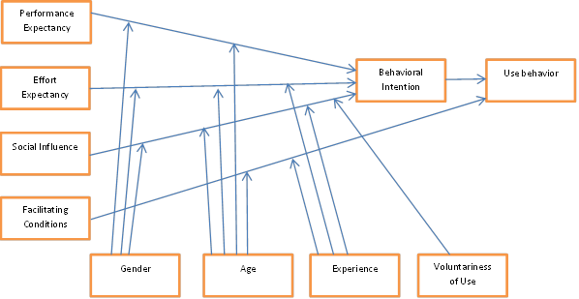

Figure 2‑1 UTAUT model (adapted from Venkatesh et al., 2003)

UTAUT is one of the technology acceptance theories most widely employed to answer the question of why people might decide to use or not to use a particular information technology (Gruzd *et al*., 2012). The origin of the UTAUT model comes from the testing and comparison of eight existing theories on technology acceptance by individuals: the theory of reasoned action (TRA), the technology acceptance model (TAM), the motivational model (MM), the theory of planned behaviour (TPB), the combined TAM and TPB model (C-TAM-TPB), the model of PC utilization (MPCU), the innovation diffusion theory (IDT), and the social cognitive theory (SCT). These different models were examined and compared in order to perceive both the strengths and weaknesses of each, and then constructs were selected to be main components of UTAUT (Venkatesh *et al*., 2003). UTAUT comprises four main constructs that influence intention and usage of information technology: performance expectancy, effort expectancy, social influence, and facilitating condition. These constructs are important in being direct determinants of user acceptance and behaviour. Furthermore, there are another four moderating variables in the model: gender, age, experience, and voluntariness (Venkatesh *et* *al*., 2003). Further details of the model constructs are presented below.

#### Performance Expectancy

Performance expectancy is defined as “the degree to which an individual believes that using a system will help him or her to attain gains in job performance” (Venkatesh *et al*., 2003, p.447). Basically, there are five minor constructs in performance expectancy which are derived from different models. They are: perceived usefulness, extrinsic motivation, job-fit, relative advantage, and outcome expectations. Venkatesh *et al*. (2003) also state that gender and age moderate the relationship between performance expectancy and intention. In terms of gender, men tend to become comfortable with new technology more quickly than do women (Minton & Schneider, 1980). In terms of age, previous research has found that age does matter in information technology usage. Burton-Jones & Hubona (2005) state that older users are reluctant to accept new information systems and find them less useful when performing their assignments. Moreover, Levy (1988) suggests that studies of age and gender need to be conducted in parallel because studies of gender differences can be misleading without reference to age. Therefore, gender and age might lead to lower or higher performance expectancy with particular information technology.

#### Effort Expectancy

Effort expectancy is defined as “the degree of ease associated with the use of the system” (Venkatesh *et al*., 2003, p.450). There are three constructs derived from existing models that relate to the concept of effort expectancy. They are: perceived ease of use (from TAM/TAM2), complexity (from MPCU), and ease of use (from IDT). According to Venkatesh *et al*. (2000), women experience higher anxiety in using new information systems, in this case digital libraries. They seem to have concerns about the ease of use of system. Furthermore, older users have difficulties in retrieving information from systems, and the capabilities for information retrieval decrease as age increases (Morris & Venkatesh, 2000). Experience of use is another moderating factor for effort expectancy. Venkatesh *et al.* (2003) suggest that the longer people use a system, the more confident they become in using it. Increased direct usage of a particular information system could enhance both confidence and capability in understanding and using the information system so as to perform assignments (DeLone, 1988). Thus, the influence of effort expectancy on behavioural intention is moderated by factors such as gender, age, and experience.

#### Facilitating Condition

Facilitating condition is defined as “the degree to which an individual believes that an organizational and technical infrastructure exists to support the use of a system” (Venkatesh *et* *al*., 2003, p.453). This factor is derived from three different constructs: perceived behavioural control (from TPB/DTPB, C-TAM/TPB), facilitating conditions (MPCU), and compatibility (IDT). Age and experience are moderating factors for facilitating condition in terms of information technology usage. As Hall and Mansfield (1975) state, older workers tend to think that receiving help and assistance on the job are important to them. Moreover, the number of forms of information technology in use may increase if users experience multiple kinds of help and support from their organisations (Bergeron *et al*., 1990).

#### Social Influence

Social influence is defined as “the degree to which an individual perceives that important others believe he or she should use the new system” (Venkatesh *et al*., 2003, p.451). Social influence is basically represented as a subjective norm in TRA, TAM2 and TPB/DTPB, as a social factor in MPCU, and as an image in IDT (Venkatesh *et al*., 2003). The influence of social behavioural intention is moderated by gender, age, experience, and voluntariness. The effect can be strong, especially in senior females, mandatory settings, and the early stages of experience (Venkatesh *et al*., 2003).

UTAUT has been widely adopted for use in research into technology acceptance. Because this model was created by weaving together the most significant aspects of existing theories, the UTAUT model is now seen as the most likely to predict and explain the information usage intentions of individuals (Venkatesh *et al*., 2003). In terms of application, the UTAUT model has been employed in research into individual acceptance of new technology in different disciplines. Mckenna *et al*. (2013) used UTAUT in conjunction with the theory of organizational information services to investigate how consumers perceived and potentially adopted information technology-based services such as reserving tickets, locating places and receiving directions. They employed both theories first to develop a software artefact and then used the UTAUT constructs to explain actually how the system should be designed and developed. In terms of the academic community, the UTAUT model has been used to study the behaviour of academics. In their study of social media adoption among scholars, Gruzd et al. (2012) utilised the UTAUT model to explain the communication and information dissemination behaviour of scholars through social media. The study aimed largely to learn how and why scholars used social media to communicate and spread information by employing the UTAUT model to interpret their usage behaviour. The study found that ‘performance expectancy’ and ‘social influence’ supported intention to use and use of social media. Conversely, ‘effort expectancy’ and facilitating conditions’ had negative effects on the intention to use and use of social media among scholars.

The UTAUT model has also been adopted in research into libraries. For instance, it has been used to examine whether university students have any interest in using digital libraries. One study focuses on factors that might influence the intention of Malaysian postgraduate students to use digital libraries (Rahman *et al*., 2011). The research findings here show that ‘performance expectancy’ and ‘effort expectancy’ do have a significant positive influence on intentions to use digital libraries. However, the study finds that gender and age have no significance for behavioural intention. According to the results, there is no difference between male and female students in their behavioural intentions toward digital libraries. Similarly, age does not play a role in determining participants’ perceptions of the system. Both older and younger students perceive digital libraries as difficult to use.

Another recent study focusing specifically on the e-book context is that conducted by Feldstein and Martin (2013). It seeks to explain the adoption patterns for e-textbooks among college students. The study examines the adoption process by employing UTAUT as its framework. According to the research findings, gender plays a role in student attitudes towards e-textbooks. Female students tend to find them easier to read and more useful than male students do. The results also support the idea that UTAUT is a relevant and appropriate theory for studying the adoption of e-books.

Although it is now widely accepted that UTAUT is an appropriate model to explain individual acceptance of information technology, there are as yet few instances of its application in an e-book context. However, as Venkatesh *et al*. (2003) state that UTAUT is a model that synthesises and captures the essential elements of previously established models, it certainly represents a reliable and useful theory to employ in any study of e-books.

### Five categories of factors influencing the reader’s choice between print and screen

Apart from the UTAUT model, there is one other model which aims to clarify the most influential factors involved in reading format choices made by individuals. This is ‘the five categories of factors influencing reader choice between print and screen’.

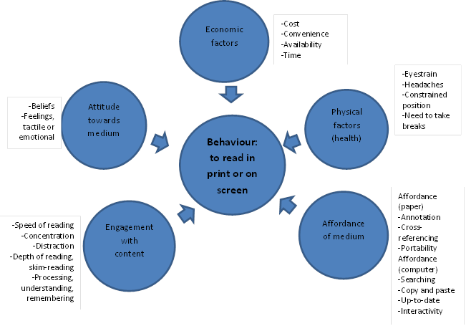

Figure 2‑2 Five categories of factors influencing a reader's choice between print and screen (based on literature review) (adapted from Keller, 2012)

Based on her study of the reading habits of undergraduate students, Keller (2012) proposes the ‘five categories’ model with the intention of examining selections made between reading in print or on screen. Keller (2012) began by reviewing the relevant literature and finding one framework that proved to be useful: ‘The Model of Attitude Influence upon Reading and Learning to Read’ by Matthewson (1994). Matthewson’s model showed the important role that attitude plays in forming intention to read and reading behaviour. Besides attitude, Matthewson (1994) concluded that there were a number of additional factors underpinning intention to read, such as external motivators (incentives, purposes, norms, and settings) and internal emotions, which acted as moderating variables. Nevertheless, it was later shown by Kahneman *et al*. (1999) that attitudes alone could not justify all the decisions made. Therefore, they proposed an economic model of choice that concerned the rational criteria behind the decision-making of individuals.

Based on both Matthewson’s model of attitudinal influence upon reading and the economic model of choice, Keller (2012) suggests a new model that embraces certain elements from both. In Keller’s model, there are five categories of factors which are considered to have an effect on reader choice (see figure 2-2). Details of the five categories are supplied in the next section.

#### Attitude towards medium

According to Matthewson (1994), it is clear that attitude toward reading has an effect on intention to read. In Matthewson’s model, there are three components of attitude: cognitive, affective, and conative elements. However, Keller (2012), through an extensive literature search, finds further attitudes towards the print medium which are consistent with the components in Matthewson’s model. These are beliefs, feelings (tactile or emotional), and habits and tradition.

#### Economic factors

Economic factors include cost, convenience, time, and availability of access to the medium.

#### Physical factors (health and wellbeing)

There are several factors affecting health and wellbeing that might be expected to play a significant role in the reading behaviour of individuals. Eyestrain, headaches, constrained position, and the need to take breaks are physical complaints that are mentioned frequently in the literature.

#### Affordances of medium

Several studies highlight the significance of the affordances of print documents, such as the possibilities offered for annotating and cross-referencing. In addition, portability is another advantage of printed text that can be found in previous studies. For electronic texts, there is a range of outstanding affordances. Good search functionalities, up-to-date information, and interactivity are stated in several research papers as reasons for choosing electronic texts.

#### Engagement with text

According to the literature, speed of reading can be a factor in terms of engagement with print or screen. Recent research shows the differences in reading techniques used for electronic and printed texts. Mangen (2008) suggests that electronic reading is carried out in a shallower and less focused way. Also, this style of reading can lead to distractions.

Keller (2012) uses this model as the base for her study about the reasons behind choices made between reading in print and on screen across all reading purposes and material types. To gather data, she conducted photo-elicitation interviews with university students regarding their reading behaviour. The main aim of the interviews was to identify the factors that have an influence on students’ reading, both on screen and in print. The results from the interviews are formulated alongside the five categories of the model.

In the current study, part of Keller’s model is adopted as the preliminary framework to direct the research. The components from the model are applied to analysis of the results from the photo-diary interviews with library users. The responses from the interviewees are categorised by means of the factors from the model.

## Application of the theoretical frameworks into the study

Outcomes from a review of the literature on technology adoption theory and factors that influence choice of reading format show the real possibility that these frameworks might be employed to describe e-book adoption and use behaviour. Since part of the current study is aimed at understanding the attitudes and behaviour of library users in relation to e-books, it is useful to apply the two models mentioned above in this study. As the UTAUT model focuses on intention to use particular technology, while Keller’s model concentrates on the behaviour of users, a combination of these two frameworks seems to be a practical option.

As there are slight differences in the characteristics of the two frameworks, each of them is applied to analysis of data from different phases of this study. The UTAUT model is utilised to identify factors that have an influence on library user intention to use e-books. Four major dependant factors (performance expectancy, effort expectancy, social influence, and facilitating conditions) were applied to the library user survey in order to help the researcher to perceive an overview of the factors influencing library user’s intention to and actual use of e-books. As the fact that UTAUT model cannot provide the researcher a clarification on the pattern of e-books use behaviour, Keller’s model is brought to fill this gap. In the final phase of this study (Phase 3), Keller’s model was adopted as a base framework to investigate use patterns and user behaviour with both e-books and print books. In addition, factors that have an effect on the user’s selection of reading format were explored. The results from the application of the two models were then analysed and compared in order to make a link between the two different phases. With the combination of two models, a clearer picture of both attitudes and behaviour of Thai library users, together with the factors influencing their e-book usage, are revealed.

# Context of the study

The preliminary overview of the whole educational system in Thailand has been provided in Chapter 1. Thus, this chapter will focus more on the details of Thai higher education which is also the main focus of the study. Overview of academic library structure and its digital transition is provided. In addition, the information and communication technology in Thai education will be discussed in this chapter as well. The chapter concludes with the details about the participating university libraries in this study in order to provide some background information for readers.

## Context of higher education in Thailand

Higher education in Thailand began in the late nineteenth century, when King Rama V introduced the first education reform. According to the Bureau of International Cooperation Strategy, Office of the Higher Education Commission of Thailand, higher education in Thailand can be divided into three eras: the early modernization period (1889-1931), the post-revolution period (1932-1949), and the development planning period (1950-present) (BICS, 2016).

Based on information from the Department of Provincial Administration (2016), the population of Thailand is 65,756,879, as of December 2015. In addition, statistical data shows that 13,569,532 people are of school and university age (National Statistical Office, 2016). In order to clarify further the higher education population, Table 3-1 identifies the number of students who are currently in higher education but distinguishes them by type of institution and level of education (Office of the Higher Education Commission, 2016).

Table 3‑1 Number of students in higher education in Thailand

|  |  |  |  |
| --- | --- | --- | --- |
| **Type of institution** | **Level of education** | | |
| **Undergraduate degree** | **Masters degree** | **Doctoral degree** |
| Public universities | 363,620 | 44,815 | 3,816 |
| Public autonomous universities | 435,256 | 57,802 | 13,048 |
| Rajabhat universities | 437,289 | 6,716 | 981 |
| Rajamangala universities of technology | 138,808 | 2,787 | 107 |
| Private universities | 205,860 | 17,484 | 1,895 |
| **Total** | **1,580,833** | **129,604** | **19,847** |

Source : Office of the Higher Education Commission (2016)

The data in the table show that most students in higher education are undergraduates. The majority of them are studying in either public autonomous universities or Rajabhat universities. However, only a small number of students in Thailand are studying for graduate degrees. In the next section, the different types of higher education institution will be explained in more detail in order to provide a better understanding about the context of higher education in Thailand.

### Types of higher education institution in Thailand

Higher education institutions in Thailand can be divided into five categories (BICS, 2016b):

1. Public universities

Public universities in Thailand receive annual financial support from the government. The administration within these institutions is driven by a bureaucratic system in which the university president is the top executive. There are 12 public universities in Thailand at present.

1. Public autonomous universities

Unlike public universities, public autonomous universities are self-governing. They have their own budgeting system and administrative structure which means they can make autonomous decisions. All the decision-making in relation to management matters can be done by the university itself. However, the government is still responsible for budget allocation to this type of university in the form of block grants. There are 23 public autonomous universities at present.

1. Rajabhat universities (public)

Rajabhat universities are institutions that focus on community development. They were developed from teacher colleges and then upgraded from institutes to universities in June 2004. Their focus is on enhancing academic and higher vocational teaching and learning. There are 38 Rajabhat universities at present.

1. Rajamangala universities of technology (public)

Rajamangala universities were first established as Rajamangala Institutes of Technology. As was the case with Rajabhat universities, the Rajamangala Institutes of Technology were upgraded to university status. Their focus is on the development of graduates in science and technology. There are nine Rajamangala universities at present.

1. Private universities

Private universities in Thailand have their own committee to administer all matters relating to university issues. The universities themselves do not receive any funding from the government. Financial support mainly comes from their own revenue sources. However, private universities do have the right to borrow money at a low rate of interest from the revolving fund for educational development offered by the Office of the Higher Education Commission (OHEC). There are 74 private universities in Thailand at present.

### University administration in Thailand

Each type of higher education institution in Thailand has a different board of management which is responsible for academic direction. The board of the management of each type of university in Thailand is shown in Figure 3-1 below (BICS, 2016a).The figure shows that a hierarchical organisational structure exists within most higher education institutions in Thailand. Each type of university is governed by several committees. However, the public autonomous universities seem to rely less on the different kinds of university committee, instead tending to handle internal management on their own.

Figure 3-1 University administration in Thailand, adapted from BICS (2016)

## Background to academic libraries in Thailand

In Thailand, information technology has been in operation in the library sector for over four decades. Academic libraries form the group of libraries that has adopted information and communication technology more quickly than have others.

In terms of technological adaptation, the 1980s was the starting point for academic libraries in Thailand. Library computerisation within Thai academic libraries began in 1981 after the arrival of the mini CDS/ISIS software (a software developed by UNESCO and freely available to libraries) (Linpisarn, 1994; Wipawin, 2002). After its first use by the Asian Institute of Technology (AIT) in 1985 for creating bibliographic records, this software was adopted in the following years by many university libraries to develop their own bibliographic databases (Siriwongworawat, 2003). From this beginning, library technology then progressed. A number of libraries started to automatise library tasks such as acquisition, cataloguing and circulation. Several commercial library automation systems were introduced at this time to help libraries perform those tasks.

Chiang Mai University Library was one of the first university libraries to employ a commercial library automated system. In 1990, with support from the IDP project (International Development Program of Australian Universities and Colleges), it purchased the SEA-URICA library system, the first commercial library automated system to be implemented in Thailand (Butdisuwan, 2005). Later, in 1994, Chulalongkorn University Library adopted the INNOPAC system to implement their in-house developed library system, Chulalinet (Siriwongworawat, 2003; Wareesa-ard, 2004). Initially, however, many academic libraries were reluctant to obtain a library automated system due to technical difficulties and restricted budgets. During the 1990s, public university libraries received funds from the Thai government to implement major upgrades to their library integrated systems. Thus, more libraries were able to purchase a library automated system (Wareesa-ard, 2004). Several popular library systems have now been utilised by many university libraries, such as INNOPAC, Dynix/Horizon, VTLS, TINlib, and ALICE. However, limited budgets for Thai academic libraries continued to hamper development. The Office of Higher Education Commission (OHEC) recognised the problem and then proposed a policy to support the development of local automation systems within public academic libraries (UniNet, n.d.). The advent of such automated systems is one of the factors that have contributed to rising technological implementation in general among academic libraries in Thailand.

Apart from these library automation systems, another significant transition for Thai academic libraries was the creation of library networks. In essence, academic libraries started to cooperate in order to share resources and take action in other areas. There are three academic library networks that have a significant role in the Thai library context: PULINET, THAILINET-M, and ThaiLIs. Further details of each network are provided as follows:

1. PULINET (Provincial University Library Network)

Established in 1986, and based on a resolution made in a meeting of chancellors of public universities in provincial areas, Chiang Mai University accepted full responsibility for founding PULINET (PULINET, n.d.). PULINET was established with an obligation to provide cooperation between member universities in the following respects:

* To develop information resource sharing among members.
* To enhance community information resources to form a national resource centre.
* To develop and actively progress the capability of staff members.
* To enhance the standards of the information delivery system.

PULINET has become a successful academic library network with twenty university libraries in its network. The library database of each individual member library can be accessed through its own web OPAC. However, members can not only access electronic resources but can also borrow books or other material from all PULINET libraries (Wareesa-ard, 2004).

1. THAILINET-M (Thai Library Network Metropolitan)

The success of PULINET stimulated the establishment of the THAILINET-M network. This project, started by the Sub-Committee on University Library Development within the Ministry of Education, allocated funds to set up the library network across twelve public academic libraries in the Bangkok Metropolitan area (Wareesa-ard, 2004). There were several aims in creating this network:

* To create a standard means of access to library databases.
* To develop a library automation system for each library member.
* To share information resources between members.
* To establish a network system among academic libraries.
* To connect to PULINET and other networks.
* To develop information services based on user demands.

Unfortunately, this network has not been successful in terms of cooperation and resource-sharing among members. However, it has still achieved some of its goals, such as developing library databases, purchasing software and computers, and enhancing library services for users.

1. ThaiLIS (Thai library Integrated System)

ThaiLIS was established in 1998 under the aegis of the Bureau of University Affairs. The bureau initiated a merger of THAILINET-M and PULINET into a new network named ThaiLIS (PUBAT, 2016). The main objective in combining the two networks was to create a nationwide network that allowed all public universities and higher education institutions access to library databases and other information resources from all members through a single search. Fundamentally, ThaiLIS is responsible for three projects: Union Catalogue, Digital Collection, and Reference Databases (Wareesa-ard, 2004).

* Union Catalogue - The Union Catalogue is a shared bibliographical database that allows users to search the library resources of all university libraries from one point of access.
* Digital Collection – The Digital Collection is an online database that collects full-text electronic dissertations and theses and other scholarly works from every public university member in order to facilitate the use of scholarly works within Thai academia.
* Reference Database – Because of the budget restrictions facing most academic libraries, many libraries cannot afford to purchase resources from or subscribe to online databases. With the intention to reduce inequality between libraries regarding digital resource access, ThaiLIS subscribes to major electronic databases on behalf of every public university library in the country. There are fourteen online databases that ThaiLIS subscribes to at present.

The library networks mentioned above are a means for academic libraries in Thailand to realise resource-sharing between libraries, particularly with regard to electronic resources. The networks also provide an opportunity for libraries to have more electronic resources in their library collections. Thus, academic libraries in Thailand are now reaching the digital era. There is much evidence of a serious attempt being made to embrace technological change. The adoption of automation systems by the libraries and the creation of a nationwide network represent significant progress. However, continuous improvement and enhanced levels of cooperation between libraries are increasingly necessary as technological trends are always evolving.

## Information technology use in Thai education

It goes without saying that information technology plays a significant role in society in the current era. The education sector is no exception. Thus, knowledge about access to and the utilisation of technology are very important for everyone. Issue relating to information communication technology (ICT) are becoming increasingly significant in Thailand; the Thai government has tasks to perform in their respect as the field is an important part of the economic development strategy of the country. A national ICT policy was first announced in 2000 and has been updated regularly since then (Makaramani, 2013). The main goal of the policy is to create a ‘Smart Thailand’, an objective which suggests a society that people possess appropriate information literacy skills (Ministry of ICT, 2009).

The use of ICT in Thai education began in 1984 when the computer courses were first offered in schools (Meleisea, 2008). Several efforts to integrate ICT into the education sector have been made by the government since then. One such initiative was the development between 2007 and 2011 of the first Master Plan for ICT in Education; this was a four-year strategic plan created to be in line with the basic education curriculum (OECD/UNESCO, 2016). Since then, the Ministry of Education has produced a subsequent Master Plan for the period 2014-2018 which is currently being implemented (OECD/UNESCO, 2016).

In general terms, the Thai government has supplied a considerable amount of investment and supported the integration of ICT in education. There have been several programmes to introduce ICT more successfully into the education sector, including the One Tablet Per Child (OTPC) project, purchasing computers for schools, Internet capacity funding for schools, and the Smart Classroom project (OECD/UNESCO, 2016). However, there is evidence that Thai students still lack skills in computer literacy, information processing, IT task performance, and communication (Fraillon et al., 2014). It is important to note here that the rate of ICT use has no relationship with the ICT proficiency among Thai students. In other words, higher rates of ICT use in education have not improved the ICT competency of Thai students.

The United Nations Educational Scientific and Cultural Organisation (OECD) has released an interesting review of the situation facing Thai education. In this OECD/UNESCO report (2016), potential reasons for the unsuccessful integration of ICT into Thai education fall into three categories. First, Thailand still lacks a stable enough infrastructure to support the use of ICT in education. A clear and long-term goal regarding ICT in education should be developed. At present, there is a lack of continuity in education policy as it changes whenever Thailand has new government. Second, digital learning materials have not been fully integrated into Thai education. A lack of access to relevant and high-quality educational materials is an important problem in the Thai education sector. Third, Thai teachers are less than competent in applying ICT into their teaching approaches. This issue is seen to be very important because teacher competence and attitudes toward digital resources also have a strong influence on student attitudes and performance in ICT-related tasks. It is strongly recommended that a national strategy which effectively enhances ICT use in education should be developed in Thailand. The strategy should be applied consistently to the educational curriculum in order to support learning and teaching in Thailand more effectively.

## Background information about e-books of the participating university libraries

In this study, nine academic libraries which located in Bangkok Metropolitan area are selected as a target population. This section provides preliminary information related to e-books in the collection of each library.

### Office of the University Library, Kasetsart university

* E-book databases : 17 databases

1. 2ebook Digital Library (191 titles) (Thai e-books)
2. Acta Horticulturae (approx. 700)
3. Audiobook Collection (30 titles)
4. Cambridge Book Online (169 titles)
5. CRCnet BASE eBooks (299 titles)
6. EBSCO eBook Collection
7. Emerald eBook Series (85 titles)
8. Emerald Emerging Markets Case Studies Collection (EEMCS)
9. Gale Virtual Reference Library (59 titles)
10. IET Digital Library (429 titles)
11. Oxford Scholarship Online (66 titles)
12. Science Direct eBooks (approx. 3,000 titles)
13. Taylor & Francis eBooks (223 titles)
14. SpringerLink Ebook (10,446 titles)
15. Wiley eBooks (18,711 titles)
16. Woodhead ebooks (15 titles)
17. World Scientific eBooks (5,154 titles)

* Library system : Millennium
* E-books are included in the library catalogue : Yes
* Off-campus access to e-books : Yes (via Proxy Server)
  + 1. **Office of Academic Resources, Chulalongkorn University**
* E-book databases : 31 databases (approx. 300,000 titles)

1. Cambridge Core
2. Emerald Management
3. Wiley Online Library
4. Life Sciences
5. Side Effects of Drugs Annual
6. Credo Reference
7. ScienceDirect
8. SpringerLink
9. CRCnetBASE
10. Ebrary
11. World Scientific
12. Gale Virtual Reference Library (eBook)
13. Audiobook Collection
14. Sage eBook Collection
15. eBook Academic Collection
16. RSC
17. eBook Collection
18. SAGE Research Methods
19. Knovel
20. AccessEmergency Medicine
21. AccessSurgery
22. Academic Onefile
23. Institute of Southeast Asian Studies (ISEAS)
24. Oxford Scholarship Online (OSO)
25. AccessEngineering
26. Book 24*7
27. Ebook Central (Proquest)
28. Bookboon
29. HSTalks
30. SciFinder-n
31. World eBook Library

* Library system : Millennium
* E-books are included in the library catalogue : Yes
* Off-campus access to e-books : Yes (via VPN)
  + 1. **Thammasat university library**
* E-book databases : 19 databases

1. Access Medicine
2. Access Surgery
3. ASCE
4. Business Source Complete
5. CRCnetBASE
6. EBSCOhost
7. EBSCOhost Education Research Complete
8. Emerald
9. IG Library
10. IMF eLibrary
11. NetLibrary
12. Ovid MEDLINE
13. PsycBOOKS
14. Springer eBooks
15. The Thieme E-book Library
16. Unbound Medicine
17. Wiley InterScience
18. World Bank eLibrary
19. The Foundation for the Promotion of Social Sciences and Humanities (Thai e-books)

* Library system : KOHA
* E-books are included in the library catalogue : Yes
* Off-campus access to e-books : Yes (via Proxy Server)
  + 1. **Silpakorn University Central Library (Thapra Palace branch)**
* E-book databases : 4 databases (plus 141 individual purchase titles)

1. EBSCOhost
2. EBSCOhost Research Complete
3. Gale Resources e-book
4. ProQuest Dissertations & Theses

* Library system : Millennium
* E-books are included in the library catalogue : Yes
* Off-campus access to e-books : Yes (via VPN)
  + 1. **Srinakharinwirot University Central Library**
* E-book databases : 19 databases

1. ABI/INFORM Collection
2. Access Medicine
3. Books@Ovid
4. Books 24*7
5. Cambridge Core
6. ClinicalKey
7. CRCnetBASE
8. eBook Academic Collection
9. eBook Collection (NetLibrary)
10. Ebrary
11. Gale Virtual Reference Library
12. IG Publishing eBook Library
13. Oxford Scholarship Online (OSO)
14. Proquest Health and Medical Collection
15. Sage Knowledge
16. ScienceDirect eBook
17. SpringerLink eBook
18. TeBook: Openserve
19. Wiley Online Library

* Library system : ExLibris Primo
* E-books are included in the library catalogue : Yes
* Off-campus access to e-books : Yes (via VPN)
  + 1. **King Mongkut’s University of Technology North Bangkok Central Library**
* E-book Database : 10 databases (total 20,541 titles)

1. Access Engineering
2. ASCE
3. Books24*7
4. Cambridge Books Online (CBO)
5. CRCnetBASE
6. Elsvier e-Books Collection
7. IG Library
8. Knovel
9. MHEbooklibrary
10. Wiley Online Library

* Library system : Millennium
* E-books are included in the library catalogue : Yes
* Off-campus access to e-books : Yes (via Proxy Server)
  + 1. **King Mongkut’s Institute of Technology Ladkrabang**
* E-book databases : 5 databases ( total 56,186 titles)

1. CRCnetBASE
2. Ebrary
3. Morgan & Claypool synthesis collection 1-7
4. NetLibrary
5. SpringerLink eBook

* Library system : Millennium
* E-books are included in the library catalogue : Yes
* Off-campus access to e-books : Yes (via VPN)
  + 1. **Ramkhamhaeng University Library**
* E-book databases : 10 databases

1. RU Library e-Book (Thai e-books)
2. Business Expert Press (BEP)
3. CRCnetBASE (5,893 titles)
4. EBSCO e-Book (369 titles)
5. Hart Publishing Ltd. (98 titles)
6. IG Library
7. ProQuest Ebook Central
8. ProQuest Ebook Central (Law Collection)
9. Sellier European Law Publishers (15 titles)
10. SpringerLink e-Book

* Library system : Millennium
* E-books are included in the library catalogue : Yes
* Off-campus access to e-books : Yes (via Proxy Server)
  + 1. **Office of Documentation and Information, Sukhothai Thammathirat Open University**
* E-book databases : 10 databases

1. Cambridge Books Online
2. Ebrary eBooks
3. EBSCO eBooks Collection
4. Gale Virtual Reference Library (eBooks)
5. IG Library
6. Oxford Scholarship Online (eBooks)
7. Springer Link (eBooks)
8. ScienceDirect eBooks
9. 2ebook Digital Library (Thai e-books)
10. JSTOR eBooks

* Library system : VTLS
* E-books are included in the library catalogue : Yes
* Off-campus access to e-books : Yes (via VPN

Based on the information above, every university library has subscribed to somewhat similar e-book databases. Thai e-books databases are also provided in some libraries. Millennium library automation system seems to be the most selected system by the participating libraries as 6 (out of 9) libraries are currently use the system. Every library in this study has included e-books into their library catalogues which means users do not need to access to e-books from separate databases. In addition, off-campus access to library e-resources is possible in every library either via Proxy Server or VPN.

# Methodology

## Introduction

As established in the introductory chapter (Chapter 1), the aim of this study is to understand how Thai academic libraries manage their e-book collections and how their management approaches relate to library user attitudes to and behaviour with e-books. The study aim thus encompasses an understanding of both the management approaches librarians use and the attitudes and behaviour of library users in relation to e-books. In order to achieve this aim, it was judged that several different data collection methods would have to be deployed in collecting multiple forms of relevant data. Thus, a mixed methods approach was adopted as it was expected to be the most likely to provide a wider and deeper understanding of the particular phenomena under investigation.

This chapter discusses the methodological issues of the study. It begins with a discussion of the philosophical context of the research. Then, an overview of the setting for the study is provided. After that, an account of the mixed methods approach is supplied. A detailed discussion of all the stages of the study is then presented: first, the interviews with academic librarians; second, the survey of library users; and third, the photo-diary interviews. Finally, the ethical issues associated with the research are discussed at the end of the chapter.

## Philosophical background

In any research, it is essential to determine the philosophical assumptions or paradigm underpinning the study. Every study has its own philosophical foundation, and it is the researcher’s task to be aware of the research paradigm chosen (Creswell & Plano Clark, 2011). The term paradigm was developed by Thomas Kuhn, who used it to characterise the different worldviews of scientists (Kuhn, 1971). Walter (2013) defines a paradigm in a social sciences context as “a shared framework of viewing and approaching the investigation and research of social phenomena” (p.10). This definition of the term has been adopted in the discussion that follows.

In order to clarify how the design of the research fits into a broader philosophical position, a potential framework is required. Crotty (1998) proposes there to be a range of elements essential to the development of any study. Within this view, there are four main elements which act as scaffolding in the design of a research study (see figure 4-1). To begin at the broadest level, the issue that the researcher needs to consider is the “paradigm worldview” or philosophical assumptions underlying the study, such as its ontology, epistemology and axiology. Then, the “theoretical lens” needs to be determined, which itself informs the methodology of the research. Finally, the methodology informs the specific methods required for the data collection.

Methods of data collection (e.g., interviews, checklists, instruments)

Methodological approach (e.g., ethnography, experiment, mixed methods)

Theoretical lens (e.g., feminist, racial, social science theories)

Paradigm worldview (e.g., ontology, epistemology, axiology)

Figure 4‑1 Four levels of developing a research study (adapted from Crotty, 1998)

All paradigms have different worldviews. Such worldviews differ in terms of their philosophical elements, particularly:

1. Ontology: the nature of reality and what can be known. Its main focus is on how the world works, the way that society is constructed, and how this influences people’s behaviour.
2. Epistemology: how knowledge is acquired of what is known. It requires the researcher to ask what is acceptable knowledge in the field is.
3. Axiology: the role values play in research. Its concern is with the researcher’s view of the role of values or ethics in a research methodology.

The differences between such views act as guidelines for researchers in terms of how to select the philosophical stances, research inquiries and strategies for their studies. Before beginning to conduct any research, it is important that a researcher recognises the method of reasoning to be used as it underpins the overall approach of the study. The methods of reasoning for conducting research consist of two possible approaches: deductive reasoning and inductive reasoning.

The deductive approach begins with a general assumption and then narrows it down to a particular aspect to test a hypothesis and theory (top-down approach). In other words, theory comes before conducting the research. The deductive approach has, broadly speaking, three steps. The first is the refining of a concept or theory relevant to the research subject. The second is the creation of an indicator to measure a concept. The last step is to test the concept or theory by means of experimentation or observation (Gray, 2014). Table 4-1 summarises the deductive process within a research study.

**Table 4‑1 Process of the deductive reasoning in a research study (adapted from Gray,2014,p.17)**

|  |  |
| --- | --- |
| **Stages in the deduction process** | **Actions taken** |
| Set problem of interest | Consider an issue that need to be studied |
| Select theory | Identify the potential theory that most relevant to the subject under investigation |
| Establish hypothesis | Establish a hypothesis (a testable proposition about the relationship between two or more concepts) |
| Operationalise | Formulate a way of measuring the concepts |
| Test by corroboration or attempted falsification | Compare the data observed with the theory. (If corroborated, the theory is assumed to have been established) |
| Examine outcomes | Accept or reject the hypothesis from the outcomes |
| Modify theory (if necessary) | In case that the hypothesis is rejected, the theory will need to be modified |

The inductive approach works the other way, with the researcher starting from the specific observations to find patterns in data in order to establish generalisations or theories (bottom up approach). In fact, people generally use induction in everyday life as they learn from experiencing things around them. Then they make conclusions based on those experiences and finally generate rules or beliefs (Walliman, 2011). In order to ensure the reliability of the approach, multiple observations need to be conducted repeatedly in different situations before general conclusions or theories can be developed (Gray, 2014).

Those two approaches are considerably different in many aspects. Deductive reasoning is a theory-driven (theory testing) approach, while inductive reasoning is data-driven (theory developing) approach. In practice, many researchers tend not to attach themselves too firmly to either one of these approaches. Rather, they adopt features of both deductive and inductive reasoning in their studies. Similarly, both deductive and inductive reasoning have been integrated into the current study. In terms of responding to the research questions established in Chapter 1, it seems clear that applying either one or the other approach may result in an insufficiency of data. Thus, this study begins with an inductive phase (academic librarian interviews) before moving over to the theory-testing deductive approach in its second phase (user survey). It concludes with more in-depth interviews, this time with users, in the third phase (photo-diary interviews) which have an explanatory function.

### Paradigms in social science research

Fundamentally, there are two research paradigms used in social science research: positivist and constructivist. Lincoln and Guba (1985) supply a paradigm contrast table in order to present the differences between these two paradigms (see table 4-2). In their table, the two paradigms are represented in terms of five dimensions: ontology, epistemology, axiology, methods, the possibility of causal linkages, and the possibility of generalisation.

The positivist paradigm centres on the belief in a single, independent and stable truth. The positivist researcher holds that “what is real is only that which can be observed” (Pickard, 2007, p.8). The way that knowledge is attained within this research paradigm is called the ‘Etic approach’ in which the researcher usually observes and makes a report on the matter under investigation without taking part in it. For this paradigm, the researcher and the subject are independent of each other. A deductive approach is employed to establish a hypothesis and then observations are made through the data in order to confirm or reject the hypothesis. In addition, positivist research is thought to be free of any values. Research is carried out assuming a cause-effect relationship in which one action makes another action happen. Generalisation can be applied to other phenomena of a similar kind, thus giving the research generalisability (Pickard, 2007; Teddlie & Tashakkori, 2009).

On the other hand, the constructivist paradigm involves a completely contradictory set of beliefs to that of the positivist. For constructivism, multiple realities exist. The ‘Emic approach’ is used to discover knowledge, in the sense that the researcher interacts with people to discover the meaning of things. This paradigm requires the researcher and the subject to be intertwined. The researcher takes an inductive approach when conducting the research. A pre-determined theory and hypothesis are not required before collecting the data. The researcher then uses the observed data to answer the research problems. Human values are involved and have an impact on the research. They should be taken into account when reporting the results of research. It is often assumed to be difficult to separate causes from effects and the results can mostly be generalized, but only under a similar context of study (Lincoln & Guba, 1985).

Table 4‑2 The original paradigm contrast table (adapted from Lincoln & Guba, 1985)

| ***Dimensions of Contrast*** | ***Positivist Paradigm*** | ***Constructivist (Naturalist) Paradigm*** |
| --- | --- | --- |
| **Ontology: the nature of reality, being, and truth** | Realism - reality is single, tangible, and fragmentable. | Realitivism - reality is multiple, constructed, and holistic. |
| **Epistemology: the relationship of the knower to the known; the nature of knowledge and its justification** | Knower and known are independent, a dualism. | Knower and known are interactive, inseparable. |
| **Axiology : the role of values in inquiry** | Inquiry is value free. | Inquiry is valued bound. |
| **Logic** | Deductive | Inductive |
| **Methods** | QUAN | QUAL |
| **The possibility of casual linkages** | There are real causes, temporally precedent to or simultaneous with their effects. | All entities are in a state of mutual, simultaneous shaping so that it is impossible to distinguish causes from effects. |
| **The possibility of generalization** | Time- and context-free generalizations (nomothetic statements) are possible. | Only time-and context-bound working hypotheses (ideographic statements) are possible. |

Since new research methodologies have emerged, the paradigm contrast table has had to be expanded. The original two columns in the table have now become five (Guba & Lincoln, 2005). In table 4-3 an expansion of the table is offered, one that presents the five major paradigms used in research. The table identifies the primary differences between the five paradigms through seven dimensions: ontology, epistemology, axiology, logic, methods, possibility of causal linkages, and possibility of generalisation.

Table 4‑3 Expanded paradigm contrast table comparing five points of view (adapted from Teddlie & Tashakkori, 2009)

| ***Dimensions of contrast*** | ***Constructivism*** | ***Transformative*** | ***Pragmatism*** | ***Postpositivism*** | ***Positivism*** |
| --- | --- | --- | --- | --- | --- |
| **Ontology**  **(the nature of reality)** | Ontological relativism multiple, constructed realities | Diverse viewpoints regarding social realities; explanations that promote justice | Diverse viewpoints regarding social realities; best explanations within personal value systems | Critical realism (external reality that is understood imperfectly and probabilistically) | Naïve realism (an objective, external reality that can be comprehended) |
| **Epistemology (researcher/participant relationship)** | Subjective; reality co-constructed with participants | Both objectivity and interaction with participants valued by researchers | Both objective and subjective points of view, depending on stage of research cycle | Modified dualism | Objective point of view (dualism) |
| **Axiology**  **(role of values)** | Value-bound inquiry | All aspects of research guided by social injustice | Values important in interpreting results | Values in inquiry, but their influence may be controlled | Value-free inquiry |
| **Logic** | Inductive | Inductive and hypothetico-deductive | Inductive and hypothetico-deductive | Hypothetico-deductive | Hypothetico-deductive |
| **Methods** | QUAL | QUAL and QUAN;  Community of participants involved in methods decisions | QUAL and QUAN; reserachers answer questions | Primarily QUAN | QUAN |
| **Possibility of casual linkages** | Impossible to distinguish causes from effects; credibility of descriptions important | Casual relations that should be understood within the framework of social justice | Casual relations, but they are transitory and hard to identify; both internal validity and credibility important | Causes identifiable in a probabilistic sense that changes over time; internal validity important | Real causes temporally precedent to or simultaneous with effects |
| **Possibility of generalization** | Only ideographic statements possible; transferability issues important | Ideographic statements emphasized; results linked to issues of social inequality and justice | Ideographic statements emphasized; both external validity and transferability issues important | Modified nomothetic position; external validity important | Nomothetic statements possible |

Table 4-3 provides a clearer picture of each paradigm. The differences presented for each dimension in the case of each paradigm reflect research commitments to different research approaches. The ontological stances are different across the paradigms. For pragmatism, ‘truth’ should not be seen as a theory or definition. Rather, “truth” is “what works” (Teddlie & Tashakkori, 2009). There are also differences in causal relations between the five worldviews. There is seen to be cause and effect in pragmatism but the link is temporary and difficult to identify. Similarly, there is cause and effect in the transformative paradigm but the relationship usually occurs within a social justice framework. For positivism, there are always real causes that link to effects. However, a constructivist believes that it is complicated to differentiate between cause and effect because all entities are engaged in simultaneously shaping each other. In terms of the possibility of generalisation, generalisation in pragmatism is time- and context-bound. It is concerned with external validity and the transferability of results. Generalisation in transformative research is also time- and context-bound. This type of research tends to link results from a particular study to broader issues of social justice.

Regarding an epistemological stance, pragmatism rejects the idea of a contrast between objectivity and subjectivity. Rather, its epistemological stance is on a continuum instead of at two opposing poles. The transformative paradigm also argues for balance in terms of objectivity and subjectivity. On the other hand, constructivism, positivism and postpositivsm posit a clear-cut separation between subjectivity and objectivity. In terms of axiological considerations, pragmatist researchers place importance on human values within the research. For them, personal values play a significant role in conducting and interpreting the results of a study. Transformative researchers also recognise the importance of human values. However, those values come from different sources, with the values that should guide research being seen as those which pursue social justice rather than a researcher’s personal interests.

It is notable that both the pragmatism and transformative paradigms reject an either-or choice of methods. Pragmatism includes the belief that both QUAL and QUAN methods are useful. The choice of method depends directly on the research question. Similarly, the transformative paradigm uses both QUAL and QUAN methods to conduct research, but for different purposes. Method selection is carried out in this case to ensure that it can facilitate the researcher to achieve results that support social justice. As both the pragmatism and transformative paradigms use both types of method in research, it is clear that researchers from these two stances are likely to use both inductive and deductive logic to address their research questions. The other paradigms – constructivism, positivism, and postpositivism – are more fixed in their methodological choice, employing either QUAL or QUAN, and in their logic, which is either inductive or deductive.

Based on the information in the table, it is clear that both the pragmatism and transformative paradigms are associated with mixed methods research. Mixed methods research is less well known than the quantitative and qualitative traditions as it has emerged as a third methodological movement only in the last thirty years (Teddlie & Tashakkori, 2009). Mixed methods research has been defined as “a type of research design in which QUAL and QUAN approaches are used in types of questions, research methods, data collection and analysis procedures, and/or inferences” (Tashakkori & Teddlie, 2003, p.711). In short, mixed methods research is the use of two or more methods in a single study. As this new research tradition has developed, a search for an appropriate philosophical paradigm has also been necessary.

However, there are several different characteristics within these two paradigms. Fundamentally, pragmatism is a new paradigm that seeks to find a middle ground between two philosophical views: dogmatism and scepticism (Johnson & Onwuegbuzie, 2004). In other words, pragmatism rejects the either or choice of constructivism (which tends to favour QUAL methods) and positivism/postpositivism (which tend to favour QUAN methods) and seeks to answer questions that intrigue the investigator (Teddlie & Tashakkori, 2009). Its aim is to solve problems in the real world instead of holding on to assumptions about the nature of knowledge (Feilzer, 2010). The focus of pragmatism is on three points: the consequences of the research, the primary importance of the question asked, and the use of multiple methods of data collection (Creswell & Plano Clark, 2011).

On the other hand, Mertens (2003) has defined the Transformative paradigm as “an adoption of an explicit goal for research to serve the ends of creating a more just and democratic society that permeates the entire research process, from the problem formulation to the drawing of conclusions and the use of results.”( p.159). The focus of this paradigm is on lives and experiences of the marginalised groups of people such as gay/lesbian, the poor, disabled people, etc. The transformative researcher is usually interested in the inequality in society, and try to link the results of the study to answer the wider questions of social justice (Mertens, 2003).

The current study uses pragmatism as its paradigmatic base. The study seeks to gain an in-depth understanding of the elements which make up academic library e-book management approaches and the attitudes and behavioural aspects of participants. In addition, based on the research questions within the study, it requires multiple methods of data collection, both quantitative and qualitative. It uses a combination of several data collection tools, such as interviews, surveys and photo-diary interviews. Thus, both inductive and deductive approaches are used to analyse the results in the different phases of this study. An inductive approach is employed in the first phase of the study. The interviews with academic librarians are conducted in order to gain an understanding of the e-book management issues within libraries. Thematic analysis is the main method employed to analyse the interview findings. Patterns of e-book management and attitudes of the librarians are thus obtained. In the second phase, a survey of library users regarding library e-books is generated based on an integration of the data found in the first phase and the most relevant theory of technology use and acceptance (UTAUT theory). Thus, the hypotheses are formed in this stage. Correlation analysis is adopted with the use of SPSS statistical software to test the hypotheses. The final phase of the study, the photo-diary interviews, is subject to inductive reasoning in order to examine participant behaviour in terms of reading material use. The data collected from this phase are used to support what has been found in the previous phases of the study. All the results are then integrated to answer the research questions.

## Research setting

This study focuses on an examination of the management approaches that academic libraries in Thailand take in order to administer their e-book collections. In addition, the attitude and behaviour of library users are also major concerns of the study. Therefore, primary details of the participating academic libraries in Thailand are provided in order to supply a better understanding of the research context.

### Academic libraries

In this study, nine university libraries (within public autonomous universities) in the Bangkok Metropolitan Region of Thailand were chosen as participants. Table 4-4 supplies the names and characteristics of all the participating libraries in the study.

Table 4‑4 Primary details of the participant academic libraries

| **Library’s name** | **Types of institutions** | **Typical characteristics of institution** | **Specific focus** |
| --- | --- | --- | --- |
| Office of Academic Resources, Chulalongkorn University | Public autonomous university | * Emphasis on scholarly and research * Provides both undergraduate and graduate programmes (both Masters and PhD) | None |
| Office of the University Library, Kasetsart University | Public autonomous university | * Emphasis on scholarly and research * Provides both undergraduate and graduate programmes (both Masters and PhD) | Agricultural, technology, and innovation |
| Thammasat University | Public autonomous university | * Emphasis on scholarly and research * Provides both undergraduate and graduate programmes (both Masters and PhD) | None |
| Silpakorn University Central Library (Thapra Palace branch) | Public autonomous university | * Greater emphasis on instruction rather than research * Provides both undergraduate and graduate programmes (both Masters and PhD) | Artistry |
| Srinakharinwirot University Central Library | Public autonomous university | * Emphasis on scholarly and research * Provides both undergraduate and graduate programmes (both Masters and PhD) | None |
| King Mongkut’s University of Technology North Bangkok Central Library | Public autonomous university | * Emphasis on scholarly and research * Provides both undergraduate and graduate programmes (both Masters and PhD) | Science and technology |
| King Mongkut’s Institute of Technology Ladkrabang | Public autonomous university | * Emphasis on scholarly and research * Provides both undergraduate and graduate programmes (both Masters and PhD) | Science and technology |
| Ramkhamhaeng University Library | Public university (open admission university) | * Greater emphasis on instruction rather than research * Provides teaching and learning systems both on campus and via distance learning * Provides both undergraduate and graduate programmes (both Masters and PhD) | None |
| Office of Documentation and Information, Sukhothai Thammathirat Open University | Public university (open admission university) | * Greater emphasis on instruction rather than research * Provides teaching and learning systems both on campus and via distance learning * Provides both undergraduate and graduate programmes (both Masters and PhD) | None |

As shown in table 4-4, every participating academic library in this study is based in either a public or public autonomous university. In the Thai academic context, the status of public universities is well-recognised. The majority of the participating academic libraries in this study are also from the top ranked universities in Thailand. Therefore, these academic libraries are more developed than other types of library and employ well-qualified academic librarians. In addition, all the selected libraries provide an e-book service, which is the main focus of this study. All of the universities provide both undergraduate and postgraduate study programmes, but they offer different specialised subjects; this allows the researcher to assess whether e-book management approaches differ between different subject focus institutions. The attitudes and behaviour of users of those libraries are also examined.

Examining e-book management approaches together with user attitudes and behaviour in relation to e-books in the selected academic libraries will assist the researcher in understanding the current status of e-books in Thai academic libraries. As this study is conducted within the leading public universities in Thailand, the research findings are expected to provide a case study for other university libraries, one that might be applied to their libraries as appropriate.

### Number of university students

Every university selected for this study is classified as a large university based on its number of students (more than 20,000). Table 4-5 shows that the student population varies between different institutions. It is noticeable that the number of undergraduate students at the two open universities (numbers 8 and 9) is approximately two or three times higher than that at others. This is probably because those universities employ an open admission policy for recruiting students. However, the number of PhD students is very low at university 8 when compared to the other universities.

Table 4‑5 The number of students in the participating universities (academic year 2016)

| **University** | **Undergraduate** | | **Postgraduate** | | | |
| --- | --- | --- | --- | --- | --- | --- |
| **Masters** | | **PhD** | |
|  | **Male** | **Female** | **Male** | **Female** | **Male** | **Female** |
| **1.Kasetsart University** | 10,341 | 16,456 | 2,751 | 4,344 | 577 | 762 |
| **2. Chulalongkorn University** | 9,692 | 13,362 | 2,887 | 4,264 | 963 | 1,275 |
| **3.King Mongkut’s Institute of Technology Ladkrabang** | 9,065 | 10,649 | 1,757 | 1,183 | 405 | 298 |
| **4. Srinakarintharawirot University** | 6,492 | 13,106 | 1,013 | 1,776 | 359 | 397 |
| **5. King Mongkut’s Institute of Technology North Bangkok** | 13,314 | 8,902 | 1,306 | 826 | 460 | 285 |
| **6. Silpakorn University** | 1,557 | 2,376 | 560 | 647 | 139 | 153 |
| **7. Thammasart University** | 1,737 | 3,398 | 1,561 | 2,581 | 135 | 169 |
| **8. Sukhothaithammatirat University** | 27,110 | 34,787 | 1,184 | 2,190 | 24 | 34 |
| **9. Ramkhamhang University** | 90,565 | 113,742 | 9,474 | 18,316 | 642 | 534 |
| **Total** | 169,873 | 216,778 | 22,493 | 36,127 | 3,704 | 3,907 |

Source : Office of The Higher Education Commission (2016)

## Research design

In this study, a mixed methods approach is employed, and is described in detail below, in order to examine e-book management processes alongside user’s attitudes and behaviour in relation to e-books within academic libraries within the nine selected universities in Thailand. However, before details of the methods chosen for this study are provided, the research questions stated in Chapter 1 are reiterated here in order to contextualise discussion of the research approach and decisions about the methods used. As stated in section 1.3, four research questions feature in the current study:

1. How do Thai academic libraries manage their e-book collections?
2. What are the attitudes of academic librarians towards e-books and use of e-books?
3. What are the attitudes and behaviours of the library users in relation to print books and e-books?
4. What are the factors affecting the relationship between, on the one hand, the attitudes and approaches of librarians and, on the other hand, the attitudes and behaviours of the library users in relation to e-books, that might shape the adoption of e-books in Thai universities?

In relation to the research questions above, it becomes clear that a range of data collection methods have to be employed in order to achieve a holistic understanding of e-books in a Thai academic context. Thus, mixed data collection methods – interviews, questionnaires and photo-diaries – are those used to collect data from the participants. The reason mixed methods are utilised is that neither quantitative nor qualitative methods can be deemed sufficient on their own to capture trends and details of the situation in question. Alternatively, when used in combination, they can complement each other and facilitate a fuller analysis (Tashakkori & Teddlie, 1998). To enable a better understanding of the mixed methods approach undertaken in the present research, further details about this method of study are presented in the following section.

### Mixed-method research

Fundamentally, the initial aim in developing this methodological approach was to bridge the gap between quantitative and qualitative methodologies (Johnson & Onwuegbuzie, 2004; Teddlie & Tashakkori, 2009). There are several definitions of mixed methods offered by different researchers, definitions which use different focuses. Some of the definitions concentrate on the combining of qualitative and quantitative research purposes and methods. Johnson *et al*. (2007) define mixed methods research as:

Mixed methods research is the type of research in which a researcher or team of researchers combines elements of qualitative and quantitative research approaches (e.g., use of qualitative and quantitative viewpoints, data collection, analysis, inference techniques) for the purposes of breadth and depth of understanding and corroboration. (p.123)

In the first edition of *Designing and Conducting Mixed Methods Research*, Creswell and Plano Clark (2007) provide another precise definition of mixed methods research, one that includes both methodology and philosophical orientation:

Mixed methods research is a research design with philosophical assumptions as well as methods of inquiry. As a methodology, it involves philosophical assumptions that guide the direction of the collection and analysis and the mixture of qualitative and quantitative approaches in many phases of the research process. As a method, it focuses on collecting, analysing, and mixing both quantitative and qualitative data in a single study or series of studies. Its central premise is that the use of quantitative and qualitative approaches, in combination, provides a better understanding of research problems than either approach alone. (p.5)

Greene *et al*. (2011, p.260) highlight five notable purposes for the combining of methods in mixed methods research:

1. Triangulation – to seek convergence, corroboration, or correspondence of results from different methods.
2. Complementarity –to generate elaborated and comprehensive understandings of complex social phenomena.
3. Development – to use the results of one method to inform the instrumentation, sampling, or implementation of another method.
4. Initiation – to seek the paradox of different results from different methods, and generate new perspectives from those discrepancies.
5. Expansion – to extend the scope and reach of the study by broadening choice of methods in order to allow the researcher to select the most appropriate method for the research questions.

To allow for a better understanding of the mixed methods approach, the characteristics of such research have been discussed widely among researchers. Mixed methods research is commonly known as a kind of research in which the researcher adopts several different methodological tools to answer the research questions of the particular study. This kind of research aims to validate the use of multiple approaches in one study rather than restricting a researcher’s selection of methods as in the past (Johnson & Onwuegbuzie, 2004; Teddlie & Tashakkori, 2009). Generally speaking, mixed methods research is a relatively creative form of research, one which contains several unique characteristics such as pluralism (application of pluralistic approaches), inclusivity and complementarity (Johnson & Onwuegbuzie, 2004). Creswell and Plano Clark (2011) have investigated a wide range of mixed methods literature and identify six core characteristics of mixed methods research:

1. In mixed methods research, the specificity of the research questions defines the choice of methods. The researcher usually collects and analyses both qualitative and quantitative data.
2. In mixed methods research, the researcher is free to choose methods (both quantitative and qualitative) and then synergistically integrate the data derived from those methods. The researcher can also link the two different forms of data by concurrently combining data, or sequentially having one build on the other.
3. In mixed methods research, the way in which the researcher gives priority to which forms of data is based on what the study emphasises.
4. In mixed methods research, it is the researcher’s choice whether to apply the different methods in a single study or in multiple phases of a program of study.
5. In mixed methods research, the researcher frames these procedures within philosophical worldviews and theoretical lenses.
6. In mixed methods research, the researcher combines the procedures into specific research designs that direct the plan for conducting the study.

According to Johnson and Onwuegbuzie (2004), there are two major types of mixed methods research: mixed-model and mixed-method. Mixed-model refers to a mixing of qualitative and quantitative approaches within or across the stages of the research process. Mixed-method refers to a combination of quantitative phases and qualitative phases in the overall research process. In this study, the mixed-method model is adopted as the study is divided into several phases, each one using a different method. Before starting to conduct any mixed methods research, the researcher should be aware of the type of mixed methods model being employed in order to avoid any confusion that might occur during the study.

In designing a mixed methods study, there are two main points that should be considered. Firstly, the researcher needs to assess the complementarity of the qualitative and quantitative methods used. Next, the researcher should consider whether to conduct the study in the form of sequential or concurrent phases. Before conducting a mixed methods study, it is essential that the researcher identify the different types of this kind of research. Figure 4-2 shows a mixed methods design matrix developed by Johnson and Onwuegbuzie (2004).

QUAL + QUAN

QUAL → QUAN

QUAN → QUAL

QUAL + quan

QUAN + qual

QUAL → quan qual → QUAN

QUAN → qual quan → QUAL

Concurrent

Sequential

Time Order Decision

Equal Status

Dominant Status

Paradigm Emphasis Decision

Figure 4‑2 Mixed-method design matrix with mixed-method reasearch design shown in the four cells (adapted from Johnson & Onwuegbuzie, 2004)

It is essential to note that there is no limitation to the number of phases in each study. It is thus possible to create more complex designs with more phases of study than the matrix shown in figure 4-2 (Johnson & Onwuegbuzie, 2004). In summary, then, mixed methods design is comparable to conducting a mini-study of quantitative and qualitative approaches in an overall single study. However, the researcher needs to ensure that the findings of the study are integrated at some point. In the case of the current study, the status of the two methods is equal. The study is conducted in sequential order with a QUAL phase followed by a QUAN phase, and then by a second QUAL phase. These different phases are then followed by an integrative phase.

### Theoretical justification

As mentioned in Chapter 2, the current study adopts the Unified Theory of Acceptance and Use of Technology (UTAUT) and Keller’s five categories of factors influencing the reader’s choice between print and screen (2012) as the basis for its framework to examine the attitudes and behaviour of library users regarding academic e-book use. This section provides some justification as to why UTAUT has been chosen for the study. In order to meet the research aim, the search for an appropriate theory to explain the attitude and behaviour of users needs to be conducted deliberately.

Selection of the most relevant theory was achieved by means of a literature review. The researcher found that there were several possible theories available for an investigation into the new technology acceptance among users. However, four theories that were seen to be the most popular and influential in an information system (IS) and information technology (IT) acceptance context:

* The theory of Reasoned Action (TRA) is based on social psychology and aims to explain the relationship between the attitudes and behaviour of individuals. TRA considers that the behavioural intention of individuals is influenced by their attitudes toward the behaviour itself, together with subjective norms (Fishbein & Ajzen, 1975). For example, people would use a particular system if they believed that it could benefit them (Samaradiwakara & Gunawardena, 2014).
* The theory of Planned Behaviour (TPB) is basically an extended version of the TRA; it adds another construct called ‘perceived behavioural control’ as a further factor concerning intention and behaviour. According to Ajzen (1991), individuals’ intentions alone may not lead to actual behaviour in some cases. Adding a third independent determinant facilitates more accurate predictions and explanations of human behaviour regarding technology use.
* The technology Acceptance Model (TAM) was developed from TRA. Davis (1989)proposed the model with the intention of being able to predict the IS/IT acceptance and understand the reasons behind the use or non-use of IT. TAM suggests there to be two factors determining behavioural intentions to use new technology: perceived usefulness and perceived ease of use.
* The Unified Theory of Acceptance and Use of Technology (UTAUT) was developed by Venkatesh et al., (2003). Their ideas was to provide a unified theory to explain acceptance of technology by individuals. UTAUT was established by the review and integration of eight outstanding models from the technology acceptance field: the Theory of Reasoned Action (TRA), the Theory of Planned Behaviour (TPB), the Technology Acceptance Model (TAM), the Motivational Model (MM), the Combined TAM and TPB (C-TAM-TPB), the Model of PC Utilization (MPCU), the Innovation Diffusion Theory (IDT), and the Social Cognitive Theory (SCT). As a result of this integration, the UTAUT consists of four constructs: 1. Performance expectancy, 2. Effort expectancy, 3. Social influence, and 4. Facilitating conditions. These four key factors are moderated by gender, age, experience, and voluntariness of use.

It seems clear that each theory has its own characteristics and the common aim of providing an explanation and understanding of technology acceptance across a variety of circumstances. However, it is also necessary to compare those theories in order to search for the most appropriate theory that best explains individual acceptance of technology. Samaradiwakara & Gunawardena (2014) set out a comprehensive comparison of technology acceptance theories comparisons in order to provide a clearer picture of each theory and found that UTAUT has the highest explanatory power, which suggests that the theory has the potential to explain behavioural intention and technology use better than can other theories. In summary, several outstanding characteristics can be drawn from UTAUT. First, the theory was developed by a critical review, comparison and integration of eight significant theories of technology acceptance. Second, UTAUT has been tested and validated through several experiments. Third, the theory has been adopted by many recent research studies (M. G. Morris & Venkatesh, 2000; Samaradiwakara & Gunawardena, 2014; Wahdain & Ahmad, 2014).

After consideration of much literatures relating to UTAUT, it seemed that the theory is an appropriate model to apply to the current study as it possesses the potential to provide a better understanding of e-book use and acceptance among library users in a Thai context.

It is clear that the UTAUT model is useful in identifying factors affecting the acceptance and use of a particular technology. However, the mere identification of those factors cannot fulfil the aim of this current study as reading behaviour is another essential element that needs to be established. Therefore, another frameworks that specifically focuses on individual reading behaviour is necessary for this study. Before the selection of a theoretical framework, a literature review was conducted in order to search for potential frameworks. Initially, there was one interesting such framework that seemed relevant to the research context: the Theory of Reasoned Action (TRA).

The focus of the Theory of Reasoned Action (TRA) is to predict and understand human behaviour through two major constructs: attitude toward behaviour and subjective norm. Attitude toward behaviour is determined belief concerning the outcome of behaviour, and the subjective norm is determined by normative beliefs (Fishbein & Ajzen, 1975). However, as the TRA theory was one of the models used to support the formulation of the UTAUT model, any intention to adopt it to examine user reading behaviour in this current study was altered.

After carefully considered several items of literatures, the researcher found that the five categories of factors influencing the reader’s choice between print and screen proposed by Alice Keller (2012) seemed to be the most suitable model for examining library user reading behaviour. The model, as stated in the literature review chapter, includes both affective and rational factors that have a potential influence on individual reading choices and behaviour. In addition, Keller’s model was constructed from a specific model about individual reading attitudes and behaviour, in this case Mathewson’s model of attitude influence upon reading and learning to read (1994). After thorough review of the relevant literature, it seems appropriate to use Keller’s model in combination with UTAUT to facilitate an examination of library user attitudes and behaviour regarding e-books use.

## Research phases

The present study was designed to determine the relationship between library e-book management and user attitudes and behaviour concerning e-book use. Thus, the major stakeholders in this study are academic libraries and library users. Both the research objectives and research questions were formulated to cover the main issues of the study: e-books management, attitudes towards e-books, e-book use behaviour, and the relationship between these issues. Initially, a qualitative approach was chosen to be the major method for conducting this study. However, to be in line with the research questions posted in Chapter 1, a combination of qualitative and quantitative methods was considered appropriate to obtain relevant data to answer each research question.

This study is divided into three phases based on different groups of participants: qualitative and quantitative approaches used sequentially. The data collection methods used in this research are discussed in more detail below.

Phase 1: Academic librarian interviews

The data collection in this study began with academic librarians. The aim was to gain a better understanding about how e-books were managed in each university library. A qualitative approach was employed because it helped the researcher to obtain in-depth information from the participants. Initially, the structured interview method was considered as a potential approach to collect data from the librarians. However, after reconsideration, the researcher found that semi-structured interviews would be more suitable for this case as this was a more flexible method. In addition, participants were able to express their views on the particular subject more naturally. In this study, academic librarians from nine universities in the Bangkok Metropolitan area participated in individual semi-structured interviews focusing on the e-book management procedures in their libraries. The opportunities and challenges in managing these procedures were discussed.

Phase 2: Library users’ survey

After an understanding had been gained of e-books management, and of librarians’ views about e-books, library users were the main focus of the second phase of the study. However, due to there being a large number of library users of each university library, a quantitative approach was considered the most appropriate way of collecting data. This took the form of a questionnaire survey. The UTAUT theory was applied to both the web-based survey and paper-based questionnaires that were made available to library users, with their responses analysed in order to gain a better understanding of their opinions and attitudes toward e-books and printed books. At the beginning, the web-based survey was the only tool used to collect the data from library users. The researcher asked for a cooperation from the participating libraries to put the link to the survey on the library websites and Facebook pages. In addition, a number of e-mails inviting participation in the online survey were sent directly to university lectures. However, the response rate was relatively low at first. Therefore, the researcher tried to improve the response rate by creating a printed version of the questionnaire and giving this to users who visited to the libraries. Perhaps surprisingly, the paper-based survey increased the response rate significantly and became the major tool for collecting data in this phase of study.

Phase 3: Photo-diary interviews In phase 3, library users were still the main focus of data collection. However, a qualitative approach was employed because an in-depth investigation into the e-books use behaviour of library users was required. Semi-structured interviews were thus the major data collection tool in this final phase of the study. Nevertheless, after consultation of the literature, it became apparent that there was another interesting method of data collection, one that allowed photographs to be used in the interviews. With this method, the participants would have a good chance to express their views about a particular situation more naturally. Eventually, the photo-diary interview method was selected for collecting data in this phase. Here, data were initially collected from photo-diaries completed by participants. Then interviews were held which allowed the researcher to investigate student reading behaviour in detail.

The model of these research phases is presented in figure 4-3. More details of all phases will be discussed in the following sections.

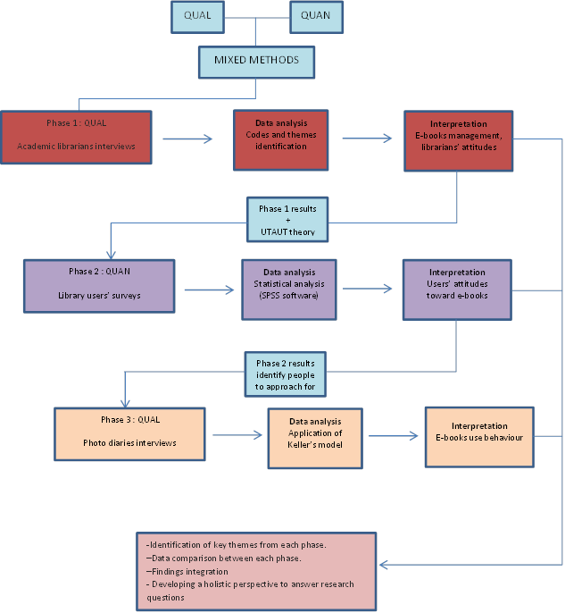

Figure 4‑3 Model of research phases

### Phase 1: Academic librarian interview

According to Creswell (2002), the qualitative approach is an instrument for understanding the meaning of social or human problems that occur either within a group or among individuals. The study of e-book management in academic libraries has not been studied widely in a Thai context. Therefore, this issue merits an exploratory qualitative approach. Another characteristic of the qualitative approach is that it helps the researcher to clarify why and how participants react as they do (Mellon, 1986). Qualitative research contains a more holistic and natural approach in order to solve that problem. Moreover, it focuses more on the subjective aspects of human behaviour and experience (Connaway & Powell, 2010).

Studying a phenomenon in its natural setting is a key characteristic of the qualitative approach as the researcher conducts a field study to collect data from the participants. Information is usually gathered by speaking to participants or observing them behave in natural settings. Face-to-face interaction is a major aspect of data collection in a qualitative study (Creswell, 2002). Moreover, a variety of data collection methods can be used, such as interview, observation, mechanical recording, and photography. Grover and Glazier (1985) also emphasise how a qualitative method facilitates the gathering of data about users’ information needs and behaviour.

In line with the characteristics of the qualitative approach explained above, this research approach is useful in exploring the challenges and opportunities involved in managing e-book collections from the perspective of academic librarians in Thailand. This approach offers the researcher an opportunity to understand the existing problems from the viewpoints of all stakeholders in the academic library context based on their real-life situations. Therefore, the qualitative method is an appropriate approach for examining participants’ experiences and behaviour in the first phase of this study.

#### Target population and sample

According to Pickard (2007), sampling is the process of selecting a part of a population as being representative of the whole in order to conduct empirical research. The population is defined as the aggregate of all cases that conform to some designated set of specifications (Chein, 1981). In conducting research, it is impossible to study an entire population due to cost and time issues. Therefore the researcher needs a sample. Selecting an appropriate scale for the sample is a significant issue with which researchers should be concerned. It is not possible when the researcher conducts a small scale study to generalise from the research findings. Similarly, a large scale and broad study might not be able to provide real detail about individuals (Pickard, 2007). Therefore, selection of the sample needs to be related to the type of study intended.

In a qualitative approach, the purpose of the study is not to generalise but to understand (Connaway & Powell, 2010). The sample is selected based on what the researcher can learn from it. Participants who can provide valuable insights into a particular phenomenon are chosen (B. Wildemuth & Cao, 2008). Generally, the researcher needs participants who have knowledge of the research questions, experience with the phenomena of interest, and have a variety of perspectives on the issues being studied (Rubin & Rubin, 2005). Purposive sampling tends to be used frequently in qualitative research as it extends the researcher’s ability to identify problems that occur in a particular condition under the study (Erlandson, 1993). The number of study participants is not so essential in the qualitative approach as the main focus is on richness, depth, complexity and quality of data collected (Connaway & Powell, 2010; B. Wildemuth, 2009). Sufficiency and saturation are used to determine the correct number of participants (Connaway & Powell, 2010). In this context, sufficiency is the effort made to include all relevant sub-populations, whilst saturation refers to the point at which, once achieved, there is little or no new information arising when new participants are added.

In this study, academic librarians from nine state universities in Thailand were chosen to take part in the interviews, where purposive sampling led to identifying the key informants who were best able to provide essential data for the researcher in answering the research questions. All of the universities were in Bangkok Metropolitan area which was seen to be a very important area as most prestigious universities were located in the area. Eventually, a total of 17 academic librarians from nine university libraries were chosen and agreed to take part in the interviews. The reason that particular academic librarians were selected was because they had direct experience of the topic and also because they were currently in charge of e-book management in their libraries. As Bradley (1993) suggests, for purposeful sampling the sample is deliberately selected because its members have certain features that are relevant to the research question.

#### Data collection (interviews)

In Phase 1, data collection took the form of interviews. Every academic librarian participant attended a semi-structured interview session.

The interview is seen as a well-established technique for collecting data as it can produce rich data and also clarify the beliefs and feelings of individuals. This method is often used in qualitative studies (Pickard, 2007). In this study, semi-structured interviews were chosen as the main method of collecting the data from academic librarians. The main characteristic of the semi-structured interview method is that it comes with pre-determined questions. Nevertheless, the interviewer can rearrange the order of questions as appropriate. The semi-structured interview has less rigidity than the structured interview but is more organised than the unstructured interview (Pickard, 2007).

In this study, semi-structured interviews were used to elicit information about e-book management procedures within Thai university libraries. All of the questions were open-ended; therefore participants were not limited in their responses to questions. Based on the research questions, the interview questions were grouped into three main topics (see Appendix 1 for the interview question outline):

1. E-book management processes.
2. Opportunities and challenges in managing e-books.
3. Academic librarians’ attitudes toward e-books.

The interview questions covered all stages of e-book management procedures. The problems and challenges in providing an e-book service to library users were also discussed in depth.

The interview script was piloted with librarians selected from the same target population, but these librarians were excluded from the study. The participants received an outline of the interview questions before the interviews took place.

#### Implementation

The interviews took place between 29 April, 2014 and 7 June, 2014. The interviewees comprised 16 women and one man. In total, there were ten interviews with 17 interviewees. Nine of the participants were librarians from acquisition and collection development departments, four from reference and user services departments, two from information and research support departments, one from an electronic resources acquisition department, and one was an officer from an audio-visual technical department. Every interview session was conducted in Thai language. The shortest interview lasted 23 minutes and the longest 95 minutes.

The interviews took place at universities in Bangkok and Nonthaburi provinces. Generally, the interviews were conducted at the participants’ institutions. The interviewees chose the locations for the interviews themselves. Each interview was done either in an interviewee’s office or in a meeting room. Six interviews took place in a meeting room in the participant’s institution. Two interviews took place in a participant’s office. Another two interviews took place at the interviewee’s work desk. The number of interviewees at each interview session varied. Six sessions were conducted with at least two interviewees from the same institution being interviewed at the same time. However, four interviews were conducted with a sole interviewee.

The interviews were recorded using a digital voice recorder. The recordings were transferred to the researcher’s laptop in MP3 format and secured with a password. A verbatim transcription was produced after each interview session had finished.

#### Data analysis

In qualitative research, data analysis normally refers to the method of producing research findings, not statistical procedures or other means of quantification (Strauss & Corbin, 1998). Morse (1994) suggests that there are certain cognitive processes to facilitate the researcher in analysing qualitative data:

* The researcher tries to understand the circumstance of the study.
* The researcher tries to find relationships occurring within that circumstance.
* The researcher tries to hypothesise how and why these relations appear as they do.
* The researcher reviews the circumstance again and relates it to what others have found before.

In the current study, the data consisted of interview transcripts and field-notes. Once all the interview sessions were completed, the data analysis process began.

As this study consists of multiple university libraries, analysis was performed both within the same university library and across the libraries. The interview transcripts were analysed for themes and then the themes were compared between each university library.

Fundamentally, the techniques used in analysing qualitative data are various. There is no single right way and methodological framework to conduct qualitative data analysis. It depends mainly on the research purpose (Punch, 2005). As Coffee and Atkinson (1996) suggest, qualitative data analysis techniques are diverse because of two components: the different questions to be addressed and the different versions of social reality that can be elaborated. However, the data analysis in this study was based on the thematic analysis approach which aims to explore both pre-determined and emergent themes within the data (Willis, 2010).

The analysis began with the transcription process. The researcher transcribed the raw data of the interview recordings. First, a de-identify number was given to each participant to avoid using the participant’s name in order to ensure confidentiality. Then, full transcripts of the interviews were produced by hand. Italicisation was used where there was an inflection of speech. All transcripts were compared to the field-notes and were read thoroughly in order to help the researcher become familiar with the data. After that, the coding process was conducted.

The coding process was done in English with a combination of two coding techniques:

* Emergent codes: the codes derived from the interview transcripts.
* Priori codes: the codes derived from a review of the relevant literature.

Initially, an emergent coding process was performed. There were two hundred codes which emerged from the interview transcripts. All these codes were reviewed thoroughly. Then, the emergent codes were compared with the codes derived from the literature review (priori codes). Similar codes were combined in order to eliminate repetition. After that, the coding categories were defined ( see example of codes and themes found from the interviews in Appendix 6). The relevant codes were classified into categories. Thus, several themes were obtained at this stage. Common themes were grouped together in order to obtain a more overall concept of the data. Separate concepts were examined further in order to discover whether there were any relationships between them. Finally, the data were presented in the form of a report.

In summary, the thematic analysis was conducted in order to:

* summarise the main stages related to e-book management within academic libraries.
* identify the main issues and challenges in managing e-book resources.
* Identify the reasons behind students’ reading choices and examine their reading behaviour.

#### Trustworthiness

In order to confirm that research findings are reliable, the criteria used to evaluate the findings should be included in the research. For qualitative research, the trustworthiness of findings can be judged by the four criteria proposed by Lincoln & Guba (1985). These are credibility, transferability, dependability, and confirmability.

* Credibility – “an adequate representation of the constructions of the social world under study” (Lincoln & Guba, 1985, p.138). There are activities that support an improvement of credibility in research findings, such as prolonged engagement in the field, persistent observation, and triangulation. The researcher needs to design transparent processes for coding and drawing conclusions from raw data. In this present study, the researcher obtained information of e-books management from both interviews (with people from different departments in the libraries) and through documents analysis (library websites) in order to ensure the consistency of the findings.
* Transferability – “the extent to which the researcher’s working hypothesis can be applied to another context”. This requires the researcher to provide rich data sets and descriptions about which others can form judgements. In this study, the researcher provided the detailed information about research setting, target population, data collection procedures and tools. Thus, the results can be applied to other similar studies.
* Dependability – “the coherence of the internal process and the way the researcher accounts for changing conditions in the phenomena”. The researcher needs to examine the consistency of the study processes. The processes within the current study were described in details systematically. Therefore, other researchers may repeat the work in the future.
* Confirmability – “the extent to which the characteristics of the data can be confirmed by others who read or review the research results”. The researcher needs to check the internal coherence of the research, which consists of the data, the findings, the interpretations, and the recommendations, by reporting the results to the participants in order to receive feedback from them. All the relevant data to this study were stored systematically and can be tracked easily. The decisions made about methods adoption were also identified. In addition, the interview results was seen by participants to ensure an accuracy of information.

### Phase 2: Library users’ survey

After all the data in Phase 1 had been gathered by means of the qualitative approach, the quantitative approach was the main method of data collection in Phase 2. This generally relies on numerical data. The quantitative approach is seen as more linear and has a more concrete framework than its counterpart (Pickard, 2007). Burns and Grove (1999) further state that quantitative research contains formal, objective, rigorous and systematic processes to generate information related to particular phenomena.

In this study, the quantitative approach was employed to obtain information about library users’ attitudes toward the usage of e-books and paper books.

#### Target population and sample

In Phase 2, the target population was full-time students and staff from nine state universities in Thailand (the same universities as the academic librarians belonged to), regardless of year and field of study. For the quantitative phase of the study, a convenience sampling approach was chosen due to the very large number of students attending those universities. The reason that this group of participants was chosen was because they were the key users of the academic libraries and also had direct experience of using both e-books and paper books, which are the main issues in the current study.

Sample size is another significant issue. Although there is a general rule that says the larger the better, there is no need to utilise a sample that is larger than necessary (Babbie, 2010). Due to the potentially huge population size in this study (as shown in table 4-5), the table for determining sample size created by Taro Yamane (1967) was utilised on this occasion in order to determine the proper number for the sample (see table 4-6). With reference to the sample size table, in which the precision level is 5%, the number of participants in this phase of the study was set at 400. Because the data was collected from students and faculty members at nine specific state universities in Thailand, the expected number of responses was approximately 50 per university.

The researcher contacted teaching staff at each university by e-mail (where addresses were obtained from the university websites) to invite them to complete the online survey. In total, 150 invitation e-mails were sent to teaching staff at all the participating universities. The researcher decided to use a paper-based survey with other library user participants because of the difficulties in obtaining a contact e-mail address for every user. Therefore, 450 paper-based surveys (50 per university) were placed in each academic library in order to make them available to any user who entered the library. In addition, participation in this survey was voluntary.

Table ‎4‑6 Taro Yamane sample size table (adapted from Yamane, 1967)

| **Size of** | **Sample Size (n) for Precision (e) of:** | | | |
| --- | --- | --- | --- | --- |
| **Population** | **±3%** | **±5%** | **±7%** | **±10%** |
| 500 | A | 222 | 145 | 83 |
| 600 | A | 240 | 152 | 86 |
| 700 | A | 255 | 158 | 88 |
| 800 | A | 267 | 163 | 89 |
| 900 | A | 277 | 166 | 90 |
| 1,000 | A | 286 | 169 | 91 |
| 2,000 | 714 | 333 | 185 | 95 |
| 3,000 | 811 | 353 | 191 | 97 |
| 4,000 | 870 | 364 | 194 | 98 |
| 5,000 | 909 | 370 | 196 | 98 |
| 6,000 | 938 | 375 | 197 | 98 |
| 7,000 | 959 | 378 | 198 | 99 |
| 8,000 | 976 | 381 | 199 | 99 |
| 9,000 | 989 | 383 | 200 | 99 |
| 10,000 | 1,000 | 385 | 200 | 99 |
| 15,000 | 1,034 | 390 | 201 | 99 |
| 20,000 | 1,053 | 392 | 204 | 100 |
| 25,000 | 1,064 | 394 | 204 | 100 |
| 50,000 | 1,087 | 397 | 204 | 100 |
| 100,000 | 1,099 | 398 | 204 | 100 |
| >100,000 | 1,111 | 400 | 204 | 100 |

Remark : a = Assumption of normal population is poor. The entire population should be sampled

#### Data collection (questionnaire survey)

The main focus of this phase was the identification of library users ‘attitudes toward e-books and print books. The data was collected by means of a questionnaire, one of the most frequently used data collection tools in the social sciences. According to (Pickard, 2007), the benefits of employing questionnaire surveys in research are fourfold: a large and dispersed community can be reached at low cost; it is more suitable for data harvesting from a larger sample than any other technique; the anonymity and confidentiality of research participants can be guaranteed; and the data analysis method can be determined at the beginning of the survey.

In order to gain a better understanding of library users’ perspectives on e-books and their acceptance of e-books in libraries, the survey was based on UTAUT constructs, with factors determining acceptance and use of technology defined by Venkatesh *et al*. (2003) adopted within it. The major factors were performance expectancy, effort expectancy, social influence, and facilitating conditions. In addition, the initial findings from the interviews were also used to develop the survey. The questionnaire contained both closed and open-ended questions. The questionnaire items were in different formats, such as multiple choice, dichotomous answers, and self-assessment items. In particular, those items related to the UTAUT model (performance expectancy, effort expectancy, social influence, and facilitating conditions) were measured using a five point Likert-type scale which ranged from strongly agree to strongly disagree. The structure of the survey is shown in the next section.

#### Questionnaire structure

The questionnaire used in this phase of study was organised into six sections:

* Section 1: Demographic questions

In this section, the participants were required to provide their information about age, gender, level of education, and field of study.

* Section 2: Awareness and usage experience of library e-book

In this section, the questions related to users’ perceptions of e-books provision and the use of e-books in their university library collections.

* Section 3: Perception and attitude of e-book

Questions in this section dealt with users’ attitudes towards e-books derived from the factors determining acceptance and use of technology of the UTAUT model.

* Section 4: Students’ expectations

Questions regarding participant expectations about e-book in the near future were included in this section.

* Section 5: General comment (Optional section)

The last section of questionnaire was an open-ended question that participant was given an opportunity to comment on e-books provided by the university libraries.

* Section 6: Invitation to additional research (Optional section)

The survey concluded with an invitation to participating in the next phase of study which was a photo diary and interview.

The survey instrument was piloted in December 2014 with 12 library users at the participating libraries. The participants were randomly invited to an online pilot survey and were asked to provide comments and suggestions regarding the format of the survey, and the clarity and readability of the survey items. Based on the comments received from the pilot participants, the questionnaire was revised. A number of alterations were made as follows:

* Demographic questions were moved into the first section of the questionnaire.
* The wording of some questions was clarified.
* Explanations of specific terms were provided.

#### Implementation

The questionnaire survey was conducted between 12th January and 31st March, 2015. To increase the response rate, the questionnaire survey in this study was developed in both web-based and paper-based formats. LimeSurvey was selected as the online survey tool to create an online version of the survey. 150 questionnaire invitations were distributed to academic staff members at every participating university library via e-mail. The convenience sampling method was used to select academic staff from within every faculty in all the participating universities. Initially, a Google search was used to identify the participating university websites. The researcher then accessed a list of academic staff from each university which included staff contact e-mail addresses. After the staff e-mail addresses were obtained, the invitations to the online questionnaire survey were sent to all staff whose e-mail addresses were available on the university websites. As university e-mail accounts are not actively used by a majority of Thai university students, an e-mail invitation approach could not be used for the student participants. Therefore, the researcher decided to put an advertisement about the survey on the Facebook page of each university library. In addition, 450 paper-based versions of the survey were placed at every participating university library for distribution to library users who visited the libraries.

#### Data analysis

Data from the completed questionnaire survey were first translated into numeric code and then exported to Statistical Package for Social Sciences software (SPSS). The data from the open-ended questions were extracted and held separately in an Excel worksheet so that they might later be subjected to further analysis through the qualitative method, which, in this case, was thematic analysis.

Although it was initially developed as statistical software for social scientists, SPSS has now gained in popularity with researchers across disciplines. It is known as a standard analytical tool for most quantitative researchers (Pickard, 2007). A number of advantages of SPSS can be identified, such as reducing the time needed to analyse numerical data, reducing the errors which occur from coding data by hand, offering various types of in-depth analysis of data, and providing clear presentation of the results in the form of charts and reports (Pickard, 2007). In this phase, SPSS was initially used to generate frequency tables and descriptive results of the data. In addition, the software was employed to examine correlations between the factors adopted from the UTAUT model.

The data from the open-ended questions in the survey were analysed using the thematic approach. First, all responses were read thoroughly. Second, codes were generated through the data. Third, the codes were categorised into themes. In this phase, there were two open ended questions in the survey: 1. Question regarding e-book characteristics 2. Question that asked participants to provide some additional comments regarding library service.

According to question about e-book characteristics, a number of codes emerged from the data, such as convenience, time-saving, ease of use etc. The researcher decided to sort the similar codes into the same category. In doing so, themes could be developed from the data. In summary, three themes can be concluded: Portability of material, features of material, and cost of material.

Findings in the second question were analysed in the same way the question about e-book characteristics. Two themes appeared in this case: suggestions that directly related to the library services, and suggestions that directly related to the e-books themselves.

#### Reliability and validity

In quantitative research, the reliability and validity of the instrument used are significant as they can decrease the number of errors that might occur in the measurement procedures.

*Reliability* refers to consistency and focuses on two aspects: consistency over time (stability or test-retest reliability) and internal consistency (Punch, 2005). In this study, stability was assured by measuring the survey instrument through the pilot testing of the questionnaire. This process was employed in case the same results were obtained after conducting the same survey with the same participants at a different time. Internal consistency was created by testing the items in the Likert-type scale during the pilot study. This was done in order to discover whether the items were consistent with each other and how well they helped to reflect the attitude of students toward the reading materials in question. The items were measured by employing a correlation matrix. The results facilitated the researcher to understand which items required rewording or even deleting.

*Validity* is the degree to which an instrument measures the accuracy of the concept or construct of the study (Punch, 2005). There are three main aspects of validity: content validity, criterion-related validity, and construct validity. Content validity was required to ascertain that the items and scores in the survey questions were representative of all the possible questions related to student attitudes toward the specific reading materials (e-books and paper books). Criterion-related validity is defined as a process to demonstrate measurement accuracy by comparing it with another measure in which the researcher has confidence (Punch, 2005). In this case, the self-designed survey questionnaire was compared with existing instruments that shared a context with the students’ reading attitudes. Construct validity relates to theoretical concept. It involves an attempt to determine how well a measure conforms with theoretical expectations (Punch, 2005).

### Photo-diary interviews

In the final phase of the study, photo-diaries and interviews were the methods selected to investigate the reading behaviour of academic library users. As stated by Keller (2012), photo-diary interviews are one of the most effective methods to clarify the reading behaviour of individuals. In addition, they are an effective means of examining participants’ behaviour from the perspective of the participants themselves without the researcher physically participating in an observation (Zimmerman & Wieder, 1977). Thus, participants’ behavioural patterns can be presented in natural settings on a day-to-day basis.

The data collection method used was a version of the photo elicitation interview method. Photo elicitation is based on the idea of integrating a photograph into an interview session (Harper, 2002). This method was initially used by Collier (1957), where the technique was used to examine how families adapted to residence among ethnically different people, and to new forms of work in urban factories. In that study, the researcher found that photographs supported the participants by sharpening their memories and also by reducing the possibility of misunderstandings (Jr., 1957). Another outstanding characteristic of photo elicitation is that it can encourage effectively the articulation of information, feelings and memories of individuals (Harper, 2002).

The purpose of the photo-diaries was to examine the reading behaviour of the library users and allow the participants to present their behaviour based on their own perspectives. Introducing the photo-diary method into this study provided the researcher with an opportunity to gain more insights into the situation. As emphasised by many researchers, photo-diary interviews allow participants to reflect on their everyday activities better (Rose, 2014; Tinkler, 2013). Furthermore, using photographs in interviews can help participants to recall memories, thus making the interviews flow smoothly and reduce the pressure of being the subject of interrogation. Photo-diary interviews also empower participants in terms of giving them a major role in explaining the photos to the researcher as they wish. The technique encourages the respondents to talk and express their feelings freely (Keller, 2012).

#### Target population and sample

The population for the photo diary interviews was obtained from the previous phase of the study, the questionnaire survey. At the end of the survey, there was a question asking for voluntary participation in a continued phase of the study, that termed the photo-diary interviews. Participants who were interested in participating in the photo-diary interviews were asked to provide their e-mail addresses so that the researcher might contact them again. Through this respondent recruiting approach, 11 respondents agreed to take part into the photo-diary interviews. The 11 participants comprised four undergraduate students, three masters students, three PhD students, and one lecturer. Table 4-7 presents the characteristics of the respondents in this phase of the study.

Table ‎4‑7 Respondents' characteristics of photo-diary interview

|  |  |  |
| --- | --- | --- |
| **No.** | **Status** | **Discipline** |
| 1 | University lecturer | Science and technology (Physics) |
| 2 | Masters’ student | Business &management |
| 3 | Masters’ student | Business &management |
| 4 | Undergraduate student | Social science (Faculty of Arts, Chinese language) |
| 5 | PhD student | Social science (Faculty of Education, Life-long learning) |
| 6 | Undergraduate student | Social science (Faculty of Arts, Philosophy) |
| 7 | PhD student | Social science (Information School, Information Studies) |
| 8 | Undergraduate student | Science and technology (Agricultural technology) |
| 9 | Masters’ student | Business & management |
| 10 | PhD student | Social science (Faculty of Arts, Thai language) |
| 11 | Undergraduate student | Social science (Faculty of Arts, Library and Information Science) |

As this final phase was dedicated to a study of user reading behaviour, participant recruitment had to be planned to ensure that the participants were able to provide significant insights into the topic of interest. For such an intensive study, the researcher looks for respondents who have the potential to provide rich data relevant to the intended study (Bernard, 2000). As this type of study aims to learn more about a specific phenomenon, a non-probability sampling approach is an efficient method of focusing on the research questions posed (Wildemuth and Cao, 2009). Thus, applying a voluntary sample to the third phase of the study ensured that the sample consisted of regular readers who read in both traditional and digital formats. In addition, the participants recruited through this sampling method also showed greater willingness to provide extensive insights into the reading behaviour topic.

#### Data collection

Each library user was asked to provide a photo-diary that documented their reading behaviour over five days. The respondents were given instructions to take photographs that represented their reading habits. They were asked to take a picture every time they read a publication, regardless of material (in either digital or traditional format), over five different days. The photos were submitted to the researcher via e-mail day by day. The interview sessions were conducted after the submission of the final photographs. In this stage, the photographs submitted by the participants were brought into the interviews as well. Thus, it was an opportunity for the participants to talk in more detail about the pictures they had captured. However, the pilot study was not conducted for this phase of study due to the limitation of time.

#### Implementation

The photo diary interviews were conducted between 1 March and 31 March, 2015. After obtaining the contact e-mail addresses of those participants who were interested in taking part in a further study, the researcher prepared the details of the photo-diary interviews before sending them to the participants. Invitation e-mails were sent to 30 possible participants. However, only 11 of them agreed to take part in the photo-diary sessions. Then, the detailed instructions on compiling the photo-diaries were sent to those who agreed to participate in the study. The instructions were as follows:

* The participants were asked to take a photograph every time they read a publication regardless of material (either digital or traditional format) over five different days.
* The participants were asked to submit their photos to the researcher every day via Dropbox.
* The participants were asked to provide more details about each photo (for example place, time and purpose) through an online form.

After the production of photo-diaries had been completed, each participant was invited to an interview. The locations of the interviews were selected by the participants themselves. There were 11 interview sessions. Five interviews were conducted in the academic institutions of the participants. One was conducted in the participant’s office. Due to limitations of place and time, five interviews had to be conducted via Skype.

The interviews started by the researcher bringing all the photos taken by each participant to the interviews and allowing the participants to talk through them one at a time. The researcher allowed the participants to lead the interviews. In this way, participants had an opportunity to elaborate their views about the photos they had submitted to the researcher. The researcher occasionally asked questions for further clarification.

Every interview was performed in Thai language and recorded using a digital voice recorder. The recordings were transferred to the researcher’s laptop in MP3 format and secured with a password. A verbatim transcription was produced after each interview session had finished.

#### Data analysis

There were two methods of analysis involved in analysing the results from the photo-diary interview approach in this final phase of study. The analysis of the findings can be divided into two parts: the photo-diaries and the subsequent interviews. Firstly, all photographs were reviewed repeatedly in order to examine the composition and objects which appeared in the photos. Primarily, specific details (place, time and purpose) of the photos provided by the participants were examined. Then, the photos were categorised into two groups – academic reading and leisure reading – based on purpose of reading. After preliminary analysis, the photo-diaries were retained for further analysis in conjunction with the interviews.

Secondly, an analysis of the interviews began with the transcription process. In this case, a verbatim transcription was applied in order to ensure an accuracy of the data. The similar qualitative coding approach was carried out, as in Phase 1. The coding process was done in English language. First, emergent codes were obtained from the interview transcripts. Second, the codes were brought to compare with a priori codes from the relevant literatures. The repeated patterns of codes were found during the coding process. Thus, the codes were categorised into the same categories in order to see an overall picture of the data. After that, themes of the data were formulated. In this phase, three main themes were identified: pattern of reading, attitudes toward reading materials, and factors related to choice of reading materials (see example of main codes and themes found from interviews in Appendix 7).

Finally, the results from the analysis of the interviews were compared to the photo-diary findings in order to explore the relationship between the two sets of results. For example, the details about place, time, and composition of photographs were brought to support the interview findings and look for the relationship between them.

## Data triangulation

As this current study combines multiple method - semi-structured interviews, a questionnaire survey, and photo-diary interviews – to collect data, this section provides clarification of how all the data were integrated. In the first phase of the study, details about e-books management at every participating university library were obtained. This provided the researcher with an insight into how e-books were treated within each library. Also, a comparison was made between the libraries. Furthermore, the interviews revealed attitudes held by the academic librarians toward e-books. This information was significant not only in answering the research questions, but also in developing the data collection tool in the second phase.

In phase 2 of the study, the researcher aimed to collect data about attitudes held by library users about e-books. A questionnaire survey was selected as the data collection tool in this phase. Alongside the UTAUT theory, which formed the basis for the model for data collection in phase 2, information obtained from librarian interviews was also used to formulate the survey. Information relating to e-books access and usage in libraries were added to the survey. In addition, questions about attitudes toward e-books services, including suggestions for libraries, were incorporated into the survey in order to investigate whether librarians and library users held common views on e-books and e-book service.

The final phase of the study focused on the actual behaviour of library users in terms of reading e-books. The findings from this phase were used to support the data about user attitudes obtained in the second phase. Moreover, the views obtained here were compared with the viewpoints of academic librarians regarding e-books usage by their users in phase 1.

The findings from all phases, especially the perceptions and actions of the academic librarians and users, were then compared and contrasted in order to perceive both similarities and differences within theme, and also the significant meanings behind those perceptions and actions. For instance, attitudes of academic librarians toward e-books were compared with users’ to clarify both similarities and the core differences between their perceptions of e-books. In addition, attitudes of the two sets of stakeholders toward each other were also compared in order to provide a clearer picture of how librarians see users and vice versa. The results of photo-diary and interviews in Phase 3 offered complementary information about users’ attitudes and behaviour of e-book use to support the survey findings in Phase 2. Finally, the results of the analysis were then used to identify factors affecting the relationship between academic librarians and library users regarding the management of, attitudes to, and usage of academic e-books in Thai libraries.

## Ethical considerations

Ethical considerations constituted a significant issue in the current study and were applied thoroughly throughout the research process. For a better understanding of ethics in research, it seems appropriate to start with background information on this topic. According to the Economic and Social Research Council (ESRC), a major UK funder for social science research, an ethical research project should be built on six major principles (Economic and Social Research Council, 2016, p.3):

1. Research should be designed, reviewed and undertaken to ensure integrity, quality, and transparency.
2. Research staff and participants must normally be informed fully about the purpose, methods and intended possible uses of the research, what their participation in the research entails, and what risks, if any, are involved.
3. The confidentiality of information supplied by research participants and the anonymity of respondents must be respected.
4. Research participants must take part voluntarily, free from any coercion.
5. Harm to research participants must be avoided in all instances.
6. The independence of research must be clear, and any conflicts of interest or partiality must be explicit.

In summary, the key issues in conducting ethical research comprise consent for the study, confidentiality, and anonymity of participants. In addition, as the photo-diary approach was used here to collect data, copyright issues relating to the photos were also a concern.

In this study, ethical issues were included in all phases of the research, following the code of practice established in the University of Sheffield’s Research Ethics Policy. Initially, an ethics application form including an information sheet and consent form was submitted to the Ethics committee in order to ensure that permission was obtained before conducting the research. As stated by (Schinke & Gilchrist, 1993), there are three criteria for developing informed consent. First, participants must be able to give their consent. Second, sufficient information must be provided. Third, consent must be voluntary and uncovered.

Thus, informed consent for this study covered information about the research, including research purpose, data collection method, and dissemination of research findings. The participants were guaranteed certain rights, any decision taken to participate in the research was voluntary, and it was acknowledged that their rights were protected.

The anonymity and confidentiality of participants were ensured. Anonymity refers to the fact that participants remain totally anonymous both during and after research procedures, while confidentiality means that the identities of all participants will not be revealed to the public (Pickard, 2007). The responses offered in this research were and will remain confidential. In case of interview sessions, pseudonyms were used when reporting the results. Real names and institutions will not be presented in the research findings report. All study data will be kept for a time and then destroyed after a reasonable period. In the case of the photo-diaries, all participants were informed about the use of pictures they had taken. As all the photos used in this study were generated by the participants, the ownership of photos is that of the participants. Permission for publishing the photos in the thesis was obtained from every participant who took part in the photo-diary interviews.

# Findings (Phase 1)

## Introduction

This chapter presents the results from the first phase of the study. It encompasses the interviews conducted with academic librarians, as they provide a first-hand overview of e-book management within Thai academic libraries. The following research questions were addressed by this element of the study:

1. How do Thai academic libraries manage their e-book collections?
2. What are the attitudes of academic librarians towards e-books and the use of e-books?

The aim was to identify the key themes relating to e-book collection management in academic libraries in Thailand. In addition, librarians’ attitudes towards e-books were also examined. Firstly, the key themes regarding approaches to e-book management are presented in the form of the e-book management stages derived from the interview sessions. The chapter continues by reporting the attitudes of academic librarians towards e-books and their perceptions of library customers’ usage of library e-books. The chapter ends with academic librarians’ views on the future role of e-books within the academic context.

## Interviewee profiles

Interviews were conducted with 17 interviewees. The purposive sampling technique was adopted for selecting interviewees. In this study, the library directors, as gatekeepers, were initially contacted. These library directors then provided the researcher with the names and contact details of people they identified as influential in the management of e-book collections in the libraries. The library staff on the lists provided by the library directors were then contacted and informed about the details of the study and scope of the interview. After acknowledging the details of the study, the librarians also suggested some additional staff who they thought might also provide useful information about library e-books.

The participants were from various departments and held different roles in the libraries. The diversity of the participants indicated that there were many different departments involved in managing e-book collections in the libraries and that different libraries were organised in different ways. Generally, e-books were looked after by the acquisition librarians from the department of resources acquisition and collection development. One library, however, had a separate acquisition department for electronic resources. Interestingly, an audio-visual technical officer was also pointed out by one academic librarian as a key informant on e-book collection management in the library. This could be implied that the library treated e-books differently from others library resources in that they were more reliant on the technical services department than other departments. It was noticeable that the participants from each institution usually comprised at least one from both the acquisition and collection development areas and one from the user support departments. This showed that library directors considered that collection, development, and user support sectors were all influential in e-book management within the libraries. Table 5-1 shows the profiles of all interviewees in this first phase of study.

Table 5‑1 Interviewee profiles

| **Library** | **University type** | **Subject specialities** | **Library’s stated vision** | **Job roles/departments** | | | | |
| --- | --- | --- | --- | --- | --- | --- | --- | --- |
| A | Autonomous | None (research intensive) | To be a leading information organisation of the university and Thai society. | (P1) Librarian: collection development & information resource analysis | | | (P2) Information specialist: research support | |
| B | Autonomous | Science and technology | To be a knowledge centre equipped with modern technologies that convenient to be accessed. | (P3) Librarian: acquisitions & collection development | | | | |
| C | Autonomous | Agricultural, technology, and innovation | To be the university’s knowledge centre, as well as, national digital library on agriculture. | (P4) Librarian: electronic resource acquisitions | | | (P5) Librarian: reference and public relations | |
| D | Public | None | To be an open university library that provides excellent service for a lifelong learning. | (P6) Librarian: acquisitions | | | (P7) Librarian: reference and user services | |
| E | Autonomous | Artistry | To be the knowledge centre that produces high quality information resources with modern technologies. | (P8) Librarian: collection development and information resource analysis | | | (P9) Librarian: reference and user services | |
| F | Public | None | To be a provider of high quality academic information resources. | (P10) Librarian: collection development and information resource analysis | | | (P11) Librarian: acquisitions | |
| G | Autonomous | Science and technology | To be a centre of information services by providing high quality information resources that meet user’s requirement. | (P12) Librarian: collection development | (P13) Librarian: collection development | | | (P14) Librarian: reference and user services |
| H | Autonomous | None (research intensive) | To provide the seamless access to information resources. | (P15) Assistant to the director: user and research support | | (P16) Audio-visual Technical Officer | | |
| I | Autonomous | None (research intensive) | To be one of the best provider of ubiquitous learning and researching in Asia. | (P17) Librarian: collection management | | | | |

## Interview findings

### Development of e-book services in Thai academic libraries

The interviews revealed that every library began their digital services by developing in-house electronic collections in the form of Institutional Repository (IR) to include, for example, student theses and dissertations, research papers, and university archives. The selected texts were scanned and converted into PDF format and then stored on the library server. In general, the documents that librarians initially chose to digitise were theses and dissertations, rare books, academic works, or even, in the case of some libraries, university exhibition programmes. Many of the interview participants were also keen to emphasise the fact that their libraries had been producing their own digital collections for more than a decade.

Our digital collections have started since 1998. We started by providing the CD-ROM collections to users. The content of those CD-ROM was mostly about art and architecture which were the major subjects of the university. (P8, Library E)

We’ve received a budget for establishing our in-house e-books collections since 2004. There were only theses and dissertations in the database at that time. (P12, Library G)

The government launched a project called the Thailand Library Integrated System (ThaiLis) in 2000. ThaiLis is overseen by the Office of the Higher Education Commission (OHEC), the aim of which is to create of a culture of lifelong learning in Thai society. ThaiLis purchases online databases and e-books for all academic libraries within public universities. As a result of this project, there are approximately more than 15,000 e-book titles (English language only) currently available in academic library collections.

There was also evidence of cooperation between libraries regarding the e-book consortium in Thailand. The Thai university e-book consortium was established in 2004 under the Provincial University Library Network (PULINET). Only one library participating in this research (Library D) was a member of the Thai university e-book consortium, however.

We have started providing e-books for around 8 or 9 years now. I think an actual start was around 2004 in the form of an e-book consortium as we are a member of the PULINET library network. Well, we take that as a starting point of having e-books in our library collection. (P6, Library D)

PULINET’s target is to build up strong local information collections and encourage collaborative sharing of information and resources among users of member libraries. Library D has so far received approximately a further 3,000 e-books (English language only) through its membership of the consortium.

Both government and private sectors had also played a part in the development of library e-book collection in some cases. Either government or private sector worked in cooperation with the library in order to develop specific e-book databases.

Furthermore, the interview findings showed that between 2007 and 2010, most of the libraries started to purchase selections of e-books from commercial e-book vendors and publishers (see Table 5-2). The number of e-books purchased varied based on different budgeting policies across the libraries (see Table 5-3). As shown in table 5-3, there was a large difference of number of e-books between libraries. Libraries in more research-intensive universities tended to have more e-books than other university libraries. Library E, however, began buying commercial e-books only as recently as 2013, the latest date of starting to purchase e-book among all the participating libraries. What is interesting in this fact is that library E, which was the first library amongst others that developed an electronic resource collection, turned out to be the last library that purchased commercial e-books for the library. Budget constraints, which were mentioned by the librarian repeatedly throughout the interview, may be a reason for this. Furthermore, the main focus of the library was about developing in-house digital collections. Thus, commercial e-book purchasing seemed to be a less important task in this case.

It was in 2013 that we officially bought e-books. We asked for approval to purchase e-books from the library executives and it was approved. However, we had to manage to buy e-books on a 200,000 THB (approximately £4,000) budget. (P8, Library E)

Well, there were so many projects regarding digital collection development running in our library. So, we just bought the new 3 e-books from Cambridge University Publisher just for avoiding the platform maintenance fee. (P8, Library E)

During the interview, the participants had also provided the researcher with details about e-books in their collections, for example, the start date, number of e-books, and the development of the in-house collection. The detailed comparisons of e-book collection between each library are provided in the following tables.

Table 5‑2 The beginning of purchased e-books

|  |  |  |  |  |  |  |  |  |
| --- | --- | --- | --- | --- | --- | --- | --- | --- |
| **Library A** | **Library B** | **Library C** | **Library D** | **Library E** | **Library F** | **Library G** | **Library H** | **Library I** |
| N/A | In 2010 | N/A | In 2004 | In 2013 | In 2008 | In 2007 | N/A | In 2011 |

Table 5‑3 Summary of e-book collection in the participating libraries

| **Library A** | **Library B** | **Library C** | **Library D** | **Library E** | **Library F** | **Library G** | **Library H** | **Library I** |
| --- | --- | --- | --- | --- | --- | --- | --- | --- |
| 31 databases  Approx. 300,000 titles | 5  databases Approx. 20,000 titles | 17 databases Approx. 40,000 titles | 10 databases Approx. 500  titles | 4 databases Approx. 200  titles | 10 databases  Approx. 20,000 titles | 10 databases  Approx. 56,000 titles | 19 databases  Approx.  200,000 titles | 19 databases Approx. 150,000 titles |

Table 5‑4 In-house developed e-book collections of the participating libraries

|  |  |  |  |  |  |  |  |  |
| --- | --- | --- | --- | --- | --- | --- | --- | --- |
| **Library A** | **Library B** | **Library C** | **Library D** | **Library E** | **Library F** | **Library G** | **Library H** | **Library I** |
| Electronic rare books,  Institutional repository | Institutional repository | Agricultural e-books,  Institutional repository | Electronic textbooks,  Institutional repository | Electronic rare books,  Institutional repository | Electronic textbooks,  Institutional repository | Institutional repository | Institutional repository | Electronic rare books Institutional repository, |

### Collection development policy

The interviews demonstrated that every library had some form of regulation for developing their e-book collections. None of the nine participating libraries had yet developed a policy written specifically for e-books or other electronic resource collections, however. Many libraries do have a dedicated section in their main library policy that covers electronic resources. Table 5-5 summarises the means of formulating the regulations in relation to e-books among the participating libraries.

Table 5‑5 Means of formulating e-books regulation

| **Library** | **Regulation on e-books** | **Remark** |
| --- | --- | --- |
| A | Included regulation on e-book collection development in the main policy | N/A |
| B | Formed guidance on e-book collection development | A policy on e-book collection development is under consideration in response to the decision of the library director |
| C | Formed guidance on e-book collection development | E-book acquisition is prioritised over print books |
| D | Included regulation on e-book collection development into the main policy | N/A |
| E | Formed guidance on e-book collection development | The regulations regarding every library resource is changeable based on the library executives |
| F | Formed guidance on e-book collection development | Budget is a main driver to develop the e-book collection |
| G | Included regulations on e-book collection development into the main policy | The regulations are changeable based on the library executives |
| H | Formed guidance on e-book collection development | N/A |
| I | Formed guidance on e-book collection development | Formal policy on e-book collection under development |

Six of the nine academic libraries had established some form of informal guidance for managing their e-book collections. Some libraries, however, showed their intentions in developing a policy for e-books. The librarians also stated that such policies were driven by decisions made by the library executives. It is noticeable that the library director’s decisions had considerable influence on the direction of collection development within Thai academic libraries. Library B, for example, has never had a collection development policy, but it was under consideration at the time of this research. The main reason for developing a policy was down to the library director.

We don’t have a specific collection development policy here… Anyway, we’re aiming to produce a kind of policy soon as it’s also an intention of our library director. (P3, Library B)

Our policy is always changing based on the decision of the library executive. (P12, Library G)

Apart from the library director’s decisions, Library F emphasised that budget was the most important driver for developing e-book collections in the library.

Well, practically we have a policy for e-resources collection development but it was never a formal written one. Instead, it was a guidance that we used. However, it was all about the budget we received each year that actually control the way we manage our library collections. (P10)

Some of the interview participants stated that e-book acquisition practices were mentioned in their main library resource acquisition policies, usually to be found as a separate section within the main policy. Similar to ARL findings (Anson & Connell, 2009), none of the participating libraries had thus far developed a specific policy on e-books and e-resources; this tended to be included in the main policy instead. Typically, the interviewees stated that methods of e-book acquisition should be aligned with university policies such as their teaching and learning objectives, a finding which is consistent with those of Vasileiou et al. (2012). Interestingly, only in Library C was the acquisition of digital resources a priority over that of their print counterparts. This does represent enthusiasm and acceptance of e-books on the part of that particular library.

In case of the book that has 2 formats (printed and electronic) available, we would consider buying the electronic format first. (P4)

The interviews show that each participating library relied on an informal approach to manage e-books and e-resources in the library. A formal policy on e-books management seemed not to be essential for the participating libraries. Rather, library executives’ decisions played a significant role in shaping collection development. However, some of the libraries featured in this study were getting interested in the idea of formulating a policy and planning to develop one for e-books in the near future.

### Budget

In order to acquire library resources, Thai academic libraries use three main sources of funding:

* University revenue - tuition fees, scholarships, donations, mutual fund dividends, etc.
* Library revenue - entrance fees, membership fees, fines, service fees (internet, printing, copying).
* Government funds –annual funds received from the government.

Table 5-6 summarises the source of budget that each library used for purchasing e-books based on the information given by participants during the interviews.

Table 5‑6 Source of budget for e-books purchase

|  |  |  |  |  |  |  |  |  |
| --- | --- | --- | --- | --- | --- | --- | --- | --- |
| **Library A** | **Library B** | **Library C** | **Library D** | **Library E** | **Library F** | **Library G** | **Library H** | **Library I** |
| University revenue | Library revenue | Government funds | Library revenue | Library revenue | University revenue | Government funds  University revenue | University revenue | Government revenue  University revenue |

For more than half of the participating libraries, most of the money for e-book purchasing came from university revenue. The others still relied on their own library revenue to some extent to buy e-books and others electronic resources. In the case of faculty libraries, although they are normally subsidiaries of the main university libraries, there is some evidence that they have certain additional sources of funding from within their own faculties. Most libraries, therefore, do have the capacity to make decisions about acquiring e-books independently if they have the budget to do so.

Apart from university revenue, there was also a case that faculty library purchased e-books by using its own faculty revenue. For example, the Faculty of Commerce and Accountancy. (P17, Library I)

The faculty libraries here have their rights to purchase any library resources if they have money. If not, they may come to us and ask for partial funding support. (P1, Library A)

None of the participating libraries, however, had separate funds allocated for acquiring e-books. Rather, e-books are acquired through the libraries’ general e-resource funds. Only Library E combined e-books and print books as the same type of resource for the purposes of acquisition. Here, the budget for e-book purchases is the same as that for print book acquisitions.

We take e-books purchase as same as print books purchase. So, both types of books were purchased with the same group of budget. (P8)

Primarily, however, the majority of participating libraries allocated 40%-60% of their total budgets to electronic resources and around 10% of e-resource funds to the purchase of e-books. Only one librarian (from Library I) was unsure about the budget allocated for e-books in the library.

…it’s difficult to tell how much exactly we had spent our budgets on e-books specifically. But for the electronic resources acquisition as a whole, we’ve spent 45% from the total budget on them. Well…, I’d say we spent around 10% of an e-resource budget on e-books. (P17)

Most of the participating libraries intended to expand their e-book collections by allocating more funds to e-book acquisition in the near future. This is consistent with previous literature that shows that a large number of academic libraries also have plans to increase the amount spent on e-books (Anson & Connell, 2009; Newman, 2010). Budget allocation seemed, however, to be one of the most problematic issues for each of the participating libraries, as the size of the budget allowed by library executives tends to stay the same while the number of library resources it is felt necessary to buy, as well as the price of resources, increases year on year.

We try to allocate more money for electronic resources. However, it was very difficult doing so because the university gave us a fixed amount of budget every year. We had tried so hard to sort this out. (P1, Library A)

We hope to buy more e-books in every year based on user’s requirement. However, some databases are very expensive. We just can’t buy it because we don’t have that much money. (P15, Library H)

### Criteria for e-book selection

A range of evaluation criteria are used when making decisions about buying e-books. Most of the participants prioritised the criteria according to their importance. Interestingly, in the interviews, the 10 most important criteria for selecting e-books were:

1. Subject coverage;
2. Recommendations made by academics;
3. Trial usage statistics;
4. Edition updates;
5. Graduate student recommendations;
6. Price;
7. Platform interface;
8. Business model;
9. The after-sales service offered by suppliers;
10. Titles not duplicated with print books.

This list of criteria is slightly different from similar lists identified by other researchers, where the cost of e-books was perceived to be the most significant issue in terms of e-book selection (Anson & Connell, 2009; Armstrong & Lonsdale, 2005; Vasileiou et al., 2012b).

Apart from subject coverage, which was the most important criteria for selecting e-books, academic’s recommendations were seen as the top criterion by every library. The interviewees stated that the reason most libraries gave preference to lecturers’ recommendations for e-book purchases is the belief held that e-books which have been selected directly by lecturers are more likely to be used by students.

We don’t choose e-books by ourselves. We normally ask our lectures to choose what e-books they want us to buy (P8, Library E)

Most e-books in our libraries were selected by lecturers. The lecturers will assign those e-books to students for reading. (P10, Library F)

The librarians also felt that every e-book selected by a university lecturer had resulted in an acceptably high usage rate. For librarians, lecturers are the main target users of e-books in the library; thus, allowing them to choose the e-books for purchase means that the number of students using those e-books will increase because the lecturers probably set student assignments which relate to the e-books they have recommended. This does, however, seem to imply that librarians see that the lecturers are significant factor influencing e-book use behaviour among students. In addition, this also reflects uncertainty about librarians’ knowledge of user needs.

Librarians are not responsible for selecting e-books to the library. If we doing so, those e-books might not support user needs and they might not be used and those e-books are very expensive. (P11, Library F)

Nevertheless, reference e-books such as electronic encyclopaedias were generally chosen by librarians themselves as the content was less specific.

In terms of the selection criteria adopted by the participating libraries, it became clear from the interviews that university students have a minor role in e-book selection within academic libraries in Thailand.

Well, we also accept the request of students regarding e-books. But the method of suggestion might not be well developed at the moment. Students might not quite sure how to submit a suggestion. (P3, Library B)

This might be connected to the problem of low usage rates for certain library e-books. There is evidence, however, that libraries do allows students to suggest book titles they would like to see in the library regardless of format. Some of the interview participants indicated that most of the titles suggested by students were in print format.

### Acquisition of e-books

The method of e-book acquisition varies from library to library. Some prefer to contact publishers directly, while others opted to make their purchases through Thai aggregators or suppliers. One participant mentioned a benefit of purchasing e-books through Thai aggregators as follows:

It was very convenient when buying e-books via the aggregator because of the after-sales services. The aggregator will take charge of most administrative tasks such as collecting usage statistics, dealing with the technical issues, and instructing the librarians in the use of different platforms. (P13, Library G)

Most of the participating libraries bought e-books from both publishers and suppliers, however. More importantly, the business models offered by publishers and suppliers are the main area of concern for all academic librarians in acquiring e-books. Generally, academic libraries have to choose between several different types of provider business model when they want to acquire e-books; they can take individual titles or packages through one-off purchases or via a subscription for a specific period. Each model has advantages and disadvantages for different academic libraries. Table 5-7 summarises the purchasing model of e-books that libraries in this study have chosen.

Table 5‑7 E-book purchasing model of the participating libraries

| **Library** | **A** | **B** | **C** | **D** | **E** | **F** | **G** | **H** | **I** |
| --- | --- | --- | --- | --- | --- | --- | --- | --- | --- |
| Subscription to e-book packages | Majority | Majority | Majority | Minority | None | Minority | Majority | Majority | Majority |
| Individual title one-off purchases | Minority | Minority | Minority | Majority | All | Majority | Minority | Minority | Minority |

In the interviews, librarians at four of the nine participating libraries (Library A, C, H, and I) expressed a strong preference for subject-based subscription package models. Subject coverage and cost-effectiveness were the main reasons given for choosing the subscription model.

The preferred purchasing model of our library would be the subscription packages model because of the diversity of subjects in the e-books package. It’s essential that we have enough e-books that support the different disciplines in the university. (P1, Library A)

One participant pointed out that subscribing to e-book packages can ensure that the library will get an updated edition of the e-books.

We need the current editions. The subscription package allows us to get a current edition of an e-book. (P16, Library, H)

Purchasing e-books in packages means that a library can receive a variety of e-book titles on a specific subject. Also, the cost per title is usually lower when a package is bought. Librarians from the remaining institutions preferred the acquisition of individual titles, however, largely because they believed that picking e-books individually meant that they could choose the most relevant titles that support user requirements most effectively.

We try to purchase e-books by a title-by-title basis because our academics have suggested it that way. Then, we want to make sure that we’ve got the right book in our library collection and it’s not going to disappear when the time past. (P6, Library D)

Budget limitations are another factor preventing libraries from selecting package acquisitions. The librarian from library E indicated that her library did not have enough in its budget to buy e-book packages, thus she believed that the title-by-title selection option would be more economical.

We buy e-books on a title-by-title basis only here because we have no enough money for the large packages subscription. Also, those e-books in our library have been carefully chosen, so the usage rate can probably be guaranteed. (P8)

The preference for acquiring individual titles coincides with several findings from previous studies (Armstrong et al., 2002; Newman, 2010).

Deciding whether to purchase or subscribe is a significant issue for all libraries. Most participating libraries therefore employed both these ownership models. The one-off purchase is still a preferred option for many libraries, however. Some of the interviewed librarians stated that they purchased e-books in the same way as print books because they wanted to avoid the platform fees that usually come with the subscription model.

The fiscal year of our library is inconsistent to the one of the foreign publisher. It’s been always very complicated for us to get the platform maintenance fee paid on time in the case of e-books package subscription. So, we’ve switched to the one-off purchase for the e-books in our library without having any platform maintenance fee to be paid. (P11, Library F)

Moreover, long-term ownership of particular books without paying an annual fee does attract academic libraries to this model. One participant even stated that the library had no budget for recurring payments for e-books. A number of previous studies found that purchase with perpetual access seems to be the chosen model for academic libraries in the UK (Anson & Connell, 2009; A. McKiel, 2008; Newman, 2010). Aside from the purchase and subscription models, one interviewee stated that a rental model for acquiring e-books was also in use. It represents that some library had tried to apply a patron-driven acquisition scheme into an acquisition of e-books.

We did try the Evidence-based selection model from Elsevier. Based on this basis, our users were allowed to try using e-books before the library buying them. At year’s end, we can decide what books we want to purchase into our library collection. (P4, Library C)

### Licence agreements

In this study, ‘licences’ defined concurrent use and other technical restrictions, such as the right to download, print, and save the information in a particular e-book. In terms of concurrent use, more than half of the participating libraries had adopted a multiple concurrent user option when signing agreements with publishers or suppliers. The numbers of concurrent users thus seemed not to be an issue for the libraries in this study. Although one library was unable to afford this multiple concurrent user option, this had so far not caused any problems for its users because the usage rate for e-books in the institution was relatively low.

In some situations we had to subscribe to e-books with a one-user license. Anyway, it’s cause no problems at all for us because it’s somewhat rare that our users access the same e-book at the same time. (P13, Library G)

Limitations that exist with downloading, printing or saving documents did seem to present a problem for some libraries, however. One obvious issue was a lack of standardisation between vendors. Different vendors had different restrictions in place about e-book access, which had caused some frustration among library users.

The problem that keeps annoying our users when using library e-books is the difference in usage restrictions between different vendors. Users have complained about that issue many times. (P17, Library I)

However, the most frequently reported issue regarding e-books usage seems to be about the library network.

Well, we didn’t get much complaint about the restriction of e-books usage. But, our users often found that it was difficult to download e-book via VPN when they were off campus. (P12, Library G)

Yeah, we sometimes got complaints from our users. It’s about download speed of e-books mostly. It’s really slow sometimes. (P7, Library D)

The technical problem that we found from e-books was about downloading. Some users just didn’t know how to download an e-book. Also, internet connection is another issue that keep annoying users. (P15, Library H)

### Promotion and user education

In the interviews, most of the librarians agreed that the pattern of student use of e-books was one of the major barriers to establishing e-book collections. The librarians claimed that their students simply did not use library e-books to any great extent. The librarian from Library C stated that:

Obviously, our undergraduate students are the main users of the university library, in that they’ve paid most for the library (included in their tuition fees), but unfortunately they use library resources the least, especially e-books.(P5)

Similarly, the librarian from Library E emphasised that:

Our users here don’t really like using electronic resources, and even e-journals can be problematic for users sometimes because they just don’t feel comfortable using them. Our users are likely to work with images or photo books mostly, so hard copy will always be the priority resources for them.(P8)

The libraries were not overlooking the issue of low rates of student use of library e-books. Rather, they had established several methods to promote e-book use among their patrons (see Table 5-8).

Table 5‑8 Promotional methods of e-books

| **Library A** | **Library B** | **Library C** | **Library D** | **Library E** | **Library F** | **Library G** | **Library H** | **Library I** |
| --- | --- | --- | --- | --- | --- | --- | --- | --- |
| Newsletter  Manual  Brochure  Facebook  E-mail  Activities | Library website  Word of mouth | Library website  University website  Touch screen bulletin board  Newsletter  Activities | E-mail  Circular letter  SMS  Library website | Poster  Circular letter  Word of mouth  Touch screen bulletin board  Library website  Activities | Library website  Brochure  Word of mouth | Circular letter  Library website  Manual  Facebook | Library website  E-mail | Facebook  Library website  Faculty library website  Activities |

There was, however, some variation in the promotional tools that the participating libraries employed. The most common tools were library websites, newsletters, library Facebook pages, e-mail and brochures. A number of other, more innovative tools had also been adopted, such as touchscreen bulletin boards, SMS (short message service), library activities (e.g. library quiz, library roadshow), and word-of-mouth. Based on the interviews, the level of enthusiasm for e-books promotion was different between libraries. The promotion of e-books was seen to be more important for some libraries than others.

There are many promotion channels for e-books. It is because our library is currently focus more on the promotional tasks. The numbers of e-books are increasing in the library, so it is necessary to promote the use of this material. (P5, Library C)

We have tried as many forms as possible for e-books promotion both online and off-line methods. We try to reach our users as much as we can. (P7, Library D)

Our library has many forms of e-books promotion: printing advertisements, electronic advertisements, and library activities. (P2, Library A)

In terms of user education, every library had developed training courses providing an introduction to the e-book database and resource utilisation. Training sessions were conducted regularly either by suppliers or librarians based on the library’s training calendar. The library could also, at the request of users, provide specific training sessions. Many libraries had also mentioned about the difficulties in conducting an e-book training session within their libraries. Most difficulties arise from library users.

Problem about conducting an e-book training session that we often found was the users who had registered to the session just did not present on the date of training. (P2, Library A)

We have several training sessions regarding the use of electronic resources that allow every user to attend. Well, it doesn’t seem to work with our student users. Only lecturers who came to those training sessions. (P15, Library H)

Throughout the interviews, many participants also emphasised the necessity to promoting e-books to increase usage rates. However, most of them never initiated any form of methods to follow up the promotional approaches they have done. In answer to a question on promotional approaches and their effect on the usage of e-books, the participants stated:

To be honest, we can’t identify how much do promotional approaches affect the usage of e-books in library. Well, it maybe because our e-books were mostly selected by lecturers, then they might ask their students to use e-books as well. So, we’re not quite sure which of these has an effect on the use of e-books in our library. (P10, library F)

Well, I’m not sure about it. But the usage report we’ve got from the publisher always looks good. (P8, library E)

The librarians suggested that e-books were still rarely used by undergraduate students, who make up the majority of the university population. Language was another barrier to e-book usage among students, as most of the academic e-books provided in the libraries were in English. Overall, however, promotion activities are seen as important for supporting e-book usage by the academic librarians.

### Usage monitoring

In evaluating e-book usage, almost every participating library relied mainly on usage statistics collected by publishers or vendors. Only the librarian from Library I stated that usage statistics for e-books in the collection were never gathered because e-books were treated in the same way as print books received in the library.

We never asked for a usage statistic of e-books we purchased from vendors. It’s because it’s not necessary for evaluation of the one-off purchase e-books. We treated those one-off purchase e-books as the same way as we do to the printed books in our collection. (P17)

In terms of user satisfaction surveys for library e-books, most of the libraries in this study had never launched any form of survey concerning attitudes to or satisfaction with their e-book collections. Library C had, however, created a survey about user satisfaction with e-books for the first time in 2014 as part of its institutional research.

## Librarians’ views about e-books

The interview findings showed that most academic librarians in this study defined e-books in very broad terms. Noticeably, when asked about the formation of e-book collections within the libraries, several electronic document types were involved in building collections. Many librarians identified several different types of electronic documents as e-books, for example, student theses and dissertations, research papers, university archives, or even university exhibition programmes.

We started from making electronic theses and dissertations in 2004. Then, we decided to buy more e-books from commercial vendors in 2007. (P12, Library G)

Well, it’s a long story. We’ve been doing this for 10 years starting from student’s thesis, exhibition programmes, and rare books. (P8, Library E)

The interview participants did mention several advantages of e-books. The most frequently cited advantages were 24/7 accessibility, time saving, and ease of retrieval. Generally, the majority of the librarians in the interviews perceived the benefits of e-books. Interestingly, one librarian seen e-books as an intangible resource.

It doesn’t matter how many e-books we have in the collection because it’s in the database, intangible, needs no shelf-space, expensive, and all gone after the contract has ended. (P7, Library D)

Some participant compared e-books to e-journals in terms of popularity and usability.

When compared e-books to e-journals, it seemed like e-journals were used more often than e-books. It’s because there are a lot more up-to-date information, variety of content, and easy to browse and select the information we need. On the other hand, e-books are a bit difficult to search for. (P10, Library F)

It’s totally different in terms of usage. For example, the usage of the CRC Netbase e-book collection that we bought seems to be either decreased or stays the same year after year as same as printed books. However, the use of e-journals in the databases seems to be the other way around. The usage of e-journals here is constantly increasing. I think maybe because e-journals are always up-to-date, but e-books are not. (P15, Library H)

One participant commented on a limitation of e-books, however, as they require a somewhat reliable internet network to use them effectively, especially for off-campus usage. In addition, unreliable internet services seemed to be a common problem for users of e-books in the Thai academic sector.

Well, in my opinion I think e-books rely heavily on the internet network. E-books mean nothing if the internet connection goes down. (P12, Library G)

Many of the interviewees still felt reading from a screen to be uncomfortable or unnatural. Furthermore, the sensation of reading a physical book was reported to possess a significance not replicated when reading books electronically. Some of the librarians mentioned about a generation gap between the librarians and users in terms of reading format preferences. This was only a general assumption, however, as the librarian still had no proof about how users experienced reading on screen.

One thing that makes me feel uncomfortable with e-book is it has to be read on screen. Well, maybe because I’m an old lady. If you go talk to our students, they might provide you with the different views. I mean they might say they really like reading from a screen (P2, Library A)

E-books are good for the new generation of kids, but not for us. (P6, Library D)

I know that e-book has many benefits, but I think people still want printed version. Well, the answer might be different if you ask this question to the teenagers. Maybe. Well, I don’t know. (P5, Library C)

## Librarians’ views about the use of e-books among library users

During the interviews, the participants occasionally expressed their views about the use of e-books among library users. Fundamentally, their views on users can be categorised into two groups: views on the lecturer users, and views on the student users. Based on the interviews, university lecturers were the main users and also the selector of e-books in the library. There were mixed opinions about lecturer users stated by academic librarians. Some of them had positive views, while others expressed some negative ones. It is noticeable that generation gap plays an important role again in this case. Many librarians stated that senior lecturers were reluctant to use e-books, while young lecturers had no problem using them.

Some of our senior academics are still not comfortable with e-books. (P2, Library A)

Some of our senior lecturers are not quite happy to use e-books. (P6, Library D)

We normally inform our lecturers everytime there is a new e-book in library collection. They just acknowledged it, but never used. Our academics here are not keen on digital stuff. (P8, Library E)

What we can notice is our young lecturers here prefer to use e-books while other senior staffs still prefer printed version. (P15, Library H)

The librarians’ views on student users are relatively negative. During the conversation about the promotion and marketing of library e-books, many of the participants mentioned the low usage rate of e-books in their library due to a lack of interest from users:

The use of e-books here? Well, it depends on students. Sometimes they just don’t want to read any academic texts no matter what kind of formats the texts are. It’s in their nature. (P1, Library A)

Our users here are not really keen electronic readers or researchers. So our user requirements for e-books are not that high. (P6, Library D)

Our users don’t use e-books if it’s not necessary. I mean if it’s not required by their lecturers, they won’t come to e-books. (P8, Library E)

Our users have not used e-books that much. (P10, Library F)

The undergraduate students are the group of users who use e-books at the lowest rate. (P5, Library C)

Moreover, some of the librarians stated that while there was evidence of e-books being downloaded by library users, many of these users tended to print e-books out before reading them.

It’s ridiculous that our users have access to e-books in the library, but end up printing the book out for reading. (P15, Library H)

Apart from user interests, the librarians also expressed their views on user capabilities as most e-books in library collection are in English language. Some librarians were unsure about the language skills of their students.

As the fact that we’re an open university, our students are less capable especially the English language skills. So, our students here use e-books less than other universities. (P7, Library D)

English e-books have been rarely used here. Maybe because our users are not keen on English. They only come to e-books when it is necessary. (P9, library E)

Thai students are not keen on e-books. (P10, Library F)

Thai students don’t like reading English texts. (P15, Library H)

Teaching and learning system was seen as an influential factor that affect the usage of e-books among students. One librarian gave an opinion on this point interestingly.

To be honest, undergraduate students here don’t use e-books because e-books don’t support their studying at all. (P7, Library D)

## The future roles of e-books

The majority of the interviewees, 12 in total, agreed that the use of e-books in the academic world would certainly grow over the next five to ten years, largely because of the current ongoing development of technology in Thailand. This growth was nonetheless seen as being dependent on several factors such as the availability of Thai language e-books, as Thai e-books are still found only infrequently, especially in an academic context. One obvious obstacle to the introduction of more Thai academic e-books seemed to be copyright issues. Although most of the librarians believed that e-book usage would increase in the near future, they felt that the speed of this growth might be gradual. More than half of the participants stated that e-books would remain supplementary to print books for the foreseeable future. The issue did depend on the type of book in question, however. According to the participants’ views, reference books would virtually all be transformed into electronic versions and the print versions would disappear. For textbooks, electronic versions would co-exist with print copies. Some of the librarians stated that the rate of adoption would vary across different academic subjects; adoption rates in the disciplines of science, technology, engineering, and medicine would probably be greater than in the social sciences and humanities.

Taking a very different line, two of the interviewees were somewhat negative about the future of e-books. They indicated their opinion that e-books would not gain in popularity among users unless print books became extinct. They based this forecast on behaviours shown by their library users, who only read e-books when instructed to do so by lecturers or when they had no other choice. These librarians posited that students rarely read e-books willingly. Also, in agreement with two other participants, they expressed the view that about 70-80% of students still preferred print books, basing this statement on a statistical report from their circulation department. The user adoption issue seemed to be a problem shared by all the participating libraries.

Most participants agreed that libraries needed to prepare for changes in user behaviour in the near future, which might be affected by the increased use of innovative technology. They expressed similar opinions about library space allocation. More than half of the participants indicated that there were plans to dedicate more space in their libraries to information technology usage by providing more IT facilities such as computers and other necessary devices. They also stated that every library had limited space for physical book storage. Supporting electronic resource usage hence poses a possible solution to this problem.

## Conclusion

It is clear that academic libraries in Thailand are entering the digital arena, perhaps largely due to the fact that they enjoy strong support from the government in expanding the provision of electronic resources across all university libraries. Moreover, the majority of universities in Thailand have more than one campus; therefore they see e-books as a solution to the issue of offering library resources equally to all users. E-book services in Thai academic libraries are still very much in their infancy, however, in the sense that it is only a few years since e-books were first introduced into library collections. This relative newness also contributes to the fact that none of the libraries has yet developed a formal procedure for the management of e-book collections, or even the wider range of electronic resources. Furthermore, none have so far allocated a separate budget for the acquisition of e-books. All the academic libraries in this study seemed to rely on suggestions from academics to guide e-book selection, which implies that librarians were somewhat uncertain in their knowledge of e-book acquisitions, while decisions about budget allocations were in the control of library executives only. Apparently, the management of e-books collection within the participating libraries is relied on two main factors: library director’s intention, and budget that has been allocated to each library.

Although most of the academic librarians interviewed forecasted growth in e-book adoption in the next few years, opinions varied as to the speed at which this would occur. Some librarians felt that e-books might gain a position of dominance only within certain specific academic disciplines. Moreover, a few dissenting librarian voices argued that e-books might struggle to gain acceptance in Thai academic society because of a user culture that still retains a strong preference for print books. Accordingly, a common barrier to the development of e-book collections in libraries, and ones that were mentioned quite frequently, seems to be a lack of interest in reading e-books among university students and a lack of English language skills especially among undergraduate students who form the majority of the university population. Moreover, the interview results also reflect the attitude of academic librarians toward teaching and learning system of higher education. The rise of e-books will, however, inevitably necessitate various changes to academic libraries. Most libraries are already making some preparations for such changes, such as redeployment of library spaces and provision of IT facilities

# Findings (Phase 2)

## Introduction

This section presents the results obtained from the library user survey. The section begins with preliminary analysis regarding the sampling, followed by a further examination of the data. The section also aims to identify statistically significant relationships between different factors by presenting the results of the correlation analysis between variables. In this second phase, the survey aimed to answer the following research question:

What are the attitudes and behaviours of library users in relation to print books and e-books?

The survey approach was then used to examine library users’ attitudes towards both print and e-books. In addition, it aimed to explore the factors that have influence on an acceptance and use of e-books among the library users. The survey incorporated ideas which had emerged from Phase 1 (interviews with academic librarians). The theoretical framework that provided the foundation for a construction of the survey was the Unified Theory of Acceptance and Use of Technology (UTAUT) and the framework commonly used for similar studies.

## Response rate

The survey was delivered to target respondents in both online and paper-based formats. 450 paper-based surveys were sent to the nine participating university libraries in Thailand (50 surveys per institution). In addition, 150 invitations to respond to the online questionnaire were sent to academic and teaching staff within the nine universities (staff members whose e-mail addresses were available on the faculty website) via e-mail. Due to the huge potential population in this study (more than 200,000 library users), the table-based method of determining sample size created by Taro Yamane (1967) was employed here to determine the correct number for the sample (see Table 4-7 for more details). The Taro Yamane table (1967) suggested, for example, that where population size in the study is more than 100,000, a legitimate sample size would be 400. To distribute the survey equally to every participating library, 50 paper-based surveys in total were provided for each library together with 150 electronic surveys for academic staff. Consequently, the appropriate number of surveys for this study was 600.

Due to the difficulties in obtaining an e-mail address of every library user, the paper-based surveys were distributed randomly among users who visited the libraries. 353 paper-based surveys were returned, which is a response rate of approximately 78%. 66 responses were obtained from the online questionnaire, which is a 44% response rate. In total, 419 completed responses were received from participants. This produced an overall usable response rate of 69%. The majority of responses came from the paper-based version of the questionnaire. In general terms, the total number of responses represents a relatively high response rate for the survey and shows that a paper-based questionnaire may be a more effective approach for conducting a survey within the Thai academic community, since here, it gained a much higher response rate than the online version. The reason behind this might simply be that the majority of the target population found completing a paper-based survey less complicated than answering an online questionnaire. Furthermore, e-mail correspondence does not seem to be an effective means of communication in the Thai academic sector.

## Respondent characteristics

The survey produced demographic profile information about the respondents. In terms of gender, 51.6% (or, in number, 216) of the respondents were male and 48.4% (203) were female (see Table 6-1). The numbers of male and female respondents were thus almost evenly proportioned.

Table 6‑1 Gender of participants

|  |  |  |
| --- | --- | --- |
| **Gender** | **Frequency** | **Percentage** |
| Male | 216 | 51.6 |
| Female | 203 | 48.4 |
| **Total** | **419** | **100** |

The respondents came from a range of different age groups, from under 21 years old to 61-65. The majority of participants were in the 21-25 age range (approximately 51% or 215). Around 17% (70) of the sample belonged to the under 21 group. The remaining 32% were aged between 26 and 60 (see Table 6-2).

Table 6‑2 Age of participants

|  |  |  |
| --- | --- | --- |
| **Age group** | **Frequency** | **Percentage** |
| **Under 21** | 70 | 16.7 |
| **21-25** | 215 | 51.35 |
| **26-30** | 26 | 6.20 |
| **31-35** | 18 | 4.29 |
| **36-40** | 35 | 8.35 |
| **41-45** | 13 | 3.10 |
| **46-50** | 18 | 4.29 |
| **51-55** | 12 | 2.86 |
| **56-60** | 10 | 2.38 |
| **61-65** | 2 | 0.47 |

In terms of status, 65% of the respondents identified themselves as undergraduate students. The next largest groups were lecturers at 19% and postgraduate students at 16% (see Table 6-3). It should be noted that levels of teaching personnel in universities in Thailand are slightly different from the UK. In Thailand, the assistant professor grade is equal to the senior lecturer in the UK.

Table 6‑3 Academic status of participants

|  |  |  |
| --- | --- | --- |
| **Status** | **Frequency** | **Percentage** |
| **Undergraduate** | 273 | 65.2 |
| **Postgraduate** | 37 | 8.8 |
| **PhD** | 31 | 7.4 |
| **Lecturer** | 39 | 9.3 |
| **Assistant Professor** | 29 | 6.9 |
| **Associate Professor** | 8 | 1.9 |
| **Professor** | 1 | 0.2 |
| **Other** | 1 | 0.2 |
| **Total** | **419** | **100** |

Among the sample, 65% indicated that they belonged to the social science and humanities disciplines and 35% to STEM (science, technology, engineering and mathematics) subjects (see Table 6-4).

Table 6‑4 Participants' fields of study

|  |  |  |
| --- | --- | --- |
| **Field of study** | **Frequency** | **Percentage** |
| **Humanities and social sciences** | 273 | 65.2 |
| **STEM** | 146 | 34.8 |
| **Total** | **419** | **100** |

In terms of overall past usage of e-books, the majority of the respondents (66%) indicated that they had experience of using e-books for both work/study and personal reading purposes. Approximately 17% of the respondents stated that they had used e-books only for work/study. 5% had used e-books for personal reading only. 12% of the respondents, however, reported that they had never used e-books before (see Figure 6-1). In the constituent groups, around 40% of the respondents who had used e-books for both purposes were undergraduate students, 14% were lecturers, and 12% were postgraduate students (see Figure 6-2).

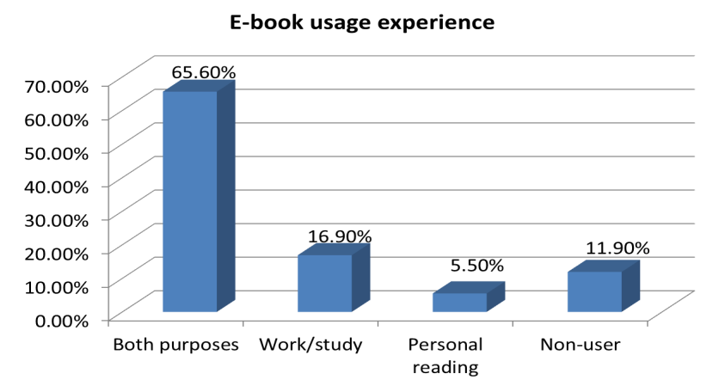

Figure 6‑1 E-book usage experiences

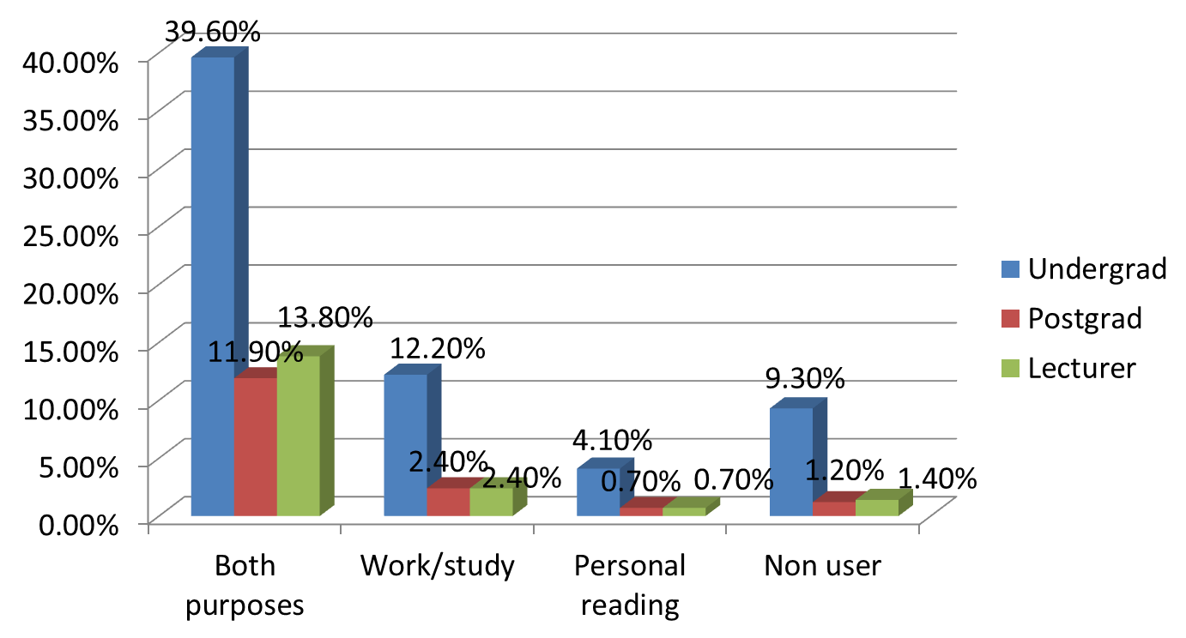

Figure 6‑2 E-book usage experiences (by academic status)

## E-book awareness

Approximately 62% of the participants stated that they were aware they could access e-books via their university libraries. Around 38% did not know that their libraries offered e-books, however. In terms of the status of participants, the results show that 34% of undergraduate students knew that they could access e-books through their libraries. Interestingly, around a third of the undergraduate students (31%) stated that they either could not use e-books from their university libraries or were unsure whether their libraries actually provided e-books. In contrast, the majority of postgraduate students and academics (74% and 81% respectively) were aware that e-books were offered by their university libraries.

40% of the sample who were aware that e-books were provided by their university libraries stated that they knew this because it featured on the library website. Other sources of knowledge about e-books access most commonly mentioned were: friend/colleague (19%), librarian (18%) and lecturer (16%). Library catalogue (13%), publisher website (13%) and search engine (13%) were the other sources that featured regularly in the respondents’ answers. Course syllabus, library newsletter and poster were less frequently mentioned by respondents in terms of available information regarding the availability of e-books in the university library, however. The findings indicate that many undergraduate students, who were the major patrons of the library, still not aware that their libraries provided e-books. As the results showed that library websites were the main channel for accessing e-books, however, these have the potential to be used as a channel to promote e-books as well.

## E-book usage

In terms of the ways in which respondents used e-books, the most frequently mentioned use was for academic purposes. 36% of participants stated that they used e-books for dissertation/thesis writing. From the other responses, 31% said they used e-books for dealing with course assignments, 28% for personal interest and curiosity, 19% for writing journal articles/books, 13% for examination preparation, 12% for preparing lectures, and 8% for leisure reading. These results suggest that e-books seem to be a better source of information for dealing with academic tasks. This is probably because e-books may be easier to access than other print resources.

Regarding how e-books provided by the university library were accessed, around 50% of respondents used laptop computers, 30% used desktop computers, 26% used smartphones, 16% used tablet PCs, and 3% used e-book readers. In other words, the most popular devices for reading e-books in university libraries are laptop and desktop computers. Smartphones appeared to be more popular for e-book reading than tablet PCs in this case. Library users have, however, still not embraced e-readers to any great extent for reading e-books offered by the university library.

In terms of the types of e-book on offer, 41% of respondents read research monographs, 39% read textbooks, 7% selected fiction, a further 7% chose reference books, and 2% used other types of e-books. Based on these results, research monographs and textbooks seem to be the most widely utilised e-book resources in Thai academic libraries.

Participants could choose multiple answers regarding their use of e-books. There were 516 answers to this question. 40% of the participants indicated that they read only selected parts of e-books. 34% preferred to download an e-book to read it off-line. 19% responded that they were likely to use the ‘search within the text’ function when utilising e-books. 15% said they used e-books by skimming through them from beginning to end. 9% of respondents chose to print out an e-book to read it whenever they needed. Only 5% of the respondents stated that they read e-books thoroughly from cover to cover. In summary, therefore, e-books are rarely read all the way through; rather for targeting selected sections. Moreover, users tend to download e-books for offline reading.

## Library users’ perceptions of e-books

One of the survey items (an open-ended question) asked the respondents to identify the key characteristic of e-books. The results show that three major characteristics were mentioned by the participants more frequently than others, which were: 24/7 accessibility, portability, and cost saving. These results seem consistent with what had been reported in the earlier questions. In the question about usage, the results showed that most participants used e-books for dealing with academic tasks. It therefore seems reasonable to suggest that respondents in this study saw accessibility and portability as the key characteristics of e-books. Furthermore, several participants considered cost saving as another main characteristic. Many of them stated that e-books were cheaper than print books, and they could save storage space and cost.

Some respondents pointed out, however, that the need for an electronic device to use e-books could be a limitation. One of the participants gave an interesting comment regarding this issue, as follows:

You definitely need at least an additional device to read e-books. Without that, e-books are useless.

Based on the findings, a few respondents showed some misunderstandings about e-books. One respondent had confused e-books with online databases:

E-books contain a variety of books in one place.

Another respondent believed that e-books can always be accessed for free from the internet:

E-books can always be read online for free, so I can save a lot of money that way.

## Respondents’ attitudes towards e-books

The results from the survey with regards to general attitudes of participants in relation to e-books are presented in the following sub-section.

### General attitude

One survey section focused on respondents’ attitudes to e-books. They were asked a series of questions about their preferences and behaviours. The results from this section are presented in Figure 6-3.

Figure 6‑3 General attitudes of respondents towards e-books

The first of these questions asked about the most commonly used format of books, print or electronic: “As regards books, I mostly read print books”. Overall, 88% of respondents agreed with this statement. This result shows that print books retain their dominant status as the material of choice for most users.

The next statement attempted to capture the changing behaviours of respondents: “Because of e-books, I now read fewer print books”. In answer, 37% of the responses agreed, 33% disagreed, and 30% were neutral. In this result, the number of ‘agree’, ‘disagree’ and ‘neutral’ responses were almost equal. This implies that the advent of e-books has had some effect on print book reading behaviour among the participants. Meanwhile, a considerable number of respondents did not think that e-books would change their reading behaviour.

The third statement tested the extent to which respondents were satisfied with the current level of access they had to e-books: “I have online access to all the books I want to use”. Around 38% of responses agreed, 31% indicated disagreement or neutrality. In terms of this result, it seems that while many respondents had no difficulty in accessing e-books, a comparable number of other respondents were still not satisfied with the level of access to e-books they had.

“My use of e-books complements my use of printed books” was a statement designed to gauge the perceptions of the relationship between print and e-books amongst respondents. 62% of respondents stated that they agreed with this statement, 24% of responses were neutral, and 13% disagreed. The result suggests that e-books have so far been used mostly as complementary material to print books.

The next statement was designed to solicit views on the way respondents tend to read print as opposed to e-books: “When I want to read a book from cover to cover, I prefer a print book”. Approximately 79% of respondents either agreed or strongly agreed with this. 7% of responses were neutral, and almost 5% either disagreed or strongly disagreed. In terms of this result, it is clear that print books retain a high level of popularity among library users when they need to read material thoroughly.

The greater importance assigned to print books was also evident in response to the statement, “For my research/study needs in general, I prefer the library to purchase e-books rather than print books”. The numbers of ‘agree’ (34%), and ‘strongly agree’, (19%) responses can be compared with only 13% who disagreed, and 3% who strongly disagreed (32% were neutral responses). The result indicates that respondents prefer to use e-books rather than print books for research/study purposes.

## Responses to questions related to the determinants derived from the UTAUT model

The survey items in the following subsections were designed to reflect the determinants in the UTAUT model (performance expectancy, effort expectancy, social influence, and facilitating conditions). Although these categories were not apparent to users, the questions were grouped to reflect these key areas to enable subsequent analysis in relation to the UTAUT factors. The first section, therefore, which included questions on e-book functionality and its impact on respondents’ working patterns, were designed to relate to the ‘performance expectancy factor’. In the second section, questions were related to the ‘effort expectancy’ factor. In the third section, questions were related to ‘social influence’. In the fourth section, questions were related to the ‘facilitating conditions’. Primarily, the questions aimed to examine library users’ perspectives and acceptance of e-books. The structuring of the questions in this survey enabled the analysis of the results to explore the factors that influence the use and acceptance of e-books.

### Performance expectancy

The statements below indicate the degree to which library users believed that using e-books would help them accomplish the desired task effectively (Responses are shown in Figure 6-4).

Figure 6‑4 Responses concerning performance expectancy

The findings represented that the majority of library users (80%) thought that e-books provided them with access to up-to-date materials. Around 60% agreed that using e-books helped them finish their work more quickly. Only around 30%, however, seemed interested in e-books’ links to other resources. Less than a quarter of the participants (22%) thought that e-books were more useful than print books.

These results show that although e-books could assist the respondents in improving their job performance, their usefulness did not always compare to print books. Nevertheless, the majority of respondents were very satisfied with the way in which e-books could lead them towards other up-to-date materials.

### Effort expectancy

The statements below indicate the degree of ease with which participants perceived they could use e-books (Responses are shown in Figure 6-5).

Figure 6‑5 Responses concerning effort expectancy

According to Figure 6-5, a large number of respondents agreed that e-books were easy to use (70%), could be used in a variety of environments (77%), and were more portable than print books (78%). In terms of ease of reading, however, slightly less than half of the respondents (49%) agreed with the statement.

In general, the respondents showed a similarly positive attitude towards the effort expectancy of e-books to that exhibited for the performance expectancy variables. In other words, the majority of participants found e-books convenient to use. Clearly, many respondents felt that e-books could be used in a variety of environments, whether at work or for study. The portability of e-books is another feature that many users agreed was an advantage over print books. Nevertheless, a number of users were still not sure about how easy e-books were to read.

### Social influence

The statements below indicate the degree to which the library users perceived that others believed they should use e-books. (Responses are shown in Figure 6-6)

Figure 6‑6 Responses concerning social influence

The findings in this section demonstrate that social influence had a minor effect on the respondents regarding e-books use. In terms of the recommendations of others regarding e-books, many respondents (40%) were ‘unsure’ if they were often recommended to use e-books by friends or family. In addition, the number of respondents who agreed that using e-books was fashionable (37%) was almost equal to the respondents who were not sure about this statement (35.6%). Less than half of the respondents agreed that their libraries supported the use of e-books (46%). In addition, only 44% agreed that academic librarians were helpful around the use of e-books.

The results show that the social influence factors explored in the survey were not particularly significant for library users in terms of making the decision whether to use e-books or not. As shown in the findings, most participants neither totally agreed nor disagreed with any of the statements provided.

### Facilitating conditions

The statements below indicate the degree to which the library users believed that their university libraries supported their use of e-books adequately. (Responses are shown in Figure 6-7)

Figure 6‑7 Responses concerning facilitating conditions

Most respondents agreed with the statements regarding facilities and assistance provided by their libraries in relation to e-book use. 46% agreed that there were necessary facilities for e-book usage provided in the library. 52% were satisfied with the assistance they received when experiencing any difficulties with e-books. In terms of knowledge required for using e-books, the number of respondents who agreed that they had knowledge to use e-books (48%) was close to those who were unsure about their knowledge (40%). Moreover, a considerable number of participants were not sure about the compatibility of library e-books and the electronic devices they owned.

Overall, the results show that the respondents perceived that their university libraries were providing some of the necessary technical infrastructure to support the use of e-books in the library. The responses were, however, somewhat ambiguous overall in the sense that the responses often differed and conflicted. In general, it appears that the respondents were undecided whether to agree or disagree with the statements regarding the facilitating conditions variables.

## Analysis of variables

Based on an amended UTAUT model, a further research model used in this thesis (see Figure 6-8) was the Pearson correlation coefficient analysis. This was conducted to test the relationships between constructs, including independent variables (performance expectancy, effort expectancy, social influence and facilitating conditions), dependent variables (behavioural intention to use e-books and use behaviour), and moderators (gender, age, status and field of study).This study attempted to discover whether any of the variables had an effect on respondents’ intention to use e-books, as obtained from the ‘intention’ question, which asked participants whether they intended to use e-books in the future (question 15 in the survey) and usage behaviour among library users (questions 6-12 in the survey). The corresponding survey items can be found in full in Appendix 2.

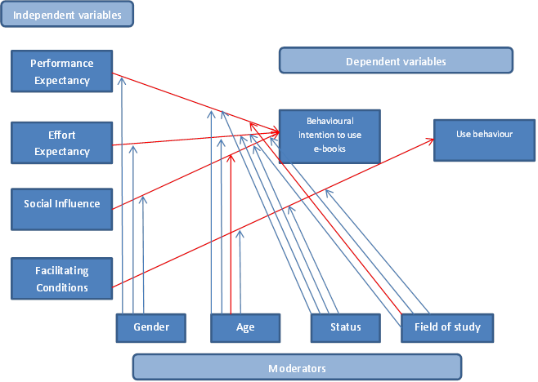

Figure 6‑8 Results of the variables analysis

Remark: A red line means that there is a relation between variables

As the first stage, the independent variables – performance expectancy (PE), effort expectancy (EE), social influence (SI) and facilitating conditions (FC) – were tested to reveal whether these variables had any influence on the behavioural intention (BI) to use e-books and usage behaviour exhibited by library users.

Table 6-5 below presents the mean values and standard deviations of all independent variables and dependent variables in the research model.

Table 6‑5 Means values and standard deviations of dependent and independent variables

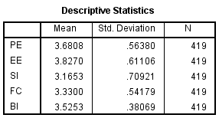

Table 6-6 provides the result of the Pearson correlation analysis to test the relationships between the UTAUT constructs. It shows the relationship between performance expectancy (PE), effort expectancy (EE), social influence (SI), facilitating conditions (FC) and library users’ behavioural intentions (BI) to use e-books to be positive and statistically significant (r = .709, Sig. = .000, r = .600, Sig. = .000, r = .758, Sig = .000, and r = .670, Sig = .000, respectively). This suggests that the respondents’ behavioural intentions to use e-books originated from their perceptions of e-book performance, the effort required to use e-books, support from the university library, and the influence of others regarding e-book use.

Table 6‑6 Correlation of independent and dependent variables

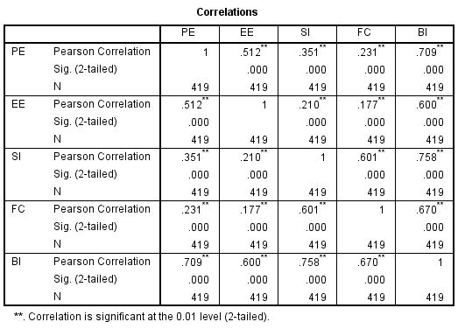

### Moderating variables

In the research model, the moderating variables – gender, age, status, and field of study – were included as constructs. In order to discover whether the relationship between dependent and independent variables is affected by the moderating variables, an analysis of these variables is provided as follows.

Table 6-7 shows the relationship between gender and three of the independent variables (PE, EE, and SI). The result indicates that there is no significant difference between the two genders with regard to performance expectancy (r= -0.25, Sig = >0.05), effort expectancy (r = -0.19, Sig = >0.05) or social influence (r = 0.11, Sig = >0.05).

Table 6‑7 Correlation of gender and dependent variables

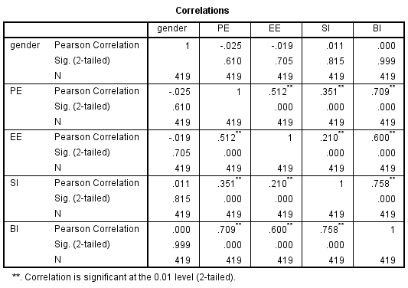

Table 6-8 shows the relationship between age and the four independent variables (PE, EE, SI and FC). The result demonstrates that the relationship between social influence and behavioural intention to use e-books can be moderated by age (r = .098, Sig = .045). There is, however, no significant difference between age groups in terms of performance expectancy (r = 0.067, Sig = >0.05), effort expectancy (r = 0.094, Sig = >0.05) or facilitating conditions (r = 0.066, Sig = >0.05).

Table 6‑8 Correlation for age and dependent variables

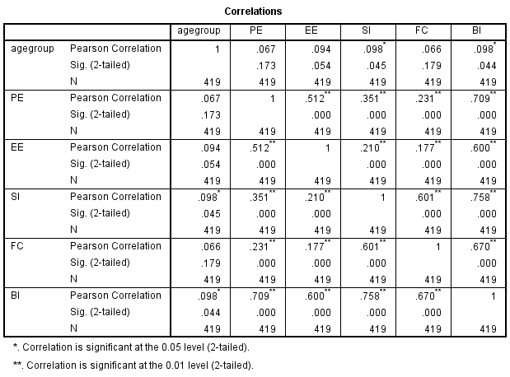

After further analysis, the results show that the effect of social influence on behavioural intention to use e-books is stronger for older users. Table 6-9 shows that the relationship between social influence and behavioural intention to use e-books among 36- 65 years old users can be moderated by age (r = .230, Sig = .029)

Table 6‑9 Correlation for age group and social influence



Table 6-10 shows the relationship between respondent status and the four independent variables (PE (r= 0.024, Sig = > 0.05), EE (r= 0.017, Sig = >0.05), SI (r = 0.012, Sig = >0.05) and FC (r = 0.024, Sig = >0.05)). The result indicates that none of those independent variables are affected by the status of library users.

Table 6‑10 Correlation for status and dependent variables

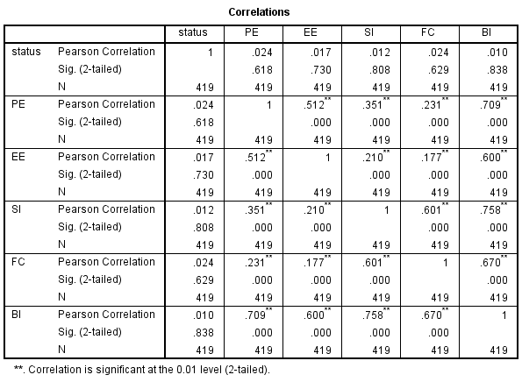

Table 6-11 represent the relationship between field of study and the dependent variables. The result shows that the relationship between facilitating conditions and behavioural intention to use e-books is moderated by social science subjects (r = -.139, Sig = .022). There is no significant difference between field of study and effort expectancy (r = .021, Sig = >0.05), social influence (r= -.079, Sig = >0.05) or performance expectancy (r= -.085, Sig = >0.05), however.

Table 6‑11 Correlation for field of study and dependent variables



## Summary of variables analysis

The results of the variable analysis highlight a number of key points. For the survey respondents, performance expectancy, effort expectancy, social influence, and facilitating conditions were shown to influence both behavioural intention to use e-books and usage behaviour. Furthermore, the analysis shows that the relationship between social influence and behavioural intention is moderated by age. This implies that the effect of social influence upon behavioural intention to use e-books is stronger among older respondents. In addition to age, participants’ field of study also affects the relationship between performance expectancy and behavioural intention to use e-books. An overview of the relationship between variables and its significance level is provided in Table 6-12.

Table 6‑12 Summary of tested hypotheses

|  |  |  |  |
| --- | --- | --- | --- |
| **H** |  | **Sig. (2-tailed)** | **Result** |
| 1 | Performance expectancy positively affects user’s behavioural intention to use e-books | .000 | Accepted |
| 2 | Effort expectancy positively affects user’s behavioural intention to use e-books | .000 | Accepted |
| 3 | Social influence positively affects user’s behavioural intention to use e-books | .000 | Accepted |
| 4 | Facilitating conditions positively affects user’s behavioural intention to use e-books | .000 | Accepted |
| 5 | The relationship between PE, EE, and SI and behavioural intention to use e-books can be moderated by gender | No significance of the difference between these variables | Rejected |
| 6 | The relationship between social influence and behavioural intention to use e-books will be moderated by age | Significant difference (at 0.05level) in correlation coefficient | Accepted |
| 7 | The relationship between PE, EE, and FC and behavioural intention to use e-books will be moderated by age | No significance of the difference between these variables | Rejected |
| 8 | The relationship between PE, EE, SI, and FC and behavioural intention to use e-books will be moderated by status | No significance of the difference between these variables | Rejected |
| 9 | The relationship between performance expectancy and behavioural intention to use e-books will be moderated by field of study | Significant difference (at 0.05level) in correlation coefficient | Accepted |
| 10 | The relationship between EE, SI, and FC and behavioural intention to use e-books will be moderated by status | No significance of the difference between these variables | Rejected |

## Future plan for e-book use

In terms of library users’ future plans for using e-books, about half of the respondents (56%) stated that they expect to be reading from both e-books and print books concurrently in 5 years’ time. Some of the respondents (21%) tended to predict that they would read more e-books in the near future, however. It seems clear that e-books and print books will continue to exist in parallel. The number of e-books in use will almost certainly increase, however, as many respondents intended to read more e-books in the near future. Figure 6-9 shows the results obtained from the survey regarding respondents’ plans for using e-books in the near future.

Figure 6‑9 Future plan for e-book use

The questionnaire also asked for the respondents’ opinion regarding the likelihood of different book categories transitioning to electronic versions. Figure 6-10 shows the results from the survey.

Figure 6‑10 possibility of transitioning to e-book versions

The results show that the majority of respondents replied affirmatively (75%), while few of them thought it unlikely (25%).

Those respondents who formed the majority in this case also provided their opinions about the specific book categories and use purposes where they expected the transition to e-books to be faster than others. Based on the answers, textbooks and research monographs had more potential to be transformed into e-books faster than other types of book. The response pattern is presented in Figure 6-11 below.

Figure 6‑11 Book categories that have a potential to be transformed to e-books faster than others

In terms of use purposes, the results are in line with the responses to the earlier questions, as most respondents thought that academic reading was most likely to be transferred into electronic format faster than other types of reading. The response pattern is presented in Figure 6-12 below.

Figure 6‑12 Purpose of reading that has a potential to be changed into electronic format faster than others

Overall, the responses show that academic books for study and work purposes might be more likely to transfer to an electronic format faster than others. Also, library users had a positive view about using e-books in the future and considered them a potential alternative to their current reading format.

## Additional comments from users

A number of respondents made additional suggestion for the libraries in relation to four main issues:

1. Users need more promotion of e-books and education in e-books uses. Comments on this issue included:

“Library should have made more effort on the e-book promotion.”

“I never know that there are e-books available in the library. They should do something to let us know if they put them in the library.”

“Library should provide at least some instruction for e-book use.”

“Most students here don’t realise that there are e-books in the library. So, the library should consider promoting them more.”

1. Number of e-books. Comments on this issue included:

“We need more e-books in the library.”

“I think the library should provide more variety of subjects on e-books.”

“There’re no interesting e-books in the library. Most of them are only university theses or dissertations.”

1. Ease of access to e-books. Comments on this issue included:

“I need an e-book that is easier to access than the one that is in the library.”

“An access to e-book in this library is still a lot more complicated than the printed books.”

“Library should make e-books to be read on any devices such as smart phones, and tablets.”

1. Library facilities. Comments on this issue included:

“I want the library to provide more devices that support the use of e-books in the library.”

“We really need a more efficient network in order to access to e-books in the library.”

## Conclusion

In this phase of the study, the survey results indicate that most library users had some prior experience with e-books. Library users stated that they had used e-books for both work/study and personal reading purposes. When it came to the library e-books, however, a number of patrons were not aware that e-books were provided in the university library collection. For users who perceived that e-books did exist in the library, they stated that they mainly used them for academic purposes such as thesis/dissertation writing and other course assignments. Laptops were the major device that library users used for reading e-books. It was rarely the case, however, that e-books were read thoroughly from cover to cover. Most participants stated that they read only selected parts of each e-book.

In terms of perceptions of e-books, the participants identified several major advantages, such as 24/7 accessibility, portability, and cost saving. A few of them seemed to misunderstand what e-books, were, however. Some confused e-books and online databases, for example. Although the majority of library users in this study had a positive attitude towards e-books, print books were still the most favoured reading format. A considerable number of users stated that e-books were used as complementary resources to print books and that they expected to still use these two formats concurrently in the near future. The results of this survey also confirmed the relationship between the UTAUT factors and the intention to use e-books, as well as the usage behaviour associated with them. The findings found that performance expectancy, effort expectancy, social influence, and facilitating conditions all had some influence on the intention towards and actual use of e-books among library users.

In summary, the library users in this study showed a positive attitude towards e-books in general. Nonetheless, print books still seemed to be the most preferred format for reading. The performance of e-books, ease of use, social influence, and necessary facilities for e-books use provided by libraries were the significant factors that directed participants’ intention and actual use of e-books. These results are consistent with the additional comments made by the respondents regarding the e-book facilities in their libraries. An increase in the promotion of e-books, number of e-books, related facilities for e-book use, and easy access to library e-books were the main concerns of users that academic libraries need to address for the future.

# Findings (Phase 3)

## Introduction

This chapter provides the results from the final phase of this study, that including the photo diaries and e-book user interviews. It begins with a summary of the participant characteristics. The photo diaries received from participants are the analysed. Finally, the results of the interviews are examined in order to explore participant attitudes and behaviour toward the use of e-books and print books, and also factors influencing choices of reading format.

## Interviewee characteristics

At the end of the recruitment process, twenty participants indicated an interest in taking part in the photo diary study. However, after the researcher had contacted and provided them more details of the study, only eleven participants confirmed their interest in taking part to the photo-diary and interviews. All of the eleven participants have a prior experience with e-books for both academic and leisure readings. Before beginning the study, all eleven received an information sheet containing the instructions for completing the photo diaries (see appendix 3). After examining the instructions thoroughly, they agreed to take photos showing their reading behaviour and to attend interview sessions afterwards.

Table 7‑1 Interviewee profiles

|  |  |  |  |
| --- | --- | --- | --- |
| **Interviewee** | **Status** | **Subject** | **Number of photographs submitted** |
| 1 | Lecturer | Applied statistics | 2 |
| 2 | Masters student | Management | 3 |
| 3 | Masters student | Management | 3 |
| 4 | Undergraduate student | Liberal arts (Chinese language) | 3 |
| 5 | PhD student | Lifelong learning and human resource development | 4 |
| 6 | Undergraduate student | Liberal arts (History) | 3 |
| 7 | PhD student | Information Studies | 3 |
| 8 | Undergraduate student | Agro-industry | 7 |
| 9 | Masters student | Management | 2 |
| 10 | PhD student | Thai language | 3 |
| 11 | Undergraduate student | Liberal arts (Information sciences) | 2 |

The respondents in this final phase of the study comprised ten females and one male. According to the results from the survey, gender has no effect on the intention to use e-books among library users. Thus, the reason of the female participants outnumber male participant could possibly be related to the fact that this study is conducted by a female researcher, thus, female participants might feel more comfortable to work with. Four of them were undergraduate students, three were masters degree students, three were PhD students, and the last one was a university lecturer. In terms of field of study, six of the participants were studying social science subjects (arts/liberal arts, education), two were studying science subjects (applied statistics, agro-industry), and the remaining three were studying an interdisciplinary subject (business management).

With regard to use of electronic devices, each participant owned at least one laptop computer and a smartphone. Some of them also owned an iPad. However, none of them owned an electronic reader (e-reader) such as a Kindle, Nook or Gobo. Moreover, many of these participants had little knowledge of e-readers. In fact, five of them stated that they did not know of or had never heard about e-readers before.

## Photo diary analysis

### Details of photographs submitted by participants

In total, 39 photographs were submitted to Dropbox. After the photographs were examined carefully, four pictures were excluded because of duplicate submission (exactly the same pictures were submitted at the same time). Therefore, in sum, 35 photographs were usable. Table 7-2 presents the number of photographs submitted by all participants categorised by purpose of reading and reading format. The majority of the photographs depict study-related reading (25 photos), and the reading format most frequently seen in the pictures received is print (13 photos). In addition, nine photos also show there to be a considerable number of participants who read both on screen and from a print format. Interestingly, printed-out versions of academic documents can be found on several occasions within the submitted photographs (six photos).

Table 7‑2 Number of photographs submitted by participants

(categorised by format of reading material and reading purpose)

|  |  |  |  |
| --- | --- | --- | --- |
| **Format** | **Leisure reading** | **Work/study–related** | **Total** |
| On screen | 5 | 2 | 7 |
| Print | 5 | 8 | 13 |
| From print-out | 0 | 6 | 6 |
| Both on screen and print | 0 | 9 | 9 |
| **Total** | 10 | 25 | 35 |

Table 7-3 shows the submitted photographs differentiated by document type. Based on this evidence, the most frequently used document types were books and journal articles (11 photos for each type). In addition, print books were the most prevalent format among participants for both work/study-related and leisure reading purposes. However, reading journal articles on screen seems to have been much preferred to reading from a print format. Other types of document that frequently appear in the submitted photographs are handouts and notes (four photos for each type). Although handouts were frequently read in print, one photograph is of a lecture handout that was used in both screen and print formats at the same time. Magazines are another type of document that appear in the photographs and were read in their print format for both study and leisure purposes. It is noticeable that most reading (both work/study and personal readings) were done at home (see Table 7-4).

Table 7‑3 Number of photographs submitted by participants (categorised by types of document)

|  |  |  |  |  |  |  |  |
| --- | --- | --- | --- | --- | --- | --- | --- |
| **Purpose of reading/format** | **Book** | **Journal** | **Handout** | **Website** | **Note** | **Magazine** | **Total** |
| **Work/study related** |  | | | | | |  |
| On screen | - | 3 | - | - | - | - | 3 |
| Print | 4 | - | 1 | - | 2 | 2 | 9 |
| From print-out | 2 | 3 | 2 | - | 2 | - | 9 |
| Both on screen and print | 1 | 3 | 1 | 1 | - | - | 6 |
| ***Total*** | ***7*** | ***9*** | ***4*** | ***1*** | ***4*** | ***2*** | ***27*** |
| **Leisure reading** |  | | | | | |  |
| On screen | 1 | 2 | - | 1 | - | - | 4 |
| Print | 3 | - | - | - | - | 1 | 4 |
| From print-out | - | - | - | - | - | - | 0 |
| Both on screen and print | - | - | - | - | - | - | 0 |
| ***Total*** | ***4*** | ***2*** | ***0*** | ***1*** | ***0*** | ***1*** | ***8*** |
| **Sub Total** | **11** | **11** | **4** | **2** | **4** | **3** | **35** |

Table 7‑4 Number of photographs submitted by participants (categorised by location of reading)

|  |  |  |  |  |  |
| --- | --- | --- | --- | --- | --- |
| **Purpose of reading** | **Location** | | | | |
|  | **Home** | **Office/**  **university** | **Library** | **Cafe** | **On board** |
| **Work/study related** | 18 | 2 | 2 | 1 | 1 |
| **Leisure reading** | 9 | 2 | - | - | - |
| **Total** | **27** | **4** | **2** | **1** | **1** |

### Photographs submitted by participants

All photographs submitted by participants through Dropbox are shown below, together with brief details and a description for each picture.

**Participant 1 (Lecturer)**

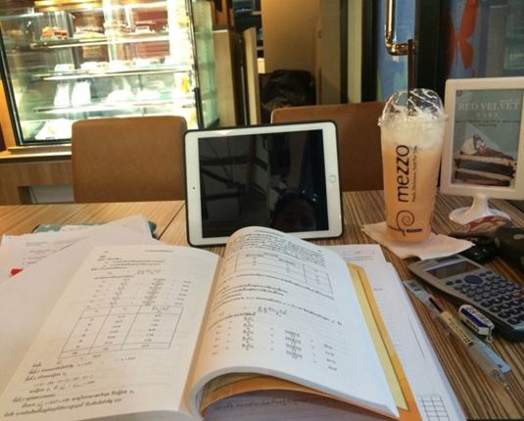

Date: 13/03/2015

Time: 2 pm

Document title: Probability and statistics

Duration: 2 hr

Place: Mezzo coffee shop

Purpose: Teaching preparation

Equipment: book, notebook, calculator

Figure 7‑1 Doing some work in the coffee shop

**“I was at a coffee shop preparing to teach my “statistics for engineer and scientist” module. It was around 2pm and I spent around 2 hours reading.”**

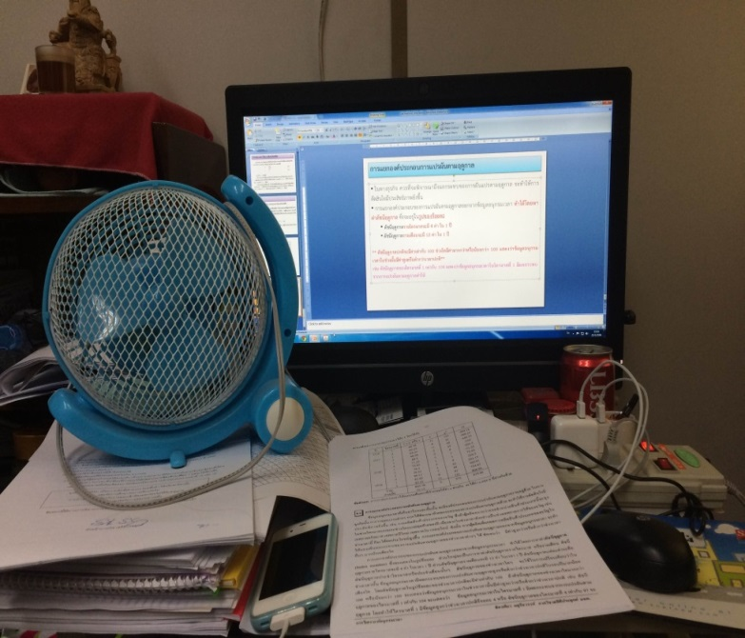

Date: 14/03/2015

Time: 1 pm

Document title: Time Series Analysis

Duration: 2.30 hr

Place: Office in the university

Purpose: Teaching preparation (preparing ppt slides)

Equipment: PC, documents, notebook, calculator

Figure 7‑2 Teaching preparation in the office

**“I was preparing power point slides in my office in the university to use in my “Statistical methods” module. It was around 1 pm and I spent around 2.30 hrs working on it.”**

**Participant 2 (Masters student)**

Date: 19/03/2015

Time: 9.30 pm

Document title: Quality management

Duration: 3 hr

Place: Home (ground floor)

Purpose: Exam preparation

Equipment: handouts, stationary, calculator

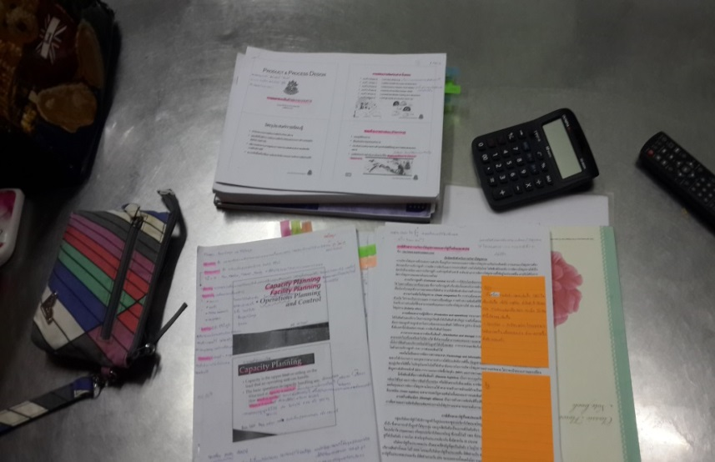

Figure 7‑3 Exam preparation at home (1)

**“I was at home preparing for an exam in my “Operation Management” module. A calculator needs to be used in this module. There’s also a pencil case on the desk containing colouring pens and markers for making notes and highlighting. I also used a mobile phone as a means of accessing an online dictionary. I spent 3 hours reading.”**

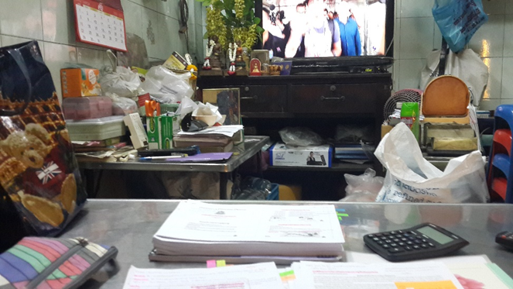

Date: 20/03/2015

Time: 9.30 pm

Document title: Capacity planning

Duration: 3 hr

Place: Home (ground floor)

Purpose: Exam preparation

Equipment: handouts, stationary, calculator, desk

Figure 7‑4 Exam preparation at home (2)

**“The television was on with the volume down a bit while I was reading because I don’t like it too quiet when I’m reading.”**

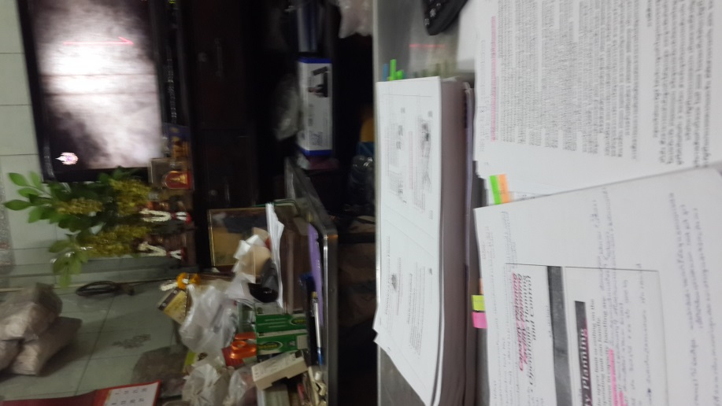

Date: 20/03/2015

Time: 9.30 pm

Document title: Facility planning

Duration: 3 hr

Place: Home (ground floor)

Purpose: Exam preparation

Equipment: handouts, stationary, calculator, desk

Figure 7‑5 Exam preparation at home (3)

**“I was at home studying some case studies. I used markers and coloured post-it flags to help me remind of what was important in the text.”**

**Participant 3 (Masters student)**

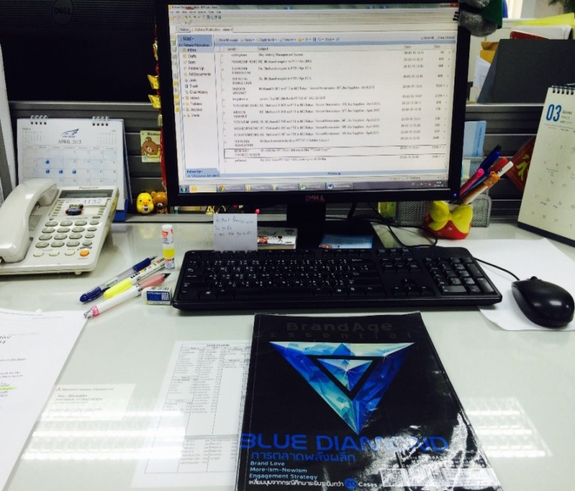

Date: 26/03/2015

Time: 12.45 pm

Document title: BrandAge Essential

Duration: 45 min

Place: Office

Purpose: Personal curiosity in modern marketing strategies

Equipment: BrandAge magazine

Figure 7‑6 Reading magazine during a lunch break

**“I was at work reading a magazine that had some content relating to what I’m doing in my masters degree. I spent some time after my lunch break reading it.”**



Date: N/A

Time: night time (before bed)

Document title: BrandAge Essential

Duration: 45 min

Place: Bedroom

Purpose: Personal curiosity in modern marketing strategies

Equipment: BrandAge magazine

Figure 7‑7 Reading magazines before bed

**“In my bedroom before going to bed, I read these magazines about new trends in marketing society as they’re related to my degree. I spent around 45 minutes before bed reading them.”**

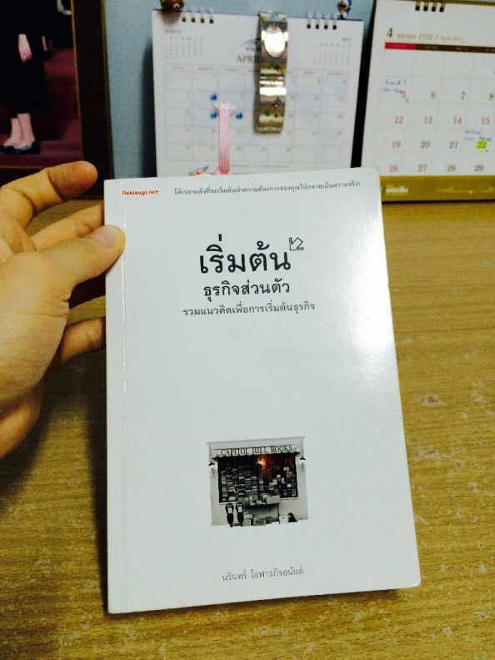

Date: N/A

Time: afternoon

Document title: Starting your own business

Duration: 30 min

Place: Home

Purpose: Personal interest

Equipment: book

Figure 7‑8 Holiday reading at home

**“I read this book in my free time. The book has content that I’m really interested in.”**

**Participant 4 (Undergraduate student)**

Date: 10/03/2015

Time: 2 pm

Document title: Chinese publications reading

Duration: 2 hr

Place: Bedroom (home)

Purpose: Exam preparation

Equipment: handout, stationary



Figure 7‑9 Reading for examination at home

**“I was studying for a Chinese exam at home. I often use this place for studying whenever I’m at home. I spent 2 hours on this.”**

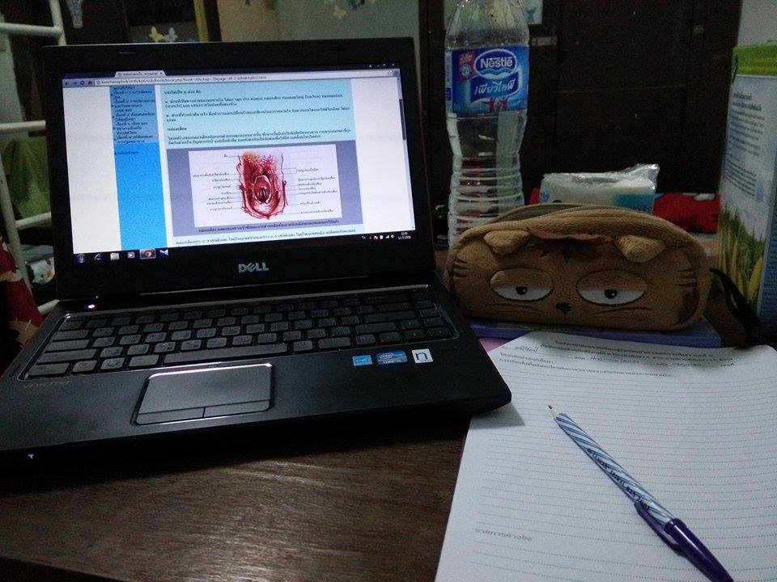

Date: 11/03/2015

Time: 5 pm

Document title: Respiratory track

Duration: 1 hr

Place: Dormitory

Purpose: Doing assignment

Equipment: laptop, course exercise, pen

Figure 7‑10 Doing assignment at dorm

**“In my room at the university dormitory, I was doing an assignment for my “Sport Science” module. I used my laptop to search for some information. I spent 1 hour doing this.”**



Date: 11/03/2015

Time: 10 pm

Document title: Survivor Chaina

Duration: 30 min

Place: Dormitory

Purpose: Personal interest, Learning new Chinese words

Equipment: laptop, course exercise, pen

Figure 7‑11 Leisure reading before bed

**“This picture was also taken at the university dormitory. I was reading this book in my free time. I spent about 30 minutes before bed reading the book.”**

**Participant 5 (PhD student)**

Date: 10/03/2015

Time: 10 pm

Document title: Mentor Mentee Mentoring

Duration: 2 hr

Place: Home

Purpose: Doing research

Equipment: book, coloured pens, notebook, laptop

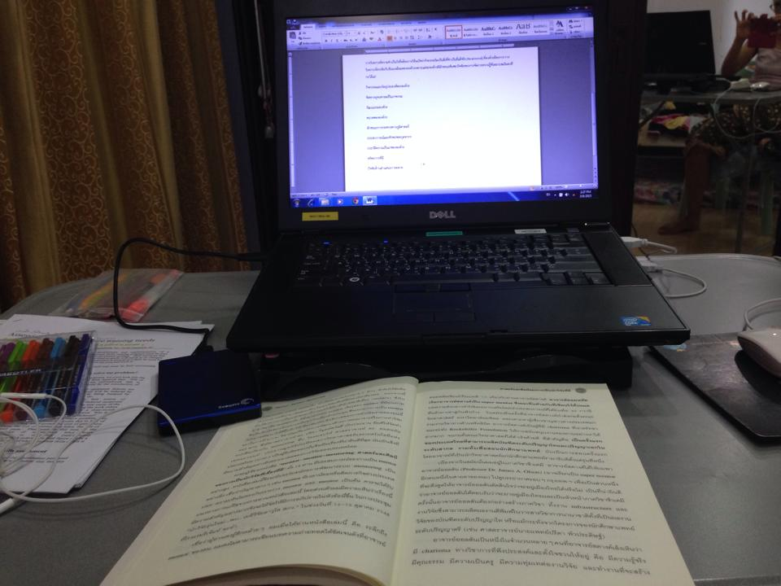

Figure 7‑12 Reading for research at home (1)

**“I spent about 2 hours before bed reading this book. I borrowed it from the university library. The way I read it was to type some important points I found in the book into Ms Word. I think reading this way made me finish the book faster.”**

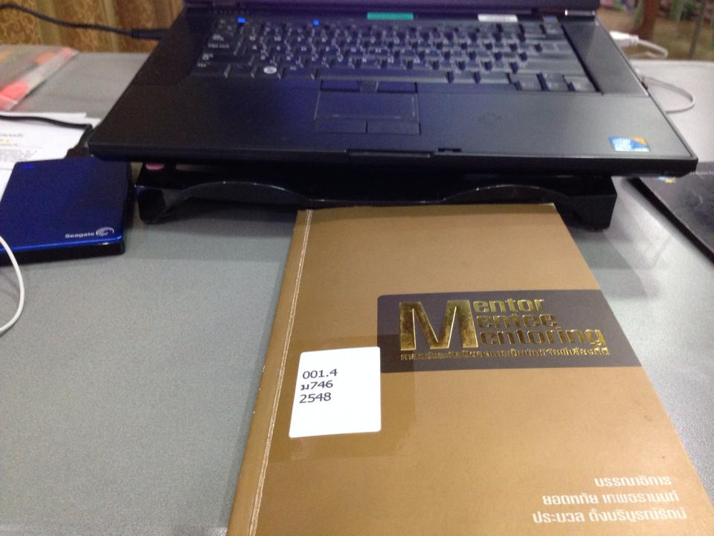

Date: 10/03/2015

Time: 10 pm

Document title: Mentor Mentee Mentoring

Duration: 2 hr

Place: Home

Purpose: Doing research

Equipment: book, coloured pens, notebook, laptop

Figure 7‑13 Reading for research at home (2)

**“This is the book I was reading in the previous photo I showed you. It’s about mentoring.”**

Date: 16/03/2015

Time: 9 pm

Document: N/A

Duration: 2 hr

Place: Home

Purpose: Doing research

Equipment: book, coloured pens, notebook, highlighter

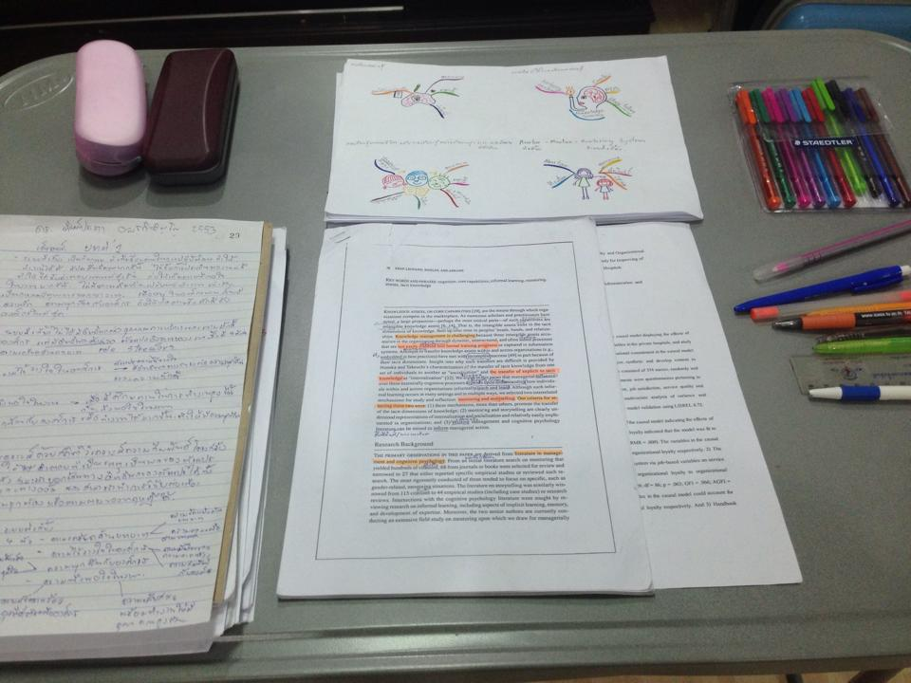

Figure 7‑14 Reading for research at home (3)

**“I was reading a research paper at home. With a research paper I use a different technique to sum up important issues. The technique I regularly use when reading is to create a mind map.**

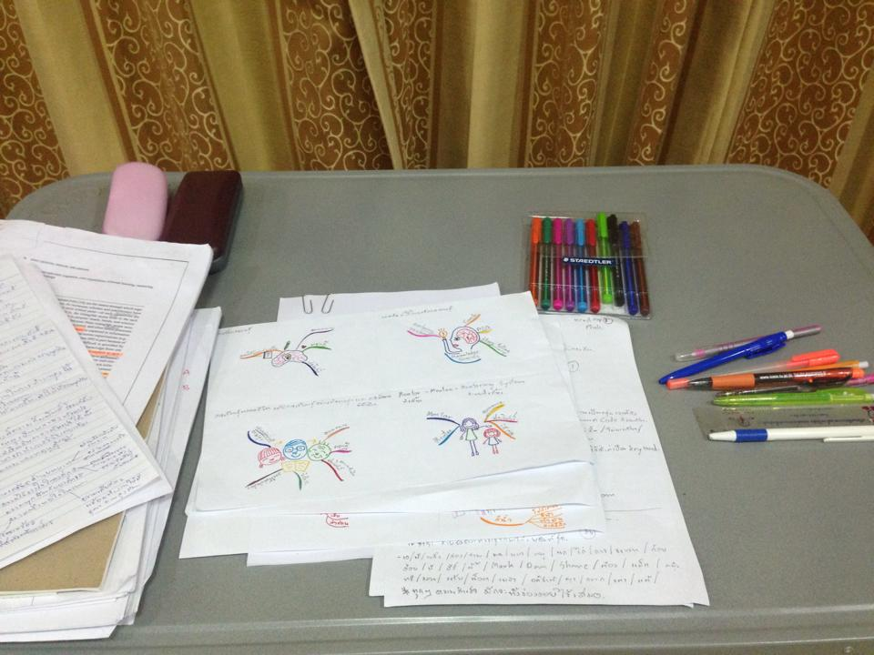

Date: 16/03/2015

Time: 9 pm

Document title: N/A

Duration: 2 hr

Place: Home

Purpose: Doing research

Equipment: book, coloured pens, notebook, highlighter

Figure 7‑15 Doing mind map of my research

**“In this picture, I just want to show you the mind mapping I did for my research. I used many colouring pens making it. Different colours have different meanings, such as red, which means it’s the most relevant topic to my research.”**

**Participant 6 (Undergraduate student)**

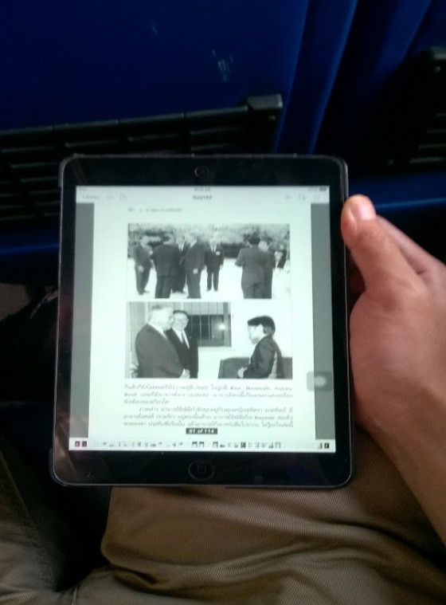

Date: 20/03/2015

Time: 10.30 am

Document title: Suwanprateep

Duration: 30 min

Place: On a coach

Purpose: Leisure reading while travelling on coach

Equipment: Ipad mini

Figure 7‑16 reading e-book on coach

**“I was sitting in the coach reading this book on my iPad mini. I regularly use an iPad to read while travelling. This time I spent around 30 minutes reading.”**

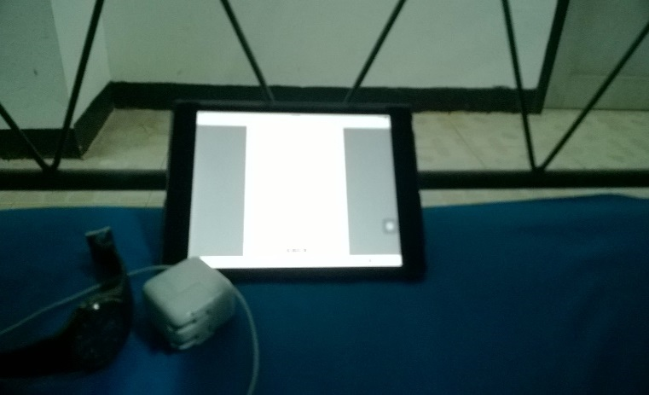

Date: 20/03/2015

Time: 10.30 pm

Document title: Suwanprateep

Duration: 1 hr

Place: In accomodation

Purpose: For essay writing

Equipment: Ipad mini

Figure 7‑17 Reading for assignment on iPad

**“I was reading an academic paper while I was on a rural development camping trip in Chonburi province. The paper was in PDF format.”**

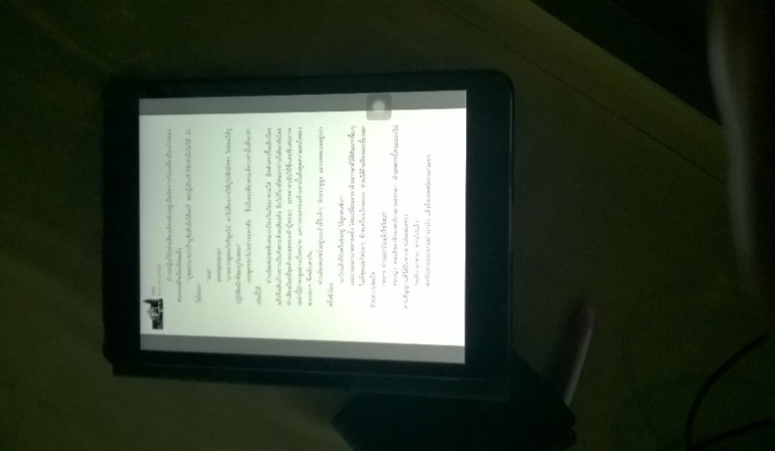

Date: 21/03/2015

Time: 11.44 pm

Document title: Suwanprateep

Duration: 45 min

Place: In accomodation

Purpose: For essay writing

Equipment: Ipad mini

Figure 7‑18 Reading for assignment

**“This is the same book I showed you in the first picture. I was reading it for an assignment I had for my class and it needed to be handed in very soon.”**

**Participants 7 (PhD student)**

Date: 9/03/2015

Time: 2 pm

Document title: Introduction: putting the learning organization into context: an emerging research field

Duration: 2 hr

Place: home

Purpose: Paper writing

Equipment:Laptop, highlighter

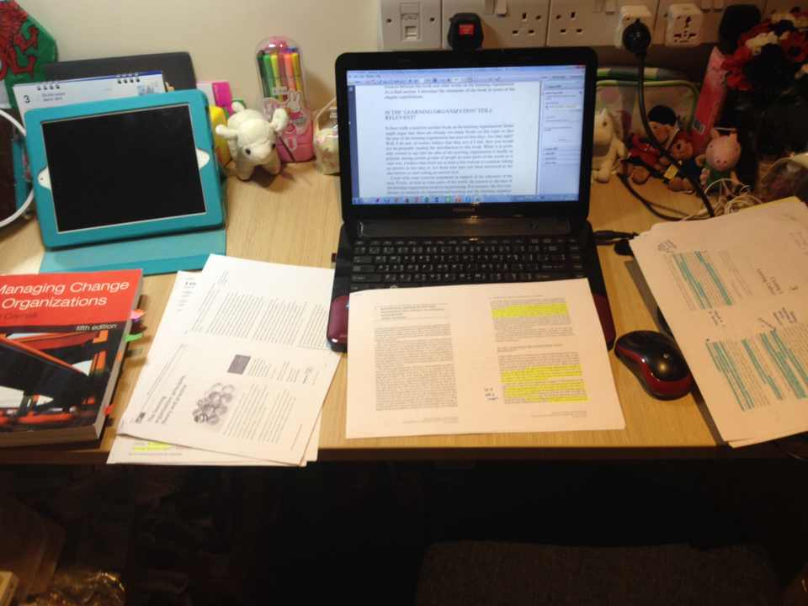

Figure 7‑19 Reading for thesis writing (1)

**“I was planning to write a literature review. So I needed to use information from several papers. When I’m reading journal papers I prefer to have both formats (print and electronic) with me because I need to make some notes and highlights on a print version but I like to read from the screen.”**

Date: 10/03/2015

Time: 4 pm

Document title: How Academic Librarians use Evidence in their Decision Making: Reconsidering the Evidence Based Practice Model (PhD dissertation)

Duration: 1.30 hr

Place: Library

Purpose: For writing paper

Equipment: Laptop, Printed articles



Figure 7‑20 Reading for thesis writing (2)

**“I was reading an unpublished dissertation in this pic. As I’ve told you, when I’m doing my work I like to have both print and electronic versions with me and use them at the same time. I was working in the library in this pic and spent around 1.30 hours there.”**

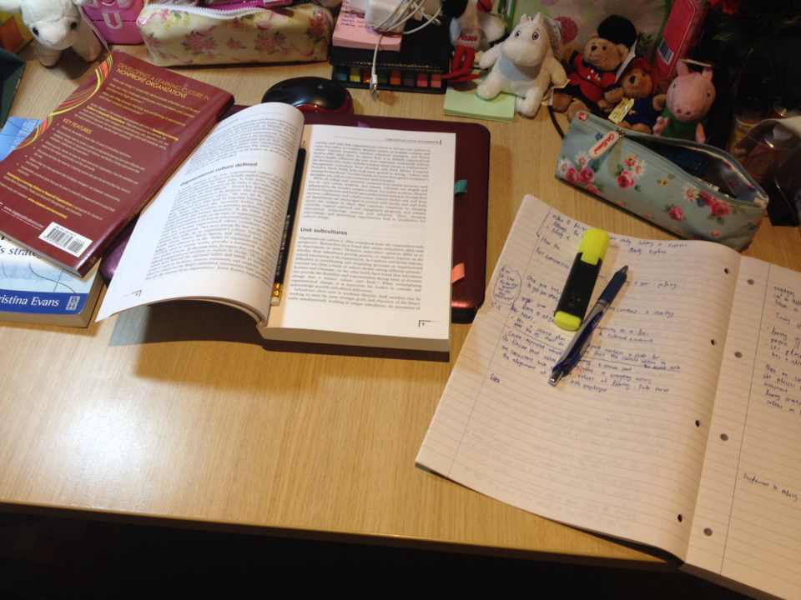

Date: 10/03/2015

Time: 10.15 am

Document title: Workplace culture in Academic Libraries

Duration: 2 hr

Place: home

Purpose: For thesis writing

Equipment: pencil, highlighter, pen, notebook

Figure 7‑21 Reading for thesis writing (3)

**“I was reading books in this pic. There are some differences between reading on screen and from print. For me, when I’m reading books I’ll make some notes in a separate notebook. I read it at home, spending around 2 hours on it in the morning.”**

**Participant 8 (Undergraduate student)**

Date: 10/03/2015

Time: 1.30 pm

Document title: EUROPEAN PARLIAMENT AND COUNCIL DIRECTIVE 94/62/EC of 20 December 1994 on packaging and packaging waste

Duration: 10 min

Place: Library

Purpose: Searching for information for writing a report

Equipment: PC, printed assignment

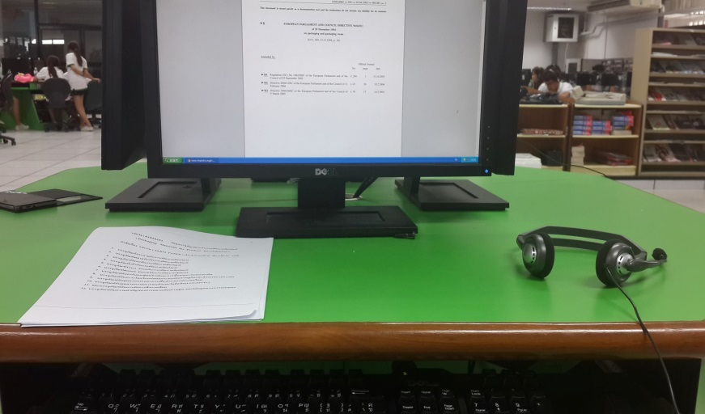

Figure 7‑22 Searching for information in the library

**“I was at a university language centre doing my assignment. The reason I was there is because there was a PC with Internet access so I could search for more information to complete an assignment.”**

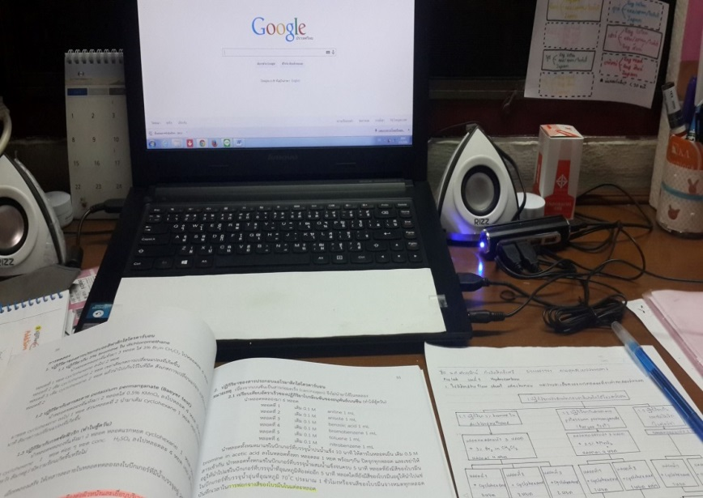

Date: 3/03/2015

Time: 7 pm

Document title: Organic chemistry

Duration: 2 hr

Place: home

Purpose: studying

Equipment: Laptop, textbook

Figure 7‑23 Studying at home

**“I was reading a textbook at home and also using my laptop to search for some more information related to the subject.”**



Date: 4/03/2015

Time: 1.40 pm

Document title: Billy Owen, Cancer Survivor, Loses Eye, Embraces New Career As Zombie Actor, Sideshow Star

Duration: 10 min

Place: home

Purpose: leisure reading

Equipment: Laptop

Figure 7‑24 Reading an online article

**“In this picture, I was at home, reading an online article that I was interested in. At first I’d planned to prepare a topic for my English speaking class, but I found this article by chance and it was really interesting, so I ended up reading this instead.”**

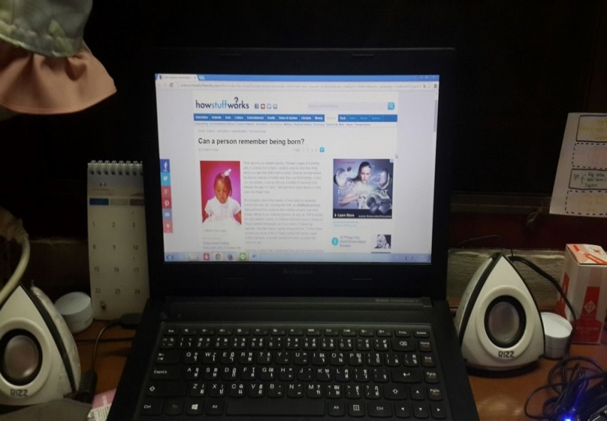

Date: 3/03/2015

Time: 8 pm

Document title: Can a person remember being born?

Duration: 15 min

Place: home

Purpose: leisure reading

Equipment: Laptop

Figure 7‑25 Reading an online article (2)

**“Actually I found this topic from my Facebook feed and felt that it was interesting, so I googled the name of the author and it brought me to the article in full.”**

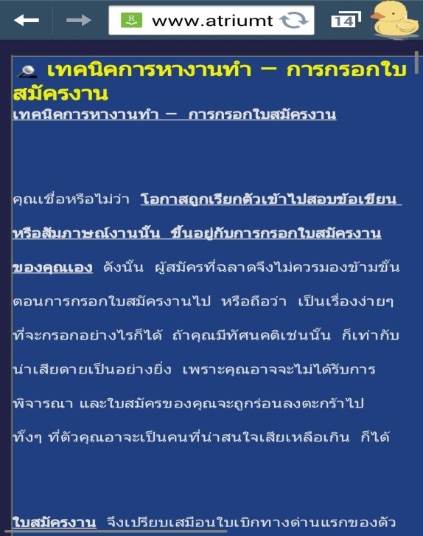

Date: 4/03/2015

Time: 7.30 am

Document title: Job finding: techniques for completing an application form

Duration: 10 min

Place: University

Purpose : leisure reading

Equipment : mobile phone

Figure 7‑26 Browsing a website from mobile phone

**“I captured this pic from my mobile phone. It’s a web blog that contained many interesting topics. I accessed the blog via my mobile and read it at the university while waiting for the class to begin.”**

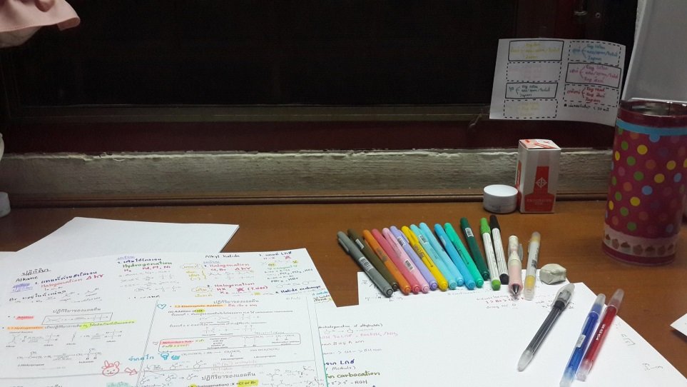

Date: 4/03/2015

Time: 7 pm

Document title: Organic chemistry

Duration: 3 hr

Place: home

Purpose: studying

Equipment: Lecture notes, coloured pens

Figure 7‑27 Revision at home

**“These are some notes that I made after reading a textbook. Colouring pens were the main tools in doing this.”**

Date: 4/03/2015

Time: 10 pm

Document title: The sacred temple in the heart of the sea

Duration: 15 min

Place: home

Purpose: leisure

Equipment: Printed magazine

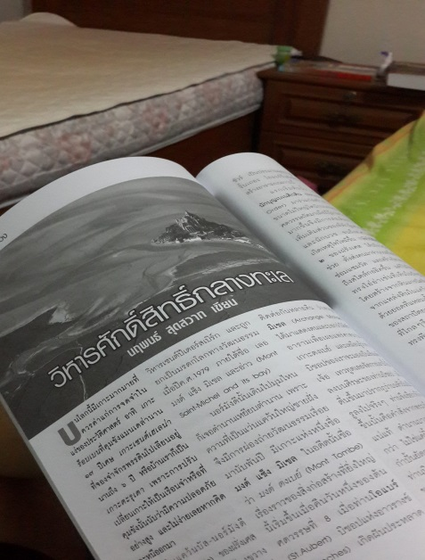

Figure 7‑28 Reading a magazine at home

**“I was reading a magazine at home in my free time. The reason I bought this was because there’re many interesting topics in it.”**

**Participant 9 (Masters student)**

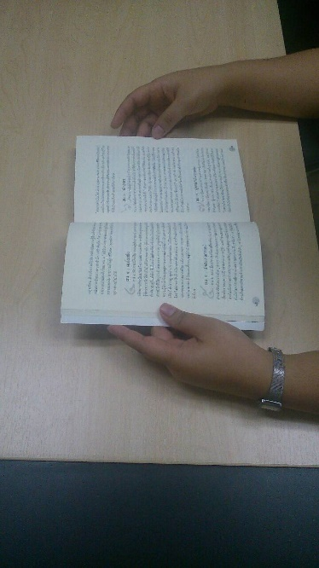

Date: 18/03/2015

Time: 7 pm

Document title: The Enneagram

Duration: 1 hr

Place: home

Purpose: leisure

Equipment: printed book

Figure 7‑29 Leisure reading at home

**“I was reading this book in my room at home. It was a book about different personalities of people. I spent about 1 hour reading this in the evening.”**

Date: 20/03/2015

Time: 9 pm

Document title: Her World magazine

Duration: 30 min

Place: home

Purpose: leisure

Equipment: printed magazine

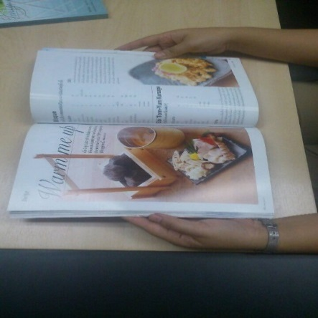

Figure 7‑30 Reading a magazine at home

**“I was reading a magazine at home at night time after I got back from work.”**

**Participant 10 (PhD student)**

Date: 5/03/2015

Time: 7 pm

Document title: Karen language

Duration: 1.30 hr

Place: home

Purpose: Double check the research data that have been collected through related documents

Equipment: book, notebook

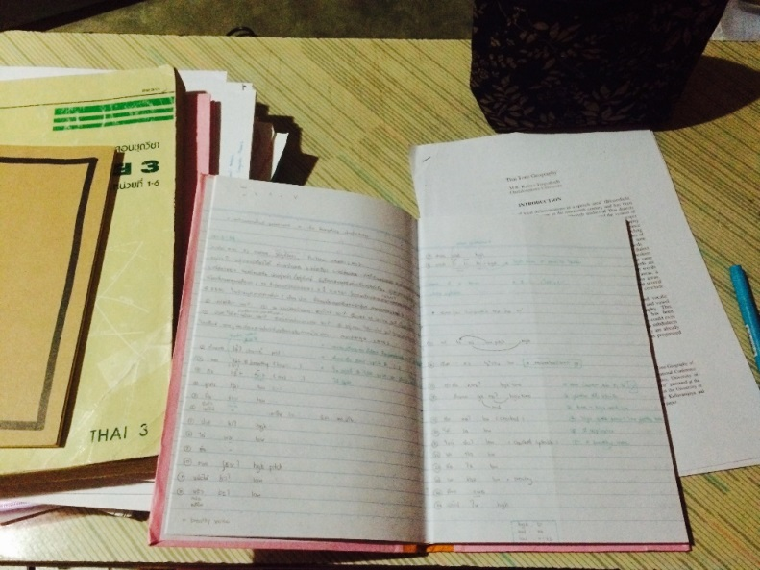

Figure 7‑31 Review the collected research data

**“In this picture, I was rechecking data that I’d collected for my research. Also, the textbook needed to be used to consult some relevant theories. I was doing it at home. It was around 7 pm and I spent 1.5 hours on this.”**

Date: 5/03/2015

Time: 1.30 pm

Document title: defining culture and identities

Duration: 2 hr

Place: home

Purpose: Doing class assignment

Equipment: printed document, pen

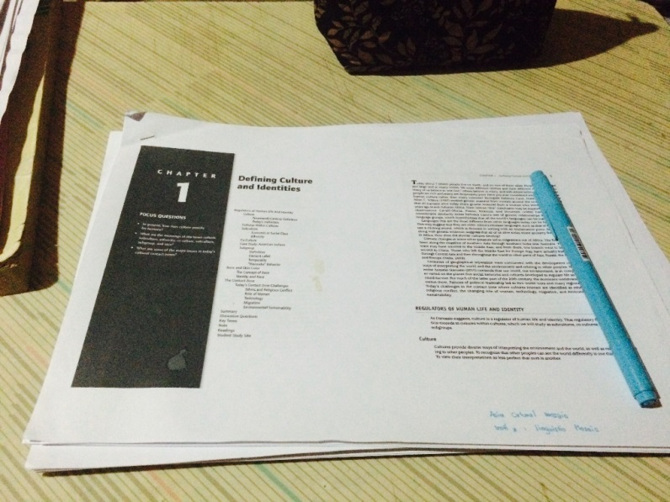

Figure 7‑32 Reading for an assignment

**“It was a printed out version of an e-book about culture. I was reading it because I’d got an assignment about the meanings of culture. I searched for the topic on the library catalogue and it linked to this e-book, and then I printed it out to read.”**



Date: 5/03/2015

Time: 7.30 am

Document title: Ethnobiological classification in two indidenous languages of the Gran Chaco Region: Toba(Guaycuruan) and Maka (Mataco-Mataguayan)

Duration: 3.45 hr

Place: home

Purpose: preparing for in class presentation

Equipment: PC, notebook, pen

Figure 7‑33 Preparing for a presentation

**“I was reading a journal article on my PC at home so that I could use it to present in class tomorrow. I had my notebook and pen ready for jotting down any ideas that popped into my head while reading it.”**

**Participant 11 (Undergraduate student)**

Date: 2/03/2015

Time: 8.30 am

Document: Human and geography

Duration: 1 hr

Place: home

Purpose: exam preparation

Equipment: laptop, handout, pens, highlighter

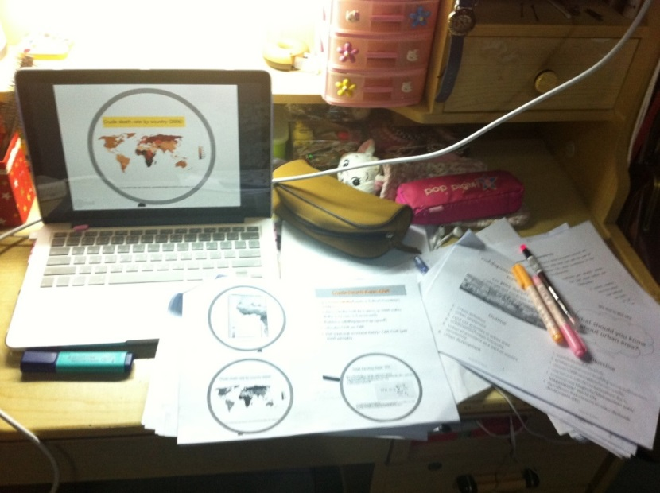

Figure 7‑34 Reading for exam

**“I was preparing for an upcoming exam. What you see on the screen was an electronic version of a handout given by the lecturer. I also had a print version with me for making some notes on it. The reason why I needed to read both versions is because the quality of picture was better on screen, but it’s much easier to make notes on paper.”**

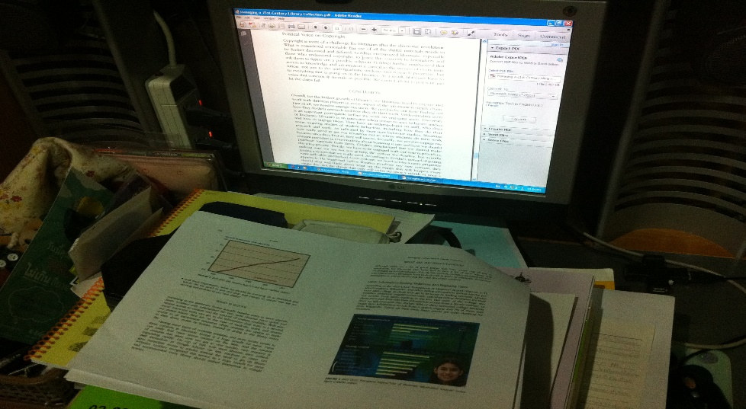

Date: 2/03/2015

Time: 10 am

Document title: Managing a 21st Century Library Collection

Duration: 2 hr

Place: home

Purpose: doing report, In- class presentation preparation

Equipment: PC, handout

Figure 7‑35 Preparing for a presentation

**“I was reading a journal article on screen and also had a printout version on my desk. I searched for the article via the university library database.”**

### Analysis of photographic data

The photo diaries, after careful examination, reveal several interesting personal patterns of reading behaviour among the participants. First, different types of reading are displayed in the pictures. The most common practices for academic reading found in the photographs can be identified as follows:

1. The print format supported most reading.
2. Although the participants were more likely to read on a print format, there are several kinds of electronic devices (laptops, desktop PCs, iPads and mobile phones, for example) nearby in most pictures.
3. There is always evidence of note-taking, text underlining, text highlighting or attaching sticky notes to text appearing in the photographs.
4. There are writing materials nearby in most pictures.
5. Most academic reading was done at a specific place, such as a writing desk in the participant’s home, an office desk or a library.
6. Most reading spaces in the photos were in an untidy condition.

Apart from the academic related photographs, several leisure reading photos were also submitted. Based on the evidence of those photos, a number of common practices emerge:

1. Different types of reading material were used (books, magazines, online articles and e-books, for example).
2. There were no other writing materials nearby.
3. Most leisure reading was done at home or in a bedroom.
4. The average reading time was 30 min – 1 hour per session.

Table 7-5 summarises the similarities and differences between academic reading and leisure reading related photographs.

Table 7‑5 Comparison between academic reading and leisure reading behaviours among the participants

|  | **Academic practices** | **Leisure practices** |
| --- | --- | --- |
| Reading format used | Mostly print | Mix of print and digital |
| Reading location | Home, office, library | Home |
| Other writing materials involved | Yes | No |
| Other electronic devices involved | Yes | No |
| Reading space condition | Untidy | Tidy, relaxed |
| Reading time | Long | Short |

As shown in the photographs, the majority of participants read from print documents more than from their electronic counterparts, regardless of reading purpose. However, it is noticeable that several kinds of electronic device appear in almost every academic reading photo. Some of the devices were switched on and active, while others were off and set down nearby. In addition, several kinds of writing material were placed around the work areas. As a primary assumption, the reasons behind electronic devices appearing in many photos of academic reading can be placed into three major groups. First, the participants were reading from print documents and writing notes on their laptops or PCs via word processing software such as Microsoft Word. Second, the participants were reading mainly from print documents and searching for more relevant information online. Third, the participants were reading the same documents in both electronic and print formats at the same time. The third group was further clarified by the participants that they preferred to read on an electronic document because it can be expanded for a clearer vision. However, the print format was still necessary for them to write some notes on it. It is clear that printed texts represent the most favoured reading material for most participants in this study, especially for academic reading purposes. The electronic devices that appear in the pictures were probably not used as main reading sources. Rather, they were used as supplements, largely for other minor tasks such as searching for additional information, as writing tools, or even as a monitor for an electronic lecture handout.

In the case of the leisure reading photographs, various types of reading format appear in the pictures. Although print books were still the most widely used material, there is evidence of different reading materials being used as well. Beside printed books and magazines, there are pictures showing that participants read digitally from online channels such as web-boards or online journals, and from offline channels such as e-books on tablets. In contrast to the academic reading pictures, there are no other objects that were not relevant to the particular texts in the leisure reading photos. For leisure reading, the participants seem to have focused only on the text they were reading at that moment. This also implies that leisure texts were read linearly by most participants.

Table 7-6 provides an in-depth examination of actions that the participants performed while reading texts in both print and digital formats. As shown in the photos, the participants used a combination of different reading formats and tools when reading. For academic reading, the most frequently used tools were printed documents, writing materials such as pens and pencils, laptop computers, printed books, and paper notebooks. These tools were often used simultaneously; about half of the photos relating to academic reading show that multiple electronic and print materials were used in combination at the same time. However, the most interesting feature of the photos is that they show the actions that the participants performed with each type of material. The most frequent types of action to appear in the photos are note-taking, highlighting texts, reading texts, and browsing the internet. It is particularly apparent that, for academic-related reading, the majority of participants usually took notes and highlighted texts that they were reading. Both such actions were generally performed on printed texts rather than on electronic ones. Only one participant (P5) made notes on a word processing programme while she was reading a printed book. However, none of the participants made any form of marking on electronic texts they were reading. Although printed documents and electronic texts were used simultaneously in many photos, participants tended to interact with printed texts more than electronic texts. Thus, writing materials such as pens, pencils, and highlighters seemed to be important equipment for academic reading among the participants. In addition, actions such as text highlighting and note-taking were important elements of reading academic texts.

In contrast, different materials were not used simultaneously in the case of leisure reading. Leisure reading in this study seemed less complicated than its academic counterpart. In the photographs, every participant used a single type of material (either print or electronic) for reading. However, printed text was still the preferred format for reading. Printed magazines and books appear frequently in the leisure reading-related pictures. Of the 11 participants, only one (P8) used a laptop, smartphone, and a printed magazine in her leisure reading. However, those tools were used individually on different occasions. Another participant (P6) used a tablet to read his book in his free time as well. Interestingly, no actions such as note taking or text highlighting were performed while participants were reading for leisure purposes. Thus, it seems clear that purpose of reading has an influence on actions that readers perform with texts.

Table 7‑6 Comparison of actions performed with print materials and electronic materials

| **Participant** | **Figure no.** | **Reading purposes** | | **Tools** | **Actions** | |
| --- | --- | --- | --- | --- | --- | --- |
|  |  | **Academic** | **Leisure** |  | **Manual** | **Digital** |
| P1 | 7-1 | × |  | Tablet, textbook, printed documents, calculator, pencil, eraser, ruler | Reading | - |
| 7-2 | × |  | Desktop, printed documents | - | Using PowerPoint for teaching preparation |
| P2 | 7-3 | × |  | Printed documents, calculator, Post-it notes | Highlighting, note taking | - |
| 7-4 | × |  | Printed documents, calculator, Post-it notes | Highlighting, note taking | - |
| 7-5 | × |  | Printed documents, calculator, Post-it notes | Highlighting, note taking | - |
| P3 | 7-6 |  | × | Printed magazine, desktop | - | Checking e-mail on desktop PC |
| 7-7 |  | × | Printed magazines | - | - |
| 7-8 |  | × | Printed book | - | - |
| P4 | 7-9 | × |  | Printed documents | Highlighting | - |
| 7-10 | × |  | Desktop, printed document, pen | Doing assignment | Searching for information on website |
| 7-11 |  | × | Printed book | - | - |
| P5 | 7-12 | × |  | Desktop, printed book, pens, printed documents | - | Taking note on MS Word |
| 7-13 | × |  | Printed book, desktop | - | - |
| 7-14 | × |  | Printed documents, notebook, pens, ruler | Highlighting, note taking, drawing mind maps | - |
| 7-15 | × |  | Printed documents, notebook, pens, ruler | Drawing mind maps, note taking | - |
| P6 | 7-16 |  | × | Tablet | - | Reading e-book |
| 7-17 | × |  | Tablet | - | Reading PDF document |
| 7-18 | × |  | Tablet | - | Reading e-book |
| P7 | 7-19 | × |  | Desktop, tablet, printed documents, printed book, Post-it notes | Highlighting, note taking | Reading PDF document |
| 7-20 | × |  | Desktop, printed documents | Highlighting, note taking | Writing paper on MS Word |
| 7-21 | × |  | Printed books, notebook, pen, pencil, highlighter | Reading, note taking | - |
| P8 | 7-22 | × |  | Desktop, printed document, headphones | - | Searching for information online |
| 7-23 | × |  | Laptop, printed book, notebook | Highlighting, note taking | Using search engine (Google) |
| 7-24 |  | × | Laptop | - | Reading an online article |
| 7-25 |  | × | Laptop | - | Reading an online article |
| 7-26 |  | × | Mobile phone | - | Reading an online discussion forum |
| 7-27 | × |  | Pens, A4 paper | Note taking | - |
| 7-28 |  | × | Printed magazine | Reading | - |
| P9 | 7-29 |  | × | Printed book | Reading | - |
| 7-30 |  | × | Printed magazine | Reading | - |
| P10 | 7-31 | × |  | Printed book, notebook, printed documents, pen | Note taking | - |
| 7-32 | × |  | Printed documents, pen | Note taking | - |
| 7-33 | × |  | Desktop, notebook, pen | Note taking | Reading PDF document |
| P11 | 7-34 | × |  | Laptop, printed documents, pens, highlighter | Note taking | Reading PowerPoint slides |
| 7-35 | × |  | Desktop, printed documents | Reading printed document | Reading PDF document |

Another interesting issue that emerges from analysis of the photographs is that concerning reading location. Based on the pictures in the photo diaries, the reading for academic and leisure purposes was done mostly at home. There were a few occasions in which academic reading was done in other locations, such as in the library, office or coffee shop. It is notable, then, that most academic reading is performed at a specific place like home (in a work or study corner), the library or the office. All three such sites possess a mutual characteristic, that of creating a proper atmosphere for studying or working. This finding thus implies that, for the participants, environment had a role in academic reading. Similarly, in the case of leisure reading, the majority of participants chose to do their reading at home. However, the readings were not done at a desk but in bed. In most of the leisure reading photos, the participants generally had their texts, in the form of books, magazines or e-books, with them in bed. The reading of fiction, therefore, seems more likely to occur in a personal comfort zone such as on a bed or in a bedroom.

It seems apparent that environment is always closely related to the purpose of reading. In this case, most academic and leisure reading was performed in a private area like home. Nevertheless, there is a distinct difference between the two reading purposes. An environment conductive to learning is essential for academic reading, whereas a more comfortable environment seems preferable for leisure reading. Another noteworthy issue found in the analysis of the photo diaries is the condition of the reading space. There is a remarkable difference between the academic and leisure reading photos. The participants in this study tended to carry out their academic reading in their reading space in untidy conditions. As stated by the participants, some of the photos were staged for the photography. However, it was done intentionally to make the photos more representative. Many printed documents or books, together with writing materials, can be seen spread around the study or work areas. A bottle or glass of water also features in many of the academic reading photos. In contrast, none of the previously mentioned objects appear in the leisure reading photographs. All of the reading spaces in the leisure reading photos were in a reasonably tidy and comfortable state.

The duration of reading sessions is another interesting issue revealed from analysis of the photo diaries. Primarily, the participants tended to spend more time on academic reading than leisure reading. On average, participants took one to two hours per session for academic reading while spending only thirty minutes to one hour for leisure reading. Furthermore, the length of reading sessions varied depending on the type of reading material used. The reading times were longer when participants were reading from printed documents (at least an hour per session). On the other hand, reading times were relatively short when participants were reading from a screen (less than thirty minutes per session). The difference in length between the two purposes is possibly due to variations in the levels of intensity and attention to detail required. Thus, the more intense the reading, the more time needed to finish that reading.

Based on the photos provided by the participants, it is noticeable that the majority of them had not actually read from e-books at all. Only one (out of eleven) participant submitted the photo of e-book reading on an iPad. The possible assumptions to this situation could be identified as follows. First, there is some confusion on how participants defined e-books. In this case, several electronic documents such as online articles, research papers, handouts, webpages, etc. were emerged in most photos. This could possibly be because the participants included these kinds of texts into what they called ‘e-books’. Second, the participants in this study may not pay attention to the category of the reading material much. It seems like most participants consider only the format of reading. They tend to select any reading formats that suit their purpose most. Many participants chose electronic reading for academic purpose because of its accessibility. Similarly, a number of participants chose printed document for leisure reading because of its comfort.

Fundamentally, the photo diaries provide a better understanding of the differences in reading behaviour across different reading purposes. Several issues relevant to reading choices thus emerge from analysis of the photographs. The issues arising from the photo diaries will be clarified further during analysis of the interviews.

## Photo-elicitation interview analysis

### Interview results

The aim of conducting interview sessions was to identify factors that influenced the library users in their choice of reading format. Furthermore, it was hoped that the interviews would allow the research to offer a clearer understanding of the reading behaviour of the library users. In this section, the results of the photo-elicitation interviews are presented as themes in relation to the Alice Keller framework (see Chapter 3) together with additional themes emerging from the data.

#### General pattern of reading

Patterns of reading disclosed by the participants were noted during the conversations about the photographs they submitted, together with further questions regarding their reading behaviour. The majority of participants showed their preference for reading in print, more so than for reading on screen. In the study-related photographs, the participants were having to take academic notes while they were reading. Based on a general opinion supplied by the participants, the simplest way to take notes was to write them down by hand. One participant made a comment about this issue as follows:

I don’t like reading on a PC because I can’t jot anything down on it. I prefer reading from a print format or even on an iPad. I think it’s okay because it’s way easier to write things down while reading in this way. (Participant 1, Lecturer)

However, there was also one case in which a participant preferred to read from a printed book but made notes by typing them into MS Word on a desktop computer:

If I find any important or interesting sentences in a book, sentences that I can use for my research, I type them into MS Word because it’s very easy to track them back later. Also, it helps me to finish the book faster.(Participant 5, PhD student)

Many participants stated that they preferred to read journal articles in both formats (print and electronic), as in the following examples:

I always read academic journals in both electronic and print formats. (Participant 7, PhD student)

I like to have both electronic and print formats of the same academic journals with me, so I can choose later which format suits me best for different occasions. (Participant 10, PhD student)

I need both formats for journal articles: print and PDF files. When I’m out I normally read them on screen, but prefer to read them in print at home.(Participant 11, Undergraduate student)

With regard to reading devices, the participants in this study used a variety of devices to read. Desktop computers, laptops, iPads and mobile phones were all mentioned frequently when the interviewees were asked about the reading devices they used regularly. Nevertheless, different devices were chosen for different reading purposes. Desktop and laptop computers were used mainly for academic reading material such as articles in electronic journals.

I mostly use my PC for reading journal articles and also every document that is in a PDF format (Participant 6, Undergraduate student)

A laptop computer is my major device for reading electronic documents. (Participant 7, PhD student)

After downloading an electronic article, I read it either on my laptop or PC. I just don’t feel like printing everything out. (Participant 10, PhD student)

For those participants who stated that they preferred a printed format to an electronic format, laptop computers were seen only as a tool used to search for further information from the Internet rather than as a mainstay of reading.

Well, I mostly read everything from hard copy, so the only time I need my laptop is when I’m doing an assignment and need more information from the Internet. (Participant 2, Masters student)

Mobile phones were another favoured device for leisure reading among many participants. Every participant in this study owned at least one smartphone, and many of them said that they often read news from their smartphones. Moreover, mobile phones seemed to be employed as alternative reading devices when participants were travelling or in situations where other devices such as laptops were not very convenient to use.

Interestingly, dedicated e-book readers such as Kindles were not very popular among the participants. More than half of the participants had no knowledge of e-book readers. Some of them had never heard of the devices before. As the conversation below shows, when the researcher asked about e-book reader usage, the participant seemed very confused.

Researcher: Have you ever tried reading on an e-reader such as a Kindle before?

Participant 4: Excuse me, what do you mean?

Researcher: A device where you can read electronic versions of books, newspapers

and magazines…

Participant 4: Umm… No, never.

Although a few participants in this study did know about e-book readers and had had a chance to try them occasionally, none of them owned one.

When asked about favourite places for reading, almost every participant mentioned their home. Some of them also chose to read in the library because of its silence and study-conducive atmosphere. However, coffee shops and public transport were favourite places for participants who did not have a problem with noise. The preferred time for reading varied between the participants; some preferred to read during the daytime, while others opted for night time because they felt that their concentration was better then.

#### Attitude towards reading

In the interviews, all the participants expressed strong and positive attitudes about printed books. When asked about the reading material they preferred, every participant chose printed books without hesitation. Several reasons were introduced to support this decision. First, printed books were easier to read and seemed the most suitable material for making notes, highlighting text or even bookmarking. One participant stated that reading from a printed text helped her to finish reading that particular document more quickly than reading it on a screen. Another participant stated that bookmarking could be done more easily on printed books, while doing so in e-books made her feel confused and lost. Second, they said that reading from a paper document could protect readers from eyestrain and other vision problems. Third, many participants held a variety of emotions toward printed books. They agreed that one of the main reasons they preferred printed book was because they could physically touch the book while reading. Some participants even mentioned loving the smell of physical books.

Furthermore, several drawbacks to electronic books were mentioned by participants during the interviews. “It is very uncomfortable reading on a screen” is a statement that was repeatedly offered in the interviews. One participant admitted that holding a tablet for a long period made him feel tired. Moreover, he found reading books from a tablet not particularly comfortable in certain situations such as reading in bed. Reading electronically could irritate some of the participants on occasion. One interviewee stated, “The screen is just too sensitive. I unintentionally turn the page too many times while reading and it’s super annoying!”

In terms of how document type might have an effect on selection of reading material, the participants made a number of comments. Some agreed that there was a relation between the two. For many participants, laptop and desktop computers were the preferred choice for reading academic documents because it was convenient to switch to other relevant electronic texts online. Nevertheless, one participant focused on the convenience of making notes in the text while reading an academic document:

When reading an academic journal, I prefer to read on any device that allows me to make notes or highlight the text easily. And I think an iPad suits me best in this case.

(Participant 1, Lecturer)

For leisure reading, some chose to read from a print format, while others did not have a specific preference. On the other hand, a few participants insisted that there was no relationship between document type and reading material choice. Due to limitations in available reading format for certain types of documents, users had little choice in these cases. One participant made a comment on this issue as follows:

I think it’s fixed by type of document. For example, we see that most academic articles nowadays are in electronic formats only, so we have no choice but to read electronically.

(Participant 7, PhD student)

Surprisingly, the aesthetics of different reading materials proved an influence on reading for some participants. Many admitted that they were addicted to the beauty of printed books. When asked whether such an issue had an effect on their selection of books, five of ten participants agreed. Two of them even said that when thinking about buying a book, the appearance often came before the content. However, aesthetics was not an issue for the other participants when purchasing books. The content of the book was always the first priority.

#### Economy and convenience

Economic factors were another issue that influenced participants in their use or non-use of e-books. Surprisingly, with regard to the price of e-books, the interviewees stated that they did not want to spend money on e-books.

Most e-books are not free and you need to buy them with a credit card and I don’t have one. It’s just too complicated to buy them and above all I don’t want to spend my money on them. (Participant 8, Undergraduate student)

Many participants even emphasized that they were always happy to pay for printed books, but for an e-book they tried to search for a free copy from the Internet first. However, there were some participants who stated that they might consider buying an e-book reader in the future if the cost of the device were not too expensive. Furthermore, a guarantee from the manufacturer that reading on an e-reader would not harm their eyes was another issue raised.

Convenience also played a significant role in influencing choice of reading device among participants. The importance of portability was mentioned by all participants. All agreed that having e-books with them would make it easier when travelling. They stated that they regularly chose between reading devices based on circumstances. When they were out, e-books were the priority reading choice because this allowed them to carry many books around with them at the same time. However, printed books were always the major reading material when they were at home.

When asked about e-book purchasing, almost every participant admitted that they had never purchased e-books. Rather, they regularly searched online for free e-books rather than buying them from e-book stores. Only three participants (the lecturer and two of the PhD students) stated that they had purchased e-books and that all the e-books they had bought were for study-related purposes. One of them further said that she purchased an e-book a long time ago, but had never had chance actually to read it.

#### Availability and discoverability of reading materials

In general, participants accessed e-books through two main channels: university library databases and Internet search engines. Many participants stated that they usually started looking for academic e-books from the databases provided by the university library. Unfortunately, they were not particularly satisfied by this method of access. Most of them found accessing e-books via the university library database to be too complicated. They also stated that looking for e-books in the university library meant that the searcher needed to be present in the library. This was because gaining access to the library database from home was regularly obstructed by technical problems. In addition, both the number of e-books in the university library databases and the right of users to access full text editions were still very limited. However, this might have been an effect of the budget issues facing each university library.

Due to problems of access to e-books via university library databases, many participants had decided to try using different options. Search engines such as Google had become the main method of finding e-books for the library users in this study. The majority of participants admitted that they normally started searching for e-books on Google because it brought them to a wider variety of e-book titles.

In terms of language availability in e-books, almost every participant agreed that the number of e-books in Thai was still limited. More than half of the e-books available in their libraries were in English, which was not their first language. Moreover, the diversity of content in Thai e-books was also somewhat restricted.

#### Physical health

Physical health was one of the most frequently mentioned issues in the interviews. There was some evidence of e-books causing physical discomfort to readers. In the current study, every participant was aware of the harm that could occur because of reading on screen. Eyestrain was discussed at length by many participants during the interviews, with dry or sore eyes being the main complaints of every participant after they read from a screen. Many of them admitted that this was the main barrier that kept them from reading electronically. Every participant believed that reading from a screen could cause serious vision problems. Thus, they tried to read in this way as little as possible. One participant even refused to read any academic-related documents on screen. She had to print out the electronic documents she required. She also mentioned a vision problem that had worsened from too much on-screen reading in the past.

#### Usability and quality

In conversation with the participants, the researcher found that many technical problems existed relating to academic e-book use within the participating academic libraries. Moreover, such problems had an effect on the selection of reading material by library users. There were three main issues that users cited frequently about using e-books from academic libraries. First, there were difficulties with downloading e-books. Every participant in this phase of the study stated that they had had trouble downloading e-books from the university library database. Download speed was also an important issue for many participants. The problem came about largely due to the low quality of the Internet connection in some institutions. Based on the interviews, unreliable and slow Internet connections were among the major irritants that kept users from downloading e-books from libraries.

The compatibility between library e-books and users’ electronic devices was another significant technical problem that had had an effect on e-book usage. Some of the participants claimed that e-books in the library were not compatible with the electronic devices they owned. One participant mentioned about this problem as follows:

It’s very very complicated to download an e-book from the library into my iPad. It seems like library e-book was made to be read on the PC only.

Therefore, many of them had had to try to use other reading devices, which sometimes caused difficulties. Consequently, some had even given up on accessing e-books from the libraries.

The last technical problem frequently found with library e-books was that of e-book navigation. The difficulty in navigating through electronic texts on screen was, for the participants, one of the most annoying issues about using e-books. Most participants were unsatisfied with particular functions such as highlighting and making annotations to texts. Many avoided using these functions while reading e-books. Instead, they made notes on paper while reading e-books or even printed out the texts and highlighted them by hand. However, the searchability function of e-books can be compensated for the drawbacks. Many participants saw this as a valuable feature of e-books that helped them to access the particular e-book easier.

Apart from the usability issues, the quality of library e-books was also a problem for users. The interviews demonstrated that e-books developed in-house proved more problematic than commercial e-books produced by publishers. In this study, electronic theses were one of the most frequently used electronic resources in libraries. The majority of participants agreed that university electronic theses (e-theses) were also the most difficult electronic resources in the libraries. E-theses in Thai university libraries have been digitised through a scanning process completed manually in many cases. Thus, it seems inevitable that the quality of the scanned documents is often unreliable. Many users agreed that reading e-theses provided by the library could be an unpleasant experience.

#### Engagement with texts

The interviews revealed that reading from e-books had little effect on levels of comprehension and concentration among readers. In this study more than half of the participants stated that either reading on screen or in print made no differences in terms of understanding and absorbing texts. However, two of the eleven participants pointed out that reading on screen decreased their focus on a text.

When reading on a screen, I just feel like it’s a bit difficult to find the main idea of the text I’m studying (Participant 1, Lecturer)

Reading e-books obviously decreases my concentration on the text. I think it’s because the screen makes my eyes tired and it also directly reduces my concentration on reading a particular text. (Participant 2, Master’s student)

Apart from concentration and comprehension issues, the length of a text had an influence on the selection of reading devices for library users. Nevertheless, the viewpoints toward this issue were varied. Some participants preferred to read short texts in an electronic format because they did not take much time to read and did not cause eye fatigue. On the other hand, others preferred to read long texts on screen due to the difficulty of carrying a big book around with them. However, there were participants who argued that reading a long book required much more concentration than a short book did. Therefore, they chose to read larger books in a paper format because this retained their focus more effectively. There were also participants who saw no difference in levels of comprehension and concentration when reading from different devices. They believed the choice of reading material to be determined by the reading purpose. Readers have to adapt themselves to the particular reading material in order to achieve their reading goals.

#### Social influence

It is interesting that social influence had no effect on the selection of reading format among the participants in this study. According to the interviewees, friends and colleagues had no influence on reading material choice. However, in case of the student participants, their lecturers seemed to exert a strong influence on the students’ choice of reading. Many participants stated that they started reading from electronic texts because these were on the reading lists offered by their lecturers. However, not every lecturer places electronic books into the course syllabus; many lecturers in Thailand still use printed books as their major teaching material. The interviews showed that there were occasions when lecturers recommended e-books to students. This situation occasionally happened when the cost of a particular printed book was very high and most students could not afford to buy it. Thus, the lecturers provided a solution by recommending an e-book version to the students. In other words, e-books were an alternative choice of reading when printed books were not available or too expensive to buy.

## Analysis of photo-elicitation interviews

### Reading habits

In this phase of the study, the photo-elicited interviews serve to highlight a number of interesting reading habits of the participants. Table 7-7 summarises reading habits in terms of participant status and purpose of reading.

Table 7‑7 Summary of participant reading habits

| **Status** | **Reader type** | **Reading purpose** | |
| --- | --- | --- | --- |
| **Academic** | **Leisure** |
| Lecturer | Technophile | Can read from any materials that can be written on conveniently | Can read from any materials |
| Masters students | Pragmatist | * Read text books in printed format only * In case of reading for specific assignments, multi-format reading materials are used | Can read from any materials but depends on place and time |
| PhD students | Technophile | * Read from both printed and electronic formats * Comfortable reading from a screen, and taking notes on paper * Occasionally print out electronic texts to read | Read from printed format only |
| Undergraduate students | Pragmatist | * Read text books in printed format only * In case of reading for specific assignments, multi-format reading materials are used | Can read from any materials but depends on place and time. |

As the results show, there were slight differences in the reading habits of different groups of participants. In the case of academic reading, the lecturer and the PhD students were more flexible with the formats of reading material. They read from both printed and electronic formats in parallel. However, regardless of reading material, the lecturer showed more concern about the relative ease of making notes in the text when using particular materials. Thus, a note-taking feature was a significant factor that influenced the lecturer’s choice of format. On the other hand, the academic reading habits of masters and undergraduate students were very similar. These groups of participants showed a strong preference for the printed format of reading material, especially for text books. Nevertheless, they agreed that they had to read from several different formats of documents when writing assignments.

What is interesting in this data is that the difference in academic reading habits can be compared across two groups of participants based on their status. The first group is that containing the lecturer and the PhD students. The second group comprises the masters students and undergraduates. As discussed above, the lecturer and the PhD students essentially read from several formats. This was possibly due to their status as researchers. They were independent learners for whom analytical and comprehension skills were very necessary. Thus, it was essential for them to be able to access all information relevant to their research interests regardless of reading format type. This group of participants read widely from different document sources in order to gain a thorough understanding of a particular subject.

On the other hand, the academic reading habits of the masters students and undergraduates were different from those of the first group. In the case of text books, every participant from this group agreed that they read only from a paper format. This habit may reflect the teaching and learning systems of higher education in Thailand in several ways. First, the second group of participants suggested there was a lack of variety in learning resources. The conversations with these participants revealed that not only were key textbooks available only in a paper format, but almost everything on their reading list was also in a printed format. It seems clear, then, that every student had spent most of their time studying from physical books. Second, the teaching approach adopted with them was passive. The student participants in this study tended to accept what their instructors said without question. The level of self-directed learning seemed somewhat low for university students in Thailand. Although there were a number of assignments that involved finding information from several sources, they were seen as being insufficient. These teaching and learning practices eventually impacted on academic reading among the participants.

The leisure reading habits of both groups of participants seemed less complicated than the academic counterpart. It appears from table 7-7 that participants were more flexible with forms of reading material for leisure reading. The majority of participants agreed that the format of texts was of minor importance for recreation reading. Selection of the reading format in this case was more dependent upon place and time. Physical books might not be the correct choice for travel, for example. Here, the participants said they might consider reading from alternative devices such as a tablet, mobile phone or e-reader. On the other hand, printed documents might still suit their requirements more effectively. For instance, the PhD student participants had a strong preference for the print format in their leisure reading. This potential anomaly should serve as a reminder that reading habits do reveal personal differences between people. Thus, this indicates that reading habits could be personal rather than common to all.

Revelle et al., (2012) proposed four types of readers. Those types can be applied to the participants in the current study. Based on the photo-diary and interviews results, different groups of participants fell into different categories. First, the lecturer and PhD students can be categorised as ‘technophiles’ as they had no trouble reading texts from a screen. They perceived the benefits of searching and accessing different features of e-books. Second, Master’s degree and undergraduate students can be categorised as ‘pragmatists’. Although this group of participants often showed their preferences for printed textbooks, there was evidence that they used both print and electronic documents simultaneously for academic reading. However, it was rarely the case that these participants read a book from cover to cover on a screen. In terms of leisure reading, this group of participants had no problems about the type of material. They suggested that they could read from both print and digital formats.

### Reading strategy

An analysis of the photographs submitted shows a clear picture of some of the strategies the participants used when reading texts. Several different strategies were used during academic reading. Regardless of status, every participant tended to make notes and/or highlight texts while reading for academic purposes. Those activities were performed manually rather than directly onto electronic texts. Writing equipment proved significant for the participants in this study. In addition, electronic devices such as laptops, desktop PCs, tablets and mobile phones were also essential for academic reading. However, most electronic devices were not used for reading texts, but for other activities such as searching for additional texts, using online dictionaries, or even playing music.

In contrast, there was no discernible pattern or strategy for leisure reading. Participants were more comfortable with and less concerned about the format of the particular title they were reading. They read what they wanted to in the way they wanted to. The choice of format came from personal preference together with convenience. In other words, personal taste had more impact on selection of reading format than did social norms.

In summary, the library users in this study used relatively similar reading strategies for serious reading such as that for academic purposes. However, most of them were more familiar with traditional reading strategies such as making notes, highlighting texts or underlining texts by hand than doing these tasks directly on a screen. This pattern implies that performing such tasks electronically was still complicated for the library users.

### Perceptions of e-books

The perceptions of e-books held by the participants in this study were recorded during the photograph analysis interviews. It was clear that the majority of participants were more familiar and comfortable with printed documents than with electronic ones. Electronic texts were seen as a complementary or sometimes optional resource that participants used when printed documents were not available. Nevertheless, for e-books in particular, the conversations with the participants revealed a number of misunderstandings hidden in their perceptions of e-books. First, the participants sometimes confused e-books with other types of electronic text such as websites. Some of them had the idea that everything they found on the Internet could be counted as e-books. Second, they thought that e-books could always be accessed freely through the open web on the Internet. Some participants even showed their disappointment after they found out that they had to pay to access e-books. In fact there were many academic e-books that could be accessed via library online databases without the need to pay additional fees.

The misunderstandings discussed above were the most frequently found issues during the interviews. Although it was only a small number of library users who suffered from misunderstandings about e-books, the fact that there were any shows that a gap in knowledge about e-books did actually exist among the participants in this study. It also reveals a lack of sufficient promotion of and education about e-books within the participating academic libraries.

### Factors influencing the choice of reading format

As stated in Chapter 3, the five categories of factors influencing the reader’s choice between print and screen model proposed by Keller (2012) was chosen for analysis of the reading behaviour of participants in the current study. In her research, Keller found that attitudes, economic factors, physical health and wellbeing, affordances of medium, and engagement with content all had a direct impact on choice of reading format. However, after consideration of all the results from the photo elicitation interviews in this research, six factors were seen to have a significant impact on selection of reading format by library users. Further details about the six factors are provided as follows:

1. Attitude – The attitudes of library users toward reading materials played a very important role in their selection of reading format. In this case, library users had internalised and deep-rooted preferences for printed documents which were consistent with what was found in Keller’s study. Most users had long become used to dealing with printed text on paper and some of them were quite reluctant to change. However, many participants had tried to use electronic texts in combination with print texts especially for academic reading. This shows that their attitudes toward electronic texts were not completely negative. Although some of them were still reluctant to use digital texts, they did also perceive several advantages in using electronic documents.
2. Cost – Although e-books and e-readers emerged in Thai society quite some time ago, they have so far not become popular with readers. The results of this study show the cost of e-books and e-readers to be the main barrier to their adoption. Library users expected e-book prices to be cheaper than those of the printed versions. However, the cost of e-books and e-readers in Thailand is relatively high and thus unacceptable to most library users. This result contradicts Keller’s findings. Cost had no impact on the choice of reading format among students. This might be because the libraries provided students with an appropriate amount of e-books.
3. Availability and discoverability – Availability and discoverability issues also impacted on choice of reading format. In Keller’s study, availability meant around the clock accessibility. Students in her study had electronic texts available to them all the time without limitations such as library opening hours. In the current study, the library users tended to choose the documents that were more convenient for them to locate. From their viewpoint, academic e-books in Thai university libraries were quite difficult to access and available only in insufficient numbers. Thus, they had to try other resources available to them.
4. Physical health – Every library user in this study shared the belief that reading electronically could be hazardous to the eyes. This resulted in most of them trying to avoid reading from a screen. Most of the library users typically read electronic texts from a computer screen rather than on a dedicated e-reader, but doing so was seen as the cause of eye fatigue, which had resulted in many participants giving up on electronic reading. Similarly, eyestrain from reading on screen was also common amongst students in Keller’s study. It was a main reason for not reading a long text on screen. Apart from eyestrain, Keller found that weight was another factor that had an impact on choice of reading format. Many students in her study tended to avoid carrying weighty printed books and used electronic texts instead.
5. Usability – As with the availability and discoverability issues, the library users in this study tended to choose the reading materials that were easier for them to use. One of the main reasons that they preferred printed books to e-books was they were simple to use. In the discussions with the library users, most of them agreed that academic e-books provided by the libraries were relatively difficult to navigate. Technical affordances were seen as one of the most important factors affecting the intention to read in print or on screen. Searching was the key feature of electronic texts that most students saw as very useful.
6. Lecturers – The final factor shown to have an important effect on the reading choices made by library users was university lecturers. Possibly due to the fact that the majority of participants in this study were students, lecturers seemed to have the most influence over assigned academic reading. In this study, all the student participants admitted that their choice of material for academic reading was dependent on their lecturers’ suggestions. This finding is different from Keller’s study, where social influence has no role in the readers’ choice of reading format.

## Conclusion

It is clear that a printed format was the preference of the readers in this study. Most participants opted for the traditional format of reading and intended to continue using it in the future. Electronic books played a role as a reading material that people chose to use temporarily when a printed format was not available or it was inconvenient to use hard copy. For some participants, the purpose of reading dictated the choice of reading material. Electronic devices such as mobile phones or tablets were used for reading ephemeral texts such as online news or magazines. In contrast, academic reading was normally done through a printed format or on a laptop and/or desktop computer.

There were six main factors relating to user choice of reading material: attitude, cost, availability and discoverability, physical health, usability, and lecturers. Attitude was a significant factor in considering reading format. All the participants were passionate about printed books. Some stated that they would use electronic reading devices mainly in situations where printed books were not convenient to read, such as when travelling. Cost also played an important role in reading choice. Purchasing e-books was not a common activity among the participants due to difficulties in methods of purchase and the considerably higher price of e-books that forced readers toward the traditional printed format. Availability of required texts also influenced the choice of format. If a particular text were convenient to access, the participants would definitely use it. Physical health also had a strong influence on selection of reading format. Every participant had experienced eyestrain and avoided reading on screen too much because there was deemed to be a moderate risk of eye damage. Usability had an effect in terms of the technical issues that occurred from downloading and navigating texts on screen. Finally, lecturers seemed related to choice of reading format. The student participants tended to read everything their lecturers recommended without questioning the choice

# Discussion

## Introduction

This chapter aims to discuss and synthesise the findings of all the three phases of the study. It has three main sections. The first provides a discussion of the key research findings in relation to the research questions. The following findings will be examined: e-book management approaches; perceptions of e-books held by academic librarians and library users; library user behaviour toward both e-books and print books; and the relationship between e-book collection management and users’ reading attitudes and patterns of behaviour concerning e-books. As well as referring to the findings of the data analysis, the discussion will make use of earlier relevant literature in order to compare it with the findings. The second section identifies a set of significant factors likely to have influenced the relationship between e-book collection management and users’ reading attitudes and patterns of behaviour. Then, the final section summarises the relationships between on the one hand the perceptions of librarians and on the other hand users regarding e-books and their management. Misalignments between the two are examined.

## E-book collection management in Thai academic libraries

This section aims to answer the first research question:

1. How do Thai academic libraries manage their e-book collections?

The section reflects on the outcomes of the interviews with academic librarians from the nine university libraries. The section begins with an overview of the significant approaches that academic libraries have adopted in the management of e-books in their library collections. Then, the major challenges that emerge from those management procedures are introduced and discussed. This section ends with a summarisation of several of the most problematic issues associated with the whole e-book collection management structure within Thai academic libraries.

### The key management approaches for e-book collections

Collection management in libraries in the digital era involves a range of activities. Fieldhouse & Marshall (2012) list the following as core library responsibilities: selection and acquisition; budget allocation and management; serial publication and electronic resource management and access control; stock evaluation, weeding, storage and preservation; liaising with users, suppliers and publishers; collaborations with other institutions; and promotion and marketing activities. The findings from the librarian interviews in this study regarding the management approaches employed for e-books are similar to those stated in the literature. According to the interviewees, there are eight major sets of responsibilities that need to be carried out, in order to manage their e-book collections, and that Thai academic libraries have adopted. These comprise:

* Discovering sources of academic e-books;
* Allocating a budget for e-books;
* Forming a set of selection criteria;
* Choosing a purchase model;
* Negotiating licenses;
* Acquiring e-books;
* Promotion and user education activities; and
* Monitoring usage.

The stages that Thai academic libraries have adopted in e-book management are similar to those found by many previous studies to have been implemented in other academic libraries (Fieldhouse & Marshall, 2012; Vasileiou et al., 2012b). Further to this, the management approaches used for e-books are similar to those employed for their print resource counterparts. In the interviews, most of the participants agreed that they managed their e-book collections with exactly the same staged approach that they used for print books. When invited to talk about the management approaches used for library e-books, all the librarians stated that there were no formal written methods for e-book collection management. Accordingly, each library had created an informal set of guidelines for e-book management, one adapted from existing collection management policy for print resources. It might be argued, however, that electronic resources require attention at their own right, just as much as do print resources. As Lee & Boyle (2004) suggest, libraries should consider formulating a formal collection development policy that identifies a unique criteria to each different type of library material.

As most of the academic libraries in this study had not yet established formal plans for managing their e-book collections, this does seem to prefigure several problems regarding e-book collection management as a whole within Thai academic libraries. One obvious problem from lack of a formal plan for e-books management is many libraries in this study seem uncertain about the formulation of their e-books collection. With regard to the establishment of e-books collection, most of it relies heavily on the decision of the library director which seems to be changing frequently. This results in the librarians are unable to provide a foundation for future planning about e-books collection within the library. In additions, an absence of a formal plan could also link to a bias in the collection management. As evidenced by the data collected from the interview with Thai academic librarians, one of them stated that the library did not have any policy regarding e-books because there was a librarian who took control of the whole management process of library e-books already. Furthermore, communication to the users regarding the purchase of e-books, which is one of the significant strategies for implementing e-book collection (Cleto, 2008), is not a concern of most Thai academic libraries. Therefore, the e-books in the current collection might not meet the library patron’s expectation. Thus, having a formal plan that clearly specifies the essential practices regarding e-books collection development would reduce the problems.

In the next section, the most significant issues facing Thai academic library management approaches will be established in order to clarify the main challenges and problems now confronting the libraries.

### Significant challenges for e-book management approaches

The discussion in the previous section revealed a sense of uncertainty within e-book collection management in academic libraries in Thailand. In this section, the key challenges in managing e-book collections in Thai academic libraries are discussed.

**1) Absence of a collection development policy for e-book**

Previous research is clear that a collection development policy plays a key role in structuring the management of library collections as a whole (Johnson, 2009; Lee & Boyle, 2004). The importance of such a policy was understood in every library in the current study. In the interviews, all the academic librarians agreed that their libraries already possessed collection development policies for library resources in their entirety, policies that, in general, were in alignment with the respective institutions’ missions and strategies. However, few of the libraries included regulations on e-book management or even on electronic resource management within their main resource acquisition policies. Some of them included only a short paragraph stated only the types of electronic resources that were in the library collection. Instead, for e-book collections, they simply adopted the approaches used to manage print resources. A study on the e-books collection development suggests some essential practices to be included into a policy regarding e-books acquisition as follows (Cleto, 2008):

1. Determine the collection development strategy – whether to be ‘pick and choose’ or ‘critical mass’ strategies. The pick and choose allows library acquire individual titles with the less initial investment on time and budget which might suit the library that is in an initial stage of e-book collection development. On the other hand, the critical mass might suit to the library that is building of a large subject-specific content to support an intense use.
2. Evaluate the different business models of the different publishers.
3. Gain internal support from all the library staffs by creating an understanding about e-books to all staffs.
4. Plan the policy change with subject specialists or librarian liaisons in order to discuss the changes to library procedures such as approval plan, budget evaluation, and usage profiles estimation.
5. Discuss implementation of e-books with technical staffs.
6. Select the collections and vendors/aggregators.
7. Link e-books to the OPAC
8. Communicate to users
9. Download usage statistics
10. Review/renew

Nevertheless, research conducted by Vasileiou et al., (2012b) found that five of the seven UK academic libraries studied had developed written policies for e-book collections. Similarly, Bucknell (2012) noted that the library at the University of Liverpool already had a written collection management policy that clearly stated the methods for e-book acquisition to be employed in the library. In this current study, only in Library B of the nine libraries was the development of a specific policy for e-resources being considered.

The results from previous research into the management of e-resources in Thai academic libraries do confirm the critical situation facing collection development policy that has been uncovered in this study. As shown in a study of electronic resource acquisition among university libraries in the north-eastern region of Thailand, only two of six libraries had established a formal policy (Chuenta, 2005). Further, Anothaisintawee (2013) demonstrates that one of the significant problems for academic libraries when acquiring e-books is the lack of a clear acquisition policy. In addition to findings from research in Thailand, the literature reveals some evidence similar to the results from the current study. Research conducted by Khan (2016) into collection development within university libraries in India shows a lack of clear policy to exist in that area in most cases. In terms of that study, however, it must be noted that a lack of library resources, particularly electronic ones, is currently a serious problem in India (A. M. Khan, 2016). In addition, a similar study into the university libraries of Pakistan reveals the majority of academic libraries in that country not to have formal collection development policies either (Khan & Bhatti, 2016). The literature thus shows that there are significant differences in library collection management between developed and developing countries. One remarkable such difference is that collection development policies in libraries in developing countries lack a clear direction and are still under-documented.

Several researcher support the idea of establishing a written collection development policy in the library (Gregory, 2011; P. Johnson, 2014; Vickery, 2004a). Vickery (2004) proposed the reasons for having a formal policy. Those reasons were categorised into four groups:

1. Selection – apart from being guidance for selecting and deselecting library resources, a written policy ensure consistency in the collection, identify the gaps, and encourage systematic progress towards achieving the library’s goals.
2. Planning – a written policy reflects the library’s goals and provides a solid foundation for future planning of the library’s collection.
3. Public relations – a formation of the policy requires the active participation of the library, its governance, and its patrons.
4. The wider context – a written policy serves as a basis for an expansion of a co-operation and resources sharing between different libraries.

The obvious reason that libraries should consider having an acquisition policy that makes a clear distinction for e-books is that electronic and print resources are different. Certainly, one significant point that differentiates e-books from print books is that of technological involvement. In this sense, managing e-books is somewhat more complicated than overseeing traditional print books. For printed materials, selection decisions about acquiring resources can be made by consulting established policy or through liaising with experts from relevant departments. However, decisions about acquiring electronic materials raise several complex issues that move far beyond those needed in the case of traditional print materials. Issues surrounding licensing, accessing, pricing, networking, ownership and changes to technology and standards make e-book management a particularly complicated field. Therefore, a specific formal policy that clearly addresses the range of specific issues relating to e-book and how to deal with them is essential for academic libraries. Lukes et al., (2016) point out a necessary of having a collection development policy on e-books based on the library case study. In the case of Indiana University Kokomo, a lack of e-book collection development policy resulted in a large number of e-books were purchased without a thorough planning, but followed the librarian’s instinct (Lukes, Markgren, & Thorpe, 2016b).

However, many academic libraries in Thailand have still not developed any formal policy to cover this area, where the problem perhaps reflects a wider inability on the part of libraries to support organisational change. It goes without saying that an advent of e-books into academic libraries brings change to a library collection management as a whole. Thus, the library’s collection development policy also needs to be changed in order to reflect changes in e-books management procedures. The fact that many academic libraries still have no formal policy for e-book acquisition is almost certainly related to the management structure in place within Thai academic libraries. As frequently mentioned by the academic librarians in this study, a library director in Thailand usually possesses authority over most decisions taken within the library. In addition, library goals and objectives are predetermined and have hardly changed in recent years. Academic libraries in Thailand might need more time to familiarise and adjust themselves to this new set of resources. The situation is strikingly similar to that seen when digital libraries first appeared in Thailand. As Butdisuwan (2005) notes, it took around three decades for that transition to be completed successfully.

**2) Selection of library e-books**

Selection of e-books for academic libraries is another issue related to e-book collection management in Thailand. In the interviews, it became clear that every participant library used similar major criteria for selecting e-books. The most frequently cited criteria included relevant subjects, lecturer recommendations, budget, age of edition, usage statistics, ease of use, and user requirements. This list of criteria is similar to those found in other research (Anson & Connell, 2009; Armstrong & Lonsdale, 2005; Newman, 2010). However, many participants did admit that the criteria they used for e-book selection had been adapted from those employed to select print resources. In addition, in every participating library the majority of e-books in the university library had been chosen by university lecturers. One reason that most academic libraries prioritise e-books selected by lecturers could be because librarians see lecturers as the main target users of e-books and also the most influential in terms of e-book use. For the librarians in this study, e-books chosen by these potential users were the worthiest of being stocked and those that would be used most productively.

However, Walters (2013b) found from his study that giving e-books as assigned reading outside the classroom did not seem to affect student decisions about resource use at Southwest Baptist University in the USA. Although most librarians in this current study agreed that e-books selected by teaching staffs had a potential to be used more by library users, a lack of e-book usage among students still be a common problem for most participating libraries. Similarly, the results from the user survey (Phase 2) also showed that there were insufficient supplies of relevant e-books to user’s needs in the libraries. As it is a fact that university students comprise the majority group of academic library users, it appears reasonable to allow them a role in shaping their library collections. Overlooking this may lead to failures in developing e-book collections that meet user requirements.

Research conducted by Nokkaew (2011) emphasises the findings of the current study. The results of Nokkaew’s investigation into the service culture framework in state university academic libraries show that staff members, when invited to talk about the services provided by libraries, failed to place any great importance on library users. Rather, the assumption they tended to make, without evidence to support the view, was that every group of library users had similar requirements. Granting university lecturers a central role in selecting e-books may suggest that librarians do not place importance on students as e-book users and also recognise them as the least meaningful users of library e-books.

**3) Budget constraints**

Another important issue often found concerning the management of e-book collections within academic libraries is that of acquisition budgets. In this study, budget constraints represented a common barrier for every Thai academic library to building an e-book collection. The interviews revealed that every library, across different types of university, suffered from budget restrictions. A limited budget dictates the number of e-books that libraries can buy, and uncertainties surrounding budgeting can impede libraries in planning ahead. For example, librarians from five of the nine libraries admitted that the budget for purchasing resources was hard to predict. It differed from fiscal year to year, with the majority of the money available having so far been dedicated to print resources as a priority. Consequently, there was often not enough money left to purchase any new electronic resources, not to mention e-books.

Similar budget problems might face every Thai academic library, but certain differences did emerge among different institutional forms. The research findings show that there was a huge divergence in terms of the size of e-book collections across different types of institution. Three of the libraries within research-led universities, all of which feature in the top ranked universities in the country, had relatively large e-book collections. The average number of e-book databases in these library collections was fifteen. However, the remaining libraries, those in specialised and teaching-led universities, had far fewer e-book databases. This demonstrates the inequality between university libraries in Thailand. It seems clear that there is a large gap between the income and resources available to different types of Thai university. The situation also creates an inequality of opportunity for library users in accessing new knowledge sources. Although it may be difficult to remove this inequality in facilities and income among university libraries in Thailand, there are signs of change. It is obvious that there are differences in service and resource availability across the libraries. However, one feature that each participating library had in common was the creation of in-house electronic databases. In the interviews, most of the librarians stated that they had helped to develop at least one such database that contained digital copies of academic work and e-textbooks. This is a sign of adaptation to new library technology. Some libraries do at present lack the budget to purchase this new technology, but one form of compensation in this situation is that the technology will become more affordable in near future.

**4) Delivering e-books to library users**

In addition to developing e-book collections, bringing e-books to the attention of library users is another important issue for many academic libraries in Thailand. The current study shows that academic libraries in Thailand have simply adopted the existing promotional tools from other library resources such as print books and e-journals (in an approach reminiscent of the formation of acquisition policy). This result is similar to that of the research conducted by Vasileiou *et al*. (2012), where none of the libraries participating in that investigation possessed a formal marketing or communication strategy to promote e-books. Likewise, the promotional methods that the Thai academic libraries in this study used most frequently included the library website, online/offline newsletters, library quizzes, social media (for example Facebook and Twitter), brochures, e-mail, SMS, and face-to-face communication. Every library had also initiated training sessions on e-book usage. Encouragingly, then, Thai academic libraries have so far employed various tools in promoting their e-books, many of them being used creatively. This promotional variety, together with the educational activities that Thai academic libraries employ to market e-books, shows that libraries are actively encouraging the use of e-books in library collections. Although the provision of e-book marketing tools and user education within Thai academic libraries are creative and enterprising, there were a number of library users who did not aware of e-books in the library. Based on the results from the user survey, a considerable number of library users stated that they did not know about e-books provided in the library. This problem has a direct effect to a low rate of e-books adoption among the academic library users. Therefore, the library might need to review an effectiveness of those promotional tools and activities regarding e-books in the library.

Apart from the promotion and marketing approaches of e-books, much less effort had been put into monitoring. The results from the interviews with the academic librarians show that all the participating libraries relied on statistics supplied by publishers or vendors in terms of assessing e-book usage. This finding is supported by other research (Anson & Connell, 2009; Vasileiou et al., 2012a).artHHHHHHHH It is reasonable to assume that obtaining statistical reports from publishers or vendors can make usage monitoring more convenient for most libraries. However, relying on figures provided by vendors alone may not be adequate to evaluate e-book usage. User surveys represent an alternative potential indicator for usage evaluation. Research by Newman (2010) found that user feedback can assist libraries to understand factors that impede users from accessing library e-books. Nevertheless, the results from the current study show that none of the libraries had ever conducted a survey in relation to e-books. The majority of participating libraries utilised user satisfaction surveys for library resources and their services as a whole. Only one survey into e-book usage had been conducted; that was by Library C in 2014. However, the librarian at Library A stated that the reason such a survey had not yet been used was that e-books were still relatively new additions to the library and that users might therefore still need time to familiarize themselves with this new resource. In general, however, the implication is that academic libraries in Thailand do not seem particularly concerned about user opinions regarding e-book usage experiences. This apparent apathy could lead to the lack of a thorough understanding of e-book exposure to library users.

Now that the management of e-books in Thai academic libraries has been considered, the next section discusses the perspectives offered by the academic librarians toward e-books, as well as their attitudes concerning library users. The discussion will assist in supplying an understanding of other factors that affect the way libraries manage their e-book collections.

## Attitudes of academic librarians towards e-books and library users

This section aims to answer the second research question:

1. What are the attitudes of academic librarians towards e-books and use of e-books?

Due to the fact that librarians are also key stakeholders in any library community, their attitudes are significant in the way that service patterns are designed in libraries. This section begins by examining the perceptions of Thai academic librarians about e-books. After that, their attitudes regarding library users will be clarified and evaluated.

#### Perceptions of Thai academic librarians towards e-books

As part of the interviews, the academic librarians were asked to indicate their views on e-books as a library resource. Most of the participants held a positive attitude in this respect and were able to elaborate on several of the distinctive features of e-books. Sorted from most frequently mentioned to least frequently they were as follows:

1. 24/7 accessibility
2. Discoverability
3. Portability
4. Ease of publishing
5. Reduction in paper consumption

This finding corresponds to the research into patterns in information behaviour of academic librarians conducted by McDonald et al.,(2015). That study found convenience, availability and environmental factors to be the most important factors influencing academic librarians’ preferences relating to print or digital media. In the interviews in the current study, convenience was also the most significant issue. All the academic librarians in Thailand also mentioned the weight issue. E-books themselves have no weight, so a user can easily download a hundred or more books into one small device and then simply carry the device around. However, even with this advantage, none of the librarians in this study chose to read e-books.

The librarians did, however, identify a number of drawbacks of e-books in addition to the advantages already listed. Eyestrain, the discomfort caused by reading from a screen and aesthetic quality were the main problems that the librarians highlighted. Most of them also noted that although there were many obvious benefits to e-books, they preferred to use print books for most of their own reading. This preference is evident in previous research (Zickuhr & Rainie, 2014), as well as in a study conducted on academic librarians in South Africa, who also opted for printed books over e-books (Zinn & Langdown, 2011).

### Attitudes of academic librarians toward library users

The participating librarians also provided ideas about library users and their opinions on library e-books. The participants’ responses show that many academic librarians in Thailand believed that their users (particularly students and senior academic staff members) did not much seem to appreciate the presence of e-books in the library. Library statistics had revealed that overall usage of e-books was still low. Indeed, it was reported that many senior academic staff users were sometimes unwilling to use library e-books. Statements such as “our lecturers are not comfortable using electronic stuff” (Library E) and “most of the lecturers here always request print books” (Library B) were repeated many times during the interviews.

In terms of student users, the negative attitudes the academic librarians held toward this group in terms of e-book usage were stronger than even those for academic staff. All the librarians told of their belief that student users showed a deep appreciation for printed materials, one that might be difficult to change. Moreover, many of the librarians defined their student users as non-active readers. Responses such as *“Our students don’t like reading no matter what format it is in”* (Library A)and *“We have to use a lot of encouragement to bring them to library e-books”* (Library C) were offered frequently during the interviews.Such statements emphasise the negative attitude of academic librarians toward university students’ reading habits. This pessimistic stereotype about student users that a majority of Thai academic librarians seem to have created might then lead to problems in library service design regarding e-books.

Another factor that the academic librarians believed to relate to e-book usage behaviour was the difference between subject disciplines. Academic discipline was the most cited factor influencing student preferences for electronic or print resources. Many of the librarians pointed out that library users from the social science disciplines seemed less interested in e-books than were users from science and technology. This discrepancy might be due to the nature of social science study, which requires more in-depth and extended reading, where print books support that purpose more effectively. On the other hand, the need for current information is acute among library users from the science and technology disciplines. Consequently, they tend to consult e-books more than do others. This assumption is in line with findings from previous studies (Ismail & Zainab, 2005; Staiger, 2012; Vasileiou et al., 2012a).

Moreover, many librarians claimed that undergraduates, who constitute the majority of library users, were the least frequent users of e-books in the libraries. A lack of competence in English was seen by the librarians as an issue having an effect on student non-use of library e-books because most of these resources were in English. However, every institution in the sample teaches mainly in Thai, with only a few international programmes being run in some of the universities. In terms of the fact that there is a much larger number of English e-books than Thai e-books in the library collections, Thai students might not feel comfortable using them and turn instead to print resources. This problem occurs not only in Thai academic libraries; it is also apparent in other non-English speaking countries. For example, Perrone (2009) suggests that a lack of Italian scholarly content available in an e-book format is one of the barriers to developing e-book collections in Italian academic libraries. Similar results can be found in a study on faculty acceptance of e-books in Oman (Al-Suqri, 2014).

Although the general attitude held by the academic librarians toward e-books was relatively positive, their opinion about user perceptions of e-books was not so favourable. Fundamentally, the librarians felt there to be little potential for their users to adopt e-books. They also expressed the strong belief that most library users, and undergraduate students in particular, did not use e-books in the library in the same way they did print books. Their reason appeared to be that users were still unfamiliar with library e-books. However, this negative attitude about user perceptions could harm the management process for e-book collections in the libraries and might eventually lead to inefficiency and an insufficiency of e-book resources.

In addition to this examination of librarian attitudes, an assessment of user opinions is considered worthwhile. Thus, the major focus in the next section is on library users. Their attitudes about e-books and their behaviour in terms of e-book use will be discussed in order to gain a better understanding of what users think about e-books and the reasons behind their thoughts and actions.

## Attitudes and behaviours of library users toward print books and e-books

This section aims to answer the third research question:

1. What are the attitudes and behaviours of the library users in relation to print books and e-books?

Besides academic librarians, library users are also important library stakeholders. Therefore, understanding user attitudes toward particular library resources will facilitate libraries to provide resources that meet user needs more effectively. In this section, library user attitudes toward both e-books and print books are examined. Moreover, reading behaviour and other relevant factors that motivate user choice of reading format are explored.

### Library users perceptions of e-books

An analysis of the library user survey, together with the photo-diary interviews regarding characteristics of e-books, reveals that users also held positive attitudes about e-books, just as the academic librarians did. For library users, convenience was the main advantage of e-books. The most frequently cited advantageous features of e-books are ranked as follows:

1. 24/7 accessibility
2. Portability
3. Discoverability of e-book titles
4. Usability
5. Cost saving

This finding is in line with many studies that have also indicated convenience and ease of use to be the most popular characteristics of e-books (Cummings et al., 2015; Douglas & Helms, 2015; Olney-Zide & Eiford, 2015; Park et al., 2015; Staiger, 2012). The current study shows library user perceptions of e-books to be consistent in most respects with those held by the academic librarians. Both the librarians and users of Thai academic libraries stated that they saw e-books as new reading technology that brought more convenience to reading. However, the library users’ opinions about e-books differed from the librarians’ views in some ways. Many of the academic library users believed that electronic books should cost less than traditional print books as there are no printing and binding processes involved. From statements like this, it can be inferred that many Thai academic library users have little knowledge of e-book publishing. Although it is true that e-books do not need to be printed or bound, the publishing of e-books requires other technical processes that are sometimes more complicated than those employed in traditional book publishing. Profitability seems to be another factor that dictate e-books price. Selling e-books is a critical decision for publishers as risky outcomes are involved. As the fact that an e-book can be easily access and transfer through a variety of devices, selling one e-book may be equivalent to selling twenty books. Thus, in order to protect their profits, publishers have to set the e-book price to be higher than the print counterpart.

The opinions given by library users about e-books suggest that e-books were understood to be simply electronic versions of printed books. However, there is evidence here of some confusion about the definition of e-books. In this study, about 7% of the survey participants held an inaccurate conception of e-books. The survey showed that there were library users who did not know what exactly e-book was. Some mistook e-books for electronic databases, while others thought of e-books as free online resources that might be accessed through websites. These errors, although small in number, show a lack of user knowledge about e-book. The results also indicate a confusion among library users in relation to the category of resources in the library collection. As every participant in the survey was a library user from at least one of the participating libraries, the confusion shows that there are still users who are lagging behind the resources available to them. These misunderstandings about e-books need to be corrected in order to give users the opportunity to make the most of library resources.

In addition to the general attitude toward e-books, user behaviour is another important factor that needs to be examined further. In the next section, the reading behaviour of Thai academic library users is discussed in order to gain a better understanding about how these library users actually use e-books.

### Users reading behaviour: comparison between print and electronic books

This section focuses on the reading behaviour of Thai library users across both print and electronic book formats. The section includes four sub-topics: reading preferences, reading purposes, reading habits and reading devices.

* ***Reading preferences***

The findings of the user survey reveal significant patterns of reading behaviour shared by most library users regardless of gender, age or educational status. In most cases, e-books represented only a complementary option when library users were looking for reading materials. The majority of library users stated that they usually read print books more than they did e-books, and used e-books only as complements to print books. This issue, that users show a preference for print books, has already been a topic of research. In previous studies into e-book use, there is much evidence that many academics still choose printed books over e-books (Cummings et al., 2015; JISC, 2009; Levine-Clark et al., 2015; Olney-Zide & Eiford, 2015). Moreover, those studies provide largely similar results. They found that even those participants who stated that they felt comfortable using e-books eventually chose print books for most of their reading. Similarly, the library users in this current study also displayed a generally positive outlook on e-books. However, the majority of them still preferred print books. Nevertheless, while library users in Thai academic libraries show a general preference for print books, this might not be the same in all circumstances. The next section focuses more on e-book use behaviour in different situations and for different purposes.

* ***Reading purposes***

Within the current study, two main purposes (academic reading and leisure reading) were mentioned by the participants regarding their reading routines. Based on the survey results, in terms of e-books in the library, the majority of users stated that they usually used e-books for academic-related purposes such as dissertation/thesis writing and dealing with course assignments. Fundamentally, they said, this was because most e-books in all nine of the participating libraries belonged to scholarly genres rather than non-scholarly ones. After close examination of the photo diaries completed by the library users, the results do contrast slightly with those shown by the survey. The photos in the diaries reveal that there were printed documents in almost every picture of academic-related reading. Evidently, then, the actual academic reading was generally conducted on a print format rather than on an electronic one. This result is supported by Mizrachi (2015b), who found that undergraduate students at the University of California, Los Angeles, preferred print to electronic formats for study purposes.

Several pictures show a parallel use of different reading materials such as printed documents and electronic devices (laptops, PCs and tablets, for example). Also, many participants made comments regarding this interesting behaviour. More than half of the participants reported that they often read on a laptop or PC as well as from printed documents when dealing with their assignments. Their main reason was because these devices were usually connected to the Internet, thus allowing easy online access to further information. For these students, retrieving academic documents in this way proved much simpler than with print as most of the academic-related documents they needed were available in an electronic format. The majority of participants from the photo diary interviews agreed that they preferred accessing academic documents electronically, but that they might consider printing them out for reading. However, when reading for exams, the students did all their reading from printed documents only (mostly textbooks or handouts). Although the library users in this study had used electronic devices for academic reading purposes, most such devices were employed to access supplementary information only. There was no evidence of any linear reading on screen in this study.

Surprisingly, the situation is totally different for leisure reading. The majority of library users did not express such strong opinions about a preferred medium to use for their leisure reading. Most of them agreed that they could read from either printed books or electronic books if it were for leisure purposes. Such decisions seemed to be dependent upon circumstances. For example, most users tended to read electronically when they were out but came back to printed materials when they were at home. There has been a certain amount of previous research into modes of reading. One study suggests that the e-book format does tend to support leisure reading (Browne & Coe, 2012). This conclusion seems to be in line with the fact that most participants in the current study do not have a problem of reading from an electronic medium for leisure purposes.

Within the findings of the current study, the reading behaviour of library users relied heavily on the purpose behind their reading. In terms of academic reading, the main user aims centred on gaining access to further information; therefore, electronic documents seemed to serve the purpose very well. On the other hand, leisure reading involved no serious purpose, so users seemed less concerned about the reading format.

* ***Reading habits***

The results of the survey show that library users in the current study read e-books only for selected parts within them rather than from beginning to end; they also tended to download books to read later off-line rather than reading from a screen. This finding is consistent with results from previous studies into e-book usage which found that e-books were used for referencing purposes, were viewed very briefly, and were not normally read thoroughly (Lenares, Smith, & Boissy, 2013; Walton, 2013). In terms of the reading behaviour exhibited by library users in this study, the academic reading photos show within them various kinds of writing equipment, such as coloured pens, coloured notepads and highlighters. Some of the users made the comment that reading for academic purposes was an intensive form of study. For them, academic reading required much thought and analysis; it asked for a substantial amount of note-taking and highlighting important points within the text. Most users felt that completing such tasks was far more convenient on paper than on an electronic device. This suggests that the users saw library e-books as less than functional and that it was difficult to perform these tasks with electronic resources (see Lamagna et al., 2015; Millar & Schrier, 2015; Rosenwald, 2015).

Although the results from the photo diary interviews show that users did employ a mix of print and electronic resources, this does still support the previous findings that library users generally prefer reading from print books rather than from e-books. This might be related to the view that most users adhere to common forms of behaviour such as highlighting, underlining or making notes on the texts they are reading. Although such functions have been embedded into e-books, the users in this study still felt that there were too many difficulties involved when performing those tasks with electronic texts. With regard to the devices used, the library users indicated that they used laptop computers to search for information on the Internet rather than reading e-books. This could be because they tended to print the electronic texts they were interested in so that it became a simple task to write in the text itself.

Supplementary to the reading habits mentioned above, a further issue emerges from the photo diary interviews. The majority of participants from the interviews liked to flip through a book to examine its content and thickness before deciding whether to take it or not. Flipping back and forth between pages in printed books was deemed easier than in e-books. The Thai library users mentioned this as a particular feature of printed books and one which made them superior to e-books. Furthermore, the users were adamant that reading from print books helped them to understand the text better, which, for them, was a crucial factor in academic reading. Using printed documents also made it easier for them to compare different texts in order to look for their main points.

* ***Reading devices***

According to the findings of this study, the majority of participants owned a laptop, PC and smartphone but, very few of them owned or used e-reader devices (2% of survey participants and none of the interview participants). Thus, the reason behind library users tending not to use e-books for extensive reading could be because proper devices for digital reading, such as dedicated e-readers, are still hard to obtain in Thailand. In addition, the library users also pointed out that most academic e-books seem not well compatible with any of the handheld devices they owned. The findings show that laptops were the most frequently used device for accessing e-books for general reading among the library users. Moreover, a number of users also used PCs or smartphones to access e-books, while some viewed e-books on tablets. However, in terms of library e-books, there were several complaints from the users in this study.

They seemed to hold the strong belief that e-books were meant to be read extensively without limitations to time or place. In practical terms, some users found accessing library e-books from outside the library to be relatively difficult. An unstable Internet connection was one of many barriers that they had encountered when trying to access library e-books. Another significant drawback was that there could be a lack of compatibility when using e-books on different devices. The users in this study stated that library e-books should be more suitable for reading on PCs. Whenever they tried to gain access from different devices such as tablets or smartphones, the results were often unpredictable or unreadable. Restriction of access was another issue that users mentioned about accessing e-books in the library. Users often become frustrated when they found that a particular e-book they wanted was not eligible for printing out. Moreover, some users (especially undergraduate students) had never used e-books in the library before. They felt that it was not necessary to use e-books in their studies because they had more than enough books to read in a print format. Thus, they had no time to search for additional books in other formats, such as electronic books.

The results show a number of significant issues in the use of e-books in Thai university libraries. Apart from ingrained reading habits that most Thai library users have in common, which could oppose the use of e-books in general, there are technical difficulties which could discourage the use of e-books in the library.

#### Factors influencing e-book use behaviours

As mentioned in the previous chapters, this study employed the UTAUT (unified theory of acceptance and use of technology) model and the Five Categories of Factors Influencing the Reader’s Choice Between Print and Screen, Compiled by Keller (2012)as its theoretical framework in order to examine factors underlying factors behind e-books use among library users. The UTAUT model, one of the most widely adopted technology acceptance theories (Gruzd et al., 2012), has been adopted to examine factors that influence an adoption of e-books. At the same time, the Five Categories of Factors Influencing the Reader’s Choice Between Print and Screen, compiled by Keller (2012) was used for a further investigation on the choice of reading format.

As shown in Chapter 5, the survey results show that performance expectancy (PE), effort expectancy (EE) and social influence (SI) do have an effect on library user intentions to use e-books in libraries and also have an impact on the use of e-books, while facilitating conditions (FC) has a direct effect on the actual use of e-books among library users. With reference to the findings from the survey, it is suggested that usefulness and ease of use of e-books, together with social influence, might have increased or even, in some circumstances, decreased the intention to use e-books, thus leading to changes in e-book use behaviour. Simultaneously, the essential facilities supporting e-book use provided by university libraries do seem to have an influence on e-book use behaviour among library users. Therefore, this current study supports the theory.

The survey findings are consistent with findings of the users’ reading behaviours in Chapter 6 in several aspects. Based on the framework of factors influencing the reader’s choice proposed by Keller (2012), four (out of five) factors have been demonstrated to have an influence on the choice of reading format among library users. According to the results from the photo-diary interview, there were totally six factors influencing the library users’ choice of reading format: 1. Attitude towards reading material, 2. Cost of e-reader, 3. Availability and discoverability of reading material, 4. Physical health, 5. Usability of reading material, and 6. Lecturer.

Closer inspection of the results from both the survey and the interview sessions shows that the results from both phases of study can be integrated together. Thus, the factors influencing e-books use behaviour among library users can be identified as follows:

1. Attitude of individual towards reading material
2. Cost
3. Usability
4. Availability and discoverability
5. Physical health
6. Social influence (particularly lecturer)
7. Supports from the library

Table 8-1 expands the elements surrounding each factor based on the findings of this study.

Table 8‑1 Factors influencing e-book use behaviour

| **UTAUT factors** | **Keller’s five categories** | **Factors found from the study** | **Description of factors found from the study** |
| --- | --- | --- | --- |
| * Performance expectancy * Effort expectancy * Social influence * Facilitating conditions | * Attitude towards medium * Economic factors * Physical health * Affordances of medium * Engagement with content | * Attitude towards reading material (print vs electronic) * Cost * Usability * Availability and discoverability * Physical health * Lecturer * Supports from the library | * Personal attitude towards reading material dictate the selection of reading format * The cost of reading material plays an important role in a selection of reading format * Users tend to choose the reading materials that were easier for them to use * Users tend to choose the material that are more convenient to locate * Users share a belief that reading electronically could be hazardous to the eyes * Lecturers seem to have the most influence over assigned academic reading * Sufficient promotion and education on e-books are essential for e-books adoption |

In summary, for the participants in this study e-books are convenient to access but not easy to use. Many library users in Thailand still prefer the paper format for books rather than the electronic form. The findings show that lecturers hold a major influence on the choice of reading of Thai students. However, the majority of reading material recommended by lecturers is in the form of paper books. Therefore, this is consistent with the previous section in that most students prefer a print format to an electronic one for their academic reading purposes. The results also show that the use of library e-books is not supported by the library especially well. Many users have found difficulty in accessing library e-books from their own reading devices as library e-books do not seem to be compatible with these devices. Also, the number of e-books available is another issue that hinders e-book use in Thai academic libraries as there is still a lack of relevant e-books title in most academic libraries.

Following this consideration of e-book management approaches, attitudes of academic librarians and library users, and user reading behaviour, the next section clarifies the relationship between these two sets of stakeholders, librarians and users.

## Comparison of findings about academic librarians and users perceptions and actions toward e-books

Table 8-2 summarises the research findings from all three phases of the study and separates them in terms of the two types of major stakeholder in this study: academic librarians and library users.

Table 8‑2 Comparison of findings about academic librarians and users perceptions and actions toward e-books

| **Academic librarians** | | **Library users** | |
| --- | --- | --- | --- |
| **Topics** | **Details** | **Topics** | **Details** |
| **Perceptions of e-book** | 1. Define e-books in very broad terms (e.g. thesis, dissertation, research paper, university archives) 2. Accessibility, discoverability, portability, ease of publishing, and reduction in paper consumption are major advantages of e-books. 3. Internet dependency, lack of aesthetic in reading, and discomfort of reading are major disadvantages of e-books. 4. E-books are less popular than e-journals. | **Perceptions of e-book** | 1. E-books are an electronic version of print books 2. Confuse e-books with other electronic resources such as e-journals or electronic databases. 3. Accessibility, portability, discoverability, and cost saving are major advantages of e-books. 4. Discomfort of reading and lack of aesthetic in reading are the major disadvantages of e-books. 5. Prefer print books to e-books |
| **Perceptions of library users** | **Lecturer users**   1. Generation gap plays a role in a preference of e-books 2. Younger lecturers have greater preference for e-books than do senior lecturers.   **Student users**   1. Lack of interest in reading 2. Lack of English language   capability   1. Current learning   curriculum in the  university does not support  the use of e- books among  Thai students | **Perceptions of e-book services in the library** | 1. Need more promotion of e-books in the library and education in e-book use. 2. Need more relevant e-books 3. Need library e-books to be more easier to access 4. Need more relevant facilities to support e-book use |
| **E-book management** | **Challenges**   1. Rely heavily on decisions made by the library director 2. Budget constraints   **Opportunities**   1. Put much efforts into promoting e-books to users 2. Create many in-house developed e-book databases | **E-book use** | **Challenges**   1. Some users are unaware of e-books in the library 2. Difficult to interact with the text 3. Physical discomfort when reading from a screen 4. Technical problems (e.g. off-campus use,   compatibility with user’s  own devices, restriction of  access)   1. Low quality of in-house developed e-books 2. Teaching and learning systems (especially for undergraduate degrees) do   not support the use of  e-books  **Opportunities**   1. E-books are convenient to use 2. Searchability function of e-book is seen very useful 3. PhD students and lecturers are potential users of library e-books 4. Non-academic e-books   have potential to be  accepted by users more |
| **Future of e-books** | The growth of e-book use will depend on:   1. Availability of Thai language e-books 2. Type of e-books (e.g. reference book, textbook, fiction) 3. Subjects of e-books | **Future of e-books** | 1. Both e-books and print books will be used concurrently 2. Textbooks and research monographs have to be transformed into e-books faster than other types of book. 3. Academic reading is most likely to be transformed into an electronic format faster than other types of reading. |

Based on the research aims, the two major concerns – e-book management and user attitudes and behaviour – were examined through a combination of semi-structured interviews and photo diaries, in order to gain a better understanding of the current status of e-books in Thai academic libraries. The findings reveal that there are four significant issues (perceptions toward e-books, perceptions toward users/library e-book services, the management/use of e-books, and views on the future of e-books) surrounding the management of e-books in the libraries and also the attitudes and behaviour of library users regarding e-books.

First, the perceptions toward e-books held by academic librarians and library users were relatively similar. Their views on the benefits and drawbacks of e-books were almost the same. Fundamentally, both librarians and users seemed to have a superficial understanding of e-books. Librarians tended to count most electronic documents as e-books, for example e-theses, university archives, and university exhibition programmes. Library users saw e-books simply as an electronic versions of print books. Some of them even confused e-books with other electronic resources such as e-journals or even online databases. Moreover, the majority of both librarians and users showed a preference for print books over e-books.

Second, the perceptions held by each group toward other form another essential point that affects the relationship between these two types of stakeholder. In the case of academic librarians, their views on users can be divided into two groups: lecturer users and student users. In the opinion of librarians, lecturers, particularly younger ones, were the potential users of library e-books. On the other hand, librarians’ views toward student users are somewhat negative. The librarians believed that the lack of reading habit, low English proficiency, and a strong preference for print books were common characteristics of Thai students, and saw these issues as barriers of e-book adoption in academic libraries. Interestingly, current teaching and learning systems in universities were also seen as obstacles to e-books. However, on the user side, the findings show that e-books were not being completely overlooked. Users felt that there ought to be improvements made to e-book services. Fundamentally, a lack of relevant e-books, promotion of and education about e-book use, and relevant library facilities to support e-book use were the major shortcomings that users had experienced when using e-books provided by libraries.

Third, the management and use of e-books are significant issues that also need to be examined. For academic libraries, there are two major challenges in managing e-books: a centralised organisational structure and budget constraints. Most libraries in this study had a centralised organisational structure. Decision-making power was held by library directors. Therefore, the librarians played only minor roles in deciding library matters. Budget constraints appear to be a common problem for almost every academic library in Thailand (and also in other countries). The resultant budget shortages mean that there is an insufficient number of e-books in the libraries. However, the libraries did make clear their intention to facilitate the e-book services. Many libraries were making an effort to promote e-books in their collections. A variety of marketing approaches had been applied to boost up the usage of e-books in the libraries. In addition, some libraries were beginning to develop their own in-house e-book databases to compensate for a lack of funds to buy commercial e-books.

It is, however, not only the libraries which are facing challenges concerning e-books. The findings show that users are also having difficulty using e-books. Physical discomfort, difficulty navigating the text, the low quality of in-house developed e-books, and certain other technical problems such as off-campus usage, device compatibility, and restriction of access: all proved to be the major challenges to e-book usage. Moreover, there were a number of users still unaware that there were e-books in the libraries. The teaching and learning systems issue was also been mentioned by library users as one of the factors that hindered their use of library e-books. Nevertheless, the majority of users agreed that convenience and the searchability function were outstanding characteristics of e-books, better than print books in these respects.

Finally, the findings show that the views of librarians and users on the future of e-books were generally similar. These two groups agreed that e-books had the potential to grow in the near future and would be used concurrently with print books. Academic librarians identified three factors they believed to be relevant to the growth of e-books: availability of Thai language e-books, types of e-books, and subjects of e-books. In the opinion of users, academic books had the possibility of being transformed into e-books faster than did other types of book.

After consideration of the issues from both sides, it seems clear that there is an underlying relationship between them. Both contradictions and agreements are emerged from the opinions of academic librarians and users towards e-books. Fundamentally, there are reasons behind the difficult situation facing e-books in Thai academic libraries. First, the librarians did not place much value in library users creates several difficulties in terms of both e-book management in the libraries and user attitudes and behaviour in terms of library e-book use. The widespread absence of communication between these two sets of stakeholders results in misunderstandings about user attitudes toward library e-books and librarian attitudes toward users. In this case, it is clear that the main obstruction to e-book purchasing in every library is budgetary. However, most library users have never been informed about the problem and believe instead that the libraries may simply ignore their needs. Although many academic libraries have adopted several approaches to promote e-books in the collection, there was evidence that some users still unaware of e-books in their libraries. This failure to communicate about user requirements and behaviour, together with the users’ strongly held preference for print books, is one reason for the failure to adopt e-books within Thai academic libraries.

Apart from the lack of communication between librarians and users, there is another important reason why the libraries are reluctant to place e-books in their collections. The absence of a well-structured e-book management framework has had a direct effect on the development of e-book collections within academic libraries in Thailand. As shown in the previous section regarding e-book management in Thai academic libraries, the majority of Thai academic libraries in the current study possess no collection development policy for e-books or even e-resources. Moreover, the approaches for e-book management have simply mimicked those used for print materials. This shows a lack of readiness about e-book adoption within Thai academic libraries. The problem affects not only resource management approaches within the libraries, but also user attitudes to and behaviour with library resources.

As evidenced in the findings of the current study, the majority of users still prefer print books to e-books and this behaviour leads to low usage of e-books in academic libraries. However, academic librarians seem not to have paid sufficient attention to the user’s preference. Therefore, it seems clear that communication between academic librarians and library users is the key to solving these problems.

## Factors affecting e-book collection management and user attitudes and behaviour regarding e-book use

The previous sections considered the findings of this study with regard to the research questions. This section now examines potential factors behind the current situation of e-book use within academic libraries in Thailand. This section aims to answer the fourth research question:

1. What are the factors affecting the relationship between, on the one hand, the attitudes and approaches of librarians and, on the other hand, the attitudes and behaviours of library users in relation to e-books, that might shape the adoption of e-

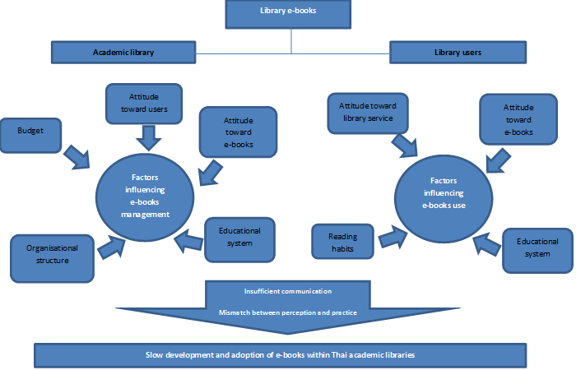

Figure 8‑1 Factors affecting the relationship between e-book collection management and user attitude and behaviour regarding e-books

Now that the overall results of the current study have been considered, the most significant factors relating to the relationship between library management of e-books and the attitudes and behaviour of library users are summarised (see Figure 8-1). The problems facing e-book collection management in Thai academic libraries and e-book use among library users were identified in the previous sections. However, there are major underlying and interlinked factors that affect e-book management and usage within these libraries.

* **Organisational structure in Thai academic libraries**

In addition to the approaches that have been used to manage e-books within academic libraries, the findings depict an overall image of the organisational culture within Thai academic libraries. The interviews with academic librarians revealed several of the major characteristics of the organisational culture in a Thai academic library context. Overall, it can be concluded that the management structure in the academic library sector is hierarchical. Based on the results of this present study, library directors are taking control of the whole library’s matters, for example, most management decisions were made by library director alone. However, a top-down management approach seems to be the management structure found in most libraries. Fundamentally, then, a hierarchical structure is one of the most common types of organisational structure in place in academic libraries (Budd, 2005; Mcguigan, 2012). According to Gulick (1937), a hierarchical structure involves positioning authority and the capacity to make decisions at the head of an organisation. At the same time, it is also a type of organisational structure criticised by experts as a major impediment to organisational development. In the interviews in this study, the majority of librarians agreed that library executives held power and took most decisions within the libraries. Subordinate staff members almost always followed the instructions of their superiors.

Evidently, this hierarchical management culture is seen as being widely used in Thailand; there are several critiques of the structure in the existing literature. For example, Inlek (2015) states that most of the state university academic libraries possess a top-down management culture in which library staff members usually wait for orders from their director before moving forward with any ideas. Similarly, librarians in this current study state that they usually follow the library director’s orders rather than initiating new ideas regarding the management approach. This results in a slow development and adoption of new library technology which is e-books in this case. It seems obvious that the majority of Thai academic librarians see e-books as a potential resource. However, the top-down management within library does slow down a development of e-book collection because librarians have no authority to make decisions.

Other studies of academic libraries in Thailand indicate negative outcomes from this hierarchical structure. Their findings also emphasise the idea that this management structure has long been present in academic libraries and might be difficult to change (Nokkaew, 2011). Another study by Pimpa (2012), this time focusing on organisational culture within the Thai public sector, found there to be a strong power distance in Thai public office. Thai public officers infrequently challenge their superiors. Likewise, a study about the cultural orientation of Iranian managers suggests that a manager who holds power also plays a vital role in decision-making and will thus be respected within an organisation (Yeganeh & Su, 2007).

In this study, the results from the interviews with academic librarians are generally in agreement with the previous literature. The organisational structure of academic libraries in Thailand has an impact on library management structure and this relates to e-book management. It is clear that the concept of power is strong within the Thai academic library sector, and the top-down decision-making process has long been used in the organisations within it. The high power distance (library staff members are dependent on top-level executives) in Thai academic libraries affects their whole management structure. Staff members in Thai academic libraries play only a minor role in decision-making regarding library issues. Although the librarians in this study saw the benefits of having e-books in their library collections, they were not in a position to make decisions with regard to library matters. Apart from that, the hierarchical structure also has an impact on the adoption of new technology by libraries as it could slow down the decision-making processes in this respect.

* **Budget constraints**

Budget issues are the main barrier to the development of e-book collections in the libraries. Budget constraints seem to be a common problem for most academic libraries and one for which it is difficult to find a solution. As shown in the findings, budget shortages can cause unsatisfied demand on the part of library users. Consequently, when this demand cannot be fulfilled because of budget problems, frustration occurs. However, there is evidence that some of the participating libraries have started to create their own in-house e-book collections by seeking to cooperate with other departments and organisations. Although there has so far been limited evidence of success, this initiative may represent a promising beginning for Thai academic libraries in solving their budget constraint problems. Apart from the budget shortage problem, the results of this study also show that many academic libraries in Thailand do not see e-books as a high priority resource to spend their budget on. As shown in the interviews, most libraries have allocated more budget on print resources rather than e-books.

* **Reading habits**

In the case of the reading behaviour patterns of library users in Thailand, the obvious factor that emerges from the library users themselves is that of the reading habits of users. The findings from both the survey and the photo-diary interviews reveal that user reading habits have a very strong impact on e-book reading behaviour. In this study, the majority of library users held a strong attachment to print books, far more so than to e-books. Although several benefits of e-books were obvious to the users and were perceived as such, most participants still preferred the printed medium to its electronic counterpart. The findings from the current study suggest that this could be because many library users have more of an emotional attachment to print books. For most users in this study, their experiences with paper books formed the basis of their expectations of e-books. However, their experiences with e-books did not fulfil these expectations. Therefore, most users had decided to return to their old reading habits. This emotional attachment to print books over e-books is also common in the previous literature (Manguel, 2008).

Apart from the issue of users’ affection for print books, the findings also show that there are certain misalignments between perceptions and actions in terms of e-books. It is clear that the majority of users in this study held positive opinions of e-books. However, upon closer examination, their habits reveal a different story. Based on the photo-diary findings, many library users were still reluctant to adapt to new reading technology. As shown in the photos, many participants were still attached to traditional ways of reading texts especially for academic-related reading, such as making notes on paper, printing texts out to highlight or underline them by hand. Many users were reluctant to mark electronic texts. Writing materials seemed to be significant for academic reading among the participants. On the other hand, there were no additional writing materials required for leisure reading. Most participants read linearly from both printed and electronic reading materials. These habits seem ingrained and could be one of several potential barriers to the adoption of e-books.

* **Attitudes toward e-books among librarians and library users**

Fundamentally, the perception of e-books shown by both Thai academic librarians and library users was positive. They perceived the characteristics of e-books in similar and positive ways. Both the librarians and the users saw accessibility, discoverability and portability as the main features of e-books. However, there were also several differences between the views of these two sets of stakeholders in terms of their ideas about e-books. The academic librarians believed that e-books would be easier to produce than paper books as they required neither printing nor binding. A reduction in paper consumption was another benefit of e-books that the librarians specified. The library users, however, noted that e-books were easy to access and involved no place or time limitations. The users also held the strong belief that using e-books would help them to save money in terms of book purchases because e-books should always be cheaper than print books. However, both librarians and users seem to lack a thorough understanding of e-books. The librarians in this study believed many irrelevant electronic resources to be e-books, while the users still confused e-books with other e-resources.

This study has also found that generally there is a misalignment between perception and practice in relation to e-books and both librarians and users. In the case of academic librarians, they realised all the potential benefits of e-books for library collections and libraries themselves. However, they had so far been unable to create an outstanding service for users. Similarly, in the case of library users, the majority of them were aware of the benefits of e-books but had failed to utilise this resource. Therefore, academic librarians and library users need to work in a coordinated fashion in order to develop a mutual understanding about the current situation of e-books in their libraries and to create e-book collections that support both user requirements and library goals at the same time.

* **Attitudes of academic librarians toward users, and vice versa**

Another important point concerns the attitude of academic librarians toward library users, as the findings show that many academic librarians held relatively negative opinions about user preferences in terms of library e-books. Moreover, a lack of in-depth understanding about user experiences and expectations can also be found in the study findings. This, then, seems to demonstrate that the librarians tended to manage e-books based on their own perception of users rather than taking into account user requirements. On the part of the library users, the results show that they were not opposed to e-books. Indeed, they displayed a positive view of them, just as the academic librarians did. Apart from the fact that most users held a natural and strong affection for print books and normally used e-books as a complementary resource, they also indicated several of the benefits to be obtained from using e-books. However, when asked about e-books in their university libraries, most library users were still unaware that their libraries had provided them with access to a number of e-books, although many librarians mentioned several of the methods they had used to promote e-books. Thus, library e-books may remain an underused resource. Many users also emphasised that their reason for not using e-books was that they had never been aware that there were e-books in their libraries in the first place. Clearly, library users will not use services if they do not know that they exist (Vasileiou & Rowley, 2011). This issue can be traced back to the lack of an effective method to deliver and market library e-books to users and also the absence of a plan to follow up initial approaches.

* **Education system in Thailand**

The education system is another influential driver of e-book management and use within the Thai academic library context. Both the academic librarians and the users in this study agreed that university lecturers were another set of stakeholders who had an influence on student reading behaviour. Recommendations from university lecturers play a significant role in formulating reading behaviour among library users in Thailand. Student participants in this study relied heavily on what their lecturers suggested they read and tended not to consider other resources that might also be relevant to their studies. This fact reflects the teaching and learning structure within the Thai academic context, a structure which represents another important factor to have an impact on the reading behaviour of Thai library users. Several studies about the education system in Thailand show that it features a relatively one-directional knowledge flow (Phungphol, 2005; Sinlarat, 2005a). Thai students act as knowledge receivers rather than knowledge producers and tend to refer to only what they have been told by lecturers; they make little attempt to seek new knowledge (Sinlarat, 2005b). Although the Thai education system attempted to move away from the traditional ‘teacher-centred teaching approach’ to a more ‘learner-centred teaching approach’ several decades ago (Phungphol, 2005), the new approach has been difficult to instil and might still be seen as less than practical in certain circumstances. Many university classrooms in Thailand are now dominated by lecturers who have adopted the ‘content-centred teaching approach’ (Phungphol, 2005). The result of this teaching approach can also be seen in the results of the current study, in that e-books are rarely applied to study in Thailand. Moreover, many of the students participating in this study also emphasised that they seldom used e-books in the library because they were not included in their reading lists. Thus, many students saw no necessity to use e-books.

## Conclusion

This chapter has discussed the findings of this study in relation to the findings from previous literature. Several significant issues from the current study confirm previous research into e-book management and library user attitudes and behaviour. In summary, the main problem facing an adoption of e-books within Thai academic libraries originates in the lack of a suitable structure for e-book collection management, budget constraint, librarians and users’ attitudes toward e-books, librarians and users’ attitude toward each other, users’ reading habits, and educational system. These also cause a misalignment between what academic librarians perceive about e-books and what they have actually done with library e-book collections, which in turn leads to an inability to deliver services that meet library user requirements. At the same time, library users themselves also have little knowledge of the complexities of e-book collection management in their libraries. However, academic librarians also have little in-depth knowledge about user requirements. It is noticeable that a lack of communication between academic librarians and library users and a mismatch between perception and practice of these two stakeholders have led the e-book service to a difficult situation. Therefore, academic librarians and users need to establish suitable forms of communication between each other in order to fill the gap in e-book management that is currently causing critical problems for academic libraries in Thailand.

# Conclusion

## Introduction

This chapter summarises the findings of the current study. It begins with an overview of how the research was conducted. The second section presents a summary of the key findings from each phase of the study. The contribution to knowledge offered by this study and its implications for those who have a stake in academic library e-book management are outlined in the third section. The chapter ends with a discussion of the limitations of the study and provides suggestions as to possible directions for future research.

## Summary of the study

The intent of the study was to contribute to an understanding of how Thai academic libraries manage their e-book collections and how their management approaches relate to the attitudes and behaviour of library users in terms of e-book reading. In recent years, practitioners and researchers have shown an increased interest in e-books as a potential resource in academic libraries, and several studies into the integration and management of e-books within academic libraries have been conducted (Lamagna et al., 2015; Moore, 2015; Pickett, Tabacaru, & Harrell, 2012; Sorrell, 2014; Zadravec & Buzina, 2014). However, the existing literature is not limited to examinations of the management of e-book collections; it also provides several user-focused studies regarding e-books. A number of researchers have attempted to understand e-book use behaviour among library users and to demonstrate user perceptions of e-books (Cassidy et al., 2012; Cataldo et al., 2014; Cummings et al., 2015; Levine-Clark et al., 2015). Nevertheless, two noticeable gaps appear in the literature on e-books. First, there has been a lack of research exploring the possible relationship between academic library management of e-books and user attitudes and behaviour in terms of e-books. Most of the previous studies have been concerned with either user perspectives on e-books or the management of e-book collections in libraries, rather than discussing the relationship between them. Second, there has been little research into the topic of e-books in academic libraries in the context of developing countries, especially in Thailand.

Accordingly, in attempting both to achieve its research aims and to reduce these knowledge gaps, the present study identified five main objectives:

1. To conduct interview sessions with academic librarians to gain a deeper understanding of the approaches that Thai academic libraries take in managing their e-book collections.
2. To use the interview data to identify the attitudes of academic librarians toward e-books and the use of e-books.
3. To conduct a questionnaire survey to examine the attitudes of library users in relation to e-books.
4. To undertake photo-diary interviews to examine the behaviour of library users in relation to print books and e-books.
5. To identify the factors emerging from all the data collected that, affect the relationship between a) the attitudes and approaches of librarians and b) the attitudes and behaviour of library users, and the adoption of e-books in Thai academic context.

The study adopted a mixed method research design in order to examine e-book collection management and user attitudes and behaviour in relation to e-books in Thai academic libraries. A combination of qualitative and quantitative methods was employed to collect the data at nine public university libraries. Semi-structured interviews with academic librarians were utilised in the investigation of the management approaches used for e-book collections in the libraries. In the next stage of the study, the results from the interviews, together with elements obtained from the UTAUT model, were incorporated into the questionnaire survey so as to explore the attitudes of library users toward e-books in academic libraries. Finally, photo-diary interviews were arranged to examine the reading behaviour of users regarding print books and e-books. The results, in the form of all the data collected, were then integrated and analysed in order to clarify the relationship between the management approaches employed for e-book collections in academic libraries and library user attitudes and behaviour with regard to e-book use.

## Key findings of the study

### Phase 1: Academic librarian interviews

The first phase of the study addressed the following two objectives:

1. To conduct interview sessions with academic librarians to gain a deeper understanding of the approaches that Thai academic libraries take in managing their e-book collections.
2. To use the interview data to identify the attitudes of academic librarians hold toward e-books and the use of e-books.

In this phase, the interviews explored the management approaches used for e-book collections in academic libraries. Currently, e-book collection development in Thai academic libraries is in its infancy. Most of the libraries in this study had no formal procedure for dealing with their e-book collections. Financial constraints were a common issue for the libraries and posed a significant barrier to e-book collection development. The study findings also revealed that the definition of e-books put forward by the academic librarians tended to be quite broad. For these librarians, most documents in an electronic format, such as dissertations, theses, research papers, other academic works, and even university exhibition programmes, were counted as e-books. The ideas held by academic librarians about library user e-book use were identified in the interviews. A majority of the librarians believed that their users displayed a low appreciation of e-books and, further, that they showed a lack of interest in reading e-books. The librarians saw both of these issues as barriers to the development of e-book collections. However, many of the academic librarians had positive views about the future of e-books in academic libraries. They believed that e-books would gain more acceptance from library users due to expected changes in user behaviour in response to rapid developments in technology.

The interviews provided a number of variables which were incorporated into the design of the questionnaire survey. This was then used to explore whether the perceptions held by library users of e-books were in line with the beliefs expressed by the academic librarians.

### Phase 2: Library users survey

This second phase of the study addressed the third research objective:

1. To conduct a questionnaire survey to examine attitudes of library users in relation to e-books.

Both online and paper based surveys were distributed to library users at the nine participating academic libraries. There were 353 responses to the paper based survey (450 invitations were sent, giving a response rate of 78%) and 66 responses to the online survey (150 invitations, and a response rate of 44%). In total, 419 responses (a response rate of 69%) were received from library users. The survey results showed that most library users had positive attitudes toward e-books in general and had some prior experience of e-book use. However, among these library users, print books were still the favoured reading format. In terms of library e-books, a considerable number of users (38%) were unaware that e-books were available in their libraries. Those respondents who used e-books in the library indicated that they rarely read e-books from beginning to end. Instead they read only selected sections of e-books in order to deal with a specific piece of work or assignment.

The factors of the UTAUT model are relevant to the acceptance and use of library e-books in Thai academic libraries. The results demonstrated that four factors (performance expectancy, effort expectancy, social influence and facilitating conditions) from the UTAUT model had a significant effect on the intention of library users to use e-books. In addition, these four factors also influenced the e-book use behaviour of users. In other words, the behavioural intention to use, as well as the actual usage of e-books in libraries originated from perceptions of e-book performance, the effort required to use e-books, the influence of others regarding e-book use, and support from the university library. The survey findings also suggested that librarians should focus more attention on promoting the e-book collections in their libraries so as to attract more users and increase their e-book usage rates.

The results also highlighted the contrast between academic librarian perceptions of library user attitudes toward e-books and the actual attitudes of the users. In general, the library users in this study did not appear to object to library e-books. A number of them had used e-books for academic tasks such as thesis or dissertation writing and in dealing with course assignments. However, a lack of awareness of library e-books seemed to be an important barrier to the adoption of e-books within Thai academic libraries. Thus, increased promotion of e-books and more education about e-book use were the main requirements the library users voiced.

### Phase 3: Photo-diary interview

The final phase of study addressed the fourth research objective:

1. To undertake a photo-diary interview to examine behaviours of library users in relation to print books and e-books.

35 photographs depicting reading behaviour were submitted by the respondents in this phase of the study. After all the photographs had been sent to the researcher, 11 interviews were conducted with 11 participants from different academic disciplines. The photo-diary interviews explored their reading behaviour in relation to both print and electronic books. The findings revealed that more than half the photographs submitted to the researcher were either work or study related (25 photos), while around a third of them showed leisure reading. The ratios of electronic and print format documents used for reading varied across different reading purposes. Printed documents were shown to be the most used format for academic reading, whereas the participants tended to use a mix of print and electronic formats for their leisure reading. Interestingly, the photo-diaries showed only one of the participants actually reading an e-book. Others were using electronic documents, but most of them were online articles, electronic theses or electronic versions of handouts. Most participants provided evidence of using printed books and print outs of electronic resources. These findings demonstrated that most library users had a preference for printed books over e-books, which is consistent with the findings from the questionnaire survey (Phase 2).

The photo-diary interview findings also indicated the factors which had an effect on choice of reading format among the library users. Six factors were shown to be involved in the selection of reading format: 1) library user attitudes towards reading material; 2) cost of e-books and e-readers; 3) availability and discoverability of particular reading material; 4) physical health concerns; 5) usability of the reading material; and 6) suggestions made by lecturers.

## Synthesis of research findings

Once the three phases of data collection had been completed, findings from all these phases were collated in order to meet the main aim of the study. In addition, the synthesised results were employed to address the final research objective:

1. To identify the factors emerging from all of the data collected that, affect the relationship between a) attitudes and approaches of librarians and b) attitudes and behaviours of library users, and the adoption of e-books in Thai academic context.

Analysis of the interviews conducted with the academic librarians supplied evidence of the most influential factors behind both their attitudes toward e-books and the approaches they used to manage e-book collections. There were six main factors which had an influence in these two respects: the organisational structure present in libraries, budget constraints, users’ reading habits librarians and users’ attitudes toward e-books, librarians’ and users’ attitudes toward each other, and educational system.. Table 9-1 summarises all these possible factors and their outcomes in terms of their contribution to the relationship between academic librarians and library users.

Table 9‑1 Factors affecting the relationship between librarians and library users

| **Librarians** | | **Library users** | |
| --- | --- | --- | --- |
| **Factors** | **Outcomes** | **Factors** | **Outcomes** |
| Organisational culture | Hierarchical management structure limits forward movement of library | Reading habits | Users have a strong preferences for print books |
| Budget constraints | Lack of budget limits expansion of e-book collections |
| Attitudes toward library users | Lack of understanding of user requirements results in pessimistic attitudes toward library users | Attitudes toward library e-book service | Users require more support from library regarding e-book use |
| Attitudes toward e-books | Both librarians and users have positive attitudes toward e-books, but still lack of a thorough understanding of e-books. | | |
| Educational system | ‘Teacher-centred’ teaching approach limits student choice of reading material | | |

All the possible factors featured above were examined further in order to ascertain whether there were underlying reasons that might explain the relationship between the two sets of stakeholders and the adoption of e-books within academic libraries. After full consideration, two underlying issues emerged from the data. First, the absence of effective communication between academic librarians and library users regarding library e-books could create problems in terms of the provision and use of e-book services within libraries. Every library in this study aimed to provide the most effective e-book service for its users. However, a strong sense of dissatisfaction remained even after users had used library e-books. A number of insufficiencies in relation to e-books were mentioned by library users, such as the number of e-books, e-book promotion, and facilities for e-book use. More communication between academic librarians and library users could, it is proposed, help to eliminate these problems.

Second, a gap between perception and practice for both academic librarians and library users was another important factor in the complex situation facing e-book management and adoption in Thai academic libraries. This study indicated that the Thai academic librarians who participated in the research were aware of the potential benefits that e-books could bring to libraries. However, they were still reluctant to enhance library e-book collections, even though they could see the advantages of doing so. Similarly, the library users had positive attitudes about e-books and were also aware of their benefits. However, their stated preference for and familiarity with print books was probably hindering the adoption of e-books in Thai academic libraries.

## Contribution to knowledge

This study has explored a number of the issues regarding e-book collection management and the attitudes and behaviour of library users in academic libraries. Thai public university libraries were chosen as the study sites in this respect. As shown in the literature review within this study, previous research into e-books in academic libraries has focused more on either library collection management and development or issues concerning users. Both focuses are of course relevant in the context of academic libraries. However, research that investigates the relationship between these two elements has been neglected. The current study sought to fill the knowledge gap about the extent to which e-book collection management approaches in academic libraries have had an effect on the attitudes and behaviour with regard to e-books among library users. In terms of that gap, this study and its outcomes have made an original contribution to knowledge in the following respects.

The current study represents a pioneer work in investigating the relationship between academic libraries and library users with regard to e-book management and use in the context of Thai academic libraries. It examined thoroughly the range of approaches that the case study libraries employed to manage their e-book collections. Moreover, other associated issues and challenges to collection management activities were identified. This study also provided insight into not only management issues but also academic librarians’ attitudes toward both e-books and library patrons and their use of e-books. An in-depth investigation into library users’ attitudes to and behaviour with e-books was also conducted. Furthermore, the combination of questionnaire survey and photo-diary interview methods provided essential clarifications in the user study part of the research. A synthesis of the findings concerning both academic library management and user attitudes and behaviour helped to provide a more thorough understanding of e-books and their current position within academic libraries.

The study has also made a contribution to the development of a more effective research methodology. As the UTAUT model is generally accepted as the basic framework for research into technological use and acceptance, it suited the context of the current study. However, an in-depth investigation of e-book reading behaviour was also a main focus of this study. Applying only the UTAUT framework might not have supplied a clear picture of issues concerning both attitudes and behaviour. Thus, Keller’s (2012) was also adopted in combination with the UTAUT in order to understand in details factors which could influence reader choice of either print or screen (Keller, 2012); this decision was made in order to examine more thoroughly attitudes toward e-books held by library users and their e-book reading behaviour. The integration of the UTAUT framework with more qualitative methods allowed the researcher to gain a more in-depth understanding of both the attitudes and behaviour of the research participants. This methodological approach may be of interest to researchers who are seeking a framework for their studies with which to explain behavioural issues.

This study has shed new light on the research into e-books, particularly in the context of Thai academic libraries. The results provided reflections on the current situation of e-book adoption and pointed out both the challenges and opportunities for academic libraries regarding their e-book services. The findings within this study also extended the current understanding of the impact of different factors on the relationship between library e-book collection management and user attitudes toward library e-books and e-book use behaviour.

## Recommendations for practice

The findings of this current study suggest several significant recommendations for library practitioners interested in developing effective e-book services in libraries. These recommendations can be separated into two types: recommendations for library executives and those for library practitioners.

Library executives should prioritise:

* Formulating strategies for the development of e-book collections, for example creating a library policy that includes plans for e-books such as selection criteria and purchasing processes
* Reconsidering current budget plans in order to ensure their sufficiency and the continuance of e-book purchases
* Considering building a relationship with other university libraries via a library consortium in order to create more bargaining power when buying library resources from vendors

Library practitioners should prioritise:

* Conducting a continuing in-depth user study, including for example observations, surveys or interviews, to gain a better understanding of both attitudes and patterns of behaviour regarding e-book use
* Developing a follow-up method for the marketing approaches that libraries employ with users in order to ensure their effectiveness
* Building a relationship with users by creating a tool that facilitates two-way communication with users, such as initiating an instant librarian chat service on the library website.

## Limitations and future research

All research projects have limitations, and this current study is no exception. A number of limitations which might have affected the study as a whole are identified in this section.

First, this study aimed to advance understanding of the relationship between e-book collection management and library user attitudes and behaviour within Thai academic libraries. It is recognised that, at the time of writing, most university libraries in Thailand do offer an e-book service. However, the data used in this study was collected exclusively from public university libraries located in the Bangkok metropolitan region. Due to limitations of time and budget, the researcher had to select only case libraries within this specific area. This limitation, however, may suggest an opportunity for future research by expanding the focus to libraries in other areas of the country. In addition, the inclusion of different types of university library could be an option for further study as they might reveal interesting similarities and differences across cases. Extended data collection in future studies will allow increased understanding of the topic of e-books within a Thai academic context.

Second, the literature that was reviewed in this study covered mainly the position of e-books in developed countries, while the main focus here was Thailand. However, the literature review was necessarily limited due to the non-availability of literature on e-books in Thai academic libraries. Further research regarding the role of e-books in an academic context both in Thailand and other developing countries would be a substantial help in filling this gap in the literature.

Third, the scope of data collection in the current study did limit the generalisability of the findings. The sample size in the interviews with participants was relatively small. Although the findings were relevant and provided valuable information for the study, they might not have been wholly representative of all the librarians and users of academic libraries in Thailand. Therefore, a broader range of interviewees could be used in any further study as this would provide a fuller spectrum of perspectives. Furthermore, as the evidence obtained from the participants was collected at one point in time, this limited the perspectives that could be taken into account in the investigation. Thus, a longitudinal data collection approach might be utilised in future research in order to provide fuller information about the e-book use behaviour of the participants.

## Conclusion

This study was undertaken to identify the relationship between e-book collection management and library user attitudes and behaviour in relation to e-books within Thai academic libraries. An exploratory mixed method design was used, one which combined interview, questionnaire survey and photo-diary interview methods to collect the data. The results were then linked in order to answer the four research questions central to the study. The findings of the study suggest that attitudes of librarians and users regarding e-books, attitudes of librarians and users towards each other, organisational structure of Thai libraries, budgets, reading habits of users, and the Thai educational system have shaped the direction of the management and acceptance of e-books within Thai academic libraries. In addition, communication between academic librarians and library users regarding a library e-book service is a pivotal element in the development of an effective service. The relationship between academic librarians and library users is a very important indicator of the success of the integration of e-books into academic libraries. The insights gained through such communication could be particularly helpful to library practitioners in terms of library service enhancements.

In summary, the current study has achieved its aim and objectives by providing an overall picture of the present status of e-books within academic libraries, by identifying the relationship between academic libraries and their users, together with the probable factors that underpin that relationship, and by highlighting several potential practices that libraries might adopt to benefit the development of their e-book collections.

# References

Abdullah, N., & Gibb, F. (2008). Students’ attitudes towards e-books in a Scottish higher education institute: part 2 Analysis of e-book usage. *Library Review*, *57*(9), 676–689. http://doi.org/10.1108/00242530810911798

Ahmad, P., & Brogan, M. (2012). Scholarly use of e-books in a virtual academic environment: A case study. *Australian Academic & Research Libraries*, *43*(3), 189–213.

Ahmad, P., Brogan, M., & Johnstone, M. N. (2014). The E-book Power User in Academic and Research Libraries: Deep Log Analysis and User Customisation. *Austrailian Academic & Research Libraries*, *45*(1), 35–47. http://doi.org/10.1080/00048623.2014.885374

Ajzen, I. (1991). The Theory of Planned Behavior. *Organizational Behaviour and Human Decision Processes*, *50*(2), 179–211.

Al-Suqri, M. N. (2014). Perceived usefulness, perceived ease-of-use and faculty acceptance of electronic books: An empirical investigation of Sultan Qaboos University, Oman. *Library Review*, *63*(4–5), 276–294. http://doi.org/10.1108/LR-05-2013-0062

Anothaisintawee, S. (2013). *The acquisition of electronic books in university libraries*. Chulalongkorn University.

Anson, C., & Connell, R. R. (2009). *E-book Collections: SPEC Kit 313*. Washington DC. Retrieved from http://www.arl.org/resources/pubs/spec

Armstrong, C. (2008). Books in a virtual world: The evolution of the e-book and its lexicon. *Journal of Librarianship and Information Science*, *40*(3), 193–206. http://doi.org/10.1177/0961000608092554

Armstrong, C., Edwards, L., & Lonsdalde, R. (2002). Virtually there? E-books in UK academic libraries. *The Electronic Library Aslib Proceedings Iss*, *36*(1), 216–227. http://doi.org/10.1108/00330330210447181

Armstrong, C., & Lonsdalde, R. (2011). Introduction. In K. Price & V. Havergal (Eds.), *E-books in libraries : A practical guide*. London: Facet Publishing.

Armstrong, C., & Lonsdale, R. (2005). Challenges in managing e-books collections in UK academic libraries. *Library Collections, Acquisition and Technical Services*, *29*, 33–50. http://doi.org/10.1016/j.lcats.2004.12.001

Armstrong, C., Lonsdale, R., & Nicholas, D. (2006). SuperBook: Planning for the e-book revolution. *Library and Information Update*, *5*(11), 28–30.

Armstronglouise, C., Lonsdale, E., Bennett, L., Landoni, M., Vassiliou, M., Rowley, J., … Lonsdale, R. (2002). Program Virtually there? E-books in UK academic libraries Virtually there? E-books in UK academic libraries. *The Electronic Library Library Hi Tech Iss Aslib Proceedings*, *36*(6), 216–227. Retrieved from http://dx.doi.org/10.1108/00330330210447181

Ashcroft, L. (2011). Ebooks in libraries: an overview of the current situation. *Library Management*, *32*(6–7), 398–407. http://doi.org/10.1108/01435121111158547

Atkins, M. (2014). Foreward. In H. Woodward (Ed.), *Ebooks in Education: Realising the Vision* (pp. v–vi). London: Ubiquity Prress.

Babbie, E. (2010). *The Practice of Social Research* (12th ed.). Belmont, CA: Wadsworth.

Bailey, T. P., Scott, A. L., & Rickey, D. (2015). Cost Differentials between E-Books and Print in Academic Libraries, 6–19. http://doi.org/10.5860/crl.76.1.6

Becker, B. W. (2015). Ebooks in the Library: The Current State of Research. *Behavioral & Social Sciences Librarian*, *34*(4), 230–233. http://doi.org/10.1080/01639269.2015.1096156

Belanger, J. (2007). Program Cataloguing e-books in UK higher education libraries: report of a survey Cataloguing e-books in UK higher education libraries: report of a survey. *Program Iss*, *41*(3), 203–216. http://doi.org/10.1108/00330330710774093

Berg, S. A., Hoffmann, K., & Dawson, D. (2010). Not on the Same Page: Undergraduates’ Information Retrieval in Electronic and Print Books. *The Journal of Academic Librarianship*, *36*(6), 518–525. http://doi.org/10.1016/j.acalib.2010.08.008

Bergeron, F., Rivard, S., & De Serre, L. (1990). Investigating the Support Role of the Information Center. *Source: MIS Quarterly*, *14*(3), 247–260. Retrieved from http://www.jstor.org

Bernard, H. R. (2000). *Social Research Methods: Qualitative and Quantitative Research Approaches*. Thousand Oaks, CA: Sage.

BICS. (2016a). Thai Higher Education System.

BICS. (2016b). Types of Thai Higher Education Institutions.

Bookboon. (n.d.). Global eBook Survey 2013 by Bookboon.

Bradley, J. (1993). Methodological Issues and Practices in Qualitative reaserach. *The Library Quarterly: Information, Community, Policy*, *63*(4), 431–449. Retrieved from http://www.jstor.org/stable/4308865

Branch, D. (2015). Successful E-Resource Acquisitions: Looking Beyond Selecting, Ordering, Paying, and Receiving to Discovery and Access. In *2014 Charleston Library Conference*. Retrieved from http://docs.lib.purdue.edu/charleston/2014/Collection/8/

Brown, G. J. (2001). Library Hi Tech Beyond print: reading digitally. *Library Hi Tech Journal of Documentation The Electronic Library Iss Hanho Jeong The Electronic Library*, *19*(3), 390–399. Retrieved from http://dx.doi.org/10.1108/07378830110412456

Browne, G., & Coe, M. (2012). Ebook Navigation : Browse , Search and Index. *Australian Library Journal*, *61*(4), 288.

Bucknell, T. (2012). Buying by the bucketful: a comparative study of e-book acquisition strategies. *Insights: The UKSG Journal*, *25*(1), 51–61.

Budd, J. (2005). *The Changing Academic Library: Operations, culture, environments*. Association of College & Research libraries.

Burns, N., & Grove, S. K. (1999). *Understanding nursing research*. Philadelphia: Saunders Company.

Burton-Jones, A., & Hubona, G. S. (2005). Individual differences and usage behavior. *ACM SIGMIS Database*, *36*(2), 58–77. http://doi.org/10.1145/1066149.1066155

Butdisuwan, S. (2005). Digital Library: A Transition for Academic Libraries in Thailand. In *Going Digital: Experiences from East Asia and the Pacific*. Chicago.

Carroll, A. J., Corlett-rivera, K., Hackman, T., Zou, J., Carroll, A. J., Corlett-rivera, K., … Zou, J. (2016). E-book perceptions and use in STEM and non-STEM disciplines: A comparative follow-up study. *Portal: Libraries and the Academy*, *16*(1), 131–162.

Cassidy, E. D., Martinez, M., & Shen, L. (2012). Not in Love, or Not in the Know? Graduate Student and Faculty Use (and Non-Use) of E-Books. *Journal of Academic Librarianship*, *38*(6), 326–332. http://doi.org/10.1016/j.acalib.2012.08.005

Cataldo, T. T., Shelton, T., Carrico, S., & Botero, C. (2014). How Users ’ Perceptions of E ‐ Books Have Changed — Or Not : Comparing Parallel Survey Responses.

Chan, G. R. Y. C., & Lai, J. K. (2005). Shaping the strategy for e-books: A Hong Kong perspective. http://doi.org/10.1016/j.lcats.2005.04.002

ChanLin, L. (2013). Reading strategy and the need of e-book features. *The Electronic Library*, *31*(3), 329–344. Retrieved from http://dx.doi.org/10.1108/EL-08-2011-0127

Chein, I. (1981). An introduction to sampling. In L. H. Kidder (Ed.), *Research Methods in Social Relations* (pp. 418–441). New York: Rinehart & Winston.

Cho, B.-Y. (2013). Adolescents’ constructively responsive reading strategy use in a critical internet reading task. *Reading Research Quarterly*, *48*(4), 329–332.

Chuenta, P. (2005). *Electronic Information Resources Acquisition: A Case Study of University Libraries in Northeastern Region*. Khon Kaen University.

Churuangsukh, J. (2009). *The Usage and Needs for Electronic Books: A Case Study in the Health Science Library, Prince of Songkla University*. Prince of Songkla University.

Cleto, C. (2008). 10 Steps to Implementing an eBook Collection: A Guide for Librarians. *Against the Grain*, *20*(1), 47–48.

Coffee, A., & Atkinson, P. (1996). *Making sense of qualitative data:complementary research strategies*. CA: Thousand Oaks. Retrieved from http://www.jstor.org

Connaway, L. S., & Powell, R. R. (2010). *Basic research methods for librarians* (5th ed.). Californiia: Libraries Unlimited.

Connaway, L. S., & Wicht, H. L. (2007). What happened to the e-book revolution?: The gradual integration of e-books into academic libraries. *The Journal of Electronic Publishing*, *10*(3).

Crawford, W., & Gorman, M. (1995). *Future Libraries: Dreams, Madness and Reality*. London: American Library Association.

Creswell, J. W. (2002). *Research Design: Qualittative, quantitative, and mixed methods* (2nd ed.). London: Sage Publications Ltd.

Creswell, J. W., & Plano Clark, V. L. (2007). *Designing and conducting mixed methods research*. Thousand Oaks, CA: Sage.

Creswell, J. W., & Plano Clark, V. L. (2011). *Designing and conducting mixed methods research* (2nd ed.). London: Sage Publications Ltd.

Crotty, M. (1998). *The foundations of social research: meaning and perspective in the research process*. London: Sage.

Cummings, L. A., Larrivee, A., Vega, L., Cummings, L. A., Larrivee, A., & Vega, L. (2015). Comparing electronic vs print book preferences between students in the social sciences , the arts and STEM. http://doi.org/10.1108/LHTN-10-2014-0088

Czechowski, L. (2011). Problems with e-books: suggestions for publishers. *Journal of the Medical Library Association : JMLA*, *99*(3), 181–182. http://doi.org/10.3163/1536-5050.99.3.001

Davis, F. D. (1989). Perceived usefulness, perceived ease of use, and user acceptance of information technology. *MIS Quarterly*, *13*(3), 319–339.

DeLone, W. H. (1988). Determinants of Success for Computer Usage in Small Business. *MIS Quarterly*, *12*(1), 51. http://doi.org/10.2307/248803

Delquie, E., & Polanka, S. (2011). E-book Standards. In S. Polanka (Ed.), *No Shelf Required: E-books in Libraries* (1st ed., pp. 135–152). Chicago: The American Library Association.

Dilevko, J., & Gottlieb, L. (2002). Print sources in an electronic age: a vital part of the research process for undergraduate students. *The Journal of Academic Librarianship*, *28*(6), 381–392. http://doi.org/10.1016/S0099-1333(02)00341-5

Dillon, D. (2001). E‐books: the University of Texas experience, part 2. *Library Hi Tech*, *19*(4), 350–362. http://doi.org/10.1108/EUM0000000006540

Ditmyer, M. M., Dye, J., Guirguis, N., Jamison, K., Moody, M., Mobley, C. C., & Davenport, W. D. (2012). Electronic vs. traditional textbook use: dental students’ perceptions and study habits. *Journal of Dental Education*, *76*(6), 728–38.

Douglas, V. A., & Helms, C. (2015). Adopting E-Readers with a Purpose: Surveying Users to Develop a Recreational Reading Kindle Lending Program. *College & Undergraduate Libraries*, *22*(1), 76–89. http://doi.org/10.1080/10691316.2014.892422

Ebrary. (2008). 2008 Global Student E-book Survey.

Economic and Social Research Council. (2016). Framework for research ethics.

Erlandson, D. A. (1993). *Doing naturalistic inquiry : a guide to methods*. *Sage*. London. http://doi.org/10.1177/0891241609343663

Feilzer, M. Y. (2010). Doing mixed methods research pragmatically: Implications for the rediscovery of pragmatism as a research paradigm. *Journal of Mixed Methods Research*, *4*, 6–16.

Feldstein, A. P., & Martin, M. M. (2013). Understanding slow growth in the adoption of e-textbooks: distinguishing paper and eletronic delivery of course content. *International Research in Education*, *1*(1).

Fieldhouse, M., & Marshall, A. (2012). *Collection Development in the Digital Age*. London: Facet Publishing.

Fishbein, M., & Ajzen, I. (1975). *Belief, Attitude, Intention and Behavior: An Introduction to Theory and Research*. London: Addison-Wesley Publishing Company.

Foertsch, M. (2003). *A study of reading practices, instruction, and achievement in district 31 schools*.

Foster, A., & Arrandale, M. (2014). Adding Demand-Driven Acquisition of eBooks. *PNLA Quarterly*, *79*(1), 91–98. Retrieved from http://search.ebscohost.com/login.aspx?direct=true&db=llf&AN=108826994&site=ehost-live%5Cnhttp://content.ebscohost.com.proxy1.lib.uwo.ca/ContentServer.asp?T=P&P=AN&K=108826994&S=R&D=llf&EbscoContent=dGJyMNLr40Sep7E4zdnyOLCmr02ep7RSrqa4S7KWxWXS&ContentCustom

Fraillon, J., Ainley, J., Schulz, W., Friedman, T., & Gebhardt, E. (2014). *Preparing for Life in a Digital Age* (1st ed.). Springer International Publishing. http://doi.org/10.1007/978-3-319-14222-7

Frederick, D. E. (2015). On eBooks in academic libraries: an article based on a presentation at the Library 2.014 Conference. *Library Hi Tech News*, *32*(5), 12–15. http://doi.org/10.1108/LHTN-02-2015-0015

Furness, H. (2016). Books are back: Printed book sales rise for first time in four years as ebooks suffer decline. *The Telegraph*.

Goertzen, M. J. (2014). The Buck Stops Here : Assessing the Value of E- Book Subscriptions at the Columbia University Libraries.

Gold Leaf. (2003). *Promoting the uptake of e-books in higher and further education*.

Gray, D. E. (2014). *Doing Research in the Real World* (3rd ed.). London: Sage Publications Ltd.

Gray, D. J., & Copeland, A. J. (2012). E-book versus print: A per-title cost and use comprison of a public library’s popular titles. *Reference & User Services Quarterly*, *51*(4), 334–339.

Greene, J. C., Kreider, H., & Mayer, E. (2011). Combining Qualitative and Quantitative Methods in Social Inquiry. In B. Somekh & C. Lewin (Eds.), *Theory and Methods in Social Research* (2nd ed., pp. 259–266). London: Sage Publications Ltd.

Gregory, V. L. (2011). *Collection Development and Management for 21st Century Library Collections: An Introduction*. New York: Neal-Schuman Publishers.

Grover, R., & Glazier, J. D. (1985). Implications for application of qualitative methods to library and information research. *Library and Information Science Research*, *7*(3), 247–260.

Gruzd, A., Staves, K., & Wilk, A. (2012). Connected scholars: Examining the role of social media in research practices of faculty using the UTAUT model. *Computers in Human Behavior*, *28*.

Guba, E., & Lincoln, Y. (2005). Paradigmatic controversies, contradictions, and emerging confluences. In N. K. Denzin & Y. Lincoln (Eds.), *Handbook of qualitative research* (3rd ed., pp. 191–215). Thousand Oaks, CA: Sage Publications, Inc.

Gulick, L. (1937). *Papers on the Science of Administration*. New York: Institute of Public Administration.

Gutenberg, P. (2010). The History and Philosophy of Project Gutenberg by Michael Hart.

Guthrie, K. M. (2012). Will Books Be Different? *Journal of Library Administration*, *52*(February 2015), 353–369. http://doi.org/10.1080/01930826.2012.700805

Harper, D. (2002). Talking about pictures : A case for photo elicitation. *Visual Studies*, *17*(1), 13–26. http://doi.org/10.1080/1472586022013734

Hernon, P., Hopper, R., Leach, M. R., Saunders, L. L., & Zhang, J. (2007). E-book use by students: Undergraduates in Economics, Literature, and Nursing. *The Journal of Academic Librarianship*, *33*(1), 3–13. http://doi.org/10.1016/j.acalib.2006.08.005

Hillesund, T. (2001). Will e-books change the world? *First Monday*, *6*(10).

Hodges, D., Preston, C., & Hamilton, M. J. (2010). Resolving the challenges of e-books. *Collection Management*, *35*(4), 196–200.

Housewright, R., Schonfeld, R. C., & Wulfson, K. (2012). *US faculty survey 2012*. New York.

Hwang, S. K., Kim, J.-Y., Lee, J., Hwan, B., Jeong, K., Pinto, M., … Kim, J. H. (2014). Usage patterns and perception toward e-books: experiences from academic libraries in South Korea. *The Electronic Library*, *32*(4), 473–492. http://doi.org/10.1108/EL-11-2012-0150

Ismail, R., & Zainab, A. N. (2005). The pattern of e-book use amongst undergraduates in Malaysia: A case of to know is to use. *Malaysian Journal of Library & Information Science*, *10*(2), 1–23.

JISC. (2009). *JISC national e-books observatory project: Key findings and recommendations*.

Johnson, P. (2009). *Fundamentals of Collection Developement and Management* (2nd ed.). Chicago: American Library Association.

Johnson, P. (2014). *Fundamentals of Collection Development and Management* (3rd ed.). Chicago: The American Library Association.

Johnson, R. B., & Onwuegbuzie, A. J. (2004). Mixed methods researcher: a research paradigm whose time has come. *Educational Researcher*, *33*(14), 14–25.

Johnson, R. B., Onwuegbuzie, A. J., & Turner, L. A. (2007). Toward a definition of mixed methods research. *Journal of Mixed Methods Research*, *1*(2), 112–133.

Jr., J. C. (1957). Photography in Anthropology: A Report on Two Experiments. *American Anthropologist*, *59*(5), 843–859. http://doi.org/10.1525/aa.1957.59.5.02a00100

Jung, J., Chan-Olmsted, S., Park, B., & Kim, Y. (2011). Factors affecting e-book reader awareness, interest, and intention to use. *New Media & Society*, *14*(2), 204–224. http://doi.org/10.1177/1461444811410407

Kahneman, D., Ritov, I., & Schkade, D. (1999). Econommic Preferences or Attitude Expressions? : An Analysis of Dollar Responses to Public Issues. *Juornal of Risk and Uncertainty*, *19*(1–3), 203–235.

Karim, A., & Hasan, A. (2007). Reading habits and attitude in the digital age; Analysis of gender and academic program differences in Malaysia. *The Electronic Library*, *25*(3), 285–298.

Keller, A. (2012). In print or on screen? Investigating the reading habits of undergraduate students using photo-diaries and photo-interviews. *Libri*, *62*(1), 1–18. http://doi.org/10.1515/libri-2012-0001

Kennedy, J. (2006). *Collection Management: A Concise Introduction*. Wagga Wagga: Center for Informatio Studies.

Kerby, E. E., & Trei, K. (2015). Minding the Gap: eBook package purchasing. *Collection Building*, *34*(4), 113–118. http://doi.org/10.1108/CB-06-2015-0008

Khamkhomkhet, K. (2013). *A study of behaviours in using electronic book of students in Khon Kaen University*. Khon Kaen University.

Khan, A. M. (2016). A study on collection development and its organizational pattern of university libraries in Uttar Pradesh (India). *Collection Building*, *35*(1), 1–11. http://doi.org/10.1108/CB-03-2014-0019

Khan, G., & Bhatti, R. (2016). An analysis of collection development in the university libraries of Pakistan. *Collection Building*, *35*(1), 22–34. http://doi.org/10.1108/CB-07-2015-0012

Kong, Y., & Chen, D. (2016). China’s eBook Market. In R. Wischenbart (Ed.), *Global eBook: A report on market trends and developments*. Vienna: Rudiger Wischenbart Content and Consulting.

Kuhn, T. S. (1971). *The Structure of Scientfic Revolutions*. Chicago: University of Chicago Press.

Lamagna, M., Hartman-Caverly, S., & Swenson Danowitz, E. (2015). Integrating e-Books into Academic Libraries: A Literature Review. *Internet Reference Services Quarterly*, *20*, 19–32. http://doi.org/10.1080/10875301.2015.1049396

Lamothe, A. R. (2013). Factors influencing the usage of an electronic book collection: Size of the e-book collection, the student population, and the faculty population. *College & Research Libraries*, *71*(1), 39–59.

Lancaster, F. W. (1995). The Evolution of Electronic Publishing. *Library Trends*, *43*(4), 518–27.

Landesman, B. M. (2002). Libraries , Publishers , And Libraries As Publishers –– In Need Of New Models For Online Books –– Ebrary Might Be a Good One ..., (April), 52–54.

Landoni, M. (2003). Electronic Book. In *International Encyclopedia of Information and Library Science* (2nd ed.). Routledge.

Landoy, A., Repanovici, A., & Gastinger, A. (2015). The more they tried it the less they liked it: Norwegian and Romanian student’s response to electronic course material. In S. Spiranec, S. Virkus, S. Kurbanoglu, E. Grassian, D. Mizrachi, & L. Roy (Eds.), *Information literacy: moving towards sustainability: third European conference, ECIL 2015, Tallinn, Estonia, October 19-22, 2015: revised selected papers* (pp. 455–463). Cham, Switzerland: Springer.

Langston, M. (2003). The California State University E-book pilot project: Implications for cooperative collection development. *Library Collections, Acquisition and Technical Services*, *27*(1), 19–32. http://doi.org/10.1016/S1464-9055(02)00305-6

Larson, L. C. (2010). Digital Readers: The Next Chapter in E-book Reading and Response. *Reading Teacher*, *64*(1), 15–22. http://doi.org/10.1598/RT.64.1.2

Lee, S. D., & Boyle, F. (2004). *Building an electronic resource collection: a practical guide* (2nd ed.). London: Facet Publishing.

Lenares, D., Smith, S., & Boissy, R. (2013). *E-book use and acceptance in an undergraduate institution*.

Lesmeister, B. (2010). Teaching Adults to read with reading apprenticeship. *Techbiques: Connecting Education and Careers*, *85*(2), 28–32.

Letchumanan, M., & Tarmizi, R. (2011). Assessing the intention to use e-book among engineering undergraduates in Universiti Putra Malaysia,Malaysia. *Library Hi Tech*, *29*(3), 512–528.

Levine-Clark, M. (2007). Electronic Books and the Humanities: A Survey at the University of Denver. *Portal: Libraries and the Academy*, *6*(3), 285–299. http://doi.org/10.1353/pla.2006.0041

Levine-Clark, M., Paulson, K., & Moeller, P. (2015). 10,000 Libraries, 4 Years: A Large-Scale Study of E-Book Usage and How You Can Use the Data to Move Forward. *The Serials Librarian*, *68*(1–4), 262–268. http://doi.org/10.1080/0361526X.2015.1017709

Levine-clark, M., Paulson, K., Moeller, P., & Levine-clark, M. (2015). 10 , 000 Libraries , 4 Years : A Large-Scale Study of E-Book Usage and How You Can Use the Data to Move Forward Can Use the Data to Move Forward, *1095*(January 2016). http://doi.org/10.1080/0361526X.2015.1017709

Levy, J. A. (1988). Intersections of gender and age. *The Sociological Quarterly*, *29*(4), 479–486.

Li, C., Poe, F., Potter, M., Quigley, B., & Wilson, J. (2011). UC Libraries Academic E-book Usage Survey. *The International Journal of Digital Curation*, *6*(2), 38–52. http://doi.org/10.1890/120103

Lincoln, Y., & Guba, E. (1985). *Naturalistic Inquiry*. London: Sage Publications Ltd.

Liu, Z. (2005). Reading Behaviour in the Digital Environment: Changes in Reading Behaviour over the Past Ten Years. *Journal of Documentation*, *61*(6), 700–712. http://doi.org/10.1108/00220410510632040

Lopatovska, I., & Regalado, M. (2016). How students use their libraries: A case study of four academic libraries. *College & Undergraduate Libraries*, *23*(4), 381–399.

Lukes, R., Markgren, S., & Thorpe, A. (2016a). E-book Collection Development: Formalizing a Policy for Smaller Libraries. *The Serials Librarian*, *70*(1–4), 106–115. Retrieved from http://dx.doi.org/10.1080/0361526X.2016.1153329

Lukes, R., Markgren, S., & Thorpe, A. (2016b). E-book Collection Development: Formalizing a Policy for Smaller Libraries. *The Serials Librarian*, *70*(1–4), 106–115.

Makaramani, R. (2013). ICT in Education Country Report (Thailand). In *UNESCO Resource Training and Distribution Centre Regional Seminar* (pp. 1–11). Penang, Malaysia.

Mangen, A. (2008). Hypertext Fiction Reading: Haptics and Immersion. *Journal of Research in Reading*, *31*(4), 404–419.

Manguel, A. (2008). *The Library at Night*. New Haven: Yale University Press.

Martindale, G., Willett, P., & Jones, R. (2015a). Use and perceptions of e-books in Derbyshire libraries. *Library Review*, *64*(12), 21–35. Retrieved from http://dx.doi.org/10.1108/LR-04-2014-0030

Martindale, G., Willett, P., & Jones, R. (2015b). Use and Perceptions of e-Books in Derbyshire Libraries.

Matthewson, G. . (1994). Model of Attitude Influence upon Reading and Learning to Read. In R. B. Ruddell & N. J. Unrau (Eds.), *Theoretical Models and Processes of Reading* (4th ed., pp. 1431–1461). Newark: International Reading Association.

McDonald, E., Rosenfield, M., Furlow, T., & Lopatovska, I. (2015). Book or Nook Information behavior of academic librarians. *Aslib Journal of Information Management*, *67*(5), 374–291.

Mcguigan, G. S. (2012). Addressing Change in Academic Libraries: A Review of Classical Organizational Theory and Implications for Academic Libraries. *Library Philosophy & Practice*, 138–148.

Mckenna, B., Tuunanen, T., & Gardner, L. (2013). Consumers’ adoption of information services. *Information & Management*, *50*(5), 248–257.

McKiel, A. (2008). Survey Analysis: ebrary User Survey. *Journal of Electronic Resources Librarianship*, *19*(3), 231–245. http://doi.org/10.1080/08963570802177253

McKiel, A. W. (2012). *2011 Global Student E-book Survey*.

McLure, M., & Hoseth, A. (2012). Patron‐driven e‐book use and users’ e‐book perceptions: a snapshot. *Collection Building*, *31*(4), 136–147. http://doi.org/10.1108/01604951211274043

Meleisea, E. (2008). *ICT in teacher education: case studies from the Asia-Pacific region*. Bangkok: UNESCO.

Mertens, D. M. (2003). Mixed methods and the politics of human research: The transformative emancipatory perspective. In *Handbook of mixed methods in social & behavioural research* (pp. 135–164). Thousand Oaks, CA: Sage.

Merzlova, C. (2013a). Short History of Digital Publishing. Retrieved February 4, 2017, from http://www.business2community.com/infographics/short-history-digital-publishing-infographic-0726062#rwhjccZf9I6ibSYk.97

Merzlova, C. (2013b). Short History of Digital Publishing.

Millar, M., & Schrier, T. (2015). Digital or Printed Textbooks : Which do Students Prefer and Why ? *Journal of Teaching in Travel & Tourism*, *15*(2), 166–185. http://doi.org/10.1080/15313220.2015.1026474

Ministry of Education. (2008a). Towards a Learning Society of Thailand: An Introduction to Education in Thailand. Retrieved July 1, 2017, from http://www.bic.moe.go.th/newth/images/stories/book/ed-eng-series/intro-ed08.pdf

Ministry of Education. (2008b). Towards a Learning Society of Thailand: An Introduction to Education in Thailand.

Ministry of ICT. (2009). *The Second Thailand Information and Communication Technology (ICT) Master Plan 2009-2013*. Bangkok.

Minton, H. L., & Schneider, F. W. (1980). *Differential Psychology*. Prospect Heights, IL: Wave-land Press.

Mizrachi, D. (2015a). Undergraduates’ Academic Reading Format Preferences and Behaviors. *The Journal of Academic Librarianship*, *41*(3), 301–311. http://doi.org/10.1016/j.acalib.2015.03.009

Mizrachi, D. (2015b). Undergraduates â€TM Academic Reading Format Preferences and Behaviors. *The Journal of Academic Librarianship*, *41*, 301–311. http://doi.org/10.1016/j.acalib.2015.03.009

MOE. (2017). An Introduction to Education in Thailand. Retrieved from http://www.bic.moe.go.th/newth/index.php?option=com_k2&view=item&layout=item&id=830&Itemid=276

Moore, K. B. (2015). Are We There Yet? Moving to an E-Only Collection Development Policy for Books. *The Serials Librarian*, *68*(1–4), 127–136. http://doi.org/10.1080/0361526X.2015.1016836

Morris, C., & Sibert, L. (2011). Acquiring e-books. In S. Polanka (Ed.), *No Shelf Required: E-books in Libraries* (pp. 95–124). Chicago: The American Library Association.

Morris, M. G., & Venkatesh, V. (2000). Age Differences in Technology Adoption Decisions: Implications for a Changing Workforce. *Personnel Psychology*, *53*, 375–403.

Morse, J. M. (1994). *Emerging from the data : the cognitive processes of analysis in qualitative inquiry. Critical issues in qualitative research methods*. Thousand Oaks, CA: Sage.

Muir, L., & Hawes, G. (2013). The Case for e-Book Literacy: Undergraduate Students’ Experience with e-Books for Course Work. *Journal of Academic Librarianship*, *39*(3), 260–274. http://doi.org/10.1016/j.acalib.2013.01.002

Muir, L., Veale, T., & Nichol, A. (2009). Like an open book? Accessibility of e-book content for academic study in a diverse student population. *Library and Information Research*, *33*(105), 90–109.

Newman, M. L. (2010). Collections Strategies for Electronic Books. *Information Outlook*, *14*(4), 10–12.

Nicholas, D., Rowlands, I., Clark, D., Huntington, P., Jamali, H. R., & Olle, C. (2008). UK scholarly e-book usage : a landmark survey. *Aslib Proceedings*, *60*(4), 311–334.

Nokkaew, J. (2011). *The service culture of the state university libraries*. Khon Kaen University.

Nuffic. (2015a). Education system Thailand, 1–29. Retrieved from https://www.nuffic.nl/en/publications/find-a-publication/education-system-thailand.pdf

Nuffic. (2015b). Education system Thailand, 1–29.

OECD/UNESCO. (2016). *Education in Thailand: An OECD-UNESCO Perspective*. *Reviews of National Policies for Education*. Paris: OECD Publishing.

Olney-zide, M., & Eiford, L. (2015). Confessions of a Late Bloomer : Use and Acceptance of an E-Books Program in an Undergraduate Library Confessions of a Late Bloomer : Use and Acceptance of an E-Books Program in an. *The Serials Librarian*, *68*(1–4), 307–317. http://doi.org/10.1080/0361526X.2015.1025656

Olney-Zide, M., & Eiford, L. (2015). Confessions of a Late Bloomer: Use and Acceptance of an E-Books Program in an Undergraduate Library. *The Serials Librarian*, *68*(1–4), 307–317. http://doi.org/10.1080/0361526X.2015.1025656

Packer, G. (2014). Cheap words : Amazon is good for customers. But is it good for books?

Pan, R., Byrne, U., & Murphy, H. (2009). Nudging the envelope: the hard road to mainstreaming UCD Library e-book provision. *Serials*, *22*(3 S1), S12–S22. http://doi.org/10.1629/22S12

Park, E., Sung, J., & Cho, K. (2015). Reading experiences influencing the acceptance of e-book devices. *The Electronic Library*, *33*(1), 120–135.

Perkins, I. M., & Johanson, G. (2009). New Texts in Old Pedagogies; Use of Electronic Books by Undergraduates. In *ALIA 14th Exhibition and Conference* (pp. 1–14). Sydney.

Perrone, A. (2009). Electronic Book Collection Development in Italy: a case study. *IFLA Journal*, *35*(4), 305–312. http://doi.org/10.1177/0340035209352422

Pesut, D., & Zivkovic, D. (2016). Students’ academic reading format preferences in Croatia. *New Library World*, *117*(5/6), 392–406.

Pešut, D., & Živković, D. (2016). Students’ academic reading format preferences in Croatia. *New Library World*, *117*(5/6), 392–406. http://doi.org/10.1108/NLW-02-2016-0008

Phimchak, Y. (2009). *The Satisfaction with and Uses of e-books by Ramkhamhaeng University Students*. Ramkhamhaeng University.

Phungphol, Y. (2005). Learner-Centered Teaching Approach: A paradigm shift in Thai education, *25*(2), 5–16.

Pickard, A. J. (2007). *Research Methods in Information*. London: Facet Publishing.

Pickett, C., Tabacaru, S., & Harrell, J. (2012). E-Approval Plans in Research Libraries. *College & Research Libraries*, *75*(2), 218–231. http://doi.org/10.5860/crl12-410

Pimpa, N. (2012). Amazing Thailand: Organizational culture in the Thai public sector. *International Business Research*, *5*(11), 35–41.

Pinto, M., Pouliot, C., & Antonio Cordón-García, J. (2014). E-book reading among Spanish university students. *The Electronic Library*, *32*(4), 473–492. http://doi.org/10.1108/EL-05-2012-0048

Plum, T., & Franklin, B. (2015). What Is Different About E-Books?: A MINES for Libraries® Analysis of Academic and Health Sciences Research Libraries’ E-Book Usage. *Portal: Libraries and the Academy*, *15*(1), 93–121. http://doi.org/10.1353/pla.2015.0007

Polanka, S. (Ed.). (2011). *No Shelf Required : E-books in Libraries* (1st ed.). American Library Association.

Poomlumchiak, P. (2013). *Factors Affecting Online Usage Behavior among ebook Users in Bangkok*. Rajamangala University of Technology Thanyaburi.

Price, K., & Havergral, V. (Eds.). (2011). *E-books in libraries a practical guide* (1st ed.). London: Facet Publishing.

PUBAT. (2016). ThaiLIS.

PULINET. (n.d.). Provincial University Library Network = PULINET).

Punch, K. (2005). *Introduction to Social Research-Quantitative & Qualitative Approaches*. London: Sage Publications Ltd.

Qayyum, M. A. (2008). Capturing the online academic reading process. *Information Processing and Management*, *44*(2), 581–595. http://doi.org/10.1016/j.ipm.2007.05.005

Rahman, A., Jamaludin, A., & Mahmud, Z. (2011). Intention to use digital library based on modified UTAUT model: Perspectives of malaysian postgraduate students. *World Academy of Science, Engineering and Technology*, *75*, 116–122.

Ramaiah, C. K. (2012). Users’ perception about e-books in India. *DESIDOC Journal of Library and Information Technology*, *32*(2), 86–94.

Ramirez, D., & Tabacaru, S. (2015). Evidence-Based Collection Management: A Discipline-Specific Usage Analysis of PsycBOOKS. *Collection Management*, *40*(3), 163–184. http://doi.org/10.1080/01462679.2015.1043420

Ramirez, E. M. (2003). The Impact of the Internet on the Reading and Information Practices of a University Student Community: The Case of UNAM. *New Review of Libraries and Lifelong Learning*, *4*(1).

Rao, S. S. (2001). Familiarization of electronic books. *The Electronic Library*, *19*(4), 247–256. http://doi.org/10.1108/02640470110402045

Rao, S. S. (2005). Electronic books: their integration into library and information centers. *The Electronic Library*, *23*(1), 116–140. http://doi.org/10.1108/02640470510582790

Raynard, M. (2016). Understanding Academic E-books Through the Diffusion of Innovations Theory as a Basis for Developing Effective Marketing and Educational Strategies. *The Journal of Academic Librarianship*. http://doi.org/10.1016/j.acalib.2016.08.011

Renner, R. A. (n.d.). *Ebooks - costs and benefits to academic and research libraries*.

Revelle, A., Messner, K., Shrimplin, A., & Hurst, S. (2012). Book Lovers, Technophiles, Pragmatists, and Printers: The Social and Demographic Structure of User Attitudes toward e-Books. *College & Research Libraries*, *73*, 420–429. http://doi.org/10.5860/crl-288

Rockinson- Szapkiw, A. J., Courduff, J., Carter, K., & Bennett, D. (2013). Electronic versus traditional print textbooks: A comparison study on the influence of university students’ learning. *Computers and Education*, *63*, 259–266. http://doi.org/10.1016/j.compedu.2012.11.022

Rose, G. (2014). *Visual Methodologies: An introduction to researching with visual materials* (3rd ed.). London: Sage Publications Ltd.

Rosenwald, M. (2015, February). Why digital natives prefer reading in print. Yes, you read that right. *The Washington Post*.

Rowlands, I., Nicholas, D., Jamali, H. R., & Huntington, P. (2007). What do faculty and students really think about e-books? *Aslib Proceedings*, *59*(6), 489–511.

Rowlands, I., Nicholas, D., Jamali, H. R., Huntington, P., Bennett, L., Landoni, M., … Usha, H. S. (2007). Program Use of e-books in an academic and research environment. *Aslib Proceedings The Electronic Library Iss Library Hi Tech*, *40*(3), 48–62. Retrieved from http://dx.doi.org/10.1108/00330330610646807

Rubin, H. J., & Rubin, I. S. (2005). *Qualitative Interviewing-The Art of Hearing Data* (2nd ed.). London: Sage Publications Ltd.

Samaradiwakara, G. D. M. N., & Gunawardena, C. G. (2014). Comparison of Existing Technology Acceptance Theories and Models to Suggest a Well Improved Theory / Model. *International Technical Sciences Journal*, *1*(1), 21–36. Retrieved from http://ejcem.eu/wp-content/uploads/2016/03/itsj-spec-1-1-3.pdf

Schinke, S. P., & Gilchrist, L. (1993). Ethics in Research. In R. M. Grinnell (Ed.), *Social Work, Research and Evaluation* (pp. 80–92). Illinois: Peacock.

Shelburne, W. A. (2009). E-book usage in an academic library: User attitudes and behaviors. *Library Collections, Acquisition and Technical Services*, *33*(2–3), 59–72. http://doi.org/10.1016/j.lcats.2009.04.002

Shrimplin, A. K., Revelle, A., Hurst, S., & Messner, K. (2011). Contradictions and Consensus — Clusters of Opinions on E-books. *College & Research Libraries*, *72*(2), 181–190. http://doi.org/10.5860/crl-108rl

Sim, G., Tay, A. C., Priyanto, I., & Hickok, J. (2014). Usage and Challenges of E-books & E-readers in Southeast Asia: A current Snapshot of the Issue. In *ALA 2014 Annual Conference International Papers and Projects Program: E-Books and E-Readers: Leveling the Playing Field or Widening the Digital Gap?* Las Vegas.

Singhadechakul, C. (2015). Current Thai Education Policies and Reform. In *APEC Education Network Meeting*. Boracay.

Sinlarat, P. (2005a). Changing the culture of education in Thai universities. *Higher Education Policy*, *18*(3), 265–269. http://doi.org/10.1057/palgrave.hep.8300088

Sinlarat, P. (2005b). Changing the culture of education in Thai universities. *Higher Education Policy*, *18*(3), 265–269. http://doi.org/10.1057/palgrave.hep.8300088

Smith, S. D., & Caruso, J. B. (2010). *The ECAR Srudy of Undergraduate Students and Information Technology, 2010*. Boulder.

Söderbäck, A. (2011). Infrastructure first! E-books and academic libraries in Sweden. *Serials*, *21*(1), 3–42. http://doi.org/http://doi.org/10.1629/2438

Sorrell, C. (2014). Digital and Physical : Coevolving Formats in Today â€TM s Research Libraries.

Spinak, E. (2016). eBooks - global market and trends - Part I: Print and digital publication in the global context.

Spiro, L., & Henry, G. (2010). *Can a New Research Library Be All-Digital?* Washington DC.

Staiger, J. (2012). How e-books are used. *Reference & User Services Quarterly*, *51*(4). http://doi.org/10.5860/rusq.51n4.355

Strauss, A., & Corbin, J. (1998). *Basics of Qualitative Research : Texhniques and Procedures for Developing Grouded Theory* (2nd ed.). London: Sage Publications Ltd.

Strong year for UK publishing industry as it grows to £4.4 bn. (2016).

Tashakkori, A., & Teddlie, C. (1998). *Mixed Methodology: Combining Qualitative and Quantitative*. Thousand Oaks, CA: Sage Publications, Inc.

Tashakkori, A., & Teddlie, C. (Eds.). (2003). *Handbook of mixed methods in social and behavioural research*. Thousand Oaks, CA: Sage Publications, Inc.

Tedd, L. A. (2005). E-books in academic libraries: An international overview. *New Review of Academic Librarianship*, *11*(1).

Teddlie, C., & Tashakkori, A. (2009). *Foundations of mixed methods research : Integrating quantitaive and qualitative approaches in the social and behavioural sciences*. Thousand Oaks, CA: Sage Publications, Inc.

Tinkler, P. (2013). *Using Photographs in Ssocial and Historical Research*. London: Sage Publications Ltd.

Tritton, R. (2014). Where next for the e-book?

UniNet. (n.d.). Library automation project.

University of Oxford. (n.d.). University of Oxford Text Archive.

Vasileiou, M. (2011). *E-books and Academic Libraries*. Manchester Metropolitan University.

Vasileiou, M., & Rowley, J. (2011). Marketing and promotion of e-books in academic libraries. *Journal of Documentation*, *67*(4), 624–643.

Vasileiou, M., Rowley, J., & Hartley, R. (2012a). Perspectives on the future of e-books in libraries in universities. *Journal of Librarianship and Information Science*, *44*(4), 217–226. http://doi.org/http://dx.doi.org/10.1177/0961000611434759

Vasileiou, M., Rowley, J., & Hartley, R. (2012b). The e-book management framework: The management of e-books in academic libraries and its challenges. *Library & Information Science Research*, *34*, 282–291.

Vassiliou, M., & Rowley, J. (2008). Progressing the definition of “e‐book.” *Library Hi Tech*, *26*(3), 355–368. http://doi.org/10.1108/07378830810903292

Velde, W. Van Der, & Ernst, O. (2009). The future of eBooks? Will print disappear? An end-user perspective. *Library Hi Tech*, *27*(4), 570–583. http://doi.org/10.1108/07378830911007673

Venkatesh, V., Morris, M. G., & Ackerman, P. L. (2000). A longitudinal field investigation of gender differences in individual technology adoption decision-making processes. *Organizational Behaviour and Human Decision Processes*, *83*(1), 33–60.

Venkatesh, V., Morris, M. G., Davis, G. B., & Davis, F. D. (2003). User Acceptance of Information Technology: Toward a Unified View. *MIS Quarterly*, *27*(3), 425–478.

Vickery, J. (2004a). Making a statement: reviewing the case for written collection development policies. *Library Management*, *25*(8), 337–342. Retrieved from http://dx.doi.org/10.1108/01435120410562826

Vickery, J. (2004b). Making a statement: reviewing the case for written collection development policies. *Library Management*, *25*(8), 337–342.

Vilar, P., & Zabukovec, V. (2016). Using e-materials for study: student’s perceptions vs. perceptions of acdemic librarians and teachers. In *Proceedings of ISIC, the Information Behaviour Conference*. Zadar, Croatia. Retrieved from www.informationr.net/ir/22-1/isic/isic1619.html

Wahdain, E. A., & Ahmad, M. N. (2014). User Acceptance of Information Technology: Factors, Theories and Applications. *Journal of Information Systems Research and Innovation*, *6*, 17–25.

Walliman, N. (2011). *Research Methods: The Basics* (1st ed.). Oxford: Routledge.

Walter, M. (2013). The nature of social science research. In M. Walter (Ed.), *Social Research Methods* (3rd ed., p. 10). Melbourne: Oxford University Press.

Walters, W. H. (2013a). E-books in Academic Libraries: Challenges for Acquisition and Collection Management. *Library and the Academy*, *13*(2), 187–211.

Walters, W. H. (2013b). E-books in academic libraries: Challenges for discovery and access. *Serials Review*, *39*(2), 97–104. http://doi.org/10.1016/j.serrev.2013.04.014

Walton, E. W. (2013). Why undergraduate students choose to use e-books. *Journal of Librarianship & Information Science*.

Ward, S. M., Freeman, R. S., & Nixon, J. M. (Eds.). (2016). *Academic E-books Publishers, Librarians, and Users* (1st ed.). West Lafayette: Purdue University Press.

Wareesa-ard, A. (2004). The role of academic libraries in developing an automated library network in Thailand. *Journal of Academic Librarianship*. http://doi.org/10.1016/j.acalib.2004.08.001

Wells, D., & Sallenbach, A. (2015). Books and ebooks in an academic library. *The Australian Library Journal*, *64*(3), 168–179. http://doi.org/10.1080/00049670.2015.1041216

Wildemuth, B. (2009). *Applications of Social Research Methods to Questions in Information and Library Science*. Libraries Unlimited.

Wildemuth, B., & Cao, L. L. (2008). Sampling for Intensive Studies. In *Applications of Research Methods in Informaion and Library Science* (pp. 123–131). Libraries Unlimited.

Wildemuth, B. M., & Cao, L. L. (2009). Sampling for Intensive studies. In B. M. Wildemuth (Ed.), *Applications of Research Methods in Informaion and Library Science* (pp. 129–137). Westport, Connecticut: Libraries Unlimited.

Wischenbart, R., Carrenho, C., Chen, D., Celaya, J., Kong, Y., Kovac, M., & Mallya, V. (2016). *Global eBook: A report on market trends and developments*.

Wischenbart, R., Carrenho, C., Kovac, M., Licher, V., & Mallya, V. (2013). *The Global eBook Market : Current Conditions & Future Projections*. Californiia.

Wischenbart, R., Carrenho, C., Kovac, M., Licher, V., & Mallya, V. (2014). *Global ebook : A report on market trends and developments*.

Wolf, M. (2008). *Proust and the squid: The story and science of the reading brain*. Cambridge: Icon Book Ltd.

Woodward, H., & Estelle, L. (Eds.). (2009). *Digital Information: Order or Anarchy?* London: Facet Publshing.

Yeganeh, H., & Su, Z. (2007). Comprehending core cultural orientations of Iranian managers. *Cross Cultural Management: An International Journal*, *14*(4), 336–353.

Zadravec, S. K., & Buzina, T. (2014). E-Book Ingest Module a at the National and nd University Library in Zagreb. *Ifla Wlic*, 1–13.

Zickuhr, K., & Rainie, L. (2014). *E-reading rises as device ownership jumps*. Washington DC.

Zimmerman, D. H., & Wieder, D. L. (1977). The Diary: Diary-Interview Method. *Journal of Contemporary Ethnography*, *5*(4).

Zinn, S., & Langdown, N. (2011). E-book usage amongst academic librarians in South Africa. *South African Journal of Libraries and Information Science*, *77*(2).

# Appendices

# Appendix 1

## Interview schedule for academic librarians

The interview schedule used for the semi-structured interviews with 17 academic librarians is presented below:

***Collection development policy***

* Could you please tell me a bit background of the development of e-book collection in the library?
* Does your library have a collection development/management policy?
* If so, does it include e-books?
* If not, what kind of principle your library use for managing e-books?

***Approaches of e-books management***

* Could you please explain about budget for acquiring e-books in the library?
* Where did the budget come from?
* What is the plan for spending on e-books?
* What criteria are used in the selection of e-books?
* Where did you purchase e-books?
* How did you discover where to purchase e-books?
* Do you purchase e-books package and/or individual titles?
* What are the preferred business model for e-books? Why?
* Which licensing issues are negotiated with the e-book vendors?
* Is the access to e-book both on campus and off campus?
* Do you have a promotion/marketing strategy for e-books?
* If not, is there a need to establish one?
* What are the promotion methods you use for e-books?
* Do you evaluate, monitor and review e-book usage?
* If so, how do you that?

***Issues and challenges in managing e-books***

* What are the issues with the budget plan for e-books?
* What are the challenges related to the evaluation of e-books?
* Are there any issues with the license negotiations with vendors?
* If so, what are they?
* What are the issues and challenges related to delivery of e-books?
* What are the issues and challenges related to promoting e-books?
* What are the issues and challenges you face with the evaluation of e-books usage?

***Future of e-books***

* What will be the role of e-books in academic libraries in five years time?
* Which factors will affect the adoption of e-books and the development of e-book services?
* What are the potential implication of theses development for academic libraries?

***Additional comments***

* Do you have anything else you would like to add about e-book management in the library?

# Appendix 2

## Library user questionnaire (English version)

**Part 1 Personal information**

**Please give the answer which best describe you.**

1. Your department/division …………………………………………………………………………
2. What best describes your current primary position?

□ Undergraduate student □ Professor

□ Postgraduate student (Masters) □ Associate professor

□ PhD student □ Assistant professor

□ Lecturer □ Other, please specify_________________

1. Your institution …………………………………………………………………………………………..
2. Gender

□ Male □ Female

1. Age…………………………..

**Part 2 Attitude and behaviour of e-books**

**Please tick in an appropriate box**

1. Do you have a prior experience of e-book use for the following purposes?

Work/study □ Yes □ No

Personal interest □ Yes □ No

1. Do you have access to e-books through your university library?

□ Yes □ No(go to question 13) □ Don’t know(go to question 13)

1. How do you know that you have a right to access to e-books through the library? (Please select all that apply)

□ Web Opac □ Course syllabus

□ Library website □ Lecturer

□ Librarian □ Publisher’s website

□ Library’s newsletter □ Friend/colleague

□ Poster/leaflet from library □ Search engine

□ Other (Please specify………………………………………………..)

1. For what purposes do you usually use library e-books? (Please tick all that apply)

□ Personal interest □ Thesis/dissertation writing

□ Dealing with course assignment □ Teaching preparation

□ Exam preparation □ Leisure reading

□ Research/paper writing □ Other (Please specify…………………………)

1. What device do you use for reading e-books? (Please tick all that apply)

□ Laptop □ E-reader

□ Desktop computer □ Mobile phone

□ Tablet PCs □ Other (Please specify……………………….)

1. What types of e-books have you used most from the library? (Please tick all that apply)

□ Textbooks/ Course books □ Research monographs

□ Fictions □ Reference books

□ Other (Please specify……………………….)

1. How do you use library e-books? (Please tick all that apply)

□ Read on some selected part

□ Read thoroughly from cover to cover

□ Browsing from first to last page

□ Use the in-text search function to find the information in the e-book

□ Download e-book for off-line reading

□ Print e-book out for reading

□ Other (Please specify……………………….)

1. In your opinion, what are the major characteristics of e-book?

………………………………………………………………………………………………………………………………………………………………………………………………………………………………………………………………………………………………………………………………………………………………………………………………………………………………………………

1. Please share your opinion about the following statement

|  |  |  |  |  |  |
| --- | --- | --- | --- | --- | --- |
|  | Strongly agree | Agree | Neutral | Disagree | Strongly disagree |
| I mostly read print books |  |  |  |  |  |
| Because of e-books, I now read fewer print books |  |  |  |  |  |
| I have online access to all the books I want to use |  |  |  |  |  |
| I use e-books complementary to print books |  |  |  |  |  |
| When I want to read a book from cover to cover, I prefer a print book |  |  |  |  |  |
| I only use e-books when online features - such as searching or hyperlinking- are important |  |  |  |  |  |
| For my research/study needs in general, I prefer the library purchase e-books rather than print books |  |  |  |  |  |

1. Please share your opinion about the following statement

|  |  |  |  |  |  |
| --- | --- | --- | --- | --- | --- |
|  | **Strongly agree** | **Agree** | **Neutral** | **Disagree** | **Strongly disagree** |
| 1. I find the e-books more useful than print books. |  |  |  |  |  |
| 1. Using e-books help me to accomplish work/assignments more quickly. |  |  |  |  |  |
| 1. I like how e-books linked to other resources. |  |  |  |  |  |
| 1. E-books provided access to more up-to-date material than is available in print books. |  |  |  |  |  |
| 1. E-books were easy to use. |  |  |  |  |  |
| 1. I could use e-books in a variety of work/study environments. |  |  |  |  |  |
| 1. E-books were easy to read. |  |  |  |  |  |
| 1. I prefer portability of e-books to that of print books. |  |  |  |  |  |
| 1. People who influence my behaviour think that I should use e-books. |  |  |  |  |  |
| 1. People who are important to me think that I should use e-books. |  |  |  |  |  |
| 1. The university librarian has been helpful in the use of e-books. |  |  |  |  |  |
| 1. In general, the university library has supported the use of e-books. |  |  |  |  |  |
| 1. I have the resources necessary to use e-books. |  |  |  |  |  |
| 1. I have the knowledge necessary to use e-books. |  |  |  |  |  |
| 1. E-book is not compatible with other devices I use. |  |  |  |  |  |
| 1. University librarian is available for assistance with difficulties I experience with e-books |  |  |  |  |  |

**Part 3 Future use**

**Please tick in an appropriate box**

1. What do you expect to happen with e-books in 5 years time?

□ I will mostly read e-books

□ I will mostly read print books

□ For some books I will prefer to read the print book, for others I will prefer the e-books

□ Don’t know

□ Other (Please specify………………………………………..)

1. In your opinion, are there particular book categories or purposes where the transition to e-books will be faster than others?

□ Yes (Please select category and purpose from the following choices)

□ No (Please go to question 18)

In the following book categories:

□ textbooks □ reference books □ fictions

□ other, please specify___________ □ don’t know

In the following purposes:

□ research and study □ teaching □ leisure

□ other, please specify_______________ □ don’t know

1. Additional comments for academic library in relation to the e-book service

………………………………………………………………………………………………………………………………………………………………………………………………………………………………………………………………………………………………………………………………………………………………………………………………………………………………………………………………………………………………………………………………………………………………………………………………

# Appendix 3

## Library user questionnaire (Thai version)

**แบบสอบถามพฤติกรรมการใช้หนังสืออิเล็กทรอนิกส์ของผู้ใช้ห้องสมุดมหาวิทยาลัย**

**คำชี้แจง โปรดทำเครื่องหมาย [https://encrypted-tbn2.gstatic.com/images?q=tbn:ANd9GcRnZnk5b3AF9MX2EBoFsLTv-Re96SqDjHhZAH6_SzsmahixIkWi](http://www.google.co.uk/url?sa=i&rct=j&q=&esrc=s&source=images&cd=&cad=rja&uact=8&ved=0CAcQjRw&url=http://icons.mysitemyway.com/legacy-icon/020712-rounded-glossy-black-icon-symbols-shapes-check-in-box/&ei=jb9kVISoAa2O7AbauYG4DA&bvm=bv.79189006,d.ZGU&psig=AFQjCNEslwaHNbKkqumOwWyEl-h3D__57Q&ust=1415975143854081)ลงในช่องสี่เหลี่ยมหรือเติมข้อความที่ตรงกับความเป็นจริง**

ข้อมูลทั่วไปของผู้ตอบแบบสอบถาม

**หมายเหตุ** ในกรณีอาจารย์ที่อยู่ในระหว่างการศึกษาต่อ กรุณาตอบแบบสอบถามโดยยึดตามต้นสังกัดเดิมของท่าน

1. คณะวิชา______________________________________________________________

2. ตำแหน่ง

□ นักศึกษาปริญญาตรี □ ศาสตราจารย์

□ นักศึกษาปริญญาโท □ รองศาสตราจารย์

□ นักศึกษาปริญญาเอก □ ผู้ช่วยศาสตราจารย์

□ อาจารย์ □ อื่นๆ (โปรดระบุ_________________________)

3. สถาบัน _______________________________________________________________

4. เพศ

□ ชาย □ หญิง □ อื่นๆ

5.. อายุ ___________ ปี

พฤติกรรมการใช้และทัศนคติที่มีต่อหนังสืออิเล็กทรอนิกส์

1. ท่านเคยมีประสบการณ์การใช้หนังสืออิเล็กทรอนิกส์ในกรณีดังต่อไปนี้หรือไม่

เพื่อประกอบการทำงาน/การศึกษา □ เคย □ ไม่เคย

เพื่อการอ่านตามความสนใจทั่วไป □ เคย □ ไม่เคย

1. ท่านสามารถเข้าใช้หนังสืออิเล็กทรอนิกส์ผ่านทางห้องสมุดมหาวิทยาลัยได้

□ ใช่ □ ไม่ใช่ (ข้ามไปข้อ 13 ) □ ไม่ทราบ (ข้ามไปข้อ 13 )

8. ท่านทราบได้อย่างไรว่าท่านมีสิทธิ์เข้าใช้หนังสืออิเล็กทรอนิกส์ผ่านทางห้องสมุดมหาวิทยาลัยได้ (โปรดเลือกทุกข้อที่ตรงกับความเป็นจริง)

□ เว็บโอแพค (Web Opac) □ ประมวลรายวิชา (course syllabus)

□ เว็บไซต์ห้องสมุด □ อาจารย์ประจำวิชา

□ เจ้าหน้าที่บรรณารักษ์ □ เว็บไซต์ของฐานข้อมูลนั้นๆ

□ จดหมายข่าวห้องสมุด □ เพื่อน/เพื่อนร่วมงาน

□ โปสเตอร์/แผ่นพับประชาสัมพันธ์จากห้องสมุด □ เสิร์ชเอนจิน (Google, Yahoo เป็นต้น)

□ อื่นๆ (โปรดระบุ___________________________)

9. วัตถุประสงค์ในการใช้หนังสืออิเล็กทรอนิกส์ที่มีให้บริการในห้องสมุดมหาวิทยาลัยของท่านคือ (โปรดเลือกทุกข้อที่ตรงกับความเป็นจริง)

□ ความสนใจส่วนบุคคล □ ประกอบการทำวิจัย/วิทยานิพนธ์

□ ประกอบการทำงานที่ได้รับมอบหมายรายวิชา □ เตรียมการสอน

□ เตรียมตัวสอบ □ อ่านเพื่อความเพลิดเพลิน

□ ประกอบการเขียนผลงานทางวิชาการ □ อื่นๆ (โปรดระบุ__________________________)

10. ท่านใช้อุปกรณ์ใดในการอ่าน/เข้าถึง หนังสืออิเล็กทรอนิกส์ที่มีให้บริการในห้องสมุดมหาวิทยาลัย (โปรดเลือกทุกข้อที่ตรงกับความเป็นจริง)

□ คอมพิวเตอร์โน้ตบุกส์ (laptop) □ เครื่องอ่านหนังสืออิเล็กทรอนิกส์ (e-reader)

□ คอมพิวเตอร์ตั้งโต๊ะ (desktop computer) □ โทรศัพท์มือถือ

□ แท็บเล็ต (tablet PCs) □ อื่นๆ (โปรดระบุ__________________________)

11. ท่านใช้หนังสืออิเล็กทรอนิกส์ประเภทใดจากห้องสมุดมหาวิทยาลัยมากที่สุด (โปรดเลือกทุกข้อที่ตรงกับความเป็นจริง)

□ หนังสือตำรา/แบบเรียน □ เอกสารรายงานทางวิชาการ (เช่น รายงานการวิจัย)

□ หนังสือบันเทิงคดี (เช่น นวนิยาย) □ หนังสืออ้างอิง (เช่น พจนานุกรม, สารานุกรม)

□ อื่นๆ (โปรดระบุ__________________________)

12. ลักษณะการใช้หนังสืออิเล็กทรอนิกส์ของห้องสมุดมหาวิทยาลัยของท่านเป็นอย่างไร (โปรดเลือกทุกข้อที่ตรงกับความเป็นจริง)

□ เลือกอ่านเฉพาะบางตอนของหนังสืออิเล็กทรอนิกส์

□ อ่านโดยละเอียดตั้งแต่ต้นจนจบ

□ อ่านผ่านๆ ตั้งแต่หน้าแรกจนถึงหน้าสุดท้าย

□ ใช้ฟังก์ชั่นค้นหาคำสำคัญที่ต้องการจากตัวเนื้อหา

□ ดาวน์โหลดตัวเล่มมาเก็บไว้เพื่อการอ่านในคราวต่อไป

□ สั่งพิมพ์หนังสืออิเล็กทรอนิกส์เมื่อต้องการอ่าน

□ วิธีอื่น (โปรดระบุ___________________________________________________)

13. ในความเห็นของท่าน อะไรคือคุณลักษณะพิเศษของหนังสืออิเล็กทรอนิกส์

___________________________________________________________________________________________________________________________________________________________________________________________________________________________________________________________________________________________________

14. โปรดทำเครื่องหมาย [http://t1.gstatic.com/images?q=tbn:ANd9GcRyquG50WyfWYA9DDF2VrqFnQEX7B21wt69XOO-OoC6OrG1Up1Y](http://www.google.co.uk/url?sa=i&source=images&cd=&cad=rja&uact=8&ved=0CAgQjRw&url=http://www.clker.com/clipart-black-check-mark.html&ei=6o5sVIz6OZLlavzHgbAM&psig=AFQjCNH7CDI5Bb_xFE5pSZa1fwe81VY6VA&ust=1416487019059762)ลงในช่องที่ตรงตามความคิดเห็นของท่านมากที่สุด

|  | เห็นด้วย อย่างยิ่ง | เห็นด้วย | ไม่แน่ใจ | ไม่เห็นด้วย | ไม่เห็นด้วยอย่างยิ่ง |
| --- | --- | --- | --- | --- | --- |
| ฉันอ่านหนังสือฉบับกระดาษ เป็นส่วนมาก |  |  |  |  |  |
| การมีหนังสืออิเล็กทรอนิกส์ ทำให้ฉันอ่านหนังสือฉบับกระดาษน้อยลง |  |  |  |  |  |
| ฉันสามารถอ่าน/เข้าถึง หนังสือทุกเล่มที่ต้องการได้ผ่านทางออนไลน์ |  |  |  |  |  |
| ฉันอ่านหนังสืออิเล็กทรอนิกส์บ้างเป็นครั้งคราว เพื่อเป็นส่วนเสริมจากการอ่านหนังสือฉบับกระดาษเท่านั้น |  |  |  |  |  |
| ฉันเลือกที่จะอ่านหนังสือฉบับกระดาษเมื่อ ต้องการอ่านแบบเก็บรายละเอียด |  |  |  |  |  |
| เพื่อประกอบการเรียน/การทำวิจัย ฉันต้องการให้ห้องสมุดเพิ่มจำนวนการซื้อหนังสืออิเล็กทรอนิกส์ให้มากกว่าหนังสือฉบับกระดาษ |  |  |  |  |  |
| ฉันพบว่าการอ่านหนังสือในรูปแบบอิเล็กทรอนิกส์ให้ประโยชน์ มากกว่าการอ่านหนังสือฉบับกระดาษ |  |  |  |  |  |
| หนังสืออิเล็กทรอนิกส์ช่วยให้ฉันทำงานที่ได้รับ มอบหมายเสร็จเร็วขึ้น |  |  |  |  |  |
| หนังสืออิเล็กทรอนิกส์ทำให้ฉันสามารถ เชื่อมโยงไปสู่สื่อออนไลน์ชนิดอื่นที่ทันสมัยมากกว่าการ ใช้หนังสือฉบับกระดาษ เช่น เว็บไซต์ที่เกี่ยวข้อง, ไฟล์เสียง, ภาพเคลื่อนไหว เป็นต้น |  |  |  |  |  |
| ฉันรู้สึกชอบที่หนังสืออิเล็กทรอนิกส์สามารถ เชื่อมโยงออกไปสู่สื่อสื่อออนไลน์ชนิดอื่นได้ |  |  |  |  |  |
| หนังสืออิเล็กทรอนิกส์ใช้ง่าย |  |  |  |  |  |
| ฉันสามารถใช้หนังสืออิเล็กทรอนิกส์เพื่อ การศึกษาหรือทำงานได้ในทุกสถานที่ |  |  |  |  |  |
| หนังสือในรูปแบบอิเล็กทรอนิกส์อ่านง่าย |  |  |  |  |  |
| หนังสืออิเล็กทรอนิกส์สามารถพกพาได้สะดวก กว่าหนังสือฉบับกระดาษ |  |  |  |  |  |
| คนใกล้ตัวมักแนะนำให้ฉันใช้หนังสืออิเล็กทรอนิกส์ |  |  |  |  |  |
| การอ่านหนังสืออิเล็กทรอนิกส์ ทำให้เป็นคนทันสมัย |  |  |  |  |  |
| ห้องสมุดมหาวิทยาลัยให้ความช่วยเหลือเกี่ยวกับการใช้หนังสืออิเล็กทรอนิกส์เป็นอย่างดี |  |  |  |  |  |
| ห้องสมุดมหาวิทยาลัยมีการส่งเสริมการใช้ หนังสืออิเล็กทรอนิกส์เป็นอย่างดี |  |  |  |  |  |
| ห้องสมุดมหาวิทยาลัยมีสิ่งอำนวยความสะดวกที่เอื้อต่อการใช้หนังสืออิเล็กทรอนิกส์อย่าง เพียงพอ |  |  |  |  |  |
| ฉันมีความรู้ที่จำเป็นสำหรับการใช้ หนังสืออิเล็กทรอนิกส์อย่างเพียงพอ |  |  |  |  |  |
| หนังสืออิเล็กทรอนิกส์ในห้องสมุดไม่รองรับกับการใช้งานบนอุปกรณ์อิเล็กทรอนิกส์ส่วนตัว ของฉัน |  |  |  |  |  |
| เจ้าหน้าที่บรรณารักษ์พร้อมที่จะให้ความ ช่วยเหลือเมื่อฉันมีปัญหาเกี่ยวกับการใช้หนังสืออิเล็กทรอนิกส์ |  |  |  |  |  |

15. ในอีก 5 ปีข้างหน้า

□ ฉันจะอ่านหนังสืออิเล็กทรอนิกส์เป็นส่วนใหญ่

□ ฉันจะอ่านหนังสือฉบับกระดาษเป็นส่วนใหญ่

□ ฉันจะอ่านหนังสือทั้งฉบับอิเล็กทรอนิกส์และฉบับกระดาษควบคู่กันไป

□ ไม่ทราบ

□ อื่นๆ (โปรดระบุ___________________________________________________)

16. ในความเห็นของท่าน ท่านคิดว่าจะมีหนังสือประเภทใดและวัตถุประสงค์ในการอ่านชนิดใดเป็นพิเศษหรือไม่ ที่มีแนวโน้มที่จะถูกปรับเปลี่ยนไปสู่การใช้งานในรูปแบบอิเล็กทรอนิกส์ได้รวดเร็วกว่าชนิดอื่น

□ มี (กรุณาระบุประเภทและวัตถุประสงค์จากตัวเลือกด้านล่าง) □ ไม่มี (ข้ามไปตอบข้อ 17)

*ประเภทของหนังสือ (โปรดเลือกทุกข้อที่ตรงกับความเป็นจริง)*

□ หนังสือตำรา/แบบเรียน □ หนังสืออ้างอิง □ งานเขียนทางวิชาการ

□ หนังสือคู่มือ □ หนังสือบันเทิงคดี □ อื่นๆ (โปรดระบุ___________________)

*วัตถุประสงค์ในการอ่าน (โปรดเลือกทุกข้อที่ตรงกับความเป็นจริง)*

□ ด้านวิชาการ □ เพื่อความบันเทิง □ อื่นๆ (โปรดระบุ___________________)

17. ข้อเสนอแนะอื่นๆ เกี่ยวกับการให้บริการและการใช้งานหนังสืออิเล็กทรอนิกส์ในห้องสมุดมหาวิทยาลัย

___________________________________________________________________________________________________________________________________________________________________________________________________________________________________________________________________________________________________

ในขั้นตอนต่อไป ผู้วิจัยมีโครงการจะทำการศึกษาเกี่ยวกับพฤติกรรมการอ่านหนังสืออิเล็กทรอนิกส์ของผู้ใช้ห้องสมุดในเชิงลึก หากท่านมีความสนใจที่จะเข้าร่วมเป็นกลุ่มตัวอย่างในการวิจัยดังกล่าว ท่านสามารถแจ้งความประสงค์ โดยระบุอีเมลล์ของท่านไว้ในที่ว่างด้านล่าง เพื่อที่ผู้วิจัยจะสามารถติดต่อท่านกลับไปเพื่อชี้แจงรายละเอียดเกี่ยวกับวิธีการและขั้นตอนของการเก็บข้อมูลในลำดับต่อไปได้

_________________________________________________________________________________________________

ขอขอบคุณทุกท่านที่สละเวลาในการตอบแบบสอบถามในครั้งนี้ หากท่านมีข้อสงสัยหรือต้องการแสดงความคิดเห็นเพิ่มเติมเกี่ยวกับแบบสอบถาม หรืองานวิจัย ท่านสามารถติดต่อผู้วิจัยโดยตรงได้ทาง อีเมล์ pvoravickositt1@sheffiedl.ac.uk

# Appendix 4

## Instructional guide for doing the photo-diary

**How to do the photo-diary**

**Equipment needed** : digital camera or camera phone

1. Take a photograph every time you read any publication regardless of format and type over 2 difference days. (No more than 5 photos per day)

Remarks : the term ‘publication’ in this case doesn’t include personal communications such as letters, e-mails, instant messenger, twitter, Facebook or other social networking sites.

1. When taking a photograph, you will need to display your reading materials and a bit of surroundings. The example below

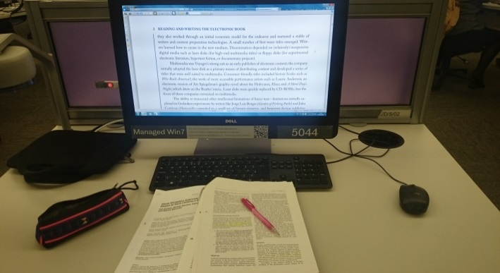



1. Upload your photo to the link <https://dbinbox.com/Photodiary> within 24 hours after taking each photo.
2. After upload the photo, go to <http://goo.gl/forms/o97Y3S0Xgb> to complete an online form regarding details of each photo.
3. After 2 days of taking photo have passed, you’ll receive an invitation to the interview about your reading habits regarding photos you’ve sent.

If you have any questions about doing the photo diary, please feel free to contact the researcher at any time.

Contact detail : [pvoravickositt1@sheffield.ac.uk](mailto:pvoravickositt1@sheffield.ac.uk)

# Appendix 5

## Interview schedule for library users

The interview outline used for the semi-structured interviews with 11 library users is presented below:

***The photographs***

* At the photos, the researcher restates the participants’ comments about the photos they submitted to the online form.
* Researcher ask the participant to elaborate

For example : Could you please explain more why did you take this picture?

Where were you when this happened?

Could you please explain more how do you use both printed

documents and laptop at the same time?

Which format of reading do you like most? Why?

Have you ever found any problems from reading electronic texts?

How did you handle the problem you found from electronic reading?

# Appendix 6

## Example of main codes and themes from librarian interviews (Phase 1)

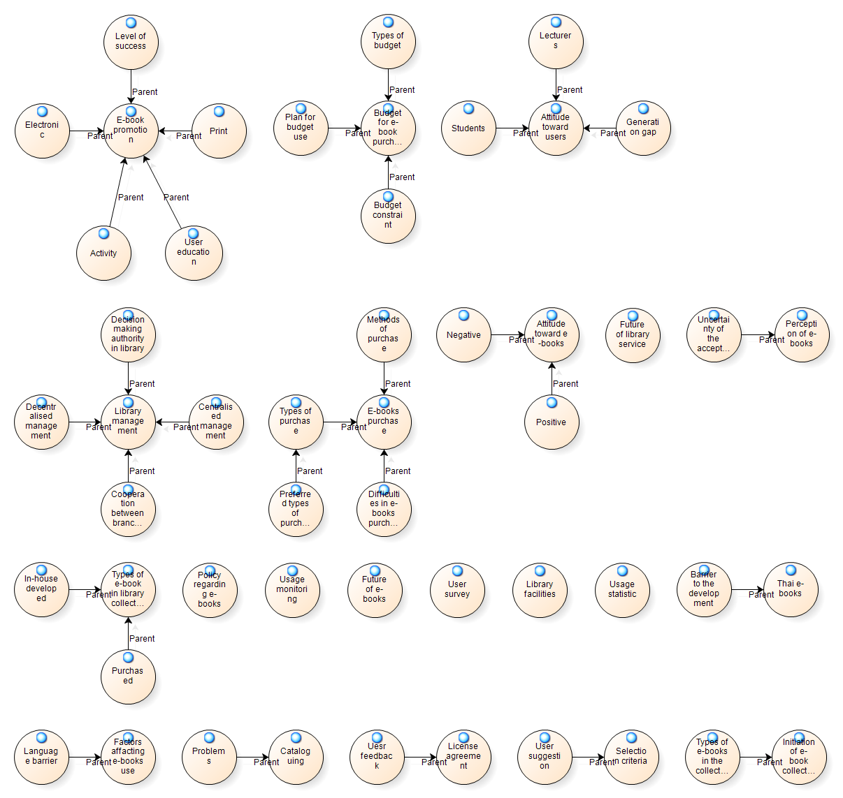

**Example of codebook**

| **Theme** | **Code** | **Definition** | **Example transcription** |
| --- | --- | --- | --- |
| Library management | Centralised management | The library management practice that all or most decision makers are located in the central library. | “Here at the central library, we’re the hub of all branch libraries. We ordered and catalogued all library stuffs and sent them out to our branch libraries in other cities” |
| Decentralised management | The library management practice that the daily operations and decision-making can be done by middle and lower-level managers within the library. | “Every branch library here has their own right of purchasing any resources into library. They have their own budgeting.” |
| Cooperation between libraries | The case that both central library and branch libraries working together regarding the library matters. | “Although our libraries hold decentralised management structure, we did share library resources between the central library and other branch libraries. We always keep each other updated about new resources we bought into libraries.” |
| Decision making authority in library | The statement related to a person who has power to give orders in the library | “Based on our library director‘s command, we have to put more effort in buying more electronic books into our library collection.” |

# Appendix 7

## Example of codes and themes from library user interviews (Phase 3)

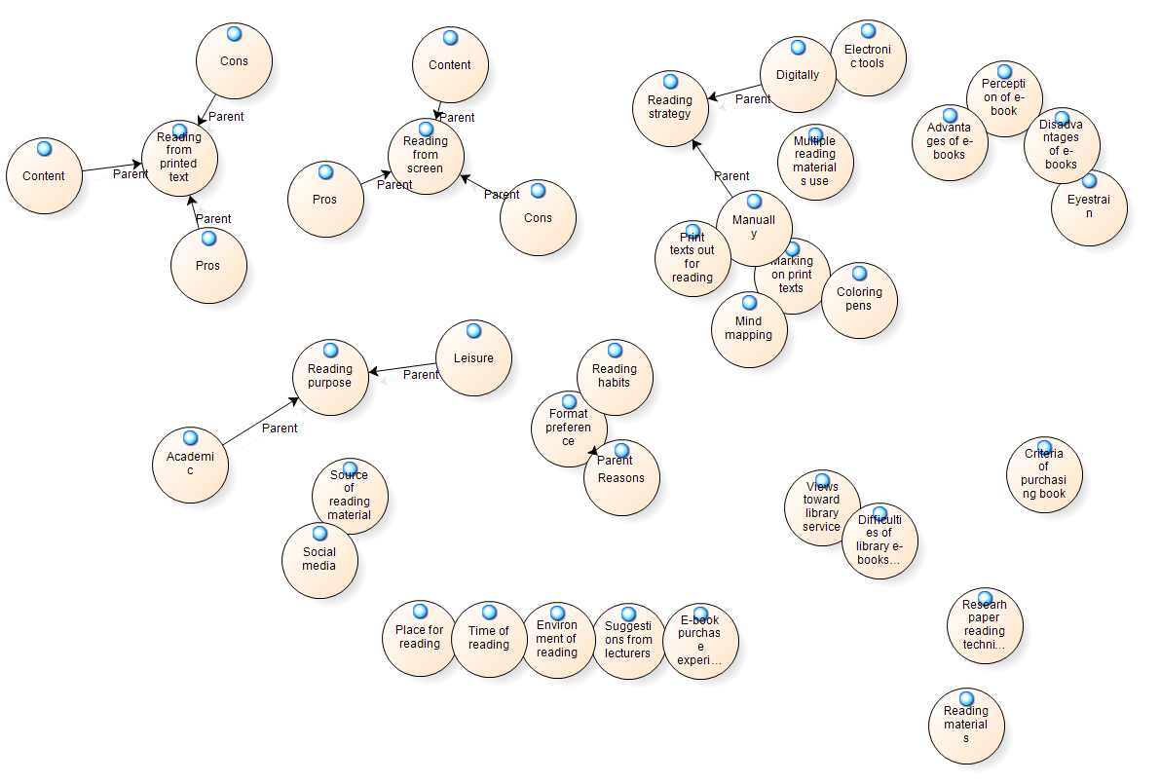

**Example of codebook**

| **Theme** | **Code** | **Description** | **Example** |
| --- | --- | --- | --- |
| Reading purpose | Academic | The statement about academic reading | “I was at home reading for my Operation management final exam.” |
| Leisure | The statement about leisure reading | “This is the book I usually read on my free time.” |
| Reading from print texts | Pros | The statement about advantages of reading from print texts | “Reading from printed documents is way more comfortable for me. I can make notes or highlights the text directly on the paper.” |
| Cons | The statement about disadvantages of reading from print texts | “For me, it’s just too tiring to carrying books around for reading.” |
| Reading from screen | Pros | The statements about advantages of reading texts from a screen | “Reading from a screen helps me to look for the content I need easier.” |
| Cons | The statements about disadvantages of reading texts from a screen | “I can never read from a screen for a long time. It always cause me eyestrain.” |

# Appendix 8

## Information Sheet and consent forms

**Information sheet and consent form for academic librarians (interview)**

|  |  |
| --- | --- |
| **The University of Sheffield.**  **Information School** | Understanding the relationship between users’ reading attitudes, behaviours and e-book collection management in Thai academic libraries. |

|  |
| --- |
| **Researchers** |

Title: Miss Name: Preeyanuch Voravickositt

Post: Research student Department: Information School

Email: [pvoravickositt11@sheffield.ac.uk](mailto:pvoravickositt11@sheffield.ac.uk) Telephone: +44 (0)7432893955

|  |
| --- |
| **Research supervisors** |

Title: Professor Name: Stephen Pinfield

Post: 1st supervisor Department: Information School

Email: [s.pinfield@sheffield.ac.uk](mailto:s.pinfield@sheffield.ac.uk) Telephone: +44 (0)115 222 2649

Title: Doctor Name: Andrew Cox

Post: 2nd supervisor Department: Information School

Email: [a.m.cox@sheffield.ac.uk](mailto:a.m.cox@sheffield.ac.uk) Telephone: +44 (0)114 222 6347

|  |
| --- |
| **Purpose of the research** |

To examine the relationship between academic libraries’ management of e-books and students’ reading attitudes and behavior. The study aims to understand the current situation of e-books in a Thai academic context and to facilitate academic librarians to understand user needs and reading bahaviour.

|  |
| --- |
| **Who will be participating?** |

Academic librarians from the nine state universities whose duty is related to electronic resources management in the academic libraries.

|  |
| --- |
| **What will you be asked to do?** |

You will be invited to an interview session individually. The interview questions will cover the details about e-book management procedures within the library including with challenges and opportunities in managing their e-book resources.

|  |
| --- |
| **What are the potential risks of participating?** |

The risks of participating are the same as those experienced in everyday life.

|  |
| --- |
| **What data will we collect?** |

Audio recordings of the interviews will be made.

|  |
| --- |
| **What will we do with the data?** |

The audio recordings will be transcribed by the researcher. These transcripts will then be analysed for inclusion in the researcher’s PhD dissertation and potentially in publications. Once the project has finished, the data will be destroyed

|  |
| --- |
| **Will my participation be confidential?** |

Your participation will be confidential. The data will be anonymised on writing up, so that you will not be identifiable.

The audio recordings, transcripts will be stored securely on a password-protected computer, and backed up onto the university drive, and shared only with the supervisory team.

|  |
| --- |
| **What will happen to the results of the research project?** |

The results of this study will be included in the researcher’s PhD dissertation which will be publicly available. Please contact the School in 3 years.

I confirm that I have read and understand the description of the research project, and that I have had an opportunity to ask questions about the project.

I understand that my participation is voluntary and that I am free to withdraw at any time without any negative consequences.

I understand that I may decline to answer any particular question or questions, or to do any of the activities. If I stop participating at all time, all of my data will be purged.

I understand that my responses will be kept strictly confidential, that my name or identity will not be linked to any research materials, and that I will not be identified or identifiable in any report or reports that result from the research.

I give permission for the research team members to have access to my anonymised responses.

I agree to take part in the research project as described above.

|  |  |  |
| --- | --- | --- |
|  |  |  |
| Participant Name (Please print) |  | Participant Signature |
|  |  |  |
| Researcher Name (Please print) |  | Researcher Signature |
| Date | | |

|  |
| --- |
| **Note: If you have any difficulties with, or wish to voice concern about, any aspect of your participation in this study, please contact Dr. Angela Lin, Research Ethics Coordinator, Information School, The University of Sheffield (**[ischool_ethics@sheffield.ac.uk](mailto:ischool_ethics@sheffield.ac.uk)**), or to the University Registrar and Secretary.** |

**Information sheet and consent form for library users (survey)**

|  |  |
| --- | --- |
| **The University of Sheffield.**  **Information School** | Understanding the relationship between users’ reading attitudes, behaviours and e-book collection management in Thai academic libraries. |

|  |
| --- |
| **Researcher** |

Title: Miss Name: Preeyanuch Voravickositt

Post: Research student Department: Information School

Email: [pvoravickositt11@sheffield.ac.uk](mailto:pvoravickositt11@sheffield.ac.uk) Telephone: +44 (0)7432893955

|  |
| --- |
| **Research supervisors** |

Title: Professor Name: Stephen Pinfield

Post: 1st supervisor Department: Information School

Email: [s.pinfield@sheffield.ac.uk](mailto:s.pinfield@sheffield.ac.uk) Telephone: +44 (0)115 222 2649

Title: Doctor Name: Andrew Cox

Post: 2nd supervisor Department: Information School

Email: [a.m.cox@sheffield.ac.uk](mailto:a.m.cox@sheffield.ac.uk) Telephone: +44 (0)114 222 6347

|  |
| --- |
| **Purpose of the research** |

To examine the relationship between academic libraries’ management of e-books and students’ reading attitudes and behavior. The study aims to understand the current situation of e-books in a Thai academic context and to facilitate academic librarians to understand user needs and reading bahaviour.

|  |
| --- |
| **Who will be participating?** |

University students of nine state universities regardless of year and field of study

|  |
| --- |
| **What will you be asked to do?** |

You will be invited to a web-based questionnaire survey regarding your attitude towards e-books and print books.

|  |
| --- |
| **What are the potential risks of participating?** |

The risks of participating are the same as those experienced in everyday life.

|  |
| --- |
| **What data will we collect?** |

The questionnaire survey answers will be obtained

|  |
| --- |
| **What will we do with the data?** |

The questionnaire survey results will be translated into numeric code and analysed on computer using the Statistical package for social sciences software (SPSS) and the results will be included in the researcher’s PhD dissertation and potentially in publications. Once the project has finished, the data will be destroyed.

|  |
| --- |
| **Will my participation be confidential?** |

Your participation will be confidential. The data will be anonymised on writing up, so that you will not be identifiable.

The questionnaire survey results will be stored securely on a password-protected computer, and backed up onto the University drive, and shared only with the supervisory team.

|  |
| --- |
| **What will happen to the results of the research project?** |

The results of this study will be included in the researcher’s PhD dissertation which will be publicly available. Please contact the School in 3 years.

I confirm that I have read and understand the description of the research project, and that I have had an opportunity to ask questions about the project.

I understand that my participation is voluntary and that I am free to withdraw at any time without any negative consequences.

I understand that I may decline to answer any particular question or questions, or to do any of the activities. If I stop participating at all time, all of my data will be purged.

I understand that my responses will be kept strictly confidential, that my name or identity will not be linked to any research materials, and that I will not be identified or identifiable in any report or reports that result from the research.

I give permission for the research team members to have access to my anonymised responses.

I agree to take part in the research project as described above.

|  |
| --- |
| **Note: If you have any difficulties with, or wish to voice concern about, any aspect of your participation in this study, please contact Dr. Angela Lin, Research Ethics Coordinator, Information School, The University of Sheffield (**[ischool_ethics@sheffield.ac.uk](mailto:ischool_ethics@sheffield.ac.uk)**), or to the University Registrar and Secretary.** |

* 1. **Information sheet and consent form for library users (photo-diary and interview)**

|  |  |
| --- | --- |
| **The University of Sheffield.**  **Information School** | Understanding the relationship between users’ reading attitudes, behaviours and e-book collection management in Thai academic libraries. |

|  |
| --- |
| **Researchers** |

Title: Miss Name: Preeyanuch Voravickositt

Post: Research student Department: Information School

Email: [pvoravickositt11@sheffield.ac.uk](mailto:pvoravickositt11@sheffield.ac.uk) Telephone: +44 (0)7432893955

|  |
| --- |
| **Research supervisors** |

Title: Professor Name: Stephen Pinfield

Post: 1st supervisor Department: Information School

Email: [s.pinfield@sheffield.ac.uk](mailto:s.pinfield@sheffield.ac.uk) Telephone: +44 (0)115 222 2649

Title: Doctor Name: Andrew Cox

Post: 2nd supervisor Department: Information School

Email: [a.m.cox@sheffield.ac.uk](mailto:a.m.cox@sheffield.ac.uk) Telephone: +44 (0)114 222 6347

|  |
| --- |
| **Purpose of the research** |

To examine the relationship between academic libraries’ management of e-books and students’ reading attitudes and behavior. The study aims to understand the current situation of e-books in a Thai academic context and to facilitate academic librarians to understand user needs and reading bahaviour.

|  |
| --- |
| **Who will be participating?** |

University students of the nine state universities regardless of year and field of study

|  |
| --- |
| **What will you be asked to do?** |

You will be asked to provide a photo diary regarding your reading behaviour by taking picture every time you read over the 2 days period and will be asked to bring those photos to the interview session later.

|  |
| --- |
| **What are the potential risks of participating?** |

The risks of participating are the same as those experienced in everyday life.

|  |
| --- |
| **What data will we collect?** |

The audio recordings of the interviews will be made.

|  |
| --- |
| **What will we do with the data?** |

The audio recordings will be transcribed by the researcher. These transcripts will then be analysed for inclusion in the researcher’s PhD dissertation and potentially in publications. Once the project has finished, the data will be destroyed.

|  |
| --- |
| **Will my participation be confidential?** |

Your participation will be confidential. The data will be anonymised on writing up, so that you will not be identifiable.

The audio recordings and transcripts will be stored securely on a password-protected computer, and backed up onto the University drive, and shared only with the supervisory team.

|  |
| --- |
| **What will happen to the results of the research project?** |

The results of this study will be included in the researcher’s PhD dissertation which will be publicly available. Please contact the School in 3 years.

I confirm that I have read and understand the description of the research project, and that I have had an opportunity to ask questions about the project.

I understand that my participation is voluntary and that I am free to withdraw at any time without any negative consequences.

I understand that I may decline to answer any particular question or questions, or to do any of the activities. If I stop participating at all time, all of my data will be purged.

I understand that my responses will be kept strictly confidential, that my name or identity will not be linked to any research materials, and that I will not be identified or identifiable in any report or reports that result from the research.

I give permission for the research team members to have access to my anonymised responses.

I agree to take part in the research project as described above.

|  |  |  |
| --- | --- | --- |
|  |  |  |
| Participant Name (Please print) |  | Participant Signature |
|  |  |  |
| Researcher Name (Please print) |  | Researcher Signature |
| Date | | |

|  |
| --- |
| **Note: If you have any difficulties with, or wish to voice concern about, any aspect of your participation in this study, please contact Dr. Angela Lin, Research Ethics Coordinator, Information School, The University of Sheffield (**[ischool_ethics@sheffield.ac.uk](mailto:ischool_ethics@sheffield.ac.uk)**), or to the University Registrar and Secretary.** |