

Investigating potential altitudinal-environmental variation on recruitment, regeneration and re-establishment of Juniperus seravschanica in Northern Oman

By:

Khalid Al Farsi

A thesis submitted in partial fulfilment of the requirements for the degree of
Doctor of Philosophy

The University of Sheffield
Faculty of Social Science
Department of Landscape

December 2017

Abstract
Juniperus seravschanica is a keystone species within the northern mountains of Oman. The species appears to be declining in the area, particularly at lower altitudes, with little regeneration being recorded. Alterations in temperature and moisture availability due to climate change could be main responsible for this decline. The main aim of this research is to identify causes of decline and suggest viable conservation strategies that may have wider application for tree conservation in this region.
Surveys indicate considerable foliar dieback of trees at lower altitudes (< 2500 m) with healthy trees limited to cooler (high altitude) or high moisture sites (wadis and depressions). A lack of juvenile trees indicates inadequate recruitment and highlights conservation concerns. Trees growing at low altitude had low growth rates compared to mid-altitude trees. Trees at low altitude produce fewer seeds and these have a lower proportion of viable, embryo intact seed (9%) with a low germination capacity.
In controlled conditions, reducing irrigation below optimum reduced growth, even under optimal temperature. In field studies, seeds and young trees, 2 and 5-year-old, were planted at selected altitudes, Low (2220 m), Mid (2300 m) and High (2560 m); the planted trees were maintained under differential irrigation regimes. Planting young trees were more successful than seed sowing when re-establishing plants in the wild. Age of transplant was important with 5-year-old trees showing greater survival (> 97%) than younger stock. Younger stock only succeeded when planted at high altitude or provided with regular artificial irrigation at low altitude. The availability of high soil moisture was important in maintaining tree viability at low altitude; however, in some locations heat stress too may be limiting plant viability and growth. Practical conservation that includes selecting genotypes with greater drought/heat tolerance and augmenting natural habitat with more mature nursery-grown trees is strongly recommended to avoid further loss of this species.

Acknowledgment
My first acknowledgment is to Diwan of Royal Court, Sultanate of Oman, who sponsored my PhD study for 4 years. I would like to express my gratitude to my supervisor, Dr. Ross Cameron, for his support and unlimited sharing of scientific and development expertise during all parts of this research, and to Dr. James Hitchmough and Dr. Darach Lupton. This project would not have been possible without their support and guidance. Their active commitment and continued confidence has encouraged my skill development and scientific knowledge. I also express my appreciation to all staff and PhD students in the Department of Landscape, at the University of Sheffield, for their support and knowledge sharing. I also express thanks to Jean Russel, research support team, and staff in mathematics and statistical help, student skill and development centre, for their help, guidance and providing training in statistical analysis covered in this thesis.
I express my grateful thanks to Oman Botanic Garden for giving permission to use their facilities and donate plants for planting experiments, and special thanks to staff in the seed bank and propagation team. My grateful thanks to all horticulture assistants for their help in preparing the experimental sites, plantings and providing support during data collection. Special thanks also to Khalid Al Hinai, Salim Al Hinai and Saif Al Hinai for their commitment during all parts of the project.
I also express my appreciation to all Omani government organisations that have been involved in this research. Ministry of Environment and Climate Affairs, and Diwan of Royal Affairs for providing the authorisation to conduct field trials and planting in the mountain sites, Soil lab at the Ministry of Agriculture and Fisheries for the analysis of soil samples, Department of Crop Science, College of Agriculture and Marine Science, at Sultan Qaboos University for their collaboration and authorising the use of their labs and tools. My grateful thanks to Dr. Mohammed Al-Yahyaei, College of Food and Agriculture, United Arab Emirates University, for his kind collaboration in providing guidance, training and expertise in mycorrhizal collection and extraction. My appreciation to Sum Rise Resort at Jabal Shams and all local people for their warm welcome and help. Thanks to Laila Al Harthi for help in generating satellite image.
My heartfelt thanks go to my father and my mother for their inspiration and heartful prayer for my success. To my brothers, sisters and all my relatives who encouraged me during my study. A special thanks to my wife, Halima, and my two daughters, Sharifa and Mymoona, for their continuous support, joining me in my field work and withstanding the hardship of continuous travel.

Table of contents

Abstract i
Acknowledgment ii
Table of contents iii
List of tables viii
List of figures x
List of abbreviations xvi
List of publications xvii

Chapter 1. Introduction 1
1.1 Introduction 1
1.2 Species under investigation 2
1.2.1 Ecological status of Juniperus forest 2
1.2.2 Juniperus seravschanica taxonomy and morphology 4
1.2.3 J. seravschanica woodland in Oman 5
1.3 Climate change and forest mortality 10
1.3.1 Climate change 10
1.3.2 Main impacts of climate change on forest ecosystems 11
1.3.3 Plant response to climate change 13
1.3.4 Tree mortality influence on ecosystem functions 15
1.4 Plant response to drought and heat stress 17
1.4.1 What is stress? 17
1.4.2 Stress due to high temperature (heat stress) 18
1.4.3 Stress due to water deficits (drought stress) 22
1.5 Methods in climate change research 24
1.6 Plant conservation 28
1.6.1 Ecosystem conservation definition 28
1.6.2 The potential role of protected areas 29
1.6.3 Ecosystem restoration 31
1.6.4 Woodland conservation in Oman 35
1.7 Aim of the study, objectives, and research rationale 37

Chapter 2: The study area (Jabal Shams, Western Hajar Mountains) 39
2.1 General location and description of the Western Hajar Mountains 39
2.2 Geology 40
2.3 Climate 41
2.4 Landscape and vegetation 42

Chapter 3: General methodology 45
3.1 Procedures for the phenological and health assessment of J. seravschanica at different altitudes in Northern Mountains of Oman 45
3.1.1 Collection of Juniperus phenophase data 45
3.1.2 Tree health variables 46
3.1.3 Ecological and environmental variables 48
3.2 J. seravschanica seed collection and propagation 50
3.2.1 Seed collection 50
3.2.2 Nursery seed propagation 51
3.3 In-situ field establishment of J. seravschanica saplings in the Northern Mountain of Oman 52
3.3.1 Preparation of saplings used for field establishment experiments 52
3.3.2 Sites selection and pre-planting practices 52
3.3.3 Planting and establishment of five-year-old saplings 54
3.3.4 Planting and establishment of two-year-old saplings 55
3.4 Chlorophyll fluorescence 56
3.4.1 Principle of Chlorophyll fluorescence 56
3.4.2 Chlorophyll fluorescence measurement 58
3.5 Relative water content 59
3.5.1 Principle of Relative water content 59
3.5.2 Relative water content measurement 61
3.6 Climate data 61
3.7 Soil analysis 62
3.7.1 Soil collection and preparation 62
3.7.2 Soil chemical analysis 63
3.8 Statistical analysis and data presentation 65

Chapter 4. Altitudinal variation in ecological status, reproductive phenology and growth of J. seravschanica population in the Northern Mountains of Oman 67
4.1 Introduction 67
4.2 Objectives 70
4.3 Experiment 1: Ecological assessment of J. seravschanica woodland in Jabal Shams, Northern Mountains of Oman 71
4.3.1 Hypothesis to be tested 71
4.3.2 Materials and methods 71
4.3.3 Results 74
4.3.4 Hypothesis test 81
4.4 Experiment 2: Influence of animal browsing on J. seravschanica seedling regeneration at three altitudinal gradients. 82
4.4.1 Hypotheses to be tested 82
4.4.2 Materials and methods 82
4.4.3 Results 84
4.4.4 Hypothesis test 86
4.5 Experiment 3: Effect of changes in altitude on the phenology and growth of J. seravschanica trees in the Northern Mountains of Oman 87
4.5.1 Hypothesis to be tested 87
4.5.2 Materials and methods 87
4.5.3 Results 91
4.5.4 Hypothesis test 100
4.6 Experiment 4: The effect of altitudinal variation and tree health status on chlorophyll fluorescence and relative water content of J. seravschanica. 100
4.6.1 Hypothesis to be tested 100
4.6.2 Materials and methods 100
4.6.3 Results 101
4.6.4 Hypothesis test 105
4.7 Discussion 106
4.7.1 Patterns of J. seravschanica condition 106
4.7.2 Influence of animal browsing on J. seravschanica seedling establishment ………………………………………………………………………………...110
4.7.3 Reproductive phenology and growth of J. seravschanica trees along an altitudinal gradient 112
4.7.4 The altitudinal variation of maximum chlorophyll fluorescence and relative water content 114
4.8 Conclusion 116

Chapter 5. Seed characteristics and germination of J. seravschanica in response to altitudinal variation, temperature and cold stratification 117
5.1 Introduction 117
5.2 Objectives 119
5.3 Experiment 1: Altitudinal variation effect in J. seravschanica seed characteristics 120
5.3.1 Hypothesis to be tested 120
5.3.2 Material and method 120
5.3.3 Results 122
5.3.4 Hypothesis tested 125
5.4 Experiment 2: Effect of different temperatures on seed germination 125
5.4.1 Hypothesis to be tested 125
5.4.2 Material and methods 125
5.4.3 Results 126
5.4.4 Hypothesis test 128
5.5 Experiment 3: Influence of seed source (altitude), temperature, and prior cold stratification on germination of J. seravschanica seed 128
5.5.1 Hypothesis to be tested 128
5.5.2 Material and method 128
5.5.3 Results 130
5.5.4 Hypothesis test 132
5.6 Experiment 4: In-situ seed germination of J. seravschanica in the Northern Mountains of Oman 133
5.6.1 Hypothesis to be tested 133
5.6.2 Material and method 133
5.6.3 Results 134
5.6.4 Hypothesis test 134
5.7 Experiment 5: Seed germination of J. seravschanica in the Northern Mountains of Oman 136
5.7.1 Hypothesis to be tested 136
5.7.2 Material and method 136
5.7.3 Results 136
5.7.4 Hypothesis test 136
5.8 Discussion 137
5.8.1 Effect of altitudes and trees condition in seed characteristics and germination capacity 137
5.8.2 Effect of temperature and stratification in seed germination 140
5.8.3 In-situ seed propagation 141
5.9 Conclusion 143

Chapter 6. Assessment of heat and drought tolerance of J. seravschanica saplings under controlled environment conditions 144
6.1 Introduction 144
6.2 Objectives 147
6.3 Experiment 1: Effect of growing temperature and water availability on the growth of J. seravschanica saplings 148
6.3.1 Hypothesis to be tested 148
6.3.2 Materials and methods 148
6.3.3 Results 150
6.3.4 Hypotheses results 156
6.4 Experiment 2: Influence of pre-treatments of heat and drought stress in fortifying J. seravschanica sapling stress defences 157
6.4.1 Hypothesis to be tested 157
6.4.2 Materials and methods 157
6.4.3 Results 158
6.4.4 Hypothesis test 159
6.5 Discussion 163
6.5.1 Effect of heat and drought on saplings growth 163
6.5.2 Effect of drought and heat stress on enhancing sapling stress defences after recovery 165
6.6 Conclusion 167

Chapter 7. In-situ field establishment of J. seravschanica in the Northern Mountains of Oman 168
7.1 Introduction 168
7.2 Objectives 170
7.3 Experiment 1: Field establishment and early development of five-year-old J. seravschanica saplings 171
7.3.1 Hypothesis to be tested 171
7.3.2 Material and methods 171
7.3.3 Results 173
7.3.4 Hypotheses test 192
7.4 Experiment 2: Field establishment and early development of two-year-old J. seravschanica saplings 192
7.4.1 Hypothesis to be tested 192
7.4.2 Material and methods 193
7.4.3 Results 193
7.4.4 Hypothesis test 197
7.5 Discussion 198
7.6 Conclusion 205

Chapter 8. Moving plants to new environment: beneficial influence of topographic site and mycorrhizal fungi 206
8.1 Introduction 206
8.2 Objectives 209
8.3 Experiment 1: Influence of habitat topography and microsite on newly-transplanted seedlings 209
8.3.1 Hypothesis to be tested 209
8.3.2 Materials and methods 209
8.3.3 Results 210
8.3.4 Hypothesis tested 214
8.4 Experiment 2: Mycorrhizal fungi spore presence and abundance along different altitudes 215
8.4.1 Hypothesis to be tested 215
8.4.2 Material and methods 215
8.4.3 Results 216
8.4.4 Hypothesis test 217
8.5 Discussion 218
8.5.1 Effect of slope aspect and microsites on seedling survival 218
8.5.2 Abundance of mycorrhizal fungi 219
8.6 Conclusion 221

Chapter 9. General discussion 222
9.1 Introduction 222
9.2 Key factors in the decline of J. seravschanica in northern Oman 223
9.2.1 Biotic factors 223
9.2.2 Abiotic factors 223
9.2.3 Influence of microsite- microrefugia 227
9.3 Potential climate change threats in Juniperus population 228
9.4 Threats in natural regeneration 231
9.4.1 Seed quality 231
9.4.2 In-situ seed germination 232
9.5 Potential success of young trees transplantation 233
9.6 Practical conservation approaches for J. seravschanica 235
9.7 Wider perspective 238
9.8 Key note points 240

References 242

Appendix: Examples of statistical analysis 271

List of tables

Table ‎1.1 Example of current experiment methods used in climate change research 26
Table 3.1 Slope direction and degree according to ArcMap software. 49
Table 3.2 Dark adaptation time and light intensity requirement to measure chlorophyll fluorescence in Juniperus saplings. 59
Table 3.3 Specification of WatchDog weather station and soil moisture sensor. 62
Table ‎4.1 Summary of the surveyed sites and ecological variable of J. seravschanica woodland on Jabal Shams. 73
Table ‎4.2 Regression model of the relationship between plant health status and the ecological and environmental variables. Comparison of aspect was made with north as a preference, and in habitat type with depression as preference. 75
Table ‎4.3 Summary of the selected sites for phonological and shoot growth study on Jabal Shams. Sites were divided in three altitude zones, 1 (Low), 2 (Mid) and 3 (High). 89
Table ‎4.4 Mean shoot growth increment of male and female J. seravschanica trees at the three elevation zones (Low, Mid, and High). Growth increments were measured every four months for two years (April 2014 to May 2016). Standard errors of the mean are presented (n=30). 95
Table ‎4.5 Regression model of the effect of environmental factors on J. seravschanica lateral shoot growth at different time periods between Aug 2014 and May 2016. 97
Table ‎4.6 Regression model for the relationship between ecological factors and J. seravschanica lateral shoot growth increments. Tree health comparisons were made with trees with 25% living foliage and trees growing in depressions. Environmental and ecological data were correlated with the sum of two years’ growth. 97
Table ‎4.7 Sites selected for assessing the influence of altitude and trees health on the physiology of J. seravschanica. Trees were selected at three zones, Low (2220 m), Mid (2300 m) and High (2570 m). 102
Table ‎5.1 The effect of seed source (altitude), temperature and stratification in Germination % and mean germination time (MGT). Standard errors of the mean are presented. 130
Table ‎5.2 Climate data from three different altitudes with mean annual temperature, mean coldest temperature (January), mean warmest temperature (July), and mean annual rainfall for 2015-2016. 138
Table ‎6.1 Main differences between acclimation and ecological memory (stress memory). Information in this table adapted from Walter et al. (2013). 146
Table ‎6.2 apical and lateral growth increment (mm) of J. seravschanica saplings growing under three different temperatures (Low, Mid and High) and under three irrigation regimes (100%, 50% or 25%). Standard errors of the means are presented. 152
Table ‎6.3 Maximum fluorescence efficiency (Fv/Fm) of J. seravschanica saplings under low, medium and high temperature and three watering regimes (100%, 50%, and 50%) measured during the experiment period. LSD were calculated for P< 0.05, DF=34, n=5 and standard errors for the mean are shown. 155
Table ‎6.4 Relative water content (%) of J. seravschanica saplings under low, medium and high temperature and three watering regimes (100%, 50%, and 50%) measured every six months. LSDs were calculated for P<0.05, DF=34, n=5 and standard errors for the mean are shown. 155
Table ‎7.1 Height growth (apical) increment (mm) over two years (growth increment every six months) in 5-year-old J. seravschanica saplings planted at three altitudes (Low, Mid and High) and watered under three irrigation treatments (Irrig.15d, Irrig.30d, and no artificial irrigation (Control)). Data is mean ±SE (n=15). 177
Table ‎7.2 Lateral shoot growth increment (mm) over two years (growth increment every six months) in 5-year-old J. seravschanica saplings planted at three altitudes (Low, Mid and High) and under three irrigation treatments (Irrig.15d, Irrig.30d, and no artificial Irrigation (Control)). Data is mean ± SE (n=15). 179
Table ‎7.3 Regression model of the effect of volumetric soil water content, minimum temperature and rainfall on 5-year-old J. seravschanica apical and lateral growth. 180
Table ‎7.4 Chemical properties of soil collected from nine selected plots for J. seravschanica establishment at three altitudes (Low, Mid, and High). 186
Table ‎8.1 Survival percentage (%) of J. seravschanica seedlings planted in two microsites (outside and under the tree canopy) in three topographical conditions (north facing slopes, depressions and south facing slopes). Data are presented as a mean ± SE of the two altitudes (Low and Mid), n=4. 212
Table ‎8.2 Light intensity (10x Lux) and soil moisture (VWC %) meaured at different planting sites (north facing, depressions, south facing) and under two microsites (outside and under the tree canopy). Data are presnted as a mean value ± SE of the two altitudes (low and mid), altitude differences are not presented due to homogeneity in trends, n=4. 213

List of figures

Figure ‎1.1 Distribution of the Juniperus seravschanica according to latest studies. Source (Adams et al., 2016) 5
Figure ‎1.2 The status of J. seravschanica woodland in the northern mountains of Oman. Top: the decline of Juniperus woodland at the lower altitude (2100 m). Bottom: Juniperus woodland at higher altitude (2560 m) in healthy condition. 9
Figure ‎1.3 Physiological response of plant to heat and drought or combination of both stresses. Source (Mittler, 2006). 18
Figure ‎2.1 The difference in the landscape and habitat topographies at Jabal Shams, steep mountain cliff (A), high moisture wadi site (B), and gravel plain depression site (C). 43
Figure ‎3.1 Male strobili of J. seravschanica. A) initiation of male strobili. B) male strobili open for pollination. 46
Figure ‎3.2 J. seravschanica health condition was assessed by the percentage of living foliage. Left, center and right photos indicate health condition of 0%, 50%, and 100% respectively. 47
Figure ‎3.3 The tangent method used to measure trees height using clinometer. The height of the person in the equation represents the a’ in the diagram. Source: adapted from (Bragg, 2008). 48
Figure ‎3.4 The three main habitat types studied differ in their site topography. The blue arrow indicates water movement after rain in each habitat type. The thicker blue arrow indicates higher water flow rates. 49
Figure ‎3.5 Satellite image of the three sites selected for J. seravschanica re-establishment in the Northern Mountains. Below, three fenced plots at the middle altitude, 2300 m asl. 53
Figure ‎3.6 Planting of five-year-old J. seravschanica saplings. A) saplings placed near the planting hole prior to planting. B) saplings planted at lower altitude in a fenced plot. 55
Figure ‎3.7 Planting of two-year-old saplings. A) 15 J. seravschanica saplings were planted in each plot. B) planting plots were covered by green shade to protect saplings from direct sun. 56
Figure ‎3.8 Kautsky induction curve represented by dark adaptation of J. seravschanica twigs. Fo represented the fluorescence origin, Fm represented the maximum fluorescence and Fv is the variable fluorescence. 58
Figure ‎4.1 Satellite image of the surveyed sites within the study area on Jabal Shams. 72
Figure ‎4.2 The relationship between altitude and health status percentage. Sites were coded according to different habitat type, hillside, wadi and depression sites. Regression equation, R2 and correlation coefficient are showed in the graph. 75
Figure ‎4.3 Height frequency distribution of J. seravschanica trees in the three surveyed altitudes, low altitude range (2100-2300 m), mid altitude range (2300-2500 m), and high altitude range (above 2500 m). Statistical analysis was examined for total trees at the three zones. 76
Figure ‎4.4 Box plot illustrating the relationship between site topography and tree height. 76
Figure ‎4.5 Box plot illustrating the relationship between J. seravschanica tree gender and health status. 78
Figure ‎4.6 Box plot illustrating the relationship between habitat topography and tree health status at (A) low altitude, (B) mid altitude, and (C) high altitude zone. 79
Figure ‎4.7 Box plot illustrating the relationship between habitat topography and degree of slope. 80
Figure ‎4.8 Box plot illustrating the relationship between habitat top layer substrate and health condition. Soil (<2 mm), small gravel (2 – 32 mm), and large gravel (>32 mm diameter). 80
Figure ‎4.9 One-year-old seedlings planted under the shade of mother tree at low altitude with three cover treatments (fully protected, partly protected, and not protected). 83
Figure ‎4.10 Female tree of J. seravschanica with ripe cones fenced at mid-altitude. 84
Figure ‎4.11 Influence of animal browsing on survival percentage of J. seravschanica seedlings after seven weeks when grown at the three different altitudes (Low, Mid and High) and three different levels of protection (Fully, Partly, and Open). Standard errors of the mean for open treatment are presented. 85
Figure ‎4.12 Influence of browsing on survival percentage of J. seravschanica seedlings during the seven weeks under no cover treatment when grown at the three different altitudes (Low, Mid and High). Standard errors of the mean are presented. 85
Figure ‎4.13 Satellite image of the plots selected for phenological and growth increment of J. seravschanica trees at different altitude zones in Jabal Shams, Northern Mountains of Oman. The three dot colours represent different altitude zones. 88
Figure ‎4.14 Male cone phenology of J. seravschanica trees observed every two months for two years at three different elevation range (Low, Mid and High). Data presented as mean percentage of trees has pollen cones (PC), pollen release (PR) or full pollen release (FR). 92
Figure ‎4.15 Female cones phenology of J. seravschanica trees observed every four months for two years at three different elevation range (Low, Mid and High). Data presented as mean percentage of trees bearing unripe, ripe or both (ripe and unripe cones in same tree). 92
Figure ‎4.16 Mean shoot growth increment of J. seravschanica trees measured every four months for two years (April 2014 to May 2016) measured at three altitudinal zones (Low, Mid and High) with male and female trees measured independently. Data were square root transformed for statistical analysis. LSD(0.01, DF= 174, n=30) values are 0.5, 0.42, 0.32, 0.5, 0.42 and 0.5 and standard errors of the mean are presented. LSD is not applicable to indicate differences between gender at each altitude due to non-significant effect. 94
Figure ‎4.17 Box plot illustrating the mean differences of yearly shoot growth increment of first and second year measurement at the three altitude zones. 95
Figure ‎4.18 Average monthly maximum, mean and minimum temperature measured at three altitudes (Low, Mid and High). Average mean temperature from data loggers were collected during April to December 2014, after that temperature data were collected form weather stations. 98
Figure ‎4.19 Monthly precipitation measured in three weather stations at different altitudes (Low, Mid and High) during the period from January 2015 to April 2016. 98
Figure ‎4.20 Box plot illustrating the mean comparisons of J. seravschanica lateral shoot growth associated with different plant health conditions. Health conditions were catagorised as: very poor (25% living foliage), poor (50% living foliage), good (75% living foliage), and very good (100% living foliage). X mark indicate two years mean shoot growth. 99
Figure ‎4.21 Box plot illustrating the mean comparison of J. seravschanica lateral shoot growth at different site topographies (hillside, wadi, and depression). X marks indicate two years mean shoot growth. 99
Figure ‎4.22 Chlorophyll fluorescence values (Fv/Fm) of J. seravschanica trees measured at three altitudes (Low, Mid and High) for healthy (H) and stressed (S) trees during the period between October 2014 to July 2016. 103
Figure ‎4.23 Chlorophyll fluorescence values (Fv/Fm) of J. seravschanica trees during autumn (October 2015), winter (February 2016), spring (May 2016) and summer (July 2016) measured at three different altitudes (Low, Mid, and High) on healthy (≥75% living foliage) and stressed trees (≤50% living foliage). LSD(0.05, DF=24, n=5) for February 2016= 0.05 and standard errors of the mean are presented. LSDs were not calculated for other months due non-significant effect of both factors. 104
Figure ‎4.24 Relative water content (RWC) of J. seravschanica trees during May 2015, February 2016 and May 2016 measured at three different altitudes (low, mid, and high) on healthy (≥75% living foliage) and stressed trees (≤50% living foliage). LSDs (0.05, DF=24, n=5) for each month = 6.1, 4.3, and 5.4 respectively, and standard errors of the mean are presented. 105
Figure ‎4.25 Competition between J. seravschanica mother trees and new growing saplings causing death of mother trees at high altitude zone. 108
Figure ‎5.1 Satellite image of J. seravschanica cone collection sites in the Northern Mountains of Oman. 121
Figure ‎5.2 Mean seed number per one hundred Juniperus cones from different altitudes (Low, Mid, and High). LSD(0.05, DF=27, n=10)= 54.6 and standard errors of the mean are presented. 122
Figure ‎5.3 Mean filled seed percentage per one hundred J. seravschanica cones collected from different altitudes (Low, Mid, and High). Standard errors for the mean are presented. LSD was not calculated due to non-significant effect. 123
Figure ‎5.4 The relationship between trees health status and filled seed percentage. 124
Figure ‎5.5 Mean germination percentage of J. seravschanica at six different temperatures. LSD(0.05, DF=6, n=2) =6.8 and standard errors for the mean are presented. 127
Figure ‎5.6 Mean germination time of J. seravschanica germinated at six different temperatures. LSD(0.05, DF=6, n=2)= 15.8 and standard errors for the mean are presented. 127
Figure ‎5.7 Seed germination trial under controlled condition. 129
Figure ‎5.8 Mean germination percentage of seed collected from different altitudes (Low, Mid, and High) with two pre-treatments (Control, and Stratification) and grown in two different temperatures (15 and 25°C). LSD(0.05, DF= 108, n=10)= 9.6 and standard errors of the mean are presented. LSD is not applicable to indicate differences between pre-treatment at each altitude/temperature due to non-significant effect. 131
Figure ‎5.9 Mean germination time of seed collected from different altitudes with two pre-treatments (Control, and Stratification) and grown in two different temperatures (15 and 25°C). LSD(0.05, DF= 108, n=30)= 3.5 and standard errors of the mean are presented. 132
Figure ‎5.10 Above: preparation of seed beds at high altitude. Below: seed beds planted in April 2014 at high altitude of the Northern Mountains of Oman. 135
Figure ‎5.11 Left: the female of seed chalcid (Megastigmus spp.). Right: holes in J. seravschanica seeds caused by seed chalcid. 139
Figure ‎6.1 One-year apical growth increase in J. seravschanica saplings growing under three different temperature (Low, Mid, and High) and watered under three irrigation regimes (100%, 50% and 25%). Data were square root transformed for statistical analysis. LSD(0.05, DF 36, n=5) = 3.64 and standard errors of the mean are presented. LSD is not applicable to indicate differences between temperatures at specific water treatment due to non-significant effect. 151
Figure ‎6.2 One-year lateral shoot growth in J. seravschanica saplings under the three different temperature (Low, Mid, and High) and watered under three irrigation regimes (100%, 50% and 25%). Data were square root transformed for statistical analysis. LSD(0.01, DF 36, n=5) = 1.7 and standard errors of the mean are presented. 153
Figure ‎6.3 Weekly maximum chlorophyll fluorescence (Fv/Fm) of J. seravschanica divided by irrigation treatment applied (irrigation - A vs no-irrigation - B). Each bar indicates the previous treatment applied (Low or Mid temperatures and 100, 50 or 25% irrigation) and standard errors for the mean are shown. 160
Figure ‎6.4 Relationship between weekly maximum chlorophyll fluorescence (Fv/Fm) and the volumetric soil water content (VWC)at 14, 21, 28, and 37 days. Regression equation, R2 and significant of the correlation is showed at each plot. Different colours indicate the previous water treatment, 100%, 50%, and 25% irrigation. 161
Figure ‎6.5 Relative water content of J. seravschanica divided by irrigation treatment applied (irrigation - A vs no-irrigation - B). Each bar indicates the previous treatment applied (Low or Mid temperatures and 100, 50 or 25% irrigation) and standard errors for the mean are shown. 162
Figure ‎7.1 Field establishment of 5-year-old J. seravschanica at mid altitude (2300 m) (January 2016). 173
Figure ‎7.2 Five-year-old J. seravschanica after 30 months from field transplanting. Left: sapling growing at low altitude under high irrigation treatment (Irrig.15d). Right: sapling growing at high altitude under control treatment (no artificial irrigation). 174
Figure ‎7.3 Survival percentage of 5-year-old J. seravschanica planted at three altitudes (Low, Mid and High) and under three irrigation treatments (Irrig.15d, Irrig.30d, and Control). Standard errors of the mean for lower and middle altitudes are presented. 174
Figure ‎7.4 Height growth increment (mm) over the first year (month 1 to 12) in J. seravschanica planted at three altitudes (Low, Mid and High) and under three irrigation treatments (Irrig.15d, Irrig.30d, and Control). Data was square root transformed for statistical analysis. LSD(0.01, DF 120, n=15) =1.45 and standard errors of the mean are presented. LSD is not applicable to indicate differences between water treatments at each altitude due to non-significant effect. 175
Figure ‎7.5 Height growth increment (mm) over second year (month 13 to 24) in 5-year-old J. seravschanica planted at three altitudes (Low, Mid and High) and under three irrigation treatments (Irrig.15d, Irrig.30d, and Control). Data was square root transformed for statistical analysis. LSD(0.001, DF 120, n=15) =1.94 and standard errors of the mean are presented. LSD is not applicable to indicate differences between water treatment at each altitude due to non-significant effect. 176
Figure ‎7.6 Height growth increment (mm) over two years in 5-year-old J. seravschanica planted at three altitudes (Low, Mid and High) and under three irrigation treatments (Irrig.15d, Irrig.30d, and Control). Standard errors of the mean are presented (n=15). * indicates significant effect of water treatment at low altitude based on Kruskal-Wallis test. 176
Figure ‎7.7 Lateral shoot increment (mm) over two years (24 months) in 5-year-old J. seravschanica planted at three altitudes (Low, Mid and High) and under three irrigation treatments (Irrig.15d, Irrig.30d, and no artificial irrigation (Control)). Data was square root transformed for statistical analysis. LSD(0.05, DF 120, n=15)= 0.6 and standard errors of the mean are presented. 178
Figure ‎7.8 The relationship between volumetric soil water content (VWC%) and lateral shoot increment (mm) of 5-year-old J. seravschanica planted at Low (A), Mid (B) and High altitude (C), and irrigated with three water treatments (Control, Irrig.15d, and Irrig.30d). Regression equation, R2 and correlation coefficient are presented. 181
Figure ‎7.9 Maximum chlorophyll fluorescence (Fv/Fm) of 5-year-old J. seravschanica planted at three altitudes (Low, Mid, and High) and under three different irrigation treatments (Irrig.15d, Irrig.30d, and no artificial irrigation (Control)). Standard errors of the mean are presented (n=15). 183
Figure ‎7.10 Maximum chlorophyll fluorescence (Fv/Fm) of 5-year-old J. seravschanica during fall (November 2015), winter (January 2016), spring (May 2016) and summer (July 2016) planted at three altitudes (Low, Mid, and High) and under three irrigation treatments (Irrig.15d, Irrig.30d, and no artificial irrigation (Control). LSDs(0.05, DF 121, n=15) for each month= 0.05, 0.07, 0.04, and 0.1, respectively and standard errors of the mean are presented. 184
Figure ‎7.11 Relative water content percentage (RWC) of 5-year-old J. seravschanica planted at three altitudes (Low, Mid, and High) and under three irrigation treatments (Irrig.15d, Irrig.30d, and no artificial irrigation (Control)). LSDs(0.01, and 0.05, DF 18, n=3) for each month = 11, and 3.8, respectively and standard errors of the mean are presented. LSD was not calculated for May 2015 due to non-significant effect of both factors. 185
Figure ‎7.12 Volumatic soil water content (VWC %) values measured in plots containing 5-year-old J. seravschanica when planted in three altitudes (Low, Mid and High) and under three irrigation treatments (Irrig.15d, Irri.30d, and no artificial irrigation (Control)). Data presented is mean value of three probes per treatment. 187
Figure ‎7.13 Volumetric soil water content (VWC %) of the non-irrigated sapling at the three altitudes (Low, Mid and High) and rainfall events (mm) measured at the three altitudes. 188
Figure ‎7.14 Soil moisture depletion (%) over time (days) during winter (January 2016) and summer (July 2016) at three altitudes (Low, Mid and High). Data presented are the mean value of two soil moisture probes under high irrigation treatment (irrigation twice a month). 188
Figure ‎7.15 Average monthly maximum, mean and minimum temperature over two years (2015-2016) recorded at three different altitudes; Low (2200 m), Mid (2300 m) and High (2570 m). 190
Figure ‎7.16 Average monthly relative humidity (%) at the three altitudes (Low, Mid, and High) over two years, 2015-2016. 190
Figure ‎7.17 Average monthly wind speed (kmh-1) at the three altitudes (Low, Mid, and High) over two years, 2015-2016. 191
Figure ‎7.18 Average monthly solar radiation (Wm-2) at the three altitudes (Low, Mid, and High) over two years (2015-2016) in sunshine between 9.00 to 16.00 hours. 191
Figure ‎7.19 Two-year-old J. seravschanica saplings after 18 months from field transplanting. Left: sapling growing at mid-altitude under irrigation treatment (Irrig.30d). Right: sapling growing at high altitude under control treatment (no-artificial water). 194
Figure ‎7.20 Survival percentage of 2-year-old J. seravschanica planted at three altitudes (Low, Mid and High) and under three irrigation treatments (Irrig.15d, Irrig.30d, and Control). Standard errors of the mean are presented (n=15). * indicates significant effect of water treatment at low altitude based on Kruskal-Wallis test. 195
Figure ‎7.21 Height increment (mm) over one year in 2-year-old J. seravschanica planted at three altitudes (Low, Mid and High) and under three irrigation treatments (Irrig.15d, Irrig.30d, and no artificial irrigation (Control)). Standard errors of the mean are presented. LSD was not calculated due non-significant effect of both factors. 196
Figure ‎7.22 Chlorophyll fluorescence (Fv/Fm) of 2-year-old J. seravschanica during winter (January 2016), spring (May 2016) and summer (July 2016) planted at three altitudes (Low, Mid, and High) and under three irrigation treatments (Irrig.15d, Irrig.30d, and Control). LSDs(0.05, 0.01 and 0,05, DF 103, n=14) for each month= 0.12, 0.2, and 0.1, respectively. LSD is not applicable to indicate differences between water treatment at each altitude due to non-significant effect. 197
Figure ‎8.1 Survival percentage of J. seravschanica seedling over 70 days influenced by altitude (A, n=12), planting site (B, n=8) and microsite (C, n=12). Standard errors of the mean are presented. 211
Figure ‎8.2. Air temperature measured within two microsites at mid-altitude (2300 m asl) 214
Figure ‎8.3 Structures of mycorrhizal fungi spores extracted from soil under rhizosphere of J. seravschanica. 216
Figure ‎8.4 Mycorrhizal fungi spore abundance under the canopy of J. seravschanica across the three surveyed altitudes (low, mid, and high). Data were square root transformed for statistical analysis. Standard errors of the mean are presented. * indicates significant effect of altitude based on Kruskal-Wallis test. 217
Figure ‎9.1 Effect of abiotic stress in seed production and germination, seedlings establishment and mature plant growth of J. seravschanica based in results obtained from controlled and field growing experiment. 224
Figure ‎9.2 Mean temperature and rainfall collected over two years along the three different altitudes (current climate) and the projected change in climate for the Al Jabal Al Akhdar mountain range for the next 20 years based on literature at the three different altitudes. 230

List of abbreviations

Abbreviation | Full name
ABA | Abscisic acid
asl | Above sea level
GSPC | Global Strategy for Plant Conservation
IPCC | Intergovernmental Panel on Climate Change
IUCN | International Union for Conservation of Nature
MECA | Ministry of Environment and Climate Affairs
MF | Mycorrhizal fungi
MGT | Mean germination time
MRMEWS | Ministry of Regional Municipalities, Environment and Water Resources
OBG | Oman Botanic Garden
RWC | Relative water content
VWC | Volumetric water content

List of publications

- Al Farsi, K., Cameron, R. and Lupton D. (2015). Assessing the putative decline of Juniperus seravschanica on Jabal Shams in Northern Oman and evaluating the potential of reintroduction scheme within the context of a changing climate. In: Dutton, R. W. (ed.) Field research in Oman: past, present and future. Sultanate of Oman: National Field Research Center for Environmental Conservation, pp 68-74.

- Al Farsi, K., Cameron, R., Hitchmough, J. and Lupton, D. 2016. Student Project: Assessing the effects of drought and temperature on the establishment of Juniperus seravschanica saplings in northern Oman. Sibbaldia: The Journal of Botanic Garden Horticulture, 14, pp 37-53.

- Al Farsi, K. A. A.Y., Lupton, D., Hitchmough, J. D. and Cameron, W. F. How fast can conifers climb mountains? Investigating the effects of a changing climate on the viability of Juniperus seravschanica within the mountains of Oman, and developing a conservation strategy for this tree species. [Accepted paper at Journal of Arid Environment].

Chapter 1. Introduction

Introduction
In natural habitats, plants are distributed and grow in environments that support their establishment and growth; however, they may be exposed on occasions to environmental conditions above or below their optimal tolerances. Being sedentary, plants may be exposed to a complex of stress-inducing conditions that damage those resources required for growth and reproduction (Atkinson and Urwin, 2012). In recent years, exposure to abiotic stress within natural ecosystems has increased dramatically, particularly due to climate change (Teuling et al., 2010; Anderegg et al., 2013). Available information indicates that mountain regions are highly susceptible to climate change effects (Rangwala and Miller, 2012). The decline of plant species within certain mountain regions has been recorded extensively (Allen et al., 2010; Choat et al., 2012).
Oman`s location, variable landscape, geology and climate is the catalyst for its exciting and unique plant diversity. Oman has a rich flora with a high degree of endemism, and the northern mountains are classified as a centre of plant endemism in the eastern Arabian Peninsular (Patzelt, 2015). However, in this region where the climate is changing to warmer and drier conditions (AlSarmi and Washington, 2011; Al-Kalbani et al., 2015), plant species are suffering a great deal due to increases in evapotranspirational demand and prolonged periods of soil moisture deficit. The unique features of mountain ecosystems especially their elevation gradient provide opportunity for environmental adaptation and geographical isolation for several highly adapted plant species. However, their range, limited population size and reliance on specific environmental conditions make such species more vulnerable to any changes in climate (El-Keblawy, 2014). Juniperus seravschanica (Zeravschan Juniper) is a potentially useful example of a species in which the effects of climate can be observed and studied. In Oman, historically this species was found from 2100 m above sea level (asl) to the summit of the mountains (3000 m). However, the distribution range of this species has contracted in recent decades, which is evident in the extensive decline in the population number and extent at low altitudes, currently healthy plants are restricted to above 2500 m asl.
Misuse and harvest of woodlands has been presented as the reason for this decline in Oman, however trees in other areas with no human interference are also declining. The trend of population decline along the altitudinal gradients indicates that climatic factors may be to blame for some woodland degradation. This raises the question, are climate change factors (abiotic stresses) fueling the decline and contraction of J. seravschanica populations in northern Oman and if so what are the most damaging factors? Increase in temperature (heat stress) and reduction in precipitation rates (drought stress) could be two main candidates? General conservation measures for J. seravschanica in Oman are in place, however this is within a context, where the reasons for decline are poorly understood and management not optimised. More information on the primary elements causing population decline is needed. The main aim of this research is to investigate how temperature and water availability, or both, affects regeneration, establishment and development of J. seravschanica along an altitudinal gradient in the Northern Mountains of Oman.

Species under investigation

Ecological status of Juniperus forest
The genus Juniperus is classified within Cupressaceae and is one of the most diverse genera of conifers, with approximately 67 species (Adams, 2011). The genus has wide geographical distribution with most species occurring in the northern hemisphere; except J. procera which is found in the African continent in the southern hemisphere (Adams, 2011). Species belonging to this genus have the ability to tolerate a wide range of environment conditions, such as harsh climatic conditions in semi-arid and arid forests (El-Juhany, 2015; Adams, 2011). Most species are referred to by the common name of Juniper.
Many studies have focused on the status of Juniperus and have illustrated problems facing Juniperus forests across the world. Ciesla (2002) stated that most Juniperus forests are fragile ecosystems. Throughout history, Juniperus forests have been exploited for human use, especially for wood collection and animal grazing. With an ever-growing global human population, pressures are increasing on this ecosystem and there is an acceleration in the rate of forest degradation. Considering that natural Juniperus regeneration rates are generally very low, more consideration needs to be given to the management and conservation of these forests.
A decline of Juniperus trees has been reported from all over the world. In Northeast England, there has been a 30% decline in the J. communis over 21 years between the period of 1973 and 1994 (Clifton et al., 1997). The decline in this Juniperus woodland is probably due to a failure in regeneration due to a loss of the appropriate microsites for germination (Broome et al., 2017). In Mediterranean semi-arid mountains, most Juniper forests are heavily degraded due to low habitat recovery and recruitment after anthropogenic disturbance; e.g. J. communis in Spain (Garcia et al., 1999), J. therefera in Morocco (Gauquelin et al., 1999), and J. phoenica in Egypt (El-Bana et al., 2010).
In south-western Asia, numerous studies have dealt with the ecological status of Juniperus forests. Juniperus populations decline in Pakistan forests have reduced at the rate of 1.27 per cent per year over the last two decades (Ahmad et al., 2012); the continuous deforestation with low natural regeneration has increased the threat processes (Achakzai et al., 2013). Tavankar (2015) reported that losses in mature trees and low seedling recruitment changed J. excelsa population forest cover from dense to open stands in north Iran. In J. seravschanica populations, overharvesting and selection of superior plants - male trees, has altered the reproductive success within the Juniper woodlands of the Kyrgyzstan forest (Sultangaziev et al., 2010).
High degradation on sub-Saharan African J. procera populations has also been reported and has been attributed to extensive livestock grazing, wood cutting; and potential climate stress (Fisher et al., 2009). High mortality rates of this species were observed in Saudi Arabia with unhealthy trees, relatively poor production of cones and widespread tree death at lower elevations of the mountain forest (Fisher, 1997). This species represents 58% of the woodland in Saudi Arabia and the percentage of trees that were under decline reached 11% of the total population (El-Juhany and Aref, 2013).

Juniperus seravschanica taxonomy and morphology
There have been intensive taxonomic studies of the central Asian Juniperus, with some reclassification in recent years. Until recently, the Juniper populations in this area were referred to as Juniperus excelsa, Greek or Crimean Juniper, with two subspecies. J. excelsa M.-Bieb. subsp. polycarpos (K.Koch) Takhtajan, distributed from Eastern Turkey, Iran, Kirgizstan, Baluchistan in Pakistan, India and Oman (Fisher and Gardner, 1995). In the east of the Mediterranean basin, J. excelsa M. Bieb. subsp. excelsa woodlands extend from the Balkans (Greece, Albania and Bulgaria) to Lebanon and Syria through Turkey and Cyprus (Douaihy et al., 2013). In recent studies, J. polycarpos was considered as a separate species (Adams, 2011). Adams and Hojjati (2012) reclassified the southern Iranian Juniper as J. polycarpos var. seravschanica, but later the Iranian population was treated as a separate species, J. seravschanica (Adams et al., 2016).
The Juniper population in the northern mountains of Oman was molecularly confirmed to be Juniperus seravschanica (Zeravschan Juniper) (Adams et al., 2014). The species extends from central Asia (Kazakhstan) to south Asia and Iran, reaching its southern limit in the northern mountains of Oman region (Adams et al., 2014) (Figure ‎1.1). Morphologically, the three species, J. excelsa, J. polycarops, and J. seravschanica are very similar (Adams et al., 2014).
Juniperus seravschanica belongs to the Sabina section, the most diverse group that contains species with fleshy seed cones. It is a slow growing dioecious tree, rarely monoecious, that can reach more than 10 m in height and is wind pollinated (Adams, 2011). Trees form a dense crown when mature with reddish to reddish-grey main trunk with short, green and cylinder shaped branchlets attached to a hard stem; leaves are oblong, decurrent and scaly (Adams, 2011; Sultangaziev et al., 2012). Male cones (strobili) are elliptical with tightly overlapped scales that spread apart during pollination. Female cones are bluish berries, turning to dark purple when mature; cones contains 2 to 6 seeds (Sultangaziev et al., 2010; Adams, 2011).

Figure ‎1.1 Distribution of the Juniperus seravschanica according to latest studies. Source (Adams et al., 2016)

J. seravschanica woodland in Oman
In the northern mountains of Oman, Juniperus seravschanica (syn. J. excelsa subsp. polycarpos; Arabic name: Al Alan) is the key component of the high mountain woodlands. It is the only native coniferous tree found in Oman. In the northern mountains, Juniperus trees are isolated to the highest areas of Jabal al Akhdar and Jabal Shams and the outlying mountains of Jabal Qubal and Jabal Kawr. Tree ring analysis suggested that this species appeared in the region not less than 1,000 years ago, with the oldest specimens showing an age of 738 years old (Sass-Klaassen et al., 2008). Juniperus populations can be found above 2100 m asl upward to the highest mountain peak in the country (3000 m); however scattered trees can be found at lower altitude (1900 m) particularly in shaded sites. This native species together with native olive trees (Olea europaea subsp. cuspidata) form an open woodland. The density of Juniperus in these woodland sites ranges from 7 to 40 trees per hectare (Al Haddabi and Victor, 2016).

Throughout its natural range, Juniper has retained a vital ecological, socioeconomic and cultural value. As a dominant tree of the mountain woodland, this species defines the landscape characters of the mountain and provides habitat for wildlife and flora. It provides shade for local livestock (Matwani, 2011; MacLaren, 2016), nesting habitat for birds, e.g. wild pigeon (Eriksen, 2008), and shade for endemic reptiles including the nationally endemic geckos, e.g. (Asaccus montanus, A. platyrhynchus and Pristurus gallagheri) (Gardner, 1999). Economically, this species provides important ecosystem services such as land stabilization and watershed conservation (MacLaren, 2016), as well as other services like carbon stock storage, microclimate mitigation, and increased soil fertility (Anderegg et al., 2013). In addition, this woodland offers local communities wide-ranging uses that improve their livelihoods in rural areas. Many parts of Juniperus trees have domestic and medicinal uses which are still in use today, such as, a home remedy for diarrhoea, diabetes, stomach-ache and ulcers; resins collected from trees are burned as incense (Matwani, 2011). Moreover, the mountain woodlands are becoming a hotspot for ecotourism, attracting increasing numbers of national and international tourists (Buerkert et al., 2010).
In this mountain range, Juniperus woodlands have been exposed to different degradation threats (Gardner and Fisher, 1996; Al Haddabi and Victor, 2016; MacLaren, 2016). Local people may extensively damage trees through cutting branches for fuel and ethnobotanical use. Juniperus woodlands are also under high threat of over-browsing by local livestock (goats) and feral donkeys. Top soil is extensively stripped off for road and building construction; soil and leaf litter underneath Juniperus trees are widely used for agriculture purposes, e.g. as a natural compost. This extensive removal of soil has negative influences on the woodlands through reducing tree stability and ability of the remaining roots to support plant growth which in turn may increase nutrient depletion and increase in soil erosion (Victor, 2008). In addition, removal of leaf litter underneath trees is likely to denude the seed bank and consequently reduce natural regeneration (Al Haddabi and Victor, 2016; MacLaren, 2016).

Fisher and Gardner (1995) were the first to examine the status of Juniperus populations in Oman. Their first assessment, based on one location at 2300 m asl (Hayl Al Jwari, Jabal Shams), found that trees growing in xeric (non-wadi) habitats showed poor health with low reproductive ability and fewer seedlings compared to trees growing in mesic habitats (wadi- dry riverbed). This was followed by a large-scale survey of Juniperus woodlands; sixty sites were surveyed along an altitudinal gradient and across habitat types (Gardner and Fisher, 1996). Above 2400 m Juniperus trees were in a healthy condition and markedly better reproductive status than those living at lower altitudes. For the next two decades, no extensive work has been followed up in this woodland, although Matwani (2011) reported improvement in tree condition when he conducted a small survey (one location in Hayl Al Jwari) which was a reflection of the restricted public access to the woodlands and a reduction in anthropogenic disturbance.
In a recent survey covering 86 sites, MacLaren (2016) reported a decline in healthy Juniperus woodlands; trees with low percentage of dieback symptoms are restricted to small areas either at high attitude (above 2600 m) or in depression or shaded habitats (north-facing slopes) or toward the east part of the mountain (higher precipitation level). The preference of this species to moist/shade condition was also indicated by Al Haddabi and Victor (2016) where availability of high moisture in wadi habitat led to trees becoming taller compared to slope habitat (xeric sites), although trees could increase in apical growth as a response of shade (shade created by site topography in wadi habitat).
The continuous decline of trees, particularly at lower altitudes raised a concern about the future viability of J. seravschanica populations in this mountain range (Figure ‎1.2). The existing decline is further impaired with low natural recruitment with few young plants being recorded within the existing population (Gardner and Fisher, 1996; Al Haddabi and Victor, 2016; MacLaren, 2016). The conservation status of this species has been raised from vulnerable (Patzelt, 2008) to endangered status (Patzelt, 2015). Similar to other Juniperus populations in the region (e.g. Ahmed et al., 1990; Achakzai et al., 2013), human disturbance, livestock grazing and deforestation due to over-development are included within the threats to Juniperus populations in Oman (Matwani, 2011; Patzelt, 2015).
The impact of these threats depends on the site condition, habitat degradation level and site protection level (Al Haddabi and Victor, 2016). Nevertheless, population decline and foliar dieback symptoms are observed in protected sites or in non-accessible sites (MacLaren, 2016). In addition, the restriction of healthy populations to high altitude (high rainfall and less heat) or shaded and damp sites at lower altitudes indicates the strong influence of environmental conditions, particularly moisture availability, in current population distribution, status and establishment. This has brought about the suggestion that the increase in soil aridity due to current climate change in the Arabian Peninsula is the primary reason for the decline of J. seravschanica populations in the northern mountains of Oman (Gardner and Fisher, 1996; Al Haddabi and Victor, 2016; MacLaren, 2016). This supports the same concern recently raised on the influence of climate change in Juniperus forest mortality in the region, e.g. J. procera in Saudi Arabia (Fisher, 1997), J. excelsa in Pakistan (Sarangzai et al., 2012), and J. pheonicea in Libya (Kabiel et al., 2016).

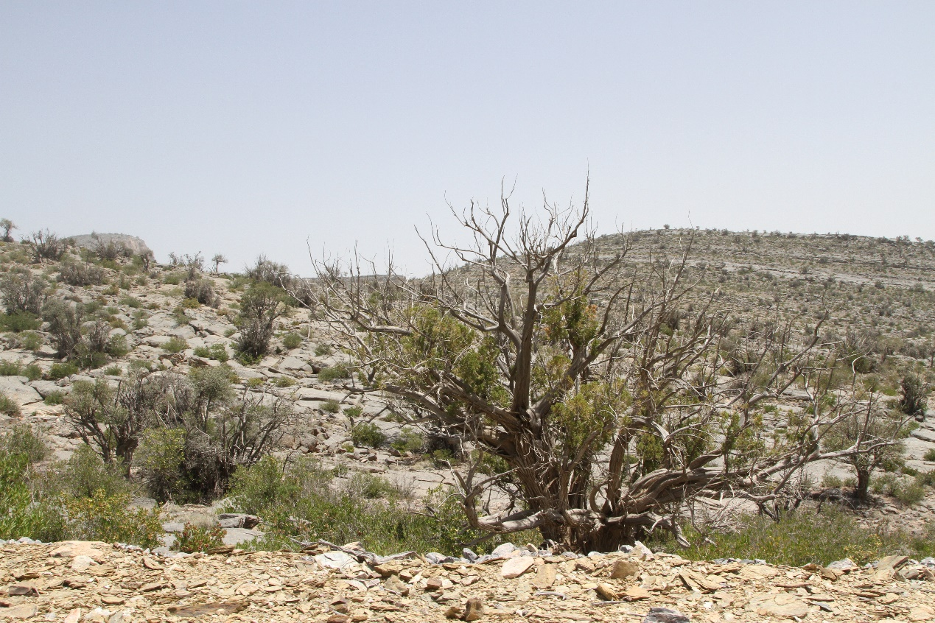

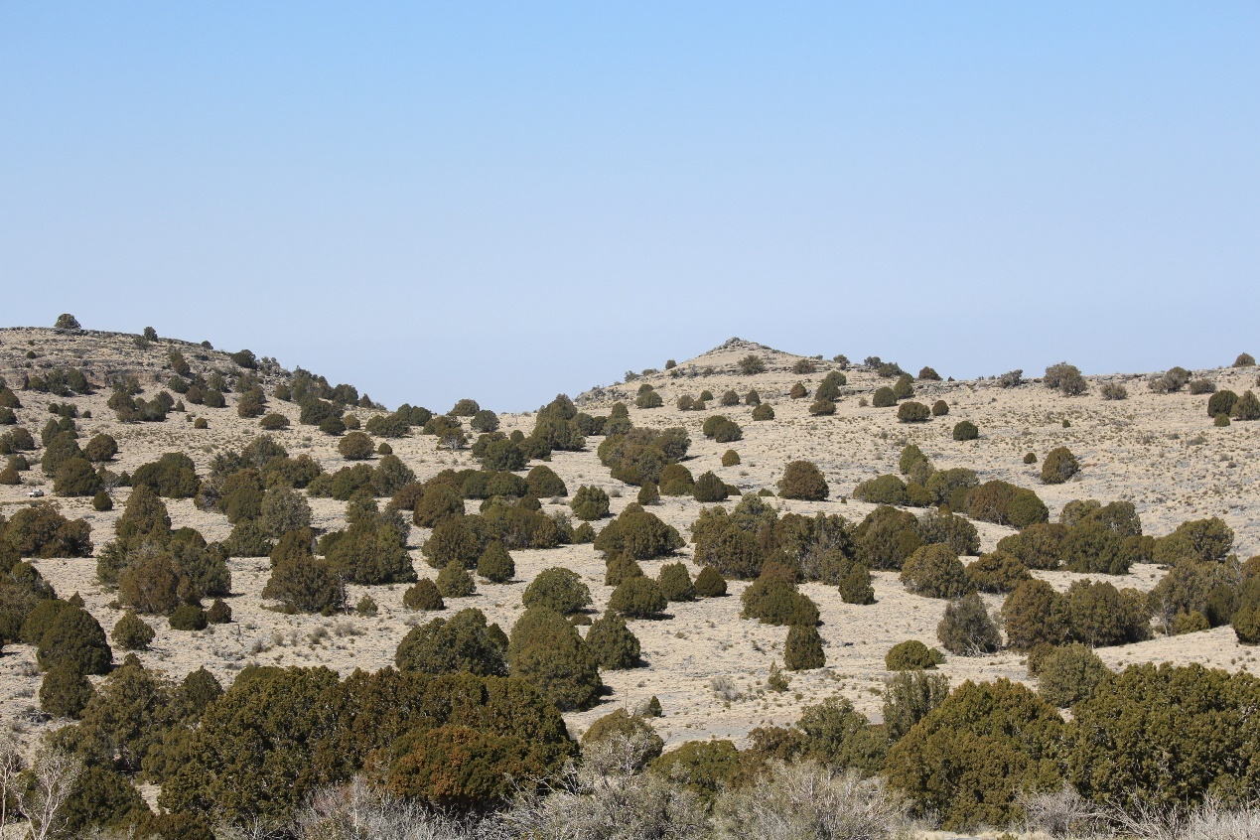

Figure ‎1.2 The status of J. seravschanica woodland in the northern mountains of Oman. Top: the decline of Juniperus woodland at the lower altitude (2100 m). Bottom: Juniperus woodland at higher altitude (2560 m) in healthy condition.

Climate change and forest mortality

Climate change
The continuous increase of fossil fuel use and subsequent release of carbon dioxide and other ‘greenhouse gases’ is expected to accelerate the effects of climate change. In addition to mean higher global temperatures this will include more severe and frequent weather extremes. Global mean temperature has raised by 0.85°C since 1880 and the change is predicted to exceed 4°C by the end of this century (IPCC, 2014). This is likely to be associated with a significant reduction in rainfall levels in arid and semi-arid regions; long-term projection estimates 25% reduction in annual precipitation by 2050 (Ragab and Prudhomme, 2002). Trends indices analysis from many regions have reported an increase in minimum and maximum temperature (Vincent et al., 2005; Klein Tank et al., 2006), and increase in the occurrence of extreme hot days and nights (New et al., 2006). In the Middle East, analysis of temporal trends of extreme temperature indicated consistent increase in warming over the region with significant increase of warm days and nights; trends also indicate drier conditions towards the eastern part of the Arabian Peninsula (Donat et al., 2013). Al Sarmi and Washington (2011) explored the distribution of temperature trends and precipitation in the Arabian Peninsula over three decades. In parallel with increasing numbers of warm days and nights, there was an increase in annual mean and absolute maximum temperatures and annual and absolute minimum temperature; on average, annual temperature was raised by 0.4°C decade⁻¹ between the period from 1980-2008.
In Oman, Al Sarmi and Washington (2011) indicated an increase in average minimum temperature of 0.85°C decade⁻¹ with significant decrease in annual precipitation (67.71 mm decade⁻¹) in the northern mountains. On Al Jabal Al Akhdar (part of the northern mountain range), Al-Kalbani et al. (2015) indicated a rise in annual average temperature of 0.27°C and a reduction in annual precipitation of 9.4 mm decade⁻¹ over the period from 1979 to 2012. This, along with the fact that Juniperus do not occur at warmer drier altitudes within Oman, suggests that these woodland areas may be becoming sub-optimal environments as a result of lower soil moisture availability and increased temperatures.

Main impacts of climate change on forest ecosystems
Impacts due to climate change on the natural ecosystem have increased in recent decades; variation in precipitation and increases in melting ice significantly alter the natural hydrological system - increases in ocean water evaporation cause an increase in sea water salinity and acidity (IPCC, 2014). Forest mortality triggered by drought and warm temperatures as a consequence of climate change has been reported in many areas and appears to be amplifying in recent decades (Allen et al., 2010; Lindner et al., 2010; Anderegg et al., 2013). Although most projections highlight the influence of climate change in raising the aerial temperature, the extensive impact of changing climate on forests’ ecosystems is through increase in evapotranspiration rates caused by increases in temperature, variation in precipitation, increase in water run-off and reduction in soil moisture availability (Ragab and Prudhomme, 2002). Plants growing at the limit of their distribution or in poor site conditions already exist under conditions of moderate stress. Accentuating or adding additional stress factors, such as more frequent water deficit will reduce plant productivity and ultimately viability, with predications for increased mortality (Jump and Penuelas, 2005).
In addition, change in environment elements in natural ecosystems may result in the proliferation of harmful insects and the colonisation of plant pathogens. Warm and dry conditions may accelerate the development stages of many insect species resulting in mass outbreak of specific species, e.g. growth of bark beetles is enhanced by increased warming causing a high concentration of multiple generations in a single breeding season (Lindner et al., 2010). The effect of climate change on plant virus and pathogen evolution and their influence in plant growth and yield have been extensively reviewed in recent years (Chakraborty, 2013). In general, changes in climate may influence species distribution, lifecycle and evolution. Several species will expand their distribution area by moving to traditionally cooler areas or as a result of host movement. Evolutionary processes are expected to occur and some existing species may be replaced by aggressive high temperature tolerant strains. Moreover, stressful environments reduce plant defence systems leaving them more susceptible to pathogen attack. The rapid accumulation of these triggers may extensively influence the resilience of the natural ecosystem and many species are at risk of extinction (Cahill et al., 2012; Bussotti et al., 2014).
The effect of climate change on tree water balance is complex and could be affected by secondary factors such as site condition (e.g. slope, altitude, soil type and aspect) or plant specific factors (e.g. species, root depth, vegetation cover and CO₂ concentration) (Ragab and Prudhomme, 2002; Allen et al., 2010). In temperate regions, prolonged drought events or severe seasonal drought may induce widespread forest mortality; while short-term water deficits may result in forest decline in tropical regions (Allen et al., 2010). The increase in heat-waves can accelerate forest stress through increased evaporation and perhaps transpiration rates even if precipitation volume remains constant (Adams et al., 2009); and it may have significant impact when the evapotranspiration rate is greater than precipitation level (Ragab and Prudhomme, 2002). In the northern hemisphere, trees growing in the south-facing slopes are more vulnerable to drought stress due to the effect of solar radiation in soil moisture availability (Dobrowski, 2011).
Although, studies have illustrated the influence of specific climatic elements in plant growth e.g. temperature or CO₂, the interactive responses of these factors in plant growth is rarely studied (Ghannoum and Way, 2011). Temperature increase may over-heat plant leaves that consequently influence many plant physiological processes such as photosynthesis, respiration and plant water balance (Catoni and Gratani, 2014). Recent studies indicate that the interactive effect of these factors can have additive or aggressive effects on plant growth in a particular plant distribution range. In temperate forests, increases in CO₂ overcome the effect of high temperature causing an increase in above-ground biomass (Dieleman et al., 2012); while for trees growing in their distribution limit or in Mediterranean forests, the negative effect of temperature increases can exceed the influence of CO₂ (Bussotti et al., 2014). This may indicate that plants grown at the southern part of the northern hemisphere are more susceptible to heat stress than plants in more northern latitudes.

Plant response to climate change

Population shift
Plants exposed to the impacts of climate change can show different responses, such as migration, adaptation, or population decline and extinction (Neilson et al., 2005; Haskins and Keel, 2012). The sequences of these responses depend on the flexibility of the ecosystem to adapt to climate change and how rapidly the changes occur. With the general climate warming, plants may shift their distribution towards higher elevations (short distance movement) or pole-ward in latitude (long distance movement) (Walther et al., 2002). Neilson et al. (2005) reported that migration success is dependent on four main components; high population reproductive ability, seed dispersal mechanism (by wind or animal), suitability of new site for seedling germination and establishment, and the ability of a plant to mature and reproduce in the new environment.
Using meta-analysis, Chen et al. (2011) estimated that species have shifted their distribution to higher elevations by 11 m decade⁻¹ and by 16.9 km in latitude decade⁻¹ in recent decades. Latitudinal shift is very slow and unstable because many species have limited seed dispersal (wind dispersed plants rarely disperse over very long distances) or may face competition from locally adapted plants (Zhu et al., 2012). Several dominant mountain species have shifted their distribution toward higher elevation, this is normally followed by subdominant species inhabitation at lower elevation parts (Kelly and Goulden, 2008; Feeley et al., 2011). For example, in northeast American forest, climate change caused an extensive decline of Picea rubens at its distribution limit (792 m), the loss of species in this mountain zone was later occupied by Abies balsamea which extended its distribution range from 732 m to 792 m (Beckage et al., 2008). Although local dispersal at altitudinal range can occur more rapidly than long geographical dispersal, this is likely to be insufficient to avoid the predicted increase in climate change (Neilson et al., 2005). Moreover, human activity has greatly modified the natural landscape resulting in high levels of habitat fragmentation; this limits the availability of suitable habitat and dispersal corridors for future plant colonisation (Zhu et al., 2012).

Evolutionary adaptation
It is predicted that in some regions (e.g. arid mountains) the rate of climate change is going to be higher than migration rates (Feeley et al., 2011; El-Keblawy, 2014). In addition, some species, particularly in polar regions or mountains, could reach the upper limit of their dispersal where no further expansion is supported by the landscape. In these scenarios, evolutionary adaptation is one possible way to enhance the presence of species in a changing system (Hoffmann and Sgro, 2011). In their life history, plants that are exposed to various climate triggers have evolved to adapt to these changes; this evolution may involve genetic change that passed on to the next generation or plastic changes in which plants adapt their phenological and morphological characteristics in response to environmental changes. Genetic evolution involves genetic modification through gene flow (hybridization) from different populations and therefore increase the populations’ tolerance to elevated temperature, drought, salinity or diseases (Gallo, 2014).
The rate of evolution depends on the level of genetic variation within plant populations. Under climate change, this process is influenced by two contrasting mechanisms. The expected species shift - altitudinal or latitudinal, could increase hybridization processes leading to high genetic variation (Hoffmann and Sgro, 2011). However, habitat degradation due to both human and climate change can lead to species fragmentation and isolation, increasing the rate of inbreeding depression (Chown et al., 2010; Broadhurst and Boshier, 2014). In addition, genetic evolution requires large population size for several generations to increase heterogeneity which makes it harder for some long-lived, slow growing trees as climate change effect would be faster than the evolutionary process (Hoffmann and Sgro, 2011).

Phenotypic adaptation
Phenotypic plasticity is another way plants can respond to climate change triggers (Nicotra et al., 2010; Matesanz et al., 2010). Some studies noted that this process is a short-term plant adaptation (not involving genetic evolution) in response to the environment a given species is exposed to (Hoffmann and Sgro, 2011); while others believe that it is genetically controlled and can be inherited to the next generation (Nicotra et al., 2010). Some of the environmentally induced, adaptive mechanisms are, early leaf unfolding ‘appearance’ and advance or delay in flowering time (Gordo and Sanz, 2010), and alteration in seed production and dispersal time (Johnsen et al., 2005). Alongside with phenological change, plant adaptation may involve alteration in morphological and physiological activity such as stomatal behaviour adjustment, increased water use efficiency, change in growth patterns and in photosynthetic product allocation (e.g. more products allocated to root growth to enhance water absorption) (Matesanz et al., 2010).
Although population shift or adaptation could reduce species loss, the rapid change in the climate would accelerate losses in the potentially colonized species and their suitable habitat before their movement or adaptation resulting in overall reduction in biodiversity (Neilson et al., 2005). Drought-induced mortality has been recorded in many forests and is predicted to accelerate due to increases in climate change stress (McDowell et al., 2008). Corlett and Westcott (2013) indicated that mountain species would not be able to match the pace of climate change predicted for the rest of this century. The rate of climate change will exceed plant movement with an expected increase in losses in many mountain areas and an associated increase in species competition, reduced seed dispersal, and an increase in habitat fragmentation.

Tree mortality influence on ecosystem functions
Tree mortality is a natural process in an ecosystem (Franklin et al., 1987), but the influence of multiple stress forces such as plant size, competition and climate, may rapidly alter plant productivity and accelerate mortality rates (Anderegg et al., 2013). Decline in woody plants is usually used to describe a set of symptoms associated with loss of tree vigour that may include growth reduction and canopy defoliation. It is usually associated with dieback symptoms, progressive dryness of plant twigs, starting from the tip of the branches (Kabiel et al., 2016). Climate-induced mortality is a complex process that may interact with other factors like plant species (Nepstad et al., 2007), tree age, size and competition (Floyd et al., 2009), position of the plants in the forest (plants in xeric sites are more vulnerable to stress) (MacLaren, 2016), or association of other biotic factors (incorporation of insect infestation with drought stress accelerate mortality rates) (Klenner and Arsenault, 2009). Increase in tree mortality can alter many natural ecosystem services such as the food web, climate improvement, water hydrology, soil nutrient decomposition and human aesthetic benefits (Carnicer et al., 2011; Anderegg et al., 2013).
A reduction in plant cover increases gaps within the plant canopy causing change in heat flux energy and water cycle (Anderegg et al., 2013). In the absence of a dense canopy, high solar radiation can increase transpiration of understorey species resulting in a rise in soil evaporation (Royer et al., 2011). In xeric sites, increasing wind speed at soil surface could increase heat flux generated to the atmosphere (Rotenberg and Yakir, 2010). Excessive crown defoliation reduces transpiration, resulting in a reduction in evaporative cooling capacity; this could increase the maximum temperature during summer or extend the hot summer season (Teuling et al., 2010). In addition, canopy loss reduces precipitation interception, and increases water run-off, altering infiltration and root water capture processes (Anderegg et al., 2013). With the absence of root stabilization mechanisms, water run-off could increase soil erosion.
In relation to the soil nutrient cycle, Xiong et al. (2011) indicated that increased foliage litter at the soil surface increases the proportion of nitrogen bacterial feeders that consequently reduce carbon and nitrogen nutrients on the soil surface, leading to an accumulation of soil inorganic nitrogen and increasing soil acidity. A decline in forest trees could also affect colonisation and diversity of beneficial soil microbes such as mycorrhizal fungi as these depend on resources availability by host plants (Koorem et al., 2017). Furthermore, drought-induced forest mortality could reduce carbon sink efficiency of the terrestrial ecosystem on a global scale (Carnicer et al., 2011) and thus influence the global net primary production of food security.

Plant response to drought and heat stress

What is stress?
In physics, stress is used to define the external force which acts on an object to produce strain. However, the biological and physiological definition describes stress as consequent impact of external factors that deviate optimal life conditions of the organism (Larcher, 2003). Jones and Jones (1989, p1) define biological stress as “overpowering pressure of some adverse force or influence that tends to inhibit normal systems from functioning’’. The impact of these forces is more detrimental to some plants than others and may significantly affect plant species composition and viability on the ecosystem (Clewell and Aronson, 2013). These stresses could be biotic (e.g. pathogen, insects, and herbivores) or abiotic (e.g. extreme temperature, salinity, water deficit, high light intensity, and nutrient deficiency).
Depending on the type of stress and its severity, plant responses pass through a sequence of different phases and scales from individual cells to whole organisms. At a cellular level, the impact of disturbance is first recognized by the receptors (plasma membrane protein) on plant cell membranes; this signal is then used to generate different messengers (including the synthesis of different proteins, hormones and enzymes) that stabilize the structural and metabolic processes required for plant adaptation and survival during unfavourable conditions (Larcher, 2003). The adaptation processes may include induction of heat shock proteins to increase plant cell thermotolerance (Burke and Chen, 2006), increase abscisic acid (ABA) concentrations in guard cells to induce stomatal closure during drought (Lambers et al., 2008), or an increase in the quantity of carotene and lutein (protective pigments) in the chloroplast to avoid high light damage (Larcher, 2003). At the plant level, stress may encourage plant growth adjustment such as regulating the ratio of root and shoot growth, changes in plant phenological timing and reduction in vegetative biomass. However, if high disturbance intensity persists for long periods, permanent damage or eventual plant death may occur.

Plant responses to abiotic factors are complex as plants can be exposed to one or multiple stresses at a single time. Studies have shown that a plant’s response to single stress (e.g. heat or drought) may vary to some extent compared to its response to a combination of two or more different stresses (e.g. heat and drought stresses) (Mittler, 2006; Cramer et al., 2011) (Figure ‎1.3).

Figure ‎1.3 Physiological response of plant to heat and drought or combination of both stresses. Source (Mittler, 2006).

Stress due to high temperature (heat stress)
Temperature is one of the main environmental factors that influences plant distribution in the natural ecosystem through its impact on the metabolic activity, establishment and viability of plant species. For most plant species, a temperature range from 5 to 25°C is optimal for vital plant functions (Larcher, 2003). When plants are exposed to lower (cold) or higher (heat) temperature more than their thermal tolerance, metabolic processes are reduced to a minimum due to protein denaturation, cell membrane perturbation and photosynthesis limitation (Larcher, 2003). These changes are reversible over the short term; however, if heat stress occurs for a prolonged period, irreversible injuries may occur leading to plant death. The threshold temperature i.e. that deemed to cause 50% injury to plant metabolism, varies between plant species and region, e.g. 45-55°C in tropics, 50-60°C in subtropics, and 40-52°C in temperate region (Larcher, 2003). For conifer species, the threshold temperature ranges from 44 to 50°C (Larcher, 2003).

Effect of heat stress on plant cell
At plant cellular level, high temperature causes damage to the thylakoid membranes inside chloroplast cells; this limits the regeneration of RuBP (Ribulose 1,5-bisphosphate), organic compound involved in photosynthesis process (Leegood and Edward, 1996). As a result, photosystem II is inhibited which is followed by the disturbance of carbon metabolism (Leegood and Edward, 1996). In addition, the solubility of CO₂ declines more strongly than O₂; this leads to an increase in oxygenating reaction of Rubisco more than carboxylating reaction. Moreover, the affinity of CO₂ decreases more than O₂ and electron transport declines strongly at high temperature. The combined effect of these two mechanisms cause an increase in photorespiration (Lambers et al., 2008). The damage in thylakoid membranes and an increase in photorespiration cause a depression in the photosynthesis rate through decreasing the efficiency of photophosphorylation as well as thermal inactivation of photosystem II (Leegood and Edward, 1996; Larcher, 2003; Lambers et al., 2008).
Mathur et al. (2014) reviewed the main impact of temperature on plant photosynthesis. They stated that the association of high temperature with excess light intensity results in photoinhibition and a decline in photosynthetic capacity. High temperature and high light impair the movement of electrons to the photosynthetic reaction centres and reduce the rate of energy absorption. In addition, high temperature reduces chlorophyll biosynthesis in plastids by destruction of numerous enzymes involved in the synthesis of the chlorophyll molecules. Moreover, at high temperature, leaf water status and stomatal conductance are affected, resulting in stomatal closure which eventually impairs photosynthesis process, namely CO₂ absorption.

Effect of heat stress on plant root systems
Even when soil moisture and other essential factors like soil nutrients are at adequate levels, soil temperature can influence root growth and mortality (Pregitzer et al., 2000). McMichael and Burke (1998) indicated that temperature higher than optimal causes reduction in lateral root growth, reduction on root elongation rates and alters dry matter accumulation. This can lead to a lower root:shoot ratio and thus, in turn, affect plant water absorption and distribution.
Energy released through root respiration is the primary mechanism for root growth and maintenance, as well as providing the driving force for ion absorption and transportation to xylem (Lambers et al., 2008). It is estimated that root respiration exponentially increases with soil temperature by 1.5 to 3 fold for each 10°C increase (Atkin et al., 2000; Pregitzer et al., 2000); for example, in J. monosperma, a 2.4x increase in respiration was recorded (Burton et al., 2002). This rise in respiration catabolises more carbohydrates which increases the sink demand for carbon in the root, thus, more biomass is allocated to the root. However, a higher proportion of this biomass is used in maintenance respiration rather than in root biomass growth (Lambers et al., 2008). It is proposed that changes in carbon allocation due to high respiration negatively affects the growth and function of fine roots particularly, as these are highly dependent on the newly-imported carbon from the plant canopy (Pregitzer et al., 2000).

Effect of heat stress on vegetative and reproductive system
Elevated temperatures also affect carbohydrate accumulation within the plant canopy. The optimum temperature for plant photosynthesis ranges from 20 to 30°C; whereas for respiration, it occurs at higher temperature, e.g. above 45°C (Yamori et al., 2014). Thus, at temperatures higher than the optimum, photosynthesis is the first to be reduced, but respiration rates continue to increase. The continuous rise of cell metabolism due to both metabolic and physical effects of temperature, lead to the depletion of more stored carbohydrate (sucrose, fructose, and starch) (Farrar and Williams, 1991). In addition, high temperature impacts the viscosity of phloem (Scartazza et al., 2015), which may affect the rate of phloem transport (Farrar and Williams, 1991). The inhibition of photosynthesis and continuous carbohydrate depletion reduces dry matter production and affects overall plant growth.
Moreover, high temperature increases the vapour pressure deficits (reduction in air relative humidity) which leads to an increase in evaporation and transpiration rate. Transpiration rate increases to reduce leaf dehydration, but at the same time more water is removed from the system (Sinclair et al., 2017). In limited water conditions, low water potential induces stomatal closure to avoid further water loss, which under extreme high temperatures causes a rise in leaf temperature leading to leaf dehydration and senescence (Jones, 1992).
Reproductive tissues exposed to heat stress results in pollen sterility, poor fruit formation and development, and fruit abortion (Larcher, 2003). Studies have shown that high temperatures alter carbohydrate concentration in developing anthers (Pressman et al., 2002), reduce stigma capacity to sustain pollen tube penetration (Hedhly et al., 2005), reduce number of pollen cones and inhibit seed production (Kon and Saito, 2015). In Juniper species, Gruwez et al. (2014) indicated that high temperature has a strong negative effect on seed development and embryo ripening; as well as reducing ripening time which eventually reduces seed viability. In non-perennial plants, high temperature accelerates plant development by reducing the cycle of vegetative and reproductive growth which ultimately reduces potential yield; whereas in perennials, changes in plant phenology, e.g. early flowering and seed maturation, affects seed development and subsequent germination success (Hatfield and Prueger, 2015).

Stress due to water deficits (drought stress)
Water transport from soil through the plant to the outside air is managed by the water potential gradient in which water moves from high to low water potential. The water potential is zero when water is freely available to the plant, but becomes negative as water stress increases (Larcher, 2003; Lambers et al., 2008). The optimal water potential for transpiring plant ranges from -0.5 to -3 MPa; values higher than this range may cause water stress, e.g. -3.5 MPa considered as threshold value in J. virginiana whereas -6.4 and -8.8 may cause 50% and 90% plant cavitation respectively (Jones, 1992).
Drought stress is determined when the water content of the soil is reduced to a level which causes water deficiency in the plant cell. Several reasons may induce drought stress, such as, low soil moisture, increased evaporation, osmotic binding in freezing water or saline soil. Water stress causes a decline in almost all plant process. The response of plants varies with the severity and duration of the drought (Larcher, 2003).

Effect of drought stress within plant cells
A living cell must maintain its turgidity to be physiologically active; this process is controlled by osmotic adjustment and cell wall elasticity (Lambers et al., 2008). Plants lose water through transpiration and evaporation, which ultimately reduces cell turgidity, when excessive. When soil moisture is limited, continuous loss of water causes reduction in vascular volume and an increase in solute concentration within the cytoplasm. Dehydration of the cytoplasm causes the plasma membrane to contract, resulting in the cells losing turgidity (i.e. becoming flaccid). Osmotic adjustment, through the accumulation of water-soluble carbohydrates and organic nitrogen compounds within the cytoplasm, attracts water into the cell. This helps maintain the cell volume and reduce loss of turgor in the leaf mesophyll. In a case of extreme low water potential, the cell wall copies the cytoplasm and shrinks inward causing biomembrane damage which ultimately breaks down the osmotic system and causes loss in water absorption ability (Larcher, 2003).

Effect of drought stress in leaves and stems
At a whole plant physiology level the reduction in the hydraulic conductance from root to shoot, raises water tension inside the xylem causing the water column to ‘snap’ as air is dissolved within the vessel or the tracheid causing xylem embolism (Jones, 1992). Water stress reduces plant photosynthesis by its influence on stomatal and non-stomatal mechanisms. Stomata, the primary controller of water loss and CO₂ absorption, are the first to be influenced by water stress. Increases in ABA, signaled by the roots toward the shoots, induces stomatal closure which helps to conserve water by limiting evaporative loss. The restriction on stomatal opening, however, reduces the availability of CO₂ at the assimilation site within the chloroplast which subsequently inhibits photosynthesis. In addition, water stress reduces the synthesis of chlorophyll pigments, causing structural change in the chloroplast, as well as enhancing concentrations of antioxidative enzymes and stress metabolites (Shao et al., 2008; Anjum et al., 2011).
Over the longer term, plant photosynthetic capacity is reduced due to stomatal closure which reduces carbohydrate transport to donor tissues. However, respiration depletes stored carbohydrates and leads to carbohydrate starvation. This ’sugar starvation’ induces several changes in the cells including suspension of division and expansion and rapid degradation of cellular protein (Morkunas et al., 2012). This in turn reduces leaf expansion and results in a net loss of leaf area and reduced biomass. The elevation on ABA concentration on leaf tissue is also involved in leaf elongation inhabitation (Lambers et al., 2008). Leaf senescence increases in response to high drought stress which further impedes photosynthetic production, potentially leading to overall decline and death.

Effect of drought stress on root systems
Extreme soil dryness results in high resistance of water movement through the soil to the root system causing less absorption by roots (Grossnickle, 2005). At moderate stress, the root:shoot ratio increases because roots are less sensitive to drought (Anjum et al., 2011); the increase in root growth at the relative expense of shoot growth is an obvious mechanism to encourage high water absorption. However, at extreme stress, which inhibits shoot growth, root elongation is also reduced due to loss of cell turgor and a reduction in the size of meristematic root cells. Increases in ABA concentration within roots during water stress has also been found to reduce root elongation (Sharp and LeNoble, 2002). Roots may also loosen their cell walls due an increased activity of expansion proteins (Lambers et al., 2008).

Effect of drought stress in vegetative and reproductive system
Water stress is a major factor affecting seed germination and plant establishment. Water deficits influence reproductive success by inhibiting development of pollen microspores (pollen grains), resulting in male sterility which may prevent fertilization or cause ovule abortion (Saini, 1997; Larcher, 2003). Water availability is highly associated with development and maintenance of reproductive organs such as numbers of flowers, fruits and seeds (Del Cacho et al., 2013). Seed viability and germination success were also shown to be affected by water accessibility (Zhu et al., 2014; Chamorro et al., 2016). In addition, changes in plant carbohydrate allocation strategy and limited shoot growth caused by water shortage influence seed production and filling (Lipiec et al., 2013).

Methods in climate change research
Research in to the effect of climate change on plants and their natural ecosystems has received much attention over the last two decades (Matesanz et al., 2010). Changes in global carbon dioxide (CO₂) concentrations, air temperature, and precipitation levels across several natural habitat communities are well-documented. Four main approaches have been widely used to predict the consequence change in ecological ecosystems; experimental work under controlled or field conditions, theoretical approachs like meta-analysis of previously generated data, climate model approach, and expert views (Sutherland, 2006; Juroszek and Von Tiedemann, 2013). Each of these approaches has inherent strength and weakness therefore it is advisable that multi-disciplinary approaches could be utilised to provide more accurate predications (Sutherland, 2006). For example, climatic models have been used to assess the risk of future climate change in biodiversity, e.g. species distribution model (Krause and Pennington, 2012), or bioclimate envelope model (Garcia et al., 2016). However, most models are dependent on data generated from species behaviour studies conducted at specific reference sites; the knowledge gained typically amassed from one or more empirical trials (Luo et al., 2011).
In the experimental approach, or other methods, the distribution and viability of plant species and natural communities were related to a selection of environmental factors that are known to influence plant physiological and molecular mechanisms (Neilson et al., 2005). These types of experiments provide a more realistic understanding on the influence of climate change on natural ecosystems; specific stressful factors can be manipulated to forecast future climatic influences (Dunne et al., 2004). In this approach, five main methods (types of research) have been followed to study the influence of climate triggers on plants and/or their ecosystems; 1) controlled condition experiment, 2) field-based experiment, 3) studies along elevation gradients, 4) studies along latitudinal gradients, 5) data-monitoring (Table ‎1.1). In these experiments researchers attempted to either understand the main influence of climate warming (Wolkovich et al., 2012) or manipulate it with additional climate factors e.g. rainfall (Hamerlynck et al., 2000), nutrients (Leppalammi-Kujansuu et al., 2014) or light level (Bornman et al., 2015).
Large mature trees have been used to study forest mortality under drought and heat stress in situ (Allen et al., 2010; Michaelian et al., 2011), whereas experiments with small trees have focused on the mechanisms causing tree die-off under controlled environmental conditions (Adams et al., 2013; Mitchell et al., 2013). However, balancing the requirements for understanding the mechanisms by which abiotic stress can effect plants under controlled environments with the need of relevant practical studies under field conditions is a common challenge of plant science (McDowell et al., 2013). Seedlings are often favoured when attempting to investigate the physiological mechanisms associated with stress, largely due to their greater ease of management compared to more mature specimens and an ability to attain complete measurements with less error (McDowell et al., 2013), and deal with multiple factors or interactions such as effects due to irrigation, CO₂, temperature, and canopy shading (Duan et al., 2013).

Table ‎1.1 Example of current experiment methods used in climate change research
Research method | Method description and comments | Reference
Controlled condition experiments | This method attempts to understand the influence of single or integrating multiple climate factors on plant physiology and growth. Although this method has the ability to manipulate and control target factors, it does not provide realistic data as to what to expect in natural environment. | Duan et al. (2013)
Field experiments | Experiments conducted on research stations, farms or natural sites. They provide more convincing data, but it is difficult to control the target factors due to variability and complex environment interaction. It has limitation on time and scale of plots. | Sutherland (2006)
Studies along elevation gradients | Study the effect of mountain elevation (short distance change in temperature and rainfall, but not day length) on species biodiversity. They compare the behaviour of single or multiple taxa along different landscape boundaries. They provide information on climatic influence on plant species distribution. | Fischer et al. (2011)
Studies along latitudinal gradients | Study the influence of climate on species distribution/behaviour along different latitudinal gradients, from temperate to tropical. For example, the influence climate has on insect distribution that may affect seed production and dispersal. | Garcia et al. (2000)
Data monitoring | Long-term observations in plant species distribution, growth or morphology in relation to climate change over many years. This requires long-term observations and appropriate weather / climate records. | Crimmins et al. (2010)

The shortage of research combining both field and controlled environment studies has tended to lead to insufficient information on the actual mechanisms responsible for drought-induced mortality of young trees under field conditions. Similarly, there is a degree of uncertainty when trying to predict how much moisture loss young seedling trees will tolerate, when cross-referencing information from controlled environments with more complex situations in the field (McDowell et al., 2013). Factors such as wind, solar intensity and capillary action of soil play an important role in plant establishment under field conditions; however, they are generally not accounted for under controlled conditions. Moreover, environmental and physiological factors associated with climate stress mortality vary with tree size and competition (Floyd et al., 2009), or levels of anthropogenic disturbance. Their interaction remains an essential research priority (McDowell et al., 2013).
In addition, understanding the influence of climate change through an experimental approach faces several limitations, basically by the scope of the experimental space and time (Luo et al., 2011). According to Hegazy and Lovett-Doust (2016), there are few studies focused on understanding the long-term effect of climate change in dry lands; they suggest that future studies should aim for long-term (>5 years) durations and the proper manipulation of water stress effects on perennial plant growth. However, although long-term experiments are favoured to understand ecosystem response, these will not be able to define the effect on even longer-term ecological processes such as a shift in soil nutrients or a change in species dominance (Luo et al., 2011). Ecological systems are dynamic interdependent, understanding the driver of a shift in species and their community composition requires the study and assessment of several generations of a single species (Fukami and Wardle, 2005). Consequently, understanding climate change triggers and their effect on specific ecosystems is essential for planning proper conservation strategies.

Plant conservation

Ecosystem conservation definition
Over many decades, conservation strategies have evolved to balance the increased human demands in natural ecosystems and maintaining biological wealth (Given, 1994). Human activities in the past four decades have accelerated at an unsustainable rate; it is estimated that 50% of the Earth’s land surface has been modified through these activities (40% of land surface used for agriculture and livestock management) (Hooke et al., 2012). The term conservation has different meanings depending on people’s understanding (Heywood and Iriondo, 2003). According to the World Conservation Strategy (IUCN, 1980), conservation is defined as:
ʻʻthe management of human use of the biosphere so that it may yield the greatest sustainable benefit to present generations while maintaining its potential to meet the needs and aspirations of future generations. Thus conservation is positive, embracing preservation, maintenance, sustainable utilization, restoration, and enhancement of the natural environment.ʼʼ(p.1).
In a wider perspective, conservation integrates both preservation and enhancement of natural habitat (Given, 1994). Conservationists have implemented several strategies to promote sustainable forest management, ranging from incorporating the importance of biodiversity in public awareness programmes, increase in natural protected areas and to the enhancement and recovery of impaired ecosystems (Hegazy and Lovett-Doust, 2016). Although plant species preservation and restoration are implemented to maintain the biological and ecological process of the natural ecosystem, the best hope for future biodiversity protection relies on well-developed education programmes and community support.
The plant conservation concept has been affected by its interrelationship with sustainable use, development of conservation biology and adaptation to biodiversity approach (Heywood and Iriondo, 2003). The consistent loss of natural habitats and the increased interest in habitat conservation encouraged the adaptation of these approaches through a global network. In 2002, the United Nations adapted the Global Strategy for Plant Conservation (GSPC), (updated in 2010 for 2011 to 2020). With its 16 targets, the GSPC provides a basis to address the global threat to plant species through national and international measures (Sharrock et al., 2014). Several countries have developed national plans to address the targets indicated by the GSPC, e.g. Oman (MECA 2014). The 16 targets cover five main objectives, threat assessment, plant conservation, sustainable use of plant diversity, increase education and public awareness, and enhance staff training and capacity buildings (Sharrock et al., 2014). Biodiversity conservation has been implemented through preserving threatened species in protected areas (in-situ), restoration of degraded habitats and preserving species outside their habitat (ex-situ), e.g. botanic garden collections, seed banks and research centres.

The potential role of protected areas
The context of natural reserve/parks has been recognized as an option to protect the biological diversity, ecosystem function and its natural and cultural resources (Watson et al., 2014). At an initial stage, protected areas were recognised as national parks facilitating human use; however, the focus then shifted toward assisting plant and habitat conservation (Becken and Job, 2014). The IUCN definition of protected area is:
ʻʻA clearly defined geographical space, recognised, dedicated and managed, through legal or other effective means, to achieve the long-term conservation of nature with associated ecosystem services and cultural values.ʼʼ (Dudley, 2008, p. 8)
Globally, there are more than 200,000 protected areas covering 15.4% of total terrestrial land (Deguignet et al., 2014); the GSPC targets aimed to effectively protect 17% of global land by 2020 (Sharrock et al., 2014). The effectiveness of these protected areas in biodiversity conservation has been documented in different regions; though, their role in conservation depends on management practices applied. In tropical regions, Bruner et al. (2001) examine the effectiveness of 39 protected areas from 22 countries in eliminating the anthropogenic threats. They found that protected parks have successfully stopped deforestation; however, they have less control in hunting, damage through fire and livestock browsing. This has been correlated to reduced levels of management like legal enforcement and forest boundary demarcation.
In meta-analysis of 2599 published papers, Geldmann et al. (2013) concluded that protected areas have been effective in maintaining forest habitat by reducing deforestation; however, their role in species protection was unclear due to a smaller number of case studies making assessment difficult. Although in most of the studies analysed, habitat loss was reduced within the protected sites, extensive loss was recorded within or outside the wider forest borders due to human activity near the core protected sites (Bruner et al., 2001; Geldmann et al., 2013). The benefit of buffer zones in plant conservation may act by providing greater protection from human activity, and minimizing biological changes; moreover these may extend the area of key habitat/s and thus facilitate plant and animal movement across the region (Given, 1994).
In respect to their effectiveness in reducing human disturbance, protected areas are facing challenges associated with climate change threats. An assessment of predicted impact of climate change on Natura 2000 protected sites (large network of protected areas over Europe) indicated that 23% of these protected areas will lose 30% of their current size by the end of this century, these are mostly from Mediterranean region landscapes (Barredo et al., 2016). As the same scenario is expected in other natural ecosystems, new strategies should be implemented to reduce the impact on protected areas (Dudley, 2008). It is predicted that management practices to conserve plant species will be increased under climate change scenarios, this will involve the relocation or initiation of larger sized protected areas, preservation of some species will need active management programmes, and an underpinning increase in research activity to fully understand the main threats of climate change (Dudley, 2008). In addition, increasing the density of protected site networks will be required to facilitate or assist plant and animal migration from disturbed habitat to more suitable sites (Barredo et al., 2016). Species translocation (artificial plant or animal movement through the landscape) may be fundamental if the natural habitat is severely damaged (Given, 1994; Barredo et al., 2016). In addition, ex-situ plant collection e.g. in botanic garden, is important for long term protection against biodiversity loss, provide a continuous supply of plant materials for ecological restoration and research, and as educational showcase to support wild conservation (Rae, 2011, Guerrant Jr et al. 2013, Canessa et al. 2015). Botanic gardens could provide the standard for wild plants collection policy, skills for proper propagation and cultivation and proper knowledge of climate change influence in plant species (Rae, 2011).

Ecosystem restoration
Human intervention and conversion of ecosystems, directly or indirectly, has caused disturbance in almost all natural ecosystems (Butchart et al., 2010). Clewell and Aronson (2013, p. 35) define disturbance as ʻʻserious disruption of ecological functioning and modification of biotic expression, especially at population and community levelʼʼ. The response of natural ecosystems to disturbance depends on type and intensity of disturbance. For example, less intense stress may suppress plant growth and productivity, conversely it may kill invasive, non-native plant species that may colonize in absence of such stress; in this case habitat recovery will be encouraged after stress events (Clewell and Aronson, 2013).
Although, for some, natural recovery can occur without human intervention, there is still a gap between loss and recovery. Between 2000 and 2012, global forest loss reached 2.3 million km²; whereas, the forest gain was only 0.8 million km² (Hansen et al., 2013). This indicates that most forest ecosystems are being subjected to severe disturbance causing significant alteration or permanent damage to natural ecological processes (Clewell and Aronson, 2013). Restoring ecological functions of a disturbed habitat through assisting recovery from human damage is globally recognized as a key activity to reinitiate and conserve biodiversity and ecosystem biological processes (Sharrock et al., 2014). Although ecological restoration can improve the dynamics of ecosystems, it should not be evoked to justify habitat degradation in the first place, as restored systems will often not be able to return to their former self-sustainable state.
As ecological recovery relies on the ability of the ecosystem to support natural regeneration (Clewell and Aronson, 2013), efforts should aim to understand the main limitations on plant succession. Protecting natural forest ecosystem from disturbance, (deforestation, fire, or animal browsing) and competition (high dense grasses, or invasive species) may encourage natural recovery (Shono et al., 2007). However, assisted regeneration is a slow process and depends on the availability of favourable conditions, e.g. soil moisture and soil organic matter, and an abundant supply of seed from the soil seed bank. Therefore, this approach cannot be implemented as the only method in dry land ecosystems where habitat degradation and desertification are widespread; in addition, natural regeneration is limited by the extreme climate conditions often present in these ecosystems (Bainbridge, 2007; Hegazy and Lovett-Doust, 2016). Moreover, the variability in patterns of plant density, species composition and disturbance levels across the varying landscapes of arid mountains may interact with regeneration success. Thus, natural restoration through planting of native plants is required to catalyze recovery process.

Translocating plants to their natural habitat
Different terms are used to define the moving of plants back to the wild such as introduction, reintroduction, augmentation, or assisted migration. Dalrymple et al. (2011) defined reintroduction as a method of establishing an inexistent (rare) genotype to an area where it has historically occurred, while augmentation (synonym: restocking or enhancement) is defined as a new supplementation of a given threatened species to an existing population of the same species. However, these terms have been used more broadly in the literature and authors have used plant reintroduction or translocation terms to describe general intentional movement of plant material to its natural habitat (e.g. Godefroid et al., 2011; Guerrant Jr, 2012). In this research translocation is used to describe plant species introduction, reintroduction and augmentation, however the accepted definition is directly used when stating these terms specifically.
It is increasingly accepted that translocation plays a significant role in conservation strategies involving enhancement of small populations, improving ecological functions, improving population genetic heterogeneity and preventing species extinction, particularly for those with limited seed dispersal (Godefroid et al., 2011; Dalrymple et al., 2012). Recent analysis indicated that translocation techniques were not only used to manage threatened plant species, but it was even employed when species are simply in decline within part of their distributional range (Dalrymple et al., 2012). Although assuring biological success in initial terms, plants must undergo their vegetative and reproductive life cycles - population sustainability being the main objective, however, not all translocation projects achieve this target (Dalrymple et al., 2012; Monks et al., 2012). The reason for this perhaps is that most translocations are structured as scientific experiments, which are subjected to specific hypotheses often within a set timeframe. In recent years, several authors have analyzed the effectiveness of translocation as a method of conserving plant species (Dalrymple et al., 2011; Godefroid et al., 2011; Dalrymple et al., 2012; Guerrant Jr, 2012). In meta-analysis of 249 translocation projects, Godefroid et al. (2011) stated that populations that were recorded as surviving, flowering and fruiting was low (52%, 19%, 16%, respectively). In more intensive analysis, Dalrymple et al. (2012) indicated that population success was influenced by propagule type used (seed, juvenile or adults). Juvenile plants, including seedlings, saplings and cuttings, showed higher survival ability (91% of 134 projects were successful) than when using seed or adult plants. In general, according to these reviews, translocation success was related to different factors such as population size, site selection and protection, plant material used, management and monitoring after planting.

Plant translocation and climate change
As influences of climate change are expected to accelerate, it is difficult to predict which species and ecosystems will be affected, and for some, their recovery may become impossible. Almost half of translocation efforts were aimed at augmenting or reintroducing plant species to previously occupied habitats (Guerrant Jr, 2012), however, these reference sites are likely to change or have their existing habitats disappear in future due to the influence of climate change. In addition, the critical outcome will depend on the extent of the threats on the plant species, or habitats where the translocations take place. Even if a species is excluded from anthropogenic disturbance, species may be exposed to an environmental threshold higher than their tolerance. The effect of these environmental triggers on populations starts with the effect on individual ‘keystone species’ more than other species (Aronson et al., 1993). There are several processes through which landscape alteration may influence species presence, e.g. reduced resource availability, effective dispersal efficiency, or habitat quality at the edge of species distribution; however, the effect of these changes is expected to appear at individual physiological level before negative influences are observed at population level (Ellis et al., 2012). Thus, understanding the physiological response of individual species to landscape-environmental change is critical to identify optimal habitat range and threshold tolerance of different individuals in natural ecosystems (Ellis et al., 2012).
The experimental approach of most translocation projects offers opportunities to explore questions related to climate change. However, these projects have rarely manipulated environmental factors in their experimental questions, e.g. only 24% of 111 tested hypotheses attempted to manipulate an environmentally-related issue (Guerrant Jr, 2012), and only 10 projects out of 1,000 were categorised as presenting the climate change issue (Dalrymple et al., 2012).
In addition, one of the most challenging aspects facing future translocation is identifying the optimal habitats. The optimal habitat is characterised by its ability to enhance long-term plant occurrence, growth, reproduction and self-sustainability. Maschinski et al. (2012b) reviewed factors influencing plant distribution and how broad and fine scale landscape differences can affect plant persistence in a changing climate. At geographic scale (broad scale), plant physiological tolerance to abiotic triggers involving climate, water hydrology, and soil chemicals is the main contributor to species distribution. At landscape scale, biotic triggers (e.g. competition, fire, and disturbance) are correlated with abiotic stress in defining the persistence of population. At a finer scale (population), different factors may influence species survival. The effect of site topography in ameliorating environment triggers such as solar radiation, water retention, and temperature greatly affects plant colonisation. In addition, the availability of suitable microenvironment at population scale is most critical for seed germination and establishment. Several studies have indicated that microsite variation within the landscape can affect species establishment and survival (Ashcroft et al., 2012; Jankju, 2013). As optimal sites for plant establishment are expected to change in latitude or altitude in response to climate stressors and anthropogenic disturbance, Maschinski et al. (2012b) advised that future experiments should aim to understand the physiological tolerance of species to predicted climate shifts through manipulating these impacts (e.g. low rainfall, increased temperature, and increased CO₂) on an experimental approach.

Woodland conservation in Oman
Oman has taken steps to reduce anthropogenic disturbance to natural wildlife through the development of legislation frameworks to safeguard ecosystems by designating areas protected by law. Currently 17% of the country’s terrestrial ecosystems are protected by law; this has led to 55% reduction in anthropogenic threats to natural vegetation and wildlife (MECA, 2014). In 2011, part of Al Jabal Al Akhdar woodland (122 km²), including the Juniperus population, was announced as a scenic reserve (MECA, 2014). However, most of the legislation relating to the reserve focused on the reduction of direct human impacts. In contrast, indirect effects such as instances of grazing animals being permitted to enter and graze the ‘protected’ sites, have not been adequately addressed.
For many years, the woodlands in Northern Oman were protected by limiting the access of people and animals. However, in recent years, since 2005, the woodlands have been opened for visitors and huge infrastructural development and construction has quickly followed; both elements have raised the threat levels to the ecosystem (Victor, 2008). According to Khalefa (2014) the vegetation cover in Al Jabal Al Akhdar was reduced dramatically between 2000 and 2013 due to increased infrastructure and housing construction; 80% of this change in vegetation cover occurred in woodland areas while less changes were noted in other parts of the reserve. The opening up of roads and construction of hotels has rapidly increased the number of visitors and tourists to the area, causing further pressure to the woodlands (Victor, 2008; Patzelt, 2015).
The mountain rangelands of Oman provide a pasture source for livestock, which contributes significantly to the rural communities’ income. The decrease of agricultural grasslands due to fresh water shortage (drought and salinity) has affected the availability and the price of animal pasture in recent years (El-Kharbotly et al., 2003). In addition, there has been an increase in animal numbers in this area due to greater human settlement in recent decades (Brinkmann et al., 2009). This increase in stocking density has further exacerbated the problem by putting additional grazing pressure on an already struggling landscape.
This highlights the need for urgent constructive conservation to protect the endangered plant species and their habitats. Oman has already started its contribution to conserve the unique wildlife and natural flora following National Biodiversity Strategy and Action Plan (e.g. MRMEWS, 2001) and by its contribution to the Global Strategy for Plant Conservation (GSPC) targets (e.g. MECA, 2014). The national biodiversity conservation plan contains 23 targets that address causes of biodiversity loss e.g. these targets include an increase in public awareness around biodiversity value, the extension of protected areas, reducing the threat on plant vegetation and wildlife, and establishment of adequate in-situ and ex-situ protocols (MECA, 2014).
Although the influence of anthropogenic disturbance on native plant flora and their ecosystems has been stated by several studies, there are still many gaps and limitations. According to the Oman Plant Red Data book (Patzelt, 2014), the increase in the number of threatened species could be related to the lack of proper management plans, less monitoring of threatened species in their natural habitat and lack of restoration plans. The absence of management plans may be related to unavailability of constructive knowledge on propagation and cultivation protocols, and practical conservation approaches on native plants. The initiation of the Oman Botanic Garden (OBG) as a national leader in native plant in-situ and ex-situ conservation has already contributed to the country’s native flora knowledge through development of protocols on seed collection, species propagation and cultivation. However, basic knowledge on practical approaches to restore these species in degraded habitats is still limited.

Aim of the study, objectives, and research rationale
The aim of this study is to investigate the long-term impact of putative climate change effects on survival and distribution of Juniperus seravschanica in Northern Oman. The research’s main hypothesis is that changes in mountain altitudinal gradients impact environmental variables and availability of water and cooler temperature particularly at high altitude are the main driver for maintaining growth and establishment of J. seravschanica trees. Links will be made between existing literature, observations in the field and scenarios developed through controlled / semi-controlled experiments to help determine plant viability within the predicted changing climate of the Arabian Peninsula. This will be used to understand more fully the threats to the Juniperus populations and guide future management and conservation plans to aid their survival. This will include assessing the likely success of new translocation / planting schemes within the context of a changed climate, including the potential for new populations to be established at higher altitudes. The research focuses on the following objectives:
- Evaluate the effect of elevation gradient on the health, growth and phenological responses of J. seravschanica.
- Study the key effects associated with climate change (drought and heat stress) on the growth and recruitment of J. seravschanica.
- Make predictions as to the long-term fitness and survival of J. seravschanica in Northern Oman.
- Assess the potential for translocation of J. seravschanica trees in appropriate locations in Northern Oman.
- Assess the effect of microclimates and site topographies on the health status and as a regeneration niche of J. seravschanica in Northern Oman.
- Design practical conservation programmes for J. seravschanica in the mountains in Northern Oman.

Research rationale
The main outcome of this study is a rigorous assessment of the putative decline of Juniperus in the mountains of Northern Oman. The growth and phenological study along an ascending altitudinal gradient will provide data on the potential temporal changes in Juniperus. Extreme changes in the timing of these events have potential to negatively impact the survival of this taxon through for example exposure to drought during delayed fruit production. An examination of the effects of predicted regional climate change models on the health of Juniperus will contribute to the design of practical conservation initiatives for the species.
Little research has been done on the native flora of Oman. Studies on seed viability and germination trials under different climatic conditions will improve our understanding of regeneration capacity and help to direct propagation and regeneration initiatives for this species in the future. An assessment of regeneration potential for Juniperus in the Northern Mountains will help direct conservation alternatives for the species in the future and will highlight the valuable role ex-situ plant collections play in practical conservation.
A clear set of baseline data on phenology, plant health, local threats to the species and accurate local climate data will be generated and provide a solid platform for further research in the area. The study will contribute significantly to Oman’s biodiversity knowledge and will input enormously into Oman’s currently limited experience in practical plant conservation and will thus provide the opportunity for important capacity building opportunities. Data generated could help maintain these characteristic landscapes of Northern Oman, and provide information for the conservation of other vegetated landscapes in similar arid climates.

Chapter 2: The study area (Jabal Shams, Western Hajar Mountains)

General location and description of the Western Hajar Mountains
The Sultanate of Oman is one of the largest countries in the Arabian Peninsula, covering an area of 309,500 km of which 0.3% is arable land, 15% mountains and the remainder is a mix of hyper-arid gravel plains and sand deserts. It is located at the south-eastern part of the Arabian Peninsula between latitude 16.6 and 26.3 N and longitude 52.0 and 59.8 E.
In the northern part of the country, a large chain of visually impressive mountains extends from the south west of the Musandam Peninsula parallel to the coastal line to the far eastern corner of the country forming an arch of 700 km long by 40 to 130 km wide. This mountain chain is called the Al Hajar (or Hajar mountains, translation: stone mountains) and it is recognised as an iconic prominent landscape feature in Oman. The northern mountains of Oman represent part of the arid mountain chain extending from south east Arabia to south west Asia (Patzelt, 2015). The Hajar mountain chain is divided into Western Hajar and Eastern Hajar bisected by the Samail gap (the only flat access between the two mountain parts). The Western Hajar mountains are wetter and more populated than the Eastern Hajar mountains and have higher levels of plant diversity and a unique mountain ecosystem attracting a lot of visitors and tourists. One of the most attractive points is the Al Jabal Al Akhdar range (translation from Arabic: green mountain) which is located between 22°30′ and 23°18′ N latitude, and between 56°50 and 57°45′ E longitude. Al Jabal Al Akhdar (eastern side) and Jabal Shams (western side) are formed by the same massif. Jabal Shams (translation from Arabic: sun mountain) is the highest point of the Al Hajar range of northern Oman. At an altitude of 3009 m asl, Jabal Shams is the highest peak in Oman. The Al Jabal Akhdar mountain range has been designated as one of the 50 sites of the world National GeoParks and sites of Special Scientific Interest (Searle, 2014). All experiments in this study were conducted in Jabal Shams (the western part of Al Jabal Al Akhdar range) starting from 2100 up to 2700 m asl.
According to the 2010 census the total number of people living on Jabal Shams is about 644. Administratively, Jabal Shams has approximately 15 small villages, under three different governorates (Batinah South, Dhahirah, and Dakhiliyah). Small villages are scattered in the mountain with the number of houses decreasing with increased elevation. The scarcity of domestic water and tough living conditions at the top of the mountains has prompted many of the young people to move down the mountain; with a few local people remaining to look after the traditional livelihood activities, such as goat-raising and agriculture. There is no source of water at the top of Jabal Shams; domestic water is transported by water trucks to the top of the mountain from nearby water distribution points.

Geology
Research over the last couple of decades strongly suggests that Oman has the best exposed and understood mountain fold thrust belt in the world (Rollinson et al., 2014). The mountains of Oman are part of the Alpine-Himalayan chain that was formed through several tectonic and uplift events, giving rise to two major nappes; the volcano sedimentary Hawasina that was pushed to the surface, and the Samail Ophiolite nappe (Rollinson et al., 2014). The Western Hajar mountain hosts the largest surface exposed ophiolite on the earth, slice of oceanic crust and upper mantle that have been merging between 70-95 million years ago; and is considered as a very attractive site for many geologists (Searle, 2014). The massif of the western part of the Northern Mountain consist of vast layers that contain thick carbonate sequence, prominent stack of thin layers of porcellanitic limestone, argillaceous carbonate, argillaceous limestone, and sandstone (Holland et al., 2009). A combination of very hard sedimentary rock and crystalline rock are found on the top surface of these layers (Patzelt, 2015).

The structure of the top soil ranges from sandy to loamy sand (according to General Soil Map, Ministry of Agriculture and Fisheries). Soil pH range from 7.5 to 8.3 and soils are generally low on nitrogen (Patzelt, 2015). Due to the open structure of the woodlands, it is estimated that the organic matter level is very low especially in hillside and wadi habitat due to high run-off after rainfall. However, in flat areas, this may increase under the shelter of trees due to high leaf litter decomposition. The soil water holding capacity ranges from 25% to 38% (Robinson and Al Nabhani, 2009).

Climate
The climate at the top of the mountain is classified as arid to semi-arid, with temperature decreasing significantly at the upper elevations of the mountain. Two weather stations are located at different parts of the mountain; Saiq weather station in Al Jabal Al Akhdar (1800 m asl) - operating since 1980, and Jabal Shams weather station at the top of the mountain (3000 m asl) - operating since 2004. The climatic data presented here are based on average temperature and precipitation levels provided by the meteorology department, Public Authority for Civil Aviation. The mean annual temperature at Saiq weather station is 18°C with a maximum temperature of 34°C and minimum temperature of -1°C. While at the top of Jabal Shams, the annual mean temperature is 11.6°C, with a maximum of 25.7°C and a minimum of -4.3°C. Using the climate data, the yearly seasons can be defined as follows: Winter (December to February), Spring (March to May), Summer (June to August) and Autumn (September to November). The coldest month is January and the hottest month is July.
The annual rainfall at the Saiq station varies greatly over the recorded years, ranging from 115 mm/year in a dry year to 900 mm/year in a wet year, with an overall average of 303 mm/year. At the top of Jabal Shams, the mean annual rain was 175 mm, ranging from 60 mm/year in a dry year to 220 mm/year in a wet year. This indicates that the east part of the mountain (Al Jabal Al Akhdar) is wetter than the west part (Jabal Shams). Precipitation varies between months with two main rainy seasons, winter (January to April), and summer (July to August). During the winter season, the western part of the mountain is affected by a high moisture flow from the Mediterranean Sea causing heavy rain in both coastal and mountain areas of the country. The summer rainfall is caused by either the monsoons from the Arabian Sea affecting the area or by the local orographic convection. The latter is formed when high water vapour caused by high temperatures moves from the Gulf of Oman toward the top of the mountain inducing significant rainfall. Additionally, heavy rain in the form of heavy storms and cyclones from the Indian Ocean can hit the mountains from time to time. Water catchment after rain is low, this is likely to be related to very steep topography of the mountain and the rapid run-off of water. Most of the water flows down the mountain in to extensive networks of broad and often deep wadis (single wadi, Arabic word, equivalent of valley or dry river bed).

Landscape and vegetation
The western Hajar Mountains landscape is characterised by four primary features; the scale of the mountains that form the highest peak in Arabia reaching 3009 m asl; the deep canyon carved in the limestone massif of Jabal Shams; the large-scale ophiolite foothills that surround the mountains; and the historical cultural landscape such as the ancient falaj irrigation system (underground water delivered through deep, long distance man-made gullys and channels), and the valuable mountain oases and terraces (Patzelt, 2015). The combination of these natural features and historical heritage have resulted in a unique natural and cultural landscape.
The landscape of Jabal Shams is characterised by rocky and stony slopes typically found in arid mountainous regions (Figure ‎2.1). Gravel plains and deep soils can be found in depression sites - shallow basins that are surrounded by hills. Wadis are varied in width and depth leading to diversity of site topographies. This wadi sites are mostly dry over the year except after rainfall event. The rapid runoff of water in wadies cause top soil erosion leaving a landscape of large stones and boulders. The variation in site topography affects the landscape with direct influence in soil moisture and vegetation cover.
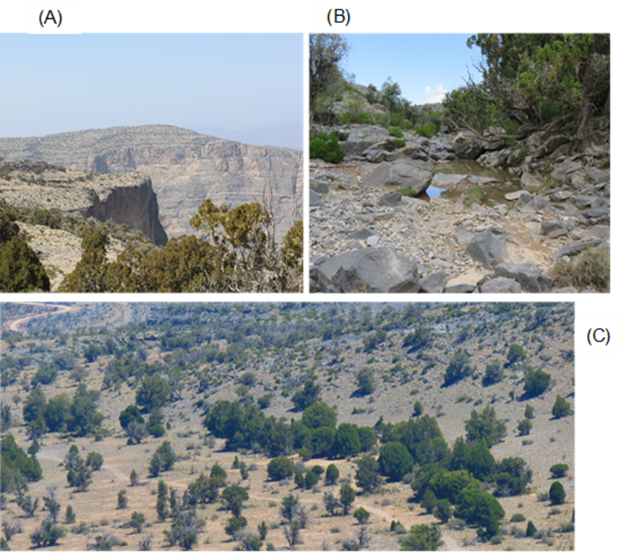

Figure ‎2.1 The difference in the landscape and habitat topographies at Jabal Shams, steep mountain cliff (A), high moisture wadi site (B), and gravel plain depression site (C).

The decrease in temperature and increase in precipitation associated with increased elevation provides favourable conditions for the growth of plant species that are not found elsewhere in the region. According to the latest figures, the flora of Oman contains 1407 taxa; within these, 302 plant species were recorded above 1500 m asl, belonging to 216 genera and 73 families representing 21% of the total flora (Patzelt, 2015). Several of these plant species (18.2%) are under special status, e.g. endemic to Oman or regional endemic (Patzelt, 2014). Above 2000 m, the natural vegetation consists of open woodlands, shrub lands and ground cover grasses. The woodlands are formed by three main wild plant species, Olea europaea subspecies cuspidata, Sideroxylon mascatense, and Juniperus seravschanica. Other plants species include Dodonaea viscosa (large shrub), Clematis orientalis (perennial climber), Ephedra pachyclada (small shrub), Euryops arabicus, Teucrium mascatense (aromatic herb), and Cymbopogon species (grass).
Along with the natural vegetation, temperate fruit such as pomegranate, almond, apricot and apple trees are cultivated in villages located at the top of the mountain. However, scarcity of water and tough topography in Jabal Shams restrict this cultivation to small traditional farm systems; unlike the eastern part of the mountain (Al Jabal Al Akhdar) where a larger scale temperate fruit cultivation can be found. In addition, forage and annual crops such as alfalfa, onion, and garlic are cultivated in the ancient terraces that are woven into the mountain slopes. Some of these terraces in the Northern Mountain of Oman date back to the first millennium BC (Patzelt, 2015) and are considered as places for in-situ conservation of plant genetic resources (Gebauer et al., 2007).

Chapter 3: General methodology

A number of methods utilized in this thesis are outlined here, including information on field sites selected. The propagation of seed and plant material, assessment of plant response to their environment (chlorophyll fluorescence and determination of tissue water content), as well as methods help determine soil and climate characteristics. Finally, method related to data collection, handling and statistical analysis are outlined.

Procedures for the phenological and health assessment of J. seravschanica at different altitudes in Northern Mountains of Oman
This section outlines the type of phenological parameters and tree condition data gathered for this research. Experimental design is outlined in chapter 4.

Collection of Juniperus phenophase data
Data relating to Juniperus phenophases (stages of plant life cycle that can be observed e.g. bud burst, inflorescence or flower appearance, and fruit formation) were collected in the field according to the USA National Phenology Network (Crimmins et al., 2013). During every site visit, the presence of both male and female cones was recorded. Male Juniperus cones presence was categorised as; 1) pollen cones present, 2) pollen release, or 3) full pollen release. The presence of male strobili was noticed when small brown scale were present (Figure ‎3.1 A), while pollen release when the scale was opened apart for pollination (Figure ‎3.1 B) (Crimmins et al., 2013). The presence of ripe or unripe Juniperus cones was also observed for the selected female trees within the area. Cones were considered ripe when their colour turned to dark blue or purple.
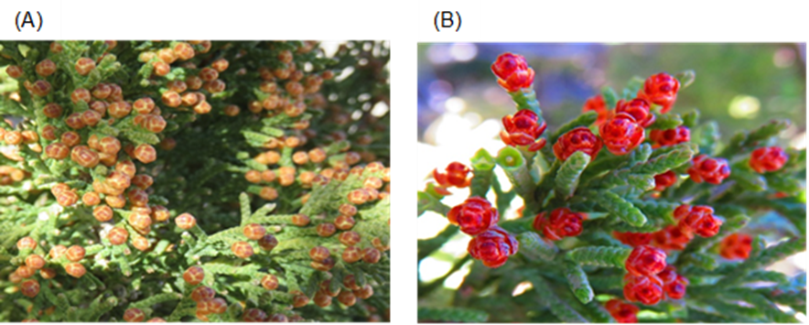

Figure ‎3.1 Male strobili of J. seravschanica. A) Initiation of male strobili. B) Male strobili open for pollination.

Tree health variables

Health condition
General health status was visually estimated by the percentage of living and dead foliage on the tree. Trees were classified on a range of scores from 0% indicating a dead or completely defoliated tree, to 100% which indicates a full healthy tree with no dead branches (Figure ‎3.2). This method was used previously by Fisher and Gardner (1995) and Gardner and Fisher (1996), to assess the distribution and ecological status of Juniperus woodlands in the Northern Mountains of Oman.

Gender
The sexual status of Juniperus trees was recorded either as, male (bearing male cones), female (bearing female cones), ambisexual (bearing both male and female cones), or unidentified (not bearing any cones). Juniperus trees retain cones all year round, so determination of gender was feasible in the field.

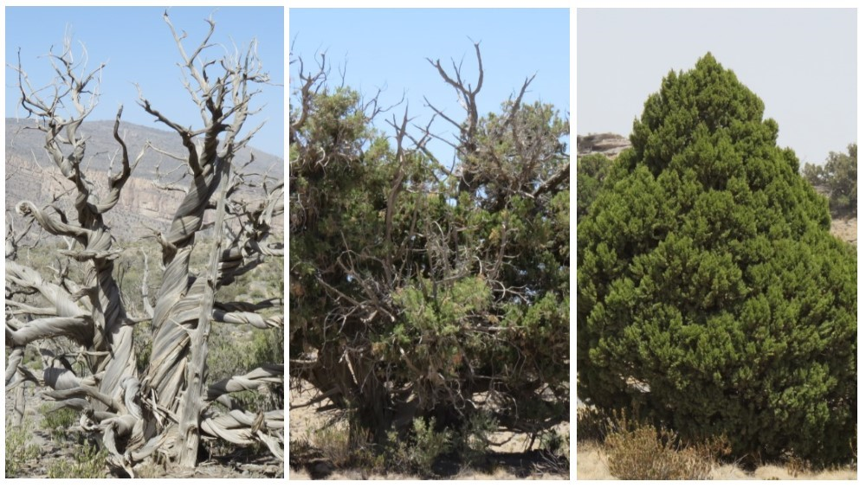

Figure ‎3.2 J. seravschanica health condition was assessed by the percentage of living foliage. Left, center and right photos indicate health condition of 0%, 50%, and 100% respectively.

Physical and mechanical damage signs
Trees were inspected for damage caused by humans such as injuries associated with sawing off branches. Damage was recoded as either present or absent.

Tree height
A measuring tape was used to measure the height of small saplings, ≤ 2 m. Trees > 2 m were measured using a clinometer. The formula below was used to calculate tree height with the clinometer.
H= d + b * tangent (A)
Where (H) is tree height, (d) is the height of the person collecting data, (b) is the distance between the tree and the person (10 m), (A) is the angle reading by the clinometer (Figure ‎3.3).
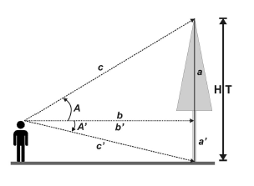

Figure ‎3.3 The tangent method used to measure trees height using clinometer. The height of the person in the equation represents the a’ in the diagram. Source: adapted from (Bragg, 2008).

Ecological and environmental variables

Habitat type
Sites were categorised in to one of three habitat types, wadi (deep valley), hillside (hill slope), or depression (basin area with gentle slopes) (Figure ‎3.4). Wadi habitat provides good shade conditions that could reduce surrounding air temperature. Hillside habitats have low shade and low water catchment. Depression habitat tends to have good water flow and partial shade from existing trees.

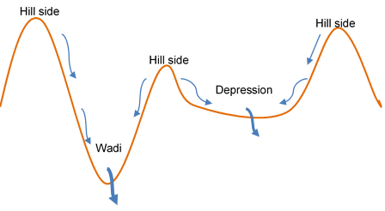

Figure ‎3.4 The three main habitat types studied differ in their site topography. The blue arrow indicates water movement after rain in each habitat type. The thicker blue arrow indicates higher water flow rates.

Slope and angle
Slope degree was measured by a homemade clinometer. A string attached to the top middle end of a protractor which fixed in a piece of paper. The degree of slope was measured. The angle of the slope was detected by hand held GARMIN GPS (Oregon 550, software version 4.52). Direction of slope (aspect) was divided into eight categories according to ArcMap 10.1 (Table 3.1).

Table 3.1 Slope direction and degree according to ArcMap software.
Direction | Degree
North | 0-22.5, 337.5-360
North-East | 22.5-67.5
East | 67.5-112.5
South-East | 112.5-157.5
South | 157.5-202.5
South-West | 202.5-247.5
West | 247.5-292.5
North-West | 292.5-337

Site exposure
Sites were categorised according to their exposure to the sun. Sites shaded by cliffs, mountain sides or plant vegetation were classified as low. Sites with no protection from the sun were classified as high. Medium exposure was applied to those which have some protection from direct sunlight.

Soil type
Soil types were categorised by visual inspection of the sites. The surface soil cover was divided into three categories, soil (less than 2 mm), small gravel (2 - 32 mm) or large gravel (more than 32 mm).

Geographical data
The latitude, longitude, and elevation for each sampled site were recorded by GARMIN GPS (Oregon 550, software version 4.52). Locations were recorded in degree, minutes and seconds; and elevation recorded in metres above sea level (asl). Sites coordinates were rechecked using Google Earth map software (version 7.1.2.2041).

J. seravschanica seed collection and propagation
The following sections outline the general procedure for seed collection, preparation and propagation. Seed cleaning and propagation were carried out at the Oman Botanic Garden (OBG).

Seed collection
Juniperus cones normally take two years to ripen, in some cases female trees can simultaneously have both first and second year’s cones (unripe and ripe cones). Only ripe cones were collected, i.e. when they are fleshy, soft and dark brown in colour. Most collection visits were carried out between January and April, prior to cones drying in summer. More than 500 cones were collected from individual trees. Cones were collected by hand in plastic bags and then transferred to the seed bank (cool room with 18-20ºC and 40-60% RH) in the OBG.
Cones were ground by hand in a 2.24 mm steel sieve and then dried in the shade for 24 hours. A KIMSEED vacuum separator was used to separate seeds from smashed cones. Seeds were then cleaned by hand to remove any remaining debris. Seeds infected or damaged by insects were removed by hand. Seeds were soaked in warm water with those seeds that floated being removed and sunken seeds retained for sowing. A floating seed treatment is a standard procedure for separating potentially viable and non-viable seeds (Scianna, 2001). Seed was dried in the shade outdoors, counted and stored in paper envelopes in a dry and cool condition in the OBG seed bank.

Nursery seed propagation
In order to help break dormancy, seeds were soaked in warm water for 24 hours. Seeds were sown in seed propagation trays (380x240x50 mm). Fine peat (Kekkila propagation peat, 0-6 mm) was used for seed germination. Seed trays were irrigated from the bottom every week by placing trays in shallow water baths. For experimental evaluations on seed germination per se, the trays were transferred to cooled incubators (Rubarth Apparate GmbH, model 3001) with precise temperatures being set according to the experimental procedure. Photoperiod was set at 12:12h light/dark. Chambers were illuminated with a white fluorescent lamp (Osram L20W/640sa).
Where the objective was to cultivate plants for subsequent experiments, for example, to determine establishment in the field with pot grown-plants, then the seed trays were maintained in an air-conditioned glasshouse at 18-25°C to encourage germination.

In-situ field establishment of J. seravschanica saplings in the Northern Mountain of Oman
In this section, nursery procedures, experimental site selection, site preparation and saplings planting are outlined. For more information about experimental layout and treatment applied see chapter 7. Saplings for this experiment were germinated and grown at the OBG.

Preparation of saplings used for field establishment experiments
Field establishment experiments used plant stocks of both five- and two-year- old progeny. Cones used for propagating the five-year-old Juniperus saplings were collected in April 2007 from the Saiq Plateau in Jabal Al Akhdar at 2339 m asl (N 23°06’31.24, E 57°39’06.96). Seeds were cleaned at the OBG and stored in the seed bank until they were germinated in October 2008. The Juniperus seeds were sown in fine peat, covered with a top layer of vermiculite and germinated in a cool glasshouse (18-25ºC). The germination percentage rate was 8%. Seedlings were potted on 1:1 peat/perlite mix. Saplings were moved to 270 mm dia. pots filled with 3:1 soil/peat mix. In October 2011 saplings were potted in 45 litre pots and kept in a glasshouse at 25°C to 28°C.
For the younger (two-year-old) stock, seeds were collected in May 2013 from Hayl Al Jwari in Jabal Shams at 2300 m asl (N 23°18’25.23, E 57°06’22.97). Seed cleaning and propagation procedures follow the procedures set out in section 3.1. After germination, seedlings were potted in 1 litre air pots with 1:1 soil:peat mix and kept in a glasshouse at 18 ºC to 25ºC.

Site selection and pre-planting practices
In January 2014, three planting sites were selected in Jabal Shams (Figure ‎3.5). Sites were selected based on altitudinal range (low, mid, and high), site security and suitability for planting. Site 1 is located next to the Sun Rise Resort at 2220 m asl (N 23°17’33.4 and E 57°09’07.76). The site has a low vegetation cover with few J. seravschanica and Olea europaea subsp. cuspidata trees and Euryops arabicus shrubs present. This site is open to the public and is frequently used by campers. Site 2 is located at Hayl Al Jawari at 2300 m asl (N 23°18’08.19 and E 57°06’14.25). This site has good vegetation cover with J. seravschanica and O. europaea subsp. cuspidata trees being predominant in the vegetation. Site entry is restricted to locals and is controlled by guards. Site 3 is located at 2570 m asl (N 23°19’13.26 and E 57°06’16.02). This site is dominated by apparently healthy J. seravschanica trees. Entering the area is prohibited for locals and visitors. A higher authority permit was needed and acquired to provide access to this site.
In each site, three plots of 100 m² (10x10 m) were enclosed using steel poles and a wire fence. Large rocks and scrubby grasses were removed from each plot. Each plot was divided into three sections, one each for seed propagation, two-year-old saplings, and five-year-old saplings. At the time the fence was constructed, 15 planting holes (0.5 m dia. x 0.5 m deep) were dug in each plot (Figure 3.6). The distance between holes was 2 m; however, some holes were re-located slightly to avoid the presence of large rocks below ground level.
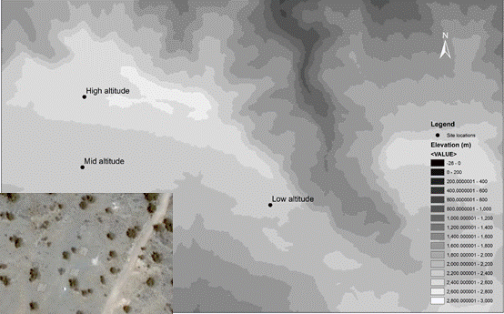

Figure ‎3.5 Satellite image of the three sites selected for J. seravschanica re-establishment in the Northern Mountains (Source: Esri. Digital Globe, Geo Eye, Earthshow). Below, three fenced plots at the middle altitude, 2300 m asl (Image © 2016 DigitalGlobe).

All three sites are located in areas with no electrical outlets or access to water. One small tank (950 L) was installed at the lower altitude and another larger tank (3000 L) was placed at the middle altitude. An additional small tank (350 L) was used for irrigation in the high altitude treatment. This tank was re-filled from the mid-altitude tank and then transported by vehicle to its destination. An electrical pump was used to supply irrigation to the plots with an irrigation hose being used to distribute it to individual plants manually. The pump was powered by an electrical converter connected to a car battery. Water rates were measured using a hose-mounted water meter.

Planting and establishment of five-year-old saplings
On the 25th March 2014, five-year-old Juniperus saplings were transported to the experimental plots in the mountains, with planting taking two days to complete (Figure ‎3.6 B). In order to provide a transition zone between nursery soil and natural soil, coarse peat was mixed with habitat soil at 1:1 ratio and then used to fill in the holes. A total of 135 five-year-old Juniperus saplings were planted across the three altitudinal sites. A raised soil rim was prepared around the saplings to keep irrigation water close to the roots and avoid run-off down the slope. Saplings were irrigated immediately.
Saplings were irrigated with 10 L sapling⁻¹. During the first five months from planting, saplings were given uniform water across treatments / altitudes to help them establish an initial root-system in the parent soil, although the volume/irrigation interval applied was progressively reduced to encourage deeper rooting into the soil profile, and less reliance on the artificial irrigation. Five saplings died after planting (one in lower altitude, two in middle altitude and two in higher altitude). These were replaced with new saplings in May 2014. Saplings were staked with bamboo canes to keep them upright and protect them from high wind. The irrigation basins had to be repaired after each rain event.
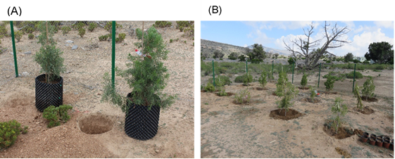

Figure ‎3.6 Planting of five-year-old J. seravschanica saplings. A) Saplings placed near the planting hole prior to planting. B) Saplings planted at lower altitude in a fenced plot.

Planting and establishment of two-year-old saplings
In March 2015, 135 two-year-old saplings were transferred from the OBG nursery to the experimental plots in the mountain. Planting holes were dug to 0.3 m deep at a spacing of 0.8 m between each hole (Figure ‎3.7 A). Coarse peat was mixed with natural soil at 1:1 ratio and then used to fill out the holes. Saplings were watered immediately. Saplings were covered with shade net (50% light) to protect them from direct sun (Figure ‎3.7 B).
Shade cover was left on until mid-August. Irrigation was carried out twice a week for the first month and once every two weeks from May to August. Each sapling received 2L water irrigation⁻¹.

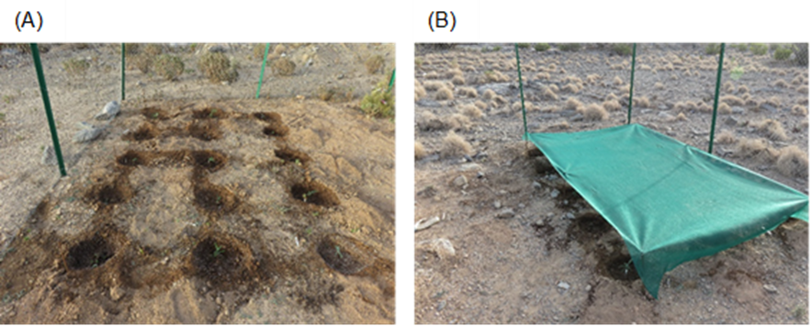

Figure ‎3.7 Planting of two-year-old saplings. A) 15 J. seravschanica saplings were planted in each plot. B) Planting plots were covered by green shade to protect saplings from direct sun.

Chlorophyll fluorescence
The principle of chlorophyll fluorescence as a tool to identify plant responses to environmental stress and corresponding data collection is outlined here. Information in experimental layouts and treatment is discussed in later chapters.

Principle of Chlorophyll fluorescence
Chlorophyll fluorescence is widely accepted as a measurement tool to detect plant response to environmental stress such as drought, light, heat, nutrient deficiency and pathogen infestation (Ogaya et al., 2011; Zivcak et al., 2014). The technique is characterized by its low cost, rapid ability to collect data, and non-invasive methodology (Baker and Rosenqvist, 2004). Photosynthesis is a chemical process in which light (irradiance) absorbed by plants is converted to a stable form of energy. When light is absorbed by chloroplast molecules in photosystem II (PS II), it is either used for photochemical or non-photochemical processes. In photochemical processes, light absorbed by leaves is used to generate energy for chemical process in photosynthesis, essentially the synthesis of sugar molecules from CO₂ and H₂O. Excessive (non-photochemical) light is either dissipated as heat or re-emitted as a specific form (wavelength) of radiation (fluorescence) (Murchie and Lawson, 2013). This process normally occurs in a competitive way e.g. reduction in energy utilization in a photochemical process will be associated with increase in energy generated by non-photochemical processes such as heat and chlorophyll fluorescence. Measuring chlorophyll florescence indicates changes in the productivity of photochemical process (photosynthesis) and the amount of heat re-emitted can be detected {Murchie, 2013, Chlorophyll fluorescence analysis: a guide to good practice and understanding some new applications}(Murchie and Lawson, 2013). Placing plants under any form of environmental stress will alter the photosynthetic pathway and therefore, affect the intensity of chlorophyll fluorescence emission.
Dark adaption of leaves will cause the photosystem II electron accepters to be re-oxidised and drop to a low excitation level whereby the PSII reaction centres are then capable of undertaking the full photochemical process (Baker and Rosenqvist, 2004). When a leaf is then illuminated with a light intensity sufficient to initiate photosynthesis, however, a rapid rise in chlorophyll fluorescence (over a few seconds) can be detected as non-photochemical energy is dissipated (due to the light harvesting complexes of the chlorophyll molecules becoming saturated with photons at this point). This is then followed by a decrease in the fluorescence signal (fluorescence quenching) (Murchie and Lawson, 2013). This is normally referred to as Kautsky induction (Figure ‎3.8). The minimum value of chlorophyll fluorescence (Fo) is measured at the time base of zero with low actinic light intensity (Figure ‎3.8). Then, high light intensity capable of saturating the plant is applied allowing measurement of maximum fluorescence (Fm). The variable difference between the maximum fluorescence and the fluorescence origin is referred to as variable fluorescence (Fv). Variable fluorescence gives an indication of the maximum capacity of photochemical quenching.
The ratio of variable fluorescence over maximum fluorescence (Fv/Fm) has been widely used as an indication of the efficiency of photosystem II in stressed plants (Baker, 2008; Murchie and Lawson, 2013). It is considered as a sensitive indication of the performance of plant photosynthesis with healthy, unstressed plants having the maximum value of about 0.83 (Murchie and Lawson, 2013). Fluorescence parameters have been used to detect plant stress associated with different environmental factors such as drought (Jedmowski et al., 2015), heat (Ogaya et al., 2011), air pollution (Manes et al., 2001), and excess light (Brzezinska et al., 2006).

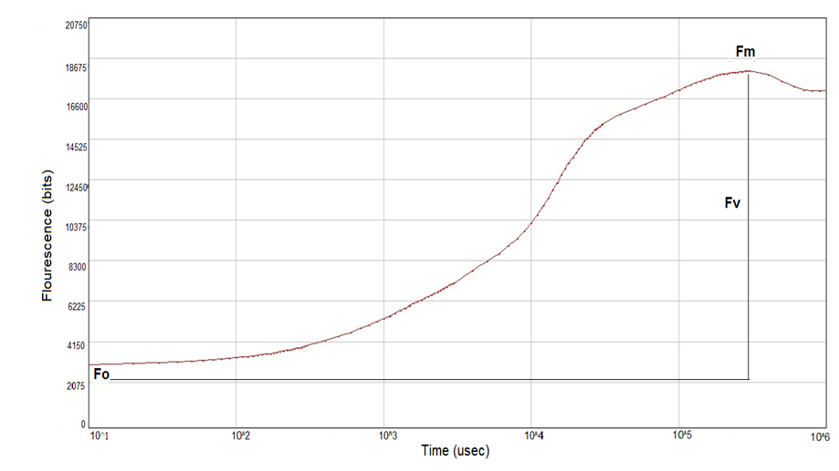

Figure ‎3.8 Kautsky induction curve represented by dark adaptation of J. seravschanica twigs. Fo represented the fluorescence origin, Fm represented the maximum fluorescence and Fv is the variable fluorescence.

Chlorophyll fluorescence measurement
Fluorescence parameters of Juniperus twigs were measured using Pocket Plant Efficiency Analyser (PEA), Hansatech Instrument, UK. Samples were dark adapted using clips. Other studies have identified 20 minutes of darkness as a minimum time to measure fluorescence (Brzezinska et al., 2006; Esteban et al., 2014). The time required for dark adaptation was identified by placing clips in a sample Juniperus sapling. The value of Fv/Fm was then measured every five minutes with full light intensity (3500 µmol m⁻² s⁻¹) (Table 3.2). The highest value of Fv/Fm was measured after 20 minutes of leaf darkness. Therefore, dark adaptation period of 20 minutes was applied before measurement. Light intensities capable of fully saturating a leaf sample and measuring accurate maximum fluorescence were identified by applying different light intensities to Juniperus leaf samples after 20 minutes of dark adaptation (Table 3.2). The highest value of Fm and Fv/Fm were measured at an illumination intensity of 3500 µmol m⁻² s⁻¹ which was therefore used for fluorescence measurement thereafter. Measurements were conducted from mid-morning to mid-afternoon and data for Fo, Fm, Fv, and Fv/Fm was automatically recorded and stored in the fluorescence meter, before downloaded to a computer.

Table 3.2 Dark adaptation time and light intensity requirement to measure chlorophyll fluorescence in Juniperus saplings.
Time (min) | 5 | 10 | 15 | 20 | 25 | 30 | 35
Fv/Fm | 0.750 | 0.762 | 0.774 | 0.791 | 0.789 | 0.790 | 0.784
Light (µmol m-2 s-1) | 700 | 1400 | 2100 | 2800 | 3000 | 3500
Fm | 2708 | 7823 | 11199 | 18313 | 19807 | 23926
Fv/Fm | 0.780 | 0.758 | 0.721 | 0.786 | 0.762 | 0.794

Relative water content
This section discusses the use of relative water content as a method for plant water status identification. It also outlines the practice followed during data collection. The experimental design and treatment are stated in the experimental chapters.

Principle of Relative water content
Plants normally lose water to the surrounding air through their leaves, which then needs to be replaced from soil reserves. Water movement is generally controlled by transpiration processes which produce an energy gradient inside the plant causing water movement between the soil and surrounding air (soil-plant-atmosphere continuum). This is normally referred to as water potential gradient. The difference in water potential in a plant cell leads to water moving from a cell with a lower water potential to a cell with higher water potential. Water moves inside the plant by cell diffusion or by xylem transmission (Sanders and Arndt, 2012).
Two methods are commonly used to determine plant water status under field conditions, water potential, and relative water content. Water potential refers to the pressure of water within the xylem vessels of the plant (but determined by other factors such as transpiration demand and cell moisture content) whereas relative water content accounts for the volume of water held within the tissues (Sanders and Arndt, 2012). Water potential refers to the water pressure in plant cell and it consists of aspects such as osmotic potential, turgor potential, matrix potential and gravitational potentials (Turner, 1981).
Relative water content, initially named relative turgidity, compares the water status of freshly-sampled leaves to that of fully saturated leaves (after a period of artificial rehydration) and expresses the result as a percentage (Barrs and Weatherley, 1962). Relative water content has been assigned as a powerful method to estimate plant water status under field conditions because it measures both water status and osmatic adjustment (Suriya-arunroj et al., 2004). Due to its association with water availability in the soil and plant physiological activities, relative water content has been used to detect water status of plants associated with different environmental stresses such as drought (Aref et al., 2013), salt accumulation (Suriya-arunroj et al., 2004), heat (Rivero et al., 2014) and altitudinal variation (Poulos and Berlyn, 2007).
Two main considerations should be accounted for when measuring relative water content of a leaf; rehydration methods and time to full turgidity. Over-rehydration was noted to be a common error in most experiments (Sanders and Arndt, 2012). Arndt et al. (2015) examine the main three methods of rehydration; floating (leaf section floated with distilled water in a petri dish), submerging (samples placed in a tube full of distilled water) and the standing method (only the petiole of the leaf attached to water). They found that the standing method expressed less error when measuring relative water content because it reduces the chance of over-rehydration which is common with the other methods. They found that increase of rehydration time could decrease relative water content.

Relative water content measurement
Juniperus leaves were sampled on a clear sky day, normally between mid-morning to early afternoon. Twig sections (50-100 mm) were cut from the top third of the saplings. Samples were immediately stored in paper bags in a sealed cool box to avoid water loss. Samples were then weighed to determine fresh weight using an electronic balance (VWR balances, readability 0.1 mg). To estimate the turgidity, leaf samples were rehydrated in glass tubes using a standing method (Arndt et al., 2015). Juniperus leaves were placed in the glass tube, with the cut end of the petiole submerged in distilled water. Tubes were then closed and kept at 20°C for 20 hours. Rehydrated samples were then removed from the tube, surface dried in paper tissue for a few seconds and weighed to get the turgid weight. Samples where then placed in a paper envelope and dried in an oven at 70°C for 24 hours. Samples were again weighed to provide a dry weight.
Leaf water content was calculated as relative water content percentage using the formula:
RWC (%) = ((fw-dw) / (tw-dw)) *100
Where (fw) is fresh weight, (tw) is turgid weight, and (dw) is dry weight.

Climate data
Different climatic parameters were collected at different stages during the experimental period. In April 2014, four data loggers (Tinytage TGP-4500, temperature range -25 to 85°C, humidity range 0-100 RH) were placed at four altitudes; 2100 m, 2200 m, 2300 m, and 2570 m asl. Temperature and relative humidity data were collected and downloaded through Tinytage Explorer 4.8 software. In addition, data loggers were used to gather climate data, mainly temperature and relative humidity inside the glasshouses in the OBG.
In December 2014, three weather stations (WatchDog 2900ET, Spectrum Technologies, Inc.) were installed in the planting sites (2200 m, 2300 m, and 2570 m asl). Weather stations were fixed to a steel pipe at 1.5 m above ground. Weather stations recorded wind speed, wind direction, air temperature, relative humidity, dew point, rainfall and solar radiation (Table 3.3). Weather data were collected each hour and downloaded monthly using SpecWare 9 professional program.
In addition, volumetric soil water content was obtained using soil moisture probes (Waterscout SM 100, Spectrum Technologies, Inc). In each plot of the three reintroduced sites, three saplings from each treatment were selected and the moisture probes (sensing area 60 x 20 mm) were installed vertically around the saplings (20 cm deep). Soil was dug by spade to allow insertion of moisture probes. Five probes were connected to the weather station; each weather station had five external sensor ports. The remaining four probes were connected to a micro station (WatchDog 1650 micro station). In addition, a soil sensor reader (Fieldscout, Spectrum Technologies, Inc) was used to obtain soil moisture readings manually.

Table 3.3 Specification of WatchDog weather station and soil moisture sensor.
Sensor | Measurement | Accuracy
Wind Speed | 0, 3-241 km h-1 | ±3 km h-1, ±5%
Wind Direction | 1° increments | ±4°
Air Temperature | -32° to 100°C | ±0.6°C
Relative Humidity | 10% to 100% at 5° to 50°C | ±3%
Dew Point | -73° to 60°C | ±2C
Rainfall | 0.25 mm resolution | ±2% at < 50 mm
Solar Radiation | 1-1500 Wm-2 | ±5%
Soil Moisture | 0% VWC to saturation | 3% VWC

Soil analysis

Soil collection and preparation
Three soil samples were collected from each Juniperus planting plot. In each plot, three samples were collected. Soil dug from the planting hole (50 cm deep) was collected in plastic bags. Soil samples were dried in the open air. They were then sieved by a 2 mm mesh sieve and then kept in plastic boxes prior to testing for mineral content.

Soil chemical analysis
Soil analysis was conducted in the Soil and Water Research Centre, Ministry of Agriculture and Fisheries, Oman.

Electrical conductivity (EC) and pH
A volume of 250 ml of sieved soil was placed in a 500 ml beaker. Distilled water was then added slowly whilst stirring until the soil became saturated. The beaker was left overnight and then the aqueous solution was transferred to a Buchner flask. A vacuum pump was used to filter the extraction. The resultant liquid extraction was used to measure soil electrical conductivity and soil pH.

Calcium (Ca)
Calcium was measured by titration with sodium salt-ethylene diamine tetra acetic acid (EDTA). A small volume (10 ml) of the extract (EC extract) was poured into a porcelain crucible with sodium hydroxide (5 drops) and murexide (50 mg) then added to the extract. The mix was titrated with EDTA until the colour changed to purple. The amount of EDTA added was recorded and the below formula was used to calculate the amount of calcium in the soil.
Ca (meq l⁻¹) = (R x N x 1000) / V
Where (R) is amount of EDTA (ml), (N) is normality of EDTA (0.01 N), (V) is the extract volume.

Magnesium (Mg)
Magnesium was measured by titration with EDTA using a flame photometer. A small volume (10 ml) of the extract (EC extract) was poured into a porcelain crucible with chloride-ammonium hydroxide buffer (5 drops) and eriochrome black indicator (1 drop). The amount of EDTA added was recorded and the below formula was used to calculate the amount of magnesium in the soil.
Mg (meq l⁻¹) = (R x N x 1000) / V
Where (R) is amount of EDTA (ml), (N) is normality of EDTA (0.01 N), (V) is the extract volume.

Total phosphorus (P)
Soil samples (2.5 g) were added to sodium bicarbonate (50 ml). The mix was shaken for 30 minutes. The soil slurry was then filtered through Watman no. 42 filter paper. A volume of 10 ml from the extraction was pipetted into a 25 ml flask. Ammonium molybdate and stannous chloride (1 ml) was added to the extraction and further diluted with distilled water to reach a total volume of 25 ml. The dilution was left to stand for 30 minutes. A spectrophotometer was used to measure total phosphorus (ppm) with standard solution of 2 ppm phosphorus (KH₂PO₄). The below formula was then used to calculate the total phosphorus.
Total P ppm = (R x D x d) / (Wg x V)
Where (R) is spectrophotometer reading mg l⁻¹, (D) is the volume of sodium bicarbonate, (d) is colour dilution, (Wg) is soil weight, (V) is the extract volume.

Ammonium acetate potassium (K)
Soil samples (5 g) were added to ammonium acetate (50 ml) in a plastic bottle and the mixture shaken for 30 minutes. The content was then filtered through Watman no. 42 filter paper. The extract was then moved to a flame photometer. The readings from the flame photometer were used to calculate potassium concentrations using the formula below.
K (ppm) = (R x D) / Wg
Where (R) is flame photometer reading mg/l, (D) is the volume of ammonium acetate, (Wg) is soil weight.

Statistical analysis and data presentation
Experiments conducted under controlled environments took the form of complete randomized designs. No blocking was used as experiments were under relatively homogenous conditions. Latin square arrangements were used to eliminate any edge effects. Under field conditions, randomized complete block designs were used with a minimum of two blocks per experiment. For each treatment, three to five replicates were assigned under each condition.
Examples of the procedure used for statistical analysis in this thesis showed in the appendix. Data exploration was carried before analysis to assess the normality distribution and degree of variance homogeneity using Levene’s test of equality of variance (using Generalised Linear Models [GLM] and homogeneity test options). Shapiro-Wilk test and histogram were used to check the normality of the residuals. If data were not normally distributed or did not satisfy the homogeneity test, they were transformed to the square root value. Data that met the assumptions were then analysed using the standard GLM. Analysis of variance (ANOVA) was used to determine the significance of different experimental factors. The significant effect of the tested factors was stated when P value was lower than P threshold e.g P< 0.05 or P< 0.01. Mean values for treatment variables are depicted within graphs or tables with associated standard errors (SE). Fisher’s least significant difference was used to indicate significance between means within multiple comparison post-hoc test. Generic LSD values were calculated when an experimental factor showed significant effect (LSD of the interaction usually being presented, protected LSD). Where time series data was recorded, LSDs were calculated for each recorded point. The LSD bars are plotted in each graph and values shown in the graph captions. In time series datasets, the LSD bar for each time is shown on the graph. SPSS does not automatically calculate the value of LSD, so LSD values were generated according to Williams and Abdi (2010) as follows:
LSD = tv,α$\sqrt{2 MS /n }$
Where tv,a is the t critical distribution associated with degree of freedom at α level, MS is the mean square of the error and n is number of observations used to calculate the mean at each level.
Non-parametric test was used when either real or transformed data did not meet the assumptions of distribution normality and/or equality in variance. Mann-Whitney test was used to compare means of two independent groups; whereas, Kruskal-Wallis test was used to identify differences between three independent groups.
Pearson’s correlation and regression models were constructed to understand the relationship between environmental variables. Person’s correlation coefficient was used to indicate the relationship between numerical variable data. Linear regression models were used to understand the relationship between correlated variables. Plots of residuals against fitted values were used to check for patterns in the residuals, and QQ plots were used to ensure the data was normally distributed. Box plot, Whisker plot, was used to indicate relationship of the explanatory variables found to be significant in the regression model. Analyses were preformed using SPSS 21.0 (IBM Statistics for Windows, Armonk, NY, USA). SPSS package and licences were provided by the University of Sheffield, UK. Microsoft Excel 2016 was used for the production of simple graphs, box plot and scatter plots with best line fit.

Chapter 4. Altitudinal variation in ecological status, reproductive phenology and growth of J. seravschanica population in the Northern Mountains of Oman

Introduction
Previous studies have indicated a decline in J. seravschanica populations in the Northern Mountains of Oman with populations of trees at lower elevations being particularly negatively affected (Fisher and Gardner, 1995; Gardner and Fisher, 1996; Al Haddabi and Victor, 2016; MacLaren, 2016). Although, anthropogenic impacts and animal browsing were associated with the decline of the J. seravschanica population, the impact of climate change has recently been strongly stated (MacLaren, 2016). Healthy trees with a high proportion of living foliage have been reported to be restricted to high altitude, high moisture or shaded habitats. However, the dynamic influence of altitude and habitat topography in tree performance and growth has not yet been studied. Understanding population structure and performance in different topographical areas (e.g. density, gender ratio, population age and growth rate) are important for future conservation strategies (Sarangzai et al., 2012). Size structure of the population, for example, indicate the stability, recruitment and mortality indices of the population (Kabiel et al., 2016). The presence of an equal size structure between adult and juvenile trees indicates stability persistence of the woodland.
The change in elevation gradient across a mountain is linked to variation in many environmental factors, particularly temperature, relative humidity, precipitation, radiation, wind speed, and partial CO₂ pressure (Kofidis et al., 2003). These variations in climate not only alter the composition of vegetation, they also determine the growth habit of individual plants along the altitudinal gradient (Jones, 1992). Studies on the impact of environmental conditions on mountain tree populations have increased over recent years, as scientists investigate the impacts of climate change, and the threat this poses to isolated plant communities (He et al., 2013). Tree growth has been shown to vary along altitudinal gradients; growth was strongly correlated to precipitation at lower altitudes while temperature played a strong role on tree growth at higher altitude (Peng et al., 2008). However, this tree growth-altitudinal relationship does not always correlate directly, nor is interpreting growth trends necessarily straightforward. For example, Mediterranean mountain plant growth habits are influenced by double climatic stress, low winter temperature and summer drought (Olano et al., 2013). Liu et al. (2013) noted that semi-arid forest is under pressure from both warmer aerial temperatures and water deficits during summer. In addition, winters are becoming warmer (at lower altitudes) causing prolonged growth, which can occur during drier conditions (Duran et al., 2014). These seasonally climatic variations could alter plants’ physiological mechanisms as these mostly related to climate conditions during or prior to that period (He et al., 2013).
In addition, growth rate often varies between male and female trees. The reproductive demand plays a role in growth of dioecious species. In J. thurifera, for example, female trees were found to allocate more resources to reproduction than male trees; this being represented by lower growth in female trees (Montesinos et al., 2006). Gender growth variation often arises under stressful conditions; female trees tend to be more susceptible to drought or high temperature than male trees (Montesinos et al., 2010). Understanding the response of trees to an altered environment, especially when these are associated with water defects is an important step for a deeper understanding of population dynamics in a changing climate (Martin-Benito et al., 2008).
Under arid conditions, temperature and precipitation not only play a role in plant growth, but they also influence phenology. Plant phenology is the study of periodic life events and how these are affected by environmental conditions (Hegazy and Lovett-Doust, 2016) and it is often associated with the time of first appearance of an event or growth response, e.g. date of first flower opening, pollen release etc. Timing of flowering is important because pollination influences fruit development and ripening, which in turn affects timing of seed dispersal and germination (Hegazy and Lovett-Doust, 2016). Mondoni et al. (2012) indicated that the negative effect of climate change in forest regeneration is through a change in timing for seed dispersal and seedling emergence and that these can occur in a season that is not conducive to seedling survival. Variation in reproductive phenology frequently arises in populations found along altitudinal gradients (Kabiel et al., 2016). In semi-arid elevation gradients, Crimmins et al. (2010) indicated that for trees at lower altitude the onset of flowering was mostly affected by both the amount of precipitation and temperatures during the previous autumn, while, at higher elevations, the beginning of flowering was mostly controlled by spring temperatures. The occurrence/maturation of male and female flowers at the same time is highly significant for Juniperus trees as pollination occurs within 12 days from the opening of female strobili; thus any variation on pollination events may affect high quality seed production (Daneshvar et al., 2017). For example, Adams et al. (2015) indicated a decrease in growth and delay in phenological development of J. monosperma in semi-arid forests; these phenotypic variations were connected to climatic changes that enhanced temperature and increased frequency of drought stress.
In addition to climatic factors, the over-browsing caused by goats and sheep on the northern mountain rangelands may augment the pressure on recruitment and survival of native plants in this region (Brinkmann et al., 2009; Dickhoefer et al., 2010). The appropriate climate at higher altitude with different topography led to high diversity of plant species (Ghazanfar, 1991). This species richness on the woodland and rangelands provide a source of feed for livestock in rural areas in Oman. According to the latest census the number of sheep and goats was 3,497 in only eight villages of Jebel Shams (Ministry of Agriculture and Fisheries, 2013); many small villages were not included. Furthermore, the increase in numbers of feral donkeys adds to the grazing/browsing pressure in the area. The damage due to animals / herbivores on rangelands can be through compacting soil, increasing soil erosion, trampling of seedlings, and browsing on adult and juvenile trees, resulting in a lack of natural regeneration (Wassie et al., 2009). In Juniperus, the influence of herbivores through grazing/browsing or seedlings trampling have been found to reduce seedlings regeneration and establishment (Garcia et al., 1999; Zamora et al., 2001).

The expected increase in the frequency of stressful events due to a change in climate acts as a catalyst to better understand how these events will affect plant population mortality and to utilise these findings in future management programmes. This study examines the current status of J. seravschanica populations in the western side of Jabal Shams (west part of Al Jabal Al Khdar region); combining this with recent studies provides a general overview of the current ecological status of J. seravschanica population along the Northern Mountains of Oman. The selected sites cover areas not included in recent studies, e.g. Hayl Juwari in Jabal Shams. It also highlights the influence of herbivore grazing/browsing pressure in J. seravschanica seedling regeneration and establishment along different altitudes. In addition, the growth and phenological studies provide a baseline knowledge on the influence of climatic variation in J. seravschanica growth along the altitudinal range.

Objectives
This chapter targeted the following points:
- Assess the ecological status of J. seravschanica trees in Jabal Shams (the western part of Al Jabal Al Akhdar chain).
- Identify the effect of ecological and environmental factors on J. seravschanica population status and distribution along altitudinal gradients.
- Examine the influence of over-browsing/grazing on J. seravschanica regeneration along altitudinal gradient.
- Examine the impact of altitudinal variation on J. seravschanica reproductive phenology, growth and physiological mechanisms.

Experiment 1: Ecological assessment of J. seravschanica woodland in Jabal Shams, Northern Mountains of Oman

Hypothesis to be tested
The first assessment of J. seravschanica trees in the Northern Mountains of Oman was conducted 20 years ago, by Gardner and Fisher (1996). Since then and up to the start of this study, no extensive detailed work was undertaken to monitor the decline in J. seravschanica woodland. This study aimed to examine the following hypothesis:
- Environmental factors associated with an increase in altitude enhance an individual tree’s health status.
- Tree height is affected by both altitude and habitat conditions.
- Altitude influences J. seravschanica gender health and abundance.
- Anthropogenic damage negatively affects tree health and population viability.
- Ecologically related factors such as topography, slope, aspect and site exposure influence the health status of J. seravschanica trees.

Materials and methods
For tree health assessment, 45 sites were theoretically randomly selected using Google Earth (version 7.1.2.2041) of which 32 sites were then surveyed; sites were in Jabal Shams between 23°16 to 23°19 North and 57°05 to 57°09 South (Figure ‎4.1). The selected sites were divided into three altitude zones; low (2100-2300 m), mid (2300-2500 m) and high (above 2500 m asl). All sites were located between 2100 m (lowest altitude of natural distribution of J. seravschanica) to 2600 m asl (highest accessible point) at which J. seravschanica woodland is expected to be potentially present (Table ‎4.1). Sites selected included all habitat types and a variety of different health conditions in the tree populations. High cliffs and deep ravines were not surveyed due to difficulty in accessibility. In each sampled site, a plot of 40 x 40 m was set out. Sites surveyed were at least 500 m apart from each other. All J. seravschanica specimens within these selected areas were examined and assessed.
Sites were surveyed between April to June 2015. Tree variables such as health status, height, sexual status, and signs of physical or mechanical damage were recorded. In addition, ecological and environmental variables (habitat type, aspect, angle of slope, exposure to direct sun or shade, and soil type) of all sites were recorded (more details in section 3.1).

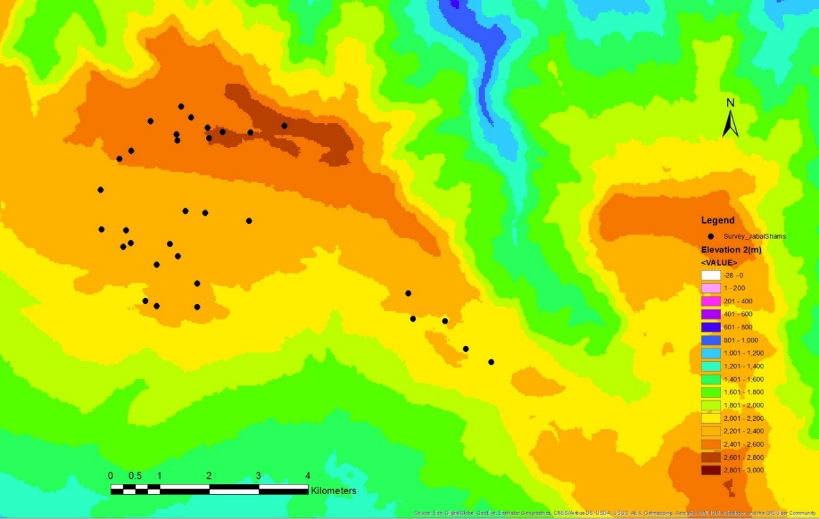

Figure ‎4.1 Satellite image of the surveyed sites within the study area on Jabal Shams (Source: Esri. Digital Globe, Geo Eye, Earthshow).

Table ‎4.1 Summary of the surveyed sites and ecological variable of J. seravschanica woodland on Jabal Shams.
Zone No. | Altitude (m asl) | Aspect | Male | Female | Bisexual | Undefined | Habitat
1 | 2108 | NE | 0 | 0 | 0 | 6 | Depression
1 | 2182 | NE | 2 | 0 | 0 | 5 | Hillside
1 | 2190 | SW | 2 | 3 | 0 | 4 | Wadi
1 | 2219 | N | 3 | 5 | 0 | 1 | Wadi
1 | 2284 | SW | 2 | 3 | 0 | 3 | Hillside
1 | 2234 | NW | 3 | 0 | 2 | 2 | Hillside
1 | 2204 | N | 5 | 1 | 0 | 0 | Wadi
1 | 2236 | E | 6 | 1 | 1 | 0 | Wadi
1 | 2196 | W | 3 | 1 | 1 | 2 | Wadi
1 | 2224 | N | 1 | 4 | 1 | 1 | Hillside
2 | 2314 | W | 8 | 2 | 0 | 0 | Wadi
2 | 2305 | NE | 8 | 5 | 0 | 3 | Depression
2 | 2310 | N | 4 | 2 | 0 | 1 | Hillside
2 | 2301 | NE | 4 | 7 | 0 | 4 | Depression
2 | 2330 | W | 2 | 3 | 0 | 0 | Hillside
2 | 2338 | SW | 6 | 1 | 0 | 1 | Hillside
2 | 2380 | S | 3 | 1 | 1 | 1 | Hillside
2 | 2338 | S | 1 | 2 | 1 | 4 | Depression
2 | 2324 | NW | 5 | 1 | 0 | 1 | Wadi
2 | 2381 | N | 3 | 3 | 0 | 0 | Hillside
2 | 2480 | SE | 2 | 5 | 0 | 1 | Hillside
2 | 2430 | S | 2 | 1 | 0 | 1 | Hillside
3 | 2575 | NE | 3 | 4 | 0 | 2 | Hillside
3 | 2574 | N | 1 | 5 | 2 | 0 | Hillside
3 | 2558 | NE | 3 | 6 | 0 | 0 | Hillside
3 | 2555 | NW | 2 | 4 | 0 | 1 | Wadi
3 | 2584 | NW | 4 | 5 | 0 | 0 | Hillside
3 | 2607 | SW | 4 | 3 | 0 | 0 | Hillside
3 | 2650 | SE | 3 | 3 | 0 | 2 | Hillside
3 | 2602 | NW | 1 | 6 | 0 | 0 | Wadi
3 | 2602 | N | 5 | 4 | 0 | 0 | Hillside
3 | 2573 | N | 3 | 5 | 0 | 2 | Wadi

The relationship between the numerical variables, e.g. plant health and altitude was analysed using Pearson’s correlation. A Linear regression model was used to identify the association of ecological or environmental variables in trees health status. Back-wise model selection was used with all variables initially included in the model. Variables with a non-significant relationship (at 95% confidence level) were removed from the first model and analysed again. Processes were repeated until all variables in the model had significant relationships with the response variable, plant health. To understand the relationship between health and categorical variables e.g. soil type, habitat type, aspect and exposure, a reference variable was indicated for each of these variables and relationships were compared with this reference variable. In addition, a non-parametric Kruskal-Whitney test with pair-wise comparison was used to identify level of differences between tree health and ecological and environmental variables.

Results
Health assessment of J. seravschanica woodland
A regression model indicated a strong significant influence of altitude, damage, habitat type and aspect of slope in J. seravschanica tree health (P< 0.01, Table ‎4.2). Tree health was strongly influenced by altitude, with trees at higher elevation having a higher percentage of living foliage (P< 0.01, Figure ‎4.2). The percentage of living foliage varied between the three zones; the median of tree health condition at low, mid and high altitudes were 23.5%, 71.9% and 94% respectively. The regression model indicated that altitude could explain 52% of trees’ health status (Figure 4.2). Tree height had no impact on tree condition and was not influenced by altitude; although the trees at high altitude were slightly shorter than low and mid altitudes. Height ranged between 4 to 8 m (Figure ‎4.3). Non-parametric analysis indicated a significant influence of site topography on tree height (H(2)=9.0, P< 0.05); trees found in depression sites were significantly taller than trees in wadis or hillsides (Figure ‎4.4).

Table ‎4.2 Regression model of the relationship between plant health status and the ecological and environmental variables. Comparison of aspect was made with north as a preference, and in habitat type with depression as preference.
Variable | Coefficients (SE) | t value | P
Constant | -312.9 (19.9) | -15.54 | <0.01
Altitude | 0.2 (0.009) | 19.7 | <0.01
Aspect- South | -13.4 (4.42) | -3.0 | <0.01
Aspect- South-West | -13.6 (4.02) | -3.4 | <0.01
Aspect- North-West | -8.1 (3.37) | -2.4 | 0.02
Damage | -17.8 (4.18) | -4.2 | <0.01
Habitat type- Hillside | -32.3 (3.56) | -9.1 | <0.01
Habitat type- Wadi | -26.6 (3.61) | -7.4 | <0.01

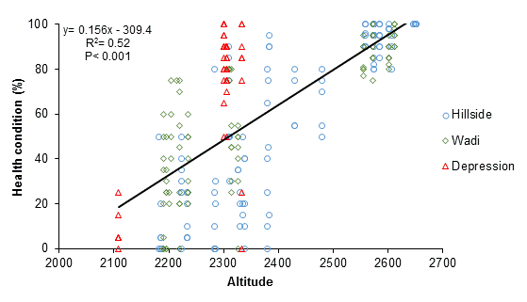

Figure ‎4.2 The relationship between altitude and health status percentage. Sites were coded according to different habitat type, hillside, wadi and depression sites. Regression equation, R² and correlation coefficient are showed in the graph.

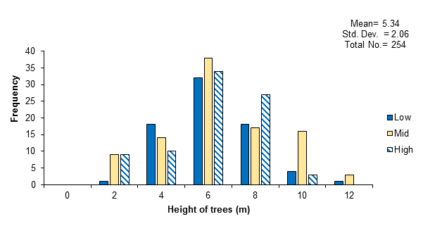

Figure ‎4.3 Height frequency distribution of J. seravschanica trees in the three surveyed altitudes, low altitude range (2100-2300 m), mid altitude range (2300-2500 m), and high altitude range (above 2500 m). Statistical analysis was examined for total trees at the three zones.

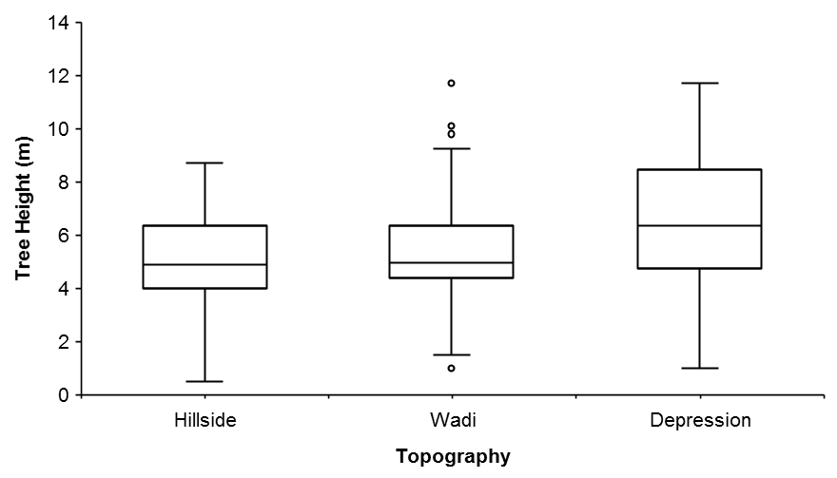

Figure ‎4.4 Box plot illustrating the relationship between site topography and tree height.

The abundance of male and female trees varied between the sites with overall male biased woodlands (Table ‎4.1). Male trees were more abundant at low and mid-altitude zones representing 36% and 48% of total trees at each altitude respectively. Female trees were less abundant at low altitude (<30%), but more biased at high altitude, representing 54% of total population at this altitude. Bisexual trees were rare, representing only 3.5% of total population. The indeterminate trees were higher at low and mid-altitudes (32.2% and 17% of total population at each altitude respectively) than high altitude (8.4%). At low and mid-altitude zones, most of these trees were either dead or had poor growth with no reproductive activity. The presence of sexually indeterminate trees at the high altitude zone was attributed to the higher occurrence of younger, immature trees. Non-parametric analysis indicated significant differences between male and female trees in relation to plant health (H(3)=24.1, P< 0.05); female trees had higher health status than male trees (Figure ‎4.5). Trees from the low altitude showed greater signs of anthropogenic damage (28.4% of the population) compared to mid and high altitude ranges (4% and 0%, respectively). Analysis indicated a significant influence of tree damage on health status at low and mid-altitudes, with a change from non-damaged to damaged trees associated with a 17.8% decline in plant health (P< 0.01, Table ‎4.2).

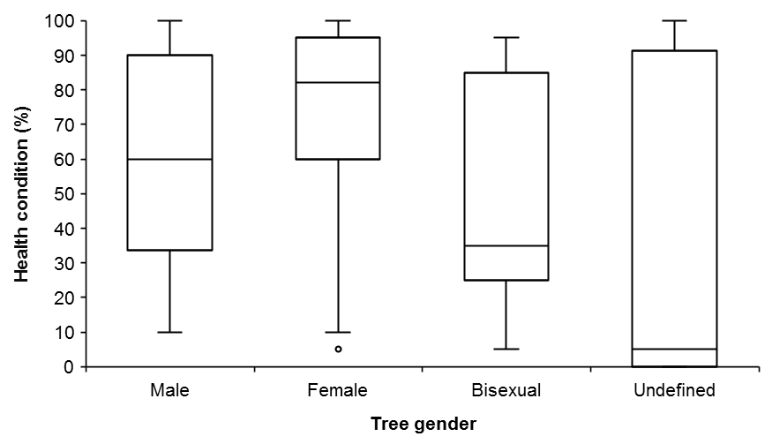

Figure ‎4.5 Box plot illustrating the relationship between J. seravschanica tree gender and health status.

Influence of ecological and environmental variables on tree heath
Degree of slope did not show any influence in plant health. However, aspect of the slope showed a significant effect in health condition (H(7)= 41.4, P< 0.01). Data indicated that trees growing on south, south west and west facing slopes were in a significantly poorer condition than trees growing in south east, north or west slopes (P< 0.01,Table ‎4.2). Topography of the habitat had the highest impact in plant health status (H(2)=10.8, P< 0.01), with the change from depression to hillsides habitat associated with a 32% decline in plant health and a change from depression to wadi habitat associated with a 26% decline in plant living foliage (Table ‎4.2). The effect of habitat topography on tree health varied within the three altitude zones. At low altitude zone (2100-2300 m), trees found in wadis were significantly healthier than trees found in depression or hillsides (P< 0.05, Figure ‎4.6 A). At mid-altitude zone (2300-2500 m), trees growing in depression had significantly higher health rank than those growing in wadi or hillsides (P< 0.05, Figure ‎4.6 B). However, above 2500 m, trees on hillsides had significantly better growth compared to those in wadis (P< 0.05, Figure ‎4.6 C); health status of trees growing in depressions were not examined at this altitude due to inability to locate such habitat type in this range.
To investigate the relationship between the degree of slope and habitat type, a pair-wise comparison was explored between the three habitat types. Results indicated significant differences between the three topographical habitats (H(2)=109.5, P< 0.05); depression sites had significantly lower slope degree than wadi and hillside sites (Figure ‎4.7). A regression model indicated that surface soil type had no influence on percentage living foliage on the surveyed trees, however data indicated that tree health significantly declined on habitats where the soil structure was predominately composed of small gravel (2-32 mm diameter) particles compared to either those composed of finer textured soil (<2 mm) or where larger gravel particles (>32 mm) covered to soil surface (P< 0.05, Figure ‎4.8). Site exposure to sunlight was not associated with better plant health; about 72% of studied sites were considered to be in full sunlight for much of the day (Table ‎4.1).

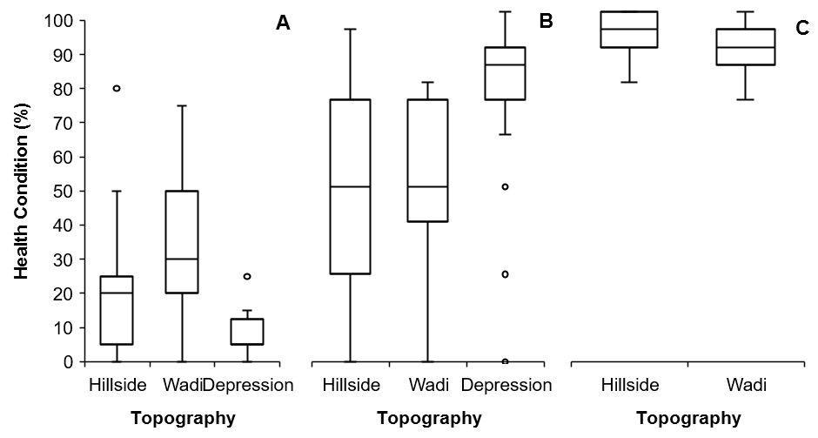

Figure ‎4.6 Box plot illustrating the relationship between habitat topography and tree health status at (A) low altitude, (B) mid altitude, and (C) high altitude zone.
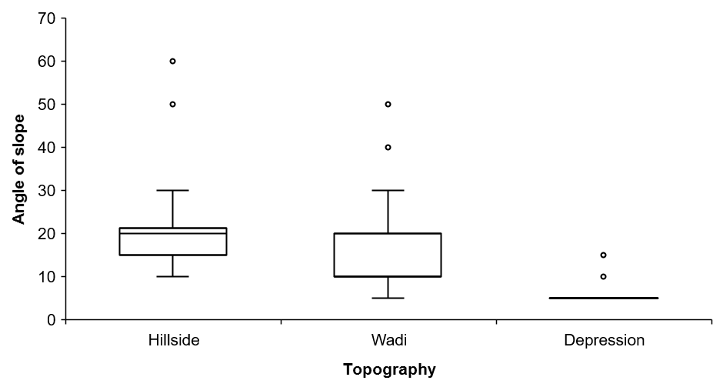

Figure ‎4.7 Box plot illustrating the relationship between habitat topography and degree of slope.

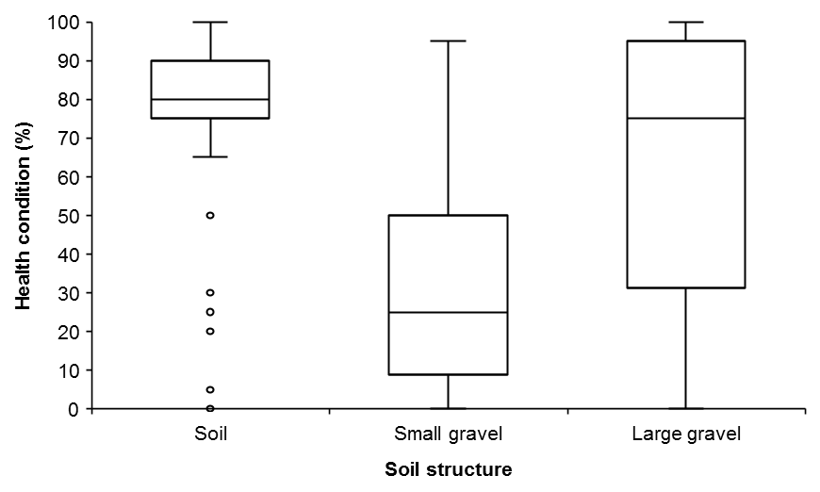

Figure ‎4.8 Box plot illustrating the relationship between habitat top layer substrate and health condition. Soil (<2 mm), small gravel (2 – 32 mm), and large gravel (>32 mm diameter).

Hypothesis test
- Results confirm the hypothesis that environmental factors associated with increased altitude improve tree health status. Tree health status index increased with higher altitudes.
- Results reject the hypothesis that tree height is affected by altitude, but support the notion that topography had a positive effect on tree height. Trees were taller in shallow depressions found within the landscape.
- Results confirm the hypothesis that altitudinal gradients influence J. seravschanica gender-health and abundance. Female trees were healthier than male trees along the elevation gradient and the populations were male biased.
- Results confirm the hypothesis that physical and mechanical damage affects trees health status. The impact of damage on tree health was significant at low altitude zone.
- Results confirm the hypothesis that site topography and aspect have an influence on tree health along altitudinal gradient. Wadi habitat has a significant positive effect on tree growth at low altitude, however, its influences marginally decreases at mid and high altitude where depression and hillsides, respectively, increased tree health index. Trees were healthier in southeast, north or west aspect. Results reject the hypothesis that slope and site exposure influence tree health.

Experiment 2: Influence of animal browsing on J. seravschanica seedling regeneration at three altitudinal gradients.

Hypotheses to be tested
Browsing pressure has been stated as having a negative effect on J. seravschanica and is potentially causing the decline of populations in Northern Oman. However, the influence of animal browsing on J. seravschanica seedlings and their establishment success has not yet been investigated in the northern populations of Oman. This experiment aimed to test the following hypotheses:
- Animal browsing by sheep, goats and feral donkeys, prevents or reduces J. seravschanica seedling regeneration and establishment.
- Herbivory by small mammals and invertebrates e.g. mice and insects negatively impact the establishment of J. seravschanica seedlings.
- Browsing pressure varies at different altitudes within Jabal Shams.
- Establishment of exclusion fences around selected plots prevents browsing and encourages seedling establishment.

Materials and methods
Experiment 1: Influence of browsing in seedlings establishment
Three sites were selected at three different altitudes, low, mid and high altitude (2200, 2300, and 2570 m asl, respectively). In each altitude, two mature J. seravschanica trees were selected and three plots (60x40 cm) were prepared under the canopy of each tree. Five one-year-old seedlings were planted within each plot, a total number of 90 seedlings were planted at the three altitudes. Three ‘animal exclusion’ treatments were set up under each tree. Treatment 1: plots were fully covered with 70% green shade netting, protecting seedlings from large and small mammals. Treatment 2: plots were covered with steel fencing (6x6 cm openings), protecting seedling from large mammals but allowing small mammals and invertebrates to enter. Treatment 3: plots were open, not protected from both large and small mammals. Green shade and wire mesh covers were fixed to a steel box (60x40x40 cm) and staked to the ground (Figure 4.9). Seedlings were irrigated by hand and seedling browsing survival rates were monitored for seven consecutive weeks. Only missing seedlings from the plots were counted, seedlings which died due to other factors (e.g. drought and heat) were marked as surviving browsing pressure. The experiment was stopped after seven weeks because a high number of seedlings were heavily grazed (in treatments that allowed animal access) or had died by other causes at low and mid altitudes.
The planting experiment layout involved 3 altitudes x 3 cover treatments (fully-shaded, partially-shaded and open) x 2 replicates of each x 5 seedlings per replicate. Non-parametric analysis test was used to detect the difference in survival percentages of seedlings. The differences between altitude and cover treatments were analyzed separately.

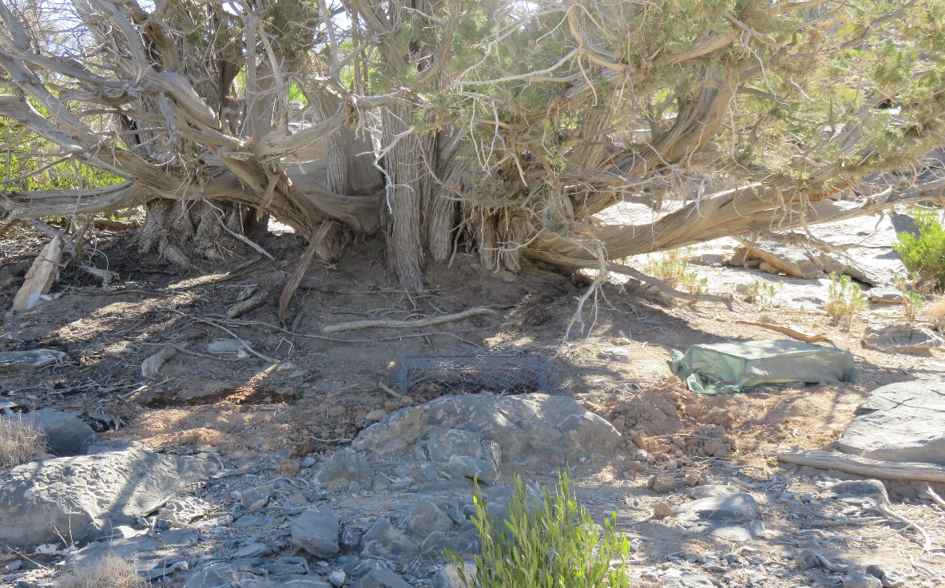

Figure ‎4.9 One-year-old seedlings planted under the shade of mother tree at low altitude with three cover treatments (fully protected, partly protected, and not protected).

Experiment 2: Effect of tree fence protection in seedling regeneration
To examine the effect of protecting trees from browsing on the natural regeneration via seedlings, mature female J. seravschanica trees were fenced at two different altitudes, 2200 and 2300 m (Figure ‎4.10). Two trees at each site were fenced off with an 8 m diameter space, using steel fencing in January 2016.
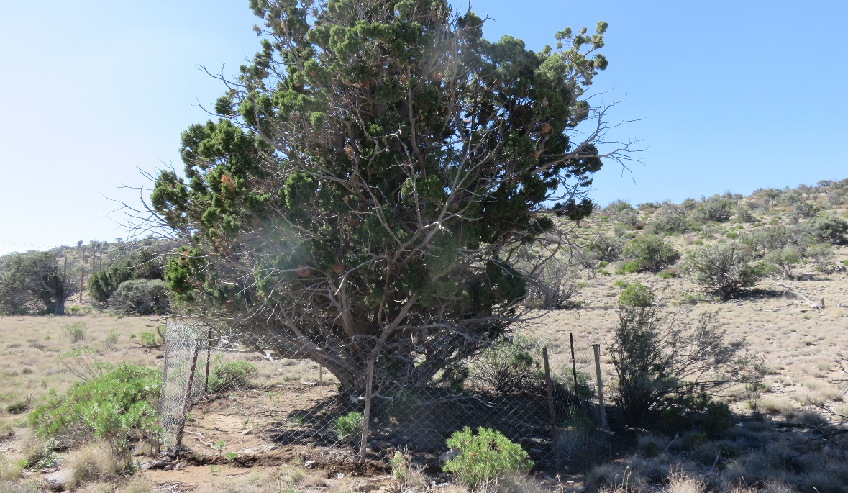
Figure ‎4.10 Female tree of J. seravschanica with ripe cones fenced at mid-altitude.

Results
Influence of browsing in seedlings establishment
The analysis indicated that the influence of browsing on seedling survival was not significantly different between the altitudes. However, significant effects of exclusion treatments on survival rates were demonstrated 29 days after planting (H(2)= 9.5, P< 0.05), with significantly low survival percentage recorded in the non-covered treatment. The influence of browsing was only detected in non-covered plots at low and mid-altitudes, whereas no influence of browsing was visible at high altitude (Figure ‎4.11). At low altitude, 20% loss in seedlings were recorded after 14 days of planting (first visit after planting) and increased to an 80% loss after 29 days. At mid-altitude, missing seedlings in non-covered plots were recorded after 29 days (20% loss) which then increased to a 90% loss after 47 days (Figure ‎4.12).
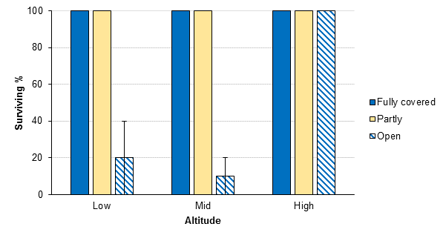

Figure ‎4.11 Influence of animal browsing on survival percentage of J. seravschanica seedlings after seven weeks when grown at the three different altitudes (Low, Mid and High) and three different levels of protection (Fully, Partly, and Open). Standard errors of the mean for open treatment are presented.

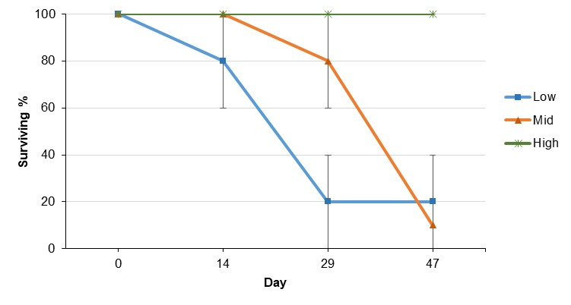

Figure ‎4.12 Influence of browsing on survival percentage of J. seravschanica seedlings during the seven weeks under no cover treatment when grown at the three different altitudes (Low, Mid and High). Standard errors of the mean are presented.
Effect of fence protection around mature female trees on seedlings regeneration
Seedling germination and emergence was monitored for a year. No seed germination was recorded for both altitudes until the end of this experiment (December 2016).

Hypothesis test
- Results confirm the hypothesis that large mammal browsing e.g. sheep, goat or feral donkeys affects the regeneration of J. seravschanica through inhibiting the establishment of seedlings.
- Results reject the hypothesis that small animals and invertebrates e.g. mice and insects, influence J. seravschanica establishment. No visible sign of small mammals was observed in any of the altitudes.
- Results reject the hypothesis that browsing pressure is varied through the different altitudinal gradients. However, no large or small animal browsing was observed in the high-altitude zone.
- Results reject the hypothesis that inclusion of a fence to protect trees from grazing encouraged the regeneration of J. seravschanica seedlings. It may however be too early to confirm this, as sufficient time may not have been provided for seed dispersal and germination (for example there may be a delayed dormancy period).

Experiment 3: Effect of changes in altitude on the phenology and growth of J. seravschanica trees in the Northern Mountains of Oman

Hypothesis to be tested
There is little information available on J. seravschanica shoot growth and plant development, especially within the context of altering climatic conditions or other environmental variables. Annual growth information is a basic requirement not only to estimate tree age but also to understand how growth is affected by climate variation. This experiment was set to examine the following hypotheses:
- Reproductive phenology for male and female trees varies across altitudinal gradients.
- Lateral shoot growth of J. seravschanica trees varies across the altitudinal gradients with a reduction in growth expected at higher altitude.
- Female trees have lower lateral shoot growth due to a high resource demand relating to reproduction.

Materials and methods
This experiment, phenological traits and growth, involved the selection of 18 sites (6 sites at each zone) at a range of different altitudes between 2100 m (lowest altitude of natural distribution of J. seravschanica) to 2600 m asl (highest accessible point). Sites were classed into three elevation gradients, low altitude zone (from 2100 m to 2300 m), mid-altitude zone (from 2300 m to 2400 m), and high altitude zone (above 2500 m) (Figure ‎4.13). Site access was an important consideration to take into account during the site selection, as close examination of individual trees was required. The occurrence of male and female plants at each site was also important in site selection as the experiment aimed to target an equal number of each gender. At each site, a square plot of 500 m² was marked out and corners staked out with steel poles. Sites were not identical in dimension due to variations in topography, e.g. sites selected in wadi habitats tended to be bilinear so as to avoid plants on very steep slopes. A summary of ecological factors of the selected sites are showing in Table ‎4.3.
In each site, five female and five male trees were selected randomly (10 trees in each plot). Tree health variables (percentage of living foliage and tree height) and environmental variables (altitude, slope, aspect, and habitat type) were recorded at each site. Sites were visited every four months over a two-year period, i.e. April 2014 to May 2016. At each visit, reproductive status was recorded for both male and female trees. Male trees were recorded as with: pollen cone, pollen cone release or full pollen release. Female trees were recorded to have immature cones, mature cones or both (more details in section 1.3).

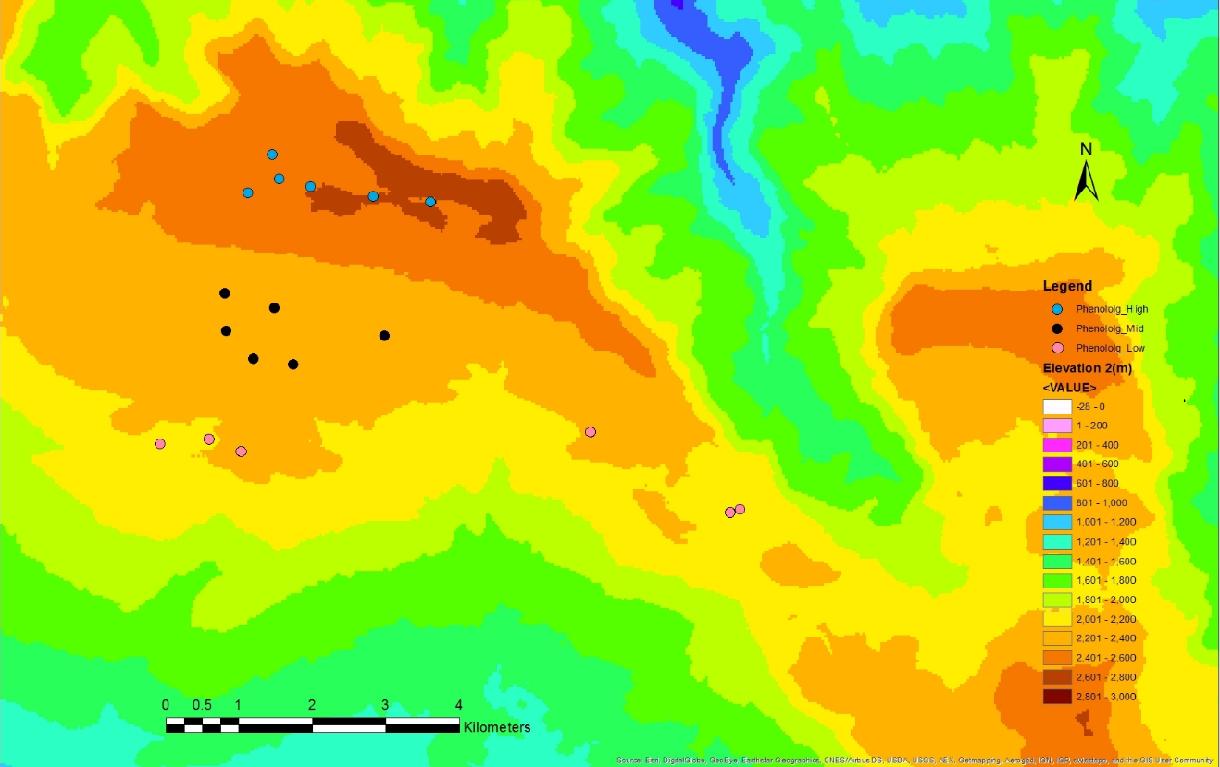

Figure ‎4.13 Satellite image of the plots selected for phenological and growth increment of J. seravschanica trees at different altitude zones in Jabal Shams, Northern Mountains of Oman. The three dot colours represent different altitude zones (Source: Esri. Digital Globe, Geo Eye, Earthshow).

Table ‎4.3 Summary of the selected sites for phonological and shoot growth study on Jabal Shams. Sites were divided in three altitude zones, 1 (Low), 2 (Mid) and 3 (High).
Zone | Plot No. | Altitude (m) | Aspect | Habitat type | Site exposure
1 | 1 | 2085 | NW | Wadi | Partly
1 | 2 | 2088 | SE-NW | Wadi | Partly
1 | 3 | 2144 | NW | Wadi | Partly
1 | 4 | 2176 | W-NW | Wadi | Partly
1 | 5 | 2210 | N | Wadi | Partly
1 | 6 | 2220 | N-NW | Depression | Fully
2 | 1 | 2307 | NW | Depression | Fully
2 | 2 | 2300 | W-NW | Hillside | Fully
2 | 3 | 2281 | NW | Depression | Fully
2 | 4 | 2303 | NW | Depression | Fully
2 | 5 | 2303 | W | Depression | Fully
2 | 6 | 2300 | NE | Wadi | Partly
3 | 1 | 2545 | N-NE | Hillside | Fully
3 | 2 | 2550 | NW | Wadi | Partly
3 | 3 | 2584 | NW | Hillside | Fully
3 | 4 | 2558 | E-NE | Hillside | Fully
3 | 5 | 2600 | SW-W | Hillside | Fully
3 | 6 | 2600 | N | Wadi | Partly

Lateral shoot growth of the selected male and female trees at the three altitude zones were also recorded during each site visit. Five lateral branches at different sides of each tree were selected; branches selected were above breast height. Red wire tape was used to tag the shoots, distance between the tape and shoot tip was measured regularly. Flexible plastic labels were used at the beginning of the experiment. However, all labels had to be changed after three months because they were destroyed by wind and animals. Hard plastic labels were then used to tag all shoots. Throughout the experiment period, some labels were destroyed by people (mainly visitors) or eaten by animals. The damaged labels were replaced and moved to new shoots; growth increment recording recommenced from this point on. Shoot growth increment between two consecutive visits were calculated to depict growth in line with the different seasons.
The experimental design was as follows: 3 altitude zones (low, mid and high) x 6 quadrats at each zone with x 5 trees from each gender. For shoot growth, 5 stems were initially selected per tree. However, because a large number of labels were destroyed during the early stages of the experiment only four replicates were used for the analysis. The mean growth increments of four shoots per tree were used for analysis. Descriptive analysis was used to investigate the influence of altitude in trees reproductive phenophase. Analysis of variance, two-way ANOVA, was used to investigate the influence of altitude and gender on shoot growth increment; altitude zone was placed as a main factor and tree gender was analysed within altitude. Data were square root transformed before analysis. Analysis was conducted for each time point (growth every four months) independently. Multiple comparison of the means was conducted and LSDs values were calculated for each time point.
Correlation and regression analyses were conducted to investigate the influence of environmental and ecological factors on shoot growth. Mean shoot growth increments during each period were correlated with environmental factors e.g. shoot increment over the period between April to August 2015 were correlated with the average four months air maximum, mean and minimum temperature, and the sum of precipitation during the same period. Only monthly mean temperature was correlated with shoot increment for the period between April to August 2014 and August to December 2014. For ecological factors, mean shoot growth was correlated with tree health scores and habitat types. A pair-wise regression model was conducted to indicate the influence of each variable in shoot growth. In addition, non-parametric, Kruskal-Whitney tests, with pair-wise comparison were used to identify the level of differences between yearly shoot growth increment and ecological factors, e.g. tree health, and habitat type.

Results
Effect of altitude on reproductive phenophase
Descriptive analyses indicated no influence of altitude on male tree reproductive phenophases. Data showed that male strobili formed between the end of December and January (Figure ‎4.14). In December 2014, only 25-35% of trees contained male strobili, this compares to December 2015 where the percentage of trees with male cones increased to 80%. Pollen was released over the next three months (between February to April), with 100% of male trees showing full pollen release by May.
Within the three altitude zones, unripe cones were more abundant than ripe cones; more than 50% of trees had unripe cones solely (Figure ‎4.15). Ripe female cones were present throughout the year but only a few trees had ripe cones exclusively. The percentage of trees with ripe cones increased in the second year (December 2015) indicating an increase in ripening of cones that had been laid down over the last two years. The mid-altitude zone had the highest number of ripe female cones during the study period.

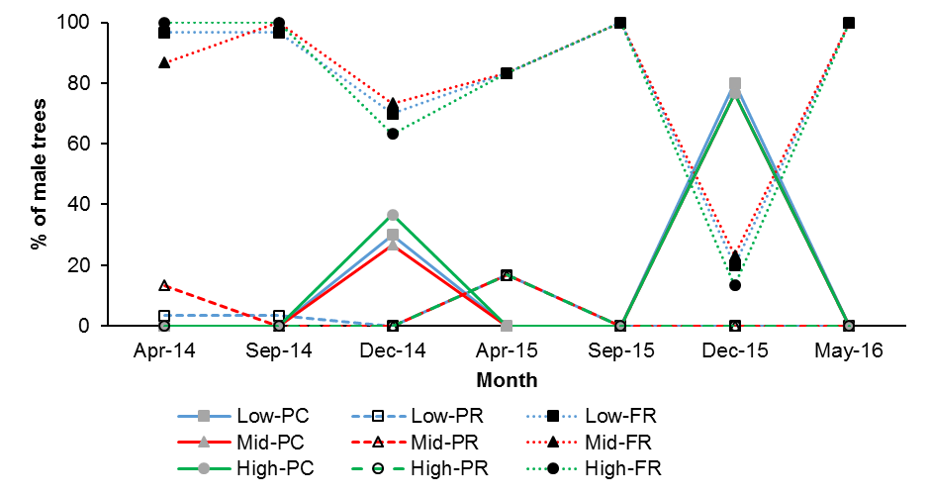

Figure ‎4.14 Male cone phenology of J. seravschanica trees observed every two months for two years at three different elevation range (Low, Mid and High). Data presented as mean percentage of trees has pollen cones (PC), pollen release (PR) or full pollen release (FR).
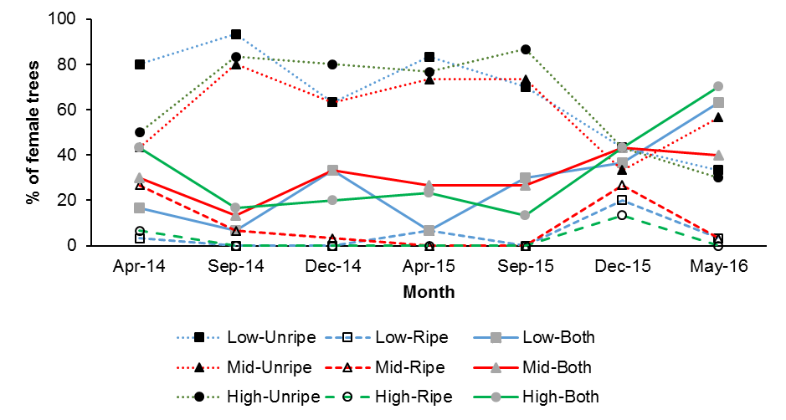

Figure ‎4.15 Female cones phenology of J. seravschanica trees observed every four months for two years at three different elevation range (Low, Mid and High). Data presented as mean percentage of trees bearing unripe, ripe or both (ripe and unripe cones in same tree).
Altitudinal variation effect on J. seravschanica growth
Lateral shoot growth of J. seravschanica trees differed markedly between the three elevations at all measured periods (P< 0.01). Trees at the mid altitude had the greatest growth during the two years of measurement (Figure ‎4.16). A marginal non-significant difference in shoot growth rate between trees at low and high altitude were recorded; trees at high altitude had a greater shoot increment than low altitude in the first year, however results showed a decline in growth of the high altitude population in the second year. In all of the stands, the growth of male and female trees was not significantly different nor was there significant interaction (P> 0.05).
The maximum growth was measured in the summer season of the first year of field work (April to August 2014), 8.8 mm and 9 mm growth increments were recorded at mid altitude on male and female trees respectively; however, growth was reduced in the second year during the same period (Table ‎4.4). Shoot growth was suppressed during the winter season (December to April) with no significant difference between altitudes recorded. The effect of gender on shoot growth was observed during the summer season in both years (April to August) at the low altitude zone. Female trees had lower lateral growth compared to male trees; however, these were not significantly different. Data analysis showed no significant differences in shoot increment between first and second years in low and mid elevation zones; whereas significant difference was found in the high altitude zone where growth was significantly higher in the first year (P< 0.05) (Figure ‎4.17). The mean annual shoot growth was 11.9, 18.1, and 12.3 at low, mid, and high altitude zones respectively.
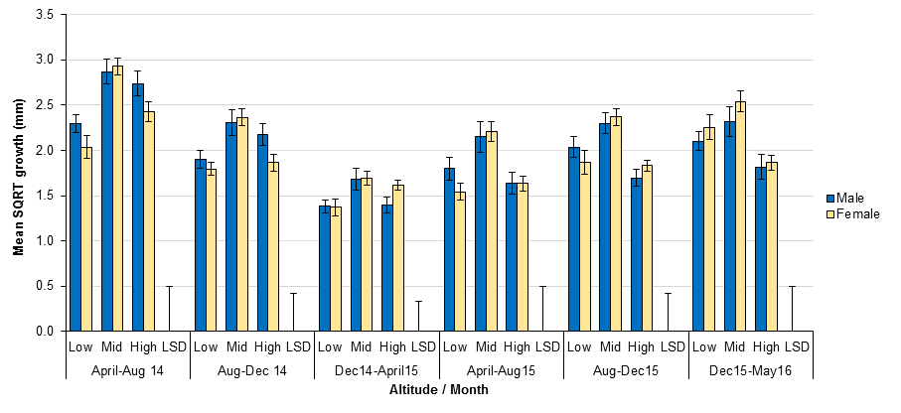

Figure ‎4.16 Mean shoot growth increment of J. seravschanica trees measured every four months for two years (April 2014 to May 2016) measured at three altitudinal zones (Low, Mid and High) with male and female trees measured independently. Data were square root transformed for statistical analysis. LSD(0.01, DF= 174, n=30) values are 0.5, 0.42, 0.32, 0.5, 0.42 and 0.5 and standard errors of the mean are presented. LSD is not applicable to indicate differences between gender at each altitude due to non-significant effect.

Table ‎4.4 Mean shoot growth increment of male and female J. seravschanica trees at the three elevation zones (Low, Mid, and High). Growth increments were measured every four months for two years (April 2014 to May 2016). Standard errors of the mean are presented (n=30).
Altitude | Low |  | Mid |  | High
Sex | Male | Female | Male | Female | Male | Female
First year
April-Aug | 5.6±0.5 | 4.6±0.5 | 8.8±0.8 | 9.0±0.5 | 8.1±0.7 | 6.6±0.7
Aug-Dec | 3.9±0.4 | 3.4±0.3 | 5.8±0.6 | 6.1±0.6 | 5.1±0.5 | 4.0±0.7
Dec-April | 2.1±0.2 | 2.1±0.2 | 3.3±0.4 | 3.2±0.4 | 2.2±0.3 | 2.7±0.2
Second year
April-Aug | 3.7±0.4 | 2.7±0.3 | 5.4±0.6 | 5.5±0.6 | 3.1±0.4 | 3.1±0.4
Aug-Dec | 4.5±0.5 | 4.0±0.5 | 5.7±0.5 | 6.3±0.8 | 3.1±0.3 | 3.5±0.3
Dec-May | 4.7±0.4 | 5.6±0.7 | 6.1±0.9 | 7.2±0.8 | 3.8±0.5 | 3.8±0.5
Mean annual | 12.2±0.7 | 11.2±0.7 | 16.5±1.1 | 18.6±1.4 | 12.7±0.6 | 11.8±0.7

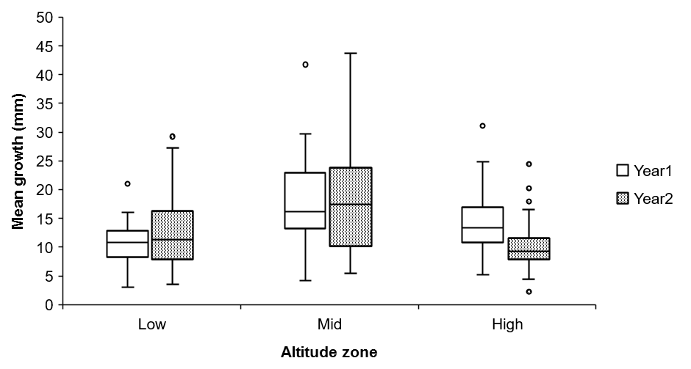

Figure ‎4.17 Box plot illustrating the mean differences of yearly shoot growth increment of first and second year measurement at the three altitude zones.
Influence of environmental and ecological factors on shoot growth
Regression analyses of environmental factors indicated a significant relationship between shoot growth and temperature or precipitation (Table ‎4.5). The analysis indicates a significant negative relationship between low temperature and shoot growth increment (P< 0.01). For lower temperature, there was a 0.23 to 0.36 mm decrease in shoot growth (Table ‎4.5). The amount of precipitation had significant effect on shoot increment (P< 0.01); however, the affects were less than those resulting from low temperatures. Data showed that precipitation negatively affected shoot growth, though the coefficient values for precipitation is very low indicating a least effect in growth. The R² values ranged from 0.05 to 0.14, indicating that only approximately 10% of the variation in shoot growth was explained by temperature and precipitation.
Analyses of ecological factors indicated no significant relationship between shoot growth increment and tree health status over the two-year study period (Table ‎4.6). However, mean comparisons indicated that trees with 75% or 100% living foliage had higher overall growth rates compared to trees with 25% living foliage (Figure ‎4.20). Increases in tree health from 25% living foliage to 75% or 100% living foliage were corresponded to 4.2 and 3.9 mm in shoot growth increments. Site topography showed a strong significant relationship with shoot growth (P< 0.01); changes from depression to hillside or wadi habitat were associated with 12 mm decrease in shoot growth (Table ‎4.6). Comparison of the mean growth rate for two-years showed that trees growing in depressions had significantly higher growth compared to hillside or wadi habitats (P< 0.05, Figure ‎4.21).

Table ‎4.5 Regression model of the effect of environmental factors on J. seravschanica lateral shoot growth at different time periods between Aug 2014 and May 2016.
Period | Variable | Coefficient (SE) | t value | P
April-August14 | Constant | 16.04 (2.38) | 6.72 | <0.01
April-August14 | Mean temperature | -0.43 (0.11) | -3.78 | <0.01
August-December14 | Constant | 8.97 (0.81) | 8.56 | <0.01
August-December14 | Mean temperature | -0.23 (0.08) | -2.915 | <0.01
December14-April15 | Constant | 1.42 (0.66) | 2.13 | 0.03
December14-April15 | Low temperature | -0.28 (0.07) | -3.81 | <0.01
December14-April15 | Precipitation | 0.04 (0.03) | 1.76 | 0.08
April-August15 | Constant | 64.39 (16.11) | 3.99 | <0.01
April-August15 | Low temperature | -0.28 (0.58) | -3.81 | <0.01
April-August15 | Precipitation | -0.05 (0.04) | -3.45 | <0.01
August-December15 | Constant | 11.68 (1.7) | 6.9 | <0.01
August-December15 | Low temperature | -0.26 (0.09) | -2.8 | <0.01
August-December15 | Precipitation | -0.06 (0.02) | -3.52 | <0.01
December15-May16 | Constant | 13.34 (2.02) | 6.61 | <0.01
December15-May16 | Low temperature | -0.36 (0.11) | -3.26 | <0.01
December15-May16 | Precipitation | -0.03 (0.01) | -3.71 | <0.01

Table ‎4.6 Regression model for the relationship between ecological factors and J. seravschanica lateral shoot growth increments. Tree health comparisons were made with trees with 25% living foliage and trees growing in depressions. Environmental and ecological data were correlated with the sum of two years’ growth.
Variable | Coefficients (SE) | t value | P
Constant | 34.43 (2.37) | 14.507 | <0.01
Health- Poor (50%) | 0.22 (2.34) | 0.096 | 0.924
Health- Good (75%) | 4.23 (2.41) | 1.757 | 0.081
Health- Very Good (100%) | 3.87 (2.52) | 1.538 | 0.126
Topography- Hillside | -11.84 (2.23) | -5.317 | <0.01
Topography- Wadi | -12.80 (1.93) | -6.612 | <0.01

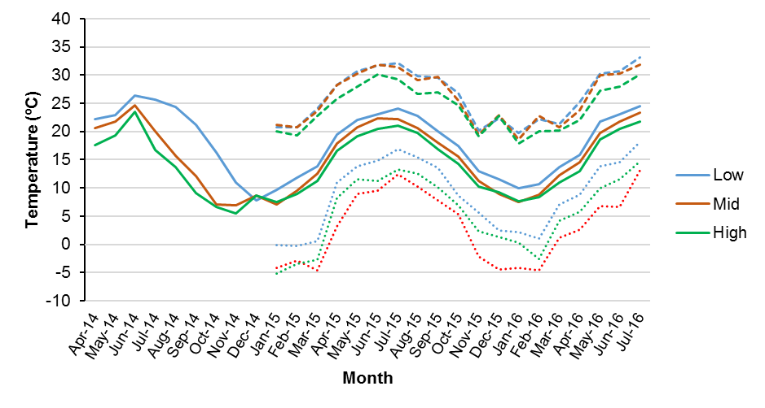

Figure ‎4.18 Average monthly maximum, mean and minimum temperature measured at three altitudes (Low, Mid and High). Average mean temperature from data loggers were collected during April to December 2014, after that temperature data were collected form weather stations.

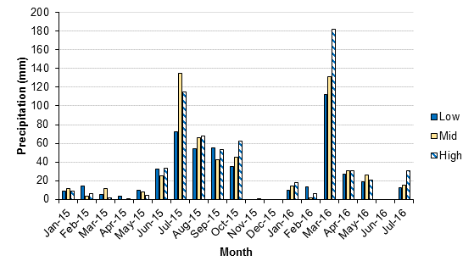

Figure ‎4.19 Monthly precipitation measured in three weather stations at different altitudes (Low, Mid and High) during the period from January 2015 to April 2016.
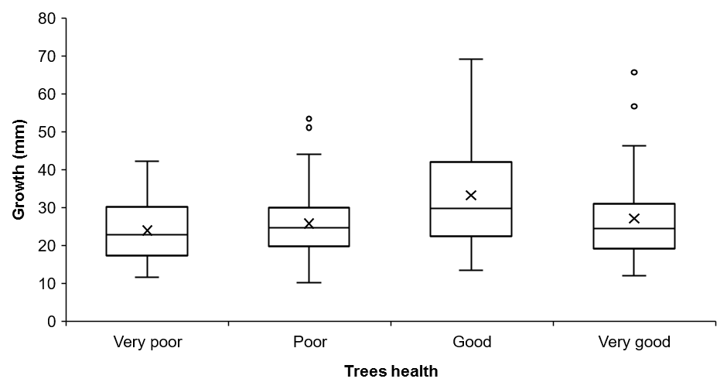

Figure ‎4.20 Box plot illustrating the mean comparisons of J. seravschanica lateral shoot growth associated with different plant health conditions. Health conditions were catagorised as: very poor (25% living foliage), poor (50% living foliage), good (75% living foliage), and very good (100% living foliage). X mark indicate two years mean shoot growth.

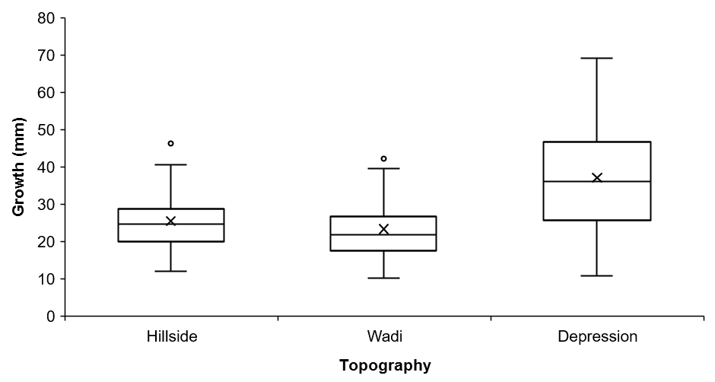

Figure ‎4.21 Box plot illustrating the mean comparison of J. seravschanica lateral shoot growth at different site topographies (hillside, wadi, and depression). X marks indicate two years mean shoot growth.

Hypothesis test
- Results reject the hypothesis that altitudinal gradients influence male and female reproductive phenology.
- Results support the hypothesis that change in altitude influences tree growth. Lateral shoot growth was greatest at the mid altitude zone with similar growth indicated at both low and high altitude zones.
- Results reject the overall hypothesis that gender type influences lateral shoot growth of J. seravschanica trees. However, data indicate growth reduction in female compared to male trees at the lower altitude

Experiment 4: The effect of altitudinal variation and tree health status on chlorophyll fluorescence and relative water content of J. seravschanica.

Hypothesis to be tested
- Chlorophyll fluorescence and relative water content will vary along the different altitudinal gradients with high maximum chlorophyll fluorescence (trees experiencing least stress) expected at high altitude.
- Healthy trees, high percentage of living foliage, have higher maximum chlorophyll fluorescence and relative water content compared to stressed trees.

Materials and methods
Within the same study area, 30 J. seravschanica trees were selected at three different altitudes, low (2220 m), mid (2300 m) and high (2570 m asl). Ten trees were selected at each altitude. Selection was based on the percentage of living foliage on each tree and divided (five trees for each group) into stressed or unhealthy trees (trees have ≤50% of living foliage) and healthy trees (trees have ≥75% of living foliage) (Table ‎4.7). The ratio of chlorophyll fluorescence (Fv/Fm) was measured every two weeks for the period from October 2014 to July 2016. Relative water content (RWC) of living foliage was measured three times, May 2015, February 2016 and May 2016. The measuring procedures of chlorophyll fluorescence and relative water content are described in section 3.4 and 3.5 respectively.
Experiment design was as follows: 3 altitudes (Low, Mid and High) x 2 tree condition types (healthy and stressed) x 5 trees per condition. Chlorophyll fluorescence was measured on one lateral branch per tree at each time. Three twigs were randomly selected for RWC measurement and the mean value per tree was used for analysis. Both Fv/Fm and RWC were analyzed for variance using two-way ANOVA test with altitude as the main factor and tree condition as the sub-factor.

Results
Maximum efficiency of chlorophyll fluorescence
Results for chlorophyll fluorescence values (Fv/Fm) indicated a seasonal pattern (Figure ‎4.22). The sharp reduction in Fv/Fm values were observed during the winter season; (e.g. February 2015 and 2016) or the summer season (e.g. Jun 2015) with higher decrease in winter rather than summer (Figure ‎4.22). A significant influence of altitude (P= 0.036) and trees health condition (P= 0.023) on Fv/Fm value was only observed during the winter season (February 2016); healthy trees at mid altitude had significantly higher Fv/Fm value than healthy trees at high altitude, no significant interaction (P= 0.6, Figure ‎4.23). A strong reduction in chlorophyll fluorescence efficiency at high altitude was observed during the winter season (February 2016) in both healthy and stressed trees. No significant effects of altitude or health status were observed in autumn, spring and summer readings. The majority of healthy trees (≥75% of living foliage) had Fv/Fm values higher than those trees with a greater proportion of defoliation (≤50% living foliage), often their ratios exceeded 0.7, whereas values for the more defoliated were below this value, however these differences were not significantly different.
Table ‎4.7 Sites selected for assessing the influence of altitude and trees health on the physiology of J. seravschanica. Trees were selected at three zones, Low (2220 m), Mid (2300 m) and High (2570 m).
Zone | Group | Sex | Altitude (m) | Aspect | Habitat type
Low | Healthy | Male | 2224 | NE | Depression
Low | Healthy | Female | 2224 | NE | Depression
Low | Healthy | Female | 2224 | NE | Depression
Low | Healthy | Male | 2224 | NE | Depression
Low | Healthy | Female | 2224 | NE | Depression
Low | Stressed | Male | 2241 | NE | Hillside
Low | Stressed | Male | 2229 | N | Hillside
Low | Stressed | Female | 2229 | N | Hillside
Low | Stressed | Male | 2229 | NE | Hillside
Low | Stressed | Female | 2229 | NE | Hillside
Mid | Healthy | Female | 2302 | SE | Wadi
Mid | Healthy | Male | 2302 | E | Wadi
Mid | Healthy | Female | 2302 | NE | Wadi
Mid | Healthy | Female | 2302 | NE | Wadi
Mid | Healthy | Female | 2302 | NE | Wadi
Mid | Stressed | Male | 2300 | SW | Hillside
Mid | Stressed | Male | 2300 | SW | Hillside
Mid | Stressed | Female | 2300 | SW | Hillside
Mid | Stressed | Male | 2300 | SW | Hillside
Mid | Stressed | Female | 2300 | SW | Hillside
High | Healthy | Male | 2570 | NE | Hillside
High | Healthy | Male | 2570 | NE | Hillside
High | Healthy | Female | 2570 | N | Hillside
High | Healthy | Female | 2570 | N | Hillside
High | Healthy | Male | 2570 | N | Hillside
High | Stressed | Male | 2572 | E | Hillside
High | Stressed | Male | 2572 | E | Hillside
High | Stressed | Male | 2572 | E | Hillside
High | Stressed | Female | 2572 | SE | Hillside
High | Stressed | Female | 2572 | SE | Hillside

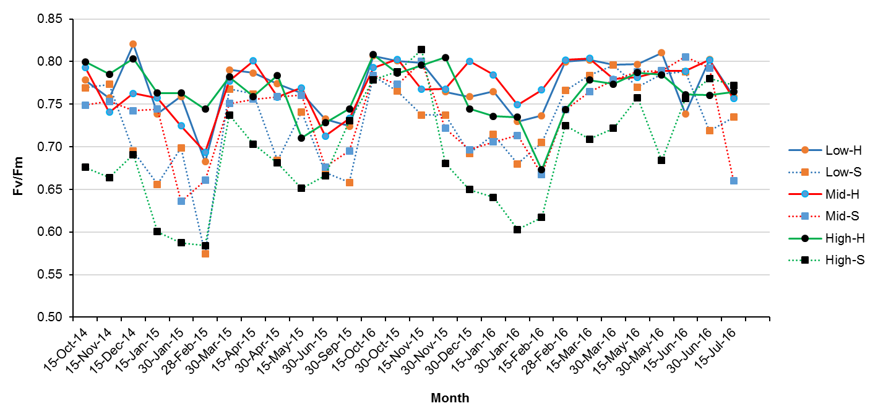

Figure ‎4.22 Chlorophyll fluorescence values (Fv/Fm) of J. seravschanica trees measured at three altitudes (Low, Mid and High) for healthy (H) and stressed (S) trees during the period between October 2014 to July 2016.
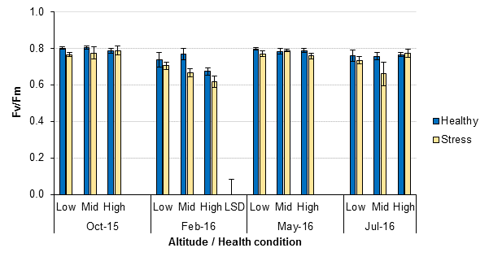

Figure ‎4.23 Chlorophyll fluorescence values (Fv/Fm) of J. seravschanica trees during autumn (October 2015), winter (February 2016), spring (May 2016) and summer (July 2016) measured at three different altitudes (Low, Mid, and High) on healthy (≥75% living foliage) and stressed trees (≤50% living foliage). LSD(0.05, DF=24, n=5) for February 2016= 0.05 and standard errors of the mean are presented. LSDs were not calculated for other months due non-significant effect of both factors.

Relative water content
Analysis of variance indicated a significant influence of altitude on February 2016 and May 2016 in relative water content measurement (P< 0.01), but not May 2015 (P= 0.3, Figure ‎4.24). However, the significant influences of trees condition were indicated in all months (P< 0.05), no significant interaction (P> 0.05). Within the three altitudes, trees grown at high altitude had the lowest RWC. In regard to tree health, trees that had more than 75% of living foliage (healthy) had higher RWC than those with less than 50% living foliage (stressed). The significant reduction in RWC in relation to plant health was mostly observed at middle altitude, with healthy trees possessing a higher RWC (>6%) than stressed trees. At low and high altitude zones, a marginal non-significant decrease in RWC was indicated between healthy and stressed trees with more reduction at low altitude.
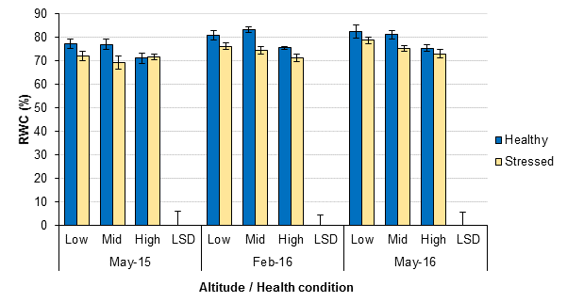

Figure ‎4.24 Relative water content (RWC) of J. seravschanica trees during May 2015, February 2016 and May 2016 measured at three different altitudes (low, mid, and high) on healthy (≥75% living foliage) and stressed trees (≤50% living foliage). LSDs (0.05, DF=24, n=5) for each month = 6.1, 4.3, and 5.4 respectively, and standard errors of the mean are presented.

Hypothesis test
- Results support the hypothesis that changes in altitude influence the chlorophyll fluorescence and relative water content, however the results showed no relationship between high altitude and high chlorophyll fluorescence.
- Results support the hypothesis that healthy trees have a high relative water content but do not support the hypothesis that healthy trees have a consistently high chlorophyll fluorescence.

Discussion

Patterns of J. seravschanica condition
The occurrence of robust, fully-leafed Juniper trees in the northern mountains of Oman is low - fully intact trees appear to be confined to a limited number of areas. In this study, trees with a high per cent of living foliage (>75%) were limited to cooler (high altitude), or high moisture level habitats (depressions or wadis). This finding supports the latest studies assessing the ecological status of J. seravschanica populations in the northern mountains (Al Haddabi and Victor, 2016; MacLaren, 2016). In this study, all trees surveyed above 2500 m had a high per cent of living foliage (>80%). Higher elevation is characterized by cooler temperatures and higher precipitation. It is possible that cooler temperatures at higher altitudes slow down soil moisture evaporation, thus trees have more available water; this coupled with higher levels of precipitation at high altitudes, reduces the overall stress and enhances survival of J. seravschanica trees in this otherwise environmentally challenging environment.
Tree height distribution indicated a high proportion of adult trees and low numbers of juvenile trees or emerging seedlings. Similar woodland structures have been described in the other locations within the mountain range (Al Jabal Al Akdar), where low numbers of juvenile and seedlings have also been recorded (Al Haddabi and Victor, 2016). The size structure of the woodland can be used to indicate its regeneration and conservation status with high proportion of adult trees indicating inadequate recruitment (Sarangzai et al., 2012). In this study, only 7% J. seravschanica trees were less than 2 m tall (i.e. were saplings). This is far less than the recorded number of saplings (19 saplings/ha) of J. excelsa in the nearest population in Iran (Tavankar, 2015) or of the same species in Pakistan, 99 to 439 saplings (<6 cm diameter at breast height)/ha (Sarangzai et al., 2013). In addition, topography of the site influenced the size and density of trees with depression habitats having taller trees and supporting these at a higher density. This type of habitat is characterized as having a high-water catchment after rain and is less prone to water run-off after rainfall event compared to wadi or hillside habitat.

At mid altitude, all young saplings were found growing in depressions. The high density of trees in this habitat seems to provide a favourable microenvironment for germination, as young Juniperus seedlings are usually found under the shaded protection of mother trees (Fisher and Gardner, 1995). Under stressful conditions, harsh environments are ameliorated by the presence of mother trees, which protect the seedlings via shading and shelter, thus helping to nullify the effects of high temperature, wind and high solar irradiance. These factors allow seedlings to take-up more resources and enable them to compete with mother trees in due time (Maestre et al., 2009b).
At high altitude (above 2500 m asl), a greater proportion of young saplings were observed (some were not included in this study) in an open habitat. These were previously grown under the shade of mother trees; however, these mature trees were characterized by either poor growth or death (Figure ‎4.25), perhaps due to increased competition for resources by their progeny. Interestingly, however, no recently germinated, small seedlings were observed at this altitudinal range. Under drought conditions, competition for water leads to a decline in the trees physical condition and creates an unsuitable environment for germination (Allen et al., 2010). Contrary to what is seen in practice (Figure ‎4.25), it is often expected that mature trees survive as a result of their larger root systems which have an enhanced ability to compete for water and nutrients compared to younger saplings; however, the opposite phenomena were observed. Verdu et al. (2004) studied post-facilitation effect (saplings grown under the shade of mother trees) on both mother tree and sapling growth performance using two Juniperus species. They indicated a reduction in growth and reproductive capacity of female mother plants rather than the younger saplings, which has been connected to lower water potential on mother trees. More studies in facilitation process are needed to explain this phenomenon at this altitude.
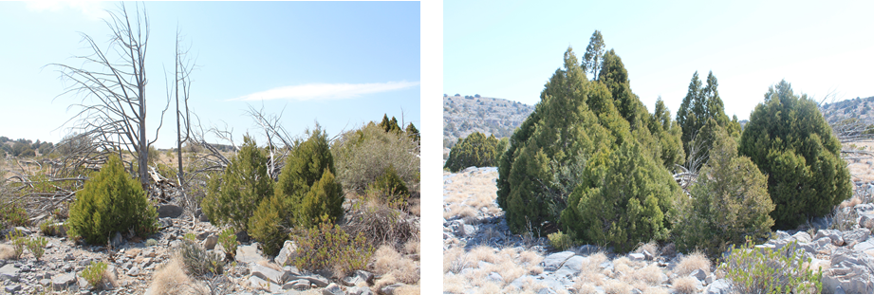

Figure ‎4.25 Competition between J. seravschanica mother trees and new growing saplings causing death of mother trees at high altitude zone.

In the current study, there was general bias toward male trees; although there was an effect of altitude on sex ratio. Male trees were abundant at low and mid-altitudes; whereas females were more abundant at high altitude. This supports the suggestion that many dioecious, wind pollinated trees, such as Juniperus, show spatial segregation in sex ratio along altitudinal gradient (Ortiz et al., 2002). The results here are in contrast with the recent study in the east part of the mountain (Al Jabal Al Akhdar), with female trees biasing the gender ratio (Al Haddabi and Victor 2016). However, it’s reported that Al Jabal Al Akhdar is wetter than Jabal Shams (study site) which has been associated with better health index of J. seravschanica trees. This could indicate that females favoured cooler sites with high moisture availability that were associated with increase in altitude.
This has important implications for the conservation of J. seravschanica populations, as a deficit of female trees at lower altitudes could be the reason for low regeneration of new progeny. The significant importance of female biased Juniperus in woodland sustainability has been reported, e.g. gender ratio of J. seravschanica in Kyrgyzstan woodlands were there are 3 female to 1 male (Sultangaziev et al., 2010). It may be that female trees are more susceptible to the stress factors (associated with a warming climate) most commonly encountered at the lower altitudes. Iszkulo and Boratynski (2011) reported a reduction in radial growth of female trees of J. communis compared to male trees; this has been linked to a higher sensitivity in female trees to changes in temperature and precipitation. The difference in health score between the two sexes may be associated with the trees’ reproductive allocation strategy. Male trees allocate more energy to vegetative growth; this being linked to enhancing their tolerance to difficult environment conditions (Ortiz et al., 2002); whereas the high cost of reproductive growth in Juniperus female trees leads them to being more susceptible to environmental changes, especially at the limit of the species natural distribution (Vasiliauskas and Aarssen, 1992). This was the case at low altitude with high proportion of male trees and restricted existence of female to shaded/high moisture sites (wadis).
Human impact on J. seravschanica woodlands is more evident at the lower altitudes with greater indications of wood being removed by cutting for fire-wood etc. Site degradation through wood cutting or soil removal has been reported to influence Juniperus growth and establishment (Al Haddabi and Victor, 2016). Although data indicates a significant effect of human damage to trees, most of the damage was restricted to lower altitude populations. This is presumably related to ease of access and transport of freshly cut wood for local people.
In terms of ecological factors and their effect on J. seravschanica, site topography had the highest impact on tree condition at the three different zones. At low and mid altitudes, wadis and especially depressions, which provide shade and moisture promote an ecological refuge for J. seravschanica. At high altitude however, site topography had no influence on the trees condition, with healthy trees being found in all habitat types. The importance of site topography seems related to the capacity to provide more consistent water resources and suitable microenvironmental conditions for tree growth and regeneration. Jones (1992) stated that within mountain areas, site topography has an important role in determining site microclimate by its effects on patterns of wind flow, percentage of shade or even an ability to influence the level of precipitation and capture of rainfall. The high per cent of living foliage of trees found in north or west facing slopes indicates the preference of shade for J. seravschanica growth. However, the availability of shade created by wadi habitats was not sufficient to encourage regeneration compared to depressions. It is possible that depressions have a high water retention capacity which reduces soil water evaporation caused by rising temperatures (MacLaren, 2016). The potential for these sites to assist natural regeneration or aid establishment of artificially planted tree stocks is high and should be considered in future reintroduction or site rehabilitation initiatives.

Influence of animal browsing on J. seravschanica seedling establishment
Results indicate that there is a negative influence on J. seravschanica seedling establishment due to browsing within the study sites. Browsing of seedlings was mainly by large mammals with no visible signs of smaller animals. The specific animal or animals browsing the seedlings were not identified; however, goat (Capra hircus L.) and sheep (Ovis aries L.) were the two main herbivore species in the study site. Al Harthi et al. (2008) analyzed the faeces of a common herbivore animal on the mountain area. They indicated that Juniperus was a moderately common component in the diet of sheep and goats but not in donkeys. The high animal browsing pressure at low and mid altitudes can be related to accessibility of local herdsmen to these sites. In contrast, little evidence of animal browsing observed at high altitude in this study due to high restriction in area access and long distance from nearby local people housing. Above 2100 m, the tree community is dominated by J. seravschanica and Olea europaea L. subsp. cuspidata; Cymbopogon schoenathus is the dominant ground cover grass. During abundant periods, the two latter species were favoured by herbivores (Al Harthi et al., 2008); however during drought season browsing on J. seravschanica trees was common (personal observation), especially at middle altitude (2300 m) where J. seravschanica becomes the dominant tree species. Juniperus are not favoured by animals due to the high concentration of essential oil within the leaves; however, this concentration varied through the season with lower concentration of essential oil measured in summer (Marko et al., 2008), possibly resulting in greater browsing pressure at this time of year.

Browsing by herbivores on Juniperus seedlings has been observed by several authors. Garcia et al. (1999) studied the influence of animal damage on one-year-old naturally growing J. communis under two different habitats (dry site and wet site). They indicated that in dry sites, 23% of the seedlings were trampled by animals whereas 3.8% were eaten. However, in wetter sites, 34.6% of the seedlings were trampled whereas 38.5% were eaten by herbivores. This indicates that even with the availability of pasture (more pasture expected under wetter sites) browsing and damage by herbivores is expected to influence the survival of J. seravschanica seedlings. On the current study site, the mid altitude is wetter than the low altitude with higher grass ground cover and it is a protected area (no public access and only few villagers living in this area); however, the influence of browsing was still higher than at the low altitude.
The influence of herbivore disturbance in woodlands is not only restricted to browsing or trampling the newly germinated seedlings; it can be extended through to disturbance of the microclimate that is most suitable for seed germination. This disturbance can be seen in two ways. Firstly, browsing on mother trees reduces the foliage density; thus, leading to excessive irradiance within the proximity of the mother trees base. Secondly, animals themselves often tend to graze under the shelter of mother trees to escape the direct sun especially in summer which induces a disturbance on the soil and disrupts the seed bank. These two factors reduce the facilitation capacity of the mother tree which is an important role in forest regeneration in dry climate (Wassie et al., 2009). Tree protection from animal browsing in the second study here did not encourage seed germination after one year. However, longer duration studies are likely to be required to determine the ability of seeds to germinate and establish, as well as for the conditions to become more conducive for germination, e.g. increases in organic matter and associated moisture retention capacity. This could be an example of a long-term assisted natural regeneration programme.

Reproductive phenology and growth of J. seravschanica trees along an altitudinal gradient
Although the results presented here tentatively suggest that J. seravschanica trees show homogeneity in male pollen phenology and female cone ripening with no influence of altitude, more intensive study is needed to confirm this. In phenological studies the regularity of observations (daily, weekly, biweekly or monthly) influences the phenological pattern generated, with biweekly observations providing reasonabl accurate data (Morellato et al., 2010). Male strobili formation of J. seravschanica trees started in December and pollen release occurred from February to April. This indicates that pollination takes place in spring (February to April) before the start of the hot summer season. The same timing of flowering and pollination was observed in J. thurifera in the western basin of the Mediterranean mountains (Montesinos et al., 2012). J. seravschanica female cones took two years to mature with cone ripening seemingly taking place in winter. Rumeu et al. (2009) reported that in Mediterranean forests, fruit maturity occurs during winter, whereas in temperate regions seed ripening takes place in summer-autumn. This seasonal preference has been linked to availability of vertebrates for seed dispersal. As yet no data on pollination or seed dispersal exists for J. seravschanica in Oman; further research in this area is recommended.
Growth of lateral shoots of J. seravschanica varied through the three altitude zones with higher increments recorded at the mid altitude. Temperature, precipitation and habitat topography are all likely to have a potential effect on shoot growth. In many studies, shoot increment was found to decrease with increasing in elevation (Ortiz et al., 2002). This was true for trees at high altitude, however a notable decrease in growth was also measured here at low altitude compared to mid-altitude. Peng et al. (2008) indicated that temperature during the warm season was a main factor influencing Juniperus shoot growth. Temperature suppressed growth when it is associated with water shortage; increasing temperatures results in increasing evapotranspiration but reduced growth (Martin-Benito et al., 2008). Temperature trends indicate no strong differences between lower and middle altitude in average monthly high and mean temperature, e.g. only 2°C difference in July was recorded; however, precipitation levels were much lower at low altitude than both mid and high altitude. Availability of high soil moisture was important for trees growth at low altitude, e.g. growth of shoots for the period from December to April 2015 to the same period in 2016 indicated that growth was more likely attributed to water soil moisture levels; 2.1 mm in growth when 32 mm precipitation in 2015 compared to 5.1 mm in growth when 180 mm precipitation in 2016 for the same period. Swidrak et al. (2013) noted that tree water status during spring and temperature were the key factors that determined total annual growth. In J. occidentalis, annual radial growth was more sensitive to drought stress at lower elevation; with growth responses being highly dependent on winter precipitation (Knutson and Pyke, 2008). Though, temperature and precipitation were found to influence lateral shoot growth, other environmental factors such as irradiance or different threshold temperature could control lateral growth of Juniperus trees (Swidrak et al., 2013).
Trees growing in shallow depressions recorded higher rates of shoot growth compared to trees from other habitats. Depressions form shallow basins which collect water after rain and they have the capacity to retain water for longer periods than surrounding areas (MacLaren, 2016). At low altitude zones, five out of six sites selected were in wadis; this is the habitat where the most reproductive J. seravschanica trees can be found. However, there was a high occurrence of depressions at mid altitude. The availability of soil moisture and warm temperatures at the middle altitude resulted in an enhanced annual shoot growth compared to sites at the lower altitude. Opala et al. (2016) have investigated the radial growth of J. seravschanica over the last 1,010 years through ring chronology studies in the Tajikistan forest. They concluded that growth of J. seravschanica trees were largely dependent on variations of winter precipitation and somewhat by spring and summer seasonal temperatures; indicating that water availability rather than temperature primarily controls J. seravschanica growth.
In J. communis subsp. alpine, Ortiz et al. (2002) indicated a significant reduction in annual growth was associated with the increase in altitude; 25.9 mm, 14.2 mm, and 9.8 mm, at 2100 m, 2350 m and 2700 m asl, respectively. These results are in line with the results from this study; with low annual growth obtained at high altitude; 12.2 mm at higher altitude compared to 18.2 mm at middle altitude. Reduction in annual growth at high altitude is more or less related to minimum temperature. Lower air temperature reduces the soil temperature which may inhibit water and nutrient uptake by the plants.
Within dioecious species, female trees allocate more of their resources for reproduction compared to male trees, which in contrast dedicate much of their resource to vegetative growth; e.g. female trees in J. communis allocate 29.5% of the resources for reproduction compared to 5.85% in male trees (Ortiz et al., 2002). However, this greater effort did not imply a significant decrease in female vegetative growth when compared with male growth in the current study. The annual growth did not show a marked difference between male and female trees. Previous studies used different types of growth parameters to indicate Juniperus growth but did not successfully demonstrate the difference in the growth between male and female trees (Gauquelin et al., 2002; Montesinos et al., 2006). In the current study, the differences in gender growth rates were related to altitudinal differences; overall, female trees had low growth at low altitude, except the last four months of the second year where female trees had a higher growth rate. However, at mid and high altitudes, the growth of female was equal or higher than that of male trees, except the first four months of the experiment where male trees had higher growth. Iszkulo et al. (2011) stated that gender growth was linked to habitat conditions; growth rate of female trees was higher in more optimal habitat conditions, whereas a decline in growth was recorded in suboptimal conditions. This has been attributed to a high sensitivity of female Juniperus trees to summer water stress (Rozas et al., 2009). Long-term studies are needed to tease out these subtle differences and ascertain if there are particular patterns in this growth parameter.

The altitudinal variation of maximum chlorophyll fluorescence and relative water content
The effect of altitude on plant photosynthesis is a complex process with details on the actual lapse rate (the change of temperature along altitude gradients) and radiation levels required before predications can be made for plant response at particular locations (Jones, 1992). The efficiency of chlorophyll fluorescence (Fv/Fm) of J. seravschanica varied along the three altitudes and showed a seasonal pattern of variation. Decline in chlorophyll fluorescence values were measured during winter season; with a strong decline occurring at high altitude. Wen et al. (2010) related the reduction in Fv/Fm values in two Juniperus species during winter months to low temperature stresses, which decrease the efficiency of photosystem II (PSII) by reducing photosynthetic energy conversion. Climate data indicates a decrease in minimum temperature during the winter season across the three altitudes, with a higher decrease recorded at high altitude (e.g.-4.6°C) in February 2016. The efficiency of photosystem II was suppressed at high elevation, whereas trees at low altitude showed high efficiency of chlorophyll fluorescence, minimum temperatures at low altitude were >0°C. Nippert et al. (2004) stated that photoinhibition and dehydration due to freezing were a possible mechanism controlling winter photosynthesis. The rapid increase in Fv/Fm values in the spring (e.g. 0.58 to 0.73 in stressed trees at high altitude between February 2015 to March 2015) indicated a rapid recovery of trees from winter stresses. This rapid increase is likely to be related to an increase in temperature, particularly an increase in minimum temperature. The increase in Fv/Fm values during spring season were followed by a slight decrease during the summer season, less than recorded in the winter season. The same seasonal pattern effect in photochemical efficiency was observed in two evergreen tree species, Quercus ilex and Phillyrea latifolia, growing in the Mediterranean under similar conditions (Ogaya et al., 2011).
Healthy trees showed higher photochemical efficiency along the three-altitudinal gradient; however, these were not significantly different than stressed trees. The same pattern in relative water content was also observed in healthy trees, healthy trees had a higher RWC than stressed trees. In many studies reductions in Fv/Fm values were associated with lower relative water content in the leaves (Fernandez-Martinez et al., 2016; Vilagrosa et al., 2003). The seasonal values of Fv/Fm at low altitude shows a constant pattern with values ranging between 0.7 to 0.8 for both healthy and stressed trees; even during the winter. This suggests that trees at lower altitude were active throughout the year even during the winter season, when growth of trees at high altitude was suppressed by low temperatures. Extended growing season is expected as a result of climate change, particularly for trees growing at the lower or higher limits of the species distribution (Mondoni et al., 2012); however, more studies will be needed to confirm this.

Conclusion
- Tree health index was associated with altitude and site topography. Healthy trees were predominantly found above 2500 m or in depressions where soil moisture and shade were available.
- The low and mid altitude populations were biased towards male trees. High altitude populations were biased towards female trees.
- Animal browsing (goats and sheep) influence the regeneration and establishment of J. seravschanica seedlings at lower and middle altitudes.
- Male pollen cone formation starts in December and pollination occurs within the next three months. The presence of female cones was evident throughout the year with fruit maturation occurring during winter.
- Tree growth varies throughout the year; trees at low altitude have a low annual growth increment compared to trees at mid altitudes. Growth rates were correlated with temperature and to a lesser extent precipitation, particularly at higher altitudes, growth at low altitude are more related to soil moisture availability. Male trees had higher growth rate compared to female trees, especially at low altitude.
- Chlorophyll fluorescence and relative water content varied across the different altitudes. Healthy trees had higher Fv/Fm and RWC values compared to stressed trees.

Chapter 5. Seed characteristics and germination of J. seravschanica in response to altitudinal variation, temperature and cold stratification

Introduction
The presence and regeneration of a plant in a specific area usually depends on its ability to produce viable seeds, i.e. sexual reproduction (Hedhly et al., 2009). The production of viable seeds by plants relates to different factors acting together during reproduction, such as pollination efficiency, amount of fruit produced, abundance of seed predators and climatic conditions during fruit production and development (Mezquida et al., 2016). For Juniperus species, many studies have found that sexual reproduction is very low, often resulting in reduced numbers of viable seeds (Garcia et al., 2002; Wesche et al., 2005; Daneshvar et al., 2014; Al Haddabi and Victor, 2016); although a single tree can bear thousands of cones in a single year (Petersen et al., 2005). Juniperus decline is occurring rapidly and over a large scale in its distribution range; thus examining the main factors influencing seed viability and germination under different climatic variables might provide an insight into the possible causes for this decline (Verheyen et al., 2009).
Climate change has been reported to impact sexual seed production in many plant species (Walck et al., 2011). Environmental factors such as temperature, precipitation and light affect seed set, development and the germination of seeds. The influence of climate change in reproductive phases are predicted to be more visible in plant species found at the limit of their distribution area (Olesen and Bindi, 2002); e.g. J. seravschanica in the Northern Mountains of Oman. Rising temperatures have been found to affect seed viability and germination of Juniperus species, e.g. rise in temperature negatively affected seed viability of J. communis (Verheyen et al., 2009). Examining temperature effects on seed viability, Gruwez et al. (2016) indicated that temperature increases during seed development alters pollen tube growth, female gametophyte development and fertilisation, often causing seed abortion. In the Northern Mountains of Oman, cones of J. seravschanica take two years to ripen; pollination occurs in winter between December and February. Pollination and fertilization take place in the first year while embryo development and ripening occurs in the second year (Gruwez et al., 2013). Increases in temperature and water stress during summer may affect seed development, especially at lower altitude, where generally, mean temperatures tend to be higher and the evaporation of soil moisture greater than at higher altitudes. Studying the influence of different environmental conditions on seed development can help to understand the influence of climate change on natural seed regeneration (Caron et al., 2014).
The germination requirements for J. seravschanica grown within the Northern Mountains of Oman have not been well studied. Species specific germination requirements are normally linked to the species adaptations to its natural environment (Meyer et al., 1990). Understanding these requirements can be linked to the timing of natural seed germination in the field and help future conservation programmes for specific species (Fenner and Thompson, 2005; Chanyenga et al., 2012). The role of temperature as a main factor regulating seed germination has been reported (Probert, 2000). Growing seed under higher or lower temperature regimes than its optimal for a given species usually prevents seed germination (Amri, 2011). Another factor affecting seed germination is seed dormancy. Even under favourable conditions, dormant seed is inhibited from germinating by the presence of one or both types of dormancy; physical (seed coat) or chemical (embryo) (Lee et al., 1995). Juniperus seeds are known to have both types of dormancy. The importance of breaking dormancy through the pre-treatment of Juniperus seeds has been illustrated in many studies examining different methods, such as, stratification (Daneshvar et al., 2016), scarification (El-Juhany et al., 2009) or exposure to smoke or other volatiles associated with fire (Tigabu et al., 2007).
Germination of seeds in their natural habitat depends on microhabitat conditions with biotic and abiotic stresses having major influences (Castro et al., 2005a). El-Juhany et al. (2008) reported that the failure of seed germination under field conditions could relate to a lack of conducive conditions for part or all of the year. Water stress during seed germination or after emergence was identified as a main cause of seed germination failure under field conditions (Castro et al., 2005b). Classen et al. (2010) reported that soil moisture and air temperature play a role in the success of seed germination under field conditions; generally, germination is favourable when soil moisture increases thus ensuring adequate moisture can be imbibed by the seed and temperature decreases to a point where respiration is optimised or dormancy-related inhibitors degraded. Despite the challenges seeds / seedlings face in nature, germination of natural seed populations or sowing seeds in situ has been used as a restoration method in degraded habitats (Jacobs and Gatewood, 1999; Albrecht and Maschinski, 2012). This study aimed to investigate the main effect of altitudinal variation ‘climatic factors’ in seed viability and germination. Moreover, it examines the potential in using in-situ seed sowing to aid natural seedlings recruitment.

Objectives
This chapter examined the following points:
- Investigate possible altitudinal variation in J. seravschanica seeds viability and germination.
- Investigate the optimum temperature for seed germination.
- Investigate the influence of cold stratification on seed germination.
- Examine the potential for in situ sowing of J. seravschanica seeds and determine germination rates in its natural habitat i.e. soils within the Northern Mountains of Oman.

Experiment 1: Altitudinal variation effect in J. seravschanica seed characteristics

Hypothesis to be tested
Seedling regeneration appears to be lower or absent at lower altitudes in the Northern Mountains of Oman. This study investigates the possible effect of changes in altitude on seed characteristics. The following hypotheses were investigated:
- Altitudinal variation in the Northern Mountains has an effect on seed reproduction.
- Healthy trees at higher altitudes produce more viable seeds compared to stressed trees at lower altitudes.
- Seed viability is a significant factor in lower tree regeneration at lower altitudes.

Material and method
Mature cones were collected from 30 different trees of J. seravschanica in Jabal Shams (Figure ‎5.1). Collection was carried out between January to April 2015. Altitudes were classified in three ranges, low altitude (2100-2200 m asl), middle altitude (2300-2400 m asl), and high altitude (above 2500 m asl). Tree health was measured using the percentage of living foliage as a proxy for overall health (see section 3.1.3).
One hundred cones with three replications from each collection were counted separately (3 altitudes x 10 trees x 100 cones x 3 reps = 9000 cones in total); seeds were extracted and cleaned (see section 3.2). Seeds with signs of insect damage were separated and counted. The total number of undamaged ‘healthy’ seeds per one hundred cones were counted and then cut cross-sectionally using scissors. Viable seeds were determined by the presence of the white fleshy intact embryo (i.e. ‘filled’ seeds). The percentage of filled seeds per one hundred cones was then calculated. Fresh seed weight was also measured for a sub-sample of 50 seeds using an electrical balance.

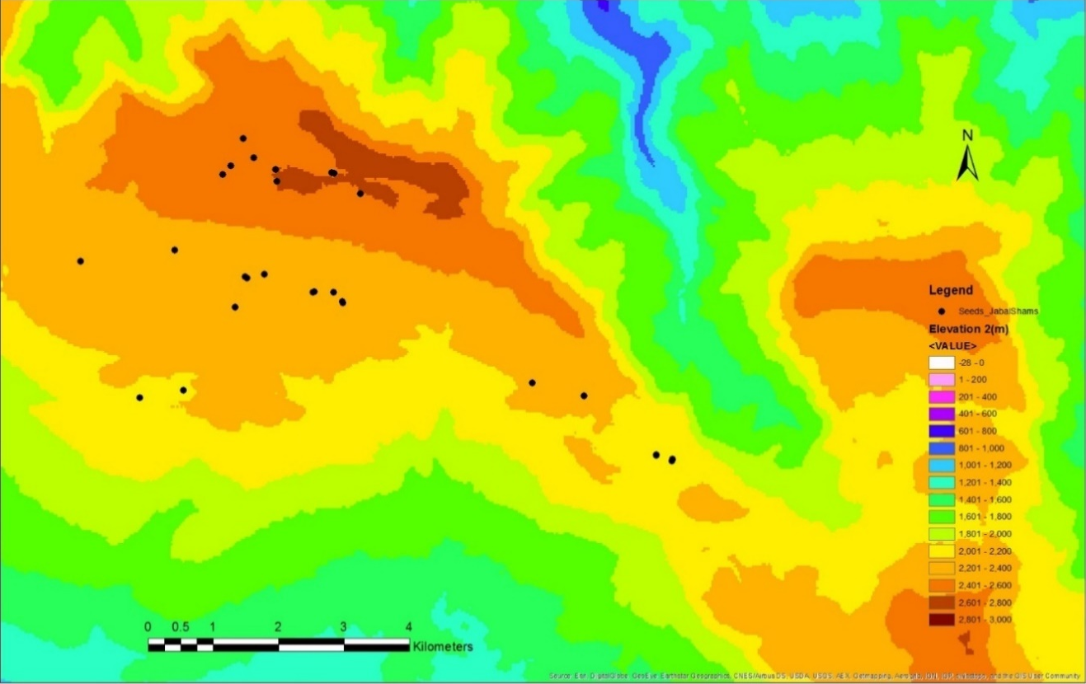

Figure ‎5.1 Satellite image of J. seravschanica cone collection sites in the Northern Mountains of Oman (Source: Esri. Digital Globe, Geo Eye, Earthshow).

General linear model (one-way ANOVA) was used to assess the differences between the altitudes for total seed number, percentage of filled seeds, and seed fresh weight. The non-parametric, Kruskal-Wallis test was used to assess the influence of altitude in proportion of insect infected seeds. Mean values of three replicates per tree were used for analysis. Pearson’s correlation and linear regression models were used to identify the relationship between trees health, number of seeds, and percentage of filled seeds. Pearson’s correlation coefficient was used to identify the relationship between the selected variables; data were considered to be correlated if P< 0.05. Linear regression model was used to understand the relationship of the correlated variables; a number of seeds were removed from the model because it showed no correlation with tree health. Tree health condition was set as predictor for percentage of filled seeds.

Results
Total seed number
The mean total number of seed per 100 cones was significantly different between altitudes (P= 0.001). Trees at high altitude produced significantly more seeds per 100 cones (approx. 462) than trees growing at low (368) or middle (358) altitudes (Figure ‎5.2).

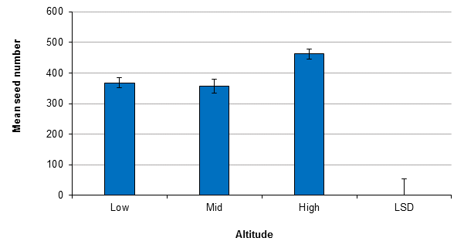

Figure ‎5.2 Mean seed number per one hundred Juniperus cones from different altitudes (Low, Mid, and High). LSD(0.05, DF=27, n=10)= 54.6 and standard errors of the mean are presented.

Insect damaged seed
The proportion of seeds damaged by insects was relatively small (< 5%), although rates were higher with seed from high (4.6±2.0%) and low (4.9±1.8%) altitudes than those of the middle altitude (2.6±0.5%). Kruskal-Wallis test indicated no significant effect of seed source (altitude) in the proportion of infected seeds (P= 0.82).

Percentage of filled seed
Trees at low altitudes had a lower proportion of viable (filled) seeds (9.5%) than those from middle and higher altitudes, 13.2 and 15.3% respectively, not significantly different (P= 0.1, Figure ‎5.3). There was no difference found between the middle and high altitude ranges with only 2% difference between the two.

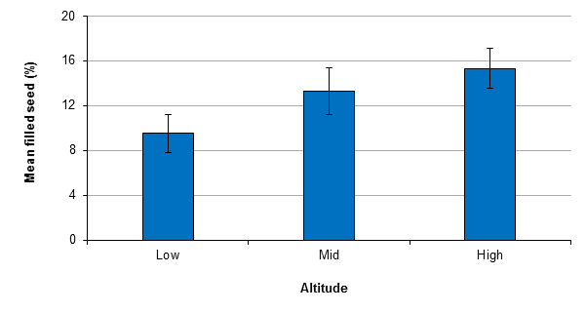

Figure ‎5.3 Mean filled seed percentage per one hundred J. seravschanica cones collected from different altitudes (Low, Mid, and High). Standard errors for the mean are presented. LSD was not calculated due to non-significant effect.

Seed fresh weight
ANOVA analysis indicated no significant influence of altitude in seed fresh weight (P= 0.06). Batches of seed though, collected at low and mid altitude had greater fresh weight (0.89±0.054 g and 0.88±0.052 g per 50 seeds, respectively) than equivalent batches from the high altitude (0.69±0.069 g).

Relationship between seed characteristics and trees health condition
The percentage of filled seed was found to be significantly influenced by the physical condition of the tree (P< 0.05). Seeds produced by healthy trees were more viable than those produced by unhealthy stressed trees (Figure ‎5.4). No influence of tree health on seeds number was found. The regression model indicates that tree health condition can explain a significant amount of the variance associated with the percentage of filled seed [F(1,28)= 11.05, P< 0.05, R²= 0.283, R²_{Adjusted}= 0.257]. This analysis suggests that health status of parent trees can be used to predict the percentage of filled seed.

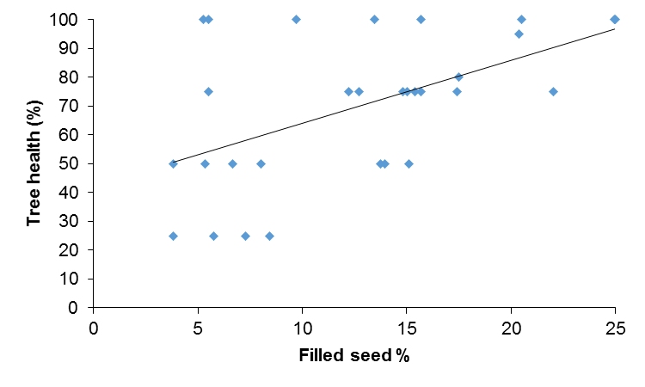

Figure ‎5.4 The relationship between trees health status and filled seed percentage.

Hypothesis tested
- Results confirm the hypothesis that altitude influences seed reproduction characteristics of Juniperus. Trees at low altitude produce less seed per cones with less seed viability (i.e. filled seed).
- Results confirm the hypothesis that healthy trees produce more viable seeds than unhealthy or stressed trees.
- Results suggest that reduced seed viability at lower altitude could be one of the reasons for lower natural regeneration at this range.

Experiment 2: Effect of different temperatures on seed germination

Hypothesis to be tested
To date, no seed germination trials have been carried out on native J. seravschanica grown in Oman. This experiment was implemented to examine the following hypothesis:
- Excessively high temperature e.g. >25°C will inhibit seed germination of J. seravschanica under controlled environment.

Material and methods
Mature J. seravschanica cones were collected in 2013 from healthy trees in Hayle Al-Jwari, part of Jabal Shams, 2300 m asl, and then cleaned and stored in OBG (more detail in section 3.2.1). Seeds were sown in plastic trays filled with fine peat. In each tray 50 seeds were planted. Six incubators were used to provide differential temperature regimes i.e. 5, 10, 15, 20, 25 or 30°C. The photoperiod was set for 12:12h light/dark in each incubator. Light and temperature levels were selected based on field conditions in spring between the lower and higher altitudes within the mountain zone. The number of seeds germinating was monitored every seven days for 16 weeks. Sowing was carried out at two separate times, March 2014 and June 2014. Germination was deemed to have taken place when the first cotyledon appeared from the soil. At the end of the experiment, germination percentages and mean germination time (MGT) were calculated. The mean germination time was calculated using the following equation:
MGT = Ʃ (n * t) / Ʃ n
Where n is the number of germinated seed at each recording time, t is the recording time in days. Ʃ n is the sum of total germinated seeds (Tigabu et al., 2007).
The experiment involved 6 temperature regimes x 3 replicates x 50 seeds x 2 sowing times (March and June). Average of three replicates was used for analysis. Germination percentage and MGT was analysed by one-way ANOVA using Welch test, due to inhomogeneity in variance, with temperature as independent factor.

Results
Germination percentage
Temperature significantly affected germination (P= 0.03), with reduced rates of germination particularly associated with both the lowest temperature, 5°C, and the highest temperature examined, i.e. 30°C, (Figure ‎5.5). Seeds germinated under 10, 15, 20, and 25°C were broadly comparable with maximum germination occurring under 15°C (22.6%).
Mean germination time
Germination was monitored for 115 days to calculate the mean germination period for each temperature. Analysis indicates a significant effect of growing temperature in germination rate (P< 0.01, Figure ‎5.6). Germination tended to be fastest at 25°C with a mean germination time of 44 days. There was no significant difference in rate of germination between this temperature and either 15, 20 or 30°C. On the other hand, germination at the two coldest temperatures, 5 and 10°C was significantly slower (P< 0.05).
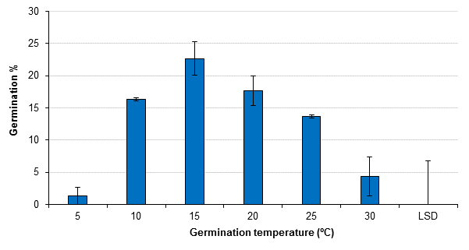

Figure ‎5.5 Mean germination percentage of J. seravschanica at six different temperatures. LSD(0.05, DF=6, n=2) =6.8 and standard errors for the mean are presented.

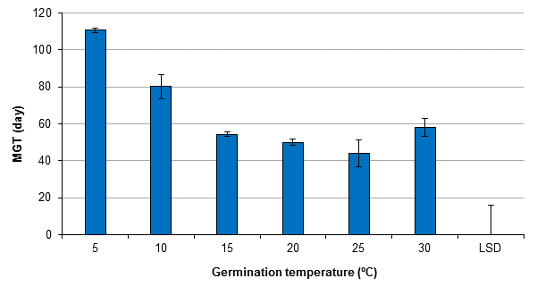

Figure ‎5.6 Mean germination time of J. seravschanica germinated at six different temperatures. LSD(0.05, DF=6, n=2)= 15.8 and standard errors for the mean are presented.

Hypothesis test
- Results confirm that excessively high temperature (>25°C) reduces seed germination of J. seravschanica in a controlled environment. The germination capacity, quantity and rate, was the greatest between 15 to 25°C.

Experiment 3: Influence of seed source (altitude), temperature, and prior cold stratification on germination of J. seravschanica seed

Hypothesis to be tested
This experiment was set to investigate the following hypothesis:
- Juniperus seeds collected from high altitude have a higher germination percentage than those from low and mid altitudes.
- Subjecting Juniperus seed to cold stratification breaks seed dormancy and increases seed germination.
- Temperature has an effect on seed germination.

Material and method
Mature cones were collected from 30 different trees along three different altitudinal gradients. These were sourced from the same trees as in the viability test experiment (see section 5.3.2). Seeds were extracted and soaked in water to remove floating (empty) seeds. Three hundred seeds from each collection were counted, and kept in small plastic boxes; silica gel was used to reduce humidity and avoid fungal infections. Sub-batches of seeds were either kept in the dark at 4°C for three months (Stratified) or stored in paper bags at an ambient room temperature of approximately 20°C (Control). After three months, seeds were removed from their storage conditions and soaked in warm water for 24 hours. Batches of seed from each treatment combination were then planted in 9 cm plastic pots filled with fine peat; 25 seeds being sown in each pot. Pots were placed in incubators at either 15°C or 25°C to determine how temperature interacted with the other factors to influence germination (Figure ‎5.7). These temperatures were selected based on results from the previous experiment. Pots were irrigated once every two weeks from the bottom of the pots. Germination rates were monitored once a week for 12 weeks. Germination date, number of days to germination and number of germinated seeds per week were recorded. At the end, germination percentages and mean germination time (see section ‎5.4.2) were calculated.
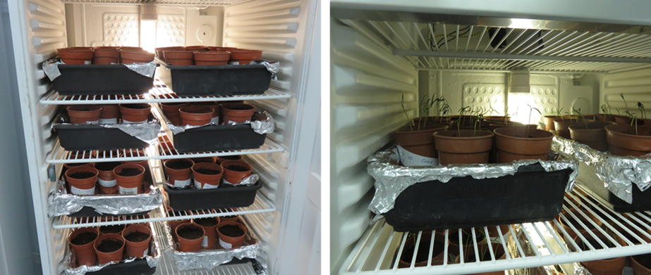

Figure ‎5.7 Seed germination trial under controlled condition.

The experiment included three independent factors: altitude, the influence of pre-treatment and the temperature at germination with three replicates per treatment combination (3 altitudes x 10 trees x 2 pre-treatments x 2 growing temperatures x 3 replications/pots). In each incubator, pots with stratified and non-stratified seed were randomly placed. The mean of the three replicates were used for analysis. Two treatments had no seeds germinate, thus MGT was not calculated for these and were excluded from the analysis. Three-way ANOVA was used to determine the significant differences in germination percentage and rate among altitude, germination temperature and pre-treatment. Multiple comparisons, both LSD and Sidak were used to indicate significant effect of each treatment combination.

Results
Germination percentage
Analysis of variance indicated that collection source (altitude) had a significant effect on seed germination under controlled environmental conditions (P= 0.001, Table ‎5.1, Figure ‎5.8). Seeds sourced from a high altitude had significantly higher germination percentage than those sourced from low and mid altitudes (Table ‎5.1, Figure ‎5.8). Analysed data indicated that there was a significant effect due to the temperature seeds being germinated under (P= 0.005, Figure ‎5.8), with 15°C promoting a greater percentage germination than 25°C (Table ‎5.1). There was no overall significant effect of pre-treatment (P= 0.2, Figure ‎5.8), although stratified seed sourced from the lowest altitude experienced a reduction in germination percentage when placed at 25ºC compared to non-stratified stock, not significant. Analysis indicated no significant interaction between all tested combinations (P> 0.05).

Table ‎5.1 The effect of seed source (altitude), temperature and stratification in Germination % and mean germination time (MGT). Standard errors of the mean are presented.
 |  | Germination % | MGT (days)
Altitude | Low | 13.4±1.7 | 34±1.1
 | Mid | 14.1±1.7 | 36±1.1
 | High | 21.6±1.7 | 36±1.1
Temperature | 15°C | 19.2±1.4 | 40±0.9
 | 25°C | 13.5±1.4 | 30±0.9
Stratification | Control | 17.7±1.4 | 33±0.9
 | Stratified | 15.1±1.4 | 37±0.9
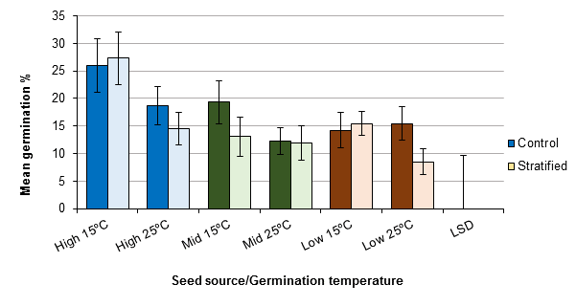

Figure ‎5.8 Mean germination percentage of seed collected from different altitudes (Low, Mid, and High) with two pre-treatments (Control, and Stratification) and grown in two different temperatures (15 and 25°C). LSD(0.05, DF= 108, n=10)= 9.6 and standard errors of the mean are presented. LSD is not applicable to indicate differences between pre-treatment at each altitude/temperature due to non-significant effect.

Mean Germination Time
Results indicated that there was no significant effect of altitude in mean germination time (P= 0.39, Table ‎5.1). The significant effect of growing temperature was observed (P< 0.001, Figure ‎5.9); seeds germinated under the lower temperature (15°C), taking longer to germinate than those under 25°C (Table ‎5.1). The results also showed that cold stratification significantly increased the MGT compared to non-stratified seed (P= 0.002, Figure ‎5.9). No significant interaction between all tested combinations was indicated (P> 0.05).
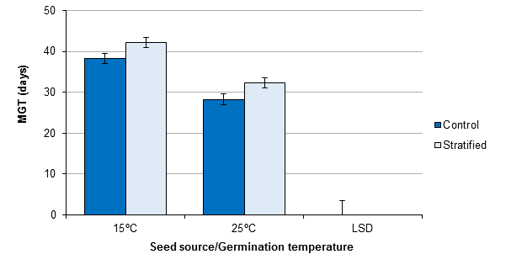

Figure ‎5.9 Mean germination time of seed collected from different altitudes with two pre-treatments (Control, and Stratification) and grown in two different temperatures (15 and 25°C). LSD(0.05, DF= 108, n=30)= 3.5 and standard errors of the mean are presented.

Hypothesis test
- Results confirm the hypothesis that seeds collected from high altitude have higher germination capacity than those from low and middle altitudes.
- Results reject the hypothesis that cold stratification pre-treatment increase seed germination of Juniperus seed. Low seed germination, in most cases, and delay in germination were recorded when seed pre-stratified.
- Results confirm that temperature influences seed germination with 15°C having greatest germination, although seed took more time to germinate.

Experiment 4: In-situ seed germination of J. seravschanica in the Northern Mountains of Oman

Hypothesis to be tested
Laboratory germination of J. seravschanica seed has shown some success, however, in-situ seed germination is perceived to be very low, with poor levels of seedling recruitment being reported. Temperature variations as a result of changes in altitude, and water availability can play a role in germination. This experiment aimed to investigate the following hypothesis:
- In-situ seed propagation can enhance Juniperus regeneration in the field.
- Abiotic changes associated with altitude have an effect on seed germination in the natural habitat.
- Water availability is the primary factor influencing seed germination in Juniperus within the natural habitat.
- Sowing time strongly influences germination rates of Juniperus seed.

Material and method
In each of the nine selected field trial plots (see chapter 3 section 3.2 for more details) an area of 12 m² was cleaned of grasses and rocks and used to evaluate tree regeneration from field-sown seed; all plots were fenced properly to provide protection from animals (Figure 5.10). The cleared areas were divided into sub-plots (45 in total each 0.3 x 0.3 m and watered prior to sowing). A piece of flat wood was used to ensure seeds were sown at consistent spacing (50 mm apart) and depth (10 mm). Seeds used in this experiment were collected in May 2013 from Hayl Al Jwari in Jabal Shams at 2300 m asl (N 23°18’25.23, E 57°06’22.97). Prior to sowing, seeds were soaked in water to remove empty (floated) seeds; sunken seeds were then soaked in water for 24 hours. Twenty-five seeds were sown in each sub-plot. Seed sowing was done at three different times to test the effect of cone ripening and environmental condition. The first sowing was done in April 2014; at the start of cones ripening and before summer season. The second sowing was done in June 2014; most of cones ripened and mid of summer season (before the start of rainfall season). The last sowing was done in September 2014; end of summer season and end of raining season. A total of 10,215 seeds were sown in all locations (3 altitudes x 3 plots x 3 sowing times x 3 watering regimes x 5 replicates x 25 seeds). Plots were irrigated once every week for one month and then three irrigation treatments were applied (Figure ‎5.10): zero irrigation, twice a month (every two weeks) and once a month. Plots were irrigated using a 10-litre watering can with fine spray water nozzles. Each plot was irrigated with 2 litres of water at each time.

Results
No seeds germinated after direct sowing in the ground. This was true of all three altitudinal locations.

Hypothesis test
- Results reject the hypothesis that in-situ seed propagation could be used for Juniperus regeneration in the Northern Mountains of Oman.
- Results reject the hypothesis that abiotic factors related to altitudinal variation has an influence in in-situ seed regeneration.
- Results reject that water availability influences seed germination under natural conditions.
- Results reject that sowing time has an effect in seed germination.

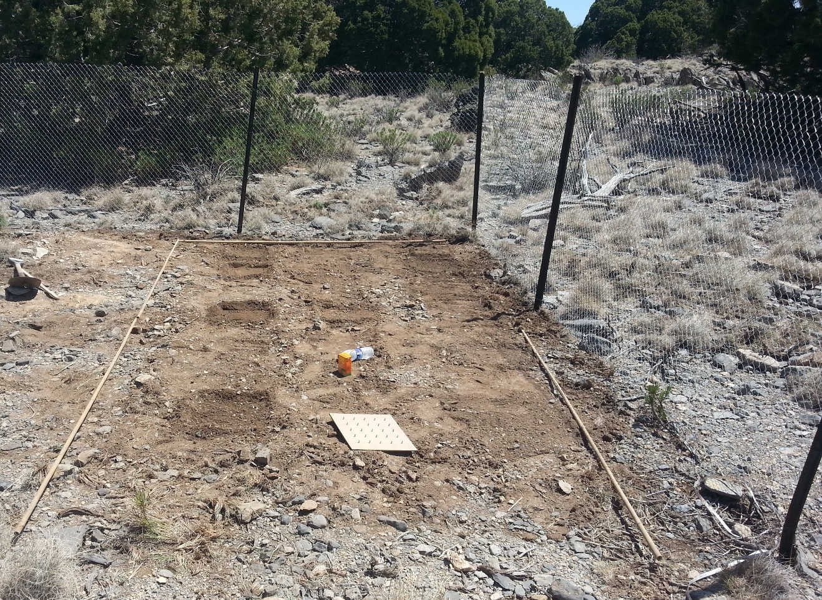
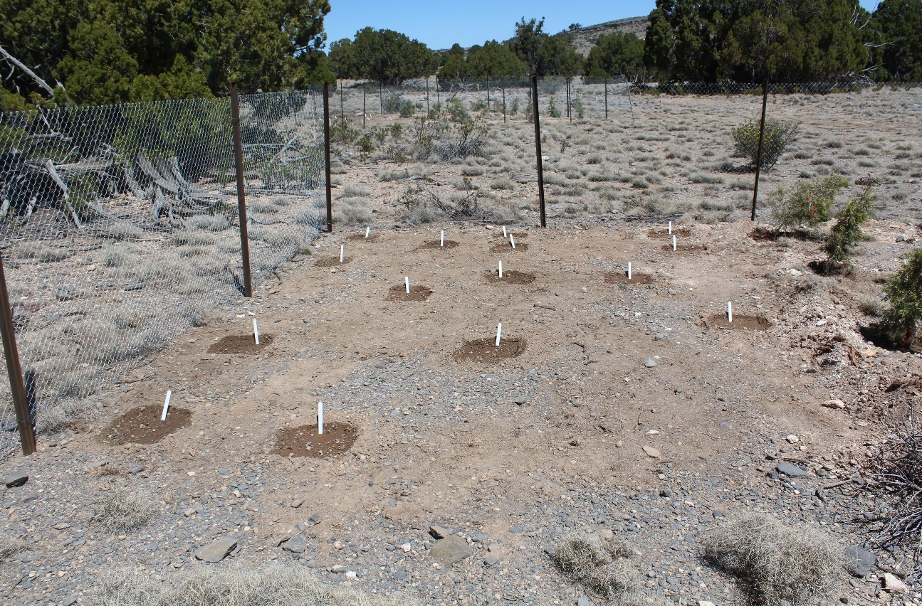

Figure ‎5.10 Above: preparation of seed beds at high altitude. Below: seed beds planted in April 2014 at high altitude of the Northern Mountains of Oman.

Experiment 5: Seed germination of J. seravschanica in the Northern Mountains of Oman

Hypothesis to be tested
Waiting for nearly 8 months, none of the seed sown in the ground germinated (see section 5.6). During the raining season, some of the seed beds were destroyed by soil erosion. An additional pot experiment was conducted in the field to test the following hypothesis:
- Climate effect due to altitudinal variation has an effect in seed germination irrespective to soil factors.
- Soil characteristics and mixture has an effect in seed germination.

Material and method
Field pot seed germination trial was initiated at the end of December 2014 in the Northern Mountain. Juniper seeds were planted in 13 cm plastic pots filled with either field soil or nursery compost (mix of one-part peat with one-part soil). Seeds used for the regeneration experiment (previous experiment) were used following the same procedure. Twenty-five seeds were planted in each pot. Five pots from each soil media were transferred to each of the selected sites at each altitude. Pots were watered once every two weeks.

Results
No seeds germinated after sowing in the pots. This was true of all three altitudinal locations.

Hypothesis test
- Results reject the hypothesis that altitudinal variation has an effect in J. seravschanica seed germination.
- Results reject that seed mixture has an effect of seed germination under field condition.

Discussion

Effect of altitudes and trees condition in seed characteristics and germination capacity
The results indicate variation within J. seravschanica seed production and viability at the three different altitudinal ranges. Juniperus cones collected from trees above 2500 m asl had the highest seed number/100 cones and the highest seed viability. At the middle altitudes (2300-2500 m), seed production was the lowest of the all altitudes; however, these were more viable than those at low altitude. The combination of reduced seed numbers and a greater proportion of non-viable (embryo absent or non-expanded ‘filled’) seed produced at lower altitude (2100-2300 m) suggest that environmental stress has an impact in seed production at this range.
Environmental stresses, such as increasing temperature, shorten the reproductive cycle and influence gymnosperms development by reducing pollination success (Gruwez et al., 2014). Caron et al. (2014) showed a 38% decrease in seed viability of Acer platanoides from seed mass collected from warmer locations to those collected from coldest location in latitudinal gradients from Italy to Norway. Despite the high number of seeds, the percentage of empty seed in this study exceeded 85% at higher altitude and more than 90% at lower altitude, which surpassed the maximum value of aborted J. communis seed in Mediterranean mountain regions (63%) (Garcia et al., 2002) and J. polycarpos in Iran (75%) (Daneshvar et al., 2014). This phenomenon of high aborted seed was also found in other Juniper species; 97% seed abortion of J. Sabina in Mongolia (Wesche et al., 2005) , 85% seed abortion in J. pinchotii in states within the USA (Warren, 2001).
The quality of seeds produced by Juniper trees varies between years and depends on environmental condition (Garcia et al., 2002). In a survey covering 10 Juniperus species over four years, Adams and Thornburg (2016) observed a variation in the percentage of filled seed over years, e.g. percentages filled seed of J. arizona were varied from 34% in the first year to 12% in the fourth year. Mezquida et al. (2016) indicated that water stress during fruit production could decrease seed mass and viability of J. thurifera. Juniperus cones for this study were collected in 2015, so pollination, fertilization and fruit maturation were started from 2013 to 2014. Unfortunately, there is no climate data at the three different altitudes available for these two years. However, climate data from 2015-2016 (Table ‎5.2) indicates that trees at lower altitude exhibit a negative effect in cone production with high temperature combined with low precipitation, drought stress.

Table ‎5.2 Climate data from three different altitudes with mean annual temperature, mean coldest temperature (January), mean warmest temperature (July), and mean annual rainfall for 2015-2016.
 | Altitude  (m asl) | Mean annual temperature (°C) | Mean coldest temperature (°C) | Mean warmest temperature (°C) | Annual rainfall  (mm)
Lower altitude | 2200 | 17.4 | 9.7 | 24 | 291.2
Middle altitude | 2300 | 15.5 | 7 | 22.2 | 347.4
Higher altitude | 2570 | 14.6 | 7.5 | 21 | 353.1

Different insects have been identified from the collected cones such as scale insect and caterpillar. The most serious infection was by seed chalcid (Megastigmus spp. Dalman, 1820), which was the first record of this genus in the Sultanate of Oman (Entomology lab, Sultan Qaboos University) (Figure ‎5.11). Megastigmus species belong to the Torymidae family and it is recognised worldwide as the main seed predator of coniferous species, 49 species are recognised to effect conifers (Roques and Skrzypczynska, 2003; Roques et al., 2016). The nearest country that reported the infestation of this genus was Saudi Arabia in Juniperus procera (Ghramh and Shati, 2011). Analysis indicates no influence of altitudes in seed chalcid infestation. Information on the distribution and host damage of this pest in the Northern Mountains of Oman is still not available. However, Garcia (1998) reported that the main effect of this predator is reducing the amount of viable seed produced by the plant.
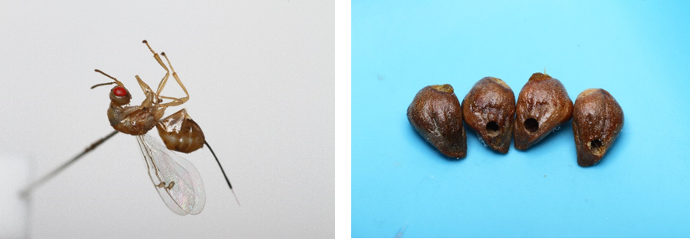

Figure ‎5.11 Left: the female of seed chalcid (Megastigmus spp.). Right: holes in J. seravschanica seeds caused by seed chalcid.

The variation of seed weight indicates that trees produce heavier seed at low and middle altitude than high altitude (0.9, 0,9, and 0.7g respectively). In normal typical cases, lower temperature at high altitudes influence seed germination time allowing seed to ripen slowly and have high seed size. However, resources available during seed development determine how the plant allocates resources to either seed size or number (Harper et al., 1970). Trees grown under stressful conditions (e.g. temperature, drought, or shade) tend to produce lower seed number with heavier seed mass; in which increased seed size is positively correlated with successful establishment of new seedlings (Parciak, 2002; Moles and Westoby, 2006).
In addition, the results indicate a positive correlation between plant health and percentage of filled seed. Most of the trees that produce fewer filled seeds had 50% or less of living foliage. Seeds collected from lower altitude were from trees found in deep valleys, surrounded by hills. Ortiz et al. (2002) suggested that pollination of Juniper trees is perhaps favoured in open structure woodland that has good air movement between trees. The effect of habitat type in J. seravschanica cone production was noticed by Fisher and Gardner (1995) where they found that trees grown in wadi (deep valley) habitat produce less cones than non-wadi habitat in the Northern Mountains of Oman. Pollen abundance due to high density of healthy reproductive trees can also result in production of high viable Juniperus seed (Douaihy et al., 2013). These results could indicate that the potential increase of climatic stresses and high mortality of trees at lower altitudes has caused multiple damage in reproductive ability through its effect on pollination efficiency, and reduction of mature healthy trees.

Effect of temperature and stratification in seed germination
The effect of temperature in seed germination was observed in both germination trials. Under controlled environments, the germination limit of Juniperus seed was between 10 to 25°C, with best germination capacity at 15°C. A previous germination trial has indicated that Juniper seed germinate best at 18°C and are retarded above 20°C (Ansley et al., 1995). Negussie et al. (1991) indicated that the maximum germination of J. excelsa seed was under 20°C (21%) compared to 25°C. A negative effect of temperature in seed germination time was also found, as temperature decreased mean germination time increased. Seed took less time to germinate in temperature above 10°C. Previous studies indicate positive correlation between temperature and rate of seed germination (Probert, 2000), as temperature increased seed germination rate increased.
The germination of J. seravschanica seed collected from different sites varied across the altitudes. The highest value of germination (27.3%) was recorded from seed sourced from high altitude, pre-stratified and grown under 15°C. As noted above, increases in elevation had a positive increase in seed filled percentage and this seems to have contributed to higher germination rates. However, seeds collected form middle altitude had significantly lower germination capacity than those from high altitude; although their seed viability was similar. Elimination of the float seed before seed propagation reduced the number of empty seed and therefore increased germination percentage. Recently, Al Haddabi and Victor (2016) examined the germination of J. seravschanica seeds collected from five different locations in Al Jabal Al Akhdar (Northern Mountains of Oman). They found that the germination success of seed collected from five locations varied from 14 to 31%.

Many studies had indicated the importance of seed stratification for Juniper seed germination (Tigabu et al., 2007; El-Juhany et al., 2009). The results of this study indicate that cold stratification for three months did not significantly influence the germination of J. seravschanica seeds. El-Juhany et al. (2009) found that seed germination of J. procera was higher from non-stratified seed compared to cold stratified seed, 76% and 62% respectively. The influence of stratification in seed germination depends on the stratification type and longevity of stratification. Warm stratification at 20°C for 12-16 weeks followed by cold stratification at 1°C for 12 weeks were found to increase germination capacity of J. polycarpos to 72% compared to 42% with cold stratification alone (Daneshvar et al., 2016). They noted that cold stratification encourages germination of seed with non-deep dormancy, while warm stratification was needed to break dormancy of seed with deep dormancy.

In-situ seed propagation
Field germination of J. seravschanica seeds in the native soil in the Northern Mountains of Oman indicated zero germination after two years. Seeds used for planting were from the same collection used in the first germination trial in the controlled environment and following the same protocol used. This eliminates the effect of seed viability as a cause of non-germination. There are limited studies where Juniperus seed was used as the foundation for a restoration programme in the field. Although 44% filled seed with 100% embryo viability was used at the time of sowing, Warren (2001) reported that after two years from planting, only one seedling out of 1500 seeds of J. pichotii germinated; the germinated seedling being found under shade. The effect of shade by mother trees in seed germination has been reported in many studies (Castro et al., 2002; Padilla and Pugnaire, 2006). In this study, it was difficult to examine the effect of mother plant shade in seed germination as most of healthy Juniper trees at lower altitude are only found in deep valleys, which means seed will probably be washed away from the ground after the rains.

Factors such as soil compaction, soil erosion and drought may have an effect on field germination. Soil textures varied over different sites, however, most of the sites had loamy-clay soil, electrical conductivity ranging from 0.5-1.5 µs cm⁻¹ and soil pH from 7.3-7.6. To test the effect of native soil in seed germination, Juniperus seed were seeded in the natural soil and kept in an incubator at 20°C. Seed germination was comparable to germination rate in the artificial soil (17.6%) (data not shown). None of the seed planted in the pots and placed in the field germinated either, despite a soil compost mix being used (i.e. a medium that was successful under controlled environment conditions). Although pots were irrigated every two weeks (as in controlled experiments), it seems water supply was not sufficient as pots dry quickly under field condition. This may indicate that soil texture and chemistry had little influence over determining germination in the outdoor locations and helps provide evidence that other abiotic factors such as temperature, irradiance and regular supply of water had a stronger determining impact on germination.
Another factor that may influence seed germination is soil erosion. Almost all sites were in slightly sloped areas or surrounded by hills, therefore after each rain event water run-off affected the soil beds. The effect was either the removal of seed from the ground or the deposition of soil on the top of seed beds. In addition, drought and soil temperature influenced seed germination in the field. High precipitation during germination time was noticed to increase seed germination of Pinus sylvestris because it reduced soil temperature and increased soil moisture (Castro et al., 2005a). In our experiment, seeds were sown in bare soil and irrigation was carried out at different intervals. Air temperature during the summer season exceeds 20°C (Table ‎5.2) and rainfall was scattered over the year with some months having no rainfall. These factors increase soil drought and temperature and may lead to loss of seed viability.

Conclusion
- Production of high number of seeds with reduced numbers of aborted seeds at higher altitudes indicates that plants at higher altitude have a higher germination potential than those at the lower zones.
- Seed viability of J. seravschanica in the Northern Mountains of Oman is low; however, it is still within the range of Juniperus seed viability.
- Temperature has strong influence on Juniper seed germination; seed germination was best under 15°C.
- Extensive trials in breaking seed dormancy with more attention to warm and cold stratification could increase seed germination of Juniper seeds.
- In-situ seed germination of J. seravschanica is not an appropriate method for a restoration programme with many biotic and abiotic factors affecting seed germination under field condition.

Chapter 6. Assessment of heat and drought tolerance of J. seravschanica saplings under controlled environment conditions

Introduction
In arid and semi-arid regions, water availability is scarce due to low precipitation which varies in time and amount (Kwarteng et al., 2009). Plants can be affected by both biotic and abiotic stresses. Drought stress is a factor, especially when associated with increased temperature, in limiting species distribution and establishment (Shao et al., 2008; Ditmarova et al., 2010; Anderegg et al., 2013). Drought causes a range of stress responses in plants. Initially soil moisture deficits trigger stomatal closure, resulting in a reduction in photosynthesis. Further water losses in the plant tissues leads to an increasing tension in the xylem water columns, resulting in cavitation and the loss of transpiration conductivity. Cellular dehydration results in an increase in osmotic potential within the cytoplasm, resulting in eventual injury to cell membranes. At extreme stress levels, plants tissues abscise - particularly leaves and entire defoliation can occur. In reality, the response to drought stress depends on its duration, severity and the plant’s ability to adapt to or tolerate the stress. Mitchell et al. (2013) noted that plants could maintain their water turgidity to a level above threshold points by depleting their carbohydrates to mortal level under low intensity drought level. However, under extreme drought, the inability of a plant to maintain water potential above critical point causes plant death through xylem cavitation. Photosynthesis is the first process to be affected by low water potential due to stomata closure and reduction of gas exchange, however respiratory processes continue to function, leading to a depletion in stored carbohydrates and carbon starvation (McDowell, 2011). Coniferous trees are known to have high resistance to water stress through exhibition of physiological and mechanical characters such as lower osmotic potential, sunken and lignification structure of guard cell, and low soil to leaf conductance (Gao et al., 2002). Moreover, extreme heat stress causes damage to leaves, and reduces plant growth, however the main effect is a reduction in light electron transport and photosynthetic capacity (Hamerlynck et al., 2000). The expected increase in temperature during the hot, dry summer season may lead a plant to reach its critical threshold for physiological processes due to limitations of transpiration cooling (Ladjal et al., 2000).
On the other hand, exposing plants to mild stress may acclimate them against future stress (Crisp et al., 2016). Recent studies indicate that plants have the ability to remember past stress events, they use this mechanism to enhance their stress defence; this is often referred to as ‘plant memory’ or ecological stress memory. Walter et al. (2013) defined ecological stress memory as the improvement on all plant response to future stress caused by primary stress event. They argue that it is different from plant acclimation (plants do not have to experience real stress); ecological stress memory can only be tested after a plant completely recovers from a previous stress event, i.e. it retains the capacity to tolerate stress, even after a prolonged period when the plant has not been exposed to stress (Table ‎6.1). Improvement in a plant’s response to stress can be observed when compared to non-stressed plants. Two possible mechanisms of plant stress response improvement after priming have been indicated: accumulation of osmoprotective proteins and epigenetic mechanism (Bruce et al., 2007). Fleta-Soriano and Munne-Bosch (2016) noted that abscisic acid plays a role in drought stress memory in the short term, while epigenetic change can occur in a long term drought stress memory.
In this study, potential presence of stress memory is stated when plants improve their response during post-stress after recovery from the primary stress (e.g. seedlings exposed to severe drought after recovery from mild drought stress). The effect of drought pre-conditioning in post-drought stress was indicated in Eucalyptus seedlings through slower decline in stomatal conductance and cell turgidity indicating improvement in water absorption and restriction in transpiration leading to high survival of pre-conditioning seedlings (Guarnaschelli et al., 2006). Ladjal et al. (2000){Ladjal, 2000, Effects of drought preconditioning on thermotolerance of photosystem II and susceptibility of photosynthesis to heat stress in cedar seedlings;Guarnaschelli, 2006, Drought conditioning improves water status`, stomatal conductance and survival of Eucalyptus globulus subsp. bicostata seedlings} indicated that pre-conditioning conifer seedlings, e.g. Cedrus brevifolia for three weeks of drought enhanced their photosystem II thermos-tolerance when these were exposed to post-heat stress (48°C) after 60 days of recovery; enabling conifer seedlings to tolerate acute dry summer conditions. Walter et al. (2013) concluded that studies exploring the drought stress memory and understanding plant physiological response are needed for different plant species.

Table ‎6.1 Main differences between acclimation and ecological memory (stress memory). Information in this table adapted from Walter et al. (2013).
 | Acclimation | Ecological memory
Expose to primary stress | Plants do not need to experience real stress | Plants need to experience real stress
Response to new stress | Plants may take time to response | Response to stress is quicker than acclimation
Active period | Short term activity | Remain active for long time
Expected improvement | Physiology | Morphology, physiology (short term) and genetic change (long term)
How improvement indicated? | Improvement after primary stress eliminated e.g. difference in response between control and stressed plant. | Improvement in plant response can be indicated when secondary stress applied after recovery from primary stress.

To date, no study investigating the effect of water deficits and increased temperature has been conducted on J. seravschanica (or previous synonym Juniperus excelsa subsp. polycarpos) in Oman or nearby regions. Understanding the morphological and physiological response of plants to environmental stresses is essential for many future conservation programmes (Shao et al., 2008). Manipulation of plants under different temperature levels and water regimes can help scientists, landscape managers and conservationists to understand how plants respond to different environments, especially under extended summer drought conditions that may become more common with climate change (Waghorn et al., 2015). All previous studies investigating the ecological status of Juniperus woodland in the Northern Mountains of Oman indicated water deficits and high temperature were the main cause of Juniperus decline at this region (Fisher and Gardner, 1995; Gardner and Fisher, 1996; Al Haddabi and Victor, 2016; MacLaren, 2016). Although J. seravschanica are classified as drought resistant (Sultangaziev et al., 2010), limited studies have been conducted to understand their response to drought stress. In addition, accelerating climate warming with expected increases in maximum temperature and decreases in precipitation within the region (AlSarmi and Washington, 2011; Al-Kalbani et al., 2015) require a more appropriate fundamental understanding of how trees are going to behave when exposed to these stress factors (Borghetti et al., 1998). This chapter aims to assess the effect of drought stress and rising temperature on the growth and viability of Juniperus trees under control conditions.

Objectives
This chapter examines the following points:
- Investigate the effects of rising temperatures on the growth and physiological parameters of J. seravschanica under controlled environment conditions.
- Examine the influence of different water regimes (drought) on the growth and physiological parameters.
- Investigate the influence of pre-conditioning (controlled drought and high temperature) on subsequent response to water deficit in J. seravschanica.

Experiment 1: Effect of growing temperature and water availability on the growth of J. seravschanica saplings

Hypothesis to be tested
- Growing J. seravschanica saplings at high temperatures (>30°C) reduces growth.
- Exposing saplings to drought conditions will delay development and reduce growth.
- Greatest growth reductions occur when plants are exposed to a combination of heat and water stress.
- Subjecting saplings to high temperature and long term drought reduces the efficiency photosystem II and stem water status of J. seravschanica saplings.

Materials and methods
The experiment was conducted at the Oman Botanic Garden (OBG) nursery. The sourcing of Juniperus seeds, their propagation and production are detailed in section 3.2.1. Five-year-old Juniperus saplings grown at the OBG were placed in three environmentally controlled glasshouses. Glasshouses were automatically controlled and temperatures were set as: low (18–20°C), medium (22–25°C), and high (28–30°C). Weekly water requirements of the Juniperus saplings was assessed by calculating water lost through transpiration of five saplings at lower temperature (18-20°C) - ‘reference plants’. The reference plants were watered to saturation and allowed to drain for 1 hour to determine container capacity (maximum moisture level in the medium once all the macro-pores had drained). Pots were weighted every two days for seven days and brought back to container capacity to determine the amount of water lost through transpiration; the assessments were repeated twice, the average water requirement per week per plant were calculated (2.5 L wk⁻¹). Fifteen Juniperus saplings were lined out in each of the three glasshouses one month before the commencement of the irrigation trials to acclimatize them to the different temperatures. Based on the calculated optimal irrigation volume from the reference plants, saplings within the experiment were subjected to three irrigation regimes: 100% (2.5L wk⁻¹), 50% (1.4L wk⁻¹), and 25% (0.7L wk⁻¹). Irrigation was measured with a hose mounted meter. The experiment was conducted over 12 months, from December 2014 to November 2015. Plant height (apical growth) and shoot growth (lateral growth) increments were measured every two months.
Chlorophyll fluorescence was measured every two months at the end of the week before irrigating saplings. Photochemical efficiency of photosystem II (Fv/Fm) value was used to indicate the effect treatments had on sapling growth. Juniperus relative water content (RWC) was measured twice in the year (every six months), in May and November 2015. A full explanation of the protocols followed for chlorophyll fluorescence and relative water content are detailed in section 3.4 and 3.5 respectively.
The experiment involved 3 temperature regimes x 3 watering regimes using 5 saplings per treatment. For shoot growth, 5 shoots per sapling (shoots were selected randomly from different direction at the top third of the saplings) were selected as replicates. Growths of the five shoots per sapling were averaged and the mean was used for analysis. One year apical and lateral growth were square root transformed. For chlorophyll fluorescence, some saplings grown under high temperatures and low irrigation rates expressed low of Fv/Fm values which affected the distribution and normality of the variance. These values were set as zero and were excluded from the analysis. The true values were used to calculate the mean and standard error for each treatment. For RWC, three twigs were randomly selected from different direction on the top third of the saplings and the average mean of each sapling was used for analysis. Square root apical growth, square root of lateral shoot growth, Fv/Fm value and RWC were analysed using two-way ANOVA with temperature as the main factor and watering regimes as the secondary factor tested under each temperature.

Results
Sapling survival
Saplings had high survival rate after one year. At low and mid temperature, 100% survival was recorded irrespective of water treatment applied. However, at high temperature, 2 saplings died under low water regimes (25% irrigation); no mortality recorded for those received 100% or 50% irrigation at this temperature.

Effect of temperature and water regimes in apical growth
The apical growth of J. seravschanica saplings was found to be strongly influenced by irrigation rates (P< 0.001), with higher volumes of water corresponding significantly to increased apical growth (Figure ‎6.1). In most cases reduction of irrigation volume to 50% or 25% resulted in significant apical growth reduction compared to optimal irrigation; saplings that received 100% water volume had twice the extension growth of the two lower rates (Table ‎6.2). There was no significant effect of temperature (P= 0.14, Figure ‎6.1), however saplings grown at the mid-temperature range showed marginally better growth than either the low or high temperature ranges. Growing saplings under high temperature and low water regime (25%) resulted in the lowest apical growth (6.7 mm year⁻¹) with zero apical growth being measured in the last five months of the experiment, no significant interaction (P= 0.98).
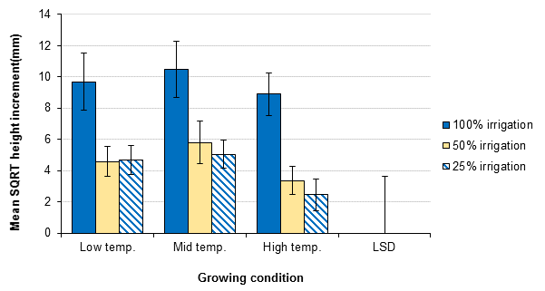

Figure ‎6.1 One-year apical growth increase in J. seravschanica saplings growing under three different temperature (Low, Mid, and High) and watered under three irrigation regimes (100%, 50% and 25%). Data were square root transformed for statistical analysis. LSD(0.05, DF 36, n=5) = 3.64 and standard errors of the mean are presented. LSD is not applicable to indicate differences between temperatures at specific water treatment due to non-significant effect.

Table ‎6.2 Apical and lateral growth increment (mm) of J. seravschanica saplings growing under three different temperatures (Low, Mid and High) and under three irrigation regimes (100%, 50% or 25%). Standard errors of the means are presented.
Temperature |  | Low |  |  |  | Mid |  |  |  | High
Irrigation | 100% | 50% | 25% |  | 100% | 50% | 25% |  | 100% | 50% | 25%
Apical growth
December to March | 45.4±17.4 | 8.8±6.4 | 20.4±7.8 |  | 36.4±7.2 | 16.8±5.2 | 17.6±7.4 |  | 35.4±12.1 | 5.6±4.4 | 4.7±2.5
March to May | 14.4±4.3 | 4.2±1.8 | 1.6±1.0 |  | 25.4±13.2 | 7.0±3.8 | 2.4±1.1 |  | 16.0±5.9 | 3.2±1.4 | 1.7±0.6
May to July | 10.0±2.7 | 4.2±1.5 | 1.2±0.5 |  | 28.2±17.5 | 6.6±5.6 | 2.8±1.5 |  | 8.6±3.3 | 2.2±1.4 | 0.3±0.2
July to September | 27.6±8.2 | 3.4±1.5 | 1.8±0.8 |  | 17.6±7.9 | 7.6±3.8 | 3.2±1.2 |  | 10.4±4.3 | 3.0±1.7 | 0.0±0.0
September to November | 10.2±4.2 | 4.0±2.2 | 0.0±0.0 |  | 15.0±2.3 | 3.0±2.8 | 2.6±1.4 |  | 16.2±4.7 | 0.4±0.2 | 0.0±0.0
One year | 107.6±33.9 | 24.6±11.0 | 25.0±8.8 |  | 122.6±45.3 | 41.0±19.5 | 28.6±8.4 |  | 86.6±25.8 | 14.4±7.9 | 6.7±3.2
Lateral growth
December to March | 12.2±3.2 | 2.8±0.8 | 8.4±3.9 |  | 8.4±1.1 | 6.8±3.3 | 3.8±0.7 |  | 5.6±1.0 | 2.2±0.9 | 1.7±0.5
March to May | 3.6±1.0 | 1.0±0.4 | 1.5±0.9 |  | 4.0±1.2 | 2.2±0.8 | 0.2±0.1 |  | 1.3±0.6 | 0.3±0.2 | 0.2±0.2
May to July | 4.6±1.1 | 1.3±0.3 | 2.0±0.9 |  | 3.0±0.6 | 1.8±1.2 | 1.0±0.2 |  | 1.4±0.2 | 0.5±0.1 | 0.5±0.2
July to September | 2.3±0.7 | 0.7±0.2 | 0.8±0.3 |  | 3.5±1.3 | 2.0±1.1 | 0.6±0.3 |  | 2.1±1.0 | 0.3±0.1 | 0.3±0.1
September to November | 2.6±1.6 | 0.9±0.3 | 0.8±0.2 |  | 2.2±0.6 | 0.6±0.2 | 0.7±0.3 |  | 2.3±1.0 | 0.6±0.4 | 0.0±0.0
One year | 25.3±6.1 | 6.6±0.9 | 13.5±5.5 |  | 21.0±2.9 | 13.4±5.4 | 6.3±0.9 |  | 12.7±2.5 | 4.0±1.3 | 2.7±0.5

Effect of temperature and water regimes on lateral shoot growth
Lateral shoot growth was affected by both changes in temperature and watering rates. One-year shoot growth indicated a significant effect of temperature, with higher temperature corresponding to significantly lower shoot growth (P< 0.01, Figure ‎6.2). A strong significant effect of water on shoot growth was also found (P< 0.001, Figure ‎6.2). A significant reduction in lateral shoot growth was associated with lower water regimes, 25% reduction than the optimal irrigation (Table ‎6.2); this decline in growth was more when associated with heat stress at 30°C, no significant interaction (P= 0.38). Moreover, saplings received 25% irrigation at high temperature had significantly lower growth than saplings received same water treatment at low temperature (temperature effect). In most cases, saplings that received 100% irrigation resulted in twice the amount of shoot growth compared to the 50% and 25% irrigated plants (Table ‎6.2).

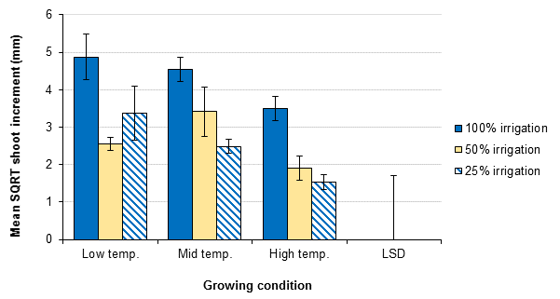

Figure ‎6.2 One-year lateral shoot growth in J. seravschanica saplings under the three different temperature (Low, Mid, and High) and watered under three irrigation regimes (100%, 50% and 25%). Data were square root transformed for statistical analysis. LSD(0.01, DF 36, n=5) = 1.7 and standard errors of the mean are presented.

Chlorophyll fluorescence
Analysis of the variance indicates that both temperature and water treatments had effects on the efficiency of PSII. A significant interaction effect of both stressed factors was observed after two months, February measurement; saplings grown under high temperature with low water regimes had significantly the lowest Fv/Fm values (0.71) (P= 0.001, Table ‎6.3). The interaction effect of both factors was again observed at the end of the experiment, September and November measurement, (P< 0.001). Saplings which received full water regime had the highest Fv/Fm values ranging from 0.79 to 0.83 with no influence of temperature at this water level. Reducing irrigation volume to lower than optimum did not cause great reduction on PSII efficiency in both low and mid temperature (Table ‎6.3). However, a strong reduction in Fv/Fm value was measured for saplings grown on high temperature and low water regime (25%) reaching 0.28 at the end of the experiment, this value was even extremely lower than those grown at low temperature under same water treatment. A significant reduction in Fv/Fm value was also recorded in the last month on saplings grown at higher temperatures with 50% water supply (P< 0.05, Table ‎6.3).

Relative water content (RWC)
Analysis indicated significant effect of temperature (P< 0.05) and water regimes (P< 0.001) in RWC at both measuring times, no significant interaction (P> 0.05, Table ‎6.4). Results revealed that RWC was reduced by water reduction and these reductions were great under high temperature conditions (Table ‎6.4). Although, reduction of irrigation to 50% or 25% of the optimal irrigation rate showed negative significant influence in RWC values at low temperature after six months of starting the experiment, this effect was not indicated at the end of the experiment period. Under mid-temperature, RWC of saplings that received 25% of optimal irrigation was significantly lower than those that received 100% irrigation (P< 0.05, Table ‎6.4). The most significant reduction in RWC was recorded under a combination of high temperature and low water regime (25%), with almost 35% reduction in cell turgidity recorded after one year (Table ‎6.4).

Table ‎6.3 Maximum fluorescence efficiency (Fv/Fm) of J. seravschanica saplings under low, medium and high temperature and three watering regimes (100%, 50%, and 50%) measured during the experiment period. LSD were calculated for P< 0.05, DF=34, n=5 and standard errors for the mean are shown.
 | Temperature |  |  |  | Low |  |  |  |  | Mid |  |  |  |  | High |  |  |  | LSD
 | Irrigation |  | 100% |  | 50% |  | 25% |  | 100% | 50% | 25% |  |  | 100% | 50% |  | 25% |  | LSD
December |  | 0.82±0.004 |  | 0.80±0.007 |  | 0.81±0.012 |  | 0.82±0.007 |  | 0.81±0.007 | 0.81±0.005 |  | 0.82±0.005 |  |  | 0.82±0.002 |  | 0.81±.004 | NA**
February |  | 0.81±0.003 |  | 0.80±0.005 |  | 0.80±0.015 |  | 0.83±0.005 |  | 0.81±0.005 | 0.80±0.007 |  | 0.81±0.004 |  |  | 0.80±0.006 |  | 0.71±.025 | 0.03
April |  | 0.82±0.007 |  | 0.80±0.007 |  | 0.79±0.012 |  | 0.81±0.009 |  | 0.78±0.003 | 0.79±0.013 |  | 0.81±0.004 |  |  | 0.81±0.007 |  | 0.67±0.120* | 0.03
July |  | 0.81±0.006 |  | 0.82±0.005 |  | 0.82±0.010 |  | 0.80±0.012 |  | 0.78±0.009 | 0.78±0.010 |  | 0.79±0.016 |  |  | 0.79±0.009 |  | 0.61±0.156* | 0.03
September |  | 0.82±0.008 |  | 0.80±0.005 |  | 0.78±0.014 |  | 0.81±0.005 |  | 0.80±0.011 | 0.80±0.006 |  | 0.79±0.006 |  |  | 0.78±0.016 |  | 0.66±0.053* | 0.04
November |  | 0.82±0.007 |  | 0.82±0.006 |  | 0.82±0.004 |  | 0.82±0.008 |  | 0.79±0.007 | 0.79±0.009 |  | 0.80±0.010 |  |  | 0.74±0.006 |  | 0.28±0.198* | 0.02
*LSDs are not vailed for these means, mean values ± standard error are shown. **LSD was not calculated due to non-significant effect of both tested factors.
Table ‎6.4 Relative water content (%) of J. seravschanica saplings under low, medium and high temperature and three watering regimes (100%, 50%, and 50%) measured every six months. LSDs were calculated for P<0.05, DF=34, n=5 and standard errors for the mean are shown.
Temperature |  | Low |  |  |  | Mid |  |  |  | High |  | LSD
Irrigation | 100% | 50% | 25% |  | 100% | 50% | 25% |  | 100% | 50% | 25% | LSD
May | 78.9±1.3 | 75.0±1.0 | 74.8±1.3 |  | 78.4±0.8 | 72.9±1.0 | 70.2±1.4 |  | 84.3±0.6 | 80.3±0.8 | 69.2± 3.8 * | 2.9
November | 83.7±0.8 | 78.8±2.4 | 78.2±1.9 |  | 84.3±1.4 | 79.7±1.7 | 77.6±2.1 |  | 83.6±1.4 | 76.8±3.0 | 65.3±4.9** | 6.1
* LSD are not vailed for this mean, mean value ± standard error is shown. **Mean value calculated for three saplings.

Hypotheses results
- Results reject the hypothesis that extreme temperature (>30C°) influences apical saplings growth, but not lateral growth. There was a significant reduction in the length of side lateral shoots on those saplings that were maintained under the highest temperature.
- Results confirm the hypothesis that imposing Juniperus saplings to various drought treatments reduce overall saplings growth.
- Results confirm the hypothesis that a combination of both heat and drought strongly decrease sapling growth. Saplings grown at high temperature (> 28°C) with low water irrigation (25%, 0.7L weak-1) showed the greatest reduction in vegetative growth that led to the eventual death of two saplings.
- Results confirm the hypothesis that growing saplings under both high temperature and drought reduce the efficiency of photosynthesis and reduce water potential of the leaves.

Experiment 2: Influence of pre-treatments of heat and drought stress in fortifying J. seravschanica sapling stress defences

Hypothesis to be tested
- Exposing J. seravschanica saplings to controlled high temperatures and drought conditions enhances their drought tolerance after recovery.

Materials and methods
Juniperus seravschanica saplings that were exposed to different heat and drought stresses were used in this experiment. Saplings grown under low (18-20°C) and mid-temperature (22-25°C) were moved to one glasshouse. Saplings previously grown under high temperatures were not used; four saplings died and others were moved to another location. Saplings were arranged according to their previous irrigation regimes (100%, 50%, and 25%) and given uniform water (2.5 L wk⁻¹) for four months using a drip irrigation system. Irrigation was then stopped for half of the saplings, and continued for the other half. Chlorophyll fluorescence efficiency (Fv/Fm) and relative water content were measured for five weeks. Volumetric soil water content was measured weekly using a soil moisture probe connected to a soil sensor reader (see section 3.6). Four cuts in the middle of the pot were made to insert the probes. Volumetric water content (VWC) was measured under soil-less media mode because saplings were grown in peat-loam mixture.
Since five saplings were previously used for each treatment, dividing saplings under each treatment was done unevenly; however, saplings were divided into equal replicates for temperature and drought treatments. The experiment tested the effect of two irrigation rates (irrigated and non-irrigated) as the main factors. The effect of drought treatment was tested against the previous two stressed factors (2 temperature and 3 water regimes) and these were put as secondary factors. The experiment involved two to three saplings per treatment and four measurements per sapling. Repeated measure analysis of variance (ANOVA) with Greenhouse-Geisser correction were used. Fv/Fm and relative water content set as dependent factors and previous temperatures, previous water regimes and irrigation supplement as independent factors. Date of sampling was set as repeated measure. To indicate the effect of each irrigation treatment independently, data was spilt and analyses were repeated. Pearson’s correlation and simple linear regression was carried out to investigate the relationship between Fv/Fm value and volumetric soil water content at each sampling point.

Results
Chlorophyll fluorescence
The value of chlorophyll fluorescence efficiency (Fv/Fm) showed variability over the duration of the experiment. Saplings that continued to receive water had stable Fv/Fm, above 0.8, regardless of previous treatments (Figure ‎6.3 A). The repeated measure indicates significant decrease on Fv/Fm values during the experimental period [F(1.704,184.07)= 163.65, P< 0.01); significant reductions being observed on the non-irrigated saplings (P< 0.01). Overall analysis indicated no significant effects of both previous treatments (temperature and water regimes) on chlorophyll fluorescence efficiency. However, analysing the non-irrigated saplings independently, indicated significant effect of previous water regimes in Fv/Fm value; saplings that had previously the lowest irrigation (25%) had significantly higher value than those with optimal irrigation (100%) at low temperature (P< 0.05, Figure ‎6.3 B).
A marginal effect of previous temperature was also observed with less sensitivity to drought (higher value of Fv/Fm) found on saplings that had been previously grown under the mid-temperature range, rather than the lowest temperature regime. Plants grown under the initial lowest temperatures also were first to show reduction in Fv/Fm (7% reduction after 21 days), especially those that had been previously relatively well-watered (100% and 50%); whereas the effect of drought on other treatments were observed only after 28 days. Similarly, at the end of the experiment, saplings previously grown under the warmer temperature regime and / or lowest irrigation volume (i.e Mid 25%, Figure ‎6.3 B) retained the highest Fv/Fm value (0.65).
Pearson’s correlation analysis indicated positive significant relationship between maximum chlorophyll fluorescence (Fv/Fm) and the volumetric soil content at the week of measurement (P< 0.05, Figure ‎6.4). The relationship increased over the time of the experiment with R² ranged from 0.05 at the third week to 0.43 at the end of the experiment. The correlation model indicated also that Fv/Fm values of previous drought stressed saplings (25% irrigation) were higher under lower VWC after 28 and 37 days, whereas it was lower under higher VWC for those that received 100% irrigation.

Relative water content
Repeated measure analysis indicated a significant interaction between time and level of drought imposed on RWC data over the period of the experiment [F(5.08, 274.6)= 3.98, P< 0.01]. Continually irrigated saplings showed an increase in RWC; indicating an increase in saplings water status over the period of the study. However, relative water content in the leaves of non-irrigated saplings decreased more than 12% after 21 days in all treatments except those that were previously grown under middle temperature with 25% of water (9.5%) (Figure ‎6.5 B). After 37 days, sharp decrease (more than 25%) was indicated in all saplings that were grown under low temperature, indicating high sensitivity of these saplings to water stress.

Hypothesis test
- Results confirm the hypothesis that exposing saplings to stress, i.e. heat and drought initially, enhanced their defence mechanisms for a second, subsequent period of stress 4 months later.

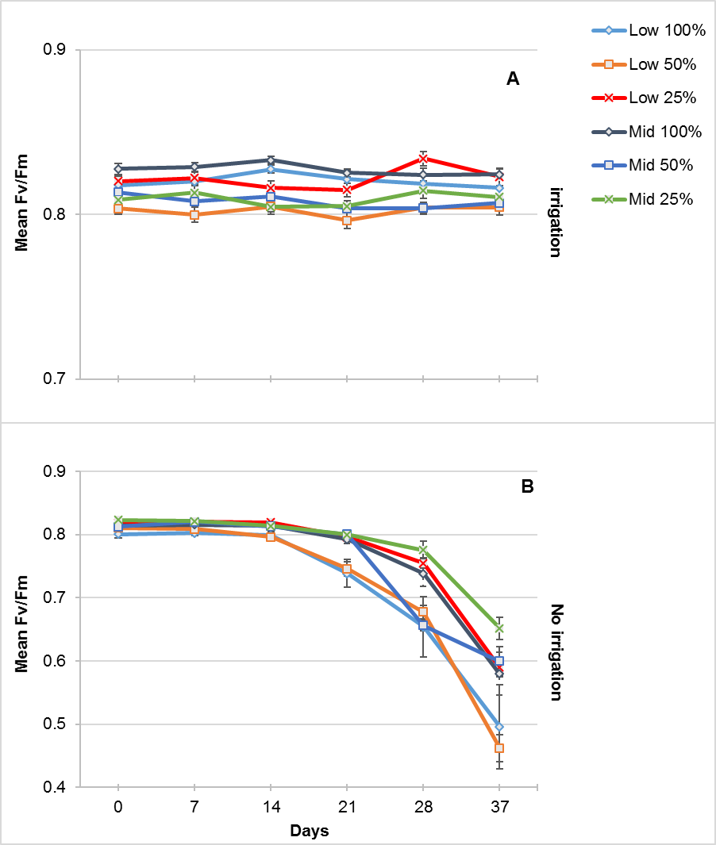

Figure ‎6.3 Weekly maximum chlorophyll fluorescence (Fv/Fm) of J. seravschanica divided by irrigation treatment applied (irrigation - A vs no-irrigation - B). Each bar indicates the previous treatment applied (Low or Mid temperatures and 100, 50 or 25% irrigation) and standard errors for the mean are shown.

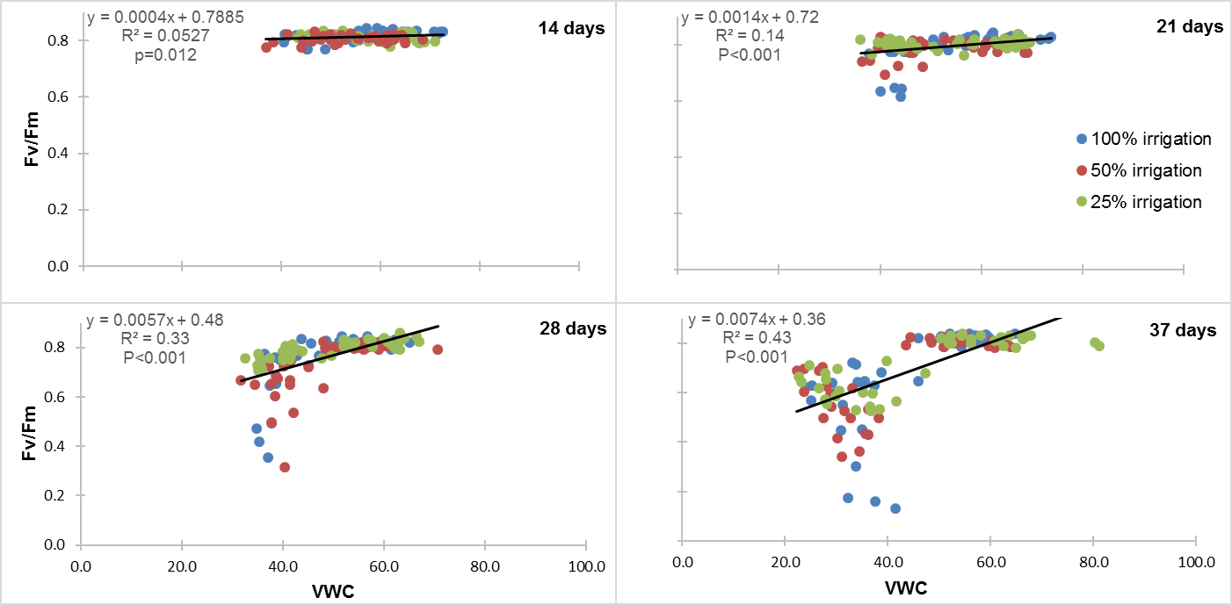

Figure ‎6.4 Relationship between weekly maximum chlorophyll fluorescence (Fv/Fm) and the volumetric soil water content (VWC)at 14, 21, 28, and 37 days. Regression equation, R² and significant of the correlation is showed at each plot. Different colours indicate the previous water treatment, 100%, 50%, and 25% irrigation.
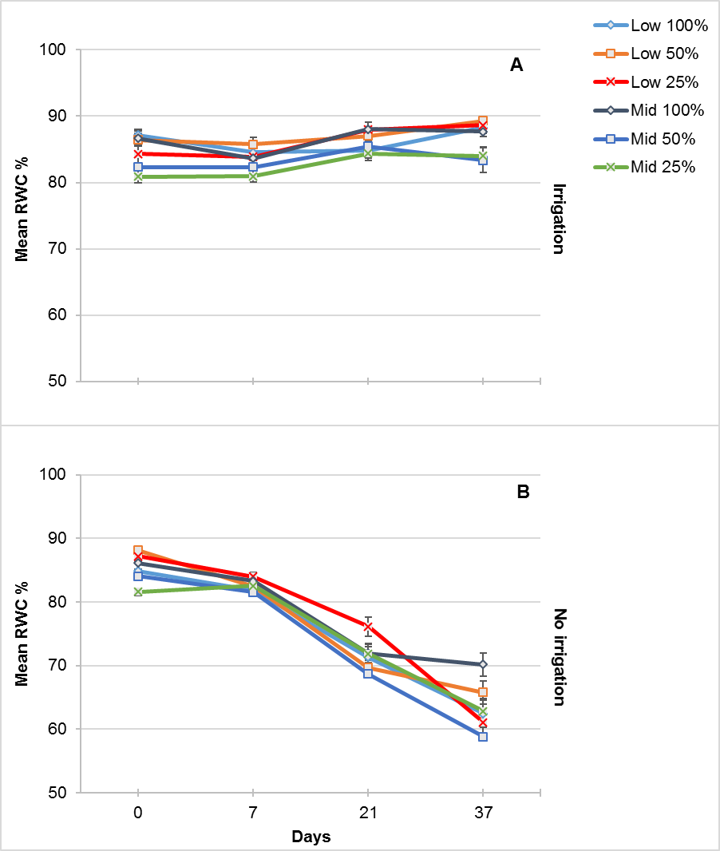

Figure ‎6.5 Relative water content of J. seravschanica divided by irrigation treatment applied (irrigation - A vs no-irrigation - B). Each bar indicates the previous treatment applied (Low or Mid temperatures and 100, 50 or 25% irrigation) and standard errors for the mean are shown.

Discussion

Effect of heat and drought on saplings growth
Environmental abiotic stress induced by factors such as inappropriate temperature and low water availability are key factors that influence plant growth and establishment (Wang et al., 2003). Data from this study indicates that irrespective of varying temperatures, reducing water supply (induced high drought conditions) strongly decreases the above ground growth of J. seravschanica saplings under controlled conditions. In terms of physiological response, saplings maintained their maximal photochemical efficiency at low and medium temperature levels, showing less sensitivity to drought treatment; however, reducing the irrigation to 25% of the optimal rate at high temperatures strongly reduced the photochemical efficiency. Relative water content was more sensitive to drought with lower cell water status being observed under both drought treatments.
Other studies indicate the same phenomenon of shoot growth reduction as a result of either drought or heat stress in conifers. Borghetti et al. (1998) indicated a reduction of 30% in apical growth and 45% in needle growth (lateral growth) on Pinus halepensis due to drought stress. Reduction in apical growth was also observed in Pinus radiata seedlings in response to varying water stress compared to the well-watered seedlings (Waghorn et al., 2015). Under field conditions, Adams et al. (2015) indicated that exposing Pinus edulis seedlings to heat, drought or a combination of both reduced shoot and needle growth by 39% with no growth observed under combination of both heat and drought condition.
Reduction in apical or lateral shoot growth is one of several adaptation responses to limited water availability. High water deficits in the soil reduces water absorption by the roots, which reduce cell water status, and facilitates stomatal closure (Clark et al., 2005), leading to a reduction in stem elongation and overall plant growth (Lipiec et al., 2013). In this study, water stress hampered apical and lateral shoot growth after four months of the treatment. Rossi et al. (2009) noted that cell development and expansion is reduced due to low water status in the plant cell at the beginning of water stress treatment and if the drought stress continues the whole plant metabolism is hampered causing a reduction in shoot growth. Results from this study showed apical and shoot growth stopped on drought stressed saplings under low and mid-temperature, although saplings had efficient photochemical activity. Photochemical processes remained active in plants with as little as 50% water supply under high temperatures.
Stomatal closure as a response to low leaf water status reduced CO₂ assimilation and photosynthesis, however this response does not influence the efficiency of photosystem II at the earlier stage (Baker and Rosenqvist, 2004). Ditmarova et al. (2010) observed the same response in Picea abies, where exposing seedlings to severe drought treatment decreased leaf water potential and CO₂ exchange earlier than chlorophyll fluorescence. Souza et al. (2004) demonstrated that the efficiency of photosystem II activity was not affected at the early stage of water stress, however when drought stress was associated with other environmental stress (elevated temperature) a rapid decrease in chlorophyll fluorescence was detected. The same was observed in this study with a rapid decrease in Fv/Fm value measured under combination of high temperature and low water regime. The occurrence of these physiological and chemical changes in parallel help plants to survive during periods of drought (Ditmarova et al., 2010).
This energy conservation strategy on plant growth and water use under drought conditions has been shown in a number of conifer species. Mitchell et al. (2013) examined the effect prolong drought in two different species, Eucalyptus sp. and Pinus radiata. They indicated that Pinus species, opposite to Eucalyptus sp., had a tight mechanism that includes reduction in growth at the cost of carbohydrate depletion. Brodribb et al. (2014) indicated differences in conifer species in terms of their response to drought when examining 42 different species. They concluded that Pinaceae and Araucariaceae species increase abscisic acid hormone synthesis / activity during water stress to close stomata (i.e. chemical signals). Whereas, Cupressaceae species utilise leaf desiccation (direct hydraulic signals) to close stomata during drought stress. Cupressaceae species are characterised by xylem tissue with high resistance to embolism; this feature with low level of ABA (after 30 days of drought) enables plants to function under high water tension of drought between rain events.
Least growth was associated with saplings grown under both high temperature (>30°C) and low water regimes (25%) with no growth measured in the last four months of the experiment. Two seedlings died under this condition and others showed severe stress symptoms. Exposing plants to both drought and heat stress impacts metabolic pathways and reduces the movement of photo-assimilation products causing a reduction in plant growth (Rossi et al., 2009). High temperature increases both the transpiration rate of the plant and direct evaporation which rapidly depletes the soil moisture; under severe drought the photosynthesis process is reduced because of high respiration and stomatal closure (Zhao et al., 2013). The low relative water content measured under this condition indicates that saplings were experiencing high water deficits. Combination of both low soil water and high respiration encourages xylem embolism leading to xylem cavitation and eventual plant death.

Effect of drought and heat stress on enhancing sapling stress defences after recovery
The aim of this experiment was to examine the effect of previous heat and drought stress applied to J. seravschanica and assess how these stresses might increase the plant’s defence and recovery following additional heat and drought episodes. Unfortunately, saplings from high temperature were unable to be used in this experiment, due to high mortality from the previous experimental phase. However, results from the remaining plant population indicated that initial temperatures and degree of drought stresses applied strongly influenced the ability to tolerate a subsequent, second stress event; indicating a strong positive influence of pre-drought treatments. Saplings grown originally on either mid-temperature or low water regimes showed less sensitivity to stress with higher maximum photochemical efficiency (Fv/Fm) and greater relative water content when measured over the second drought-inducing period.

Exposing plants to different level of stress modified their response or acclimatised them to tolerate upcoming stress exposure (Walter et al., 2011; Crisp et al., 2016). Data here indicated that exposing J. seravschanica saplings to severe drought expedited their response to a repeated drought period. After 21 days of drought, the reduction of leaf water status did not exceed 13% and maximum chlorophyll fluorescence was marginally changed for saplings previously exposed to high drought conditions (25%). Vilagrosa et al. (2003) studied the effect of drought pre-hardening on post-drought treatment on three conifer species under semi-arid conditions. They found that pre-conditioning encouraged Juniperus seedlings to maintain higher water content, higher net CO₂ assimilation and raised maximum photochemical efficiency during post-drought condition. This study suggests that J. seravschanica saplings close their stomata at higher leaf water status as a water conservation strategy which has been stimulated by previous drought treatment. This could be caused by an increase in abscisic acid (ABA) concentration at the early stage of the drought stress. Increase in ABA concentration cause reduction in guard cell turgor leading to stomatal closure. This increase in ABA concentration has been associated with plant response to drought stress and higher levels in ABA concentration were indicated in plants that were previously exposed to double-stress, indicating short term drought stress memory (Fleta-Soriano and Munne-Bosch, 2016). Brodribb and McAdam (2013) investigated the effect of ABA on drought stress response in two conifer species, Pinus radiata (Pinaceae) and Callitris rhomboidea (Cupressaceae). They indicated faster increase in foliar ABA concentration in C. rhomboidea than in P. radiata; this high increase was associated with early stomatal closure even under high leaf water potential. However, the level of ABA decline later as leaf water potential decreased indicating a shift from ABA stomatal closure control to water potential control which help plants recover faster when drought stress is eliminated.
The maximum photochemical efficiency of PSII was higher for given relative water content in previously low watered (i.e. drought pre-conditioned) saplings compared to well-watered saplings, e.g. plants grown previously under mid-temperature with 100% water had Fv/Fm value of 0.58 under 70% RWC compared to 0.65 Fv/Fm value under 65% RWC for those that previously received 25% irrigation. In addition, the value of Fv/Fm was higher under low volumetric water content after 28 and 37 days of drought on pre-drought seedlings (Figure ‎6.4). Chlorophyll photochemical fluorescence has been widely used as an index of electron transport on photosynthetic leaf and reduction in its value has been linked to photochemical damage of PSII or photo-inhibition (Murchie and Lawson, 2013). Priming plants under stressed conditions encourages more effective mechanism for photosystem II repairing and enhance non-photochemical electron transport (Vilagrosa et al., 2003). This may indicate that plants previously exposed to extreme stress enhanced their adaptation through their ability to avoid photo-inhibition damage.

Conclusion
- Drought stress strongly influenced the growth J. seravschanica saplings by reducing the efficiency of photosynthesis.
- Increased water availability to J. seravschanica saplings can reduce the potential negative effects of high temperatures.
- Growing J. seravschanica saplings under both extreme drought and high temperature cause saplings mortality, potentially due to xylem starvation.
- Priming (pre-conditioning) J. seravschanica under extreme drought stress (25% of optimal irrigation) enhances its response to future water stress up to four months of recovery.

Chapter 7. In-situ field establishment of J. seravschanica in the Northern Mountains of Oman

Introduction
In situ conservation is, in most cases, the preferred option when trying to protect and conserve wild plant species and populations, where they can interact with their natural environment (Reichard et al., 2012). Augmenting natural regeneration in disturbed habitats through eliminating the factors that cause habitat disturbance, e.g. control of browsing and human disturbance, could be the first step toward forest recovery (Clewell and Aronson, 2013). However, for some species such as Juniperus, the natural germination and establishment of new plants is very low (Menges, 2008). In the northern mountains of Oman, the proportion of naturally regenerated J. seravschanica seedlings was only nine per cent of total Juniperus populations (Al Haddabi and Victor, 2016). In addition, when conducting a survey on 86 sites along different altitudes, MacLaren (2016) found only four seedlings near the summit of the mountains (3000 m asl); the number of small saplings (less than 2.5 m height) were also very low representing only 10% of the total number of surveyed trees.
This low rate of natural recruitment in addition to a high mortality of adult trees (especially at lower altitudes) raises a major concern for the long term viability of this species (Gardner and Fisher, 1996; MacLaren, 2016). The latest site exploration indicates that a high percentage of healthy trees (limited dieback of foliage) are found at high altitude, towards the east of the mountain range (higher annual rainfall) and on north facing slopes (less direct solar radiation); at low altitude, healthy trees were found in depression habitats (where there may be more soil water retention) (MacLaren, 2016). This data suggests that ecological distribution, health status and establishment success of J. seravschanica are highly reliant on the availability of soil moisture. However, the information to assess the direct association between soil moisture and growth/survival is not currently available.

Water is the major resource influencing successful establishment and growth of newly germinated seedlings under arid climates (Guerrant Jr, 2012). Arid land ecosystems are characterised by low rainfall and seasonal temperature profiles with prolonged hot, dry summers. In addition, yearly variability of rainfall is common with volume and distribution being unpredictable (Hegazy and Lovett-Doust, 2016). The shortage of water during summer results in high stress for plants and limits natural regeneration by increasing seedling mortality which is associated with elevated heat during this period (Garcia, 2001; Castro et al., 2005b). In addition, increases in temperature during summer may induce a reduction in plant photosynthetic capacity due to leaves overheating (Penuelas and Llusia, 2002). Consequently, availability of high soil moisture throughout the early stage of a plant’s life may strongly determine establishment and its long term survival (Classen et al., 2010).
A decrease in a species natural recruitment could be considered a primary indicator of a population distribution change - ultimately leading to a local population extinction. The addition of new planting stock would be essential to facilitate species recovery especially when the limitation is due to a lack of naturally germinated propagules (Godefroid et al., 2011). Translocation of threatened plants to their natural habitat has been widely used as a method to facilitate habitat recovery and augment plant populations in decline (Monks, 2008; Dalrymple et al., 2011). Although the main goal of translocation projects is to increase population size and ensure biological success, the experimental approach should be considered to generate reliable knowledge that can contribute to and direct long term conservation success (Guerrant Jr, 2013). The experimental approach could combine detailed planning such as, appropriate type of propagule to be translocated (seed, seedlings, saplings, cutting etc.), examining different planting locations (based on the presence or absence of threatening processes, and security of the site) and the planting layout design (test of different stresses such as drought, extreme heat, shade etc.) (Monks and Coates, 2002). Translocation of threatened species is likely to increase in future due to the effects of climate change and increased fragmentation of suitable habitats; indeed, most of these efforts offer opportunities to address questions related to climate change issues (Guerrant Jr, 2013). Maschinski et al. (2012b) noted that optimal locations for species distributions will be decreased due to rapid climate change habitat disturbance, thus selecting transplanting sites where a species can maintain its biological biodiversity for a long time is a great challenge.
The current perceived decline in J. seravschanica populations in northern Oman raises the hypothesis that increases in temperature and reductions in soil moisture status due to climate change are responsible for the degradation of the forests. The prevalence of these ‘stressful’ abiotic factors in the mountains of Oman and their interaction on the emergence, survival and establishment of J. seravschanica are not well studied to date. This study aims to investigate the interactive effect of these two factors, thus providing a better understanding of their relative influence on the establishment of J. seravschanica individuals and viability of their populations. In wider terms too, the research aims to determine the potential for transplanting nursery-grown saplings to an arid wild habitat and identify the environmental components that are conducive to plant establishment in the field.

Objectives
- Assess the effect of transplant age on survival and establishment of saplings, when planted out under natural field conditions.
- Identify the effect of environmental variables (mainly temperature and precipitation) associated with changes in altitude in early in-situ survival and establishment of J. seravschanica saplings.
- Study the influence of soil moisture availability on survival, growth and establishment of J. seravschanica along different altitudinal elevations.
- Investigate the potential of augmenting wild populations with new planting stocks and define suitable locations for future transplanting programmes.

Experiment 1: Field establishment and early development of five-year-old J. seravschanica saplings

Hypothesis to be tested
- Plant survival in 5-year old stock is optimised at higher altitudes due to greater moisture availability and lower temperatures.
- Soil water availability is a primary factor influencing saplings establishment; increased irrigation improves survival, growth and photosynthetic capacity rates, irrespective of altitude.

Material and methods
Three planting sites were selected at each of three altitudes, low (2200 m), mid (2300 m) and high (2570 m asl). Sites preparation, sapling planting and post-planting establishment practices are described in chapter 3, section 3. Planting commenced in March 2014. Root development into the parent soil was encouraged over the first six months, by careful and regular irrigation, before any formal treatments commenced. In September 2015, the saplings were exposed to three irrigation treatments, high (irrigation every 15 day- Irrig.15d), low (irrigation every 30 day- Irrig.30d), and control (no artificial irrigation - plants rely completely on natural precipitation). Plants that received artificial irrigation were irrigated with 10 L of water per irrigation event; the water volume was based on the calculated water use ratio in potted saplings in the nursery. Sapling survival and growth were monitored for the following 24 months - September 2014 to August 2016.
At the start of the irrigation trial, a ‘reference’ point near the top of the primary stem of each sapling was marked with tape, and this was used to measure any extension growth (growth increment) over the subsequent months; i.e. the distance between the reference point and the developing tip of the shoot being measured regularly. In addition, five lateral shoots were also selected at different points around the circumference of the sapling and growth increments of these were measured for every two months. Plant growth was recorded at two monthly intervals and percentage survival reported at the end of the experiment.
Chlorophyll fluorescence parameters were collected bimonthly (at the same time of sapling growth measurement) and Fv/Fm values were used to determine physiological stress. Measurements were collected on clear sky days at midday for a single twig per sapling; twigs were dark adapted for 20 minutes prior to measurement and before irrigation (more detailed in chlorophyll fluorescence measurement in section 3.5). Relative water content (RWC) was measured at three times, May 2015, January 2016, and May 2016; measurements were taken for three saplings per treatment at each altitude (more details on RWC measurement procedure in section 3.6). Soil samples collected from each plot before planting were analysed for electrical conductivity (EC), soil pH, total calcium (Ca), total magnesium (Mg), total phosphorous (P) and total ammonium acetate potassium (K), (more details in section 3.8). Moreover, soil moisture values were measured within the proximity of three saplings per treatment at each altitude throughout the study period via soil moisture probes, (more details in section 3.7). Climate data was recorded from three weather stations located at the three planting sites.
The experiment consisted of a randomised complete block design with layout involving 3 altitudes (Low, Mid and High) x 3 blocks x 3 irrigation treatments (Irrig.15d, Irrig.30d, and Control) x 5 saplings per treatment. In the case of lateral shoot development, the mean growth of five shoots were used for analysis. Although, apical and lateral growth were measured bimonthly, yearly growth increments were used for the analysis - the very low bi-monthly growth increments of Juniperus saplings were almost imperceptible which made measuring at this scale difficult. Yearly apical and two years lateral growth were square root transformed. Chlorophyll fluorescence values (Fv/Fm) were analysed for four months representing different seasons and mean value of three twigs per saplings was used for RWC analysis. Plant survival and two years apical growth was analysed by non-parametric, Kruskal-Wallis test. The influence of water treatment at each altitude was indicated dependently. Sapling yearly growth, Fv/Fm value and RWC were analysed for variance using univariate analysis (two-way ANOVA). Altitude was used as a main independent factor and influence of irrigation treatments analysed within altitude. Correlation and linear regression analyses were used to investigate the effect of climatic factors on plant growth.

Results
Sapling survival
Five-year-old saplings had high survival rate in all field sites, over 90%, no significant effect of altitude or water regimes (P> 0.5, Figure ‎7.1, Figure ‎7.2, Figure ‎7.3). At high altitude, 100% survival was recorded irrespective of the water treatment applied, these plants showing more resilience than saplings at lower and middle altitude. In total, six saplings died during the experimental period; at lower altitude, one sapling died under control treatment just after initiation of irrigation treatment and 5 other saplings died during the first summer season (May to August 2015). These small number of plant failures were relatively evenly distributed across the different irrigation treatments.
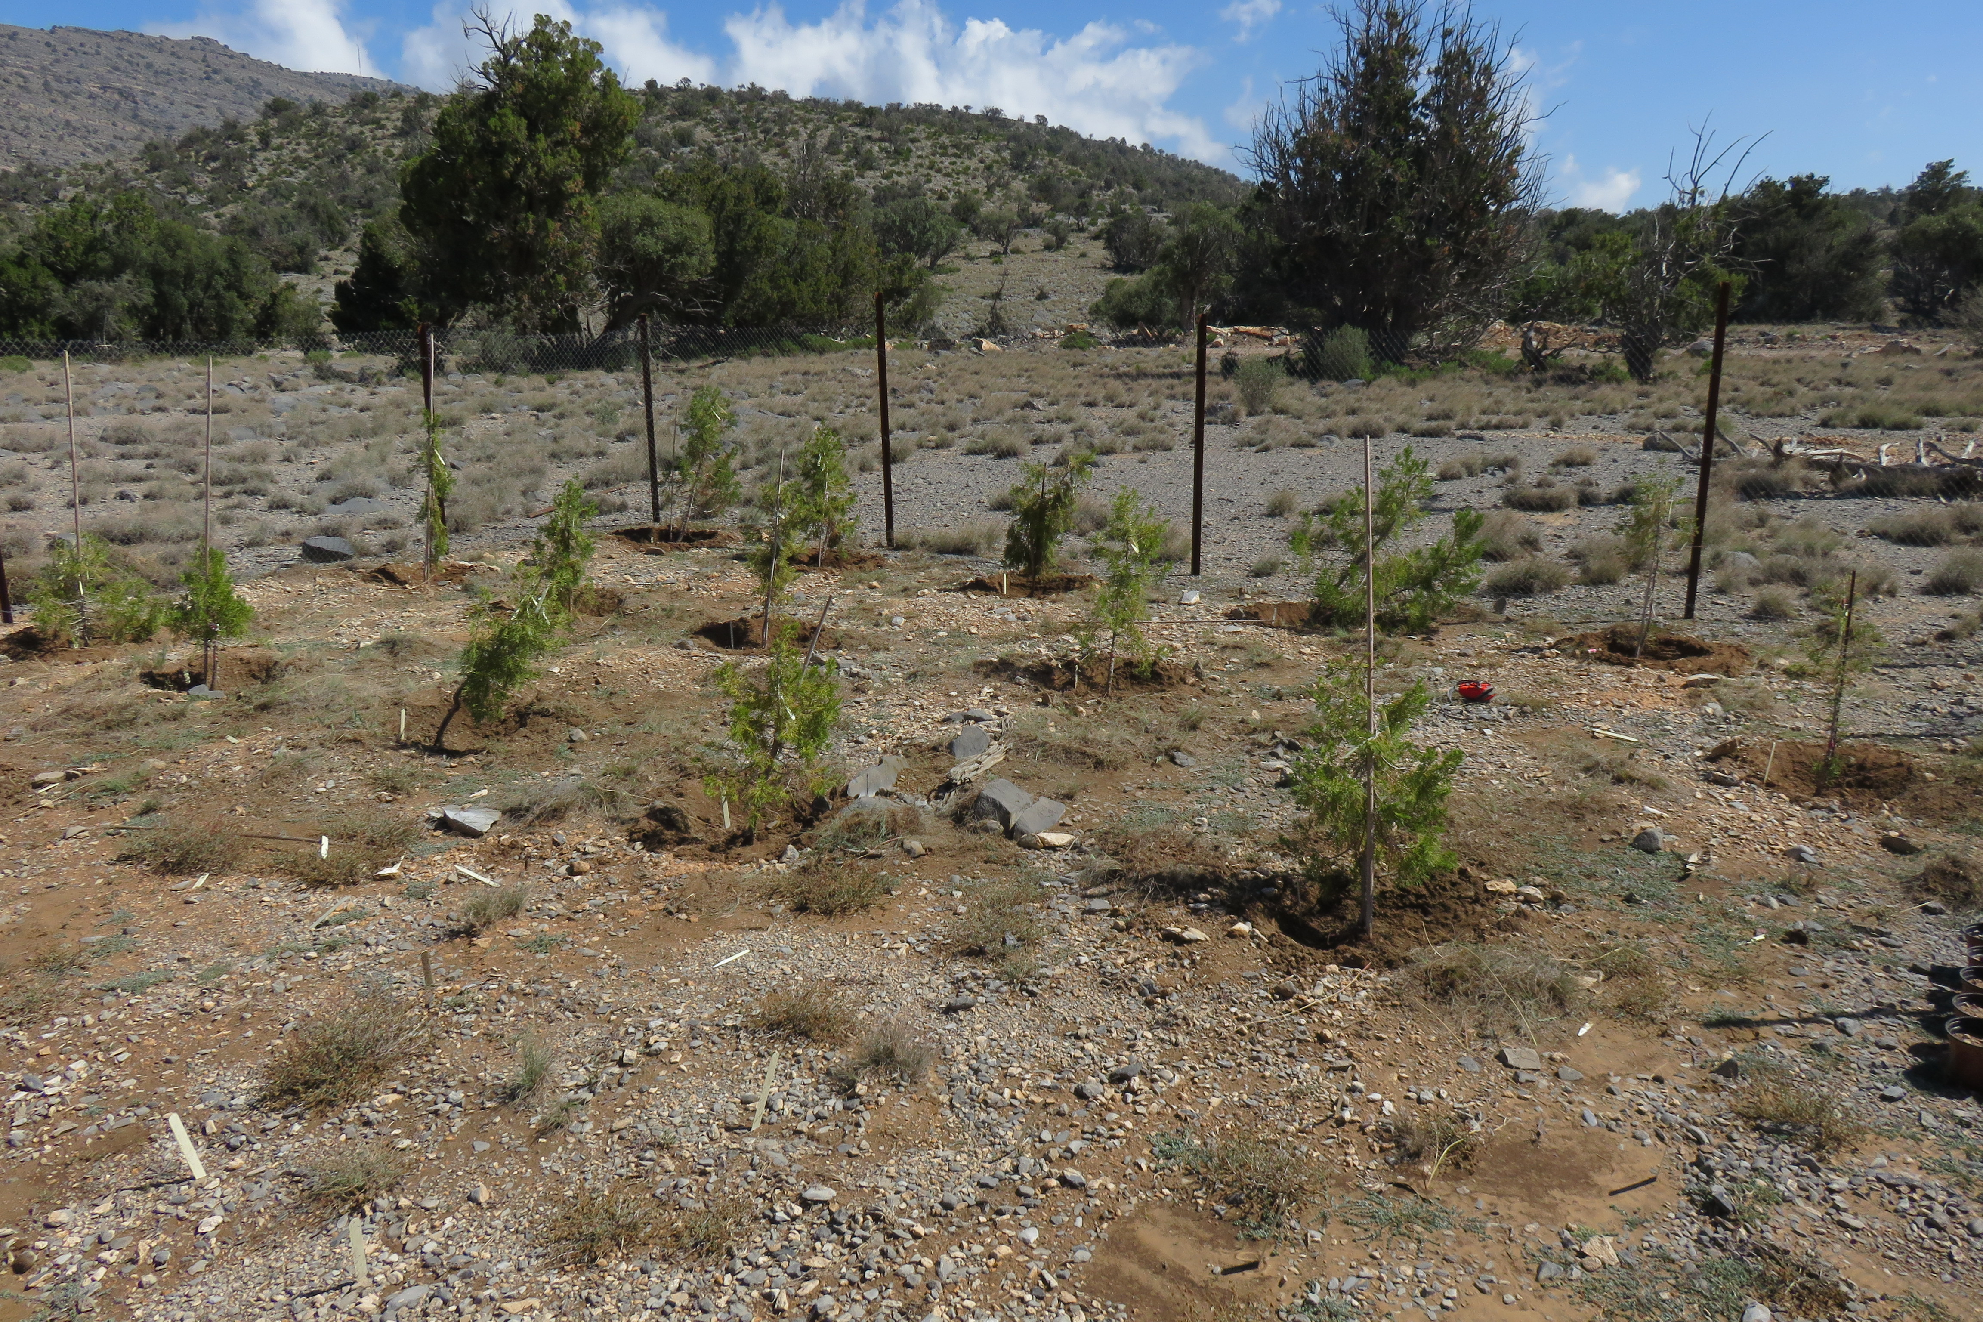

Figure ‎7.1 Field establishment of 5-year-old J. seravschanica at mid altitude (2300 m) (January 2016).
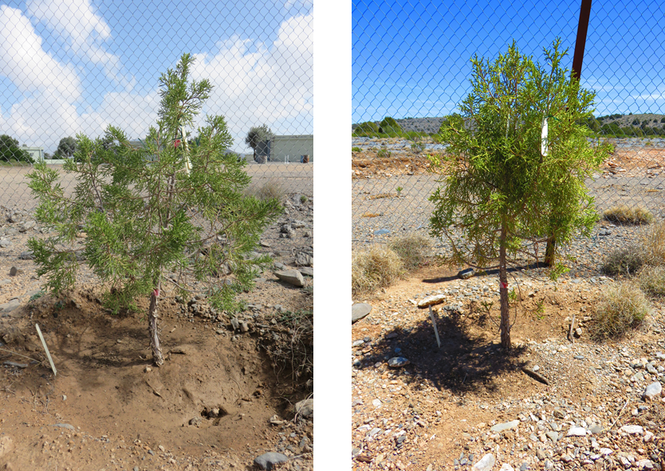

Figure ‎7.2 Five-year-old J. seravschanica after 30 months from field transplanting. Left: sapling growing at low altitude under high irrigation treatment (Irrig.15d). Right: sapling growing at high altitude under control treatment (no artificial irrigation).
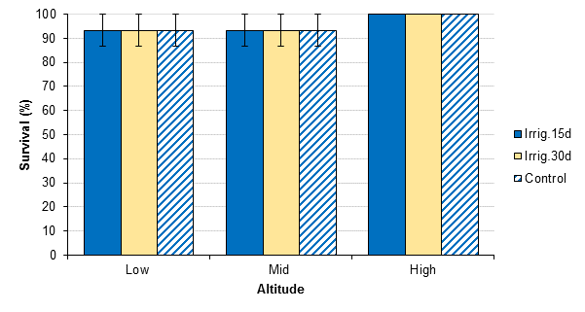
Figure ‎7.3 Survival percentage of 5-year-old J. seravschanica planted at three altitudes (Low, Mid and High) and under three irrigation treatments (Irrig.15d, Irrig.30d, and Control). Standard errors of the mean for lower and middle altitudes are presented.
Sapling height growth increment (apical extension)
Results reported significant effect of altitude in both years and in overall two years growth (P< 0.001) with strong reduction in apical growth at the top of the mountain (high altitude) (Figure ‎7.4, Figure ‎7.5, Figure ‎7.6). The effect of water treatment was not significant in first year growth or second year growth (P> 0.05). However, restricted data a low altitude indicates significant effect of water treatment in two years growth (P= 0.016). Kruskal-Wallis pair-wise comparison reports significant influence of the irrigation treatment on apical extension at low altitude where applying artificial irrigation encouraged significant extension compared to non-irrigated plants; and even significantly higher than at high altitude under the same treatment (Figure ‎7.6). In contrast, applying irrigation at mid and high altitudes did not encourage more extension in plant height. Apical growth in non-irrigated control saplings was not affected in the first six months after the experiment started, but was then reduced for the next 18 months (Table ‎7.1). Growth tended to be promoted at the low altitude over the entire 24 months, with a strong influence of irrigation. At this altitude, apical extension in irrigated saplings (78mm) was twice that of controlled saplings (37mm).
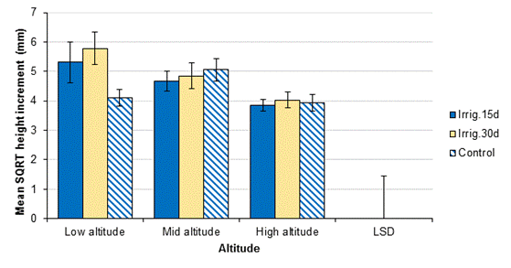

Figure ‎7.4 Height growth increment (mm) over the first year (month 1 to 12) in J. seravschanica planted at three altitudes (Low, Mid and High) and under three irrigation treatments (Irrig.15d, Irrig.30d, and Control). Data was square root transformed for statistical analysis. LSD(0.01, DF 120, n=15) =1.45 and standard errors of the mean are presented. LSD is not applicable to indicate differences between water treatments at each altitude due to non-significant effect.
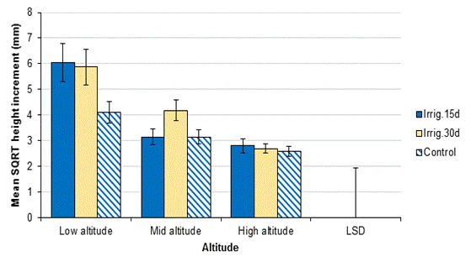
Figure ‎7.5 Height growth increment (mm) over second year (month 13 to 24) in 5-year-old J. seravschanica planted at three altitudes (Low, Mid and High) and under three irrigation treatments (Irrig.15d, Irrig.30d, and Control). Data was square root transformed for statistical analysis. LSD(0.001, DF 120, n=15) =1.94 and standard errors of the mean are presented. LSD is not applicable to indicate differences between water treatment at each altitude due to non-significant effect.
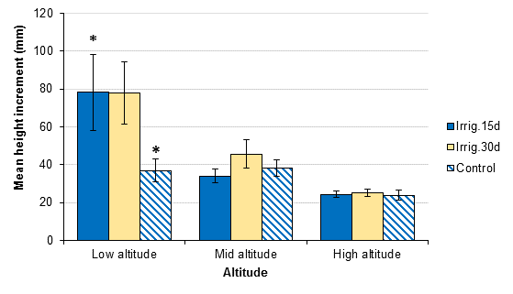
Figure ‎7.6 Height growth increment (mm) over two years in 5-year-old J. seravschanica planted at three altitudes (Low, Mid and High) and under three irrigation treatments (Irrig.15d, Irrig.30d, and Control). Standard errors of the mean are presented (n=15). * indicates significant effect of water treatment at low altitude based on Kruskal-Wallis test.
Table ‎7.1 Height growth (apical) increment (mm) over two years (growth increment every six months) in 5-year-old J. seravschanica saplings planted at three altitudes (Low, Mid and High) and watered under three irrigation treatments (Irrig.15d, Irrig.30d, and no artificial irrigation (Control)). Data is mean ±SE (n=15).
Altitude | Low |  |  |  | Mid |  |  |  | High
Water treatment | Irrig.15d | Irrig.30d | Control |  | Irrig.15d | Irrig.30d | Control |  | Irrig.15d | Irrig.30d | Control
Sep.14-April15 | 12.1±3.1 | 13.2±2.9 | 10.4±1.9 |  | 9.2±1.9 | 8.8±1.8 | 15.1±3.7 |  | 9.5±1.7 | 9.7±2.4 | 11.3±2.1
March-Sep.15 | 22.4±6.9 | 23.7±5.3 | 7.4±1.2 |  | 13.4±2.6 | 17.0±4.0 | 11.7±2.3 |  | 5.9±1.0 | 7.5±0.9 | 5.3±1.2
Year 1 | 34.5±9.3 | 36.9±7.5 | 17.8±2.3 |  | 22.6±3.0 | 25.8±5.2 | 26.8±4.0 |  | 15.4±1.5 | 17.2±2.5 | 16.6±2.3
Sep.15-April16 | 15.1±6.3 | 12.1±2.8 | 6.1±1.2 |  | 6.1±1.3 | 10.4±1.9 | 5.9±1.5 |  | 4.5±0.9 | 3.7±0.9 | 3.9±0.9
March-August16 | 28.5±5.9 | 29.0±8.1 | 13.0±3.9 |  | 5.0±1.0 | 9.2±2.3 | 5.0±0.9 |  | 4.3±0.9 | 4.2±0.8 | 3.4±0.7
Year 2 | 43.7±11.6 | 41.1±10.3 | 19.1±4.7 |  | 11.1±2.0 | 19.6±3.5 | 10.9±1.9 |  | 8.8±1.5 | 7.9±0.9 | 7.3±0.9
Two Years Growth | 78.2±20.1 | 78.0±16.3 | 36.9±6.0 |  | 33.8±3.7 | 45.4±7.5 | 37.6±4.3 |  | 24.2±1.7 | 25.1±2.0 | 23.9±2.6

Sapling shoot growth increment (lateral extension)
The overall two-year lateral growth was significantly influenced by both altitude and irrigation (P< 0.001), no significant interaction (P= 0.3, Figure ‎7.7, Table ‎7.2); total extension ranged between 15.2 mm to 38 mm over 24 months. Saplings grown at high altitude had significantly less shoot extension than those planted at low and mid altitude (P< 0.05, Figure ‎7.7). Applying artificial irrigation at low altitude strongly increased lateral growth (P< 0.05). There was also a positive influence of applying artificial irrigation on branch extension on mid and high altitude (P< 0.05, Figure ‎7.7, Table ‎7.2). No significant effect of altitude in non-irrigated saplings was indicated.

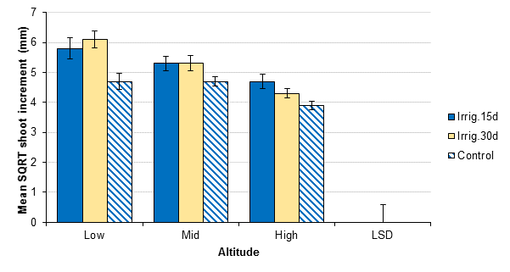

Figure ‎7.7 Lateral shoot increment (mm) over two years (24 months) in 5-year-old J. seravschanica planted at three altitudes (Low, Mid and High) and under three irrigation treatments (Irrig.15d, Irrig.30d, and no artificial irrigation (Control)). Data was square root transformed for statistical analysis. LSD(0.05, DF 120, n=15)= 0.6 and standard errors of the mean are presented.
Table ‎7.2 Lateral shoot growth increment (mm) over two years (growth increment every six months) in 5-year-old J. seravschanica saplings planted at three altitudes (Low, Mid and High) and under three irrigation treatments (Irrig.15d, Irrig.30d, and no artificial Irrigation (Control)). Data is mean ± SE (n=15).
Altitude | Low |  |  |  | Mid |  |  |  | High
Water treatment | Irrig.15d | Irrig.30d | Control |  | Irrig.15d | Irrig.30d | Control |  | Irrig.15d | Irrig.30d | Control
Sep14-April15 | 4.4±0.7 | 6.2±0.8 | 4.9±0.5 |  | 8.3±1.1 | 7.5±1.0 | 6.2±0.9 |  | 5.4±0.4 | 4.9±0.4 | 4.2±0.4
April-Sep15 | 12.6±2.1 | 11.6±1.7 | 6.8±1.0 |  | 9.3±1.7 | 11.1±1.6 | 8.2±0.9 |  | 8.6±1.7 | 4.9±0.5 | 4.5±0.5
Year 1 | 17.1±2.8 | 17.8±1.9 | 11.7±1.2 |  | 17.6±2.0 | 18.6±1.6 | 14.4±1.0 |  | 14.0±2.0 | 9.9±0.6 | 8.7±0.7
Sep15-April16 | 6.9±1.2 | 6.6±0.7 | 3.5±0.4 |  | 4.0±0.4 | 5.1±0.4 | 3.9±0.6 |  | 3.1±0.3 | 4.2±0.5 | 2.6±0.4
March-August16 | 11.6±1.2 | 13.7±2.5 | 8.2±1.7 |  | 7.5±1.0 | 6.4±1.1 | 5.1±0.8 |  | 5.5±0.6 | 5.0±0.7 | 3.9±0.7
Year 2 | 18.5±2.2 | 20.3±3.1 | 11.7±2.0 |  | 11.5±1.1 | 11.4±1.5 | 9.0±1.2 |  | 8.6±0.8 | 9.1±0.9 | 6.5±0.9
Two Years Growth | 35.5±4.5 | 38.0±3.8 | 23.4±3.0 |  | 29.1±2.7 | 30.0±2.7 | 23.4±1.5 |  | 22.6±2.5 | 19.0±1.3 | 15.2±1.1

Influence of environmental factors on sapling growth
Bimonthly apical and lateral increments were significantly associated with soil moisture availability and minimum air temperature (P< 0.01, Table ‎7.3) mean or highest temperature showed no correlation with plant growth. The availability of high soil moisture was more important than the amount of rainfall and minimum temperature for plant growth (regression coefficient was high for VWC than minimum temperature); however, this was strongly dependent on the planting site / altitude (Figure ‎7.8). High soil moisture was more important for plants growth at low altitude; R² value at low altitude was 0.57 (Figure ‎7.8 A), so 57% of the variation in lateral growth was explained by soil moisture content, whereas at mid and high altitude R² was 0.2 and 0.26, respectively (Figure ‎7.8 B and C). The effect of low temperature, however, did not follow a constant trend along the three altitudes; significant effect of low temperature on lateral growth increment was only detected at mid-altitude [F(1,25)= 8.3, P< 0.05, R²= 0.25, R²_{Adjusted}= 0.22].

 | Variable | Coefficients (SE) | t value | P
Apical growth | Constant | -3.5(1.2) | -3.0 | <0.01
 | VWC (%) | 0.53 (0.08) | 6.3 | <0.01
 | Min. temp. | 0.33 (0.07) | 4.8 | <0.01
 | Rainfall | -0.02 (0.008) | -2.9 | <0.01
Lateral growth | Constant | -1.5 (0.51) | -2.9 | 0.004
 | VWC (%) | 0.28 (0.40) | 7.5 | <0.01
 | Min. temp. | 0.18 (0.03) | 5.9 | <0.01
 | Rainfall | -0.01 (0.004) | -2.8 | <0.01
Table ‎7.3 Regression model of the effect of volumetric soil water content, minimum temperature and rainfall on 5-year-old J. seravschanica apical and lateral growth.

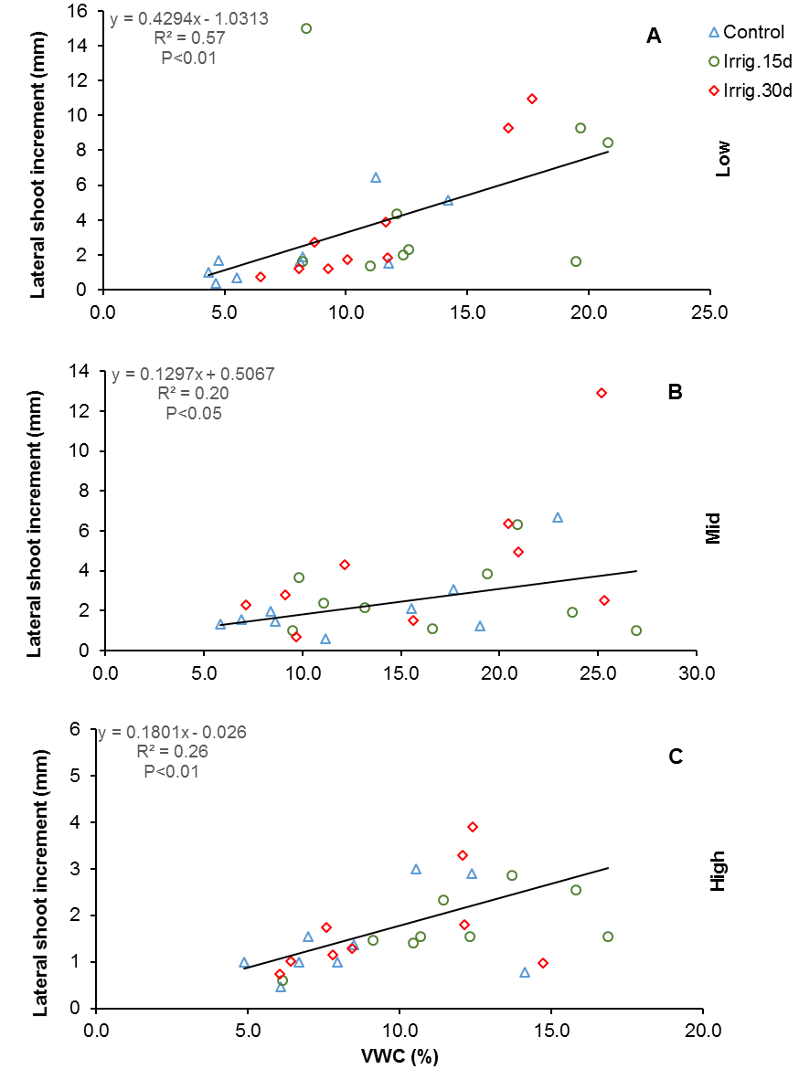

Figure ‎7.8 The relationship between volumetric soil water content (VWC%) and lateral shoot increment (mm) of 5-year-old J. seravschanica planted at Low (A), Mid (B) and High altitude (C), and irrigated with three water treatments (Control, Irrig.15d, and Irrig.30d). Regression equation, R² and correlation coefficient are presented.

Chlorophyll fluorescence
Chlorophyll fluorescence values (Fv/Fm) were varied throughout the experimental period with strong seasonal patterns observed (Figure ‎7.9, Figure ‎7.10). Strong reduction in Fv/Fm values were recorded during winter and summer. Winter stress was not related to altitude (reduction observed in all altitudes), though there was a marginal effect observed in the winter of 2016. However, summer stress was associated with altitude (strong reduction at low altitude) and observed in both summers. A significant effect of water treatment was indicated in fall with significant rise in Fv/Fm values when high frequency of irrigation (Irrig.15d) was applied, particularly at low and high altitudes (P= 0.009). ANOVA indicated a significant interaction of both factors in winter (P= 0.03) with strong decline in Fv/Fm value in non-irrigated plants at low altitude to those that received artificial irrigation at the same altitude or to non-irrigated plants at mid and high altitude. The most notable reduction in Fv/Fm value was associated with some treatments in summer readings (Figure ‎7.9), with great effect based on altitude (P< 0.001) and less effect of water treatments (P= 0.04). Plant grown in low and mid-altitude showed suppression in photosynthetic capacity and application of high level of irrigation at low altitude was important to mitigate the negative influence of water stress, but was not enough to promote a positive response to the stresses they experienced when compared with plants at high altitude, this resulted in a suppressed photosynthetic capacity (Fv/Fm value less than 0.5).

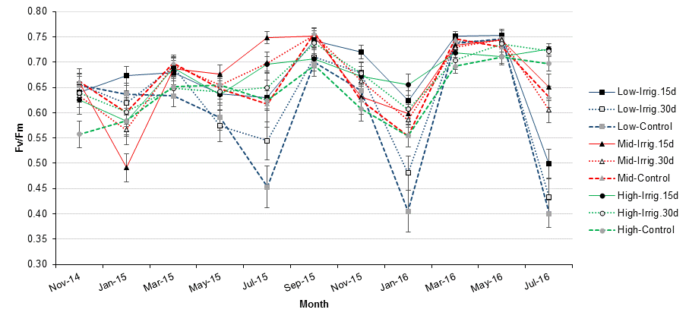

Figure ‎7.9 Maximum chlorophyll fluorescence (Fv/Fm) of 5-year-old J. seravschanica planted at three altitudes (Low, Mid, and High) and under three different irrigation treatments (Irrig.15d, Irrig.30d, and no artificial irrigation (Control)). Standard errors of the mean are presented (n=15).

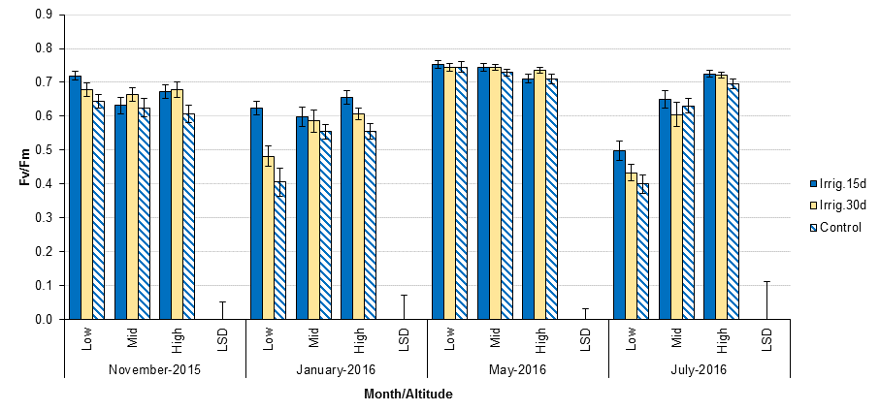

Figure ‎7.10 Maximum chlorophyll fluorescence (Fv/Fm) of 5-year-old J. seravschanica during fall (November 2015), winter (January 2016), spring (May 2016) and summer (July 2016) planted at three altitudes (Low, Mid, and High) and under three irrigation treatments (Irrig.15d, Irrig.30d, and no artificial irrigation (Control). LSDs(0.05, DF 121, n=15) for each month= 0.05, 0.07, 0.04, and 0.1, respectively and standard errors of the mean are presented.
Relative water content (RWC)
Results reported a significant effect of altitude in January RWC (P= 0.009); with non-irrigated trees at mid-altitude having less leaf water content than those at low or high altitude. There was a marginal increase in RWC on plants which received supplementary irrigation, not significantly different (P= 0.05, Figure ‎7.11). Decline in RWC was recorded in May 2015 (RWC< 80%), however, no significant differences were observed between altitudes nor water treatments. A significant effect of artificial water application on RWC was indicated in May 2016 at low-altitude (P= 0.03); saplings that received artificial water (Irrig.30d) had significantly higher RWC than non-irrigated once (Figure ‎7.11).

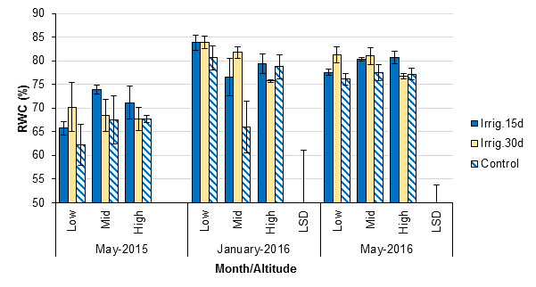

Figure ‎7.11 Relative water content percentage (RWC) of 5-year-old J. seravschanica planted at three altitudes (Low, Mid, and High) and under three irrigation treatments (Irrig.15d, Irrig.30d, and no artificial irrigation (Control)). LSDs(0.01, and 0.05, DF 18, n=3) for each month = 11, and 3.8, respectively and standard errors of the mean are presented. LSD was not calculated for May 2015 due to non-significant effect of both factors.

Soil sample analysis
Soil samples collected from the planting sites had low soil salinity with pH value 7.5 (Table ‎7.4). Calcium (Ca) and magnesium (Mg) concentration was low in all soil samples. Soil available phosphorus (P) varied between the altitudes and between plots; soil samples collected at low altitude had high values of phosphorus. Planting plots located at low and mid-altitude had higher total potassium than high altitude plots.

Table ‎7.4 Chemical properties of soil collected from nine selected plots for J. seravschanica establishment at three altitudes (Low, Mid, and High).
Altitude | Plot | EC (µs/cm) | pH | Ca (meq/l) | Mg (meq/l) | P (ppm) | K (ppm)
Low | 1 | 1.1 | 7.4 | 2.7 | 5.8 | 54.4 | 176.7
 | 2 | 0.9 | 7.5 | 1.7 | 4.7 | 47.4 | 180.0
 | 3 | 0.5 | 7.5 | 2.7 | 4.5 | 21.1 | 143.3
Mid | 1 | 1.0 | 7.5 | 3.7 | 5.1 | 40.5 | 143.3
 | 2 | 0.9 | 7.5 | 3.3 | 5.5 | 16.8 | 170.0
 | 3 | 1.0 | 7.5 | 3.0 | 4.7 | 25.7 | 96.7
High | 1 | 0.6 | 7.5 | 4.3 | 5.7 | 23.3 | 60.0
 | 2 | 0.7 | 7.6 | 2.6 | 4.3 | 24.3 | 43.3
 | 3 | 1.0 | 7.5 | 2.7 | 5.1 | 18.8 | 36.7

Soil moisture
Soil moisture availability was strongly related to artificial water applied (Figure ‎7.12) and to natural precipitation (Figure ‎7.13). Applying artificial water (twice a month) maintained high soil moisture levels in all planting sites; however, a drop in soil moisture was recorded in some instances (e.g. March to July 2015). At low altitude, irrigating saplings twice a month was important to maintain high soil moisture level especially during summer; e.g. soil moisture values were 13.8% (Irrig.15d), 7.8% (Irrig.30d), and 4.2% (control) in July 2016. Soil moisture in non-irrigated (Control) plots was highly correlated with the volume of precipitation at each event (Figure ‎7.13). Mid-altitude had a high soil moisture percentage throughout most of the study period, suggesting consistent and efficient levels of water retention at this altitude. Soil water depletion over time was highly varied between season (temperature) and altitude; rapid depletion occurred during summer, with the highest levels of depletion being recorded at low altitude, more than 50% decrease in soil moisture within four days of irrigation (Figure ‎7.14).

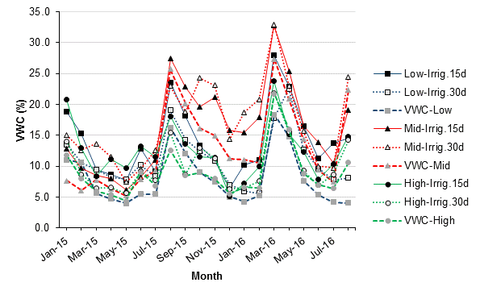

Figure ‎7.12 Volumatic soil water content (VWC %) values measured in plots containing 5-year-old J. seravschanica when planted in three altitudes (Low, Mid and High) and under three irrigation treatments (Irrig.15d, Irri.30d, and no artificial irrigation (Control)). Data presented is mean value of three probes per treatment.
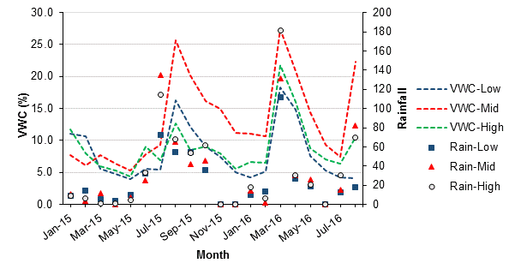

Figure ‎7.13 Volumetric soil water content (VWC %) of the non-irrigated sapling at the three altitudes (Low, Mid and High) and rainfall events (mm) measured at the three altitudes.

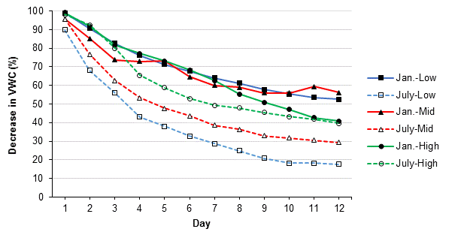

Figure ‎7.14 Soil moisture depletion (%) over time (days) during winter (January 2016) and summer (July 2016) at three altitudes (Low, Mid and High). Data presented are the mean value of two soil moisture probes under high irrigation treatment (irrigation twice a month).

Meteorological data
Climate data reported that low altitude experience the highest mean, maximum and minimum temperatures (Figure ‎7.15); maximum temperature was over 30°C during summer and above 0°C during winter. Maximum and mean temperature were the lowest at high altitude especially during summer. Data showed that mid-altitude had the lowest minimum temperature with temperature drop down to -5°C during winter months; in contrast, it experienced high maximum temperature, similar to values recorded at low altitude (Figure ‎7.15). Total precipitation over the 20 months (January 2015 to August 2016) was greatest at the top of the mountain (above 2500m) (710 mm); compared to 501 and 648 mm at low and mid-altitude respectively (Figure ‎7.13).
Meteorological data also indicated that monthly relative water humidity was less than 60% at all planting sites and dropped down to 20% during summer (Figure ‎7.16); and overall it was lowest at low altitude. In addition, low altitude is characterised by having high wind speed (Figure ‎7.17). Although the monthly average showed that wind speed is between 2 to 9 km/h, the area experienced periods of high wind that often exceeds more than 30 kmh⁻¹, e.g. in Jun 2016 wind speed reach 35 km/h at low altitude. Solar radiation was similar in the three altitudes, over 900 Wm⁻² in summer and below 500 wat/m² in winter (Figure ‎7.18).

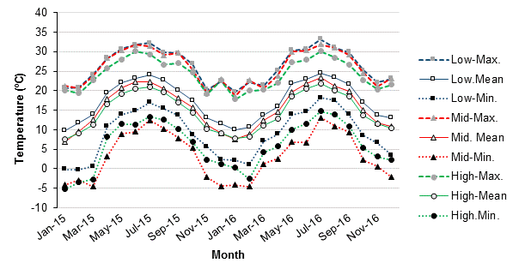

Figure ‎7.15 Average monthly maximum, mean and minimum temperature over two years (2015-2016) recorded at three different altitudes; Low (2200 m), Mid (2300 m) and High (2570 m).

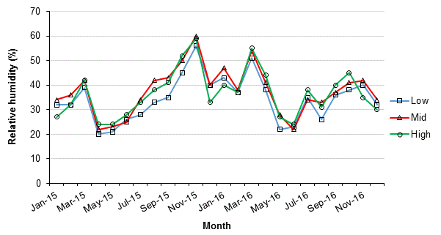

Figure ‎7.16 Average monthly relative humidity (%) at the three altitudes (Low, Mid, and High) over two years, 2015-2016.

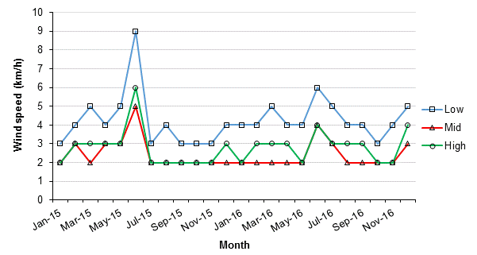

Figure ‎7.17 Average monthly wind speed (kmh⁻¹) at the three altitudes (Low, Mid, and High) over two years, 2015-2016.

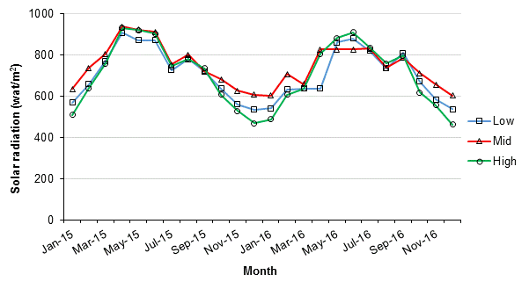

Figure ‎7.18 Average monthly solar radiation (Wm⁻²) at the three altitudes (Low, Mid, and High) over two years (2015-2016) in sunshine between 9.00 to 16.00 hours.

Hypotheses test
- Results reject the hypothesis that abiotic changes associated with altitude has an influence in sapling survival; survival percentage was above 90% at each of the three altitudes. However, the data supports the hypothesis that changes in altitude influences growth and physiological activity. Environment factors at low altitude generally encouraged high growth, however they also induced injury to the photosynthetic process, particularly during summer.
- The results reject the hypothesis that increased irrigation leads to higher survival rates in 5-year-old trees; saplings survival was equal in irrigated and non-irrigated plots. Results though, support the hypothesis that greater water availability increases growth through enhancing photosynthetic capacity; this was true at low altitude where adding high volumes of water increased both growth and chlorophyll fluorescence values.

Experiment 2: Field establishment and early development of two-year-old J. seravschanica saplings

Hypothesis to be tested
- Changes in temperature and precipitation associated with altitudinal gradient affect survival, growth and physiological activity in transplanted two-year-old saplings.
- Soil water availability is a primary factor influencing sapling establishment; higher irrigation rates will increase survival, growth and photosynthetic capacity.

Material and methods
In March 2015, at the same selected planting sites (Low, Mid and High altitude) (see section 3.3), 2-year-old J. seravschanica saplings were planted. The planting establishment procedure followed the same protocol for 5-year-old saplings (more details in section 3.3). After six months of post-planting establishment (saplings were given uniform water and protected from direct sun for the first 6 months), plants were irrigated using the same experimental regime as used on the five-year-olds: high (Irrigation every 15 days), low (Irrigation every 30 days) and control (no artificial water - saplings rely on natural rainfall). The volume of irrigation water applied was 2 L sapling⁻¹ (compared to 10 L for 5-year-old plants); this was proportional to their smaller size and the increased risk of overwatering particularly during the winter months. Survival and growth were monitored for one year (September 2015 to August 2016). Apical growth increment was measured every two months, lateral shoot increment was not measured due to the low number of branches per sapling. Chlorophyll fluorescence was measured following the same procedure as in 5-year-old stock.
The experiment was set up using a randomised complete block design with layout involving, 3 altitudes (Low, Mid and High) x 3 blocks x 3 water treatments (Irrig.15d, Irrig.30d, and Control) x 5 saplings per treatment. Survival percentage was analysed by non-parametric, Kruskal-Wallis test and significant influence of altitude and water treatment were indicated independently. One-year apical growth increment and chlorophyll fluorescence value (Fv/Fm) were analysed for variance using univariate analysis (tow-way ANOVA). Altitude was placed as a main independent factor and influence of irrigation treatment analysed within altitude.

Results
Sapling survival percentage
Plant fatalities overall tended to be greater than the 5-year-old trees, but were also dependent on the treatment combinations plants were exposed to (Figure ‎7.19). Altitude significantly affects 2-year-old plant survival (P= 0.03). Survival was greater at high altitude, e.g. 93% survival in controlled (non-irrigated) at high altitude compared to 66% (Mid) and 60% (Low); Kruskal-Wallis pair-wise comparison indicating significant difference between mid and high altitude (Figure ‎7.20). Kruskal-Wallis test showed no overall significant effect associated with water treatment (P= 0.52), but restriction of the data to the low altitude alone indicates significant influence of water treatment in improving plant survival at low altitude (P= 0.05, Figure ‎7.20), with more frequent irrigation increasing survival capacity. There was no effect of water treatment in survival rates observed at the mid-altitude; though, high seedling mortality rates were observed at this altitude. Overall survival during post-planting appeared to be favoured at high altitude, more variable at mid-altitude (note the relatively large S.E. values indicating plot differences) and strongly dependent on irrigation at the low altitude.

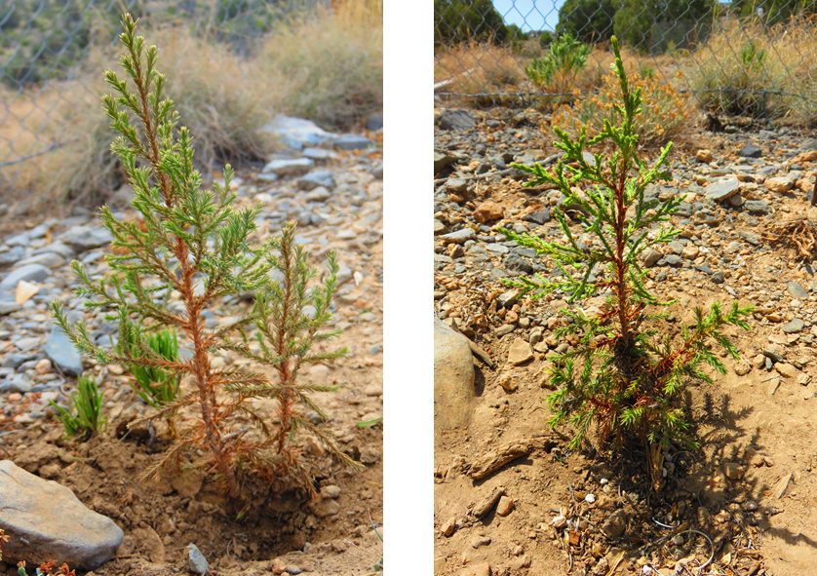

Figure ‎7.19 Two-year-old J. seravschanica saplings after 18 months from field transplanting. Left: sapling growing at mid-altitude under irrigation treatment (Irrig.30d). Right: sapling growing at high altitude under control treatment (no-artificial water).
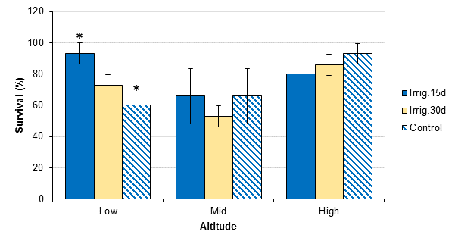

Figure ‎7.20 Survival percentage of 2-year-old J. seravschanica planted at three altitudes (Low, Mid and High) and under three irrigation treatments (Irrig.15d, Irrig.30d, and Control). Standard errors of the mean are presented (n=15). * indicates significant effect of water treatment at low altitude based on Kruskal-Wallis test.

Sapling height increment
There was no overall effect of altitude (P= 0.61) or irrigation treatment (P= 0.3) on sapling height increment (Figure ‎7.21), no interaction (P= 0.06). However, increased irrigation (Irrig.15d) led to higher apical extension at low altitude (27 mm year⁻¹) compared to mid (18.3 mm year⁻¹) and high altitude (19.3 mm year⁻¹) (differences not significant). Moreover, high irrigation frequencies (Irrig.15d) at the low altitude encouraged greater extension, though this was not statistically significantly different from the other treatments. At high altitude, irrigating saplings once a month (Irrig.30d) increased growth compared to non-irrigated saplings. Providing irrigation did not influence growth at the mid-altitude.

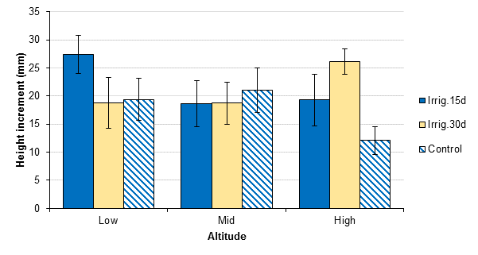
Figure ‎7.21 Height increment (mm) over one year in 2-year-old J. seravschanica planted at three altitudes (Low, Mid and High) and under three irrigation treatments (Irrig.15d, Irrig.30d, and no artificial irrigation (Control)). Standard errors of the mean are presented. LSD was not calculated due non-significant effect of both factors.

Chlorophyll fluorescence
A seasonal pattern and overall low chlorophyll fluorescence values were recorded for 2-year-old saplings with significant effect of altitude (P< 0.001) observed in all seasons, but not water regimes (P> 0.05) or interaction (P> 0.5, Figure ‎7.22). Photosynthetic productivity was suppressed during winter, particularly at mid-altitude where a great reduction in values was recorded (P< 0.001). A sharp reduction in chlorophyll fluorescence values during July 2016 was based on altitude too; plants at lower altitude had significantly lower Fv/Fm values (<0.3) compared to mid and high altitudes (values <0.5; P< 0.001, Figure ‎7.22). At this level, applying artificial irrigation did not improve plant responses to stress. Chlorophyll fluorescence values were greater at high altitude during summer; however, the value did not reach 0.7. Applying high irrigation at mid-altitude partially reduced the effect of stress plants were experiencing.
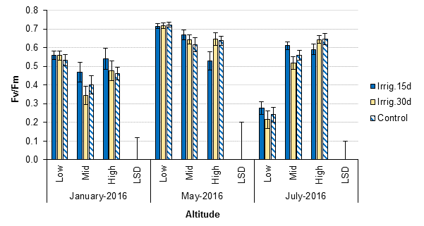

Figure ‎7.22 Chlorophyll fluorescence (Fv/Fm) of 2-year-old J. seravschanica during winter (January 2016), spring (May 2016) and summer (July 2016) planted at three altitudes (Low, Mid, and High) and under three irrigation treatments (Irrig.15d, Irrig.30d, and Control). LSDs(0.05, 0.01 and 0,05, DF 103, n=14) for each month= 0.12, 0.2, and 0.1, respectively. LSD is not applicable to indicate differences between water treatment at each altitude due to non-significant effect.

Hypothesis test
- Results support the hypothesis that abiotic factors associated with altitudinal gradient significantly affect survival percentage, but not apical growth in 2-year saplings; survival percentage was greatest at high altitude. Results confirm that chlorophyll fluorescence values were influenced by altitudinal gradient, plants at high altitude tended to retain higher Fv/Fm values during summer than those at mid and low altitude. Values for Fv/Fm, however, were also strongly influenced by seasonal effects.
- Results do not support the hypothesis that increasing water irrigation overall leads to greater survival or greater growth or improved photosynthetic capacity; although, supplying water did enhance survival at the low altitude and increasing water availability increased sapling growth, at least under some circumstances, for example at the less frequent application at the high altitude.

Discussion
The survival and growth pattern of younger (2-year-old) and older (5-year-old) J. seravschanica saplings highlight the importance of plant age in survival and establishment when planted out under field conditions. Overall, survival was relatively high, with older plants showing a higher establishment success rate than younger plants; survival of older stocks was over 93% irrespective of the planting site (altitude) or irrigation treatments. In contrast, the mortality of younger plants was high, particularly at the mid-altitude zone or when irrigation was not provided at the low altitude zone. However, the apparent differences between the two ages should be interpreted with caution as these were planted in two different years (5-year-old planted in 2014 whereas 2-year-old planted in 2015) and they were irrigated with two different volumes of water (2 L for younger and 10 L for older stocks), which may have caused a variation of the stress levels they were exposed to. Unfortunately, rainfall and soil moisture data were not collected for 2014; however, climatic data indicates that 2014 was warmer than 2015 (Figure 4.18, data collected at ground surface using data logger at each altitude) and it was drier during the first year (January to July 2015) than the second year after planting (January to July 2016) (Figure ‎7.13). This suggests that the older saplings experienced more severe environmental stress than younger ones during the establishment period; though survival was higher for older saplings.
The positive relationship between the size of planting stock and survival rate when new plants are transplanted to field conditions has been identified in many re-introduction programmes (Albrecht and Maschinski, 2012). Raising plants in nursery conditions for longer periods of time before transplanting to field sites not only increases the above ground biomass but it also encourages development of a larger, more extensive root system. The high mortality of younger stocks could be associated with their smaller root ball, which may affect their ability to access water within the soil profile. Planting stocks with vigorous, well-developed root systems (e.g. 5-year-old saplings) increases survival rates especially when trees that possess a tap-root are planted in arid land environments (Bainbridge, 2007). In this study increasing soil moisture availability was critical for survival in younger stock, however increased soil moisture was also important in the growth increments of the older plants especially for those at low altitude. This strongly suggests that water availability is critically important for tree viability and establishment at low altitudes where elevated temperatures accelerate the evapotranspiration process to high levels. This significant importance of soil moisture for plant survival at this altitude is strongly supported by the presence of less stressed Juniper trees in mesic habitats where water availability enhances trees’ growth.
Although water availability was important for sapling establishment, it does not seem to be the only factor contributing to plant viability in this region. At the mid-altitude, the loss of 2-year-old saplings was significant even under high irrigation treatments. Planting sites at this altitude were associated with good levels of precipitation and relatively high soil moisture retention (Figure ‎7.12 and Figure ‎7.13). Climatic data indicated that aerial maximum and mean temperature at this planting site were almost the same as those at low altitude, especially during summer. The planting site was surrounded by mountains and this enclosed landscape is noted for trapping hot air during summer and cold air during winter. So, despite this being the mid-altitudinal range, summer temperatures could be high and comparable at times to that of the low elevation site (see the maximum temperature data recorded in Figure 7.15). Thus, the challenging climatic conditions that occur both at the low and mid-altitude zones may be causing high temperature stress on plants, possibly explaining the lower levels of survival of young saplings at these sites. In contrast, high altitude was associated with high precipitation level and summer temperatures tended to be lower, which reduced soil moisture evaporation (less soil moisture depletion at high altitude during summer, Figure 7.14). This could strongly suggests that availability of high soil moisture was a reason behind the higher survival rates of non-irrigated (2 and 5-year-old) trees here. Overall, the results show a clear survival advantage for J. seravschanica plants growing at high altitude. This has important implications for the potential negative impacts of climate change on J. seravschanica populations in northern Oman and the possible establishment of re-introduction or rehabilitation programmes in the future.
Comparing the survival success of J. seravschanica plants in this experiment with other studies that have attempted to re-introduce Juniper plants to semi-arid areas suggests that J. seravschanica is more able to cope with re-introduction in to the wild. For example, a plantation of J. excelsa showed a plant survival rate of less than 50% for non-irrigated plants, while application of artificial water increased plants survival to more than 70% after two years from transplanting in the Iranian forest (Tabari and Shirzad, 2012). The same figures were derived for J. phoenicea in Jordan, where applying irrigation to one-year-old seedlings increased survival to 82%, whereas lower survival (32%) was recorded for rain-fed plants alone (Alrababah et al., 2008). The survival percentage was even higher for J. procera in Saudi Arabia; 98% survival in 2-year-old seedlings planted at 1920 m and irrigated once a week during summer (Aref and El-Juhany, 2004). The higher survival rates in this study can be attributed to the cultivation practices followed after planting. Application of sufficient water after transplanting plants to their natural habitat is essential to encourage high survival and establishment (Maschinski et al., 2012a). Watering during early field establishment reduces drought stress shock, which can often happen due to the nature of the highly reduced root system (e.g. due to damage to bare root stock, localised drying and root dieback in container stock or an imbalance of shoot to root ratios encouraged by growth under cultivation), leaving roots which can initially only absorb limited quantities of water and nutrients. The five-year-old saplings in this study have survived at least their first two summers, which is often considered the most vulnerable phase for plants growing in arid zones. It is likely that plants raised in a nursery for 5 years or more are more resilient than younger plants due to the size of their root system and above ground biomass. These factors provide a survival advantage when dealing with environmental stresses; however, the longevity of this long-lived species should be taken into account when determining the survival success.
Providing irrigation not only enhanced survival, it also encouraged high rates of above ground growth. At the low altitude, increase in water availability was the main factor driving plant growth, high apical and lateral extension of both younger and older stocks were associated with availability of soil moisture. However, this positive association was not strongly expressed at mid or high altitudes where suppression in plant growth was recorded despite receiving the highest annual precipitation and application of irrigation. High altitude and even mid-altitude were characterised by low aerial mean temperature during winter - dropping down to below 0ºC on some occasions. The effect of temperature in encouraging or suppressing growth in conifers has been presented in previous studies; increases in apical growth of J. thurifera was associated with an increase in annual temperature (Gimeno et al., 2012a), whereas growth was suppressed in Pinus sylvestris when mean or minimum temperature dropped down to below 5°C (Swidrak et al., 2011). Along with its altitudinal effect, the influence of temperature on growth was also indicated through seasons; growth rates were reduced during autumn-winter and enhanced during spring-summer. The physiological effect of low temperature on plant water relation will need more investigation in this arid region.
Al Haddabi and Victor (2016) noted that the availability of favoured conditions (high moisture and cooler climate) at the top of the mountain increased tree growth, although in their study the highest elevation was 2350 m which corresponds to mid-altitude in this study. In our study, the opposite phenomenon was observed with plant growth decreasing in those plots located further up the mountains (i.e. at higher altitude). It does not appear that water availability is the only limiting factor, as mid and high altitude received high precipitation and irrigation, neither of which increased plant growth. Climatic data showed that both altitudes had low minimum temperature that dropped to below 0ºC during winter and lower than 15°C during summer. Analyses indicated that water availability was not the main factor influencing growth at these altitudes and suggest that temperature, mainly low temperature, plays an important role in reducing growth rates.
The positive influence of supplementing artificial water at low altitudes resulted in a greater above ground biomass and hence higher plant metabolic rate and greater photosynthetic products. This encourages the development of new roots growing deeper in the soil profile with the capability to increase water flow and hence reduce water stress (Grossnickle, 2005). Studies indicated that survival of newly-planted seedlings under reforestation in arid environments depends on their ability to direct roots down vertically to reach natural water reservoirs, lower down the soil profile (Canadell et al., 1996; Peek et al., 2006). Juniperus species have strong root systems that could spread through even small rock cracks to deep natural water reservoirs in soil profile, extending their absorption area (Zangiabadi et al., 2012).
However, despite the fact that water availability is essential for root growth, the effect of overwatering must be considered. More frequent irrigation (e.g. twice a month) restricts root development to the top layers of the soil profile due to availability of high moisture at this level (Fernandez et al., 1991); which can cause a plant to be more susceptible to water stress when irrigation reduces or stops (Gilman et al., 2003). The negative influence of regular irrigation is also through limiting the capacity of the tree to condition itself against any severe environmental stress that it may experience. This was notable at low altitude during summer; trees that were receiving irrigation once a month had more growth than those having regular irrigation (twice a month). Acclimatisation to severe drought could be prompted by exposure to drying soil, or short periods of moderate water stress (Cameron et al., 2008).
Results showed that chlorophyll fluorescence values (Fv/Fm) for younger and older saplings were below 0.7 during summer (e.g. July 2016); a threshold value which is considered as an indication of stress in conifer trees (Fang-yuan and Guy, 2004). The photosynthetic capacity was strongly associated with altitude (high precipitation and low temperature) and the availability of high soil moisture content through supplement of irrigation during summer or amount of rainfall received, high Fv/Fm value recorded under high irrigation treatment. For the non-irrigated trees, photosynthetic production tended to be strongly linked with the amount of rainfall received at the corresponding period. The high association of precipitation with increasing soil moisture at the mid-altitude led to greater photosynthetic capacity (high Fv/Fm) in older saplings during July 2015; however, this phenomenon was not repeated in July 2016 when at this time the mid-altitude received less rainfall. In contrast, during July 2016 highest Fv/Fm values were associated with the high altitude, where rainfall was sufficient to increase soil moisture levels.
Although water availability seems to regulate plant performance during summer, the role of other abiotic factors such as temperature should not be ruled out. Lower altitudes were associated with lower Fv/Fm values during summer; adding artificial irrigation was not enough to increase plant photosynthetic capacity in plants of either age. Plants at this site experienced the warmest temperatures during summer, which could accelerate soil water evaporation (50% soil moisture depletion within 5 days) and increase plant evapotranspiration. Results indicated that applying irrigation twice a month at low altitude during July 2016 increased soil moisture; however, plants had low Fv/Fm values compared to those planted at the top of the mountain. In contrast, plant photochemical capacity was not affected by reduction in soil moisture at high altitude where aerial mean and maximum temperatures were the lowest during summer, which could support the hypothesis that heat stress induces a secondary stress at low and mid-altitudes.
It is unclear if this high reduction in photochemical efficiency at lower altitude was caused by a reduction in cell water potential as a result of drought stress (hydraulic signal) or a conservative strategy where stomata close during environmental stress to avoid further reduction in plant cell water potential (chemical signal). Or in fact by photoinhibition (reduction in photosynthetic capacity caused by high light intensity); where excessive heat during summer associated with drought and high light intensity may cause short-term photoinhibition (Prieto et al., 2009; Rubio-Casal et al., 2010). Penuelas and Llusia (2002) noted that temperature greater than 35°C could inhibit photorespiration causing reduction in chlorophyll fluorescence rates due to damage in photosynthetic electron transport through photosystem II.
Juniperus species follow a range of different physiological activities during stressful periods in an attempt to reduce water loss. At earlier stages, an increase of ABA within the guard cells of the stomata induce stomatal closure even under high water potential; later, ABA concentrations decrease to induce a hydraulic control of stomatal closure (Brodribb and McAdam, 2013). This process boosts a rapid response by the plant to the increase in surrounding soil moisture after a high rainfall event during spring and at the end of the summer season, which suggests that saplings grown at low altitude suppressed their photosynthetic process during drought/high heat stress to avoid further soil moisture decline. When water availability is not a limiting factor, increases in temperature to optimum level induce high photosynthetic rates, encouraging an increase in biomass production (Prieto et al., 2009). These results suggest that more frequent irrigation (once a week) or high irrigation volume may be required to maintain soil moisture availability for transplanted trees at lower altitudes during summer.
The strong decline in Fv/Fm values in 2-year-old saplings, even though artificial irrigation was supplied in summer, could be related to the increase in soil water evaporation at the top layer of soil profile due to high temperature. During the summer, soil moisture rapidly decreased at the top layer of the soil (moisture probes were 20 cm deep) after irrigation supplement; more than 50% of the moisture was lost within 5 days after irrigation at low and mid-altitude (Figure ‎7.14). Younger plants were planted at a depth of 30 cm and it was expected that these plants would be more reliant on above ground water supply due to absence of strong taproot. Oliet et al. (2002) indicated that soil water decline during the summer in the top layer of the soil (0-30 cm) caused high soil tension and suppression of root growth whereas no significant decline was observed at deeper layers (30-60 cm). They suggested that it is significantly important for newly-planted trees to develop deeper roots (more than 60 cm deep) before the onset of the summer season.
Although data anticipated that the main stress was associated with drought and heat stress during the summer season, there is some evidence of reduction in plant growth and Fv/Fm values during winter, with non-irrigated saplings having the lowest values. Low temperature during winter in conjunction with drought stress due to low rainfall decreases photosynthetic rates (Rubio-Casal et al., 2010). Our observations on growth suggest that winter stress was more severe at mid and high altitude.
Overall the results presented within this chapter indicate that water availability and temperature are the main factors controlling survival and growth of J. seravschanica saplings and these are strongly influenced by the altitude within the mountains of Oman. This should not preclude the influence of other factors, however. Viability may also be influenced by solar radiation, wind speed, humidity, and soil nutrient availability. Climatic data collected over two years showed that the low altitudes experience high wind speeds compared to mid and high altitude. It is expected that wind speed increased with elevation increase (Holtmeier and Broll, 2010); e.g. wind speed was roughly higher in high altitude than mid-altitude in this study. Increase in wind speed at low altitude could be interpreted as a potential threat to trees in these altitudinal zones (high decline of J. seravschanica at low altitude). The loss of trees corresponds to a loss in shelter and thus an increase in wind speed and potential desiccation. Trees benefit the landscape and associated plant species in a habitat (as in mid and high altitude) by reducing wind speed, reducing atmospheric carbon dioxide and biosphere heat through plant transpiration (Clewell and Aronson, 2013). In general, plant performance and growth depends on the balance between soil moisture and evaporation rates; increase in wind speed has been linked to a decrease in plant growth through its effect on increasing evaporation rates (Jones, 1992; Bornman et al., 2015) and in arid environments hot wind can rapidly dry parent soil and impose severe stress on plants (Bainbridge, 2007). The high flow of dry wind during the summer season led to decrease in relative water humidity (below 30%); dry wind associated with high temperature increases transpiration (even under stomatal closure), increases water defects and may cause leaf desiccation. Future research may wish to study the impact of wind on Juniperus populations more fully.

Conclusion
- Older planting stock (5-year-old) demonstrated a greater resilience to transplanting compared to the younger stock (2-year-old).
- Transplanting success rates were highest in the high altitude sites (above 2500 m); however, abiotic factors at this altitude might suppress plant growth.
- Soil moisture was the main element directing the growth and physiological activity of the sapling especially at low altitude were high soil moisture was required to encourage plants’ survival and growth.
- Temperature affects sapling survival and establishment primarily through its influence on soil moisture and its deleterious effect on seedlings survival is more severe under dry rather than wet conditions.

Chapter 8. Moving plants to new environment: beneficial influence of topographic site and mycorrhizal fungi

Introduction
Identifying suitable sites where plants can be transplanted and where they will be exposed to the minimum amount of stress or competition is a key factor in promoting successful reforestation (Knight, 2012). Selected sites need to have the capacity to protect young, actively growing plants from harmful environmental conditions and stress factors caused by climate change (Ashcroft et al., 2012). Suitable sites are characterised by appropriate microclimates that are defined by fine scale differences in habitat and topographic structure (Dobrowski, 2011). Within mountain areas, site topography as influenced by elevation, slope and aspect can strongly affect microclimate and determine limiting factors such as land surface temperature and water availability (Maschinski et al., 2012b); thus, careful site selection can be paramount in aiding plant establishment. In arid regions, recruitment and establishment are more related to the availability of soil moisture and its variation along different habitat can create refugia sites (Dobrowski, 2011; MacLaren, 2016). Dobrowski (2011) demonstrated that slope and aspect have a greater influence in soil moisture than temperature, this is due to their effect on evapotranspiration through radiation intensity differences. In addition, lower lying depression sites can retain soil moisture for long periods after precipitation events (MacLaren, 2016).
Moreover, the survival and establishment of newly transplanted seedlings are determined by their ability to acclimatize to the new environment (Haskins and Pence, 2012). Indeed, plants germinated under greenhouse conditions are exposed to less stressful environments than those expected in natural habitats. Under field conditions, the establishment success of new transplants relies on the ability of the local environmental conditions at the new site being able to mitigate transition stress (Grossnickle, 2005). In addition, the influence of abiotic stress on naturally germinated seedlings is more severe during the early establishment phases (Walck et al., 2011). The benefit of climatic amelioration through plant to plant interactions (i.e. mature established trees on juvenile material) has a significant influence in seedling survival in semi-arid/arid environment (Hegazy and Lovett-Doust, 2016). Under these conditions where high heat and drought stress limit seedling establishment, successful recruitment of new generations strongly depends on plant facilitation (Castro et al., 2004; Schob et al., 2013; Caldeira et al., 2014) and it is expected to be more common in arid environments (Jankju, 2013).
Many authors have illustrated the significant role of plant facilitation in improving the microclimate by providing shade, and cooling, and thus helping to retain some degree of soil moisture (Maestre et al., 2009a; Perea and Gil, 2014). In addition, the decomposition of litter under the canopy of perennial plants leads to the formation of fertile islands where much of the biological activity occurs (Pugnaire et al., 2011). Litter decomposition under Juniperus trees increases soil organic carbon pools, total nitrogen, and di-phosphorus dioxide (P₂O₂) (Allegrezza et al., 2016). This shift in environment conditions under the canopy of nurse plants augment the survival rate of new seedlings ‘positive facilitation’; however competition by the mature nurse plants for resources could alter seedling growth at a later stage ‘negative facilitation’ (Pueyo et al., 2016).
Nonetheless, the positive environmental influences that certain topographies or tree canopies can provide, has encouraged many reforestation practitioners to consider them in restoration programmes (Castro et al., 2002; Padilla and Pugnaire, 2006; Jankju, 2013). Although J. seravschanica recruitment and growth is strongly associated with altitudinal gradients, there are some potential positive effects due to habitat topography particularly at lower altitudes (e.g. trees with high amounts of living foliage were located on north facing slopes or in depression sites, where greater levels of soil moisture may be able to accumulate). MacLaren (2016) suggests too, a positive effect of parent facilitation on the regeneration and establishment of new seedlings. With regards to these two assumptions, no studies have yet demonstrated the fitness of these habitat topographies and microsites in J. seravschanica seedling regeneration and establishment. Therefore, the primary aim of this chapter is to assess the influence of habitat topography and parental nursing on the survival of new transplanted seedlings.
The aerial climate (troposphere) is a key element in controlling plant growth; however, the interaction between plant root systems and soil mutualists are also often essential for plant productivity (Burkle and Belote, 2015). Plants with a healthy root ratio increase water uptake and reduce water deficits and are therefore more equipped to deal with environment stress. For some wild plant species, growth and functioning of root systems strongly depends on the availability of beneficial soil microbes, e.g. mycorrhizal fungi (Haskins and Pence, 2012). Mycorrhizal fungi (MF) perform a multifunctional symbiosis with plant root system. There are two main groups of mycorrhizae, ecto-mycorrhizae - dense fungi hypha concentrate on the outside of the root surface, and endo-mycorrhizae – where fungi hypha penetrate cell tissue; arbuscular MF are the most abundant endo-mycorrhizae in soil habitat (Sadhana, 2014). Plants associated with arbuscular MF increase host growth productivity and nutrient absorption, specifically phosphorus (Querejeta et al., 2007), which enhances resistance to soil pathogens (Borowicz, 2001) and promote tolerance to extreme drought (Li et al., 2014). In addition, mycorrhizal fungi improve soil structure and stability through the production of a mycelial network and the secretion of glomalin - a glycoprotein produced by arbuscular mycorrhizae that has the ability to increase water retention and reduce soil erosion (Gianinazzi et al., 2010).
The positive influence of arbiscular MF colonisation on host roots has been found to be associated with 90% of plant communities in natural ecosystems (Sitieneia et al., 2015); this symbiosis is believed to play an important role in arid regions by mitigating the negative effects of these harsh environments (Al-Yahya’ei et al., 2011). Studies show a positive significant effect of arbuscular MF in increasing growth and stress tolerance of Juniperus plants through improving nutrient uptake and nitrogen assimilation (Alguacil et al., 2006; Caravaca et al., 2006). Moreover, Sanguin et al. (2016) indicated that adaptation of J. phoenicea to high drought stress and low soil nutrient sites was due to the symbiosis of complex MF communities related to those found in semi-arid regions. It should be noted that MF symbionts are highly host specific, therefore in some cases a decline in host tree growth could negatively influence the density and composition of an MF community (Ibanez et al., 2015). A second part of this chapter therefore, aims to assess the relationship between tree growth and the abundance and diversity of mycorrhizal fungi along an altitudinal gradient.

Objectives
- Identify the influence of habitat topography on seedling survival.
- Assess the potential effect of tree shading on seedling survival.
- Identify the presence and abundance of mycorrhizal fungi along an altitudinal gradient.

Experiment 1: Influence of habitat topography and microsite on newly-transplanted seedlings

Hypothesis to be tested
- Habitat topography affects seedling establishment; sites associated with low-lying topographical depressions and shaded north facing slopes positively influence seedling establishment.
- Shade provided by parent trees enhances the microenvironment and thus increases seedling survival rate.

Materials and methods
In the same study area (Jabal Shams), one-year-old seedlings were planted in February 2016 at two different altitudes, low (2200 m) and mid (2300 m); and under three different topographic conditions, 1) depressions, 2) north facing slopes, and 3) south facing slopes. In each of these sites seedlings were planted within two microsites: outside canopy line (seedlings planted in open bare soil), and under the canopy of J. seravschanica trees. Two planting plots were prepared (60x40 cm) in each microsite and three seedlings were planted in each plot. Tree leaf litter was removed from the top surface so seedlings could be planted in the soil layer. Plots were enclosed within stacked steel fencing (6x6 cm opening) to avoid damage from herbivores. Seedlings were irrigated by hand every two weeks and survival rates were monitored for ten consecutive weeks. Light intensity (digital luxmeter MS6610, minimum resolution =1 lux), and soil moisture (VWC%) were measured every two weeks in all treatments. Air temperature was measured using data loggers positioned at ground level within the two microclimates at mid-altitude.
The experiment was established at two altitudes (low and mid). There were three planting sites (north facing slopes, depressions, and south facing slopes) with two microclimates (outside and under canopy of tree) in each and two replicates of each microclimate. Survival percentage, irradiance intensity and soil moisture were analysed at specific dates. Non-parametric tests were used due to the non-normal data distribution. Mann-Whitney rank-test was used to indicate the effect of altitude and cover treatment. Kruskal-Wallis test was used to assess the influence of site conditions on plant survival.

Results
Seedlings survival
Seedling survival was not influenced by either altitude or planting site; though, survival was marginally lower at mid-altitude (P> 0.05, Figure ‎8.1 A) and south facing slopes (P> 0.05, Figure ‎8.1 B). The influence of parent tree canopy, however, was significant (P< 0.01); survival capacity was greatest under the canopy of parent trees (Figure ‎8.1 C). Seedlings planted under tree canopy on depression sites had the highest survival; although, sudden mortality within two weeks from planting were recorded in bare soil plots (Table ‎8.1).
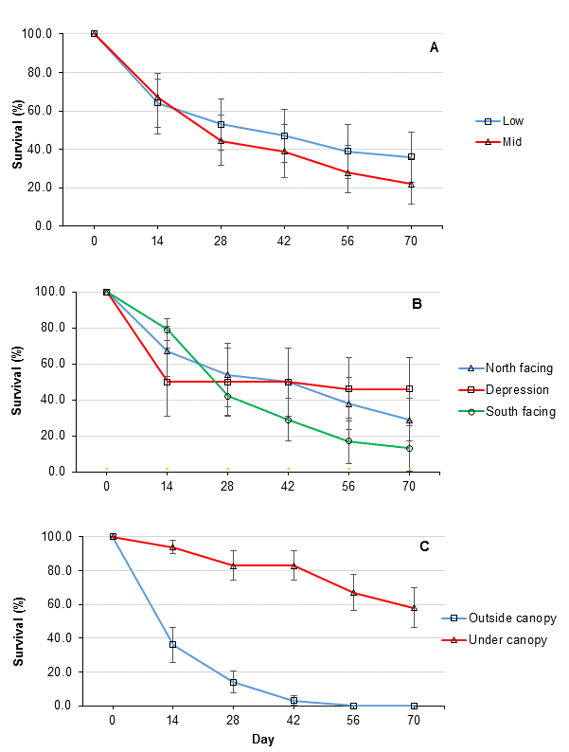

Figure ‎8.1 Survival percentage of J. seravschanica seedling over 70 days influenced by altitude (A, n=12), planting site (B, n=8) and microsite (C, n=12). Standard errors of the mean are presented.

Table ‎8.1 Survival percentage (%) of J. seravschanica seedlings planted in two microsites (outside and under the tree canopy) in three topographical conditions (north facing slopes, depressions and south facing slopes). Data are presented as a mean ± SE of the two altitudes (Low and Mid), n=4.
 |  |  |  | Day
Planting site | Microsite | 1 | 14 | 28 | 42 | 56 | 70
North facing | Outside | 100 | 33±13.6 | 8±8.3 | 0 | 0 | 0
North facing | Under | 100 | 100 | 100 | 100 | 75±8.3 | 58±8.3
Depression | Outside | 100 | 0 | 0 | 0 | 0 | 0
Depression | Under | 100 | 100 | 100 | 100 | 92±8.3 | 92±8.3
South facing | Outside | 100 | 75±8.3 | 33±13.6 | 8±8.3 | 0 | 0
South facing | Under | 100 | 83±9.6 | 50±16.6 | 50±16.6 | 33±23.6 | 25±25

Environmental variables
The presence of a tree canopy had a significant effect on light intensity (P< 0.001), with values notably reduced compared to open areas (Table ‎8.2). There was no overall significant effect of canopy on soil moisture, differences not significant between outside and under tree canopy (Table ‎8.2). Seedlings planted under trees also experienced less heat stress (Figure ‎8.2) due to a lower maximum temperature compared to those outside the tree canopy line. No significant influence of site topography was indicated (P> 0.05). Mountain ridges in slope sites had a marginal effect in light intensity outside of the plant canopy (not significant); intensity in open field was the lowest in north facing slopes (Table ‎8.2). The influence of topographic sites and microsite on light intensity and soil moisture showed a consistent trend at both low and mid-altitude (date not presented).

 |  |  | Day
 | Site | Microsite | 1 | 14 | 28 | 42 | 56 | 70
Light intensity | North facing | Outside | 495±66 | 686±371 | 1255±399 | 1082±351 | 950±370 | 1621±205
Light intensity | North facing | Under | 52±6 | 114±78 | 191±35 | 116±23 | 157±87 | 90±44
Light intensity | Depression | Outside | 1405±85 | 1080±108 | 1362±367 | 1387±348 | 1407±377 | 1830±73
Light intensity | Depression | Under | 71±3 | 65±3 | 203±24 | 145±27 | 75±13 | 59±10
Light intensity | South facing | Outside | 1325±108 | 1043±351 | 1221±366 | 1278±414 | 1244±436 | 1470±346
Light intensity | South facing | Under | 333±152 | 327±158 | 391±44 | 445±43 | 240±76 | 169±80
Soil moisture | North facing | Outside | 3.4±0.6 | 4.2±0.7 | 3.6±0.8 | 3.5±0.5 | 9.8±0.5 | 10.2±1.9
Soil moisture | North facing | Under | 4.3±0.5 | 6.1±0.8 | 4.7±0.8 | 3.7±0.5 | 18.3±4.0 | 10.2±1.3
Soil moisture | Depression | Outside | 3.1±0.4 | 3.4±0.4 | 3.8±0.3 | 3.6±0.2 | 10.6±1.2 | 11.7±0.6
Soil moisture | Depression | Under | 3.1±0.8 | 3.5±1.4 | 5.3±1.2 | 5.2±1.2 | 15.7±1.4 | 9.6±2.9
Soil moisture | South facing | Outside | 1.9±0.2 | 2.6±0.7 | 2.1±0.4 | 1.8±0.2 | 11.5±3.6 | 7.7±1.1
Soil moisture | South facing | Under | 2.9±0.2 | 5.5±1.8 | 4.5±1.3 | 3.9±1.2 | 10.9±1.8 | 9.5±1.4
Table ‎8.2 Light intensity (10x Lux) and soil moisture (VWC %) meaured at different planting sites (north facing, depressions, south facing) and under two microsites (outside and under the tree canopy). Data are presnted as a mean value ± SE of the two altitudes (low and mid), altitude differences are not presented due to homogeneity in trends, n=4.

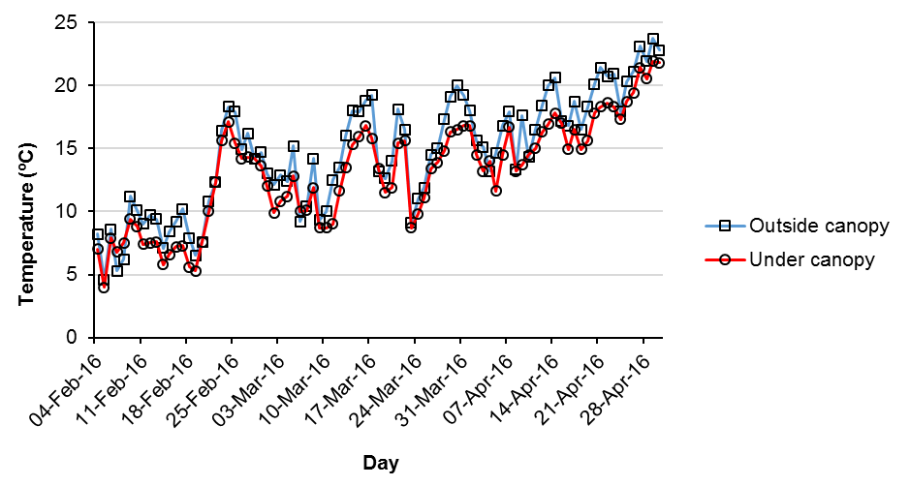

Figure ‎8.2. Air temperature measured within two microsites at mid-altitude (2300 m asl)

Hypothesis tested
- Results were unable to support the hypothesis that site topography significantly effects seedlings survival, although seedlings planted at south facing slope had lower survival rates.
- Results support the hypothesis that planting beneath the parent tree canopy increases seedling survival rates. The main effect of tree canopy is through reducing light intensity.

Experiment 2: Mycorrhizal fungi spore presence and abundance along different altitudes

Hypothesis to be tested
- The presence and abundance of mycorrhizal fungi spores under the canopy of J. seravschanica trees is influenced by tree conditions along altitudinal gradients.

Material and methods
In March 2016, 15 trees were selected at three different altitudes, (5 trees per altitude), low (2100-2230 m), mid (2300-2340 m), and high (2570 m). Trees were selected from similar topographical sites e.g. not in deep valleys or steep hillsides. Tree health condition was recorded based on percentage of living foliage score (see section 3.1.2). Soil samples were collected from five directions around the circumference of the tree rhizosphere; above ground tree litter was removed and 30 cm deep soil samples were collected. Soil samples were air dried inside a greenhouse (25-28°C) and then sieved through a 2 mm sieve to remove roots and debris. Mycorrhizal spores were extracted by wet sieving and sucrose density gradient centrifugation as described by Daniels and Skipper (1982) and then counted under a microscope at 10x magnification. Spores from each site were mounted on permanent slides for future species identification.
The experiment was set up at three altitudes (low, mid, and high) x 5 trees x 5 samples, 75 samples in total. The mean value of five samples per tree were calculated and used for analysis. The effect of altitude on mean spore abundance was analysed by non-parametric, Kruskal-Wallis test. Pearson’s correlation was carried out to identify the relationship between trees health condition score and spore number.

Results
Soil samples showed diversity of mycorrhizal spores’ structures and morphologies (Figure ‎8.3). Analysis of variance indicates a significant influence of altitude in spore abundance (P= 0.04); spores were greatest at high altitude (19.5 spores 10 g⁻¹ of dry soil) (Figure ‎8.4); whereas less abundant at lower altitudes (less than 6 spores 10 g⁻¹ of dry soil). There was a significant relationship between trees health and number of MF spores (r=0.593, P< 0.05).

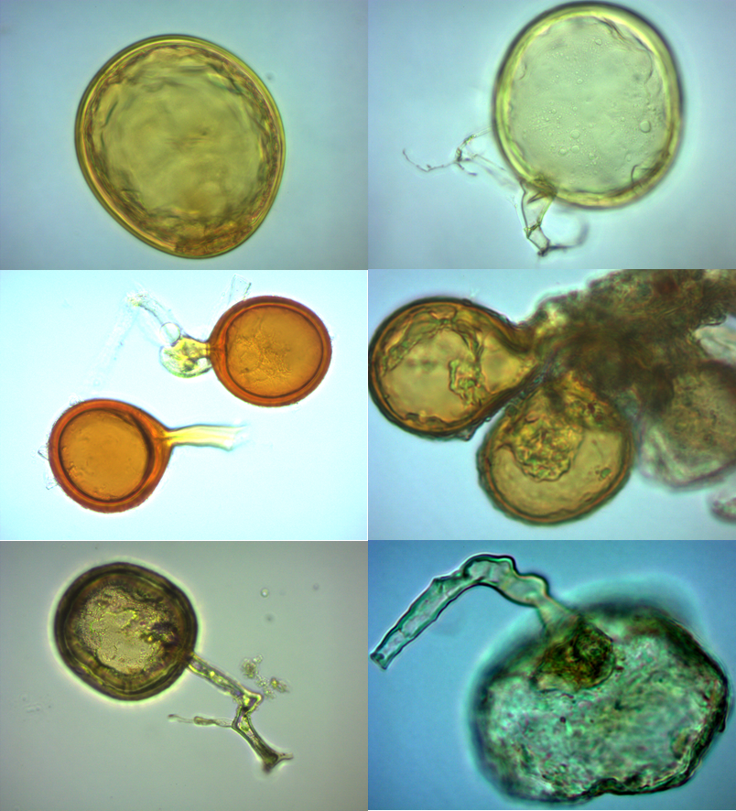

Figure ‎8.3 Structures of mycorrhizal fungi spores extracted from soil under rhizosphere of J. seravschanica.
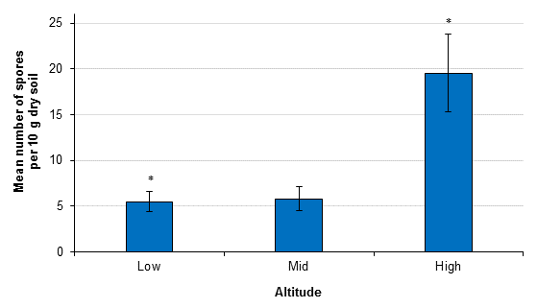

Figure ‎8.4 Mycorrhizal fungi spore abundance under the canopy of J. seravschanica across the three surveyed altitudes (low, mid, and high). Data were square root transformed for statistical analysis. Standard errors of the mean are presented. * indicates significant effect of altitude based on Kruskal-Wallis test.

Hypothesis test
- Results support the hypothesis that tree condition at different altitudes, influences the abundance of mycorrhizal fungal spores. Soil collected underneath trees with high proportions of living foliage growing at high altitude had greatest number of MF spores.

Discussion

Effect of slope aspect and microsites on seedling survival
Data indicate a strong effect of parent tree shade and a marginal positive effect of topographic characteristics on survival through mitigating environmental stresses such as high temperature, high light intensity and drought. Seedlings planted on north facing slopes in bare soil plots experienced lower solar radiation levels and by association lower air temperatures which appear to have a positive influence on seedling survival. The benefit of shade cast by mountain ridges was associated with high soil moisture content and was likely due to reduction in soil water evaporation. This result supports the suggestion by MacLaren (2016), that improvement of climate conditions and availability of high soil moisture on north facing slopes has a potential positive effect on tree establishment and recommends that this habitat type, topographically may act as an important refugia site for J. seravschanica in the northern mountains of Oman. In the depression sites studied, survival was significantly dependent on the shade provided by parent trees. The current study shows that shade provided by mountain ridges was beneficial but not sufficient to protect seedlings from environmental stress and eventual loss in bare soil plots.
Planting was carried out in February (end of winter) and seedlings were irrigated once every two weeks; therefore, seedlings were exposed to less environmental and drought stress. However, even with this regular irrigation, mortality rates outside trees canopy reached more than 60% within two weeks from planting. Soil moisture was not significantly different between the two microsites. Light intensity at ground level under the canopy was reduced by 60 to 90% to the outside, which led to differences in temperature up to 4°C. The improvement of environmental conditions under the shade of the parent tree mitigated seedling water stress through a reduction in evapotranspiration rates, resulting in a reduction in seedling mortality. This supports the hypothesis that shade created by tree canopies is essential for seed germination and survival in arid environments (Pugnaire et al., 2011). This follows the same canopy facilitation observed in other Juniperus species, for example in J. thurifera (Gimeno et al., 2012b), and J. excelsa (Sarangzai et al., 2015) and postulates that survival of newly-germinated or transplanted seedlings of this species is shade-dependent in the early stages of development.
Indeed, the study suggests that shade under canopy is more important than shade created by mountain ridges. However, the potential negative effects of parental shade on seedling establishment must be considered. Shade can reduce seedling growth especially for shade intolerant species, and negatively influence their water use efficiency; therefore, rendering them more susceptible to water stress (Gimeno et al., 2012b). Noumi et al. (2015) argued that the role of facilitation in reforestation is more common under semi-arid conditions, however in arid conditions a negative direction of this interaction can be observed. They have also shown, consistent with Holmgren and Scheffer (2010), that facilitation is only significant during less stressful conditions and in drought intolerant species, and therefore not an appropriate reforestation tool under arid conditions. An example of the potential negative influence of facilitation on J. seravschanica trees was observed in the study site (see chapter 4 section 7.1).
This study considers the positive effects of parent tree shade on seedling establishment and survival to be important, however the impact of reduced soil moisture content is recognised as a potentially limiting factor. The potential positive effect of shade provided by other large woody species within the Juniperus woodlands needs to be studied. Dodonea viscosa, a large evergreen shrub found in abundance throughout the woodlands, could provide the shade needed to assist seedlings to reach semi-maturity.

Abundance of mycorrhizal fungi
The current climate shifts are causing severe damage to forest ecosystems; specific plant communities support specific soil microbes and species extinction may affect soil processes, and consequently the function of the ecosystem (Fischer et al., 2014). In the current study, spores were highly abundant at the top of the mountain (above 2500 m). High altitude is characterized by lower temperature, high rainfall and high species composition, which has been positively correlated with increases in MF density (Yang et al., 2016; Melo et al., 2017). Reduced mycorrhizal spore density at lower altitudes could be attributed to habitat disturbance by biotic and abiotic pressures. Anthropogenic disturbance such as soil removal and herbivore browsing has been noted to negatively influence MF composition and abundance (Melo et al., 2014).
Abiotic factors such as reduction in soil moisture could potentially decrease community composition of MF (Symanczik et al., 2015). A recent study indicated a strong association of environmental factors (e.g. irradiance) and the ability of a plant to provide sufficient photosynthetic resources in MF root colonization, but not species diversity (Koorem et al., 2017). MF are highly dependent on carbon photosynthesis by plants, thus their persistence may depend on the ability of host species to generate more photosynthetic products. Trees at low and mid-altitudes are under stress, low proportions of living foliage reduce photosynthetic production. In addition, the tree rhizosphere is frequently disturbed by campers and animals. These factors could alter soil’s physical and chemical properties and negatively impact mycorrhizal fungi communities and beneficial activities.
Inoculating soil compost with MF under greenhouse conditions is widely used to promote seedlings growth (Ortega et al., 2004; El Mrabet et al., 2014) and their effectiveness in enhancing reforestation success has been reported (Shen and Wang, 2011). Unfortunately, MF species were not identified during this project due to the author’s limited experience in mycological taxonomy, however collaboration with another institute was initiated for MF identification. It is anticipated that this study will highlight the importance of using MF in promoting Juniperus seedlings establishment under controlled conditions and considering its role in field transplanting success if a conservation project is to be initiated.

Conclusion
- Survival of young seedlings was strongly shade-dependent and survival was greatly increased under the canopy of trees.
- Habitat topography (aspect) can ameliorate the effects of harsh environmental conditions on seedling establishment. North facing slopes experience less solar radiation and hence low soil water evaporation.
- Mycorrhizal fungi abundance was significantly lower at lower altitudes, below 2500 m. This may have an effect on Juniperus health at these altitudes and therefore further study is required in this area.

Chapter 9. General discussion

Introduction
Globally, forest decline has been attributed to numerous factors including human deforestation, over-grazing, pollution, acid rain and climate change (IPCC, 2014; Hegazy and Lovett-Doust, 2016). One method of combatting these issues has been the increase in reserve areas, for example, which have the potential to reduce plant diversity loss through reducing anthropogenic disturbance (Bruner et al., 2001). However, these protection efforts have been made more complex by the negative impacts of climate change accelerating habitat degradation (Gillson et al., 2013). Climate change is considered a major threat that can potentially accelerate plant species extinction (Cahill et al., 2012). Investigating the long-term effects of climate change is challenging as it involves the issue that plant populations and their habitats may have been displaced due to climatic triggers (Bonebrake et al., 2014). However, for some species, e.g. J. seravschanica in Oman, escaping the pressures of climate change is hampered due to an inability for long distance dispersal, population isolation, and the lack of suitable habitat in which to move to.
Conservation strategies attempting to mitigate the threats due to climate change, e.g. population augmentation or assisted managed relocation, have shown the potential to reduce or avoid species extinction (Monks et al., 2012; Williams and Dumroese, 2013). However, the impact due to human disturbance may induce further complications in conservation success and must be carefully considered. Proper conservation strategies should be generated by effective studies targeting multiple threats, e.g. human disturbance and climate change, in a single framework (Gillson et al., 2013; Bonebrake et al., 2014). In this research, results generated by examining the impact of biotic and abiotic factors on J. seravschanica populations are used to develop a clearer understanding of the potential impacts of climate change. By understanding these aspects more thoroughly we can design effective in-situ and ex-situ conservation programs in an attempt to safeguard the future of J. seravschanica in northern Oman.

Key factors in the decline of J. seravschanica in northern Oman

Biotic factors
Results from the literature and data from this research indicate that plants at lower altitudes (<2500 m) are harmed by human disturbance and animal browsing. Human disturbance is largely as a result of wood harvesting. However, such damage was most noticeable in trees already in decline. Animals browsing on Juniperus leaves and on small, planted seedlings was observed, however, with browsing pressure greater at low and mid-altitudes. The presence of animals in moist habitats, where the prime browsing is noted, is likely to have a deleterious effect on tree recruitment as these sites correspond to where optimum seed germination occurs. In addition, lower rates of tree growth and seedling regeneration at lower altitudes may also be influenced by the low occurrence of mycorrhizal fungi at these altitudes. It is not clear if these lower zones have initially low mycorrhizal colonisation or this low abundance is a reflection of current decline in the woodland; further research into this is needed.
There was no evidence that trees are being attacked by harmful pathogens (shoot and root samples of seven different trees along different altitudes were cultured for pathogen analysis). However, even though when anthropogenic disturbance is well-controlled e.g. high altitude, signs of foliar die-back and trees mortality were observed.

Abiotic factors
Analysis of data gathered from within semi-protected areas - set up to observe plant development, suggest that losses to J. seravschanica populations are being influenced by local climatic conditions (Figure 9.1). Seed sowing and the transplanting of nursery-grown trees were evaluated in the absence of human and animal disturbance. Despite the protection from disturbance, field seed sowing yielded zero germination success. Furthermore, there were losses to newly-planted seedlings in plots at lower altitudes.

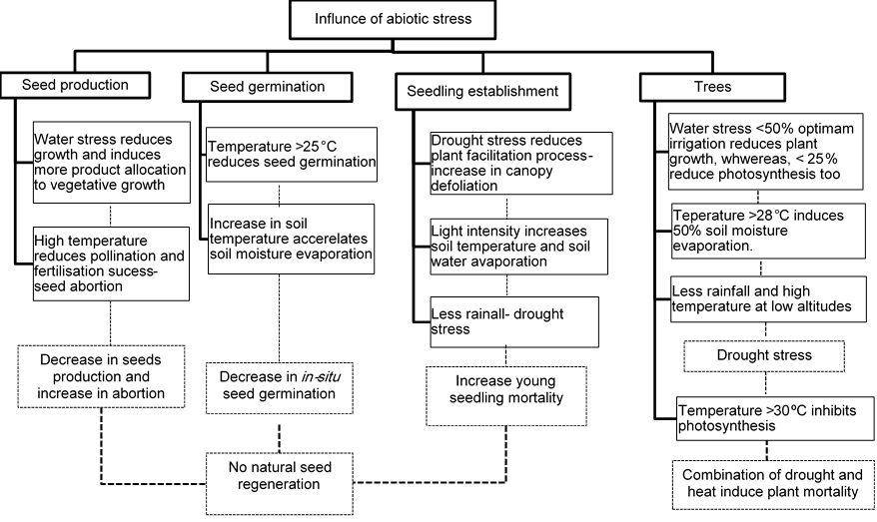
Figure ‎9.1 Effect of abiotic stress in seed production and germination, seedlings establishment and mature plant growth of J. seravschanica based in results obtained from controlled and field growing experiment.
Trials conducted under controlled and field conditions indicate that drought and high temperatures (heat stress) have a negative impact on photochemical efficiency, growth rates and eventual survival of J. seravschanica. Under controlled conditions, providing plants with low levels of irrigation caused drought stress and reduced plant growth even when the plants were grown at optimum temperatures. The same pattern was shown under field conditions, loss of seedlings and a reduction in growth rates were high under drought treatments. The influence of temperature was largely through its effect on plant photosynthesis and soil evaporation rates. Under field conditions, temperature extremes can double the stress load on a plant, cold stress during winter and heat stress during summer (Flexas et al., 2014); in our research both stresses appeared to limit Juniperus growth in northern Oman. The influence of abiotic stresses was higher at low altitudes due to the association of drought stress during a warm winter and a hot summer.
Precipitation levels varied along the mountain elevations, with increases as elevation rose. The lowest altitude received the least rain; this included low rainfall during summer when temperature is the highest (most rainfall events occurred in summer in this mountain region). For example, in 2016, low altitude received 30 mm rainfall during summer, whereas, mid and high altitude received 100 mm at the same period. In addition to low rainfall, low altitude was warmer than high altitude, particularly when dealing with maximum temperature (i.e. that which relates to heat stress in the plants). Summer temperature exceeds 30°C from Jun to August at low altitude, being more intense at July (reaching 33°C) and were recorded in 14 days (57 hours) at this month. The same was recorded at mid-altitude, however, at high altitude, temperature of more than 30°C was recorded only at one hour in July 2016. The increase of air temperature beyond species-specific threshold level for a period of time causes permanent damage to plant growth. In Juniperus species e.g. J. oxycedrus and J. phoenicea, temperature higher than 30°C caused reduction in plant net photosynthesis rate due to the influence of heat on stomatal conductance, whereas air temperature equal or higher than 50°C caused irreversible damage to plant physiological processes, due to surpassing the heat stress threshold value (Rubio-Casal et al., 2010). In this research, providing plants with sufficient water was important to mitigate the effect of temperature increase and drought stress at low altitude; however high temperature (30°C) during summer suppressed photosynthetic capacity even with irrigation supplement. In contrast, the increase in soil moisture due to high precipitation at mid-altitude reduced the influence of drought/heat stress even though this site experienced high maximum temperature similar to low altitude. Increase in soil moisture evaporation due to high temperature (Figure 7.14) compiled with low precipitation level (low soil moisture) induce significant drought stress on plants at low altitude.
The interactions between drought and heat stress is complex and can be additive or negative to plants. Drought stress increases photosynthesis thermotolerance, thus shifting temperature threshold tolerances to higher values (Ladjal et al., 2000). By contrast, drought causes stomata closure which under high temperature could raise leaf temperature by 2-5°C leading to damage in electron transport capacity and Rubisco activity (Suzuki et al., 2014). Two mechanisms could lead to plant mortality during drought stress (hydraulic failure, where high intense drought reduces soil water potential resulting in limited root hydraulic conductance and ultimately plant cell desiccation) and starvation (stomatal closure causes a depletion in storage carbohydrates in turn limiting metabolic maintenance) (McDowell et al., 2008). Although, Juniper plants are drought tolerant, they are more susceptible to hydraulic failures because they have low water use efficiency during drought (McDowell et al., 2008). Adding heat stress to this could accelerate the physiological effects through heat increasing soil moisture evaporation and plant cell respiration, causing more hydraulic tension and depletion of carbohydrates (plant starvation). Examples of drought-induced mortality in Juniper include J. phoenicea and J. thurifera in Spain (Penuelas et al., 2001), J. monosperma in a medium elevational zone in Arizona, USA (Gitlin et al., 2006) and J. ashei in Texas semi-arid savannah, USA (Twidwell et al., 2014).

Influence of microsite- microrefugia
The influence of micro-sites appeared to be significant in J. seravschanica regeneration and establishment. These micro-sites provide favourable, local climatic conditions, supporting species persistence by protecting them from harsher environmental conditions, an aspect that may be becoming increasingly important within the context of a changing climate (Dobrowski, 2011). Wadis, north facing slopes and depression sites may provide microrefuge habitats for J. seravschanica in Oman. However, the opportunities they afford for plant development vary with the different types of land-form. Wadis and north facing slopes, for example, to be suitable, may depend on any shade provided by site topography thus helping to cool the enclosed air and reduce soil moisture evaporation. However, these sites have high soil surface run-off, which may reduce water retention and effect soil seed bank around trees. Climate amelioration in these sites could provide support for young seedlings and promote the establishment of adult trees, but it may not be conducive to seed germination.
On the other hand, depression sites have high water retention that are considered favourable to supporting plant growth and regeneration ability (MacLaren, 2016). The functionality of this habitat in reality, is strongly dependent on the amount of precipitation received and the intervals between each rainfall event. In addition, high tree density improves the microsite through plant to plant shade interactions. However, the expected change in climate parameters, i.e. a decrease in precipitation and increase in heat, could impact plant productivity negatively and increase crown defoliation (observations within this study indicate tree dieback is already occurring), thus significantly reducing the protective effect of canopy cover on tree regeneration. Results indicate that depression sites receive high soil radiation that may increase soil temperature and thus evaporation rates. Therefore depression sites, which are suggested to act as microrefugia for water limited species (Dobrowski, 2011; MacLaren, 2016), may in fact come under severe stress given the predicted climate change scenario for this location. Therefore, weighing these factors up, would suggest that wadis and north facing slopes will be the more favourable sites for trees colonisation in future, and on an individual site basis the ability to balance temperature effects against water loss will determine their suitability for plant establishment and development. In conclusion, our data overall suggests that wadis and north facing slopes will provide the best option for the long-term security of J. seravschanica and thus are recommended as prime locations for translocation programs and the establishment of protected areas in Oman.

Potential climate change threats in Juniperus population
Within Oman mountain zones, the presence of Juniper trees with healthy foliage and the occurrence of small saplings are highly correlated to cool, high moisture and shaded sites (e.g. high elevation, wadis, depressions, and north facing slope sites at lower altitudes). The relationship between the increase of tree health toward high altitudes and to more favoured habitats at lower altitudes (<2500 m) indicates that J. seravschanica follows a typical shift pattern towards high altitude/less stressful sites that has been observed in other mountain plant species in response to climate change (Feeley et al., 2011). The change in Juniperus distribution toward cooler sites is not a random effect - and is expected in situations where annual temperatures are rising. The pattern of plant response to climatic stress in this Juniperus woodland follows the same drought-induced decline observed recently in Juniperus forest in the mountains of central Asia; where increases in temperature by 1.1°C and reduction of precipitation by 40 mm in the last five decades caused reduction in plant growth and change in population distribution (Seim et al., 2016).
During the last two decades, between 1996 to 2016, Juniperus populations in northern Oman have shifted upwards in altitude by 125 m/decade as a result of an increase in abiotic stresses at lower altitudes (MacLaren, 2016). The rapid upward migration of Juniperus populations in this region is higher than similar migrations recorded in other mountain species, e.g. 96 m upward shift on Abies concolor between 1977 to 2007 (32 m/decade) in semi-arid conifer forest (Kelly and Goulden, 2008); 11 m/decade in tropical mountain (Chen et al., 2011); and 29 m/decade in west Europe (Lenoir et al., 2008). This strongly indicates that at lower altitudes, Juniper in Oman is existing at the limit of its abiotic stress tolerance and that further changes in climate conditions will continue to force trees to migrate to more favourable conditions at higher altitude.
Analysis of climate trends indices in the last three decades (1979-2012) indicate that the northern mountains in Oman have experienced an increase in temperature and decrease in annual precipitation (AlSarmi and Washington, 2011; Al-Kalbani et al., 2015) (Figure 9.2). Therefore, over the last three decades the Juniperus environment has undergone an increase in temperature of 1°C (in mean) to 2°C (in minimum). Failure in seed regeneration or establishment indicates a loss of suitable environment/habitat across the landscape (Corlett and Westcott, 2013). In response to the loss of habitat as a result of climate change, plants often move populations to beyond the current limit through seed dispersal e.g. 210 m elevational shift of endemic Artemisia morrisonesis in Taiwan (Jump et al., 2012), and latitudinal shift of Allex opaca to further north latitude to avoid warming in mid-west parts of the United States (Zhu et al., 2012). The persistence of a high proportion of young saplings at high altitude may suggest a previous population shift toward higher elevations in response to past change in climate; according to the current sapling size and slow growth rate of Juniper this migration and regeneration event is likely to have occurred more than twenty years ago.
Worryingly, this high altitude mountain area is predicted to have a further increase in heat and drought stress (Al-Charaabi and Al-Yahyai, 2013) (Figure 9.2). Rough estimates using climate data collected from the three altitudes used in this research and projected climate change data for the next 20 years, indicate that the higher altitudes in these Al Jabal Al Akhdar mountains will be exposed to heat stress similar to current low altitudes stress by 2040 (Figure 9.2). Given that precipitation will also decrease at the summit of the mountains, severe drought-induced mortality will be expected within the entire mountain range during the next two decades. The current rate of demographic change observed in Juniperus populations in northern Oman through a reduction in population size, reproductive ability and survival with projected future increase in climate stress threats may be used as a proxy of local population extinction.

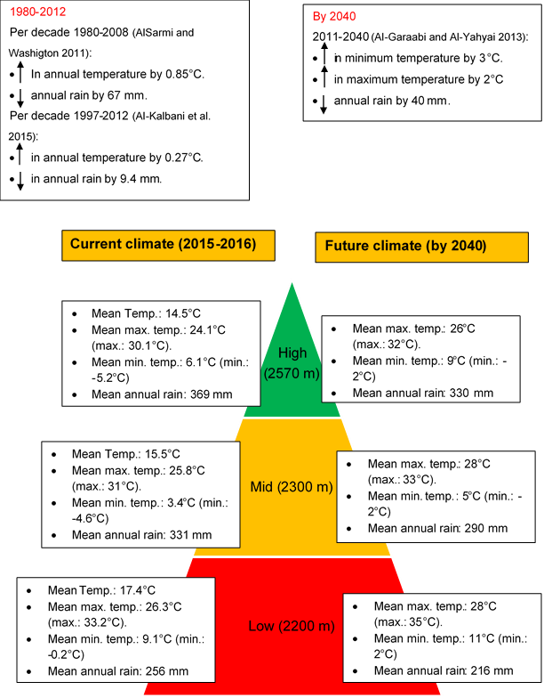

Figure ‎9.2 Mean temperature and rainfall collected over two years along the three different altitudes (current climate) and the projected change in climate for the Al Jabal Al Akhdar mountain range for the next 20 years based on literature at the three different altitudes.

Threats in natural regeneration

Seed quality
The observed lack of natural recruitment in Juniperus populations in northern Oman can be attributed to the absence of one or many regeneration-related factors - including the production of high quantity and quality of seeds by mother plants, availability of suitable microsites, and suitable climatic conditions for seed germination, seedling establishment and development. Embryo intact seeds were generally low (15% at high altitude); trees at low altitudes produce fewer seeds (366 seed per 100 cones) and these seeds have low intact embryo ratios (9%). Increase in abiotic stress, heat and drought, during pollination and seed development at lower altitudes may have negative influences on the ability of trees to produce viable pollen (see chapter 5). Low plant density and segregation between male and female trees may influence pollination success. At low altitude, trees were restricted to wadi habitats; this topographic site may have low levels of wind flow which in turn could reduce pollination success.
The health status and general conditions of trees as a result of abiotic stress may also affect seed production. At low elevations, abiotic stress is the main contributing factor influencing tree growth, this was particularly evident in female trees. Trees growing in very stressful conditions may allocate more of their photosynthetic products to vegetative growth rather than reproduction as a mechanism to promote survival during stress events (Clewell and Aronson, 2013); this is likely to reduce the number and quality of seeds produced by the parent plant. Consequently, the altitudinal patterns observed in seed production and quality suggest that abiotic factors control seed quality through their negative influence on pollination and the suppression of vegetative growth, with knock-on effects on carbohydrate and other resource allocation to the developing seed embryos. This suggestion is in line with recent findings by Redmond et al. (2012) where 40% reduction in seed cone production of Pinus edulis was correlated with increase in temperature during the cone initiation period within semi-arid forests in the USA.

In addition to environmental factors, the increase in seed abortion particularly at lower altitudes could be related to low genetic diversity. Increase in population fragmentation and isolation to smaller habitats increases genetic erosion and increases the potential for inbreeding depression due to a limitation in gene flow (Broadhurst and Boshier, 2014). In gymnosperm species, high genetic diversity within populations due to their outcrossing and wind pollination characteristics is expected (Vanden-Broeck et al., 2011). However, on the other hand, isolation to the edge of its distribution and high population fragmentation can lead to genetic depression in some Juniperus species. For example, in Ethiopia, J. procera, low genetic diversity within the Goba population and low percentage of polymorphic loci (49%) has been related to high population disturbance. Similarly isolation to low distribution sites reduced the amplified fragment length polymorphism (AFLP) of the Yabelo population (Sertse et al., 2011). In addition, Garcia et al. (2000) suggested that reduction in seed cone production and filled seed of J. communis within the southern Iberian Peninsula could relate to the shrinkage of the population and its long-term genetic isolation. In the mountain regions of Oman, Juniper populations were strongly fragmented at lower altitudes with only a few female trees occurring in each fragmented population. Studies on the genetic diversity of J. seravschanica in this mountain range are currently underway. The results of this genetic study in tandem with our results have the potential to contribute significantly to the development of practical conservation measures for Juniper in northern Oman.

In-situ seed germination
Abiotic stress may affect the ability of seed to germinate in the natural environment. Solar radiation, temperature levels and soil moisture are the main physical variables controlling seed germination and establishment. Regenerating new seedlings via direct seed sowing in the field was unsuccessful, although water was artificially applied on some treatments. Nursery germination trials indicated that germination rates were at the highest between 15°C and 25°C, above 25°C germination rates were significantly reduced. Under field conditions, temperature levels during germination trials were above 20°C, reaching 30°C on some occasions. The high levels of light resulting from low cloud cover hitting the ground surface in the Juniper woodlands can increase soil temperatures significantly; corresponding to a decrease in seed longevity and germination (Mamo et al., 2011). In contrast, a reduction in light intensity and decrease in surface temperature under the tree canopy can maintain soil moisture allowing for seedling germination and early stage development. Thus, a reduction in the number of suitable microsites caused by disturbance to the existing tree canopy cover can be potentially harmful to the regeneration success, especially at lower altitudes.
Furthermore, any seeds that do naturally germinate at lower altitudes are under greater stress as a result of biotic pressure; browsing on seedlings by livestock was more severe at low and mid-altitude. However, despite this, no young seedlings were actually observed either within semi-protected areas, e.g. high altitude. In contrast, planting young trees (one-year-old seedlings in animal browsing experiment and two-year-old seedlings in open field), showed high establishment success at this altitude. Walck et al. (2011) reported that alterations in soil moisture caused by variation in precipitation and increases in temperature affect seed longevity, level of dormancy and germination success. It is suggested that limitations to natural regeneration due to poor seed productivity and disappearance of suitable habitat will reduce the ability of conifer species to track the shifts due to climate change (Kroiss and HilleRisLambers, 2015). This may suggest that although the current environmental conditions at high altitude support plant growth and establishment, this may not be the case in the future.

Potential success of young trees transplantation
Results from this study demonstrated that the addition of supplementary water to plants can alleviate the influence of drought stress, and maintain plant viability at the driest and hottest location, i.e. the low altitude zone. Providing artificial irrigation was required at low altitude to ensure high survival of young trees, and to maintain photochemical process of older saplings, but this beneficial effect was less apparent during summer (heat stress). Moreover, evidence from the nursery experiments showed that saplings collapse at higher temperatures, even when 25% of optimal water was provided. Adding to this there was a high mortality of young trees at mid-altitude, suggesting that excessive heat is imposing a secondary stress on plants. This could have a negative influence for long-term viability of Juniperus populations, particularly for those growing in low and mid-altitudes, where heat stress is more likely. It is, therefore, unclear how plants would cope with the high drought and high temperature stresses that are expected to occur in the region as an effect of proposed climate change scenario for the next twenty years (Al-Charaabi and Al-Yahyai, 2013) (Figure 9.2).
Although our results indicate an initial success of transplanting five-year-old J. seravschanica in to field conditions, two issues should be considered before reaching a final conclusion. Firstly, Juniperus is a long living species and may take years, 6-8 years (Iszkulo and Boratynski, 2011), to reach reproductive age. Secondly, in the future, plants may be exposed to abiotic stresses - high heat and drought stress, higher than those experienced over the 3 years of this study, in which case an accurate prediction of the trees response is difficult to determine. The future viability of the transplanted plants is closely related to the severity of these abiotic stresses and at what stage (age) of the trees’ life they occur.
As a restriction in water and excessive heat are expected to limit the success of transplanting young trees, future practices should aim to improve seed selection and improve nursery techniques. Seed for the propagation of new trees may be sourced from trees that are better adapted to future climate condition (Gallo and Marchelli, 2014). Trees growing in harsh environmental condition may have evolved through hybridization from parents with superior stress-tolerant traits (less well adapted plants being less competitive and dying out) resulting in progeny inheriting and enhancing those traits (Gallo, 2014). Future seed collection efforts should target those trees that have survived at lower altitudes as they may contain inherent adaptive genetic traits to cope with climate extremes. In addition, improving nursery techniques through using long root containers and preconditioning trees to environment stresses increases their ability to withstand environment stress once planted in the field (Vallejo et al., 2012), i.e. create intermittent temporary drought and heat stress conditions in nursery-grown trees prior to transplanting in the field.
In our experiment, transplanted saplings were initially grown in controlled glasshouse conditions for five years where temperature varied between 25°C to 28°C, and sometimes reached above 30°C. Results from the controlled experiments indicated that exposing Juniperus plants to extreme stress enhances their response to future stress after recovery. Thus, the variation in temperature levels during the nursery establishment period may encourage plants to expedite their response to repeated stress, triggering a ‘stress memory’ response (chapter 6, section 6.5.2). This may suggest that priming/pre-conditioning plants during early nursery establishment would increase establishment success when transplanting to field conditions.

Practical conservation approaches for J. seravschanica
The data generated from this research provides evidences that the populations of J. seravschanica particularly at lower altitudes are under stress and this stress can be partially explained by climatic factors resulting in moisture limitation and elevated heat stress, this furthermore is augmented by anthropogenic disturbance. Protection of the remaining Juniper populations is essential and could be achieved through effective fencing and sign-posting with priority given to the populations growing in the moist and shaded habitats (e.g. wadis or depression sites). Fencing around trees in these sites could also assist natural regeneration; though this will depend on the ability of trees to recover from current disturbance and availability of suitable microclimates for seed germination. However, caution is required here as solutions are not that simple. Results from this study indicate that the probability of natural regeneration, even within protected sites is very low, particularly at lower elevations.
In addition to woodland protection, augmenting natural J. seravschanica populations with nursery grown plants is important for its long-term persistence and providing some stability to the habitat. It is essential that the negative anthropogenic impacts are stopped or reduced before any consideration is given to potential re-introduction/population augmentation programmes. Planting of young Juniperus plants should be concentrated at shaded, cooler, and high moisture sites (refugia sites) at lower altitudes, below 2500 m; and at higher altitudes where natural regeneration is limited by other natural factors. Integration of other plant species should be considered at lower altitudes to recover the loss of trees in xeric habitats (i.e. in an attempt to provide some degree of canopy cover) and to reduce landscape fragmentation and degradation. Native trees such as Olea europaea subsp. cuspidata (natural distribution from 900-2900 m asl), Sideroxylon mascatense (1000-3000 m), Ziziphus hajarensis (900-2300 m), and Acacia gerrardii (800-2500 m) might be useful planting companions, providing potential shade and shelter for emerging Juniperus seedlings and saplings. It is our contention that the presence of these species would positively influence the establishment of Juniperus population through the improvement of the surrounding environment.
Climatic factors observed in this study are likely to having an effect on other plant species growing in the northern mountains. Approximately 18% of the plant species found within or in proximity to the Juniper woodlands have special conservation status, e.g. endemic or threatened. If the predicted climate change scenarios are correct then this percentage may increase in the future. If this transpires, it is likely that many of the fragile or specialised montane species will need active management through, for example, site protection and possible translocation of nursery grown plants to natural habitats. This could help to augment the threatened populations and promote normal ecological and evolutionary processes, which are and will be essential to the survival of the species in northern Oman.
The assessment for the potential translocating of young trees of J. seravschanica back in to their natural habitat in northern Oman was undertaken during this research to gather the practical knowledge required to carry out such a programme in the future. The following points have been gathered and distilled from the results, observations and literature studied throughout this research and these form a series of recommended steps to carry out the successful translocation of J. seravschanica or other mountain species into favourable habitats in northern Oman:
- Collect seed from different locations with a minimum of 30 trees per population (Eriksson, 2014); these locations should have similar climate conditions to the planting sites. In addition, seeds should be harvested from superior trees that show some degree of water and heat stress tolerance.
- Reintroduce young trees in preference to direct seed sowing. Propagate seeds collected from superior trees under nursery conditions based on species requirements. Grow trees for at least 5 years before transplanting to the wild - older trees have higher survival rates.
- Pre-condition trees before transplanting by exposing them to variable levels of heat and drought stress e.g. high temperature with low irrigation. This may include exposing trees to multiple cycles of stresses after recovery from primary stress.
- Secure planting sites through proper fencing to eliminate the influence of anthropogenic disturbance.
- Transplant young trees to a variety of sites and locations. Plant trees in small clusters with high species density (pocket planting) throughout mountain habitat (Reichard et al., 2012; Clewell and Aronson, 2013;). Consider planting high numbers of trees in wadis, north facing slopes and within mature standing populations. In the case of dioecious species, such as Juniper trees, ensure to plant the equal ratio of male and female trees at each planting site.
- Transplant young trees during early spring (March). Provide irrigation during the first summer until trees become fully established in the field, ensure trees are weaned-off the artificial irrigation supply at a rate that doesn’t harm the tree. This could be through either reducing the volume of water supplied at each time, or increasing time between irrigation events. Ceasing the supplementary irrigation by the autumn allows trees to naturally establish during less stressful seasons before onset of second summer. Roots will also be encouraged to grow deeper in the soil which will promote structural stability.
- Keep monitoring the development of transplanted trees across the range of planted sites. Measure survival, growth and recruitment of all species to identify potential limitation in species recovery.
Further studies
- Future studies should concentrate on fully understanding the threshold temperature and drought stress that J. seravschanica can tolerate. This will be essential for the long-term conservation of the species in Oman as an understanding of the species tolerance range is likely to be an important tool to combat predicted or unpredicted changes in climate.
- Identifying mycorrhizal fungi species associated with this species and the possibility of its integration in a cultivation programme.
- Identifying the genetic status and variability of Juniperus trees is essential for understanding population dynamics, locating and selecting genetically diverse individuals or populations and determining the potential relationship between tree health and genetic diversity.
- A more thorough examination of the potential presence of harmful primary or secondary pathogenic infections in the Juniperus populations.
- The setting up of permanent, long-term monitoring sites is essential for the understanding of natural cycles in Juniperus populations. Sites should be representative of multiple habitats and be of sufficient size to allow natural processes to occur.

Wider perspective
It is widely recognised that humankind is facing serious challenges in protecting plant species and their habitats from continuous degradation. Data from this research will form a base for future J. seravschanica conservation in Oman and in doing so will be one of the first such studies in the country. In addition to the concerns raised about the future of J. seravschanica, this study also anticipates that climate stress will widely reduce fitness of other montane plant species. This thesis highlights problems that conservation managers may face in the future. In the current situation, we anticipate that some of the threatened native species may only persist through active management e.g. seed collection from threatened populations, nursery cultivation and transplanting in to suitable habitats. Conservation of such long living species requires long-term financial and time commitments. It is essential that the people and government of Oman are fully aware of this potential loss to Oman’s natural heritage and act swiftly and appropriately.
Data from this study highlights a loss of perennial plant cover at low altitude, which is likely to influence the functionality of the landscape. Lower altitudinal zones experience a persistent dry wind that can increase soil aridity and potentially reduce beneficial soil microbial processes. The subsequent loss of plant diversity due to soil aridity and anthropogenic disturbance is a potential cause of desertification (Le Houerou, 1996). The same pattern of land degradation due to over-browsing was recently reported in the cloud mountain forest in the southern part of Oman, suggesting potential desertification (Galletti et al., 2016). Thus, an urgent conservation management plan is required to sustain the northern mountain ecosystem.
This could have many implications - financial and ethical issues in a country like Oman where natural resources are limited. The rural mountain area has limited water resources, which are essential for the existence of domestic and agricultural life. The latter has been severely affected by water shortages in recent years. Therefore, any conservation plan needs to consider using alternative water resources. One option is integrating natural conservation within urban landscaping. The mountain area has become a hotspot destination for ecotourism (Buerkert et al., 2010); and recently urban development, e.g. hotels and public parks, in the Al Jabal Al Akhdar mountain area has increased dramatically. This may increase water demand for urban landscaping particularly if exotic tree species are used. Linking nature conservation and urban landscaping through integrating native plants in landscape design could be proposed to stimulate the persistence of wild plants, as well as reducing the demand of water resources.

In the case of J. seravschanica, the availability of suitable habitat in this mountain region will decrease in response to climate change triggers. If the species viability is limited by climatic factors, then it is more advisable to consider the concept of assisted migration (managed relocation). This would involve introducing this plant species to other mountain ranges within the species natural distribution where environmental stress, heat and drought, are not harmful to the species survival. Seed dispersal is not likely to reach these sites, therefore managed relocation programmes would be needed. Assisted migration is proposed as an option to prevent species extinction as an effect of climate change (Williams and Dumroese, 2013; Sansilvestri et al., 2015); however, the possible negative impact on recipient sites requires caution (Ricciardi and Simberloff, 2009; Haskins and Keel, 2012; Reichard et al., 2012). The risk of introducing an invasive plant that may negatively interact with similar plant species (interbreeding with native species) and with the other species (competition in natural resources), or damage to wildlife or beneficial soil microbes in translocated sites must be considered. These factors can alter the recipient site ecosystem development and functioning. Therefore, alongside acquiring legal approval, assessment of invasive risk probability to recipient sites should be evaluated before considering this option. This would be through full understanding of specific species impact on soil chemistry, hydrology, nutrient cycle and existing food-web.

Key note points
In summary, this research demonstrates that J. seravschanica populations in Oman are under threat from climate, drought and heat stress. Every attempt should be made to conserve this ancient and noble tree by implementing the recommendations outlined in this research. Alongside in-situ conservation, assessment of integrating this species or other mountain plants in new urban development landscaping design or the feasibility of future assisted migration should be considered. The main key findings from this research can be summarised in the following points:
- Abiotic stresses are the main drivers for J. seravschanica decline in this mountain region.
- Results from this thesis showed that drought stress is the main contributor in Juniper decline at low altitude. Lower altitude received 30% rainfall to that at high altitude during summer and evidence from nursery and field indicated growth decline when trees are exposed to drought stress (see Figure 4.16, Figure 6.1, Figure 7.10).
- The effect of temperature was expressed through increased soil moisture evaporation particularly during summer (Figure 7.14). There was evidence from controlled experiment that high temperature (e.g. 30°C) reduced plant growth and physiological processes (Figure 6.2 and Table 6.3). This effect was not clearly indicated under field experiments; however, the author believes that temperature higher than that experienced during this research (e.g. > 35°C) may cause significant decline in plant growth.
- Limitations to regeneration appear to be strongly correlated with summer drought stress and disappearance of plant to plant facilitation at lower altitudes. Additionally, reduction in seed production and percentage of filled seeds are clearly significant factors influencing to the low levels of recruitment.
- Augmenting natural populations with new progeny at high altitude is feasible to avoid species extinction from this mountain range.
- Translocation of nursery grown Juniper saplings (5 years) with water supplementation during establishment are fundamental for successful translocation.

References

Achakzai, A. K. K., Batool, H., Aqeel, T. and Bazai, Z. A. 2013. A comparative study of the deforestation and regeneration status of Zirat juniper forest. Pakistan Journal of Botany, 45(4), pp 1169-1172.
Adams, H. D., Collins, A. D., Briggs, S. P., Vennetier, M., Dickman, L. T., Sevanto, S. A., Garcia‐Forner, N., Powers, H. H. and McDowell, N. G. 2015. Experimental drought and heat can delay phenological development and reduce foliar and shoot growth in semiarid trees. Global Change Biology, 21(11), pp 4210-4220.
Adams, H. D., Germino, M. J., Breshears, D. D., Barron‐Gafford, G. A., Guardiola‐Claramonte, M., Zou, C. B. and Huxman, T. E. 2013. Nonstructural leaf carbohydrate dynamics of Pinus edulis during drought‐induced tree mortality reveal role for carbon metabolism in mortality mechanism. New Phytologist, 197(4), pp 1142-1151.
Adams, H. D., Guardiola-Claramonte, M., Barron-Gafford, G. A., Villegas, J. C., Breshears, D. D., Zou, C. B., Troch, P. A. and Huxman, T. E. 2009. Temperature sensitivity of drought-induced tree mortality portends increased regional die-off under global-change-type drought. Proceedings of the National Academy of Sciences, 106(17), pp 7063-7066.
Adams, R. P. 2011. Juniperus of the world: the genus Juniperus, Third Edition, US: Bloonington, Trafford Publishing Co.
Adams, R. P., Al-Farsi, A. and Schwarzbach, A. E. 2014. Confirmation of the southern-most population of Juniperus seravschanica in Oman by DNA sequencing of nrDNA and four cpDNA regions. Phytologia, 96(3), pp 218-224.
Adams, R. P., Armagan, M., Boratynski, A., Douaihy, B., Dagher-Kharrat, M. D., Farzaliyev, V., Gucel, S., Mataraci, T., Tashev, A. N. and Schwarzbach, A. E. 2016. Evidence of relictual introgression or incomplete lineage sorting in nrDNA of Juniperus excelsa and J. polycarpos in Asia Minor. Phytologia, 98(2), pp 146-155.
Adams, R. P. and Hojjati, F. 2012. Taxonomy of Juniperus in Iran: Insight from DNA sequencing. Phytologia, 94(2), pp 219-227.
Adams, R. P. and Thornburg, D. 2016. A survey of percent-filled and empty seeds in multiple years observations of Juniperus arizonica and J. osteosperma. Phytologia, 98(3), pp 164-169.
Ahmad, S. S., Abbasi, Q., Jabeen, R. and Shah, M. T. 2012. Decline of conifer forest cover in Pakistan: a GIS approach. Pakistan Journal of Botany, 44(2), pp 511-514.
Ahmed, M., Shaukat, S. S. and Buzdar, A. H. 1990. Population structure and dynamics of Juniperus excelsa in Balouchistan, Pakistan. Journal of Vegetation Science, 1(2), pp 271-276.
Al Haddabi, L. and Victor, R. 2016. The ecological status of juniper woodlands in Al Jabal Al Akhdar, northern mountains of Oman. International Journal of Environmental Studies, 73(5), pp 746-759.
Al Harthi, L. S., Robinson, M. D. and Mahgoub, O. 2008. Diets and resource sharing among livestock on the Saiq Plateau, Jebel Akhdar Mountains, Oman. International Journal of Ecology and Environmental Sciences, 34(2), pp 113-120.
Al-Charaabi, Y. and Al-Yahyai, S. 2013. Projection of future changes in rainfall and temperature patterns in Oman. Journal of Earth Science and Climate Change, 4(5), pp 154-161.
Al-Kalbani, M. S., John, C. and Martin, F. 2015. Recent trends in temperature and precipitation in Al Jabal Al Akhdar, Sultanate of Oman, and the implications for future climate change. Journal of Earth Science and Climatic Change, 6 (8), http://dx.doi.org/10.4172/2157-7617.1000295. [Accessed 15th November 2016].
Al-Yahya’ei, M. N., Oehl, F., Vallino, M., Lumini, E., Redecker, D., Wiemken, A. and Bonfante, P. 2011. Unique arbuscular mycorrhizal fungal communities uncovered in date palm plantations and surrounding desert habitats of Southern Arabia. Mycorrhiza, 21(3), pp 195-209.
Albrecht, M. A. and Maschinski, J. 2012. Influence of founder population size, propagule stages, and life history on the survival of reintroduced plant populations. In: Maschinski, J. and Haskins, K. E. (eds.) Plant reintroduction in a changing climate: promises and perils. Washington, USA: Island Press, pp 171-188.
Alguacil, M., Caravaca, F., Diaz-Vivancos, P., Hernandez, J. A. and Roldan, A. 2006. Effect of arbuscular mycorrhizae and induced drought stress on antioxidant enzyme and nitrate reductase activities in Juniperus oxycedrus L. grown in a composted sewage sludge-amended semi-arid soil. Plant and Soil, 279(1-2), pp 209-218.
Allegrezza, M., Corti, G., Cocco, S., Pesaresi, S., Chirico, G., Saracino, A. and Bonanomi, G. 2016. Microclimate buffering and fertility island formation during Juniperus communis ontogenesis modulate competition–facilitation balance. Journal of Vegetation Science, 27(3), pp 616-627.
Allen, C. D., Macalady, A. K., Chenchouni, H., Bachelet, D., McDowell, N., Vennetier, M., Kitzberger, T., Rigling, A., Breshears, D. D., Hogg, E., Gonzalez, P., Fensham, R., Zhangm, Z., Castro, J., Demidova, N., Lim, J.-H., Allard, G., Running, S. W., Semerci, A. and Cobb, N. 2010. A global overview of drought and heat-induced tree mortality reveals emerging climate change risks for forests. Forest Ecology and Management, 259(4), pp 660-684.
Alrababah, M., Bani-Hani, M., Alhamad, M. and Bataineh, M. 2008. Boosting seedling survival and growth under semi-arid Mediterranean conditions: Selecting appropriate species under rainfed and wastewater irrigation. Journal of Arid Environments, 72(9), pp 1606-1612.
AlSarmi, S. and Washington, R. 2011. Recent observed climate change over the Arabian Peninsula. Journal of Geophysical Research: Atmospheres, 116 (D11109), DOI:10.1029/2010JD015459. [Accessed 9th Jun 2016].
Amri, E. 2011. Germination of terminalia sericea buch. EX DC seeds: The effects of temperature regime, photoperiod, gibberellic acid and potassium nitrate. International Journal of Applied Biology and Pharmaceutical Technology, 2(2), pp 104-110.
Anderegg, W. R., Kane, J. M. and Anderegg, L. D. 2013. Consequences of widespread tree mortality triggered by drought and temperature stress. Nature Climate Change, 3(1), pp 30-36.
Anjum, S. A., Xie, X., Wang, L., Saleem, M. F., Man, C. and Lei, W. 2011. Morphological, physiological and biochemical responses of plants to drought stress. African Journal of Agricultural Research, 6(9), pp 2026-2032.
Ansley, R., Pinchak, W. and Ueckert, D. 1995. Changes in redberry juniper distrubtion in northwest Texas (1948 to 1982). Rangelands, 17(2), pp. 49-53.
Aref, I., El Atta, H., El Obeid, M., Ahmed, A., Khan, P. and Iqbal, M. 2013. Effect of water stress on relative water and chlorophyll contents of Juniperus procera Hochst. ex Endlicher in Saudi Arabia. Life Science Journal, 10(4), pp 681-685.
Aref, I. and El-Juhany, L. 2004. Planting Juniperus procera trees in the natural forests of Saudi Arabia: the first trial. The Second Conference of Development and Environment in Arab World. Assiut University, Egypt. pp 339-344. Available from: faculty.ksu.edu.sa/69123/Full%20Paper1/juniper%20paper%20Assuit.pdf. [Accessed 19 December 2013].
Arndt, S. K., Irawan, A. and Sanders, G. J. 2015. Apoplastic water fraction and rehydration techniques introduce significant errors in measurements of relative water content and osmotic potential in plant leaves. Physiologia Plantarum, 155(4), pp 355-368.
Aronson, J., Floret, C., Floc'h, E., Ovalle, C. and Pontanier, R. 1993. Restoration and rehabilitation of degraded ecosystems in arid and semi‐arid lands. I. A view from the south. Restoration Ecology, 1(1), pp 8-17.
Ashcroft, M. B., Gollan, J. R., Warton, D. I. and Ramp, D. 2012. A novel approach to quantify and locate potential microrefugia using topoclimate, climate stability, and isolation from the matrix. Global Change Biology, 18(6), pp 1866-1879.
Atkin, O. K., Edwards, E. J. and Loveys, B. R. 2000. Response of root respiration to changes in temperature and its relevance to global warming. New Phytologist, 147(1), pp 141-154.
Atkinson, N. J. and Urwin, P. E. 2012. The interaction of plant biotic and abiotic stresses: from genes to the field. Journal of Experimental Botany, 63(10), pp 3523-3543.
Bainbridge, D. A. 2007. A guide for desert and dryland restoration: new hope for arid lands, Washington, USA: Island Press.
Baker, N. R. 2008. Chlorophyll fluorescence: a probe of photosynthesis in vivo. Annual Review of Plant Biology, 59(1), pp 89-113.
Baker, N. R. and Rosenqvist, E. 2004. Applications of chlorophyll fluorescence can improve crop production strategies: an examination of future possibilities. Journal of Experimental Botany, 55(403), pp 1607-1621.
Barredo, J. I., Caudullo, G. and Dosio, A. 2016. Mediterranean habitat loss under future climate conditions: Assessing impacts on the Natura 2000 protected area network. Applied Geography, 75, pp 83-92.
Barrs, H. and Weatherley, P. 1962. A re-examination of the relative turgidity technique for estimating water deficits in leaves. Australian Journal of Biological Sciences, 15(3), pp 413-428.

Beckage, B., Osborne, B., Gavin, D. G., Pucko, C., Siccama, T. and Perkins, T. 2008. A rapid upward shift of a forest ecotone during 40 years of warming in the Green Mountains of Vermont. Proceedings of the National Academy of Sciences, 105(11), pp 4197-4202.
Becken, S. and Job, H. 2014. Protected areas in an era of global–local change. Journal of Sustainable Tourism, 22(4), pp 507-527.
Bonebrake, T. C., Syphard, A. D., Franklin, J., Anderson, K. E., Akcakaya, H. R., Mizerek, T., Winchell, C. and Regan, H. M. 2014. Fire management, managed relocation, and land conservation options for long‐lived obligate seeding plants under global changes in climate, urbanization, and fire regime. Conservation Biology, 28(4), pp 1057-1067.
Borghetti, M., Cinnirella, S., Magnani, F. and Saracino, A. 1998. Impact of long-term drought on xylem embolism and growth in Pinus halepensis Mill. Trees, 12(4), pp 187-195.
Bornman, J. F., Barnes, P. W., Robinson, S. A., Ballare, C. L., Flint, S. and Caldwell, M. M. 2015. Solar ultraviolet radiation and ozone depletion-driven climate change: effects on terrestrial ecosystems. Photochemical and Photobiological Sciences, 14(1), pp 88-107.
Borowicz, V. A. 2001. Do arbuscular mycorrhizal fungi alter plant–pathogen relations? Ecology, 82(11), pp 3057-3068.
Bragg, D. C. 2008. An improved tree height measurement technique tested on mature southern pines. Southern Journal of Applied Forestry, 32(1), pp 38-43.
Brinkmann, K., Patzelt, A., Dickhoefer, U., Schlecht, E. and Buerkert, A. 2009. Vegetation patterns and diversity along an altitudinal and a grazing gradient in the Jabal al Akhdar mountain range of northern Oman. Journal of Arid Environments, 73(11), pp 1035-1045.
Broadhurst, L. and Boshier, D. 2014. Seed provenance for restoration and management: conserving evolutionary potential and utility. In: Bozzano, M., Jalonen, R., Thomas, E., Boshier, D., Gallo, L., Cavers, S., Bordacs, S., Smith, P. and Loo, J. (eds.) Genetic considerations in ecosystem restoration using native tree species. State of the World’s Forest Genetic Resources- Thematic Study. Rome: Food and Agriculture Organization of the United Nations (FAO), pp 27-37.
Brodribb, T. J. and McAdam, S. A. 2013. Abscisic acid mediates a divergence in the drought response of two conifers. Plant Physiology, 162(3), pp 1370-1377.
Brodribb, T. J., McAdam, S. A., Jordan, G. J. and Martins, S. C. 2014. Conifer species adapt to low-rainfall climates by following one of two divergent pathways. Proceedings of the National Academy of Sciences, 111(40), pp 14489-14493.
Broome, A., Long, D., Ward, L. K. and Park, K. J. 2017. Promoting natural regeneration for the restoration of Juniperus communis: a synthesis of knowledge and evidence for conservation practitioners. Applied Vegetation Science, 20(3), pp 397-409.
Bruce, T. J., Matthes, M. C., Napier, J. A. and Pickett, J. A. 2007. Stressful “memories” of plants: evidence and possible mechanisms. Plant Science, 173(6), pp 603-608.
Bruner, A. G., Gullison, R. E., Rice, R. E. and Da Fonseca, G. A. 2001. Effectiveness of parks in protecting tropical biodiversity. Science, 291(5501), pp 125-128.
Brzezinska, E., Kozlowska, M. and Stachowiak, J. 2006. Response of three conifer species to enhanced UV-B radiation; consequences for photosynthesis. Polish Journal of Environment Study, 15(4), pp 531-536.
Buerkert, A., Luedeling, E., Dickhoefer, U., Lohrer, K., Mershen, B., Schaeper, W., Nagieb, M. and Schlecht, E. 2010. Prospects of mountain ecotourism in Oman: the example of As Sawjarah on Al Jabal al Akhdar. Journal of Ecotourism, 9(2), pp 104-116.
Burke, J. J. and Chen, J. 2006. Changing in cellular and molecular processes in plant adaptation to heat stress. In: Huang, B. (ed.) Plant-environment interaction. New York, USA: CRC Press, Taylor and Francis Group, pp 27-46.
Burkle, L. A. and Belote, R. T. 2015. Soil mutualists modify priority effects on plant productivity, diversity, and composition. Applied Vegetation Science, 18(2), pp 332-342.
Burton, A., Pregitzer, K., Ruess, R., Hendrick, R. and Allen, M. 2002. Root respiration in North American forests: effects of nitrogen concentration and temperature across biomes. Oecologia, 131(4), pp 559-568.
Bussotti, F., Ferrini, F., Pollastrini, M. and Fini, A. 2014. The challenge of Mediterranean sclerophyllous vegetation under climate change: from acclimation to adaptation. Environmental and Experimental Botany, 103, pp 80-98.
Butchart, S. H., Walpole, M., Collen, B., Van Strien, A., Scharlemann, J. P., Almond, R. E., Baillie, J. E., Bomhard, B., Brown, C. and Bruno, J. 2010. Global biodiversity: indicators of recent declines. Science, 328(5982), pp 1164-1168.
Cahill, A. E., Aiello-Lammens, M. E., Fisher-Reid, M. C., Hua, X., Karanewsky, C. J., Ryu, H. Y., Sbeglia, G. C., Spagnolo, F., Waldron, J. B. and Warsi, O. 2012. How does climate change cause extinction? Proceeding of Royal Society B: Biological Sceince, 280 (1750). DOI: 10.1098/rspb.2012.1890. [Accessed 4th May 2017].
Caldeira, M. C., Ibanez, I., Nogueira, C., Bugalho, M. N., Lecomte, X., Moreira, A. and Pereira, J. S. 2014. Direct and indirect effects of tree canopy facilitation in the recruitment of Mediterranean oaks. Journal of Applied Ecology, 51(2), pp 349-358.
Cameron, R., Harrison‐Murray, R., Fordham, M., Wilkinson, S., Davies, W., Atkinson, C. and Else, M. 2008. Regulated irrigation of woody ornamentals to improve plant quality and precondition against drought stress. Annals of Applied Biology, 153(1), pp 49-61.
Canadell, J., Jackson, R., Ehleringer, J., Mooney, H., Sala, O. and Schulze, E. D. 1996. Maximum rooting depth of vegetation types at the global scale. Oecologia, 108(4), pp 583-595.
Caravaca, F., del Mar Alguacil, M., Diaz, G., Marin, P. and Roldan, A. 2006. Growth and nitrate reductase activity in Juniperus oxycedrus subjected to organic amendments and inoculation with arbuscular mycorrhizae. Journal of Plant Nutrition and Soil Science, 169(4), pp 501-505.
Carnicer, J., Coll, M., Ninyerola, M., Pons, X., Sanchez, G. and Penuelas, J. 2011. Widespread crown condition decline, food web disruption, and amplified tree mortality with increased climate change-type drought. Proceedings of the National Academy of Sciences, 108(4), pp 1474-1478.
Caron, M. M., De Frenne, P., Brunet, J., Chabrerie, O., Cousins, S. A., De Backer, L., Diekmann, M., Graae, B. J., Heinken, T. and Kolb, A. 2014. Latitudinal variation in seeds characteristics of Acer platanoides and A. pseudoplatanus. Plant Ecology, 215(8), pp 911-925.
Castro, J., Zamora, R., Hodar, J. A. and Gomez, J. 2005a. Ecology of seed germination of Pinus sylvestris L. at its southern, Mediterranean distribution range. Investigación Agraria. Sistemas Y Recursos Forestales, 14(2), pp 143-152
Castro, J., Zamora, R., Hodar, J. A. and Gomez, J. M. 2002. Use of shrubs as nurse plants a new technique for reforestation in Mediterranean mountains. Restoration Ecology, 10(2), pp 297-305.
Castro, J., Zamora, R., Hodar, J. A. and Gomez, J. M. 2005b. Alleviation of summer drought boosts establishment success of Pinus sylvestris in a Mediterranean mountain: an experimental approach. Plant Ecology, 181(2), pp 191-202.
Castro, J., Zamora, R., Hodar, J. A., Gomez, J. M. and Gomez‐Aparicio, L. 2004. Benefits of using shrubs as nurse plants for reforestation in Mediterranean mountains: a 4‐year study. Restoration Ecology, 12(3), pp 352-358.
Catoni, R. and Gratani, L. 2014. Variations in leaf respiration and photosynthesis ratio in response to air temperature and water availability among Mediterranean evergreen species. Journal of Arid Environments, 102, pp 82-88.
Chakraborty, S. 2013. Migrate or evolve: options for plant pathogens under climate change. Global Change Biology, 19(7), pp 1985-2000.
Chamorro, D., Parra, A. and Moreno, J. 2016. Reproductive output, seed anatomy and germination under water stress in the seeder Cistus ladanifer subjected to experimental drought. Environmental and Experimental Botany, 123, pp 59-67.
Chanyenga, T., Geldenhuys, C. and Sileshi, G. 2012. Germination response and viability of an endangered tropical conifer Widdringtonia whytei seeds to temperature and light. South African Journal of Botany, 81, pp 25-28.
Chen, I. C., Hill, J. K., Ohlemuller, R., Roy, D. B. and Thomas, C. D. 2011. Rapid range shifts of species associated with high levels of climate warming. Science, 333(6045), pp 1024-1026.
Choat, B., Jansen, S., Brodribb, T. J., Cochard, H., Delzon, S., Bhaskar, R., Bucci, S. J., Feild, T. S., Gleason, S. M. and Hacke, U. G. 2012. Global convergence in the vulnerability of forests to drought. Nature, 491(7426), pp 752-755.
Chown, S. L., Hoffmann, A. A., Kristensen, T. N., Angilletta Jr, M. J., Stenseth, N. C. and Pertoldi, C. 2010. Adapting to climate change: a perspective from evolutionary physiology. Climate Research, 43(1-2), pp 3-15.
Ciesla, W. M. 2002. Juniper forests—a special challenge for sustainable forestry. Forests, Trees and Livelihoods, 12(3), pp 195-207.
Clark, L., Gowing, D., Lark, R., Leeds-Harrison, P., Miller, A., Wells, D., Whalley, W. and Whitmore, A. 2005. Sensing the physical and nutritional status of the root environment in the field: a review of progress and opportunities. Journal of Agricultural Science-Cambridge, 143(5), pp 347-385.

Classen, A. T., Norby, R. J., Sides, K. E. and Weltzin, J. F. 2010. Climate change alters seedling emergence and establishment in an old-field ecosystem. PLoS One, 5(10), pp e13476. Available from: https://doi.org/10.1371/journal.pone.0013476 [Accessed 15th March 2015].
Clewell, A. F. and Aronson, J. 2013. Ecological restoration: principles, values, and structure of an emerging profession, Washington, USA: Island Press.
Clifton, S. J., Ward, L. K. and Ranner, D. S. 1997. The status of juniper (Juniperus communis L.) in northeast England. Biological Conservation, 79(1), pp 67-77.
Corlett, R. T. and Westcott, D. A. 2013. Will plant movements keep up with climate change? Trends in Ecology and Evolution, 28(8), pp 482-488.
Cramer, G. R., Urano, K., Delrot, S., Pezzotti, M. and Shinozaki, K. 2011. Effects of abiotic stress on plants: a systems biology perspective. BMC Plant Biology, 11(1), pp 163, DOI:10.1186/1471-2229-11-163. [Accessed 6th Jun 2017].
Crimmins, T. M., Crimmins, M. A. and David Bertelsen, C. 2010. Complex responses to climate drivers in onset of spring flowering across a semi‐arid elevation gradient. Journal of Ecology, 98(5), pp 1042-1051.
Crimmins, T. M., Elmore, A. J., Huete, A., Keller, S., Levetin, E., Luvall, J., Meyers, O., Stylinski, C. D., VandeWater, P. K. and Vukovic, A. 2013. Researcher-driven Campaigns Engage Nature's Notebook Participants in Scientific Data Collection. [online]. Available from: https://ntrs.nasa.gov/archive/nasa/casi.ntrs.nasa.gov/20140003106.pdf. [Accessed 6th March 2016].
Crisp, P. A., Ganguly, D., Eichten, S. R., Borevitz, J. O. and Pogson, B. J. 2016. Reconsidering plant memory: Intersections between stress recovery, RNA turnover, and epigenetics. Science advances, 2 (2), DOI: 10.1126/sciadv.1501340. [Accessed 10th November 2016].
Dalrymple, S. E., Banks, E., Stewart, G. B. and Pullin, A. S. 2012. A meta-analysis of threatened plant reintroductions from across the globe. In: Maschinski, J. and Haskins, K. E. (eds.) Plant reintroduction in a changing climate: promises and perils. Washington, USA: Island Press, pp 31-50.
Dalrymple, S. E., Stewart, G. B. and Pullin, A. S. 2011. Are re-introduction an effective way of mitigating against plant extinction? CEE review 07-008 (SR32). Collaboration for Environmental Evidence. Avialble from: www.environmentalevidence.org/SR32.html. [Accessed 15th March 2015].
Daneshvar, A., Tigabu, M., Karimidoost, A., Farhadi, M. and Oden, P. C. 2014. Growth characteristics and reproductive output of dwarf mistletoe-infected Juniperus polycarpos in Iran. Journal of Forestry Research, 25(4), pp 827-834.
Daneshvar, A., Tigabu, M., Karimidoost, A. and Oden, P. C. 2016. Stimulation of germination in dormant seeds of Juniperus polycarpos by stratification and hormone treatments. New Forests, 47(5), pp 751-761.
Daneshvar, A., Tigabu, M., Karimidoost, A. and Oden, P. C. 2017. Flotation techniques to improve viability of Juniperus polycarpos seed lots. Journal of Forestry Research, 28(2), pp 231-239.
Daniels, B. A. and Skipper, H. D. 1982. Methods for the recovery and quantitative estimation of propagules from soil. In: Schenck, N. C. (ed.) Methods and principles of mycorrhizal research. USA: American Phytopathological Society, St. Paul, Minn, pp 29-35.
Deguignet, M., Juffe-Bignoli, D., Harrison, J., MacSharry, B., Burgess, N. and Kingston, N. 2014. 2014 United nations list of protected areas. UNEP-WCMC: Cambridge, UK. Available from: https://www.unep-wcmc.org/system/dataset_file_fields/files/000/000/263/original/2014_UN_List_of_Protected_Areas_EN_web.PDF?1415613322. [Accessed 16th May 2017].
Del Cacho, M., Penuelas, J. and Lloret, F. 2013. Reproductive output in Mediterranean shrubs under climate change experimentally induced by drought and warming. Perspectives in Plant Ecology, Evolution and Systematics, 15(6), pp 319-327.
Dickhoefer, U., Buerkert, A., Brinkmann, K. and Schlecht, E. 2010. The role of pasture management for sustainable livestock production in semi-arid subtropical mountain regions. Journal of Arid Environments, 74(8), pp 962-972.
Dieleman, W. I., Vicca, S., Dijkstra, F. A., Hagedorn, F., Hovenden, M. J., Larsen, K. S., Morgan, J. A., Volder, A., Beier, C. and Dukes, J. S. 2012. Simple additive effects are rare: a quantitative review of plant biomass and soil process responses to combined manipulations of CO2 and temperature. Global Change Biology, 18(9), pp 2681-2693.
Ditmarova, L., Kurjak, D., Palmroth, S., Kmet, J. and Strelcova, K. 2010. Physiological responses of Norway spruce (Picea abies) seedlings to drought stress. Tree Physiology, 30(2), pp 205-213.
Dobrowski, S. Z. 2011. A climatic basis for microrefugia: the influence of terrain on climate. Global Change Biology, 17(2), pp 1022-1035.
Donat, M., Peterson, T., Brunet, M., King, A., Almazroui, M., Kolli, R., Boucherf, D., Al‐Mulla, A. Y., Nour, A. Y. and Aly, A. A. 2013. Changes in extreme temperature and precipitation in the Arab region: long‐term trends and variability related to ENSO and NAO. International Journal of Climatology, 34(3), pp 581-592.
Douaihy, B., Restoux, G., Machon, N. and Dagher-Kharrat, M. B. 2013. Ecological characterization of the Juniperus excelsa stands in Lebanon. Ecologia Mediterranea, 39(1), pp 169-180.
Duan, H., Amthor, J. S., Duursma, R. A., O'Grady, A. P., Choat, B. and Tissue, D. T. 2013. Carbon dynamics of eucalypt seedlings exposed to progressive drought in elevated [CO2] and elevated temperature. Tree Physiology, 33(8), pp 779-792.
Dudley, N. 2008. Guidelines for applying protected area management categories, Gland, Switzerland: IUCN. Available from: https://portals.iucn.org/library/sites/library/files/documents/PAG-021.pdf. [Accessed 16th May 2017].
Dunne, J. A., Saleska, S. R., Fischer, M. L. and Harte, J. 2004. Integrating experimental and gradient methods in ecological climate change research. Ecology, 85(4), pp 904-916.

Duran, J., Morse, J. L., Groffman, P. M., Campbell, J. L., Christenson, L. M., Driscoll, C. T., Fahey, T. J., Fisk, M. C., Mitchell, M. J. and Templer, P. H. 2014. Winter climate change affects growing‐season soil microbial biomass and activity in northern hardwood forests. Global Change Biology, 20(11), pp 3568-3577.
El Mrabet, S., Ouahmane, L., El Mousadik, A., Msanda, F. and Abbas, Y. 2014. The effectiveness of arbuscular mycorrhizal inoculation and bio-compost addition for enhancing reforestation with Argania spinosa in Morocco. Open Journal of Forestry, 4(1), pp 14-23.
El-Bana, M., Shaltout, K., Khalafallah, A. and Mosallam, H. 2010. Ecological status of the Mediterranean Juniperus phoenicea L. relicts in the desert mountains of North Sinai, Egypt. Flora, 205(3), pp 171-178.
El-Juhany, L. 2015. The magnitude of dieback on Juniperus procera trees in the natural forests in the southwestern region of Saudi Arabia. Biosciences, Biotechnology Research Asia, 12(1), pp 219-230.
El-Juhany, L. I. and Aref, I. M. 2013. The present status of the natural forests in the southwestern saudi Arabia: 3-Asir and east Jazan forests. World Applied Science Journal, 21(5), pp 710-26.
El-Juhany, L. I., Aref, I. M. and Al-Ghamdi, M. A. 2008. The possibility of ameliorating the regeneration of juniper trees in the natural forests of Saudi Arabia. Research Journal of Agriculture and Biological Sciences, 4(2), pp 126-133.
El-Juhany, L. I., Aref, I. M. and Al-Ghamdi, M. A. 2009. Effects of different pre-treatments on seed germination and early establishment of the seedlings of Juniperus procera trees. World Application Science Journal, 7(5), pp 616-624.
El-Keblawy, A. 2014. Impact of climate change on biodiversity loss and extinction of endemic plants of arid land mountains. Journal of Biodiversity and Endangered Species, 2 (1). DOI: 10.4172/2332-2543.1000120. [Accessed 5th May 2017].
El-Kharbotly, A., Mahgoub, O., Al-Subhi, A. and Al-Halhali, A. 2003. Indigenous grass species with potential for maintaining rangeland and livestock feeding in Oman. Agriculture, Ecosystems and Environment, 95(2), pp 623-627.
Ellis, R. D., McWhorter, T. J. and Maron, M. 2012. Integrating landscape ecology and conservation physiology. Landscape Ecology, 27(1), pp 1-12.
Eriksen, J. (ed.) 2008. The birds of Al Jabal Al Akhdar, Center for Environmental Studies and Research, Sultan Qaboos University.
Eriksson, G. 2014. Collection of propagation material in the absence of genetic knowledge. In: Bozzano, M., Jalonen, R., Thomas, E., Boshier, D., Gallo, L., Cavers, S., Bordács, S., Smith, P. and Loo, J. (eds.) Genetic considerations in ecosystem restoration using native tree species. State of the World’s Forest Genetic Resources–Thematic Study. Rome: FAO and Bioversity International, pp 79-84.
Esteban, R., Fernandez-Marin, B., Olano, J. M., Becerril, J. M. and Garcia-Plazaola, J. I. 2014. Does plant colour matter? Wax accumulation as an indicator of decline in Juniperus thurifera. Tree Physiology, 34(3), pp 267-274.
Fang-Yuan, Y. and Guy, R. D. 2004. Variable chlorophyll fluorescence in response to water plus heat stress treatments in three coniferous tree seedlings. Journal of Forestry Research, 15(1), pp 24-28.
Farrar, J. and Williams, M. 1991. The effects of increased atmospheric carbon dioxide and temperature on carbon partitioning, source‐sink relations and respiration. Plant, Cell and Environment, 14(8), pp 819-830.
Feeley, K. J., Silman, M. R., Bush, M. B., Farfan, W., Cabrera, K. G., Malhi, Y., Meir, P., Revilla, N. S., Quisiyupanqui, M. N. R. and Saatchi, S. 2011. Upslope migration of Andean trees. Journal of Biogeography, 38(4), pp 783-791.
Fenner, M. and Thompson, K. 2005. The ecology of seeds, UK: Cambridge University Press.
Fernandez, J., Moreno, F., Cabrera, F., Arrue, J. and Martin-Aranda, J. 1991. Drip irrigation, soil characteristics and the root distribution and root activity of olive trees. Plant and Soil, 133(2), pp 239-251.
Fernandez-Martinez, J., Fransi, M. A. and Fleck, I. 2016. Ecophysiological responses of Betula pendula, Pinus uncinata and Rhododendron ferrugineum in the Catalan Pyrenees to low summer rainfall. Tree Physiology, 36(12), pp 1520-1535.
Fischer, A., Blaschke, M. and Bässler, C. 2011. Altitudinal gradients in biodiversity research: the state of the art and future perspectives under climate change aspects. Waldökologie, Landschaftsforschung und Naturschutz, 11, pp 35-47. Available from: http://www.afsv.de/download/literatur/waldoekologie-online/waldoekologie-online_heft-11-4.pdf. [Accessed 15th March 2015].
Fischer, D., Chapman, S., Classen, A. T., Gehring, C., Grady, K., Schweitzer, J. and Whitham, T. 2014. Plant genetic effects on soils under climate change. Plant and Soil, 379(1-2), pp 1-19.
Fisher, M. 1997. Decline in the juniper woodlands of Raydah Reserve in southwestern Saudi Arabia: a response to climate changes? Global Ecology and Biogeography Letters, 6(5), pp 379-386.
Fisher, M. and Gardner, A. S. 1995. The status and ecology of a Juniperus excelsa subsp. polycarpos woodland in the northern mountains of Oman. Vegetatio, 119(1), pp 33-51.
Fisher, Z. S., Cartwright, S., Bealey, C., Rayaleh, H. A., McGowan, P. and Milner-Gulland, E. 2009. The Djibouti francolin and juniper forest in Djibouti: the need for both ecosystem and species-specific conservation. Oryx, 43(4), pp 542-551.
Fleta-Soriano, E. and Munne-Bosch, S. 2016. Stress memory and the inevitable effects of drought: a physiological perspective. Frontiers in Plant Science, 7, DOI: 10.3389/fpls.2016.0014. [Accessed 25 January 2017].(
Flexas, J., Diaz-Espejo, A., Gago, J., Galle, A., Galmes, J., Gulias, J. and Medrano, H. 2014. Photosynthetic limitations in Mediterranean plants: a review. Environmental and Experimental Botany, 103, pp 12-23.
Floyd, M. L., Clifford, M., Cobb, N. S., Hanna, D., Delph, R., Ford, P. and Turner, D. 2009. Relationship of stand characteristics to drought-induced mortality in three southwestern pinon-juniper woodlands. Ecological Applications, 19(5), pp 1223-1230.
Franklin, J. F., Shugart, H. and Harmon, M. E. 1987. Tree death as an ecological process. BioScience, 37(8), pp 550-556.

Fukami, T. and Wardle, D. A. 2005. Long-term ecological dynamics: reciprocal insights from natural and anthropogenic gradients. Proceedings of the Royal Society of London B: Biological Sciences, 272(1577), pp 2105-2115.
Galletti, C. S., Turner, B. L. and Myint, S. W. 2016. Land changes and their drivers in the cloud forest and coastal zone of Dhofar, Oman, between 1988 and 2013. Regional Environmental Change, 16(7), pp 2141-2153.
Gallo, L. 2014. The role of hybridization in the restoration of forest ecosystems. In: Bozzano, M., Jalonen, R., Thomas, E., Boshier, D., Gallo, L., Cavers, S., Bordacs, S., Smith, P. and Loo, J. (eds.) Genetic considerations in ecosystem restoration using native tree species. State of the World’s Forest Genetic Resources–Thematic Study. Rome: FAO and Bioversity International, pp 75-78.
Gallo, L. and Marchelli, P. 2014. Gene flow in the restoration of forest ecosystem. In: Bozzano, M., Jalonen, R., Thomas, E., Boshier, D., Gallo, L., Cavers, S., Bordacs, S., Smith, P. and Loo, J. (eds.) Genetic considerations in ecosystem restoration using native tree species. State of the World’s Forest Genetic Resources–Thematic Study. Rome: FAO and Bioversity International, pp 67-78.
Gao, Q., Zhao, P., Zeng, X., Cai, X. and Shen, W. 2002. A model of stomatal conductance to quantify the relationship between leaf transpiration, microclimate and soil water stress. Plant, Cell and Environment, 25(11), pp 1373-1381.
Garcia, D. 1998. Interaction between juniper Juniperus communis L. and its fruit pest insects: pest abundance, fruit characteristics and seed viability. Acta Oecologica, 19(6), pp 517-525.
Garcia, D. 2001. Effects of seed dispersal on Juniperus communis recruitment on a Mediterranean mountain. Journal of Vegetation Science, 12(6), pp 839-848.
Garcia, D., Zamora, R., Gomez, J. M. and Hodar, J. A. 2002. Annual variability in reproduction of Juniperus communis L. in a Mediterranean mountain: relationship to seed predation and weather. Ecoscience, 9(2), pp 251-255.
Garcia, D., Zamora, R., Gomez, J. M., Jordano, P. and Hodar, J. A. 2000. Geographical variation in seed production, predation and abortion in Juniperus communis throughout its range in Europe. Journal of Ecology, 88(3), pp 435-446.
Garcia, D., Zamora, R., Hodar, J. A. and Gomez, J. M. 1999. Age structure of Juniperus communis L. in the Iberian peninsula: conservation of remnant populations in Mediterranean mountains. Biological Conservation, 87(2), pp 215-220.
Garcia, R. A., Cabeza, M., Altwegg, R. and Araujo, M. B. 2016. Do projections from bioclimatic envelope models and climate change metrics match? Global Ecology and Biogeography, 25(1), pp 65-74.
Gardner, A. S. 1999. The reptiles and amphibians of Oman: herpetological history and current status. The Natural History of Oman: A Festschrift for Michael Gallagher. Backhuys Publishers, Leiden, pp 65-88.
Gardner, A. S. and Fisher, M. 1996. The distribution and status of the montane juniper woodlands of Oman. Journal of Biogeography, 23(6), pp 791-803.
Gauquelin, T., Bertaudiere, V., Montes, N., Badri, W. and Asmode, J. 1999. Endangered stands of thuriferous juniper in the western Mediterranean basin: ecological status, conservation and management. Biodiversity and Conservation, 8(11), pp 1479-1498.
Gauquelin, T., Bertaudiere‐Montes, A., Badri, W. and Montes, N. 2002. Sex ratio and sexual dimorphism in mountain dioecious thuriferous juniper (Juniperus thurifera L., Cupressaceae). Botanical Journal of the Linnean Society, 138(2), pp 237-244.
Gebauer, J., Luedeling, E., Hammer, K., Nagieb, M. and Buerkert, A. 2007. Mountain oases in northern Oman: an environment for evolution and in situ conservation of plant genetic resources. Genetic Resources and Crop Evolution, 54(3), pp 465-481.
Geldmann, J., Barnes, M., Coad, L., Craigie, I. D., Hockings, M. and Burgess, N. D. 2013. Effectiveness of terrestrial protected areas in reducing habitat loss and population declines. Biological Conservation, 161, pp 230-238.
Ghannoum, O. and Way, D. A. 2011. On the role of ecological adaptation and geographic distribution in the response of trees to climate change. Tree Physiology, 31(12), pp 1273-1276.
Ghazanfar, S. A. 1991. Vegetation structure and phytogeography of Jabal Shams, an arid mountain in Oman. Journal of Biogeography, 18(3), pp 299-309.
Ghramh, H. A. and Shati, A. A. 2011. Description of a new species of Megastigmus Dalman (Hymenoptera: Chalcidoidea: Torymidae) from Saudi Arabia. African Journal of Biotechnology, 10(21), pp 4501-4507.
Gianinazzi, S., Gollotte, A., Binet, M. N., van Tuinen, D., Redecker, D. and Wipf, D. 2010. Agroecology: the key role of arbuscular mycorrhizas in ecosystem services. Mycorrhiza, 20(8), pp 519-530.
Gillson, L., Dawson, T. P., Jack, S. and McGeoch, M. A. 2013. Accommodating climate change contingencies in conservation strategy. Trends in Ecology and Evolution, 28(3), pp 135-142.
Gilman, E. F., Grabosky, J., Stodola, A. and Marshall, M. D. 2003. Irrigation and container type impact red maple (Acer rubrum L.) 5 years after landscape planting. Journal of Arboriculture, 29(4), pp 231-236.
Gimeno, T. E., Camarero, J. J., Granda, E., Pias, B. and Valladares, F. 2012a. Enhanced growth of Juniperus thurifera under a warmer climate is explained by a positive carbon gain under cold and drought. Tree Physiology, 32(3), pp 326-336.
Gimeno, T. E., Escudero, A., Delgado, A. and Valladares, F. 2012b. Previous land use alters the effect of climate change and facilitation on expanding woodlands of Spanish juniper. Ecosystems, 15(4), pp 564-579.
Gitlin, A. R., Sthultz, C. M., Bowker, M. A., Stumpf, S., Paxton, K. L., Kennedy, K., Munoz, A., Bailey, J. K. and Whitham, T. G. 2006. Mortality gradients within and among dominant plant populations as barometers of ecosystem change during extreme drought. Conservation Biology, 20(5), pp 1477-1486.
Given, D. R. 1994. Principles and practice of plant conservation, London, UK: Chapman and Hall.

Godefroid, S., Piazza, C., Rossi, G., Buord, S., Stevens, A. D., Aguraiuja, R., Cowell, C., Weekley, C. W., Vogg, G., Iriondo, J. M., Johnson, I., Dixonm, B., Gordon, D., Magnanon, S., Valentin, B., Bjureke, K., Koopman, R., Vicens, M., Virevaire, M. and Vanderborght, T. 2011. How successful are plant species reintroductions? Biological Conservation, 144(2), pp 672-682.
Gordo, O. and Sanz, J. J. 2010. Impact of climate change on plant phenology in Mediterranean ecosystems. Global Change Biology, 16(3), pp 1082-1106.
Grossnickle, S. C. 2005. Importance of root growth in overcoming planting stress. New Forests, 30(2-3), pp 273-294.
Gruwez, R., De Frenne, P., De Schrijver, A., Leroux, O., Vangansbeke, P. and Verheyen, K. 2014. Negative effects of temperature and atmospheric depositions on the seed viability of common juniper (Juniperus communis). Annals of Botany, 113(3), pp 489-500.
Gruwez, R., De Frenne, P., Vander Mijnsbrugge, K., Vangansbeke, P. and Verheyen, K. 2016. Increased temperatures negatively affect Juniperus communis seeds: evidence from transplant experiments along a latitudinal gradient. Plant Biology, 18(3), pp 417-422.
Gruwez, R., Leroux, O., De Frenne, P., Tack, W., Viane, R. and Verheyen, K. 2013. Critical phases in the seed development of common juniper (Juniperus communis). Plant Biology, 15(1), pp 210-219.
Guarnaschelli, A. B., Prystupa, P. and Lemcoff, J. H. 2006. Drought conditioning improves water status, stomatal conductance and survival of Eucalyptus globulus subsp. bicostata seedlings. Annals of Forest Science, 63(8), pp 941-950.
Guerrant Jr, E. O. 2012. Characterizing two decades of rare plant reintroductions. In: Maschinski, J. and Haskins, K. E. (eds.) Plant reintroduction in a changing climate: promises and perils. Washington, USA: Island Press, pp 9-29.
Guerrant Jr, E. O. 2013. The value and propriety of reintroduction as a conservation tool for rare plants. Botany, 91(5), pp v-x.
Hamerlynck, E. P., Huxman, T. E., Loik, M. E. and Smith, S. D. 2000. Effects of extreme high temperature, drought and elevated CO2 on photosynthesis of the Mojave Desert evergreen shrub, Larrea tridentata. Plant Ecology, 148(2), pp 183-193.
Hansen, M. C., Potapov, P. V., Moore, R., Hancher, M., Turubanova, S., Tyukavina, A., Thau, D., Stehman, S., Goetz, S. and Loveland, T. 2013. High-resolution global maps of 21st-century forest cover change. Science, 342(6160), pp 850-853.
Harper, J. L., Lovell, P. and Moore, K. 1970. The shapes and sizes of seeds. Annual Review of Ecology and Systematics, 1(1), pp 327-356.
Haskins, K. E. and Keel, B. G. 2012. Managed relocation: panacea or pandemonium? In: Maschinski, J. and Haskins, K. (eds.) Plant reintroduction in a changing climate: promises and persils. Washington, USA: Island Press, pp 229-241.
Haskins, K. E. and Pence, V. 2012. Transitioning plants to new environments: beneficial applications of soil microbes. In: Maschinski, J. and Haskins, K. E. (eds.) Plant reintroduction in a changing climate: promises and perils. Washington, USA: Island Press, pp 89-107.
Hatfield, J. L. and Prueger, J. H. 2015. Temperature extremes: effect on plant growth and development. Weather and Climate Extremes, 10, pp 4-10.
He, M., Yang, B. and Brauning, A. 2013. Tree growth–climate relationships of Juniperus tibetica along an altitudinal gradient on the southern Tibetan Plateau. Trees, 27(2), pp 429-439.
Hedhly, A., Hormaza, J. and Herrero, M. 2005. The effect of temperature on pollen germination, pollen tube growth, and stigmatic receptivity in peach. Plant Biology, 7(5), pp 476-483.
Hedhly, A., Hormaza, J. I. and Herrero, M. 2009. Global warming and sexual plant reproduction. Trends in Plant Science, 14(1), pp 30-36.
Hegazy, A. and Lovett-Doust, J. 2016. Plant ecology in the Middle East, UK: Oxford University Press.
Heywood, V. H. and Iriondo, J. M. 2003. Plant conservation: old problems, new perspectives. Biological Conservation, 113(3), pp 321-335.
Hoffmann, A. A. and Sgro, C. M. 2011. Climate change and evolutionary adaptation. Nature, 470(7335), pp 479-485.
Holland, M., Urai, J. L., Muchez, P. and Willemse, E. J. 2009. Evolution of fractures in a highly dynamic thermal, hydraulic, and mechanical system-(I) Field observations in Mesozoic Carbonates, Jabal Shams, Oman Mountains. GeoArabia, 14(1), pp 57-110.
Holmgren, M. and Scheffer, M. 2010. Strong facilitation in mild environments: the stress gradient hypothesis revisited. Journal of Ecology, 98(6), pp 1269-1275.
Holtmeier, F. K. and Broll, G. 2010. Wind as an ecological agent at treelines in North America, the Alps, and the European Subarctic. Physical Geography, 31(3), pp 203-233.
Hooke, R. L., Martin-Duque, J. F. and Pedraza, J. 2012. Land transformation by humans: a review. GSA Today : A Publication of the Geological Society of America, 22(12), pp 4-10.
Ibanez, B., Gomez-Aparicio, L., Avila, J. M., Perez-Ramos, I. M., Garcia, L. V. and Maranon, T. 2015. Impact of tree decline on spatial patterns of seedling-mycorrhiza interactions: implications for regeneration dynamics in Mediterranean forests. Forest Ecology and Management, 353, pp 1-9.
Intergovernmental Panel on Climate Change (IPCC) 2014. Climate Change 2014: Synthesis Report. Contribution of Working Groups I, II and III to the Fifth Assessment Report of the Intergovernmental Panel on Climate Change, IPCC, Geneva, Switzerland. Available from: http://www.ipcc.ch/report/ar5/syr/. [Accessed 3ed May 2017].
International Union for Conservation of Nature (IUCN) 1980. World Conservation Strategy: living resource conservation for sustainable development: Gland, Switzerland. Available from: https://portals.iucn.org/library/efiles/documents/wcs-004.pdf [Accessed date: 16 May 2017].
Iszkulo, G. and Boratynski, A. 2011. Initial period of sexual maturity determines the greater growth rate of male over female in the dioecious tree Juniperus communis subsp. communis. Acta Oecologica, 37(2), pp 99-102.
Iszkulo, G., Jasinska, A. K., Romo Diez, A. M., Tomaszewski, D. and Szmyt, J. 2011. The greater growth rate of male over female of the dioecious tree Juniperus thurifera only in worse habitat conditions. Dendrobiology, 66, pp 15-24.
Jacobs, B. F. and Gatewood, R. G. 1999. Restoration studies in degraded pinyon-juniper woodlands of north-central New Mexico. Proceedings of the Ecology and Management of Pinyon-juniper Communities Within the Interior West. USDA Forest Service Proceedings RMRS-P-9. Rocky Mountain Research Station, Fort Collins, CO, 294-298. Available from: https://www.fs.fed.us/rm/pubs/rmrs_p009/rmrs_p009_294_298.pdf. [Accessed 28th February 2016].
Jankju, M. 2013. Role of nurse shrubs in restoration of an arid rangeland: effects of microclimate on grass establishment. Journal of Arid Environments, 89, pp 103-109.
Jedmowski, C., Ashoub, A., Momtaz, O. and Bruggemann, W. 2015. Impact of drought, heat, and their combination on chlorophyll fluorescence and yield of wild barley (Hordeum spontaneum). Journal of Botany, pp 1-9. DOI: http://dx.doi.org/10.1155/2015/120868. [Accessed 4th April 2016].
Johnsen, O., Fossdal, C. G., Nagy, N., Molmann, J., Daehlen, O. and Skroppa, T. 2005. Climatic adaptation in Picea abies progenies is affected by the temperature during zygotic embryogenesis and seed maturation. Plant, Cell and Environment, 28(9), pp 1090-1102.
Jones, H. G. 1992. Plants and microclimate: a quantitative approach to environmental plant physiology, UK: Cambridge university press.
Jones, H. G. and Jones, M. B. 1989. Introduction: some terminology and common mechanisms. In: Jones, H. G., Flowers, T. J. and Jones, M. B. (eds.) Plants under stress: biochemistry, physiology and ecology and their application to plant improvement. Cambridge, UK: Cambridge University Press, pp 1-10.
Jump, A. S., Huang, T. J. and Chou, C. H. 2012. Rapid altitudinal migration of mountain plants in Taiwan and its implications for high altitude biodiversity. Ecography, 35(3), pp 204-210.
Jump, A. S. and Penuelas, J. 2005. Running to stand still: adaptation and the response of plants to rapid climate change. Ecology Letters, 8(9), pp 1010-1020.
Juroszek, P. and Von Tiedemann, A. 2013. Plant pathogens, insect pests and weeds in a changing global climate: a review of approaches, challenges, research gaps, key studies and concepts. The Journal of Agricultural Science, 151(2), pp 163-188.
Kabiel, H. F., Hegazy, A. K., Lovett-Doust, L., Al-Rowaily, S. L. and Al Borki, A. E. N. S. 2016. Ecological assessment of populations of Juniperus phoenicea L. in the Al-Akhdar mountainous landscape of Libya. Arid Land Research and Management, 30(3), pp 269-289.
Kelly, A. E. and Goulden, M. L. 2008. Rapid shifts in plant distribution with recent climate change. Proceedings of the National Academy of Sciences, 105(33), pp 11823-11826.

Khalefa, E. 2014. Mapping and Assessment of Vegetation Cover Change of Woodlands Areas Using NDVI Techniques, (Unpublished report, Oman Earthwatch Programme. Available from: https://issuu.com/omanep/docs/year5part2. [Accessed 7th May 2017].
Klein Tank, A., Peterson, T., Quadir, D., Dorji, S., Zou, X., Tang, H., Santhosh, K., Joshi, U., Jaswal, A. and Kolli, R. 2006. Changes in daily temperature and precipitation extremes in central and south Asia. Journal of Geophysical Research: Atmospheres, 111(D16), DOI:10.1029/2005JD006316.
Klenner, W. and Arsenault, A. 2009. Ponderosa pine mortality during a severe bark beetle (Coleoptera: Curculionidae, Scolytinae) outbreak in southern British Columbia and implications for wildlife habitat management. Forest ecology and management, 258, pp S5-S14.
Knight, T. M. 2012. Using population viability analysis to plan reintroductions. In: Maschinski, J. and Haskins, K. E. (eds.) Plant reintroduction in a changing climate. Washington, USA: Island Press, pp 155-169.
Knutson, K. C. and Pyke, D. A. 2008. Western juniper and ponderosa pine ecotonal climate-growth relationships across landscape gradients in southern Oregon. Canadian Journal of Forest Research, 38(12), pp 3021-3032.
Kofidis, G., Bosabalidis, A. and Moustakas, M. 2003. Contemporary seasonal and altitudinal variations of leaf structural features in oregano (Origanum vulgare L.). Annals of Botany, 92(5), pp 635-645.
Kon, H. and Saito, H. 2015. Test of the temperature difference model predicting masting behavior. Canadian Journal of Forest Research, 45(12), pp 1835-1844.
Koorem, K., Tulva, I., Davison, J., Jairus, T., Opik, M., Vasar, M., Zobel, M. and Moora, M. 2017. Arbuscular mycorrhizal fungal communities in forest plant roots are simultaneously shaped by host characteristics and canopy-mediated light availability. Plant and Soil, 410(1-2), pp 259-271.
Krause, C. and Pennington, D. 2012. Strategic decisions in conservation: using species distribution modeling to match ecological requirements to available habitat. In: Maschinski, J. and Haskins, K., E (eds.) Plant reintroduction in a changing climate: promises and perils. Washington, USA: Island Press, pp 131-153.
Kroiss, S. J. and HilleRisLambers, J. 2015. Recruitment limitation of long‐lived conifers: implications for climate change responses. Ecology, 96(5), pp 1286-1297.
Kwarteng, A. Y., Dorvlo, A. S. and Vijaya Kumar, G. T. 2009. Analysis of a 27‐year rainfall data (1977–2003) in the Sultanate of Oman. International Journal of Climatology, 29(4), pp 605-617.
Ladjal, M., Epron, D. and Ducrey, M. 2000. Effects of drought preconditioning on thermotolerance of photosystem II and susceptibility of photosynthesis to heat stress in cedar seedlings. Tree Physiology, 20(18), pp 1235-1241.
Lambers, H., Chapin III, S. and Pons, T. 2008. Plant physiological ecology, New York, USA: Springer.
Larcher, W. 2003. Physiological plant ecology: ecophysiology and stress physiology of functional groups, Berlin, Germany: Springer.
Le Houerou, H. N. 1996. Climate change, drought and desertification. Journal of Arid Environments, 34(2), pp 133-185.
Lee, S., Cregg, C. and Fleege, C. Propagation of Juniperus: challenges to propagation and opportunities for improvement. In: Landis, T. D. and Cregg, B., eds. National Proceedings: Forest and Conservation Nursery Associations. Gen. Tech. Rep. PNWGTR, 1995 U.S. Department of Agriculture, Forest Service, Pacific Northwest Research Station. Avilable from: https://rngr.net/publications/proceedings/1995/lee.pdf. [Accessed 13th March 2015].
Leegood, R. C. and Edward, G. E. 1996. Carbon metabolism and photorespiration: temperature dependence in relation to other environmental factors. In: Barker, N. R. (ed.) Photosynthesis and the environment. Dordrecht, The Netherlands: Kluwer Academic Publishers, pp 191-221.
Lenoir, J., Gegout, J. C., Marquet, P., De Ruffray, P. and Brisse, H. 2008. A significant upward shift in plant species optimum elevation during the 20th century. Science, 320(5884), pp 1768-1771.
Leppalammi-Kujansuu, J., Salemaa, M., Kleja, D. B., Linder, S. and Helmisaari, H. S. 2014. Fine root turnover and litter production of Norway spruce in a long-term temperature and nutrient manipulation experiment. Plant and Soil, 374(1), pp 73-88.
Li, T., Lin, G., Zhang, X., Chen, Y., Zhang, S. and Chen, B. 2014. Relative importance of an arbuscular mycorrhizal fungus (Rhizophagus intraradices) and root hairs in plant drought tolerance. Mycorrhiza, 24(8), pp 595-602.
Lindner, M., Maroschek, M., Netherer, S., Kremer, A., Barbati, A., Garcia-Gonzalo, J., Seidl, R., Delzon, S., Corona, P. and Kolstrom, M. 2010. Climate change impacts, adaptive capacity, and vulnerability of European forest ecosystems. Forest Ecology and Management, 259(4), pp 698-709.
Lipiec, J., Doussan, C., Nosalewicz, A. and Kondracka, K. 2013. Effect of drought and heat stresses on plant growth and yield: a review. International Agrophysics, 27(4), pp 463-477.
Liu, H., Park Williams, A., Allen, C. D., Guo, D., Wu, X., Anenkhonov, O. A., Liang, E., Sandanov, D. V., Yin, Y. and Qi, Z. 2013. Rapid warming accelerates tree growth decline in semi‐arid forests of Inner Asia. Global Change Biology, 19(8), pp 2500-2510.
Luo, Y., Melillo, J., Niu, S., Beier, C., Clark, J. S., Classen, A. T., Davidson, E., Dukes, J. S., Evans, R. and Field, C. B. 2011. Coordinated approaches to quantify long‐term ecosystem dynamics in response to global change. Global Change Biology, 17(2), pp 843-854.
MacLaren, C. A. 2016. Climate change drives decline of Juniperus seravschanica in Oman. Journal of Arid Environments, 128, pp 91-100.
Maestre, F. T., Bowker, M. A., Puche, M. D., Belen Hinojosa, M., Martinez, I., Garcia‐Palacios, P., Castillo, A. P., Soliveres, S., Luzuriaga, A. L. and Sanchez, A. M. 2009a. Shrub encroachment can reverse desertification in semi‐arid Mediterranean grasslands. Ecology Letters, 12(9), pp 930-941.
Maestre, F. T., Callaway, R. M., Valladares, F. and Lortie, C. J. 2009b. Refining the stress‐gradient hypothesis for competition and facilitation in plant communities. Journal of Ecology, 97(2), pp 199-205.
Mamo, N., Nigusie, D., Tigabu, M., Teketay, D. and Fekadu, M. 2011. Longevity of Juniperus procera seed lots under different storage conditions: implications for ex situ conservation in seed banks. Journal of Forestry Research, 22(3), pp 453-459.
Manes, F., Donato, E. and Vitale, M. 2001. Physiological response of Pinus halepensis needles under ozone and water stress conditions. Physiologia Plantarum, 113(2), pp 249-257.
Marko, G., Gyuricza, V., Bernath, J. and Altbacker, V. 2008. Essential oil yield and composition reflect browsing damage of junipers. Journal of Chemical Ecology, 34(12), pp 1545-1552.
Martin-Benito, D., Cherubini, P., Del Rio, M. and Canellas, I. 2008. Growth response to climate and drought in Pinus nigra Arn. trees of different crown classes. Trees, 22(3), pp 363-373.
Maschinski, J., Albrecht, M. A., Monks, L. and Haskins, K. E. 2012a. Center for plant conservation best reintroduction practice guidelines. In: Maschinski, J. and Haskins, K. E. (eds.) Plant reintroduction in a changing climate: promises and perils. Washington, USA: Island Press, pp 277-306.
Maschinski, J., Falk, D. A., Wright, S. J., Possley, J., Roncal, J. and Wendelberger, K. S. 2012b. Optimal locations for plant reintroductions in a changing world: promises and perils. In: Maschinski, J. and Haskins, K. E. (eds.) Plant reintroduction in a changing climate: promises and perils. Washington, USA: Island Press, pp. 109-129.
Matesanz, S., Gianoli, E. and Valladares, F. 2010. Global change and the evolution of phenotypic plasticity in plants. Annals of the New York Academy of Sciences, 1206(1), pp 35-55.
Mathur, S., Agrawal, D. and Jajoo, A. 2014. Photosynthesis: response to high temperature stress. Journal of Photochemistry and Photobiology B: Biology, 137, pp 116-126.
Matwani, D. 2011. People and plants: the story of Juniperus woodland in Hayl Al Juwari. Msc. Thesis, Imperial College, London.
McDowell, N., Pockman, W. T., Allen, C. D., Breshears, D. D., Cobb, N., Kolb, T., Plaut, J., Sperry, J., West, A. and Williams, D. G. 2008. Mechanisms of plant survival and mortality during drought: why do some plants survive while others succumb to drought? New Phytologist, 178(4), pp 719-739.
McDowell, N. G. 2011. Mechanisms linking drought, hydraulics, carbon metabolism, and vegetation mortality. Plant Physiology, 155(3), pp 1051-1059.
McDowell, N. G., Ryan, M. G., Zeppel, M. J. and Tissue, D. T. 2013. Feature: improving our knowledge of drought‐induced forest mortality through experiments, observations, and modeling. New Phytologist, 200(2), pp 289-293.
McMichael, B. and Burke, J. 1998. Soil temperature and root growth. HortScience, 33(6), pp 947-951.
Melo, C. D., Luna, S., Kruger, C., Walker, C., Mendonça, D., Fonseca, H. M., Jaizme-Vega, M. and da Camara Machado, A. 2017. Arbuscular mycorrhizal fungal community composition associated with Juniperus brevifolia in native Azorean forest. Acta Oecologica, 79, pp 48-61.
Melo, C. D., Walker, C., Rodríguez-Echeverria, S., Borges, P. A. and Freitas, H. 2014. Species composition of arbuscular mycorrhizal fungi differ in semi-natural and intensively managed pastures in an isolated oceanic island (Terceira, Azores). Symbiosis, 64(2), pp 73-85.
Menges, E. S. 2008. Restoration demography and genetics of plants: when is a translocation successful? Australian Journal of Botany, 56(3), pp 187-196.
Meyer, S. E., Monsen, S. B. and McArthur, E. D. 1990. Germination response of Artemisia tridentata (Asteraceae) to light and chill: patterns of between-population variation. Botanical Gazette, 151(2), pp 176-183.
Mezquida, E., Rodriguez‐Garcia, E. and Olano, J. 2016. Efficiency of pollination and satiation of predators determine reproductive output in Iberian Juniperus thurifera woodlands. Plant Biology, 18(1), pp 147-155.
Michaelian, M., Hogg, E. H., Hall, R. J. and Arsenault, E. 2011. Massive mortality of aspen following severe drought along the southern edge of the Canadian boreal forest. Global Change Biology, 17(6), pp 2084-2094.
Ministry of Agriculture and Fisheries. 2013. Agricultural census, Ministry of Agriculture and Fisheries (Sultanate of Oman, Muscat).
Ministry of Environment and Climate Affairs (MECA) (ed.) 2014. 5th National Report to the Convention on Biological Diversity (CBD), Muscat, Oman. Available from: https://www.cbd.int/doc/world/om/om-nr-05-en.pdf. [Accessed 11th April 2017].
Ministry of Regional Municipalities Environment and Water Resources (MRMEWS) (ed.) 2001. National Biodiversity Strategy and Action Plan, Muscat, Sultanate of Oman. Available from: https://www.cbd.int/doc/world/om/om-nbsap-01-en.pdf. [Accessed 16th April 2017].
Mitchell, P. J., O'Grady, A. P., Tissue, D. T., White, D. A., Ottenschlaeger, M. L. and Pinkard, E. A. 2013. Drought response strategies define the relative contributions of hydraulic dysfunction and carbohydrate depletion during tree mortality. New Phytologist, 197(3), pp 862-872.
Mittler, R. 2006. Abiotic stress, the field environment and stress combination. Trends in Plant Science, 11(1), pp 15-19.
Moles, A. T. and Westoby, M. 2006. Seed size and plant strategy across the whole life cycle. Oikos, 113(1), pp 91-105.
Mondoni, A., Rossi, G., Orsenigo, S. and Probert, R. J. 2012. Climate warming could shift the timing of seed germination in alpine plants. Annals of Botany, 110(1), pp 155-164.
Monks, L. 2008. Experimental approaches in threatened plant translocations: how failures can still lead to success. Australasian Plant Conservation: Journal of the Australian Network for Plant Conservation, 17(3), pp 8-10.
Monks, L. and Coates, D. 2002. The translocation of two critically endangered Acacia species. Conservation Science Western Australia, 4(3), pp 54-61.
Monks, L., Coates, D., Bell, T. and Bowles, M. L. 2012. Determining success criteria for reintroductions of threatened long-lived plants. In: Maschinski, J. and Haskins, K. E. (eds.) Plant reintroduction in a changing climate: promises and perils. Washington, UAS: Island Press, pp 189-208.
Montesinos, D., De-Luis, M., Verdu, M., Raventos, J. and Garcia-Fayos, P. 2006. When, how and how much: gender-specific resource-use strategies in the dioecious tree Juniperus thurifera. Annals of Botany, 98(4), pp 885-889.
Montesinos, D., Garcia-Fayos, P. and Verdu, M. 2010. Relictual distribution reaches the top: elevation constrains fertility and leaf longevity in Juniperus thurifera. Acta Oecologica, 36(1), pp 120-125.
Montesinos, D., Villar‐Salvador, P., Garcia‐Fayos, P. and Verdu, M. 2012. Genders in Juniperus thurifera have different functional responses to variations in nutrient availability. New Phytologist, 193(3), pp 705-712.
Morellato, L. P. C., Camargo, M. G. G., Fernanda, F., Luize, B. G., Mantovani, A. and Hudson, I. L. 2010. The influence of sampling method, sample size, and frequency of observations on plant phenological patterns and interpretation in tropical forest trees. In: Hudson, I. L. and Keatley, M. R. (eds.) Phenological research: methods for environmental and climate change analysis. Dordrecht: Springer Science and Business Media, pp 99-121.
Morkunas, I., Borek, S., Formela, M. and Ratajczak, L. 2012. Plant responses to sugar starvation. In: Chang, C. F. (ed.) Carbohydrates-comprehensive studies on glycobiology and glycotechnology. Online: InTech, pp 409-438. Available from: http://dx.doi.org/10.5772/51569. [Accessed 10th Jun 2017].
Murchie, E. H. and Lawson, T. 2013. Chlorophyll fluorescence analysis: a guide to good practice and understanding some new applications. Journal of Experimental Botany, 64(13), pp 3983-3998.
Negussie, A., Good, J. and Mayhead, G. 1991. The effect of pre-treatments and diurnal temperature variations on the germination of Juniperus excelsa. International Tree Crops Journal, 7(1-2), pp 57-66.
Neilson, R. P., Pitelka, L. F., Solomon, A. M., Nathan, R., Midgley, G. F., Fragoso, J. M., Lischke, H. and Thompson, K. 2005. Forecasting regional to global plant migration in response to climate change. Bioscience, 55(9), pp 749-759.
Nepstad, D. C., Tohver, I. M., Ray, D., Moutinho, P. and Cardinot, G. 2007. Mortality of large trees and lianas following experimental drought in an Amazon forest. Ecology, 88(9), pp 2259-2269.
New, M., Hewitson, B., Stephenson, D. B., Tsiga, A., Kruger, A., Manhique, A., Gomez, B., Coelho, C. A., Masisi, D. N. and Kululanga, E. 2006. Evidence of trends in daily climate extremes over southern and west Africa. Journal of Geophysical Research: Atmospheres, 111(D14), pp 1-11.
Nicotra, A. B., Atkin, O. K., Bonser, S. P., Davidson, A. M., Finnegan, E., Mathesius, U., Poot, P., Purugganan, M. D., Richards, C. and Valladares, F. 2010. Plant phenotypic plasticity in a changing climate. Trends in Plant Science, 15(12), pp 684-692.
Nippert, J., Duursma, R. and Marshall, J. 2004. Seasonal variation in photosynthetic capacity of montane conifers. Functional Ecology, 18(6), pp 876-886.
Noumi, Z., Chaieb, M., Michalet, R. and Touzard, B. 2015. Limitations to the use of facilitation as a restoration tool in arid grazed savanna: a case study. Applied Vegetation Science, 18(3), pp 391-401.
Ogaya, R., Penuelas, J., Asensio, D. and Llusia, J. 2011. Chlorophyll fluorescence responses to temperature and water availability in two co-dominant Mediterranean shrub and tree species in a long-term field experiment simulating climate change. Environmental and Experimental Botany, 73, pp 89-93.
Olano, J. M., Almeria, I., Eugenio, M. and Arx, G. 2013. Under pressure: how a Mediterranean high‐mountain forb coordinates growth and hydraulic xylem anatomy in response to temperature and water constraints. Functional Ecology, 27(6), pp 1295-1303.
Olesen, J. E. and Bindi, M. 2002. Consequences of climate change for European agricultural productivity, land use and policy. European Journal of Agronomy, 16(4), pp 239-262.
Oliet, J., Planelles, R., Arias, M. L. and Artero, F. 2002. Soil water content and water relations in planted and naturally regenerated Pinus halepensis Mill. seedlings during the first year in semiarid conditions. New Forests, 23(1), pp 31-44.
Opala, M., Niedzwiedz, T., Rahmonov, O., Owczarek, P. and Malarzewski, L. 2016. Towards improving the Central Asian dendrochronological network—new data from Tajikistan, Pamir-Alay. Dendrochronologia, 41, 10-23.
Ortega, U., Dunabeitia, M., Menendez, S., Gonzalez-Murua, C. and Majada, J. 2004. Effectiveness of mycorrhizal inoculation in the nursery on growth and water relations of Pinus radiata in different water regimes. Tree Physiology, 24(1), pp 65-73.
Ortiz, P. L., Arsita, M. and Talavera, S. 2002. Sex ratio and reproductive effort in the dioecious Juniperus communis subsp. alpina (Suter) Čelak.(Cupressaceae) along an altitudinal gradient. Annals of Botany, 89(2), pp 205-211.
Padilla, F. M. and Pugnaire, F. I. 2006. The role of nurse plants in the restoration of degraded environments. Frontiers in Ecology and the Environment, 4(4), pp 196-202.
Parciak, W. 2002. Environmental variation in seed number, size, and dispersal of a fleshy‐fruited plant. Ecology, 83(3), pp 780-793.
Patzelt, A. 2008. Oman plant red data book, Muscat, Sultanate of Oman: Diwan of Royal Court, Office for Conservation of the Environment.
Patzelt, A. 2014. Oman plant red data book, Muscat, Oman: Oman Botanic Garden, Diwan of Royal Court.
Patzelt, A. 2015. Photographic field guide to the plants of the Western Hajar Mountains, Sultanate of Oman: with a complete checklist of vascular plant species, Muscat, Oman: Sultan Qaboos University.
Peek, M. S., Leffler, A. J., Hipps, L., Ivans, S., Ryel, R. J. and Caldwell, M. M. 2006. Root turnover and relocation in the soil profile in response to seasonal soil water variation in a natural stand of Utah juniper (Juniperus osteosperma). Tree Physiology, 26(11), pp 1469-1476.
Peng, J., Gou, X., Chen, F., Li, J., Liu, P., Zhang, Y. and Fang, K. 2008. Difference in tree growth responses to climate at the upper treeline: Qilian juniper in the Anyemaqen Mountains. Journal of Integrative Plant Biology, 50(8), pp 982-990.
Penuelas, J., Lloret, F. and Montoya, R. 2001. Severe drought effects on Mediterranean woody flora. Forest Science, 47(2), pp 214-218.
Penuelas, J. and Llusia, J. 2002. Linking photorespiration, monoterpenes and thermotolerance in Quercus. New Phytologist, 155(2), pp 227-237.
Perea, R. and Gil, L. 2014. Shrubs facilitating seedling performance in ungulate-dominated systems: biotic versus abiotic mechanisms of plant facilitation. European Journal of Forest Research, 133(3), pp 525-534.
Petersen, J. L., Ueckert, D. N., Taylor, C. A. and Shaffer, K. R. 2005. Germination of Redberry Juniper (Juniperus pinchotii) seed in western Texas. Texas Journal of Agriculture and Natural Resources, 18, pp 28-30.
Poulos, H. and Berlyn, G. 2007. Variability in needle morphology and water status of Pinus cembroides across an elevational gradient in the Davis Mountains of west Texas, USA 1. The Journal of the Torrey Botanical Society, 134(2), pp 281-288.
Pregitzer, K. S., King, J. S., Burton, A. J. and Brown, S. E. 2000. Responses of tree fine roots to temperature. New Phytologist, 147(1), pp 105-115.
Pressman, E., Peet, M. M. and Pharr, D. 2002. The effect of heat stress on tomato pollen characteristics is associated with changes in carbohydrate concentration in the developing anthers. Annals of Botany, 90(5), pp 631-636.
Prieto, P., Penuelas, J., Llusia, J., Asensio, D. and Estiarte, M. 2009. Effects of long-term experimental night-time warming and drought on photosynthesis, Fv/Fm and stomatal conductance in the dominant species of a Mediterranean shrubland. Acta Physiologiae Plantarum, 31(4), pp 729-739.
Probert, R. J. 2000. The role of temperature in the regulation of seed dormancy and germination. In: Fenner, M. (ed.) Seeds: the ecology of regeneration in plant communities. London, UK: CABI Publishing, pp 261-292.
Pueyo, Y., Moret‐Fernandez, D., Arroyo, A. I., Frutos, A., Kefi, S., Saiz, H., Charte, R., Giner, M. and Alados, C. L. 2016. Plant nurse effects rely on combined hydrological and ecological components in a semiarid ecosystem. Ecosphere, 7(10), pp e01514, DOI: 10.1002/ecs2.1514.
Pugnaire, F. I., Armas, C. and Maestre, F. T. 2011. Positive plant interactions in the Iberian Southeast: mechanisms, environmental gradients, and ecosystem function. Journal of Arid Environments, 75(12), pp 1310-1320.
Querejeta, J. I., Allen, M. F., Alguacil, M. M. and Roldan, A. 2007. Plant isotopic composition provides insight into mechanisms underlying growth stimulation by AM fungi in a semiarid environment. Functional Plant Biology, 34(8), pp 683-691.
Rae, D. 2011. Fit for purpose: the importance of quality standards in the cultivation and use of live plant collections for conservation. Biodiversity and conservation, 20(2), pp 241-258.
Ragab, R. and Prudhomme, C. Climate change and water resources management in arid and semi-arid regions: prospective and challenges for the twenty first century. Food production, poverty alleviation and environmental challenges as influenced by limited water resources and population growth. Volume 1A. 18th International Congress on Irrigation and Drainage, Montreal, Canada, 2002., 2002. International Commission on Irrigation and Drainage (ICID), pp 1-51.
Rangwala, I. and Miller, J. R. 2012. Climate change in mountains: a review of elevation-dependent warming and its possible causes. Climatic Change, 114(3-4), pp 527-547.
Redmond, M. D., Forcella, F. and Barger, N. N. 2012. Declines in pinyon pine cone production associated with regional warming. Ecosphere, 3(12), pp 1-14.
Reichard, S., Liu, H. and Husby, C. 2012. Is managed relocation of rare plants another pathway for biological invasions? In: Maschinski, J. and Haskins, K. E. (eds.) Plant reintroduction in a changing climate: promises and perils. Washington, USA: Island Press, pp 243-261.
Ricciardi, A. and Simberloff, D. 2009. Assisted colonization is not a viable conservation strategy. Trends in Ecology and Evolution, 24(5), pp 248-253.
Rivero, R. M., Mestre, T. C., Mittler, R., Rubio, F., Garcia-Sanches, F. and Martinez, V. 2014. The combined effect of salinity and heat reveals a specific physiological, biochemical and molecular response in tomato plants. Plant, Cell and Environment, 37(5), pp 1059-1073.
Robinson, M. D. and Al Nabhani, S. 2009. An assessment of rangeland soils on the Saiq Plateau, Jebel Akhdar, Oman. International Journal of Ecology and Environmental Sciences, 35(4), pp 321-327.
Rollinson, H. R., Searle, M. P., Abbasi, I. A., Al-Lazki, A. I. and Al Kindi, M. H. 2014. Tectonic evolution of the Oman Mountains: an introduction. Geological Society, London, Special Publications, 392(1), pp 1-7.
Roques, A., Copeland, R. S., Soldati, L., Denux, O. and Auger-Rozenberg, M. A. 2016. Megastigmus seed chalcids (Hymenoptera, Torymidae) radiated much more on Angiosperms than previously considered. I-Description of 8 new species from Kenya, with a key to the females of Eastern and Southern Africa. ZooKeys, pp 51-124. DOI: 10.3897/zookeys.585.7503. [Accessed 5th September 2016].
Roques, A. and Skrzypczynska, M. 2003. Seed-infesting chalcids of the genus Megastigmus Dalman, 1820 (Hymenoptera: Torymidae) native and introduced to the West Palearctic region: taxonomy, host specificity and distribution. Journal of Natural History, 37(2), pp 127-238.
Rossi, S., Simard, S., Rathgeber, C. B., Deslauriers, A. and De Zan, C. 2009. Effects of a 20-day-long dry period on cambial and apical meristem growth in Abies balsamea seedlings. Trees, 23(1), pp 85-93.
Rotenberg, E. and Yakir, D. 2010. Contribution of semi-arid forests to the climate system. Science, 327(5964), pp 451-454.
Royer, P. D., Cobb, N. S., Clifford, M. J., Huang, C. Y., Breshears, D. D., Adams, H. D. and Villegas, J. C. 2011. Extreme climatic event‐triggered overstorey vegetation loss increases understorey solar input regionally: primary and secondary ecological implications. Journal of Ecology, 99(3), pp 714-723.
Rozas, V., DeSoto, L. and Olano, J. M. 2009. Sex‐specific, age‐dependent sensitivity of tree‐ring growth to climate in the dioecious tree Juniperus thurifera. New Phytologist, 182(3), pp 687-697.

Rubio-Casal, A., Leira-Doce, P., Figueroa, M. and Castillo, J. 2010. Contrasted tolerance to low and high temperatures of three tree taxa co-occurring on coastal dune forests under Mediterranean climate. Journal of Arid Environments, 74(4), pp 429-439.
Rumeu, B., Nogales, M., Elias, R. B., Padilla, D. P., Resendes, T., Rodriguez, A., Valdes, F. and Dias, E. 2009. Contrasting phenology and female cone characteristics of the two Macaronesian island endemic cedars (Juniperus cedrus and J. brevifolia). European Journal of Forest Research, 128(6), pp 567-574.
Sadhana, B. 2014. Arbuscular mycorrhizal fungi (AMF) as a biofertilizer - a review. International Journal of Current Microbiology and Applied Science, 3(4), pp 384-400.
Saini, H. S. 1997. Effects of water stress on male gametophyte development in plants. Sexual Plant Reproduction, 10(2), pp 67-73.
Sanders, G. J. and Arndt, S. K. 2012. Osmotic adjustment under drought conditions. In: Aroca, R. (ed.) Plant Responses to Drought Stress. Berlin: Springer, pp 199-229.
Sanguin, H., Mathaux, C., Guibal, F., Prin, Y., Mandin, J.-P., Gauquelin, T. and Duponnois, R. 2016. Ecology of vertical life in harsh environments: the case of mycorrhizal symbiosis with secular cliff climbing trees (Juniperus phoenicea L.). Journal of Arid Environments, 134, pp 132-135.
Sansilvestri, R., Frascaria-Lacoste, N. and Fernandez-Manjarres, J. F. 2015. Reconstructing a deconstructed concept: policy tools for implementing assisted migration for species and ecosystem management. Environmental Science and Policy, 51, pp 192-201.
Sarangzai, A. M., Ahmed, A., Siddiqui, M. F., Laghari, S. K., Akbar, M. and Hussain, A. 2013. Ecological status and regeneration patterns of Juniperus excelsa forests in north-eastern Balochista. FUUAST Journal of Biology, 3(2), pp 53-61.
Sarangzai, A. M., Ahmed, M., Ahmed, A., Tareen, L. and Jan, S. U. 2012. The ecology and dynamics of Juniperus excelsa forest in Balochistan-Pakistan. Pakistan Journal of Botany, 44(5), pp 1617-1625.
Sarangzai, A. M., Siddiqui, M. F., Ahmed, M., Hussain, M. I., Laghari, S. K. and Ahmed, A. 2015. Relationship between soil properties and natural regeneration pattern of Juniperus excelsa forest in Ziarat, Balochistan. Pakistan Journal of Botany, 47(3), pp 905-910.
Sass-Klaassen, U., Leuschner, H., Buerkert, A. and Helle, G. 2008. Tree-ring analysis of Juniperus excelsa from the northern Oman mountains. Proceedings of the Dendrosymposium 2007, May 3rd-6th 2007, Riga, Latvia, pp, 83-90.
Scartazza, A., Moscatello, S., Matteucci, G., Battistelli, A. and Brugnoli, E. 2015. Combining stable isotope and carbohydrate analyses in phloem sap and fine roots to study seasonal changes of source–sink relationships in a Mediterranean beech forest. Tree Physiology, 35(8), pp 829-839.
Schob, C., Armas, C. and Pugnaire, F. I. 2013. Direct and indirect interactions co‐determine species composition in nurse plant systems. Oikos, 122(9), pp 1371-1379.
Scianna, J. D. 2001. Rocky mountain juniper seed collecting, processing and germinating. Native Plants Journal, 2(2), pp 73-78.
Searle, M. P. 2014. Preserving Oman's geological heritage: Proposal for establishment of world heritage sites, national geoparks and sites of special scientific interest (SSSI). Geological Society, London, Special Publications, 392(1), pp 9-44.
Seim, A., Omurova, G., Azisov, E., Musuraliev, K., Aliev, K., Tulyaganov, T., Nikolyai, L., Botman, E., Helle, G. and Linan, I. D. 2016. Climate change increases drought stress of juniper trees in the Mountains of Central Asia. PloS one, 11(4), pp e0153888. DOI:10.1371/journal.pone.0153888. [Accessed 15th Jun 2017].
Sertse, D., Gailing, O., Eliades, N. G. and Finkeldey, R. 2011. Anthropogenic and natural causes influencing population genetic structure of Juniperus procera Hochst. ex Endl. in the Ethiopian highlands. Genetic Resources and Crop Evolution, 58(6), pp 849-859.
Shao, H. B., Chu, L. Y., Jaleel, C. A. and Zhao, C. X. 2008. Water-deficit stress-induced anatomical changes in higher plants. Comptes Rendus Biologies, 331(3), pp 215-225.
Sharp, R. E. and LeNoble, M. E. 2002. ABA, ethylene and the control of shoot and root growth under water stress. Journal of Experimental Botany, 53(366), pp 33-37.
Sharrock, S., Oldfield, S. and Wilson, O. (eds.) 2014. Plant Conservation Report 2014: a review of progress towards the Global Strategy for Plant Conservation 2011-2020, Secretariat of the Convention on Biological Diversity, Montreal, Canada and Botanic Gardens Conservation International, Richmond, UK. Available from: https://www.cbd.int/doc/publications/cbd-ts-81-en.pdf. [Accessed 18th May 2017].
Shen, S. K. and Wang, Y. H. 2011. Arbuscular mycorrhizal (AM) status and seedling growth response to indigenous AM colonisation of Euryodendron excelsum in China: implications for restoring an endemic and critically endangered tree. Australian Journal of Botany, 59(5), pp 460-467.
Shono, K., Cadaweng, E. A. and Durst, P. B. 2007. Application of assisted natural regeneration to restore degraded tropical forestlands. Restoration Ecology, 15(4), pp 620-626.
Sinclair, T. R., Devi, J., Shekoofa, A., Choudhary, S., Sadok, W., Vadez, V., Riar, M. and Rufty, T. 2017. Limited-transpiration response to high vapor pressure deficit in crop species. Plant Science, 260, pp 109-118.
Sitieneia, P., Wagaraa, I., Kariukia, S., Jefwab, J. and Kibirod, E. 2015. Occurrence and biodiversity of arbuscular mycorrhizae fungi associated with indigenous trees in Eastern Mau Forest, Kenya. Science Journal of Microbiology, DOI: 10.7237/sjmb/125. [Accessed 21st March 2017].
Souza, R., Machado, E., Silva, J., Lagoa, A. and Silveira, J. 2004. Photosynthetic gas exchange, chlorophyll fluorescence and some associated metabolic changes in cowpea (Vigna unguiculata) during water stress and recovery. Environmental and Experimental Botany, 51(1), pp 45-56.
Sultangaziev, O., Konrad, H., Schueler, S. and Geburek, T. 2012. North‐south population subdivision of Juniperus seravschanica in Kyrgyzstan revealed through novel plastid DNA markers. Journal of Systematics and Evolution, 50(5), pp 411-421.
Sultangaziev, O., Schueler, S. and Geburek, T. 2010. Morphometric traits and sexual dimorphisms do not strongly differentiate populations of Zeravshan juniper (Juniperus seravschanica Kom.) in Kyrgyzstan. Flora-Morphology, Distribution, Functional Ecology of Plants, 205(8), pp 532-539.
Suriya-arunroj, D., Supapoj, N., Toojinda, T. and Vanavichit, A. 2004. Relative leaf water content as an efficient method for evaluating rice cultivars for tolerance to salt stress. Science Asia, 30, pp 411-415.
Sutherland, W. J. 2006. Predicting the ecological consequences of environmental change: a review of the methods. Journal of Applied Ecology, 43(4), pp 599-616.
Suzuki, N., Rivero, R. M., Shulaev, V., Blumwald, E. and Mittler, R. 2014. Abiotic and biotic stress combinations. New Phytologist, 203(1), pp 32-43.
Swidrak, I., Gruber, A., Kofler, W. and Oberhuber, W. 2011. Effects of environmental conditions on onset of xylem growth in Pinus sylvestris under drought. Tree Physiology, 31(5), pp 483-493.
Swidrak, I., Schuster, R. and Oberhuber, W. 2013. Comparing growth phenology of co-occurring deciduous and evergreen conifers exposed to drought. Flora-Morphology, Distribution, Functional Ecology of Plants, 208(10), pp 609-617.
Symanczik, S., Courty, P. E., Boller, T., Wiemken, A. and Al-Yahya’ei, M. N. 2015. Impact of water regimes on an experimental community of four desert arbuscular mycorrhizal fungal (AMF) species, as affected by the introduction of a non-native AMF species. Mycorrhiza, 25(8), pp 639-647.
Tabari, M. and Shirzad, M. A. 2012. Growth characteristics of rainfed/irrigated Juniperus excelsa planted in an arid area at North-Eastern Iran. In: Lee, T. S. (ed.) Water quality, soil and managing irrigation of crops. InTech, DOI: 10.5772/35052. Available from: https://www.intechopen.com/books/water-quality-soil-and-managing-irrigation-of-crops/growth-characteristics-of-rainfed-irrigated-juniperus-excelsa-planted-in-an-arid-area-at-north-easte. [Accessed 11 Jun 2016].
Tavankar, F. 2015. Structure of natural Juniperus excelsa stands in Northwest of Iran. Biodiversitas, 16(2), pp 161-167.
Teuling, A. J., Seneviratne, S. I., Stockli, R., Reichstein, M., Moors, E., Ciais, P., Luyssaert, S., Van Den Hurk, B., Ammann, C. and Bernhofer, C. 2010. Contrasting response of European forest and grassland energy exchange to heatwaves. Nature Geoscience, 3(10), pp 722-727.
Tigabu, M., Fjellstrom, J., Oden, P. C. and Teketay, D. 2007. Germination of Juniperus procera seeds in response to stratification and smoke treatments, and detection of insect-damaged seeds with VIS+ NIR spectroscopy. New Forests, 33(2), pp 155-169.
Turner, N. C. 1981. Techniques and experimental approaches for the measurement of plant water status. Plant and Soil, 58, pp 339-366.
Twidwell, D., Wonkka, C. L., Taylor, C. A., Zou, C. B., Twidwell, J. J. and Rogers, W. E. 2014. Drought‐induced woody plant mortality in an encroached semi‐arid savanna depends on topoedaphic factors and land management. Applied Vegetation Science, 17(1), pp 42-52.
Vallejo, V. R., Smanis, A., Chirino, E., Fuentes, D., Valdecantos, A. and Vilagrosa, A. 2012. Perspectives in dryland restoration: approaches for climate change adaptation. New Forests, 43(5-6), pp 561-579.
Vanden-Broeck, A., Gruwez, R., Cox, K., Adriaenssens, S., Michalczyk, I. M. and Verheyen, K. 2011. Genetic structure and seed-mediated dispersal rates of an endangered shrub in a fragmented landscape: a case study for Juniperus communis in northwestern Europe. BMC genetics, 12(1), pp 73. DOI: 10.1186/1471-2156-12-73. [Accessed 6th April 2017].
Vasiliauskas, S. and Aarssen, L. 1992. Sex ratio and neighbor effects in monospecific stands of Juniperus virginiana. Ecology, 73(2), pp 622-632.
Verdu, M., Villar‐Salvador, P. and Garcia‐Fayos, P. 2004. Gender effects on the post‐facilitation performance of two dioecious Juniperus species. Functional Ecology, 18(1), pp 87-93.
Verheyen, K., Adriaenssens, S., Gruwez, R., Michalczyk, I. M., Ward, L. K., Rosseel, Y., Van den Broeck, A. and Garcia, D. 2009. Juniperus communis: victim of the combined action of climate warming and nitrogen deposition? Plant Biology, 11(1), pp 49-59.
Victor, R. 2008. Are we losing Al Jabal Al Akhdar? An environmental evaluation of an arid mountain ecosystem in Oman. International Journal of Environmental Studies, 65(6), pp 731-736.
Vilagrosa, A., Cortina, J., Gil‐Pelegrin, E. and Bellot, J. 2003. Suitability of drought‐preconditioning techniques in Mediterranean climate. Restoration Ecology, 11(2), pp 208-216.
Vincent, L. A., Peterson, T., Barros, V., Marino, M., Rusticucci, M., Carrasco, G., Ramirez, E., Alves, L., Ambrizzi, T. and Berlato, M. 2005. Observed trends in indices of daily temperature extremes in South America 1960-2000. Journal of Climate, 18(23), pp 5011-5023.
Waghorn, M. J., Whitehead, D., Watt, M. S., Mason, E. G. and Harrington, J. J. 2015. Growth, biomass, leaf area and water-use efficiency of juvenile Pinus radiata in response to water deficits. New Zealand Journal of Forestry Science, 45(1), pp 1-11.
Walck, J. L., Hidayati, S. N., Dixon, K. W., Thompson, K. and Poschlod, P. 2011. Climate change and plant regeneration from seed. Global Change Biology, 17(6), pp 2145-2161.
Walter, J., Jentsch, A., Beierkuhnlein, C. and Kreyling, J. 2013. Ecological stress memory and cross stress tolerance in plants in the face of climate extremes. Environmental and Experimental Botany, 94, pp 3-8.
Walter, J., Nagy, L., Hein, R., Rascher, U., Beierkuhnlein, C., Willner, E. and Jentsch, A. 2011. Do plants remember drought? Hints towards a drought-memory in grasses. Environmental and Experimental Botany, 71(1), pp 34-40.
Walther, G. R., Post, E., Convey, P., Menzel, A., Parmesan, C., Beebee, T. J., Fromentin, J.-M., Hoegh-Guldberg, O. and Bairlein, F. 2002. Ecological responses to recent climate change. Nature, 416(6879), pp 389-395.
Wang, W., Vinocur, B. and Altman, A. 2003. Plant responses to drought, salinity and extreme temperatures: towards genetic engineering for stress tolerance. Planta, 218(1), pp 1-14.
Warren, Y. 2001. Field germination and establishment characteristics of redberry juniper. Phd, Texas Tech University. Available from: https://ttu-ir.tdl.org/ttu-ir/bitstream/handle/2346/13292/31295017999607.pdf?sequence=1. [Accessed 28th February 2016].
Wassie, A., Sterck, F. J., Teketay, D. and Bongers, F. 2009. Effects of livestock exclusion on tree regeneration in church forests of Ethiopia. Forest Ecology and Management, 257(3), pp 765-772.
Watson, J. E., Dudley, N., Segan, D. B. and Hockings, M. 2014. The performance and potential of protected areas. Nature, 515(7525), pp 67-73.
Wen, L., Chen, T., Zhang, M., Wang, Y., Zhang, Y., Duan, Z., An, L., Jian, Q. and Peng, R. 2010. Seasonal changes in anthocyanin contents and in activities of xanthophyll and ascorbate–glutathione cycles in Sabina species derived from different environments. Acta Physiologiae Plantarum, 32(4), pp 801-808.
Wesche, K., Ronnenberg, K. and Hensen, I. 2005. Lack of sexual reproduction within mountain steppe populations of the clonal shrub Juniperus sabina L. in semi-arid southern Mongolia. Journal of Arid Environments, 63(2), pp 390-405.
Williams, L. J. and Abdi, H. 2010. Fisher’s least significant difference (LSD) test. Encyclopedia of Research Design, 218, pp 840-853.
Williams, M. I. and Dumroese, R. K. 2013. Preparing for climate change: forestry and assisted migration. Journal of Forestry, 111(4), pp 287-297.
Wolkovich, E. M., Cook, B. I., Allen, J. M., Crimmins, T. M., Betancourt, J. L., Travers, S. E., Pau, S., Regetz, J., Davies, T. J. and Kraft, N. J. 2012. Warming experiments underpredict plant phenological responses to climate change. Nature, 485(7399), pp 494-497.
Xiong, Y., D’Atri, J. J., Fu, S., Xia, H. and Seastedt, T. R. 2011. Rapid soil organic matter loss from forest dieback in a subalpine coniferous ecosystem. Soil Biology and Biochemistry, 43(12), pp 2450-2456.
Yamori, W., Hikosaka, K. and Way, D. A. 2014. Temperature response of photosynthesis in C3, C4, and CAM plants: temperature acclimation and temperature adaptation. Photosynthesis Research, 119(1-2), pp 101-117.
Yang, W., Zheng, Y., Gao, C., Duan, J. C., Wang, S. P. and Guo, L. D. 2016. Arbuscular mycorrhizal fungal community composition affected by original elevation rather than translocation along an altitudinal gradient on the Qinghai-Tibet Plateau. Scientific Reports, 6, 36606. http://doi.org/10.1038/srep36606. [Accessed 14 March 2017].
Zamora, R., Gomez, J. M., Hodar, J. A., Castro, J. and Garcıia, D. 2001. Effect of browsing by ungulates on sapling growth of Scots pine in a Mediterranean environment: consequences for forest regeneration. Forest Ecology and Management, 144(1), pp 33-42.

Zangiabadi, S., Naseri, F. and Ahmadimoghadam, A. 2012. Investigation on silvicultural properties and soil characteristics of Juniperus excelsa M. Bieb in the southeast of Iran. American-Eurasian Journal of Agricultural Environmental Science, 12(3), pp 269-274.
Zhao, J., Hartmann, H., Trumbore, S., Ziegler, W. and Zhang, Y. 2013. High temperature causes negative whole‐plant carbon balance under mild drought. New Phytologist, 200(2), pp 330-339.
Zhu, K., Woodall, C. W. and Clark, J. S. 2012. Failure to migrate: lack of tree range expansion in response to climate change. Global Change Biology, 18(3), pp 1042-1052.
Zhu, Y., Yang, X., Baskin, C. C., Baskin, J. M., Dong, M. and Huang, Z. 2014. Effects of amount and frequency of precipitation and sand burial on seed germination, seedling emergence and survival of the dune grass Leymus secalinus in semiarid China. Plant and Soil, 374(1-2), pp 399-409.
Zivcak, M., Olsovska, K., Slamka, P., Galambosova, J., Rataj, V., Shao, H. and Brestic, M. 2014. Application of chlorophyll fluorescence performance indices to assess the wheat photosynthetic functions influenced by nitrogen deficiency. Plant, Soil and Environment, 60(5), pp 210-215.

Appendix: Examples of statistical analysis

- Checking the assumption for two-way ANOVA
First step was to check the assumption of normal distribution of the residuals (example 1). If the residual was very skewed (example 2), data transformation (square root) was carried out (example 2). The second step was to check the quality of variance, homogeneity of variance using Levene’s test. If Levene’s P< 0.05, P value threshold reduced to 0.01 or 0.001 instead to 0.05 and ANOVA test were considered significant to these values (example 3, P value were considered significant at P< 0.01). If Levene’s tests showed non-equal of variance, data were transformed to root square.

Example 1: normal distributed residuals (seed germination)
Example 2: data was transformed to root square when real data shows non-normality
A. Real data (one-year shoot growth- nursery experiment)
B. Transformed data (square root)
Example 4. Levene’s normality test
Levene's Test of Equality of Error Variancesª
Dependent Variable: SQRT one-year shoot growth-nursery experiment
F | df1 | df2 | Sig.
2.465 | 8 | 36 | .031

- Carrying out ANOVA test and post hoc mean comparisons
Analysis of variance (ANOVA test) was conducted for data that met the assumptions (example 5). In example 5, the effect of temperature or water treatment were considered significant when P< 0.01 (because Levene’s test P< 0.05). LSD value for multiple comparison were calculated at P= 0.01 (example 6). LSD post hoc values were compared with Tukey post hoc.

Example 5: tests of Between-Subjects Effects
COMPUTE SQRToneyear=SQRT(oneyear).
EXECUTE.
UNIANOVA SQRToneyear BY Temperature Watertreatment
/METHOD=SSTYPE(3)
/INTERCEPT=INCLUDE
/SAVE=ZRESID
/POSTHOC=Temperature Watertreatment(TUKEY LSD)
/EMMEANS=TABLES(Temperature)
/EMMEANS=TABLES(Watertreatment)
/PRINT=HOMOGENEITY DESCRIPTIVE
/CRITERIA=ALPHA(.05)
/DESIGN=Temperature Watertreatment Temperature*Watertreatment.

Descriptive Statistics
Dependent Variable: SQRT one-year shoot growth (nursery experiment)
Temperature | Water treatment | Mean | Std. Deviation | N
Low | 100% | 4.8756 | 1.37321 | 5
Low | 50% | 2.5463 | .38103 | 5
Low | 25% | 3.3735 | 1.62000 | 5
Low | Total | 3.5985 | 1.52513 | 15
Mid | 100% | 4.5422 | .71432 | 5
Mid | 50% | 3.4132 | 1.49576 | 5
Mid | 25% | 2.4887 | .39719 | 5
Mid | Total | 3.4814 | 1.25920 | 15
High | 100% | 3.5061 | .73081 | 5
High | 50% | 1.9085 | .70513 | 5
High | 25% | 1.5223 | .45078 | 5
High | Total | 2.3123 | 1.06903 | 15

Dependent Variable: SQRT one-year shoot growth- nursery experiment
Source | Type III Sum of Squares | df | Mean Square | F | Sig.
Corrected Model | 50.756a | 8 | 6.344 | 6.49 | .000
Intercept | 441.064 | 1 | 441.064 | 451.3 | .000
Temperature | 15.174 | 2 | 7.587 | 7.7 | .002
Water treatment | 31.378 | 2 | 15.689 | 16.0 | .000
Temperature * Water treatment | 4.204 | 4 | 1.051 | 1.0 | .383
Error | 35.180 | 36 | .977
Total | 527.000 | 45
Corrected Total | 85.936 | 44

Example 6: LSD calculation
LSD = tv,α$\sqrt{2 MS /n }$
tv,α for df 36 at α 0.01 = 2.72
LSD = 2.72$\sqrt{2 (0.98) /5 }$ = 1.7

- Non-parametric analysis
When data did not meet the assumption of normal distribution or equality of variance, non-parametric test was carried out. The significant influence of each factor was analysed independently. In example 7, the effect of altitude and water treatment were analysed separately. Significant effect was indicated at P< 0.05 and pairwise comparison was carried out for those showing significant.

Example 7: non-parametric test (effect of altitude and water treatment in two-year growth of 5-year-old saplings in field trial).
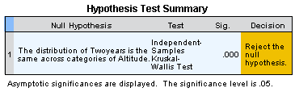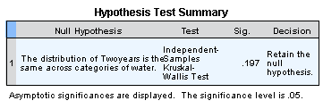


- Correlation and regression analysis
Before carrying out the analysis, scatter plots were produced to check the linear relationship between the dependant and independent variables. In addition, residuals normal distribution and ensuring that homoscedasticity plots show no pattern were checked before starting regression analysis (example 8). Back-wise regression were conducted when dealing with multiple factors and only those showed significant difference were included in final model (example 9).

Example 8: assumption for regression

Example 9. Regression (First entry)

Variables Entered/Removed
Model | Variables Entered | Variables Removed | Method
1 | Shaded, SouthWest, Unable, SouthEast, Bisexual, East, West, Partly, South, Damge, Height, slope, Female, Small gravel, NorthWest, altitude, Big gravel, Hillside, NorthEast, Wadi^{b} | . | Enter
a. Dependent Variable: Health
b. All requested variables entered.

Model Summary^{b}
Model | R | R Square | Adjusted R Square | Std. Error of the Estimate
1 | .877ª | .770 | .750 | 16.966

ANOVAª
Model |  | Sum of Squares | df | Mean Square | F | Sig.
1 | Regression | 224204.783 | 20 | 11210.239 | 38.943 | .000^{b}
1 | Residual | 67071.614 | 233 | 287.861
1 | Total | 291276.398 | 253

Coefficientsª
Model |  | Unstandardized Coefficients |  | Standardized Coefficients | t | Sig.
 |  | B | Std. Error | Beta | t | Sig.
1 | (Constant) | -284.545 | 23.112 |  | -12.312 | .000
1 | altitude | .168 | .010 | .780 | 16.768 | .000
1 | Height | -2.450 | .618 | -.149 | -3.964 | .000
1 | slope | .139 | .140 | .046 | .990 | .323
1 | Female | .482 | 2.539 | .007 | .190 | .849
1 | Unable | -19.940 | 3.465 | -.231 | -5.755 | .000
1 | Bisexual | 2.815 | 6.126 | .015 | .460 | .646
1 | NorthEast | -3.437 | 5.035 | -.040 | -.683 | .496
1 | East | .033 | 5.276 | .000 | .006 | .995
1 | SouthEast | -6.808 | 5.190 | -.054 | -1.312 | .191
1 | South | -13.097 | 5.214 | -.104 | -2.512 | .013
1 | SouthWest | -15.137 | 4.489 | -.135 | -3.372 | .001
1 | West | -4.520 | 4.660 | -.041 | -.970 | .333
1 | NorthWest | -12.191 | 4.078 | -.134 | -2.989 | .003
1 | Damge | -9.509 | 4.114 | -.085 | -2.311 | .022
1 | Small gravel | -7.991 | 4.328 | -.086 | -1.847 | .066
1 | Big gravel | -11.695 | 3.806 | -.171 | -3.073 | .002
1 | Hillside | -31.911 | 4.453 | -.470 | -7.166 | .000
1 | Wadi | -26.001 | 6.306 | -.366 | -4.123 | .000
1 | Partly | -3.226 | 5.035 | -.040 | -.641 | .522
1 | Shaded | 12.751 | 8.022 | .070 | 1.589 | .113
Regression (Last entry)

Variables Entered/Removed
Model | Variables Entered | Variables Removed | Method
1 | Wadi, Damge, SouthWest, South, NorthWest, altitude, Hillside^{b} | . | Enter
a. Dependent Variable: Health
b. All requested variables entered.
Model Summary^{b}
Model | R | R Square | Adjusted R Square | Std. Error of the Estimate
1 | .845ª | .713 | .705 | 18.425

ANOVAª
Model |  | Sum of Squares | df | Mean Square | F | Sig.
1 | Regression | 207764.454 | 7 | 29680.636 | 87.430 | .000^{b}
1 | Residual | 83511.944 | 246 | 339.479
1 | Total | 291276.398 | 253
a. Dependent Variable: Health
b. Predictors: (Constant), Wadi, Damge, SouthWest, South, NorthWest, altitude, Hillside

Coefficientsª
Model |  | Unstandardized Coefficients |  | Standardized Coefficients | t | Sig.
 |  | B | Std. Error | Beta | t | Sig.
1 | (Constant) | -312.871 | 19.999 |  | -15.645 | .000
1 | altitude | .170 | .009 | .789 | 19.746 | .000
1 | South | -13.424 | 4.423 | -.107 | -3.035 | .003
1 | SouthWest | -13.593 | 4.017 | -.122 | -3.384 | .001
1 | NorthWest | -8.072 | 3.377 | -.089 | -2.390 | .018
1 | Damge | -17.856 | 4.180 | -.160 | -4.271 | .000
1 | Hillside | -32.344 | 3.564 | -.477 | -9.075 | .000
1 | Wadi | -26.649 | 3.611 | -.375 | -7.379 | .000
a. Dependent Variable: Health

