

**NMR Studies of Sperm and Seminal Plasma**

**A thesis submitted to the University of Sheffield for the degree of Doctor of Philosophy in the Academic Unit of Reproductive and Developmental Medicine, Department of Oncology and Metabolism by**

**Jack Pearson**

**June 2017**

**Summary**

The aims of this thesis were to use Nuclear Magnetic Resonance (NMR) to scan live spermatozoa in order to identify and quantify spermatozoa metabolites. The results indicate that NMR can both identify live sperm metabolites as well as quantify and monitor them in real time.

NMR has only once previously been used to study live sperm metabolism in real time. Therefore, the first half of this thesis focussed on optimising proton NMR (1H) parameters and ensuring sperm remained viable within the scanner. Six sperm metabolite peaks were identified from NMR spectra indicating the presence of lipid, lactate, arginine+spermine+leucine, citrate, glutamine and glucose/fructose. External stimuli were then used to alter sperm metabolism and the difference in metabolite spectral peaks quantified. Changes in lactate were measurable which helped support previous literature suggesting that glycolysis was a significant metabolic pathway in mammalian sperm and that NMR was capable of detecting metabolite changes in real time.

Intra ejaculate variation of metabolites was investigated in high motility, normozoospermic sperm and found to not vary signignificantly. The comparison of metabolites observed in seminal plasma, as well as low-quality and high-quality sperm was then performed between normozoospermic (n=15), oligozoospermic (n=3); and asthenozoospermic (n=5) samples. This suggested, there were no significant differences between metabolites from high and low motility spermatozoa, but glutamine was significantly different in seminal plasma between normozoospermic & oligozoospermic ejaculates and oligozoospermic & asthenozoospermic ejaculates.

Finally carbon 13 NMR was used to track labelled pyruvate in real time as it was metabolised by spermatozoa into metabolic products. Pyruvate, lactate, and bicarbonate were identified suggesting that both glycolytic and OXPHOS metabolism pathways were being utilised. CO2 was identified in longer scans further supporting sperm utilising OXPHOS alongside glycolysis. No significant difference was identified in human spermatozoa from different classes of fertility in terms of rate of 13C pyruvate consumption.

**Acknowledgements**

Thank you Allan for your patience, your kitchen table at weekends and teaching me to be confident in myself. You’ve set high standards, which I will continue to strive for in the future. Your humour and sensitivity has been fundamental throughout my research. Thank you Martyn for always lifting my spirits and making me feel more relaxed. Your knowledge and expertise helped me explore a world of physics, network, present and socialise in a field I knew nothing about, pushing me out of my comfort zone. A massive thank you to Steven Reynolds who has put up with training a biologist to think like a physicist. I could always come into the scanning room knowing that Steve would focus my mind and find a solution when things were not going to plan. Javier, Nurul, Emmanuel and Vicky thank you for encouraging and motivating me always. Sarah Elliot and Sarah Waite have worked endlessly to provide all the facilities I needed. Secretarial staff Gill and Daniel have provided plenty of listening time as well as last minute duties and never complained. I would also like to thank all the Andrology staff who helped me gain experience in the clinical setting and were always entertaining as I passed through.

I must also thank my Mother who constantly encouraged me and was as enthusiastic about my research as I was. My sister Rachel always put things into perspective and made me feel motivated against all odds. And my Father for just being a rock.

Sofia, thank you for saving me in and out of work since we met four years ago. Many people have come and gone and you’re always there. I know you’re going to be the flourishing academic I will always admire. You have endless energy and motivation and you’re my indestructible voice of reason. I would also like to thank a dear friend, Sofia, who gave up her time to help me with statistics.

Finally I would like to thank the EPSRC for funding my research and the University of Sheffield for all of my training and opportunities as a PhD student.

**Prizes & Conference presentations**

**Oral presentations**

1st prize 3-minute thesis presentation

Postgraduate researchers day

Sheffield, 2015

3rd prize oral presentation

How 13C NMR can be used to measure metabolism in live sperm

Spermatology

Australia, 2014

Measuring live sperm metabolism using 13C NMR

Fertility 2015

Birmingham, 2015

Measuring live sperm metabolism using 13C NMR

Jessop symposium

Sheffield, 2014

Identifying intracellular sperm metabolites using HR MAS NMR

International society for magnetic resonance imaging

Milan, 2014

**Poster presentations**

Scanning sperm: 13C NMR as a novel sperm function test

British chapter International society for magnetic resonance imaging

Edinburgh, 2014

Measuring changes in sperm metabolism using NMR

British fertility society

Sheffield, 2014

NMR studies of sperm

International society for magnetic resonance imaging

Utah, 2013

Measuring changes in sperm metabolism using NMR

British chapter International society for magnetic resonance imaging

London, 2013

NMR studies of sperm and seminal plasma

British chapter International society for magnetic resonance imaging

Cambridge, 2012

**List of Abbreviations**

ACH Alphachlorohydrin

ART Assisted reproductive techniques

AQ Acquisition time

B0 Static magnetic field

BMI Body mass index

13C Carbon 13

COMET Single cell gel electrophoresis assay

cAMP Cyclic adenosine monophosphate

FID Free induction decay

FSH Follicle stimulating hormones

GAPDHS Glyceraldehyde phosphate dehydrogenase

GnRH Gonadotrophin releasing hormone

GPC Glycerophosphocholine

1H Proton

HR-MAS High Ressolution Magic Angle Spinning

HZA Hemizona assay

ICSI Intracytoplasmic sperm injection

IUI Intrauterine insemination

IVF *In vitro* fertilisation

LDHC Lactate dehydrogenase C

LH Luteinising hormone

LN Natural Log

MACS Magnetic activated cell sorting

MAS Magic angle spinning

MS Mass spectrometry

NICE National institute for health and care excellence

NMR Nuclear magnetic resonance

NS Number of scans

ODFs Outer dense fibres

OXPHOS Oxidative phosphorylation

PBS Phosphate buffered saline

PGCs Primordial germs cells

PGK2 Phosphorglycerate

PKA Protein kinase A

Pi Phosphate

Ppm Parts per million

PSA Prostate specific antigen

RE Reterograde ejaculation

RF Radiofrequency

ROS Reactive oxygen species

SCSA Sperm chromatin structure assay

SNR Signal to noise ratio

SP Seminal plasma

TAC Total antioxidant capacity

TSP 3-(trimethylsilyl)-propionic-2,2,3,3-D4 acid

TUNNEL Terminal deoxynucleotidyl transferase dUTP nick end labelling

WHO World health organisation

ZP Zona pellucida

**List of Figures**

**Chapter 1**

Figure 1.1: Spermatozoa production by spermatogenesis

Figure 1.2: Interaction of spermatozoa with the oocyte during fertilization

Figure 1.3: Structure of mammalian spermatozoa

Figure 1.4: Cross-section of the sperm flagellum

Figure 1.5: Activated and hyperactivated motility direction

Figure 1.6: The male reproductive system

Figure 1.7: The female reproductive tract

Figure 1.8: Hormonal control of the male reproductive system

Figure 1.9: Nuclear spin and charge

Figure 1.10: Behavior of nuclei in external magnetic fields

Figure 1.11: The radiofrequency pulse

Figure 1.12: Free Induction Decay

Figure 1.13: Diagrammatic representation of the chemical shift of lactate

Figure 1.14: Magic Angle Spinning NMR

Figure 1.15: Glycolysis

Figure 1.16: The Krebs cycle

Figure 1.17 The Electron Transport Chain

**Chapter 2**

Figure 2.1: Neubauer haemocytometer

Figure 2.2: Sperm wash procedure

Figure 2.3: Magnetic activated cell sorter device

Figure 2.4: The NMR spectrometer

Figure 2.5: NMR sample holders used with MAS and broadband probes

Figure 2.6: Illustration of the method of peak integration

**Chapter 3**

Figure 3.1: Metabolite spectra at different spin frequencies

Figure 3.2: Signal to noise and spin frequency

Figure 3.3: G force and spin frequency

Figure 3.4: Percentage of boar sperm viability before and after spinning

Figure 3.5: Metabolite spectra at different acquisition times

Figure 3.6: Signal to noise and acquisition time

Figure 3.7: Metabolite spectra from different numbers of scans

Figure 3.8: Signal to noise of TSP and number of scans

Figure 3.9: Metabolite spectra from different concentrations of sperm

Figure 3.10: Signal to noise of lactate at different concentrations of sperm

**Chapter 4**

Figure 4.1: Processing of boar semen

Figure 4.2: Boar metabolite spectra from sperm incubated at 21°C

Figure 4.3: Boar metabolite spectra from sperm incubated at 39°C

Figure 4.4: Boar metabolite spectra from sperm incubated without ACH

Figure 4.5: Boar metabolite spectra from sperm incubated with ACH

Figure 4.6: Difference in boar sperm metabolites at 21°C and 39°C and with/without ACH-broadband and MAS NMR.

**Chapter 5**

Figure 5.1: Recruitment of donors and processing of semen

Figure 5.2: Human seminal plasma, high and low motility sperm metabolite spectra

Figure 5.3: Intra donor metabolite comparisons of high quality spermatozoa

Figure 5.4: Comparison of seminal plasma metabolites from three ejaculate phenotypes

Figure 5.5: Comparison of high motility sperm metabolites

Figure 5.6: Comparison of low motility sperm metabolites

Figure 5.7: Comparison of metabolites from high motility, low motility and seminal plasma fractions from the same donor

**Chapter 6**

Figure 6.1: Metabolism of 13C pyruvate

Figure 6.2: Metabolism of 13C pyruvate to CO2 and the krebs cycle

Figure 6.3: Recruitment of donors and processing of semen

Figure 6.4: Processing of boar semen

Figure 6.5: Boar time course spectra

Figure 6.6: Average integral value of boar sperm metabolites

Figure 6.7: Overnight scan spectrum of boar sperm

Figure 6.8: Average urea integral value of live human sperm of different ejaculate phenotypes

Figure 6.9: Spectrum from overnight scan of the metabolism of 13C pyruvate in human spermatozoa

Figure 6.10: Average metabolite integral values from the overnight scan of 13C pyruvate human spermatozoa samples from 3 ejaculate phenotypes.

**List of Tables**

Table 3.1: MAS parameters from existing literature

Table 3.2 Optimal NMR acquisition parameters

1.0: Introduction to Sperm and NMR 13

1.1 Biology of sperm 14

1.1.1 Spermatozoa production 14

1.1.2 Structure and function of spermatozoa 20

1.2 Ejaculation 25

1.3 Journey through the female reproductive tract 27

1.3.1 Vagina 27

1.3.2 Cervical mucus 29

1.3.3 Uterus 29

1.3.5 Capacitation 29

1.3.6 Hyperactivation 30

1.3.7 Acrosome reaction and perm oocyte binding 30

1.4 Infertility 32

1.4.1 Male Infertility 33

1.5 Traditional semen analysis 38

1.6 Sperm function tests 39

1.6.1 Acrosomal Integrity 39

1.6.2 Sperm zona pellucida binding tests 40

1.6.3 Sperm penetration assay 40

1.6.4 Reactive oxygen species 41

1.6.5 Tests of sperm DNA damage 42

1.7 Sperm metabolomics 43

1.8 Nuclear Magnetic Resonance 44

1.8.1 Overview 44

1.8.2 Clinical applications 45

1.8.3 Nuclear spin and resonance 45

1.8.4 The vector model of NMR 47

1.8.5 Radiofrequency pulse and relaxation 49

1.8.6 Chemical shift 52

1.8.7 Coupling 52

1.8.8 Sensitivity, signal to noise 52

1.8.9 NMR nuclei 54

1.9 Cellular metabolism 57

1.9.1 Glycolysis 57

1.9.2 The Krebs cycle 59

1.9.3.Oxidative phosphorylation (OXPHOS) &The electron transport chain 59

1.9.4 Sperm metabolism 62

1.9.5 NMR and sperm metabolism 69

1.1.0 Aims and objectives 71

1.2.0 Hypothesis 73

2.0 Materials and Methods 74

2.1 Collection of sperm 75

2.1.1 Boar spermatozoa 75

2.1.2 Human spermatozoa 75

2.2 Semen analysis 76

2.2.1 Measurement of sperm concentration 76

2.2.2 Measurement of sperm motility 76

2.3 Sperm washing 76

2.3.1 Boar sperm washing 77

2.3.2 Human sperm washing with PureSperm 79

2.4 Preparation for scanning 79

2.5 Analysis of ejaculate fractions 79

2.5.1 Seminal plasma 79

2.5.2 High motility spermatozoa 79

2.5.3 Low motility spermatozoa 81

2.6 Magnetic-activated cell sorting (MACS) 81

2.6.1 Preparation of sperm for MACS 81

2.6.2 Magnetic separation 83

2.7 NMR 83

2.7.1 Pre scan spectral optimisation 84

2.7.2 1H (proton) NMR 84

2.7.3 13C NMR 84

2.7.4 Magic angle spinning (MAS) probe 87

2.7.5 Post scanning procedure 87

2.7.6 Normalisation of metabolite peaks 87

3.0 Optimising Acquisition Parameters for Magic Angle Spinning of Boar Sperm 89

3.1 Introduction 90

3.2 Materials & methods 93

3.2.1 Sperm preparation 93

3.2.2 Spin frequency & viability 93

3.2.3 Acquisition time 93

3.2.4 Number of scans 93

3.2.5 Sperm concentration 94

3.2.6 Identification of boar sperm metabolites 94

3.3 Results 94

3.3.1 Spin frequency 94

3.3.2 Acquisition time 97

3.3.3 Number of scans 97

3.3.4 Sperm concentration 104

3.4 Discussion 104

4.0 Identifying & detecting changes in boar sperm metabolites using 1H Magic Angle Spinning and Broadband NMR 112

4.1 Introduction 113

4.2 Hypothesis 114

4.3 Aims 115

4.4 Material & methods 115

4.4.1 Sperm preparation 115

4.4.2 Broadband NMR 115

4.4.3 MAS NMR 117

4.4.4 Temperature incubation 117

4.4.5 Alphachlorohydrin (ACH) incubation 117

4.4.6 Statistical analysis 117

4.5 Results 117

4.5.1 Broadband NMR 117

4.5.2 Temperature Incubation 120

4.5.3 Alphachlorohydrin incubation 120

4.5.4 MAS NMR 120

4.5.4.1 Temperature Incubation 120

4.5.4.2 Alphachlorohydrin incubation 120

4.6 Discussion 124

4.6.1 Broadband NMR 124

4.6.2 MAS NMR 126

4.7 Conclusions 127

5.0: Comparison of human sperm and seminal plasma metabolites using 1H broadband NMR 129

5.1 Introduction 130

5.2 Hypotheses 132

5.3 Aims 132

5.4 Materials and methods 133

5.4.0 Donor recruitment 133

5.4.1 Semen analysis 133

5.4.2 Preparation of sample for NMR 133

5.4.3 NMR 135

5.5 Results 136

5.5.1 Intra donor ejaculate comparison 136

5.5.2 Seminal plasma 138

5.5.3 High motility spermatozoa 138

5.5.4 Low motility spermatozoa 138

5.5.5 Seminal plasma, high motility and low motility sperm metabolite comparison 141

5.6 Discussion 141

5.6.1 Inter donor comparison 144

5.6.2 Seminal plasma 145

5.6.3 High motility spermatozoa 145

5.6.4 Low motility spermatozoa 146

5.6.5 Comparison of seminal plasma, high and low motility sperm metabolites 146

6.0: Spermatozoa Metabolism in Real Time 149

6.1 Introduction 150

6.2 Hypotheses 151

6.3 Aims 152

6.4 Materials and Methods 155

6.4.1 Donor recruitment 155

6.4.2 Boar Ejaculates 155

6.4.3 Preparation of sample for NMR 155

6.4.4 NMR Real time metabolic rate 155

6.4.5 NMR overnight acquisition 155

6.4.6. Statistical analysis 158

6.5 Results 158

6.5.1 Boar real time metabolic rate 158

6.5.2 Boar overnight NMR acquisition 161

6.5.3 Human real time metabolic rate 161

6.5.4 Human overnight NMR acquisition 161

6.6 Discussion 166

6.6.1 Real time sperm metabolism 166

6.6.1.3 Human overnight NMR acquisition 168

7.0 General Discussion 170

References 186

# 1.0: Introduction to Sperm and NMR

## 1.1 Biology of sperm

Spermatozoa are cells produced by the testes that transport haploid genetic information of the male to the oocyte, which contains genetic information of the female. Mammalian sperm are unique in that they have a highly polarised structure which has evolved under strong selection pressures (Rowe et al., 2013). Sperm competition, which occurs when a female mates with more than one male in a single oestrous cycle, has resulted in the evolutionary strategy of men having high numbers of very small sperm (Parker, 1982). High numbers of sperm are costly to the body’s resources and therefore, there is little investment in each one. This is evident as sperm lack organelles common to somatic cells including the endoplasmic reticulum, golgi and ribosomes and having almost no cytoplasm (Mukai and Travis, 2012). Transportation of haploid genetic information is achieved by motility. Motility is essential as following ejaculation, sperm become pooled in the anterior vagina and then swim up from this pool into the cervical canal (Suarez and Pacey, 2006) and begin their journey to the Fallopian tubes to accomplish fertilisation (Suarez and Pacey, 2006). Abnormalities in the structure, motility or genetic make up of spermatozoa will affect fertility and ultimately the ability to conceive.

### 1.1.1 Spermatozoa production

#### 1.1.1.1 Spermatogenesis

Spermatogenesis, the process by which spermatozoa are formed consists of three entities (i) mitotic proliferation which produces a large number of cells, (ii) meiotic division which creates genetic diversity and halves the chromosome number and (iii) cytodifferentiation which involves packaging the chromosomes enabling delivery to the oocyte (Figure 1.1).

Within the immature testis lies the quiescent interphase prospermatogonial germ cells which are reactivated postnatally and enter rounds of mitosis in the basal compartment of the tubule. These are unsurprisingly terms spermatogonial stem cells (SSC’s) from which type A spermatogonia arise with distinct morphology.

Type A1 spermatogonium

Intermediate

spermatogonia

Type B

spermatogonia

Primary spermatocytes (1st meiotic division)

Secondary spermatocytes (2nd meiotic division)

Spermatids

**Figure 1.1:** Spermatogenesis showing mitotic proliferation, meiotic division and cytodifferentiation (figure adapted from Johnson et al., 2013)

A2

A3

A4

Cytodifferentiation

Meiotic division

Mitotic proliferation

Each type A spermatogonia undergoes numerous mitotic divisions producing a clone of 16 cells. These then develop into morpholically distinct type A1 spermatogonia, each of which undergoes a further five mitotic divisions forming A1-4, intermediate and type B. All of the type B spermatogonia then divide to form primary spermatocytes (Johnson et al., 2013) Each primary spermatocyte duplicates its DNA content forming secondary spermatocytes containing a single set of chromosomes. Secondary spermatocytes are short lived as they quickly divide to become haploid spermatids. Cytoplasmic remodelling of the spermatid is termed spermiogenesis. This involves spermatids changing from round to elongated, generation of the tail, mid piece formation containing mitochondria, equatorial and postacrosomal cap region formation and the acrosome also forms.

#### 1.1.1.2 Epididymal maturation

The spermatozoon released from the output of the testis is morphologically complete but immotile and unable to fertilise an oocyte (Dacheux and Dacheux, 2014). In mammals, the spermatozoon acquires fertilisation ability through a series of post gonadal differentiations stages that occur during transit through the epididymal tubule. Epididymal sperm acquire motility with an increase in asymmetry and irregular flagella beating in the anterior part of the epididymis (Bork et al., 1988, Chevrier and Dacheux, 1992). However, such motility is only observed *in vitro* when epididymal sperm are washed free of epididymal fluids and re-suspended in artificial medium. The second significant maturation step of epididymal spermatozoa is the gradual acquisition of the ability to bind to the zona pellucida (ZP) and the oocyte membrane (Figure 1.2). The spermatozoa plasma membrane (Figure 1.3), which is also the inner acrosomal membrane, interacts with the egg plasma membrane during fertilisation. It is thought that the role of the epididymis in the development of sperm-egg interaction may be associated with the control of processing and redistribution of testicular sperm surface proteins. These modifications are suggested to be linked to the binding properties of the spermatozoa however, the specific role mechanism by which these modifications take place remains unexplained (Dacheux and Dacheux, 2014).

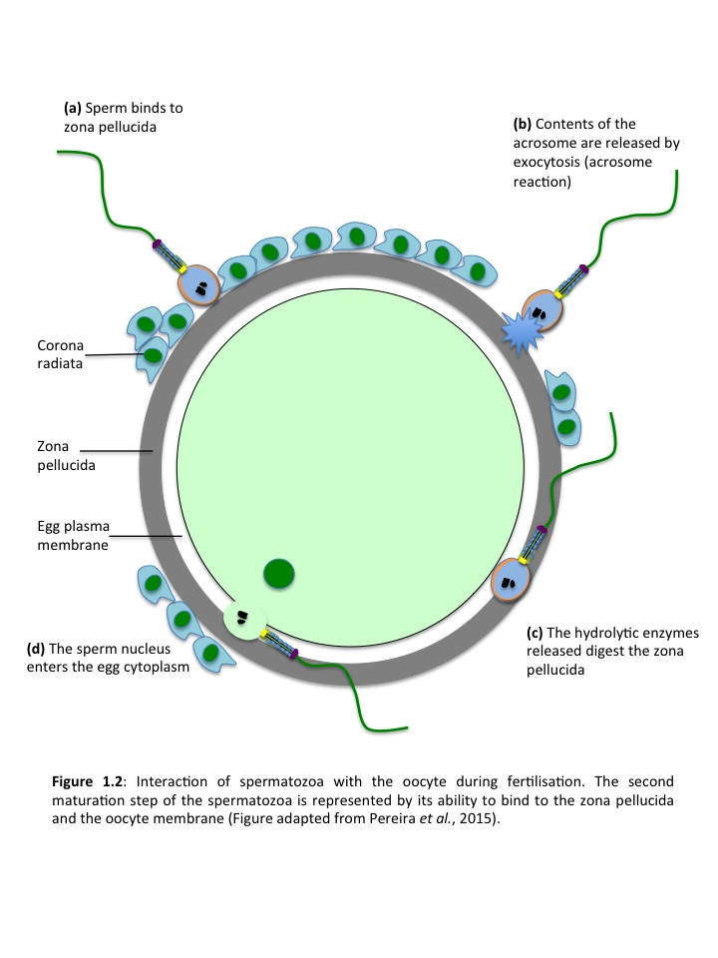

#### 1.1.1.3 Hormonal regulation of sperm production

Since the late 1920’s, testosterone (T) has been demonstrated to maintain the structure and functions of the epipidymis (Benoit, 1926) and there have been several publications showing the response of the epididymis in mammals to androgen withdrawal (reviewed in (Robaire and Hamzeh, 2011)). Concentrations of T in the seminiferous tubules are 10-100 times those found in serum (Turner et al., 1984, Turner, 1991) and are essential for the maintenance of spermatogenesis (Jarow and Zirkin, 2005, Awoniyi et al., 1990). High concentrations of T leave the testis through the efferent ducts and upon entry to the epididymis, are rapidly converted to dihydrotestosterone (DHT) (Turner, 1991), the most biologically active endogenous androgen, by the enzyme steroid 5α reductase and to E2 by the P450 enzyme, steroid aromatase, which can be found in spermatozoa (Janulis et al., 1998). The actions of T and DHT are primarily mediated by binding to androgen receptors (AR), although there is some evidence for cell surface mediated androgen action (Benten et al., 1999, Kampa et al., 2002). Androgen receptors are found in the epididymis of all species examined to date (rat, rabbit, dog, ram, monkey and human (reviewed in (Robaire and Hamzeh, 2011)).

Steroidogenesis is fundamental to spermatogenesis within the male testes. Steroidogenesis involves the hypothalamic-pituitary-gonadal axis (HPG axis) which consists of three levels: (i) hypothalamus, (ii) pituitary and (iii) testes. GnRH, gonadotrophins containing leutinizing hormone (LH) and follicle-stimulating hormone (FSH) along with sex steroids such as oestrogen and androgens are all products of the HPG axis. GnRH secreted by the hypothalamus in a periodic pulsatile manner (Seeburg et al., 1987) stimulates the synthesis and secretion of LH and FSH by the anterior pituitary glands (Jin and Yang, 2014). The duration and frequency of pulsatile GnRH secretions influence the subsequent release of LH and FSH (Thackray et al., 2010). LH and FSH share common ‘A’ subunits but differ in their ‘B’ subunits (Morgan et al., 1975). Therefore, LH specifically binds to receptors on Leydig cells and interstitial cells in the testes and promote leydig cells to secrete androgens. FSH binds to sertoli cells which build the microenvironment of spermatogenesis. FSH accompanied with testosterone regulates the maturation of spermatozoa. Activin, inhibin and follistatin regaulte the expression and secretion of gonadotrophins.

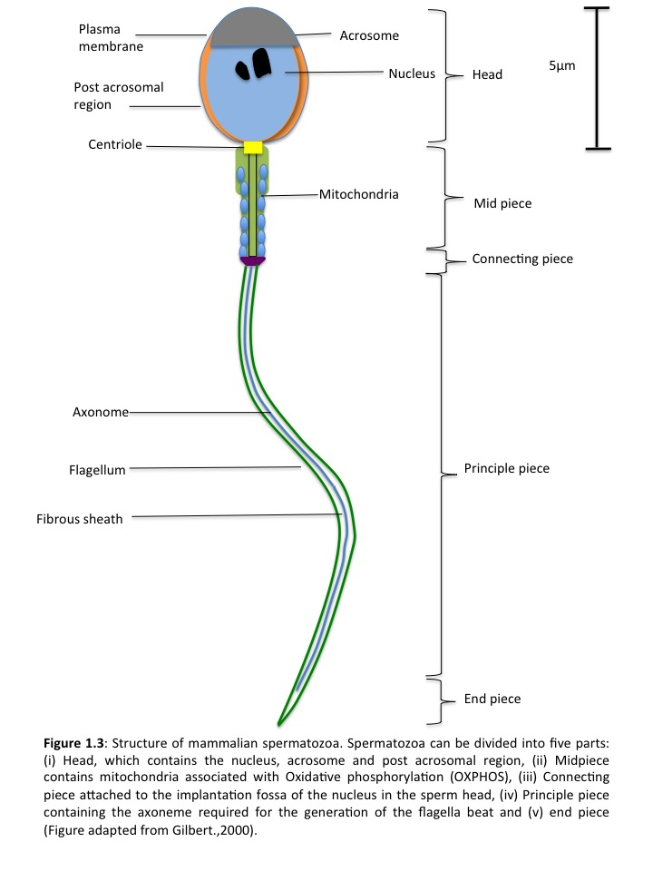

Oestrogen, androgens and progesterone are also involved in the HPG axis and regulate the secretion of gonadotrophins and GnRH. Both LH and FSH together with gonadal steroid hormones and peptide hormones including activin and inhibin act as feedback molecules in the HPG axis (Jin and Yang, 2014).

### 1.1.2 Structure and function of spermatozoa

#### 1.1.2.1 Head

The main function of the sperm head is to protect the DNA contained within the sperm during transit to the site of fertilisation (Figure 1.3). The head contains a limited number of structures including the nucleus, acrosome and post acrosomal region. Aberration in sperm morphology is associated with impaired function and includes irregular head shape (Kruger et al., 1988, Marsh et al., 1987, Oehninger et al., 1988). Semen analysis measures amongst other parameters, the dimensions of the head for morphology assessment because irregularities in head shape have major consequences for male infertility (Barratt et al., 2011).

#### 1.1.2.2 Flagellum

The mammalian sperm flagellum is structurally divided into four sections: (i) the connecting piece, (ii) the midpiece, (iii) the principle piece, and (iv) the end piece (Fawcett, 1975)(Figure 1.3). The connecting piece is the section of the flagellum that is attached to the implantation fossa of the nucleus in the sperm head. From here, the axoneme extends through out the length of the flagellum. The axoneme is a cytoskeletal structure composed of a ring of 9 microtubule doublets surrounding a central pair (Figure 1.4). Inner and outer dynein arms project out from each of the outer 9 doublets, and these arms are responsible for creating the motive force of the flagellum (Burgess et al., 2003). Furthermore, 9 radial spokes, each of which originates from 1 of the 9 outer micro tubular doublet pairs, project inward towards the central pair in a helical fashion (Figure 1.4). Tail abnormalities have been suggested to impair sperm function (Lim et al., 1998, Hall et al., 1995). Mitochondria, the site of oxidative phosphorylation are located in the sperm midpiece at the extreme anterior end of the flagellum (Ford, 2006)(Figure 1.3).

The midpiece is wider due to the presence of helically arranged mitochondria around the outer dense fibres (ODF’s) and axonome. A poorly produced midpiece is also associated with impaired sperm function (Sukcharoen et al., 1995). The majority of the sperm is composed of the principle piece, characterised by the fibrous sheath (Figure 1.3), which lies just below the plasma membrane and has two longitudinal columns that are connected by lateral ribs. Its termination marks the beginning of the end piece.

#### 1.1.2.3 Spermatozoa motility

Mammalian sperm display two types of motility: activated motility, seen in freshly ejaculated sperm and hyperactivated motility, identified in sperm recovered from the site of fertilisation (Katz and Yanagimachi, 1980, Suarez and Osman, 1987). Activated motility is characterised by low amplitude, symmetrical waveform of the flagellum (Figure 1.5), which propels the sperm in a relatively straight line. In contrast, hyperactivated motility involves an asymmetrical flagella beat at high amplitude (Figure 1.5), which results in ‘star shaped’ or figure of eight trajectories (Yanagima.R, 1970, Yanagimachi, 1994c, Ishijima et al., 2002). It is currently understood that activated motility is used to propel the sperm through the female reproductive tract to the oviduct (Suarez and Pacey, 2006) whereas hyperactivated motility helps sperm detach from the oviductal epithelium, reach the site of fertilisation and penetrate the cumulous and zona pellucida of the oocyte (Suarez et al., 1991, Stauss et al., 1995, Ho et al., 2002).

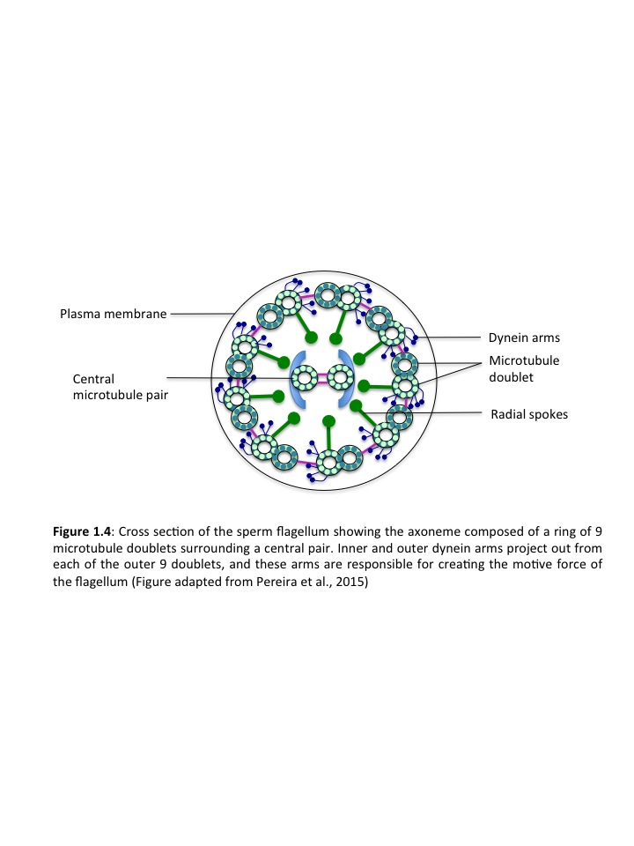

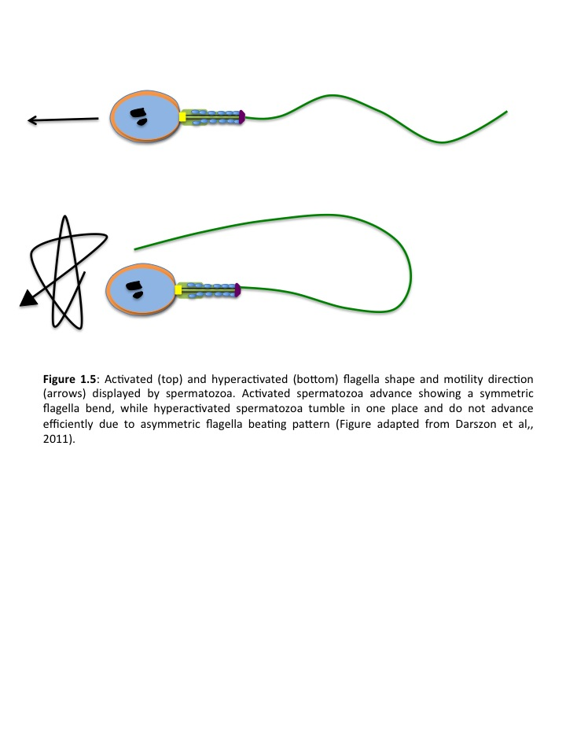

#### 1.1.2.4 Regulation of sperm motility

Initiation and maintenance of activated motility in mammals is partially dependent on the cAMP-dependent phosphorylation of flagella proteins (Tash and Means, 1982, Tash and Means, 1983, Sanagustin and Witman, 1994). Mice with a targeted deletion of the sperm specific isoform of the catalytic (C) subunit of cAMP dependent serine/threonine kinase, protein kinase A (PKA) have a phenotype of male infertility correlated with poor sperm motility (Skalhegg et al., 2002, Leclerc et al., 1996). This suggests that cAMP affects sperm motility through the activation of PKA. PKA may operate through multiple pathways to control flagella function however, one mechanism of action is the phosphorylation of serine/threonine of PKA target proteins which results in activation of downstream, unidentified tyrosine kinase (Leclerc et al., 1996). Tyrosine phosphorylation is also strongly associated with the onset of sperm motility (Tash and Bracho, 1998) and is likely to be downstream of the serine/threonine phosphorylation. Calcium signalling is another pathway found to regulate both activated and hyperactivated sperm motility (Suarez and Osman, 1987, Tash and Means, 1987, Lindemann and Goltz, 1988, White and Aitken, 1989, Yanagimachi, 1994b, Ho et al., 2002). It has been suggested that intracellular calcium stores are involved in the regulation of hyperactivated motility (Ho and Suarez, 2003) however, there are no obvious intracellular calcium stores in spermatozoa due to their lack of an endoplasmic reticulum within the flagellum.

The sperm nucleus is highly condensed and therefore is transcriptionally silent (Miller et al., 2005, Miller and Ostermeier, 2006) and translational activity is negligible although evidence has been presented for translation occurring at the ribosomes (Gur and Breitbart, 2008, Chandrashekran et al., 2014). Regulation of sperm function is therefore dependent primarily on post translational processes. [Ca2+]I signalling is paramount to this regulation and in mammalian sperm it plays a pivotal role in controlling sperm motility type and potentially chemotaxis, induction of the acrosome reaction (AR) and capacitation (Publicover et al., 2007, Darszon et al., 2007, Darszon et al., 2011). The importance for sperm function of membrane Ca2+ influx is well established (Darszon et al., 2011) and there is also good evidence supporting the existence and functional importance of intracellular Ca2+ storage organelles in sperm (Darszon et al., 2007, Publicover et al., 2007). Specifically, the acrosomal vesicle at the apex of the head and the collection of vesicular membranous structures that occur at the sperm neck and anterior midpiece appear to be functionally important Ca2+ stores. At these locations inositol-1,4,5-trisphosphate-(IP3)receptor (IP3Rs) were detected in human and bovine sperm by immunostaining (Dragileva et al., 1999, Kuroda et al., 1999, Ho and Suarez, 2001b, Ho and Suarez, 2003). IP3 is a second messenger with a specific requirement for Ca2+ which acts as a co-agonist in order to open Ca2+ channels (Bezprozvanny et al., 1991).

## 1.2 Ejaculation

During mental and physical stimulation, increasing levels of arousal reach a threshold, which triggers ejaculation in the male (Levin, 2009). Rhythmic contractions of the ischiocavernosus and bulbospongiosus muscles and consequent semen expulsion are mediated by the sensory neurons in the pelvis (Levin, 2009). Peristaltic contraction of smooth muscle in the epididymis, vas deferens, seminal vesicle and prostate follows, propelling sperm and accessory organ secretions through the male ductal system, into the ejaculatory ducts and urethra (Barazani et al., 2012). The seminal vesicles (Figure 1.6) are responsible for approximately 50-80% of the male ejaculate, producing a fluid that is alkaline and rich in fructose (Tauber et al., 1975). The result is semen, a biological soup containing spermatozoa from the testes and epididymis and seminal plasma consisting of multiple contributions from accessory organs. Therefore, the ejaculate can be divided into two fractions: (i) the seminal plasma and (ii) the spermatozoa.

Seminal plasma consists of multiple contributions of the accessory organs including the prostate, seminal vesicles and with little contribution from the Wolffian ducts (in humans), testes and epididymis. It also consists of inorganic ions, zinc, magnesium, calcium, low molecular weight organic compounds, peptides, hormones (Sorensen et al., 1999) and antibodies (Chamley and Clarke, 2007). Upon ejaculation, semen coagulates and the thick mucous component is enzymatically degraded in 30-60 minutes (Lilja and Lundwall, 1992).

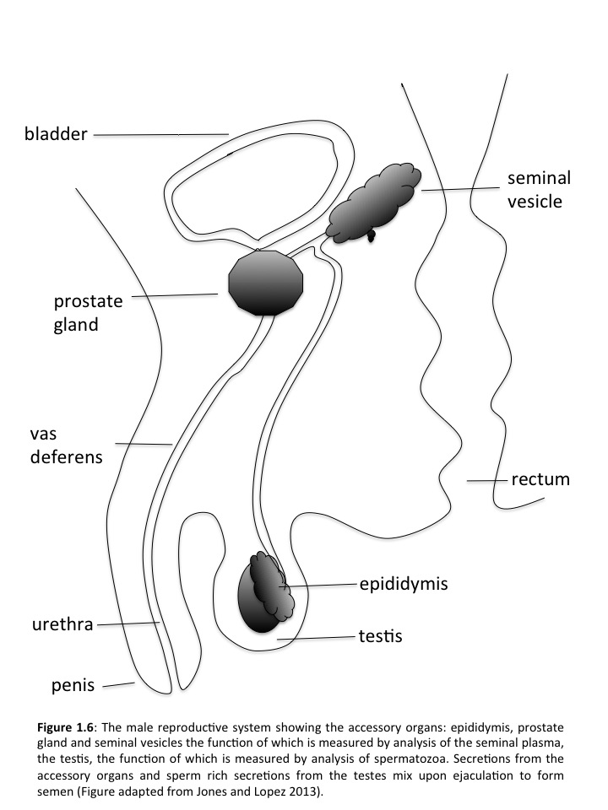

Degradation occurs due to the presence of a prostate specific antigen (PSA), a serine protease secreted by the prostate gland (Watt et al., 1986). It has been suggested that this coagulum protects the sperm against the harsh environment of the vagina (Lundwall et al., 2003). During sperm washing *in vitro*, three fractions are generated (i) seminal plasma (ii) low motility spermatozoa, and (iii) high motility spermatozoa. After ejaculation, mammalian sperm acquire energy from nutrient molecules found in the seminal plasma and the female reproductive secretions to fuel their journey through the female reproductive tract (Visconti, 2012).

## 1.3 Journey through the female reproductive tract

The journey undertaken by sperm through the female reproductive tract is designed to maximise the chance of fertilisation and ensure that vigorously motile sperm with normal morphology are successful (Suarez and Pacey, 2006). Sperm are subjected to physical stresses during ejaculation and contractions of the female tract and they must survive oxidative damage. Furthermore, the female immune system may mistake sperm as infectious bodies and thus attack them with an immune response (Kutteh et al., 1993). Therefore, on this long journey, sperm must maintain their function in spite of these numerous attempts to inhibit their journey. Of the millions of sperm inseminated at coitus, only a few thousand reach the Fallopian tubes and a single sperm fertilises the oocyte.

### 1.3.1 Vagina

In humans, the vagina is the location at which the semen is deposited following ejaculation. Here, the semen pools at the anterior and within minutes sperm begin to swim up into the cervical canal (Sobrero and Macleod, 1962) (Figure 1.7). In contrast, in pig species the vagina is bypassed with semen being deposited directly into the uterine cavity to enable quick access for the sperm to the oviduct (Hunter, 1981).

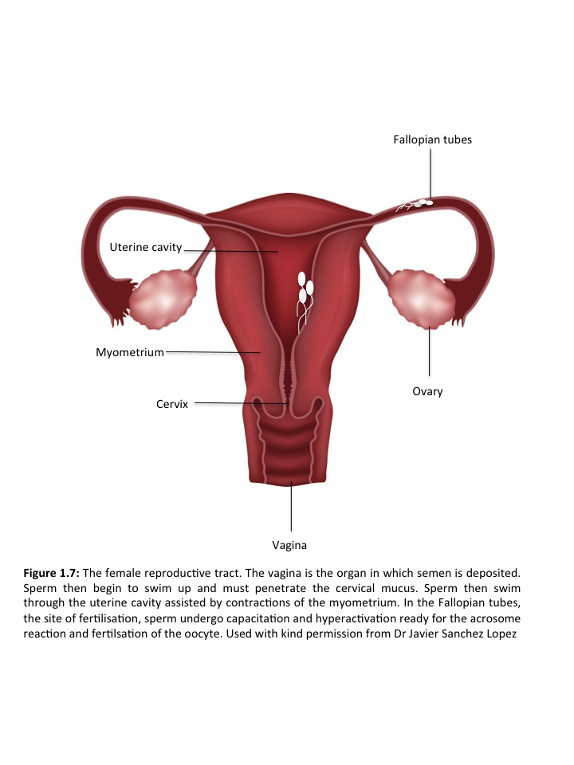

### 1.3.2 Cervical mucus

Sperm in humans enter the cervical canal rapidly where they encounter cervical mucus (Figure 1.7). Under the influence of oestrogen, the cervical mucus secreted by the cervical crypts becomes more hydrated and the extent of its hydration determines the penetrability to sperm (Morales et al., 1993). Cervical mucus is the first barrier sperm face and it selects morphologically normal, vigorously motile sperm (Hanson and Overstreet, 1981, Barros et al., 1984, Katz et al., 1990, Katz et al., 1997).

### 1.3.3 Uterus

The human’s uterine cavity is just a few centimetres in length. A single sperm swimming at 5mm/min can swim through the entire cervix in less than 10 minutes. (Mortimer and Swan, 1995). The sperm have further assistance by ovarian contractions of the myometrium (Figure 1.7) which also draw sperm up from the cervix (Lyons et al., 1991). However, motility is key to their success in reaching the site of fertilisation.

**1.3.4 Uterotubal junction**

The uterotubal junction acts as an anatomical, physiological and mucous barrier to sperm passage in most mammal species. The entrance to the junction is not complex in humans but in other species it is much more difficult for sperm to pass due to its narrow lumen and the presence of mucosal folds (Hook and Hafez, 1968, Beck and Boots, 1977, Wrobel et al., 1993). It can also be mucous filled which can inhibit the progress of sperm even further.

### 1.3.5 Capacitation

In the Fallopian tubes (Figure 1.7), sperm undergo two changes in preparation for fertilisation. The first, capacitation, involves plasma membrane changes including shedding of proteins and cholesterol that prepare sperm to undergo the acrosome reaction and fertilise oocytes (De Jonge, 2005). Capacitation also involves an increase in certain intracellular messengers including cAMP and PKA, and increased phosphorylation of a set of proteins by a set of kinases (Storey, 1995, Baldi et al., 1996, Visconti and Kopf, 1998). It is suggested that its role is to prevent the release of lytic enzymes until spermatozoa reach the oocyte (Tesarik, 1989). Capacitation is also characterised by a rapid increase in sperm motility and flagella beating frequency known as hyperactivation.

### 1.3.6 Hyperactivation

It is likely that the sperm become hyperactivated in the Fallopian tubes (Figure 1.7). Sperm can also be hyperactivated in aqueous media *in vitro* and their motility changes from progressive to circular and erratic motions (see section 1.1.2.3). Hyperactivation may also assist sperm in detaching from m the epithelium (Ho and Suarez, 2001a). *In vivo* it is suggested that hyperactivation is required for sperm to swim towards the oocyte and penetrate its vestments. Hyperactivation is also essential for penetration of the zona pellucida (Stauss et al., 1995, Quill et al., 2003, Ren et al., 2001).

### 1.3.7 Acrosome reaction and perm oocyte binding

When the sperm reaches its final destination, the ovum, the acrosome releases enzymes that penetrate the zona pellucida (Brucker and Lipford, 1995). Fusion of the spermatozoa outer membrane with the zona pellucida plasma membrane occurs (Osman et al., 1989) and consequently fertilisation.

The acrosome reaction is an exocytotic calcium dependent process essential for the penetration of sperm through oocyte coats. The acrosome is a secretory vesicle which sits on the tip of the sperm head and its structure varies among species. The acrosome consists of an outer membrane that sits underneath the sperm plasma membrane and an inner membrane which overlays the nuclear membrane. Within the two membranes there is a space containing the hydrolytic enzymes. The AR is calcium dependent process based on multiple fusions of the outer membrane and the plasma membrane as well as the interaction between a pair of proteins called SNAREs (soluble NSF attachment protein receptors) (Kierszenbaum, 2000). The patches formed allow the highly fusible inner acrosomal membrane to be exposed at the same time expelling enzymes including hyaluronidase and trypsin like proteases that are key to the digestion and penetration of the oocyte extracellular matrix (Harper et al., 2008). In mammals, there are two main areas of interest regarding the acrosome reaction (i) when does it occur? (ii) where does it occur? (Yanagimachi, 2011, Buffone et al., 2014) however, this remains controversial and has recently been reviewed (Okabe, 2014). Further to theories relating to cytoplasmic calcium, recent findings in human sperm suggest the existence of L-amino acid oxidase initiating sperm capacitation and acrosomal exocytosis in the presence or absence of progesterone (Houston et al., 2015) by activating adenylyl cyclase downstream in opening store-operated calcium channels during the swelling process (Sosa et al., 2016). In mammals, two sperm signalling pathways underpin exocytosis during the AR (Primakoff and Myles, 2002). After binding a GTP binding protein and phospholipase C (PLC) are activated, followed by elevation of intracytoplasmic calcium. On the other hand a transient influx of calcium takes place through low voltage T-type channels and their subtypes Cav3.2 (Stamboulian et al., 2004) a calcium store depletion pathway (O'Toole et al., 2000) and additional calcium entry occurs through the activation of Trp family of calcium channels (Jungnickel et al., 2001).

The binding of sperm with the oocyte begins in the primary form which involves species specific recognition of structures and molecules (Bi et al 2002). Although the major structures involved in gamete binding are similar in sperm from different species, they are different in the oocytes: the vitelline layer in the sea urchin, chorion in the ascidans and zona pellucida (ZP) in most mammals (Tosti and Menezo, 2016). The gametes recognition mechanism in mammals is conserved and its foundation is a carbohydrate-protein interaction between sperm and oocyte. Oligosaccharides arranged on the outer structure of the oocyte envelope are recognised by complementary proteinaceous receptors on the sperm (Tosti and Menezo, 2016). Sperm hyaluronidases are suggested to play a key role in mammalian fertilisation and sperm specific SPAMI and HYAL5 hyaluronidase were suggested to be involved in sperm- ZP binding in the mouse. However, more recent studies show that hyaluronidases are not required for fertilisation, contradicting the theory that oligosaccharides are involved in gamete recognition mechanisms (Yoon et al., 2014).

The mammalian ZP is elastic and formed of fibrils and filaments. The absence of ZP production causes infertility in females whereas removal of the ZP from virgin oocytes prevent species specific recognition *in vitro* (Wassarman and Litscher, 2008, Wassarman and Litscher, 2012). The functional region (ZP domain) is composed of three glycoproteins (ZP1, ZP2, ZP3) that are synthesis and secreted during oocyte growth and whose structure and function are species specific (Topfer-Petersen et al., 2000). Human ZP contains the additional ZP4 glycoprotein which is a prologue of ZP1. In the early 1980’s ZP3 was identified in mouse as the ‘primary receptor’ responsible for species specific sperm recognition and adhesion (Bleil and Wassarman, 1980). It was suggested that ZP1, ZP3 and ZP4 bind to capacitated human sperm and induce the AR, whereas ZP 2 only binds to acrosome-reacted spermatozoa and thus may only be considered a secondary sperm receptor (Gupta et al., 2012, Gupta, 2015) however, this has not been validated by *in vitro* studies and is still under speculation.

On the sperm surface galactosyltransferase (GalTase) which recognises ZP3 oligosaccharides and triggers the AR was recognised (Florman and Wassarman, 1985, Miller et al., 1992). In humans, a homolog to the PH-20 glycoprotein present on the head of guinea pig sperm was also found to play a role in sperm ZP binding through hyaluronidase activity (Gmachl et al., 1993). SEDI has also been identified as being required for the adhesion of sperm to the oocyte coat which is secreted by the epididymal epithelium. Although ZP3 has been largely identified as being involved in sperm binding and induction of the AR, the nature of proteins that bind sperm are still controversial (Tosti and Menezo, 2016).

## 1.4 Infertility

Over the last few decades, the average number of children born to each woman has been decreasing in the western world and this is partly due to changes in the behaviour of couples (Ehrlich, 2015). Starting a family is in competition with career development and couples are waiting longer for financial security, professional stability and thus the mean age at first birth has increased by 2-4 years in the last 30-40 years (Sobotka, 2004). Postponing having a child can result in infertility as ovarian reserve and overall fertility decline at an exponential rate (Klein and Sauer, 2001). Furthermore, the later childbearing is left, the increase risk of infertility due to obesity, sexually transmitted diseases, environmental exposure to endocrine disrupting chemicals, often associated with poor semen quality and adverse reproductive outcomes (Carlsen et al., 1992, Swan et al., 2000, Meeker et al., 2010, Ehrlich et al., 2012). Unfortunately, humans have surprisingly poor fertility compared to other animal species (Sharpe, 2012). Infertility is diagnosed when a couple has regular unprotected intercourse for at least one year without being able to conceive (WHO 2011). Infertility remains a significant global health condition worldwide and is estimated to affect between 8 and 12% of the population at reproductive age (Ombelet et al., 2008), with 9% predicted as the global average (Boivin et al., 2007). This figure also increases with increasing age (Tvrda et al., 2015). In certain regions of the world, infertility rates are much higher, reaching approximately 30% in regions such as South Asia, sub-Saharan Africa, The Middle East and North Africa, Central and Eastern Europe and Central Asia (Mascarenhas et al., 2012).

### 1.4.1 Male Infertility

In 20% of cases of infertility, the male factor is solely responsible for reproductive failure, and it partially contributes to an additional 30% of infertile couples (Honig et al., 1994, Walsh, 2011, Walsh et al., 2009). Despite technical advances in the field of reproductive biology, the cause of male infertility remains unknown in 25% of cases (Jung and Seo, 2014). Genetic abnormalities account for approximately 15% of all causes for male infertility and despite decades of improvements in diagnostics, the etiological factors for male fertility remain obscure. Male infertility can be classified into idiopathic male infertility, where there is a reduction in quality of semen, and unexplained infertility where semen parameters remain in a normal range but the infertility’s origin is unknown (Sabanegh, 2012). Without the knowledge of what is causing idiopathic and unexplained fertility, treatments cannot be developed (Ko et al., 2012).

Over the past 35 years, the treatment of infertility has witnessed the development of revolutionary new assisted reproductive technologies including IVF and ICSI (Alukal and Lamb, 2008). These technologies are being used with increasing frequency by couples globally (Alukal and Lamb, 2008). In 2010, over 23,000 cycles of ICSI and 21,000 cycles of IVF were performed in the UK with 2.2% of national births being assisted reproductive techniques (ART) infants (Kupka et al., 2014). Unlike the majority of therapeutic procedures in medicine, the assisted reproductive technologies never underwent rigorous safety testing before clinical use (Alukal and Lamb, 2008). Modern ART such as Intracytoplasmic sperm injection (ICSI) allow embryologists to bypass the need for sperm motility however, the cause of the infertility remains unknown. Furthermore, it is too early to report the long term affects of the use of IVF and ICSI to the human population and success rates using these methods still remains at just over 30%.

These technologies are designed to overcome infertility phenotypes that may possess a genetic basis and therefore, unwanted genetic traits may be transmitted to offspring. Therefore, many couples currently undergo fertility treatment without understanding the basis of their infertility and the potential long-term risks for their offspring (Alukal and Lamb, 2008). This is where an understanding of the cause of male infertility or an improved method of sperm selection, to ensure the highest quality functioning sperm are used in ART is needed to reduce the long term risks to offspring and help couples make an informed decision regarding the use of ART.

#### 1.4.1.1 Causes

##### **1.4.1.1.1 Pre-testicular causes**

The most common pre-testicular causes of male infertility relate to genetic abnormalities in the male. These include conditions such as Klinefelters sundrome and Y microdeletions which cause oligozoospermia and azoospermia (Bar et al., 2014, Yuen et al., 2014). Other conditions include Hypogonadotrophic hypogonadism (HH) in which the male testis produce little or no testosterone, resulting in infertility due to oligozoospermia (Krausz, 2011). This is caused by a lack of hormones that usually stimulate the testes including gonadotropin releasing hormone (GnRH), Follicle-Stimulating Hormone (FSH and Luteinising Hormone (LH) (Figure 1.8). HH can be caused by genetic abnormalities (Seminara et al., 2000), including the inheritable form of HH called Kallmann syndrome, damage to the pituitary gland or hypothalamus (from surgery, injury, tumours, infection or radiation), severe stress, nutritional problems or chronic inflammation or infections. (Krausz, 2011). There has also been research into the affect of maternal lifestyle choices around conception and whilst pregnant that may affect the later fertility of a male foetus. For example, exposure of the foetus to gonadotoxic agents (e.g. cigarette smoking during pregnancy) was suggested to reduce the adult semen quality of sons born (Sharpe, 2010, Ramlau-Hansen et al., 2007, Sobinoff et al., 2014).

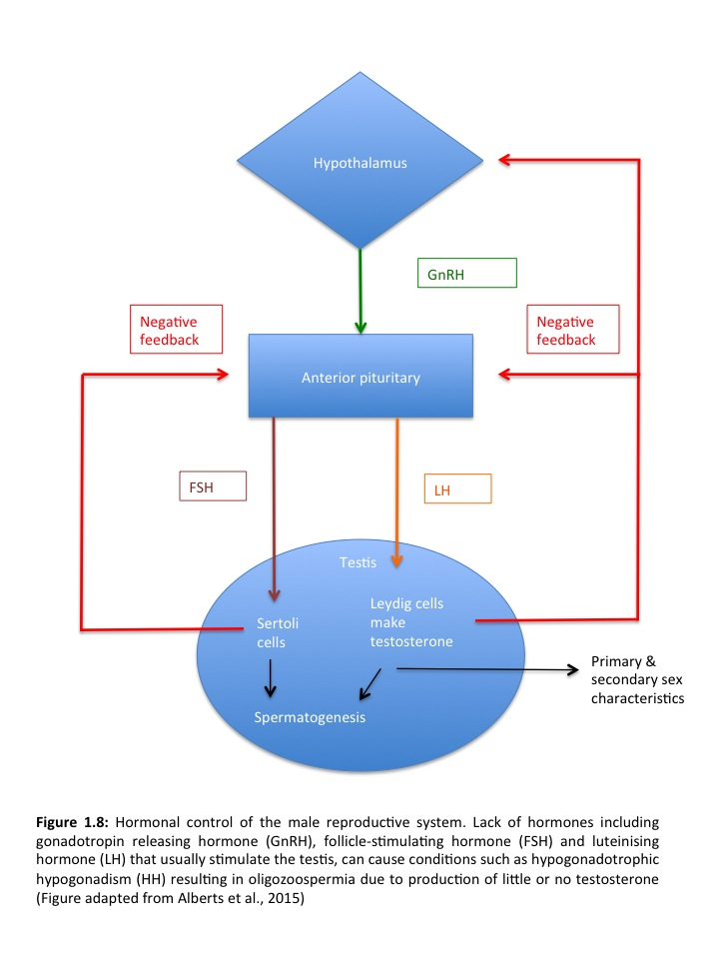

**1.4.1.1.2 Testicular causes**

Testicular causes are associated with the structures within the testicles such as the epididymis, sertoli cells or conditions that have may have affected functioning of these. Varicocele is a condition defined by abnormal dilation of the pampiniform plexus, a network of small veins found in the human male spermatic cord and characterised by retrograde venous flow (Zini and Boman, 2009, Forti and Krausz, 1998, Forti et al., 2003). It occurs in approximately 15% of the adult population (Forti et al., 2003, Canales et al., 2005, Cayan and Woodhouse, 2007) however, its affect on male fertility is somewhat disputed given that 10% of men with normozoospermic ejaculates have varicocele (Krausz, 2011). The affect on fertility is largely dependent on the grade of the varicocele. However, WHO data indicates that a minor cause of infertility such as a varicocele is more likely to manifest in couples where the female partner also suffers a reduced fertility (WHO., 1987). Crytorchidism is defined as the absence of one or both testicles from the scrotum. It is the most common congenital birth defect in male children and can occur as an isolated condition or alongside other congenital abnormalities (Main et al., 2010). The incidence is 2-9% at birth and decreases to 1-2% by 3 months of age due to delayed spontaneous decent (Virtanen and Toppari, 2008, Wohlfahrt-Veje et al., 2009). However, it can also be an acquired disorder diagnosed during infancy and childhood. Acquired cryptorchidism has a higher incidence in the UK (7%) compared to the congenital form (5.7%) (Wohlfahrt-Veje et al., 2009, Villumse.Al and Zachauch.B, 1966). Klinefelter syndrome is a well known example of numerical aneuploidy chromosomal disorderwhere mosiacism is common (Bojesen and Gravholt, 2007). Klinefelter syndrome (47XXY) has a prevalence of 1:600 males (Hotaling and Carrell, 2014) and its the most common genetic cause of male infertility and primary testicular failure (Bar et al., 2014). Expression is diverse however, males tend to have small testes and significantly elevated FSH and LH (Hotaling and Carrell, 2014).

Chromosomal abnormalities occur mainly during meiosis (Martin, 2008) with impaired sperm production associated with high frequency of numerical and structural chromosomopathies (Vincent et al., 2002). Patients with less than 10 million spermatozoa/ml show 10 times higher incidence (4%) of chromosomal abnormality compared to the general population. In patients with severe oligozoospermia (<5 million spermatozoa per ml) the incidence increases to 7-8%, and in non-obstructive azoospermic men, it peaks at 15-16% (Vincent et al., 2002).

##### **1.4.1.1.3 Post-testicular causes**

Post testicular causes of male infertility include obstruction of the seminal tract (distal or proximal), infections, inflammation of accessory organs and autoimmune conditions. Infection can be bacterial or viral. Bacterial infections include *Chlamydia trachomatis* which has been suggested to reduce semen quality (Custo et al., 1989, Wolff et al., 1991, Witkin et al., 1995, Cengiz et al., 1997, Al-Mously et al., 2009). Contrary to this, others have suggested that it has no association with poor semen quality (Gregoriou et al., 1989, Nagy et al., 1989, Eggertkruse et al., 1990, EggertKruse et al., 1996, EggertKruse et al., 1997, Soffer et al., 1990, Dieterle et al., 1995, Weidner et al., 1996, Habermann and Krause, 1999, Hosseinzadeh et al., 2004). Furthermore, viral infections such as human immunodeficiency virus, hepatitis C and B virus infection have also been found to significantly reduce concentration, motility and viability in infected men compared to healthy controls (Lorusso et al., 2010). On the other hand, when considering overall male infertility, ejaculatory duct obstruction is diagnosed in only 1-5% of patients (Pryor and Hendry, 1991, Porch, 1978). Therefore, its overall contribution to the causes of male infertility is small.

The UK National Institute for Clinical Excellence (NICE) suggests that clinicians consider five modifiable lifestyle factors considered to increase the risk of poor semen quality (O'Flynn, 2014). These include excessive alcohol intake, cigarette smoking, the wearing of tight underwear, having a BMI of >29 and the use of recreational drugs. Overall, research into the affect of lifestyle factors (Povey et al., 2012) and occupation (Cherry et al., 2008) on poor motile sperm concentrations implies that men can make few changes to improve the quality of their semen (Pacey et al., 2014).

Other pre-testicular causes arise in the form of coital disorders such as erectile dysfunction and ejaculatory disorders. Ejaculatory disorders interfere with the delivery of sperm to the female genital tract. Although they are rare causes of male sub-fertility, in a multinational survey of over 11 000 men, capable of achieving erections, 30.1%, 54.9% and 74.3% reported ejaculatory problems aged 50-59, 60-69, and 70-80 years respectively (Rosen et al., 2003). There are two phases of ejaculation (i) emission and (ii) expulsion. During the expulsive phase, the bladder neck must close to prevent the reflux of the semen into the bladder as pressure in the urethra increases (Jefferys et al., 2012). Retrograde ejaculation (RE) occurs when the bladder neck fails to close resulting in a reflux of semen into the bladder. RE accounts for only 0.3-2% of male infertility (Yavetz et al., 1994, Vernon et al., 1988).

## 1.5 Traditional semen analysis

Conventional semen analysis has been the main laboratory test of male fertility for at least 50 years (Natali and Turek, 2011). Routine semen analysis is the first laboratory test a clinician will advise after completing a detailed medical history and physical examination of the male partner. Prospective studies (Bonde et al., 1998, Zinaman et al., 2000, Louis et al., 2014) in couples who stopped the use of contraceptive suggest that sperm count, total sperm number, and percentage morphologically normal spermatozoa can predict time-to-pregnancy, which is a marker of fecundity. Furthermore, if a semen analysis is abnormal, it has been found to correlate with a lower probability of natural conception (WHO, 2010), although this is not a true measure of fertility (Natali and Turek, 2011). Global standardisation of routine semen analysis (semen volume, sperm count, motility and morphology) and the reference ranges used for diagnosis has been conducted by the World Heath Organisation (WHO 2010), whom created the internationally agreed ‘reference range’ designed to assist clinicians in making decisions using data on semen quality (WHO, 2010). Over the past 30 years, four updates have been published however; issues have been raised regarding the accuracy of traditional semen analysis. There was concern over significant variation in the use of semen analysis in different laboratories. This was supported by studies in the UK (Matson, 1995, Riddell et al., 2005) and USA (Keel et al., 2002) which led to the development of training programs and external quality assurance programs in Andrology (Bjorndahl et al., 2002, Franken et al., 2010, Franken and Kruger, 2006, Pacey, 2006, Pacey, 2010). International and national societies of Andrology, reproductive medicine, human reproduction and pathology have contributed further by training technologists in the standardised methods of routine semen analysis. However, despite all of this, the use of these parameters cannot precisely and accurately predict the fertility of a man (Wang and Swerdloff, 2014). This is because there are a host of other factors in addition to sperm and semen quality that contribute to the ability of sperm to fertilise an oocyte. Semen analysis is now considered as a limited method of defining a man’s fertility by providing nothing more than a visual description of an ejaculate. As a consequence, more sophisticated tests of sperm function have been developed in an attempt to improve male fertility diagnosis.

## 1.6 Sperm function tests

Due to the limitations of current semen analysis, the development of more sophisticated tests of sperm function have been explored. Many are based on key steps in the process of spermatozoa’s passage through the female reproductive tract and their interaction with the oocyte during fertilisation.

### 1.6.1 Acrosomal Integrity

As described in section 1.1.2.1 the acrosome is situated on the anterior half of the head in spermatozoa and releases proteolytic enzymes at the time of fertilisation, which digest through the zona pellucida, allowing sperm oolemma fusion (also see section 1.3.7). Acrosomal abnormalities (such as round headed sperm that do not possess an acrosome) have been shown to lack ability to bind or penetrate to the zona pellucida (Vonbernhardi et al., 1990). Often the acrosomal integrity can be assessed using staining with fluorescent lectins that bind to either the outer membrane or acrosomal contents (Aitken, 2006). This has been associated with predicting fertilisation potential of human spermatozoa *in vitro* (Cummins et al., 1991). Acrosomal enzymatic release can be induced using ionophore A23187, progesterone and the human zona pellucida, and the proportion of reacted spermatozoa recorded (Brucker and Lipford, 1995). Meta analysis of tests of sperm acrosome reaction using human zona suggest that there is a high predictive power of the induced acrosome reaction tests for the predication of fertilisation (Schuffner et al., 2002). Testing of acrosomal integrity may be used in evaluation of men following IVF failure. As a sperm function test, in reality they give little information regarding the cause of failed acrosome reaction and once again give a simple descriptive explanation to the cause of male infertility with no detailed molecular level explanation.

### 1.6.2 Sperm zona pellucida binding tests

Spermatozoa binding to the zona pellucida stimulates the acrosome reaction (Oehninger et al., 2013). The most common causes of IVF failure are defects in binding and penetration of the zona pellucida (Liu and Baker, 2003, Liu and Baker, 2000). The interaction of sperm and the zona pellucida (ZP) is a vital event resulting in fertilisation and is indicative of sperm function (i.e. completion of capacitation and ligand- induced acrosome reaction) (Oehninger et al., 1992b, Oehninger et al., 1992a, Oehninger, 2000, Oehninger, 2001, Liu and Baker, 1992). The two most common sperm-ZP binding tests are the hemizona assay (HZA) (Burkman et al., 1988) and a competitive intact zona sperm-binding test (Liu et al., 1988). They may differ in methodology but they both assess the binding of the sperm to the ZP and have shown high predictive value for the outcome of fertilisation *in vitro* (Oehninger, 2000, ESHRE, 1996, Liu et al., 2004).

The hemizona assay uses human oocytes from which the zona pellucida is isolated and divided in half. One half is incubated with healthy fertile donor spermatozoa whilst the other is incubated with patient spermatozoa. The binding of healthy donor sperm and the binding of patient sperm is quantified and a ratio comparing the two calculated, with prospective studies reporting a cut off value of 35% as predictive of IVF outcome (Oehninger et al., 1989, Franken et al., 1993, Franken and Oehninger, 2006). Sperm ZP binding tests are useful sperm function tests and are most suitable for counselling couples during ART when considering therapeutic methods such as Inter uterine injection (IUI) vs ICSI. Therefore, it may help couples financially when deciding on the suitability of ART therapies, but it is not widely used in routine assessment of sperm function.

### 1.6.3 Sperm penetration assay

The sperm penetration assay also known as the zona free hamster oocyte penetration assay is the most sensitive measures of sperm function available (Aitken, 2006). It tests the spermatozoa’s ability to undergo capacitation, acrosome reaction, fusion and penetration through the oolema as described in section 1.3.7 and decondensation within the cytoplasma of the oocyte. For this test, the zona pellucida is removed from a hamster oocyte, which is then incubated with human spermatozoa. The spermatozoa then fuse with the hamster ova. The assay is scored by calculating the percentage of ova that are penetrated by sperm, or the average number of sperm penetrations per ovum. This tests has been shown to positively correlate with IVF fertilisation rates (Freeman et al., 2001, Soffer et al., 1992, Aitken et al., 1987) and pregnancy in males with unexplained infertility (Aitken et al., 1991). Reproducibility of this assay and standardisation of methodologies between laboratories is low (Vogiatzi et al., 2013). Furthermore, this procedure is less efficient than the biological process *in vivo*, and may involve different mechanisms, false negative results (sperm from males that fail the SPA but successfully fertilise *in vivo* and *in vitro*) have frequently been recorded (Oehninger et al., 2014). Meta analysis have shown a poor clinical value of SPA as a predictor of fertilisation after assessment of nearly 3,000 cycles (Oehninger et al., 2000). Furthermore its expensive and time consuming and therefore its use to evaluate fertility potential is not recommended (Oehninger et al., 2014).

### 1.6.4 Reactive oxygen species

To test oxidative stress to spermatozoa direct assays such as chemiluminescence, nitro blue tetrazolium test, cytochrome C reduction test, flow cytometry, electron spin resonance and xylenol orange based assay, have been developed (Hwang et al., 2011). Direct ROS assays measure the net oxidative imbalance between ROS production and the antioxidant concentration in semen by measuring the amount of oxidation in the sperm cell membrane (Agarwal et al., 2014). There are also indirect assays which measure the downstream effect of ROS on spermatozoa such as DNA damage or lipid peroxidation levels (Agarwal et al., 2014). These tests include myleperoxidase or Endtz test, redox potential, and DNA damage testing.

Reactive oxygen species (ROS) is associated with causing oxidative stress correlated with impaired sperm function (Agarwal et al., 2003). Human spermatozoa are particularly sensitive to ROS due to the DNA being highly condensed within the sperm head and no other cellular barrier as protection (Aitken et al., 1989). Low levels of ROS are necessary for human spermatozoa capacitation (Aitken et al., 1998) however, excessive levels have been suggested to spermatozoa cell membrane lipid peroxidation, decreased sperm motility, impaired DNA integrity and reduced spontaneous pregnancy rates and fertilising potential *in vivo* and *in vitro* (Agarwal et al., 2003, Lewis and Aitken, 2005). Furthermore, ROS induced DNA damage may increase germ cell apoptosis causing lowered sperm counts (Agarwal et al., 2003). High levels of ROS have been detected in 25-40% of infertile men (Agarwal et al., 2003) however, the overall contribution of ROS to infertility remains debatable.

Direct assays have limited widespread clinical application due to cost and practicality issues (Agarwal et al., 2014). Furthermore, undertaking total antioxidant capacity (TAC) as part of routine andrology is not justified by lack of evaluation of a proven benefit, practicality and cost in comparison to routine semen analysis (Agarwal et al., 2014). There is also an absence of standardised protocols to assess seminal oxidants (Agarwal et al., 2014). Currently, no publications recommend against the use of ROS testing however, the American Urologic Association Best Practices Statement on evaluating the infertile couple does not support the use of ROS testing routinely in infertility assessment. Oxidative stress has been shown to cause DNA damage in human spermatozoa reducing fertilisation potential and DNA integrity (Aitken et al., 2014). Therefore, tests of sperm DNA damage have also been developed to measure the effect of ROS on sperm DNA and the implications of potential damage on male fertility.

### 1.6.5 Tests of sperm DNA damage

More recently, as sperm function tests advance, tests of sperm DNA damage have been used in the evaluation of the infertile male in an attempt to increase accuracy compared to standard sperm parameters alone (Zini et al., 2014). The aetiology of sperm DNA damage is likely to be of multiple causes. Human sperm DNA damage may be caused be primary causes such as defects in spermatogenesis or caused by secondary factors causing testicular or post testicular injury (e.g. gonadotoxins, hyperthermia, oxidants, endocrine abnormalities) (Zini et al., 2014).

Research suggests that there is a threshold of sperm DNA damage beyond which, pregnancy rates and embryo development are reduced (Cho et al., 2003, Evenson et al., 1999) and poorer outcomes after IUI (Bungum et al., 2007, Duran et al., 2002). Studies also show that the spermatozoa of infertile men possess high levels of DNA damage compared to fertile men (Evenson et al., 1999, Zini et al., 2001). DNA damage in men is associated with poor semen quality, impaired pre-implantation development, increased abortion and increased incidence of disease in the offspring, including childhood cancer (Lewis and Aitken, 2005). There are a large number of tests that have been developed to test DNA damage (Delbes et al., 2010, Zini, 2011). The most popular include the sperm chromatin structure assay (SCSA), the COMET assay (single- cell gel electrophoresis) and the TUNEL assay (terminal deoxynucleotidyl transferase-mediated deoxyuridine triphosphate dUTP nick end labelling). Although there is a vast amount of research investigating the relationship between sperm DNA damage and pregnancy rates and progeny outcome, its use in assessment of a mans fertility potential has met resistance (Zini et al., 2014). Reasons for this include a lack of interventions from the results of the test, other than antioxidant supplementations all current DNA damage tests require destruction of the patient’s spermatozoa. Furthermore, there is a lack of standardised protocols, there is unknown precision regarding reproducibility and repeatability of the various assays and thresholds have not yet been validated (Practice Committee of the American Society for Reproductive, 2013, 2015). However, data suggests that DNA damage does not impact the fertilisation rate or pregnancy outcome after ICSI (Bungum et al., 2007, Zini et al., 2005, Benchaib et al., 2007).

## 1.7 Sperm metabolomics

Conventional semen analysis has been the main laboratory test of male fertility for at lest 50 years (Natali and Turek, 2011). Studies have shown that sperm count, total sperm number and percentage morpholically normal spermatozoa can predict time to pregnancy, and this is a marker of fecundity (Bonde et al., 1998, Zinaman et al., 2000, Dacheux and Dacheux, 2014). However, conventional semen analysis has come under scrutiny regarding its global standardisation across laboratories in the UK (Matson, 1995, Riddell et al., 2005) and USA (Keel et al., 2002). Despite all of this, it remains the routine method of assessment of male fertility in clinics worldwide. This is due to the pitfalls of advance sperm function tests that have been developed, but never routinely used in clinics. Therefore, there is still a need for the development of a sperm function test, suited to routine clinical practice. Many of the tests discussed above have considered aspects of sperm function related to their journey through the female reproductive tract and the interactions with the female gametes. Sperm metabolomics is an avenue that requires further exploration and offers information regarding the real time function of a sperm in relation to its environment and its consequence for male fertility.

Recent metabolomics research have allowed extremely detailed characterisations of the complex molecular composition of distinct cells, tissues and organisms (Smith et al., 2014). The identification of metabolites and proteins as downstream products from the expression of genomes and transcriptomes that have been potentially exposed to environmental cues is significant. This is because it is the first step in understanding the normal composition and physiology of cells and tissues and the dysfunction associated with pathological states (Jodar et al., 2012, Wishart et al., 2013, Castillo et al., 2014a, Castillo et al., 2014b). Proteomics has been been successful in studying human spermatozoa. Over 6000 proteins have been identified using mass spectrometry (MS), representing approximately 80% of the proteome of this cell (Oliva and Martinez-Heredia, 2008, Oliva et al., 2009, Amaral et al., 2013, Amaral et al., 2014, Baker et al., 2013, Azpiazu et al., 2014). On the other hand, significantly fewer metabolites (approximately 20) have been identified in sperm from different model species (Oliva et al., 1982, Patel et al., 1999, Dreann et al., 2000, Jones and Bubb, 2000, Marin et al., 2003, Hung et al., 2009, Lin et al., 2009). Reasons for identification of such a low number are probably because there are naturally fewer metabolites compared to proteins in cells (Kouskoumvekaki and Panagiotou, 2011, Wishart et al., 2013). Furthermore, it has been suggested that the full potential of the current metabolomics techniques has not ben applied to the study of the sperm metabolome (Kovac et al., 2013).

For historical reasons, the most commonly used technique for metabolic study has been Nuclear Magnetic resonance (NMR) (Nicholson et al., 2002, Courant et al., 2013). An in detailed description of this technique, its applications and previous use in the study of sperm metabolites is discussed next.

## 1.8 Nuclear Magnetic Resonance

### 1.8.1 Overview

Nuclear Magnetic Resonance (NMR) was independently developed in 1946 by Felix Bloch and Edward Purcell and since has seen unparalleled growth as an analytical tool in chemistry, biology, medicine, materials science and geology (Claridge, 2009). NMR has been identified as an important diagnostic technique when investigating many health problems (Lynch et al., 1994).

### 1.8.2 Clinical applications

NMR was first used to scan an entire human body to identify tumours in 1971 (Damadian, 1971) and is now regarded as the principle structural technique of the research chemist (Claridge, 2009).1H NMR has been used extensively in the clinical setting in analysing the biochemistry of tissue samples including kidney (Moka et al., 1997), adipose tissue (Moka et al., 1998) red blood cells (Humpfer et al., 1997), prostate (Tomlins et al., 1998a) and brain tissue (Cheng et al., 1997). 1H NMR has now been acknowledged as a global approach to identifying metabolites and thus gaining an insight into the metabolism of a cell (Cudalbu et al., 2012). So far the method has enabled the identification of a number of mechanisms of disease including Huntington’s disease (Jenkins et al., 1993), liver trauma (Ranjan et al., 2006) and urinary tract infection (Gupta et al., 2006) allowing biochemical analysis using NMR spectroscopy.

### 1.8.3 Nuclear spin and resonance

One of the key principles of NMR is nuclear spin (Figure 1.9). Atoms such as carbon-12 would be of great interest to organic chemists however, they unfortunately have nuclear spin of zero. This is because nuclear spin arises due to an odd number of protons or neutrons within the nucleus of an atom and carbon 12 has an equal number. Therefore, carbon-12 is considered NMR silent because nuclear spin is fundamental to detectability using NMR (Tognarelli et al., 2015). In contrast, alternative isotopes of elements such as carbon-13 are NMR active due to an odd number of protons and neutrons within the nucleus. Therefore, they can be substituted for carbon-12 when using NMR analysis. The nuclei are positively charged and therefore charge forms around them. This charge and the nuclear spin form a magnetic moment (Hore et al., 2000). Therefore NMR active elements are mini magnets themselves (Figure 1.9). When placed in an external, static magnetic field (*B*0), these microscopic magnetic moments align themselves with the static magnetic field in a discrete number of orientations. This external static magnet imposes a torque on the microscopic magnetic moment of the atoms, which traces a circular path about the applied field (Figure 1.9). This motion is referred to as precession or more specifically *Larmor precession* (Hore et al., 2000). It is comparable to the way in which the gyroscope spins about its own axis and this axis in turn precesses about the direction of the gravitational field. NMR occurs when the nucleus of the atom changes spin state, caused by the absorption of a

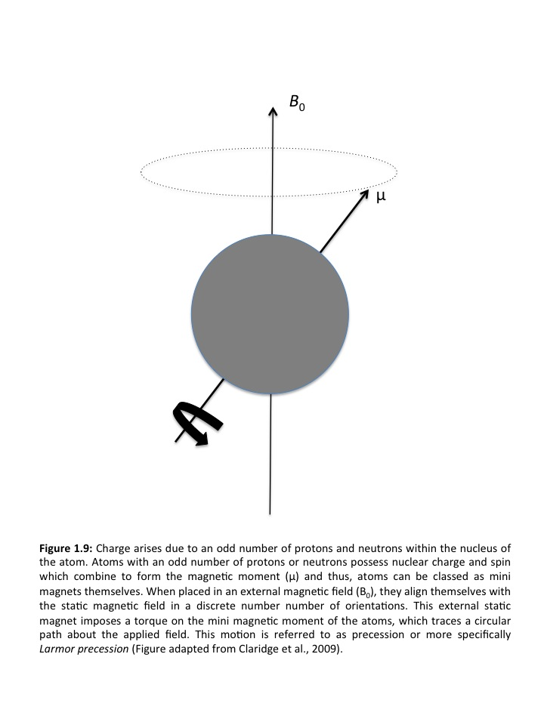

quantum of energy. This energy is applied as electromagnetic radiation whose frequency must match that of the Larmor precession of the atoms (Claridge, 2009).

### 1.8.4 The vector model of NMR

As previously described, each nucleus has nuclear spin and thus generates a weak magnetic field, which surrounds them. This magnetic field, created by the nuclear spin, interacts with the magnetic field applied when the sample is loaded into the scanner (Figure 1.10a-c)(Keeler, 2005). It is important to clarify that what is observed is the average behaviour of a large number of spins, if you consider that the sample is made up of many nuclei of individual atoms (Figure 1.10a). This is the bulk magnetisation (Figure 10c), which is the basis for the vector model of NMR (Keeler, 2005).

When the sample is placed in the scanner, the individual spins are all pointing in random directions within the sample (Figure 1.10a). After a few seconds, a Boltzman distribution will occur in that there will be a small preference for nuclear spins to be in a low energy state rather than a high-energy state (Figure 1.10c). Low energy spins are close to the z+ axis (Figure 10f) whilst high-energy spins are closer to the z-axis (Figure 1.10f). Therefore, bulk magnetisation forms along the z+ axis. However, this bulk magnetisation is non-observable. To observe this magnetisation, it must be moved away from the z-axis. When the magnetisation is taken away from the z-axis it precesses about the z-axis (Figure 1.10g), going round and round on a cone. This precession is equal to the Larmor frequency and is now detectable (Keeler, 2005).

Detection of this precession is achieved through the coil wrapped around the x- axis (the radiofrequency (rf) coils described in section 1.8.5). The magnetisation vector cuts through the coil and this induces a current in the coil, which can be detected in the NMR experiment (Figure 1.10h). To move the bulk magnetisation away from the z-axis, we apply a weak magnetic field along the x-axis, which oscillates at the Larmor frequency. This phenomenon is called resonance (Keeler, 2005).

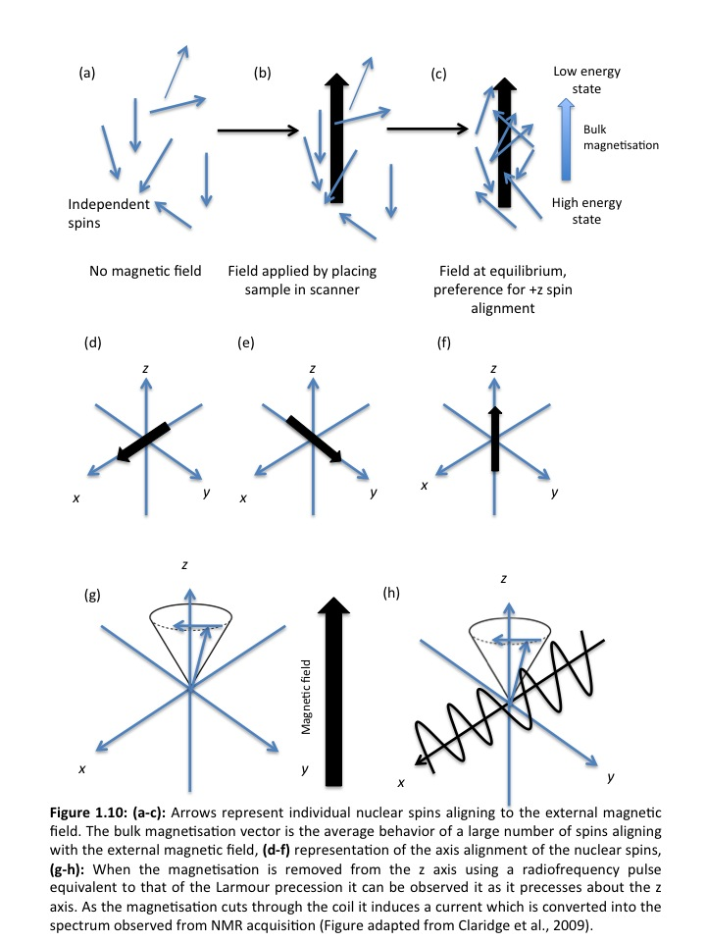

### 1.8.5 Radiofrequency pulse and relaxation

The radiofrequency pulse (rf) supplies the electromagnetic radiation to the sample to induce NMR. The pulse simply refers to turning on the radiofrequency irradiation for a defined amplitude and time period, before switching it off.

The radiofrequency electromagnetic field imposes a torque on the bulk magnetisation vector, which rotates the vector from the z axis towards the x-y plane (Figure 1.11). The rate at which the vector moves is proportional to the strength of the radiofrequency field and therefore the angle through which the vector turns, frequently termed the flip or pulse angle, will be dependent on the amplitude and duration of the pulse (Claridge, 2009).

If the rf was turned off just as the vector reached the y axis, this would be a 90° pulse (Figure 1.11a). If the rf pulse continued until the vector reached the z axis, it would be a 180° pulse (Figure 1.11b). As the vector starts to precess about the z-axis, at its Larmor frequency, it produces a weak oscillating voltage in the coil that surround the sample, in a similar way to how the rotating magnet in a dynamo induces a voltage in the coils that surround it. These are the electrical signals that we detect and gives us the observed NMR signal. However, naturally magnetisation in the x-y plane corresponds to a deviation from the equilibrium and so the transverse vector will gradually disappear and simultaneously grow along the z-axis. This return to equilibrium is called relaxation determining the observed NMR signal, which decays over time (Free Induction Decay (FID)) (Figure 1.12) (Claridge, 2009).

There are two types of relaxation associated with NMR. *T1*relaxation or longitudinal relaxation refers to relaxation of nuclear spins in the z direction. This involves the re-establishment of the distribution of spin states in the magnetic field. *T2* relaxation refers to the loss of phase coherence between nuclei. *T2* is less than or equal to *T1* because the return of the bulk magnetisation to the z-direction inevitably causes loss of magnetisation in the x-y plane. Relaxation is important as T*1* governs the minimum repetition rate during NMR acquisition for quantitative data. A short *T1* means that the magnetisation recovers more rapidly and therefore the spectrum can be acquired in less time (Tognarelli et al., 2015).

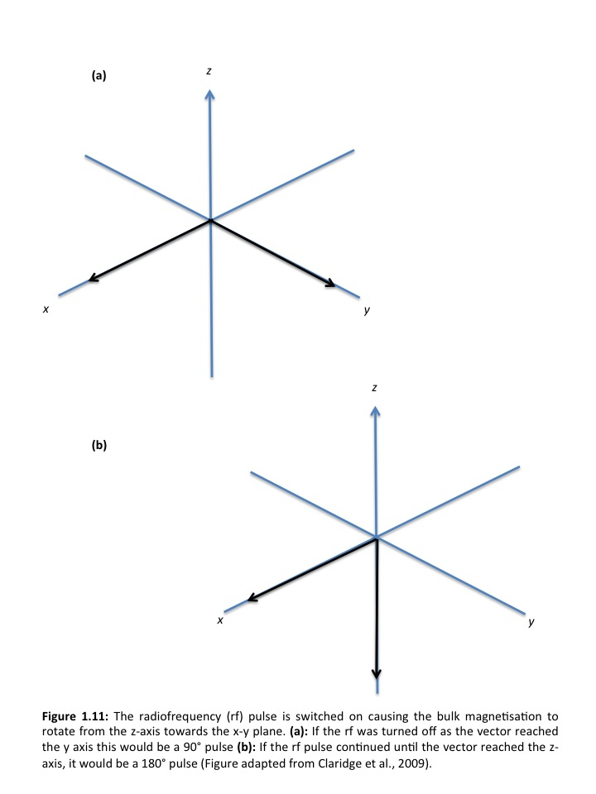

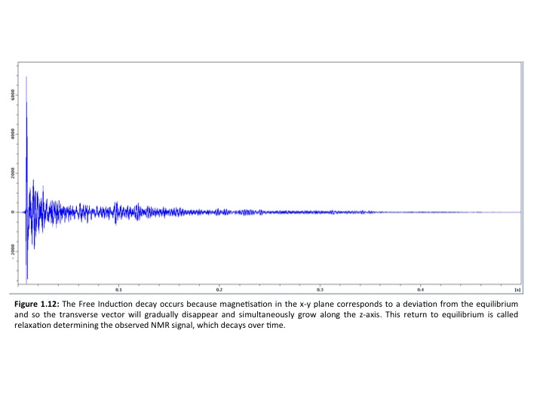

### 1.8.6 Chemical shift

The electron density surrounding each nucleus in a molecule varies according to the type of nuclei and bonds in the molecule. The electrons oppose the external

magnetic field and thus the effective field at each nucleus will therefore vary. This is called the chemical shift (Harwood and Claridge, 1996). Each atom will behave uniquely when analysed using NMR depending on its molecular bonding. Therefore, different compounds can be identified simultaneously as each atom gives a unique signal during NMR depending on its molecular structure. Furthermore, the chemical shift range for 13C NMR is twenty times larger than 1H NMR allowing molecular groups to be more readily resolved (Harwood and Claridge, 1996).

### 1.8.7 Coupling

Nuclei that experience different magnetic environments or have different chemical shifts are termed non-equivalent. Atomic nuclei that are close to one another exert an influence on each other’s effective magnetic field. This effect is apparent on an NMR spectrum when nuclei are non-equivalent. This effect is a through bond mediated effect and is not influenced by the magnetic field operated within. If the distance between non-equivalent nuclei is less than or equal to three bond lengths, spin-spin coupling or J coupling is observable (Claridge, 2009). Overall this phenomenon explains why we can see two or more peaks corresponding to the same compound within a sample. For example two peaks appear for lactate at different chemical shifts when using 1H NMR at 1.3 and 4.1ppm (Figure 1.13). In lactate there are many protons present and they exert an influence on each other over 3 bonds. In lactate the peak at 1.3ppm is a doublet due to the presence of a single proton from the resonance at 4.1ppm. Furthermore the peak at 4.1ppm is a quartet due to the presence of three protons on the methyl groups resonating at 1.3ppm.

### 1.8.8 Sensitivity, signal to noise

The sensitivity of an NMR spectrometer is a measure of the minimum number of spins detectable by the spectrometer. The signal to noise ratio is the ratio between the amount of signal given by atoms within a molecule and the background signal detected from the surrounding environment. The intensity of the signal detected is proportional to the number of spins in the sample and therefore the quantity of the

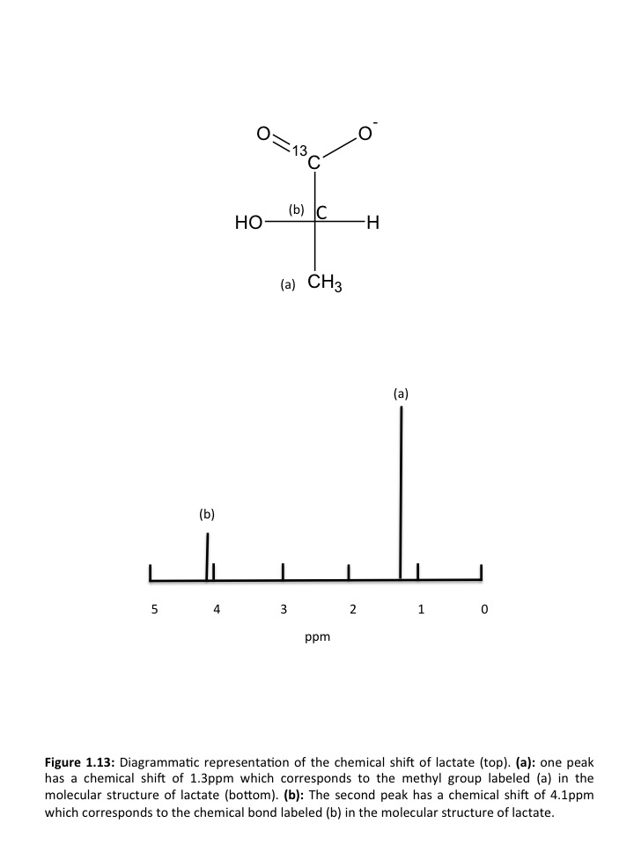

molecule in the sample (Claridge, 2009). The gyromagnetic constant γ determines the energy difference Δ*Ε* between two spin states. Nuclei that have a larger gyromagnetic ratio are more sensitive to radiofrquency pulse emitted during NMR. The gyromagnetic ratio of the proton (1H) nucleus is four times greater than that of the carbon. However, 13C has 1% natural abundance and therefore less spins observable using NMR. Consequently carbon NMR is almost 6000 times less sensitive in comparison to proton NMR, hence the use of isotopically labelled 13C in many NMR experiments (Clendinen et al., 2015).

### 1.8.9 NMR nuclei

#### 1.8.9.1 Proton (1H) NMR

1H NMR has been used extensively in the clinical setting in analysing the biochemistry of tissue samples including kidney (Moka et al., 1997), adipose tissue (Moka et al., 1998) red blood cells (Humpfer et al., 1997), prostate (Tomlins et al., 1998a) and brain tissue (Cheng et al., 1997). Therefore it has a high reputation in the clinical setting making it suitable for future sperm metabolomics studies.

##### **1.8.9.1.1 Broadband NMR**

The broadband probe is the probe of choice for the majority of NMR experiments. This is because it operates over a wide frequency range and therefore induces NMR in a variety of compounds allowing detection of a broad spectrum of nuclei and thus metabolites. Broadband NMR is simple and minimal preparation of the sample is required. As a consequence, it has been widely used in previous metabolic research in a number of tissue types. The disadvantage of broadband NMR is the large sample volume required when compared to the Magic Angle Spinning probe discussed below. A minimum of 300μl is required, preferably 500 μl to fill the 5mm glass NMR tube sufficiently so that the sample volume lies within the range of the rf coils. Broadband NMR is also better suited to liquid samples as shimming (see section 2.7.1) becomes complex the less viscous the sample is.

##### **1.8.9.1.2 Magic Angle Spinning (MAS) NMR**

NMR of solid state samples is complicated for two reasons: (i) restricted motion of the analyte; and (ii) physical heterogeneity within the samples (Claridge, 2009). As described in section 1.8.4 each atomic nucleus acts as a mini magnet. In low viscosity solutions, the atoms are mobile and tumble which mean that dipolar couplings are averaged to zero. For solid-state samples, the restricted atomic nuclei results in residual dipolar couplings being reintroduced and as a consequence the NMR resonances will broaden, reducing the quality of the spectrum observed. To eliminate the negative effects of both restricted motion of the analyte and heterogeneity within solid-state samples, rapid rotation of the sample about the so call ‘magic angle’ *Θ*=54.7° is used (Figure 1.14). Magic Angle Spinning (MAS) has the potential to increase signal-to-noise 3x compared to conventional broadband NMR and at the same time uses 1/10 of the sample volume (Claridge, 2009).

Due to its success in producing high resolution spectra, MAS has been applied to study metabolomics of breast (DeFeo and Cheng, 2010, Bathen et al., 2010), colon (Chan et al., 2009), prostate (Burns et al., 2004), liver (Martinez-Granados et al., 2011) and lung (Rocha et al., 2010) tissue. Specifically in breast cancer tissue, multiple studies have gone further by investigating quantities of breast cancer metabolites in relation to clinical prognosis (Sitter et al., 2010) and using results from HR MAS to predict prognosis in cancer patients (Giskeodegard et al., 2010). This is a promising example of its clinical diagnostic potential.

#### 1.8.9.2 Carbon (13C) NMR

Unfortunately the naturally abundant carbon-12 nucleus possesses a nuclear spin of zero, however, carbon-13 does due to the presence of an unpaired neutron. Carbon-13 nuclei make up approximately 1% of carbon on Earth. Therefore, carbon-13 NMR spectroscopy will have less sensitivity (reduced signal to noise ratio) than hydrogen spectroscopy (Clendinen et al., 2015). Advantages of 13C NMR are that no water signal is detected and that there is less signal overlap in comparison to 1H NMR due to the chemical shift range for 13C NMR being 20 times that of 1H NMR. Furthermore, addition of isotopically labelled substrates to spermatozoa such as 13C pyruvate, would allow identification of the substrate of interest and its metabolic intermediates and end products without detection of any other substrates, intermediates or end products. This would allow direct analysis and quantification of sperm

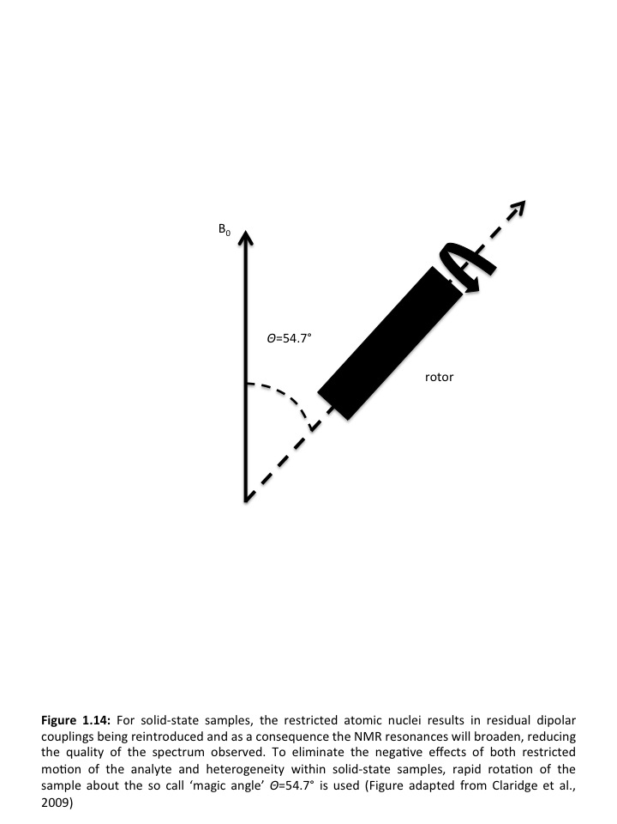

metabolism. This technique has been employed in mouse sperm to follow the utilisation of labelled substrates in real time (Odet et al., 2011).

## 1.9 Cellular metabolism

The chemical reactions within a cell would usually take place at much higher temperatures outside the cell. This is achieved through the use of specialist biological enzymes which act as catalysts (Helmreich and Cori, 1965). Enzyme catalysed reactions are connected in series so that the product of one reaction becomes the substrate for the next. These interconnected processed often form a cycle, thus allowing cells to survive, grow and reproduce. Two streams of reactions occur in cells: (i) catabolism involving the breakdown of large molecules into smaller ones thus releasing useful energy for the cells; and (ii) anabolic pathways which use the small molecules and energy harnessed from catabolism to form other useful molecules. Together these two sets of pathways are referred to as metabolism (Lenzen, 2014) .

### 1.9.1 Glycolysis

Glycolysis, Greek for the splitting of sugar, is a process where glucose, the most abundant monosaccharide in living systems, is converted into simpler products. This pathway is common in almost all cells, both prokaryotes and eukaryotes. In eukaryotes glycolysis takes place in the cytosol (Berg, 2002) and the process is likely to have evolved during the early history of life, before photosynthetic organisms introduced oxygen to the atmosphere (Lenzen, 2014). Glycolysis produces ATP without the involvement of molecular oxygen (O2 gas). During glycolysis, a glucose molecule with 6 carbon atoms is converted into two molecules of pyruvate, each with 3 carbons in ten steps, each producing a sugar intermediate and each catalysed by a different enzyme (Figure 1.15). This reaction does not happen spontaneously and therefore 2 ATP molecules are required for every 4 produced, giving a net gain of just 2 ATP molecules per molecule of glucose. Although no oxygen is involved in glycolysis, oxidation occurs during the removal of two electrons by NAD+ producing NADH from some of the carbons derived in the glucose molecule. In aerobic circumstances, these NADH molecules donate their electrons to the electron transport chain (see section 1.9.2) and the NAD+ formed from this donation is used again for glycolysis (Pajor, 1999).

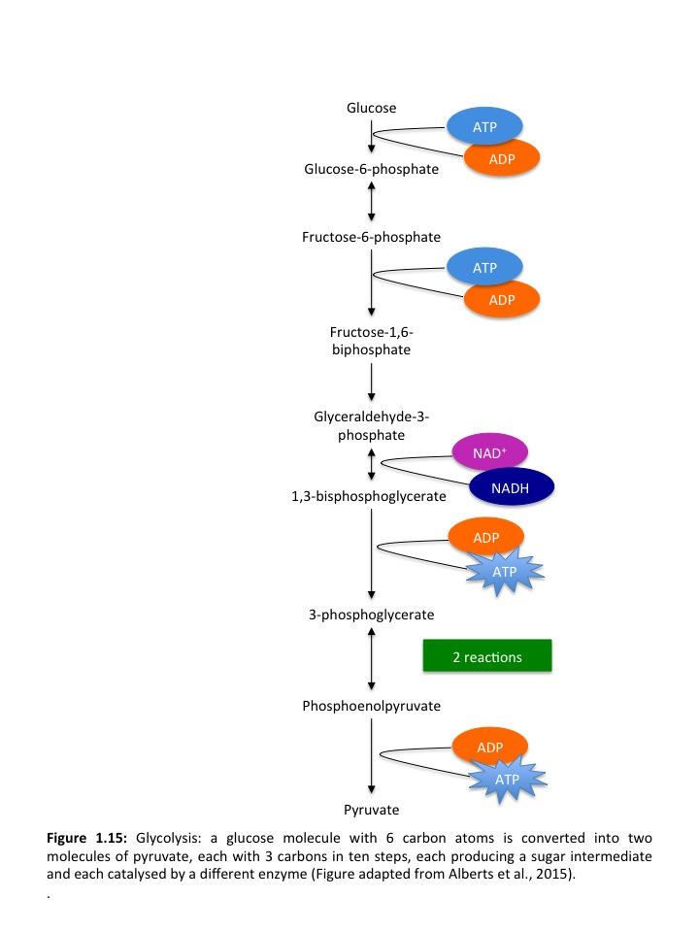

### 1.9.2 The Krebs cycle

In the early 19th century, biologists noticed that in the absence of oxygen, cells produce lactic acid (in muscle) or ethanol (in yeast) however, when oxygen is present they consume it and produce CO2 and H2O (Schroeder et al., 2009). This led to the discovery of the Krebs cycle in 1937 by Hans Krebs in Sheffield. The Krebs cycle accounts for approximately two thirds of the total oxidation of carbon compounds in most cells. It takes place inside the mitochondria in eukaryotic cells. During the Krebs cycle, the carbon atoms of the acetyl groups in acetyl CoA are completely oxidised. This happens in stages where the acetyl group is passed to a larger 4-carbon molecule, oxaloacetate to form a six carbon tricarboxylic acid (citric acid). The citric acid molecule is then gradually oxidised, and the energy from this oxidation to be harnessed to produce energy rich activated carrier molecules (Blomstrand et al., 1997) (Figure 1.16) Three molecules of NADH are produced for each turn of the Krebs cycle. One molecule of FADH2 (reduced flavin adenine dinucleotide) from FAD and one molecule of riboneucleoside triphosphate (GTP) from GDP. GTP is closely related to ATP and the transfer of its terminal phosphate group in each cycle produces one ATP molecule. The energy that is stored in the transferred electrons of NADH and FADH2 are then used for ATP production in oxidative phosphorylation (Blomstrand et al., 1997).

### 1.9.3.Oxidative phosphorylation (OXPHOS) &The electron transport chain

NADH and FADH2 now transfer the electrons they have gained during the electron transport chain. As the electrons pass along the multiple electron acceptor and donor molecules, they fall into lower energy states (Figure 1.17). The energy yielded pumps H+ ions (protons) across the inner most mitochondrial compartment to the cytosol generating a gradient of H+ ions. This gradient provides a large amount of energy for the generation of ATP by the phosphorylation of ADP. (Alberts et al., 2015). This is the process of OXPHOS. At the end of the chain, the electrons are passed to molecules of oxygen gas, which combine with protons to produce water.

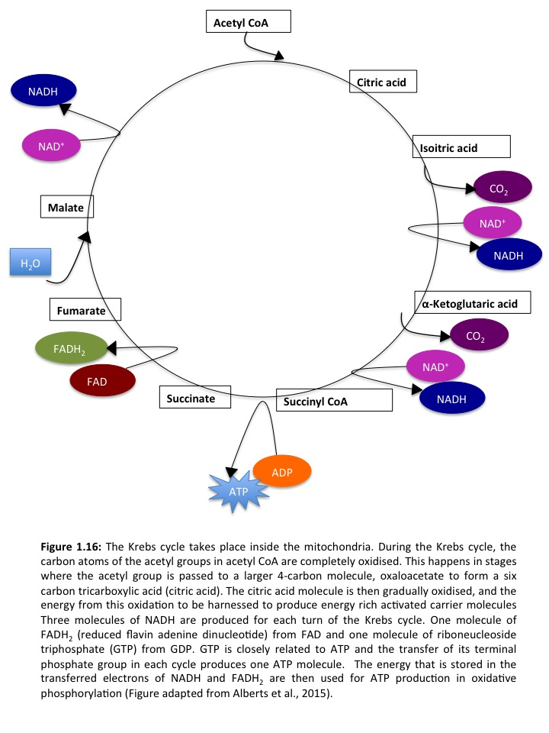

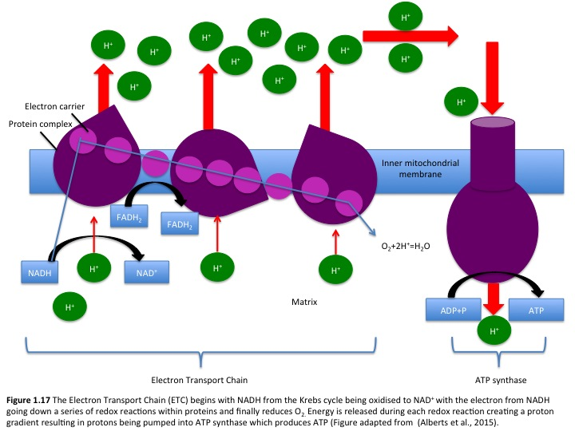

Overall, the complete oxidation of a molecule of glucose to H2O and CO2 is used by the cell to produce 30 molecules of ATP compared to only 2 molecules of ATP produced per molecule of glucose by glycolysis (Alberts et al., 2015).

### 1.9.4 Sperm metabolism

As with all living cells, energy is required for development and function, spermatozoa included. Mammalian spermatozoa specifically rely on adenosine triophosphate (ATP) to maintain their intracellular environment (Mistro and Ramya., 2012) and for cellular processes such as motility, capacitation, hyperactivation and the acrosome reaction (Mannowetz et al., 2012, Mukai and Travis, 2012), all of which are key to normal fertilisation. ATP is formed from adenosine diphosphate (ADP) and thus the addition and removal of phosphate groups to ADP molecules forms the foundation of metabolism in all living cells (du Plessis et al., 2015). The pathway of energy production in spermatozoa has been investigated but still remains controversial. Rees et al (Rees et al., 1990). States that all mammalian sperm share the same structural issue in that ATP must be delivered long the entire length of the flagellum, which consequently means that they must utilise multiple metabolic pathways to generate it.

ATP is produced in spermatozoa via two main metaobolic pathways: (i) glycolysis and (ii) oxidative phosphorylation (OXPHOS). Glycolysis occurs in the head and principle piece (Figure 1.13) of the flagellum and OXPHOS occurs in the mitochondria. Glycolysis involves the breakdown of six carbon monosaccharides during a number of enzyme catalysed reactions that produces two molecules of the three carbon compound pyruvate (Figure 1.15). The net yield of glycolysis is two molecules of ATP per molecule of glucose oxidised. In subsequent reactions, pyruvate is further oxidised and the carbonyl group is lost to CO2 to produce the acetyl group of the acetyl-coenzyme A. The acetyl group is then completely oxidised to CO2 by the citric acid cycle (Figure 1.16). Electron donors, NADH and FADH2 are formed from glycolysis, fatty acid oxidation and the citric acid cycle and they are energy rich with a high electron transfer potential (du Plessis et al., 2015). In the following reactions, electrons are taken from NADH and FADH2 to O2 through protein complexes in the inner mitochondrial membrane. An uneven distribution of protons creates a proton- motive force as the electrons transfer. This leads to protons being pumped out f the mitochondrial matrix. ATP is synthesised when protons flow back into the mitochondrial matrix through the enzyme complex ATP synthase (Gnaiger, 2001, Erecinska and Wilson, 1977).

Oxidative phosphorylation is a more complex chain of reactions involving two components of the inner mitochondrial membrane: (i) the respiratory chain and (ii) ATP synthase (Piomboni et al., 2012). OXPHOS yields thirty molecules of ATP per molecule of oxidised glucose making it 15 times more efficient than glycolysis. The rate of OXPHOS is defined mainly by the availability of ADP (Erecinska and Wilson, 1977, Kim et al., 2007). Together the oxidation of glucose and the phosphorylation of ADP working alongside a proton gradient across the inner mitochondrial membrane are the foundations of generation of ATP.

Spermatozoa can survive purely on glycolytic energy (Spiropoulos et al., 2002) however, they do require OXPHOS for differentiation and maturation (Nakada et al., 2006, Ruiz-Pesini et al., 1998, Ford, 2006). However, sperm metabolism is not a one size fits all process as it is highly species specific (Storey, 2008). In support of this, various studies (Miki et al., 2004, Galantino-Homer et al., 2004) have shown that glycolysis is fundamental for fertilisation in mice, rat, hamster and humans spermatozoa, but not required in bovine sperm.

**1.9.4.1 Site of ATP production via oxidative phosphorylation**

Mitochondria are housed on the mitochondrial sheath located in the mid-piece region of the spermatozoa (Ramalho-Santos et al., 2009), occupying a major portion of the cellular volume (15%-22%) (Turner, 2003). Mature spermatozoa contain approximately 72-80 mitochondria, which are involved in major processes such as the acrosome reaction and oocyte penetration (Rajender et al., 2010). There are four sub compartments: (i) the outer mitochondrial membrane, (ii) inter membrane space, (iii) inner mitochondrial membrane and (iv) matrix bearing much resemblance to somatic cells but differing both morphologically and functionally (Ramalho-Santos et al., 2009, Ferramosca et al., 2012). They differ morphologically due to the tight wrapping of the mitochondria around the axoneme. Tight wrapping results in the formation of a mitochondrial capsume consisting of selenoprotein and disulphide bridges. This gives the mitochondrial sheath great stability (Storey, 2008, Ho and Suarez, 2003). The inner mitochondrial membrane is folded into structures called cristae which are the principle sites for OXPHOS and ATP generation. Sperm mitochondria contain specific isoforms of proteins and isoenzymes such as cytochrome C (Goldberg et al., 1977, Narisawa et al., 2002), hexokinase subunit VIb of the cytochrome C oxidase (Huttemann et al., 2003), and lactate dehydrogenase (LDH) (Blanco and Zinkham, 1963), all of which cannot be found in somatic cell mitochondria (30).

**1.9.4.2 Site of ATP production via glycolysis**

Because glycolysis has been found to be key in mammalian sperm energy production, an understanding of the site of its production is extremely important (Turner, 2006, Mukai and Okuno, 2004, Albarracin et al., 2004). The head and principle piece are devoid of any respiratory enzymes meaning that ATP production by glycolysis can only occur in these areas (Mishro and Ramya., 2012). Multiple glycolytic enzymes including hexokinase, phosphoglucokinase isomerase, phosphofructokinase, LDH and glyceraldehyde-3-phosphate dehydrogenase (GAP) have been identified in the fibrous sheath of spermatozoa (Kim et al., 2007, Westhoff and Kamp, 1997, Bradley et al., 1996, Mori et al., 1998, Bunch et al., 1998, Travis et al., 1998).

**1.9.4.3 The use of ATP by spermatozoa**

The journey of the spermatozoa to the site of fertilisation is a long one making mammalian fertilisation complex (Wassarman, 1999, Hunter, 2005). Significant processes such as motility, capacitation, hyperactivation and the acrosome reaction must occur in an orderly fashion (Hunter, 2005, Wassarman, 1999) all of which are energy dependent thus making energy production paramount in spermatozoa.

**1.9.4.4 ATP and sperm motility**

Movement of the sperm flagellum constitutes more than 90% of the entire length of the mammalian spermatozoa (Rajender et al., 2010). Sperm motility has been defined as the result of ‘a propagation of transverse waves along the flagellum in a proximal- distal direction producing a hydrodynamic impulse that pushes the spermatozoon through the female genital tract towards the oocyte (Suarez and Ho, 2003). Spermatozoa are dependent on motility derived from ATP (Vigue et al., 1992) however, an understanding of how they are metabolically adapted to utilise ATP is less understood (Kamp et al., 2007). ATP is needed to support the structured movement of the central axoneme and the surround flagella pieces (Turner, 2003).

Mitochondria are not distributed along the entire length of the flagellum as they would interfere with flagella beating (Kamp et al., 2007). However, it is well known that mitochondrial ATP production is much more efficient raising questions as to whether ATP can diffuse rapidly enough along the entire length of the flagellum to support the energy requirements needed for fast beating activity. Research around this question remains contradictory. Biophysicists (Adam and Wei, 1975, Nevo and Rikmensp, 1970) have calculated the required rate of ATP diffusion to support motility in the spermatozoa of the sea urchin and bulls and have concluded that ATP diffusion is sufficient to maintain the beating frequency of the flagellum. Furthermore, mitochondrial membrane potential has been suggested to be an indictor of sperm motility and a reduction in potential has resulted in reduced sperm motility and fertilisation ability (Troiano et al., 1998, Donnelly et al., 2000, Kasai et al., 2002, Wang et al., 2003). Studies on asthenozoospermic patients have found a positive correlation between mitochondrial membrane potential and non-linear motility. Alterations in the mitochondrial respiratory chain enzyme activity can also have an effect on sperm motility (Luft, 1994). The electron transport chain (Figure 1.17) is composed of two mobile carriers (coenzyme Q and cytochrome C) and four multi-meric complexes (I, II, III and IV). Based on experiments involving specific mitochondrial enzymes and sperm motility, it has been suggested that mitochondrial dysfunction may lead to idiopathic asthenozoospermia (Ruiz-Pesini et al., 1998).

However, contradictory to the above are the findings of Tombes and Shapiro (Tombes and Shapiro, 1987) who suggest that when ATP is produced by the distant cell body or mitochondrion, whether by glycolysis or OXPHOS, it cannot meet the energy demands needed for normal flagella development due to the insufficient diffusion capacity of the ATP to the area where the energy demand is high. It is still unclear whether this is applicable to human sperm (Turner, 2003). Moreover, the products of ATP hydrolysis including ADP, inorganic phosphate Pi and H+ must be removed to avoid kinetic and thermodynamic stress (Oberholzer et al., 2007). Several researchers have therefore proposed an alternative pathway of energy production suggesting that there is a need for local ATP production closer to the site of ATP utilisation and that is achieved by the glycolytoic pathway of ATP production due to the presence of glycolytic enzymes in the fibrous sheath of the flagellum (Westhoff and Kamp, 1997) Furthermore, despite species specific differences (Rodriguez-Gil, 2006), mammalian spermatozoa can use a range of carbohydrates as substrate for ATP production (Williams and Ford, 2001, Frenette et al., 2006, Urner and Sakkas, 1999) (Mann and Lutwak Mann., 1981). This allows energy production in the cytoplasm regardless of mitochondrial activity (Westhoff and Kamp, 1997).

Glucose has been suggested to induce a high beat frequency in the flagellum and has been investigated by Mukai and Okuno who used a glucose analogue, 2-deoxyglucose (DOG), to inhibit glycolysis in spermatozoa. They found that DOG had no effect on mitochondrial respiration as assessed by the fluorescent probe -5,5’6,6’-tetrachloro-1,1’,3,3’-tetraethylbenzimidazolyl carbocyanine iodide (JC-1) (Mukai and Okuno, 2004), whereas it did inhibit the activity of pyruvate and lactate when provided as substrates which results in low motility and decreased ATP content (Mukai and Okuno, 2004). This evidence further supports the idea that glycolysis is a key contributor to sperm motility and when supressed, leads to decreased motility event though mitochondrial substrates are present. The ATP content when DOG was added was also examined. The concentration of ATP in the presence/absence of pyruvate along with DOG was found to be similar. Because DOG cannot inhibit ATP synthesis in mitochondria, this suggests that normal mitochondrial respiration is not sufficient to maintain the concentration of ATP required for sperm flagella motility. This further strengthens the case for glycolysis being the preferred energy source specifically for motility functions.

Other areas of investigation include spermatogenic isoforms of proteins that are found through out the fibrous sheath of the sperm flagellum. One of the most prominent is the GAPD enzyme. GAPD-S is a gene that is specific to mouse spermatogenic cells (Miki et al., 2004) and its human ortholog is GAPD-2. It is also the first catalytically active enzyme found to be bound to the fibrous sheath of spermatozoa (Westhoff and Kamp, 1997). It acts as a regulator of glycolysis during spermatogenesis and is also the target of multiple environmental compounds that dramatically affect male fertility (Mohri et al., 1975). This has been studied by Miki et al (Miki et al., 2004) who studied GAPD-S gene expression and found that sperm produced by GAPD-S -/- mice have low motility and exhibit no forward progression (Miki et al., 2004). Welch et al (Welch et al., 2000) also sequenced and cloned the cDNA for the human homologue GAPD-2 and implied that it may have similar roles in human spermatozoa.

Investigations into mitochondrial ATP production have involved the use of carboyl cyanide m-chlorophenylhydrazie (CCCP) which acts as an uncoupler inhibiting ATP production. The addition of CCCP to highly motile mice spermatozoa had no effect on ATP content and motility parameters, suggesting that mitochondrial respiration does not play a pivotal role in sperm motility (Mukai and Okuno, 2004). In further support of this, LDH-C, a spermatogenic cell variant and a glycolytic enzyme (Blanco and Zinkham, 1963), catalyses the conversion of pyruvate to lactate which is essential for sperm motility during anaerobic respiration. If the LDH-C gene is disrupted in mice, neither tyrosine phosphorylation nor hyperactive motility occur, both necessary for capacitation (Odet et al., 2008). Hung et al (74) did also suggest that OXPHOS is not necessary for hyperactivated sperm motility in the sperm of rhesus macaque monkeys and Hereng et al (Hereng et al., 2011) has also shown that during exogenous supplementation of pyruvate and glucose, the glycolytic pathways was the dominant source of energy which fuelled progressive motility and capacitation through ATP production.

**1.9.4.5 ATP in capacitation and the acrosome reaction**

Fertilisation includes several processes that occur in order, one after the other (Yanagimachi, 1994a). After spermatozoa are deposited in the vagina, a series of processes collectively known as capacitation take place before fertilisation can occur (Rajender et al., 2010). Capacitation has been defined as “the cellular and biochemical modifications that the spermatozoon undergoes in response to appropriate stimuli essential for the acrosome reaction to occur” (deLamirande et al., 1997). When human sperm are incubated in capacitation medium, an average of 10-20% show motility patterns consistent with hyperactivation (Burkman, 1984, Buffone et al., 2005). ATP needs to be efficiently produced to by mammalian spermatozoa to fuel and maintain these significant processes (Ho et al., 2002). Modifications take place at the surface of the sperm head as well as through out the flagella (deLamirande et al., 1997). The acrosome reaction refers to the release of hydrolytic enzymes from the acrosome vesicles leading to successful sperm binding and penetration of the oocyte (du Plessis et al., 2015).

The acrosome reaction begins due to signals produced by the oocyte activating G proteins inside the sperm which in turn increases intracellular Ca2+ levels. This activates numerous kinases and phosphorylation of various proteins. Ca2+ can be sourced from either plasma membrane channels formed by proteins in the CatSper family or from Ca2+ stored in organelles (Kirichok et al., 2006). A point of interest is that although CatSper channels are found only on the principle piece of the flagellum, the redundant nuclear envelope (RNE) which is a collection of membrane vesicles (Toshimori et al., 1985, Franklin, 1968), that serves as an important source of calcium ions to the base of the midpiece of the mitochondrial sheath. A rise in Ca2+ in sperm that are acrosome reacted has been shown to increase flagella beat intensity leading to an increase in hyperactivation (Suarez and Dai, 1995).

ATP is essential for ATPase activity, cyclic adenosine monophosphate making and phosphorylation. Therefore it plays a significant role in acrosomal integrity and the acrosome reaction itself. Mitochondria are heavily involved in capacitation-dependent tyrosine phosphorylation in mammalian spermatozoa (Kota et al., 2010, Ficarro et al., 2003). Interestingly a secretory pathway (Ca2+-ATPase has been immunolocalised to the mid piece and base of the head and may be involved in Ca2+ clearance that is released from the RNE store (Harper and Publicover, 2005). Furthermore, selenium-dependent phospholipid hydroperoxide glutathione peroxidase is highly expressed in spermatids and shows activity in the post pubertal testes (Roveri et al., 1992). In mature sperm it is confined to the midpiece region (Calvin, 1981) which embeds the helix of the mitochondria and plays a significant role in sperm maturation and mitochondrial function (Mitra and Shivaji, 2005). Despite this the specific role of tyrosine phosphorylation during human sperm capacitation has remains unclear.

Turning to substrates, mammalian sperm rely on high concentrations of glucose, pyruvate and lactate (Hoshi et al., 1991, Williams and Ford, 2001, Mukai and Okuno, 2004) which are all present in oviductal fluid (Ruiz-Pesini et al., 2007). The oviductal fluid of sheep and pigs has been found to contain lactate which is metabolised by spermatozoa whereas in mouse sperm, oyruvate and glucose fuelled vigorous motility for longer (Restall, 1966, Nichol et al., 1992). The metabolic substrate utilised varies considerably between species and thus determines the metabolic pathway to produce ATP for capacitation (Storey, 2008). The presence/absence of extracellular substrates also has an effect but if present, sperm metabolise such substrates by glycolysis to provide ATP for flagella movement. On the other hand, when substrates for glycolysis are scarce, sperm metabolise respiratory substrates. In this situation, respiratory substrates function as substrates for gluconeogenesis in the mid piece, resulting in the production of glucose that can diffuse to other areas of the sperm flagellum. It has been shown that bull sperm depend on OXPHOS to support capacitation (Hutson et al., 1977) however, it has been suggested that human spermatozoa depend on glucose derived ATP (Urner and Sakkas, 1996, Williams and Ford, 2001). Glucose derived ATP serves as a fast source of energy, mitochondrial activity increases during sperm capacitation (Boell, 1985, Fraser and Lane, 1987). To define the role of mitochondria during capacitation, a study compared spermatozoa before and after swim up treatment, incubated for varying time intervals. Results indicated that respiratory activity in spermatozoa incubated under capacitating conditions was significantly increased compared to cells prior to swim up. This could be related to efficient ATP generation through OXPHOS (Stendardi et al., 2011).

### 1.9.5 NMR and sperm metabolism

NMR is another method that has previously been employed to investigate sperm metabolites. A study on goat sperm (Patel et al., 1998, Patel et al., 1999) looked at epididymal sperm and focussed on identification and quantification of the amino acid L-arginine and its role in sperm metabolism. Utilisation of amino acids in sperm metabolism is interesting, as it is not well documented however, there are many more substrates more likely to be affecting sperm metabolism and sperm function in mammalian species. The goat is also not a model species for sperm studies considering that boar spermatozoa are morphologically much more similar to human sperm. NMR has been used to study boar sperm metabolism (Jones and Bubb, 2000), once again from sperm extracted from the epididymis. Sperm were then saponified (lysed using surfactant) and the metabolites extracted. This study was successful in contributing further to knowledge of boar sperm metabolism through the use of metabolic inhibitors to identify pathways of sperm metabolism. However, as in the goat study, sperm from the epididymis are not representative of the natural process of ejaculation, which may contribute to sperm metabolism as the sperm and seminal plasma interact in the male reproductive tract. Destruction of the sperm also prevents real time monitoring of their metabolism. Another study investigated the metabolome of turbot (flat fish species) sperm (Dreann et al., 2000). Although sperm of this species are not similar to human spermatozoa in their morphology or fertilising environment, researchers were able to identify anaerobic respiration and OXPHOS as sources of ATP, utilised during the swimming phase. Furthermore, comparisons were made between sperm, seminal fluid and urine metabolites highlighting the importance of comparing sperm and seminal plasma in sperm metabolite studies. Studies on rhesus macaque spermatozoa reflect the closest species comparison to human sperm other than studies on human sperm themselves. NMR has been used to study the affect of environmental tobacco smoke on sperm function in rhesus macaques (Hung et al., 2009) and found little effect however, sperm did show changes in their metabolome. This study contributed to our understanding of the effect of one of many possible environmental affects on sperm function. A second study used an inhibitor of glycolysis and an uncoupler of OXPHOS to investigate primate sperm metabolism (Lin et al., 2009). Interestingly they found a significant change in sperm metabolites correlated with seasonal variations in fertility, which suggested that NMR would be a promising tool in measuring sperm function through metabolite analysis. Finally, human spermatozoa were analysed using NMR and gas chromatography (Paiva et al., 2015) identifying 69 metabolites in human spermatozoa, 42 of which were identified by NMR alone. This was a significant contribution to scientific knowledge of the human sperm metabolome however, like previous studies, measurements were taken from extracted sperm metabolites at different time points. Very recently, data has been published suggesting the ability of NMR to be used to provide information about the molecules present in live human sperm (Reynolds et al., 2017). This recent publication focussed on developing the foundations of sperm washing in preparation for NMR analysis. Furthermore, it explores the differences in sperm metabolite quantities taken from fractions of Percoll gradient wash and compares metabolites from seminal plasma and spermatozoa. Real time monitoring of human sperm metabolites has been accomplished using NMR and comparisons made between sperm from fractions of the Percoll wash. There has been little focus on comparing the inter and intra metabolite profile of seminal plasma, high or low motility live sperm from different ejaculate phenotyopes using NMR. NMR still requires further investigation to explore its in studying live sperm metabolism possibly allowing real time monitoring of sperm metabolism in different environments and during key processes such as capacitation, hyperactivation and the acrosome reaction.

## 1.1.0 Aims and objectives

Although sperm cells visually appear simplistic in their structure, they are in fact a unique cell with the essential purpose of transporting genetic information from the male to the oocyte during conception. Furthermore, they are subjected to multiple environmental stresses and cues that influence their metabolism and overall success in reaching the site of fertilisation. This raises the question as to whether traditional semen analysis is sufficient to classify a man’s fertility based on visual descriptors of sperm function, most importantly sperm motility.

Despite multiple efforts in developing novel tests of sperm function which focus on specific structural aspects of sperm and the biological challenges and processes they encounter during their journey through the female reproductive tract, none have been adopted in routine clinical practice. The development of these tests have each contributed further to our understanding of sperm function, but a technique that is economically and practically viable in the Andrology laboratory is yet to be successfully developed and implemented. Sperm metabolomics is the most promising field of sperm function testing, given that sperm metabolism is essential for sperm motility and sperm motility essential for successful fertilisation *in vitro*.

NMR has a strong record within the field of medical diagnostics, most significantly in oncology, and has more recently been used to investigate male fertility with a focus on seminal plasma metabolites. It has the ability to identify sperm metabolites and thus quantify sperm metabolism. It also permits analysis of live sperm metabolism in real time, which has not been achieved previously. Furthermore, due to its specificity, it has the potential to increase our knowledge of sperm metabolism and its relationship to fertility further allowing scientists and patients to understand the cause of infertility and potentially help develop personalised therapeutics in the future.

Given the potential of NMR in the field of Andrology, investigations into its use in analysing sperm function will be carried out in this thesis. Chapter 3 aims to optimise two NMR techniques (broadband NMR and Magic Angle Spinning NMR) for use in experiments in subsequent chapters. Boar sperm will be the focus on these initial investigations. This Chapter will include initial metabolite observations and identify metabolites, which will be investigated in more detail in subsequent chapters. Chapter 4 then focuses on manipulating sperm metabolism using temperature and a pharmacological agent to validate NMR’s ability to detect changes in metabolites when a known environment affect is implemented. The effects were measured using both types of NMR mentioned above and the advantages and disadvantages of each technique discussed in order to justify the use of one of the techniques in future experiments. Chapter 5 moves on to investigate the metabolites within human spermatozoa and evaluates the differences in metabolites from seminal plasma, high motility and low motility spermatozoa within the same ejaculate and between ejaculates of the same and different individuals. This aims to help answer the question is there is variation in metabolite content of different fractions of a man’s ejaculate? Furthermore it may help to answer the question of how much a man’s ejaculate varies biologically over time? Finally Chapter 6 evaluates NMR in the analyses of real time sperm metabolism using a labelled isotope of carbon 13 and tracking its journey through multiple metabolic pathways employed by sperm. This aims to answer the question regarding the significance of either glycolysis or OXPHOS in ATP production for human sperm motility. Furthermore, comparison of live sperm metabolism in real time is evaluated in boars and humans with different classes of fertility deduced from traditional semen analysis. This aims to answer the question of whether NMR can be used to classify male fertility in the diagnostic setting and its future use in the Andrology laboratory.

## 1.2.0 Hypothesis

NMR will be able to detect and quantify sperm metabolites from glycolytic and OXPHOS metabolic pathways. Monitoring of these metabolites will be possible in real time.

# 

# 2.0 Materials and Methods

This chapter will describe the core techniques used for sperm preparation and analysis as well as the technique of NMR used in subsequent chapters. The design of individual experiments is given in each experimental chapter.

## 2.1 Collection of sperm

### 2.1.1 Boar spermatozoa

Sperm rich samples of semen were provided by fertile boars from JSR Genetics Limited at Thorpe Willoughby (Selby, Yorkshire, United Kingdom). The boars were a mixture of breeds and their semen is primarily used for commercial artificial insemination. Prior to dispatch, the ejaculates were mixed with Beltsville (BTS) ambient temperature extender which acts to preserve full fertility for up to three days after ejaculation (Johnson et al., 1988). The semen samples arrived (via Royal Mail Special Delivery) within 24 hours of ejaculation and were placed in an incubator (Memmert IPP200, Schwabach, Germany) at 17°C until used in experiments. All samples were used within two days of ejaculation and by the expiry date provided.

### 2.1.2 Human spermatozoa

Samples of human semen were obtained from 18-35 year old men. The University of Sheffield ethics committee approved the use of human sperm donors in this study (SMBRER293). Donors were recruited using electronic and paper based materials displayed in University departments and social areas. Written informed consent was obtained from all participants before enrolment to the study and upon donation of each ejaculate used in this research.

Semen samples were collected by masturbation after 2-5 days of abstinence, at home into a disposable cup 100ml PP (Sarstedt, Numbrecht, Germany) and bought to the laboratory within 40 minutes of production. Donors were instructed to keep samples as close to body temperature as possible during transit. Ejaculates were allowed to liquefy before semen analysis which was performed within 1 hour of ejaculate production, using methods described in WHO (2010) and summarised in section 2.2.

## 2.2 Semen analysis

### 2.2.1 Measurement of sperm concentration

Before samples were used in experiments the total number of sperm in the sample was calculated in order to accurately standardise the number of sperm across experiments. The concentration of sperm was calculated using the method outlined in the WHO laboratory manual for the examination and processing of human semen (WHO, 2010). Briefly, 10μl of a thoroughly mixed sample was observed on a glass slide with a cover slip to determine the appropriate dilution. The sample was then mixed with the appropriate volume of formalin (Sigma Aldrich, Gillingham, UK) and loaded onto the Neubauer haemocytomer (Hawksley, Lancing, UK) (Figure 2.1) and allowed to settle for 3-4 minutes in a humid chamber. At least 200 spermatozoa were then counted using x40 magnification for each grid on the haemocyometer. The concentration of sperm per ml was then determined using conversion factors outline by the (WHO, 2010). From this the total number of sperm in the sample could then be calculated.

### 2.2.2 Measurement of sperm motility

Sperm motility was measured in accordance with the WHO laboratory manual (WHO, 2010). Briefly, 10μl of semen was prepared on a slide and coverslip on a preheated stage set to 37°C. A total of 200 sperm were graded and the percentage motility and progressive motility calculated. The motility of each spermatozoon is graded as follows:

* Progressive motility: spermatozoa moving actively, either linearly or in a large circle, regardless of speed.
* Non-progressive: all other patterns of motility with an absence of progression e.g. swimming in small circles, the flagella force hardly displacing the head, or when the flagella beat can be observed.
* Immotility: no movement.

## 2.3 Sperm washing

Different sperm washing media were used during density centrifugation of boar and human ejaculates. For boar sperm, Percoll (GE Healthcare Life Sciences, Little Chalfont, UK) medium was used. It has previously been speculated to have toxic affects on sperm membranes (Strehler et al., 1998) however, despite this it is still the media of choice for animal *in vitro* sperm selection procedures (Cesari et al., 2006, Machado et al., 2009). For human sperm samples, PureSperm (Nidacon, Mölndal, Sweden) was used. This is the medium used in Jessop Fertility (Sheffield, UK) to prepare human semen samples for use in IVF treatment cycles and its use supported in the following studies (Chen and Bongso, 1999, Dorado et al., 2011, Maxwell et al., 2007, Nicolas et al., 2012).

### 2.3.1 Boar sperm washing

Highly motile preparations of boar spermatozoa were prepared using the method originally described in (Lynham and Harrison, 1998). Briefly, sperm were separated from diluted semen by sedimentation through two concentrations of iso-osmotic Percoll (GE Healthcare Bio-Sciences AB, Little Chalfont, UK) (as illustrated in Figure 2.2. Two concentrations of isotonic Percoll were made by diluting it to 70% (v/v) and 30% (v/v) using the HEPES 1x solution (Biosera, Uckfield, UK). 2ml of 30% Percoll was then layered on top of 2ml 70% Percoll which consequently formed an interface between the two. 3ml boar semen (diluted in BTS) was placed on top of the two concentrations of Percoll. Density centrifugation took place in a 15ml microcentrifuge tube (Starlab, Milton Keynes, United Kingdom). Samples were then centrifuged in a Sigma 3-16K at 200*g* for 15 minutes followed by 900*g* for 15 minutes. Centrifugation caused a pellet to form at the base of the tube (Figure 2.2G) allowing aspiration of the supernatant and addition of 3ml Tyrodes buffer (Harrison and Miller, 2000) before final centrifugation at 900*g* for 15 minutes. The aspirated pellet was either left in the pellet form and pipetted neat for use in experiments described in Chapter 3, or re-suspended in 1ml PBS 1x. The final suspensions were stored at 39°C, shielded from sunlight and used within 1 hour.

**Figure 2.1:** Figure has been removed for copyright reasons

### 2.3.2 Human sperm washing with PureSperm

Donor ejaculates were allowed to liquefy before semen analysis. Two PureSperm (Nidacon, Mölndal, Sweden) gradients of 80% (v/v) and 40% (v/v) were created using PureSperm 100 solution and PureSperm buffer solution. The gradients were layered on top of each other in a 15ml microcentrifuge tube and the presence of an interface verified (Figure 2.2). A maximum of 1ml of the ejaculate was then layered on top of the gradients and centrifuged at 300g for 20 minutes. Following the first round of centrifugation, the seminal plasma was removed and stored as summarised in section 2.5.1. The immotile sperm was also removed from the interface between the 80% and 40% Pursperm (Figure 2.2G) as summarized in section 2.5.3. The motile spermatozoa were re-suspended in 2ml PBS 1x and centrifuged at 500g for 10 minutes. The supernatant was removed and the final motile sperm pellet was re-suspended in 2ml PBS 1x ready for NMR acquisition (section 2.5.2)

## 2.4 Preparation for scanning

A 20mM 3-(Trimethylsilyl) propionic acid, sodium salt (TSP) (Sigma aldrich Gillingham, UK) insert was made by diluting TSP in D2O to achieve a 20mM concentration. Samples were then spiked with 10μl of the 20mM TSP reference. 10% (v/v) D2O was added to all samples for field frequency lock.

## 2.5 Analysis of ejaculate fractions

### 2.5.1 Seminal plasma

Once the first centrifugation had taken place, the seminal plasma was removed from the top of the gradient columns using a 3ml Pasteur pipette (Ramboldi Ltd, Limassol, Cyprus). The seminal plasma was then frozen at -80°C until scanning could take place. When required, seminal plasma samples were thawed. To remove any residual sperm, seminal plasma was then centrifuged at 1000*g* for 10 minutes and the supernatant removed for scanning. The pelleted cells were discarded.

### 2.5.2 High motility spermatozoa

Motile spermatozoa were collected following washing (see Figure 2.2G). Motile spermatozoa were immediately re-suspended in 1ml PBS 1X at 37°C for human

**Figure 2.2:** Figure has been removed for copyright reasons

and 39°C for boar. Concentration and motility analysis were then performed immediately prior to scanning.

### 2.5.3 Low motility spermatozoa

Immotile spermatozoa in the 80/40 interface were carefully removed using a Pasteur pipette after the first centrifugation had taken place. Briefly, seminal plasma was removed first to avoid contamination. The layer of low motility sperm which had collected at the 40/80 interface was then removed also using a Pasteur pipette. This was pipetted into an eppendorf tube and centrifuged at 300*g* for 10 minutes. The supernatant was removed and discarded and the low motility sperm were resuspended in 0.5ml PBS. They were then subject to Magnetic-Activated Cell Sorting (MACS) (see section 2.6) for purification so that leukocytes and other non sperm cells were eliminated from the sample.

## 2.6 Magnetic-activated cell sorting (MACS)

### 2.6.1 Preparation of sperm for MACS

All MACS equipment was sourced from Miltenyi Biotec (Bisley UK). LS columns were used for the gentle isolation of MicroBead labeled cells alongside a MidiMACS separator attached to a MultiStand (Figure 2.3). Semen analysis (concentration and motility (see section 2.2)) was performed on low and high motility sperm samples following sperm washing (see section 2.3). Sample concentrations were adjusted if necessary so that a concentration of 107 ml was not exceeded. Cell suspensions were centrifuged at 300*g* for 10 minutes and the supernatant aspirated completely. The sperm pellet was re-suspended in 80μl MACS buffer (PBS, 0.5% (w/v) bovine serum albumin (BSA), 2mM EDTA) and 20μl CD45 MicroBeads added and mixed well. The sperm and MicroBeads were incubated at 5°C for 15 minutes. Following incubation the sperm were washed by adding 2ml MACS buffer and centrifuged at 300*g* for 10 minutes. The supernatant was aspirated completely. Cells were then re-suspended in 500μl MACS buffer.

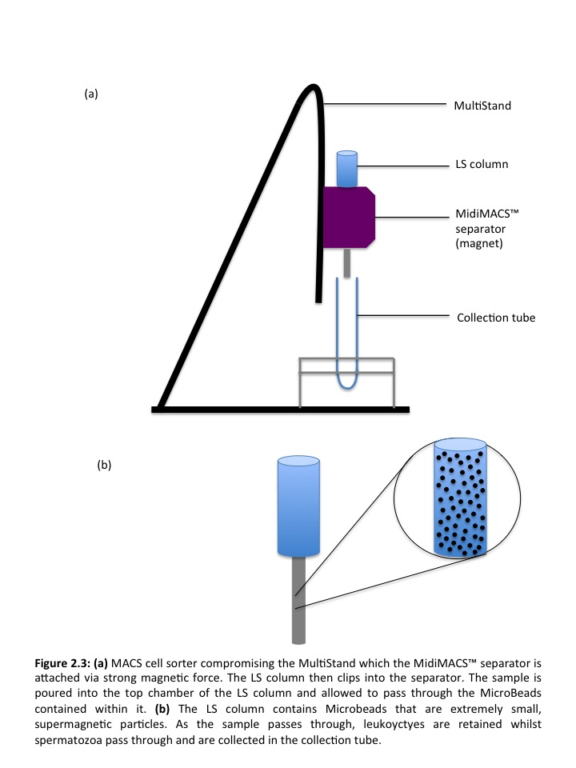

### 2.6.2 Magnetic separation

The LS column was placed into the magnetic field of the MACS separator (Figure 2.3). The column was prepared by adding 3ml MACS buffer and allowing it to drip through. The sperm and MicroBead solution was then added to the column. The unlabeled cells (spermatozoa only) were collected and the column was washed with 9mls of MACS buffer. This unlabeled (purified sperm) cell suspension was centrifuged for 500g for 10 minutes and re-suspended in 600μl PBS and prepared for NMR acquisition as summarised in section 2.4. Concentration and motility was performed as summarized in section 2.2 prior to scanning. Processed sperm samples were microscopically analysed for purity from a wet prep slide of 10μl of the purified sample. The entire slide was analysed and the presence of non sperm cells recorded if present.

## 2.7 NMR

1-dimensional and 2-dimensional 1H NMR spectra were obtained using a Bruker Avance III (Bruker Biospin, Karlsruhe, Germany) Ultrashield 400WB Plus scanner (Figure 2.4). A single-pulse acquisition sequence was used with suppression of the water resonance by WATERGATE (WATER suppression by GrAdient Tailored Excitation). The transmitter frequency was set on the water resonance and a non selective 90° pulse was applied followed by a 1-2 msec gradient pulse. The gradient pulse dephases all of the resonances. A composite pulse (consisting of 6 hard pulses separated by a delay, (τ) is then applied which acts as a 180° pulse for everything in the sample except for the peaks on resonance (i.e. water) (Adams et al., 2013). Sample temperature was held at 39°C for boar experiments and 37°C for human experiments.

The NMR probe head sits directly in the centre of the magnet and houses the radio frequency coils and associated wiring that act as an antenna, transmitting and receiving the electromagnetic radiation (Figure 2.4). Two types of probe were used in these experiments. Firstly, a Magic Angle Spinning (MAS) probe, which operates across a wide frequency range, has a small sample volume (80μl maximum) and is designed for more solid-state sample analysis (Figure 2.5a). The second probe, a 5mm broadband probe operates over a wide frequency range however, samples are loaded into 5mm glass NMR tubes (Figure 2.5b) and better suited to liquid samples. The minimum volume to scan was approximately 400μl and the maximum 2000μl.

### 2.7.1 Pre scan spectral optimisation

Prior to spectral acquisition, shimming was performed to increase the quality of the spectra. Shimming involves the adjustment of current flowing through shim coils that create their own small magnetic fields and can be adjusted according to changes in the current that flows through them. When a sample is lowered into the centre of the magnet it creates inhomogeneity in the magnetic field. The shim coils act to increase magnetic field homogeneity across the sample by adjustment of the current and the magnetic field around them, removing residual in homogeneities.

### 2.7.2 1H (proton) NMR

To begin, samples were scanned and the water resonance frequency manually identified from the spectrum. The resonance frequency was then recorded and input into the scanners acquisition parameters. A Watergate sequence was then selected and run with the water peak placed at the centre of the spectrum. The Watergate sequence was then eliminated the residual water peak from the spectrum making identification of metabolite peaks easier.

### 2.7.3 13C NMR

1-dimensional 13C NMR was performed on the same 5mm broadband probe previously described in section 2.7. Spectral resonance was initially optimised by shimming (section 2.7.1) and confirmed using 1-dimensional inverse gated pulse sequence.

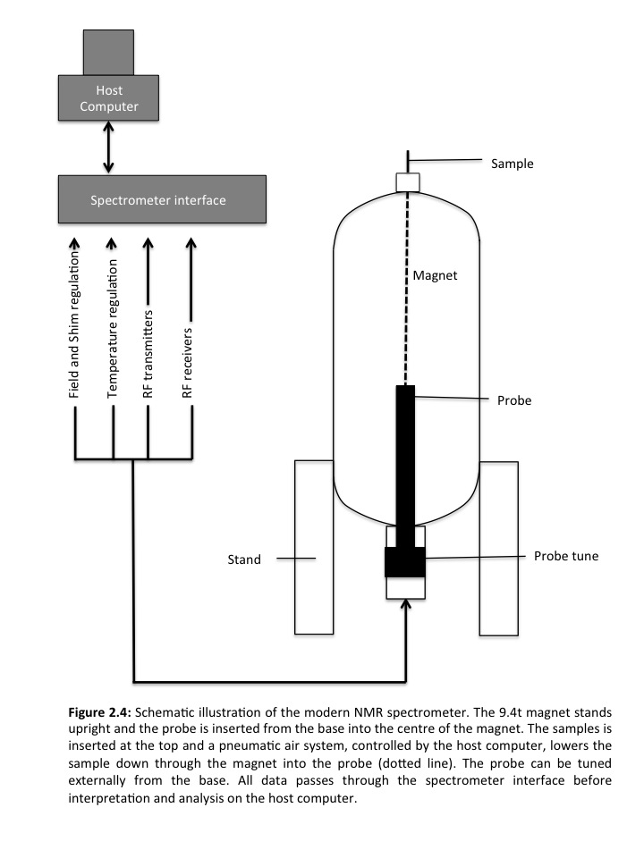

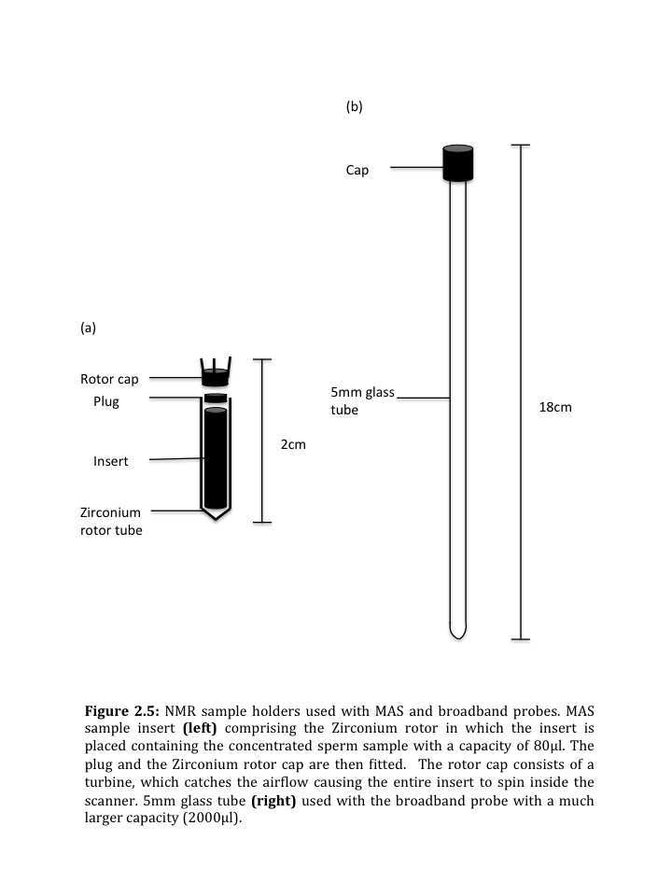

### 2.7.4 Magic angle spinning (MAS) probe

Washed sperm pellets (See section 2.2.1) were pipetted into an 80μl magic angle disposable insert (Bruker Biospin, Karlsruhe, Germany) (Figure 2.5a) with a plug put in place to prevent leakage. A cap and rotor were then fitted and it was placed inside a Zirconium 4mm rotor tube (Figure 2.5a). Spectral opimisation was performed as outlined in section 2.7.1.

### 2.7.5 Post scanning procedure

After acquisition, spectra were Fourier transformed. Fourier transformation is the most important innovation in NMR spectroscopy (Ernst and Anderson, 1966). A Fourier transform operation converts a signal from the time domain to the frequency domain. It can separate out a complex wave into many waves each with a specific fixed frequency (Aue et al., 1976). This enables molecular structure determination at the atomic level in aqueous solution. Spectra were automatically phase corrected and baseline corrected. (Cooley and Tukey, 1965). Peak integrations were taken about the peak at an area of the baseline where no spectral peaks were present, just noise as a starting point (Figure 2.6). The peak was then incorporated and integration terminated on the other side where once again no metabolite peaks were present in an area of noise. The TSP reference compound peak was used as a chemical shift reference and calibrated to 0ppm. The integrals recorded were the absolute integrals. These are values created by the TopSpin software that quantifies the area underneath the spectral peaks. The absolute integral is the sum of the values underneath the peak. This allows the reference peak to be quantified (TSP or 13C urea) and the absolute metabolite integral is then divded by the reference compound integral to quantify the metabolite peak in relation to the known reference compound peak (Figure 2.6).

### 2.7.6 Normalisation of metabolite peaks

To normalise metabolite peak integrals, each integral value was divided by the total integral, this being the integral value for the entire chemical shift on the visible spectrum. This normalises the metabolite peaks to a constant concentration.

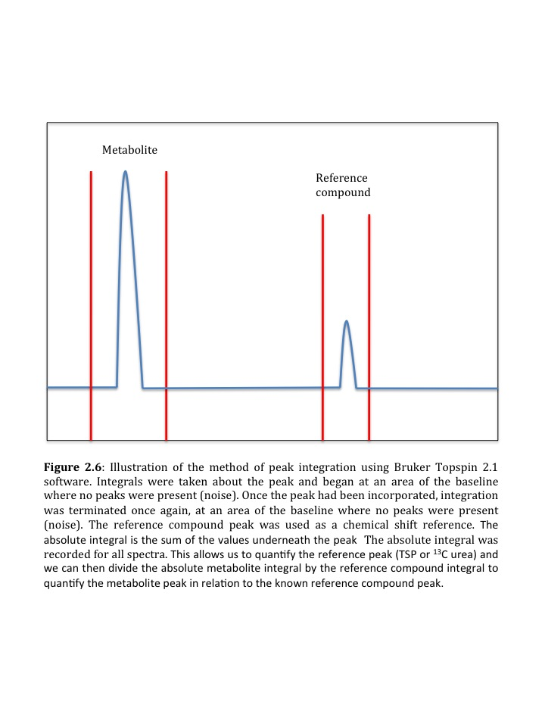

# 3.0 Optimising Acquisition Parameters for Magic Angle Spinning of Boar Sperm

## 3.1 Introduction

The majority of samples analysed using the traditional broadband NMR are liquids including blood (Brindle et al., 2002), bile (Wen et al., 2010), and urine (Clayton et al., 2006). However, recent advances in technology have allowed the analysis of metabolites within intact tissues using a technique known as Magic Angle Spinning (MAS) (Beckonert et al., 2010). Magic Angle Spinning (MAS), outlined in section 1.8.9.1.2 was first developed in 1959 (Andrew et al., 1959), and has only recently been used in main stream high resolution NMR (Claridge, 1999). Due to its success in producing high resolution spectra, MAS has been applied to study metabolomics of breast (DeFeo and Cheng, 2010) (Bathen et al., 2010), colon (Chan et al., 2009), prostate (Burns et al., 2004), liver (Martinez-Granados et al., 2011) and lung (Rocha et al., 2010) tissue. Specifically in breast cancer tissue, multiple studies have gone further by investigating quantities of breast cancer metabolites in relation to clinical prognosis (Sitter et al., 2010) and using results from MAS to predict prognosis in cancer patients (Giskeodegard et al., 2010). This is a promising example of its clinical diagnostic potential using metabolites. MAS has never been used to scan sperm. Therefore, complete optimisation of the scanning parameters was needed to conduct experiments described subsequent chapters.

Table 3.1 summarises the acquisition parameters used in previously published literature when analysing samples such as brain, tumour, kidney, blood vessel and breast tissue. First of all it is important to consider the frequency of the NMR scanner being used. The higher the frequency, the higher the potential signal to noise available during acquisition, making identification and quantification of metabolite more accurate. The frequency of the NMR scanner is defined at production and cannot be altered.

As outlined in section 1.8.9.1.2 to perform MAS NMR the sample must be spun at high frequency. For most biological tissues this is not an issue but for live spermatozoa the affects on their viability require further investigation. The tissues listed in Table 3.1, were analysed at spin frequencies ranging from 2000 to 5000Hz. The spin frequency determines the position of on spinning bands that appear in the spectrum.

|  |  |  |  |  |  |
| --- | --- | --- | --- | --- | --- |
| Reference | Tissue | Scanner frequency (Hz) | Spin frequency (Hz) | Acquisition time (sec) | Number of scans |
| Moka 1997 | Kidney | 400 | 5000 | 1.37 | 256 |
| Detour et al 2011 | Brain | 500 | 3000 | 2.30 | 128 |
| Li et al 2011 | Breast | 500 | 2000 | - | 1024 |
| Anwar 2012 | Blood vessel | 600 | 5000 | 2.72 | 256 |
| Selnaes 2013 | Tumour | 600 | 5000 | 3.27 | 128 |

**Table 3.1:** MAS parameters from existing literature of a variety of biological tissues. ‘–‘ Indicates data is unavailable for parameters.

Spinning bands form from rotational resonances and appear in the spectra when there is incomplete cancellation of factors that give rise to the solid-state magic angle. The lower the spin frequency, the closer together these spinning bands occur, causing potential masking of metabolite peaks and their chemical shifts. Spin frequency is also important when considering its effects on sperm viability. Carjaval et al (2004) reported a positive effect of centrifugation on cryosurvival of sperm. The length of time that sperm are spun for has been found to be more significant in determining viability than the g force that they are spun at (Nicolas et al., 2012). Overall it is clear that there is an effect of spinning on sperm viability and therefore its effect needs to be investigated, especially since the g force in HR MAS is much greater than that used in standard sperm washing protocols.

In the samples shown in Table 3.1, acquisition time varied from 1.37-2.72 seconds. Acquisition time is unique to the sample and is decided by observing the Free Induction Decay (FID) outlined in Figure 1.12. In order to maximise the signal to noise ratio of the spectra, the acquisition time must not extend after the FID signal has decayed into noise. If the acquisition time is too long more noise will be added to the averaged final spectrum decreasing the overall signal to noise ratio making individual metabolite peaks more difficult to distinguish.

In Table 3.1, the number of scans varied from 128 to 1024. The more scans that are performed, the higher the signal to noise and the better the quality of the spectra. However, the more scans performed, the longer the sample spends in the scanner, potentially reducing the viability of the sperm.

Finally, an important consideration when using MAS NMR to scan live sperm is the total number of sperm in the sample. Many of the biological tissues that have been analysed previously contain millions of cells and therefore only a small sample volume is needed. The minimum number of sperm required for metabolite peak identification and quantification needs to be determined. This can be achieved by diluting a sample down until the signal to noise to metabolite peak ratio is below the required ratio suggested for accurate integration (5:1).

Therefore, the aims of this chapter were to optimise acquisition parameters for Magic Angle Spinning of boar spermatozoa. This focused specifically on defining the optimum: (i) acquisition time; (ii) spin frequency; (iii) number of scans; and (iv) sperm concentration.

## 3.2 Materials & methods

### 3.2.1 Sperm preparation

Boar sperm samples (see section 2.1.1) were analysed as outlined in section 2.2 to determine the ejaculate concentration and motility prior to washing. High motility sperm were isolated by washing (see section 2.3.1) to form a pellet with a final concentration of 1x109/ml except for samples used in the concentration experiment (outlined in section 3.2.5) where the sperm concentration varied. Briefly, a 50μl of sperm pellet in addition to 10μl of 20mMol TSP reference compound were pipetted into 60μl MAS Zirconium rotor (Bruker Billerica, USA) and scanned using a Bruker Avance III 9.4T 400MHZ scanner with HR-MAS probe. All samples were scanned at 39°C.

### 3.2.2 Spin frequency & viability

Spin frequency was altered using Bruker MAS unit (Bruker Biospin, Karlsruhe, Germany). Spin frequency ranged from 1000 to 6000 Hz in 1000Hz increments. 128 scans were performed at each frequency and the signal to noise measured of each spectrum to assess spectral quality. Sperm viability was measured for each sample spun at each frequency using a Live/Dead Sperm Viability Kit (Molecular probes 2001-L-7011).

### 3.2.3 Acquisition time

Acquisition time was altered according the length of the Free Induction Decay. Three acquisition times were applied, 0.6sec, 2sec and 4sec. The resulting spectra observed and the signal to noise ratio was measured using a Bruker Topspin software package (Bruker Biospin, Karlsruhe, Germany) in order to assess the spectral quality as outlined in section 2.7.6.

### 3.2.4 Number of scans

The number of scans was increased from 8 to 64, 128, 256, 1028. Signal to noise ratio was once again calculated using Bruker Topspin software (Bruker Biospin, Karlsruhe, Germany) to quantify signal to noise ratio as outlined in section 2.7.6.

### 3.2.5 Sperm concentration

Three concentrations of sperm were scanned once the above parameters had been optimised. The three concentrations were 1 x 109 per ml, 5 x 108 per ml and 2.5 x 108 per ml. However, the total volume of the sperm pellet pipetted into the zirconium rotor was 50μl. Therefore actual numbers of sperm scanned were 5 x107, 2.5 x 107 and 1.25 x 107

### 3.2.6 Identification of boar sperm metabolites

Boar sperm metabolites have been identified in previous literature using NMR (Jones and Bubb, 2000). This literature was used to match metabolites. Identification was further supported by comparison to the online Spectral Database for Organic Compounds (SDBS). Both the literature and the online database contained data on the exact ppm at which metabolite peaks occurred. Metabolite peaks seen after HR MAS NMR were matched to the peak ppm online and in the literature.

## 3.3 Results

Six metabolite peaks were identified in boar sperm metabolites using MAS NMR including lipid, lactate, arginine+leucine+leucine, glutamine, citrate, glucose/fructose.

### 3.3.1 Spin frequency

Figure 3.1 shows representative spectra of sperm metabolites from a single sperm sample spun at frequencies of: (a) 1000, (b) 3000 and (c) 6000 Hz. In Figure 3.1a spinning bands can be identified at 4 points on the spectrum. Spinning band 3 (Figure 3.1a) lies at 2ppm, directly in the spectral range of metabolites, potentially masking them. The three remaining spinning bands (arrows 1, 2 & 4) do not interfere with metabolites. Figure 3.1b is a representative spectrum from spermatozoa spun at 3000Hz. This spectrum has lost the spinning bands completely as they move outwards as the spin frequency increased. Figure 3.1c, is at 6000Hz where once again no spin bands were observed.

Figure 3.2 shows the mean (±SD) signal to noise ratio (SNR) for the TSP reference peak for spin frequencies 1000 to 6000Hz in 1000 Hz increments observed in 8 sperm samples. The SNR of the TSP peak increased rapidly from 1000-3000 Hz.

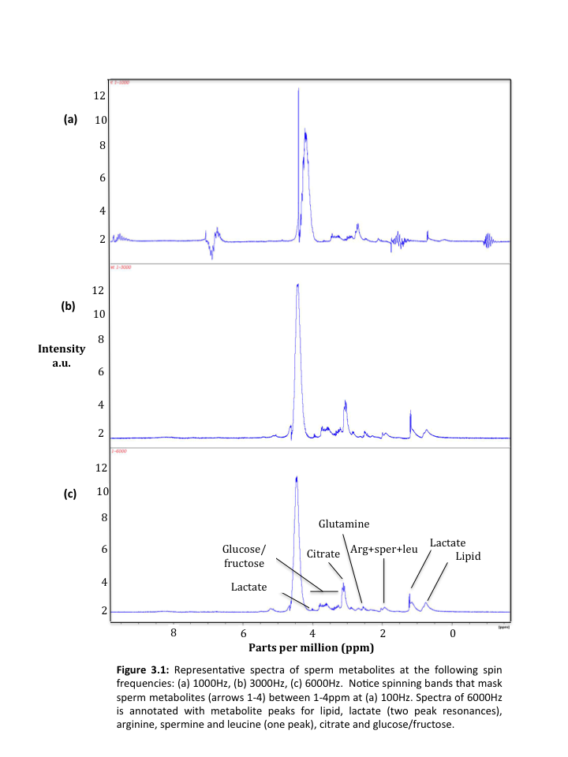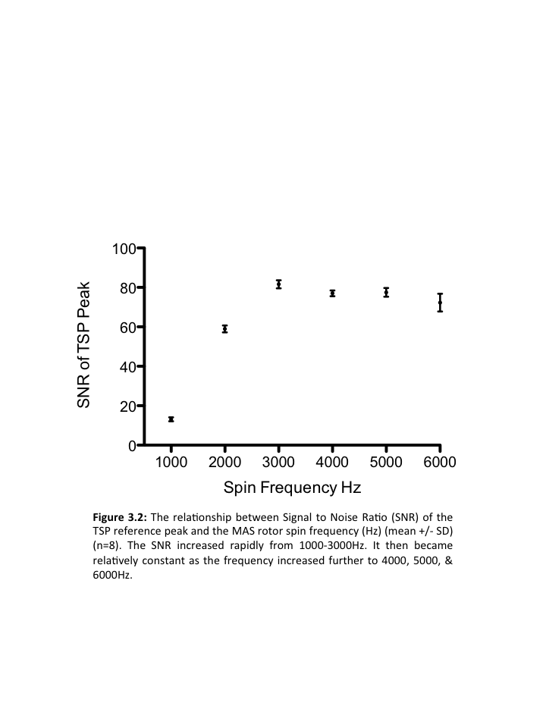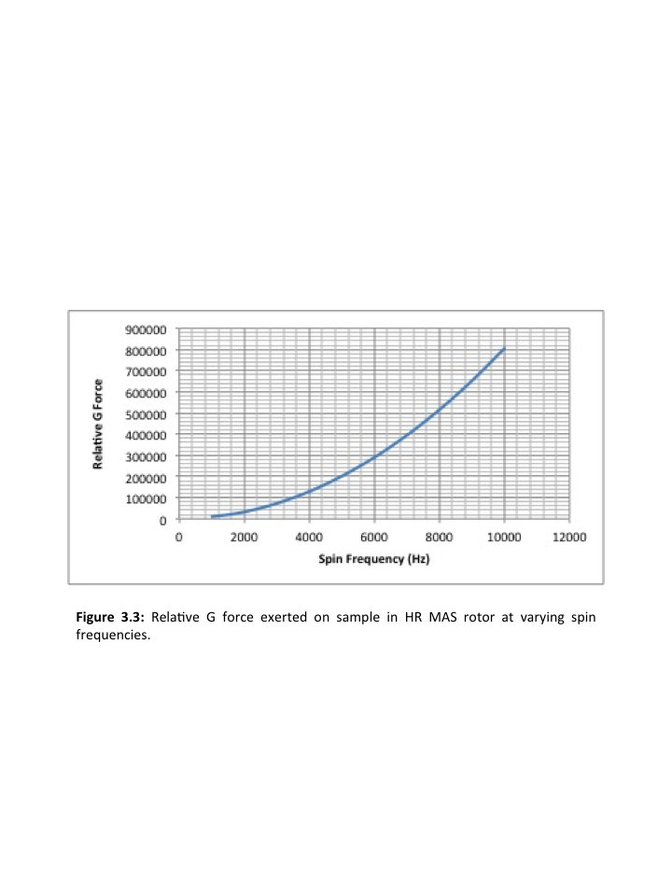

41

31

21

1



However it plateaus at 3000Hz and remains relatively constant as the spin frequency increased further to 4, 5 & 6000Hz.

Calculation of the G force exerted on the spermatozoa (Figure 3.3) shows a curvilinear relationship between spin frequency and G force. At 6000Hz, the relative G force reaches 300,000. At 3000Hz the G force falls to 80,000, more than a third less than the G force experienced at 6000Hz. Figure 3.4 shows the relationship between spin frequency and sperm viability of aliquots of 8 boar ejaculates before and after scanning. There was a variation in sample viability prior to scanning (mean ranged from 61.67%-74.40%). Between 1000 & 4000 Hz, the viability remained relatively constant (1000Hz mean 50.67%, 4000 Hz mean 47.67%,). At 5000 and 6000 Hz the viability rapidly decreased (mean 24.17%,).

### 3.3.2 Acquisition time

Figure 3.5 shows representative metabolite spectra of a boar ejaculates, scanned with an acquisition time of 0.6-4.0 seconds. Figure 3.6 shows the relationship between mean (±SD) SNR of the TSP reference peak and the acquisition time (n=8). These data show that the signal to noise ratio is highest with an acquisition time of 2.0 seconds and lowest at 0.6 seconds.

### 3.3.3 Number of scans

Figure 3.7 shows representative spectra of boar sperm metabolites from acquisitions with 8, 64 and 128 scans. Figure 3.7a (8 scans) has a lower signal to noise ratio (mean 19.29) compared to (b) 64 scans (mean 48.15) and (c) 128 scans (mean 81.59), 256 scans (mean 95.6). As the number of scans increases, the SNR of the TSP also increases however, it becomes more constant after 256 scans (1056 scans (mean 99.5).



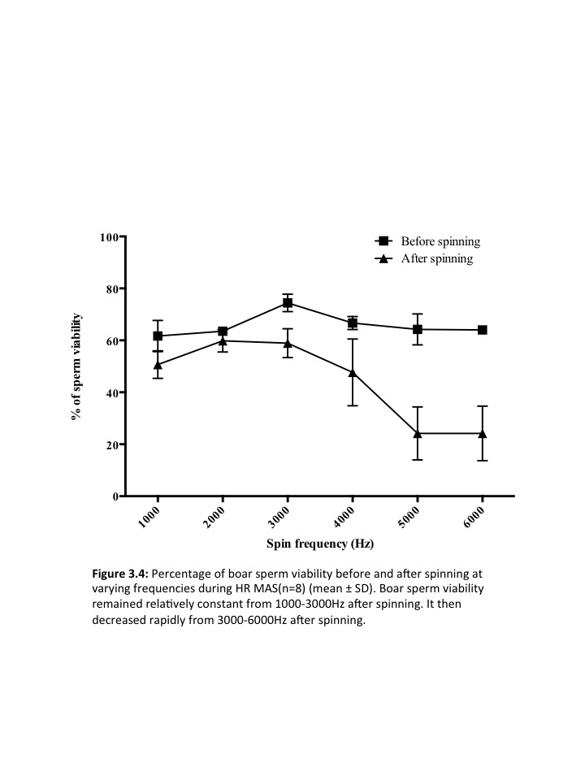

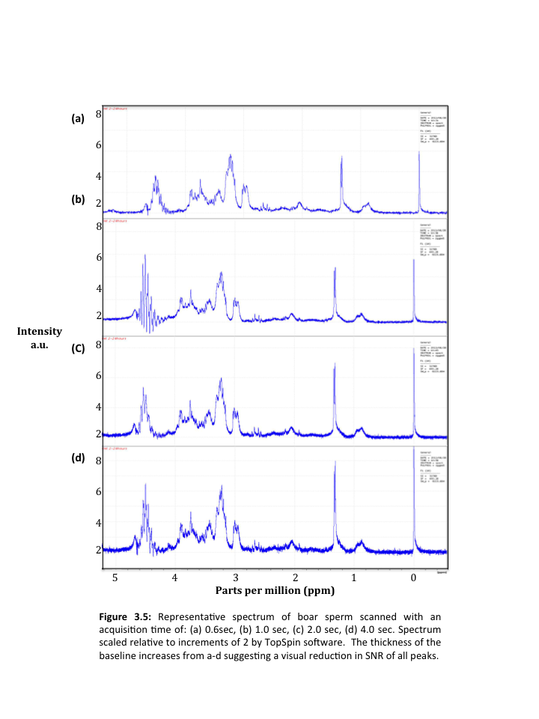

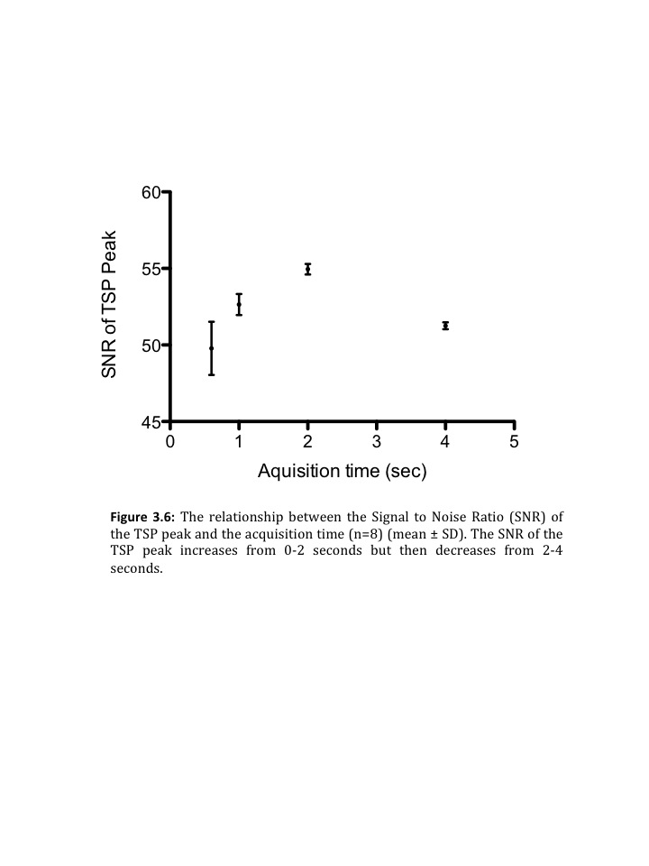

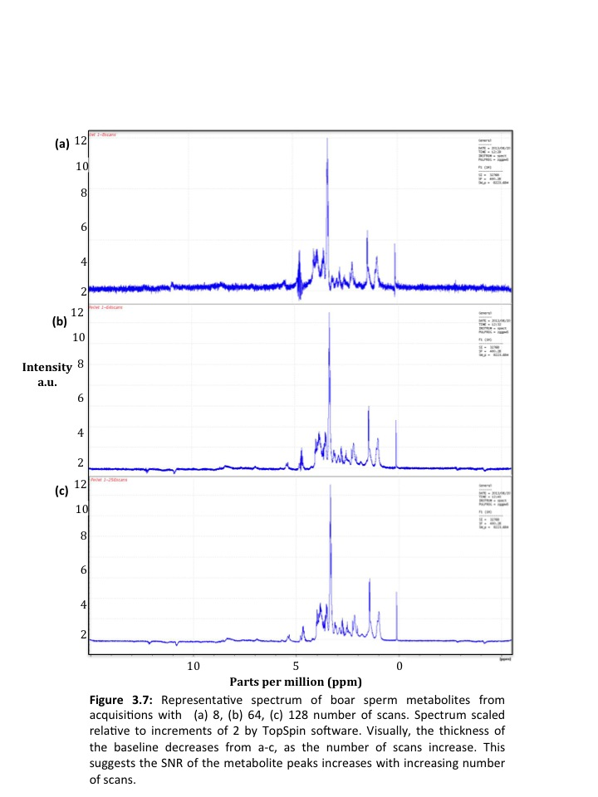

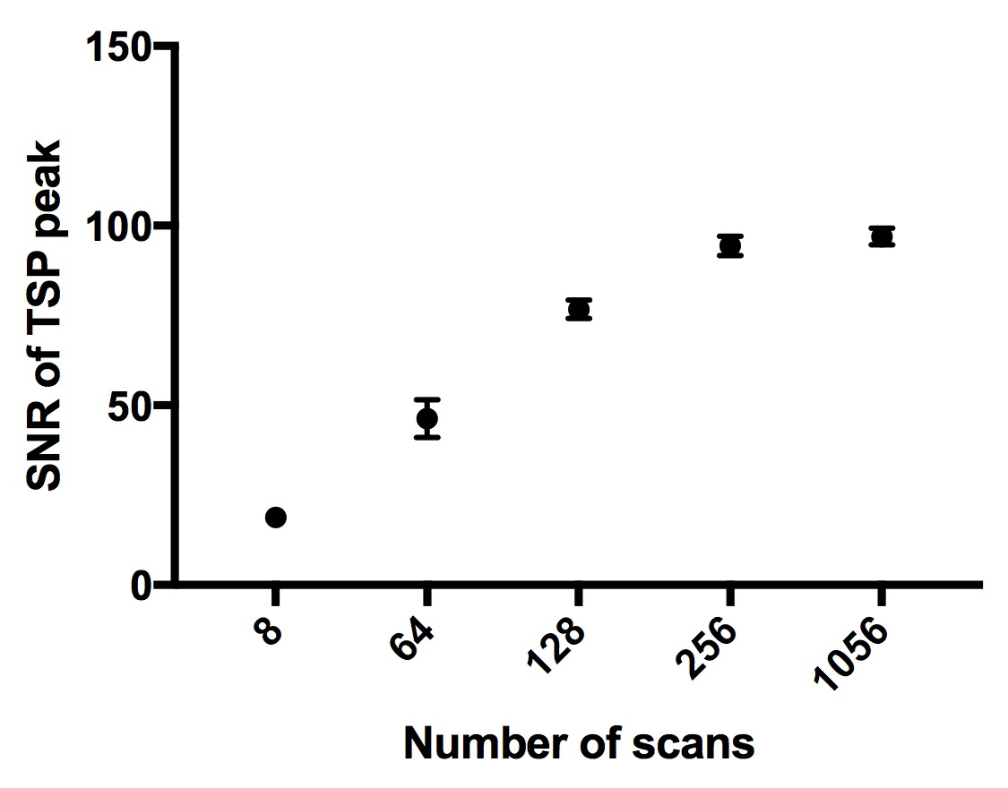

**Figure 3.8:** The relationship between signal to noise ratio (SNR) of the TSP peak and the number of scans in an acquisition (n=8) (mean ±SD. As the number of scans increases, the SNR of the TSP also increases becoming more constant at 256 scans

### 3.3.4 Sperm concentration

Figure 3.9 shows boar sperm metabolite spectra from the same semen sample adjusted to 3 different total numbers of sperm after washing. The TSP reference compound peak can be seen at 0 ppm. This peak does not change in height or shape and therefore can be used to compare metabolite peak sizes to when altering the concentration of sperm. Figure 3.9a is a representative spectrum of a sample containing 50 million sperm. Metabolite peaks are largest in this spectrum compared to the TSP peak. Figure 3.9b is a representative spectrum of a sample containing 25 million sperm. There is a visual reduction in metabolite peak heights compared to the TSP peak. Figure 3.9c is a representative spectrum of a sample containing 12.5 million sperm. There is a further visual reduction in metabolite peaks.

The signal to noise ratio of lactate, a previously identified boar sperm metabolite (Jones and Bubb, 2000) was calculated in an attempt to identify possible changes in metabolite peaks in relation to total number of sperm. Figure 3.10 shows the relationship between the SNR of the TSP peak and the SNR of the lactate peak. The SNR of the TSP and lactate peaks increases slightly and then plateaus as the total number of sperm in the sample increases.

## 3.4 Discussion

The aims of this chapter were to optimise acquisition parameters for Magic Angle Spinning of boar spermatozoa and focused specifically on defining the optimum (i) acquisition time (AQ); (ii) spin frequency; (iii) number of scans; (iv) sperm concentration for future experiments. In summary, the data shows that AQ times of 0.5, 1.0, 2.0 and 4.0 seconds all produced an SNR of the TSP reference peak of >45:1 (Figure 3.6). The acceptable SNR for peak integration is 5:1. Therefore, the use of all of these AQ times would produce an acceptable spectral quality. However, as expected, as the acquisition time increased from 0.0-2.0 seconds, the SNR of the TSP peak increased to above 50:1. As the AQ time is increased, the signal quantified from metabolite peaks increases and therefore the SNR is greater. However, at an AQ time of 4.0 seconds it had decreased. This is because the background noise quantified during NMR had been added to the

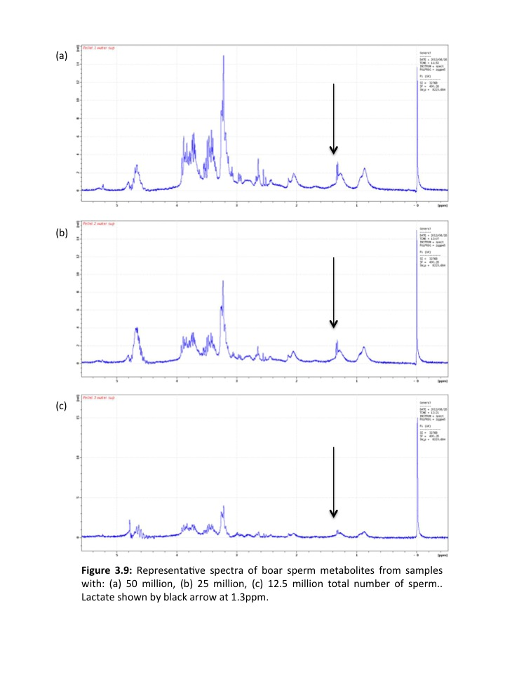

TSP

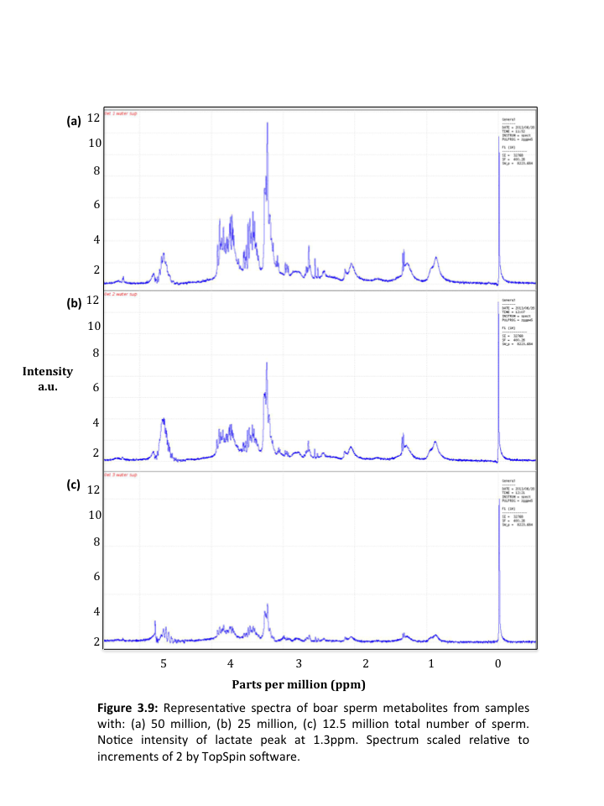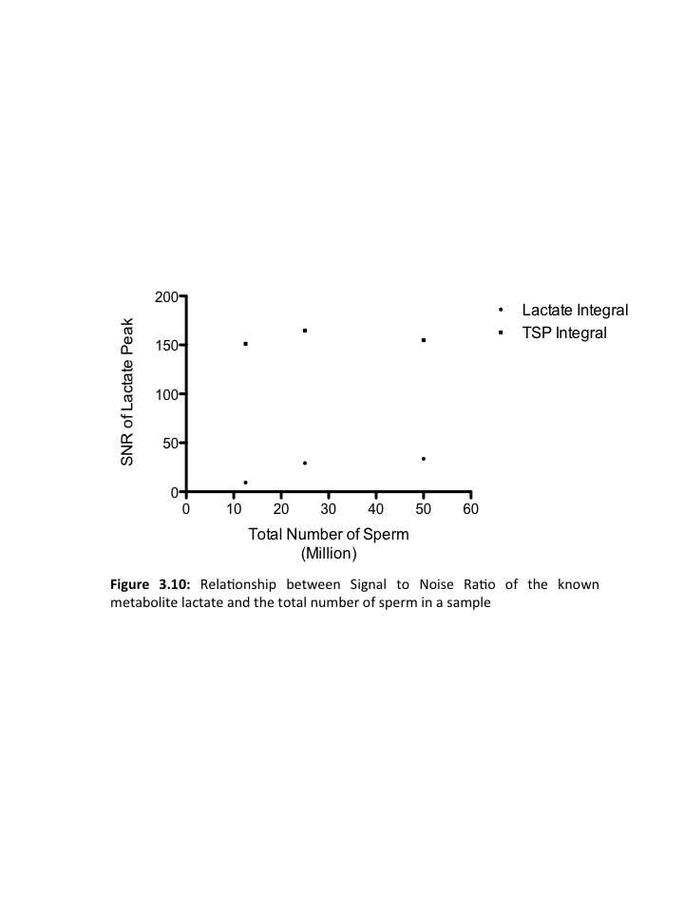

.

X

X

X

X

signal from metabolite peaks. Therefore, the optimum AQ time for NMR studies of sperm appears to be 2 seconds.

Although HR-MAS has been used to identify metabolites in a variety of tissues to including breast (DeFeo and Cheng, 2010, Bathen et al., 2010), colon (Chan et al., 2009), prostate (Burns et al., 2004), liver (Martinez-Granados et al., 2011) and lung (Rocha et al., 2010) tissue, it has never been applied to the study of live sperm metabolism. The majority of tissues analysed using HR MAS have consisted of solid-state samples. Therefore, optimising acquisition parameters for a semi solid sperm sample was paramount to ensure the highest quality metabolite spectra could be obtained in future experiments. A total of 6 metabolites were identified using HR MAS on live boar spermatozoa. Previous literature (Jones and Bubb, 2000) used conventional broadband NMR and successfully identified 15 boar sperm metabolites. As with many previous studies of sperm metabolites, metabolites were extracted by saponification. This meant that sperm were no longer viable at the time of scanning. Although 15 metabolites were identified, they cannot be monitored in real time.

The frequency of the NMR scanner used in these experiments was 400MHz. This frequency is not adjustable and therefore, when comparing acquisition parameters to previous literature, the frequency of the scanner used had to be considered. Research analysing breast (Li et al., 2011) and brain (Detour et al., 2011) tissue was conducted using a 500MHz scanner whilst tumour (Selnaes, 2013) and blood vessels (Anwar et al., 2012) were scanned in a 600MHz scanner. When using higher frequency scanners, resulting spectra have the potential to have higher signal to noise ratio as more power is being applied during radiofrequency pulses. Kidney tissue has been scanned using a 400MHz scanner during MAS (Moka et al., 1998). This frequency was adequate in allowing the identification of endogenous substances from cytosolic and membrane compartments, which suggests the use of the 400Mhz scanner to scan sperm might be sufficient to detect metabolites.

MAS is unique in its ability to reduce improve spectral quality through spinning the sample at high frequency and at the magic angle (Claridge, 1999). However, when analysing a live sample, effect of high frequency spinning of sperm viability required further investigation. Previous studies (DeFeo and Cheng, 2010, Chan et al., 2009, Burns et al., 2004) analysing biological tissue using MAS have used biopsy tissue, where the cells were fixed and therefore their viability was of no concern. The relative G force exerted on the sperm was extremely high. At 3000Hz, the G force was around 100,000. A previous study (Len et al., 2008) investigating the effect of centrifugal force on boar sperm parameters found that at 4,500*g* boar sperm viability, motility and the percentage of intact acrosomes was reduced compared to sperm spun at 400 & 900*g*.After three repeats the average viability after spinning at 3000Hz fell slightly from 70%-55%. However, 55% of the sperm remained viable which is promising for future experiments that investigate time dependent changes in the metabolism of sperm. Reasons for unexpectedly high sperm viability after exposure to high G force may be explained by their unique structure compared to a variety of cells. There is very little cytoplasm within the sperm head as it is tightly packed with DNA. This tight package could be the key to preventing cell lysis and thus maintaining viability. Other previous research into the effect of g force on sperm cells has found that the length of time the sperm is exposed to G force has a stronger effect than the actual level of G force itself (Nicolas et al., 2012). Therefore, the 55% viability of samples spun at 3000Hz may be remarkably high due to the short time at which they are spinning (less than 5 minutes). It has also been suggested that there is a positive effect on cryosurvival of sperm when exposed to higher G force during sample preparation by centrifugation (Carvajal et al., 2004).

Acquisition time is the length of time the scanner records a signal after radiofrequency pulse is applied. The length of the acquisition time is usually determined by observation of the Free Induction decay (FID) (outlined in section 1.8.5). The results from these experiments clearly show a relationship between the acquisition time and the signal to noise ratio of TSP peak (Figure 3.6). As the acquisition time increases from 0.6-2.0 seconds, the SNR increases. It then begins to decrease at 4.0 seconds. The majority of acquisition time parameters from previous literature (Table 3.1) are between 2.0-3.0 seconds. The optimum acquisition time was 2.0 seconds, which is similar to that used in previous literature (Table 3.1). This acquisition time is also suitable for use in future experiments which may involve scanning samples of hyperactivated sperm. Sperm hyperactivation lasts for up to 10 minutes (Holt and Harrison, 2002) and therefore, a sufficient number of scans at 2.0 seconds per scan could be obtained in a 10 minute time period.

The number of scans performed on a sample strongly determines the signal to noise ratio of peaks. Each scan is additive to the final spectrum which is an average of all scans. Therefore the more scans, the higher the number averaged for the final spectrum. In these experiments, as the number of scans increases from 8 to 64 to 128, the signal to noise ratio increases dramatically however, becomes more constant at 265 scans (Figure 3.8). Furthermore, as the number of scans increases, as does the length of time the sperm spend in the scanner, which could affect viability. Therefore, 256 scans will be used in future experiments given that the signal to noise ratio increases less rapidly above 256 scans. The signal to noise ratio at 8 scans is still above the acceptable ratio for peak integration of 1:5 however, it increases 8 fold at 256 scans. It takes 20 minutes to perform 256 scans which meant that analysis of multiple samples of different ejaculate fractions in different experimental groups could be practically achieved in a working day with the scanner.

Sperm viability was only measured when experimenting with spinning speed of the sample. When experimenting with AQ time and number of scans, the maximum amount of time a sample remained in the scanner was 20 minutes. Therefore, having spun the sperm at increasing spinning frequencies for the same amount of time as when testing other parameters (20 minutes) viability was performed and sperm viability remained >50% until 30000Hz. It was therefore assumed that sperm viability was ≥50% when experimenting with all other parameters as the sperm were within the scanner for the same amount of time.

As with all other parameters investigated, the total number of sperm in the sample determines the signal to noise ratio of the spectrum. It is also important, as an eventual aim of this project is to investigate the metabolites of sperm from oligozoospermic ejaculates where the sperm concentration is less than 15x106/ml (WHO, 2010). Therefore, at such low concentrations, it must be determined whether metabolite peaks are of a sufficient SNR ratio to enable accurate comparison to fertile controls or other infertile men with higher sperm concentrations (e.g. asthenozoospermia). These experiments show that at 12.5 x106 total number of sperm the SNR of lactate is approximately 9:1. This is above 5:1, the level required for accurate peak integration. Therefore, metabolites from sperm with low sperm numbers can still be accurately be measured using HR MAS NMR.

MAS has a number of advantages when investigating sample metabolites. For example, if there is a short time scale for obtaining spectral data and minimal sample preparation is required. These two factors alone satisfy important requirements for use in clinical diagnosis (Waters et al., 2000). Furthermore, MAS spectra have on average a three-fold signal-to-noise-gain yet uses a tenth of the sample required by conventional solution spectra (Claridge, 1999) meaning a smaller volume but more cells can be analysed in each sample.

Therefore, in this chapter it has been demonstrated that HR MAS is a suitable technique for identifying metabolites in sperm cells, at concentrations lower than the WHO reference value (15 x106/ml) for male fertility. All acquisition parameters have been optimised (Table 3.2) and will be used in future experiments to ensure the highest signal to noise ratio of metabolite peaks is achieved. Parameters may need to be re-optimised for human sperm samples and this will discussed in Chapter 4.

|  |  |
| --- | --- |
| Parameter | Chosen setting |
| Spin frequency | 3000Hz |
| Acquisition time | 2 seconds |
| Number of scans | 256 |
| Sperm concentration | 25 x106 total number of sperm |

**Table 3.2:** Optimal NMR acquisition parameters that will be used in subsequent experiments

# 

# 4.0 Identifying & detecting changes in boar sperm metabolites using 1H Magic Angle Spinning and Broadband NMR

## 4.1 Introduction

Following the optimisation of Magic Angle Spinning (MAS) parameters outlined in chapter 3 (See Table 3.2), in this chapter both MAS and broadband NMR will be used to scan spermatozoa. Broadband NMR has previously been used to investigate male fertility though its application to the scanning of seminal plasma (Hamamah et al., 1998, Gupta et al., 2011a, Gupta et al., 2011c, Gupta et al., 2013) and extracted sperm metabolites from different species including goat (Patel et al., 1998, Patel et al., 1999), boar (Jones and Bubb, 2000, Marin et al., 2003), turbot (Dreann et al., 2000), and rhesus macaque (Hung et al., 2009, Lin et al., 2009) and lyophilised human spermatozoa (Paiva et al., 2015). MAS NMR, discussed in section 1.8.9.1.2, is a relatively novel method of NMR analysis and its applications have been mostly applied investigating tissue metabolomics including breast (DeFeo and Cheng, 2010, Bathen et al., 2010), colon (Chan et al., 2009), prostate (Burns et al., 2004), liver (Martinez-Granados et al., 2011) and lung (Rocha et al., 2010) tissue as it is well suited to solid state samples. Its use in the identification of the metabolome of other tissues and the identification of potential biomarkers of disease suggests NMR has the capability to not only classify the metabolome of live sperm but potentially characterise biomarkers of sperm pathologies by biomarkers of sperm metabolism (Paiva et al., 2015). Following sperm washing, the sperm pellet approximates a solid sample because of the high number of sperm cells that have been concentrated. A higher number of cells in the concentrated pellet would yield higher signal to noise and therefore MAS could potentially be advantageous in the study of sperm metabolites. Due to the success of broadband NMR in previous literature, it will be used alongside MAS NMR and the two methods compared.

Given that both 1H broadband and MAS NMR are novel approaches in the study of live sperm metabolites, confirmation was needed to ensure that NMR was sensitive enough to: (i) detect individual metabolites and (ii) detect changes in metabolite concentrations in spermatozoa. Therefore, there was a need to manipulate sperm metabolism externally in order to test the ability of NMR to measure such a change within spermatozoa. Simple external stimuli include temperature of medium and addition of pharmacological agents.

At a fundamental level, cellular metabolism is underpinned by the laws of thermodynamics (Clarke and Fraser, 2004). Temperature is a significant factor affecting cellular metabolism (Clarke and Fraser, 2004). Metabolic rate of cells is driven directly by the kinetic energy of the cell (Gillooly et al., 2001). Therefore, a higher temperature inevitably leads to a higher metabolic rate (Gillooly et al., 2001). Thermal energy fuels enzymes involved in glycolysis (e.g. hexokinase, phosphoglucose isomerase) and enzymes involved in oxidative phosphorylation (e.g. lactate and pyruvate dehydrogenases) (Daniel et al., 2008). Therefore, with increased thermal energy, collision of the substrates with the active site of the enzyme is increased and as a consequence ATP production increases, increasing metabolism (Daniel et al., 2010). Sperm metabolism fuels motility and therefore changes such as temperature can be used to increase or decrease metabolism and motility. The sperm can then be scanned in these different treatments, which allows us to validate 1H broadband and HR MAS NMR as a method for detecting changes in metabolites. Temperature is an ideal stimulus given that it does not require addition of agents to the sample, preventing masking of potential metabolite peaks in the spectra obtained.

Exposure to alphachlorohydrin (ACH) results in rapid reversible male infertility (Zhang et al., 2012) in various mammalian species including rats (Jones et al., 1969), rams (Kreider and Dutt, 1970), boars (Johnson and Pursel, 1972), and primates (Kirton et al., 1970). ACH specifically inhibits glyceraldehyde-3-phosphate dehydrogenase (GAPDS) (Frayne et al., 2009, Miki et al., 2004) and blocks the pathway of glycolysis (Stevenson and Jones, 1984). Glycolysis is argued to be significant resource of sperm ATP (Mukai and Okuno, 2004, Williams and Ford, 2001, Nascimento et al., 2008) and therefore, inhibition of glycolysis using ACH is likely to cause a profound reduction in ATP production and consequently sperm motility. This should then be detectable from analysis of sperm metabolites using 1H broadband NMR. Boar sperm are highly sensitive to ACH making it a suitable inhibitor for these experiments.

## 4.2 Hypothesis

This chapter has two hypotheses:

1. External influence of metabolism will be measurable using NMR in sperm samples incubated at different temperatures and with/without pharmacological metabolic inhibitors.
2. There will not be a difference between the results obtained from broadband and MAS NMR in terms of which metabolites significantly differ between treatments.

## 4.3 Aims

1. Artificially induce changes in sperm metabolism and measure the effect on sperm metabolites using broadband and MAS NMR.
2. Compare the results from MAS and broadband NMR.

## 4.4 Material & methods

### 4.4.1 Sperm preparation

Boar sperm (see section 2.1.1) of high quality and motility were prepared by washing (see section 2.3.1) forming pellets. For the temperature experiments a total of 8 boar samples were analysed whilst in the ACH experiments 6 boar samples were analysed (Figure 4.1). Three pellets from the same boar were combined and re-suspended in 1ml Phosphate Buffered Saline (PBS) giving a sperm concentration >1x107 spermatozoa/ml. This was then incubated differently for each experiment (see sections 4.4.2 & 4.4.3)

### 4.4.2 Broadband NMR

400μl of sperm suspension was pipetted into a 5mm NMR tube (Bruker Darmstadt, DE) with 10% (v/v) D2O to produce a field-locking signal and 10μl 20mM 3-(Trimethylsilyl) propionic-2,2,3,3-d4 acid, sodium salt (TSP), used as a frequency reference. Total number of sperm scanned varied for each sample however, the integral values were standardised for total integral during statistical analysis. All experiments were conducted using a Bruker Avance III 9.4T Scanner with 5mm broadband observe probe. 1H Watergate excitation

Boar ejaculates

(n=28)

Broadband

(n=14)

Magic Angle Spinning

(n=14)

Temperature

(n=8)

Temperature

(n=8)

ACH

(n=6)

ACH

(n=6)

**Figure 4.1:** Processing of boar semen (ACH= Alphachorohydrin)

sculpting pulse sequence was used (Table 3.2) (zgppw5; NS=256; DS=2; SWH=8223.685; AQ=2sec; D1=4sec). Metabolite peaks were integrated using the Bruker Topspin package.

### 4.4.3 MAS NMR

Washed sperm pellets were pipetted into an 80μl magic angle insert (Bruker Biospin, Karlsruhe, Germany), with a plug put in place to prevent leakage. A cap and rotor were then fitted and it was placed inside a Zirconium 4mm rotor tube (Bruker Biospin, Karlsruhe, Germany). The acquisition parameters optimised in chapter 3 (see Table 3.2) were: NS: 256, DS: 2, SWH: 11160.74, AQ: 2sec, D1:4sec. The spin rate was approximately 3000Hz. 10μl of 20mmol 3-(Trimethylsilyl) propionic-2,2,3,3-d4 acid, sodium salt (TSP) (Sigma aldrich Gillingham, UK) solution was added to all samples to serve as a chemical shift and concentration reference.

### 4.4.4 Temperature incubation

Immediately after washing, the 8 sperm suspensions were divided into two 500μl samples, one incubated at 21°C and the other 39°C in a thermostatic water bath for 3 hours. During this time, samples were gently mixed every 30 minutes.

### 4.4.5 Alphachlorohydrin (ACH) incubation

Sperm from 6 additional boars, prepared as described in section 4.4.3, were divided into two 500μl samples, incubated with/without 50mM ACH (Terrell et al., 2011) in PBS for 1 hours in a thermostatic water bath set to 39°C.

### 4.4.6 Statistical analysis

A paired t-test was performed to measure the difference between normalised individual metabolite integrals. All statistical analysis was performed using SPSS statistics version 22.

## 4.5 Results

### 4.5.1 Broadband NMR

Using broadband NMR, a total of 6 metabolites were identified in live boar sperm. These were lipid, lactate, arginine+spermine+leucine, glutamine, citrate, fructose (Figure 4.2 & 4.3).

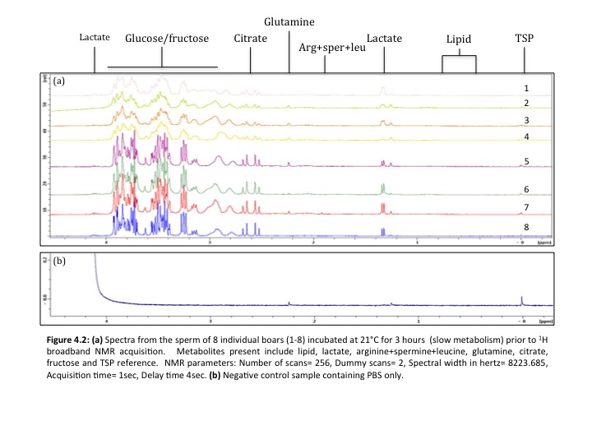

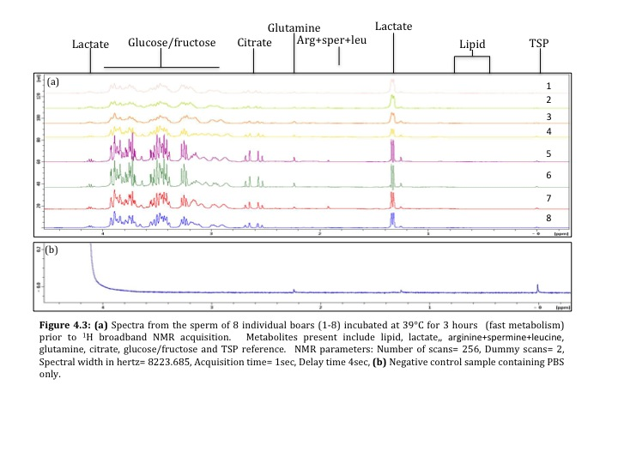

### 4.5.2 Temperature Incubation

Sperm from 8 individual boars were analysed in this set of experiments. There was no significant difference between the two temperatures for lipid, arginine, spermine and leucine, glutamine and glucose/fructose (Figure 4.6a). There was a significant difference in the metabolite integral of lactate (t=15.46, df=14, p<0.001, (means: 21°C=2.43, 39°C=7.87)) which increased and citrate which decreased in sperm incubated at the higher temperature (t=2.185, df=14, p=0.02, (means: 21°C=4.24, 39°C=3.82) (Figure 4.6a).

### 4.5.3 Alphachlorohydrin incubation

A total number of 6 boar ejaculates were analysed in these experiments. There was no significant difference between the two treatments for lipid, lactate, arginine, spermine and leucine, glutamine and citrate. There was a significant difference between the metabolite integrals for glucose/fructose incubated with/without ACH (t=12.73, df=10, p<0.001, (means: UT=81.59, T=29.26)). The integral value for glucose/fructose in the treated sample was significantly lower compared to the untreated sample (Figure 4.6c).

### 4.5.4 MAS NMR

Using MAS NMR, a total of 6 metabolite peaks, identical to those described above, were identified in live boar sperm (Figure 4.4 & 4.5)

### 4.5.4.1 Temperature Incubation

Sperm from 8 individual boars were analysed in this set of experiments. There was no significant difference between metabolite integrals for lipid, arginine, spermine and leucine, glutamine, citrate and glucose/fructose incubated at the two temperatures. There was a significant difference in the metabolite integral of lactate t=0.28, df=10, p<0.001, (means: 21°C=3.1, 39°C=7.84). Lactate significantly increased when sperm were incubated at the higher temperature of 39 degrees (Figure 4.6b).

### 4.5.4.2 Alphachlorohydrin incubation

There was no significant difference for each metabolite integral from sperm incubated in the treated and non-treated samples (Figure 4.6d).

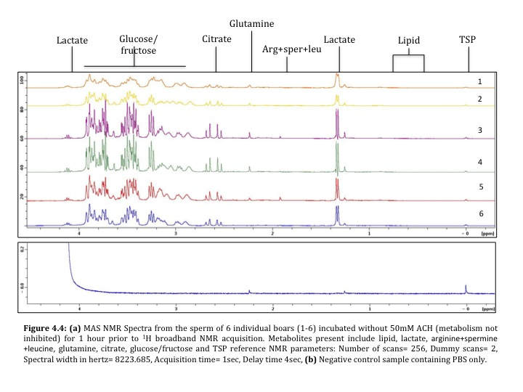

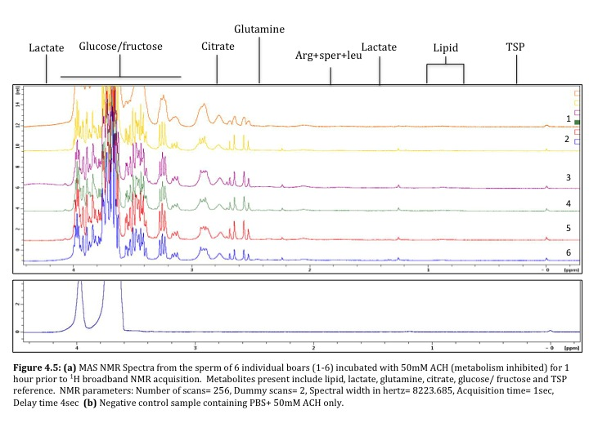



*

*

*

*

**Figure 4.6:** Metabolite integral values for: (a) broadband temperature experiments (n=8) (b) MAS temperature experiments (n=8), (c) broadband ACH experiments (n=6) and (d) MAS ACH experiments.(n=6) 21 refers to samples incubated at 21°C and 39 refers to samples incubated at 39°C. T refers to samples treated with 50mM ACH and UT is untreated. Data shown is mean ± SD. Significance (p<0.05) indicated by *.

**(a)**

**(b)**

**(c)**

**(d)**

## 4.6 Discussion

The aims of the experiments in this chapter were to artificially induce changes in sperm metabolism and see if it was possible to measure any changes in sperm metabolites using broadband and MAS NMR. Using both methods, 6 metabolites were identified in spermatozoa. As outlined previously, broadband NMR has been used to investigate male fertility by scanning seminal plasma (Hamamah et al., 1998, Gupta et al., 2011a, Gupta et al., 2011c, Gupta et al., 2013) and extracted sperm metabolites from different species including goat (Patel et al., 1998, Patel et al., 1999), boar (Jones and Bubb, 2000, Marin et al., 2003), turbot (Dreann et al., 2000), and rhesus macaque (Hung et al., 2009, Lin et al., 2009) and lyophilised human spermatozoa (Paiva et al., 2015). However, MAS NMR is a relatively novel method of NMR not previously used on sperm. It had been used to study the metabolomics of breast (DeFeo and Cheng, 2010, Bathen et al., 2010) colon (Chan et al., 2009), prostate (Burns et al., 2004), liver (Martinez-Granados et al., 2011) and lung (Rocha et al., 2010) tissue. Neither method (broadband or MAS NMR) has been used to analyse metabolites in live sperm. Therefore, confirmation was needed that the two methods could (i) detect individual live sperm metabolites; and (ii) detect changes in live spermatozoa metabolites that have been experimentally induced.

### 4.6.1 Broadband NMR

Broadband NMR has not been used to analyse live sperm metabolites. Broadband NMR was used to analyse sperm from the temperature and ACH experiments. The integrals were then standardised to total integral.

#### 4.6.1.1 Temperature experiments

Sperm from the same boar were independently incubated at 21°C and 39°C for 3 hours before scanning. Once analysed, metabolites from sperm incubated at these two temperatures were compared.

Lactate and citrate were the only two metabolites that significantly differed in sperm incubated at 21°C and 39°C (Figure 4.6a). Although metabolic substrates used in the formation of ATP vary between species, mature boar spermatozoa are dependent on lactate for sperm motility (Jones and Bubb, 2000). Boar sperm are almost completely reliant on the glycolytic pathway for the production of lactate which is preferentially oxidised to CO2 over other substrates such as pyruvate, glucose, fructose and glycerol (Jones, 1997). In these experiments the lactate integral increased significantly with increasing temperature (Figure 4.6a) This might suggest that the lactate integral could be used as a biomarker of sperm metabolism, given that it changed significantly with externally induced changes in sperm metabolism using temperature. In contrast, citrate is a prevalent component of mammalian semen however, its function remains unclear (Kamp and Lauterwein, 1995). Previously, it has been used in the assessment of accessory gland secretory function (Jones and Bubb, 2000). It has also been suggested to act as a chelating agent for Ca+, Mg2+ or Zn2+ and act as a pH buffer (Kamp and Lauterwein, 1995). In sperm it has not been previously explored and therefore little is known regarding its function. In these experiments the citrate integral decreased significantly in sperm incubated at 39°C. However, the reliability of citrate as a biomarker of live sperm metabolism is unclear and requires further investigation as its biochemical link to sperm metabolism has also not yet been fully determined.

#### 4.6.1.2 ACH experiments

A total of 6 boar ejaculates were analysed in these experiments. Sperm from the same boar were incubated in PBS only or PBS containing the glycolytic inhibitor ACH for 1 hour prior to scanning. Once analysed, metabolites from sperm incubated in the two treatments were compared.

There was no significant difference in any metabolite integrals between the treated and untreated samples apart from the glucose/fructose integral (Figure 4.6c). These results are surprising as ACH has been found previously to cause rapid reversible male infertility (Zhang et al., 2012) specifically in boar sperm (Johnson and Pursel, 1972). Therefore, it was expected that the lactate integral in sperm from treated samples would be significantly less than untreated, if glycolytic metabolism was taking place. It is understood that glycolytic metabolism is a pathway boar sperm rely on for ATP production (Jones and Bubb, 2000) however, sperm do have the ability to alter their metabolism depending on the substrates and oxygen availability within their environment (Hereng et al., 2011). Therefore, it is possible that boar sperm switched to OXPHOS when glycolysis was blocked using ACH. This would explain the lack of difference in glycolytic products seen between the treated and untreated samples. Previously pathways of glycolysis have been knocked out in mice suggesting the importance of this pathway in sperm metabolism (Miki et al., 2004). It is highly likely that OXPHOS was not operating within the boar sperm and that the sperm themselves died during incubation and did not form any metabolic substrates.

The significant difference in the glucose/fructose peak was expected to correlate with a significant increase in lactate, given that it is a product of glycolytic metabolism in boar sperm. The glucose peak on the NMR spectrum is a complex peak formed from multiple peaks integrated together. This increases the chances of integration error and reduces the accuracy of quantifying the glucose/fructose within the sample. Therefore, it is possible that the significant difference we observe here is a result of integration error. It was expected that the glucose peak would decrease as it represents the endogenous substrates stored within sperm of which there is previous evidence of (Amaral et al., 2011) The role of exogenous glucose and fructose in sperm metabolism varies between species. It will inhibit capacitation in bull sperm but is required for capacitation in mouse sperm (Turner, 2006).

### 4.6.2 MAS NMR

MAS NMR has not previously been used to analyse live sperm metabolites. MAS NMR was used to analyse sperm from the temperature and ACH experiments.

#### 4.6.2.1. Temperature experiments

Live sperm from 8 boar ejaculates were analysed. Sperm from the same boar were independently incubated at 21°C and 39°C for 3 hours before scanning.

Only the lactate integral significantly differed between sperm incubated at the two temperatures. This is expected given that boar sperm are almost completely reliant on the glycolytic pathway for the production of lactate which is preferentially oxidised to CO2 over other substrates such as pyruvate, glucose, fructose and glycerol (Jones, 1997). These results support the increase in lactate integral described in section 4.6.1.1 where broadband NMR standardised for total integral found a significant difference in lactate. This suggests that using lactate as a biomarker of sperm metabolism could be applied to both broadband and MAS NMR.

#### 4.6.2.2 ACH experiments

When total integral was used to standardise metabolite peaks, there was no significant difference in any metabolite peaks between treated and untreated samples (Figure 4.6d). This is surprising given that lactate integral was expected to be higher in the untreated samples as glycolysis was not inhibited by ACH. This might also be expected to be accompanied by a significant decrease in glucose as it is converted into lactate.

## 4.7 Conclusions

Spermatozoa apoptosis within the scanner was inevitable given that sperm were suspended in substrate free media and exposed to atmospheric conditions. Apoptosis in spermatozoa is poorly understood and differs significantly from apoptosis in somatic cells (Aitken et al., 2015). Primarily there is a sudden increase in the production of mitochondrial ROS and a loss of sperm motility (Koppers et al., 2011). The production of mitochondrial ROS initiates a lipid peroxidation cascade that results in the generation of cytotoxic lipid aldehydes such as 4-hydroxynonenal (4HNE) and acrolein as a result of free radical attacks on the polyunsaturated fatty acids that abound in spermatozoa (Aitken et al., 2012). Lipid peroxidases are strong electrophiles that bind to the nucleophilic centres of proteins in the immediate vicinity (Aitken et al., 2012). Some of these protein targets are molecules associated with the mitochondrial electron transport chain including succinic acid dehydrogenase (Aitken et al., 2012). As a result the electron transport chain is dysregulated causing electrons to leak out which are consumed by oxygen, the universal electron acceptor. This generates superoxide anion which rapidly dimutates to H2O2 which triggers yet more lipid peroxidation. It seems that the oxidative stress initiated by the mitochondria is self propagating, forcing cells down the intrinsic apoptotic pathway (Koppers et al., 2011). As a result, caspases are activated in the sperm cytosol phosphatidylserine is expressed on the surface. During this cascade, the mitochondrion superoxide anion causes the production of H2O2. This is NMR detectable however, It would resonate at an almost identical chemical shift to that of water. Therefore, it is likely to be supressed in all water supressed spectra used in analysis of sperm metabolites. Furthermore, the amounts of H2O2 produced are likely to be undetectable as the molecule will be interacting immediately with surrounding water.

Overall both broadband NMR and MAS NMR were able to identify 6 metabolite peaks within live boar spermatozoa. Broadband NMR is equally as sensitive as the same number of metabolite peaks in sperm can be identified however, it is advantageous that this method reduces the risk of damaging the sperm as no high frequency spinning is involved. MAS NMR involves spinning of the sample at a high frequency and thus risks potential of damage to the metabolising sperm. MAS is advantageous given its ability to scan a small volume of very concentrated cells in comparison to broadband NMR where a significantly lower population of cells are diluted in media to reach the required volume for scanning. Having said that, the quality of the spectra from both MAS and broadband NMR are visually similar and thus integration is similarly as challenging in both of them. MAS NMR is a delicate process involving loading of the sperm sample into the rota and balancing of the sample. This is often time consuming and accompanied by the risks of cell damage due to the velocity of the spinning, it does not seem practical to continue using this method for the study of live sperm metabolism. Broadband NMR was highly practical and gave adequate signal to noise ratio to allow identification and integration of metabolite peaks present in boar sperm. It is ideal for the future analysis of live sperm metabolism through the addition of isotopically labelled substrates into the volume of media and sperm required for broadband analysis. Broadband NMR is suitable for the analysis of sperm suspension and seminal plasma of larger volumes. Therefore it will be ideal for the study of all aspects of the male ejaculate including sperm and seminal plasma in subsequent chapters.

# 

# 5.0: Comparison of human sperm and seminal plasma metabolites using 1H broadband NMR

## 5.1 Introduction

In the previous chapter it was shown how NMR could be used to examine the metabolites present inside live spermatozoa and that it could detect changes in metabolite peaks when metabolism was externally manipulated. Broadband NMR was found to be advantageous as it is poses less of a risk of damaging the live spermatozoa whilst scanning. So far, six metabolite peaks have been identified in live boar spermatozoa and of these, lactate, a product of glycolysis, appears to change according to the rate of metabolism within spermatozoa. This is promising with regards to NMR being implemented as a technique to monitor live sperm metabolism however, spermatozoa form only a small fraction of an ejaculate.

An ejaculate is made up of multiple secretions from two main sections of the male reproductive system. First, seminal plasma consists of a mixture of secretions from the prostate, seminal vesicles and a smaller percentage form the Wolffian ducts and epididymis (Mann, 1951) which represents the function of these accessory organs. In contrast, spermatozoa pass through the epididymis, form within the testes and thus represent the function of these organs. It is important to highlight that the contributions from these separate entities are biochemically distinct and that they combine upon ejaculation. Therefore, it seems paramount that their function in relation to fertility be investigated separately using NMR and then compared.

*In vivo*, sperm with fertilising potential are separated from immotile sperm, debris and seminal plasma in the female reproductive tract by active migration through cervical mucus (Suarez and Pacey, 2006). Separation of an ejaculate *in vitro* is termed sperm washing (see section 2.2.1) and uses density gradient centrifugation to separate an ejaculate into three distinct parts: (i) seminal plasma (SP); (ii) high motility; and (iii) low motility spermatozoa. Clinically, sperm washing is used to separate the highly motile sperm from the ejaculate (Henkel and Schill, 2003) which are then used in multiple ART techniques, whilst the other fractions are normally discarded. In this chapter, one of the discarded fractions (SP) is considered in more detail to determine if it provides additional information about spermatozoa metabolism in relation to ejaculate phenotype.

The biochemical composition of seminal plasma includes fructose, zinc, acid phosphatase, free l-carnitine and alpha 1,4 glucosidase, and glycerophosphorylcholine (Gupta et al., 2011b). Such information has been obtained by classical biochemical analysis with varying degrees of sensitivity (Soufir et al., 1981, Guerin et al., 1986, Mieusset et al., 1988, Cooper et al., 1990, Yeung et al., 1990, Bujan, 1995). Many of these biochemical markers relating to the accessory organs have been largely investigated but few have proven clinically useful (Hamamah et al., 1998).

Analysis of human seminal fluid by NMR has recently become possible due to advances in high field NMR technology (Irvine, 1998). These developments have allowed a higher degree of sensitivity with increased observation frequency. Not only can components of seminal plasma be identified, but acquisition of qualitative and quantitative metabolic information can be obtained in reasonable time and concentrations of clinical relevance determined (Gupta et al., 2009, Ranjan et al., 2006). Moreover, the information obtained can be used to identify infertility (Hamamah et al., 1998).

Previous research has successfully classified signature biomarkers of male fertility within human seminal plasma (Gupta et al., 2011b). This research suggested that alanine, citrate, GPC, tyrosine and phenylalanine could be used to determine infertility in the human male. It has also been used to distinguish between spermatogenic failure and obstructive azoospermia and different forms of spermatogenic failure on the basis of GPC/choline ratio (Hamamah et al., 1998). However, the ratio of GPC, choline and other metabolites does not provide a complete picture of the metabolic profile of infertility, given that the spermatozoa themselves are not analysed.

Although seminal plasma metabolites are a promising avenue of research into diagnosis of male infertility, consideration of the spermatozoa metabolism and function is essential to build a complete description of ejaculate metabolism and its relationship with male fertility.

Our knowledge of sperm metabolomics remains descriptive of a snapshot of sperm metabolism at the point where the sperm were lyophilised. Furthermore, the immotile sperm metabolites have not been compared to the motile sperm metabolites within the same ejaculate. Seminal plasma metabolites have also not been compared to motile and immotile sperm metabolites within an ejaculate leaving gaps in our knowledge regarding the reliance of spermatozoa on external nutrition from seminal plasma and differences in sperm metabolites from immotile and motile sperm. Furthermore, metabolic analysis of an ejaculate from the same male over time has not been performed previously using NMR.

Therefore, this chapter will examine the metabolites found in seminal plasma as well as high motility and low motility spermatozoa following separation *in vitro* by density centrifugation. Differences in metabolites between seminal plasma, motile and immotile sperm will be investigated and possible correlations identified. Furthermore, metabolites within each of the ejaculate constituents will be compared across classifications of the ejaculate (normozoospermic, oligozoospermic and asthenozoospermic) and multiple ejaculates from the same donor will be compared over time

## 5.2 Hypotheses

The metabolite integral of a single donor will not differ significantly over time, but metabolites within seminal plasma, high motility spermatozoa and low motility spermatozoa will significantly differ between normozoospermic, oligozoospermic and asthenozoospermic ejaculates. The metabolite integrals will also significantly differ between seminal plasma, high motility and low motility spermatozoa from normozoospermic samples.

## 5.3 Aims

1. Characterise the 1H metabolite profile of human seminal plasma, high and low motility spermatozoa from normozoospermic, oligozoospermic and asthenozoospermic ejaculates.
2. Compare the 1H metabolic profile multiple ejaculates from single donor over time.
3. Perform statistical comparison of seminal plasma, high motility and low motility spermatozoa metabolites from normozoospermic, oligozoospermic and asthenozoospermic ejaculates.

## 5.4 Materials and methods

### 5.4.0 Donor recruitment

A total of 45 ejaculates were processed for scanning (Figure 5.1), of which 38 were normozoospermic, 3 were oligozoospermic and 4 were asthenozoospermic.

### 5.4.1 Semen analysis

Semen analysis was performed on each ejaculate (see section 2.2). Sperm concentration and motility were performed on the raw ejaculate and the motile sample after density centrifugation prior to scanning. Sperm concentration was determined on the immotile sperm fractions prior to scanning.

### 5.4.2 Preparation of sample for NMR

#### 5.4.2.1 Seminal plasma

Seminal plasma was removed following the first centrifugation during sperm washing (see section 2.3). They were then frozen at -80°C until NMR analysis could be performed. When necessary, the seminal plasma was thawed at room temperature for 30 minutes and centrifuged for 10 minutes at 1000*g* to remove any residual sperm*.* The supernatant was removed and prepared for NMR scanning (see section 2.4).

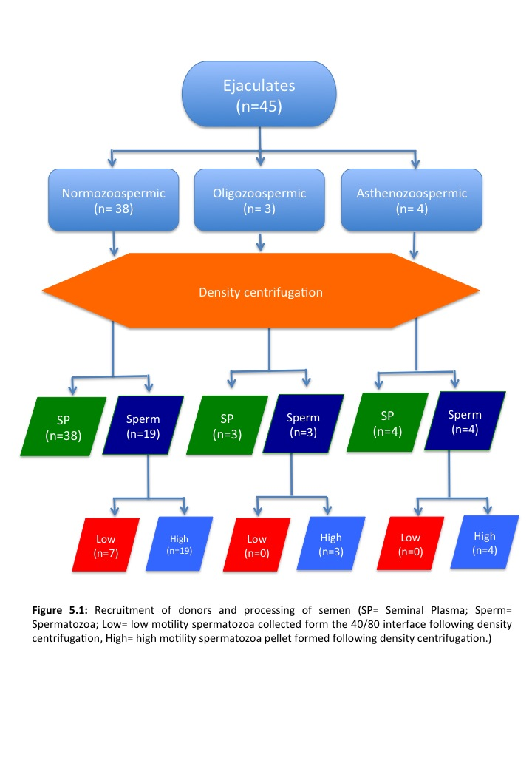

#### 5.4.2.2 Low quality spermatozoa

Low motility spermatozoa were present at the 80/40 Puresperm interface following the first centrifugation of sperm washing (see section 2.5.3). They were easily extracted using a Pasteur pipette (Greiner bio-one, Stonehouse, UK) subjected to MACS purification (see section 2.6). The sperm were then centrifuged for 10 minutes at 1000*g,* the supernatant removed and the immotile sperm pellet re-suspended in 2ml PBS 1x. This was then centrifuged at 500*g* for a further 10 minutes, the supernatant removed and the immotile sperm pellet re-suspended in 2ml PBS 1x ready to be used in NMR acquisition (see section 2.5.3) (n=7 from normozoospermic samples).

#### 5.4.2.3 High quality spermatozoa

High motility spermatozoa formed a pellet post sperm wash (see section 2.3) which was subjected to MACS purification (see section 2.6) before being re-suspended in 2ml PBS 1x ready to be used in NMR acquisition (see section 5.2.3) (normozoospermic n=19, oligozoospermic n=3, asthenozoospermic n=4).

### 5.4.3 NMR

400μl of each sample of seminal plasma (see section 5.4.2.1), low motility spermatozoa (see section 5.4.2.2 and or high motility spermatozoa (section 5.4.2.3) were pipetted into a 5mm glass tube along with 10% (40μl) D2O and 10μl TSP reference. Samples were allowed to equilibrate for 10 minutes once in the scanner at 37°C. Acquisition parameters were: NS= 256, Aq= 1, D1=4.

**5.4.4 Statistical analysis**

All statistical analysis was performed using SPSS statistics version 22.

#### 5.4.4.1 Intra ejaculate variation

Donor 1 ejaculated 4 times, 1 week apart and donor 2 ejaculated 3 times one week apart to investigate intra ejaculate variation.

#### 5.4.4.2 Seminal plasma, high motility and low motility fractions

A Multivariate ANOVA (MANOVA) was performed to collectively compare the integral values for the three ejaculate fractions simultaneously with the three fertility classifications.

## 5.5 Results

Figure 5.2a shows the 1H NMR spectra of a metabolic profile and chemical shift assignments of difference resonances in seminal plasma of a normozoospermic sample. Resonance signals of various metabolites in seminal plasma were assigned using known chemical shifts and coupling constant parameters (Gupta et al., 2011b, Gupta et al., 2011a, Tomlins et al., 1998a, Hamamah et al., 1998, Lynch et al., 1994). A total of 14 metabolites were identified including valine, isoleucine, leucine-0.05-1.37ppm, lactate-1.33ppm, alanine-1.47ppm, arginine, spermine, leucine-1.58-1.83ppm, glutamine-2.37ppm, glutamate, citrate-2.55ppm, choline-3.21ppm, Glycerophosphorocholine (GPC)-3.23ppm, uridine-7.84ppm, tyrosine-6.88ppm, histidine-7.01, and phenylalanine-7.3-7.44ppm) and their quantities estimated by integrating their resonances. Figure 5.2b and 5.2c shows the 1H NMR spectra and metabolic profile of high motility and low motility spermatozoa respectively. Resonance signals of spermatozoa metabolites were assigned in the same way. Eight metabolites comprising of six peaks (lipid-0.9ppm, lactate- 1.33ppm, arginine, spermine, leucine-1.58-1.83ppm, glutamine-2.37ppm, citrate-2.55ppm, and glucose/fructose-3-4ppm) were present and their quantities estimated by integrating their resonances. All normalised integrals were then subject to statistical analysis.

### 5.5.1 Intra donor ejaculate comparison

Spermatozoa metabolites across normozoospermic ejaculates for the same donor (intra donor ejaculate comparison) were plotted for visual comparison (Figure 5.3) for two donors. Donor 1 (n=4) showed little variability in all metabolites in ejaculates across a four-week period. Glucose and fructose did increase slightly in week two and then decrease at week three in donor 2 (Figure 5.3)

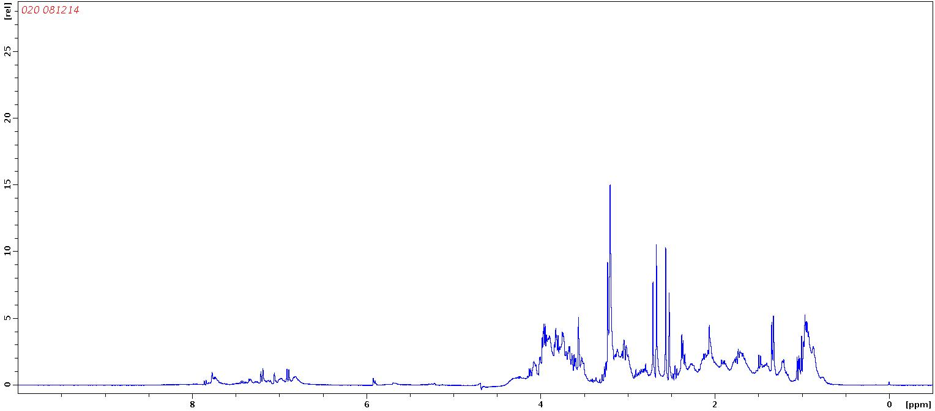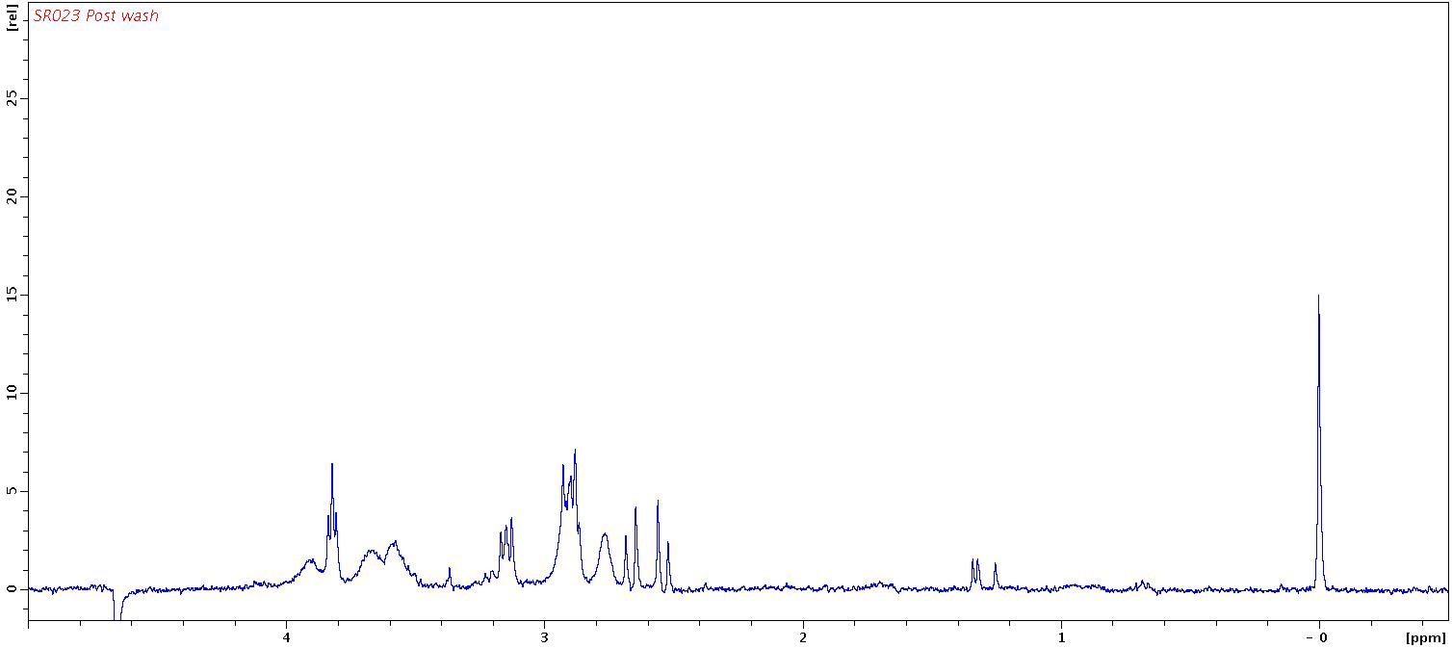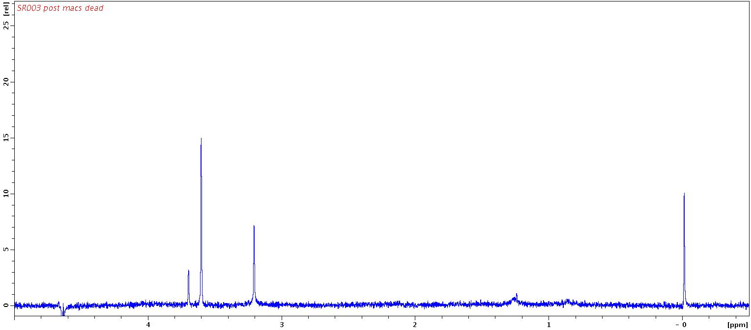

**Figure 5.2 (a):** Human seminal plasma 1H metabolite spectrum, **(b)** high motility spermatozoa metabolite spectrum, **(c)** low motility spermatozoa metabolite spectrum from a normozoospermic ejaculate.

**(a)**

**(b)**

**(c)**

0

2

4

6

8

10

2

4

6

8

10

12

2

4

6

8

10

12

2

4

6

8

10

12

**Intensity**

**a.u.**

**Parts per million (ppm)**

### 5.5.2 Seminal plasma

For the comparison of metabolites between the 3 classifications (normozoospermic, oligozoospermic and asthenozoospermic) (Figure 5.4) a multivariate ANOVA was performed (MANOVA) for the difference in means. Under Hotelling’s trace with an F28,52 =0.749 null hypothesis was not rejected (p=0.842) i.e. there is no difference in the mean integral value for all metabolites across all three classifications.

### 5.5.3 High motility spermatozoa

Highly motile spermatozoa from 19 normozoospemric, 3 oligozoospermic and 4 asthenozoospermic were analysed and a total of 6 metabolite peaks were identified which were lipid, lactate arginine + apermine, + leucine (one peak), glutamine, citrate and glucose/fructose. For the comparison of metabolite integrals between the three classifications a multivariate ANOVA (MANOVA) for the difference in means was performed. Under Hotelling’s Trace with an F12, 26 =0.822 the null hypothesis was not rejected (p=0.26) indicating there is no difference in mean integral value for all the metabolites across all classifications (Figure 5.5).

### 5.5.4 Low motility spermatozoa

Immotile spermatozoa from 7 normozoospermic males and no other classifications were analysed (Figure 5.6). A total of 6 metabolite peaks were identified in spermatozoa.

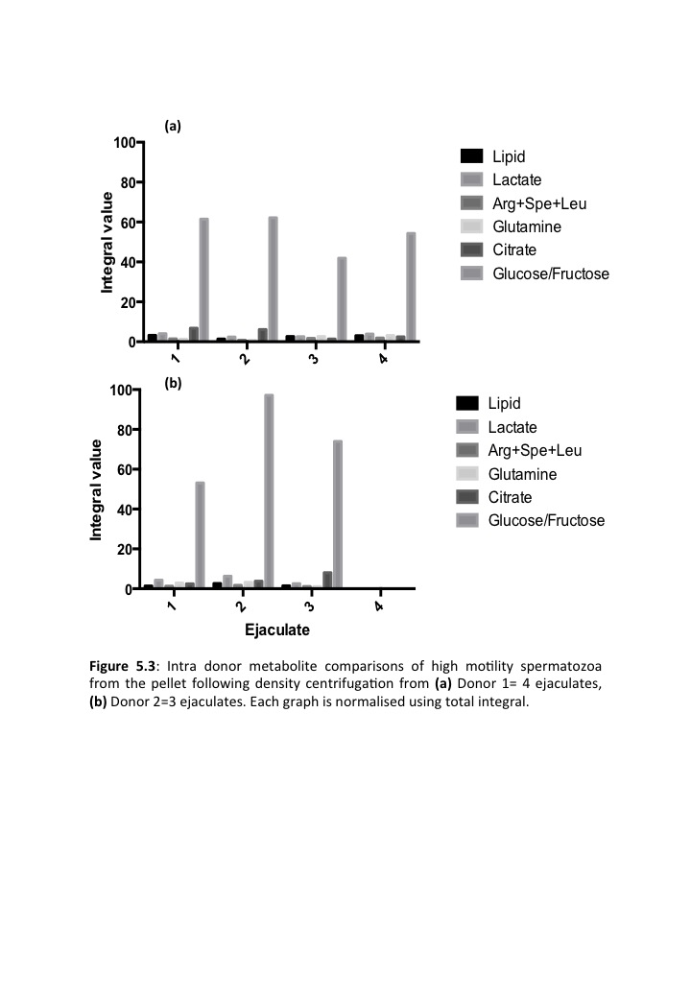

**Figure 5.4:** Comparison of seminal plasma metabolites normalised using total integral from: normozoospermic samples (N;n=38), oligozoospermic samples (O;n=3), asthenozoospermic samples (A;n=4). Bars represent mean integral value ± SD.



### 5.5.5 Seminal plasma, high motility and low motility sperm metabolite comparison

A total of 14 metabolite peaks were identified in seminal plasma (sees section 5.5.2) and 6 metabolite peaks were identified in immotile and motile spermatozoa (see sections 5.5.3 & 4). For the comparison of metabolites across all three ejaculate fractions, 6 metabolites found in both motile and immotile spermatozoa were compared (Figure 5.7) whilst only 4 were compared between seminal plasma and motile and immotile spermatozoa. A multivariate ANOVA (MANOVA) test was performed for the difference in metabolite integral means. Under Hotelling’s Trace with an F12, 14 =0.822 statistic the null hypothesis was not rejected (p=0.096) suggesting there is no difference between the mean integral values between the three ejaculate fractions for the 4 metabolites. For the comparison of high motility and low motility spermatozoa only, a multivariate ANOVA (MANOVA) was performed for the difference in the 6 metabolite integral means. Under Hotelling’s Trace with an F,0.23, 5.6 =2.17 the null hypothesis was not rejected (p=0.147) suggesting there is no difference in mean integral value for all 6 metabolites between motile and immotile spermatozoa.

## 5.6 Discussion

Current metabolomic analysis of an ejaculate and its correlation with male fertility lacks an understanding of inter ejaculate variability, the composition of seminal plasma and its relationship with sperm metabolites, live spermatozoa metabolism, and comparison of motile and immotile spermatozoa metabolites. Identification of biomarkers of male fertility have previously only been accomplished by analysing human seminal plasma (Gupta et al., 2011b, Gupta et al., 2011a) from males with oligozoospermic and normozospermic ejaculates. However, as discussed previously, seminal plasma is representative of the accessory organs and the function of the testes and epididymis cannot be measured unless metabolites from spermatozoa are analysed as well.

**Figure 5.5:** Comparison of high motility sperm metabolites from the sperm pellet after density centrifugation from normozoospermic samples (N) n=19, oligozoospermic samples (O) n=3, asthenozoospermic samples (A) n=5. Bars represent mean integral value ±SD.



Motile

Immotile

Seminal plasma



**Figure 5.6:** Low motility sperm metabolites from sperm collected at the 40/80 interface following density centrifugation. Bars represent mean integral ±SD.



**Figure 5.7:** Comparison of metabolites from high motility, low motility and seminal plasma fractions from the same donor. Total number of donors =3. Motile spermatozoa were collected from the pellet formed following density centrifugation, immotile spermatozoa were collected at the 40/80 interface following density centrifugation. And seminal plasma was removed from the top of the column following density centrifugation. Bars represent mean integral value ±SD.

The experiments in this chapter aimed to characterise the metabolite profile of human seminal plasma, high and low motility sperm from human ejaculates. It aimed to compare the metabolic profile of spermatozoa from multiple ejaculates from a single donor over time. Furthermore, it aimed to compare seminal plasma, high and low motility spermatozoa metabolites from normozoospermic, oligozoospermic and asthenozoospermic ejaculates. Finally it aimed to compare seminal plasma, motile and immotile spermatozoa from a single ejaculate in a number of donors.

### 5.6.1 Inter donor comparison

1H broadband NMR successfully identified 6 metabolites within human spermatozoa. These were then compared between ejaculates over time for the same donor. The aim of this experiment was to identify potential significant differences in metabolites in multiple ejaculates from the same male. Both donors for the longitudinal study were normozoospermic and were informed that 48 hours abstinence was required before sample production and samples were collected one week apart. A significant change in metabolites over time would suggest that the metabolic profile of an individual male’s sperm is variable and therefore analysis of the metabolites using NMR would be less reliable at identifying a biomarker of male infertility. This was not the case as visually there appears to be little difference in spermatozoa metabolites over ejaculates from two donors and (see section 5.5.1). In contrast to these findings, previous literature has suggested that there is significant inter-ejaculate variability in semen parameters in fertile, infertile and men with cancer (Nallella et al., 2004). Over a one-year period, there was also a significant difference found in semen parameters between ejaculates from the same male (Mallidis et al., 1991). This is further supported by research suggesting that there was a significant difference in semen parameters within subjects over a 10 week period (Alvarez et al., 2003). Research further suggests that semen parameters significantly differ between ejaculates within a male (Cooper et al., 1991, Knuth et al., 1988, Poland et al., 1985, Poland et al., 1986, Schrader et al., 1991, Wijchman et al., 2001, Schwartz et al., 1979). Reasons for this experiments results differing from previous findings from the literature could be related to the small sample size of only two donors compared over a 4-week period however previous studies focussed on results from semen analysis no the metabolic profile of an ejaculate.

### 5.6.2 Seminal plasma

Current seminal fluid based clinical descriptor variables are inefficient for predicting fertility (Menkveld et al., 2001). A number of studies have demonstrated the potential use of NMR in the identification of seminal plasma constituents and have attempted to use the ratio of metabolites in the diagnosis of fertility (Tomlins et al., 1998b, Hamamah et al., 1998, Lynch et al., 1994, Maher et al., 2008). Seminal plasma, one of the three fractions of the ejaculate analysed in these experiments, was analysed from 38 normzoospermic, 3 oligozoospermic and 4 asthenozoospermic ejaculates. A total of 14 metabolites were identified from 17 metabolite peaks. Statistical analysis suggested that there was no overall significant difference in mean metabolite integrals between the 3 classifications of ejaculate (p=0.842) (section 5.5.2), which is contrary to the finding of previous literature.

### 5.6.3 High motility spermatozoa

The metabolite integrals were compared across high motility spermatozoa from 19 normozoospermic, 3 oligozoospermic and 4 asthenozoospermic ejaculates. Following statistical analysis, there was no significant different between high motility spermatozoa metabolite integrals across classifications (p=0.26) (section 5.5.3). Characterisation of a metabolite profile of human spermatozoa has been reported before (Paiva et al., 2015). In this previous report, a total of 38 metabolites were identified using 1H NMR. Reasons for the higher number of metabolites identified are that the study pooled ejaculates to achieve a high cell number after washing, followed by methanol extraction of metabolites from spermatozoa by lyophilsation. The frequency of the NMR scanner used was also higher (600MHz compared to 400MHz used in this study). Of the 6 metabolites identified in this study, 4 were also identified in the previous study including lactate, leucine, glutamine and glucose/fructose. Lipid and citrate, identified in experiments in this thesis were not found in other literature. The previous study focussed on classification and identification of the human sperm metabolome and therefore, there does not appear to be any current publications that draw comparisons of sperm metabolites across classifications of male fertility. Lactate is a known product of aerobic glycolysis in mammalian sperm metabolism, it is expected that there will be a lower amount of lactate asthenozoospermic samples. On the other hand, ejaculates were washed and the motile fraction analysed. Therefore, one might expect there to be no significant difference between motile spermatozoa from the three classifications of ejaculate due to the selection of the highest quality spermatozoa in the ejaculate by washing.

### 5.6.4 Low motility spermatozoa

The low motility sperm fraction could not be compared between classifications of ejaculates, as the low motility sperm fraction was only removed from seven normozoospermic ejaculate washes.

### 5.6.5 Comparison of seminal plasma, high and low motility sperm metabolites

Overall 6 metabolites were identified in high and low motility sperm and 14 in seminal plasma. Four metabolite peaks could be compared between the seminal plasma and sperm fractions including lactate, arginine+spermine+leusine, glutamine and citrate. Comparison of the three fractions showed that there were no significant differences between these four metabolites (F8,24=16.269, p=0.096). Focusing on just the high and low motility spermatozoa, the seminal plasma metabolites were excluded and the 6 metabolites identified within the sperm were compared. Once again no significant difference was found for the six sperm metabolites from the high and low motility fractions (F6,24=102.913, p=0.147). It is disappointing that a higher number of metabolites identified in seminal plasma could not also be identified in spermatozoa for comparison. In previous literature, 38 sperm metabolites have been identified (Paiva et al., 2015) and 17 seminal plasma metabolites have been identified (Gupta et al., 2011b, Gupta et al., 2011a). As mentioned previously, the study identifying 38 sperm metabolites was not conducted on live sperm but on the metabolic extracts of a high concentration of sperm pooled prior to metabolite extraction. Therefore, given a higher cell number in these experiments, comparison between a higher numbers of metabolites could be possible with the hope of identifying differences in metabolites in difference fractions of the ejaculate. In a more comparable recent study, choline/GPC and lactate/lipid regions of live sperm 1H NMR spectra were significantly different between high motility sperm (from a pellet formed by density centrifugation) and low motility sperm (collected at the 40% interface) (P< 0.0001), in a very similar method to the experiments of this chapter (Reynolds et al., 2017). Despite similar methods being used, results from this study and the experiments in this chapter differ. Reasons for this could relate to the low number of donors used in comparison experiments in this chapter (n=3) compared to n=20 in the studies by Reynolds et al. Furthermore, Reynolds et al investigated and suggested that two washes were needed, following density centrifugation with Percoll in order to remove the residual seminal plasma from sperm at both the 40% and 80% interfaces. In the experiments for this thesis, sperm were taken from either interface, re-suspended in PBS and washed once. This was highlighted as not sufficient in removing residual seminal plasma by Reynolds et al and therefore might explain why no significant difference was identified between the three ejaculate fractions.

Unexpectedly, there was no significant difference in lactate across the three fractions. It was expected that the amount of lactate in the motile spermatozoa compared to the seminal plasma and immotile spermatozoa would be higher given that these motile cells would be converting substrates into lactate via aerobic glycolysis however, lack of complete washing of seminal plasma (as described above) may also explain a lack of difference in individual metabolite peaks such as lactate.

Arginine+spermine+leucine is a combination of three overlapping metabolite peaks. In previous literature (Gupta et al., 2011b) this was not quantified due to the overlapping of the three peaks making it difficult to assign to one metabolite for any potential significant change in metabolite integrals. In the experiments carried out for this thesis, the peak representing these three metabolites was integrated and quantified as one peak however, no conclusions can be made regarding which peak out of the three was individually changing in the spermatozoa in these experiments.

Citrate is a characteristic constituent of mammalian semen (Kamp and Lauterwein, 1995) , in particular the seminal plasma. Therefore, its integral value was expected to be higher in the seminal plasma fraction in comparison to motile and immotile spermatozoa. Once again, reasons for this lack of difference are likely to relate to sample size. There were thirty eight seminal plasma samples scanned in comparison to nineteen motile and seven immotile spermatozoa. A larger sample size would be necessary to improve the reliability of the outcome of the results.

Variation in the data as seen in Figures 5.4 and 5.5 could be explained by spectral integration using the TopSpin software. Integration by this method involves the user selecting an area of the spectrum either side of the metabolite peak where there appears to be no other peaks (just baseline spectral noise). This method appears less accurate when metabolite peaks are broader or when integrating those metabolite peaks that are in busy chemical shifts of the spectrum. Furthermore, precise calibration of the chemical shift is required by the user telling the software the exact chemical shift at which the reference compound peak resonates. An alternative to this method of metabolite peak quantification would be spectral binning used in subsequent NMR sperm metabolites studies. Here, the entire spectrum is integrated at intervals defined by the user (e.g. 0.2ppm). Therefore changes in metabolites peaks will appear within these defined bins making quantification and comparison more accurate. In all comparisons there was an unequal number of subjects in each Furthermore, the variation may also be biological in that sperm and seminal plasma from different subjects differs highly in its metabolite quantity and composition making classification of signature biomarkers for sub fertility types less likely.

In this chapter, the metabolite integrals from multiple ejaculates from the same donor have been compared over time. 14 seminal plasma metabolites have been identified and compared over the three classifications of male fertility. The motile sperm separated during density centrifugation has also been compared across ejaculate phenotypes. All three fractions of the male ejaculate including seminal plasma, high and low motility sperm have been separated and independently scanned and compared within males. Analysis of spermatozoa metabolites has been performed on live sperm. To our knowledge this is the first set of experiments analysing live sperm metabolites however, the spectra acquired here are still just snapshots of the metabolite profile of sperm at different time points. In the next chapter, the metabolic rate of live spermatozoa will be monitored in real time using labelled substrates will be presented. These substrates can then be tracked as they are metabolised by spermatozoa allowing visualisation and quantification live sperm metabolism including the metabolic intermediates and products in real time.

# 

# 6.0: Spermatozoa Metabolism in Real Time

## 6.1 Introduction

In the previous chapter, differences in spermatozoa and seminal plasma metabolites were identified from ejaculates of varying phenotypes. This suggests that NMR has the potential to measure metabolite content within ejaculate constituents, however the significance of this in understanding fertility is still in its infancy. Seminal plasma metabolites have been previously investigated and biomarkers of male fertility identified. However, little attention has been paid to spermatozoa metabolites when using NMR as an analysis technique. Reasons for the disproportionate amount of research focussed on seminal plasma metabolites include its ease of analysis being that it is a liquid and is often ejaculated in volumes greater than 0.5ml, above the minimum required for 1H NMR analysis. The concentration of the metabolites within seminal plasma is easily detectable using NMR. However, spermatozoa are more difficult to measure due to the requirement of a high number of sperm within the sample to achieve a sufficient signal to noise ratio.

An understanding of live sperm metabolism could contribute to the ongoing debate regarding the pathways of metabolism utilised by spermatozoa. This includes production of ATP for motility and for other key processes that occur in the female reproductive tract. For example bull spermatozoa rely on OXPHOS to support capacitation from oxidisable substrates (Hutson et al., 1977, Vandop et al., 1977) whereas human spermatozoa rely on glucose derived ATP from glycolysis for capacitation and hyperactivation (Hoshi et al., 1991, Williams and Ford, 2001) (see section 1.3.4 & 1.3.5), tyrosine phosphorylation (Travis et al., 2001) and fertilisation (Mahadevan et al., 1997) *in vitro*. Despite these findings, it remains unclear and debated in the field as to whether glycolysis or OXPHOS is the major contributor of ATP needed for fertilisation in humans (Ford, 2006). Use of NMR to monitor the metabolism of substrates in real time could be used to investigate the utilisation of these pathways during these key events in spermatozoa during their journey through the female reproductive tract.

Investigation of spermatozoa metabolism in real time using radioactively labelled substrates has been conducted previously in mouse sperm (Odet et al., 2011). The research focussed on using NMR to track the utilisation of labelled substrates in real time, to investigate the function of the germ cell specific lactate dehydrogenase C (LDHC) gene in sperm ATP production. During this research, glucose and pyruvate consumption were quantified and monitored whilst lactate production was simultaneously quantified. From the isotopically labelled products of metabolism such as lactate, the authors were able to suggest the importance of glycolytic metabolism in the flagellum of mouse sperm and its dependence on the LDHC gene expression to produce ATP for sperm metabolism.

In the final stages of glycolysis, pyruvate kinase catalyses the dephosphorylation of phosphoenolpyruvate into pyruvate. The breakdown of glucose through glycolysis yields two molecules of pyruvate and two net molecules of ATP (Gray et al., 2014). The fate of pyruvate is often reduction to lactate by the enzyme lactate dehydrogenase which reversibly catalyses the reduction of pyruvate to lactate coupled with the oxidation of NADH to NAD+ (Figure 6.1). Pyruvate can also continue into the citric acid cycle where it drives ATP production by oxidative phosphorylation. Here there are many intermediate that it can be converted into including carbon dioxide and bicarbonate (Figure 6.2). This makes it an ideal candidate when choosing a substrate to isotopically label, as there is opportunity for the label to be converted into products of glycolysis and OXPHOS. With the use of pyruvate, metabolic pathways utilised within spermatozoa can be investigated using 13C NMR. Furthermore, pyruvate is known to be metabolised by mammalian sperm (Frenkel et al., 1973) and therefore is suited to both human and boar sperm studies.

Therefore, this chapter will examine the isotopically labelled substrate pyruvate and the subsequently labelled products of boar and human sperm metabolism in real time using 13C NMR. Differences in the amounts of isotopically labelled products will be compared between ejaculate phenotypes. The metabolism of both human and boar sperm will be quantified and monitored in real time.

## 6.2 Hypotheses

a) 13C pyruvate added to boar and human sperm will be metabolised and its products detectable using 13C NMR.

b) The integral value for metabolite peaks of products of metabolism will change over time.

c) The metabolite peaks of products of pyruvate metabolism will differ between the different ejaculate phenotypes in human spermatozoa.

d) The integral value will also differ between ejaculate phenotypes in the human sperm scanned overnight using 13C NMR.

## 6.3 Aims

1. Identify the 13C metabolite products of boar and human spermatozoa following the metabolism of 13C pyruvate.
2. Compare the 13C metabolite peaks of products of pyruvate metabolism from boar and human spermatozoa over time.
3. Compare the 13C metabolite products of human spermatozoa from different classes of fertility over time.
4. Compare the metabolite peaks of products of pyruvate metabolism from human spermatozoa from different classes of fertility from overnight scans.

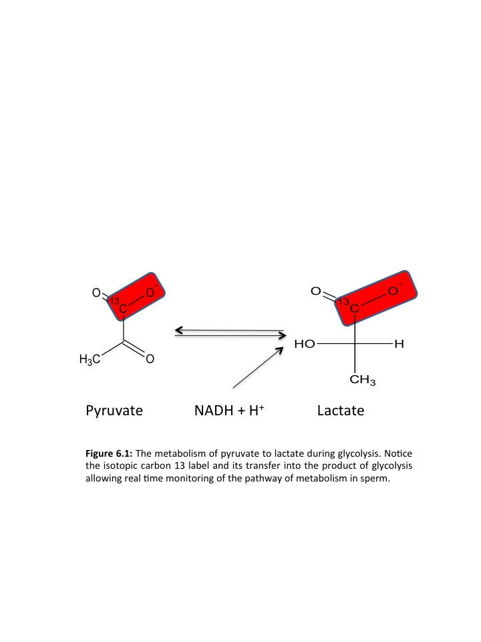

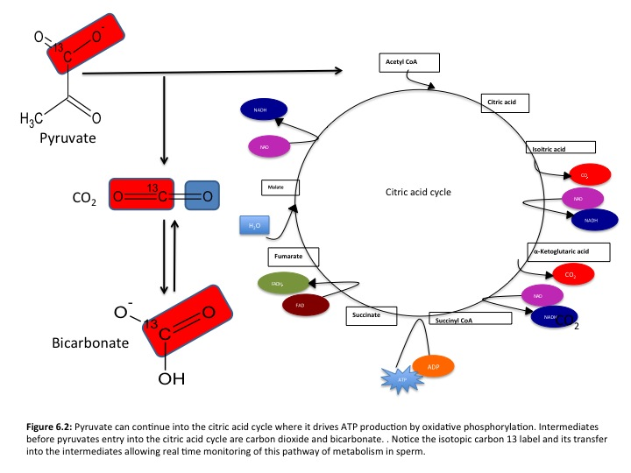

## 6.4 Materials and Methods

### 6.4.1 Donor recruitment

A total of 16 ejaculates were processed for scanning (Figure 6.3). Of these 16 ejaculates, 9 were normozoospermic, 2 were oligozoospermic and 5 were asthenozoospermic. Human spermatozoa were washed as described in section 2.3.2.

### 6.4.2 Boar Ejaculates

A total of 15 boar ejaculates were processed for scanning (Figure 6.4) and washed as described in section 2.3.1. All boar ejaculates were normozoospermic prior to sperm washing.

### 6.4.3 Preparation of sample for NMR

Motile spermatozoa formed a pellet post sperm wash (see section 2.3). The sperm were re-suspended in 400μl PBS and the sperm concentration and motility were calculated (see section 2.2.1.2). Following this 5μl 1M13C urea was added as concentration reference and 40μl D2O was added for field frequency lock.

### 6.4.4 NMR Real time metabolic rate

13C NMR spectra were obtained using a Bruker Avance III 9.4T scanner and 5mm BBO probe at 37°C for human and 39°C for boar. Once scanning parameters had been optimised (shimming, resolution), 10μl 1M 13C urea and 50μl 100mM 13C labelled pyruvate was added and acquisition commenced immediately. Six 13C inverse gated spectra were obtained at 20 minute intervals post addition of 13C1 pyruvate (NS: 256, AQ: 0.16sec, D1: 4sec, SWH: 24038).

### 6.4.5 NMR overnight acquisition

Following the real time acquisitions, metabolic pathways of 13C pyruvate were elucidated by acquiring a 13C inverse gated spectrum overnight to give high signal to noise ratio (NS: 10 000, AQ: 2sec, D1: 8, flip angle: 22°). It is likely that following the real time experiments, the sperm would no longer be viable therefore, an overnight scan was performed, acquiring many spectra and adding them together which increased the signal to noise ratio of metabolite peaks, enabling potential metabolites present in smaller quantities to be visible in the spectrum.

High motility

(n=5)

High motility

(n=2)

Oligozoospermic

(n=2)

Normozoospermic

(n=9)

Asthenozoospermic

(n= 5)

Ejaculates

n=16

Density Centrifugation

High motility

(n=9)

Real time

(n=9)

Real time

(n=2)

Real time

(n=5)

Night

(n=6)

Night

(n=1)

Night

(n=4)

**Figure 6.3:** Recruitment of donors and processing of semen (High motility = high motility spermatozoa pellet formed following density centrifugation, Real time = samples used in time lapse experiment where rate of live sperm metabolism was calculated, Night= overnight NMR acquisition of 10 000 scans for improved spectral signal to noise ratio).

Normozoospermic

(n=15)

Ejaculates

n=15

Density Centrifugation

High motility

(n=15)

Real time

(n=15)

Night

(n=13)

**Figure 6.4:** Processing of boar semen (High motility = high motility spermatozoa pellet formed following density centrifugation, Real time = samples used in time lapse experiment where rate of live sperm metabolism was calculated, Night= overnight NMR acquisition of 10 000 scans for improved spectral signal to noise ratio).

### 6.4.6. Statistical analysis

All statistical analysis was performed using SPSS statistics version 22.

A univariate repeated measures ANOVA to measure the differences in metabolites from the same individual across time points, factoring in the different ejaculate phenotypes. A one way ANOVA was performed to measure differences in metabolite integrals from overnight acquisitions between the three ejaculate phenotypes.

## 6.5 Results

### 6.5.1 Boar real time metabolic rate

High quality spermatozoa from 15 normozoospermic boars were analysed. Two 13C labelled metabolites were identified in boar spermatozoa (Figure 6.5). These were 13C lactate and 13C bicarbonate. A univariate repeated measures ANOVA was performed to analyse the difference in means for each metabolite across time points.

As shown in Figure 6.6a, urea remained relatively constant over time, with an average change in LN integral value of 0.001 Integral values/min. Under Greenhouse Geisserwith an F1.05,70 = 1.116 the null hypothesis was not rejected (p=0.207) indicating there is no difference in mean integral value of urea over the 6 time points.

In contrast, pyruvate decreased (Figure 6.6b) with an average rate of change in LN integral value of 0.003/Integral value min. Under Greenhouse Geisserwith an F2.389, 33.450 = 3.936 the null hypothesis was rejected (p=0.002) suggesting there is a significant difference in mean integral value of pyruvate over the 6 time points.

Lactate increased (Figure 6.6c) with an average rate of change in LN integral value of 0.009 Integral value/min. Under Greenhouse Geisserwith an F3.465, 48.514 = 17.78 the null hypothesis was rejected (p=0.000) suggesting there is a significant difference in mean integral value for lactate over the 6 time points.

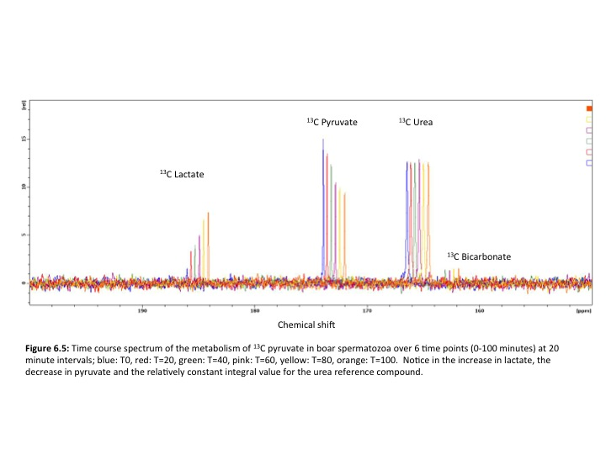



(a)

(b)

(c)

(d)

**Figure 6.6:** Mean integral value ±SD (n=15) for boar sperm metabolites (a) urea, (b) pyruvate, (c) lactate, (d) bicarbonate over time

Finally, bicarbonate remained constant over time (Figure 6.6d) with an average rate of change in LN integral value of 0.005 integral value/min. Under Greenhouse Geisserwith an F1.219, 17.064 = 1.34 the null hypothesis was not rejected (p=0.272) suggesting there is no difference in mean integral value for bicarbonate over the 6 time points.

### 6.5.2 Boar overnight NMR acquisition

High quality spermatozoa from 15 normozoospermic boars were analysed. A total of four 13C labelled metabolites were identified including pyruvate, lactate, bicarbonate and carbon dioxide (Figure 6.7).

### 6.5.3 Human real time metabolic rate

High quality spermatozoa from 9 normozoospermic, 2 oligozoospermic and 5 asthenozoospermic donors were analysed. A total of three 13C1 labelled metabolites were identified in human spermatozoa (Figure 6.8). The rate of metabolite production was calculated and a univariate ANOVA was performed to analyse the difference in mean integral values for each metabolite at each time point across classifications of ejaculate fertility. For example the integral value for lactate at 20 minutes for a normozoospermic sample was compared to the integral value for lactate of an oligozoospermic and asthenozoospermic sample at 20 minutes. There was no significant difference in any of the 3 metabolites at each time point between the 3 ejaculate phenotypes.

### 6.5.4 Human overnight NMR acquisition

High quality spermatozoa from 6 normozospermic, 1 oligozoospermic and 4 asthenozoospermic were analysed. A total of four 13C labelled metabolites were identified in human spermatozoa including pyruvate, lactate, bicarbonate and carbon dioxide (Figure 6.9). Individual metabolites were analysed separately.

#### 6.5.4.1. Pyruvate

Following a one-way ANOVA, F2,8, = 3.698, the null hypothesis was not rejected suggesting there is no difference in the mean pyruvate integral value in live spermatozoa from the three ejaculate phenotypes (p=0.073) (Figure 6.10).

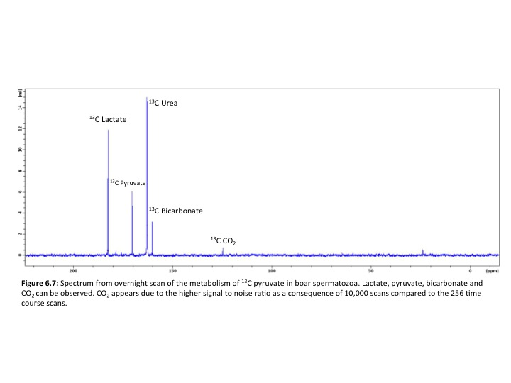

*Macintosh HD:Users:jackpearson:Desktop:Screen Shot 2017-06-15 at 09.15.09.png*

**(d)**

**(c)**

**(b)**

**(a)**



**Figure 6.8:** Average metabolite integral values from live human spermatozoa: **(a)** urea (control), **(b)** pyruvate, **(c)** lactate, **(d)** bicarbonate from 3 ejaculate phenotypes: NZ=normozoospermic, OZ =oligozoospermic and AZ= asthenozoospermic. Data shown are means ± SD.

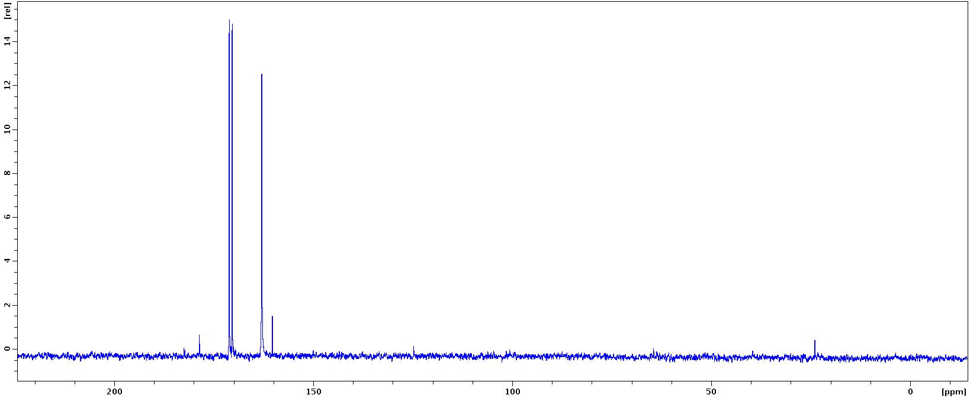

**Figure 6.9:** Spectrum from overnight scan of the metabolism of 13C pyruvate in human spermatozoa.Lactate, pyruvate, bicarbonate and CO2 can be observed. CO2 appears due to the higher signal to noise ratio as a consequence of 10,000 scans compared to the 256 time course scans.

13C Pyruvate

13C Lactate

13C Urea

13C Bicarbonate

13C CO2



**Figure 6.10:** Average metabolite integral values from the overnight scan of 13C pyruvate human spermatozoa samples from 3 ejaculate phenotypes: NZ =normozoospermic,

OZ= oligozoospermic and AZ= asthenozoospermic. Data shown are means ± SD.

##### **6.5.4.1.2 Lactate**

Following a one-way ANOVA, F2,8, = 0.838, the null hypothesis was not rejected suggesting there is no difference in the mean lactate integral values in live spermatozoa from the three ejaculate phenotypes (p=0.47) (Figure 6.10).

##### **6.5.4.1.3 Bicarbonate**

Following a one-way ANOVA, F2,8, = 0.61, the null hypothesis was not rejected suggesting there is no difference in the mean bicarbonate integral values in live spermatozoa from the three ejaculate phenotypes (p=0.57)(Figure 6.10).

##### **6.5.4.1.4 Carbon dioxide**

Following a one-way ANOVA, F2,8, = 0.563, the null hypothesis was not rejected suggesting there is no difference in the mean carbon dioxide integral values in live spermatozoa from the three ejaculate phenotypes (p=0.59)(Figure 6.10).

## 6.6 Discussion

The aims of the experiments in this chapter were to: (i) identify metabolite products of boar and human spermatozoa following the metabolism of 13C pyruvate, (ii) compare the 13C metabolite peaks of products from pyruvate metabolism from boar and human spermatozoa over time; and (iii) compare the metabolite peaks of products of pyruvate metabolism from human spermatozoa from different ejaculate phenotypes from overnight acquisitions.

### 6.6.1 Real time sperm metabolism

High quality spermatozoa from fifteen normozoospermic boars were analysed. A total of two 13C labelled metabolites were identified in boar and human spermatozoa, which were lactate and bicarbonate. This is promising as 13C NMR has identified the production of lactate further supporting the presence of glycolytic metabolism in mammalian sperm. It also identified bicarbonate, suggesting that OXPHOS is also operating alongside glycolysis.

#### 6.6.1.1 Boar spermatozoa

There was not a significant difference in the urea or bicarbonate integrals but there was a significant decrease in the pyruvate integral over time. Lactate also increased significantly over time. This is expected because the lactate peak can only have been formed from 13C pyruvate that was added. The NMR tube is a closed system and therefore metabolite peaks should change proportionally to each other. The significant increase in the lactate integral suggests that glycolytic metabolism is occurring in the boar sperm, which is in agreement with previous literature regarding mammalian sperm metabolism. (Miki et al., 2004, Ford, 2006, Storey, 2008, Nascimento et al., 2008). Unfortunately in the experiments discussed here, there was no statistically significant increase in bicarbonate, a metabolic intermediate of OXPHOS. Therefore, an involvement of OXPHOS or switching between metabolic pathways is suggested by these results but further investigation is required to support this.

#### 6.6.1.2 Human spermatozoa

High quality spermatozoa from nine normozoospermic, two oligozoospermic and five asthenozoospermic donors were incubated with 13C pyruvate. Comparison of pyruvate, lactate and bicarbonate over time between classes of fertility showed that there was no significant difference in any metabolite at each time point between normozoospermic, oligozoospermic and asthenozoospermic ejaculates. This lack of difference between normozoospermic, oligozoospermic and asthenozoospermic ejaculates suggests that high quality sperm from men with different ejaculate phenotypes may not differ biochemically. This is in contrast to studies of seminal plasma that found multiple metabolites including alanine, citrate, choline, glycerophosphorcholine, tyrosine and phenyalanine could be used to determine fertility (Gupta et al., 2011b). Furthermore lysine, arginine, tyrosine, citrate, proline and fructose in human seminal plasma have previously been used to define idiopathic infertility (Jayaraman et al., 2014). It was expected that pyruvate would be metabolised at a higher rate in sperm from normozoospermic samples compared to sperm from oligozoospermic and asthenozoospermic samples given that the motility of normozoospermic samples is higher and therefore the ATP demands to sustain motility are increased, and require more substrate. It was also expected that the lactate integral would be significantly higher in normozoospermic samples compared to oligozoospermic and asthenozoospermic given that lactate is a product of aerobic glycolysis in the sperm of many mammals (Miki, 2007). It was expected that the lactate integral differed over time as the pyruvate was metabolised and glycolytically converted in lactate during ATP production. Furthermore, the lack of difference between the amount of lactate produced and the ejaculate phenotypes which further supports the idea that high quality sperm selected from normozoospermic, oligozoospermic and asthenozoospermic men are biochemically similar. There was no significant difference in the bicarbonate integral at each time point between normozoospermic, oligozoospermic and asthenozoospermic samples. This suggests that OXPHOS was not utilised as a metabolic pathway within human spermatozoa under the conditions in the scanner.

Overall, human sperm may have metabolised 13C pyruvate but it was not statistically significantly different over time. The spermatozoa may have instead metabolised endogenous substrates making quantification of sperm metabolism using 13C NMR unsuccessful. In addition, reasons for the lack of significant change in metabolites could be explained by possible sedimentation within the NMR tube whilst in the scanner. Initially, the sperm are well mixed and evenly suspended within the media of the sample tube. Over time, they may have sunk due to gravity to the base of the tube which is not within the radio-frequency coils of the NMR scanner. Attempts were made to increase the height of the tube so that the bottom was within the rf coils however, this reduced the spectral quality as it was difficult to shim. Unless sperm are within the radiofrequency coils, their metabolite content cannot be measured. Methods of mixing throughout the 100 minutes would need to be developed so that sedimentation could be ruled out and more accurate monitoring of live sperm metabolism could be achieved.

### 6.6.1.3 Human overnight NMR acquisition

High quality sperm from six normozoospermic, one oligozoospermic and five asthenozoospermic ejaculates were scanned overnight. A total of four 13C metabolites were identified including pyruvate, lactate, bicarbonate and CO2. CO2 is probably now visible in the spectra due to the increased signal to noise ratio which occurs from the increased number of scans. The presence of CO2 and bicarbonate supports the idea that OXPHOS is operating in these sperm under these conditions.

The pyruvate metabolite integral did not significantly differ between the three ejaculate phenotypes when standardised using total integral and cell number. This was expected given that the time course experiments described in section 6.5.3 indicated that the human sperm were not metabolising exogenous 13C labelled pyruvate and instead could have metabolised endogenous substrates. If a different 13C labelled substrate had been used, such as 13C glucose, we may have expected the asthenozoospermic sperm to have metabolised the substrate at a slower rate and therefore expected to see a significant difference in the substrate integral following an overnight scan.

Furthermore, the lactate integral also did not significantly differ between the three ejaculate phenotypes when standardised for total integral and cell number. Once again this is not surprising given the given that the time course experiments (see section 6.5.3) indicated that the human sperm were not metabolising exogenous 13C labelled pyruvate and instead could have metabolised endogenous substrates.

The bicarbonate integral did not significantly differ between ejaculate phenotypes when standardised for total integral and cell number. Furthermore, the CO2 integral, although appears visually more prominent in overnight scans, due to increased signal to noise ratio, did not differ significantly between the three ejaculate phenotypes.

The substrates metabolised by sperm vary between species (Storey, 2008) however, generally sperm metabolise a variety of substrates including glucose, fructose, mannose and sorbitol (Goodson et al., 2012) and have the ability to metabolise fructose (Murdoch and White, 1968, Rigau et al., 2001) glycerol (Jones et al., 1992), sorbitol (Cao et al., 2009) and acetate through the glycolytic pathway (Frenkel et al., 1973). Therefore, there is potential to investigate sperm metabolism using real time and overnight long scans using 13C NMR of sperm from a variety of species using metabolites specific to the preferred substrate of the species.

# 7.0 General Discussion

This thesis planned to investigate the use of NMR to detect and monitor sperm and seminal plasma metabolites and thus determine its suitability for use in the clinical setting. Chapter 1 introduced sperm biology and the complexity of sperm metabolism, highlighting the variation in use of metabolic pathways OXPHOS and glycolysis among mammalian species, substrates metabolised and conditions that influence sperm metabolism. Furthermore, the use of traditional semen analysis was questioned and the failure of sperm function tests to be used routinely in clinical practice was discussed. It also introduced NMR and associated techniques previously employed to investigate disease and metabolism in the clinical setting. Although NMR had been used previously to investigate sperm metabolism, there was only a single study using NMR to investigate live sperm metabolism and therefore the majority of the literature described a snapshot of sperm metabolism. The potential of NMR to observe live sperm metabolism and the information gained from such studies seemed significant enough to warrant further investigation which was the purpose of experiments for this thesis.

Chapter 2 discussed the overall materials and methods employed, applicable to all chapters such as sperm washing, magnetic activated cell sorting and NMR techniques and parameters.

Chapter 3 used boar sperm to show that two NMR techniques required a large amount of essential optimisation before they could be used to investigate sperm metabolism further. Sperm viability in the scanner was also investigated and maximum spectral quality was achieved given the trade off between acquisition time, number of scans and sperm viability.

Chapter 4 investigated the ability of broadband and MAS NMR to detect changes in boar sperm metabolites when external stimuli including temperature and a pharmacological agent were used to stimulate a change in metabolism. 6 metabolites were identified using both NMR techniques and significant differences in lactate and citrate were observed when standardising metabolite integrals using total integral in the temperature experiments. This suggested that lactate could be a biomarker of sperm metabolism. When using alphachlorohydrin to alter sperm metabolism, there was a significant difference in the glucose/fructose peak. Broadband NMR was both sensitive enough to detect metabolites with the benefit of simplicity compared to Magic Angle Spinning NMR. Therefore, broadband NMR was taken forward for use in future experiments.

Chapter 5 investigated the metabolite content of high motility sperm form multiple ejaculates from the same male, and compared the metabolite content of high and low motility sperm and seminal plasma from multiple males of different classes of fertility. Results showed that there was no significant difference in intra ejaculate high motility sperm metabolites over time. Surprisingly no significant difference was found in high motility sperm from ejaculates of different phenotypes. Glutamate was the only seminal plasma metabolite that significantly distinguished asthenozoospermic ejaculates from normozoospermic and oligozoospermic.

Chapter 6 began the use of more sophisticated methodology using NMR to track the metabolism of labelled substrates in real time during their consumption by metabolising boar and human spermatozoa. Carbon 13 labelled pyruvate was metabolised and its metabolic products observed in sperm from varying classes of fertility. Pyruvate, lactate, and bicarbonate were identified from short time lapse experiments suggesting that glycolytic and OXPHOS metabolism pathways were being utilised. CO2 was identified in longer scans further supporting sperm utilising OXPHOS alongside glycolysis. No significant difference was identified in human spermatozoa from different classes of fertility in terms of rate of 13C pyruvate consumption.

**NMR can detect sperm and seminal plasma metabolites**

Previous research investigating the metabolite content of live spermatozoa using NMR consists of only 1 paper (Reynolds et al., 2017) alongside another that extracted sperm metabolites (Paiva et al., 2015). The studies by Paiva et al have proven successful in increasing our knowledge of the metabolic content of sperm and how this relates to their function and choice of metabolic pathway (Paiva et al., 2015). Furthermore, Reynolds et al further optimised sperm washing techniques to more accurately identify liver sperm metabolites, reducing spectral contamination by residual seminal plasma. For diagnosis of male infertility or development of a more advanced sperm function test, methods used by Paiva et al are adequate. A snapshot of sperm metabolite content, with further research, could be enough to classify a mans ejaculate as ‘good’ or ‘poor’ provided thresholds were defined for significant metabolites. However, results from Reynolds et al went further to show that there was a statistically significant difference in choline/GPC and lactate/lipid regions of live sperm metabolite spectrum from high motility, low motility and seminal plasma ejaculate fractions after washing. The difference in results could be explained by sample size (n=3 for Chapter 5 experiments compared to n=20 in Reynolds et al). The results of this thesis combined with previous research supports the use of NMR as a diagnostic technique however, It is clear that the link between the metabolic profile of a male and his fertility requires further confirmation. Although defining the metabolic content of spermatozoa is interesting and requires further work, is it enough to truly understand sperm function? The answer is no. In the same way that traditional semen analysis provides a visual description of an ejaculate, the metabolite content of sperm does not go far enough to investigate reasons for sperm dysfunction. The metabolite profile of sperm at one time point achieved using NMR is not enough to understand sperms ability to function through out the entire female reproductive tract. Consider hyperactivation, which takes place when semen pools in the vagina, this process is dynamic and the sperm do not switch between activated and hyperactivated motility instantly. The sperms metabolism may surge and therefore need to be monitored in real time to fully understand the requirements of the sperm *in vivo* for possible monitoring or replication using therapeutics *in vitro*. Furthermore, capacitation, the acrosome reaction and even fertilisation could potentially be metabolically profiled with the use of real time NMR. These are essential to conception and therefore future investigation of such processes is a priority over development of another sperm function test. Furthermore, development of therapeutics to supplement defective spermatozoa with metabolites they lack could be developed from the monitoring of real time sperm metabolism using NMR. The substrate requirements of spermatozoa could be highly variable through out their journey through the female reproductive tract and consequently analysis of this cannot be achieved on lysed unviable sperm.

The previous use of NMR to investigate male fertility includes studies on seminal plasma (SP) and dead spermatozoa metabolites. Seminal plasma is an important component of semen, providing a survival medium for sperm transport from ejaculation to deposition in the vagina (Juyena and Stelletta, 2012). However, this view has come under scrutiny given the advent of assisted reproductive technologies where washed sperm can fertilise the oocyte and result in viable embryos when the female reproductive tract has not come into contact with the SP (Juyena and Stelletta, 2012). On the other hand, studies in livestock have shown that storage of sperm with SP removed or diluted results in lower fertility rates than with natural mating (Tummaruk et al., 2000). Evidence does suggest that SP components contribute to key events related to sperm function, fertilisation and embryo development in the female reproductive tract (Juyena and Stelletta, 2012), however, an understanding of the effects of SP ingredients on spermatozoa is contradictory. The chemical composition of SP varies among species, among males within a species and among ejaculates of the same males (Killian et al., 1993, Aurich et al., 1996). Furthermore, differences in the composition of SP may be due to environmental factors including diet, enzymes present in SP and the metabolic activity of spermatozoa suspended in SP (Juyena and Stelletta, 2012). Therefore, analysis of SP must be unique to an individual and generalisations about SP metabolites and fertility cannot be made. A man may lack metabolite A in his SP but his sperm may preferentially metabolise metabolite B whilst another man’s sperm may require metabolite A for metabolism and function. Although previous research has analysed only SP using NMR (Gupta et al., 2011b, Gupta et al., 2011a, Sharma et al., 2001, Damai et al., 2010) (bearing in mind that SP should always be classed as a separate entity to spermatozoa), research should focus on the analysis of both components of semen. Chapter 5 achieved this by analysing the high and low quality spermatozoa and seminal plasma within an ejaculate from one male. Statistical analysis suggested that there was an overall significant difference in mean metabolite integrals between the 3 ejaculate phenotypes. Further statistical analysis suggested that glutamate was significantly different from ejaculates that were asthenozoospermic when compared to seminal plasma from normozoospermic and oligozoospermic ejaculates. Previous research into seminal plasma metabolites and their ability to determine forms of male infertility found that alanine, choline, citrate, glycerophosphorocholine tyrosine and phenylalanine could be used to determine fertility (Gupta et al., 2011b). However, comparison was between seminal plasma from normozoospermic and oligozoospermic men and did not consider asthenozoospermic seminal plasma metabolites. A higher sample size is needed and more samples from oligozoospermic and asthenozoospermic ejaculates are needed. One previous study has investigated the lipid content of human sperm and SP and performed a comparison (Schiller et al., 2000) however, the focus was on lipid content and the effect of cryopreservation and no other metabolites related to sperm metabolism were analysed.

In summary the answer is yes, NMR can detect metabolites in sperm and seminal plasma. Although they originate from different sources and are separate entities, future NMR studies should always encompass all components of the ejaculate with analysis of each taking place independently and comparison after. This will always ensure a comprehensive analysis of all aspects of the male reproductive system that work together to define a mans overall fertility.

**OXPHOS or Glycolysis?**

Mammalian spermatozoa specifically use ATP to maintain intracellular milieu and for cellular processes including motility, capacitation, hyperactivation and the acrosome reaction (Mannowetz et al., 2012, Mukai and Travis, 2012) which are all essential for successful fertilisation. To this day there is still controversy regarding the most significant pathway contributing towards energy production in spermatozoa (du Plessis et al., 2015). The most prevalent problem sperm face is that ATP must be delivered along the entire length of the flagellum which means that a variety of metabolic strategies must be employed to generate it (Rees et al., 1990). The question remains as to whether mitochondrial ATP can diffuse rapidly enough along the entire length of the flagellum to support the energy requirements of fast beating activity. Multiple biophysicists have calculated the rate of diffusion of ATP required to support motility in bull and sea urchin spermatozoa (Nevo and Rikmensp, 1970, Adam and Wei, 1975) and concluded that the rate of ATP diffusion is sufficient to maintain the beat frequency of the flagellum. Furthermore, mitochondrial membrane potential has previously been found to correlate with sperm motility and fertilisation ability (Troiano et al., 1998, Donnelly et al., 2000, Kasai et al., 2002, Wang et al., 2003). A positive correlation between mitochondrial membrane potential and non linear motility has also been suggested in asthenozoospermic patients (Paoli et al., 2011). However, there is plenty of evidence contradicting this, including a study suggesting that regardless of the metabolic pathway used (OXPHOS or glycolysis) the diffusion capacity was insufficient to meet the requirements of high energy areas in the flagellum (Tombes and Shapiro, 1987). It is not clear whether human sperm have this problem (Turner, 2003). It is also known that products of ATP hydrolysis including ADP, inorganic phosphate and H+ must be removed to avoid kinetic and thermodynamic stress (Oberholzer et al., 2007). This has lead to research proposing that there is a need for ATP production close to the site of ATP utilisation and that this is achieved by the glycolytic pathway of ATP production due to the presence of glycolytic enzymes in the fibrous sheath of the flagellum (Westhoff and Kamp, 1997). Furthermore, mammalian spermatozoa can use a variety of carbohydrates as substrates for ATP generation (Williams and Ford, 2001, Frenette et al., 2006, Urner and Sakkas, 1999) which allows for ATP generation in the cytoplasm regardless of mitochondrial activity (Westhoff and Kamp, 1997).

Substrates used in metabolism vary between species and is the deciding factor in which metabolic pathway for ATP production to support capacitation (Storey, 2008). It all depends on the availability of extracellular substrates. Glycolysis can be employed to provide ATP for motility however, in the absence of glycolytic substrates, sperm metabolise respiratory substrates (Mukai and Okuno, 2004). Respiratory substrates function as substrates for gluconeogenesis in the midpiece, producing glucose that can diffuse to all regions of the sperm flagellum. Bull sperm depend on OXPHOS to support capacitation (Hutson et al., 1977), human sperm appear to depend on glucose-derived ATP (Urner and Sakkas, 1996, Williams and Ford, 2001). Although glucose derived ATP is an immediate source of energy, mitochondrial activity increases during sperm capacitation (Boell, 1985, Fraser and Quinn, 1981). Mitochondria are known to occupy a major proportion of the total cell volume (15%-22%) (Turner, 2003) and are located only on the mid-piece. A mature spermatozoon contains approximately 72-80 mitochondria which contribute to significant processes including the acrosome reaction and oocyte penetration (Rajender et al., 2010).

Several glycolytic enzymes specific to the spermatogenic cell have been identified in the fibrous sheath of spermatozoa including hexokinase, phosphoglucokinase isomerase, phophofructokinase, LDH and glyceraldehyde-3-phophate dehydrogenase (GAPD) (Kim et al., 2007, Westhoff and Kamp, 1997, Bradley et al., 1996, Bunch et al., 1998, Mori et al., 1998, Travis et al., 1998). GAPD-S is a gene that is specific to mouse spermatozoa (Miki et al., 2004) and its human variant is GAPD-2. It is a key regulator of glycolysis during spermatogenesis and also the target of a number of environmental compounds that reduce male fertility (Mohri et al., 1975). GAPD-S knock out mice studies have shown that they have low motility and exhibit no progressive motility (Miki et al., 2004). Further studies have sequenced and cloned the c-DNA from the human analogue GAPD-2 and suggested that it could have similar roles in human spermatozoa (Frayne et al 2009). Studies focussing on LDH-C, a spermatogenic cell variant and a glycolytic enzyme (Odet et al., 2011, Boatman and Robbins, 1991) conclude that it catalyses the conversion of pyruvate to lactate which is essential for sperm motility during aerobic respiration. Disruption of this gene in mice results in a lack of tyrosine phosphorylation and hyperactive motility necessary for capacitation. (73). Furthermore, using glycolytic inhibitors, spermatozoa pyruvate and lactate production was decreased as well as sperm motility even in the presence of mitochondrial substrates (Mukai and Okuno, 2004). This suggests that glycolysis is a key contributor to sperm motility. The ATP content was also assessed and regardless of the presence or absence of pyruvate along with the glycolytic inhibitor, the ATP concentration remained the same. This further suggests that normal mitochondrial respiration is not sufficient to maintain the concentration of ATP needed for sperm flagella motility. Carbonyl cyanide m-chlorophenylhydrazine (CCCP) inhibits mitochondrial ATP production. When added to active mice spermatozoa it had no effect on ATP content and motility parameters suggesting that mitochondrial respiration does not play a vital role in sperm motility (Mukai and Okuno, 2004). It has also been suggested that OXPHOS is not necessary for hyperactivated motility in rhesus macaque monkeys (Hereng et al., 2011).

Analysis of the literature clearly shoes species specificity for preference of metabolic pathways for spermatozoa ATP generation. In human spermatozoa, several studies have proposed that glycolysis is the predominant pathway for ATP production, even in the presence of oxygen. However, the efficiency of ATP production through OXPHOS during aerobic respiration cannot be ignored. The role of mitochondrial respiration in sperm maturation and differentiation must not be underestimated and overall both pathways appear to be essential for human sperm function and successful fertilisation. Furthermore, in human spermatozoa nothing is set in stone. Mitochondrial respiration (OXPHOS) or glycolysis may take place independently at any one time or simultaneously to provide ATP.

The results of this thesis support the overall debate in the literature that both pathways of metabolism take place in mammalian spermatozoa. These results add to scientific knowledge that NMR can be used as another method of sperm metabolism analysis, which has not previously been achieved in live sperm. Unfortunately, the results from this thesis cannot contribute to either side of the debate. It is clear from the metabolite spectra that products of both pathways of metabolism are present (lactate for glycolysis and bicarbonate and CO2 for OXPHOS) but the favourability of either pathway for ATP production under the conditions within the scanner cannot be quantified. Furthermore, the literature discusses how processes such as hyperactivation, capacitation and the acrosome reaction that occur within the female reproductive tract, often stimulate a change in use of metabolic pathway (usually from glycolytic to OXPHOS as OXPHOS yields more ATP). The results from this thesis have laid the foundations for the further investigation of these complex processes. Hyperactivation and capacitation could be measured within the scanner in real time and give a more precise indication of ATP demand and how this is met through the use of glycolysis and OXPHOS during key processes leading up to fertilisation. Also the availability of substrates within secretions such as oviductal fluid in the female reproductive tract define pathways of metabolism in human spermatozoa. Given that the substrate content of sections from the female reproductive tract may be unique to the individual due to genetics, environment and lifestyle, its important to now analyse sperm metabolism using NMR whilst exposing sperm to a variety of substrates.

Although a contribution to the debate of spermatozoa metabolism was not possible, these results support the theory of a combination of two metabolic pathways generating ATP for sperm function and motility. It provides the foundations for future research into metabolic substrates and how they determine metabolic pathways and the metabolism during key processes that are essential for successful fertilisation.

**Is NMR in Andrology clinically useful?**

Current clinical Andrology focuses on the use of ‘traditional’ semen analysis techniques using light microscopy and a trained biomedical scientist. This method has come under scrutiny regarding its accuracy and diagnostic ability, which has led to the development of more sophisticated sperm function tests. There are two areas of clinical interest apparent in Andrology (i) do we need more accurate and sophisticated diagnostic methods? (ii) Do we need to delve deeper and develop a new sperm function test. The short answer is yes to both questions however, those sperm function tests that have been previously developed have all failed to make it into routine clinical practice.

Although traditional semen analysis has been used for over half a century, it serves a purpose and research supports the ability of sperm count, total sperm number and percentage morphologically normal sperm successfully predicting time-to-pregnancy which is a marker of fecundity (Bonde et al., 1998, Zinaman et al., 2000, Louis et al., 2014). In the UK we are lucky enough to have guidelines for semen analysis in Andrology outlined by the WHO with the use of the 5th edition of the manual for semen analysis being widespread. However, there have been previous issues raised regarding variation in accuracy between clinics in the UK (Matson, 1995, Riddell et al., 2005) and the USA (Keel et al., 2002) which led to the development of training programs and external quality assurance programs in Andrology (Bjorndahl et al., 2002, Franken et al., 2010, Franken and Kruger, 2006, Pacey, 2006, Pacey, 2010). International and national societies of Andrology, reproductive medicine, human reproduction and pathology have contributed further by training technologists in the standardised methods of routine semen analysis. However, despite all of this, the use of these parameters cannot precisely and accurately predict the fertility of a man (Wang and Swerdloff, 2014). This is because there are a host of other factors in addition to sperm and semen quality that contribute to the ability of sperm to fertilise an oocyte. Semen analysis is now considered a limited method of defining a man’s fertility, providing nothing more than a visual description of an ejaculate. However, it is cost effective, quick and provides a reason for infertility giving a couple an explanation as to why they cannot conceive. An approximate cost for each semen analysis performed in the NHS andrology laboratory in Sheffield is around £60. It currently functions well alongside assisted reproductive technologies such as IVF and ICSI where oligozoospermia or asthenozoospermia are not an issue as ICSI bypasses the journey of the spermatozoa through the female reproductive tract, and even fertilisation itself. But scientists do not know the long-term effects of ICSI. And clinicians are simply bypassing a journey, which is naturally selective on sperm and using cells from a substandard ejaculate to create embryos. Although this technique is now fundamental in clinical embryology, efforts must still be made to investigate the root cause of poor sperm function.

The history of the development of sperm function tests is one of false advances in that much excitement has developed surrounding the development of new tests when in the long term they’ve achieved little clinical significance (Barratt et al., 2011, Pacey, 2010). This has been due to two main reasons (i) poor technical and methodological control of purported assays (ii) low quality clinical trial information from poor experimental design and low numbers. Sperm DNA damage testing is a prime example with a plethora of studies suggesting it has a strong association with impaired fertilisation, slow early embryo development, reduced implantation, miscarriage and in animal studies birth defects in offspring (Lewis et al., 2013). Disadvantages of this technique arise because sperm with high a proportion of fragmented DNA cannot be excluded from samples as the sample is destroyed during analysis. Therefore, it can only be used to guide couples with high DNA damage and those with low DNA damage to IUI and IVF. Once again this is just another test that requires the use of assisted reproductive techniques and does not offer any explanation of the cause of the DNA fragmentation and there are no avenues for development of therapeutics. Furthermore, three comprehensive reviews of the clinical data concluded that the significance of sperm DNA integrity assessment for natural and ART remains unclear (Collins et al., 2008, Barratt et al., 2010, Sakkas and Alvarez, 2010). Finally in support of this, clinical practice guidelines published by the British Fertility Society (2015) concluded that *‘there is evidence of a relationship between sperm DNA damage and either semen parameters and/or outcome of assisted conception. However, reports conflict and depend largely on the laboratory test utilized. Results are unlikely to alter patient management’*.

Another example of developments in andrology that fail to reach routine clinical practice is that of computer aided sperm analysis (CASA). Although the latest WHO manual (WHO, 2010) recommends a CASA system as a selective means to analyse semen samples, experts still question the accuracies of clinical application of CASA (Lu et al., 2014). Furthermore, users of CASA in clinical laboratories prefer using it whilst knowing little about the principles of CASA systems and the sources of analytical errors resulting in significant differences in semen analysis results and consequent misdiagnosis of patients. There are multiple factors influencing the accuracy of CASA results including frame rate (Castellini et al., 2011),counting chambers (Hu et al., 2006), algorithms (Mortimer and Swan, 1999), sperm concentration and its affects of motility accuracy (Spiropoulos, 2001). Overall, although CASA systems are widely used in clinical laboratories, this technique is still riddled with problems including How to define the normal reference value of the CASA parameter? Which velocity or type of sperm movement will benefit fertilisation with the egg? How to define the threshold between nonprogressive and immotile spermatozoa or between grade c and d spermatozoa? How to determine the proportion of spermatozoa with normal morphology and activity? And since the use of ICSI became common in ART, the analysis of sperm motion parameters has become less important and so CASA’s use clinically has weakened. Traditional semen analysis therefore still has its place over CASA in routine clinical practice given its simplicity and the information it gives to a clinician at lesser cost through training and expensive equipment.

1H NMR has been used extensively in the clinical setting in analysing the biochemistry of tissue samples including kidney (Moka et al., 1997), adipose tissue (Moka et al., 1998) red blood cells (Humpfer et al., 1997), prostate (Tomlins et al., 1998a) and brain tissue (Cheng et al., 1997). 1H NMR has now been acknowledged as a global approach to identifying metabolites and thus gaining an insight into the metabolism of a cell (Cudalbu et al., 2012). So far the method has enabled the identification of a number of mechanisms of disease including Huntington’s disease, liver trauma and urinary tract infection (Jenkins et al., 1993), (Ranjan et al., 2006), (Gupta et al., 2006).

The use of NMR for biochemical analysis of a number of tissues (DeFeo and Cheng, 2010; Bathen et al., 2010; Chan et al., 2009; Burns et al., 2004; Martinez-Granados et al., 2011; Rocha et al., 2010) has been a great success and it is an extremely valuable technique in the field of metabolomics, which continues to evolve. However, its success has been primarily in the research setting and to use it in routine clinical practice still requires further development. Firstly, to make the experiments conducted for this thesis more efficient, an automated sample changer could be installed. Increasing the number of samples scanned per day would reduce the cost of scanning each sample and therefore make it more suitable for routine clinical practice. This would also reduce sample-processing time and make NMR more suitable to cope with high workloads associated with clinical andrology. Superconducting magnets such as the one used for experiments in this thesis have large running costs associated with cryogens that keep the magnet cool. On average it costs around £30 to run a sample if 12 samples a day were to be run on the scanner used in these experiments. This is half the price of traditional semen analysis however, it does not take into account the initial cost of the scanner being around £400,00 as well as the cost of reagents and time washing the sperm ready for analysis in the scanner. To reduce this cost further bench top NMR scanners have been developed (Benchtop NMR Spectrometer-Pulsar, Oxford Instruments, Abingdon, UK). These do not require cryogens and do not need a dedicated room for them to operate. They are also considerably cheaper to initially purchase. Unfortunately at this stage the strongest magnet available is 60MHz compared to the 400MHz scanner used in these experiments. This would not currently be strong enough to detect metabolites in spermatozoa in a timeframe suited to the clinical setting. They also have the added benefit of being easy to use and largely automated meaning that specialist training would not be necessary.

Overall NMR in andrology has striking potential. Detailed information regarding sperm metabolites and pathways of metabolism utilised could be quickly obtained and used in therapeutics to increase sperm function. It offers information to clinicians and the patient beyond the scope of previously developed sperm function tests. However, development in equipment is preventing its transition into the clinical setting. Furthermore, more research needs to be conducted regarding its ability to determine the fertilising potential of spermatozoa *in vivo*.

Although the development of more sophisticated sperm function tests has been a battlefield, new technology is still being introduced to improve sperm function and the chances of conception. Researchers in Germany began working on ‘Spermbots’ or sperm flagella driven Micro-Bio-Robot (MBR), which consist of a bovine spermatozoa, which is captured inside a Ti/Fe nanomembrane (Magdanz and Schmidt, 2014). This nanomembrane is rolled up in to a 50μm long microtubule, which is self-propelled by the sperm cell and guided using external magnetic force. This paper describes the success of early attempts to control the direction of spermatozoa in two dimensions and its possible future in controlling guidance of a single sperm in physiological environments. This concept was recently taken further with the development of artificially motorised sperm cells using a novel type of hybrid micromotor, where customised microhelices functioned as motists for transporting sperm with motion deficiencies to assist in their natural function (Medina-Sanchez et al., 2016). The researchers claimed they were able to capture, transport and release a single immotile live spermatozoa cell in fluidic channels that mimic physiological conditions. Although there are many challenges still to overcome, this looks to be a promising approach towards assisted reproduction that would rival techniques such as ICSI being that it is less invasive.

Recent developments in sperm function testing and enhancement are fascinating but even the latest approach such as the ‘Spermbot’ simply take a defective sperm and manipulate ways to transport it to the oocyte. This may be enough to achieve conception in some cases however, it is well known that sperm motility is not the only cause of infertility. NMR and metabolomics allows investigation within the spermatozoa to find out what is really going on that causes defects in motility and sperm function. And this has the potential to monitor sperm from the point of ejaculation and through essential processes within the female reproductive tract. ‘Spermbots’ are a significant contribution to development of assisted reproductive techniques however, sperm function testing aims to reduce the need for them and therefore ‘Spermbots’ appear to be another sperm function test that could be less invasive than ICSI.

**Limitations**

Shortcomings of the results from this thesis centre on the low sample number from all classifications of fertility. A surprisingly high proportion of donors were normozoospermic. It was expected that around 1 in 4 donors would have sperm parameters that classed them as infertile however, this was not the case. Donors were recruited on the University campus and therefore samples from donors were only representative of a narrow age range of younger men. The lifestyle of younger students is also not representative of the general population and therefore sampling from a wider age range and occupation would be desirable. For future experiments and to overcome the limitations of the results in this thesis, NHS ethical approval could be obtained to gain access to a high number of samples from a variety of classifications of fertility. NHS ethics requires a lengthy application before approval and therefore was not obtained for the experiments in this thesis.

An instrumental shortcoming was the strength of the NMR magnet. The NMR magnet used in these experiments was 400MHz whilst metabolic studies of other tissues in the literature used strengths up to 600MHz. 400MHz was sufficient to measure sperm metabolites as outlined in this thesis however, 600MHz scanner would be more sensitive and therefore detect metabolites that were present at lower concentrations in the same amount of time as the 400MHz. This could explain the low number of metabolites detected in spermatozoa compared to previous studies.

Furthermore, all results from the experiments performed in this thesis relate *in vitro* experiments that represent sperm metabolism under conditions experienced by them within the scanner. Therefore, much more research is needed to draw conclusions regarding sperm metabolism *in vivo.*

**Future studies**

To take the experiments in this thesis further, it would be beneficial to use another analysis technique to further support findings on sperm metabolism. Mass spectrometry (MS) has been used previously to study the human sperm metabolome as a complementary technique alongside 1H NMR (Paiva et al., 2015). Using the two methods, 69 metabolites were identified, 42 by NMR, 27 by MS and just 4 by both. This shows how the use of two techniques could dramatically increase detection of metabolites. Moreover, the research findings described above were performed on lysed sperm, which means there is still an avenue of research employing these two methods to study live sperm metabolism.

Another NMR technique that could also advance findings on sperm metabolism further is that of hyperpolarised dynamic nuclear polarisation (HP DNP) NMR. This technique overcomes the limitation of standard NMR having low sensitivity. Using HP DNP NMR, signal intensity can be increased by up to 10,000 times and it consequently allows detection of the introduced metabolic agent, and its metabolic products in real time, in a similar way to 13C NMR used in this thesis experiments. This technique could increase our knowledge of the sperm metabolome further and is also well suited for analysis of split second events such as hyperactivation and the acrosome reaction as it takes <10 seconds for the scan to take place, still yielding 10 000 times the signal compared to conventional NMR.

Moving away from technical enhancement, the experiments in this thesis used pyruvate as a substrate for investigation of live sperm metabolism. There are many other substrates available with the 13C isotope incorporated including fructose, glucose, sorbitol and maltose. The lack of understanding of spermatozoa metabolism in terms of substrate preference through out transit through the female reproductive tract and consequent utilisation of the appropriate metabolic pathway suggests that experiments using a variety of substrates could shed light on sperm metabolism further.

In conclusion it is hoped that the work presented in this thesis will provide the base for future experiments using NMR to investigate sperm metabolism and its significance to key processes through out the female reproductive tract. Its future use in routine clinical practice is a possibility but its power to investigate the root cause of sperm dysfunction appears much more intriguing.

# References

2015, T. Semen quality and its relationship to natural and assisted conception. *British Fertility Society Guidlines for Practice. Human Ferility, in Press*.

Adam, D. E. & Wei, J. 1975. Mass-Transport of ATP Within Motile Sperm. *Journal of Theoretical Biology,* 49**,** 125-145.

Adams, R. W., Holroyd, C. M., Aguilar, J. A., Nilsson, M. & Morris, G. A. 2013. "Perfecting" WATERGATE: clean proton NMR spectra from aqueous solution. *Chemical Communications,* 49**,** 358-360.

Agarwal, A., Saleh, R. A. & Bedaiwy, M. A. 2003. Role of reactive oxygen species in the pathophysiology of human reproduction. *Fertility and Sterility,* 79**,** 829-843.

Agarwal, A., Tvrda, E. & Sharma, R. 2014. Relationship amongst teratozoospermia, seminal oxidative stress and male infertility. *Reproductive Biology and Endocrinology,* 12.

Aitken, R. J. 2006. Sperm function tests and fertility. *International Journal of Andrology,* 29**,** 69-74.

Aitken, R. J., Baker, M. A. & Nixon, B. 2015. Are sperm capacitation and apoptosis the opposite ends of a continuum driven by oxidative stress. *Asian Journal of Andrology,* 17**,** 633-639.

Aitken, R. J., Clarkson, J. S. & Fishel, S. 1989. Generation Of Reactive Oxygen Species, Lipid-Peroxidation, And Human-Sperm Function. *Biology of Reproduction,* 41**,** 183-197.

Aitken, R. J., Harkiss, D., Knox, W., Paterson, M. & Irvine, D. S. 1998. A novel signal transduction cascade in capacitating human spermatozoa characterised by a redox-regulated, cAMP-mediated induction of tyrosine phosphorylation. *Journal of Cell Science,* 111**,** 645-656.

Aitken, R. J., Irvine, D. S. & Wu, F. C. 1991. Prospective Analysis Of Sperm-Oocyte Fusion And Reactive Oxygen Species Generation As Criteria For The Diagnosis Of Infertility. *American Journal of Obstetrics and Gynecology,* 164**,** 542-551.

Aitken, R. J., Smith, T. B., Jobling, M. S., Baker, M. A. & De Iuliis, G. N. 2014. Oxidative stress and male reproductive health. *Asian Journal of Andrology,* 16**,** 31-38.

Aitken, R. J., Thatcher, S., Glasier, A. F., Clarkson, J. S., Wu, F. C. W. & Baird, D. T. 1987. Relative Ability Of Modified Versions Of The Hamster Oocyte Penetration Test, Incorporating Hyperosmotic Medium Or The Ionophore A23187, To Predict Ivf Outcome. *Human Reproduction,* 2**,** 227-231.

Aitken, R. J., Whiting, S., De Iuliis, G. N., Mcclymont, S., Mitchell, L. A. & Baker, M. A. 2012. Electrophilic Aldehydes Generated by Sperm Metabolism Activate Mitochondrial Reactive Oxygen Species Generation and Apoptosis by Targeting Succinate Dehydrogenase. *Journal of Biological Chemistry,* 287**,** 33048-33060.

Al-Mously, N., Cross, N. A., Eley, A. & Pacey, A. A. 2009. Real-time polymerase chain reaction shows that density centrifugation does not always remove Chlamydia trachomatis from human semen. *Fertility and Sterility,* 92**,** 1606-1615.

Albarracin, J. L., Fernandez-Novell, J. M., Ballester, J., Rauch, M. C., Quintero-Moreno, A., Pena, A., Mogas, T., Rigau, T., Yanez, A., Guinovart, J. J., Slebe, J. C., Concha, Ii & Rodriguez-Gil, J. E. 2004. Gluconeogenesis-linked glycogen metabolism is important in the achievement of in vitro capacitation of dog spermatozoa in a medium without glucose. *Biology of Reproduction,* 71**,** 1437-1445.

Alberts, B., Johnson, A., Lewis, J., Roberts, K. & Walter, P. 2015. *Molecular Biology of the Cell,* New York, Gartland Science.

Alukal, J. P. & Lamb, D. J. 2008. Intracytoplasinic sperm injection (ICSI) - What are the risks? *Urologic Clinics of North America,* 35**,** 277-+.

Alvarez, C., Castilla, J. A., Martinez, L., Ramirez, J. P., Vergara, F. & Gaforio, J. J. 2003. Biological variation of seminal parameters in healthy subjects. *Human Reproduction,* 18**,** 2082-2088.

Amaral, A., Castillo, J., Maria Estanyol, J., Luis Ballesca, J., Ramalho-Santos, J. & Oliva, R. 2013. Human Sperm Tail Proteome Suggests New Endogenous Metabolic Pathways. *Molecular & Cellular Proteomics,* 12**,** 330-342.

Amaral, A., Castillo, J., Ramalho-Santos, J. & Oliva, R. 2014. The combined human sperm proteome: cellular pathways and implications for basic and clinical science. *Human Reproduction Update,* 20**,** 40-62.

Amaral, A., Paiva, C., Baptista, M., Sousa, A. P. & Ramalho-Santos, J. 2011. Exogenous glucose improves long-standing human sperm motility, viability, and mitochondrial function. *Fertility and Sterility,* 96**,** 848-850.

Andrew, E. R., Bradbury, A. & Eades, R. G. 1959. Removal of dipolar broadening of nuclear magnetic resonance spectra of solids by specimen rotation. *Nature,* 183**,** 1802-1803.

Anwar, M. A., Shalhoub, J., Vorkas, P. A., Lim, C. S., Want, E. J., Nicholson, J. K., Holmes, E. & Davies, A. H. 2012. In-vitro Identification of Distinctive Metabolic Signatures of Intact Varicose Vein Tissue via Magic Angle Spinning Nuclear Magnetic Resonance Spectroscopy. *European Journal of Vascular and Endovascular Surgery,* 44**,** 442-450.

Aue, W. P., Bartholdi, E. & Ernst, R. R. 1976. 2-Dimensional Spectroscopy - Application To Nuclear Magnetic-Resonance. *Journal of Chemical Physics,* 64**,** 2229-2246.

Aurich, J. E., Kuhne, A., Hoppe, H. & Aurich, C. 1996. Seminal plasma affects membrane integrity and motility of equine spermatozoa after cryopreservation. *Theriogenology,* 46**,** 791-797.

Awoniyi, C. A., Sprando, R. L., Santulli, R., Chandrashekar, V., Ewing, L. L. & Zirkin, B. R. 1990. Restoration Of Spermatogenesis By Exogenously Administered Testosterone In Rats Made Azoospermic By Hypophysectomy Or Withdrawal Of Luteinizing-Hormone Alone. *Endocrinology,* 127**,** 177-184.

Azpiazu, R., Amaral, A., Castillo, J., Maria Estanyol, J., Guimera, M., Lluis Ballesca, J., Balasch, J. & Oliva, R. 2014. High-throughput sperm differential proteomics suggests that epigenetic alterations contribute to failed assisted reproduction. *Human Reproduction,* 29**,** 1225-1237.

Baker, M. A., Naumovski, N., Hetherington, L., Weinberg, A., Velkov, T. & Aitken, R. J. 2013. Head and flagella subcompartmental proteomic analysis of human spermatozoa. *Proteomics,* 13**,** 61-74.

Baldi, E., Luconi, M., Bonaccorsi, L., Krausz, C. & Forti, G. 1996. Human sperm activation during capacitation and acrosome reaction: Role of calcium, protein phosphorylation and lipid remodelling pathways. *Frontiers in Bioscience (online),* 1**,** D189-205.

Bar, G., Lunenfeld, E. & Levitas, E. 2014. Klinefelter syndrome: genetic aspects, characteristics and reproduction--present and future. *Harefuah,* 153**,** 342-366.

Barazani, Y., Stahl, P. J., Nagler, H. M. & Stember, D. S. 2012. Management of ejaculatory disorders in infertile men. *Asian Journal of Andrology,* 14**,** 525-529.

Barratt, C. L. R., Aitken, R. J., Bjorndahl, L., Carrell, D. T., De Boer, P., Kvist, U., Lewis, S. E. M., Perreault, S. D., Perry, M. J., Ramos, L., Robaire, B., Ward, S. & Zini, A. 2010. Sperm DNA: organization, protection and vulnerability: from basic science to clinical applications-a position report. *Human Reproduction,* 25**,** 824-838.

Barratt, C. L. R., Mansell, S., Beaton, C., Tardif, S. & Oxenham, S. K. 2011. Diagnostic tools in male infertility-the question of sperm dysfunction. *Asian Journal of Andrology,* 13**,** 53-58.

Barros, C., Vigil, P., Herrera, E., Arguello, B. & Walker, R. 1984. Selection of morphologically abnormal sperm by human cervical mucus. *Archives of andrology,* 12 Suppl**,** 95-107.

Bathen, T. F., Sitter, B., Sjobakk, T. E., Tessem, M.-B. & Gribbestad, I. S. 2010. Magnetic Resonance Metabolomics of Intact Tissue: A Biotechnological Tool in Cancer Diagnostics and Treatment Evaluation. *Cancer Research,* 70**,** 6692-6696.

Beck, L. R. & Boots, L. R. 1977. The comparative anatomy, histology and morphology of the mammalian oviduct. *Academic Press, London 1974: i-xvi, 1-369.***,** 1-52,illust.

Beckonert, O., Coen, M., Keun, H. C., Wang, Y., Ebbels, T. M. D., Holmes, E., Lindon, J. C. & Nicholson, J. K. 2010. High-resolution magic-angle-spinning NMR spectroscopy for metabolic profiling of intact tissues. *Nature Protocols,* 5**,** 1019-1032.

Benchaib, M., Lornage, J., Mazoyer, C., Lejeune, H., Salle, B. & Guerin, J. F. 2007. Sperm deoxyribonucleic acid fragmentation as a prognostic indicator of assisted reproductive technology outcome. *Fertility and Sterility,* 87**,** 93-100.

Benoit, J. 1926. Anatomical, cytological, and histophysiological researches on the excretory ducts of the testis in mammals. On general cytological problems relative to the glandular cells. *Arch Anal Hist Et Emb,* 5**,** 173-412.

Benten, W. P. M., Lieberherr, M., Giese, G., Wrehlke, C., Stamm, O., Sekeris, C. E., Mossmann, H. & Wunderlich, F. 1999. Functional testosterone receptors in plasma membranes of T cells. *Faseb Journal,* 13**,** 123-133.

Berg, T., Stryer 2002. *Biochemistry* New York, W.H. Freeman & Co Ltd.

Bezprozvanny, I., Watras, J. & Ehrlich, B. E. 1991. Bell-shaped calcium-response curves of INS(1,4,5)P3-gated and calcium-gated channels from endoplasmic-reticulum of cerebellum. *Nature,* 351**,** 751-754.

Bjorndahl, L., Barratt, C. L. R., Fraser, L. R., Kvist, U. & Mortimer, D. 2002. ESHRE basic semen analysis courses 1995-1999: immediate beneficial effects of standardized training. *Human Reproduction,* 17**,** 1299-1305.

Blanco, A. & Zinkham, W. H. 1963. Lactate Dehydrogenases In Human Testes. *Science,* 139**,** 601-&.

Bleil, J. D. & Wassarman, P. M. 1980. Mammalian Sperm-Egg Interaction - Identification Of A Glycoprotein In Mouse Egg Zonae Pellucidae Possessing Receptor Activity For Sperm. *Cell,* 20**,** 873-882.

Blomstrand, E., Radegran, G. & Saltin, B. 1997. Maximum rate of oxygen uptake by human skeletal muscle in relation to maximal activities of enzymes in the Krebs cycle. *Journal of Physiology-London,* 501**,** 455-460.

Boatman, D. E. & Robbins, R. S. 1991. Bicarbonate - Carbon-Dioxide Regulation Of Sperm Capacitation, Hyperactivated Motility, And Acrosome Reactions. *Biology of Reproduction,* 44**,** 806-813.

Boell, E. J. 1985. Oxygen-Consumption Of Mouse Sperm And Its Relationship To Capacitation. *Journal of Experimental Zoology,* 234**,** 105-116.

Boivin, J., Bunting, L., Collins, J. A. & Nygren, K. G. 2007. International estimates of infertility prevalence and treatment-seeking: potential need and demand for infertility medical care. *Human Reproduction,* 22**,** 1506-1512.

Bojesen, A. & Gravholt, C. H. 2007. Klinefelter syndrome in clinical practice. *Nature Clinical Practice Urology,* 4**,** 192-204.

Bonde, J. P. E., Ernst, E., Jensen, T. K., Hjollund, N. H. I., Kolstad, H., Henriksen, T. B., Scheike, T., Giwercman, A., Olsen, J. & Skakkebaek, N. E. 1998. Relation between semen quality and fertility: a population-based study of 430 first-pregnancy planners. *Lancet,* 352**,** 1172-1177.

Bork, K., Chevrier, C., Paquignon, M., Jouannet, P. & Dacheux, J. L. 1988. Flagellar Motility And Movement Of Boar Spermatozoa During Epididymal Transit. *Reproduction Nutrition Development,* 28**,** 1307-1315.

Bradley, M. P., Geelan, A., Leitch, V. & Goldberg, E. 1996. Cloning sequencing and characterization of LDH-C-4 from a fox testis cDNA library. *Molecular Reproduction and Development,* 44**,** 452-459.

Brindle, J. T., Antti, H., Holmes, E., Tranter, G., Nicholson, J. K., Bethell, H. W. L., Clarke, S., Schofield, P. M., Mckilligin, E., Mosedale, D. E. & Grainger, D. J. 2002. Rapid and noninvasive diagnosis of the presence and severity of coronary heart disease using H-1-NMR-based metabonomics. *Nature Medicine,* 8**,** 1439-1444.

Brucker, C. & Lipford, G. B. 1995. The human sperm acrosome reaction: Physiology and regulatory mechanisms: An update. *Human Reproduction Update,* 1**,** 51-62.

Buffone, M. G., Calamera, J. C., Verstraeten, S. V. & Doncel, G. F. 2005. Capacitation-associated protein tyrosine phosphorylation and membrane fluidity changes are impaired in the spermatozoa of asthenozoospermic patients. *Reproduction,* 129**,** 697-705.

Buffone, M. G., Hirohashi, N. & Gerton, G. L. 2014. Unresolved Questions Concerning Mammalian Sperm Acrosomal Exocytosis. *Biology of Reproduction,* 90.

Bujan, L. 1995. Blood hormonal profiles and semen biochemical markers in azoospermia due to congenital bilateral absence of vas deferens. *Epididymis: Role and Importance in Male Infertility Treatment,* 11**,** 219-234.

Bunch, D. O., Welch, J. E., Magyar, P. L., Eddy, E. M. & O'brien, D. A. 1998. Glyceraldehyde 3-phosphate dehydrogenase-S protein distribution during mouse spermatogenesis. *Biology of Reproduction,* 58**,** 834-841.

Bungum, M., Humaidan, P., Axmon, A., Spano, M., Bungum, L., Erenpreiss, J. & Giwercman, A. 2007. Sperm DNA integrity assessment in prediction of assisted reproduction technology outcome. *Human Reproduction,* 22**,** 174-179.

Burgess, S. A., Walker, M. L., Sakakibara, H., Knight, P. J. & Oiwa, K. 2003. Dynein structure and power stroke. *Nature,* 421**,** 715-718.

Burkman, L. J. 1984. Characterization Of Hyperactivated Motility By Human-Spermatozoa During Capacitation - Comparison Of Fertile And Oligozoospermic Sperm Populations. *Archives of Andrology,* 13**,** 153-165.

Burkman, L. J., Kruger, T. F., Coddington, C. C., Rosenwaks, Z., Franken, D. R. & Hodgen, G. D. 1988. The Hemizona Assay (Hza) - Development Of A Diagnostic-Test For The Binding Of Human-Spermatozoa To The Human Hemizona Pellucida To Predict Fertilization Potential. *Fertility and Sterility,* 49**,** 688-697.

Burns, M. A., He, W. L., Wu, C. L. & Cheng, L. L. 2004. Quantitative pathology in tissue MR spectroscopy based human prostate metabolomics. *Technology in Cancer Research & Treatment,* 3**,** 591-598.

Calvin, H. I. 1981. Comparative Labeling Of Rat Epididymal Spermatozoa By Intratesticularly Administered (Zncl2)-Zn-65 And Cysteine-S-35. *Journal of Reproduction and Fertility,* 61**,** 65-73.

Canales, B. K., Zapzalka, D. M., Ercole, C. J., Carey, P., Haus, E., Aeppli, D. & Pryor, J. L. 2005. Prevalence and effect of varicoceles in an elderly population. *Urology,* 66**,** 627-631.

Cao, W., Aghajanian, H. K., Haig-Ladewig, L. A. & Gerton, G. L. 2009. Sorbitol Can Fuel Mouse Sperm Motility and Protein Tyrosine Phosphorylation via Sorbitol Dehydrogenase. *Biology of Reproduction,* 80**,** 124-133.

Carlsen, E., Giwercman, A., Keiding, N. & Skakkebaek, N. E. 1992. Evidence For Decreasing Quality Of Semen During Past 50 Years. *British Medical Journal,* 305**,** 609-613.

Carvajal, G., Cuello, C., Ruiz, M., Vazquez, J. M., Martinez, E. A. & Roca, J. 2004. Effects of centrifugation before freezing on boar sperm cryosurvival. *Journal of Andrology,* 25**,** 389-396.

Castellini, C., Dal Bosco, A., Ruggeri, S. & Collodel, G. 2011. What is the best frame rate for evaluation of sperm motility in different species by computer-assisted sperm analysis? *Fertility and Sterility,* 96**,** 24-27.

Castillo, J., Amaral, A., Azpiazu, R., Vavouri, T., Maria Estanyol, J., Lluis Ballesca, J. & Oliva, R. 2014a. Genomic and proteomic dissection and characterization of the human sperm chromatin. *Molecular Human Reproduction,* 20**,** 1041-1053.

Castillo, J., Amaral, A. & Oliva, R. 2014b. Sperm nuclear proteome and its epigenetic potential. *Andrology,* 2**,** 326-338.

Cayan, S. & Woodhouse, C. R. J. 2007. The treatment of adolescents presenting with a varicocele. *Bju International,* 100**,** 744-747.

Cengiz, T., Aydoganli, L., Baykam, M., Mungan, N. A., Tuncbilek, E., Dincer, M., Yakupoglu, K. & Akalin, Z. 1997. Chlamydial infections and male infertility. *International Urology and Nephrology,* 29**,** 687-693.

Cesari, A., Kaiser, G. G., Mucci, N., Mutto, A., Vincenti, A., Fornes, M. W. & Alberio, R. H. 2006. Integrated morphophysiological assessment of two methods for sperm selection in bovine embryo production in vitro. *Theriogenology,* 66**,** 1185-1193.

Chamley, L. W. & Clarke, G. N. 2007. Antisperm antibodies and conception. *Seminars in Immunopathology,* 29**,** 169-184.

Chan, E. C. Y., Koh, P. K., Mal, M., Cheah, P. Y., Eu, K. W., Backshall, A., Cavill, R., Nicholson, J. K. & Keun, H. C. 2009. Metabolic Profiling of Human Colorectal Cancer Using High-Resolution Magic Angle Spinning Nuclear Magnetic Resonance (HR-MAS NMR) Spectroscopy and Gas Chromatography Mass Spectrometry (GC/MS). *Journal of Proteome Research,* 8**,** 352-361.

Chandrashekran, A., Isa, I., Dudhia, J., Thrasher, A. J., Dibb, N., Casimir, C., Readhead, C. & Winston, R. 2014. Lentiviral vector transduction of spermatozoa as a tool for the study of early development. *Febs Open Bio,* 4**,** 266-275.

Chen, M. J. & Bongso, A. 1999. Comparative evaluation of two density gradient preparations for sperm separation for medically assisted conception. *Human Reproduction,* 14**,** 759-764.

Cheng, L. L., Ma, M. J., Becerra, L., Ptak, T., Tracey, I., Lackner, A. & Gonzalez, R. G. 1997. Quantitative neuropathology by high resolution magic angle spinning proton magnetic resonance spectroscopy. *Proceedings of the National Academy of Sciences of the United States of America,* 94**,** 6408-6413.

Cherry, N., Moore, H., Mcnamee, R., Pacey, A., Burgess, G., Clyma, J. A., Dippnall, M., Baillie, H., Povey, A. & Participating Ctr Chaps, U. K. 2008. Occupation and male infertility: glycol ethers and other exposures. *Occupational and Environmental Medicine,* 65**,** 708-714.

Chevrier, C. & Dacheux, J. L. 1992. Evolution Of The Flagellar Wave-Form Of Ram Spermatozoa In Relation To The Degree Of Epididymal Maturation. *Cell Motility and the Cytoskeleton,* 23**,** 8-18.

Cho, C., Jung-Ha, H., Willis, W. D., Goulding, E. H., Stein, P., Xu, Z., Schultz, R. M., Hecht, N. B. & Eddy, E. M. 2003. Protamine 2 deficiency leads to sperm DNA damage and embryo death in mice. *Biology of Reproduction,* 69**,** 211-217.

Claridge, T. D. W. 1999. *High-Resolution NMR Techniques in Organic Chemistry,* Oxford, Pergamon.

Claridge, T. D. W. 2009. *High-Resolution NMR Techniques in Organic Chemistry,* Oxford, UK, Elsevier.

Clarke, A. & Fraser, K. P. P. 2004. Why does metabolism scale with temperature? *Functional Ecology,* 18**,** 243-251.

Clayton, T. A., Lindon, J. C., Cloarec, O., Antti, H., Charuel, C., Hanton, G., Provost, J. P., Le Net, J. L., Baker, D., Walley, R. J., Everett, J. R. & Nicholson, J. K. 2006. Pharmaco-metabonomic phenotyping and personalized drug treatment. *Nature,* 440**,** 1073-1077.

Clendinen, C. S., Stupp, G. S., Ajredini, R., Lee-Mcmullen, B., Beecher, C. & Edison, A. S. 2015. An overview of methods using C-13 for improved compound identification in metabolomics and natural products. *Frontiers in Plant Science,* 6.

Collins, J. A., Barnhart, K. T. & Schlegel, P. N. 2008. Do sperm DNA integrity tests predict pregnancy with in vitro fertilization? *Fertility and Sterility,* 89**,** 823-831.

Cooley, J. W. & Tukey, J. W. 1965. An Algorithm For Machine Calculation Of Complex Fourier Series. *Mathematics of Computation,* 19**,** 297-&.

Cooper, T. G., Jockenhovel, F. & Nieschlag, E. 1991. Variations In Semen Parameters From Fathers. *Human Reproduction,* 6**,** 859-866.

Cooper, T. G., Weidner, W. & Nieschlag, E. 1990. The Influence Of Inflammation Of The Human Male Genital-Tract On Secretion Of The Seminal Markers Alpha-Glucosidase, Glycerophosphocholine, Carnitine, Fructose And Citric-Acid. *International Journal of Andrology,* 13**,** 329-336.

Courant, F., Antignac, J.-P., Monteau, F. & Le Bizec, B. 2013. Metabolomics as a Potential New Approach for Investigating Human Reproductive Disorders. *Journal of Proteome Research,* 12**,** 2914-2920.

Cudalbu, C., Lanz, B., Duarte, J. M. N., Morgenthaler, F. D., Pilloud, Y., Mlynarik, V. & Gruetter, R. 2012. Cerebral glutamine metabolism under hyperammonemia determined in vivo by localized H-1 and N-15 NMR spectroscopy. *Journal of Cerebral Blood Flow and Metabolism,* 32**,** 696-708.

Cummins, J. M., Pember, S. M., Jequier, A. M., Yovich, J. L. & Hartmann, P. E. 1991. A Test Of The Human Sperm Acrosome Reaction Following Ionophore Challenge - Relationship To Fertility And Other Seminal Parameters. *Journal of Andrology,* 12**,** 98-103.

Custo, G. M., Lauro, V., Saitto, C. & Frongillo, R. F. 1989. Chlamydial Infection And Male-Infertility - An Epidemiological-Study. *Archives of Andrology,* 23**,** 243-248.

Dacheux, J.-L. & Dacheux, F. 2014. New insights into epididymal function in relation to sperm maturation. *Reproduction,* 147**,** R27-R42.

Damadian, R. 1971. Tumor detection by Nuclear Magnetic Resonance. *Science,* 171**,** 1151-&.

Damai, R. S., Sankhala, R. S., Anbazhagan, V. & Swamy, M. J. 2010. (31)P NMR and AFM Studies on the Destabilization of Cell and Model Membranes by the Major Bovine Seminal Plasma Protein, PDC-109. *Iubmb Life,* 62**,** 841-851.

Daniel, R. M., Danson, M. J., Eisenthal, R., Lee, C. K. & Peterson, M. E. 2008. The effect of temperature on enzyme activity: new insights and their implications. *Extremophiles,* 12**,** 51-59.

Daniel, R. M., Peterson, M. E., Danson, M. J., Price, N. C., Kelly, S. M., Monk, C. R., Weinberg, C. S., Oudshoorn, M. L. & Lee, C. K. 2010. The molecular basis of the effect of temperature on enzyme activity. *Biochemical Journal,* 425**,** 353-360.

Darszon, A., Nishigaki, T., Beltran, C. & Trevino, C. L. 2011. Calcium Channels In The Development, Maturation, And Function Of Spermatozoa. *Physiological Reviews,* 91**,** 1305-1355.

Darszon, A., Trevino, C. L., Wood, C., Galindo, B., Rodriguez-Miranda, E., Acevedo, J. J., Hernandez-Gonzalez, E. O., Beltran, C., Martinez-Lopez, P. & Nishigaki, T. 2007. Ion channels in sperm motility and capacitation. *Society of Reproduction and Fertility supplement,* 65**,** 229-44.

De Jonge, C. 2005. Biological basis for human capacitation. *Human Reproduction Update,* 11**,** 205-214.

Defeo, E. M. & Cheng, L. L. 2010. Characterizing Human Cancer Metabolomics with ex vivo H-1 HRMAS MRS. *Technology in Cancer Research & Treatment,* 9**,** 381-391.

Delamirande, E., Leclerc, P. & Gagnon, C. 1997. Capacitation as a regulatory event that primes spermatozoa for the acrosome reaction and fertilization. *Molecular Human Reproduction,* 3**,** 175-194.

Delbes, G., Hales, B. F. & Robaire, B. 2010. Toxicants and human sperm chromatin integrity. *Molecular Human Reproduction,* 16**,** 14-22.

Detour, J., Elbayed, K., Piotto, M., Moussallieh, F. M., Nehlig, A. & Namer, I. J. 2011. Ultra fast in vivo microwave irradiation for enhanced metabolic stability of brain biopsy samples during HRMAS NMR analysis. *Journal of Neuroscience Methods,* 201**,** 89-97.

Dieterle, S., Mahony, J. B., Luinstra, K. E. & Stibbe, W. 1995. Chlamydial Immunoglobulin Igg And Iga Antibodies In Serum And Semen Are Not Associated With The Presence Of Chlamydia-Trachomatis Dna Or Ribosomal-Rna In Semen From Male Partners Of Infertile Couples. *Human Reproduction,* 10**,** 315-319.

Donnelly, E. T., O'connell, M., Mcclure, N. & Lewis, S. E. M. 2000. Differences in nuclear DNA fragmentation and mitochondrial integrity of semen and prepared human spermatozoa. *Human Reproduction,* 15**,** 1552-1561.

Dorado, J., Alcaraz, L., Duarte, N., Portero, J. M., Acha, D., Demyda, S., Munoz-Serrano, A. & Hidalgo, M. 2011. Centrifugation on Pure Sperm (R) density-gradient improved quality of spermatozoa from frozen-thawed dog semen. *Theriogenology,* 76**,** 381-385.

Dragileva, E., Rubinstein, S. & Breitbart, H. 1999. Intracellular Ca2+-Mg2+-ATPase regulates calcium influx and acrosomal exocytosis in bull and ram spermatozoa. *Biology of Reproduction,* 61**,** 1226-1234.

Dreann, C., Seguin, F., Cosson, J., Suquet, M. & Billard, R. 2000. H-1-NMR and P-31-NMR analysis of energy metabolism of quiescent and motile turbot (Psetta maxima) spermatozoa. *Journal of Experimental Zoology,* 286**,** 513-522.

Du Plessis, S. S., Agarwal, A., Mohanty, G. & Van Der Linde, M. 2015. Oxidative phosphorylation versus glycolysis: what fuel do spermatozoa use. *Asian Journal of Andrology,* 17**,** 230-235.

Duran, E. H., Morshedi, M., Taylor, S. & Oehninger, S. 2002. Sperm DNA quality predicts intrauterine insemination outcome: a prospective cohort study. *Human Reproduction,* 17**,** 3122-3128.

Eggertkruse, W., Buhlingergopfarth, N., Rohr, G., Probst, S., Aufenanger, J., Naher, H. & Runnebaum, B. 1996. Antibodies to Chlamydia trachomatis in semen and relationship with parameters of male fertility. *Human Reproduction,* 11**,** 1408-1417.

Eggertkruse, W., Gerhard, I., Naher, H., Tilgen, W. & Runnebaum, B. 1990. Chlamydial infection- A female and or male infertility factor. *Fertility and Sterility,* 53**,** 1037-1043.

Eggertkruse, W., Rohr, G., Demirakca, T., Rusu, R., Naher, H., Petzoldt, D. & Runnebaum, B. 1997. Chlamydial serology in 1303 asymptomatic subfertile couples. *Human Reproduction,* 12**,** 1464-1475.

Ehrlich, S. 2015. Effect of fertility and infertility on longevity. *Fertility and Sterility,* 103**,** 1129-1135.

Ehrlich, S., Williams, P. L., Missmer, S. A., Flaws, J. A., Ye, X., Calafat, A. M., Petrozza, J. C., Wright, D. & Hauser, R. 2012. Urinary bisphenol A concentrations and early reproductive health outcomes among women undergoing IVF. *Human Reproduction,* 27**,** 3583-3592.

Erecinska, M. & Wilson, D. F. 1977. On the mechanism of regulation of cellular respiration. The dependence of respiration on the cytosolic ATP , ADP and PI. *Advances in experimental medicine and biology,* 94**,** 271-8.

Ernst, R. R. & Anderson, W. A. 1966. Application Of Fourier Transform Spectroscopy To Magnetic Resonance. *Review of Scientific Instruments,* 37**,** 93-+.

Eshre 1996. Consensus workshop on advanced diagnostic andrology techniques. ESHRE (European Society of Human Reproduction and Embryology) Andrology Special Interest Group. *Human reproduction (Oxford, England),* 11**,** 1463-79.

Evenson, D. P., Jost, L. K., Marshall, D., Zinaman, M. J., Clegg, E., Purvis, K., De Angelis, P. & Claussen, O. P. 1999. Utility of the sperm chromatin structure assay as a diagnostic and prognostic tool in the human fertility clinic. *Human Reproduction,* 14**,** 1039-1049.

Fawcett, D. W. 1975. Mammalian Spermatozoon. *Developmental Biology,* 44**,** 394-436.

Ferramosca, A., Provenzano, S. P., Coppola, L. & Zara, V. 2012. Mitochondrial Respiratory Efficiency is Positively Correlated With Human Sperm Motility. *Urology,* 79**,** 809-814.

Ficarro, S., Chertihin, O., Westbrook, V. A., White, F., Jayes, F., Kalab, P., Marto, J. A., Shabanowitz, J., Herr, J. C., Hunt, D. F. & Visconti, P. E. 2003. Phosphoproteome analysis of capacitated human sperm - Evidence of tyrosine phosphorylation of a kinase-anchoring protein 3 and valosin-containing protein/p97 during capacitation. *Journal of Biological Chemistry,* 278**,** 11579-11589.

Florman, H. M. & Wassarman, P. M. 1985. O-Linked Oligosaccharides Of Mouse Egg Zp3 Account For Its Sperm Receptor Activity. *Cell,* 41**,** 313-324.

Ford, W. C. L. 2006. Glycolysis and sperm motility: does a spoonful of sugar help the flagellum go round? *Human Reproduction Update,* 12**,** 269-274.

Forti, G. & Krausz, C. 1998. Evaluation and treatment of the infertile couple. *Journal of Clinical Endocrinology & Metabolism,* 83**,** 4177-4188.

Forti, G., Krausz, C., Cilotti, A. & Maggi, M. 2003. Varicocele and infertility. *Journal of Endocrinological Investigation,* 26**,** 564-569.

Franken, D. R., Aneck-Hahn, N., Lombaard, C. & Kruger, T. F. 2010. Semenology training programs: 8 years' experience. *Fertility and Sterility,* 94**,** 2615-2619.

Franken, D. R. & Kruger, T. F. 2006. Lessons learned from a sperm morphology quality control programme. *Andrologia,* 38**,** 225-229.

Franken, D. R., Kruger, T. F., Oehninger, S., Coddington, C. C., Lombard, C., Smith, K. & Hodgen, G. D. 1993. The Ability Of The Hemizona Assay To Predict Human Fertilization In Different And Consecutive In-Vitro Fertilization Cycles. *Human Reproduction,* 8**,** 1240-1244.

Franken, D. R. & Oehninger, S. 2006. The clinical significance of sperm-zona pellucida binding: 17 years later. *Frontiers in Bioscience,* 11**,** 1227-1233.

Franklin, L. E. 1968. Formation Of Redundant Nuclear Envelope In Monkey Spermatids. *Anatomical Record,* 161**,** 149-&.

Fraser, L. R. & Lane, M. R. 1987. Capacitation-Related And Fertilization-Related Alterations In Mouse Sperm Oxygen-Consumption. *Journal of Reproduction and Fertility,* 81**,** 385-393.

Fraser, L. R. & Quinn, P. J. 1981. A Glycolytic Product Is Obligatory For Initiation Of The Sperm Acrosome Reaction And Whiplash Motility Required For Fertilization In The Mouse. *Journal of Reproduction and Fertility,* 61**,** 25-35.

Frayne, J., Taylor, A., Cameron, G. & Hadfield, A. T. 2009. Structure of Insoluble Rat Sperm Glyceraldehyde-3-phosphate Dehydrogenase (GAPDH) via Heterotetramer Formation with Escherichia coli GAPDH Reveals Target for Contraceptive Design. *Journal of Biological Chemistry,* 284**,** 22703-22712.

Freeman, M. R., Archibong, A. E., Mrotek, J. J., Whitworth, C. M., Weitzman, G. A. & Hill, G. A. 2001. Male partner screening before in vitro fertilization: preselecting patients who require intracytoplasmic sperm injection with the sperm penetration assay. *Fertility and Sterility,* 76**,** 1113-1118.

Frenette, G., Thabet, M. & Sullivan, R. 2006. Polyol pathway in human epididymis and semen. *Journal of Andrology,* 27**,** 233-239.

Frenkel, G., Peterson, R. N. & Freund, M. 1973. Changes In Metabolism Of Guinea-Pig Sperm From Different Segments Of Epididymis. *Proceedings of the Society for Experimental Biology and Medicine,* 143**,** 1231-1236.

Galantino-Homer, H. L., Florman, H. M., Storey, B. T., Dobrinski, I. & Kopf, G. S. 2004. Bovine sperm capacitation: Assessment of phosphodiesterase activity and intracellular alkalinization on capacitation-associated protein tyrosine phosphorylation. *Molecular Reproduction and Development,* 67**,** 487-500.

Gillooly, J. F., Brown, J. H., West, G. B., Savage, V. M. & Charnov, E. L. 2001. Effects of size and temperature on metabolic rate. *Science,* 293**,** 2248-2251.

Giskeodegard, G. F., Grinde, M. T., Sitter, B., Axelson, D. E., Lundgren, S., Fjosne, H. E., Dahl, S., Gribbestad, I. S. & Bathen, T. F. 2010. Multivariate Modeling and Prediction of Breast Cancer Prognostic Factors Using MR Metabolomics. *Journal of Proteome Research,* 9**,** 972-979.

Gmachl, M., Sagan, S., Kreil, G. & Ketter, S. 1993. The Human Sperm Protein Ph-20 Has Hyaluronidase Activity. *Febs Letters,* 336**,** 545-548.

Gnaiger, E. 2001. Bioenergetics at low oxygen: dependence of respiration and phosphorylation on oxygen and adenosine diphosphate supply. *Respiration Physiology,* 128**,** 277-297.

Goldberg, E., Sberna, D., Wheat, T. E., Urbanski, G. J. & Margoliash, E. 1977. Cytochrome-C - Immunofluorescent Localization Of Testis-Specific Form. *Science,* 196**,** 1010-1012.

Goodson, S. G., Qiu, Y., Sutton, K. A., Xie, G., Jia, W. & O'brien, D. A. 2012. Metabolic Substrates Exhibit Differential Effects on Functional Parameters of Mouse Sperm Capacitation. *Biology of Reproduction,* 87.

Gray, L. R., Tompkins, S. C. & Taylor, E. B. 2014. Regulation of pyruvate metabolism and human disease. *Cellular and Molecular Life Sciences,* 71**,** 2577-2604.

Gregoriou, O., Vitoratos, N., Papadias, C., Gregoriou, G. & Zourlas, P. A. 1989. The Role Of Chlamydial Serology In Fertile And Subfertile Men. *European Journal of Obstetrics Gynecology and Reproductive Biology,* 30**,** 53-58.

Guerin, J. F., Benali, H., Rollet, J., Souchier, C. & Czyba, J. C. 1986. Alpha-Glucosidase As A Specific Epididymal Enzyme Marker - Its Validity For The Etiologic Diagnosis Of Azoospermia. *Journal of Andrology,* 7**,** 156-162.

Gupta, A., Dwivedi, M., Gowda, G. a. N., Mahdi, A. A., Jain, A., Ayyagari, A., Roy, R., Bhandari, M. & Khetrapal, C. L. 2006. H-1 NMR spectroscopy in the diagnosis of Klebsiella pneumoniae-induced urinary tract infection. *Nmr in Biomedicine,* 19**,** 1055-1061.

Gupta, A., Dwivedi, M., Mahdi, A. A., Gowda, G. a. N., Khetrapal, C. L. & Bhandari, M. 2009. (1)H-nuclear magnetic resonance spectroscopy for identifying and quantifying common uropathogens: a metabolic approach to the urinary tract infection. *Bju International,* 104**,** 236-244.

Gupta, A., Mahdi, A. A., Shukla, K. K., Ahmad, M. K., Bansal, N., Sankhwar, P. & Sankhwar, S. N. 2013. Efficacy of Withania somnifera on seminal plasma metabolites of infertile males: A proton NMR study at 800 MHz. *Journal of Ethnopharmacology,* 149**,** 208-214.

Gupta, A., Mandi, A. A., Ahmad, M. K., Shukla, K. K., Bansal, N., Jaiswer, S. P. & Shankhwar, S. N. 2011a. A proton NMR study of the effect of Mucuna pruriens on seminal plasma metabolites of infertile males. *Journal of Pharmaceutical and Biomedical Analysis,* 55**,** 1060-1066.

Gupta, A., Mandi, A. A., Ahmad, M. K., Shukla, K. K., Jaiswer, S. P. & Shankhwar, S. N. 2011b. (1)H NMR spectroscopic studies on human seminal plasma: A probative discriminant function analysis classification model. *Journal of Pharmaceutical and Biomedical Analysis,* 54**,** 106-113.

Gupta, A., Mandi, A. A., Ahmad, M. K., Shukla, K. K., Jaiswer, S. P. & Shankhwar, S. N. 2011c. H-1 NMR spectroscopic studies on human seminal plasma: A probative discriminant function analysis classification model. *Journal of Pharmaceutical and Biomedical Analysis,* 54**,** 106-113.

Gupta, S. K. 2015. Role of zona pellucida glycoproteins during fertilization in humans. *Journal of Reproductive Immunology,* 108**,** 90-97.

Gupta, S. K., Bhandari, B., Shrestha, A., Biswal, B. K., Palaniappan, C., Malhotra, S. S. & Gupta, N. 2012. Mammalian zona pellucida glycoproteins: structure and function during fertilization. *Cell and Tissue Research,* 349**,** 665-678.

Gur, Y. & Breitbart, H. 2008. Protein synthesis in sperm: Dialog between mitochondria and cytoplasm. *Molecular and Cellular Endocrinology,* 282**,** 45-55.

Habermann, B. & Krause, W. 1999. Altered sperm function or sperm antibodies are not associated with chlamydial antibodies in infertile men with leucocytospermia. *Journal of the European Academy of Dermatology and Venereology,* 12**,** 25-29.

Hall, J. A., Fishel, S. B., Timson, J. A., Dowell, K. & Klentzeris, L. D. 1995. Human Sperm Morphology Evaluation Pre-Percoll And Post-Percoll Gradient Centrifugation. *Human Reproduction,* 10**,** 342-346.

Hamamah, S., Seguin, F., Bujan, L., Barthelemy, C., Mieusset, R. & Lansac, J. 1998. Quantification by magnetic resonance spectroscopy of metabolites in seminal plasma able to differentiate different forms of azoospermia. *Human Reproduction,* 13**,** 132-135.

Hanson, F. W. & Overstreet, J. W. 1981. The Interaction Of Human-Spermatozoa With Cervical-Mucus Invivo. *American Journal of Obstetrics and Gynecology,* 140**,** 173-178.

Harper, C. V., Cummerson, J. A., White, M. R. H., Publicover, S. J. & Johnson, P. M. 2008. Dynamic resolution of acrosomal exocytosis in human sperm. *Journal of Cell Science,* 121**,** 2130-2135.

Harper, C. V. & Publicover, S. J. 2005. Reassessing the role of progesterone in fertilization - compartmentalized calcium signalling in human spermatozoa? *Human Reproduction,* 20**,** 2675-2680.

Harrison, R. a. P. & Miller, N. G. A. 2000. cAMP-dependent protein kinase control of plasma membrane lipid architecture in boar sperm. *Molecular Reproduction and Development,* 55**,** 220-228.

Harwood, L. & Claridge, T. 1996. *Introduction to Organic Spectroscopy,* New York, OXford University Press.

Helmreich, E. & Cori, C. F. 1965. Regulation of glycolysis in muscle. *Advance Enzyme Regulat,* 3**,** 91-107.

Henkel, R. R. & Schill, W.-B. 2003. Sperm preparation for ART. *Reproductive biology and endocrinology : RB&E,* 1**,** 108-108.

Hereng, T. H., Elgstoen, K. B. P., Cederkvist, F. H., Eide, L., Jahnsen, T., Skalhegg, B. S. & Rosendal, K. R. 2011. Exogenous pyruvate accelerates glycolysis and promotes capacitation in human spermatozoa. *Human Reproduction,* 26**,** 3249-3263.

Ho, H. C., Granish, K. A. & Suarez, S. S. 2002. Hyperactivated motility of bull sperm is triggered at the axoneme by Ca2+ and not cAMP. *Developmental Biology,* 250**,** 208-217.

Ho, H. C. & Suarez, S. S. 2001a. Hyperactivation of mammalian spermatozoa: function and regulation. *Reproduction,* 122**,** 519-526.

Ho, H. C. & Suarez, S. S. 2001b. An inositol 1,4,5-trisphosphate receptor-gated intracellular Ca2+ store is involved in regulating sperm hyperactivated motility. *Biology of Reproduction,* 65**,** 1606-1615.

Ho, H. C. & Suarez, S. S. 2003. Characterization of the intracellular calcium store at the base of the sperm flagellum that regulates hyperactivated motility. *Biology of Reproduction,* 68**,** 1590-1596.

Holt, W. V. & Harrison, R. a. P. 2002. Bicarbonate stimulation of boar sperm motility via a protein kinase A-dependent pathway: Between-cell and between-ejaculate differences are not due to deficiencies in protein kinase A activation. *Journal of Andrology,* 23**,** 557-565.

Honig, S. C., Lipshultz, L. I. & Jarow, J. 1994. Significant Medical Pathology Uncovered By A Comprehensive Male-Infertility Evaluation. *Fertility and Sterility,* 62**,** 1028-1034.

Hook, S. J. & Hafez, E. S. E. 1968. A Comparative Anatomical Study Of Mammalian Uterotubal Junction. *Journal of Morphology,* 125**,** 159-&.

Hore, P., Jones, J. & Wimperis, S. 2000. *NMR, the toolkit,* Oxford, Oxford University Press.

Hoshi, K., Tsukikawa, S. & Sato, A. 1991. Importance Of Ca2+, K+ And Glucose In The Medium For Sperm Penetration Through The Human Zona-Pellucida. *Tohoku Journal of Experimental Medicine,* 165**,** 99-104.

Hosseinzadeh, S., Eley, A. & Pacey, A. A. 2004. Semen quality of men with asymptomatic chlamydial infection. *Journal of Andrology,* 25**,** 104-109.

Hotaling, J. & Carrell, D. T. 2014. Clinical genetic testing for male factor infertility: current applications and future directions. *Andrology,* 2**,** 339-350.

Houston, B., Curry, B. & Aitken, R. J. 2015. Human spermatozoa possess an IL4I1 L-amino acid oxidase with a potential role in sperm function. *Reproduction,* 149**,** 587-596.

Hu, Y.-A., Lu, J.-C., Lu, N.-Q., Shao, Y. & Huang, Y.-F. 2006. Comparison of four methods for sperm counting. *Zhonghua nan ke xue = National journal of andrology,* 12**,** 222-227.

Humpfer, E., Spraul, M., Nicholls, A. W., Nicholson, J. K. & Lindon, J. C. 1997. Direct observation of resolved intracellular and extracellular water signals in intact human red blood cells using H-1 MAS NMR spectroscopy. *Magnetic Resonance in Medicine,* 38**,** 334-336.

Hung, P.-H., Froenicke, L., Lin, C. Y., Lyons, L. A., Miller, M. G., Pinkertone, K. E. & Vandevoort, C. A. 2009. Effects of environmental tobacco smoke in vivo on rhesus monkey semen quality, sperm function, and sperm metabolism. *Reproductive Toxicology,* 27**,** 140-148.

Hunter, R. H. F. 1981. Sperm Transport And Reservoirs In The Pig Oviduct In Relation To The Time Of Ovulation. *Journal of Reproduction and Fertility,* 63**,** 109-117.

Hunter, R. H. F. 2005. Fallopian tube physiology: Preliminaries to monospermic fertilization and cellular events post-fertilization. *New Mechanisms for Tissue-Selective Estrogen-Free Contraception,* 52**,** 245-261.

Hutson, S. M., Vandop, C. & Lardy, H. A. 1977. Mitochondrial Metabolism Of Pyruvate In Bovine Spermatozoa. *Journal of Biological Chemistry,* 252**,** 1309-1315.

Huttemann, M., Jaradat, S. & Grossman, L. I. 2003. Cytochrome c oxidase of mammals contains a testes-specific isoform of subunit VIb - the counterpart to testes-specific cytochrome c? *Molecular Reproduction and Development,* 66**,** 8-16.

Hwang, K., Lipshultz, L. I. & Lamb, D. J. 2011. Use of diagnostic testing to detect infertility. *Current urology reports,* 12**,** 68-76.

Irvine, D. S. 1998. Epidemiology and aetiology of male infertility. *Human Reproduction,* 13**,** 33-44.

Ishijima, S., Baba, S. A., Mohri, H. & Suarez, S. S. 2002. Quantitative analysis of flagellar movement in hyperactivated and Acrosome-reacted golden hamster spermatozoa. *Molecular Reproduction and Development,* 61**,** 376-384.

Janulis, L., Bahr, J. M., Hess, R. A., Janssen, S., Osawa, Y. & Bunick, D. 1998. Rat testicular germ cells and epididymal sperm contain active P450 aromatase. *Journal of Andrology,* 19**,** 65-71.

Jarow, J. P. & Zirkin, B. R. 2005. The androgen microenvironment of the human testis and hormonal control of spermatogenesis. *Testicular Cell Dynamics and Endocrine Signaling,* 1061**,** 208-220.

Jayaraman, V., Ghosh, S., Sengupta, A., Srivastava, S., Sonawat, H. M. & Narayan, P. K. 2014. Identification of biochemical differences between different forms of male infertility by nuclear magnetic resonance (NMR) spectroscopy. *Journal of Assisted Reproduction and Genetics,* 31**,** 1195-1204.

Jefferys, A., Siassakos, D. & Wardle, P. 2012. The management of retrograde ejaculation: a systematic review and update. *Fertility and Sterility,* 97**,** 306-U551.

Jenkins, B. G., Koroshetz, W. J., Beal, M. F. & Rosen, B. R. 1993. Evidence For Impairment Of Energy-Metabolism In-Vivo In Huntingtons-Disease Using Localized H-1-Nmr Spectroscopy. *Neurology,* 43**,** 2689-2695.

Jin, J. M. & Yang, W. X. 2014. Molecular regulation of hypothalamus-pituitary-gonads axis in males. *Gene,* 551**,** 15-25.

Jodar, M., Kalko, S., Castillo, J., Lluis Ballesca, J. & Oliva, R. 2012. Differential RNAs in the sperm cells of asthenozoospermic patients. *Human Reproduction,* 27**,** 1431-1438.

Johnson, L. A., Aalbers, J. G. & Grooten, H. J. G. 1988. Artificial-insemination of swine- fecundity of boar semen stored in beltsville TS (BTS), modified modena (MM) or MR-A and inseminated on one, 3 and 4 days after collection. *Zuchthygiene-Reproduction in Domestic Animals,* 23**,** 49-55.

Johnson, L. A. & Pursel, V. G. 1972. Reversible Infertility In Male Swine Fed Alpha-Chlorohydrin. *Journal of Animal Science,* 34**,** 241-&.

Jones, A. R. 1997. Metabolism of lactate by mature boar spermatozoa. *Reproduction Fertility and Development,* 9**,** 227-232.

Jones, A. R. & Bubb, W. A. 2000. Substrates for endogenous metabolism by mature boar spermatozoa. *Journal of Reproduction and Fertility,* 119**,** 129-135.

Jones, A. R., Chantrill, L. A. & Cokinakis, A. 1992. Metabolism Of Glycerol By Mature Boar Spermatozoa. *Journal of Reproduction and Fertility,* 94**,** 129-134.

Jones, A. R., Davies, P., Edwards, K. & Jackson, H. 1969. Antifertility effects and metabolism of alpha and epi-chlorhydrins in rat. *Nature,* 224**,** 83-&.

Jung, J. H. & Seo, J. T. 2014. Empirical medical therapy in idiopathic male infertility: Promise or panacea? *Clinical and experimental reproductive medicine,* 41**,** 108-14.

Jungnickel, M. K., Marrero, H., Birnbaumer, L., Lemos, J. R. & Florman, H. M. 2001. Trp2 regulates entry of Ca2(+) into mouse sperm triggered by egg ZP3. *Nature Cell Biology,* 3**,** 499-502.

Juyena, N. S. & Stelletta, C. 2012. Seminal Plasma: An Essential Attribute to Spermatozoa. *Journal of Andrology,* 33**,** 536-551.

Kamp, G. & Lauterwein, J. 1995. Multinuclear Magnetic-Resonance Studies Of Boar Seminal Plasma. *Biochimica Et Biophysica Acta-General Subjects,* 1243**,** 101-109.

Kamp, G., Schmidt, H., Stypa, H., Feiden, S., Mahling, C. & Wegener, G. 2007. Regulatory properties of 6-phosphofructokinase and control of glycolysis in boar spermatozoa. *Reproduction,* 133**,** 29-40.

Kampa, M., Papakonstanti, E. A., Hatzoglou, A., Stathopoulos, E. N., Stournaras, C. & Castanas, E. 2002. The human prostate cancer cell line LNCaP bears functional membrane testosterone receptors, which increase PSA secretion and modify actin cytoskeleton. *Faseb Journal,* 16**,** 1429-+.

Kasai, T., Ogawa, K., Mizuno, K., Nagai, S., Uchida, Y., Ohta, S., Fujie, M., Suzuki, K., Hirata, S. & Hoshi, K. 2002. Relationship between sperm mitochondrial membrane potential, sperm motility, and fertility potential. *Asian Journal of Andrology,* 4**,** 97-103.

Katz, D. F., Morales, P., Samuels, S. J. & Overstreet, J. W. 1990. Mechanisms Of Filtration Of Morphologically Abnormal Human Sperm By Cervical-Mucus. *Fertility and Sterility,* 54**,** 513-516.

Katz, D. F., Slade, D. A. & Nakajima, S. T. 1997. Analysis of pre-ovulatory changes in cervical mucus hydration and sperm penetrability. *Advances in Contraception,* 13**,** 143-151.

Katz, D. F. & Yanagimachi, R. 1980. Movement Characteristics Of Hamster Spermatozoa Within The Oviduct. *Biology of Reproduction,* 22**,** 759-764.

Keel, B. A., Stembridge, T. W., Pineda, G. & Serafy, N. T. 2002. Lack of standardization in performance of the semen analysis among laboratories in the United States. *Fertility and Sterility,* 78**,** 603-608.

Keeler, J. 2005. *Understanding NMR Spectroscopy,* Cambridge Wiley.

Kierszenbaum, A. L. 2000. Fusion of membranes during the acrosome reaction: A tale of two SNAREs. *Molecular Reproduction and Development,* 57**,** 309-310.

Killian, G. J., Chapman, D. A. & Rogowski, L. A. 1993. Fertility-associated proteins in Holstein bull seminal plasma. *Biology of Reproduction,* 49**,** 1202-1207.

Kim, Y.-H., Haidl, G., Schaefer, M., Egner, U., Mandal, A. & Herr, J. C. 2007. Compartmentalization of a unique ADP/ATP carrier protein SFEC (Sperm Flagellar Energy Carrier AAC4) with glycolytic enzymes in the fibrous sheath of the human sperm flagellar principal piece. *Developmental Biology,* 302**,** 463-476.

Kirichok, Y., Navarro, B. & Clapham, D. E. 2006. Whole-cell patch-clamp measurements of spermatozoa reveal an alkaline-activated Ca2+ channel. *Nature,* 439**,** 737-740.

Kirton, K. T., Ericsson, R. J., Ray, J. A. & Forbes, A. D. 1970. Jale Antifertility Compounds - Efficacy Of U-5897 In Primates(Macaca-Mulatta). *Journal of Reproduction and Fertility,* 21**,** 275-&.

Klein, J. & Sauer, M. V. 2001. Assessing fertility in women of advanced reproductive age. *American Journal of Obstetrics and Gynecology,* 185**,** 758-770.

Knuth, U. A., Kuhne, J., Balspratsch, M. & Nieschlag, E. 1988. Intra-Individual Variation Of Sperm Velocity, Linearity, Lateral Head Displacement And Beat Frequency In Healthy-Volunteers. *Andrologia,* 20**,** 243-248.

Ko, E. Y., Siddiqi, K., Brannigan, R. E. & Sabanegh, E. S., Jr. 2012. Empirical Medical Therapy for Idiopathic Male Infertility: A Survey of the American Urological Association. *Journal of Urology,* 187**,** 973-978.

Koppers, A. J., Mitchell, L. A., Wang, P., Lin, M. & Aitken, R. J. 2011. Phosphoinositide 3-kinase signalling pathway involvement in a truncated apoptotic cascade associated with motility loss and oxidative DNA damage in human spermatozoa. *Biochemical Journal,* 436**,** 687-698.

Kota, V., Rai, P., Weitzel, J. M., Middendorff, R., Bhande, S. S. & Shivaji, S. 2010. Role of Glycerol-3-Phosphate Dehydrogenase 2 in Mouse Sperm Capacitation. *Molecular Reproduction and Development,* 77**,** 773-783.

Kouskoumvekaki, I. & Panagiotou, G. 2011. Navigating the Human Metabolome for Biomarker Identification and Design of Pharmaceutical Molecules. *Journal of Biomedicine and Biotechnology*.

Kovac, J. R., Pastuszak, A. W. & Lamb, D. J. 2013. The use of genomics, proteomics, and metabolomics in identifying biomarkers of male infertility. *Fertility and Sterility,* 99**,** 998-1007.

Krausz, C. 2011. Male infertility: Pathogenesis and clinical diagnosis. *Best Practice & Research Clinical Endocrinology & Metabolism,* 25**,** 271-285.

Kreider, J. L. & Dutt, R. H. 1970. Induction of temporary infertility in rams with an orally administered chlorohydrin. *Journal of Animal Science,* 31**,** 95-&.

Kruger, T. F., Swanson, R. J., Hamilton, M., Simmons, K. F., Acosta, A. A., Matta, J. F., Oehniger, S. & Morshedi, M. 1988. Abnormal Sperm Morphology And Other Semen Parameters Related To The Outcome Of The Hamster Oocyte Human-Sperm Penetration Assay. *International Journal of Andrology,* 11**,** 107-113.

Kupka, M. S., Ferraretti, A. P., De Mouzon, J., Erb, K., D'hooghe, T., Castilla, J. A., Calhaz-Jorge, C., De Geyter, C., Goossens, V., European, I. V. F. M. E. I. M. & Eshre 2014. Assisted reproductive technology in Europe, 2010: results generated from European registers by ESHRE. *Human Reproduction,* 29**,** 2099-2113.

Kuroda, Y., Kaneko, S., Yoshimura, Y., Nozawa, S. & Mikoshiba, K. 1999. Are there inositol 1,4,5-triphosphate (IP3) receptors in human sperm? *Life Sciences,* 65**,** 135-143.

Kutteh, W. H., Edwards, R. P., Menge, A. C. & Mestecky, J. 1993. Iga Immunity In Female Reproductive-Tract Secretions. *Local Immunity in Reproductive Tract Tissues***,** 229-243.

Leclerc, P., Delamirande, E. & Gagnon, C. 1996. Cyclic adenosine 3',5'monophosphate-dependent regulation of protein tyrosine phosphorylation in relation to human sperm capacitation and motility. *Biology of Reproduction,* 55**,** 684-692.

Len, J. A., Jenkins, J. A., Eilts, B. E., Paccamonti, D. L., Lyle, S. K. & Hosgood, G. 2008. Centrifugation has minimal effects on motility, viability, and acrosome integrity of equine sperm. *Theriogenology,* 70**,** 582-583.

Lenzen, S. 2014. A Fresh View of Glycolysis and Glucokinase Regulation: History and Current Status. *Journal of Biological Chemistry,* 289**,** 12189-12194.

Levin, R. J. 2009. Revisiting Post-Ejaculation Refractory Time-What We Know and What We Do Not Know in Males and in Females. *Journal of Sexual Medicine,* 6**,** 2376-2389.

Lewis, S. E. M. & Aitken, R. J. 2005. DNA damage to spermatozoa has impacts on fertilization and pregnancy. *Cell and Tissue Research,* 322**,** 33-41.

Lewis, S. E. M., Aitken, R. J., Conner, S. J., De Iuliis, G., Evenson, D. P., Henkel, R., Giwercman, A. & Gharagozloo, P. 2013. The impact of sperm DNA damage in assisted conception and beyond: recent advances in diagnosis and treatment. *Reproductive Biomedicine Online,* 27**,** 325-337.

Li, M., Song, Y., Cho, N., Chang, J. M., Koo, H. R., Yi, A., Kim, H., Park, S. & Moon, W. K. 2011. An HR-MAS MR Metabolomics Study on Breast Tissues Obtained with Core Needle Biopsy. *Plos One,* 6.

Lilja, H. & Lundwall, A. 1992. Molecular-Cloning Of Epididymal And Seminal Vesicular Transcripts Encoding A Semenogelin-Related Protein. *Proceedings of the National Academy of Sciences of the United States of America,* 89**,** 4559-4563.

Lim, C. C., Lewis, S. E. M., Kennedy, M., Donnelly, E. T. & Thompson, W. 1998. Human sperm morphology and in vitro fertilization: sperm tail defects are prognostic for fertilization failure. *Andrologia,* 30**,** 43-47.

Lin, C.-Y., Hung, P.-H., Vandevoort, C. A. & Miller, M. G. 2009. (1)H NMR to investigate metabolism and energy supply in rhesus macaque sperm. *Reproductive Toxicology,* 28**,** 75-80.

Lindemann, C. B. & Goltz, J. S. 1988. Calcium Regulation Of Flagellar Curvature And Swimming Pattern In Triton X-100 Extracted Rat Sperm. *Cell Motility and the Cytoskeleton,* 10**,** 420-431.

Liu, D. Y. & Baker, H. W. G. 1992. Test Of Human Sperm Function And Fertilization Invitro. *Fertility and Sterility,* 58**,** 465-483.

Liu, D. Y. & Baker, H. W. G. 2000. Defective sperm-zona pellucida interaction: a major cause of failure of fertilization in clinical in-vitro fertilization. *Human Reproduction,* 15**,** 702-708.

Liu, D. Y. & Baker, H. W. G. 2003. Frequency of defective sperm-zona pellucida interaction in severely teratozoospermic infertile men. *Human Reproduction,* 18**,** 802-807.

Liu, D. Y., Garrett, C. & Baker, H. W. G. 2004. Clinical application of sperm-oocyte interaction tests in in vitro fertilization-embryo transfer and intracytoplasmic sperm injection programs. *Fertility and Sterility,* 82**,** 1251-1263.

Liu, D. Y., Lopata, A., Johnston, W. I. H. & Baker, H. W. G. 1988. A Human Sperm-Zona Pellucida Binding Test Using Oocytes That Failed To Fertilize Invitro. *Fertility and Sterility,* 50**,** 782-788.

Lorusso, F., Palmisano, M., Chironna, M., Vacca, M., Masciandaro, P., Bassi, E., Luigi, L. S. & Depalo, R. 2010. Impact of chronic viral diseases on semen parameters. *Andrologia,* 42**,** 121-126.

Louis, G. M. B., Sundaram, R., Schisterman, E. F., Sweeney, A., Lynch, C. D., Kim, S., Maisog, J. M., Gore-Langton, R., Eisenberg, M. L. & Chen, Z. 2014. Semen quality and time to pregnancy: the Longitudinal Investigation of Fertility and the Environment Study. *Fertility and Sterility,* 101**,** 453-462.

Lu, J. C., Huang, Y. F. & Lu, N. Q. 2014. Computer-aided sperm analysis: past, present and future. *Andrologia,* 46**,** 329-338.

Luft, R. 1994. The Development Of Mitochondrial Medicine. *Proceedings of the National Academy of Sciences of the United States of America,* 91**,** 8731-8738.

Lundwall, A., Giwercman, A., Ruhayel, Y., Giwercman, Y., Lilja, H., Hallden, C. & Malm, J. 2003. A frequent allele codes for a truncated variant of semenogelin I, the major protein component of human semen coagulum. *Molecular Human Reproduction,* 9**,** 345-350.

Lynch, M. J., Masters, J., Pryor, J. P., Lindon, J. C., Spraul, M., Foxall, P. J. D. & Nicholson, J. K. 1994. Ultra-High Field Nmr Spectroscopic Studies On Human Seminal Fluid, Seminal-Vesicle And Prostatic Secretions. *Journal of Pharmaceutical and Biomedical Analysis,* 12**,** 5-19.

Lynham, J. A. & Harrison, R. a. P. 1998. Use of stored pig eggs to assess boar sperm fertilizing functions in vitro. *Biology of Reproduction,* 58**,** 539-550.

Lyons, E. A., Taylor, P. J., Xin, H. Z., Ballard, G., Levi, C. S. & Kredentser, J. V. 1991. Characterization Of Subendometrial Myometrial Contractions Throughout The Menstrual-Cycle In Normal Fertile Women. *Fertility and Sterility,* 55**,** 771-774.

Machado, G. M., Carvalho, J. O., Siqueira Filho, E., Caixeta, E. S., Franco, M. M., Rumpf, R. & Dode, M. a. N. 2009. Effect of Percoll volume, duration and force of centrifugation, on in vitro production and sex ratio of bovine embryos. *Theriogenology,* 71**,** 1289-1297.

Magdanz, V. & Schmidt, O. G. 2014. Spermbots: potential impact for drug delivery and assisted reproductive technologies. *Expert Opinion on Drug Delivery,* 11**,** 1125-1129.

Mahadevan, M. M., Miller, M. M. & Moutos, D. M. 1997. Absence of glucose decreases human fertilization and sperm movement characteristics in vitro. *Human Reproduction (Oxford),* 12**,** 119-123.

Maher, A. D., Patki, P., Lindon, J. C., Want, E. J., Holmes, E., Craggs, M. & Nicholson, J. K. 2008. Seminal Oligouridinosis: Low Uridine Secretion as a Biomarker for Infertility in Spinal Neurotrauma. *Clinical Chemistry,* 54**,** 2063-2066.

Main, K. M., Skakkebaek, N. E., Virtanen, H. E. & Toppari, J. 2010. Genital anomalies in boys and the environment. *Best Practice & Research Clinical Endocrinology & Metabolism,* 24**,** 279-289.

Mallidis, C., Howard, E. J. & Baker, H. W. G. 1991. Variation Of Semen Quality In Normal Men. *International Journal of Andrology,* 14**,** 99-107.

Mann 1951. Studies on the metabolism of semen. 7. Cytochrome in human spermatozoa. *The Biochemical journal,* 48**,** 386-8.

Mannowetz, N., Wandernoth, P. M. & Wennemuth, G. 2012. Glucose is a pH-Dependent Motor for Sperm Beat Frequency during Early Activation. *Plos One,* 7.

Marin, S., Chiang, K., Bassilian, S., Lee, W. N. P., Boros, L. G., Fernandez-Novell, J. M., Centelles, J. J., Medrano, A., Rodriguez-Gil, J. E. & Cascante, M. 2003. Metabolic strategy of boar spermatozoa revealed by a metabolomic characterization. *Febs Letters,* 554**,** 342-346.

Marsh, S. K., Bolton, V. N. & Braude, P. R. 1987. The Effect Of Morphology On The Ability Of Human-Spermatozoa To Penetrate Zona-Free Hamster Oocytes. *Human Reproduction,* 2**,** 499-503.

Martin, R. H. 2008. Meiotic errors in human oogenesis and spermatogenesis. *Reproductive Biomedicine Online,* 16**,** 523-531.

Martinez-Granados, B., Manuel Morales, J., Manuel Rodrigo, J., Del Olmo, J., Angel Serra, M., Ferrandez, A., Celda, B. & Monleon, D. 2011. Metabolic profile of chronic liver disease by NMR spectroscopy of human biopsies. *International Journal of Molecular Medicine,* 27**,** 111-117.

Mascarenhas, M. N., Flaxman, S. R., Boerma, T., Vanderpoel, S. & Stevens, G. A. 2012. National, Regional, and Global Trends in Infertility Prevalence Since 1990: A Systematic Analysis of 277 Health Surveys. *Plos Medicine,* 9.

Matson, P. L. 1995. External Quality Assessment For Semen Analysis And Sperm Antibody Detection - Results Of A Pilot Scheme. *Human Reproduction,* 10**,** 620-625.

Maxwell, W. M. C., Parrilla, I., Caballero, I., Garcia, E., Roca, J., Martinez, E. A., Vazquez, J. M. & Rath, D. 2007. Retained functional integrity of bull spermatozoa after double freezing and thawing using PureSperm(R) density gradient centrifugation. *Reproduction in Domestic Animals,* 42**,** 489-494.

Medina-Sanchez, M., Schwarz, L., Meyer, A. K., Hebenstreit, F. & Schmidt, O. G. 2016. Cellular Cargo Delivery: Toward Assisted Fertilization by Sperm-Carrying Micromotors. *Nano letters,* 16**,** 555-61.

Meeker, J. D., Ehrlich, S., Toth, T. L., Wright, D. L., Calafat, A. M., Trisini, A. T., Ye, X. & Hauser, R. 2010. Semen quality and sperm DNA damage in relation to urinary bisphenol A among men from an infertility clinic. *Reproductive Toxicology,* 30**,** 532-539.

Menkveld, R., Wong, W. Y., Lombard, C. J., Wetzels, A. M. M., Thomas, C. M. G., Merkus, H. & Steegers-Theunissen, R. P. M. 2001. Semen parameters, including WHO and strict criteria morphology, in a fertile and subfertile population: an effort towards standardization of in-vivo thresholds. *Human Reproduction,* 16**,** 1165-1171.

Mieusset, R., Bujan, L., Mansat, A., Pontonnier, F., Grandjean, H. & Chap, H. 1988. Glycerophosphocholine In Seminal Plasma Of Fertile And Infertile Men. *International Journal of Andrology,* 11**,** 405-413.

Miki, K. 2007. Energy metabolism and sperm function. *Society of Reproduction and Fertility supplement,* 65**,** 309-25.

Miki, K., Qu, W. D., Goulding, E. H., Willis, W. D., Bunch, D. O., Strader, L. F., Perreault, S. D., Eddy, E. M. & O'brien, D. A. 2004. Glyceraldehyde 3-phosphate dehydrogenase-S, a sperm-specific glycolytic enzyme, is required for sperm motility and male fertility. *Proceedings of the National Academy of Sciences of the United States of America,* 101**,** 16501-16506.

Miller, D. & Ostermeier, G. C. 2006. Spermatozoal RNA: Why is it there and what does it do? *Gynecologie, obstetrique & fertilite,* 34**,** 840-6.

Miller, D., Ostermeier, G. C. & Krawetz, S. A. 2005. The controversy, potential and roles of spermatozoal RNA. *Trends in Molecular Medicine,* 11**,** 156-163.

Miller, D. J., Macek, M. B. & Shur, B. D. 1992. Complementarity Between Sperm Surface Beta-1,4-Galactosyl-Transferase And Egg-Coat Zp3 Mediates Sperm Egg Binding. *Nature,* 357**,** 589-593.

Mitra, K. & Shivaji, S. 2005. Proteins implicated in sperm capacitation. *Indian Journal of Experimental Biology,* 43**,** 1001-1015.

Mohri, H., Suter, D. a. I., Brownwoodman, P. D. C., White, I. G. & Ridley, D. D. 1975. Identification Of Biochemical Lesion Produced By Alpha-Chlorohydrin In Spermatozoa. *Nature,* 255**,** 75-77.

Moka, D., Vorreuther, R., Schicha, H., Spraul, M., Humpfer, E., Lipinski, M., Foxall, P. J. D., Nicholson, J. K. & Lindon, J. C. 1997. Magic angle spinning proton nuclear magnetic resonance spectroscopic analysis of intact kidney tissue samples. *Analytical Communications,* 34**,** 107-109.

Moka, D., Vorreuther, R., Schicha, H., Spraul, M., Humpfer, E., Lipinski, M., Foxall, P. J. D., Nicholson, J. K. & Lindon, J. C. 1998. Biochemical classification of kidney carcinoma biopsy samples using magic-angle-spinning H-1 nuclear magnetic resonance spectroscopy. *Journal of Pharmaceutical and Biomedical Analysis,* 17**,** 125-132.

Morales, P., Roco, M. & Vigil, P. 1993. Human Cervical-Mucus - Relationship Between Biochemical Characteristics And Ability To Allow Migration Of Spermatozoa. *Human Reproduction,* 8**,** 78-83.

Morgan, F. J., Birken, S. & Canfield, R. E. 1975. Amino-Acid Sequence Of Human Chorionic-Gonadotropin - Alpha-Subunit And Beta-Subunit. *Journal of Biological Chemistry,* 250**,** 5247-5258.

Mori, C., Nakamura, N., Welch, J. E., Gotoh, H., Goulding, E. H., Fujioka, M. & Eddy, E. M. 1998. Mouse spermatogenic cell-specific type 1 hexokinase (mHk1-s) transcripts are expressed by alternative splicing from the mHk1 gene and the HK1-S protein is localized mainly in the sperm tail. *Molecular Reproduction and Development,* 49**,** 374-385.

Mortimer, S. T. & Swan, M. A. 1995. Variable kinematics of capacitating human spermatozoa. *Human Reproduction,* 10**,** 3178-3182.

Mortimer, S. T. & Swan, M. A. 1999. The development of smoothing-independent kinematic measures of capacitating human sperm movement. *Human Reproduction,* 14**,** 986-996.

Mukai, C. & Okuno, M. 2004. Glycolysis plays a major role for adenosine triphosphate supplementation in mouse sperm flagellar movement. *Biology of Reproduction,* 71**,** 540-547.

Mukai, C. & Travis, A. J. 2012. What Sperm Can Teach us About Energy Production. *Reproduction in Domestic Animals,* 47**,** 164-169.

Murdoch, R. N. & White, I. G. 1968. Studies Of Metabolism Of Human Spermatozoa. *Journal of Reproduction and Fertility,* 16**,** 351-&.

Nagy, B., Corradi, G., Vajda, Z., Gimes, R. & Csomor, S. 1989. The Occurrence Of Chlamydia-Trachomatis In The Semen Of Men Participating In An Ivf Program. *Human Reproduction,* 4**,** 54-56.

Nakada, K., Sato, A., Yoshida, K., Morita, T., Tanaka, H., Inoue, S. I., Yonekawa, H. & Hayashi, J. I. 2006. Mitochondria-related male infertility. *Proceedings of the National Academy of Sciences of the United States of America,* 103**,** 15148-15153.

Nallella, K. P., Sharma, R. K., Said, T. M. & Agarwal, A. 2004. Inter-sample variability in post-thaw human spermatozoa. *Cryobiology,* 49**,** 195-199.

Narisawa, S., Hecht, N. B., Goldberg, E., Boatright, K. M., Reed, J. C. & Millan, J. L. 2002. Testis-specific cytochrome c-null mice produce functional sperm but undergo early testicular atrophy. *Molecular and Cellular Biology,* 22**,** 5554-5562.

Nascimento, J. M., Shi, L. Z., Tam, J., Chandsawangbhuwana, C., Durrant, B., Botvinick, E. L. & Berns, M. W. 2008. Comparison of Glycolysis and Oxidative Phosphorylation as Energy Sources for Mammalian Sperm Motility, Using the Combination of Fluorescence Imaging, Laser Tweezers, and Real-Time Automated Tracking and Trapping. *Journal of Cellular Physiology,* 217**,** 745-751.

Natali, A. & Turek, P. J. 2011. An Assessment of New Sperm Tests for Male Infertility. *Urology,* 77**,** 1027-1034.

Nevo, A. C. & Rikmensp 1970. Diffusion Of ATP In Sperm Flagella. *Journal of Theoretical Biology,* 26**,** 11-&.

Nichol, R., Hunter, R. H. F., Gardner, D. K., Leese, H. J. & Cooke, G. M. 1992. Concentrations Of Energy Substrates In Oviductal Fluid And Blood-Plasma Of Pigs During The Periovulatory Period. *Journal of Reproduction and Fertility,* 96**,** 699-707.

Nicholson, J. K., Connelly, J., Lindon, J. C. & Holmes, E. 2002. Metabonomics: a platform for studying drug toxicity and gene function. *Nature Reviews Drug Discovery,* 1**,** 153-161.

Nicolas, M., Alvarez, M., Anel, E., Martinez, F., Borragan, S., Martinez-Pastor, F., De Paz, P. & Anel, L. 2012. Spermatozoa recovery and post-thawing quality of brown bear ejaculates is affected for centrifugation regimes. *European Journal of Wildlife Research,* 58**,** 77-84.

O'flynn, N. 2014. Assessment and treatment for people with fertility problems: NICE guideline. *British Journal of General Practice,* 64**,** 50-51.

O'toole, C. M. B., Arnoult, C., Darszon, A., Steinhardt, R. A. & Florman, H. M. 2000. Ca2+ entry through store-operated channels in mouse sperm is initiated by egg ZP3 and drives the acrosome reaction. *Molecular Biology of the Cell,* 11**,** 1571-1584.

Oberholzer, M., Bregy, P., Marti, G., Minca, M., Peier, M. & Seebeck, T. 2007. Trypanosomes and mammalian sperm: one of a kind? *Trends in Parasitology,* 23**,** 71-77.

Odet, F., Duan, C., Willis, W. D., Goulding, E. H., Kung, A., Eddy, E. M. & Goldberg, E. 2008. Expression of the gene for mouse lactate dehydrogenase C (Ldhc) is required for male fertility. *Biology of Reproduction,* 79**,** 26-34.

Odet, F., Gabel, S. A., Williams, J., London, R. E., Goldberg, E. & Eddy, E. M. 2011. Lactate Dehydrogenase C and Energy Metabolism in Mouse Sperm. *Biology of Reproduction,* 85**,** 556-564.

Oehninger, S. 2000. Clinical and laboratory management of male infertility: An opinion on its current status. *Journal of Andrology,* 21**,** 814-821.

Oehninger, S. 2001. Molecular basis of human sperm-zona pellucida interaction. *Cells Tissues Organs,* 168**,** 58-64.

Oehninger, S., Acosta, A. A., Morshedi, M., Veeck, L., Swanson, R. J., Simmons, K. & Rosenwaks, Z. 1988. Corrective Measures And Pregnancy Outcome In Invitro Fertilization In Patients With Severe Sperm Morphology Abnormalities. *Fertility and Sterility,* 50**,** 283-287.

Oehninger, S., Burkman, L. J., Coddington, C. C., Acosta, A. A., Scott, R., Hodgen, G. D. & Franken, D. A. 1989. Hemizona Assay - Assessment Of Sperm Dysfunction And Prediction Of Invitro Fertilization Outcome. *Fertility and Sterility,* 51**,** 665-670.

Oehninger, S., Franken, D., Alexander, N. & Hodgen, G. D. 1992a. Hemizona Assay And Its Impact On The Identification And Treatment Of Human Sperm Dysfunctions. *Andrologia,* 24**,** 307-321.

Oehninger, S., Franken, D. R. & Ombelet, W. 2014. Sperm functional tests. *Fertility and Sterility,* 102**,** 1528-1533.

Oehninger, S., Franken, D. R., Sayed, E., Barroso, G. & Kolm, P. 2000. Sperm function assays and their predictive value for fertilization outcome in IVF therapy: a meta-analysis. *Human Reproduction Update,* 6**,** 160-168.

Oehninger, S., Morshedi, M. & Franken, D. 2013. The hemizona assay for assessment of sperm function. *Methods in molecular biology (Clifton, N.J.),* 927**,** 91-102.

Oehninger, S., Toner, J., Muasher, S. J., Coddington, C., Acosta, A. A. & Hodgen, G. D. 1992b. Prediction Of Fertilization Invitro With Human Gametes - Is There A Litmus-Test. *American Journal of Obstetrics and Gynecology,* 167**,** 1760-1767.

Okabe, M. 2014. Mechanism of Fertilization: A Modern View. *Experimental Animals,* 63**,** 357-365.

Oliva, R., De Mateo, S. & Estanyol, J. M. 2009. Sperm cell proteomics. *Proteomics,* 9**,** 1004-1017.

Oliva, R. & Martinez-Heredia, J. 2008. Proteomics in the study of the sperm cell composition, differentiation and function. *Systems Biology in Reproductive Medicine,* 54**,** 23-36.

Oliva, R., Vidal, S. & Mezquita, C. 1982. Cellular Content And Biosynthesis Of Polyamines During Rooster Spermatogenesis. *Biochemical Journal,* 208**,** 269-&.

Ombelet, W., Cooke, I., Dyer, S., Serour, G. & Devroey, P. 2008. Infertility and the provision of infertility medical services in developing countries. *Human Reproduction Update,* 14**,** 605-621.

Osman, R. A., Andria, M. L., Jones, A. D. & Meizel, S. 1989. Steroid induced exocytosis- the human sperm acrosome reaction. *Biochemical and Biophysical Research Communications,* 160**,** 828-833.

Pacey, A. A. 2006. Is quality assurance in semen analysis still really necessary? A view from the andrology laboratory. *Human Reproduction,* 21**,** 1105-1109.

Pacey, A. A. 2010. Quality assurance and quality control in the laboratory andrology. *Asian Journal of Andrology,* 12**,** 21-25.

Pacey, A. A., Povey, A. C., Clyma, J. A., Mcnamee, R., Moore, H. D., Baillie, H., Cherry, N. M. & Participating Ctr Chaps, U. K. 2014. Modifiable and non-modifiable risk factors for poor sperm morphology. *Human Reproduction,* 29**,** 1629-1636.

Paiva, C., Amaral, A., Rodriguez, M., Canyellas, N., Correig, X., Ballesca, J. L., Ramalho-Santos, J. & Oliva, R. 2015. Identification of endogenous metabolites in human sperm cells using proton nuclear magnetic resonance (H-1-NMR) spectroscopy and gas chromatography-mass spectrometry (GC-MS). *Andrology,* 3**,** 496-505.

Pajor, A. M. 1999. Sodium-coupled transporters for Krebs cycle intermediates. *Annual Review of Physiology,* 61**,** 663-682.

Paoli, D., Gallo, M., Rizzo, F., Baldi, E., Francavilla, S., Lenzi, A., Lombardo, F. & Gandini, L. 2011. Mitochondrial membrane potential profile and its correlation with increasing sperm motility. *Fertility and Sterility,* 95**,** 2315-2319.

Parker, G. A. 1982. Why Are There So Many Tiny Sperm - Sperm Competition And The Maintenance Of 2 Sexes. *Journal of Theoretical Biology,* 96**,** 281-294.

Patel, A. B., Srivastava, S., Phadke, R. S. & Govil, G. 1998. Arginine activates glycolysis of goat epididymal spermatozoa: An NMR study. *Biophysical Journal,* 75**,** 1522-1528.

Patel, A. B., Srivastava, S., Phadke, R. S. & Govil, G. 1999. Identification of low-molecular-weight compounds in goat epididymis using multinuclear nuclear magnetic resonance. *Analytical Biochemistry,* 266**,** 205-215.

Piomboni, P., Focarelli, R., Stendardi, A., Ferramosca, A. & Zara, V. 2012. The role of mitochondria in energy production for human sperm motility. *International Journal of Andrology,* 35**,** 109-124.

Poland, M. L., Moghissi, K. S., Giblin, P. T., Ager, J. W. & Olson, J. M. 1985. Variation Of Semen Measures Within Normal Men. *Fertility and Sterility,* 44**,** 396-400.

Poland, M. L., Moghissi, K. S., Giblin, P. T., Ager, J. W. & Olson, J. M. 1986. Stability Of Basic Semen Measures And Abnormal Morphology Within Individuals. *Journal of Andrology,* 7**,** 211-214.

Porch, P. P. 1978. Aspermia Owing To Obstruction Of Distal Ejaculatory Duct And Treatment By Trans-Urethral Resection. *Journal of Urology,* 119**,** 141-142.

Povey, A. C., Clyma, J. A., Mcnamee, R., Moore, H. D., Baillie, H., Pacey, A. A., Cherry, N. M. & Participating Ctr, C.-U. 2012. Modifiable and non-modifiable risk factors for poor semen quality: a case-referent study. *Human Reproduction,* 27**,** 2799-2806.

Practice Committee of the American Society for Reproductive, M. 2013. The clinical utility of sperm DNA integrity testing: a guideline. *Fertility and sterility,* 99**,** 673-7.

Primakoff, P. & Myles, D. G. 2002. Penetration, adhesion, and fusion in mammalian sperm-egg interaction. *Science,* 296**,** 2183-2185.

Pryor, J. P. & Hendry, W. F. 1991. Ejaculatory Duct Obstruction In Subfertile Males - Analysis Of 87 Patients. *Fertility and Sterility,* 56**,** 725-730.

Publicover, S., Harper, C. V. & Barratt, C. 2007. Ca2+ (i) signalling in sperm - making the most of what you've got. *Nature Cell Biology,* 9**,** 235-242.

Quill, T. A., Sugden, S. A., Rossi, K. L., Doolittle, L. K., Hammer, R. E. & Garbers, D. L. 2003. Hyperactivated sperm motility driven by CatSper2 is required for fertilization. *Proceedings of the National Academy of Sciences of the United States of America,* 100**,** 14869-14874.

Rajender, S., Rahul, P. & Mahdi, A. A. 2010. Mitochondria, spermatogenesis and male infertility. *Mitochondrion,* 10**,** 419-428.

Ramalho-Santos, J., Varum, S., Amaral, S., Mota, P. C., Sousa, A. P. & Amaral, A. 2009. Mitochondrial functionality in reproduction: from gonads and gametes to embryos and embryonic stem cells. *Human Reproduction Update,* 15**,** 553-572.

Ramlau-Hansen, C. H., Thulstrup, A. M., Storgaard, L., Toft, G., Olsen, J. & Bonde, J. P. 2007. Is prenatal exposure to tobacco smoking a cause of poor semen quality? A follow-up study. *American Journal of Epidemiology,* 165**,** 1372-1379.

Ranjan, P., Gupta, A., Kumar, S., Ajjapa, G., Gowda, N., Ranjan, A., Sonker, A. A., Chandra, A. & Ramakant 2006. Detection of new amino acid markers of liver trauma by proton nuclear magnetic resonance spectroscopy. *Liver International,* 26**,** 703-707.

Rees, J. M., Ford, W. C. L. & Hull, M. G. R. 1990. Effect Of Caffeine And Of Pentoxifylline On The Motility And Metabolism Of Human Spermatozoa. *Journal of Reproduction and Fertility,* 90**,** 147-156.

Ren, D. J., Navarro, B., Perez, G., Jackson, A. C., Hsu, S. F., Shi, Q., Tilly, J. L. & Clapham, D. E. 2001. A sperm ion channel required for sperm motility and male fertility. *Nature,* 413**,** 603-609.

Restall, B. J. 1966. Fallopian tube of sheep. I. Cannulation of Fallopian tube. *Australian Journal of Biological Sciences,* 19**,** 181-&.

Reynolds, S., Calvert, S. J., Paley, M. N. & Pacey, A. A. 2017. 1H Magnetic Resonance Spectroscopy of live human sperm. *Molecular human reproduction*.

Riddell, D., Pacey, A. & Whittington, K. 2005. Lack of compliance by UK andrology laboratories with World Health Organization recommendations for sperm morphology assessment. *Human Reproduction,* 20**,** 3441-3445.

Rigau, T., Farre, M., Ballester, J., Mogas, T., Pena, A. & Rodriguez-Gil, J. E. 2001. Effects of glucose and fructose on motility patterns of dog spermatozoa from fresh ejaculates. *Theriogenology,* 56**,** 801-815.

Robaire, B. & Hamzeh, M. 2011. Androgen Action in the Epididymis. *Journal of Andrology,* 32**,** 592-599.

Rocha, C. M., Barros, A. S., Gil, A. M., Goodfellow, B. J., Humpfer, E., Spraul, M., Carreira, I. M., Melo, J. B., Bernardo, J., Gomes, A., Sousa, V., Carvalho, L. & Duarte, I. F. 2010. Metabolic Profiling of Human Lung Cancer Tissue by H-1 High Resolution Magic Angle Spinning (HRMAS) NMR Spectroscopy. *Journal of Proteome Research,* 9**,** 319-332.

Rodriguez-Gil, J. E. 2006. Mammalian sperm energy resources management and survival during conservation in refrigeration. *Reproduction in Domestic Animals,* 41**,** 11-20.

Rosen, R., Altwein, J., Boyle, P., Kirby, R. S., Lukacs, B., Meuleman, E., O'leary, M. P., Puppo, P., Robertson, C. & Giuliano, F. 2003. Lower urinary tract symptoms and male sexual dysfunction: The multinational survey of the aging male (MSAM-7). *European Urology,* 44**,** 637-649.

Roveri, A., Casasco, A., Maiorino, M., Dalan, P., Calligaro, A. & Ursini, F. 1992. Phospholipid Hydroperoxide Glutathione-Peroxidase Of Rat Testis - Gonadotropin Dependence And Immunocytochemical Identification. *Journal of Biological Chemistry,* 267**,** 6142-6146.

Rowe, M., Laskemoen, T., Johnsen, A. & Lifjeld, J. T. 2013. Evolution of sperm structure and energetics in passerine birds. *Proceedings of the Royal Society Biological Sciences Series B,* 280**,** 1-9.

Ruiz-Pesini, E., Diez, C., Lapena, A. C., Perez-Martos, A., Montoya, J., Alvarez, E., Arenas, J. & Lopez-Perez, M. J. 1998. Correlation of sperm motility with mitochondrial enzymatic activities. *Clinical Chemistry,* 44**,** 1616-1620.

Ruiz-Pesini, E., Diez-Sanchez, C., Lopez-Perez, M. J. & Enriquez, J. A. 2007. The role of the mitochondrion in sperm function: Is there a place for oxidative phosphorylation or is this a purely glycolytic process? *Mitochondrion in the Germline and Early Development,* 77**,** 3-19.

Sabanegh, E. A., A. 2012. Male infertility. In: Campbell MF, WalshPC, Wein AJ, editor. *Campbell Walsh urology.*

Sakkas, D. & Alvarez, J. G. 2010. Sperm DNA fragmentation: mechanisms of origin, impact on reproductive outcome, and analysis. *Fertility and Sterility,* 93**,** 1027-1036.

Sanagustin, J. T. & Witman, G. B. 1994. Role Of Camp In The Reactivation Of Demembranated Ram Spermatozoa. *Cell Motility and the Cytoskeleton,* 27**,** 206-218.

Schiller, J., Arnhold, J., Glander, H. J. & Arnold, K. 2000. Lipid analysis of human spermatozoa and seminal plasma by MALDI-TOF mass spectrometry and NMR spectroscopy - effects of freezing and thawing. *Chemistry and Physics of Lipids,* 106**,** 145-156.

Schrader, S. M., Turner, T. W. & Simon, S. D. 1991. Longitudinal-Study Of Semen Quality Of Unexposed Workers Sperm Motility Characteristics. *Journal of Andrology,* 12**,** 126-131.

Schroeder, M. A., Atherton, H. J., Ball, D. R., Cole, M. A., Heather, L. C., Griffin, J. L., Clarke, K., Radda, G. K. & Tyler, D. J. 2009. Real-time assessment of Krebs cycle metabolism using hyperpolarized C-13 magnetic resonance spectroscopy. *Faseb Journal,* 23**,** 2529-2538.

Schuffner, A. A., Bastiaan, H. S., Duran, H. E., Lin, Z. Y., Morshedi, M., Franken, D. R. & Oehninger, S. 2002. Zona pellucida-induced acrosome reaction in human sperm: dependency on activation of pertussis toxin-sensitive Gi protein and extracellular calcium, and priming effect of progesterone and follicular fluid. *Molecular Human Reproduction,* 8**,** 722-728.

Schwartz, D., Laplanche, A., Jouannet, P. & David, G. 1979. Within-Subject Variability Of Human-Semen In Regard To Sperm Count, Volume, Total Number Of Spermatozoa And Length Of Abstinence. *Journal of Reproduction and Fertility,* 57**,** 391-395.

Seeburg, P. H., Mason, A. J., Stewart, T. A. & Nikolics, K. 1987. The Mammalian Gnrh Gene And Its Pivotal Role In Reproduction. *Recent Progress in Hormone Research,* 43**,** 69-98.

Selnaes, K. M. G., Ingrid S; Bertilsson, Helena; Et Al 2013. Spatially matched in vivo and ex vivo MR metabolic profiles of prostate cancer – investigation of a correlation with Gleason score. *NMR in Biomedicine,* 26**,** 600-6.

Seminara, S. B., Oliveira, L. M. B., Beranova, M., Hayes, F. J. & Crowley, W. F. 2000. Genetics of hypogonadotropic hypogonadism. *Journal of Endocrinological Investigation,* 23**,** 560-565.

Sharma, U., Chaudhury, K., Jagannathan, N. R. & Guha, S. K. 2001. A proton NMR study of the effect of a new intravasal injectable male contraceptive RISUG on seminal plasma metabolites. *Reproduction,* 122**,** 431-436.

Sharpe, R. M. 2010. Environmental/lifestyle effects on spermatogenesis. *Philosophical Transactions of the Royal Society B-Biological Sciences,* 365**,** 1697-1712.

Sharpe, R. M. 2012. Sperm counts and fertility in men: a rocky road ahead Science & Society Series on Sex and Science. *Embo Reports,* 13**,** 398-403.

Sitter, B., Bathen, T. F., Singstad, T. E., Fjosne, H. E., Lundgren, S., Halgunset, J. & Gribbestad, I. S. 2010. Quantification of metabolites in breast cancer patients with different clinical prognosis using HR MAS MR spectroscopy. *Nmr in Biomedicine,* 23**,** 424-431.

Skalhegg, B. S., Huang, Y. Z., Su, T., Idzerda, R. L., Mcknight, G. S. & Burton, K. A. 2002. Mutation of the C alpha subunit of PKA leads to growth retardation and sperm dysfunction. *Molecular Endocrinology,* 16**,** 630-639.

Smith, R., Mathis, A. D., Ventura, D. & Prince, J. T. 2014. Proteomics, lipidomics, metabolomics: a mass spectrometry tutorial from a computer scientist's point of view. *Bmc Bioinformatics,* 15.

Sobinoff, A. P., Sutherland, J. M., Beckett, E. L., Stanger, S. J., Johnson, R., Jarnicki, A. G., Mccluskey, A., St John, J. C., Hansbro, P. M. & Mclaughlin, E. A. 2014. Damaging legacy: maternal cigarette smoking has long-term consequences for male offspring fertility. *Human Reproduction,* 29**,** 2719-2735.

Sobotka, T. 2004. Is lowest-low fertility in Europe explained by the postponement of childbearing? *Population and Development Review,* 30**,** 195-+.

Sobrero, A. J. & Macleod, J. 1962. Immediate Postcoital Test. *Fertility and Sterility,* 13**,** 184-&.

Soffer, Y., Golan, A., Herman, A., Pansky, M., Caspi, E. & Ronel, R. 1992. Prediction Of Invitro Fertilization Outcome By Sperm Penetration Assay With Test-Yolk Buffer Preincubation. *Fertility and Sterility,* 58**,** 556-562.

Soffer, Y., Ronel, R., Golan, A., Herman, A., Caspi, E. & Samra, Z. 1990. Male Genital Mycoplasmas And Chlamydia-Trachomatis Culture - Its Relationship With Accessory-Gland Function, Sperm Quality, And Autoimmunity. *Fertility and Sterility,* 53**,** 331-336.

Sorensen, M. B., Bergdahl, I. A., Hjollund, N. H. I., Bonde, J. P. E., Stoltenberg, M. & Ernst, E. 1999. Zinc, magnesium and calcium in human seminal fluid: relations to other semen parameters and fertility. *Molecular Human Reproduction,* 5**,** 331-337.

Sosa, C. M., Zanetti, M. N., Pocognoni, C. A. & Mayorga, L. S. 2016. Acrosomal Swelling Is Triggered by cAMP Downstream of the Opening of Store-Operated Calcium Channels During Acrosomal Exocytosis in Human Sperm. *Biology of Reproduction,* 94.

Soufir, J. C., Marson, J. & Jouannet, P. 1981. Free L-Carnitine In Human Seminal Plasma. *International Journal of Andrology,* 4**,** 388-397.

Spiropoulos, J. 2001. Computerized semen analysis (CASA): Effect of semen concentration and chamber depth on measurements. *Archives of Andrology,* 46**,** 37-42.

Spiropoulos, J., Turnbull, D. M. & Chinnery, P. F. 2002. Can mitochondrial DNA mutations cause sperm dysfunction? *Molecular Human Reproduction,* 8**,** 719-721.

Stamboulian, S., Kim, D., Shin, H. S., Ronat, M., De Waard, M. & Arnoult, C. 2004. Biophysical and pharmacological characterization of spermatogenic T-type calcium current in mice lacking the Ca(v)3.1 (alpha(1G)) calcium channel: Ca(v)3.2 (alpha(1H)) is the main functional calcium channel in wild-type spermatogenic cells. *Journal of Cellular Physiology,* 200**,** 116-124.

Stauss, C. R., Votta, T. J. & Suarez, S. S. 1995. Sperm Motility Hyperactivation Facilitates Penetration Of The Hamster Zona-Pellucida. *Biology of Reproduction,* 53**,** 1280-1285.

Stendardi, A., Focarelli, R., Piomboni, P., Palumberi, D., Serafini, F., Ferramosca, A. & Zara, V. 2011. Evaluation of mitochondrial respiratory efficiency during in vitro capacitation of human spermatozoa. *International Journal of Andrology,* 34**,** 247-255.

Stevenson, D. & Jones, A. R. 1984. The action of (R)-Alpha-chlorohydrin and (S)- Alpha-chlorohydrin and their metabolites on the metabolism of boar sperm. *International Journal of Andrology,* 7**,** 79-86.

Storey, B. T. 1995. Interactions between gametes leading to fertilization: The sperm's eye view. *Reproduction Fertility and Development,* 7**,** 927-942.

Storey, B. T. 2008. Mammalian sperm metabolism: oxygen and sugar, friend and foe. *International Journal of Developmental Biology,* 52**,** 427-437.

Strehler, E., Baccetti, B., Sterzik, K., Capitani, S., Collodel, G., De Santo, M., Gambera, L. & Piomboni, P. 1998. Detrimental effects of polyvinylpyrrolidone on the ultrastructure of spermatozoa - (Notulae seminologicae 13). *Human Reproduction,* 13**,** 120-123.

Suarez, S. S. & Dai, X. B. 1995. Intracellular Calcium Reaches Different Levels Of Elevation In Hyperactivated And Acrosome-Reacted Hamster Sperm. *Molecular Reproduction and Development,* 42**,** 325-333.

Suarez, S. S. & Ho, H. C. 2003. Hyperactivation of mammalian sperm. *Cellular and Molecular Biology,* 49**,** 351-356.

Suarez, S. S., Katz, D. F., Owen, D. H., Andrew, J. B. & Powell, R. L. 1991. Evidence For The Function Of Hyperactivated Motility In Sperm. *Biology of Reproduction,* 44**,** 375-381.

Suarez, S. S. & Osman, R. A. 1987. Initiation Of Hyperactivated Flagellar Bending In Mouse Sperm Within The Female Reproductive-Tract. *Biology of Reproduction,* 36**,** 1191-1198.

Suarez, S. S. & Pacey, A. A. 2006. Sperm transport in the female reproductive tract. *Human Reproduction Update,* 12**,** 23-37.

Sukcharoen, N., Keith, J., Irvine, D. S. & Aitken, R. J. 1995. Predicting The Fertilizing Potential Of Human Sperm Suspensions In-Vitro - Importance Of Sperm Morphology And Leukocyte Contamination. *Fertility and Sterility,* 63**,** 1293-1300.

Swan, S. H., Elkin, E. P. & Fenster, L. 2000. The question of declining sperm density revisited: An analysis of 101 studies published 1934-1996. *Environmental Health Perspectives,* 108**,** 961-966.

Tash, J. S. & Bracho, G. E. 1998. Identification of phosphoproteins coupled to initiation of motility in live epididymal mouse sperm. *Biochemical and Biophysical Research Communications,* 251**,** 557-563.

Tash, J. S. & Means, A. R. 1982. Regulation Of Protein-Phosphorylation And Motility Of Sperm By Cyclic Adenosine-Monophosphate And Calcium. *Biology of Reproduction,* 26**,** 745-763.

Tash, J. S. & Means, A. R. 1983. Cyclic Adenosine 3',5' Monophosphate, Calcium And Protein-Phosphorylation In Flagellar Motility. *Biology of Reproduction,* 28**,** 75-104.

Tash, J. S. & Means, A. R. 1987. Ca-2+ Regulation Of Sperm Axonemal Motility. *Methods in Enzymology,* 139**,** 808-823.

Tauber, P. F., Zaneveld, L. J. D., Propping, D. & Schumacher, G. F. B. 1975. Components Of Human Split Ejaculates .1. Spermatozoa, Fructose, Immunoglobulins, Albumin, Lactoferrin, Transferrin And Other Plasma-Proteins. *Journal of Reproduction and Fertility,* 43**,** 249-267.

Terrell, K. A., Wildt, D. E., Anthony, N. M., Bavister, B. D., Leibo, S. P., Penfold, L. M., Marker, L. L. & Crosier, A. E. 2011. Glycolytic Enzyme Activity Is Essential for Domestic Cat (Felis catus) and Cheetah (Acinonyx jubatus) Sperm Motility and Viability in a Sugar-Free Medium. *Biology of Reproduction,* 84**,** 1198-1206.

Tesarik, J. 1989. Appropriate Timing Of The Acrosome Reaction Is A Major Requirement For The Fertilizing Spermatozoon. *Human Reproduction,* 4**,** 957-961.

Thackray, V. G., Mellon, P. L. & Coss, D. 2010. Hormones in synergy: Regulation of the pituitary gonadotropin genes. *Molecular and Cellular Endocrinology,* 314**,** 192-203.

Tognarelli, J. M., Dawood, M., Shariff, M. I. F., Grover, V. P. B., Crossey, M. M. E., Cox, I. J., Taylor-Robinson, S. D. & Mcphail, M. J. W. 2015. Magnetic Resonance Spectroscopy: Principles and Techniques: Lessons for Clinicians. *Journal of clinical and experimental hepatology,* 5**,** 320-8.

Tombes, R. M. & Shapiro, B. M. 1987. Enzyme Termini Of A Phosphocreatine Shuttle - Purification And Characterization Of 2 Creatine-Kinase Isozymes From Sea-Urchin Sperm. *Journal of Biological Chemistry,* 262**,** 16011-16019.

Tomlins, A. M., Foxall, P. J. D., Lindon, J. C., Lynch, M. J., Spraul, M., Everett, J. R. & Nicholson, J. K. 1998a. High resolution magic angle spinning H-1 nuclear magnetic resonance analysis of intact prostatic hyperplastic and tumour tissues. *Analytical Communications,* 35**,** 113-115.

Tomlins, A. M., Foxall, P. J. D., Lynch, M. J., Parkinson, J., Everett, J. R. & Nicholson, J. K. 1998b. High resolution (1)H NMR spectroscopic studies on dynamic biochemical processes in incubated human seminal fluid samples. *Biochimica Et Biophysica Acta-General Subjects,* 1379**,** 367-380.

Topfer-Petersen, E., Petrounkina, A. M. & Ekhlasi-Hundrieser, M. 2000. Oocyte-sperm interactions. *Animal Reproduction Science,* 60**,** 653-662.

Toshimori, K., Higashi, R. & Oura, C. 1985. Distribution Of Intramembranous Particles And Filipin-Sterol Complexes In Mouse Sperm Membranes - Polyene Antibiotic Filipin Treatment. *American Journal of Anatomy,* 174**,** 455-470.

Tosti, E. & Menezo, Y. 2016. Gamete activation: basic knowledge and clinical applications. *Human Reproduction Update,* 22**,** 420-439.

Travis, A. J., Foster, J. A., Rosenbaum, N. A., Visconti, P. E., Gerton, G. L., Kopf, G. S. & Moss, S. B. 1998. Targeting of a germ cell-specific type 1 hexokinase lacking a porin-binding domain to the mitochondria as well as to the head and fibrous sheath of murine spermatozoa. *Molecular Biology of the Cell,* 9**,** 263-276.

Travis, A. J., Jorgez, C. J., Merdiushev, T., Jones, B. H., Dess, D. M., Diaz-Cueto, L., Storey, B. T., Kopf, G. S. & Moss, S. B. 2001. Functional relationships between capacitation-dependent cell signaling and compartmentalized metabolic pathways in murine spermatozoa. *Journal of Biological Chemistry,* 276**,** 7630-7636.

Troiano, L., Granata, A. R. M., Cossarizza, A., Kalashnikova, G., Bianchi, R., Pini, G., Tropea, F., Carani, C. & Franceschi, C. 1998. Mitochondrial membrane potential and DNA stainability in human sperm cells: A flow cytometry analysis with implications for male infertility. *Experimental Cell Research,* 241**,** 384-393.

Tummaruk, P., Lundeheim, N., Einarsson, S. & Dalin, A. M. 2000. Reproductive performance of purebred Swedish Landrace and Swedish Yorkshire sows: I. Seasonal variation and parity influence. *Acta Agriculturae Scandinavica Section a-Animal Science,* 50**,** 205-216.

Turner, R. M. 2003. Tales from the tail: What do we really know about sperm motility? *Journal of Andrology,* 24**,** 790-803.

Turner, R. M. 2006. Moving to the beat: a review of mammalian sperm motility regulation. *Reproduction Fertility and Development,* 18**,** 25-38.

Turner, T. T. 1991. Spermatozoa Are Exposed To A Complex Microenvironment As They Traverse The Epididymis. *Male Germ Cell : Spermatogonium to Fertilization,* 637**,** 364-383.

Turner, T. T., Jones, C. E., Howards, S. S., Ewing, L. L., Zegeye, B. & Gunsalus, G. L. 1984. On The Androgen Microenvironment Of Maturing Spermatozoa. *Endocrinology,* 115**,** 1925-1932.

Tvrda, E., Agarwal, A. & Alkuhaimi, N. 2015. Male Reproductive Cancers and Infertility: A Mutual Relationship. *International Journal of Molecular Sciences,* 16**,** 7230-7260.

Urner, F. & Sakkas, D. 1996. Glucose participates in sperm-oocyte fusion in the mouse. *Biology of Reproduction,* 55**,** 917-922.

Urner, F. & Sakkas, D. 1999. Characterization of glycolysis and pentose phosphate pathway activity during sperm entry into the mouse oocyte. *Biology of Reproduction,* 60**,** 973-978.

Vandop, C., Hutson, S. M. & Lardy, H. A. 1977. Pyruvate Metabolism In Bovine Epididymal Spermatozoa. *Journal of Biological Chemistry,* 252**,** 1303-1308.

Vernon, M., Wilson, E., Muse, K., Estes, S. & Curry, T. 1988. Successful Pregnancies From Men With Retrograde Ejaculation With The Use Of Washed Sperm And Gamete Intrafallopian Tube Transfer (Gift). *Fertility and Sterility,* 50**,** 822-824.

Vigue, C., Vigue, L. & Huszar, G. 1992. Adenosine-Triphosphate (Atp) Concentrations And Atp/Adenosine Diphosphate Ratios In Human Sperm Of Normospermic, Oligospermic, And Asthenospermic Specimens And In Their Swim-Up Fractions - Lack Of Correlation Between Atp Parameters And Sperm Creatine-Kinase Concentrations. *Journal of Andrology,* 13**,** 305-311.

Villumse.Al & Zachauch.B 1966. Spontaneous Alterations In Position Of Testes. *Archives of Disease in Childhood,* 41**,** 198-&.

Vincent, M. C., Daudin, M., De Mas, P., Massat, G., Mieusset, R., Pontonnier, F., Calvas, P., Bujan, L. & Bourrouillou, G. 2002. Cytogenetic investigations of infertile men with low sperm counts: A 25-year experience. *Journal of Andrology,* 23**,** 18-22.

Virtanen, H. E. & Toppari, J. 2008. Epidemiology and pathogenesis of cryptorchidism. *Human Reproduction Update,* 14**,** 49-58.

Visconti, P. E. 2012. Sperm Bioenergetics in a Nutshell. *Biology of Reproduction,* 87.

Visconti, P. E. & Kopf, G. S. 1998. Regulation of protein phosphorylation during sperm capacitation. *Biology of Reproduction,* 59**,** 1-6.

Vogiatzi, P., Chrelias, C., Cahill, D. J., Creatsa, M., Vrachnis, N., Iliodromiti, Z., Kassanos, D. & Siristatidis, C. 2013. Hemizona assay and sperm penetration assay in the prediction of IVF outcome: a systematic review. *BioMed research international,* 2013**,** 945825-945825.

Vonbernhardi, R., Deioannes, A. E., Blanco, L. P., Herrera, E., Bustosobregon, E. & Vigil, P. 1990. Round-Headed Spermatozoa - A Model To Study The Role Of The Acrosome In Early Events Of Gamete Interaction. *Andrologia,* 22**,** 12-20.

Walsh, T. J. 2011. Male reproductive health and prostate cancer risk. *Current Opinion in Urology,* 21**,** 506-513.

Walsh, T. J., Croughan, M. S., Schembri, M., Chan, J. M. & Turek, P. J. 2009. Increased Risk of Testicular Germ Cell Cancer Among Infertile Men. *Archives of Internal Medicine,* 169**,** 351-356.

Wang, C. & Swerdloff, R. S. 2014. Limitations of semen analysis as a test of male fertility and anticipated needs from newer tests. *Fertility and Sterility,* 102**,** 1502-1507.

Wang, X., Sharma, R. K., Gupta, A., George, V., Thomas, A. J., Falcone, T. & Agarwal, A. 2003. Alterations in mitochondria membrane potential and oxidative stress in infertile men: a prospective observational study. *Fertility and Sterility,* 80**,** 844-850.

Wassarman, P. M. 1999. Mammalian fertilization: Molecular aspects of gamete adhesion, exocytosis, and fusion. *Cell,* 96**,** 175-183.

Wassarman, P. M. & Litscher, E. S. 2008. Mammalian fertilization: the egg's multifunctional zona pellucida. *International Journal of Developmental Biology,* 52**,** 665-676.

Wassarman, P. M. & Litscher, E. S. 2012. Influence of the zona pellucida of the mouse egg on folliculogenesis and fertility. *International Journal of Developmental Biology,* 56**,** 833-839.

Waters, N. J., Garrod, S., Farrant, R. D., Haselden, J. N., Connor, S. C., Connelly, J., Lindon, J. C., Holmes, E. & Nicholson, J. K. 2000. High-resolution magic angle spinning H-1 NMR spectroscopy of intact liver and kidney: Optimization of sample preparation procedures and biochemical stability of tissue during spectral acquisition. *Analytical Biochemistry,* 282**,** 16-23.

Watt, K. W. K., Lee, P. J., Mtimkulu, T., Chan, W. P. & Loor, R. 1986. Human Prostate-Specific Antigen - Structural And Functional Similarity With Serine Proteases. *Proceedings of the National Academy of Sciences of the United States of America,* 83**,** 3166-3170.

Weidner, W., Floren, E., Zimmermann, O., Thiele, D. & Ludwig, M. 1996. Chlamydial antibodies in semen: Search for ''silent'' chlamydial infections in asymptomatic andrological patients. *Infection,* 24**,** 309-313.

Welch, J. E., Brown, P. L., O'brien, D. A., Magyar, P. L., Bunch, D. O., Mori, C. & Eddy, E. M. 2000. Human glyceraldehyde 3-phosphate dehydrogenase-2 gene is expressed specifically in spermatogenic cells. *Journal of Andrology,* 21**,** 328-338.

Wen, H., Yoo, S. S., Kang, J., Kim, H. G., Park, J.-S., Jeong, S., Lee, J. I., Kwon, H. N., Kang, S., Lee, D.-H. & Park, S. 2010. A new NMR-based metabolomics approach for the diagnosis of biliary tract cancer. *Journal of Hepatology,* 52**,** 228-233.

Westhoff, D. & Kamp, G. 1997. Glyceraldehyde 3-phosphate dehydrogenase is bound to the fibrous sheath of mammalian spermatozoa. *Journal of Cell Science,* 110**,** 1821-1829.

White, D. R. & Aitken, R. J. 1989. Relationship Between Calcium, Cyclic-Amp, Atp, And Intracellular Ph And The Capacity Of Hamster Spermatozoa To Express Hyperactivated Motility. *Gamete Research,* 22**,** 163-177.

Who 2010. *World Health Organisation Laboratory Manual for the Examination and processing of Human Semen,* Geneva, World Health Organisation.

Wijchman, J. G., De Wolf, B., Graaff, R. & Arts, E. 2001. Variation in semen parameters derived from computer-aided semen analysis, within donors and between donors. *Journal of Andrology,* 22**,** 773-780.

Williams, A. C. & Ford, W. C. L. 2001. The role of glucose in supporting motility and capacitation in human spermatozoa. *Journal of Andrology,* 22**,** 680-695.

Wishart, D. S., Jewison, T., Guo, A. C., Wilson, M., Knox, C., Liu, Y., Djoumbou, Y., Mandal, R., Aziat, F., Dong, E., Bouatra, S., Sinelnikov, I., Arndt, D., Xia, J., Liu, P., Yallou, F., Bjorndahl, T., Perez-Pineiro, R., Eisner, R., Allen, F., Neveu, V., Greiner, R. & Scalbert, A. 2013. HMDB 3.0-The Human Metabolome Database in 2013. *Nucleic Acids Research,* 41**,** D801-D807.

Witkin, S. S., Kligman, I. & Bongiovanni, A. M. 1995. Relationship between an asymptomatic male genital tract exposure to Chlamydia trachomatis and an autoimmune response to spermatozoa. *Human Reproduction,* 10**,** 2952-2955.

Wohlfahrt-Veje, C., Boisen, K. A., Boas, M., Damgaard, I. N., Kai, C. M., Schmidt, I. M., Chellakooty, M., Suomi, A.-M., Toppari, J., Skakkebaek, N. E. & Main, K. M. 2009. Acquired cryptorchidism is frequent in infancy and childhood. *International Journal of Andrology,* 32**,** 423-428.

Wolff, H., Neubert, U., Zebhauser, M., Bezold, G., Korting, H. C. & Meurer, M. 1991. Chlamydia-Trachomatis Induces An Inflammatory Response In The Male Genital-Tract And Is Associated With Altered Semen Quality. *Fertility and Sterility,* 55**,** 1017-1019.

Wrobel, K. H., Kujat, R. & Fehle, G. 1993. The Bovine Tubouterine Junction - General Organization And Surface-Morphology. *Cell and Tissue Research,* 271**,** 227-239.

Yanagima.R 1970. Movement Of Golden Hamster Spermatozoa Before And After Capacitation. *Journal of Reproduction and Fertility,* 23**,** 193-&.

Yanagimachi, R. 1994a. Fertility of mammalian spermatozoa: Its development and relativity. *Zygote,* 2**,** 371-372.

Yanagimachi, R. 1994b. Mammalian fertilization. *The physiology of reproduction, Second edition, Vols. 1 and 2***,** 189-317.

Yanagimachi, R. 1994c. *Mammalian fertilization,* New York, Raven Press Ltd.

Yanagimachi, R. 2011. Mammalian Sperm Acrosome Reaction: Where Does It Begin Before Fertilization? *Biology of Reproduction,* 85**,** 4-5.

Yavetz, H., Yogev, L., Hauser, R., Lessing, J. B., Paz, G. & Homonnai, Z. T. 1994. Retrograde Ejaculation. *Human Reproduction,* 9**,** 381-386.

Yeung, C. H., Cooper, T. G. & Senge, T. 1990. Histochemical-Localization And Quantification Of Alpha-Glucosidase In The Epididymis Of Men And Laboratory-Animals. *Biology of Reproduction,* 42**,** 669-676.

Yoon, S., Chang, K. T., Cho, H., Moon, J., Kim, J. S., Min, S. H., Koo, D. B., Lee, S. R., Kim, S. H., Park, K. E., Park, Y. I. & Kim, E. 2014. Characterization of pig sperm hyaluronidase and improvement of the digestibility of cumulus cell mass by recombinant pSPAM1 hyaluronidase in an in vitro fertilization assay. *Animal Reproduction Science,* 150**,** 107-114.

Yuen, R. K. C., Merkoulovitch, A., Macdonald, J. R., Vlasschaert, M., Lo, K., Grober, E., Marshall, C. R., Jarvi, K. A., Kolomietz, E. & Scherer, S. W. 2014. Development of a high-resolution Y-chromosome microarray for improved male infertility diagnosis. *Fertility and Sterility,* 101**,** 1079-U517.

Zhang, H., Yu, H., Wang, X., Zheng, W., Yang, B., Pi, J., He, G. & Qu, W. 2012. (S)-alpha-Chlorohydrin Inhibits Protein Tyrosine Phosphorylation through Blocking Cyclic AMP - Protein Kinase A Pathway in Spermatozoa. *Plos One,* 7.

Zinaman, M. J., Brown, C. C., Selevan, S. G. & Clegg, E. D. 2000. Semen quality and human fertility: A prospective study with healthy couples. *Journal of Andrology,* 21**,** 145-153.

Zini, A. 2011. Are sperm chromatin and DNA defects relevant in the clinic? *Systems Biology in Reproductive Medicine,* 57**,** 78-85.

Zini, A., Albert, O. & Robaire, B. 2014. Assessing sperm chromatin and DNA damage: clinical importance and development of standards. *Andrology,* 2**,** 322-325.

Zini, A., Bielecki, R., Phang, D. & Zenzes, M. T. 2001. Correlations between two markers of sperm DNA integrity, DNA denaturation and DNA fragmentation, in fertile and infertile men. *Fertility and Sterility,* 75**,** 674-677.

Zini, A. & Boman, J. M. 2009. Varicocele: Red Flag or Red Herring? *Seminars in Reproductive Medicine,* 27**,** 171-178.

Zini, A., Meriano, J., Kader, K., Jarvi, K., Laskin, C. A. & Cadesky, K. 2005. Potential adverse effect of sperm DNA damage on embryo quality after ICSI. *Human Reproduction,* 20**,** 3476-3480.