

Material Flow Analysis

&

Life Cycle Assessment

Of

Critical alloys in the Steel industry

By:

Muhammed Raheel Afzal

A thesis submitted in partial fulfilment of the requirements for the degree of
Doctor of Philosophy

The University of Sheffield
Faculty of Engineering
Department of Materials Science

Submission Date: 28-02-2017

Abstract
Ferro-alloys are essential in the steel making process and also play a pivotal role in the practical performance of steel products. Despite the significance of the ferro-alloy industry, a number of knowledge gaps exist. These include: definition of criticality, Material Flow Analysis (MFA) of critical elements and Life Cycle Assessment (LCA) of electricity and ferro-alloys.
The objective of this thesis was to address these knowledge gaps and make an original contribution. In order to fulfil this, a comprehensive literature review was conducted which would help assess criticality as well as populating MFA and LCA models.
Noteworthy findings of this thesis include: there was no single definition of criticality and it was strongly dependant on the perspective from which it was conducted and on the purpose of its use.
In term of MFA, this thesis managed to produce five Sankey diagrams mapping the flows of: steel, chromium, molybdenum, niobium and vanadium. Of particular interest were niobium and vanadium global flows, which provide a more up to date view with respect to current literature. With respect to LCA of electricity, a novel method was developed resulting in the creation of average electricity models based on global ferro-alloy production for five ferro-alloys (Fe-Cr, Fe-Mn, Fe-Ni, Fe-Si and Si-Mn). In terms of ferro-alloys, an overview of existing literature resulted in the creation of ten ferro-alloys, including the more exotic alloys (i.e. Fe-B, Fe-Mo, F-Nb, Fe-Ti and Fe-V). These ferro-alloy models were then utilised in eight steel grades (i.e. Boron, DP800, DP600, S450, S390, S355, XF400 and IF grades) to reveal alloying additions produce significant additional CO₂ impacts especially for dual phase steel grades.
In summary this thesis has made a number of original contributions to literature and results applied to real life applications in terms of steel grades.

Acknowledgements
I gratefully acknowledge the financial support of the Engineering and Physical Sciences Research Council UK (EPSRC) through the Centre for Doctoral Training in Advanced Metallic Systems. I would also like to thank Tata Steel Group Environmental in particular, Dr Nick Coleman, Dr Peter Hodgson, and Mr Iain Miller for providing training in use of LCA software as well as explaining the principles behind LCA. Additionally I would also like to acknowledge my supervisors at Tata Steel Dr Paul Bruton and Dr Andrew Davies for their support and encouragement whilst simultaneously working at Tata Steel and finishing my PhD.
I would like to show my appreciation to my peers in the CDT cohort 2016 and express my special thanks to my University of Sheffield supervisor Dr Richard Thackray, for his guidance and support.
Lastly I would like to thank my friends (Jamal Miah, Kamal Miah, Maz Nayyar, Chung To & Suleman Rana) and my family (Mum, Dad, Dr Fazil Afzal & Saira Afzal) for continually supporting me physically, spiritually and emotionally through this life altering journey.

List of Figures
Figure 1. Basic Concept of Material Flow Analysis (Rodrigues & Giljum 2004). 17
Figure 2. Types of Material Flow-Related Analysis (Gregory 2006). 19
Figure 3. LCA framework according to ISO 14040 (ISO 14040. 2006). 22
Figure 4. Life Cycle Sustainable Assessment framework (Guinee et al., 2010). 22
Figure 5. Examples of the three types of scoring methods utilised in criticality assessments. 25
Figure 6. Graph representing the three dimensional criticality devised by Graedel, which utilises the aforementioned supply risk and impact of supply risk factors, in addition to the expected environmental impact of a material scarcity. 26
Figure 7. List of the factors included in the criticality assessment of 10 studies. 29
Figure 8. Flowchart from EU critical materials report displaying the assessment criteria used to determine the economic impact of material scarcity, as determined by the EU expert panel (European Commission 2014). 38
Figure 9. System boundary for ferro-alloy study. 86
Figure 10. Utilisation of data from literature to create Fe-Cr. 87
Figure 11. Sankey diagram representing the estimated global flow of steel for the year 2008. 88
Figure 12. Sankey diagram representing the estimated material flow of chromium within global industry as of 2014. 91
Figure 13. Periodic table, from UNEP Recycling Rates of Metals: A Status Report, displaying the EOL RR of metals (Graedel et al. 2011). 93
Figure 14. Sankey diagram representing the estimated material flow of molybdenum within global industry as of 2014. 95
Figure 15. Sankey diagram representing the estimated material flow of niobium within global industry as of 2013. 98
Figure 16. Sankey diagram representing the estimated material flow of vanadium within global industry as of 2014. 101
Figure 17. A comparison in terms of GWP of breakdown of electricity by fuel source for India, Japan and Norway via GaBi and IEA databases for the year 2011. 110
Figure 18. GaBi model of average electricity for global Fe-Cr production. 112
Figure 19. GaBi model of average electricity for global Fe-Mn production 114
Figure 20. GaBi model of average electricity for global Fe-Ni production. 116
Figure 21. GaBi model of average electricity for global Fe-Si production. 118
Figure 22. GaBi model of average electricity for global Si-Mn production. 120
Figure 23. GWP values across all five ferro-alloys comprising of the average electricity grid mixes. 121
Figure 24. Make up of top three global producers for Fe-Cr, Fe-Mn, Fe-Ni, Fe-Si and Si-Mn. 122
Figure 25. Country specific GWP from GaBi based on the functional unit 1MJ. 123
Figure 26. Comparison of different literature sources for Fe-B production via GWP. 126
Figure 27. Comparison of boric oxide and borates in terms of energy. 127
Figure 28. Fe-B modelled using borates. 128
Figure 29. Comparison of original literature source for Fe-Cr production via GWP. 129
Figure 30. Comparison of Eurometaux and GaBi literature sources for Fe-Cr production via GWP. 131
Figure 31. Global Fe-Cr model utilising data from Haque. 133
Figure 32. GaBi model of LC Fe-Cr (60% Cr, 1%). 134
Figure 33. Comparison of original literature sources for Fe-Mn production via GWP. 135
Figure 34. Comparison of Eurometaux and Gasik literature sources for Fe-Mn production via GWP. 137
Figure 35. Comparison of GaBi Fe-Mn models via GWP. 138
Figure 36. Global Fe-Mn model created from data source Haque. 140
Figure 37. LC Fe-Mn production (Si-Mn Eurometaux) from Eurometaux data. 140
Figure 38. Comparison of Fe-Mo production from both IMOA and GaBi. 141
Figure 39. Comparison of all literature sources for Fe-Ni production. 142
Figure 40. Global Fe-Ni model. 145
Figure 41. Comparison of all literature sources for Fe-Nb production. 146
Figure 42. Fe-Nb production from data source Nuss. 147
Figure 43. Comparison of all literature sources for Fe-Si production. 148
Figure 44. Global Fe-Si model. 150
Figure 45. Comparison of GWP results for Fe-Ti production. 151
Figure 46. Fe-Ti production via Gasik data source. 152
Figure 47. GWP value for Fe-V. 153
Figure 48. Incomplete Fe-V model utilising data from Vanitec. 153
Figure 49. Comparison of all literature sources for Si-Mn production. 154
Figure 50. Si-Mn production from Haque data. 156
Figure 51. A comparison of additional CO₂ per kg due to alloying additions for 8 different steel grades. 160
Figure 52. Additional CO₂ impact over IF steel grade for 4 different steel categories. 161
Figure 53. A graph illustrating the relationship between alloying additions added per cast against additional CO₂ per kg due to alloying addition. 161
Figure 54. Breakdown of individual contribution of alloying additions for Boron steel grade. 163
Figure 55. Breakdown of individual contribution of alloying additions for DP800 steel grade. 163
Figure 56. Breakdown of individual contribution of alloying additions for DP600 steel grade. 164
Figure 57. Model illustrating recipe for additions of alloys in steel grades. 165
Figure 58. Ferroboron model with borates. 198
Figure 59. Ferroboron with boric oxide. 199
Figure 60. Global Fe-Cr production utilising data from Haque. 201
Figure 61. HC ferrochrome model from Eurometaux data. 202
Figure 62. LC ferrochrome model from Eurometaux data. 202
Figure 63. Fe-Si-Cr (13% Si) model. 204
Figure 64. Fe-Si-Cr (53% Si) model. 204
Figure 65. GaBi model of HC ferrochrome (60% Cr, 6% C). 205
Figure 66. GaBi model of LC ferrochrome (60% Cr, 1% C). 205
Figure 67. Schematic flow sheet of ferromanganese and silica-manganese production (Haque & Norgate 2013). 206
Figure 68. Global ferromanganese model created from data source Haque. 208
Figure 69. HC ferromanganese production via Eurometaux data. 212
Figure 70. LC ferromanganese model (Si-Mn Haque) from Eurometaux data. 213
Figure 71. LC ferromanganese production (Si-Mn Eurometaux) from Eurometaux data. 213
Figure 72. HC ferromanganese production (Discard Method) from data source Gasik. 214
Figure 73. HC ferromanganese production (Duplex Method) from data source Gasik. 215
Figure 74. GaBi model of HC ferromanganese (77% Mn, high carbon) (thinkStep 2015) 215
Figure 75. GaBi model of LC ferromanganese (90% Mn, low carbon) (thinkStep 2015). 216
Figure 76. Illustration of inputs to create ferromolybdenum from data source IMOA. 219
Figure 77. Global ferronickel model. 221
Figure 78. GaBi ferronickel model (thinkStep 2015). 222
Figure 79. Ferronickel model based on Eurometaux data. 222
Figure 80. Fe-Nb production from data source Gasik. 226
Figure 81. Ferroniobium production from data source Nuss. 227
Figure 82. Schematic of ferrosilicon production (Haque & Norgate 2013). 228
Figure 83. Global ferrosilicon model. 229
Figure 84. Ferrosilicon model utilising Eurometaux data. 230
Figure 85. Fe-Si model from data source Gasik. 231
Figure 86. GaBi model of ferrosilicon production (thinkStep 2015). 231
Figure 87. Ferrotitanium production via Gasik data source. 232
Figure 88. Ferrovanadium production by GaBi (thinkStep 2015). 233
Figure 89. Silicomanganese model utilising data from Haque. 236
Figure 90. Silicomanganese model from Eurometaux data. 237

List of Tables
Table 1. Evaluation of importance to corporate strategy. 37
Table 2. Overview of materials investigated of frequently discussed criticality studies. 40
Table 3. Summary of elements of interest in this research, identified in the 2012 BGS risk list. 41
Table 4. Summary of elemental models in terms of spatial flow and dissimilar geographical levels. (Chen & Graedel 2012) 42
Table 5. Summary of elements with different numbers of anthropogenic cycles. (Chen & Graedel 2012) 43
Table 6. Summary of the 4 principle literature sources used to investigate the 10 ferro-alloys of interest. 53
Table 7. Input data utilised to create global steel Sankey diagram for the year 2008. 59
Table 8. Input data utilised to create global chromium Sankey diagram for the year 2014. 61
Table 9. Input data utilised to create global molybdenum Sankey diagram for the year 2014. 63
Table 10. Input data utilised to create global niobium Sankey diagram for the year 2013. 66
Table 11. Input data utilised to create global vanadium Sankey diagram for the year 2014. 68
Table 12. Literature values on global Fe-Cr production in 2012. (N/A = not available). 71
Table 13. Top three global Fe-Mn producers in 2011 according to (Bedinger et al. 2015). 72
Table 14 Top three global HC Fe-Mn and refined manganese producers in 2011 according to (IMnI 2011). 72
Table 15. Top three global Fe-Ni producers in 2011 according to (Bedinger et al. 2015). 73
Table 16. Top three global Fe-Si producers in 2011 according to (Bedinger et al. 2015). 73
Table 17. Top three global Si-Mn producers in 2011 according to (IMnI 2011). 73
Table 18. Breakdown of electricity by energy source for ferro-alloy making countries of interest. 74
Table 19. Breakdown of electricity by energy source (%) for ferro-alloy making countries of interest. 74
Table 20. Breakdown of electricity by energy source (%) for New Caledonia for the year 2012 [N/A = not available]. 74
Table 21. Electric power transmission and distribution losses for the year 2013 (World Bank Data 2015). 82
Table 22. Electric power transmission and distribution losses for the year 2010 (Pacific Power Association 2011). 82
Table 23. High and Low voltage grid losses. 82
Table 24. Individual country breakdown of GWP results. 121
Table 25. Comparison of all literature sources for Fe-Cr production via energy. 131
Table 26. Energy values for all the literature sources utilised to create Fe-Mn. 138
Table 27. Energy values for all the literature sources utilised to create Fe-Ni. 142
Table 28. Comparison of ferro-alloys utilising aluminothermic reduction production routes. 151
Table 29. A comparison of percentage errors of models created against the original GWP value of 5 ferro-alloys of interest. 157
Table 30. Final processes selected from each individual ferro-alloy. 158
Table 31. Summary of analysis of correlation between alloying addition cast and additional CO₂ due to alloying additions. Key Green = largest impact, Yellow = smallest impact. 161
Table 32. Steel model Data sources and calculations used to map the flows of steel from steelmaking to intermediate products. Citations are shown in curved brackets, e.g. (1, p, 21, tab.3), with full references provided at the end of the table. 181
Table 33. Breakdown of electricity generation by fuel source from GaBi and IEA databases for India. 192
Table 34. Breakdown of electricity generation by fuel source from GaBi and IEA databases for Japan. 192
Table 35. Breakdown of electricity generation by fuel source from GaBi and IEA databases for Norway. 192
Table 36. Inventory data for ferroboron production (Gasik.M 2013). 193
Table 37. Inventory data of inputs for borates process (Probas 2004). 194
Table 38. Inventory data of outputs for borates process (Probas 2004). 195
Table 39. Inventory data for ferrochrome production (Haque & Norgate 2013). 199
Table 40. Inventory data for HC ferrochrome production (Eurometaux 2014). 200
Table 41. Inventory data for LC ferrochrome production (Eurometaux 2014). 200
Table 42 Inventory data for Fe-Si-Cr (13% Si) (Gasik.M 2013). 202
Table 43. Inventory data for Fe-Si-Cr (53% Si) (Gasik.M 2013). 202
Table 44. Inventory data for ferromanganese production (Haque & Norgate 2013). 206
Table 45. Inventory data from Eurometaux for HC ferromanganese production (Eurometaux 2014). 207
Table 46. Inventory data for inputs manganese ore (Probas 2004). 208
Table 47. Inventory data for outputs manganese ore (Probas 2004). 209
Table 48. Inventory data from Eurometaux for LC ferromanganese production (silicothermic) (Eurometaux 2014). 211
Table 49. Inventory data for HC ferromanganese (Discard Method) (Gasik.M 2013). 212
Table 50. Inventory data for HC Fe-Mn (Duplex Method) (Gasik.M 2013). 213
Table 51. Inventory data for ferromolybdenum production. 216
Table 52. Inventory data from Haque for ferronickel production (Haque & Norgate 2013). 219
Table 53. Inventory data for ferroniobium production from (Gasik.M 2013). 222
Table 54. Inventory data for pyrochlore (resources) (Probas 2004). 222
Table 55. Inventory data for pyrochlore (air & water emissions) (Probas 2004). 223
Table 56. Inventory for data from (Nuss & Eckelman 2014). 225
Table 57. Inventory data for ferrosilicon production from (Haque & Norgate 2013). 227
Table 58. Inventory for ferrosilicon production from (Eurometaux 2014). 228
Table 59. Inventory for ferrosilicon production from (Gasik.M 2013). 229
Table 60. Inventory for ferrotitanium production (Gasik.M 2013). 231
Table 61. Inventory for silicomanganese production from (Haque & Norgate 2013). 234
Table 62. Inventory from Eurometaux for Si-Mn process. 235
Table 63. Breakdown of additional CO₂ impact due to alloying additions (kgCO₂/kg) for Boron steel grade. 237
Table 64. Breakdown of additional CO₂ impact due to alloying additions (kgCO₂/kg) for DP800 steel grade. 238
Table 65. Breakdown of additional CO₂ impact due to alloying additions (kgCO₂/kg) for DP600 steel grade. 239
Table 66. Breakdown of additional CO₂ impact due to alloying additions (kgCO₂/kg) for S450 steel grade. 239
Table 67. Breakdown of additional CO₂ impact due to alloying additions (kgCO₂/kg) for S390 steel grade. 240
Table 68. Breakdown of additional CO₂ impact due to alloying additions (kgCO₂/kg) for S355 steel grade. 240
Table 69. Breakdown of additional CO₂ impact due to alloying additions (kgCO₂/kg) for XF400 steel grade. 241
Table 70. Breakdown of additional CO₂ impact due to alloying additions (kgCO₂/kg) for IF steel grade. 241

List of Formulae
Equation 1 – End of Life Recycling Rate (EoL-RR). 31
Equation 2 – Global Innovation Index (GII) . 36
Equation 3 – Compound Annual Growth Rate (CAGR) 64
Equation 4 – Total Electricity Losses……………............................................................................... 83 Equation 5 – Loss Factor (Electricity) 83
Equation 6 – Carbon Content of Coke. 85
Equation 7 – Carbon Dioxide emitter per fuel source . 86

1. Introduction

1.1 Introduction of the context of the research
Globally raw materials are distributed disproportionately, but are present in finite yet changing quantities within the Earth’s crust. For example over 50% of chromium and vanadium are mined in China, whereas over 90% of niobium is mined in Brazil. Thus any disruptions to supply, due to economic or political matters, will have a substantial impact on the economies of countries and industries reliant on these raw materials.
Consequently, the UK and EU have produced several high level government reports over the last decade emphasising several risks surrounding the supply of these ‘strategically’ important raw materials. Apart from being over reliant on a single producer, the production concentrations are compounded by low recycling rates and low substitutability. This therefore has helped to initiate a much larger focus on the supply chains of these materials via Material Flow Analysis (MFA). However, the majority of these raw materials are also key ingredients in the production of ferro-alloys.
Ferro-alloys are essential in the steel making process and also play a pivotal role in the practical performance of steel products. However, despite the significance of the ferro-alloy industry, the number of studies reported in literature, especially pertaining to the use of Life Cycle Assessment (LCA), remains small and limited.
The purpose of this thesis is to critically assess the supply and environmental impact of ferro-alloys in the steel industry utilising MFA and LCA methodologies.
MFA is a technique that allows the user to assess the flows of valuable substances from supply to recycling whether it is domestic, corporate or on a global scale. These flows can then be visually represented allowing the identification of bottlenecks, knowledge gaps, potential threats and opportunities. LCA on the other hand allows the user to observe resource efficiency. It can evaluate process and material choices as well as identifying environmentally weak/strong points in a system.
Since much of the global as well as UK focus has been on Rare Earth Elements (REE) and on ‘Green Technologies’, it has presented an opportunity to investigate ferro-alloys used extensively in the steel industry.

1.2 Summary of current research
Evaluation of existing research has revealed a number of knowledge gaps particularly in areas concerning definition of criticality, MFA of critical elements, LCA of electricity and ferro-alloys. The subsequent paragraphs are brief summaries highlighting the current understanding of the topic as well as opportunities for this research.
With regards to criticality, this topic has been investigated by a number of international organisations including: British Geological Survey (BGS), European Commission and United States Geological Survey (USGS) to name a few. However Thomas Graedel (Yale University) is the leading figure in criticality studies.
In the majority of criticality studies, criticality is still considered from an individual perspective, thus explaining the lack of a single definition of criticality between the numerous studies present. For instance, the study by the (British Geological Survey 2012) defines criticality, based on those elements that we need to maintain our economy and lifestyle. Whereas, the Science and Technology Committee, (2011) study refers to these materials as ‘strategic’ not critical, and defines ‘strategic raw materials’ as those that may be of importance to any user within the UK. Apart from a clear definition, a comprehensive review of the literature has indicated little or no studies focusing on the issue of criticality and its relevance to the steel industry. Although a wide variety of raw materials associated with steel have been investigated in the major criticality studies of interest, no specific focus has been directed on defining what elements are critical to the steel industry.
In relation to MFA studies, to summarise since the year 2000, a total of 1,074 individual cycles have been constructed from approximately 350 publications for 59 elements. Two principal modelling methods, static or dynamic, have been used to create individual cycles. Although the literature clearly highlights the lack of dynamic rather than static studies, the former is much more favoured since it can provide information on reservoir stocks as well the progression of stocks and flows over time. Dynamic cycles although regarded as more useful between the two cycles, require extensive information, and consequently this explains the limited amount of dynamic studies in literature. Concerning, lack of knowledge, the literature clearly points to a gap to create molybdenum, niobium and vanadium global static models.
As to LCA studies, in particular electricity, these were limited to a handful in the present literature. Studies that were available either focused on emission factors (Turconi et al. 2013) or variations in energy source (Norgate et al. 2007). However, a particular study (Itten et al. 2014a) highlighted the use of life cycle inventories for electricity production. Since the majority of LCA studies particularly ferro-alloys (Haque & Norgate 2013) based their electricity processes on a single country. This represented an opportunity to create models based on global ferro-alloy production by applying the methodology utilised by Itten.

Lastly with respect to LCA studies on ferro-alloys, the key findings from the literature were as follows:
- LCA studies on ferro-alloys were generally limited although there a number of studies particularly on Fe-Ni. However few or no LCA studies have been conducted on the more exotic ferro-alloys: Fe-B, Fe-Mo, Fe-Nb, Fe-Ti and Fe-V.
- Life Cycle Inventory (LCI) for the more common ferro-alloys e.g. Fe-Cr was readily accessible but much more limited for the exotic alloying elements e.g. Fe-Nb. Additionally data obtained from scientific publications or company sustainability reports were unclear as to whether they were life cycle based or not.
- The main stream of LCA studies have been cradle-to-gate studies with either 1 kg or 1 tonne as the functional unit. Cradle-to-grave studies are limited but do represent an opportunity for investigation.
- As regards to LCA software, SimaPro was the primary software of choice for the majority of studies in literature apart from notable exceptions utilising alternative LCA software program GaBi or internally created LCA software by CSIRO (Commonwealth Scientific and Industrial Research Organisation).
- The principle impact categories used for analysis were Global Warming Potential (GWP) and Gross Energy Requirement (GER) in the majority of LCA studies. Other environmental impact categories such as Acidification Potential (AP), Solid Waste Burden (SWB), and Eutrophication Potential (EP) were also used, but water impact categories less so.

Building on work already done by (Haque & Norgate 2013) there was an opportunity to conduct a literature review on existing common ferro-alloy models, with the aim of using this understanding to construct the more exotic ferro-alloys thus allowing creation of a robust methodology as well contributing to the knowledge gap in the field of LCA.

1.3 Introduction to present research
With a number of gaps identified in the present literature, a structured approach was used to fill these gaps.
The structure of the research was initially based on understanding criticality. This was conducted by firstly understanding terminology related to criticality. After establishing the definition of criticality, 10 specific studies were selected form literature. Selection of these studies was based on leading experts in the field, in terms of researchers (i.e. Thomas Graedel) and organisations (i.e. BGS, European Commission). These 10 studies were then investigated firstly, in terms of materials and then in depth by factors used to assess criticality.
An overall summary of the findings indicated little or no studies focussing on the issue of criticality and its relevance to the steel industry. Although a wide variety of raw materials were investigated, in the 10 studies of interest, no specific focus was directed on elements related to steel. Additionally, the main factors used to assess criticality in the majority of studies were supply risk and vulnerability in terms of impact of supply disruption or importance of use.
In general, investigations into criticality have helped consolidate current understanding of minerals criticality and develop improved methodologies to assess future developments and markets. In addition they have aided in the selection and justification of 4 elements of interest: chromium, molybdenum, niobium and vanadium used in further work associated with MFA.
With regards to MFA, the novelty of the work was to create global flow diagrams particularly for niobium and vanadium, not currently present in literature. For each of the 4 elements, data from literature was sought for a single year in terms of 4 categories: Extraction, Processing, Applications and Metallurgical Applications. Via the use of commercial software from Umberto called e!Sankey pro version 3.2, Sankey diagrams were created using this data to present global mass flows of chromium, molybdenum, niobium and vanadium. Chromium and molybdenum were modelled first due to the abundance in literature which allowed a robust methodology to be developed. This was then applied to the more exotic elements, niobium and vanadium, where data was less freely available or outdated by decades. A global flow diagram of steel was also constructed, again to aid in understanding the methodology behind MFA modelling as well as creating the link between steel and alloying elements.
Principle findings of the 5 Sankey diagrams highlighted a number of areas, especially recycling and losses where more emphasis of future work could be placed. Nevertheless the use of Sankey diagrams as a visualisation tool, particularly on elements not previously modelled, has generated interest and provided direction for further research.
Regarding LCA, having identified the gaps in literature as previously mentioned, the objective was to contribute an original piece of work that was both novel and achievable in terms of data and time scale. Building on work already done by (Haque & Norgate 2013) the following method was used to develop a novel study:
- Utilising data from (Haque & Norgate 2013) and utilising LCA software GaBi, ferro-alloy models were created with the intention of replicating similar results by the original author. Thus establishing a robust method to model ferro-alloys.
- Having replicated the original author, data was gathered to model the more exotic ferro-alloys: Fe-B, Fe-Mo, Fe-Nb, Fe-Ti and Fe-V. Anticipating the lack or limited amount of data, the robustness of the ferro-alloy methodology would bring reliability and accuracy to the results.
- A number of other data sources were used to create multiple versions of the same ferro-alloy. Therefore conducting a review of the literature into LCA of ferro-alloys. In addition, within these alternative data sources, a number of variations such as high carbon and low carbon ferro-alloy grades were also investigated.
- The electricity process from the original model (i.e. Australia) was altered and an average electricity model based on global ferro-alloy production used instead. This was for ferro-alloys: Fe-Cr, Fe-Mn, Fe-Ni, Fe-Si and Si-Mn.
- The average electricity models were created by firstly determining the top three global producers. Secondly by obtaining data from the International Energy Agency (IEA) relating to the breakdown of electricity grid mixes by fuel source for each of these countries. In total electricity grid mixes were created for 8 countries namely: China, India, Japan, Kazakhstan, Norway, Russian Federation, South Africa and Ukraine, as well as for New Caledonia a territory of France.
- The robustness of the average electricity models was tested in terms of GWP via a sample of three countries (India, Japan and Norway).Selection of these three was based on their presence in both the software program GaBi and IEA online statistics database for the year 2011. The results between the 2 databases and 3 countries were identical, illustrating reliability in the method developed and used.
- From the l0 ferro-alloys investigated, one was selected for each ferro-alloy as a representative of the process. These were then utilised in 8 grades of steel data obtained from Tata Steel, to determine the additional impacts of alloying additions in grades of steel.

The overall summary of the findings did indicate for average electricity models, that percentage of global production and breakdown of fuel both contributed significantly to explaining the results and trends. For ferro-alloys, 5 existing common ferro-alloy models were updated and 5 new models were created for the more exotic elements. However, more importantly an extensive overview of ferro-alloy literature was conducted highlighting data sources, production routes and gaps. As regards to grades of steel, significant additional CO₂ impacts were produced from dual phase steel grades, DP800 and DP600. Yet, both the alloying addition amount and emission factor related to that alloying addition, played a pivotal role in influencing the end result.
Nevertheless, the results were not the only thing that emphasised the value of this study. Methods developed to model average electricity grid mixes and ferro-alloys, were themselves novel because of their potential use and applications beyond this research. For example, ferro-alloy models developed in this research were utilised by Tata Steel in order to develop an ‘automotive master model’.
In this master model, the ferro-alloy processes were key ingredients and so a range of grades could be investigated by variations in ferro-alloys. This is particularly useful in the automotive industry, where light-weighting, cost reduction and environmental emissions are becoming more stringent.
Although not investigated here, substitutability of elements particularly where data was missing or market conditions had changed would have been very useful in advancing LCA related work.

2. General Background

2.1 The Concept of Material Flow Analysis (MFA)
According to (Brunner & Rechberger 2004), MFA can be defined as, “A systematic assessment of the flows and stocks of materials within a system defined in space and time”. It is based upon the first law of thermodynamics where total inputs for a given system must by definition, equal total outputs, plus net accumulation of materials in the system. This mass balance principle holds true for any sub-system from a nation’s economy to industrial sectors and even individual households (Hinterberger et al. 2003). As illustrated by Figure 1, MFAs follow the lifecycle of a product, beginning initially at extraction followed by production, and then to consumption and finally ending with disposal of wastes (Haberl & Weisz 2007).
Production
Other region/countries
Hidden flows
Material extraction
Domestic/regional economy
Consumption
Physical Stock
PC
Waste
Physical Environment
Exports
Imports
Net additions to stock

PC = Total Physical Consumption,
Figure 1. Basic Concept of Material Flow Analysis (Rodrigues & Giljum 2004).
The historical development of MFAs are based on early work by (Ayres et al. 1969) who introduced concepts of material and energy balancing. Yet, the first national level MFAs were published in the early 1990s by a handful of countries which included: Austria (Steurer 1992), Germany (Fischer-Kowalski et al. 1994), and Japan (Haberl & Weisz 2007;Japan Environment Agency 1997). However at the same time, a concerted approach was made to standardize diverse MFA methods by different research groups. Funded by the European Commission, The Concerted Action Group, were one of the first to standardise international MFA methodologies (Kleijn et al. 1998; Fischer-kowalski 1997).
In spite of this action, it was not until the late 1990s, the World Resources Institute (WRI) co-ordinated two publications, based on comparative national MFA studies, by bringing together MFA experts: Austria, Germany, Japan, Netherlands and the USA. In their first publication by (Albert et al. 1997), resource input indicators were defined by analysis of material inputs for four industrial sectors. For the second publication by (Matthews et al. 2000), emission indicators were introduced by focussing on material outflows (Haberl & Weisz 2007; Hinterberger et al. 2003). Though such publications were produced, this did not result in an outburst of publications or knowledge in the field of MFA.
It was not until 2001, where the pivotal moment of MFA was observed. For the first time ever, standardization for economy-wide material flows was achieved and published in a methodological guidebook by the European Statistical Office (Eurostat, 2002). Economy-wide MFA covered all material inputs (imports and raw materials), outputs (exports, emissions and wastes, dissipative uses) and net-changes in materials stock, except for air and water. These type of MFAs, focused on flows between the economy and environment and excluded flows between economic sectors (internal flows) as well as flows within ecosystems.
The publication of a methodological MFA guide increased the number of countries both within the EU and the Organisation for Economic Co-operation and Development (OECD) implementing MFA. As a result, MFAs have been published for a number of developing countries including: Brazil (Lukesch 2002), Chile (Giljum 2004), Laos (Schandl et al. 2005), Philippines (Rapera 2004), Thailand (Weisz et al. 2005) and Venezuela (Castellano 2001). Within the EU, Eurostat has published economy-wide MFAs for all current EU-15 member states and made preparations to extend this for 10 future member states (Amann et al. 2004). In parallel, the OECD is working on MFA databases for all OECD countries (Haberl & Weisz 2007).
Currently, Eurostat in close co-operation with the OECD, are making amendments and extensions of the original Eurostat MFA guide. These changes include data sources, practical implementation of MFAs and applicability to OECD countries (Haberl & Weisz 2007). However one aspect not mentioned in this guide is having an International Organization for Standardization (ISO) for MFAs. Although a standardization has been achieved for economy-wide material flows, has previously mentioned, the effect of not having an ISO standard for MFAs might include; more output variability diluted conclusions particularly when comparing different studies as well as potential fracture of the field of MFA into divisions and groups. Therefore it is recommended to include a standard as this will assist current growth rates in the field of MFAs whilst simultaneously providing consistency and reliability of up and coming studies.
With an ever increasing amount of MFAs being conducted, MFA studies can be classified into two types, Type 1 and Type 2. (Gregory 2006)

Type 1 - Impacts per unit flow of substance, materials and products within certain firms, sectors and regions.

Type 2 - Throughput of firms, sectors and regions associated with substances, materials and products.
Figure 2. Types of Material Flow-Related Analysis (Gregory 2006).

Type 1 MFA studies, cover the impacts per unit flow of substances, materials and products within specified industrial firms, regions and sectors. In addition, Type 1 MFAs are also used to evaluate the environmental impact of a product and develop environmental policies. In contrast Type 2 MFAs are used to obtain environmental performance data, develop MFA accounts and statistics and improve sustainability gauges. A summary of both types of MFAs are illustrated by Figure 2.
Despite the different types of MFAs, the principle behind their creation and use remains the same. In addition to providing accurate and descriptive data pertaining to the material flows and stocks of the system, visual representation of MFAs allows the following:
1. To track the flow of materials through a process, organisation or country.
2. Identify hotspots in a process.
3. Retrace loss of material along with waste and where it is generated.
4. Make strategic decisions based on data.
5. Implement measures to minimise waste and emissions as well as to recover key materials.

It is the ability to quickly identify potential areas of opportunities and threats that make the use of MFAs so advantageous. Nevertheless MFA studies are regularly confused with substance flow analysis (SFA) and LCAs as being one and the same. MFAs differ to SFAs in that MFA studies relate to a group of substances and products, such as plastics, whereas SFAs relate to a single type of matter, such as CO₂. On the other hand, MFAs differ to LCAs in two aspects, firstly MFA studies focus on manageability and transparency for a limited system size. Whereas LCA studies strive for completeness and a holistic approach to the life cycle of a product or process. Secondly, the results of MFA studies can be used to establish a materials inventory for a life cycle analysis. (Gregory 2006) However LCAs will be discussed in detail in the following section.
To conclude MFA studies have been around for several decades, but it is only recently in the last 15 years or so, where it has become a significant technique from which materials, products and substances can be analysed.

2.2 The Concept of Life Cycle Assessment (LCA)
The conveniences of modern life have led to the realisation that consumer behaviour and product design can affect the efficiency and environmental performance of a product. As a consequence, companies no longer focus on a single criteria, but all aspects of a product from mining, manufacturing, utilisation and end of life (World Steel Association 2010).
LCA has become an accepted tool to evaluate the economic, social but particularly environmental performance of consumer products and materials. LCA provides an all-inclusive approach that considers the potential impacts from all stages namely: extraction, processing, use and end of life. This method is called the ‘cradle to grave’ approach with other variants including, cradle to gate, cradle to cradle, gate to gate and wheel to wheel. Use of such an approach can provide answers to current concerns of the public such as global warming (World Steel Association 2010).
The origins of LCA can be traced back to two distinguishing time periods: firstly the time between 1970 and 1990 then secondly the time between 1990 and 2000. In the first time period, also known as, ‘The decade of conception’, (1970-1990), the first studies, now recognised as (partial) LCAs, were developed from the late 1960s to early 1970s. These initial studies were limited to energy analyses but subsequently broadened later on with the addition of environmental criteria such as amount of emissions, generated waste and resource requirements. One of the first such projects, although not labelled as an LCA, involved Coca-Cola products in 1969 (Guinee et al., 2010).
Conducted by the Midwest Research Institute (MRI), the ‘Coca-Cola study’ investigated emissions, resources required and waste flows for a number of different beverage containers (Hunt, 1974). Unfortunately the findings of the study were not published. Even so, this marked the beginning of the development of LCA and a number of follow up studies were conducted by the U.S. Environmental Protection Agency (EPA) (United States EPA, 1974) and in Switzerland by (Hofman & Basler, 1974) (Guinee et al., 2010).
Still, after a brief period of reduced public interest, in 1984, a report published by the Swiss Federal Laboratories for Materials Testing and Research (EMPA) re-invigorated public interest. The report highlighted what data inventory was required in order to conduct LCA studies, thus leading to broader applications of LCA. Through application of an impact assessment method, it was also able to characterise emissions into so called airborne and waterborne emissions. (Guinee et al., 2010)
In the second time period, also known as, ‘The decade of standardisation’, (1990-2000), remarkable growth of the LCA area was witnessed. Beginning in 1991, at a conference organised by Society of Environmental Toxicology and Chemistry (SETAC), it was agreed that the appropriate name for LCA should be altered to ‘Life Cycle Assessment’ rather than ‘Analysis’. Later on in 1993, SETAC also developed the first standard ‘Code of Practice’. But it was in 1995, SETAC working alongside the International Organization for Standardization (ISO) focused on standardising methods. Collaborative work was undertaken on 4 different ISO documents (ISO 14040 to 14044) based on the existing international approaches at the time. These were later revised to ISO 14040 (2006e) and ISO 14044 (2006e) and are the current international standards in use today. (Guinee et al., 2010)
To recap, common framework, discussion of LCAs and standard terminologies summarised the 1990s. Worldwide activities were reflected in an increase in the number of workshops, LCA guides and books.
Whereas the decade of standardisation brought LCA together, the present-day ‘The decade of elaboration’, (2000 - current) is characterised by a divergence in LCA methods. With alternate viewpoints based on interpretation of ISO requirements, diverging approaches were developed with respect to allocation and system boundaries. As a result, a number of different LCA studies were conducted which included: based and hybrid LCAs (Suh et al. 2006), dynamic LCAs (Levasseur et al. 2010), environmental input-output based LCAs (Hendrickson et al. 2006), risk-based LCAs (Nishioka et al. 2006) and spatially differentiated LCAs (Finnveden et al. 2009). Alongside the variations in allocation and system boundaries, Life Cycle Costing (LCC) and social life cycle assessment have also been developed. However, the reliability of such methods can be questioned particularly in relation to consistency with environmental LCAs. (Guinee et al., 2010)
Nonetheless in 2005, the European Commission introduced its European platform on LCA. The proposal aimed to produce consistent data, reduce costs of LCA studies and co-ordinate quality between the time period of 2005 and 2008. The intention was to establish LCAs as more reliable in order to promote its acceptance in government. (Baumann & Tilman 2004)
The current ISO standards (ISO 14040 (2006e) define the life cycle of a product as including “raw material extraction and acquisition, through energy and material production and manufacturing, to use and end of life treatment and final disposal”. Figure 3 outlines the stages required to complete an LCA according to ISO 14040 (2006e) set of standards.
Figure 3. LCA framework according to ISO 14040 (ISO 14040. 2006).
Goal & Scope Definition
Inventory Analysis
Impact Assessment
Interpretation
Direct Application:
- Product Development and Improvement.
- Strategic Planning.
- Marketing.
- Other.

Yet the future of LCA seems to point towards LCSA (Life Cycle Sustainable Assessment) framework.
LCSA would broaden the scope to include several areas previously not covered. These include all three dimensions of sustainability (people, planet, and prosperity) as well as diverging from product related questions to sector and economy level, as illustrated by Figure 4.
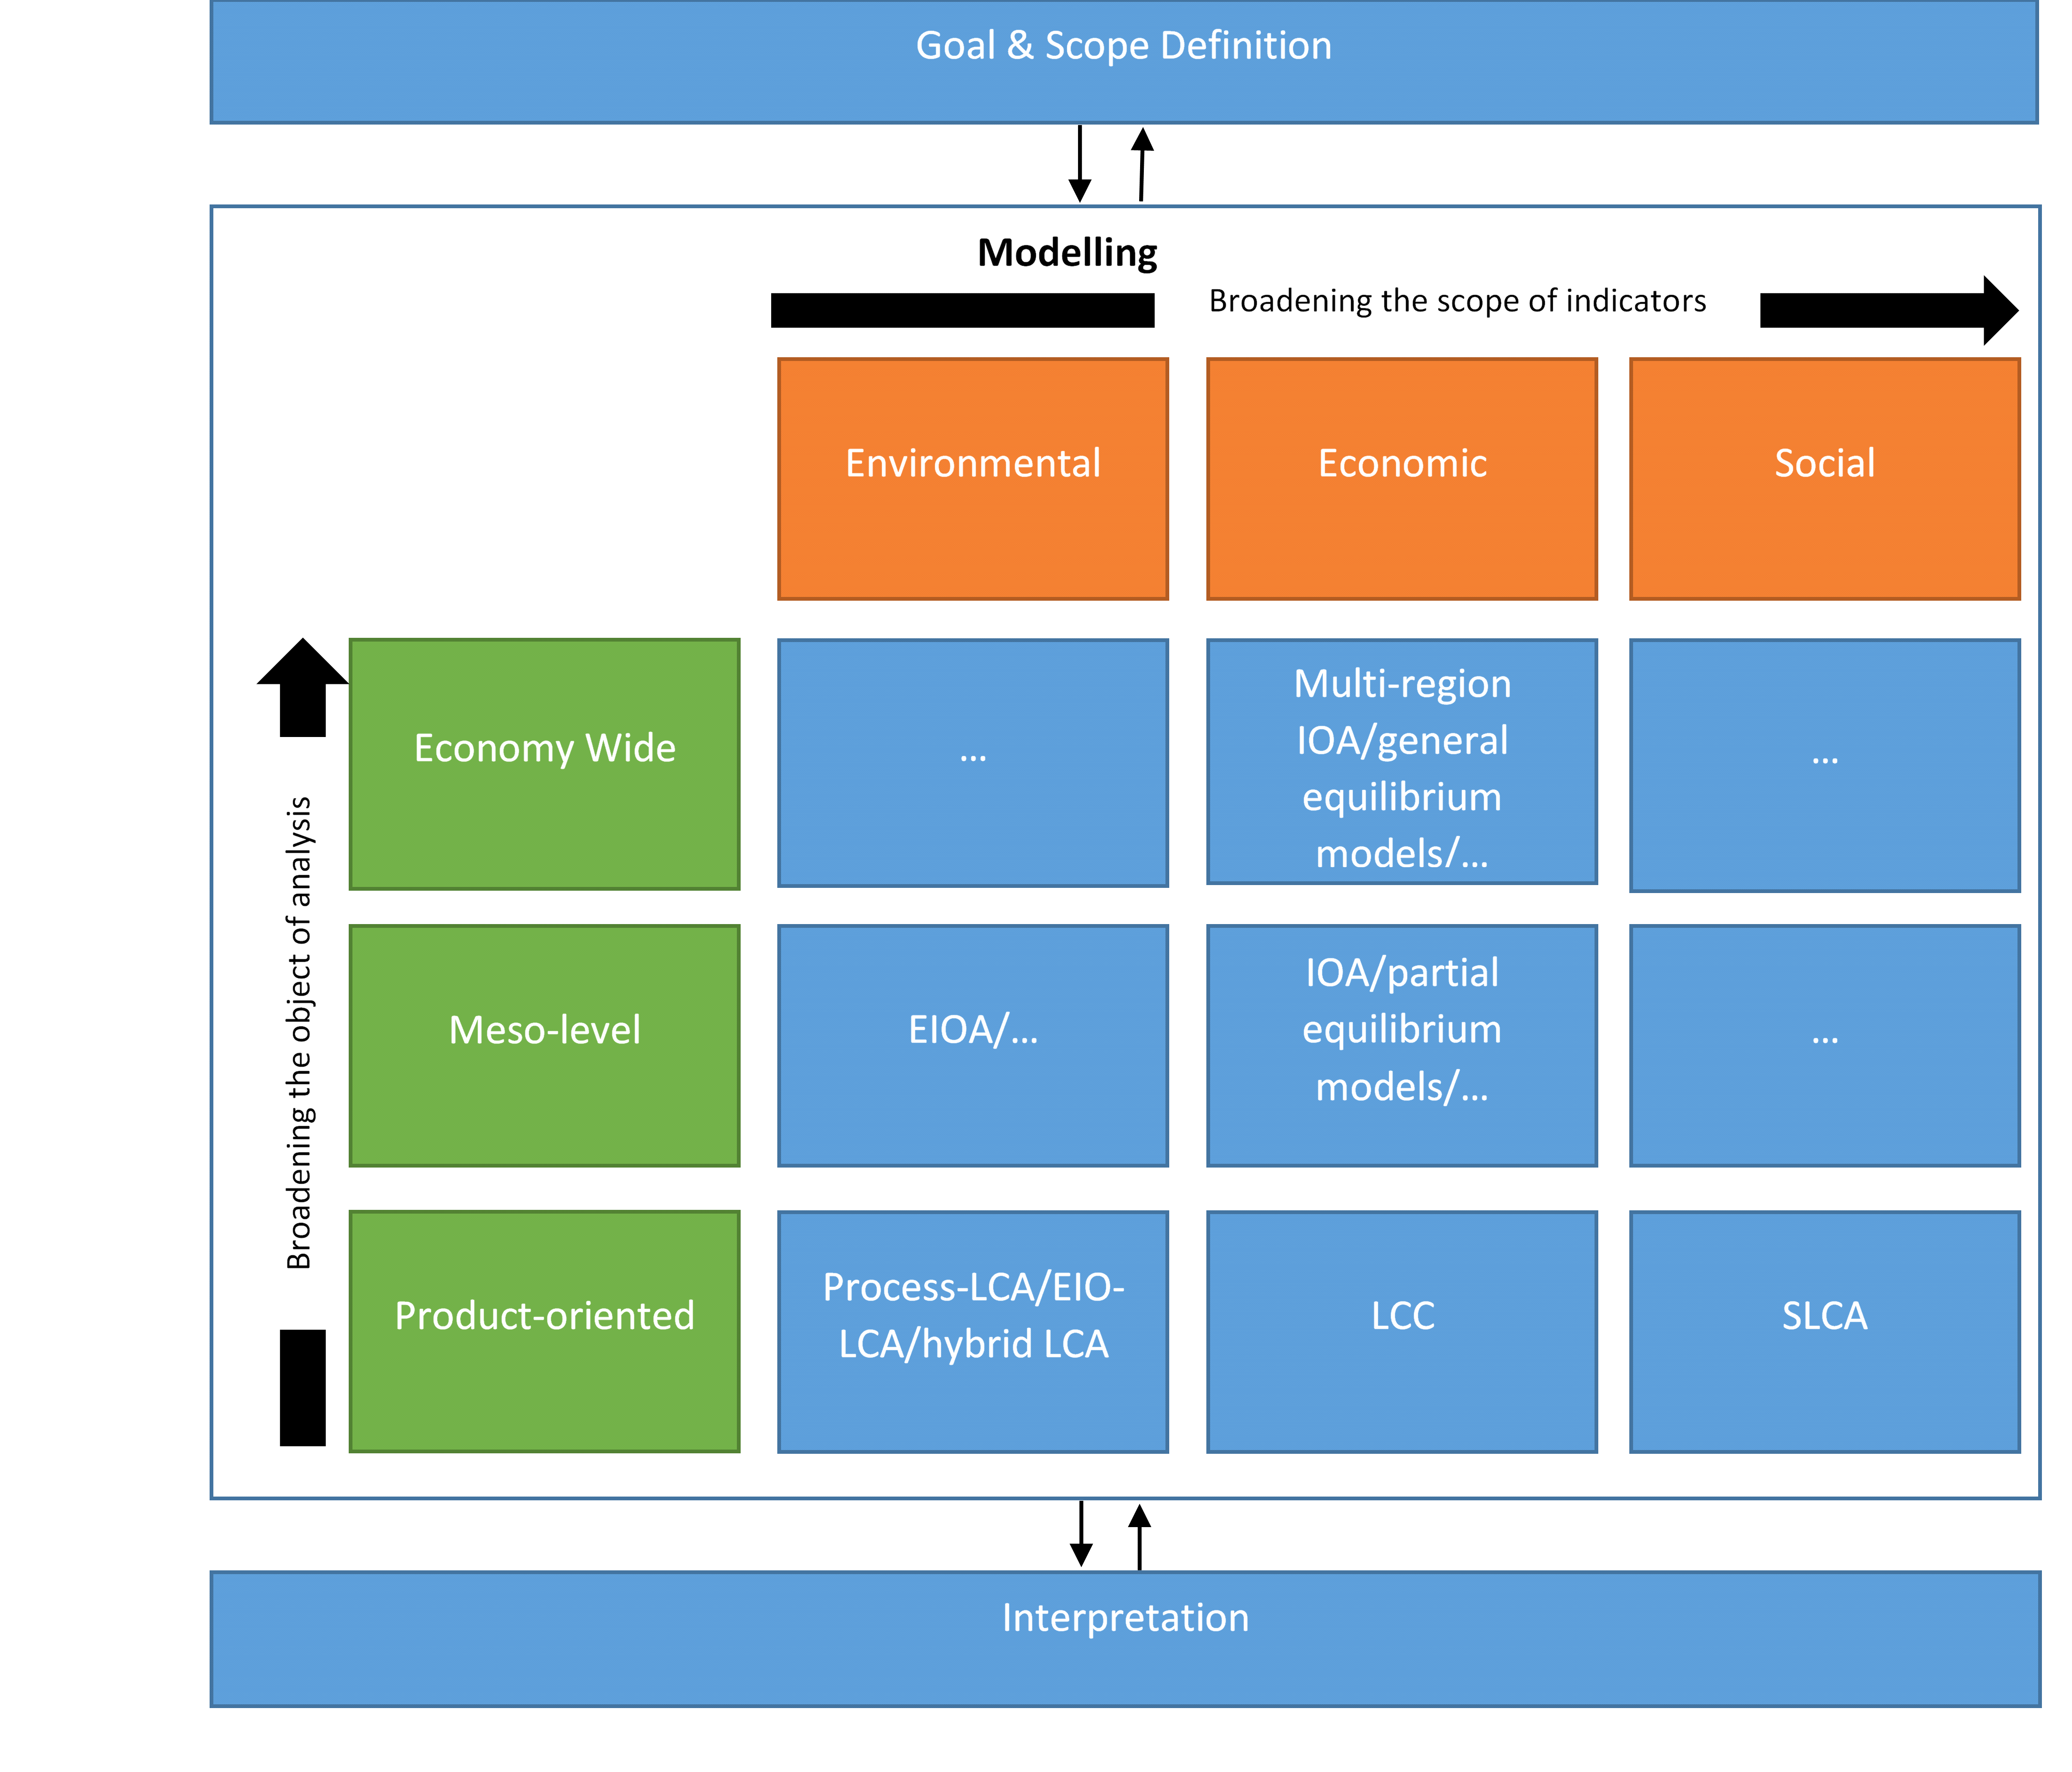
Figure 4. Life Cycle Sustainable Assessment framework (Guinee et al., 2010).
Summarising, LCA can be performed by various individuals ranging from people in industry to academics and even government policymakers. It can be applied to virtually any material, product or structure possible. Depending on the system boundaries and interpretation, the variability between LCA studies of similar products can be varied.

3. Literature Review

3.1 Review and critique of current ‘Criticality’ literature
The idea of ‘criticality’ pertaining to raw materials can be traced back as far as 1939 with the ‘Material Stock Piling Act’. Due to geopolitical uncertainty, the US government began securing supply and stock piling militarily-related materials (National Research Council 2007). However, the following decades resulted in little or no development of the concept of criticality up until the past decade, where it has become a popular methodology.
The popularity of critical metals has primarily been based on the uneasiness surrounding availability of such metals. Thus, resulting in governments and industries with large usage of critical metals, pursuing diversification of supply chains in order to mitigate potential availability constraints in the future. Consequently, two assessment methods have been created to measure the ‘availability’ of critical metals. The first method, ‘high level comparative multi-criteria analyses’ focuses on a macroscopic scale looking at a range of metals. Alternatively, the second method of ‘technology specific assessments’ tends to be much more focused on a microscopic level, targeting an in-depth approach to provide a high level of understanding (Speirs et al. 2014). Nevertheless, there is some accordance in methods developed for measuring availability of criticality metals. However, given the wide and varied interested organisations involved in and around critical metals, this has led to variations to measure availability of critical metals. Thus leading to an unclear definition of ‘criticality’ in the literature.
In the majority of criticality studies, criticality is still considered from an individual perspective, thus explaining the lack of a single definition of criticality between the numerous studies present. For instance, the study by the (British Geological Survey 2012) defines criticality, based on those elements that we need to maintain our economy and lifestyle. Whereas, the (Science and Technology Committee, 2011) study refers to these materials as ‘strategic’ not critical, and defines ‘strategic raw materials’ as those that may be of importance to any user within the UK. Similarly, a report by the ad-hoc working group in the EU (European Commission 2010) terms a raw material to be critical if it faces high supply risks, high environmental risks and is of economic importance.
Due to a lack of a single definition of criticality, this has led to a lot of confusion and interchangeable usage of terms such as ‘strategic’, ‘critical’ and even ‘Rare Earth Elements (REE)’ (European Commission 2010). The term ‘critical’ brings about a negative stereotype that the world is running out of these resources, which is not the case. Mineral markets are not static; supply and demand is continually changing, mainly due to technology, leading to continual revision of criticality. Nevertheless, the broad definition of criticality can be explained by the metrics used in criticality assessments. Since there appears to be degree of accordance in the general methodology for carrying out criticality assessments.
Typically authors gather an assortment of metrics representing the determining factors of metal availability. From this a range of materials, typically metals but occasionally minerals, are then assessed and scored against these metrics, resulting in an aggregated score. Thus, providing a relevant measure of criticality. The 4 commonly used metrics to assess criticality are shown below and include unique sub-factors related to the primary factor:
- Supply factors comprising of: geological availability, economic availability and recycling.
- Geo-political factors comprising of: policy and regulatory risk, geopolitical risk and supply concentration.
- Demand factors comprising of: future demand potential and substitutability.
- Other Factors comprising of: cost reduction, economic importance and environmental issue.(Speirs et al. 2013)

Although there are numerous commonly included factors, the form a criticality assessment takes varies between studies. To convey this, the subsequent paragraphs provide an overview of how some of these factors differentiate in the current literature. One of these factors is the means by which metals are scored against assessed metrics. These primarily include: criticality matrices with two axes, quantitative numerical scale and qualitative low-medium-high scales as illustrated by Figure 5.

Figure 5. Examples of the three types of scoring methods utilised in criticality assessments.
Where criticality matrices are used, the two individual axis represent two different factors. One of these axis is referred to as ‘supply risk’ and consists of supply and geopolitical factors grouped together. Whilst the second axis, is either referred to as ‘vulnerability’ (Erdmann & Graedel 2011) or ‘economic importance’ (Angerer 2009) depending on the study. This second axis generally groups together demand and other associated factors. In advancement of criticality matrices, the matrix can also be represented by 3 separate axis as shown by Figure 6. A study by (Graedel et al. 2012) into methods determining metal criticality determination, resulted in the creation of a third axis, ‘environmental implications’, which capture the use of a particular metal, along with its corresponding impact on ecosystems and human health.

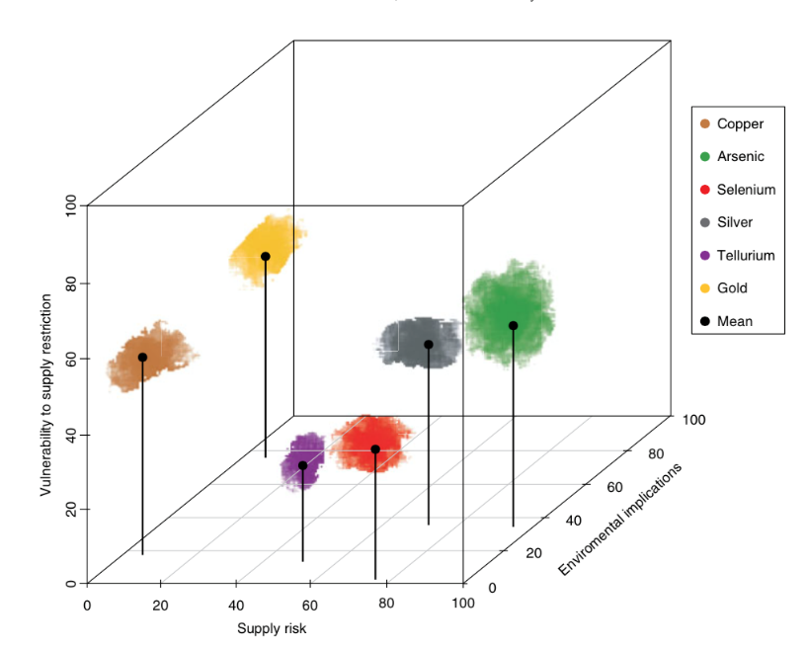
Figure 6. Graph representing the three dimensional criticality devised by Graedel, which utilises the aforementioned supply risk and impact of supply risk factors, in addition to the expected environmental impact of a material scarcity.
Aside from scoring methods, the ‘perspective’ of criticality assessments can also influence the end results. Some assessments may be conducted from the perspective of a country (Erdmann & Graedel 2011), of a private company (Duclos et al. 2010) and some from a specific political or economical goal such as low carbon technology development (Buchert et al 2009). Additionally, geographical scope, may produce further variations in results, leading to increased uncertainty within results. For example the following studies in literature, (British Geological Survey 2012; Achzet et al. 2011; Bauer et al, 2011; Buchert et al. 2009) investigated criticality from the global perspective. Whilst, 2 studies (European Commission 2014; Moss et al. 2011) gave the viewpoint from the European region.
Outside Europe, there were a number of studies from Japan, in particular from (NEDO 2008) which investigated substitution of rare earth metals, but reports from China were especially uncommon and incomplete. The perception of criticality can influence the scope and analysis of relevant studies when one considers the European perspective where criticality is seen as limiting the potential impact on material supply. This is in contrast to the Chinese position which focuses on maintaining stable supply of raw materials for domestic use and the Japanese viewpoint of securing stable supply. The notable omission from general trends in literature was the study by (Graedel et al. 2012) which investigated criticality from three different geographic foci: global, national and corporate. This approach is understandable especially when resources critical to one nation may not be critical to another, and thus aggregating such a metric can create substantial uncertainty.
Studies from literature also varied in the weighting and aggregation of criticality scores. When combining scores in criticality assessments for multiple factors, some authors elected to represent all factors equally (Erdmann & Graedel 2011), whilst others favoured giving extra weight to certain factors of interest (Buchert et al, 2011). As well as the manner in which weighting was applied, it also varied between and within studies. In regards to aggregation, although it seems to be subjective, the variation in weighting can considerably adjust the findings of criticality assessments. For example, the study by (Erdmann & Graedel 2011) confirmed varying the aggregation method impacted upon the criticality scores in the European Commission study ‘Critical raw materials for the EU’. Comparison of scores using different weighting methods reveals that ranking of critical metals may be significantly affected by the aggregation methodology used.
Yet even wide-ranging characteristics used in criticality assessment methodologies exhibit limitations. One of the main limitations are that criticality assessment methodologies are not intended to capture the impacts of criticality over time. This is demonstrated by how the metric, time horizon, is often treated indirectly in criticality studies thus resulting in the following variations in literature:
- Generally, the short-term availability of raw materials is addressed in almost all studies.
- Three studies, (Graedel et al. 2012; Bauer et al, 2011; Buchert et al, 2009) include a range of time frames ranging from short, medium and long term.
- There are different dynamics of supply and demand captured by (Buchert et al, 2009) which include physical (reserves compared to yearly demand) temporary (time lag between demand and production) and structural (in coupled production, metal is just a minor product) scarcity. For instance, if the demand for the main product (e.g. copper) decreases whilst demand for a by-product (e.g. indium) increases, a suitable supply increase of the by-product might be delayed by supply limitations of the main product. Thus emphasising, materials studied will become critical, but at different times.
- The following studies: (Achzet et al. 2011; Duclos et al. 2010; Morley & Eatherley 2008) do not include a specific time frame.

This is particularly evident in studies that utilise supply risk factors, since these are calculated by related factors such as geopolitical and metal supply, which themselves can considerably alter in the short, medium or long term. A good example of this are several studies: (Graedel et al. 2012; SEPA 2011; Achzet 2011; AEA 2010; Buchert 2009) that make use of supply risk factor, based on geological data, to calculate the ratio in the most recent year of reserves to production (R/P). Therefore, based on the previously mentioned explanation, that criticality assessments are not intended to capture the impacts of criticality over time, the R/P ratio has to be considered unreliable in terms of measuring future availability. Yet, alternatives are lacking apart from the use of ‘Depletion Time’ developed by (Graedel et al. 2012) and are hardly ever applied in criticality assessments.
Aside from criticality over time, criticality assessments are also affected by data availability and data certainty, in particular when comparing and contrasting large number of metals within criticality assessments. Relevant data may not be available for all metals, thus limiting the type of metric that can be included. For example the R/P ratio although found wanting, data is freely available for the majority of metals and therefore is included in many assessments. Even though data may be available for all metals, the level of certainty behind it may not be. Geological data, for instance may be extensive for some elements and very limited for others. But without incorporating this uncertainty (i.e. through aggregation or weighting) criticality assessment gives all data equal certainty. This can subsequently mask the variation in quality of the data source.
As previously mentioned, an alternative to criticality assessment, is metal/technology specific analyses. These tend to be less methodologically driven and the numerous approaches are reflective of varying environments surrounding each of the critical metals. These assessments have a supply perspective, demand perspective and the dynamic interactions between them. In parallel with criticality assessments, this approach cannot capture changes in estimates of reserves or metal demand over time.
To summarise there is some confusion and interchangeable usage of terms when it comes to criticality and so it is important to define these clearly. With regards to defining criticality, there is no single clear definition but it is impacted by how individual studies conduct criticality assessments. In the present literature this is performed via two different approaches; criticality assessments or technology specific analyses. However, even within these approaches there are variations in the factors used (aggregation, geography, perspective, scoring type and weighting) to assess and score criticality. In particular limitations of criticality assessments are highlighted by not being designed to capture impacts of criticality assessments over time. Additionally data quality and certainty make conducting criticality assessments for large numbers of metals difficult.
From the overview, 10 studies were selected to assess in more detail the 4 primary factors used in criticality assessments. Selection, specifically of these 10 studies, was based on two factors. Firstly being at the forefront in the field of criticality. Secondly and supporting the previous point, by being commonly referred and cited by alternative authors and journals. However this is not a comprehensive list and additional studies, where appropriate were analysed and included. A summary of the 10 studies correlated against the 4 primary factors and sub factors within, can be seen in Figure 7.
Figure 7. List of the factors included in the criticality assessment of 10 studies.
Key: Green = Included within study, Red = Not included within study. A multiply indicator (e.g.*2) indicates that more than one indicator was used to quantify this factor.

3.1.1 Supply Factors
Supply factors can be defined as those factors related to the physical availability of a material or metal, and are usually presented in the form of three indicators:
- Geological availability - a measure of what is physically present.
- Economic availability - a measure of what can be economically accessed.
- Recycling - a measure of the availability of metal recovery from End-of-life (EOL) products.
Within the list of 10 studies, a number of different methods were employed to quantitatively assess the geological availability of a metal. One of these methods, was the use of a multiplying factor or ratio where estimated future demand for a metal was compared with current global production. Studies utilising this method included: (European Commission 2014; Moss et al. 2011; Morley & Eatherley 2008).
Alternatives to the multiplying factor included the use of the previously mentioned R/P ratio, used in three studies here (Graedel et al. 2012; Achzet et al. 2011; National Research Council 2008) but also present in additional studies (SEPA 2011; AEA 2010). The aim of the R/P ratio was to determine the number of years remaining until fossil fuel resources (i.e. coal, oil and natural gas) are depleted, assuming static reserves and global production. This assumption makes the metric inaccurate since both reserves and production of resources are highly dynamic. Interestingly, the report by (Buchert et al, 2009) uses both the R/P ratio and a reserves to consumption ratio, which is a notable analogue to the R/P ratio. However due to the inaccuracies of using the R/P ratio for estimating future demand, an alternative metric proposed by (Graedel et al. 2012) labelled ‘Depletion Time’ was also present.
The Depletion Time metric, estimates the relative availability of a metal by determining the amount of supply being met by recycling, and then calculating the amount of time it would take to deplete the geological reserves at the current rate of demand. Unlike the R/P ratio, which is simply a ratio, Depletion Time incorporates 4 main variables namely: EoL recycling rate, lifetime distributions, past and estimated future demand statistics and tailing and slag losses from other processes. These variables allows for a more sophisticated evaluation using future scenarios for world demand, recycling rate and lifetime of end-use products. Although more advanced than the R/P ratio, Depletion Time metric lacks a form of geological constraint and inherently assumes that future production (minus any losses) is equal to future demand minus end-of-life recycling. In actual application of the metric in (Nassar et al. 2012), demand, lifetime and recycling rate were assumed constant for simplicity. However, in a report by (Buchert et al, 2009) the equation was reduced to a R/P ratio, in order for the metals investigated to have zero recycling rates. Graedel noted these flaws and as a consequence a more sophisticated analysis is in development and is to be published in the future.
The second factor defining supply risk was economic availability. A key factor in calculating future supply, it was explained and incorporated in nine out of the ten studies, with the exception of the study from the (British Geological Survey 2012). Although no study identified here conducted modelling of economic availability over time, all 9 studies recognised not all resources are cost effective to produce. Furthermore, use of USGS reserve and reserve base data, implied acknowledgement and inclusion of economic availability in the studies. The study by (Duclos et al. 2010) was the notable exception that assessed and quantitatively incorporated metal price fluctuation which can be considered a measure of economic availability, into its study.
Although, not always included in criticality assessments, the recycling of raw materials was covered by most studies as an alleviating measure to reduce primary raw material demand. It is often measured as the end of life recycling rate (EoL-RR), which can be determined by the product of the percentage of recycled material at each recycling stage, as displayed by Equation 1.

 | $$EoL RR= \frac{Recycled EoL Metal From Old Scrap}{Metal Content of EoL Products}$$ | (1)

According to a report from (UNEP, 2011), in which an overview of recycling knowledge on 60 metals was provided, only 3 metals (lead, niobium and ruthenium) had an EoL-RR above 50%. The majority of the 10 studies used EoL-RR data from UNEP, as it was the most up-to date and comprehensive literature source. However there were variations in how this data was utilised by each study in their own criticality assessments.
For example, in the report by (Buchert et al, 2009), 4 different aspects of recycling were assessed which included: high scale dissipative applications, physical and chemical limitations to recycling, lack of appropriate technologies (e.g. separation processes) and infrastructure and lack of price incentives for recycling markets (e.g. secondary scrap market). On the other hand, the report by (Duclos et al. 2010) did not include recycling rates, but rather recycling measures for the most critical materials identified. However, the most sophisticated modelling of recycling was provided by (Graedel et al. 2012).
Assuming present-day recycling rates from the 2011 UNEP study, Graedel estimated the useful lifetime of products using a Weibull distribution. A number of other studies namely (British Geological Survey 2012; Achzet et al. 2011), utilised the UNEP report to identify the recycling rates of materials of interest to them, before applying their own unique scoring method.
Still in all the criticality assessments, there was no modelling based on the relationship between recycling rates and resource economics over time. A high metal price should incentivise an increase in recycling, but this has not been investigated yet.

3.1.2 Geopolitical Factors
Geopolitical factors are usually composed of exterior risks that are not natural i.e. man-made. These factors can be used to describe three supply criteria, linked to national policies and global markets which include:
- Geopolitical risk which can be defined as a measure of the risks posed by policy actions that may limit the global availability of a particular material and political instability.
- Policy and regulatory risk which is a measure of the risk that existing national policies may pose.
- Supply concentration which is a measure of the various different global countries producing a material.
Within the 10 studies, the report from (Buchert et al, 2009) was the sole report excluding geopolitical factors in its criticality assessment. For the remaining studies geopolitical risk was considered either by itself or as ‘political instability’ in the cases of (Moss et al. 2011; Morley & Eatherley 2008). On the other hand, there were several studies present: (European Commission 2014; Bauer et al, 2011; Duclos et al. 2010) in which a combination of one or both of alternative geopolitical factors (i.e. policy and regulatory risk plus supply concentration) were also considered.
Further analysis within the studies highlighted 2 main metrics as the primary tools used to quantify political instability and overall geopolitical risk. The first of these metrics, developed by the World Bank (Kaufmann et al. 2010), was the World Governance Indicators (WGI). The WGI encompassed 6 different indexes namely: Accountability, Control of Corruption, Government Effectiveness, Political Stability and Absence of Violence/Terrorism, Regulatory Quality and Rule of Law and Voice. In each index, the data was standardized and a percentile ranking given for each country (Kaufmann et al. 2010).
The second commonly used metric was the Fund for Peace’s Failed States Index (FSI). This metric measured geopolitical risk using 12 indicators in 3 different areas. A list of the indicators includes: Economic Indicators (Uneven Economic Development and Poverty and Economic Decline), Social indicators (Demographic Pressures, Group Grievance, Human Flight & Brain Drain and Refugees or Internally-Displaced Persons), and Political and Military Indicators (External Intervention, Factionalized Elites, Human Rights & Rule of Law, Public Services, Security Apparatus and State Legitimacy) (Fund for Peace 2016).
Both indicators used freely available data yet aggregated this differently, resulting in occasional variations in results. For instance, studies by (British Geological Survey 2012; Morley & Eatherley 2008) assigned a qualitative (High-Mid-Low) score for a metal’s political risk. Taking the example of nickel, present in both studies, the latter study categorised nickel as high risk whilst the former study identified it as low risk. Related to this qualitative approach a study by (Moss et al. 2011) examined both the WGI and FSI scores of key suppliers in order to assign a qualitative (High-Mid-Low) score for a metal’s political risk. Assessment using either indicator, as evidenced in their poor rankings, highlighted both Indonesia and Russia as representing a substantial share of world nickel supply and thus posing some long term risk. Therefore agreeing with the study from BGS. The inclusion of geopolitical risk is essential in assessing supply risk. However, its consideration and usage of the WGI, is not particularly effective in longer-term assessments, and may not take into account, some of the more sensitive effects such as sudden political shifts.
Regarding policy and regulation indicators, these assess the risk that existing national policies may pose especially to activities such as mining. These indicators also take into consideration public opposition to these policies usually in the form of perceived negative environmental or socio-economic effects. Out of the 10 studies, 7 did not consider an indicator for policy and regulation. With the 3 outstanding studies that did, the policy and regulation indicators varied from being qualitative (Bauer et al 2011) or quantitative (Graedel et al. 2012; National Research Council 2008).
With respect to quantitative, quantification of this factor in the study by (National Research Council 2008) employed the use of a metric produced by the Fraser Institute called the Policy Potential Index (PPI). This index evaluates a broad range of governmental and non-governmental issues (e.g. taxation, geological database, security) that affect mining investments and potential exploration. The results are compiled into a single score for each jurisdiction with a perfect score of 100 meaning that a jurisdiction is perceived to be best in all measured aspects of public policy. A score of 0 means it is the worst in all categories. The Fraser Institute also produced two other complementary metrics to PPI, called the Current Mineral Potential Index (CMPI) and the Best Practices Mineral Potential Index (BPMPI). The CMPI measures the mineral potential of a certain region and whether the current policy environment encourages or discourages exploration. The BPMPI measures whether policies conform to best practices (McMahon & Cervantes 2013). Additionally by subtracting the BPMI score from the CMP a room-for-improvement score is calculated. High positive scores on this metric, indicate that the jurisdiction is far from best practices. Apart from the latter, both CMPI and BPMPI were used in (National Research Council 2008) study to assess policy and regulatory risk. However, the weighting of these metrics in formulating the final criticality score is unclear.
On the other hand, the study by (Graedel et al. 2012) used both the PPI along with the Human Development Index (HDI), which was published by the United Nations Development Programme (UNDP). HDI evaluates the level of social progress of a country under the hypothesis that high levels of social progress correspond with a preference for human quality of life over intrusive industrial development, where those two goals appear to be in conflict. The HDI measures the performance of a country according to life expectancy, education and living standards (e.g. income per capita). PPI and HDI are weighted equally to give a score of 0-100 for the ‘Social and Regulatory’ component of supply risk (Graedel et al. 2012).
Apart from geopolitical availability, risk to supply concentration was the only other factor to be considered by all 10 studies. Although risk to supply concentration was considered for all 10 studies, they were reflected in alternative methods. Several studies, (Bauer et al 2011; Buchert 2009; NRC 2008) merely allocate a score based on the number of supplying countries reported in an annual mineral commodity summary report by the (USGS 2012). Other studies (European Commission 2014; Graedel et al. 2012) made use of the Herfindahl-Hirschman index (HHI), which is a metric commonly used to measure market concentration. The HHI is calculated by summing the squares of each source country‘s annual production (mining, refining, or smelting) share, so a higher HHI indicates a more concentrated market.
Additionally, inclusion of risk to supply concentration, should also factor in that production concentration may change over time. This is particularly significant, if the distribution of reserves of a metal differs from its production distribution, as is the case of materials for low-carbon energy technologies. For instance: Lithium and REEs are examples of metals with reserves more widely distributed than their production (Gruber et al. 2011; Parthemore 2011; Kara et al. 2010). Therefore, it can be assumed with some certainty that the supply concentration of these metals will change in the future. Thus critically assessment involving such metals should be correctly adjusted for any foreseeable future changes. This done to varying depths in the following studies: (European Commission 2014; Bauer et al 2011; Buchert 2009) but it is omitted in others e.g. (Graedel et al. 2012), resulting in an questionably negative bias on geopolitical factors.

3.1.3 Demand Factors
Demand factors are important in the shaping of future availability and are commonly captured by 2 factors:
- Future demand projections - which is an approximation of the likely growth of demand in the future.
- Substitutability - which is a measure of how easily and adequately a material can be replaced through substitution for other metals or technologies, in order to reduce future demand.
Existing global demand for many materials can be located in the annual minerals yearbook publicised by the USGS. However alternative information can also be found from the BGS (BGS 2012) or individual consultancy reports, for example (Chegwidden 2011). In particular the BGS report identified a number of factors namely environmental change, economic development and population growth as the main factors influencing the future of the metals and minerals sector. In the 10 studies investigated here, future demand was projected in a number of ways.
Reports from (British Geological Survey 2012; Achzet et al. 2011; NRC 2008), did not include future demand projection as a factor in their criticality assessments. In studies that did determine future demand, a number of methods were used.
The study by (Morley & Eatherley 2008) made use of exogenous assumptions for future demand. These assumptions, obtained from citing market analyst forecasts and market reports e.g. (Chegwidden 2011) affect a model without being affected by it, and whose main aims are to set arbitrary external conditions.
On the other hand, the report by (Buchert 2009) decided to analyse critical metals by focusing on the magnitude of demand growth rates and splitting this into two distinct stages, rapid demand growth (> 50% increase of total demand since 2007 until 2020) or an estimated moderate demand growth (> 20% increase demand growth until 2020). Alternative studies incorporated future demand either by use of material intensity (the amount of metal demanded per unit of final product) (Moss et al. 2011; Bauer et al, 2011) or using specialist opinion, based on expected annual growth rates connected to economic growth (European Commission 2014).
A more complicated and in-depth treatment of material intensity was also found in alternative studies that focused on a single metal or technologies. These studies: (Graedel et al. 2012; Wadia et al. 2011; Kara et al. 2010; Fthenakis 2009), allowed demand projections in their methodology, yet demonstrated a lack in practical applications. Apart from (Angerer 2009) amendments for future reductions in material intensity, which may take place through enhanced manufacturing techniques or partial substitution, are not usually included in criticality assessments.
As a result of the various methods, projections of future demand in criticality assessment studies often remain subjective.
Studies that investigated substitutability had to deal with qualitative and/or semi-quantitative data, as there was no consistent or inclusive quantitative data on the substitutability of raw materials. Thus, making this factor difficult to measure and assess. From the 10 studies investigated here, excluding (Buchert 2009), substitutability was assessed using a variety of different tools including by: supply (European Commission 2014; BGS 2012; Graedel et al. 2012; Achzet et al. 2011; Morley & Eatherley 2008), material (Duclos et al. 2010), product (NRC 2008) and technology (Moss et al. 2011; Bauer et al, 2011). The study by (Morley & Eatherley 2008) made use of expert opinion to decide which technologies were more inherently substitutable than others. This was also done in other studies (SEPA 2011; AEA 2010). However in all these cases, the source of expert opinion was unclear.
However, availability of experts or development of substitutes may be of limited use, as substitutes can still appear unexpectedly.

3.1.4 Other Factors
A number of additional factors were considered, although their use is less common than the primary factors considered previously, they can still influence the final criticality score. The main three factors considered were:
- Cost reduction effects - which are defined as the reduction of technology costs associated either with knowledge or innovation, whose impact is on supply or demand.
- Economic importance - which measures how critical a material is based on a particular economy.
- Environmental issues - which is a measure of the potential for environmental impacts of material production to become an influence on future production through regulation.
Cost reduction effects can be both demand and supply related. On the demand side, reduction in costs are mostly due to material intensity or novelty and learning effects. The supply side includes reductions in the cost of metal extraction, production, refining and recycling processes. Use of cost reduction effects are only considered in a select few studies (Graedel et al. 2012; Bauer et al, 2011) and mainly include the assumptions that production costs will decrease or remain constant (Rosenau-Tornow et al. 2009). The study by (Achzet 2011) was the noteworthy exception, since it did not consider cost reduction via technology innovation. Instead this study focused more on the complex extraction and processing techniques on supply and price.
From all 10 studies, no single study investigated the concept of dynamic modelling, in which certain resources (e.g. recycled metals) become gradually profitable and accessible. But, (Graedel et al. 2012) was the only study to consider innovation directly, through the use of the Global Innovation Index (GII), developed by business school, INSEAD.
The GII provides a score from 1 (least innovative) to 7 (most innovative) for 125 nations. Represented by Equation 2, the index is composed of a total of 60 variables that are based on seven categories namely: Business sophistication, Creative outputs, Human capital and research, Infrastructure, Institutions, Market sophistication and scientific outputs.
 | $$GII Transformed= \frac{350}{3}-\frac{50}{3}×GII$$ | (2)
In the present literature alternative innovation scales exist e.g. (Schwab et al., 2002) but are not utilised in any other studies.
In terms of economic importance, this factor is not considered in many general criticality studies, but are inherent for studies with a corporate or national scope. In the studies that it was considered in, economic importance was quantified in various ways.
The study by (European Commission 2014) assessed the economic impact of material scarcity, using the methodology displayed in Figure 8. Explaining the method, each application of the chosen material was listed and then assigned to a ‘Mega-sector’, or an industrial sector that used the specific material. The Gross Value Added (GVA) by each Mega-sector, was then multiplied by the percentage of material that was fed into the Mega-sector, to build a weighted sum representing the economic importance of the material.
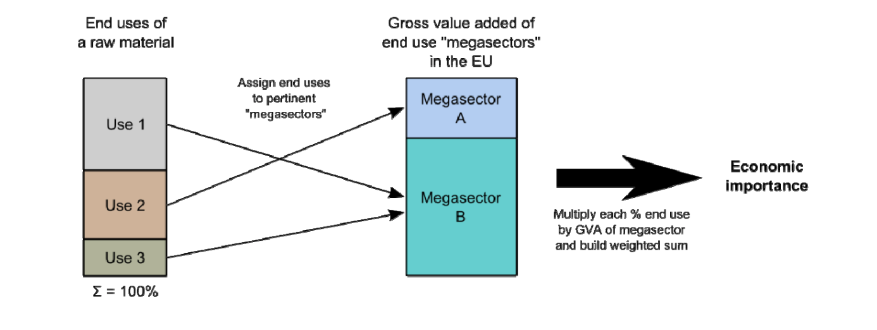
Figure 8. Flowchart from EU critical materials report displaying the assessment criteria used to determine the economic impact of material scarcity, as determined by the EU expert panel (European Commission 2014).
On the other hand, (Graedel et al. 2012) assessed economic importance quantitatively and qualitatively. In terms of quantitatively, where possible a score was given on a scale of 0-100. With regards to qualitative assessment, a very high (87.5), high (62.5), medium (37.5) or low (12.5) labels were applied with the relevant scores as shown in Table 1.
Table 1. Evaluation of importance to corporate strategy.
Score Range | Default Score | Evaluation
75 – 100 | 87.5 | Essential
50 – 75 | 62.5 | Important
25 – 50 | 37.5 | Moderately important
0 – 25 | 12.5 | Less important

Lastly, although environmental issue is a factor that was used in several studies, the exact aims and methods varied considerably between studies. For instance studies by (Bauer et al, 2011; National Research Council 2008) considered this factor qualitatively, including it as a regulatory restriction to expanding supply. On the other hand, (Morley & Eatherley 2008) included a score for three environmental factors, two under material risk (Global Warming Potential and Total Material Requirement) and one under supply risk in the form of the vulnerability of key supplying regions to climate change.
Concerning the study by (Graedel et al. 2012) an Environmental Implications (EI) metric, as an indicator to the potential environmental implications of utilizing a particular metal was introduced. To quantify this change, the EI metric was firstly calculated and then used in the Environmental Impact Ratio (EIR). For EI evaluation, inventory data from the Eco-invent life cycle analysis (LCA) tool (Frischknecht et al., 2007) was used.
In contrast, the report by (European Commission 2014) made use of the Environmental Performance Index (EPI) which assesses the risk through which significant supplying countries may limit the supply of raw materials to the EU, in order to protect their own domestic environments. This measure was also investigated equivocally by (Graedel et al. 2012) in the social and regulatory component of their methodology. Although it is possible but not certain, a number of other studies may also indirectly assess this risk in their social, political and regulatory risk factors.
Summarising, environmental issues are only clearly included in the methodologies of 7 studies, although their inclusion is unclear and mainly qualitative. Where it is included, it forms part of the pre-selection of critical metals such as in (Graedel et al. 2012) compared to studies where it is not directly included (Bauer et al, 2011; NRC 2008).

3.1.5 Summary
Criticality is strongly dependant on the perspective from which it is conducted and on the purpose of use. Consequently, the majority of criticality studies investigated here demonstrate dissimilar scopes e.g. global economy, corporations or a practical view on specific raw material, thus making it difficult to group their findings into a single conclusion.
However, there does appear to be a degree of agreement in the general methodology for conducting criticality assessments. The main dimensions in most cases are supply risk (e.g. producer concentration, mine production or consumption) and vulnerability in terms of impact of supply disruption or importance of use. An in-depth analysis of these two factors discloses that the contributing connected to supply risk e.g. producer concentration, mine production or consumption, are quantitative in nature. Whereas factors associated with vulnerability dimension e.g. impact to supply or strategic relevance are more qualitative. Aggregating these indicators, predominantly equal or indicator-specific weights are used. Furthermore, the bulk of studies either make use of a criticality matrix or index for all materials to be analysed. Graphical representation and future market situation analysis are also used, but in the minority. Often, the scale of measure in these studies is an ordinal scale, which purely offers ordering of rank.
Alternative perspectives suggest the usage of several sub-indictors. But in reality, the main indicators display little or no accordance amongst the diverse approaches, even when conducted from the same standpoint.
In general, the 10 studies investigated here, helped to consolidate the current understanding of minerals criticality, and support development of improved methodologies to assess future developments and markets. Although, the 10 studies covered the vast majority of the main principles in literature, they were not comprehensive to include everything and some ideas, methods and results would undoubtedly not have been included. However, there is sufficient room for improvement and research, particularly related to the steel industry.
Identifying what elements to investigate was challenging due to the wide breadth of materials examined, in particular from the 10 studies has shown by Table 2. Five of the studies (European Commission 2014; British Geological Survey 2012; Moss et al. 2011; Duclos et al. 2010; Buchert et al, 2009) contained a systematic investigation of a wide variety of raw materials (between 26 and 70), the remaining studies analyse the criticality of roughly a dozen raw materials. In addition, all studies cover metals, but 2 of the studies (European Commission 2014; Morley & Eatherley 2008) also included industrial minerals.

Table 2. Overview of materials investigated of frequently discussed criticality studies.
[Note: a) Oakdene Hollins identifies 8 most at risk metals out of the ranking of 69. b) This becomes 35 materials if the group rare earth elements (REE) are considered separately. c) The Yale University methodology has so far only been applied to copper and its by-products, although forthcoming publications will apply it to more materials. d) Rare earth elements as one group (various coverage). e) Originally 8 materials designated as insecure, but one (Hg) was finally dropped. ) All assumed to become critical within different time horizons. g) Eleven of the original 52 elements have been excluded from the update because of data availability and quality issues. h) PGE and REE included as one group.]

The selection of what elements to investigate was initially conducted by creating a list of 32 elements: (Al, As, B, Be, Bi, C, Ca, Ce, Co, Cr, Cu, Fe, H, Mg, Mn, Mo, N, Nb, Ni, P, Pb, S, Sb, Se, Si, Sn, Te, Ti, W, V, Zn and Zr) commonly used in steel. From this list, data was gathered from cradle to grave (i.e. abundance in earth’s crust, global production, reserves, applications, recycling etc.) on all 32 elements. Three principal factors: data availability, application and use in steel and similar studies in literature, were selected as filters resulting in 4 elements of interest: chromium, molybdenum, niobium and vanadium. Selection of these elements was supported by the BGS 2012 risk list as summarised in Table 3.
Table 3. Summary of elements of interest in this research, identified in the 2012 BGS risk list.
Element | Symbol | Relative Supply  Risk Index | Leading Producer | Top Reserve Holder
Chromium | Cr | 6.2 | South Africa | Kazakhstan
Molybdenum | Mo | 8.6 | China | China
Niobium | Nb | 7.6 | Brazil | Brazil
Vanadium | V | 6.7 | South Africa | China

Although elements such as chromium are not as critical as molybdenum, due to its metallurgical effects being difficult to replicate using any other combinations of elements, and also being expensive, the availability of numerical data was such that it would act as a control in any methodology developed. This being particularly useful to compensate for lack of data for the more exotic elements such as niobium and vanadium.
Selection of two of the elements i.e. chromium and niobium was vindicated by being highlighted by the European Commission report on criticality (EC 2014). Due to the presence of these elements in the European Commission report and their importance in LCA work (explained further on) already being conducted, it was decided to create MFAs for these four elements. Not only would the MFAs provide a macroscopic image of key areas of interest but it could link the three aspects of work mainly criticality, MFA and LCA more consistently.

3.2. Review and critique of current MFA literature
Present-day studies using the method of MFA can be differentiated in several ways. These consist of: the covered time period (static vs. dynamic models), type of analysis (top-down vs. bottom-up data), modelling approach (retrospective vs. prospective), metal use (end use categories vs. products) and system overview (processes covered).
According to a review conducted by (Chen & Graedel 2012) since the year 2000, a total of 1,074 individual cycles have been constructed from approximately 350 publications for 59 elements. More than 90% of these publications have appeared since the year 2000. The majority of these cycles have been static (989), in comparison with the number of dynamic cycles (85) which contain numerous sub-cycles within them (Chen & Graedel 2012). Additionally, the review also differentiated the cycles from each other in terms of geographic levels, as summarized by Table 4.
Table 4. Summary of elemental models in terms of spatial flow and dissimilar geographical levels. (Chen & Graedel 2012)
Spatial level | Global | Continent | Country or territory | City | River basin | Total
Static | 47 | 105 | 791 | 28 | 18 | 989
Dynamic | 9 | 7 | 60 | 9 | 0 | 85
Total | 56 | 112 | 851 | 37 | 18 | 1074

For global level elemental cycles, the study by (Chen & Graedel 2012) identified cycles for 30 elements, representing 47 static and 9 dynamic cycles. With respect to dynamic cycles, they were represented by the following elements: aluminium (Martchek 2006), cobalt (Harper & Graedel 2008), iron (Hatayama et al. 2010), lead (Mao & Graedel 2009), phosphorus (Vuuren et al. 2010), platinum (Elshkaki & Van der Voet 2006), silicon (Williams 2003), tin (Izard & Müller 2010) and vanadium (Hope 2008). Notable exclusions included, metalloids, non-metal elements, PGM (excluding platinum) and a number of individual metals e.g. niobium and molybdenum used to form super-alloys. (Chen & Graedel 2012).
A similar pattern of ratio of dynamic to static studies was observed for cycles at the continent-level. The bulk of studies, approximately 94%, being characterised via static cycles. Furthermore, all continent-level cycles were representative of cycles in Europe, apart from cycles from the Yale Centre of Industrial Ecology as mentioned in (Johnson et al. 2006).
As regards to country-level cycles, 45 elements were covered for a total of 791 static and 60 dynamic cycles. Breakdown of the results in terms of geographical areas, from highest to lowest, depicts the following: Japan (42 elements, 97 static cycles and 26 dynamic cycles) > USA (31 elements, 57 static cycles and 8 dynamic cycles) > Europe (20 elements, 223 static cycles and 12 dynamic cycles). To summarise, Japan investigated the most number of elements but Europe produced the largest number of cycles, especially in regards to static. In terms of the rest of the world, excluding China, elemental cycles for 7 metals (chromium, iron, nickel, copper, zinc, silver and lead) have been characterised by the Yale Centre for 5 nations (Australia, Brazil, South Korea, Taiwan and Turkey). Examples related to specific elements conducted by the Yale Centre are mentioned later on.
With respect to city and river basin level cycles, the amount of studies are minute especially compared to country-level cycles. Nearly all city-level cycles focus on inputs, emissions and in-use stock for heavy metals. In particular studies such as those from (Bergback et al. 2000), sponsored by the Swedish Environmental Protection Agency, have been conducted in Stockholm on this exact topic.
On the other hand, cycles first reported on river basins were from (Brunner et al. 1994) and mainly involved two elements, nitrogen and phosphorus. Nitrogen because of water eutrophication issues and phosphorus mainly due to emission and toxicity concerns.
Summarising, static cycles outnumber dynamic cycles approximately 12:1, with the majority of geographical studies being country-level based. According to existing literature, anthropogenic cycles for 33 of the first 92 elements of the periodic table, do not exist. Dynamic cycles exist mostly for major metals such as aluminium, copper and iron as well as a range of other elements mentioned previously. Table 5 best summarises the number of cycles per element, and identifies 33 elements currently with no cycles and 19 elements with a single cycle.
Table 5. Summary of elements with different numbers of anthropogenic cycles. (Chen & Graedel 2012)
No of cycles | Elements | No of elements
≥ 5 | Ad, Al, Cd, Cl, Co, Cr, Cu, Fe, Hg, In, Mn, N, Ni, P, Pb, Pd, Pt, Sb, Sn, W, Zn | 21
4 | As, Au, Mo, Rh, V | 5
3 | Ga, Ge, Li, Nb, Ta, Ti | 6
2 | Be, Bi, Cs, Dy, Hf, Mg, Se, Zr | 8
1 | B, C, Ce, Eu, F, Gd, La, Nd, Pr, Re, S, Si, Sm, Sr, Tb, Te, Tl, U, Y | 19
0 | Ba, Ca, Er, H, He, Ho, Ir, Lu, O, Os, Ra, Ru, Sc, Th, Tm, Yb | 16
Excluded | Ac, Ar, At, Br, Fr, I, K, Kr, Na, Ne, Pa, Pm, Po, Rb, Rn, Tc, Xe, | 17

In contrast, 21 elements have 5 or more cycles each. Iron has been the most widely analysed, with more than 200 cycles available, with copper, chromium, lead, nickel, silver and zinc each being represented with 70 cycles or more. The reason for the large number of cycles for aluminium, copper and iron is in all probability, due to significance and greater availability and transparency of data.
Although knowledge in the area of anthropogenic cycles of elements has increased, due to an increase in the number of publications. This knowledge comes from a select number of research groups. These research groups are based in 4 geographical areas, namely the USA, Europe, Japan and mainland China.
In the USA, two organisations, the USGS and the Yale Centre for Industrial Ecology provide the bulk of contributions. Contributions from the USGS are mainly centered on the USA between the time period of 1990 and 2005. In the early 90s, the USGS was the first organisation to characterize cycles notably for cobalt (Shedd 1993), vanadium (Hilliard 1994) and zinc (Jolly 1993). In the intervening time period since, approximately 25 cycles of metals (i.e. aluminium, beryllium, cadmium, chromium, copper, gallium, gold, indium, iron and steel, lead, magnesium, manganese, mercury, molybdenum, nickel, PGM, selenium, silver, tantalum, titanium, tin, tungsten, zirconium) at the single country-level have been created.
On the contrary, the Yale Group has been active since 2000, with an emphasis on ‘criticality of metals’. Led by Thomas Graedel, the early aims of the research group centred on assessment of criticality for 62 elements (base year 2008), made up of metals, metalloids and other elements from the periodic table. Publications of some of the elements investigated by the research team led by Graedel include: chromium (Johnson et al. 2006), copper (Graedel et al. 2004), iron (Wang et al. 2007), lead (Mao & Graedel 2009), nickel (Reck et al. 2008), silver (Johnson et al. 2005) and zinc (Graedel et al. 2005) to name a few. However enhancement in criticality methodology particularly with the development and use of 3 dimensions - supply risk, environmental implications, and vulnerability to supply restriction has extended this work. With the emphasis, currently in progress, on alternative development scenarios of criticality for the period 2010 to 2050.
Conversely most of the metal cycles in Europe were heavy metals based, with more of an emphasis placed on environmental emissions and health risks to people. Seven countries (Austria, Denmark, Germany, the Netherlands, Norway, Sweden and Switzerland) are regarded as leaders in the field of MFA and SFA studies according to a study from the (Herczeg et al., 2007). The most active of groups within these 7 nations, appears to be the Centre for Environmental Studies at Leiden University. This group in close collaboration with the USGS were the first to develop country level SFA framework and apply it to elements such as cadmium (Van der Voet et al. 1994), chlorine (Kleijn et al. 1994) and nitrogen (Van der Voet et al. 1996). Further development of the framework by Leiden University led to indicators that could be derived from stock and flow analysis of heavy metals. More recently Leiden University as developed dynamic modelling methods to conduct future scenario predictions of stocks and flows of metals (Elshkaki et al. 2005).
In comparison to the USA and Europe, from 2005, virtually all elemental cycle publications from Japan relate to either Japan or its Asian neighbours. Contributions to the construction of these extremely detailed and comprehensive cycles of elements in Japan range from institutions such as the National Institute for Material Sciences (NIMS) and University of Tokyo to metallurgists and scientists. Based on recent publications, three researchers: Ichiro Daigo, Kenichi Nakajima and Tetsuya Nagasaka are leading researchers in flow studies related to Japan. Elements investigated by these authors includes, aluminium (Hatayama et al. 2007), chromium (Daigo et al. 2010), copper (Daigo et al. 2009), manganese (Nakajima et al. 2008), molybdenum (Nakajima et al. 2007) and stainless steel (Daigo et al. 2010). A specific feature of Japanese studies compared to American or European are studies related to the interaction of different elements while they are passing through the anthroposphere together as alloys. Examples of these include, molybdenum associated with iron and steel (Nakajima et al. 2007), aluminium and its alloying elements (Hatayama et al. 2007) and chromium and nickel in stainless steel (Daigo et al. 2010).
Lastly, China has only recently began to characterise its domestic cycles, as it seeks to increase its participation in the field of MFA at a rapid pace. To aid this, institutions specialising in metallurgy such as Nanjing and Tsinghua University, have been built to specifically increase publications of base metals at the country level. Recent examples of elements investigated include aluminium (Weiqiang et al. 2010), copper (Guo & Yu, 2008) and zinc (Guo et al. 2010). However, China still falls behind principally, in the number of completed studies and secondly global access to its publications with the majority being published in Mandarin. In spite of this, China dominates metal production, trade and consumption on the global level, and thus it is reasonable to expect China to catch up and potentially overtake other leading countries on characterization of metal cycles in the near future.
To review, analysis of modern literature has focused on the amount of studies, geographical boundaries as well as identifying significant research organisations involved. From this, 4 elements: chromium, molybdenum, niobium and vanadium have been singled out from which an original contribution can be made. Therefore the subsequent paragraphs review specific literature for each individual element.
In terms of chromium, up until 2012, there have been 76 cycles produced, 73 static and 3 dynamic. The greater part of these cycles were produced from one publication, ‘The Contemporary Anthropogenic Lifecycle of Chromium’ (Johnson et al. 2006). This study produced lifecycles based on 54 countries, 9 world regions and the planet. The remaining static studies from literature comprised of, (Daigo et al. 2010; Oda et al. 2010; Rauch & Pacyna 2009; Ma et al. 2007; Bergback et al. 2000; Papp 1994).Within these studies, three studies, (Daigo et al. 2010; Oda et al. 2010; Bergback et al. 2000) were the only dynamic studies on chromium from literature.
From literature related to chromium, two solitary global studies (Rauch & Pacyna 2009; Johnson et al. 2006) were published. The study by (Johnson et al. 2006) constructed a global chromium model concentrating more on end products. Whilst the study from (Rauch & Pacyna 2009) was more directed on mass movements of natural systems against anthropogenic systems. Where both studies were similar was the use of 4 primary stages, along with the other literature sources, to map flows of chromium by way of: Production, Fabrication & Manufacturing, Use and Waste Management & Recycling. Where the two studies differentiate, are (Johnson et al. 2006) sticks to the more conventional metal production route involving the 4 primary stages. Whereas (Rauch & Pacyna 2009) adopts the use of emissions to air, land and water and their associated impacts alongside the primary stages.
Not with standing this fact, 3 other studies, (Daigo et al. 2010; Oda et al. 2010; Papp 1994) along with (Johnson et al. 2006) emphasised the importance of scrap and recycling but from different perspectives. (Johnson et al. 2006) argued that findings related to in use stock changes and finished products allow for more accurate planning for future scrap availability. On the other hand, the study by (Daigo et al. 2010) recommended, conducting a dynamic MFA by alloy type. Especially, as this would allow information on the trade of stainless steel scrap to be divided into alloy types. Thus allowing precise analysis on recyclability. A second study from Japan by (Oda et al. 2010) investigated the flow of chromium via special steels, carbon steels, and all other steel materials, and made the endorsement that recyclability of chromium can be improved by the construction of a recovery system. This system would be able to recover magnetic alloy steels as alloy steels. Other variables such as the environmental impact (Bergback et al. 2000) and health risk assessment (Ma et al. 2007) have also been investigated for chromium. Although there was an abundance of literature covering chromium, this was not the case for the remaining elements of interest.
Concerning molybdenum, 3 studies, all static cycles were present in literature. Two of the studies (Nakajima et al. 2007) and (Halada 2008) were from Japan with a sole study (Blossom 1998) from the United States.
Comparisons between the Japanese studies and the sole study from the USA have to be taken in context. Not only due to a significant gap, of at least a decade between the earliest and latest model but also due to scope. The study from (Blossom 1998) at the time, was an initial assessment of a single elemental cycle whereas the study from (Nakajima et al. 2007) was more advanced by investigating an individual elemental contribution in an alloy. Additionally, the difference in the study are no better highlighted by the studies themselves were, (Nakajima et al. 2007) states that approximately 24.4 Mt of molybdenum recycling is possible by recycling of molybdenum valves in EoL vehicles. In comparison (Blossom 1998) estimated 8,000t of molybdenum to be recycled.
However (Blossom 1998) states that as long as the price of molybdenum remains relatively low, scrap metal is not likely to be sought for its molybdenum content. Thus recycling rates of 33% and a recycling efficiency of 30% for molybdenum are not likely to deviate in the long term. An update by Blossom in 2004 on his original study, supports his argument of recycling rates and recycling efficiency not deviating.
(Nakajima et al. 2007) on the other hand also investigated molybdenum flow and its recycling but in the context of its association with iron and steel flow. The study by Nakajima was more concerned about ‘promoting’ molybdenum recycling, via identification of dismantling technology and standardizing of special steel scrap as the two primary processes of opportunity. The term ‘promoting’ here does not imply that the study by Nakajima had an agenda, rather the study is quite subjective. Although the method and data to construct MFAs should be objective. Sometimes and has is the case here, the type of study, the element being investigated and the country from which the study originates are factors that can contribute towards a subjective MFA study. In this particular case, Japan is known to be driving towards a circular economy with recycling being a major part of this. Additionally the majority of data provided was from Japanese Institutions and Research Centres. Thus the study by Nakajima, can be seen as assisting the policy of the government of Japan as well as being a relevant MFA study. However it is important to be aware that some studies do promote an economic and political agenda as to create a certain positive or negative public as well as global perception.
Comparisons of the two studies from Japan would have been useful, but information regarding the processes and data used in (Halada 2008) could not be retrieved, even by tracing back the original reference used by a recent study (Chen & Graedel 2012). In addition to molybdenum, data appears to be available for chromium for the years 2003 and 2006 as well as for niobium and vanadium for the years 2000 and 2006. However this cannot be verified.
Regarding niobium, studies from (Halada 2008) and (Cunningham 1998) were the only present sources located in literature. With the unavailability of the study from (Halada 2008), the remaining study in literature was from (Cunningham 1998). Although difficult to compare against other models due to niobium’s unique production route, it does highlight a gap where more related studies need to be conducted. Or if they are conducted to be freely available, in order to progress the field within niobium.
Finally literature related to vanadium, similarly to molybdenum and niobium, was limited to a few studies specifically: (Halada 2008; Hope 2008; Hilliard 1994). The study by (Hope 2008) was the only dynamic study investigating the global cycling of anthropogenic vanadium whilst study by (Hilliard 1994) was more focused on material flow of vanadium within the United States. (Hope 2008) focused more on the anthropogenic emissions on air, land and water whereas (Hope 2008) placed more emphasis on recycling. The methodology for the two studies was dissimilar, with (Hilliard 1994) following the conventional 4 stages of MFA and creating a simple flow model of vanadium flow. (Hope 2008) on the other hand utilised a conceptual model of relationships between reservoirs and fluxes but in 4 very different stages (Stage 1 - Preindustrial, Static, Initial Estimates: Stage 2 - Preindustrial, Static, Balanced: Stage 3 - Preindustrial, Dynamic, Balanced and Stage 4 - Industrial, Dynamic, Balanced). No static global models of vanadium are currently present in literature.
More recent publications, involving global level for base metals such as indium (Yoshimura et al. 2013), rare earths (Du & Graedel 2011a; Du & Graedel 2011b), steel and aluminium (Cullen et al. 2012; Cullen & Allwood 2013), tungsten (Leal-Ayala et al. 2015) and a joint study for neodymium, cobalt and platinum (Nansai et al., 2014), highlight a lack of focus and thus explain the limited studies on molybdenum, niobium and vanadium. A more recent publication by (Muller et al. 2014), compiling information from 60 studies between the years1999 to 2013 and covering a total of 34 metallic elements supports the lack of models particularly for molybdenum, niobium and vanadium.
To summarise, there are two principle modelling methods, static or dynamic, and several variables within these respective methods that can be varied to create individual cycles. Although the literature clearly highlights the lack of dynamic to static studies, the former is much more favoured since it can provide information on reservoir stocks as well the progression of stocks and flows over time. Dynamic cycles although regarded as more useful, between the two cycles require extensive information, and consequently this explains the limited amount of dynamic studies in literature. As far as justification of selection of elements to investigate, the literature clearly points to a gap to create molybdenum, niobium and vanadium global static models. However, chromium will also be created due to plentiful supply of data which should aid in developing a methodology to apply to the more challenging exotic elements. For comprehensiveness, an updated global steel model based on (Cullen et al. 2012) will also be created to link the models since they will focus on production of the metal but also its metallurgical applications.

3.3. Review and critique of current LCA (electricity) literature
Concerning electricity, it is a topic that is increasing in LCA literature, but still lags behind more prominent topics of focus. As a result, studies by authors on electricity are sporadic and split between direct studies related to electricity such as (Bartzas & Komnitsas 2015; Turconi et al. 2013; Itten et al. 2014) or in-direct studies: (Khoo et al. 2016; Haque & Norgate 2013; Norgate et al. 2007; Norgate et al. 2004). In-direct studies were classified as studies where electricity was not the primary factor of study. Taking the example of (Norgate et al. 2007), the primary focus was on the environmental impact of metal production processes. This included GWP, GER and SWB as impact categories. Electricity alongside other variables i.e. grade of coal, were investigated as factors influencing environmental impacts.
Additionally the literature could also be split into studies that provided foundation for selection of data and methodology with respect to LCA. In this case the study by (Itten et al. 2014) could be categorised more as a Life Cycle Inventory (LCI) study rather than Life Cycle Assessment.
Analysis of the in-direct studies revealed some common trends and differences between them. Although electricity was not the main variable of investigation, it was investigated more in terms of a ‘scenario’ due to its effect on energy and in particular greenhouse gas emissions. In the case of (Haque & Norgate 2013) this study used two different electricity types, Tasmanian and Australian. The Tasmanian mix was mainly composed of coal, hydro-electricity and natural gas, whilst the Australian electricity grid mix was made up of coal and gas fuel. Haque argued that contributions from renewable energy into electricity grid mixes produced lower GWP values and thus decreased environmental impacts. Results across all ferro-alloys investigated by Haque (see later) supported this argument.
Aside from Haque, studies by (Khoo et al. 2016) and (Norgate et al. 2007; Norgate et al. 2004) also assessed the impact of substituting fossil fuel energy sources with alternative fossil fuels as well as renewable energy sources. Utilising black coal as the main source of electricity, this was substituted with natural gas and hydro-electricity in both studies, with (Khoo et al. 2016) going one step further and also investigating alterations with energies from solar and wind.
Results from Haque’s first study (Norgate et al. 2004) illustrated that both hydro-electricity (190 kg CO2-e/MWh) and natural gas (570 kg CO2-e/MWh) produced lower greenhouse gas emission values than coal (960 kg CO2-e/MWh). However substitution for hydro-electricity also resulted in total energy also being lower, which was not the case for natural gas. Norgate claimed this was due to generation efficiency of natural gas being the same as coal (35%), whereas it was 80% with hydro-electricity thus explaining the lower total energy being produced.
Norgate building on his earlier study, advanced his work (Norgate et al. 2007) by repeating his variations in electricity (coal, hydro-electricity and natural gas) but this time for aluminium production worldwide. Drawing parallels with his earlier study Norgate stated that greenhouse gas intensity of the energy source and electricity generation efficiency were the two chief variables that can affect and potentially reduce both GWP and GER.
On the other hand, results from (Khoo et al. 2016) supported earlier statements by Haque and Norgate in that coal had the highest GWP value. Khoo also investigated the results in terms of fossil fuel depletion, something not considered in the other two studies, and surprisingly found natural gas had a similar value to coal for fossil fuel depletion. Khoo explained the heating value of natural gas is two to three times generally lower than coal therefore, the fossil fuel depletion value should also be lower. However, inclusion of extraction and upstream processing of natural gas before it is used as a fuel, could have contributed to its unexpected higher fossil fuel depletion value.
In regards to hydro, solar and wind power, solar had the highest global warming due to the manufacturing of photovoltaic (PV) modules which contained aluminium, cadmium, silicon, silver and lead.
Summing up the 4 studies, although the end applications were different in each study, the results of substituting a fossil fuel based energy source with a renewable energy source were identical. Although Khoo and Norgate went further in their individual studies, by also investigating fossil fuel depletion and generation efficiencies respectively.
Studies by (Bartzas & Komnitsas 2015; Turconi et al. 2013; Itten et al. 2014) although more directly related in their investigations of electricity took slightly different approaches.
(Bartzas & Komnitsas 2015) using alternative scenario GE (Green Energy), investigated 50% substitution of fossil fuels mix with biochar and 50% substitution of lignite with renewable resources for electricity production. Analysis of the results indicated reduced energy savings and greenhouse gas emissions by 17% and 35% respectively, compared to base line values (commonly used fossil fuels). Based on his findings, Bartzas proposed replacing fossil fuels with renewable carbon such as bio-char, a recommendation also proposed by (Haque & Norgate 2013) and (Westfall 2016).
On the other hand, the studies by Turconi and Itten were more focused on electricity generation but from different perspectives.
Concerning Turconi, the study was an attempt by researchers at the Technical University of Denmark, to provide a thorough foundation for selection of data and methodology with respect to LCA modelling of electricity generation. In this study, focusing on electricity generation technologies, the researchers critically reviewed 167 case studies based on these technologies in order to provide a systematic overview of the important emissions.
Contrastingly the report by Itten described the life cycle inventories of electricity production. Emphasis on the report was updating European electricity models since global electricity markets had substantially altered from when the previous models were created in the 1990s. Besides the European electricity supply, life cycle inventories of electricity production were described for 11 Asian and Australasian, 3 African and 6 American countries, covering 84% of global electricity production.
Although the report by Itten is an excellent data source in terms of obtaining quantitative data, and stands out particularly by including transmission and distribution losses: the study is more of a method to create electricity grid mixes. In addition it cannot be considered a comprehensive report particularly in terms of environmental impacts, as it only focuses on emissions related to GWP (ozone, sulphur hexafluoride and nitrous oxide) and does not consider other categories such as AP and EU. On the other hand, Turconi provides a much more thorough investigation particularly in terms of emissions and breakdown by fuel source, leading to two main conclusions.
From an LCA methodological perspective, the definition of the functional unit, the LCA method employed (e.g. Input-Output analysis) and allocation principle when used affected the transparency and consistency of Turconi’s results. In terms of technological aspects, three trends were highlighted. For fossil fuel technologies, direct emissions from plant operation represented the majority of the life cycle emissions. For biomass technologies (71% for GHG, 54% for NOx and 61% for SO₂) and nuclear power (60% for GHG, 82% for NOx and 92% for SO₂) fuel provision represented the largest contribution. For renewables, infrastructure provided the highest impact.
To summarise, though Itten provides an in-depth analysis of how to model electricity grid mixes in terms of breakdown by fuel source and inclusion of transmission, distribution and grid losses: the study was limited. But the study from Turconi was an excellent example of the variability present in LCA results for electricity generation. The LCA methodology utilised here was clearly explained alongside the selection and review of emissions data related to electricity generation technologies. The results were also broken up into individual electricity generation technologies so that the impact of emissions could easily be deduced. In addition Turconi et al acknowledged several key areas such as direct/indirect emissions, data inventory, and functional unit to name a few in the discussion.
However, the key learning objective that can be taken from this study was that data applicability and methodological limitations have to be clear so that results taken from LCA studies are useable and repeatable.

3.4. Review and critique of current LCA (ferro-alloy) literature
To date, for the assessment of sustainability in all industrial sectors, LCA is considered the best approach (Finnveden et al. 2009). Over the last decade the number of LCA studies has increased particularly in areas such as batteries, electric vehicles, and renewable energy. But, the quantity of LCA studies related to ferro-alloys in the steel industry still remains small and limited. However this is changing, especially due to an increase on emphasis in areas such as criticality and recycling.
The aim of this section of literature review was to firstly evaluate existing literature and identify in particular, ferro-alloys not studied or modelled previously. Secondly to identify key sources of literature that could be used to produce an original contribution in the field of LCA. Thirdly to identify key variables within these studies that were commonly used, but varied from study to study.
Currently, there are several LCA studies available for the metal industry in general. (Berkel 2007) conducted a case study to define how environmental sustainability and social advancement had competing goals with metal production and suggested the pursuit of eco-efficiency (EE) in tandem with innovations in primary metal production to reconcile these competing objectives. (Yellishetty et al. 2009) presented a critical review of existing LCA methods in the metal and mineral sectors. In particular the focus was on determining allocation issues related to abiotic resource depletion, land use impacts and open-loop recycling within the LCA, as well as accounting for spatial and temporal dimensions in LCA practice. On the other hand (Paraskevas et al. 2015) highlighted the role of dilution losses and quality degradation during metal recycling and thus presented an LCA tool to determine, from an environmental perspective, the optimum metal inputs for aluminium recycling depending on the final end product.
Similarly, steel industries around the world for example the European Steel Industry (Iosif et al. 2009) and steel production in Thailand (Tongpool et al. 2010), are addressing the energy shortage and carbon emission reduction issues. Though from these selection of studies, ‘steel’ has been the area of focus, a number of related studies have gone more in-detail and applied the LCA approach to specific metals and ferro-alloys. CSIRO based in Australia, is one organisation responsible for these supplementary studies.
Pre-dominantly through authors Nawshad Haque and Terry Norgate, a number of LCA studies have been published investigating the environmental impacts of either products or processes. One such study by, (Haque & Norgate 2013) stands out as an exemplary study, from which to understand and build upon present literature on the topic of ferro-alloys. This study was a cradle-to-gate LCA study on ferro-alloy production with the functional unit one tonne of ferro-alloy. The LCA results, showed that coke and coal contributed approximately 60% of GHG emissions from ferro-alloy production. However, limitations of the study included inventory data provided for the ferro-alloys not being as detailed as the others i.e. missing transportation data. In addition only five ferro-alloys were investigated namely Fe-Cr, Fe-Mn, Fe-Ni, Fe-Si and Si-Mn. More exotic alloying elements such as Fe-B, Fe-Mo, Fe-Nb, Fe-Ti and Fe-V were missing and highlighted a gap in which this research aims to fill.
Since the study of primary interest, in terms of ferro-alloys, was (Haque & Norgate 2013) a methodical search was done based initially on this study, and then expanded to locate as many relevant studies to compare and contrast with. Four of these studies came from either Haque as the main or contributing author. These 4 other publications included, studies on gold production (Norgate & Haque 2012), laterite processing technology (Khoo et al. 2016), production of REE (Weng et al. 2016) and REE production from Monazite (Browning et al. 2016). Similarly Haque’s colleague Norgate, also produced a number of publications of interest including: (Norgate & Haque 2012; Norgate & Jahanshahi 2011; Norgate et al. 2007; Norgate et al. 2004). Metals covered by these studies included: aluminium, copper, lead, nickel, stainless steel, zinc and titanium (unpublished). Additional studies especially for nickel, were present in literature from (Bartzas & Komnitsas 2015) and (Northey et al. 2014). Though this list of journals would be useful in developing LCA methodology and comparing results in terms of GWP. They lacked quantitative data to model some of the more exotic ferro-alloy elements.
To overcome this data gap, a literature review was conducted on data availability of ferro-alloys. Three types of literature sources were pre-dominantly identified and examined, namely: journal publications, life cycle inventory (LCI) databases and company reports. A summary of the primary data sources located and used in the literature are presented by Table 6.
Table 6. Summary of the 4 principle literature sources used to investigate the 10 ferro-alloys of interest.
 | Data source from literature
Ferro-alloy | GaBi LCA 2015 software | Haque & Norgate  2013 (Journal) | M.Gasik 2013 (book) | Eurometaux 2014 (Report)
Fe-B
Fe-Cr
Fe-Mn
Fe-Mo
Fe-Ni
Fe-Nb
Fe-Si
Fe-Ti
Fe-V
Si-Mn

Apart from the study by (Haque & Norgate 2013) which was the primary data source, quantitative data to use to create ferro-alloy models was limited in journal publications. The study from (Norgate et al. 2007) did possess data for Fe-Cr and Fe-Ni, however apart from the modelling procedure not being detailed enough, it lacked specific information particularly with the production routes to be utilised.
Aside from journal publications, quantitative data in the form of environmental impacts of metals production processes was also available from several LCI databases as shown by the following list.
- Eco-invent (2010), life cycle inventory database.
- European Commission (2011), ELCD core database version.
- TU Delft (2001), IdEMAT life cycle inventory database.
- UBA, ProBas (2010), life cycle inventory database.
- PE International (2012) GaBi 6 life cycle inventory database.

However access to the databases was through purchase of specific licenses and as highlighted by Table 6 even with the purchase of a software program, the specific ferro-alloys may still not be present and neither the input processes which to create complete ferro-alloy processes. In addition, several of these LCI databases report data in aggregated form (e.g. pre-allocation, co-production) thus making robust comparisons difficult. LCI datasets are not all the time representative of global metals production routes or the mineral form and maybe out of data if representing older technologies. Nonetheless from the LCI databases, SimaPro software program using Eco-invent LCI database was predominantly used in the literature reviewed.
With regards to data from company sustainability reports, yearly publications by (The Society of Motor Manufacturers and Traders Limited 2015) are factually very informative focussing on issues such as automotive supply chain, economic performance, environmental performance and vehicle emissions. Supported by 25 automotive brands, including, BMW, JLR, Honda and Nissan, who are signatories to the report it is important. Yet reports like these as well as individual company sustainability reports, reveal very little in terms of LCI data which is actually released or the results presented in such a way that it is difficult to validate. One exception being the collaborative report produced by (Hatch 2014) on global manganese alloy production from an LCA viewpoint.
The Hatch report was produced via data from 16 mines and smelters for the year 2010, representing 26% of global manganese extraction and 8% of global manganese alloy production. However this type of report is in the minority due to three reasons. Firstly the majority of these reports are kept in-house for several years, thus losing their impact once released in the public domain where the market has substantially shifted. Secondly, they are not all as open as the Hatch report on data sources, therefore creating doubt as to the accuracy and reliability of any conclusions made. Thirdly it is not clear, specifically with life cycle-based reports, whether inefficiencies associated with electricity generation have been accounted for. This tends not to be the case according to (Norgate & Haque 2012) who compared values reported from a life cycle inventory database (Hagelüken & Meskers, 2010) against a company sustainability report (Mudd 2007). The company sustainability report which was not expected to be life cycle-based had lower values for the reasons explained above, than values shown in the other reports.
Apart from the three primary literature sources mentioned previously, a book titled, ‘Handbook of Ferro-alloys Theory and Technology’ by (Gasik.M 2013) also proved to be useful in obtaining potentially useful data, particularly for some of the more exotic alloying elements. Although not life cycle based, quantitative data in the form of inputs and outputs related to a functional unit, usually the production of 1 tonne of ferro-alloy was available. In addition in-depth analysis of production routes particularly for different grades of steel was provided, something missing in the majority of journals which just focused on a single grade of steel.
With data availability issues answered in the literature, the select list of journals were then compared and contrasted against each other, as well as against a set list of topics which included: software utilised, functional unit, environmental impact categories and source of quantitative data.
In terms of LCA software programs a number of different software’s were utilised between the studies. LCA studies conducted by (Norgate & Haque 2012) and (Weng et al. 2016) used the SimaPro software program albeit different versions (7.3.3) and (8.0) respectively. Likewise, Norgate also utilised LCA software SimaPro for assessment of the environmental impact of seven metal processing routes (Norgate et al. 2007) and assessment of various technologies for processing nickel laterite ores (Norgate & Jahanshahi 2011). But for his investigations into stainless steel (Norgate et al. 2004) CSIRO mineral in-house software program was utilised. Studies which used GaBi software, including this study, were limited to (Bartzas & Komnitsas 2015) and (Chen et al. 2015). For literature sources (Khoo et al. 2016) and (Browning et al. 2016) the LCA software program utilised was not stated.
Although it is known that there are a number of LCA software programs available in industry, there has never been a comparison between these LCA software programs, specifically regarding ferro-alloys, to date. In addition, it is not known if any differences exist between the software’s and how exactly they fundamentally affect LCA studies. Though not the primary aim of this research, by utilising data from other sources, such secondary aims can be answered thus making the research unique.
In terms of functional unit, the list below summarises the variation in functional unit between the numerous studies of interest:
- 1 tonne of ferro-alloy (Haque & Norgate 2013).
- 1 tonne of ore/Au Haque (Norgate & Haque 2012).
- 1 tonne of nickel-based feedstock (Khoo et al. 2016).
- 1 kg of refined stainless steel (Norgate et al. 2004).
- 1 kg of refined metal (Norgate et al. 2007).
- 1 tonne of nickel metal (Norgate & Jahanshahi 2011).

Although selection of the functional unit has to be appropriately based for each particular study, it makes comparison between LCA studies more difficult. But, results from the selected environmental impact categories can be utilised instead, as a more appropriate means to compare and contrast the studies.
The majority of the selected studies, utilised LCA methodology according to ISO 14040/14044 standards, to evaluate the environmental impacts of the process or product under investigation. The bulk of the studies focused on environmental impacts, principally greenhouse gas emissions and gross energy requirements. Studies not assessing environmental impacts were limited, but did exist such as the study from (Northey et al. 2014). This conducted life-cycle based water footprint assessment on copper, gold and nickel production. However, Northeys study was limited due to mainly focusing on water stress index for metal production and water consumption. But, Northeys study did highlight a gap in literature where more emphasis could be placed on investigating water impacts or another type of impact rather, than from the traditional environmental view point.
The key findings from the literature can be summarised below:
- LCA studies on ferro-alloys are limited although there a number of studies particularly with Fe-Ni. However little or no LCA studies have been conducted on the more exotic ferro-alloys: Fe-B, Fe-Mo, Fe-Nb, Fe-Ti and Fe-V.
- LCI for the more common ferro-alloys e.g. Fe-Cr is obtainable but much more difficult for the exotic alloying elements. In addition data obtained from scientific publications or company sustainability reports particularly when it is unclear whether they are life cycle based or not.
- The main stream of LCA studies have been cradle-to-gate studies with either 1 kg or 1 tonne as the respectable functional unit. Cradle-to-grave studies were limited but do represent an opportunity for investigation. As regards to software, SimaPro software programme was the primary software of choice for these studies apart from the odd study utilising GaBi or CSIRO in house software.
- The principal impact categories used for analysis were GWP and GER in the majority of LCA studies.

Relating the aims of the research to the literature there is a gap to not only fulfil using exotic ferro-alloys but enhance with common ferro-alloys. Using existing LCA methods and data, LCA models can be created to review existing ferro-alloy models and then applied to the more exotic alloying elements. Thus allowing creation of a robust methodology as well contributing to the knowledge gap in the field of LCA.

4. Experimental Methodology

4.1 Construction of MFA models using e!Sankey software
This section describes the software and data utilised to create global Sankey diagrams for steel, chromium, molybdenum, niobium and vanadium. In-depth explanations and assumptions based on each individual element are explained in their respective sections.

4.1.1 Description of e!Sankey software
Via the use of commercial software from Umberto called e!Sankey pro version 3.2, Sankey diagrams were selected as the primary visualisation tool to represent global mass flows of steel, chromium, molybdenum, niobium and vanadium. Choice of the software was based firstly on the fact that Sankey diagrams are distinctive, because the width of the arrows represent proportionality of the flow quantity. This feature draws the attention of viewers, thus allowing a quick ‘snapshot’ to areas of interest.
Secondly to assist with creating the global Sankey diagrams, this particular version of e!Sankey contained an ‘Excel live link’ functionality. This feature, allowed a "live" connection from one or more Excel spreadsheets to an individual e!Sankey diagram. Use of the live link function allowed alterations or corrections to be made only in the excel spreadsheet with the Sankey diagram automatically incorporating any new changes. Thus allowing for more efficient modelling. The availability of this function influenced the method of obtaining data and creating excel spreadsheet tables first and then drawing the Sankey diagrams.
However, limitations of utilising Sankey diagrams include that they do not specify accumulated, natural or man-made material stocks. Nor do they account for surplus resources and emissions (i.e. chemicals, gas and water) during material transformation processes.

4.1.2 Data Availability
The 4 elements (chromium, molybdenum, niobium and vanadium) and single alloy (steel) were populated using data from a variety of academic sources as well as international organisational bodies. In some instances, where direct data was not available, the missing data was back-calculated, estimated or inferred from.
The following sections provide further in-depth information about the data, methods and assumptions applied to create each individual global flow. For each of the 4 elements, the mass flow estimations were divided into 4 categories: Mining, Processing, Generic Applications and Metallurgical Applications. With regards to steel, selection of categories used to estimate mass flow were based on the original data source
For distinction within the Sankey diagrams, colour was used in the cases of chromium, molybdenum, niobium and vanadium to highlight 3 different types of flow: primary, recycled and waste flows. As regards to steel, colour was used to distinguish between the different processing stages.

i) Steel
Table 7. Input data utilised to create global steel Sankey diagram for the year 2008.
Stage | Description | Tonnage (Mt) | Data Source | Data Source Year
Stage 1  (Ironmaking) | Iron Ore | 1,002 | Cullen JM, Allwood JM, Bambach MD (2012) Mapping the global flows of steel: From steelmaking to end-use goods. Environ Sci Technology 46 (24):13048-13055 | 2008
Stage 1  (Ironmaking) | Scrap | 540 |  | 2008
Stage 2  (Steelmaking) | Liquid Steel | 1,328 |  | 2008
Stage 2  (Steelmaking) | Loss | 189 |  | 2008
Stage 3  (Casting) | Continuously Cast | 1,223 |  | 2008
Stage 3  (Casting) | Ingots | 82 |  | 2008
Stage 3  (Casting) | Liquid steel to cast products | 11 |  | 2008
Stage 4  (Hot Rolling) | Blooms (Section Mill) | 104 |  | 2008
Stage 4  (Hot Rolling) | Billets (Rob/Bar Mill) | 491 |  | 2008
Stage 4  (Hot Rolling) | Slabs (Plate Mill) | 139 |  | 2008
Stage 4  (Hot Rolling) | Slabs (Hot Strip Mill) | 564 |  | 2008
Stage 4  (Hot Rolling) | Total | 1,298 |  | 2008
Stage 4  (Hot Rolling) | Hot Roll (Long Products) | 556 |  | 2008
Stage 4  (Hot Rolling) | Hot Roll (Flat Products) | 665 |  | 2008
Stage 5  (Intermediate Products) | Sections | 94 |  | 2008
Stage 5  (Intermediate Products) | Tube | 90 |  | 2008
Stage 5  (Intermediate Products) | Bar+ Rod | 432 |  | 2008
Stage 5  (Intermediate Products) | Plate | 110 |  | 2008
Stage 5  (Intermediate Products) | Cold Rolled Coil | 270 |  | 2008
Stage 5  (Intermediate Products) | Hot Rolled Coil | 200 |  | 2008
Stage 5  (Intermediate Products) | Cast Steel/Iron | 79 |  | 2008
Stage 5  (Intermediate Products) | Total | 1,275 |  | 2008

The steel Sankey diagram was created using data obtained from Table S2 in supporting information from (Cullen et al. 2012). This approach was replicated here and can be seen along with detailed information regarding formulae, assumptions and original data sources utilised, in the Appendix (B1.Steel). From the 116 flows calculated the data was split into 5 distinct stages and flows selected, summarising the key inputs, outputs or products related to that stage as shown by Table 7.
Whilst reconstructing the model based on data from (Cullen et al. 2012) discrepancies for 7 flows (51, 52, 53, 57, 58, 66 and 67) were discovered, which did not match the original flow values. However, on contact with one of the two original authors (i.e. Jonathan Cullen) the discrepancies were resolved as follows:
- Flow 51 was stated as 10.5Mt but the value was actually 10.538Mt due to rounding errors.
- Flow 52 was stated originally as 0.1Mt. The value was correct but the original formulae was incorrect and altered to Flow [52] = [51] / 0.522 × [47] / ([46]+[47]+[48]).
- Flow 53 was automatically corrected, due to correction made to flow 52.
- Flow 57 was stated as 68.3Mt but the value was actually 68.303Mt due to rounding errors.
- Flow 58 was stated as 0.5Mt. The original value was not correct nor the original formulae which should have been Flow [58] = [57] /0.522 × [47] / ([46]+[47]+[48]).
- Flow 66 was stated as 8.9Mt. The value was correct but the original formulae was incorrect and flow 64 should have instead been flow 65.
- Flow 67 was stated as 1.6Mt. The value was correct but the original formulae was incorrect and flow 64 should have instead been flow 65.

Despite the discrepancies, an attempt was made to update the global steel model from the year 2008 to the year 2014. However a number of significant flows (40,81,84,97,111,113,115,116) were not able to be updated directly through literature. An attempt was made to extrapolate these values from known quantities in other years and with available trend data. But, due to large number of flows and in particular, the connectivity of flow values from one calculation to another, this would have decreased in accuracy and therefore has been left until such time where more reliable and accurate data is available.

ii) Chromium
Table 8. Input data utilised to create global chromium Sankey diagram for the year 2014.
Stage | Source | Tonnage (t) | Data Source | Data Source Year
Stage 1  (Extraction) | India | 3,000,000 | USGS MCS | 2014
Stage 1  (Extraction) | Kazakhstan | 4,000,000 | USGS MCS | 2014
Stage 1  (Extraction) | South Africa | 15,000,000 | USGS MCS | 2014
Stage 1  (Extraction) | Turkey | 2,400,000 | USGS MCS | 2014
Stage 1  (Extraction) | Other | 4,600,000 | USGS MCS | 2014
Stage 1  (Extraction) | Global Total | 29,000,000 | USGS MCS | 2014
Stage 1  (Extraction) | Global Fe-Cr Production | 12,130,000 | ICDA | 2014
Stage 1  (Extraction) | MC & LC Fe-Cr | 650,000 | ICDA | 2014
Stage 1  (Extraction) | Wastage | 16,121,235 | Calculation | 2014
Stage 2  (Processing) | Global Fe-Cr Production | 12,130,000 | ICDA | 2014
Stage 2  (Processing) | Cr Ore* | 748,765 | Extrapolation | 2010
Stage 2  (Processing) | Total SUS Scrap* | 5,023,535 | Extrapolation | 2010
Stage 2  (Processing) | OAS Scrap* | 299,506 | Extrapolation | 2010
Stage 2  (Processing) | Total Primary | 12,878,765 | Calculation | 2010 & 2014
Stage 2  (Processing) | Total Recycled | 5,323,042 | Calculation | 2010 & 2014
Stage 3  (Applications) | Metallurgical | 16,381,626 | Calculation | 2014
Stage 3  (Applications) | Chemical | 910,090 | Calculation | 2014
Stage 3  (Applications) | Refractories & Foundries | 910,090 | Calculation | 2014
Stage 4  (Metallurgical Applications) | Super-alloy | 1,474,346 | Calculation | 2014
Stage 4  (Metallurgical Applications) | Stainless Steel | 14,415,831 | Calculation | 2014
Stage 4  (Metallurgical Applications) | Steel | 327,633 | Calculation | 2014
Stage 4  (Metallurgical Applications) | Other | 163,816 | Calculation | 2014
Note * Corresponds to data generated from percentage data from non-2014 sources applied to 2014 chromium tonnages. [SUS Scrap = Stainless Steel Scrap, OAS Scrap = Other Alloy Steel Scrap]
Global mine production figures, given in metric tons of chromium, and displayed in Table 8 were obtained via USGS mineral commodity summary report (USGS 2015a). This was for the year 2014, and formed the basis of the MFA model.
As regards to global Fe-Cr production this was divided into charge chrome/HC (High Carbon), MC-Fe-Cr (Medium Carbon) and LC Fe-Cr (Low Carbon) and calculated using data from (ICDA 2015). For completeness the amount of chromium as gangue material was calculated by subtracting global mined production of chromium against global Fe-Cr production. The global Fe-Cr production value was then utilised in the EAF and BOS steelmaking stage.
This stage accounted for the combination of all estimated melt-stock products, from primary ore sources, in addition to recycled stock being re-added to the manufacturing process. The recycled material data was identified at the ultimate stage, succeeding the application sectors, in the case of chromium, data was used from a study detailing chromium and nickel MFA in Japanese stainless steelmaking (Daigo et al. 2010). When using data from (Daigo et al. 2010) it was assumed that all other industries used the same input proportions of Fe-Cr, chromium ore and scrap as the stainless steel industry. Although this is certainly not the case, stainless steel makes up 88% of chromium use in metallurgy, according to an EU criticality report (European Commission 2014) and 79% of chromium overall and therefore should remain reliable for the majority of the flow. The combination of new and recycled material flows were then combined to achieve the total amount of material inputted into chromium production.
The penultimate MFA stages involved grouping of EAF and BOS products, firstly into generic applications followed by metallurgical applications. Using percentage data from (ICDA 2013) 3 principle applications were identified (metallurgical, chemical and refractories) and numerical values calculated for each application, by multiplication of percentage data against total chromium (primary + recycled).
Due to the majority of chromium applications being metallurgical i.e. 90%, percentage data available from the EU Criticality Report (European Commission 2014) was used to calculate the breakdown of metallurgical applications into the final industrial sectors to which they contributed.
For completeness of the model, recycling loops were identified in the EoL products, which were then fed back into the EAF and BOS melt stage where applicable, to complete the MFA model. Ideally, the model could have been enhanced by tracing the recycling melt-stock through into each application sector, but this was not possible for chromium because such data did not exist.
For reliability and consistency, the entire MFA was traced and summed in reverse order to ensure conservation of mass, which by definition allowed validation of the model. Additionally, ICDA data used in the study enabled the MFA to regain greater levels of continuity, particularly in the ultimate recycling stage.

iii) Molybdenum
Table 9. Input data utilised to create global molybdenum Sankey diagram for the year 2014.
Stage | Source | Tonnage (T) | Data Source | Data Source  Year
Stage 1 (Extraction) | USA | 65,500 | USGS MCS 2015 | 2014
Stage 1 (Extraction) | Armenia | 6,700 | USGS MCS 2015 | 2014
Stage 1 (Extraction) | Canada | 9,500 | USGS MCS 2015 | 2014
Stage 1 (Extraction) | Chile | 39,000 | USGS MCS 2015 | 2014
Stage 1 (Extraction) | China | 100,000 | USGS MCS 2015 | 2014
Stage 1 (Extraction) | Iran | 6,300 | USGS MCS 2015 | 2014
Stage 1 (Extraction) | Mexico | 11,000 | USGS MCS 2015 | 2014
Stage 1 (Extraction) | Mongolia | 2,000 | USGS MCS 2015 | 2014
Stage 1 (Extraction) | Peru | 18,100 | USGS MCS 2015 | 2014
Stage 1 (Extraction) | Russia | 4,800 | USGS MCS 2015 | 2014
Stage 1 (Extraction) | Turkey | 2,800 | USGS MCS 2015 | 2014
Stage 1 (Extraction) | Uzbekistan | 550 | USGS MCS 2015 | 2014
Stage 1 (Extraction) | Global Mine Production | 266,250 | USGS MCS 2015 | 2014
Stage 2 (Processing) | Fe-Mo* | 82,471 | IMOA | 2013
Stage 2 (Processing) | Upgrade Products* | 47,126 | IMOA | 2013
Stage 2 (Processing) | Tech Oxide* | 106,034 | IMOA | 2013
Stage 2 (Processing) | Revert Scrap** | 46,150 | IMOA | 2011
Stage 2 (Processing) | Old Scrap & Blends** | 28,511 | IMOA | 2011
Stage 2 (Processing) | New Scrap ** | 13,867 | IMOA | 2011
Stage 2 (Processing) | Molybdenite (Primary Mo)** | 235,631 | IMOA | 2011
Stage 2 (Processing) | Total Recycled** | 88,528 | IMOA | 2011
Stage 3 (Applications)  Primary Mo | Chemicals* | 36,954 | IMOA | 2013
Stage 3 (Applications)  Primary Mo | Cast Iron* | 21,006 | IMOA | 2013
Stage 3 (Applications)  Primary Mo | Mo Metal* | 16,208 | IMOA | 2013
Stage 3 (Applications)  Primary Mo | Tool Steel* | 11,410 | IMOA | 2013
Stage 3 (Applications)  Primary Mo | Ni Alloy* | 2,658 | IMOA | 2013
Stage 3 (Applications)  Primary Mo | Engineering Steel* | 119,874 | IMOA | 2013
Stage 3 (Applications)  Primary Mo | Stainless Steel* | 44,215 | IMOA | 2013
Stage 4 (Applications)  Recycled Mo | Chemicals* | 1,945 | IMOA | 2013
Stage 4 (Applications)  Recycled Mo | Cast Iron* | 4,927 | IMOA | 2013
Stage 4 (Applications)  Recycled Mo | Tool Steel* | 14,522 | IMOA | 2013
Stage 4 (Applications)  Recycled Mo | Ni Alloy* | 3,825 | IMOA | 2013
Stage 4 (Applications)  Recycled Mo | Engineering Steel* | 19,514 | IMOA | 2013
Stage 4 (Applications)  Recycled Mo | Stainless Steel* | 27,100 | IMOA | 2013
Stage 4 (Applications)  Recycled Mo | Total | 71,834 | Calculation | 2013
Notes * Corresponds to data generated from percentage data from non-2014 sources applied to 2014 molybdenum tonnages. ** Corresponds to data extrapolated to 2014 from non-2014 sources, using Equation 3.
Similarly to the chromium MFA model, initial molybdenum extraction data, given in metric tons of molybdenum, was obtained from the (USGS 2015b) for the year 2014, as illustrated by Table 9. However, utilising this data for the calculation of molybdenum production (both primary and recycled), involved a number of assumptions and extrapolation of data as explained below.
From literature source (IMOA 2013), it was determined that recycling contributed 25% of all molybdenum production in 2011 providing an empirical value of 80,000t. This was made up of individual contributions including 13% for revert scrap, 4% for old scrap and 4% for new scrap and blends. The remainder of molybdenum production was assumed to come from primary molybdenum to give an empirical value of 240,000t for 2011.
Taking global molybdenum mining values in 2014 as equal to primary molybdenum production, estimated recycled values for 2014 were calculated using a Compound Annual Growth Rate (CAGR) equation as displayed below:
$$CAGR={\left(\frac{Ending Value}{Beginning Value}\right)}^{\left(\frac{1}{n}\right) }-1$$ |  | (3)

where n equals the number of years
Assuming a linear extrapolation and no losses, the Year on Year (YoY) percentage from primary production was applied to 2011 values of revert scrap, old scrap, new scrap and blends to determine estimated values for 2014. The final value for primary molybdenum 2014 was calculated as 235,631t after assuming 11.5% losses as industrially un-usable ore concentrate (IMOA 2015b). For recycled molybdenum a numerical value of 88,528t was calculated.
From determining primary molybdenum values for the year 2014, using percentage data from (ICDA 2013) this was further broken down into its respective constituent products namely Ferro-Molybdenum (35%), Upgrade products (20%) (Incl. chemical products, pure Mo and MoS₂ lubricants) and Tech oxide (45%).
The final stages to complete the MFA model for molybdenum, involved calculating the amount of molybdenum (both primary and recycled) in each respective application sector. This was done by firstly obtaining a percentage breakdown of the main sectoral applications of molybdenum (IMOA 2015a). The percentages for each sector were then multiplied against the total of primary and recycled molybdenum calculated previously (324,159t) to give a breakdown of molybdenum by sector. For each of the respective sectors, data from (IMOA 2013) provided a percentage value of molybdenum from scrap. This was then applied to work out the amount of recycled molybdenum. Primary molybdenum values were calculated by subtracting the original value for each sector against the recycled value.
Unlike the chromium MFA model, recycled flows could be calculated per sector, highlighting potential opportunities to save resources or increase the usage of recycled molybdenum in comparison to primary sources.
Comparable to the chromium MFA model some values correspond to data generated from percentage data from non-2014 sources applied to 2014 molybdenum tonnages. In addition some values correspond to data extrapolated to 2014 from non-2014 sources. Both of these variations are highlighted in the summary table to the appropriate data.

iv) Niobium
Table 10. Input data utilised to create global niobium Sankey diagram for the year 2013.
Stage | Source | Tonnage (t) | Data Source | Data Source Year
Stage 1 (Extraction) | Primary Niobium (Oxides) | 55,833 | USGS | 2013
Stage 1 (Extraction) | Recycled Niobium | 11,394 | Mackay | 2015
Stage 1 (Extraction) | Niobium from tin smelter waste and columbite | 1,139 | Calculation | -
Stage 2 (Processing) | Niobium Metal Production | 68,366 | Calculation | -
Stage 2 (Processing) | Combined processing losses | 8,204 | Allwood | 2011
Stage 3 (Intermediate Applications) | HSLA Steel | 52,943 | BGS | 2013
Stage 3 (Intermediate Applications) | High Strength & Corrosion Resistance | 2,406 | BGS | 2013
Stage 3 (Intermediate Applications) | Niobium Chemicals | 2,406 | BGS | 2013
Stage 3 (Intermediate Applications) | Niobium Metal | 1,805 | BGS | 2013
Stage 3 (Intermediate Applications) | Niobium Alloys | 602 | BGS | 2013
Stage 4  (End Sector Use) | Structural Steel* | 13,105 | Allwood | 2011
Stage 4  (End Sector Use) | Tube Steel* | 13,105 | Allwood | 2011
Stage 4  (End Sector Use) | Automobile Steel* | 12,056 | Allwood | 2011
Stage 4  (End Sector Use) | Stainless Steel* | 6,814 | Allwood | 2011
Stage 4  (End Sector Use) | IF Steel* | 4,193 | Allwood | 2011
Stage 4  (End Sector Use) | Other* | 3,669 | Allwood | 2011
Note *Corresponds to data generated from percentage data from non-2013 sources applied to 2013 niobium tonnages.
A number of assumptions were made to identify the primary and secondary sources of niobium metal production. Taking the value of 56,972t as 100% niobium metal production, and using percentages from (BGS 2011) it was assumed that 98% (55,833t) of this was from primary niobium oxides and the remaining 2% (1,139t) from secondary sources such as tin smelter waste and columbite.
For recycled niobium, according to (Mackay & Simandl 2015), approximately 20% of niobium was sourced from recycled material in 2013. Applying this percentage to the original value for primary niobium production, a value of 11,394t was estimated for recycled niobium.
Combining primary, secondary and recycled quantities, total niobium metal production came to a value of 68,366t. However this was reduced to a value of 60,162t after accounting for processing losses of 12%, according to (Allwood 2015). Multiplying the niobium production value after inclusion of losses against percentage application breakdown data from (Mackay & Simandl 2015), the numerical quantities of breakdown of Fe-Nb to intermediate products was calculated.
Since the majority of Fe-Nb applications are for HSLA steel, utilising percentage data from (Allwood 2015), a breakdown of niobium use in HSLA steel by end sector uses was calculated to complete the model.
It was difficult to create the niobium model utilising data from a single year due to data availability issues. Primary data was obtained for the year 2013 and the rest of the quantities generated based on data from this year.

v) Vanadium
Table 11. Input data utilised to create global vanadium Sankey diagram for the year 2014.
Stage | Source | Tonnage (t) | Data Source | Data Source Year
Stage 1 (Extraction) | Global Vanadium Production | 82,710 | USGS MCS | 2014
Stage 2 (Processing) | Co-product Steelmaking Slag* | 15,715 | Atlantic | 2012
Stage 2 (Processing) | Primary V Ores* | 66,987 | Atlantic | 2012
Stage 2 (Processing) | Secondary Production* | 5,269 | Atlantic | 2012
Stage 2 (Processing) | Waste | 7,444 | Hillard | 2004
Stage 3  (Intermediate Applications) | Steel Alloying* | 66,987 | Atlantic | 2010
Stage 3  (Intermediate Applications) | High Performance Alloys* | 5,269 | Atlantic | 2010
Stage 3  (Intermediate Applications) | Vanadium Chemicals* | 3,011 | Atlantic | 2010
Stage 4  (Demand by Application) | HSLA Steel* | 45,160 | Atlantic | 2012
Stage 4  (Demand by Application) | Special Steel* | 22,580 | Atlantic | 2012
Stage 4  (Demand by Application) | Super Alloys/Titanium Alloys* | 2,258 | Atlantic | 2012
Stage 4  (Demand by Application) | Chemicals* | 2,258 | Atlantic | 2012
Stage 4  (Demand by Application) | Cast Iron* | 1,505 | Atlantic | 2012
Stage 4  (Demand by Application) | Energy Storage* | 753 | Atlantic | 2012
Stage 4  (Demand by Application) | Stainless Steel* | 753 | Atlantic | 2012
Note *Corresponds to data generated from percentage data from non-2014 sources applied to 2014 vanadium tonnages.
In order to calculate vanadium extraction, 3 primary production routes namely co-product steel making slag, primary vanadium ores and secondary production were identified. For each route, the tonnage of vanadium was calculated by multiplication of global vanadium production data against percentage data for each route provided by (Atlantic 2013).
Since none of the previously mentioned processes are 100% efficient, an efficiency of 91% from (Hilliard 1994) for vanadium producing plants producing vanadium pentoxide was assumed and included in the calculations. Summarising, from vanadium extraction 75,266t of vanadium pentoxide was calculated.
Assuming the vanadium pentoxide value of 75,266t as 100%, the relevant intermediate applications namely, steel alloying, high performance alloys and vanadium chemicals were calculated using percentage breakdown data from (Atlantic 2013). Since the majority of intermediate application, approximately 90%, is steel alloying, this was broken down into demand by application, using percentage data available from (Atlantic 2013).
Recycling of vanadium is possible, but at this present time, due to a lack of appropriate data, no recycling flows were incorporated into the model.

4.2 Production of global electricity models using GaBi software
Global electricity models were created by following LCA ISO 14040/14044 guidelines and utilising LCA software package, called GaBi version 6.110 from thinkStep. Utilisation of ISO standards allowed a standard method to be followed consisting of 4 distinct steps: defining the goal and scope of the study, gathering data, utilising the data to create models and interpreting the results. In this section, these first two steps are explained in detail with the remaining steps found in the results and discussion section.
To begin with the goal of creating global electricity models was firstly, to develop a novel method from which the electricity grid from any country could be created. Secondly to add to literature by having an electricity model based on actual global ferro-alloy production rather than being country specific. Thirdly to assess the electricity models against Global Warming Potential.
To conclude, these goals would aid in making an original contribution in the area of LCA as well as sticking to system boundaries and not deviating.
To aid in this, the scope of the study was setup as cradle to grave with the following functional units:
- Functional unit for electricity equal to 1MJ of electricity output for the electricity grid mixes.
- Functional unit for ferro-alloys equal 1 kg of ferro-alloy for environmental impact analysis.
As the functional unit for average electricity is related to generation rather than supply of electricity, its distribution and consumption were considered outside the system boundary and thus not included. However, if electricity consumption was considered its effect particularly from the point of view of security of supply on geographic clustering of ore processing would be quite considerable. For example, China due to its economic growth is facing shortages in essential minerals from its own local mineral resources. Thus in the last decade China has invested heavily in obtaining mineral resources elsewhere, particularly targeting mineral rich Africa. This government led strategy has allowed China to secure sustainable supplies for the long term. Examples of such projects include; the Husab project in Namibia to mine huge deposits of uranium and Zijin Mining Group completing the acquisition to mine the world’s biggest undeveloped high-grade copper deposit in DCR. However, even with acquisitions of key ores and minerals, the refinement and production to high end products is primarily conducted in China. This is because electricity supply is more secure in China than it is in Africa, even though Chinese state owned companies in Africa are addressing this issue by building and increasing Africa’s net power output particularly via hydro-power. However there are also two main reasons why electricity generation is preferred to electricity consumption. Firstly electricity generation data is more readily available in comparison to supply which is difficult to obtain. Secondly the focus from the majority of LCA studies appears to be more on renewable vs non-renewables and not supply of electricity. However, it is a topic worth investigating as electricity consumption, in energy intensive industries such as steel, where some of these exotic minerals are used, can potentially make a big difference.
For the ferro-alloys, the system boundary only included global ferro-alloy production. All other variables for example, by products, consumption, export, etc., were not included. It follows that with the establishment of the goal and scope of the study, a selection had to be made of which countries electricity grid mix would be modelled. In order to create the global electricity models, data from literature was used in 3 specific stages.
In stage 1, electricity grid mixes to be modelled were highlighted based on global production values for 5 ferro-alloys: Fe-Cr, Fe-Mn, Fe-Ni, Fe-Si and Si-Mn. For each ferro-alloy the top 3 global producing nations were identified leading to a list of 8 countries, as follows: China, India, Japan, Kazakhstan, Norway, Russian Federation, South Africa and Ukraine and 1 territory, New Caledonia.
Following on from stage 1, in stage 2 electricity breakdown by energy source was obtained for the 9 countries of interest. This would allow construction of electricity grid mixes for each individual country.
Finally in stage 3 losses were applied to make the models accurate and reliable. An in-depth explanation of each of the stages is provided in the subsequent sections.

Stage 1 - Global Production Data
In stage 1, global production data for the 5 ferro-alloys was obtained from 3 main sources. For Fe-Mn, Fe-Ni and Fe-Si this was from the USGS (Bedinger et al. 2015), for Fe-Cr it was from (ICDA 2015) and for Si-Mn it was from (IMnI 2011). The majority of ferro-alloy production data, for 4 out of the 5 ferro-alloys, was for the year 2011. The notable exception being Fe-Cr, where global production data was for the year 2012. The following paragraphs explain in detail the selection of each type of ferro-alloy beginning with Fe-Cr.
i) Ferro-Chromium
For Fe-Cr, earlier years before 2012, indicated South Africa as the leading global Fe-Cr producer. However, issues such as power shortages and energy constraints hindered South Africa, and eventually led to China overtaking South Africa in 2012 to become the primary global Fe-Cr producer. However there was disparity amongst different literature sources regarding this as illustrated by Table 12:
Table 12. Literature values on global Fe-Cr production in 2012. (N/A = not available).
 | Literature Source
 | USGS (Bedinger) | KPMG (Fossay) | ICDA | Heinz  (Pariser) | Roskill
Country | Quantity (Mt) | Quantity (Mt) | Quantity (Mt) | Quantity (Mt) | Quantity (Mt)
South Africa | 3.00 | 3.97 | 4.00 | 3.01 | N/A
China | 2.80 | 2.70 | 4.20 | 3..32 | 3.12
Kazakhstan | 1.31 | 1.25 | 1.20 | n/a | N/A
Other | 1.87 | 2.62 | 2.35 | n/a | N/A
Global Total | 8.98 | 10.54 | 11.75 | 9.30 | 9.45

In 2012, (Bedinger et al. 2015) and (Fossay 2012) cited South Africa still as the primary global Fe-Cr producer. On the other hand, (Pariser 2013) and (Roskill 2012) stated China has the leading global Fe-Cr producer. For Roskill, no quantitative figure was given for South Africa, but the literature source stated China had overtaken South Africa. It was decided to use (ICDA 2015), since the data was more recent (2012/2013), from an international organisational body, and followed the more than likely forecast that China would end up as the leading global producer.

ii) Ferro-Manganese
For Fe-Mn two main literature sources were used to ascertain the primary global producers of Fe-Mn as shown by Table 13 and Table 14. The first of these data sources utilised data from USGS (Bedinger et al. 2015) which included breakdown contributions from both blast furnace and electric furnace processes for Fe-Mn production.
Table 13. Top three global Fe-Mn producers in 2011 according to (Bedinger et al. 2015).
 | USGS Ferro-Alloys Quantity (Mt)
Country | Blast Furnace | Electric Furnace | Total | Percentage (%)
China | 0.350 | 2.700 | 3.050 | 48.82
South Africa | 0 | 0.714 | 0.714 | 11.43
India | 0 | 0.420 | 0.420 | 6.72
Other | 0.147 | 1.916 | 2.063 | 33.02
Global Total | 0.497 | 5.750 | 6.247 | 100.00

For the data from India, the values were reported from the IMnI. On the other hand the data from Table 14 categorised the data into HC Fe-Mn and refined Fe-Mn as shown below.

Table 14 Top three global HC Fe-Mn and refined manganese producers in 2011 according to (IMnI 2011).
 | International Manganese Institute (IMI)
Country | HC Fe-Mn | Country | Ref Fe-Mn | Total | Percentage (%)
China | 1.960 | China | 0.815 | 2.775 | 40.76
South Africa | 0.418 | Norway | 0.198 | 0.616 | 9.04
India | 0.400 | South Korea | 0.163 | 0.563 | 8.26
Other | 2.420 | Other | 0.434 | 2.854 | 41.93
Global Total | 5.198 | Global Total | 1.610 | 6.808 | 100.00

The two data sources revealed a similar trend with China being the leading global producer of Fe-Mn albeit with different percentages (48.82% to 40.76%) and global production levels (6.247Mt to 6.808Mt). With identical data and assuming global production values of Fe-Mn included HC Fe-Mn and refined Fe-Mn, the data from (Bedinger et al. 2015) was chosen.

iii) Ferro-Nickel
For Fe-Ni the primary data source utilised was from (Bedinger et al. 2015), has illustrated by Table 15. Data from (Bedinger et al. 2015), was based on average estimate content ranging from between 20 to 25% nickel. The data highlighted approximately half of global Fe-Ni production was from China which included low nickel pig iron and high nickel ferro-nickel carbonyl powder. In addition, the total global production of ferro-nickel also included low iron ferro-nickel containing greater than 85% nickel and ferro-nickel chromium and nickel resist cast iron produced from scrap.

Table 15. Top three global Fe-Ni producers in 2011 according to (Bedinger et al. 2015).
 | USGS Ferro-alloys
Country | Quantity (Mt) | Percentage (%)
China | 1.280 | 52.67
Japan | 0.280 | 11.52
New Caledonia | 0.132 | 5.44
Other | 0.738 | 30.37
Total | 2.430 | 100.00

iv) Ferro-Silicon
For Fe-Si, global production values were sourced from (Bedinger et al. 2015) which did not include total USA net production. Out of all the ferro-alloys, this had the largest percentage share by a single country, namely China, as shown by Table 16.
Table 16. Top three global Fe-Si producers in 2011 according to (Bedinger et al. 2015).
 | USGS Ferro-alloy
Country | Quantity (Mt) | Percentage (%)
China | 5.400 | 69.05
Russia | 1.030 | 13.17
Norway | 0.170 | 2.18
Other | 1.220 | 15.60
Global Total | 7.820 | 100.00

v) Silica-Manganese
Finally for Si-Mn, two alternative literature sources (Bedinger et al. 2015; IMnI 2011) were used and recognised China as the major global producer of Si-Mn However, there was disparity in terms of numerical values for total global production and production values from China for the same year (2011). Between these two sources (IMnI 2011) stated values of 11.8Mt for global production and 7.4Mt for China. Whilst (Bedinger et al. 2015) specified values of 11.4 Mt for global production and 6.7Mt for China. Personal interactions with IMnI, stated their data was based on sources within China. Thus, values from IMnI were selected as depicted by Table 17.
Table 17. Top three global Si-Mn producers in 2011 according to (IMnI 2011).
International Manganese Institute (IMI)
Country | Quantity (Mt) | Percentage (%)
China | 7.469 | 63.52
India | 1.296 | 11.02
Ukraine | 0.679 | 5.77
Other | 2.315 | 19.69
Global Total | 11.759 | 100.00

Stage 2 - Breakdown of electricity by fuel source
Table 18. Breakdown of electricity by energy source for ferro-alloy making countries of interest.
Country | Year | Coal | Oil | Natural Gas | Biofuels | Waste | Nuclear Energy | Hydro Electric | Geothermal | Solar | Wind | Tide | Other | Total
China | 2013 | 4,110,826 | 6,504 | 90,602 | 38,300 | 12,304 | 111,613 | 92,0291 | 109 | 15,477 | 141,197 | 8 | 0 | 5,447,231
India | 2013 | 869,181 | 23,169 | 65,102 | 21,809 | 1,338 | 34,228 | 141,637 | 0 | 3,433 | 0 | 33,583 | 0 | 1,193,480
South Africa | 2013 | 237,157 | 192 | 0 | 298 | 0 | 14,106 | 4,040 | 0 | 243 | 37 | 0 | 0 | 256,073
Kazakhstan | 2013 | 77,515 | 601 | 9,515 | 0 | 0 | 0 | 7,731 | 0 | 1 | 5 | 0 | 0 | 95,368
Ukraine | 2013 | 81,013 | 390 | 13,983 | 101 | 0 | 83,209 | 14,472 | 0 | 570 | 639 | 0 | 0 | 194,377
Japan | 2013 | 336,731 | 149,902 | 401,708 | 32,107 | 8,579 | 9,303 | 84,886 | 2,596 | 14,280 | 5,201 | 0 | 0 | 1,045,293
Russia | 2013 | 161,876 | 8,706 | 529,974 | 37 | 2,888 | 172,508 | 182,654 | 444 | 0 | 5 | 0 | 0 | 1,059,092
Norway | 2013 | 138 | 31 | 2,452 | 211 | 342 | 0 | 129,022 | 0 | 0 | 1,894 | 0 | 150 | 134,240
Table 19. Breakdown of electricity by energy source (%) for ferro-alloy making countries of interest.
Country | Year | Coal | Oil | Natural Gas | Biofuels | Waste | Nuclear Energy | Hydro Electric | Geothermal | Solar | Wind | Tide | Total
China | 2013 | 75.47 | 0.12 | 1.66 | 0.70 | 0.23 | 2.05 | 16.89 | 2.00E-03 | 0.28 | 2.59 | 1.47E-04 | 100.00
India | 2013 | 72.83 | 1.94 | 5.45 | 1.83 | 0.02 | 2.87 | 11.87 | 0.00 | 0.29 | 0.00 | 2.81 | 99.91
South Africa | 2013 | 92.61 | 0.07 | 0.00 | 0.12 | 0.00 | 5.51 | 1.58 | 0.00 | 0.09 | 1.44E-02 | 0.00 | 100.00
Kazakhstan | 2013 | 81.28 | 0.63 | 9.98 | 0.00 | 0.00 | 0.00 | 8.11 | 0.00 | 1.05E-03 | 5.24E-03 | 0.00 | 100.00
Ukraine | 2013 | 41.68 | 0.20 | 7.19 | 0.05 | 0.00 | 42.81 | 7.45 | 0.00 | 0.29 | 0.33 | 0.00 | 100.00
Japan | 2013 | 32.21 | 14.34 | 38.43 | 3.07 | 1.57E-01 | 0.89 | 8.12 | 0.25 | 1.37 | 0.50 | 0.00 | 99.34
Russia | 2013 | 15.28 | 0.82 | 50.04 | 0.00 | 5.30E-02 | 16.29 | 17.25 | 0.04 | 0.00 | 4.72E-04 | 0.00 | 99.78
Norway | 2013 | 0.10 | 0.02 | 1.83 | 0.16 | 6.28E-03 | 0.00 | 96.11 | 0.00 | 0.00 | 1.41 | 0.00 | 99.75

Table 20. Breakdown of electricity by energy source (%) for New Caledonia for the year 2012 [N/A = not available].
 | Oil | Natural Gas | Coal | Nuclear Energy | Hydro Electric | Renewables | Other | Total
New Caledonia | 54.30 | N/A | 24.10 | N/A | 17.40 | 2.70 | 1.50 | 100.00

Tables 18 and Table 19 illustrate breakdown of electricity by fuel source, both in terms of energy (GWh) and as a percentage value, for 8 out of the 9 countries of interest for the year 2013. The majority of the data was obtained from the International Energy Agency (IEA), although an alternative source called The Shift Project Data Portal (TSPDP) was available. However, in-depth analysis of this data source, revealed the use of IEA as an internal data source and so direct use of IEA was preferred.
The notable omission from the IEA was the country New Caledonia, from which data was alternatively obtained from the Pacific Economic Cooperation Council (PECC 2013) and compared against a secondary data source from the US Energy Information Administration (US EIA 2015). Data from both sources was for the year (2012), and illustrated a higher percentage of fossil fuels (85%) from US EIA compared to (78%) for PECC. Similarly, the percentage of renewables was lower for the US EIA (15%) in comparison to (20%) for PECC. Overall data from PECC (see Table 20) was selected over US EIA since it gave a more comprehensive breakdown of electricity by fuel source. However, obtaining data for countries such as New Caledonia are difficult and these percentages have been taken has worst case scenarios.
Although percentage data highlighting the breakdown of electricity grid mixes for the 9 countries of interest was obtained; the relevant processes depicting the individual fuel sources and thus required to create a model was limited in GaBi. From the 9 countries, only India, Japan and Norway had individual processes for each fuel source within GaBi. The only notable omissions were 2 fuel sources (photovoltaic and waste) from India which had to utilise processes from another country. For the remaining countries namely; China, New Caledonia, Kazakhstan, Russia, South Africa and Ukraine, alternative individual processes had to be used and are explained below.

i) Selection of electricity process for coal
Electricity processes for countries including China, Kazakhstan and South Africa were unavailable in GaBi and so the process from India was selected due to a number of reasons. Firstly, the type of coal used by these 4 countries was bituminous including anthracite. Secondly, South Africa (93%), Kazakhstan (81%), China (75%) and India (73%) all had relatively high percentages of coal as the main electricity source according to the IEA (see Table 19). Thirdly, the coal efficiencies for China (33%), India (31%) and South Africa (35%) were also identical (WCA 2011b). The average efficiency of coal fired power plants around the world was around 34%, which is well below the state of the art rate of 45%. Furthermore China and India also had very similar end industry uses, particularly in iron and steel, non-ferrous metals, non-metallic minerals and paper, pulp and printing (WCA 2011a).
Apart from current trends, the future strategies of these nations were also alike. China, India and South Africa are all developing UCG (Underground Coal Gasification) techniques. China has about 30 projects using UCG in different phases of preparation. Whereas India plans to use underground gasification to access an estimated 350 billion tonnes of coal and South African companies Sasol and Eskom both have UCG pilot facilities (World Energy Council 2013).
Similarly for Russia and Ukraine, individual electricity processes for coal were unavailable from GaBi. Alternatives such as an average EU-27 process was considered but since these were not obtainable, focus shifted to individual countries, such as Germany. Selection of Germany was firstly based on type of coal, since Germany was pre-dominantly lignite based (99.9%) compared to Russia (68.7% and Ukraine (54.7%) (World Energy Council 2013). Secondly, both Germany and Ukraine use coal as the major fuel source for electricity production contributing 46% and 42% respectively. On the other hand, coal only contributes 15% of Russian electricity production which is primarily from nuclear energy. However, with a lack of alternative countries in GaBi, Germany was selected has the only representative process.
As regards to New Caledonia, this was unique to model because of its size, geography and being the world’s third largest ferro-nickel producer. There were no other islands or similar countries to which New Caledonia could be based upon. For these reasons, Australia was chosen principally based on geographical location but is a worst case scenario.

ii) Selection of electricity process for oil
For China, selection of electricity process for oil from India was nominated because both nations are emerging economies. China and India’s global ranking for consumption and imports are identical along with their trade patterns. Although India’s electricity generation by oil is three times higher than China’s, oil is not a major fuel source for electricity generation for either nation (IEA 2015). Alternatively, Japan could have been picked since it ranked similarly to China, in terms of global consumption and imports, but India was the better choice particularly in terms of future development.
For Russia, India was also selected because of its emerging economy status, but also due to lack of an appropriate process from an EU-27 country. In terms of Europe, Russia dominates global production accounting for 12.9% followed by Norway at 2% respectively (Finley, 2013). The majority of Russia's crude oil exports (79%) go to European countries (including Eastern Europe), particularly Germany, Netherlands, and Poland. Since the majority of European countries are importers of oil and not exporters, a European country was not selected. In addition Europe does not have the capacity that other countries have i.e. India, China that can represent modelling Russia.
Electricity generation from oil was very low for Kazakhstan (0.63%), South Africa (0.07%) and Ukraine (0.20%) (IEA 2015). For South Africa, a process from an African country would have been ideal to utilise but no such countries were present in GaBi. Thus the process from Germany was selected since it also had a very low percentage of electricity generation by oil (1.21%).
For New Caledonia, Australia was chosen as a worst case scenario as well as based on nearest geographical location.
iii) Selection of electricity process for natural gas
In terms of selection of an electricity process for natural gas, a process from China was unavailable and so an alternative had to be used. Although natural gas usage is increasing in China, it only contributed 2% of the country's total electricity generation in 2013(IEA 2015). Alternatives such as India, Japan or South Korea were investigated to deduce a suitable substitute. The natural gas process for South Korea was disregarded due to its unavailability in GaBi, leaving processes from either India or Japan. Eventually India was selected due to more similarities with China particularly since natural gas is not the main source of fuel for electricity production whereas in Japan it is.
For Kazakhstan and Ukraine, Germany was selected as a proportional representative since natural gas was not a significant fuel in terms of electricity production, for any of these countries, with percentage values of 12% (Germany), 10% (Kazakhstan) and 7% (Ukraine) (IEA 2015).
In terms of Russia, natural gas process from Japan was selected since it also utilises a lot of natural gas (38.43%) for electricity generation. A process from a European country could have been used but would not have been representative. Alternatively processes from Middle Eastern countries could also have been used but were unavailable in GaBi.
For New Caledonia and South Africa, no process was required since electricity production from natural gas was negligible.

iv) Selection of electricity process for bio-fuels
There were a number of potential countries that could have been utilised to represent the bio-fuels process from China. Japan was one of these countries however its biofuels industry is considerably less developed than that of Brazil, the USA and Europe. Global biofuel production continues to be dominated by ethanol, and the USA is the world’s dominant biofuel producer, leading in both ethanol and biodiesel. Hydro-treated Vegetable Oil (HVO), is the world’s third largest volume biofuel and its production is growing at a faster pace than the more mature ethanol and biodiesel industries (Secretariat, R., 2014). Alternatively India could have also been selected due to its increasing use of biofuel production but its major feedstock is Jatropha oil compared to USA (Corn/Wheat), Brazil (Sugarcane) and China (Corn/Cassava/Rice). Currently China’s biofuel industry is based on first generation technology, significantly behind the USA. On the other hand it has limited land resources when compared to Brazil and the USA. The bio-fuels process from the USA was selected based on China’s progressive attitude of significantly developing its second generation technology and closing the gap on the top two global producers, the USA and Brazil. In addition government led plans such as the 12th Five year plan sets a target of renewable energy consumption of 11.4% by 2015.
For South Africa and Ukraine, an alternative European nation, Switzerland, was selected, since it had similar production and technology levels as these nations. Germany and France are the major European producers but selection of either of them would not be characteristic since they have very developed bio-fuel sectors.
For Kazakhstan, Russia and New Caledonia, no process was required since electricity production from bio-fuels was negligible.

v) Selection of electricity process for waste
An electricity process for waste was available in GaBi for China and so was selected.
In terms of Russia, there was no Russian electricity process from waste available in GaBi. Since the Russian electricity from waste process is predominantly from industrial waste and the EU-27 process was available and representative of industrial waste, this was chosen. Similarly the same EU-27 process was also used to model for the country India.
For Kazakhstan, South Africa, Ukraine and New Caledonia, no process was required since electricity production from waste was negligible.

vi) Selection of electricity process for nuclear energy
The electricity process for nuclear energy from the USA was selected to represent China, based on a number of facts. In terms of geographical location, Japan or South Korea could have been selected. South Korea is the leading Asian nation in nuclear power however the electricity process for nuclear energy was unavailable in GaBi for this country. Besides, Japan could have also have been selected but was more representative of BWR (Boiling Water Reactor) (56%) rather than PWR (Pressure Water Reactor) technology. On the other hand China predominantly makes use of PWR or Pressurised-Heavy Water Reactor (PHWR) similar to the USA, which makes it a better choice since its nuclear reactor make up is approximately 66% PWR and 34% BWR (World Nuclear Association 2016). Alternatively the electricity process for nuclear energy could have been from India but it is not a leading nation in Asia, but like South Korea and China its nuclear plants are 93% PWR based.
Finally the latest technology acquisition for China has been from the USA (via Westinghouse,) and France. The State Nuclear Power Technology Corporation (SNPTC) from Chin has made the Westinghouse AP1000 the main basis of technology development in the immediate future, particularly evident in the local development of CAP1400 (World Nuclear Association 2016). Thus, the electricity process for nuclear energy from the USA was selected based on type, technology and generation.
South Africa has 2 PWR nuclear reactors the Koeberg 1 and 2, which generate approximately 5% of its electricity (Itten et al. 2014b). Any number of leading PWR countries could have been used to model South Africa but since the only process based on PWR available was the USA this was selected.
Selection of a country to represent Russian electricity process from nuclear energy was difficult due to its present nuclear capacity. Russia’s nuclear reactors are mainly composed of 28 PWR, 18 Light Water Graphite Reactors (LWGR) which are unique to Russia and 2 Fast Breeder Reactors (FBR). Russia is a world leader in fast neutron reactor technology with emphasis on a transition to fast reactors from 2025 onwards. The USA or Japan could have been selected but Japan was chosen due to its familiarity and progressive steps in the future related to fast breeder reactors. The USA could have also been chosen, but it lags behind Japan and Russia in terms of nuclear technology and is more focused on developing a Generation IV high-temperature gas-cooled reactor, capable of producing electricity and hydrogen on a large scale (World Nuclear Association 2016).
Ukraine is heavily dependent on nuclear energy. It has 15 reactor, all PWR based, generating about 50% of its electricity. Ukraine receives most of its nuclear services and nuclear fuel from Russia, but is reducing this dependence by buying fuel from Westinghouse (USA). The electricity process for nuclear energy from the USA was chosen to reflect the diversification sought from Russia as well as being predominantly PWR based (World Nuclear Association 2016).
No nuclear process was required for Kazakhstan, Norway or New Caledonia. Norway and New Caledonia do not produce electricity from nuclear energy and Kazakhstan’s sole nuclear power plant, a BN350 nuclear reactor at Mangyshlak, was decommissioned in 2001.

vii) Selection of electricity process for hydro-electricity
The majority of China’s hydro-electricity is produced via storage (75%) compared to only 25% from run off (Itten et al. 2014b). Unfortunately, no hydro-electric processes from China exists in this version of GaBi. In this case, hydro-electricity was modelled from Brazil since it is the second largest global producer of hydro-power after China. Secondly, the majority of electricity produced is from storage (100%) similar to China.
For South Africa, there was no hydro-electric processes for South Africa or any other African nation in GaBi. The 2% of electricity generated from hydro-power was mainly via storage type hydro-power. South Africa mainly imports hydro-electricity from its neighbours which include: Mozambique, Lesotho and Zimbabwe. Thus, the best approximation for electricity production from hydropower is using Brazilian dataset (Itten et al. 2014b).
Kazakhstan has five major hydroelectric plants primarily located along the Irtysh River which flows from China across northeast Kazakhstan. The share of hydro-electricity is via storage type. Thus, the best approximation for electricity production from hydropower was using the average EU-27 dataset.
Likewise the electricity production from hydro-power for Russia and Ukraine was approximated using the average EU-27 dataset taking into account storage, run-off and pumped type hydro-production.
Hydro-power in New Caledonia is via the Yate Dam., which contributes 100% of storage type hydro-power production. The electricity production from hydro-power is approximated using datasets from Brazil based on the type of hydro-power generation. Alternative datasets include Australia but it is not selected due to the share of its hydro-power being mainly by run-off river.

viii) Selection of electricity process for geothermal power
Within the GaBi database there were only five countries which could model geothermal power: Italy, Portugal, Japan, New Zealand and the USA, thus limiting selections to best approximations.
For Russia, Portugal was selected based on cumulative installed capacity in 2013 (Finley, 2013). Selection of this parameter was based on current global position of each country, where Portugal (0.2%) had similar global shares to China (0.2%) and Russia (0.7%). Alternatively Japan could have been selected but its capacity (503 MW) and global share of (4.3%) were significantly higher.
No countries were selected for China, Kazakhstan, South Africa, Ukraine and New Caledonia since negligible electricity was produced from geothermal power.

ix) Selection of electricity process for solar power
Japan was selected to represent China since, both nations dominate the solar photovoltaic (PV) market and both had excellent growth compared to 2012 levels (China 160% and Japan 103% respectively). In particular growth by China accounted for nearly one-third of global capacity added, followed by Japan and the United States. In addition solar power was 99% via solar PV rather than by Concentrating Solar Power CSP for both nations (Finley, 2013).
South Africa generated 50 GWh of electricity from solar in 2012 which made up 0.02% of its total electricity. There were no African nations in GaBi for representation of electricity from solar therefore Sweden was denoted to represent South Africa based on a worst case scenario. Other European nations were not selected since their production and technology was more advanced than Sweden and would be an over-representation.
Ukraine has a similar European market share (approximately 3%) as countries such as Netherlands and Switzerland. Although Ukraine’s total installed capacity in 2012 (130 MW) was lower than Switzerland (226MW) and Netherlands (360MW), Switzerland was selected based on installed capacity.
For Kazakhstan, New Caledonia, Norway and Russian no countries were selected due to negligible or no electricity being produced from solar power.

x) Selection of electricity process for wind power
For China, and Ukraine an average European dataset EU-27 was used. The selection for both countries was based on the fact that European data would include on-shore, offshore as well as nations such as Spain, Denmark and Germany who are significant users of wind power.
For Kazakhstan, Russia and South Africa there was negligible electricity production from wind power so no process selected.
For New Caledonia Australia was chosen as a worst case scenario as well as being based on geographical location.

xi) Selection of electricity process for tide power
Although mentioned in Table 18 and Table 19, electricity processes from tidal power were not included due to the fact that apart from China and India, no other county produces electricity from this particular renewable energy source. In addition GaBi did not have any representative process from which to model. Finally the quantities are minute that their impact would be minimal particularly in terms of energy and CO₂.

Stage 3 - Calculation of losses
Losses were included to portray an accurate representation of electricity processes in real life. Electric power transmission and distribution losses related to each country were obtained from World Bank Data (World Bank Data 2015) for the year 2013, with the exception of New Caledonia.
Losses for New Caledonia were based on a benchmarking report from (Pacific Power Association 2011). The report did not include New Caledonia but did include the majority of small pacific nations, from which a median value was calculated.
Table 21. Electric power transmission and distribution losses for the year 2013 (World Bank Data 2015).
Country | Electric power transmission and distribution losses (% of output)
India | 18.46
Japan | 4.58
Norway | 8.02
China | 5.80
South Africa | 8.49
Kazakhstan | 11.72
Russia | 10.12
Ukraine | 10.69

Table 22. Electric power transmission and distribution losses for the year 2010 (Pacific Power Association 2011).
Country | Electric power transmission and distribution losses (% of output)
New Caledonia | 15.10

Apart from transmission and distribution losses, high and low voltage grid losses were also considered. Specifically high voltage grid losses were utilised due to the fact the work considered in this report was based on ferro-alloys. Ferro-alloy production is mainly via EAF which make use of high voltages. Data for high voltage grid losses was from (Danish Energy Authority, 2004) and is shown by Table 23. As regards to the future, China has started developing UHV (Ultra High Voltage) transmission systems, but these are not significant enough to include in the current models.
Table 23. High and Low voltage grid losses.
Type of Loss | Percentage (%)
High Voltage Grid Loss | 1.00
Low Voltage Grid Loss | 3.80

Use of the data associated with distribution and transmission losses alongside high voltage loss was via the use of the equations below. These equations were manually typed into the models for each of the respective countries.
$$Total Losses=1-(Transmission \& Distribution Losses+High Voltage Losses)$$ | (4)

$$Loss Factor= \frac{1}{Total Losses}$$ | (5)

Equation 4 was calculated first in order to determine total losses, which was then applied to Equation 5 to calculate a loss factor. The loss factor was applied to the percentage values for each fuel source per country in order to produce values more reflective in real world applications.

4.3 Creation of ferro-alloy models utilising GaBi software
Comparable to the methodology used for modelling global electricity models, modelling of the 10 ferro-alloys was conducted according to LCA ISO 14040/14044 guidelines (ISO 14040. 2006) and made use of LCA software GaBi version 6.110 from thinkStep. In regards to input data required to use the software and illustrate the unique production routes for each individual ferro-alloy, this data was obtained from the following 6 primary literature sources:
- Data source 1 - Gasik, M. (2013). ‘Handbook of Ferro-alloys Theory & Technology’.
- Data source 2 - Haque. N & Norgate T, 2013. ‘Estimation of greenhouse gas emissions from ferro-alloy production using life cycle assessment with particular reference to Australia’. Journal of Cleaner Production 39 (2013) pgs. 220 -230.
- Data source 3 - European Association of Metals (Eurometaux). Draft Report (2014). Chapter 8 - Ferro-alloy production.
- Data source 4 - Thinkstep. GaBi Software System and Databases for Life Cycle Engineering. Copyright, TM. Stuttgart, Echterdingen. 1992-2015.
- Data source 5 - P. Nuss & Matthew J. Eckelman 2014. ‘LCA of Metals: A Scientific Synthesis’ Plos One. July 2014 | Volume 9 | Issue 7 | e101298.
- Data source 6 - International Molybdenum Association (IMOA), (2005). Personal communication.

The range of literature sources varied from journals, to books to online databases and international organisations. Data source 2, (Haque & Norgate 2013) was the primary data source used to create and test the ferro-alloy modelling methodology. For some ferro-alloys (e.g. Fe-Cr) multiple sources of data were available to produce and compare results against. For other ferro-alloys (e.g. Fe-B) limited data was available. A detailed explanation of data sources used and models created for each of the 10 ferro-alloys can be seen in the Appendix under heading D. LCA Ferro-alloy Methodology. The upcoming paragraphs provide specific explanations of the method followed to create the ferro-alloy models.
Before creating any ferro-alloy model, system boundaries were set based upon analysis of the quantity and quality of input data. In this case, the boundaries of the study were set to ‘cradle-to-gate’ as illustrated by Figure 9. As a result the most significant of the various material and energy inputs along the production chain of the various ferro-alloys within this boundary were included in this study. Transport links were excluded in this study but were included by other data sources i.e. GaBi. In addition, infrastructure contributions were not included in this study due to the potential contribution being limited i.e. large production of ferro-alloy over life of the plant.

Figure 9. System boundary for ferro-alloy study.
Based on the system boundary, a functional unit for each ferro-alloy model was set to either 1000 kg or 1 kg of ferro-alloy depending on the data source. However all results generated were based on 1kg of ferro-alloy.
To explain how each ferro-alloy model was developed, the example of Fe-Cr with input data from Haque (Table 39), will be used for reference. Using data from Haque, flows were created by manually inserting values from Table 39 into the ‘Inputs’ section, with units appropriately labelled as either kg or MJ. The column associated with factor was left as 1 thus depicting the same quantity as the original value and illustrating the model has not been scaled up or down.
To make the model accurate, under the Parameters’ section, ‘carbon corrections’ were manually input to account for carbon burning within the production route as illustrated by Figure 10.This ensured total carbon into and out of the models was equal. Carbon corrections were performed in a three stage process. Firstly, the emission factor for EAF coal (3.257tCO₂/unit) was obtained from (World Steel Association, 2015). This emission factor was then inserted into Equation 6 see below, in order to obtain a value of 0.88 representing the carbon content of coke.
$$\left(\frac{Emission factor}{Atomic mass of carbon dioxide}\right)×Atomic mass of carbon$$ | (6)

Percentage of carbon content for alternative fuel sources, as shown below, was also obtained from literature (World Steel Association, 2015), and used appropriately in the relevant ferro-alloy models.
- Carbon content of electrodes = 0.97.
- Fixed carbon content of coal (anthracite) = 0.85.
- Carbon content of wood-chips (25% moisture content) = 0.375.
Employing the previously mentioned carbon content percentages, Equation 7 was utilised to calculate the CO₂ emitted per fuel source. Equation 7 included a CO₂ correction factor based on dividing atomic mass of carbon dioxide with atomic mass of carbon.
$$Amount of fuel source×Carbon content of fuel source×{CO}_{2} correction$$ | (7)
The carbon correction was completed by creating a new flow in outputs and attaching the parameter via the parameter name ‘Total CO₂’. The output of the model, which in this case was 1000 kg of Fe-Cr, was also inserted into the outputs to complete the process. Figure 10 depicts the complete data input, output and carbon calculations to create the Fe-Cr process.
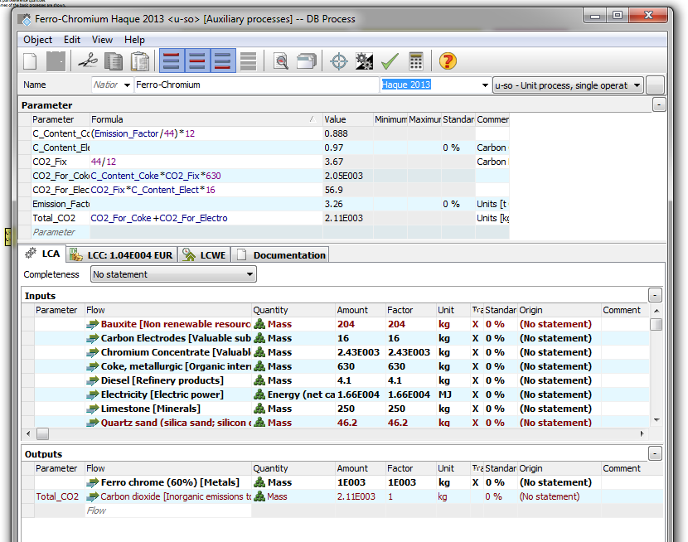
Figure 10. Utilisation of data from literature to create Fe-Cr.
The model was completed by double clicking on the main process, selecting ‘instance properties’ and setting the scaling factor to 1. This ensured all impacts and associated processes were set to the production of 1000kg of Fe-Cr.
This procedure was repeated, to not only create the final 10 ferro-alloy models utilised later on, but a number of other ferro-alloys as well as the same ferro-alloy but with multiple literature sources. Performing the methodology in this way allowed a standard methodology to be created utilising a number of ferro-alloys (Fe-Cr, Fe-Mn, Fe-Ni, Fe-Si and Si-Mn) with complete data sources. Using these ferro-alloys an attempt could be made to create a method to replicate the results. This would build confidence the method developed was robust enough to be applied to ferro-alloys with limited data. As well as bringing consistency across all ferro-alloy models.
.

5. MFA Results

5.1 Global Steel MFA Model 2008
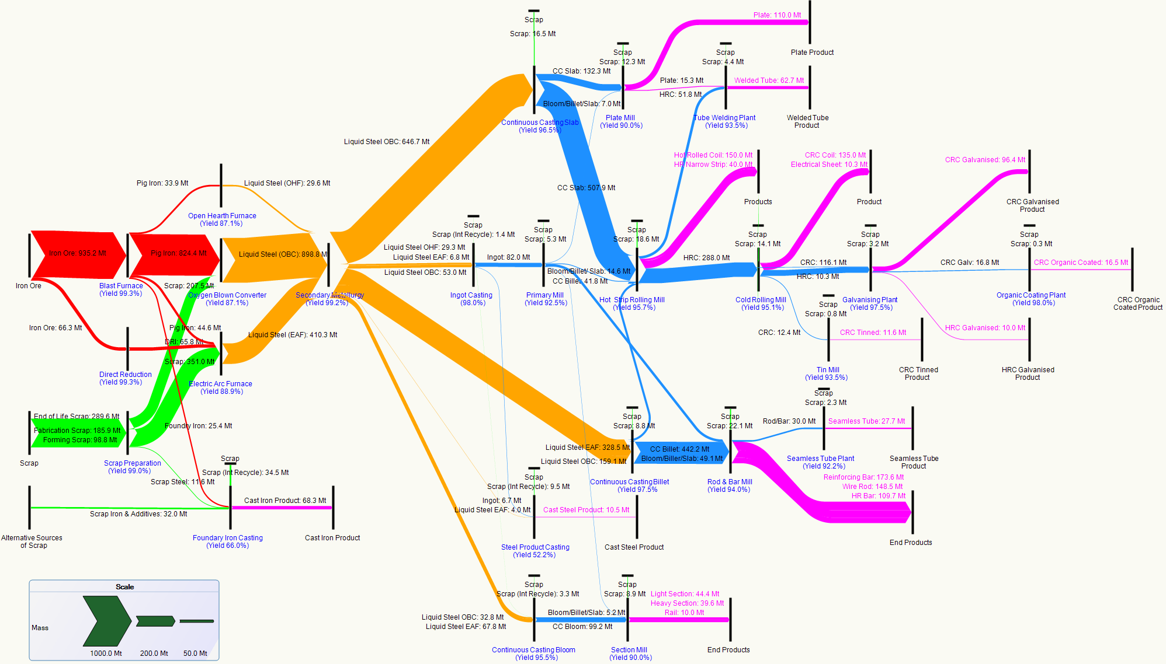
Figure 11. Sankey diagram representing the estimated global flow of steel for the year 2008.
Key: Text Colours: Blue = Main Processes, Fuchsia = End Products. Flow Colours: Ironmaking = Red, Scrap = Lime, Steelmaking = Amber, Hot Rolling = Blue and Intermediate/End products = Purple. Minor losses are present but not included here. Refer back to Pg.60 for list of alterations from original model.
Figure 11 illustrates that two-thirds of the world’s steel was produced from mined ore, with the remainder from recycled scrap. Mined ore production was predominantly from the basic oxygen steelmaking process whereas electric arc furnace accounted for production from scrap. In terms of scrap, roughly 20% of it was produced internally within steel. Whilst about 40% was produced each from fabrication and EoL products.
Approximately 99% of the world’s steel was rolled after casting with roughly 45% of it ending up as hot rolled long products and the remainder (55%) as hot rolled flat products. The resulting stock products are approximately broken down into (10%) plate (thick sheets), (10%) sections, (40%) strip (thin sheets) and (40%) rod and bar.
In terms of end products, 50% of the world’s steel was used in construction, of which one-third was from reinforcing steel in buildings. The majority of steel used in vehicle manufacture was from cold rolled coil or from castings.
Whilst not as critical in terms of global supply and demand, modelling the global flow of steel can be justified in a number of ways. In terms of the method used, although the model is a replication of results already present in the current literature, by Allwood and Cullen, replication of the results allowed a profound understanding of the methodology used to create the model. From this understanding, mistakes from the original author (refer to Pg.61) were able to be noticed and rectified, as well as identifying the difficulty in obtaining data for this type of model.
Although an attempt was made here to update the model for the year 2014, intricacies of creating the model (i.e. formulae and assumptions), as well as the quantity (i.e. 116 flows) and interlinkage of flows within the model, did not allow this. However, with the 2014 model set-up, when the relevant data appears from future literature sources, the model can be finished and potentially published.
Nevertheless as indicated by Figure 11, half of the world’s steel is used in construction and it is this industry along with automobile, and white goods industries that will present opportunities for high steel demand over the next decade.
In terms of construction, steel is already lighter and more durable compared to previous decades. These properties alongside improvements on construction frameworks to distribute weight more evenly will allow construction of buildings to withstand natural disasters such as earthquakes and hurricane force winds. Thus, refining of such methods will aid in decreasing the risk to human life, particularly with different types of disaster events (Steel Technology 2015). But the concept of light-weighting is not only being used in construction, but also extensively in the automotive industry.
Vehicle light-weighting will assist automobile manufacturers in reducing fuel emissions and meeting GHG requirements. Presently two tools, the use of aluminium alloys and Advanced High Strength Steel (AHSS) grades lead the market in making vehicles lighter. However steel does still lag behind aluminium in vehicle light-weighting (e.g. Ford F-150 the first aluminium pickup truck) particularly for heavy passenger vehicles, light trucks and SUVs. However, the competition between aluminium and steel presently, as well as with magnesium and composite materials eventually should relate to advanced vehicle designs in the future (Steel Technology 2015). Apart from opportunities in steel products, the use of recycled steel will also be pivotal in the future.
Figure 11 reveals that one third of global production of steel is via recycled steel. Recycled steel could potentially be increasingly used as the world becomes less dependent on fossil fuels for the production of energy. Implementation of devices designed to generate energy using the sun (e.g. Tarfaya complex, Morocco), waves (e.g. Aquamarine Power, off the coast of Scotland) and even from wind (e.g. Hornsea Project One, largest off-shore wind farm) are already underway. Refinement of these devices over time, will make them less expensive to manufacture, more readily available and easier to install. Such devices would aid in either increasing usage of energy intensive EAF processes or implement these technologies into types of EAF which are less energy intensive.
Whatever the solution, steel in the upcoming years will not become obsolete. Steel will adapt with new technology to become even more important than ever, as new ways emerge to put this important material to good use. With this in mind, it is recommended the steel MFA model should next be updated in 2020, since the current model although originally published in 2013, has been primarily constructed from the year 2008. This will provide sufficient time to gather the necessary data as well as incorporate potential changes to the steel sector in the new 2020 steel MFA model.

5.2 Global Chromium MFA 2014
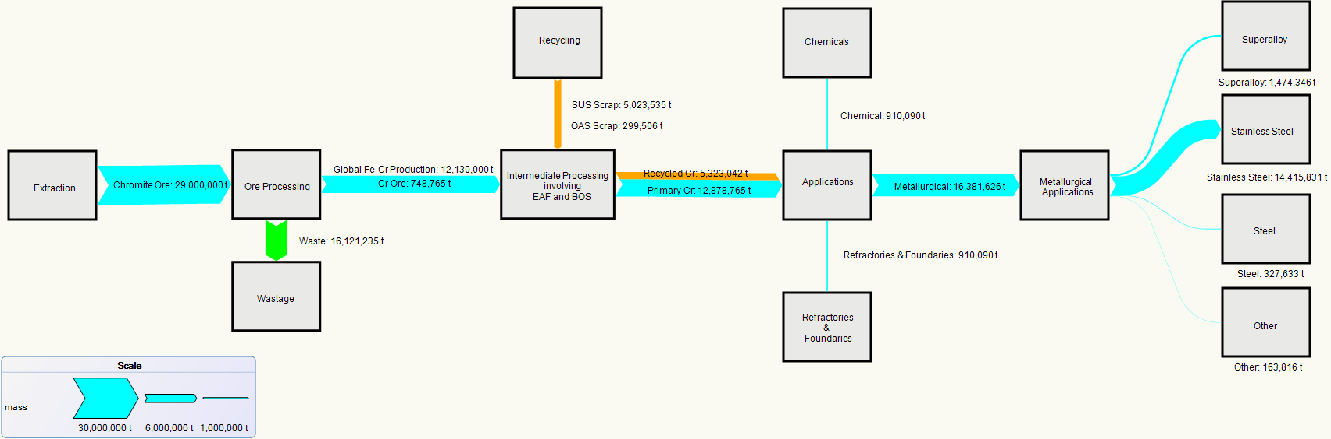
Figure 12. Sankey diagram representing the estimated material flow of chromium within global industry as of 2014.
Key: Primary flow = Cyan, Recycled flow = Orange and Waste flow = Lime.
N.B. The cyan flow from the applications sector in the chromium MFA constitutes of an amalgamation of the primary and recycled flows, as opposed to a purely primary flow.
Figure 12 depicts the global flow of chromium, from extraction to end product as well as accounting for recycling of chromium. Global chromite mine production is primarily accounted by South Africa, making up roughly 52% followed by Kazakhstan (14%) and India (10%) respectively. Beneficiation losses from ore processing account for 57%.
After mined production of chromite ore, chromium is extracted from the residual charge contained within the ore. For the production of ferro-chromium, high-grade chromium ore is extracted and reduced in a large scale electric arc furnace with the addition of aluminium or silicon reductants. Approximately 92% of global ferro-chromium is converted to charge/HC ferro-chromium, with the remainder being made up of MC ferro-chromium (5%) and LC ferro-chromium (2%).
In terms of primary and recycled chromium, primary chromium accounts for 70% of global ferro-chromium production with the remainder of 30% being provided by recycled chromium. With respect to recycled chromium, 95% comes from stainless steel scrap with 5% from other alloy steel scrap. Within stainless steel scrap, 35% is equally provided by in-house and obsolete scrap with industrial scrap (17%), imported scrap (8%) and OAS (Other Alloy Steel) scrap (5%) making up the remainder.
In terms of generic applications, 90% of ferro-chromium is used in metallurgical applications, with the remainder equally split between chemicals and refractories. Specifically within metallurgical applications, stainless steel provides the bulk (90%) end use of ferro-chromium. From the description of the global chromium flow, a number of knowledge gaps and queries were identified for analysis.
With regards to recycling, comparisons were made between previously undertaken studies, performed by (Daigo et al. 2010). In this case the consumption of chromium from recycled sources was found to be 40% as of 2014 which compared favourably to the value of 34% put forward by Daigo in 2010, representing a potential increase of 6% within a 4-year period. Although the observed increase appears high, it is potentially a hugely positive result for the state of chromium recycling. In the study by (Daigo et al. 2010), the focus was placed solely on the Japanese stainless steel industry which is generally ahead of the global recycling trend. Therefore, on a purely global level the percentage increase in recycling rate from 2010 to 2014 could actually be quite accurate.
The main issue present in the recycling of chromium is the removal of chromium containing scrap as a contaminant, which occurs when these scrap grades are combined with carbon steel scrap. This accounts for compositional losses of up to 32%wt for chromium. Therefore, the upturn in chromium recycling levels can help to confirm that the recommendations made by academics such as Oda et al., in specifying the importance of keeping chromium scrap grades separate to carbon steel grades, are having a positive impact upon global chromium recycling levels.
Apart from the comparability of recycling with other such studies, one of the more noticeable findings of the chromium MFA study was the identification of a key wastage pool during the processing stage. As displayed in Figure 12, approximately 16Mt of all chromite ore extracted from global reserves, equating to 55.59%, was lost in the intermediate stage between ore extraction and production into Fe-Cr. There are two potential reasons as to this large percentage loss.
Firstly the chromium MFA model could potentially be missing a vital production route, therefore leading to missing data. Thus explaining and accounting for such a large discrepancy. However input data utilised to create the MFA model was in line with data sources used, which included academic (Daigo et al. 2010) and institutional (ICDA). The data sources stated that 95% of chromite used in metallurgical applications is consumed in the form of Fe-Cr. Although the assumption that the chemical and refractory industries use chromium melt-stock products in the same proportions as the metallurgical industry (95% Fe-Cr, 5% Cr ore) may have led to some degree of inaccuracy. These sectors make up only 10% of chromite consumption and hence would not be expected to lead to such a large potential discrepancy. Furthermore, chemical and refractory input data was accounted for at the application stage of the MFA model.
The second possible explanation for the low yield of Fe-Cr from chromite is the classification of a shipping grade chromite reserve by the USGS. This classification states that a reserve classified as ‘shipping grade’, is normalised to contain 45% chromite. Therefore material will be lost as wastage in the form of charge and further losses would be occurred during processing of chromite to Fe-Cr. Hence a yield of approximately 40% Fe-Cr from extracted chromite (plus charge) does not seem unreasonable, despite the volume of wastage looking to be very high initially. In addition not all chromite can be produced straight into Fe-Cr.
A potential hypothesis that can be drawn from these results is that the low yield of Fe-Cr from chromite (29.0Mt to 12.1 Mt) could be the reasoning behind the high levels of recycling for chromium. As is displayed in Figure 13, the EOL-RR of chromium metal is in excess of 50%.
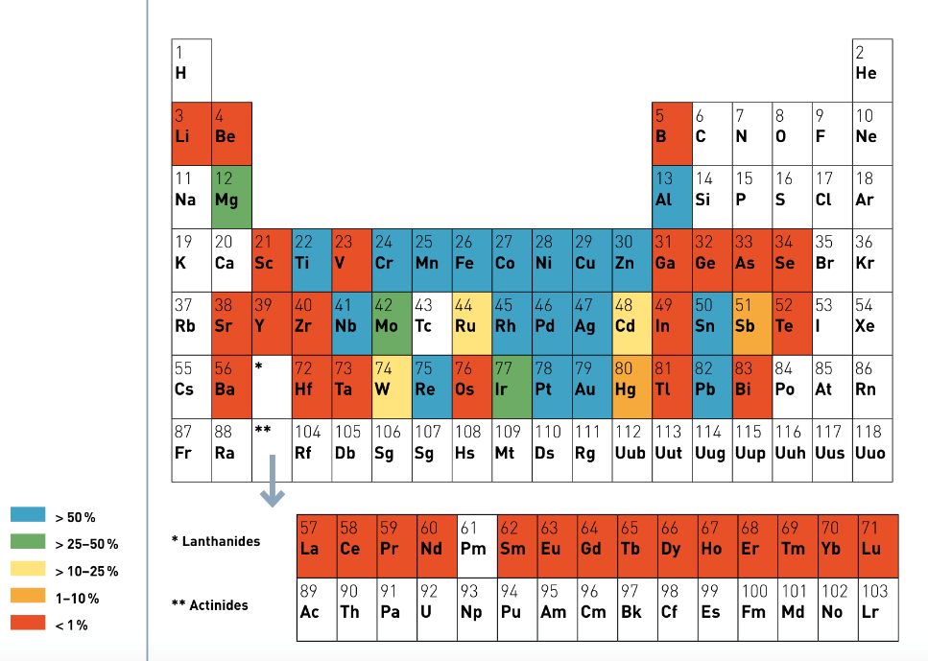
Figure 13. Periodic table, from UNEP Recycling Rates of Metals: A Status Report, displaying the EOL RR of metals (Graedel et al. 2011).
The EOL-RR of 93% and 87% has stated by (Johnson et al. 2006) and (Papp 2004) are substantially higher than the other metals (i.e. molybdenum, tungsten and seaborgium) also present in group VI of the periodic table. Indeed it is surprising to see chromium classified in the same ensemble of gold and silver since chromium is traditionally not a ‘valuable material’. Therefore, the high levels of chromium recycling could be due to the inefficiency of producing primary chromium from chromite. For this reason, it may be industrially preferable to extract the maximum possible yield from ‘urban mines’, as coined by (Hagelüken & Meskers, 2010) via EOL-RR instead of purely relying upon primary sources of chromium. By utilising these ‘urban mines’, the entire process for obtaining Fe-Cr from chromite can potentially be bypassed.

5.3 Global Molybdenum MFA 2014
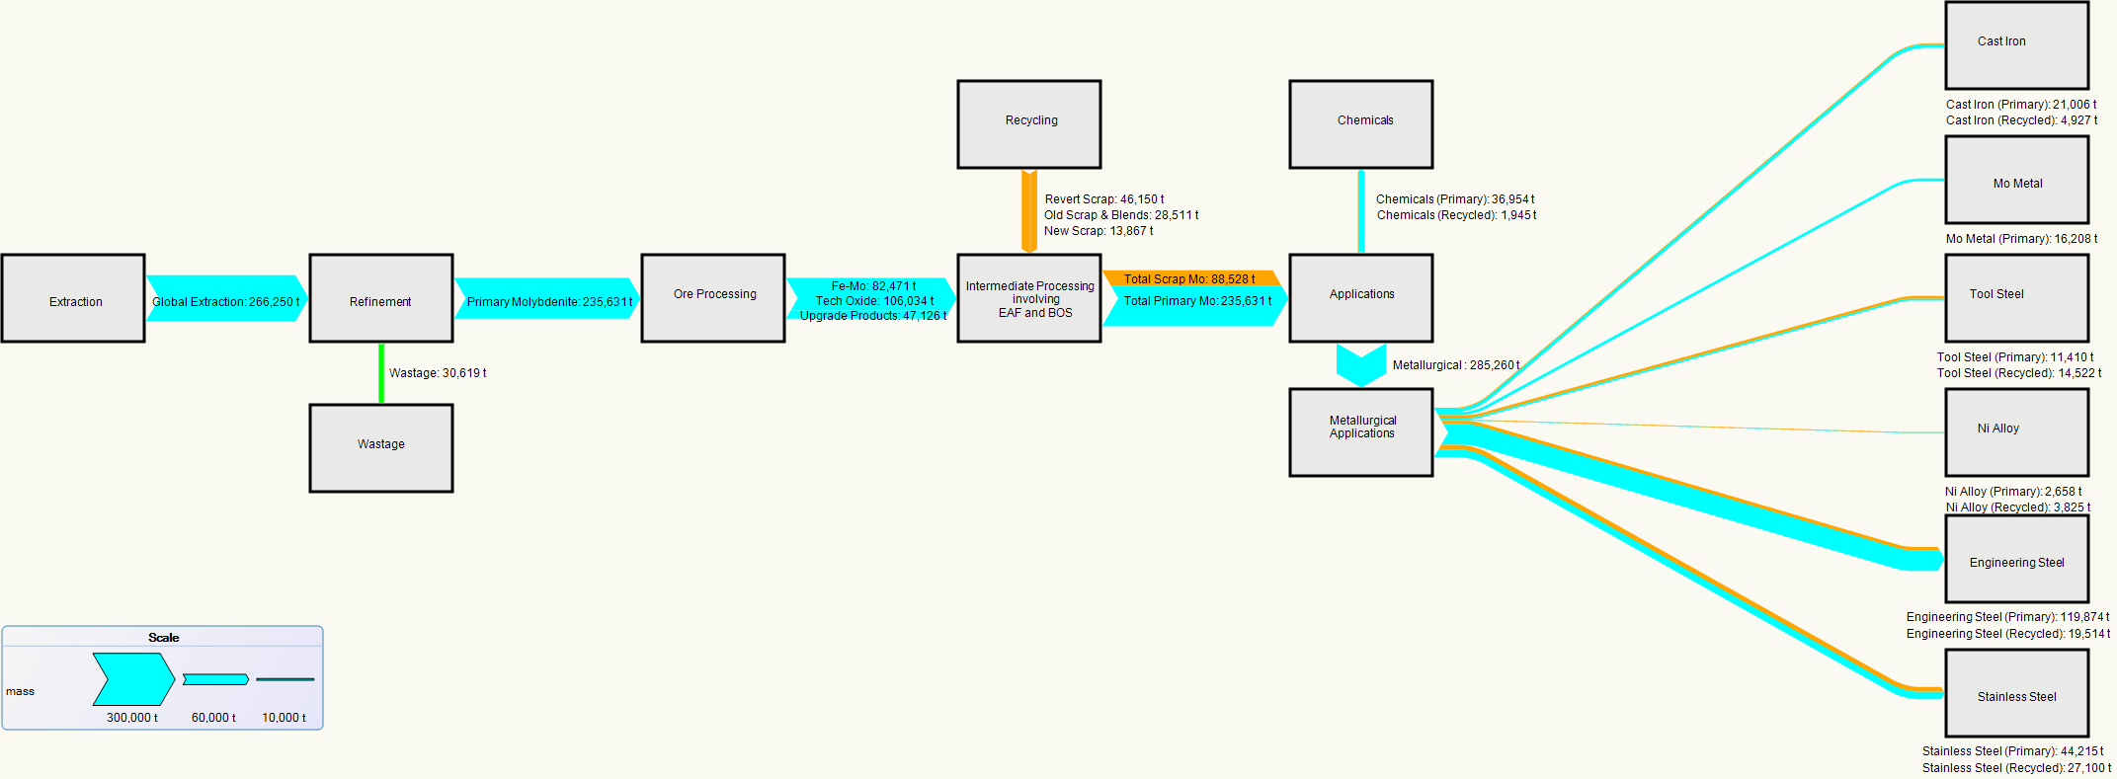
Figure 14. Sankey diagram representing the estimated material flow of molybdenum within global industry as of 2014.
Key: Primary flow = Cyan, Recycled flow = Orange and Waste flow = Lime.

The molybdenum MFA, displayed in Figure 14, illustrates that 266,250t of molybdenite, primary molybdenum ore, was mined in 2014. This was made up of several countries with China (38%), USA (25%) and Chile (15%) comprising the top three global countries that mined molybdenite.
In terms of refining molybdenite, approximately 11.5% of molybdenite was lost as industrially un-usable ore concentrate. The remaining molybdenite was broken down into primary products: Fe-Mo (35%), Upgrade Products (20%) and Tech Oxide (45%).
In terms of generic applications, the top three molybdenum applications consisted of engineering steels (43%), stainless steels (22%) and chemicals (12%). With the availability of percentage of molybdenum from scrap data from IMOA, Figure 14 reveals the largest sources of recycled scrap provided by stainless steel (40%), engineering steels (20%) and tool steels (11%). End of life scrap is estimated to account for 27% of input material for refining. In terms of the overall model, primary production accounts for 75% whilst the remainder (25%), was assumed to be from recycled molybdenum.
The initial findings from the molybdenum MFA study established that the results displayed good agreement with previously researched studies by Nakajima. In particular, one study (Nakajima et al. 2007) which was able to determine that the iron and steel industry accounted for 85% of molybdenum consumed by Japanese industry. This was in line with the 1998 IMOA annual report, whose percentages were used in the molybdenum MFA diagram: which reported a yield of between 85 and 92% molybdenite at the floatation stage, prior to processing the ore into melt stock products, such as Fe-Mo.
Furthermore, the recycling data generated and implemented into the MFA study identified that 25% of the molybdenum inputted into the production cycle originated from recycled sources, such as old, new and revert scrap. This recycling loop is in line with the published UNEP EOL-RR data, displayed in Figure 13, which states that the recycling rate of molybdenum metal was estimated to be between 25-50% as of 2011. This is further backed up by USGS sources (Polyak 2015) that estimated the upper bound of molybdenum recycling to be 30%. High levels of comparability aid in confirming the reliability and validity of the data achieved from the MFA model.
As was discussed in the recycling of chromium, the removal of chromium containing scrap as a contaminant, occurs when these scrap grades are combined with carbon steel scrap. This also applies to molybdenum where compositional losses account for between 11-29%wt for molybdenum. Thus specifying the importance of keeping molybdenum scrap grades separate to carbon steel grades.
Additionally this would aid the future outlook of molybdenum recycling as this result remains in line with the predicted upturn in molybdenum scrap usage within the next 15 years. The predicted increase, from 2011 levels (i.e. 25%) is a climb back to 27% as of 2020 and a further climb to 35% as of 2030 (Graedel et al. 2011; Hagelüken & Meskers, 2010).
Finally in identification of key wastage pool, unlike chromium, waste for molybdenum was found to be only 11.5 % of extracted molybdenite containing ore. Although the percentage yield of 42% Fe-Cr (12.1 Mt) from chromite was greater than the corresponding 35% Fe-Mo yield (82,471 t) from molybdenite. The majority of molybdenite is not processed into Fe-Mo, whereas 95% of chromite ore is processed into Fe-Cr. However, when all the useful melt stock products produced from molybdenite, such as Tech oxide and upgraded Mo products, are included the overall desirable product yield for molybdenum, the value comes to 89.1%, which dwarfs the 44.4% yield achieved by chromium.

5.4 Global Niobium MFA 2013
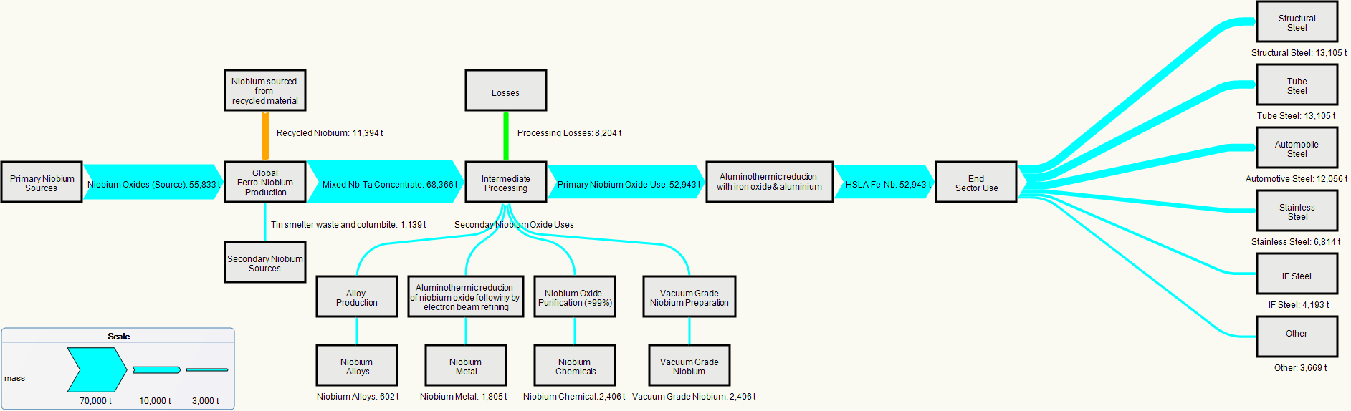
Figure 15. Sankey diagram representing the estimated material flow of niobium within global industry as of 2013.
Key: Primary flow = Cyan, Recycled flow = Orange and Waste flow = Lime.
The niobium MFA model, has illustrated by Figure 15, depicts the flow of niobium from extraction, processing to end product as well as including recycling but not in terms of individual end product contribution.
Explaining the flow of the model, most niobium is extracted as a primary ore from pyrochlore minerals. The extraction of this ore is dominated by Brazil which accounted for over 90% of global niobium mine production in 2013. The average beneficiation recovery rate from mining pyrochlore is roughly 60%. From the model, primary niobium production comprises 80% with recycled niobium attributing 20%. Within primary production, 98% is provided by niobium oxides with secondary sources such as tin smelter waste and columbite providing the remainder. With regards to recycling, niobium steels and super-alloys provide the majority of recycled material. But quantifying and including this has individual flows from the end products was not possible due to lack of quantitative data.
As indicated by Figure 15 the majority of niobium (88%), is converted into HSLA grade Fe-Nb for steel production, with processing losses accounting for about 12%. The large percentage into a single product is due to the properties and usage of niobium in several industries including automotive, pipeline construction and stainless steel.
The primary reason for the increased usage of niobium steels, especially in automotive steels is because of light-weighting. Reducing the weight of a vehicle means lower fuel consumption and lower CO₂ emissions. For a mid-sized vehicle, a meagre 300 grams of niobium can reduce the weight of the vehicle by 200 kg, resulting in fuel economy of 1litre per 200 kilometres.
In pipeline steels, niobium increases steel strength and toughness simultaneously. This enables pipelines to operate at higher pressures as well as allowing thinner walls and larger diameters to be designed. Leaner, larger diameter pipelines mean more oil and gas transportation at a lower cost.
In structural steels, niobium steels are far more beneficial compared to relying on concrete and conventional steel. Apart from increasing the strength and toughness of the steels, leaner and faster construction can occur with niobium steels. This means far less resources are consumed and the structures built are environmentally friendly. Final breakdown in terms of end sector uses is primarily made up of: structural steels (24.75%), tube steels (24.75%) and automobile steels (22.77%).
To summarise, the niobium MFA model does reveal: that primary extraction is via pyrochlore, primary production comprises 80% and production from recycling 20% and the main end use being in HSLA steels. However there are a number of knowledge gaps, particularly to do with recycling and the niobium supply chain that can be analysed.
With regards to recycling, once niobium is embedded in steel, it is extremely difficult to recover as a single element. For one thing it is not known how much niobium is diluted and downgraded during steel recycling and thus how much is effectively recycled and used for its unique properties. Additionally it is not even known if it is physically possible to recover niobium from steel to avoid dilution. Consequently, even if recovery was physically possible would it be financially viable? Currently, considerable amounts of scrap steel are recycled from EOL components and processing scrap. Niobium is consequently recycled as part of this operation.
In conjunction, little is known about manufacturing losses and recycling rates from other niobium products processing routes. Thus highlighting the single flow of recycled niobium in the MFA model. Because the current supply and reserves of niobium are dominated by one country Brazil, it is only through technological change or extreme increase in usage and intensity of niobium in products that emphasis to recycle niobium might occur. Thus until it does, the current status quo will exist.
Relating to supply chain, as an alloying element niobium strengthens steel, hence less steel is required for specific high strength applications. However the exact impact of niobium over the steel supply chain in terms of steel demand reduction is unknown and a possible area of investigation. Consequently, associated with the use of niobium as an alloying element in steel, would be its environmental impact in terms of carbon and energy emissions. Again another potential topic of investigation for future work.

5.5 Global Vanadium MFA 2014
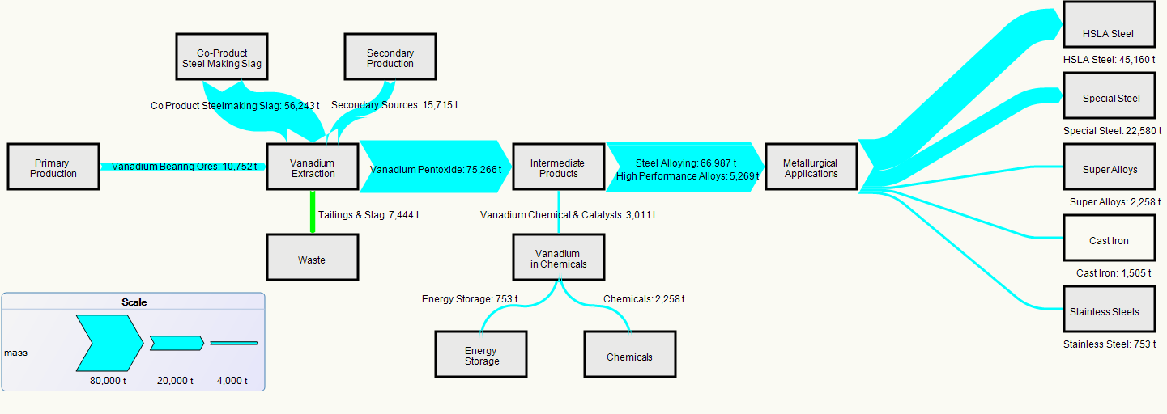

Figure 16. Sankey diagram representing the estimated material flow of vanadium within global industry as of 2014.
Key: Primary flow = Cyan, Waste flow = Lime.
Global vanadium mine production is dominated by three countries: China (54.41%), South Africa (25.39%) and Russia (18.26%) which account for 98% of total global production. Although in terms of vanadium reserves, China and South Africa have identical global reserves of 38% followed by Russia with 21%. However vanadium is unique compared to other metals because it cannot be recovered from a single ore.
Vanadium is found in over 65 different minerals as a trace element, and is commercially produced as a by-product of other mining operations. The primary source of vanadium is from Titaniferrous Magnetite (TFM) ores with an average grade of ~0.3 to +1% of vanadium pentoxide. However mining from ores only accounts for 13% of vanadium production with the majority of vanadium being produced as a co-product from steel making slag, approximately 68%. The remainder of vanadium, about 19%, is produced from secondary sources oils, uranium, fly ash and catalysts.
The primary production of vanadium, approximately 80%, is as a by or co-product with the extraction of other metals. This route produces vanadium as an oxide, either in the form vanadium pentoxide or vanadium (III) oxide as explained in detail in the subsequent paragraph.
From the initial stage a slag is produced containing most of the titanium and a pig iron containing most of the vanadium (1.6%). The slag is removed and oxygen blown into the molten pig iron to form a new slag containing vanadium pentoxide (V₂O₅). Each country performs this process slightly differently: In Russia a special oxygen steel converter is used, whilst China carries this out by spray refining and South Africa through a shaking ladle. As a consequence there is variation in V₂O₅ in the slag, with slag form South Africa containing the highest percentage of V₂O₅ (25%) compared to 14-22% for China and Russia (Vanitec 2015).
Once the metallurgical slag has been isolated the V₂O₅ undergoes three main extraction techniques; roasting, leaching and precipitation in order to obtain industrial grade purity (86.5%) or higher (99.5%) in order to produce Fe-V.
High grade industrial purity Fe-V is used in steel making accounting for 89% with the remainder of uses being in high performance alloys and vanadium chemicals. Within the steel making, HSLA steels account for 60% with special steels comprising 30% of metallurgical end product use.
Though the global vanadium MFA provides a very useful snapshot of the flow of vanadium, there are a several topics of interest, based on the nature of vanadiums properties, supply and use.
In terms of supply, over the next couple of years between 2012 and 2017, only a few projects are predicted to come online. This is because expansion of vanadium’s supply is highly dependent upon the global steel market. The more developed and stable the steel market, the more likelihood current producers will expand and upgrade resulting in new projects being mined, explored and developed.
Currently the most advanced project to come online will be Atlantic’s Windimurra project in Western Australia. The Windimurra mine is not a new project, rather an upgrade of an existing mill. Originally it first produced vanadium in 1999, but closed down in 2003 due to market conditions being unfavourable. However it was expected to restart in 2011 but due to delays, this has been pushed back to late 2012 or early 2013. Windimurra will produce approximately 6,300 Metric tons Vanadium (MTV), mainly Fe-V for usage in steel. Apart from the Windimurra project, not many Greenfield projects (i.e. projects built from scratch) are expected to come online. Thus the emphasis will be on primary vanadium producing countries to upgrade or expand production. The following are brief summaries, examining projects in the near future from the 3 main vanadium producing countries.
China is expected to significantly upgrade its vanadium by-product production by strategically supporting growing internal steel production from its own domestic ores. Over the years China has become dependent on importing iron ore from aboard, and this strategy is designed to counteract that dependence. Currently low iron bearing ores (30%) rich in titanium and vanadium have been discovered in the provinces of Sichuan and Hebei. In addition, the Daquan Project is also expected to go on-line in 2012 with a capacity of 6,400 tons per annum. According to this approach, China is expected to produce an extra 20,000 tonnes of by-product vanadium from planned steel mill expansions over the next 5 years. (Perles 2012)
Apart from China, the other 2 primary producing nations (South Africa and Russia) are also set to expand production. Expansion of existing plants such as Nizhny Tagilsteel mill (Russia) and Highveld Steel mill (South Africa) are expected in 2015 with increased production capacities of 7,000 and 1,500 MTV respectively. Additionally, unspecified expansion from either unfunded or not identified vanadium mining projects could bring an additional 6,000 MTV per year to market by 2017. (Atlantic Ltd 2013)
Apart from supply, vanadium demand will also be susceptible to changes in the market and in particular the steel industry. Within steel, the production of titanium alloys predominantly in aerospace applications could have a significant impact on vanadium demand. In particularly Ti6-4 which contains about 4% vanadium. In 2011 over 3,000 MTV was consumed in titanium alloy production and increased to about 3,229 MTV in 2012. This meant titanium alloys accounted for about 4% of consumption of vanadium in 2012. However, with air traffic doubling over the next 15 years and military demand increasing by about 40% between 2010 to 2015, demands for vanadium consumption by titanium alloys is expected to reach 6,000 MTV by 2016. This therefore strategically places titanium alloy demand in aerospace applications, as potentially one of the quickest growing markets for global vanadium demand. (Atlantic Ltd 2013)
Outside the steel sector, vanadium has had little use up to now in the energy sector. In 2012 vanadium consumption was thought to be about 1% in energy storage applications. However with significant development in energy storage applications such as, lithium battery systems and vanadium redox flow batteries (VRB), this could change. Lithium batteries are in demand due to their improved energy to weight characteristics as well as their higher voltages which are ideal for use in electric cars. Whereas, VRB are in demand due to their unlimited storage capacity and extremely rapid discharge ability which make them suitable for large power storage applications in wind or solar energy. These two energy storage applications have the potential to have a substantial impact on future global vanadium demand. In 2012 demand for lithium batteries was 200 tonnes whereas for VRB it was 1,100 tonnes. However, conservative projections have put future demand for lithium batteries at 1,700 tonnes and 8,500 tonnes for VRB by 2017. (Atlantic Ltd 2013)
Even-though energy storage applications and titanium alloy demand might have a substantial impact on vanadium demand, the steel industry will still dominate global vanadium demand. Global vanadium demand today is driven by two basic variables: global steel production rates, and the Specific Vanadium Consumption Rate (SVCR) (kilograms vanadium used per metric ton of steel produced, or kg-Vanadium/MT steel) within the steel industry. Changes in these two variables will be the main drivers for changes in global vanadium demand in the up-coming years. (Perles 2012)
As a summary, vanadium alloy production is in the phase of stability and growth and this application will make a contribution in the next 5 years. Energy storage applications do offer potential to have a significant impact on vanadium demand growth in the coming years. Vanadium chemical applications are for the most part mature applications with growth in vanadium consumption in this field projected to be close to global gross domestic product (GDP) growth. But changes in the steel market will continue to drive and predominantly affect the global vanadium supply and demand. (Perles 2012).

5.6 Summary
Mapping the flows of critical metals to identify ‘hotspots’ i.e. areas of interest, is a challenging task. Most critical metals are mined in a handful of countries and in minute capacities involving only a select number of organisations. On top of this, data availability in literature concerning these metals is low and not helped by data confidentiality being an issue particularly, when production is concentrated in countries such as China.
The five Sankey diagrams shown in the preceding sections were populated using industrial statistics obtained from a comprehensive literature review. In some instances, where direct data was not available, the missing data was back-calculated, estimated or inferred from revealing knowledge gaps in mapping flows. The only solution to overcome these knowledge gaps is wider stakeholder engagement across all levels of supply chain from extraction, manufacturing and end use of products. In addition, to attempting to gather the missing knowledge from literature.
Despite the limitations, analysis of the five Sankey diagrams has revealed a number of ‘hotspots’. From the global steel MFA (Figure 11) opportunities for high steel demand over the next decade will come from the usage of steel, in particular from the construction and automobile industries. Specifically the concept of ‘ vehicle light-weighting’ is pushing the steel industry towards developing Advanced High Streel Steel (AHSS) grades which will beneficially bring about weight savings as well as meeting GHG requirements. Consequently, development of AHSS grades will push the steel industry closer to aluminium has steel still lags behind aluminium predominantly in vehicle light-weighting. However, other alternatives such as magnesium and Carbon Fibre Reinforced Polymers (CFRP) are also being researched and thus should provide impetus and healthy competition to steel manufacturers to develop newer and advanced steel grades. Apart from opportunities in steel products, another hotspot from the global steel MFA is the use of recycled steel.
Figure 11 revealed that one third of global production of steel was via recycled steel. Principally, increasing the usage of recycled steel should be the objective of steel producers in the future. However, the production of steel by this route is heavily energy intensive, and thus steel producers heavily dependent on fossil fuels for electricity generation incur significant financial costs. Thus, bringing the emphasis slightly away from steel and to electricity generation. If electricity generation can be based more from renewable sources i.e. solar (e.g. Tarfaya complex, Morocco), waves (e.g. Aquamarine Power, off the coast of Scotland) these will benefit energy intensive industries such as steel. Summarising, with global industries trying to meet GHG emission targets and become less reliant on fossil fuels, there is an opportunity to use more recycled steel.
With regards to the chromium MFA model (Figure 12) this illustrated two hotspot areas, namely wastage during the processing stage and recycling of chromium scrap. As displayed in Figure 12, approximately 16Mt of all chromite ore extracted from global reserves, equating to 55.59%, was lost in the intermediate stage between ore extraction and production into Fe-Cr. There are two potential reasons as to this large percentage loss. Firstly this could be due to missing data, thus explaining and accounting for such a large discrepancy. However input data utilised to create the MFA model was in line with data sources used, which included academic (Daigo et al. 2010) and institutional (ICDA). The second and more plausible explanation being the low yield of Fe-Cr from chromite.
Data used from the original data source i.e. USGS confirms a yield of 45% chromite. Hence a yield of approximately 40% Fe-Cr from extracted chromite does not seem unreasonable considering material would be lost as wastage in the form of charge and further losses would occur during processing of chromite to Fe-Cr. Additionally the low yield of Fe-Cr from chromite (29.0Mt to 12.1 Mt) could also explain the second hotspot, of high levels of chromium recycling.
From the Sankey diagram, the consumption of chromium from recycled sources was found to be 40% as of 2014 which compared favourably to the value of 34% put forward by Daigo in 2010, representing a potential increase of 6% within a 4-year period. In the study by (Daigo et al. 2010), the focus was placed solely on the Japanese stainless steel industry which is generally ahead of the global recycling trend. Therefore, on a purely global level the percentage increase in recycling rate from 2010 to 2014 could actually be quite accurate. Additionally, the main issue present in the recycling of chromium is the removal of chromium containing scrap as a contaminant, which occurs when stainless scrap grades are combined with carbon steel scrap. This accounts for compositional losses of up to 32%wt for chromium. According to academics such as Oda et al., the importance of keeping chromium scrap grades separate to carbon steel grades is also a reason for the upturn in global chromium recycling levels.
Similarly to the Sankey diagram for chromium, the hotspots for molybdenum (Figure 14) also focused on wastage during processing and recycling. Unlike chromium, waste for molybdenum was found to be only 11.5 % of extracted molybdenite containing ore. Although the percentage yield of 42% Fe-Cr (12.1 Mt) from chromite was greater than the corresponding 35% Fe-Mo yield (82,471 t) from molybdenite. The majority of molybdenite is not processed into Fe-Mo, whereas 95% of chromite ore is processed into Fe-Cr. However, when all the useful melt stock products produced from molybdenite, such as Tech oxide and upgraded Mo products, are included the overall desirable product yield for molybdenum, the value comes to 89.1%, which dwarfs the 44.4% yield achieved by chromium.
With regards to recycling, the molybdenum Sankey diagram identified that 25% of data input into the production cycle originated from recycled sources, such as old, new and revert scrap. This recycling loop is in line with the published UNEP EOL-RR data, displayed in Figure 13, which states that the recycling rate of molybdenum metal was estimated to be between 25-50% as of 2011. This is further backed up by USGS sources (Polyak 2015) that estimated the upper bound of molybdenum recycling to be 30%. The difference between chromium and molybdenum recycling rates can be explained firstly, due to the primary demand for chromium being stainless steels (88%) compared to (22%) for molybdenum. Secondly due to the tonnages associated with the respective Sankey diagrams, with 14.4Mt of Stainless steel being produced from chromium compared to 0.04Mt from molybdenum. Thus explaining the higher recycling percentage due to chromium potentially possessing the greater source of recyclable material from end product.
To summarise, the niobium MFA model (Figure 15) does reveal: that primary extraction is via pyrochlore, primary production comprises 80% and production from recycling 20% and the main end use being in HSLA steels. However there are a number of hotspots, particularly to do with recycling and the niobium supply chain that can be analysed.
With regards to recycling, once niobium is embedded in steel, it is extremely difficult to recover as a single element. For one thing it is not known how much niobium is diluted and downgraded during steel recycling and thus how much is effectively recycled and used for its unique properties. Additionally it is not even known if it is physically possible to recover niobium from steel to avoid dilution. Consequently, even if recovery was physically possible would it be financially viable? Currently, considerable amounts of scrap steel are recycled from EOL components and processing scrap. Niobium is consequently recycled as part of this operation.
In conjunction, little is known about manufacturing losses and recycling rates from other niobium products processing routes. Thus highlighting the single flow of recycled niobium in the MFA model. Because the current supply and reserves of niobium are dominated by one country Brazil, it is only through technological change or extreme increase in usage and intensity of niobium in products that emphasis to recycle niobium might occur. Thus until it does, the current status quo will exist.
Relating to supply chain, as an alloying element niobium strengthens steel, hence less steel is required for specific high strength applications. However the exact impact of niobium over the steel supply chain in terms of steel demand reduction is unknown and a possible area of investigation.
Though the global vanadium MFA provides a very useful snapshot of the flow of vanadium, there are a several hotspots, based primarily on the supply and demand of vanadium.
Since the majority of vanadium being produced is as a co-product from steel making slag (68%), future expansion of vanadium’s supply is thus highly dependent upon the global steel market. The more developed and stable the steel market, the more likelihood current producers will expand and upgrade resulting in new projects being mined, explored and developed. Over the next couple of years between 2012 and 2017, only a few projects are predicted to come online from the top three producing countries, China, Russia and South Africa.
China is expected to significantly upgrade its vanadium by-product production by strategically supporting growing internal steel production from its own domestic ores. Over the years China has become dependent on importing iron ore from aboard, and this strategy is designed to counteract that dependence. According to this approach, China is expected to produce an extra 20,000 tonnes of by-product vanadium from planned steel mill expansions over the next 5 years. (Perles 2012)
Apart from China, the other 2 primary producing nations (South Africa and Russia) are also set to expand production. Expansion of existing plants such as Nizhny Tagilsteel mill (Russia) and Highveld Steel mill (South Africa) are expected in 2015 with increased production capacities of 7,000 and 1,500 MTV respectively.
Apart from supply, vanadium demand will also be susceptible to changes in the market and in particular the steel industry. Within steel, the production of titanium alloys predominantly in aerospace applications could have a significant impact on vanadium demand. In particularly Ti6-4 which contains about 4% vanadium. In 2011 over 3,000 MTV was consumed in titanium alloy production and increased to about 3,229 MTV in 2012. This meant titanium alloys accounted for about 4% of consumption of vanadium in 2012. However, with air traffic doubling over the next 15 years and military demand increasing by about 40% between 2010 to 2015, demands for vanadium consumption by titanium alloys is expected to reach 6,000 MTV by 2016. This therefore strategically places titanium alloy demand in aerospace applications, as potentially one of the quickest growing markets for global vanadium demand. (Atlantic Ltd 2013) Additionally global vanadium demand today is driven by two basic variables: global steel production rates, and the Specific Vanadium Consumption Rate (SVCR) (kilograms vanadium used per metric ton of steel produced, or kg-Vanadium/MT steel) within the steel industry. Changes in these two variables will be the main drivers for changes in global vanadium demand in the up-coming years. (Perles 2012)
Apart from analysing hotspots the four supply chains analysed here were divided into four stages: extraction, processing, generic applications and metallurgical applications. Some general trends were also observed about the quality and quantity of data available for each stage:
- Mine production, refinery production and recovery rates are generally available from a number of literature sources, but mainly Geological Surveys (e.g. BGS and USGS) as well as metal specific institutes and groups (i.e. International Chromium Development Association (ICDA)).
- Literature regarding in-depth details about mining and processing methods used to extract metals from ore are not accessible in great detail. This includes factors (i.e. economic, physical and technological) that provide the backbone of operations by these companies that mine and refine these metals.
- The true environmental effects of operations run by metals mining and refining companies are unknown since they do not publish data related to sustainability indicators. Platinum Group Metals (PGM) are the notable exception.
- Uncertainty exists on use of recycling metrics and estimates for all four elements analysed. This is due to a lack of detail, presently missing in current literature, concerning the exact methods and processes used to recycle these metals. Even with the presence of qualitative data, there is lack of supportive quantitative data.
- The outcome of EoL products is not well understood in literature and requires further study. Especially the anthropogenic stocks which will provide an understanding of how much material is obtainable form current products for recycling. Thus, establishing the economic and technical viability of such operations presently as well as in the future.

Though large amounts of data are produced by global companies and international organisational bodies, combined with data confidentiality, this results in only a fraction of usable data from which MFA studies can be created. Consequently, MFA studies provide only an estimate of the present state of industry and not exact figures. Yet MFA studies are extremely significant in identifying areas of interest i.e. hotspots as previously mentioned, for a myriad of different industries and applications. The findings of such results often act as the backbone upon which industrial practises are devised, revised and updated, as well as upon which governmental policies are formed and acted upon.
In addition, although not investigated here, the benefits of monetising MFA diagrams would highlight major costs, current profitability of manufacturing routes and products and potential opportunities. For example with Cobalt, leading automotive manufacturers have said by approximately 2020, 12-13 million Hybrid Electric Vehicle (HEV) and Electrical Vehicle (EV) should be on the road. If approximately 4kg of Cobalt is required for HEV and 6kg for EV, this will require at least 20,000 - 30,000Mt of Cobalt. (Burgert P. 2012) Thus, highlighting a clear economic opportunity to focus on a particular product or sector.
However, due to the complexity of the metal life cycle (i.e. cradle to grave) it is recommended that monetising be performed on lower levels such as on the organisational level. This would better highlight distribution of costs (e.g. energy, labour, materials, taxes) within a project and the economic flow of the project. Thus allowing organisations to select the most economically appropriate strategy which can maximise profits as well as take into account other important factors such as the environmental impacts.
b

6. LCA Results - Electricity

6.1 Verification of electricity grid mix method using India, Japan and Norway

Figure 17. A comparison in terms of GWP of breakdown of electricity by fuel source for India, Japan and Norway via GaBi and IEA databases for the year 2011.
Before developing average electricity grid mixes for all nine countries of interest, a sample of three countries (India, Japan and Norway) were selected to develop a robust and valid methodology. Selection of these three was based on their presence in both the software program GaBi and IEA online statistics database for the year 2011. The results illustrate that India has the smallest deviation (3.50%) followed by Japan (9.92%), with Norway displaying the largest difference (47.49%) between GaBi and IEA databases.
Analysis of the breakdown of electricity by fuel source, for all three countries, did not reveal any major differences, and is presented in detail in the Appendix (see Tables 33 to Table 35). In terms of fuel sources, India and Japan were predominantly fossil fuel based with Norwegian electricity mainly being based on hydro-electricity. The primary fuel source for India was coal and represented approximately 68% of electricity production in both GaBi and IEA databases. For Japan, the principal fuel was natural gas and represented approximately 36% of electricity production in both GaBi and IEA databases. A similar trend was also seen for Norway with hydroelectricity being the chief fuel source, contributing approximately 95%, in both GaBi and IEA databases. Although the breakdown of electricity by fuel source percentages are similar, with some variation, it does not explain the deviated values as shown by Figure 17.
There are a number of potential reasons as to the cause of the deviated values between the three countries of interest and two different databases. Regarding India, solar and waste processes from India were not available and so processes from Japan (solar) and EU-27 (waste) were selected. However contributions from each process (i.e. solar 0.01-0.08% and waste 0.02%) were minor, that selection of an alternative country could account for some but not all of the deviated value of 3.50% for India, between GaBi and IEA databases.
However, an alternate explanation of the differences could be due to the values used for electric power transmission and distribution losses. Loss percentages from GaBi for India (22.3%), Japan (4.81%) and Norway (8.44%) were lower than the values obtained from the World Bank (see Table 21). The difference in loss percentage values between GaBi and the World Bank may explain why in Figure 17, India and Japan have underestimated values compared to IEA and Norway an overestimated value.
However, the percentage deviations from India, Japan and Norway have to be considered in a global context. Regarding Norway, since it had the largest deviation, it produces more than 95% of its electricity from hydropower. Even if natural gas only represents 3% of its electricity production it is responsible from more than 30% of the GHG emissions. This means any assumptions made regarding the natural gas production or the yield of the natural gas power plant can have a huge impact particularly in percentage. Compared to other countries in EU or in the world (hereafter are rounded values), Norway has very low GHG emissions as shown by the numerical values below:
- 46g CO₂eq/kWh in Norway.
- 100gCO₂eq/kWh in France.
- 600gCO₂eq/kWh in Germany.
- 900gCO₂eq/ kWh in China.
The 47.49% (i.e. 21.84g CO₂eq/kWh) mentioned as ‘percentage deviation’ for Norway would be therefore for other countries a minor one particularly compared to the ‘absolute numbers of g CO₂/kWh’ as shown below:
- 17% in France.
- 3% in Japan.
- 3% in Germany.
- 2% in China.
- 1% in India.
For Norway the results were satisfactory as the deviation in absolute numbers is not high but only in percentage numbers (47.5%) due to the named fact that g CO₂ per kWh is very low in Norway with 46g.
To summarise, breakdown of electricity by fuel sources for India, Japan and Norway was identical whether GaBi or IEA database was used. However there was also some variation between GaBi and the World Bank in terms of electric power transmission and distribution losses. Thus, a combination of slight variations in both cases would have caused the deviated results as presented in Figure 17. The reliability of the results was tested by comparing ‘percentage deviation’ against known ‘absolute values’, resulting in recognition of the method used as being accurate and trustworthy.

6.2. Analysis of average electricity models
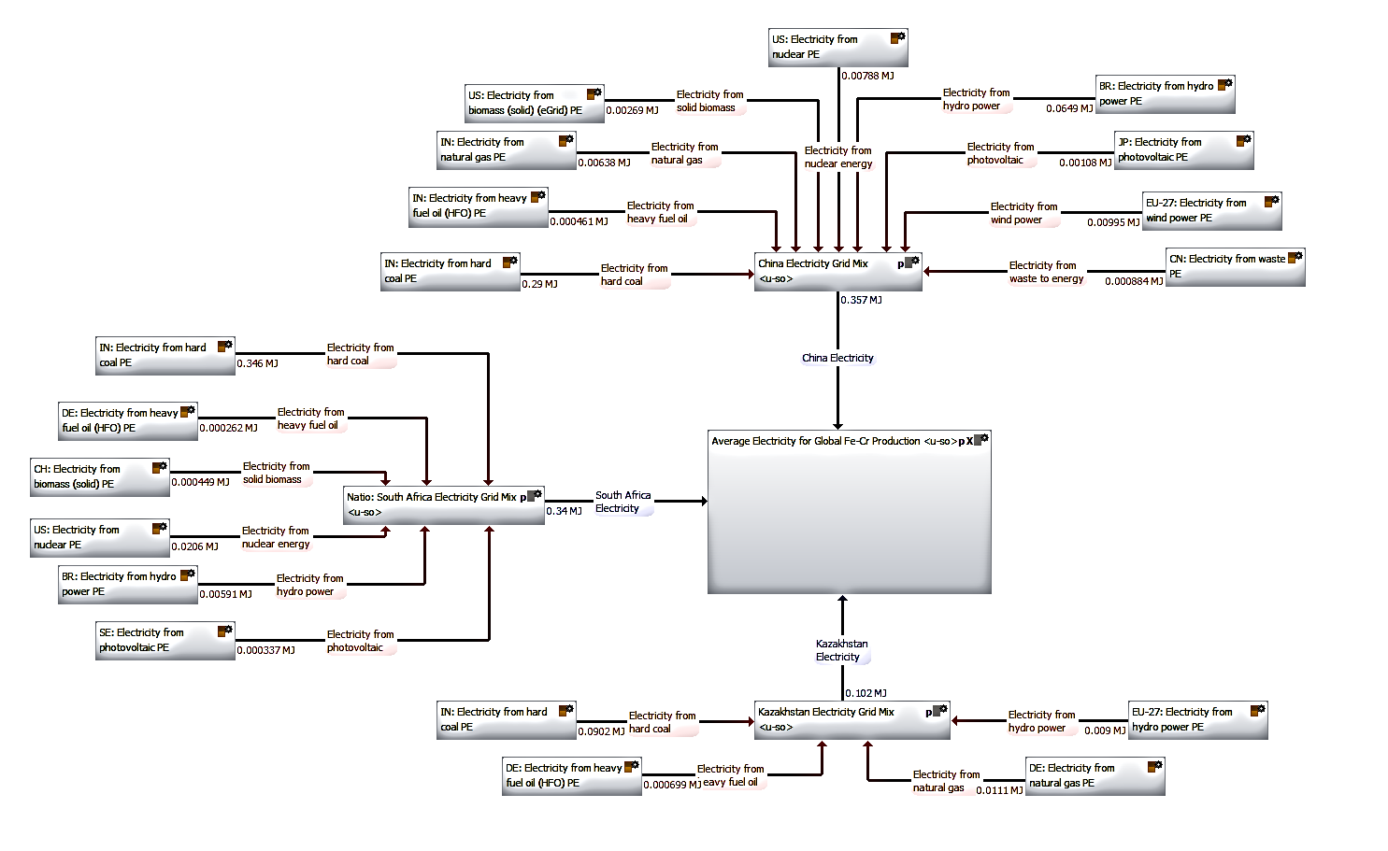
Figure 18. GaBi model of average electricity for global Fe-Cr production.

Figure 18 depicts the average electricity for global Fe-Cr model. The model is made up of China (35.74%), South Africa (34.04%) and Kazakhstan (10.21%) has the top three leading countries that produce Fe-Cr.
In terms of China, the primary source of electricity was via fossil fuels, specifically electricity from coal contributing (75.47%). The other significant contributor to electricity production was via hydro-electricity which made up 16.89%. The remaining fuel sources were much lower (i.e. 3% or lower) and had approximately similar percentages. China also had quite a diverse range of fuel sources, with electricity being produced from nine different fuel sources. A divergent electricity source supports China’s economic policy of reducing dependency on fossil fuels and developing and utilising alternative clean energy. Alternatives energy sources included in China’s electricity grid mix were, biomass, solar, and wind power. Other possibilities included electricity from geothermal and tide. However, these were not included because the percentage values were so small i.e. 3 to 4 decimal places, that even if a process from a substitute country was used, their impact would still be negligible.
With regards to South Africa, the primary source of electricity production was by usage of fossil fuels, in particular coal. Electricity from coal contributed 92.61%, of South Africa’s electricity grid mix, with the next largest fuel source, electricity from nuclear, contributing a minor 5.51% of the grid mix. In comparison to China on types of fuel sources, six different electricity sources were used to compose South Africa’s electricity grid mix. Processes for electricity production using geothermal, natural gas, tide and waste made no contribution to the electricity grid mix and so were not included. The electricity process from wind was also omitted due to the value being small i.e. to 4 decimal places, that even with the use of an alternate country, its impact would have been negligible.
Kazakhstan’s electricity grid mix was composed of merely four electricity sources. Namely three fossil fuels (coal, natural gas and oil) as well as hydro-electricity. The fossil fuels contributed a total 91.89% with 81.28% of electricity as a percentage being produced from coal. The only alternative to fossil fuel, hydro-electricity contributed 8.11%. No electricity processes from biomass, geothermal, nuclear, tide and waste were included since they did not contribute to the make-up of the electricity grid mix. With regards to the solar and wind processes, these were not included primarily due to their low percentage values i.e. to 4 decimal places that even if a process from a substitute country was used, their impact would still be negligible.

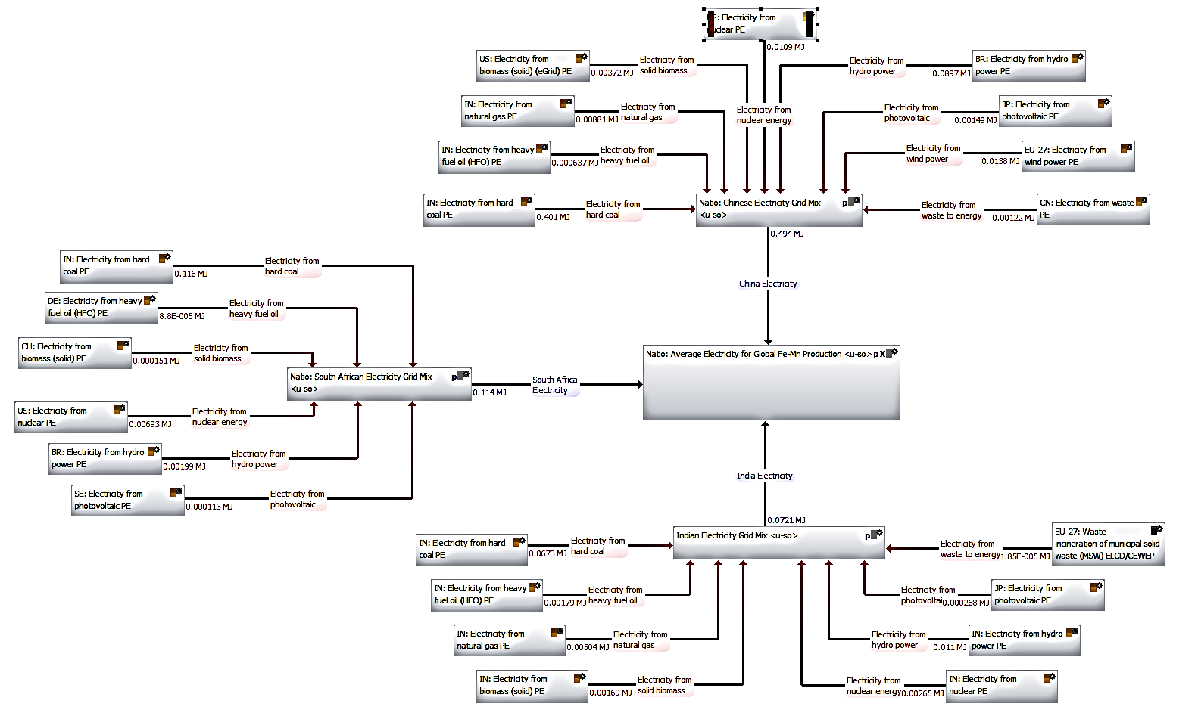
Figure 19. GaBi model of average electricity for global Fe-Mn production
Figure 19 depicts the average electricity for global Fe-Mn model. The model consists of China (49.40%), South Africa (11.05%) and India (7.28%) as the top three leading countries that produce Fe-Mn. But, unlike Fe-Cr where the global production was evenly contested between China and South Africa, China is evidently the primary global producer for Fe-Mn.
In terms of electricity grid mixes, the models for China and South Africa are identical to the models used for Fe-Cr. The only difference being the percentage make-up of the model in relation to global production. Thus leaving the description of the electricity grid mix for India.
As to India, its primary and secondary sources of electricity were identical to China, in that they were represented by hard coal and hydro-electricity. Additionally the percentage contributions from these two fuel sources were also comparable to percentage values for China, with contributions of 72.83% for coal and 11.87% for hydro-electricity respectively. Though both countries had similar percentages for coal and hydro-electricity, the actual values in GWh provided a different perspective. In terms of GWh, China produced 4.73 times more electricity from hard coal than India, and 6.49 times more electricity than India in terms of hydro-electricity. Thus highlighting a significant difference, but not unusual particularly when comparing against China, due its rapid technological development in sectors such as energy as well as the size of some of its industries.
In the matter of range of fuel sources India’s electricity grid mix was composed of eight different processes for electricity production. Geothermal and wind were not included since they did not contribute any value to the electricity grid makeup according to the IEA database. Additionally, electricity from tide was not included since the process was not available in GaBi.
Finally six out of eight processes selected for India were from the source country. Notable exceptions were electricity from photovoltaic and waste, were processes from Japan and the EU-27 were instead utilised.

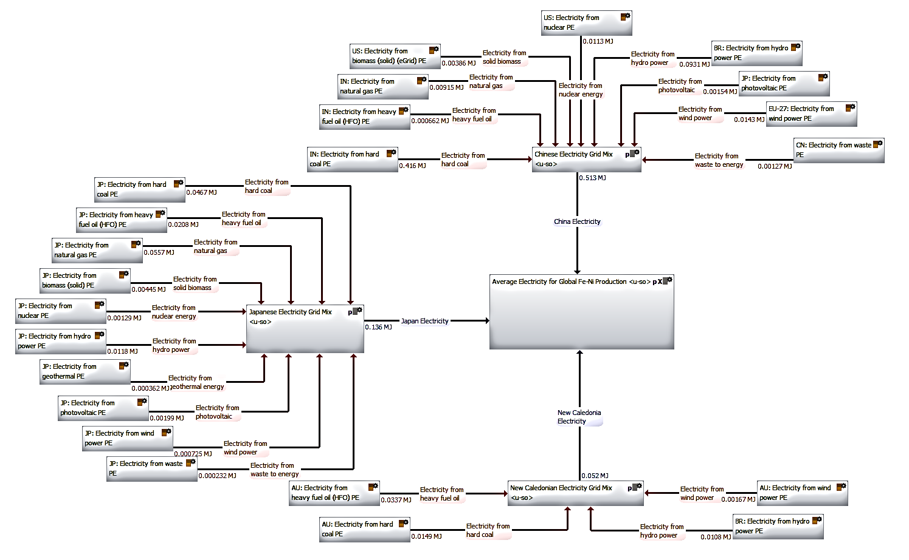
Figure 20. GaBi model of average electricity for global Fe-Ni production.

Figure 20 depicts the average electricity for global Fe-Ni model. The model consists of China (51.28%), Japan (13.62%) and New Caledonia (5.20%) has the top three leading countries that produce Fe-Ni. The make-up of China’s electricity grid mix has been described in detail earlier in Fe-Cr and so the focus will be on analysis of Japanese and New Caledonian electricity models.
Concerning Japan, its electricity grid mix was predominantly fossil fuel based, with fossil fuels contributing 84.98% of total electricity produced. The remainder of electricity production was provided by non-fossil fuel sources (14.13%), excluding electricity from nuclear energy (0.89%). Breakdown of fossil fuels, revealed natural gas (38.43%) to be the primary contributor followed by coal (32.21%) and natural gas (14.34%). In terms of non-fossil fuels, hydro-electricity contributed the most amount with a percentage of 8.12%. Contributions from the remainder of the electricity grid mix specifically, biomass (3.07%), geothermal (0.25%), solar (1.37%), waste (0.16%) and wind (0.50%) were minor. Out of all the countries modelled, Japan possessed the most diversified electricity grid mix with electricity contributions from ten different sources. In addition, electricity from tide was excluded since it made no contribution to the electricity grid make up as well as the process being unavailable in GaBi.
Finally, Japan was one of three countries, India and Norway being the other two, for which GaBi did have country specific electricity processes.
As far as the electricity grid mix for New Caledonia, this consisted of simply four different fuel sources by way of coal (24.1%), oil (54.30%), hydro-electricity (17.40%) and wind (2.50%). Fossil fuels made up 78.40% compared to renewables which consisted of 19.90%. Biomass, geothermal, natural gas, nuclear, solar, tide and waste did not contribute to the electricity grid mix and so were not included. Electricity processes were taken primarily from Australia (i.e. 3 out of 4 processes) has worst case scenarios since actual electricity processes from New Caledonia were not available in GaBi.

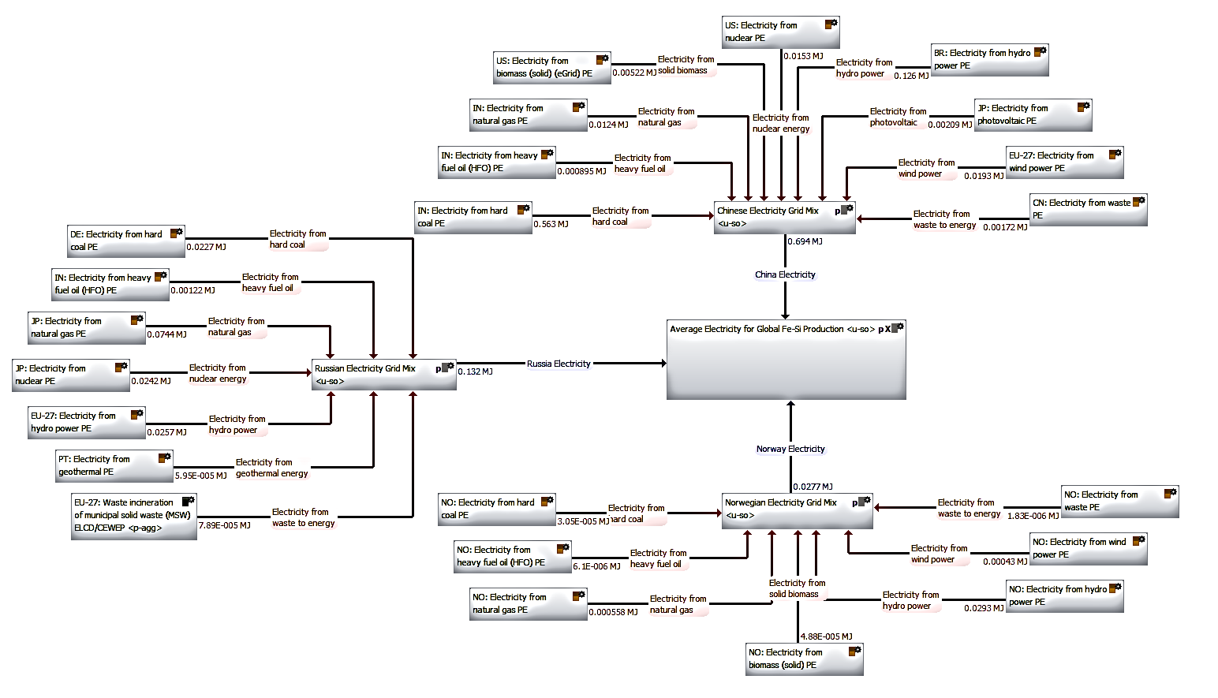
Figure 21. GaBi model of average electricity for global Fe-Si production.

Figure 21 depicts the average electricity for global Fe-Si model. The model consists of China (69.36%), Russia (13.24%) and Norway (2.77%) has the top three leading countries that produce Fe-Si. The make-up of China’s electricity grid mix has been described in detail earlier in Fe-Cr and so the focus will be on analysis of Russian and Norwegian electricity models. Coincidentally out of all the average electricity models, China had the largest share of global production for Fe-Si
Russia’s electricity grid mix was made up of seven different electricity processes. The major source of electricity production was from natural gas which contributed roughly 50.04%. Significant secondary contributions were also made from coal (15.28%), nuclear (16.29%) and hydro-electric (17.25%). Minor contributions came from geothermal (0.04%), oil (0.82%) and waste (0.0053%). No electricity was produced from biomass, solar and tide and thus were not included in the electricity grid mix. Furthermore, electricity from wind, was not included since the percentage value was to 4 decimal places, that even if included, its impact would have been negligible. Since no Russian processes for electricity were available, estimates were made utilising other countries has illustrated by Figure 21.
With regards to Norway electricity processes for the different fuel sources did exist in GaBi and were used in the construction of Norway’s electricity grid mix. The grid mix consisted of seven different electricity fuel sources, with hydro-electricity contributing 96.11%. The remaining fuel sources biomass (0.16%), coal (0.10%), natural gas (1.83%), oil (0.02%), waste (0.00063%) and wind (1.41%) made very little in terms of contribution. Electricity from geothermal, nuclear, solar and tide were not included as they did not contribute to Norway’s electricity grid mix.

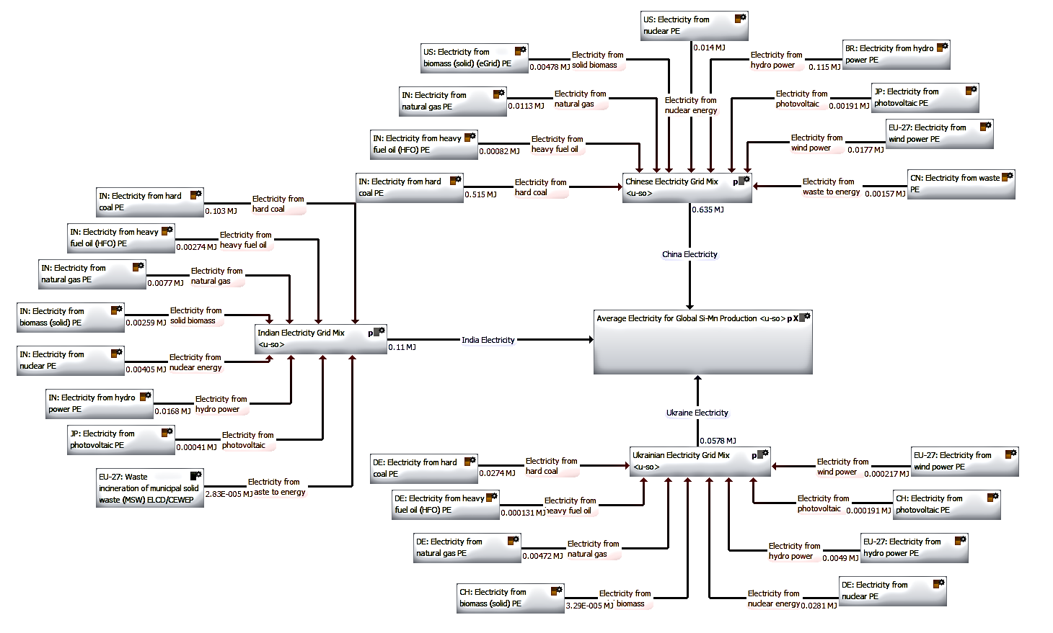
Figure 22. GaBi model of average electricity for global Si-Mn production.

Figure 22 depicts the average electricity for global Si-Mn model. The model consists of China (63.52%), India (11.02%) and Ukraine (5.77%) has the top three leading countries that produce Si-Mn. The make-up of China’s and India’s electricity grid mixes have been described previously and will not be discussed here. Instead the focus will be on Ukraine.
Ukraine’s electricity grid mix is heavily based on electricity from nuclear (42.81%) followed closely by electricity from coal (41.68%). Although Ukraine’s electricity breakdown is composed of eight different fuel sources, excluding nuclear and coal, their contribution are small. For example, non-renewables make up some of Ukraine’s electricity grid mix through, biomass, hydro-electricity, solar and wind, but their contributions only amount to 8.12% of overall electricity. Electricity from geothermal, tide and waste were not included as they did not contribute to Ukraine’s electricity grid mix.
With an in-depth description provided about the five average electricity models based on global ferro-alloy production. The ferro-alloys were critically evaluated by determining the individual GWP values for each of the ferro-alloys as shown by Figure 23.

Figure 23. GWP values across all five ferro-alloys comprising of the average electricity grid mixes.
Figure 23 reveals from highest to lowest the following GWP results; Fe-Cr > Si-Mn > Fe-Si > Fe-Mn > Fe-Ni. Fe-Cr had the largest value, with Fe-Ni the lowest. The percentage difference between the two values was roughly 34%. In order to explain why Fe-Cr had the highest value and Fe-Ni the lowest, each ferro-alloy was broken down into its constituent countries as displayed by Figure 24.

Figure 24. Make up of top three global producers for Fe-Cr, Fe-Mn, Fe-Ni, Fe-Si and Si-Mn.
It is distinguishable that China dominates the production of all five ferro-alloys: Fe-Cr (35%), Fe-Mn (49%), Fe-Ni (52%), Fe-Si (69%) and Si-Mn (64%). From current global trends and literature into fuel sources, it would be expected that the country with the largest percentage make-up i.e. China would have the highest value i.e. Fe-Si > Si-Mn >Fe-Ni > Fe-Mn > Fe-Cr, but this is not the case. Breakdown of individual ferro-alloys into the constituent countries, reveals secondary and tertiary countries to also have a significant impact as depicted by Table 24.
Table 24. Individual country breakdown of GWP results.
Ferro-alloy | Country 1 | Percentage  (%) | Country 2 | Percentage  (%) | Country 3 | Percentage  (%)
Fe-Cr | China | 40.40 | South Africa | 46.70 | Kazakhstan | 12.70
Fe-Mn | China | 68.80 | South Africa | 19.30 | India | 11.70
Fe-Ni | China | 81.40 | Japan | 11.90 | New Caledonia | 6.40
Fe-Si | China | 92.40 | Russia | 7.40 | Norway | 0.00
Si-Mn | China | 80.30 | India | 16.30 | Ukraine | 3.20

Table 24 reveals the percentage significant contribution from South Africa and Kazakhstan, thus explaining why Fe-Cr had the largest GWP value. Interestingly for Fe-Si, although no contribution was made from Norway, it percentage contribution from China was greater than that of Fe-Ni, thus explaining why it had a higher GWP value than Fe-Ni. To summarise although China is a primary contributor to the GWP results, it is more of a combination of all three countries that dictates the total GWP value and thus the ranking of high carbon emitters to low carbon emitters in terms of ferro-alloys.
However the GWP value is also dependant on breakdown of electricity by source. Although China produces 35% of global Fe-Cr compared to 30% for South Africa. This percentage difference is not greater than the breakdown of fuel by source, where South Africa utilises 92% of coal to produce electricity compared to 76% for China. This explains why South Africa GWP value of (0.121kg/CO₂-Equiv) was higher than the value of China (0.115kg/CO₂-Equiv) and resulted in an overall higher GWP value for Fe-Cr. This explanation is also supported by the result from Fe-Si, where even though China contributes (69%) of the model, the other constituent countries Russia (42% coal) and Norway (96% hydroelectricity) are not fossil fuel heavy and therefore provide less CO₂ emissions and a lower GWP value. Even if Russia and Norway were fossil fuel heavy, their contributions to the model (13% and 3%) respectively were not substantial enough to affect GWP.
A further analysis of the results was conducted by comparing country specific against average electricity models in terms of GWP. GWP results for eight countries were selected and calculated for the year 2013, as illustrated by Figure 25.

Figure 25. Country specific GWP from GaBi based on the functional unit 1MJ.
The selection of countries for Figure 25 was based on IEA statistics of key world electricity producers in 2013. Notable absentees include Canada, China, Russia and South Korea due to their unavailability in GaBi database. Instead, other nations of interest namely, the UK and Australia were included for a comprehensive global review. The GWP values were obtained by utilising GaBi software and conducting balances based on 1MJ as the functional unit.
From Figure 25 India had the highest GWP value, followed by Australia in second (25% less than India) and the USA third (33% less than Australia). Both Brazil and France had quite low GWP values in comparison with the other countries, with France having the lowest GWP value from all countries. The discrepancy in GWP values between the countries can be explained by the breakdown of electricity by energy source for each country.
The GWP value of India was expected to be high, because within the eight countries present India had the highest contribution from hard coal. In terms of explaining why Australia had a larger GWP value than the USA, this was due to the make-up of their electricity grid mixes. From GaBi documentation, the top three fuel sources for Australia’s electricity grid mix consisted of: hard coal (46.56%), lignite (21.89%) and natural gas (19.66%). Hard coal (0.34 kgCO₂/kWh) and lignite (0.36 kgCO₂/kWh) are known emit higher carbon dioxide emissions. In contrast, lignite contributes only 2.17% of USA electricity grid mix. The majority of coal burned in the USA is steaming coal, both bituminous and sub-bituminous. This would explain the significantly higher GWP values of Australia compared to the USA.
France and Brazil were expected to have low GWP values due to their alternative non-fossil fuel based energy sources. The electricity grid mix of France was mainly nuclear (80%). Whereas for Brazil, hydro-power contributed nearly 80% of electricity.
Comparing country specific to average electricity grid mix, the latter seems to provide a more representative view point as demonstrated by the Fe-Cr example. However it is recognised that this type of data is not available and thus hard to compare our results with something meaningful. The majority of the current literature focusses on country, company or product specific GWP values. However even within these groups there exists a number of variables: (type of plant, type of fuel, electricity grid mix,) thus making each study unique and conclusions more broad based.
To summarise, Fe-Cr had the greatest GWP value across all five ferro-alloys investigated. The explanation behind this lay not just in the contribution from China, the primary producer for all five ferro-alloys, but from contributions from secondary and tertiary countries. In addition breakdown by fuel source would have also affected the GWP values, with fossil fuel based countries (i.e. South Africa), having a greater impact than renewables based nations (i.e. Norway). In comparison with GWP values from singular countries, the average electricity models were more representative has they included parameters such as share of global production, breakdown of fuel source and percentage of renewables and non-renewables.

6.3 Summary
Generating average electricity grid mixes based on global ferro-alloy production is a challenging task. Most existing studies in literature utilise an electricity process based on a single country. Furthermore these studies utilise electricity as a parameter variation within a study and investigate the impact of switching from fossil fuels to renewables based electricity sources.
The five average electricity models, described and explained in the previous sections, were produced in three stages. In stage 1, electricity grid mixes to be modelled were highlighted based on global production values for 5 ferro-alloys: Fe-Cr, Fe-Mn, Fe-Ni, Fe-Si and Si-Mn. For each ferro-alloy the top 3 global producing nations were identified leading to a list of 9 countries, as follows: China, India, Japan, Kazakhstan, New Caledonia, Norway, Russian Federation, South Africa and Ukraine. In stage 2 electricity breakdown by fuel source was obtained from the IEA for the 9 countries of interest. This would allow construction of electricity grid mixes for each individual country. Finally in stage 3 utilising data from the World Bank, transmission, distribution and high voltage losses were applied to make the models accurate and reliable.
Before developing average electricity grid mixes for all nine countries of interest, a sample of three countries (India, Japan and Norway) was selected to develop a robust and valid methodology. Selection of these three was based on their presence in both the software program GaBi and IEA online statistics database for the year 2011. The results illustrated that India had the smallest deviation (3.50%) followed by Japan (9.92%), with Norway displaying the largest difference (47.49%) between GaBi and IEA databases. Further analysis of the results by Norway were conducted in terms of GHG emissions, specifically ‘percentage deviation’ against known ‘absolute values’. For Norway the results revealed that the deviation is high only as a percentage (47.5%) and not an absolute number; due to the fact that g CO₂ per kWh is very low in Norway with 46g.
With regards to the analysis of the five average electricity models. The general trend across all models was that China was the leading global producer in all ferro-alloys with the largest percentage in Fe-Si (69.36%) and the lowest in Fe-Cr (35.74%). Regarding assessment by GWP, Fe-Cr had the largest GWP value across all five ferro-alloys investigated with Fe-Ni the lowest. In-depth analysis by individual country breakdown revealed GWP was influenced by a combination of the percentage from China as well as contributions from secondary and tertiary countries. In addition breakdown by fuel source would have also affected the GWP values, with fossil fuel based countries (i.e. South Africa), having a greater impact than renewables based nations (i.e. Norway).
In comparison with GWP values from singular countries, the average electricity models were more representative as they included parameters such as share of global production, breakdown of fuel and percentage of renewables and non-renewables.
Overall there is confidence in the data obtained from literature and the methods utilised in creating these average electricity grid mixes to be utilised as processes in the ferro-alloy models.

7. LCA Results - Ferro-alloy

7.1. Ferro-Boron

Figure 26. Comparison of different literature sources for Fe-B production via GWP.
The results for Fe-B were divided into two categories as indicated by the colours in Figure 26. The dark pink colour represented GWP values for processes created using literature. Whereas the red colour represented an estimated value. For all three GWP values, Tudor’s value was 29.16% lower than the actual values calculated using boric oxide and borates which were identical. The following in-depth analysis can explain the discrepancy between all three results.
Tudor’s GWP value was an estimation due to lack of information within the LCA GaBi software relating to Fe-B or boric acid. The GWP value was calculated, based on the assumption that boric oxide production process was identical to the process used for the production of titanium. In the case of Fe-B, the boric acid is heated in an EAF along with iron (III) oxide powder and coke, to create a carbo-thermic reduction. Whereas Fe-Ti is assumed to be produced via the melting of scrap titanium (Ti) along with iron (iii) oxide and coke in the EAF. This carbo-thermic reduction produces a Fe-Ti with a Ti level of 70%. Thus a value similar to Fe-Ti would be suitable.
Furthermore it is known that the presence of boron ores and minerals in the Earth’s crust are lower than that for titanium ores and minerals. Therefore more work i.e. energy is required for extraction. Based on this and the GWP value calculated by Tudor for Fe-Ti (14.00kg of CO₂ per kg), a slightly higher figure of 15.00kg of CO₂ per kg of Fe-B was concluded on.
For the two Fe-B processes created from literature, there was a percentage difference of 1.25% between Fe-B (boric oxide) and Fe-B (borates). Unsurprisingly the percentage difference was small due to the selected production route being the same for both processes. In addition aluminium and magnesium were the primary contributors of GWP with values of 9.67 kg CO₂ and 8.42 kg CO₂ respectively for both processes. However there are two possible explanations to explain the 1.25% percentage difference.
Firstly when GWP was calculated solely on boric oxide (2.03 kg CO₂) and for borates (1.78 kg CO₂), the percentage difference was calculated to be 1.25%, exactly the same for the percentage difference of the complete processes. Thus the individual processes themselves, could have been the source of the difference between the respective models.
A second explanation for the difference in values between boric oxide and borates can be attributed to the boron content. Although the boron content is unknown for both processes, it would be expected that the higher the boron content in the ore, the less energy required for extraction. This explanation is supported by Figure 27, which demonstrates an 11.32% percentage difference in energy between boric oxide and borates.

Figure 27. Comparison of boric oxide and borates in terms of energy.
Thus suggesting boric oxide has a lower boron content, which requires more work for extraction and subsequently produces more CO₂ has highlighted in Figure 27.
The results show the difference between estimation of results, in this case GWP, to actual calculation of results. Tudor’s estimated value was based several years ago where there was little or no data in literature. Even though Tudor developed a methodology to calculate CO₂ output for a number of alloying additions, a deviation of 29.16% cannot be ignored. However GWP values calculated for actual Fe-B processes are difficult to verify particularly against literature, since there are little or no comparable results currently present. In addition, limited documentation particularly against GaBi processes (boric oxide) adds to this uncertainty of the results. Thinkstep, suppliers of GaBi software, are in the midst of creating a process for Fe-B using their extensive industrial contacts, but this is currently incomplete so no current comparisons can be made at this moment in time.
Summarising, an in-depth analysis reveals little or no useful description of the data source and method used by GaBi to create boric oxide, making it difficult to evaluate. Taking this into consideration, the Fe-B (borates) (Figure 28) was selected as the process to represent boron in the additional work related to grades of steel.

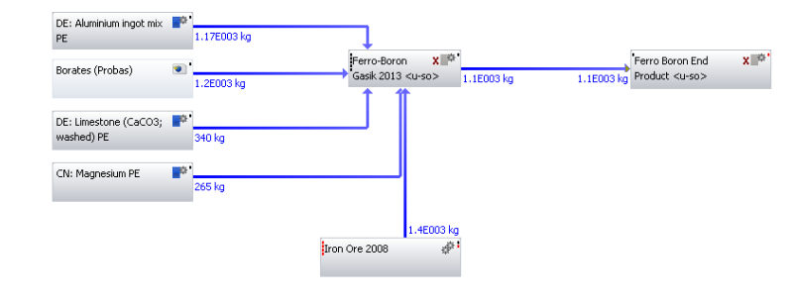
Figure 28. Fe-B modelled using borates.

7.2. Ferro-Chromium

Figure 29. Comparison of original literature source for Fe-Cr production via GWP.
Several Fe-Cr models were created due to an abundance in literature and so the results were divided into Figure 29 and Figure 30.
The results in Figure 29 were based on the original data source (Haque) and subsequent variations from it. This is highlighted by the use of three different colours. Results in yellow are results taken directly from Haque, whilst gold and green colours represent models created using identical data to Haque (Haque Version 2) and a representative global Fe-Cr model. Overall the four results represent three different electricity sources with the first column, representing Tasmanian electricity, the middle two columns representing Australian electricity and the remaining column representing an average electricity process based on global Fe-Cr production.
Analysis of the results in terms of GWP revealed a number of topics for discussion. One of these topics, selection of Tasmania as the main electricity source, resulted in the GWP value being approximately 2.4 times lower in comparison to the selection of Australia. The significant difference between the two results was due to hydroelectricity contribution in the fuel mix for Tasmania. Whilst, Australia’s fuel mix was mainly composed of coal and gas fuel, and thus explained why its GWP value was greater.
Another topic, was the GWP value for Fe-Cr Haque Version 2. This model was created to test the robustness of creating ferro-alloys i.e. the methodology. Results from this model were identical to the original result with a deviance of 0.55%.This was evident because Fe-Cr Haque Version 2 was modelled using the original data and associated assumptions. Thus it may be argued that by taking Haques data and creating a model, similar results should have been expected. However this can be disputed by a number of factors. Firstly Haque utilised SimaPro software to create his models whereas GaBi software was used to create models in this report. Therefore, not only is the reliability of the method being tested, but a comparison of two different softwares for creating ferro-alloys are also being assessed.
Additionally within these LCA software programs, there are a wide variety of databases with specific processes. So for one input, a dozen similar processes could be utilised. Although Haque has depicted schematic diagrams, completed final LCA diagrams revealing the processes to this kind of detail are missing. Nevertheless it can be said the GWP values are reliable and accurate based the minute deviance between the original result and the result from Haque Version 2.
With regards to the global Fe-Cr model, highlighted in green, this had a higher GWP value compared to the Haque Version 2, which represented the original data. This can be explained based on two differences between the models. Firstly, in the Haque Version 2 model, diesel mix at refinery process was modelled using data from Australia, whereas the global Fe-Cr model used an identical process but from China. Calculation of GWP based on 1 kg of product from the respective processes revealed values of 0.414 kg-CO₂-Equiv for Australia and 0.442 kg-CO₂-Equiv for China. The percentage difference between these values based on the lowest value was 6.54%. However diesel mix contributed 4.1 kg or 0.13% in terms of mass, to the complete model, and so its impact would have been minimal to explain the total difference in GWP.
The second difference which could account for the majority of the difference between the two GWP values were the processes utilised for electricity grid mix. In the Haque Version 2 model, Australian electricity grid mix was utilised, whereas in the global Fe-Cr model, an average electricity grid mix, based on global Fe-Cr production was created and used. Corresponding to 1MJ, the value from Australia was 0.279 kg/ CO₂ and 0.293 kg/ CO₂ for the global average electricity model. The percentage difference between these values correlated to 4.89%. This percentage difference was also the difference between the two GWP values approximately 4.57%. These percentages are supported by the fact there were no other noticeable differences via process or quantities between the two models
Apart from the original data source, multiple other data sources were also utilised to create Fe-Cr models as shown by Figure 30.

Figure 30. Comparison of Eurometaux and GaBi literature sources for Fe-Cr production via GWP.
Figure 30, compared alternative Fe-Cr models created using data from (Eurometaux 2014). In the case of GaBi, Fe-Cr models were not created, but instead existing models were obtained and contrasted against. In terms of analysis, Figure 30 highlights a number of trends. Firstly HC Fe-Cr GWP values for both Eurometaux and GaBi are lower than LC Fe-Cr models. Secondly, for Eurometaux, variation in percentage of silicon, shows increasing the silicon percentage increases the GWP value. Thirdly, the results for Eurometaux for both HC and LC Fe-Cr models are approximately 35% lower compared to HC and LC Fe-Cr models from GaBi.
Comparison of results from Figure 30 against results from the original model reveal the GWP values from Eurometaux were approximately 30% lower taking the lowest GWP values from all models. Whilst values for GaBi were approximately 10 % higher, taking the highest GWP value from both models.
An in-depth analysis of models from Eurometaux, displayed identical GWP results for both high and low carbon (13% Si) models. Even-though, the production routes for HC Fe-Cr (carbo-thermic reduction) and LC Fe-Cr (silicon reduction) were different, it was their inputs which impacted upon the GWP values. In this case both processes had identical electrical energy inputs of 3100 kWh/t (HC Fe-Cr) and 3400 kWh/t (LC Fe-Cr) respectively. In terms of inputs, HC Fe-Cr utilised 700kg more chromite and 500 kg of carbon in comparison to LC Fe-Cr. Whereas LC Fe-Cr used 900 kg more silicon and 675kg of Fe-Si-Cr than HC Fe-Cr. Therefore, although different production routes and inputs were utilised, identical GWP values were obtained.
In regards to the LC Fe-Cr models with variation in percentages of silicon. These were modelled as Fe-Si-Cr (13% and 53%) respectively and full details of inputs (Table 42 and Table 43) and complete models (Figure 63 and Figure 64) can be seen in the appendix under heading D2. Individual GWP values were calculated for 13% Si (2.24 kg/CO₂) and 53% Si (3.11 kg/CO₂) and showed quite a disparity. The high value for 53% Si was due to the makeup of the inputs to this process. Coke and iron steel chips made up 828kg of the total inputs, compared to only 573 kg of total inputs for 13% Si. This represented a difference of roughly 30% which was similar to the difference between the two Fe-Si-Cr models. However the difference decreased to 11.3% in the completed LC Fe-Cr models. This would be expected due to the influence of the individual process decreasing as it was introduced into a number of other models and other factors such as electricity having more of an impact.
With respect to LCA software GaBi, both Fe-Cr processes had high GWP values in particular LC Fe-Cr. The documentation surrounding the creation of these processes alongside the current modelling procedure can explain the results. Both Fe-Cr processes created by GaBi were created using datasets and system boundaries based on the country South Africa. This was significant, particularly in terms of energy since the rest of the Fe-Cr processes, except global Fe-Cr model, were created using Australia as the source of electricity. Coal was the dominant fuel source in South Africa and accounted for over 90% of electricity production in 2013 according to IEA. On the other hand Australia was also coal dominant but had a lower percentage (approximately 70%) of electricity production by coal. With roughly 20% also coming from natural gas. Since coal was the main source of carbon emissions, the 20% difference in utilisation of coal as a fuel source, between South Africa and Australia, can explain the higher GWP values from the GaBi processes.
Apart from the variable source of electricity, the percentage content of materials particularly in the outputs can also explain some of the variation in the results. The global Fe-Cr model assumed an end product of 53% Cr, 6.4% C, compared to GaBi (60% Cr with 6% C) and Eurometaux (15 to 25% Cr). Looking at the high carbon GWP values, the results identify a positive trend, in that the higher the percentage of carbon the higher the resultant GWP value.
Another variable which could have affected the results was time representativeness of the data. Data from GaBi was the most up to data from the year 2013, whilst models created using data from Haque were collected by Haque from various sources between 2003 and 2010. No time representativeness was given for Eurometaux data. However the selected production route for Fe-Cr has not significantly changed over the years, so the effect of time representativeness data might be minimal in the processes, but cannot be excluded. Lastly all Fe-Cr models were compared against one another in terms of energy as shown by Table 25.

Table 25. Comparison of all literature sources for Fe-Cr production via energy.
Type of Model | Energy (net calorific value) [MJ]
Fe-Cr (Haque) Version 2 | 113.61
Global Fe-Cr Model | 105.34
HC Fe-Cr (Eurometeaux) | 78.35
LC Fe-Cr (Eurometeaux) (13% Si) | 87.08
LC Fe-Cr (Eurometeaux) (53% Si) | 94.89
*GaBi HC Fe-Cr | 112.05
GaBi LC Fe-Cr | 118.21

The results from Table 25 support and follow the trend from GWP values. In terms of Eurometaux, the energy values were the lowest from all data sources. Although no description was provided about the energy source from the original data, from the results they appear to be most likely European based. The majority of European nations are still coal dependent as the main source of electricity but have begun diversification into renewable technology. Germany for example leads the way in wind technology. Whilst some countries such as Norway are completely dependent on non-renewables (hydro-electricity) as their main source of energy roughly 96%.
The energy values from GaBi do not appear to be significantly higher, in comparison to Haque. This is surprising since South Africa’s energy infrastructure is not the most efficient or productive compared to Australia. However this deficiency in energy might be offset by the composition of chromite ore. South Africa’s composition would be higher based on the type and amount of deposits than Australia, which has comparatively little production of chromite and thus would have to import. The only other factor that can explain the results would be the amount of ore, since this mining step would be energy intensive. In Haques model approximately 2400kg of chromite is used whereas this is an unknown quantity in the GaBi models. The results suggest a similar quantity from the GaBi models but cannot be verified.
From evaluating all the models and results, Figure 31 and Figure 32, were selected as the processes to represent HC Fe-Cr and LC Fe-Cr. Both of these models were utilised in work associated with grades of steel.
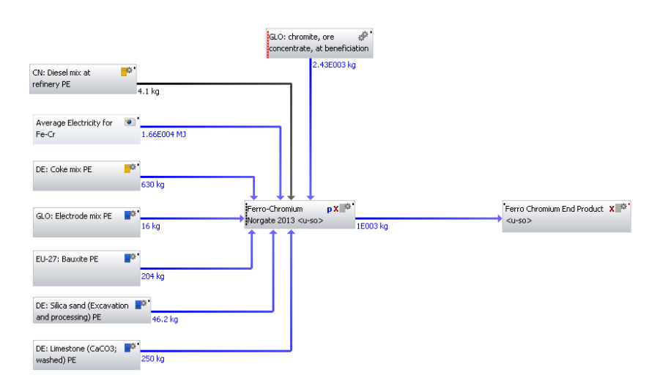
Figure 31. Global Fe-Cr model utilising data from Haque.
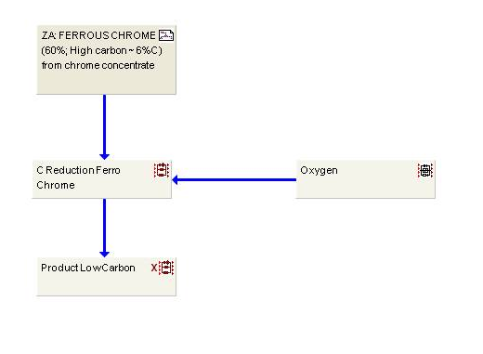
Figure 32. GaBi model of LC Fe-Cr (60% Cr, 1%).

7.3. Ferro-Manganese

Figure 33. Comparison of original literature sources for Fe-Mn production via GWP.
Comparable to Fe-Cr, the abundance in literature available for Fe-Mn, allowed several models to be constructed from a variety of different literature sources. Equivalent to Fe-Cr Figure 33 illustrates in yellow, the original results from Haque; in gold, a model created duplicating Haque; and in green a global Fe-Mn model. Equally the four results represent three different electricity sources. With the first column, represented by Tasmanian electricity, the middle two columns represented by Australian electricity and the remaining column representing an average electricity process based on global Fe-Mn production.
With respect to comparing and contrasting models, the difference between Haque’s models utilising Tasmanian and Australian electricity grid mixes was primarily due to fuel mix. Hydroelectricity was the major contributor to the fuel mix for Tasmania whilst Australia’s fuel mix primarily consisted of coal and natural gas. Thus explaining why the GWP value for Australia was twice as large as compared to the value produced from Tasmanian energy.
In terms of the global Fe-Mn model, the percentage difference in GWP values in comparison to Haque Version 2, which characterised the original data source, was 20.30%.
The primary difference between models Haque Version 2 and global Fe-Mn were three processes namely: diesel mix at refinery, hard coal mix and electricity grid mix. In Haque Version 2, the three processes were selected from the country Australia, in order to replicate the original data source. Whereas in global Fe-Mn, diesel mix at refinery and hard coal processes were selected from China, since it was the dominant producer, and the aim of the global model was to be reflective of the present global market. The electricity grid mix was created based on global Fe-Mn production.
In terms of explaining the percentage difference of GWP (20.30%), has previously mentioned, the three different processes between the models were analysed. Based on 1kg of product the percentage difference between firstly diesel mix at refinery (4.14 kg-CO₂-Equiv) for Australia and (0.442 kg-CO₂-Equiv) for China was 6.54%. Secondly, the percentage difference between hard coal mix (0.171 kg-CO₂-Equiv) for Australia and (0.285 kg-CO₂-Equiv) for China, was 50.00%. Thirdly, in terms of electricity, corresponding to 1MJ, the value from Australia was 0.279 kg/ CO₂ and 0.238 kg/ CO₂ for the average electricity model. Thus presenting a percentage difference of 15.86%.
Analysis of the differences in the three processes, revealed diesel mix at refinery and hard coal mix to be greater in the global model, and electricity to be greater in Haque Version 2. Thus it would be expected the global model to have a higher GWP, particularly based on the large difference in hard coal between the models (50.00%). However breakdown of GWP contribution by process, for either model, revealed electricity grid mix contributed 63.56%, followed by hard coal mix 0.46% and diesel mix at refinery with 0.005%. Therefore, electricity would have contributed a significant amount of the GWP and can explain why Haque Version 2 is and should be higher. However the modelling method for Fe-Mn as well as Si-Mn could have also attributed to the difference between the two models.
Unlike Fe-Cr, Fe-Ni and Fe-Si where the processes were modelled linearly, i.e. one main process with several inputs attached to it, the manganese processes were divided into three main stages (mining, sintering and production). This resulted in a process flow diagram, from which GWP was calculated. Alternatively Fe-Cr, Fe-Ni and Fe-Si could have also been modelled in this manner. However in these cases it would have resulted in several main processes with a single output between them, thus being the same as one main process with all the inputs.
In the case of Fe-Mn and Si-Mn, some of the outputs were split and went into both sintering and production, thus it was modelled as a multi stage process. It was not known how Haque modelled Fe-Mn, in order to produce the GWP value of 3.59 kg-CO₂-Equiv, so therefore it was difficult to compare the original result against the global Fe-Mn model. A fairer comparison between Haque Version 2 and global Fe-Mn, demonstrated electricity grid mix as the primary source of difference between the two models in terms of GWP. Apart from the global Fe-Mn model, alternative Fe-Mn models were also constructed using literature sources (Eurometaux 2014; Gasik.M 2013) as illustrated by Figure 34.
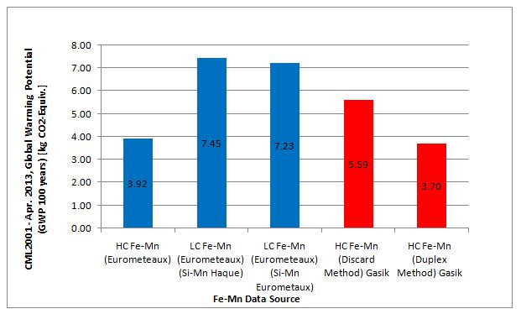
Figure 34. Comparison of Eurometaux and Gasik literature sources for Fe-Mn production via GWP.
In comparison against the original process, the percentage difference in GWP from HC Fe-Mn (Eurometaux) was 8.79%, whilst for LC Fe-Mn (Eurometaux, Si-Mn Haque) it was 62.09%.
Data from literature source (Gasik.M 2013) was used to assess two different processes (Discard and Duplex) for the production of HC Fe-Mn. The GWP result for the Duplex method was 3.02% higher in comparison with the original result. On the other hand, the Discard method produced a GWP value of (43.71%) which was significantly higher in comparison against the original value.
Analysis of all HC Fe-Mn models revealed the Discard method to have considerably greater electricity and carbon inputs (1.19×10⁴ MJ, 550kg) compared to the Duplex (7.92×10³ MJ, 350kg) and Eurometaux HC Fe-Mn models (7.92×10³ MJ, 410kg).Consequently explaining why its GWP value was considerably higher.
In terms of the remaining models, both the Duplex and Eurometaux models had identical electricity inputs, but the Duplex method had the lower carbon input. Thus explaining why out of the three HC Fe-Mn models, the Fe-Mn model with the Duplex method had the closest GWP value to the original value from Haque. The literature is supportive of the GWP results, particularly supporting the Duplex method as the most common and effective production route for HC Fe-Mn. For the Duplex method the percentage of Mn in the slag is high (35-38%) thus allowing the slag to be reprocessed for the production of silico-manganese or metal manganese. In addition the overall manganese recovery is higher (97-99%) thus allowing less coke to be utilised and consequently a lower environmental footprint.
For the LC Fe-Mn models from Eurometaux, a parameter variation was conducted using Si-Mn. This was used as an input into both processes primarily as a reducing agent. Two Si-Mn processes were created (see appendix D10) one utilising data from Haque and the other using data from Eurometaux. The Si-Mn processes were then included in separate LC Fe-Mn processes as shown in Figure 70 and Figure 71. The difference between the two LC Fe-Mn models was primarily due to the difference between the two Si-Mn models. Si-Mn (Haque) had a higher GWP than Si-Mn (Eurometaux) due to more usage of electricity (4.68×10⁴ kWh to 3.80×10⁴ kWh) and carbon based inputs (650kg to 400kg).
Finally analysis of the Fe-Mn models was also conducted utilising models for both HC and LC Fe-Mn in GaBi, with the results displayed by Figure 35.

Figure 35. Comparison of GaBi Fe-Mn models via GWP.

Analysis of the results from GaBi revealed the models for both HC and LC Fe-Mn had the highest GWP values from all Fe-Mn models. The large GWP values were chiefly attributed to source of electricity. Both Fe-Mn models in GaBi were constructed using data and electricity grid mixes based from the country South Africa. The remainder of the models constructed, excluding global Fe-Mn model, used an Australian electricity grid mix. Even though, for both countries, the grid mixes were dominated by coal. The major difference between the models, was the percentage coal contributed to the total electricity grid mix. For South Africa, electricity from coal made up approximately 93% whereas with Australia it was roughly 69%. Translation of this in terms of energy meant, for a corresponding energy of 1MJ, energy from Australian electricity grid mix equates to 0.281 GWP kg /CO₂ compared to 0.403 GWP kg /CO₂ for South Africa. Therefore explaining why GWP values for models from GaBi were greater.
Other potential contributing factors included the percentage content of Mn. The Mn content varied between the models from 74-82% (Haque) to, 76-99% (Gasik) as well as 77-90% (GaBi). The notable omission being percentage content of Mn from Eurometaux, where no percentages were stated. The percentage of Mn was important as it was expected that the higher the Mn content in the ore, the less work required in terms of usage of electricity for extraction of the ore from gangue material, resulting in a lower environmental impact in terms of CO₂. Aside from percentage of Mn content, time representativeness could have also impacted the results.
Data from Eurometaux and Gasik models were approximately 5 to 10 years old. In comparison, data from (Haque & Norgate 2013) and (thinkStep 2015) for LCA GaBi software were quite recent, especially GaBi where data was from year 2013. Although the fundamental process route might have stayed the same, the technological improvements might have had a positive impact in reducing emissions and saving resources.
Finally all Fe-Mn models were compared against one another in terms of energy as shown by Table 26.
Table 26. Energy values for all the literature sources utilised to create Fe-Mn.
Type of Model | Energy (net calorific value) [MJ]
Fe-Mn (74-82% Mn) Haque, Version 2 | 80.40
Global Fe-Mn Model | 64.37
HC Fe-Mn (Eurometeaux) | 57.72
LC Fe-Mn (Eurometeaux) (Si-Mn Haque) | 121.68
LC Fe-Mn (Eurometeaux) (Si-Mn Eurometaux) | 120.56
HC Fe-Mn (Discard Method) Gasik | 84.15
HC Fe-Mn (Duplex Method) Gasik | 56.07
GaBi HC Fe-Mn (77% Mn) | 96.09
GaBi LC Fe-Mn (90% Mn) | 102.49

Table 26 illustrates the individual energy value for all Fe-Mn models created. HC Fe-Mn (Duplex) had the lowest value as would be expected since it had the lowest electricity (2200 kWh/t) and carbon (350kg/t) inputs from all Fe-Mn processes.
HC Fe-Mn from Eurometaux had identical inputs in terms of electricity (2200 kWh/t) and carbon (410 kg/t), in comparison to HC Fe-Mn (Duplex) and so unsurprisingly also had a low energy value.
The LC Fe-Mn models from Eurometaux had predictably high energy values, not purely from electricity but a combination of electricity and other mass inputs such as carbon, limestone and in particular Si-Mn.
If input of electricity was solely the key variable, then HC Fe-Mn (Discard) would have had the largest energy value, since it had the largest electricity input (3306 kWh/t) from all Fe-Mn processes. However contributions from other inputs were also significant and the results disprove this.
For the global Fe-Mn model the energy value was lower than Haque Version 2. This was expected due to the make-up of the average electricity grid mix. Although the percentage of coal as the source of electricity between the three nations making up the average process (China (76%), South Africa (93%) and India (71%)) are higher than Australia (69%) from the original source. This is offset by the global production for each of these countries – China (49.40%), South Africa (11.45%) and India (7.28%). China and India, individually would be higher in terms of energy but combined as an average along with factoring in global production, the average value is lower than Australia.
Analysis of the GaBi results for Fe-Mn could not be conducted in detail due to lack of detailed data for raw material and energy inputs utilised in its own models.
Critical evaluation of all the models, has led to the decision to select models depicted by Figure 36 and Figure 37 in applications to grades of steel. Global Fe-Mn model was selected as the HC Fe-Mn model of interest for the grades of steel work. This was because it had a unique modelling method as well as the inputs and outputs relating to the model being well understood.

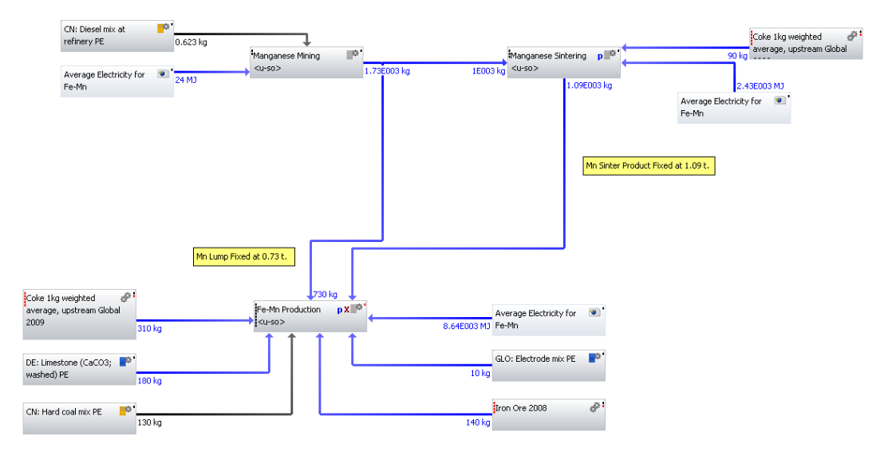
Figure 36. Global Fe-Mn model created from data source Haque.

For LC Fe-Mn the process from Eurometaux was selected alongside the Si-Mn also created from the same data source.

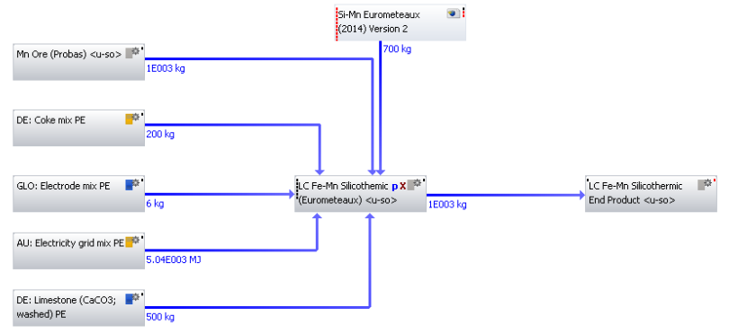
Figure 37. LC Fe-Mn production (Si-Mn Eurometaux) from Eurometaux data.

7.4. Ferro-Molybdenum

Figure 38. Comparison of Fe-Mo production from both IMOA and GaBi.
For Fe-Mo, limited data availability resulted in the creation of a single model. This was evaluated against a process from GaBi as shown by Figure 38. The percentage difference amongst the GWP values was approximately 56.23% between the two data sources. Analysis of each model was conducted in order to explain the difference in GWP values.
Model 1 with a GWP value of 9.09 kg CO₂-Equiv was created using data exclusively acquired from IMOA. The data was for the year 2005 and consisted of inputs and outputs (including emissions) related to the production of 1kg of Fe-Mo. Supporting information from IMOA revealed the process to be based on the common route of molybdenum production: oxidative roasting of molybdenite concentrates.
In contrast, model 2, with a GWP value of 16.20 kg CO₂-Equiv was obtained from GaBi. Specific details of the inputs and outputs relating to the process were restricted due to software licensing issues and only the result available in terms of GWP. The data was for the year 2011.
Enquires made at thinkStep, providers of GaBi software, revealed the model did indeed include data from the IMOA. However specific details (i.e. production route, electricity grid mix, country of origin) was not provided. Thus at the present moment, the primary cause of the large deviation between the two models is assumed to be due to time representativeness of the models.
Little or no alternative data was located from either literature or alternative LCA databases for evaluation.
Based on the fact Model 1, was created using data from IMOA with known inputs and outputs. The Fe-Mo process from this data source was selected for the grades of steel work.

7.5. Ferro-Nickel

Figure 39. Comparison of all literature sources for Fe-Ni production.
Figure 39 utilises a colour key to differentiate between the multiple sources of literature used to model Fe-Ni production. These are explained in detail in the subsequent paragraphs.
The two columns highlighted in yellow illustrate the original results from Haque, where the electricity grid mix was varied between Tasmania and Australia. As previously stated, the GWP value for Tasmania was considerably lower due to hydro-electricity contribution in its fuel mix. In contrast the GWP value for Australia was greater due to heavy fossil fuel utilisation.
The single column highlighted in gold was identical to the original GWP result (24.10 kg CO₂-Equiv) with a percentage difference of 2.05%. The model was a control to test the methodology of modelling Fe-Ni utilising data from Haque. The identical GWP value to the original result highlighted accuracy and reliability in the method used.
The global Fe-Ni model, highlighted in green, had a lower GWP value, approximately 10.03% compared to Haque Version 2. Principal differences namely: diesel mix at refinery, hard coal mix and electricity grid mix can explain the contrasting GWP values between the two models. In the same way to Fe-Cr and Fe-Mn, Australian data was used for all three processes for Haque Version 2. Whilst a combination of China for both fuel sources and average electricity based on global Fe-Ni production was used for the global Fe-Ni model. As mentioned in Fe-Cr and Fe-Mn, the percentage difference for both fuel sources, was 6.54% for diesel mix at refinery and 50.00% for hard coal mix. In terms of electricity Fe-Ni, had the lowest GWP value corresponding to 1MJ (0.209 kg/ CO₂) from all average electricity grid mixes created. The percentage difference between the average electricity grid mix and Australia (0.279 kg/ CO₂) correlated to 28.69%.
The large percentage difference of 28.69% can be explained by the breakdown of the average electricity model. Average electricity for Fe-Ni was based on three countries China (53%), Japan (12%) and New Caledonia (5%). From the percentage contribution values, China dominates and contributed the majority of the GWP value, roughly 81.34% (0.170 GWP kg /CO₂) for global Fe-Ni model. Japan and New Caledonia were not significant contributors, firstly due to their percentage of global production (as stated earlier). Secondly coal was not the primary source of fuel for either Japan (32.32%) or New Caledonia (24.10%) and the percentage makeup of electricity by coal, was low compared to China (75.47%) and Australia (64.72%).
Although the percentage differences appear large, the actual contribution of diesel mix (0.01%), hard coal mix (2.70%) to total GWP is small. Instead electricity contributed 46.30% of total GWP and so would have had the largest impact and can explain the difference in GWP values between the two models.
The column highlighted in blue represented the model from Fe-Ni (Eurometaux). The GWP value (23.92 kg CO₂-Equiv) was the closest across all results to the original value, with a percentage difference of about 0.75%. The GWP value was surprising since the Fe-Ni model had been constructed with the laterite ore process missing from the inputs. However, according to Haque, even-though Fe-Ni is energy intensive it was coal which provided the largest contribution of carbon emissions from the various inputs of Fe-Ni production. Inclusion of laterite ore process might have increased the GWP slightly to be closer to the original result.
With regards to the final column highlighted in purple which represented the Fe-Ni process from GaBi. This had the lowest GWP values from all Fe-Ni processes created. Excluding Fe-Ni (Haque Tasmanian energy), the process from GaBi was approximately 61.96% lower than all the other models.
The expressively low GWP value can be explained by the fact the geographic representativeness of the data was a mix of New Caledonia, Japan and the Dominican Republic. In comparison the average electricity model based on global production of Fe-Ni consisted of countries: China, Japan and New Caledonia. Clearly the absence of China may have contributed to the significantly lower GWP value of GaBi Fe-Ni. The results are further supported by Table 27, which illustrates the energy values of Fe-Ni processes from Haque, Eurometaux and GaBi.
Table 27. Energy values for all the literature sources utilised to create Fe-Ni.
 | Energy (net calorific value) [MJ]
Fe-Ni (30% Ni)(Haque) Version 2 | 346.23
Fe-Ni (20 % Ni)(Eurometaux 2014) | 317.21
GaBi Fe-Ni (30% Ni) | 250.00

The significantly lower energy value for the Fe-Ni process from GaBi, supports the suggestion of the presence of a missing country. Inclusion of China based on its fossil fuel consumption would have increased the energy output from the current value indicated.
Apart from comparing the created models against the original data source as well as in terms of energy, further analysis was conducted using alternative literature sources. Further comparisons to literature revealed the influence of production routes.
An LCA study conducted by (Norgate et al. 2004) investigated alternative routes to stainless steel, where ferronickel was used as the source of nickel. From this study a GWP figure of 9.3 kg CO₂-Equiv was reported for Fe-Ni. Within the same study, comparisons were made specifically against, the Nickel Development Institute (NDI) where Norgate noticed a much larger difference in terms of energy between the results. For Fe-Ni, the total energy was reported as 110 MJ/kg compared to 225 MJ/kg by the NDI. The difference between the two results was due to processing of sulphidic ores. The results produced by Norgate considered only pyrometallurgical processing of sulphidic ore. Whereas the result by NDI was based on the average of both pyrometallurgical and hydrometallurgical processing of both sulphidic and oxidic ores. It has been shown that hydrometallurgical processing requires more energy than pyrometallurigcal. Although no GWP for Fe-Ni was stated by the NDI, based on the total energy values and explanation into production routes it can be assumed with some confidence that the value would be greater than 9.3 kg CO₂-Equiv.
A further study by Norgate (Norgate et al. 2007) investigated the energy impacts of nickel laterite processing. The study reported a GWP value of 16.1 kg CO₂-Equiv. This value was based on the pressure acid leaching and solvent extraction/ electro-winning (SX/EW) route for Fe-Ni production.
In comparison with the GWP value from the earlier study by Norgate (9.3 kg CO₂-Equiv) it would be expected that both values would be similar. Both studies were cradle to gate with a functional unit based on 1kg of end product and modelled using the pyrometallurigcal process route. However one noticeable difference between the two models was the quantity of ‘ore grade’. In the earlier study (Norgate et al. 2004), the feedstock was laterite ore 2.4% Ni, whereas in the latter study (Norgate et al. 2007) it was again based on laterite ore but with a lower percentage of 1.7% Ni. It is known as ore grade declines, additional energy must be consumed in the mining and mineral processing stages to move and treat the additional gangue material. The decrease in percentage ore correlates with the increase in GWP from 9.3 to 16.1 kg CO₂-Equiv. The noticeable change in GWP was more evident with Fe-Ni as it is particularly energy intensive compared to other ferro-alloy processes.
Aside from Norgate, the Nickel Institute also conducted an LCA study in 2012 on Nickel and Fe-Ni. The scope of the study was comprehensive as it involved participation from 9 main nickel producers with 19 sites, accounting for 40% of the Fe-Ni market. However a notable omission was Ni production from China. The reference year for the study was 2011 and in terms of technology included all main pyrometallurgical and hydrometallurgical nickel processing technologies. The result of the study showed for 1 kg nickel in Fe-Ni a GWP value of 32 kg CO₂-Equiv was produced. Although 50% higher than all other Fe-Ni GWP results, the actual quantities and make up behind the results were not revealed. Including critical inputs such as source of electricity, carbon inputs and losses associated with the model. So although the study was from an international organisational body with data inventory from nickel producing sites, without access to the model, the GWP value cannot fully be relied upon.
Summarising it is difficult to compare one LCA study with another, particular when important quantitative and qualitative data are missing. In order to mitigate this, work conducted here has focused on understanding the key material and energy requirements and then conducting modelling with reasonably stated assumptions. This has proved particularly reliable with Fe-Ni, where the GWP values are identical across 4 different models, excluding GaBi, even with subtle differences in each particular model.
Based on the results and potential to investigate parameters of interest, the global Fe-Ni model below, was selected as the model of choice the grades of steel work.
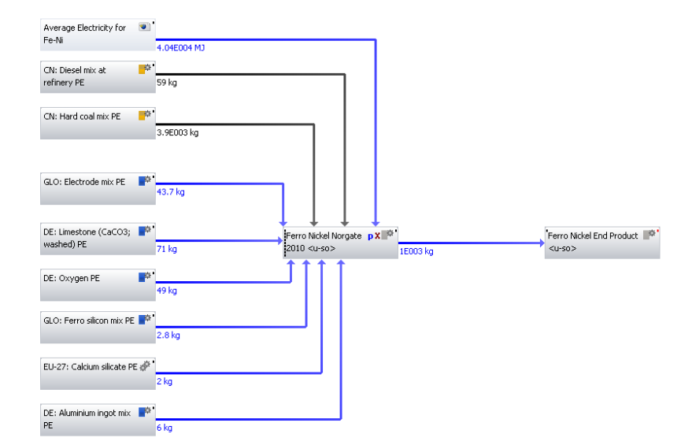
Figure 40. Global Fe-Ni model.

7.6. Ferro-Niobium

Figure 41. Comparison of all literature sources for Fe-Nb production.
Figure 41 illustrates the three different sources used for Fe-Nb modelling. The GWP value produced from Tudor was an estimated value based on a worst case scenario. It was estimated based on the unique production route of Fe-Nb (i.e. aluminothermic reduction) but with limited data.
Actual creation of Fe-Nb models was via data from (Gasik.M 2013) and (Nuss & Eckelman 2014). Data from these models produced GWP values of 4.39 (Gasik) and 4.83 (Nuss) kg CO₂-Equiv respectively. The difference in GWP value between the models was approximately 9.54% and can be explained by breakdown of GWP in terms of CO₂ contribution.
For both Gasik and Nuss, aluminium was the main CO₂ contributor with percentages of 73% (3.18 kg CO₂-Equiv) and 94% (4.55 kg CO₂-Equiv) respectively. For Gasik, magnesium contribution was also significant at 25% (1.08 kg CO₂-Equiv). For both models pyrochlore, contributed minutely, but contribution from Nuss (0.27 kg CO₂-Equiv) was twice as much as compared to Gasik (0.13 kg CO₂-Equiv). Explanation of the difference in pyrochlore between Nuss and Gasik can be explained in the doubling of the amount of pyrochlore in the inventory, 1640kg for Nuss, compared to 758 kg for Gasik.
Alternatively, instead of pyrochlore, a niobium pentoxide process could have been used in the Gasik model. However from the results, aluminium was the key variable and so including the niobium pentoxide process might have affected the total amount of GWP but not the overall result. To summarise the difference in GWP between Gasik and Nuss Fe-Nb models was primarily due to the amount of aluminium with a small impact from pyrochlore.
The GWP values produced from Gasik and Nuss were also compared against reported GWP values for Fe-Nb in literature. Nuss using the same data as the models above, but his own modelling procedure obtained a GWP value of 7.13 kg CO₂-Equiv. This was considerable higher than the values obtained in Figure 41. The main reasons could be the use of different software’s since LCA software GaBi was used to produce the results in Figure 41. Whereas Nuss made use of SimaPro 8 software. Additionally, although Nuss stated the use of Eco-invent data, it is not known exactly what processes were linked to the input data. As mentioned before, multiple processes exist in the databases for one process and so selection of different processes can make a difference.
In terms of other literature, GWP values by Nuss were appreciably higher than the 2.1 kg CO₂-Equiv reported by IAMGOLD in Canada in their corporate sustainability report. For pure niobium (99.99%), the GWP for 100 years derived from SimaPro software was reported to be 46.6 kg CO₂-Equiv.A higher value would be expected due to the processing of pure niobium metal (99.99%) against
Fe-Nb (65%Nb).
To summarise, although the GWP values from Gasik and Nuss appear to be on the low side they have been calculated using numerical data, as opposed to being estimated by Tudor. A plausible explanation for the low GWP values could be the fact that system-wide GWP associated with aluminium provision (the major contributor to GWP) might not be included in the process. However as illustrated by literature the GWP values of Fe-Nb vary and depend on the modelling software as well as inventory data used to create the model. Another possible reason could be the input pyrochlore, which potentially could require further investigation.
However as illustrated by literature the GWP values of Fe-Nb vary and depend on the modelling software as well as inventory data used to create the model. In addition Fe-Nb is not as widely investigated as Fe-Ni, and therefore future studies will assist in better understanding its processes and subsequent results.
From the data used and the results generated, the process depicted by Figure 42 i.e. Fe-Nb (Nuss) was selected for use in application of steel grades. Although the GWP value was higher, the data from Nuss was more current and included the data to model pyrochlore, thus retaining a semblance of accuracy across the model.
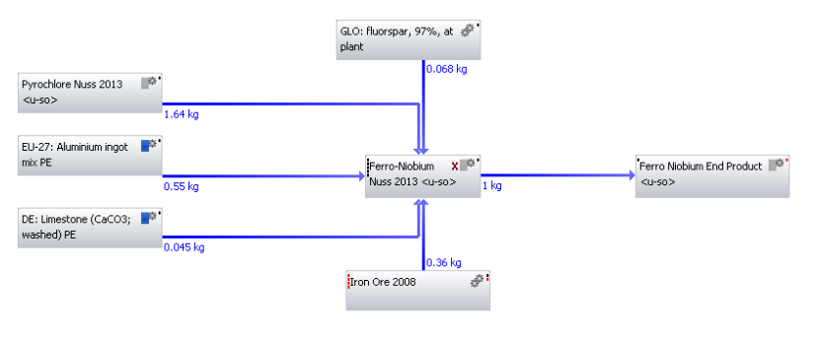
Figure 42. Fe-Nb production from data source Nuss.

7.7. Ferro-Silicon

Figure 43. Comparison of all literature sources for Fe-Si production.
Figure 43 utilises a colour key to differentiate between the multiple sources of literature used to model Fe-Si production. Interestingly, out of all the ferro-alloys with more than a single model, Fe-Si had the closest grouping of results. Excluding Fe-Si (Tasmania energy) the results across all models were close to 12.00 kg CO₂-Equiv. apart from Fe-Si (Eurometaux), which stood out with a GWP value of 14.19 kg CO₂-Equiv.
In terms of the original results, the difference in GWP values between Tasmanian and Australian electricity grid mixes was about quadruple, compared to previously mentioned ferro-alloys (i.e. Fe-Cr, Fe-Mn) where it was double the difference. The difference in GWP values can be explained by analysing the contribution of carbon emissions from the various components of each ferro-alloy production. For the majority of ferro-alloys there was one significant contributor (coal or coke). However in the case of Fe-Si, equal contributions were made from coal, coke and electricity. Thus explaining why Fe-Si (Australian energy) might have a higher GWP. Resulting in a larger difference in GWP values between Fe-Si (Tasmanian energy) and Fe-Si (Australian energy).
In regards to Haque Version 2, which was modelled to replicate the original results, the percentage difference between this and the original model was 2.69%. Furthermore, Haque version 2 in comparison with global Fe-Si model, had a greater percentage difference of 7.77%. This difference can be explained by comparing and contrasting the two models.
The fundamental differences between Haque Version 2 and global Fe-Si were the use of the following three processes – thermal energy from natural gas, hard coal mix an electricity grid mix. For Haque Version 2, these were all modelled using Australia as the source country. For global Fe-Si, thermal energy from natural gas and hard coal mix were modelled using China. For electricity grid mix, an average based on global Fe-Si production was utilised.
Calculations of GWP based on 1 MJ of product, revealed for thermal energy values of 0.0657 kg-CO₂-Equiv for Australia and 0.0705 kg-CO₂-Equiv for China. A difference equating to 7.05%. With regards to hard coal mix, the percentage difference was 50.00% has mentioned previously with Fe-Cr, Fe-Mn and Fe-Ni. For the contribution of 1 MJ of electricity the values were 0.249 kg /CO₂ for global Fe-Si and 0.279 kg /CO₂ for Australia. Equating to a percentage difference of 11.36% between the GWP values.
Although the percentage difference values are high, particularly for hard coal, they have to be taken into context especially in relation to their total impact on GWP. Breakdown of individual contributions of total GWP by process, reveals electricity from grid mix accounted for 68.4%, hard coal mix 0.80% and thermal energy from natural gas 0.10%.
The difference in GWP can also be accounted for by the countries comprising the global Fe-Si model, which primarily included China, Russia and Norway. The largest contribution came from China which contributed (0.230 kg /CO₂) from a total of 0.249 kg /CO₂. Large contributions were not expected from Russia (natural gas) and Norway (hydroelectricity) whose primary fuel sources were low carbon emitters. Thus the total GWP was not expected to be higher than the original result and is further supported by the value of 0.279 kg /CO₂ corresponding to 1MJ of energy from Australian electricity grid mix. This should be and is higher than the corresponding value of 0.249 kg /CO₂ for global Fe-Si model.
Related to electricity, apart from two models (i.e. global Fe-Si model and GaBi), the remaining Fe-Si models utilised Australia as the main source of electricity grid mix. The global Fe-Si model was based on global production of Fe-Si. However, for the GaBi model, electricity grid mix was from EU-27 and Germany. The EU on average does not have a high percentage of electricity from coal as compared to Australia. So it would be expected that Fe-Si (GaBi) would have a lower GWP value than 12.10 kg /CO₂. However this could have been offset by the percentage of Si in Fe-Si (91% in this case), since getting to this percentage requires more refining and thus more electricity. Therefore more electricity could have been used for this model, but due to electricity grid mix, being based on EU, the overall effect of usage would have been negated and the current GWP value obtained.
Finally analysis of Fe-Si (Eurometaux) inputs, reveal this model to have the largest electricity contribution (9000 kWh/t) out of all Fe-Si models. Additionally the input ‘woodchips’ was also present, thus both inputs would have increased CO₂ emissions leading to a greater GWP value. Without these additional inputs, Fe-Si (Eurometaux) GWP would have been identical to the rest of the models.

In terms of literature, according to (Lindstad et al. 1998), the emission factor for Fe-Si production from Norway for the year 2006 was approximately 5.56. This was calculated by dividing global Fe-Si production (4,080,000 Mt) by greenhouse gas emissions from Norway for Fe-Si production (733,000 Ton-CO₂ Equiv/year). Comparing this to the 2006 IPCC Guidelines for National Greenhouse Gas Inventories, the emission factor 5.56 was higher than 4.00 and 4.80 calculated for Fe-Si (75% and 90% Si) variations. The CO₂ emissions from the Norwegian ferro-alloys production account for about 4 % of the Norwegian emissions. The results above cannot be directly compared unless data similar to that stated in the previous paragraph is located particularly for China, which is the major global CO₂ emitter primary producer of a lot of the important ferro-alloys.
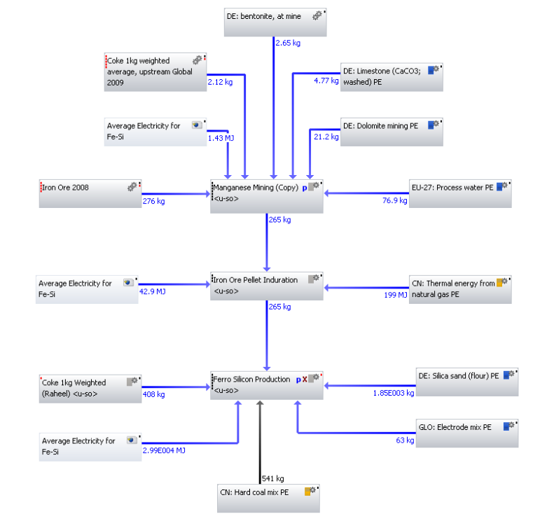
Figure 44. Global Fe-Si model.
From evaluating all the models and results, the global Fe-Si model above (Figure 44), was selected as the process representing Fe-Si. This model was also selected to be utilised in work associated with application in grades of steel.

7.8. Ferro-Titanium

Figure 45. Comparison of GWP results for Fe-Ti production.
Analysis of the Fe-Ti results compared models created from Tudor and Gasik. Tudors estimated GWP value was based on the carbothermic reduction route. To produce Fe-Ti from this route, scrap titanium is melted along with Fe₂O₃ and coke in an EAF, producing Fe-Ti with a Ti level of 70%. Since there was no information on Fe-Ti within GaBi databases, the GWP value estimated by Tudor, was based on the CO₂ value for the production of Ti which was, 16.6kg of CO₂ per kg of Ti. As the process uses scrap Ti, the figure for the production of Ti was used to determine 70% of the Fe-Ti CO₂ figure:

- 70% of Fe-Ti is Ti = 0.70 × 16.6kg = 11.62kg of CO₂

The remaining 30% of Fe-Ti was calculated taking the worst case scenario from similar carbothermic reduction processes i.e. Fe-Cr or Fe-Mn. Taking the GWP for LC Fe-Cr (7.99kg of CO₂ per kg) the remaining 30% of Fe-Ti came to 2.397kg of CO₂.This would equate to a total value of 14.017kg of CO₂ per kg of Fe-Ti.
On the other hand, the process from Gasik was created based on inputs for aluminothermic reduction in an electric arc furnace. The input aluminium contributed approximately 85%of the overall GWP value of Fe-Ti.
Comparison of the two values against one another was not accurate, since the method by Tudor was based on little or no data and estimations using worst case scenarios. In addition, the current literature indicates Fe-Ti is manufactured using metallothermic reduction and not carbothermic reduction due to minimising carbon content in Fe-Ti alloys. However a low GWP value for Fe-Ti (Gasik) may be due to a number of factors:
- Similarly to Fe-Nb, system-wide GWP associated with aluminium provision (the major contributor to GWP) might not be included in the process.
- In recent years, secondary scrap has become more important in producing Fe-Ti, thus decreasing the carbon footprint.
- Iron used in the process is assumed to be low carbon iron scrap, thus minimising carbon emissions.
Comparisons against literature was difficult due to minimal information on actual Fe-Ti created processes. As well as data sources used to create Fe-Ti models. In this case comparisons were made between Fe-B, Fe-Nb and Fe-Ti since all three routes were based on aluminothermic reduction in an electric arc furnace.
Table 28. Comparison of ferro-alloys utilising aluminothermic reduction production routes.
 | Ferro Boron (Borates) | Ferro-Niobium (Nuss) | Ferro-Titanium (Gasik)
CML2001 - Apr. 2013, Global Warming Potential (GWP 100 years) [kg CO2-Equiv.] | 19.87 | 4.83 | 4.30
Energy (net calorific value) [MJ] | 384.49 | 97.56 | 103.10

Aluminium was the main contributor in all 3 processes with the addition of magnesium in Fe-B being significant. This explains why across the two categories of GWP and energy, Fe-B had the highest impact. In terms of Fe-Nb and Fe-Ti, these were similar due to the similar quantity of aluminium present in each process. For all 3 processes, the specific ore for each process contributed little to the total GWP.
In terms of GWP values in literature to compare against, there was little or no data available for Fe-Ti.
Since a single process was created as depicted by Figure 46, this was utilised in work associated with application in grades of steel.
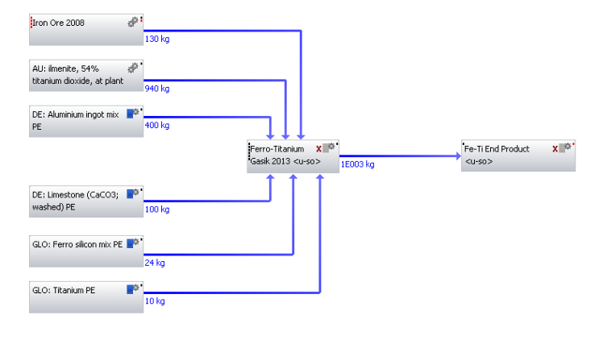
Figure 46. Fe-Ti production via Gasik data source.

7.9. Ferro-Vanadium

Figure 47. GWP value for Fe-V.
For Fe-V, a single GWP value of 84.10 kg CO₂-Equiv was calculated based on the process from GaBi. As mentioned in the ferro-alloy methodology, quantitative data was obtained on how to produce 1 metric ton of 80 % ferrovanadium. But with the process ‘vanadium pentoxide’ missing and with little or no data to create this, no other Fe-V model could be created to compare and contrast with.
The lack of openly available data was also reflected in little or no literature to compare the GWP value against. Although Fe-V models might exist in-house within companies and organisational bodies. For the results from this study it was difficult to obtain something relevant to compare against.
Contact was made with World Steel Association in order to model Fe-V, via steel making slag, but proved unsuccessful. However, with a Fe-V model set-up, as shown by Figure 48 appropriate data when available can be inserted and the results analysed.
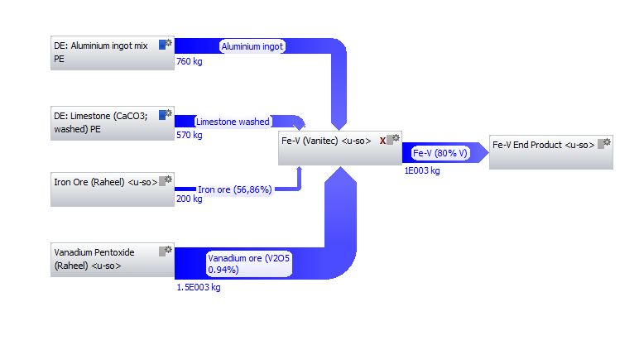
Figure 48. Incomplete Fe-V model utilising data from Vanitec.

7.10. Silica-Manganese

Figure 49. Comparison of all literature sources for Si-Mn production.
Figure 49 utilises a colour key to differentiate between the multiple sources of literature used to model Si-Mn production. The majority of models developed had greater GWP values than the original mode. A more detailed explanation of the results from each model are detailed in the paragraphs below.
As expected Haque’s original data shows a strong correlation between source of electricity and GWP value. The value from Tasmanian energy was considerably lower when compared to Australian energy. However this would be expected due to the contribution of non-renewable energy (hydro-electricity) in Tasmania and Australian energy being predominantly fossil fuel heavy.
Following the same trend as Fe-Mn, Si-Mn (Haque) Version 2 had a larger GWP value (7.60 kg CO₂-Equiv) than global Si-Mn (7.17 kg CO₂-Equiv). In terms of the global Si-Mn model, the percentage difference in GWP values in comparison to Haque Version 2, which characterised the original data source, was 5.82%.
Since global Si-Mn used a similar modelling method to global Fe-Mn, the differences between Haque Version 2 and the respective global models was the same. The detailed explanation can be seen in the Fe-Mn section. The only exception being the value of the average electricity grid mix corresponding to 1MJ, which was 0.263 kg/ CO₂. The percentage difference between this and the value from Australia (0.279 kg /CO₂) was 5.94%. This therefore points towards the fact that GWP for global Si-Mn should be and is lower. This is explained by the country make-up of average electricity grid mix for global Si-Mn production.
The average electricity grid mixed was based on the top three global Si-Mn producers, namely: China, India and Ukraine. If GWP was solely based on electricity, then both China (75.47%) and India (72.83%) have higher percentages from coal for electricity generation than Australia (64.72%). However percentage of global production also has to be taken into consideration. China provides 63.52% of global production followed by India 11.02% and the Ukraine with 5.77%. Although the percentage of electricity from coal may be high from China and India, because the average value is taken across the three countries, it explains the lower value of 0.263 kg/ CO₂.This is further supported by considering breakdown of GWP contribution by process.
For either Haque Version 2 or global Si-Mn models reveal electricity grid mix contributed 66.00%, followed by hard coal mix 0.30% and a negligible amount from diesel mix at refinery. Therefore, electricity would have contributed a significant amount of the GWP. Since Australia has a greater corresponding value based on 1MJ (0.279 kg /CO₂) it explains why Haque Version 2 is and should be higher.
In terms of Si-Mn (Eurometaux), this was modelled linearly and included key processes Mn ore and Fe-Mn. Its GWP value was lower than Si-Mn (Haque) Version 2 primarily because the latter process had more electricity usage (4.68×10⁴ kWh to 3.80×10⁴ kWh) and carbon based inputs (650kg to 400kg).
With regards to the GWP value from Tudor, this was calculated based on the assumption that the process used to produce Si-Mn was similar to the processes utilised for Fe-Mn and Fe-Si production. The CO₂ emission levels relating to these were: 7.85kg of CO₂ for Fe-Mn (GaBi) and 12.1kg of CO₂ for Fe-Si (GaBi). Tudor could not determine whether it was the high carbon or low carbon version of the Fe-Mn that was used, so took LC Fe-Mn value as the worst case scenario and calculated Si-Mn CO₂ emissions as follows:
- 16% of Si in Si-Mn = 0.16 × 12.1kg = 1.936kg of CO₂.
- 68% of Mn in Si-Mn = 0.68 × 7.85kg = 5.338kg of CO₂.
- Total = 7.274 kg of CO₂ for 84%, scaled up to 100% produces 8.659 kg of CO₂.

Tudor’s value were expected to be higher since they were based on a worst case scenario with a number of calculated assumptions.
From all the Si-Mn models created, Global Si-Mn (see Figure 50) was selected to use in applications to grades of steel.
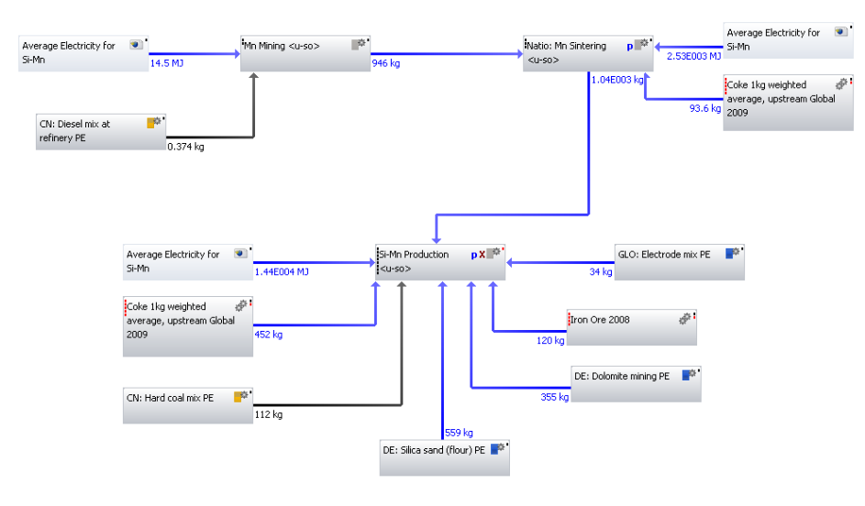
Figure 50. Si-Mn production from Haque data.

7.11. Summary
Constructing ferro-alloy models from various literature sources was demanding. Although most ferro-alloys are produced via the EAF route, with some notable exception, data availability in literature concerning these ferro-alloys is low and varied. In conjunction with this, within these ferro-alloys several different versions and variations (i.e. HC, MC and LC) exist.
For the ten ferro-alloys investigated here, quantitative data to construct the models was primarily obtained from the following six primary literature sources.
- Data source 1 - Gasik, M. (2013). ‘Handbook of Ferro-alloys Theory & Technology’.
- Data source 2 - Haque. N & Norgate T, 2013. ‘Estimation of greenhouse gas emissions from ferro-alloy production using life cycle assessment with particular reference to Australia’. Journal of Cleaner Production 39 (2013) pgs. 220-230.
- Data source 3 - European Association of Metals (Eurometaux). Draft Report (2014). Chapter 8 - Ferro-alloy production.
- Data source 4 - Thinkstep. GaBi Software System and Databases for Life Cycle Engineering. Copyright, TM. Stuttgart, Echterdingen. 1992-2015.
- Data source 5 - P. Nuss & Matthew J. Eckelman 2014. ‘LCA of Metals: A Scientific Synthesis’ Plos One. July 2014 | Volume 9 | Issue 7 | e101298.
- Data source 6 - International Molybdenum Association (IMOA), (2005). Personal communication.

This allowed a literature review of existing process, routes and other variations as well as creating the ferro-alloy models. Some general trends were observed across the ten ferro-alloys investigated.
- Work previously conducted by Tudor, relied upon estimating the environmental impacts of ferro-alloys using assumptions based on identical production routes or worst case scenarios. In comparison with ferro-alloy models constructed with actual data, GWP values from Tudor’s estimations proved to be significantly different.
- Review of the literature, by modelling the ferro-alloys against multiple literature sources, revealed electrical energy and carbon inputs are the two primary contributors to variation within the ferro-alloy models as well as within the literature.
- Results across all 10 ferro-alloys revealed Fe-Si to have the smallest variation between all models created from literature.
- Fe-V was the only ferro-alloy where complete data could not be located in literature to create a model, produce a GWP value and compare this with the value from the process from GaBi.
- GWP values for GaBi in comparison with other literature sources were higher for (Fe-Cr, Fe-Mn and Fe-Mo) lower for (Fe-Ni) and approximately identical to Fe-Si.
However the results should be taken into context as revealing differences rather than ‘trends’ between the different ferro-alloy models. To elaborate, a trend can be defined as a systematic variation of one parameter with another. In the case of the ferro-alloy models, although novel electricity grid mixes were created for 5 ferro-alloys (i.e. Fe-Cr, Fe-Mn, Fe-Ni, Fe-Si and Si-Mn) these were contributing factors to the variation of GWP values for models within the alloys. For example, Table 29, illustrates the percentage error of similarly created models in comparison to the GWP values from the original models by Haque.
Table 29. A comparison of percentage errors of models created against the original GWP value of 5 ferro-alloys of interest.
 |  | Fe-Cr | Fe-Mn | Fe-Ni | Fe-Si | Si-Mn
 | Original GWP Value | 7.22 | 3.59 | 24.10 | 12.10 | 6.09
Percentage Error (%) | Haque Version 2 Model | 0.55 | 55.71 | 2.07 | 2.73 | 17.73
Percentage Error (%) | Global Ferro-alloy Model | 5.26 | 27.02 | 7.67 | 4.96 | 17.73

Table 29 clearly shows a higher percentage error for global ferro-alloy models in comparison to Haque version 2 for three out of the five ferro-alloys. The only exceptions being Fe-Mn which has a greater percentage error for Haque version 2, which has been previously explained, and Si-Mn which has identical values irrespective of the model. In terms of explaining why there is a larger percentage error from the global models, this is because of 2 potential errors in creating the average electricity models. Firstly the percentage make-up of country is different for each ferro-alloy and within the ferro-alloys there are differences in countries utilised. For example for Fe-Cr, in the global model, China is used as the primary country whereas in the Gabi models, South Africa is used. Secondly the type of process utilised for each individual fuel source would have also contributed to a difference. For example for Fe-Ni fuel processes from New Caledonia were not available and so other countries such as Australia were utilised in worse case scenarios, thus accounting for some of the 7.67% difference calculated in the table above. It is useful to make an assessment of what the errors are, but it is important to remember that these errors are not the sole cause but a contributing factor and do require further research not explored here.
The objective of this research was to identify literature and data related to ferro-alloys and create models based on this. Although there is a tendency that a ‘trend’’ can be seen in the data this is not the case. For instance Figure 39, depicts GWP values for all Fe-Ni data sources. Now the results show quite a close trend between all the results apart from model from Gabi which has a significantly lower GWP value than the rest. Currently it would be difficult to establish a clear trend due to the variations in: percentage of nickel in ore, amount of carbon, amount of electricity, source of ore and source and type of electricity. Now although not investigated here, this research has identified these variables as potential indicators or contributors where trends could be identified but this would require further modelling and could be conducted as future work in progressing this research.
Based on all the results, one model per ferro-alloy was selected to be utilised to investigate the impact of alloying additions in grades of steel, as displayed by Table 30. The notable exception being Fe-V which was not utilised as it was not present as an alloying addition in the grades of steel work to follow.
Table 30. Final processes selected from each individual ferro-alloy.
Alloying Addition | Selected Process | CML2001 - Apr. 2013, Global Warming Potential  (GWP 100 years) kg CO₂-Equiv.
Ferro-Boron | Fe-B (Borates) | 19.87
High Carbon Ferro-Chromium | Global Fe-Cr Model | 7.60
Low Carbon Ferro-Chromium | GaBi LC Fe-Cr | 7.99
High Carbon Ferro-Manganese | Global Fe-Mn Model | 4.56
Low Carbon Ferro-Manganese | LC Fe-Mn (Eurometaux) | 7.23
Ferro-Molybdenum | Fe-Mo (IMOA) | 9.09
Ferro-Nickel | Global Fe-Ni Model | 22.25
Ferro-Niobium | Fe-Nb (Nuss) | 4.83
Ferro-Silicon | Global Fe-Si Model | 11.50
Ferro-Titanium | Fe-Ti (Gasik) | 4.30
Silica-Manganese | Global Si-Mn Model | 7.17

8. LCA Results - Impact of alloying additions to steel grades
This particular section of work was concerned with determining the additional CO₂ per kg due to alloying additions for 8 different steel grades.
Steel making data, was obtained from Tata Steel making site in Port Talbot, specifically from the BOS plant. The data specified the type of alloying addition as well as the amount added per cast for 8 grades of steel: Boron, DP800, DP600, S450, S390, S355, XF400 and IF grades. Using these values as well as the emission factor calculated from the ferro-alloy models, the additional impact of the alloying additions for each grade of steel was calculated. A detailed breakdown of these calculations can be seen in the Appendix under heading ‘Breakdown of grades of steel calculations’. The results for all eight types of steel grade are summarised by Figure 51.

Figure 51. A comparison of additional CO₂ per kg due to alloying additions for 8 different steel grades.
The results illustrate significant additional CO₂ impacts, particularly from the dual phase steel grades, DP800 (0.2535 kg CO₂/kg) and DP600 (0.1767 kg CO₂/kg). To put into context, the combined CO₂ impacts from S450, S390, S355 and XF400 were approximately equal to the result by DP800. After the dual phase steel grades, Boron steel grade had the third highest additional CO₂ impact with a value of 0.0933 kg CO₂/kg. In terms of the constructional steel grades, S355 had the largest CO₂ impact value (0.0804 kg CO₂/kg) followed by S450 and S390. The high strength low ally steel grade XF400, had a relatively low CO₂ impact value (0.0471 kg CO₂/kg) in comparison with the other six steel grades. Finally, IF steel grade had the lowest additional CO₂ impact value of (0.0155 kg CO₂/kg) roughly 16 times the impact in comparison with DP800.
In addition, the results were also considered by steel category as shown by Figure 52. These results were generated by taking a steel grade from each category UHSS (Boron), AHSS (DP800), Conventional HSS (S450) and dividing it by the Mild steel (IF steel grade).

Figure 52. Additional CO₂ impact over IF steel grade for 4 different steel categories.
The trend in additional CO₂ impact, in increasing order appears to be Conventional HSS, UHSS and AHSS.
A possible explanation of the results from Figure 51 and Figure 52, could be that steel grades with high alloying addition added per cast, produce the highest additional CO₂ impact. For instance, 11.58t of alloying additions were cast for DP800 in contrast to 0.92t for IF steel grade. However this trend only applies to DP800, DP600 Boron and IF steel grades. For the constructional steel grades, although S355 steel grade has the highest additional impact, it is in fact S450 which has the higher tonnage of alloying additions. The comparison of the trend between additional CO₂ impact and alloying addition cast for all three constructional grades and XF400, are graphically illustrated below.

Figure 53. A graph illustrating the relationship between alloying additions added per cast against additional CO₂ per kg due to alloying addition.
Figure 53 indicates no clear trend between amount of alloying addition added per cast and additional CO₂ impact due to alloying additions. An in-depth analysis of each of the steel grades indicates a single factor namely the individual contribution of an element has the key variable that can explain the results. Comparing all three constructional grades of steel, the largest individual contribution was from medium Fe-Mn followed by aluminium, with the element Mn, also contributing the largest proportion of alloying addition cast.
Comparing S450 and S355 steel grades, although S450 has Fe-P which S355 does not, its CO₂ impact has already been included in the steel making process, so for this analysis both grades can be considered as having the same constituents. The main difference between the two grades are that, S355 has approximately 16% more aluminium and 25% more medium carbon ferro-manganese. Therefore, even though S450 has the largest total in terms of alloying addition cast its individual contributions are lower than S355, resulting in this grade producing more additional CO₂.
With regards to the XF400 steel grade, the results were comparable against S390 steel grade. Although XF400 had the greater alloying addition cast as well as largest individual contribution from medium Fe-Mn (i.e. 13% more), S390 had slightly more aluminium (16% more) and a significant contribution from Fe-Si resulting in XF400 producing the lowest additional CO₂ amount from alloying additions. A summary of the analysis of the correlation between alloying addition cast and additional CO₂ due to alloying additions is displayed in the table below.
Table 31. Summary of analysis of correlation between alloying addition cast and additional CO₂ due to alloying additions. Key Green = largest impact, Yellow = smallest impact.
Steel Grade | Alloying Addition added per cast (t) | Individual Contribution - Medium Fe-Mn | Individual Contribution - Total Mn | Individual Contribution - Aluminium | Additional CO₂ per kg due to Alloying Additions
S450 | 6.58 | 4.25 | 4.875 | 0.6 | 0.0711
S390 | 3.38 | 2.35 | 2.45 | 0.7 | 0.0514
S355 | 5.66 | 4.7 | 4.8 | 0.7 | 0.0804
XF400 | 4.18 | 2.67 | 2.725 | 0.6 | 0.0471

In order to further understand the above results, the three steel grades with the highest CO₂ impacts (Boron, DP800 and DP600) were selected and a breakdown of the individual contribution of the alloying additions conducted.
In terms of boron, the steel grade make-up included ten different alloying additions with Silica-Manganese (36.72%) representing the largest individual contribution followed by high carbon ferro chrome (17.98%) and high carbon ferro-manganese (14.01%). Further analysis revealed even though ferro-boron (19,870 kgCO₂/kg) and ferro-silicon (11,500 kgCO₂/kg) had a higher emission factor in comparable to silica-manganese (7,173 kgCO₂/kg). The alloying addition added in particular for ferro-boron (0.055t) was small compared to 2.5t alloying addition for silica-manganese, thus explaining why silica-manganese had a greater impact on an individual level for boron steel grade.

Figure 54. Breakdown of individual contribution of alloying additions for Boron steel grade.
For DP800, the steel grade was made up of nine different alloying additions. Figure 55 highlights, the primary contributor being electrolytic manganese (63.83%) followed a distance second by high carbon ferro chrome (18.56%) and ferro-silicon (7.77%) in third. In this case, the results were not surprising since electrolytic manganese made up approximately 43% of the total alloying addition amount with 5t and also had the highest emission factor (13,700 kgCO₂/kg) for any of the alloying additions.

Figure 55. Breakdown of individual contribution of alloying additions for DP800 steel grade.
Lastly, in the case of DP600, this was made up of eight different alloying addition types. Similarly to boron steel grade, the highest individual contribution was from silica-manganese (35.71%) followed by low carbon ferro-chrome (19.89%) and medium carbon ferro-chrome (15.77%). Correspondingly to boron steel grade, these top three individual contributors did not have the highest emission factor, which belonged to ferro-silicon (11,500 kgCO₂/kg) and aluminium (9,060 kgCO₂/kg). However all three alloying additions did have significant cast amounts of 4.00t, 2.00t and 2.00t respectively.

Figure 56. Breakdown of individual contribution of alloying additions for DP600 steel grade.
Summarising, the results from breakdown of individual contribution of alloying additions for the three different grades of steel, indicated alloying amount added to cast as the primary source of the results. For all three steel grades the highest individual contribution came from the alloying addition with the largest amount.
The results thus summarize both the alloying addition amount and emission factor related to that alloying addition, play a pivotal role in influencing the end result.

9. Industrial significance of results
Customers of Tata Steel are increasingly becoming interested in the environmental credentials of its products. Being the responsible and sustainable manufacturer that Tata Steel is, it is continually examining the environmental impacts of its operations. One of these operations is the environmental impacts of Tata’s steel products.
Tata’s product portfolio is varied and the factors affecting the environmental impacts of its steels are complicated by the many possible ‘recipes’ used to produce them. However, it is desirable to know the performance of these steels across a variety of environmental factors. In order to accomplish this, models need to be developed to allow Tata to make these evaluations.
Currently at Tata, models are being developed using commercial software GaBi as provided by Thinkstep. Data relating to the production of many common materials is included in database extensions provided by Thinkstep, but there are some materials which are not included and in particular, some of the alloying materials used in the production of many of Tata’s steel grades. The figure below (Figure 57) below shows how many material inputs can be used to produce a steel.
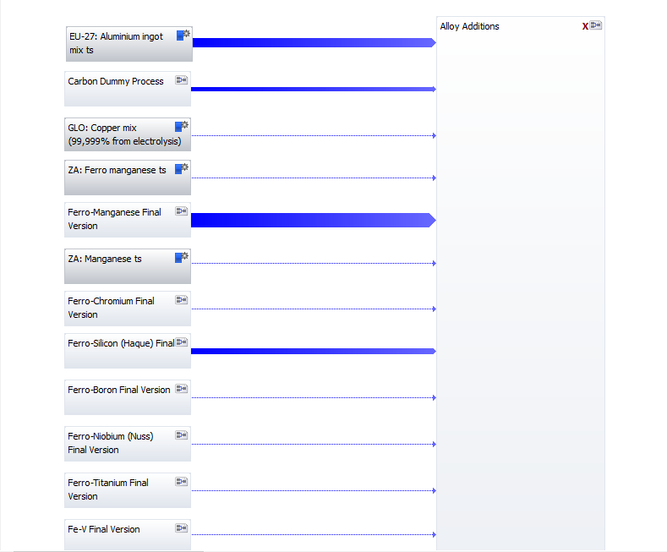
Figure 57. Model illustrating recipe for additions of alloys in steel grades.
The model allows for many different grades of steel to be selected, and the amounts of each input are varied accordingly. It can be seen that some of the inputs are from existing databases (for instance “ZA: Manganese” signifies a material that is within the Thinkstep database). However, data was not available for many of the materials used, and hence work form this research has proved valuable in filling a data gap in literature and bringing about a contribution in real life industrial applications.

10. Conclusion
As demonstrated, investigating alloys in the steel industry via MFA and LCA methodologies, is worthwhile, but complicated. Nonetheless, recapping the main topics a number of things were learned as shown by the following 5 points:
- Criticality - There is no single definition of criticality and it is strongly dependant on the perspective from which it is conducted and on the purpose of use. However, in the present literature there does appear to be a degree of accordance in the general methodology (i.e. use of supply risk and vulnerability) as the main dimensions for conducting criticality assessments.
- MFA - Five Sankey diagrams were created for steel, chromium, molybdenum, niobium and vanadium. Although mapping of flows was useful in identifying bottlenecks, hotspots and resource efficiency opportunities. It also highlighted a data gap which can only be filled with wider stakeholder engagement across all levels of supply chain.
- LCA of electricity - Based on the global production of the top three countries for five ferro-alloys of interest (Fe-Cr, Fe-Mn, Fe-Ni, Fe-Si and Si-Mn), average electricity grid mixes were developed. The method was tested by comparing processes from GaBi and IEA databases and demonstrated a robust methodology for creating average electricity processes.
- LCA of ferro-alloys - Ten ferro-alloys were constructed using six primary literature sources. Results across all ten ferro-alloys revealed firstly, Fe-Si to have the smallest variation between all models created from literature. Secondly, Fe-V was the only ferro-alloy where complete data could not be located in literature to model. Thirdly electrical energy and carbon inputs were the two primary contributors to variation within the ferro-alloy models.
- Grades of Steel – Utilising previously created ferro-alloy models, the impacts of alloying additions were investigated across 8 grades of steel: Boron, DP800, DP600, S450, S390, S355, XF400 and IF grades. Significant additional CO₂ impacts were seen from the dual phase grades of steel. Breakdown by individual contribution of alloying additions in the grades revealed the amount of alloying addition and emission factor pivotal in influencing the end results.
Yet, there are a number of limitations of each of the main topics discussed in the research. In particular limitations of criticality assessments are highlighted by not being designed to capture impacts of criticality assessments over time. The metric time horizon is critical in studies that utilise supply risk factors, since these are calculated by related factors such as geopolitical and metal supply, which themselves can considerably alter in the short, medium or long term. Thus resulting in some studies highlighting particular metals as critical in the short term whilst other studies highlight the same metal as critical in the long term. Such limitations could be overcome by the use of alternative metrics such as ‘Depletion Time’ developed by Thomas Graedel, but need to be applied much more in criticality assessments.
With regards to MFA, the single largest limitation was data availability. The importance of this, is shown by the global steel Sankey diagram, which is representative of the year 2008. Although fundamentals of the steel making process may have remained similar, updating the models to the relevant year is important in keeping up to date with global markets, technologies and trends. For instance, the MFA models could have highlighted a consistent trend of oversupply by China in the global steel market, and thus led to organisations and countries taken preventative counter measures beforehand like trade tariffs.
Similarly, data availability was also an issue in creating the MFAs for the 4 elements of interest. The current models developed are simple, but can be further developed if knowledge gaps centered on recovery rates, processing methods and environmental impacts are addressed. In particular, the outcome of EoL products in tandem with recycling are not well understood but could be with the relevant data present in literature. Limitations in data availability can only be resolved with wider stakeholder engagement across all levels of supply chain. This means access to quantitative or qualitative data which at this moment in time is lacking and thus hindering progress, particularly on elements of interest such as niobium and vanadium.
Relating to LCA models of electricity, the individual breakdown of fuel sources by country was the principle limiting factor. This was important because each country has unique production routes, or includes transportation or has different transmission and distribution losses. By selecting identical processes from alternate countries a lot of this individual information is lost, creating uncertainty in the grid mixes. To overcome this a lot of factors were considered such as technology, capability, developed or developing nation in order to decide which country to select. However in some cases GaBi simply did not have an alternative viable and worst case scenarios were used as was the case for New Caledonia.
Such limitations are an opportunity for ThinkStep, providers of GaBi software, to currently expand the heavily European based data and include other continents. This would not only be useful to them but to their clients who might investigate such scenarios has shown here.
Concerning ferro-alloy modelling, in parallel to MFA, the limitations were centered on data availability. Although ten ferro-alloys were investigated, not enough results were generated especially concerning the more exotic ferro-alloys, to be confident in any conclusion. Currently the confidence of the results are based more on a robust method, rather than data used to generate any results. However, apart from data availability, the work was limited since only electricity was varied and modelled. Other variations that could have been modelled were sources of carbon and ore grades. Sources of carbon would have been based on use of renewable biochar or replacements of coal and coke and would have been useful as it is currently a topic of interest. In regards to ore grades, a similar procedure could have been adopted to ferro-alloys, and ore grades modelled for each ferro-alloy and investigated in terms of its impact or lack of it. However a similar problem could have been encountered with data availability, as it was here in the case of lack of data to model vanadium pentoxide. Thus requiring future work to be a collaboration between data providers and users of data in order to maximise productivity.
Finally concerning the grades of steel, the only limitation was the lack of a grade with vanadium as an alloying addition. This would have helped to put into context, the impact of vanadium alloying additions.
The findings from this research make an original contribution by filling in gaps in the existing literature as listed below:
- Creation of global MFA models for niobium and vanadium, currently either not available in literature or outdated by several decades.
- Construction of average electricity models based on global ferro-alloy production which again is not available in literature. However much more valuable is the methodology to create these models which can be applied to countries not studied here and developed to be used when data does become available.
- An overview of existing literature into ferro-alloys as well as variables that can affect it which has not been studied in literature.
- Use of ferro-alloy models by Tata steel in its ‘recipe’ of steel grades in order to understand the environmental impact of producing steel grades through specific routes and use of alloying additions. This is novel and shows actual use of work presented here in real life applications.
- Use of ferro-alloy models to understand impact of alloying additions in 8 different grades of steel. An original piece of work and difficult to compare since no other study in literature has performed this.

Overall this research has made a number of original contributions to literature and in some cases industry. But has been created in such a way, that future researchers can come after and pick up key aspects of this research and take it forward as this work has.

11. Recommendations for Future Work
MFA
- The current models developed are simple, but can be further developed if knowledge gaps centered on recovery rates, processing methods and environmental impacts are addressed. In particular, the outcome of EoL products in tandem with recycling are not well understood but could be with the relevant data present in literature.
- Although not investigated here, it would be useful to assess the MFA models in terms of monetary value i.e. in pounds/dollars rather than purely on tonnage. This would provide economic incentive particularly for organisations to target specific areas to maximise opportunities for profits or limit costs.
LCA – Electricity
- Relating to LCA models of electricity, the individual breakdown of fuel sources by country was the principle limiting factor. Such limitations are an opportunity to currently expand the heavily European based available data and include other continents. In particular data is lacking for Middle Eastern and African nations which will transform particularly with the current investment in energy technologies.
- Additionally the models created here were based purely on electricity generation and not electricity consumption. Thus it would be interesting if an investigation was conducted to investigate this variable in detail and any specific effects it would have.
LCA – Ferroalloys
- Other variations that could have been modelled were sources of carbon and ore grades. Sources of carbon would have been based on use of renewable biochar or replacements of coal and coke and would have been useful as it is currently a topic of interest. In regards to ore grades, a similar procedure could have been adopted to ferro-alloys, and ore grades modelled for each ferro-alloy and investigated in terms of its impact or lack of it.
- There is also an opportunity to create a Fe-V process which this research attempted but could not complete due to insufficient data.
LCA – Alloying additions
- Increase the range of grades of steel investigated as well as the potential for application in related steel fields such as stainless and aerospace steels.
- Build upon previously conducted work by Kerry Tudor on ‘Life Cycle CO₂ analysis of AHSS in vehicles’ by inputting the alloying additions data and processes created in this research to determine the true benefit cradle to grave of AHSS.

Appendices

A. References
Achzet B., Reller A., Zepf V., (University of Augsburg), Rennie C., (BP), Ashfield M. and Simmons J., (ON Communication) (2011): Materials critical to the energy industry. An introduction. [PDF].
Adriaanse, A., Bringezu, Stefan, Hammond, A., Moriguchi, Yuichi, Rodenburg, Eric, Rogich, Don, and Schütz, Helmut (1997): Resource Flows, The Material Basis of Industrial Economies. Washington DC: World Resources Institute.
AEA, 2010. Review of the Future Resource Risks Faced by UK Business and an Assessment of Future Viability AEA Technology plc, London, UK.
Allwood, J.M., 2015. Private communication.
Amann, C. (2004). Development of material use in the EU-15 : 1970-2001. Types of materials, cross-country comparison and indicator improvement. Draft Working Paper. Office for Official Publications of the European Communities, Luxembourg.
Angerer, G., Marscheider-Weidemann, F., Lüllmann, A., Erdmann, L., Scharp, M., Handke, V. and Marwede, M., (2009). Raw materials for emerging technologies. Karlsruhe: Fraunhofer.
Atlantic Ltd, (2013). Vanadium Market Outlook. (Powerpoint Presentation). Available: http://www.mantaring.com/AlloyMTD/VanadiumMarketOutlook.pdf [Accessed 22th April 2013].
Ayres, R.U. and Kneese, A.V., 1969. Production, consumption, and externalities. The American Economic Review, 59(3), pp.282-297.
Bartzas, G. and Komnitsas, K., 2015. Life cycle assessment of ferronickel production in Greece. Resources, Conservation and Recycling, 105, pp.113-122.
Bauer, D., Diamond, D., Li, J., McKittrick, M., Sandalow, D. and Telleen, P., 2011. Critical Materials Strategy. US Department of Energy. Washington DC, 2011.
Baumann, H. and Tillman, A.M., 2004. The Hitch Hiker's Guide to LCA. An orientation in life cycle assessment methodology and application. External organization.
Bedinger, George M, Corathers, Lisa A. Kuck, Peter H Papp, John F. Polyak, Désirée E. Shedd, Kim B and Tuck, Christopher A (2014). Ferro-alloys Advance Release. Available: http:// www.usgs.com.
Bergbäck, B., Johansson, K. and Mohlander, U., 2001. Urban metal flows–a case study of Stockholm. Review and Conclusions. Water, air and soil pollution: Focus, 1(3-4), pp.3-24.
Berkel van, R., 2007. Eco-efficiency in primary metals production: Context, perspectives and methods.
Resources, Conservation and Recycling, 51(3), pp.511-540.
British Geological Survey (2011) Niobium-Tantalum. Available: http://www.bgs.ac.uk/mineralsuk/statistics/mineralProfiles.html [Accessed 20th April 2012].
British Geological Survey (BGS) Risk list, 2012, [Pdf], Available at: http://www.bgs.ac.uk/mineralsuk/statistics/riskList.html [Accessed 20th April 2012].
Blossom, J.W., 2002. Molybdenum recycling in the United States in 1998. Open-file Report. U. S. Geological Survey, (165), p.16.

Browning, C., Northey, S., Haque, N., Bruckard, W. and Cooksey, M., 2016. Life cycle assessment of rare earth production from monazite. In Rewas 2016 (pp. 83-88). Springer International.
Brunner, P.H., Daxbeck, H. and Baccini, P., 1994. Industrial metabolism at the regional and local level: A case-study on a Swiss region. Industrial metabolism: Restructuring for sustainable development, pp.163-193.
Brunner, P.H. and Rechberger, H., 2004. Practical handbook of material flow analysis.
Buchert, M., Schüler, D. and Bleher, D., 2009. Critical metals for future sustainable technologies and their recycling potential: United Nations Environment Programme & United Nations University, 81 p., accessed February 1, 2013.
Burgert, P 2012. ‘Supply Disruption threats looming for Cobalt’, Investing in African Mining Indaba. Online Review February 9, 2012 Available at www.miningjournal.com.
Castellano, H., 2001. Material flow analysis in Venezuela. Report to the European Commission DG XI, EU FP4 INCO-DEV project" Amazonia21".,-unpublished.
Chegwidden, J. and Kingsnorth, D.J., 2011. Rare earths—an evaluation of current and future supply. Presentation to the Institute for the Analysis of Global Security.
Chen, W.Q. and Graedel, T.E., 2012. Anthropogenic cycles of the elements: A critical review. Environmental Science & Technology, 46(16), pp.8574-8586.
Chen, S., Fu, X., Chu, M., Liu, Z. and Tang, J., 2015. Life cycle assessment of the comprehensive utilisation of vanadium titano-magnetite. Journal of Cleaner Production, 101, pp.122-128.
Cullen, J.M., Allwood, J.M. and Bambach, M.D., 2012. Mapping the global flow of steel: from steelmaking to end-use goods. Environmental Science & Technology, 46(24), pp.13048-13055.
Cullen, J.M. and Allwood, J.M., 2013. Mapping the global flow of aluminium: From liquid aluminium to end-use goods. Environmental Science & Technology, 47(7), pp.3057-3064.
Cunningham, L.D., 1998. Columbium (niobium). Plunkert, PA, and Jones, TS, comps., Metal prices in the United States through, pp.35-38.
Daigo, I., Hashimoto, S., Matsuno, Y. and Adachi, Y., 2009. Material stocks and flows accounting for copper and copper-based alloys in Japan. Resources, Conservation and Recycling, 53(4), pp.208-217.
Daigo, I., Matsuno, Y. and Adachi, Y., 2010. Substance flow analysis of chromium and nickel in the material flow of stainless steel in Japan. Resources, Conservation and Recycling, 54(11), pp.851-863.
Danish Energy Authority, Elkraft and Eltra (2004), Technology data for electricity and heat generating plants. Danish Energy Authority, Copenhagen.
Du, X. and Graedel, T.E., 2011. Global in-use stocks of the rare earth elements: a first estimate. Environmental Science & Technology, 45(9), pp.4096-4101.
Du, X. and Graedel, T.E., 2011. Uncovering the global life cycles of the rare earth elements. Scientific reports, 1, p.145.
Duclos, S.J., Otto, J.P. and Konitzer, D.G., 2010. Design in an era of constrained resources. Mechanical Engineering, 132(9), p.36.

Elshkaki, A., van der Voet, E., Timmermans, V. and Van Holderbeke, M., 2005. Dynamic stock modelling: A method for the identification and estimation of future waste streams and emissions based on past production and product stock characteristics. Energy, 30(8), pp.1353-1363.
Elshkaki, A. and Van Der Voet, E., 2006. The consequences of the use of platinum in new technologies on its availability and on other metals cycles. Conservation & Recycling and Resources: New Research. Nova Science, pp.61-92.
Erdmann, L. and Graedel, T.E., 2011. Criticality of non-fuel minerals: a review of major approaches and analyses. Environmental Science & T echnology, 45(18), pp.7620-7630.
Eurometaux, (2014). Chapter 8 - Processes to Produce Ferro-alloys.
European Union Commission, 2010. Critical raw materials for the EU. Report of the Ad-hoc Working Group on defining critical raw materials. Ad-hoc Working Group: July, 2010, p.84.
European Union Commission, 2014. Report on Critical Raw materials for the EU. Retrieved April, 30, p.2015.
Eurostat, H.W., Fischer-Kowalski, M., Amann, C., Eisenmenger, N., Erb, K., Hubacek, K., Krausmann, F. and Schultz, N.B., 2002. Material use in the European Union 1980—2000: Indicators and analysis. Working Paper and Studies series. Luxembourg: Office for Official Publications of the European Communities.
Finley, M., 2013. BP statistical review of world energy. 2013)[2015-03]. http://www, bp. com.
Finnveden, G., Hauschild, M.Z., Ekvall, T., Guinée, J., Heijungs, R., Hellweg, S., Koehler, A., Pennington, D. and Suh, S., 2009. Recent developments in life cycle assessment. Journal of Environmental Management, 91(1), pp.1-21.
Fischer-Kowalski, M., Haberl, H. and Payer, H., 1994. A plethora of paradigms: Outlining an information system on physical exchanges between the economy and nature. Industrial metabolism: Restructuring for sustainable development.
Fischer-Kowalski, M., 1997. Society’s Metabolism. On the Development of Concepts and Methodology of Material Flow Analysis. A Review of the Literature. In ConAccount Conference on Material Flow Accounting, Univ. of Leiden, January (pp. 21-23).
Fossay, C., 2012. KPMG - Special Commodity Insights Bulletin: Chrome and Ferrochrome.[PDF] Publication number: 120420.
Frischknecht, R., Jungbluth, N., Althaus, H.J., Bauer, C., Doka, G., Dones, R., Hischier, R., Hellweg, S., Humbert, S., Köllner, T. and Loerincik, Y., 2007. Implementation of life cycle impact assessment methods. Ecoinvent report.
Fthenakis, V., 2009. Sustainability of photovoltaics: The case for thin-film solar cells. Renewable and Sustainable Energy Reviews, 13(9), pp.2746-2750.
Fund for Peace (2016). Fragile State Indicators. [Online]. Available: http://fsi.fundforpeace.org/indicators [Accessed 23rd August 2015].
Gasik, M. ed., 2013. Handbook of ferroalloys: theory and technology. Butterworth-Heinemann.
Giljum, S., 2004. Trade, materials flows, and economic development in the South: the example of Chile. Journal of Industrial Ecology, 8(1‐2), pp.241-261.

Graedel, T.E., Van Beers, D., Bertram, M., Fuse, K., Gordon, R.B., Gritsinin, A., Kapur, A., Klee, R.J., Lifset, R.J., Memon, L. and Rechberger, H., 2004. Multilevel cycle of anthropogenic copper. Environmental Science & Technology, 38(4), pp.1242-1252.
Graedel, T.E., Beers, D., Bertram, M., Fuse, K., Gordon, R.B., Gritsinin, A., Harper, E.M., Kapur, A., Klee, R.J., Lifset, R. and Memon, L., 2005. The multilevel cycle of anthropogenic zinc. Journal of Industrial Ecology, 9(3), pp.67-90.
Graedel, T.E., Barr, R., Chandler, C., Chase, T., Choi, J., Christoffersen, L., Friedlander, E., Henly, C., Jun, C., Nassar, N.T. and Schechner, D., 2012. Methodology of metal criticality determination. Environmental Science & Technology, 46(2), pp.1063-1070.
Gregory, J., (2006). Massachusetts Institute of Technology- Department of Materials Science & Engineering. ‘Material Flow Analysis’ [Power point presentation]. , pp.1–37.
Gruber, P., 2010. Global Lithium availability: a constraint for electric vehicles? (Doctoral dissertation, University of Michigan).
Guinee, J.B., Heijungs, R., Huppes, G., Zamagni, A., Masoni, P., Buonamici, R., Ekvall, T. and Rydberg, T., 2010. Life cycle assessment: past, present, and future.
Guo, X. and Song, Y., 2008. Substance flow analysis of copper in China. Resources, Conservation and Recycling, 52(6), pp.874-882.
Guo, X., Zhong, J., Song, Y. and Tian, Q., 2010. Substance flow analysis of zinc in China. Resources, Conservation and Recycling, 54(3), pp.171-177.
Haberl, H., Weisz, H., Bartley, D.M., Brugère, C., Soto, D., Gerber, P. and Harvey, B., 2007. The potential use of the Materials and Energy Flow Analysis (MEFA) framework to evaluate the environmental costs of agricultural production systems and possible applications to aquaculture.
Hagelüken, C. and Meskers, C.E., 2010. Complex life cycles of precious and special metals. Linkages of sustainability, 4.
Halada, K. Japanese Data on Metals Flow, New Haven, 2008. http://www.nims.go.jp/ecomaterial/hal/MR/doc/Yale080815b.pdf.
Haque, N. and Norgate, T., 2013. Estimation of greenhouse gas emissions from ferroalloy production using life cycle assessment with particular reference to Australia. Journal of Cleaner Production, 39, pp.220-230.
Harper, E.M. and Graedel, T.E., 2008. Illuminating tungsten’s life cycle in the United States: 1975− 2000. Environmental Science & Technology, 42(10), pp.3835-3842.
Hatayama, H., Yamada, H., Daigo, I., Matsuno, Y. and Adachi, Y., 2007. Dynamic substance flow analysis of aluminium and its alloying elements. Materials Transactions, 48(9), pp.2518-2524.
Hatayama, H., Daigo, I., Matsuno, Y. and Adachi, Y., 2010. Outlook of the world steel cycle based on the stock and flow dynamics. Environmental Science & Technology, 44(16), pp.6457-6463.
Hatch (2014) Lifecycle assessment of global manganese alloy production. International Manganese Institute (IMnI), Paris, Available online: http://www.manganese.org.
Hendrickson, C.T., Lave, L.B. and Matthews, H.S., 2006. Environmental life cycle assessment of goods and services: an input-output approach. Resources for the Future.

Herczeg, M., Carlsen, R., Nemeskéri, R., Πειραιά, Β.Π. and στο KETlib, Α., 2007. Feasibility assessment of using the Substance Flow Analysis Methodology for chemicals information at macro-level (No. 1). Technical report.
Hilliard, H.E., 1994. The materials flow of vanadium in the United States. Washington, DC: US Department of the Interior, Bureau of Mines.
Hinterberger, F., Giljum, S. and Hammer, M., 2012. Material Flow Accounting and Analysis (MFA): A Valuable Tool for Analyses of Society-Nature Interrelationships. Vienna: Sustainable Europe Research Institute (SERI). Info Agro.(2010)."
Hofman & Basler., 1974. Study Environment and Economics, Comparison of environmental pollution Of PVC, glass, sheet and cardboard containers; Swiss Confederation Environmental protection: Bern, Switzerland.
Hope, B.K., 2008. A dynamic model for the global cycling of anthropogenic vanadium. Global Biogeochemical Cycles, 22(4).
Hunt, R.G., 1974. Resource and environmental profile analysis of nine beverage container alternatives.
International Chrome Development Association (ICDA), 2013. Activity Report. Available:http://www.icdacr.com. [Accessed Spetember 2013].
International Chrome Development Association (ICDA), 2015. A record year for record year ferrochrome only ferrochrome only. Minerals and Metals Review, (June), pp.48–49.
International Energy Agency (IEA), (2015). Percentage breakdown of fuel source by individual country. [Online]. Available: https://www.iea.org [Accessed 14th January 2014].
International Manganese Institute (IMnI), 2011. Annual Market Research Report. Available: http://cn.manganese.org/ [Accessed 20th September].
International Molybdneum Association (IMOA), (2005). Private communication - Ferromolybdenum data.
International Molybdneum Association (IMOA), 2013. Molybdenum scrap saves resources. Excerpt from MolyReview 2/2013. [PDF].
International Molybdneum Association (IMOA), 2015a. Uses of new Molybdenum. Available at: http://www.imoa.info/molybdenum/molybdenum-global-production-use.php. {Accessed 23rd August 2014].
International Molybdneum Association (IMOA), 2015b. Molybdenum Processing. Available at: http://www.imoa.info/molybdenum/molybdenum-global-production-use.php. {Accessed 23rd August 2014].
Iosif, A.M., Hanrot, F. and Ablitzer, D., 2008. Process integrated modelling for steelmaking life cycle inventory analysis. Environmental Impact Assessment Review, 28(7), pp.429-438.
ISO. Technical Committee ISO/TC 207, Environmental management. Subcommittee SC 5, Life cycle assessment, 2006. Environmental Management: Life Cycle Assessment: Principles and Framework. ISO.
ISO. Technical Committee ISO/TC 207, Environmental management. Subcommittee SC 5, Life cycle assessment, 2006. Environmental Management: Life Cycle Assessment: Requirements and Guidelines. ISO.

Itten, R., Frischknecht, R., Stucki, M., Scherrer, P. and Psi, I., 2012. Life cycle inventories of electricity mixes and grid.
Izard, C.F. and Müller, D.B., 2010. Tracking the devil's metal: Historical global and contemporary US tin cycles. Resources, Conservation and Recycling, 54(12), pp.1436-1441.
Japan Environment Agency. 1997. Quality of the Environment in Japan 1997. Japan Environment Association, Tokyo.
Johnson, J., Jirikowic, J., Bertram, M., Van Beers, D., Gordon, R.B., Henderson, K., Klee, R.J., Lanzano, T., Lifset, R., Oetjen, L. and Graedel, T.E., 2005. Contemporary anthropogenic silver cycle: A multilevel analysis. Environmental Science & Technology, 39(12), pp.4655-4665.
Johnson, J., Schewel, L. and Graedel, T.E., 2006. The contemporary anthropogenic chromium cycle. Environmental Science & Technology, 40(22), pp.7060-7069.
Jolly, J.H., 1993. Materials flow of zinc in the United States 1850–1990. Resources, Conservation and Recycling, 9(1-2), pp.1-30.
Kara, H., Chapman, A., Crichton, T., Willis, P., Morley, N. and Deegan, K., 2010. Lanthanide resources and alternatives. A report for the Department for Transport and the Department for Business, Innovation and Skills.
Kaufmann, D., Kraay, A. and Mastruzzi, M., 2011. The worldwide governance indicators: methodology and analytical issues. Hague Journal on the Rule of Law, 3(2), pp.220-246.
Khoo, J.Z., Haque, N., Woodbridge, G., McDonald, R. and Bhattacharya, S., 2017. A life cycle assessment of a new laterite processing technology. Journal of Cleaner Production, 142, pp.1765-1777.
Kleijn, R., Van Der Voet, E. and de Haes, H.A.U., 1994. Controlling substance flows: The case of chlorine. Environmental Management, 18(4), pp.523-542.
Kleijn, R., Bringezu, S., Fischer-Kowalski, M. and Palm, V., 1999. ConAccount workshop Ecologizing societal metabolism: designing scenarios for sustainable materials management, November 21st 1998, Amsterdam, The Netherlands.
Leal-Ayala, D.R., Allwood, J.M., Petavratzi, E., Brown, T.J. and Gunn, G., 2015. Mapping the global flow of tungsten to identify key material efficiency and supply security opportunities. Resources, Conservation and Recycling, 103, pp.19-28.
Levasseur, A., Lesage, P., Margni, M., Deschenes, L. and Samson, R., 2010. Considering time in LCA: dynamic LCA and its application to global warming impact assessments. Environmental Science & Technology, 44(8), pp.3169-3174.
Lindstad, T., Olsen, S.E., Tranell, G., Færden, T. and Lubetsky, J., 2007, February. Greenhouse gas emissions from ferroalloy production. In International Ferro-Alloys Congress (INFACON XI).
Lukesch, R., Payer, H. (Eds.) Amann, C., Binder, M., Bruckner, W.,van Drunen, M., Hinojosa, E., Fenzl, N., Fischer-Kowalski, M., Grünbühel, C., de Lisio, A., Rennie, F., Zárate, C. (2002) Amazonia 21. Operational Features for Managing Sustainable Development in Amazonia (Final Report) Publication Series Vol. 1.
Ma, H.W., Hung, M.L. and Chen, P.C., 2007. A systemic health risk assessment for the chromium cycle in Taiwan. Environment International, 33(2), pp.206-218.
Mackay, D.A. and Simandl, G.J., 2014. Geology, market and supply chain of niobium and tantalum—a review. Mineralium Deposita, 49(8), pp.1025-1047.
Mao, J. and Graedel, T.E., 2009. Lead In‐Use Stock. Journal of Industrial Ecology, 13(1), pp.112-126.
Martchek, K., 2006. Modelling More Sustainable Aluminium (4 pp). The International Journal of Life Cycle Assessment, 11(1), pp.34-37.
Matthews, E., Amann, C., Bringezu, S., Hüttler, W., Ottke, C., Rodenburg, E., Rogich, D., Schandl, H., Van, E., Voet, D. and Weisz, H., 2000. The weight of nations-material outflows from industrial economies. In World Resources Institute.
McMahon, F. and Cervantes, M., 2011. Survey of Mining Companies.
Milbourn, D.(2015) Vanitec. Personal communication.
Morley,N & Eatherley, D. (2008), Material Security. Ensuring resource availability for the UK economy O. Hollins, ed., Chester, UK.: C-Tech Innovation Ltd.
Moss, R.L., Tzimas, E., Kara, H., Willis, P. and Kooroshy, J., 2011. Critical metals in strategic energy technologies. JRC-scientific and strategic reports, European Commission Joint Research Centre Institute for Energy and Transport.
Mudd, G.M., 2007. Global trends in gold mining: Towards quantifying environmental and resource sustainability. Resources Policy, 32(1), pp.42-56.
Müller, E., Hilty, L.M., Widmer, R., Schluep, M. and Faulstich, M., 2014. Modeling metal stocks and flows: A review of dynamic material flow analysis methods. Environmental Science & Technology, 48(4), pp.2102-2113.
Nakajima, K., Yokoyama, K., Matsuno, Y. and Nagasaka, T., 2007. Substance flow analysis of molybdenum associated with iron and steel flow in Japanese economy. International SteeI Institute Japan (ISIJ) International, 47(3), pp.510-515.
Nakajima, K., Yokoyama, K. and Nagasaka, T., 2008. Substance flow analysis of manganese associated with iron and steel flow in Japan. International SteeI Institute Japan (ISIJ), International, 48(4), pp.549-553.
Nassar, N.T., Barr, R., Browning, M., Diao, Z., Friedlander, E., Harper, E.M., Henly, C., Kavlak, G., Kwatra, S., Jun, C. and Warren, S., 2012. Criticality of the geological copper family. Environmental Science & Technology, 46(2), pp.1071-1078.
National Research Council, 2008. Minerals, critical minerals, and the US economy. National Academies Press.
New Energy and Industrial Technology Development Organization (NEDO): Trend Report of Development in Materials for Substitution of Scarce Metals, (NEDO, Tokyo, 2009)
Nishioka, Y., Levy, J.I. and Norris, G.A., 2006. Integrating air pollution, climate change, and economics in a risk-based life-cycle analysis: a case study of residential insulation. Human and Ecological Risk Assessment, 12(3), pp.552-571.
Norgate, T.E., Jahanshahi, S. and Rankin, W.J., 2004, February. Alternative routes to stainless steel–a life cycle approach. In Tenth International Ferroalloys Congress (pp. 1-4).
Norgate, T.E., Jahanshahi, S. and Rankin, W.J., 2007. Assessing the environmental impact of metal production processes. Journal of Cleaner Production, 15(8), pp.838-848.
Norgate, T. and Jahanshahi, S., 2011. Assessing the energy and greenhouse gas footprints of nickel laterite processing. Minerals Engineering, 24(7), pp.698-707.

Norgate, T. and Haque, N., 2012. Using life cycle assessment to evaluate some environmental impacts of gold production. Journal of Cleaner Production, 29, pp.53-63.
Northey, S.A., Haque, N., Lovel, R. and Cooksey, M.A., 2014. Evaluating the application of water footprint methods to primary metal production systems. Minerals Engineering, 69, pp.65-80.
Nuss, P. and Eckelman, M.J., 2014. Life cycle assessment of metals: A scientific synthesis. PLoS One, 9(7), p.e101298.
Oda, T., Daigo, I., Matsuno, Y. and Adachi, Y., 2010. Substance flow and stock of chromium associated with cyclic use of steel in Japan. International SteeI Institute Japan (ISIJ), International, 50(2), pp.314-323.
Pacific Economic Corporation Council, (PECC) (2013). Seminar on Energy Transition. Energy transition in industrialized islands New Caledonia : a case study.
Pacific Power Association, 2011. Performance benchmarking for Pacific Power Utilities. Benchmarking report. December.
Papp, J.F., 1994. Chromium life cycle study (No. 9411). US Bureau of Mines.
Papp, J.F., 2004, Chromium use by market in the United States: Proceedings of the Tenth International Ferro Alloys Congress, 1st – 4th February, Cape Town, South Africa. http://minerals.usgs.gov/minerals.
Papp, J.F., 2011. Niobium (columbium) and tantalum: 2008 US geological survey minerals yearbook 52: 1–14.
Paraskevas, D., Kellens, K., Dewulf, W. and Duflou, J.R., 2015. Environmental modelling of aluminium recycling: a Life Cycle Assessment tool for sustainable metal management. Journal of Cleaner Production, 105, pp.357-370.
Pariser, H.H., 2013. Chromite: World Distribution, Uses, Supply & demand, Future. Heinz H. Pariser Alloy Metals & Steel Market Research Xanten/Germany. Accessed 16 05 2013.
Parthemore, C., 2011. Elements of security: mitigating the risks of US dependence on critical minerals. Center for a New American Security.
Perles, T., 2012. Vanadium Market Fundamentals and Implications. Metal Bulletin 28th International Ferroalloys Conference. Berlin, Germany.
Polyak, D.E., 2012. Molybdenum: US. Geological Survey Mineral Commodity Summaries, 2012, pp.106-107.
ProBas (2004) Lifecycle Database. Freiburg (Germany): German Federal Environmental Agency and O Co-institute. Available: http: //www.probas.
Rapera, C.L., 2004. Southeast Asia in Transition. The Case of the Philippines 1981 to 2000. Part 1.
Rauch, J.N. and Pacyna, J.M., 2009. Earth's global Ag, Al, Cr, Cu, Fe, Ni, Pb, and Zn cycles. Global Biogeochemical Cycles, 23(2).
Reck, B.K., Müller, D.B., Rostkowski, K. and Graedel, T.E., 2008. Anthropogenic nickel cycle: Insights into use, trade, and recycling. Environmental Science & Technology, 42(9), pp.3394-3400.
Rodrigues, J. and Giljum, S., 2005. The accounting of indirect material requirements in material flow-based indicators. ICFAI Journal of Environmental Economics, 3(2), pp.51-69.

Rosenau-Tornow, D., Buchholz, P., Riemann, A. and Wagner, M., 2009. Assessing the long-term supply risks for mineral raw materials—a combined evaluation of past and future trends. Resources Policy, 34(4), pp.161-175.
Roskill (2015). Chromium: Global Industry Markets and Outlook Summary. [Online] Available: https://roskill.com. [Accessed 23rd May 2015]
Science and Technology Committee, 2010. Strategically important metals. Fifth report of session, 12.
Schandl, H., Grünbühel, C.M., Thongmanivong, S., Pathoumthong, B. and Inthapanya, P., 2004. National and Local Material Flow Analysis for Lao PDR.
Schwab, K., Porter, M.E. and Sachs, J., 2002. The global competitiveness report 2001-2002. Oxford University Press, USA.
Scotish Environmental Protection Agency (SEPA) (2011). Raw materials critical to the Scottish economy. Edinburgh, Scotland, A report by AEA Technology for SEPA and the Scotland and Northern Ireland Forum For Environmental Research (SNIFFER).
Secretariat, R., 2014. Renewables 2014 global status report. REN21, Paris, Tech. Rep
Shedd, K.B., 1993. The materials flow of cobalt in the United States (Vol. 9350). US Department of Interior, Bureau of Mines.
Speirs, J., Houari, Y. and Gross, R., 2013. Materials availability: Comparison of material criticality studies—Methodologies and results. UK Energy Research Centre,(30 pp.).
Speirs, J., Gross, R., Contestabile, M., Candelise, C., Houari, Y. and Gross, B., 2014. Materials availability for low-carbon technologies: an assessment of the evidence. UK Energy Research Centre, London.
Steel Technology, (2015). Using Steel in the Years to come.[Online]. Available: http://steeltechnology.org [Accessed 15th June 2016].
Steurer, A. 1992. Material flow balance Austria, 1988. Series of publications Social Ecology. No. Volume 26. IFF / Department of Social Ecology, Vienna.
Suh, S., Lenzen, M., Treloar, G.J., Hondo, H., Horvath, A., Huppes, G., Jolliet, O., Klann, U., Krewitt, W., Moriguchi, Y. and Munksgaard, J., 2004. System boundary selection in life-cycle inventories using hybrid approaches. Environmental Science & Technology, 38(3), pp.657-664.
The Society of Motor Manufacturers and Traders Limited (SMMT), 2015. 2015 Automotive Sustainability Report. 16th edition - 2014 data.
Thinkstep. GaBi Software System and Databases for Life Cycle Engineering. Copyright, TM. Stuttgart, Echterdingen. 1992-2015.
Tongpool, R., Jirajariyavech, A., Yuvaniyama, C. and Mungcharoen, T., 2010. Analysis of steel production in Thailand: environmental impacts and solutions. Energy, 35(10), pp.4192-4200.
Turconi, R., Boldrin, A. and Astrup, T., 2013. Life cycle assessment (LCA) of electricity generation technologies: overview, comparability and limitations. Renewable and Sustainable Energy Reviews, 28, pp.555-565.
United Nations Environmental Programme (UNEP) (2011) Recycling Rates of Metals – A Status Report, A Report of the Working Group on the Global Metal Flows to the Interna- tional Resource Panel.Graedel, T.E.; Allwood, J.; Birat, J.-P.; Reck, B.K.; Sibley, S.F.; Sonnemann, G.; Buchert, M.; Hagelüken, C.
United States Energy Information Administration (US EIA). (2016), Electricity Data Browser.[Online] Available: http://www.eia.gov [Accessed 25th April 2016].
United States Geological Survey (USGS) (2012). Mineral Commodity Summaries 2012. Reston, VA, US Geological Survey.
United States Geological Survey (USGS) (2015a). Mineral Commodity Summaries, (Chromium) Reston, VA, U.S. Geological Survey.
United States Geological Survey (USGS) (2015b). Mineral Commodity Summaries, (Molybdenum) Reston, VA, U.S. Geological Survey.
United States Geological Survey (USGS) (2015c). Mineral Commodity Summaries, (Vanadium) Reston, VA, U.S. Geological Survey.
Vanitec, (2015). Vanadium Overview.[Online] Available: http://vanitec.org. [Accessed 24th May 2015].
Van der Voet, E., van Egmond, L., Kleijn, R. and Huppes, G., 1994. Cadmium in the European Community: A policy-oriented analysis. Waste Management & Research, 12(6), pp.507-526.
Van der Voet, E., Kleijn, R. and de Haes, H.A.U., 1996. Nitrogen pollution in the European Union–origins and proposed solutions. Environmental Conservation, 23(02), pp.120-132.
Van Vuuren, D.P., Bouwman, A.F. and Beusen, A.H., 2010. Phosphorus demand for the 1970–2100 period: a scenario analysis of resource depletion. Global Environmental Change, 20(3), pp.428-439.
Wadia, C., Albertus, P. and Srinivasan, V., 2011. Resource constraints on the battery energy storage potential for grid and transportation applications. Journal of Power Sources, 196(3), pp.1593-1598.
Wang, T., Müller, D.B. and Graedel, T.E., 2007. Forging the anthropogenic iron cycle. Environmental Science & Technology, 41(14), pp.5120-5129.
Weiqiang, C., Lei, S. and Yi, Q., 2010. Substance flow analysis of aluminium in mainland China for 2001, 2004 and 2007: Exploring its initial sources, eventual sinks and the pathways linking them. Resources, Conservation and Recycling, 54(9), pp.557-570.
Weisz, H., Krausmann, F. and Sangkaman, S., 2004. Resource Use in a Transition Economy. Material-and Energy-Flow Analysis for Thailand 1970/1980-2000.
Weng, Z., Haque, N., Mudd, G.M. and Jowitt, S.M., 2016. Assessing the energy requirements and global warming potential of the production of rare earth elements. Journal of Cleaner Production, 139, pp.1282-1297.
Westfall, L.A., Davourie, J., Ali, M. and McGough, D., 2016. Cradle-to-gate life cycle assessment of global manganese alloy production. The International Journal of Life Cycle Assessment, 21(11), pp.1573-1579.
Williams, E., 2003. Forecasting material and economic flows in the global production chain for silicon. Technological Forecasting and Social Change, 70(4), pp.341-357.
World Bank Data (WBD), (2015). Electric Power Transmission and Distribution Losses.[Online]. Available: http://data.worldbank.org [Accessed 17th June 2014].
World Coal Association (WCA), 2011a. Coal matters 1: Coal in the Global Energy Supply. [Online]. Available: https://www.worldcoal.org/. [Accessed 24th June 2014].
World Coal Association (WCA), 2011b. Coal matters 3: Coal and Electricity Generation. [Online]. Available: https://www.worldcoal.org/. [Accessed 24th June 2014].
World Energy Council, (2013). World Energy Resources, [Online]. Available: https://www.worldenergy.org/ [Accessed 25th July 2014].
World Nuclear Association, (2016). Nuclear Basics [Online]. Available: World Nuclear Association, 2016. [ Accessed 25th June 2014].
World Steel Association, (2010). Life cycle assessment in the steel industry. World Steel position paper, [PDF].
World Steel Association, (2015). CO2 Emissions Data Collection. User Guide version 7.
Yellishetty, M., Ranjith, P.G., Tharumarajah, A. and Bhosale, S., 2009. Life cycle assessment in the minerals and metals sector: a critical review of selected issues and challenges. The International Journal of Life Cycle Assessment, 14(3), p.257.
Yoshimura, A., Daigo, I. and Matsuno, Y., 2013. Global substance flow analysis of indium. Materials Transactions, 54(1), pp.102-109.Yoshimura, A., Daigo, I. & Matsuno, Y., 2013. Global Substance Flow Analysis of Indium. Materials Transactions, 54(1), pp.102–109.
.

B.MFA Methodology Details

B1. Steel
Table 32. Steel model Data sources and calculations used to map the flows of steel from steelmaking to intermediate products. Citations are shown in curved brackets, e.g. (1, p, 21, tab.3), with full references provided at the end of the table.
Flow | Mt | Description | Calculation | Notes
1 | 66.3 | Iron Ore | Flow 2 /0.993 | DR yield = 99.3%, assumed to be equal to the BF yield. Fe content only.
2 | 65.8 | Direct Reduced Iron | Direct from Reference | Compare with 65.2Mt (2, p.34). It is assumed that all DRI is fed to the EF.
3 | 0.5 | Loss | Flow 1 - Flow 2 | Fe losses only
4 | 935.2 | Iron Ore | Flow 5 / 0.993 | BF yield = 99.3%, the product of the sinter plant yield 99.84% (3, p.32) and the BF yield 99.43% (3, p.33). Represents the small amount of Fe that is lost to landfill and the atmosphere. The total includes on average 7.2% Fe recycled mill scale/dust (3, p.34) as an input to the sinter plant.
5 | 928.4 | Pig Iron | Direct from Reference | BF yield = 99.3%. The BF total includes 1.4Mt of pig iron from smelt reduction process: Corex 0.6Mt and Hsmelt 0.8Mt. Pig iron includes pig iron for steelmaking and foundry iron used in casting. Fe content approximately 94%.
6 | 6.8 | Loss | Flow 5 - Flow 6 | Fe losses only
7 | 289.6 | Scrap (End of Life) | Flow 10 + Flow 11 - Flow 8 - Flow 9 | End‐of‐life scrap, also known as post‐consumer scrap. Calculated as the balance of scrap. Compare with the extrapolated value of 370Mt of discards for 2008 in Hatayama et al. (4, fig.2) multiplied by the world steel recovery rate for end‐of‐life scrap of 80% (5, p.2), equals 296Mt.
8 | 98.8 | Scrap (Forming) | Flow 30 + 36 + 41 + 62 + 66 + 71 + 76 + 82 + 86 + 90 + 93 + 98 + 101 + 104 | Equals the sum of all scrap from rolling and forming processes. An additional 39Mt is recycled internally in steel casting (continuous, ingot and product) and 35Mt in iron foundry casting, but is not included in this total.
9 | 185.9 | Scrap (Fabrication) | New steel scrap = 14% of Apparent Steel Consumption | World Steel Dynamics estimate that globally ‘new steel scrap’ (from fabrication processes) equals 14% of apparent steel consumption (6, p.19). Using a crude steel figure of 1,328Mt gives 186Mt for fabrication scrap.

Flow | Mt | Description | Calculation | Notes
10 | 570.2 | Scrap | (475.5 + Flow 8 ) *0.99 | Reported scrap consumption is 475.5Mt (7, p.26) but is assumed to exclude forming scrap [8], which is internally recycled and typically not included in recycling statistics. SP yield = 99.3%, assumed to be equal to the BF yield. Fe content only and excludes recycling collection inefficiencies.
11 | 4.2 | Loss | Flow 7 + Flow 8 + Flow 9 - Flow 10 | Fe losses only
12 | 44.6 | Pig Iron | (Pig Iron + Hot Metal)*Ratio of EAF production totals | Based on reported global pig iron inputs to EAF steel making in 2008 (2, p.34), which includes: 36.2Mt pig iron and 9.3Mt hot metal (liquid pig iron). Scaled using the ratio of EAF production totals from the two sources: 407.0Mt (1, p.25) divided by 414.9Mt (2, p.34) = 0.98.
13 | 351.0 | Scrap | Flow 14 /0.889 - Flow 2 - Flow 12 | EF yield = 88.9%, from the gross metallic yield =1000/1125 (3, p.67, fig.63), which is within the range for overall yield 86.1%‐95.7%. Note the Fe yield, which excludes non‐iron materials, is much higher 92.8%‐ 98.6%. The EF scrap input is comparable to 345.8Mt (2, p.34).
14 | 410.3 | Liquid Steel | Flow 23/0.992 | SM yield = 99.2% (3, p.70), which is the average of the overall yield range 98.3%‐100%. (Note the Fe yield is 99.4‐100 %.) The mass of alloying elements is ignored.
15 | 51.2 | Loss | Flow 2 + Flow 12 + Flow 13 - Flow 14 | Slag losses are sent for reprocessing and the resulting FeO is sintered and fed to the BF.
16 | 824.4 | Pig Iron | (Flow 18 / 0.871) - Flow 17 | OBC yield =87.1%, calculated as the product of: the pre-treatment yield = 98.4%, calculated as 1000/1015 (3, p.52, fig.38) with a range of 94.5%‐100%.BOF yield =85.5%, calculated as 1000/1130 (3, p.59, fig.49) with a range of 81%‐100%. (Note the Fe yield for the BOF is 90‐100 %.)
17 | 207.5 | Scrap | Flow 10 - Flow 13 - Flow 54 | Assumes no scrap is used in OHF. This equals 20% of the charge to OBC, but includes forming scrap from the rolling mills (internal run‐around scrap). This value is above the 10% scrap charge assumed by Worrell et al. (8, p.6) and the value of 13.8% used by Tata Steel for their carbon footprint calculation (9), however these values may not include forming scrap. The maximum thermodynamic limit for scrap charge is 25‐30%without the addition of extra fuel (10, p.181).

Flow | Mt | Description | Calculation | Notes
18 | 898.8 | Liquid Steel | Flow 24 / 0.992 | SM yield = 99.2%, see note for flow 14.
19 | 133.1 | Loss | Flow 18*( 1 / 0.871 - 1) | OBC yield=87.1%, see note for flow 16. Slag losses are sent for reprocessing and the resulting FeO is sintered and fed to the BF.
20 | 33.9 | Pig Iron | Flow 21 / 0.871 | OHF yield =87.1%, assumed to be equal to the OBC yield. It is assumed that only pig iron (no scrap) is fed to the OHF.OHF yield =87.1%
21 | 29.6 | Liquid Steel | Flow 25 / 0.992 | SM yield = 99.2%, see note for flow 14.
22 | 4.4 | Loss | Flow 21* (1 / 0.871 - 1) | OHF yield = 87.1%, see note for [20].Slag losses are sent for reprocessing and the resulting FeO is sintered and fed to the BF.
23 | 407.0 | Liquid Steel (EF) | Direct from Reference | Crude steel production from EF. Assumed to be post SM value. Compare with 414.9Mt (2, p.34).
24 | 891.7 | Liquid Steel (OBC) | Direct from Reference | Crude steel production from OBC. Assumed to be post SM value
25 | 29.3 | Liquid Steel (OHF) | Liquid Steel (OHF) + Liquid steel other | Crude steel production from OHF. Assumed to be post SM value. Assumed to all be cast as ingots.
26 | 10.7 | Loss | Flow 23 + 24 + 25 *(1/(0.992-1)) | SM yield = 99.2%, see note for [14].Slag losses are sent for reprocessing and the resulting FeO is sintered and fed to the BF. The mass of alloying elements is ignored.
27 | 67.8 | Liquid Steel (EF) | Flow (23-45-50)*(29+30+31)/(29+30+31+35+36+37) | The EF liquid steel (less a small fraction to ingots and products) is assumed to be divided between blooms and billets on a pro‐rata basis, using the throughput of each process (less any internal recycle).
28 | 32.8 | Liquid Steel (OBC) | Flow 29 / 0.955 - Flow 27 - Flow 32 | CC billet yield = 95.5%, taken as the median prime yield for blooms (conditioned blooms over the liquid steel fed to the caster) (3, p.81, fig. 87).
29 | 99.2 | CC Bloom | Flow 105 + Flow 106 + Flow 107 / 0.9*0.95 | SEM yield = 90%, taken as the average prime yield (output of acceptable rolled product over material input) of heavy sections, medium sections, angles and rails (World Steel Yield Improvement, p.170, fig.21).The breakdown of input material to the rolling mills, ingot versus CC, is taken from the World steel chart (World Steel Yield Improvement, p.139, fig.172). It shows 95% of the input to SEM is CC bloom, and 5% is ingot rolled to bloom in the PRM.

Flow | Mt | Description | Calculation | Notes
30 | 0.7 | Scrap | Flow 29 * ((1/0.955-1) *0.16)) | CC bloom yield =95.5%, see note for [28]. 16% of the scrap/lost material from CC is scrap that is returned as forming scrap to the EF or OBC for steelmaking (3, p.83, fig.90).
31 | 0.6 | Loss | Flow 29 * ((1/0.955-1) *0.13)) | CC bloom yield =95.5%, see note for [28].13% of the scrap/lost material from CC is lost as scale (mainly FeO) that is reprocessed and sintered before being returned to the BF (World Steel Yield Improvement, p.83, fig.90).
32 | 3.3 | Scrap (Int Recycle) | Flow 29 * ((1/0.955-1) *0.71)) | CC bloom yield =95.5%, see note for [28]. The remaining 71% of scrap/lost material from CC is recycled internally in the casting facility (3, p.83, fig.90).
33 | 328.5 | Liquid Steel (EF) | Flow (23-45-50)*(35+36+37)/(29+30+31+35+36+37) | The EF liquid steel (less a small fraction to ingots and products) is assumed to be divided between blooms and billets on a pro‐rata basis, using the throughput of each process (less any internal recycle).
34 | 159.1 | Liquid Steel (OBC) | Flow 35/0.975 - Flow 33 - Flow 38 | CC billet yield =97.5%, taken as the median prime yield for billets (conditioned billets over the liquid steel fed to the caster) (3, p.81, fig. 87).
35 | 484.0 | CC Billet | Flow 68 + Flow 79 | -
36 | 2.0 | Scrap | Flow 35 * ((1/0.975-1) *0.16)) | CC bloom yield =97.5%, see note for [34]. 16% is forming scrap, see note for [30]
37 | 1.6 | Loss | Flow 35 * ((1/0.975-1) *0.13)) | CC bloom yield =97.5%, see note for [34]. 13% is lost, see note for [31].
38 | 8.8 | Scrap (Int Recycle) | Flow 35 * ((1/0.975-1) *0.71)) | CC bloom yield =97.5%, see note for [34]. 71% is recycled internally see note for [32]
39 | 646.7 | Liquid Steel (OBC) | Flow 40 / 0.965 - Flow 43 | CC slab yield =96.5%, taken as the median prime yield for slab (conditioned slab over the liquid steel fed to the caster) (3, p.81, fig.87).It is assumed that only OBC liquid steel is used for CC for slab, as a higher purity of steel is demanded for slab and the strip mills.
40 | 640.0 | CC Slab | Direct from Reference | Global estimate of 640Mt cast as slab in 2008.
41 | 3.7 | Scrap | Flow 40 * ((1/0.965-1) *0.16)) | CC bloom yield =96.5%, see note for [39].16% is forming scrap, see note for [30].
42 | 3.0 | Loss | Flow 40 * ((1/0.965-1) *0.13)) | CC bloom yield =96.5%, see note for [39]. 13% is lost, see note for [31].

Flow | Mt | Description | Calculation | Notes
43 | 16.5 | Scrap  (Int Recycle) | Flow 40 * ((1/0.965-1) *0.71)) | CC bloom yield =96.5%, see note for [39].71% is recycled internally, see note for [32]
44 | 53.0 | Liquid Steel (OBC) | Flow 46/0.98 - Flow 25 - Flow 45 - Flow 48 | Ingot casting yield =98.0%, taken as the average of 97% and 98.9% for the reference plant yield (12, p.2).In most cases CC has replaced the IC/PM route.
45 | 6.8 | Liquid Steel (EF) | Flow 49 /0.98 | Ingot casting yield =98%, see note for [44]. It is assumed that product casting uses only EF liquid steel and EF ingots, see note for [51].
46 | 88.7 | Ingot | Direct from Reference | Crude steel production, cast as ingots.
47 | 0.5 | Loss | Flow 46 * ((1/0.98-1) *0.25)) | Ingot casting yield =98%, see note for [44]. 25% of the scrap/lost material is assumed to be lost as scale (mainly FeO) that is reprocessed and sintered before being returned to the BF.
48 | 1.4 | Scrap  (Int Recycle) | Flow 46 * ((1/0.98-1) *0.75)) | Ingot casting yield =98%, see note for [44]. 75% of the scrap/lost material is assumed to be recycled internally in the casting facility.
49 | 6.7 | Ingot | Flow 51 / 0.522 - Flow 50 - Flow 53 | Ingots used in product casting must be re-melted (a second time) using additional energy. It is assumed that product casting uses only EF liquid steel and EF ingots, see note for [51].
50 | 4.0 | Liquid Steel (EF) | Direct from Reference | Liquid steel for castings is assumed to come from EF liquid steel, see note for (51)
51 | 10.5 | Cast Steel Product | Direct from Reference | The value of 10.5Mt is the global 2008 total for steel casting (11, p.19). Itis assumed that only EF based steel and internal recycled scrap is used in product casting, giving a recycled content of 88%. Shifo and Radia comment that over 90% of raw materials melted for ferrous casting are from recycled sources (13, p.9).
52 | 0.1 | Loss | Flow 51 / 0.522* Flow 47/ (Flow 46 +Flow 47 + Flow 48) | SPC yield =52.2%, calculated as the weighted average of US 2003 data for steel castings (13, p.52, tab.30). The lost fraction for SPC is assumed to be the same as for ingot casting.
53 | 9.5 | Scrap  (Int Recycle) | Flow 51 * (1/0.522-1) - Flow 52 | SPC yield =52.2%, see note for [52].

Flow | Mt | Description | Calculation | Notes
54 | 11.6 | Scrap (Steel) | Flow 57 * 0.17 | The fraction of scrap steel include in the cast iron product output can be calculated by considering, the dilution of carbon from pig iron (4%C) to cast iron (3.4% gray iron and ductile iron, 2.5% malleable iron), giving approximately 17% of scrap steel.
55 | 25.4 | Foundry Iron | Flow 5 - Flow 12 - Flow 16 - Flow 20 | Calculated as the balance of pig iron not used in steelmaking. Note that the value for foundry iron input to FIC (25.2Mt) is comparatively much smaller than the total for pig iron used in steelmaking (total ~900Mt).Small % fluctuations or errors in steelmaking pig iron will have a large effect on the calculated value for FIC pig iron.
56 | 32.0 | Scrap Iron | Flow 57 / 0.66 - Flow 54 - Flow 55 - Flow 59 | FIC yield =66.0%, calculated as the weighted average of US 2003 data for grey and ductile iron castings (13, p.52, tab.30).
57 | 68.3 | Cast Iron Product | Direct from Reference | The value of 68.3Mt cast iron products 42.9Mt of gray iron, 23.8Mt of ductile iron and 1.5Mt of malleable iron (Modern Casting, p.19).
58 | 0.7 | Loss | Flow 57 /0.522 * Flow 47 / (Flow 46 + Flow 47 + Flow 48) | FIC yield =66.0%, see note for [56]. The lost fraction for SPC is assumed to be the same as for ingot casting.
59 | 34.5 | Scrap (Int Recycle) | Flow 57 *(1/ 0.66-1) - Flow 58 | FIC yield =66.0%, see note for [56]. No yield value is given for the lost metal in the casting process, so all scrap is assumed to be recycled.
60 | 82.0 | Ingot | Flow 46 - Flow 49 | The remaining ingots (less SPC) are assumed to be made from OBC liquid steel, in older integrated plants (pre‐CC) with PRM for processing ingots into blooms, billets and slab.
61 | 75.9 | Bloom / Billet / Slab | Flow 60 *0.925 | PRM yield =92.5%, calculated as the average from the range 91.5% and 93.5% (3, p.142).
62 | 5.3 | Scrap | Flow 61 * (1/0.925-1) - Flow 63 | Scrap steel is returned as forming scrap to the EF or OBC for steelmaking
63 | 0.8 | Loss | Flow 61 / 0.925*0.01 | PRM yield =92.5%, see note for [61]. Scale loss (mainly FeO) equals 1% of PRM throughput (3, p.143, tab.27)
64 | 5.2 | Bloom (Ingot) | Flow 65 / 0.900* 0.05 | SEM yield =90%, is calculated as the weighted average of heavy sections, medium sections (assumed to be same as light sections) and rail. Median values for each are estimated from the graph (3, p.170, fig.201). 5% of the input to SEM is ingot rolled to bloom in the PRM, see note for [29].

Flow | Mt | Description | Calculation | Notes
65 | 94.0 | Section | Flow 105 + Flow 106 + Flow 107 | Equals the sum of heavy sections, light sections and rail.
66 | 8.9 | Scrap | Flow 64 * (1/0.9-1) - Flow 67 | SEM yield =90%, see note for [64].
67 | 1.6 | Loss | Flow 65 / 0.900* 0.015 | SEM yield =90%, see note for [64]. Scale loss (mainly FeO) equals approximately 1.5% of SEM throughput (3, p.165, fig.197) and is reprocessed and sintered before being returned to the BF.
68 | 442.2 | CC Billet | Flow 70 / 0.940*0.90 | RBM yield =94.0%, which is solved so that the sum of the liquid steel (OBC) to casting (=[28]+[34]+[39]+[44]) is equal to the World steel value of 892Mt [24].
69 | 49.1 | Billot (Ingot) | Flow 70 / 0.940*0.10 | RBM yield =94.0%, and 10% of the input to RBM is ingot rolled to billet in the PRM, see note for [68].
70 | 461.9 | Rod/Bar | Flow 84 + Flow 108 + Flow 109 + Flow 110 | Equals the sum of reinforcing bar, wire rod, hot rolled bar, and seamless tube (extruded from rod and bar).Note, the general term ‘rod and bar’ is assumed to include all types of wire, rod and bar (3, p.172, tab.43).
71 | 22.1 | Scrap | Flow 70 * (1/0.94-1) - Flow 72 | RBM yield =94%, see note for [68].
72 | 7.4 | Loss | Flow 70 / 0.940 *0.015 | RBM yield =94%, see note for [68]. Scale loss (mainly FeO) is assumed to equal the SEM value of 1.5% of throughput
73 | 132.3 | CC Slab | Flow 75 / 0.9*0.95 | PLM yield =90%, is the final prime yield for plate (3, p.159, tab.37). The breakdown of input material to the rolling mills, ingot versus CC, is taken from the World steel chart (3, p.139, fig.172). It shows 95% of the input to PLM is CC bloom, and 5% is ingot rolled to slab in the PRM.
74 | 7.0 | Slab (Ingot) | Flow 75 / 0.9*0.05 | PLM yield =90%, and 5% of the input to PLM is ingot rolled to slab in the PRM, see note for [73].
75 | 125.3 | Plate | Flow 87 + Flow 111 | Equals the sum of plate (sold as intermediate product) and plate rolled into welded tubes. Compare with 120Mt (14, p.3).
76 | 12.3 | Scrap | Flow 75 * (1/0.9-1) - Flow 77 | PLM yield =90%, see note for [73].
77 | 1.6 | Loss | Flow 70 / 0.900*0.0115 | PLM yield =90%, see note for [73]. Scale loss (mainly FeO) equals approximately 1.15% of PLM throughput (3, p.159, tab.37) and is reprocessed and sintered before being returned to the BF.

Flow | Mt | Description | Calculation | Notes
78 | 507.9 | CC Slab | Flow 81 / 0.957 - Flow 79 - Flow 80 | HSM yield =95.7%, which is solved so that the sum of CC slab to the PLM and HSM (=73]+[78]) is equal to the Steel Business Briefing value of 640Mt [40]. Compare with the World steel yield report which gives a prime yield for HSM of approximately 96% (3, p.126, fig.159).
79 | 41.8 | CC Billet | Flow 116 / 0.957 | HSM yield =95.7%, see note for [78]. It is assumed that HR narrow strip is all made from CC billet (rather than CC slab which is used for other HSM products).
80 | 14.6 | Slab (Ingot) | Flow 61 - Flow 64 - Flow 69 - Flow 74 | Calculated as the balance of ingot rolled in the PRM. The affects the breakdown of ingot versus CC slab for the HSM, with 2.5% of the input to HSM being ingot rolled to slab in the PRM. This is half of the approximate value from World steel of 5% (3, p.139, fig.172), which would give a higher value of 29Mt for the slab (ingot) input to HSM.
81 | 540.0 | HRC | Direct from Reference | Steel Business Briefing estimate the total HRC as 500Mt in 2008 with an addition 40Mt of HR narrow strip.
82 | 18.6 | Scrap | Flow 81 * (1/0.957-1) - Flow 83 | HSM yield =95.7%, see note for [78].
83 | 5.6 | Loss | Flow 81 /0.957*0.01 | HSM yield =95.7%, see note for [78]. Scale loss (mainly FeO) equals approximately 1% of HSM throughput (3, p.97, fig.105)
84 | 30.0 | Rod/Bar | Direct from Reference | Based on the estimated value from Steel Business Briefing for intermediate products. Gives a STP yield =92.2%, which seems reasonable.
85 | 27.7 | Seamless Tube | Direct from Reference | Global total for seamless tube in 2008.
86 | 2.3 | Scrap | Flow 84 - Flow 85 | -
87 | 15.3 | Plate | Flow 89 / 0.935 - Flow 88 | TWP yield =93.5%, which is solved so that the sum of all HR flat product =[75]+[81], is equal to the World steel value of 665Mt (1, p.43, tab.13), which seems a reasonable yield for the welded tube process. The extra 15Mt of HR plate, over and above the World steel value of 110Mt [111], is assumed to be hidden in the statistics for welded tube. This equates to 12% of all plate being diverted to welded tube fabrication.

Flow | Mt | Description | Calculation | Notes
88 | 51.8 | HRC | Flow 81 - 91 - 95 - 115 - 116 | Calculated as the balance of hot rolled coil from the HSM, less: HRC and HR narrow strip (sold as products) and HRC diverted to the CRM and GP. This equates to 10% of all HRC being diverted to welded tube fabrication.
89 | 62.7 | Welded Tube | Apparent Steel - Flow 51-Flow 85-Flow 97-Flow100 -Flow 103 - Flows 105-116 | Solved so that the total of all intermediate products (excluding cast iron product) matches the World steel apparent consumption figure of 1207Mt. The comparable World steel value for welded tube is 44.5Mt (1, p.62, tab.26). The difference cannot be accounted for.
90 | 4.4 | Scrap | Flow 89 * (1/0.935-1) | TWP yield =93.5%, see note for [87].
91 | 288.0 | HRC | Flow 92 / 0.951 | CRM yield =95.1%, calculated as the product of the average throughput yield for pickling =97%, cold rolling =99% and batch annealing =99% (3, p.126, fig.159).
92 | 273.9 | CRC | Flow 94 + Flow 99 + Flow 112 + Flow 113 | Sum of the cold rolled coil products.
93 | 14.1 | Scrap | Flow 92 * (1/0.951 - 1) | CRM yield = 95.1%, see note for [91].
94 | 116.1 | CRC | Flow 96 / 0.975 | GP yield = 97.5%, equal to the average throughput yield for both hot dip galvanising and electrolytic galvanising (3, p.126, fig.159). Note the weight of zinc is ignored.
95 | 10.3 | HRC | Flow 97 / 0.975 | GP yield = 97.5%, see note for [94].
96 | 113.2 | CRC Galv | Flow 102 + Flow 114 | Sum of the galvanised CRC products.
97 | 10.0 | HRC Galv | Direct from Reference | Global total for galvanised hot rolled coil in 2008, from SBB.
98 | 3.2 | Scrap | Flow 96 + Flow 97 * (1/0.975-1) | GP yield = 97.5%, see note for [94].
99 | 12.4 | CRC | Flow 100/ 0.935 | TM yield =93.5%, equal to the average throughput yield for tinning lines (3, p.126, fig.159).Note the weight of tin is ignored.
100 | 11.6 | CRC Tinned | Direct from Reference | Global total for tin mill products in 2008. Compare with the SBB value of 15Mt for tinplate products (14,p.4)
101 | 0.8 | Scrap | Flow 100 * (1 / 0.935-1) | TM yield = 93.5%, see note for [99].
102 | 16.8 | CRC Galv | Flow 103 / 0.98 | OCP yield = 98%, equal to the average throughput yield for organic coating lines (3, p.126, fig.159). Note the weight of the organic coating is ignored.

Flow | Mt | Description | Calculation | Notes
103 | 16.5 | CRC Org | Direct from Reference | Global total for non‐metallic coated sheet and strip in 2008, from World steel, assumed to be the same as organic based coatings (i.e. paint).Organic coating is assumed to be applied only to galvanised CRC.
104 | 0.3 | Scrap | Flow 103 * (1 / 0.98-1) | OCP yield = 98%, see note for [102].
105 | 44.4 | Light Sections | Direct from Reference | Global total for light sections (<80mm) in 2008, from World steel
106 | 39.6 | Heavy Sections | Direct from Reference | Global total for heavy sections (≥80mm) in 2008, from World steel
107 | 10.0 | Rail | Direct from Reference | Global total for railway track material in 2008, from World steel
108 | 173.6 | Re-inforcing Bar | 147 + 26.6 | Global total for concrete reinforcing bar in 2008=147Mt (1, p.48, tab.17), from World steel. An additional 26.6Mt is added to the reinforcing bar total, so that the sum of all HR long products [65]+[70], equals the sum of the World steel values for: HR long products 525Mt (1, p.41, tab.12),seamless tubes 28Mt (1, p.60, tab.25) and the yield loss from STP 2.3Mt [86].
109 | 148.5 | Wire Rod | Direct from Reference | Global total for wire rod in 2008, from World steel.
110 | 109.7 | HR Bar | Direct from Reference | Global total for hot rolled bars (other than concrete reinforcing bars) in 2008, from World steel.
111 | 110.0 | Plate | Direct from Reference | Global total for plate in 2008, from SBB.
112 | 10.3 | Electrical Sheet | Direct from Reference | Global total for electrical sheet and strip in 2008, from World steel
113 | 135.0 | CRC | Direct from Reference | Global total for cold rolled coil (sold as an intermediate product) in 2008
114 | 96.4 | CRC Galv | Direct from Reference | Global total for other metallic coated sheet and strip, from World steel assumed to be primarily galvanised cold rolled coil
115 | 150.0 | HRC | Direct from Reference | Global total for hot rolled coil (sold as an intermediate product) in 2008,
116 | 40.0 | HR Narrow Strip | Direct from Reference | Global total for hot rolled narrow strip in 2008, from SBB.

References for Table 32
1. World steel (2010) Steel statistical yearbook 2009. World Steel Association, Brussels, http://www.worldsteel.com/
2. Barrington, C. (International Pig Iron Association) (2010) Ore based metallics: overview of global trends. Presented at the CIS Steel and Raw Materials in the World Market—2010.
3. World steel (2009) Yield improvement in the steel industry: working group report 2003—2006. World Steel Association, Brussels, http://www.worldsteel.com/
4. Hatayama, H., Daigo, I., Matsuno, Y., & Adachi, Y. (2010) Outlook of the world steel cycle based on the stock and flow dynamics. Environmental Science & Technology, 44(16):6457‐63.
5. World steel (2011) Fact sheet: steel and raw materials. World Steel Association, Brussels, http://worldsteel.com/
6. World Steel Dynamics (2008) Ask World Steel Dynamics, Iron & Steel Technology, July 2008.
7. World steel (2009) World steel in figures 2009. World Steel Association, Brussels, http://www.worldsteel.com/
8. Worrell, E., Price, L., Neelis, M., Galitsky, C., & Zhou, N. (2008). World best practice energy intensity values for selected industrial sectors, LBNL‐62806, rev.2. Retrieved from http://escholarship.org/uc/item/77n9d4sp.pdf/
9. Tata (2011) Tata Steel Construction website, http://www.tatasteelconstruction.com/en/sustainability/carbon_and_steel/
10. De Beer, J., Worrell, E., & Blok, K. (1998). Future technologies for energy‐efficient iron and steel making. Annual Review of Energy and the Environment, 23(1):123–205.
11. Modern Casting (2009) 43rd Census of World Casting Production—2008, Dec 2009, 17‐21, http://www.moderncasting.com/content/view/841/207/
12. IISI (1992) Towards a better steelworks' yield. International Iron and Steel Institute, now known as World Steel Association, Brussels, http://www.worldsteel.com/
13. Schifo, J. F. and Radia, J. T. (2004). Theoretical/Best Practice Energy Use In Metal Casting Operations. U.S. Department of Energy: Energy Efficiency and Renewable Energy,
http://www1.eere.energy.gov/manufacturing/industries_technologies/metalcasting/pdfs/doebestpractice_052804.pdf
14. SBB (2009) The world of steel: introduction to steel, module 3. Steel Business Briefing, London.
15. EUROFER (2010) European steel in figures: 2005‐2009. The European Confederation of Iron and Steel Industries, http://www.eurofer.eu/eurofer/Publications/pdf/2009‐ESF.pdf/

C. LCA Electricity Methodology

GaBi vs IEA
Table 33. Breakdown of electricity generation by fuel source from GaBi and IEA databases for India.
 | Nuclear | Lignite | Hard Coal | Coal Gases | Natural Gas | Heavy Fuel Oil | Biomass | Hydro | Waste | Wind | Solar | Total
India (GaBi) 2011 | 3.16 | 6.63 | 61.19 | 0.12 | 10.31 | 1.16 | 2.71 | 12.42 | 0.02 | 2.27 | 0.01 | 100.00
India (IEA) 2011 | 3.00 | 0.00 | 66.76 | 0.00 | 10.63 | 2.25 | 1.64 | 13.34 | 0.02 | 2.28 | 0.08 | 100.00

Table 34. Breakdown of electricity generation by fuel source from GaBi and IEA databases for Japan.
 | Nuclear | Hard Coal | Coal Gases | Natural Gas | Heavy Fuel Oil | Biomass | Waste | Hydro | Wind | Solar | Geothermal | Total
Japan (GaBi) 2011 | 9.68 | 23.49 | 3.25 | 35.57 | 14.59 | 2.74 | 0.77 | 8.72 | 0.43 | 0.49 | 0.25 | 99.98
Japan (IEA) 2011 | 9.68 | 26.82 | 0.00 | 35.68 | 14.36 | 2.77 | 0.78 | 8.72 | 0.44 | 0.49 | 0.25 | 100.00

Table 35. Breakdown of electricity generation by fuel source from GaBi and IEA databases for Norway.
 | Hard Coal | Coal Gases | Natural Gas | Heavy Fuel Oil | Biomass | Biogas | Waste | Hydro | Wind | Other | Total
Norway (GaBi) 2011 | 0.03 | 0.06 | 3.17 | 0.02 | 0.19 | 0.01 | 0.18 | 95.33 | 1.01 | 0.00 | 100.00
Norway (IEA) 2011 | 0.10 | 0.00 | 3.21 | 0.02 | 2.03E-03 | 0.00 | 1.78E-03 | 95.24 | 1.01 | 0.05 | 99.62

D. LCA Ferro-alloy Methodology

D1.Ferro-Boron
Three data sources (thinkStep 2015; Gasik.M 2013; Probas 2004) were used for the construction of a ferroboron model. Primary data was obtained from (Gasik.M 2013) in the form of an input/output table as shown by Table 36. This consisted of five primary inputs and ferroboron as the most important output. Slag and dust outputs were included for a complete mass balance.
Table 36. Inventory data for ferroboron production (Gasik.M 2013).
Input Stream | kg | Output Stream | kg
Boric Anhydride (93% B₂O₃) | 1200.00 | Fe-B ( 21.8% B) | 1095.00
Iron Ore (90% Fe₂O₃) | 1400.00 | Tapped Slag (9.4% B₂O₃) | 1200.00
Aluminium (99.2% Al) | 1167.00 | Furnace Slag (10.6% B₂O₃) | 1858.00
Lime (88% CaO) | 340.00 | Bottom Slag (12.7% B₂O₃) | 167.00
Magnesite Brick Use | 265.00 | Dust in gas ducts (28.0% B₂O₃) | 30.00
Total | 4372.00 | Total | 4350.00

Construction of the ferroboron model involved entering the input data into a new process within GaBi called ferroboron as flows. For each flow, the auxiliary process was located in GaBi and connected to the central process, ferroboron, as depicted by Figure 59. However the process for the input ‘boric anhydride’ could not be located in GaBi and thus boric oxide was used as an alternative. However, the documentation associated with boric oxide had little or no description including percentage of boric oxide content. To evaluate this, an alternative process called ‘borates’ was created using data from (Probas 2004).
The borates process was constructed using qualitative data in the form of resources as its main input and air and water emissions as its main outputs, with supplementary quantitative data. A summary of the input and output data used to create the borates process can be seen in Table 37 and Table 38 respectively.

Table 37. Inventory data of inputs for borates process (Probas 2004).
Flow | Quantity | Amount | Unit
Borates (Metal raw material) [Resources] | Mass | 0.224 | kg
Energy unspecific [Energy Resources] | Energy (NCV) | 0.439 | MJ
Energy, potential (incl. hydropower reservoir), converted [Renewable energy resources] | Energy (NCV) | 34.400 | MJ
Hard coal (in MJ) [Hard coal (resource)] | Energy (NCV) | 22.161 | MJ
Metals n.e.c related unused extraction [Valuable substances] | Mass | 6.060 | kg
Metals n.e.c Extracted for use [Valuable substances] | Mass | 2140.000 | kg
Nuclear energy [Uranium (resource)] | Energy (NCV) | 3839.000 | MJ
Occupation, arable [Hemerobie ecoinvent] | Areatime | 4.160 | m2*yr
Occupation, industrial area [Hemerobie ecoinvent] | Areatime | 12.800 | m2*yr
Process and cooling water [Operating materials] | Mass | 234.000 | kg
Transformation, from unknown [Hemerobie ecoinvent] | Area | 0.161 | sqm
Note NCV = Net Calorific Value.

Table 38. Inventory data of outputs for borates process (Probas 2004).
Flow | Quantity | Amount | Unit
Borate (Output) [Valuable Substance] | Mass | 1.00×10³ | kg
1,11-Trichloroethane [Halogenated organic emissions to fresh water] | Mass | 2.88×10⁻¹¹ | kg
Adsorbable organic halogen compounds (AOX) [Analytical measures to fresh water] | Mass | 2.46×10⁻⁶ | kg
Ammonia [Inorganic emissions to fresh water] | Mass | 1.90×10⁻³ | kg
Ammonia [Inorganic emissions to air] | Mass | 3.11×10⁻² | kg
Arsenic [Heavy metals to fresh water] | Mass | 1.54×10⁻⁵ | kg
Arsenic [Heavy metals to air] | Mass | 7.93×10⁻⁶ | kg
Benzene [Hydrocarbons to fresh water] | Mass | 6.70×10⁻⁴ | kg
Benzene [Group NMVOC to air] | Mass | 6.73×10⁻³ | kg
Benzo{a}pyrene [Group PAH to air] | Mass | 6.73×10⁻³ | kg
Biological oxygen demand (BOD) [Analytical measures to fresh water] | Mass | 4.84×10⁻¹ | kg
Cadmium [Heavy metals to fresh water] | Mass | 2.23×10⁻⁶ | kg
Cadmium [Heavy metals to air] | Mass | 6.91×10⁻⁶ | kg
Carbon Dioxide [Inorganic emissions to air] | Mass | 1.52×10³ | kg
Carbon Dioxide (biotic) [Inorganic emissions to air] | Mass | 2.59×10¹ | kg
Carbon Monoxide [Inorganic emissions to air] | Mass | 6.63×10⁻¹ | kg
Carbon tetrachloride (tetrachloromethane) [Halogenated organic emissions to air] | Mass | 1.25×10⁻⁸ | kg
Chemical oxygen demand (COD) [Analytical measures to fresh water] | Mass | 4.89×10⁻¹ | kg
Chloride [Inorganic emissions to fresh water] | Mass | 1.89×10⁰ | kg
Chlorinated hydrocarbons (unspecified) [Halogenated organic emissions to air] | Mass | 1.80×10⁻⁴ | kg
Chromium (unspecified) [Heavy metals to fresh water] | Mass | 3.48×10⁻⁵ | kg
Chromium (unspecified) [Heavy metals to air] | Mass | 9.28×10⁻⁶ | kg
Copper [Heavy metals to fresh water] | Mass | 5.19×10⁻⁵ | kg
Copper [Heavy metals to air] | Mass | 1.70×10⁻⁴ | kg
Cyanide [Inorganic emissions to fresh water] | Mass | 3.92×10⁻⁶ | kg
Dichloroethane (ethylene dichloride) [Halogenated organic emissions to fresh water] | Mass | 2.32×10⁻⁷ | kg
Dichloromethane (methylene dichloride) [Halogenated organic emissions to air] | Mass | 5.66×10⁻¹⁰ | kg
Dioxins (unspecified) [Halogenated organic emissions to fresh water] | Mass | 2.19×10⁻¹¹ | kg
Ethene (ethylene) [Group NMVOC to air] | Mass | 8.86×10⁻⁵ | kg
Fluoride [Inorganic emissions to fresh water] | Mass | 6.00×10⁻⁴ | kg
Formaldehyde (methanal) [Group NMVOC to air] | Mass | 5.05×10⁻³ | kg
Hexachlorobenzene (Perchlorobenzene) [Halogenated organic emissions to air] | Mass | 1.51×10⁻¹¹ | kg
Hydrocarbons, chloro-/fluoro- [Halogenated organic emissions to air] | Mass | 7.61×10⁻⁹ | kg
Hydrogen chloride [Inorganic emissions to air] | Mass | 3.08×10⁻² | kg
Hydrogen fluoride [Inorganic emissions to air] | Mass | 2.66×10⁻³ | kg
Hydrogen sulphide [Inorganic emissions to air] | Mass | 1.07×10⁻² | kg
Lead [Heavy metals to fresh water] | Mass | 3.10×10⁻⁴ | kg
Lead [Heavy metals to air] | Mass | 2.63×10⁻⁵ | kg
Mercury [Heavy metals to fresh water] | Mass | 1.57×10⁻⁷ | kg
Mercury [Heavy metals to air] | Mass | 1.38×10⁻⁵ | kg
Methane [Organic emissions to air (group VOC)] | Mass | 3.16×10⁰ | kg
Methane (biotic) [Organic emissions to air (group VOC)] | Mass | 7.60×10⁻⁴ | kg
Nickel [Heavy metals to fresh water] | Mass | 5.25×10⁻⁵ | kg
Nickel [Heavy metals to air] | Mass | 2.70×10⁻⁴ | kg
Nitrate [Inorganic emissions to fresh water] | Mass | 1.16×10⁻³ | kg
Nitrogen [Inorganic emissions to fresh water] | Mass | 2.25×10⁻³ | kg
Nitrogen monoxide [Inorganic emissions to fresh water] | Mass | 2.55×10⁻² | kg
Nitrogen oxides [Inorganic emissions to air] | Mass | 2.83×10⁰ | kg
NMVOC (unspecified) [Group NMVOC to air] | Mass | 3.98×10⁰ | kg
Organic compounds (unspecified) [Organic emissions to fresh water] | Mass | 8.22×10⁻⁷ | kg
Particulates<10um [Particles to air] | Mass | 2.72×10⁰ | kg
Pentachlorophenol (PCP) [Halogenated organic emissions to air] | Mass | 8.73×10⁸ | kg
Phenol (hydroxy benzene) [Hydrocarbons to fresh water] | Mass | 1.50×10⁻⁴ | kg
Phosphorus [Inorganic emissions to fresh water] | Mass | 1.90×10⁻⁴ | kg
Polychlorinated biphenyls (PCB unspecified) [Halogenated organic emissions to air] | Mass | 1.81×10⁻¹¹ | kg
Polycycliaromatic hydrocarbons (PAH, unspecified) [Hydrocarbons to fresh water] | Mass | 1.21×10⁻⁵ | kg
Polycycliaromatic hydrocarbons (PAH, unspecified) [Group PAH to air] | Mass | 2.40×10⁻⁴ | kg
Solids (suspended) [Particles to fresh water] | Mass | 2.37×10⁻² | kg
Sulphate [Inorganic emissions to fresh water] | Mass | 1.14×10⁰ | kg
Sulphur dioxide [Inorganic emissions to air] | Mass | 1.32×10⁰ | kg
Sulphur hexafluoride [Inorganic emissions to air] | Mass | 1.86×10⁻⁶ | kg
Tetrachloroethene (perchloroethylene) [Halogenated organic emissions to air] | Mass | 6.20×10⁻¹¹ | kg
Total dust [Resources] | Mass | 5.29×10⁰ | kg
Total organic bounded carbon [Analytical measures to fresh water] | Mass | 1.49×10⁻¹ | Kg
Trichloromethane (chloroform) [Halogenated organic emissions to air] | Mass | 3.36×10⁻⁹ | Kg
Zinc [Heavy metals to fresh water] | Mass | 2.40×10⁻⁴ | Kg
Zinc [Heavy metals to air] | Mass | 1.70×10⁻⁴ | Kg

Data provided by the Probas database was European averaged data for the year 2002-2003. The boundaries of the system included extraction and delivery to borax factory, with transportation being excluded from the system. Not too dissimilar in the way input data from (Gasik.M 2013) was used to create ferroboron, the data from Probas was used to create the ‘Borates’ process. The inputs and outputs represented flows in the process. However a number of flows (i.e. resources, air and water emissions) were missing from GaBi databases. Instead, alternatives had to be utilised, in some cases new flows had to be created, and in other cases some flows were missing from both databases and were not included. In detail:
- For resources - Land use, renewable fuel and fossil fuel flows were replaced with transformation with unknown, hydroelectric power and hard coal flows.
- For air emissions (New flows) – A new flow was created for the input total dust.
- For air emission (Alternative flows) - CO₂ fossil, CO₂ regenerative, CH₄ fossil, CH₄ biogen were all substituted with CO₂, CO₂ biotic, CH₄ and CH₄ biotic flows. For the hydro carbons, CFC (Chlorofluorocarbon) and CHC (Chlorohydrocarbon) were combined into one flow (Chlorinated hydrocarbons).
- For air emissions (Missing flows) - PFC (Perfluorocarbons) was not included due to unavailability in both databases.
- For water emissions (Alternative flows) - Halogen compounds, organic tin compounds and suspended matter were exchanged with AOX adsorbable organic halogen compounds, organic compounds unspecified and solids suspended.
- For water emissions (Missing flows) - The following inputs were not included due to unavailability: Benzo (a) pyrene, Dioxins, HCBD (Hexachlorobutadiene) and POP (Persistent Organic Pollutant).
The complete process for ferroboron with borates can be seen in Figure 58.
Figure 58. Ferroboron model with borates.
The criteria of replacing one flow with another, was based on analysing existing inputs and outputs in a number of processes currently in GaBi. Analysis of the processes revealed a trend, in which the same resources, air and water emissions were used. Based on this knowledge, the same principle was applied to the borates process in order to be accurate but keep consistency with GaBi related processes.
Apart from adjusting input and output data within the borates process, a number of adjustments were also made to the primary inputs to complete the modelling of ferroboron.
For processes, the magnesium process was selected and used instead of magnesite bricks as this was unavailable. In terms of electrical energy, due to the selected production route (aluminium reduction) it was assumed the majority of the energy was via chemical exothermic reaction (60%). The remaining 30% was made up of electrical energy already included in the processes as well as metal and slag formation reactions. This would explain the lack of an electricity process as this would result in double addition. Finally the percentages given for each input as well as output were assumed to be the same as the original data source. The ferroboron process with the process boric oxide instead of borates can be seen in Figure 59. The two processes are identical apart from the source of boron.

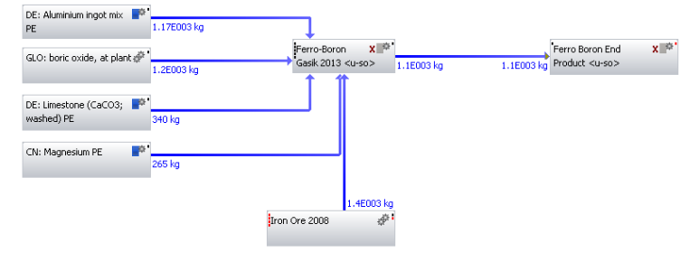
Figure 59. Ferroboron with boric oxide.

D2.Ferro-Chromium
The abundance in literature sources (Eurometaux 2014; Haque & Norgate 2013; Gasik.M 2013) meant a number of chromium models including, variations in carbon and silicon, could be created and then compared and contrasted. Details of each individual model created from the respective data sources are explained below.
Initial ferrochrome models were created using data source (Haque & Norgate 2013) seeing that it had the most detail relating to inventory data, production routes and CO₂ emissions for postliminary analysis of results. The inventory data employed for creating the ferrochrome model is illustrated below.
Table 39. Inventory data for ferrochrome production (Haque & Norgate 2013).
Stage | Input | Inventory | Units
Mining | Chromium Concentrate | 2427.00 | kg/ t Fe-Cr
 | Diesel | 4.10 | kg/ t Fe-Cr
 | Electricity | 91.01 | kWh/ t Fe-Cr
Metal Production | Coke | 0.63 | kg/ t Fe-Cr
 | Carbon Electrodes | 16.00 | kg/ t Fe-Cr
 | Electricity | 4528.00 | kWh/ t Fe-Cr
 | Bauxite | 203.70 | kg/ t Fe-Cr
 | Silica Sand | 46.20 | kg/ t Fe-Cr
 | Lime | 250.00 | kg/ t Fe-Cr

Comparable to ferroboron, a centralised process was created where all inputs from Table 39 were inserted as flows and all units converted to kg/t Fe-Cr for mass and kWh/t Fe-Cr for energy. The output of the process was set to the functional unit of 1000kg of ferrochrome. Related processes to the flows were all located in GaBi and connected to the central process as shown by Figure 60 .
In terms of selection of related processes; electricity and fuel sources were initially based on Australia in order to verify Haques original model. The results of which (see Figure 29) highlight accuracy to the original model. This allowed the ferrochrome model to be altered to be more globally representative. This was conducted by inclusion of average electricity process based on global ferrochrome production process. Apart from energy corrections, carbon corrections were made for coke and carbon electrodes based on previously mentioned equations 6 and 7. Thus, satisfying the carbon balance in the model.
As a final point the end product was assumed to be HC ferrochrome, based on the material percentages (25.5% Cr in chromite ore, 11.6% in crude ore, 53 % Cr in Fe-Cr and 6.4%C) provided by the original data source.
Figure 60. Global Fe-Cr production utilising data from Haque.
Apart from (Haque & Norgate 2013), data from (Eurometaux 2014) was also utilised to construct not only HC ferrochrome but LC ferrochrome models as well. Development of the HC ferrochrome was based on direct carbothermic reduction of chromite ore in three-phase submerged electric arc furnaces (SAF) with continuous operation. Whilst for LC ferrochrome the selected production route was via silicon reduction. The inventory data used to create both models are illustrated in Table 40 and Table 41.
Table 40. Inventory data for HC ferrochrome production (Eurometaux 2014).
Input | Inventory | Units
Chromite | 2300.00 | kg/t
Coke | 500.00 | kg/t
Electrode | 7.00 | kg/t
Limestone | 200.00 | kg/t
Electrical Energy | 3100.00 | kWh/t

Table 41. Inventory data for LC ferrochrome production (Eurometaux 2014).
Input | Inventory | Units
Chromite | 1600.00 | kg/t
Fe-Si-Cr | 675.00 | kg/t
Limestone | 1100.00 | kg/t
Sand | 100.00 | kg/t
Silicon | 40.00 | kWh/t
Electrode | 10.00 | kg/t
Boric Acid | 3.00 | kg/t
Electrical Energy | 3400.00 | kWh/t
For both sets of data, the output was fixed to 1000kg of their respective ferro-alloys. However a number of similar alterations were made for both models. Firstly the type of flux was not stated in Eurometaux and so limestone was selected for both models on the basis it is extensively used as a slag former in iron and steel making. Secondly for both HC and LC ferrochrome the source of electricity was selected as Australia in order to compare the results from these models to the original which was also modelled using Australia. Thirdly cooling water and process water were not included in either of the ferrochrome models and alloy output recovery was assumed to be between 90 - 95% Cr. The completed HC and LC ferrochrome models are illustrated by Figure 61 and Figure 62 .

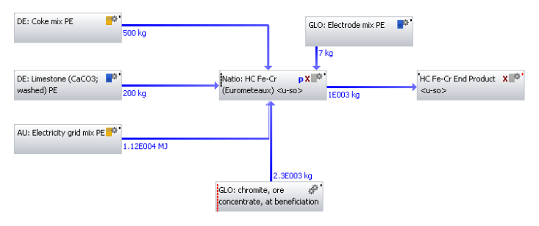
Figure 61. HC ferrochrome model from Eurometaux data.

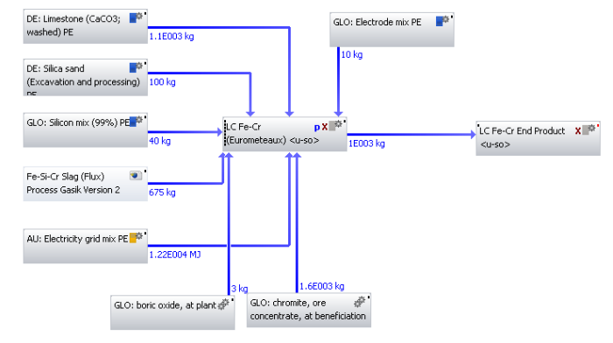
Figure 62. LC ferrochrome model from Eurometaux data.
Conversely, there were a number of notable differences between the two ferrochrome models. For HC ferrochrome, electrical energy was used rather than potential energy for coke. Utilisation of the input coke already included its associated energy and thus avoided double addition.
However, the biggest difference between HC and LC ferrochrome was the presence of the reducing agent, Fe-Si-Cr. In the original data for LC ferrochrome, the amount of electrical energy was based on the conversion of Fe-Si-Cr to LC ferrochrome. However since an intermediate process, Fe-Si-Cr, had to be input, the associated electrical energy would also conversely increase. The Fe-Si-Cr process was unavailable in any of the GaBi databases and had to be created. Data obtained from Gasik, would allow creation of the Fe-Si-Cr process thus completing the LC ferrochrome model.
Data from (Gasik.M 2013), was available for a range of different percentages of silicon. In this case, the minimum (13% Si) and maximum (53% Si) percentages of silicon were selected for investigation. The inventory data for both percentages of silicon are shown below.
Table 42 Inventory data for Fe-Si-Cr (13% Si) (Gasik.M 2013).
Input | Inventory | Units
Chromite | 1908.00 | kg/t
Coke | 543.00 | kg/t
Quartzite | 634.00 | kg/t
Iron Steel Chips | 30.00 | kg/t

Table 43. Inventory data for Fe-Si-Cr (53% Si) (Gasik.M 2013).
Input | Inventory | Units
Chromite | 923.00 | kg/t
Coke | 712.00 | kg/t
Quartzite | 1464.00 | kg/t
Iron Steel Chips | 116.00 | kg/t

Using data in the above tables as inputs, the relevant processes per input were obtained from GaBi and flows connected linking the input processes to a centralised process called Fe-Si-Cr. The output for both models was set to a functional unit of 1000 kg of Fe-Si-Cr. Minor corrections had to be made, specifically for the input Quartzite which was absent from GaBi, thus silica sand process was used as an alternative. In addition, electricity as a process input was not required due to the chemical reaction between chromium and iron oxides with silicon. This exothermic reaction was sufficient enough to release large amounts of heat which would sustain the reaction. However it was assumed some electricity would be required to initiate the reaction, and this source of energy would come via electrical energy associated with the inputs. Lastly carbon correction was made for coke in both models utilising equations 6 and 7.
During the creation of Fe-Si-Cr, both slag (flux) and slag less process variations were also considered. However slag (flux) processes were selected on the overall basis of being higher in product quality and slag recovery compared to slag less processes. In terms of modelling both silicon percentages were separately input into Fe-Si-Cr and then into LC ferrochrome and the results generated. The complete models for both percentages of silicon (13% and 53%) are shown below.

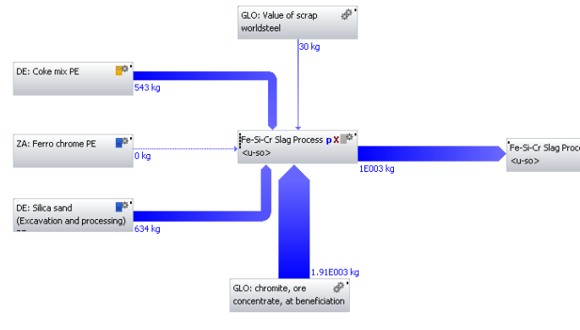
Figure 63. Fe-Si-Cr (13% Si) model.
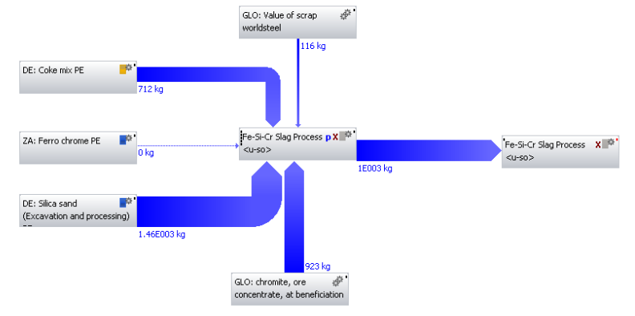
Figure 64. Fe-Si-Cr (53% Si) model.
The final data source (thinkStep 2015) did not allow for creation of ferrochrome models due to the processes being black box processes. This essentially meant the inputs and outputs associated with the process could be viewed but not altered. Instead, the documentation surrounding the production of HC ferrochrome and LC ferrochrome for GaBi was analysed instead.
Documentation for both ferrochrome models revealed geographical representativeness of the data via South African ferrochrome production. The production of the dataset began with mining of the chromite ore via open cast and underground mines followed by beneficiation of the ore. Separation of the gangue and concentrate occurs via heavy media separation (HMS), with the concentrate then being transported to the melting furnace. Data for the models was for the year 2013 and consisted of ferrochrome models (60%) with high carbon (6%C) and low carbon (1%C) content from South Africa. Unlike the previous data sources and related models, the functional unit for both GaBi ferrochrome models was 1kg. This was due to the modelling procedure adopted by GaBi operators who created the models using their own methods and data sources. The processes representing HC and LC ferrochrome models from GaBi is depicted by Figure 65 and Figure 66.
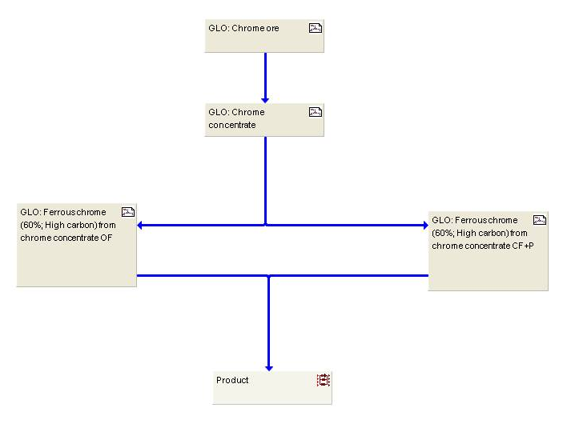
Figure 65. GaBi model of HC ferrochrome (60% Cr, 6% C).
Figure 66. GaBi model of LC ferrochrome (60% Cr, 1% C).
As a summary, three different data sources were used to create a number of ferrochrome process models including HC and LC models. This included a variation for LC ferrochrome based on the reducing agent Fe-Si-Cr.

D3.Ferro-Manganese
Ferromanganese had multiple data sources from which HC and LC ferromanganese processes were modelled. The primary data sources included: (thinkStep 2015; Eurometaux 2014; Gasik.M 2013; Haque & Norgate 2013; Probas 2004).
The modelling of ferromanganese was conducted differently compared to previous ferro-alloys such as ferroboron and ferrochrome. In this case three separate processes (manganese mining, manganese sintering and ferromanganese production) were constructed individually and then linked together. The main reasons for this approach were firstly, the original data source was separated into these three stages. Secondly combining all the data into one stage was not representative of the production route depicted below.
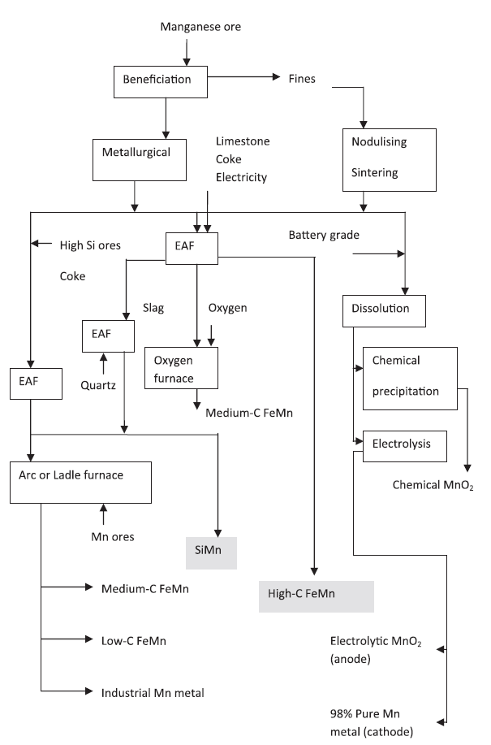
Figure 67. Schematic flow sheet of ferromanganese and silica-manganese production (Haque & Norgate 2013).
In addition multiple stages would allow for a better analysis of strengths and weaknesses of the model. Table 44 highlights the key steel making ingredients required for ferromanganese production in a submerged furnace.

Table 44. Inventory data for ferromanganese production (Haque & Norgate 2013).
Stage | Input | Inventory | Units
Mining | Diesel | 0.36 | kg/ t Mn Ore
 | Electricity | 3.86 | kWh/ t Mn ore
 | Lump | 0.73 | kg/ t Fe-Mn
Sintering | Coke | 90.00 | kg/ t sinter
 | Electricity | 675.00 | kWh/ t sinter
Submerged EAF | Sinter | 1040.00 | kg/ t
 | Iron Ore | 140.00 | kg/ t
 | Limestone | 180.00 | kg/ t
 | Coke | 310.00 | kg/ t
 | Coal | 130.00 | kg/ t
 | Electrode | 10.00 | kg/ t
 | Electricity | 2400.00 | kWh / t

Similarly to previous ferro-alloy models a central process was created and the inputs inserted. In this case, three central processes, manganese mining, manganese sintering and ferromanganese production were created and populated with data from Table 44. The output from the model was fixed as 1000kg of ferromanganese. Some of the original input quantities did not match with the corresponding values in the model. This was due to fixing input variables, manganese lump and manganese sinter to ensure that the total mass balance in and out of all three processes and thus the whole model was equal.
Other alterations included, utilising average electricity of global ferromanganese production as shown by Figure 68. For both models carbon corrections were made for coal, coke and electrode in order to make sure total carbon into and out of the system was equal. The end product was assumed to be HC ferromanganese and not any intermediaries (medium or low carbon).
Figure 68. Global ferromanganese model created from data source Haque.
For data source Eurometaux, sufficient data was present to construct both HC and LC ferromanganese processes. For HC ferromanganese, the selected production route was carbothermic reduction of lumpy or sintered manganese ore in a three-phase submerged EAF. The key constituents of the HC ferromanganese production can be seen in the table below.
Table 45. Inventory data from Eurometaux for HC ferromanganese production (Eurometaux 2014).
Input | Inventory | Units
Mn Ore | 1900.00 | kg/t
Coke | 410.00 | kg/t
Electrode | 8.00 | kg/t
Cooling Water | 1.50 | m³/t
Electricity | 2200.00 | kWh/t

A single principle process was created and the inputs from Table 45 included in this process. The output was fixed to 1000 kg of HC ferromanganese. The associated processes were located in GaBi and connected via flows to the main process. However the main problem associated with completing the model was the input manganese ore. This process missing in GaBi and little or no data was available from literature, apart from an online database (Probas 2004). Data for manganese ore was obtained from this database for the year 2003-2004. The boundaries of the data included mining and concentration but not transportation.
Related to the ‘Borates’ process, data for ‘Manganese Ore’ was available in the form of resources, air and water emissions to create a manganese ore process. Table 46 and Table 47 illustrate the inventory to create the manganese ore process. Comparable to borates, the same flows missing for borates were also missing for manganese ore. In this case the same procedure was used to mitigate any missing flows.
Table 46. Inventory data for inputs manganese ore (Probas 2004).
Flow | Quantity | Amount | Unit
Borates (Metal raw material) [Resources] | Mass | 0.001 | kg
Energy unspecific [Energy Resources] | Energy (NCV) | 21.500 | MJ
Energy, potential (incl. hydropower reservoir), converted [Renewable energy resources] | Energy (NCV) | 150.000 | MJ
Hard coal (in MJ) [Hard coal (resource)] | Energy (NCV) | 1730.000 | MJ
Metals n.e.c related unused extraction [Valuable substances] | Mass | 0.265 | kg
Metals n.e.c Extracted for use [Valuable substances] | Mass | 0.019 | kg
Nuclear energy [Uranium (resource)] | Energy (NCV) | 20.800 | MJ
Occupation, arable [Hemerobie ecoinvent] | Areatime | 0.087 | m2*yr
Occupation, industrial area [Hemerobie ecoinvent] | Areatime | 22.100 | m2*yr
Process and cooling water [Operating materials] | Mass | 1418.000 | kg
Transformation, from unknown [Hemerobie ecoinvent] | Area | 0.172 | sqm
Note NCV = Net Calorific Value.

Table 47. Inventory data for outputs manganese ore (Probas 2004).
Flow | Quantity | Amount | Unit
Mn Ore [Valuable Substance] | Mass | 1.00×10³ | kg
1,11-Trichloroethane [Halogenated organic emissions to fresh water] | Mass | 2.88×10⁻¹² | kg
Adsorbable organic halogen compounds (AOX) [Analytical measures to fresh water] | Mass | 4.92×10⁻⁷ | kg
Ammonia [Inorganic emissions to fresh water] | Mass | 1.02×10⁻⁴ | kg
Ammonia [Inorganic emissions to air] | Mass | 2.73×10⁻² | kg
Arsenic [Heavy metals to fresh water] | Mass | 4.27×10⁻⁶ | kg
Arsenic [Heavy metals to air] | Mass | 2.73×10⁻⁶ | kg
Benzene [Hydrocarbons to fresh water] | Mass | 4.73×10⁻⁵ | kg
Benzene [Group NMVOC to air] | Mass | 3.21×10⁻⁵ | kg
Benzo{a}pyrene [Group PAH to air] | Mass | 3.21×10⁻⁵ | kg
Biological oxygen demand (BOD) [Analytical measures to fresh water] | Mass | 3.63×10⁻² | kg
Cadmium [Heavy metals to fresh water] | Mass | 3.13×10⁻⁷ | kg
Cadmium [Heavy metals to air] | Mass | 2.17×10⁻⁷ | kg
Carbon Dioxide [Inorganic emissions to air] | Mass | 1.12×10¹ | kg
Carbon Dioxide (biotic) [Inorganic emissions to air] | Mass | 1.22×10⁻¹ | kg
Carbon Monoxide [Inorganic emissions to air] | Mass | 6.92×10⁻² | kg
Carbon tetrachloride (tetrachloromethane) [Halogenated organic emissions to air] | Mass | 1.45×10⁻⁹ | kg
Chemical oxygen demand (COD) [Analytical measures to fresh water] | Mass | 4.55×10⁻² | kg
Chloride [Inorganic emissions to fresh water] | Mass | 8.41×10⁻² | kg
Chlorinated hydrocarbons (unspecified) [Halogenated organic emissions to air] | Mass | 4.56×10⁻⁷ | kg
Chromium (unspecified) [Heavy metals to fresh water] | Mass | 9.77×10⁻⁵ | kg
Chromium (unspecified) [Heavy metals to air] | Mass | 4.44×10⁻⁴ | kg
Copper [Heavy metals to fresh water] | Mass | 7.24×10⁻⁵ | kg
Copper [Heavy metals to air] | Mass | 2.05×10⁻⁵ | kg
Cyanide [Inorganic emissions to fresh water] | Mass | 9.56×10⁻⁷ | kg
Dichloroethane (ethylene dichloride) [Halogenated organic emissions to fresh water] | Mass | 1.49×10⁻⁸ | kg
Dichloromethane (methylene dichloride) [Halogenated organic emissions to air] | Mass | 5.42×10⁻¹¹ | kg
Dioxins (unspecified) [Halogenated organic emissions to fresh water] | Mass | 4.72×10⁻¹² | kg
Ethene (ethylene) [Group NMVOC to air] | Mass | 3.50×10⁻⁵ | kg
Fluoride [Inorganic emissions to fresh water] | Mass | 1.24×10⁻⁴ | kg
Formaldehyde (methanal) [Group NMVOC to air] | Mass | 1.34×10⁻⁵ | kg
Hexachlorobenzene (Perchlorobenzene) [Halogenated organic emissions to air] | Mass | 3.82×10⁻⁹ | kg
Hydrocarbons, chloro-/fluoro- [Halogenated organic emissions to air] | Mass | 7.38×10⁻¹⁰ | kg
Hydrogen chloride [Inorganic emissions to air] | Mass | 5.09×10⁻⁴ | kg
Hydrogen fluoride [Inorganic emissions to air] | Mass | 5.22×10⁻⁵ | kg
Hydrogen sulphide [Inorganic emissions to air] | Mass | 1.58×10⁻⁵ | kg
Lead [Heavy metals to fresh water] | Mass | 4.09×10⁻⁶ | kg
Lead [Heavy metals to air] | Mass | 1.50×10⁻⁵ | kg
Mercury [Heavy metals to fresh water] | Mass | 1.04×10⁻⁷ | kg
Mercury [Heavy metals to air] | Mass | 6.05×10⁻⁷ | kg
Methane [Organic emissions to air (group VOC)] | Mass | 1.29×10⁻² | kg
Methane (biotic) [Organic emissions to air (group VOC)] | Mass | 3.30×10⁻⁵ | kg
Nickel [Heavy metals to fresh water] | Mass | 1.49×10⁻³ | kg
Nickel [Heavy metals to air] | Mass | 9.71×10⁻⁶ | kg
Nitrate [Inorganic emissions to fresh water] | Mass | 5.69×10⁻⁴ | kg
Nitrogen [Inorganic emissions to fresh water] | Mass | 2.99×10⁻⁴ | kg
Nitrogen monoxide [Inorganic emissions to fresh water] | Mass | 2.45×10⁻¹ | kg
Nitrogen oxides [Inorganic emissions to air] | Mass | 1.72×10⁻³ | kg
NMVOC (unspecified) [Group NMVOC to air] | Mass | 8.31×10⁻² | kg
Organic compounds (unspecified) [Organic emissions to fresh water] | Mass | 7.58×10⁻⁸ | kg
Particulates<10um [Particles to air] | Mass | 2.01×10⁻² | kg
Pentachlorophenol (PCP) [Halogenated organic emissions to air] | Mass | 7.73×10⁻⁹ | kg
Phenol (hydroxy benzene) [Hydrocarbons to fresh water] | Mass | 1.07×10⁻⁵ | kg
Phosphorus [Inorganic emissions to fresh water] | Mass | 1.22×10⁻⁴ | kg
Polychlorinated biphenyls (PCB unspecified) [Halogenated organic emissions to air] | Mass | 5.75×10⁻⁹ | kg
Polycycliaromatic hydrocarbons (PAH, unspecified) [Hydrocarbons to fresh water] | Mass | 9.14×10⁻⁶ | kg
Polycycliaromatic hydrocarbons (PAH, unspecified) [Group PAH to air] | Mass | 8.53×10⁻⁷ | kg
Solids (suspended) [Particles to fresh water] | Mass | 1.45×10⁻² | kg
Sulphate [Inorganic emissions to fresh water] | Mass | 2.44×10⁻² | kg
Sulphur dioxide [Inorganic emissions to air] | Mass | 5.39×10⁻⁸ | kg
Sulphur hexafluoride [Inorganic emissions to air] | Mass | 3.86×10⁻⁴ | kg
Tetrachloroethene (perchloroethylene) [Halogenated organic emissions to air] | Mass | 6.19×10⁻¹² | kg
Total dust [Resources] | Mass | 2.49×10⁻² | kg
Total organic bounded carbon [Analytical measures to fresh water] | Mass | 1.50×10⁻² | kg
Trichloromethane (chloroform) [Halogenated organic emissions to air] | Mass | 3.33×10⁻¹⁰ | kg
Zinc [Heavy metals to fresh water] | Mass | 2.23×10⁻⁵ | kg
Zinc [Heavy metals to air] | Mass | 4.93×10⁻⁵ | kg

With the creation and inclusion of manganese ore, a number of alterations were included to complete the model. Carbon corrections were made for coke and electrodes using equations 6 and 7 to balance the total amount of carbon in the system. In addition the source of electricity was fixed as Australia. The complete model for HC ferromanganese production from Eurometaux data is displayed by Figure 69.
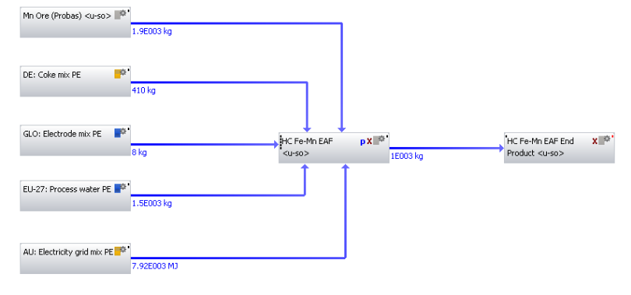
Figure 69. HC ferromanganese production via Eurometaux data.
In terms of LC ferromanganese, this was easier to model compared to HC ferromanganese, due to the availability of the newly created manganese ore process. The constituents making LC ferromanganese can be seen in Table 48.
Table 48. Inventory data from Eurometaux for LC ferromanganese production (silicothermic) (Eurometaux 2014).
Input | Inventory | Units
Mn Ore | 1000.00 | kg/t
Coke | 200.00 | kg/t
Electrode | 6.00 | kg/t
Limestone | 500.00 | kg/t
Si-Mn | 700.00 | kg/t
Electricity | 1400.00 | kWh/t

The production route was based on silicothermic reduction in an EAF, with the functional output unit set to 1000 kg of LC ferromanganese. As shown by Figure 70, LC Fe-Mn (silicothermic) process was created as a single stage process, where the inputs from Table 48 were inserted and the relevant processes located in GaBi and attached. Amendments were made to include carbon corrections for coke and electrode as well as fixing the source of electricity from Australia. Si-Mn was created (see Si-Mn section) using data from both Haque and Eurometaux, both of which are represented separately by Figure 70 and Figure 71.
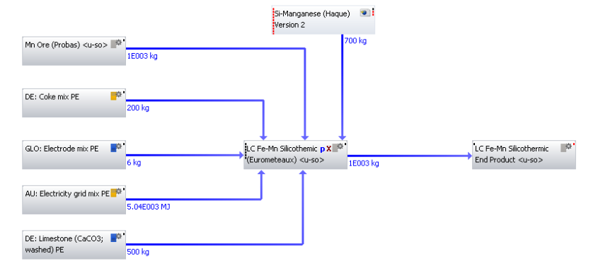
Figure 70. LC ferromanganese model (Si-Mn Haque) from Eurometaux data.
Figure 71. LC ferromanganese production (Si-Mn Eurometaux) from Eurometaux data.
Following on from modelling using Eurometaux data, alternative literature source (Gasik.M 2013) was resorted to investigate and model alternative routes for HC ferromanganese. Two of these alternatives routes involved using the Discard and Duplex methods, both of which are displayed in Table 49 and Table 50 with a list of the input data required to model.

Table 49. Inventory data for HC ferromanganese (Discard Method) (Gasik.M 2013).
Input | Inventory | Units
Mn Ore | 1950.00 | kg/t
Coke Mix | 550.00 | kg/t
Electrode Mix | 10.00 | kg/t
Electricity Grid Mix | 3306.00 | kWh/t
Iron Ore | 110.00 | kg/t
Limestone | 700.00 | kg/t

Table 50. Inventory data for HC Fe-Mn (Duplex Method) (Gasik.M 2013).
Input | Inventory | Units
Mn Ore | 2750.00 | kg/t
Coke Mix | 350.00 | kg/t
Electrode Mix | 12.00 | kg/t
Electricity Grid Mix | 2200.00 | kWh/t
Iron Ore | 85.00 | kg/t

In terms of modelling, Figure 72 and Figure 73 show how the models were constructed from Table 49 and Table 50. A main process was created and the inputs inserted into it and the associated processes attached from GaBi databases. For both models the original data for Gasik did not specify a country so Australia was selected as source of electricity. In addition, carbon corrections were made for inputs coke and electrode, again for both models. The completed models can be seen below:

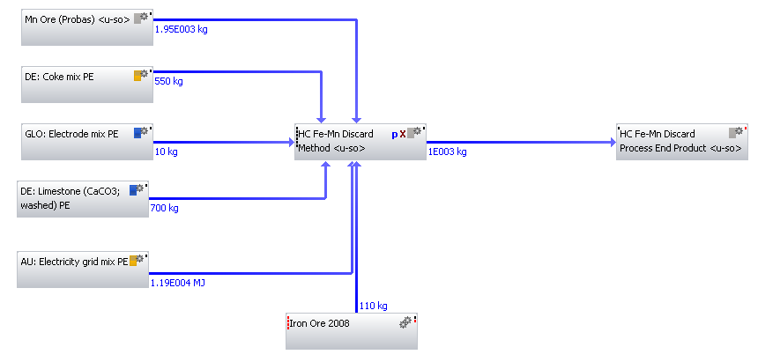
Figure 72. HC ferromanganese production (Discard Method) from data source Gasik.
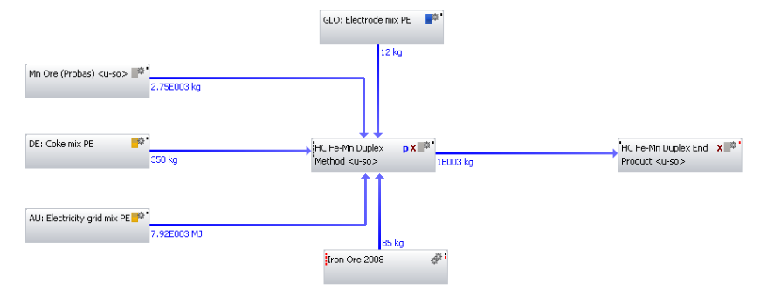
Figure 73. HC ferromanganese production (Duplex Method) from data source Gasik.
HC and LC ferromanganese processes were also available in GaBi. Documentation from GaBi stated the main source for data for Fe-Mn was the South African industry. All relevant background data such as energy and auxiliary material were taken from the GaBi databases keeping consistency. The boundaries of the system from which the data was extracted included mining and the beneficiation of the ore (South African specific and mining and beneficiation are at the same operation site), sinter- and melting process (EAF). The main geographic representativeness of the data was from South Africa and the time representativeness was for the year 2013. In terms of electricity, this was modelled according to the individual country-specific situation, in this case South Africa. The country-specific situation included; individual power plants in service, net losses and imported electricity, national emission and efficiency standards of the power plants and country specific fuel supply. For transport, all relevant and known transport processes used were included in the models.
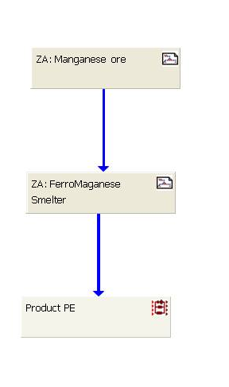
Figure 74. GaBi model of HC ferromanganese (77% Mn, high carbon) (thinkStep 2015)
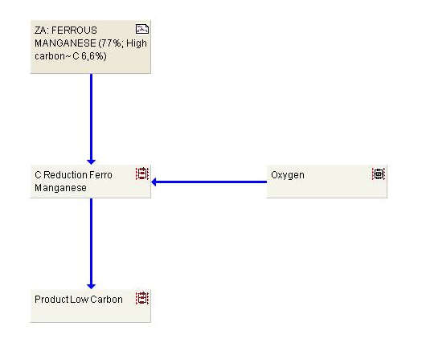
Figure 75. GaBi model of LC ferromanganese (90% Mn, low carbon) (thinkStep 2015).

D4. Ferro-Molybdenum
Data provided by (IMOA 2005) was utilised to create a ferromolybdenum process based on the roasting of molybdenum concentrates utilising a smelting hearth. Similar to the data source (Probas 2004), the data provided was in the form of resources for inputs and emissions (air and water) for outputs. The end product was 1 kg of Fe-Mo (67% Mo) for the year 2005. The constituents producing ferromolybdenum are depicted by Table 51.
Table 51. Inventory data for ferromolybdenum production.
Flow | Unit | Per 1 kg Fe-Mo  (contains 67% Mo)
r Coal (in ground) | kg | 1.96×10⁰
r Iron (Fe, ore) | kg | 5.70×10⁻²
r Iron (in ground) | kg | 6.64×10⁻¹
r Limestone (CaCO3, in ground) | kg | 2.00×10⁻²
r Natural gas (in ground) | kg | 6.85×10⁻¹
r Oil (in ground) | kg | 6.47×10⁻¹
r Molybdenum (in ground) | kg | 9.92×10⁻¹
r Uranium (ore) | kg | 4.80×10⁻³
r Water used (total) | litre | 4.33×10²
a Carbon Dioxide (CO2, fossil) | kg | 8.59×10⁰
a Nitrogen Oxides (NOx, as NO2) | kg | 3.60×10⁻²
a Sulphur Oxides (SOx as SO2) | kg | 2.17×10⁻¹
a Particulates | kg | 2.00×10⁻²
a Molybdenum (Mo) | kg | 2.60×10⁻⁴
a Hydrocarbons (except CH4) | kg | 3.80×10⁻³
a Carbon Monoxide (CO) | kg | 3.00×10⁻²
a Methane (CH4) | kg | 2.00×10⁻²
a Ammonia (NH3) | kg | 2.30×10⁻³
a Hydrogen Chloride (HCl) | kg | 1.10×10⁻³
a Hydrogen Cyanide (HCN) | kg | 8.00×10⁻⁷
a Hydrogen Sulphide (H2S) | kg | 3.10×10⁻⁵
a Lead (Pb) | kg | 3.00×10⁻⁶
a Mercury (Hg) | kg | 3.10×10⁻⁷
a Zinc (Zn) | kg | 9.10×10⁻⁶
a Metals (unspecified) | kg | 1.70×10⁻⁵
w Ammonia (NH4+, NH3, as N) | kg | 4.10×10⁻⁴
w BOD5 | kg | 1.30×10⁻³
w Chlorides (Cl-) | kg | 2.00×10⁻¹
w Fluorides (F-) | kg | 1.70×10⁻⁴
w PAH, unspecified | kg | 5.90×10⁻⁹
w Nitrate (NO3-) | kg | 9.60×10⁻⁶
w Oils (unspecified) | kg | 1.10×10⁻³
w Phosphates (as P) | kg | 7.90×10⁻⁶
w Sulphate (SO4--) | kg | 1.54×10⁻¹
w Total suspended solids | kg | 1.70×10⁻²
w Chromium (Cr III, CrVI) | kg | 5.30×10⁻⁴
w Copper (Cu++) | kg | 7.60×10⁻⁴
w Cyanide (CN-) | kg | 7.20×10⁻⁶
w Aluminium (Al3+) | kg | 5.50×10⁻⁴
w Cadmium (Cd++) | kg | 1.20×10⁻⁶
w Iron (Fe++, Fe3+) | kg | 7.10×10⁻⁴
w Lead (Pb++, Pb4+) | kg | 5.80×10⁻⁶
w Manganese (Mn II, IV, VII) | kg | 1.30×10⁻⁴
w Mercury (Hg+, Hg++) | kg | 7.20×10⁻⁸
w Molybdenum (Mo II through VI) | kg | 5.00×10⁻⁴
w Nickel (Ni++, Ni3+) | kg | 7.20×10⁻⁵
w Silica (Si) | kg | 5.40×10⁻⁸
w Zinc (Zn++) | kg | 3.00×10⁻⁵
w Metals (unspecified) | kg | 3.20×10⁻³
Waste rock | kg | 2.08×10²
Tailings | kg | 2.74×10²
Waste: non-hazardous, non-organic, to disposal | kg | 8.78×10⁻¹
Waste: hazardous, non-organic, to disposal | kg | 3.20×10⁻³
Waste: hazardous, organic, to disposal | kg | 1.90×10⁻⁵
Waste: for incineration | kg | 2.90×10⁻⁵
Waste: oils | kg | 6.10×10⁻⁴
Waste: filters | kg | 2.90×10⁻⁴
Waste: slag | kg | 1.11×10⁰
Waste: sludge | kg | 2.40×10⁻²
Waste (other): sulphur | kg | 7.20×10⁻⁵
Waste (total, excl. waste rock & tailings) | kg | 2.01×10⁰
Recovered Material | kg | 5.90×10⁻²
Key: r = resources, a = air emissions and w = water emissions.
A number of modifications were made for both resources and emissions. In terms of resources, iron ore and ‘iron in ground’ flows were combined. Additionally a new flow for ‘molybdenum in ground’ was created. For air and water emissions, emissions for water were specified as ‘fresh water emissions’. In addition four new flows were created for waste oils, waste filters, waste total and recovered material'. Hydrocarbons (except CH₄) was not available and replaced with hydrocarbons unspecified. Additionally waste other sulphur was replaced with ‘other waste’, due to unavailability. The figure below illustrates how the data was input with the final ferromolybdenum process indicated on the left hand side.

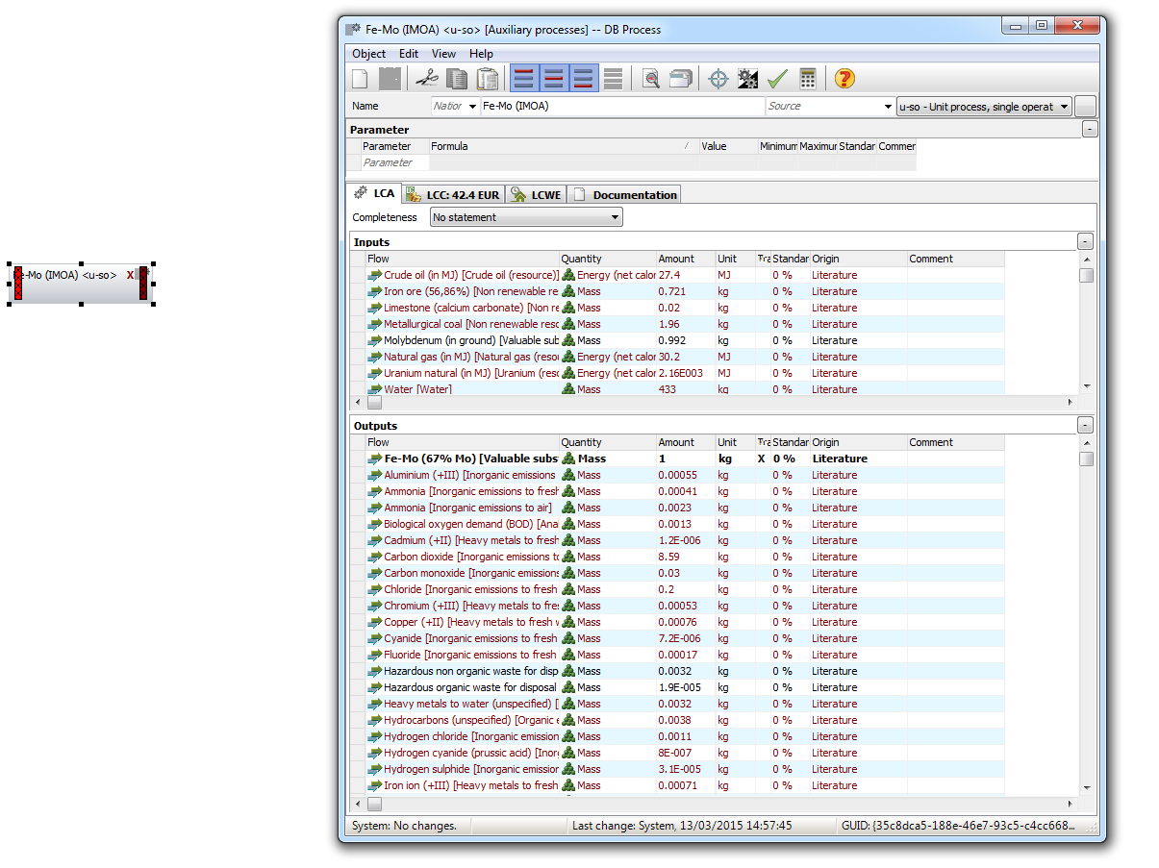
Figure 76. Illustration of inputs to create ferromolybdenum from data source IMOA.
Comparison against other models are difficult due to limited data of ferromolybdenum to produce comparable results. However a ferromolybdenum process in GaBi was located after creating the process using data from the IMOA. However, the documentation surrounding this was very limited but did state that ferromolybdenum mining and roasting was based on mass balance (stoichiometric) while the smelting process was a representative furnace technology. The reference year for the model was 2011.

D5.Ferro-Nickel
The ferronickel process was created primarily from data by (Haque & Norgate 2013). Alternative data sources (thinkStep 2015) and (Eurometaux 2014) were utilised to compare and contrast against the primary ferronickel model. From all data sources, Haque was the most detailed both in documentation and quantitative data. The inventory data used to model ferronickel is illustrated by Table 52.
Table 52. Inventory data from Haque for ferronickel production (Haque & Norgate 2013).
Stage | Input | Inventory | Units
Mining | Electricity | 11218.00 | kWh / t Fe-Ni
 | Diesel | 59.00 | kg / t Fe-Ni
Metal Production | Coal | 3900.00 | kg / t Fe-Ni
 | Carbon Electrodes | 43.70 | kg / t Fe-Ni
 | Lime | 71.00 | kg / t Fe-Ni
 | Oxygen | 49.00 | kg / t Fe-Ni
 | Ferro-silicon | 2.80 | kg / t Fe-Ni
 | Calcium Silicon | 2.00 | kg / t Fe-Ni
 | Aluminium | 6.00 | kg / t Fe-Ni

Corresponding to previously created ferro-alloys, a centralised process was created where all inputs from Table 52 were inserted, and all units converted to kg/t Fe-Ni for mass and kWh/t Fe-Ni for energy. The output of the process was set to the functional unit of 1000kg of ferronickel. Related processes to the flows were located in GaBi and connected to the central process as shown by Figure 77.
The main input, in terms of energy, was electricity whilst the main input from mass, was from coal. For the modelling of the process the source of electricity was selected as Australia, initially to build the model, but then altered to average electricity based on global ferronickel production. The mining and metal production stages were combined for ease of modelling. Combining the two steps would not make a significant difference to cause deviations in the results from the model. Due to the presence of carbon, carbon corrections were made for coal and carbon electrodes. Finally in terms of percentages of material, the following assumptions were made: 1.3% Ni in laterite ore, 95% overall nickel recovery, 30% Ni in Fe-Ni and an overall 95% nickel recovery. The complete global ferronickel model utilising data from Haque is shown by Figure 77.
Figure 77. Global ferronickel model.
Like the processes for ferrochrome and ferromanganese, a ferronickel process was available from GaBi for comparison. For GaBi ferronickel, the geographic representativeness of the data was a mix of the Dominican Republic, Japan and New Caledonia. In terms of technology representativeness, the data set described global ferronickel production as follows. Initial mining of nickel ore occurs via open cast and underground mines. Primary source of nickel ore is from copper ore, which must first be treated by grinding, flotation or magnetic separation to produce a copper-nickel concentrate. The copper and nickel are separated via the matte refining process after smelting and the concentrate is transported to the melting furnace. The smelter utilised is commonly an EAF. Secondary sources of nickel are also produced via nickel sulphides. The data set covers 95% of production and is for the year 2013. The inputs and outputs associated with GaBi ferronickel production are shown by Figure 78.
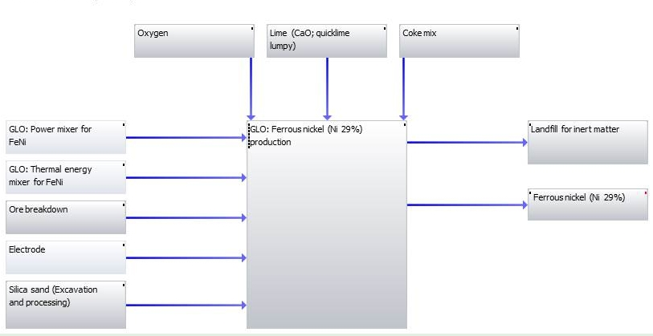
Figure 78. GaBi ferronickel model (thinkStep 2015).
Al alternative data source, Eurometaux, was available to create ferronickel. However after an extensive literature source, no process or data to create the laterite ore process could be located. Due to the ore being the principal input of 20,000 kg/t Fe-Ni, the process was modelled and the results analysed to see if the presence or absence of the laterite ore would make any difference.
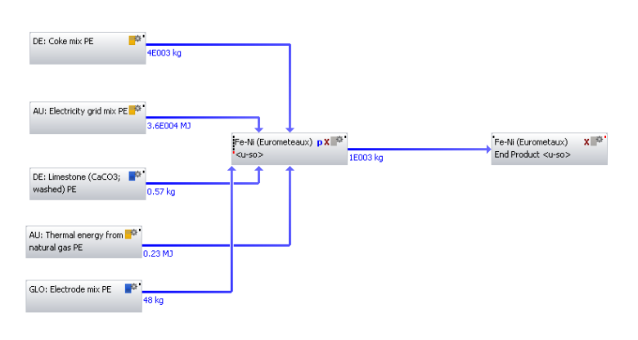
Figure 79. Ferronickel model based on Eurometaux data.

D6.Ferro-Niobium
Data for ferroniobium production was from two literature sources, (Nuss & Eckelman 2014) and (Gasik.M 2013). The selection of both of these sources was based on availability of quantitative data. Data for the production of ferroniobium from (Gasik.M 2013) is represented by Table 53.
Table 53. Inventory data for ferroniobium production from (Gasik.M 2013).
Input Stream | Quantity | Units | Output Stream | Quantity | Units
Niobium Pentoxide (Base 100% Nb₂O₅) | 758.00 | kg | Fe-Nb (50% Nb) | 1000.00 | kg
Aluminium Powder | 385.00 | kg
Iron Ore Pellets | 275.00 | kg
Lime | 86.00 | kg
Magnesite Powder | 31.00 | kg
Total | 1535.00

The ferroniobium model was created in a similar manner to the other ferroalloy models. A primary process (i.e. ferroniobium) was created and the data from Table 53 input and the associated processes in GaBi located and connected. The only exception being magnesite powder and niobium pentoxide. In the case of magnesite, this process was not available and so magnesium was used as a suitable alternative. For niobium pentoxide, no process was located in GaBi or available in literature to model from. Instead an alternative ‘pyrochlore’ process was created using data from (Probas 2004). In a similar manner to the borates and ferromolybdenum processes, the pyrochlore process was created using input data resources and emissions (air and water) as represented by Table 54 and Table 55.
Table 54. Inventory data for pyrochlore (resources) (Probas 2004).
Flow | Quantity | Amount | Unit
Biomass (solid) [Biomass fuels] | Mass | 2.790 | kg
Energy unspecific [Energy Resources] | Energy (NCV) | 0.055 | MJ
Energy, potential (incl. hydropower reservoir), converted [Renewable energy resources] | Energy (NCV) | 878.000 | MJ
Hard coal (in MJ) [Hard coal (resource)] | Energy (NCV) | 1929.000 | MJ
Metals n.e.c related unused extraction [Valuable substances] | Mass | 24.500 | kg
Metals n.e.c Extracted for use [Valuable substances] | Mass | 32.800 | kg
Niobium [Non-renewable elements] | Mass | 13400.000 | kg
Nuclear energy [Uranium (resource)] | Energy (NCV) | 773.000 | MJ
Occupation, arable [Hemerobie ecoinvent] | Areatime | 3.030 | m2*yr
Occupation, industrial area [Hemerobie ecoinvent] | Areatime | 90.700 | m2*yr
Process and cooling water [Operating materials] | Mass | 10192.000 | kg
Transformation, from unknown [Hemerobie ecoinvent] | Area | 0.713 | sqm
Note NCV = Net Calorific Value.

Table 55. Inventory data for pyrochlore (air & water emissions) (Probas 2004).
Flow | Quantity | Amount | Unit
Niobium Oxide (57.6% Nb2O5,1.88% Ta2O5) [Valuable Substance] | Mass | 1.00×10³ | kg
1,11-Trichloroethane [Halogenated organic emissions to fresh water] | Mass | 2.23×10⁻¹⁰ | kg
Adsorbable organic halogen compounds (AOX) [Analytical measures to fresh water] | Mass | 1.24×10⁻⁵ | kg
Ammonia [Inorganic emissions to fresh water] | Mass | 3.28×10⁻³ | kg
Ammonia [Inorganic emissions to air] | Mass | 7.29×10⁻¹ | kg
Arsenic [Heavy metals to fresh water] | Mass | 2.03×10⁻⁴ | kg
Arsenic [Heavy metals to air] | Mass | 6.90×10⁻⁵ | kg
Benzene [Hydrocarbons to fresh water] | Mass | 1.04×10⁻³ | kg
Benzene [Group NMVOC to air] | Mass | 1.20×10⁻³ | kg
Benzo{a}pyrene [Group PAH to air] | Mass | 1.20×10⁻³ | kg
Biological oxygen demand (BOD) [Analytical measures to fresh water] | Mass | 2.99×10⁻¹ | kg
Cadmium [Heavy metals to fresh water] | Mass | 1.86×10⁻⁵ | kg
Cadmium [Heavy metals to air] | Mass | 4.30×10⁻⁶ | kg
Carbon Dioxide [Inorganic emissions to air] | Mass | 1.53×10² | kg
Carbon Dioxide (biotic) [Inorganic emissions to air] | Mass | 3.35×10⁰ | kg
Carbon Monoxide [Inorganic emissions to air] | Mass | 1.23×10⁰ | kg
Carbon tetrachloride (tetrachloromethane) [Halogenated organic emissions to air] | Mass | 1.98×10⁻⁶ | kg
Chemical oxygen demand (COD) [Analytical measures to fresh water] | Mass | 5.67×10⁻¹ | kg
Chloride [Inorganic emissions to fresh water] | Mass | 7.11×10⁻¹ | kg
Chlorinated hydrocarbons (unspecified) [Halogenated organic emissions to air] | Mass | 4.74×10⁻⁵ | kg
Chromium (unspecified) [Heavy metals to fresh water] | Mass | 2.30×10⁻³ | kg
Chromium (unspecified) [Heavy metals to air] | Mass | 1.01×10⁻² | kg
Copper [Heavy metals to fresh water] | Mass | 1.86×10⁻³ | kg
Copper [Heavy metals to air] | Mass | 6.60×10⁻⁴ | kg
Cyanide [Inorganic emissions to fresh water] | Mass | 4.78×10⁻² | kg
Dichloroethane (ethylene dichloride) [Halogenated organic emissions to fresh water] | Mass | 2.40×10⁻⁵ | kg
Dichloromethane (methylene dichloride) [Halogenated organic emissions to air] | Mass | 9.00×10⁻⁹ | kg
Dioxins (unspecified) [Halogenated organic emissions to fresh water] | Mass | 1.00×10⁻¹⁰ | kg
Ethene (ethylene) [Group NMVOC to air] | Mass | 9.10×10⁻⁴ | kg
Fluoride [Inorganic emissions to fresh water] | Mass | 1.33×10⁻² | kg
Formaldehyde (methanal) [Group NMVOC to air] | Mass | 2.10×10⁻⁴ | kg
Hexachlorobenzene (Perchlorobenzene) [Halogenated organic emissions to air] | Mass | 8.30×10⁻⁸ | kg
Hydrocarbons, chloro-/fluoro- [Halogenated organic emissions to air] | Mass | 5.80×10⁻⁸ | kg
Hydrogen chloride [Inorganic emissions to air] | Mass | 1.36×10⁻² | kg
Hydrogen fluoride [Inorganic emissions to air] | Mass | 2.05×10⁻³ | kg
Hydrogen sulphide [Inorganic emissions to air] | Mass | 5.50×10⁻⁴ | kg
Lead [Heavy metals to fresh water] | Mass | 1.81×10⁻⁴ | kg
Lead [Heavy metals to air] | Mass | 4.10×10⁻⁴ | kg
Mercury [Heavy metals to fresh water] | Mass | 3.55×10⁻⁶ | kg
Mercury [Heavy metals to air] | Mass | 1.80×10⁻⁵ | kg
Methane [Organic emissions to air (group VOC)] | Mass | 3.36×10⁻¹ | kg
Methane (biotic) [Organic emissions to air (group VOC)] | Mass | 8.53×10⁻³ | kg
Nickel [Heavy metals to fresh water] | Mass | 3.26×10⁻² | kg
Nickel [Heavy metals to air] | Mass | 6.60×10⁻⁴ | kg
Nitrate [Inorganic emissions to fresh water] | Mass | 1.66×10⁻² | kg
Nitrogen [Inorganic emissions to fresh water] | Mass | 2.33×10⁻¹ | kg
Nitrogen monoxide [Inorganic emissions to fresh water] | Mass | 5.27×10⁻² | kg
Nitrogen oxides [Inorganic emissions to air] | Mass | 4.30×10⁰ | kg
NMVOC (unspecified) [Group NMVOC to air] | Mass | 1.58×10⁰ | kg
Organic compounds (unspecified) [Organic emissions to fresh water] | Mass | 8.75×10⁻⁷ | kg
Particulates<10um [Particles to air] | Mass | 5.55×10⁰ | kg
Pentachlorophenol (PCP) [Halogenated organic emissions to fresh water] | Mass | 4.09×10⁻⁵ | kg
Pentachlorophenol (PCP) [Halogenated organic emissions to air] | Mass | 6.60×10⁻⁷ | kg
Phosphorus [Inorganic emissions to fresh water] | Mass | 5.93×10⁻³ | kg
Polycycliaromatic hydrocarbons (PAH, unspecified) [Hydrocarbons to fresh water] | Mass | 2.64×10⁻⁶ | kg
Polycycliaromatic hydrocarbons (PAH, unspecified) [Group PAH to air] | Mass | 7.53×10⁻⁵ | kg
Solids (suspended) [Particles to fresh water] | Mass | 1.66×10⁻² | kg
Sulphate [Inorganic emissions to fresh water] | Mass | 2.17×10¹ | kg
Sulphur dioxide [Inorganic emissions to air] | Mass | 5.34×10⁻¹ | kg
Sulphur hexafluoride [Inorganic emissions to air] | Mass | 1.00×10⁻⁵ | kg
Tetrachloroethene (perchloroethylene) [Halogenated organic emissions to air] | Mass | 4.78×10⁻¹⁰ | kg
Total dust [Resources] | Mass | 5.95×10⁰ | kg
Total organic bounded carbon [Analytical measures to fresh water] | Mass | 2.00×10⁻¹ | kg
Trichloromethane (chloroform) [Halogenated organic emissions to air] | Mass | 2.63×10⁻⁸ | kg
Zinc [Heavy metals to fresh water] | Mass | 1.26×10⁻³ | kg
Zinc [Heavy metals to air] | Mass | 2.10×10⁻³ | kg

For pyrochlore, no electricity process was required as it was assumed the electrical energy from each input was already included, and that the main reaction was exothermic with the heat being used as energy source for the process. However the enthalpy between the niobium concentrate and aluminium is slightly lower than the threshold value for self-sustaining aluminothermic reactions, therefore oxygen-releasing lime is required in the inputs.

Likewise to the modelling technique for borates and ferromolybdenum, some named flows were unavailable and thus alternatives had to be created. The same method and changes applied in the creation of borates and ferromolybdenum were also applied to creation of the pyrochlore process. The completed ferroniobium model including the input pyrochlore is highlighted by Figure 80.
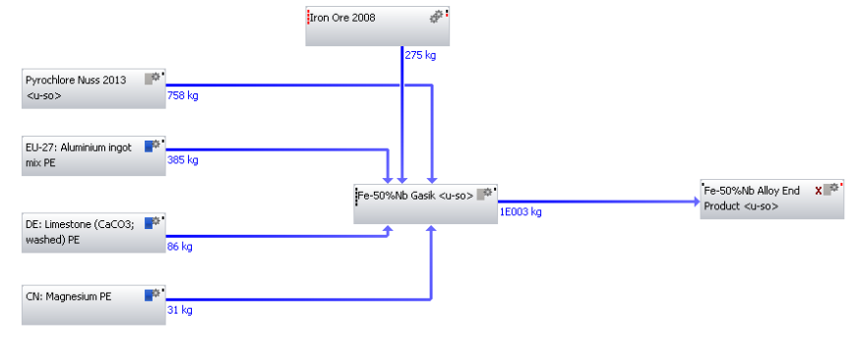
Figure 80. Fe-Nb production from data source Gasik.
The second data source employed to create ferroniobium was via (Nuss & Eckelman 2014). Similarly to Gasik, the production route for which the data was selected, corresponded to aluminium reduction of niobium oxide ores with the addition of iron oxides. Again no electricity input was required due to the exothermic nature of the process. The data used pyrochlore as an input, but since this had been created, the process form Nuss could be modelled. Unlike most other data sources, the functional unit for which the inputs were based on was for production of 1kg of ferroniobium. The inputs provided by Nuss to create the ferroniobium process are shown by Table 56.
Table 56. Inventory for data from (Nuss & Eckelman 2014).
Input Stream | Quantity | Units | Output Stream | Quantity | Units
Pyrochlore concentrate (65% Nb₂O₅) | 1.64 | Kg | Ferro-Niobium | 1.00 | kg
Iron ore (65% Fe) | 0.36 | Kg
Aluminum | 0.55 | Kg
Fluorspar (97%) | 0.07 | Kg
Limestone | 0.05 | Kg

The modelling for ferroniobium via data from (Nuss & Eckelman 2014) was straight forward. A new process labelled ferroniobium was created and the contents of Table 56 inserted as inputs along with a solitary output. The processes for each input were located from GaBi and added to the plan. The flows were connected between the processes, creating the final model as shown by Figure 81.
Figure 81. Ferroniobium production from data source Nuss.
The primary differences between the two models was firstly the percentage of niobium in the end product. For Gasik, the end product had 50% niobium in ferroniobium whilst Nuss had 65%. The second difference was the niobium pentoxide process in Gasik. This was an original input but a similar process could not be located in literature or enough data found to build the process. Although it has been substituted for pyrochlore, the two processes are different. Pyrochlore is the source of niobium pentoxide and where it is produced from. Whereas the data source from Gasik suggests the product niobium pentoxide rather than the associated upstreaming activities, related to obtain it. Full analysis of the models can be seen in the results section.

D7.Ferro-Silicon
Multiple literature sources were available with relevant quantitative data to model ferrosilicon. These included: (thinkStep 2015; Eurometaux 2014; Gasik.M 2013; Haque & Norgate 2013). The first of these data source (Haque & Norgate 2013) utilised the following schematic diagram for the production of ferrosilicon.

Electricity
Ferrosilicon
Electric Arc Furnace
(EAF)
Quartz
Coal
Scrap Iron
Aluminium

Figure 82. Schematic of ferrosilicon production (Haque & Norgate 2013).
Utilising Haques data ferrosilicon was produced in a three phase submerged arc furnace by the carbothermic reduction of quartz in the presence of iron oxide. The main end product was ferrosilicon (75% Si). Unlike ferromanganese, ferrosilicon is a complete reduction process and requires raw material inputs to be oxides of high purity. The data used to model ferrosilicon production is shown by Table 57.
Table 57. Inventory data for ferrosilicon production from (Haque & Norgate 2013).
Stage | Input | Inventory | Units
Pelletising | Iron Ore | 1040.00 | kg/t pellets
 | Electricity | 1.50 | kWh / t
 | Water | 290.00 | kg/ t ore
 | Limestone | 18.00 | kg/ t ore
 | Dolomite | 80.00 | kg/ t ore
 | Coke Breeze | 8.00 | kg/ t ore
 | Bentonite | 10.00 | kg/ t ore
Pellet Induration | Process Steam | 750.00 | MJ/ t sinter
 | Electricity | 45.00 | kWh / t pellets
Submerged EAF | Quartz | 1854.00 | kg/ t
 | Iron Ore | 265.00 | kg/ t
 | Coke | 408.00 | kg/ t
 | Coal | 541.00 | kg/ t
 | Electrode | 63.00 | kg/ t
 | Electricity | 8300.00 | kWh / t

Resembling ferromanganese, the ferrosilicon process was created using 3 distinct stages namely: pelletising, iron ore pellet induration and ferro alloy production stages. Using the data above, each process was created using the relevant data for each stage. Processes from GaBi were used to represent the input processes. Each stage was then connected to each other to create a complete ferrosilicon production process. The units for energy were set to kWh/t whilst for mass they were kg/t. The functional unit for the output of the model was set to 1000 kg of ferrosilicon.
The model excluded transportation, for this reason shipping coke and coal were not included. Electricity production was modelled using Australia as well as an average electricity based on global ferrosilicon production. In addition carbon corrections were made for coal, coke and electrodes. Finally it was assumed the Si and Fe content in the final ferrosilicon product were 76%, and 20% respectively. The complete model is displayed by Figure 83.
Figure 83. Global ferrosilicon model.
The second data source to create ferrosilicon was from (Eurometaux 2014). The selected production route was slightly different to Haque and involved production via a rotary kiln electric furnace. However, unlike Haque, the data was not split into stages and was modelled in a singular stage. The components of ferrosilicon can be seen in the following table.
Table 58. Inventory for ferrosilicon production from (Eurometaux 2014).
Input | Inventory | Units
Quartzite | 1800.00 | kg /t
Coke | 1100.00 | kg /t
Electrode | 40.00 | kg /t
Iron ore pellets | 300.00 | kg /t
Woodchips | 225.00 | kg /t
Electrical Energy | 9000.00 | kWh / t
Assumptions in the modelling included utilising silica sand due to unavailability of quartzite. In addition the reducing agent was assumed to be coke and carbon corrections were made for it and electrodes. Unlike Haque, woodchips were also an input. Thus a carbon correction was also included for this. The values selected from the original data were the minimum rather than maximum values to minimise errors. The end product was assumed to be ferrosilicon (75% Si). The ferrosilicon model produced using Eurometaux data is illustrated by Figure 84.
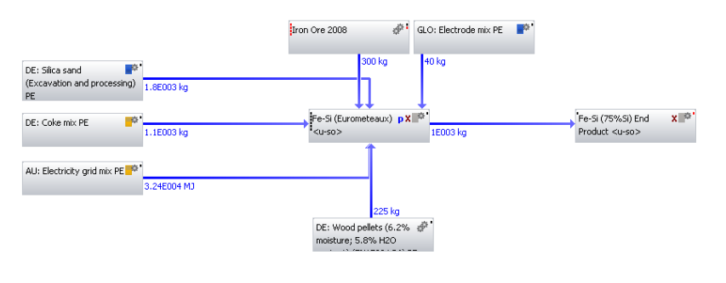
Figure 84. Ferrosilicon model utilising Eurometaux data.
For the third data source, ferrosilicon was produced via (Gasik.M 2013). The production route for ferrosilicon was similar to Haque and involved carbon reduction of silica-rich raw materials (quartzite or quartz) in a submerged EAF. The functional unit was for 1000 kg of ferrosilicon and the inputs required to create the model are displayed in Table 59.
Table 59. Inventory for ferrosilicon production from (Gasik.M 2013).
Input | Inventory | Units
Quartzite | 1930.00 | kg /t
Iron chips | 250.00 | kg /t
Coke | 845.00 | kg /t
Electrode Paste | 54.00 | kg /t
Electrical Energy | 8800.00 | kWh / t

The table resembles identical inputs to the inputs from Eurometaux, with the exception of woodchips. As usual, Australia was selected as the electricity source and carbon corrections made for coke. In addition this process was modelled in a singular stage, with all inputs connected to one main process. The silicon yield for this process was assumed to be approximately 91-93%, and the end silicon product contained 75% Si. The final model is illustrated by Figure 85 .
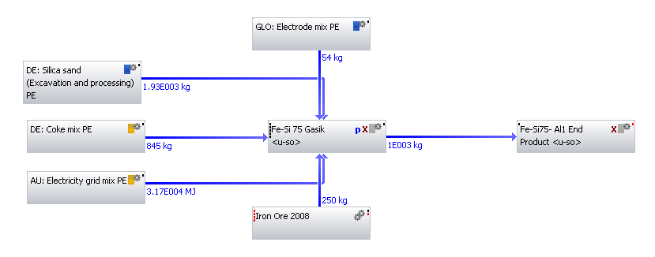
Figure 85. Fe-Si model from data source Gasik.
The final data source to compare all ferrosilicon models with was via GaBi software. Although documentation was limited, it did included the geographical and technology representativeness to create the model. In terms of geographical representativeness the dataset represented a global mix. The main producing countries such as China and Russia were included alongside ferrosilicon producers Brazil, India and Norway. Minor producing countries were excluded from the dataset.
In terms of technology description, the dataset centered on mining and the beneficiation of quartz, with the mined quartz being crushed and then processed in an electric furnace. Although this did depend on country specific system boundaries. The primary production route of ferrosilicon was based on utilising a low-shaft three phase submerged electric arc furnaces. The majority of the data for GaBi was for the year 2013 and did include transportation. The complete model is displayed by Figure 86.
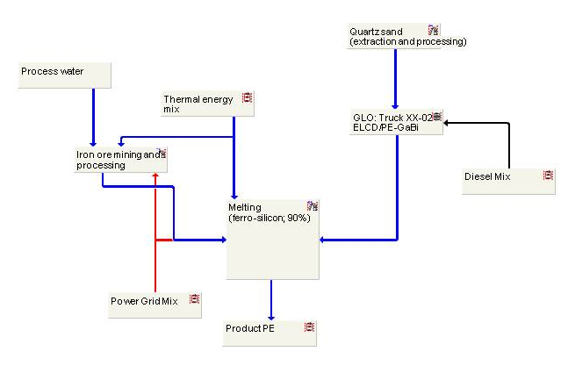
Figure 86. GaBi model of ferrosilicon production (thinkStep 2015).

D8.Ferro-Titanium
The only viable literature source located to model ferrotitanium was from (Gasik.M 2013). The literature source provided sufficient data, see Table 60, to create a model of ferrotitanium production based on an aluminothermic reduction process.
Table 60. Inventory for ferrotitanium production (Gasik.M 2013).
Input | Quantity | Units
Ilmenite Concentrate | 940.00 | kg / t Fe-Ti
Aluminium Powder | 400.00 | kg / t Fe-Ti
Lime | 100.00 | kg / t Fe-Ti
Fe-Si (75%Si) | 24.00 | kg / t Fe-Ti
Iron Ore | 130.00 | kg / t Fe-Ti
Ti Scrap | 10.00 | kg / t Fe-Ti

For this process, silicon was used as a reducing agent but is problematic since it has lower affinity for oxygen than titanium. Thus, recovery of titanium dioxide is only possible with a high content of silicon in the ferro-alloy. To create the model, the functional unit was set as 1000 kg of ferrotitanium and the model created in a single stage with all input processes obtained from GaBi and connected to the ferro-alloy production stage. Electricity was assumed to be already included in the inputs and not included as a separate input. Additionally it was assumed that the process itself was exothermic but is initiated with either magnesium or a spark. From all the inputs, titanium scrap was not available and so titanium metal was used as an alternative. The complete process can be seen in Figure 87.
Figure 87. Ferrotitanium production via Gasik data source.

D9.Ferro-Vanadium
Although a ‘ferrovanadium’ process existed in GaBi, supporting documentation relating to the creation of the process, particularly sources of data, was limited and unclear. However, documentation that was available stated the process created by GaBi, has being based on ferrovanadium production in South Africa, with South African system boundaries applied. The ore content of vanadium pentoxide (V₂O₅) in the ore was approximately 0.98 % with almost 30% of V₂0₅ lost up to the point of precipitation. The process was based on a functional unit of 1kg ferrovanadium (V 80%).
In terms of production, the documentation stated the primary ore for vanadium was Titaniferrous magnetite (TFM) ore. Production of ferrovanadium, consisted of concentrating the ore followed by grinding and magnetic separation processes. The magnetite concentrate is then subjected to a conventional roast leach precipitation process for the recovery of vanadium as Vanadium Trioxide (V₂O₃) or Vanadium Pentoxide (V₂O₅). The DC Arc furnace is used to produce 80% vanadium containing ferrovanadium. Figure 88 summarise the production route as utilised by GaBi to create ferrovanadium.
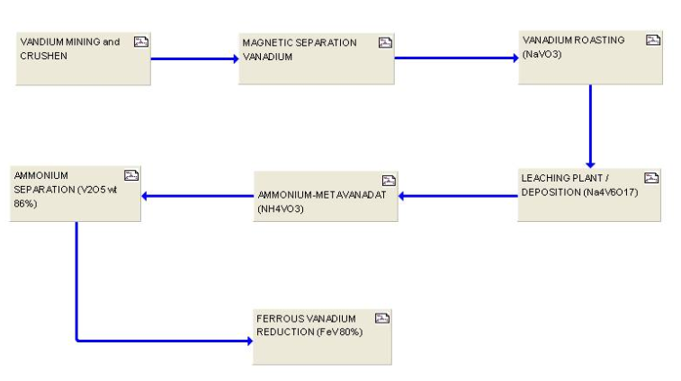

Figure 88. Ferrovanadium production by GaBi (thinkStep 2015).

Ferrovanadium is primarily produced from steel making slag (approximately 68%) with the remainder coming from primary vanadium ores (21%), or secondary industrial wastes (11%) (Vanitec 2015). For a typical ferrovanadium production from vanadium pentoxide (V₂O₅), the following raw materials and quantities are required to produce 1 metric ton of 80 % ferrovanadium according to (Milbourn 2015):
- 1,500 kg V₂O₅.
- 200 kg Iron.
- 570 kg CaO.
- 760 kg Al.
There is no energy requirement for the reaction, but there would be energy involved in producing the iron, calcium oxide and aluminium. However the ferrovanadium process from primary vanadium ores was not developed because vanadium pentoxide was missing from GaBi with little or no data in literature to create the process. Additionally data was sought from the World Steel Association to model ferrovanadium from secondary steel making slag, but with little or no data provided, ferrovanadium could not be created via this process route either.

D10.Silico-Manganese
The final ferro-alloy to be modelled was silicomanganese. Two primary data sources, (Eurometaux 2014; Haque & Norgate 2013) were used to model silicomanganese. Beginning with data from (Haque & Norgate 2013), the production of silicomanganese followed upstreaming production of HC ferromanganese as previously mentioned. The key ingredients required to model silicomanganese production can be seen in Table 61.
Table 61. Inventory for silicomanganese production from (Haque & Norgate 2013).
Stage | Input | Inventory | Units
Mining | Diesel | 0.36 | kg/ t Mn Ore
 | Electricity | 3.86 | kWh/ t Mn ore
 | Ore fines | 910.00 | kg/ t sinter
Sintering | Coke | 90.00 | kg/t sinter
 | Electricity | 675.00 | kWh/ t sinter
Submerged EAF | Sinter | 1040.00 | kg/ t
 | Iron Ore | 120.00 | kg/ t
 | Quartz | 559.00 | kg/ t
 | Dolomite | 355.00 | kg/ t
 | Coke | 452.00 | kg/ t
 | Coal | 112.00 | kg/ t
 | Electrode | 34.00 | kg/ t
 | Electricity | 4000.00 | kWh / t

Similar to ferromanganese, silicomanganese was also modelled in 3 separate stages (mining, sintering and ferro-alloy production).The units of the process were set to kWh/ t for energy and kg/t for mass, and the output set to 1000kg of silicomanganese. Each individual stage was modelled separately and then connected to make one process. The processes representing the inputs were located from GaBi and attached to the relevant stages.
A number of alterations were made to the model which included carbon corrections for coal, coke and electrodes. In addition it was assumed that there was no ferromanganese slag and that all the manganese came from the ore. In terms of electricity, initially Australia was used as the source of energy to calibrate the model. Whilst later on an average electricity process based on global silicomanganese production was used in the final model. The manganese mining and sintering stages were used since they were related upstream processes involved in the creation of silicomanganese. The complete silicomanganese process is shown by Figure 89.

Figure 89. Silicomanganese model utilising data from Haque.
Data from Eurometaux was also used to create a silicomanganese process. With this data source the production route was assumed to be via submerged electric arc furnace. The functional unit for the process was 1000 kg of silicomanganese, and the key components of the process can be seen below.
Table 62. Inventory from Eurometaux for Si-Mn process.
Input | Inventory | Units
Mn Ore | 500.00 | kg/t
Coke | 400.00 | kg/t
Electrode | 10.00 | kg/t
Cooling Water | 1.50 | m³/t
Electricity | 3800.00 | kWh/ t
Fe-Mn Slag | 400.00 | kg/t

The silicomanganese process was modelled as a single stage with all inputs inserted into a central process called silicomanganese as flows. The relevant processes were then located in GaBi database and flows attached linking the input processes to the central process. Carbon corrections were made for coke and electrode as well as altering electricity to come from Australia. Finally, there was no process for ferromanganese slag in GaBi so ferromanganese was used as an alternative, In this case it was the ferromanganese produced from Haque that was used. The complete process can be seen in Figure 90.

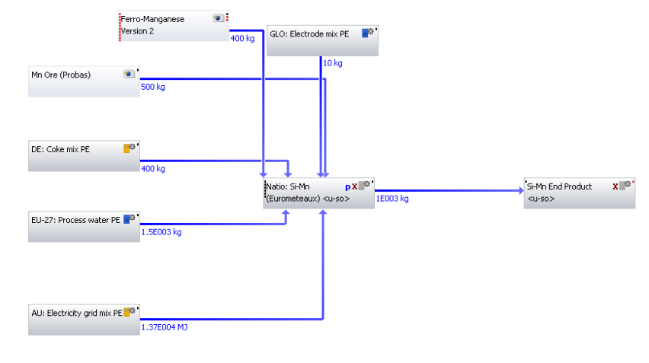
Figure 90. Silicomanganese model from Eurometaux data.

E. Breakdown of grades of steel calculations
Table 63. Breakdown of additional CO₂ impact due to alloying additions (kgCO₂/kg) for Boron steel grade.
Grade | Alloying Addition | Amount Added for Boron Cast (kg) | Amount Added for Boron Cast (t) | Emission Factor (kgCO₂/kg) | Emission Factor (kgCO₂/t) | CO₂ for this cast (kgCO₂) | Total impact per T | Additional impact per T | Additional impact per kg
Boron | Carbon | 255 | 0.255 | 0.00 | 0 | 0
Boron | High Carbon Ferro Manganese | 1,300 | 1.300 | 4.56 | 4,560 | 5,928
Boron | Ferro Silicon | 100 | 0.100 | 11.50 | 11,500 | 1,150
Boron | High Carbon Ferro Chrome | 1,155 | 1.155 | 7.60 | 7,600 | 8,778
Boron | Ferro Titanium | 125 | 0.125 | 4.30 | 4,296 | 537
Boron | Ferro Boron | 55 | 0.055 | 19.87 | 19,870 | 1,093
Boron | Calcium-Silicate | 1,600 | 1.600 | 0.14 | 144 | 230
Boron | Aluminium | 700 | 0.700 | 9.06 | 9,060 | 6,342
Boron | High Carbon Ferro Manganese Large | 1,500 | 1.500 | 4.56 | 4,560 | 6,840
Boron | Silica-Manganese Large | 2,500 | 2.500 | 7.17 | 7,173 | 17,932
Boron | Mild Steel | 325,000 | 325.000 | 1.90 | 1,900 | 617,500
Boron | Total | 334,290 | 334.290 |  |  | 666,330 | 1993.27 | 93.27 | 0.093
Key:
- Green = Assumptions [Carbon: The carbon that is used will come from onsite processes and so like the Fe-P, the CO₂ emissions related to its production will have already been included within the overall steel figure and so no additional value is required.] [Fe-P: As the Fe-P is produced as a result of the steel-making process, which is already included within the overall CO₂ value for steel-making of 2.2399kg of CO₂ per kg of steel, it was decided that it was reasonable to assume that there was no additional CO₂ value associated with Fe-P that needed to be incorporated.] [Mild Steel: Assume that the CO₂ emissions for a cold rolled coil, up to and including the secondary steel-making process, is 1.9kg of CO₂ per kg cold rolled coil.]
- Yellow = Emission factor values calculated from created ferro-alloy models.
- Light Red = Emission factor values from GaBi software.
- Blue = Calculation of emission factor using extrapolation. In this particular case, MC Fe-Mn was calculated based on values from HC and LC Fe-Mn.

Table 64. Breakdown of additional CO₂ impact due to alloying additions (kgCO₂/kg) for DP800 steel grade.
Grade | Alloying Addition | Amount Added for Boron Cast (kg) | Amount Added for Boron Cast (t) | Emission Factor (kgCO₂/kg) | Emission Factor (kgCO₂/t) | CO₂ for this cast  (kgCO₂) | Total impact per T | Additional impact per T | Additional impact per kg
DP800 | Carbon | 60 | 0.060 | 0.00 | 0 | 0
DP800 | High Carbon Ferro Manganese | 625 | 0.625 | 4.56 | 4,560 | 2,850
DP800 | Ferro Silicon | 725 | 0.725 | 11.50 | 11,500 | 8,338
DP800 | High Carbon Ferro Chrome | 2,620 | 2.620 | 7.60 | 7,600 | 19,912
DP800 | Ferro Niobium | 125 | 0.125 | 4.83 | 4,833 | 604
DP800 | Ferro Titanium | 125 | 0.125 | 4.30 | 4,296 | 537
DP800 | Electrolytic-Manganese | 5,000 | 5.000 | 13.70 | 13,700 | 68,500
DP800 | Calcium-Silicate | 1,600 | 1.600 | 0.14 | 144 | 230
DP800 | Aluminium | 700 | 0.700 | 9.06 | 9,060 | 6,342
DP800 | Mild Steel | 325,000 | 325 | 1.90 | 1,900 | 617,500
DP800 | Total | 336,580 | 336.580 |  |  | 724,813 | 2153.46 | 253.46 | 0.253

Table 65. Breakdown of additional CO₂ impact due to alloying additions (kgCO₂/kg) for DP600 steel grade.
Grade | Alloying Addition | Amount Added for Boron Cast (kg) | Amount Added for Boron Cast (t) | Emission Factor (kgCO₂/kg) | Emission Factor (kgCO₂/t) | CO₂ for this cast  (kgCO₂) | Total impact per T | Additional impact per T | Additional impact per kg
DP600 | High Carbon Ferro Manganese | 400 | 0.400 | 4.56 | 4,560 | 1,824
DP600 | Medium Carbon Ferro Manganese | 925 | 0.925 | 6.33 | 6,335 | 5,860
DP600 | Ferro Silicon | 335 | 0.335 | 11.50 | 11,500 | 3,853
DP600 | High Carbon Ferro Chrome | 675 | 0.675 | 7.60 | 7,600 | 5,130
DP600 | Aluminium | 700 | 0.700 | 9.06 | 9,060 | 6,342
DP600 | Medium Carbon Ferro Manganese Large | 2,000 | 2.000 | 6.33 | 6,335 | 12,670
DP600 | Silica-Manganese Large | 4,000 | 4.000 | 7.17 | 7,173 | 28,691
DP600 | Low Carbon Ferro Chrome | 2,000 | 2.000 | 7.99 | 7,991 | 15,981
DP600 | Mild Steel | 325,000 | 325.000 | 1.90 | 1,900 | 617,500
DP600 | Total | 336,035 | 336.035 |  |  | 697,850 | 2076.72 | 176.72 | 0.177
Table 66. Breakdown of additional CO₂ impact due to alloying additions (kgCO₂/kg) for S450 steel grade.
Grade | Alloying Addition | Amount Added for Boron Cast (kg) | Amount Added for Boron Cast (t) | Emission Factor (kgCO₂/kg) | Emission Factor (kgCO₂/t) | CO₂ for this cast  (kgCO₂) | Total impact per T | Additional impact per T | Additional impact per kg
S450 | High Carbon Ferro Manganese | 625 | 0.625 | 4.56 | 4,560 | 2,850
S450 | Medium Carbon Ferro Manganese | 1,250 | 1.250 | 6.33 | 6,335 | 7,919
S450 | Ferro Phosphorous | 925 | 0.925 | 0.00 | 0 | 0
S450 | Ferro Niobium | 185 | 0.185 | 4.83 | 4,833 | 894
S450 | Aluminium | 600 | 0.600 | 9.06 | 9,060 | 5,436
S450 | Medium Carbon Ferro Manganese Large | 3,000 | 3.000 | 6.33 | 6,335 | 19,004
S450 | Mild Steel | 325,000 | 325.000 | 1.90 | 1,900 | 617,500
S450 | Total | 331,585 | 331.585 |  |  | 653,603 | 1971.15 | 71.15 | 0.071

Table 67. Breakdown of additional CO₂ impact due to alloying additions (kgCO₂/kg) for S390 steel grade.
Grade | Alloying Addition | Amount Added for Boron Cast (kg) | Amount Added for Boron Cast (t) | Emission Factor (kgCO₂/kg) | Emission Factor (kgCO₂/t) | CO₂ for this cast  (kgCO₂) | Total impact per T | Additional impact per T | Additional impact per kg
S390 | High Carbon Ferro Manganese | 100 | 0.1 | 4.56 | 4,560 | 456
S390 | Medium Carbon Ferro Manganese | 550 | 0.55 | 6.33 | 6,335 | 3,484
S390 | Ferro Silicon | 75 | 0.075 | 11.50 | 11,500 | 863
S390 | Ferro Niobium | 160 | 0.16 | 4.83 | 4,833 | 773
S390 | Aluminium | 700 | 0.7 | 9.06 | 9,060 | 6,342
S390 | Medium Carbon Ferro Manganese Large | 1,800 | 1.8 | 6.33 | 6,335 | 11,403
S390 | Mild Steel | 325,000 | 325 | 1.90 | 1,900 | 617,500
S390 | Total | 328,385 | 328.385 |  |  | 640,821 | 1951.43 | 51.43 | 0.0514306

Table 68. Breakdown of additional CO₂ impact due to alloying additions (kgCO₂/kg) for S355 steel grade.
Grade | Alloying Addition | Amount Added for Boron Cast (kg) | Amount Added for Boron Cast (t) | Emission Factor (kgCO₂/kg) | Emission Factor (kgCO₂/t) | CO₂ for this cast  (kgCO₂) | Total impact per T | Additional impact per T | Additional impact per kg
S355 | High Carbon Ferro Manganese | 100 | 0.1 | 4.56 | 4,560 | 456
S355 | Medium Carbon Ferro Manganese | 1,700 | 1.7 | 6.33 | 6,335 | 10,769
S355 | Ferro Niobium | 160 | 0.16 | 4.83 | 4,833 | 773
S355 | Aluminium | 700 | 0.7 | 9.06 | 9,060 | 6,342
S355 | Medium Carbon Ferro Manganese Large | 3,000 | 3 | 6.33 | 6,335 | 19,004
S355 | Mild Steel | 325,000 | 325 | 1.90 | 1,900 | 617,500
S355 | Total | 330,660 | 330.66 |  |  | 654,845 | 1980.42 | 80.42 | 0.080418

Table 69. Breakdown of additional CO₂ impact due to alloying additions (kgCO₂/kg) for XF400 steel grade.
Grade | Alloying Addition | Amount Added for Boron Cast (kg) | Amount Added for Boron Cast (t) | Emission Factor (kgCO₂/kg) | Emission Factor (kgCO₂/t) | CO₂ for this cast  (kgCO₂) | Total impact per T | Additional impact per T | Additional impact per kg
XF400 | High Carbon Ferro Manganese | 50 | 0.05 | 4.56 | 4,560 | 228
XF400 | Medium Carbon Ferro Manganese | 675 | 0.675 | 6.33 | 6,335 | 4,276
XF400 | Ferro Niobium | 150 | 0.15 | 4.83 | 4,833 | 725
XF400 | Calcium-Silicate | 700 | 0.7 | 0.14 | 144 | 101
XF400 | Aluminium | 600 | 0.6 | 9.06 | 9,060 | 5,436
XF400 | Medium Carbon Ferro Manganese Large | 2,000 | 2 | 6.33 | 6,335 | 12,670
XF400 | Mild Steel | 325,000 | 325 | 1.90 | 1,900 | 617,500
XF400 | Total | 329,175 | 329.175 |  |  | 640,935 | 1947.10 | 47.10 | 0.047096

Table 70. Breakdown of additional CO₂ impact due to alloying additions (kgCO₂/kg) for IF steel grade.
Grade | Alloying Addition | Amount Added for Boron Cast (kg) | Amount Added for Boron Cast (t) | Emission Factor (kgCO₂/kg) | Emission Factor (kgCO₂/t) | CO₂ for this cast  (kgCO₂) | Total impact per T | Additional impact per T | Additional impact per kg
IF | Ferro Titanium | 320 | 0.32 | 4.30 | 4,296 | 1,375
IF | Aluminium | 600 | 0.6 | 9.06 | 9,060 | 5,436
IF | Mild Steel | 325,000 | 325 | 1.90 | 1,900 | 617,500
IF | Total | 325,920 | 325.92 |  |  | 624,311 | 1915.53 | 15.53 | 0.016

