**Contents**

**Abstract** p.2

**1. Introduction and context** p.3

**2. Pierre Boulez and *Structures 1a*** p. 15

**3. John Cage and *Music of Changes*** p. 25

**4. Iannis Xenakis and *Achorripsis***  p. 36

**5. Motivations and differences** p. 46

**6. Directions since 1950** p. 52

**Appendix: Classical Serialism** p. 54

**Bibliography** p. 62

**Pre-compositional algorithms in compositions by Boulez, Cage and Xenakis in the 1950s.**

**Abstract:**

In the 1950s, the idea of pre-compositional automation, or subjecting as many parameters as the composer desires to controls or formal plans other than the will/personality of the composer, was a theme that crossed over supposed stylistic divides, such as indeterminism versus serialism, or serialism versus stochasticism. I shall examine three crucial works from the period, *Music of Changes, Structures 1a and Achorripsis* by John Cage, Pierre Boulez and Iannis Xenakis respectively. The first section provides a context for discussion of these composers by the investigation of selected works by Schoenberg and Webern. The following three sections explore the works mentioned, aiming to show that these works upon scrutiny themselves typify a high-level of compositional automatism unprecedented for each composer up to that time My analyses draw upon other commentaries as well as observations of my own. Following this, I aim to uncover why pre-compositional automation was chosen as a valid strategy for composition, as well as exploring what common ground the composers occupied aesthetically and intellectually. My conclusion is that the relative degrees of control of the material were the chief division between Boulez, Cage and Xenakis. The last section ends by looking at developments in the use of pre-compositional algorithms taken by other composers after the 1950s.

**1. Introduction and context**

The world of classical music in the aftermath of the Second World War was a fractious field of competing ideologies, and it was one in which John Cage and Pierre Boulez had already taken a not insubstantial role in shaping, prefiguring the pivotal contributions they were to make. Iannis Xenakis's circumstances were such that it was *political* and not musical systems that were having the greatest impact upon him at this time. By 1947, he had fled his homeland on pain of imprisonment in concentration camps by the emergent autocratic regime in his native Greece. The ensuing repressive climate prevented the full expression of Xenakis's artistic and philosophical concerns and therefore stalled the development of the musical *métier* which we now regard as his main achievement. It was his training as an engineer coupled with a passionate and conscientious foray into architecture with one of the great innovators of the discipline that would occupy him from the mid-forties to the early fifties.

The ‘development’ of classical music after 1945 saw the emergence of a highly technical, modernist aesthetic which built upon various developments implicit and explicit in music from the turn of the century. In order to present a coherent, if not extensive précis of the period, these developments must be discussed and explained. Indeed, it was the motivation to unite these implicit and explicit elements under a grand principle or series that drove Boulez's expansion of serialism. For an explanation of classical serialism, the reader is referred to the appendix.

Schoenberg's 12-tone system and their multifarious deployments in the works from Op. 25 onwards, along with the achievements of Berg and Webern, demonstrated the potential of the serial system in creating convincing and striking works of classical music. As an instance, the Variations for Orchestra, op. 31 combines the serial language with the classical technique of writing a theme and variations. It has been described as 'neo-romantic’ and as precedents Schoenberg could look to Brahms' orchestral *Variations on a theme by Joseph Haydn in B-flat major*, op. 56a.[1] A look at the fourth variation demonstrates its Brahmsian heritage (ex. 1).

The rhythms of the waltz are evident and there is generally rhythmic stress on the first beat of each bar in the accompaniment, which imparts a strong sense of meter. Care is given to bring out the main melody as indicated by the *hauptstimme* marking. The melody itself is a return to the lyrical writing we would expect of much orchestral music before Schoenberg. The phrases of the melody form two-bar couplets in bars 130-139, one bar answering the next. The pause at bar 138 serves to accentuate the point of arrival in bar 139 and subsequent cadence and transition of the melody to the clarinet. The gentle swells complement the rise and fall of the melodic line as well as the *gracioso* marking. There is also a stability of timbre in that the melody always remains in the high woodwind instruments. Certainly, this is not the disquieting pointillism of earlier outings.

Melodic and harmonic features in the piece also allude to tonality, though bereft of the functionality it possessed in the common practice period. The insistent rhythms of the introduction outline triadically derived chords: A diminished seventh built on G is the first sonority we encounter, followed by the addition of a B and an F# either acting as auxiliary notes or suggesting an altered dominant built on A. More generally, the sustained G and B-flat may suggest a G-minor tonality with the triplets chromatically eclipsing the tonal function.

Schoenberg felt the need to join the tradition of old to the new language of dodecaphony. Such attempts prompted several notable and scandalising polemics from a young Pierre Boulez.

One of the central issues in Boulez's assessments of Schoenberg was his attempt to meld the rhythmic language and forms of the Western classical tradition with the 12-tone system, which seemingly uprooted its foundations by removing its harmonic framework entirely. Boulez regarded this new system as having not just harmonic consequences, but also ramifications with regard to melody, dynamics and rhythm. Schoenberg regarded the serial composition of music as a method, but not one with especially stylistic consequences: writing in *Style and Idea*, one of Schoenberg's commands in ‘New Music’ is to ‘find the form in which the laws of earlier art can be applied to the new’.[2] Boulez, on the other hand, saw the system of 12-tones as having implications with regard to the design of a piece and on a wider scale, the rhythmic language of classical music itself.

Boulez applauded the pre-serial atonal works of Schoenberg, calling *Pierrot Lunaire* a ‘resounding triumph and saying of the works from op. 11 to op. 23 that ‘...aesthetic, poetics, and technique are all in phase’.[3] It is with works such as op. 25 and onwards that Boulez bases his *coup de plume* and of these works he opines: ‘Since the pre-classical and classical works which predominate are historically unconnected with dodecaphony, a yawning chasm opens up...’ Boulez emphasizes their incompatibility to support his own view of serialism: ‘This could hardly be called a valid way of working, and it yields results which can simply be discounted’.[4]

For Boulez, the discovery of the serial technique demanded an abandonment of the older forms which Schoenberg had sought to reintroduce. His diagnosis of the problem is at once a manifesto for the integral, automated serialism to come: ‘[Schoenberg's] investigation of serialism was one-sided: it neglected rhythm, and even, strictly speaking, sound, in the sense of dynamics and mode of attack...This, to my mind, is the central, provoking, UNEVIDENCE of a body of work without intrinsic unity’.[5] Boulez then reiterates the possibilities of generalizing the serial technique to other parameters: ‘Perhaps we might enlarge the serial domain with intervals other than the semitone...Perhaps we might generalize the serial principle to the four constituents of sound: pitch, duration, dynamics/attack, and timbre’.[6]

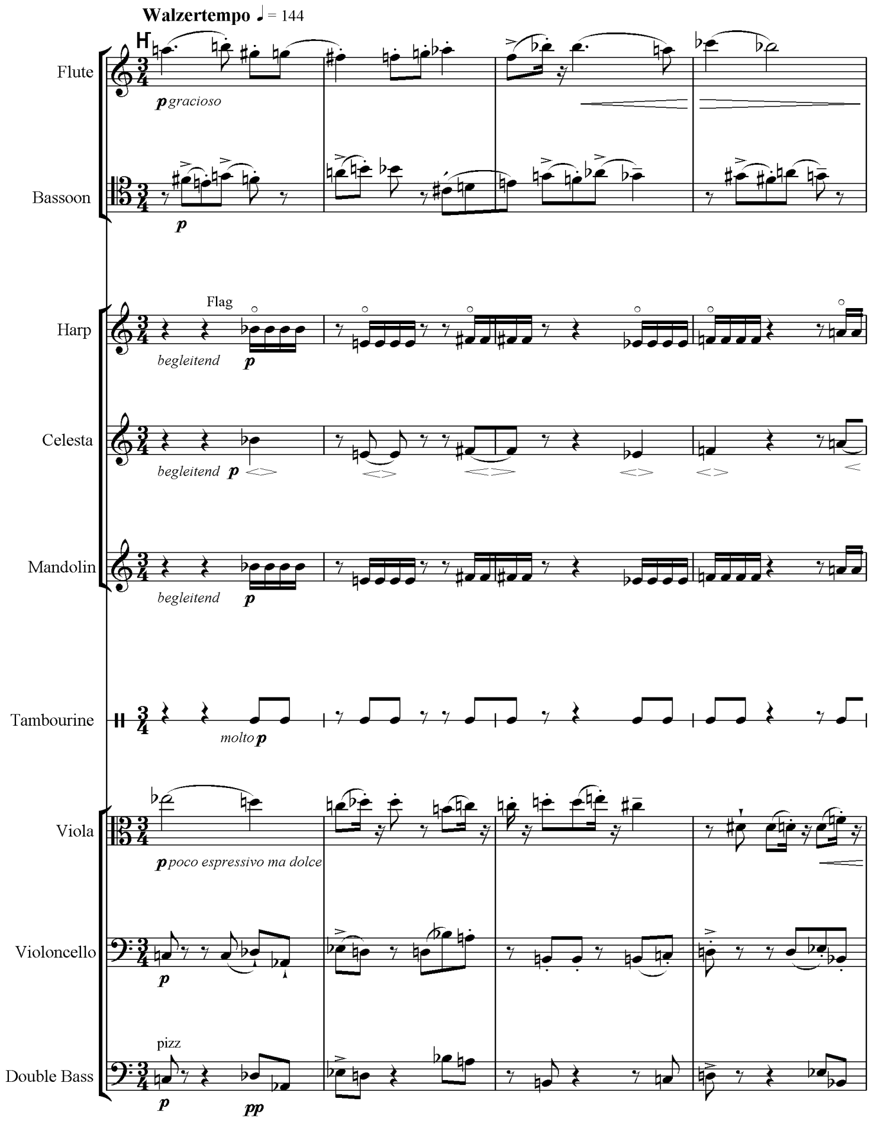

**Ex. 1** Schoenberg, Variations for Orchestra, fourth variation

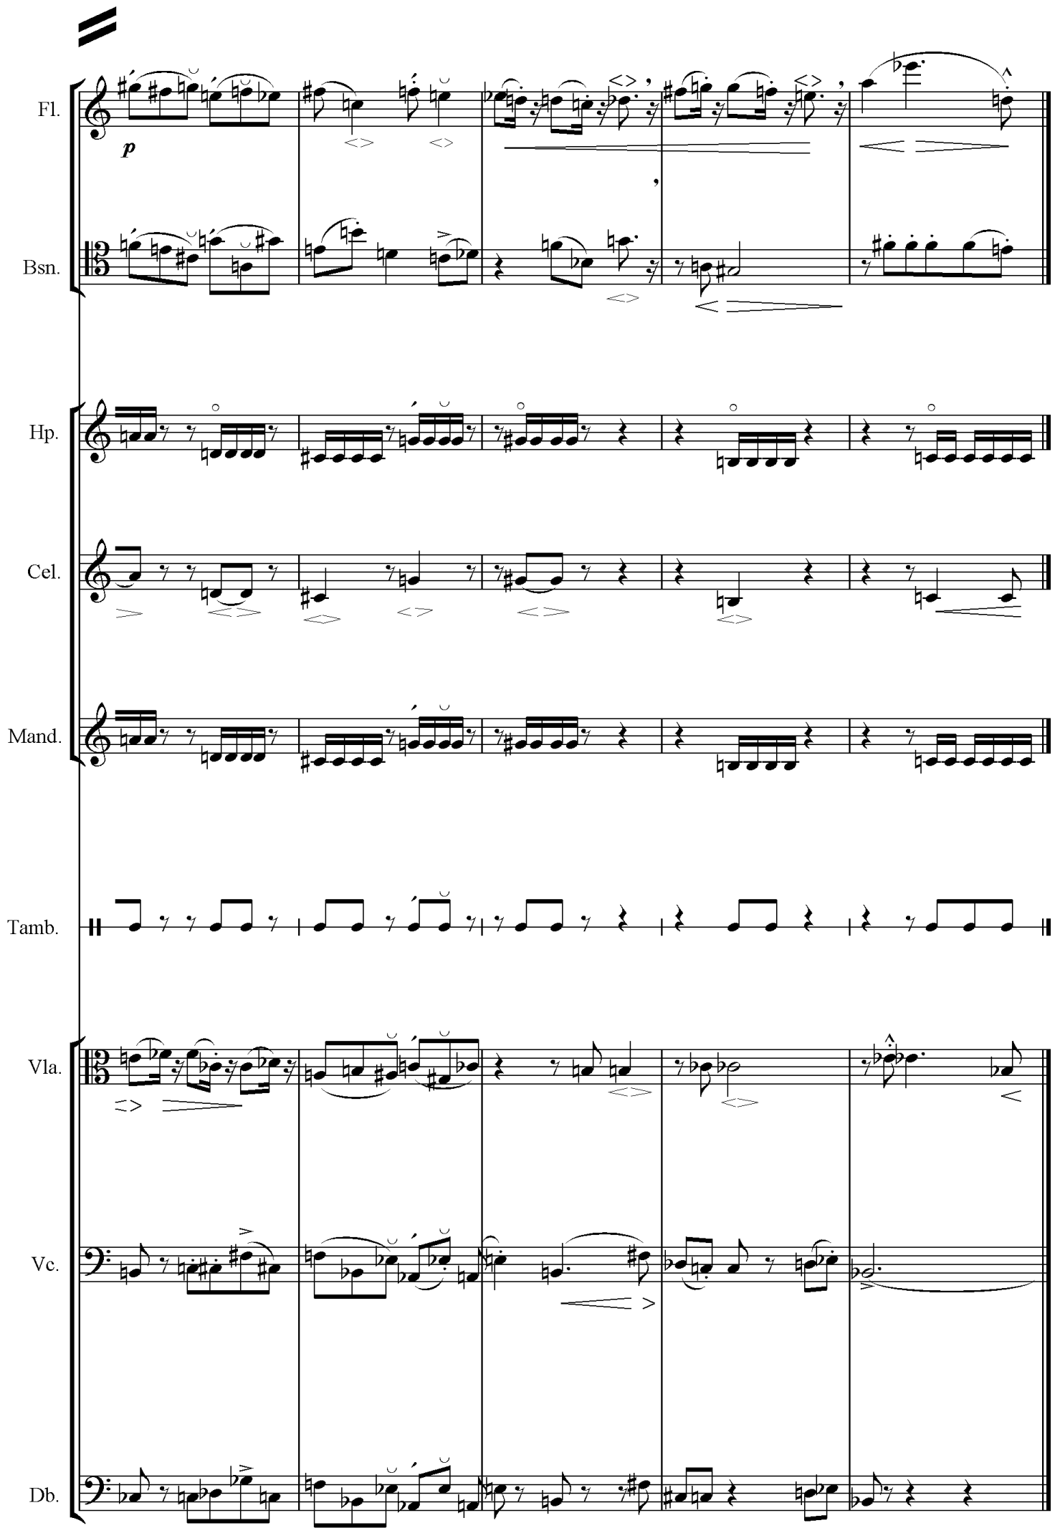

**Ex. 1** (*cont*.)

Boulez is specific with the stylistic aspects of Schoenberg’s 12-tone music to which he objects:

The persistence, for example, of accompanied melody, of counterpoint based on the idea of a leading voice and secondary voice (*Hauptstimme* and *Nebenstimme*)…From Schoenberg’s pen flows a stream of infuriating clichés and formidable stereotypes redolent of the most wearily ostentatious romanticism: all those endless anticipations with expressive accent on the harmony note, those fake appoggiaturas, those arpeggios, tremolandos, and note-repetitions.[7]

Boulez was not merely lashing out.[8] That is to say, one finds these stylistic devices in the works of the ‘accused’. There are the leading and secondary voice markings as found in examples in the appendix on classical serialism and the repeated notes in ex. 1. Nevertheless, my purpose is not to endorse Boulez’s accusations of stylistic poverty against Schoenberg (for instance, one may equally applaud Schoenberg’s attempts to marry the old and new). It merely shows that Boulez found certain features of style repellent to *his* conception of serialism.

It is plain here that the compositional technique Boulez advocated is one of much greater automatism then Schoenberg was willing to allow. Boulez's view of the serial technique may be said to be prescriptive, in that he derived a normative rule proscribing correct compositional technique from an abstract series; an ‘ought’ from an ‘is’ (*a fortiori*, he goes as far as to condemn all non-serial composers as ‘useless’ in the same article). On the other hand, Schoenberg, though he wished to restrict automatism to pitch choice alone, did not see the series as having stylistic consequences. This was the theoretical battleground which undoubtedly spurred Boulez to push serialism to its limits.

As Schoenberg provided, certainly for Boulez at least, a *negative* example of how to continue the serialist project, it is his pupil and assistant Anton von Webern who provided a *positive* prototype for the post-war serialists. Despite being written with the same conceptual tone row used by Schoenberg, the results Webern achieves are dramatically different. Webern's music was constructed in such a way as to derive the maximum amount of material from the minimum of resources, and consequently the relations of this material pervade all aspects of the piece.[9]

Achieving this sort of connectedness requires careful construction of the row and therefore the method which Webern starts with is decided upon before the piece is even written, much as it would do with later serialism. There is an emphasis on pre-compositional decisions that we do not see to the same extent in Schoenberg.

This sort of decision-making is more wholesale in Webern’s oeuvre. Webern would use pre-compositional means to bring about motivic and intervallic connections in a piece. An analysis of some of the features of Webern's style will demonstrate why he was such a compelling figure to the post-war generation who wanted an emphatic break with tradition.

I begin with a short analysis of the second movement of Webern's Symphony, op. 21. The row of the series runs as follows:

|  |  |  |  |  |  |  |  |  |  |  |  |
| --- | --- | --- | --- | --- | --- | --- | --- | --- | --- | --- | --- |
| A | C | B | Bb | D | C# | G | Ab | E | F | F# | Eb |

**Fig. 1** Tone row in Symphony op. 21

The row will form the starting-point of the analysis in order to show how properties at the smallest level branch out into the highest structural levels of the piece. One will note that the minor second is the preponderant interval of the row. There are tonality-suggesting thirds in the row, but one could suggest that these cancel each other out as there are two minor thirds complemented by major thirds.

Firstly, it will be noted that there is a hexachordal structure to the row of this piece: The second hexachord is a retrograded version of the first hexachord, transposed by a tritone. The tritone has a special part to play in this row (and the piece as a whole - Webern draws attention to this fact by finishing the piece with a firmly struck F-B in the harp) by ensuring invariance between series. As mentioned already, the second hexachord is a transposed and retrograded version of the first hexachord. This means the intervallic structure of the whole row is a palindrome:

m3, m2, m2, M3, m2, TT, m2, M3, m2, m2, m3.

For instance, the P0 series is identical with R6 and by having the prime series identical with its retrograde transposed a tritone, this halves the number of available rows to 24. This process is also displayed in the inversion series - I0 finds its exact repeat in RI6, a tritone higher. By deliberately restricting the use of available sets and intervals Webern is able to introduce an element of repetition. This also gave prominence to the interval in serial music that perhaps mirrored the structural role of the tonic in tonal music.

As mentioned previously, the interval structure of the row is palindromic, and with respect to pitch a prime series and its inversion a tritone higher are one and the same. This concern for symmetry is another essential feature of Webern's music and another composer influential on the post-war serialists, Olivier Messiaen, deliberately used series with a limited range of transpositional possibilities, much as Webern constructed his rows in such a way to reduce the number of unique sets. Messiaen would also use palindromic rhythms throughout many of his pieces, and he described the idea in his theoretical works.

Webern follows the same procedure with other aspects of the music, subjecting them to the principle of a non-retrogradable structure. The theme in movement two begins with P8. It is also an arresting example of Webern's concern with symmetry. It is symmetrical with regard to rhythm and dynamics. The accompaniment, which uses P2 is also palindromic with regard to rhythm, dynamic, and even timbre: The harp has four crotchets in harmonics followed by a four quaver passage with the normal method of execution, then followed again by four crotchets in harmonics, completing P2. The choice of pitch rows is similarly consistent: P2 is the retrograde of P8.

The first variation reflects the concern for balance and symmetry which the theme firmly established: The pitch materials are P3 followed by R3 in the first violin with this process mirrored in the second violin. Likewise, the viola and cello are paired by usage of RI1 and I1, with the viola in retrograde-inversion when the cello is using the inversion and *vice versa*. Though Webern uses the rows in full here, he restricts the available pitches by effectively using two rows at once - it is worth noting also that these rows are almost hexachordally combinatorial with each other. I1's first hexachord shares five notes with the second hexachord of P3. Equally illustrative of this concern for symmetry are the rhythms for each part of the variation as they are completely palindromic, complementing the choice of series.

More generally, the tempi of the theme and its seven variations are non-retrogradable:

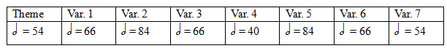

**Fig. 2** Tempo structure in Symphony, Op. 21

Each of the variations is 11 bars long which seems too coincidental to not be regarded as another pre-compositional decision. The fourth variation is stricter and in keeping with the spirit of the piece; two fermatas frame a *molto* *ritenuto* which is, as one would expect, the middle of the variation (as well as the near middle of the movement itself). The third variation, in terms of tempo, is construable as broadly palindromic:

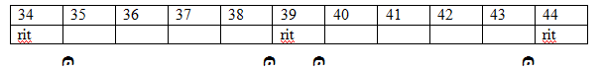

**Fig. 3** Tempo markings, third variation in Symphony, Op. 21

As Mark Starr has pointed out in a resourceful analysis, Webern intended for the creation of relationships between each structure of the piece.[10] The theme uses exactly the same pitch resources as the coda, and the first variation is completed by the seventh, the second complemented by the sixth, and the third complemented by the fifth in terms of pitch material. The fourth is the lone variation and owes nothing to any of the other structures of the piece; it is an island entire of itself. The example below demonstrates this structural phenomenon:

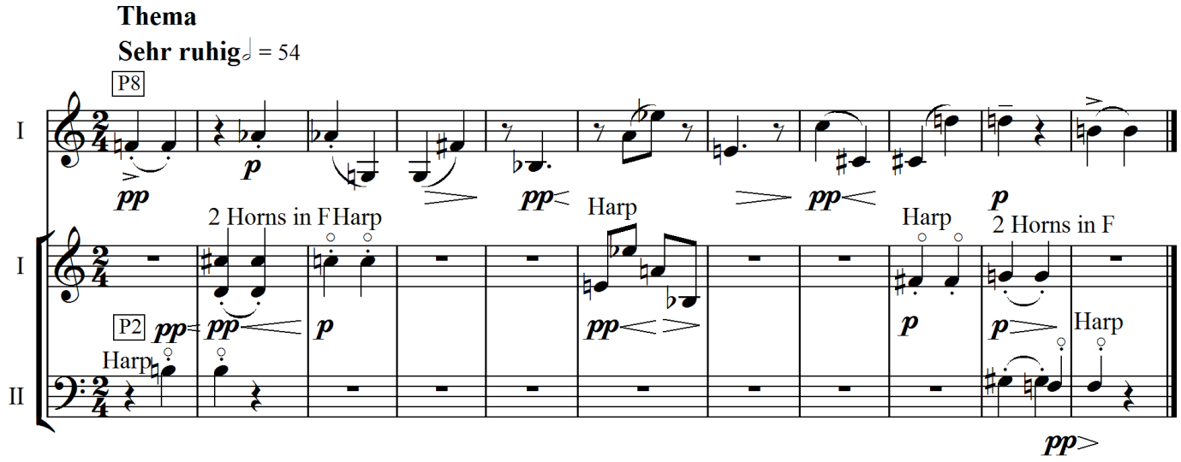

**Ex. 2** Webern, Symphony Op. 21, 2nd movement, theme

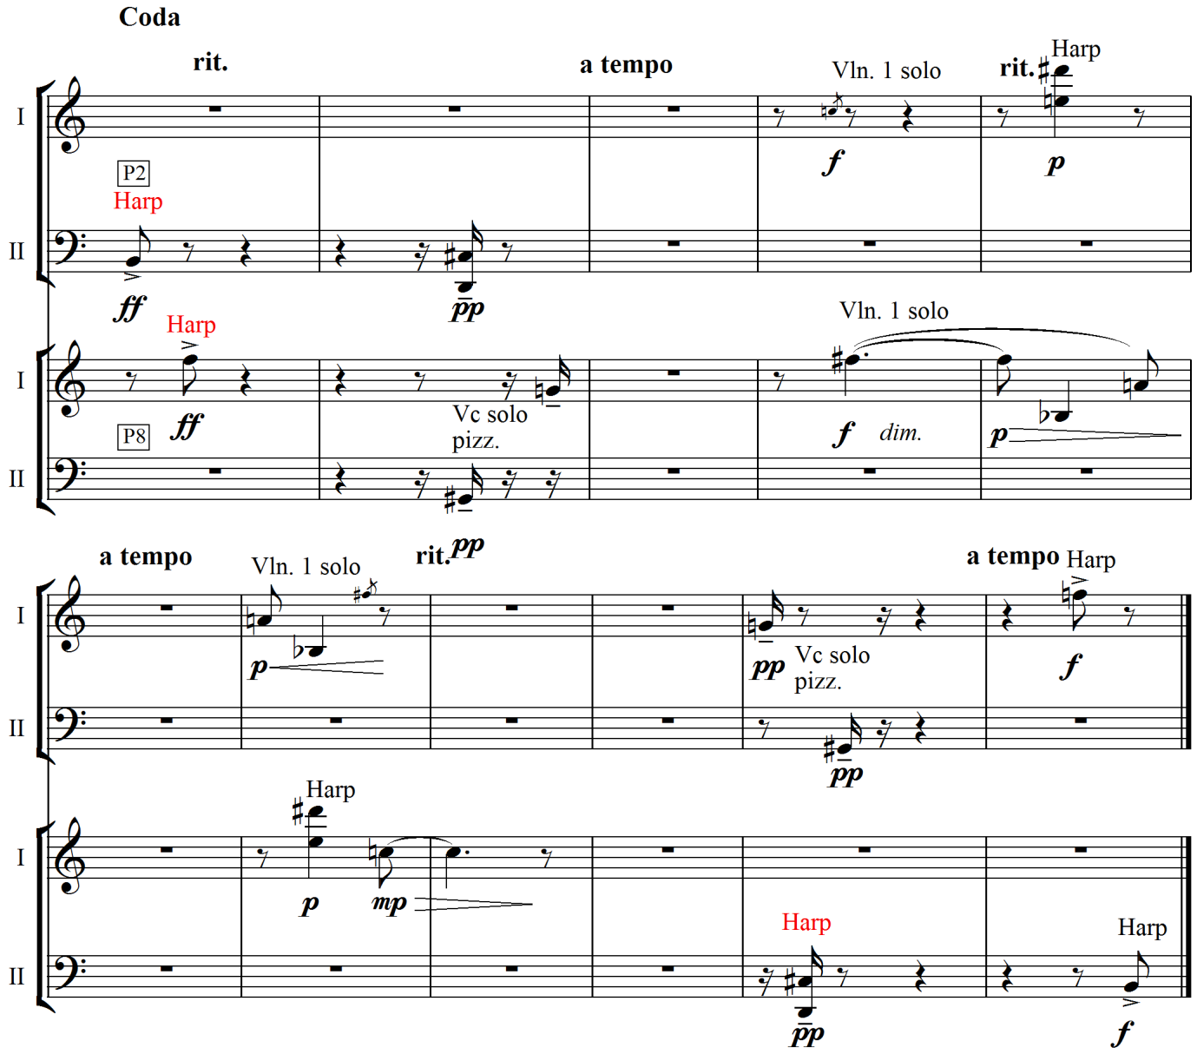

**Ex. 3** Webern, Symphony Op. 21, 2nd movement, coda

The pitch choices of the coda are a reflection of those in the theme (the coda is also of identical length). There are other parallels too in the texture, which is essentially a melody with accompaniment, as P8 is unequivocally the theme although in the coda both rows alternate between serving as accompaniment and melody.

Although this may represent an extreme point in terms of Webern's thinking about pre-compositional structure, these concerns for symmetry and intense focus appear elsewhere in his oeuvre. The String Trio, op. 20 of 1927 offers another example (ex. 4). As with the second movement of the Symphony, in particular the third and sixth variation, we see a relentless focus on dynamic shifts between *piano* and *forte* before gradually settling on *forte*, as well as a palindromic alternation between arco and pizzicato bowing. The texture is similar to the Symphony, in that there is a focus on the uniqueness of the motive, neglecting any sense of melodic line, not to say development, in favour of concentration on a certain interval. Commentators have spoken of the kaleidoscopic nature of Webern’s output and here it is in evidence: we have the interval of a semitone presented with differing pitch pairs, passed amongst the instruments, but retaining the same identity. [11] The violin begins with A flat harmonic, descending to a G natural, followed by the viola’s entry which is a briefly held G-flat harmonic descending a minor ninth to a F. The cello follows suit by matching the violin's opening gesture, only in true Webernian fashion, the cello opens with a regular note followed by a harmonic. This focus on the semitone also ensures a distance from the language of tonality, which was something Berg was keener on preserving in his 12-tone works.

This apparent stasis is achieved by a sameness of rhythm. Rhythmic figures echo amongst the instruments and are subtly varied by augmentation or diminution. By bar eight the maximum density is achieved in which an angular six-note figure (F#, G, C, B, D, E-flat) in the cello is echoed in the viola (G#, G, E-flat, E, G, F#). These features of apparent stasis and self-contained structures apply *mutatis mutandis* to the rest of the trio.

There is an uncertain, skittering quality to this particular example. It is difficult to detect a pulse, and the phrases are very short and unconnected. We should also note the high-level of notational detail this part of the piece presents, sometimes requiring a different timbre, dynamic, articulation or style of attack for each note. With music of such variety, only the unity of the interval is holding it together. This is an instance of *Klangfarbenmelodie*, in an extreme guise that presages the integral serialist music of the fifties.

Recalling his infamous *inutile* invective, Boulez wrote of Webern that ‘[He] is the threshold of new music; any composer who has not profoundly experienced and understood the ineluctable necessity of Webern is perfectly useless’.[12] Boulez's first encounters with Webern probably came from tuition with René Leibowitz. This is additionally borne out by the fact that students from Messiaen's class sought out Leibowitz. Jameux outlines this story: ‘Detailed analysis sessions then took place every Saturday morning: The first work we analysed was the Symphony, Op. 21, by Webern; I was very impressed by this and made a copy of it, since the score was not then available’.[13]

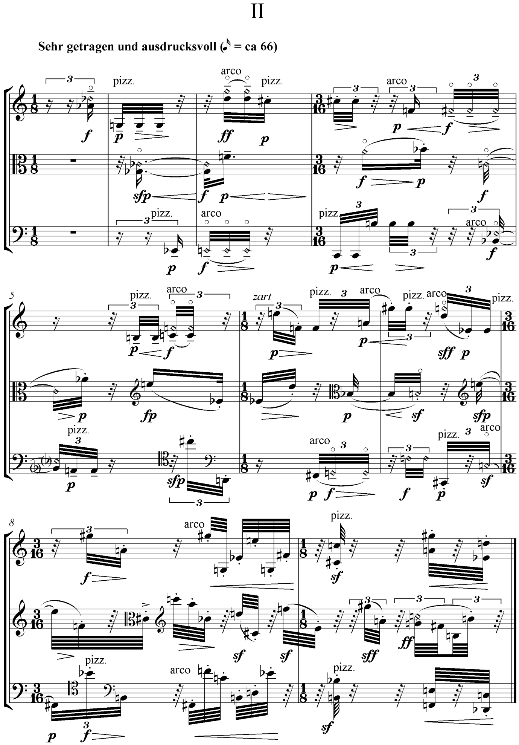

**Ex. 4** Webern, String Trio Op. 21, opening of second movement

Webern was more a subject of discussion amongst Boulez's circle of friends in the late forties.[14] Other newly emerging post-war composers also claimed Webern as an important influence: Herbert Eimert writes that ‘Webern was the first composer to move on from the single level conception of the twelve-tone technique.’[15]

Therefore, Webern was clearly a touchstone for the incipient Frenchman. He also served as a lodestar for John Cage who became good friends with Boulez in the 1940s. Cage recalls that:

I used to go [to an Anton Webern concert, in the late forties] with my hair on end…Webern *seems* to break with the past. He gives one the feeling he *could* break with the past. For he shook the foundation of sound as discourse in favour of sound itself. But in Schoenberg, the supremacy of pitch relations remains.[16]

As well as sharing a key influence, Cage and Boulez were seeking the same goal from their respective opuses. Boulez had written that with *Structures 1a* he wanted to ‘find out how far automatism in musical relationships would go…to bring everything into question again, make a clean sweep of one’s heritage’. [17] Meanwhile, Cage confidently declared from his experiments in composing the piece that: ‘It is thus possible to make a musical composition the continuity of which is free of individual taste and memory’.[18] Iannis Xenakis’s *Achorripsis* was the result of a fundamental questioning of the premises of music, as detailed in his own writings. He attempted to go back to first principles in order to build music from new foundations. His experiments were connected with the ‘total serialism’ he had been exposed to, as they revealed the possibility of numerical or abstract control of pitch, rhythm and other elements. Yet rather than serial rows, other techniques were used by the Greek.

Amidst such theoretical backgrounds, factions formed and cross-faction friendships were strained. It is difficult to say exactly when cordial relations between the two were severed, but as with Schoenberg, Boulez wrote dismissively of Cage in an essay entitled ‘Alea’, though nowhere near as directly as he did with Cage’s one-time teacher. Cage’s response was similarly wholesale: He derides Boulez’s (and others) works: ‘That these works are serial in method somewhat diminishes the interest they enjoin’ and ‘Curiously enough, the twelve-tone system has no zero in it…there is not enough of nothing in it’.[19]

Xenakis also found fault with some of the musical ideas prevalent in the 1950s. Starting on the basis that serialism commits itself to polyphony, with the multiple deployments of strands that occur in pieces by Boulez, Stockhausen et. al, Xenakis argued that rather than hearing the individual strands, one hears: ‘A mass of notes in various registers…There is consequently a contradiction between the polyphonic linear system and the heard result, which is surface or mass’.[20] An espousal of probabilistic methods entailed the rejection of serialism’s ‘strict deterministic causality’[21] and a rejection of determinism and ‘linear thought’. His point is clear: On listening to serial music, one hears a kind of chaos that is not mirrored in the certitude and ‘definite nature’ of the serial method. Theodor Adorno had made a similar point, with typical pungency: ‘The safe balance which they have worked out on paper cannot be realized. Their disproportional need for security destroys security’.[22]

Xenakis did not believe in giving the performer choices over what was to be performed. Boulez said that there was a ‘legitimate desire to construct a sort of labyrinth with several circuits’ and saw chance as something to be absorbed into a composition, rather than be dominated by it.[23] Boulez still desired to use automatic structures, or serial rows to determine the material of the music, but he speaks of allowing the incursion of chance procedures in the choice of a register of a given note, and then expanding this to duration and dynamics further. Boulez also discusses delegating to the performer certain avenues of choice, whether these are flexible tempi within limits, or the insertion of a variable number of grace notes in a passage to create the effect of a ‘nonhomogeneous time’.[24] He concludes that such ideas lead to a ‘glorification of the interpreter’ and not ‘an interpreter-robot of terrifying precision’, though one may counter that the creation of such automatons was Boulez’s own doing with fiendishly difficult works as the *Second Piano Sonata*.

Xenakis identified what he regarded as two ‘logical infirmities’ in Boulez’s approach: The performer, argues Xenakis, through years of practice and dedication is a highly conditioned being who will invariably bring their experiences to bear both on the execution and interpretation of the music. This reduces the likelihood of genuine randomness, in that humans have thoughts, feelings, and minds of their own.[25] Secondly, Xenakis saw in the case of several difference routes of a composition that the problem of choice is given to *the performer* who becomes the composer himself by making a choice on the piece’s eventual form, leading to a ‘substitution of authors’.[26] Xenakis describes this in strong terms, likening it to an abdication of responsibility: a ‘resignation’. He reserved further contempt for composers who used graphical symbols who (apparently) had ‘nothing to say’.

Xenakis maintained that chance is ‘a rare thing’ and problematic to simulate using mathematical methods.[27] He quoted approvingly the work of Emile Borel, a mathematician who proved, through a mathematical law of large numbers, that independent events such as a coin toss (as in Cage’s method) tend towards the initial probability with enough repeated trials. Xenakis’s point in relation to improvisation may hold for music that is not as strictly notated as Boulez’s *Third Piano Sonata.* Nevertheless, for more determinate notation of that kind, it could be reasonably advanced that there are performers whose familiarity with and mastery of the classical, modern and avant-garde repertoire of the piano forms a counter-example to Xenakis’s point about conditioning. So we could grant a weaker form of Xenakis’s point, which is that performers are conditioned beings who will bring their own experience and particular tastes to any performance, and the performer acts as *more* of a composer than before in making structural decisions in or before the performance. At any rate, this, combined with his stance against serialism was part of Xenakis’s justification for the use of stochastics in music.

**2. Pierre Boulez and *Structures 1a***

The representative work of the expansion of serial technique is undoubtedly *Structures 1a* for two pianos. Boulez would go further than Schoenberg, Webern and Messiaen before him in his application of the serial principle to various facets of the piece.

In homage to Messiaen, Boulez selected as his basic tone row the prime 12-note mode that his tutor had used in *Mode de valeurs et d’intensités*. Messiaen’s piece was a prime example for the younger serialists in that each pitch had a dynamic and register all of its own, unconnected to ones which followed or preceded it. The series itself has predominantly minor seconds as the chief interval, though there are some tonal allusions such as the major third at the beginning of the second hexachord as well as the final tritone of the row. The row also has combinatorial implications: The prime series (P0) is hexachordally combinatorial with its inversion a minor second higher (I1). This means that each half of the series just mentioned combine to make a full tone-row meaning that new rows can be constructed from this combination that are not present in the matrix constructed from the original row at the outset, as shown below:

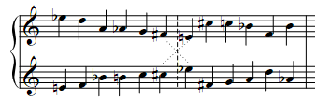

P0: [Eb D A Ab G F#] [E C# C Bb F B]

I1: [E F Eb B C C#] [Eb F# G A D Ab]

**Fig. 4** Prime row and combinatorial relationships in *Structures 1a*

One sees that the second half of P0 (equivalent to the first half of I1) can be combined with the first half of I1 (equivalent to the second half of P0) to produce a differently ordered but equivalent set.

In spite of this combinatoriality, Boulez does not make use of it in the design of the piece. This is because he does not design his matrix (or rather matrices as we shall see) in the manner described earlier. Whereas conventional design of the 12-tone matrix starts with the prime row and then the writing of the inversion of the same transposition directly beneath, Boulez opted to write first the prime row and then the second row beginning with the second note of the matrix, and the third row with third note and this process continues until the 12x12 square is formed. One will note that proceeding in this manner renders any potential hexachordal combinatoriality tautologous since the prime row equals the inverted row in terms of order *and* content. Therefore, a matrix based upon the inverted series must be formed, and again, this matrix is formed in much the same way as the prime series was.

ORIGINAL SERIES:

|  |  |  |  |  |  |  |  |  |  |  |  |
| --- | --- | --- | --- | --- | --- | --- | --- | --- | --- | --- | --- |
| 1  Eb | 2  D | 3  A | 4  Ab | 5  G | 6  F# | 7  E | 8  C# | 9  C | 10  Bb | 11  F | 12  B |
| 2  D | 8 C# | 4  Ab | 5  G | 6  F# | 11  F | 1  Eb | 9  C | 12  B | 3  A | 7  E | 10  Bb |
| 3  A | 4  Ab | 1  Eb | 2  D | 8  C# | 9  C | 10  Bb | 5  G | 6  F# | 7  E | 12  B | 11  F |
| 4  Ab | 5  G | 2  D | 8  C# | 9  C | 12  B | 3  A | 6  F# | 11  F | 1  Eb | 10  Bb | 7  E |
| 5  G | 6  F# | 8  C# | 9  C | 12  B | 10  Bb | 4  Ab | 11  F | 7  E | 2  D | 3  A | 1  Eb |
| 6  F# | 11  F | 9  C | 12  B | 10  Bb | 3  A | 5  G | 7  E | 1  Eb | 8  C# | 4  Ab | 2  D |
| 7  E | 1  Eb | 10  Bb | 3  A | 4  Ab | 5  G | 11  F | 2  D | 8  C# | 12  B | 6  F# | 9  C |
| 8  C# | 9  C | 5  G | 6  F# | 11  F | 7  E | 2  D | 12  B | 10  Bb | 4  Ab | 1  Eb | 3  A |
| 9  C | 12  B | 6  F# | 11  F | 7  E | 1  Eb | 8  C# | 10  Bb | 3  A | 5  G | 2  D | 4  Ab |
| 10  Bb | 3  A | 7  E | 1  Eb | 2  D | 8  C# | 12  B | 4  Ab | 5  G | 11  F | 9  C | 6  F# |
| 11  F | 7  E | 12  B | 10  Bb | 3  A | 4  Ab | 6  F# | 1  Eb | 2  D | 9  C | 5  G | 8  C# |
| 12  B | 10  Bb | 11  F | 7  E | 1  Eb | 2  D | 9  C | 3  A | 4  Ab | 6  F# | 8  C# | 5  G |

INVERTED SERIES:

|  |  |  |  |  |  |  |  |  |  |  |  |
| --- | --- | --- | --- | --- | --- | --- | --- | --- | --- | --- | --- |
| 1  Eb | 7  E | 3  A | 10  Bb | 12  B | 9  C | 2  D | 11  F | 6  F# | 4  Ab | 8  C# | 5  G |
| 7  E | 11  F | 10  Bb | 12  B | 9  C | 8  C# | 1  Eb | 6  F# | 5  G | 3  A | 2  D | 4  Ab |
| 3  A | 10  Bb | 1  Eb | 7  E | 11  F | 6  F# | 4  Ab | 12  B | 9  C | 2  D | 5  G | 8  C# |
| 10  Bb | 12  B | 7  E | 11  F | 6  F# | 5  G | 3  A | 9  C | 8  C# | 1  Eb | 4  Ab | 2  D |
| 12  B | 9  C | 11  F | 6  F# | 5  G | 4  Ab | 10  Bb | 8  C# | 2  D | 7  E | 3  A | 1  Eb |
| 9  C | 8  C# | 6  F# | 5  G | 4  Ab | 3  A | 12  B | 2  D | 1  Eb | 11  F | 10  Bb | 7  E |
| 2  D | 1  Eb | 4  Ab | 3  A | 10  Bb | 12  B | 8  C# | 7  E | 11  F | 5  G | 9  C | 6  F# |
| 11  F | 6  F# | 12  B | 9  C | 8  C# | 2  D | 7  E | 5  G | 4  Ab | 10  Bb | 1  Eb | 3  A |
| 6  F# | 5  G | 9  C | 8  C# | 2  D | 1  Eb | 11  F | 4  Ab | 3  A | 12  B | 7  E | 10  Bb |
| 4  Ab | 3  A | 2  D | 1  Eb | 7  E | 11  F | 5  G | 10  Bb | 12  B | 8  C# | 6  F# | 9  C |
| 8  C# | 2  D | 5  G | 4  Ab | 3  A | 10  Bb | 9  C | 1  Eb | 7  E | 6  F# | 12  B | 11  F |
| 5  G | 4  Ab | 8  C# | 2  D | 1  Eb | 7  E | 6  F# | 3  A | 10  Bb | 9  C | 11  F | 12  B |

**Figs. 5 & 6** Serial matrices for *Structures 1a*

From this double matrix, the 48 rows are derivable and may be arranged as normal within a given piece. Boulez assigns to each piano 24 rows – the first piano has the prime and retrograde inversion forms and the second piano has the inversion and retrograde forms. The first matrix is used for the prime and retrograde series, and the second for the inversion and retrograde inversion series.

In *Structures 1a* the choice of rows is automated. The first piano uses all 12 prime series and then all retrograde inversion series once and once only. The order of the prime series rows follows the sequence of the inverted series, 1 7 3 10 12 9 2 11 6 4 8 5. That is, P1 is the first to appear, followed by P7 and P3 simultaneously, and so on until P5. After the prime series are exhausted, the retrograde inversion series are used, with RI1 determining their order of presentation. The pitch material for Piano II utilizes the complementary 24 rows of the inversion and retrograde series respectively and P1 determines the presentation of the inverted series, and then the retrograde series are in order of R1 following the same logic as already described in the procedure for Piano I. The diagrams below demonstrate this process:

|  |  |  |  |  |  |  |  |  |
| --- | --- | --- | --- | --- | --- | --- | --- | --- |
| Piano 1 | P1 | P7 P3 | P10 P12 |  | P9 P2 P11 | P6 | P4 P8 | P5 |
| Piano 2 | I1 | I3 I2 | I4 | I5 | I6 I7 I8 | I9 | I10 I11 I12 |  |

|  |  |  |  |  |  |  |
| --- | --- | --- | --- | --- | --- | --- |
| Piano 1 | RI5 RI8 RI4 | RI6 | RI11 RI2 | RI9 RI12 | RI10 | RI3 RI7 RI1 |
| Piano 2 | R12 R11 | R10 R9 | R8 R7 | R6 R5 | R4 | R3 R2 R1 |

**Fig. 7**Pitch row deployment in *Structures 1a*

Nevertheless, it is not merely the pitch treatment that makes *Structures 1a* a conspicuous piece – rather it is the rhythmic complexity and dynamic flux that make this unusual even in Boulez’s oeuvre to this point. The dynamics or ‘intensities’ are assigned a number from 1 to 12, the quietest being ***pppp*** and the loudest ***ffff***:

|  |  |  |  |  |  |  |  |  |  |  |  |
| --- | --- | --- | --- | --- | --- | --- | --- | --- | --- | --- | --- |
| 1 | 2 | 3 | 4 | 5 | 6 | 7 | 8 | 9 | 10 | 11 | 12 |
| ***pppp*** | ***ppp*** | ***pp*** | ***p*** | *meno* ***p*** | ***Mp*** | ***mf*** | *quasi* ***f*** | ***f*** | ***ff*** | ***fff*** | ***ffff*** |

**Fig. 8**Dynamic row in *Structures 1a*

The articulations:

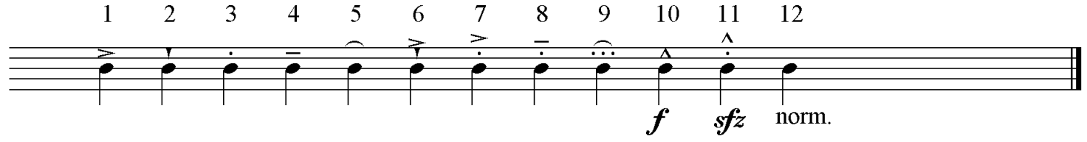

**Fig. 9**Articulation row in *Structures 1a*

And the durations:



**Fig. 10**Duration row in *Structures 1a*

In the case of the dynamics and durations, there is a multiplicative logic to the row as one has a basic unit **(*pppp*** and a demi-semi-quaver) which is multiplied according to what *n* might be. However, it is not entirely clear why Boulez chose the attacks as he did – there is no continuum from one extreme to the other as there is comparatively with the dynamics and durations. As Boulez notes, these are rows are ‘not parallel. There can thus be plans of interchangeable structures, counterpoints of structures’.[28] Thus a row used for the control of pitch need not be the same row that determines the dynamics or the durations. And this applies to just one row; as seen above, there are multiple strands in action at any given time, giving rise to the sensation of a contrapuntal texture, albeit a very abstract sort.

Firstly, the durations: these are treated in much the same way as pitch, which seems a logical consideration as pitch and rhythm are part of the same frequency continuum.[29] The duration order for Piano I assigns all of the RI rows whose order is determined by RI1 and I rows whose order is determined by R1. With Piano II, it is the R series in order R1 and then all of the P series in order RI1. A look at the first page demonstrates this technique in action. Piano I, which we know is enunciating P1 as the pitch row, follows RI5 in respect of duration.

Performance considerations give rise to a different technique in the selection and serialisation of dynamics. A problem of contradictory instructions arises from a combination of the rows, for instance, a ***sfz*** attack on a long duration marked ***pppp***. A look at the various strands seem to show a dynamic fixity which seems to be at odds with the pitch treatment. This was achieved by using smaller rows than the usual 12, and thereby preventing the potential cases of contradiction described previously and instead of assigning dynamics to each note, a dynamic is given to each row. Similarly, there is deviation from rote usage of the rows in the matrix in devising the dynamic rows: Boulez employs diagonals to yield series for the dynamics. The selected diagonals of Matrix A give the dynamic series for Piano I and the diagonals of Matrix B give the dynamics for Piano II.

Piano I: Piano II:

|  |  |  |  |  |  |  |  |  |  |  |  |
| --- | --- | --- | --- | --- | --- | --- | --- | --- | --- | --- | --- |
|  |  |  |  |  |  | 2 |  |  |  |  | 5 |
|  |  |  |  |  |  |  | 6 |  |  | 2 |  |
|  |  |  |  |  |  |  |  | 9 | 2 |  |  |
|  |  |  |  |  |  |  |  | 8 | 1 |  |  |
|  |  |  |  |  |  |  | 8 |  |  | 3 |  |
|  |  |  |  |  |  | 12 |  |  |  |  | 7 |
| 2 |  |  |  |  | 12 |  |  |  |  |  |  |
|  | 6 |  |  | 8 |  |  |  |  |  |  |  |
|  |  | 9 | 8 |  |  |  |  |  |  |  |  |
|  |  | 2 | 1 |  |  |  |  |  |  |  |  |
|  | 2 |  |  | 3 |  |  |  |  |  |  |  |
| 5 |  |  |  |  | 7 |  |  |  |  |  |  |

|  |  |  |  |  |  |  |  |  |  |  |  |
| --- | --- | --- | --- | --- | --- | --- | --- | --- | --- | --- | --- |
|  |  |  |  |  |  | 7 |  |  |  |  | 12 |
|  |  |  |  |  |  |  | 9 |  |  | 7 |  |
|  |  |  |  |  |  |  |  | 6 | 7 |  |  |
|  |  |  |  |  |  |  |  | 11 | 1 |  |  |
|  |  |  |  |  |  |  | 11 |  |  | 3 |  |
|  |  |  |  |  |  | 5 |  |  |  |  | 2 |
| 7 |  |  |  |  | 5 |  |  |  |  |  |  |
|  | 9 |  |  | 11 |  |  |  |  |  |  |  |
|  |  | 6 | 11 |  |  |  |  |  |  |  |  |
|  |  | 7 | 1 |  |  |  |  |  |  |  |  |
|  | 7 |  |  | 3 |  |  |  |  |  |  |  |
| 12 |  |  |  |  | 2 |  |  |  |  |  |  |

**Figs. 11 & 12** Dynamic rows in *Structures 1a*

This provides a dynamic range from ***pppp*** to ***fff***. The sforzando attacks and accents further contribute to the contrasts in intensity; the figure below gives an indication of this:

|  |  |  |  |  |  |  |  |  |  |  |  |  |  |
| --- | --- | --- | --- | --- | --- | --- | --- | --- | --- | --- | --- | --- | --- |
| Piano 1 | ***ffff*** | ***mf*** | ***fff*** | ***fff****, quasi* ***p****, quasi* ***p****,* | ***ff*** | ***mf****,* ***mf*** | ***ffff*** | ***pppp****,* ***ppp****,* ***pp*** | ***mp*** | ***f****,* ***mf*** | ***f****,* ***mf*** | ***mp*** | ***pp****,* ***ppp****,* ***pppp*** |
| Piano 2 | *quasi* ***p*** | ***ppp*** | ***f*** | ***fff****,* ***fff****, quasi* ***f*** | *quasi* ***f*** | ***ppp****,* ***ppp*** |  | ***mf****,* ***pp*** | ***f****,* ***pppp*** | ***mp****,* ***ppp*** | ***mp****,* ***ppp*** | ***f*** | ***mf****,* ***ppp*** |

**Fig. 13**Dynamic structure of *Structures 1a*

The self-imposed stricture of using each row once has a perfunctoriness to it that suits the mechanical nature of the piece. The row automation is a plain indicator of this: The pitch material is a result of having worked down or up each matrix one row at a time. The rows are not considered in how they might relate to each other in terms of intervallic content or melodic considerations;

instead follow from one another according to the numerical series.

In terms of row operations, the piece is simplistic. The question of harmonic relations between the rows was one which was simply ignored. Of course, there is the potential for unintended tonal relations to arise between the simultaneous rows, and given Boulez’s commitment to ‘throw off all the accumulated fetters of past centuries’[30] in embarking on such a project; it must have been a question worthy of consideration in the composition of the piece. Indeed, some potentially tonal ‘moments’ are avoided by control of one factor that Boulez could manipulate as he pleased: register.

If we hear a minor second, which is classed as a fundamentally ‘dissonant’ interval, it sounds at its most dissonant when the two notes are as close as they can be to each other. On the other hand, a three-octave gap between the two notes will undoubtedly diminish the perception of dissonance. Naturally, other factors influence this acoustic and psychological perception, such as timbre, rhythm and dynamics. Timbral contrast between different instruments is obviously minimized as Boulez uses the same instrument twice.

Indeed, registral manipulation occurs at certain points in the piece: a widely spaced consonance in bar 82, thus reducing the strength of the consonant interval. Here, the first note of RI2 and RI11 produce a major third (the A of RI11 being reinforced in unison in Piano II as the starting note of R3) and these are dislocated in register to avoid the suggestion of an unseemly consonance. Another technique Boulez uses is the avoidance of the octave; his strategy here is quite straightforward, and that is to place a repeated note between two or more rows in the same register. Thus, at bar eight, the E-flat as the second note of I2 which sounds in Piano II on the third quaver of the beat is heard a semi-quaver later in Piano I as the second note of P7. There are numerous examples of this throughout the piece and the effect is that of a tantalizing, fleeting point of focus amidst perpetual variation.

We can detect the influence of Webern behind this concern to stifle any allusions to a tonality which might undermine the emergence of a new music. In fact, we find Boulez praising the Symphony of Webern for ‘laying the foundations of a language totally stripped of allusion...The disjunct intervals are spaced so as to prevent tonal relations from emerging’.[31]

Register is certainly another aspect that makes *Structures* an arresting piece of music. Bandwidths of several octaves distance are traversed at will. At bar 73 for instance, the RI6 strand commences with a Bb7 followed by an E3, dropping down to a B2 and then A0, a seven octave plummet within the space of three bars at a moderate tempo. If done scalically this would require some virtuosity on the part of the performer; as such the leaps are completely unprepared and require some agility to execute, since they are marked legato.

Moreover, register is distinguishable from other defined parameters of the piece in that it is one aspect that Boulez used his own will and not numerical sequences in composing the piece. Although it may appear strange that Boulez did not serialize this parameter, it does not contradict his aesthetic thoughts at the time. We find him writing just after the composition of the piece that ‘One has only to imagine the instability arising out of the relation between an unchanging series and a continuously changing register, or between changing series and a completely fixed register: the extreme points in the play of ambiguities of pitch, which may equally combine with ambiguities of rhythm or dynamics’[32] and in speaking of sketches for *La marteau sans maître* later: ‘[So] we should regard the series less as a way of controlling the register of variable pitches, than as a way of regulating the permutations of sound objects that are in some sense fixed’.[33] For Boulez, the selective manipulation of register enabled him to avoid the impermissible intervals of consonance.

To the question of articulation, there does not seem to be any sign of serialism at the small scale. The first section of *Structures* shows a lack of articulative variation from note to note; rather we have articulative contrast at the global level – legato in Piano I versus non-legato in Piano II. In the second section there is the reinforced marcato-staccato in Piano I as opposed to a mezzo-tenuto in Piano II. Thus, articulation is generalized to each section of the piece and appears to follow a similar plan to those of the dynamics:

Piano I: Piano II:

|  |  |  |  |  |  |  |  |  |  |  |  |
| --- | --- | --- | --- | --- | --- | --- | --- | --- | --- | --- | --- |
| 1 |  |  |  |  | 6 |  |  |  |  |  |  |
|  | 8 |  |  | 6 |  |  |  |  |  |  |  |
|  |  | 1 | 2 |  |  |  |  |  |  |  |  |
|  |  | 2 | 8 |  |  |  |  |  |  |  |  |
|  | 6 |  |  | 12 |  |  |  |  |  |  |  |
| 6 |  |  |  |  | 3 |  |  |  |  |  |  |
|  |  |  |  |  |  | 11 |  |  |  |  | 9 |
|  |  |  |  |  |  |  | 12 |  |  | 1 |  |
|  |  |  |  |  |  |  |  | 3 | 5 |  |  |
|  |  |  |  |  |  |  |  | 5 | 11 |  |  |
|  |  |  |  |  |  |  | 1 |  |  | 5 |  |
|  |  |  |  |  |  | 9 |  |  |  |  | 5 |

|  |  |  |  |  |  |  |  |  |  |  |  |
| --- | --- | --- | --- | --- | --- | --- | --- | --- | --- | --- | --- |
| 1 |  |  |  |  | 9 |  |  |  |  |  |  |
|  | 11 |  |  | 9 |  |  |  |  |  |  |  |
|  |  | 1 | 7 |  |  |  |  |  |  |  |  |
|  |  | 7 | 11 |  |  |  |  |  |  |  |  |
|  | 9 |  |  | 5 |  |  |  |  |  |  |  |
| 9 |  |  |  |  | 3 |  |  |  |  |  |  |
|  |  |  |  |  |  | 8 |  |  |  |  | 6 |
|  |  |  |  |  |  |  | 5 |  |  | 1 |  |
|  |  |  |  |  |  |  |  | 3 | 12 |  |  |
|  |  |  |  |  |  |  |  | 12 | 8 |  |  |
|  |  |  |  |  |  |  | 1 |  |  | 12 |  |
|  |  |  |  |  |  | 6 |  |  |  |  | 12 |

**Fig. 14**Articulation rows of *Structures 1a*

Given that dynamics, pitch and rhythm are also serialized there are bound to be some contrary instructions to interpret. For instance, in bars 36-39 *sforzandi* attacks are played simultaneously with a *quasi* ***p*** marking. Is this an outright *sforzando*, or one in the context of a generally quiet dynamic? There is also the further incongruity in bar 55 of the low E-flat marked ***ppp*** and required to be marcato-staccato and *poco* ***sfz*** all at once. These curiosities showed the practical difficulties of Boulez’s integral serialist project *ab initio*. This may explain why Boulez decided to restrict modes of attack to sections, rather than notes, which would have only multiplied the inconsistencies.

With rhythm we return to more structured fields and this was an area of particular fascination for Boulez, so it is fitting that this element is controlled as strictly as pitch for the reason already mentioned, since they are part of the same continuum of sound. In *Structures 1a* his approach was based on the idea of a serial expansion of a demi-semi quaver. This is similar Messiaen's method in *Mode de valeurs* (see ex. 5). Messiaen used multiples of a semi-quaver, from 1 to 12. He claims this organization mirrored the way an octave is divided into 12 equal semitones, thus giving ‘dureés chromatiques’. Stockhausen refuted this supposition quite aptly in ‘...wie der Zeit vergeht...’ An example will illustrate: Messiaen's method reckons that by simply multiplying a duration by an integer from 1 to 12, we have a direct analogy with equal temperament. This is simply not the case: The relationship between a root and its octave is 1:2 and the arithmetical relationship between a semiquaver and a dotted crotchet the ratio does not hold. It is akin to multiplying a given frequency by an integer: In this case, supposing a note with frequency 440Hz, on being multiplied by 12 yields 5280Hz, which lies somewhat outside the range of the piano and certainly not the octave. In Toop's words, it is a ‘gross disparity’.[34]

Nevertheless, the piece is noticeable for its rhythmic angularity; a result of the numerical controls and Boulez’s decision to abide by them. There is never, at any time, a sense of regular pulse in the piece and the ‘ametric effect’ is multiplied when the polyphony is at its most dense. The bar lines only serve to aid performer synchronicity. An example will demonstrate this, as well as giving a flavour of the piece as a whole (see ex. 5).

The first piano has two strands, RI2 and RI11. Rhythmically it is complex, there are no patterns or repetitions due to the numerical control, and rhythmic simultaneity between the two strands is rare (a single instance in bar 87). The serialisation of rhythm is evident here: RI2 follows the pattern 7, 11, 10, 12, 9, 8, 1, 6, 5, 3, 2, 4, whereas RI11 follows 8, 2, 5, 4, 3, 10, 9, 1, 7, 6, 12, 11 which are R7 and R8 respectively. No patterns or motifs can emerge as they can in the Webern extract, and the strands are pure counterpoint, with harmonies emerging because of the polyphony. This feature accentuates the pointillist colour of the piece rather like *Mode de Valeurs*, in which each note of the chromatic scale occurs in three different registers, and in which it occurs with a different duration, dynamic and attack.

Boulez differs from Messiaen here in several respects: He has reduced Messiaen's mode to a row capable of serial treatment, especially in terms of rhythm and pitch. He has followed Messiaen in keeping dynamics and attack not subordinate to the number 12, but still invokes a serial treatment, unlike Messiaen who places the dynamics modally. Boulez's serialisation allows each note of the chromatic to assume a different character each time it appears. This is not the case in the *Mode de Valeurs*. One could echo Messiaen’s opinion of the 12-tone school; this piece lacks ‘harmony’ because any harmonic relations are entirely coincidental, only resulting from the serialisation. However, the goal and objectives of this particular composition were not an exploration of harmonic colour, as one could guess from its severity. Rather, Boulez had already explored these aspects in earlier works such as *Les Soleil Des Eaux* and the First Piano Sonata.

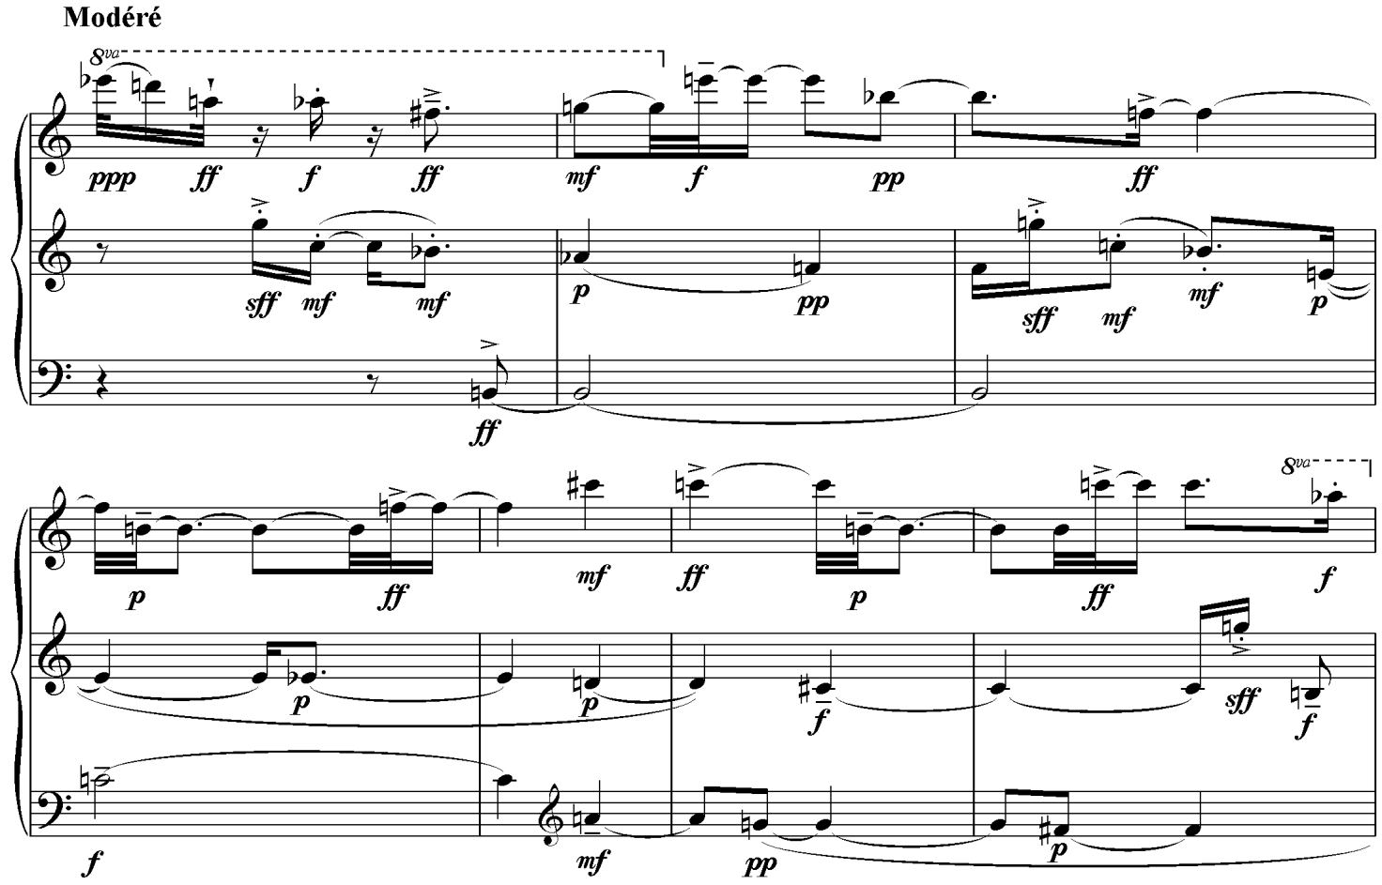

**Ex. 5** Messiaen, *Mode de valeurs et d’intensités*, opening bars

*Structures 1a* did not emerge *ex nihilo* - as discussed, key works of Webern and Messiaen were forerunners of the total serialisation which emerged in the 1950s.The involuntary character of the piece is made more pronounced by the lack of variety in the texture itself: The only variation is in the density of the lines, the lines or ‘rows’ themselves are a literal rendering of the serial duration row - there are no grace notes or moments of flexibility, no pauses or chordal writing. There are parallels with Stockhausen’s own *Kreuzspiel* in this regard, which similarly paired pitch and duration together. Stockhausen is similarly austere in his treatment of the instruments, restricting the piano mostly to single notes which are at the extremes of the piano throughout most of the piece. The respite from this comes fittingly in the middle of the piece, which also features some chordal attacks in the piano, which are deliberate in this case.

Therefore, at this point it would be profitable to comment on the ‘teleology’ of *Structures 1a*. To what extent the piece seems to evolve toward a given musical goal in the more traditional sense? The musical argument is quite difficult to follow, if indeed one exists. Dominique Jameux has suggested a model: That of two contrasting sections, the first being agitated and unsettled and the second being calmer and less varied. The dynamic programme of the piece confirms this, though one cannot agree with Jameux’s analysis that the second section is ‘marked by a general increase in density’. Rather, it is quasi-palindromic as measured by the number of strands in play and the dynamics.[35] This is the closest one can come to finding a sense of musical agenda in 1a, and yet it remains obscure compared to *Kreuzspiel.* One might glance back at the String Trioof Webern, which sees him employ classical procedures such as the sonata-form and a palindromic theme and variations movement of *Symphony,* to create a definite and perceivable sense of a musical argument or process.

Returning briefly to Webern’s Op. 21, we find a telling example of a formalized procedure that is manipulated to reach a musical goal or point. The first movement is a strict double canon by inversion, with the crossing of the canonic lines and the constantly shifting instrumentation effacing the transparency of the traditional musical process. Dynamics are very quiet, with only one *forte* attack in the first 25 bars, which are repeated. The registral space is confined, with notes above the treble clef stave being an exception (this is the case in the third section, as Perle has pointed out).[36] This slowly changes as the piece develops, with higher notes beginning to permeate the texture more, which is still muted. After a pause at bar 46, the piece intensifies in mood – extreme registers and *forte* attacks are part of the climax of the piece, mainly brought about by the strings. This is sustained for 14 bars before slowing and returning to the hushed mood of the beginning. Here is an example of something ‘teleological’ – that is, although the music is abstract in nature and quite unlike the symphonic music of anything before Webern, there is still a musical goal toward which the notes move to and from. That is, the dynamics are signposts of a musical journey. *Structures 1a* is freer in this regard, because the total serialisation necessarily conflicts with any sense of traditional musical argument, introducing a high level of change from note to note, which would disrupt any overarching plan.

Nevertheless, it is still a combination of the automatic and some of the composer's will which produced the result: The extremity of the total serialisation allowed Boulez to see how far the process itself could generate the musical composition, ‘with individual invention appearing only in some very simple forms of disposition, in the matter of densities, for example.’[37] This seems to have been a personal terminus for Boulez, for he would turn away from such mechanisation in future works. This process is mirrored in *Structures*, Book One itself, as Jameux observes that ‘*Structures 1b* and *1c* were written later (after *Polyphonie* X) and they progressively reduce the part played by automatism, thereby increasing the role of the composer’.[38] Boulez's works would incorporate increasing flexibility, beginning with *Le Marteau sans Maître*, progressing through the ‘open form’ of the Third Piano Sonata to the ‘improvisations’ of *Pli Selon Pli* and the in-the-moment decisions of *Éclat*. In fact, in 1954, the year that *Le Marteau* was due to receive its premiere at Donaueschingen, he declared in an article ‘that composition and organization cannot be confused without falling into a maniacal inanity…one [now] organizes rhythm, timbre, dynamics; everything is fodder for that monstrous polyvalent organization which must quickly be brought under control unless one wishes to be condemned to deafness’.[39]

In parallel with this move away from the strict use of serialism, Boulez’s advocacy of Webern cooled. Martin Iddon writes that Boulez, as part of his Darmstadt lecture in 1955 on Debussy, had begun to adopt a more critical approach towards Webern: he takes him to task for harking back to classical models, no matter how advanced his musical language may have been.[40] He had also suggested that figures such as Debussy and Mallarmé were at the root of modernism in an article of 1956, which notably omits any mention of the spiritual hero of Darmstadt.[41] This position hardened, as in 1975 Boulez said that Webern’s work is ‘like a picture by Mondrian. You can see its perfection and it is very striking…but when you see it again at a later date, it offers nothing further’.[42]

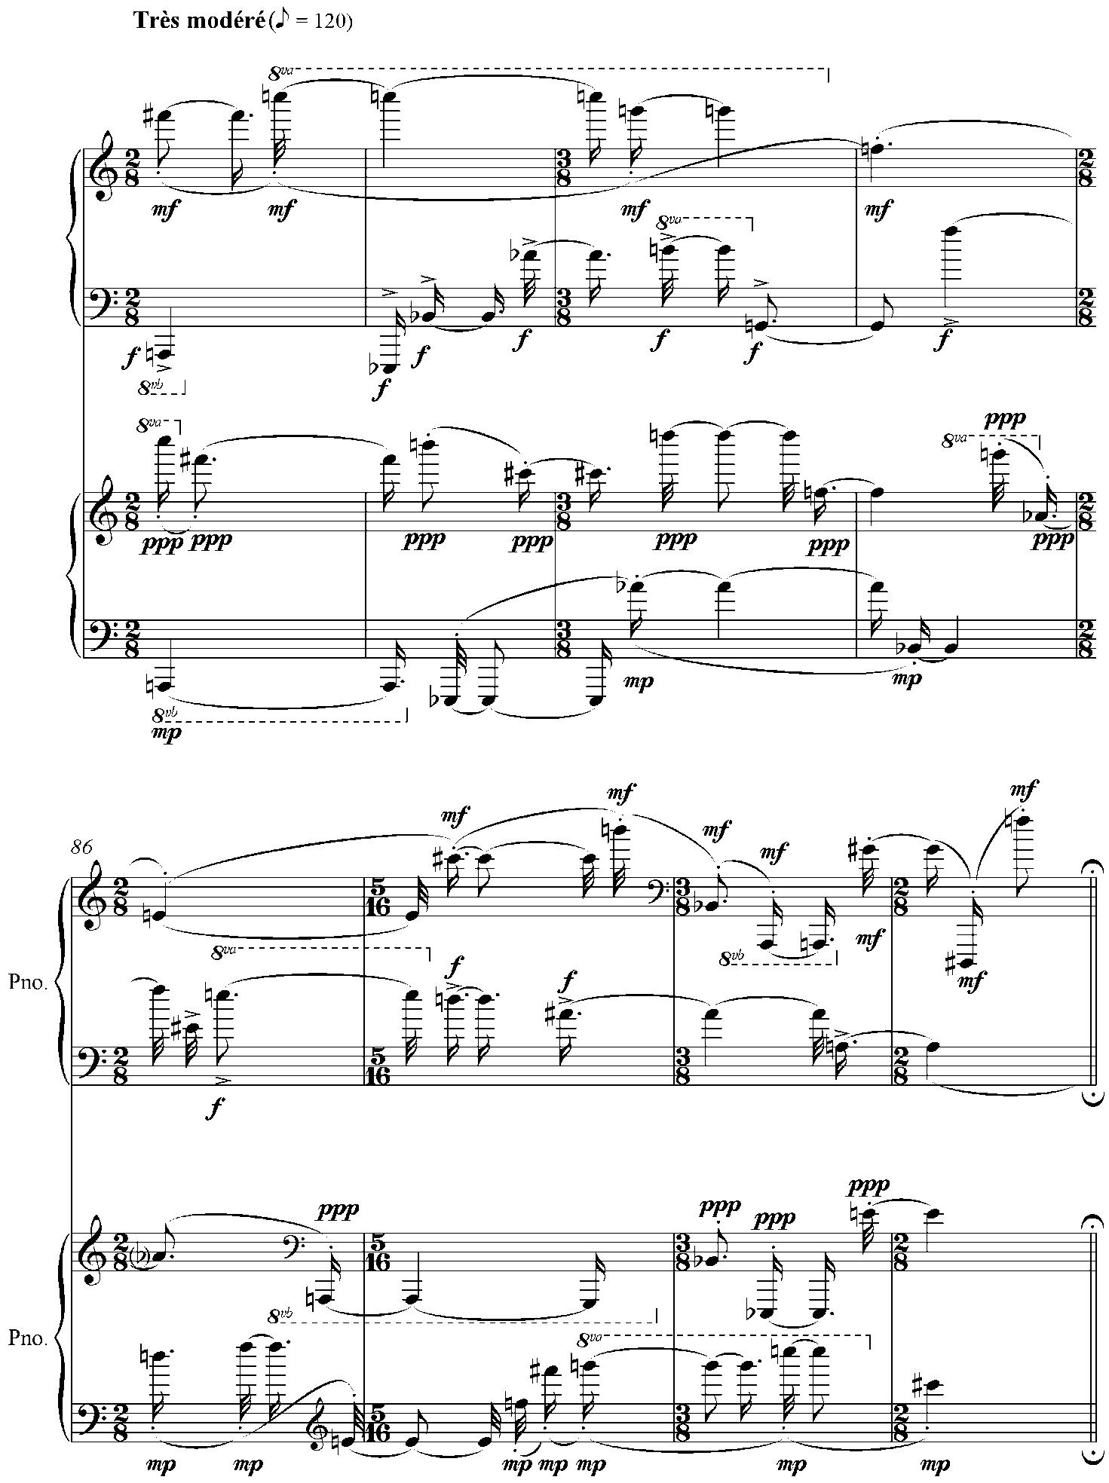

**Ex. 6** Boulez, *Structures 1a*, bars 82-89

**3. John Cage and *Music of Changes***

A move towards total automatism was also apparent in the works of John Cage of this time, and the American and Frenchman became good friends in the late forties. It is consequently unsurprising that the two were engaged in an intense correspondence over the direction of modern music and art. Boulez was approving of Cage’s use of chordal aggregates and the removal of ‘choice’ from composition. In a letter of December 1950 he was currently grappling with *Polyphonie X*, writing: ‘I shall also make use, as you do in the music you are in the process of writing, of sampled sonorities [*sonorities échantillonées*], i.e. sound aggregates…like you, too, and as in my Quartet, I can build the construction with all the possibilities afforded by the material…and thus where the form does not stem from an aesthetic choice’.[43] In the same letter Boulez was also delighted to read of Cage’s innovations which he detailed in his letters to the Frenchman: ‘You cannot imagine how happy I was to see how we are progressing in making discoveries, and in the same rhythm’[44] and even a confession that he had adopted one of Cage’s methods to fit with his own serial system: ‘I’ve taken over your chess-board system for my own purposes, by making it serve on dissociated, antagonistic, and parallel or anti-parallel levels’.[45] Cage was similarly inspired by the boldness of the Frenchman's early pieces, choosing to describe their impact in emotional terms: ‘Your music gives to those who love it an arousing and breathtaking enlightenment. I am still always trembling afterwards’.[46] Certainly, this is quite apt for Cage who was more given to describing music’s emotional impact than Boulez: ‘Whereas form only wants freedom to be. It belongs to the heart; and the law it observes, if indeed it submits to any, has never been or never will be written’.[47] In a similar vein, he defines the purpose of music in ‘Forerunners of Modern Music’ as ‘...edifying, for from time to time it sets the soul in operation. The soul is the gatherer-together of the disparate elements (Meister Eckhart), and its work fills one with peace and love’.[48]

By the time Cage had encountered Boulez in 1949 he had composed several innovative pieces of music that had aspects of pre-compositional planning and automatism as part of their design. He found inspiration in ‘outsider’ composers such as Satie and Webern: He saw them as rebels against the classical harmony system and their conception of music was rooted in ‘a different and correct structural means...one based on lengths of time’.[49] A stronger version of these beliefs is found in his ‘Defense of Satie’:

With Beethoven the parts of a composition were defined by means of harmony. With Satie and [Anton] Webern they were defined by means of time lengths. The question of structure is so basic, and it is so important to be in agreement about it, that one might ask: Was Beethoven right or are Webern and Satie right? I answer immediately and unequivocally, Beethoven was in error, and his influence, which has been as extensive as it is lamentable, has been deadening to the art of music. [50]

Cage nevertheless insisted that composition necessitated structure. This had been impressed upon him by Schoenberg, however, Cage held little truck with the specific harmonic practices of Western music, and he regarded it as being ‘in a process of disintegration’.[51] His solution to this will be discussed below.

Cage, like Boulez, was lucid in his explanations of current projects and compositions. The *Music of Changes* has connections with his earlier work, as much as Boulez’s work had roots in his earlier investigations and engagement with the musical currents of the time. It is worth commenting briefly on what Cage had been experimenting with prior to this defining piece as Cage himself says of it that ‘I doubt that whether anything radically new will enter my technique until I finish this particular piece’.[52]

Cage's *First Construction in Metal* for seven percussionists is an attempt at providing structure by devising an abstract pre-compositional framework. The following structure is given: 4, 3, 2, 3, 4. This rhythmic structure, or square-root form is a novel example of how Cage used compositional algorithms not only to generate materials but to provide structures within which to compose. They are also remarkable for their properties of self-similarity, that is, congruence at several levels from large to small.

The rhythmic structure is used to determine the number of bars per section, as well as how they are split (a single 16 bar section is split into 4, 3, 2, 3, 4). It also determines how many larger sections there are: From this, we can derive that there are four 16 bar sections, then three 16 bar sections, then two 16 bar sections, and so on. There are, naturally, 16 of these in total. I have taken the example below from James Pritchett’s work on Cage to illustrate this structure[53]:

**4**

Phrase lengths **|**4|3|2|3|4**|** 4|3|2|3|4**|** 4|3|2|3|4**|** 4|3|2|3|4**||**

(in bars)

**3**

**|**4|3|2|3|4**|** 4|3|2|3|4**|** 4|3|2|3|4**||**

**2**

**|**4|3|2|3|4**|** 4|3|2|3|4**||**

**3**

**|**4|3|2|3|4**|** 4|3|2|3|4**|** 4|3|2|3|4**||**

**4**

**|**4|3|2|3|4**|** 4|3|2|3|4**|** 4|3|2|3|4**|** 4|3|2|3|4**||**

**Fig. 15**Structuralself-similarity in *First Construction in Metal*

Cage used this technique extensively. For example, in the *Third Construction,* written two years later, Cage uses the rhythmic microstructure 2, 8, 2, 4, 5, 3 meaning 24 x 24 measures. Instead of having all the musical materials fit into this structure, each player has a different permutation of the cycle:

Player 1: 2, 8, 2, 4, 5, 3

Player 2: 5, 3, 2, 8, 2, 4

Player 3: 3, 2, 8, 2, 4, 5

Player 4: 8, 2, 4, 5, 3, 2

This ‘purely formal, impersonal idea’,[54] as his Parisian correspondent termed it, does not depend in any way on the materials of the piece at all and preceded actual composition of the notes of the piece. In consequence, it places a limit on matters such as motives, phrase structure, bars, as well as the section length and ultimate duration of the piece as a function of tempo. As an algorithm it allows Cage to write pretty much as he pleases in terms of stylistic and instrumental content although it places a marker on how long each musical phrase is. Thus it is liberating and constraining all at once. Note that there is also no demand that each phrase be related to each other in anyway; what is important are the sounds themselves, and Cage is free to use what means he pleases to differentiate the phrases, be they rhythmic, instrumental, or timbral means. This idea becomes increasingly important for Cage; his rejection of harmony was a step towards his desire to let sounds be themselves.

As shown above, Cage's use of the rhythmic proportion technique became more sophisticated. In the *Third Construction*, unlike the *First Construction*, a counterpoint of rhythms are allowed to merge, and the phrase ends do not coincide as readily: the first player and the fourth player both end their respective phrases at bar 10, but they do not coincide again until the end of the cycle.

A further refinement of the technique came in the *Sonatas and Interludes* for prepared piano, composed during 1946-48. The rhythmic structure uses fractions as well as whole numbers, creating a much less block-like and more fluid structure within which Cage could write more idiomatically for a melodic instrument. Each piece in the suite has different rhythmic proportions, further displaying Cage's confidence with the technique. Cage had developed his preparation of the piano to a correspondingly high level; the piano is ‘subjected’ to 45 preparations. The detailed tablature of screws, bolts, rubber and plastic offer a rich, varied palette of sound.

I take Sonata IV as an example the evolution of rhythmic structuring technique. This piece has as its proportions 3, 3, 2, 2. The technique is slightly different here in that Cage made the pieces conform to a pre-classical sonata structure. This pre-classical structure is AABB, a straightforward binary form, whilst giving consideration to the microstructural and macrostructural correspondence used in earlier pieces. The proportion gives a unit-size in bars, and in this piece it is 10 bars, 10 being the sum of the rhythmic proportions. Section A is 30 bars in length, as there are three units of 10 bars, which is then repeated to give the AA structure and the corresponding first half of the rhythmic structure. Likewise for section B, this is 20 bars in length as there are two units in total, which is repeated to reflect the BB structure and the second half of the rhythmic structure. The rhythmic structure is also reflected the phrase structure of the piece, as I have marked on the score extract (ex. 7).

Aside from the modernist formalism of the pre-compositional plan, the sparseness of this piece is worthy of attention, as is Cage's use of near or actual silence in developing a musical phrase. Much stress is laid on B4 as a focal pitch throughout the extract, as the opening note and closing note of each phrase, in particular the first two phrases. It returns as a sustained note against which other attacks are played in the left-hand. Fittingly, the same note signals the end of the piece.

This particular sonata evinces a structural logic through its numerical framework and its pitch stress. Boulez drew attention to the overall piece's ambiguous footing in two ‘entirely different musical worlds’, namely, the mixture of the classical sonata structure and the new sound-world presented by Cage’s use of the prepared piano. Cage’s use of his rhythmic structure technique for a pitched instrument was not so detached from his experiments with percussion, when one considers that the prepared piano made the concert instrument more akin to a percussion ensemble.

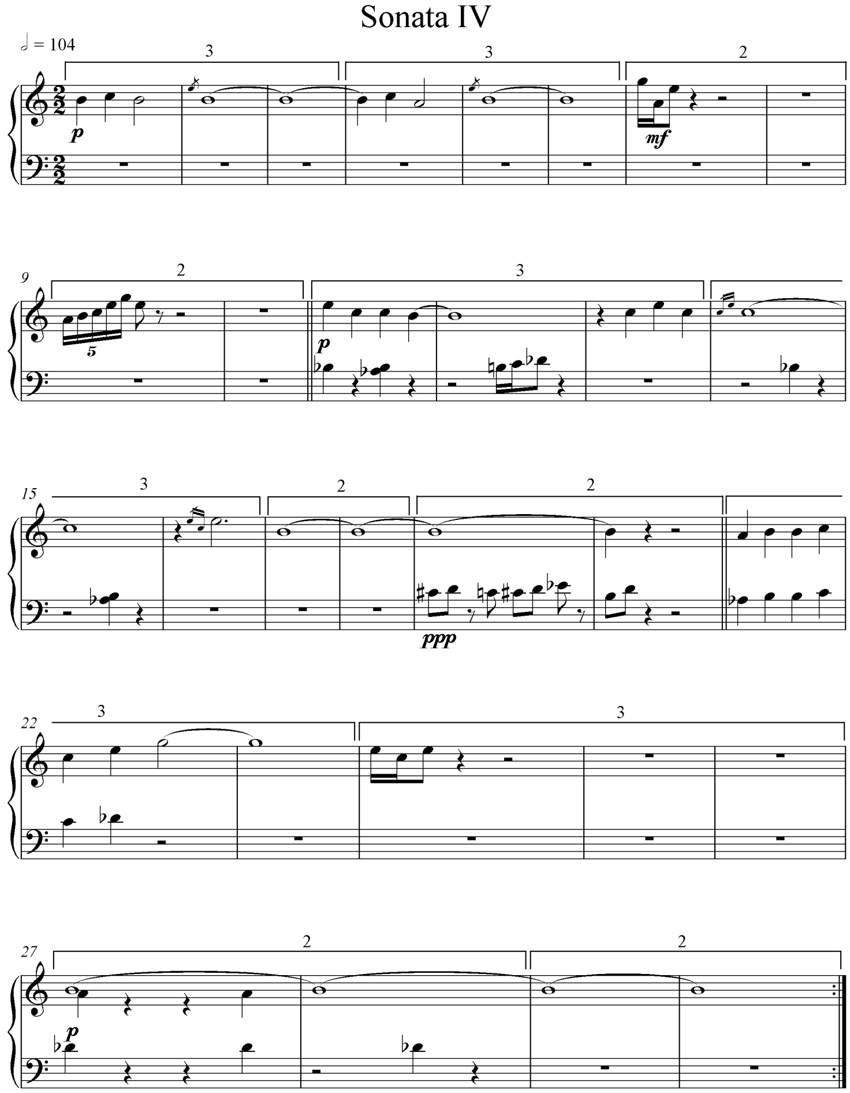

**Ex. 7** Cage, *Sonatas and Interludes*, 4th sonata

A further example to illustrate is Sonata XI, which has an insistent A-flat acting as a quaver pulse around which other pitches orbit. The same pitch (in the same register) has a cadential function in a later phrase in the piece, and appears frequently as sustained pitches in the B-section. David W. Bernstein has spoken of ‘tonal references’ in the sonatas; he points to pitch-centricity around A in Sonata IV, as well as Sonata XII having a centricity around B. However, as he admits, ‘many elements of this language remain unfixed’.[55] This is due to the preparations of the piano, which muddle any abstract tonal relations that may emerge from an otherwise unprepared piano. Yet this is the point: Cage's priority was sound, and not harmony. However, I would state if we accept that the piano preparations rule out any concept of a tonal argument, it remains possible that Cage wished to accentuate certain sounds and give weight to certain tones, prepared or not, in a way that tonal composers gave weight to the tonic and dominant harmonies in structuring their pieces. Thus it is not quite right for Patterson to say that Sonata XVI closes the cycle in ‘unambiguous G major’: This disregards the piano preparations which, of necessity, create 'disturbances' that dissolve the tonality, neither are there conventional harmonic progressions or directions designed to establish a given key.

Another significant piece prior to the *Music of Changes* is his *String Quartet in Four Parts*. This uses a ‘gamut’ of sounds. The gamut is a linear arrangement of randomly selected single sounds or aggregates that remain in force throughout the piece as the pitch materials. Cage emphasizes the ‘immobility’ of the technique; the pitches in each gamut stay in the same register as they start in. No transposition of the elements is applied, nor is there variation in the method of production:[56] a clear influence of Webern's habit of fixing pitches in the register they appear in. Of note is the fact that Cage did not use automated procedures to choose pitches from the gamut in all movements but the third, where the gamut is subjected to procedures of canon. In essence, the purport of the gamut is that it represents another step in pre-compositional decision making, as well as enlarging the scope of Cage’s sound world. The use of the technique meant decisions regarding the musical materials to be used in a piece before the composition was to begin. In the *String Quartet* the gamut represents the entire musical materials of the piece and there are no deviations or developments of the bank of sounds which Cage has designed for himself.[57]

In a later piece, Cage modified his thinking on the gamut in his composition of *Concerto for Prepared Piano and Chamber Orchestra*. Instead of a linear gamut, Cage organized the materials into a 14 x 16 chart. He assigns rows to single instruments or groups within the 25-player orchestra, and so, the first four rows are assigned to the winds, the next four to the brass, the third quarter to the percussion and the remaining four to the strings, mirroring the standard layout of an orchestral score. Therefore, selection of a given cell determines the instrumentation too. In the predetermination of cells and instruments, which Ligeti referred to as ‘prefabricated arrangements’ in his assessment of serial music, Cage’s own pieces were similar in method. A form of pointillism similar to serial music results from the instrumentally varied lines, which are point or group-like in character rather than traditionally melodic.[58]

In the first movement, he says in a letter to Boulez that he made ‘moves of a thematic nature’ to determine which cells are deployed although as he says, ‘an “athematic” result is the consequence’. The piano part is freely composed. This separation is mirrored in the strict separation of the piano from the orchestra - they rarely, if ever, sound together and no dialogue between them is permitted, although various players are instructed to assist the pianist in helping produce certain sounds by moving a plastic bridge that produces an array of microtones. Cage also retained features of earlier music: First, the rhythmic structure technique of earlier works, this time using a 23 bar structure subdivided into 3: 2: 4: 4: 2: 3: 5. Cage abides by this structure in all of the movements, and the audibility of the structure is most striking in the last movement, whereby the end of each microstructure is a five-bar measure of silence. As the title suggests the piano is subjected to preparation; this time a bridge is inserted into the piano to create microtones.

The last movement of the piece is perhaps most significant from the point of view of Cage's technical approach. He decided to merge the piano and orchestra into one chart and consulted the Chinese divination text, the *I Ching,* in order to make decisions on which sounds from the orchestra or piano were chosen. Fittingly, the strict separation between piano and the orchestra is relaxed somewhat in these movements, although this mainly consists in quiet held notes in the orchestra whilst the piano plays a more prominent and virtuosic role, rather like a traditional concerto.

The *I Ching* proceeds by opposites. In consulting the 64 hexagrams which constitute the text, one either encounters a solid line, representing ‘male’ or a broken line which denotes ‘female’ and each of these has a corresponding ‘moving’ line, that is, a transition from one state to the other. The method of ‘divination’ is by coin-tossing: Two heads and a tail is a solid line, two tails and a head is a broken line, three tails is a solid line moving to a broken line, three heads is a solid line moving to a broken line.

For a solid line, Cage chose a sound from the piano and for a broken line, a sound from the orchestra, based on the extant chart from the second movement. For moving lines, solid to broken resulted in a sound for the orchestra then the piano, and broken to solid, the opposite. The parameters of the piece are also subject to chance: these are tempi, durations, sounds and dynamics. Cage also defines the parameter of ‘superpositions’, which are similar to the strands of Boulez's *Structures* in that they define how many simultaneous events are happening in the piece at once. Cage’s procedure was to use the *I Ching* to select the sounds from the pre-existing charts, based on two additional charts which consisted of either empty cells or ‘moves’. If a cell with a move was selected he chose an appropriate sound to insert into the piece, however, if the cell was empty, a silence was inserted instead. The result is startling to listen to. Cage had, through the use of ‘unaesthetic choices’ and extensive preparations, come closer to letting sounds be themselves.

Cage’s next major work, *Music of Changes* for solo piano, forms a counterpart to Boulez’s *Structures* with its systematic precision and his most sophisticated pre-compositional plan to date. It also saw Cage alter previous practices or render earlier practices redundant: For instance, although he uses a rhythmic structure of 29 5/8 x 29 5/8, divided into 3, 5, 6¾, 6¾, 5, 31/8. Each section of the microstructure has a different tempo (subject to *accelerandi* and *ritardandi*) making the structure meaningless from the point of view of perceptibility. He also dispensed with conventional notation in that he used spatial notation to indicate durations, with a basic unit of a crotchet equalling 2.5 cm acting as the scale. However, Cage used a wide range of durations, not only those based on the even division of a crotchet, as well as odd divisions (e.g. quintuplet), down to a demi-semi-quaver, mirroring the rhythmic complexity that Boulez had discussed in letters to Cage (He had also written of his frustration at the profusion of ‘half-notes’ in the *Concerto*).[59] Along with the tempo fluctuations, this led to Cage’s most rhythmically diffuse piece yet, as well as performance problems for the outstanding pianist, David Tudor, who had to devise mathematical formulae to ensure an authentic performance.

For the composition of the piece Cage used the *I Ching* again, this time more extensively in order to determine which materials are selected from the charts he devised prior to the chance operation. In that sense, the finished version of *Music of Changes* is but one of myriad other potential results, due to chance. On the other hand, Cage was at his most methodical in his devising of the charts: Each chart used is 8 x 8, with an element specified in each square. Eight charts are used for the various sounds and silences of the piece (named ‘aggregates’ by Cage)[60], as well as eight charts for durations, eight charts for dynamics, one for tempi and one for ‘superpositions’, these being the number of layers present at any given moment. The durations, aggregates and dynamics charts are subject to an intriguing bifurcation: four are ‘immobile’ and four are classed as ‘mobile’. This means that four of the chart’s materials remain static and capable of reselection (immobile), and the other four charts have materials that are ‘mobile’, that is, once used, they are discarded and replaced by a new sound.

Cage was then ready to compose. He abided by his preordained rhythmic structure, and then proceeded to ‘divine’ a single hexagram to give the number of layers for a phrase and its tempo. Cage then tossed coins for each layer that the hexagram had determined. The exact method was to toss three coins six times to yield a hexagram (mirroring the 64 hexagrams of the *I Ching*) selecting each element from his charts in turn to construct a musical phrase. Even numbers for sounds yielded silences, and odd gave a sound or a noise (of indefinite pitch). Cage composed in such a way that one can read the chart horizontally or vertically and each row or column will contain all 12 tones.[61]

In respect of dynamics, 16 numbers, in a sequence from 1, 5, 9… produce a dynamic change and the rest maintain the previous dynamic. Cage also factors combinations into the mix, which are recognised as either crescendi or diminuendi. Rhythms, compared to Boulez’s offering, are even more intricate in Cage’s work, foreshadowing the extreme virtuosity of later works such as *Etudes Australes*. Cage bases rhythms not only on subdivisions of a beat, but also fractional amounts applied to these subdivisions (i.e. two thirds of a demi-semi quaver, three fifths of a crotchet) giving a quantity of durations that, per Cage, are ‘practically infinite in number’.[62] Indeed, because of this, the piece was Cage’s most convoluted in terms of rhythm. A comparison of ex. 7 with ex. 8 will show the difference. Though there are more complicated movements from the *Sonatas and Interludes* set, they do not approach *Music of Changes* in this regard in terms of ramification. It is significant that Cage’s subordination of rhythm to chance produced results that he might not have he pursued composition more habitually, and indeed, had not up to that time. Similarly, it is interesting to note that when Cage returned to ‘traditional composition’ as in *Cheap Imitation* or the Number Pieces of later, rhythms are much simpler or abandoned altogether in favour of single durations (as in the single sounds or chords of *One5* composed in May 1990 for piano) embedded in his time-bracket system.

An extract from the score will serve to illustrate the multifaceted nature of Cage’s approach:

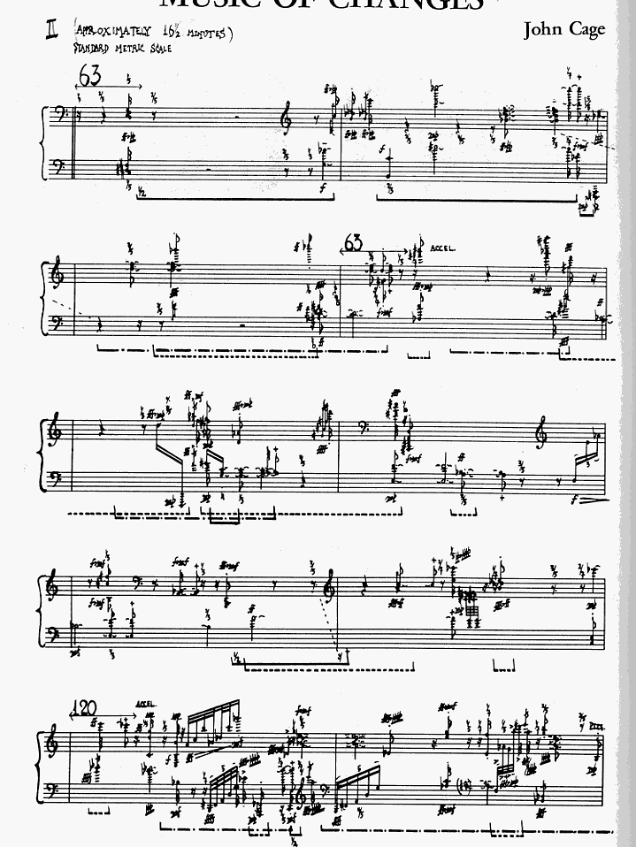

**Ex. 8** John Cage, *Music of Changes*, 2nd movement, opening bars

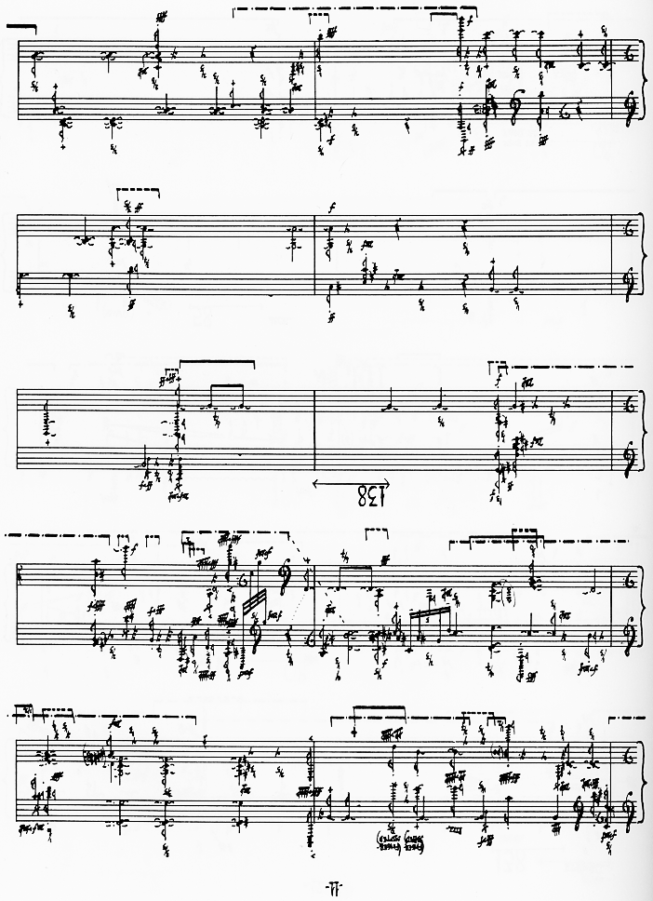

**Ex. 8** (*cont*.)

The piece shows a tension between old and new techniques; Cage’s square-root form is still in evidence, but the decision to use chance to determine tempo via an eight by eight grid and to make the transitions between these tempi a continual flux are a new idea. Not only do the shifting tempi make the rhythmic structure as it relates to musical concepts redundant, Cage’s desire to compose in terms of space and time rather than musical beats make the rhythmic structure little more than a visual backdrop. Indeed, an identically measured space within the piece will vary with respect to the desired tempo at that time.

In conceiving music as primarily rhythmic; a space within which sounds and silence could co-exist, Cage’s *Music of Changes* was one of the first works to *notationally* reflect this belief. Cage opts for a proportional notation where the durations are determined by the space they inhabit in relation to a scale. A crotchet equals 2.5 cm in this case, and all other durations are derived from this.

Aside from the notational innovation, the score reveals the extreme moment-to-moment nature of the music – the lack of continuity between musical events surpasses *Structures 1A*. Whereas in Boulez’s work, each ‘structure’ had a global dynamic and a perceptible serial thread or bundle which one could grasp, at the formal, precompositional level at least, there is no possibility of any tying thread in Cage’s work. David Tudor, who had had to come to terms with both composers’ works, said of Boulez’s Second Piano Sonata that ‘I had to put my mind in a state of non-continuity – not remembering – so that each moment is alive’. The same, *a fortiori*, could be said of Cage’s protean work.

Because of the chance operations, the fluctuations between multiplicity and scarcity are strictly non-intentional, nevertheless, the piece might be thought of as a dialectic between these two poles. A differently minded composer might have sought to synthesize these two extremities, but this was precisely the sort of intentional thinking Cage wanted to rule out.

This extract is one of the denser moments of the piece, and a look at bar nine shows the complexities required of the performer. Each pedal of the piano is used at some point and there are several types of sonic gesture: isolated attacks, grace notes, rapid flurries, fractional durations and chords of varying registral spans all expressed through a wide range of dynamics. All of this is performed at a tempo which very gradually accelerates to the next tempo in precisely 6.75 units time. Compare this with bar 16: The music is at a stable tempo and has a number of separate attacks countable on (though not playable by) one hand.

The frenetic nature of the work did not only extend to movements of the pianist’s hands but also his body in order to execute some of the extended techniques Cage required: In bar 11 the pianist must rise to mute a single attack. These techniques served to distance him from the acoustic purity of Boulez’s serial experiments: The performer is also required to strike, scratch, pluck and sweep across the strings of the piano, recalling Henry Cowell’s experiments with string piano. Cage also asks for percussive gestures, such as striking of the piano lid or parts of the piano with a beater.

As abstract as *Structures 1A* is, there are sections where a change in tempo is perceivable and as Ligeti pointed out in his analysis, Boulez pays special attention to the overall tempo structure of the piece.[63] It makes no sense however, to speak of Cage’s piece as a fast or slow piece, not least because of Cage’s mutable tempi. Such musical considerations are simply sidestepped but nevertheless cement its reputation as a tour de force of algorithmic composition. Actually, Tudor regarded the tempo fluctuations in the work as paramount and consulted a mathematician to derive two formulas for the durations at a stable tempo and at a modified tempo. It is apt that the pre-performance work of Tudor, who apparently amassed as many as 80 pages of computations, graphs and lists as performance aids[64] was mirrored by Cage’s own intense pre-compositional planning.

Cage might be said to have more readily grasped the consequences of automatism. He appreciated that assigning musical decisions to numbers or chance operations was a removal of the will of the composer, and to this end he understood, perhaps more than Boulez, that it was extinction of the composer: ‘*The Music of Changes* is an object more inhuman than human, since chance operations brought it into being’. [65] Cage’s future compositional endeavours, from *4’33”* to *HPSCHD* are more consistent with the consequences of total automatism: that of apparent purposelessness. Cage was by temperament and outlook, more accepting of removing human agency from music than Boulez ever would be.

It must be said however that *Music of Changes* was the summit of Cage’s experiments with total organization by chance to date. Faced with the seeming paradox of chance processes producing a work of forbidding complexity and determinism, he continued to use random procedures to produce pieces that were indeterminate with respect to length, structure and outcome. The degrees of indeterminacy varied from piece to piece. For instance, *Atlas Eclipticalis* (1961) is for an 86-strong orchestra, though any number or combination of players may perform the piece. Unlike his *Music of Changes,* tempo is unspecified and the durations relate to the tempo specified by the conductor in performance. He also experimented with indeterminacy in *Concert for Piano and Orchestra* (1957-8). As non-linear as *Music of Changes* might have been in terms of musical direction, the expectation is that one plays through the score page by page as one would with a traditional piece of music. In *Concert for Piano and Orchestra* piece one simply has parts for each instrument which can be played in any order by any combination of instruments (compare this with *Music of Changes*, which unquestionably requires a virtuoso pianist). Thus, it can act as a solo piece for piano, a chamber ensemble piece or an orchestral piece. At the notational level, the parts are somewhat detailed but aspects such as durations, dynamics and pitch are unspecified or hinted at. Though Cage retained the use of chance as an algorithm throughout his works, after *Music of Changes*, it would not be to produce such determinate results in musical composition again until the three sets of etudes in the 1970s.

**4. Iannis Xenakis and *Achorripsis***

Xenakis was a singular figure in his incorrigible harvesting of mathematical techniques for the purposes of music production. In fact, several of his pieces apply probabilistic mathematics to music, including the law of large numbers.[66] His experience as an engineer and architect gave him confidence in the usage of mathematical techniques for non-musical problems.

His *oeuvre* is a testament to the creativity of applying mathematical theories to various musical problems to produce works of unique power and scope. As these techniques were highly novel (and remain so) he felt compelled to explain and justify his practices which served the purpose of exposition of the work as well as defining his own position, which as we will see is opposed to practices we have already discussed.

As discussed at the end of the second chapter, it mattered to Xenakis that his own theories had a solid intellectual basis and he attacked competing theories which he believed did not hold up to scrutiny. Furthermore, Xenakis believed that the intellectual debates in music at the time had their roots in philosophy beginning with the Ancient Greeks.[67] The titles of his pieces overtly reflected intellectual concerns, for instance, *Pithoprakta* meaning ‘actions through probability’, *Terretektorh* meaning ‘construction by action’ or *Synaphaï* meaning ‘connexities’.[68] *Pithoprakta* and *Metastaseis* had won Xenakis notoriety for his usage of probabilistic methods to create sound-masses at variance with the serialist music of the time. *Achorripsis* (Greek for ‘jets of sound’) was a continuation of the ‘stochastic music’ he had begun to investigate in his compositions and propound in various articles, but it is distinct from the earlier works in being the first to rigorously follow a formal plan derived from the mathematical laws Xenakis had imposed.[69] It might be regarded as analogous to Boulez’s own *Structures* in that Boulez’s works prior to *Structures* had utilised the 12-tone row less stringently.

Xenakis, in his critique of his contemporaries, believed that the correct way to understand chance was through understanding probability. Probability theory says that an event, such as rolling a seven with two dice, is an event which can be assigned a numerical value that indicates the probability of its occurring. Naturally, rolling a seven is only one possible outcome of several in this case, and indeed one is able to assign a numerical value to each outcome. The sum of these outcomes equals one and the various probabilities of the events or variables are known as a *probability distribution*.[70]

Certain classes of probability distributions are used for calculating probabilities. In order to use these distributions in a valid sense, it is assumed that the events are *independent*, that is, the likelihood of one event occurring is not affected by a previous event. Xenakis reasoned that he could apply such thinking to music. His overarching idea was that sounds made by an instrument or collection of instruments could be governed by a mathematical formula or law, and could be construed as events occurring in a given time interval. His choice for modelling these events was the *Poisson distribution,* which is used to determine the probability of a certain number of events happening in a given time[71]:

I shall define the terms as follows: *p* is the probability of an event occurring, λ (Greek symbol for lambda) is the expected initial probability, *k* is the number of events we wish to test the probability for and *e* is a mathematical constant equal to 2.7183 that is the base of the natural logarithms. The exclamation mark denotes a ‘factorial’ number, which requires the multiplication of the number specified and any positive whole numbers less than or equal to the number specified (That is, 2! expresses 2 x 1 and 6! is the product of 6 x 5 x 4 x 3 x 2 x 1). To give a non-musical example at first, suppose that on a usual day that a doctor sees on average six patients an hour. The probability that the doctor would see exactly three patients, arriving at random intervals, in a given hour is calculated:

$$P_{3}=\frac{6^{3}}{3!} e^{-6}$$

$$P_{3}= \frac{\left(216\right)}{6} \left(0.00248\right)=0.09$$

Thus, the probability of this occurring is 9% (0.09 x 100 = 9). One can do the same for all other possibilities in our thought experiment, from no patients to an above average number of patients. Each calculation produces a numerical probability of each event occurring. Note that the Poisson formulation requires an initial estimate to be put into the calculation. This is the value of λ and in our previous example, this number was six - Xenakis chose 0.6 for this particular value, from which he obtains the following probabilities:

Po = 0.5488

P1 = 0.3293

P2 = 0.0988

P3 = 0.0198

P4 = 0.0030

P5 = 0.0004

In this instance, the likelihood of no events occurring is the highest probability, at ≈ 55%, the likelihood of one event occurring is ≈ 33% and so on. The value of λ affects the probability distribution in that a higher value will increase the probability of some event occurring and for a lower value this will increase the probability of nothing occurring.[72]

How does Xenakis apply this to music? He begins by defining seven different timbres and specifies that the piece will be split into 28 units of time. Therefore, multiplying these numbers gives us 196 – therefore there are 196 cells in which musical events will happen or not happen. The probabilities above relate to the likelihood of how many cells will have no events, one event, two events and so on. To distribute these probabilities amongst the grid, they are multiplied by 196 to yield the following values:

Po = 0.5488 x 196 = 107

P1 = 0.3293 x 196 = 65

P2 = 0.0988 x 196 = 19

P3 = 0.0198 x 196 = 4

P4 = 0.0030 x 196 = 1

P5 = 0.0004 x 196 = 0

Therefore, of the 196 cells, 107 are such that no events occur: In musical terms, we have silence. Xenakis also applies Poisson’s law to distribute the various events amongst the grid. The finished grids are produced on pages 40-41.

That is, he re-uses the same calculation to determine how many columns will have instances of each type of event (or non-event). For instance, the calculations determined that 65 cells would contain a single event. As there are 28 columns, performing the following calculation 65/28 yields 2.32, a new value by which to determine how columns have 0 single events, 1 single events, 2 single events and so on:

$$P_{2}=\frac{{2.32}^{1}}{1!} e^{-2.32}$$

The above value yields approximately six columns in which one single event will occur. This is borne out by fig. 16, which I have reproduced from Xenakis’s own chart. Once the columnar calculations have been completed, Xenakis reapplies the formula for the instance of each type of event per row and so horizontally and vertically, the matrix has the same level of logic. It is evident that the pre-compositional plan has a remarkable degree of rigour and consistency, following a deductive chain of initial calculations and subsequent recalculations based on the data provided by Poisson’s elegant algorithm, although Xenakis did manipulate some of the figures for musical or artistic considerations.[73]

Regarding what constitutes a ‘single event’, this is not as simple as mapping ‘single’ to one, ‘double’ to two. Xenakis specified an average for each: zero remains zero, a single event has on average five sounds per bar, a double event has 10, a triple event has 15 and quadruple is 20. This influences the composition of the notes, but the notion of an average allows for more scope compositionally. That is, deciding that a single event could be anywhere from 2.5 to 6.5 sounds per bar allows for greater possibilities. Xenakis specifies that each column in the matrix is equal to 6.5 bars. Therefore, as Arsenault explains, we would expect a single event cell to have, on average, 32.5 separate attacks (the product of 6.5 x 5).[74]



**Fig. 16**General plan of *Achorripsis*

|  |  |  |  |  |  |  |  |  |  |  |  |  |  |  |
| --- | --- | --- | --- | --- | --- | --- | --- | --- | --- | --- | --- | --- | --- | --- |
| **Column** | **1** | **2** | **3** | **4** | **5** | **6** | **7** | **8** | **9** | **10** | **11** | **12** | **13** | **14** |
| **Flutes** |  | 4.5 | 6 | 9 | 10 |  |  |  | 5 |  |  |  |  |  |
| **Oboes** |  |  |  |  |  | 5.5 | 4 |  | 5 | 6 |  |  | 4.5 |  |
| **Gliss** |  |  | 5 |  |  | 5 |  |  | 4 | 10 |  |  | 14 |  |
| **Perc.** |  |  | 9 |  | 9.5 |  | 8.5 |  |  | 4 | 5 | 6.5 |  |  |
| **Pizz.** | 3.5 | 6 | 4.5 |  | 4 | 5 | 5.5 |  | 4.5 |  |  |  | 5 |  |
| **Brass** |  |  |  |  |  |  | 10 |  | 5.5 |  | 10 |  |  | 4.5 |
| **Arco** |  |  |  | 6.5 | 15 |  | 3.5 |  |  | 11 | 4.5 |  | 10 |  |

|  |  |  |  |  |  |  |  |  |  |  |  |  |  |  |
| --- | --- | --- | --- | --- | --- | --- | --- | --- | --- | --- | --- | --- | --- | --- |
| **Column** | **15** | **16** | **17** | **18** | **19** | **20** | **21** | **22** | **23** | **24** | **25** | **26** | **27** | **28** |
| **Flutes** |  | 9.5 | 5 | 4 | 5.5 | 2.5 |  | 5 | 6.5 |  | 4.5 |  | 5.5 | 10.5 |
| **Oboes** | 5 |  |  | 3.5 | 4.5 |  |  | 5 |  |  | 20 |  |  | 6.5 |
| **Gliss** | 3.5 | 6.5 | 4.5 |  |  | 11.5 |  | 6 |  |  |  | 6 | 4 |  |
| **Perc.** |  |  | 10 | 6 | 4 | 3.5 |  |  |  |  | 11.5 | 5 |  |  |
| **Pizz.** |  |  | 5.5 | 3.5 |  |  | 17 | 10.5 | 10 |  | 4 |  | 6.5 | 5 |
| **Brass** |  |  |  | 5 | 6.5 | 5 |  |  |  |  | 10.5 |  | 6 |  |
| **Arco** |  |  | 5 | 4.5 | 4 | 5 |  |  |  |  | 9 | 6 | 16 |  |

**Fig. 17**Numerical density plan for *Achorripsis*

Looking at figure 17, we see in the first column, which is a single event for pizzicato strings, that there should be 22.75 sounds in the first ‘unit of time’ (3.5 sounds on average per measure x 6.5 bars = 22.75 sounds in total). Looking at the opening 13 bars as an example, Xenakis has 22 different sounds in the first unit in the pizzicato strings, and the second unit of time begins with the entrance from piccolo, e-flat clarinet and bass clarinet which has a single event of an average of 4.5 sounds per measure (29.25 sounds in a unit of time) whilst the string pizzicato increases in density to an average of 6 sounds per measure (39 sounds). This is mostly borne out by what we find in the actual score and Xenakis stays relatively faithful to his preordained plan in this regard (ex. 9).

In terms of the architecture of the piece, it is hard to see an over-arching goal and at best it might be thought of in terms of three sections delineated by the ‘silences’ (at column 8 and 24). In terms of dynamics rather than density, the first section might be thought of as a generalized crescendo, with the loudest section occurring at Column 6, from bars 32.5 to 39. This demonstrates that Xenakis did not consistently co-ordinate dynamics with the numerical density. It is also interesting to note that Column 8, which has no sounds at all, is contradicted by the result in the score which has isolated sounds in pizzicato strings from bars 45.5 to 50, although a quiet dynamic is observed.

Column 9 begins half a bar early at the beginning of 51 but this section lasts 7.5 bars to compensate for the early entries. The middle section of the piece, from Column 9 to Column 23 is more varied. The first five columns are fairly constant with regard to density though Xenakis varies the dynamics and there is a greater role for percussion and the glissandi strings, with the glissandi more undulating and swooping than in the previous section. The midpoint of this section has a much sparser passage for the percussion followed by the return of the strings. There is a gradual rise and fall in both the number of instruments and volume level before reaching the third and final section, beginning at bar 156. Here is the loudest section of the piece in terms of volume and density (it is the only section of the piece which has a quadruple event, which is given to the oboe class of instruments). The intensity level is maintained, with the reduction in dynamics coming from a numerical diminution. The usage of density and masses to structure musical time was consistent with Xenakis’s other works of this period, such as *Metastaseis*.

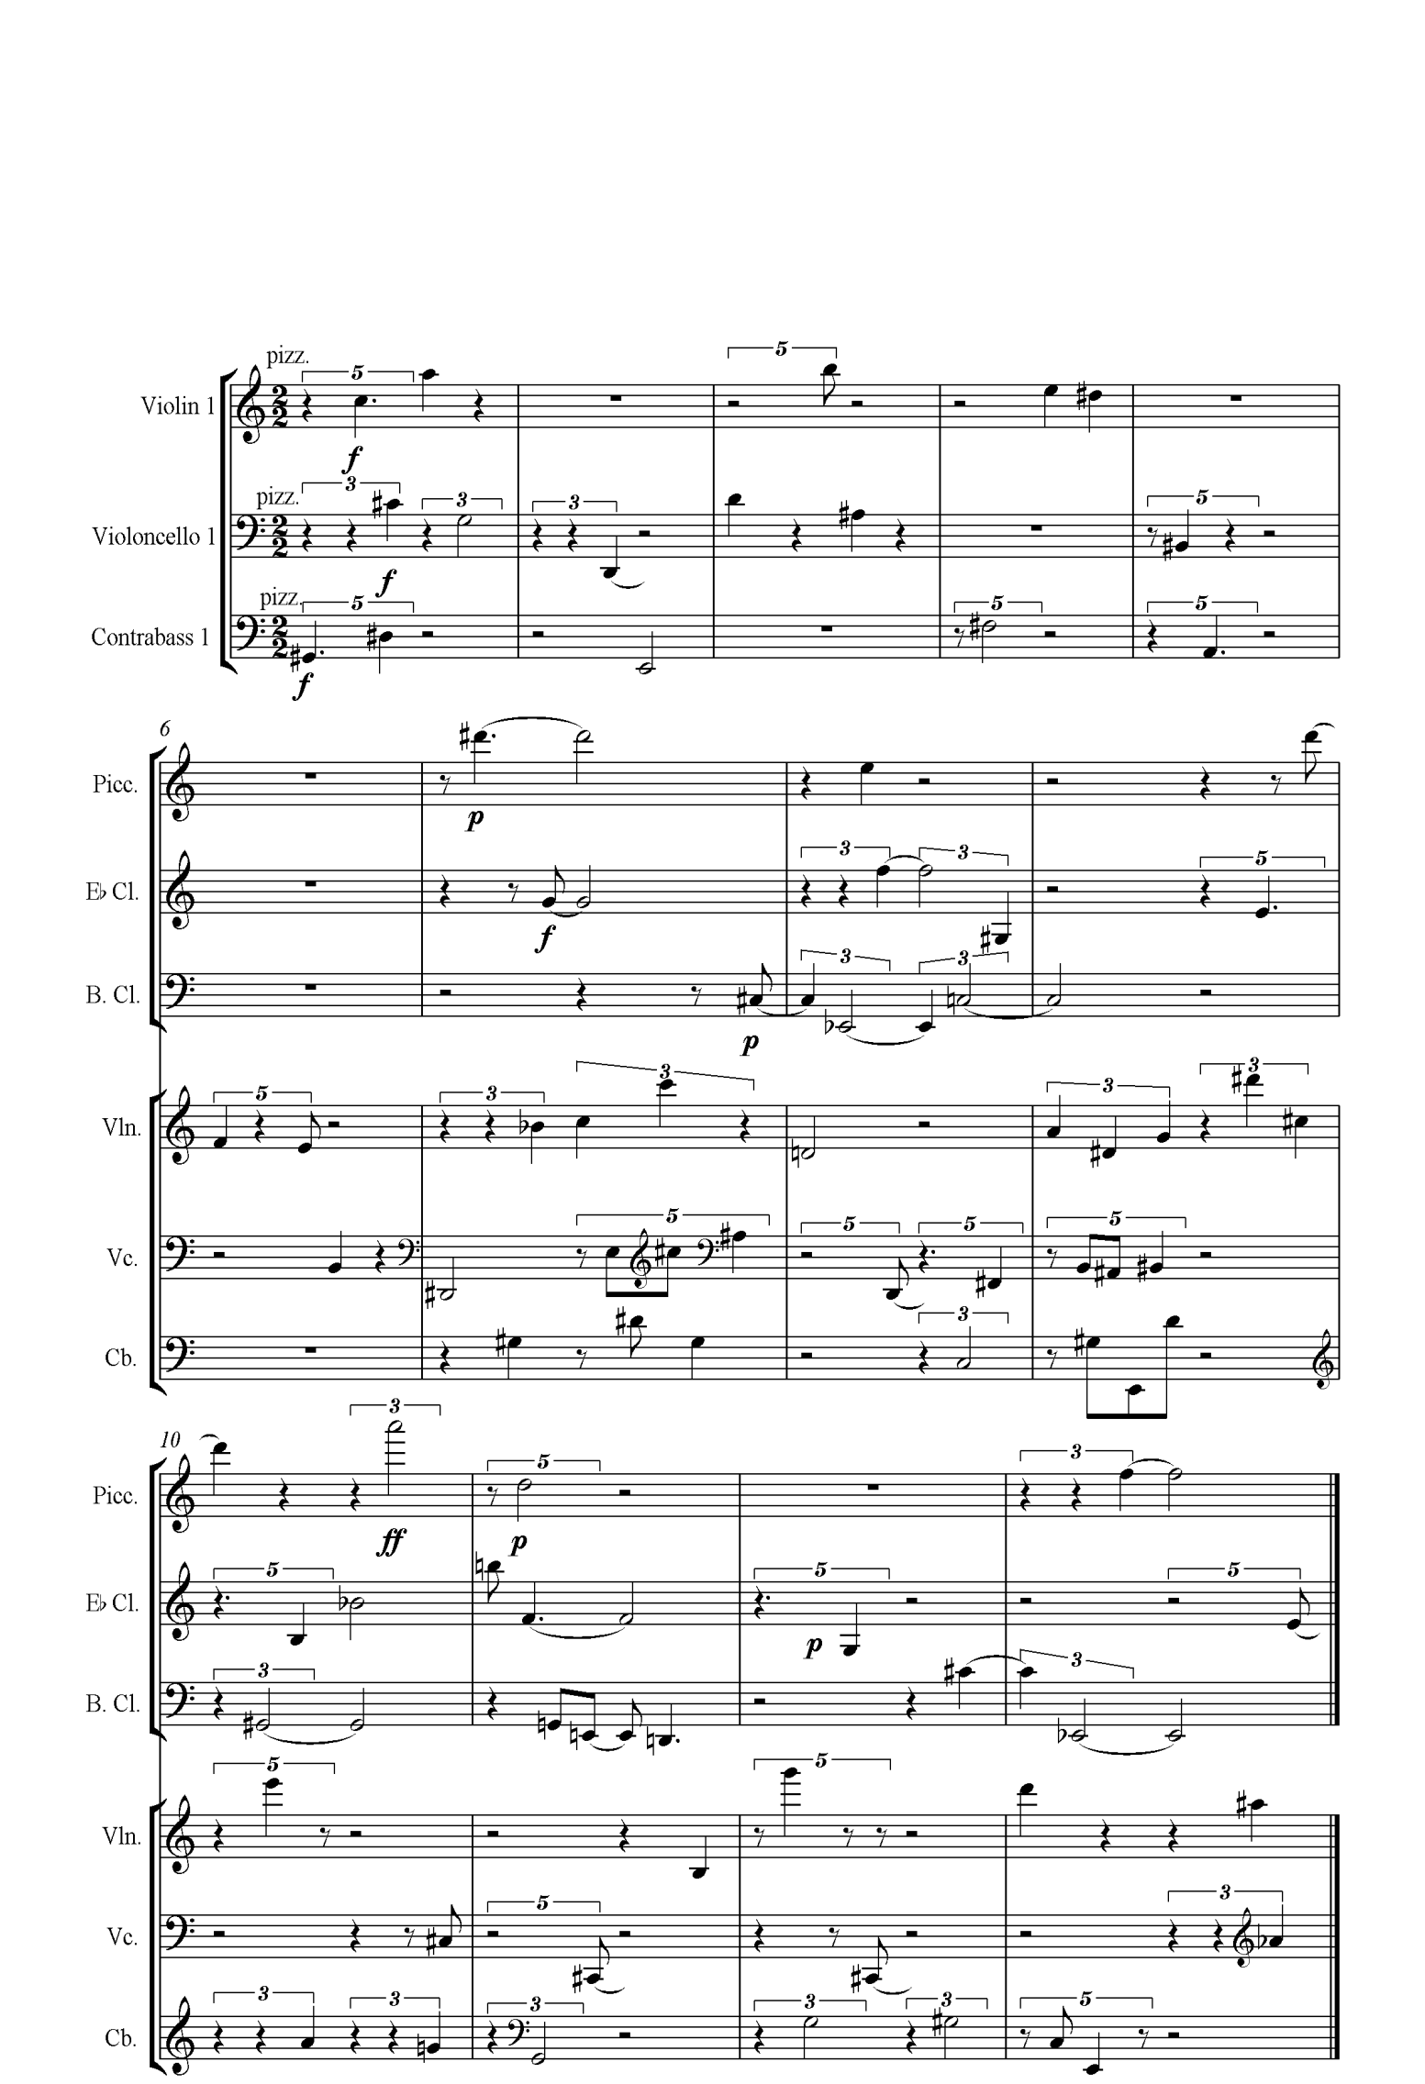

**Ex. 9** Xenakis, *Achorripsis*, opening bars

The usage of statistical distributions also extended to the sounds within the matrix. The calculations are somewhat different but retain the usage of probability distributions to produce numerical values. Xenakis uses various probability distributions to draw up three tables of probability for a table of durations, a table of speeds and a table of intervals. The durations are relational, that is, they are not absolute units of time but are rather to do with the durations between notes. In addition, one should observe that the interval calculations are concerned with discrete, non-glissandi attacks, though the composer must decide on where to start. The glissandi have their own calculations, determined by rate of change over time.

However, as with *Structures 1a*, certain considerations are left out of Xenakis’s calculations. The dynamics are terraced – no crescendi or decrescendi feature in the entire piece. As mentioned before, Xenakis might be constrained by interval choices, but not the starting note of the interval. Similarly, articulation is down to the composer’s own preference. This avoids at least, the troubles of Boulez and Cage in yielding irrational articulation/dynamic combinations.

Given Xenakis’s commitment to modernism, the pitch material in *Achorripsis* is highly chromatic, and Xenakis was certainly not interested at this stage in reviving tonal music as he had hailed the emancipation of the dissonance as ‘a new path parallel to that of the physical sciences’[75]. Moreover, one of his core precepts in composing music was to ‘construct an abstraction from all inherited conventions and to exercise a fundamental critique of acts of thought’.[76] Though the music is not strictly 12-tone, it is very angular in terms of rhythm and pitch displacement, particularly in the writing for the clarinets, bringing to mind the pointillist music of the Second Viennese School. In ex. 9, the texture is closest to that of polyphony, but with no intentions on the part of the composer of these voices relating to one another as a canon might. The continuity and smoothness of the melodic line is upset by large spaces between attacks, or groups of attacks. One also observes the large leaps between attacks in all of the instruments, as well as fixed but distinctly contrasted dynamics.

This style of writing is sometimes juxtaposed with slower-moving, continuous changes in pitch played in the strings. An example of this is the tremolo glissandi in the third bass and violin in ex. 10. Most striking of all is the complexity of the texture: isolated attacks, angular passages, pizzicato and arco strings combine with the seemingly glacial glissandi. This example shows the evolution in texture from the beginning of the piece.

Certainly, one characteristic that had distinguished Xenakis’s music up to this point was the usage of slow-moving glissandi in their own right as musical materials, rather than as isolated dramatic gestures[77], and the presence of these served to prevent any confusion of his music with the atonal music of his contemporaries. In fact, the ending of the piece is notable for a particular use of glissandi strings: A slow, excruciating ascent from B5 to A#6 for seven bars on a violin in tremolo at ***fff*** is set off against the contrary motion of the bass which covers more ground in its descent, moving from E4 to Bb2. Complementing this is the sustained tremolo in the third cello. Xenakis scores each of these as *sul ponticello* to distinguish them further.

Be that as it may, there is nothing about Xenakis’s rules that would dictate the stylistics of a resultant piece, and much like *Structures*, it is akin to a game which may be played in many different ways and different results which still obey the rules of the game (one could do the same with *Music of Changes or Structures 1a*). Despite a minor infringement of the rules to avoid silence in the piece for stretches of time, and an admission from the composer that ‘the theory and the calculation define the tendencies of the sonic entity, but they do not constitute a slavery’,[78] *Achorripsis* is one reasonably faithful realization of the rules Xenakis laid down.

One may aver that *Achorripsis* was just one of many of Xenakis’s immensely abstract and formal musical compositions and to this one must assent. Some of the works which followed such as *ST/10-1, 080262* are realizations of the theories laid down by Xenakis in *Achorripsis*, only this time the computations were done by computer. However, I would argue that *Achorripsis* was Xenakis’s most formalized work *up* to that point. The only work prior to *Achorripsis* that could approach the same level of formalism is *Pithoprakta*. Xenakis himself conceded that *Pithoprakta* was the ‘starting point of a (sic) utilisation of the theory and calculus of probabilities in musical composition’.[79] *Pithoprakta* also used probability distributions to determine attacks, speeds, as well as the velocity of the glissandi but the tripartite form of the piece was still Xenakis’s own personal preference, and the section lengths and orchestration, not to say timbral choices are also the results of his own design. Whereas, what we find with *Achorripsis* is a further move towards formal abstraction, as the matrix and its completion in accordance with the mathematical rules establish the form of the piece, which is in essence, twenty-eight sections following one after the other. The lack of real musical goal or path in *Achorripsis* reinforces this: The instruments appear to be switched on or off according to their place in the grid at a given point in time, and the manner of the writing does not vary much for each timbral class, only the density. This is in contrast to *Pithoprakta*, in which clear compositional dialectics are set-up such as the percussive knocking on the violins and the expansive passages for the arco strings at the beginning, in which the arco strings ‘win out’ before giving way to the next textural development.

In closing, what is most remarkable of all about the structure of *Achorripsis* is that, in an era when the forms of classical music seemed to be forever lost, with considerations of open forms and indeterminacy *de rigueur* in the 1950s, Xenakis’s recurrent blocks of time are absolutely regular and invariant. It was only in later works that he considered variable section lengths when composing algorithmic music.[80] Nevertheless, *Achorripsis* was a pioneering work in incorporating probability structures into the field of musical composition, providing Xenakis with a rigidly structured grid of time into which he would compose according to numerical denotations which dictated the number and duration of each section, its density, as well as the type of instrument performing the events within the piece. In this sense it is worth comparing with the works examined hitherto: Xenakis had gone one stage further than Boulez in specifying density as a parameter determined by probability[81]: This was something Cage had done in *Music of Changes* with his ‘superpositions’ or layers. However, aspects such as dynamics and articulation were left untouched by algorithmic control in this particular piece. This was something he addressed in future pieces, such as those based on the ST algorithm. *Achorripsis* was a necessary step on the way to such endeavours.

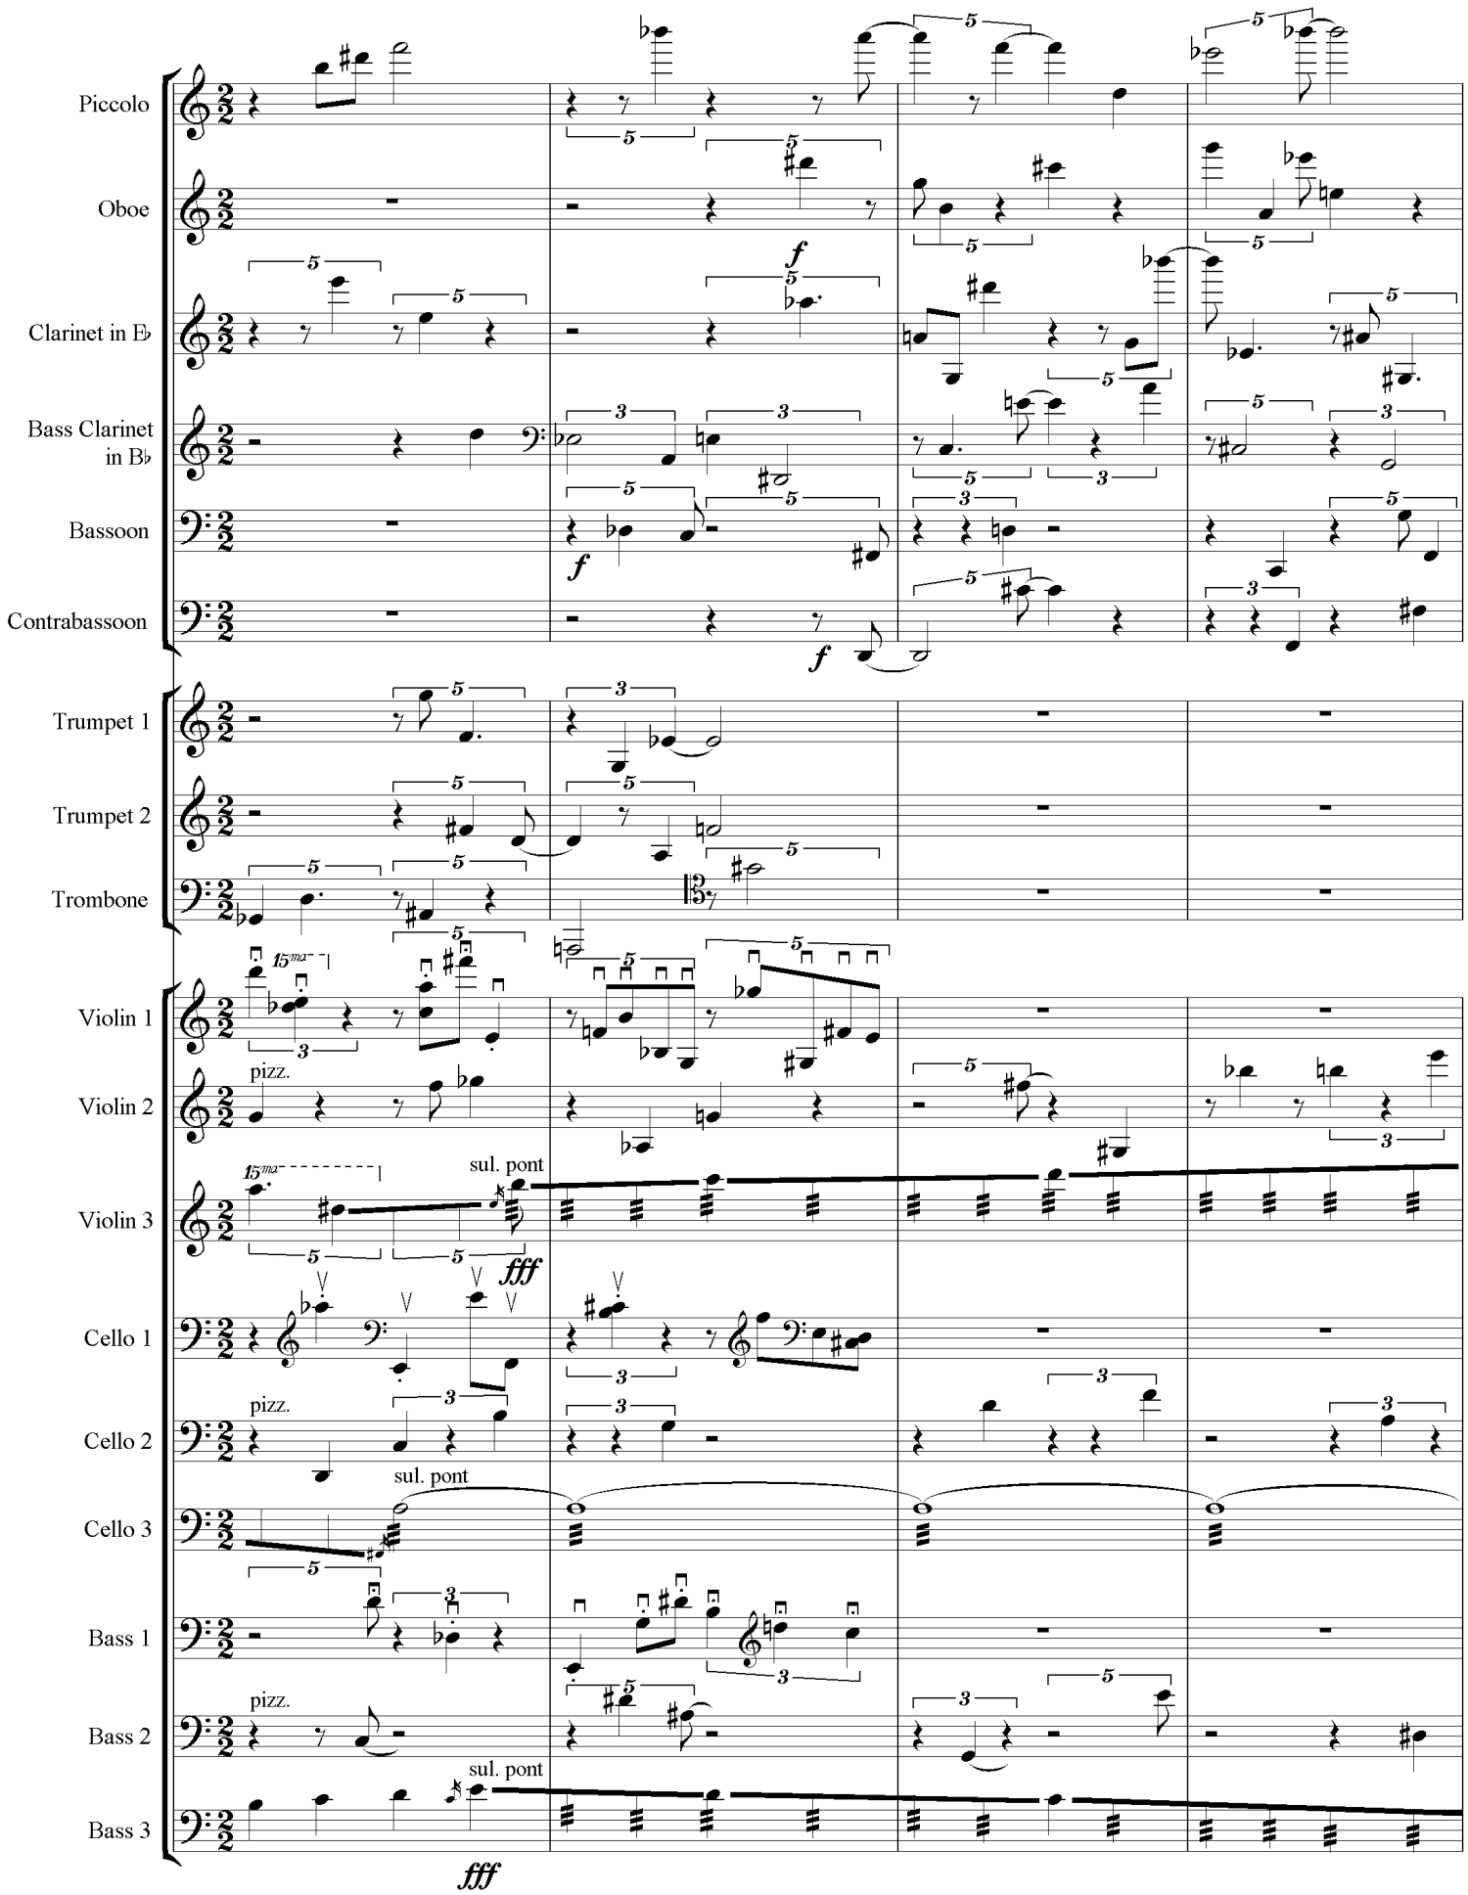

**Ex. 10** Xenakis, *Achorripsis*, closing bars

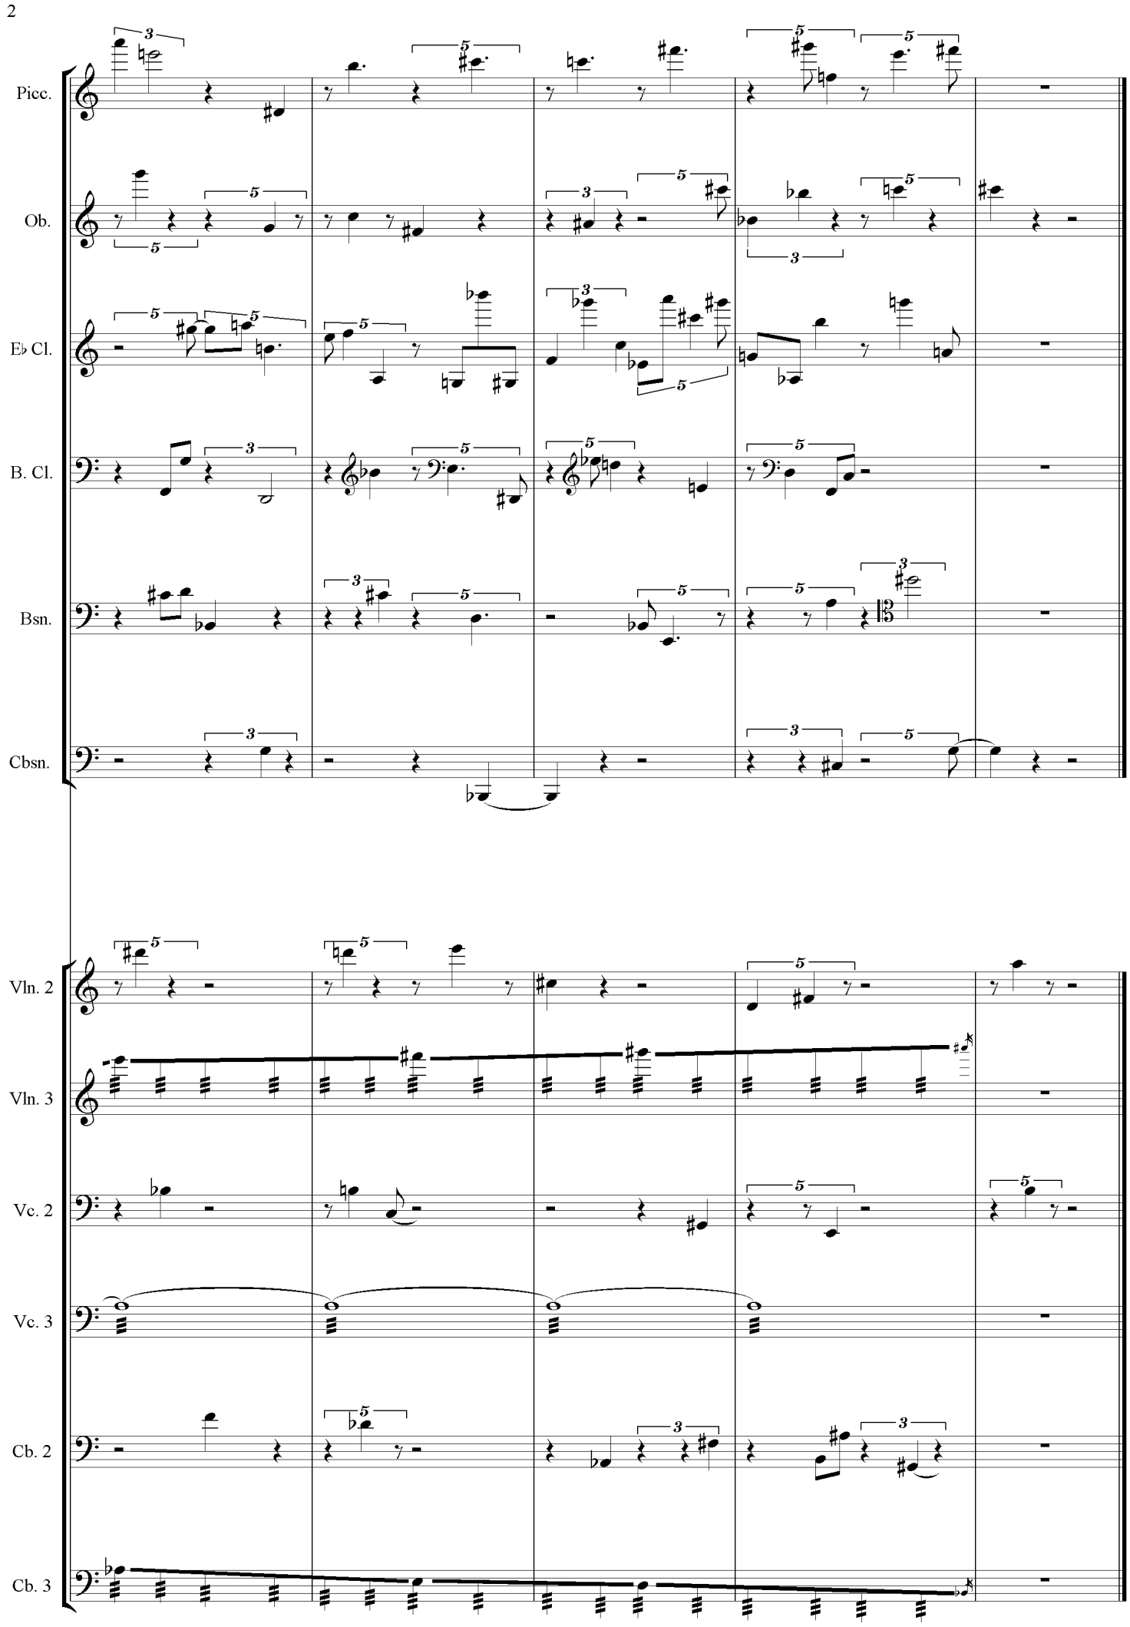

**Ex. 10** (*cont.*)

**5. Motivations and differences**

So far we have seen three different approaches to automation in composition that reflected some compositional concerns in the 1950s. We must firstly explore what was behind this frenzy for system and mistrust of intuition in composition, hitherto unknown in music?

Firstly, a clue is given by Xenakis’s earlier declaration that to compose music was a ‘fundamental critique of acts of thought’. In the three main pieces I have subjected to analysis, the composers in question were concerned with effacement of the past. By resorting to abstract structures outside of the traditional domains of music, they ensured that their music would be free of allusions to the music of their forebears. Such constructions, whether they were the square-root form of Cage, the multi-stranded serialism of Boulez and his peers or the stochastic music of Xenakis: all of these were innovative procedures that were new to music and would imply new ways of working with musical material. This was what made the music so provocative at the time; it had little connection with what had gone before. Smith-Brindle in his analysis of ‘The New Music’ speaks of the composer’s desire to ‘eliminate memory’[82] as one of the main causes of integral serialism. He speaks of its variance with earlier classical music on the basis of memorability: ‘Classical music, however difficult, has a certain predictable quality…but the music of total serialism was unpredictable; performers had to struggle through it note by note’.[83]

The performer had reached a similar perspective of this particular music too. We should recall pianist David Tudor’s desire to ‘not remember’ whilst tackling the music of Cage. In a similar vein, John Tilbury commented that ‘I had to learn how to be able to cancel my consciousness of any previous moment, in order to be able to produce the next one’.[84]

Cage thought the best way of doing this was subjugation of the will and a reliance on chance procedures, after which the only act of volition was deciding to compose. Hence, he sought music that was free of memory and the traditions of art. As both Boulez and Cage were highly trained in the traditional aspects of composition, removal of their tastes and desires (as far as possible) was a necessary step to take on the path to automatism. For Boulez, the best approach was through serialism: ‘We are thus freed from all melody, all harmony and all counterpoint, since serial structure has caused all these (essentially modal and tonal) ideas to disappear’.[85] Xenakis, wary of both chance and serialist music, used mathematics to reconstruct music that had reference to concepts in physics, such as density, disorder and rate of change. He did not see that the problems of music were resolvable with recourse to traditional subjects of music, such as harmony or counterpoint. Instead, he sought answers in other disciplines which could be brought to bear on musical considerations: ‘It is necessary to prevail upon more powerful tools such as mathematics and logic and go to the bottom of things to the structure of musical thought’.[86]

Varèse’s definition of composition as ‘organized sound’ was obviously heeded by the three composers I have discussed. Varèse had utilised unusual sound sources in compositions such as *Ionisation* and his conceptualisation of sound in its most general sense not only expanded the palette which composers had available to use but also led to composers into thinking about musical materials in an abstract way; ways that did not have to rely on older musical concepts or tastes. A ‘melody’, however conceived has restrictive connotations in a way that a ‘sound’, which admits of more possibilities, does not. Cage writes approvingly of this: ‘The present methods of writing music, principally those which employ harmony and its reference to particular steps in the field of sound, will be inadequate for the composer…the composer (organizer of sound) will not only be faced with the entire field of sound but also with the entire field of time’.[87] Xenakis conjectured that music is nothing more than to express ‘human intelligence by sonic means’.[88] Boulez at the time of writing *Structures 1A* stated that ‘sound material can only be organized serially’[89] and he defines the serial row in terms of its sonic aspects: ‘A series is a succession of *n* sounds’.[90] In sum, the generalization of composer as a sound sculptor allowed composers to look to other disciplines, be they mathematics or philosophy, in order to organize them as he saw fit. As the materials themselves were unprecedented, the methods could be too and again they served to free the music from earlier associations.

What is particular to the European composers I have analysed is associations with the science of the day. Schoenberg was keen to assert that the method of composing with 12 tones was not a ‘mere technical device’ but a theory of the ‘rank and importance of scientific theory’.[91] Xenakis had worked as an engineer and had familiarity with the latest applications of advanced mathematics to a wide range of problems. Boulez around the 1950s sought to couch his explorations in scientific terms:

It seems that, the minute one makes contact with a sound-world defined by serial principles, one can, without forcing the point, bring in set-theory, relativity, quantum theory…I have no illusions about the reality of the connections it is all too easy to draw between music, mathematics and philosophy; but I am prepared to claim some equivalence in the way they extend their respective fields of operation.[92]

Related to this is the reliance on a system ahead of instinct. The three composers discussed were not alone in such an approach but it is clear that musical intuition was relegated in favour of objective system. The chief reason for this seems to be related to that of memory again; reliance on musical intuition led one down to the path of familiar habits and tastes and therefore connected it with music of the past.

More traditionally-minded composers who relied on craft and intuition were disparaged either overtly or covertly. For example, Boulez was dismissive of Berg in the 1950s, or rather aspects of Berg which were celebrated by others: ‘What these dear musicians find comforting in Berg is precisely what I can accept the least: his romanticism and, it must be said, his attachment to tradition’.[93] On specific music matters Boulez objects to the use of ‘octave leaps in thirds’ and ‘two note turns’ in the *Lyric Suite* (ex. 11) as well as other features which he regards as springing from the ‘vulgar *verism*o excesses of Italian opera’ (note also the use of *Hauptstimme*, another Boulezian interdiction).[94] Cage was forthright about traditionally-minded composers who were not engaged in experimental music; he was unfavourable toward composers who used music to ‘express sentiments’ as they were ‘no longer necessary’.

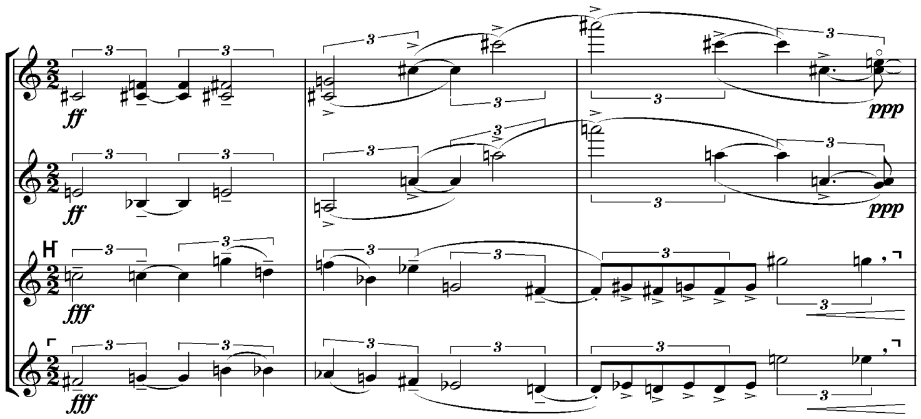

**Ex. 11** Alban Berg, *Lyric Suite*, 3rd movement: ‘Trio estatico’

Similarly, Cage dismisses the practices of harmony, counterpoint and composing in simple meters as irrelevant in his article on ‘History of Experimental Music in the United States.’[95] Neo-classical music comes in for the sharpest treatment as being ‘indicative of intellectual poverty’. Another reason for the disregard of intuition was the desire to recast composition as research or experiment rather than as pure art form. Compositional system could assume the character of a scientific experiment, with pre-compositional plans providing the method by which one conducted musical experiments. The results could be explained and discussed as one might in a scientific journal. To rely on one’s intuition meant a return to the practices of older composers and would imply that one did not regard composition as experimentation with sound. Ligeti writes tellingly in his analysis of *Structures 1A* that:

Composition loses its essence as ‘artwork’: the act of composing becomes at the same time a research into the newly perceived cohesion of the material. This may seem to be a negative, ‘unartistic’ attitude; but the composer today has no other path if he truly wants to move forward.[96]

This attitude, as Marcus Zagorski reveals[97] was expressed more explicitly by Stockhausen years earlier:

One will have to undertake very many note experiments and the necessary relevant studies. The acceptable results will shape a new idea of sound, which can again provide support for composition. For a long time to come, composing will have to be at the same time researching.

Xenakis was perhaps the most explicit of all composers on this point. He states in *Formalized Music* that:

We may further establish that the role of the living composer seems to have evolved, on the one hand, to one of inventing schemes (previously forms) and exploring the limits of these schemes, and on the other, to effecting the scientific synthesis of the new methods of construction…Music, by its abstract nature, is the first of the arts to have attempted the conciliation of artistic creation with scientific thought. Its industrialization is inevitable and irreversible.[98]

The tone of prophecy is evident in Xenakis’s assertion and suggests a necessity or goal to which the evolution of music tends. In fact, all of the composers attempted to justify their musical ideologies as the ideal form of musical composition and as somehow necessarily implied by history. One finds similar sentiments expressed by Schoenberg in relation to his conceptualisation of the 12-tone series: ‘The method of composing with twelve tones grew out of a necessity’.[99]

Essentially, the two prongs of this strategy were to recast musical history in such a way that justified their own ideological position and attack other competing musical practices that were in contradistinction to their own. Kyle Gann writes of Cage’s ‘omnivorous tolerance’[100]which conveniently overlooks the fact that he made statements every bit as chauvinistic as Boulez in the 1950s. Cage writes of composition that it is ‘necessarily experimental’ and that his definition of composition as the integration of sounds and noises means that ‘so much of European musical studies’ are not pertinent to the present-day composer. In fact, Cage’s belief in the integration of noises and tones into composition ‘alters the view of history’.[101] Certain composers are singled out as innovators: Henry Cowell’s early experiments with string piano are spoken of approvingly as are the open forms of the *Mosaic Quartet* which Cage sees as predating Boulez’s own experiments with open form.[102] Varèse is credited for incorporating noise into the vocabulary of experimental music. Conversely, composers who do not think in the experimental terms Cage proposes are subject to prejudice: Ives is no ‘longer experimental or necessary’, nor is Carl Ruggles. Similarly, Elliott Carter’s innovations in rhythm are not experimental but based on tonality and the principle of modulation. The music of the Darmstadt school is treated witheringly in that it exhibits ‘an element of tradition’ and ‘…a surprising acceptance of even the most banal of continuity devices: ascending or descending linear passages, crescendi and diminuendi…’[103] and he forecasts that experimental music will supersede the post-Webern serialism in vogue at the time (as well as stating that the characterisation of Boulez et. al’s music as post-Webern is purely a chronological distinction and not a musico-historical one). Therefore, it is clear that Cage was not dissimilar to Boulez in viewing his own compositional automatism in the 1950s (based as it was in chance operations and experimental music) as the ideal form; writing appreciatively of those who pointed the way to it and against those who did not.

Xenakis, in writing his own view of musical history, speaks in similar terms. He praises the antique music of his homeland as well as Byzantine music. Greek music is favourable for its reliance upon ‘tetrachords and *systems*’ while Byzantine music is regarded as simultaneously a continuance and preservation of older music.[104] Most of western classical music from Bach onwards is rejected for the most part by Xenakis, with the exceptions of Debussy and Messiaen for their focus on whole-tone scales and modes of limited transposition respectively. Xenakis regards Western classical music’s development as erroneous because of its obsession with polyphony and its dependence on the temporal aspect of music as well as the neglect and degradation of structures such as modes or systems.[105] More specifically, the Western practices of harmony and counterpoint had focused only on relationships as they happen in time, like a harmonic progression or a melody, rather than scales or systems which are not affected by time (A scale’s structure remains what it is regardless of its presentation in a musical composition, whereas a harmonic progression or a melody requires time in order to be perceived and is regarded as an *in-time* realization of an *outside-time* structure like a scale or chord, in Xenakis’s words). I have already mentioned Xenakis’s critique of serialism, which he generalises to a critique of polyphony as well as his stance against indeterminacy. His championing of ancient music comes from an apparent realization of the ‘dialectics of recent European music, with its wrong turns and dead ends’. [106]

It is clear then, *prima facie*, that Xenakis, Cage and Boulez were not so far apart on certain matters. All three wanted to do away with writing music in a more traditional sense, as one might have been taught to do so at a musical conservatoire in the 1950s. As well as their own works, polemical texts from the period were the products of this belief, as we can see from the above points in this section so far.

Moreover, Xenakis and Boulez shared a desire to use technical means from other disciplines such as mathematics in their composition. Another similarity is shared by these two composers is their repudiation of music composed by chance operations as practiced by Cage, as well as music that involved a larger degree of improvisation or indeterminate in some sense. The underlying premise here is that the use of dice or coins was laziness on the part of the composer who wanted to waive responsibility for the results that were produced. Boulez and Xenakis therefore believed in the composer having more control over the elements of the composition than Cage was seemingly happy to leave to chance, as it were.

Xenakis denounced contemporary musical ‘intuitionists’ (composers of graph music and theatre music) for having ‘a romantic attitude’ by relying on spontaneity rather than ‘control by the mind’. This particular musical path, for Xenakis, meant not only ‘trivial improvisation, imprecision and irresponsibility’ but ‘these groups are in fact denying music’.[107] Moreover, Xenakis regarded non-mathematical approaches to chance music as impoverished, for they did not prevail upon the tools of statistical analysis: ‘We are not speaking here of cases where one plays heads or tails in order to choose a particular alternative in some trivial circumstance. The problem is much more serious that’.[108]

Boulez was enthusiastic about Cage’s rejection of taste and his trust in automatic processes, yet more steadfast in his criticism of chance operations: ‘The only thing, forgive me, which I am not happy with, is the method of absolute chance (*by tossing the coins*). On the contrary, I believe that chance must be extremely controlled…there is already quite enough of the unknown’.[109]

Whilst Cage continued to explore purposelessness and its sonic equivalent in silence, Boulez withdrew from automatism: ‘I was certainly dissatisfied with the sort of inflexibility that had begun to characterise musical ideas’.[110] He also broadly condemned the early total serial experiments: ‘Moreover, by dint of ‘preorganisation’ and ‘precontrol’ of the material, total absurdity was let loose’.[111]

Indeed, Boulez took issue with composers of chance music, diagnosing it as an extreme reaction to total automatism but equally symptomatic of a desire by composers unwilling to take responsibility for their musical decisions: ‘What did this general permissiveness and these long holidays from thought signify, if not a continued flight from responsibility?’[112] Boulez took chance music as symptomatic of a kind of fashion parade, a music with very little substance: ‘There was the year of numbered series, that of novel tone colours…, the ‘chance’ year; the formless year…’ He goes on: ‘Such a practice…suggests a brothel of ideas, and can hardly be considered composition’.[113] Rather intriguingly, and perhaps in an act of self-critique, he suggests that the broadening of the serial system was in some part to blame for the emergence of a music which emphasised pre-compositional control above all other aspects: ‘It was difficult not to feel oneself at the mercy of the law of large numbers..This procedure might be seen as a take-over by numbers; the composer fled from his own responsibility, relying on a numerical organization’.[114]

Tellingly, the charge of irresponsibility is one that Boulez lists against both total serialism and chance music. In ‘Alea’ he writes that of composers who use chance that ‘…the individual does not feel responsible for his work, but merely throws himself by unadmitted weakness…’[115] Xenakis remarks of chance music that ‘[the] composer resigns his function altogether’.[116] I would argue therefore that there was more that united Xenakis and Boulez in terms of what was permitted for pre-control of musical material, and though they may have differed on the extent to which the use of mathematics was a valid instrument, the use of chance procedures in terms of pre-compositional planning represented something objectionable to both in the 1950s.

By comparison, Cage was happy to let the sounds occur as ‘nature intended’ and in this way relinquish the control that Xenakis and Boulez regarded as necessary for the act of composition. For Cage, as discussed previously, the idea of a finished work over which one had control became questionable in works from the 1950s and onwards, whereby pieces of music had no set number of instruments as in *Concert for Piano and Orchestra* from 1958, or the earlier *Music for Piano 21-36; 37-52* from 1955, which permitted not only overlapping performances with earlier works in the series, but allowed the performer control over pacing and volume. One imagines that works of this kind were the ones that caused Boulez and Xenakis to revolt: Cage was giving decisions traditionally left to the composer to the performer.

Cage’s compositions questioned the notion that what actually occurred in a piece of music was the will of the composer. His *Imaginary Landscape No. 4* (1951) for twelve radios and a conductor result in a juxtaposition of white noise from the tuning of the radios as well as the sounds of the broadcasts that are hit upon. *Pace* Cage, Boulez disregarded the use of noise ‘used without any hierarchic plan’ which leads to the ‘ancedotal, because of its reference to reality’.[117]

This therefore seemed to be the fundamental division between Boulez and Xenakis on one hand and Cage on the other.[118] Having agreed that music had to move forward from its traditional forms and methods (and the main works examined herein do not refer to traditional forms such as symphony, sonata or otherwise) they disagreed on how far the composer could relinquish control of his material. Boulez could accept a small role for chance in terms of ordering of material, as in *Éclat* or *Domaines,* but the musical material was always strictly composed. Whereas Xenakis, apart from experiments with game theory in *Duel* (1959)and *Stratégie* (1962) (which still featured musical material written very precisely), largely stayed clear of permitting chance or optional orders into the performance of his music.[119]

**6. Directions since 1950**

In spite of the differences between the composers, relating to the extent of human intervention within a composition, what algorithmic composition did was to foster a wider range of styles and approaches to composition than had been previously inconceivable under traditional musical terms. The introduction of total serialism, chance and statistics were novel ideas that resulted from a desire to explore new sound worlds through the usage of their respective methods. The main division was the extent to which the algorithm took over what the composer had traditionally done. That is, Cage would be content with a piece which had few traces of human intention as its result: such a work would not be countenanced by Boulez (or Xenakis) for reasons explicated already and their works had elements which were solely left to the composer to determine.

Yet the automatic had no singular, correct approach. Indeed, a composer would have to find the algorithm which somehow proved that *his system* was the only correct and complete one. This was a task more suited to the mathematician than the composer. Indeed, there was nothing about each system that mutually excluded the other. As many composers found in the 1950s, differing tactics could be artfully smuggled into their own systems: Chance could be serialised in degrees or calculated mathematically using statistics. The rhythmic tumult in Boulez’s early piano works could be replicated by chance operations. Open-form thinking originating from the New York School found its way into the compositions of serialist composers such as in Stockhausen’s *Klavierstück XI* and Boulez’s Third Piano Sonata.

Though few remained consistently faithful to the techniques of serialism (with Milton Babbitt a chief exception) or indeterminacy, such techniques undoubtedly showing composers what could be achieved in terms of pre-compositional automation, with intervention from the composer being the independent variable as it was with the works examined herein. The development of the computer and its increasing computational power were also factors in its subsequent progression. These enabled Xenakis to realise some of the ideas regarding stochastic synthesis outlined earlier in his *Formalized Music.* Computers greatly reduced the time needed for calculation, as well as providing accuracy with the mathematical equations and data output. Parallel to this development was the usage of computers in their own right as generators or synthesizers of sound. This differed sharply from musique concrete, which used existing or ‘found’ sounds although there is now considerable overlap between the two approaches in modern electroacoustic music. Xenakis developed the UPIC system (Unité Polygogique Informatique de CEMAMu), a computer-aided composition program which allowed its users to compose by the use of a graphic interface. The user ‘draws’ lines or shapes onto the device which are in turn synthesized into sounds by the computer.[120] It saw usage in several of Xenakis’s pieces, such as *Mycenae alpha*, *Pour la paix* and *GENDY3* as well as in the work of other composers such as Jean-Claude Risset. Further developments to the system, supervised by Xenakis, allowed the application of stochastic techniques he had theorized in the 1960s alongside the visual approach.

The computer proved itself a natural ally for composers seeking to automate certain parameters of composition, whilst still seeking to retain control over the artistic intention and goals of a piece. In addition to Xenakis’s experiments in the seventies, the works of Gerard Grisey and Tristan Murail bear mention as they used computer-generated analyses of the spectra of a given sound or tone to compose pieces based on these scientific analyses. Concepts such as frequency modulation and additive synthesis also influenced the thinking behind these composers’ works.[121] In this case, the algorithm is used as an aid and the human is still the main source of creativity. For instance, Grisey’s *Partiels* (1975) uses sonograms of brass instruments to compositionally ‘reconstruct’ the timbre of a low E in terms of its fundamental and partials.[122]

At the same time, there has also been a greater focus on computers being the creative generator of the music itself. This strategy relegates the role of the human being to a programmer (albeit a musically inclined one usually) with the creativity emerging from the rules and syntax of the computer program. One such approach was developed by David Cope.[123] Cope programmed *signatures*, that is, motives used by a composer in more than one work as well as stylistic features such as ostinati or characteristic rhythms like a waltz. The output from the computer is a combination of these encoded signatures. Cope later developed models to allow for separation of the patterns into harmonic patterns, melodic patterns, and dynamic patterns. Following on from this research, Cope has also created a program named ‘Emily Howell’ which has been described as an attempt to create a ‘virtual composer’.[124] This program is more focused on a contemporary style and is more interactive than Cope’s previous model. Cope asks the computer a musical question and the computer responds based on the resources it has programmed into it; Cope then accepts or rejects the material it has offered. As more and more of these exchanges occur, the computer develops a sort of ‘understanding’ based on what the human composer has deemed ‘good’ or ‘bad’. That is, the computer remembers the certain relations between notes or patterns which the human composer deemed favourable and aims to suggest more of those sorts ahead of the patterns which have been rejected.[125]

At the other end of the scale, much of the development of algorithmic composition that places the computer at the centre of the creative act has focused on trying to simulate more traditional musical idioms, such as four-part harmonization, species counterpoint, or jazz improvisation and chord progressions.[126] At the same time, it is not hard to imagine computers producing a version of Boulez’s *Structures 1a*, and similarly, it is possible to see computer simulations/realisations of many of Cage’s experiments.

There is little doubt that computers will continue to play a role in composition as it develops, whether it is used as a sound source, with the data and material steered and sculpted to fit a composer’s aim(s) a la Spectralism. This path is similar to the one Boulez and Xenakis had taken. Another road, and perhaps an inevitable one, is to probe deeper into how, if at all, machines can be creative in their own right. As detailed above, computers are capable of mimicking human ‘intentionality’ in composition with the right code. They may yet be able to produce significant compositions, *sui generis*, which show few traces of an ego or human design; a result more in keeping with Cage’s ethos of purposelessness.

**Appendix: Classical Serialism**

12-tone composition was developed by Arnold Schoenberg as an attempt to formalize and control the free and frequently atonal chromaticism which had emerged in varying degrees of influence by the turn of the century in compositions by the Second Viennese School, as well as those by Richard Strauss and Béla Bartók. Schoenberg developed the tone row, that is, a series encompassing all 12 tones of the chromatic scale as the basis for a piece. This series remains the same throughout a piece and is subjected to classical transformations, these being inversion, retrograde and retrograde-inversion. Below is an example of a tone row and the typical transformations. Numbers are used to denote pitch in the example. If we take an E-flat as a starting point, as the example below does, then a chromatic ascent of E-flat, E-natural, F-natural, F-sharp would be notated as (0, 1, 2, 3, 4...).

In discussion of this music it is common practice since Allen Forte's *The Structure of Atonal Music* to refer to pitch-classes rather than notes or tones. Returning to the previous example, if E-flat acts as the point of origin for the tone row in the table below, then E-flat as a pitch class refers to all possible E-flats (and D# sharp by enharmonic equivalence) separated by octaves.

Prime: 0 11 6 5 4 3 1 10 9 7 2 8

Inversion: 0 1 6 7 8 9 11 2 3 5 10 4

Retrograde: 8 2 7 9 10 1 3 4 5 6 11 0

Retrograde-

Inversion: 4 10 5 3 2 11 9 8 7 6 1 0

**Fig. A**Tone row and its classical transformations

The prime form is the blueprint for the transformations. It is transposable to any pitch class within the 12-note scale. *Transposition* applies to all forms of the row. It consists in adding the same number consistently to all elements of the pitch-class row. If one takes the pitches 0, 1, 2, 3 and adds 5 to them, we arrive at a new pitch collection: 5, 6, 7, 8. Traditionally speaking, this would be transposition by a perfect fourth. *Inversion* takes the intervals of the prime series and produces a series which is, in terms of semitones, an exact inversion of the prime series. Looking at the prime form, we see that the first interval between a 0 and 11, a semitone downward, is mirrored in the inversion by movement of a semitone upward (0 to 1). It is worth noting that a pitch class and its inversion always sum to 12. *Retrogression* is the simplest of the operations, producing a backwards version of the row, and by extension, the retrograde-inversion combines the earlier operations.

The consequences of this are worth touching upon. Given that any pitch within the octave may act as zero or '0', there are 12 versions of a prime series. Therefore, there are also 12 versions of a retrograde series, and 12 versions of an invertible series, and naturally, the remaining 12 versions of a retrograde inversion. This perhaps demonstrates the necessity of the method, for Schoenberg, given the extreme chromaticism available to the composer without such controls. The use of a series served as a means of regulating and giving chromatic music an intervallic unity throughout a movement or a whole piece. Of course, it is down to the composer to decide which series they wish to use and indeed, which series or pitch successions will appear to have more importance in the music they write. This is because Schoenberg still regarded concepts such as theme and melody as integral to the conception of a piece, and we still see a differentiation between the main theme (or *Hauptstimme*) and subsidiary themes (*Nebenstimme)* in purely 12-tone music of Schoenberg's, as seen in the extract below:

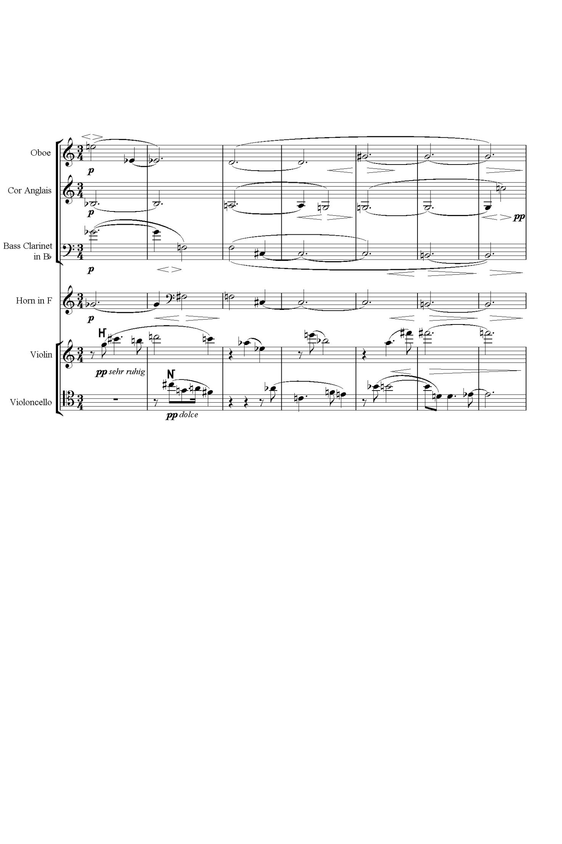

**Ex. A** Schoenberg, Variations for Orchestra

A brief excursus on the importance of the 12-tone matrix will ensue to serve as a later point of departure as well as a being a visual demonstration of the abstract principles discussed up to this point. A matrix is constructed by writing out the prime series in terms of pitch or using numbers, horizontally. Then, one writes the inversion of this prime series in the first column:

Eb D A Ab G F# E C# C Bb F B

E

A

Bb

B

C

D

F

F#

Ab

C#

G

From here, it is a case of writing out the remaining prime series at the relevant transposition for each row. If done correctly, one should have all of the prime series in rows left-to-right, the retrograde rows right-to-left, the inversion series reading vertically top-to-bottom, and bottom-to-top for the retrograde inversion. The matrix, aside from being convenient for the 12-tone composer as a presentation of the serial means at his disposal, allows for analysis of relationships between the rows and aids the search for more abstract concepts such as combinatoriality and invariance, along with other concepts found in set theory as applied to music. A completed matrix is shown on the next page.

This is the extent of the formalization in what Stefan Kostka calls ‘Classical Serialism’.[127] Serialism represented a startling advance in formalizing aspects or decisions about composition before the actual writing of a piece; similar operations had been utilised and subsequently disregarded in music of the Renaissance, whereby composers devised isorhythmic schemes which regarded the *color* and *talea* as independent. The *color* is a certain sequence of notes that repeat through its rhythmic counterpart, the *talea,* which is a series of durations that repeats throughout a piece.[128]

The first composers to utilise this technique systematically were Arnold Schoenberg, Anton Webern and Alban Berg, for whom history has given the label the ‘Second Viennese School’. It must not be supposed even that each composer used the 12-note series in the same way; indeed, it was just these differences that many analysts recognised in works by these composers.

Eb D A Ab G F# E C# C Bb F B

E Eb Bb A Ab G F D C# B F# C

A Ab Eb D Db C Bb G F# E B F

Bb A E Eb D C# B Ab G F C F#

B Bb F E Eb D C A Ab F# C# G

C B F# F E Eb C# Bb A G D G#

D C# Ab G F# F Eb C B A E Bb

F E B Bb A Ab F# Eb D C G C#

F# F C B Bb A G E Eb C# Ab D

Ab G D C# C B A F# F Eb Bb E

C# C G F# F E D B Bb Ab Eb A

G F# C# C B Bb Ab F E D A Eb

**Fig. B** 12-tone matrix

Despite differences in treatment of the row, the Second Viennese School and succeeding composers before the advent of non-pitch serialism confined usage of the row to pitch relations. They left matters such as dynamics, rhythm and timbre to their own will or desires for what they wanted to achieve or express in a given piece. This is not to say that these fundamental aspects of composition were left untouched by the developments in 12-tone music, and indeed techniques such as *pointillism,* which created an angular, even splintered concept of melodic line, and *klangfarbenmelodie,* which extended melodic considerations to timbre. These were novel techniques that emerged both out of the pre-serial and early serial music. The use of devices was guided by intuition and not numerical relations, as Schoenberg and others appeared to think that their system went far enough in leaving one crucial aspect of music to the ‘automatic’.

An example will demonstrate these considerations and serve as a basis for later comparison. This is the second movement from Schoenberg's Suite for Piano Op. 25, written from 1921 to 1923 (ex. B). It is styled as a gavotte; these commonly appeared in instrumental dance suites from the Baroque period. The general rhythmic schema of the gavotte is adhered to, though expansions and contractions of this are encountered already around bar five and later on at bars 17 – 20. That Schoenberg adheres to the gavotte's rhythmic schema is clearly demonstrated by the ascending phrase which begins half-way through bar 10. By this point the rhythm of the particular dance is well fixed and the duple meter, aside from an extra beat in bar five, remains intact. The steady rhythm in the left hand, which acts as the customary half-measure, as well as the angular figure in the right hand both finish by bar 12. The regular pulse which is established in bar 10 is maintained through bar 11 too, reinforcing the sense of the dance. This phrase is also distinctive in its strong allusions to the baroque heritage of the form, with its motoric rhythm and regularity of both the accompaniment and the harmonized melody. The following phrase is quite a contrast; being marked *dolce* and with many instances where the articulation suggests a legato touch. It lacks the dynamism of the previous phrase. That Schoenberg used, generally speaking, the rhythmic form of the gavotte shows a commitment to traditional forms. He did not think them outdated yet it would be untrue to say that the gavotte of Schoenberg is the gavotte of Bach or Handel.

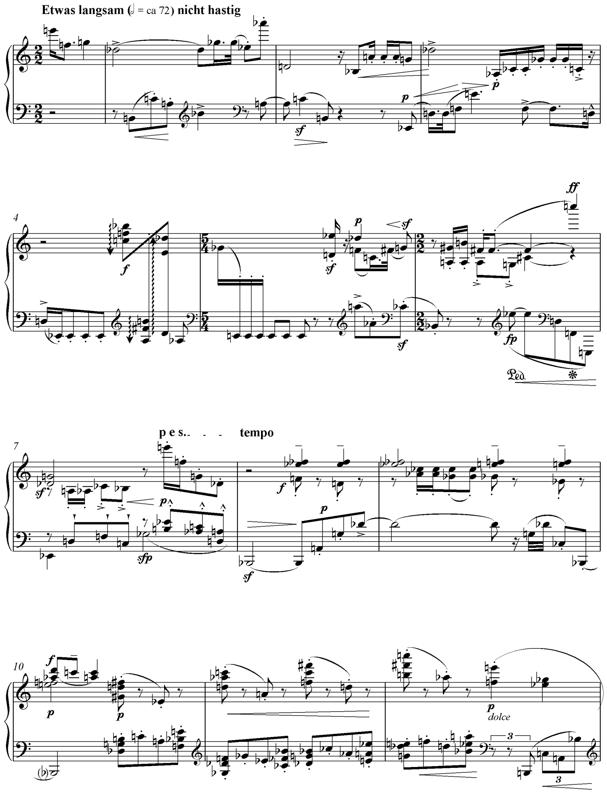

**Ex. B** Schoenberg, Gavotte from Suite Op. 25

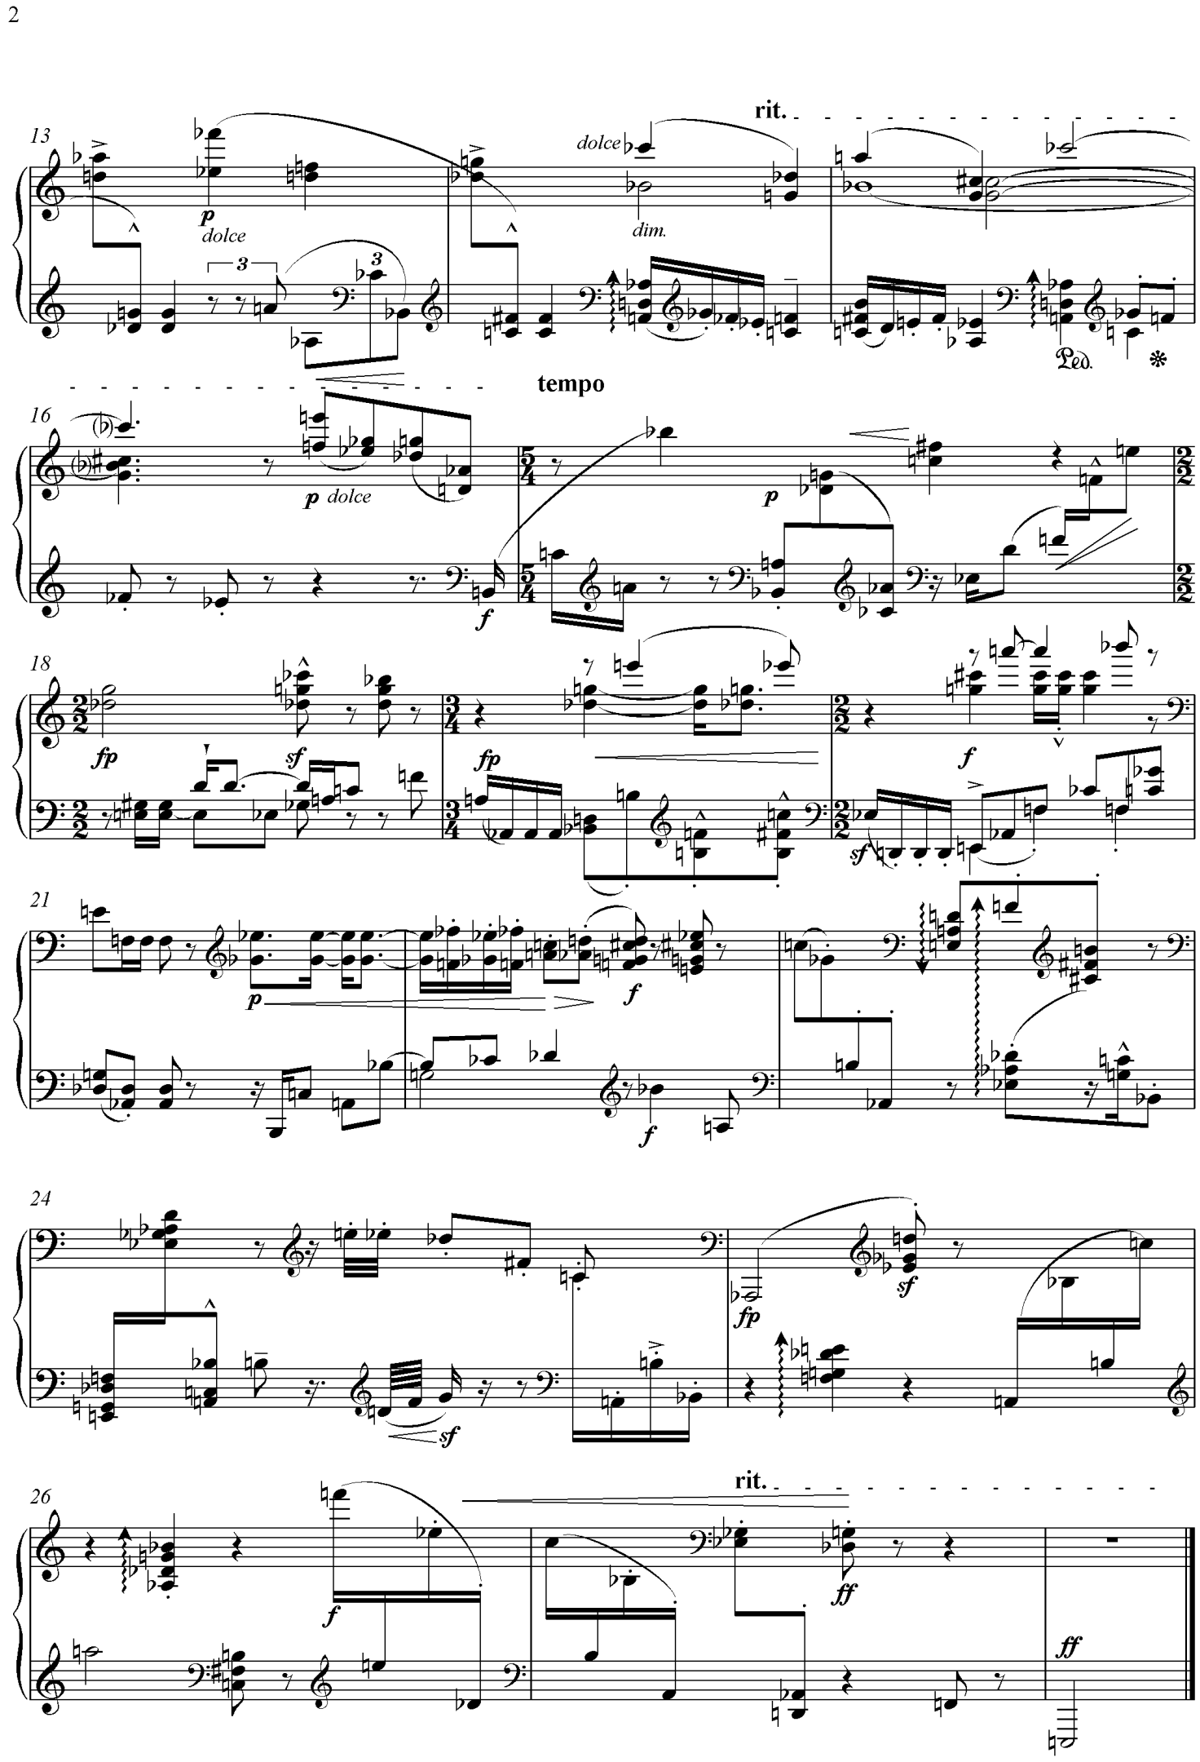

**Ex. B** (*cont.*)

Aside from a 12-tone vocabulary which extends the harmony beyond the remit of the Baroque, there are also melodic considerations which give it its serial character. These are the frequent dissonant leaps, exemplified by the triplet figure in the left hand at the end of bar 12; a sequence of minor ninths. The concluding gesture of the piece is another clear example of this prefiguring of pointillism: a pronounced and forceful descent down to the lower registers of the piano – again the choice of dissonant intervals is distinct: an F6 followed by E5, then Eb5, followed by D4, and so on until the final E1 minim, a somewhat heavy-handed ending hinting at the parodic nature of the movement. This is another characteristic of the music which marks it as atonal; the avoidance of smooth voice leading and a preponderance of disjunct steps. A dramatic example of this stylistic trait is the conclusion of bar six, where the bass descends a ninth from F2 the E2 and the treble voice has leapt from F#4 to C7. This is in contradistinction to tonal music which even at its most chromatic, steered towards conjunct motion with skips and leaps used variously but sparingly, usually for moments of high significance or drama, virtuosity and the avoidance of monotony. Therefore, there is a greater acceptance of registral flux in the Gavotte, which complements the attendant loss of tonal centre.

To complete this brief outline an analysis of the row which forms the basis of the piece will follow. The prime series for this piece is 0, 1, 3, 9, 2, 11, 4, 10, 7, 8, 5, 6. The row itself teasingly alludes to the aforementioned baroque precedent of the suite, with the third tetrachord spelling out the famous Bach cryptogram. The row itself is worthy of note in the context of Schoenberg’s 12-note practice. It does not lend itself to the combinatoriality we know that the composer was aware of and sought to exploit in other works, though it does contain some amount of invariance which leads to the notion that Schoenberg was interested early on in maintaining unity throughout transposed chromatic sequences. Indeed, in P0 the subset G, C#, F#, D#, G#, D of the prime row is found exactly repeated in RI1, beginning on the fifth note in the retrograde and the third in the prime. This row appears in the Gavotte at bar 17. In general, we can say of this particular row that any of its prime forms will feature a totally invariant subset in its retrograde inversion a semitone higher. The usage of invariant subsets within a piece of music for Schoenberg was one of many ways of giving a piece a sense of motivic unity that would be ever-present throughout the many presentations of the row.[129] Schoenberg's own wordsgive weight to this idea of preserving unity throughout a diverse presentations of the row: ‘Comprehensibility requires limitation of variety, especially if notes, harmonies, motive-forms or contrasts follow each other in rapid succession’[130] and, ‘A piece of music resembles in some aspects a photograph album, displaying under changing circumstances the life of its basic idea - its basic motive’.[131]

Schoenberg's approach to using the row at this stage is significant. We can see by examining the opening melody that this prime series is used, though out of order. The row is split into three tetrachords, those of [E, F, G, Db], [Gb, E, Ab, D] and [B, C, A, Bb]. The order of appearance is actually [E, F, G, Db], then the third tetrachord of the row which signals the entry of the bass in the texture, and the second tetrachord begins as the third ends. The phrases continue in this way, assigning one tetrachord to each phrase of the two-part texture. The row I6 begins the second phrase, a transposition of a tritone from the first series. Schoenberg's usage of this interval is reflective of the invariance of the interval of the tritone itself, only advancing to itself and then the octave from the original starting point. We see this invariance denoted in that the first phrase of the piece finishes with G to Db descent, and the first phrase of the second row concludes with a G to Db ascent. The tritone is a prominent interval in the row and it is the final interval of tetrachords one and two of the prime row. Schoenberg opts to give it prominence at the micro-level in terms of interval structure as well as macro-level in terms of row choice and the subsequent harmony. There are other instances of this insistence on the tritone in row presentation in the gavotte: At bar 19 I5 is used for the entire phrase, finishing on an E flat which acts as the beginning note of the ensuing phrase and row, starting in the bass in the new phrase (I11).

**Bibliography**

**Books**

Adorno, Theodor, *Dissonanzen: Musik in der verwalteten Welt* (3rd edn, Göttingen: Vandenhoeck & Ruprecht, 1963)

Boulez, Pierre and John Cage, *The Boulez-Cage Correspondence*, ed. by Jean-Jacques Nattiez, trans. by Robert Samuels (Cambridge: Cambridge University Press, 1993)

Boulez, Pierre, *Boulez on Music Today* (London: Faber and Faber, 1971)

Boulez, Pierre, *Conversations with Célestin Deliège* (London: Eulenburg, 1976)

Boulez, Pierre, *Orientations*, ed. by Jean-Jacques Nattiez, trans. by Martin Cooper (London: Faber and Faber, 1986)

Boulez, Pierre, *Stocktakings of an Apprenticeship*, trans. by Stephen Walsh (Oxford: Oxford University Press, 1991)

Cage, John, *Silence* (London: Boyars, 1978)

Cope, David, *Techniques of the Contemporary Composer* (Belmont: Schirmer, 1997)

Feldman, Morton, *Give my regards to Eighth Street: Collected Writings of Morton Feldman* (Cambridge, Mass.: Exact Change, 2000)

Grant, M. J., *Serial music, serial aesthetics: Compositional theory in post-war Europe* (Cambridge: Cambridge University Press, 2001)

Griffiths, Paul, *Modern Music and After* (Oxford: Oxford University Press, 1995)

Harley, James, *Xenakis: His Life in Music* (London: Routledge, 2004)

Hodeir, Andre, *Since Debussy: A View of Contemporary Music* (London: Secker & Warburg, 1961)

Iddon, Martin, *New Music at Darmstadt* (Cambridge: Cambridge University Press, 2013)

Jameux, Dominique, *Pierre Boulez*, trans. by Susan Bradshaw (London: Faber and Faber, 1991)

Kazimer, Leonard J., *Business Statistics*, 4th edn (New York: McGraw Hill, 2004)

Kostka, Stefan, *Materials and Techniques of 20th Century Music* (New Jersey: Pearson Prentice Hall, 2006)

Kostelanetz, Richard, *Conversing with Cage,* 2nd edn. (London: Routledge, 2003)

Lester, Joel, *Analytic Approaches to Twentieth Century Music* (New York: W. W. Norton & Company, Inc., 1989)

Nichols, Roger, *Messiaen* (Oxford: Oxford University Press, 1975)

Nyman, Michael, *Experimental Music: Cage and Beyond* (Cambridge: Cambridge University Press, 2004)

Perle, George, *Serial Composition and Atonality*, 4th edn (Berkeley:

Pritchett, James, *The Music of John Cage* (Cambridge: Cambridge University Press, 1993)

Schoenberg, Arnold, *Fundamentals of Music Composition,* ed. by Gerald Strang, trans. by Leo Black (London: Faber and Faber, 1967)

Schoenberg, Arnold, *Style and Idea*, trans. by Leo Black (Berkeley: University of California Press, 1984)

Smith Brindle, Reginald, *The New Music*, 2nd. edn (Oxford: Oxford University Press, 1987)

Straus, Joseph N., *Twelve-Tone Music in America* (Cambridge: Cambridge University Press, 2014)

Stein, Erwin, *Orpheus in New Guises* (New York: Hyperion Press, 1953)

Steinitz, Richard, *György Ligeti: Music of the Imagination* (London: Faber, 2003)

Taruskin, Richard, *Music in the Early Twentieth Century: The Oxford History of Western Music* (Oxford: Oxford University Press, 2010)

Whittall, Arnold, *Musical Composition in the Twentieth Century* (Oxford: Oxford University Press, 1999)

Xenakis, Iannis, *Formalized Music* (London: Indiana University Press, 1971)

**Chapters in Books**

Bernstein, David W., 'Music I: to the late 1940s' in *The Cambridge Companion to John Cage*, ed. by

David Nicholls (Cambridge: Cambridge University Press, 2002), 63-84

Cage, John, 'Defense of Satie' in *John Cage*, ed. by Richard Kostelanetz (New York: Praeger Publishers, 1970)

Eimert, Herbert ‘What is Electronic Music’ in *Die Reihe, 1*, trans. by Alexander Goehr (Bryn Mawr: Theodore Presser, 1958), 1-10

Gann, Kyle, ‘No escape from Heaven: John Cage as father figure’ in *The Cambridge Companion to John Cage*, 242-260

Ligeti, György, ‘Decision and Automatism in Structure 1a’ in *Die Reihe*, 5, trans. by Leo Black (Bryn Mawr: Theodore Presser, 1961), 36-63

Ligeti, György, ‘Metamorphoses of Musical Form’ in *Die Reihe*, 7, trans. by Cornelius Cardew (Bryn Mawr: Theodore Presser, 1965), 5-20

Osmond-Smith, David, ‘New beginnings: the international avant-garde, 1945-62’ in *The Cambridge History of Twentieth-Century Music*, ed. by Nicholas Cook and Anthony Pople (Cambridge: Cambridge University Press, 2008), 336-63.

**Journal articles**

Arsenault, Linda, ‘Iannis Xenakis’s *Achorripsis*: The Matrix Game’, *Computer Music Journal*, 26.1 (2002), 58-72

Boulez, Pierre, ‘Alea’, trans. by David Noakes and Paul Jacobs, *Perspectives of New Music*, 13:2 (1964), 42-52.

Castanet, P. A., ‘Gerard Grisey and the Foliation of Time’, trans. by Joshua Fineberg in *Contemporary Music Review*, 19:3 (2000), 29-40.

Childs, Edward, ‘Achorripsis: A sonification of probability distributions’, *Proceedings of the 2002 International Conference on Auditory Display, Kyoto, Japan, July 2-5, 2002*, <http://www.icad.org/websiteV2.0/Conferences/ICAD2002/proceedings/16_EdwardChilds.pdf> [ accessed 15 July 2013]

Fernández, Jose David and Francisco Vico, ‘AI Methods in Algorithmic Composition: A Comprehensive Survey’, *Journal of Artificial Intelligence Research*, 48 (2013), 513-582

Muscutt, Keith, ‘Composing with Algorithms: An Interview with David Cope’, *Computer Music Journal*, 31:3 (2007), 10-22

Nelson, Robert U., 'Schoenberg's Variation Seminar', *The Musical Quarterly*, 50:2 (1964), 141-64

Pousseur, Henri and David Behrman, ‘The Question of Order in New Music’, *Perspectives of New Music*, 5.1 (1966), 93-111

Ravenscroft, Brenda, ‘Re-Construction: Cage and Schoenberg’, *Tempo*, 60:235 (2006), 2-14

Rose, François, ‘Introduction to the Pitch Organization of French Spectral Music’, *Perspectives of New Music*, 34:2 (1996), 6-39

Starr, Mark, 'Webern's Palindrome', *Perspectives of New Music*, 8:2 (1970), 127-142

Toop, Richard, 'Messiaen/Goeyvaerts, Fano/Stockhausen, Boulez'*,* *Perspectives of New Music*, 13:2 (1974), 141-69

**Web pages**

Blitzstein, Ryan, *Triumph of the Cyborg Composer* (Santa Barbara: Pacific Standard, 2010) < http://www.psmag.com/books-and-culture/triumph-of-the-cyborg-composer-8507> [accessed 01 September 2015]

1. Robert U. Nelson, 'Schoenberg's Variation Seminar', *The Musical Quarterly*, 50:2 (1964), 141-64 (p. 157).
2. Arnold Schoenberg, *Style and Idea*, trans. by Leo Black (Berkeley: University of California Press, 1984), p. 137.
3. Pierre Boulez, *Stocktakings of an Apprenticeship*, trans. by Stephen Walsh (Oxford: Oxford University Press, 1991), p. 211.
4. Boulez, *Stocktakings*, p. 212.
5. Ibid., p. 213.
6. Ibid., p. 214.
7. Ibid., p. 213.
8. Ibid., p. 214.
9. Joel Lester, *Analytic Approaches to Twentieth Century Music* (New York: W. W. Norton & Company, Inc., 1989), pp. 219-221.
10. Mark Starr, ‘Webern's Palindrome’, *Perspectives of New Music*, 8:2 (1970), 127-142 (p. 127).
11. Erwin Stein, *Orpheus in New Guises* (New York: Hyperion Press, 1953), pp. 99-101. Also Richard Taruskin, *Music in the Early Twentieth Century: The Oxford History of Western Music* (Oxford: Oxford University Press, 2010), p. 362.
12. Boulez, *Stocktakings*, p. 303.
13. Dominique Jameux, *Pierre Boulez*, trans. by Susan Bradshaw (London: Faber and Faber, 1991), p. 15.
14. Jameux, p. 32.
15. Herbert Eimert, ‘What is Electronic Music’ in *Die Reihe, 1*, trans. by Alexander Goehr (Bryn Mawr: Theodore Presser, 1958), 1-10 (p. 8) One finds similar claims made by Henri Pousseur in the first edition of *DR*: ‘With Webern, we come closer to the problems which are our special concern’ (p. 31).
16. Richard Kostelanetz, *Conversing with Cage,* 2nd edn. (London: Routledge, 2003), p. 48.
17. Boulez, *Conversations*, pp. 56-57.
18. Halzaepfel, p. 173.
19. Cage, *Silence,* pp. 53, 79.
20. Iannis Xenakis, *Formalized Music* (London: Indiana University Press, 1971), p. 8.
21. Ibid.
22. Theodor Adorno, ‘Das Altern der neuen Musik’ in *Dissonanzen: Musik in der verwalteten Welt*, 3rd edn (Göttingen: Vandenhoeck & Ruprecht, 1963), pp. 144-45.
23. Pierre Boulez, ‘Alea’, trans. by David Noakes and Paul Jacobs, *Perspectives of New Music*, 13:2 (1964), pp. 42-52.
24. Ibid., p. 46.
25. Xenakis, p. 38
26. Ibid.
27. Ibid., pp. 39, 206.
28. Pierre Boulez, *Orientations*, ed. by Jean-Jacques Nattiez, trans. by Martin Cooper (London: Faber and Faber, 1986), p. 140.
29. Reginald Smith Brindle, *The New Music*, 2nd edn. (Oxford: Oxford University Press, 1987), p. 31.
30. Boulez, *Stocktakings,* p. 158.
31. Ibid., p. 298.
32. Ibid., p. 120.
33. Ibid., p. 130.
34. Richard Toop, ‘Messiaen/Goeyvaerts, Fano/Stockhausen, Boulez’*,* *Perspectives of New Music*, 13:2 (1974), 141-69 (p. 144).
35. Jameux, pp. 276-77.
36. George Perle, *Serial Composition and Atonality*, 4th edn. (Berkeley: University of California Press, 1977), p. 121.
37. Pierre Boulez, *Conversations with Célestin Deliège* (London: Eulenburg, 1976),p. 55.
38. Jameux, p. 52.
39. Boulez, *Stocktakings,* p. 16.
40. Martin Iddon, *New Music at Darmstadt* (Cambridge: Cambridge University Press, 2013), p. 118
41. Iddon, p. 119.
42. Boulez, *Conversations*, p. 24
43. *The Boulez-Cage Correspondence*, ed. by Jean-Jacques Nattiez, trans. by Robert Samuels (Cambridge: Cambridge University Press, 1993), p. 85.
44. Ibid, p. 86.
45. Ibid., p. 88.
46. Ibid., p. 78.
47. John Cage, *Silence* (London: Boyars, 1978), p. 14.
48. Ibid., p. 38.
49. Ibid., p. 39.
50. John Cage, ‘Defense of Satie’ in *John Cage*, ed. by Richard Kostelanetz (New York: Praeger Publishers, 1970), p. 81.
51. Ibid., p. 40.
52. Ibid., p. 92.
53. James Pritchett, *The Music of John Cage* (Cambridge: Cambridge University Press, 1993), p. 17.
54. Cage, *John Cage,* p. 31.
55. David W. Bernstein, ‘Music I: to the late 1940s’ in *The Cambridge Companion to John Cage*, ed. by David Nicholls (Cambridge: Cambridge University Press, 2002), 63-84 (pp. 83-84).
56. Ibid., p. 92.
57. Pritchett, p. 48.
58. György Ligeti, ‘Metamorphoses of Musical Form’ in *Die Reihe*, 7, trans. by Cornelius Cardew (Bryn Mawr: Theodore Presser, 1965), 5-20 (p. 5).
59. *The Boulez-Cage Correspondence*, p. 95.
60. Ibid.
61. Cage, *Silence*, p. 58.
62. Ibid., p. 59.
63. György Ligeti, ‘Decision and Automatism in Structure 1a’ in *Die Reihe*, 5, trans. by Leo Black, (Bryn Mawr: Theodore Presser, 1961), 36-63 (p. 51).
64. John Halzaepfel, ‘Cage and Tudor’ in *The Cambridge Companion to John Cage*, p. 173.
65. *Silence*, p. 36.
66. The law of large numbers specifies the average or mean to which a number of repeated trials will tend. An example to illustrate is a game of heads or tails: If a coin is tossed enough times, the number of heads and tails will generally balance the more times the game is played, though they may exhibit randomness or unbalance after only a few trials, that is, one might observe five heads after five coin tosses, though this is generally unlikely.
67. Ibid., p. 207.
68. James Harley, *Xenakis: His Life in Music* (London: Routledge, 2004), pp. 15, 46, 71.
69. Ibid., p. 22.
70. Leonard J. Kazimer, *Business Statistics*, 4th edn (New York: McGraw Hill, 2004), p. 96.
71. Kazimer, pp. 104-106.
72. Linda Arsenault, ‘Iannis Xenakis’s *Achorripsis*: The Matrix Game’, *Computer Music Journal*, 26:1 (2002), 58-72 (p. 59).
73. Ibid.
74. Ibid.
75. Xenakis, p. 4.
76. Ibid., p. 5.
77. Harley, p. 11.
78. Xenakis, p. 34.
79. Xenakis, p. 16.
80. Harley, p. 27.
81.
82. Smith-Brindle, p. 23.
83. Smith-Brindle, p. 41.
84. Michael Nyman, *Experimental Music: Cage and Beyond* (Cambridge: Cambridge University Press, 2004), p. 62.
85. Boulez, *Orientations,* p. 141.
86. Xenakis, p. 208.
87. Cage, *Silence,* p. 4.
88. Xenakis, p. 178.
89. Boulez, *Orientations,* p. 135*.*
90. Ibid., p. 137.
91. Schoenberg, p. 220
92. Boulez, *Stocktakings*, p. 141.
93. Boulez, *Stocktakings*, p. 183.
94. Ibid.
95. Cage, *Silence*, pp. 69-70.
96. Ligeti, pp. 62-63.
97. Marcus Zagorski, ‘Material and History in the Aesthetics of ‘Serielle Musik’, *Journal of the Royal Musical Association*, 134:2 (2009), 271-317 (p. 299).
98. Xenakis, p. 133.
99. Schoenberg, p. 216.
100. Kyle Gann, ‘No escape from Heaven: John Cage as father figure’, *The Cambridge Companion to John Cage*, 242-260 (p. 258).
101. Cage, *Silence*, p. 71.
102. Ibid.
103. Ibid., pp. 74-75.
104. Xenakis, pp. 182-3.
105. Ibid., p. 194.
106. Ibid., p. 186.
107. Xenakis, p. 181-2.
108. Xenakis, p. 39.
109. *The Boulez-Cage Correspondence*, pp. 112-113.
110. Boulez, *Conversations,* p. 63.
111. Pierre Boulez, *Boulez on Music Today* (London: Faber and Faber, 1971), p.25.
112. Ibid., p. 26.
113. Ibid., p. 21-3.
114. Ibid., p. 25.
115. Boulez, ‘Alea’, p. 42.
116. Xenakis, p. 38.
117. *Boulez on Music Today*, p. 22.
118. See David Osmond-Smith, ‘New beginnings: the international avant-garde, 1945-62’ in *The Cambridge History of Twentieth-Century Music*, ed. by Nicholas Cook and Anthony Pople (Cambridge: Cambridge University Press, 2008), pp. 336-63 (p. 357) for a similar point.
119. Xenakis, p. 114.
120. Harley, p. 115.
121. François Rose, ‘Introduction to the Pitch Organization of French Spectral Music’, *Perspectives of New Music*, 34:2 (1996), 6-39 (p. 8).
122. P. A. Castanet, ‘Gerard Grisey and the Foliation of Time’, trans. by Joshua Fineberg in *Contemporary Music Review*, 19:3 (2000), 29-40, p. 31.
123. David Cope, *Techniques of the Contemporary Composer* (Belmont: Schirmer, 1997), p. 199.
124. Keith Muscutt, ‘Composing with Algorithms: An Interview with David Cope’, *Computer Music Journal*, 31:3 (2007), 10-22 (p. 20).
125. Ryan Blitzstein, *Triumph of the Cyborg Composer* (Santa Barbara: Pacific Standard, 2010) < http://www.psmag.com/books-and-culture/triumph-of-the-cyborg-composer-8507> [accessed 01 September 2015]
126. Jose David Fernández and Francisco Vico, ‘AI Methods in Algorithmic Composition: A Comprehensive Survey’, *Journal of Artificial Intelligence Research*, 48 (2013), 513-582 (pp. 515-6).
127. Stefan Kostka, *Materials and Techniques of 20th Century Music* (New Jersey: Pearson Prentice Hall, 2006), p. 198.
128. The idea of the *talea* has returned, though with a difference, in contemporary music. Gerard Grisey's *Talea* explores abstract isorhythmic procedures in the context of so-called ‘spectral music’.
129. Kostka, pp. 204-6.
130. Arnold Schoenberg, *Fundamentals of Music Composition,* ed. by Gerald Strang, trans. by Leo Black (London: Faber and Faber, 1967), p. 21.
131. Schoenberg, p. 58.