The Role of DNA Methylation in Arabidopsis Immunity

By:
Leonardo Furci

A thesis submitted in partial fulfilment of the requirements for the degree of Doctor of Philosophy

The University of Sheffield
Faculty of Science
Department of Animal and Plant Sciences (APS)

Submission Date
31/05/2017

“I know what I do not know”, Socrates.
From Plato, “The Apology”.

The more we know,
the more we know what we do not (yet) know

Thesis Summary

DNA methylation in plants is an epigenetic mechanism controlling genome stability and gene expression. Unlike other epigenetic marks, patterns of DNA methylation can be maintained through meiosis over multiple generations. Recent studies have revealed a role for DNA methylation in plant defence priming, an immune sensitisation mechanism that allows plants to mount a faster and stronger basal defence reaction to pathogen attack, resulting in enhanced resistance. The aim of the study presented in this thesis is to gain insight into the role of DNA methylation in immunity of Arabidopsis thaliana (Arabidopsis). Analysis of Arabidopsis mutants with altered levels of global DNA methylation revealed that DNA methylation represses basal resistance against the biotrophic pathogen Hyaloperonospora arabidopsidis (Hpa), but enhances resistance to the necrotrophic fungus Plectosphaerella cucumerina, suggesting a regulatory function of DNA methylation in innate immune responses. Conversely, systemic acquired resistance was unaffected in these mutants, indicating that DNA methylation does not play a major role in within-generation acquired immunity. To explore the contribution of DNA methylation in heritable disease resistance, a core population of epigenetic recombinant inbred lines (epiRILs) was characterized for disease resistance. This population, which is derived from a cross between Col-0 and the ddm1-2 mutant, shows minimal genetic variation, but varies in DNA methylation at heterochromatic regions, due to inheritance of hypo-methylated DNA from the ddm1-2 parent. There were significant levels of variation in Hpa resistance in the epiRIL population, which could be linked to four epigenetic quantitative trait loci (epiQTLs). Characterisation of eight Hpa-resistant epiRILs revealed that this resistance is associated with priming of salicylic acid (SA)-dependent and SA-independent defence mechanisms. RNA-sequencing analysis of the immune response of four Hpa-resistant epiRILs confirmed this notion, and revealed a potentially novel regulatory mechanism by which DNA hypo-methylated transposable elements in the epiQTLs regulate the responsiveness of defence genes in trans.

Table of content
List of Frequent Abbreviations i

Chapter 1 - General Introduction 2
1.1: Background 3
1.2: DNA methylation in plants 5
1.2.1: Methylation of plants DNA 5
1.2.2: Initiation and establishment of de novo DNA methylation 7
1.2.3: Maintenance of DNA methylation over cell division. 10
1.2.4: Transgenerational maintenance of DNA methylation over meiosis 11
1.2.5: Relationship between DNA methylation and histone modifications 12
1.2.6: DNA demethylation in plants 13
1.3 The plant innate immune system: plant defences against pathogens 15
1.3.1: Early-acting inducible defences 15
1.3.2: Late-acting inducible defences 16
1.3.3: Pathogen effectors and effector-triggered immunity 18
1.4: Priming of defence: plant adaptive immunity 19
1.4.1: what is priming? 19
1.4.2: Costs and benefits of priming 22
1.4.3: Trans-generational priming 23
1.4.4: Molecular mechanisms of priming 23
1.4.5: Role of DNA methylation in regulation of plant defences and priming 24
1.5: Overview of experimental chapters 26

Chapter 2 - Materials and Methods 28
2.1: Plant material and growth conditions 29
2.2: Quantification of basal resistance to H. arabidopsidis 29
2.3: Quantification of basal resistance to P. cucumerina and A. brassicicola 31
2.4: Quantification of basal and systemic acquired resistance to P. syringae pv. tomato DC3000 31
2.5: Trypan blue staining for quantification of colonisation by H. arabidopsidis or A. brassicicola. 32
2.6: Quantification of elicitor-induced callose in hydroponically grown Arabidopsis seedlings 32
2.7: Quantification of callose effectiveness against H. arabidopsidis infection 33
2.8: Growth analysis of epigenetic recombinant inbred lines 34
2.9: Mapping of epigenetic quantitative trait loci (epiQTLs) 34
2.10: RNA extraction and targeted gene expression analysis 36
2.11: Seed germination assays 36
2.12: mRNA-sequence analysis of four epiRILs 37
Chapter 3 - The Role of DNA (de)Methylation in Plant Basal and Acquired Immunity 39
3.1: Abstract 40
3.2: Introduction 41
3.2: Results 44
3.2.1: Effects of DNA (de)methylation on basal resistance to biotrophic H. arabidopsidis 44
3.2.2: Effects of DNA (de)methylation on basal resistance to necrotrophic fungi 46
3.2.3: Effects of DNA (de)methylation on early-acting cell wall defence 48
3.2.4: Effects of DNA (de)methylation on within-generation systemic acquired resistance against P. syringae pv tomato DC3000 50
3.3: Discussion 52

Chapter 4 - Mapping the Epigenetic Basis of Pathogen Resistance Using a Population of Epigenetic Recombinant Inbred Lines 54
4.1: Abstract 55
4.2 Introduction 56
4.3: Results 61
4.3.1: Quantification of H. arabidopsidis resistance in the parental lines of the Col-0 x ddm1-2 epiRILs population 61
4.3.2: Screening of the epiRILs population for variation in resistance to biotrophic H. arabidopsidis 63
4.3.3: Mapping of epiQTLs controlling H. arabidopsidis resistance 65
4.3.4: Genetic variation by shared transposition events in the epiRILs population does not contribute to H. arabidopsidis resistance 67
4.3.5: Screening of the epiRILs population for variation in seedling growth 69
4.3.5: Screening of the epiRILs population for variation in resistance against necrotrophic P. cucumerina 71
4.4 Discussion 73

Chapter 5 - Phenotypic characterisation of eight epiRILs expressing enhanced resistance to downy mildew 75
5.1: Abstract 76
5.2: Introduction 77
5.3: Results 79
5.3.1: Cross-resistance phenotypes of H. arabidopsidis resistant epiRILs 79
5.3.2: H. arabidopsidis resistance of the eight epiRILs is associated with priming of inducible defences 81
5.3.3: Fitness phenotypes of the eight H. arabidopsidis-resistant epiRILs 83
5.3.4: Transgenerational stability of the H. arabidopsidis resistance trait in F10 families of the eight epiRILs 85
5.4: Discussion 88
Chapter 6 - Whole-Transcriptome Analysis of Four Downy Mildew-Resistant epiRILs Reveals a trans-Regulatory Role for Transposable Elements in Global Defence Gene Priming 90
6.1: Abstract 91
6.2: Introduction 92
6.3: Results 94
6.3.1: Selection of four H. arabidopsidis-resistant epiRILs for mRNA-sequencing analysis 94
6.3.2: Principal component analysis of mRNA sequencing reads from mock- and H. arabidopsidis-inoculated epiRILs and WT plants 96
6.3.3: Hierarchical clustering of differentially expressed genes in H. arabidopsidis-resistant epiRILs 98
6.3.4: Identification of H. arabidopsidis-inducible genes that are primed and/or constitutively up-regulated in the H. arabidopsidis-resistant epiRILs 100
6.3.5: Primed genes in H. arabidopsidis-resistant epiRILs are enriched with defence-related gene ontology terms. 103
6.3.6: Expression analysis of primed genes inside the epiQTL intervals suggests trans-regulation of protein coding genes by DNA methylation. 105
6.3.7: Removal of transposable element-annotated genes from the dataset does not improve detection of differentially expressed protein-coding genes. Error! Bookmark not defined.
6.4: Discussion 111

Chapter 7 - General Discussion, Conclusions and Future Perspectives 113
7.1: Scope 114
7.2 DNA methylation and regulation of plant basal defences 115
7.3: Translational value of epigenetic-based plant resistance in epiRILs and future applications. 117
7.4: Possible mechanisms of trans-regulation of defence genes by DNA methylation. 120
7.5: Concluding remarks. 127

Appendix 128
List of 111 defence-related GO terms showing significant enrichment* 128

Bibliography 132

List of Frequent Abbreviations

Ab Alternaria brassicicola
BABA β-aminobutyric acid
dai Days after inoculation
DMR Differentially methylated region
epiQTL Epigenetic quantitative trait locus
EpiRIL Epigenetic recombinant inbred line
GO Gene ontology
Hpa Hyaloperonospora arabidopsidis
hpi Hours post-inoculation
JA Jasmonic acid
Pc Plectosphaerella cucumerina
PC Principal component
Pst Pseudomonas syringae pv tomato
RdDM RNA-directed DNA methylation
RNS Reactive nitrogen species
ROS Reactive oxygen species
SA Salicylic acid
SAR Systemic acquired resistance
siRNA Small interfering RNA
sTE Shared transposition event
TE Transposable element

Chapter 1 - General Introduction

1.1: Background

According to UN projections, the global human population is set to reach 10 billion by 2050 (source: https://esa.un.org). Plants are the main source of food (and fibres and medicines) to sustain this population growth. Accordingly, it is of critical importance to increase the efficiency of crop production. Every year, plant pathogens and pests are responsible for 20% to 40% of losses in crop productivity worldwide. From the start of the Green Revolution in the 1960s, crop yields have steadily increased, which is largely attributable to more intense use of pesticides and inorganic fertilisers. However, there are increasing opposition to the use of these agro-chemicals, which are deemed unsustainable due to costs of production, application and potential negative effects on human health. This situation is further aggravated by the confounding effects of climate change, which will render agricultural land unsuitable for production, leading to a ‘perfect storm’ scenario of food insecurity [1]. Faced with this challenge, the development of sustainable crop protection methods becomes a key priority to safeguard food security in the near future.
Plants have evolved a multi-layered set of constitutive and inducible defence mechanisms to counter pathogen attacks. Specialized plant pathogens have co-evolved effector molecules that can suppress these inducible plant defences. In a continuous evolutionary arms race, some plants counter-evolved resistance (R) genes that recognize and counter these pathogen effectors. The resulting resistance is commonly referred to as ‘qualitative resistance’ or ‘gene-for gene resistance’ [2]. While qualitative resistance can be very effective against biotrophic pathogens, its range of effectiveness is very narrow. Moreover, qualitative resistance is often not a durable form of disease protection, since it imposes strong selective pressure for avirulent pathogen strains to break the resistance gene. Another strategy by which plants can resist virulent pathogens is through acquired resistance or ‘induced resistance’, which is often based on a sensitisation, or ‘priming’, of the plant’s basal immune system. This priming mediates a faster and stronger expression of basal defences at the relatively early and most critical stages of interaction [3]. Although the multi-genic nature of acquired immunity offers long-lasting and durable disease protection that is effective against a wide range of different attackers, it is not widely exploited in agriculture [4]. This is mostly due to the fact that application of resistance-inducing agents is costly and the level of disease protection is often not as high as that provided by single resistance genes or pesticides. Recent evidence suggests that some acquired immune responses in plants involve regulation by epigenetic mechanisms [5-7].
Epigenetics is defined as the study of the mechanisms controlling heritable information independently of changes in DNA sequence, such as different patterns of DNA methylation (epialleles) [8]. Over recent years, epigenetics has gained significant interest in the scientific community for its potential to influence gene expression and heritable phenotypes, potentially explaining the “missing heritability” of complex traits [9,10]. In plants, epigenetics could be exploited by selection of favourable epialleles, which provide heritable crop traits that cannot be selected for by conventional genetic breeding [11,12].
The three main epigenetic mechanisms are DNA methylation, histone modifications and chromatin remodeling, and non-coding RNAs. While these three mechanisms are interdependent between each other, DNA methylation is the mechanism mostly responsible for transgenerational transmission of epigenetic phenotypes in plants [13,14]. Variation in plant DNA methylation has been shown to generate (relatively) stable epialleles [15-17] that explain phenotypic variation of complex traits independently of genetic variation [18]. Multiple lines of evidence point to a mechanism by which plants can change their DNA methylation profile when exposed to certain diseases [19,20], while genetically-induced changes in DNA methylation can have an effect on quantitative expression of plant defences [21,22]. This thesis describes a study about the relationship between DNA methylation and the plant immune system. It will provide evidence that DNA methylation plays an important defence regulatory role in immune responsiveness of Arabidopsis thaliana (Arabidopsis). Furthermore, by using a population of epigenetic inbred lines of Arabidopsis, It will demonstrate that variation in DNA methylation can account for heritable epialleles that provide quantitative disease resistance.

1.2: DNA methylation in plants

1.2.1: Methylation of plants DNA
DNA methylation in plants involves the addition of a methyl group (-CH3) to the fifth carbon of the cytosine base, forming 5-methylcytosine (5mC). Although methylation at the sixth nitrogen of adenine (N6-methyladenine) has been reported in plants [23], only three subsequent studies have confirmed its presence [24-26] and its biological significance and molecular regulation remain unknown. Hence, from here onwards, when referring to DNA methylation, this concerns cytosine methylation only. Unlike other organisms, DNA methylation in plants can occur in different sequence contexts. Apart from CG contexts, plants also methylate DNA in CHG and CHH contexts (where H indicates any base except G, Figure 1.1). In Arabidopsis, each sequence context is established and maintained by different mechanisms, involving distinct DNA methyltransferase and upstream regulatory pathways (Figure 1.1). Methylation in CG context is mediated by METHYLTRANSFERASE1 (MET1) [27], a plant orthologue of the mammalian DNMT1 [28], whereas methylation in CHG context is predominantly mediated by the CHROMOMETHYLASE-class (CMT) methyltransferase CMT3 [29]. Asymmetric DNA methylation in CHH context can be mediated by DOMAINS REARRANGED METHYLTRANSFERASE-class (DRM) methyltransferases DRM1 and DRM2, whose activities are controlled by the plant-specific RNA-directed DNA methylation pathway (RdDM); [30]). Alternatively, CHH methylation can be mediated by the CHROMOMETHYLASE-class methyltransferase CMT2, which operates independently from the RdDM pathway [31] (Figure 1.1), but requires the chromatin remodelling protein DDM1 (see section 1.2.2). Interestingly, DNA methylation at the three different sequence contexts is not distributed evenly across the Arabidopsis genome. Whereas CG methylation is found mostly at gene bodies and transposable elements (TEs) in heterochromatic regions, CHG and CHH methylation is found mostly at intergenic regions and TEs in both heterochromatic and euchromatic regions (Figure 1.1) [32]. Notably, a recent study reported that this distribution of DNA methylation can vary across different families of the Angiosperms [33].

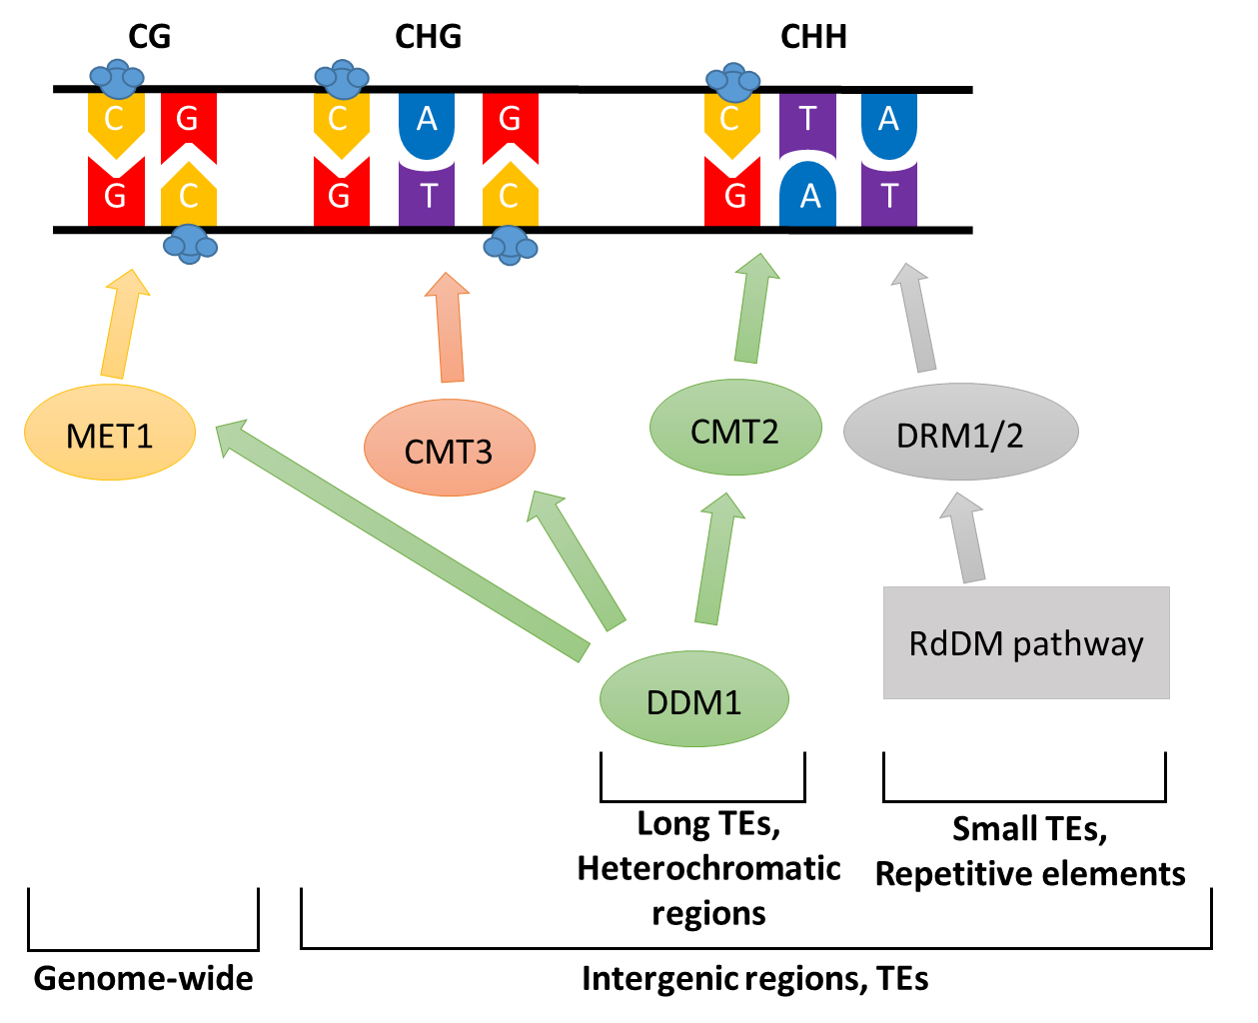
Figure 1.1: Different contexts of DNA methylation in plants. Diagram showing examples of methylated CG, CHG and CHH DNA contexts, and the DNA methyltransferase enzymes responsible for its establishment and maintenance of DNA methylation in different sequence contexts (CG, CHG and CHH, where H represents any base except G). CG DNA methylation is mediated by the methyltransferase MET1, is the most abundant and is widely distributed across the whole genome. Non-CG DNA methylation is mostly found in intergenic regions and transposable elements (TEs) and include CHG methylation, mediated by the chromomethylase CMT3, and asymmetrical CHH methylation, mediated by three different methyltransferases. CHH DNA methylation of small transposable element and repetitive sequences is established by DRM1/2 methyltransferases which are controlled by the RdDM pathway (see section 1.2.2). On the other hand establishment and maintenance of CHH DNA methylation of long TES and heterochromatic regions (which are inaccessible to different components of the RdDM pathway) is mediated by the chromomethylase CMT2 through interactions with the chromatin remodeler DDM1 and independently from RdDM (see section 1.2.2). Through its chromatin remodelling function DDM1 allows CMT2 access to heterochromatic DNA, as well as methyltransferases MET1 and CMT3, resulting in maintenance of DNA methylation in all three sequence contexts.

The main functions of DNA methylation are to control genome stability (through silencing of TEs and repetitive elements) and to regulate gene expression [34,35]. TEs are mobile genetic elements which can disrupt genes coding regions or promoters through their random insertion. In plants, TEs are divided into two classes of based on their method of replication: DNA transposons, which transpose through a transposase protein, excising the TE sequence and reinserting it in a different region of the genome (“cut and paste” mechanism), and retrotransposons [36]. The latter are initially transcribed into RNA which is then subjected to reverse transcription, leading to insertion of the resulting cDNA in different regions of the genome (“copy and paste” mechanism) [36]. TEs from both classes are also defined as autonomous if their sequence encodes all the genes necessary for transposition, or non-autonomous, if they rely on other TEs or TE-related genes for transposition [36].
Extensive DNA methylation at TEs and gene promoter regions usually associates with more condensed heterochromatin that is marked by specific histone marks, such as methylation of lysine residue 9 in the tail of histone H3 (H3K9me), resulting in transcriptional gene silencing. Extensive loss of DNA methylation can cause transcriptional re-activation of TEs and transposition events [37-39], potentially leading to developmental defects and genome instability [40]. Furthermore, changes in DNA methylation of TEs at gene promoter regions or introns can have direct impacts on transcription or transcriptional responsiveness of corresponding genes [41-43]. A classic example of this type of epigenetic gene control comes from the transcriptional factor FLOWERING WAGENINGEN (FWA) [44], where DNA methylation of a SINE-derived repeats in its promoter can reduce its expression resulting in altered flowering phenotypes [44,45]. Interestingly, the majority of retrotransposons in Arabidopsis have become inactive through accumulation of deleterious mutations or ORF disruption [46-48]. This suggests that Arabidopsis has ‘domesticated’ inactive retrotransposons in its genome for their regulatory functions in gene expression. On the other hand, CG methylation in gene bodies is found in many transcriptionally active genes and does not correlate well with reduced gene expression [49].

1.2.2: Initiation and establishment of de novo DNA methylation
De novo DNA methylation in plants is mediated by RdDM pathway [30], which is primarily responsible for transcriptional gene silencing (TGS). The RdDM pathway is initiated by the binding of the DNA-dependent RNA Polymerase IV (Pol-IV) to the target DNA [50]. Recruitment of Pol-IV requires interaction with the chromatin remodeller protein CLASSY1 (CLSY1) [51,52] and the SAWADEE HOMEODOMAIN HOMOLOG 1 (SHH1 or DTF1), which is a homeodomain protein that recognizes unmethylated H3K4 and methylated H3K9 [53]. Since these post-translational histone modification mark condensed heterochromatin [54], the interaction between Pol-IV and SHH1/DTF1 suggests that recognition of RdDM sequences by Pol-IV is regulated by the chromatin status. Upon binding of Pol-IV to its target locus, RNA-DEPENDENT RNA POLYMERASE 2 (RDR2) associates with Pol-IV [55] and converts the single-stranded RNA from Pol-IV into double-stranded RNA (dsRNA)[50,56]. These dsRNAs are then cut into 24-nucleotides small RNA (sRNA) duplexes by the DICER-LIKE 3 (DCL3) ribonuclease [57] and 2'-O-methylated at their 3’ end by the HUA ENHANCER1 (HEN1) methyltransferase [58,59]. Subsequently, the mature siRNA is loaded onto the ARGONAUTE 4 protein (AGO4). Upon loading, AGO4 associates with the C-terminal domain of DNA-dependent RNA Polymerase V (Pol-V) through the action of KOW DOMAIN-CONTANING TRANSCRIPTION FACTOR 1 (KTF1) [50]. Pol-V occupies the same genomic loci as Pol-IV [60], but requires DEFECTIVE IN RNA-DIRECTED DNA METHYLATION 1 (DRD1), DEFECTIVE IN MERISTEM SILENCING 2 (DMS2), REQUIRED FOR DNA METHYLATION 1 (RDM1) and DEFECTIVE in MERISTEM SILENCING 4 (DMS4) proteins to initiate transcription (alternatively called DDR complex) [50]. According to the latest model, the DDR complex unwinds the DNA duplex at the transcription origin of Pol-V, thereby creating a transcription fork [61,62]. AGO4 is recruited to the specific site of Pol-V binding, where it interacts with RDM1 in the DDR complex at the transcription fork, so that the siRNA can anneal to the single stranded RNA from Pol-V, [61,63]. Subsequently, RDM1, and possibly the inactive DNA methyltransferase DRM3 [64], recruit the methyl transferases DRM1/2 that are responsible for DNA methylation in non-CG contexts [61]. Recruitment of DRM1/2 to unmethylated DNA requires the INVOLVED in DE NOVO2/FACTOR of DNA METHYLATION1-2 (IDN2/FDM1-2) complex, which binds to the double stranded siRNA-Pol-V transcript complex (through AGO4) and the unwinded unmethylated DNA. [65-67]. In addition, IDN2 binds with a SWI/SNF chromatin remodelling complex for deposition of repressive histone marks and adjustment of nucleosome positioning [68], as well as the MORC-family ATPase MORC6, which causes further heterochromatin condensation [69] (Figure 1.2).
More recently, it was shown that messenger RNA (mRNA) from active transposons can initiate RdDM in the absence of Pol-IV (referred to as the “non-canonical” RdDM pathway). During this variation of the canonical RdDM pathway, nascent Pol-II transcripts are converted into dsRNAs by RNA-dependent RNA Polymerase 6 (RDR6). The dsRNAs are then processed by DCL2 and DCL4 into 21 and 22-nucleotides siRNAs, which are used by the AGO1/AGO2 in the post-transcriptional gene silencing (PTGS) machinery to establish low levels of DNA methylation in CG context [70]. These low levels of DNA methylation enable Pol-IV binding of the transposable element, which then triggers the canonical RdDM pathway for further establishment and maintenance of DNA methylation in CHH context [70]. Alternatively, high levels of RDR6-dependent dsRNAs can saturate DCL2/DCL4 and be processed directly by DCL3 as a driver of canonical (Pol-V-dependent) RdDM [71] (Figure 1.2).
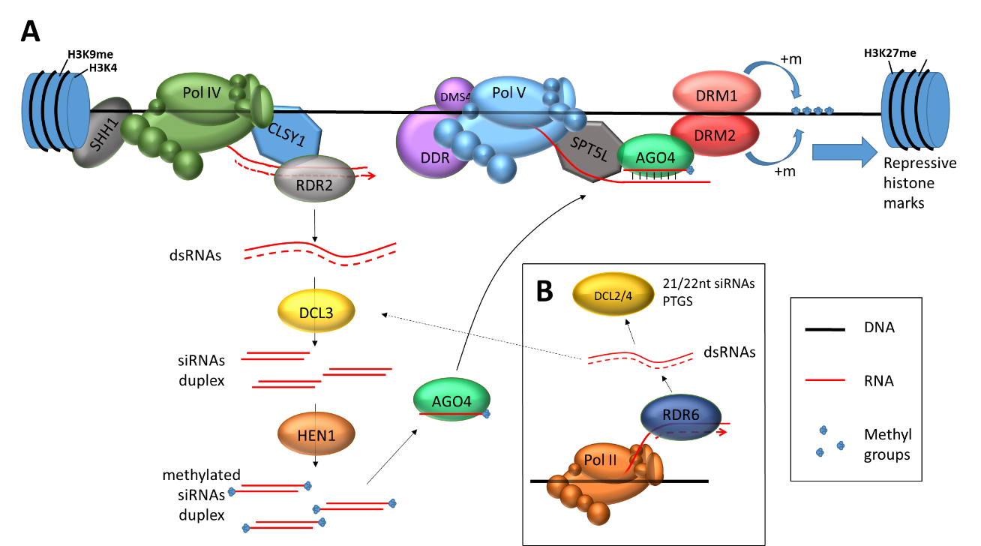
Figure 1.2: A: Model of the ‘canonical’ RdDM pathway. The RNA polymerase Pol-IV initiates the process by transcribing DNA regions. Pol-IV binding to target sequences and initiation of transcription requires association with SHH1 and CLSY1 (DTF1). The transcribed single-stranded RNAs are then copied into double-stranded RNAs (dsRNAs) by RDR2, which associates with the chromatin remodeling protein CLSY1. The dsRNA is then cleaved into 24 nucleotide small interference RNAs (siRNAs) by the DICER-like protein DCL3 and subsequently methylated at the 3’ ends by HEN1. Single-stranded methylated siRNAs are loaded into the argonaute protein AGO4, forming an RNA-induced silencing complex (RISC). The RISC-AGO4 complex binds to Pol-V transcripts by base pairing, using the single-stranded siRNA bound to AGO4 as template to match with the target region to be methylated. Interactions between AGO4 and Pol-V are mediated by SPT5L (or KTF1), which also binds to transcribed RNA, and the DRM2 inactive paralog DRM3. Pol-V transcription requires assistance from the DDR complex (formed by DRD1, DMS3 and RDM1) and DMS4. Interaction of AGO4 with RDM1 recruits DNA-methyltransferases (DRM1 and to a lesser extent DRM2) resulting in DNA methylation of the target region. Recent findings suggest that the RDM1 protein from the DDR complex is required for the interaction between AGO4, Pol-V and DRM1, as well as the IDN2/FDM1-2 complex (not included in the picture for simplicity). IDN2 binds with SWI/SNF chromatin remodelling complex and MORC6, which are responsible for further chromatin condensation after deposition of DNA methylation. B: Non-canonical variation to the RdDM pathway. RNAs transcribed by Pol-II can be intercepted by the RNA-dependent RNA polymerase RDR6 and converted into dsRNA. The resulting dsRNA is then processed by DICER-like proteins DCL2 and DCL4 into 21 or 22 nucleotides siRNAs, which are then fed in the post-transcriptional silencing (PTGS) machinery. Alternatively, the dsRNAs can be processed by DCL3 into 24nt siRNAs and trigger RdDM independently of Pol-IV transcription. See text for more details.

In both cases, the “non-canonical” RDR6-RdDM pathway provides a link between PTGS and TGS. It has been suggested that this non-canonical RDR6-RdDM pathway is responsible for de novo CG DNA methylation at unmethylated sites and serves as a ‘primer’ for canonical RdDM to establish TGS [72]. Hence, the non-canonical Pol-II-dependent RdDM triggers de novo DNA methylation, after which canonical Pol-VI dependent RdDM establishes de novo DNA methylation and TGS.
Not all intergenic regions or TEs are targeted by the RdDM pathway. A chromatin remodeler of the SWI/SNF family, DECREASE DNA METHYLATION1 (DDM1) is responsible for DNA methylation of long TEs, gene bodies and intergenic regions in heterochromatin-dense (mostly pericentromeric) regions that cannot be accessed by the RdDM machinery [73,74]. The DDM1 chromatin remodeler unwinds heterochromatic DNA, allowing access to the methyltransferases MET1 and CMT3 for CG and CHG methylation, respectively. DDM1 also provides access for the methyltransferase CMT2, which can mediate de-novo CHH methylation that operates independently of RdDM (Figure 1.1) [73,75]. Together with RdDM, DDM1 accounts for nearly all TE methylation and silencing in the plant genome [73].

1.2.3: Maintenance of DNA methylation over cell division.
After DNA replication, both parental strands maintain DNA methylation at the palindromic cytosines of CG and CHG contexts (see Figure 1.1), while the newly synthesized daughter strands are not methylated (hemi-methylation). DNA hemi-methylation is not biologically active and needs to be re-established on both strands in order to maintain its functions [76]. At CG contexts, the DNA METHYLTRANSFERASE MET1 is recruited to the hemi-methylated sites by the VARIANT IN METYLATION1 (VIM1) protein [77,78], after which it re-establishes DNA methylation at both strands. Maintenance of CG methylation at long transposable elements also requires the chromatin remodeler DDM1 [73,79,80]. At CHG contexts, DNA methylation is maintained through a self-reinforcing loop between histone modification proteins and the DNA methyltransferase CMT3. The histone methyltransferases SU(VAR)3-9 HOMOLOG 4 (SUVH4)/KRYPTONITE (KYP) , SUVH5 and SUVH6 bind to hemi-methylated CHG sequences through their SRA domain and catalyse H3K9 single and di-methylation (H3K9me and H3K9me2) [81-84]. The DNA methyltransferase CMT3 in turn recognizes the methylated residues on H3K9 through its chromodomain, and catalyses DNA methylation at CHG contexts [85].
The asymmetrical CHH context does not have a palindromic cytosine on the opposite strand (Figure 1.1). Consequently, one of the two newly synthesized DNA molecules lacks DNA methylation at this context. Since siRNAs from parent cells are still present in the daughter cells, CHH methylation at small TEs and euchromatic intergenic regions is continuously re-established by DRM1/2 through RdDM after each cell division [30,86]. CHH methylation at long TEs and heterochromatic intergenic regions is mediated by the chromomethylase CMT2, which catalyses de novo methylation independently of the RdDM pathway and (like CMT3) requires the presence of H3K9me at the target site [73,75,87].

1.2.4: Transgenerational maintenance of DNA methylation over meiosis
Altered patterns of DNA methylation in plants can be maintained over meiosis, acting as de-facto epialleles that are stably inherited for multiple generations [88]. Since the early discovery by Barbara McClintock of heritable but reversible changes in TEs activity, later associated with changes in DNA methylation [89], multiple examples of heritable epiallele have been reported in different plant species (summarized in [88]).
Maintenance of CG and CHG DNA methylation by MET1 and the chromatin remodeler DDM1 (see above) is crucial for transgenerational inheritance of epialleles [90]. For instance, epigenetic recombinant inbred lines (epiRILs), WT Arabidopsis lines deriving from crosses with DNA de-methylated mutants met1-3 and ddm1-2, retained regions of de-methylated DNA (differentially methylated regions, DMRs) through 6 or 7 generations of self-pollination respectively [15,16]. Some regions of demethylated DNA were maintained up to sixteen generations of self-pollination in epiRILs derived from a cross with ddm1-2 [91]. The regions of demethylated DNA could affect complex traits such as flowering time or root length independently from genetic variation [92]. In ddm1-2-based epiRILs, only 33.2% of DNA demethylated regions present in the ddm1-2 parent segregated in the population [17], indicating reversion of DNA demethylation which can occur through RdDM pathway activity [93]. Maintenance of stable DNA de-methylated regions though several round of meiosis, and the finding that 50% of these DMRs overlap with naturally occurring epialleles [91], indicate that some regions of the Arabidopsis genome are less efficiently targeted by DNA demethylation reverting mechanisms. Indeed, a recent publication demonstrated that genetic sequence features can influence the predisposition of certain loci to form stable or reversible epialleles [94].
Despite multiple lines of evidence for stable inheritance of DNA (de)methylation through generations, global analyses of DNA methylomes have also shown that plants undergo a partial epigenetic reprogramming during sexual reproduction (extensively reviewed in [95]). The reprogramming involves widespread loss of DNA methylation mostly in vegetative and endosperm cells. The DNA glycosylase DEMETER (DME) is active in the vegetative cells of pollen grains, where it mediates genome-wide DNA demethylation of small TEs [96], causing their transcriptional activation. TE-associated siRNAs can migrate into and accumulate in the sperm cell, where they establish de novo non-CG methylation through the RdDM pathway [97-100]. A similar mechanisms was found in the endosperm, causing de novo DNA methylation in the embryo [43,101], and both can contribute to maternal and paternal imprinting [95,102]. This model however does not account for maintenance of patterns of DNA demethylation through generations, and the transfer of non-autonomous small RNAs from vegetative cells to sperm cell has been challenged [103]. Recently, novel roles for “non-canonical” RDR6-RdDM and RdDM-independent CMT2 in the transgenerational maintenance of DNA methylation in pollen cells are emerging [104].

1.2.5: Relationship between DNA methylation and histone modifications
It is generally accepted that methylated DNA drives formation of heterochromatin through promoting post-translational histone modifications, such as H3K4me2/3, H3K27me/me2, H3K9me/me2 and H4K20me [105]. As such, the distribution and abundance of DNA methylation determines chromatin status. In the case of H3K9 methylation, however, the opposite relation stands true, where specific histone modifications drive non-CG methylation. The DNA methylases CMT2 and CMT3 both require H3K9me and H3K9me2 to bind to their target sites through their chromodomain. In vitro studies have shown that CMT2 prefers H3K9me2 sites over H3K9me, while CMT3 has no preference [75]. In addition, the RdDM pathway requires H3K9me to initiate and establish DNA methylation. As detailed above, the SHH1 protein recognizes H3K9me2 and unmodified H3K4 regions, which binds and directs Pol-IV for siRNA generation and RdDM [53]. On the other hand, it has been shown that lack of H3K9me and H3K9me2 causes an extensive loss of non-CG methylation, due to disruption of the non-CG DNA methylation maintenance pathway, while elimination of all non-CG DNA methylation results in loss of H3K9 methylation [75,106]. Hence, the histone methyltransferases SUVH4(KYP)/5/6 require DNA methylation at non-CG sites to bind and deposit H3K9 methylation, creating a bi-directional feedback loop between non-CG methylation and H3K9 methylation. Interestingly, this feedback mechanisms also implies a mechanism by which CHG DNA methylation can spread into neighbouring CHH methylation (and vice versa). In this scenario, SUVH4/5/6-mediated H3K9 methylation near methylated CHG contexts could recruit CMT2 for methylation of neighbouring CHH sites, or even recruit Pol-IV to initiate de novo RdDM at CHH sites [53,75].
The spread of non-CG methylation offers an explanation for previous studies reporting transition of DNA methylation from transgenes or TEs to neighbouring genes [107-110]. This spread of non-CG DNA methylation can be antagonised by active DNA demethylation mechanisms, which prevent undesirable gene silencing. Mutations in REPRESSOR OF SILENCING1 (ROS1, see below), which is the predominant DNA demethylase in vegetative tissues, result in genome-wide DNA hyper-methylation in all contexts [87].
In contrast to non-CG methylation, CG methylation functions independently from H3K9 methylation, since the loss-of-function kyp/suvh5/suvh6 triple mutant is not severely reduced in overall CG methylation [87]. On the other hand, loss of MET1 activity leads to reduced levels of non-CG DNA methylation and, consequently, also H3K9 methylation [27,87]. This suggest a yet poorly understood mechanism that links CG to non-CG methylation. This link is supported by emerging evidence that non-CG DNA methylation can spread into CG DNA methylation that is stably maintained over subsequent generations [72,110].

1.2.6: DNA demethylation in plants
DNA demethylation in plants can happen passively, due to removal or inhibition of active methylation maintenance machinery (such as in met1 or ddm1 mutants), or actively, through enzymes that remove methylated cytosines. Active demethylation prevents excessive spreading of DNA methylation and chromatin-mediated silencing of active genes. This active process can also reduce levels of DNA methylation in response to environmental stresses [19,111-113]. In Arabidopsis, active DNA demethylation is determined by four DNA glycosylases: DEMETER (DME), REPRESSOR OF SILENCING1 (ROS1), DEMETER-LIKE1 (DML1) and DEMETER-LIKE2 (DML2). These four DNA glycosylases recognize and excise the methylated cytosines [114-116], which are then replaced by un-methylated cytosines through the base excision repair (BER) pathway [117].
DME is only active in the vegetative cells in pollen grains, where it mediates partial epigenetic reprogramming and parental imprinting (see section 1.2.4). In vegetative tissues, ROS1, DML1 and DML2 have redundant functions, with ROS1 being the most active DNA demethylase [115,118,119]. ROS1 has been reported to associate with the siRNA-binding protein REPRESSOR OF SILENCING3 (ROS3), suggesting a mechanism by which active demethylation is directed by siRNA [120]. However, comprehensive analysis of ros3 mutants revealed no major reductions in DNA methylation [119], casting doubt about the exact role of ROS3 in DNA-demethylation.
A recent study identified a helitron TE in the ROS1 gene promoter, whose DNA methylation status negatively affects ROS1 gene expression [121,122]. However, between this TE and the 5’UTR of ROS1, there is a relatively short stretch of methylated DNA that is targeted by both the RdDM pathway and ROS1 and that counters the repressive effect of the helitron TE on ROS1 transcription. Interestingly, when methylated by RdDM, this region boosts ROS1 gene expression. Consequently, RdDM promotes ROS1 expression, after which ROS1 represses CHH methylation levels in its own promoter and reduces ROS1 expression [121,122]. This negative feedback mechanism allows the ROS1 promoter to act as a global DNA methylation sensor (“methylstat” [123]) and explains why mutations in RdDM machinery and ROS1 can have similar effects on the expression of certain (trans)genes [124].

1.3 The plant innate immune system: plant defences against pathogens

The plant innate immune system controls inducible defence mechanisms that become active in response to pathogen/herbivore attack [2]. Plants have evolved different “layers” of inducible defence mechanisms, which are considered more specific and effective compared to constitutively produced defences, but are typically also more costly for the plant [125].

1.3.1: Early-acting inducible defences
Herbivores and pathogens are perceived by the plants through specific pattern recognition receptors (PRRs), which can detect either microbe-associated molecular patterns (MAMPs), or damage-associated molecular patterns (DAMPs) [126,127]. MAMPs are molecular signatures that are absent in plants (“non-self” recognition), while DAMPs are small molecules derived from the damaged plant (“damaged-self” recognition). Well known examples of defence-eliciting MAMPS are the 22-amino acid peptide flg22, derived from bacterial flagellin [128], and chitin oligomers from fungal cell walls [129]. Examples of defence-eliciting DAMPs are cutin monomers or oligogalacturonides from the cell wall matrix [130]. MAMPs allow for direct recognition of microbial pathogens, while DAMPs allow for perception of attack by herbivores or necrotrophic pathogens that cause cell damage. Well-characterized PRRs include Leucine-Rich Repeat Receptor-like Kinases (LLR-RLKs), which are membrane proteins with an extracellular LRR domain for pattern recognition and an intracellular kinase domain for downstream signalling [131]. For a detailed overview of PRRs, see [126,132].
Plants respond to perception of MAMPs/DAMPs with a short and localized oxidative burst, consisting of the production of reactive oxygen species (ROS) and reactive nitrogen species (RNS). Defence-related ROS are typically produced in the apoplast by a family of NADPH-oxidases called Respiratory Burst Oxidase Homologues proteins (RBOH; [133]). The mechanisms of RNS production are less well understood. Proteins with nitric oxide synthase (NOS)-like activity have yet to be identified in plants, although known NOS inhibitors have been reported to suppress Nitric Oxide (NO•) production in plants [134]. RNS production through nitrate reductase (NR)-dependent formation of NO• has been demonstrated in plants, although this pathway interferes with primary and secondary metabolism and is, for this reason, not considered to contribute to defence-related RNS [134]. In addition to direct toxic effects on pathogens, ROS and RNS can act as second messengers for downstream defences. For instance, H₂O₂ can induce a wide spectrum of defence-related genes through activation of H₂O₂-dependent MAPK cascades, including positive feedback genes encoding other NAPDH-oxidases, defence genes [135] and programmed cell death (PCD)-related genes [136] [137]. H₂O₂ stimulates the octadecanoid pathway, which boosts production of the plant defence hormone jasmonic acid (JA) [137]. Furthermore, RBOHD-dependent H₂O₂ has been implicated in systemic wound signalling and in cell-to-cell signalling upon infection by necrotrophic pathogens and exposure to abiotic stress [138,139]. NO• signalling is mainly based on covalent modifications of proteins through direct reaction with amino-acid residues. A well-known redox-dependent protein modification is S- nitrosylation of the thiolic group at cysteine residues [140]. S- nitrosylation of the defence regulatory protein NPR1 directly influences this protein’s monomerisation and translatocation to the nucleus [141,142]. S- nitrosylation also inhibits allene-oxide cyclase, a key enzyme in the octadecanoid pathway, leading to reduced JA levels [143]. For further details to NO• signalling, see [134].
Following pathogen-induced ROS and RNS accumulation, plants typically accumulate cell wall papillae that are rich in callose, a β-1,3 polyglucan. In Arabidopsis, the pathogen-inducible callose synthase is termed GSL5 (synonymous CalS12 or PMR4). Activation of this enzyme can result in callose accumulation within minutes of wounding or pathogen inoculation [144]. Rapid formation of callose-rich papillae encapsulates bacterial cells or fungal structures like hyphae and haustoria, blocking their growth in the apoplast [145]. This mechanism makes callose deposition effective against pathogens with different lifestyle [145,146]. Callose production is tightly linked with abscisic acid (ABA) regulation [145], and seems to follow different regulatory pathways in response to bacterial-derived or fungal-derived elicitors [147]. It has been proposed that GSL5-dependent callose deposition inhibits the later-acting salicylic acid (SA)-dependent defence responses [148], suggesting the existence of a negative cross-talk mechanism between early defences and relatively late defences (see below). Recently, it was shown that early deposition of small callose papillae results in complete penetration resistance to powdery mildew (Blumeria graminis), indicating that the timing of this defence response is critical for its effectiveness [149].

1.3.2: Late-acting inducible defences
As infection progresses, plants activate relatively late acting defences that require de novo production of defence signalling hormones. SA and JA hormones are considered the key players in these hormone-regulated defence responses [150,151]. SA-dependent defences are marked by expression of a wide range of defence-related genes (also referred to as pathogenesis-related (PR) genes), such as PR-1, PR-2 and PR-5 [152]. The SA pathway is mediated by the NPR1 protein, which is present in the cytoplasm in an oligomeric form. SA induces monomerisation of NPR1, which involves a thioredoxin-mediated disruption of the intramolecular disulphite bonds [142]. Monomeric NPR1 translocates to the nucleus, where it interacts with TGA-family transcription factors to activate transcription of PR genes. TGA2, TGA5, TGA6, and WRKY70 are required for SA-mediated PR-1 transcription [153,154], although a direct interaction between NPR1 and WRKY70 has never been reported.
The JA-dependent response leads to expression of a different suite of defence-related genes than those induced by SA, such as PDF1.2, CHI-B and HEL [155,156]. JA-induced signal transduction involves the JA amino-acid synthetase JAR1 (which converts JA into active JA-isoleucine conjugate (JA-Ile) [157]), the F-box protein COI1 [158], and the transcription factor MYC2, required for transcription of JA-dependent genes [159]. JA-dependent signalling is constitutively repressed by jasmonate ZIM-domain (JAZ) proteins, which inhibit JA-dependent gene expression through physical binding to MYC transcription factors [160,161]. JA-mediated interaction of the SCF-COI1 ubiquitin ligase complex with JAZ proteins, which is considered to be the JA-ile receptor [162], leads to ubiquitination of JAZ proteins and their subsequent degradation in the proteasome [160,161]. Upon degradation of the JAZ proteins, the MYC transcription factors are no longer retained and activate transcription of JA-dependent genes [160,161]. In general terms, SA-dependent defences are mostly effective against biotrophic pathogens, which extract nutrients from living plant cells [163,164], while JA-dependent defences are more effective against herbivores and necrotrophic pathogens, which feed on destroyed host tissues [165-168].
There is ample evidence for antagonistic crosstalk between SA- and JA-dependent defence signalling. This negative crosstalk allows plants to prioritize their defence resources against the appropriate attacker, thereby minimizing energy costs [169,170]. For instance, Arabidopsis plants exposed to the hemi-biotrophic pathogen Pseudomonas syringae pv. tomato (Pst) become more susceptible to the necrotrophic pathogen Alternaria brassicicola due to SA-induced repression of JA-dependent defences [21]. Conversely, infection by the biotrophic pathogen Hyaloperonospora arabidopsidis (Hpa) suppresses JA-induced defences in response by the herbivore caterpillar Pieris rapae [171]. Many components in the JA- and SA-dependent signalling pathways are also involved in this negative signalling crosstalk. The npr1 and wrky70 mutants of Arabidopsis are impaired in SA-dependent suppression of JA-defences [172,173], while MYC2 is required for suppression of SA-dependent defences during infection by virulent Pst [174].
Despite the well-established antagonism between SA and JA signalling, there are exceptions to the rule. For instance, JA and SA have been reported to act synergistically when applied in low concentrations [175,176]. Furthermore, defence against the necrotrophic pathogen Botrytis cinerea was found to be dependent on SA in conjunction with JA and ethylene [177], while JA has been reported to reduce infection by the hemibiotrophic Pst [178]. These exceptions illustrate that the regulation of the plant innate immune system is more versatile than a binary switch between JA- and SA-dependent defence pathways, allowing plants to recognize and respond to specific pathogens through a complex interplay between different signalling pathways (e.g. ‘signal signature’, hypothesized in [179]), and mount an appropriate and cost-efficient defence response [170,180]. This view is consistent with the fact that very few plant pathogens can be characterized as solely biotrophic or necrotrophic. Most pathogens start host infection as a biotrophic pathogen, and switch to a necrotrophic lifestyle at later stages of infection. Depending on which lifestyle is most dominant, these pathogens are commonly referred to as hemibiotrophic or heminecrotrophic.

1.3.3: Pathogen effectors and effector-triggered immunity
While plants evolved a sophisticated multi-layered innate immune system, pathogens evolved cunning strategies to overcome these defences through production of effectors: small proteins or molecules that can specifically block or de-regulate defence signalling pathways to increase susceptibility of the tissue [2]. For instance, some virulent strains of Pst produce coronatine, an analogue of JA-ile which activates JA-dependent defences, resulting in JA-dependent suppression of SA defences, thereby increasing susceptibility to the biotrophic pathogen [181,182]. Plants have counter-evolved the ability to recognize the pathogen’s effectors through specific resistance (R) proteins, resulting in an augmented defence response that results in apoptosis, the hypersensitive response (HR). This effector-triggered immunity (ETI) is highly specific and requires the presence of a specific effector gene in the pathogen and a corresponding R gene in the host plant [2,183]. Accordingly, ETI is commonly referred to as ‘gene-for-gene resistance’ or ‘qualitative resistance’. In turn, pathogens can evolve alternative effectors that are no longer recognized by R proteins, resulting in an ongoing evolutionary arms race [2]. Most R proteins are cytoplasmic receptors of the CC-NB-LRR family. They are made up of an N-terminal LRR domain for recognition of pathogen effectors, a nucleotide binding (NB) domain that acts as a “switch” for protein activation and a coiled coil (CC) domain, potentially involved in protein-protein interactions [184,185].

1.4: Priming of defence: plant adaptive immunity

1.4.1: what is priming?
In biology, priming can be defined as the phenomenon by which perception of a specific (a)biotic stimulus sensitises the reaction to a subsequent stimulus, resulting in a faster and/or stronger expression of this secondary response [186]. Priming in the context of plant stress biology is a type of phenotypic plasticity that provides adaptive value in the form of enhanced tolerance or resistance. Priming typically occurs in response to a low-intensity stress signal that transiently induces direct defence activity, followed by increased responsiveness of inducible defences to subsequent stress. In the case of abiotic stress, priming can increase tolerance to subsequent salt stress, heat stress, and cold stress [187-189]. Although this phenomenon is often referred to as “acclimation”, it can be considered a form of priming. In case of biotic stress, plants exposed to pathogens or herbivores develop priming that can provide long-lasting resistance against a wider range of attackers [190,191]. While this so-called ‘induced resistance’ or ‘acquired resistance’ has been known for several decades [192-194], the underlying mechanisms have only partially been elucidated. Priming provides immunological memory by enhancing the responsiveness of the plant’s innate immune system. As such, it can be regarded as a form of acquired immunity.
A localised attack by a pathogen or an herbivore, treatment with MAMPs or specific priming chemicals, such as SA, the SA analogue benzothiadiazole (BTH), JA or β-aminobutyric acid (BABA), can induce transient defence expression that sets the plant to a ‘primed’ immune state. Upon subsequent exposure to a pathogen or herbivore, primed plants activate a faster and stronger innate immune response that provides enhanced resistance (Figure 1.3 and 1.4) [190,195,196]. A faster and/or stronger activation of inducible defences allows plants to react more effectively to attacker during the earlier and more critical stages of the interaction (Figure 1.4). In the interaction with biotrophic pathogens, the accelerated defence response can stop infection before the pathogen has the opportunity to employ its susceptibility-inducing effectors (see 1.2.3)[4]. Priming of plant defences can give enhanced resistance to a broad range of pathogens and herbivores [197].
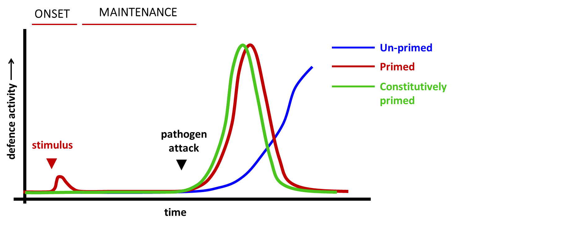
Figure 1.3: Conceptogram of defence priming in plants. Plants subjected to a priming stimulus (ie: pathogen/herbivore attack or chemical treatment) typically respond with transient and relatively short defence response, which translates into a longer-lasting sensitisation of the plant immune system. This “primed” immune state results in a faster and stronger activation of plant defences after a subsequent pathogen attack compared to un-primed plants. Some plant varieties or progenies are constitutively (or innately) primed through genetic or epigenetic mechanisms without the need for an external stimulus, resulting in a similar resistance phenotype.

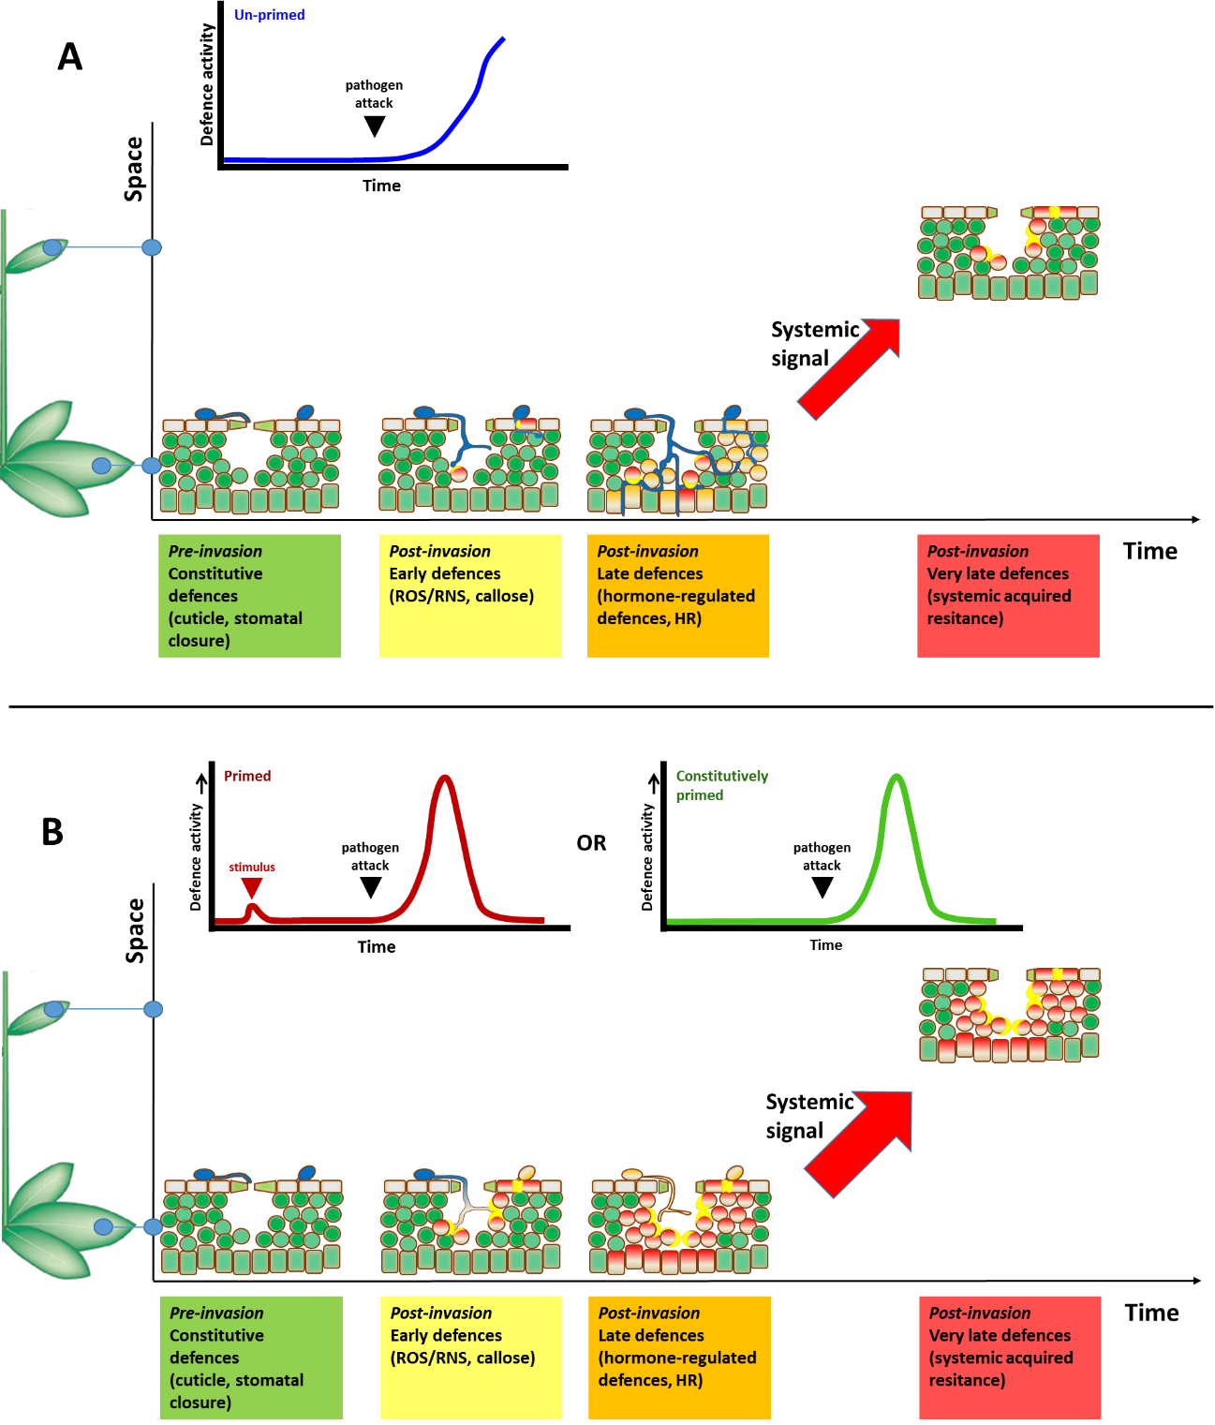
Figure 1.4: Model of the different layers of inducible plant defences after pathogen attack, and comparison between un-primed (A) and primed (B) plants. A: Upon pathogen perception, plants activate different layers of defences at the infection site (lower point in the vertical space axis). Early-acting inducible defences are activated immediately upon pathogen perception and include production of reactive oxygen/nitrogen species (oxidative burst) and deposition of callose at the sites of attack. Relatively late acting inducible defences involve de novo production of defence signalling hormones, such as salicylic acid (SA) or jasmonic acid (JA), which coordinate the production of antimicrobial proteins. Higher concentrations of pathogen-induced SA can lead to a hypersensitive response (HR), which is a form of programmed cell death (PCD) that is particularly effective against biotrophic pathogens. Late acting defences also involve the production long-distance signals that can transiently induce defences in systemic tissues, and even neighbouring plants in case of volatile defence signals (e.g. methyl salicylic acid or methyl jasmonate). The transient defence induction in the systemic tissues marks the onset of systemic acquired resistance (SAR), which can be maintained through priming of inducible defences. B: In primed (red) or innately primed (green) plants, the activation of inducible defences occurs faster and/or stronger (shown by a higher number of red cells in the picture), resulting in more effective resistance response at their earlier stages of the interaction.
Priming acts on different layers of the innate immune system, ranging from early-acting defence responses, such as ROS production and callose deposition, to later-acting hormone-regulated defences and HR (extensively reviewed in [198]). Systemically expressed induced resistance phenomena often involve priming (Figure 1.4). The classic example is systemic acquired resistance (SAR). This immune response is triggered by local pathogen attack or MAMP exposure, resulting in transient expression of SA-dependent defences in distal tissues, followed by a priming of these defences [195,199]. Herbivore-induced volatile organic compounds (VOCs) can prime JA-dependent defence responses in systemic plant organs or even neighbouring plants [195,200,201]. Furthermore, beneficial rhizobacteria or mycorrhizal fungi in the rhizosphere can trigger an induced systemic resistance (ISR) response, which involves priming of a combination of JA-dependent and JA-independent defences [202-204]

1.4.2: Costs and benefits of priming
The concept of priming implies that costly defence mechanisms are not activated until the plant is under attack by a pathogen or herbivore, which makes priming a cost-effective mode of resistance. Although relatively minor in comparison to resistance through direct up-regulation of defence mechanisms, the primed defence state is nevertheless associated with growth reductions under stress-free conditions [205]. However, this cost is out-weighted by the benefits of disease protection under disease pressure [205]. Arabidopsis mutants that are constitutively (or innately) primed showed relatively minor reductions in growth, comparable to chemically primed wild-type plants, but performed better in terms of growth and seed set under disease pressure. Conversely, mutants displaying continuous expression of inducible defences show a more dramatic growth reduction, which is comparable to wild-type plants that are under constant disease pressure [205]. Thus, priming is a beneficial defence strategy in environments that impose longer periods of disease pressure, but brings costs in low-stress environments. Interestingly, some naturally occurring accessions of Arabidopsis display constitutive priming of SA-dependent and –independent defences [206], suggesting that these accessions evolved priming as a genetic trait to cope with hostile environments. However, plants living in more variable environments would benefit more from a system that allows transmitting priming as a heritable but reversible trait, i.e. without having to fix the trait genetically, along with the accompanying costs.

1.4.3: Trans-generational priming
In 2012, three independent publications in the same issue of Plant Physiology reported that Arabidopsis can transmit priming to its progeny [6,207,208]. Considering that the parental plants in these experiments were isogenic, these studies provided the first evidence that priming can be transmitted epigenetically over meiosis. In the first study, BABA-treated plants transmitted the chemically induced priming to their progeny, resulting in enhanced resistance against Pst [207]. The resistance was associated with enhanced responsiveness of SA-dependent inducible genes, but was lost after one treatment-free generation [207], leaving doubt whether this phenotype is a truly epigenetic trait. A second study reported that herbivore-infested, wounded and MeJA-treated tomato and Arabidopsis plants produced progeny that were more resistant to H. zea and P. rapae feeding, respectively [208]. Moreover, the transgenerational resistance response in Arabidopsis could be transmitted over one stress-free generation, was associated with increased responsiveness of JA-dependent defences, and required an intact siRNA biogenesis pathway, suggesting involvement of de novo DNA methylation [208]. The third paper showed that Arabidopsis repeatedly inoculated with increasing doses of Pst produced progeny that are more resistant to the biotrophic pathogen Hpa, but more susceptible to the necrotrophic pathogen Alternaria brassicicola, which was associated with SA-dependent defences and repression of JA-dependent defences [6]. The priming of SA-dependent genes and enhanced resistance to Hpa could be transmitted over one stress-free generation, indicating a truly epigenetic response. Furthermore, the enhanced responsiveness of the SA-inducible genes PR1, WRKY6 and WRKY51 was associated with enrichment of transcription-permissive H3K9 acetylation in their promoter regions, while the repression of the JA-inducible marker gene PDF1.2 was associated with promoter enrichment of H3K27me3, a transcription-repressive histone mark [6]. Interestingly, DNA methylation mutants ddc and ago4 (bearing widespread loss of non-CG methylation) showed a constitutive priming phenotype that was similar to that of progeny from infected wild-type plants [6,22], suggesting that loss of non-CG methylation triggers transgenerational priming.

1.4.4: Molecular mechanisms of priming
Various reports have shown that priming coincides with an increased accumulation of inactive signalling proteins, such as MAP-kinases or transcription factors [198]. The increased presence of these signalling proteins would allow for enhanced defence signalling capacity, facilitating a faster and stronger defence signalling response upon subsequent pathogen attack [198,209]. A first validation of this hypothesis came from the experimental evidence that plants treated with the SA-analogue BTH show higher levels of inactive MAPK3 and MAPK6 [210]. Furthermore, it has been shown that BABA and ISR-eliciting rhizobacteria increase the expression of defence regulatory transcription factors, without directly activating the downstream defence response [204].
While the above mechanisms provide a plausible mechanism for short-term priming, it does not account for the long-lasting nature of the primed state, which has been shown to last for up to 28 days in Arabidopsis [211]. Signalling proteins usually have high turnover rates driven by their phosphorylation [212], making it unlikely that an initial burst in production of these proteins can have an effect that lasts longer than several days. Epigenetic mechanisms, on the other hand, can account for long-lasting changes in gene expression or responsiveness. In particular, the permissive chromatin state observed in trans-generationally primed plants [6] provides a plausible mechanisms for gene priming [197,213]. However, how these chromatin modifications remain stable over meiosis remains to be resolved, since there is no evidence that post-translational histone modifications can be transmitted faithfully through meiosis.

1.4.5: Role of DNA methylation in regulation of plant defences and priming
Over recent years, an increasing body of evidence has accumulated showing that DNA methylation plays an important regulatory role in plant defence. For instance, mutants in RdDM have been shown to express enhanced resistance to Pst, while at the same time displaying enhanced susceptibility to necrotrophic fungi, such as B. cinerea and P. cucumerina (Pc) [21]. The defence phenotype of these mutants was associated with priming of SA-dependent genes and repression of JA-dependent genes, which coincided with increased incidence of permissive histone marks in the promoter region of PR1, but not of PDF1.2 [21]. The innate priming phenotypes of these mutants therefore mimic the transgenerational priming phenotype of progeny from Pst-inoculated wild-type plants [22]. Furthermore, mutants impaired in establishment and maintenance of DNA methylation have been reported to be more resistant to Pst [19]. This paper also showed that treatment with SA or infection by virulent or avirulent Pst induces genome-wide changes in DNA methylation [19]. Another report showed that treatment of plants treated with either the bacterial elicitor Flg22, or Pst, underwent ROS1-dependent demethylation of loci that are targeted by the RdDM pathway [20]. Again, mutants in the RdDM pathway and in maintenance of CG and CHG methylation were found to be more resistant against Pst through SA-dependent mechanisms [20].
In summary, the constitutively primed phenotype of DNA methylation mutants [7,21,112] indicates a pivotal role for DNA (de)methylation in the regulation of plant defence. Since DNA demethylation is associated with removal of repressive histone marks and establishment of permissive ones, changes in DNA demethylation could also explain how primed progeny from disease Arabidopsis show transcription-permissive changes in histone modifications at defence gene promoters [6]. Considering that there is ample evidence that patterns of DNA methylation patterns can be transmitted faithfully over meiosis (epialleles; see section 1.2.4), changes in DNA methylation provide the most plausible mechanism by which plants transmit defence priming to their progeny.

1.5: Overview of experimental chapters

The current thesis describes the regulatory role of DNA methylation in (transgenerational) disease resistance of Arabidopsis. After the materials and methods chapter (Chapter 2), the first experimental chapter (Chapter 3) will focus on the role of DNA methylation and DNA (de)methylation machinery in disease resistance by characterizing defence phenotypes of two mutants with opposite global DNA methylation patterns. The first mutant, nrpe1-11 ([214]) lacks the largest subunit of Pol-V and shows widespread DNA hypo-methylation at non-CG contexts due to an impairment in RdDM [119]. The second mutant, ros1-4 [215], is a T-DNA insertion mutant of the DNA glycosylase gene ROS1. Mutations in this gene have been shown to cause widespread DNA hyper-methylation in all contexts [119]. When exposed to pathogens with different lifestyles, the two DNA methylation mutants showed opposite resistance phenotypes. Moreover, nrpe1-11 and ros1-4 showed differential regulation of callose deposition and SA-dependent defence gene expression. The results from the first chapter are part of a recently published paper (Lopez et al. 2016, Plant J [215]), which provides evidence for an important regulatory role of DNA methylation in plant immune responsiveness.
The Chapters 4 to 6 are focused on transgenerational resistance in epigenetic recombinant inbred lines (epiRILs) of Arabidopsis. These chapters make use of a set of 123 near-isogenic Arabidopsis lines, which differ in DNA methylation due to introgression of hypo-methylated DNA from the ddm1-2 mutant [15]. Chapter 4 describes chromosomal mapping of epigenetic quantitative trait loci (epiQTLs) controlling resistance to the biotrophic oomycete Hpa and the necrotrophic fungus Pc. The mapping of Hpa resistance resulted in four statistically significant epiQTLs that provide enhanced resistance to Hpa. No statistically significant epiQTLs could be detected for the resistance to Pc in this epigenetic mapping population. Image analysis of seedling growth revealed one statistically significant epiQTL that suppressed growth, which did not overlap with any of the Hpa resistance epiQTLs. This suggests that the transgenerational resistance to Hpa in the population is not associated with major costs to plant growth.
Chapter 5 focuses on a selection of eight epiRILs that expressed the highest level of transgenerational resistance to Hpa. In-depth analysis of defence phenotypes revealed that the elevated level of Hpa resistance in these lines is associated with a faster and stronger induction of SA-inducible PR1 gene and/or enhanced deposition of resistance-contributing callose. In support of the whole-population growth analysis reported in Chapter 4, the constitutive priming phenotypes of the eight epiRILs was not associated with statistically significant reductions in vegetative growth. While some lines showed reduced seed production under disease-free conditions, other lines produced comparable amounts of seeds as wild-type plants. This indicates that the reduced seed production in some lines is not causally related to the transgenerational defence priming conferred by the epiQTLs. Finally, the chapter addresses transgenerational trait stability in five independent F10 progenies derived from individual F9 plants, as well as cross-effects of the transgenerational resistance to Hpa to resistance against the necrotrophic fungus Pc and tolerance to salt stress.
Chapter 6 describes the potential mechanisms by which DNA methylation in the epiQTLs regulates immune priming and genome-wide defence gene expression. To this end, four Hpa-resistant epiRILs were selected for carrying different yet partially overlapping Hpa resistance epiQTLs, and subjected to whole-genome transcriptome analysis (RNA-Seq) at 48 and 72 hours after Hpa inoculation. Global analysis of transcriptome patterns revealed that the elevated Hpa resistance of the four epiRILs is associated with primed induction of Hpa-inducible defence (i.e. Hpa-responsive genes showing a faster and/or stronger induction in the epiRILs than the wild-type). For each epiRIL, the number of identified priming-responsive genes was 3- to 5-fold higher than the number of pathogen-inducible genes showing a constitutively elevated expression pattern, Moreover, the set of priming-responsive genes showed stronger enrichment of GO terms related to (SA-dependent) plant defence, supporting the notion that the transgenerational resistance phenotype of the epiRILs is largely based on priming of SA-dependent defence genes. Finally, analysis of priming-responsive genes within the four epiQTL intervals revealed that the majority of defence-related genes are controlled in trans, as was evidenced by a lack of correlation between epiQTL and primed expression pattern. Interestingly, however, the few genes showing primed expression in accordance to DNA demethylation at the epiQTLs were almost exclusively TEs or TE-related genes. This outcome suggests that heritable DNA methylation of TEs plays a global trans-regulatory role in the responsiveness, or ‘priming’, of SA-dependent defence genes.
The final chapter (Chapter 7) is the general discussion and places the results of the experimental chapters in context of the latest developments in the field of plant epigenetics and disease resistance. This chapter will discuss the translational value of transgenerational immune priming, as well as explore different models of trans-regulation of plant coding genes by DNA methylation.

Chapter 2 - Materials and Methods

2.1: Plant material and growth conditions
Epigenetic recombinant inbred lines (epiRILs) seeds (A. thaliana, Col-0 accession) were purchased from Versailles Arabidopsis Stock Centre, INRA, France (http://publiclines.versailles.inra.fr/epirils/index). A. thaliana seeds from epiRILs, Col-0 accession (WT) or ros1-4 (SALK_135293), nrpe1-11 (SALK_029919), ddm1-2 [216] mutants were stratified in water at 4°C in the dark for 3 to 5 days (d). For pathogen bioassays seeds were sown in soil and grown in short-day conditions for 3 to 5 weeks, as specified for each assay (8.5 h light/15.5 h dark, 21°C, 80% relative humidity, light intensity 100-140 µmol s⁻¹ m⁻¹). For growth analysis and seed production, seeds were sown in soil and grown in short-day conditions for 5 weeks (8.5h light/15.5 h dark, 21°C, 80% relative humidity (RH), light intensity 100-140 µmol s⁻¹ m⁻¹), then transferred to long-day condition until inflorescence development and seed production (16 h light/8 h dark, 21°C, 80% RH, light intensity 100-140 µmol s⁻¹ m⁻¹). Seeds were harvested, using ARACONs (BetaTech bvba, ASN01) and dried for 3 days at 28°C before storage.

2.2: Quantification of basal resistance to H. arabidopsidis
Three week-old Arabidopsis seedlings of selected (epi)genotypes were spray-inoculated with a suspension of water containing asexual conidia of Hyaloperonospora arabidopsidis strain WACO9 (Hpa) at a density of 10⁵ spores/ml. Conidia were obtained from a running culture that was maintained on hyper-susceptible Ws-0 NahG plants [217]. After inoculation, plants were kept at 100% RH until leaves were for collected for trypan blue staining (see section 2.5) and microscopy analysis on the first day of visual sporulation (5 to 6 days after inoculation). Trypan blue-stained leaves were scored with a stereomicroscope (LAB-30, Optika Microscopes, ) by assigning inoculated leaves to four different colonisation classes: class I, no colonisation; class II, ≤ 50% leaf area colonized by the pathogen without conidiophores formation; class III, ≤ 75% leaf area colonized by the pathogen, presence of conidiophores (indicator of the pathogen completing the asexual reproduction cycle); class IV, > 75% leaf area colonized by the pathogen, abundant conidiophores and sexual oospores (Figure 2.1). For each bioassay, at least 150 leaves per treatment/(epi)genotype were analysed, not including the cotyledons. Statistically significant differences in classes distribution between different lines or genotypes were assessed by Pearson Chi-squared test in pairwise comparisons with the indicated control line in each experiment (p <0.05).

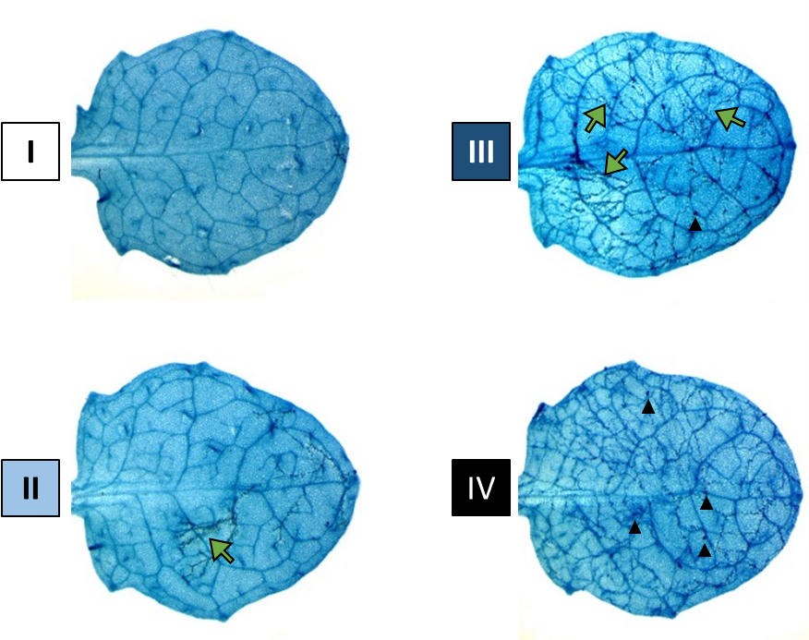
Figure 2.1: Examples of different H. arabidopsidis infection classes: Trypan Blue scoring of H. arabidopsidis infection 6 days after spraying. white (class I), absent or minimal colonisation; light blue (class II), ≤ 50% leaf area colonized by the pathogen; dark blue (class III), ≤ 75% leaf area colonized by the pathogen, presence of conidiophores; black (class IV), > 75% leaf area colonized by the pathogen, abundant conidiophores and sexual spores. Green arrows indicate leaf colonisation by the pathogen hyphae, while black triangles indicate sexual oospores. Conidiophores not shown.

2.3: Quantification of basal resistance to P. cucumerina and A. brassicicola
Plectosphaerella cucumerina (Pc) and Alternaria brassicicola (Ab) were grown from frozen agar plugs (-80°) on potato dextrose agar (PDA; Difco, UK) or PDA-CaCO₃ plates (for 1l: 20g PDA, 20g Sucrose, 30g CaCO₃, pH 7.4), respectively. Inoculated plates were maintained at room temperature in the dark for at least 2 weeks. Spores were gently scraped from water-inundated plates, after which spore densities were adjusted to 10⁶ spores/ml using a hemocytometer (Improved Neubauer, Hawksley). Four fully expanded leaves of similar age from 5 weeks-old plants were inoculated by applying 5µl droplets, thereby minimizing variability due to age-related resistance. After inoculation, plants were kept at 100% RH until scoring of lesion diameters or trypan blue staining. For experiments presented in Chapters 3 and 5, lesion diameters by Pc were measured between 7 and 14 days after inoculation (dai). Average lesion diameters were based on 4 leaves per plant from 12 plants per (epi)genotype (n=48), using a precision caliper (Traceable, Fischer Scientific). For the screen of 123 epiRILs (Chapter 4), necrotic lesion areas by Pc were estimated at 9 dai by image analysis of high-resolution photographs from 4 leaves per plant from 4 plants per epiRIL (n=16), using Adobe Photoshop 6.0 software. The number of pixels of each necrotic lesion was referenced to the number of pixels in a known surface (1mm²) using a ruler. Statistically significant differences in necrotic lesions caused by Pc were assessed by Student’s T-test in pairwise comparisons with the indicated control in each experiment (p <0.05). Disease progression by Ab was analysed from 14 dai by microscopy analysis of trypan blue-stained leaves (see section 2.5). Leaves from 12 different plants were assigned to 3 different colonisation classes, based on disease progression at the time of scoring: class I; no or minimal germination of spores without hyphal colonisation; class II, hyphal colonisation without extensive tissue necrosis; class III, extensive hyphal colonisation with large-scale tissue necrosis. Statistically significant differences in classes distribution between different genotypes were assessed by Pearson Chi-squared test in pairwise comparisons with Col-0 control line (p <0.05).

2.4: Quantification of basal and systemic acquired resistance to P. syringae pv. tomato DC3000
One day before systemic acquired resistance (SAR) induction or challenge inoculation, avirulent Pseudomonas syringae pv. tomato DC3000 (Pst), expressing the avirulence gene AvrRpt2 [218], or virulent Pst, expressing the GFP gene , were grown overnight at 28°C in liquid KB medium containing 50mg/l Rifampicin and 25mg/l Kanamycin, or liquid LB medium containing 50mg/l Rifampicin and 50mg/l Kanamycin respectively. To elicit SAR, three fully expanded leaves from 4 ½ weeks-old Arabidopsis plants were pressure-infiltrated using a needleless syringe with a suspension of Pst(AvrRpt2) at 10⁷ colony forming units (CFU)/ml (in 10mM MgSO₄). Corresponding control plants were mock-treated by pressure infiltration of leaves with 10mM MgSO₄. At 3 days after induction treatment, four leaves of each plant were challenged by pressure-infiltration with an inoculum of a virulent Pst strain expressing the GFP gene (5x10⁵ CFU/ml in 10mM MgSO₄), using a needleless syringe. Three days after challenge inoculation, four leaf discs from each plant (one per inoculated leaf) were collected on ice in 600 µl 10mM MgSO₄ and manually ground in 1.5ml Eppendorf tubes, using plastic pestles. Serial dilutions (5-fold; 8 dilutions) were plated on selective agar plates (LB-agar containing 50mg/l Kanamycin and 50 mg/l Rifampicin) and incubated for 2 to 3 days at 28°C before counting numbers of CFU. Each sample was plated twice on different plates and CFU numbers from each sample were averaged between technically replicated plates. A total of 12 plants per genotype/treatment combination were analysed for each assay (n=12). The level of Pst(GFP) colonisation was expressed as logCFU/cm² leaf area. Statistically significant differences in Pst(GFP) colonisation between all genotypes and treatments were assessed via Student's T-test in pairwise comparisons as indicated in Figure 3.4 (p <0.05).

2.5: Trypan blue staining for quantification of colonisation by H. arabidopsidis or A. brassicicola.
Inoculated seedlings (Hpa) or leaves (A. brassicicola) were collected in 100% ethanol. After clearing of chlorophyll, leaves were transferred to lactophenol trypan blue solution (for 450ml: 100 mg trypan blue, 50mg phenol, 50mg glycerol, 50 ml lactic acid, water to 150ml volume and 300ml 100% ethanol). Samples were boiled twice for 1 minute and allowed to cool down for 5 minutes in between. After 3 to 5 hours (h) of subsequent incubation at room temperature, the lactophenol trypan blue solution was replaced with 60% w/v chloral hydrate for removal of excess trypan blue staining solution and storage.

2.6: Quantification of elicitor-induced callose in hydroponically grown Arabidopsis seedlings
Arabidopsis seeds were vapour-phase sterilized for 4 h by exposing them inside a desiccator to vapours from freshly prepared 10% v/v hydrochloric acid (37% v/v HCL, Fischer Scientific, 7732-18-5) in bleach. Seeds were subsequently air-dried for one hour in a sterile laminar flow cabinet to remove residues of chlorine gas, and sown in CELLSTAR ® 12-wells cell culture plates (Greiner Bio-One, 665180), containing 1ml of MS basal medium per well (Duchefa, M0221;+ 0.05% MES, + 0.5% sucrose, pH 5.7). Each well contained approximately 15 seeds. Seeds were stratified inside the wells for 4 days in the dark at 4°C, after which they were transferred to short day conditions (8.5h light/15.5h dark, 80% RH, light intensity 100-140 µmol s⁻¹ m⁻¹). After 7 days of growth and 2 days before challenge treatment, the MS medium was replaced with fresh MS medium. After 9 days of growth, seedlings were challenged by adding 10µl of 1 mM Flg22 solution (PhytoTechnology Laboratories, P6622) to a final concentration of 1µM and incubated for up to 24h. Corresponding controls were mock-treated by adding 10µl of sterile water. After collection, seedlings were cleared for at least 24 h in 100% ethanol. One day before microscopy analysis, samples were incubated for 30 min in 0.07M phosphate buffer (pH 9) and incubated overnight in a solution of 0.5% w/v aniline blue (Sigma-Aldrich, 415049) in 0.07M phosphate buffer (pH 9). Stained leaves were mounted on microscope slides and photographed, using an epifluorescence microscope (Olympus BX 51) fitted with a fluorescent camera and a blue filter (XF02-2; excitation 330nm, emission 400nm). Analysis of callose deposition was based on high-resolution digital photographs, using Adobe Photoshop 6.0 software. For each cotyledon, the number of fluorescent pixels corresponding to elicitor-induced callose was selected, using the “Color Range” selection tool, and expressed as a ratio relative to the number of pixels corresponding to total cotyledon area. For each genotype/time-point combination, 20 cotyledons were scored and averaged (n=20). Statistically significant differences in callose deposition following elicitor treatment were assessed by one-Way ANOVA with Tukey's post-hoc test (p <0.05) for multiple comparisons at each time-point tested.

2.7: Quantification of callose effectiveness against H. arabidopsidis infection
Seedlings were collected at 3 days after Hpa inoculation and cleared for at least 24 h in 100% ethanol. One day before microscopy analysis, samples were incubated for 30 min with 0.07M phosphate buffer (pH 9) and incubated for 15 mins with a 4:1 mixture (v/v) of 0.05% w/v aniline blue (Sigma-Aldrich, 415049) in 0.07M phosphate buffer (pH 9) and 0.025% w/v calcofluor white (Fluorescent brightener 28, Sigma-Aldrich, F3543) in 0.1M Tris-HCL (pH 7.5). After the initial staining, samples were incubated overnight in 0.5% w/v aniline blue (Sigma-Aldrich, 415049) in 0.07M phosphate buffer (pH 9). Samples were scored using an epifluorescence microscope (Olympus BX 51), fitted with blue filter (XF02-2; excitation 330nm, emission 400nm). Each germinated conidia was assigned to different classes, based on its interaction with callose depositions. In Chapter 3, germinating conidia were assigned to 4 different classes, ranging from spores that were fully encapsulated in callose (maximum callose effectiveness) to spores penetrating into the mesophyll and extensively colonizing the plant despite the presence of callose depositions along the expanding hyphae (lowest level of callose effectiveness; Figure 3.3B, legend). In Chapter 5, the scoring method was upgraded to include only 2 classes, based on effective or non-effective blocking of Hpa penetration by callose deposition (Figure 5.2B, legend). In each assay, 10 leaves from different plants per each (epi)genotype were analysed (n=10), and the pooled spores identified in all leaves were expressed as relative frequencies within each class. Statistically significant differences in classes distribution were assessed by Pearson Chi-squared test in pairwise comparisons with Col-0 control line (p <0.05).

2.8: Growth analysis of epigenetic recombinant inbred lines
Epigenetic recombinant inbred lines (epiRILs) were analysed for growth phenotypes by digital image analysis of total green leaf area (GLA), using Adobe Photoshop 6.0. GLA was calculated by measuring the number of green pixels with a combination of Magic Wand Tool, Color Range selection and manual adjustment when needed. The number of green pixels corresponding to GLA were expressed as a ratio with the number of pixels of known surfaces for standardisation, including a ruler for conversion in mm². Growth analysis of the 123 epiRILs (Chapter 4) was carried out with photos of 3 week-old plants (n = 12-15), which were taken on the day of Hpa inoculation. Growth analysis of a sub-set of Hpa-resistant epiRILs (Chapter 5) was carried out with 5 plants per line (n=5) by monitoring growth phenotypes of individual plants between 3 and 5 ½ weeks after planting.

2.9: Mapping of epigenetic quantitative trait loci (epiQTLs)
Mapping of epiQTLs was performed using the ‘scanone’ function of the “R/qtl” package for R [219] (Haley-Knott regression, step size 2cM), combining the recombination map of differentially methylated regions (DMR) that was generated by [17] with the phenotypical data from each experiment. For analysis of Hpa resistance, the categorical scoring of Hpa resistance was converted into a numeric resistance index (RI), using the following formula:
RI = (f_{class I} * 4) + (f_{class II} * 3) + (f_{class III} * 2) + (f_{class IV} * 1),
where f = relative frequency of Hpa colonisation class of each line, multiplied by an arbitrary weight value ranging from 4 for the most resistant category (class I) to 1 for most susceptible category (class IV). Mapping of epiQTLs controlling plant growth was based on average GLA values of each line before Hpa infection (see section 2.8). Mapping of epiQTLs controlling Pc resistance was based on average surface areas of necrotic lesion by the pathogen (in mm²). A logarithm of odds (LOD) threshold of significance for each trait was determined on the basis of 1,000 permutations for each dataset (α = 0.05). The proportion of phenotypic variance R²(G) explained by the DMR markers with the highest LOD score (peak markers) of all four epiQTLs was calculated with the following formula [18]:
$R^{2}\left(G\right)=1-\frac{n-1}{n-\left(k+1\right)}\frac{\sum_{i}^{n}{{(y_{i}-[{\hat{β}}_{0}+\sum_{j}^{k}{β_{j}g_{ij}]})}^{2}}}{\sum_{i}^{n}{{\left(y_{i}-\overline{y}\right)}^{2}}}$,
where n = number of lines analysed, k = number of DMR markers tested; β₀ = intercept of the multiple regression model; β_{j}= QTL effect for each QTL j (slopes for each marker in the multiple regression model); g_{ij} = (epi)genotype of the j^{th} marker for each individual i (coded as ‘1’ for ddm1-2 epialleles and ‘-1’ for WT epialleles); y_{i} = phenotypic value of individual i; $\overline{y}$ = mean of phenotypic values. The contribution of each individual QTLj (R²(g))was calculated, using the following formula:
$$R^{2}\left(g\right)=1-\frac{n-1}{n-\left(k+1\right)}\frac{{\hat{β}}_{j}^{2}\sum_{i}^{n}{{\left(g_{ij}-{\overline{g}}_{j}\right)}^{2}}}{\sum_{i}^{n}{{\left(y_{i}-\overline{y}\right)}^{2}}} ,$$
as described by [18], where n= number of lines analysed, k= number of markers tested; β_{j}= QTL effect for each QTLj (slopes for each peak marker in the multiple regression model); g_{ij}= (epi)genotype of the j^{th} marker for each individual i (coded as ‘1’ for ddm1-2 epialleles and ‘-1’ for WT epialleles); ${\overline{g}}_{j}$= average of the (epi)genotypes values for the j^{th} marker. Covariance was calculated by subtracting the sum of the individual contributions of each QTLj on phenotypical variance (i.e. R²(g_{QTL1}) + R²(g_{QTL2}) + R²(g_{QTL4}) + R²(g_{QTL5})) from the phenotypical variance explained by the full model (i.e. R²(G)).
To confirm that the four Hpa resistance epiQTLs are predominantly determined by stably inherited epialleles, rather than genetic variation within the epiRILs population, Illumina whole-genome sequencing data for 122 out of 123 epiRILs were used to determine the presence of shared insertions of transposable elements (sTEs) within the epiQTL intervals, using TE-tracker software [220]. This genomic analysis was performed at the laboratory of Professor Vincent Colot (Institut de Biologie de l'École Normale Supérieure, Paris, France). Genetic features shared between multiple epiRILs were analysed for statistical significant correlation with the resistance phenotype using a multiple regression model (see Chapter 4, Table 4.1). For each QTL interval, the presence or absence of sTEs in each epiIRIL line was used in a multiple regression in lieu of the corresponding peak DMR marker.

2.10: RNA extraction and targeted gene expression analysis
Targeted gene expression analysis by reverse-transcriptase quantitative polymerase chain reaction (RT-qPCR) was based on three biologically replicated samples (n=3) per genotype/treatment/time-point combination, each consisting of 6 to 12 leaves collected from different plants per pot. Samples were snap-frozen in liquid nitrogen and ground to a fine powder, using a tissue lyser (QIAGEN TissueLyser). Total RNA was extracted using a modified TRIzol isolation protocol. Frozen powder was vortexed for 30 seconds in 1ml Extraction buffer: 1M guanidine thiocyanate (Amresco, 0380), 1M ammonium thiocyanate (Sigma-Aldrich, 1762-95-4), 0.1M sodium acetate (Fisher Scientific, 127-09-3), 38% v/v AquaPhenol (MP Biomedicals, 108-95-2) and 5% v/v glycerol (Fisher Scientific, 56-81-5). Samples were incubated at room temperature (RT) for 1 min. and then centrifuged for 5 min. at 16,500 g. The supernatant was then transferred to a new tube, mixed with 200μl chloroform and vortexed for 10-15 sec. After centrifuging for 5 min (16,500 g), the upper aqueous phase was transferred to new tubes, gently mixed by inversion with 350μl 0.8M sodium citrate (Sigma-Aldrich, 6132-04-3) and 350 μl isopropanol (Fischer Chemicals, 67-63-0) and left at RT for 10 min for RNA precipitation. Samples were then centrifuged for 15 min at 16,500 g (4°C), after which pellets were washed twice in 1ml 70% ethanol, centrifuged at 16,500 g for 1 min, and air-dried before being dissolved in 50μl nuclease-free water. Total RNA was quantified using a Nanodrop 8000 Spectrophotometer (Thermo Scientific). RNA extracts were then treated with DNaseI, using the RQ1 RNase-Free DNase kit (Promega, M6101). First-strand cDNA synthesis was performed from 1μg RNA, using SuperScript III Reverse Transcriptase (Invitrogen, 18080093) in accordance to the supplier’s recommendations. The qPCR reactions were carried out with a Rotor-Gene Q real-time PCR cycler (Qiagen), using the Rotor-Gene SYBR Green PCR Kit (Qiagen, 204074). Relative gene expression was quantified using Livak’s ΔΔCT method [221] with correction for average PCR efficiencies for each primer pair across experiment samples. Gene expression was normalised against average expression values of At1g13440 (GAPDH), At5g25760 (UBC) and At2g28390 (SAND family protein)[222]. Statistically significant differences in relative gene expression between treatments and/or (epi)genotypes were assessed by Student's T test in pairwise comparisons as indicated (p <0.05).

2.11: Seed germination assays
Seeds of selected epiRILs were sterilised by exposing them inside a desiccator for 4 h to chlorine vapours from a ~200 ml bleach solution containing 10% v/v hydrochloric acid (37% v/v HCl, Fischer Scientific, 7732-18-5). Seeds were subsequently air-dried for 1 h in a sterile laminar flow cabinet to remove chlorine gas residues. Sterile seeds were plated on half strength MS plates (Duchefa, M0221; +0.05% w/v MES, +1% w/v sucrose, pH 5.7) containing varying concentrations of NaCl (0mM, 50mM, 75mM and 100mM; Fischer Scientific, 7647-14-5 ), and kept for 4 days in the dark at 4°C. After stratification, plates were transferred to short-day growth conditions (8.5h light/15.5h dark, 21°C, 80% RH, light intensity 100-140 µmol s⁻¹ m⁻¹). Germination was expressed as the percentage of seeds producing fully expanded cotyledons by 6 days after transference of plates to the growth chamber. Germination percentages of each epiRIL/treatment combination were calculated from a total of 100 seeds divided between two plates. Statistically significant differences in seed germination at each NaCl concentration were assessed by Fischer's Exact test in pairwise comparisons with the control line (602; p <0.05)

2.12: mRNA-sequence analysis of four epiRILs
RNA was extracted at 48 h and 72 h after Hpa or mock inoculation of 3 weeks-old plants. Every epiRIL/treatment/time-point combination involved 3 biological replicates, each consisting of 6-12 leaves from different plants per pot. Leaf material was snap-frozen in liquid nitrogen and ground to a fine powder, using a tissue lyser (QIAGEN TissueLyser). RNA was extracted from the powdered plant material using the TRIzol isolation protocol (see section 2.11). RNA concentration and integrity was measured using 2100 Bioanalyzer (Agilent) with the provided reagents kits according to the manufacturer’s instructions. All RNA samples displayed RNA integrity number (RIN) superior to 7.5. Library preparation and sequencing was performed by Dr. O. Berkowitz (La Trobe University, Melbourne, Australia). RNA-seq libraries were prepared from total RNA using the TruSeq Stranded Total RNA kit with Ribo-Zero Plant leaf kit (Illumina, RS-122-2401) according to the manufacturer’s instructions. Sequencing runs were performed on a HiSeq1500 platform (Illumina), generating paired-end reads with a length of 125 bp, and an average quality score (Q30) of above 93%. Around 35 million paired reads were recovered per sample.
RNA seq data analysis was performed by Dr. Ritushree Jain at University of Sheffield. Quality of the reads was assessed using FastQC software [223]. Read length and distribution was optimized and adapter sequence was trimmed using Trimmomatic software [224]. Reads were aligned and mapped to the Arabidopsis genome (TAIR10 annotation) using splice site-guided HISAT2 alignment software (John Hopkins University, second iteration of [225]). For all samples, more than 95% of reads successfully mapped once or more to the Arabidopsis genome. Number of reads per gene were quantified using Python package HTseq [226]. Differential expression analysis was performed using “DESeq2” R package [227]. DESeq2 applies a generalized linear model to the sequencing data, modelling read counts to a negative binomial distribution and estimating the mean and dispersion of read counts of each gene from the average expression strength over all samples. Differences in library size for each sample were normalized by size-factor estimation, i.e. the median across genes of one sample of the ratio of the expression to the gene’s geometric mean across all samples [228]. The size-factor represents the coverage or sequencing depth of each library, and accounts for potential batch effects coming from libraries preparation or sequencing reactions [228]. Additionally, for the modelling of read counts replicates are treated as individual samples, to prevent batch effects from the experimental design [227]. Read counts per gene were transformed using regularized logarithmic transformation (rlog) function [227] and used to perform principal component analysis (PCA) using the plotPCA function. Using a full model which combines the three experimental factors (treatment, epigenotype and time) and their interactions, likelihood ratio test (lrt test; q- value <0.05) against a reduced model lacking the interactions was performed to identify genes showing differences caused by the treatment in any epigenotype at any time-point [227]. Differentially expressed genes (DEGs, including both protein-coding and TE/TE-related genes) in any genotype at any time-point and in any of the treatments were subjected to hierarchical clustering (Ward method) and presented as a heat map using the “pheatmap” R package [229]. For each gene, the rlog normalized read counts of each individual sample were subtracted from the mean of all samples, and then divided by the standard deviation for easier visualisation (z-score). To identify DEGs in individual treatment/time-point/genotype combinations, pair-wise comparisons (Wald test; q < 0.05) were performed on the list of DEGs obtained by the lrt test. Additionally, the pipeline used to identify DEGs was repeated as described after removal of all read counts from genes annotated as transposable elements from the dataset (TAIR10 annotation).
Gene ontology (GO) term enrichment analysis was done on primed and constitutively expressed genes using the Plant GSEA toolkit [230]. GO terms were checked for significant enrichment against the whole genome background using a hypergeometric test and Hochberg false discovery rate correction (q <0.05). The lists of enriched GO terms in each treatment were fed through the GO Trimming 2.0 algorithm [231] to remove redundancy, using a soft trimming threshold of 0.40. The output list from GO Trimming 2.0 was run through GOSlim Viewer (AgBase) to further reduce the GO terms list according to GO slim ontologies (GO consortium). Enrichment was displayed as a percentage, calculated as the number of genes belonging to a specific GO term in the test list over the number of genes in that GO term in the whole genome.

Chapter 3 - The Role of DNA (de)Methylation in Plant Basal and Acquired Immunity

Results described in this Chapter are part of (López Sánchez et al., 2016, Plant J) [215].

3.1: Abstract

Global DNA methylation is actively controlled by DNA methyltransferases and DNA demethylases. This Chapter examines the impacts of global DNA (de)methylation on the Arabidopsis immune system. The nrpe1-11 mutant, which is affected in RNA-directed DNA methylation, displayed enhanced resistance to the biotrophic oomycete Hyaloperonospora arabidopsidis (Hpa), whereas the ros1-4 mutant, which has enhanced levels of DNA methylation due to a defect in DNA demethylase activity, displayed enhanced susceptibility to this pathogen. In contrast, the ros1-4 mutant showed enhanced resistance to the necrotrophic fungi Plectosphaerella cucumerina and Alternaria brassicicola. Aniline-blue staining revealed that the ros1-4 mutant shows enhanced callose deposition in response to the bacterial elicitor Flg22. Interestingly, however, analysis of callose deposition after Hpa inoculation revealed that the enhanced callose in ros1-4 is less effective in resisting Hpa colonisation spores. Finally, analysis of systemic acquired resistance (SAR) against Pseudomonas syringae pv. tomato (Pst) upon localised infection by avirulent Pst was intact in both nrpe1-11 and ros1-4 plants, indicating that changes in global DNA methylation do not critically affect within-generation SAR.

3.2: Introduction

Plants primarily perceive attack by virulent pathogens through recognition of conserved microbial-associated molecular patterns (MAMPs) or damage-associated molecular patterns (DAMPs) due to cellular damage by the disease [232]. This type of perception leads to activation of a multi-layered inducible defence response that is controlled by the plant’s innate immune system. Relatively early acting defence responses include production of reactive oxygen or nitrogen species and deposition of callose, while relatively late acting defence responses include induced production of defence hormones such as salicylic acid (SA) and jasmonic acid (JA) [2,233]. This signalling cascade leads to local induction of defence-related genes and production of secondary defence metabolites to counter the attacker, as well as production of long-distal defence signals that induce resistance in distal plant parts [2,233].
Plant innate immunity responses can be enhanced through immune priming, which results in a faster and stronger induction of defence responses and more effective blocking of pathogen infections at their early stages [3,186,190]. Priming is typically triggered by transient induction of innate immunity after pathogen/herbivore attack or treatment with defence chemical elicitors [3,190]. Systemic acquired resistance (SAR) is a classic example of priming, during which local attack by an (a)virulent pathogen triggers multiple distal signals which induce priming in distal parts of the plants [234,235]. Diverse distal signals contributing to SAR have been identified, including SA and its derivative methyl SA [236], the diterpenoid dehydroabietinal [237], the dicarboxylic acid azelaic acid [199], pipecolic acid [238,239], glycerol-3-phosphate [240,241] and nitric oxide [242,243]. Priming is considered to be a long-lasting defence response, which can last up to 28 days from the initial induction [211].
In 2012, three independent studies published in the same issue of Plant Physiology showed that defence priming in Arabidopsis can be transmitted to following generations [6,207,208]. In two of these studies, the primed state could be transmitted over one stress free generation, suggesting involvement of epigenetic mechanisms in the long-term maintenance of immune priming [6,208]. Indeed, one study reported that primed defence gene promoters in progeny from P. syringae pv. tomato (Pst)-inoculated plants showed enhanced acetylation of histone H3 at lysine residue K9 (H3K9ac) [6], which is commonly considered to be a chromatin modification that facilitates gene transcription [244], and is usually found in promoters of primed genes [213,245]. Furthermore, mutants altered in DNA methylation failed to show a difference in basal resistance between progenies from Pst-infected and mock-inoculated plants, suggesting an important regulatory role for DNA methylation in Pst-induced transgenerational priming (see General Introduction, Figure 1.3)[7,21].
DNA methylation is a key epigenetic mark that controls gene expression, genome stability and development. DNA methylation can form meta-stable epialleles that can be transmitted over meiosis for multiple generations [40,246,247]. As such, stress-induced changes in DNA methylation provide a plausible mechanism by which priming can be transmitted trans-generationally. DNA methylation in plants can occur in three difference sequence contexts: CG, CHG and CHH, where H stands for any base except G [35,248,249]. In Arabidopsis, CG DNA methylation predominantly occurs in gene bodies and is found throughout the genome, whereas non-CG DNA methylation is mostly found in intergenic regions at TEs [38]. The effect of CG methylation at gene bodies is not fully understood, although some correlation studies suggest that this form of DNA methylation can slightly enhance gene transcription [39,250]. DNA methylation at transposable elements (TEs) and other repetitive sequences is associated with strong transcriptional repression of those loci [35,248,249]. Accordingly, DNA methylation (or lack thereof) at these loci can have a direct effect on transcription of nearby coding genes [107,251].
One of the main mechanisms of non-CG DNA methylation establishment and maintenance in plants is the RNA-directed DNA Methylation (RdDM) pathway, which relies on two plant-specific DNA-dependent RNA Polymerases: Pol-IV and Pol-V [30]. Initiation of the RdDM pathway machinery starts by transcription of target sequences by Pol-IV. RNA transcripts from Pol-IV are then copied into double-stranded RNAs (dsRNAs) [50,55,56] and processed by DICER-LIKE 3 (DCL3) into 24nt small interfering RNAs (siRNAs) [57]. Single-stranded siRNAs are loaded onto the ARGONAUTE protein AGO4, where they bind to the transcripts of Pol-V through a base-pairing mechanism [61,63]. Binding of the AGO4-siRNA with the nascent Pol-V transcript and unmethylated DNA (through the IDN2/FDM1-2 complex [65-67]) recruits DNA methyltransferases DRM1/2 for deposition of DNA methylation [61], as well as chromatin remodelling complexes for heterochromatin formation (see Chapter 1, section 1.1.2 for a more detailed overview) [68,69].
Plants also possess an active DNA demethylation machinery, which prevents excessive spreading of DNA methylation and unwanted gene silencing, as well as controlling dynamic regulation of DNA methylation during development and stress exposure [248]. The most active component in vegetative tissues is REPRESSOR OF SILENCING 1 (ROS1), a DNA glycosylase which excises methylated cytosines [114-116], which are then replaced by un-methylated ones by the base excision repair pathways [117]. The antagonistic activities of RdDM and ROS1 modulate DNA methylation predominantly at TEs. Recently, it was found that RdDM of a small sequence in the 5’-untranslated region (UTR) of the ROS1 gene enhances ROS1 expression, countering the repressive effect of a helitron TE upstream in ROS1 promoter [121,122]. On the other hand, ROS1 directly antagonizes the RdDM pathway at many loci, including the locus in its own 5’-UTR, thereby creating a negative feedback loop between DNA methylation and DNA demethylation [121,122]. Interestingly, ROS1 has been reported to bind to the small RNA-binding protein REPRESSOR OF SILENCING 3 (ROS3) [120], suggesting that the activity of ROS1 may be driven by siRNAs, similar to RdDM. However no follow-up studies have confirmed this hypothesis, and the ros3 mutation did not have substantial effects on global levels of DNA methylation (unlike the ros1 mutation) [119]. Recent studies have shown that ROS1 also counters DNA methylation at loci that are not targeted by the RdDM pathway [252].
The study presented in this Chapter aimed to gain further insight in the mechanisms by which DNA (de)methylation affects pathogen resistance and inducible plant defences. To this end, two Arabidopsis mutants with generally opposite DNA methylation profiles, nrpe1-11 and ros1-4, were tested against pathogens with opposite lifestyles. In addition, these mutants were tested for responsiveness of early inducible defences and their ability to express within-generation SAR. The nrpe1-11 mutant [214] lacks the biggest catalytical subunit of the RdDM pathway-specific RNA Polymerase Pol-V, and is therefore impaired in RdDM (see Figure 1.2). As such, the nrpe1-11 mutation leads to extensive loss of non-CG DNA methylation (DNA hypo-methylation) in regions targeted by canonical and non-canonical RdDM (i.e. mostly small TEs) [253]. On the other hand, the ros1-4 mutant is impaired in transcription of the ROS1 gene and therefore affected in active DNA demethylation, causing a widespread increase in DNA methylation in all contexts across the whole genome (DNA hyper-methylation), but particularly near TEs [87,252].

3.2: Results

3.2.1: Effects of DNA (de)methylation on basal resistance to biotrophic H. arabidopsidis
To determine the effect of DNA (de)methylation on resistance against biotrophic pathogens, the hypo-methylated nrpe1-11 mutant and hyper-methylated ros1-4 mutant were inoculated with conidia of H. arabidopsidis (Hpa). The severity of Hpa infection was quantified at 6 days after inoculation (dai) of 3 weeks-old plants by assigning trypan blue-stained leaves to different Hpa colonisation classes, as described in Chapter 2 (section 2.2). Compared to WT Col-0 plants, nrpe1-11 showed a higher number of leaves in Hpa infection class II and fewer leaves in Hpa colonisation class III and IV, which was statistically significant (Figure 3.1). On the other hand, ros1-4 plants showed a statistically significant shift towards the higher colonisation classes (classes III and IV; Figure 3.1). Together, these results show that RdDM and ROS1 act antagonistically on the level of basal resistance to Hpa, suggesting that RdDM represses defence mechanisms against biotrophic pathogens, whereas ROS1-dependent hypo-methylation of DNA increases the efficiency of defence against Hpa.

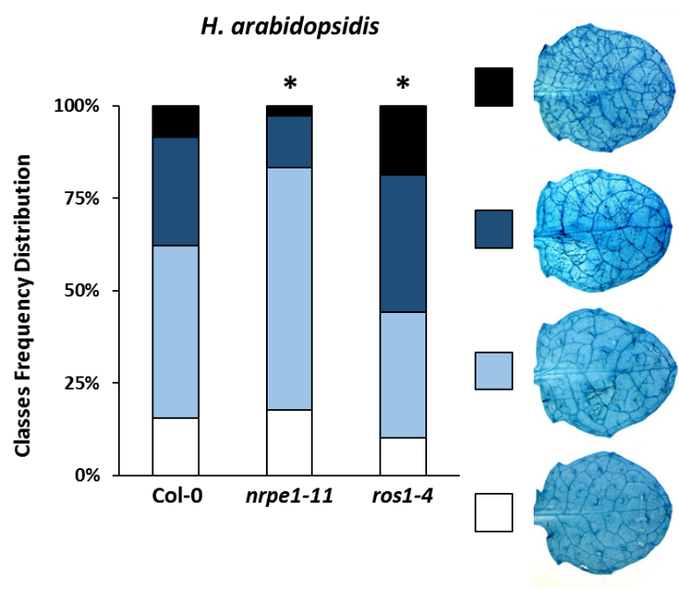
Figure 3.1: Basal resistance of Col-0, nrpe1-11 and ros1-4 against the biotrophic pathogen H. arabidopsidis. Leaves for analysis were collected at 6 days after inoculation (spraying with 10⁵ conidia/ml) of 3 weeks-old plants. After trypan-blue staining, leaves were assigned to different classes based on Hpa colorisation, as illustrated by the insets on the right: white (class I), absent or minimal colonisation; light blue (class II), ≤ 50% leaf area colonized by the pathogen; dark blue (class III), ≤ 75% leaf area colonized by the pathogen, presence of conidiophores; black (class IV), > 75% leaf area colonized by the pathogen, abundant conidiophores and sexual spores. Statistically significant differences (asterisks) in class distribution were assessed by Pearson Chi-squared test compared to WT Col-0 plants; p <0.05.

3.2.2: Effects of DNA (de)methylation on basal resistance to necrotrophic fungi
To determine the effects of DNA (de)methylation on basal resistance to necrotrophic pathogens, 5 weeks-old WT Col-0, nrpe1-11 and ros1-4 plants were droplet-inoculated with the necrotrophic ascomycetes Alternaria brassicicola (Ab) and Plectosphaerella cucumerina (Pc). Progression of Ab infection was analysed in trypan blue-stained leaves at 14 dai by assigning leaves to different categories based on cell death severity of hyphal colonisation. The hyper-methylated ros1-4 mutant showed a statistically significant shift of leaves into the lower disease classes compared to WT Col-0 plants, indicating enhanced resistance of this mutant to this fungus (Figure 3.2A). By contrast, the DNA hypo-methylated nrpe1-11 mutant showed no statistically significant difference in class distribution compared to WT Col-0 plants (Figure 3.2A). Severity of Pc infection was assessed by measuring the size of the necrotic lesions at 7 dai. While the ros1-4 mutant showed a statistically significant reduction in lesion diameter compared to WT Col-0 plants (Figure 3.2 B), the nrpe1-11 mutant developed larger lesions than WT Col-0 plants, which was borderline statistically significant (p =0.058, Figure 3.2B). Together, these results indicate that DNA hyper-methylation by the ros1-4 mutation increases basal resistance against necrotrophic pathogens.

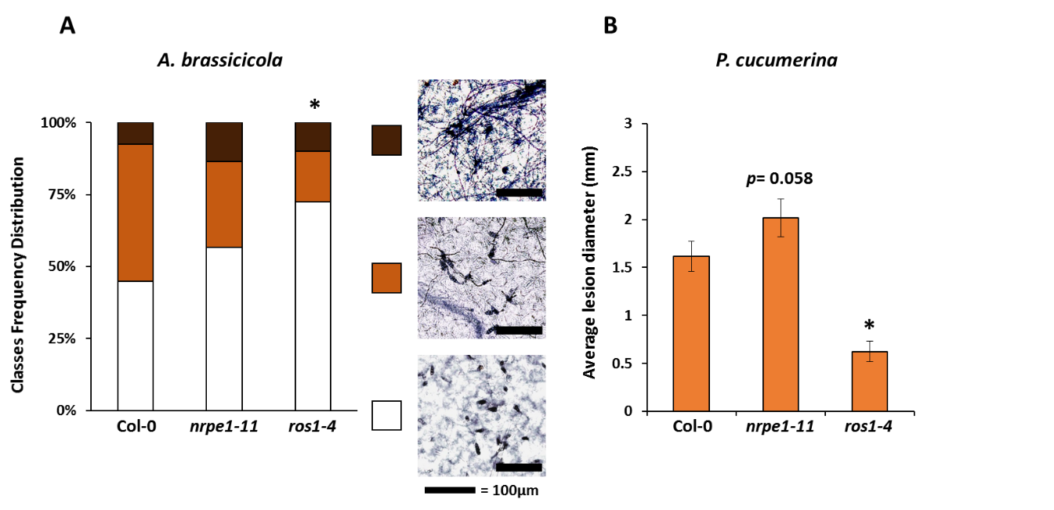
Figure 3.2: Basal resistance of Col-0, nrpe1-11 and ros1-4 against the necrotrophic pathogens A. brassicicola and P. cucumerina. A: Trypan blue scoring of A. brassicicola colonisation in fully expanded leaves at 14 days after drop-inoculation (10⁶ spores/ml) of 5 weeks-old plants. Leaves were assigned to different classes, based on cell death and fungal colonisation level, as illustrated by the insets on the right: white, spores not germinating or barely germinated; light brown, mild colonisation; dark brown, full colonisation with clear necrotic lesions. B: Average diameter of necrotic lesions at 7 days after drop-inoculation (10⁶ spores/ml) of 5 weeks-old plants. Statistically significant differences (asterisks) were assessed by A) Pearson Chi-squared test, or B) Student's T-test in pairwise comparisons with WT Col-0; p <0.05.

3.2.3: Effects of DNA (de)methylation on early-acting cell wall defence
Deposition of callose is a relatively early defence response, which is known to be effective against both biotrophic and necrotrophic pathogens [145,147]. This type of cell wall defence can slow down colonisation by virulent pathogens [146]. To test whether DNA (de)methylation affects callose deposition, hydroponically grown seedlings of WT (Col-0), nrpe1-11 and ros1-4 plants were treated with the bacterial elicitor Flg22 (10µM) or a mock solution (water). Cotyledons were harvested over a 24h time-course, after which callose deposition was quantified by aniline blue staining and epifluorescence microscopy (Chapter 2, section 2.6). At 12 and 24h after Flg22 treatment, the hyper-methylated mutant ros1-4 showed significantly higher levels of Flg22-induced callose than Col-0, whereas nrpe1-11 plants showed WT levels of callose deposition. This result suggests that ROS1-dependent hypo-methylation prevents callose deposition. However, since the analysis of Flg22-induced callose does not assess whether callose deposition contributes to arresting pathogen colonisation, Col-0, nrpe1-11 and ros1-4 plants were evaluated for effectiveness of callose deposition against Hpa colonisation. To this end, leaves were collected at 2 dai for calcofluor/aniline blue double staining, which enables simultaneous visualisation of germinating Hpa spores and callose depositions by epifluorescence microscopy (Chapter 2, section 2.7). To quantify the effectiveness of callose against Hpa, germinated spores were assigned to different classes, based on their level of penetration into the leaf mesophyll, ranging from spores completely blocked by callose to spores able to penetrate through callose depositions and extensively colonizing large portions of the leaf (Figure 3.3B). Surprisingly, callose deposition in ros1-4 was less effective than Col-0 in preventing Hpa germ tubes from penetrating the mesophyll (Figure 3.3B), despite the fact that ros1-4 plants showed enhanced callose deposition in response to Flg22 treatment. Conversely, Hpa-induced callose deposition in nrpe1-11 was more effective in blocking Hpa colonisation compared to Col-0 WT plants (Figure 3.3B). Together, these results show that DNA methylation can affect both callose deposition and its effectiveness in terms of pathogen resistance. Most strikingly, despite the fact that DNA hyper-methylation in the ros1-4 mutant resulted in enhanced levels of Flg22-induced callose deposition, the callose deposition in this mutant was less effective in arresting Hpa. These results indicate that the amount of callose deposited in response to elicitor treatment does not necessarily indicate enhanced defence capability against microbial infection.

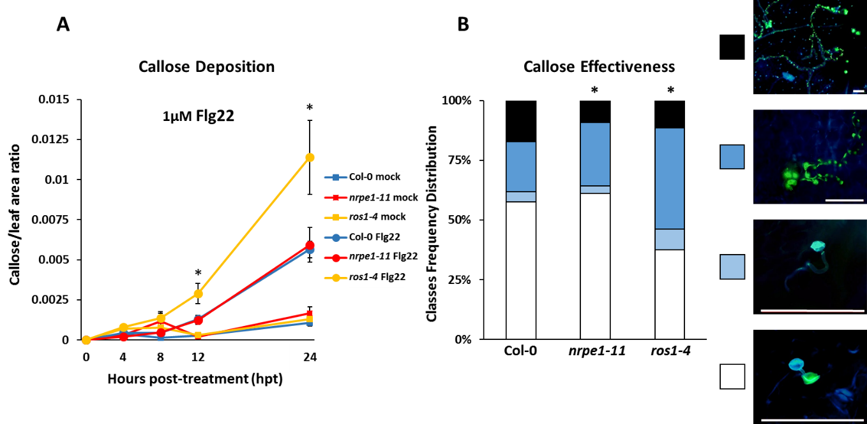
Figure 3.3: Quantification of callose deposition and callose effectiveness in Col-0, nrpe1-11 and ros1-4. A) Quantification of callose deposition in cotyledons of hydroponically-grown Arabidopsis seedlings (9 days old) over a 24h time-course after treatment with the bacterial MAMP elicitor Flg22 or mock solution (water). The area covered by callose was normalized against the total surface area of each cotyledon. Error bars represent standard error of the mean (n=20) B) Analysis of callose effectiveness in blocking mesophyll penetration by germinating Hpa spores at 48h after inoculation (10⁵ spores/ml). Hpa spores and tubes are visualized through calcofluor white staining (bright light blue colour) while callose deposition is visualized through aniline blue staining (bright green colour). Spores were assigned to different classes based on the level of penetration into the mesophyll, as shown on the right (10 leaves scored per genotype): white, spores blocked before or directly upon germination; light blue, spores not fully blocked by callose but delayed in penetrating the mesophyll; dark blue, spores not blocked by callose and able to penetrate the mesophyll; black, spores penetrating the mesophyll and colonising large portion of the leaf. White scale bar= 100µm. Statistically significant differences (asterisks) were assessed by A) One-Way ANOVA with Tukey's post-hoc test for multiple comparisons at each time-point, or B) Pearson Chi-squared test in pairwise comparisons with WT Col-0; p <0.05.

3.2.4: Effects of DNA (de)methylation on within-generation systemic acquired resistance against P. syringae pv tomato DC3000
SAR is a relatively late resistance response that develops in distal tissues upon local pathogen attack and that is largely based on priming of SA-dependent defences [234,254]. The primed state of SAR has been reported to last up to 28 days after the initial pathogen attack [211]. To test the role of DNA (de)methylation during within-generation SAR, 4 ½ weeks old Col-0, npre1-11 and ros1-4 plants were pressure-infiltrated with either a suspension of 10⁷ colony forming units (CFU)/ml of avirulent Pst carrying the avirulence gene avrRpt2 (in 10mM MgSO₄) or mock solution (10mM MgSO₄). Three days after induction treatment, four distal leaves of the same plants were pressure-infiltrated with virulent Pst. Growth of virulent bacteria was quantified 3 days later by dilution plating of extracts from challenged leaves on selective agar plates. Col-0 plants showed a clear SAR response, as evidenced by a statistically significant reduction in Pst growth in systemic leaves after pre-treatment with Pst avrRpt2 (Figure 3.4). Mock-treated nrpe1-11 plants showed reduced bacterial growth compared to mock-treated Col-0 (Figure 3.4), indicating enhanced basal resistance against hemi-biotrophic Pst, which is consistent with this mutant’s enhanced basal resistance to biotrophic Hpa (Figure 3.1). While mock-treated ros1-4 plants displayed higher levels of Pst growth than mock-treated Col-0 WT plants, this difference was not statistically significant (p =0.25). Moreover, both nrpe1-11 and ros1-4 showed a statistically significant reduction in Pst growth upon pre-treatment with Pst avrRpt2 (Figure 3.4), indicating that the altered levels of DNA methylation in these mutants do not affect within-generation SAR. Hence, RdDM- and ROS1-dependent DNA (de)methylation does not play a role in establishment and expression of within-generation SAR.

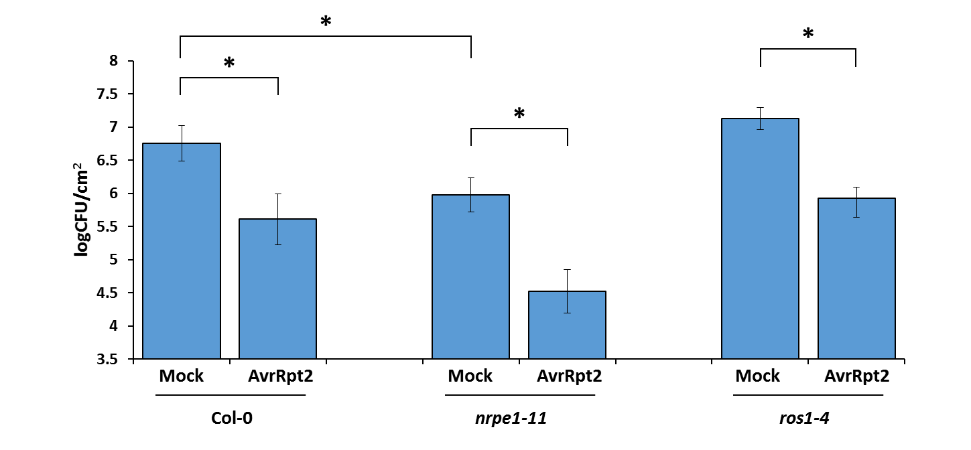
Figure 3.4: Within-generation systemic acquired resistance (SAR) in Col-0, nrpe1-11 and ros1-4. SAR was induced in 4 ½ weeks-old plants by pressure infiltration with either 10µM MgSO₄ (Mock), or avirulent Pst carrying the avirulence factor avrRpt2 (AvrRpt2). Three days after SAR induction, plants were challenged by pressure-infiltrating distal leaves with a suspension of virulent Pst. Growth of Pst in infiltrated leaves was quantified 3 days later by dilution plating of inoculated tissues on selective agar plates. Error bars represent standard error of the mean (n=12). Statistically significant differences (asterisks) were assessed via Student's T-test in pairwise comparisons as indicated; p <0.05.

3.3: Discussion

The results presented in this chapter provide further insight into the role of DNA (de)methylation in innate immunity against pathogens with different lifestyles, as well as acquired immunity of Arabidopsis. A previous study has established that mutants in RdDM express enhanced resistance to the hemi-biotrophic pathogen Pst and increased susceptibility to the necrotrophic pathogen Pc [21]. These results are in agreement with the results presented in Figures 3.1 and 3.4. In addition, the results in this Chapter have shown that the DNA hyper-methylated ros1-4 mutant shows enhanced susceptibility to the biotrophic pathogen Hpa (Figures 3.1) and enhanced resistance against two necrotrophic fungi, Ab and Pc (Figure 3.2). Taken together, these results suggest that RdDM and ROS1-depedant DNA demethylation have antagonistic effects on basal resistance against biotrophic or necrotrophic pathogens.
SA and JA control well-characterized defence signalling pathways, which act antagonistically on resistance against biotrophic or necrotrophic pathogens, respectively [255]. This negative signalling cross-talk may explain the opposite effects of the nrpe1-11 and ros1-4 mutations on resistance against biotrophic and necrotrophic pathogens. Indeed, Lopez et al. (2016) showed that nrpe1-11 plants are primed to activate SA-dependent gene expression, whereas ros1-4 plants show repressed activation of SA-dependent gene expression after Hpa inoculation [215]. Furthermore, the npre1-11 mutant showed enhanced susceptibility to necrotrophic Pc, which was borderline statistically significant (Figure 3.2B). Subsequent experiments by Lopez et al. (2016) confirmed this enhanced susceptibility, which was associated with repressed induction of JA-dependent gene expression [215]. Together, these results indicate that RdDM represses JA-dependent resistance via enhanced SA-dependent signalling. In contrast to nrpe1-11, the hyper-methylated ros1-4 mutant showed enhanced resistance to both Ab and Pc (Figure 3.2) [215]. However, subsequent analysis of JA-dependent gene expression revealed in ros1-4 revealed that this mutant’s enhanced resistance to necrotrophic fungi is unrelated to changes in responsiveness of JA-dependent gene expression [215]. Hence, increased DNA methylation by the ros1-4 mutation boosts resistance to Pc independently of JA-dependant defence responses and antagonistic signalling cross-talk between SA- and JA-dependent signalling pathways.
The ros1-4 mutant showed enhanced callose deposition in response to treatment with Flg22 (Figure 3.3A). It is tempting to speculate that this phenotype is related to SA-dependant repression of callose deposition. For instance, the SA-inducible beta-glucanase PR2 has been shown to degrade callose [256]. Since ros1-4 plants show repressed SA-dependent gene induction [215], the augmentation in Flg22-induced callose deposition in this mutant could be be explained by delayed induction of SA-dependent PR2 after Flg22 treatment. However, this hypothesis does not explain why nrpe1-11 plants, which are primed for SA-dependent gene induction [215], show wild-type levels of Flg22-induced callose deposition (Figure 3.3A).
Despite the increase in Flg22-induced callose deposition in ros1-4, callose deposition in response to germinating Hpa spores appeared to be less effective in resisting this pathogen. This apparent discrepancy can be explained by the notion that timing of papilla formation is more important that the overall amount of callose deposited [149,257]. For instance, plants over-expressing the callose synthase PMR4 develop complete resistance to different Arabidopsis powdery mildews strains through increased arrest of fungal colonisation at early stages of the interaction [149]. These 35S::PMR4-GFP plants produce enhanced amounts of the pathogen-inducible callose synthase PMR4, which allows for faster deposition of callose around the penetration sites after pathogen perception [149]. Interestingly, the actual amount of callose deposition in these 35S::PMR4-GFP plants is lower than susceptible WT Col-0 plants, which accumulate higher amounts of callose that is less effective in resisting powdery mildew infection [149]. In agreement with these results, Figure 3.3B revealed that the more susceptible ros1-4 mutant accumulated enhanced callose deposition that is less effective in arresting Hpa colonisation. In this perspective the nrpe1-11 mutant showed marginally increased effectiveness of Hpa-induced callose deposition, which may have contributed to the enhanced Hpa resistance of this mutant.
SAR is a form of acquired immunity that is established by long-distance signals originating from the local site of infection, which prime SA-dependent defence genes against subsequent pathogen attack [234,235]. This priming of SA-dependent defence can partially be transmitted to progeny [6,207] .The establishment of SAR in distal tissues requires intact SA production and NPR1-dependant SA signalling, as well as “microbursts” of reactive oxygen species (ROS) in local and distal tissues [234,235]. Since the nrpe1-11 and ros1-4 mutants were not impaired in the expression of SAR (Figure 3.4), DNA (de)methylation does not appear to play a role in the establishment of within-generation SAR. In addition to SA, the putative mobile signal pipecolic acid (Pip) was recently found to be required for the establishment of SAR in Arabidopsis, acting both synergistically and independently of SA [239]. The SA-independent activity of Pip could explain why the ros1-4 mutant is unaffected in within-generation SAR, despite the fact that it shows reduced responsiveness of SA-dependent defence genes [258]. Additional experiments by Lopez et al. (2016) showed that both ros1-4 and nrpe1-11 are impaired in transgenerational acquired immunity (TAR) upon repeated inoculation of parental plants with Pst [215]. Taken together, these results suggest that changes in DNA methylation do not affect establishment of within-generation SAR, but that RdDM and ROS1-dependant DNA demethylation are required for the induction, transmission or establishment of TAR

Chapter 4 - Mapping the Epigenetic Basis of Pathogen Resistance Using a Population of Epigenetic Recombinant Inbred Lines

4.1: Abstract

DNA methylation is a key epigenetic mark that regulates basal plant defence against different pathogens. Reduced DNA methylation (hypo-methylation) has also been implicated in the transmission of transgenerational resistance and defence priming. In this Chapter, a core population of 123 epigenetically Recombinant Inbred Lines (epiRILs) of Arabidopsis was used to map heritable hypo-methylated loci controlling heritable disease resistance. These epiRILs, which are derived from a cross between Col-0 and the ddm1-2 mutant, show minimal genetic variation, but vary substantially in DNA methylation at heterochromatic regions, due to inheritance of hypo-methylated DNA regions from the ddm1-2 parent. The ddm1-2 parental line, which exhibits widespread cytosine demethylation at pericentromeric DNA, displayed strongly enhanced resistance against the biotrophic pathogen Hyaloperonospora arabidopsidis (Hpa). Analysis of Hpa colonisation in the 123 epiRILs revealed high levels of variation in basal resistance to this pathogen, with few lines displaying levels of resistance comparable to that of the ddm1-2 mutant. Interval mapping of Hpa resistance, using previously characterized DNA methylation markers that follow a Mendelian segregation pattern, identified four statistically significant epigenetic quantitative trait loci (epiQTLs) controlling Hpa resistance on chromosomes one, two, four and five. None of the epiQTL regions were associated with shared genetic variation from transposition events. For all four epiQTLs, the hypo-methylated allele from the ddm1-2 parent correlated with enhanced Hpa resistance. Image-based growth analysis of the epiRILs population under the conditions of the Hpa resistance screen identified a growth-repressing epiQTL on chromosome two, which did not overlap with the Hpa-resistance epiQTL on this chromosome. This suggests that the epigenetically inherited resistance to Hpa is not associated with major costs to plant growth. Furthermore, screening of the epiRILs population for resistance to the necrotrophic fungus Plectosphaerella cucumerina revealed relatively low variation in resistance, which could not be linked to a statistically significant epiQTL. Hence, heritable variation in DDM1-dependent DNA methylation has a bigger impact on resistance against biotrophic pathogens than on resistance against necrotrophic pathogens.

4.2 Introduction

Over recent years, much attention has been paid to the role of epigenetics in heritable plant traits. The main focus of this research has been on the interplay between epigenetic and genetic variation [259,260], as well as the potential role of epigenetic variation in plant evolution [261]. Epigenetic variation has also been proposed as a possible mechanism explaining “missing heritability” of certain traits [262]. Studying the epigenetic basis of complex traits may also lead to practical applications via the generation of artificially-induced epigenetic variation and selection of agronomically desirable traits. Considering the emerging role of DNA methylation in disease resistance (Chapter 3; [7,21,112,215]), plant epigenetic variation can potentially be exploited to create crops expressing heritable, quantitative disease resistance [12].
A novel tool to explore the epigenetic basis of complex plants traits comes from epigenetic Recombinant Inbred Lines (epiRILs). These populations show little genetic variation, but vary substantially in DNA methylation. Consequently, epiRILs enable quantification of the impact of heritable epigenetic variation on complex plant traits, such as growth, flowering and stress resistance [18,263], independently from genetic variation. Arabidopsis epiRILs population have been created by crossing Arabidopsis wild-type (WT) plants with mutants that are affected in DNA methylation [216,264]. Through backcrossing or F2 self-pollination, the genetic mutation of the mutant parent can be removed, while inherited regions of hypo-methylated DNA from the mutant parent can be retained over generations of inbreeding [216,264].
The Col-0 x ddm1-2 Arabidopsis epiRILs population has been characterized for genome-wide variation in DNA methylation, making it suitable for mapping studies. This population is derived from a cross between the DECREASED DNA METHYLATION1 (DDM1) mutant ddm1-2 and WT Col-0 [216]. DDM1 is a chromatin re-modeller that maintains DNA methylation of long transposons in pericentromeric heterochromatic regions and other genomic regions. Its chromatin remodelling function allows access to DNA for the methyltransferases MET1, CMT3 and CMT2 in H1-rich regions (commonly associated with heterochromatin), resulting in DNA methylation maintenance in all three sequence contexts [73,75]. As such, the ddm1-2 mutation leads to progressive loss of DNA methylation over subsequent generations of self-pollination [265].
To maximize isogenicity, the WT and ddm1-2 parents used to generate the Col-0 x ddm1-2 epiRILs population were derived from a single heterozygous individual carrying one ddm1-2 allele (Figure 4.1). One homozygous WT and one homozygous ddm1-2 plant from this heterozygous parent plant were self-pollinated for four generations to generate the parental lines (Figure 4.1). These generations allowed the ddm1-2 parent to accumulate substantial levels of stochastic DNA hypo-methylation [216]. The heterozygous DDM1/ddm1-2 F1 resulting from a cross between both parents was then backcrossed to the WT parent (DDM1/DDM1), in order to remove the genetic ddm1-2 mutation (Figure 4.1). From this backcrossed progeny (BC₁F₂), 505 plants with a WT genotype were self-pollinated for seven generations by single-seed descent, resulting in a population of 505 inbred lines [216].

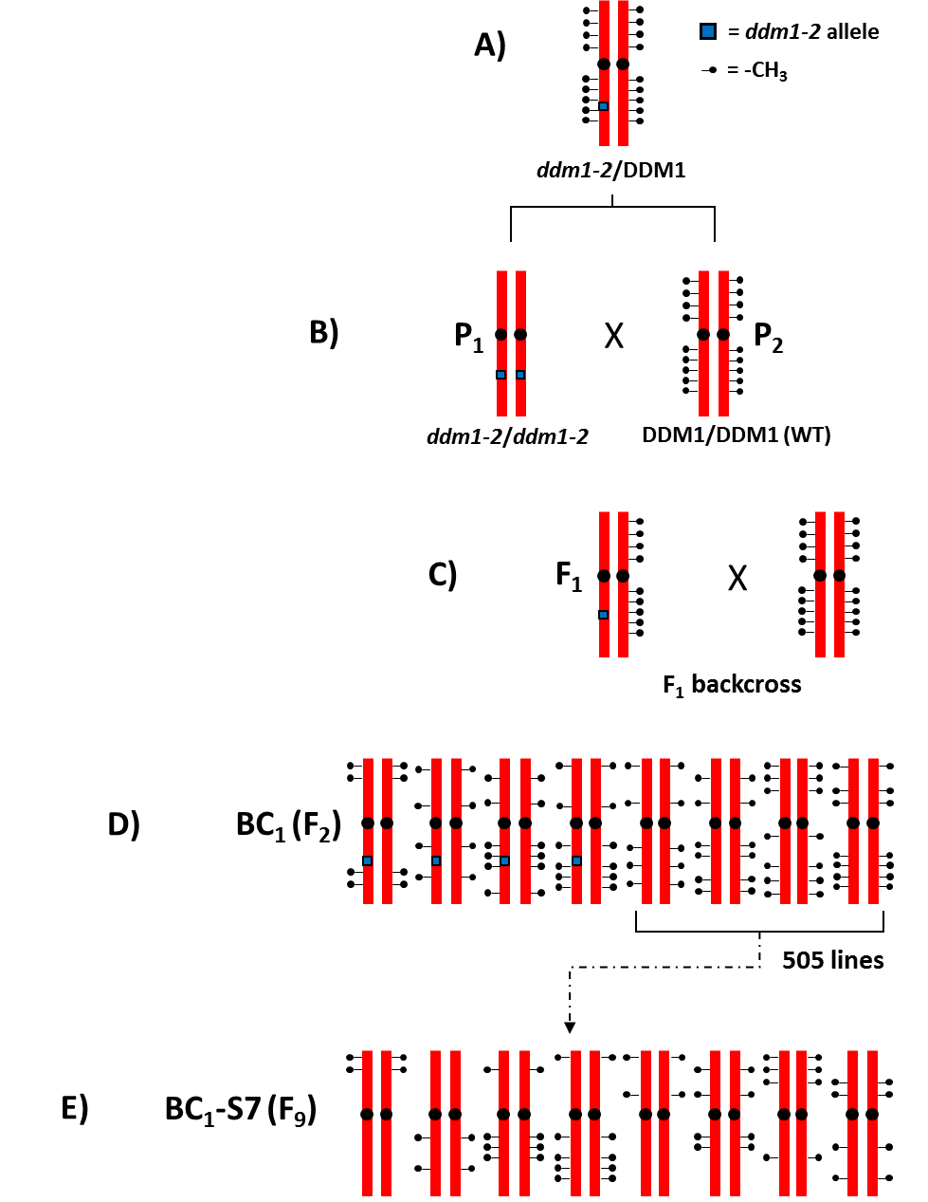

Figure 4.1: Diagram of the construction of the Col-0 x ddm1-2 epiRILs population (adapted from [216]). A) Generation of the epiRILs population started from a single heterozygous individual carrying the ddm1-2 allele, to maximise isogenicity. B) After self-pollination, one recessive homozygous ddm1-2/ddm1-2 and one WT individual (DDM1/DDM1) were selected as parental lines for the population. Both ddm1-2 and WT parental lines were self-pollinated for four generations to allow the ddm1-2 mutant to accumulate significant levels of stochastic DNA demethylation. C) Crossing the parental lines generated heterozygous F₁ plants which retained regions of DNA demethylation from the ddm1-2 parent. D) One F₁ individual was backcrossed to the parental WT Col-0 line, generating a population of heterozygous (ddm1-2/DDM1) and WT lines retaining patterns of DNA demethylation from the ddm1-2 parental line. E) Out of the population resulting from the backcross (BC₁ or F₂) 505 genetically WT lines were selected and self-pollinated for seven generations to stabilize the DNA de-methylated epialleles (BC₁-S7(F₉)). The resulting lines maintained stochastically inherited regions of de-methylated DNA from the ddm1-2 parental line.

The BC₁-S7(F₉) lines of the Col-0 x ddm1-2 epiRILs population were characterized by global methylated DNA immunoprecipitation followed by tilling array hybridisation (MeDIP-Chip) analysis, revealing that the epiRILs retained on average 33.2% of 1-2kb differentially methylated regions (DMRs) from the ddm1-2 parent [17]. DMRs showing Mendelian segregation in a sub-set of 123 methylome-sequenced epiRILs were selected to generate a gentic linkage map, covering 81.9% of the Arabidopsis genome [266] (Figure 4.2). Previous studies have shown that this DMR linkage map can be used to map epigenetic quantitative trait loci (epiQTLs) controlling complex traits, such as root length and flowering time [18,263].
Recent evidence points to an important regulatory role of DNA methylation in disease resistance and immune priming. Plants exposed to selected environmental stimuli, such as localised pathogen attack, developed enhanced resistance, which is associated with an increased responsiveness (‘priming’) of the plant innate immune system [190]. Priming is characterised by augmented induction of defence-related genes after pathogen challenge. Interestingly, defence-related genes in the primed state are associated with an increased occurrence of post-translational histone modifications that mark a de-condensed chromatin state [19,20,209]. Moreover, the primed state can be transmitted to the next generations through an epigenetic mechanism [6,208]. On the other hand, mutants in DNA methylation machinery showing genome-wide reduction in DNA methylation often show a “constitutively primed” phenotype [7,21,258], suggesting a role for DNA hypo-methylation in (transgenerational) immune priming. Indeed, Chapter 3 of this thesis has shown that changes in DNA methylation antagonistically regulate basal defences against pathogens with different lifestyles, as well as affecting different layers of inducible defences.
The current Chapter describes the characterisation of the Col-0 x ddm1-2 epiRILs population for basal resistance against the biotrophic pathogen H. arabidopsidis (Hpa) and the necrotrophic pathogen P. cucumerina (Pc). The DMR linkage map generated for these lines [266] (Figure 4.2) was used for interval-mapping of heritable epiQTLs controlling disease resistance.

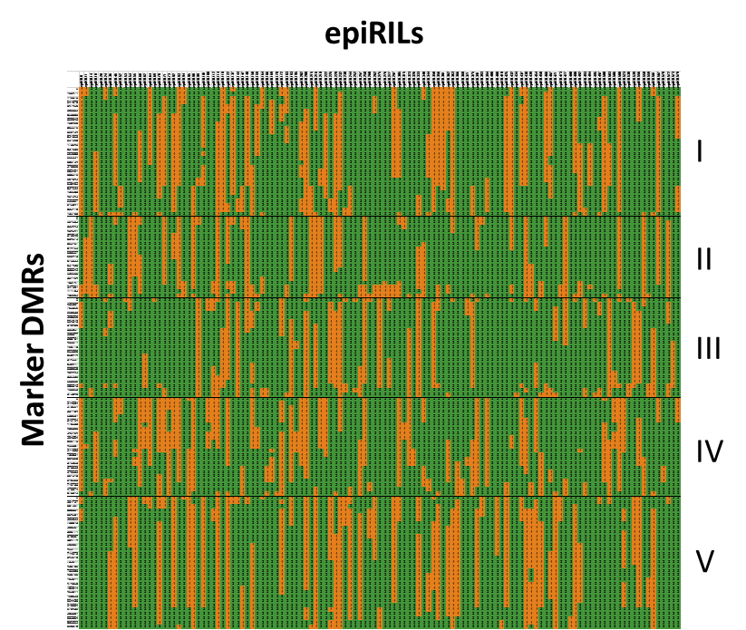
Figure 4.2: Linkage map of differentially methylated regions markers in the Col-0 x ddm1-2 epiRILs population. Shown are DMRs for each chromosome (I-V) against the 123 epiRILs of the core population. The DMR markers were selected for displaying a Mendelian segregation within the population. Green squares represent WT haplotypes with approximately normal levels of DNA methylation; orange squares represent ddm1-2 haplotypes (which are hypo-methylated). The map is a replotting of the data produced in [17].

4.3: Results

4.3.1: Quantification of H. arabidopsidis resistance in the parental lines of the Col-0 x ddm1-2 epiRILs population
Siblings of the parental plants of the Col-0 x ddm1-2 epiRILs population (WT and ddm1-2; F4 generation) were tested for basal resistance against the biotrophic pathogen Hpa. Leaves of 3 weeks-old seedlings were challenged with Hpa conidia and at 6 days post inoculation (dpi) examined for Hpa colonisation by trypan blue staining. Resistance was quantified by assigning leaves to different Hpa colonisation categories, ranging from non-infected leaves (Figure 4.3, white bars) to fully colonized leaves with presence of asexual and sexual pores (Figure 4.3, black bars). In comparison to the Col-0 parent, the hypo-methylated ddm1-2 parent showed strongly elevated levels of resistance, as was evident from a higher proportion of its leaves allowing relatively low levels of Hpa colonisation (Figure 4.3).

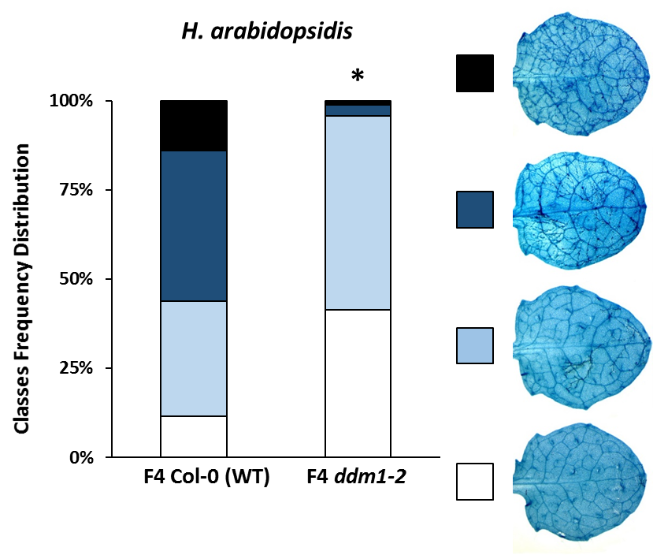
Figure 4.3: H. arabidopsidis resistance in siblings of the epiRILs parental plants. Trypan blue scoring of leaf infection by Hpa. Inoculated leaves were divided in different classes based on the extent of Hpa colonisation, as displayed by the insets on the right: white, no or minimal colonisation; light blue, ≤ 50% leaf area colonized by the pathogen; dark blue, ≤ 75% leaf area colonized by the pathogen, presence of conidiophores; black > 75% leaf area colonized by the pathogen, abundant conidiophores and sexual oospores. Statistically significant difference (asterisk) was assessed by Pearson Chi-squared test compared to F4 Col-0 plants; p <0.05.

4.3.2: Screening of the epiRILs population for variation in resistance to biotrophic H. arabidopsidis
To examine further whether the elevated Hpa resistance of the ddm1-2 mutant can be inherited over multiple generations in a wild-type background, the core set of the Col-0 x ddm1-2 epiRILs population was screened for Hpa resistance, using the same Hpa pathoassay as described above. All 123 epiRILs were analysed in the same assay and compared to the ddm1-2 and WT parents and five additional WT Col-0 lines derived from the WT Col-0 parent (INRA). As is shown in Figure 4.4A, the entire population displayed substantial variation in Hpa resistance, which was statistically highly significant (X² =5215; p =0). While the majority of epiRILs showed resistance levels comparable to those of WT control lines (Figure 4.4A, green triangles), 51 lines showed significantly higher levels of resistance than the 6 Col-0 WT Col-0 lines (Pearson Chi-squared test, p <0.05). Of these, eight lines showed statistically similar levels of resistance as the ddm1-2 parent (Figure 4.4A, red triangle).
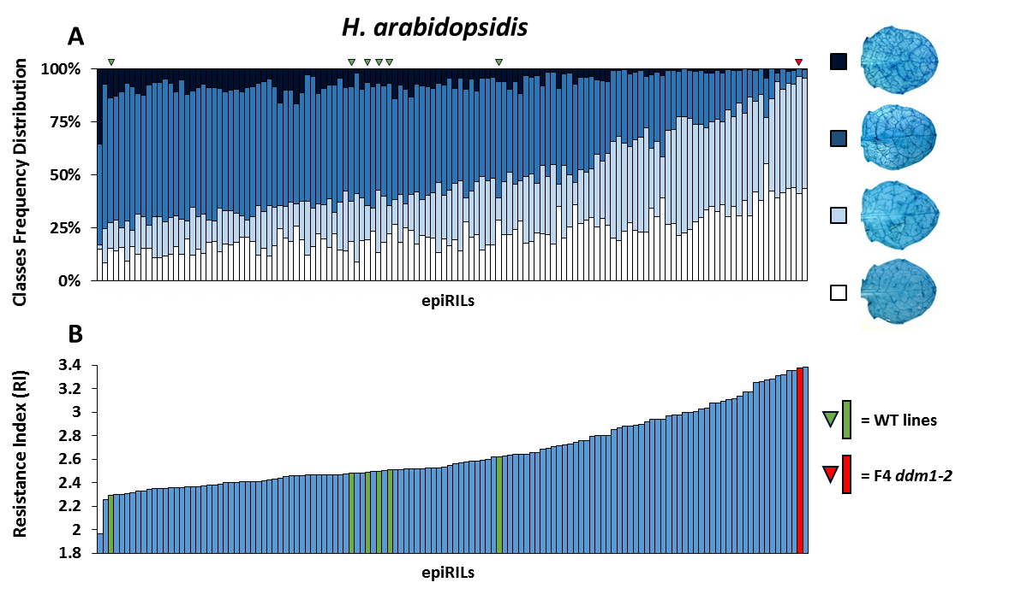
Figure 4.4: Variation in basal resistance to H. arabidopsidis between lines of the Col-0 x ddm1-2 epiRILs population. A) Leaves were collected at 6 days after inoculation of 3 weeks-old plants. Trypan-blue stained leaves were assigned to different Hpa colonisation classes. Examples of the different classes are displayed on the right: white, no or minimal colonisation; light blue, ≤ 50% leaf area colonized; dark blue, ≤ 75% leaf area colonized, presence of conidiophores; black > 75% leaf area colonized by the pathogen, abundant conidiophores and sexual oospores. Green triangles indicate WT Col-0 control lines generated as part of the epiRILs set (siblings of the parental WT plant); red triangle indicates siblings of the parental mutant plant F4 ddm1-2. B) Basal Hpa resistance levels in the 130 lines as quantified by Resistance Index (RI), a mathematical conversion of the frequency distribution of different Hpa colonisation classes into a single numerical value (Chapter 2). Green bars indicate WT Col-0 lines while red bar indicates siblings of mutant plant ddm1-2.

4.3.3: Mapping of epiQTLs controlling H. arabidopsidis resistance
To test whether the variation in Hpa resistance within the epiRILs population can be attributed to heritable epiQTLs, the categorical classification of Hpa resistance was converted into a single numeric resistance index (RI) for each line. To this end, an arbitrary weight value was assigned to each Hpa colonisation class and multiplied by the relative frequency of the respective class. As further detailed in Chapter 2 (section 2.9), the RI value for each line was defined as the sum of the weighted frequency values of the four Hpa colonisation classes, resulting in a numerical values that can range between 1 (all leaves in the highest susceptibility class) to 4 (all leaves in the lowest Hpa colonisation class, i.e. complete immunity). Figure 4.4B shows the RI values of the entire epiRILs population (blue), the WT Col-0 lines (green) and ddm1-2 parent (red). Using the DMR linkage map of the epiRILs population (Figure 4.2), interval mapping of RI values revealed four highly significant epiQTLs on chromosomes one, two, four and five (Figure 4.5A), of which the epiQTL on chromosome two showed the strongest significance value as determined by the logarithm of odds (LOD). For each epiQTL, the DMR markers with the highest relative LOD score (peak markers) showed a positive correlation between RI value and the ddm1-2 haplotype (Figure 4.5B), indicating that the hypo-methylated alleles from the ddm1-2 parent provide increased resistance against Hpa. A linear regression model to calculate the percentage of RI variance in the population explained by each epiQTL peak marker (R²(g); Chapter 2, section 2.9) confirmed that the peak marker on chromosome two epiQTL has the strongest contribution. Using an additive model, the combined contribution of all four epiQTL peak markers (R²(G); Chapter 2, section 2.9) was estimated at 59.98% (Figure 4.5C). Because Hpa resistance is scored by pooling all individuals of each line (Chapter 2, section 2.2), the lack of within-line variability impedes the estimation of broad-sense heritability (H²).

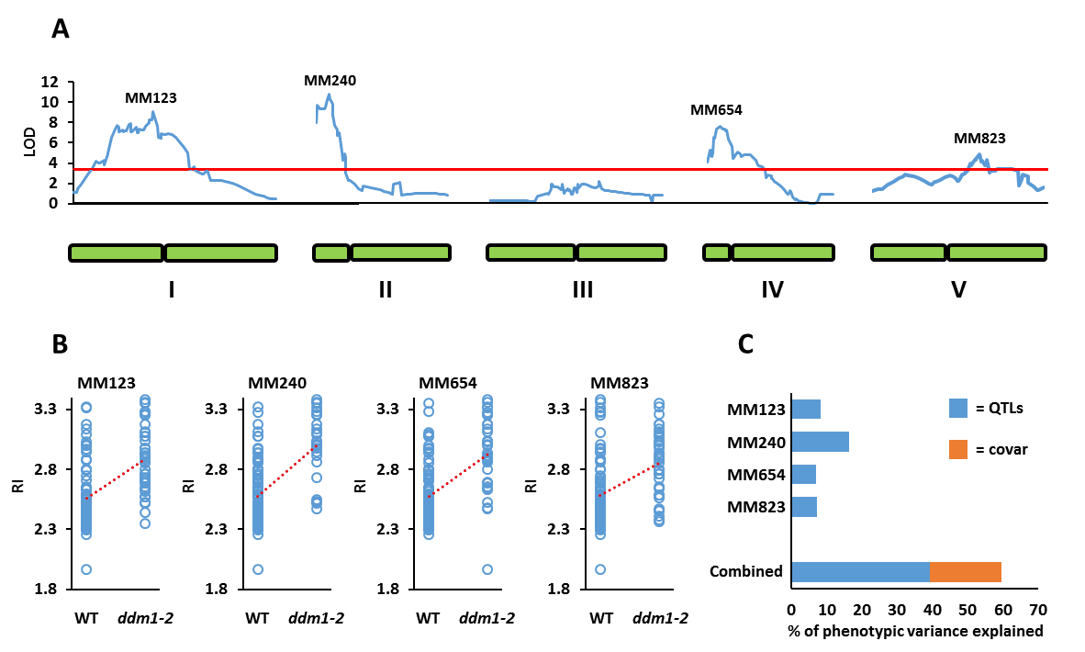
Figure 4.5: Mapping of epiQTLs controlling H. arabidopsidis resistance in the epiRILs population. A) Linkage mapping of Resistance Index (RI) values, using the DMR linkage map of the epiRILs population (Figure 4.2). Arabidopsis chromosomes are represented below in green. Threshold of significance (red line) was obtained by performing 1000 permutations on the dataset (α= 0.05). The DMR markers with the highest LOD score (peak markers) are displayed above each QTL interval (MM#) B) Correlation plots between RI values and peak marker haplotypes (WT or ddm1-2). C) Percentage of phenotypic variance explained by the four different peak markers separately (R²(g), see section 2.9) and all four peak markers combined (R²(G) see section 2.9), as well as the covariance (orange) between the four peak markers.

4.3.4: Genetic variation by shared transposition events in the epiRILs population does not contribute to H. arabidopsidis resistance
A major function of DNA methylation is to prevent transposition of transposable elements (TEs) and, thereby, maintain genome stability. In the Col-0 x ddm1-2 epiRILs population, most DMRs originating from the ddm1-2 parent overlap or are in the proximity of long transposons in heterochromatic pericentromeric regions [73,266]. However, frequent occurrence of transposition events in the epiRILs is unlikely, since the DMRs in the population (33.2% of the total DMRs from ddm1-2) are mostly at “relic” transposons, which have lost the ability to transpose [266]. Furthermore, it is likely that over seven generations of single seed descent, active transposons have been re-methylated by de novo DNA methylation mechanisms, such as RdDM. Moreover, if such transposition events had happened over the seven generations of inbreeding, it is highly unlikely that they occurred at similar loci in independent lines. It cannot, however, be excluded that the widespread DNA hypo-methylation in the ddm1-2 parent may have led to transposition events in the ddm1-2 parental line during the four generations of ddm1-2 inbreeding before the F1 cross with the WT (Figure 4.1). If so, this could have resulted in shared transposition events (sTEs) between multiple epiRILs, which could have contributed to genetic variation influencing Hpa resistance. To account for this possibility, all four epiQTL intervals within LOD-drop-off boundaries of 2 were analysed for sTEs present in more than 2 epiRILs out of 122 epiRILs, using TE-tracker software [220]. Three sTEs could be identified, which all mapped to the epiQTL interval on chromosome one (Table 4.1). However, linear regression analysis revealed that these sTEs do not correlate significantly with RI value (Table 4.1). Hence, the observed variation in Hpa resistance within the epiRILs population is not due to genetic variation, but is caused by variation in DNA methylation inherited from the ddm1-2 parent at the four identified loci (epiQTLs).

Table 4.1: Effect of peak DMR marker or identified shared Transposition Events (sTEs) on H. arabidopsidis resistance in the interval of epiQTL1 on chromosome one.
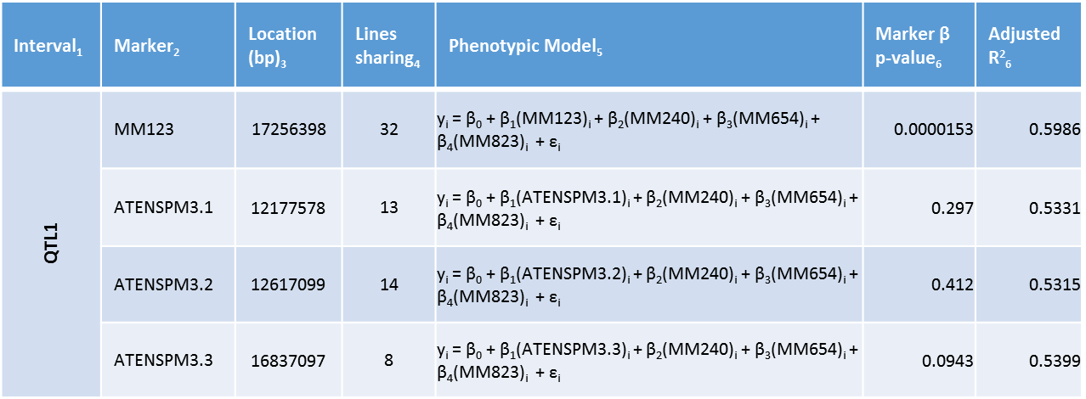
¹ No sTEs were identified in the epiQTL intervals at chromosomes two, four and five; intervals were defined by LOD drop-off values of 2.
² name of the peak DMR marker or transposable element mobilized within the interval;
³ physical coordinates (bp) of the peak DMR marker or site of insertion of the transposable element from the top of the chromosome.
⁴ number of epiRILs sharing the de-methylated DMR marker or the sTE;
⁵ multiple regression models used to explain the phenotypical value (y_{i}) by either the peak DMR maker or sTEs.
⁶ Levels of significance (p-value) and correlation (Adjusted R²) between marker and RI.

4.3.5: Screening of the epiRILs population for variation in seedling growth
During the Hpa resistance screen, it was noticed that some epiRILs displayed differences in growth rate, leaf morphology and/or plant size, which could have had an indirect effect on resistance against Hpa. Furthermore, it is well documented that enhanced pathogen resistance in plants can result in lower growth, due to the costs of enhanced defence expression [267]. In order to study the interrelationship between growth phenotypes and Hpa resistance in the epiRILs population, the Green Leaf Area (GLA) of each line was estimated, using image analysis of digital photographs of 12 to 15 individuals per line, which were taken before Hpa inoculation (see Chapter 2, section 2.8). The analysis revealed statistically significant differences in GLA values between 23 epiRILs and the mean of 6 WT Col-0 lines (99% confidence interval; Figure 4.6A). Subsequent interval mapping revealed one DMR marker on chromosome one with statistical linkage to variation in GLA values (MM150; Figure 4.6B). This peak marker showed a negative correlation between GLA values and ddm1-2 haplotype (Figure 4.6C), indicating that the hypo-methylated ddm1-2 allele represses seedling growth. Notably, this growth regulatory epiQTL on chromosome one did not overlap with the Hpa resistance epiQTL, suggesting that there is no interrelationship between plant growth and Hpa resistance (Figure 4.6B, inset).
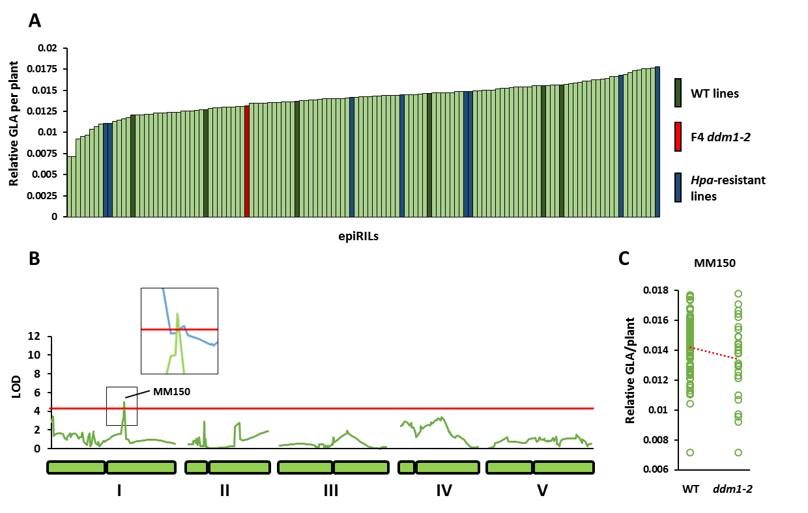
Figure 4.6: Mapping of epiQTLs controlling seedling growth. A) Variation in average Green Leaf Area per plant (GLA) between epiRILs. n = 12-15. Dark green bars indicate WT control lines, blue bars indicate the eight most Hpa-resistant epiRILs (Figure 4.3) and the red bar indicates the parental ddm1-2 line. B) Linkage mapping of average GLA values, using the DMR linkage map of the epiRILs population (Figure 4.2). Threshold of significance (red line) was obtained by performing 1000 permutations on the dataset (α = 0.05). The inset compares LOD/threshold values between GLA (green line) and RI (blue line; Figure 4.5) around the MM150 peak marker. C) Correlation plot between GLA values and MM150 peak marker haplotypes (WT or ddm1-2).

4.3.5: Screening of the epiRILs population for variation in resistance against necrotrophic P. cucumerina
The set of 123 epiRIL lines and 5 control WT Col-0 lines was tested for basal resistance against the necrotrophic fungus Pc. Leaves of 5 weeks-old plants were droplet-inoculated with Pc spores and photographed at 9 dpi. Since lesion dimeter is a reliable parameter of Pc colonisation of Arabidopsis [196,268], basal resistance was quantified by average necrotic lesion area (NLA), which was estimated from image analysis of 4 inoculated leaves from 4 plants per line (Chapter 2, section 2.3). Although there were statistically significant differences in NLA values between epiRILs (one-way ANOVA; p <0.05; Figure 4.7A), this variation could not be linked to a DMR marker by interval mapping (Figure 4.7B). Hence, the analysis failed to identify a statistically significant epiQTL controlling resistance to Pc.
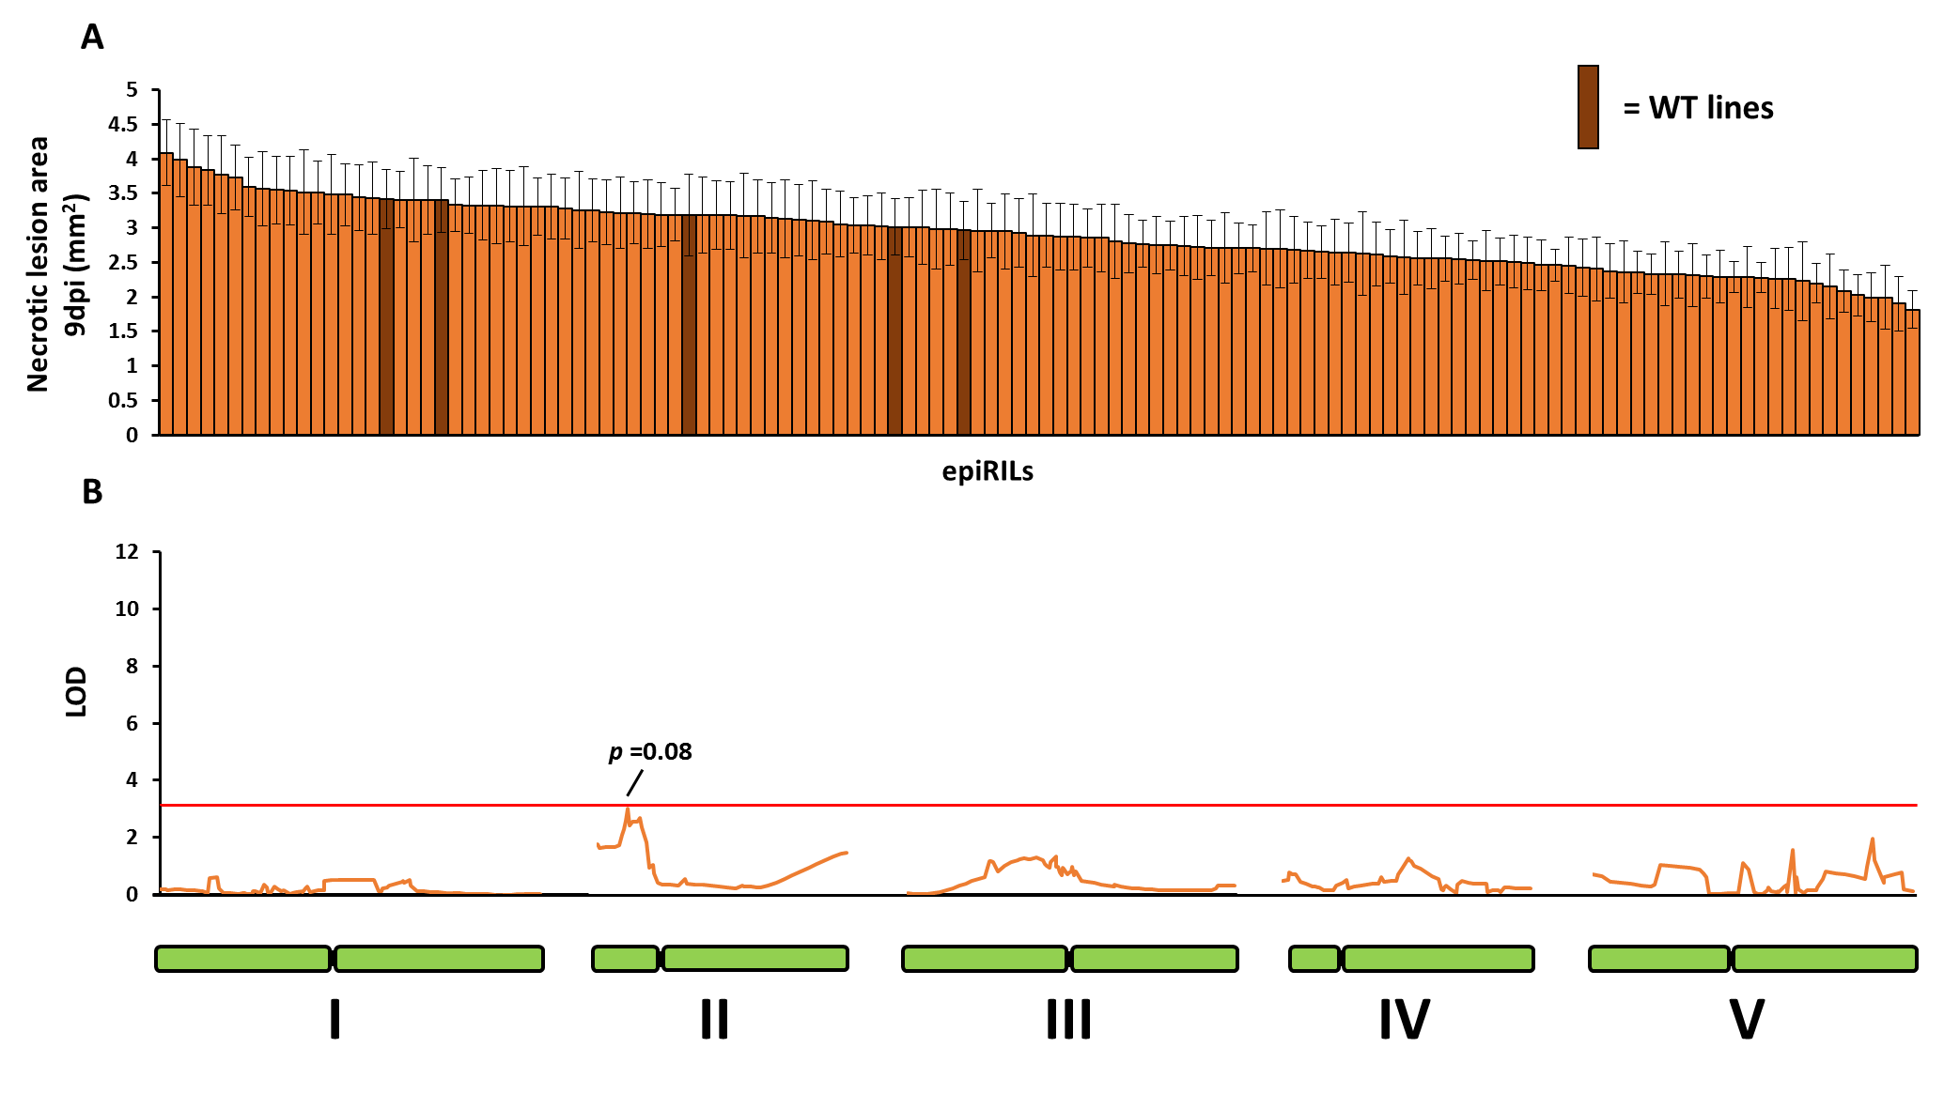
Figure 4-7: Screening epiRILs for resistance against necrotrophic P. cucumerina. A) Resistance was determined at 9 days after droplet inoculation of 5 weeks-old plants. Error bars represent standard error of mean Necrotic Lesion Areas (NLA) per line (mm²; n = 16). Dark brown bars indicate WT Col-0 lines. B) Linkage mapping of average NLA values, using the DMR linkage map of the epiRILs population (Figure 4.2). For details, see legend to Figure 4.5. Arabidopsis chromosomes are represented below in green. Threshold of significance (red line) was obtained by performing 1000 permutations on the dataset (α= 0.05). No DMR markers were found showing statistically significant linkage to NLA.

4.4 Discussion

This Chapter shows that heritable changes in DNA methylation from the ddm1-2 mutant can provide quantitative disease resistance against biotrophic Hpa. It was found that 39.2% of the epiRILs population exhibited statistically elevated levels of resistance in comparison to the WT plants, of which eight were as resistant as the ddm1-2 parent (Figure 4.4). Since the epiRILs in the BC₁-S7(F₉) generation retained only 33.2% of DMRs present in the ddm1-2 parent[266], these results indicate that the level of global DNA hypo-methylation is not necessarily proportional to Hpa resistance. The heritable DMRs in the epiRILs population were maintained over seven generations of single seed descent in a WT background containing intact DNA methylation machinery [15,266]. Some DMRs from the ddm1-2 parent could still be detected after sixteen generations of inbreeding [91], demonstrating that hypo-methylation at some DDM1-targetted loci shows high levels of transgenerational durability. Interestingly, ~50% of these stably inherited DMRs also occur in naturally occurring Arabidopsis accession [91], indicating that these hypo-methylated loci are resilient against DNA re-methylation by RdDM. Indeed, a recent publication showed that genetic sequence features can influence the predisposition of certain loci to form stable or reversible epialleles [94].The multigenerational stability of these DMRs, together with their effects on complex plant traits like quantitative disease resistance, creates tangible opportunities for exploitation of epigenetic traits in crop breeding schemes.
The observed variation in Hpa resistance (Figure 4.3) could be linked to four statistically significant epiQTLs (Figure 4.4). The combined contribution of all four DMR peak markers of these epiQTLs to phenotypical variation was estimated at 59.98% (Figure 4.5C), which is higher than other epigenetically controlled plant traits in this population, such as flowering time or root length [18]. All peak markers showed a positive correlation between the haplotype from the ddm1-2 parent and Hpa resistance (Figure 4.5B), indicating that the hypo-methylated ddm1-2 allele induces enhanced resistance. This is consistent with the results presented in Chapter 3 (Figure 3.1 and Figure 3.4) and other studies reporting that DNA hypo-methylation by mutations in cellular DNA methylation machinery lead to enhanced resistance against biotrophic pathogens [7,21,22]. There were no sTEs in 3 out of the 4 epiQTL intervals, while the 3 sTEs within the epiQTL interval on chromosome one did not correlate with Hpa resistance. Therefore, it can be concluded that the observed variation in Hpa resistance within the epiRILs population is not due to shared genetic variation, but rather due to shared epigenetic variation inherited from the hypo-methylated ddm1-2 parent.
Screening the epiRILs population for resistance against Pc identified statistically significant variation of resistance against this necrotrophic fungus (Figure 4.7A). Nevertheless, linkage mapping against the epigenetic DMR map failed to identify statistically significant epiQTLs controlling Pc resistance. This indicates that epigenetic variation in DDM1-dependent DNA methylation has a greater impact on resistance to biotrophic pathogens than that to necrotrophic pathogens. However, the Pc resistance screen was based on a relatively low number of replication (4 lesions per plant from 4 plants per epiRIL; n =16). This may have affected the statistical power of the linkage mapping. It is, therefore, tempting to speculate that the DMR marker on chromosome two showing borderline statistically significant linkage (MM335; p = 0.08), represents a weak epiQTL controlling resistance.
Screening the epiRILs population for growth phenotypes (GLA) revealed one relatively weak epiQTL on chromosome two (Figure 4.6B). The ddm1-2 haplotype of the corresponding DMR peak marker (MM150) was negatively correlated with GLA (Figure 4.6C.), suggesting that the hypo-methylated allele from the ddm1-2 parent represses seedling growth. These results are in agreement with a previous study [263], which screened Relative Growth Rates (RGR) on the basis of leaf area in a subset of 99 ddm1-2 epiRILs and identified a RGR-repressing epiQTL in the same region on chromosome two [263]. Interestingly, the DMR peak marker of the growth-repressing epiQTL in this study, MM150, did not fall within the much stronger Hpa-resistance epiQTL on chromosome two. Since the GLA screen was carried out in the same bioassay as the Hpa resistance screen, it can be concluded that the variation in seedling growth within the epiRILs is not related to Hpa resistance. This also implies that the observed Hpa resistance within the epiRILs population represents a form of resistance that is not associated with major costs on plant growth. Resistance that is based on priming of defence entails an augmentation of multi-genic resistance that is not associated with major costs on plant growth [205]. Therefore, it is tempting to speculate that the epigenetically controlled resistance against Hpa is based on priming of defence. This hypothesis is investigated further in the next Chapter of this thesis (Chapter 5).

Chapter 5 - Phenotypic characterisation of eight epiRILs expressing enhanced resistance to downy mildew

5.1: Abstract

Epigenetic recombinant inbred lines (epiRILs) are near-isogenic lines in a genetic WT background, containing recombinant regions of hypo-methylated DNA. In the previous chapter, characterisation of the Col-0 x ddm1-2 epiRILs population for H. arabidopsidis (Hpa) resistance identified four highly significant epigenetic quantitative trait loci. In this chapter, a sub-set of 8 epiRILs with the highest levels of Hpa resistance in the population are characterized further for resistance to other stresses, mechanisms of Hpa resistance, costs of Hpa resistance and transgenerational stability of Hpa resistance. Of the eight epiRILs tested, one line exhibited weakly enhanced resistance to the necrotrophic pathogen Plectosphaerella cucumerina, whereas all eight epiRILs showed enhanced tolerance to abiotic salt stress, although to varying degrees. While none of the epiRILs displayed constitutively enhanced expression of the salicylic acid (SA)-inducible PR1 gene, five epiRILs showed a faster and/or stronger induction of PR1 after Hpa inoculation, indicating that they were primed for SA-dependent defences. Furthermore, seven epiRILs were primed to deposit resistance-enhancing callose at germinating Hpa spores. Despite the fact that the epiRILs were unaffected in relative growth rate under disease-free conditions, seven epiRILs displayed reduced seed production, suggesting a possible cost of the constitutive immune priming. Finally, assessment of Hpa resistance in forty F10 families from the eight epiRILs identified two F10 families that had lost Hpa resistance. Furthermore, five epiRILs displayed increased variability in Hpa resistance between F10 families, suggesting partial reversal of the Hpa resistance trait.

5.2: Introduction

Upon pathogen perception plants activate a multi-layered defence response to counter infection [2]. Early acting inducible defences include the production of reactive oxygen and nitrogen species (ROS and RNS), which is often immediately followed by callose deposition around the infection site [269,270]. These relatively early post-invasive defences can affect pathogen growth negatively and set the scene for subsequent local and systemic defences that are controlled by de novo production of defence regulatory hormones. Together, this immune multi-mechanistic response amounts to quantitative disease resistance, which is effective against taxonomically un-related pathogens with different lifestyles. The key defence regulatory hormones are salicylic acid (SA) and jasmonic acid (JA), although their signalling can be assisted by other plant hormones such as ethylene, abscisic acid and cytokinins [271]. SA-dependant defence is predominantly effective against (hemi)biotrophic pathogens, while JA-dependant defence responses are mostly effective against herbivores and necrotrophic pathogens [255]. The SA- and JA-dependent pathways exert antagonistic activity on each other: activation of the one pathway results in suppression of the other [150,255]. This antagonism has been interpreted as a cost-saving strategy, in which plants optimize the resource costs associated with these defence pathways by activating only the correct one in response to a specific pathogen [170]. The costs associated with hormone-dependent defence have been documented in different plant species. Application of defence regulatory hormones, or their chemical analogues, results in reduced plant growth under pathogen-free conditions [272-275]. Furthermore, genetic mutations causing enhanced production of SA and/or JA, or increased activity of signalling components in the downstream signalling pathways, affect plant fitness, including reduced growth and seed production [276-279].
The responsiveness of the plant’s innate immune system can be enhanced by specific environmental signals [186,190,209]. A transient induction of defences after pathogen attack or chemical treatment often results in a longer-lasting defence sensitisation, or ‘priming’, that mediates a faster and/or stronger induction of these basal defences upon subsequent pathogen attack [186,190,209]. If this augmented defence activation precedes the production of disease susceptibility-enhancing effectors by the pathogen, defence priming can provide enhanced resistance to the point of near-immunity [186,190,209]. Maintenance of the primed state, however, comes with a fitness cost. Arabidopsis primed with low (non-toxic) concentrations of the chemical agent β-aminobutyric acid (BABA) showed a marginal reduction in plant growth and seed production under pathogen free conditions, which was also apparent in constitutively primed Arabidopsis mutants, such as edr1-1 [205]. Crucially, these relatively minor fitness costs were not proportional to those observed in plants expressing constitutively elevated defence, and were greatly outweighed under conditions of disease pressure due to the enhanced disease protection [205]. Hence, priming is a cost-efficient defence strategy in hostile environments that impose relatively high levels of constant disease pressure.
Priming of inducible defences has been linked to epigenetic regulation, such post-translational histone modifications and DNA methylation [245,258]. Mutants displaying DNA hypo-methylation show constitutively priming of SA-dependent defences, whereas the ros1-4 mutant, which is affected in DNA demethylation, shows repressed responsiveness of SA-dependent defences (Chapter 3) [21]. Furthermore, transgenerational acquired resistance in progeny from diseased Arabidopsis is affected in mutants with a defect in DNA (de)methylation machinery [7,215]. Extensive DNA demethylation in certain Arabidopsis mutants, such as met1-1 or ddm1-2, can also lead to developmental abnormalities [280,281], which can complicate accurate assessment of resistance phenotypes. As reported also in Chapter 3 of this thesis, DNA methylation affects different layers of plant inducible defences, including callose deposition and hormone-dependent defence responses (Chapter 3, [215]). Thus, changes in DNA methylation can provide a plausible explanation by which acquired immune priming is inherited.
In the previous chapter, a core population of epigenetic recombinant inbred lines (epiRILs) was used to investigate the effects of heritable DNA hypo-methylation on disease resistance. The Col-0 x ddm1-2 epiRILs population, which varies in inherited regions of hypo-methylated DNA from the ddm1-2 mutant [246], showed significant variation in resistance against the biotrophic downy mildew pathogen Hyaloperonospora arabidopsidis (Hpa). Using an epigenetic map of differentially methylated regions (DMRs) for the 123 epiRILs of the core population, interval mapping revealed four highly significant epiQTLs that were responsible for the observed variation in Hpa resistance. For each of these resistance epiQTLs, the hypo-methylated ddm1-2 haplotype conferred enhanced Hpa resistance, indicating that DDM1-dependent DNA methylation represses resistance against Hpa. The current chapter characterizes a subset of eight epiRILs which displayed the highest levels of Hpa resistance within the epiRILs population. In addition to characterisation of resistance to other (a)biotic stresses, this chapter demonstrates that the Hpa resistance of the eight epiRILs is associated with priming of SA-dependent and SA-independent defences. Furthermore, for some epiRILs, the Hpa resistance was associated with reduced seed set and trait instability from the F9 to F10 generation.

5.3: Results

5.3.1: Cross-resistance phenotypes of H. arabidopsidis resistant epiRILs
Eight epiRILs with the highest levels of Hpa resistance from within the Col-0 x ddm1-2 epiRILs population were selected for further phenotypic characterisation: epiRIL 71, epiRIL 92, epiRIL 93, epiRIL 148, epiRIL 193, epiRIL 229, epiRIL 454, and epiRIL 508. Their enhanced Hpa resistance was confirmed in an independent experiment (Figure 5.1A). In order to analyse potential cross-effects of the Hpa resistance on other types of (a)biotic resistance, the eight epiRILs were tested for resistance against the necrotrophic pathogen Pc and tolerance to salt (NaCl). Pc resistance was determined at nine days after droplet inoculation of 5 weeks-old plants. EpiRIL 193 showed a small, but statistically significant reduction in necrotic lesion size in comparison to the WT Col-0 line (602), indicating enhanced resistance (Figure 5.1B). The seven remaining epiRILs showed WT levels of Pc resistance. Salt tolerance was assessed by measuring the percentage of seeds able to produce fully-expanded cotyledons in the presence of 50, 75 or 100mM of NaCl by 6 days after stratification of seeds. Remarkably, all Hpa-resistant epiRILs showed varying degrees of salt tolerance at the highest NaCl concentration in comparison to the WT Col-0 line (602, Figure 5.1C). Of these, epiRIL 229 showed the highest level of stress tolerance, with 71.7 % of its seeds fully germinating at 100mM NaCL in comparison to only 2.6% of the WT seeds (Figure 5.1C).
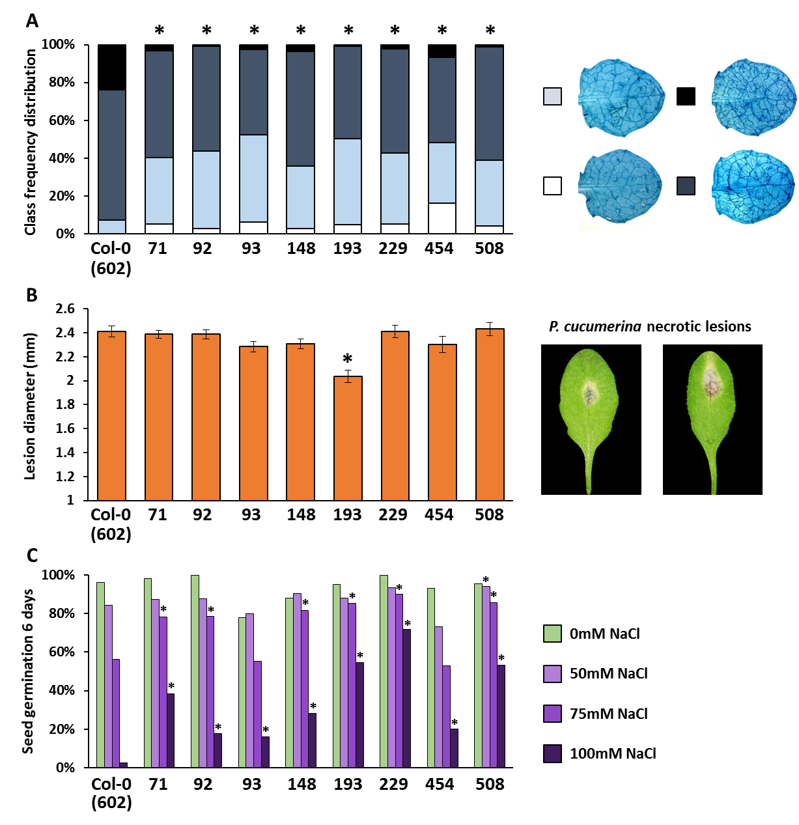
Figure 5.1: Basal resistance phenotypes of eight H. arabidopsidis-resistant epiRILs against different (a)biotic stresses. Eight epiRILs with the highest levels of Hpa resistance in the Col-0 x ddm1-2 epiRILs population were selected for further characterisation (Chapter 4). A) Confirmation of enhanced Hpa resistance in the eight epiRILs. Shown are levels of Hpa colonisation, determined by microscopy analysis of trypan blue-stained leaves at 7 days post inoculation (dpi). Leaves were divided in different classes based on the extent of Hpa colonisation, as displayed by the insets on the right: white, no or minimal colonisation; light blue, ≤ 50% leaf area colonized by the pathogen; dark blue, ≤ 75% leaf area colonized by the pathogen, presence of conidiophores; black > 75% leaf area colonized by the pathogen, abundant conidiophores and sexual oospores. B) Basal resistance against Pc. Shown are average lesion diameters at 9 dpi of 5 weeks-old plants with Pc (10⁶ spores/ml). Error bars represent standard error of the mean (n =48). Insets on the right illustrate representative examples of necrotic lesions by Pc. C) Tolerance to salt. Shown are percentages of seed germination at increasing concentrations of NaCl in agar medium (n = ~100). Statistically significant differences (asterisks) were assessed by A) Pearson Chi-squared test in pairwise comparisons with WT Col-0 line (602), B) Student's T-test in pairwise comparisons with WT Col-0 line (602) or C) Fischer's Exact test in pairwise comparisons with WT Col-0 line (602) for each NaCl concentration; p <0.05.

5.3.2: H. arabidopsidis resistance of the eight epiRILs is associated with priming of inducible defences
Basal resistance against Hpa can be based on SA-dependent or SA-independent defence mechanisms [282]. To examine the role of SA-dependent defences in the enhanced Hpa resistance of the epiRILs, expression levels of the SA-inducible marker gene PR1 were quantified by RT-qPCR at 48 and 72 hours (h) after spray inoculation with a mock suspension (water) or Hpa spores. None of the lines showed elevated levels of PR1 expression after 48 and 72 h after mock inoculation, indicating that the Hpa resistance is not due to constitutively up-regulated SA-dependent defence. However, in comparison to the WT Col-0 line, epiRILs 71, 148, 193, 229 and 508 showed augmented levels of PR1 induction at 48 and/or 72 h post inoculation (hpi) (Figure 5.2A). Hence, five of the eight lines showed primed responsiveness of SA-dependent defence to Hpa.
Callose deposition can provide early defence against pathogens and is mostly controlled by SA-independent signalling pathways [147]. To examine a possible role for callose in Hpa resistance of the eight epiRILs, the effectiveness of callose deposition was quantified at 48 hpi, using aniline-blue/calcofluor white-stained leaves and epifluorescence microscopy. This technique visualizes callose depositions relative to germinating Hpa spores, enabling quantitative measurement of the effectiveness by which callose can arrest or not early Hpa colonisation. All but one epiRIL (193) showed a statistically significant increase in the level of defence-related callose deposition compared to the WT Col-0 line (602; Figure 5.2B). No enhanced callose deposition was observed in mock-inoculated epiRILs (data not shown), indicating that they are primed to deposit resistance-contributing callose against Hpa infection.
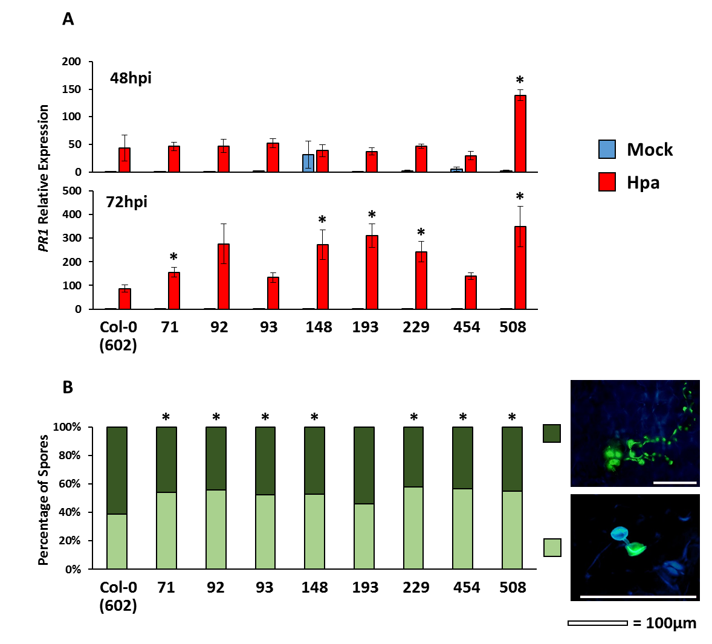
Figure 5.2: Quantification of PR1 gene expression and defence-related callose deposition in eight H. arabidopsidis-resistant epiRILs. A) Relative expression (RT-qPCR) of the SA-dependent defence response marker PR1 in the Hpa-resistant epiRILs and the WT Col-0 line (602) at 48 and 72 hpi with the mock suspension (water; blue bars) or Hpa spores (red bars). Error bars represent standard error of the mean (n =3). B) Quantification of callose effectiveness in Hpa-resistant epiRILs and the WT Col-0 line (602) at 48 hpi. Shown are percentages of germinating spores that are unaffected by callose (dark green) and germinating spores that are arrested by callose (light green) (n >150 spores). Insets on the right show representative examples, white scale bar= 100µm. Statistically significant differences (asterisks) were assessed by A) Student's T test in pairwise comparisons to the Hpa-inoculated WT Col-0 line (602) at each time-point, or B) Chi-square tests in pairwise comparisons to WT Col-0 line (602); p <0.05.

5.3.3: Fitness phenotypes of the eight H. arabidopsidis-resistant epiRILs
Chapter 4 revealed a relatively weak epiQTL on chromosome one correlating with reduced seedling size during the Hpa resistance screen (Figure 4.6). This growth regulatory epiQTL was located at a different region than the Hpa resistance epiQTL on chromosome one, suggesting that the variation in Hpa resistance in the population is unrelated to differences in growth phenotypes. However, it remains possible that this epigenetic Hpa resistance is associated with costs that become apparent at later developmental stages of the plant. To examine this hypothesis, five individuals from the eight Hpa-resistant epiRILs were grown for five weeks at short-day conditions and monitored non-destructively for green leaf area (GLA). As is shown in Figure 5.3, all eight Hpa-resistant epiRILs displayed similar growth rates as the WT Col-0 line (602; Figure 5.3).

After five weeks, all plants were transferred to long-day conditions to trigger flowering. Quantification of subsequent seed yield revealed statistically significant variation between lines (Figure 5.4). Only one Hpa-resistant epiRIL (epiRIL 92) produced similar amount of seeds as the WT Col-0 line, whereas all other Hpa-resistant epiRILs produced statistically lower amounts of seeds, with two epiRILs (93 and 229) producing less than half of the average amount of seeds produced by WT plants (Figure 5.4). Thus, the epigenetically inherited Hpa resistance in these epiRILs may have a confounding effect on seed production.

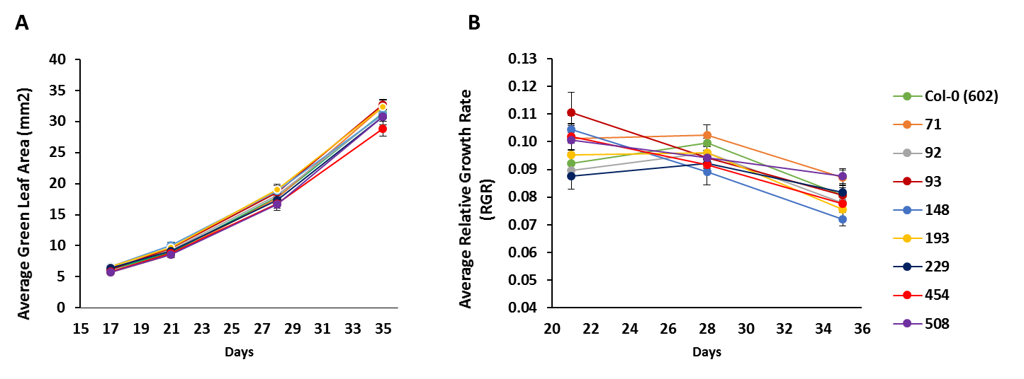
Figure 5.3: Growth analysis of H. arabidopsidis-resistant epiRILs. A) Average Green Leaf Area (GLA) of eight Hpa-resistant epiRILs and the WT Col-0 line (602) over 35 days of growth in short-day conditions (8.5 h per day). Error bars represent standard error of the mean (n =5) B) Relative growth rates (RGR) of the Hpa-resistant epiRILs and the WT Col-0 line (602) over three successive 7-day intervals Error bars represent standard error of the mean (n =5). Statistically significant differences in A) and B) were assessed by one-way ANOVA, followed by Tukey's post-hoc analysis for multiple comparisons at each time-point. No statistically significant differences were detected.

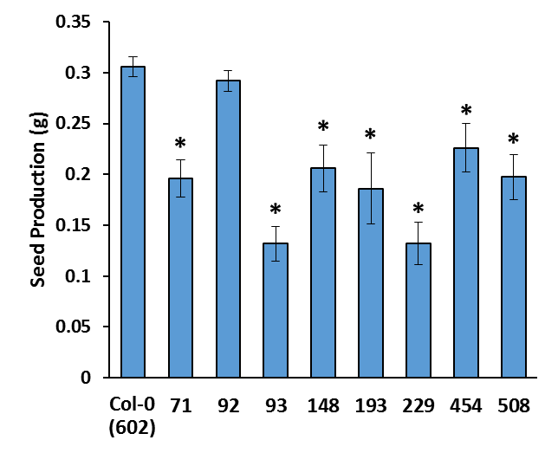

Figure 5.4: Seed production of H. arabidopsidis-resistant epiRILs. Seed production (in grams) of the eight epiRILs and the WT Col-0 line (602) were assessed after transference to long-day conditions (16 h/day) until senescence. Error bars represent standard error of the mean (n =5). Statistically significant differences (asterisks) were assessed by Student's T-test in pairwise comparison with the WT Col-0 line (602); p <0.05.

5.3.4: Transgenerational stability of the H. arabidopsidis resistance trait in F10 families of the eight epiRILs
Unlike genetic variation, epigenetic variation by DNA demethylation can be reversed over successive generations. This is mostly due to de novo DNA methylation mechanisms, such as RNA-dependent DNA methylation [93]. All epiRILs from the Col-0 x ddm1-2 population have a WT genotype and possess fully functional RdDM/ROS1 DNA (de)methylation machinery and the DDM1 protein, making it plausible that some epigenetically controlled phenotypes can be lost over successive generations. Indeed, analysis of parental DMRs in the 123 epiRILs revealed that only 867 DMRs (33.2%) were consistent with stable inheritance of ddm1-2-induced DNA hypo-methylation [17], indicating that 68.8% of all DMRs are subject to (partial) reversal. To examine transgenerational stability of the Hpa resistance trait, five F10 families from self-pollinated F9 individuals of each line were tested for Hpa resistance. When pooling leaf frequencies within similar Hpa resistance classes from five F10 families per line, each epiRIL displayed enhanced Hpa resistance in comparison to the WT Col-0 lines (Figure 5.5, top asterisks). However, when comparing resistance class distributions from individual F10 families to that of the pooled class distribution from the WT Col-0 lines, two of the forty F10 families (epiRIL71-2 and epiRIL148-2) exhibited similar levels of resistance as the WT, indicating that they had lost Hpa resistance from the F9 to the F10 generation. Furthermore, analysis of variation in resistance class distribution between F10 families within each epiRIL revealed that four epiRILs (71, 148, 545, and 508) displayed statistically significant variation in Hpa resistance (Figure 5.5; † symbols), suggesting partial reversal of Hpa resistance.
Finally, linear regression between the amount of seeds produced by each F9 individual (Figure 5.4) and Hpa resistance index (RI) of the corresponding F10 families revealed a statistically significant negative correlation between seed production and Hpa resistance (Figure 5.6). Although the model explains only a 23.72% of the total variability in Hpa resistance index, this correlation suggests that epigenetically controlled Hpa resistance may be associated with costs on seed production. However, presence of unequal variance in the dataset (heteroscedasticity, Breusch–Pagan test, p <0.01) may indicate that Hpa resistance alone does not fully explain the reduced seed production in the epiRILs.

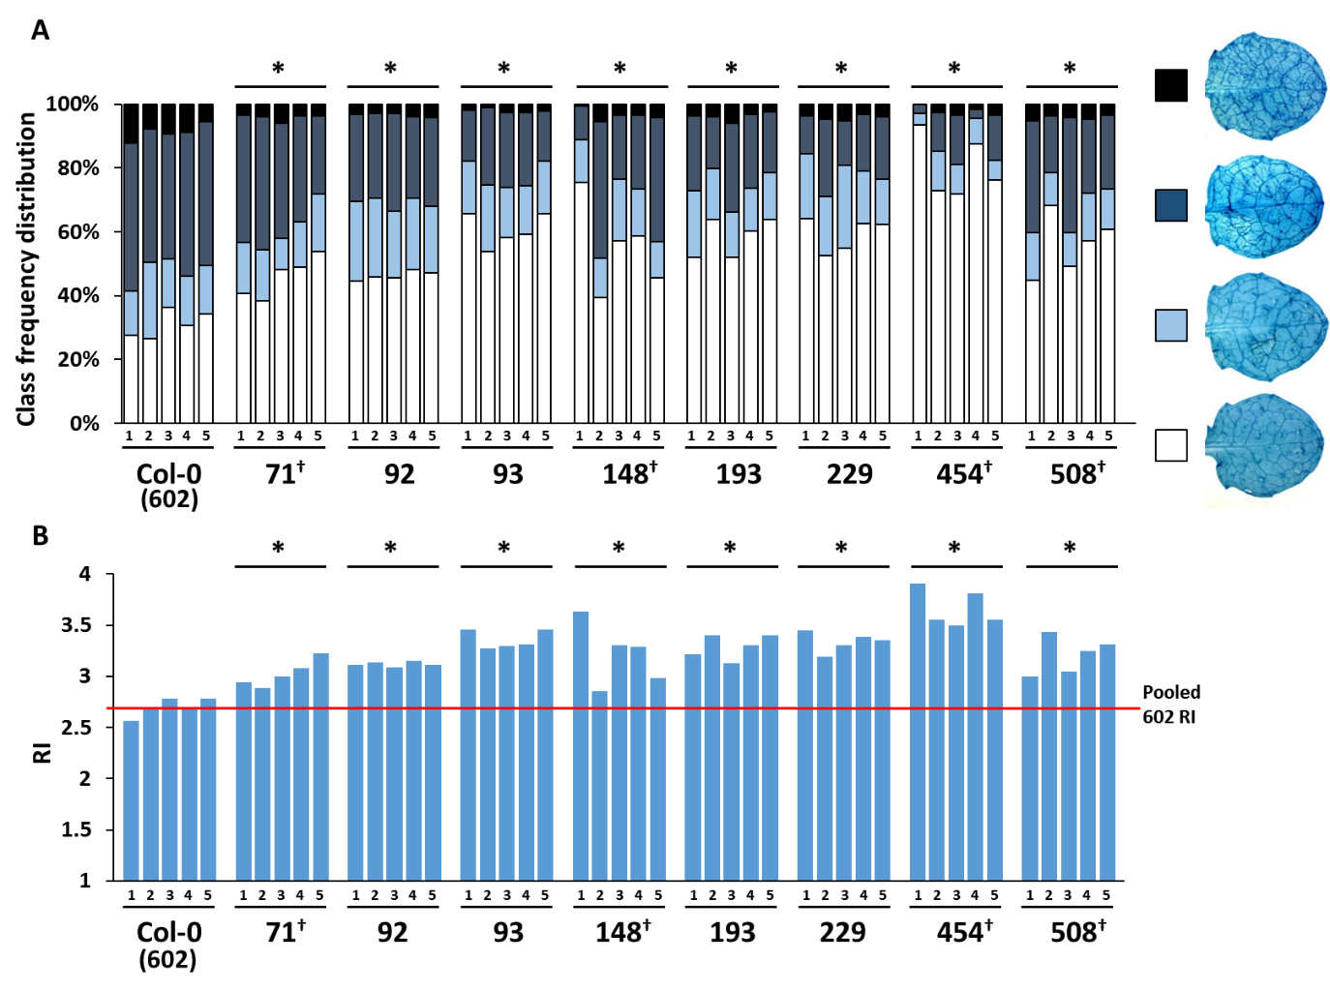
Figure 5.5: Stability of H. arabidopsidis resistance from the F9 to the F10 generation. Five F10 families per line (602, 71, 92, 93, 148, 193, 229, 454 and 508) were derived from individual F9 plants. At 6 days after inoculation with Hpa, seedlings from each F10 family were collected for trypan-blue staining. A) Shown are frequency distributions of leaves in different Hpa colonisation classes, determined by microscopy analysis. See legend to Figure 5.1 for details B) Resistance index (RI) values of the F10 families. RI represents a mathematical conversion of the frequency distribution of the different Hpa colonisation classes into a single numerical value (Chapter 2, section 2.9). The red line indicates the average RI value of the WT, obtained by the pooled frequencies of the five F10 families from the WT Col-0 line (602). Asterisks at the top of the graph indicate statistically significant differences in resistance class distribution between pooled F10 families of each epiRIL and pooled F10 families of the WT Col-0 line 602 (Pearson Chi-square test; p <0.05). Crosses (†) at the bottom of the graph indicate statistically significant differences between F10 families within each epiRIL (Pearson Chi-square test; p <0.05).

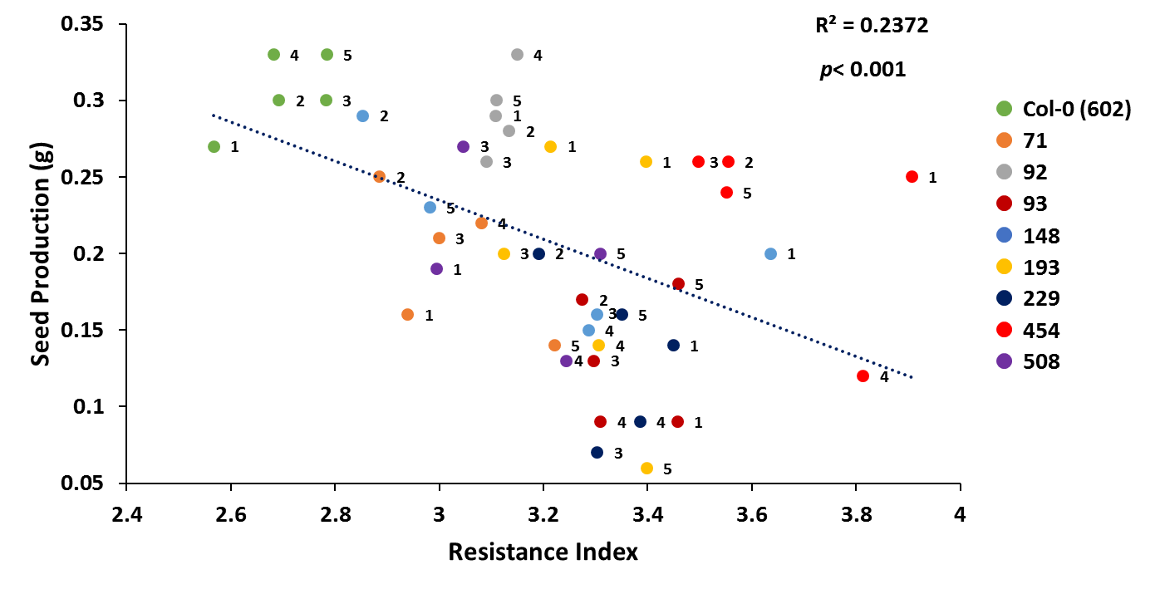
Figure 5.6: Correlation between seed production of F9 parents and H. arabidopsidis resistance in corresponding F10 progeny for the H. arabidopsidis-resistant epiRILs and the WT (602). Seed production (grams) was determined in individual plants after transfer to long-day conditions until complete senescence. F10 families are colour coded according to epiRIL. Numbers indicate F10 families.

5.4: Discussion

The Hpa resistance phenotype of eight epiRILs could be confirmed in an independent assay (Figure 5.1A), confirming the validity of the whole-population screen for Hpa resistance (Chapter 4; Figure 4.4). Subsequent analysis of Pc resistance of these eight Hpa-resistant lines revealed that one line, epiRIL 193, displays a relatively small but statistically significant increase in basal resistance to this fungus compared to the WT Col-0 line (602, Figure 5.1B). Remarkably, the screen of the whole epiRILs population for Pc resistance (Chapter 4, Figure 4.7) did not identify this line as enhanced resistant to Pc. Furthermore, the Hpa-resistant epiRIL93 showed a statistically significant reduction in necrotic lesion area in comparison to 2 of the 5 WT Col-0 lines in the whole-population screen (Chapter 4, Figure 4.7), but failed to show a statistically significant reduction in lesion diameter in the second experiment (Figure 5.1B). One explanation for these discrepancies is the relatively small number of replicates used in the whole-population screen for Pc resistance: 16 lesions obtained from four independent plants. This relatively low level of biological replicates may have increased phenotypic variability in the Pc resistance screen. Hence, the whole-population screen for Pc resistance may not have been sufficiently robust to identify relatively subtle variation in basal Pc resistance.
Analysis of salt tolerance revealed that all eight Hpa-resistant epiRILs displayed increased tolerance to salt stress. Salt tolerance has been reported previously in both met1- and ddm1-derived epiRILs populations [16,263]. What is novel, however, is that this salt tolerance consistently coincides with Hpa resistance in a selection of eight epiRILs (Figure 5.1C). Previous interval mapping of plant development traits under control and salt stress conditions in Col-0 x ddm1-2 epiRILs population revealed epiQTLs on chromosomes one and four that specifically influence flowering, leaf area and plant height under salt stress conditions [263], which partially overlap with Hpa resistance epiQTLs on these chromosomes (Chapter 4; Figure 4.4). Considering that abscisic acid (ABA) controls both salt stress tolerance and callose-mediated disease resistance [283], it is possible that these epiQTLs influence ABA signalling. Above all, this experiment illustrates that manipulation of DNA methylation can provide heritable plant resistance that is effective against both biotic and abiotic stress. This outcome provides a promising basis for future crop improvement strategies, where multi-resistant crops could be created through manipulation of their epigenome.
Figure 5.2 demonstrates that the Hpa resistance in the eight epiRILs is associated with priming of SA-dependent PR1 induction and/or deposition of defence-related callose. This finding supports previous findings on DNA hypo-methylated mutants of DNA methylation machinery (Chapter 3)[7,21]. While all Hpa-resistant lines showed comparable levels of Hpa resistance (Figure 4.4 and Figure 5.1A), they did not necessarily share the same resistance mechanisms: four epiRILs were simultaneously primed for PR1 induction and deposition of defence-related callose (epiRILs 71, 148, 229 and 508), three epiRILs were only primed for callose deposition (epiRILs 92, 93 and 454), and one epiRIL was only primed for PR1 induction (epiRIL 193; Figure 5.2). This result is consistent with the notion that basal resistance is a multigenic and multimechanistic trait [284].
Despite priming offers a cost-efficient defence strategy under conditions of high disease pressure, there are minor costs associated with it [205]. The eight Hpa-resistant epiRILs showed unaffected growth rates in comparison to WT plants (Figure 5.3), indicating that their primed immune systems do not compromise vegetative growth under short-day conditions. However, seven of the eight epiRILs displayed reduced seed production under long-day conditions (Figure 5.5), which correlated with enhanced Hpa resistance of their F10 progeny (Figure 5.7). However, the low R² value and the presence of heteroscedasticity in the dataset (Breusch–Pagan test, p<0.01) indicates that the Hpa resistance trait alone is not solely responsible for the observed reduction in seed production. Indeed, the presence of one Hpa-resistant epiRIL producing WT amounts of seeds (epiRIL 92, Figure 5.4) suggests that changes in DNA methylation can induce enhanced Hpa-resistance independently from reduced seed production. Repeated self-pollination of the ddm1-2 mutant can also result in a ‘Bonsai’ (bns) phenotype, which is characterized by reduced apical dominance and abnormalities in inflorescence development [107]. Indeed, epiRIL 93 showed dramatic alterations in inflorescence development, with loss of apical dominance in the primary inflorescence, enhanced development of axillary inflorescences and reduced siliques size (not shown). Moreover, the Col-0 x ddm1-2 core population of 123 epiRILs was originally selected for variation in flowering time [266], potentially creating a bias. Therefore, the relatively high frequency of flowering time and inflorescence phenotypes within the Col-0 x ddm1-2 core population may be responsible for reduced seed production in the seven Hpa-resistant epiRILs and may not be causally related to Hpa resistance trait.
Overall, the results presented in this chapter reinforce the idea that artificial introgression of DNA demethylation into a WT individual can provide heritable quantitative resistance against a range of biotic and abiotic stresses. The enhanced resistance against biotrophic Hpa is based on a constitutively primed state, mimicking the phenotype of some DNA hypo-methylated mutants, but without the detrimental effects on plant growth [280,281]. As an epigenetic trait, enhanced Hpa resistance is subject to partial or complete reversion to WT levels (Figure 5.5). Nonetheless, the results presented in this chapter show that the enhanced resistance is largely stable over ten generations, including eight generations of self-pollination (Figure 5.5). The relative durability of this trait makes epigenetic variation an attractive target for obtaining durable stress resistance in crops.

Chapter 6 - Whole-Transcriptome Analysis of Four Downy Mildew-Resistant epiRILs Reveals a trans-Regulatory Role for Transposable Elements in Global Defence Gene Priming

6.1: Abstract

DNA methylation regulates responsiveness of defence genes and disease resistance in Arabidopsis (Chapter 3; Lopez et al., 2016). Using the Col-0 x ddm1-2 population of epigenetic recombinant inbred lines (epiRILs), Chapter 4 of this thesis identified four epigenetic quantitative trait loci (epiQTLs) controlling heritable resistance to the downy mildew pathogen Hyaloperonospora arabidopsidis (Hpa). Analysis of eight Hpa-resistant epiRILs in Chapter 5 revealed that the enhanced Hpa resistance in these lines is associated with priming of salicylic acid-dependent PR1 induction and deposition of defence-related callose. In order to gain further insight about the mechanisms by which DNA hypo-methylation influences global gene expression in response to pathogen attack, four Hpa-resistant epiRILs carrying different combinations of the resistance epiQTLs were subjected to global mRNA-sequencing analysis at 48 and 72 hours after inoculation with water (mock) or Hpa. Principal component analysis (PCA) revealed that that epiRILs display distinct transcriptional patterns compared to WT plants, which were particularly pronounced after Hpa challenge. Subsequent statistical analysis identified 19,187 protein-coding genes (93.3%) and 1382 TEs/TE-related genes (6.7%) differentially expressed between all epiRIL/treatment/time-point combinations, of which 9,167 protein-coding genes (97.8%) and 210 TEs/TE-related genes (2.3%) were inducible by Hpa in one or more lines. Further statistical filtering revealed that among Hpa-inducible genes, 5111 protein-coding genes (96.5%) and 183 TEs/TE-related genes (3.5%) were primed for faster and stronger induction in one or more epiRILs, whereas 2561 protein-coding genes (99.4%) and 15 TEs/TE-related genes (0.6%) showed constitutively elevated expression in one or more epiRILs. Genes displaying augmented induction at 48 hours post inoculation in one or more epiRILs were strongly enriched for defence-related GO terms, suggesting that the Hpa resistance of these lines is based on priming of defence-related genes. Surprisingly, almost all primed genes located in the hypo-methylated epiQTLs of the ddm1-2 haplotype were associated with transposable elements (TE). Based on these results, a model is proposed in which methylation status of DDM1-targeted TEs in the resistance epiQTLs trans-regulate transcriptional responsiveness of distant defence genes.

6.2: Introduction

A primary function of DNA methylation is to control genome stability via the transcriptional silencing of transposable elements (TEs) [285]. In Arabidopsis, DNA methylation of TEs occurs in all sequence contexts, causing suppression of their transcription [37]. The DNA methylation status of TEs can silence expression of neighbouring genes via spreading of the heterochromatic state of TEs or antisense transcription of long non-coding RNAs [286,287]. For example, the BONSAI gene is repressed by hyper-methylation of a nearby TE LINE family TE in its promoter [107], whereas the FWA gene is repressed by methylation at SINE-derived repeats in its promoter [44,45]. Recently, it was found that TE methylation downstream of the RING-type ubiquitin ligase gene CNI1 represses transcription by modulating expression of an antisense long noncoding RNA (lncRNA) [288]. Interestingly, DNA methylation of a specific sequence in the promoter of the DNA demethylase gene ROS1 counters repression by a nearby helitron TE and induces transcription, creating a de-facto DNA methylation sensor that adjusts activity of the DNA demethylase according the methylation state of its promoter [121,122].
The chromatin re-modeller DDM1 plays a key role in silencing of TEs via maintenance of DNA methylation. The DDM1 protein predominantly targets long heterochromatic TEs at pericentromeric regions [31]. Through its chromatin remodelling activity, the enzyme provides access for the DNA methyltransferases MET1, CMT3 and CMT2 to their target loci, resulting in DNA methylation in all three sequence contexts [31,289]. Loss-of-function ddm1 mutants accumulate genome-wide DNA demethylation, which becomes more severe over generations of self-pollination [290]. After multiple generations of inbreeding, extensive DNA hypo-methylation by the ddm1-2 mutation causes severe developmental phenotypes [107,280,291], which can in part be attributed to re-activation of transposons [291,292].
Defence priming is a type of immunological memory that enables plants to activate faster and stronger innate immune responses upon pathogen attack, leading to enhanced disease resistance [3,190]. Priming typically occurs after perception of stress signal(s) that are generated during pathogen or herbivore attack, causing transient activation of inducible defence mechanisms [3,186,190]. Subsequent maintenance of the primed state has been linked to epigenetic mechanisms, such as changes in chromatin status or DNA methylation. For instance, it has been shown that priming of defence gene induction is associated with post-translational histone modifications in promoters that mark an open chromatin structure, facilitating a faster and/or stronger induction of transcription [209,213]. Hypo-methylated Arabidopsis with mutations in DNA methylation machinery display a constitutive priming phenotype (Chapter 3) [7,19,21,215], whereas the hyper-methylated ros1 mutant, which is impaired in the DNA demethylation, shows enhanced disease susceptibility and is blocked in its ability to transmit priming to the next generation (Chapter 3) [7,215]. Whole-transcriptome analysis of the nrpe1-11 and ros1-4 mutants after inoculation with Hpa revealed that 49% of Hpa-inducible genes are affected by NRPE1- or ROS1-dependant changes in DNA methylation [258]. Furthermore, of the 166 defence-related genes displaying primed induction in the hypo-methylated nrpe1 mutant and/or repressed induction in hyper-methylated ros1, only 25 genes were associated with NRPE1- and/or ROS1-dependent DNA methylation at a nearby transposable element [258]. This indicates that the majority of genes that are influenced by DNA (de)methylation by RdDM and ROS1 regulate defence gene responsiveness via trans-acting mechanisms in these mutants.
Results from the previous two Chapters in this thesis have shown that epiRILs from the Col-0 x ddm1-2 population show variation in basal resistance to the biotrophic downy mildew pathogen Hyaloperonospora arabidopsidis (Hpa; Chapter 4, Figure 4.4). Using a map of differentially methylated regions (DMRs) in the epiRILs population (Chapter 4; Figure 4.2) [266], interval mapping of this resistance phenotype identified four statistically significant epiQTLs on chromosomes one, two, four and five (Chapter 4, Figure 4.5A). For each of these loci, the hypo-methylated haplotype from the ddm1-2 parent correlated with Hpa resistance (Chapter 4, Figure 4.5B), indicating that DDM1-dependent methylation at these loci represses resistance. Analysis of a smaller sub-set of eight Hpa-resistant lines revealed that their resistance is associated with priming of salicylic acid (SA)-dependent and SA-independent defence responses (Chapter 5, Figure 5.2). To gain more insight into the mechanisms by which DNA hypo-methylation controls defence gene expression at the global scale, four Hpa-resistant epiRILs were selected for mRNA sequencing analysis at different time-points after mock and Hpa inoculation. This chapter describes the results from this transcriptomic dataset analysed in conjunction with Dr. Ritushree Jain, who the performed transcriptome assembly and differential gene expression analysis.

6.3: Results

6.3.1: Selection of four H. arabidopsidis-resistant epiRILs for mRNA-sequencing analysis
Of the eight Hpa-resistant epiRILs characterized in Chapter 5, lines 148, 193, 454, 508 were selected for whole-genome transcriptome analysis by RNA sequencing. These epiRILs were selected because they carry different combinations of the resistance epiQTLs and partially differed in their defence phenotype (Figure 6.1; Chapter 5, Figure 5.2). All four lines plus the WT control line (602) were inoculated with either water (mock) or Hpa spores. At 48 and 72 hours post inoculation (hpi), three biologically replicated samples were collected for RNA extraction, amounting to a total of 60 samples (Figure 6.1).

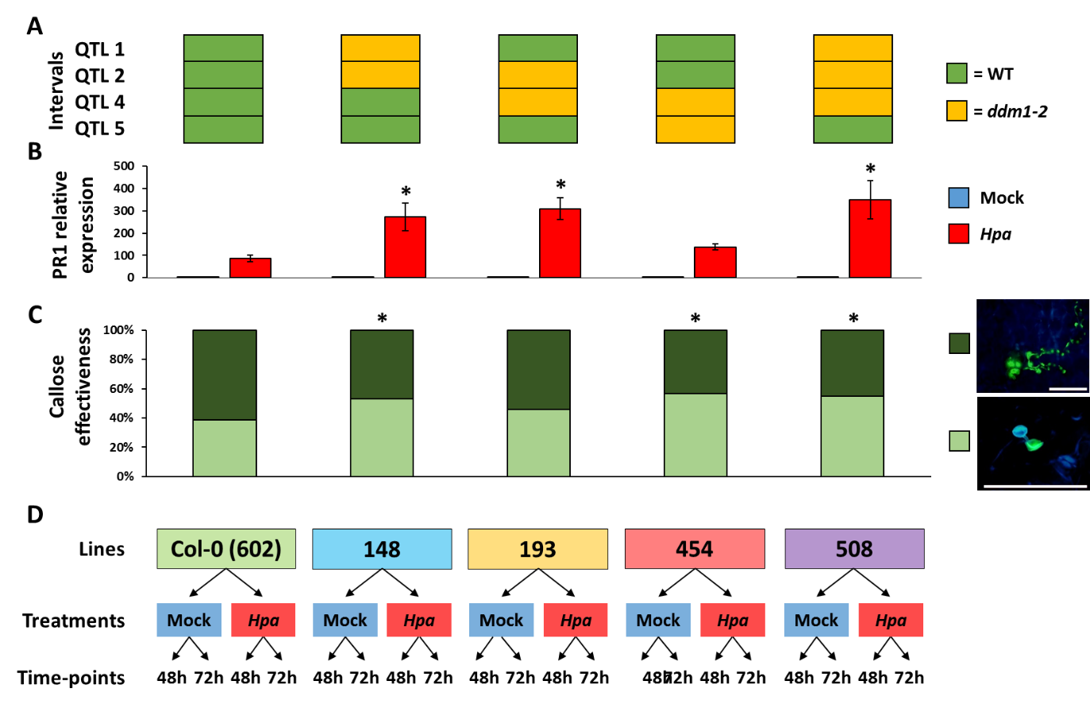
Figure 6.1: Overview of priming phenotypes and epigenotypes of epiRILs selected for whole-transcriptome analysis and experimental design. A) DNA methylation haplotypes for all four epiQTLs and lines. Green: WT haplotype; yellow: ddm1-2 haplotype (hypo-methylated). B) Relative expression of the SA-dependant defence response marker PR1 in selected Hpa-resistant epiRILs and WT control line (602) 72 hours after inoculation with Hpa (red bars) or mock (blue bars). Error bars represent standard error from 3 pooled biological replicates (excerpt from Figure 5.2 A). Statistically significant differences (asterisks) were assessed by Student's T test in pairwise comparisons with Hpa-treated WT Col-0 (602, p <0.05). C) Aniline blue/calcofluor white double-staining for analysis of callose effectiveness in blocking Hpa spores penetration in the mesophyll. Light green: spores effectively blocked by callose deposition; dark green: spores not blocked by callose deposition and able to penetrate the mesophyll. Examples displayed on the right, white scale bar= 100µm. >150 spores analysed for each line (excerpt from Figure 5.2 B). Statistically significant differences (asterisks) were assessed by Chi-square test in pairwise comparisons with WT Col-0 line (602, p <0.05). D) Experimental design of the RNA sequencing experiment. Selected epiRIL lines (148, 193, 454 and 508) and the WT Col-0 line (602) were spray-inoculated with water (Mock; blue) or Hpa suspension (Hpa; red). Three biologically replicated samples of each epigenotype/treatment were collected at 48 and 72 hours post inoculation (hpi), amounting to a total of 60 samples.

6.3.2: Principal component analysis of mRNA sequencing reads from mock- and H. arabidopsidis-inoculated epiRILs and WT plants
Principal component analysis (PCA) of all 27,641 transcripts from the transcriptome assembly revealed clear separation between different treatments and epigenotypes. The first and second principal component (PC) of the PCA explained 31% and 20% of gene expression variance, respectively. While the first PC separated samples from mock- and Hpa-inoculated plants, the second PC separated samples from different lines (Figure 6.2). This indicates that Hpa infection had a bigger effect on global gene expression than epigenotype. As expected, samples from mock-inoculated plants within each line clustered together at both time-points (Figure 6.2), suggesting relatively little impact of the mock treatments. For all lines, including the WT, samples from Hpa-inoculated plants clustered apart from samples of mock-inoculated plants. Interestingly, however, samples from Hpa-inoculated WT at 48 hpi clustered in between samples from Hpa-inoculated WT at 72 hpi and samples from mock-inoculated WT plants. By contrast, samples from Hpa-inoculated epiRILs showed no or relatively little separation between 48 hpi and 72 hpi (Figure 6.2). This PCA pattern suggests that WT plants show a slower transcriptional response to Hpa inoculation than the epiRILs.

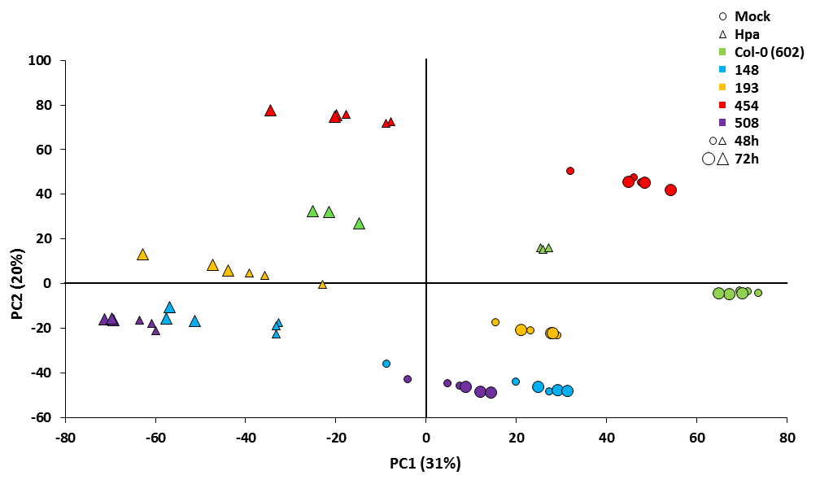
Figure 6.2: Principal component analysis (PCA) of 27,641 mRNA-sequencing transcripts from mock and H. arabidopsidis-treated epiRILs and WT. Each marker represents a single sample. Colour codes indicate different lines: green: WT Col-0 line (602); light blue: epiRIL 148; yellow: epiRIL 193; red: epiRIL 454; purple: epiRIL 508. Different marker shapes indicate different treatments: circles represent mock-treated samples; triangles represent Hpa-inoculated samples. Different marker sizes indicate different time-points of sampling: smaller markers represent samples collected at 48hpi and larger markers represent samples collected at 72hpi. Values between parentheses indicate the percentage of variance explained by each principal component.

6.3.3: Hierarchical clustering of differentially expressed genes in H. arabidopsidis-resistant epiRILs
A three-factorial likelihood ratio test (see Chapter 2, section 2.12; q <0.05) identified 19,187 differentially expressed protein-coding genes (93.3%) and 1382 differentially expressed TEs/TE-related genes (6.7%), adding up to a total of 20,569 differentially expressed genes (DEGs) between all epigenotype, treatment and time-point combinations (full list available in Supplementary Dataset, on CD). Hierarchical clustering of this gene selection revealed a large cluster of Hpa-inducible genes displaying augmented induction in the four epiRILs at 48h following Hpa infection. At both time-points, genes within this cluster did not show significant variation between mock-inoculated epiRILs and the WT (Figure 6.3, black box). Hence, many Hpa-inducible genes in the epiRILs were primed for augmented induction after Hpa inoculation.

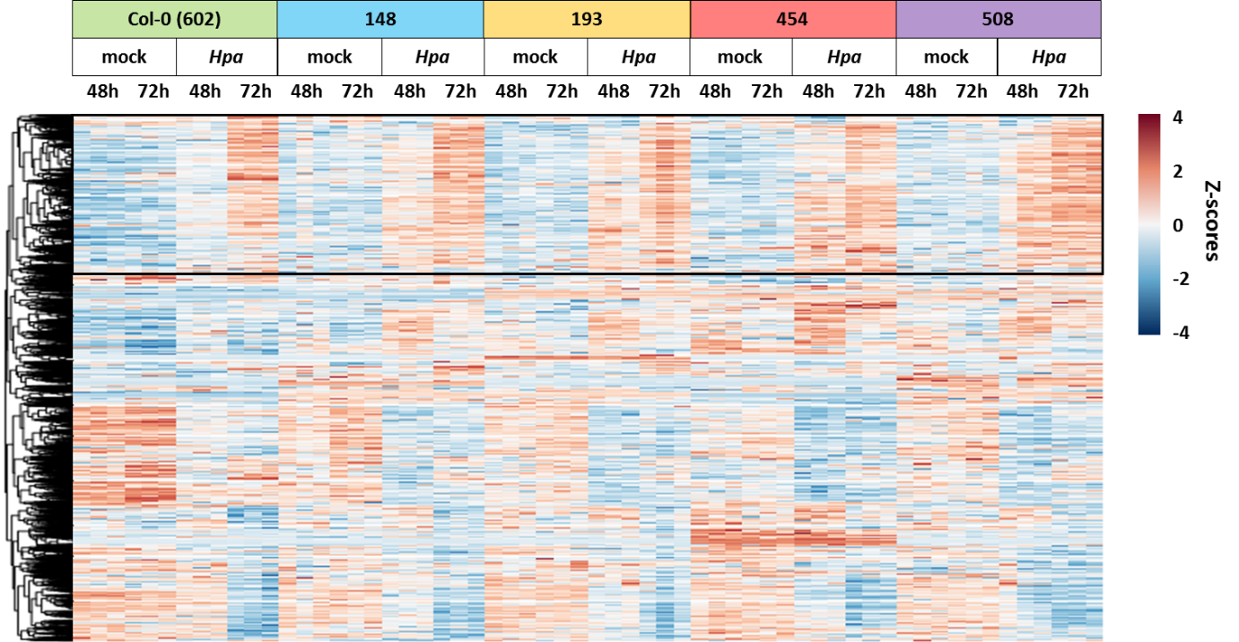
Figure 6.3: Hierarchical clustering of differentially expressed genes. A likelihood ratio test with a three-factorial design was used to identify 20,570 DEGs (q <0.05) for at least one factor (epigenotype, treatment or time-point). The heat-map projects normalized standard deviations (z-scores) from the mean read counts for each gene (row), using rlog-transformed read counts as explained in [227]. Z-scores for the three biological replicates were arranged by hierarchical clustering (Ward’s method [293]), using the "pheatmap" package of R. The black square indicates Hpa-inducible genes displaying augmented induction in one or more Hpa-resistant epiRILs at 48 h after Hpa inoculation.

6.3.4: Identification of H. arabidopsidis-inducible genes that are primed and/or constitutively up-regulated in the H. arabidopsidis-resistant epiRILs
Of the 20,570 DEGs, Hpa induced 9,377 genes in one or more of the lines (Wald test; q <0.05; full list available in Supplementary Dataset), of which 9,167 are annotated as protein-coding genes (97.8%) while 210 are annotated as TEs/TE-related genes (2.3%). The global PCA and cluster analysis of DEGs already suggested that a large fraction of these Hpa-inducible genes are primed in the Hpa-resistant epiRILs. However, this does not exclude a possible resistance contribution from Hpa-inducible defence genes that are constitutively up-regulated in the epiRILs. To identify Hpa-inducible genes with primed and/or constitutively enhanced expression in the epiRILs, the group of 9,377 Hpa-inducible genes was subjected to further statistical filtering (Wald tests, q <0.05; Figure 6.4). Hpa-inducible genes displaying priming or a combination of priming and constitutive up-regulation in one or more epiRILs (hereafter referred to as ‘primed’) were selected by three statistical filters: i) Hpa-inducible in the WT (602), ii) Hpa-inducible in the epiRILs and iii) higher expression in the Hpa-treated epiRILs compared to the Hpa-treated WT (Figure 6.4). Hpa-inducible genes displaying constitutively up-regulated expression in one or more epiRILs (hereafter referred to as ‘constitutive’) were defined by the following three criteria: i) Hpa-inducible in the WT, ii) not Hpa-inducible in the epiRILs and iii) expression in the mock-treated epiRILs is equal or higher than expression in the Hpa-treated WT (Figure 6.4). The gene selection is illustrated in Figures 6.5A-B by Venn diagrams and schematic examples of typical expression profiles.
A total of 5,294 Hpa-inducible genes were primed for faster and stronger induction in one or more epiRILs, of which 5111 are annotated as protein-coding genes (96.5%) while 183 are annotated as TEs/TE-related genes (3.5%; Figure 6.4C); on the other hand, a total of 2,576 Hpa-inducible genes showed a constitutively elevated expression pattern in one or more epiRILs, of which 2561 are annotated as protein-coding genes (99.4%) while only 15 are annotated as TEs/TE-related genes (0.6%; Figure 6.4C; full lists available in Supplementary Dataset). For each epiRIL, the largest number of primed genes was detected at the relatively early time-point of 48 hpi, which represents a critical time-point for host defence against Hpa [294,295]. Furthermore, compared to the other gene selections, a relatively large proportion of primed genes at this time-point were shared between different epiRILs (Figure 6.5), indicating commonality in the transcriptional response to Hpa between the four different epiRILs. Interestingly, only 8% of all primed genes and 6.5% of all constitutive genes in one or more of the Hpa-resistant epiRILs were physically located within the epiQTLs intervals (Figure 6.4C). This suggests that the majority of defence-related genes are controlled in trans by the Hpa resistance epiQTLs.

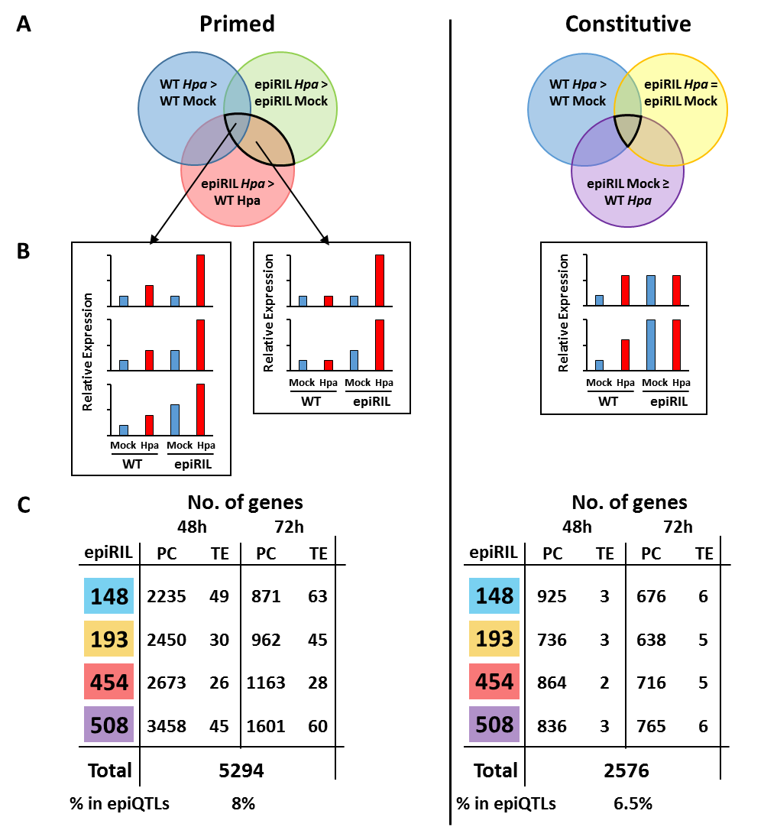
Figure 6.4: Selection of H. arabidopsidis-inducible genes that are primed and/or constitutively up-regulated in epiRILs. A) Venn diagrams illustrate the statistical criteria used to select genes with a primed and/or constitutively enhanced expression profile in the epiRILs. Overlapping areas highlighted by a black line indicate the combination of expression criteria used for each selection. Primed: Hpa-inducible genes showing priming or a combination of priming and constitutive up-regulation in the epiRILs. Constitutive: Hpa-inducible genes showing constitutive up-regulation in the epiRILs. Statistically significant differences between conditions were determined by Wald tests (q < 0.05). B) Schematic examples of expression profiles by genes in the primed and constitutive gene selection. C) Number of protein-coding (PC) and TEs/TE-related genes (TE) in the primed and constitutive gene selection for different epiRILs and time-points. The total number of unique genes identified in each selection is displayed below each table. Percentages indicate proportions of genes in the primed and constitutive gene selection (for at least one epiRIL and time-point) that are physically located within the epiQTLs intervals.

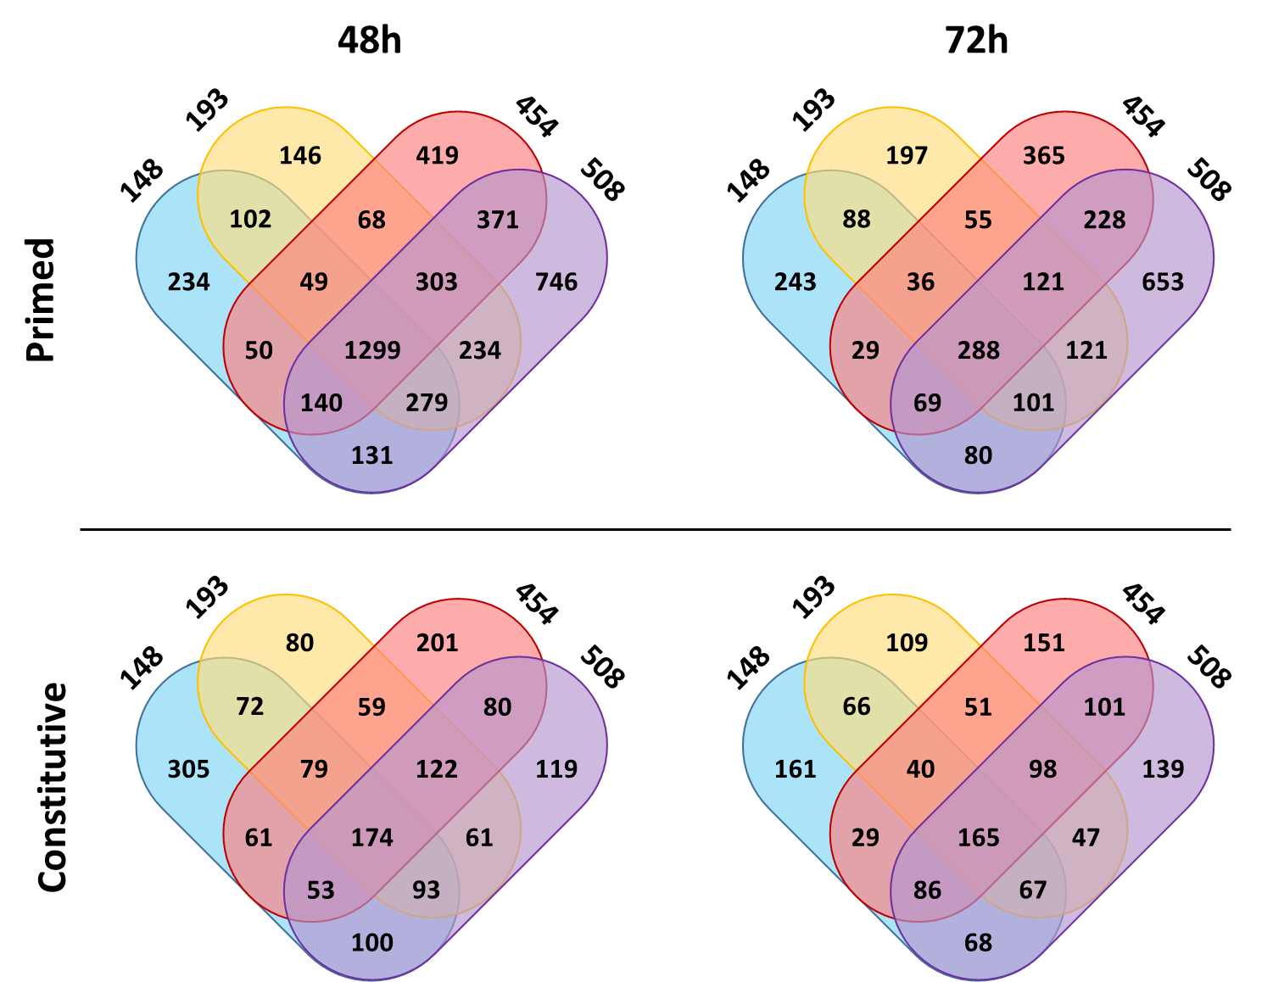

Figure 6.5: Numbers of H. arabidopsidis-inducible genes that are primed and/or constitutively up-regulated between different epiRILs. Venn diagrams show numbers of genes that are unique or shared between epiRILs for each gene selection and time-point.

6.3.5: Primed genes in H. arabidopsidis-resistant epiRILs are enriched with defence-related gene ontology terms.
To examine functional contributions of the selected gene sets, gene ontology (GO) term enrichment analysis was performed, using the Plant GeneSet Enrichment Analysis toolkit (Chapter 2, section 2.13). The proportion of GO-annotated genes in each selection were tested for statistically significant enrichment in comparison to the proportion GO-annotated genes in the whole genome, using hypergeometric test (p <0.05 + Bejaminini-Hochberg FDR correction). Statistically-enriched GO terms were trimmed for redundant GO terms, according to GO slim ontologies (for details, see Chapter 2, section 2.13). This pipeline identified a total of 469 GO accessions for which one or more gene sets showed statistically significant gene enrichment. As is shown in the heatmap projection of Figure 6.6, the primed gene sets at 48 hpi stood out for substantially stronger enrichment of GO terms than all other gene sets. This trend was obvious for all four epiRILs, and was particularly pronounced for 111 defence-related GO terms (Figure 6.6; Appendix). The 111 defence-related GO terms in the primed gene set related to both SA-dependent and SA-independent defence mechanisms (Appendix), supporting the outcome of targeted analyses in Chapter 5 (Figure 5.2). Thus, the outcome of the GO term analysis strongly suggests that the Hpa resistance in the epiRILs is based predominantly on priming of SA-dependent and SA-independent defence genes, rather than a constitutive up-regulation of defence genes.

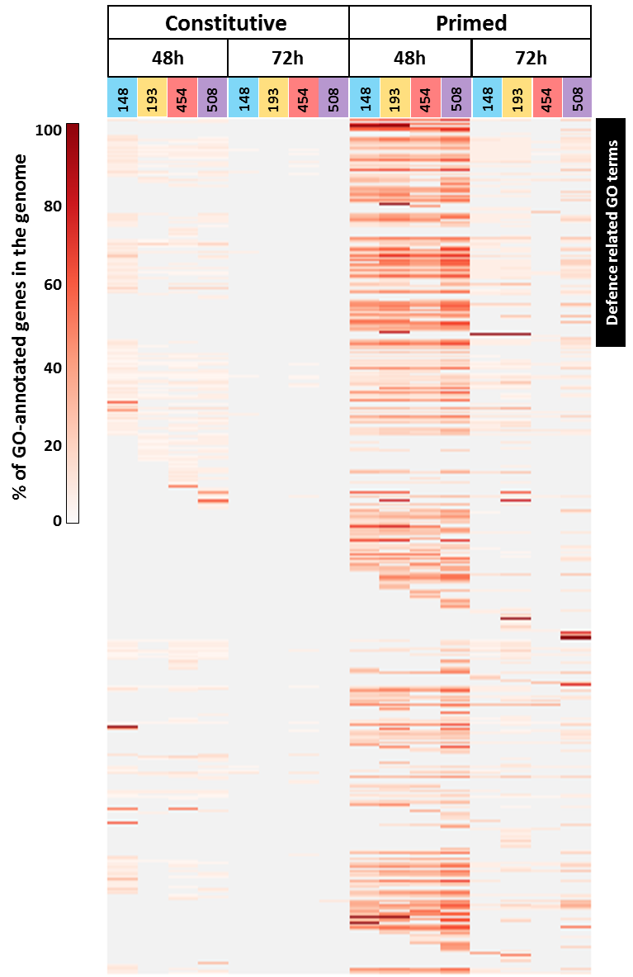
Figure 6.6: GO term enrichment in the selection of H. arabidopsidis-inducible genes that are primed and/or constitutively up-regulated in the epiRILs. Shown are 469 GO terms for which one or more sets displayed statistically significant gene enrichment. Heatmap-projected values represent percentages of GO-annotated genes in each gene set, relative to the total number of GO-annotated genes in the genome. The black bar on the top right indicates 111 defence-related GO terms.

6.3.6: Expression analysis of primed genes inside the epiQTL intervals suggests trans-regulation of protein coding genes by DNA methylation.
Of all Hpa-inducible genes that showed priming in one or more Hpa-resistant epiRILs, only 8% (424 genes) were located within the physical boundaries of the four epiQTL intervals (LOD-drop-off value of 2; Figure 6.4). This indicates that DNA methylation at the epiQTLs regulates the majority of primed defence genes via indirect (trans-regulatory) mechanisms. It is, however, possible that a small number of key regulatory genes in the epiQTLs are cis-regulated by DNA methylation. To identify such cis-regulated genes, expression patterns of primed genes inside each epiQTL intervals in the epiRILs possessing the corresponding ddm1-2 haplotype were re-analysed for each epiRIL (351 genes). For this purpose, expression ratios between the Hpa-inoculated epiRILs and the Hpa-inoculated WT were calculated, clustered and projected as heatmap (Figure 6.7). This primed expression ratio represents the level of augmented expression during pathogen infection, either at 48, or 72 hpi. Since the four epiRILs were selected for different combinations of epiQTLs, it was expected that highest expression ratios of cis-regulated genes would correlate with the presence of the hypo-methylated haplotype of the ddm1-2 mutant. Accordingly, primed genes in the epiQTL intervals that are trans-regulated by DNA methylation would not correlate with the hypo-methylated haplotype of the ddm1-2 mutant. While the expression ratios of the majority of genes (79.2%) failed to correlate with ddm1-2 haplotype, each epiQTL interval contained a smaller set of 21, 26, 19 and 7 genes respectively, whose expression correlated with the ddm1-2 haplotype, suggesting cis-regulation by DNA methylation. Surprisingly however, 89.1% of the 73 cis-regulated genes were TEs, such as DNA transposons of the CACTA family, retrotransposons of the GYPSY or COPIA families, or genes encoding transposases or enzymes necessary for TE function. Only two of all cis-regulated genes in the epiQTL intervals were annotated as protein-encoding genes, and none of these had any clear annotated function in plant defence (AT2G07240, cysteine-type peptidase; AT2G07750, RNA helicase). Since TE-encoded proteins have no antimicrobial function or defence regulatory activity, these results suggest that global defence gene priming by the hypo-methylated epiQTLs is not mediated by cis-regulated defence signalling genes, but rather by alternative mechanisms that mediate trans-regulation of distant defence gene responsiveness by TEs.

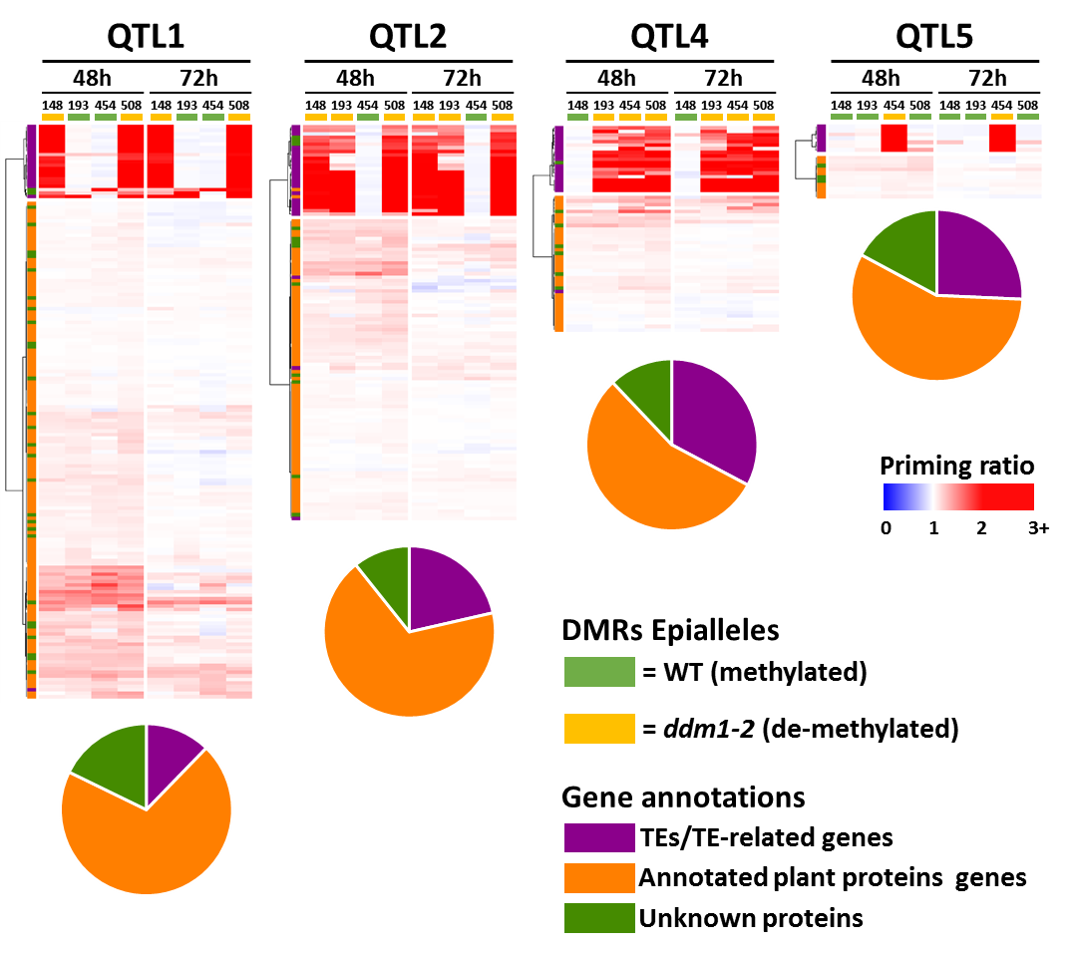
Figure 6.7: Hierarchical clustering of augmented expression patterns by primed genes in epiQTL intervals. Augmented expression of primed genes was calculated as the ratio between expression in the Hpa-treated epiRILs divided by expression in the Hpa-treated WT Col-0 line (602). For each time-point, epiRIL and epiQTL interval (LOD-drop-off boundaries 2), expression ratios were hierarchically clustered, using the "pheatmap" package for R (Ward method). Haplotypes of epigenetic markers (DMRs) in each epiQTL interval are displayed on the top of each heatmap: green: WT haplotype; yellow: ddm1-2 haplotype (DNA hypo-methylated). Bars on the left of the heatmaps and pie charts below indicate gene annotations: purple: TEs or TE-related genes; orange: genes encoding annotated plant proteins; dark green: genes encoding unknown proteins.

6.3.7: Removal of transposable element-annotated genes from the dataset does not improve detection of differentially expressed protein-coding genes.
In transcriptomic datasets, highly-expressed genes can influence the power of detection after multiple testing correction, such as false discovery rate (FDR) [295,296]. Additionally, when modelling a negative binomial distribution, a vast proportion of genes showing large differences in expression between samples or treatments can alter the estimation of gene variability (dispersion). These factors can result in loss of statistical power to detect DEGs. Accordingly, the large differences in expression of TE-annotated genes between WT and epiRILs (as seen in Figure 6.7) may reduce the statistical stringency to detect differentially expressed protein-coding genes in the dataset. To test this hypothesis, the entire transcriptome analysis was repeated after removing read counts for all transcripts that are annotated as TE or TE-related (TAIR10 annotation, see Chapter 2, section 2.12).
Analysis of protein-coding genes showing augmented (‘primed’) induction in the epiRILs after Hpa inoculation (as explained in section 6.3.4 and Figure 6.4A), identified a total of 5,024 unique genes between all combinations of lines and time-points. Surprisingly, compared to the amount of primed protein-coding genes identified in the initial analysis (Figure 6.4C), removal of TE-annotated genes resulted in a lower number of primed protein-coding genes (Figure 6.8). Additionally, the number of primed genes inside the epiQTL intervals (LOD-drop-off value of 2) decreased from 425 in the first analysis to 328 genes in the second analysis (section 6.3.4). Out of these 97 genes that were no longer present in the selection from the second analysis, only 81 had a TE-related annotation. This indicates that 16 protein-coding genes in the epiQTLs were no longer identified statistically as being primed in the second analysis. Thus, contrary to expectation, removing TE-annotated sequences from the dataset reduced the statistical detection of primed protein-coding genes.
The analysis of expression ratios of the 328 primed genes within the epiQTL intervals among all four epiRILs failed to identify protein-coding genes showing augmented expression that correlates with the ddm1-2 haplotype (Figure 6.9). Furthermore, only two previously identified protein-coding genes in epiQTL2 (AT2G07240 and AT2G07750) and one unknown protein-coding gene in epiQTL4 (AT4G07965) showed a primed profile indicative of cis-regulation by DNA methylation (Figure 6.9). However, further investigation of their genomic context revealed these genes include TEs in their coding or flanking sequences (Figure 6.10).
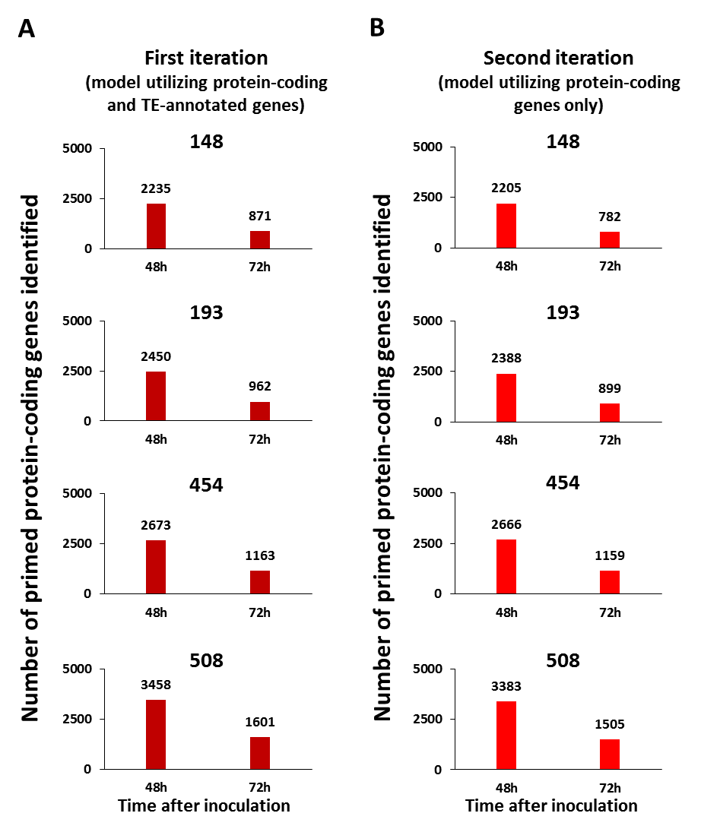
Figure 6.8: Comparison of primed protein-coding genes identified in Hpa-resistant epiRILs 48h and 72h following Hpa infection in different iterations of the RNA-seq analysis pipeline. A) Number of primed protein-coding genes identified in each Hpa-resistant epiRIL from the first iteration of RNA-seq dataset analysis, which included read counts from both protein-coding and TE-annotated genes (replotted from Figure 6.4C, protein coding genes only); B) Number of primed protein-coding genes identified in each Hpa-resistant epiRIL in the second iteration of RNA-seq dataset analysis, following removal of read counts for TE-annotated genes (TAIR10 annotation).

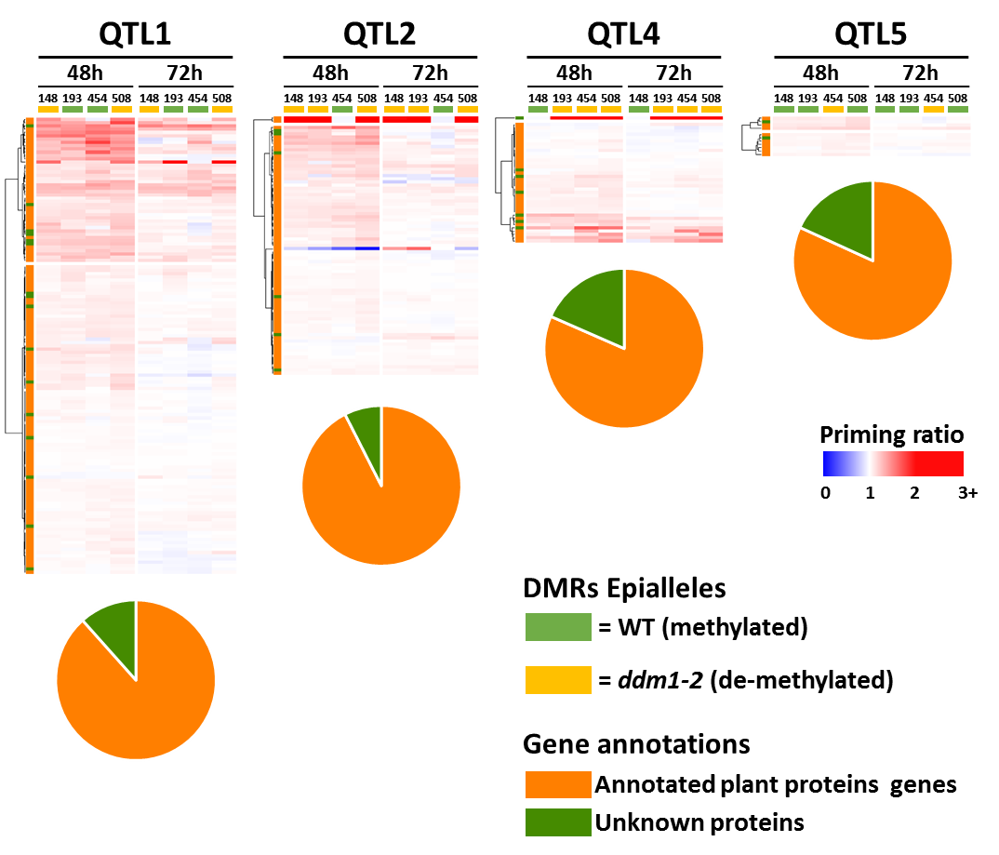
Figure 6.9: Hierarchical clustering of augmented expression patterns by primed genes in epiQTL intervals identified in the second iteration of RNA-seq analysis. Augmented expression of primed genes was calculated as the ratio between expression in Hpa-treated epiRILs divided by expression in Hpa-treated WT Col-0 line (602). For each time-point, epiRIL and epiQTL interval (LOD-drop-off boundaries 2), expression ratios were hierarchically clustered, using the "pheatmap" package for R (Ward method). Haplotypes of epigenetic markers (DMRs) in each epiQTL interval are displayed on the top of each heatmap: green: WT haplotype; yellow: ddm1-2 haplotype (DNA hypo-methylated). Bars on the left of the heatmaps and pie charts below on the right indicate gene annotations: orange: genes encoding annotated plant proteins; dark green: genes encoding unknown proteins.

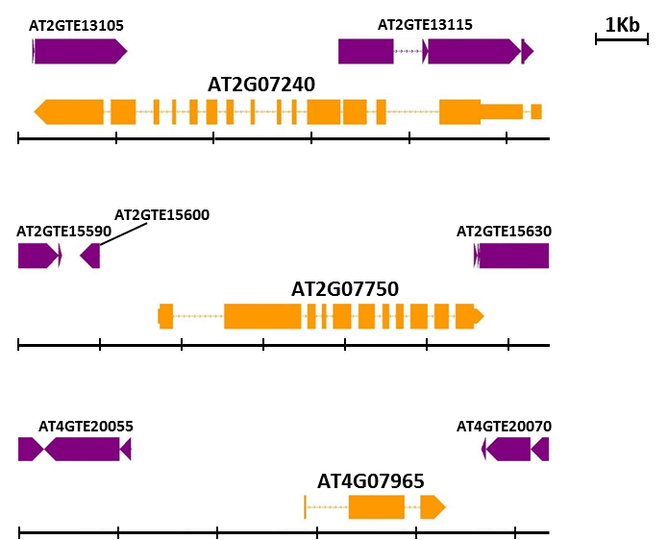
Figure 6.10: Genomic features of protein coding genes showing augmented Hpa induction in epiRILs carrying corresponding DNA de-methylated epialleles. Genome Browser view showing transposable elements (purple) overlapping with or flanking potentially cis-regulated protein-coding genes (orange) identified in Figure 6.9. Large blocks represent exons, lines between blocks represent introns and smaller blocks at the edges of coding sequence represent UTRs. Each interval in the black line underneath each gene represents 1 kilobase.

6.4: Discussion

In this Chapter, the relationship between DNA methylation, global gene transcription and defence phenotype was examined by global mRNA sequencing analysis of four Hpa-resistant epiRILs, each carrying different combinations of defence regulatory epiQTLs (Chapter 4). Compared to the WT, PCA of the transcriptome data revealed profound differences in the transcriptional response of the epiRILs to Hpa (Figure 6.2), pointing to a relatively late and/or weak response by WT plants. Hierarchical clustering of DEGs confirmed this trend and revealed a large cluster of Hpa-inducible genes displaying augmented induction in the Hpa-resistant epiRILs relative to the WT (Figure 6.3). Subsequent statistical filtering of gene expression patterns demonstrated that the majority of Hpa-inducible genes (56.5%) can be classified as genes showing priming, or a combination of priming and constitutively enhanced expression, in the Hpa-resistant epiRILs (Figure 6.4). Most genes in this selection showed augmented induction at 48 hpi (Figure 6.4), which is consistent with previous results from transcriptome analyses of primed plants [215,298,299]. Plants in the primed defence state respond faster and/or more strongly to pathogen infection compared to un-primed plants [3,186], which take longer to mount a full defence response to the pathogen. Consequently, augmented induction of pathogen-inducible genes in primed plants is less pronounced at later stages of infection, during which induction levels become comparable to that of un-primed plants. Indeed, the number of genes showing augmented induction at 72 hpi was on average three-fold lower than those at 48 hpi (Figure 6.4).
The relatively early time point of 48 hpi represents a critical time-point for the interaction between Arabidopsis and Hpa, during which hyphae from germinating Hpa spores start to penetrate the epidermal cell layer and invade the mesophyll [294,295]. Accordingly, augmented host defence at this relatively early time-point provides enhanced resistance to Hpa. Indeed, the primed genes displaying augmented induction at 48 hpi were strongly enriched for defence-related GO terms, relating to both SA-dependent and SA-independent defence mechanisms (Figure 6.6, Appendix). This outcome supports the defence-related phenotypes reported in Chapter 5, which further reinforces the notion that the four epiQTLs present in the Hpa-resistant epiRILs prime both SA-dependent and SA-independent defence reactions (Figure 5.2).
Interestingly, 92% of all primed genes in one or more epiRILs were located outside the epiQTL intervals (Figure 6.4). This demonstrates that the majority of primed defence genes are regulated in trans by DNA methylation at the epiQTLs. Since DMRs in the epiRILs are inherited from the ddm1-2 mutant, they mostly occur at long non-functional TEs in the pericentromeric regions of the genome [266], due to the role of DDM1 in maintaining DNA methylation at these heterochromatic loci [73]. DNA methylation of TEs can have direct effects on transcription of neighbouring coding genes [44,45,107,121,122]. Of the 351 primed genes analysed in Figure 6.7, there were only 73 genes (20.8%) whose augmented expression after Hpa inoculation correlated with the presence of the hypo-methylated ddm1-2 haplotype (Figure 6.7; Supplementary Dataset). Thus, a minority of primed genes in the epiQTLs are potentially cis-regulated by DNA methylation. Of these 73 genes, 65 encoded TEs or TE-related genes (89.1%), while six encoded genes of unknown function (8.2%; Supplementary Dataset). Only two cis-regulated genes encoded annotated plant proteins, neither of which has a clear role in plant defence (AT2G07240, AT2G07750; Figure 6.7 and Figure 6.9). Removal of TE-annotated genes from the dataset did not led to detection of any novel differentially expressed protein-coding genes. On the contrary, a slightly lower number of primed protein-coding genes was identified in all analyses (Figure 6.8 and Figure 6.9), most likely from less accurate estimation of size factors and genes dispersion in the statistical model caused by the lower number of genes available in the dataset. It is, therefore, plausible to assume that the defence regulatory function of DNA methylation at the identified epiQTLs acts via trans-regulatory mechanisms, resulting in global priming of distant defence genes.
A recent transcriptome analysis of DNA (de)methylation mutants at 48 and 72 hpi with Hpa revealed 166 defence-related genes, displaying primed induction in the hypo-methylated nrpe1-11 mutant and/or repressed induction in hyper-methylated ros1-4. Of these, only 25 genes were associated with NRPE1- and/or ROS1-dependent DNA methylation at nearby transposable elements [258]. Hence, the majority of RdDM and ROS1-dependent defence gene priming is controlled via trans-acting mechanisms. Although NRPE1-dependent RdDM and ROS1-dependent DNA demethylation target TEs at partially different genomic loci than DDM1 [73], the outcome of the Lopez et al. (2016) study is strikingly similar as the transcriptome results presented in this Chapter. In both studies, DNA methylation represses the transcriptional responsiveness of distant defence genes via trans-regulatory mechanisms. Moreover, the outcome of this chapter provides evidence that this type of trans-regulation is mediated by DNA methylation of TEs at specific genomic loci, which represses the responsiveness of distal defence genes. The final chapter of this thesis (Chapter 7) will discuss different mechanisms by which these TEs repress global responsiveness of the defence-related transcriptome.

Chapter 7 - General Discussion, Conclusions and Future Perspectives

7.1: Scope

The main objective of the work presented in this thesis was to gain a better understanding of how DNA methylation regulates basal resistance of Arabidopsis against different pathogens. The first experimental chapter (Chapter 3) showed that DNA (de)methylation processes in Arabidopsis alter basal resistance and innate immune responses against both biotrophic and necrotrophic pathogens, but do not affect within-generation acquired immunity (systemic acquired resistance; SAR). The following experimental chapters (Chapters 4 to 6) describe phenotypic characterisation of epigenetic recombinant inbred lines (epiRILs), a set of WT Arabidopsis lines carrying hypo-methylated DNA from the hypo-methylated mutant ddm1-2, against diverse (a)biotic stresses. Chapter 4 demonstrated that a core population of 123 epiRILs display significant variation in levels of basal resistance against biotrophic Hyaloperonospora arabidopsidis (Hpa) and, to a lesser extent, necrotrophic Plectosphaerella cucumerina (Pc). This chapter furthermore showed that the enhanced resistance to Hpa can be mapped to 4 epigenetic quantitative trait loci (epiQTLs) on chromosomes one, two, four and five. Chapter 5 focused specifically on the defence-related phenotypes of eight Hpa-resistant epiRILs, and revealed that these lines can express broad-spectrum resistance that is not only effective against Hpa, but also against necrotrophic Pc and salt stress. Additional analyses of growth and seed production showed that most Hpa-resistant lines are not affected in plant growth. Conversely, seven of the eight Hpa-resistant epiRILs were found to be affected in seed production. Ultimately, the last experimental chapter (Chapter 6) describes the transcriptomic response of four Hpa-resistant epiRILs to Hpa, each containing a different combination of Hpa resistance epiQTLs. This global RNA sequencing analysis revealed genome-wide priming of Hpa-responsive genes in Hpa-resistant epiRILs, which was particularly pronounced at a relatively early time-point after pathogen inoculation. A large portion of these primed genes appeared to be regulated in-trans by DNA methylation, implying a novel regulatory mechanism by which DNA methylation of TEs at specific epiQTLs regulates the responsiveness of defence-related genes in trans.

7.2 DNA methylation and regulation of plant basal defences

Results from different experimental chapters have demonstrated that DNA hypo-methylation results in enhanced resistance against (hemi)biotrophic pathogens (Chapter 3, Figures 3.1 and 3.4; Chapter 4, Figures 4.3 and 4.4; Chapter 5 Figures 5.1A and 5.5). This enhanced resistance is associated with a stronger induction of inducible defence responses following Hpa inoculation, rather than a constitutively enhanced expression of inducible defences. For instance, phenotypic characterisation of eight Hpa-resistant epiRILs revealed that they are constitutively primed for Hpa-induced expression of the salicylic acid (SA)-dependent PR1 gene and/or deposition of resistance-contributing callose (Chapter 5, Figure 5.2). Subsequent transcriptome analysis at different time-points after Hpa inoculation confirmed global priming of defence-related genes in four Hpa-resistant epiRILs (Chapter 6, Figures 6.5 and 6.7). Hence, reduction in both RdDM (Chapter 3) or DDM1-dependent DNA methylation (Chapters 4–6) results in enhanced defence of Arabidopsis that is particularly effective against hemi(biotrophic) pathogens.
Preliminary studies on the epigenetic mechanisms of priming identified a role for transcription-permissive histone modifications (such as H3K4me3 and H3K9ac) and stalled RNA Polymerase II (Pol-II) at the promoters of primed genes after induction of priming [213,245,300]. An increased presence of permissive histone modifications, which is required for Pol-II recruitment [301], and stalled Pol-II, which results in more rapid transcription initiation [300,302], can account for the enhanced gene expression which manifests upon pathogen inoculation in primed plants. Furthermore, DNA de-methylated mutants (such as nrpe1-11) and epiRILs are constitutively primed, resulting in enhanced induction of defence responses after pathogen inoculation (Chapter 3, Figure 3.3B; Chapter 5, Figure 5.2) [21,258]. Hypo-methylation at non-CG sites in different loss-of-function mutants related to DDM1 results in loss of repressive histone marks, such as H3K9me/me2, and favours histone acetylation [75], which is generally associated with a more permissive state for gene transcription [244]. The link between DNA methylation and chromatin status may explain the constitutively primed phenotype of hypo-methylated Arabidopsis mutants and epiRILs. This hypothesis is reinforced by independent findings that the Arabidopsis genome undergoes a global reduction of DNA methylation after infection by hemi-biotrophic P. syringae [19,20] or exposure to abiotic stresses [111,288].
While hypo-methylated Arabidopsis lines, such as the npre1-11 mutant or selected epiRILs, show primed resistance to hemi-biotrophic pathogens, they are more susceptible to necrotrophic fungi, such as Pc, which is associated with reduced responsiveness of JA-dependent defence genes [21,258]. Conversely, the hyper-methylated ros1-4 mutant shows enhanced susceptibility to biotrophic Hpa and enhanced resistance to necrotrophic Pc and Alternaria brassicicola (Chapter 3, Figures 3.1 and 3.2). While the enhanced susceptibility of ros1-4 to Hpa was associated with reduced responsiveness of SA-dependent genes, its enhanced resistance to necrotrophic fungi could not be linked to priming of jasmonic acid (JA)-dependant defences [258]. This indicates that ros1-induced resistance to necrotrophic fungi operates independently from the JA-dependent defence pathway. At the same time, independent experiments presented in this thesis showed that hypo-methylated DNA in selected epiRILs can also express enhanced resistance to necrotrophic Pc (Chapter 4, Figure 4.7; Chapter 5, Figure 5.1B). Thus, in contrast to resistance against (hemi)biotrophic pathogens, there is little consistency in the directionality of the inter-relationship between global DNA methylation and resistance against necrotrophic pathogens. This suggests that variation in DNA (de)methylation has more specific effects on JA-dependent and JA-independent resistance mechanisms against necrotrophic pathogens.

7.3: Translational value of epigenetic-based plant resistance in epiRILs and future applications.

DNA demethylation in WT epiRILs, inherited from the ddm1-2 parent, can result in enhanced resistance against biotrophic Hpa and necrotrophic Pc, as well as enhanced tolerance to salt (Chapter 5, Figure 5.1). The level of enhanced resistance to Hpa in selected epiRILs lines is comparable to that of the ddm1-2 parent (Chapter 4, Figure 4.4). The Col-0 x ddm1-2 epiRILs population retained only 33.2% of differentially methylated regions (DMRs) present in the ddm1-2 parent [17], indicating that the global DNA hypo-methylation is not directly proportional to Hpa resistance. This finding is particularly significant, as extensive DNA demethylation in ddm1 mutants (or other DNA methylation mutants) can result in severe abnormalities of plant development and reproduction [107,280,281].
Enhanced resistance to Hpa in selected epiRILs is associated with global priming of pathogen-inducible genes (Chapter 6, Figures 6.5 and 6.7), providing multi-mechanistic resistance that is based on a combination of SA-dependent and SA-independent defence mechanisms (Chapter 5, Figure 5.1). Basal resistance and its broad-spectrum effectiveness is attractive for exploitation in sustainable crop protection strategies [4,303]. However, constitutive overexpression of basal defences comes with major fitness costs, resulting in reduction of growth and/or seed production [205,304]. This makes breeding strategies for constitutively enhanced basal defence less attractive [267]. Priming of basal defence also results in fitness costs, although these are not comparable to the costs of constitutively expressed basal defence [205]. Moreover, the relatively minor fitness costs of priming are outweighed under conditions of disease pressure by the benefits of disease protection, making priming a more cost-efficient defence strategy than constitutive over-expression of basal defences [205]. Interestingly, fitness analysis of Hpa-resistant epiRILs revealed no significant growth reduction in eight Hpa-resistant epiRILs under pathogen-free conditions (Chapter 5, Figure 5.3), indicating that priming by artificial introgression of DNA hypo-methylation does not associate with costs in plant growth.
The Col-0 x ddm1-2 epiRILs population has a WT genotype and is, therefore, unlikely affected in the signalling machinery mediating initiation, establishment and maintenance of DNA methylation. Hence, the global hypo-methylated DNA originating from the ddm1-2 parent can revert to WT levels [93]. Indeed, the epiRILs population only retained 33.2% of DMRs present in the ddm1-2 parent [266], but these DMRs were stable for at least seven generations of single seed descent by self-pollination [216]. As an epigenetic trait, the primed resistance in selected epiRILs can therefore be lost if their hypo-methylated resistance epiQTLs become re-methylated to WT levels. In support of this, results presented in Chapter 5 have shown partial or complete reversion of Hpa resistance in some F10 families of Hpa-resistant epiRILs (Chapter 5, Figure 5.5). Nonetheless, the fact that epigenetically determined the disease resistance from the ddm1-2 mutant could be maintained over seven to eight generations of self-pollination (Chapter 4, Figure 4.7; Chapter 5, Figure 5.1B, Figure 5.5) indicates relative durability of this trait. Indeed, it has been shown that some DMRs in the Col-0 x ddm1-2 epiRILs population can be maintained over sixteen generations of self-pollination [91].
The strength, broad-spectrum effectiveness, relatively low fitness cost, and durability of resistance obtained through artificial introgression of hypo-methylated DNA makes this strategy a prime candidate for translational breeding programs for crops. Identification of DDM1 orthologues in B. rapa [305], rice [306], maize [307] and tomato (LOC101248358, LOC101255451; NCBI database) opens up the possibility of creating ddm1-based epiRILs for these crop species. Alternatively, stochastic genome-wide reduction of DNA methylation can be induced by treating seeds with 5-azacytidine, a chemical analogue of cytidine which inhibits DNA methyltransferases and induces DNA hypo-methylation [308]. A similar approach in oilseed rape (B. rapa) produced significant heritable variation in multiple traits, including agronomic ones such as production of seed oils and seed protein content [309].
Global reduction of DNA methylation in cereal crop species can result in stronger deleterious effects due to the larger proportion of transposable elements (TEs) present in their genomes. In Arabidopsis, TEs make up only 11.6% of the total number of coding genes (TAIR10), whereas TEs constitute 80% and 95% of the whole genome in maize and wheat, respectively [310]. Considering that DDM1 predominantly targets TEs for DNA methylation [31], it is therefore not surprising that silencing of both DDM1 orthologues in maize causes lethality [311]. The phenotypic analysis of the core population of the Col-0 x ddm1-2 epiRILs and selected Hpa-resistant lines within this population revealed that widespread DNA hypo-methylation can have negative effects on plant growth and seed production, albeit both appeared to be independent from enhanced resistance phenotype (Chapter 4, Figure 4.6; Chapter 5, Figures 5.4 and 5.6). These findings support the idea that targeted DNA methylation editing strategies may prove more effective than genome-wide editing of DNA methylation, particularly for cereal crops. To date, however, no targeted epigenome editing tools exist for plants. One potential method for targeted DNA demethylation could come from the widely-used clustered regularly interspaced short palindromic repeat (CRISPR)-Cas9 system. Inactivated endonuclease Cas9 (dCas9) retains the ability to bind specific DNA regions without exerting its endonuclease function. A fusion construct between dCas9 and the plant DNA glycosylase ROS1 could allow guided DNA demethylation of specific regions through synthetic guide RNAs (gRNA). A similar approach using the catalytic domain of the mammalian methylcytosine dioxygenase TET1 has achieved targeted DNA demethylation in human and mouse cells [312,313]. The analysis performed in Chapter 6 revealed no key epigenetic regulator of plant defences, but rather a multitude of loci contributing to enhanced induction of plant defences at the global scale (Figure 6.7). The endonuclease Cas9 can be guided to different loci simultaneously by incorporating multiple gRNA sequences into a single vector (multiplexing) [314], and this capability is enhanced in the Cas9-homologous endonuclease Cpf1 [315]. This technology could allow targeted epigenome editing of multiple loci simultaneously

7.4: Possible mechanisms of trans-regulation of defence genes by DNA methylation.

Whole-transcriptome analysis of four Hpa-resistant epiRILs revealed global priming of Hpa-inducible genes (Chapter 6, Figure 6.4). Primed genes showing augmented expression at 48 hours post inoculation were more strongly enriched with GO terms. This enrichment was particularly pronounced for plant defence-related GO terms (Chapter 6, Figure 6.6). Interestingly, the majority of primed genes in the epiRILs (92%) were located outside the epiQTL intervals that control Hpa resistance (Chapter 6; Supplementary Dataset). Expression analysis of primed genes inside the epiQTL intervals revealed that only 20.8% displayed a primed expression profile that correlates with the presence of the hypo-methylated ddm1-2 haplotype (Chapter 6, Figure 6.7). High-resolution bisulphite-sequencing data are currently being analysed to verify that the primed expression profiles of these genes are associated with DNA hypo-methylation. Strikingly, the majority of these potentially cis-regulated genes encode TEs or TE-associated proteins (Chapter 6, Figure 6.7), which do not have known antimicrobial activities, nor play a role in defence signalling, and are most likely inactive [266]. In fact, TE-encoded proteins in plants have not been linked to biological processes other than their own transcription, translation or transposition [316,317]. Accordingly, it is plausible that global priming of defence-related genes is controlled by unknown trans-regulatory mechanisms that originate from DDM1-methylated TEs at the epiQTLs. To date, DNA methylation of TEs has been shown to affect the epigenetic makeup and transcription responsiveness of nearby genes [286,318], but has not been implicated in trans-regulation of transcriptional responsiveness of distant defence genes.
Previous studies of three dimensional chromatin structures by Hi-C analysis have uncovered locus-specific interactions between different regions of Arabidopsis chromosomes [319-322]. These interactive heterochromatic islands (IHIs) rely on DNA methylation and histone modifications, such as H3K9me2 [322]. Interestingly, the ddm1-2 mutation results in changes in the heterochromatic structure of pericentromeric regions of chromosomes one, two and four [322], which roughly map to the same regions as the three strongest resistance epiQTLs (Chapter 4; Figure 4.5), and these changes alter the topology of IHIs in the chromosome arms [322]. Therefore, it is tempting to speculate that DNA hypo-methylation at TE-related genes in the pericentromeric epiQTLs disrupts or alters formation of IHIs in the chromosome arms, which may release heterochromatin suppression of distant defence genes. The resulting lack of transcriptional repression could account for the priming of distant defence genes in the Hpa-resistant epiRILs (Figure 7.1). Interrogating the Hi-C sequences from Wang et al. (2014) against the sequences of cis-regulated TEs identified in Chapter 6 (Figure 6.7; Supplementary Dataset) would be a first step towards confirming this hypothesis.

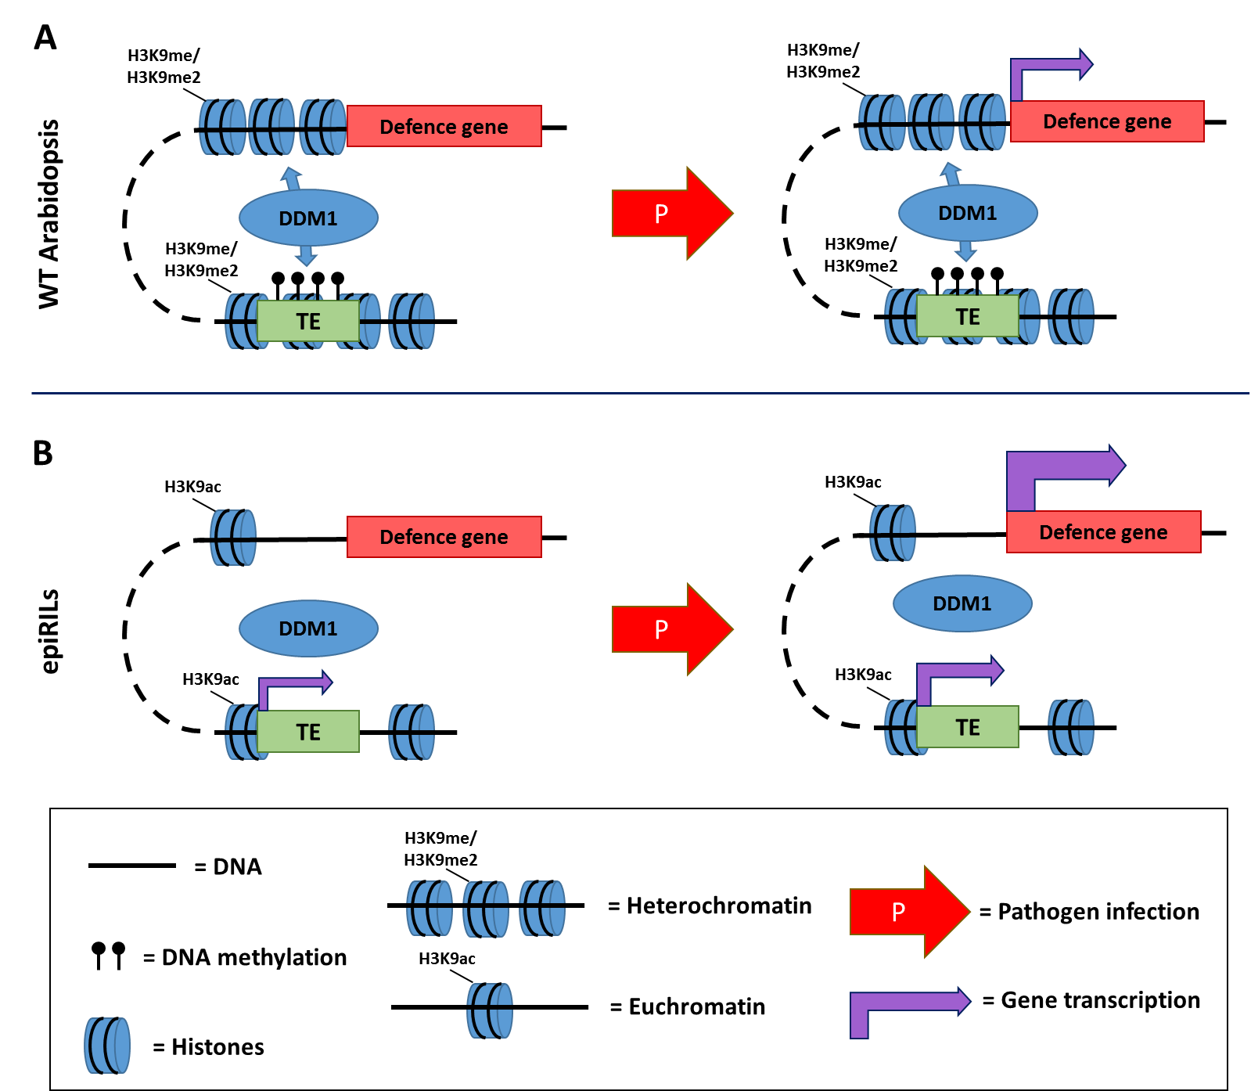
Figure 7.1: Model of trans-regulation of defence genes by trans-acting chromatin interactions. In WT plants, DDM1 could cross-links methylated TEs and TE-related genes at pericentromeric epiQTLs with distant defence genes. The resulting interacting heterochromatic islands (IHIs) in the chromosome arms can silence defence genes through induction of heterochromatin (A, left panel), which suppresses the level of defence gene induction after pathogen attack (A, right panel). In epiRILs carrying the DNA hypo-methylated ddm1-2 haplotype in the epiQTLs, TEs and TE-related genes are transcriptionally active. Accordingly, lack of DDM1-mediated maintenance of heterochromatin at pericentromeric regions alters the topology of trans-silencing IHIs on chromosome arms, which primes distant defence genes (B, left panel). Pathogen attack increases the level of TE expression. In addition, the lack of heterochromatin-mediated silencing allows for augmented induction of the distant defence genes (B, right panel).

Alternative mechanisms of trans-regulation by DNA methylation may involve trans-acting non-coding RNAs originating from the de-repressed TE-related genes. For instance, Long TEs that are transcribed, such as those identified in the hypo-methylated epiQTLs (Chapter 6; Figure 6.7), can produce mRNAs that are processed into 21-22nt and 24nt siRNAs by RDR6- and DCL3-dependent (but Pol IV-independent) pathways [323]. These siRNAs can guide DNA methylation and heterochromatin formation of complementary sequences in the genome via canonical and non-canonical RNA-directed DNA methylation (RdDM) pathways [323]. It is possible that siRNAs derived from transcriptionally active TEs in epiQTLs generate siRNAs that silence distant repressors of defence genes. Silencing of such regulatory genes could cause genome-wide priming of defence genes (Figure 7.2). In support of this hypothesis, hierarchical clustering of DEGs in our dataset revealed clusters of genes showing enhanced repression in the epiRILs after Hpa infection (Chapter 6, Figure 6.3). Cross-referencing these repressed genes (and their promoters) for sequence complementary with the cis-regulated TEs identified in Chapter 6 (Figure 6.7; Supplementary Dataset) would be a way forward to verify the siRNA hypothesis.

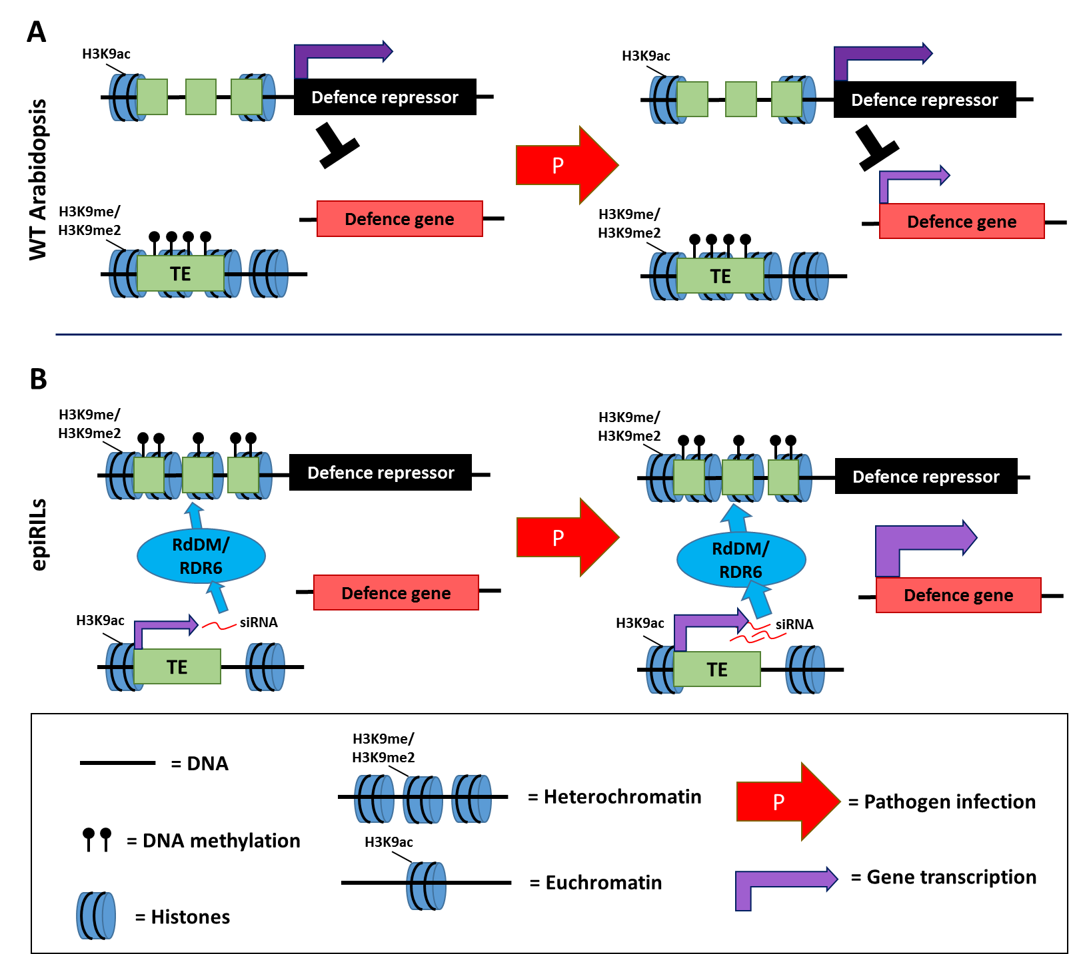
Figure 7.2: Model of trans-regulation of defence genes by TE-derived siRNAs that silence defence-repressing regulatory genes. Actively transcribed hypo-methylated TEs or TE-related genes in the epiQTLs produce mRNAs that are processed into 21-22nt and 24nt siRNAs, which are complementary to (promoter) sequences of (a) distant defence-repressing gene(s). The siRNAs silence the expression of the repressor gene(s) by canonical and non-canonical RNA-directed DNA methylation (RdDM). In WT plants, the methylated TEs are not expressed, preventing trans-silencing of distant repressor gene(s), suppressing the transcriptional responsiveness of defence gene(s) (A, left panel). After pathogen attack, the expression of the repressor gene(s) suppresses the level of defence gene induction (A, right panel). In epiRILs carrying the hypo-methylated ddm1-2 haplotype of the epiQTLs, the TE-derived siRNAs silence the expression of the repressor genes(s), causing genome-wide priming of defence genes (B, left panel). Pathogen infection enhances TE expression, leading to rinforced silencing of the repressor gene(s), which facilitates augmented induction of defence genes (B, right panel).

A recent report demonstrated that Arabidopsis TEs can produce long intergenic noncoding RNAs (lincRNAs) after exposure to abiotic stress or ABA treatment [324]. Moreover, alteration of the DNA methylation and chromatin status in the Arabidopsis ddm1-2 mutant increased the production of lincRNAs, including novel ones that are not produced in WT plants [324]. In animal cells, long noncoding RNAs (lincRNAs) can induce both euchromatin and heterochromatin formation at distant genomic sequences [325,326]. Accordingly, it is possible that production of lincRNAs from hypo-methylated TEs in the epiQTLs induces formation of euchromatin at distant defence genes, which would prime their responsiveness to pathogen attack (Figure 7.3). It must be stated, however, that there is no current evidence supporting a role for plant lincRNAs in euchromatin formation [325]. While knowledge about the cis- and trans-regulatory functions of lincRNAs in plants remains limited, their regulatory activity will likely depend on sequence complementary with their target loci [327]. Consequently, identifying sequence complementarity between primed defence genes outside the epiQTL intervals (Figure 6.4; Supplementary Dataset) and the cis-regulated TEs identified in Chapter 6 (Figure 6.7; Supplementary Dataset) would provide further support for the lincRNA hypothesis.

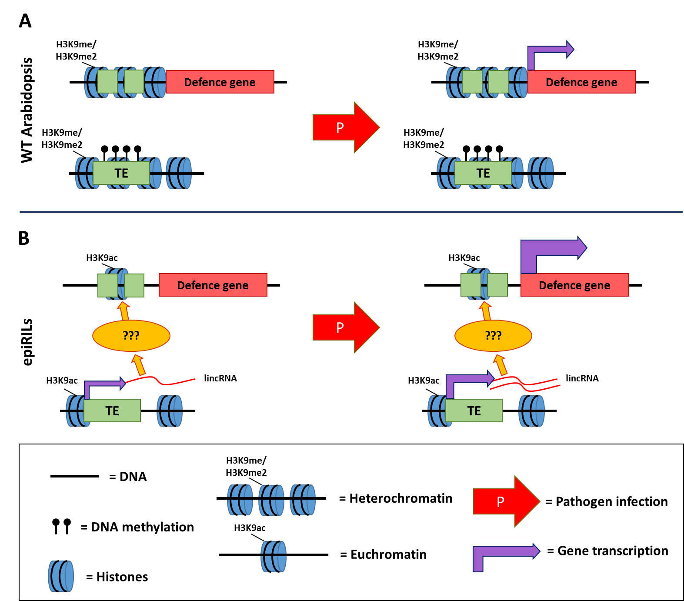
Figure 7.3: Model of trans-regulation of defence genes by TE-encoded long intergenic non-coding RNAs (lincRNAs). Actively transcribed hypo-methylated TEs in the epiQTLs produce lincRNAs, which are complementary to (promoter) sequences of distant defence genes. Via a yet unknown mechanisms, these TE-derived lincRNAs could induce euchromatin formation at (promoters of) distant defence genes. In WT plants, the methylated TEs are not expressed, preventing induction of euchromatin by lincRNAs, which represses the transcriptional responsiveness of the corresponding defence genes (A, left panel). After pathogen attack, the lack of euchromatin suppresses the level of defence gene activation (A, right panel). In epiRILs carrying the hypo-methylated ddm1-2 haplotype of the epiQTLs, TE-derived lincRNAs prime defence gene(s) through formation of euchromatin (B, left panel). Pathogen attack enhances TE expression, leading to enhanced production of lincRNAs, which further facilitates an augmented induction of defence gene(s) (B, right panel).

7.5: Concluding remarks.

In recent years plant epigenetics has become a pivotal research topic for two main reasons. Firstly, epigenetic mechanisms are often suggested as a potential explanation for “missing heritability” of complex traits in population genetics. Secondly, epigenetic mechanisms have been implicated in the regulation of short- and long-term adaptation of plants, including trans-generational phenotypes to environmental stress. At the time of this thesis writing, most epigenetic research in the field of plant pathology has focused on how chromatin modifications affect gene responsiveness to infections, or on how plant re-shape their DNA methylome after pathogen perception. The research presented in this thesis shows how artificial changes in DNA methylation alone can have profound effects on multiple layers of the Arabidopsis innate immune system that is effective against a wide range of pathogens.
While chromatin modification and DNA methylation work in concert to regulate gene responsiveness, only patterns of DNA methylation can faithfully be transmitted over meiosis and form meta-stable epialleles [216,264]. The results presented in this thesis show that specific epialleles can provide strong resistance phenotypes that are heritable over multiple generations. Additionally, this thesis shows, for the first time, that heritable variation in DNA methylation can influence Arabidopsis phenotypes independently from genetic variation via genome-wide changes in gene transcription. The epigenetic inheritance of broad-spectrum disease resistance bears a strong translational message. Crop breeders are typically restricted by natural genetic variation in the crop populations that are available to them. Introducing additional epigenetic variation provides a means to expand the range of potentially beneficial phenotypes, including quantitative disease resistance.
Finally, the identification of a potential trans-regulatory mechanism by DNA methylation adds another layer of complexity by which epigenetic mechanisms can affect global gene expression in plants. While the effects of altered DNA methylation in TEs affecting expression of neighbouring protein-coding genes (cis-regulation) have been documented before [41-43], a potential trans-regulatory role of TEs via long-distance genes interactions remains unexplored in plants. In scientific research, even the most explicative answers can give rise to novel questions. By the same principle, the findings presented in this thesis will hopefully stimulate further studies on the subject, and lead to important advances in fundamental plant epigenetics and plant pathology.

Appendix

List of 111 defence-related GO terms showing significant enrichment*
(Chapter 6, Figure 6.6)
* Percentages of enrichment of each GO term in each selection, epiRIL and time-point are shown in Supplementary Dataset due to space restrictions
GO term ID | Description
GO:0050896 | RESPONSE TO STIMULUS
GO:0006950 | RESPONSE TO STRESS
GO:0042221 | RESPONSE TO CHEMICAL STIMULUS
GO:0010033 | RESPONSE TO ORGANIC SUBSTANCE
GO:0009628 | RESPONSE TO ABIOTIC STIMULUS
GO:0051716 | CELLULAR RESPONSE TO STIMULUS
GO:0009607 | RESPONSE TO BIOTIC STIMULUS
GO:0006952 | DEFENSE RESPONSE
GO:0009719 | RESPONSE TO ENDOGENOUS STIMULUS
GO:0033554 | CELLULAR RESPONSE TO STRESS
GO:0051707 | RESPONSE TO OTHER ORGANISM
GO:0070887 | CELLULAR RESPONSE TO CHEMICAL STIMULUS
GO:0009725 | RESPONSE TO HORMONE STIMULUS
GO:0071310 | CELLULAR RESPONSE TO ORGANIC SUBSTANCE
GO:0009416 | RESPONSE TO LIGHT STIMULUS
GO:0010035 | RESPONSE TO INORGANIC SUBSTANCE
GO:0009605 | RESPONSE TO EXTERNAL STIMULUS
GO:0002376 | IMMUNE SYSTEM PROCESS
GO:0006955 | IMMUNE RESPONSE
GO:0009266 | RESPONSE TO TEMPERATURE STIMULUS
GO:0045087 | INNATE IMMUNE RESPONSE
GO:0006970 | RESPONSE TO OSMOTIC STRESS
GO:0009743 | RESPONSE TO CARBOHYDRATE STIMULUS
GO:0071495 | CELLULAR RESPONSE TO ENDOGENOUS STIMULUS
GO:0009651 | RESPONSE TO SALT STRESS
GO:0048583 | REGULATION OF RESPONSE TO STIMULUS
GO:0009409 | RESPONSE TO COLD
GO:0009737 | RESPONSE TO ABSCISIC ACID STIMULUS
GO:0009755 | HORMONE-MEDIATED SIGNALING PATHWAY
GO:0006979 | RESPONSE TO OXIDATIVE STRESS
GO:0009617 | RESPONSE TO BACTERIUM
GO:0009814 | DEFENSE RESPONSE, INCOMPATIBLE INTERACTION
GO:0031347 | REGULATION OF DEFENSE RESPONSE
GO:0009620 | RESPONSE TO FUNGUS
GO:0009753 | RESPONSE TO JASMONIC ACID STIMULUS
GO:0046686 | RESPONSE TO CADMIUM ION
GO:0009751 | RESPONSE TO SALICYLIC ACID STIMULUS
GO:0009627 | SYSTEMIC ACQUIRED RESISTANCE
GO:0009733 | RESPONSE TO AUXIN STIMULUS
GO:0010200 | RESPONSE TO CHITIN
GO:0050776 | REGULATION OF IMMUNE RESPONSE
GO:0045088 | REGULATION OF INNATE IMMUNE RESPONSE
GO:0009414 | RESPONSE TO WATER DEPRIVATION
GO:0009639 | RESPONSE TO RED OR FAR RED LIGHT
GO:0009626 | PLANT-TYPE HYPERSENSITIVE RESPONSE
GO:0042742 | DEFENSE RESPONSE TO BACTERIUM
GO:0080135 | REGULATION OF CELLULAR RESPONSE TO STRESS
GO:0051789 | RESPONSE TO PROTEIN STIMULUS
GO:0010363 | REGULATION OF PLANT-TYPE HYPERSENSITIVE RESPONSE
GO:0009723 | RESPONSE TO ETHYLENE STIMULUS
GO:0034976 | RESPONSE TO ENDOPLASMIC RETICULUM STRESS
GO:0009863 | SALICYLIC ACID MEDIATED SIGNALING PATHWAY
GO:0048585 | NEGATIVE REGULATION OF RESPONSE TO STIMULUS
GO:0050832 | DEFENSE RESPONSE TO FUNGUS
GO:0009611 | RESPONSE TO WOUNDING
GO:0000302 | RESPONSE TO REACTIVE OXYGEN SPECIES
GO:0009408 | RESPONSE TO HEAT
GO:0009867 | JASMONIC ACID MEDIATED SIGNALING PATHWAY
GO:0009642 | RESPONSE TO LIGHT INTENSITY
GO:0031348 | NEGATIVE REGULATION OF DEFENSE RESPONSE
GO:0042542 | RESPONSE TO HYDROGEN PEROXIDE
GO:0009862 | SAR, SALICYLIC ACID MEDIATED SIGNALING PATHWAY
GO:0006972 | HYPEROSMOTIC RESPONSE
GO:0009697 | SALICYLIC ACID BIOSYNTHETIC PROCESS
GO:0009744 | RESPONSE TO SUCROSE STIMULUS
GO:0010167 | RESPONSE TO NITRATE
GO:0071216 | CELLULAR RESPONSE TO BIOTIC STIMULUS
GO:0071445 | CELLULAR RESPONSE TO PROTEIN STIMULUS
GO:0051788 | RESPONSE TO MISFOLDED PROTEIN
GO:0030968 | ENDOPLASMIC RETICULUM UNFOLDED PROTEIN RESPONSE
GO:0009746 | RESPONSE TO HEXOSE STIMULUS
GO:0042538 | HYPEROSMOTIC SALINITY RESPONSE
GO:0014070 | RESPONSE TO ORGANIC CYCLIC COMPOUND
GO:0010583 | RESPONSE TO CYCLOPENTENONE
GO:0009750 | RESPONSE TO FRUCTOSE STIMULUS
GO:0009695 | JASMONIC ACID BIOSYNTHETIC PROCESS
GO:0009637 | RESPONSE TO BLUE LIGHT
GO:0002679 | RESPIRATORY BURST INVOLVED IN DEFENSE RESPONSE
GO:0010114 | RESPONSE TO RED LIGHT
GO:0002237 | RESPONSE TO MOLECULE OF BACTERIAL ORIGIN
GO:0001666 | RESPONSE TO HYPOXIA
GO:0010218 | RESPONSE TO FAR RED LIGHT
GO:0009749 | RESPONSE TO GLUCOSE STIMULUS
GO:0048584 | POSITIVE REGULATION OF RESPONSE TO STIMULUS
GO:0009624 | RESPONSE TO NEMATODE
GO:0009625 | RESPONSE TO INSECT
GO:0042631 | CELLULAR RESPONSE TO WATER DEPRIVATION
GO:0009612 | RESPONSE TO MECHANICAL STIMULUS
GO:0052542 | DEFENSE RESPONSE BY CALLOSE DEPOSITION
GO:0031349 | POSITIVE REGULATION OF DEFENSE RESPONSE
GO:0000303 | RESPONSE TO SUPEROXIDE
GO:0045089 | POSITIVE REGULATION OF INNATE IMMUNE RESPONSE
GO:0009817 | DEFENSE RESPONSE TO FUNGUS, INCOMPATIBLE INTERACTION
GO:0002238 | RESPONSE TO MOLECULE OF FUNGAL ORIGIN
GO:0046685 | RESPONSE TO ARSENIC-CONTAINING SUBSTANCE
GO:0010193 | RESPONSE TO OZONE
GO:0009816 | DEFENSE RESPONSE TO BACTERIUM, INCOMPATIBLE INTERACTION
GO:0002218 | ACTIVATION OF INNATE IMMUNE RESPONSE
GO:0009646 | RESPONSE TO ABSENCE OF LIGHT
GO:0071456 | CELLULAR RESPONSE TO HYPOXIA
GO:0006995 | CELLULAR RESPONSE TO NITROGEN STARVATION
GO:0009682 | INDUCED SYSTEMIC RESISTANCE
GO:0070417 | CELLULAR RESPONSE TO COLD
GO:0052544 | DEFENSE RESPONSE BY CALLOSE DEPOSITION IN CELL WALL
GO:0002831 | REGULATION OF RESPONSE TO BIOTIC STIMULUS
GO:0010112 | REGULATION OF SYSTEMIC ACQUIRED RESISTANCE
GO:0010188 | RESPONSE TO MICROBIAL PHYTOTOXIN
GO:0052033 | PAMP DEPENDENT INDUCTION BY SYMBIONT OF HOST INNATE IMMUNE RESPONSE
GO:0034051 | NEGATIVE REGULATION OF PLANT-TYPE HYPERSENSITIVE RESPONSE
GO:0071323 | CELLULAR RESPONSE TO CHITIN
GO:0080185 | EFFECTOR DEPENDENT INDUCTION BY SYMBIONT OF HOST IMMUNE RESPONSE

Bibliography

1. Beddington J (2009) Food, energy, water and the climate: a perfect storm of global events? : MH Government. 9 p.
2. Jones JD, Dangl JL (2006) The plant immune system. Nature 444: 323-329.
3. Conrath U, Beckers GJM, Langenbach CJG, Jaskiewicz MR (2015) Priming for enhanced defense. Annu Rev Phytopathol 53.
4. Ahmad S, Gordon-Weeks R, Pickett J, Ton J (2010) Natural variation in priming of basal resistance: from evolutionary origin to agricultural exploitation. Molecular Plant Pathology 11: 817-827.
5. Jaskiewicz M, Conrath U, Peterhansel C (2011) Chromatin modification acts as a memory for systemic acquired resistance in the plant stress response. EMBO Rep 12.
6. Luna E, Bruce TJA, Roberts MR, Flors V, Ton J (2012) Next-Generation Systemic Acquired Resistance. Plant Physiology 158: 844-853.
7. Luna E, Ton J (2012) The epigenetic machinery controlling transgenerational systemic acquired resistance. Plant Signaling & Behavior 7: 615-618.
8. HAIG D (2004) The (Dual) Origin of Epigenetics. Cold Spring Harb Symp Quant Biol 69: 67-70.
9. Manolio TA, Collins FS, Cox NJ, Goldstein DB, Hindorff LA, et al. (2009) Finding the missing heritability of complex diseases. Nature 461: 747-753.
10. Eichler EE, Flint J, Gibson G, Kong A, Leal SM, et al. (2010) Missing heritability and strategies for finding the underlying causes of complex disease. Nat Rev Genet 11: 446-450.
11. King GJ, Amoah S, Kurup S (2010) Exploring and exploiting epigenetic variation in cropsThis article is one of a selection of papers from the conference “Exploiting Genome-wide Association in Oilseed Brassicas: a model for genetic improvement of major OECD crops for sustainable farming”. Genome 53: 856-868.
12. Springer NM (2013) Epigenetics and crop improvement. Trends in Genetics 29: 241-247.
13. Martienssen RA, Colot V (2001) DNA Methylation and Epigenetic Inheritance in Plants and Filamentous Fungi. Science 293: 1070-1074.
14. Takeda S, Paszkowski J (2006) DNA methylation and epigenetic inheritance during plant gametogenesis. Chromosoma 115: 27-35.
15. Johannes F, Porcher E, Teixeira FK, Saliba-Colombani V, Simon M, et al. (2009) Assessing the impact of transgenerational epigenetic variation on complex traits. PLoS Genet 5.
16. Reinders J, Wulff BBH, Mirouze M, Mari-Ordóñez A, Dapp M, et al. (2009) Compromised stability of DNA methylation and transposon immobilisation in mosaic Arabidopsis epigenomes. Genes Dev 23.
17. Colomé-Tatché M, Cortijo S, Wardenaar R, Morgado L, Lahouze B, et al. (2012) Features of the Arabidopsis recombination landscape resulting from the combined loss of sequence variation and DNA methylation. Proceedings of the National Academy of Sciences 109: 16240-16245.
18. Cortijo S, Wardenaar R, Colome-Tatche M, Gilly A, Etcheverry M, et al. (2014) Mapping the epigenetic basis of complex traits. Science 343.
19. Dowen RH, Pelizzola M, Schmitz RJ, Lister R, Dowen JM, et al. (2012) Widespread dynamic DNA methylation in response to biotic stress. Proceedings of the National Academy of Sciences.
20. Yu A, Lepère G, Jay F, Wang J, Bapaume L, et al. (2013) Dynamics and biological relevance of DNA demethylation in Arabidopsis antibacterial defense. Proceedings of the National Academy of Sciences 110: 2389-2394.
21. Lopez A, Ramirez V, Garcia-Andrade J, Flors V, Vera P (2011) The RNA silencing enzyme RNA polymerase v is required for plant immunity. PLoS Genet. 2012/01/14 ed. pp. e1002434.
22. Luna E, Ton J (2012) The epigenetic machinery controlling transgenerational systemic acquired resistance. Plant Signal Behav 7.
23. Vanyushi.Bf, Kadyrova DK, Karimov KK, Belozers.An (1971) MINOR BASES IN DNA OF HIGHER PLANTS. Biokhimiya 36: 1251-&.
24. Vanyushin BF, Alexandrushkina NI, Kirnos MD (1988) N6-Methyladenine in mitochondrial DNA of higher plants. FEBS Lett 233: 397-399.
25. Ashapkin VV, Kutueva LI, Vanyushin BF (2002) The gene for domains rearranged methyltransferase (DRM2) in Arabidopsis thaliana plants is methylated at both cytosine and adenine residues. FEBS Lett 532: 367-372.
26. Van Blokland R, Ross S, Corrado G, Scollan C, Meyer P (1998) Developmental abnormalities associated with deoxyadenosine methylation in transgenic tobacco. The Plant Journal 15: 543-551.
27. Saze H, Scheid OM, Paszkowski J (2003) Maintenance of CpG methylation is essential for epigenetic inheritance during plant gametogenesis. Nat Genet 34: 65-69.
28. Yen RW, Vertino PM, Nelkin BD, Yu JJ, el-Deiry W, et al. (1992) Isolation and characterisation of the cDNA encoding human DNA methyltransferase. Nucleic Acids Res 20: 2287-2291.
29. Bartee L, Malagnac F, Bender J (2001) Arabidopsis cmt3 chromomethylase mutations block non-CG methylation and silencing of an endogenous gene. Genes Dev 15: 1753-1758.
30. Matzke MA, Mosher RA (2014) RNA-directed DNA methylation: an epigenetic pathway of increasing complexity. Nat Rev Genet 15: 394-408.
31. Zemach A, Kim MY, Hsieh P-H, Coleman-Derr D, Eshed-Williams L, et al. (2013) The Arabidopsis Nucleosome Remodeler DDM1 Allows DNA Methyltransferases to Access H1-Containing Heterochromatin. Cell 153: 193-205.
32. Cokus SJ, Feng S, Zhang X, Chen Z, Merriman B, et al. (2008) Shotgun bisulphite sequencing of the Arabidopsis genome reveals DNA methylation patterning. Nature 452: 215-219.
33. Niederhuth CE, Bewick AJ, Ji L, Alabady MS, Kim KD, et al. (2016) Widespread natural variation of DNA methylation within angiosperms. Genome Biol 17: 194.
34. Vanyushin BF (2006) DNA Methylation in Plants. In: Doerfler W, Böhm P, editors. DNA Methylation: Basic Mechanisms. Berlin, Heidelberg: Springer Berlin Heidelberg. pp. 67-122.
35. He X-J, Chen T, Zhu J-K (2011) Regulation and function of DNA methylation in plants and animals. Cell Res 21: 442-465.
36. Joly-Lopez Z, Bureau TE (2014) Diversity and evolution of transposable elements in Arabidopsis. Chromosome Research 22: 203-216.
37. Lippman Z, Gendrel AV, Black M, Vaughn MW, Dedhia N, et al. (2004) Role of transposable elements in heterochromatin and epigenetic control. Nature 430.
38. Zhang X, Yazaki J, Sundaresan A, Cokus S, Chan SWL, et al. (2006) Genome-wide High-Resolution Mapping and Functional Analysis of DNA Methylation in Arabidopsis. Cell 126: 1189-1201.
39. Zilberman D, Gehring M, Tran RK, Ballinger T, Henikoff S (2007) Genome-wide analysis of Arabidopsis thaliana DNA methylation uncovers an interdependence between methylation and transcription. Nat Genet 39: 61-69.
40. Henderson IR, Jacobsen SE (2007) Epigenetic inheritance in plants. Nature 447: 418-424.
41. Lippman Z, Gendrel AV, Black M, Vaughn MW, Dedhia N, et al. (2004) Role of transposable elements in heterochromatin and epigenetic control. Nature 430: 471-476.
42. Henderson IR, Jacobsen SE (2008) Tandem repeats upstream of the Arabidopsis endogene SDC recruit non-CG DNA methylation and initiate siRNA spreading. Genes Dev 22: 1597-1606.
43. Gehring M, Bubb KL, Henikoff S (2009) Extensive demethylation of repetitive elements during seed development underlies gene imprinting. Science 324: 1447-1451.
44. Soppe WJJ, Jacobsen SE, Alonso-Blanco C, Jackson JP, Kakutani T, et al. (2000) The Late Flowering Phenotype of fwa Mutants Is Caused by Gain-of-Function Epigenetic Alleles of a Homeodomain Gene. Mol Cell 6: 791-802.
45. Kinoshita Y, Saze H, Kinoshita T, Miura A, Soppe WJJ, et al. (2007) Control of FWA gene silencing in Arabidopsis thaliana by SINE-related direct repeats. The Plant Journal 49: 38-45.
46. Voytas DF, Konieczny A, Cummings MP, Ausubel FM (1990) The structure, distribution and evolution of the Ta1 retrotransposable element family of Arabidopsis thaliana. Genetics 126: 713-721.
47. Konieczny A, Voytas DF, Cummings MP, Ausubel FM (1991) A superfamily of Arabidopsis thaliana retrotransposons. Genetics 127: 801-809.
48. Flavell AJ, Dunbar E, Anderson R, Pearce SR, Hartley R, et al. (1992) Ty1-copia group retrotransposons are ubiquitous and heterogeneous in higher plants. Nucleic Acids Res 20: 3639-3644.
49. To TK, Saze H, Kakutani T (2015) DNA Methylation within Transcribed Regions. Plant Physiology 168: 1219-1225.
50. Haag JR, Pikaard CS (2011) Multisubunit RNA polymerases IV and V: purveyors of non-coding RNA for plant gene silencing. Nat Rev Mol Cell Biol 12: 483-492.
51. Smith LM, Pontes O, Searle I, Yelina N, Yousafzai FK, et al. (2007) An SNF2 Protein Associated with Nuclear RNA Silencing and the Spread of a Silencing Signal between Cells in Arabidopsis. The Plant Cell Online 19: 1507-1521.
52. Zhang H, Ma Z-Y, Zeng L, Tanaka K, Zhang C-J, et al. (2013) DTF1 is a core component of RNA-directed DNA methylation and may assist in the recruitment of Pol IV. Proceedings of the National Academy of Sciences.
53. Law JA, Du J, Hale CJ, Feng S, Krajewski K, et al. (2013) Polymerase IV occupancy at RNA-directed DNA methylation sites requires SHH1. Nature 498: 385-389.
54. Krishnan S, Horowitz S, Trievel RC (2011) Structure and Function of Histone H3 Lysine 9 Methyltransferases and Demethylases. ChemBioChem 12: 254-263.
55. Haag JR, Ream TS, Marasco M, Nicora CD, Norbeck AD, et al. (2012) In Vitro Transcription Activities of Pol IV, Pol V, and RDR2 Reveal Coupling of Pol IV and RDR2 for dsRNA Synthesis in Plant RNA Silencing. Mol Cell 48: 811-818.
56. Lu C, Kulkarni K, Souret FF, MuthuValliappan R, Tej SS, et al. (2006) MicroRNAs and other small RNAs enriched in the Arabidopsis RNA-dependent RNA polymerase-2 mutant. Genome Res 16: 1276-1288.
57. Xie Z, Johansen LK, Gustafson AM, Kasschau KD, Lellis AD, et al. (2004) Genetic and Functional Diversification of Small RNA Pathways in Plants. PLoS Biol 2: e104.
58. Huang Y, Ji L, Huang Q, Vassylyev DG, Chen X, et al. (2009) Structural insights into mechanisms of the small RNA methyltransferase HEN1. Nature 461: 823-827.
59. Li J, Yang Z, Yu B, Liu J, Chen X (2005) Methylation protects miRNAs and siRNAs from a 3'-end uridylation activity in Arabidopsis. Curr Biol 15: 1501-1507.
60. Wierzbicki AT, Cocklin R, Mayampurath A, Lister R, Rowley MJ, et al. (2012) Spatial and functional relationships among Pol V-associated loci, Pol IV-dependent siRNAs, and cytosine methylation in the Arabidopsis epigenome. Genes Dev 26: 1825-1836.
61. Pikaard CS, Haag JR, Pontes OMF, Blevins T, Cocklin R (2012) A Transcription Fork Model for Pol IV and Pol V–Dependent RNA-Directed DNA Methylation. Cold Spring Harb Symp Quant Biol 77: 205-212.
62. Matzke MA, Kanno T, Matzke AJM (2014) RNA-directed DNA methylation: the evolution of a complex epigenetic pathway in flowering plants. Annu Rev Plant Biol 66.
63. Rowley MJ, Avrutsky MI, Sifuentes CJ, Pereira L, Wierzbicki AT (2011) Independent Chromatin Binding of ARGONAUTE4 and SPT5L/KTF1 Mediates Transcriptional Gene Silencing. PLoS Genet 7: e1002120.
64. Henderson IR, Deleris A, Wong W, Zhong X, Chin HG, et al. (2010) The De Novo Cytosine Methyltransferase DRM2 Requires Intact UBA Domains and a Catalytically Mutated Paralog DRM3 during RNA–Directed DNA Methylation in Arabidopsis thaliana. PLoS Genet 6: e1001182.
65. Ausin I, Mockler TC, Chory J, Jacobsen SE (2009) IDN1 and IDN2: two proteins required for de novo DNA methylation in Arabidopsis thaliana. Nature structural & molecular biology 16: 1325-1327.
66. Zhang C-J, Ning Y-Q, Zhang S-W, Chen Q, Shao C-R, et al. (2012) IDN2 and Its Paralogs Form a Complex Required for RNA–Directed DNA Methylation. PLoS Genet 8: e1002693.
67. Xie M, Ren G, Zhang C, Yu B (2012) The DNA- and RNA-binding protein FACTOR of DNA METHYLATION 1 requires XH domain-mediated complex formation for its function in RNA-directed DNA methylation. The Plant Journal 72: 491-500.
68. Zhu Y, Rowley MJ, Böhmdorfer G, Wierzbicki Andrzej T (2013) A SWI/SNF Chromatin-Remodeling Complex Acts in Noncoding RNA-Mediated Transcriptional Silencing. Mol Cell 49: 298-309.
69. Liu Z-W, Zhou J-X, Huang H-W, Li Y-Q, Shao C-R, et al. (2016) Two Components of the RNA-Directed DNA Methylation Pathway Associate with MORC6 and Silence Loci Targeted by MORC6 in Arabidopsis. PLoS Genet 12: e1006026.
70. Nuthikattu S, McCue AD, Panda K, Fultz D, DeFraia C, et al. (2013) The Initiation of Epigenetic Silencing of Active Transposable Elements Is Triggered by RDR6 and 21-22 Nucleotide Small Interfering RNAs. Plant Physiology 162: 116-131.
71. Mari-Ordonez A, Marchais A, Etcheverry M, Martin A, Colot V, et al. (2013) Reconstructing de novo silencing of an active plant retrotransposon. Nat Genet 45: 1029-1039.
72. Bond DM, Baulcombe DC (2015) Epigenetic transitions leading to heritable, RNA-mediated de novo silencing in Arabidopsis thaliana. Proc Natl Acad Sci U S A 112: 917-922.
73. Zemach A, Kim MY, Hsieh PH, Coleman-Derr D, Eshed-Williams L, et al. (2013) The Arabidopsis nucleosome remodeler DDM1 allows DNA methyltransferases to access H1-containing heterochromatin. Cell 153.
74. Schoft VK, Chumak N, Mosiolek M, Slusarz L, Komnenovic V, et al. (2009) Induction of RNA‐directed DNA methylation upon decondensation of constitutive heterochromatin. EMBO reports 10: 1015-1021.
75. Stroud H, Do T, Du J, Zhong X, Feng S, et al. (2014) Non-CG methylation patterns shape the epigenetic landscape in Arabidopsis. Nat Struct Mol Biol 21.
76. Weber H, Graessmann A (1989) Biological activity of hemimethylated and single-stranded DNA after direct gene transfer into tobacco protoplasts. FEBS Lett 253: 163-166.
77. Woo HR, Pontes O, Pikaard CS, Richards EJ (2007) VIM1, a methylcytosine-binding protein required for centromeric heterochromatinisation. Genes Dev 21: 267-277.
78. Woo HR, Dittmer TA, Richards EJ (2008) Three SRA-Domain Methylcytosine-Binding Proteins Cooperate to Maintain Global CpG Methylation and Epigenetic Silencing in Arabidopsis. PLoS Genet 4: e1000156.
79. Jeddeloh JA, Bender J, Richards EJ (1998) The DNA methylation locus DDM1 is required for maintenance of gene silencing in Arabidopsis. Genes Dev 12: 1714-1725.
80. Hirochika H, Okamoto H, Kakutani T (2000) Silencing of Retrotransposons in Arabidopsis and Reactivation by the ddm1 Mutation. Plant Cell 12: 357-368.
81. Jackson JP, Lindroth AM, Cao X, Jacobsen SE (2002) Control of CpNpG DNA methylation by the KRYPTONITE histone H3 methyltransferase. Nature 416: 556-560.
82. Malagnac F, Bartee L, Bender J (2002) An <em>Arabidopsis</em> SET domain protein required for maintenance but not establishment of DNA methylation. EMBO J 21: 6842-6852.
83. Ebbs ML, Bartee L, Bender J (2005) H3 Lysine 9 Methylation Is Maintained on a Transcribed Inverted Repeat by Combined Action of SUVH6 and SUVH4 Methyltransferases. Mol Cell Biol 25: 10507-10515.
84. Ebbs ML, Bender J (2006) Locus-Specific Control of DNA Methylation by the Arabidopsis SUVH5 Histone Methyltransferase. Plant Cell 18: 1166-1176.
85. Johnson LM, Bostick M, Zhang X, Kraft E, Henderson I, et al. (2007) The SRA Methyl-Cytosine-Binding Domain Links DNA and Histone Methylation. Current Biology 17: 379-384.
86. Cao X, Aufsatz W, Zilberman D, Mette MF, Huang MS, et al. (2003) Role of the DRM and CMT3 Methyltransferases in RNA-Directed DNA Methylation. Current Biology 13: 2212-2217.
87. Stroud H, Greenberg MV, Feng S, Bernatavichute YV, Jacobsen SE (2013) Comprehensive analysis of silencing mutants reveals complex regulation of the Arabidopsis methylome. Cell 152.
88. Hauser M-T, Aufsatz W, Jonak C, Luschnig C (2011) Transgenerational epigenetic inheritance in plants. Biochim Biophys Acta 1809: 459-468.
89. Fedoroff NV (1995) DNA Methylation and Activity of the Maize Spm Transposable Element. In: Meyer P, editor. Gene Silencing in Higher Plants and Related Phenomena in Other Eukaryotes. Berlin, Heidelberg: Springer Berlin Heidelberg. pp. 143-164.
90. Lippman Z, May B, Yordan C, Singer T, Martienssen R (2003) Distinct Mechanisms Determine Transposon Inheritance and Methylation via Small Interfering RNA and Histone Modification. PLOS Biology 1: e67.
91. Latzel V, Allan E, Bortolini Silveira A, Colot V, Fischer M, et al. (2013) Epigenetic diversity increases the productivity and stability of plant populations. Nature Communications 4: 2875.
92. Cortijo S, Wardenaar R, Colomé-Tatché M, Gilly A, Etcheverry M, et al. (2014) Mapping the Epigenetic Basis of Complex Traits. Science 343: 1145-1148.
93. Teixeira FK, Heredia F, Sarazin A, Roudier F, Boccara M, et al. (2009) A Role for RNAi in the Selective Correction of DNA Methylation Defects. Science 323: 1600-1604.
94. Catoni M, Griffiths J, Becker C, Zabet NR, Bayon C, et al. (2017) DNA sequence properties that predict susceptibility to epiallelic switching. EMBO J.
95. Kawashima T, Berger F (2014) Epigenetic reprogramming in plant sexual reproduction. Nat Rev Genet 15: 613-624.
96. Schoft VK, Chumak N, Choi Y, Hannon M, Garcia-Aguilar M, et al. (2011) Function of the DEMETER DNA glycosylase in the Arabidopsis thaliana male gametophyte. Proc Natl Acad Sci U S A 108: 8042-8047.
97. Slotkin RK, Vaughn M, Borges F, Tanurdžić M, Becker JD, et al. (2009) Epigenetic Reprogramming and Small RNA Silencing of Transposable Elements in Pollen. Cell 136: 461-472.
98. Calarco JP, Borges F, Donoghue MTA, Van Ex F, Jullien PE, et al. (2012) Reprogramming of DNA methylation in pollen guides epigenetic inheritance via small RNA. Cell 151: 194-205.
99. Ibarra CA, Feng X, Schoft VK, Hsieh TF, Uzawa R, et al. (2012) Active DNA demethylation in plant companion cells reinforces transposon methylation in gametes. Science 337: 1360-1364.
100. Martínez G, Panda K, Köhler C, Slotkin RK (2016) Silencing in sperm cells is directed by RNA movement from the surrounding nurse cell. Nature plants. pp. 16030.
101. Pignatta D, Gehring M (2012) Imprinting meets genomics: new insights and new challenges. Current Opinion in Plant Biology 15: 530-535.
102. Bond DM, Baulcombe DC (2013) Small RNAs and heritable epigenetic variation in plants. Trends in Cell Biology.
103. Grant-Downton R, Kourmpetli S, Hafidh S, Khatab H, Le Trionnaire G, et al. (2013) Artificial microRNAs reveal cell-specific differences in small RNA activity in pollen. Current Biology 23: R599-R601.
104. Hsieh P-H, He S, Buttress T, Gao H, Couchman M, et al. (2016) Arabidopsis male sexual lineage exhibits more robust maintenance of CG methylation than somatic tissues. Proceedings of the National Academy of Sciences 113: 15132-15137.
105. Roudier F, Ahmed I, Bérard C, Sarazin A, Mary‐Huard T, et al. (2011) Integrative epigenomic mapping defines four main chromatin states in Arabidopsis. EMBO J 30: 1928-1938.
106. Du J, Johnson LM, Jacobsen SE, Patel DJ (2015) DNA methylation pathways and their crosstalk with histone methylation. Nat Rev Mol Cell Biol 16: 519-532.
107. Saze H, Kakutani T (2007) Heritable epigenetic mutation of a transposon-flanked Arabidopsis gene due to lack of the chromatin-remodeling factor DDM1. EMBO J 26: 3641-3652.
108. Ahmed I, Sarazin A, Bowler C, Colot V, Quesneville H (2011) Genome-wide evidence for local DNA methylation spreading from small RNA-targeted sequences in Arabidopsis. Nucleic Acids Res 39.
109. Sasaki T, Kobayashi A, Saze H, Kakutani T (2012) RNAi-independent de novo DNA methylation revealed in Arabidopsis mutants of chromatin remodeling gene DDM1. The Plant Journal 70: 750-758.
110. Zhao M, San León D, Delgadillo MO, García JA, Simón-Mateo C (2014) Virus-induced gene silencing in transgenic plants: transgene silencing and reactivation associate with two patterns of transgene body methylation. The Plant Journal 79: 440-452.
111. Popova OV, Dinh HQ, Aufsatz W, Jonak C (2013) The RdDM Pathway Is Required for Basal Heat Tolerance in Arabidopsis. Molecular Plant 6: 396-410.
112. Yu A, Lepere G, Jay F, Wang J, Bapaume L, et al. (2013) Dynamics and biological relevance of DNA demethylation in Arabidopsis antibacterial defense. Proc Natl Acad Sci U S A 110.
113. Garg R, Narayana Chevala VVS, Shankar R, Jain M (2015) Divergent DNA methylation patterns associated with gene expression in rice cultivars with contrasting drought and salinity stress response. Scientific Reports 5: 14922.
114. Agius F, Kapoor A, Zhu J-K (2006) Role of the Arabidopsis DNA glycosylase/lyase ROS1 in active DNA demethylation. Proceedings of the National Academy of Sciences 103: 11796-11801.
115. Zhu J, Kapoor A, Sridhar VV, Agius F, Zhu J-K (2007) The DNA Glycosylase/Lyase ROS1 Functions in Pruning DNA Methylation Patterns in Arabidopsis. Current Biology 17: 54-59.
116. Ponferrada-Marín MI, Roldán-Arjona T, Ariza RR (2009) ROS1 5-methylcytosine DNA glycosylase is a slow-turnover catalyst that initiates DNA demethylation in a distributive fashion. Nucleic Acids Res 37: 4264-4274.
117. Jacobs AL, Schär P (2012) DNA glycosylases: in DNA repair and beyond. Chromosoma 121: 1-20.
118. Ortega-Galisteo A, Morales-Ruiz T, Ariza R, Roldán-Arjona T (2008) Arabidopsis DEMETER-LIKE proteins DML2 and DML3 are required for appropriate distribution of DNA methylation marks. Plant Mol Biol 67: 671-681.
119. Stroud H, Greenberg Maxim VC, Feng S, Bernatavichute Yana V, Jacobsen Steven E (2013) Comprehensive Analysis of Silencing Mutants Reveals Complex Regulation of the Arabidopsis Methylome. Cell 152: 352-364.
120. Zheng X, Pontes O, Zhu J, Miki D, Zhang F, et al. (2008) ROS3 is an RNA-binding protein required for DNA demethylation in Arabidopsis. Nature 455: 1259-1262.
121. Lei M, Zhang H, Julian R, Tang K, Xie S, et al. (2015) Regulatory link between DNA methylation and active demethylation in Arabidopsis. Proceedings of the National Academy of Sciences 112: 3553-3557.
122. Williams BP, Pignatta D, Henikoff S, Gehring M (2015) Methylation-Sensitive Expression of a DNA Demethylase Gene Serves As an Epigenetic Rheostat. PLoS Genet 11: e1005142.
123. Lei M, Zhang H, Julian R, Tang K, Xie S, et al. (2015) Regulatory link between DNA methylation and active demethylation in Arabidopsis. Proc Natl Acad Sci U S A 112.
124. Le T-N, Schumann U, Smith NA, Tiwari S, Au PCK, et al. (2014) DNA demethylases target promoter transposable elements to positively regulate stress responsive genes in Arabidopsis. Genome Biol 15: 458.
125. Baldwin IT (1998) Jasmonate-induced responses are costly but benefit plants under attack in native populations. Proceedings of the National Academy of Sciences 95: 8113-8118.
126. Boller T, Felix G (2009) A Renaissance of Elicitors: Perception of Microbe-Associated Molecular Patterns and Danger Signals by Pattern-Recognition Receptors. Annual Review of Plant Biology 60: 379-406.
127. Eckardt NA (2008) Chitin Signaling in Plants: Insights into the Perception of Fungal Pathogens and Rhizobacterial Symbionts. The Plant Cell Online 20: 241-243.
128. Felix G, Duran JD, Volko S, Boller T (1999) Plants have a sensitive perception system for the most conserved domain of bacterial flagellin. The Plant Journal 18: 265-276.
129. Wan J, Zhang X-C, Stacey G (2008) Chitin signaling and plant disease resistance. Plant Signaling & Behavior 3: 831-833.
130. Dubery I, Sanabria N, Huang J-C (2012) Nonself Perception in Plant Innate Immunity. In: López-Larrea C, editor. Self and Nonself: Springer US. pp. 79-107.
131. Gomez-Gomez L, Boller T (2000) FLS2: An LRR receptor-like kinase involved in the perception of the bacterial elicitor flagellin in Arabidopsis. Mol Cell 5: 1003-1011.
132. Tör M, Lotze MT, Holton N (2009) Receptor-mediated signalling in plants: molecular patterns and programmes. Journal of Experimental Botany 60: 3645-3654.
133. Overmyer K, Brosché M, Kangasjärvi J (2003) Reactive oxygen species and hormonal control of cell death. Trends in Plant Science 8: 335-342.
134. Leitner M, Vandelle E, Gaupels F, Bellin D, Delledonne M (2009) NO signals in the haze: Nitric oxide signalling in plant defence. Current Opinion in Plant Biology 12: 451-458.
135. Orozco-Cárdenas ML, Narváez-Vásquez J, Ryan CA (2001) Hydrogen Peroxide Acts as a Second Messenger for the Induction of Defense Genes in Tomato Plants in Response to Wounding, Systemin, and Methyl Jasmonate. The Plant Cell Online 13: 179-191.
136. Neill SJ, Desikan R, Clarke A, Hurst RD, Hancock JT (2002) Hydrogen peroxide and nitric oxide as signalling molecules in plants. Journal of Experimental Botany 53: 1237-1247.
137. Almagro L, Gómez Ros LV, Belchi-Navarro S, Bru R, Ros Barceló A, et al. (2009) Class III peroxidases in plant defence reactions. Journal of Experimental Botany 60: 377-390.
138. Miller G, Schlauch K, Tam R, Cortes D, Torres MA, et al. (2009) The Plant NADPH Oxidase RBOHD Mediates Rapid Systemic Signaling in Response to Diverse Stimuli. Sci Signal 2: ra45-.
139. Pogány M, von Rad U, Grün S, Dongó A, Pintye A, et al. (2009) Dual Roles of Reactive Oxygen Species and NADPH Oxidase RBOHD in an Arabidopsis-Alternaria Pathosystem. Plant Physiology 151: 1459-1475.
140. Stamler JS, Lamas S, Fang FC (2001) Nitrosylation: The Prototypic Redox-Based Signaling Mechanism. Cell 106: 675-683.
141. Wu Y, Zhang D, Chu Jee Y, Boyle P, Wang Y, et al. (2012) The Arabidopsis NPR1 Protein Is a Receptor for the Plant Defense Hormone Salicylic Acid. Cell Reports 1: 639-647.
142. Tada Y, Spoel SH, Pajerowska-Mukhtar K, Mou Z, Song J, et al. (2008) Plant Immunity Requires Conformational Charges of NPR1 via S-Nitrosylation and Thioredoxins. Science 321: 952-956.
143. Romero-Puertas MC, Campostrini N, Mattè A, Righetti PG, Perazzolli M, et al. (2008) Proteomic analysis of S-nitrosylated proteins in Arabidopsis thaliana undergoing hypersensitive response. PROTEOMICS 8: 1459-1469.
144. Chen XY, Kim JY (2009) Callose synthesis in higher plants. Plant Signal Behav 4: 489-492.
145. Flors V, Ton J, Jakab G, Mauch-Mani B (2005) Abscisic Acid and Callose: Team Players in Defence Against Pathogens? Journal of Phytopathology 153: 377-383.
146. Voigt CA (2014) Callose-mediated resistance to pathogenic intruders in plant defense-related papillae. Frontiers in Plant Science 5.
147. Luna E, Pastor V, Robert J, Flors V, Mauch-Mani B, et al. (2010) Callose Deposition: A Multifaceted Plant Defense Response. Molecular Plant-Microbe Interactions 24: 183-193.
148. Nishimura MT, Stein M, Hou BH, Vogel JP, Edwards H, et al. (2003) Loss of a callose synthase results in salicylic acid-dependent disease resistance. Science 301: 969-972.
149. Ellinger D, Naumann M, Falter C, Zwikowics C, Jamrow T, et al. (2013) Elevated Early Callose Deposition Results in Complete Penetration Resistance to Powdery Mildew in Arabidopsis. Plant Physiology 161: 1433-1444.
150. Robert-Seilaniantz A, Grant M, Jones JDG (2011) Hormone Crosstalk in Plant Disease and Defense: More Than Just JASMONATE-SALICYLATE Antagonism. Annual Review of Phytopathology 49: 317-343.
151. Pieterse CMJ, Leon-Reyes A, Van der Ent S, Van Wees SCM (2009) Networking by small-molecule hormones in plant immunity. Nat Chem Biol 5: 308-316.
152. Van Loon LC, Van Strien EA (1999) The families of pathogenesis-related proteins, their activities, and comparative analysis of PR-1 type proteins. Physiological and Molecular Plant Pathology 55: 85-97.
153. Zhang Y, Tessaro MJ, Lassner M, Li X (2003) Knockout Analysis of Arabidopsis Transcription Factors TGA2, TGA5, and TGA6 Reveals Their Redundant and Essential Roles in Systemic Acquired Resistance. The Plant Cell Online 15: 2647-2653.
154. Li J, Brader G, Palva ET (2004) The WRKY70 Transcription Factor: A Node of Convergence for Jasmonate-Mediated and Salicylate-Mediated Signals in Plant Defense. The Plant Cell Online 16: 319-331.
155. Penninckx IA, Eggermont K, Terras FR, Thomma BP, De Samblanx GW, et al. (1996) Pathogen-induced systemic activation of a plant defensin gene in Arabidopsis follows a salicylic acid-independent pathway. The Plant Cell Online 8: 2309-2323.
156. Lorenzo O, Piqueras R, Sánchez-Serrano JJ, Solano R (2003) ETHYLENE RESPONSE FACTOR1 Integrates Signals from Ethylene and Jasmonate Pathways in Plant Defense. The Plant Cell Online 15: 165-178.
157. Staswick PE, Tiryaki I (2004) The oxylipin signal jasmonic acid is activated by an enzyme that conjugates it to isoleucine in Arabidopsis. Plant Cell 16: 2117-2127.
158. Xie D-X, Feys BF, James S, Nieto-Rostro M, Turner JG (1998) COI1: An Arabidopsis Gene Required for Jasmonate-Regulated Defense and Fertility. Science 280: 1091-1094.
159. Lorenzo O, Chico JM, Sánchez-Serrano JJ, Solano R (2004) JASMONATE-INSENSITIVE1 Encodes a MYC Transcription Factor Essential to Discriminate between Different Jasmonate-Regulated Defense Responses in Arabidopsis. The Plant Cell Online 16: 1938-1950.
160. Chini A, Fonseca S, Fernandez G, Adie B, Chico JM, et al. (2007) The JAZ family of repressors is the missing link in jasmonate signalling. Nature 448: 666-671.
161. Thines B, Katsir L, Melotto M, Niu Y, Mandaokar A, et al. (2007) JAZ repressor proteins are targets of the SCF(COI1) complex during jasmonate signalling. Nature 448: 661-665.
162. Katsir L, Schilmiller AL, Staswick PE, He SY, Howe GA (2008) COI1 is a critical component of a receptor for jasmonate and the bacterial virulence factor coronatine. Proc Natl Acad Sci U S A 105: 7100-7105.
163. Kachroo A, Kachroo P (2007) Salicylic acid-, jasmonic acid- and ethylene-mediated regulation of plant defense signaling. Genet Eng (N Y) 28: 55-83.
164. Vlot AC, Dempsey DMA, Klessig DF (2009) Salicylic Acid, a Multifaceted Hormone to Combat Disease. Annual Review of Phytopathology 47: 177-206.
165. van Kan JAL (2006) Licensed to kill: the lifestyle of a necrotrophic plant pathogen. Trends in Plant Science 11: 247-253.
166. Laluk K, Mengiste T (2010) Necrotroph attacks on plants: wanton destruction or covert extortion? Arabidopsis Book 8: e0136.
167. Paré PW, Tumlinson JH (1999) Plant Volatiles as a Defense against Insect Herbivores. Plant Physiology 121: 325-332.
168. Howe GA, Jander G (2008) Plant Immunity to Insect Herbivores. Annual Review of Plant Biology 59: 41-66.
169. Bostock RM (2005) Signal crosstalk and induced resistance: straddling the line between cost and benefit. Annu Rev Phytopathol 43: 545-580.
170. Vos IA, Pieterse CMJ, van Wees SCM (2013) Costs and benefits of hormone-regulated plant defences. Plant Pathology 62: 43-55.
171. Leon-Reyes A, Van der Does D, De Lange ES, Delker C, Wasternack C, et al. (2010) Salicylate-mediated suppression of jasmonate-responsive gene expression in Arabidopsis is targeted downstream of the jasmonate biosynthesis pathway. Planta 232: 1423-1432.
172. Spoel S, Johnson JS, Dong X (2007) Regulation of tradeoffs between plant defenses against pathogens with different lifestyles. Proceedings of the National Academy of Sciences of the United States of America - PNAS 104: 18842-18847.
173. Li J, Brader G, Kariola T, Tapio Palva E (2006) WRKY70 modulates the selection of signaling pathways in plant defense. The Plant Journal 46: 477-491.
174. Laurie-Berry N, Joardar V, Street IH, Kunkel BN (2006) The Arabidopsis thaliana JASMONATE INSENSITIVE 1 Gene Is Required for Suppression of Salicylic Acid-Dependent Defenses During Infection by Pseudomonas syringae. Molecular Plant-Microbe Interactions 19: 789-800.
175. van Wees SCM, de Swart EAM, van Pelt JA, van Loon LC, Pieterse CMJ (2000) Enhancement of induced disease resistance by simultaneous activation of salicylate- and jasmonate-dependent defense pathways in Arabidopsis thaliana. Proceedings of the National Academy of Sciences 97: 8711-8716.
176. Mur LAJ, Kenton P, Atzorn R, Miersch O, Wasternack C (2006) The Outcomes of Concentration-Specific Interactions between Salicylate and Jasmonate Signaling Include Synergy, Antagonism, and Oxidative Stress Leading to Cell Death. Plant Physiology 140: 249-262.
177. Ferrari S, Plotnikova JM, De Lorenzo G, Ausubel FM (2003) Arabidopsis local resistance to Botrytis cinerea involves salicylic acid and camalexin and requires EDS4 and PAD2, but not SID2, EDS5 or PAD4. The Plant Journal 35: 193-205.
178. Thaler JS, Owen B, Higgins VJ (2004) The Role of the Jasmonate Response in Plant Susceptibility to Diverse Pathogens with a Range of Lifestyles. Plant Physiology 135: 530-538.
179. De Vos M, Van Oosten VR, Van Poecke RMP, Van Pelt JA, Pozo MJ, et al. (2005) Signal signature and transcriptome changes of Arabidopsis during pathogen and insect attack. Molecular Plant-Microbe Interactions 18: 923-937.
180. Koornneef A, Pieterse CMJ (2008) Cross Talk in Defense Signaling. Plant Physiology 146: 839-844.
181. Cui J, Bahrami AK, Pringle EG, Hernandez-Guzman G, Bender CL, et al. (2005) Pseudomonas syringae manipulates systemic plant defenses against pathogens and herbivores. Proc Natl Acad Sci U S A 102: 1791-1796.
182. Laurie-Berry N, Joardar V, Street IH, Kunkel BN (2006) The Arabidopsis thaliana JASMONATE INSENSITIVE 1 gene is required for suppression of salicylic acid-dependent defenses during infection by Pseudomonas syringae. Mol Plant Microbe Interact 19: 789-800.
183. Flor HH (1971) Current Status of the Gene-For-Gene Concept. Annual Review of Phytopathology 9: 275-296.
184. Takken FLW, Albrecht M, Tameling WIL (2006) Resistance proteins: molecular switches of plant defence. Current Opinion in Plant Biology 9: 383-390.
185. Lukasik E, Takken FLW (2009) STANDing strong, resistance proteins instigators of plant defence. Current Opinion in Plant Biology 12: 427-436.
186. Martinez-Medina A, Flors V, Heil M, Mauch-Mani B, Pieterse CMJ, et al. (2016) Recognizing Plant Defense Priming. Trends in Plant Science 21: 818-822.
187. Pandolfi C, Mancuso S, Shabala S (2012) Physiology of acclimation to salinity stress in pea (Pisum sativum). Environmental and Experimental Botany 84: 44-51.
188. Larkindale J, Vierling E (2008) Core Genome Responses Involved in Acclimation to High Temperature. Plant Physiology 146: 748-761.
189. Thomashow MF (1999) PLANT COLD ACCLIMATION: Freezing Tolerance Genes and Regulatory Mechanisms. Annual Review of Plant Physiology and Plant Molecular Biology 50: 571-599.
190. Conrath U, Beckers GJM, Flors V, García-Agustín P, Jakab G, et al. (2006) Priming: Getting Ready for Battle. Molecular Plant-Microbe Interactions 19: 1062-1071.
191. Frost CJ, Mescher MC, Carlson JE, De Moraes CM (2008) Plant Defense Priming against Herbivores: Getting Ready for a Different Battle. Plant Physiology 146: 818-824.
192. Chester KS (1933) The Problem of Acquired Physiological Immunity in Plants. The Quarterly Review of Biology 8: 275-324.
193. Ross AF (1961) Systemic acquired resistance induced by localized virus infections in plants. Virology 14: 340-358.
194. Kuć J (1982) Induced Immunity to Plant Disease. BioScience 32: 854-860.
195. Ton J, Van Pelt JA, Van Loon LC, Pieterse CMJ (2002) Differential Effectiveness of Salicylate-Dependent and Jasmonate/Ethylene-Dependent Induced Resistance in Arabidopsis. Molecular Plant-Microbe Interactions 15: 27-34.
196. Ton J, Mauch-Mani B (2004) β-amino-butyric acid-induced resistance against necrotrophic pathogens is based on ABA-dependent priming for callose. The Plant Journal 38: 119-130.
197. Conrath U, Beckers GJM, Langenbach CJG, Jaskiewicz MR (2015) Priming for Enhanced Defense. Annual Review of Phytopathology 53: 97-119.
198. Pastor V, Luna E, Mauch-Mani B, Ton J, Flors V (2013) Primed plants do not forget. Environmental and Experimental Botany 94: 46-56.
199. Jung HW, Tschaplinski TJ, Wang L, Glazebrook J, Greenberg JT (2009) Priming in Systemic Plant Immunity. Science 324: 89-91.
200. Turlings TCJ, Ton J (2006) Exploiting scents of distress: the prospect of manipulating herbivore-induced plant odours to enhance the control of agricultural pests. Current Opinion in Plant Biology 9: 421-427.
201. Ton J, D'Alessandro M, Jourdie V, Jakab G, Karlen D, et al. (2007) Priming by airborne signals boosts direct and indirect resistance in maize. The Plant Journal 49: 16-26.
202. Pozo MJ, Van Der Ent S, Van Loon LC, Pieterse CMJ (2008) Transcription factor MYC2 is involved in priming for enhanced defense during rhizobacteria-induced systemic resistance in Arabidopsis thaliana. New Phytologist 180: 511-523.
203. Van Wees SCM, Van der Ent S, Pieterse CMJ (2008) Plant immune responses triggered by beneficial microbes. Current Opinion in Plant Biology 11: 443-448.
204. Van der Ent S, Van Hulten M, Pozo MJ, Czechowski T, Udvardi MK, et al. (2009) Priming of plant innate immunity by rhizobacteria and β-aminobutyric acid: differences and similarities in regulation. New Phytologist 183: 419-431.
205. van Hulten M, Pelser M, van Loon LC, Pieterse CMJ, Ton J (2006) Costs and benefits of priming for defense in Arabidopsis. Proceedings of the National Academy of Sciences 103: 5602-5607.
206. Ahmad S, Van Hulten M, Martin J, Pieterse CMJ, Van Wees SCM, et al. (2011) Genetic dissection of basal defence responsiveness in accessions of Arabidopsis thaliana. Plant, Cell & Environment 34: 1191-1206.
207. Slaughter A, Daniel X, Flors V, Luna E, Hohn B, et al. (2012) Descendants of Primed Arabidopsis Plants Exhibit Resistance to Biotic Stress. Plant Physiology 158: 835-843.
208. Rasmann S, De Vos M, Casteel CL, Tian D, Halitschke R, et al. (2012) Herbivory in the Previous Generation Primes Plants for Enhanced Insect Resistance. Plant Physiology 158: 854-863.
209. Conrath U (2011) Molecular aspects of defence priming. Trends in Plant Science 16: 524-531.
210. Beckers GJM, Jaskiewicz M, Liu Y, Underwood WR, He SY, et al. (2009) Mitogen-Activated Protein Kinases 3 and 6 Are Required for Full Priming of Stress Responses in Arabidopsis thaliana. The Plant Cell Online 21: 944-953.
211. Luna E, López A, Kooiman J, Ton J (2014) Role of NPR1 and KYP in long-lasting induced resistance by β-aminobutyric acid. Frontiers in Plant Science 5: 184.
212. Nelson CJ, Millar AH (2015) Protein turnover in plant biology. Nature Plants 1: 15017.
213. Jaskiewicz M, Conrath U, Peterhänsel C (2011) Chromatin modification acts as a memory for systemic acquired resistance in the plant stress response. EMBO reports 12: 50-55.
214. Pontier D, Yahubyan G, Vega D, Bulski A, Saez-Vasquez J, et al. (2005) Reinforcement of silencing at transposons and highly repeated sequences requires the concerted action of two distinct RNA polymerases IV in Arabidopsis. Genes Dev 19: 2030-2040.
215. López Sánchez A, Stassen JH, Furci L, Smith LM, Ton J (2016) The role of DNA (de)methylation in immune responsiveness of Arabidopsis. Plant J 88.
216. Johannes F, Porcher E, Teixeira FK, Saliba-Colombani V, Simon M, et al. (2009) Assessing the impact of transgenerational epigenetic variation on complex traits. PLoS Genet 5.
217. Friedrich L, Vernooij B, Gaffney T, Morse A, Ryals J (1995) Characterisation of tobacco plants expressing a bacterial salicylate hydroxylase gene. Plant Mol Biol 29: 959-968.
218. Mudgett MB, Staskawicz BJ (1999) Characterisation of the Pseudomonas syringae pv. tomato AvrRpt2 protein: demonstration of secretion and processing during bacterial pathogenesis. Mol Microbiol 32: 927-941.
219. Broman KW, Wu H, Sen Ś, Churchill GA (2003) R/qtl: QTL mapping in experimental crosses. Bioinformatics 19: 889-890.
220. Gilly A, Etcheverry M, Madoui M-A, Guy J, Quadrana L, et al. (2014) TE-Tracker: systematic identification of transposition events through whole-genome resequencing. BMC Bioinformatics 15: 1-16.
221. Livak KJ, Schmittgen TD (2001) Analysis of Relative Gene Expression Data Using Real-Time Quantitative PCR and the 2−ΔΔCT Method. Methods 25: 402-408.
222. Czechowski T, Stitt M, Altmann T, Udvardi MK, Scheible W-R (2005) Genome-Wide Identification and Testing of Superior Reference Genes for Transcript Normalisation in Arabidopsis. Plant Physiology 139: 5-17.
223. Andrews S (2010) FastQC: a quality control tool for high throughput sequence data.
224. Bolger AM, Lohse M, Usadel B (2014) Trimmomatic: a flexible trimmer for Illumina sequence data. Bioinformatics 30: 2114-2120.
225. Kim D, Langmead B, Salzberg SL (2015) HISAT: a fast spliced aligner with low memory requirements. Nat Meth 12: 357-360.
226. Anders S, Pyl PT, Huber W (2015) HTSeq—a Python framework to work with high-throughput sequencing data. Bioinformatics 31: 166-169.
227. Love MI, Huber W, Anders S (2014) Moderated estimation of fold change and dispersion for RNA-seq data with DESeq2. Genome Biol 15: 550.
228. Anders S, Huber W (2010) Differential expression analysis for sequence count data. Genome Biol 11: R106.
229. Kolde R (2015) "pheatmap": Pretty Heatmaps. https://cran.r-project.org/.
230. Yi X, Du Z, Su Z (2013) PlantGSEA: a gene set enrichment analysis toolkit for plant community. Nucleic Acids Res 41: W98-W103.
231. Jantzen SG, Sutherland BJ, Minkley DR, Koop BF (2011) GO Trimming: Systematically reducing redundancy in large Gene Ontology datasets. BMC Research Notes 4: 267.
232. Choi HW, Klessig DF (2016) DAMPs, MAMPs, and NAMPs in plant innate immunity. BMC Plant Biology 16: 232.
233. Dangl JL, Horvath DM, Staskawicz BJ (2013) Pivoting the plant immune system from dissection to deployment. Science 341: 746-751.
234. Conrath U (2006) Systemic Acquired Resistance. Plant Signaling & Behavior 1: 179-184.
235. Fu ZQ, Dong X (2013) Systemic Acquired Resistance: Turning Local Infection into Global Defense. Annual Review of Plant Biology 64: 839-863.
236. Park S-W, Kaimoyo E, Kumar D, Mosher S, Klessig DF (2007) Methyl Salicylate Is a Critical Mobile Signal for Plant Systemic Acquired Resistance. Science 318: 113-116.
237. Chaturvedi R, Venables B, Petros RA, Nalam V, Li M, et al. (2012) An abietane diterpenoid is a potent activator of systemic acquired resistance. The Plant Journal 71: 161-172.
238. Návarová H, Bernsdorff F, Döring A-C, Zeier J (2012) Pipecolic Acid, an Endogenous Mediator of Defense Amplification and Priming, Is a Critical Regulator of Inducible Plant Immunity. Plant Cell 24: 5123-5141.
239. Bernsdorff F, Döring A-C, Gruner K, Schuck S, Bräutigam A, et al. (2016) Pipecolic Acid Orchestrates Plant Systemic Acquired Resistance and Defense Priming via Salicylic Acid-Dependent and -Independent Pathways. Plant Cell 28: 102-129.
240. Chanda B, Xia Y, Mandal MK, Yu K, Sekine K, et al. (2011) Glycerol-3-phosphate is a critical mobile inducer of systemic immunity in plants. Nat Genet 43: 421-427.
241. Yu K, Soares Juliana M, Mandal Mihir K, Wang C, Chanda B, et al. (2013) A Feedback Regulatory Loop between G3P and Lipid Transfer Proteins DIR1 and AZI1 Mediates Azelaic-Acid-Induced Systemic Immunity. Cell Reports 3: 1266-1278.
242. Mandal MK, Chandra-Shekara AC, Jeong R-D, Yu K, Zhu S, et al. (2012) Oleic Acid–Dependent Modulation of NITRIC OXIDE ASSOCIATED1 Protein Levels Regulates Nitric Oxide–Mediated Defense Signaling in Arabidopsis. Plant Cell 24: 1654-1674.
243. El-Shetehy M, Wang C, Shine MB, Yu K, Kachroo A, et al. (2015) Nitric oxide and reactive oxygen species are required for systemic acquired resistance in plants. Plant Signaling & Behavior 10: e998544.
244. Zhou J, Wang X, He K, Charron J-BF, Elling AA, et al. (2010) Genome-wide profiling of histone H3 lysine 9 acetylation and dimethylation in Arabidopsis reveals correlation between multiple histone marks and gene expression. Plant Mol Biol 72: 585-595.
245. Espinas NA, Saze H, Saijo Y (2016) Epigenetic control of defense signaling and priming in plants. Front Plant Sci 7.
246. Johannes F, Porcher E, Teixeira FK, Saliba-Colombani V, Simon M, et al. (2009) Assessing the Impact of Transgenerational Epigenetic Variation on Complex Traits. PLoS Genet 5: e1000530.
247. Weigel D, Colot V (2012) Epialleles in plant evolution. Genome Biol 13: 249.
248. Law JA, Jacobsen SE (2010) Establishing, maintaining and modifying DNA methylation patterns in plants and animals. Nat Rev Genet 11: 204-220.
249. Vanyushin BF, Ashapkin VV (2011) DNA methylation in higher plants: Past, present and future. Biochimica et Biophysica Acta (BBA) - Gene Regulatory Mechanisms 1809: 360-368.
250. Bewick AJ, Ji L, Niederhuth CE, Willing E-M, Hofmeister BT, et al. (2016) On the origin and evolutionary consequences of gene body DNA methylation. bioRxiv.
251. Soppe WJJ, Jacobsen SE, Alonso-Blanco C, Jackson JP, Kakutani T, et al. (2000) The late flowering phenotype of fwa mutants is caused by gain-of-function epigenetic alleles of a homeodomain gene. Mol Cell 6.
252. Tang K, Lang Z, Zhang H, Zhu J-K (2016) The DNA demethylase ROS1 targets genomic regions with distinct chromatin modifications. Nature Plants 2: 16169.
253. Stroud H, Greenberg MVC, Feng S, Bernatavichute YV, Jacobsen SE (2013) Comprehensive analysis of silencing mutants reveals complex regulation of the Arabidopsis methylome. Cell 152.
254. Gao Q-M, Zhu S, Kachroo P, Kachroo A (2015) Signal regulators of systemic acquired resistance. Frontiers in Plant Science 6: 228.
255. Glazebrook J (2005) Contrasting Mechanisms of Defense Against Biotrophic and Necrotrophic Pathogens. Annual Review of Phytopathology 43: 205-227.
256. Oide S, Bejai S, Staal J, Guan N, Kaliff M, et al. (2013) A novel role of PR2 in abscisic acid (ABA) mediated, pathogen-induced callose deposition in Arabidopsis thaliana. New Phytologist 200: 1187-1199.
257. Voigt CA (2014) Callose-mediated resistance to pathogenic intruders in plant defense-related papillae. Frontiers in Plant Science 5: 168.
258. López Sánchez A, Stassen JHM, Furci L, Smith LM, Ton J (2016) The role of DNA (de)methylation in immune responsiveness of Arabidopsis. The Plant Journal 88: 361-374.
259. Schmitz RJ, Ecker JR (2012) Epigenetic and epigenomic variation in Arabidopsis thaliana. Trends in Plant Science 17: 149-154.
260. Quadrana L, Colot V (2016) Plant Transgenerational Epigenetics. Annu Rev Genet 50: 467-491.
261. Vidalis A, Živković D, Wardenaar R, Roquis D, Tellier A, et al. (2016) Methylome evolution in plants. Genome Biol 17: 264.
262. Whipple AV, Holeski LM (2016) Epigenetic Inheritance across the Landscape. Frontiers in Genetics 7: 189.
263. Kooke R, Johannes F, Wardenaar R, Becker F, Etcheverry M, et al. (2015) Epigenetic Basis of Morphological Variation and Phenotypic Plasticity in Arabidopsis thaliana. The Plant Cell Online 27: 337-348.
264. Reinders J, Wulff BBH, Mirouze M, Marí-Ordóñez A, Dapp M, et al. (2009) Compromised stability of DNA methylation and transposon immobilisation in mosaic Arabidopsis epigenomes. Genes Dev 23: 939-950.
265. Ito T, Tarutani Y, To TK, Kassam M, Duvernois-Berthet E, et al. (2015) Genome-Wide Negative Feedback Drives Transgenerational DNA Methylation Dynamics in Arabidopsis. PLoS Genet 11: e1005154.
266. Colome-Tatche M, Cortijo S, Wardenaar R, Morgado L, Lahouze B, et al. (2012) Features of the Arabidopsis recombination landscape resulting from the combined loss of sequence variation and DNA methylation. Proc Natl Acad Sci U S A 109.
267. Huot B, Yao J, Montgomery BL, He SY (2014) Growth–Defense Tradeoffs in Plants: A Balancing Act to Optimize Fitness. Molecular Plant 7: 1267-1287.
268. Pétriacq P, Stassen JHM, Ton J (2016) Spore Density Determines Infection Strategy by the Plant Pathogenic Fungus Plectosphaerella cucumerina. Plant Physiology 170: 2325-2339.
269. O’Brien JA, Daudi A, Butt VS, Paul Bolwell G (2012) Reactive oxygen species and their role in plant defence and cell wall metabolism. Planta 236: 765-779.
270. Bellin D, Asai S, Delledonne M, Yoshioka H (2012) Nitric Oxide as a Mediator for Defense Responses. Molecular Plant-Microbe Interactions 26: 271-277.
271. Bari R, Jones JDG (2009) Role of plant hormones in plant defence responses. Plant Mol Biol 69: 473-488.
272. Agrawal AA, Strauss SY, Stout MJ (1999) Costs of Induced Responses and Tolerance to Herbivory in Male and Female Fitness Components of Wild Radish. Evolution 53: 1093-1104.
273. Heil M, Hilpert A, Kaiser W, Linsenmair KE (2000) Reduced growth and seed set following chemical induction of pathogen defence: does systemic acquired resistance (SAR) incur allocation costs? Journal of Ecology 88: 645-654.
274. Canet JV, Dobón A, Ibáñez F, Perales L, Tornero P (2010) Resistance and biomass in Arabidopsis: a new model for Salicylic Acid perception. Plant Biotechnology Journal 8: 126-141.
275. Redman AM, Cipollini DF, Schultz JC (2001) Fitness costs of jasmonic acid-induced defense in tomato, Lycopersicon esculentum. Oecologia 126: 380-385.
276. Bowling SA, Guo A, Cao H, Gordon AS, Klessig DF, et al. (1994) A mutation in Arabidopsis that leads to constitutive expression of systemic acquired resistance. Plant Cell 6: 1845-1857.
277. Heil M, Baldwin IT (2002) Fitness costs of induced resistance: emerging experimental support for a slippery concept. Trends in Plant Science 7: 61-67.
278. Heidel AJ, Clarke JD, Antonovics J, Dong X (2004) Fitness Costs of Mutations Affecting the Systemic Acquired Resistance Pathway in <em>Arabidopsis thaliana</em>. Genetics 168: 2197-2206.
279. Cipollini D (2010) Constitutive expression of methyl jasmonate-inducible responses delays reproduction and constrains fitness responses to nutrients in Arabidopsis thaliana. Evolutionary Ecology 24: 59-68.
280. Kakutani T, Jeddeloh JA, Flowers SK, Munakata K, Richards EJ (1996) Developmental abnormalities and epimutations associated with DNA hypomethylation mutations. Proc Natl Acad Sci U S A 93: 12406-12411.
281. Kankel MW, Ramsey DE, Stokes TL, Flowers SK, Haag JR, et al. (2003) Arabidopsis MET1 Cytosine Methyltransferase Mutants. Genetics 163: 1109-1122.
282. Coates ME, Beynon J (2010) Hyaloperonospora arabidopsidis as a Pathogen Model. Annual Review of Phytopathology 48: 329-345.
283. Ton J, Flors V, Mauch-Mani B (2009) The multifaceted role of ABA in disease resistance. Trends in Plant Science 14: 310-317.
284. St.Clair DA (2010) Quantitative Disease Resistance and Quantitative Resistance Loci in Breeding. Annual Review of Phytopathology 48: 247-268.
285. Law JA, Jacobsen SE (2010) Establishing, maintaining and modifying DNA methylation patterns in plants and animals. Nat Rev Genet 11.
286. Hirsch CD, Springer NM (2017) Transposable element influences on gene expression in plants. Biochimica et Biophysica Acta (BBA) - Gene Regulatory Mechanisms 1860: 157-165.
287. Hollister JD, Gaut BS (2009) Epigenetic silencing of transposable elements: a trade-off between reduced transposition and deleterious effects on neighboring gene expression. Genome Res 19.
288. Wibowo A, Becker C, Marconi G, Durr J, Price J, et al. (2016) Hyperosmotic stress memory in Arabidopsis is mediated by distinct epigenetically labile sites in the genome and is restricted in the male germline by DNA glycosylase activity. eLife 5: e13546.
289. Stroud H, Greenberg MVC, Feng S, Bernatavichute YV, Jacobsen SE (2013) Comprehensive analysis of silencing mutants reveals complex regulation of the Arabidopsis methylome. Cell 152.
290. Jeddeloh JA, Stokes TL, Richards EJ (1999) Maintenance of genomic methylation requires a SWI2/SNF2-like protein. Nat Genet 22: 94-97.
291. Miura A, Yonebayashi S, Watanabe K, Toyama T, Shimada H, et al. (2001) Mobilisation of transposons by a mutation abolishing full DNA methylation in Arabidopsis. Nature 411.
292. Tsukahara S, Kobayashi A, Kawabe A, Mathieu O, Miura A, et al. (2009) Bursts of retrotransposition reproduced in Arabidopsis. Nature 461.
293. Ward JH (1963) Hierarchical Grouping to Optimize an Objective Function. Journal of the American Statistical Association 58: 236-244.
294. Koch E, Slusarenko A (1990) Arabidopsis is susceptible to infection by a downy mildew fungus. Plant Cell 2: 437-445.
295. Soylu EM, Soylu S (2003) Light and Electron Microscopy of the Compatible Interaction Between Arabidopsis and the Downy Mildew Pathogen Peronospora parasitica. Journal of Phytopathology 151: 300-306.
296. Noble WS (2009) How does multiple testing correction work? Nature biotechnology 27: 1135-1137.
297. Conesa A, Madrigal P, Tarazona S, Gomez-Cabrero D, Cervera A, et al. (2016) A survey of best practices for RNA-seq data analysis. Genome Biol 17: 13.
298. Molitor A, Zajic D, Voll LM, Pons-Kühnemann J, Samans B, et al. (2011) Barley Leaf Transcriptome and Metabolite Analysis Reveals New Aspects of Compatibility and Piriformospora indica–Mediated Systemic Induced Resistance to Powdery Mildew. Molecular Plant-Microbe Interactions 24: 1427-1439.
299. Burra DD, Berkowitz O, Hedley PE, Morris J, Resjö S, et al. (2014) Phosphite-induced changes of the transcriptome and secretome in Solanum tuberosum leading to resistance against Phytophthora infestans. BMC Plant Biology 14: 254.
300. Liu N, Avramova Z (2016) Molecular mechanism of the priming by jasmonic acid of specific dehydration stress response genes in Arabidopsis. Epigenetics & Chromatin 9: 8.
301. Schubert V, Weisshart K (2015) Abundance and distribution of RNA polymerase II in Arabidopsis interphase nuclei. Journal of Experimental Botany 66: 1687-1698.
302. Wu JQ, Snyder M (2008) RNA polymerase II stalling: loading at the start prepares genes for a sprint. Genome Biol 9: 220-220.
303. Borges AA, Sandalio LM (2015) Induced resistance for plant defense. Frontiers in Plant Science 6: 109.
304. Vos IA, Pieterse CMJ, Wees SCM (2013) Costs and benefits of hormone-regulated plant defences. Plant Pathol 62.
305. Fujimoto R, Sasaki T, Inoue H, Nishio T (2008) Hypomethylation and transcriptional reactivation of retrotransposon-like sequences in ddm1 transgenic plants of Brassica rapa. Plant Mol Biol 66: 463-473.
306. Higo H, Tahir M, Takashima K, Miura A, Watanabe K, et al. (2012) DDM1 (Decrease in DNA Methylation) genes in rice (Oryza sativa). Molecular Genetics and Genomics 287: 785-792.
307. Li Q, Eichten SR, Hermanson PJ, Zaunbrecher VM, Song J, et al. (2014) Genetic perturbation of the maize methylome. Plant Cell 26.
308. Santi DV, Garrett CE, Barr PJ (1983) On the mechanism of inhibition of DNA-cytosine methyltransferases by cytosine analogs. Cell 33: 9-10.
309. Amoah S, Kurup S, Rodriguez Lopez CM, Welham SJ, Powers SJ, et al. (2012) A Hypomethylated population of Brassica rapa for forward and reverse Epi-genetics. BMC Plant Biology 12: 193.
310. Devos KM, Ma J, Pontaroli AC, Pratt LH, Bennetzen JL (2005) Analysis and mapping of randomly chosen bacterial artificial chromosome clones from hexaploid bread wheat. Proc Natl Acad Sci U S A 102: 19243-19248.
311. Li Q, Eichten SR, Hermanson PJ, Zaunbrecher VM, Song J, et al. (2014) Genetic Perturbation of the Maize Methylome. Plant Cell 26: 4602-4616.
312. Vojta A, Dobrinić P, Tadić V, Bočkor L, Korać P, et al. (2016) Repurposing the CRISPR-Cas9 system for targeted DNA methylation. Nucleic Acids Res 44: 5615-5628.
313. Okada M, Kanamori M, Someya K, Nakatsukasa H, Yoshimura A (2017) Stabilisation of Foxp3 expression by CRISPR-dCas9-based epigenome editing in mouse primary T cells. Epigenetics & Chromatin 10: 24.
314. Cong L, Ran FA, Cox D, Lin S, Barretto R, et al. (2013) Multiplex Genome Engineering Using CRISPR/Cas Systems. Science 339: 819-823.
315. Zetsche B, Heidenreich M, Mohanraju P, Fedorova I, Kneppers J, et al. (2017) Multiplex gene editing by CRISPR-Cpf1 using a single crRNA array. Nat Biotech 35: 31-34.
316. Ito H, Kakutani T (2014) Control of transposable elements in Arabidopsis thaliana. Chromosome Research 22: 217-223.
317. Kubiak MR, Makałowska I (2017) Protein-Coding Genes’ Retrocopies and Their Functions. Viruses 9: 80.
318. Negi P, Rai AN, Suprasanna P (2016) Moving through the Stressed Genome: Emerging Regulatory Roles for Transposons in Plant Stress Response. Frontiers in Plant Science 7: 1448.
319. Grob S, Schmid MW, Luedtke NW, Wicker T, Grossniklaus U (2013) Characterisation of chromosomal architecture in Arabidopsis by chromosome conformation capture. Genome Biol 14: R129-R129.
320. Grob S, Schmid Marc W, Grossniklaus U (2014) Hi-C Analysis in Arabidopsis Identifies the KNOT, a Structure with Similarities to the flamenco Locus of Drosophila. Mol Cell 55: 678-693.
321. Wang C, Liu C, Roqueiro D, Grimm D, Schwab R, et al. (2015) Genome-wide analysis of local chromatin packing in Arabidopsis thaliana. Genome Res 25: 246-256.
322. Feng S, Cokus Shawn J, Schubert V, Zhai J, Pellegrini M, et al. (2014) Genome-wide Hi-C Analyses in Wild-Type and Mutants Reveal High-Resolution Chromatin Interactions in Arabidopsis. Mol Cell 55: 694-707.
323. Panda K, Ji L, Neumann DA, Daron J, Schmitz RJ, et al. (2016) Full-length autonomous transposable elements are preferentially targeted by expression-dependent forms of RNA-directed DNA methylation. Genome Biol 17: 170.
324. Wang D, Qu Z, Yang L, Zhang Q, Liu Z-H, et al. (2017) Transposable elements (TEs) contribute to stress-related long intergenic noncoding RNAs in plants. The Plant Journal 90: 133-146.
325. Heo JB, Lee Y-S, Sung S (2013) Epigenetic regulation by long noncoding RNAs in plants. Chromosome Research 21: 685-693.
326. Quinodoz S, Guttman M (2014) Long non-coding RNAs: An emerging link between gene regulation and nuclear organisation. Trends in Cell Biology 24: 651-663.
327. Vance KW, Ponting CP (2014) Transcriptional regulatory functions of nuclear long noncoding RNAs. Trends in Genetics 30: 348-355.

