Comprehensive internationalisation in higher education in China and England: institutional challenges and benefits

By:
Dina Lewis

A thesis submitted in partial fulfilment of the requirements for the degree of Doctor of Education

The University of Sheffield
Faculty of Social Sciences
School of Education

July 2017

Comprehensive internationalisation in higher education in China and England:
institutional challenges and benefits

ABSTRACT
This thesis set out to discover if comprehensive forms of internationalisation in higher education have been adopted in recent years in China and England. It is also a response to calls (Yang 2014, 2016, Marginson 2014d, Ryan 2011a) for western researchers to develop more nuanced understanding of the cultural, historical and political forces influencing the development of internationalisation in China. The study adopts a case study form of inquiry; three higher education institutions (HEIs) in China and three HEIs in England were selected as the case institutions. Respondents were all selected as internationalisation enthusiasts (Warwick 2014) with senior management responsibility for internationalisation within their institutions. Vice –presidents, Deans of Faculties of Education (or equivalent) and mangers of International Offices (or equivalent) were interviewed in both countries.

The research is located in a broad range of literature so that the contested and symbiotic nature of globalisation and internationalisation can be reviewed, including an examination of the dark side of internationalisation as conceptualised by Hudzik (2015) with specific reference to inequities faced by institutions in China. A rationale for the identification of comprehensive internationalisation as the seminal definition underpinning this study is presented and the development of 3 iterations of a conceptual framework designed to support the data analysis is identified.

A narrative analysis of the single case institutions provides context and background for the multi-case analysis of three institutions in China and three comparable institutions in England. The findings and discussion from the multi-case analysis are presented in three chapters structured under three themes. Theme A Student and staff mobility including student and staff recruitment, Theme B Internationalisation of the curricula and Theme C Strategic co-operation, partnerships and capacity building. The findings and discussion chapters confirm that the six institutions involved in the study were adopting comprehensive approaches to the implementation of internationalisation. Approaches were changing at an unprecedented rate and there were distinct signs that the balance of power in Anglo-Sino collaborative partnerships was shifting.

ACKNOWLEDGEMENTS

There are many people I would like to thank without whom this thesis would never have been finished. My supervisor Vassiliki for her patience and incisive feedback when I needed it most. My colleagues who have embraced comprehensive approaches to internationalisation so enthusiastically, especially Peter who mentored me, regularly boosted my confidence and believed in me, Catherine who travelled with me to China and South East Asia, whose enthusiasm for internationalisation knows no bounds, and Sarah who helped so much in formatting the final presentation of the thesis. My generous and supportive peers on the EdD programme: Sylvie, Julia, Annushka and Deanna who encouraged and consoled in equal measure. My friends and family who have understood why I’ve not been available on so many occasions for so long.

Finally, I’d like to thank my Mum for her love and kindness despite her slow decline into dementia throughout this research process. She is my role model and memories of her determination to complete every task to the best of her ability have given me the resilience to see this through.

Dedication
This thesis is dedicated to two baby granddaughters, Mathilde Olwen born 28 March 2013 and Jemima born 13 April 2017 both died on the day they were born, in recognition of a united family’s sadness for two lives that would have been.

Contents Page

Abstract … iii
Acknowledgements … v
List of Tables … xv
Glossary … xvii
Abbreviations … xxi

Chapter 1 Introduction

1.1 Introduction … 1
1.2 Stimulus for the research … 1
1.3 The opportunity to conduct an empirical qualitative study … 3
1.4 Selection of the case institutions … 4
1.5 Selection of the respondents … 6
1.6 Locating the research in the literature … 7
1.7 A definition of internationalisation to underpin the study … 8
1.8 Research questions … 10
1.9 Findings … 12
1.10 Organisation of the chapters … 13
1.11 Summary … 17

Chapter 2 Literature Review

2.1 Introduction … 19
2.2 Conceptualizing globalisation and internationalisation in higher
education … 19
2.3 The changing role of the nation state … 22
2.4 Theorising the impact of globalisation … 24

Contents Page

2.5 Globalisation and internationalisation in neo-liberal times … 26
2.6 World systems theory … 29
2.7 The dark side of internationalisation … 32
2.7.1 Dark side1: The dominance of western discourses … 32
2.7.2 Dark side 2: The superimposition of western models of higher
education in China … 34
2.7.3 Dark side 3: Challenging the dominance of English as the global
lingua franca through soft power initiatives … 36
2.7.4 Dark side 4: The threat of brain drain … 39
2.7.5 Dark side 5: The impact of transnational education (TNE)
in China … 41
2.7.6 Dark side 6: The impact of global rankings on higher
education … 43
2.8 The search for a definition of internationalisation to support the
study … 47
2.9 Comprehensive internationalisation … 53
2.10 Developing a conceptual framework … 54
2.11 Summary … 59

Chapter 3 Context

3.1 Introduction … 61
3.2 Timeline influences on Chinese higher education … 61
3.2.1 500 BCE – 1900CE: The influence of ancient China … 62
3.2.2 1900 – 1949: Early western influences on higher education … 63
3.2.3 1949 – 1964: Chinese Communist Party and the Russian
influence … 64
3.2.4 1965-1978: The Cultural Revolution … 65
3.2.5 1978 – 1990: Deng Xiaoping’s Open Door policy … 65
Contents Page

3.2.6 1990 – 1995: Decentralisation, massification and quality
assurance … 67
3.2.7 1996 – 2000: Project 985 and world-class universities … 67
3.2.8 2000-2007: Going Global … 68
3.2.9 2008 – Present day: China as a rising power in a global
system of higher education … 69
3.3 To summarise socio-political influences on the development of
internationalisation in China … 70
3.4 Timeline influences on UK higher education … 74
3.4.1 1200 – 1800: Foundation of the first universities in the UK … 74
3.4.2 1800 – 1900: Influence of the British Empire … 75
3.4.3 1900 – 1960: Postcolonial and commonwealth
Influence, the growth of international students … 75
3.4.4 1960 – 1969: The mass expansion of higher education and the
introduction of fees for international students … 76
3.4.5 1970 – 1990: Thatcher and the introduction of full fees for
international students … 76
3.4.6 1990 – 2005: Blair and PMI 1, developing the market in
international student recruitment … 77
3.4.7 2006 – 2009: PMI 2, promoting the UK brand as a world leader in
higher education … 79
3.4.8 2010 – 2013: The coalition government and the impact of border
control … 80
3.4.9 2013 – ongoing: The future of internationalisation, the East is
rising … 81
3.5 To summarise socio-political influences on the development of
internationalisation in the UK … 83
3.6 Comparative perspectives on government influences in China and
England … 86
3.7 Summary … 88
Contents Page

Chapter 4 Methodology

4.1 Introduction … 89
4.2 Reconciling positionality … 90
4.3 Insider/outsider ethnographic research … 96
4.4 Subjectivity and the research process … 95
4.5 Accepting uncertainty … 97
4.6 Finding a methodological approach … 98
4.7 A case study approach … 99
4.8 Semi-structured interviews … 103
4.9 Research questions underpinning this study … 105
4.10 Selection of the case institutions … 105
4.11 Selection of respondents … 107
4.12 An unexpected set back at the beginning of the data collection … 108
4.13 Informed consent and cultural values and norms … 110
4.14 The data analysis … 112
4.14.1 Structuring the single case data analysis … 112
4.14.2 Structuring the multi-case analysis … 113
4.14.3 Iteration 2 of the comprehensive internationalisation
conceptual framework … 116
4.14.4 Iteration 3 of the comprehensive internationalisation
conceptual framework … 121
4.15 Summary … 126

5. Chapter 5 Single Case Analysis

5.1 Introduction … 127
5.2 Internationalisation enthusiasts … 127
5.3 The interviews … 129

Contents Page

5.4 The single case analysis … 131
5.5 Huángsè University … 131
5.5.1 Respondent profiles at Huángsè University … 134
5.6 Yellow University … 136
5.6.1 Respondent profiles at Yellow University … 138
5.7 Hόng University … 140
5.7.1 Respondent profiles at Hόng University … 143
5.8 Red University … 144
5.8.1 Respondent profiles at Red University … 146
5.9 Lán Sè University … 148
5.8.1 Respondent profiles at Lán Sè University … 150
5.10 Blue University … 151
5.10.1 Respondent profiles at Blue University … 154
5.11 Summary … 155

Chapter 6 Presentation and Discussion of Findings: Theme A

6.1 Introduction … 157
6.2 Presentation of data for Theme A … 157
6.3 Theme A International staff and student mobility including student
and staff recruitment … 161
6.4 Sub-theme A1: Changing priorities in China and England
including recruitment of international students … 161
6.5 Sub-theme A2: Transnational Education (TNE) … 166
6.6 Sub-theme A3: Staff mobility and overseas experience … 171
6.7 Summary … 177

Contents Page

Chapter 7 Presentation and Discussion of Findings: Theme B
7.1 Introduction … 179
7.2 Presentation of data for Theme B … 179
7.3 Theme B: Internationalisation of the curricula … 183
7.4 Sub-theme B1: International dimensions in teaching and learning,
including English language challenges and exchanging pedagogies … 183
7.5 Sub-theme B2: Resistance to internationalisation … 189
7.6 Sub-theme B3: Transcultural/intercultural skills and employability … 193
7.7 Summary … 198

Chapter 8 Presentation and Discussion of Findings: Theme C

8.1 Introduction … 201
8.2 Presentation of data for Theme C … 201
8.3 Theme C Strategic co-operation, partnerships and capacity building … 205
8.4 Sub-theme C1: Strategic partnerships, alliances and mutually beneficial
collaborations … 205
8.5 Sub-theme C2: Research collaborations and English language
publications … 213
8.6 Sub-theme C3: Reforming university systems, government support
and global rankings … 220
8.7 Summary … 224

Chapter 9 Conclusion

9.1 Introduction … 227
9.2 Main research question … 227
9.3 Research sub-question 1 … 233
9.4 Research sub-question 2 … 236
9.5 Reflections on the answers to the research questions … 238
Contents Page

9.6 Original contribution to the field of knowledge … 239
9.7 Limitations of the study … 242
9.8 Potential for future research … 244
9.9 Impact of the study on my Faculty … 244
9.10 Wider implications of the study for higher education
Internationalisation policy and practice … 248
9.11 Impact on my academic, professional and personal development … 254

Bibliography … 255

Appendices

Appendix 1 … 277
Appendix 2 … 293
Appendix 3 … 298

List of Tables Page

Table 1.1: A summary of respondents and institutions … 6
Table 2.1: Iteration 1 Comprehensive internationalisation conceptual
framework (Theme A) … 56
Table 2.2: Iteration 1 Comprehensive internationalisation conceptual
framework (Theme B) … 57
Table 2.3: Iteration 1 Comprehensive internationalisation conceptual
framework (Theme C) … 58
Table 3.1: Time line summary of key developments influencing
internationalisation in higher education in China … 72
Table 3.2: Time line summary of key developments influencing
internationalisation in higher education in UK … 85
Table 3.3: Level of government support in China and UK (adapted from
Ilieva and Peak 2016) … 87
Table 4.1: Respondent and institution key for iterations 2 and 3 of the
comprehensive internationalisation framework … 117
Table 4.2: Iteration 2 Comprehensive internationalisation conceptual
framework (Theme A) … 118
Table 4.3: Iteration 2 Comprehensive internationalisation conceptual
framework (Theme B) … 119
Table 4.4: Iteration 2 Comprehensive internationalisation conceptual
framework (Theme C) … 120
Table 4.5: Iteration 3: Comprehensive internationalisation conceptual
framework (Theme A) … 123
Table 4.6: Iteration 3 Comprehensive internationalisation conceptual
framework (Theme B) … 124
Table 4.7: Iteration 3 Comprehensive internationalisation conceptual
framework (Theme C) … 125
Table 5.1: Profile of Huángsè University … 134
Table 5.2: Profile Yellow University … 138

List of Tables Page

Table 5.3: Profile of Hόng University … 142
Table 5.4: Profile of Red University … 146
Table 5 5: Profile of Lán Sè University … 150
Table 5.6: Profile of Blue University … 154
Table 6.1: Iteration 2 Comprehensive internationalisation conceptual
framework (Theme A) … 159
Table 6.2: Iteration 3 Comprehensive internationalisation conceptual
framework (Theme A) … 160
Table 7.1: Iteration 2 Comprehensive internationalisation conceptual
framework (Theme B) … 181
Table 7.2: Iteration 3 Comprehensive internationalisation conceptual
framework (Theme B) … 182
Table 8.1: Iteration 2 Comprehensive internationalisation conceptual
framework (Theme C) … 203
Table 8.2: Iteration 3 Comprehensive internationalisation conceptual
framework (Theme C) … 204

Glossary

Chinese terms

Comprehensive university Comprehensive universities are general universities and provide a wide range of programmes in the sciences, arts and humanities.

C9 League The C9 league universities are the original Project 985 universities and in 2009 were formed as a group of elite institutions, they are sometimes known as China’s equivalent of Russell Group Universities.

Gaokao University entrance exam.

Keju Historical civil service examination.

Kaoshi Chinese language proficiency test.

Key Science Laboratory National Key Science Laboratories receive generous funding and administrative support from central government. The laboratories specialise in particular areas of academic interest.

National University Funded directly through the Ministry of Education.

Normal University Normal universities were originally founded as Teacher Training universities: however most Normal universities also now offer a comprehensive range of other subjects and programmes.

Public University Public universities are state funded universities

Private universities Private universities are privately funded and tend to cater for students who have failed to pass the college entrance examination.

Project 211 status Launched in 1995, it was designed to support reform and improve the quality of China’s top 100 HEIs.

Project 985 status Launched in 1998 and designed to support targeted investment in the development of world class universities 39 universities have been awarded this status.

Shuyuan Private education academies in Ancient China where scholars could engage in quiet study and contemplation.

Thousand Talents Scheme Launched in 2008 and designed to attract Chinese scholars working overseas back to China.

English terms

Branch Campus A branch campus is a campus of a university that that is physically at a distance from the original university – it is usually smaller than the main university campus.

Erasmus Exchange Programme Student exchange programme open to EU students. Students spend up to 12 months or less in other EU countries they do not pay extra tuition fees in the countries they visit.

Fulbright Fellowship Scholarship for exchange programme between US and UK.

Russell Group University The Russell Group represents 24 of the UK’s leading universities which are committed to maintaining the highest research and outstanding teaching and learning.

Westphalian politics Based on the Treaty of Westphalia in 1648 and the principle that each nation state has sovereignty over its domestic affairs.

Abbreviations
ARWU Academic Rankings of World Universities

ASEAN Association of South East Asian Nations

BCE Before Common Era

BIS The Department for Business Innovation and Skills

CCP Chinese Communist Party

CEC China Education Centre

CI Confucius Institute

DTI Department for Trade and Industry

EEC European Economic Community

HERS Higher Education Ranking Systems

HEI Higher Education Institution

HSK Hanyu Shuiping Kaoshi proficiency test

IMF International Monetary Fund

NPM New Public Management

OECD The Organisation for Economic Co-operation and Development
PGR Post Graduate Research

PMI1 Prime Ministers Initiative 1

PMI2 Prime Ministers Initiative 2

TESOL Teachers of English to Speakers of Other Languages

THE Times Higher Education

TNE Transnational Education

WB World Bank

UKBA United Kingdom Border Agency

UKCISA United Kingdom Council for International Student Affairs

Chapter 1 Introduction

Background to the study

1.1 Introduction
This Chapter will outline why comprehensive internationalisation in higher education was identified as the focus of this thesis and will provide a brief overview of the literature that underpinned the research. It also provides a rationale for adopting the case study form of inquiry to support this study. It outlines the selection of the case institutions and individual respondents in both China and England. The key research questions underpinning the study are provided. Reference is made to the development of three iterations of a conceptual framework to support the data analysis and focus the investigation on approaches to comprehensive internationalisation in higher education. Finally, a brief outline summary of each chapter is provided.

1.2 Stimulus for the research
This study was stimulated by two seminal experiences that had a deep impact on me both professionally and personally. In 2010, the year before I joined the Sheffield EdD programme, I decided to hold a focus group with international students to find out about their student experience in my faculty. I was shocked to find that some international students felt isolated and unsupported, one Chinese student talked about waking in the middle of the night and crying because she felt so alone and desperate. This focus group made a deep impression on me and left me feeling that as a faculty we were failing our international student community.

Soon after this encounter an opportunity arose for me to visit China with a colleague who, at the time, was responsible for international student recruitment and that trip confirmed my fears that the faculty’s approach to internationalisation was not fit for purpose. We visited a number of Chinese universities, including research intensive institutions, and it soon became evident that we had been inadequately briefed. At one prestigious university my colleague gave a presentation and it was obvious that the assembled audience of eminent scholars were expecting a research seminar and my colleague gave a sales pitch focused on student recruitment. The content of his talk was inappropriate and I felt embarrassed.

On my return to the UK, I determined to review the faculty’s approach to internationalisation and the two incidents outlined above were seminal in focusing my thoughts on research in the field of internationalisation in higher education. I looked for a PGR programme that would support my professional development as a senior manager with responsibility for the strategic direction of the faculty and allow me to focus my research on internationalisation. The Sheffield University EdD programme handbook 2011 states that the programme has been developed by academic staff committed to the personal and professional development of mature students who seek a more informed understanding of their own professional contexts and individual practices and discussion with the Sheffield admissions tutor convinced me that the EdD programme would meet my needs. I started the programme in October 2011 with plans to investigate approaches to internationalisation in higher education with a particular interest in China. My study was inspired by the experiences outlined above and the desire to develop an internationalisation strategy for my faculty that was fit for purpose, informed by theoretical knowledge and based on empirical research. I was aware that approaches were changing rapidly in the sector and I wanted to develop knowledge and understanding of the priorities driving internationalisation in higher education at the time. I was particularly keen to develop a better understanding of Chinese approaches to internationalisation and I thought that it would be really interesting to introduce an international comparative element to my research.

1.3 The opportunity to conduct an empirical qualitative study
Preliminary reading, Ryan (2009) and Maringe and Foskett (2010) identified gaps in the research literature on internationalisation in higher education in China; very few empirical studies using qualitative methods have been conducted in China. I wanted to conduct empirical research with the potential to compare approaches to internationalisation in higher education in China and England. I was aware that my role as a senior manager in an English higher education institution (HEI) offered me openings and contacts in universities in England and China and I had access to opportunities to travel and collect data from primary sources in both countries. I had a unique and privileged opportunity to conduct an empirical investigation into approaches to internationalisation in China and England and I thought that this would bring originality to my research.

1.4 Selection of the case institutions
A faculty trip to China was scheduled for March 2014 and I planned to use this visit for the dual purpose of faculty/university business and also to conduct interviews to collect data for my thesis. The timing of the trip meant that I had to prioritise selecting the Chinese case institutions before the English institutions. I wanted to interview senior managers in Chinese institutions who were particularly committed to internationalisation activity. I also wanted to engage at a disciplinary level with faculties of Education as I was specifically interested in how internationalisation strategies were being operationalised in faculties similar to my own. I also wanted to make contacts that could develop into future partnership opportunities for my faculty. My colleagues were very helpful, particularly a Chinese national, working in the university’s international office and she gave me contacts in two long established prestigious 211 985 (see Chapter 3 Sections 3.2.6 and 3.2.7 for an explanation of these terms) universities with Faculties of Education actively engaged in international activity. She also helped me make contacts in a newer ‘Normal university’ (see glossary p. xvii) with a strong reputation for teaching and learning and a strong commitment to internationalisation. The contacts were extremely helpful and I was able to arrange appointments to interview senior managers with a responsibility for internationalisation in the three identified institutions before my trip.
During the data collection in China it became clear that the two elite 211 985 universities had long established collaborative arrangements with partner universities in England. I made an expedient decision to select the English partner institutions as my English case institutions. The Chinese and English partner institutions had self-selected each other as like-minded institutions with similar status and research ambitions and I thought that this could bring balance to the investigation. The third institution I selected in China was a large Normal University with a strong reputation for learning and teaching and internationalisation. At that time, this Chinese university did not have a strong international partnership with an English institution. The university had a dynamic Vice-President who was deeply committed to innovation in teaching and learning and internationalisation. Later, I used my academic contacts in England to identify a large post-92 university with a strong reputation for teaching and learning and internationalisation; this English university also had a dynamic DVC with an enterprising commitment to internationalisation. So although the third Chinese and English universities did not have an established collaborative partnership with each other, there were strong synergies in terms of the ethos and size of the institutions and their commitment to teaching and learning and internationalisation. It should be noted that the three selected institutions were all English universities and representative of English higher education rather than UK higher education.

1.5 Selection of the respondents
The respondents were selected because they were all actively engaged in internationalisation in their respective institutions and they all held senior management responsibility (apart from the research fellow at English Yellow University) for the implementation of internationalisation strategies within their institutions. I planned to interview three respondents in each institution including: a Vice President/Deputy Vice Chancellor, a Dean from the Faculty with a disciplinary focus on Education and a Manager from the institution’s international office (or equivalent). In all 16 interviews were conducted.

In order to protect the anonymity of the institutions investigated in the study, the institutions are identified by colours, in pinyin Chinese for Chinese institutions and English for English institutions. The following table provides an overview of the anonymised institutions and identifies the institutional roles held by the respondents interviewed during the data collection.

Table 1.1: A summary of respondents and institutions
Chinese  Universities | Chinese  Respondents | English  Universities | English  Respondents
Huángsè University | Dean  Associate Professor | Yellow University | Dean  Research Fellow
Hόng University | Vice-President  Dean  Deputy Head International Affairs | Red University | Deputy Vice-Chancellor  Dean  Manager International Office
Lán Sè University | Vice-President  Dean  Deputy Head International Affairs | Blue University | Deputy Vice-Chancellor  Dean  International Office Manager
A fuller explanation of why only two respondents were interviewed in Huángsè and Yellow universities is given in the findings and data analysis (Chapter 5 Section 5.4.1 and 5.5.1)

1.6 Locating the research in the literature
I began the process of research by locating my study in the literature, and considered a wide range of perspectives and conceptualisations of internationalisation in higher education. I very quickly understood that my investigation of approaches to internationalisation in higher education could not be separated from an examination of the impact of globalisation on higher education. I came to appreciate that notions of globalisation and internationalisation are contested and understood in comparable and diverse ways in England and China.

I discovered an emerging discourse (Hayhoe 2005, 2013, 2014; Ryan 2009, 2011a; Yang 2014, 2016 and Marginson 2014a, 2014b, 2014d,) identifying the need for western researchers to develop deeper and more nuanced understanding of the culture and values underpinning the impetus for internationalisation in higher education in China. The commentators listed above argue that too many western researchers make superficial assumptions about educational practices in the east based on western perspectives and western knowledge paradigms and they warn that eastern/Chinese perspectives are often misunderstood. This really interested me and made me question my approach and my positionality as a western researcher. I discovered an emerging discourse focused on the potential risks and ethical consequences of internationalisation in higher education. I began to appreciate that internationalisation is experienced in different ways in different global locations and this led me to reflect on inequalities in the way in which internationalisation impacts on higher education in China and England. Hudzik (2015) frames such inequalities as the dark side of internationalisation and I included an examination of manifestations of inequities framed as the dark side of internationalisation with specific reference to China and England in the literature review.

1.7 A definition of internationalisation to underpin the study
A key purpose of the literature review was to identify a definition of internationalisation to underpin the study, Knight’s (2008) widely accepted definition of internationalisation was taken as the starting point. However, Yang (2014) and Marginson (2014d) argue that Knight’s definition has limited applicability in China, as it does not does not take into account the tensions and dilemmas that internationalisation brings to China. This intrigued me, and I discovered literature focused on the tensions created as a consequence of superimposing western models of higher education in China on a system of higher learning based on thousands of years of very different educational traditions and values. Chapter 3 endeavours to summarise some of the main historical, cultural and political influences impacting on the development of internationalisation in higher education in China and England and charts significant developments in historical timelines in the two countries.

Other definitions of internationalisation (Bartell 2003 and Turner and Robson 2008) that allowed for a more complex and dynamic interpretation of internationalisation susceptible to changing external environments were examined and I eventually settled on Hudzik’s (2011) definition of Comprehensive Internationalisation as:
Commitment confirmed through action to infuse international and comparative perspectives throughout the teaching, research and service missions of higher education. It shapes institutional ethos and values and touches the entire higher education enterprise…It is an institutional imperative not just a desirable possibility…[it] not only impacts all of campus life but the institution’s external frames of reference, partnerships and relations. (Hudzik 2011 p.6)

This is considered in more detail in the literature review Chapter 2 Section 2.9 Hudzik’s (ibid.) definition allows for the possibility of comparative perspectives and heterogeneous interpretations in different geographical locations and acknowledges that external frames of reference and partnership relations impact on the process. This definition was taken as the seminal definition underpinning this investigation and it was used as the stimulus for the development of a conceptual framework to support the data analysis.

The conceptual framework is structured under three themes adapted from Hudzik’s (2011, 2015) conceptualisation of comprehensive internationalisation as follows:
- Theme A International staff and student mobility including staff and student recruitment
- Theme B Internationalisation of the curricula
- Theme C Strategic co-operation, partnerships and capacity building

The framework was developed through 3 iterations, iteration 1 is outlined in the final section of the literature review Chapter 2 Section 2.10 and the Methodology Chapter 4 sections 4.13.3 and 4.13.4 outline how two further iterations of the framework were developed. The second iteration framework provided a format for coding each respondents comments as part of the multi-case analysis of institutional approaches focused on comprehensive internationalisation. The third iteration was developed to reduce the number of identified sub-themes, to structure the sequential and coherent discussion of the main findings presented in Chapters 6, 7 and 8. The third iteration of the framework was also designed to reflect Hudzik’s (2011, 2015) conceptualisation of internationalisation as a complex multifaceted phenomenon with cross-cutting themes and elements that do not lend themselves to neat classification. Cross-cutting sub-themes are identified and the location of related discussions under different sub-themes in different sections of the findings chapters are mapped. It should be noted that the discussion of the findings with references to relevant literature is embedded within the findings chapters. Different formats were trialled and a decision was made to integrate the discussion within the findings chapters as this better reflected the integral nature of all elements of comprehensive internationalisation.

1.8 Research questions
The Methodology section (Chapter 4) outlines a personal ontological and philosophical journey and reflective account of my academic, professional and personal development as a researcher. It provides the reader with an understating of how the research questions were formulated and reformulated as a result of an inductive approach to research. I initially set out to find out if new forms of internationalisation were being adopted in the case institutions but during the iterative research process I realised that I had been investigating whether comprehensive forms of internationalisation were being adopted by higher education institutions in China and England. The research questions were reformulated and developed throughout the research process and I finally settled on the following questions:

Main research question: Are comprehensive forms of internationalisation being adopted by higher education institutions in China and England?

Research sub-questions:
- How do senior managers from the selected universities perceive the challenges to internationalisation in higher education in China and England?
- How do senior managers from the selected universities perceive the benefits of internationalisation in higher education China and England?

A case study form of inquiry was adopted for the investigation, and a single case analysis was used to develop institutional profiles and respondent biographies. Iterations 2 and 3 of the Comprehensive Internationalisation conceptual framework were developed to structure the multi-case analysis of institutions across countries and to focus the analysis specifically on comprehensive internationalisation.

1.9 Findings
As outlined above, a decision was made to integrate the discussion of the findings in the findings chapters and the findings and discussion are presented in four chapters. There is strong evidence of the institutions adopting comprehensive approaches to internationalisation as conceptualised by Hudzik (2011, 2015). A narrative analysis of each of the case institutions is presenteded in Chapter 5 with brief profiles of each of the respondents and provides context for the study and useful background information to support the findings and discussion.

The findings and discussion of the multi-case analysis are presented in Chapter 6, 7, and 8 and each chapter is structured sequentially under the three sub-themes identified in the conceptual framework. Theme A is focused on student and staff mobility including student and staff recruitment the findings reveal that institutional priorities have undergone a paradigm shift in focus in recent years in both countries. English institutions have moved away from short term financially driven models of student recruitment towards the longer term development of sustainable strategic alliances and partnerships. Chinese priorities have also changed from exporting students to study overseas to importing models of student mobility and international student recruitment had become a key priority for all the Chinese institutions involved in this study.
Theme B Internationalisation of the curricula explores a wide range of challenges and underlying tensions in relation to the increasing demand for programmes delivered in English language in China. Resistance to internationalisation was an interesting and recurrent theme to emerge in both countries and inequities in the way in which Chinese respondents experienced the impact of internationalisation are also discussed under Theme A and C in Chapters 6 and 8. In contrast, the strongly held belief of all the respondents in the transformative power of international experience and the benefits of intercultural exchange is also explored under Theme B. Discussions of findings under Theme C, Strategic co-operation, partnerships and capacity building, reveals the strategic importance of international partnerships for institutions in both countries and a discernible shift towards more equality in partnership relations was identified.

The findings suggest that Yang (2014) was right when he argued that China has reached a new phase of global engagement and new forms of internationalisation in higher education are in the making, shifting from a one way import of foreign (western) knowledge into China to a much improved balance between introducing the world to China and bringing China to the world. It is hoped that this small scale study will develop understanding and make a contribution to bringing internationalisation in higher education in China to the world.

1.10 Organisation of the chapters
The following section provides a brief overview of each chapter presented in this thesis. Chapter 2, the Literature Review, provides the reader with an overview of the key theoretical approaches and discourses that have informed the study. The contested nature of globalisation and internationalisation is examined and the ethical consequences of inequalities at play in global higher education are considered and framed as the dark side (Hudzik 2015) of internationalisation with specific reference to China. The chapter also outlines the search to find a seminal definition of internationalisation to underpin the study and support the development of Iteration 1 of a conceptual framework to structure the data analysis.

Chapter 3 presents the reader with a chronological record of the key political, historical and cultural developments setting the background context for internationalisation in higher education in the two countries. It aims to provide the reader with an understanding of how the past has impacted on the present and how global and local (glolocal) influences are driving the political policy agendas influencing internationalisation in higher education in China and England. Time line summaries of the key developments impacting on internationalisation in higher education are provided.

Chapter 4, the methodology chapter, charts a personal, philosophical and theoretical journey which reconciled doubts and uncertainty through an examination of researcher positionality and summarises the search for a methodological approach to support this study. The formulation of the research questions is outlined and the rationale for adopting a case study form of inquiry is provided. The development of iterations 2 and 3 of the Comprehensive Internationalisation conceptual framework for classifying and coding the data to support a meaningful and coherent multi-case collective analysis is outlined.

Chapter 5 presents a single case narrative analysis of each of the case institutions, institutional internationalisation priorities are presented through the identification of the main activities driving internationalisation strategies in the case institutions. Institutional profiles are presented including key institutional statistical information. Short biographies are also provided for each of the respondents identifying their institutional role in supporting internationalisation.

Chapter 6 presents Iteration 2 and 3 of the Comprehensive Internationalisation conceptual framework and shows how the data was coded within both iterations of the framework. Particular attention should be given to Column 1 of Iteration 3 of the framework as this column identifies cross cutting themes and sub-themes and gives the location of other related discussions within the findings chapters. Each of the three multi-case findings and discussion chapters (6,7 and 8) are structured under one of the three overarching themes presented in the framework. The chapter also presents discussion of the findings from the multi-case analysis structured under Theme A International staff and student recruitment including staff and student mobility. Three sub-themes are discussed under Theme A and findings related to changing priorities in China and England in the recruitment of international students are considered with reference to the literature. TNE is presented as a sub-theme in its own right and there is strong evidence that TNE is becoming an increasingly important strategic imperative in institutions in both countries. The third sub-theme examined in this chapter is staff mobility, institutional support for overseas experience and the challenges of recruiting international staff. Where possible the discussion of findings is triangulated by reference to relevant literature.

Chapter 7 focuses on Theme B Internationalisation of the curricula and the findings and discussion are structured under three sub-themes. International dimensions in teaching and learning including programmes taught in English language is the first sub-theme under examination and English language proficiency and the challenges of exchanging pedagogies are also discussed under this section. Resistance to internationalisation was a recurrent theme during the data collection and overt and covert examples of resistance to internationalisation in the Chinese and English institutions are explored. The value of transcultural /intercultural skills and their impact on employability are also discussed in this chapter. References are made to relevant literature throughout the discussion of the findings.

Chapter 8 presents a discussion of the findings coded under Theme C Strategic co-operation, partnerships and capacity building. Sub-theme C1 focuses on the institutional approaches to the development of strategic partnerships and alliances and a new emphasis on the importance of mutually beneficial collaborations. International research collaborations are identified as a sub-theme worthy of deeper discussion and the challenges of publishing in English language journals for non-native English speakers is considered. The final sub-theme covered in the discussion of findings is internationalisation as a driver to reform university systems with reference to the impact of government support and global rankings. References are made to relevant literature throughout the findings and discussions chapters.

Chapter 9 represents the conclusion and the original research questions are reconsidered in light of the findings, the original contribution this thesis has made to the field of internationalisation in higher education is considered and the limitations of the study are discussed. The impact of the research on my work context and my personal and professional development is also acknowledged.

1.11 Summary
Chapter 1 is an introduction to the thesis and provides the reader with background information on the stimulus for the study. It briefly locates the research in the literature and presents a definition of comprehensive internationalisation which was identified as the seminal definition supporting this research. The research questions and the methodological approach are outlined and the selection of the case institutions and respondents is summarised. Brief reference is made to the research findings and finally a summary of the sequential organisation of the chapters is provided with brief reference to the chapter content. The next chapter locates the study within current literature.

Chapter 2 Literature Review

Theorising comprehensive internationalisation

2.1 Introduction
This chapter provides the reader with an overview of the key theoretical approaches, discourses and debates that have informed the study. It draws attention to the contested nature of globalisation and internationalisation and identifies the need for western researchers to appreciate that internationalisation is understood and enacted in similar and different ways in China and England. The review identifies emerging discourses that are dominating debates on inequalities and the ethical consequences of internationalisation in global higher education. Hudzik (2015) frames such inequities in higher education as the dark side of internationalisation and examples of the dark side with specific reference to China are examined. The chapter also outlines the search to find a seminal definition of internationalisation to underpin the study and support the development of a conceptual framework to structure and support the data analysis.

2.2 Conceptualising globalisation and internationalisation in higher education
Conceptualisations of globalisation and internationalisation are fluid and contested and difficult to pin down. Maringe and Foskett (2010) argue cogently that globalisation and internationalisation are two sides of the same coin both simultaneously acting on and shaping and mutually reinforcing the other. Globalisation provides the impetus for higher education institutions to internationalise and as universities intensify internationalisation activities the pace and scope of globalisation is accelerated. Enders (2004: p.365), claimed that ‘Globalisation sometimes seems a catch all phrase or a non-concept, a catalogue of more or less everything that seems different since the 1970s’; he went on to offer the following definition:
Globalisation refers primarily to the processes of increasing interdependence, and ultimately convergence of economies, and to the liberalisation of trade and markets…. The process of globalisation is associated with a restructuring of the nation state: through the deregulation of legal and financial controls, the opening of markets or quasi markets (including higher education), and the increasing primacy of notions of competition, efficiency and managerialism. (ibid. p.368)

This emphasis on the opening of global trade and free markets and the primacy of competition was ubiquitous in the literature. Peters and Olsen (2005) took this definition further and emphasised the importance of technology and science; they defined the process of globalisation as much more than the opening up of free markets, they claimed that globalisation occurred as: ‘a consequence of changes in technology and science, which have brought many parts of the world closer together through developments in forms of technology’ (ibid. p.314).

Maringe and Foskett (2010) argued that such definitions were both descriptive and normative, and as such offered an English language western construction of the phenomenon. They challenged the way such definitions were based on western values and understandings and offered a definition that was also a critique, inviting the reader to question the assumptions upon which understanding of the concept were shaped and framed. They suggested that the term globalisation is a concept that is used not only to describe a set of empirical changes but also to prescribe desired interpretations of, and responses to, these changes.

Maringe and Foskett (2010) assert that there is nothing inevitable about the social imaginary of globalisation and that alternatives are not only possible but necessary. The notion of social imaginary is relevant to this study and worthy of further explication. It is defined by Rizvi and Lingard (2010 p.34) as: ‘a way of thinking shared in a society by ordinary people, the common understandings that make every day practices possible, giving them a sense and legitimacy’. Taylor (2004 p.23) warned that such understandings become embedded not only in everyday understandings but also in theories and ideologies and theorists should be careful of terms that are generally accepted, offering a widely-shared sense of legitimacy. Appadurai (1996 p.14) suggested that the social imaginary of globalisation was being reshaped simultaneously by both global and local processes and he challenged academics to raise their critical awareness of such processes in order to find alternatives to accepted Western understandings.

So bearing in mind the possibility that conceptualisations of globalisation in English language publications are predominantly based on western knowledge paradigms and understandings, the need to critique the literature for prescriptive interpretations of phenomenon that privileged the west was evident. This thesis endeavours to identify and interrogate discourses that are dominated by western ways of seeing and draws on seminal writers such as: Hayhoe (2001, 2005, 2013); Pan (2010); de Wit (2012); Yang (2014) and Marginson (2014a, 2014d) to take account of the hegemonic dominance of western frames of reference and raise awareness of East Asian perspectives, particularly Chinese frames of reference. A growing awareness of literature focused on eastern perspectives and the potential for underlying hegemonic bias informed the methodological approaches adopted in this research.

2.3 The changing role of the nation state
Any review of the impact of globalisation and internationalisation on higher education would not be complete without considering the impact of globalisation on the relevance of nation states as independent governing entities controlling and influencing higher education in individual countries, in this case, in China and England. Yang (2000, 2014, 2015b); Enders (2004); Held and McGrew (2005); Ryan (2011a); Hayhoe (2013, 2014) and Grant (2013) have all argued that as nation-states became more interconnected and activities across borders increase, cooperation between nation-states expands and at the same time reduces the sovereign power of nation states. On a global scale Lingard (2009) argues that in the wake of the Cold War and the rise of a global economy there is a shift away from locating political authority in single nation states and a move towards post- Westphalian politics:
which are more cellular, networked and horizontal in character functioning across porous national borders. This does not mean that the national state is no longer significant or powerless, but rather that it now has to function in different, globally strategic ways. (ibid. p.235)

This conception of networked and cellular systems operating across national boundaries has implications for this study.

With reference to China, Mok (2013) uses the term glocalisation to describe the interaction of a range of complex factors shaping the local context driven by global trends. He argues that globalisation has driven modern states to search for alternative governance models that promote new and improved governance models: ‘the market model, the participatory state model, the flexible government model and the deregulated government model are alternatives to the traditional system’ (ibid. p.123). He contends that new governance models are impacting on Chinese society; for example: the Chinese Communist Party (CCP) has adopted decentralisation policies in higher education and individual universities are now given more autonomy and power in determining their affairs. The Ministry of Education is charged with responsibilities to co-ordinate higher education development while central government and local government are engaged in a new relationship described as gongjian (joint administration). Over the last decade local government has managed university staff, labour and salaries while individual universities have enjoyed far more autonomy and flexibility to run their own businesses (Mok 2013). Mok (ibid.) also argues that pressure to compete globally has driven educational reforms in higher education and this has led to policies to decentralise and to increase university autonomy.

Developing an understanding of government priorities in the two nations investigated in this study was an essential integral element of this thesis and Chapter 3 outlines key government policies and considers nation state interventions that have impacted on university approaches to the implementation of internationalisation in the two countries.

2.4 Theorising the impact of globalisation
Maringe and Foskett (2010 p.2) suggest that globalisation has replaced post-modernism as a theory and framework for understanding world development. Held and McGrew (2005) proposed three broad perspectives and ontological positions from which theorists analyse the impact of globalisation. An awareness of these three theoretical perspectives underpinned the development of this thesis and the three perspectives can be summarised as follows.
- Globalists. Several theorists, Giddens (1990); Donald (1992) and Saxenian (2002, 2006) believed that globalisation was a real and significant social development that advanced all nations of the world through increasing opportunities for growth and collaboration. Giddens (1990) argued that by eroding constraints of time and space globalisation offered new possibilities for new modes of social organisation. Wallerstein (1979) advocated a change of perspective from the national to the global and predicted a future where the international division of labour would be unregulated by political structures. The globalists were positively focused on the economic and social advantages and possibilities brought about by increased supranational organisations and structures.
- Sceptics. Green (1997) and Gacel-Avila (2005) viewed globalisation as primarily an ideological social construct that reinforced post-colonial capitalism and forms of western hegemony and warned that globalisation increased inequality between nations and created an atmosphere of exclusion and marginalisation. In their most extreme form the sceptics were anti-globalists. A strong anti-globalisation movement has emerged over the last decade through the formation of associations who see themselves in terms of protest and the politics of resistance.
- Transformationalists. Held and McGrew (1999), Tickly (2001) took a middle position between the two outlined above; they suggested that globalisation described dynamic changes resulting from the increasing flows of capital, trade, people, images and ideologies around the world. They viewed globalisation as a complex set of local, national and international relationships that have generated new forms of inclusion and exclusion. They viewed globalisation as an historically contingent process resulting in greater integration in some areas of the economy, politics and culture but paradoxically, they also argued that it was also leading to greater fragmentation and stratification, in which some states, societies and communities were becoming marginalised (Tickly 2001: p.155). Transformationalists sought to include and engage others from ‘a global community based on common humanity and a shared future’ (Caruana 2010a p.56).

The three theoretical frames of reference outlined above help to identify underlying ideologies that have influenced the western social imaginary of globalisation. It should also be noted that the perspectives are not mutually exclusive, in that they described different aspects of the same deeply contested phenomenon. Another ideological perspective that that has had an important impact on the development of the research conducted in this study is neo-liberalism.

2.5 Globalisation and internationalisation in neo-liberal times
The literature also identified the pervasive impact of western ideologies on the global system of higher education and perhaps one of the most significant ideologies influencing global higher education in the 21 Century is neo-liberalism. Maringe and Foskett (2010) defined neoliberalism as:
A philosophy that seeks to open up the world as a market place and limit the role of the nation state in decisions about business and trade while elevating the role of international organisations in overseeing and legislating for international free trade. (ibid. p.22)

The term neo-liberalism is ubiquitous; some would argue over used and frequently used interchangeably with ‘globalisation’ (Olssen and Peters 2005 and Rivzi and Lingard 2009). Olssen and Peters (2005) argue that neo-liberalism is the dominant ideology of western nation states and therefore a politically imposed discourse; yet it is often represented as an objective description of global and social processes. This echoes Maringe and Foskett’s (2010) reservations discussed earlier on the influence of social imaginaries on society (section 2.2). Rivzi (2011) cautions readers to be aware of the impact of the neo-liberal social imaginary on education:
[it is] concerned with the promotion of instrumental values of competition and choice across national boundaries. It rests on the pervasive naturalization of the logic of the markets, justifying it on the grounds of both individual autonomy and social efficiency. It preaches the principle of global ‘free trade’, applying it equally to both goods and services, including education, which had once been marked by its largely national character. (ibid. p.698)

Cohen and Kennedy (2000) also conceived of neo-liberalism as the dominant ideology and they argued that the neo-liberal ideology steers the social imagination of people towards a particular set of value preferences that are embedded in our consciousness and ways of thinking.

Olssen and Peters (2005) relate neo-liberalism to new public management (NPM) practices in the public sector and argue that: ‘under neoliberalism markets have become a new technology by which control can be effected and performance enhanced in the public sector’ (ibid. p.316). Altbach and Teichler (2001), also argue that neo-liberal management practices have transformed the way in which public sector organisations are governed and managed and Olsen and Peters (2005) argue that neo-liberal reforms have transformed the way in which higher education institutions are governed and managed.

More recently, however, Marginson (2011) has drawn attention to the impact of neo-liberalism on higher education in China and he argues that neo-liberalism has been harnessed by universities in: China, Singapore, Japan, Korea, Taiwan and Hong Kong as a driver for modernisation and reform. He asserts that ‘the neo-liberal forms of governance and NPM reforms pioneered in the UK and spread throughout the world are marching through East Asia’ (ibid. p.587) at an unprecedented rate. He argues that the post- Confucian model of neo-liberal modernisation have been adopted so successfully in China due to four interdependent drivers:
- Strong nation-state governance (Communist in China) shaping, funding and setting priorities
- Commitment of families to invest in education, growing levels of household funding used for tuition fees – sustained by duty and post- Confucian values supporting commitment to invest in education
- The priority families place on University entrance examinations which also drives competition and university rankings
- Accelerated CCP investment in research and ‘world-class’ universities.
An awareness of Marginson’s (2011. p.605) four underpinning elements supporting the unprecedented rate of change and reform in the Chinese higher education system, provides useful context and background for the focus of this study. He asserts that the Chinese have adopted neo-liberal modernisation agendas and have adapted them and harnessed them successfully to beat the west at their own game. He argues that the unique form of neoliberal reform adopted in China is not a simple ‘splicing of Confucian tradition with Western modernisation’ (ibid. p.606) but an ‘organic hybrid of old and new, and East and West: a distinctive Confucian form of modernisation in the knowledge economy’ (ibid. p.607).

Marginson (2011) contends that neo-liberal values are changing the global balance of power in higher education at an unprecedented rate, because:
together private funding of tuition, public funding of research and economic growth enable Confucian systems to lift mass participation, university quality, research and development, all at the same time and at an unprecedented speed……No other developmental model of the knowledge economy is associated with progress at this rate. (ibid. p.609)

Marginson’s (ibid.) claim that the neo-liberal ideology has been harnessed in China to strengthen their system of higher education is powerful. However, it should be noted that he also argues that a consequence of neo-liberal government interventions in China has also led to inequalities within the Chinese system, as a small number of elite institutions are receiving very high proportions of the CCP’s total investment in Chinese universities. An awareness of these reservations also provides useful contextual understanding as a backdrop for the study.

2.6 World systems theory
World systems theory (Wallerstein 1979, Chase-Dunn and Grimes 1995) is a theoretical framework directly relevant to this study and an appreciation of the theory has underpinned the findings and discussions chapters 6,7 and 8 and informed interpretations focused on China’s position in the world system of higher education. World systems theory was developed in the field of Business Studies in the 1970s and proposed that the world is divided into three broad layers: core, semi periphery and periphery. The core layer is made up of the richest nations in the world; these nations tend to be located in the west, periphery nations are the poorest developing countries of the world and tend to service (supply raw materials and cheap labour to) the richest nations at the core, and the semi-periphery nations are more developed than the periphery but are also drawn into dependent relations that supported the economic and service demands of the core. Altbach (2004) agreed with this structuralist perspective and stated: ‘The world’s powerful universities have always dominated the production and distribution of knowledge while weaker institutions and systems with fewer resources and lower academic standards have tended to follow in their wake’ (ibid. p.7). He went on to say that world centres and peripheries grow ever more complex in higher education because the major international research oriented universities in the global North, especially those using English language occupy the top tier, and he argued that the price of entry to the top tier has risen and world class research universities require such vast investment (for example in laboratory facilities and equipment) that universities with fewer resources particularly from emerging economies are priced out of the competition.

Marginson (2015), in a topical article in the Times Higher Education (December 03 2015 p.22), argues that the challenges for countries on the periphery are more complex than lack of resources and investment. He argues that China’s top universities cannot yet challenge those long-established US and UK elite institutions for top tier status. Despite all the reforms that the CCP have implemented since Deng Xiaoping’s first Open Door policies of the 1980s and despite the massive investment in Chinese higher education in recent years (£65 billion per annum) he argues that the conditions for success are not yet in place. He puts this down to the fact that China’s dynastic political culture alternates between liberalism and state control and this constant tension inhibits success. He also claims that at a disciplinary level success is uneven. Chinese universities have made significant progress in the physical sciences and engineering (for example, in Chemistry between 2000 and 2012 China’s proportion of the world’s top papers by citation volume rose from 0.6% to 16.3%). However, the major challenge for China is in the social sciences where very few publications are recognised as world leading. Marginson concluded his article by identifying the need for more rounded Chinese universities that blend Chinese civilisation and modernity with the Anglo-American and European research standards.

The review of literature related to world systems theory emphasises the need to consider the possibility of inequities in the world system of higher education, particularly inequalities related to China and England. Hudzik (2015) framed such inequalities as the dark side of internationalisation. In considering the dark side to internationalisation Hudzik 2015) is not alone. Jones and de Wit (2012) argue that insufficient attention has been given to the norms, values and ethics of internationalisation practice in the literature and they call for a better-informed debate on the potential risks and ethical consequences of internationalisation in higher education. They identified some of the possible negative consequences of internationalisation as: ‘brain drain, cultural homogenisation, unfair and unequal competition among higher education institutions and a shift towards commercialisation’ (ibid. p.16) The following section attempts to summarise some of the key discourses that have raised awareness of the potential negative consequences (dark sides) of internationalisation with particular reference to the challenges faced by the Chinese institutions investigated in this study.

2.7 The dark side of internationalisation
Hudzik (2015 p.10) asked the question ‘Is there a dark side to twenty-first century higher education internationalisation?’ in his book Comprehensive Internationalisation he briefly summarised concerns raised by a number of commentators including de Wit (2011), Maringe and Foskett (2010) and Knight (2011). His recognition of a dark side of internationalisation particularly resonated with comments made by respondents in this study and the following section develops Hudzik’s (ibid.) notion of the dark side further and examines literature directly related to the concerns raised by the respondents during the data collection.

2.7.1 Dark side 1: The dominance of western discourses
The negative impact of east /west divides based on post-colonial distributions of power, influence and resources are identified in a wide range of discourses in the literature (Tickly 2001; Marginson and Mollis 2001; Turner and Robson 2008; Maringe and Foskett 2010; Rivzi and Lingard 2010; Zhang 2010; Clifford and Montgomery 2011; Ryan 2011b; Jiang 2014 and Yang 2014). A number of commentators have raised significant concerns about the potential negative consequences of internationalisation and initiated debates on the often unintended consequences of perpetuating power structures that reinforce inequities in the global system of higher education. The ethnocentrism of western academe was criticised by Appadurai (1996) in the 1990s and since then many others have taken this debate forward. Jones and de Wit (2012) argue that it is now generally accepted that internationalisation, is a predominantly western phenomenon in which developing countries have played only a reactive role. Tickly (2001); Halliday (2002); Brown et.al (2008), de Wit (2011); Lillis and Curry (2010) and Jiang (2014) have all critiqued the impact of western hegemonic internationalisation practices and have called on western researchers to accommodate different global viewpoints from new protagonists in a world system of higher education. De Wit (2012) argues that western academics should question their practice and asks whether: ‘we can learn from contributions to the internationalization debate in different parts of the world and converge our discourse to deliver more effective practice now and in the future’ (ibid. p.39).

Yang (2008) warned of the dangers of western academics and western nations proceeding without reference to others and without fully acknowledging the legacies of colonialism and imperialism on international collaborations and partnerships in higher education. Yang (2010) used the term sanctioned ignorance to describe the root cause of inequalities in international partnerships in higher education between the east and west. He argued that western academics miscalculate their role in international partnerships ‘the global-local nexus is a twofold process of give and take, an exchange by which global trends are reshaped to local ends through a dynamic interaction between global trends and local responses’ (ibid. p.282). Ryan (2011a) also challenges those working in UK universities to open up not just their doors but their minds to the benefits of diverse academic traditions and perspectives. She particularly challenges western academics to examine their openness to Confucian heritage academic traditions, and emphasises there is much to learn from the east. The desire to develop more nuanced understanding of eastern perspectives and knowledge traditions has underpinned this research project.

2.7.2 Dark side 2: The superimposition of western models of higher education in China
The impact of homogenising the world system of higher education by imposing western educational practices on a broad range of indigenous contexts (Maringe and Foskett 2010; Yang 2014 and Hayhoe 2014) is an emerging discourse in the literature. There is growing concern that the priorities currently driving global higher education are based on western knowledge traditions and European and American models of universities and do not take account of the rich traditions of higher learning that underpin higher education in other countries and cultures outside the west. Ryan (2011a), Hayhoe (2013) Yang (2014) and Marginson (2014d) relate these concerns specifically to China and they argue cogently that modern universities are a recent foreign import to China. They (ibid.) assert that a tradition of higher learning based on thousands of years of scholarly commitment should not be ignored and the university model understood by the west as the norm was superimposed on the Chinese system relatively recently, during the twentieth century.

Yang (2014, 2015a, 2016) identifies a dual tension at play in universities in China between official, formal, institutional values and policies which mimic Western models of higher learning and hidden, unofficial, informal yet powerful modes of thinking based on thousands of years of social and epistemological practices which continue to influence the way in which Chinese academics behave. He warned of the need for Western researchers to avoid naive assumptions about the status of Chinese knowledge and the underlying values that infuse the Chinese academy. He argues that the strikingly different orientations of Chinese academic traditions and western academic traditions have created tensions in Chinese higher education. The two value systems do not always ‘support each other and often work against each other’ (Yang 2014 p.151). He contends that a western model of higher education has rarely been successfully practised in China, due to the tensions created by ‘institutionalized yet invisible and powerful systems within Chinese universities’ and this has led to ‘ineffectiveness being a kind of norm’ (ibid. p.153).

Marginson (2014a p.34) summarises essential differences in the perspectives of western and eastern traditions of higher education and suggests that western English speaking traditions focus on: the power of individualism, on knowledge as an end in itself and on the contribution of universities to the broader public sphere, civil discussion and democracy. The Sinic tradition, he argues, focuses on the good of the collective and individual awareness of the collective, and the applications of knowledge for practical ends, on securing state responsibility and good government, and on the social leadership role of universities. He expresses respect for both traditions, and argues that they are rich and generative and contribute to intellectual life and social relations in distinctive ways and both have the potential to contribute to the global evolution of higher education (ibid. p.36).

Hayhoe (2001, 2005, 2007, 2014) has also written extensively on the rich heritage and values underpinning Chinese education systems, she argues that there is as much to be learnt from the Chinese system as the European and American traditions currently dominating world systems of higher education. She acknowledges that the academic landscape in China is complex and she argues that new philosophical inputs are needed in a globalised society. She argues that ‘The challenge is to recognise the complexities and nuances of the modern context and then seek to create a global academic environment that recognises the need to ensure that academic relationships are as equal as possible’ (Hayhoe 2001 p.349). This discourse illuminated the complexity of conducting Sino-Anglo research collaborations and emphasised the need for western researchers to develop better understanding of the deep-seated values impacting on higher education in China.

2.7.3 Dark side 3: Challenging the dominance of English as the global lingua franca through soft power initiatives
The dominance of English language journals in the competition for globally recognised research outputs and the status of English language journal articles as indicators of scholarly performance was a theme much debated in the literature. Altbach (2004) warned of inevitable inequalities brought about by a higher education system dominated by the use of English language; he stated: ‘In many ways the place of English at the pinnacle of scientific communication gives significant advantage to the US and UK and to other wealthy English speaking countries’(ibid. p.10). Many scientific journals are edited in the US and Altbach (2004) argued that the peer review system is dominated by people accustomed to both the language and methodologies used by US scholars. de Wit (2011); Chowdhury and Phan (2014) and Ryan (2011b), argue that non-native English language scholars particularly from the east are at a distinct disadvantage in a world system of higher education where they are required to communicate in a foreign language and conform to unfamiliar academic rules. English language journals and books dominate the international academic research environment and Altbach (2004) also argues that the most widely used international citation data bases are in the English language, placing non-native English speakers at a distinct disadvantage.

However, Ding (2008); Starr (2009) and Yang (2010) identify changes in the higher education landscape in China and argue that the CCP has put in place plans to challenge the hegemonic dominance of western universities and the trend of English language as the global lingua franca through the adoption of soft power policies and practices. Soft power is defined as ‘the ability to get what you want through attraction rather than coercion or payment’ (Nye 2004 p.34) and one of the most potent soft power projects in China is the establishment of Confucius Institutes (CIs).

Yang (2010) argues that China’s projection of soft power through the formation of CIs is challenging north –south imbalances and inequalities. Yang (ibid.) asserts that the CI programme is China’s ‘most systematically planned soft power policy so far’ (ibid. p.237) and he claims that it demonstrates ‘a new form of China’s higher education internationalisation, featuring a much improved balance between introducing the world into China and bringing China to the world within an altered global landscape of higher education’ (ibid. p.237). Starr (2009) also argues that China understands the critical role of higher education in the projection of soft power in using international exchange and collaboration to expand its global influence.

CIs have received strong criticism from some quarters particularly in the west, there are fears of a hidden political agenda beyond the stated objective of sponsoring language and cultural learning worldwide. In 2008 staff at Stockholm University (which hosted the Nordic CI) demanded an end to the CI arrangement and the separation of the CI from the university. However, following an independent inquiry the Rector of Stockholm University rejected claims that the Institute had been used for Chinese political purposes (Starr 2009). The suspicion surrounding CIs continues and controversies focused on threats to academic freedom regularly hit the press in the UK. The CI movement has been demonised as a mechanism for disseminating political propaganda and valorised by others as a means of rebalancing inequalities in a system of higher education that is calibrated in favour of the west. Marginson (2014a) argues that one of the most important challenges for global higher education is to step back from such polarised positions to seek common understanding:
Until and unless there is common understanding between the post-Confucian systems and the English speaking systems on questions of the role and nature of the state, the state-university relation, the society university relation and the mores that govern academic labour there can be no comprehensive conventions governing faculty working. (ibid. p.39)

The need to develop common understanding that transcends nation state suspicion is convincing and it seems likely that the success of future research and academic partnerships and joint collaborative ventures is at risk, if partners do not enter into such relationships with a genuine commitment to equality and learning from each other.

2.7.4 Dark side 4: The threat of brain drain
The student mobility literature warns of the dangers of diploma mobility and the negative impact of flows of students migrating from east to west and from south to north, from developing to advanced economies particularly from East Asia to English speaking destinations. It was argued (Meyer et al.1997) that this form of mobility was draining developing countries of their best talent and exaggerating inequalities worldwide. The binary phenomenon was termed ‘brain drain and brain gain’ (ibid. 1999). However, Saxenian (2002, 2006), Altbach (2004) and de Wit (2008) suggest that staff and student mobility can make the international exchange of human capital more equal and could be understood as brain circulation rather than brain drain or gain. In the system of brain circulation mutually beneficial outcomes are enabled through the mobility of scholars from the developing world; they gain qualifications in some of the best universities overseas and take advantage of opportunities for intellectual development in the developed world, then return to their countries of origin to strengthen their home country’s higher education systems through a deliberate process of brain circulation.

China was one of the first developing nations to recognise the potential of the process of brain circulation and the CCP put in place state sponsored schemes to attract their best scholars back to China, nearly a decade ago. The Thousands of Talents Scheme was launched in 2008, with the aim of attracting 2000, academics and successful business men and women back to China in 5-10 years. Within two years over 3,000 had returned (Pan 2010 p.279). This scheme has continued to the present day and offers tax-free financial inducements to Chinese scholars working overseas in prestigious international universities to return to China to take up well paid positions in Chinese universities and the numbers of returners are still growing (ibid.). Such universities have also introduced policies that make overseas educational experience and overseas visiting scholar experience key criteria for promotion. Also since 1998 Chinese universities have attracted increasing numbers of the world’s leading academics by offering competitive salaries, with the highest pay for international scholars being about 20 times the average salary of indigenous professors (ibid. p.259).

So although historically commentators (Meyer et al. 1997) warned of the risks of inequalities due to brain drain and brain gain and east/west losses and gains, the current reality is more complex than binaries of winners and losers. Countries like China have been proactive in rebalancing inequalities and have invested in policies and initiatives that have taken advantage of the opportunities and benefits of experience overseas with inducements to ensure that their best scholars return. Perhaps the tables are turning in terms of human capital and countries like the UK, with a poor track record in sending scholars to benefit from overseas experience, will eventually be disadvantaged in a global system of higher education.

2.7.5 Dark side 5: The impact of Transnational Education (TNE) in China
Transnational Education is defined by the Global Alliance on Transnational Education (GATE) as:
Any teaching or learning activity in which students are in a different country (the host country) to that in which the institution providing the education is based (the home country). (GATE 2000:1)

The literature focused on Transnational Education (TNE) also identified ethical concerns related to the exploitative impact of western universities establishing branch campuses overseas without due regard for the local environments in which they are located. Tickly (2001); Kim (2009, 2010); Naidoo (2009); Ryan (2009); Kauppinen (2012); Caruana and Montgomery (2015) and Hudzik (2015) Stafford and Taylor (2016) identify the need for more western universities to adopt more respectful approaches to TNE delivery of programmes and they emphasise that arrangements should strengthen the higher education infrastructure of host nations. Yang (2008: p.274) analysed the impact of TNE in China and argued that China was perhaps the world’s ‘most complex, overhyped and under analysed market for TNE’. He argued that the Chinese government accepted TNE particularly the establishment of branch campuses by some of the most elite institutions in the world as a means of rapidly boosting capacity within the Chinese higher education system and accelerating the process of reform in the higher education system. Yang (ibid.) argues that the consequences of branch campus developments in China have not been without their drawbacks and many tensions and challenges have been created by western universities transplanting branch campuses into overseas environments without respect for indigenous contexts, values and traditions.

Recently Jane Knight (2015 p.1) suggested that approaches to TNE are transforming and she proposed that three new generic models of international universities are emerging in the west. The first most common model is the Classic international university with a diversity of international partnerships and international and intercultural activities both at home and abroad and a broad spectrum of intercultural and international academic, research, service and management initiatives. The second generation is the Satellite university; such universities concentrate on developing off-campus TNE research centres and international branch campuses. Currently five countries - United States, Australia, UK, France and India are responsible for about 75% of all international branch campuses. Knight argues (ibid. p.5) that the landscape of TNE is changing rapidly and a new generation of international universities is emerging. The third generation is internationally Co-founded universities; these institutions are co-founded or co-developed by two or more partner institutions from different countries. She suggests that such mutually beneficial arrangements perhaps offer a way forward where partner institutions and host countries have equal vested interests in the success of the venture. Knight’s (ibid.) vision of future co-founded universities is essentially optimistic and looks to a future of much more equal collaborative arrangements supporting mutually beneficial outcomes for international partners.

Stafford and Taylor (2016) identify the challenges that TNE presents for governance and strategic leadership in western universities:
TNE brings a parallel need for more sophisticated governance processes capable of responding to increased organisational complexity and the particular challenges of operating across national boundaries. (Stafford and Taylor 2016 p.634)

They (ibid.) call for deeper and more systematic understanding of the nature of TNE in the context of rapidly changing and increasing environmental complexity.

2.7.6 Dark side 6: The impact of global rankings on higher education
In direct contrast with Knight’s vision of mutually beneficial arrangements, some commentators (Nokkola 2007; Deem et al. 2008 and Hudzik 2015) argue that there is a danger that global competition is driving the culture in higher education further away from co-operation towards competition. Any discussion of the risks and negative impacts of increased global competition in higher education is not complete without reference to the influence of world rankings on the core missions of universities around the world. Higher education ranking systems (HERS) have become increasingly accepted as indicators of international institutional performance and an interesting discourse was identified in the literature focused on the validity and reliability of such ranking systems (Deem et al. 2008; Marginson 2013b and Hazelkorn 2015). Baty (2012) challenged the normative acceptance of world ranking systems in an article in the Times Higher (2012 May 31), he argues that ranking tables are ‘inherently crude as they reduce universities to a single composite score’ and he argues that ‘no ranking can ever be objective, as they all reflect the subjective decisions of their creators, as to which indicators to use and what weighting to give them’.

Such challenges to the reification of league tables were common in the literature. A report by Rauvargers (2013) for the European University Association entitled Rankings: Global university rankings and their impact critiqued the main ranking compilers and found that their methodologies are not designed to cover large numbers of institutions and do not provide a sound basis for analysing entire higher education systems. The report concludes that HERS methodologies are not fit for purpose as they provide poor indicators of comparative performance. Reputational surveys select elite universities (already positioned high in the ranking tables), and academics from the selected elite institutions are asked to nominate a limited number of universities as best in their field. The findings showed that a small number of elite institutions nominated institutions who were likely to nominate them. The report concluded that the HERS that adopt methodologies based on reputational rankings are flawed and maintain the elite status of a few universities at the top. The report also critiqued the relative neglect of arts, humanities and social science outputs in HERS indicators and also identified the dominance of English language research outputs; and the Scopus database (a widely-adopted indicator) used to calculate the quality and volume of international publications is focused predominantly on US and English language journals.

As noted above, China has actively sought to establish a Sinic ranking system and the Academic Ranking of World Universities (ARWU) was established by Shanghai Jiaotong University in 2003 and has become universally accepted by higher education institutions across the world. However it is argued that the ARWU rankings are based on western standards for teaching, research and other aspects of higher education activity (Wang 2013). This focus on western standards concerned Yang and Welch (2012) and they argue that China’s aspiration to become world class had been translated into policies and practices that are prescribed by western standards and western knowledge paradigms and as such are not appropriate in China. Indeed, Marginson (2015) and Altbach (2016) argue that China has invested more heavily than any other developing nation to improve their universities’ quality and so challenge the world ranking of universities. China’s success has been limited, there has been some success in repositioning universities in terms of the Sciences, but Marginson (2015) argues that Chinese universities are not yet in a position to challenge the elite institutions at the top of world rankings for research in the social sciences. In the 2015 THE world university rankings, only Peking University and Tsinghua University made it in to the top 50 in 48th and 49th place respectively. However, CCP investment has demonstrably improved China’s position in Asian rankings, China overtook Japan as Asia’s number one nation in the THE Asian university rankings with over 21 institutions in the top 100 in 2015.

Clearly the impact of global rankings on internationalisation in higher education is not uniformly positive and there are many debates focused on ranking systems reinforcing inequalities in a global system of higher education in the literature. World systems theory as mentioned earlier in this literature review (section 2.6) was a useful lens to explicate the global rankings game, but it is clear that the elite western institutions at the core are better advantaged than institutions on the periphery in non-English speaking countries with different traditions of knowledge, language and learning. However, there is strong evidence that East Asian universities are entering the global competition and beginning to challenge the status of elite western universities at the core. Altbach (2016) refers to China’s position in world rankings as China’s glass ceiling and feet of clay and he argues that China’s focus on achieving elite status for a very small number of top universities has led to policies that have been successful at the expense of lower status universities in China and this has created a very unbalanced higher education system. The complexity of the impact of global rankings in China is a topic beyond the scope of this literature review but this brief examination of some of the consequences of increased global competition has revealed further challenges faced by Chinese institutions and could be conceptualised as yet another manifestation of the dark side of internationalisation in China.

So far, this literature review has considered conceptualisations of globalisation and internationalisation in higher education and a range of theoretical perspectives and ideologies have been examined; the potential for inequalities in a world system of higher education and an examination of such inequalities framed as the dark side of internationalisation has been provided. The focus of this review now turns to the important task of identifying a seminal definition of internationalisation to underpin this study.

2.8 The search for a definition of internationalisation to support the study
Internationalisation is not a new phenomenon, examples of scholars travelling overseas to visit centres of higher learning can be traced back thousands of years (de Wit 2008; Rivzi 2011and Hudzik 2015). Scholars travelled throughout Asia to learn from the Confucian Schools in China (6C BCE) and in England more recently the monasteries and colleges of the Dark and Middle Ages (8C-14C) were visited by scholars from Europe and beyond.
Original conceptualisations of internationalisation even in 6C BC focused on the borderless and mobile search of individuals for learning and knowledge – it seems even then, that cross cultural exchange of knowledge was a reciprocal activity between visitors and hosts. (Hudzik 2015 p.12)

Early internationalisation activity was not driven by nation states or even by educational institutions; it was initiated by individuals: Traditional internationalisation was not institutionalised in educational practices at organisational level, ‘rather it was based on the voluntary activities of individual actors’ (Nokkola 2007 p.14).

More recent conceptualisations of internationalisation have gone beyond the traditional search of individuals for the international exchange of knowledge and ideas, and focused on institutional responses. Institutionalised internationalisation is a relatively recent phenomenon and has only been discussed in western literature since the 1970s and 80s (Knight and de Wit 1995; Scott 1998 and de Wit and Merkx 2012). Since then there has been general agreement that institutional internationalisation in higher education is not an homogenous concept and there is a growing base of literature covering a complex range of interpretations including: institutional (de Wit and Merkx 2012 and Knight 2014); sectoral (Knight 2003, Altbach 2004 and Hudzik 2015); the internationalisation of the curriculum (Knight 2003, Robson 2008, Ryan 2009, 2011b); the recruitment of students (Fielden 2008); enhancing the quality of higher education (van Damme 2001); the introduction of global competition and the associated managerialism in Higher Education (Goddard 2006; Rivzi and Lingard 2009; Maringe and Foskett 2010; Marginson 2011; Wang 2013 and Yang 2014) and a focus on collaborative and research partnerships (Teichler 2004, Bone 2008, Grant 2013).

Jane Knight’s (1995, 2003, 2006, 2008) definitions of internationalisation in Higher Education dominate the literature. As early as 1995 Knight and de Wit called for clarity on the process of internationalisation in higher education. They considered institutional internationalisation strategies in the USA, Europe, Canada and Australia and proposed a broad definition: ‘any systematic effort aimed at making higher education responsive to the requirements and challenges related to the globalisation of societies, economy and labour market’ (Knight and de Wit 1995 p.18).

Knight (2003) subsequently proposed a conceptual framework for considering internationalisation which she termed the triad approach, it operated at three levels: national, sectoral and the institutional, she identified an approach that brought international, intercultural and global breadth and depth to the process of internationalisation. In 2006 she refined her definition as: ‘the process of integrating international dimensions into teaching, research and service’ (Knight 2006 p.5). She emphasised that internationalisation was not narrowly focused on economic outcomes and the successful recruitment of international students but about changing the nature of all the functions of the whole university. In 2008 she further refined the definition as:
The process of integrating an international, intercultural or global dimension into the purpose, functions or delivery of post-secondary education. (Knight 2008 p.21)

She emphasised internationalisation as an institutional response to globalisation one that requires universities to change every aspect of their vision and mission and it impacts on the culture and ethos of the whole institution. It is widely agreed in the literature (Maringe and Foskett 2010; Marginson 2014d; Yang 2014 and Hudzik 2015) that Knight’s (2006/2008) definitions set the foundation for 21C interpretations of internationalisation in higher education.

Knight’s 2008 definition was taken as the starting point for the research undertaken in this study. However, Knight’s definition, although widely cited, was recently critiqued in a special edition of Frontiers of Education in China 9(2) and this had important ramifications on the design of this study. Yang (2014) argued that Knight’s (2008 p.21) definition of internationalisation as the process of ‘integrating an international, intercultural or global dimension into the purpose, functions, or delivery of post-secondary education’ does not work in China because higher education itself is non-indigenous and has been adopted as a result of international engagement. His argument is complex and subtle; his critique focuses on the fact that her definition does not take into account the tensions and dilemmas that internationalisation brings to China. He traces this back historically, modern universities are a modern import to China and not tolerant of other educational traditions:
the European –North American university model has never been tolerant toward other alternatives, leading to inefficacy of universities in non-Western societies, on whom a so-called “international” perspective has been imposed from the outset. (ibid. p.153)

Yang (ibid.) argues that instead of enriching pre-given national/local traditions with additional global connections and sensibilities, as envisioned by Knight (2008), internationalisation has the potential to be deeply subversive of national and local traditions in higher education in China. He argues, that China had a unique continuous history of fostering education and ‘cultural heritages over thousands of years’ and yet China’s oldest university was founded as recently as 1893. He contends convincingly that international engagement is being layered onto models of education that have grown out of centuries of systems of higher learning based on very different values and epistemic traditions.

Marginson (2014d) responds to Yang’s article in the same journal edition and agrees with Yang (ibid.) that non-indigenous internationalisation has been partly imposed on China:
non-indigenous [approaches] derived from prior and continuing international engagement partly forced on China and other emerging countries while also partly chosen by them, is very different to the voluntary internationalisation of say a university in Canada or the Netherlands. (Marginson, 2014d p.171)

He argues that there are very few studies investigating the coercive effect of international engagement in China and he claims that most studies in the internationalisation literature, including Knight’s work, represent internationalisation as a benign process of cultural exchange and do not acknowledge that the process of internationalisation is fraught with potential inequalities. He says that cross-border engagement in China is always deeply subversive of national and local tradition. Yang (op.cit.) concludes with the assertion that China has now reached a new phase of global engagement and new forms of internationalisation in higher education are in the making, shifting from a one way import of foreign (western) knowledge into China to a much improved balance between introducing the world to China and bringing China to the world. This discourse had important implications for the design of this research project and Yang’s (2014) call for new forms and new conceptualisations of internationalisation that take account of the impact of western higher education in non-western contexts lies at the core of the search for a definition of internationalisation.

Indigenous Chinese definitions of ‘internationalisation’ were difficult to find in the literature, perhaps because the literature reviewed was in English language journals and books. However, Ryan (2011a) identifies a definition of internationalisation from an indigenous Chinese scholar which raises the possibility of respect for difference:
The internationalisation of education can be expressed in the exchange of culture and values, mutual understanding and a respect for difference…The internationalisation of education does not simply mean the integration of different national cultures or the suppression of one national culture by another culture. (Gu 2001 p.105)

In the definition Gu (ibid.) introduces the possibility of inequality and the potential dominance of one cultural perspective over another. As such, his definition takes account of the Chinese perspective called for by Yang (2014), Marginson (2014d) and others and introduces the idea of respect for difference.

Bartell (2003) approached the process of defining internationalisation in a different way. He conceptualised internationalisation as a dynamic, multi-faceted phenomenon that is understood and enacted in different ways in different organisations through:
a variety of understandings, interpretations and applications, from a minimalist instrumental and static view such as securing funding for exchange programmes to a view of internationalisation as a complex, all-encompassing and policy driven process integral to and permeating the life, culture, curriculum and instruction and research activities of the university. (ibid. p.46)

He proposed that a useful way of understanding institutional internationalisation was to conceive of the process as a series of different activities underpinned by different values and he identified the different characteristics of internationalisation within a values framework. He positioned the different characteristics and activities on a dynamic continuum thus reflecting the diverse range of motivations and priorities enacted by different institutions.

His conceptualisation influenced Turner and Robson (2008) in their construction of a model of transformative internationalisation at institutional level. They captured both tangible and value based aspects of the process of internationalisation as a fluid continuum of positions from the symbolic (short-term and superficial) at one end of the continuum to the transformative (long-term and sustainable) at the other end of the scale. The symbolic end of the Turner and Robson (ibid.) spectrum is aligned to neoliberal values and motivations (ratios of international students and staff, income generation, financial imperatives and market competition) and the transformative end of the spectrum characterises collaborative long term internationalisation strategies which have been deeply embedded in ‘routine ways of thinking and doing within the institutions’ culture and ethos’ (Turner and Robson 2008 p.26). The Turner and Robson model structured internationalisation as a continuum of dynamic aspects and recognises internationalisation as a complex process rather than a uni-dimensional or static phenomenon. It also recognises that the internationalisation process is susceptible to management initiatives and to a changing external environment.

2.9 Comprehensive internationalisation
More recently, Hudzik (2015 p.7) took account of Bartell’s (2003) and Turner and Robson’s (2008) model of internationalisation as a continuum of activities and values and he also envisioned internationalisation as a complex phenomenon understood in different ways in different places. He adopts the term ‘comprehensive internationalisation’, to convey the dynamic heterogeneity of internationalisation and he envisions comprehensive internationalisation as an approach and ‘set of strategic institutionalized and integrated higher education behaviours in response to changing higher education and twenty-first century environments’ (ibid. p.24) and defines comprehensive internationalisation as
Commitment confirmed through action to infuse international and comparative perspectives throughout the teaching, research and service missions of higher education. It shapes institutional ethos and values and touches the entire higher education enterprise…It is an institutional imperative not just a desirable possibility… [it] not only impacts all of campus life but the institution’s external frames of reference, partnerships and relations. (Hudzik 2011 p.6)

He was clearly influenced by Bartell (2003); Turner and Robson (2008) and by Knight’s (2006, 2008) definition of institutional internationalisation impacting on all aspects of an institutions core functions. However, his definition acknowledges the importance of comparative perspectives and also introduces the notion of external frames of reference and partnership relations. He argues that contemporary manifestations of internationalisation have evolved to become multi-faceted and there are many dimensions and aspects to internationalisation some of which are controversial. He emphasises that there is diversity in the way in which internationalisation plays out in practice not only locally within institutions and within nations but also across global regions (Hudzik 2015). He also argues that people ‘grow accustomed to the concept in terms relevant to them’ (ibid. p.7). His definition respects that institutions are idiosyncratic and their priorities for action different and he offers a definition that is dynamic and emergent and allows for shifting heterogeneous interpretations and his definition was selected as the seminal definition to support this study.

2.10 Developing a conceptual framework
Hudzik’s (ibid.) interpretation of comprehensive internationalisation also provided the stimulus for developing a conceptual framework to support the multi-case data analysis. He argues that classifying and grouping internationalisation activities is not a neat or simple process, however, he also suggests that internationalisation activities could be grouped or classified under the following broad thematic headings: cross border mobility of students and scholars, language learning, internationalisation of curricula (including cross-cultural learning and the internationalisation of the home curriculum) and cross border institutional partnerships for learning research, service and development (ibid.p.18). He referred to a European Commission Report European Higher Education in the World (2013 p.8) which states that internationalisation strategies should include the following 3 key areas:
- International student and staff mobility
- The internationalisation of the curricula and digital learning
- Strategic co-operation, partnerships and capacity building
He argues that in institutions with well-developed internationalisation strategies these three areas of activity are not operationalised as separate entities but as integral elements of an institution’s approach. Taking account of the groupings identified by Hudzik (2015) and the similar themes identified in the European Commission Report, these 3 themes were later adopted to structure the first iteration of a conceptual framework that was developed to provide much needed focus and coherence during the data analysis phase of the research project. The themes adopted to focus the data analysis specifically on Comprehensive internationalisation were:
- Theme A: International student and staff mobility including student and staff recruitment
- Theme B: Internationalisation of the curricula
- Theme C: Strategic Co-operation, partnerships and capacity building
The activities and sub-themes listed in the first column under Themes A, B and C were identified as significant and worthy of further consideration during an initial broad brush coding of data using Nvivo (see Chapter 4 Section 4.14.2).

Table 2.1: Iteration 1
Comprehensive Internationalisation conceptual framework (Theme A)
Theme A International student and staff mobility including and student and staff recruitment
Activities and sub-themes identified in Nvivo | Huángsè University | Hόng University | Lan Se  University | Yellow University | Red university | Blue university
International student recruitment

Visiting scholars

Staff and student exchanges

Conference attendance

International staff recruitment

Broadening staff and student perspectives

TNE joint programmes

TNE branch campuses

Table 2.2: Iteration 1
Comprehensive Internationalisation conceptual framework (Theme B)
Theme B Internationalisation of the curricula

Activities and sub-themes identified in Nvivo | Huángsè University | Hόng University | Lan Se  University | Yellow University | Red university | Blue university
International dimensions
in teaching and learning
Programmes taught in English

English language proficiency

Employability

Resistance to internationalisation: staff attitudes

Internationalisation of the curricula

Intercultural exchange

Digital technologies

Table 2.3: Iteration 1
Comprehensive Internationalisation conceptual framework (Theme C)
Theme C Strategic cooperation, partnerships and capacity building

Activities and sub-themes identified in Nvivo | Huángsè University | Hόng University | Lan Se  University | Yellow University | Red university | Blue university
Strategic alliances

Mutually beneficial collaborations
Commercial collaborations

Professional collaborations

Research collaborations

English language publications
Reforming university systems

Rankings

The methodology Chapter 4 (sections 4.13.3 and 4.13.4) explains how this initial conceptual framework (Iteration 1) was developed through 2 further iterations to accommodate comments from each of the respondents and allow for the complex integrated nature of comprehensive internationalisation to be acknowledged within the analysis.

As outlined above, through an iterative inductive process of reading and research, Hudzik’s (2011, 2015) conceptualisation of comprehensive internationalisation was adopted as the core focus of this thesis and had a seminal influence on the development of the main research questions and informed the development of the conceptual framework used to structure the data analysis.

2.11 Summary
This literature review considered conceptualisations of globalisation and internationalisation within a rapidly changing system of global higher education. Key commentators were considered and an emerging discourse was identified calling for higher education institutions in the west to adopt more equal approaches to internationalisation. The need to move away from a narrow emphasis on western knowledge agendas towards more inclusive and reciprocally negotiated forms of knowledge exchange was emphasised (Turner and Robson 2008; Knight 2011; Jones and de Wit 2012; Yang 2014; Marginson 2014d and Hudzik 2015).

Definitions of internationalisation were reviewed and critiqued and Hudzik’s (2011, 2015) conceptualisation of comprehensive internationalisation was identified as the seminal definition to underpin this study and support the development of iteration1 of a conceptual framework designed to structure the data analysis and focus the research on approaches to comprehensive internationalisation as conceptualised by Hudzik (ibid.). The following chapter responds to calls from leading commentators (Ryan 2011b; Hayhoe 2013 and 2014; Yang 2014, 2016; Wang 2014 and Marginson 2014d) for western researchers to develop more nuanced understanding of the historical and cultural influences impacting on internationalisation in higher education in the East, in this case in China, and attempts to set this study within the nation state policy contexts of China and England.

Chapter 3 Context

Internationalisation in higher education in China and England: the socio-political context

3.1 Introduction
This chapter provides the reader with a timeline summary of the key historical policy developments impacting on the development of internationalisation in higher education in China and England. It identifies key underpinning influences and political priorities driving approaches to internationalisation in higher education in the two countries and seeks to demonstrate the inexorable influence of the past on the present in each country’s approach to internationalisation.

3.2 Timeline influences on Chinese higher education
A strong theme to emerge from the previous literature review chapter was the need for western researchers to avoid naïve assumptions about higher education in China. Ryan (2009) explicitly challenges those working with Chinese universities to seek to understand the underpinning impetus for reform, and other commentators challenge western academics to develop more nuanced understanding of the cultures and traditions underpinning higher education in China (Hayhoe 2001; 2013; Yang 2014, 2016 and Marginson 2014).

The following timeline attempts to outline the main influences and developments impacting on internationalisation in higher education in China over the last century.

3.2.1 500 BCE – 1900CE: The influence of ancient China
It is argued (Hayhoe 2001, 2005, 2013; Marginson 2011, 2014a, 2014d and Yang 2014, 2016) that the core values which continue to underpin the Chinese education system were formed in the second millennium BCE and pre-dates the teachings of Confucius. In the Chinese imperial dynasties dating back to over 500BCE higher level learning was formalised as a mechanism for selecting and training an elite group of scholars to govern the country, this was regulated through private academies or shuyuan and achievement was framed and recognised through a system of civil service examinations known as keju (Yang 2009, Liu et. al. 2015). Confucius’s (551BCE – 479BCE) teachings led to the first significant reforms in the Chinese education system and under Confucian influence access to education, which had been strictly the preserve of the nobility (Liu et. al. 2015), was opened to the civilian population. Confucian educational values rested on the belief that all human beings were fundamentally good and teachable, improvable and perfectible through personal and communal endeavour, especially through self-cultivation and self-creation. Commitment to self-cultivation was fundamental to Confucian society and education was regarded as the most important route to social mobility (Liu et. al. 2015).

An important argument to emerge in the recent literature (Hayhoe 2005, 2014; Ryan 2011a; Marginson 2011, 2013; Chan 2013 and Yang 2014), is that Confucian values continue to permeate higher education in China today and hidden, unofficial, yet powerful modes of thinking are present in the current system of higher education. The legacy and influence of Confucius on present day education in China is a recurrent theme in the literature and the terms ‘post-Confucian values’, ‘Confucian heritage values’ and ‘Confucian heritage culture’ are used interchangeably to signify these values. Hayhoe (1984, 2005, 2014); Marginson (2011) ; Yang (2014) and Lui et al. (2015) all separately cited the same example of post-Confucian values impacting on higher education today as they compared the current day university entrance examination, the gaokao, with the imperial keju civil service examination. They traced the value Chinese families currently place on prioritising their children’s education, by paying significant proportions of the family income to prepare their offspring for university entrance exams (the gaokao), directly back to Confucian heritage values.

3.2.2 1900 – 1949: Early western influences on higher education
In the early 20th century the civil service examination the keju was abolished and China began to look to the west for guidance on how to reform higher education (Wang 2013). During the latter half of the 19th century and early 20th century, western higher education particularly Christian higher education played an important role in shaping Chinese higher education. By the mid-1920s there was a diverse higher education system consisting of national universities, church affiliated universities, corporate universities and private universities (British Council 2013). Educationists from around the world were welcomed to China, for example, the American educationalist Dewey visited in 1919 – 1922 and influenced the development of higher education particularly in the foundation of Peking University (Hayhoe 2014). Chinese higher education was in the early stages of modernisation and there was a co-existence of traditional Confucian values and overseas influences (ibid. p60). In 1931 there were 39 universities: 13 national (funded by Education Ministry or Central government), 12 provincial (funded by regional government) and 14 private universities all based on western principles. In 1947, 207 universities had been established, mainly single subject universities, including 55 comprehensive universities offering a mixed portfolio of subjects including science and arts subjects (Hayhoe 1984, 2001).

3.2.3 1949 – 1964: Chinese Communist Party and the Russian influence
The Soviet university model was adopted in the late 1950s and further modernisation of the Chinese university system took place, specialist universities were created in the fields of agriculture and education. The number of comprehensive universities was reduced from 49 to 13 and student enrolment for places in the humanities and social sciences decreased dramatically, from 33% to 14.9% of all enrolments (Ouyang 2004 p.141). During this period one large arts and science university was established in each region, surrounded by a cluster of polytechnic, normal universities and monotechnic institutions (Hayhoe 1984). The aim of higher education reform under the communist government was:
to educate workers for national construction who will have a high cultural level, will possess modern scientific and technical accomplishments and will serve wholeheartedly the people by means of the teaching method known as ‘the unity of theory and practice.’ (Hayhoe 1984 p.68)

Between 1957 and 1960 the number of universities grew exponentially from 229 to 1,289, though this number was reduced to 434 in 1965 (Hayhoe 1984 p.72) when revolutionary committees controlled universities. At this time political allegiance was more important than academic ability in determining higher education student recruitment and selection processes.

3.2.4 1965-1978: The Cultural Revolution
The Cultural Revolution led to the eradication of most formal education thus leaving an entire generation virtually uneducated at university level. This phase in Chinese history is rarely mentioned by Chinese scholars today. During this period international exchange for staff and students was suspended with the intention of eliminating capitalist influences (Miao & Cheng 2010).

3.2.5 1978 – 1990: Deng Xiaoping’s Open Door policy
The Open Door policy marked the end of the Cultural Revolution, the National College Entrance Examination or gaokao was resumed and universities opened again and this marked the beginning of the current phase of reform leading to the massification of the Chinese higher education system (Hayhoe 1984, 2014). Internationalisation was a key founding principle of the modernisation agenda (Wang 2013) and Deng Xiaoping (The Leader of the People’s Republic of China 1978-1989) introduced policies to send Chinese students and staff to study overseas and encouraged Chinese universities to set up exchanges and establish partnerships with overseas universities (Wang 2013: 308). China also started to adopt reform policies of decentralisation and in 1985 the Chinese Communist Party (CCP) published the Decision of Reform of the Higher Education System which emphasised local responsibility and the decentralisation of power to provincial governments and individual institutions. As provincial governments and individual institutions gained more autonomy, institutional international exchanges grew rapidly for example: Institutes under the State Education Commission established cooperative programmes with more than 300 universities in more than 20 countries (Vidovich et al. 2007). It is important to note that the Chinese higher education system has both academic and communist party governance structures. Chinese Communist Party officials hold positions of administrative responsibility at all levels of university management structures, even to the present day. CCP officials take part in all the major decision making processes including: the implementation of state policies, the selection recruitment and evaluation of faculty members, the management and implementation of strategic initiatives, and institutional restructuring and reorganisations. The CCP is ultimately responsible for the ideological and political focus of each university (Brandenburg and Zhu 2007).

3.2.6 1990 – 1995: Decentralisation, massification and quality assurance
The government further promoted the decentralisation and massification of higher education and formulated policies to improve quality assurance. Outline for reform and development of Education in China (CCP and State Council 1993). China turned away from Russia and began to look to the west again as a model and source of high quality higher education. Domestic demand outstripped capacity to provide university places in mainland China and the government provided generous scholarships to support Chinese students studying overseas. In 1995 The Ministry of Education and the Ministry of Finance issued a document entitled The 211 Project Planning. Project 211 was introduced to provide the funding to invest in 100 universities and equip them to meet the challenges of global higher education in the 21st century (hence the project’s title 211) – 100 institutions received additional funding specifically with the aim of raising research standards to improve their contribution to the socio-economic development of the country, this investment also included funds to encourage the chosen universities to engage in internationalisation activities (Wang 2013).

3.2.7 1996 – 2000: Project 985 and world-class universities
Project 985 was introduced in 1998, it was announced in May 1998 by President Jiang Zemin (hence project title 985) to raise standards in research intensive universities and provide additional resource for the top Chinese universities to compete more effectively in a global system of higher education. The first nine universities selected for this project were considered the most elite in China and they were designated to become world-class universities. In 2004, Project 985 was extended to include an additional 30 universities (39 in total) and they were expected to become world-known universities with slightly lower levels of research achievement and strengthening international reputations (Wang 2013). The scheme provided 985 institutions with the governance autonomy to make strategic decisions to improve their national and international competitiveness and to narrow the gap between them and global competitors for academic achievement and research performance (Altbach and Salmi 2011). Government policies supported the further decentralisation of the higher education system and the introduction of marketisation strategies to diversify income (Vidovich et al. 2007).

3.2.8 2000-2007: Going Global
The Chinese Ministry’s Action plan for the revitalisation of education (MOE 2004) and The Going Global action plan stressed China’s ambition to expand their global influence by promoting Teaching Chinese as a foreign language (TCFL). The Chinese Bridge Policy was launched to promote Chinese language worldwide and to develop cross-cultural understanding. This resulted in the establishment of Confucius Institutes (CIs) and the standardisation of the Hanyu Shuiping Kaoshi (HSK) proficiency test for Chinese language, these initiatives have been referred to as soft power initiatives (Vidovich et al. 2007 and Wang 2013). The Chinese government also implemented a soft power scheme to provide educational assistance to other less developed countries especially Africa. (Vidovich et al. 2007; Ryan 2011a; Wang 2013). Policies to decentralise higher education continued and universities became more market oriented and increasingly focused on revenue generation (Vidovich et. al. 2007).
3.2.9 2008 – Present day: China as a rising power in a global system of higher education
The Thousand Talents Scheme was launched in 2008 and the CCP’s aim was to attract 2,000 Chinese academics working overseas back to China within 5-10 years, through a scheme which offered fast track promotion opportunities and high salaries to returning academics. The Thousand Talents Scheme was designed to reverse the threat of brain drain by encouraging Chinese scholars to return to work in China. Chinese scholars were sponsored to gain qualifications in some of the best universities overseas then they were offered inducements to return to China to strengthen the Chinese higher education system through a deliberate state sponsored process of brain circulation. So far over 3,000 scholars have returned to China, far exceeding the original target of 2,000 by 2010 (Pan 2010 p.279). In 2009, with backing from the Ministry of Education the initial nine Project 985 universities formed The C9 league which include:
- Tsinghua University
- Fudan University
- Zhejiang University
- Xian Jiao Tong University
- Harbin Institute of Technology
- Peking University
- Shanghai Jiao Tong University
- University of Science and Technology of China
- Nanjing University

They formed a group of elite institutions sometimes described as China’s equivalent of the Ivy League or Russell Group universities. The formation of the C9 group was a deliberate policy to challenge world rankings and research reputation and support Chinese institutions to challenge western elite universities at the top of world rankings (Montgomery 2016). The National Outline for Mid and Long-Term Education Planning and Development (MoE 2010) was issued in 2010. This policy set even more ambitious goals for China’s higher education system in terms of internationalisation, it reiterated the determination to improve the quality of higher education to world class standards and it called for the enhancement of China’s international profile through investment in research and financial inducements to attract world leading scholars to live and work in China. There was also a continuing commitment to promote cultural exchange and increase aid to developing countries (Wang 2013).

3.3 To summarise socio-political influences on the development of internationalisation in China
This brief timeline (also see Table 3.1) outlines the significant influences and policy responses that have shaped the development of the Chinese higher education system since ancient times, long before western models of universities were imported to China at the beginning of the 20th century. The timeline charts a shift in political agendas and a shift in approaches towards internationalisation since the beginning of the 20th century. The literature suggests that China is no longer playing a reactive and subordinate role imitating western higher education. The timeline evidences that since 1980 China has implemented many initiatives to challenge the balance of power in the world system of higher education. This shift in political priorities is outlined in an article by Wang (2014) in which he summarises changes in state driven support for internationalisation in higher education over the last 30 years as: catching up during the 1980s, to the facilitation of economic competition in the 1990s, to using internationalisation to strengthen China’s international status in the new millennium. He suggests that through a deliberate process of gradual exposure to the rest of the world China has become aware of the importance of internationalisation for its future development as a world class economy. Deliberate soft power initiative like CIs and Aid to Africa have enabled China to manipulate internationalisation for its own advancement. Wang (2014) argues that the balance of power in world systems of higher education is not only changing but changing at an unprecedented rate and the evidence considered in this timeline summary suggests that he could be right.

Table 3.1: Time line summary of key developments influencing internationalisation in higher education in China
Date | Context | Key influences on internationalisation in higher education in China | References
500BCE – 1900 | The influence of ancient China | Higher learning focused on training civil servants in private academies shuyuan and civil service examinations keju were crucial. | Hayhoe (1984 2014) Yang (2009,2014 2016)  Ryan (2011a) Marginson (2013) Liu et al.(2015)
1900 – 1949 | Early western influences on higher education. | Peking University, Fudan university,  Tianjin University, Jia Tong University established between 1885 and 1905 | Hayhoe (1984 2014)  Brandenburg and Zhu (2007)  Wang (2013)
1949 – 1964 | Chinese Communist Party (CCP) and the Russian influence | Soviet model of higher education was adopted with a highly-centralised system. | Hayhoe (1984, 2014)  Ouyang (2004)  British Council (2012)  Wang (2013)
1965 – 1978 | The Cultural Revolution | Most formal higher education suspended. | Mio and Cheng (2010)  Wang (2013, 2014)  Hayhoe (2014)
1978 – 1990 | Deng Xiaoping’s Open Door policy 1980 | Decision of Reform of the Higher Education system (CCP 1985) focus on reducing the gap in education development between China and the west. | Vidovich et al. (2007)  Wang (2013,2014)  Yang and Mie (2015)
1990 – 1995 | Decentralisation, massification and quality assurance | The Outline for Reform and Development of Education in China issued in 1993 CCP and State Council 1993 increased emphasis on internationalisation.  1995 Launch of 211 Project Planning to create 100 universities fit to meet the challenges of 21C. | Vidovich et al. (2007).  Brandenburg, Zhu (2007)  Altbach (2011)  Wang (2013, 2014)
1996 – 2000 | Project 985 and world class universities | 1998 Launch of 985 project to produce world-class universities, initially 9 universities (world class) extended to 39 (world known) in 2004  Action plan for revitilisation of Education in the 21 Century launched (MoE and State Council 1999) Increasing emphasis on internationalisation and decentralisation. | Vidovich et al. (2007).  Brandenburg, Zhu (2007)  Altbach (2011)  Wang (2013, 2014)
2000 – 2007 | Going Global | 2003-2007 Ministry of Education updated Action Plan for the revitalisation of Education: going global (MOE 2004).  Soft power initiatives adopted.  Note 2003 Academic Ranking of World Universities (ARWU) established by Shanghai Jiaotong University.  195,503 international student studying in China in 2007 | MOE (2004, 2010)  Vidovich et al. (2007)  Ryan (2011)  Wang (2013, 2014)  Montgomery (2015)  CSC website 2015
2008 – present day | China as a rising power in a global system of higher education | The National Outline for Mid- and Long-term Education Planning and Development (State Council 2010) with references to the benefits of internationalisation in terms of recruitment, academic exchange and cooperation, competition, international influence, cultural exchange and reputation, and world class status.  328,330 international students in China 20012 | Wang (2014)  CSC website 2015

3.4 Timeline influences on UK higher education
Although this thesis is specifically focused on higher education in England and China, the majority of available literature focused on policy developments in the UK rather than England. Therefore this section charts the influences impacting on the development of internationalisation in the UK with English higher education represented an integral part of the UK higher education system.

3.4.1 1200 – 1800: Foundation of the first universities in the UK
References to internationalisation in higher education in the UK tended to start with reference to the travelling scholars of the middle ages, when internationalisation was focused on the movement of individual academics in search of new knowledge mainly throughout Europe (Hudzik 2015). The earliest universities founded in the UK were Oxford and Cambridge in the 12th and 13th centuries and scholars studied: arts, theology, law and medicine (Pedersen 1997). It should be noted that the formation of institutions of higher learning in the UK lagged behind other civilisations including: the Confucian Schools in China in the 6C BCE, the Platonic Academy of Athens 5C BCE, the Library of Alexandria 4C BCE, the Academy of Gunishapur in Persia 3C CE, Nalanda in India 5C CE and Renaissance Italy in 14C CE (Hudzik 2015). Cross-cultural influences impacted on international centres for higher learning from the ancient periods through to the Italian renaissance (ibid.). The original purpose of internationalisation in the UK and in the ancient societies cited above was the borderless search for knowledge and learning, it was not institutionally organised and did not require institutional support and links to overseas centres of higher learning were made by individuals in search of new ideas and understanding.

3.4.2 1800 – 1900: Influence of the British Empire
During the19th century the British Empire and expanding British trade routes created new kinds of global connections and different forms of international education emerged (Pietsch 2012). During this time, international student mobility was linked to the UK as a colonial power and the political need for an educated administrative class able to manage local populations overseas (Rivzi 2011). In the late 19th century the Indian government mandated that all Indian civil servants should be holders of British degrees and, at that time, this meant attending universities in the UK. The development of western knowledge, skills and attitudes among the indigenous elite of the Empire was considered essential (Rivzi 2011). International education was designed to impart much needed attributes and skills whilst maintaining the values of the Empire. In 1859 the requirement that students should attend classes in approved centres of the University of London was abolished and by the turn of 20th century, students from across the Empire were studying London degrees in their home countries, which included: Jamaica, Ceylon Sierra Leone and Hong Kong (Walker 2014).

3.2.3 1900 – 1960: Postcolonial and commonwealth influence, the growth of international students
Students, particularly from countries that had been former colonies, arrived in growing numbers to study in the UK believing (under the influence of the Empire) that a British education was the best in the world. There was a tradition rather than a policy that fees for international students were heavily subsidised by the British taxpayer. (Belcher 1987; Lingard 2009; Humfrey 2011; Rivzi 2011 and Lomer 2016). By 1958 there were 21,000 international students studying in the UK, rising to 27,500 in 1960 (Walker 2014).

3.2.4 1960 – 1969: The mass expansion of higher education and the introduction of fees for international students
Major government education reforms initiated policies supporting the mass expansion of higher education in the UK, this can be tracked back to the Robbins report in 1963. Robbins recommended that higher education should be an entitlement for all who were suitably qualified. Internationalisation at this time was seen as a marginal activity largely providing education free of charge to overseas students from former colonies. The Government set a differential fee of £250 for international students in 1969, to distinguish them from home students whose education was paid for from taxation (Humfrey 2011). This policy was designed to decrease public spending on higher education and reduce the number of international students putting additional financial strain on the UK higher education system.

3.4.5 1970 – 1990: Thatcher and the introduction of full fees for international students
Margaret Thatcher was appointed Minister for Education in the Conservative Government from 1970 to 1974, she was elected as Prime Minister in 1979 and introduced policies to develop British higher education as a marketable asset. There was an ideological shift in managerial style in higher education, Marginson (1999) identifies this shift as the beginning of neo-liberal managerialism (see Chapter 2 section 2.5) in global higher education. Under neo-liberalism UK universities were restructured to respond to market and state demands. Market pressures encroached on the core business of universities, and students were no longer perceived as beneficiaries of liberal educational opportunities, instead they were conceived as active consumers of services and university products (Olssen and Peters 2005).

Margaret Thatcher introduced full fees for non-EU international students in 1979 (Walker 2014). An explicit market in the recruitment of international students emerged during this time of austerity in higher education, many institutions saw the introduction of full fees for international students as a new opportunity to generate income. Many institutions established international offices with a dual focus of overseas recruitment and supporting staff and student mobility particularly across Europe (Turner and Robson 2008). It should be noted that the UK joined the European Economic Community EEC in 1973 and this increased student exchanges and study abroad opportunities in Europe.

3.4.6 1990 – 2005: Blair and PMI, developing the market in international student recruitment
Involvement in international student recruitment was de rigueur across the UK sector at this time with universities competing to gain market share and increase revenue from increasing numbers of overseas students (Walker 2014). This activity was entirely funded through individual institutions’ budgets without government support. It should also be noted that immigration controls were relaxed, John Major’s government (1990 – 1997) abolished embarkation controls and paper records of arrivals and departures of individuals from non-EU destinations (Merrick and Spary 2013). There were 116,840 non-EU domiciled students in the UK in 1997 (Walker 2014).

In 1999 Tony Blair acknowledged the importance of international student recruitment to the British economy and launched the first phase of the Prime Minister’s Initiative (PMI). He aimed to increase the number of international students studying in the UK and encouraged collaboration between universities and Government to promote UK education abroad. The initiative set targets to increase the number of international students studying in the UK by 50,000 by 2005. The package of measures also included revisions to the student visa system relaxing limitations on eligibility to work during degree courses, and the expansion of degree programmes for international students (Lomer 2016). The targets were exceeded ahead of schedule with an additional 93,000 students studying in the UK by 2004 (Walker 2014). Luijten-Lub et al. (2005) attribute the exponential growth in international student numbers at the time to the financial autonomy of English HE institutions that enabled them to respond to market demand, pressure of the financial stringencies that had been imposed on the English system for the previous two decades and the global dominance of English language.

3.4.7 2006 – 2009: PMI 2, promoting the UK brand as a world leader in higher education
Tony Blair determined to strengthen the economy further and brand the UK as a world leading provider of higher education by supporting and managing the growth of UK international education delivered at home and overseas, PMI 2 was launched in 2006 (Lomer 2016, Blair 2006, DfES 2006). The strategy set out 4 interconnected strands:
- To improve UK positioning (marketing strategies to position UK as a world leader)

- To diversify the market and reduce dependence on a small number of countries

- To ensure the quality of the international student experience

- To develop collaborative strategic partnerships with overseas universities.

Although targets were set to attract an additional 70,000 international students by 2011 and double the numbers of countries sending more than 10,000 students each year to the UK, the focus was also on the quality of international student bi-lateral and multi-lateral partnership agreements with overseas universities (Walker 2014; Lomer 2016).

The shift in focus of the PMI2 was emphasised in 2008, when the government commissioned Drummond Bone to review internationalisation activity and make recommendations on the future strategy of internationalisation in higher education. Bone (2008) envisioned the need for new approaches to internationalisation and recommended that ‘universities should focus their international efforts on a long-term programme of internationalisation and avoid the temptation of short-term mass recruitment to traditional study in the UK’ (Bone 2008 p.1). He recommended that UK institutions ‘need to broaden their perspective on overseas work. Even if recruitment of students to study in the UK remains an objective, it will increasingly have to take place in a context of bi-lateral and multilateral internationalisation’ (ibid. p.15). He predicted that the future of internationalisation in universities would be developed through partnerships and collaborative networks focused on knowledge sharing and research. The British Council (2008) endorsed this view and stated that the level and mode of student recruitment to the UK at the time was unsustainable in the longer term and institutions should move towards a much wider internationalisation agenda balancing overseas activity with recruitment, partnerships, research and capacity building. (Economist Intelligence Unit 2008). A clear shift in emphasis from a focus on student recruitment as an end in itself towards a focus on longer term strategic partnerships was evident in the policy documents of the time.

3.4.8 2010 – 2013: The coalition government and the impact of border control
The change of government to a Coalition Government in 2010 had a significant impact on internationalisation in higher education, as one of the central commitments in the Conservative party 2010 manifesto was to cut net migration from hundreds of thousands to tens of thousands and international students were included in net migration figures. The UK Border Agency (UKBA) made it clear that ‘the Government’s aim to reduce net migration will not be achieved without careful consideration and action on the non-economic routes including students’ (UKBA 2010. p.3). This policy became highly politicised and Universities UK (2011, 2014), the UK Council for International Student Affairs (UKCISA 2015) campaigned vigorously against the points based immigration system arguing that it had damaged the reputation of UK higher education worldwide and reduced overseas student recruitment levels, particularly from India.

3.4.9 2013 – ongoing: The future of internationalisation, the East is rising
In 2013 the government published its first strategy on international education International Education: Global Growth and Prosperity. The strategy was focused explicitly on the economic advantages of international education to the UK economy. ‘International education in all its forms represents a huge opportunity for Britain. BIS estimates education exports were worth £17.5 billion to the UK economy in 2011’ (ibid. 2013 p.5). It set out a plan for the future growth of international education focused on building the UK’s global reputation through developing economic opportunities at home and abroad. There were five strategic aims:
- To reform the visa system
- To further support transnational education
- To develop world leading education technology.
- To build new relationships with emerging powers.
- To build the UK brand and seize opportunities.

The strategy made bold assertions about education becoming one of Britain’s greatest export industries of the 21st century. The UK International Unit and the Leadership Foundation produced a report specifically focused on internationalisation in higher education in 2013: Horizon Scanning: what will higher education look like in 2020? (Lawton et al. 2013). The report took a comprehensive look at an increasingly complex global higher education sector and asserted that the co-existence of collaboration and competition was an inevitable feature of internationalisation in higher education and specifically referred to a change in the focus of higher education partnerships with institutions in China:
At an EU-China dialogue it was said that both sides had moved on from mainly facilitating student exchanges to discussing institutional-level cooperation and creating joint-research platforms that would also include partners from outside China and Europe. (Lawton et.al. 2013 p.11)

The report traced a shift in the attitudes of UK university leaders from a mind-set of seeing China as a source of revenue generation from fee-paying students, to viewing China as a competitive partner, recommendations focused on building relationships with Chinese institutions focused on strategic collaborations in research. The report acknowledged the rise of Asian universities and reflected awareness of a broader global shift in economic power to Asia. China was identified as the most significant protagonist in the east. Key findings predicted that growth in international student mobility will not keep pace with growth in higher education demand worldwide because of the increase in domestic capacity in countries like China. The growth of TNE was identified as a game changer in international higher education and the report called for a UK national long-term TNE strategy. The rise of Asian higher education was acknowledged and China was specifically identified as a growing competitive threat for the recruitment of international students. The report highlighted the emergence of new highly integrated forms of international partnerships and warned of the limitations of international rankings: ‘they are misinterpreted and misreported and can compound competitiveness which could have adverse long term implications for developing countries’ (ibid p.13).
It concluded by challenging universities in the UK to face up to a future where the west is no longer setting the ground rules for global domination in higher education and envisioned major changes in the future of internationalisation in higher education. It predicted that global demand for higher education will continue to rise but at a slower rate and the way students enter higher education will change; the majority of international students will no longer follow full time residential three year degree programmes and there will be more south to south mobility exemplified by the TNE activities of China and the drive for the Association of South East Asian Nations (ASEAN) integration.

3.5 To summarise socio-political influences on the development of internationalisation in the UK
The UK time line (see Table 3.2) charts the development of internationalisation activity in higher education in the UK. Historically, during the middle ages, internationalisation was conceived as hosting itinerant visiting scholars, then during 19C and early 20C it was developed to support international student mobility to meet the colonial and post-colonial need for an educated elite in the former colonies. In the 1960s it became a response to the mass expansion of higher education and the need for increased revenue through the introduction of full fees for international students at a time of great austerity in the sector. Margaret Thatcher’s introduction of fees for international students is now seen as a seminal development in the marketization of higher education and in the foundation of an international student market. Tony Blair was the first UK Prime Minister to realise the importance of the global market in international student recruitment to the UK economy and the Blair PMI initiatives of 2005 and 2008 set ambitious targets for increasing international student numbers, while at the same time recognising that a narrow focus on international student recruitment was not likely to be sustainable in the longer term. The coalition government of 2010 introduced strict Border Control policies including international students in net migration figures and manifesto pledges to reduce immigration significantly impacted on international student recruitment from Asia. And more recently a government report (HM Government 2013) International Education Global Growth and Prosperity emphasised that the global market for higher education is changing rapidly and this report predicted that China will emerge as one of the most important competitors in global higher education.

Table 3.2: Time line summary of key developments influencing internationalisation in higher education in UK.
 | Context | Key influences on Internationalisation in higher education in UK | References
1200-1800 | Foundation of the first universities in the UK | Foundation of oldest European universities Naples, Toulouse, Lund, Oxford and Cambridge | Walker (2014)  Hudzik (2015)
1800-1900 | Influence of the British Empire | International students attracted to Britain from Colonies (particularly India). | Pietsch (2012)  Walker (2014)
1900-1959 | Postcolonial and commonwealth influence: growth of international students | No government policy re international students, no fees for international students at this time. | Belcher (1987)  Rivzi and Lingard (2009)  Humphrey (2011)  Walker (2014)
1960-1969 | Mass expansion of HE: introduction of fees for international students | 27,000 international students studying in UK in 1960.  Robbins Report 1963  1969 introduction of £250 differential fee for overseas students. | Humfrey (2011)  Walker (2014)
1970-1990 | Thatcher government: introduction of marketization in higher education | 1979 Thatcher government introduced full fees  Introduction of market competition and universities turned to international student recruitment for income. | Olsen and Peters (2005)  Turner and Robson (2008)  Walker (2014)
1990-2005 | Developing the market in international student recruitment: Blair and PMI1 | Increasing reliance on income from international student recruitment  Launch of PMI 1 acknowledging importance of international student recruitment to British economy. | Luijten-Lub et al. (2005)Walker (2014)  Lomer (2016)
2006-2009 | Promoting UK brand as a world leader in higher education: PMI2 | Launch of PMI2 with broader focus on quality and development of networks and partnerships | Blair (2006)  DfES (2006)  Walker (2014)  Lomer (2016)
2010-2014 | The Coalition government: impact of border control | Conservative party manifesto pledge to reduce net migration.  2013 Launch of Government’s first International Education Strategy: International Education Global Growth and Prosperity. | UKBA (2010)  Universities UK (2011)
3.6 Comparative perspectives on government influences in China and England
The timeline summaries evidence that there are many similarities and some distinct differences between factors influencing the development of internationalisation in higher education in China and England. Perhaps the most significant differences are the different characters of the nation-states and the different models of higher education regulation at play in the two countries (Vidovich et al. 2007; Wang 2014 and Walker 2014). Marginson (2013) argues that the state’s role in China is qualitatively different to the role of the state in England, the CCP’s involvement is more explicit and directive than the UK government’s devolved model of control. Every university in China has representatives of the communist party working as members of the governance and management structure in each institution and party members are responsible for the administration. Strategic managerial decisions are made jointly between academics and party representatives. In contrast, in England the State’s right to intervene in the running of universities is constantly questioned by society and by higher education institutions.

A recent British Council report (Ilieva and Peak 2016) The Shape of Global Higher Education: National Policies Framework for International Engagement compared national policy frameworks for international engagement in 26 countries (including the UK and China) and presented a framework comparing different national policies on internationalisation in higher education. The comparative framework assessed 26 countries against 37 qualitative indicators and identified three areas of government support that are vital to the development of internationalisation:
- Openness and mobility: Government support for the international mobility of students, researchers, academic programmes and university research

- Quality assurance: Government support for a regulatory environment that provides quality assurance practices and recognition for international qualifications

- Access and sustainability: Government funding to support student and academic mobility and international research collaboration.

The study concluded that the levels of government support for internationalisation in both China and the UK are high and there was strong evidence of national policy frameworks supporting all three areas in both countries.
Table 3.3: Level of government support in China and UK
(adapted from Ilieva and Peak 2016)
 | Overall score | Openness | Quality assurance | Access and sustainability
China | High | Very high  5th out of 26 countries | Low  9th out of 26 countries | Very high  1 out of 26 countries
UK | Very high | Very high  3rd out of 26 countries | Very high  2nd out of 26 countries | High  9th out of 26 countries

Overall the quality assurance of international higher education emerged as the least developed area of the framework for all countries and China’s lowest position was for quality assurance (QA). Whereas the UK scored second out of 26 countries, for quality assurance; interestingly, the countries that achieved the highest scores for QA had well established track records in delivering TNE programmes overseas. Although there are fundamental key differences in the ways in which governments in the two countries engage with higher education, the Ilieva and Peak (2016) report suggests that governments in China and the UK have prioritised establishing policy frameworks to strengthen internationalisation.

3.7 Summary
This chapter has sought to provide the reader with an overview of the key influences impacting on internationalisation in higher education within the two national contexts of China and England. The chapter has aimed to illuminate the different social, historical and political influences that have impacted and shaped the development of higher education internationalisation in the two countries and summary tables of the key policy developments impacting on both countries are provided. Nation state priorities are also discussed with reference to Ilieva and Peak’s (2016) comparative report on the level of government support available for the implementation of internationalisation strategies in 26 countries. Chapter 4 focuses on the search for an appropriate methodology to investigate internationalisation in higher education in China and England.

Chapter 4 Methodology

Accepting uncertainty and identifying a methodological approach

4.1 Introduction
This chapter outlines a personal and ontological journey and charts how fears and doubts regarding researcher positionality were reconciled and how this process resulted in the formulation of the research questions underpinning this study. The process of selecting an appropriate methodology for this research project was not straightforward and raised many theoretical, philosophical and personal questions. The chapter provides the reader with a rationale for adopting the case study form of inquiry and outlines how a conceptual framework to structure the data analysis was refined and developed.

The search for a method to support this study had a direct and personal impact on me as a researcher so I have decided to revert to the first person to chart this journey of personal development and discovery. I hope that the reader will accept this personal account as an authentic and appropriate format for structuring the doubts and uncertainty that beset my initial approach to the research and developed my understanding and finally informed my decision to adopt the case study form of inquiry.

4.2 Reconciling positionality
Bourdieu (Bourdieu et al. 1999) for instance, has spoken of the need to reject ‘epistemological innocence,’ a stance which can be compared with Appadurai’s (2001) call for ‘epistemological diffidence’ and Smith’s (1999) talk of the need for ‘epistemological openness’. Such a rejection of epistemological innocence demands that researchers articulate their positioning within the research, in terms of their value stances, their problem choice, and their theoretical and methodological frames. (Rivzi and Lingard 2009 p.38)

Almost as soon as I registered for the EdD programme, I fretted about how my positionality might compromise my research. I was aware that O’Leary (2005) argued that researchers should consider their positionality as soon as they begin to think about a research project and this worried me. My interest in approaches to internationalisation in Chinese and English higher education institutions was stimulated by my concern to enhance my faculty’s internationalisation strategy and I feared this would create a serious conflict of interest. I was driven by a dual desire to develop theoretical understanding of internationalisation in higher education and to improve my faculty’s approach to internationalisation. I could not separate my motivation to investigate how other universities in England and China were conceptualising and implementing internationalisation strategies from my professional desire to implement an effective internationalisation strategy and build stronger collaborative partnerships with Chinese institutions. I was also responding to intrinsic university pressure to improve the performance of my faculty in terms of increasing international student recruitment and to increase the volume of internationally recognised research outputs.

As I began to frame general research questions to support the investigation, my interests seemed so conflicted they were irreconcilable. I wanted to find out whether key similarities and differences in approaches to internationalisation in China and England between institutions and between countries were relevant. I was interested in the underpinning values that were driving internationalisation activities and I wanted to find out about the challenges and benefits of internationalisation in institutions in both countries. The more I tried to focus on specific research questions, the more I found myself doubting my ability to undertake research that was not compromised by conflicts of interest. I feared that by using my professional contacts and taking advantage of opportunities to travel to China and to visit other English HEIs, I was exploiting professional advantages in a way that would compromise my objectivity. I feared my professional academic role was in conflict with my researcher identity and my neutrality would be brought into question. I was confused and fully expected to find that it was not possible to separate my managerial positionality from my researcher positionality and this would render the research results invalid. I turned to the literature on research methods in trepidation.

4.3 Insider/outsider ethnographic research
The literature on ethnography and the insider versus outsider research was helpful, (Merton 1972; Lewis 1973; Burgess 1984; Powney and Watts 1987; Sayer 1992; Hockey 1993; Lecompte and Preissle 1993; Thomson and Gunter 2011 and Cohen et.al. 2011), it allayed some of my fundamental concerns. Ethnography originated as a social science research method in the early 20th century and involves the systematic study of people and cultures. Researchers observed the interactions of groups (often ethnic groups) from the point of view of the subject(s) of the study, the researchers were subjectively involved with their participants and much to my surprise, it seemed that this lack of objectivity was an accepted characteristic of the approach. An appreciation of ethnographic approaches made me realise that it was possible for an individual researcher to bring their personal subjectivities into the research process. Indeed, Merton (1972) argued that a researcher’s identity could influence research practice and findings for the better. He defined the insider as an individual who possesses intimate knowledge of the research community and he argued that the insider’s intimate knowledge of the subjects, offers opportunities for privileged insights and understandings that might not be disclosed to an outsider. Burgess (1984 p.23) on the other hand, argued that ‘being a stranger, an outsider in the social setting, gives the researcher scope to stand back and abstract material from the research experience.’ Critiques of insider approaches argue that insiders often do not see the obvious because they are too familiar with the situation and outsiders are more likely to spot commonplace but obvious issues. The theme of making the familiar strange and making the strange familiar ran through debates on the binary of insider and outsider research (Lewis 1973; Hockey 1993 and Hellawell 2006) and it was clear that there were advantages and disadvantages to both positions.

I began to see that both positions were acceptable but was I an insider or an outsider? As I considered the advantages and disadvantages of insider and outsider research, I reflected further on my professional identity in relation to the data collection in China and England. In some ways I was clearly an outsider in China and an insider in England, as I was a British academic working in an English university. I had an insider understanding of English higher education policy and practice and limited outsider understanding of the policies and systems influencing Chinese higher education. However, the more I considered my ontological bias the more I realised that my insider/outsider positionality was complex and there was no straightforward binary of east/west divides in terms of my insider or outsider status. In many ways the challenges Chinese institutions are facing in globalised higher education are very similar to the challenges English institutions are facing and during the interviews my insider understanding of common and shared strategic imperatives and operational priorities, currently driving higher education institutions in both countries, helped me to establish insider rapport with both Chinese and English respondents. My understanding of the influences impacting on the development of internationalisation in higher education in China was very limited, at the beginning of the research process, and positioned me as an outsider and I quickly learned that I needed to develop a better understanding of the cultural historical and political influences at play in both countries.

My insider status as a senior manager in English higher education gave me insider access to other senior managers in institutions in both China and England, such contacts would not have been available to many other junior research students and I realised that in some ways my insider contacts, networks and experience of higher education could be an advantage and strengthen my approach. Harvey (2009) uses the term ‘elite interviews’ to explore some of the challenges faced by doctoral students aiming to interview senior managers at the top of organisations. He offers evidence-based advice and guidance to junior researchers intending to interview senior managers holding elite positions at the top of organisations. He (ibid p.13) argues that it can be very difficult for junior researchers to gain access to elite groups because they have less experience, professional contacts and social capital than more senior researchers. I was in the unique position of having the experience, professional standing and social capital of a senior manager at the same time as I was engaging in research as a junior researcher. . I appreciated that in many ways, my outsider status, as an English doctoral student, following a non-traditional career trajectory in UK higher education, placed me in an ambivalent position but I determined to make the most of it, I thought that my elite/junior dual positionality might also strengthen my ability to stand back and reflect.

My concerns about the prejudicial impact of my personal and professional positionality were put in perspective by wider concerns highlighted in the literature on the potential hegemonic influence of the UK’s colonial past on my researcher identity. I developed an awareness of debates focused on the legacy of the UKs colonial past and post-colonial present resulting in power inequalities in transnational research:
Residual, dominant, emergent, and contested geographies of power, including those of the colonial past and postcolonial present, are at play across these global spaces and manifest in vernacular ways in the local, national and regional... For those researchers in the Global North, recognition of the researcher’s positionality within Western universities and their relationships to these geographies of power is a central beginning for challenging the silent valorization of Western epistemologies in research of all kinds, including education policy research (Lingard 2009 p.238).

Lingard’s view is shared by other leading commentators (Teichler 1996; Slaughter 2001; Wimmer et.al. 2002; Dale 2005; Foskett 2010; Montgomery 2010; Ryan 2011a; Jones and de Wit 2012; Marginson 2014d and Yang 2014, ,) who argue that a west knows best mentality still pervades comparative studies in global higher education and western researchers should challenge assumptions and approaches that privilege western knowledge paradigms above other research and knowledge traditions particularly in the east. This discourse was relevant to my study and resonated with the inequalities that I had considered in the literature review.

Throughout the research process I tried to interrogate my western assumptions about systems and processes in the east and I tried to acknowledge the inevitable limitations of using a western lens to analyse and interrogate Chinese perspectives. Yang (2016) claims awareness of eastern perspectives is one of the single most important challenges for all western researchers conducting research in the east. Throughout the data collection and analysis, I was constantly confronted by the need to extend my western understanding of the complex challenges, and in some cases, inequities that confront Chinese universities and Chinese academics in implementing internationalisation strategies. The more I learned about Chinese higher education the more I realised how much more there was to learn, and a significant challenge for me was to accept that the scope of this study limited how much time I could spend on trying to develop an informed understanding of the political, historical and cultural influences impacting on internationalisation in China. This thesis charts the beginning of that journey.

4.4 Subjectivity and the research process
Throughout the research process I found that my professional identity constantly shifted from insider to outsider status in both countries. My career has followed a non-traditional trajectory, and the fact that I was engaged in doctoral research placed me on the outside of traditional academic expectations of ‘elite’ senior managers in both England and China, particularly in research intensive institutions. As I reflected on my positionality, professionally, personally and culturally, I began to realise that it was not possible to separate researcher positionality from my professional and personal positionality, as each aspect was continually being redefined and coalesced and separated depending on the context. Through an inductive research process of reading, data collection, writing and reflection I began to understand the contingent nature of researcher and personal and professional identities. This enabled me to place my research within a continuum of shifting positionality and it also helped me to clarify my own drivers and motivations. As a committed doctoral researcher, I wanted to conduct research that would produce original knowledge and contribute to the field of research in internationalisation in higher education. As a senior manager, I wanted to develop new understandings that would enhance the quality of internationalisation activity within my faculty and my institution and as an English academic, I was intellectually curious and wanted to build my knowledge and understanding not only of the theory of internationalisation but I also wanted to experience first-hand the transformative power of internationalisation, that I had read about in the literature. I was aware that I was driven by a mixture of pragmatism, expediency, intellectual curiosity and also self-interest.

I began to accept that my positionality could not be separated from my research methods and possibly this was not a bad thing, Smith (1999) argued:
The traditional sense of objectivity, authority and validity of knowledge is challenged as the researcher’s positionality (who she is, how she engages participants, and why she did research) is inseparable from the research finding. (ibid.436)

As my understanding developed, I left behind fears about the objectivity of my approach and began to accept that my positionality and my subjectivity were inseparable from my methods. Without realising, I had set out approaching the problem of research from a positivist ontological perspective, I blamed myself for not being able to bring the highest standards of objectivity and neutrality to the research process. And yet, the research process had changed this positivist view and I came to appreciate that research problems become known mediated by our own interpretations. Through reading Balarin (2009), my perspective shifted and I understood that there was another way of approaching research that ‘acknowledges that our knowledge of the world is always mediated by our perspectives and by the interpretive framework through which we organise our perspectives' (ibid. p.295). I felt reassured by the idea that all researchers bring their own subjectivity and bias to the research process.

4.5 Accepting uncertainty
As my ontological and philosophical awareness developed, my appreciation of the complexity of the task in hand also intensified, and at times it seemed that the whole process of research was so complex, it was rendered unknowable. Each time I thought that I had fully understood a research paradigm or theoretical framework, a contrary argument, perspective, or theory came along to shake my confidence and trouble my understanding. It seemed that my perspective, position and understanding was constantly shifting and adapting to accommodate different paradigms and conflicting ideas. I found that I was beginning to identify with postmodernism and post-structuralist understandings that allow for multiple and fluid identities and accommodate the constantly shifting and changing perspectives of all involved in the research process (Merrian et al. 2001).
It was not until I encountered post-structural, post-modern interpretations of research knowledge that I was able to frame my confusions and doubts as bona fide and I began to accept the negotiated and situationally contingent nature of knowledge and appreciate that the ability to interrogate data from many different vantage points or perspectives could be an advantage.

4.6 Finding a methodological approach
Having accepted my positionality as inseparable from my interpretivist approach to qualitative research in universities in China and England, I deliberated on my choice of methodology. Initially, I considered conducting a transnational comparative study. I was aware of critiques of international comparative studies based on western frames of reference and the unintentional bias often implicitly embedded in comparative research (Teichler 1996; Slaughter 2001; Marginson and Mollis 2001; Dale 2005; and Yang 2014). Dale (2005) warned of the dangers of basing western models of higher education as the norm against which other national systems are compared. Marginson (2014a) also warned against scholars imposing their indigenous systems of higher education as the norm:
Most analytical work in comparative education, particularly in the US and the leading Education powers, imposes a single norm of system design as the template against which all systems are evaluated. Typically the norm is undeclared and based on the scholar’s own higher education system. The approach is comparative but nation bound, liable to underplay elements from other nations that fall outside the template, and global relations across national borders. Often the effect is also neo-imperial, as national systems are positioned as inferior copies of the master system. (Marginson 2014a pp. 28-29)

I had considered discourses on the impact of colonial power and its hegemonic implications on my identity as a western researcher earlier in the examination of my personal researcher positionality and the notion of post-colonial bias as a result of my nationality was an additional concern to me. I decided that an international comparative study would be beyond the scope of an EdD thesis. I turned to the literature to consider other methods and the case study approach seemed like a germane possibility.

4.7 A case study approach
I began by considering critiques of the case study approach, Yin (2009), Simons (2009) and Thomas (2013) suggest that case studies often lack coherence and direction and a serious drawback is that they offer limited opportunities for wider generalisations in the field under investigation. However, Cohen et al. (2011) argue that case studies provide unique opportunities to examine real people in naturalistic situations and enable readers ‘to understand ideas more clearly than simply presenting them with abstract theories and principles’ (ibid. p289). I could see that there was a trade-off between collecting rich, in-depth data from a small number of cases (in my situation universities in China and England), compared with the potential for generalisations that a wider sample would offer.

Simons (2009) also argues that case study should not be used as a method in itself, it should be adopted as a design frame with the potential to incorporate a number of methods. Thomas (2013 p.599) agreed: ‘there is no one specific method that characterises the case study and case study is not a method in itself’. Rather the case study is a form of inquiry, a design frame that structures research. I was looking for a way of structuring my research to support an in-depth investigation of the complex and fluid phenomenon of internationalisation in higher education in a small number of institutions in two countries. The case study approach offered a form of inquiry that would allow a range of perspectives and complexities to be explored. Simons (2009) defines case study as:
Case study is an in-depth exploration from multiple perspectives of the complexity and uniqueness of a particular project, policy, institution, programme or system in a ‘real life’ context (ibid. 2009 p.21).

It seemed that the case study form of inquiry could offer the structure I was looking for and illuminate the complexity of internationalisation in higher education in the small number of case institutions that I had identified. Thomas (2013 p.591) convinced me that the case study form of inquiry also offers opportunities to explore ‘indeterminate zones of practice… in which uncertainty, complexity uniqueness and conflict prevail’. Having come to terms with my positionality as a fluid and conflicted phenomenon, I was looking for a form of inquiry that would allow for uncertainty, complexity and even conflict to emerge as a bone fide element of the research process.

Thomas (ibid. p.591) also emphasised the pragmatic benefits: ‘The case study presents a view of inquiry that takes a pragmatic view of knowledge, one that elevates a view of life in its complexity’. I wanted to adopt a research methodology that would allow me to be open to complexity and accommodate the shifting and changing perspectives of all those involved in the research process (Merriam et al. 2001) as outlined earlier. I decided that the case study form of inquiry was the right approach for my study, it would support the collection of primary and secondary data from a range of sources including semi-structured interviews, web site information, hard copy and electronic documents in China and England. I planned to collect factual data on the size and performance of each institution, at the same time, as I collected qualitative data on the perceptions and conceptualisations of senior managers in the institution involved.

Thomas (ibid.) also argued that the best case studies enable researchers to test and build new theory:
…in a theory building case study the researcher will be building a framework of ideas that has no necessary connection to the pre-formulated notions about what is important. While it maybe impossible for the researcher not to connect to pre-existing ideas at all, it is however possible to attempt to dismiss any allegiance to pre-existing ideas. Researchers attempting to build theory should in other words be open to new interpretations suggested by their data. (Thomas 2013 p.597)

His vision of an inductive research process allowing the researcher to develop new understanding and new interpretations appealed to me.
Stake (1995 p.240) identifies three main types of case studies:
- intrinsic case studies -undertaken to understand a particular case in question
- instrumental case studies – examining a particular case in order to gain insight into an issue or a theory
- collective case studies - groups of individual case studies that are undertaken to gain a fuller picture.
I planned to adopt an approach that was a combination of instrumental and collective. An instrumental approach would enable me to analyse the data initially at the level of individual institutions. I planned to interrogate the way in which each institution was implementing internationalisation strategies; I wanted to scratch beneath the surface and find out about the changes and challenges that were confronting the individual institutions. I then planned to adopt a collective approach, to gain a fuller international perspective by analysing and comparing the data at a meta- level identifying common and diverse themes and issues across the case institutions in both countries. I planned to select three institutions in China and three institutions in England. Although I had rejected a comparative education research design framework as being beyond the scope of this study, I nevertheless, wanted to explore the nature of commonalities and differences between the institutions. The multiple-case design provided the structure to identify comparable and divergent themes and practices across the breadth of the six institutions in China and England. The two-country approach also offered opportunities to develop a global perspective from two different international contexts which seemed appropriate for a study focused on internationalisation. I wanted to investigate the complexity of each institution, within its national, regional and geopolitical context and at the same time, to identify national and transnational common and divergent themes and practices.

4.8 Semi-structured interviews
I selected semi-structured interviews as the main research method as the semi-structured interview format provided structure and consistency for the interviews and at the same time allowed me to respond flexibly and openly to any issues raised by the respondents. As discussed earlier, I was influenced by post-modern interpretations of the negotiated and situationally contingent nature of knowledge (Merrian et al. 2001) and I wanted to be able to follow lines of inquiry as they emerged through the interview process. I wanted the flexibility to respond personally to individual perspectives, themes and issues raised by respondents during the interviews. Harvey (2009) offers advice for researchers planning to conduct ‘elite interviews’ with senior managers and he emphasises the need for researchers to be as flexible as possible in designing interview questions. I was very aware that my respondents were very busy people and wanted to demonstrate that I was thoroughly prepared and concerned not to waste their valuable time.

. The examination of insider/outsider researcher positionality as discussed above developed my confidence in framing the interview questions as part of an interactive process in which the interviewer and interviewee influence each other. I had developed an appreciation of the research relationship between researcher and participant as a fluid and shifting continuum of constantly changing perceptions and values and my desire to establish rapport and trust influenced my approach to designing the semi-structured interview questions. I designed the questions to support an open-ended conversation/ interview in which the participants could explore their views and experiences and which would allow me the flexibility to follow new lines of inquiry. The semi-structured interview questions are provided in Appendix 2.

My approach was influenced by Balarin’s (2009), conception of an open and inductive research process where it is not necessary, indeed, not always helpful to start out with a fixed idea of where the research is leading. She advocates a research process:
in which the formulation of the problem and the research questions as well as data gathering and analysis remain open to transformation and refinement as the research develops and as we formulate better theories to explain the problems that concern us. (ibid. p.300)

Through reading her work I realised that, I had been trying to formulate perfect research questions that were guaranteed to lead to the right results. Through reading Balarin my perspective shifted; I found it was possible to formulate and reformulate questions as the research progressed, indeed she (ibid.) argues that an inductive and iterative approach can lead to crisper better formulated questions and results. I decided to follow an inductive process not only during the semi-structured interviews but also in the formulation of the overarching research questions for the entire study.

4.9 Research questions underpinning this study:
Through an iterative process of reading, data collection, writing and reflection my main research questions came into sharper focus mediated by my shifting and evolving understanding and intellectual development and the following questions emerged:
Main question
Are comprehensive forms of internationalisation being adopted by higher education institutions in China and England?
Research sub-questions
- How do senior managers from the selected universities perceive the challenges to internationalisation in higher education in China and England?
- How do senior managers from the selected universities perceive the benefits of internationalisation in higher education China and England?

4.10 Selection of the case institutions
As described in the introduction Chapter 1 section 1.4, the six institutions were selected partly through a process of convenience sampling (Cohen et al. 2011). It could also be argued that according to Teddlie and Yu’s (2007) typology I also adopted purposive and homogenous sampling as I wanted to investigate partner institutions in England and China with similar and comparable profiles.

The convenience sampling of the Chinese institutions was influenced by contacts I made through the international networks of colleagues in my own university. I deliberately selected two institutions with 211, 985 status (explained in Chapter 3 sections 3.2.6 and 3.2.7) which are comparable to research intensive Russell Group universities in the UK and in this respect my sampling was purposive. I particularly wanted to find out how high ranking institutions with a commitment to international research collaborations were developing their approaches to internationalisation and I also decided to select universities with a teaching and learning emphasis. I thought this would bring balance to the investigation and provide a more representative sample of higher education in both counties. I used my contacts at work to select one university in China with a teaching and learning focus and a strong reputation for active involvement in internationalisation activities.

The selection of the English institutions was to some extent also driven by homogeneous sampling (Teddlie and Yu 20007), as I wanted to examine like-minded institutions with comparable profiles in each country. The two elite 985 211 case institutions had strong partnership arrangements with Russell Group universities in England, the institutions had already self-selected like-minded partners with similar strategic ambitions and I decided to approach their English partner institutions and ask them to take part in my study. The third Chinese institution with a teaching and learning focus did not have a close relationship with an English institution at the time, and I therefore selected an English institution with a comparable profile and similar strategic aims.

4.11 Selection of respondents
I adopted a purposive sampling approach (Cohen et al. 2011) in selecting the individual respondents as I deliberately selected senior managers in the identified institutions, with a particular interest in and responsibility for internationalisation; I planned to interview three respondents in each institution. I wanted to find out about the perceptions of senior leaders with a strategic responsibility for the implementation of internationalisation strategies in the identified universities. I planned to interview Vice –Presidents (VPs) in China and Deputy Vice –Chancellors (DVCs) in England, Deans of Education Faculties, or the equivalent, in both countries and Managers of International Offices, or the equivalent, in both countries.

According to Teddlie and Yu’s (2007) typology of sampling approaches I also adopted an homogenous sampling approach as I selected individuals holding similar positions in partner institutions to support a comparative multi-case analysis. I deliberately selected Deans of Faculties of Education as I was particularly interested in finding out how other faculties similar to my own were implementing internationalisation. I wanted to examine in depth, the perceptions of other Deans of Education and explore their experience of issues relevant to Education Faculties.

It should be noted that this emphasis on Deans of Education Faculties will impact on the findings of this study; had I interviewed Deans of Science Faculties their perceptions may have been very different. My purpose was to develop understanding of the issues facing senior managers with a university-wide responsibility of internationalisation in their university and in addition I wanted to focus specifically on the experience and knowledge and understanding of Deans with a responsibility for Education. I also planned to interview managers of international offices as this role has become increasingly significant in and I thought that they could contribute a wider strategic and non-academic perspective to the investigation. Dexter (1970, 2006) identifies such senior managers as ‘elite subjects’ and the planning and design of the interview questions reflected an awareness of good practice as recommended in the literature on elite interviews, I tried to respect the respondent’s busy schedules and drafting semi-structured questions that would allow the senior managers to lead the course of discussions. I also hoped that my social capital as a senior manager would help to establish rapport and mutual trust. (Dexter 1970, 2006, Aberbach and Rockman 2002, Harvey 2009).

4.12 An unexpected set back at the beginning of the data collection
Conducting research in two countries with very different knowledge traditions created a number of unexpected challenges and tensions. An excellent example of tensions created as a result of misaligned expectations confronted me at the beginning of the first research interview in China. I very quickly realised that the first Chinese respondent, the Dean of Faculty, was not comfortable signing the ethical consent form, which was an essential part of the informed consent process at the University of Sheffield. It was clear that the Dean was taken aback when I asked him to sign the form and at the end of the interview, I was asked to meet with the Deputy Dean, (the academic with whom I had negotiated access for the research interviews). He politely but firmly informed me that in China they use different, less formal, research techniques and he asked me to use them. From this, I understood that it was not appropriate to ask Chinese respondents to sign ethical clearance forms. I discussed this response with a Chinese national working at my own university and she advised me not to ask for written ethical consent. After further deliberation, I decided not to ask the Chinese respondents to sign ethical consent forms, as it seemed to cause unnecessary discomfort and embarrassment.

At the beginning of each interview, I provided a copy of background information on my research project and I also asked each respondent for their verbal consent to take part in the interviews. I kept copies of the emails I had sent to individuals explaining my research and copies of their return emails when they agreed to take part. I decided to continue to collect the data and discuss this issue with my supervisor on my return. I felt very uneasy about whether my supervisor would support my decision. The ethical consent process at the Sheffield University is very rigorous and did not seem to allow for such circumstances.

On my return, I discussed this issue with my supervisor and she suggested that I should look at research ethics in non-western contexts and problematise my experience as part of the research process to reflect on the implications for the study as a whole. I found a small but growing body of literature contesting the validity of western/northern codes of research ethics when conducting research in unknown and emerging contexts in the global south (Nolen and Puten 2007; Holliday 2013 and Shamin and Qureshi 2013). This literature focused particularly on Africa and the Middle East and Pakistan but it seemed relevant and applicable to any research environment underpinned by different value systems than those of Western universities in the developed world. In summary, the literature suggested that the underpinning principles of ethical consent, of protecting the rights of human subjects were universal, but the application of the principles required contextual knowledge, particularly in terms of culturally appropriate norms of behaviour in any given research context.

4.13 Informed consent and cultural values and norms
Shamin and Qureshi (2013) argue cogently that in many cultures, oral or informal consent is more binding on participants than written consent and yet international guidelines implicitly as well as explicitly recognise informed consent as a written document, a form to be read and signed by research participants. UK guidance on informed consent can be traced back to the 1979 Belmont Report which recommended that informed consent should be based on the following three principles:
- Respect for persons, individuals should be treated as autonomous agents except in the case of people with diminished responsibility and they should be protected.
- Information, participants should be given adequate information about a study
- Comprehension, the information should be provided in a manner and language that is comprehensible to the participants.

In collecting data in China I felt that I had observed these general principles and the literature (Nolen and Puten 2007; Holliday 2013 and Shamin and Qureshi 2013) affirmed my position, they argued that formal procedures to protect participants and assure informed consent should be more flexible and respectful of different cultural traditions and social mores. Nolen and Puten (2007), Holliday (2013) and Shamin and Qureshi (2013) argue that researchers should be required to provide details of the methods used to make accommodations to suit the requirements of different local socio-cultural contexts.

In my case, in respecting my respondents’ right not to sign the consent forms, I felt that I had accommodated their individual autonomy and cultural norms. I thought that their verbal consent was sufficient to convince me that I had respected their right to choose to take part in the research without offering their signature. I provided all the participants with information on my study: I sent copies of the information on my study in advance of the interviews and I also provided them with hard copies of the information before I began to interview each individual. According to the underpinning principles outlined in the Belmont guidance I felt that my respondents’ rights had been respected and I had not exploited them through my research process. Kushner (2000) advocates the creation of ethical space between Northern standards and Southern research environments that allows researchers to be both responsive and fair in making ethical judgments regarding informed consent and I believed that my position in conducting the research without the form of signed consent was responsive and fair. It should be noted that I collected signed copies of ethical consent forms from all the English respondents.

4.14 The data analysis
I collected data from a range of primary and secondary sources including: transcripts of the semi-structured interviews, field notes, documentary evidence, including written internationalisation strategies and website information. I recorded (with the respondent’s permission) each of the semi-structured interviews and transcripts of each interview were made from the recordings. Only one respondent declined to have her interview recorded as identified in Chapter 5 section 5.7.1.

4.14.1 Structuring the single case data analysis
The first phase of analysis involved examining the individual case institutions on a case by case basis. I planned to write a narrative analysis for each case institution providing information on strategic priorities, internationalisation activities and the size and scope of each university. I also planned to present biographical information on each of the respondents to develop personal profiles. I started out by using Nvivo (software designed to support coding and analysing data) and I coded all the source material as listed above (4.13) under four simple themes which corresponded with the research design as outlined in section 4.8.
- Institutional contexts and priorities
- Changes in approaches to internationalisation during the last 5 years
- Challenges to internationalisation
- Benefits of internationalisation
Information taken from the transcripts and field notes and other documentary evidence (sources) was coded to the four themes identified above and these were established in Nvivo as primary nodes. I then established sub-nodes under the four primary nodes and coded sub- themes, activities and processes from the source material under the sub-nodes. This process was complex and time consuming and generated a huge volume of coded data. This worked well for analysing the data focused on the context of the individual case institutions and was used to develop the single case profiles and individual respondent biographies.

4.14.2 Structuring the multi-case analysis
However, the sheer volume of sub-themes and source evidence coded within Nvivo to support the multi-case analysis was unmanageable. In total 113 thematic sub-nodes were created and 544 sources were linked to the sub-nodes. I felt overwhelmed and my attempts to make sense of the data were confused and incoherent and I couldn’t find a way to relate the resulting numerous thematic strands to the main research question: Are comprehensive forms of internationalisation being adopted by higher education institutions in China and England? I decided to cut down the sheer volume of data by identifying any sub node (theme, process or activity) with more than six individual sources as a sub-theme worthy of further consideration and this reduced the number of sub-themes to 24. The data was more manageable but I still struggled to structure my ideas and develop coherent arguments about the themes emerging from the data.

I decided I needed to adopt a new approach to structure and focus the multi-case analysis specifically on comprehensive forms of internationalisation. I revisited my literature review. Chapter 2 section 2.9 outlines the rationale for selecting Hudzik’s (2011) definition of comprehensive internationalisation as the seminal definition underpinning this study. After careful consideration I thought that I would try to structure the multi-case data analysis on an adaptation of the three themes Hudzik’s (2011, 2015) identifies in his conceptualisation of comprehensive internationalisation:
- Theme A: International student and staff mobility including student and staff recruitment
- Theme B: Internationalisation of the curricula
- Theme C: Strategic co-operation, partnerships and capacity building
Using these three themes, I developed the first iteration of a conceptual framework specifically focused on comprehensive internationalisation. I took the three overarching themes/areas of activity and structured the 24 significant sub-themes and activities that I had identified in Nvivo as having more than six sources, under one of the three overarching themes A, B and C.
Theme A included : International student recruitment; Visiting scholars; Staff and student exchanges; Conference attendance; International staff recruitment; Broadening staff and student perspectives, TNE joint programmes and TNE branch campuses.
Theme B included: International dimensions in teaching and learning; Programmes taught in English; English language proficiency; Employability; Resistance to internationalisation; Staff attitudes; Internationalisation of the curricula; Intercultural exchange and Digital technologies.
Theme C included: Strategic alliances; Mutually beneficial collaborations; Commercial collaborations; Professional collaborations; Research collaborations; English language publications; Reforming university systems and Rankings.
This seemed to work well, and helped me to begin to develop and structure my thoughts and arguments. This framework with 3 overarching themes was developed into the first Iteration of my conceptual framework and this is presented at the end of Chapter 2 Section 2.10. However as my analysis of the multi-case perspectives progressed I found that this iteration did not allow me to code and track information from each of the individual respondents, and I felt it was vital to distinguish between comments from individuals at each institution to reflect the complexity and richness of comments from different levels perspectives within the organisations. I therefore expanded Iteration 1 to include the identification of individual respondents and institutions and this developed into Iteration 2 of the comprehensive internationalisation conceptual framework.

4.14.3 Iteration 2 of the comprehensive internationalisation conceptual framework
Iteration 2 of the conceptual framework builds on Iteration 1 and expands the framework to analyse comments from each of the respondents. Many of the respondent comments did not fit neatly under discrete themes and sub-themes and judgements were made as to the best fit of each comment. Their comments on significant activities and sub-themes initially identified in Nvivo were mapped against the activities and sub-themes structured under the three overarching themes A B and C in the framework. Iteration 2 is presented below in Tables 4.2, 4.3, and 4.4. Table 4.1 below provides a key for identifying respondents in Iterations 2 and 3 of the framework and also provides the key for identifying respondents and institutions in the tables used to present the data analysis in Chapters 6, 7 and 8.

Table 4.1: Respondent and institution key for iterations 2 and 3 of the comprehensive internationalisation conceptual framework
Chinese universities | Key | Chinese respondents | Key | English universities | Key | English respondents | Key
Identifying respondentsHuángsè University | HU | Dean | HU1 | Yellow University  Site | YU | Dean | YU1
Huángsè University | HU | Associate Professor | HU2 | Yellow University | YU | Research Fellow | EY2
Hόng University | HoU | Vice President | HoU1 | Red University | RU | Deputy Vice Chancellor | RU1
Hόng University | HoU | Dean | HoU2 | Red University | RU | Dean | RU2
Hόng University | HoU | Deputy Head International affairs | HoU3 | Red University | RU | International Office Manager | RU3
Lán Sè University | LU | Vice President | LU1 | Blue University | BU | Deputy Vice Chancellor | BU1
Lán Sè University | LU | Dean | LU2 | Blue University | BU | Dean | BU2
Lán Sè University | LU | Deputy Head International Affairs | LU3 | Blue University | BU | International Office Manager | BU3

Table 4.2: Iteration 2 Comprehensive internationalisation conceptual framework (Theme A)
Iteration2 Theme A: International student and staff mobility including student and staff recruitment

Sub-themes and activities identified in Nvivo | HU1 | HU2 | HoU1 | HoU2 | HoU3 | LU1 | LU2 | LU3 | YU1 | YU2 | RU1 | RU2 | RU3 | BU1 | BU2 | BU3
International student recruitment

Visiting scholars

Staff and student exchanges

Conferences attendance

International staff recruitment

Broadening staff and student perspectives
TNE joint programmes

TNE branch campuses

Table 4.3: Iteration 2 Comprehensive internationalisation conceptual framework (Theme B)
Iteration2 Theme B Internationalisation of the curricula

Sub-themes and activities identified in Nvivo | HU1 | HU2 | HoU1 | HoU2 | HoU3 | LU1 | LU2 | LU3 | YU1 | YU2 | RU1 | RU2 | RU3 | BU1 | BU2 | BU3
International dimensions in teaching & learning
Programmes taught in English

English language proficiency

Employability

Resistance to internationalisation: staff attitudes
Internationalisation of the curriculum

Intercultural exchange

Digital technologies

Table 4.4: Iteration 2 Comprehensive internationalisation conceptual framework (Theme C)
Iteration 2 Theme 3 Strategic co-operation, partnerships and capacity building

Sub-themes and activities identified in Nvivo | HU1 | HU2 | HoU1 | HoU2 | HoU3 | LU1 | LU2 | LU3 | YU1 | YU2 | RU1 | RU2 | RU3 | BU1 | BU2 | BU3
Strategic alliances

Mutually beneficial collaborations

Commercial collaborations

Professional collaborations

Research collaborations

English language publications

Reforming university systems

Rankings

4.14.4 Iteration 3 of the comprehensive internationalisation conceptual framework
Iteration 2 of the conceptual framework was successful in structuring the individual comments of each of the respondents against the 24 activities and sub-themes identified in Nvivo specifically on Hudzik’s (2011, 2015) conceptualisation of comprehensive internationalisation and more importantly the conceptual framework provided a clear and coherent structure for mapping and analysing respondent comments with a specific focus on approaches to comprehensive internationalisation. However, in practice, Iteration 2 of the framework did not fully reflect the complexity and integral nature of the characteristics of comprehensive internationalisation as conceptualised by Hudzik (2011, 2015) and resulted in an unrepresentative linear classification of sub-themes and activities. I felt that there were still too many individual sub-themes and activities (24 in total) to support a meaningful discussion of the findings. I further reviewed the data coded within Iteration 2 of the framework and decided to reduce the number of sub-themes conflating may of the sub-themes to focus on the most interesting and richest data. Iteration 3 of the conceptual framework reduces the 24 activities and sub-themes into nine strong sub-themes in an attempt to simplify the framework and provide a clear and sequential structure for the presentation and discussion of the written findings.
Theme A was reduced to Sub-theme A1 Changing priorities in China and England including recruitment of international students. Sub-theme A2 TNE joint programmes and international branch campuses and Sub-theme A3 Staff mobility, overseas experience and international staff recruitment.
Theme B was reduced to Sub-theme B1 International dimensions in teaching and learning including English language challenges and exchanging pedagogies. Sub-theme B2 Resistance to internationalisation and Sub-theme B3 Transcultural/intercultural skills and employability.
Theme C was reduced to Sub-theme C1 Strategic partnerships and alliances and mutually beneficial collaborations. Sub-theme C2 Research collaborations and English language publications and Sub-theme C3 Reforming university systems, government support and global rankings.
In order to reflect the complex and integrated nature of comprehensive approaches to internationalisation, the first column of Iteration 3 is designed to identify the location of related cross cutting sub-themes and activities within the framework to emphasise the integral nature of all aspects of comprehensive approaches to internationalisation. Table 4.1 presents the codes for identifying institutions and respondents within Iterations 2 and 3 of the Comprehensive internationalisation conceptual framework
Please note copies of Iterations .1, 2 and 3 of the Comprehensive Internationalisation Conceptual Framework are provided in Appendix 3.

Table 4.5: Iteration 3 Comprehensive internationalisation conceptual framework (Theme A)
Iteration 3 Theme A: International student and staff mobility including student and staff recruitment

Column 1  Sub-themes  and location of cross cutting themes | HU1 | HU2 | HoU1 | HoU2 | HoU3 | LU1 | LU2 | LU3 | YU1 | YU2 | RU1 | RU2 | RU3 | BU1 | BU2 | BU3
Sub-theme A1
Changing priorities in China and England and recruitment of international students.
Also discussed under ?

Sub-theme A2
TNE - joint programmes and international branch campuses.
Also discussed under ?

Sub-theme A3
Staff mobility, overseas experience and international staff recruitment
Also discussed under ?

Table 4.6: Iteration 3 Comprehensive internationalisation conceptual framework (Theme B)
Iteration 3 Theme B: Internationalisation of the curricula

Column 1  Sub-themes  and location of cross cutting themes | HU1 | HU2 | HoU1 | HoU2 | HoU3 | LU1 | LU2 | LU3 | YU1 | YU2 | RU1 | RU2 | RU3 | BU1 | BU2 | BU3
Sub-theme B1 International dimensions in teaching and learning including English language challenges and exchanging pedagogies
Also discussed under?

Sub-theme B2
Resistance to internationalisation
Also discussed under

Sub-theme B3 Transcultural/intercultural skills and employability
Also discussed under ?

Table 4.7: Iteration 3 Comprehensive internationalisation conceptual framework (Theme C)
Iteration3 Theme C: Strategic co-operation, partnerships and capacity building

Column 1  Sub-themes  and location of cross cutting themes | HU1 | HU2 | HoU1 | HoU2 | HoU3 | LU1 | LU2 | LU3 | YU1 | YU2 | RU1 | RU2 | RU3 | BU1 | BU2 | BU3
Sub-theme C1
Strategic partnerships and alliances and mutually beneficial collaborations

Also discussed under ?

Sub-theme C2
Research collaborations and English language publications

Also discussed under ?

Sub-theme C3
Reforming university systems, government support and global rankings

Also discussed under ?

4.15 Summary
This chapter outlines a personal account of some of the doubts and misgivings that threatened to derail this research project from the outset. It charts my progress through the process of selecting a methodological approach and explores some of the theoretical, philosophical and personal challenges that supported my personal professional and academic growth and development and informed my final decision to adopt the case study form of inquiry. It explores how I came to terms with my positionality as an academic with insider and outsider status and as a western researcher planning to conduct an instrumental and collective multi-case study form of inquiry in the east and west. A serious ethical dilemma that confronted me at the beginning of the data collection in China is considered.

The chapter also outlines how the initial conceptual framework developed in the literature review Chapter 2 section 2.10 based on Hudzik’s (2011, 2015) conceptualisation of comprehensive internationalisation was developed and refined through two further iterations to support and structure the data analysis. The third iteration was designed to support a clear and meaningful discussion of the findings and reflect the complex integrated nature of cross cutting sub-themes and activities embedded within comprehensive approaches to internationalisation. The next chapter presents a narrative analysis of the single case institutions.

Chapter 5 Single case analysis

Profiling the institutions

5.1 Introduction
The previous chapter charted a personal, philosophical and theoretical journey to find a methodological approach to underpin this investigation, it provided a rationale for adopting a case study form of inquiry and outlined the development of two iterations of a conceptual framework to support the multi-case data analysis. This chapter presents the single case analysis of each of the case institutions. A narrative analysis of each institutions’ approach to internationalisation is offered and provides background context for the multi-case analysis presented in Chapters 6, 7 and 8. Brief biographical profiles are also provided for each of the respondents interviewed in the study.

5.2 Internationalisation enthusiasts
Before presenting the individual case profiles it should be noted that as outlined in the methodology Chapter 4 section 4.9, the selection of respondents was purposive (Teddlie and Yu 2007). The respondents were deliberately selected as senior managers actively involved in the implementation of internationalisation in their institutions. One of the most striking features of the data collection and the semi-structured interviews was the deep personal commitment to internationalisation in higher education expressed by each of the respondents.

The literature identifies such people as internationalisation enthusiasts (Carauna and Ploner 2010 and Warwick 2014) and many of the respondents talked about the seminal impact that their previous international experience had on transforming their lives and values and career aspirations:
I personally left *****[English City] a long time ago to work overseas, so I always wanted to do international things both in my professional life and in my education and I remember coming back to ******[English City] as a young woman and finding my friends doing the same things that they’d done three or four years previously and recognising, I think, how much I’d grown and learnt (Dean Blue University)

I remember when ***[wife’s name] and I spent four years in Hong Kong, just to be personal for a moment, as an aside, what I realised about myself, I thought of myself before then as being English, born in England you know patriotic, not nationalist, but when I went to Hong Kong I realised that my sense of myself was much more European…So I think understanding yourself, understanding your country, getting perspective on it is really really valuable. (Dean Yellow University)

In terms of myself, the study abroad experience ten years ago in Canada made a huge impact on me… and made a difference for me on the thinking on the research methods. (Dean Lán Sè University)

Even those who had not studied or worked abroad expressed their personal commitment to the value of internationalisation activity. It is important at this stage to emphasise the values orientation of the respondents and acknowledge that their positive allegiance to institutional internationalisation is likely to influence the findings of this study. Warwick (2014) argued that internationalisation enthusiasts are critical to the success of the implementation of university internationalisation strategies, however, he cautioned that enthusiasts can only take universities a certain distance towards internationalising the organisation, a critical mass of colleagues are needed to take the whole organisation to the desired state. The respondents in this study were purposely selected for their commitment to internationalisation and they are not offered as a representative sample of senior higher education managers generally, and the reader should bear in mind their positive values orientation as internationalisation enthusiasts. It should also be noted that the Deans interviewed during the study were all Dean’s of Educations Schools and Faculties and their Social Science background it likely to have impacted on the findings.

5.3 The interviews
The Chinese interviews were all conducted within a 10 day period during March 2014. The English interviews were conducted during July, August and September during 2014. The timing and location of the interviews were arranged at the convenience of the respondents. All interviews were conducted on the premises of the selected universities. A semi-structured interview format was adopted and the same semi-structured interview questions were covered in each of the interviews see Appendix 2. Each interview lasted between 30 and 50 mins. All the respondents agreed to have their interviews recorded apart from the DVC at Red University and this is noted in her profile. All the interviews were conducted in a relaxed conversational manner, a good rapport was quickly established and the respondents without exception seemed to enjoy sharing their views and experiences.
The Chinese respondents provided their own translators, usually PhD students, in a few cases (this is noted in the profiles below) however most of the Chinese respondents preferred to participate in the interviews in English language without translation. In Hunagse University the Dean and International Office Manager invited PhD students to observe the interviews and in Lan Se University the Dean invited colleagues to observe her interview. In both cases the respondents invited observers to the interviews and viewed the occasion as a development opportunity for students and staff. A colleague of mine also travelled to China with me and sat in and observed the Chinese interviews. She also made field notes during the interviews and provided me with a copy of her notes at the end of each interview.

The English interviews were all conducted on a one-to-one basis, I planned the interviews carefully and respected that as senior managers they were busy people and were working to tight time schedules. This is consistent with the guidance on elite interviews (Harvey 2009) The interviews were successful, I established positive rapport easily and the respondents seemed to trust me, and seemed open and candid in their responses to questions.

The interview recordings were transcribed verbatim and were used as a primary source of evidence during the data analysis. Detailed field notes including verbatim quotes were used for the one interview that was not recorded.

5.4 The single case analysis
Source information was retrieved from the university web sites (in English language), from written internationalisation strategies where they were provided, from web information (translated from Chinese in some cases) and from comments taken from the interview transcripts. The source material was coded within Nvivo at an institutional level, sub-nodes were established to code institutional activities and sub-themes. The Nvivo analysis informed the development of a narrative analysis of each institution’s approach to internationalisation. Short biographies are also provided for each of the respondents. Care was taken to anonymise all identifying details for institutions and individuals, statistical information is approximated to provide an overview of the size and scope of each institution and generic job titles are used to provide a sense of the roles and responsibilities of the respondents.
Note that many of the terms used in the Chinese and English institutional profiles are defined in the glossary and Chapter 3 and section references are provided.

5.5 Huángsè University
Huángsè University was established at the beginning of the 20th century and is a prestigious Normal university (see glossary p.xvii) located in a large and affluent city in the east of China. The university has a commitment to equality and widening access and has a deliberate policy of enrolling students from less privileged backgrounds. The university offered a mixed portfolio of provision including: Humanities, Social Sciences, Education and Natural Sciences. Huángsè University is one of China’s leading Normal universities (see glossary p.xvii) with an international reputation for the quality of research. It is a public university (see glossary p.xvii) managed by provincial government. It was awarded Project 211 (see Chapter 3 section 3.2.6) status in 1996 and Project 985 (see Chapter 3 section 3.2.7) status in 2002 and is in receipt of annual research funding of over 100 million RMB for science research. It has over 70 research laboratories including National Key Science Laboratories (see glossary p.xvii). It was ranked within the top ten institutions in the China University Rankings and ranked in the top 250 in the world QS rankings.

Huángsè University has a strong commitment to internationalisation and a broad range of examples were given of strategies that have been put in place to strengthen internationalisation. Student and staff mobility was actively encouraged and funding was available to support staff in overseas travel, and the university regularly hosts world renowned visiting scholars. The university provides scholarships for PhD students to study abroad for up to one year and recently a small number of scholarships have been introduced to support undergraduates to study overseas.

English language proficiency was an increasingly important priority for the university. All staff appointed since 2012 were required to have published at least one paper in an international English language peer reviewed journal and at least two papers in Chinese journals before appointment. Recent policies had also been introduced to link promotions criteria with evidence of research outputs in English language journals. Another recent strategic priority had been to increase the number of masters and undergraduate programmes taught in English language.

The university had a long tradition of involvement in Transnational Education (TNE), and had been delivering undergraduate and postgraduate Chinese language programmes in South East Asia for over fifteen years. TNE activity was also delivered in the US in the form of two-month immersive summer schools on Chinese language and culture delivered at two US elite universities.

The university had a long-established tradition of international research collaborations and had over 300 partnership agreements with some of the highest-ranking institutions globally, they were also partners in seven Confucius Institutes (see literature review Chapter 2 section 2.7.3) with universities around the world. The university had a particularly strong research partnership with English Yellow University and they hosted an annual joint education research conference, alternating between hosting the conference in China and the UK.

Table 5.1: Profile of Huángsè University
Huángsè University

Rankings | Ranked in top 10 institutions in China University Rankings  Ranked in top 250 institutions in QS rankings
Academic staff | Over 16,000
Students | Over 20,000 students, circa 40% of enrolled students are from Western China, 30% from rural areas and 25% from low income families
Students | Undergraduates  Postgraduate  International students | 8,500  10,000  1,800
Programmes | Over 50 undergraduate programmes  162 Masters programmes,  7 Masters programmes are currently taught in English language  100 doctoral programmes
Partnerships | Over 300 partnership agreements with universities and research institutes worldwide in over 30 countries.
Confucius Institutes | The university has seven Confucius institutes in: US, Canada, UK and other countries in Europe.

5.5.1 Respondent profiles at Huángsè University
Despite having secured agreement to interview three respondents at Huángsè University prior to the data collection visit to China in March 2014 it was not possible to interview a vice-president or an international office manager (or equivalent) at that time, as Michelle Obama was visiting the university on the day scheduled for the interviews. An expedient decision was made, at the time of the visit, to interview the Dean of the Higher Education Institute as previously agreed and to interview an Associate Professor with a strong enthusiasm for internationalisation activity from the Faculty of Education and Teacher Training.

The Dean at Huángsè University. The Dean of Higher Education at Huángsè University was a Professor with a long-established reputation (over 25 years) in China for research in higher education policy studies, comparative education and international educational management. He had published extensively in Chinese journals on research focussed on what he defined as ‘the impact of research on policy making and educators’ practice’. He had held prestigious positions as an advisor to the Chinese Ministry of Education and was a founding member of the organising committee for an annual World Alliance Conference supported by the OECD and World Bank. He was also a visiting scholar at an Ivy League university in the US. He had worked on joint research projects with partners at Yellow University and has visited English Yellow University on a number of occasions. He had delivered research papers at the joint annual Chinese Huángsè and Yellow University Education research conference. His English language proficiency was fluent and he opted not to have a translator during the interview. He was a thoughtful and sociable man with a wry sense of humour.

The Associate Professor Huángsè University. The associate professor was Deputy Head of Teacher Training, and held the responsibility for international affairs and international students within his faculty. He had previously been awarded scholarships to study for a Master’s degree in the US and PhD in the UK. He was described by the Dean as a rising star in the university. He returned to China in 2008 with a well-developed understanding of research and learning and teaching practices in the west. He had published in international peer reviewed English language journals and his research area of interest was inclusive education. He currently had an English language book contract with the publisher Springer. His level of English language proficiency was high and he was keen to be interviewed in English. He was a dynamic individual, engaging and enthusiastic about all aspects of his work.

5.6 Yellow University
Yellow University is a research-intensive Russell Group university established in the mid-19th century and located in the South of England. The university had a long and proud history of research excellence and attracted over £200 million in research grants in 2014 and was ranked in the top 10 Times Higher English institutions and in the top 50 World QS ranking. The university offered a mixed portfolio of subjects including: Arts and Humanities, Sciences, Education, Social Sciences and Medicine.

The respondents painted a picture of an institution that was becoming increasingly strategic and proactive in terms of internationalisation activity. A new and dynamic Head of the International Office was appointed in 2010 and under his leadership a more strategic and focused approach to internationalisation had been established. The institution’s strategy focused on fewer more strategic international partnerships and higher quality research collaborations. There had been a deliberate shift away from a narrow internationalisation strategy focused on student recruitment. The recruitment of international staff had been recently prioritised and HR policies had been realigned to support international staff recruitment. Overseas in-country marketing campaigns had been implemented including a deliberate strategy to raise their profile in mainland China by attracting Chinese TV coverage of a recent high profile visit. Staff mobility was a key aspect of the internationalisation strategy they hosted visiting international scholars and also supported their own leading scholars to attend conferences and give lectures and seminars around the world. Student mobility was encouraged particularly through Erasmus Exchange (see glossary p.xviii) programmes in Europe and a doctoral exchange programme in Japan. Transnational Education (TNE) was a growing area of activity and was enacted through: joint Masters programme arrangements with universities in Japan and China; a doctoral scheme with a university in Japan; online TESOL courses, and a flying faculty programme delivered in Chile, online and in the UK.
Recent strategies to increase recruitment of international staff and students had been successful and the respondents felt that the institution had a particular strength in providing high levels of support to international staff and students. On the whole this university gave every impression of being confident and outward facing embracing internationalisation as a means of strengthening reputation.
Table 5.2: Profile Yellow University
Yellow University

Rankings | Top 10 Times Higher Rankings  Top 50 World QS rankings
Academic staff | Over 5,000
Students | Over 30,000  Over 15,000 undergraduate students  Over 10,000 postgraduate students  Over 10,000 International students
Programmes | 27 UG programmes  482 Masters programmes  75 PGR programmes.
TNE | Mixed approach to TNE including: online delivery, overseas summer schools, flying faculty model of programme delivery and joint PhDs with overseas universities
Partnerships | The Education Faculty has a strong research partnership with the Education Institutes in Huángsè University and co-host an annual international education conference.  University strategy to reduce the number of partnerships worldwide.
Confucius Institutes | The University has two Confucius institutes with two of the highest-ranking universities in China.

5.6.1 Respondent profiles at Yellow University
Yellow University has a strong strategic partnership with Huángsè University and as it was only possible to interview two respondents at Huángsè University as described above a decision was made to try to mirror the data collection in Yellow University and two respondents with comparable profiles and a strong commitment to internationalisation were selected.

The Dean Yellow University. The Dean of Education had been in post since 2008, he was a Professor with an international research profile in the field of language, culture and education. He has had a successful publications history spanning over the last 30 years and had an international reputation as a leading researcher in his field. He had visiting professor status at leading Chinese, Japanese and American universities and was regularly invited to give keynote lectures at international conferences and seminars. He was the international academic lead for his faculty and also chaired the university’s working group on East Asia. He was a thoughtful man with a personal commitment to internationalisation in higher education which he attributed to his personal international experience. He lived in Hong Kong for a number of years at the beginning of his career and has since travelled extensively in East and South East Asia.

The Research Fellow Yellow University. The respondent is a Chinese national, she completed her PhD at Yellow University in 2010, she then returned to China to take up an associate professor post at a university in Beijing. In 2012 she was seconded for a two-year research fellowship to Yellow University. She was working as a research fellow at Yellow university, and also teaching on a number of education programmes, she also carried out some work for the university’s International Office and for the Confucius Institute. She had wide research interests mainly focused on Languages in Education. She had published a number of articles in Chinese and English language journals. Her personal enthusiasm for internationalisation in higher education was infectious and her experience as an international student and lecturer and as an international researcher at Yellow University brought an interesting perspective to the investigation.

5.7 Hόng University
Hόng University is a high-ranking research intensive university located in an attractive Eastern coastal location, it was founded in the early 20th century as a private university by a Chinese businessman who had lived in South East Asia for many years. He had been keen to establish the university as an outward facing international university from its earliest foundation. The university’s proud history of internationalisation was embedded within the university’s core ethos and mission. It became a national university (funded directly through the Ministry of Education) in the 1950s, and offered a mixed portfolio of provision including: Arts, Humanities, Sciences, Education, Business and Medicine. It became one of China’s high status universities and was awarded Project 211 status in 1995 and Project 985 status in 2000. It was ranked in the top 20 institutions in China University Rankings and ranked in the top 250 institutions in QS rankings in 2014. The university’s strong commitment to internationalisation was evidenced through their broad ranging and ambitious internationalisation strategy.

At the time of the interviews the institution was in the process of launching one of China’s first Branch Campuses in South East Asia and this was considered a highly prestigious development for the university. The university was also pursuing a deliberate strategy of increasing the number of high quality partnerships with high ranking universities worldwide and was host to 17 Confucius Institutes. Ambitious plans were in place to increase the number of international students on campus and strategies were being implemented to increase opportunities for home students to study abroad. At the time, over 2000 students a year were able to take up opportunities to study abroad through short courses, post-graduate scholarships and summer schools in UK, US, Japan, Taiwan and Hong Kong and through internships in the Confucius Institutes.

Support for staff mobility was also a strategic aim of the internationalisation strategy and this included administrative staff exchanges. At the time of interviews the university had implemented a new academic promotions policy based on experience of study abroad particularly in English speaking countries – one of the criteria for staff promotion to full professorships was for scholars to have studied or worked in the west for at least one year. The university also made generous funds available to attract growing numbers of eminent visiting scholars from some of the top universities in the world.

Hόng University has a strong strategic partnership with Red University, they share a Confucius Institute and also a joint research centre both partner institutions have invested funds in the research centre to promote the development of joint collaborative research projects.

Table 5.3: Profile of Hόng University
Hόng University

Rankings | Ranked in top 20 institutions in China University Rankings  Ranked in top 250 institutions in QS rankings
Academic staff | Over 4,000
Students | Circa 30,000 students  Undergraduates  Postgraduates  International students | 20,000  10,000  3,000
Transnational education | The university was in the process of launching a branch campus in South East Asia. This is an important development for the university, the goal was to recruit 5,000 students to a large 150-acre site over the next 3-5 years.
Programmes | Over 80 undergraduate programmes  7 undergraduate programmes are currently taught in English language  270 Masters programmes  11 Masters programmes are currently taught in English language  180 doctoral programmes
Partnerships | The university has a strong strategic partnership with English Red University.  Over 180 partnership agreements - the university has an ambition to partner with 50 of the top 200 in global rankings (they currently partner with 28 in top 200)
Confucius Institutes | The university had 17 Confucius Institutes and 3 more in the pipe line in Russia, South Africa and Philippines. They have three in England one with Red University.

5.7.1 Respondent profiles at Hόng University
The Vice President of Chinese Hόng University was appointed over 10 years ago and had a responsibility for International Affairs. He was an eminent scholar and member of the prestigious China Association of Higher Education and also a member of the Ministry of Education’s Committee of Social Science. He held senior visiting scholar status at a UK Russell Group university and held a Fullbright Fellowship at a leading US university. His research was focused on comparative higher education and the massification of Chinese higher education. He had published extensively in Chinese language publications. He led Hόng University’s negotiations with Red University to establish a joint University college to encourage and support research collaborations. The Vice President was a friendly and gregarious man who expressed great pride in his university’s long history of commitment to internationalisation.

The Dean of Higher Education had been in post for over 10 years. He was recognised as an eminent scholar in China and internationally, his research interest was focused on the Chinese examination system and university entrance exams. He had a long list of publications in Chinese language journals and had single authored 10 Chinese language books. He was a member of the State Council of Subjects and regularly advised Chinese government on national educational policy reform in higher education and was a senior visiting scholar at two research intensive English universities. He was a thoughtful man with quiet authority. He chose to use an interpreter during the interview although he seemed to understand all the questions and at times answered directly without relying on translation.
The Deputy Director of the Office of International Affairs had a responsibility for international student recruitment, student study and work abroad schemes and also for making research links with overseas universities in: the Philippines, Thailand, Japan, Korea, North America and Europe. She was not an academic member of staff, but nevertheless highly respected by her academic colleagues; they spoke very positively about her role in promoting internationalisation in the institute. She was an enthusiastic and friendly individual. She used an interpreter and her spoken English language was not very clear at times.

5.8 Red University
Red University is a Russell Group university established in the mid-19th century located in the North of England. The university offers a mixed portfolio of provision including: Arts and Humanities, Sciences, Education, Social Sciences and Medicine. It is a research-intensive institution attracting over £100 million in research grants in 2014. It was ranked within the top 20 Times Higher English institutions and in the top 150 World QS rankings in 2014. The university had a strong commitment to internationalisation particularly through the establishment of strategic partnerships and alliances. The manager of the international office had a clear remit to support strategic international developments and it was interesting to note that her responsibility did not include student recruitment.

The university had put in place an internationalisation strategy in 2012, it explicitly stated that internationalisation was identified as a means of improving reputation and opening up institutional confidence. The strategy had six core strategic objectives with a strong emphasis on research and partnerships. This marked a shift for the university, as until 2012 the university’s strategy had been focused on international student recruitment. The strategy was structured around two distinct themes internationalisation at home and internationalisation abroad.

Internationalisation at home included a broad range of activities focused on the home campus including: improving international student induction, building more opportunities for home students to study abroad, developing designing the curriculum to embrace diversity and develop the international skills of all students, there was also an objective for increasing international staff recruitment.

Internationalisation abroad within the strategy included: prioritising and consolidating the three strategic partnership initiatives already in existence, the two branch campuses in South East Asia and the ambitious joint strategic partnership with Chinese Hόng University. The strategy also prioritised building a European office with a view to establishing research networks to attract European research grants. The expansion of TNE activity and objectives to increase recruitment of students to off shore programmes was the third strand of internationalisation abroad. Strong senior management commitment to internationalisation was evident in this university and the narrative of the internationalisation strategy demonstrated that a new approach had been adopted.

Table 5.4: Profile of Red University
Red University

Rankings | Top 20 Times Higher English institutions.  Top 150 World QS ranking
Academic staff | Over 2,000
Students | Students total over 25,000  Undergraduates over 16,000  Postgraduates over 6,000  International students over 6,000 mainly from: China, Brazil Thailand, Malaysia and Ecuador.
Programmes | 175 undergraduate programmes  340 postgraduate programmes
TNE | Two branch campuses in South East Asia
Partnerships | The university has a strong partnership with Hong university including a joint university research centre, teaching and learning progression agreements. The university policy is to reduce the number of links and focus on high quality strategic partnerships for both research and teaching and leanring
Confucius Institutes | The university has a Confucius institute with Chinese Hόng University

5.8.1 Respondent profiles at Red University
The Deputy Vice Chancellor of Red University had a responsibility for Internationalisation. She was a Professor in the Social Sciences and an internationally renowned researcher in the field of Higher Education with a publications record extending over 30 years. She was actively involved in government and national advisory boards and was an advisor to a working group that produced an influential report on internationalisation in higher education. She was a clear thinking, confident woman prepared to share her views with candour. It should be noted that she chose not to have her interview recorded, extensive field notes were taken during the interview and some quotes were captured verbatim.

The Dean of Education was Professor of Education and had published extensively on internationalisation in higher education. She had designed and delivered postgraduate professional programmes in the UK, Syria, China and Hong Kong. She was a member of Red University’s international executive board which oversaw and reviewed the implementation of the university’s international strategy. She was committed to utilising the rich diversity that international students brought to the home campus and had led initiatives to develop the curriculum to utilise diversity. She is a quiet and thoughtful woman with a deep commitment to inclusive approaches to education.

The Internationalisation Manager’s post was created to support the strategic implementation of Red University’s internationalisation strategy, and she was in the process of writing an implementation plan to operationalise the university’s internationalisation strategy. She was not responsible for student recruitment per se, her focus was on the development of strategic transnational education partnerships. Her background was in Business Administration and she had recently completed an Executive MBA. She gave the impression of being a capable woman committed to achieving strategic objectives. She was well respected by academic colleagues at Red University.

5.9 Lán Sè University
Lán Sè University was a teaching focused Normal university established in the 1950s located in a large urban city on the eastern coast of China. It was predominantly a teaching and learning Comprehensive university (without 211, 985 status) and offered a mixed portfolio of provision including: Arts, Humanities, Sciences, Education. The university attached great importance to internationalisation and over the last 10 years had significantly increased international student numbers from a few hundred in 2000 to over 3,000 in 2014. The university had strong aspirations to develop its research profile and viewed partnerships with overseas universities as the first step on this journey. The university had an active department for international affairs which supported the development of joint international programmes and student exchange programmes.

The Vice President international affairs was a dynamic and proactive force driving the university’s internationalisation strategy. The strategy was broad ranging including: the recruitment of international students particularly from Hong Kong, Macau and Korea. An important strategic priority for the university was the development of joint international programmes and increasing the number of collaborative partnerships, at the time the university had established over 130 partnerships with universities worldwide. Staff were particularly pleased with an innovative curriculum development approach that had been championed by the Vice President. The same programme specification was used to deliver the same programme in a number of different countries with a number of different partners.
The university faced challenges in recruiting staff who were able to deliver programmes in English language and this was reported as a constant pressure. The internationalisation strategy included encouraging staff mobility and providing funds for staff to travel overseas to attend conferences and seminars. The university hosted two very successful student exchange programmes with Japan, and Korea. An interesting theme to emerge in this university was internationalisation as a lever for change and the Vice President and respondents made reference to their leadership using internationalisation to reform the university’s core functions.
Table 5 5: Profile of Lán Sè University
Lán Sè University

Rankings | China University Rankings - not able to find this information it is not in the top 100 universities in China university rankings.  Ranked in top 1,500 institutions in QS rankings
Academic staff | Over 1,500
Students | Circa 25,000 students  Undergraduate students 14,000  Postgraduate students 8,000  International students 3,000
Transnational education | Does not recruit students overseas to TNE programmes
Programmes | 68 undergraduate programmes – 3 programmes taught in English language.  40 masters programmes  10 doctoral programmes
Partnerships | Partnerships with over 130 universities worldwide  Developing partnership with one UK university  Strong partnership with a Korean university
Confucius Institutes | Three Confucius Institutes one in Thailand one in Africa and one with UK partner

5.9.1 Respondent profiles at Lán Sè University
The Vice President was responsible for International Affairs at Lán Sè University. It was not possible to access information on his international research profile so it was not clear whether he had produced research publications. Colleagues at Chinese Lán Sè University reported that he was a respected leader and the driving force behind internationalisation within Lán Sè University. He talked enthusiastically about using internationalisation as a lever for change and reform within his institution and created an impression of a charismatic leader with bold ambitions.

The Dean of Education was a Professor of Comparative Education and had been in post since 2010. She had published in Chinese journals and had two publications in Canadian English language journals. She was a visiting professor at the University of British Colombia and had spent two sabbatical leaves there during the last 10 years. She was enthusiastic with an energetic commitment to internationalisation and proudly reported that her School was the most actively engaged in international activity in the university.

The Deputy of International Affairs Office was very keen to be interviewed and volunteered to take part in the study. She had a close working relationship with the Vice President International Affairs and had a great respect for his leadership. In her role as deputy of the international affairs office she had responsibility for the international exchange programmes with partner universities at undergraduate and postgraduate levels. She was energetic, thoughtful and deeply committed to the benefits of internationalisation for staff and students. She did not elect to have translation during the interview.

5.10 Blue University
Blue University was a post-92 institution, established as a college of technology at the end of 19th century, located in the North of England. The university had improved its league table position significantly during recent years and had established a strong reputation for high quality applied/vocational programmes and research in: Art and Design, Social Sciences, Business, Built and Natural Environment, Computing, Engineering, Information Sciences, Healthcare and Education.

The university had established a strong international reputation for applied research and graduate employability and had ambitious plans for pioneering international strategic alliances with governments, industry and universities overseas. The university had very strong links with Hong Kong and one particular country in the ASEAN region. The international strategy was led by the DVC (with extensive business and international experience) and he had a clear and well-articulated plan to expand sustainable internationalisation activity across the university. The university has worked collaboratively with local government and regional councils in the North of England to engage local partners in international activity and this approach had had a significant impact on the cultural life of the city.

The International Office at Blue University had been recently restructured and was split into teams. The manager of the International Office worked very closely with the DVC International Development and thought that the DVC’s leadership had had a significant impact on the progress of internationalisation in the university over the last few years. The university had four offices overseas in China, India, Malaysia and Indonesia.

The university’s internationalisation strategy was implemented through a broad range of activities with ambitious targets to double international student recruitment to home campuses by 2018, actionplans to support this objective focused on improved support for registry services leading to swifter conversion times for international applications and much improved induction programmes for international students. New initiatives to enhance the curriculum to take account of the learning needs of international students were also in place. TNE developments were an increasingly important aspect of the university approach to internationalisation particularly a strategic alliance established to deliver joint TNE programmes in the ASEAN region. Increased opportunities for student mobility through exchange and study abroad programmes was a recent feature. There was emphasis on staff mobility too with initiatives to encourage staff to take part in teaching exchanges and new HR policies to support international staff recruitment.

Table 5.6: Profile of Blue University
Blue University

Rankings | Top 60 Times Higher league tables  Top 260 QS rankings
Academic staff | Over 3,000
Students | Circa students 30,000  Undergraduate students 22,000  Postgraduate students 7,000  International students 3,000
Transnational education | Students enrolled on overseas programmes delivered through strategic alliances and joint schools particularly in ASEAN region
Programmes | Strong emphasis on professional and applied programmes. The university is one of England’s top 10 universities for graduates entering professional employment
Partnerships | Focused on fewer high quality strategic alliances particularly in The ASEAN region.  Strong emphasis on working with global business partners too.
Confucius Institutes | Does not have a Confucius Institute

5.10.1 Respondent profiles at Blue University
The DVC International was a Professor of Business and Management Education. He had worked in Russell Group and post-92 institutions and held visiting professorships with universities in Russia and China. He was asked to take on the international work within his portfolio of responsibilities at Blue University because of his wealth of international experience as he was previously Dean of a Business School in a Russell Group university. He gave the impression of being a dynamic leader with business awareness and an entrepreneurial spirit.

The Dean was Dean of Education and held an honorary international position as Vice President of an alliance of professionals. She started her career working in Egypt, Germany and the US and this experience had a profound impact on her belief in the value of international experience. She had held a number of international roles at post 92 institutions in the North of England and had worked with partners across the world on professional and research projects. She held a number of prestigious professional positions both nationally and internationally. She was awarded the CBE in 2012 for her services to her profession. She gave the impression of being an internationalisation enthusiast and deeply committed to the international development of her profession.

The Head of the International Development Office. His department had been recently restructured and rebranded as having a global function. He worked closely with the DVC International and had a key role in ensuring that the DVC’s plans for international activity were implemented. He was very enthusiastic about his new more strategic role and his commitment to the university’s internationalisation strategy was evident.

5.11 Summary
The examination of the individual case institutions presented in this chapter evidenced that all the institutions were implementing comprehensive approaches to internationalisation. Their institutional internationalisation strategies comprised a broad range of integral activities cutting across the ethos and key functions of each university. The respondent profiles provide the reader with an understanding of the roles and responsibilities and research interests of those involved in the study. This single case narrative analysis provides the reader with context and background for the more complex cross institution, multi-case form of analysis. The findings from the multi-case analysis are presented and discussed in the following three chapters under the three overarching themes identified in the conceptual framework:
Chapter 6 Theme A International student and staff mobility including student and staff recruitment;
Chapter 7 Theme B Internationalisation of the curricula and
Chapter 8 Theme C Strategic co-operation, partnerships and capacity building.

Chapter 6 Presentation and Discussion of Findings: Theme A

Theme A International staff and student mobility including international student and staff recruitment

6.1 Introduction
This chapter presents a discussion of the findings structured under Theme A International student and staff mobility including student and staff recruitment. Two tables illustrate how the data was coded and analysed using iterations 2 and 3 of the Comprehensive internationalisation conceptual framework to support the multi-case data analysis of Theme A. The discussion of the findings is presented and structured under the 3 sub-themes identified in iteration 3 of the framework as follows: Sub-theme A1: Changing priorities in China and England and recruitment of international students; Sub-theme A2: TNE – joint programmes and international branch campuses and Sub-theme A3: Staff mobility, overseas experience and international staff recruitment.

6.2 Presentation of data for Theme A
Tables 6.1 and 6.2 present how the data was coded and analysed in iterations 2 and 3 of the comprehensive internationalisation conceptual framework under Theme A International student and staff mobility including international student and staff recruitment. Three sub-themes are identified under Theme A and discussions of the findings are presented sequentially in the order in which the sub-themes appear in Iteration 3 Table 6.2. The first column of iteration 3 of the conceptual framework identifies where cross cutting sub-themes are coded and where they appear in other sections of the framework and where they are discussed in other sections of this thesis. At the beginning of each discussion of a sub-theme the location of other relevant discussions is provided.

Please note a decision was made to integrate the discussion of the findings with the presentation of the findings as this better reflected the integrated nature of comprehensive approaches to internationalisation and simplified the tracking of cross cutting themes throughout the findings and discussion chapters. It is hoped that the reader will thus be able to take a holistic view of the discussion of findings offered in the following three chapters and will reflect on the cross-cutting nature of many of the sub-themes and activities discussed. The findings are discussed with reference to relevant literature.

This approach to presenting the data analysis through iterations 2 and 3 of the framework and integrating the discussion of the findings with the presentation of the findings will be repeated in chapters 7 and 8 where Themes B and C will be considered. The key to Tables 6.1 and 6.2, 7.1 and 7.2 and 8.1 and 8.2 is presented in Chapter 4 Table 4.1 p.115.

Table 6.1: Iteration 2 Comprehensive internationalisation conceptual framework (Theme A)
Iteration2 Theme A International student and staff mobility including international student and staff recruitment

Activities and sub-themes identified in Nvivo | HU1 | HU2 | HoU1 | HoU2 | HoU3 | LU1 | LU2 | LU3 | YU1 | YU2 | RU1 | RU2 | RU3 | BU1 | BU2 | BU3
International student recruitment | X | X | X | X | X | X | X | X | X |  | X | X | X | X | X | X
Visiting scholars | X | X | X | X | X | X |  |  | X | X |  | X | X |  | X
Staff and student exchanges | X | X | X | X | X | X | X | X | X | X | X |  | X | X | X
Conferences attendance | X | X | X | X |  |  | X |  | X | X |  |  |  | X | X
International staff recruitment | X | X | X | X |  | X | X |  | X |  | X | X | X | X | X
Broadening staff and student perspectives | X | X | X | X | X | X | X | X | X | X | X | X | X | X | X | X
TNE joint programmes | X | X | X | X |  | X |  |  | X |  | X | X | X | X | X | X
TNE branch campuses | X |  | X | X | X |  |  |  | X |  | X | X | X

Table 6.2: Iteration 3 Comprehensive internationalisation conceptual framework (Theme A)
Iteration3 Theme A International student and staff mobility including student and staff recruitment

Column 1  Sub-themes  and location of cross cutting themes | HU1 | HU2 | HoU1 | HoU2 | HoU3 | L1 | LU2 | LU3 | YU1 | YU2 | RU1 | RU2 | RU3 | BU1 | BU2 | BU3
Sub-theme A1  Changing priorities in China and England and recruitment of international students.  Also discussed under A2, A3, B2, C1. | X | X | X | X |  | X | X | UX | X |  | X | X | X | X | X
Sub-theme A2  TNE - joint programmes and international branch campuses.  Also discussed under A1, A3, B1, C1, C2 | X | X | X | X | X | X |  |  | X |  | X | X | X | X | X
Sub-theme A3  Staff mobility, overseas experience and international staff recruitment  Also discussed under A3, B1, B2, B3, C1, C2, C3 | X | X | X | X | X | X | X |  | X | X | X | X | X | X | X | X

6.3 Theme A International student and staff mobility including student and staff recruitment
All respondents talked about the importance of student and staff mobility and a significant and recurrent theme to emerge from the analysis of comments under student and staff mobility was the way in which approaches to student recruitment in both countries have changed and evolved over recent years.
References to recruitment to transnational education (TNE) programmes are also discussed under Theme A. The benefits and challenges of staff mobility and overseas experience are considered and perceptions of the benefits of international staff recruitment are explored.

6.4 Sub-theme A1: Changing priorities in China and England including recruitment of international students
(Also related to the discussions on sub-themes A2, A3, B2, C1)
The Chinese respondents reported changes in their institutions’ priorities over recent years: 10 years ago their universities’ had focused on capacity building in the higher education system through student and staff mobility and study abroad opportunities; domestic demand for higher education at the time, outstripped supply. More recently, respondents reported that their institutions had turned to international student recruitment as a strategic imperative to support income generation and the further expansion of higher education. Chinese respondents reported a paradigm shift in their universities from exporting to importing models of international student mobility. This shift in focus can also be traced through the literature (GATE 2000; van der Wende 2002; Mok 2003; Huang 2007 and Chan 2013). The Chinese Education Centre (CEC 2015) confirmed significant growth in international students enrolled in China over the last decade from 195,503 in 2007 to 377,054 in 2014. This exponential growth in international student numbers can be compared with UK figures 436,585 international student enrolments in UK in 2014 (UKCISA 2015 website) and the CEC website (2015) reports that China is now the third most popular study destination for international students in the world, following the US and UK.

The Chinese respondents referred to growth in international student numbers as a key strategic imperative for their institutions:
The university attaches great importance to internationalisation … the university has put great effort in.. the following aspects. The first one is international students in 2000 we had less than 300 international students from seven countries…. last year we have almost 3,000 international students from 65 countries (Vice-president Lán Sè University)

up to now in our campus we, each year, we have over 3,000 overseas students in our campus. And one third of them for degree, for their degree, ..one third for one year study … and one third for certain language learning. (Vice-president Hόng University)

The Chinese respondents gave examples of their institutions adopting new and flexible strategies to increase international student recruitment; institutions had deliberately developed mixed portfolios of provision, specifically designed to attract a broad range of international students, many of whom were registered on short sub-degree programmes. The determination of the Chinese case institutions to respond quickly to meet growing demand from international students was evident. The data analysis revealed that the Chinese institutions were focused almost exclusively on attracting students from Asia and South East Asia and that the Chinese case institutions recruited very few international students from western countries.

The Chinese respondents reported an increasing strategic focus on international student recruitment and interestingly the majority of English respondents talked of a discernible shift in their institutions’ strategies in recent years, perhaps reflecting an awareness that international recruitment patterns were changing. English respondents all reported that their institutions had moved away from a narrow focus on international student recruitment as a short-term income generating activity, towards the development of longer term investment focused approaches involving strategic alliances. This shift in emphasis was predicted as early as 2008 in the UK, in Tony Blair’s Prime Minister’s Initiative 2 (PMI2 2008), which strongly recommended that UK HEIs should develop collaborative strategic partnerships with overseas universities. In the same year Bone (2008) made recommendations that UK institutions should change their strategies:
UK and UK institutions will need to broaden their perspective on overseas work. Even if recruitment of students to study in the UK remains an objective, it will increasingly have to take place in a context of bi-lateral and multi-lateral internationalisation.’ (Bone 2008 p.3)

Bone argued convincingly in order to avoid instability in the recruitment market and promote the best interests of the UK at large, universities should focus their ‘long term efforts on a long-term programme of internationalisation and avoid the temptation of short-term mass recruitment to traditional study in the UK’ (ibid. p.3).

More recently in 2013 the UK Observatory on Borderless Education produced a report: Horizon Scanning: What will higher education look like in 2020? They argued that the demographics of student recruitment will change significantly as emerging countries strengthen their domestic HE capacity and Transnational Education (TNE) will become increasingly important:
Growth in international student mobility will not keep pace with the growth in HE demand worldwide; this is because of the increase in domestic HE capacity in some countries (eg China) and the growth of TNE options in many countries. India’s share of internationally mobile students will rise and China’s will fall. Domestic capacities and demography both pull in that direction. (ibid. p.7)

Whether these reports had directly influenced the views of the English respondents interviewed during this investigation or whether the reports have had a more subtle influence on the zeitgeist of internationalisation in English universities over the last few years was impossible to discern but a shift in emphasis and values underpinning institutional strategies was evident. A complex picture emerged of institutions balancing economic incentives to increase tuition fee income from international student recruitment with the desire to develop longer-term sustainable strategic partnerships. The phenomenon Maringe (2010 p.28) identified in 2008 of institutions predominantly concentrating on one type of approach to internationalisation (in this case, narrowly focused income driven approaches to student recruitment), was no longer evident in the English institutions under investigation.

Respondents from all three English institutions reported multi-faceted approaches to international student recruitment which were consistent with Hudzik’s (2015) conceptualisation of comprehensive internationalisation. They reported changes in their institutions’ recruitment strategies that acknowledged the need for mutually beneficial reciprocal arrangements:
it involves recruitment of international students, very very important to the economy of the institution as with any UK university… [but] there’s a sort of sea change it’s much more sort of to do with reciprocity, you know mutual international arrangements rather than shall we say a sort of post-colonial, let’s go out and get some students and bring them back. (Dean Yellow University)

it [the university’s approach to internationalisation] has been mainly around income generation, mainly from student fee recruitment, although there are some recent developments that are more research oriented or more engagement oriented. (Dean Red University)

The interviews suggested that new reciprocal approaches are becoming more prevalent. The English respondents talked about internationalisation being more than the recruitment of international students to home campuses and reported a diverse range of activities including the recruitment of students to programmes delivered overseas.
My understanding of the concept of internationalisation is much broader than the recruitment of students and the creation of collaborative arrangements…. It means to us the recruitment of students to this campus, the enrolment of students to transnational education in foreign parts, it means the facilitation of student mobility in international quarters…and international research and commercial collaboration where we can… (DVC Blue University)

Some of the English respondents expressed concerns about the limitations of their institutions’ approach to international student recruitment in the past:
I think over the last five years in some ways we have recognised that just bringing in a large number of international students does nothing for the faculty, the department and even sometimes for the student (Dean Blue University).

It was interesting to note that both Chinese and English respondents expressed concerns about the limitations of strategies purely driven by economic imperatives to exploit student markets and increase international student recruitment in their institutions. As mentioned previously perhaps this reflected the personal values of the respondents interviewed but their comments seemed to reflect more than personal values, they perceived changes in the values driving their organisations, and the need for partnerships based on equality and reciprocity was a theme raised by respondents in both countries (also see C1 discussion Chapter 8).

6.5 Sub-theme A2: Transnational Education (TNE)
(Also related to the discussions on sub-themes A1, A3, B1, C1, C2)
Another significant change in institutional approaches to international student recruitment was the growth in Transnational Education (TNE). The majority of respondents in England and China identified TNE as an increasingly important strategic priority and an integral aspect of their institutions’ international student recruitment strategies. The literature review Chapter 2 (section 2.7.5) considers definitions of TNE and the UK HESA (Higher Education Statistics Agency 2014) provides a definition generally understood from a UK perspective: ‘programmes of study originating in a UK higher education institution but delivered from the UK by distance learning and programmes conducted at a foreign branch campus of a UK institution’ (HESA website 2014).

In drawing comparisons between the two countries it is important to note that the respondents did not necessarily understand the term ‘TNE’ in the same way. Huang (2006) argues there is no equivalence for the term TNE in many non-English –speaking countries in East Asia and these countries have adopted other usages to denote a similar but broader meaning. ‘TNE denotes any education or training at higher education level provided beyond national or regional borders through mobility of people, program or institution’ (Huang 2006 p.6).

It was evident that even in the same country respondents described their TNE activity in different ways, some understood TNE as a broad range of overseas delivery and some respondents understood it as establishing branch campuses abroad. Respondents from both countries identified the following examples of TNE activity:
- joint postgraduate and undergraduate programmes

- online and blended programmes

- combined flying faculty programme delivery in host countries with intensive summer schools

- shared delivery involving whole nation subject alliances

- strategic branch campus developments

Respondents at Red University talked of the strategic importance of their university’s branch campus developments in South East Asia. Red University had established a medical school in Asia: 'we don't franchise programmes like new universities, we build partnerships.' The DVC at new Blue University described a different approach to TNE:
I do not believe that we have the strategic capability or capacity, more the capacity to set up a campus in Kuala Lumpur or Ning Bo like Nottingham ……a lot more could be achieved through strategic alliances. (DVC Blue University)

Blue University had established an ambitious approach to TNE through a country wide strategic alliance in the form of a range of joint programmes delivered throughout a whole partner country in East Asia focused on one of Blue University’s internationally renowned applied subject areas. Blue University had negotiated exclusive rights to provide accreditation for this high demand subject throughout the whole country: ‘one of the big things we are trying to create is this sort of Europe meets Asia thing in [an applied subject area] ’ (DVC Blue University). Blue University had plans to extend this alliance throughout all the ASEAN nations, and to use the current partner nation as a negotiating hub to engage the other ASEAN countries in adopting exclusively their programmes and delivery model throughout the ASEAN alliance countries.

It should be noted that Chinese respondents reported much higher levels of involvement in exporting TNE programmes than was initially expected, the literature (Huang 2003, 2006; Fang 2012; Oleksiyenko and Yang 2015 and Caruana and Montgomery 2015) suggests that China is predominantly a receiver of TNE programmes but the interviews revealed that two of the Chinese case institutions (the two elite 211, 985 institutions) were delivering well established TNE programmes in other countries in South East Asia. English universities like Liverpool and Nottingham led the branch campus initiative in China over 10 years ago and the Dean at Huángsè University reported a long-established tradition of delivering TNE programmes in South East Asia, his university had been involved in exporting programmes and delivering programmes overseas nearly as long as some of the pioneering English institutions:
We learn from Liverpool. English universities can have cooperation with Chinese campuses so we can also do it…with *****[location in South East Asia] about 15 years ago we have the programme for Chinese research, Chinese Studies, Chinese Language Studies and we offer the Batchelor Degree and Master’s Degree. (Dean Chinese Huángsè University)

During the week of the research interviews in March 2014 Hόng University launched a building project to establish one of the first Chinese Branch Campuses in South East Asia, this was proudly reported by Hόng University’s VP as one of the most important strategic developments for his University during the past 10 years.
In the following year we will have a campus in ****** [country in South East Asia]…150 acres large campus…. we will employ our faculty from the world we will have global teachers….the goal is 5,000 students. (VP Hόng University)

Although China first experienced TNE as a receiving country hosting the branch campuses of mainly American, European and Australian universities (Caruana and Montgomery 2015), the interviews revealed that the two elite case institutions Hόng and Huángsè Universities were proactively developing TNE programmes in East and South East Asia as an integral feature of their internationalisation strategies. Lán Sè University had not yet ventured into delivering programmes overseas, their involvement at the time of the interviews, had been as a receiving institution. Lán Sè had a very successful TNE programme delivered by a Korean university, and Lán Sè had increased recruitment of home students by entering into a bi-lateral agreement with the Korean university. The arrangement had increased the quality and prestige of their own programmes and provided attractive opportunities for their home students to study abroad.

Undoubtedly TNE was an increasingly important aspect of internationalisation strategies in all the case institutions. Growth in TNE activity in the UK is well documented, a review of UK HESA statistics revealed that in 2007-2008 196,000 overseas students were studying on UK TNE programmes in their home countries and within five years 2012-13 this had grown exponentially to 598,485 (Caruana and Montgomery 2015 p.5). There are currently more students studying on UK TNE programmes overseas than international students studying on campuses in the UK (over 300,000 in 2014 HESA). Over 120,000 students were enrolled as distance learners during 2012, and enrolments to UK branch campuses had doubled to over 170,000, and the number of students studying UK degrees delivered by partner organisations had increased more than ten-fold to 343,320 (HESA).

It was not possible to source comparable data on the Chinese export and import of TNE for a number of reasons. In particular, very few host countries collect data on TNE programmes and, as mentioned previously, there are differences in terminology between UK and China. The British Council (2013) agrees that direct comparisons are very difficult as the use of generic terms for both sending and host countries leads to confusion and the overlapping and evolutionary nature of TNE delivery modes make the collection of data problematic (British Council 2013). However the Chinese Ministry of Education website recorded 730 co-operative programmes and 55 co-operative educational institutions in 2013 and this gives some sense of the scale of activity in China as a host or receiving country.

The interviews revealed that the two elite Chinese case institutions were proactively developing their capacity to deliver TNE programmes overseas and significantly increasing TNE activity with partners particularly in Pacific Rim countries and TNE, in those institutions, was much longer established than the literature in western publications suggests.

6.6 Sub-theme A3: Staff mobility and overseas experience
(Also related to the discussions of sub-themes A3, B1, B2, B3, C1, C2, C3)
The mobility of staff was a recurrent theme in the interviews and English respondents were all convinced of the benefits of overseas experience for teaching staff, they reported growing awareness of the value of such experience within their respective institutions. Some English respondents described how opportunities to teach abroad had resulted in transformational attitudinal changes in their colleagues which had led to a much broader appreciation of the benefits of intercultural exchange. The Dean of Blue University described how she had positively encouraged her staff to teach overseas on joint programmes in China and Malaysia. She said that internationalisation isn’t about what we do to them, it’s much more about what we can learn from others. She believed in challenging staff who were colonial about their views by encouraging them to teach abroad and she also promoted teaching exchanges and hosted visiting international scholars. She was convinced that home students had a richer learning experience as a result of their lecturers’ first-hand experience of teaching overseas. This theme of intercultural exchange and the mutual benefits of learning from overseas partners was expressed by both Chinese and English respondents and resonates with the literature (Ryan 2011a; Jones and de Wit 2012 and Hayhoe 2014) and similar comments were reiterated in interviews throughout the data collection.

The need to access funding to support international staff mobility was a key issue identified by respondents in both countries. Huángsè and Hόng universities receive additional government funding through their Project 211 and Project 985 status to support internationalisation and this includes funding staff to travel overseas. The Dean of Hόng University explained that as a consequence of his faculty’s research performance, each of his faculty had the equivalence of £2,000 per annum to spend on overseas travel and conference attendance. In Hόng University investment in staff travel was not restricted to academic staff either, administrative staff were also funded to visit administrative departments in overseas universities normally in the UK and US. The Red University and Hόng University collaborative partnership had created the opportunity for a senior administrator from Hόng University International Office to spend one year working in Red University’s International Office at the time of the interviews. The DVC at Red University expressed some concerns that it would be more difficult to support this exchange in reverse as the Chinese institution would find English salaries very hard to match. It was interesting to find that, in this case, the Chinese institution had initiated the administrative exchange. The Chinese institutions’ preparedness to invest in innovative partnership developments was evident and respondents reported that the 211, 985 funding in Hόng and Huángsè universities was crucial.

Another interesting theme to emerge from Chinese respondents’ comments was the recent introduction of policies making overseas experience a requirement for academic promotion in Huángsè and Hόng universities. ‘If she has not studied abroad she has no chance of being promoted’ (VP Hόng University) and the Dean at Hόng University outlined this requirement as one of the four underpinning features of his faculty’s internationalisation strategy:
the second part is faculty members and how we reach more international backgrounds ……Now is the new requirement from last year if you want to move to full Professor from Associate the University requires you must have at least one year’s research or study there [overseas]. It is a requirement. (Dean Hόng University)

The Dean of Huángsè University offered a different perspective he said that not all Chinese scholars viewed mobility as an opportunity and they were resistant to opportunities to study and work abroad for a number of reasons:
But the last reason maybe different – so different people have different reasons. Maybe they don’t want to – to live for too long apart from their families as well. And also for money reasons OK? And then maybe for some convenience to apply for the research projects, if they are staying outside of China, sometimes it means maybe it will – they lose some opportunities if they can’t be at home. (Dean Huángsè University)

His thoughtful comments hinted at the possibility of underlying resistance to international study opportunities and yet in the elite Chinese institutions promotions policies had incentivised working and studying abroad and instrumental rewards were a key factor influencing staff mobility. Chinese respondents reported that English language proficiency and time spent studying and researching in western universities were becoming essential criteria for promotion in many elite Chinese universities. Under close examination this policy seemed to create tensions and resentment from some academics in the universities adopting such policies.

Only one English respondent talked about career progression in relation to international experience and she was passionate about a Higher Education Academy (HEA) project she had been involved in to establish new career progression routes in recognition of international teaching and learning expertise.
What I’m really pushing on now is that in the four institutions we’re all acknowledging career progression opportunities for people on the basis of teaching… in terms of curriculum innovation in internationalisation and the challenges for teaching of internationalisation are being recognised particularly at senior levels. So that, I guess, is a passion – something I’m working on strategically now – (Dean Red University)

The focus of this particular project was to establish internationally agreed promotions criteria in recognition of internationalisation teaching and learning activity rather than research activity, as reported in the Chinese institutions, and this was an interesting point of comparison.

In relation to research activity, the Chinese respondents’ comments highlighted the challenges confronting Chinese academics seeking promotion in Chinese institutions. Not only do they have to have spent time studying abroad but in addition to writing high quality publications for Chinese journals, they are increasingly expected to publish in English language peer reviewed journals. The pressure they reported raised the question how many English academics would be promoted, if their promotion depended on time spent studying or researching overseas and writing for peer-reviewed journals in another language?

This fundamental difference in academic expectations privileging English academics linked directly to the literature on inequities in the global higher education system and the hegemonic dominance of English language as the global lingua franca (Altbach 2004; Vidovitch et al. 2007; de Wit 2011; Ryan 2011b and Chowdhury and Phan 2014). This phenomenon could be interpreted as empirical evidence of western institutions setting the global standards and rules by which international competition is understood, a concern raised by many commentators in recent literature including: Humphry (1999); Briggs (2003); Coverdale-Jones and Rastall (2009); Yang (2010) and Marginson (2014c) and raised the question how level is the playing field for Chinese and English researchers? How much harder do Chinese academics have to work to compete against English academics in terms of promotions, research outputs and research citation metrics? Mok (2007) argued that the Chinese quest for world-class status as defined by western/Anglo-Saxon standards has created a new dependency culture and reinforced American hegemony.
The introduction of English as the medium of instruction; the adoption of curricula from Australia, the UK and US; the sending of students for overseas studies and international exchanges; and the quest for world class universities as predominantly defined by the Anglo-Saxon world have not only created a new dependency culture but also reinforced the American-dominated hegemony (Mok 2007 p.438).

The challenges of recruiting international staff was a recurrent theme in both Chinese and English institutions. English respondents at the two Russell group universities Yellow and Red emphasised the importance of attracting and recruiting international scholars and were positively committed to enriching their faculty profile through intercultural diversity. One of the Deans had established a deliberate policy of recruiting staff from outside the UK:
when I came to the university my faculty had a largely Caucasian staff and I thought this is a shame, you know you ought to be able to do something about this, so I’ve made a point as Dean of trying to promote this. So I’ve asked to approve every panel for any appointment in our faculty…and to…insist that academic appointments are advertised internationally………it’s enabled us to appoint some terrific people…worldwide pre the REF, we appointed about 20 academics and I would say that more than half were from outside the UK. (Dean Yellow University)

He thought that this had had a positive impact all round:
First of all it has leavened and provided yeast for the staffing as a whole. Secondly it has brought different perspectives. Thirdly students see staff around from these countries, now we’ve got a much well… the beginnings of a much more diverse academic staff. (Dean Yellow University)

Recruitment of international staff was a priority for the Chinese respondents too, the VP of Hόng University, referred to deliberate plans to employ only the best international scholars from around the world at their new branch campus in South East Asia. As mentioned previously a particular concern for the Chinese respondents related to finding and recruiting staff with high enough levels of English language proficiency and this was common to all the Chinese institutions ‘so we have to find them from universities overseas’. Motivations to recruit international faculty differed in each context but generally the interviews indicated that institutions in both countries viewed the recruitment of international staff as being of positive benefit. It should be noted that respondents at the English elite institutions Yellow and Red (both Russell group institutions) reported success in recruiting growing numbers of high performing international staff from around the world, their partner institutions in China reported greater difficulty in appointing world class scholars to permanent positions, although both elite 211 985 institutions reported success in attracting world renowned scholars on a short-term visiting scholar basis.

6.7 Summary
Analysis of comments structured under Theme 1 Staff and student mobility including staff and student recruitment revealed dynamic and changing priorities in the institutions under investigation. Approaches in the English case institutions had changed significantly, the data evidenced a shift in institutional strategies from short-term financially driven approaches to international student recruitment to the establishment of longer term sustainable strategic partnerships and alliances. In China respondents reported a rapid rate of growth in the numbers of international students attracted to study in their institutions, in one institution from 50 international students 10 years previously to over 2,000 in 2014. There was evidence that the Chinese institutions were recruiting predominantly from South East Asia and that institutional international student recruitment strategies were impacting on programme design in response to demands from international students for flexible and shorter sub-degree level programmes.

TNE activity in both countries is becoming increasingly strategically important. The growth in imported TNE programmes has helped China to meet increasing demand for high quality higher education and interestingly exporting TNE is longer established in two of the Chinese case institutions than was expected. TNE activity was implemented through a broad range of strategies by the English universities ranging from the establishment of Branch Campuses overseas, to flying faculty models of programme delivery and online flexible arrangements for recruiting overseas students in their home countries.

All respondents expressed a belief in the value of student and staff exchanges and overseas travel and study abroad and many of the respondents shared examples of the transformational impact overseas experience had on their professional and personal development. The respondents were all convinced of the value of recruiting international staff although there was evidence that Chinese institutions face significant challenges in recruiting western academics to permanent posts. The next chapter presents a discussion of the findings under Theme B of the conceptual framework: Internationalisation of the Curricula.

Chapter 7 Presentation and Discussion of Findings: Theme B

Theme B Internationalisation of the Curricula

7.1 Introduction
This chapter presents a discussion of the findings structured under Theme B Internationalisation of the Curricula. Tables 7.1 and 7.2 illustrate how the data was coded and analysed using iterations 2 and 3 of the Comprehensive internationalisation conceptual framework to support the multi-case data analysis of Theme B. The discussion of the findings is structured under the 3 sub-themes identified in iteration 3 of the conceptual framework as follows: Sub-theme B1: International dimensions in teaching and learning, including English language challenges and exchanging pedagogies; Sub-theme B2: Resistance to internationalisation and Sub-theme B3: Transcultural/intercultural skills and employability.

7.2 Presentation of data for Theme B
Tables 6.1 and 6.2 present how the data was coded and analysed in iterations 2 and 3 of the comprehensive internationalisation conceptual framework under Theme B Internationalisation of the curricula. Three sub-themes are identified under Theme B and discussions of the findings are presented sequentially in the order in which the sub-themes appear in Iteration 3 Table 7.2. A key for iterations B and C of the conceptual framework is provided in Table 4.1 page 115. The first column of iteration 3 of the conceptual framework identifies where cross cutting and related sub-themes are coded in other sections of the framework and discussed in other sections of other chapters of this thesis. At the beginning of each sub-theme discussion the location of other related discussions are provided.

Table 7.1: Iteration 2 Comprehensive internationalisation conceptual framework (Theme B)
Iteration2 Theme B Internationalisation of the curricula

Activities and sub-themes identified in Nvivo | HU1 | HU2 | HoU1 | HoU2 | HoU3 | LU1 | LU2 | LU3 | YU1 | YU2 | RU1 | RU2 | RU3 | BU1 | BU2 | BU3
International dimensions in teaching & learning | X | X | X | X | X | X | X | X | X | X | X | X | X | X | X | X
Programmes taught in English | X | X | X | X | X | X | X | X | X | X | X |  |  | X
English language proficiency | X | X | X | X | X | X | X | X | X | x |  | X | X | X | X
Employability |  | X | X |  |  | X | X | X | X |  | X | X | X | X | X
Resistance to internationalisation: staff attitudes | X | X |  | X |  | X | X |  | X |  | X | X | X | X | X | X
Internationalisation of the curriculum | X | X | X | X |  | X | X |  | X | X | X | X | X | X | X | X
Benefits of intercultural exchange | X | X | X | X | X | X | X | X | X | X | X | X | X | X | X | X
Digital technologies |  |  |  |  |  |  |  |  | X |  | X |  |  | X | X

Table 7.2: Iteration 3 Comprehensive internationalisation conceptual framework (Theme B)
Iteration3 Theme B Internationalisation of the curricula

Column 1  Sub-themes  and location of cross cutting themes | HU1 | HU2 | HoU1 | HoU2 | HoU3 | LU1 | LU2 | LU3 | YU1 | YU2 | RU1 | RU2 | RU3 | BU1 | BU2 | BU3
Sub-theme B1 International dimensions  in teaching and learning, including English language challenges and exchanging pedagogies  Also discussed under A2,A3, B3,C2,C3 | X | X | X | X | X | X | X | X | X | X | X | X | X | X | X | X
Sub-theme B2  Resistance to internationalisation  Also discussed under  A3, B1, B3, C3 | X | X |  |  |  | X | X |  | X |  | X | X | X | X | X
Sub-theme B3 Transcultural/intercultural skills and employability  Also discussed under A3, B1, B2, B3, C3 | X | X | X | X | X | X | X | X | X | X | X | X | X | X | X | X

7.3 Theme B Internationalisation of the curricula
International dimensions in teaching and learning was a strong and recurrent sub-theme identified by the respondents and stimulated a range of comments on recent policies in Chinese institutions to increase the number of programmes taught in English language. Respondents reported capacity issues in terms of the number of staff available with the language proficiency to teach programmes in English language. The chapter also explores wider findings related to some of the hidden challenges of internationalisation and examples of resistance and the impact of negative staff attitudes in both countries is explored. The discussion of resistance and hidden challenges is tempered by an examination of the respondents’ deeply held belief in the benefits of transcultural and intercultural exchange.

7.4 Subtheme B1: International dimensions in teaching and learning, including English language challenges and exchanging pedagogies
(Also related to the discussions on sub-themes A2, A3, B3, C2, C3)
All respondents without exception mentioned the importance of international dimensions in teaching and learning and each institution interpreted this aspect of internationalisation in different ways. The Dean of Huángsè University asserted, in his view, the curriculum is the most important aspect of university life and that internationalisation has impacted on the curriculum in three ways:
The curriculum – the curriculum is the most important thing inside the university, as the curriculum I think it’s a form of life. If you don’t have a curriculum so how can you imagine what a university life will be… the curriculum is just a structure for the student activity. But I think the curriculum change with internationalisation, I think maybe in three ways. One way in the past we just take foreign published textbooks, this is in the past…just the translation or introduce more text books into China and nowadays ..we become more active maybe we invite the foreign friends to offer long or short courses (this is the second way). And now the other way is that more younger faculty have good foreign language proficiency and may try to offer some courses in English or even maybe other languages. (Dean Huángsè University)

The three changes identified by the Dean:1) the adoption of western textbooks, 2) increasing the numbers of visiting scholars from overseas, 3) increasing the demands for English language proficiency and quoted above and the impact of such manifestations of internationalisation have been debated widely in the literature. Particularly the recent trend of offering and delivering increasing numbers of programmes in English language (Vidovich et al. 2007; Ryan 2011b and Wang 2013,). Respondents from Hόng and Lán Sè universities also referred to the challenges of increasing the numbers of programmes delivered in English language as part of their institutions’ deliberate strategy to attract international students. Now, each year our Institute also receives many applications from India and East Asia like comparing the more Western countries…for courses taught in English - bilingual (Dean Hόng University). Chinese respondents reported that institutional demands to increase the number of programmes taught in English language had outstripped institutional capacity to deliver them. Hόng University did not have any programmes delivered in English language five years previously, yet at the time of the interviews, there were seven such undergraduate programmes and 11 postgraduate programmes.

The policy of increasing the availability of English language as a medium of instruction presented challenges for all three Chinese institutions; all reported shortages in staff with the English language proficiency to deliver the programmes and this created capacity issues for those with a responsibility for delivering the curriculum. This shortage of staff could be framed as another hidden dark side of internationalisation and highlights the challenges that Chinese universities face in competing for international student numbers in a world system that is dominated by English language programme delivery (Altbach 2004; Vidovitch et al. 2007; de Wit 2011; Ryan 2011b and Chowdhury and Phan 2014).

Another interesting issue raised by the Chinese respondents was the tension created by different knowledge traditions influencing the development of the curriculum in China. The Dean of Huángsè University, reported that Soviet influences in the curriculum were in tension with more recent western influences on teacher education. He asserted that up until the 1980s Chinese teacher training had been heavily influenced by the Russian single subject model of teacher training but more recently western integrated models of teaching were dominating teacher education in China:
Traditionally in Chinese university the curriculum are based on the former Soviet Union system. That means that once students come to university they have professional learning from the first year, …then what they learn about is their own professional subject, that’s very typical former Soviet Union way and to most Western countries I think the first year and second year the students access more subjects. So the Chinese Normal universities students learn…. just one subject so one of the result is that after they graduated all they know is to teach one subject. But after the end of the 1990s we realised that is a problem because new curriculum standards call that there should be more integrated content of curriculum in the classroom. But teachers say no I have never been trained or never learnt about that. Then I think things in the 21st century, the more universities recognise that point and they want to change the curriculum but it is a little bit hard. (Dean Huángsè University)

He believed that there was a crisis in Chinese schools because the CCP expect Chinese primary school teachers to adopt new teaching methods based on western constructivist pedagogies and western integrated approaches to curriculum design and yet the Chinese teachers have been trained according to the Russian model of single subject specialisms. The context Chapter 3 (section 3.2) charts the different knowledge traditions and different systems of higher education that have influenced approaches to curriculum development in higher education in China (Hayhoe 2005, 2014; Vidovich et al. 2007; Yang 2014 and Marginson 2014d,) and the Russian influence was prevalent during 1950-1970s. This respondent’s comments underlined debates in the literature (ibid.) that warn of the tensions created in the Chinese education system by overlaying foreign and western educational methods onto traditional Chinese educational traditions. His comments suggest that the recent adoption of Western methods was also in conflict with the adoption of Soviet methods earlier in the 20 Century.

The challenge of exchanging and sharing pedagogies between partners from different academic traditions in England and China was a complex and nuanced theme raised by many of the respondents in both countries. The Chinese respondents talked of an underlying and in some cases covert resistance to western pedagogies in the Chinese universities.
When we talk about the change we have to be very careful because sometimes you expect faculty to change something, for example pedagogy, but sometimes it is just an idea…it’s a dream, it’s a nice dream but you know.... you can persuade them but you cannot press them. (Dean Huángsè University

The Dean suggested that hidden resistance to changes in the curriculum was limiting the impact of internationalisation in Huángsè University, so sometimes maybe the influence of internationalisation could be very small. (Dean Huángsè University). An example of the complexity of resistance was evidenced by the disconnect between the western learner centred educational theories taught within the curriculum in the Faculties of Education in the three Chinese case institutions and the traditional Chinese didactic teaching methods used to teach the theory of such methods. The Associate Professor expressed regret when talking about the impact of internationalisation on pedagogy in his department:
Now we really wish that this kind of internationalisation could impact on pedagogic change but it is really hard, [our] Vice-President is eager for us to borrow some experience from Western countries but under the compass of the Chinese university most of the postgraduate student classes are no different to high school classes still teachers deliver lectures with not really enough interaction, no debates in the classroom, no more readings. (Associate Professor Huángsè University)

The associate professor went on to explain that the problem was not only because the teachers cannot use constructivism and we cannot adapt that way but also because the students are not prepared to accept this new kind of teaching methods. In his opinion, Chinese students also resisted interactive teaching methods and refused to engage in debates and classroom discussions. This tension between espoused theory and applied practice in the field of Education was a recurrent theme to emerge in the Chinese interviews and raised the question, ‘Could this be a subtle manifestation of the dark side of internationalisation?’

Some respondents reported that their institutions seemed to operate at two levels, the level of valorised theory and institutional policy clearly influenced by western policy and practice and endorsed by the CCP at the level of applied and operational practice which in the experience of respondents seemed to revert back to Chinese educational traditions and didactic approaches. In contrast, the Dean of Lán Sè University reported more positive signs of incremental change in the teaching methods of younger academics at post-graduate level, which she thought was a consequence of their having experienced western pedagogies first hand through study experiences overseas:
But now we have more and more teachers graduating from foreign universities and they have learned Western methods and they are changing this situation step by step especially if they are teaching PhDs. (Dean Lán Sè University)

She implied that her colleagues had had success in applying western methods at post-graduate level but this had not been achieved at undergraduate level.

The English respondents also cited examples of the initial challenges of sharing pedagogies and co-teaching with overseas partners. The Dean from Blue University had extensive experience, over ten years of co-delivering joint programmes in China and Malaysia, when asked about the challenges of internationalisation, she talked about the challenges of assessment and feedback:
And that has pros and cons because particularly around marking …, we would have students who said, “Oh I want the Blue University teacher to mark this script” and you go, “No, it just goes into the pack and whoever gets it – (Dean Blue University)

In the early stages of the partnership, the students believed that the English lecturers would mark their work more sympathetically and this had caused some tensions between lecturers and students. However, she said that over time the Chinese and Malaysian students adapted to the joint approach and rigorous quality assurance and moderation exercises had ensured that standards were consistent across the partnership teaching teams. She also talked about the powerful impact of co-teaching with international partners and gave examples of reciprocal arrangements for visiting lecturers from China and Malaysia to teach on shared programmes on Blue University campus:
so that the whole, I think the embodiment of this is shared and this is what we are doing with two different and sometimes three different groups of people [international partners] is really I think quite powerful for the students. (Dean Blue University)

She reported that over the past 10 years working in close contact with a small number of international partners her faculty had built academic partnerships that had led to new ways of working based on mutual dialogue and respect for different professional and academic knowledge traditions and cultures. The value of sharing intercultural experience was reiterated in the interviews in both countries and extended beyond intercultural exchange within the curriculum.

7.5 Sub-theme B2: Resistance to internationalisation
(Also related to the discussions on sub-themes A3, B1, B3, C3)
In contrast to the positive and enthusiastic belief in the value of internationalisation on the learning experiences of home students expressed by all the respondents, an important recurrent theme was the attitude and outlook of some of their colleagues. English respondents talked about the negative impact of parochial and post-colonial attitudes in their institutions and such behaviours were reported at all levels of seniority from lecturers to university leaders. One English Dean found the attitude of senior academic managers in his institution frustrating: however senior they may be they just don’t get it. He said that he had fought such attitudes throughout his career, they say, oh we don’t want to take on more students, their language isn’t good enough, they can’t argue critically. The challenge of confronting negative attitudes towards international students was reiterated by the DVC in Blue university, he talked of academics in his institution not buying into having international students in their classroom. He put this down to his colleagues’ lack of cultural awareness and not appreciating the rich diversity that international students bring to the home students’ learning experiences. Another English Dean talked explicitly about the way in which international students were problematised within her institution:
It was the deficit model. Absolutely. So my university teaching experience from the outset was with international students and then getting involved in various discussions at faculty level where students were being problematized and we weren’t really looking at the kind of cultural and structural changes that we needed to make as an institution. (Dean Red University)

Such examples were reflected in the literature: Robson and Turner (2008); Singh (2009); Montgomery (2010); Rivzi (2011); Ryan (2011b) and Yang (2014) all argue that western academics have problematised international students as being in deficit and in need of remediation for far too long and they call for new transcultural approaches to curriculum design that respect the epistemological plurality of different cultures and knowledge bases. The Dean at Red university reiterated this call for a cultural shift:
Whole cultural shift that’s a huge challenge that we’ve yet to achieve and probably most unis have to achieve where diversity is regarded really genuinely as a strength and richness rather than a challenge in a negative sense. (Dean Red University)

This belief in the value of transcultural exchange was reflected by most of the English respondents and as mentioned previously their personal values as internationalisation enthusiasts (Warwick 2014) is likely to have impacted on their perceptions and beliefs.

A really interesting theme to emerge in one of the Chinese institutions was the emergence of invisible resistance to internationalisation and the suppression of views that were not in favour of government and institutional commitment to internationalisation. One Chinese respondent talked about covert changes in staff attitudes towards internationalisation in his university. He thought that academics no longer felt able to voice objections to internationalisation in his university. He thought that 10 years ago academics would say that they were against it but recently this attitude had changed and if they were against it they don’t speak out. He implied that it was no longer acceptable for academics in his university to voice their reservations about the value of internationalisation.

Chinese comments on covert resistance highlighted the complexity of conducting qualitative research in China and raised questions about whether the respondents were voicing espoused/official views of internationalisation in their interviews rather than their personal, deeply held, views. This possibility should not be dismissed lightly, although their personal values orientation would suggest otherwise. The data analysis focused on the answers respondents gave and to speculate beyond their espoused comments would be unfounded conjecture. However awareness of the possibility of hidden opinions and awareness of the possibility that respondents might not have reflected their personal views, reinforced the need for awareness of the contingent nature of knowledge and the need for nuanced understanding of the complexity of interpreting data in both countries.

The Deputy Director of International Affairs at Hong University conceived of different reasons why staff might resist internationalisation, she was the only respondent to identify challenges as a result of differences in the knowledge traditions underpinning models of higher education in the two countries and her non-academic view was worthy of further consideration.
I also think the big challenge is, since… we did more to follow the international model [of higher education], like the European model or like the American model… maybe it’s one of the challenges… since we have many differences in terms of the academic focus but still we have our own focus yeah and they need time to come together… (Manager from International Office Hόng University)

Her view that Chinese universities had a very different academic focus to western universities was not raised by any other respondent but resonates with the literature (Hayhoe 2005; Ryan 2011a; and Yang 2014 and Marginson 2014d). Yang (2014) has written extensively on this theme, and argues that western models of the modern university were adopted in China, relatively recently (during the last 150 years) and previously higher learning in China was underpinned by a very different knowledge tradition which dates back to Confucianism (551-449 BCE). He went as far as to say that that a western model of higher education has rarely been successfully practiced in China, because there are constant tensions between the western models of universities currently adopted in China and institutionalised invisible and powerful forces, based on thousands of years of different educational traditions which underpin higher education. He claims this has led to ineffectiveness being a kind of norm in Chinese universities. Covert resistance came through as a recurrent theme in the Chinese interviews and the candid comments of Chinese respondents suggest that Yang’s arguments chimed with their experiences. Evidence of resistance to the rhetoric of governmental and institutional support for internationalisation was found beneath the surface in both Hong and Huángsè universities. This was less so in Lán Sè University although the Vice president did talk of the need for change and using first-hand experience of internationalisation to lever change and transform resistant attitudes of some of his staff.

7.6 Sub-theme B3: Transcultural/intercultural skills and employability
(Also related to the discussions on sub-themes A3, B1, B2, B3, C3.)
The positive benefits of staff and students developing intercultural / transcultural skills was raised by many of the respondents and is worthy of further examination. The Chinese research fellow working at English Yellow University was particularly positive about the value of intercultural / transcultural exchanges for staff and students:
well it’s very important to have these kind of international exchanges, because that’s helping us as members of staff to have a kind of international vision to build up our contacts and then you know reach more widely internationally’. (Research fellow Yellow University)

She had previously been a PhD student at the same English university and went on to say from a student’s perspective:
I think the thing I love so much is that, you know as a student, I never knew the world could be so international an experience… you feel you are one member of a very international family, you have friends from all over the world, I made friends with people from more than 30 countries. So what is the feeling of that? It was a really really very exciting experience. (Research Fellow Yellow University)

English respondents were convinced that international diversity in the classroom enriched the student experience: Internationalisation improves the quality of the student experience, having a diverse mix of students has got to enrich the learning experience. (Dean Red University). It was not possible to triangulate the veracity of such statements but their belief in the positive impact of international diversity on home students’ learning experience was persuasive. The International Office manager at Blue University extended the idea of enriching learning communities through diversity to include the contribution international students made not only to Blue University but also to the City in which Blue University was located; it is certainly good for ***** [name of City] it is a very vibrant city, and the diversity [international students] brings a fantastic mix. This theme was also developed by the DVC of Blue University who said the main benefit of internationalisation was the breaking down of barriers: It’s a real benefit for Blue University and our students to be exposed to students from all over the world. He said that he came into higher education with a belief in equality of opportunity and broadening horizons and having the international mix of colleagues and students from all over the world breaks down cultural barriers and makes us better people (DVC Blue University).

This belief in the value of sharing cultures and celebrating diversity was also raised by the Chinese respondents. The Vice President of Huángsè University’s immediate response when asked about the benefits of internationalisation was sharing of cultures and The Dean in Chinese Lán Sè University related her personal experience of intercultural exchange and the time she had spent in Canada ten years previously. She said it had transformed her identity in terms of myself, the study abroad experience 10 years ago in Canada made a huge impact on me even now and made a difference on my thinking.

Respondent comments on the benefits of transcultural experience resonated with a growing discourse in the literature: Elkin et al. (2005); Robson and Turner (2008); Ryan (2011b) and Jones (2013) all call for western universities to change fundamentally the way they work with international students. Elkin (2005) criticised Anglophone universities for limiting their interactions with international students to one way transmissions of knowledge, and argued that current approaches resulted in lost opportunities for mutual learning for both tutors and students. Elkin et.al. (ibid.) further argues that in truly internationalised and transcultural learning environments everyone is international and global knowledge and skills become available to all.

It was interesting to note that questions on the benefits of intercultural exchange struck a chord with the respondents and prompted them to open up and share their personal stories of the positive impact of overseas experiences on their personal life histories and identities. The interview questions focused on the benefits of internationalisation prompted many references to the value of intercultural exchange and stimulated animated discussions on the transformative power of internationalisation. The possibility of bias due to the positive values orientation of the respondents identified as internationalisation enthusiasts (Warwick 2014) previously identified in Chapter 5 section 5.2 and should be acknowledged within this analysis but the common belief in the value of internationalisation shared by all the respondents in both countries made a powerful impact.

An interesting benefit identified by the respondents and structured under intercultural skills was internationalisation as a means of enhancing student employability. The DVC at Blue University talked of the importance of internationalisation within the curricula as a means of preparing students for a global labour market:
…we are looking to broaden the international inputs to our curriculum… International must be part of everything we do because if you are a student studying for a degree here, you will be entering a global labour market and you have to have…our curriculum must be international, our outlook and our perspective must be much more international. (DVC Blue University)

At Red University internationalisation of the curricula was part of an internationalisation at home strategy which embedded international experiences and perspectives within taught programmes for both home and international students. The Dean at Red University gave a specific example of developing a new module to enable students to make the most of transcultural opportunities as a means of enhancing their longer term employability:
We’re starting to look at modules which are specifically geared towards helping students to appreciate the importance of internationalising their university experience…. It’s as a result of some research I did …we realised that students just weren’t aware … of how … international students might enrich their experience, and once it was explained then they were open to the idea and could see the value of it to their CV and their employability in the longer term. (Dean Red University.)

The benefits of the module were framed by the Dean in terms of personal development and the longer term employability of students.

A number of Chinese respondents also agreed that one of the most significant benefits of internationalisation was in enhancing student employability and providing students with the best possible experience which would ultimately improve their career prospects:
they have a different educational experience from different [international] partners, they improve their English, they have opportunities to study abroad and this benefits their job hunting. (Deputy Head of International Affairs Lán Sè University)

This perspective endorsed by Chinese and English respondents also resonates with the literature. Elkin et al. (2005) and Jones (2013), argued that international, intercultural experience within the curriculum produce internationally oriented and qualified graduates more able to understand different cultures and better equipped to work in a multicultural globalised society. In addition, Warwick (2014) emphasised the way in which the process of internationalisation broadened perspectives and equipped students to work in the global economy:
Done well, university internationalisation as a process will enhance the learning environment for all students; it will give a more international focus to research and through the vehicle of an international curriculum will help graduates to develop a global rather than blinkered domestic focus as they prepare to enter employment in the global economy. (Warwick 2014 p.93)
Warwick’s (ibid.) vision of developing graduates with wider global perspectives in preparation for employment in the global economy was shared by respondents in both countries.

7.7 Summary
Theme 2 Internationalisation of the curricula revealed some expected and some surprising findings. The increased emphasis on the delivery of programmes in English language in China was undoubtedly creating capacity problems for all three Chinese institutions they simply did not have enough staff with the necessary English language proficiency to meet the growing demand for programmes delivered in English language. Doubts were also raised as to whether indigenous Chinese students had the language proficiency to cope with an increasing number of programmes taught in English language.

Some respondents talked of covert resistance to internationalisation and a changing zeitgeist in Chinese institutions where it is no longer acceptable to criticise the impact of internationalisation on higher education. The analysis exposed tensions in China between the espoused learning theories taught and the delivery modes and pedagogies deployed on Teacher Training programmes. A paradox of teaching the theory of western interactive teaching methods using traditional Chinese didactic teaching conventions was exposed. Resistance in the English institutions was largely framed as a result of the post-colonial and discriminatory staff attitudes.

Despite exploring tensions and resistance to internationalisation within their institutions in both countries the respondents’ expressed strongly held beliefs in the transformative power of inter-cultural exchanges with the added value of preparing students as global citizens equipped to work in a global economy.

Chapter 8 Presentation and Discussion of Findings: Theme C

Theme C Strategic co-operation, partnerships and capacity building

8.1 Introduction
This chapter presents a discussion of the findings structured under Theme C Strategic co-operation, partnerships and capacity building. Tables 8.1 and 8.2 illustrate how the data was coded and analysed using iterations 2 and 3 of the Comprehensive internationalisation conceptual framework to support the multi-case data analysis of Theme C. The discussion of the findings is structured under the 3 sub-themes identified in iteration 3 of the conceptual framework as follows: Sub-theme C1: Strategic partnerships and alliances and mutually beneficial collaborations; Sub-theme B2: Research collaborations and English language publications and Sub-theme B3: Reforming university systems, government support and global rankings.

8.2 Presentation of data for Theme C
Tables 8.1 and 8.2 present how the data was coded and analysed in iterations 2 and 3 of the comprehensive internationalisation conceptual framework under Theme C: Strategic co-operation, partnerships and capacity building. Three sub-themes are identified under Theme C and discussions of the findings are presented sequentially in the order in which the sub-themes appear in Iteration 3 Table 8.2. The first column of iteration 3 of the conceptual framework identifies where cross cutting sub-themes are coded in other sections of the framework and discussed in other chapters and sections of this thesis. At the beginning of each sub-theme discussion the location of other related discussions is provided.
.

Table 8.1: Iteration 2 Comprehensive internationalisation conceptual framework (Theme C)
Iteration 2 Theme C Strategic co-operation, partnerships and capacity building

Activities and sub-themes identified in Nvivo | HU1 | HU2 | HoU1 | HoU2 | HoU3 | LU1 | LU2 | LU3 | YU1 | YU2 | RU1 | RU2 | RU3 | BU1 | BU2 | BU3
3.1 Strategic alliances | X | X | X | X | X | X | X | X | X | X | X | X | X | X | X | X
3.2 Mutually beneficial collaborations | X | X | X | X |  | X | X | X | X | X | X | X |  | X | X
3.3 Commercial collaborations |  |  |  |  |  |  |  |  |  |  |  |  |  | X
3.4 Professional collaborations | X | X
3.5 Research collaborations | X | X | X | X |  | X | X |  | X | X | X | X | X | X | X | X
3.6 English language publications | X | X |  | X |  | X | X |  | X |  | X | X |  | X
3.7 Reforming university systems | X | X | X |  |  | X | X |  | X |  | X | X | X | X | X
3.8 Rankings | X |  | X | X |  | X |  |  | X |  | X | X | X | X

Table 8.2: Iteration 3 Comprehensive internationalisation conceptual framework (Theme C)
Iteration3 Theme C Strategic co-operation, partnerships and capacity building

Column 1  Sub-themes  and location of cross cutting themes | HU1 | HU2 | HoU1 | HoU2 | HoU3 | LU1 | LU2 | LU3 | YU1 | YU2 | RU1 | RU2 | RU3 | BU1 | BU2 | BU3
Subtheme C1  Strategic partnerships and alliances and mutually beneficial collaborations  Also discussed under A1, A2, A3, B1, B2, B3, C2, C3 | X | X | X | X | X | X | X | X | X | X | X | X | X | X | X | X
Sub-theme C2  Research collaborations and English language publications  Also discussed under B1, B2, C1, C3 | X | X | X | X |  | X | X | X | X | X | X | X | X | X | X
Sub-theme C3  Reforming university systems, government support and global rankings  Also discussed under A1, A2, A3, B1, C2 | X | X | X | X |  | X | X |  | X |  | X | X | X | X | X

8.3 Theme C Strategic co-operation, partnerships and capacity building
Strategic partnerships are an increasingly important aspect of comprehensive approaches to internationalisation for institutions in both countries and the analysis revealed some interesting differences driving the priorities of institutions in China and England. All the respondents emphasised the importance of establishing more equal partnerships leading to mutually beneficial outcomes. Research collaborations were also considered under this theme and some of the challenges Chinese researchers face in getting published in English language journals is explored. Finally the chapter ends with a consideration of how internationalisation is being used to support reform in the universities under examination and findings related to government support and world rankings are also presented in this section.

8.4 Sub-theme C1: Strategic partnerships, alliances and mutually beneficial collaborations
(Also related to discussions on sub-themes A1, A2, A3, B1, B2, B3, C2, C3)
One of the most striking changes in approaches to internationalisation in both countries was the growing importance of strategic collaborative partnerships, respondents from all the institutions in both countries commented on this shift in institutional strategic priorities. Approaches in both countries have progressed from ad hoc arrangements made by individual academics linking with overseas researchers and teaching enthusiasts to the establishment of institutionally driven, strategically led partnerships and alliances. This resonates with the literature (Heffernan and Poole 2005; Bone 2008; Grant 2013; Lawton et al. 2013; Warwick 2014 and Taylor 2016). Indeed Warwick (2014) argues that partnerships and alliances are an increasingly important means by which institutions are internationalising:
International partnerships are an increasingly important driver of internationalisation in higher education. They are not a short cut to internationalisation, but an alliance with the right partner can package several aspects of the internationalisation strategy in one relationship. Therefore they offer an important and useful tool for successful internationalisation (ibid. p.96)

Partnerships and alliances fell in to two types: teaching and learning partnerships and research partnerships. There was a sense in some institutions that it was easier to establish teaching and learning partnerships than it was to establish effective research partnerships and some complex insights on the challenges of establishing productive and effective partnerships and collaborations were discussed.

A determination to reduce the number of overseas partnerships was common to all the English institutions. When invited to talk about changes in his institution’s approach to internationalisation over the last five years the Dean of Yellow University reported that since the appointment of a new Director of International Affairs, his faculty had adopted a much more strategic and organised approach. They had reduced the number of memos of agreement with partners around the world to a smaller and more manageable number where things really happened as a result of the agreement rather than it just being a piece of paper. When the Dean arrived in 2007 he said that the faculty did not have a coherent internationalisation strategy, academics had ad hoc connections around the world, whereas at the time of the data collection, approaches had become much more strategically focused. The DVC at English Blue University reiterated that his institution’s strategy was similar with an increasing focus on quality:
so we have got ourselves out of small arrangements that are really…, that have just grown up out of personal contacts and targeted new market development and particularly academic quality, quality partnerships... So we want fewer, broader based, higher quality, all encompassing partnerships rather than taking 50 students from here, there and everywhere. (DVC English Blue University)

The Dean at Blue University confirmed this strategy had been adopted in her faculty:
We’ve kept one very very strong partner in *** for over ten years as we’ve not jumped around because we’ve learnt about shared assurance regimes and systems. We sit together on curriculum reviews….so several things have progressed and matured and it hasn’t just been ‘We’re out here to tell you what we want you to do…

She felt that the collaboration had matured and developed over time resulting in a shared and more equal working relationship. Interestingly the data revealed that this determination to reduce the number of international partnerships was an English priority, Taylor (2016) suggests that this English priority is also shared more widely by Northern European universities, however the Chinese institutions were driven by different expansionist agendas.

Chinese institutions without exception had strategic plans to continue to expand their number of partnership arrangements worldwide, particularly through Confucius Institutes (CIs).

So, in Europe we have seven Confucius Institutes. In the whole world we have 15 Confucius Institutes… and you know that, in our university we have, up to now, we have maybe 187 partner university in the world…. Now, I don’t mind how many partner university we have in the world. (Vice president Huángsè University)

The institutional profiles provided in Chapter 5 evidence that the Chinese universities had growing numbers of partnership arrangements and CIs. Huángsè University had over 300 partnership agreements and 7 CIs, Hόng University had 187 partnership agreements and 15 CIs and Lán Sè had over 130 partnership agreements and three CIs with plans for three more in process.

Respondents at Hόng and Red universities talked proudly of their long established joint strategic partnership, and yet the data analysis revealed that underlying the rhetoric of successful collaboration the partners had, in some ways, misaligned expectations. Their strategic alliance included both teaching and learning (joint programme developments in Business Management and Architecture and Design) and research collaborations and administrative exchanges and the two universities had a joint CI. The Vice Chancellor of Red University and the President of Hόng University had visited their respective partner institutions during 2014 and had ratified their commitment to the collaborative partnership. Both institutions had invested significant funds (one million US dollars) to pump prime collaborative research projects through the auspices of a joint university college.
We have research programmes and our university sponsored one million US dollars and [English Red] university sponsored one million US dollars, we called them seed fund….If a professor wants to get the seed funding he must put forward a proposal to the joint board meeting (Vice-president Hόng University)
The Chinese VP was unreservedly positive in his account of the joint university college. However, the DVC at Red University also talked about the special relationship between the two institutions and expressed some reservations about the long-term viability of the joint college and wider partnership if Red University was not able to collect student fees in China in the future. Her comments revealed that Red University’s strategic drive to work collaboratively with Hόng University was complex and concerns to generate income were not divorced from the desire to collaborate on joint teaching and research projects.

The DVC of Red University was candid in expressing further reservations about the rhetoric of partnership working between the two organisations. She cited the recent visit of the President of Hόng University and how disappointed the VC of Red University had been to discover that the special relationship with Hόng University was not exclusive. When the President of [Hόng] University came to visit recently we realised that [Hόng] University also has a special relationship with at least 10 other institutions. Red University’s internationalisation strategy explicitly stated their intention to work with a reduced number of high quality international partners and their strategic intent contrasted sharply with Hόng University’s ambition to work with growing numbers of global partners. As previously quoted, the VP of Hόng University talked of his university’s pride in having 17 Confucius Institutes and partnership agreements with 187 partners worldwide. Respondents from both Red and Hόng Universities expressed commitment to their strategic partnership and yet both institutions had sharply contrasting strategic aims and therefore different priorities and expectations. There was potential for this difference in strategic intent to create tensions in the future. This one example of diametrically opposing aims illuminated the complexity of international partnership working. Although the partnership was vaunted as a great success by both institutions, once the surface was scratched, the existence of unaligned priorities revealed a more challenging reality fraught with misaligned expectations and the possibility of future tensions.

All respondents talked about the importance of mutually beneficial collaborations and the shift towards more reciprocal and equal relationships was a recurrent theme which linked with the literature (Beeerkens and der Wende 2007; Chan 2004; Mok 2007; Knight 2008; Deem et al. 2008; Kinser and Green 2009 and Tadaki and Tremewan 2013) and is worthy of deeper scrutiny. Respondents identified a shift during recent years, from arrangements dominated by western partners towards more equal partnership working:
China and many other countries in Asia and elsewhere have been wise to the fact that British, American and Australian universities have been plundering them for students. And a) they’re building their own infrastructure and b) they want something out of it. (Dean Yellow University)

The Dean of Yellow University went on to say that UK institutions needed to reach a much more balanced position on internationalisation than was the case even five years ago, China is importing as well as exporting, and that’s very important. He argued that China had become a strong competitor in the global market for recruitment of international students. This is confirmed by data reported on the China Education Centre [CEC] website, in 2014 328,330 international students were enrolled on programmes in China compared with 436,585 international student enrolments in UK in 2014 (UKCISA 2015 website). He said that China followed the UK as second highest recruiter of international students globally and is now the third highest importer of higher education international students globally. He also noted that China’s recruitment strategies, particularly in the elite institutions were supported by significant government investment.

His awareness of the need for reciprocity seemed to be both pragmatic and ideological, as earlier in the interview he had talked about the need to move away from UK university strategies to recruit Chinese students based on post-colonial notions of west knows best exploitation. He was convinced that China was in the process of altering its status in a global system of higher education and as a result it was time for UK institutions to develop new ways of working with Chinese institutions based on respect and acceptance of China as an equal competitor in the global higher education market.

Chinese respondents also identified the need for more equal collaborations, one respondent questioned whether UK research partnerships were equal, he said internationalisation should be beneficial to both sides and sometimes international partners did not collaborate very equally. He suggested that:
maybe we need to have more support from you [UK partners] in English proficiency and also in publishing in journals and even some research ideas but we on our side just maybe one thing is strong, we can offer the Chinese statistics. (Dean Huángsè University)

In the Dean’s view Chinese partners were at a disadvantage in research collaborations as the expected outcome of research collaborations was to produce outputs published in English language journals. Implicit in his response was the concern that the standards set for the publication of research were established according to western knowledge agendas and dominated by English language as the academic global lingua franca. He said that western academics were not interested in publishing in Chinese language journals. Discourses in the literature support this concern (Altbach 2004; Vidovitch et al. 2007; de Wit 20011; Ryan 2011a; Chowdhury and Phan 2014) and the inevitable inequalities brought about as a result of the dominance of English language research, this also links with concerns expressed by Chinese respondents earlier in relation to growing pressure in higher education to deliver more and more programmes in English language (Chapter 7 sub-theme B1)

Another Chinese respondent conceptualised the shared benefits of partnership working in more positive terms and talked about the benefits of learning from each other (we can learn from each other, each side can combine the force and energy together) and he also referred to the shared benefits of international conferences. One enthusiastic Chinese respondent shared her vision for true international partnerships that transformed the way both partners think:
we can share some concepts some ideas that are international… this is the new internationalisation... if people just visit among different partners but do not change in mind... it’s not called international; you are still UK people, we are still Chinese people. But when you think the same way with our partners, both ways, it’s called true internationalisation. (Deputy Head of International Affairs Lán Sè University)

Her aspirational vision of transformational partnerships based on mutual understanding resonates with the literature and reflects the philosophical and humanistic writings of Tu Weiming (1998):
Through dialogue we can appreciate the value of learning from the other in the spirit of mutual reference. We may even celebrate the difference between us as the reason for expanding both of our horizons… Dialogue, so conceived, is neither a tactic of persuasion nor a strategy of conversion but a way of generating mutual understanding through sharing common values and creating new meaning together.’ (ibid. p.13)

There were strong indications in the interviews that respondents in both countries shared common values and the possibility of partners creating new meaning together seemed like a real possibility. It should be noted that the analysis of respondent responses again revealed the positive values orientation of the individuals involved in the study and their personal commitment to internationalisation was evident in their commitment to international collaborations.

8.5 Sub-theme C2: Research collaborations and English language publications
(Also related to discussions on sub-themes B1, B2, C1, C3)
The importance of research collaborations was mentioned by all the respondents in every interview, and developing high quality international research was an increasingly high priority for institutions in both countries. The Associate Professor at Chinese Huángsè University was an active researcher working on a number of joint research projects with partners in England and he spoke cogently and convincingly about the particular challenges facing Chinese academics engaged in international research projects in the social sciences. He noted a change in emphasis in his institution; five years ago internationalisation activities in his university were:
about faculty attending international conferences and visiting overseas universities now it is about deepening co-operation, attracting research grants, establishing research projects with overseas partners… and publishing articles and books in the English language. (Associate Professor Huángsè University)

Institutional priorities had changed recently from supporting staff mobility to visit and study overseas to requiring academics to generate internationally recognised research and to collaborate on joint international research projects and he felt that this this shift had created problems for Chinese academics. His concerns about the challenges confronting Chinese scholars were shared by other Chinese respondents and the particular challenges posed by qualitative research methodologies in the social sciences are worthy of further scrutiny. He placed this issue in an historical context. He suggested that the first generation of Chinese social science researchers visited Europe and the US in 1930s and 40s and made great contributions in the field of sociology in China at the time. But:
there was an obvious interruption during the cultural revolution shall we say… there was tremendous damage on the whole of academic affairs… It not only destroyed the academic traditions, but for at least two generations they didn’t know what research was. (Associate Professor Huángsè University)

He was the only respondent to mention the Cultural Revolution during any of the interviews: the absence of references to the cultural revolution was noted as an omission that should be recognised and respected. However, this respondent introduced the topic and talked openly about the Cultural Revolution and the dominance of the Russian influence and Marxist ideology on research, there was only one school in Social Science research and that was Marxist… they just want to employ Marxism to all other problems and in his opinion this approach was very narrow. He talked about the Opening up policies of the 1980s when China started to send scholars to western countries again. They returned to China with some understanding of western methodologies but it is a very slow process because traditional Chinese education studies is based on philosophical thinking not on empirical research methods. In his view Chinese scholars are still deeply influenced by Marxist ideology, we don’t know how to think like western scholars and the important thing is that the students lack academic training in the field of education. Whether this comment was valorising western ways of thinking was not clear and whether Chinese scholars should be expected to think like western scholars is widely debated in the literature (Tu 1998; Hayhoe 2001, 2005, 2013, 2014; Yang 2002, 2010, 2011, 2012, 2014; and Ryan 2009, 2011a, 2011b) but the specific point he was making, that Chinese scholars in the field of Education lack experience and expertise in using qualitative methods, was an interesting one. He asserted that before 2008 most Education researchers in China were using quantitative methodologies and even in 2014 very few researchers used qualitative methodologies in China. This has implications for international collaborative research projects in Education and perhaps, more widely in the social sciences.

Marginson (2015) and Altbach (2016) recently argued that China’s failure to excel in social science research is severely limiting their ability to reposition themselves at the top of world university rankings. They both argued that China had made significant progress in world-leading research in the sciences, but the reason that they are not able to challenge the elite institutions at the top of world rankings was because they have not matched the success they have achieved in research in social sciences, despite having invested more than any other developing nation in research.

The fundamental difference in methodological approaches identified by respondents was perceived as a significant obstacle for research collaborations in the field of Education. Could this be framed as yet another covert manifestation of the dark side of internationalisation? To determine how many western/English researchers in the field of education appreciate just how challenging the use of qualitative methods are for Chinese partners is beyond the scope of this research but this one example reinforces Yang’s (2014, 2016) arguments that western researchers need to develop more nuanced understanding of the real challenges confronting western higher education researchers in China.

Another barrier to international research collaborations identified by one of the respondents was perspective, by which the respondent meant the research topics that interest indigenous Chinese scholars in Education. He suggested that it was easy for Chinese scholars to publish on mathematics learning, everywhere in the world is now concerned with that. The problem, as he saw it, was that overseas scholars are not interested in Chinese philosophical thinking in Education, they don’t care about the phenomena that interest Chinese scholars, things like classroom size and group work. These topics, he said, were no longer of interest in other countries but to Chinese scholars such issues are still new. He suggested that Chinese scholars are researching topics in Education that have gone out of fashion and are not considered relevant in other countries. He argued that most education articles published in Chinese journals are based on philosophical thinking and not on empirical research:
very hard for Western scholars to understand Chinese papers as they just claim some points and statements and conclusions from a philosophical perspective but where is the data analysis? Where are the evidences and without evidence how can you make conclusions? (Associate Professor Huángsè University)

This respondent’s unquestioning acceptance of the pre-eminence of western research paradigms lies at the heart of many debates in the literature on the hegemonic dominance of western epistemologies and research traditions. Tickly (2001); Halliday (2002); Brown et al. (2008); Lillis and Curry (2010); de Wit (2011) and Jiang (2014), argue that there is much to be learnt from Chinese philosophical reasoning and they challenge the valorisation of western research traditions currently dominating world research.

So although all the respondents in both countries talked of the importance of research collaborations, when the topic was examined in detail, with specific reference to research in the field of education, a complex raft of issues and inequalities surfaced that could have profound implications for Anglo-Sino research collaborations. Perhaps it is time, for research partners to think about new ways of collaborating as Tadaki and Tremewan (2013) argue and reimagine international partnerships by creating spaces with the potential for the transformation of all partners:
By understanding the discourses and practices as always in the making we can draw our attention to where and how certain ideas, projects and norms become established, and perhaps we can expand our ability to make them differently. (ibid. p.367)

The theme of inequality and the hegemonic dominance of English language as the accepted medium of research publications in the west came up recurrently throughout the interviews and is yet another example of a comprehensive theme integral to all sections of this findings chapter. The Dean of Yellow University, was concerned by the hegemonic status of English language journals and raised the question ‘When we’re reviewing research, I mean why do we review it only in English? He referred to the large volume of research that is published in Chinese and Spanish language and argued that this is largely ignored by American and UK citation databases. The Dean had supported an ex-PhD student in setting up a bilingual journal in China and he thought that bilingual publications could herald a way forward respecting both western and eastern language and knowledge traditions.

Other Chinese respondents problematised the need to be published in English language journals and reported that pressure to compete with colleagues and publish in English language journals was increasing in their institutions.
We are encourage to publish our articles with international [English language] academic press… Springer is one of our cooperation target and over the past two years I think three to four books have been published by Springer but it is a hard process because they have strict review panels, I think nearly 20 staff applied but only three or four got a book to be published. (Associate Professor Huángsè University)

…if you publish 10 papers in Chinese academic journals that will be fine recorded as CSSCI [Chinese Social Science Citation Index]... but if you publish just one or two papers in international journals that is more valued…in some subjects particularly in education research it is really hard to publish the foreign language articles. (Dean Huángsè University)

It was interesting to note that publications in English language journals took precedence over other languages and the US and UK were perceived as setting the gold standard for international research publications by the respondents in this study. The hegemonic dominance of English as the global lingua franca was a recurrent theme in the data analysis, it has been considered a number of times already in this chapter and was conceptualised as a dark side in the literature review. Altbach (2004); Vidovitch et al. (2007); de Wit (2011); Ryan (2011b) and Chowdhury and Phan (2014), and others argued that the dominant status of English language journals and English language citation databases are at the heart of significant inequalities in the increasingly competitive global system of higher education, comments from the interviews support such arguments.

One Chinese respondent emphasised how hard it was for Chinese scholars to publish in English language journals: it is the nightmare for older Chinese scholars. He referred to a new policy in his university (a similar policy was also reported in Hόng University) that stipulated that all new members of staff, were required to have published at least one paper in an English language international journal: if you do not publish you cannot be appointed as a new member of staff at this university. The expectation to publish in English language journals at both Hόng and Huángsè universities was perceived as a constant pressure for academics in those two universities and they had turned to collaborative international research projects with overseas partners as a means of increasing their English language outputs. The Chinese respondents clearly felt that they were at a disadvantage in terms of competing for publications and citations in international journals and they felt that challenges were greater for Chinese scholars in the social sciences rather than the natural sciences.

8.6 Sub-theme C3: Reforming university systems, government support and global rankings
(Also related to discussions on sub-themes A1, A2, A3, B1, C2,)
There was a marked difference in how the respondents in England and China viewed government support for internationalisation. English respondents cited the Government’s immigration policies and border control policies as presenting serious barriers to internationalisation. When asked what they saw as the major challenge to internationalisation in higher education without exception the English respondents’ first comment was UK immigration policies:
Border control. The UK government policy is quite hostile to international students despite what David Cameron says….I think challenges are the UK government treating them as immigrants rather than temporary residents and taking away the post-study work visa has been catastrophic for students from India and the Indian subcontinent who use that, particularly the postgrad students (PVC Blue University)

Challenges…. if I was sitting with a recruitment hat on, obviously government policy, immigration policy, things like that.’ (English international Office manager Blue University)

Barriers to internationalisation…… Well partly they’ve been national in that the coalition government’s policy on migration….and the activities of the Border Agency (PVC Red University).

All the English respondents expressed frustration that government policy was seriously impeding institutional internationalisation strategies, particularly in relation to student recruitment from Asia and the Indian subcontinent. English respondents were convinced that the UK government policies sent out mixed messages in relation to internationalisation in higher education. This concern has been debated in the literature (Jenkins 2014) and Universities UK (UUK) have lobbied the coalition and conservative governments systematically since 2010 to raise awareness of the detrimental impact of immigration reforms on international student recruitment. (UUK 2011, 2014). Senior managers from Yellow and Blue universities had both been involved in Government led overseas visits to promote the UK brand of higher education in East and South East Asia and they reported that the Ministers involved were very supportive of strategies to promote UK higher education internationally and yet at the same time increasingly draconian and restrictive border control policies were damaging the UK’s reputation as a host country for international students.

In China, on the other hand, respondents talked of the benefits of government policy and CCP investment in support of institutional approaches to internationalisation. The respondents from the two 211, 985 institutions particularly valued the additional resources that CCP had invested in support of institutional internationalisation activities. In the less prestigious Lán Sè University, the Dean talked about the CCP releasing small amounts of funds to support them in hosting international conferences.
For example if I’m holding an international conference, I can apply for the government funding for a small pot of that…….we can access more government support nowadays, like for exchange programme we can have more students and for the school exchange we can have more funding, so we can get more support from the government. (Dean Lán Sè University)

All three Chinese institutions were dependent on government funding to resource the implementation of their internationalisation strategies and respondents agreed that institutional internationalisation strategies had been largely funded by government investment.

A number of the Chinese respondents suggested that the CCP had used internationalisation as a lever for change in reforming the higher education system and government investment in internationalisation was a deliberate strategy and lever to support the reform of the higher education system:
The intention is from the national or even the local government because Huángsè University is one of the key universities in China... These universities will get extra funding from the national government and the one pot that is to promote internationalisation so national government give the grant and universities use the grant to push internationalisation… the government also want to do something you know to change the university with education change – university change. If the government says ‘you have to change’ the faculty says ‘oh you can speak out but how can you force me to change? What is the use of change?... The Government use internationalisation as how do you say – as a lever you know? (Dean Huángsè University)

The same respondent also talked about a darker side and the government’s fears in relation to internationalisation: And to the Government I think the main barriers is one things – they worry about the national cultural tradition they are losing. So although the CCP in his opinion was using internationalisation as a lever to reform the higher education system, he also identified an ambivalence, as, in his opinion, the Chinese government also feared that internationalisation was threatening the Chinese national identity and putting at risk China’s rich history and cultural heritage. His view links to the literature on the Chinese government soft power policy to establish Confucius Institutes (CIs) to promote Chinese traditions, Chinese language learning and Chinese cultural heritage across the world (Nye 2004; Ding 2008; Starr 2009 and Hudzik 2015). Each of the Chinese institutions involved in this study have CIs, Huángsè University has seven Confucius Institutes with university partners worldwide, Hόng University has 17 (one with English Red university) and Lán Sè University has seven with three more in the pipeline. The Chinese Institutions without exception felt that CIs were an important element of their institutional internationalisation strategies.

English universities Yellow and Red both had CIs and cited CIs as examples of their institutional internationalisation strategies. English Blue University did not have a CI and the DVC reported that this had been a deliberate decision by his university senior management team; he did not offer an explanation as to why this decision had been taken. Perhaps his institution had been influenced by arguments, as reported by Starr (2009), that CIs threatened western conceptualisations of academic freedom. Interestingly the two English Universities with CIs were both Russell Group Universities and Blue University without was a post-92 institution.

Global rankings was another recurrent theme raised throughout the interviews, respondents had mixed views as to their veracity and most of the respondent expressed ambivalence as to their value. One Chinese respondent said that he thought they were a Western invention designed to sell newspapers and he had little interest in them: In a foreign country they make some university ranking because maybe I was told... some of the newspapers they will close down, so they think idea to make university ranking. Although earlier in his interview this same respondent referred to his institution’s ambition to partner 50 out of the top 200 universities in the world rankings, which seemed to contradict his confident dismissal of their status and value above.

English respondents questioned the validity of the formulae used to compile the rankings:
I think the lack of transparency about how QS and some of these rankings are determined is being looked at very closely. I’ve actually been asked to take part in one of those rankings but when we looked around the Head of School forum about two months ago, nobody else had been asked to take part in those rankings. So you just wonder how wide the trawl is for people to make judgments about your position out of the top ten in your discipline or whatever. Trying to work through to some sort of understanding so that one can be strategic about the league tables I think is quite difficult. (Dean Red University)

Others also questioned the reliability of rankings that rely on peer assessment, and the criteria used to rank institutions seemed to be an issue for most of the English respondents.

8.7 Summary
The findings and discussion in this chapter revealed that the priorities driving international partnerships in China and England were different. The English preoccupation with reducing the number of strategic partnerships contrasted sharply with Chinese institutional expansion agendas and this disparity in strategic priorities was identified as a possible source of future tensions. Respondents from both countries were committed to the development of equal and mutually beneficial partnership arrangements and this seemed to signify a shift in power relations. Chinese institutions are becoming more confident and no longer accepting subordinate positions in partnership arrangements and respondents from both countries felt that this was a positive development.
The hegemonic impact of English as the academic lingua franca was raised and related to career development and institutional demands for Chinese academics to publish in English language peer-reviewed journals. The challenges of engaging in Anglo- Sino research collaborations in the Social Sciences with specific reference to the use of qualitative methodologies was explored illuminating the need for western researchers to develop more nuanced understanding of challenges in the east. Internationalisation as a lever for change and reform was also explored and examples shared of the transformative power of international experience. Respondents from both countries expressed scepticism as to the value of global rankings but their influence on institutional internationalisation strategies should not be dismissed.

Chapter 9 Conclusion

Reflections on the study

9.1 Introduction
This chapter will endeavour to answer the original research questions outlined in Chapter 1 section 1.7 and draw conclusions from the rich and complex range of findings discussed in Chapters 5, 6, 7 and 8. The chapter will also consider the contribution this research offers to the field of literature on internationalisation in higher education and consider some of the limitations of the study. Finally the chapter ends with some personal reflections on the impact the research process has had on my faculty and on my academic, professional and personal identity.

9.2 Main research question:
Are comprehensive forms of internationalisation being adopted in higher education in China and England?
The findings uncovered a complex picture of institutional internationalisation strategies operationalised through common and divergent priorities in the two countries. The research process also revealed the need for western researchers conducting research in China to appreciate that there are different cultural and historical and epistemological values underpinning indigenous forms of internationalisation in higher education in China and England.
Before attempting to answer the main research question, it might be helpful to remind the reader of the definition of Comprehensive internationalisation underpinning this study:
Commitment confirmed through action to infuse international and comparative perspectives throughout the teaching, research and service missions of higher education. It shapes institutional ethos and values and touches the entire higher education enterprise…It is an institutional imperative not just a desirable possibility…[it] not only impacts all of campus life but the institution’s external frames of reference, partnerships and relations. (Hudzik 2011 p.6)

This definition was adopted as it acknowledges comparative perspectives and the importance of external frames of reference and emphasises the importance of relations with external partners. This study has revealed the importance of recognising and appreciating that different zeitgeists are impacting on internationalisation in higher education in China and England. Hudzik’s (ibid.) conceptualisation of comprehensive internationalisation envisioned an ‘approach and set of strategic institutionalized and integrated higher education behaviours in response to changing higher education and twenty-first century environments’ (ibid. p.24). The multi-case investigation revealed that approaches to internationalisation have become more strategic and integrated during recent years and there was strong evidence to suggest that comprehensive forms of internationalisation have emerged in response to the changing higher education environment in the six institutions under consideration.

The Chinese institutions reported growing confidence in their commitment to comprehensive approaches to internationalisation, they talked about internationalisation impacting on the entire mission of their institutions and there was clear evidence that they were increasingly driven by external frames of reference. Similarly comprehensive forms of internationalisation were reported by respondents in the English institutions, most significantly, English institutions reported institutional imperatives that had moved towards broader, deeper, longer term strategic approaches involving sustainable partnerships with a greater emphasis on partnership relations. Taylor (2004 p.168) argues that internationalisation represents one of the most significant drivers of change facing the modern university’ and each institution conceptualised internationalisation activity in terms of how their institutional strategies had changed at an unprecedented rate over the previous five years. Respondents from both countries reported a complex integrated mix of internationalisation activities cutting across the ethos and values of their institutions.

A conceptual framework derived from Hudzik’s (2011, 2015) conceptualisation of Comprehensive Internationalisation was developed through three iterations to support the data analysis and data was coded within Iterations 2 and 3 under three overarching themes adapted from Hudzik (2015). The coding confirmed that all the institutions were engaged in a range of practices, processes and activities that could be identified as comprehensive internationalisation. Each institution had undergone a paradigm shift in reshaping their institutional strategies in terms of: international student and staff mobility including staff and student recruitment, internationalisation of the curricula and strategic cooperation, partnerships and capacity building in response to external indigenous nation state and global pressures.

Recruitment patterns had changed significantly in both countries. English respondents reported shifting priorities within their institutions and a move away from short-term financially driven models of student recruitment towards more comprehensive longer term strategic approaches focused on sustainable partnerships and TNE delivery. The English institutions were establishing progression agreements with like-minded Chinese counterparts and developing new quality assurance and programme infrastructures to support shared degree programmes offering Chinese students the opportunity to progress on to levels 5 and 6 of joint degree programmes in England. Priorities were also changing in China and export models of international student and staff mobility (sending scholars and students to study abroad) had been superseded by import models of student mobility with increasing emphasis on international student recruitment at home particularly from Asia and South East Asia including: Pakistan, Thailand, Taiwan and Kazakhstan. There were strong signs that the Chinese institutions were positioning themselves to compete with the UK and US as recruiters/importers of international students and all respondents acknowledged a complex mix of collaboration and competition driving their approaches to international student recruitment.

Respondents in both countries cited the growing importance of TNE as an increasingly important feature of comprehensive approaches to international student recruitment and all the institutions apart from one Chinese university had established successful TNE programmes in host countries overseas. Although China had first experienced TNE as a receiving country, the Chinese institutions had much better established TNE activity in East and South East Asia than expected or suggested in the literature and respondents from both countries were convinced that international student recruitment would be realised increasingly through TNE activity in the future.

The data analysis demonstrated that all institutions were adopting comprehensive approaches to internationalising the curricula and Chapter 7 examines the challenges and benefits of international curricula developments in both countries. The findings revealed particular challenges for Chinese institutions delivering increasing numbers of programmes in English language and this related to other discussions on resistance to internationalisation within the chapter. English respondents were convinced of the transformative power of overseas teaching experience and this was conceived as beneficial to the quality of teaching on home campuses.

Conceptualisations of internationalisation in both countries were shaped by an increasing emphasis on the strategic importance of multi-lateral international partnerships in both countries and this reflects global changes identified in the literature:
International partnerships are an increasingly important driver of internationalisation in Higher Education. They are not a short cut to internationalisation, but an alliance with the right partner can package several aspects of the internationalisation strategy in one relationship. Therefore they offer an important and useful tool for successful internationalisation (Warwick 2014 p.96).

English respondents reported new and planned institutional strategies to reduce the proliferation of international partnerships and all three English institutions shared a common desire to consolidate international relationships through fewer high quality strategic partnerships and alliances. This strategic imperative common to the English institutions contrasted sharply with Chinese institutional commitments to continue to grow the numbers of international partnerships and collaborations and was uncovered as a hidden source of tension in one of the Anglo Sino partnerships investigated in the study.

It seemed that all the institutions were using international partnerships as a means of developing comprehensive forms of internationalisation between English and Chinese universities and perhaps the single most important aspect of this development was that those involved in the study were all committed to developing more equal and mutually beneficial partnerships.

Respondents in both countries reported changes in the balance of power between English and Chinese institutions and this resonates with the literature:
the international HE context is rapidly changing, ‘internationalisation’ like international education was until recently predominantly a western phenomenon in which the developing countries only played a reactive role…Now the emerging economies and the higher education community in other parts of the world are altering the landscape of internationalisation… (Jones and de Wit 2012 page 36)

There were distinct signs that institutions in both countries are actively seeking to establish partnership arrangements based on mutual respect and all partners recognised the need for more equal participation. Partner institutions were committed to developing mutually beneficial arrangements and outcomes and it was clear that the Chinese institutions were no longer prepared to accept a subjugated role in those arrangements. This change in power relations in the transnational context of higher education was predicted by Rivzi in 2009:
The new transnational context of higher education can no longer assume asymmetrical power relations that had in the past resulted in uni-directional flows of students –from the rest to the West. With the changing political architecture of the world, there are now numerous challenges to this asymmetry of global power relations…. There is now a confident assertion of knowledge traditions other than western scientific rationalism, together with the recognition of non-economic values (ibid. p.200).

It was heartening to find that the interviews conducted during this study confirmed that power relations are undoubtedly changing and the Chinese respondents expressed growing confidence in their ability to set the terms of engagement for such collaborations.

9.3 Research sub-question 1
What are the key challenges to internationalisation for the selected universities in China and England?
The semi-structured interview questions were designed to elicit respondents’ views and perceptions on the challenges of internationalisation in 2014 and some of the findings confirmed themes found in the literature whereas other findings confounded expectations and raised new and unexpected issues.

One of the more nuanced themes to emerge during the data collection was resistance to internationalisation framed through staff attitudes. This was uncovered as a real challenge in both countries and perhaps not surprisingly resistance took on different forms in the two countries. English respondents reported concerns about the post-colonial or neo-colonial attitudes of their colleagues rooted in a lack of cultural awareness and lack of recognition for the rich and diverse perspectives and skills that overseas students bring to English seminar rooms and lecture halls. Chinese respondents gave different examples of their colleagues’ resistance to internationalisation and traced their negative attitudes back historically to different Confucian didactic traditions and different models of higher learning in China. In China there was evidence to suggest that resistance has become more covert in recent years and it is no longer acceptable for Chinese scholars to speak out against institutional internationalisation initiatives. This resonates with the literature and Yang (2014 p.159) warns: ‘Any analysis that fails to recognise this would not be able to grasp the essence of the real issues and might well be self-deceptive and misleading to others’.

Hudzik’s (2015) conceptualisation of the dark side of internationalisation was used to inform the data analysis particularly in response to the question of perceived challenges and manifestations of inequities between the two countries were identified and linked to the literature. Altbach (2004) argues that, global academic systems have always been characterised by inequalities and the first step to redressing the balance is to recognise the inequalities:
The challenge is to recognise the complexities and nuances of the modern context and then seek to create a global academic environment that recognises the need to ensure that academic relationships are as equal as possible. Recognising inequality is the first step. The second is to create a world that ameliorates these inequalities. (ibid. p.24)

It is hoped that this data and its analysis makes a small contribution to ameliorating these inequalities and redressing the balance by raising awareness of some overt and covert examples of inequities and challenges experienced by the respondents in this study, particularly in China.

Many of the challenges and inequalities reported by Chinese academics were focused on the hegemonic dominance of English language as the academic global lingua franca. Chinese academics were experiencing increasing pressure to publish in English language journals (promotions criteria are based on this) and to increase the number of programmes taught in English. Demand for high levels of English language proficiency was outstripping supply in all three Chinese institutions and this was framed as a nightmare by one of the respondents.

The global dominance of western research paradigms and research methods in the social sciences was also illuminated as a specific challenge for Chinese researchers. This perspective is corroborated in the literature with Altbach (2004); Marginson (2013b) and Yang (2014) arguing that China is now competing with world class universities in terms of research in the natural sciences but underperformance in social science research is compromising China’s ability to compete with the most elite institutions in the world. Chinese respondents shed light on this issue at a local level and shared examples of the challenges that qualitative methodologies present for Chinese academics in the field of Education.

An important barrier to internationalisation identified unequivocally by all of the English respondents was the UK government’s immigration and border control policies. English respondents expressed strong convictions that UK government border control policies are seriously damaging the UK’s position in the international student recruitment market and they were concerned that such policies will have long-term impact on the reputation of the UK as a host country for international students. Although the data analysis revealed many overt, and some covert, challenges for English and Chinese institutions and partnerships, all respondents were also unequivocal in their positive belief in the transformational benefits of internationalisation.

9.4 Research sub-question 2
How did the respondents perceive the benefits of internationalisation?
All respondents conceptualised the benefits of internationalisation through a broad range of examples. When asked directly to share their views on the benefits of internationalisation, many of the respondents started by sharing their personal histories of the transformative power of overseas experience and the impact this had on their identity and values: It made a difference to my thinking and international experience makes us better people was a typical response. The positive benefits of staff and students developing intercultural and transcultural skills was a strong theme to emerge from the analysis and examples were given of international diversity in the classroom providing rich opportunities for transcultural learning and breaking down cultural barriers. The benefits of employing international faculty and establishing collaborative teaching and learning partnerships was also emphasised by respondents.

A number of respondents perceived of the benefits of internationalisation in terms of the future employability of students in a global labour market. International experience was also directly linked to career progression opportunities for Chinese academics, for some this was conceived as a benefit and for other this was conceived as a challenge.

The respondents identified a shift in the values driving international partnerships and emphasised the need for partnerships based on equality and reciprocity, and all respondents talked of the importance of building mutually beneficial collaborations focused on teaching and learning and research. English respondents acknowledge that China is altering its status in a global system of higher education and one Dean suggested that it is time for English institutions to develop new ways of working based on respect for Chinese partners as equal competitors in global higher education.

The benefits of internationalisation in terms of research collaborations was identified as a sub-theme in its own right and respondents talked of changing institutional priorities and measures taken to generate world class research in both countries. This included an innovative example of a joint venture to support Anglo-Sino research collaborations with both partner institutions making a commitment to invest up to 100 million US dollars in seed funding for joint research projects. A range of examples were given of institutions using internationalisation as a lever for change and one of the Chinese Vice Presidents shared examples of academics in his institution who had been resistant to new reforms until they had experienced the benefits of new ways of working through international teaching and learning collaborations.

9.5 Reflections on the answers to the research questions
The findings and discussion chapters structured discussions of comprehensive internationalisation under nine sub-themes and confirmed that the institutions involved in this study were adopting much more diverse, integrated and comprehensive approaches to internationalisation. The mapping in Column 1 of Iteration 3 of the conceptual framework (Tables 6.2, 7.2 and 8.2), and the discussion of the findings, demonstrate quite clearly that many of the sub-themes and activities identified in the conceptual framework were cross cutting. Institutional approaches to comprehensive internationalisation were integrated and impacted on the entire higher education enterprise of the institutions involved, including staff and student mobility, the development of the curricula and international partnerships.

Perhaps one of the most striking findings to emerge from the analysis was not only the breadth of change but the rate of change particularly in China. The Chinese research fellow working in England ended her interview reflecting on this:
I was born in China, I grew up in China and it just changed so radically. If I visit London five years ago and I come back to London it stay the same – well there could be changes but roughly the major thing is still there. But if you left China five years ago and you went back, you’ll be a total alien, it’s like ten years changes, 20 years then changes could be done within five years. There’s something exciting about China. (Research Fellow Yellow University).

Evidence confirming that comprehensive approaches to internationalisation are being adopted in higher education in China and England was convincing. However, it should be remembered that approaches were dynamic and evolving at such a pace in both countries that the findings in this study capture a moment in time and indicate a direction of travel rather than an end in themselves.

9.6 Original contribution to the field of knowledge
It is hoped that this study will make an original and unique contribution to the study of internationalisation in higher education in China and England in a number of different ways. The study aimed to cover a gap identified in the literature, Yang (2014, 2016) argues that very few empirical, qualitative studies of this type have been conducted in China particularly by western researchers.
Assessing East Asian higher education is seldom based on empirical data nor does it use a cultural perspective while a combination of both is even more infrequent. (Yang conference presentation 2016)

Yang (ibid.) identified the need for studies that bring together empirical data with an awareness of cultural perspectives and Morgan and Wu (2011) identified the need for qualitative studies to bring together the voices and opinions and needs of all stakeholders in Chinese higher education. Yang (2016) called on western researchers to adopt approaches to empirical research in China that show awareness of different cultural perspectives and the study was influenced by calls for researchers to take new approaches to Anglo-Sino research
In short universities need to take a new stance, one that moves beyond interactions between cultures, with one culture positioned as more powerful and dominant, to a new stance which arises from mutual dialogue and respect amongst academic cultures and knowledge traditions and results in new learning, knowledge and practices (Ryan 2011a p.635).

A concerted effort was made to develop understanding of underpinning cultural, historical and political influences impacting on internationalisation in higher education in both countries. Chapter 3, outlines some of the major influences impacting on internationalisation in China and England and this cultural awareness informed the research process and data analysis. It is hoped that my efforts to develop cultural awareness will be understood as a response to calls for new approaches to empirical research based on respect for different academic traditions in China and England.

I had privileged access to senior managers in partner universities with a particular focus on Education Faculties in China and England. Qualitative methods were used to design an empirical research project which provided Chinese and English participants with an equal opportunity to voice their perceptions of the realities and complexities of institutional approaches to internationalisation. The multi-case form of inquiry was designed to shed light on indigenous issues local to Chinese and English partner institutions and this approach provided unique opportunities for comparative analysis of the perspectives and priorities of partner institutions in China and England. A conceptual framework was developed to focus the data analysis specifically on institutional approaches to comprehensive internationalisation. It was not possible to identify another study using this approach and this again emphasises the originality of the study.

Conceptualisations of the dark side of internationalisation are not original to this study. However, the way in which the data was interrogated to reveal primary source examples of the dark side in practice was unique. The findings chapters revealed that many inequities are at play in the global system of higher education outlined under Research sub-question 2 (discussed above in section 9.3). Perhaps not surprisingly the respondents identified resistance to internationalisation as an important theme.

The research was a direct response to calls for more empirical, qualitative comparative studies in China (Ryan 2011a; Morgan and Wu 2011; Hayhoe 2014; Marginson 2014d and Yang 2014, 2016,) and to broader calls for better research focused on contemporary internationalisation in higher education. Elspeth Jones (2015) identified the need for contemporary research to develop understanding of contemporary internationalisation:
The many dimensions of contemporary internationalisation require institutions to adjust and define the concept for their own purposes, adding to the richness of our understanding of the ‘meta-discipline’ of internationalisation in practice… Development and implementation of the concept in such new environments will add to our understanding of the benefits and challenges of internationalisation practice over the coming years’ (Jones 2015 xv)

Jones specifically identified the need to develop understanding of the benefits and challenges of contemporary internationalisation and the research questions underpinning this study demonstrate that the study directly responds to this call. It is hoped that this study represents a unique contribution to the literature in the field of internationalisation and the meta-discipline of internationalisation in practice in higher education and also contributes to developing more nuanced understanding of the benefits and challenges of internationalisation practice in China and England during 2014.

9.7 Limitations of the study
Undoubtedly the study was subject to a number of limitations that should be acknowledged in this conclusion. The potential for unconscious bias was compounded by language issues and the fact that I do not speak or understand Chinese. All the literature supporting this study was taken from English language journals, books and conference proceedings and, as such, the selection of relevant literature was predominantly influenced by English language authors. Most of the interviews were conducted in English, two were translated with the help of an interpreter and all the written documents were analysed in English, with the Chinese website statements provided in English translation. Inevitably some of the subtlety and nuanced meaning embedded within the Chinese language could have been lost in translation.

The multi-case study approach focused on a limited sample of institutions in two countries, which is another limitation. The literature cautions against making wider claims and generalisations from small scale case studies (Verschuren 2003; Yin, 2009 and Cohen et al. 2011).

Another constraint of the study covered in depth in the Methodology Chapter 4 is the personal positionality of the author, the thesis was written by a western researcher with an English academic’s understanding of the zeitgeist currently at play in English higher education. Commentators (Dale 2002,2005 and Lingard 2009) call on western researchers to challenge the silent valorisation of western epistemologies in their research:
… including those of the colonial past and postcolonial present, are at play across these global spaces and manifest in vernacular ways in the local, national and regional…For those researchers in the Global North, recognition of the researcher’s positionality within Western universities and their relationships to these geographies of power is a central beginning for challenging the silent valorization of Western epistemologies in research of all kinds (Lingard, 2009 p.238).

Throughout the research process I tried to limit my unconscious bias and taken for granted assumptions reifying western norms against which Chinese perspectives were compared.

The study focused on six institutions in six different locations in China and England between March and September in 2014 and the findings of this study reflect the perceptions of senior managers within the six institutions at that time. However, despite reservations about making wider generalisations, this small scale, multi-case, form of inquiry identified many themes and issues that triangulate with discourses and debates found in the literature and this strongly suggests the findings represent more than idiomatic evidence that internationalisation in higher education is changing and more complex and comprehensive forms of internationalisation are being developed in China and England.
9.8 Potential for future research
I hope that this study will encourage other western researchers to plan and conduct qualitative studies in China. My experience has exposed a gap in the literature and my experience has also confirmed that Chinese colleagues welcome empirical studies of this type. In terms of my own research I would like to extend the study to examine approaches to internationalisation in other countries in South and South East Asia. I want to find out how other HEIs in developing and emerging countries are implementing internationalisation and how they perceive the challenges and benefits. Another investigation could focus on how colleagues outside Social Sciences perceive internationalisation. A really interesting area of study in China would be to focus on universities away from the affluent East coast and examine less well-resourced universities in more rural and remote areas of China as they face very different challenges to the universities examined in this study in developed economic provinces. There is considerable scope for a study focused specifically on the inequities in global higher education. This study’s prime focus was on comprehensive internationalisation, but an empirical research project focused specifically on the dark side of internationalisation would be really valuable and interesting.

9.9 Impact of the study on my faculty
Looking back over the 5 years of this study it is fair to say that my faculty’s approach to internationalisation has been transformed and become comprehensive. Internationalisation is at the core of the day to day business of the education faculty and faculty staff are positively encouraged to engage in internationalisation activities in all aspects of their work.
Student and staff mobility is a key strand of the new approach, all undergraduate programmes now offer students the opportunity to study abroad or take up internships in education settings overseas. We now have an annual placement fair where students are provided with detailed information on the international placements and internships in Norway, Sweden, Finland, Spain, Holland, China, and Hong Kong. We have an annual arrangement with two universities close to Beijing and send two lecturers each year to teach on two undergraduate programmes for two weeks. The six staff that have been involved in this teaching exchange so far have reported that the experience has transformed their understanding of international perspectives in the curriculum and also their understanding of the needs of international students. Over the last three years 15 members of staff have taken advantage of Erasmus travel grants and established networks of partners throughout Europe, these networks led to three subsequent large successful Erasmus+ research grant applications. The Faculty has hosted visiting scholars and post graduate research students from China, New Zealand, India, Portugal, Mexico and Vietnam during the last four years. A commitment to staff and student mobility is now embedded within the core ethos and mission of all aspects of the Faculty’s strategy and priorities and numbers of international students have increased steadily from a more diverse range of countries.

In terms of internationalisation of the curricula the Faculty has undergone a root and branch review of all taught modules to ensure that wherever possible module delivery includes international and global perspectives. Lunchtime teaching and learning seminars have been introduced to enable colleagues to share good practice focused on the internationalisation of the curricula. International students are now routinely encouraged to share international perspectives across all programmes. We have two well established progression agreements on our Early Years undergraduate programme with two different Chinese universities and Chinese undergraduate students now progress onto year two of our undergraduate Early Years programme. Particular attention has been given to the level of support available for international students and ensuring their community is growing and thriving is a faculty priority.

We have just established our first TNE programme in Hong Kong and from September 2017, we will deliver the first Early Years top up programme in Hong Kong in partnership with the training organisation responsible for all Early Years training. This programme is expected to attract 120 students each year and will involve our programme team in flying out to Hong Kong three times a year from September 2017. The programme team have embraced this new development enthusiastically and opportunities to engage home and Hong Kong students in exchange opportunities are currently being explored. New online modules have been developed to support overseas flexible delivery at Masters level and colleagues are currently working on a project with APPLE to deliver training in the use of iBooks to support the use and evaluation of mobile technologies in schools in the Middle East, Africa and Europe.

The Faculty’s developing approach to comprehensive internationalisation has a strong emphasis on strategic co-operation, partnerships and capacity building and this has impacted not only on the faculty’s teaching collaborations as outlined above but also on the Faculty’s research collaborations and resulted in higher quality research outputs and increased numbers of successful grant applications. International partnerships have supported three successful large Erasmus+ bids (over 350,000 euros each) to research the use of digital technologies across schools in Europe. Colleagues in the Faculty have also attracted British Council funding to support Early Career research projects in Mexico, Egypt and Vietnam. In 2015 the Faculty hosted an international conference to launch a collaborative research network to support research links between Europe and East Asia and six colleagues from the Faculty led a symposium at the Society for Research in Higher Education 2015 annual conference on international research collaborations with East and South East Asia.

The university established a Confucius Institute during 2016 as a direct result of the partnership developed between my Faculty and Lán Sè university and this has created many opportunities to support staff and student mobility in China. We are currently exploring the possibility with the National College for Teaching and Learning to offer a PCGE in Chinese in collaboration with the Confucius Institute. The work is ongoing and there is still much to be done to extend the scope of the Faculty’s approach to comprehensive internationalisation, but looking back to the incidents that triggered the desire to conduct this research much has been achieved.

9.10 Wider implications of this study for higher education internationalisation policy and practice
The study revealed significant findings within the six institutions under examination for the future development of institutional approaches to comprehensive internationalisation in universities in the East and West. In all six institutions, approaches to internationalisation were integrated within the core functions of each university’s mission I offer the following summary in the hope that these findings will support other institutions, internationalisation enthusiasts and, even those who are sceptical about the impact of internationalisation to develop broader, deeper more comprehensive approaches to internationalisation in higher education. It is time to acknowledge that internationalisation is no longer a western phenomenon defined by western academics working in western higher education institutions. This thesis identifies the need for western scholars to develop more nuanced understanding of the external frames of reference that impact on international relations between higher education partners located in different historical, cultural and epistemological traditions.

Student and staff mobility including student and staff recruitment
The findings confirm that patterns in international student and staff mobility are changing, and changing at an unprecedented rate.
- China is shifting from an exporter of international students to an importer of international students and entering as a serious competitor into the global market for international student recruitment, and this trajectory is rising at an unprecedented rate.
- TNE is an increasingly important aspect of institutional approaches to international student recruitment particularly in England. Numbers of student enrolments overseas far outweigh numbers of international students registered on home campuses in the UK. China has longer established experience of delivering TNE programmes overseas than most western exporters of TNE realise. This trend is set to continue.
- English institutions are changing recruitment strategies and there is a discernible shift towards the longer term establishment of bi-lateral and multi-lateral partnership agreements with overseas universities, particularly with Chinese universities.
- Staff mobility is central to Chinese academic/professional development plans and overseas study and work experience is an increasingly important criteria in Chinese promotions policies.
- Increasing numbers of English academics are delivering teaching overseas either through flying faculty TNE programmes or participating in collaborative teaching partnerships with institutions overseas.
- Chinese institutions find it difficult to appoint eminent international scholars to permanent positions in China whereas English institutions are appointing increasing numbers of eminent international scholars. This was conceived as a challenge and inequity in the global system of higher education by Chinese institutions.
- The transformational benefits of teaching overseas was acknowledged by all the respondents in this study in terms of academics developing inter-cultural understanding and wider and broader global perspectives.

Internationalisation of the curricula
Findings related to internationalisation of the curricula revealed explicit and covert challenges for Chinese institutions. The issue of working in a global system of higher education dominated by English as the global lingua franca was raised as a challenge for all the Chinese institutions. Resistance to internationalisation framed through staff attitudes was also a theme raised by many of the respondents in both countries.
- The findings identified an increasing emphasis on collaborations focused on teaching and learning and programme developments leading to progression agreements and shared joint degree programmes in China and England. Respondents talked of the need for such agreements to be mutually beneficial for both parties; Chinese institutions are no longer prepared to accept a subjugated role in such arrangements.
- Chinese respondents reported particular challenges as a result of university policies to increase the number of programmes delivered in English language. The hegemonic impact of English as the global lingua franca should not be under-estimated for non-native English language nations. Demand for an increased supply of English language programmes in China is outstripping supply as many Chinese academics do not have the levels of English language proficiency required.
- Government pressure for Chinese institutions particularly those involved in the education of teachers to deliver programmes using western pedagogies was also identified. Experiential/constructivist pedagogies do not sit comfortably with traditional Chinese didactic teaching methods. Western academics should be aware that western knowledge traditions have been superimposed on a system of higher learning that was successful in China since ancient times and this has created the potential for tensions and inefficiencies in the Chinese system.
- The study identified resistance to internationalisation in China and this has become covert as Chinese scholars no longer feel able to voice their objections to internationalisation within their institutions. .
- Resistance to internationalisation was attributed to post-colonial attitudes and unconscious prejudice in the English institutions. English respondents felt that some of their colleagues held discriminatory views about the deficits of international students without an appreciation of the rich contribution international students can make to home programmes.
- All respondents in the study held strong belief in the transformational power of transcultural experience and exchange to enrich the lives and perspectives of their students and colleagues.
- Respondents in both countries also conceived of the benefits of international experience of study and work overseas in terms of enhanced employability skills and providing students with an edge in the employment market.

Strategic co-operation, partnerships and capacity building
Finally the findings focused on strategic co-operation, partnerships and capacity building have particular implications for institutions seeking to develop bi-lateral and multi-lateral partnerships as part of a strategic drive to internationalise. Yang (2016) warns western researchers to beware of the dangers of ‘sanctioned ignorance’ and post-colonial and imperialistic approaches to international collaboration. He (ibid.) argues that senior managers in the East are well aware that there are different historical, political and cultural influences at play in the higher education systems in the East and West. However, he claims that western senior managers assume that the world system of higher education is based on western standards and western frames of reference and he argues that this lack of understanding has the potential to lead to significant tensions and misaligned expectations in international partnerships. He calls on western researchers to develop more nuanced understanding of the real forces at play in higher education in the east and west.
- The findings identified a shift in institutional strategic priorities towards long term strategic alliances between institutions in the east and west. Approaches in both countries had shifted from ad hoc arrangements between individuals towards strategically led partnerships and alliances.
- Divergent institutional priorities were identified between Chinese and English institutions. All the English institutions reported a determination to reduce the number of overseas partnerships, to focus on fewer high quality alliances. This contrasted sharply with the Chinese institutions expansionist agendas to continue to grow the number of partnership arrangements with ever increasing numbers of institutions across the world.
- The need to align expectations or at least to be open about expectations from the onset of international partnership arrangements was identified as crucial to sustaining long-term successful partnerships.
- The findings evidenced the importance of Confucius Institutes to Chinese institutions. CIs are part of a deliberate CCP soft power strategy to rebalance international academic relations and bring Chinese culture and language to the world. It should be noted that the Chinese CI initiative has been much criticised in the western press.
- The findings revealed that both Chinese and English respondents were keen to develop international research collaborations as an integral feature of their partnership arrangements.
- Chinese academics reported that qualitative research methods are seldom adopted in China and this has important ramifications for research collaborations in the Social Sciences, reinforcing the need for western researchers to develop more nuanced understanding of the knowledge traditions driving research in China.
- Chinese respondents reported the pressure they experience to increase their number of publications in English language peer reviewed journals. The recent introduction of institutional promotions policies based on English language publications and citations has exacerbated the inequities they face in a global system of higher education.
- All English respondents expressed frustration with UK Border Control policies and the negative impact such policies are having on the UK’s reputation in the world system of higher education.
- Respondents from both countries expressed scepticism about global ranking systems and the validity of the formulae used to compile the rankings. However, the respondents were in agreement that global ranking systems are a feature of global higher education and cannot be ignored. The interviews revealed that most institutions were concerned to raise their positioning within ranking systems and conceived of internationalisation as a means of improving reputation and performance.

9.11 Impact on my academic, professional and personal development
The journey analogy seems appropriate here as I have charted an academic, professional and personal journey through a troubled and changing landscape both personally and professionally. Academically, the Methodology chapter (Chapter 4) charts my personal ontological and epistemological development. I set out with positivist doubts about the impact of my professional positionality on the research process. As the research process progressed I found that my understanding of my academic identity shifted and changed through an iterative process of reading and reflection. Once I had encountered post-structuralist, post-modern perspectives, I was able to frame my doubts and confusion. I developed a post-modern acceptance of uncertainty as integral and a transformational aspect of the research process.

Turner and Robson (2008 p 33) assert that transformative internationalisation is personal not institutional and it is as much about ‘academics’ personal world-views as about anything that is achievable managerially’. They argue that:

One of the most intractable challenges for university managers in addressing internationalization therefore, lies in building impetus for fundamental long term behavioural and values based change within an institution while maintaining a focus on current business deliverables. (Turner and Robson 2008 p.34).

I hope that the section above demonstrates that in an increasingly turbulent and competitive university environment this research has led to long term values based change within my Faculty and at the same time has built our capacity to deliver sustainable University business imperatives.

Since the outset of this doctoral study I have charted major personal life changes, including: the end of my marriage, the tragic loss of two beloved baby granddaughters, the birth of four more much loved granddaughters and my mother’s sad decline into dementia. Throughout all the vicissitudes the doctorate was a constant: oppressing me, exciting me and challenging me to change my world view and my managerial perspectives. There have been many times when I felt that I would fail, many times when the sheer scale of the task in hand has felt overwhelming and insurmountable but I’ve kept plugging away and now it is finished and I can stand back and appreciate the transformative power of a research journey focused on internationalisation.

Bibliography

Aberbach J., Rockman B. (2002). Conducting and coding elite interviews. Political Science and Politics. 35(4), pp. 673-676.
Altbach P. (1981). The university as centre and periphery. Teachers College Record. 82(4), pp. 01-622.
Altbach P., Teichler U. (2001). Internationalisation and exchanges in a globalised university. Journal of Studies in International Education. 5(1), pp. 5-25.
Altbach P. (2004). Globalization and the university: myths and realities in an unequal world. Tertiary Education and Management. 10 (1), pp. 3-35.
Altbach P., Knight J. (2007). The internationalization of Higher Education: motivations and realities. Journal of Studies in International Education. 11(3-4), pp. 290-305.
Altbach P., Salmi J (2011). The road to academic excellence: the making of world-class research universities. Washington USA: The World Bank.
Altbach P. (2013. 19 December) Faster than a speeding bullet train. Times Higher Education.
Altbach P. (2016 19. Feb). China’s glass ceiling and feet of clay. University World News. Issue 401. Retrieved March 2016 from: http://www.universityworldnews.com/article.php?story=201602217143711361
Appadurai A. (1996). Modernity at large: cultural dimensions of globalisation. Minneapolis: The University of Minnesota Press.
Archer L. (2007). Diversity equality and higher education: a critical reflection on the abuses of equity discourse within widening participation. Teaching in Higher Education 12(5-6), pp. 635-653.
Balarin M. (2009). Using theory in social research: reflections on a doctoral study. In Daniels H., Lauder H., Porter J. (Eds), Knowledge values and educational policy: a critical perspective. (284-309). Abingdon, Oxfordshire: Routledge.
Bartell M. (2003). Internationalization of universities: a university culture-based framework. Higher Education. 45, pp. 43-70
Bassett R. (2006) The WTO and the university: globalisation, GATS and American higher education. New York USA: RoutledgeFalmer.

Baty P. (2012, May 31). Rankings without reason. Inside Higher Education. Retrieved May 2015 from: http://www.insidehighered.com/views/2012/05/31/essay-danger-countries-setting -policy-based-university-rankings
Beerkens E., der Wende M. (2007). The paradox in international cooperation: institutionally embedded universities in a global environment. Higher Education. 53, pp.61-79.
Belcher J. (1987). The recruitment of international students: the British experience, 1979-1987 and the way forward. Journal of Tertiary Education Administration. 9(2), pp.127-144.
Belmont (1979). The Belmont report. Retrieved (Aug 2015) from: http://www.hhs.gov/ohrp/humansubjects/guidance/belmont.html
Blair T. (2006, April 18). Why we must attract more students from overseas. The Guardian.
Bleikie I. (2005). Organizing higher education in a knowledge society. Higher Education. 49, pp. 31-59.
Boli J., Thomas G. (1997). World Culture in the world polity: a century of international non-governmental organisation. American Sociological Review. 62(2) pp. 171-90.
Bone D. (2008). Internationalisation of Higher Education: a ten-year view. London: DIUS.
Brandenburg U., Zhu J. (2007). Higher education in China in light of massification and demographic change: lessons to be learned from Germany. Germany: CHE Centrum fur Hochschulentwicklungg.
Briggs J. (2003). Teaching for quality learning at university: what the student does. (2nd ed.), Maidenhead: Open University Press.
British Council (2013). Going Global: the shape of things to come. The evolution of transnational education: data, definitions, opportunities and impact analysis. London: British Council.
British Council (2016). The shape of global higher education: national policies framework for international engagement. Emerging themes. London: British Council.
Brown R. (2006). League tables do we have to live with them? Perspectives: Policy and Practice in Higher Education. 10(2), pp33-38.
Brown P., Lauder H., Ashton D. (2008). Education, globalisation and the future of the knowledge economy. European Educational Research Journal. 7(2), pp. 131-147.
Burgess H., Sieminski S., Arthur L. (2008). Doing your research project. London: Sage.
Burgress R. (1984). In the field: an introduction to field research. London: Unwin Hyman.
Burnett S-A., Huisman J. (2009). Globalisation, universities responses to globalisation: the influence of organisational culture. Journal of Studies in International Education. doi:10.1177/1028315309350717
Campbell D. (1975). Degrees of freedom and the case study. Comparative Political Studies. 8, pp. 178-93.
Caruana V. (2010a). Global Citizenship for all: putting the ‘higher’ back into UK higher education? In Maringe F. and Foskett N. (Eds), Globalisation and Internationalisation in higher education (pp. 51-64). London. UK: Continuum
Caruana V., Ploner J. (2010b). International student learning in HE: never mind the mobility feel the diversity. Leeds: Leeds Metropolitan University
Caruana V., Montgomery C. (2015). Understanding the transnational higher education landscape shifting positionality and the complexities of partnership. Learning and Teaching 8(1), pp. 5-29.
Caruso M. (2008). World systems, world society, world polity: theoretical insights for a global history of education. History of Education 37(6), pp. 825-840.
Cavanagh M., Glennie A. (2012). International students and net migration in the UK. London: Institute for Public Policy Research.
Chan J. (2014). Empress Dowager Cixi. London: Vintage
Chan S. (2013). Internationalising higher education sectors: explaining the approaches in four Asian countries. Journal of higher education policy and management 35(3), pp. 316-329.
Chan W. (2004). International cooperation in higher education: theory and practice. Journal of Studies in International Education. 8(1), pp. 32-55.
Chase-Dunn C., Grimes P. (1995). World Systems Analysis. Annual Review of Sociology. 21, pp. 387-417.

Chen J. (1990). Confucius as a teacher. Beijing China: Foreign Language Press.
Childs P., Williams P. (1997) Introduction to post-colonial theory. Oxon: Prentice Hall.
China Education Centre (CEC) (2015). Numbers of international students studying in China during 2014. Retrieved July 8, 2015 from: http://www.chinaeducationcentre.com
China Ministry of Education (2015). TNE. Retrieved July 2015 from: www.crs.jsj.edu.cn/index.php/default/index/sort/1006
Chowdhury R., Phan L H. (2014). Desiring Tesol and international education. Market abuse and exploitation. Bristol UK: Multilingual Matters.
Clifford V. and Montgomery C. (2011). Moving towards internationalisation of the curriculum for global citizenship in higher education. Oxford: The Oxford Centre for Staff and Learning Development.
Cohen R., Kennedy P. (2000). Global sociology New York: New York University Press.
Cohen C., Manion L., Morrison K. (2011) Research Methods in Education (7th Edn.). London: Routledge Falmer.
Coverdale-Jones T., Rastall P. (2009). Internationalising the University: The Chinese Context. Basingstoke UK: Palgrave Macmillan.
Crotty M. (1998). The foundations of social research. London: Sage.
Dale R. (2005). Globalisation, knowledge economy and comparative education. Comparative Education. 41(2), pp. 117-149.
van Damme D. (2001). Quality issues in the internationalisation of higher education. Higher Education. 41, pp. 415-441.
Deschamps E., Lee J. (2014). Internationalization as mergers and acquisitions: senior international officers’ entrepreneurial strategies and activities in public universities. Journal of Studies in International Education pp. 1-8.
Deem R., Mok K., Lucas L. (2008). Transforming higher education in whose image? Exploring the concept of the world-class university in Europe and Asia. Higher Education Policy. 21(1), pp. 83 -97.
Department for Education and Skills (DFES) (2006). Prime Minister Blair launches strategy to make UK leader in international education. [Press release]. Retrieved June 3. 2016 from: http://webarchive.nationalarchives.gov.uk/20080524111138/http://www.britainusa.com/sections/articles_show_nt1.asp?d=0&i=41075&L1=41075&L2=41009&a=41689&pv=1
Department for Trade and Industry (DTI) (1998) Our competititve future: building the knowledge driven economy. Retrieved Nov 2016 from: http://webarchive.nationalarchives.gov.uk/+/http:/www.dti.gov.uk/comp/competitive/prs_n2.htm
Delgado- Marquez B., Hurtado- Torres N., Bondar Y. (2011). Internationalisation of Higher Education: theoretical and empirical investigation of its influence on university institution rankings. Revista Universidad Sociedad del Conocimiento. 8(2), pp. 265-284.
Delgado- Marquez B., Escudero- Torres M., Hurtado- Torres N. (2013). Being highly internationalised strengthens your reputation: an empirical investigation of top higher education institutions. Higher Education. 66, pp. 619-633.
Deschamps E., Lee J. (2014). Internationalisation as mergers and acquisitions: senior international officers’ entrepreneurial strategies and activities in public universities. Journal of studies in international education. pp. 1-18. Retrieved July 8 2016 from: http://si.sagepub.com/content/early/2014/06/28/1028314538284
Dexter L. (2006). Elite and specialized interviewing. University of Essex Colchester: European Consortium for Political Research Press.
Ding S. (2008). The dragon’s hidden wings: how China rises with its soft power. Lanham MD: Lexington Books.
Dixon R., Slanickova D., Warwick P. (2013). Business school partnerships for globalisation. Journal of Teaching in International Business. 24(3-4), pp. 198-213.
Donald J. (1992). Sentimental Education. London: Verso.
Economist Intelligence Unit (2008). What does the future hold? China Country Report: the outlook for international student mobility. London: British Council.
Egron- Polak E. (2012). Internationalization of higher education – An introduction. IAU Horizons. 18(1), pp. 15.
Elkin G., Devjee F., Farnsworth J. (2005). Visualising the ‘internationalisation’ of universities. International Journal of Educational Management. 19(4), pp. 318-329.
Elliott J. (2005). Using narrative in social research: qualitative and quantitative approaches. London: Sage.
Enders J. (2004). Higher education, internationalisation, and the nation-state: recent developments and challenges to governance theory. Higher Education. 47, pp. 361-382.
European Commission (2013). Communication from the commission to the European parliament, the council, the European economic and social committee and the committee of the regions: European higher education in the world. Brussels, Belgium: European Commission.
Fang W. (2012). The development of transnational higher education in China: a comparative study of research universities and teaching universities. Journal of Studies in International Education. 16(1), pp. 5-23.
Feng G., Gong S. (2006) Sino-foreign joint education ventures: a national, regional and institutional analysis. London: Observatory on Borderless Higher Education.
Fetterman D. (1998). Ethnography. Thousand Oaks Canada: Sage Publications.
Fielden J. (2008). The Practice of Internationalisation: Managing international activities in UK universities. London: UK Higher Education International Unit.
Gacel-Avila J. (2005). The internationalisation of higher education: a paradigm for global citizenry. Journal of studies in international education. 9(2), pp. 121-136.
Garret R., Verbik L. (2004). Transnational delivery by UK Higher Education Part 1: data and missing data. Redhill, Surrey: The Observatory on Borderless Higher Education.
Giddens A. (1990). The Consequences of Modernity. London: Polity Press.
Giddens A. (2000). Runaway world: how globalisation is reshaping our lives. New York: Routledge.
Goddard S. (2006). Uncommon ground: indivisible territory and the politics of legitimacy. International Organisation. 60 (1), pp. 35-68.
Global Alliance for Transnational Education (GATE) (2000). Demand for transnational education in the Asia Pacific. Washington, US: GATE.
Grant C. (2013). Losing our chains? Contexts and ethics of university internationalisation. London: Leadership Foundation for Higher Education.
Green A. (1997). Education, globalisation and the nation state. Basingstoke, UK: Macmillan.
Grimshaw T. (2007). Problematizing the construct of the Chinese learner: insights from ethnographic research. Educational Studies. 33(3), pp. 299-311.
Gu M. (2001). Education in China and abroad: perspectives from a lifetime in comparative education. Hong Kong: Comparative Education Research Centre, University of Hong Kong.
Hall S. (1995). ‘When was the post-colonial?’ Thinking at the limit In Chamber I., Curti L. (Eds.), The postcolonial question: common skies, divided horizon. (pp.242-260) London: Routledge.
Halliday J. (2002). Researching values in education. British Research Journal. 28(1), pp. 49-62.
Hammersley M. (1992). What’s wrong with ethnography? London: Routledge.
Hammersley M., Traianou A. (2007). Ethics and educational research. London: TLRP
Harvey. W. (2009). Methodological approaches for junior researchers interviewing elites: a multidisciplinary perspective. Vancouver Canada: University of British Colombia. Retrieved September 2017 from: http://www.egrg.org.uk/pdfs/egrg-wp0109.pdf
Hayhoe R. (1984). The evolution of modern educational institutions. In Hayhoe R. (Eds.), Contemporary Chinese Education (pp. 24-46). London: Croom Helm.
Hayhoe R. (2001). Lessons from the Chinese Academy. In Hayhoe R., Pan J. (Eds.), Knowledge across cultures: a contribution to the dialogue among civilizations. (pp. 334-370). Hong Kong: Hong Kong Comparative Education Research Centre.
Hayhoe R. (2005). Sino-American educational interaction from the mircrocosm of Fudan’s early years. In Cheng L. (Eds.), Bridging minds across the pacific US – China educational exchanges 1978-2003. (pp. 25-47). Lanham Maryland USA: Lexington Books.
Hayhoe R., Pan J., Zha Q. (2013). Lessons from the legacy of Canada-China university linkages. Frontiers of Education in China 8(1), pp. 80-104.
Hayhoe R. (2014). Hopes for Confucian pedagogy in China? Journal of Curriculum Studies. 46(3), pp. 313-319.
Hazelkorn H. (2007). The impact of league tables and ranking systems on higher education decision making. Higher Education Management and Policy. 19(2), pp. 87-110.
Hazelkorn E. (2015). Rankings and the reshaping of higher education: the battle for world-class excellence. London: Palgrave Macmillan.
Heffernan T., Poole D. (2005). In search of ‘the vibe’: creating effective international education partnerships. Higher Education. 50, pp. 223-245.
Held D., McGrew A., Goldblatt D., Perraton J. (1999). Global transformations: politics, economics, culture. Cambridge: Polity.
Held D., McGrew D. (2005). The global transformation reader: an introduction to the globalization debate. Cambridge UK: Polity Press.
Hellawell D. (2006). Inside-out: analysis of the insider-outsider concept as heuristic device to develop reflexivity in students doing qualitative research. Teaching in Higher Education. 22(1), pp. 43-54.
Henze J. (1984). Higher Education: the tension between quality and equality. In Hayhoe R. (Eds.). Contemporary Chinese Education. (pp. 93-153). London: Croom Helm.
HESA (2014) Statistical First release 2014. Retrieved June 6 2015 from: https://hesa.ac.uk/dox/pressOffice/sfr197/280607 student sfr197 1213 table 1.xlsx
HM Government. (2013) International Global Growth and prosperity. Retrieved November 2013 from: https://www.gov.uk/government/uploads/system/uploads/attachment_data/file/340600/bis-13-1081-international-education-global-growth-and-prosperity-revised.pdf
Hockey J. (1993). Research methods – researching peers and familiar settings. Research Papers in Education. 6(2), pp. 199-225.
Hofstede G. (2003). Cultures and organizations – software of the mind. London: Profile Books Ltd.
Holliday A. (2013). The politics of ethics in diverse cultural settings: colonising the centre stage. Compare. 43(4), pp. 537-54.
Hood C. (1991). A public management for all seasons. Public Administration. 69, pp. 3-19.
Hoogvelt A. (1997). Globalisation and the postcolonial world: the new political economy of development. Basingstoke UK: Macmillan.
Howe W., Martin G. (1998). Internationalisation strategies for management education. Journal of Management Development. 17(5), pp. 447-462.
Huang F. (2003). Transnational higher education: a perspective from China. Higher Education Research and Development. 22(2), pp.193-203.
Huang F. (2006). Transnational Education in Asia and the Pacific region. Hiroshima Japan: Research Institute for Higher Education Hiroshima University.
Huang F. (2007). Internationalization of higher education in the developing and emerging countries: a focus on transnational higher education in Asia. Journal of Studies in International Education. 11(3/4), pp. 421-432.
Hudzik J. (2011). Comprehensive Internationalization: From concept to action. Washington DC: NAFSA Association for international educators.
Hudzik J. (2015). Comprehensive Internationalization: institutional pathways to success. Oxon: Routledge
Hughes M., Peterson L., Harrison J., Paxton P. (2009). Power and relation in the world polity: the INGO network country score, 1978-1998. Social Forces. 87(4), pp. 1712-1742.
Humphry C. (1999). Managing International Students. Buckingham UK: Open University Press.
Humfrey C. (2011). The long and winding road: a review of the policy, practice and development of the internationalisation of higher education in the UK. Teachers and Teaching, 17(6), pp. 649- 661.
Ilieva J. Peak M. (2016). The shape of global higher education: national policies framework for international engagement. London: British Council.
Jenkins M. (2014). On the effects and implications of UK border agency involvement in higher education. The Geographical Journal. 180(3), pp.265-270.
Jiang K. (2014). Inequality in internationalization of higher education. Frontiers of Education in China 9(2), pp. 182-187.
Jones E., de Wit H. (2012). Globalization of internationalization: thematic and regional reflections on a traditional concept. The International Journal of Higher Education and Democracy. 3, pp. 35-54.
Jones E. (2013). Internationalization and employability: the role of intercultural experiences in the development of transferable skills. Public money and management. 33(2), pp. 95-104.
Jones E. (2015). Series editor’s forward. In Hudzik J. Comprehensive internationalisation: institutional pathways to success. (pp. i – viii). Oxon: Routledge.
Karvelas P. (2006 Jan 6). ‘Unis dependent on money from foreign students’ The Australian.
Kauppinen I. (2012). Towards a theory of transnational capitalism. British Journal of Sociology of Education. Retrieved July10, 2015 from: http://dx.doi.org/10.1080/01425692.2013.823833
Kehm B., Teichler U. (2007). Research on internationalisation in higher education. Journal of Studies in International Education. 11(260), pp. 260-273 DOI10.1177/1028315307303534.
Kim T. (2009). Transnational academic mobility, internationalization and interculturality in higher education. Intercultural Education. 20(5), pp. 395-405.
Kim T. (2010). Transnational academic mobility, knowledge and identity capital, discourses. Studies in the Cultural Politics of Education. 31(5), pp. 577-591.
Kinser K., Green M. (2009). The power of partnerships: a transatlantic dialogue. Washington DC: American Council of Education.
Knight J. (1994). Internationalization: elements and checkpoints (Research Monograph No 7). Ottawa, Canada: Canadian Bureau for International Education.
Knight J., de Wit H. (1995). Strategies for internationalisation of higher education: historical and conceptual perspectives. In de Wit H. Strategies for the internationalisation of higher education. A comparative study of Australia, Canada, Europe and the United States of America. (pp. 5-32), Amsterdam Netherlands: EAIE.
Knight J. (2003). Updating the definition of internationalization. International Higher Education. 33(Fall), pp. 260-273.
Knight J. (2004). Internationalization remodelled: definitions, rationales, and approaches. Journal for Studies in International Education. 8, pp.5-31.
Knight J. (2006). Internationalisation of HE: new directions, new challenges: the 2005 IUA global survey report. Paris, France: International Association of Universities.
Knight J. (2008). Higher Education in turmoil: the changing world of internationalisation. Rotterdam Netherlands: Sense.
Knight J. (2011). Five myths about internationalization. International Higher Education 62, pp. 14-15.
Knight J. (2015). International universities: misunderstandings and emerging models. Journal of Studies in International Education. pp. 1-15.
Kushner S. (2000). ‘Come into my parlour: ethical space and the conduct of evaluation.’ In Simon H., Usher R. Situated ethics in educational research (pp. 56-68), London: Routledge.
Labaree D. (2003). The peculiar problems of preparing educational researchers. Educational Researcher 32(4), pp. 13-22.
Lawrence A., Lawrence P. (2009). Values, congruence and organisational commitment, P-O fit in higher education institutions. Journal of Academic Ethics. 7, pp. 297-314.
Lawton W., Ahmed M., Angulo T., Axel-Berg A., Burrows, A., Katsomitros A. (2013). Horizon scanning: what will higher education look like in 2020? London: The UK HE International Unit, Leadership Foundation for Higher Education, and the Observatory on Borderless Higher Education. Retrieved 28 Dec. 2015 from: http://www.lfhe.ac.uk/en/news/index.cfm/horizonscanning.
Lecompte M., Preissle J. (1993). Ethnography and qualitative design in educational research (2nd Edn.), London: Academic Press.
Lewis D. (1973). Anthropology and colonialism. Current Anthropology. 14, pp. 581-602.
Le Gallais T. (2008). Wherever I go there I am: reflections on reflexivity and the research stance. Reflective Practice. 9(2), pp. 145-155.
Lillis T., Curry M. (2010). Academic writing in a global context. The politics of publishing in English. London: Routledge.
Lingard B. (2009). Researching education policy in a globalised world: Theoretical and methodological considerations. Yearbook of the national society for the study of education. 108(2), pp. 226-246.
Lomer S. (2016). International students in UK policy from 1999 to 2013: rationales for recruitment and representations of students. Education Doctorate. Sheffield University, School of Education.
Lui H., Wu W., Lewis D. (2015). Bridging understanding: Confucian heritage values in contemporary higher education. Proceedings from the SRHE conference Converging concepts in global higher education research local national and international perspectives. Newport. Wales.
Luijten- Lub A., Huisman J., van der Wende M. (2005). Conclusions, reflections and recommendations. In Huisman J. and van der Wende M. (Eds.) On Cooperation and competition 11: institutional responses to internationalisation europeanisation and globalisation. Bonn Germany: Lemmens.
Marginson S. (1999). Harvards of the antipodes? Nations building universities in a global environment. Critical Perspectives on Culture and Policy Studies in Education. 18(2), pp. 1-20.
Marginson S., Mollis M. (2001). ‘The door opens and the tiger leaps’: Theories and reflexivities of comparative education for a global millennium. Comparative Education Review. 45(4), pp. 581-615.
Marginson S. (2006a). Dynamics of national and global competition. Higher Education. 5(2), pp. 1-39.
Marginson S. (2006b). National and global competition in higher education. In Lauder P., Brown J., Halsey A. (Eds.) Education, globalisation and social change. Oxford, England: Oxford University Press.
Marginson S. (2008) Global field and global imagining: Bourdieu and worldwide higher education. British Journal of Sociology of Education. 29(3), pp. 303-315.
Marginson S. (2011). Higher education in East Asia and Singapore: rise of the Confucian model. Higher Education. 61, pp. 587-611.
Marginson S. (2013a). The impossibility of capitalist markets in higher education. Journal of Education Policy, 28(3), pp. 353-370.
Marginson S. (2013b). University rankings and social science. European Journal of Education. 49(1), pp. 217 -234.
Marginson S. (2014a). Academic freedom: A global comparative approach. Frontiers of Education in China. 9(1), pp. 24-41.
Marginson S., Hartnett R. (2014b).The Jixia academy and the birth of higher learning in China. Higher Education, 68(2), pp. 323-324.
Marginson S. (2014c). Education and neoliberal globalization: review essay on Carlos Torres book. British Journal of Sociology of Education. 35(3), pp. 460-464.
Marginson S. (2014d). A response from Simon Marginson. Frontiers of Education in China. 9(2), pp. 163-187.
Marginson S. (2015 December 03). Systems great and good in The BRICS & emerging economies rankings 2016. Times Higher Education. p. 22.
Maringe F. (2010). The meanings of globalisation and internationalisation in HE: findings from a world survey. In Maringe F., Foskett N. (Eds.), Globalisation and internationalization in higher education: theoretical, strategic and management perspectives. (pp. 17-34). London, England: Continuum.
Maringe F. and Foskett N. (2010). Globalisation and internationalization in higher education: theoretical, strategic and management perspectives. London, England: Continuum.
Merrian S. (1988). Case study research in education. London: Jossey-Bass.
Merrian S., Johnson-Bailey J., Lee M., Kee Y., Ntseane G., Muhamad M. (2001). Power and positionality: negotiating insider/outsider status within and across cultures. International Journal of Lifelong Education. 20(5), pp. 405-416.
Merrick J., Spary S. (2013 January 03). Nobel winner slates Britain’s stupid immigration reforms. Independent. p. 6.
Merton R. (1972). Insiders and outsiders: a chapter in the sociology of knowledge. American Journal of Sociology. 7(8), pp. 9-47.
Meyer J., Boli J., Thomas G., O’Ramierez F. (1997). World society and the nation state. American Journal of Sociology. 103(1), pp. 144-181.
Miao D., Cheng X. (2010). Development, current situation and terms of Chinese policy on studying abroad: 1949- 2009. Journal of Xuzhou Normal University. 36, pp. 1-7.
MOE (2004). 2003-2007 Action plan for revitalization of education. Beijing: Ministry of Education.
Mok K., Lee H. (2001). Globalisation or glocalisation? Higher education reforms in Singapore. Paper presented at the International Conference of cultures of learning: risk uncertainty and education. University of Bristol.
Mok K.(2003). Globalisation and higher education restructuring in Hong Kong, Taiwan and mainland China. Higher Education Research and Development. 22(2), pp. 117-129.
Mok K. (2005). Globalization and educational restructuring: University merging and changing governance in China. Higher Education. 50, pp. 57-88.
Mok K. (2007). Questing for internationalization of universities in Asia: critical reflections. Journal of Studies in International Education. 11(3/4), pp. 433-454.
Mok K. (2013). Centralisation and decentralisation: educational reforms and changing governance in Chinese societies. New York: Springer Science.
Montgomery C. (2010). Understanding the international student experience. London: Palgrave Macmillan.
Montgomery C. (2016). Transnational partnership in higher education in China: the diversity and complexity of elite strategic alliances. London Review of Education. (14) 1, pp.70-84
Morgan W., Wu B. (2011). Higher education reform in China: beyond the expansion. Oxon: Routledge.
Naidoo R. (2009). Transnational higher education: a stocktake of current activity. Journal of Studies in International Education. 13(3), pp. 310-330.
Neave G. (2002). Anything Goes: or how the accommodation of Europe’s universities to European integration integrates an inspiring number of contradictions. Tertiary Education and Management. 8(2), pp. 181-197.
Nokkala T. (2007). Constructing the ideal university: the internationalisation of higher education in the competitive knowledge society. Doctoral Dissertation. University of Tampere, Tampere, Finland.
Nolan A., Puten J. (2007). Action research in education: addressing gaps in educational principles and practices. Educational Researcher 36(7).
Nye J. (2004). Soft power: the means to success in world politics. New York: Public Affairs.
OECD (2012). Education at a glance 2012: OECD indicators. OECD Publishing. Retrieved July 10 2015 from: http://www.oecd.org/edu/eag2012.htm
O’Leary Z. (2005). Researching real world problems. London: Sage.
Oleksiyenko A., Yang R. (2015). Nix the BRICs? Competitive and collaborative forces in the ostensibly ‘blocalized’ higher education systems. Frontiers of Education in China. 10(1), pp. 1-6.
Olssen M., Peters M. (2005). Neoliberalism, higher education and the knowledge economy: from the free market to knowledge capitalism. Journal of Education Policy. 20(3), pp. 313-34.
Ouyang K. (2004). Higher education reform in China today. Policy Futures in Education 2(1), pp. 141-149.
Pan S. (2010). China’s experience: changes and challenges in the flow of international human capital. Journal of Studies in International Education. 14, pp. 259-288.
Pedersen O. (1997). The first universities: stadium generale and the origins of university education in Europe. Cambridge: Cambridge University Press.
People’s daily online (2009) Chinese students studying abroad exceed 1.39 million. Retrieved 26 March 2011 from: http://english.people.com.cn/90001/90776/90882/6622888.html
Peters M. (2001). National education policy constructions of the ‘knowledge economy’: towards a critique. Journal of Educational Enquiry. 2(1), pp.1-22.
Pietsch T. (2012 March 8). Imperial echoes. Times Higher Education Supplement. pp. 9-13.
Plowright D. (2011). Using Mixed Methods: frameworks for an integrated methodology. London: Sage.
Powney J., Watts M. (1987). Interviewing in Educational Research, London: Routledge and Keegan Paul.
Punch K.F. (2009). Introduction to research methods in education. London: Sage.
Rauhvargers A. (2013). Global University Rankings and their impact – report 11 –Belgium: European University Association.
Ridley D. (2012). The literature review: a step by step guide for students. London: Sage.
Rizvi F. and Lingard B. (2009). Globalising Education Policy. London: Routledge.
Rivzi F. (2010). International students and doctoral studies in transnational spaces. In Walker M., Thompson P. (Eds.), The Routledge doctoral supervisors companion: supporting effective research in education and the social sciences (pp. 155-170) London: Routledge.
Rivzi F. (2011). Theorizing student mobility in an era of globalization. Teachers and Teaching: theory and practice 17(6), pp. 693-701.
Robertson R. (1992). Globalisation. London: Sage.
Robson C. (2002). Real world research. (2nd Edn.), Oxford: Blackwell.
Robson S. (2011). Internationalization: a transformative agenda for higher education? Teachers and Teaching: theory and practice. 17(6), pp. 619-630.
Rudzki R. (1995). The application of a strategic management model to the internationalisation of higher education. Higher Education. 29(4) pp. 421-441.
Ryan J. (2005). Improving teaching and learning practices for international students: implications for curriculum, pedagogy and assessment. In Carroll J.,
Ryan J. (2009). China’s Higher Education Reform and Internationalisation. Oxford: Routledge.
Ryan J. (2011a). China’s higher education reform and internationalisation. Oxon: Routledge.
Ryan J. (2011b). Teaching and learning for international students: towards a transcultural approach. Teachers and Teaching: Theory and Practice. 17(6), pp. 631-648.
Said E. (1978). Orientalism. London: Penguin.
Said E.(1994). Culture and Imperialism. London: Vintage.
Salmi J,. Saroyan A. (2007). League tables as policy instruments: uses and misuses. Higher Education Management and Policy. 19(2), pp. 31-68.
Saxenian A. (2002). Brain circulation. Brookings Review 20(1), pp. 28-31.
Saxenian A. (2006). The new argonauts: regional advantage in a global economy. Cambridge USA: Harvard University Press.
Sayer A. (1992). Method in social science: a realistic approach. London: Routledge.
Scott P. (1998). The Globalisation of Higher Education Buckingham UK: SHRE and Open University Press.
Scott P. (2000). Globalisation and higher education: challenges for the 21 century. Journal of Studies in Higher Education. 4(1), pp. 3-10.
Shamin F., Qureshi R. (2013). Informed consent in educational research in the south: tensions and accommodations. Compare: a journal of comparative and international education. 43(4), pp. 464-482.
Sharma Y. (2013 11 May). ‘Beijing wants more in-depth HE links with Europe’, University World News. Retrieved May 2013 from: www.universityworldnews.com/article.php?story=20130510160844829
Shin J., Kehm B. (2013). Institutionalization of world class university in global competition. Dordrecht, Netherlands: Springer.
Shin J., Harman G. (2009). New challenges for higher education: global and Asia-Pacific perspectives. Asia Pacific Education Review. 10 (1), pp. 1-13.
Shultz L., Shelane J. (2008). Global citizenship education in post-secondary institutions: a review of the literature. Retrieved 10 May 2011 from: http://www.uofaweb.ualberta.ca/uai_globaleducation/pdfs/GCE_lit_review.pdf
Simons H. (2009). Case study research in practice. London: Sage
Singh M. (2009). Using Chinese knowledge in internationalising research education: Jacques Ranciere, an ignorant supervisor and doctoral students from China. Globalisation, Societies and Education. 7(2), pp. 185-201.
Slaughter S. (2001). Problems in comparative higher education: political economy, political sociology and postmodernism Higher Education. 41, pp. 389 -412.
Smith L. (1999). Decolonising methodologies: research and indigenous peoples. Dunedin New Zealand: University of Otago Press.
Soderqvist M. (2002). Internationalization and its management at higher education institutions: applying conceptual, content and discourse analysis. Helsinki, Finland: Helsinki School of Economics.
Stafford S., Taylor J. (2016).Transnational education as an internationalisation strategy: meeting the institutional management challenges. Journal of Higher Education Policy and Management. 1(12), pp.625-636.
Stake R. (1994). Case Studies. In Denizen N., Lincoln Y. (Eds.), Handbook of qualitative research. (pp. 236-247) London: Sage.
Stake R. (1995). The Art of Case Study Research. California USA: Sage.
Stake R. (2005). Qualitative case studies. In Denzin N., Lincoln Y. (Eds.), The SAGE handbook of qualitative research. (pp. 443-466). Thousand Oaks. CA: SAGE.
Starr D. (2009). Chinese language education in Europe: the Confucius Institutes European Journal of Education 44(1), pp. 65-83.
Steger M. (2003). Globalisation: a very short introduction. Oxford: Oxford University Press.
Stier J. (2004). Taking a critical stance toward internationalization ideologies in higher education: idealism, instrumentalism and educationalism. Globalisation, Societies and Education. 2(1), pp. 83-97.
Stone D. (2001). Policy paradox: the art of political decision-making. New York: Norton.
Tadaki M., Tremewan C. (2013). Reimagining internationalization in higher education: international consortia as a transformative space? Studies in Higher Education. 38(3), pp. 367-387.
Taylor C. (2004). Modern Social Imaginaries. Durham, NC: Duke University Press.
Taylor J. (2004). Towards a strategy for internationalisation: lessons and practice from four universities. Journal of Studies in International Education. 8(2), pp149-171.
Taylor J. (2010). The management of internationalisation in higher education. In Maringe F., Foskett N. (Eds) Globalisation and internationalisation in higher education (pp 97-108). London: Continuum.
Taylor J. (2016) Understanding international partnerships. Perspectives: Policy and Practice in Higher Education. 20(2-3), pp. 44-50.
Teddlie C. Yu F. (2007). Mixed methods sampling: a typology of examples. Journal of Mixed Methods Research. 1(1), 77-100
Teichler U. (1996). Comparative higher education: potentials and limits. Higher Education. 32, pp. 431-465.
Teichler U. (2004). The changing debate on internationalisation of higher education. Higher Education 48, pp. 5-26.
Teichler U. (2009). Internationalisation of higher education: European experience. Asia Pacific Education Review. 10, pp. 93-106.
Thomas G. (2011). A typology for the case study in social science following a review of definition, discourse and structure. Qualitative Inquiry. 17(6), pp. 511-521.
Thomas G. (2013). From question to inquiry: operationalising the case study for research in teaching. Journal of Education for Teaching. 39(5), pp.590-601.
Thomson P., Gunter H. (2011). Inside, outside, upside down: the fluidity of academic researcher ‘identity’ in working with/in school. International Journal of Research and Method in Education. 34(1), pp. 17-30.
Tickly L. (2001). Globalisation and education in the post-colonial world: towards a conceptual framework. Comparative Education. 37(2), pp. 151-171.
Tofallis H. (2011). A different approach to university rankings. Higher Education. DOI: 10.1007/s10734-011-9417-z
Tu W.(1998). Beyond the enlightenment mentality In Tucker M., Berthrong J. (Eds), Confucianism and Ecology: The interrelation of heaven earth and humans. (pp. 13-14). Cambridge USA: Harvard University Centre for the Study of World Religions, Harvard University Press.
Turner Y., Robson S. (2008). Internationalising the university. London: Continuum.
Turner Y. Robson S. (2009) Conceptions of Internationalisation and their implications for academic engagement and institutional action: a preliminary case study. In Coverdale-Jones T., Rastall P. Internationalising the university the Chinese context. .(pp. 13-33). Basingstoke UK: Palgrave.
UK Border Agency (2008). Students under the points based system (tier 4) statement of intent. London: Home Office
UK Border Agency (2010). Overseas students in the immigration system: types of institution and levels of study. London: Home Office
UK Council for International Student Affairs (UKCISA). (2015). Important UK college pathways for international students must be protected. [Press release]. Retrieved 20 Nov 2015 from: www.ukcisa.org.uk/filedownload.aspx?id=17897
UK Council for International Student Affairs (UKCISA). (2015). Numbers of non-EU international students studying in UK in 2014/15. Retrieved Nov 2015 from: http://www.UKCISA.org.uk
Universities UK. (2011). Response to the student immigration system – a consultation. London: Universities UK.
Universities UK. (2014). International students in higher education: The UK and its competition. London: Universities UK.
Vaira M. (2004). Globalisation and higher education organisation change: a framework for analysis. Higher Education 48, pp. 483-510.
Verbik L., Jokivirta L. (2005). National regulatory frameworks for transnational higher education: models and trends, part 2. London: The Observatory on Borderless Higher Education.
Verschuren P. (2003). Case study as a research strategy: some ambiguities and opportunities. International Journal of Research Methodology. 6(2), pp. 121-39.
Vidovich L., Yang R., Currie J. (2007). Changing accountabilities in higher education as China opens up to globalisation. Globalisation, Societies and Education. 5(1), pp. 89-107.
Wachter B. (2003). An introduction to internationalisation at home in context. Journal of Studies in International Education. 7(5), pp. 5-11
Walker P. (2014). International student policies in UK higher education from colonialism to the coalition developments and consequences. Journal of Studies in International Education, 18(4), pp. 325-344.
Wallerstein I. (1979) The capitalist world economy. Cambridge: Cambridge University Press
Wang L. (2013). Going Global: the changing strategy of internationalisation of education in China. Journal of Higher Education Policy and Management. 35(3), pp. 305-315.
Wang L. (2014) Internationalization with Chinese characteristics: the changing discourse of internationalization in China. Chinese Education and Society. 47(1), pp. 7-26.
Warwick P. (2014). The international business of higher education – a managerial perspective on the internationalisation of UK universities. The International Journal of Management Education. 12, pp. 91-103.
Wellington J. (2000). Educational Research: contemporary issues and practical approaches. London: Continuum International Publishing Group.
Welsh A., Cai H. (2011). Enter the dragon: the internationalisation of China’s higher education system. In Ryan J. (Eds.), China’s higher education reform and internationalisation. (pp. 9-33). London: Routledge?
Welch A., Zhang Z. (2008). Communications networks among the Chinese knowledge diaspora. In Epstein D.,Bulen R., Deen R., Rivzi F., Wright s. (Eds.), World year book of education 2008: geographies of knowledge, geometries of power. (pp.306-358). London: Routledge.
van der Wende M. (2002). Higher education globally: towards new frameworks for research and policy. In Neave G., van de Wende M, Enders J. (eds). The CHEPS inaugrals 2002 (p26-69). Twente, the Netherlands: University of Twente.
Williams l. (1990). Country studies on student mobility. London: Overseas Student Trust.
Williams P., Chisman L. (2013). Colonial discourse and post-colonial theory: a reader. Oxon: Routledge
de Wit H. (2002). Internationalisation of higher education in the United States of America and Europe: a historical, comparative and conceptual analysis. Westport, CT: Greenwood.
de Wit H. (2008). Changing dynamics in international student circulation: meanings, push and pull factors, trends and data. In de Wit H. et al. (Eds.), The dynamics of international student circulation in a global context. (pp. 13-36). Rotterdam: Sense Publishers.
de Wit H. (2011). Trends issues and challenges in internationalization of higher education. Amsterdam: School of Economics and Management, the Hogeschool van Amsterdam.
de Wit H., Merkx G. (2012). The history of internationalization of higher education. In Deardoff D., de Wit H., Heyl J. Adams T. (Eds.), The SAGE handbook of international higher education. (pp. 457-486). Thousand Oaks, CA: Sage.
World Bank (1998). World development report 1998/1999: knowledge for development. New York: Oxford University Press. Retreieved Nov 2016 from: https://openknowledge.worldbank.org/handle/10986/5981
Xiaoping J. (2008). Towards the internationalisation of higher education from a critical perspective. Journal of Further and Higher Education. 32(4), pp. 347-358.
Yang R. (2000). Tensions between the global and local: a comparative illustration of the reorganisation of China’s higher education in the 1950s and 1990s. Higher Education 39. pp. 319-327.
Yang R. (2002). University internationalisation: its meanings, rationales and implications. Intercultural Education. 13(1), pp. 81-95.
Yang R. (2010). Soft power and higher education: an examination of China’s Confucius Institutes. Globalisation, Societies and Education. 8(2), pp. 235-245.
Yang R. (2011). Self and the other in the Confucian cultural context: implications of China’s higher education development for comparative studies. International Review of Education. 57(3-4), pp. 337-355.
Yang R. Welch A. (2012). A world class university in China? The case of Tsinghua. Higher Education. 63, pp. 645-666.
Yang R. (2014). China’s strategy for the internationalization of higher education: an overview. Frontiers of Education in China. 9(2), pp.151-162.
Yang R. (2015a) The Tianxia Concept and its impact on Chinese discourses on the west. In Halse C. Asia literate schooling in the Asian century. (pp. 32-44). Abingdon UK: Routledge.
Yang R., Xie M. (2015b). Learning towards the centres: international networking at China’s five C9 league universities. Frontiers of Education in China. 10(1), pp. 66-90.
Yang R. (2016). Cultural Challenges facing East Asian Higher education: a preliminary assessment: Presentation given at Internationalising Higher Education in Vietnam conference Vietnam National University Education University Hanoi ( 20 April 2016)
Yin R. (2009). Case study research: design and methods. (4th Ed.), Thousand Oaks CA: Sage.
Yumei J (2010). The role of English language teaching. In Maringe F., Foskett N. (Eds.), Globalization and internationalization in Higher Education (pp. 225 – 237), London Continuum.
Zhang H. (2010). Higher education reforms and problems in China: challenges from globalisation. In Maringe F., Foskett N.(Eds.), Globalisation and Internationalisation in higher education. (pp. 125-138), London: Continuum
Zhou G., Xie Z. (2006). Bankruptcy analysis of China’s private universities. Xiamen, China: Xiamen University Press.

Appendix 1 – Ethical Approval
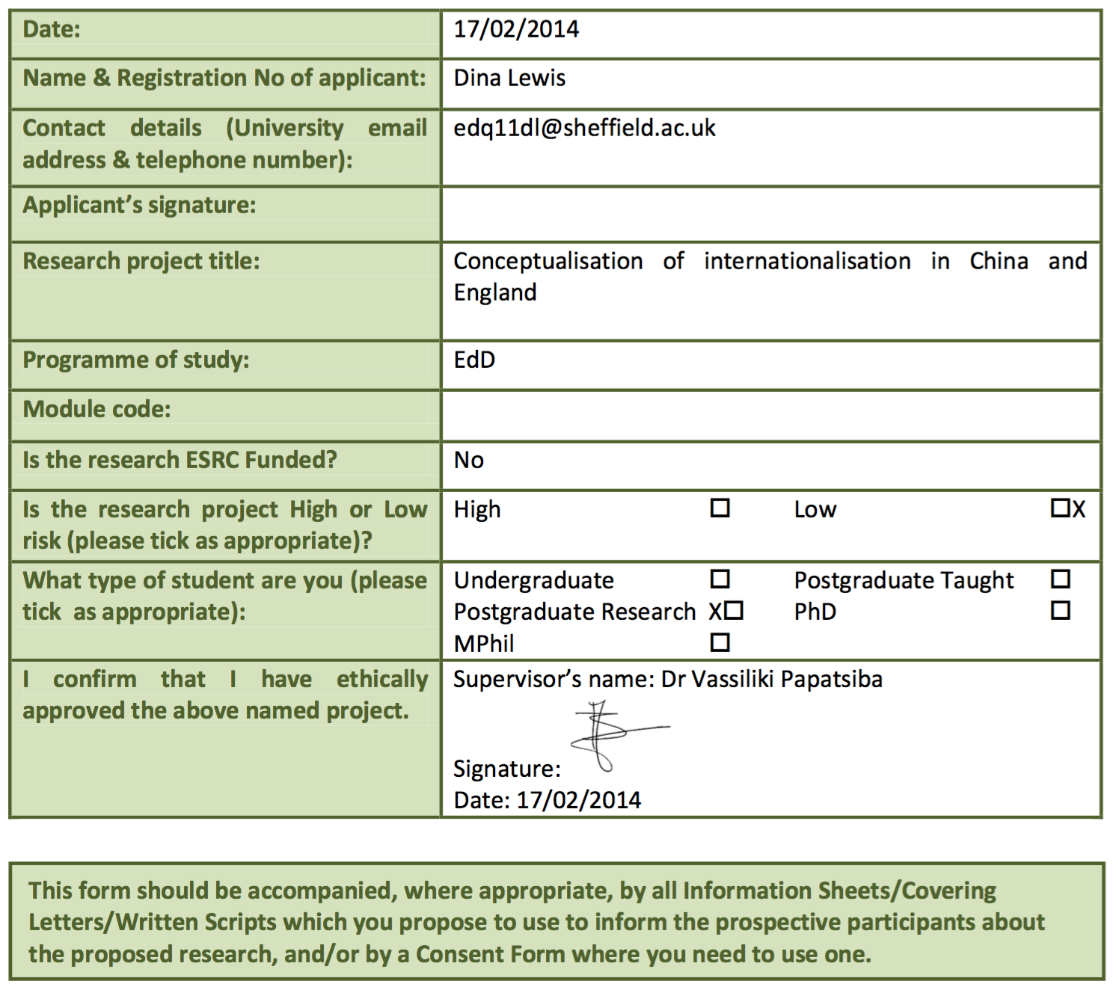
A1 Is this a student project?

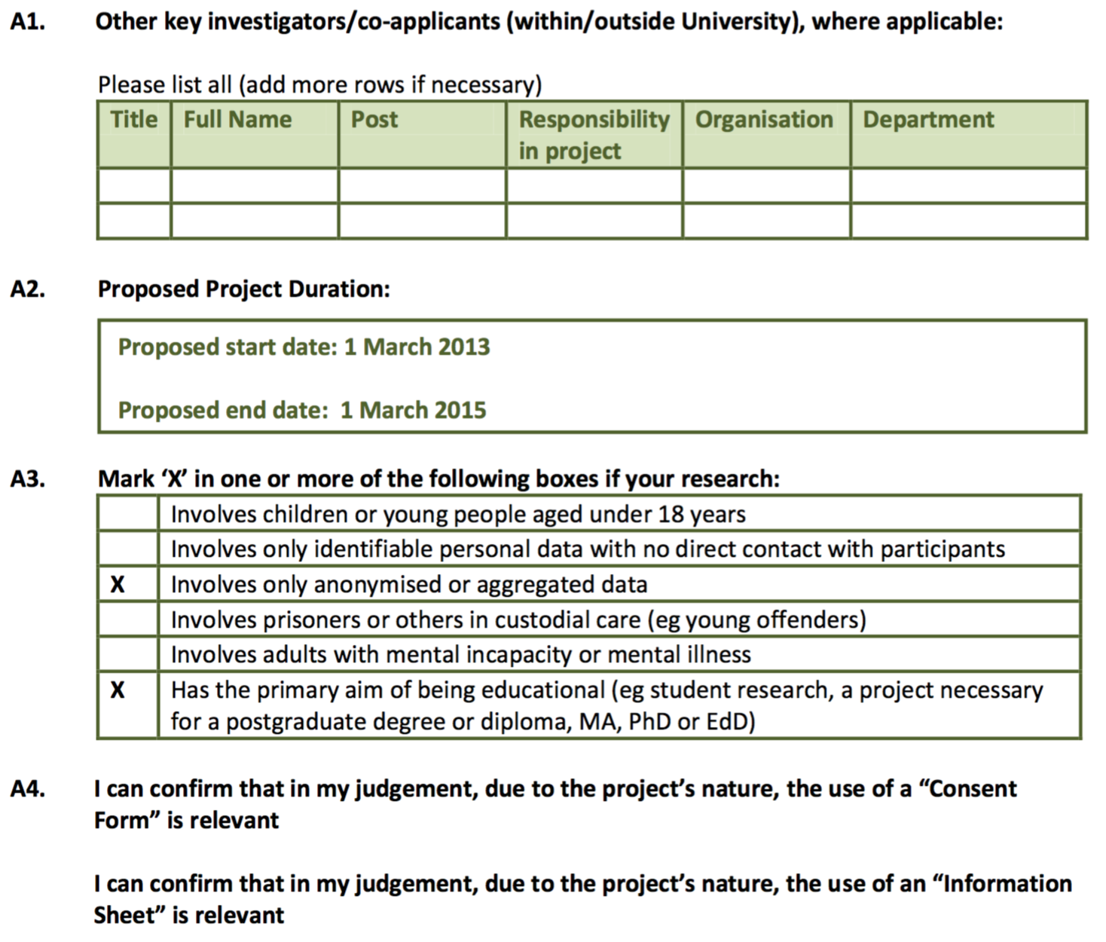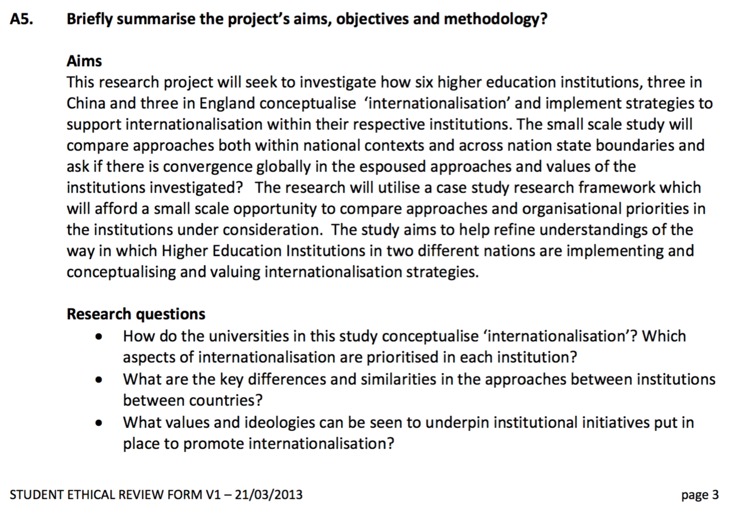

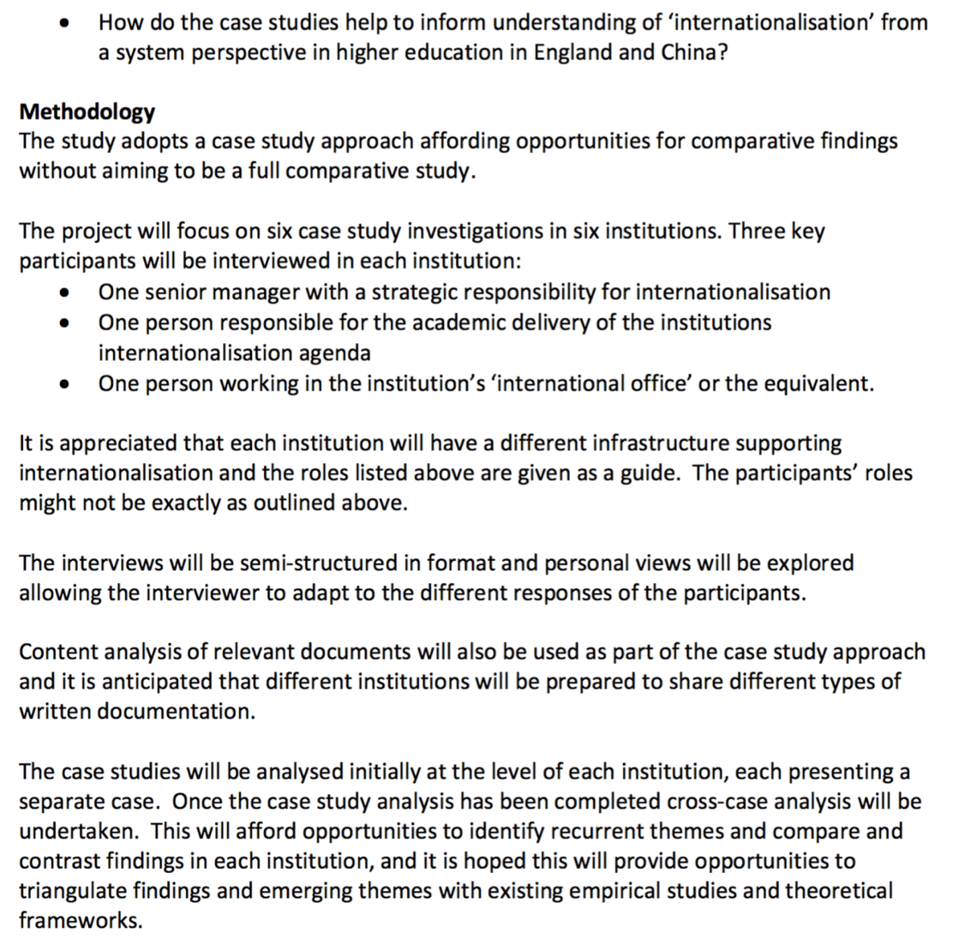

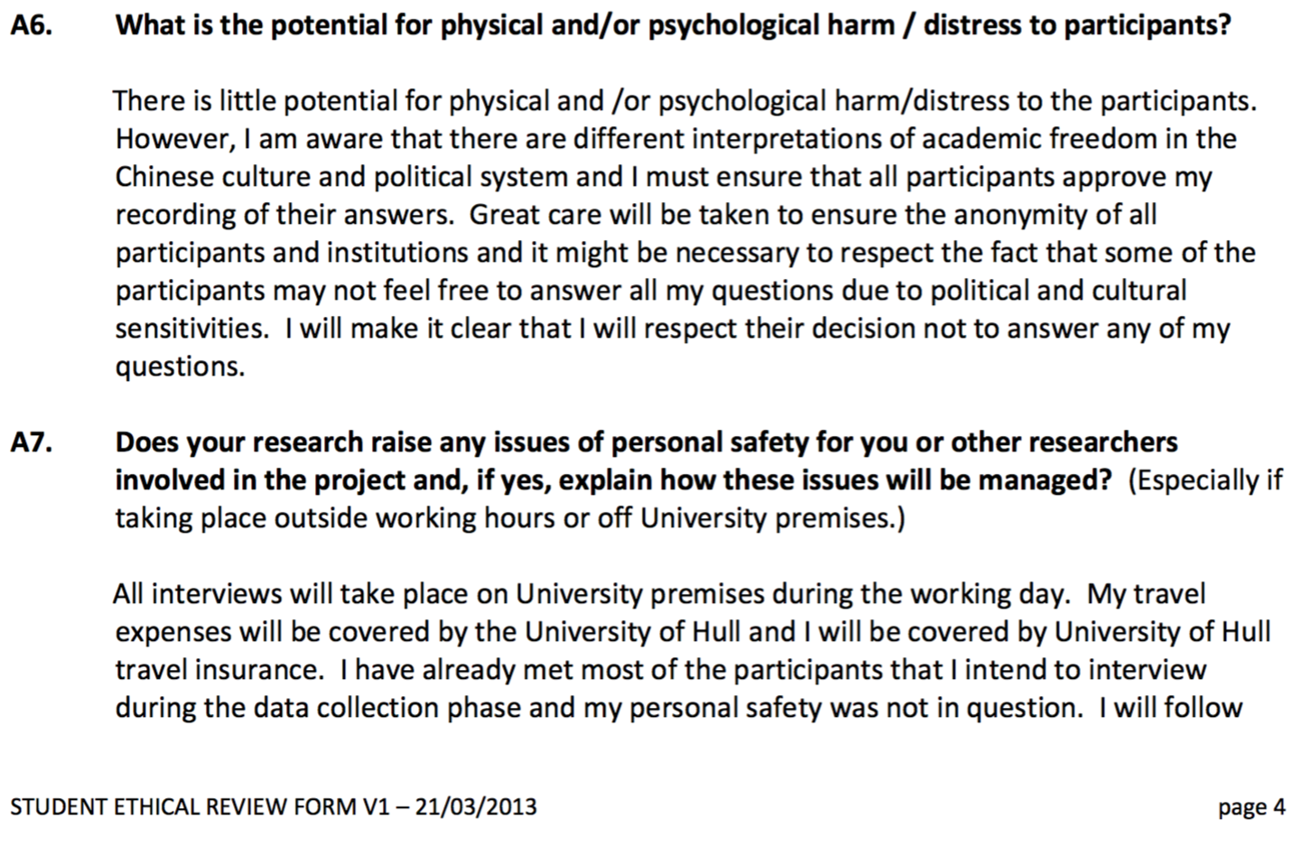

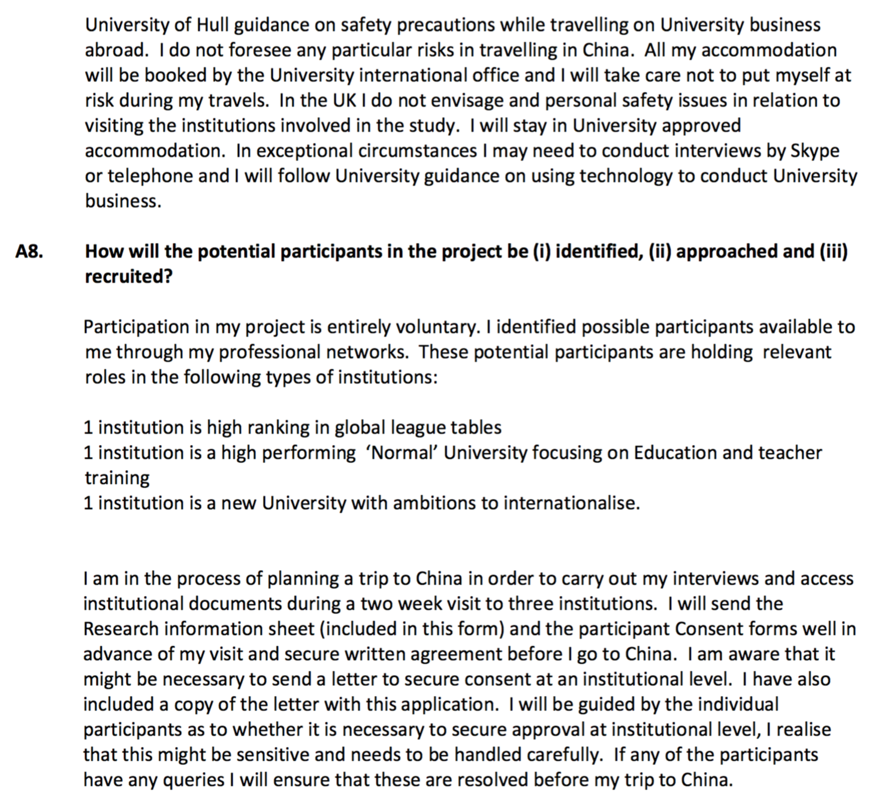
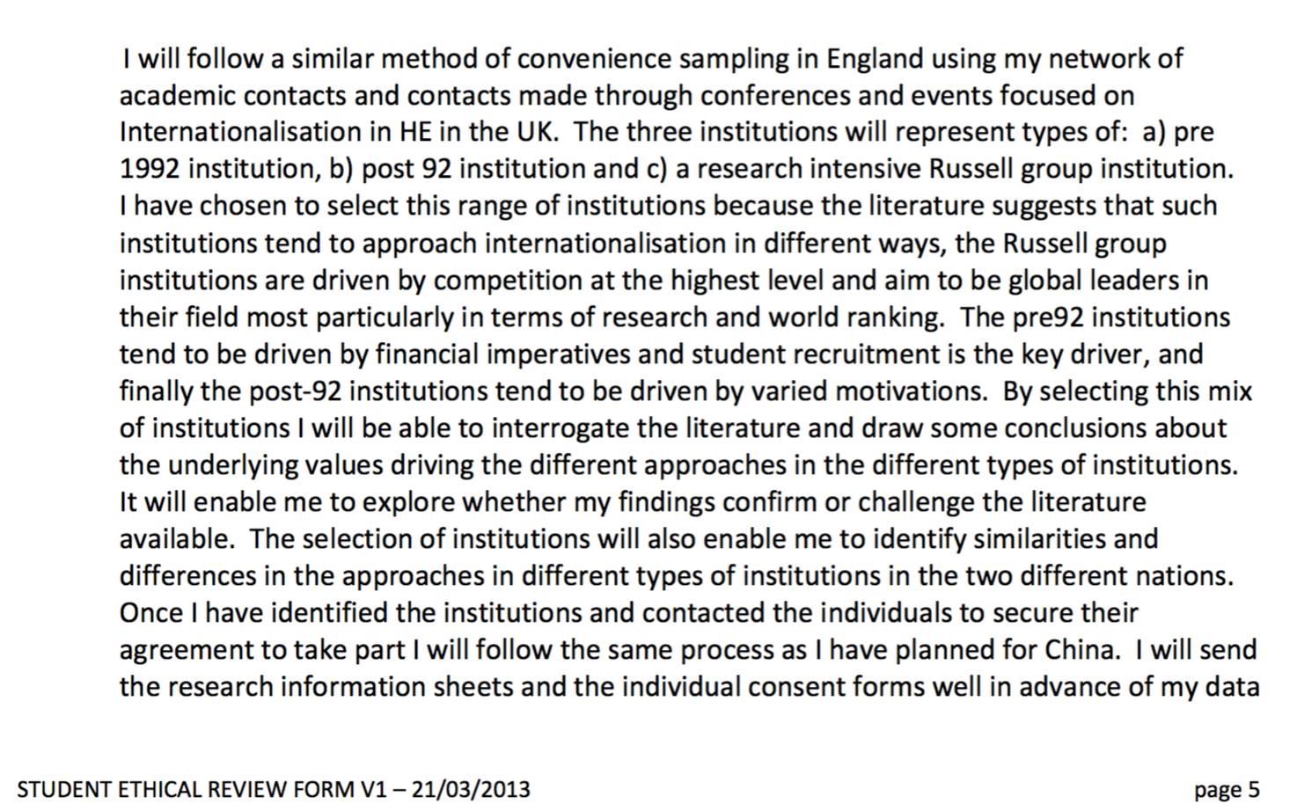

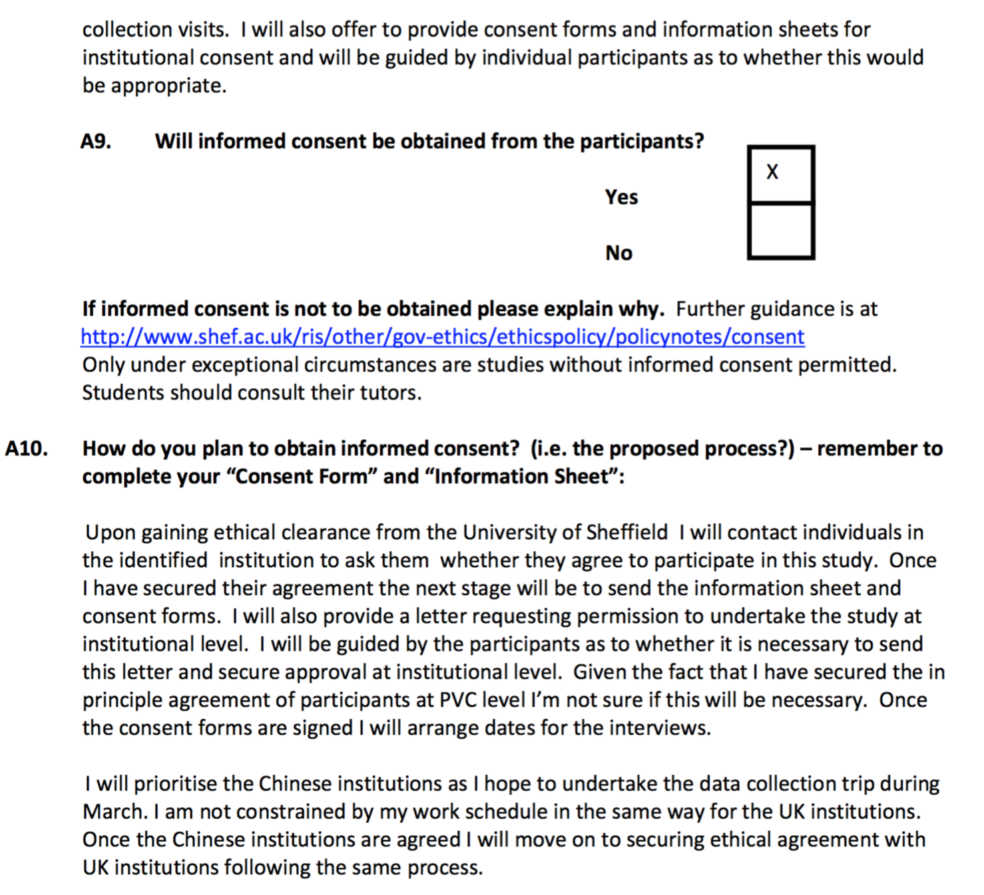





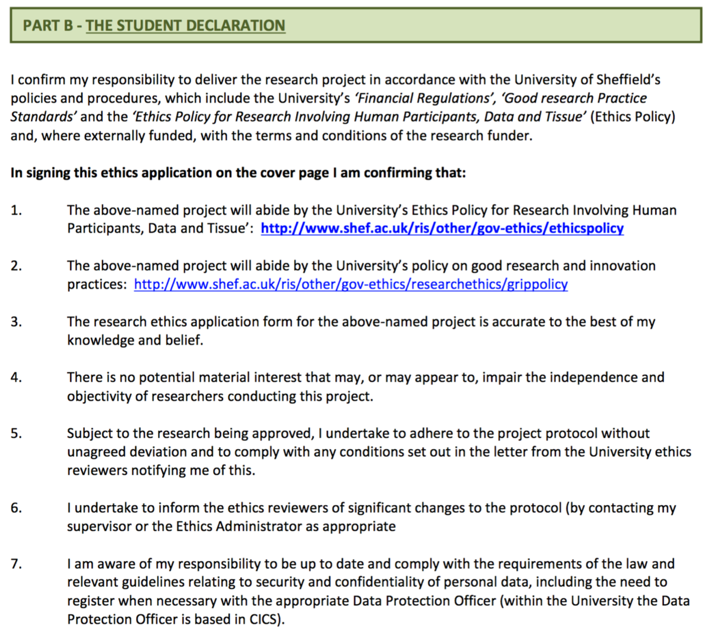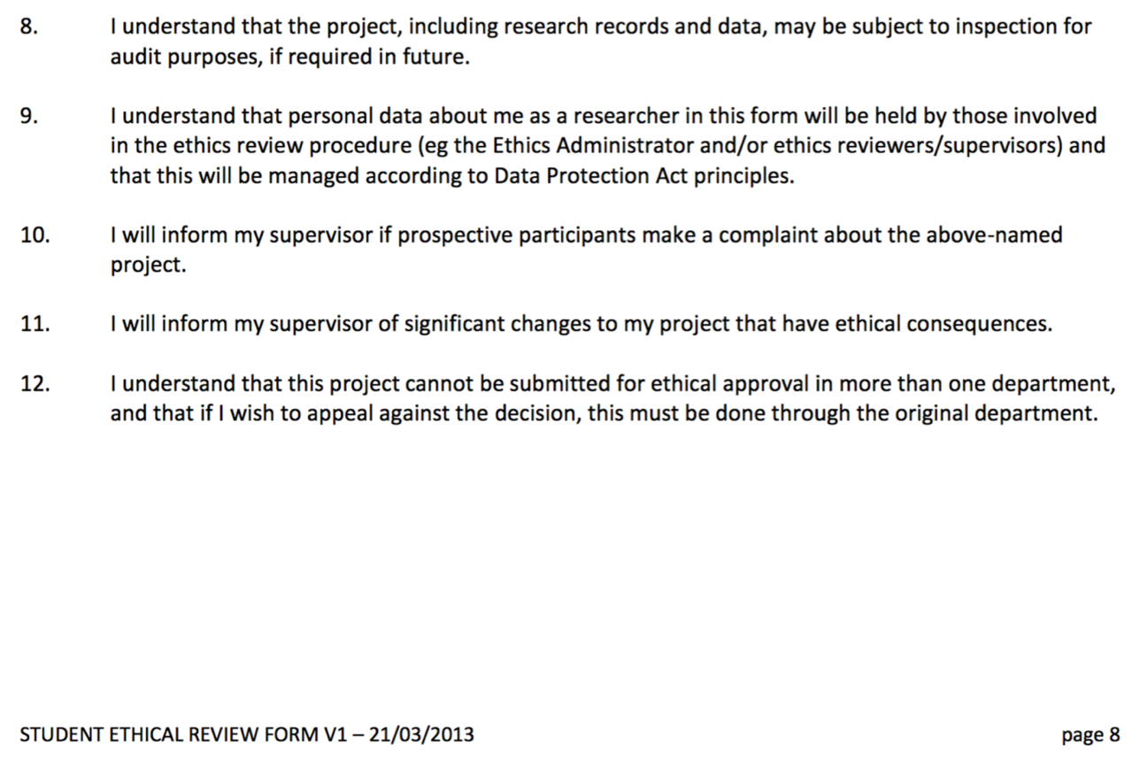

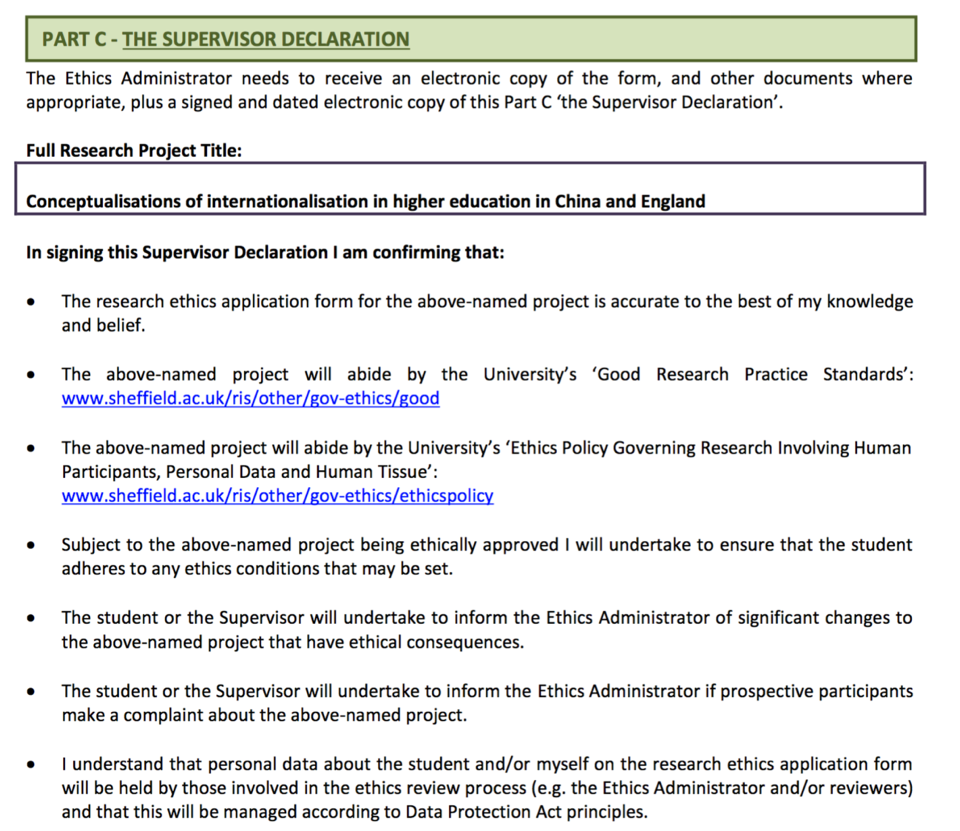
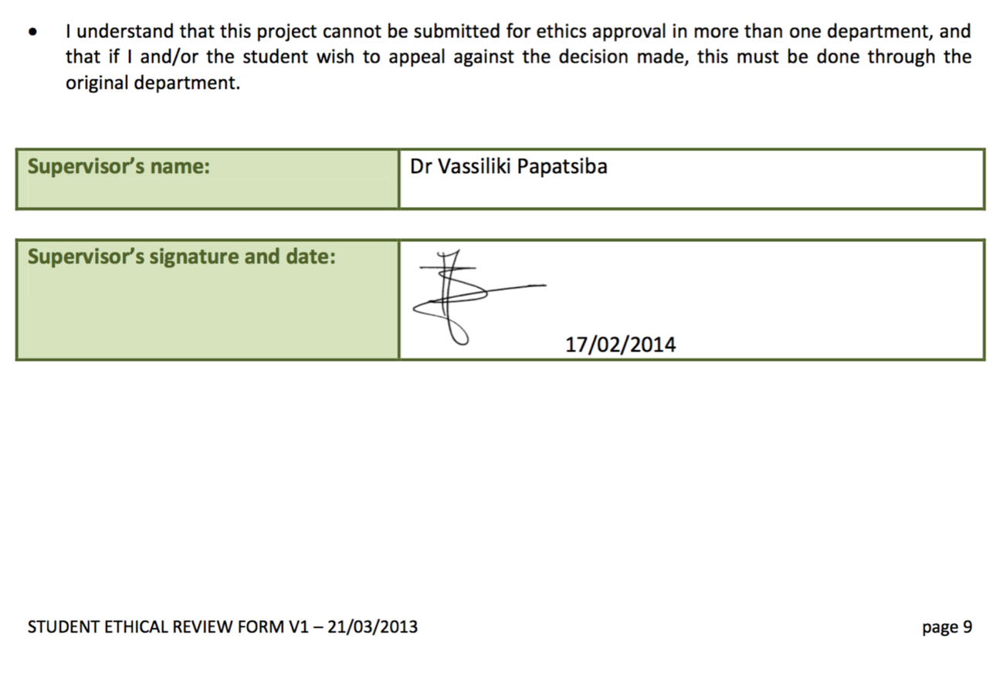
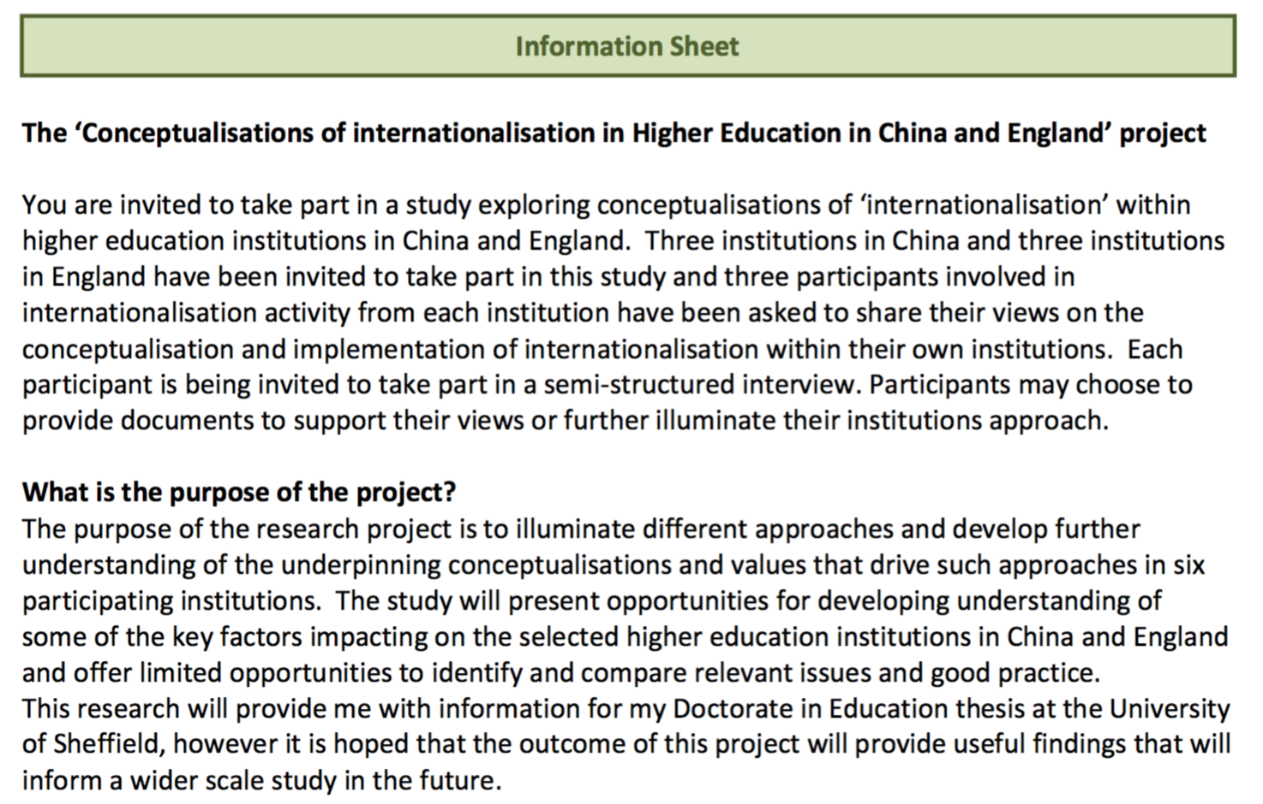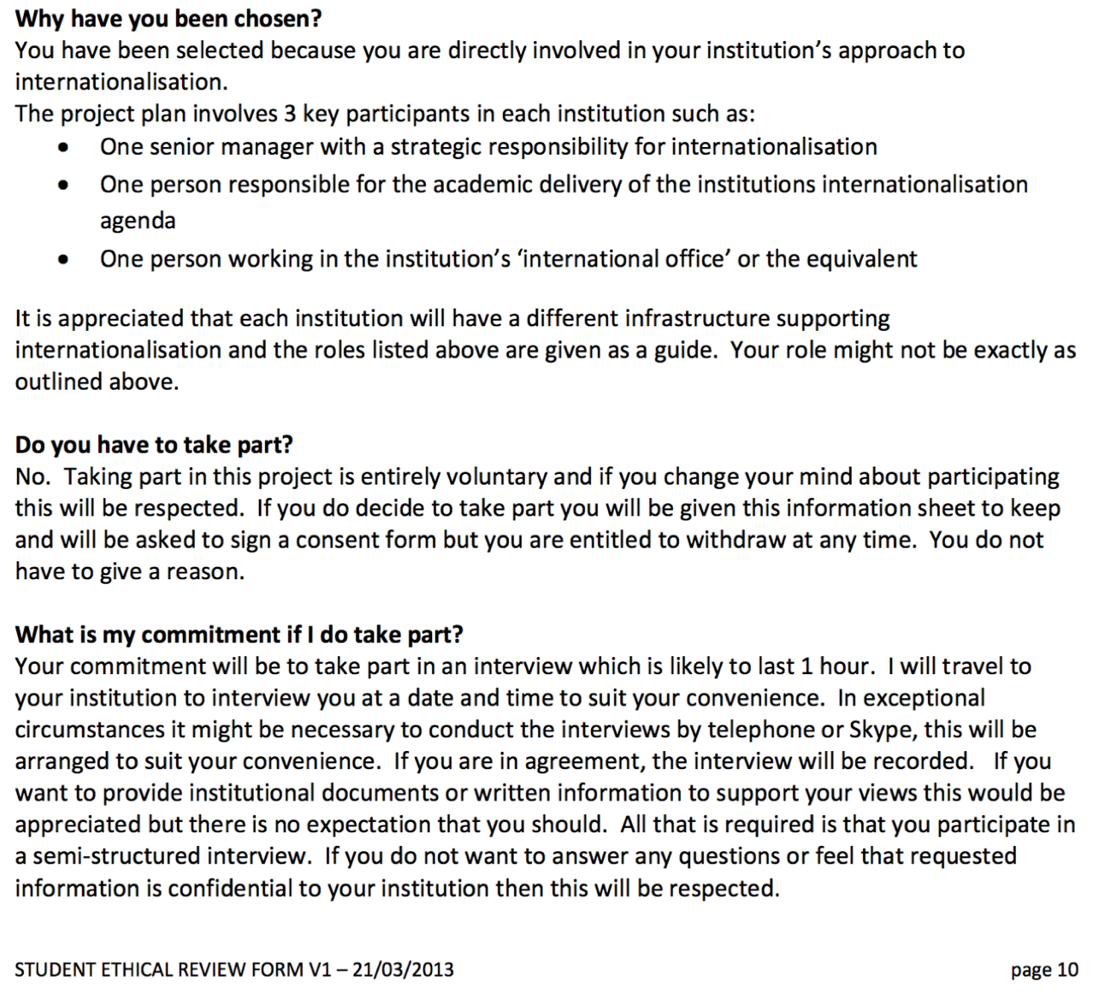

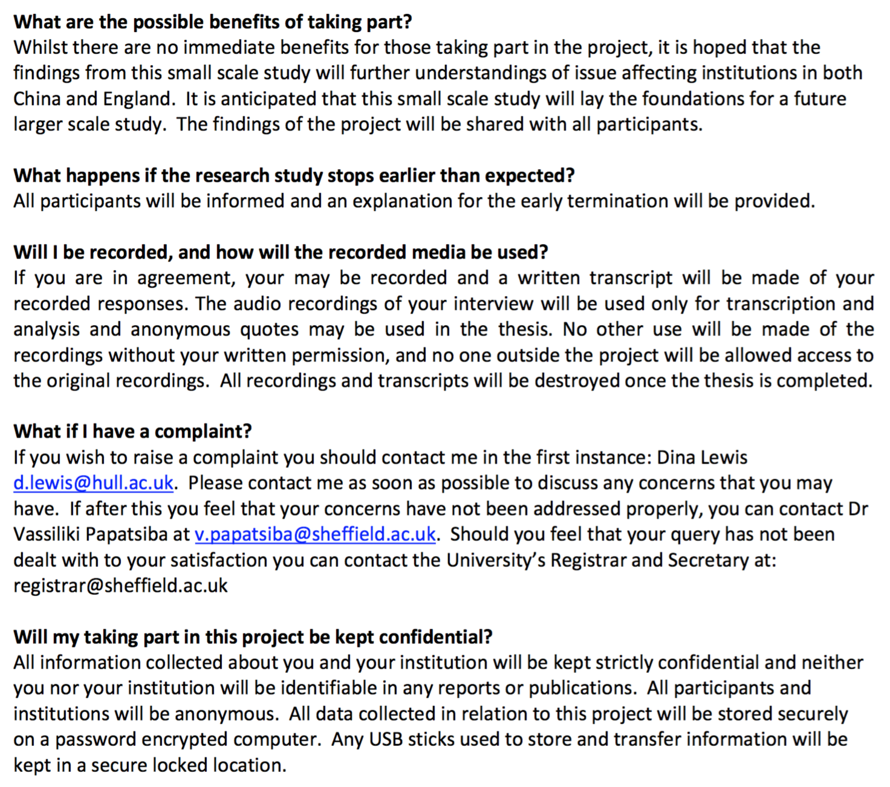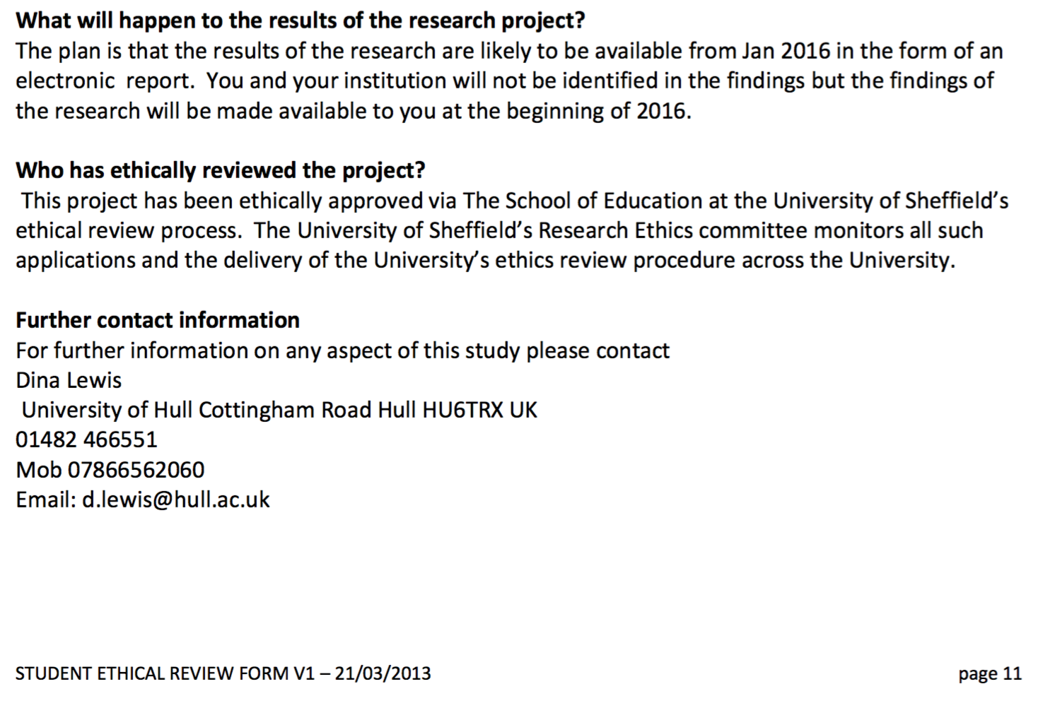
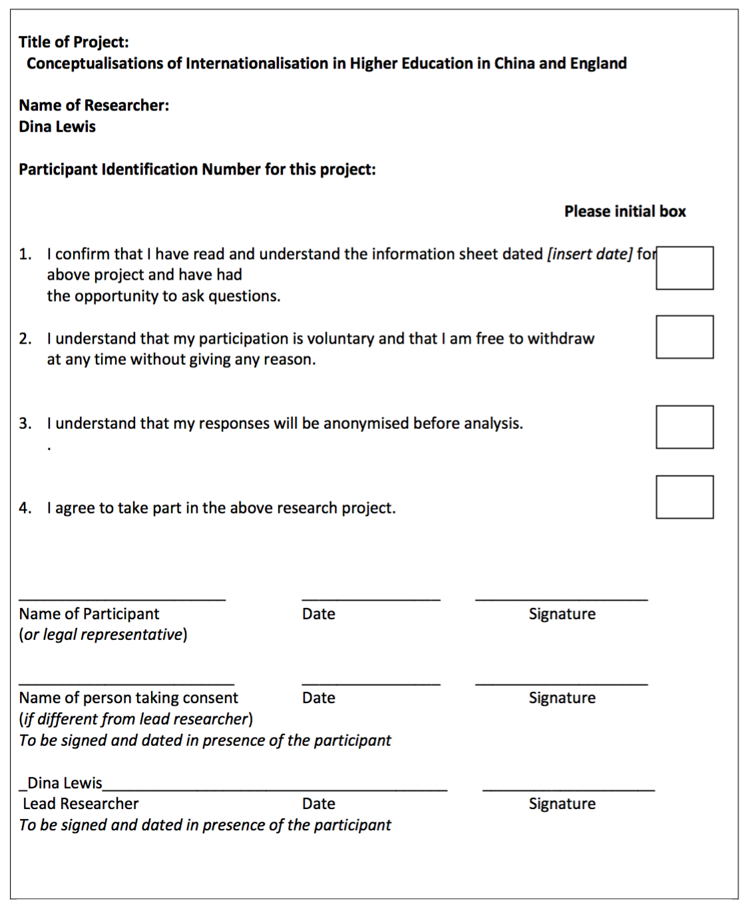


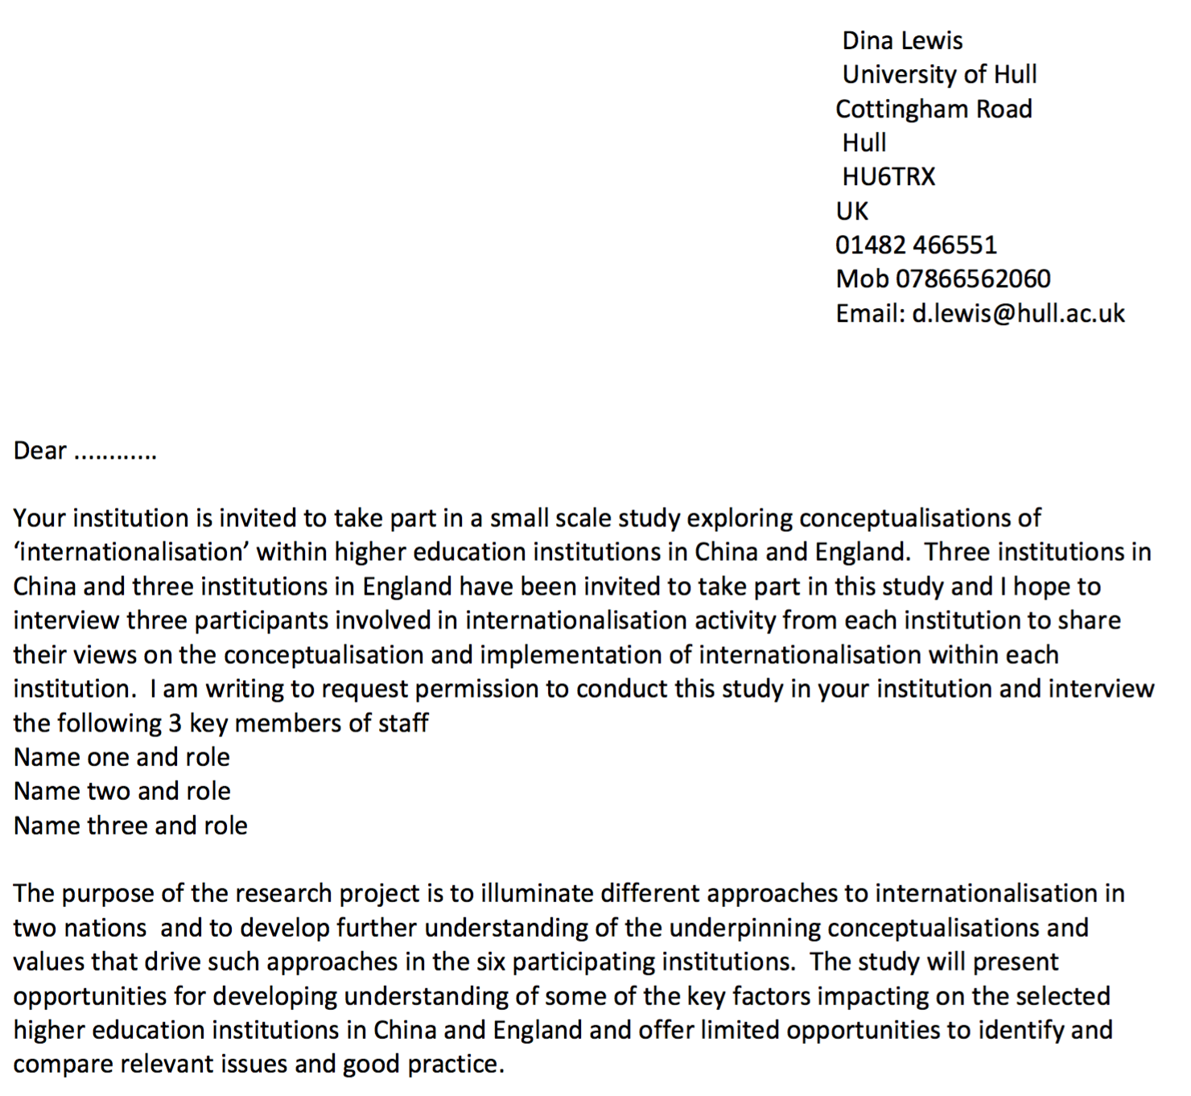
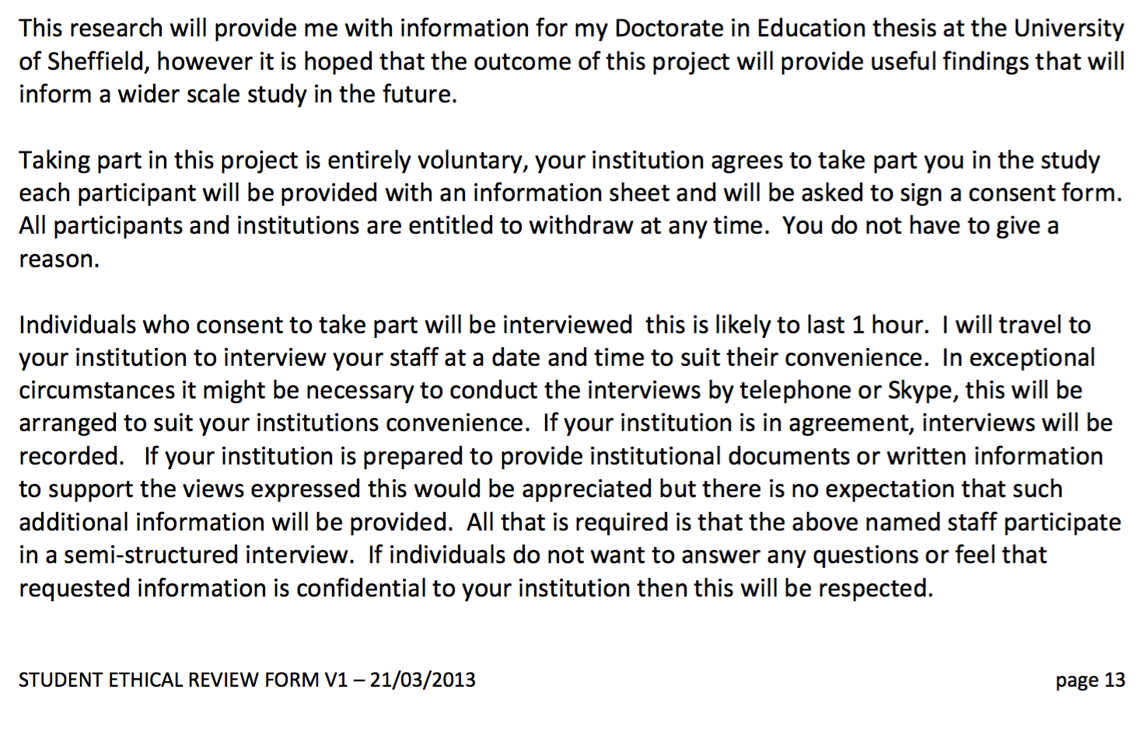
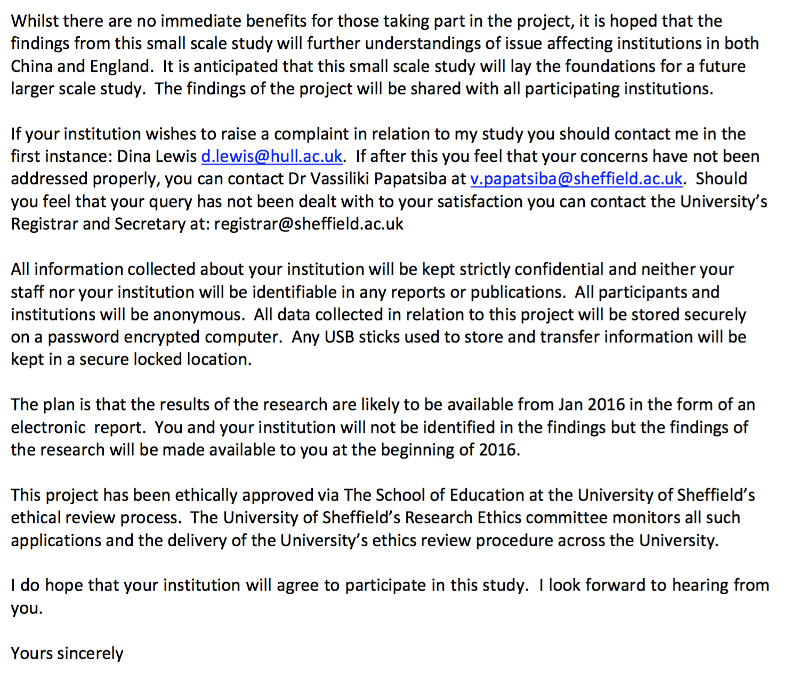

Appendix 2 Research questions for semi-structured interviews in China and England

- Can you tell me about your role in the University?
- Can you give me some background about your University and its plans for ‘internationalisation’?
- Has your University’s approach to internationalisation changed during the past 5 years? If so How?
- In your opinion, have these changes made a difference? How?
- What were the key challenges/tensions /obstacles to internationalisation activities in your university?
- Does your university have an Internationalisation strategy? Can you tell me about it?
- If prompts are needed I could ask about the following areas:
  - Recruitment of international students
  - Recruitment of international staff
  - Sponsoring staff and students to travel abroad
  - Student/ staff exchange programmes
  - Development of international partnerships and joint programmes with articulation arrangements
  - Development of collaborative research partnerships
  - Internationalisation of the student experience
  - Redesign of curricula, teaching methods and assessment.
  - Offering international work placements internships
  - Any others?
- Does the internationalisation strategy relate to the University’s mission and vision if so how?
- Do you have a senior manager with responsibility for Internationalisation? What is their title? What are their responsibilities?
- How is internationalisation supported within theUniversity? Is there a separate international office.
- Does your university senior management team support the internationalisation agenda? Can you give me some examples?
- How does your University value international partnership? Can you give me some examples of the benefits or otherwise of international partnerships at university/ faculty/departmental level
- Does your government promote internationalisation? if so how does it support internationalisation in your University.
- What do you think are the greatest challenges facing your University in trying to implement internationalisation strategies?
- What do you think are the greatest benefits of internationalisation in higher education?

Appendix 3 -Iterations 1, 2 and 3 of the Comprehensive Internationalisation Conceptual Framework

Table 2.1: Iteration 1
Comprehensive Internationalisation conceptual framework (Theme A)
Theme A International student and staff mobility including and student and staff recruitment
Activities and sub-themes identified in Nvivo | Huángsè University | Hόng University | Lan Se  University | Yellow University | Red university | Blue university
International student recruitment

Visiting scholars

Staff and student exchanges

Conference attendance

International staff recruitment

Broadening staff and student perspectives

TNE joint programmes

TNE branch campuses

Table 2.2: Iteration 1
Comprehensive Internationalisation conceptual framework (Theme B)
Theme B Internationalisation of the curricula

Activities and sub-themes identified in Nvivo | Huángsè University | Hόng University | Lan Se  University | Yellow University | Red university | Blue university
International dimensions
in teaching and learning
Programmes taught in English

English language proficiency

Employability

Resistance to internationalisation: staff attitudes

Internationalisation of the curricula

Intercultural exchange

Digital technologies

Table 2.3: Iteration 1
Comprehensive Internationalisation conceptual framework (Theme C)
Theme C Strategic cooperation, partnerships and capacity building

Activities and sub-themes identified in Nvivo | Huángsè University | Hόng University | Lan Se  University | Yellow University | Red university | Blue university
Strategic alliances

Mutually beneficial collaborations
Commercial collaborations

Professional collaborations

Research collaborations

English language publications
Reforming university systems

Rankings

Table 4.1: Respondent and institution key for iterations 2 and 3 of the comprehensive internationalisation conceptual framework
Chinese universities | Key | Chinese respondents | Key | English universities | Key | English respondents | Key
Identifying respondentsHuángsè University | HU | Dean | HU1 | Yellow University  Site | YU | Dean | YU1
Huángsè University | HU | Associate Professor | HU2 | Yellow University | YU | Research Fellow | EY2
Hόng University | HoU | Vice President | HoU1 | Red University | RU | Deputy Vice Chancellor | RU1
Hόng University | HoU | Dean | HoU2 | Red University | RU | Dean | RU2
Hόng University | HoU | Deputy Head International affairs | HoU3 | Red University | RU | International Office Manager | RU3
Lán Sè University | LU | Vice President | LU1 | Blue University | BU | Deputy Vice Chancellor | BU1
Lán Sè University | LU | Dean | LU2 | Blue University | BU | Dean | BU2
Lán Sè University | LU | Deputy Head International Affairs | LU3 | Blue University | BU | International Office Manager | BU3

Table 4.2: Iteration 2 Comprehensive internationalisation conceptual framework (Theme A)

Iteration2 Theme A: International student and staff mobility including student and staff recruitment

Sub-themes and activities identified in Nvivo | HU1 | HU2 | HoU1 | HoU2 | HoU3 | LU1 | LU2 | LU3 | YU1 | YU2 | RU1 | RU2 | RU3 | BU1 | BU2 | BU3
International student recruitment

Visiting scholars

Staff and student exchanges

Conferences attendance

International staff recruitment

Broadening staff and student perspectives
TNE joint programmes

TNE branch campuses

Table 4.3: Iteration 2 Comprehensive internationalisation conceptual framework (Theme B)
Iteration2 Theme B Internationalisation of the curricula

Sub-themes and activities identified in Nvivo | HU1 | HU2 | HoU1 | HoU2 | HoU3 | LU1 | LU2 | LU3 | YU1 | YU2 | RU1 | RU2 | RU3 | BU1 | BU2 | BU3
International dimensions in teaching & learning
Programmes taught in English

English language proficiency

Employability

Resistance to internationalisation: staff attitudes
Internationalisation of the curriculum

Intercultural exchange

Digital technologies

Table 4.4: Iteration 2 Comprehensive internationalisation conceptual framework (Theme C)
Iteration 2 Theme 3 Strategic co-operation, partnerships and capacity building

Sub-themes and activities identified in Nvivo | HU1 | HU2 | HoU1 | HoU2 | HoU3 | LU1 | LU2 | LU3 | YU1 | YU2 | RU1 | RU2 | RU3 | BU1 | BU2 | BU3
Strategic alliances

Mutually beneficial collaborations

Commercial collaborations

Professional collaborations

Research collaborations

English language publications

Reforming university systems

Rankings

Table 4.5: Iteration 3 Comprehensive internationalisation conceptual framework (Theme A)
Iteration 3 Theme A: International student and staff mobility including student and staff recruitment

Column 1  Sub-themes  and location of cross cutting themes | HU1 | HU2 | HoU1 | HoU2 | HoU3 | LU1 | LU2 | LU3 | YU1 | YU2 | RU1 | RU2 | RU3 | BU1 | BU2 | BU3
Sub-theme A1
Changing priorities in China and England and recruitment of international students.
Also discussed under ?

Sub-theme A2
TNE - joint programmes and international branch campuses.
Also discussed under ?

Sub-theme A3
Staff mobility, overseas experience and international staff recruitment
Also discussed under ?

Table 4.6: Iteration 3 Comprehensive internationalisation conceptual framework (Theme B)
Iteration 3 Theme B: Internationalisation of the curricula

Column 1  Sub-themes  and location of cross cutting themes | HU1 | HU2 | HoU1 | HoU2 | HoU3 | LU1 | LU2 | LU3 | YU1 | YU2 | RU1 | RU2 | RU3 | BU1 | BU2 | BU3
Sub-theme B1 International dimensions in teaching and learning including English language challenges and exchanging pedagogies
Also discussed under?

Sub-theme B2
Resistance to internationalisation
Also discussed under

Sub-theme B3 Transcultural/intercultural skills and employability
Also discussed under ?

Table 4.7: Iteration 3 Comprehensive internationalisation conceptual framework (Theme C)
Iteration3 Theme C: Strategic co-operation, partnerships and capacity building

Column 1  Sub-themes  and location of cross cutting themes | HU1 | HU2 | HoU1 | HoU2 | HoU3 | LU1 | LU2 | LU3 | YU1 | YU2 | RU1 | RU2 | RU3 | BU1 | BU2 | BU3
Sub-theme C1
Strategic partnerships and alliances and mutually beneficial collaborations

Also discussed under ?

Sub-theme C2
Research collaborations and English language publications

Also discussed under ?

Sub-theme C3
Reforming university systems, government support and global rankings

Also discussed under ?

The term before common era (BCE) is adopted to reflect the non-Christian cultural heritage of China.

