Experimental Study of Microbubbles Behaviour in Airlift Bioreactor (ALB)

A Thesis submitted for the degree of Master of Philosophy
in the Department of Mechanical Engineering at the
University of Sheffield, UK.
by
Ng Woon Choon

April , 2017

Supervisor: Dr. Robert J Howell

Abstract
This thesis is mainly focused on improving the performance of the application in the airlift bioreactor (ALB) by introducing microbubbles. At the first part of study, the major work consists handling the factors that affected the microbubbles diameters generated by using porous ceramic aerators. The results showed that the pore diameters and the gas inlet flow rates have significant effects on the bubble diameters at the steady flow condition. In addition, this study has proved the bubble diameters generated by the oscillation flow are smaller compared to the bubble diameters generated by the steady flow. Besides that, this study has also proved the existence of an optimum oscillation frequency where bubbles produced here are significantly smaller in diameter than elsewhere in the frequency range. The second part of the study consist the experimental study of the microbubbles in the ALB by using particles image and tracking velocimetry (PIV & PTV). The mass transfer characteristic in the ALB with a range of microbubble diameter were studied. Smaller microbubbles lead to a better performance in mass transfer due to the low rise velocity which is very beneficial for the chemical reaction process. Nevertheless, very small microbubbles with lesser momentum to further increase the liquid flow velocity in the ALB even though smaller bubble diameter has better surface area to volume ratio. Therefore, a suitable bubble diameter with an adequate rise velocity is very essential in improving the performance of the ALB. The third part of the study is to investigate the effect of the draft tube geometry on the ALB performance, with maintain a consistent bubbles size. Therefore, this chapter presents the effects of C_{T} (the distance between the top of column and the upper end of the draft tube) and C_{B} (the distance between the bottom of column and the lower end of draft tube) on the liquid flow velocity. The study of the C_{T} / C_{B} ratio on the liquid flow velocity showed that the C_{T} / C_{B} ratio should be 0.5 – 1.0 in order to obtain the highest liquid flow velocity. In addition, this study also highlighted the height limit for the C_{T} and C_{B} where the C_{T} and C_{B} larger than 50 mm will lead to low liquid flow velocity based on this the particular lab scale ALB and the fixed operating condition.

Acknowledgements

First of all, I would like to express my thanks to my supervisor Dr Robert J Howell and Prof William Zimmerman for their excellent guidance and never ending help. Their invaluable ideals and opinions were very helpful in my project development throughout the period. Additionally, I want to thank them for his supervision and believe in me to carry out this project.
I want to express my gratitude to Dr Wernher Brevis for his valuable experimental support. I want to take this opportunity to thank all of the colleagues and technician from Mechanical and CBE Department of University of Sheffield for their help and knowledge sharing.
Finally, I want to thank my family and friends for giving me the support and I could never do it without you.

-Thank You-

Ng Woon Choon

Contents
Abstract I
Acknowledgements II
List of Figures VIII
List of Tables XI
Chapter 1 Introduction 1
1.1 Background of the Project 1
1.2 Aim and Objectives 4
1.3 Organization of Thesis 5
Chapter 2: Literature Reviews 6
2.1 Microbubbles 6
2.1.1 Characteristics of Microbubbles 6
2.1.2 Advantages of Microbubbles 8
2.1.2.1 High Ratio of Surface Area to Volume 8
2.1.2.2 Low Terminal Rise Velocity 9
2.1.3 Bubble Formation Basics 11
2.1.3.1 Liquid Viscosity 12
2.1.3.2 Liquid Surface Tension 12
2.1.3.3 Wettability of the Surface of the Aerator 14
2.1.3.4 Liquid Density 16
2.1.3.5 Gas Density 16
2.1.3.6 Pores Sizes 17
2.2 Microbubble Applications 18
2.2 1 Water Treatment and Waste Water Treatment 18
2.2.1.1 Air Flotation 18
2.2.1.2 Oxygen Dosing 19
2.2.2 Algae Growth & Harvesting 19
2.2.3 Aquaculture- Fish and Shellfish Culture 21
2.3 Techniques of Microbubble Generation 22
2.3.1 Liquid Flow Microbubble Generator 22
2.3.1.1 Spherical Body in a Flowing Tube 22
2.3.1.2 Rotary liquid flow type 23
2.3.1.3 Venturi type 24
2.3.2 Gas Flow Microbubble Generator 25
2.3.2.1 Porous Membrane Type 25
2.3.2.2 Porous Mullet Ceramics Technique 25
2.3.3 Low Power Generation Techniques 26
2.3.3.1 Microchannel Technique 26
2.3.3.2 Low Power Microfludic Microbubble Generation 27
2.3.4 Summary Microbubble Generation Method 28
2.4 Bubble Size Measurement Techniques 29
2.4.1 Introduction 29
2.4.2 Optical Methods –Photography Technique 29
2.4.2.1 Specification and Working Principle 29
2.4.2.2 Calibration Method 30
2.4.2.3 Bubble Sizing Analysis 30
2.4.2.4 Advantages and Disadvantages 31
2.4.3 Photonic Methods – Spraytec 32
2.4.3.1 Specification and Working Principle 32
2.4.3.2 System Alignment 34
2.4.3.3 Bubble Sizing Analysis 35
2.4.3.4 Advantages and Disadvantages 36
2.4.4 Summarized Method Usage 37
2.5 Particles Image Velocimetry (PIV) and Particles Tracking Velocimetry (PTV) 39
2.5.1 Overview of PIV and PTV techniques 39
2.5.2 Development of PIV for Bubbly flow 42
2.5.2.1 Single Camera Method (A) 43
2.5.2.2 Two Cameras with Filters Method (B) 43
2.5.2.3 Two Cameras Looking from Opposite Side Methods (C) 44
2.5.2.4 Single camera and Shadowgraph method (D) 44
2.5.2.5 No Laser, Single Camera with Shadowgraphy Method (E) 45
2.5.2.6 Two Cameras With ﬁlters and a Dichroic Mirror Method (F) 46
2.5.3. Seeding Particles for Bubbly Flow 46
2.5.4 Illumination Unit 47
2.6 Bioreactors 48
2.6.1 Bubble Column Bioreactors 48
2.6.2 Airlift Bioreactors Morphology and Development 49
2.6.3 ALB Performance and Behaviour 50
2.6.3.1 Liquid Circulation and Mixing In ALB 51
2.6.3.2 Gas Holdup and Gas-Liquid Mass Transfer 52
2.6.4 ALB Modification and Improvement 52
Chapter 3: Equipment and Methodology 54
3.1 Equipment 54
3.1.1: Fluidic Oscillator 54
3.1.2 Airlift Loop Bioreactor (ALB) 56
3.1.3 Airlift Bioreactor and a range of Draft Tubes 57
3.1.4 Porous Ceramic Aerators 59
3.2: Experimental Setup 61
3.2.1 Experimental Setup 1- Steady Flow Microbubble Generation System 61
3.2.2 Experimental Setup 2 – Oscillatory Flow Microbubble Generation System 63
3.3.3 Experimental Setup 3- Microbubbles Effects 65
3.3.4 Experimental Setup 4- Draft Tube Height Effects 67
3.3 Measurement Techniques 69
3.3.1 Determination of Bubble Diameter 69
3.3.1.1 Photography Method 69
3.3.1.2 Calibration Procedure 70
3.3.1.3: Image Processing Procedures 70
3.3.2 Determination of Oscillation Frequency 74
3.3.2.1 Accelerometer 74
3.3.2.2 Sampling Frequency (Accelerometer) 75
3.3.2.3 Calibration 76
3.3.2.4 Procedure of the Frequency Measurement of the Oscillatory Flow 77
3.3.3 Determination of Bubble Rise and Bubble Driven Liquid Flow Velocity 79
3.3.3.1 Image Acquisition 79
3.3.3.2 Calibration Procedure 81
3.3.3.3 PIV Image Pre – Processing 82
3.3.3.4 PTV Image Pre – Processing 84
3.3.3.5 PIV Image Evaluation 84
3.3.3.6 PTV Image evaluation 86
3.3.3.7 Post Processing 89
3.3.4: Determination of the mass transfer 91
3.3.4.1: Dissolved Oxygen Meter (Do meter) 91
3.3.4.2: Data Analysis 92
Chapter 4: Characterization of Bubbles Generated from Porous Aerators 94
4.1: Introduction 94
4.2 Results and Discussions 95
4.2.1: Steady Flow Condition 95
4.2.1.1: Effect of Pore diameter on Average Bubble Diameter 95
4.2.1.2: Bubble Diameter Distribution Characterisations 97
4.2.1.3: Effect of Flow Rate on Bubble Diameter 100
4.2.2: Oscillatory Flow Condition 102
4.2.2.1: Oscillatory Flow Effect on Bubble Size 102
4.2.2.2 Feedback Loop Length Effects on Oscillatory Frequency 103
4.2.2.3 Flow Rates Effects on Oscillatory Frequency 105
4.2.2.4: Bubble Size Dependence on the Oscillation Frequency 107
4.3: Summary 110
Chapter 5: Microbubble Size Effects on Rise Velocity, Mass Transfer and Liquid Flow Velocity in an ALB. 111
5.1: Introduction 111
5.2: Results and Discussions 112
5.2.1 Bubble Rise Velocity in ALB 112
5.2.2 Mass Transfer for Microbubbles and Fine Bubbles 115
5.2.3 Liquid Flow Velocity in ALB 118
5.3. Summary 124
Chapter 6: Effects of the Draft Tube on Liquid Flow Velocity in ALB 125
6.1 Introduction 125
6.2 Results and Discussions 127
6.2.1 Effects of the Draft Tube Position in the ALB or C_{T} / C_{B} Ratio in the ALB on Liquid Flow Velocity. 127
6.2.2 Effects of both C_{T} and C_{B} in the ALB on Liquid Flow Velocity. 129
6.3 Summary 132
Chapter 7: Conclusions 133
7.1 Characterization for Bubble Generated from Porous Aerators 133
7.2 Microbubbles Behaviour and Effects in ALB 135
7.3 Effects of the Geometrical Parameters on Liquid Flow Velocity in ALB 136
7.4 Future Work 138
References 140
Publications 147

List of Figures

Figure 2.1: Different behaviour of the normal sized bubble and microbubble (Takahashi 2005). 6
Figure 2. 2: Different internal pressure of the normal sized bubble and microbubble. 7
Figure 2.3: (a) The transfer benefit of microbubble generation. 8
Figure 2.4: Bubble rising velocity vs. bubble radius. (Tsuge, 1982) 10
Figure 2.5 : The effect of 5 liquid surface tensions on bubble size. (Kullkarni & Joshi, 2005) 13
Figure 2.6: The force acting on a drop of water on a lower energy surface 14
Figure 2.7: Single pore low-surface-energy aerator (Left) and single pore high-surface-energy aerator (Right). 15
Figure 2.8: Multipore low-surface-energy aerator. 16
Figure 2.9 : The effect of orifice diameter on bubble size in water. (Kullkarni & Joshi, 2005) 17
Figure 2.10: Photograph of the field experiment at steel plant (Zimmerman et al. 2011) 20
Figure 2.11: Photograph of the flotation unit showing the algae separation at three different key stages. (Hanotu et al. 2012) 20
Figure 2.12: Sterilization of oyster using ozone nanobubbles 21
Figure 2.13: Schematic of Sadatomi microbubble generator. (Sadatomi et al. 2005) 22
Figure 2.14: (a) Tatsumi’s microbubble generator (b) Ohnari’s microbubble generator. 23
Figure 2.15: Venturi type microbubble generator (Parmar & Majumder, 2013) 24
Figure 2.16: Schematic diagram for the porous membrane type microbubble generator. 25
Figure 2.17: Schematic illustration of experimental set up: (a) bubbler and (b) set up. 26
Figure 2.18: Schematic of the bubbler. 26
Figure 2.19: Microchannel technique for microbubble production. (Parmar & Majumder, 2013) 27
Figure 2. 20: Left: Photograph of microbubbles generated by using fluidic oscillator. Right: Photograph of microbubbles generated without fluidic oscillator from the same ceramic diffuser. (Zimmerman et al. 2009) 27
Figure 2.21: Schematic diagram of the optical method experimental setup 29
Figure 2.22: Schematic diagram of the photonic method experimental setup. 32
Figure 2. 23: Fundamentals of Spraytec measurement 33
Figure 2. 24 : Measuring the angle of diffraction determines the size of the particle. 33
Figure 2.25: Histogram spectra for the bubble size (Screenshot from Spraytec) 34
Figure 2. 26: Graphic representation of the velocity of tracer particles. 39
Figure 2.27: Schematic of 6 different PIV experimental setups for bubbly flow (Sathe et al. 2010). 42
Figure 2.28: Schematic diagram of the images acquisition of florescent tracer particles with the applied laser light and bubbles with the shadow imaging technique (IST). 45
Figure 2.29: Schematic diagram of a bubble column 48
Figure 2.30: Spargers Design 49
Figure 2.31: (a) Schematic diagram of an internal airlift bioreactor (b) Schematic diagram of an external airlift bioreactor 50

Figure 3.1: Photograph of the no-moving-part fluidic oscillator. (Zimmerman et al. 2008) 54
Figure 3.2: Oscillator working principle (Zimmerman et al. 2008) 55
Figure 3.3: Flow pattern of the airlift bioreactor (ALB). 56
Figure 3.4: (a) Photograph of draft tubes (50-mm150mm) (b) Photograph of labscale ALB. 57
Figure 3.5: Photograph of the aerators and housing 59
Figure 3. 6: SEM pictures of 5 porous ceramic. (a) 2 µm (b) 20 µm (c) 50 µm (d) 100 µm (e) 150 µm 60
Figure 3.7: Schematic of the steady flow microbubble generation system setup 61
Figure 3.8: Schematic of the Oscillatory flow microbubble generation system setup 63
Figure 3.9: Schematic drawing of experimental setup. 65
Figure 3.10: Schematic for the bubble sizing photography method 69
Figure 3.11: Captured image of the calibration target 70
Figure 3.12 (a) Raw image of the bubbles (b) Images with “sharpen” function 71
Figure 3.13: (a) Image with the function subtract back ground (b) Images with “Threshold” applied 71
Figure 3.14: (a) Image after “threshold” conversion (b) Image after “binary close” and “Fill function” 72
Figure 3.15: Zoom in raw image after “threshold” conversion (b) Zoom in image after “binary close” and “Fill function” 72
Figure 3.16: Raw image of the overlap bubbles (b) Image after “threshold” (c) Image after “water shed” function 73
Figure 3.17: shows the macro programming that allow the image analysis run automatically. 73
Figure 3.18: Accelerometer 74
Figure 3.19: Schematic for the Setup of the accelerometer. 75
Figure 3.20: Schematic diagram for the microphone transducer setup. 76
Figure 3.21 : Particle Image Velocimetry (PIV) Setup 79
Figure 3.22: Calibration grid as a calibrated target for the PIV 81
Figure 3.23: The effect of several pre-processing techniques (a) Original (b) CLAHE (c) Intensity High pass (d) Intensity Capping 83
Figure 3.24: The principle of the window deformation technique. 85
Figure 3.25 :Flow diagram of the integrated CC and RM method 87
Figure 3. 26: Flow chart of the relaxation method iterations. 88
Figure 3.27: Scatter plot of u and v velocities in the PIV analysis of a bubble driven flow velocity. Data inside the red rectangle in the centre is supposed to be valid, vectors outside of the rectangle are supposed to be outliers. 89
Figure 3.28 (left): Contour plot with the 9 positions markers (right): Line plot obtained from one of the positions. 90
Figure 3. 29 (Left): Vector plot generated from PTV (right) Histogram of the velocity distribution generated from PTV 90
Figure 3.30: Photograph of Dissolved Oxygen meter 91
Figure 3.31: (a) Oxygen level data collected for the oxygen dosing (b) Oxygen level data collected for the oxygen removal (c) Semilog plot for oxygen dosing data & (d) Semilog plot for oxygen removal data 92

Figure 4.1: Plot of the average bubble diameter with the function of pores diameter 0.05 l/min, 0.1 l/min and 0.2l/min 95
Figure 4.2: Bubble size distribution graph from (a)150 µm, (b) 100 µm, (c) 50 µm, (d)20 µm and (e) 2 µm porous ceramic aerator under the condition of steady flow, 0.1 l/min. 97
Figure 4.3: Plot of average bubble diameter with the function of gas volume flow rate. 100
Figure 4.4: The basic reason: Young-Laplace surface tension law. Pressure difference across the air/water surface is inversely proportional to the curvature radius r. 101
Figure 4.5: Bubble diameter distribution graph from the steady flow and oscillatory flow at the condition 0.15 l/min (a) Steady flow (b) Oscillatory flow with 900 mm feedback loop tubing length 102
Figure 4.6: Plots of the Oscillation frequency with the function of the length of feedback loop at 3 inlet flow rate (a) 0.1 l/min (b) 0.15 l/min (c) 0.12 l/min 103
Figure 4.7: Plots of the oscillation frequency with the function of the inlet flow rate with 8 feedback loop length. 105
Figure 4.8: Plots of the average bubble diameter with the function of oscillation frequency at 4 different inlet flow rate condition. (a) 0.1 l/min (b) 0.15 l/min (c) 0.2 l/min (c) 0.35 l/min 107

Figure 5.1: Plot of average bubble rise velocity across the riser region of ALB 112
Figure 5.2(a): Vector plot of bubble rise velocity across the riser region of ALB. (b) Bubble rising velocity distribution graph extract from PTVlab. 113
Figure 5.3: Diagram of difference in pressure for the big and small bubbles (Arrow show direction and amount of pressure) 113
Figure 5.4: (a) Example plot of the dissolved oxygen in the water with the function of time (440 µm microbubble diameter). (b)Typical plot for KLa estimation (0.1l/min, O2removal), where the slope of the linear fitting represents the value of K_{L}a (min⁻¹) 115
Figure 5.5 (a) K_{L}a under 5 different bubble diameters-oxygen removal. (b) K_{L}a under 5 different bubble diameters-oxygen dosing. 116
Figure 5.6 :Contour plot and vector plot of liquid flow velocity of five different bubble size (a) 1020 µm (b) 910 µm (c) 755 µm (d) 690 µm (e) 440 µm 118
Figure 5.7: Plot of overall average liquid flow velocity of 5 different bubbles’ size in the ALB. 119
Figure 5.8 : Average axial velocity profile along the radial direction at different height. a) 200 mm b)400 mm c)600 mm d) 800 mm e) 1000 mm f) 1200 mm g) 1400 mm h) 1600 mm I) 1800 mm 122
Figure 5. 9: Bubble size distributions of 5 aerators with pores diameters (a)2 µm (b)16 µm (c)20 µm (d)50 µm (e)150 µm 124

List of Tables

Table 2.1: The relation between the contact angle and degree of wetting of the solid by the liquid. 15
Table 2.3: Comparison table for the photography and Spraytec method 37

Table 3.1: Experimental 1 Operating Conditions 62
Table 3.2: Experimental 2 Operating Conditions 64
Table 3.3: Experimental 3 Operating Conditions 66
Table 3.4: Experimental 4 Operating Conditions 68
Table 3.5: Microphone transducer configuration setting 76
Table 3.6 : Validation percentage of error table 77
Table 3. 7: Oscillation frequency data example 78
Table 3.8: PIV and PTV Setting 80

Chapter 1 Introduction

1.1 Background of the Project
In recent years, the research into the use of microbubbles has gained a lot of attention due to its size and the associated characteristics. Microbubbles have been proven to enhance performance effectively in several applications, which include water, waste water treatment, also algae growth and harvesting, fish and shell fish cultures as well as medical applications. However, the required microbubble sizes vary in the different fields of application vary (Li 2006).
In general, mass transfer and flotation separation are the two processes that make up main application. The overall mass transfer coefficient is enhanced and improved because of the advantages of the microbubble has the large surface area to volume ratio and low terminal rise velocity. Microbubbles having large surface to volume ratio and low terminal rise velocity are able to transfer their momentum to the liquid easily, they also provide a better dragging ability for the microbubbles compared with the larger bubbles which enhances the performance of the liquid mixing in bioreactors (Zimmerman et al. 2009). However, the very small size of microbubble does not make them suitable for some biological culture application such as microalgae. The small size of microbubbles with better dragging ability will drag the microalgae to the surface of the liquid, which is not desirable. In contrast, algae or yeast harvesting and water treatment require microbubble with the diameter smaller than 200 µm (Hanotu et al. 2012). Hence, the characteristic of the various sizes of microbubble should be fully understood to implement a suitable bubble size for efficient performance in each application.
As discussed earlier, the microbubble size appears to be one of the key factors affecting its performance in various applications. The aeration method will be used as a microbubble generator system in this thesis. Microbubbles are generated by supplying a steady air flow directly to the porous aerator in the fluid. The factors that affect microbubble size generated from the porous aerator should be fully understood to generate desired bubble size distribution that will be used for future experiments. Consequently, the study of several basic factors was included in this thesis.
Zimmerman et al. (2009) invented a low power microbubble generation method which is comprised of a fluidic oscillator and aerators. The fluidic oscillator is a no-moving part amplifier based on the Coanda effect, provided with a feedback loop. The main function of the fluidic oscillator is to generate oscillatory flow to limit the bubble growth period by controlling the amount of gas supply during bubble formation. The fluidic oscillator supplies oscillatory flow to the aerators to generate microbubbles. Aerator is an air diffuser that is made of a porous material with a hydrophilic surface. The oscillation frequency of the oscillatory flow depends on the gas flow rate and length of the feedback loop tubing. The oscillatory flows were proven to have a significant effect on the bubble size, however there are still very few of studies on the factors that affects microbubble size. Therefore, factors affecting the frequency of the oscillatory flow, the relation between the oscillatory frequency and the microbubble size across a range of flow rate were investigated.
Since microbubbles were first shown to enhance the performance of mass transfer compared to larger bubbles, the combination of the airlift bioreactor (ALB) with the novel low power Tesar-Zimmerman fluidic oscillator has been applied in several field experiments. In these field experiments microbubbles also showed an improvement of the performance of the ALB (Al-Mashhadani et al. 2012; Ying et al. 2013) both in terms of mass transfer and mixing, therefore bubble size should be considered as one of the ALB design factors. However, the bubble size were neglected in several previous studies of the effects of ALB geometry on its performance (Lu et al. 2000; Gouveia & Hokka 2003; Garci & Garci 2004; Kilonzo et al. 2007; Al-azzi & Al-kuffe 2010). The classical tracer response techniques that have been previously applied in ALB mixing studies are not suitable for studying the effect of microbubbles. This is due to implemented tracer solutions such as sodium chloride, hot water, acidic and alkaline solution which are interfering and affecting bubble sizes by changing of the water properties. (Weiland 1984; Al-azzi & Al-kuffe 2010)
The size of the microbubbles is an essential condition in controlling the ALB performance, and therefore this thesis investigates a range of microbubble sizes and their effects on ALB performance. The particle image velocimetry (PIV) method and particle tracking velocimetry (PTV) were applied to replace the classical tracer response technique, as the PIV tracer particles do not affect the bubble size during the experiment. Furthermore, a study on the clearance between the draft tube top with the surface of water (C_{T}) and the clearance between the aerator surface with the bottom of the draft tube(C_{B}) has never been performed simultaneoulsy using a constant bubble size. Therefore, this thesis will present a study of the C_{T} and C_{B} height effects on liquid flow velocity in ALB, using PIV and under relatively constant conditions.

1.2 Aim and Objectives
As mentioned previously, microbubble size is one of the essential key controlling parameter in applications. The aim of this study is to fully understand the microbubble characteristic including generation method, factors that affect microbubble size, performance and impact of microbubble in the airlift bioreactor (ALB).

The main objectives are listed below:
- To study the factors that affect bubble size generated from the porous ceramic at steady and oscillatory flow conditions.
- To study the enhancement of the microbubble in the mass transfer and liquid flow velocity in the ALB.
- To study the geometry parameter, C_{T} (the distance between the top of column and the upper end of the draft tube) and C_{B} (the distance between the bottom of column and the lower end of draft tube) effects on the liquid flow velocity in the ALB with maintain a consistent bubble size.

1.3 Organization of Thesis
Chapter 1 introduces the background, aims, and objectives of this project.
Chapter 2 covers the literature review of this research. The literature review consists six main section which is microbubble characteristics, microbubble applications, microbubble generation methods, bubble sizing methods, particles image velocimetry (PIV) developments for bubbly flow, and bioreactor characteristics.
Chapter 3 discusses the equipment and methodology of this project. There are 4 sets of experimental detailed designs that implemented in these studies following with detailed explanation of the measurement technique are covered in this chapter
Chapter 4 presents the factors that affect the size of microbubbles that generated from the porous ceramic and the relation between oscillatory flow and the microbubble sizes.
Chapter 5 presents the effects of the microbubble size on the bubbles rising velocity, bubble driven liquid flow velocity and mass transfer.
Chapter 6 presents the effects of geometrical parameters on mixing characteristic of an ALB in term of liquid circulation velocity. Particle image velocimetry (PIV) experimental technique was used in the study of both chapters.
Chapter 7 covers the overall summary or conclusion for this thesis.

Chapter 2: Literature Reviews

2.1 Microbubbles
A bubble with the diameter within the range from 1 µm to 999 µm and uniformly suspended in liquid is defined as microbubbles (The American Heritage Dictionary of English language: Fourth Edition, 2000). However, some researchers such as Ohnari (2002a) stated that bubbles with a diameter of the order of 10 µm or smaller should be classed as microbubbles only. The definition of microbubbles has not reached an agreement by the researchers. Overall, the statement that the various fields of application required different suitable microbubble sizes. (Li 2006)

2.1.1 Characteristics of Microbubbles
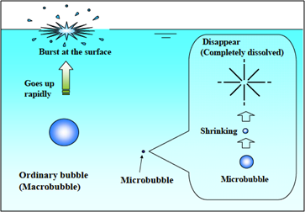
Figure 2.1: Different behaviour of the normal sized bubble and microbubble (Takahashi 2005).

Figure 2.1 schematically presents the different behaviour between Macrobubble and microbubble. Macrobubble rises upward in the liquid rapidly and burst at the liquid surface, whereas microbubble (∼100 μm) remains stable in the liquid. After a period of time, the size of the microbubble decreases gradually as the gases dissolve into the liquid and the microbubble dissapears when the gas is completely dissolved (Marui 2010).
The disappearance of the microbubble is due to the low rising speed, large specific surface to volume ratio and high gas pressure witin the microbubble.
Liquid
Low Pressure Gas
High
Pressure
Gas

Figure 2. 2: Different internal pressure of the normal sized bubble and microbubble.

Smaller bubbles have higher internal pressure (see right) and release gas to dissolves under pressure into solution whereas larger bubbles grow by taking up gas from solution; thus small bubbles shrink and large bubbles grow . The rates of these processes depend on the circumstances. Also as bubbles rise the pressure on them drops due to the depth of the water and they consequentially enlarge and rise faster, see Figure 2.2.
The internal gas pressure within a bubble is greater compared with liquid pressure due to the surface tension. The magnitude of the pressure different can be predicted with the eqn 2.1.
The relationship between the interior gas pressure and the bubble diameter is expressed by the Young-Laplace equation listed below, which explains the collapsing behavior (Takahashi 2005).
$P=P_{l}+\frac{2σ}{r}$ (Eqn 2. 1)

Where, P is the gas pressure, P_{l} is the liquid pressure (N/m²), σ is the surface tension (N/m), and r is the radius of the bubble (m).
For example, the Laplace pressure of a 10 μm bubble is about 2.9 X 10⁴ pa at 25 °C , about 0.3 times the atmospheric pressure, while for a 1 μm bubble laplace pressure is 2.9 X 10⁵ pa, 3 times the atmospheic pressure.

2.1.2 Advantages of Microbubbles

2.1.2.1 High Ratio of Surface Area to Volume
In general, smaller bubbles have larger surface area to volume ratio compared to the large bubbles. The property is very beneficial to all of the transportation processes such as mass transfer, momentum transfer and heat transfer. This is because the interface surface area between the liquid and bubble is one of the main factors that affect transport processes. Eqn 2.2 listed below illustrates the surface area to volume ratio of the bubble increases inversely propotional to the radius of the bubble.

$\frac{S}{V}=\frac{4πr^{2}}{\left(\frac{4}{3}\right)πr^{3}}=\frac{3}{r}$ (Eqn 2.2)
Where S is the surface area of the bubble (m²), V is the volume of bubble (m³) and r is the radius of the bubble (m).

$S=\frac{3}{r}v_{o}$ (Eqn 2.3)
Eqn 2.3 illustrates the surface area of the microbubble with a constant total volume of bubbles.
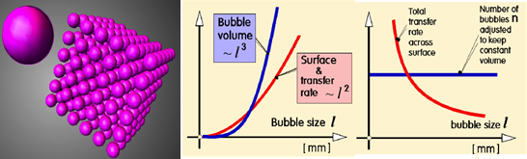
Figure 2.3: (a) The transfer benefit of microbubble generation.
A typical example is illustrated in Figure 2.3, the liquid interface of the continuous phase in a tank exposed to the atmosphere would be better if 1 litre of air spreads evenly in 100 micron sized bubbles, which generates 10 m² of interface area. In general, the mass transfer coefficient of a single bubble may be difficult to assess due to the dependence of the microbubble mass transfer on various condition such as constituents of a culture medium, transferrable materials, bubble rise hydrodynamics and the bubble’s environment. (Deshpande & Zimmerman 2005a; Deshpande & Zimmerman 2005b).
Nevertheless, convection forces dominated in most of the flow and it can be explained by a general equation of mass transfer coefficient where the overall mass flux (J) is directly proportional to the interfacial area (S) of the dispersed phase. The interfacial area (S) is inversely proportional to the microbubble diameter (d). Thus, a decrease in bubble diameter (d) leads an improvement in the transfer dynamic, mass transfer and heat flux (Zimmerman et al. 2009). The interphase mass transfer flux equation is listed below:

$J=K_{l}S(C_{g}-C_{l})$ (Eqn 2. 4)

where $K_{l}$mass transfer coefficient (unit of velocity), S is interfacial area, and ${ C}_{g}$ and $C_{l}$ are molar concentrations.

2.1.2.2 Low Terminal Rise Velocity
Apart from the advantage of microbubbles having a higher surface area to volume ratio, microbubbles also have longer residence time compared to larger bubbles. Therefore, microbubbles are able to transfer their momentum to the liquid easily and drag the liquid along with them. The terminal rising velocity of a single bubble can be expressed by Hadamard-Rybczynski equation listed below and this is generated when the buoyancy force (F_{B}) balancing the gravitational force (g) and friction force (f)

$u_{b}=\frac{2\left(ρ_{L}-ρ_{G}\right)gr^{2}}{9μ}$ (Eqn 2. 5)

$F_{B}=\frac{4}{3}πr^{3}\left(ρ_{L}-ρ_{G}\right)g$ (Eqn 2. 6)

$f=6πμrU_{b}$ (Eqn 2. 7)

U_{b:} Terminal rising velocity (m/s)
r: Bubble radius (m)
ρ_{L}: Liquid density (kg/m³)
ρ_{G}: Gas density (kg/m³)

It can be seen that the terminal rise velocity (U_{b}) is proportional to the square of bubble radius (r²) and this shows that microbubbles will stay markedly longer in the same height in a liquid compared with normal sized bubbles. Therefore, reducing the size of the bubble will allows the bubbles stay longer in the liquid and allow longer period for the mass transfer process within the bioreactors and fermenters (Grammatika & Zimmerman 2001).
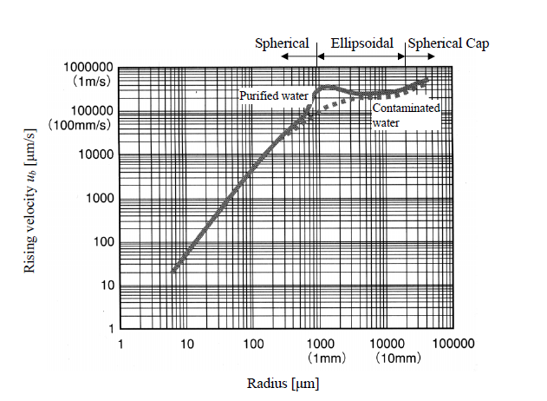
Figure 2.4: Bubble rising velocity vs. bubble radius. (Tsuge, 1982)

Figure 2.4 presents the plot of rising velocity with radius of bubbles in the purified and containminated water. The plot shows that the bubble has a lower rise velocity in the contaminated water. This is because of the presence of the contaminants makes the bubble surface immobile. The terminal rise velocity (U_{b}) is proportional to the square of bubble radius (r²). In addition, the plot also shows that the 10 µm has very low velocity as 50 µm/s which leads to a very large residence time and cause the higher gas holdup which also increase in the specific interfacial area. The shape of the bubbles with the diameter in the range between 1 to 10mm is ellipsoids and the bubbles with the diameter >10mm is in spherical caps.

2.1.3 Bubble Formation Basics
The most basic method for bubble formation is to supply gases of interest to liquid by using porous aerator (porous media). The gas mass transfer rate is influenced by the bubble size, rising velocity and bubble size distribution. It is important to understand bubble formation process in order to control the bubble size effectively and optimize the bubble generation system thus improve the mass transfer and mixing performance in various processes.
During bubble formation, bubbles continue to grow at a single orifice and does not detach immediately due to the surface tension. As there is a restraint force between the bubble and the edge of the aperture of the orifice, the bubble only breaks off when it has enough volume to generate an adequate buoyancy force to overcome the restraint force (Zimmerman et al. 2008).
There exists a second restraint force on hydrophobic materials often used as aerators. The gas phase of bubble forms the second restraint force which causes the bubble to require a larger buoyant force to break off. Therefore, a bubble with larger volume is required before a sufficient buoyancy force is generated to extent that it exceeds the main and second restraint forces. Thus, the bubble diameter is normally ten times larger compared to the pore size. (Zimmerman et al. 2009).
After detaching from the orifice, the size of the bubble decreases gradually as the gases dissolve into the surrounding liquid owing to the pressure difference between the gas and liquid phases (Weaire et al. 2003). The interpretation of Eqn 2.5, the rising velocity decreases with the bubble diameter decreases. Therefore, it is possible for microbubble to shrink and disappear before it reaches the surface of the liquid.
2.1.4 Factors Affecting Bubble Size
As mentioned previously, bubble size is an essential key in controlling most of the mass transfer and mixing performances in various applications. Therefore, the factors that affect bubble size are important and have to be fully understood in order to control and generate desired bubble size distribution. Factors that affect the bubble size are listed below (Kulkarni & Joshi 2005):

- Liquid viscosity
- Liquid surface tension
- Liquid density
- Gas density

In addition to the above, The aerator’s wettability surface and pore sizes are also factros that were considered in several study (Kulkarni & Joshi 2005) .

2.1.3.1 Liquid Viscosity
In the bubble formation process, liquid viscosity is an arguable parameter as several researchers have observed various types of liquid viscosity effects on bubble diameters. Some of the researchers concluded that that the liquid viscosity does not affect the bubble size (Kumar & Kuloor 1970; Benzlngl & Myers 1955). However, other researchers have a different point of view that the bubble diameter increases with the liquid viscosity (Khurana & Kumar 1969) (Khurana & Kumar 1969). In addition, there is another finding on the liquid viscosity effects on bubble diameter by Blasenbildung (1951) and it appears to be more comprehensive. The finding was the bubble sizes are independent of liquid viscosity in the low liquid viscosity conditions. But, at the high viscosities condition, higher viscosity leads to an increase in bubble size generated at a small inlet flow rate.

2.1.3.2 Liquid Surface Tension
In general, surface tensions forces are the essential factors that affect the bubble growth. During the bubble formation and growth process, the liquid drags the rear surfaces of the bubble backwards and the surface is stretched in the front part of the bubble. Hence, new surface is constantly generated. The bubble surface near the orifice is compressed and the liquid is pushed toward the edges of orifice. Consequently, the bubble is attached to the edges of orifice by the liquid surface tension and delayed the detachment process (Hughes et al. 1955).
There are static and dynamic surface tensions force act on bubbles. The dynamic surface tension occurs as its contact angle with the orifice change continuously at the initial part of bubble growth phase and the static surface tension occurs when the contact angle becomes constant (Kulkarni & Joshi 2005).The bubble is restrained by the liquid surface tension and the front part of the bubble is stretched by the continuous gas supply. With continuous gas supply until to a certain level of pressure, the final static surface tension can be overcome; the bubble is detached from orifice. Therefore, the surface tension causes the delay of detaching time and leads to an increase in bubble size. Figure 2.5 shows the effects of 5 different liquid surface tensions on bubble size. Moreover, liquid surface tension increases with the diameter of the orifice and therefore affects bubble size (Gaddis 1986).
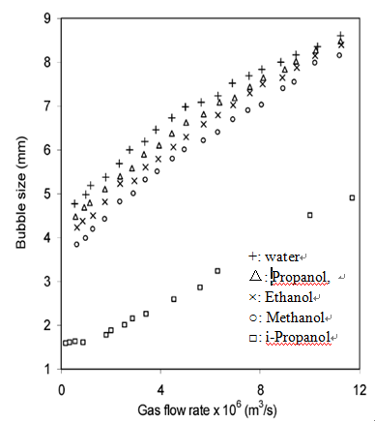

Figure 2.5 : The effect of 5 liquid surface tensions on bubble size. (Kullkarni & Joshi, 2005)

2.1.3.3 Wettability of the Surface of the Aerator
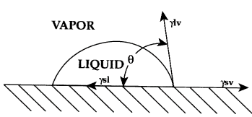
Figure 2.6: The force acting on a drop of water on a lower energy surface

Previous published experimental studies showed that free energy at the surface of the aerator is the primary determinant of bubble diameter. The free energy at the surface is a direct result of intermolecular forces and the strength of these intermolecular forces depends on the chemical structures. Molecules are equally bonded to each other in the bulk of a homogeneous material. However, the unequal forces at the boundary between phases are created when molecules are interfaces with molecules with different force of attraction. This condition is known as surface tension or surface free energy.
The wetting characteristic of the aerator is very important for bubble formation. The wetting of the surface depends primarily on the surface energy of the solid and liquid. In general, the surface energy of the liquid has to be lower or at least equal to the critical surface energy of the solid surface to assure the solid surface is completely wetted. The Young’s equation listed below expressed the equilibrium between the solid, liquid and vapour phase interface:

$γ^{sv}=γ^{sl}+γ^{lv}cosθ$ (Eqn 2. 8)

Where, ϒ^{sv} is solid surface free energy, ϒ^{sl} is the solid /liquid interfacial free energy, ϒ^{lv} is the liquid surface free energy and ϴ is the contact angle. The contact angle is the primary data that indicated the degree of wetting of the solid by the liquid, see Table2.1.

Contact angle | Degree of wetting | Strength of solid/liquid interactions
θ = 0 | Perfect wetting | strong
0 < θ < 90° | high wettability | strong
0 < θ < 90° | high wettability | weak
90° ≤ θ < 180° | low wettability | weak
θ = 180° | Perfectly non-wetting | weak
Table 2.1: The relation between the contact angle and degree of wetting of the solid by the liquid.

By referring to Table 2.1, wetting is complete when the contact angle is zero and the liquid is over a large surface. However, when the contact angle increases up to 180 degree for the partial wettability or perfectly non wetting means that the wetting the surface is unfavourable. A compact liquid droplet is formed only contacting the solid at only one point. For an aqueous system, high surface energy materials are known as hydrophilic (wettable surface) and low surface energy materials are known as hydrophobic (non wettable surface).

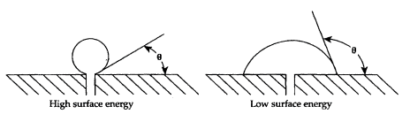
Figure 2.7: Single pore low-surface-energy aerator (Left) and single pore high-surface-energy aerator (Right).

During the bubble formation, some of the bubbles detached from the aerator surface at small size while some of them continue to grow to a larger size before being released from the aerator surface. Figure 2.7 illustrated that the bubble formation at two different surface energy aerators for single orifice. At the small contact angle condition, the gas is displaced by the water from the high-energy aerator surface pore in order to minimize the restraint force between the bubble and the aerator surface. Therefore, only a small amount of buoyant force is adequate for the bubble to detach from the aerator surface. At the large contact angle condition, the water is pushed away by the gas. Therefore, the bubble must grow larger before the buoyant force is adequate to overcome the restraint force of the larger area in order to detach from the aerator. For a multi pores aerator, the membrane contact area of the bubble is able to expand to two or more pores due to the low wetting surface, see Figure 2.8. This cause the bubble to grow to a larger size as high amount of gas will be delivered by several pores concurrently.
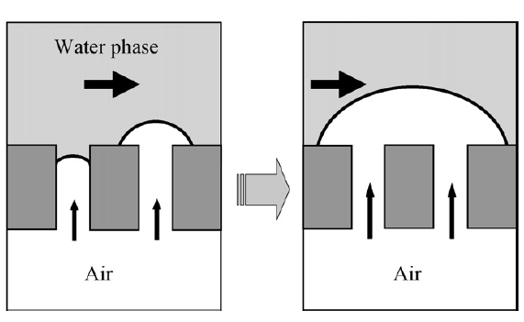

Figure 2.8: Multipore low-surface-energy aerator.

2.1.3.4 Liquid Density
Liquid density is one of the important factors that affect bubble size. A bubble has to detach early from the aerator to achieve spherical shape in order to achieve stability. In general, the static pressure head above the bubble is equivalent to the pressure energy during the formation of a bubble. As the liquid density increases, it will cause the static head above bubble increases and consequently decreases in bubble volume during bubble formation process. As a result, bubble size decreases as the liquid density increases. Khurana & Kumar (1969) found the same results at the condition where low flow rate and low viscosity. In addition, the second findings obtained that, bubble size is independent of liquid density at the condition of large flow rate and large viscosity with a small orifice diameter.

2.1.3.5 Gas Density
There are two methods to vary the gas density either increases the gas pressure or apply higher molecular weight gas. The gas density increases with the decreases of the density difference between the gas and liquid phase which consequently causes the reduction in bubble size and buoyancy force of the bubble (Kulkarni & Joshi 2005). Some researcher has discovered that high gas density generates smaller bubbles due to the dominant surface tension force and also delays the bubble detachment process. Nevertheless, this can be observed in the scenario of the large orifice diameter. In contrast, bubble diameter seems to be independent of gas density for small diameter orifice as the effect of the drag force is more significant compared to the surface tension. (Idogawa, 1987; Wilkinson, 1991).

2.1.3.6 Pores Sizes
Orifice size is one of the factors that involves in effecting the bubble size but it is not a simple relationship as other characteristics are involved in determining bubble size. Tsuge & Hibino et al (1983) reported the volume of bubble increases with the flow rate for large orifice while bubble size seems to be independent of very small orifice. Kulkarni & Joshi (2005) provided an opposite view on the effect of the orifice diameter on bubble size in water. Figure 2.9 below also illustrates the bubble size is affected by flow rate significantly and higher flow rate at the small orifice generates smaller bubble size while the effect of the flow rate on the bubble size seems to be weaker for larger orifice. In additon, Figure 2.9 also illustrated that the bubble size seems to be affected by the pore sizes of the orifice as the diameter of the bubble increases with the orifice diameter.

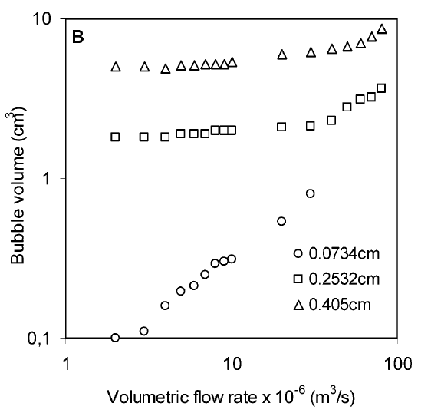
Figure 2.9 : The effect of orifice diameter on bubble size in water. (Kullkarni & Joshi, 2005)

2.2 Microbubble Applications
This section details some of the applications of microbubbles and the scientific literature relating to those applications:

2.2 1 Water Treatment and Waste Water Treatment
In the water treatment and waste water treatment, the application of microbubbles is divided into two categories which are air flotation and oxygen supply.

2.2.1.1 Air Flotation
Flotation is a separation process where air bubbles are generated to attach and partial hydrophobic solid particles to be separated and produces the buoyant aggregates. The bubbles drag the particles to be separated as they rise to the surface of the flotation device, where following bubbles bursts at the surface and so the particles can be recovered (Dai et al. 2000). The main purpose in developing the flotation process is to solve the problems with non-bubble based separation techniques. Basically, it is a rate enhancing approach over sedimentation and has been widely explored in various industries.

When first deployed, flotation separation technique was implemented in the mineral processing process and classification of the ore constituents (Kitchener, 1984). In 2001, flotation separation technique started to be applied in water and waste water treatment for water clarification (Kiuru, 2001; Schofield, 2001). Small bubbles (20-100 μm) are required for the flotation process for the portable water treatment due to the suspended or dispersed oil or particles that colloidal in nature.

Bubble size plays an important role in improving the flotation separation process. The efficiency of the bubble-particle interaction in the liquid can be improved by decreasing the size of the bubble. This will prevent the bubbles passing through the surrounding liquid without dragging the particles out of the liquid. Smaller bubble has higher surface to volume ratio which is very beneficial in attaining optimum interaction and attachment between the bubbles and particles in the aqueous solution for an efficient capture before reaching the liquid surface (Derjaguin & Dukhin 1993). With the reduction of the bubble diameter from 700 μm to 70 μm, approximately a 100-fold improvement can be observed in the performance of fine particles separation (Ahmed & Jameson 1985). In addition, small bubbles are more suitable to deal with fragile flocs instead of large bubbles as small bubbles have gentle convective force due to its low-rise velocity (Schulze 1992).

2.2.1.2 Oxygen Dosing
There are several of serious ecological problems that occur in lakes and waterways such as nutrient enrichment, elevated concentration of nitrogen and phosphorous. This results in the uncontrolled growth of algae or water based plants and leads to the excessive nutrient in the water which reduces the dissolved oxygen concentration and can even create oxygen “dead zones” in deep water. Some researcher did field experiments by supplying O₂ using microbubbles to the deep part of the water and showed that supplying pure oxygen microbubbles increase rapidly the dissolved oxygen concentration of the lower layer in a dam lake (Morimoto et al.1996; Onari et al. 1999; Mastuo et al. 2005). A little increase of turbidity also occurred in the lower part, but it did not affect the turbidity (Turbidity is a key test of water quality and haziness which is generated by large quantity of individual particles that could not be seen with bare eye) in the middle and surface layers. Yamada and Minagawa (2005) did a pilot experiment and found that the oxygen concentration increased as the bubble size reduced.

2.2.2 Algae Growth & Harvesting
A field experiment was conducted at steel plant to investigate the possibility of microalgae to grow with the exhaust gases from steel plant, see Figure 2.10. The combustion off-gases from steel processing generated a high CO₂ content exhaust gas (Zimmerman et al. 2011). The rapid mass transfer from high CO₂ gas microbubble mediated and efficient mixing induced by airlift loop caused the liquid phase saturated easily. In general, high dissolved CO₂ levels are not really helping in increasing the growth of algal biomass. From the field experiments, it was successfully shown that there was a steady growth of algal with 100% of survival rate. Ying et al. (2013) studied the effect of the microbubbles on the growth of the microalgae and he proved that the application of microbubble improved the higher chlorophyll content by approximately 6 - 8 times higher and and there was a 20% - 40% increase in specific growth rate. The bubble diameter applied is approximately 500 µm.

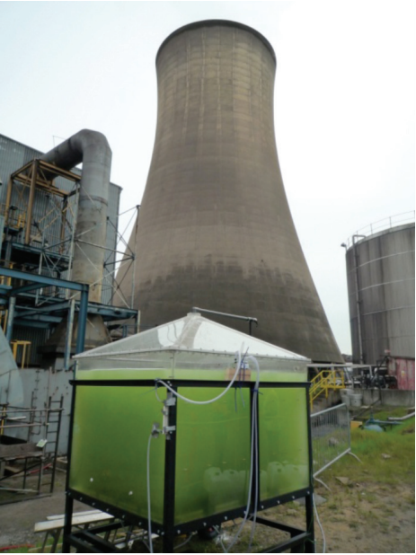
Figure 2.10: Photograph of the field experiment at steel plant (Zimmerman et al. 2011)

Hanotu et al. (2012) conducted experiments in algae separation by using microflotation technique and reported that microbubbles recovered the algal biomass from growth solution effectively, see Figure 2.11.

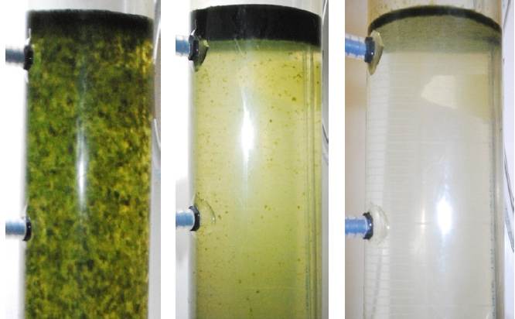
Figure 2.11: Photograph of the flotation unit showing the algae separation at three different key stages. (Hanotu et al. 2012)

2.2.3 Aquaculture- Fish and Shellfish Culture
The application of microbubbles on fish and shellfish culture in recent years draw much interest especially in Japan (Ohanari, 1999 and 2002; Takahashi, 2004). On July 22, 1999, Yomiuri Shinbun reported that field experiments of the application of microbubble in the oyster bed in Hiroshima were conducted. It was shown that the application of microbubble improved both the cultured oyster’s growth rate and the size of the oysters. Ohnari (2002) studies proved that the microbubble injection increases the dissolved oxygen concentration in the water and that this improvement was the primary reason in the growth promotion. In addition, the mean blood flux in the heart of shellfish increases by 2.0-2.5 times with microbubble supply. By supplying the oysters with only 15 minutes of air microbubble the coliform bacteria count in the body of oysters was decreased below the standard for raw eating. This is very efficient when compared to the old method that the oyster must be disinfected by ozone , chloride or ultra violet for 48 hours in order to achieve the standard.

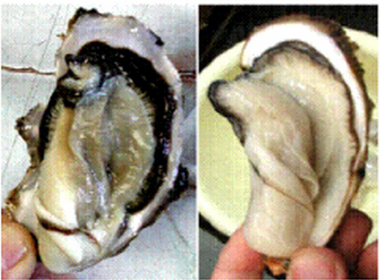
Figure 2.12: Sterilization of oyster using ozone nanobubbles

2.3 Techniques of Microbubble Generation
Nowadays, methods used to generate the microbubbles are dependent on the treatment application. In recent years, researchers from all around the world had made very great efforts to develop a minimal power required for the microbubble generator and these methods can be classed into three categories.

2.3.1 Liquid Flow Microbubble Generator
Microbubble is generated by using the flowing liquid and several important examples have been briefly discussed below.

2.3.1.1 Spherical Body in a Flowing Tube
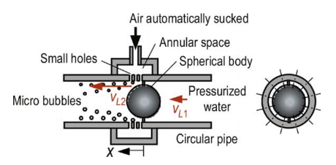
Figure 2.13: Schematic of Sadatomi microbubble generator. (Sadatomi et al. 2005)

Sadatomi et al. (2012) introduced a microbubble generator that pumps pressurized water in a pipe whilst locating a spherical object in the core regions see Figure 2.13. The liquid velocity is accelerated by the spherical object and to reduce the pressure inside the pipe. The gas is aspirated automatically due to the pressure reduction and generated microbubbles.

2.3.1.2 Rotary liquid flow type
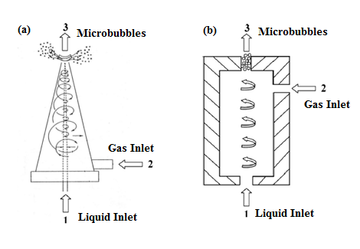
Figure 2.14: (a) Tatsumi’s microbubble generator (b) Ohnari’s microbubble generator.

A typical rotating flow type microbubble generator invented by Tatsumi (2004) is shown in Figure 2.14 above. The basic working principle for this method is to generate rotary liquid flow by pumping the pressurized water into the conic shape in the generator. A vortex is generated as the water circulates along the inner wall of the generator and causes the reduction of pressure in its central axial part. The low pressure creates the automatic suction of gas into the central axis part. The gas is sheared into microbubbles when the air is extracted out of the aerator by the liquid with a very high rotating velocity. Ohnari (2006) invented a new type of rotating flow microbubble generator which is more effective compared to the typical type, see Figure 2.14(a). The main difference between the typical and the new rotary flow microbubble generator is the position of the gas inlet. The gas induction point for the new microbubble generator is located near to the outlet instead of water input point; resulting in the gas being sheared into microbubbles by the high rotating flow and then the input flows in the generator before extracting it out from the generator.

2.3.1.3 Venturi type
Fujiwara (2006) generated microbubble with approximately 100 µm bubble diameter by using venturi system microbubble generator. The basic working principle for this method, microbubble is generated by supplying the gas and liquid simultaneously into the venturi tube. Figure 2.15 illustrated the schematic of venture type microbubble generator. The pressurized liquid is supplied through the inlet section to the tabular part. The liquid is accelerated at the throat of the venturi system and causes the pressure at this section to decrease. Thus, the gas is being sucked into the venture system. Microbubbles with the diameter of approximately 100 µm are generated when the pressure at the downstream of the venture tube.
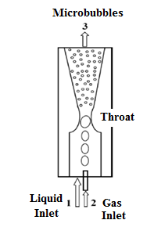
Figure 2.15: Venturi type microbubble generator (Parmar & Majumder, 2013)

2.3.2 Gas Flow Microbubble Generator
In this category, microbubble is generated by supplying gas. Several of the important examples under this category have been briefly discussed below.

2.3.2.1 Porous Membrane Type
The porous membrane type microbubble generator was used by Kukizaki & Goto (2006), it generates the micro-nano bubbles through a uniform pores Shirasu porous-glass membranes (SPG), where the system consist of dispersed gas phase and continuous water phases containing surfactant. The gas supplied through the SPG membranes in the flowing surfactant contained water, where the mean bubble diameter obtained from this method is approximately 720 nm. The main advantage of this method is that the pore size of the membrane can be varied to achieve the desired size of bubble.

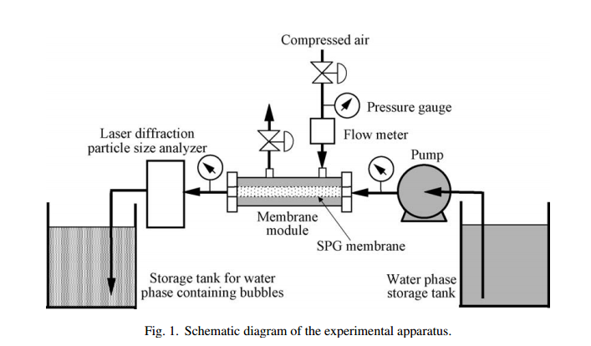
Figure 2.16: Schematic diagram for the porous membrane type microbubble generator.

2.3.2.2 Porous Mullet Ceramics Technique
The porous mullet ceramics with unidirectional oriented pores were used by Okada et al. to generate microbubbles. The porous mullet ceramic is produced by using an extrusion method using rayon fibers as the pore formers. The specifications of the porous mullet ceramics are 1200 mm in length same for the thick or thin types, 20-30 mm and 30-50 mm for the inner and outer diameter respectively. The porosities for the thick and thin porous ceramic is 47% and 49% and average pore radii of 7.8 µm. The average radius of the nitrogen microbubble generated in the water is in the range of 70-105 microns. This system required at least 20 kPa to generate microbubbles (Okada et al. 2010).

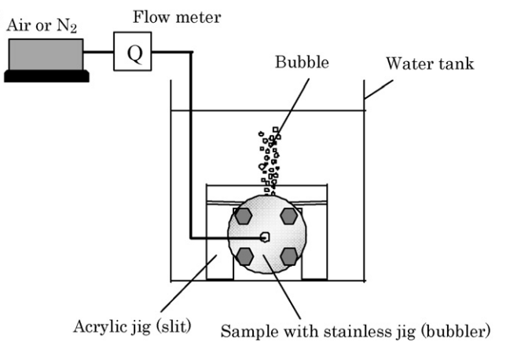
Figure 2.17: Schematic illustration of experimental set up: (a) bubbler and (b) set up.

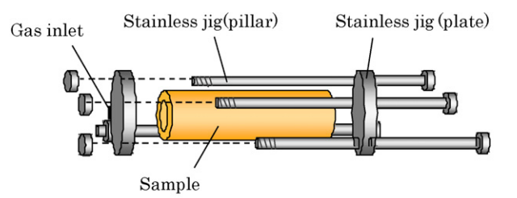
Figure 2.18: Schematic of the bubbler.

2.3.3 Low Power Generation Techniques
These techniques use less power to generate microbubbles than traditional methods and some of these methods are discussed below.

2.3.3.1 Microchannel Technique
Silicon microchannels is used in this method to generate monodispersed microbubble. Figure 2.19 illustrated the microchannel technique that used by Yasuno et al (2004) to generate monodispersed microbubbles. The average microbubble size generated with this method is ranged from 33.6 to 51.1 µm. Photolithography and orientation-dependent etchings are used to fabricate the microchannel plate. The specification of the microchannel plate was 15 mm × 15 mm in dimension, 1 mm diameter hole at the centre and four terrace lines are fabricated on the microchannel plate with the dimension of 100 µm and 10 nm for the height and length respectively. The liquid is supplied and filled the microchannel module continuously and then dispersed gas phase flow through microchannel. Monodispersed microbubbles were formed from the microchannel (Yasuno et al. 2004).

.
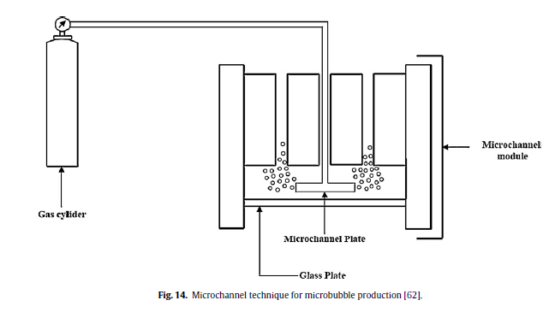

Figure 2.19: Microchannel technique for microbubble production. (Parmar & Majumder, 2013)

2.3.3.2 Low Power Microfludic Microbubble Generation
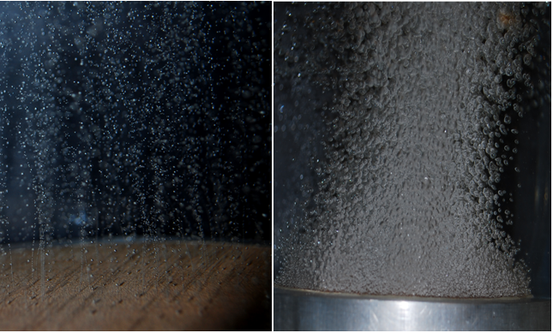
Figure 2. 20: Left: Photograph of microbubbles generated by using fluidic oscillator. Right: Photograph of microbubbles generated without fluidic oscillator from the same ceramic diffuser. (Zimmerman et al. 2009)
Microbubbles can be generated by directly supply gas through a microporous aerator. Nevertheless, this method is not that effective and the diameter of the microbubbles generated is few times larger compared with the pores diameter of the aerator. A novel innovative microbubble generator has invented by Zimmerman et al. (2009) based on the idea that oscillation pulse that generated from the fluidic oscillator is to limit the bubble growth period by controlling the amount of gas supply during bubble formation. The amount of gas entering the bubble per pulse is adequate to create a bubble then force the bubble to pinch off may occur during every pulse. This prevents any delayed of the bubble detachment process and causes the larger sized bubble. The comparison of microbubble generation by normal aerator and by oscillator along with the same aerator, see Figure 2.20.

2.3.4 Summary Microbubble Generation Method
After reviewing the bubble generation methods, it can be concluded that microbubble generation with a flowing liquid is mostly suitable for the water and waste water treatment as very small bubbles are generated due to the high shear stress flow. However, the high shear stresses flow is not suitable for the biological systems as it may cause damage to the cell; particularly with animal cell culture. Nevertheless, the low power generation methods and those without accompanying liquid flow are suitable for the cell sensitive biological culture and harvesting as well as the reasonable bubble size generated work well in the mixing process in the bioreactors. Therefore, it is important and essential to choose a suitable generation method depending on the treatment application.
As mentioned previously, microbubble size is the essential key in controlling the performance in all the application. Hence, the bubble size generated from different microbubble generation method should be studied in order to choose a suitable bubble generation method for the desired bubble required to improve the efficiency of the application.

2.4 Bubble Size Measurement Techniques

2.4.1 Introduction
This section mainly illustrates the ‘pros and cons’ of the two bubble size measurement methods. The two methods are discussed in this chapter which are optical (photography method) and photonic method (Spraytec). This chapter illustrates the working principle, using procedure, specifications and the analysis methods of all the bubble size measurement methods.

2.4.2 Optical Methods –Photography Technique

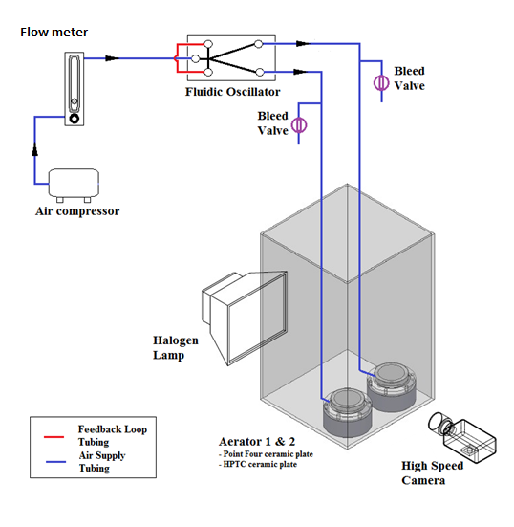
Figure 2.21: Schematic diagram of the optical method experimental setup

2.4.2.1 Specification and Working Principle
The apparatus for the image analysis system includes a camera (FastCam SA3 Model120K) and a 40 Watt halogen light with light source diffuser sheet (Caddilac). The camera resolution used was 1024 X 1024 pixels at 2000 fps and provided with a macro lens (Nikon Nikkor Lens, 1.8 D). The calibration scale factor measured 25.0 pixel /mm. Photography method commonly consists of a monochromatic light source, an object and a high-speed camera or a CCD camera with a sufficient high frame speed per seconds. The bubble generator is placed in the centre with the light source and the camera placed opposite to each other in order to obtain the best contrast for the bubbles. The camera was located parallel to the focal plane (Object plane) in order to minimize optical distortion, see Figure 2.21. The main working principle for the photography method is taking the bubble images at single plane or in a small space and extrapolations have to be made.

2.4.2.2 Calibration Method
Calibration is an important and essential step in the experiment to ensure that the images taken are focussed correctly and the scale factor necessary for processing of the images is obtained. The calibration method applied during this experiment is used of a calibration target (scale ruler). The scale factor is obtained by comparing the apparent distance between any two lines of the ruler provided by the perspective of the high-speed camera with the actual distance. (The details of the calibration method will be given later in chapter 3)

2.4.2.3 Bubble Sizing Analysis
Automated and manually method can be applied by using any suitable programming language viz. Octave, Matlab, Mathematica & LabView and the procedure processing the bubble sizing analysis are identical. In this project, Image J macro programme was used to make the analysis automated. The procedure mainly includes splitting the channel of the colour images, sharpen the images, threshold the bubble from the background and particles detection function to detect the bubbles. After few image processing steps, the bubble area data is obtained and saved in to data file, please refer to Chapter 3.2.1 for the details of the image processing and bubble sizing analysis.

2.4.2.4 Advantages and Disadvantages

The high-speed camera photography method requires humble skills, expertise and short time to setup. In addition, the equipment is light in weight and does not require a large working space.

It is as simple as taking pictures and the bubble sizing application only requires moderate level of camera specifications having 200 fps. The simplicity of the system is one of the advantages as it results in cost reduction. In addition, this method is applicable to all bubble diameters by changing the lens of the camera.

However, there are some limitations of this method as well. Automated image analysis cannot be reliably used for overlapping bubbles as well as non-circular bubbles and when the bubbles are present next to the wall. Although this problem can be solved by using a function such as “watershed” function in image-j but there is still an unavoidable minor error.

In addition, it is difficult to capture a decent quality images of the high bubble cloud density. This can be improved by reducing the bubble cloud density with a DIY bubble flow guide that able to guide the bubble cloud to flow in a single plane without affecting the bubble size. The bubbles also need to be in a single plane, in focus and non-overlapping. Depending on the angle used, the bubble size obtained would be significantly different. A long working length lens could be used, which in turn, makes the process expensive and cumbersome.

Furthermore, the camera is attached on a tripod which may appear satisfactory but the position of the camera can be easily misaligned. Therefore, this method requires a special bench design to fix the equipment positions. In addition, the calibration for the high speed camera methods has to be done manually.

2.4.3 Photonic Methods – Spraytec
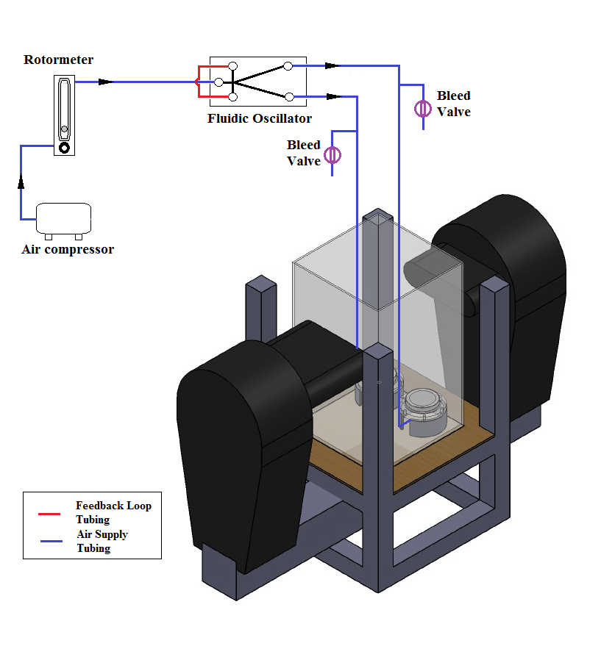
Figure 2.22: Schematic diagram of the photonic method experimental setup.

2.4.3.1 Specification and Working Principle
The Spraytec instrument measures the size of droplets (or particles) in an air spray or bubbles in water. Specifically, it measures the distribution of different sizes within a two-phase mixture.
The mixture is to be delivered between the two functional modules of the instrument, the transmitter and receiver. The transmitter uses a He-Ne laser to produce a laser beam that passes through the measurement zone. Detecting optics in the Receiver module detect the light diffraction pattern, converting the light detected into electrical signals. The signals are processed by analogue and digital electronics boards, and passed to the analysis software. To calculate the spray size distribution, the light diffraction pattern is analysed using a scattering model. The software displays the results in several forms, including histograms, result-under plot and result-over plot, etc. Saved data is exported as required for use and further analysis elsewhere.

Fundamental:
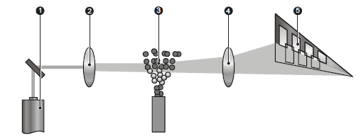
Figure 2. 23: Fundamentals of Spraytec measurement

- Light from the laser 1 is scattered by the bubbles 3.
- The laser beam is expanded by the collimating optics 2 to provide a wide parallel beam.
- The scattered light is focused by a focusing lens 4 in a Fourier arrangement and picked up by the detector array 5.
- Unscattered light passes through the pinhole at the centre of the detector array and they are detected by the beam power detector.

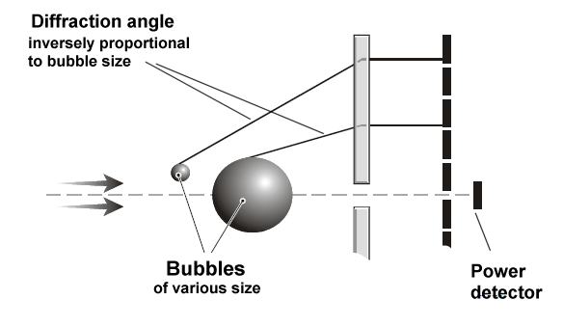

Figure 2. 24 : Measuring the angle of diffraction determines the size of the particle.

The detector array is made up of over 30 individual detectors, each of which collects the light scattered by a particular range of angles. There is a data channel for each of these individual detectors. Diffraction is influenced by optical properties of the water and gas in the bubbles. The user has to input into the instrument the data on refractive index and density. In cases where the particle concentration is high, the measurement process is complicated by scattered light being re-scattered by other particles before it reaches the detector. The Spraytec software can apply a patented multiple scattering algorithm to correct for this effect. Spraytec software generated histogram spectra of the bubble sizes. Figure 2.25 below is the example of the spectrum.

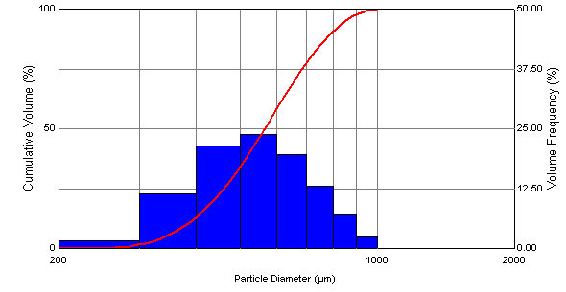
Figure 2.25: Histogram spectra for the bubble size (Screenshot from Spraytec)

2.4.3.2 System Alignment
The calibration of the Spraytec system is to check the alignment between the electrical and optical backgrounds measurements and the calibration is performed automatically by the instruments itself at the beginning of each measurements. The two background components are measured as follows:

- Electronic background (noise)
The electronic background measurement is also known as the Dark background measurement. The Sprayte software switches the laser beam off automatically to make this measurement. Therefore, there is no transmission reading and there should also be minimal light diffraction as no light should be able to enter the sealed unit

- Optical background
The optical background measurement is also known as the light background measurement. The laser beam is switched on by the Spraytec software to make the measurement. The purpose of this measurement is to check the cleanliness of the optics and the dispersing environment around the instrument. This measure the laser power, the scattering caused by contamination on the optics, daylight or artificial illumination, and flare caused by the optical surfaces.

The laser intensity of non-scattered light is measured during the measurement and is displayed in percentage value. Typically, on a clean instrument the value of the laser intensity should be between 70% and 95%. The instrument optics need to be clean, if the laser intensity is low (around 60%). The laser may be failing, in the case where the laser intensity is still low (60 % or below) after the optics have been cleaned.

2.4.3.3 Bubble Sizing Analysis
There are most two important moment means were used in Spraytec which are surface area moment D [3,2] and Volume moment mean which also known as Sauter mean diameter and De brouckere Mean Diameter. Sauter mean diameter is an average diameter of a sphere that has the same volume/surface area ratio as the entire particles whereas the volume moment mean diameter is the mean diameter of a volume or mass distribution.

The choice of the technique is based on the application and what is the properties that we look for. These means are analogue to moments of inertia and introduce another linear term in diameter. (i.e. surface area has a d³ dependence and volume or mass a d⁴ dependence as below:)

$D\left[4,3\right]=\frac{∑d^{4}}{∑d^{3}}$ (Eqn 2. 9)

$D\left[3,2\right]=\frac{∑d^{3}}{∑d^{2}}$ (Eqn 2. 10)

2.4.3.4 Advantages and Disadvantages
The main advantage of Spraytec is that is has a self-correcting calibration system for alignment. In general, alignment is the most important initial procedure before the measurement begins. It will cause plenty of major errors and inconsistencies if this step is not performed accurately. Therefore, there is an auto alignment feature embedded in its protocol.

It is easy to setup the device as it comes with a rail which allow the transmitter and receiver to be attached on the rail and fixed at a desire positions. This will ensure the system is taking the measurement at a relatively consistent position.

Spraytec is very user friendly as it does not require extra special training required to use the device and laser training due to the well design rail which is safe to be used. The Spraytech is very efficient and the software provided can be easily operated, in addition to its ability to process the measurement taken in a very short period of time. The result formats as the user requirements can be defined easily at the beginning of the measurement in the measurement wizards. There is no post processing required for the results obtained as the software is able to average the results, provide the data in size distribution form and export selected data as user’s requirement etc. Furthermore, Spraytec has feature that able to capture the spray dynamics of the system and how the size changes with time. The duration of the time can be defined as user required.

However, there are several disadvantages on this method as well. High density bubble cloud sizing might be a difficult phenomenon for laser diffraction techniques since the bubbles would be diffracting far more than a particle and there is a possibility of total internal reflection in a bubble. Since this principle depends on light diffraction and not a property exhibited specifically by bubbles alone, it cannot differentiate between a bubble and a particle. Finally, the equipment quite heavy and required a large lab bench.

2.4.4 Summarized Method Usage
 | Photography Method | Spraytec Method
Skill level required | Low | Low
User friendly | Medium | Medium
Calibration | Manual | Automatic
Area of interest | Large and adjustable with different camera lens. | Fix laser beam size (10mm)
Work space required | Small | Huge
Working Bench | Not provided | Came with the equipment and very stable but heavy
Data processing program | Third party software such as “labview” and “Image J” | Spraytech software with the function of the data acquisition, average etc.
Post Processing | - Required an image processing software and programme code.  - Process manually with Image processing software and programme.  - Raw image or data can be review. | - Can be easily done by using the equipment software, easy to be operated.  - Rapid results and process automatically by the software.  - No raw data available to review.
Sampling chamber | Yes, transparent | Yes, transparent
Bubble Cloud | Can be solved with the image processing software. | Not suitable for very high density bubbles measurement.
Table 2.2: Comparison table for the photography and Spraytec method

Summary of the photography method and Spraytec method are listed in the Table 2.2. The bubble sizing measurement method mainly depends on the uses, availability, expertise and the application, different methods can be used to obtain the bubble size distribution and upon significant inference, accurate bubble size distributions can be obtained. The author has limited access to the Spraytec device because the device was borrowed from the EPSRC. Therefore, the author has chosen to use the photography method instead of Spraytec for all bubble sizing experiments in this thesis, in order to maintain a constant measurement method for the study in this thesis.

2.5 Particles Image Velocimetry (PIV) and Particles Tracking Velocimetry (PTV)

2.5.1 Overview of PIV and PTV techniques
PTV and PIV are both non-intrusive optical measurement method which both techniques have a common methodological principle, where the seeding particles are injected in the liquid and move with the local flow velocity. The seeding particles are illuminated by a light sheet and the position of the illuminated seeding particle that is suspended in the fluid are captured and recorded, at two successive instants images of the seeding particles.

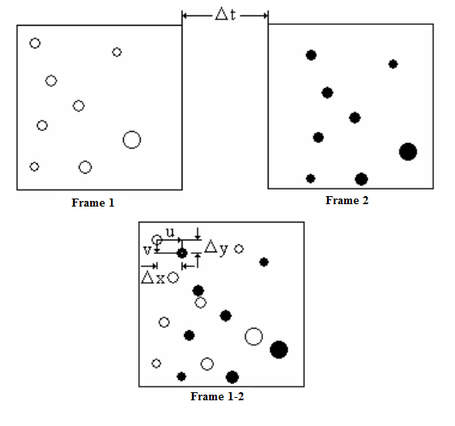
Figure 2. 26: Graphic representation of the velocity of tracer particles.

The time interval between the captured images provides a displacement record of the particles within the measurement plane, which is then analysed and scaled to velocity. The velocity information produced in this way shows the instantaneous velocity distribution, as the pulse separation and camera exposure time are smaller than the smallest time scale of interest in the flow. Basically, the velocity is measured by evaluating the displacement (∆x and ∆y) of the seeding particles in two consecutive frames, which caused a time difference of ∆t and it can be represented mathematically in Eqn 2.11 and Eqn 2.12, it is also shown graphically Figure 2.26 (Refer Chapter 3 for details)

$u=\frac{∆x}{∆t}$ (Eqn 2.11)
$v=\frac{∆y}{∆t}$ (Eqn 2.12)

The main difference between PIV and PTV is the method that is used to evaluate the captured image pairs. PIV determines the velocity field in an Eulerian frame of reference whereas PTV determines it in a Lagrangian.

PIV evaluates the image pairs by subdividing all images into interrogation areas and evaluates them individually. The seeding particles within one interrogation area are assumed to have moved relatively homogeneous between the pair of frame. The cross correlation is applied to determine the displacement of the particles in the interrogation area in the first frame with the 2D shifting of the interrogation area in the second frame that in the same position. Therefore, it is easier to filter errors and post process using the PIV measurement as one vector is provided for each interrogation area.

There are couple of condition to be fulfilled in order to use PIV measurement such as the range of the particles displacement must be smaller than the interrogation areas to obtain meaningful correlation factors. In addition, several particles should be included in interrogation areas to ensure real neighbourhood correlations.

In contrast, each individual particle is detected separately and traced in the second frame. By referring to the information of the neighbourhood, the displacement of each individual particle is effectively identified. This means PTV provides a displacement vector for each particle, which is efficient in terms of processing time at lower particle numbers.

The false vector in the vectors that are obtained by PTV is difficult to eliminate as the vectors are not regularly located. Furthermore, in the case of PTV, the seeding particles do not have to move or distribute homogeneously and the range of displacements is limited by the degree of the deformation of the flow field rather than the size of the interrogation areas. This is because neighbourhoods may not be identical as at relatively large deformations which prohibits the correlation.

The algorithm details of both PIV and PTV will be given later in chapter 3.

2.5.2 Development of PIV for Bubbly flow
The major challenge of the two phases flow PIV is to separate the gas phase and liquid phase from the captured image and the literature showed that there are number of different discrimination methods that can be developed and applied. Over the past 15 years, there have been significant developments in the two-phase flow PIV technique and a brief review is given below. The schematic of the 6 different PIV experimental setups for bubbly flow are illustrated in Figure 2.27.

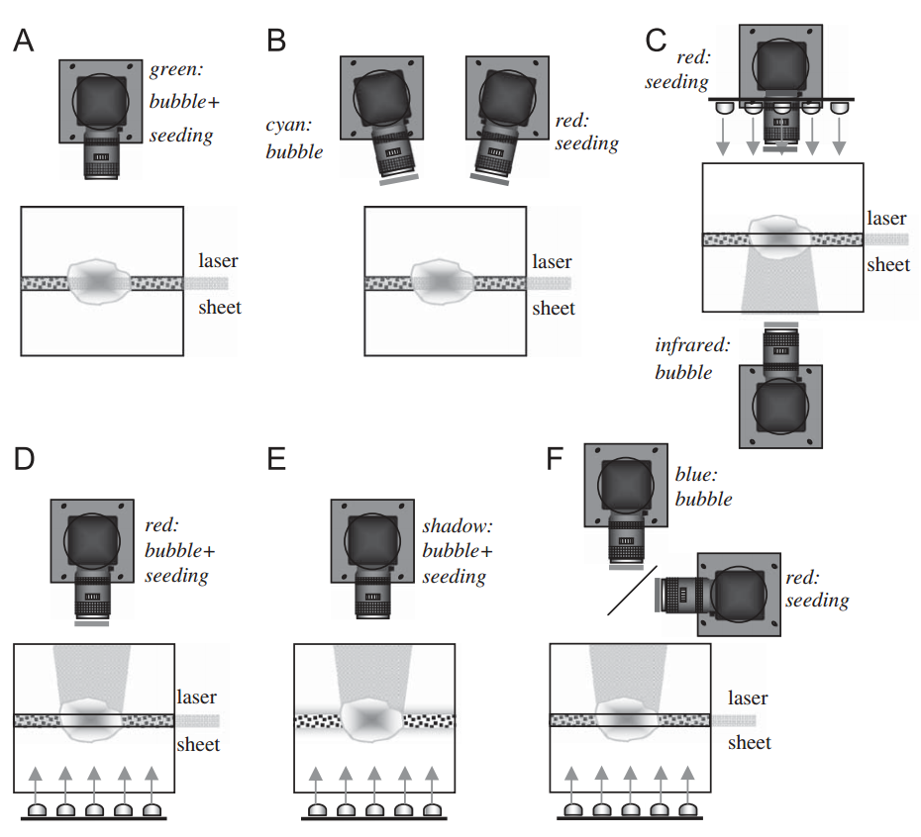
Figure 2.27: Schematic of 6 different PIV experimental setups for bubbly flow (Sathe et al. 2010).

2.5.2.1 Single Camera Method (A)
Delnoij et al. (2000) proposed to implement ensemble correlation algorithm in the image processing technique to separate the gas and liquid phase from the captured images. This method depends on the velocities difference between the bubbles and surrounding liquid flow in relation to the slip velocity between gas and liquid phases. Consequently, approximately 10-15 images were ensemble together to obtain the two correlation peaks for both phases. There are two main disadvantages of this method which is not suitable to be used in the study of time average flow fields and very small bubbles as significant difference in velocities between the bubbles and surrounding liquid is required for this method.

2.5.2.2 Two Cameras with Filters Method (B)
Bröder & Sommerfeld (2002) succeeded in measuring the bubble swarm and liquid velocity simultaneously at a relatively high void fraction condition. Two cameras with appropriate filters and the fluorescent seeding particles are used in this method in order to achieve the phase separation. In order to achieve maximum difference in the reflected and fluorescent light intensity, two cameras were kept at a particular angle with respect to the laser sheet. The fluorescent seeding particles and camera fitted with an optical filter were used to minimize the flaring that caused by the laser light reflection. The wavelength of the fluorescent light emitted from the fluorescent seeding particles is approximately 555 nm- 585 nm which is higher compared to the wavelength of the bubbles reflection light (532 nm) corresponding to the illuminating laser. The higher wavelength fluorescent light is captured using a camera fitted with an orange filter while the green light laser is captured by using another camera fitted with a green filter. In order to attain an accurate bubble velocity measurement, the shape of the bubble has to be spherical or no more than slightly ellipsoidal with smooth interface, which generates a unique reflection spot per bubble. In addition, the sizes of the bubble have to be smaller than the size of interrogation area and the reported bubble diameters are 0.5 mm and 1.8 mm.

2.5.2.3 Two Cameras Looking from Opposite Side Methods (C)
The combination of the PIV with fluorescent seeding particles and shadow graph method (IST) measurements on a single bubble by locating the two cameras opposite side and facing each other (Tokuhiro et al. 1998). IST is used to measure the bubble shape and motion while the PIV with the fluorescent seeding particles method is used to measure the liquid velocity. Figure 2.27(c) depicts the arrangement consisting of two CCD cameras; the rear camera with the colour filter for the PIV and the front camera for IST. The shadow image of the bubble is generated by the infrared LEDs outlining a square and located behind the bubble. The dark part around the backlight is projected from the refraction of the strong curvature of the bubbles and therefore a shadow is captured by the CCD camera. The bubble velocity can be determined easily due to the decent quality captured images with the sharp shadow boundary. In relation to the bubbles in focal plane, this can be determined by referring to the intensity’s gradient at the edge of bubbles. In addition, the control of the intensity of the backlight and the position for the two cameras are essential in order to attain a reliable measurement in the experiment. The bubble shape and the surrounding liquid flow field can be captured concurrently by synchronising the triggering of the laser and the LED with the two CCD cameras. Figure 2.26 shows that the laser light sheet is illuminated from the sides of the test section.

2.5.2.4 Single camera and Shadowgraph method (D)
Lindken & Merzkirch (2002) used a single camera with filter, fluorescent seeding particles and shadowgraph method. Figure 2.27(d) illustrates the schematic diagram of the images acquisition of florescent tracer particles with the applied laser light and bubbles with shadow imaging technique (IST).

The image capturing process of the tracer particles is represented by the top section of the schematic diagram while the bottom section represented the images capturing process of the bubbles. The laser light sheet is used to illuminate the multiphase flow during the captured of the particle images. The laser light sheet is generated by using the double pulsed Nd:YAG laser with 532 nm wavelength. The florescent seeding particle was applied in this system and the wavelength of the fluorescent light emitted from the fluorescent seeding particles are approximately 555 nm- 585 nm and the peak emission wavelength of the fluorescent light is approximately 566 nm.

In addition, the shadow images of the bubble is generated by the double-pulsed high power light emitting diode (LED) with wavelength of 675 nm. The fluorescent light emitted from tracer and the bubble shadow image with the wavelength of 675 nm can be captured by using a camera fitted with the optical high pass filter with a sharp transmission edge at 570 nm±5 nm. Therefore, both seeding particles and bubble images can be captured concurrently by the single CCD camera. There is no interference between the bubbles and seeding particles as they are spatially separated in the object field and image field. Therefore, an image processing programme are required in separating the velocity information of the seeding particles and bubbles.

Figure 2.28: Schematic diagram of the images acquisition of florescent tracer particles with the applied laser light and bubbles with the shadow imaging technique (IST).

2.5.2.5 No Laser, Single Camera with Shadowgraphy Method (E)
Bröder & Sommerfeld (2003) reported a complete shadow PIV without using the laser illumination. The pulsed LED backlight is applied in combination with huge seeding particles approximately 150 µm which are detectable in shadow image. The camera lens with shallow depth of field is implemented to ensure the planer velocity measurement. In addition, image processing is required to process the bubbles and seeding particles that are not within the focal plane. Since the shadow of particles gets mixed with the shadow of the bubbles, this method is not applicable for the liquid velocity information near the bubbles. Based on the bubbles size is larger compared with the particles and therefore can be separated. However, a significant change in background intensity was found for the out of focus bubbles and interfere the edge detection of the in-focus bubbles. Therefore, this method is only applicable for the sparse dispersions of small bubbles in narrow column. This method work well for small bubbles. However, two problems appeared for the large bubbles measurement. Firstly, the interface is wavy and cause a few number of reflecting spots around the bubble surface. In addition, the refraction and reflection near the interface makes the generation of mask from transverse laser sheet illumination difficult and this cause the uncertainty about the bubble contour (Diaz and Riethmuller, 1998).

2.5.2.6 Two Cameras With ﬁlters and a Dichroic Mirror Method (F)
The technique F is a combination of the method B and C which is an improvement of the work reported by Tokuhiro et al. (1998) and by Lindken and Merzkirch (2002). A dichroic mirror is used to separate the shadow images of bubble and the fluorescent light emitted from tracer particles. In order to attain a reliable liquid velocity data, a digital mask generated from bubble shadow image is applied to the tracer particle images.

2.5.3. Seeding Particles for Bubbly Flow
The choice of the right seeding material to scatter the light from laser beams or a light sheet can be crucial to the acquisition of successful experimental data. In order to reveal the motion of the gas or liquid, seeding tracer particles are applied into the flow. Therefore, seeding tracer particles must follow the flow accurately and scattering sufficient light to be detectable by the CCD camera. The inertia of particles affects how well they respond to changes in fluid velocity and in general impose the condition that particles are small.

The selection of the seeding particles is mainly depending on the application and the properties of the seeding particles should be considered including the particle density, particle diameter, the type of laser, the width and the thickness of the light sheet that will be used with the particles.

The seeding particle for the bubbly flow measurement is to track the bubble driven liquid flow velocity. Therefore, fluorescent particles are used to discriminate between the bubble phase and liquid phase. The seeding tracer particles are chosen to have nearly neutral density (ρ ≈ 1000 kg m⁻³) for experiments in water, so that adequate tracking responses could still be expected.

Tokuhiro(1998a) applied Rhodamine-B fluorescent particles (1-10 µm) with a specific density 1.02 g/cm3 for the bubble diameter approximately 9.2 mm and he suggests that the particles should be 1000 times smaller compared to the bubble size. Bröder and Sommerfeld (2002) applied fluorescent particles with a mean diameter of 50 µm for the bubbly flow PIV measurement. The particle material was melamine resin doped with a Rodamine 6G dye, having a material density 1.05 g/cm3 and the bubble diameter in the range of 0.5- 4mm.

2.5.4 Illumination Unit
The illumination system for PIV that applied on the bubbly flow can be either continuous wave or pulsed light sources. The source can be a laser or a lamp due to the method will be used to measure the bubbly flow. In addition, the selection of the light sheet dimensions and the laser characteristics mainly depends on the choice of particle diameter, the scattered light intensity and also the experimental setup. Due to the phase discrimination for the bubbly flow, the seeding tracer particles are usually very small (less than 50 µm) which required higher power laser for light diffraction. There are quite a few common lasers that used in the bubbly flow PIV application, such as Ar ion lasers (wavelength 488 or 514.5 nm), and pulsed lasers, such as frequency-doubled Nd:YAG (wavelength 532 nm), ruby (wavelength 694 nm) and copper vapour (wavelength 511 nm) lasers, must be gated for PIV applications (Melling, 1997).

2.6 Bioreactors
This section reviews the literature relating to bioreactors. The analogies, similarities and differences of the bubble column bioreactors and airlift bioreactors are presented. In addition, the classification of the airlift bioreactor was introduced in this section as well.

2.6.1 Bubble Column Bioreactors
Helmut Gerstenberg was the first person who used bubble column bioreactor as an apparatus for the gas –liquid reaction. (Soccol, Pandey and Larroche, 2013) Generally, bubble column reactors are used to achieve mixing and mass transfer between a continuous liquid and dispersed gas phase. Figure 2.29 presents the schematic of the bubble column bioreactor. The basic construction of a bubble column bioreactor is built from a vertically arranged cylinder column filled with liquid and the introduction of gas at the bottom of the column. In the column, the gas is aerated through the various kinds of sparger. The gas rises upwards in the form of bubbles and comes in contact with the liquid (Bai 2010).

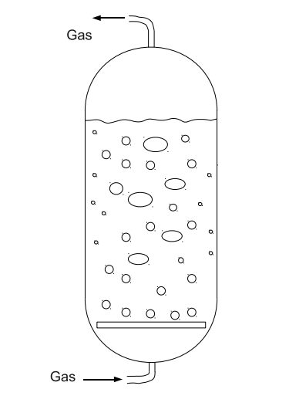
Figure 2.29: Schematic diagram of a bubble column

The formation of gas bubbles at the gas sparger is the most important process in the bubble column due to the bubble diameter being the essential factor that affects the mass transfer between the gas and liquid phases. Therefore, plenty of sparger designs have been developed presented in Figure 2.30. The traditional gas spargers are classified into two categories which are dynamic spargers and static spargers. Dynamic spargers generate very small bubbles but they create a very high shear flow in the bubble column while static spargers generate large bubbles with low shear stress flow. (BIOTOL 1992)

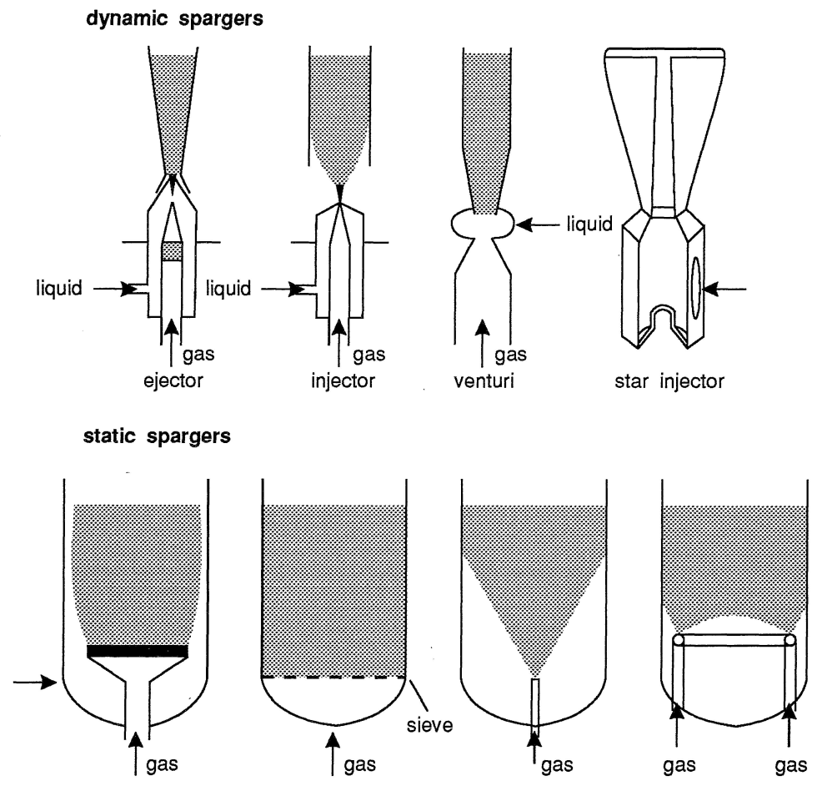
Figure 2.30: Sparger Designs
Compare to the stirred tank bioreactor, bubble columns with the static sparger are usually used for low viscous broths and to process large volume. Bubble column bioreactors with the static sparger are suitable for shear sensitive organisms due to the lack of mechanical stirring, such as easy operation, low operating and maintenance costs and compactness.

2.6.2 Airlift Bioreactors Morphology and Development
After reviewing the pros and cons of the bubble column bioreactor mentioned in the previous section, a conclusion is that bubble column bioreactors are only useful in certain applications or circumstances. To meet specific process requirements, there has been tendency to modify the bubble column. This has led to variety of bubble column like bioreactors such as airlift bioreactor. The requirement of better liquid circulation has stimulated the development of ALB with internal or external liquid and split bioreactor in Figure 2.31.

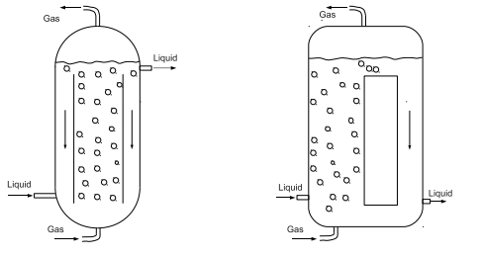
(a) (b)
Figure 2.31: (a) Schematic diagram of an internal airlift bioreactor (b) Schematic diagram of an external airlift bioreactor

2.6.3 ALB Performance and Behaviour
In recent years, the characteristics of the airlift bioreactor (ALB) have been studied and are perceived to have better performance compared to the bubble columns and stirred tank bioreactors for many applications such as shear sensitive organisms. Generally, an airlift reactor is used in the culturing of shear sensitive organisms due to the presence of the draft tube that enhances axial mixing throughout the reactor and the circulation occurs in one direction and so the bubbles travel in a more ordered direction. Therefore, ALB provides better performance in increasing mixing throughout the reactor and reduces the bubble coalescence.

Nevertheless, there are still disadvantages of using airlift reactor such as high energy requirements due to the tall design, leading to high gas hold-ups, long bubble residence times and a region of high hydrostatic pressure near the sparger at the base of the fermenter and cell damage due to bubble bursting; particularly with animal cell culture. Since hydrodynamics play an important part in the performance of ALB, they have been intensively studied to improve and optimize the performance of the airlift reactor.

2.6.3.1 Liquid Circulation and Mixing In ALB
Previously published studies have aimed at improving the ALB performance by modifying parameters such as the outer tube and draft tube diameter ratio, the distance between the upper edge of the draft tube to the dispersion surface (C_{T}) and the distance between the lower edges of the draft tube to the aerator surface (C_{B}). Sandiani (2012) studied the effects of geometrical parameters on mixing characteristics, in particular, liquid mixing time and liquid circulation velocity of an ALB. Sandiani (2012) found that the increase of the column aspect ratio (height to diameter) lead to a decrease in the liquid circulation velocity and an increase in liquid mixing time. In addition, Sandiani (2012) also found that the increase of the C_{T} and C_{B} height cause the liquid circulation velocity to be decreased.

Gouveia & Hokka (2003) studied the effect of geometrical relation on liquid velocity in a 6 litres ALB with the A_{D}/A_{R}= 0.63. (A_{D} is the down comer cross-sectional area, and A_{R}, riser cross-sectional area.) They found that increase of the C_{T} height lead to a higher liquid circulation velocity. This is because of the range of the C_{T} height that was used in the studies is insufficient to show the overall effects of the clearance height on the mixing velocity. Al-azzi & Al-kuffe (2010) studied the influence of draft tube diameter on operation behaviour of air lift loop reactors. The author found that the draft tube diameter and the reactor tube ratio have influence to the process in the ALB. Weiland (1984) recommended D_{d}/D_{c} ratios between 0.8 and 0.9 for efficient mixing (D_{d} is the draft tube diameter, and D_{c} is the column diameter). Largest liquid circulation rates were reported at diameter ratio of 0.59 (Weiland 1984), 0.6 (Miyahara et al. 1986) and approximately 0.5 (Jones 1985). Another report claimed that minimal mixing times at diameter ratio (D_{d}/D_{c}) in the range from 0.6 to 1.0 (where D_{d}=D_{c} correspond to bubble column operation) (Rousseau and Bu’lock 1980).

2.6.3.2 Gas Holdup and Gas-Liquid Mass Transfer
The effects of the spargers design on the gas holdup and gas liquid mass transfer in the ALB have been proven in some of the published studies. The bubble size generated in the ALB is the essential key in determine the gas hold up and gas-liquid mass transfer, where the sparger design is one of the main factor that controlling the bubble sizes.

Al-Mashhadani et al. (2012) studied fine bubbles and microbubble effects on the CO2 mass transfer in the ALB and the results obtained illustrated that microbubbles have better performance compared with the fine bubbles in term of gas holdup and gas liquid mass transfer. Contreras et al. (1999) studied the effect of sparger pore size on shear rate and mass transfer in the ALB using sea water as the liquid phase. Contreras et al. (1999) concluded with his findings that the smaller pore size spargers that generated smaller sized bubble produced the lowest shear rates and the higher mass transfer rate in the bubbly flow. However, the shear rates and mass transfer were not affected by the sparger pore size in the heterogeneous flow. In addition, the gas holdup correlation from several researchers showed the dependence of gas holdup on the sparger hole diameter such as Miyahara et al (1986).

2.6.4 ALB Modification and Improvement
Several different ideal of improving the conventional airlift bioreactor have been developed by changing the design instead of the dimensions.

Lu et al. (2000) modified the circular outer tube of the airlift reactor into a square and performed an investigation on the effects of the ratio of height and diameter of draft tube, and the ratio of cross sectional area of riser and down comer regions on gas hold up, liquid circulation velocity and reactor mixing time in the modified square airlift reactor. They found that the modified square airlift has better performance compared to the circular airlift reactor.

Wang et al. (2002) modified the traditional internal loop airlift bioreactor by changing the inner circular draft tube to the rectangular wire-mesh draft tube. The results came out with the new design successfully reduced up to 30 % of mixing time and the volumetric oxygen transfer coefficient and the gas holdup increased up to 50 % and 90 % respectively.

Wu & Merchuk (2003) introduce the baffle of the helical flow promoter (HFP) on top of the draft tube. PIV and optical trajectory analysis were used to run the flow analysis. The researcher reported that the introduction of the HFP generated a secondary flow that enhanced the radial mixing and the heat transfer from the wall of the bioreactor.

Zimmerman et al. (2009) replaced the traditional sparger with the porous aerator and fluidic oscillator. It has been proved that with a hydrophilic surface and tiny pores diameter porous aerator works with the fluidic oscillator is a low power microbubble generator where able to produce microbubble with low shear stress flow.

Chapter 3: Equipment and Methodology

3.1 Equipment
This chapter describes the equipment that are used in the work described in this thesis for microbubble generation studies, microbubbles behaviour in the ALB and the ALB geometry design consist of three major parts, the fluidic oscillator, the airlift loop bioreactor and the porous aerators. Basic working principles and introduction of the equipment will be explained as per the details and specifications of the equipment used in the experiments.

3.1.1: Fluidic Oscillator
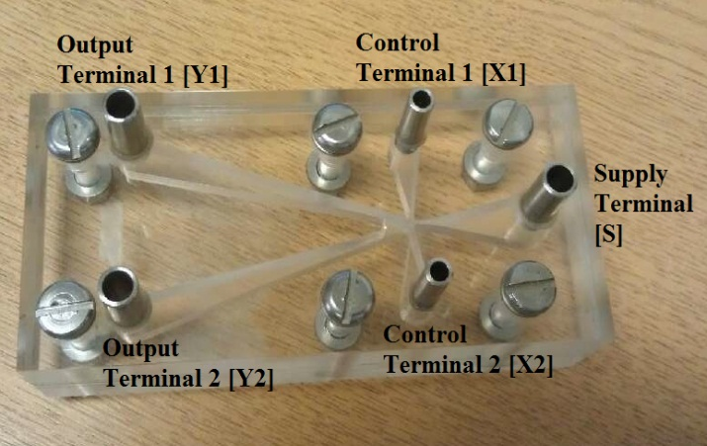
Figure 3.1: Photograph of the no-moving-part fluidic oscillator. (Zimmerman et al. 2008)

The fluidic oscillator is one of the essential part of the low power microbubbble generation system patented by Zimmerman et al, see Figure 3.1. The main function of the fluidic oscillator is to generate oscillatory flow to limit the bubble growth period by controlling the amount of gas supply during bubble formation. The fluidic oscillator supplies oscillatory flow to the ceramic aerators or microporous media to generate microbubbles. There are several types of fluidic oscillators with different design, shapes, sizes and capacities are used to generate oscillatory flow. The cuboid shaped fluidic oscillator used for the work in this thesis measures (Outside Dimension): 10cm x 5cm x 5cm in length, height and width respectively, see Figure 3.1 (Zimmerman et al. 2011). The five major ports of the applied fluidic oscillator consist a main supply port, two feedback control ports and two exit ports, see Figure 3.2.

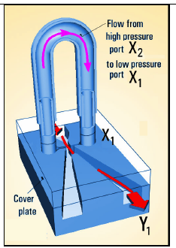
Figure 3.2: Oscillator working principle (Zimmerman et al. 2008)

The basic working principle for the fluidic oscillator is converting a steady air flow into oscillatory flow with a certain oscillation frequency. Steady air flow (pressurised gas) is supplied into the supply port [S] and the jet of gas is formed after the air flow through the nozzle in the fluidic oscillator. The jet adheres to one wall due to the Coanda effect (Coanda effect: Jet flow adheres to a nearby surface and turns with curved surface) and thus led into one of the two output ports [Y1] or [Y2]. Due to the pressure changes in the feedback loop, the jet consequent detaches and adheres to the opposite attachment wall [Y1], see Figure 3.2.
The oscillatory flow is controlled by the control action applied to the control ports [X1] and [X2]. Therefore, a feedback loop is provided. A suitable length of tubing connects the two control ports [X1] and [X2]. The jet is guided by the internal attachment wall of the fluidic oscillator and the curve trajectories of the jet in the area of control ports generate the radial pressure gradient across the jet. The difference in pressure between the two control ports occurs as the pressure reduction at one of the control ports [X1]. As a result, the air from the opposite control port which is at higher pressure flows [X2] to the current low pressure control port [X1] across the feedback loop provided.
The pressure difference in the feedback loop tubing generates the flow oscillation and reroute the flow from the low-pressure port to the high-pressure port. In relation to the amplification effect, a sufficient momentum is gained by the feedback flow gradually to switch the jet from the current output port [Y1] to an opposite output port [Y2]. The jet is swapping between the two exits port based on the same principle as the fluidic oscillator is symmetric and the oscillation frequency relies upon the feedback characteristic of the fluidic oscillator (Zimmerman et al. 2008).

3.1.2 Airlift Loop Bioreactor (ALB)

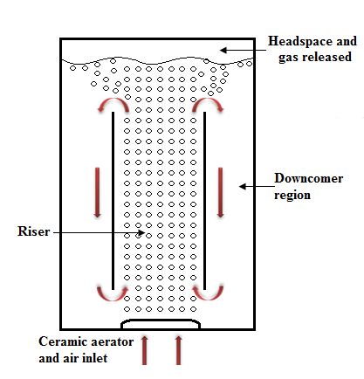
Figure 3.3: Flow pattern of the airlift bioreactor (ALB).

As mentioned previously in Chapter 2, an airlift reactor is used in the culturing of shear sensitive organisms because of the presence of the draft tube that generates the large scale flow motion in the ALB without any mechanical stirrer. Bubbles cause the fluid to rise in the central draft tube and return downwards outside the draft tube. The presence of the draft tube enhances axial mixing throughout the reactor and the circulation occurs in one direction and so the bubbles travel in a more ordered direction. Therefore, ALB provides better performance by increasing the mixing process throughout the reactor and reduces the bubble coalescence.
The main design of the airlift bioreactor consists of an internal draft tube which separates the so-called riser and down comer region, with an improvement by replacing the traditional sparger with a novel aeration system. The traditional aeration system is replaced with a tailored ceramic aerator which is supplied either with steady flow or oscillatory flow generated from the fluidic oscillator. The novel aeration system improves the conventional ALB by generating smaller bubbles and more uniform bubble size distribution. As the bubble size is the main factor in controlling the liquid flow velocity, which makes it also an important factor that has influenced the performance of the ALB.
Figure 3.3 illustrated the schematic diagram and flow pattern of an airlift loop bioreactor. Microbubble cloud rises slowly and smoothly inside the draught baffle (riser region). Due to their high surface to volume ratio, bubbles rise and draw the liquid along with the bubbles to the top surface and to the down comer region. The fluid at the top section of the reactor has higher density compared to the liquid in the riser region; therefore, the fluid flow to the bottom of the reactor and re-join the bubble streams.

3.1.3 Airlift Bioreactor and a range of Draft Tubes

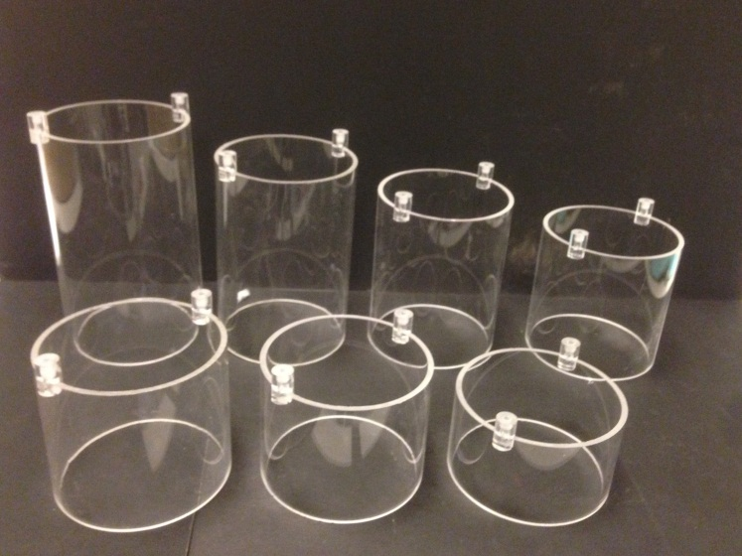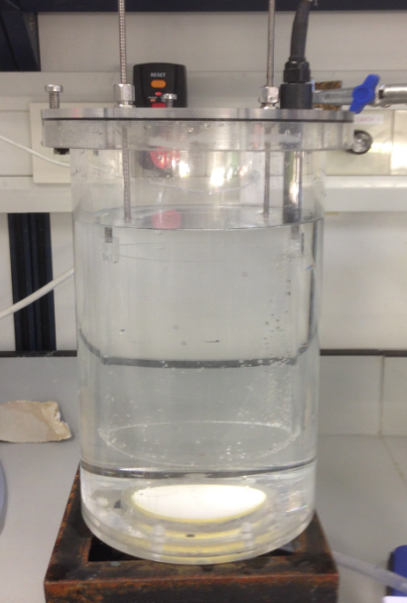
Figure 3.4: (a) Photograph of draft tubes (50-mm150mm) (b) Photograph of labscale ALB.

A standard ALB was used in the experiments in chapter 5 and with a range of draft tube heights to study the effects on the liquid flow velocity within the ALB in Chapter 6. The ALB column to draft tube diameter ratio was 0.6, this ratio is chosen based on the work of Klein et al. (2003) who determined it as suitable for bio-systems in order to avoid their sedimentation.

Figure 3.4 (b) shows the lab scale ALB manufactured in acrylic. In Chapter 5, the height of the ALB is approximately 260mm with the inner diameter of 140mm while the height of the draft tube is 130mm with the inner diameter of 84mm. The inner draft tube hung approximately 40mm from the aerator surface. Five ceramic aerators with different pore diameters were used to generate five different bubble sizes (150 µm, 50 µm, 20 µm, 16 µm and 2 µm). The diameter of the porous ceramic plate is approximately 55mm. Those porous ceramic plates were fitted into a housing and fix at the bottom of the ALB.

In Chapter 6, the height of the ALB is approximately 260mm with the inner diameter of 140mm. There was a set of draft tubes with different heights prepared for the experiment (50 mm, 70 mm, 80 mm, 90 mm, 100 mm, 110 mm, 130 mm, 150 mm) with the inner diameter of 84mm, see Figure 3.4(a). In addition, the holder for the draft tube was specially designed to be adjustable to vary the position of the draft tube. The air lift loop design consists of a ceramic aerator with a diameter of 50 mm and pore size 20 µm. The main purpose of the research in Chapter 6 was to investigate the effect of the C_{B} and C_{T} heights; therefore, the diameter of the column and draft tube of the ALB was kept constant for all experiments.

3.1.4 Porous Ceramic Aerators
5 aerators with different pores sizes were used in these studies. The aerator housing for the porous ceramic plates was designed to be fitted to the bottom of the ALB, see Figure 3.5. The hydrophilic surface porous ceramic with pores diameter of 150 µm, 100 µm, 50 µm, 20 µm and 2 µm were used in the experiments of this thesis. The technician modifies the porous ceramic plate to fit into the housing shown in Figure 3.5 .

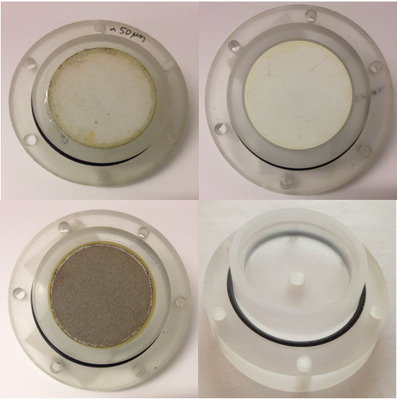
Figure 3.5: Photograph of the aerators and housing

Ceramic aerators with five different pore diameters were used in the experiment to investigate the factors that affect the bubble diameter. Figure 3. 6 (a)-(e) were taken by using SEM to validate the approximate sizes as compare to the specification given by the manufacturer.
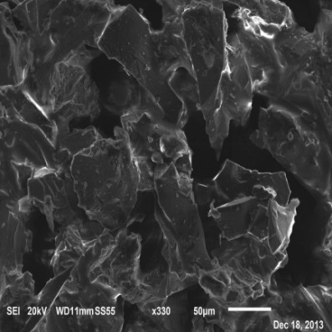
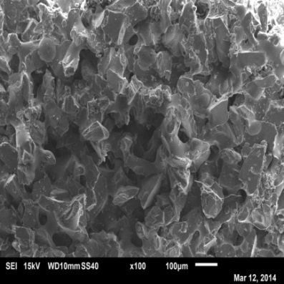
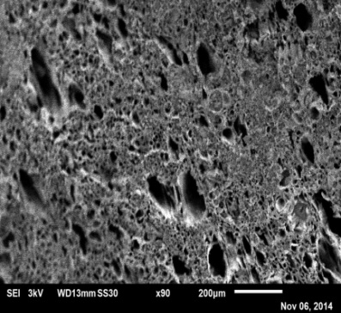
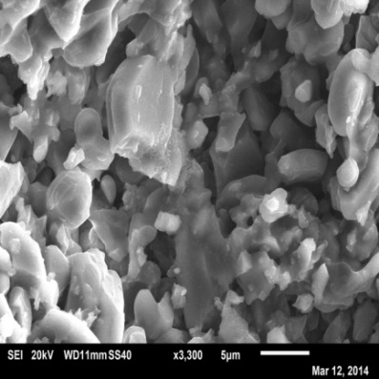
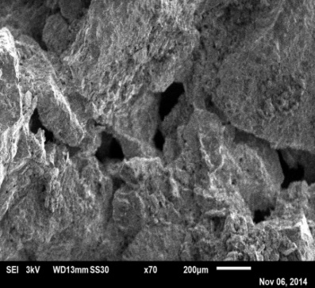
(a)
(b)
(c)
(d)
(e)

Figure 3. 6: SEM pictures of 5 porous ceramic. (a) 2 µm (b) 20 µm (c) 50 µm (d) 100 µm (e) 150 µm.

3.2: Experimental Setup

3.2.1 Experimental Setup 1- Steady Flow Microbubble Generation System
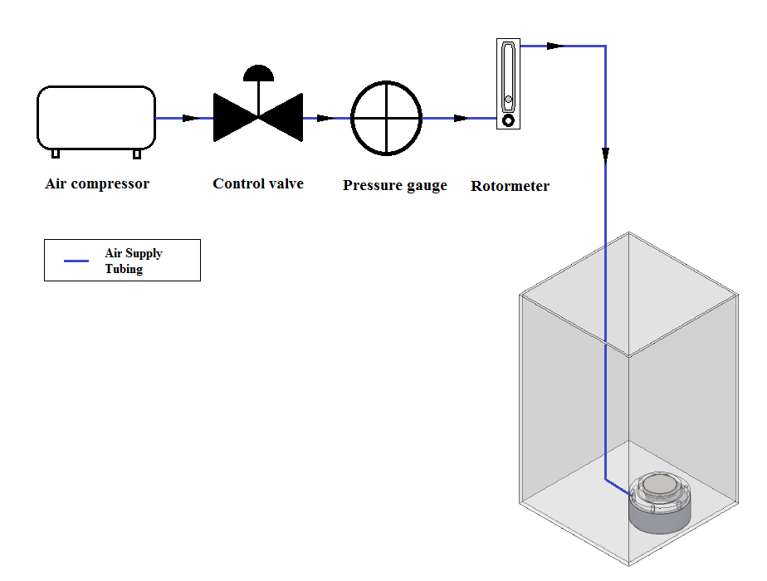
Figure 3.7: Schematic of the steady flow microbubble generation system setup

A steady flow microbubble generation method was used to investigate the pores diameter and the flow rate effect on the bubble diameter at the steady flow condition. Figure 3.7 shows the schematic diagram for the steady flow bubble generation system setup. Compressed air was supplied from the main compressor to the system to generate microbubbles. The inlet flow rate and pressure were measured by using a rotormeter and a pressure regulator. The ceramic aerator submerges in approximately 195 mm height water from the surface of the aerator. Five aerators with different pore diameters were used in the experiments and supplied with inlet flow rates between the ranges of 0.05 l/min to 0.5 l/min. The bubble diameter distributions were measured by using optical method and the bubble images were processed by using an “Image J” function and macro programme script written by the author to process the images automatically. Please refer to Chapter 3.2 for the measurement technique and procedure. The operating pressure was caused by different as different pore size ceramic aerator. Therefore, a correction factor given by the manufacturer was applied to obtain require flow rate.

Table 3.1: Experimental 1 Operating Conditions
Tank Size
W x L x H | : 250X 250X310 (mm)
Wall thickness | : 4mm
Diffuser
Inside diameter | : 50 mm
Area | : 1963.5 mm²
Pore diameter | : 150 µm, 100 µm, 50 µm, 20 µm and 2 µm
Operating Condition
Gas Inlet Flow Rate | : 0.05 - 0.5 l/min
Operating Pressure | : 0.05-2.5 bar
Water Temperature | : 20±1°C
Volume of water | : 10 l
Medium Height | : 195mm
Flow condition | : Steady flow

3.2.2 Experimental Setup 2 – Oscillatory Flow Microbubble Generation System
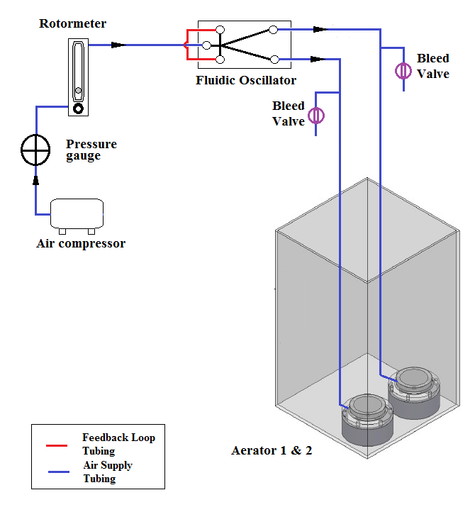
Figure 3.8: Schematic of the Oscillatory flow microbubble generation system setup

To study and investigate the effect of the oscillator flow on bubble diameter, bubbles were generated by supplying compressed air through the Tesar-Zimmerman fluidic oscillator to the aerators with pores diameter of 20 µm. The experiment was conducted by locating two aerators at the bottom of a 19 litres water tanks with working volume 10 litres water to achieve a proper balance oscillation. The dimension of the fluidic oscillator is measured 100 mm x 50 mm x 50 mm respectively while the aerator diameter is measured 50 mm respectively. A rotormeter was used to control the main inlet flow rate that supply to the fluidic oscillator. The bleed valves were used to adjust the air flow in order to achieve a proper balance oscillation. The operating pressure was caused by different as different pore size ceramic aerator. Therefore, a correction factor given by the manufacturer was applied to obtain require flow rate.

Table 3.2: Experimental 2 Operating Conditions
Tank Size
W x L x H | : 250X 250 X310 (mm)
Wall thickness | : 4mm
Aerator
Inside diameter | : 50 mm
Area | : 1963.5 mm²
Pore diameter | : 20 µm
Operating Condition
Gas Inlet Flow Rate, Q | : 0.1l/min-0.6l/min
Operating Pressure | : 2-3 bar
Water Temperature | : 20±1°C
Volume of water | : 10 l
Medium Height | : 195mm
Flow condition | : Oscillatory flow
Feedback loop length | : 300- 1950mm

The characterisation of Tesar–Zimmerman fluidic oscillator was conducted with a range of feedback tube lengths (300 mm- 1950 mm) with the same diameter (d) and a range of main inlet flow rates were supplied for each length of feedback loop tube (0.1 l/min to 0.6 l/min). An accelerometer was attached on one of the outlet of the fluidic oscillator for the frequency measurement while the bubble size measurement was performed by using a camera and halogen lamp was used to illuminate the images. The water tanks were sealed with a cover and connected with the rotormeter to measure the actual gas inlet flow rate of the aerator.

3.3.3 Experimental Setup 3- Microbubbles Effects

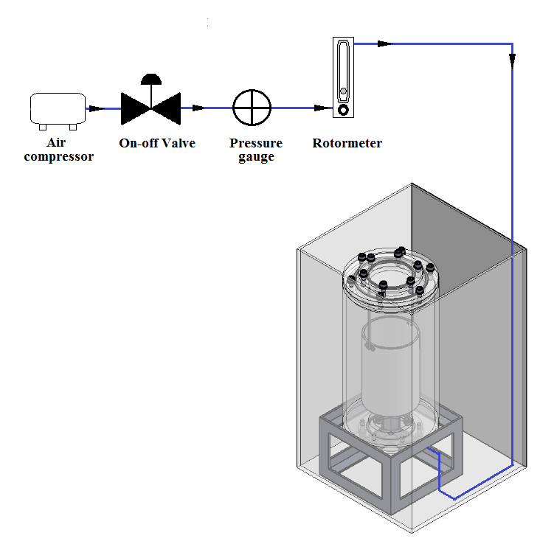
Figure 3.9: Schematic drawing of experimental setup.

Figure 3.9 shows the experimental setup for determining the microbubble rise velocity and liquid flow velocity in the ALB. The aeration method was used as the microbubble generator system. The microbubble is generated by supplying a steady air flow directly to the porous aerator in the fluid. The bubble rise velocity and the liquid flow velocity of the five bubble sizes in the ALB were measured. The ALB is filled with approximately 3 Litres of de-ionized water and the distance between the water level and the ceramic aerator surface is approximately 195 mm. At a given 0.1 l/min steady flow rate, 1020 µm, 910 µm, 755 µm, 690 µm and 440 µm bubbles were generated by the aerator with pore sizes of 150 µm, 50 µm, 20 µm, 16 µm and 2 µm respectively. In order to maintain a relatively constant condition, the inlet flow rate was controlled by using rotormeter and a pressure regulator was used to maintain a constant pressure for the system. The experimental condition is presented in Table 3.3. The operating pressure was caused by different as different pore size ceramic aerator. Therefore, a correction factor given by the manufacturer was applied to obtain require flow rate.
Table 3.3: Experimental 3 Operating Conditions
Airlift Bioreactor Geometry
Inside diameter | : 140mm
Height | : 260mm
Diameter of draft tube | : 84mm
Height of draft tube | : 130mm
Ceramic Aerator Geometry
Inside diameter | : 55mm
Area | : 2375.83mm²
Pore diameter | : 2-150 µm
Operating Conditions
Gas Inlet Flow Rate | : 0.1 l/min
Operating Pressure | : 0.05-1bar
Water Temperature | : 20±1°C
Volume of water | : 3 l
Medium Height | : 195mm
Flow condition | : Steady flow

3.3.4 Experimental Setup 4- Draft Tube Height Effects

The experimental setup in Chapter 6 that used to determine the liquid phase circulation velocity within the ALB with a range of draft tube height is identical with the experimental setup in Chapter 5.

A conventional aeration method was used as the microbubble generator system. In the experiment, the aerator was fixed at the bottom of the ALB. The ALB was filled with approximately 2.8-3 Litres of deionised water (Di water) and three water heights were investigated which are 200 mm, 190 mm and 180 mm water level from the ceramic aerator surface. To maintain the constant condition for all the experiments, a 20 µm pore size ceramic aerator was used at the same flow rate (0.1 l/min, 0.05 bar). The operating pressure was caused by different as different pore size ceramic aerator. Therefore, a correction factor given by the manufacturer was applied to obtain require flow rate.
The inlet air flow was turned on for approximately 30 seconds to make sure the flow in the ALB was constant and stable before beginning the measurement. The particle image velocity (PIV) was used to measure the liquid flow velocity.

In the first experiment in Chapter 6, two water heights were used, 200 mm and 180 mm. With 200 mm water height, a 100mm draft tube was implemented, and likewise with the 180 mm water height, a 80 mm draft tube was implemented. The positions of the draft tube were varied from 20 mm from the surface of the ceramic aerator to 80 mm height.

In the second experiment in Chapter 6, 7 different heights of draft tube were used and the position of the draft tube was maintained at the centre of the water height to maintain the C_{T} / C_{B} ratio equal to 1. Three different water heights were tested.

Table 3.4: Experimental 4 Operating Conditions
Airlift Bioreactor Geometry
Inside diameter | : 140mm
Height | : 260mm
Diameter of draft tube | : 84mm
Height of draft tube | : 50 mm, 70 mm, 80 mm, 90 mm, 100 mm, 110 mm, 130 mm, 150 mm
Ceramic Aerator Geometry
Inside diameter | : 55mm
Area | : 2375.83mm²
Pore diameter | : 20µm
Operating Conditions
Gas Inlet Flow Rate | : 0.1 l/min
Operating Pressure | : 0.05bar
Water Temperature | : 20±1°C
Volume of water | : 2.8-3 l
Medium Height | : 180mm, 190mm, 200 mm
Flow condition | : Steady flow

3.3 Measurement Techniques

3.3.1 Determination of Bubble Diameter

3.3.1.1 Photography Method
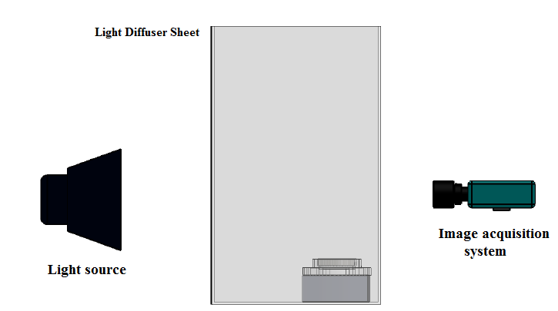
Figure 3.10: Schematic for the bubble sizing photography method

An optical method was used to measure the bubble size distribution. The apparatus for the image analysis system includes a camera (FastCam SA3 Model120K / Pixelink) and a halogen light. The camera was located parallel to the focal plane (Object plane) to minimize optical distortion, see Figure 3.10. A ruler used as a calibration target was placed inside middle of the water tank. Once the reference pictures and the calibration are created, the air supply is switched on. The camera starts to capture the images of the bubble generated for 400 frames with a record speed 200 frame per second (fps). The fps can be adjusted according to the images quality obtained. The monitored area for all the bubble size was maintained at the same size. To capture decent quality images, the halogen lamp is used as an external lighting during the images captured to provide a proper illumination. The light source was only switched on during the period of capturing the bubble images to prevent heating the water in the tank. Finally, a computer with digital image processing software (Image-J) was used to process the images capture.

3.3.1.2 Calibration Procedure
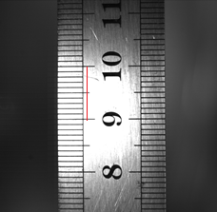

Figure 3.11: Captured image of the calibration target

Calibration is an important and essential step in the experiment to ensure that the images taken are focussed correctly and the scale factor necessary for processing of the images is obtained. After setting up the camera and placing the target in the middle of the water tank, a ruler was used as a calibration, the halogen light is switched on and images of the ruler are taken. The camera is focussed such that all the ruler scale appears sharp before the proper images are taken. Finally, the images are analysed by using Image-J (image processing software) and the scale factor is obtained by comparing the apparent distance between any two lines of the ruler provided by the perspective of the high-speed camera with the actual distance, see Figure 3.11(redline). The pixel/mm for shows in Figure 3.11 is approximately 25.6 px/mm.

3.3.1.3: Image Processing Procedures

Step 1:
Figure 3.13(a) shows one of the examples for the raw image of the bubbles. In order to improve the bubble detections, all images required a few simple steps of image processing. In this project, Image J with macro programming which written by the author was used to process the images. First of all, “sharpen” function was applied to make the outline of the bubbles sharper in order to make the bubble to be identified easily, presented Figure 3.12 (b).
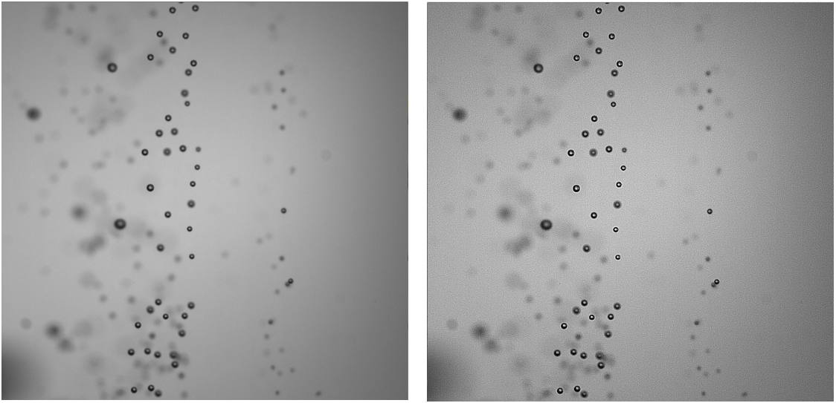
Figure 3.12 (a) Raw image of the bubbles (b) Images with “sharpen” function

Step 2:

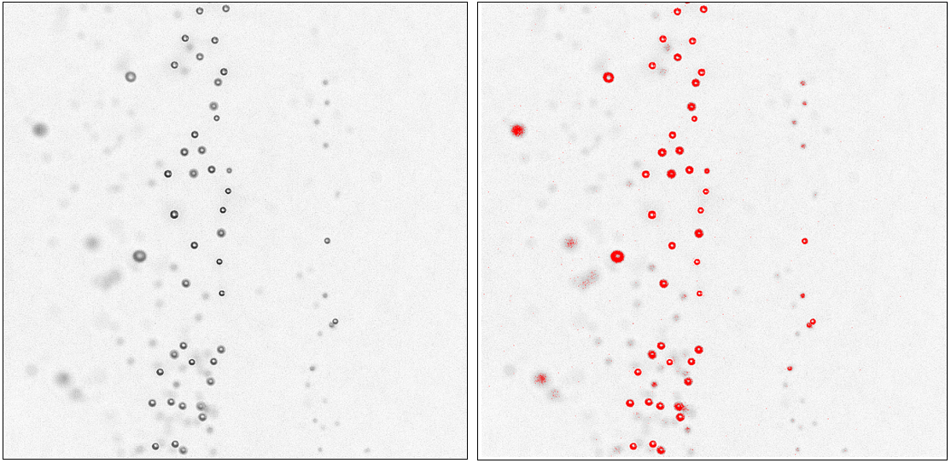
Figure 3.13: (a) Image with the function subtract back ground (b) Images with “Threshold” applied

Next, “subtract background “function was applied in order to delete the shadow of the bubbles, out of focus bubbles and some dots at the background of the images. “Threshold” function was applied to identify the bubbles in the images by defining the upper limit and lower limit of the threshold and converts the image into binary form (mask or “black and white”). The threshold limits depend on the image quality. In other words, better image quality lead to a higher accuracy in the measurement of bubble diameter.
Step 3:
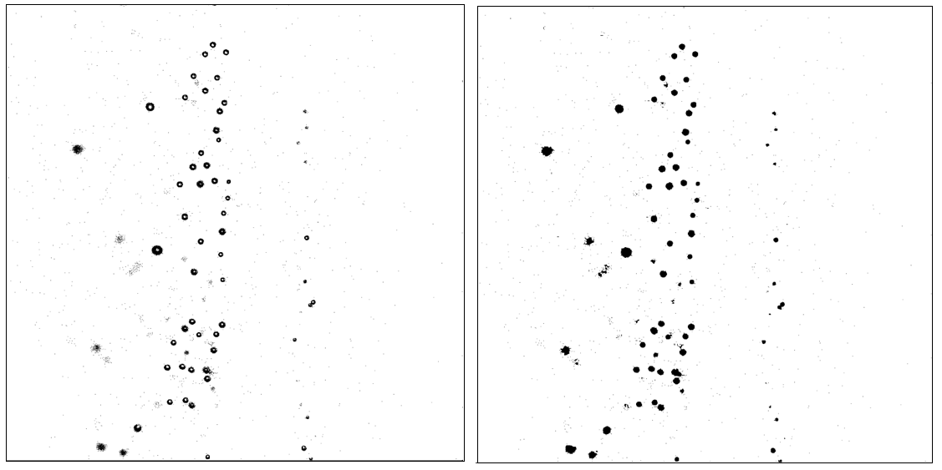
Figure 3.14: (a) Image after “threshold” conversion (b) Image after “binary close” and “Fill function”

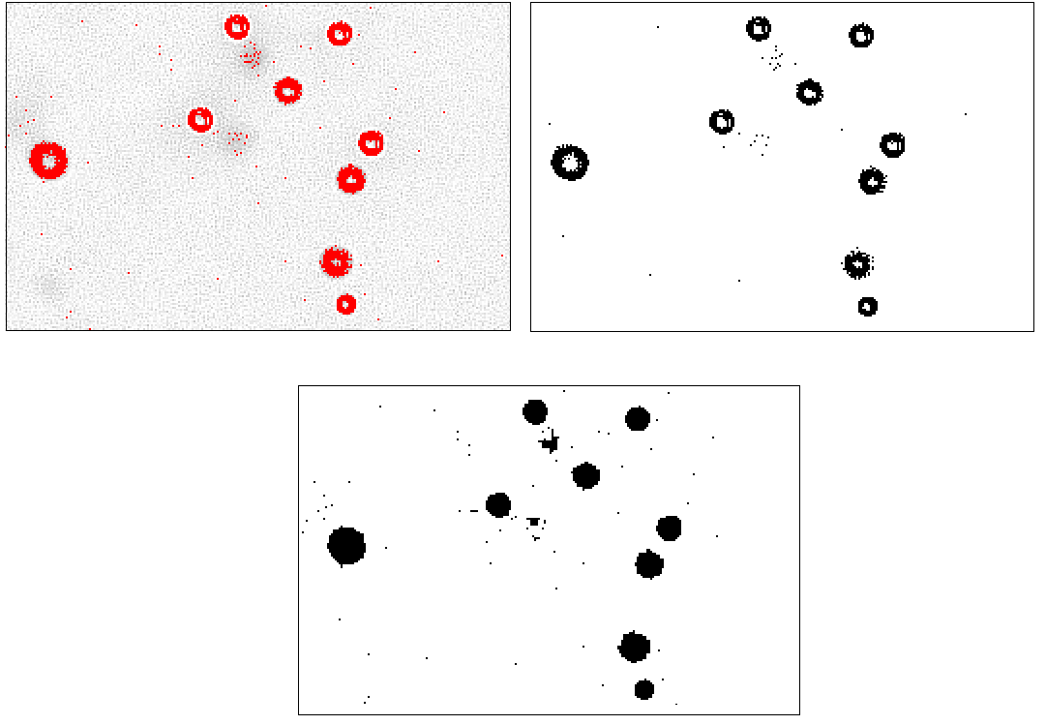
Figure 3.15: Zoom in raw image after “threshold” conversion (b) Zoom in image after “binary close” and “Fill function”

Figure 3.15 (b) shows the image after the threshold conversion. However, there are some minor errors in the image such as some of the bubbles are not fully close and there is a hole in the centre for bubble. Therefore, in order to obtain accurate results and to simplify the “analyses particles” process, two more functions have to be applied. The “binary close” and “Fill” function were applied to cover up the final part of the image processing. Finally, the function of “analyses particles” was applied and the size and circularity was defined to detect the bubbles and excludes the small dots in the images.

Optional Function – watershed
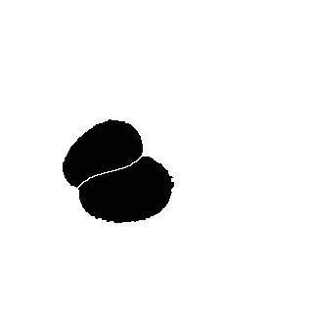
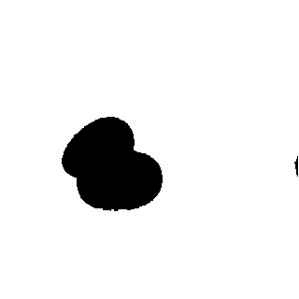
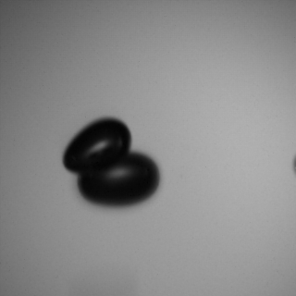

Figure 3.16: Raw image of the overlap bubbles (b) Image after “threshold” (c) Image after “water shed” function
In certain condition, when there is an overlap bubbles and a special function “watershed” will be used to separate the bubbles automatically.
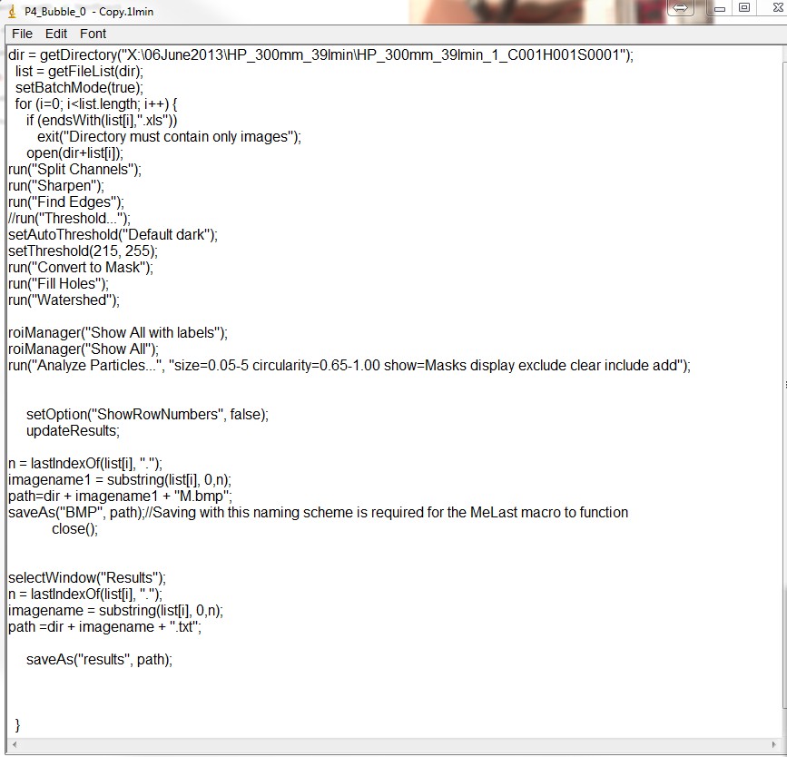
Figure 3.17: shows the macro programming that allow the image analysis run automatically.

3.3.2 Determination of Oscillation Frequency

3.3.2.1 Accelerometer
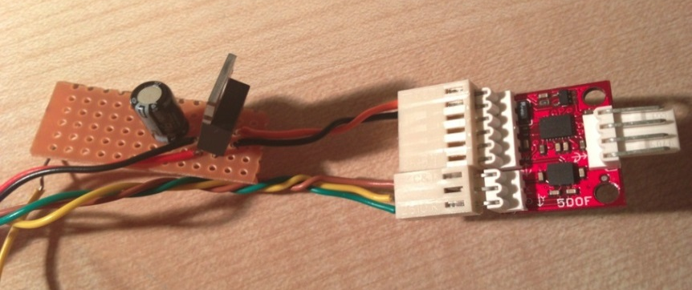
Figure 3.18: Accelerometer

An accelerometer (Sparkfun- ADXL335) was used to measure the oscillation frequency of the fluidic oscillator. The accelerometer is a small thin and low power consumption device and the most important factor is low noise which is ideal for high accuracy in the measurement of oscillation frequency in this case. The circuit was designed and made by the author. The NI USB-6008 is a data acquisition device that was used to collect data from the transducer converts it into a digital signal and then sends it to the computer for processing. The three signals from the accelerometer (x,y, and z) are connected to the analog ports on the NI USB-6008. A 24V switch mode power supply with a regulated 24vdc output was used for the accelerometer. Therefore, a 3.3V voltage regulator was applied to regulate the 24 V_{dc} supply voltage into 3.3V. A 100 µF capacitor was applied in the circuit in order to eliminate any high frequency AC voltage that could otherwise combine with the output voltage. The data obtained from the DAQ was then process by the LabView FFT program.
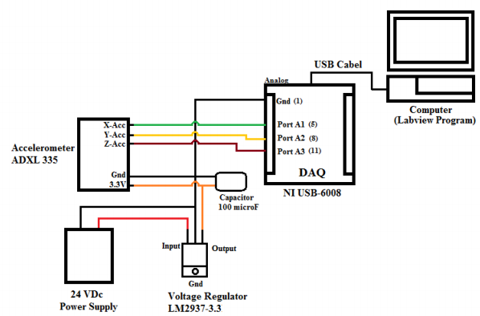
Figure 3.19: Schematic for the Setup of the accelerometer.

3.3.2.2 Sampling Frequency (Accelerometer)
Sampling frequencies ranging from 4 kHz to 10 kHz were used in the first instance. The sampling frequency was determined in the accelerometer testing experiment. The oscillation frequency with 10 cm length feedback loop tubing and supplied with 80 l/min main inlet flow rate was measured. The results obtained from Labview programs showed an oscillation frequency of around 578.1Hz. This indicates that the minimum sample frequency for obtaining reliable data is 1156.2 by referring to the Nyquist Sampling theorem which states that the sampling frequency (f_{s}) should be at least twice the highest frequency contained in the signal (f_{c}). The Nyquist sampling theorem provides a prescription for the nominal sampling interval required to avoid aliasing. It may be stated simply as follows:

$f_{s}≥2f_{c}$ (Eqn 3. 1)
To be on the safe side, a sample frequency of 4000 Samples/second was used. Using this sample frequency, we will take 20,000 samples, which will give us a frequency resolution of 0.2 Hz.

3.3.2.3 Calibration
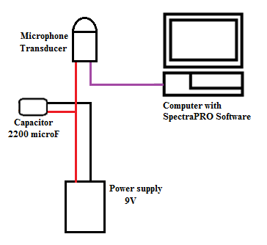
Figure 3.20: Schematic diagram for the microphone transducer setup.
Accelerometer calibration was carried out by using microphone transducer. The results showed that the average percentage of error between two measurement devices results is 0.68 % which is acceptable considering the external noise and vibration effects. The input device microphone transducer (HD audio microphone) can be directly applied by connect to the personal computer microphone port. The signal received is interpreted by using the software which known as SpectraPro. A DC 9V power supply is applied to the microphone transducer. In addition, a 2200 µF capacitor is used in the circuit to eliminate any high frequency AC voltage that could otherwise combine with the output voltage.
Table 3.5: Microphone transducer configuration setting
Configuration setting
Mode | : Real time
Sampling rate | : 44100HZ
Decimation Ratio | : 1
FFT Size | : 4096 samples
Spectral Line Resolution | : 10.767Hz
Frequency Limit | : 22050Hz
Sampling format | : 16bits
Averaging type | : exponential

Table 3.6 : Validation percentage of error table
Testing Condition FO FBL Length(mm) | Frequency (microphone Transducer) | Frequency (accelerometer) | Frequency different | Percentage of error (%)
150 | 441.43 | 444.8 | 3.37 | 0.8
300 | 376.6 | 377.8 | 1.2 | 0.3
600 | 215.3 | 216.2 | 0.9 | 0.4
900 | 150.7 | 152 | 1.3 | 0.8
1200 | 118.4 | 119.8 | 1.4 | 1.1
Average Percentage of Error (%) |  |  |  | 0.68

3.3.2.4 Procedure of the Frequency Measurement of the Oscillatory Flow
In the experiment, the water tank is cleaned and filled with 10 litres of deionised water. After that, the air supply is switched on at low flow rate and two of the aerators are submerged in the 10 litres deionised water. The accelerometer was placed on top of one of the outlet tubes of a fluidic oscillator and approximately 100 mm from the fluidic oscillator. In the frequency measurement experiment, the test was conducted with a range of feedback tube lengths (300- 1950mm) with the same diameter (d) and a range of main inlet flow rates were supplied for each feedback tube lengths (0.1 l/min to 0.6 l/min). Accelerometer was monitored by using a Labview program. The signal from the accelerometer is transferred to the computer through a data acquisition device (DAQ) and processed by the labview FFT program.
In the experiment, the oscillation frequencies generated from the six (6) different feedback loop tubing lengths (300mm to 1950mm) were measured. Three sets of test data were taken for each feedback loop tubing length across a range of flow rates. The order of taken data started from the low gas inlet flow rate to high gas inlet flow rate for the first set of test data (T1), the second set of the test data (T2) was taken starting from the high gas inlet to the low one, while the third set of test data (T3) was taken randomly. Three readings were taken in each test data, see Table 3.7. This measurement method is applied to avoid the systematic errors.

Table 3. 7: Oscillation frequency data example
Gas Inlet Flow Rate (Q) l/m | FREQUENCY OF OSCILLATION (Hz) |  |  |  |  |  |  |  |  | Average  of the Oscillation Frequency (Hz)
Gas Inlet Flow Rate (Q) l/m | Test 1 (T1) |  |  | Test 2 (T2) |  |  | Test 3 (T3) |  |  | Average  of the Oscillation Frequency (Hz)
0.1 | 227.4 | 227.4 | 227.4 | 227.8 | 227.6 | 227.8 | 227.2 | 227.2 | 227.2 | 227.4
0.15 | 339.4 | 339.4 | 339.2 | 228.8 | 228.6 | 228.6 | 228.4 | 228.4 | 228.4 | 265.5
0.2 | 342 | 342 | 342 | 341.4 | 341.4 | 341.4 | 340.8 | 340.8 | 340.8 | 341.4
0.35 | 343.6 | 343.4 | 343.2 | 342.6 | 342.4 | 342.4 | 342.4 | 342.2 | 342 | 342.7
0.5 | 428.2 | 427.8 | 427.8 | 428 | 428.4 | 427.8 | 427.4 | 427.2 | 427.4 | 427.8

3.3.3 Determination of Bubble Rise and Bubble Driven Liquid Flow Velocity

3.3.3.1 Image Acquisition
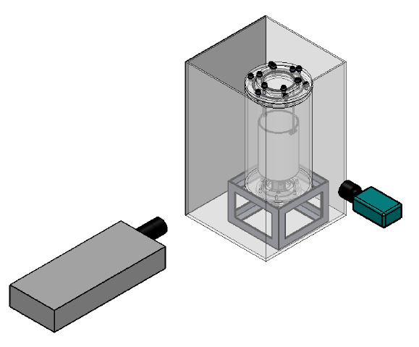
Figure 3.21 : Particle Image Velocimetry (PIV) Setup

2D2C particle image velocimetry (PIV) was used to measure the bubble rising velocity and liquid flow velocity. Figure 3.21 shows the schematic diagram of the PIV experiment set up. The measurement area was illuminated by a thin thickness Nd: YAG laser light sheet (532nm Green laser). A suitable laser thickness for the bubble measurement is essential to obtain a reliable result. Therefore, the laser thickness has to be control within the range that able illuminate the bubbles and also the seeding particles. In order to minimize the optical distortion, it is necessary for the object plane to be positioned parallel to the camera image plane. In addition, the refractive index matching technique was used to minimize the problem. The circular tank was submerged in a rectangular glass tank and filled with water which in return will reduce the curvature effect. This technique was tried and used in Bröder & Sommerfeld (2002), Chen(1992).
The double light pulses Nd: YAG laser is expanded to a thin layer light sheet which used as the focal plane for the captured of images. The double or multi exposed image was taken by the CCD camera in a known time interval. The displacement records of the particles and bubbles within the measurement plane which is then analysed and scaled to velocity. Microbubble itself acts as a tracer for the bubble rising velocity measurement while fluorescent tracer was used to measure the liquid circulation velocity with an orange filter on the CCD camera. There were approximately 200 pairs of image, with capture rate of 4Hz. The captured images were process by using the open source PIV software PIVlab and PTVlab.

Table 3.8: PIV and PTV Setting
PIV Lab Setting
Tracer | fluorescent tracer (Rhodamine B)  20-50 µm
Laser sheet thickness | 1 mm
Integration window | 64 X 64, 32 X 32 ,16 X 16 (px)
Pixel/mm | 5.1 px/mm.
Time Interval | 25 ms
PTV Lab Setting
Tracer | Bubbles
Laser sheet thickness | 1.5 mm
Pixel/mm | 5.1 px/mm.
Time Interval | 15 ms
Cross correlation parameters
By min of particles | 50
Relaxation parameters
Radius of neighbourhood (Tn) | 15 px
Relaxation Radius (Tq) | 10 px
Minimum number of  neighbours | 5
Filtering of local Velocity | 70 %
Min and max probability | 80 %

3.3.3.2 Calibration Procedure
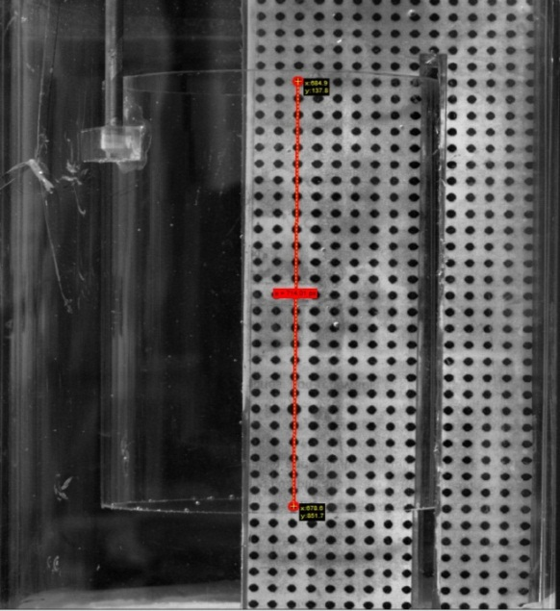
Figure 3.22: Calibration grid as a calibrated target for the PIV

Calibration is an important and essential step in the experiment to ensure that the images taken are focussed correctly and the scale factor necessary for processing of the images is obtained. The calibration method applied in the experiment is used of a calibration target (grid). The first way makes use of a calibration target, given in Figure 3.22. A special grid made by the author was used as a calibrated target. The grid was created using “Solidworks” software with a known dimension and printed out with laser printer. It was laminated and so water proof and it was attached on a strong soft plastic cardboard to ensure the position is straight enough in the bioreactor. The camera is focussed such that all the grids appear sharp before the proper images are taken. The factor is obtained by comparing the apparent distance between any two dots of the grid provided by the perspective of the high-speed camera with the actual distance.

3.3.3.3 PIV Image Pre – Processing
In order to ensure the highest measurement quality possible, image pre-processing is one of the essential steps before the analysis begin (Shavit et al. 2006). Three selected image pre-processing techniques in PIVlab include histogram equalization (CLAHE), Intensity high-pass and intensity capping. As the images obtained from the experiment for this thesis are quite decent and can be evaluated and analysis without any image pre-processing applied.

Contrast Limited Adaptive Histogram Equalization (CLAHE)
The development of the CLAHE method is to improve the readability of image data in medical imaging (Pizer et al. 1987). The working principle for the CLAHE is to develop the most frequent intensities of the image histogram to the full range of the data (from 0 to 255 in 8 bit images) and it only operate in every small region of the images. Operating in small region of the images only is beneficial in processing the PIV images as there is no guarantee of uniform of uniform exposure of the whole image in PIV due to the Gaussian intensity of the laser beam. Optimization for the low exposure regions and the high exposure regions will be done independently. (Thielicke & Stamhuis 2014)

Intensity Highpass
The correlation signal is strongly affected by inhomogeneous lighting caused by reflections from objects or inhomogeneous seeding. A high pass filter can be used to remove the low frequency background information and conserves the high frequency information from the particles illumination (Gonzalez et al. 1992) The basic working principle for this method is performed by blurring the images with the application of the low pass filter to the image and the result is subtracted from the original image. On the other words, any low frequency information in the images is supressed and the particle information in the image is emphasized by the high pass filter. (Thielicke & Stamhuis 2014)

Intensity Capping
In general, PIV analyses the movement of all particles inside one interrogation window statistically. The particles within the interrogation window are assumed to be the same in this method where this is impossible, as perfectly uniform flow does not exist. Bright particles or spots within the area contribute statistically more to the correlation signal, which may bias the results in non-uniform flows (Shavit et al. 2006). This problem can be solved by the intensity capping technique. An upper limit of greyscale intensity is selected, and all pixels that exceed the threshold are replaced by the upper limit. (Thielicke & Stamhuis 2014)

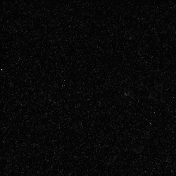



(a)
(b)
(c)
(d)

Figure 3.23: The effect of several pre-processing techniques (a) Original (b) CLAHE (c) Intensity High pass (d) Intensity Capping

3.3.3.4 PTV Image Pre – Processing
PTV image pre-processing can be performed by using background subtraction method during pre-processing process, blistering or reflection of the PTV images will be eliminated by subtracting the background from every recorded image.
An empty flow field background image is required to subtract the background and the empty flow field image can be generated by
- Taking an image with no seeding particles.
- Calculating the mean image from the sequence of the recorded frames, that is calculating the mean values of every separate pixel over the sequence of frames.
The slow-moving tracer particles that have higher pixel brightness along their path on average may be removed during the subtraction process. The subtracted frames will eventually turn in to nearly black and white with some background noise after subtracting the mean image from every recorded frame.

3.3.3.5 PIV Image Evaluation
The cross correlation is applied to determine the most probable displacement of the particles in the interrogation areas. The cross-correlation technique can match the particle pattern statistically between the interrogation A and B. The discrete cross correlation function listed below is implemented in the PIV analysis software that used in this thesis (H Huang et al. 1997):

$C\left(m,n\right)=\sum_{i}{\sum_{j}{A(i,j)B(i-m,j-n)}}$ (Eqn 3. 2)

where A and B are represented the interrogation areas from image A and Image B.
The correlation matrix C relies upon the location of the intensity peak which indicates the most probable displace of the particles within the interrogation A and B. Direct cross correlation (DCC) and Discrete Fourier transform (DFT) are two common methods implemented in computing the correlation matrix in the frequency domain. The main difficulty in taking PIV measurements for the bubbly flow is the bubbly flow is impossible to flow in a straight line due to the pressure gradient; therefore, the advanced discrete fourier transform technique along with window deformation technique was used in this thesis. The advanced discrete fourier transform technique is an improvement version of the standard DFT where this technique able to minimize the losing information of the particle displacement by running several DFT passed on the same dataset and the integer result obtained from the first pass is used to offset the interrogation area of following passes. This technique also increases the signal to noise ratio. In addition, window deformation technique was proven in increasing accuracy over sheared flow. Figure 3.18 presented the working principle of the window deformation technique which continuous image deformation progressively transforms the images towards two hypothetical recordings taken simultaneously at time t + Δt/2. (Thielicke & Stamhuis 2014)
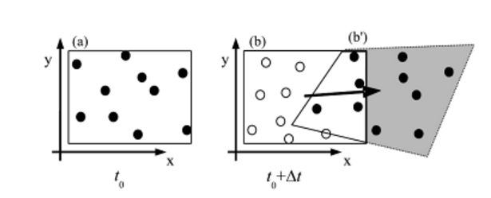
Figure 3.24: The principle of the window deformation technique.

Figure 3.24 (a) & (b) shows the tracer pattern in the first exposure and second exposure. The solid circles in the Figure 3.18(b) illustrated the tracers correlated with the first exposure in the interrogation window and the displacement distribution estimated from a previous interrogation generated the grey deformed window (Raffel.M et al. 1998).

3.3.3.6 PTV Image evaluation

Integrating the cross correlation and relaxation algorithm are implemented in PTVlab analysis software. Based on the software author, the first step of the evaluation process is to determine a preliminary result of the velocity field by using cross correlation. (Brevis et al. 2011).
Several types of filters such as correlation threshold level (Ct), mean and median filters are then applied to the results of this step.

$R=\frac{Σ_{M}Σ_{N}(A_{mn}-\overline{A})(B_{mn}-\overline{B})}{\sqrt{\left(Σ_{m}Σ_{n}{(A_{mn}-\overline{A})}^{2}\right)\left(Σ_{m}Σ_{n}{(B_{mn}-\overline{B})}^{2}\right)}}$ (Eqn 3. 3)

R: cross correlation efficiency
A, B: matrices of size m x n
$\overline{A}$, $\overline{B}$ : mean values light intensities of elements of respective matrices.

Cross correlation threshold that implemented after the cross correlation which is to compare the cross-correlation coefficient that generated during this step. All the cross-correlation coefficient values that larger than the threshold will be accepted.
After the accepted particles matches at this step are assumed valid, the probability equal to 1 to be assigned for the next relaxation step.
The particles matched by cross correlation step are used to update the probability of the particles analysed by relaxation method and they do not change during the process.
The relaxation method matching step will became an inactive after a particle achieves the convergence criteria. The probability will be used to update of the remaining unmatched particles.
This is to make sure a continuous reduction in the particle numbers analysed by relaxation method with the iteration numbers also increase the process of the analysis.
Filtering 1
Output
Initialization of particles for RM
Probability of matched particles is 1
Relaxation methods (RM) matching
Filtering 2
Image Processing
Cross Correlation (CC) matching
Particle Detection
Rejected
Accepted
Accepted

Figure 3.25 :Flow diagram of the integrated CC and RM method (Brevis et al. 2011).

During cross correlation, the correlation levels were calculated between the no match particles and their remaining candidates are converted to initial probabilities using equation listed below:
${Po}_{ij(i)}=\frac{R_{ij(i)}}{Σ_{j\left(i\right)=1}^{ni}\left(R_{ij\left(i\right)}\right)+(1-\max_{j\left(i\right)=1…ni}{(R_{ij(i)})})}$ (Eqn 3. 4)
Where is ${Po}_{ij(i)}$ initial probabilities, $R_{ij(i)}$ is the correlation coefficient associated with the displacement ${\overset{→}{d}}_{ij(i)}$ and the function max is used to determine $R_{ij(i)}$
While Eqn 3.5 is the equation for the initial no match probability which also determined using the difference between 1.0 and the maximum correlation.
$P_{i}^{*}=\frac{(1-\max_{j\left(i\right)=1…ni}{(R_{ij(i)})}}{Σ_{j\left(i\right)=1}^{ni}\left(R_{ij\left(i\right)}\right)+(1-\max_{j\left(i\right)=1…ni}{(R_{ij(i)})})}$ (Eqn 3. 5)
These probabilities are used as the initial condition for the iteration of the relaxation matching algorithm.
A sequential labelling process was to identified particles to determine individual particle trajectories. The trajectory of a single particle can be recovered according to the ID number over output results when the analysis is completed.
$$P_{ij(i)}^{n}>P_{i}^{*}$$
$$P_{ij(i)}^{n}>P_{t}$$
Next Iteration
Converged
$$δ=\left|P_{ij(i)}^{n}-P_{ij(i)}^{n-1}\right|$$
$$δ≥λ$$
$$δ<λ$$
No
No
Yes
Yes

Figure 3. 26: Flow chart of the relaxation method iterations (Brevis et al. 2011).

3.3.3.7 Post Processing
There are two main processes for the post processing which are the data validation and the data extraction for both PIVlab and PTVlab.

Data validation
Data validation is performed to get reliable results. In these ALB bubbly flow measurement experiments, the draft tube wall and obscures some of the interrogation areas and reflects the laser light sometimes. Even though the most advanced image correlation technique is applied, the number of the mistaken vectors will therefore will still be considerable. In PIVlab and PTV lab, a basic method is implemented to filter outliers and to choose acceptable velocity limits manually. This method must be used with caution, as it is based on the experience of the experimenter, and therefore has very subjective properties.

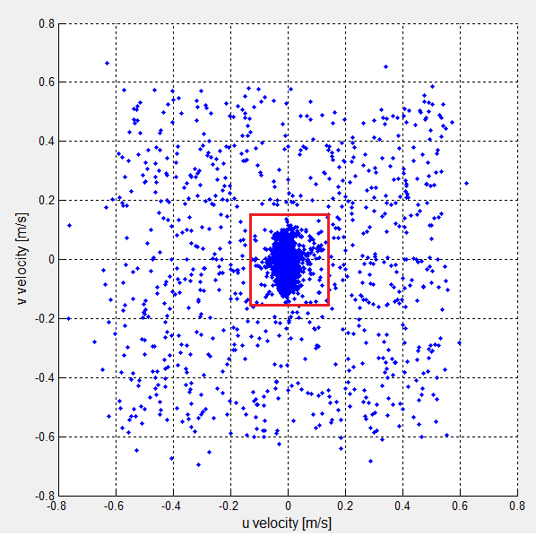

Figure 3.27: Scatter plot of u and v velocities in the PIV analysis of a bubble driven flow velocity. Data inside the red rectangle in the centre is supposed to be valid, vectors outside of the rectangle are supposed to be outliers.

Data Extraction
In the data extraction section, line extraction method is applied in PIVlAb. After average, the 200 pairs of image data obtained from the evaluation, ALB is separate into total 9 positions across the ALB and the data on these 9 lines (positions) were taken, see Figure 3.28. The data is exported and saved into Excel file.
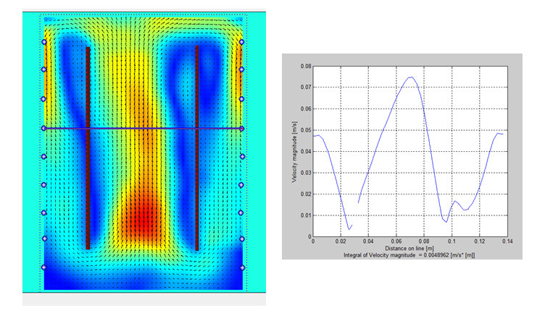
Figure 3.28 (left): Contour plot with the 9 positions markers (right): Line plot obtained from one of the positions.
The data in the PTVlab is extracted from the histogram and saved into excel file, see Figure 3. 29.
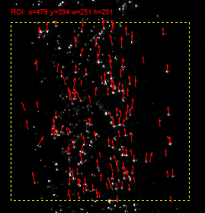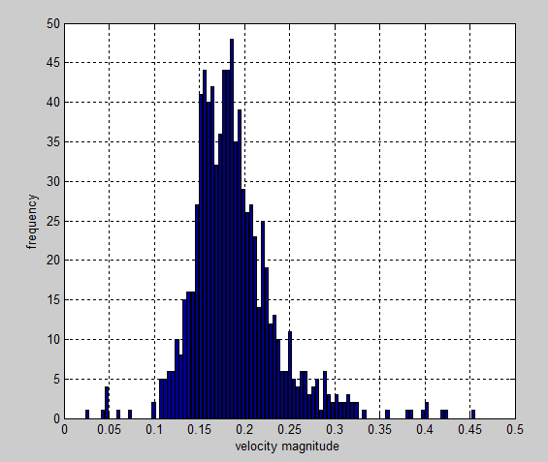
Figure 3. 29 (Left): Vector plot generated from PTV (right) Histogram of the velocity distribution generated from PTV

3.3.4: Determination of the mass transfer

3.3.4.1: Dissolved Oxygen Meter (Do meter)

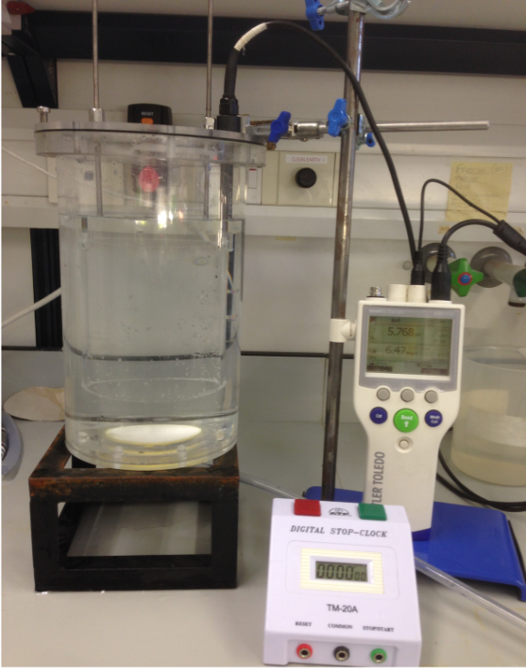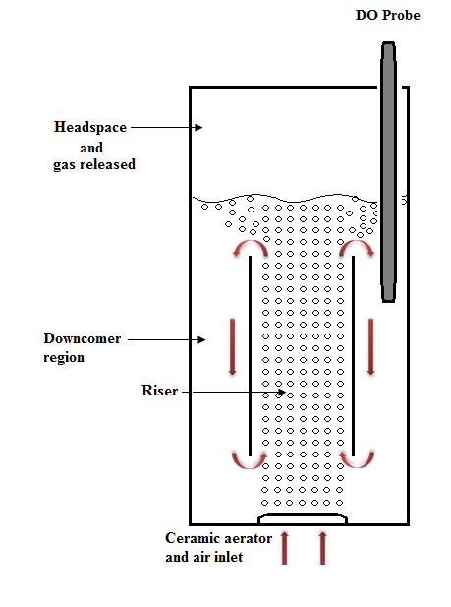
Figure 3.30: (a)Photograph of Dissolved Oxygen meter (b)Do Probe position.

A dissolved oxygen meter (Mettler Toledo SevenGo Duo Pro SG68) with a dissolved oxygen probe was used to measure the oxygen contained in the liquid which is capable of measuring from 0 to 99 mg/l which approximately 0% - 600% concentration of oxygen. The position of the DO probe is presented in Figure 3.30 (b). The accuracy of this meter is approximately ±0.5%. The response times for dissolved oxygen probes used in this thesis are reported to be about 30 s, respectively. Thesis is reported to be about 20 s and 30 s, respectively. However, the response time on the certificate is given for stable conditions, as usually the lab use pH/ dissolved oxygen probes are designed for single measurement. Therefore, in a stable condition, as long as the sampling time interval is longer than or equal to the response time, the reading could be as accurate as described in the instruction manual. During the research, all experiments were carried out at constant air and water properties to maintain the consistent condition in generating the different bubble sizes.

3.3.4.2: Data Analysis

Figure 3.31: (a) Oxygen level data collected for the oxygen dosing (b) Oxygen level data collected for the oxygen removal (c) Semilog plot for oxygen dosing data & (d) Semilog plot for oxygen removal data

Figure 3.31 (a) & (b) shows the data collected by the Do meter the level of oxygen dissolved in the liquid. The effectiveness of mass transfer is directly reflected by the parameter K_{L}a. The determination of overall K_{L}a was well interpreted in Chisti(1989). The gas transfer rate is related to the K_{L}a and concentration driving force by the equation listed below:

$\frac{{dC}_{t}}{dt}=K_{L}a\left(C^{*}-C_{t}\right)$ (Eqn 3. 6)

Where, the C_{t} and C* is instantaneous concentration and equilibrium/saturation concentration. Equation can be written into integration form listed below:

$ln\frac{C^{*}-C_{0}}{C^{*}-C_{t}}= K_{L}a.t$ (Eqn 3. 7)

Where, C_{o} represents the initial concentration. The usual convention is

$E= \frac{C_{t}-C_{0}}{C^{*}-C_{0}}$ (Eqn 3. 8)

Therefore, equation can be written as

$ln\frac{1}{1-E}=K_{L}a.t$ (Eqn 3. 9)

The value of the K_{L}a can be obtained by calculating the slope of a semilog plot of 1/(1-E) versus t., see Figure 3.31 (c) & (d).

Chapter 4: Characterization of Bubbles Generated from Porous Aerators

4.1: Introduction
As mentioned previously, microbubble size is a key element in improving the performance of applications. Consequently, the factors that affect microbubble size are important and should be fully understood to control and generate desired bubble diameter distribution. This chapter mainly discusses the factors that affect the bubble diameter generated from the porous aerators.
The aerator material surface property is the primary determinant of bubble size and the hydrophilic surface is the best in generating very small bubbles. With using the aerator with the hydrophilic surface, the pore size of the aerator is one of the main factors that affect the bubbles diameter. The effects of the pore size on bubble diameter and bubble diameter distribution were studied in this chapter. In addition, the effects of the gas flow rate on the bubble diameter were studied and included in this chapter as well.
Zimmerman et al. (2009) suggested that a greater reduction in bubble size under an oscillatory flow. Therefore, the bubble diameter distribution of the steady flow and oscillatory flow was compared and studied. Also, the effects of the frequency of the oscillatory flow on the bubble size were investigated in this chapter.
The oscillatory flow is generated by using a device known as Tesar-Zimmerman fluidic oscillator. The main function of the fluidic oscillator is to generate oscillatory flow to limit the bubble growth period by controlling the amount of gas supply during bubble formation. Principally, the oscillation frequency depends on the gas flow rate and length of the feedback loop tubing. The feedback loops length and inlet flow rate of the fluidic oscillator are the two factors that affect the frequency of the oscillatory flow, they were studied at the beginning of the bubble sizing experiments and included in this chapter as well.

4.2 Results and Discussions

4.2.1: Steady Flow Condition

4.2.1.1: Effect of Pore diameter on Average Bubble Diameter

Figure 4.1: Plot of the average bubble diameter with the function of pores diameter 0.05 l/min, 0.1 l/min and 0.2l/min

Five hydrophilic surface aerators with different pore diameters were used to generate bubbles in this study. The effect of the pores diameter on the bubble diameter across three different inlet volume gas flow rate is presented in Figure 4.1.
The plot indicates that the bubble diameter increases with the pores diameter as one would expect. The pores size is responsible in the variation of the bubble and can be explained by referring to the bubble formation process discussed earlier in the thesis. There are two main stages in the bubble formation process, which are bubble growth and bubble detachment. At the initial stage of bubble generation, the emerging bubble cannot expand the contact base beyond the area of the pore. In the other words, the emerging bubble grows by using pore area as the contact base, maintaining the spherical shape of bubble, and detaches from the orifice when the air volume creates enough buoyancy for the bubble to be detached from the edge of the pore.
By referring Eqn 4.2 that used to predict the detached bubble volume (Davidson and Schüler, 1960), the equation clearly shows the relation between the bubble diameters with the pores diameter. In addition, liquid surface tension increases with diameter of orifice and therefore affects bubble size (Gaddis 1986).

$V_{b}=\frac{πD_{h}σ}{\left(ρ_{l}-ρ_{g}\right)g} , V_{b}=\frac{\left(πD^{3}\right)}{6}$ (Eqn 4.1)

$D=\sqrt[3]{\frac{6D_{h}σ}{\left(ρ_{l}-ρ_{g}\right)g}}$ (Eqn 4.2)

Where V_{b} is bubble volume (m³), D_{h} is the pore diameter (m),$σ$ is the surface tension (N/m), g is the gravity vector (N/kg), $ρ_{l} and ρ_{g}$is the liquid and gas phase density (kg/m³).

4.2.1.2: Bubble Diameter Distribution Characterisations

Figure 4.2: Bubble size distribution graph from (a)150 µm, (b) 100 µm, (c) 50 µm, (d)20 µm and (e) 2 µm porous ceramic aerator under the condition of steady flow, 0.1 l/min.
The average bubble diameter is usually considered in majority of the application while the bubble diameter distribution has usually been ignored. Using only the average bubble diameter causes the loss of valuable information that might be required in controlling the performance in the specific applications. The bubble diameter distribution that generated from the aerator with non-uniform pores need to be studied and examined It does not represent the pores size distribution and the characteristic of the aerators applied. For example, when the average diameter appears to be the same but there is a case that having different bubble diameter distribution which will lead to different effects on the performance such as there is two or more dominant bubble diameters.

Figure 4.2 (a)-(e) show the bubble size distribution of five different pore diameters under the condition of steady flow 0.1 l/min. The bubble images were captured with a camera at 95 fps and 320 X 320 resolutions and analysed by using an image analysis programme, written by the author by using macro programming in Image J.

The bubble diameter distribution of the aerator with the pore diameter of 150 µm is illustrated in Figure 4.2 (a). The average bubble diameter obtained is approximately 1.8 mm which is approximately 12 times larger than the pores diameter. In addition, the plot indicates that 62 % of the bubble are smaller than 1950 µm. The highest peak in the graph indicates the dominance of 1.95 mm bubble diameter. In addition, minimum and maximum bubble diameter generated is 1.5 mm and 2.5 mm respectively.
Figure 4.2(b) shows the bubble size distribution of the aerator with the pores diameter of 100 µm. The mean bubble diameter generated is approximately 1.3 mm bubble diameter which is 13 times l arger than the pore diameter. Besides that, the plot indicates that 53 % of bubble diameter less than 1.15 mm. Also, minimum and maximum bubble diameter generated is 1 mm and 2 mm respectively.

Figure 4.2(c) shows that the average bubble size generated from the ceramic aerator with the pores diameter of 50 µm is 910 µm. The bubble diameter generated is approximately 18 times larger than the pores diameter and 73 % of the bubbles smaller than 1050 µm. The highest peak in the graph indicates the dominance of 850 µm bubble diameter. Furthermore, minimum and maximum bubble diameter obtained is 300 µm and 1400 µm respectively.

On the other hand, Figure 4.2(d) shows that the ceramic aerator with the pores diameter of 20 µm generated 755 µm average bubble diameter. Nevertheless, the average bubble size generated is approximately 38 times larger than the pore diameter. Besides that, the distribution data shows that 62 % of the bubble diameter are less than 750 µm while the minimum and maximum bubble diameter obtained is 400 µm and 1100 µm respectively.

The bubble size distribution graph of the ceramic aerator with the pores diameter of 2 µm shows that the average bubble size generated is equal to 440 µm. In addition, 440 µm is exactly 220 times larger than the pores diameter. Furthermore, Figure 4.2(e) shows that the 60 % of the bubbles less than 375 µm. Still, minimum and maximum obtained is 250 µm and 950 µm.

Overall, first observation obtained is excellent agreement with the fundamental that the pore size does affect the bubble size. The second observation obtained the efficiency by referring to the bubble size ratio to the pore size. It shows that the smallest the pore size aerator does not generate a reasonable bubble size as compare with the pore diameter yet, the smallest pore diameter required higher pressure and flow to generate bubbles. However, the main focus should be on the behaviour of the bubble diameter distribution.

Figure 4.2 (e) shows that the aerator with the pores diameter of 2 µm generated narrow range of bubble diameter distribution which is more uniformly concentrated in small bubble size compare to the other pores size aerators. In addition, Figure 4.5(b) shows the aerator with the pores diameter of 100 µm has similar behaviour which generated a very uniform bubble diameter although the bubble diameters are quite large. It can be observed that there is two or more dominant bubble size shown in the bubble diameter distribution which will lead to the difficulties in controlling the performance and effects in the applications, see Figure 4.2(a), (c) & (d).

In summary, the bubble diameter distribution clearly represents the characteristic of the aerator in term of the pore size distribution of the porous aerator. In addition, the information contained is very important in controlling the performance of the application as there is possible generation of a few dominant bubble sizes from porous aerator. Therefore, it is important to fully consider the characteristic of the bubble generated rather just only considered the average bubble diameter.

4.2.1.3: Effect of Flow Rate on Bubble Diameter

Figure 4.3: Plot of average bubble diameter with the function of gas volume flow rate.

Figure 4.3 shows the flow rate effect on the bubble size. Generally, it can be observed that the bubble diameter increases with the volume flow rate supplied. An investigation was performed on five aerators with different pore diameters (150 µm, 100 µm, 50 µm, 20 µm and 2 µm).
The bubble diameters generated by five aerators with different pore diameters across a range of gas volume flow rate suggested a similar behaviour. It can be concluded that the bubble size increase with gas volume flow rate.
This can be explained by referring to the Young-Laplace equation. The gas inlet flow rate affect the pressure difference across the air/water surface and the pressure drop is inversely proportional to the curvature radius. Therefore, when the gas supply flow rate increases and it will lead to a low acting pressure difference, while this results the large curvature radius (r), refers to basic Young-Laplace law, see Figure 4.7.

Figure 4.4: The basic reason: Young-Laplace surface tension law. Pressure difference across the air/water surface is inversely proportional to the curvature radius r.

Furthermore, the effects of flow rate on bubble size is observed during the experiments. The bubble size is affected when the gas supply increases and reduces surface tension effects Ramakrishnan et al. (2001). When the gas flow rate increase, bubbles are generated in a group of 4, 7, 9 or 10 or even more with gaps in between groups. The newly generated bubbles are affected by the bubbles formed previously where there is possibility of the newly generated bubble penetrates through the bubble that was generated previously and emerging above it or the newly generated bubble penetrates and combines with the bubble generated previously. Therefore, the coalescence is generated near to the aerator surface when the flow rate increases and causes the bubble sizes to increase.

4.2.2: Oscillatory Flow Condition

4.2.2.1: Oscillatory Flow Effect on Bubble Size

Figure 4.5: Bubble diameter distribution graph from the steady flow and oscillatory flow at the condition 0.15 l/min (a) Steady flow (b) Oscillatory flow with 900 mm feedback loop tubing length
Figure 4.5 (a) & (b) shows the bubble size distributions generated from the aerator with the pores diameter of 20 µm at steady flow condition and oscillatory flow condition. It can be observed that the bubble size greatly reduces with oscillatory flow present. It is approximately 80% of the bubbles generated with fluidic oscillator is smaller than 450 µm while only 24% of the bubble size generated without fluidic oscillator is smaller than the 450 µm. In addition, the mean bubble diameter generated by using oscillatory flow is approximately 440 µm while the mean bubble diameter that generated with the steady flow is approximately 680 µm.
The plots in Figure 4.5 (a) & (b) also illustrates that the bubble size generated at oscillatory flow condition is more uniform compared to the bubble size generated at steady flow condition. The narrow range of bubble diameter distributions is observed at oscillatory flow condition while a broader range of bubble diameter distribution is observed at steady flow condition. There is about 50 % of the total number of bubble generated at oscillatory flow condition with the diameter of 440 µm, the mean bubble diameter. However, only 15 % of the total number of bubble generated at steady flow condition has a diameter of 680µm, the mean bubble diameter.

4.2.2.2 Feedback Loop Length Effects on Oscillatory Frequency

Figure 4.6: Plots of the Oscillation frequency with the function of the length of feedback loop at 3 inlet flow rate (a) 0.1 l/min (b) 0.15 l/min (c) 0.12 l/min

Figure 4.6 (a)-(c) indicates the effects of varying the feedback loop length on the frequency of the oscillatory flow. The percentage of reduction of the oscillation frequency in between shortest and longest feedback loop tubing length is approximately 74.7 %, 74.8 % and 74.9 % with the gas inlet flow rate of 0.1 l/min, 0.15 l/min and 0.2 l/min respectively. It can be concluded that the oscillation frequency is dependent on the length of the feedback loop. The frequency of the oscillatory flow is increased as the decrease of the length of the feedback loop, where the trend is similar at three inlet flow rate condition. This is compatible with the hypothesis that the shortest the length of the feedback loop tube, the highest frequency generated.
This can be explained by referring to the basic working principle for the fluidic oscillator, see Figure 3.2. The pressure difference in the feedback loop tubing generates the flow oscillation by rerouting the flow from the low-pressure port to the high-pressure port. Therefore, a shorter feedback loop means the path for rerouting the feedback flow shorter, thereby increases the speed of feedback flow to gain a sufficient momentum to alternate the jet between the two output ports with high oscillation frequency.
There are several sets of data collected from the experiments. However, most of the data appears to have a similar behaviour and this behaviour is tested and indicates repeatable in every condition applied; therefore, the author decides to present and discuss only the oscillation frequency that generated at three different inlet flow rates in this thesis.

4.2.2.3 Flow Rates Effects on Oscillatory Frequency

Figure 4.7: Plots of the oscillation frequency with the function of the inlet flow rate with 8 feedback loop length.

Figure 4.7 shows the flow rate effect on the frequency of the oscillatory flow. It shows that percentage of increment of the oscillation frequency between the highest and lowest inlet flow rate is 2.00 %, 2.85 %, 2.59 %, 2.54 %, 2.48 %, 3.74 %, 1.66 % and 1.23 % from the feedback loop length of 300 mm. 500 mm, 600 mm, 700 mm, 900 mm, 1100 mm, 1200 mm and 1500 mm, respectively. It can be concluded that the oscillation frequency also increases with gas inlet flow rate even though the increment rate is low. This behaviour is tested and indicates repeatable in every feedback loop length.
The oscillation frequency varies with gas inlet flow rate was proven by the data above. This can be explained by referring to the working principle of the fluidic oscillator. The deflection flow in the fluidic oscillator happens because of the air flow rerouting in the feedback loop tubing flow from high pressure control terminal to the low pressure control terminal. Therefore, the gas flow rate that supply to supply terminal [s] increases, the air flow rerouting in the feedback loop tubing flow from high pressure control terminal to the low pressure control terminal will be accelerated and rapidly gain an adequate momentum to alternate the jet.
An example, the low pressure at the control terminal [X1] with 0.6 l/min inlet flow rate supply will be lower compare with the low pressure at control terminal [X1] with 0.1 l/min. On the other hand, the high pressure at the control terminal [X2] with 0.6 l/min inlet flow rate supply will be lower compared with the high pressure at control terminal [X2] with 0.1l/min. Therefore, the pressure difference between the two control ports at the high inlet flow rate condition is higher compared with the low inlet flow rate condition; thereby, higher oscillation frequency is generated.

4.2.2.4: Bubble Size Dependence on the Oscillation Frequency

Figure 4.8: Plots of the average bubble diameter with the function of oscillation frequency at 4 different inlet flow rate condition. (a) 0.1 l/min (b) 0.15 l/min (c) 0.2 l/min (c) 0.35 l/min

This experiment was performed to investigate the bubble size behaviour by varying the oscillation frequency of the oscillatory flow. The aerator with the pores diameter of 20 µm combined with a fluidic oscillator was used to generate bubbles in the experiment. Figure 4.8 (a)-(d) show the effect of the oscillation frequency on the bubble diameter. At the first observation, there is a distinctive minimum average bubble diameter within the range of frequency. The minimum average bubble size occurring at the oscillation frequency is 122 Hz, 124 Hz, 124 Hz and 125 Hz with the flow rates of 0.1 l/min, 0.15 l/min, 0.2 l/min and 0.35 l/min respectively.

0.1 l/min Inlet flow rate
A greater reduction in bubble diameter is observed where the bubble diameter reduces from approximately 580 µm at steady flow condition (0Hz) to 340 µm at 122.24 Hz condition; see Figure 4.8 (a). It is approximately 40 % reduction in bubble diameter. The bubble diameter increases to approximately 500 µm when the oscillation frequency higher than 122.24 Hz. The bubble diameter remains constant with the oscillation frequency between the ranges of 150 Hz to 315 Hz.

0.15 l/min Inlet flow rate
A similar pattern emerges for the experiment performed with an inlet flow rate of 0.15 l/min. The bubble diameter reduces steadily from 690 µm to 370 µm within the range of oscillation frequency 0 Hz to 123.89 Hz, see Figure 4.8 (b). There is approximately 47 % reduction in bubble diameter. The bubble diameter increase steadily just after the optimum oscillation frequency until 185 Hz and the bubble diameters remain constant in the range of 185 Hz to 315 Hz.

0.2 l/min Inlet flow rate
Figure 4.8 (c) shows the results shows that the bubble diameter reduces steadily from 680 µm to 407 µm within the range of oscillation frequency 0 Hz (steady flow) to 124.73 Hz which is approximately 40% reduction in bubble diameter. Again, the bubble diameter increase steadily beyond the optimum frequency.

0.35 l/min Inlet flow rate
At the condition of 0.35 l/min inlet flow rate, the bubble diameter reduces steadily from 776 µm to 408 µm in the range of oscillation frequency 0 Hz (steady flow) to 126 Hz which is approximately 47 % reduction in bubble diameter. The bubble diameter increases at the point where the oscillation frequency beyond 126 Hz, see Figure 4.8 (d).

In summary, the existence of an optimum frequency where bubbles produced here are significantly smaller in diameter than elsewhere in the frequency range. This trend agreed with the four-different inlet flow rate. Application of the optimum frequency can reduce bubble sizes by up to ~47 %.

The existence of an optimum frequency can be explained by referring to the working principle of the fluidic oscillation and the bubble formation. The main function of the fluidic oscillator is to limits the bubble growth period by controlling the air pulses entering the forming bubble. The optimum oscillation frequency generated smaller bubbles because of the amount of gas entering the bubble in every single pulse is adequate to create bubbles and allow the bubbles to pinch off during every single pulse as sufficient buoyancy force and gas momentum provided.

If a very high oscillation frequency (shorter pulse) was used to generate bubbles, the amount of gas delivered per pulse will be insufficient for the bubble to pinch off and it may take two or more pulses before pinch off. Therefore, more gas entering the forming bubble and results in increasing bubble sizes. Instead, if a low oscillation frequency (longer pulse) was used to generate bubbles and it could not stop the bubble growing in the correct timing. Thus, high amount of gas that will be delivered in a single pulse to force the bubble to pinch off and this also results in increasing bubble sizes.

4.3: Summary
This chapter has characterised bubbles generated using various methods and parameters that will be used within this thesis. This is important since the bubble size (average) will be used for future experiments.
The studies of this chapter are summaries as below:
Steady flow condition:
- The bubble diameter increases with pores diameter on the hydrophilic surface porous aerator surface.
- The bubble diameter increases with gas inlet flow rate and this was tested by implemented five aerators with different pore diameters across a range of gas inlet flow rate.
- A relationship exists between the bubble diameter distributions which correlates with the non-uniform pore characteristics of the porous aerator. The importance of the bubble diameter distribution in controlling the performance of the application was proven in this chapter.

Oscillatory flow condition:
- The oscillatory flow generates smaller and relatively uniform bubble diameter distribution compared to the bubble diameter generated at the steady flow condition.
- The oscillation frequency is mainly controlled by varying the feedback tube length and the inlet flow rate effect on the oscillation frequency are not significant.
- The existence of an optimum frequency where bubbles produced is significantly smaller in size than elsewhere in the frequency range.

In conclusion, the experiment data shows that a range of micro sized bubbles can be generated by using porous aerators with different pore diameters at a steady flow condition and the oscillatory flow with an optimum frequency can be used to generate smaller and more uniform micro sized bubbles.

Chapter 5: Microbubble Size Effects on Rise Velocity, Mass Transfer and Liquid Flow Velocity in an ALB.

5.1: Introduction
This chapter uses PTV and PIV measurements to determine the effect of the bubble size on bubble rising velocity, as well as the liquid flow velocity in the airlift bioreactor (ALB). In addition, the effect of the bubble size on the mass transfer coefficient (K_{L}a) and the gas holdup are also studied.
Five average bubble sizes (1020 µm, 910 µm, 755 µm, 690 µm and 440 µm) were generated from five aerators with different pore diameters at steady flow conditions. An optical method with image analysis program that discussed earlier in this thesis was used to characterise these bubbles.
Particle image velocimetry (PTV) was used to measure the bubble rise velocity and particle image velocimetry (PIV) was used to measure the liquid flow velocity in the ALB. An identical experimental procedure was applied for both velocity measurements. The bubbles generated in the ALB were used as the tracer for the bubble rise velocity measurements and the injected particles are used to track the liquid flow velocity (bubble driven circulation velocity). 1mm average bubble size distribution was generated as a reference case to compare with various other microbubble sizes.
Oxygen dissolved and removal method was used to measure the mass transfer coefficient (K_{L}a) of five different bubble diameters between the ranges from 1 mm to 440 µm. Oxygen removal method was to remove the oxygen from the water in the ALB by dosing nitrogen gas bubble and oxygen dissolved method was to dissolve the oxygen into the water in the ALB by dosing air compressed bubble. The oxygen contained in the water was measured by the dissolved oxygen meter (DO meter) and the mass transfer coefficient (K_{L}a) was calculated from the oxygen contained data.

5.2: Results and Discussions

5.2.1 Bubble Rise Velocity in ALB

Figure 5.1: Plot of average bubble rise velocity across the riser region of ALB

Vertical error bars: the standard deviation of the bubble rising velocity obtained for the 5 average bubble diameters.

Horizontal error bars: the standard deviation of the average bubble diameters obtained for each bubble diameters.

In the airlift reactor, the rise velocity of five bubble sizes in purified water (1020 µm, 910 µm, 755 µm, 690 µm and 440 µm) were measured by using particle tracking velocimetry method (PTV). 200 image pairs were taken over time of 50 seconds to measure bubble rising velocity with the repetition rate of 4 Hz. Figure 5.2 (a) shows the vector plot of a pair of images and Figure 5.2 (b) shows overall bubble rising velocity distribution of 755 µm bubble diameter.
The main difficulty in taking PIV measurements is the bubbly flow not flow in a straight line; therefore, there are some minor errors which are unavoidable. There is a pressure gradient developed when a bubble is formed and when it rises. When a bubble is generated, it is subjected to shape oscillations which cause a differential pressure gradient as well. This gradient is then responsible for steering the bubble away from the vertical line. One thing to note is that the bubble formation is governed by the Weber Number. So, at a lower weber number one would observe a vertical path whereas the non-linearity with respect to the normal (I.e. Becomes less vertical) due to higher weber numbers. During the research, all experiments were carried out at constant air and water properties to maintain the consistent condition in generating the different bubble sizes.

Figure 5.2(a): Vector plot of bubble rise velocity across the riser region of ALB. (b) Bubble rising velocity distribution graph extract from PTVlab.

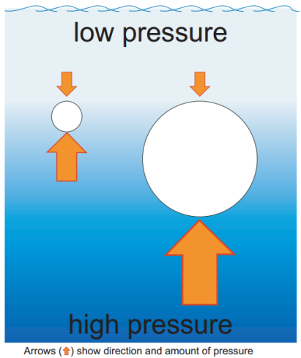

Figure 5.3: Diagram of difference in pressure for the big and small bubbles (Arrow show direction and amount of pressure)

The results presented in Figure 5.1 show that bubble rising velocity increase with the bubble diameter. The pressure is high in a deep liquid and low in a shallow liquid and the bubble rises because there is more pressure on its bottom than that on its top.
Figure 5.3 illustrated that a bigger bubble gets a bigger push because there is a greater difference in pressure between its bottom and its top. Another way to explain this effect is using the buoyancy force on a bubble which is proportional to its diameter or volume eqn 2.6. Therefore, a large bubble will have a greater buoyancy force than a small bubble.

5.2.2 Mass Transfer for Microbubbles and Fine Bubbles

Figure 5.4: (a) Example plot of the dissolved oxygen in the water with the function of time (440 µm microbubble diameter). (b)Typical plot for KLa estimation (0.1l/min, O2removal), where the slope of the linear fitting represents the value of K_{L}a (min⁻¹)

The lab scale ALB was fitted with five aerators with different pore diameters supplying either Nitrogen gas (N₂) or compressed air (air with O₂) at the same flow rate 0.1 l/min to generate five microbubble sizes in order to study the relationship between the microbubble size and the mass transfer. During the research, all experiments were carried out at constant temperature.

Figure 5.4 (a) shows the plot of the oxygen (O₂) removal data for the 440 µm microbubble diameter and used as an example for explanation. It is clearly observed that the contained O₂ dropped rapidly from approximately 6.19 mg/L until nearly 0.92 mg/L within 6 seconds. After 6 seconds, the speed of removing the O₂ decreased as the O₂ contained decreased and remained constant at its lowest point. However, bubbles with larger diameter takes longer time to remove the O₂ from the water and to reach the lowest points. The operational parameters (e.g. flow rate) were always slightly tuned to achieve the target level within the first 1 min during each test. Therefore, bubbling conditions, the time period selected for K_{L}a estimation was determined to be between 1 min and 6 min, to minimise error. The slope of a semilog plot of 1/ (1-E) versus time (t) is required to determine the mass transfer coefficient (K_{L}a), see Figure 5.4(b).

Figure 5.5 (a) K_{L}a under 5 different bubble diameters-oxygen removal. (b) K_{L}a under 5 different bubble diameters-oxygen dosing.

Vertical error bars: the standard deviation of the mass transfer coefficient obtained for the 5 average bubble diameters.

Figure 5.5(a) presents the mass transfer coefficient (K_{L}a) for O₂ removal across five bubble diameters. Figure 5.5(b) presents the mass transfer coefficient (K_{L}a) for dosing O₂ of 5 different bubble diameters.

Theoretically, the mass transfer coefficient (K_{L}a) for dosing and removal of O₂ should be identical, and these experimental values are acceptably similar and discrepancies could have occurred through temperature variation. The mass transfer coefficient K_{L}a increases as bubble diameter decreases. In other words, smaller bubble diameter performs better in mass transfer process.

Generally, K_{L}a mainly depends on the gas-liquid properties (e.g. density, viscosity, diffusivity and temperature etc.), and therefore it is usually considered as a constant for fixed circumstances. Chisti (1989) expressed the gas -liquid interfacial area ‘a’ (m⁻¹) as a function of gas holdup (ε) and bubble diameter, d_{B} (m) shown as:

$a=\frac{6ε}{d_{B}}$ (Eqn 5.8)
At the same inlet flow rate condition, the gas hold depends on the bubble diameter. A smaller bubble diameter generates higher gas holdup due to longer residence time in the water which leads to higher K_{L}a . In addition, smaller bubble diameter has higher surface area to volume ratio which is beneficial for the mass transfer.

In summary, bubble size and gas hold up turn out to be the governing parameters for mass transfer rate.

5.2.3 Liquid Flow Velocity in ALB
(a) | 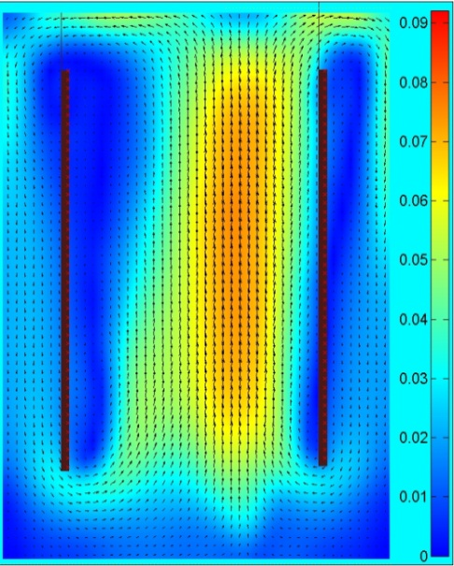 | (b) | 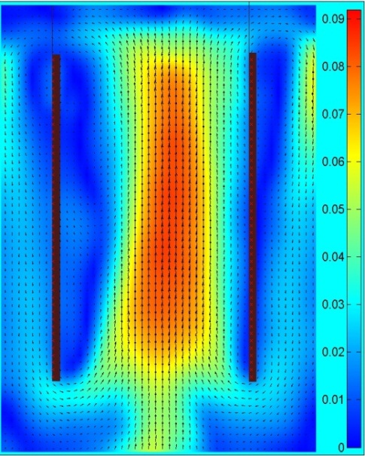
(c) | 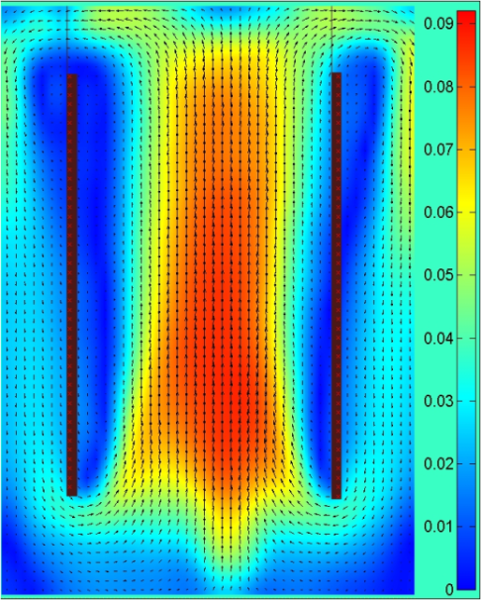 | (d) | 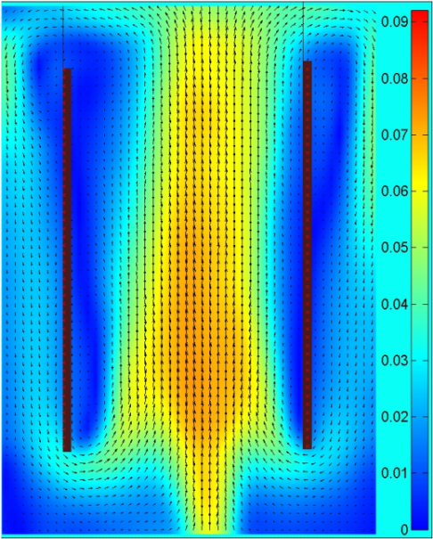
(e) | 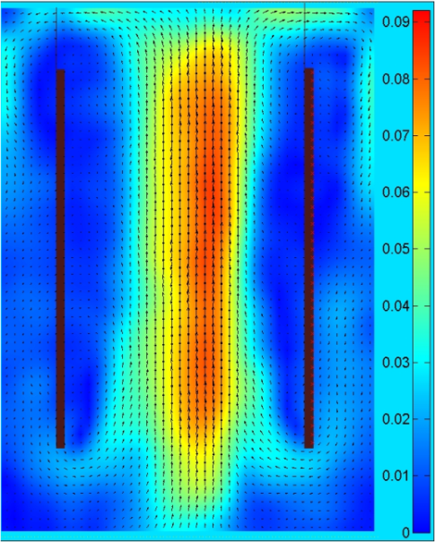 |  | Figure 5.6 :Contour plot and vector plot of liquid flow velocity of five different bubble size (a) 1020 µm (b) 910 µm (c) 755 µm (d) 690 µm (e) 440 µm

In an ALB, the rising bubbles in the air-riser cause the liquid to flow in a vertical direction. To counteract these upward forces, liquid will flow in a downward direction in the down-comer region. This leads to liquid circulation and thus improved mixing efficiencies as compared to bubble columns.
In this chapter, the liquid velocity in an ALB is measured using PIV measurements of fluorescent seeding particles injected into the water system. The injected Rhodamine-B fluorescent particles are used to track the liquid flow velocity. Figure 5.6(a)-(e) show the average contour plots and vector plots of liquid flow velocity of 5 different bubble sizes (1020 µm, 910 µm, 755 µm, 690 µm and 440 µm) in the ALB with the steady flow inlet flow rate 0.1l/min. The average contour and vector plot were obtained using 200 image pairs taken over time of 50 seconds with the repetition rate of 4 Hz.

Figure 5.7: Plot of overall average liquid flow velocity of 5 different bubbles’ size in the ALB.
Horizontal error bars: the standard deviation of the average bubble diameters obtained for each bubble diameters.
Vertical error bars: the standard deviation of the average liquid flow velocity obtained for the 5 average bubble diameters.

The average liquid velocity of each bubble size for 9 different heights is plotted in Figure 5.7 and the axial velocity profile along the radial direction at 9 different height presented in Figure 5.8.
The plot indicates that decreased in bubble diameter from 1020 µm to 755 µm lead to an upsurge in the liquid flow velocity, see Figure 5.7. Nevertheless, the liquid flow velocity driven by the bubble diameter smaller than 755 µm is decreased. In this fixed condition, a total improvement of 39 % is observed in the liquid flow velocity that is driven by the bubbles with a diameter within the range of 1020 µm to 755 µm.
It can be observed that the bubble diameter decreases from large sized bubble to micro sized bubble diameter lead the liquid flow velocity to be increased until a ‘sweet spot’ and the liquid flow velocity started to decrease right after the ‘sweet spot’ .
This effect is expected as the bouyancy force of the large bubbles overwhelming the drag force and therfore the the liquid velocity was lower as shorter time in momentum transfer. The smaller , slower moving bubbles have longer time in momentum transfer although they have less momentum to transfer. That is the reason smaller bubbles do a better job at dragging the liquid along with them, thereby generating stronger liquid circulation. In addition, surface area to volume ratio –momentum is also transferred by shear stress, across the surface area of the bubble and it is known that smaller the bubble size has higher surface to volume ratio. Therefore the flux of momentum is markedly increased by the decrease in bubble size. These effects become lesser as when the momentum of the bubbles is too low when the bubble size decrease. Therefore, the liquid flow velocity decrease when the bubble size decreased after 755 µm.

Figure 5.8 : Axial velocity profile along the radial direction at different heights. a) 200 mm b)400 mm c)600 mm d) 800 mm e) 1000 mm f) 1200 mm g) 1400 mm h) 1600 mm i) 1800 mm
Furthermore, the results obtained in Figure 5.7 also shows the importance of the information that contained in the bubble diameter distribution. The data shown in Figure 5.7 indicates that the bubbles with diameter of 750 µm generate the largest liquid flow velocity, the peak of the data set. However, the bubbles with average diameters of 690 µm have an abnormal size distribution compared to the other 4 bubble diameters. This particular diffuser generated bubble sizes in 3 distinct peaks (250 µm, 450 µm & 750 µm), as shown in Figure 5.9 (b). Although smaller bubbles with the diameter of 250 µm and 450 µm have larger surface to volume ratio compared to the bubbles with the diameter of 750 µm. Nevertheless, low rise velocity of the smaller bubbles may have caused the liquid flow velocity to be lower compared to a bubble cloud with relatively uniform bubbles of this specific diameter. Therefore, we identify a peak liquid velocity region of bubble diameters (including 690 um) rather than a specific bubble diameter value, in Figure 5.7.

Figure 5. 9: Bubble size distributions of 5 aerators with pores diameters (a)2 µm (b)16 µm (c)20 µm (d)50 µm (e)150 µm

5.3. Summary
The characteristics of the microbubble have been determined and summarized as below:
- The bubble rise velocity in the airlift reactor increases with the bubble diameter increases.
- Micro sized bubbles have the potential to save energy in terms of higher mass transfer coefficient.
- Smaller bubbles have larger surface to volume ratio which is favourable to the increased of liquid velocity; Nevertheless, the rise velocity of the bubbles decrease with bubble diameter. Therefore, a suitable bubble diameter with an adequate rise velocity is very important in improving the liquid flow velocity in the ALB.

In a conclusion, the experimental data shows that microbubble improves the airlift reactor efficiency. In addition, bubble size is an important parameter in the design of an ALB rather than only the physical parameters of the ALB.

Chapter 6: Effects of the Draft Tube on Liquid Flow Velocity in ALB

6.1 Introduction
The design of vessel significantly influences the performance of airlift reactor, in particularly, the outer tube and draft tube diameter ratio, the distance between the upper edge of the draft tube to the dispersion surface (C_{T}) and the distance between the lower edge of the draft tube to the aerator surface (C_{B}). Over last decade, there have been lot of studies on the column diameters to draft tube diameter ratio. However, the effect of the top and bottom clearance on the performance of the ALB and the effect of the position of the draft tube on the flow behaviour in the ALB have not been studied to such an extent. Weiland (1984) and Chisti, et al. (1989) reported that that there is a certain range of top clearance affecting the ALB performance and the effects of the bottom clearance was neglected. Sandiani (2012) and Al-azzi & Al-kuffe (2010) neglected the bubble size which affects the flow velocity in the ALB. Sandiani (2012) and Al-azzi & Al-kuffe (2010) varied the clearance distance by changing the water height. Therefore, after completing the previous chapter, illustrating the importance of bubble size on the performance of the ALB, it is necessary to investigate the effect of the draft tube geometry on the ALB performance, with maintaining a consistent bubble size. Therefore, this chapter presents the effects of C_{T} (the distance between the top of column and the upper end of the draft tube) and C_{B} (the distance between the bottom of column and the lower end of draft tube) on the liquid flow velocity in the ALB.

Two sets of PIV experiments were performed to measure the liquid flow circulation velocity. The diameter of the ALB column and the draft tube were maintained constant for all of the experiments. In the first experiments, 100 mm and 80 mm draft tube heights were used for the 200 mm and 180 mm water height experiments, respectively. The position of the draft tube was varied from 20 mm from the surface of the ceramic aerator to 80 mm height, in 10 mm increments. In the second sets of experiments, the draft tube was positioned at the centre of the water height (C_{T}/C_{B}=1) and a range of different draft tube heights (50 mm to 150 mm) were used to vary the C_{T} and C_{B} heights.

6.2 Results and Discussions

6.2.1 Effects of the Draft Tube Position in the ALB or C_{T} / C_{B} Ratio in the ALB on Liquid Flow Velocity.

Figure 6.1: Plot of the average velocity with the function of C_{T} / C_{B} ratio at water height.
(a) 200 mm (b) 180 mm

The main purpose of the first set of experiments was to study the effects of the draft tube position in the ALB or C_{T}/C_{B} ratio in the ALB on the liquid flow velocity. Figure 6.1 shows the average liquid flow velocity in the ALB as a function of the C_{T} / C_{B} ratio in the ALB. Two different water heights (200 mm and 180 mm) in the ALB and with a range of C_{T} /C_{B} ratio were investigated. The error bars are calculated using all experimental repeat. The maximum error is only 5% which is acceptable for this experiment due to the minor error during taking the measurement and uncontrollable inconsistent generated bubble size distribution.

It can be seen in Figure 6.1 (a) & (b), liquid flow velocity at both water heights appears to have s similar trend. Both cases show that there is a range of C_{T} / C_{B} ratio with the highest flow velocity which is the C_{T} / C_{B} ratio 0.43 to 1 for the 200 mm water height and the C_{T} / C_{B} ratio 0.667 to 1 for the 180 mm water height.

In the case where C_{T} > C_{B}, low liquid flow velocity was obtained. Generally, the smallest bottom clearance causes the liquid flow velocity to be restricted by the pressure drop in the bottom of the ALB and causes the majority the bubbles to be trap in the down comer region. In addition, the large C_{T} causes vortices. These vortices cause an increased in coalescence of bubbles leading to formation of large size bubbles that escape quickly from the system resulting in the decreased of gas hold up and thus decreased in liquid circulation velocity (Vanzara et al. 2015, Zhang et al. 2012).

In the case where C_{T} < C_{B} an identical situation occurs where the velocity of the liquid is restricted because bubbles struggle to enter the down comer region and burst at the liquid surface. In addition, part of the gas from the aerator can directly flow into the down comer which reduces the driving force and liquid velocity (Yakubu-gumery 2010).

In summary, there is an optimum C_{T} / C_{B} ratio range 0.5 – 1.0, where bubbles experience relative freedom at the top and bottom of the ALB, without flow restrictions. This is an important parameter when considering further ALB design.

6.2.2 Effects of both C_{T} and C_{B} in the ALB on Liquid Flow Velocity.

Figure 6.2: Plots of the average liquid flow velocity in the ALB as a function of the clearance height of the top and bottom in the ALB at three different height conditions. (a)200mm (b)190mm (c)180mm

Figure 6.2 shows the average liquid flow velocity in the ALB as a function of the C_{T} and C_{B} in the ALB. The average liquid flow velocity was investigated across a range of C_{T} and C_{B} clearances at three different water heights. It can be observed that there are two distinct levels of liquid flow velocity. A higher liquid flow velocity is observed when C_{T} and C_{B} are smaller than 50 mm. A lower liquid flow velocity is observed when C_{T} and C_{B} are larger than 50mm. This trend agrees with the three different water heights tested. The percentage difference between these two levels of average liquid velocity is approximately 46.3 %, 24.3 % and 16.7% at three different height 200mm, 190mm and 180mm respectively.

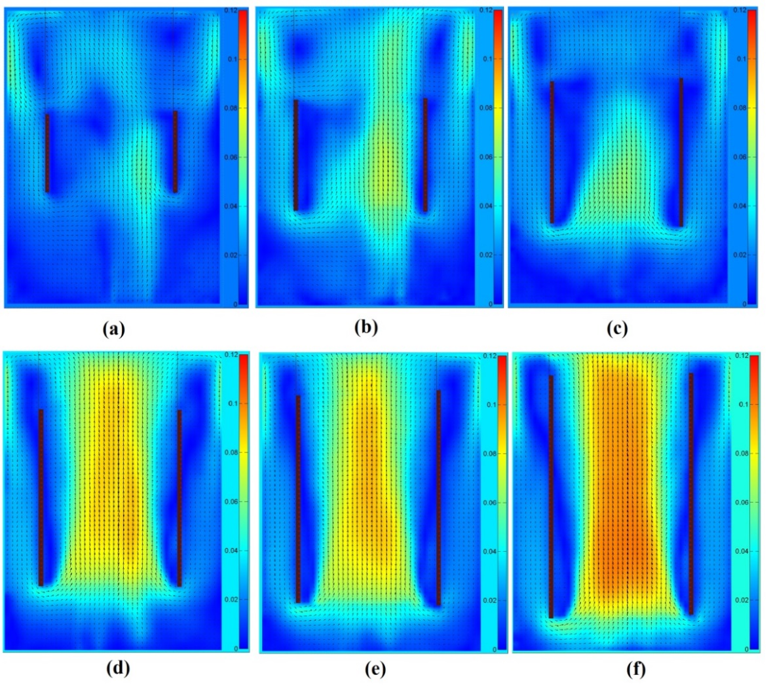
By referring to the contour plot, it is observed that vortices are generated in the upper corners of the ALB for C_{T} and C_{B} values larger than 50 mm, see Figure 6.3. It is strongly believed that these vortices became the circulation resistance that affect the flow going down to the down comer region and hinder or slow the liquid velocity. In addition, these vortices increased coalescence of bubbles leading to formation of large size bubbles that escape quickly from the system resulting in the decreased in gas hold up and thus decreased in liquid circulation velocity. In addition, large C_{B} cause parts of the bubble from the aerator directly flow into the down comer which reduces the driving force and liquid velocity (Vanzara et al. 2015, Zhang et al. 2012) In addition, the decreased in the liquid circulation velocity will cause the sedimentation of the cultural cells or particles at the dead zones in the ALB.
Figure 6.3: Contour and vector plots of the liquid phase flow velocity of 6 different height of clearance (a)70 mm (b) 90 mm (c) 100 mm (d) 110 mm (e) 130 mm (f) 150 mm.
In summary, the optimum clearance height of the lab scale ALB under the fixed condition is approximately 50 mm. This lab scale ALB result proves that both C_{T} and C_{B} in the ALB affect the behaviour of the liquid flow velocity in ALB. The result also concludes that there is a height limit for the C_{T} and C_{B} values and this clearance values (C_{T} and C_{B}) should be considered for the ALB design so to prevent vortices occurring and therefore the loss of system efficiency.

6.3 Summary
The studies of this chapter are mainly focused on the clearance between the liquid and the draft tube and the results are summaries as below:

- The study of the C_{T} / C_{B} ratio on the liquid flow velocity shows that the C_{T}/ C_{B} ratio should be 0.5 – 1.0 in order to obtain the highest liquid flow velocity.

- C_{T} > C_{B} leads to low liquid flow velocity due to the liquid flow velocity restricted by the pressure drop in the bottom of the ALB and the vortices that occur on top of the draft tube blocking the liquid flow.

- C_{T} < C_{B} cause the low liquid flow velocity because of the gas from the aerator can directly flow into the down comer which reduces the driving force and liquid velocity.

- The study shows the effect of the C_{T} and C_{B} on the liquid flow velocity. The study highlighted the height limit for the C_{T} and C_{B} where the C_{T} and C_{B} larger than 50 mm will lead to low liquid flow velocity based on this particular lab scale ALB and the fixed operating condition.

Chapter 7: Conclusions

As mentioned previously that introducing microbubbles into an ALB would improve the mass transfer and liquid flow velocity in the ALB. Thus, the characteristic of the various sizes of microbubble and the behaviour of the mircobubbles in the ALB are very important in controlling the performance of the mass transfer and mixing efficiency in the ALB. The factors that affect the bubble diameter generated from the porous aerators by using steady flow and oscillatory flow were studied. In addition, bubble rise velocity, gas holdup, mass transfer and liquid flow velocity in an ALB were studied across a range of bubble diameter. Furthermore, the effect of the draft tubes was studied across a range of the height of the draft tube and a consistent bubble diameter where the findings agreed that the microbubbles size should be included in the ALB design factor. The detailed conclusions and major findings were summarized as follows:

7.1 Characterization for Bubble Generated from Porous Aerators

Chapter 5 is mainly focused the characteristics of the bubbles that were generated by the porous aerators with a hydrophilic surface coating. The characteristics of bubble were generated by the steady flow conditions and oscillatory flow conditions were also studied.

In the cases of steady flow conditions, the effects of the pore diameter and gas inlet flow rate on the bubble diameter were studied. It can be concluded that the bubble size increases with pore diameters of the porous aerators as well as gas inlet flow rate. The bubble diameter distribution generated from the porous aerator was studied as well. It can be concluded that the bubble diameter distribution clearly represents the characteristic of the aerator in term the pore size distribution of the porous aerator. In addition, the information contained which is very important in controlling the performance of the application as there is possible generation of a few dominant bubble sizes from porous aerator. As mentioned previously, bubble diameter and its distribution is the essential element in controlling the performance of the application, it is important to fully consider the characteristic of the bubble generated rather just only considered the average bubble diameter.

The frequency of the oscillatory flow mainly depends on the length of feedback loop tubing and supply flow rate. The bubble diameter generated at the oscillatory flow condition was proven to be smaller and more uniform compared to the bubbles that generating using steady flow. In addition, the effect of the oscillation frequency on the bubble diameter was discovered. It can be concluded that there is a distinctive minimum average bubble diameter within the range of applied frequency. The oscillation frequency that generates the smallest bubble diameter can be known as “sweet spot” or the optimum oscillation frequency.

The existence of an optimum frequency can be explained by small air pulses entering the forming bubble. The oscillation pulse that generated from the fluidic oscillator is to limit the bubble growth period. The pulse will be longer if the oscillation frequency is low and therefore more gas entering the forming bubbles. This will mean that high amount of gas that will be supplied in a single pulse and force the bubbles to pinch off. Instead, if the oscillation frequency is too high, the amount of gas which is supplied in a single pulse will be insufficient for the bubbles to pinch off; therefore, at least two or more pulses are required for the bubbles to pinch off. If nonetheless the oscillation frequency is at the optimum, an adequate amount of gas is supplied in every single pulse to create bubbles and allow the bubbles to pinch off during every single pulse.

Smaller bubbles are generated due to the association of the lifting force with the gas momentum that generated during the oscillation pulse will increase the buoyancy force. The surface tension effects can be overcome by the combination of the buoyancy force and gas momentum. Smaller momentum contributions per pulse will be delivered at the oscillation frequency that just above the optimum oscillation frequency and therefore results in increasing bubble sizes above the optimum frequency. The amount of air and momentum contribution per pulse at even higher oscillation frequencies above the optimum oscillation frequency is insufficient to overcome the surface tension and thrust the bubble away from the aerator. Consequently, the smaller bubble requires more air pulses to increase its bubble volume and buoyancy force in order to pinch off. The amount of gas supplied in every single pulse at the frequencies just below the optimum is more than sufficient for the bubbles to pinch off. Consequently, the bubbles will remain to grow through the pulse and increase in bubble sizes.

7.2 Microbubbles Behaviour and Effects in ALB
Chapter 6 is a study of microbubbles behaviour within an ALB when average bubble diameter is varied. To study this, five different bubble sizes were produced, four being microbubbles of different sizes and a larger size as a reference in the experiment. The PIV measurement method is used to measure the bubble rise velocity and liquid flow velocity in the ALB. The mass transfer coefficient was calculated from the oxygen level data was measured by using a dissolved oxygen meter (DO meter).

The main finding for this chapter was that the microbubble has lower rise velocity than larger bubble. This is because the buoyant force on a bubble is proportional to its volume. Therefore, a large bubble will have a greater buoyant force than a small bubble. The bubble rise velocity was found to increase with bubble diameter which has also been shown in the literature. In addition, micro sized bubble with larger surface area to volume ratio were found to have better performance in mass transfer process which was proven in oxygen removal and dosing experiments in this chapter. The mass transfer coefficient was found to be increased with the decreased in bubble diameter, given the same gas inlet flow rate.

The effect of the bubble diameter on liquid flow velocity was also found in this chapter. The bubble diameter decreases from large sized bubble to micro sized bubble diameter leads an increased in liquid flow velocity until a ‘sweet spot’ and the liquid flow velocity started to decrease right after the ‘sweet spot’.
This can be explained by refering to the characteristic of the microbubbles that the smaller bubble has better dragging ability (higher liquid flow velocity) compared to the larger bubble. The smaller , slower moving bubbles have longer time in momentum transfer although they have less momentum to transfer. That is the reason smaller bubbles do a better job at dragging the liquid along with them, thereby generating stronger liquid circulation.
But, the rise velocity of the bubble decreases with the diameter as well and this explain the liquid flow velocity started to decreases right after the ‘sweet spot’. The momentum of the bubbles decrease when the bubble size decrease and cause the low liquid flow velocity. Therefore, a suitable bubble diameter with an adequate rise velocity is essential in improving the liquid flow velocity in the ALB.
Overall this study has shown that the improvement in liquid flow velocity and mass transfer coefficient in the ALB through have been improved with the application of microbubbles. Therefore, it is confidently concluded that microbubble diameter and distribution is one of the essential factors to be considered when designing the ALB.

7.3 Effects of the Geometrical Parameters on Liquid Flow Velocity in ALB

Chapter 7 included the effects of the C_{T} and C_{B} on the liquid flow velocity in the ALB. The studies was separated into two experiments. The first experiment is examined the effects of the draft tube positions (C_{T} / C_{B} height ratio) and the second part is examined the C_{T} and C_{B} effects at the condition where C_{T} / C_{B} ratio is equal to 1.

The first part mainly studies the effects of draft tube positon (C_{T} / C_{B} ratio) on the liquid flow velocity within the ALB. In the first experiments, 100 mm and 80 mm draft tube heights were used for the 200 mm and 180 mm water height experiments, respectively. The position of the draft tube was varied from 20mm from the surface of the ceramic aerator to 80 mm height, in 10 mm increments. The gas inlet flow rate is maintained at 0.1 l/min for both sets of experiments. The both sets of experiment results obtained from the PIV measurements show there is an optimum C_{T} / C_{B} height ratio range 0.5 – 1.0, where bubble experiences relative freedom at the top and bottom of the ALB.

High C_{T} / C_{B} ratio (C_{T} / C_{B} ratio >1.0), this will mean that C_{T} > C_{B} and the relatively small bottom clearance (C_{B}) caused the liquid flow velocity to be restricted by the pressure drop in the bottom of the ALB and caused the majority the bubbles to be trap in the down comer region. In addition, the large top clearance C_{T} of the ALB caused the formation of vortices. These vortices increased coalescence of bubble and caused the formation of large size bubble that escape quickly from the system. This result in the decreased of gas hold up and thus decreased in liquid circulation velocity.

Low C_{T} / C_{B} ratio (C_{T} / C_{B} ratio <0.5), this will mean that C_{T} < C_{B} and the velocity of the liquid is restricted because bubbles struggle to enter the down comer region and burst at the liquid surface. In addition, the large bottom clearance C_{B} of the ALB causes part of the gas from the aerator can flow directly into the down comer which reduces the driving force and liquid velocity

The second part of the experiment focused on the effects of C_{T} and C_{B} on the liquid flow velocity in the ALB. A set of draft tubes, with a range of heights, were placed at the centre of three water height cases (200mm, 190 mm and 180 mm). It was observed from experimental results that the liquid flow velocity was clearly affected by the C_{T} and C_{B} of the ALB. There are two distinct regions of average liquid velocity. A higher ‘plateau’ region, where C_{T} and C_{B} is smaller than 50 mm, and a lower ‘tail’ region, where C_{T} and C_{B} is larger than 50 mm. Although this is obtained only for labscale ALB, this can be a reference for all sizes of ALB.

It can be concluded that there is a height minimum and maximum for the C_{T} and C_{B} and these clearance (C_{T} and C_{B}) should be considered for the ALB design so to prevent uncertainty of losing efficiency. If C_{T} and C_{B} are too small the draft tube blocks the liquid flow. Likewise, if C_{T} and C_{B} are too larger flow pattern are not favourable for fast liquid velocities.

7.4 Future Work
This research work was limited due to the numerous challenges such as general logistic, lab limitations and equipment failure and time constraints. Therefore, several of future work are suggested as follows:

- In term of the bubble characterisation from the porous aerator (Chapter 5). There are still quite a few of factors such as thickness of the porous aerator, materials of the aerator, distance between pores, medium properties and other types of porous aerator such as membrane or mesh, that should be studied. The further investigation will gain more knowledge and fundamental in term of factors that controlling bubble size which is very useful when generating the desire microbubble size for varies of applications and conditions. In addition, the strongest the knowledge and fundamental will helps in developing a more stable microbubble generation methods or even smaller bubbles such as nanobubbles. In the Chapter 5 proofs that the optimum oscillation frequency that generates smallest bubble. Therefore; in the case of the oscillatory flow, a different method of generating oscillatory flow with the desired oscillation frequency should be investigated in the future.

- In the Chapter 6 of this thesis, only five bubble sizes were generated and studies due to the materials limitations. In future, it is suggested that smaller bubble size should be generated studies the behaviour of the rise velocity, mass transfer and mixing performances in the ALB. In addition, fluidic oscillator that able to generate more uniform bubble size can be used as the bubble generation system. However, the three main problems of using fluidic oscillator should be take care before the implementation which are the maintain a relatively constant actual inlet flow rate for all the bubble sizes, reduces the high back pressure from the aerator and leakages of the fluidic oscillator that affects the inlet flow rates and pressure.

In term of PIV measurement method, there are plenty of improvement can be done such as taking the bubble flow and the liquid flow images simultaneously. This couldn’t be done as there is only one camera available in the PIV system. In addition, there are several advanced PIV methods presented in Chapter 2.5.3 are worthwhile to be implemented and determined the most suitable measurement method for the two-phase flow velocity measurement in the future. The method B and F are recommended to be used in the future experiments. The main advantage of these two techniques is able to capture the flow of the bubbles and seeding particles simultaneously. These techniques will be able effectively separate the gas phase and liquid phase during capturing the images. This also means that there is no further image processing required to separate the gas phase (Bubbles) and liquid phase (Seeding Particles) during results processing and analysis. Therefore, high accuracy and better quality results will be obtained with these techniques. In addition, the further study of the relation between the bubble velocity and liquid flow velocity can be done with the simultaneous acquisition of the bubble and liquid flow images.

- The consideration the bubble size was excluded in almost all of the previous study of the geometry of the ALB. Therefore, development of the ALB design should also include changing bubble size, so that process conditions remain optimised. In addition, those studies in this thesis are only being tested in the lab scale ALB. Therefore, subsequent works should be carried out to scaling up the ALB with the application of microbubble to industrial level requirement.

References

Publications
Journal Paper:
Stuart Brittle, Pratik Desai, Woon Choon Ng, Alan Dunbar, Robert Howell, Vaclav Tesař, William B. Zimmerman, Minimising microbubble size through oscillation frequency control, Chemical Engineering Research and Design, Volume 104, December 2015, Pages 357-366, ISSN 0263-8762, http://dx.doi.org/10.1016/j.cherd.2015.08.002.
(http://www.sciencedirect.com/science/article/pii/S0263876215002993)

Symposium Manuscript:
Ng, W. C., Brittle, S., Howell, R. and Zimmerman, W. B. (2014) Computational Model for Microbubble Enhanced Performance of Airlift Bioreactor (ALB). In: The University of Sheffield Engineering Symposium Conference Proceedings Vol. 1. USES 2014 - The University of Sheffield Engineering Symposium, 24 June 2014, The Octagon Centre, University of Sheffield. .

