Ruthenium-Carbonyl Carbon Monoxide-Releasing Molecules (CORMs) as Antimicrobial Agents:
a Revised Perspective

A thesis submitted by

Hannah Marie Southam

In partial fulfilment of the requirements for the degree of
Doctor of Philosophy

May 2017

The University of Sheffield
Faculty of Science
Department of Molecular Biology and Biotechnology
Dedication

***

This thesis is dedicated to my wonderful grandparents
Granny, Grandad, Nanny and Gramps

I love you
Nanny and Gramps RIP x

***

Acknowledgements

Firstly, I would like to thank my supervisors - Prof. Robert Poole and Prof. Peter Henderson. You not only gave me the opportunity to undertake a PhD, you generously donated your time and your thoughts, you challenged my ideas and you believed my conclusions. This project was chemically complex, controversial and went against many previously established ideas, including previous ideas from our laboratory. I could not have achieved anything without your scientific rigor, your knowledge and your wisdom. Above all else, you have been kind, thoughtful, understanding, generous and supportive. Thank you.
In the 12th century, Bernard of Chartres introduced ‘anos gigantum humeris insidentes’, or in English, ‘standing on the shoulders of giants’. The conclusions and ideas presented in this thesis have their grounding in important contributions from other researchers in the Poole laboratory and beyond, many of whom I have had the privilege of working alongside. In particular, I’d like to acknowledge Dr Sam McLean, Dr Lauren Wareham, (soon to be Dr) Nam Rana and Dr Helen Jesse for their work on CO and CORMs over recent years. It has been inspiring to work alongside such intelligent, driven and ambitious women. I would also like to acknowledge Dr Shahira Hassoubah and Nam for being my comrades on this PhD journey.
I have been fortunate to work alongside so many great and talented collaborators throughout this project. I would like to thank Prof. Mike Williamson who, right from the beginning, helped me to consider CORMs from a chemist’s perspective. He and Andrea Houndslow assisted with all the NMR experiments. Thank you also to Thomas Smith, Laurie Middlemiss and Dr Michael Hippler, whose expertise on gas phase FTIR was very much required to unravel the mysteries of CO release from CORM-3! Thanks also to Prof. Sherif El Khamisy and Dr Chunyan Liao for taking on a microbiology student, with no prior experience with mammalian cell culture, to investigate the actions of CORM-3 on human cells. All of the ICP-AES in this project (and there is a lot!) was conducted by Neil Bramall. Thank you also to the undergraduate project students that have joined the project over the years, particularly Jonathan Chapman who contributed towards some of the work presented in this thesis. Thanks also to Dr Jim Imlay who communicated unpublished data and ideas on ROS/CORMs. The CORM-3 used in this project was generously donated by Prof. Brian Mann and Keith Owen.
Next, I would like to thank my friends, Lauren and Shuo. Your friendships have been invaluable, you picked me up when I was at my lowest and the world is a better place when you’re around. I miss you every day. I think America might have to give you back soon!

It must be said that I could not have completed this project without the continued love and support from my family. To my mum and dad: you have unquestionably supported my academic efforts over the years. Throughout every level of my education, you went above and beyond to support me. You argued with stubborn teachers that doubted my abilities, you stayed up late to help me with my homework and sacrificed so much to ensure myself and Matt never had to struggle financially whilst we were at university. You taught me about dinosaurs, about animals and about space. You took me to museums, bought me microscopes and chemistry sets and inspired me to love science. My strong work ethic and my unrelenting drive to never give up and to always keep trying, even when everything seems impossible, is all because of you. You are intelligent, kind, caring, generous, loving and would give anything for my brother and I to be happy. I love you so much and I am so thankful for everything. I would also like to thank my little brother Matt. I’m so proud of you and everything you achieve. I could not have done any of this without you. Your support and reason over the years has meant everything to me.
Thank you to Misty and Leia, a big fluffy dog and a little fluffy dog with unbreakably delightful spirits.
This thesis is dedicated to my grandparents: Granny, Grandad, Nanny and Gramps. In the course of this PhD, my Nanny and Gramps sadly passed away. They would have been so happy to see me become the first Dr in the family, and I hope that, wherever they are, they know that I am grateful to them. I also dedicate this thesis to my Granny and Grandad, who had such an enormous influence on me whilst I was young, stimulated my interest in nature and have continued to support me. I love you and this is for you all.
Finally, I would like to thank my partner Dr Chris Hepworth. Throughout the last 2 years you have been unquestionably supportive and patient, you’ve helped me with every aspect of my PhD and ensured I still ate and slept over the last few months. Above all you are a constant reminder of everything that is good in life. I couldn’t have done this without you. I love you.

Abstract

Commentators speculate that we are approaching a post-antibiotic era. We particularly need new drugs to combat multi-drug-resistant Gram-negative bacteria. Although carbon monoxide-releasing molecules (CORMs) are extensively used as experimental tools to study the effects of CO in mammalian systems, there is increasingly interest in the employment of these compounds as novel antimicrobial drugs. Ru-carbonyl CORMs, CORM-2 and CORM-3, are the most antimicrobial CORMs. Curiously however, CO is not an effective antimicrobial agent and therefore it was suspected that CORM-induced antimicrobial effects were not due to CO alone.

The overall aim of this project was to investigate the potential of Ru-carbonyl CORMs as replacements, or adjuvants, to antibiotics. To achieve this, the relative contribution of the CO and the Ru(II) ions in the antimicrobial activities of these compounds against E. coli – a model bacterium – were investigated. An important issue was to elucidate how these compounds were so toxic to bacteria and yet reportedly non-toxic to mammalian cells.

It was found that CORM-2- and CORM-3-induced bacterial cell killing was due to the consequences of CORM-derived Ru binding to bacterial cell targets. Whilst CO release from CORM-2 may also contribute to cell killing, is it highly unlikely that CORM-3 is a CORM in biological experiments. It was demonstrated that intracellular targets of CORM-derived Ru could include: surface-exposed Cys, His and Met residues on proteins (Chapter 4); reduced and oxidised sulfhydryl-compounds e.g. glutathione (Chapter 5); bacterial membranes (Chapter 6); and DNA (Chapter 6). Thus it is suggested that CORM-induced killing was the consequence of Ru(II) ions binding to multiple cellular targets and inhibiting multiple cellular processes, much like the toxic effects of other non-essential metal ions. These cellular targets are also conserved in mammalian cells. Thus, a re-investigation of the effects of CORM-3 against human cells in vitro revealed that human cells also accumulate CORM-derived Ru to cytotoxic levels.

This thesis presents a revised perspective on the antimicrobial activities of Ru-carbonyl CORMs. It is recommended that CORM-2 and CORM-3 should be re-classified as ‘functional Ru-based antimicrobial compounds’ rather than ‘CO-releasing molecules’. Over 300 publications exist on the employment of these compounds as mere ‘CO-donors’ and therefore CORM-2 and CORM-3 have contributed enormously to the understanding of the roles of CO in mammalian physiology. However, from the findings of this work, it can be concluded that the biological effects of CORM-2 and CORM-3 in these studies were probably mediated by the CORM-derived Ru(II) ions binding to mammalian cell targets.
Abbreviations

-S-S- Oxidised sulfhydryl
–SH Thiol or sulfhydryl group
¹H-NMR Proton nuclear magnetic resonance spectroscopy
ADME Absorption, distribution, metabolism and excretion
AMP Adenosine 5’-monophosphate
AMR Antimicrobial resistance
ARB Antibiotic Resistance Breaker
ATP Adenosine triphosphate
bb_{n} Bis[4(4’-methyl-2,2’-bipyridyl)]-1,n-alkane
BHI Brain-Heart Infusion (broth)
BMPO 5-tert-butoxycarbonyl 5-methyl-1-pyrroline N-oxide
BSA Bovine serum albumin
CAMHB Cationic-adjusted Mueller-Hinton broth or MH-II
CAP Covalently attached protein
CFU Colony forming units
cGMP Cyclic guanosine 3’,5’-monophosphate
CipA Ciprofloxacin A
CMP Cytidine 5’-monophosphate
CO Carbon monoxide
CO-Mb Carbonmonoxy-myoglobin
COHb Carbonmonoxy-haemoglobin
CORM Carbon monoxide-releasing molecule
CORM-2 Carbon monoxide-releasing molecule 2
CORM-2 Carbon monoxide-releasing molecule 3
CVCA Crystal violet cell adhesion (assay)
d⁶-DMSO Deuterated DMSO
DCF 2’,7’-dichlorofluorescein
DCFH₂ 2’,7’-dichlorodihydrofluorescein
DCFH₂-DA 2’,7’-dichlorodihydrofluorescein diacetate
Deoxy-Mb Deoxygenated myoglobin
DMEM Dulbecco’s Modified Eagle Medium
DMSO Dimethyl sulfoxide
DOSY ¹H-NMR Diffusion-Ordered spectroscopy
DOSY Diffusion-Ordered Spectroscopy
dsDNA Double-stranded DNA
DTNB 5,5-dithio-bis-(-2-nitrobenzoic acid) also known as Ellman’s reagent
dw Dry weight
EAEC Enteroaggregative E. coli
EDTA Ethylenediaminetetraacetic acid
EHEC Enterohemorrhagic E. coli
EM Electron microscopy
EPEC Enteropathogenic E. coli
EPR Electron paramagnetic resonance spectroscopy
EU European Union
EUCAST European Committee on antimicrobial susceptibility testing
FBS Fetal bovine serum
FCS Fetal calf serum
FDA Food and Drug Agency (US)
FTIR Fourier transform infrared spectroscopy
GC Gas chromatography
GDMM Glucose defined minimal medium
GMP Guanosine 5’-monophosphate
GSH Reduced glutathione
GSSG Oxidised glutathione
H₂S Hydrogen sulfide
HEWL Hen egg white lysozyme
HGT Horizontal gene transfer
HO Haem-oxygenase
HSA Human serum albumin
HSAB Hard-Soft Acid-Base
iCORM Inactivated carbon monoxide-releasing molecule
iCORM-2 Inactivated carbon monoxide-releasing molecule 2 or Ru(II)Cl₂(DMSO)₄
iCORM-3 Inactivated carbon monoxide-releasing molecule 3
ICP-AES Inductively coupled plasma atomic emission spectroscopy
IDSA Infectious Disease Society of America
IL Interleukin
IM Inner-membrane
IMP Inner-membrane protein
IR Infrared
kan^{R} Kanamycin resistance
K_{d} Dissociation constant
KPi Potassium phosphate buffer
LB Lysogeny broth (Miller)
LDH Lactate dehydrogenase
LP Lipoprotein
LPS Lipopolysaccharide
LTA Lipoteichoic acids
MAP-K Mitogen-activated protein kinase
Mb Myoglobin
MDR Multi-drug resistant
MH Mueller-Hinton (broth)
MH-II Mueller-Hinton II broth or CAMHB
MIC Minimum inhibitory concentration
MS Minimal salts (medium)
MTT 3-(4, 5-dimethylthiazol-2-yl)-2,5-diphenyl tetrazolium bromide
NAC N-acetyl cysteine
NAHS Sodium hydrosulfide
NO Nitric oxide
NOS Nitric oxide synthase
NPN N-phenyl-l-napthylamine
OD_{xnm} Optical density at x nm
OM Outer-membrane
OMP Outer-membrane protein
PACT Photodynamic chemotherapy
PBS Phosphate buffered saline
PDAMT Photodynamic antimicrobial therapy
PDT Photodynamic therapy
photoCORM Photo-activated CORM
PI Propidium iodide
PMF Proton motive force
PRAMT Photorelease antimicrobial therapy
PS Photo-sensitizer
R&D Research and development
red-Mb Reduced myoglobin
RKO Homo sapiens colon carcinoma cell line
RNS Reactive nitrogen species
ROS Reactive oxygen species
RPMI Roswell Park Memorial Institute medium
RT Room temperature
Rubb₁₂ [(Ru(phen)₂)₂(μ-bb₁₂)]⁴⁺
SD Standard deviation
sGC Soluble guanylate cyclase
SOD Superoxide dismutase
TF Transcription factor
THF Tetrahydrofuran
TLR Toll-like receptor
TMAH Tetramethylammonium hydroxide
TMP Thymidine 5’-monophosphate
TNF α Tumour necrosis factor α
TSP trimethylsilylpropionate
UPEC Uropathogenic E. coli
UTI Urinary tract infection
VF Virulence factor
WHO World Health Organisation
WT Wild type
WTA Wall teichoic acids

Contents

 | Title | 1
 | Dedication | 2
 | Acknowledgements | 3
 | Abstract | 5
 | Abbreviations | 6
 | Contents | 10
 | List of Figures | 16
 | List of Tables | 18
Chapter 1 | Introduction | 19
1.1 | Context: the rise of antibiotic resistance and the need for novel antimicrobials | 19
1.1.1 | A brief history of antibiotics | 19
1.1.2 | How current antibiotics work | 19
1.1.3 | The rise of AMR and the underlying molecular mechanisms of resistance | 22
1.1.4 | The extent of the threat of AMR | 28
1.1.5 | The need to find novel antimicrobials as alternatives or adjuvants to antibiotics | 31
1.1.6 | What is the ‘ideal’ antimicrobial compound? | 33
1.1.7 | What bacterial pathogens should we target in development of novel antimicrobial compounds? | 35
1.2 | Escherichia coli as an important pathogen and a model organism to evaluate novel antimicrobial agents | 36
1.2.1 | E. coli – an introduction | 36
1.2.2 | E. coli cell organisation and molecular physiology | 38
1.2.3 | E. coli as an important pathogen | 45
1.3 | Carbon monoxide and carbon monoxide-releasing molecules – an introduction | 47
1.3.1 | The biological chemistry of carbon monoxide (CO) | 47
1.3.2 | The development of carbon monoxide-releasing molecules (CORMs) | 47
1.3.3 | CORM-2 and CORM-3 speciation chemistry and CO release | 51
1.3.4 | Cytotoxicity of CORM-2 and CORM-3 on cultured mammalian cells and in whole animal models | 56
1.3.5 | The reported activities of CORM-2 and CORM-3 in mammalian gasotransmitter research and their potential in therapeutic CO-delivery | 58
1.4 | CORMs as novel antimicrobial agents | 60
1.4.1 | The employment of CORMs as antimicrobial agents and as adjuvants to antibiotics in vitro | 60
1.4.2 | The efficacy of CORM-2 and CORM-3 as antimicrobial agents in vivo | 63
1.4.3 | The antimicrobial effects of CO gas | 63
1.4.4 | The antimicrobial effects of CORMs are not due to CO gas alone | 65
1.5 | The mechanisms underlying CORM-2 and CORM-3 antimicrobial effects | 67
1.5.1 | The ‘Trojan Horse’ hypothesis and a critical review of the role of CO in the antimicrobial activity of CORM-2 and CORM-3 | 67
1.5.2 | The contribution of ROS and/or exogenous thiols in the antimicrobial activities of CORM-2 and CORM-3 | 70
1.5.3 | Measurements of uptake of Ru-carbonyl CORMs by bacteria | 76
1.5.4 | Possible bacterial cell targets of CORMs | 77
1.5.5 | The effects of CORM-2 and CORM-3 on E. coli gene regulation | 78
1.5.6 | Are the antimicrobial effects of CORM-2 or CORM-3 due to the CO or Ru(II) ion(s)? | 79
1.6 | Ruthenium compounds as potential antimicrobial agents | 80
1.6.1 | Metals as antimicrobial agents | 80
1.6.2 | The biological chemistry of ruthenium | 82
1.6.3 | An introduction to ruthenium compounds as potential antimicrobial agents | 82
1.6.3a | Class I – structural | 83
1.6.3b | Class II – carrier | 86
1.6.3c | Class III – functional | 87
1.6.3d | Class IV – photo-activated | 89
1.7 | Aims, objectives and scope of thesis | 89
Chapter 2 | Methods | 92
2.1 | General methods | 92
2.1.1 | Bacterial strains and human cell lines | 92
2.1.1a | Bacterial strains | 92
2.1.1b | Human cell lines | 92
2.1.2 | Preparation of buffers and growth media | 92
2.1.2a | Bacterial growth media | 92
2.1.2b | Mammalian cell culture media | 93
2.1.2c | Buffers | 93
2.1.3 | Preparation of CORM-2 and CORM-3 stocks | 93
2.1.3a | CORM-2, Tricarbonyldichlororuthenium(II) dimer, Ru₂Cl₄(CO)₆ | 93
2.1.3b | CORM-3, Tricarbonylchloro(glycinato)ruthenium(II), C₅H₄ClNO₅Ru | 94
2.2 | Microbiological methods | 94
2.2.1 | Routine bacterial growth and strain maintenance | 94
2.2.2 | Measurements of E. coli culture growth and viability | 95
2.2.2a | Growth | 95
2.2.2b | Viability | 95
2.2.3 | Determination of Ru content of whole E. coli cells | 95
2.2.4 | Assessment of buffers or growth media on the growth inhibitory effects of CORM-2 and CORM-3 against E. coli | 96
2.2.5 | Determination of the affect of casamino acids on the growth inhibitory effects of CORMs against E. coli | 97
2.2.6 | CORM growth inhibition screens against E. coli following pre-incubations of CORM-2 or CORM-3 with exogenous amino acids, sulfur compounds or nucleotides | 97
2.2.6a | Amino acids | 97
2.2.6b | Sulfur-containing compounds | 98
2.2.6c | Nucleotides | 98
2.2.7 | Determining the effects of exogenous amino acids or glutathione on the level of CORM-derived Ru accumulation and E. coli viability loss upon CORM addition | 99
2.2.7a | Amino acids | 99
2.2.7b | Glutathione | 99
2.2.8 | Determination of intracellular thiol content of E. coli | 99
2.2.9 | Sub-cellular distribution of CORM-derived Ru in E. coli | 100
2.2.10 | CORM-derived Ru binding to E. coli chromosomal DNA in vivo | 101
2.2.11 | Measurements of extracellular ATP levels | 101
2.3 | Methods for measuring CO release from CORMs | 101
2.3.1 | Myoglobin assays | 101
2.3.1a | General | 101
2.3.1b | Determination of CO release from CORM-2 in various media | 102
2.3.2 | Gas-phase Fourier transform infrared spectroscopy (FTIR) | 102
2.4 | ¹H-NMR experiments | 103
2.4.1 | Preparation of solutions and reagents for ¹H-NMR experiments | 103
2.4.1a | Buffer | 103
2.4.1b | CORM stocks | 103
2.4.1c | Peptide stocks | 104
2.4.2 | ¹H-NMR experiments and spectra acquisition | 104
2.4.3 | CORM/peptide titrations and determination of K_{d} | 105
2.5 | Experiments with human carcinoma cells in vitro | 105
2.5.1 | Routine growth and maintenance of RKO cells | 106
2.5.2 | Assessment of CORM-3 cytotoxicity against RKO cells via clonogenic survival assays | 106
2.5.3 | Measurements of CORM-3-derived Ru accumulation by RKO cells | 107
2.6 | Other methods | 108
2.6.1 | Determination of logP | 108
2.6.2 | General data handling and statistical analysis | 108
Chapter 3 | The contributions of CO and Ru in the antimicrobial effects of Ru-carbonyl CORMs | 109
3.1 | Introduction | 109
3.1.1 | Are the antimicrobial effects of CORM-2 and CORM-3 due to CO or Ru? | 109
3.1.2 | The antimicrobial activities of CORM-2 and CORM-3 are altered depending on the choice of growth medium | 112
3.1.3 | If CO is not fully responsible for CORM-2 and CORM-3 antimicrobial affects, why are ‘iCORM’s non-toxic? | 114
3.1.4 | Aims and objectives of Chapter 3 | 115
3.2 | Results | 116
3.2.1 | CORM-2 and CORM-3 are potent antimicrobial agents against E. coli MG1655 in glucose defined minimal medium | 116
3.2.2 | E. coli MG1655 cell cultures accumulate ruthenium to milimolar levels upon exposure to CORM-2 or CORM-3 | 118
3.2.3 | The extent of cell killing by CORM-2 or CORM-3 in E. coli is strongly correlated with the extent of intracellular Ru accumulation | 120
3.2.4 | The antimicrobial effects of CORM-2 and CORM-3 against E. coli are alleviated by components of complex growth media | 120
3.2.5 | CO release from CORM-2 to deoxy-Mb is unaffected by pre-incubation in various growth media | 122
3.2.6 | The ability of CORM-3 to release CO upon addition of sodium dithionite is rapidly diminished by pre-incubation in phosphate buffer or growth media | 124
3.2.7 | CORM-3 speciation chemistry upon addition to phosphate buffers | 127
3.3 | Discussion | 133
3.3.1 | Cell killing by CORM-2 or CORM-3 is mediated, at least in part, by Ru | 133
3.3.2 | Components of rich growth media protect E. coli against CORM-2 and CORM-3 antimicrobial affects | 135
3.3.3 | CO release from CORM-3 is rapidly ‘inactivated’ upon addition to phosphate buffer and various growth media – when does CORM-3 become ‘iCORM-3’? | 137
3.4 | Concluding remarks | 140
Chapter 4 | The interactions of Ru-carbonyl CORMs with amino acids | 141
4.1 | Introduction | 141
4.1.1 | Are amino acids the components of rich media that prevent CORM-2 or CORM-3 antimicrobial affects? | 141
4.1.2 | Could amino acids or proteins be bacterial cell targets of CORM-2 and CORM-3 Ru(II) ion(s)? | 141
4.1.3 | Aims and objectives of Chapter 4 | 144
4.2 | Results | 144
4.2.1 | Addition of casamino acids to GDMM alleviates CORM-2 and CORM-3 toxicity | 144
4.2.2 | Exogenous cysteine, histidine or methionine partially or fully alleviate the antimicrobial activities of CORM-2 | 146
4.2.3 | Exogenous cysteine, histidine or methionine partially or fully alleviate the antimicrobial activities of CORM-3 | 149
4.2.4 | Relative binding affinities of CORM-2 to selected amino acid residues by ¹H-NMR | 151
4.2.4a | Cysteine (A₃CA₃) | 153
4.2.4b | Histidine (A₃HA₃) | 153
4.2.4c | Methionine (A₃MA₃) | 155
4.2.4d | Aspartate (A₃DA₃) and Alanine (A₇) | 158
4.2.5 | Relative binding affinities of CORM-3 to selected amino acid residues by ¹H-NMR | 158
4.2.5a | Cysteine (A₃CA₃) | 158
4.2.5b | Histidine (A₃HA₃) | 161
4.2.5c | Methionine (A₃MA₃) | 161
4.2.5d | Aspartate (A₃DA₃) and Alanine (A₇) | 161
4.2.6 | CO release from CORM-3 is not promoted by reaction with amino acids | 165
4.3 | Discussion | 165
4.3.1 | Exogenous Cys, His and Met fully or partially protect against the antimicrobial effects of CORM-2 and CORM-3 | 165
4.3.2 | The nature of CORM-2 and CORM-3 interactions with cysteine | 168
4.3.3 | The nature of CORM-2 and CORM-3 interactions with histidine | 169
4.3.4 | The nature of CORM-2 and CORM-3 interactions with methionine | 170
4.3.5 | Why do cysteine and histidine prevent CORM-derived Ru accumulation by E. coli but methionine does not? | 171
4.3.6 | Aspartate and alanine do not interact with CORM-2 or CORM-3 in vitro | 172
4.3.7 | Are surface exposed Cys, His or Met residues on proteins likely bacterial targets of CORM-2 and CORM-3 Ru(II) ions? | 172
4.4 | Concluding remarks | 174
Chapter 5 | Ru-carbonyl CORMs as sulfhydryl-reagents in vitro and in vivo | 175
5.1.1 | Could intracellular thiols be targets of CORM-derived Ru(II) ions? | 175
5.1.2 | Thiols are known targets of metal ions | 176
5.1.3 | CORM-2 and CORM-3 interact with thiol containing compounds in vitro but intracellular thiol binding has not been demonstrated | 177
5.1.4 | Aims and objectives of Chapter 5 | 178
5.2 | Results | 179
5.2.1 | The impact of exogenous reduced or oxidised sulfhydryl compounds on the antimicrobial activities of CORM-2 | 179
5.2.2 | The impact of exogenous reduced or oxidised thiol compounds on the antimicrobial activities of CORM-3 | 82
5.2.3 | Glutathione-deficient E. coli mutants are more sensitive to CORM-2 and CORM-3 and accumulate less CORM-derived Ru than WT cells | 185
5.3 | Discussion | 189
5.3.1 | CORM-2 and CORM-3 interact with reduced and oxidised sulfhydryl-containing compounds in vitro and in vivo | 189
5.3.2 | Intracellular GSH is an intracellular target of CORM-derived Ru and may have a protective role against CORM toxicity in E. coli | 191
5.4 | Concluding remarks | 193
Chapter 6 | Are bacterial membranes and DNA overlooked targets of Ru-carbonyl CORMs? | 195
6.1 | Introduction | 195
6.1.1 | Is DNA a previously overlooked bacterial cell target of CORM-2 and CORM-3? | 195
6.1.2 | Do CORM-2 and CORM-3 target bacterial cell membranes? | 196
6.1.3 | Aims and objectives of Chapter 6 | 198
6.2 | Results | 198
6.2.1 | Nitric acid washing of CORM-treated E. coli cells does not significantly decrease the level of detectable Ru in whole cells by ICP-AES | 198
6.2.2 | CORM-derived Ru is distributed equally between the membrane and the soluble fraction of E. coli cells | 199
6.2.3 | CORM-derived Ru is present in E. coli genomic DNA extracts following exposure of cells to CORM-2 or CORM-3 | 203
6.2.4 | Pre-incubation of CORM-2 or CORM-3 with exogenous nucleotides do not prevent the growth inhibitory effects of CORMs against E. coli | 205
6.2.5 | Sub-lethal doses of CORM-2 and CORM-3 induce ATP leakage from E. coli cells into the extracellular milieu | 206
6.2.5a | Preliminary work | 206
6.2.5b | Assessment of membrane damage by leakage of ATP | 208
6.2.6 | CORM-2 and CORM-3 are not lipophilic compounds | 211
6.3 | Discussion | 213
6.3.1 | The subcellular distribution of CORM-2 and CORM-3 in E. coli cells | 213
6.3.1a | Possible membrane targets of CORM-2 and CORM-3 | 213
6.3.1b | Possible cytoplasmic/periplasmic targets of CORM-2 and CORM-3 | 214
6.3.2 | Are nucleic acids intracellular targets of CORM-derived Ru(II) ions? | 215
6.3.3 | Why do sub-lethal doses of CORM-2 and CORM-3 induce ATP leakage from E. coli cells? | 216
6.4 | Concluding remarks | 218
Chapter 7 | A re-examination of CORM-3 cytotoxicity | 220
7.1 | Introduction | 220
7.1.1 | The employment of CORM-2 and CORM-3 as experimental tools to elucidate the roles of CO in mammalian physiology | 220
7.1.2 | Do the cytotoxic effects of CORM-2 and CORM-3 against cultured mammalian cells require a re-examination? | 222
7.1.3 | Determining an appropriate cell viability test to examine the cytotoxicity of CORM-2 and CORM-3 in vitro | 223
7.1.4 | Aims and objectives of Chapter 7 | 224
7.2 | Results | 224
7.2.1 | CORM-3 is cytotoxic to human RKO cells in PBS | 224
7.2.2 | Rich growth media and/or FCS protect human RKO cells against CORM-3 cytotoxicity in vitro | 225
7.2.3 | Human RKO cells accumulate CORM-3-derived Ru to milimolar levels in vitro, but rich growth media decreases the extent of accumulation | 228
7.3 | Discussion and concluding remarks | 230
7.3.1 | CORM-3 is significantly cytotoxic to human cells in the absence of rich growth media or FCS | 230
7.3.2 | Are the underlying mechanisms of CORM-induced cytotoxicity in human cells essentially the same as the antimicrobial actions of these CORMs against bacteria? | 231
7.3.3 | Implications for the employment of CORMs as experimental tools to investigate the physiological effects of CO in mammalian cells | 232
Chapter 8 | General conclusions and future work | 234
8.1 | General conclusions | 234
8.1.1 | Ru-carbonyl based CORMs as antimicrobial agents: a revised perspective | 234
8.1.1a | CORM-3 is not a CORM | 234
8.1.1b | iCORMs should not be used as negative controls to assess the contribution of the Ru(II) ions to the biological effects of CORM-2 and CORM-3 | 235
8.1.1c | CORM-2 and CORM-3 antimicrobial effects are strongly associated with CORM-derived Ru accumulation by bacterial cells | 235
8.1.1d | CORM-derived Ru uptake and accumulation by E. coli is proposed to be driven by diffusion and is dependent on the availability of intracellular targets of Ru(II) ions | 236
8.1.1e | The antimicrobial effects of CORM-2 and CORM-3 are likely to be mediated by the consequences of Ru(II) coordination to diverse targets and consequential inhibition of multiple cellular processes. | 236
8.1.2 | Re-classification of CORM-2 and CORM-3 as functional ruthenium antimicrobial agents | 238
8.1.3 | Could CORM-2 and CORM-3 act as potential replacements or adjuvants to existing antibiotics? | 238
8.1.4 | A message to mammalian scientists: It’s probably not the CO and it’s almost certainly the Ru! | 239
8.2 | Future work | 240
8.2.1 | How does CORM-derived Ru(II) ion coordination to multiple cellular targets induce bacterial cell killing? | 240
8.2.2 | Mechanisms of CORM-derived Ru uptake by bacteria | 241
8.2.3 | Is DNA a target of CORM-derived Ru? | 241
8.2.4 | Contribution to the design of better CORMs | 242
 | References | 243
 | Supplementary information | 254

List of Figures

Fig. 1.1 | Key dates and important landmarks in the history of antibiotics and metal compounds in medicine | 20
Fig. 1.2 | The widespread uses of antibiotics and other antimicrobial compounds in modern life | 26
Fig. 1.3 | The ‘ideal’ antimicrobial compound | 34
Fig. 1.4 | Schematic representation of an E. coli cell | 41
Fig. 1.5 | The composition of the E. coli K-12 MG1655 cell envelope | 42
Fig. 1.6 | Key differences between Gram-positive and Gram-negative cell envelopes | 43
Fig. 1.7 | The E. coli respiratory chain and ATP synthesis via the proton motive force | 46
Fig. 1.8 | Roles of CO in mammalian biological systems | 48
Fig. 1.9 | CO generation via the haem-degradation pathway | 49
Fig. 1.10 | Structures and speciation chemistry of CORM-2 and CORM-3 | 54
Fig. 1.11 | The ‘Trojan Horse Hypothesis’ of CORM-2 and CORM-3 antimicrobial activity | 66
Fig. 1.12 | Theories of the generation of ROS from Ru-carbonyl CORMs | 72
Fig. 1.13 | How do the Ru(II) ion(s) of CORM-2 and CORM-3 cause bacterial cell killing? | 81
Fig. 1.14 | Examples of structural Ru antimicrobial compounds | 84
Fig. 3.1 | CORM-2 and CORM-3 inhibit cell growth and are bactericidal to E. coli MG1655 in glucose defined minimal media | 117
Fig. 3.2 | Exposure of E. coli MG1655 cells to CORM-2 or CORM-3 results in an accumulation of milimolar levels of intracellular Ru | 119
Fig. 3.3 | E. coli cell killing by CORM-2 and CORM-3 is strongly correlated with the extent of intracellular Ru accumulation | 121
Fig. 3.4 | Toxicity of CORM-2 and CORM-3 to E. coli is alleviated by the components of complex growth media. | 123
Fig. 3.5 | CO release from CORM-2 is unaffected by pre-incubation in various growth media or KPi buffer | 125
Fig. 3.6 | CO release from CORM-3 is reduced by incubation in various bacterial or mammalian cell culture growth media and phosphate buffer | 126
Fig. 3.7 | ¹H-NMR spectrum of CORM-3 in distilled H₂O, pH 2.5 | 129
Fig. 3.8 | 1H-NMR spectrum of CORM-3 is altered upon adjustment to neutral pH or upon addition of 30 mM KPi buffer pH 7.4 | 130
Fig. 3.9 | ¹H-NMR spectra of CORM-3 in 30 mM KPi buffer pH 7.4 before and after spiking with glycine | 131
Fig. 3.10 | 2D-DOSY ¹H-NMR spectrum of CORM-3 in 30 mM KPi buffer at pH 7.4 | 132
Fig. 4.1 | Toxicity of CORM-2 and CORM-3 to Escherichia coli is alleviated by supplementation of growth medium with casamino acids | 145
Fig. 4.2 | E. coli growth inhibition screen of CORM-2 +/- exogenous amino acids | 147
Fig. 4.3 | The effects of exogenous amino acids on CORM-2-induced bacterial cell death and intracellular Ru accumulation | 148
Fig. 4.4 | E. coli growth inhibition screen of CORM-3 +/- exogenous amino acids | 150
Fig. 4.5 | The effects of exogenous amino acids on CORM-3-induced bacterial cell death and intracellular Ru accumulation | 152
Fig. 4.6 | Binding affinity of CORM-2 to cysteine as determined by ¹H-NMR. | 154
Fig. 4.7 | Binding affinity of CORM-2 to histidine as determined by ¹H-NMR | 156
Fig. 4.8 | Binding affinity of CORM-2 to methionine as determined by ¹H-NMR | 157
Fig. 4.9 | Titrations of A₃DA₃ and A₇ peptides with CORM-2/DMSO by ¹H-NMR | 159
Fig. 4.10 | Binding affinity of CORM-3 to cysteine as determined by ¹H-NMR | 160
Fig. 4.11 | Binding affinity of CORM-3 to histidine as determined by ¹H-NMR | 162
Fig. 4.12 | Binding affinity of CORM-3 to methionine as determined by ¹H-NMR | 163
Fig. 4.13 | Titrations of A₃DA₃ and A₇ peptides with CORM-3 by ¹H-NMR | 164
Fig. 4.14 | Amino acids do not promote CO release from CORM-3 | 167
Fig. 5.1 | E. coli growth inhibition screen of CORM-2 +/- exogenous sulfur compounds | 180
Fig. 5.2 | The affects of exogenous glutathione on CORM-2-induced bacterial cell death and intracellular Ru accumulation | 181
Fig. 5.3 | E. coli growth inhibition screen of CORM-3 +/- exogenous sulfur compounds | 183
Fig. 5.4 | The affects of exogenous glutathione on CORM-3-induced bacterial cell death and intracellular Ru accumulation | 184
Fig. 5.5 | Phenotypic characterisation of E. coli glutathione deficient (gshA) mutant strain | 187
Fig. 5.6 | Glutathione deficient gshA E. coli cells accumulate less Ru upon exposure to CORM-2 or CORM-3, but are more sensitive to CORMs than WT gshA⁺ E. coli | 188
Fig. 6.1 | Nitric acid washing of E. coli cell pellets does not significantly decrease intracellular Ru content | 200
Fig. 6.2 | Subcellular localisation of CORM-derived Ru | 201
Fig. 6.3 | CORM-derived Ru targets chromosomal DNA inside E. coli cells | 204
Fig. 6.4 | E. coli growth inhibition screen of CORM-2 and CORM-3 +/- nucleotide monophosphates | 207
Fig. 6.5 | Treatment of E. coli with sub-lethal concentrations of CORM-2 causes ATP leakage from cells | 209
Fig. 6.6 | Treatment of E. coli with sub-lethal concentrations of CORM-3 causes ATP leakage from cells | 210
Fig. 6.7 | CORM-2 and CORM-3 are not lipophilic in GDMM at 37°C pH 7.4 | 212
Fig. 7.1 | CORM-3 is acutely cytotoxic to cultured human cells in PBS | 226
Fig. 7.2 | Components of mammalian cell culture media or supplements protect human cells against the acute cytotoxicity of CORM-3 in vitro | 227
Fig. 7.3 | Human cells accumulate CORM-3-derived Ru in vitro | 229
Fig. 8.1 | Uptake and accumulation of CORM-derived Ru by E. coli cells upon exposure to CORM-2 or CORM-3 | 237
S. Fig. S1 | Dry weight vs OD_{600nm} calibration curve | 254

List of Tables

Table 1.1 | Structures of commonly used antibiotics and how they work | 23
Table 1.2 | Molecular mechanisms of resistance to clinically relevant antibiotics | 29
Table 1.3 | Possible future therapeutic and preventative approaches as alternative or adjuvants to antibiotics | 32
Table 1.4 | World Health Organisation’s list of Global Priority Pathogens for R&D on new antibiotics 2017 | 37
Table 1.5 | An estimation of the macromolecular composition of an E. coli cell, in exponential phase in glucose defined minimal medium | 39
Table 1.6 | Physical and chemical properties of CO | 50
Table 1.7 | Examples of commonly used CORMs | 52
Table 1.8 | Cytotoxicity of Ru-carbonyl CORMs towards cultured mammalian cells | 57
Table 1.9 | Antimicrobial activities of CORM-2 and CORM-3 | 61
Table 3.1 | The concentrations of CORM-2 or CORM-3 required to induce antimicrobial effects and the choice of growth medium employed | 113
Table 4.1 | Summary of the relative binding affinities of CORM-2 and CORM-3 to selected amino acids as determined by ¹H-NMR | 166

Chapter 1

Introduction

1.1. Context: the rise of antibiotic resistance and the need for novel antimicrobials

1.1.1. A brief history of antibiotics

The discovery and clinical application of antibiotics in the early 20th century is widely considered one of the most significant and revolutionary achievements in the history of medicine (Davies and Davies, 2010). In many ways, the treatment of infections with antibiotics represents a remarkable success story; no other class of pharmaceutical compound has so efficiently and so cost-effectively reduced the morbidity and mortality of both human and animal disease (Butler et al., 2017). The dates of discovery and first incidences of the clinical application of commonly used antibiotics are illustrated in Fig. 1.1. Antibiotics were initially viewed as miraculous drugs and were used indiscriminately in the treatment of bacterial and non-bacterial infections (Alanis, 2005). By the 1950s-1960s, it was widely believed that infectious diseases would become a forgotten relic of the past, with future generations unburdened by such readily curable infections (Bragginton and Piddock, 2014). Just over half a century later, with the emergence of antimicrobial resistance (AMR) and the woefully deplete pipeline of new antibiotics, a future absent of infectious diseases is inconceivable to clinicians and microbiologists (Alanis, 2005; Davies and Davies, 2010). In 2017, antibiotics are no longer viewed as panaceas of modern medicine, but instead a valuable resource which is becoming increasingly less effective and more important to preserve.

1.1.2. How current antibiotics work

Selman Waksman, discoverer of streptomycin in the 1940s, first proposed the term ‘antibiotic’ to describe any class of organic molecule that inhibits growth of or kills microorganisms via specific interactions with bacterial cell targets (Davies and Davies, 2010). Recently, ‘antibiotic’ has become synonymous with any form of antibacterial drug (Blair et al., 2015; Meek et al., 2015). Antibiotics can either be derived from natural sources, as is the case for penicillin or streptomycin, or be synthetic, as is the case for sulfonamides and trimethoprim (Davies and Davies, 2010).

Fig.1.1. Key dates and important landmarks in the history of antibiotics and metal compounds in medicine
(continued on following page)
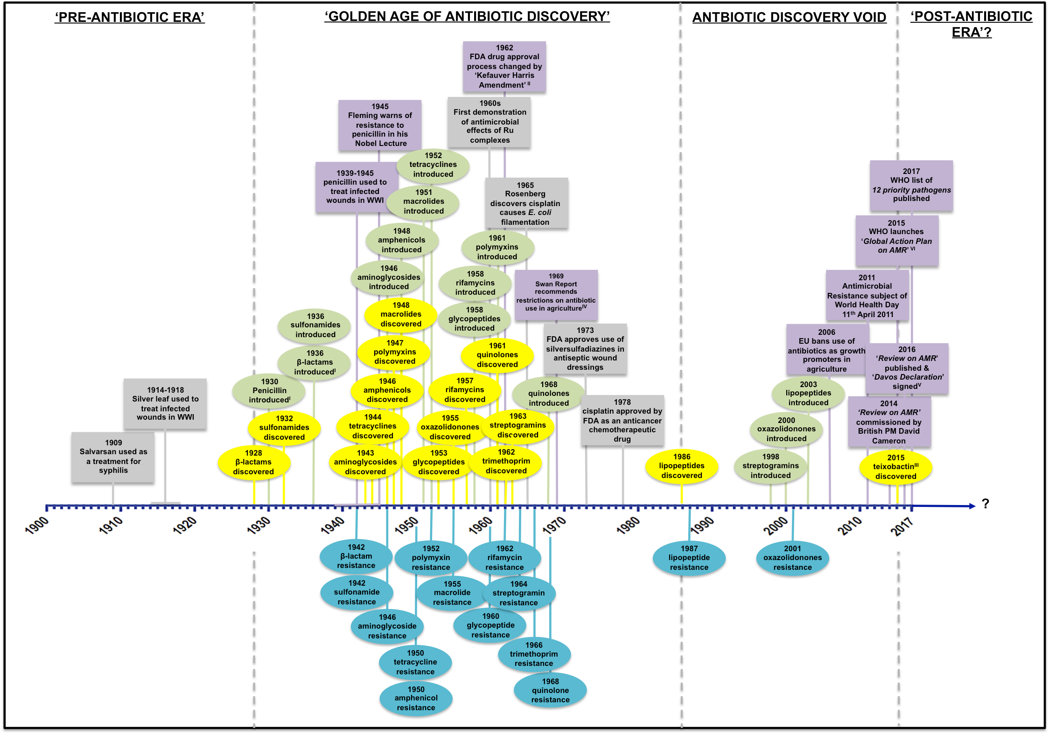

Fig. 1.1. Key dates and important landmarks in the history of antibiotics and metal compounds in medicine
The Eras of Antibiotics: From left-to-right, Pre-1928, the ‘PRE-ANTIBIOTIC ERA’, before the discovery of antibiotics. The serendipitous discovery of penicillin by Alexander Fleming in 1928 marked the beginning of the ‘GOLDEN AGE OF ANTIBIOTIC DISCOVERY’, the period in which most antibiotics used in the clinic today were discovered. Post-1986 to 2015: the ‘ANTIBIOTIC DISCOVERY VOID’ where no new classes of antibiotic were found until the discovery of Teixobactin by Lewis and co-workers in 2015 (Ling et al., 2015). Some commentators speculate that we are currently in, or fast approaching, a ‘POST-ANTIBIOTIC ERA’ (Alanis, 2005).
Dates of discovery, clinical application and resistance of antibiotics. The dates of discovery of key classes of antibiotics are shown in yellow, dates of their first clinical applications are shown in green and the dates of first reports of bacterial resistance are shown in blue. The first clinical application of penicillin is widely reported to be 1936 (Lewis, 2013), but there is evidence to suggest that Dr Cecil Paine, a pathologist working at Sheffield Royal Infirmary, used penicillin in the treatment of gonococci infections in infants between 1930-1931(Wainwright and Swan, 1986).
Important landmarks in the history of antibiotics. Shown in purple. Soon after its discovery, penicillin was largely reserved for military use in World War II (WWII) (1939 - 1945). In 1945, Alexander Fleming warned in his Nobel Lecture, that misuse or under-dosing of antibiotics would lead to the generation of resistant strains (Braggington and Piddock 2014). As a consequence of the thalidomide disaster, the US Food and Drug Administration (FDA) introduced the Kefauver-Harris Amendment (also known as the ‘Drug Efficacy Amendment’) in 1962, this led to much stricter efficacy and safety criteria in the approval of new drugs, including antibiotics (Davies and Davies, 2010). In 1969, following concerns over the increasing use of antibiotics in livestock, the Swan Report recommended restrictions on the use of antibiotics in agriculture (Antibiotic Action, 2017). Over 35 years later in 2006, the European Union (EU) banned the use of antibiotics as growth promoters in agriculture, although the practice is still widespread in non-EU countries. In 2011, the World Health Organisation (WHO) declared AMR the subject of its annual World Health Day. Dr Margaret Chan, WHO Director-General, stated: ‘no action today, no cure tomorrow’ (Review on AMR, 2016a). In 2014, the ‘Review on AMR’ was commissioned by the then UK Prime Minister, David Cameron, to assess the global economic impact of AMR (Review on AMR, 2016a). In January 2016, the Davos Declaration was launched – this was a declaration by the pharmaceutical industries to commit to reducing development of antibiotic resistance and increase investment in R&D into new antibiotics (Review on AMR, 2016b). In May 2016, Jim O’Neill published the final report on the ‘Review on AMR’ and warned that by 2050, up to 10 million people per year could die as a consequence of AMR (Review on AMR, 2016a). Earlier this year, the WHO published a list of 12 families of bacteria that pose the greatest threat to human health (WHO, 2017), as described in Section 1.1.5.
Key dates in the history of metals in medicine. Shown in grey. Paul Ehrlich’s quest for a ‘magic bullet’ led to the discovery of salvarsan, an organo-arsenic compound, first used to treat syphilis in 1909 (Aminov, 2010). Prior to the discovery of antibiotics, silver leaf was used to treat wound infections in World World I (WWI) (1914 - 1918) (Dai et al., 2010). In the 1960s, Dwyer and co-workers first demonstrated the antimicrobial activities of complexes of Ru (Dwyer and Mellor, 1964), see Section 1.3. In 1965, Rosenberg discovered that cisplatin caused filamentous growth in E. coli (Rosenberg et al., 1967). In 1973, the FDA approved the use of silver compounds in anti-septic wound dressings (FDA, 2017). In 1978, cisplatin was approved by the FDA for use as an anticancer chemotherapeutic agent. Cisplatin and its derivatives are still the most widely used chemotherapeutic drugs in clinical use ( Rosenberg et al., 1967; Wong and Giandomenico, 1999).
Additional references: Lewis, 2013; Davies and Davies 2010; Braggington and Piddock 2014; Evans et al 1999; Fleming et al., 1972.

Antibiotics are classified depending on the compound’s structure, mechanism of action, spectrum of activity, and whether it is bacteriostatic or bactericidal, as shown in Table 1.1 (Davies and Davies, 2010; Lewis, 2013). Antibiotics of the same class share structural features. For example, all β-lactam antibiotics (a class that includes penicillins, cephalosporins, carbapenems and monobactams) contain the β-lactam ring (Table 1.1). The mechanism of action of a particular antibiotic involves the targeting of a specific bacterial cell target or process (Table 1.1). An antibiotic may selectively target either Gram-positive or Gram-negative bacteria, or both, as is the case for ‘broad-spectrum’ antimicrobials (Lewis, 2013). Antibiotics are classified as bacteriostatic or bactericidal, depending on the mechanism of action and the dose at which the compound exerts growth inhibition or cell killing (Lewis, 2013). Bacteriostatic antibiotics inhibit cell growth only, and typically include those that act by disrupting cell processes such as folic acid synthesis, transcription or translation (Davies and Davies, 2010; Lewis, 2013). Bactericidal antibiotics induce cell death and include those that act via inhibition of DNA replication, inhibition of cell wall synthesis or cause membrane dysfunction or damage (Davies and Davies, 2010; Lewis, 2013). Structures and mechanisms of action of commonly used antibiotics are shown in Table 1.1.

Generally, antibiotics are considered to elicit their antibacterial effects by acting on specific bacterial cell targets as outlined in Table 1.1, however, some researchers have proposed that the actions of bactericidal antibiotics are also due to a culmination of additional effects. Walker and co-workers proposed that the bactericidal effects of β-lactams, quinolones and aminoglycosides are also mediated by the generation of hydroxyl radicals (OH•), and subsequent DNA damage, via the oxidation of the intracellular guanine nucleotide pool (Foti et al., 2012). However, the involvement of OH• and other reactive oxygen species (ROS) in cell killing by antibiotics is controversial and has been widely disputed (Keren et al., 2013; Liu and Imlay, 2013).

1.1.3. The rise of AMR and the underlying molecular mechanisms of resistance

Antibiotics are extensively used in human medicine and veterinary practice in the treatment and prevention (prophylaxis) of infections, as illustrated in Fig. 1.2. Nonetheless, the medicinal use of antibiotics accounts for less than half of all of their commercial applications (Davies and Davies, 2010). Antibacterial agents, including antibiotics, are widely employed in numerous anthropogenic roles, including as growth promoters in the production of livestock and in aquaculture; as additives to household products and cosmetics; in anti-fouling paints; in
Table 1.1. Structures of commonly used antibiotics and how they work
ANTIBIOTIC CLASS | EXAMPLE(S) & STRUCTURE |  | MECHANISM OF ACTION | POTENCY | SPECTRUM OF ACTIVITY
Beta-lactams  Penicillins (penams)  Cephalosporins  Carbapenems  Monobactams | Ampicillin  Cephamycin  Meropenem  Aztreonam | 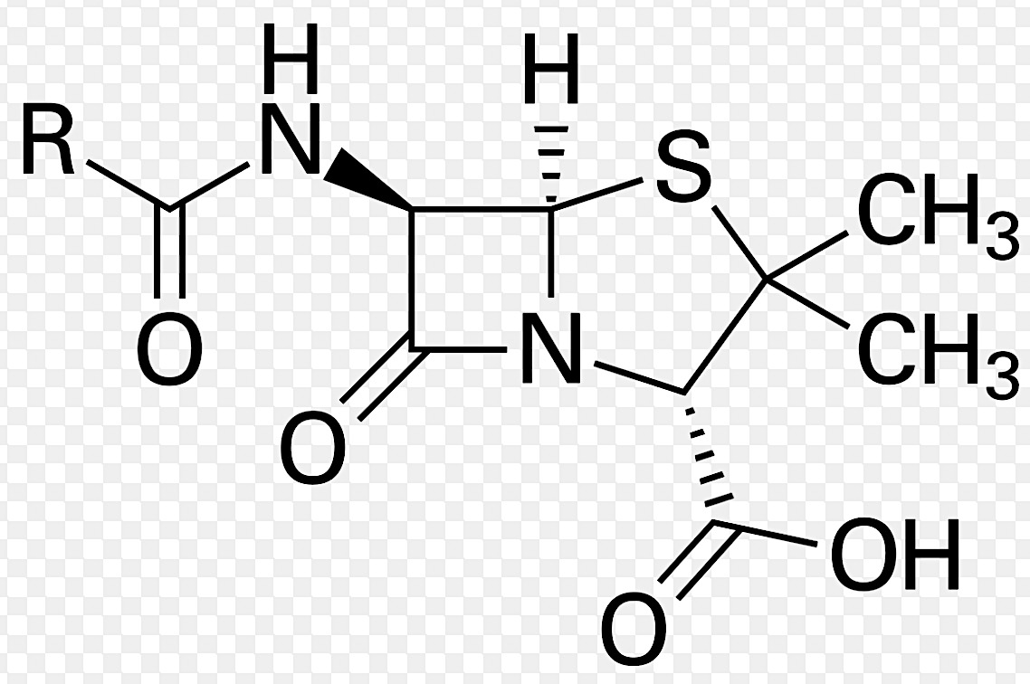  Penicillin | Disruption of peptidoglycan and cell wall synthesis | Bactericidal | Broad-spectrum
Glycopeptides | 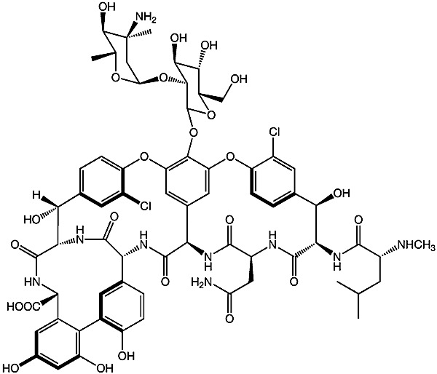  Vancomycin |  | Disruption of peptidoglycan and cell wall synthesis | Bactericidal | Gram-positive bacteria
Lipopeptides | Daptomycin  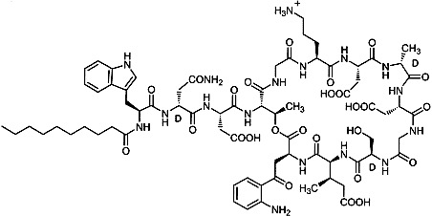 |  | Depolarisation of cell membrane and inhibition of cell wall synthesis | Bactericidal | Gram-positive bacteria
Tetracyclines | Doxycycline |  | Inhibition of protein synthesis;  30S ribosome subunit;  translation initiation inhibitor | Bacteriostatic | Broad-spectrum
Aminoglycosides | 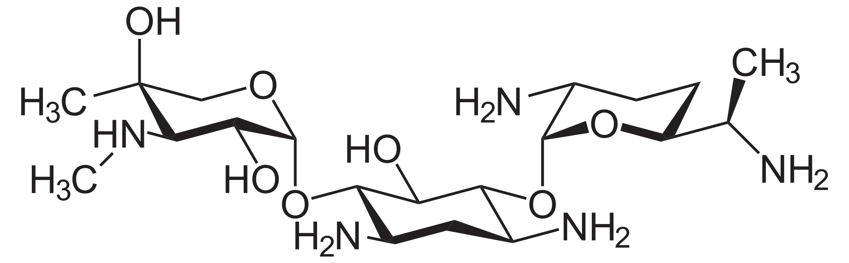  Gentamycin |  | Inhibition of protein synthesis;  30S ribosome subunit;  translation initiation inhibitor | Bactericidal | Broad-spectrum
Oxazolidonones | 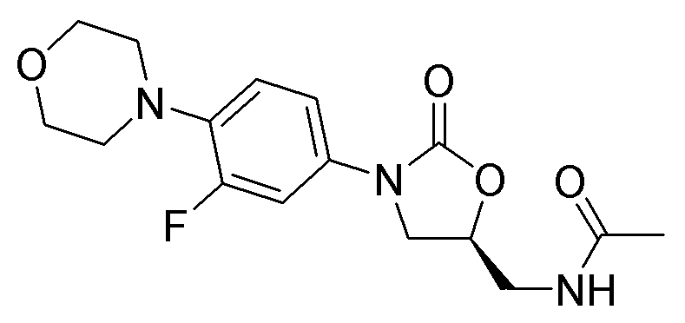  Linezolid |  | Inhibition of protein synthesis;  50S ribosome subunit;  translation initiation inhibitor | Generally bacteriostatic | Gram-positive bacteria

Continued on following page

Table 1.1. continued
ANTIBIOTIC CLASS | EXAMPLE(S) & STRUCTURE | MECHANISM OF ACTION | POTENCY | SPECTRUM OF ACTIVITY
Streptogramins  Steptogramin A  Streptogramin B | Synercid (combination of A & B)  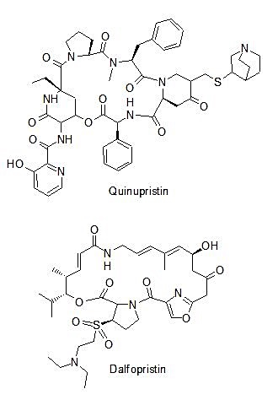 | Inhibition of protein synthesis;  50S ribosome subunit;  transpeptidation/  translocation inhibitor | Bacteriostatic alone/ bactericidal in combination | Gram-positive bacteria
Amphenicols | 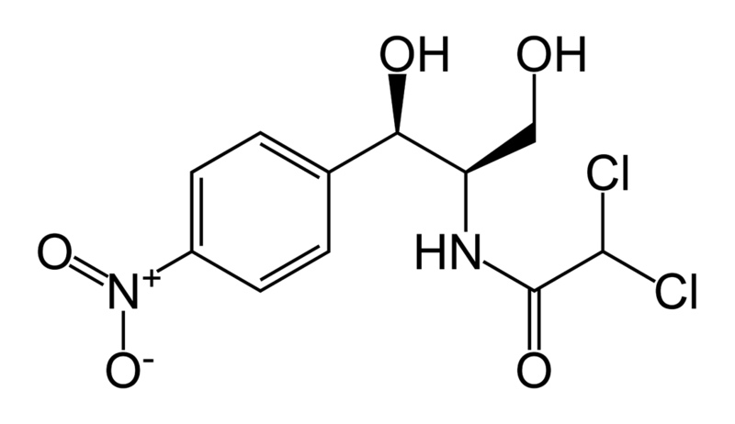  Chloramphenicol | Inhibition of protein synthesis;  50S ribosome subunit;  peptidyl-transferase inhibitor | Bacteriostatic | Broad-spectrum
Macrolides | Erythromycin  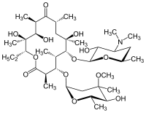 | Inhibition of protein synthesis;  50S ribosome subunit;  transpeptidation/  translocation inhibitor | Primarily bacteriostatic | Broad-spectrum
Quinolones  fluoroquinolones | 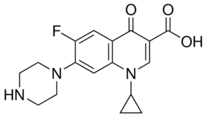  Ciprofloxacin | Inhibition of DNA replication via inhibition of DNA gyrase & topoisomerase IV | Bactericidal | Broad-spectrum
Rifamycins  aminoquinones | 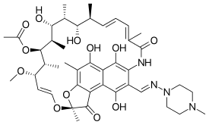  Rifampin | Inhibition of RNA synthesis;  Bacterial RNA polymerase inhibitor | Bacteriostatic | Gram-positive bacteria

Continued on following page
Table 1.1. continued
ANTIBIOTIC CLASS | EXAMPLE(S) & STRUCTURE | MECHANISM OF ACTION | POTENCY | SPECTRUM OF ACTIVITY
Sulfonamides | 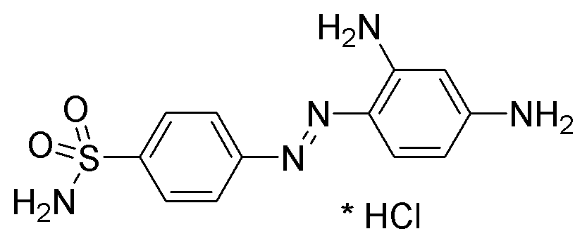  Prontosil | Disruption of folic acid synthesis via competitive inhibition of dihydropteroate synthase | Bacteriostatic | Broad-spectrum
Pyrimidines | Trimethoprim  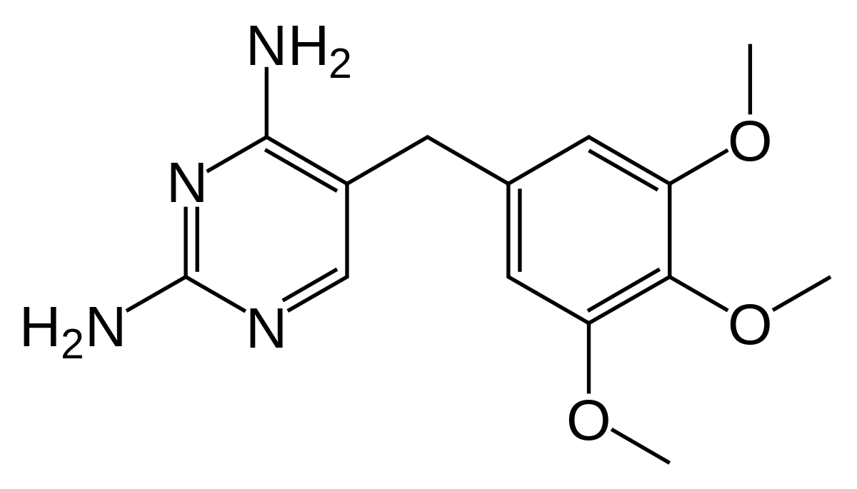 | Disruption of folic acid synthesis via competitive inhibition of dihydrofolate reductase | Bacteriostatic | Broad-spectrum
Polymyxins | Colistin  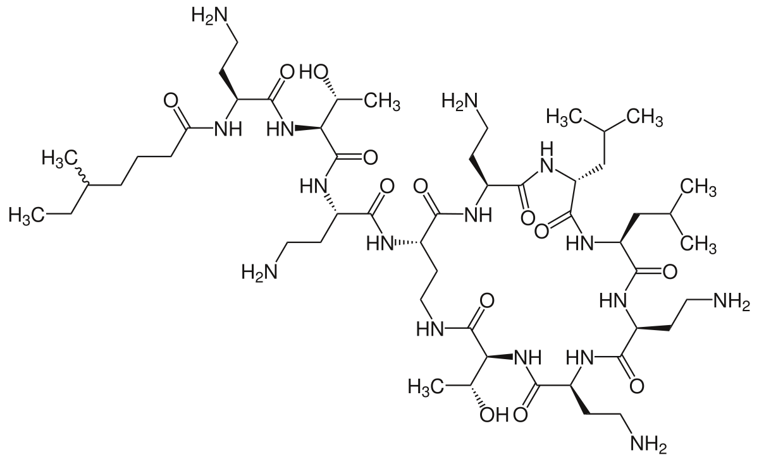 | De-stabilisation of Gram-negative cell envelope | Bacteriostatic (low conc.)  Bactericidal  (high conc.) | Gram-negative bacteria
Teixobactin | 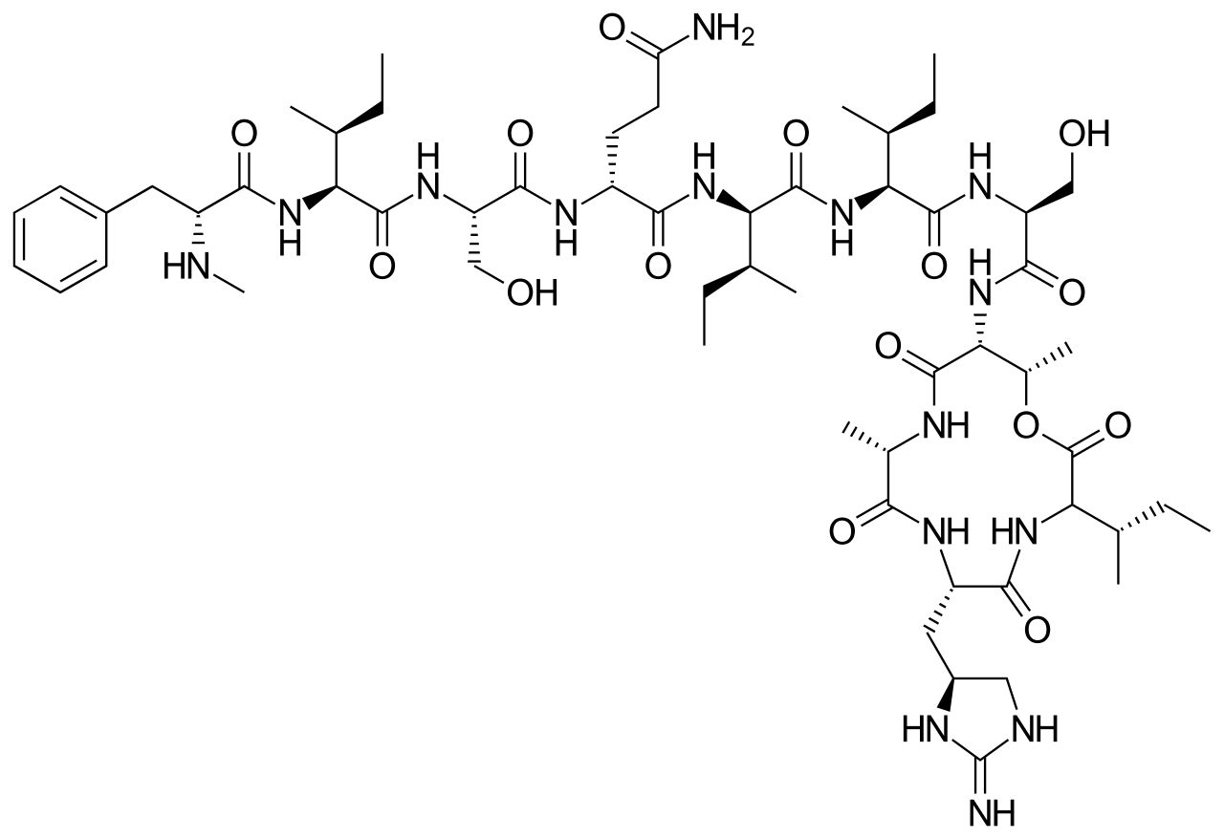 | Disruption of peptidoglycan synthesis by binding to lipid II and lipid III | Bactericidal | Gram-positive bacteria
Table 1.1. Structures of commonly used antibiotics and how they work. Information in Table 1.1. adapted from the following: Davies and Davies, 2010; Lewis, 2013; Alanis, 2005; Evans et al., 1999; Ling et al., 2015; Brown, 2015.

Fig. 1.2. The widespread uses of antibiotics and other antimicrobial compounds in modern life
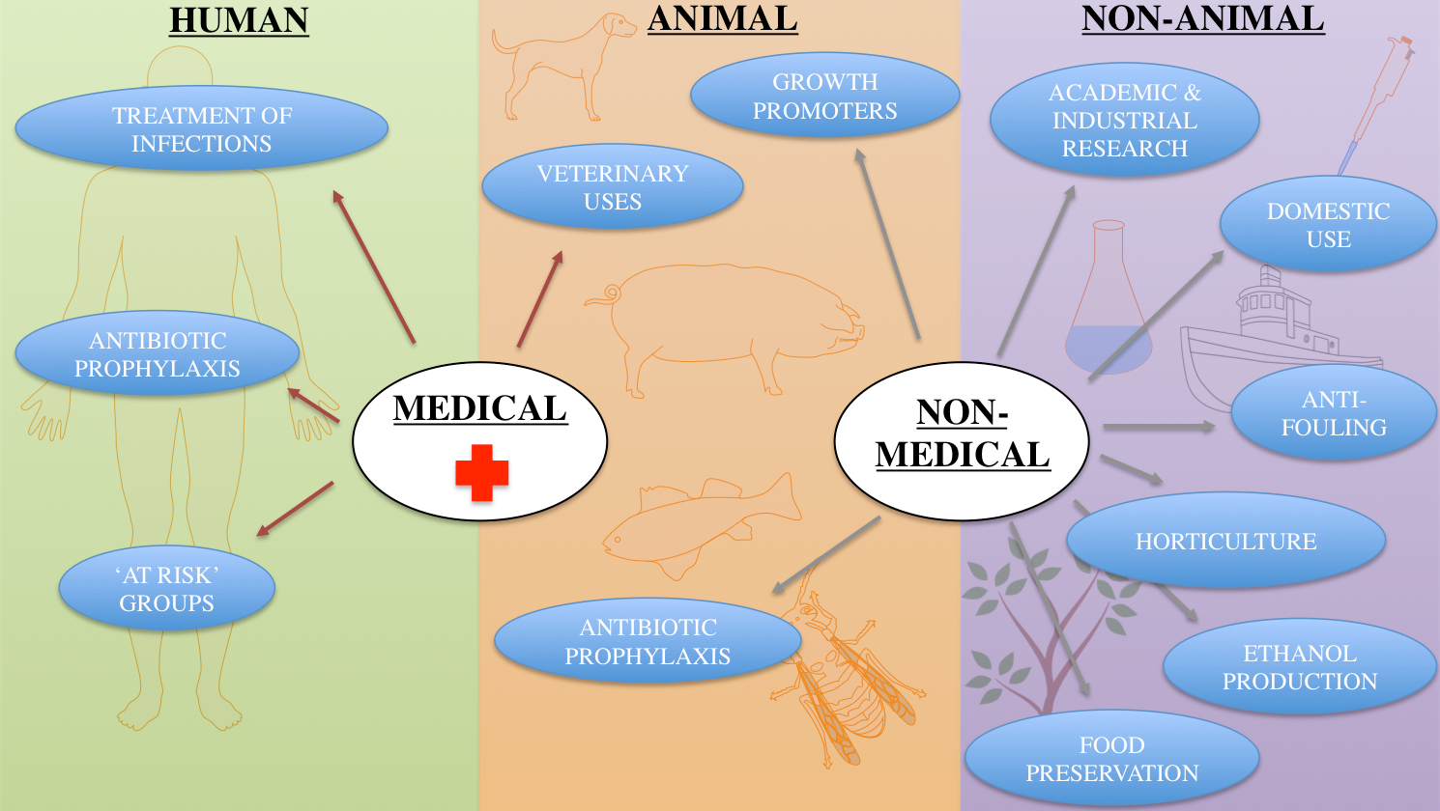

TREATMENT OF INFECTIONS  Common infections treated with antibiotics include: acne & other skin infections; sexually transmitted infections (e.g. chlamydia); bronchitis; conjunctivitis; pharyngitis; and urinary tract & kidney infections  ANTIBIOTIC PROPHYLAXIS  Antibiotics prescribed to prevent infections in patients with: animal bites & wounds; recurrent urinary tract infections; viral infections (e.g. genital herpes); rheumatic fever and immune system deficiencies. Antibiotics also prescribed to patients following: eye-surgery, joint replacements, organ transplants, breast implants, pacemaker surgery, and organ removals.  ‘AT RISK’  The following groups of patients are deemed to be at higher risk of infections and are therefore more likely to be prescribed antibiotics: those aged 75 and over; pre-term and full-term babies under 72 hours old; patients with heart failure, diabetes, HIV/AIDs or cystic fibrosis; cancer patients undergoing radiotherapy or chemotherapy; and other immuno-compromised patients | VETERINARY USES  Antibiotics used in veterinary practices in both domesticated and non-domesticated animals, including in: treatment of infections, prophylaxis to prevent infections and control measures to prevent spread of diseases  GROWTH PROMOTERS  Antibiotics added to animal feed and/or water in non-EU countries to accelerate growth and increase biomass of livestock. This practice is employed in production of livestock for food and in aquaculture. In the US, more antibiotics are used as growth promoters in animals than in human medicine. The EU banned the use of antibiotics as growth promoters in member states in 2006.  PROPHYLAXIS  Antibiotics routinely used in the production of livestock, in aquaculture and in bee-keeping to prevent bacterial infections. | ACADEMIC & INDUSTRIAL RESEARCH  Antibiotics routinely used in molecular cloning and selection/sterilisation procedures in academic and industrial research.  DOMESTIC USE  Antibiotics and other antimicrobial compounds have been incorporated into: soaps, shampoos, facial cleansers, moisturisers, sunscreens, mouthwashes, detergents, cleaning products, fabrics and children’s toys.  ANTI-FOULING  Antibiotics and other antimicrobial compounds used in anti-fouling paint to prevent the formation of biofilms of marine microorganisms to reduce barnacle build-up on ship hulls.  HORTICULTURE  Antibiotics and other antimicrobial compounds used in plant treatments to prevent bacterial infections in crop and garden plants.  ETHANOL PRODUCTION  Antibiotics used to prevent bacterial contamination during yeast-mediated fermentation processes in alcohol production.  FOOD PRESERVATION  Antimicrobial compounds added to dairy products and canned goods to prevent growth of bacterial pathogens.
Fig. 1.2. The widespread uses of antibiotics and other antimicrobial compounds in modern life.
References: Meek et al., 2015; Davies and Davies, 2010, Antibiotic Action, 2017; NHS, 2017

horticulture; in food preservation and ethanol production; and, somewhat pertinently given the context of this thesis, in scientific research (see Fig.1.2 for details). Antibiotics are in high demand globally and this intense commercial pressure has driven down the manufacturing and production costs of this class of pharmaceuticals. Antibiotics are inexpensive and readily available worldwide, often prescription free and off-label, particularly in developing countries (Davies and Davies, 2010). It is estimated that many millions of tons of antibiotics have been produced for anthropogenic purposes over the past 70 years (Davies and Davies, 2010). These compounds have subsequently been released into the environment, with some resistant to biodegradation, leading to an inestimable buildup of these agents in the biosphere (Davies and Davies, 2010).

Antibiotic resistance, generally referred to as ‘AMR’, is a consequence of the remarkable ability of microorganisms to rapidly adapt to external pressures in their environment and the immense selective pressure imposed by human applications of antibiotics (Alanis, 2005). Although resistance genes, i.e. those genes that encode molecular resistance mechanisms to antibiotics, have been found contained within bacteria that existed many thousands of years before the evolution of humans (Blair et al., 2015), our saturation of the planet with antibiotics has undoubtedly created conditions that have enabled bacteria that carry such genetic determinants to survive, proliferate and spread at an alarming and potentially catastrophic rate (Davies and Davies, 2010; Meek et al., 2015). For every class of antibiotic, there exists one or more mechanism(s) of resistance (Alanis, 2005). The date in which resistance first emerged to each clinically relevant class of antibiotic is illustrated in Fig 1.1. The only exception is teixobactin, which has only been recently discovered and has not yet been developed for clinical use (Ling et al., 2015).

Bacterial resistance to antibiotics can be classified as intrinsic or acquired. Intrinsic resistance is conveyed by the natural physical characteristics of the microorganism in the absence of the selective pressure exerted by antibiotics (Alanis, 2005). Bacteria may be naturally resistant to an antibiotic because they intrinsically lack the antibiotic’s target; e.g. the resistance of Pseudomonas spp. to triclosan is due to the lack of a triclosan-sensitive enoyl-acyl reductase in these bacteria (Blair et al., 2015). Additionally, intrinsic resistance of Gram-negative bacteria to many antibiotics is due to the composition and structure of their cell membranes. In the case of daptomycin, a glycopeptide active only against Gram-positive bacteria, the relatively lower proportion of anionic phospholipids contained within Gram-negative bacterial membranes prevent Ca(II)-mediated insertion of the antibiotic into the membrane, thus preventing its antimicrobial activities (Blair et al., 2015). The inability for certain antibiotics to cross the outer membrane of Gram-negative bacteria also conveys these bacteria intrinsic resistance to many antibiotics that are consequently only active against Gram-positive bacteria, e.g. vancomycin (Blair et al., 2015).

Alternatively, and most importantly in the context of the present AMR crisis, resistance may be acquired via selective pressure exerted by the presence of an antibiotic (Alanis, 2005). These acquired mechanisms, encoded by resistance genes, are illustrated in Table 1.2 and can be summarised as follows. Acquired antibiotic resistance can occur via:

- Prevention of access of the antibiotic to the bacterial cell target - either via reduced membrane permeability to impair antibiotic uptake and/or increased active efflux of the antibiotic out of the cell
- Alteration of the antibiotic’s target within the bacterial cell - either via mutation of the target or modification/protection of the target
- Inactivation of the antibiotic - either via enzymatic hydrolysis or inactivation mediated by the transfer of a chemical group to the antibiotic

Resistance genes are normally located within mobile genetic elements, known as transposons, that enable the rapid spread of acquired resistance mechanisms via horizontal gene transfer (HGT) (Alanis, 2005). HGT can occur via conjugation, transformation or transduction. Conjugation, the most prominent mechanism in the spread of AMR, is plasmid-mediated and often involves the transference of multiple antibiotic resistance genes, contained within integrons, per plasmid (Alanis, 2005). Plasmids are transferred from one bacterial cell to another via the formation of a pilus, enabling the receiving bacterial cell to acquire resistance to multiple antibiotics by just one conjugation event (Alanis, 2005). Antibiotic resistance genes can also be acquired by the uptake of ‘naked DNA’ from nearby lysed cells (transformation) or carried by bacteriophages that can incorporate DNA from other bacterial cells into the host cell’s chromosomal DNA (transduction) (Alanis, 2005).

1.1.4. The extent of the threat of AMR

The treatment of infections caused by multi-drug resistant (MDR)-bacteria is difficult, costly and associated with higher morbidity, increased hospital stays and higher mortality rates (Alanis, 2005). MDR-bacterial strains, often referred to as ‘superbugs’, are generally more virulent and more easily transmitted between humans and animals hosts (Davies and Davies, 2010). Of increasing concern is that if AMR continues to increase, many modern medical
Table 1.2. Molecular mechanisms of resistance to clinically relevant antibiotics
MECHANISM | EXPLANATION | ANTIBIOTIC CLASS | EXAMPLE(S)
1. PREVENTION OF ACCESS TO TARGET
Reduced permeability | Resistance to antibiotics that act on cytoplasmic or periplasmic targets are conveyed by alterations that reduce the permeability of the bacterial cell membrane | β-lactams  fluoroquinolones  tetracyclines  amphenicols | Downregulation of outer membrane porins (OmpF/OmpC) in Enterobacteriaceae reduces permeability of certain β-lactams into the cell
Active efflux | Bacterial efflux pumps convey resistance by actively pumping the antibiotics to the outside of the cell, thus preventing the antibiotic from acting on its intracellular targets. In particular, multi-drug resistance (MDR) efflux pumps have broad substrate specificity and convey resistance to many classes of antibiotics. Bacteria with mutations that lead to upregulation of MDR-efflux pumps are associated with highly AMR clinical strains. | fluoroquinolones rifamycins tetracyclines amphenicols  β-lactams macrolides aminoglycosides lincosamides streptogramins oxazolidonones pyrimidines sulfonamides polymyxins | Resistance-nodulation-division (RND) superfamily of bacterial transport proteins play key roles in AMR in Gram-negative bacteria. These are proton/antibiotic antiporters, e.g. AcrAB-TolC of  E. coli. They have wide substrate specificity and convey broad resistance to various antibiotic and non-antibiotics.
2. ALTERATION OF TARGET
Target alteration by mutation | Under the selective pressure of an antibiotic, point mutations to the target that impair antibiotic binding, yet maintain functionality of the target, can convey resistance. | β-lactams  oxazolidonones fluoroquinolones | DNA gyrase mutations convey resistance to fluoroquinolones
Target alteration by modification/protection | The antibiotic’s target is altered by modification via the transfer of a chemical group and/or the presence of target-binding proteins that prevent the antibiotic from interacting with its target. | macrolides lincosamides streptogramins phenicols oxazolidonones fluoroquinolones polymyxins glycopeptides tetracyclines aminoglycosides pyrimidines rifamycins | Addition of methyl groups to ribosomal 16S rRNA convey resistance to macrolides.  Resistance to quinolones is mediated by the binding of pentapeptide-repeat-proteins (PRPs) to DNA topoisomerases, thus preventing fluoroquinolone binding
3. INACTIVATION OF THE ANTIBIOTIC
Inactivation by hydrolysis | Bacteria produce enzymes that degrade the antibiotic, thus rendering it inactive. This is only generally applicable to naturally-derived antibiotic classes | β-lactams aminoglycosides phenicols macrolides | Various classes of β-lactamases convey resistance via hydrolysis of β-lactams antibiotics. Including: penicillinases, carbapenemases and extended- β-lactamases (ESBLs)
Inactivation by transfer of a chemical group | The addition of various chemical groups to the antibiotic prevents the drug from interacting with its target via steric hindrance. Such chemical modifications include: acetylation, phosphorylation, nucleotidylation, monooxygenation and glycosylation | aminoglycosides tetracyclines  macrolides lincosamides streptogramins  phenicols  fluoroquinolones rifamycins | Aminoglycosides are particularly vulnerable to inactivation by chemical modification and have been shown to be modified by bacterial acetyltransferases, phosphotransferases and nucleotidyltransferases
Table 1.2. Molecular mechanisms of resistance to clinically relevant antibiotics.
References: Blair et al., 2015; Baker-Austin et al., 2006 ; Alanis, 2005; Davies and Davies, 2010; Li and Nikaido, 2009
procedures that were developed with the concurrent use of antibiotics, such as invasive surgery and chemotherapy, will become increasingly more perilous or impossible to perform due to the incidence of untreatable MDR-infections (Hogberg et al., 2010). In Europe, the economic cost of AMR in 2009 was estimated to be €1.5 billion annually (ECDC/EMEA, 2010). Worldwide it is currently estimated that 700,000 people die every year as a result of MDR-infections – a figure that is predicted to rise to 10 million p.a. by 2050 (Review on AMR, 2016).

The list of clinically relevant bacteria that have been reported to carry MDR-genes continues to rise. Amongst the most notable are: Staphylococcus aureus (including the notorious methicillin-resistant MRSA), Neisseria gonorrhoeae, Haemophillus influenzae, Mycobacterium tuberculosis, Enterococci spp., Shigella spp., Salmonella spp., Vibrio spp., Escherichia coli, Klebsiella pneumoniae, Acinetobacter baumannii, Pseudomonas aeruginosa and Clostridium difficile (Alanis, 2005; Davies and Davies, 2010; Brown, 2015). Of particular concern are Gram-negative bacteria: K. pneumoniae, A. baumannii, P. aeruginosa and Enterobacter spp. (Brown, 2015).

The problem of AMR is further compounded by the lack of discovery and clinical development of new antibiotic classes (see Fig. 1.1). In 2015, the discovery of teixobactin was significant as it was the first new class of antibiotic following a 20-year antibiotic discovery void (Ling et al., 2015). Despite this success, teixobactin is likely to be many years away from clinical application and is only active against Gram-positive bacteria. Of grave concern is that no new class of antibiotic has been developed for clinical use against Gram-negative bacteria in over 40 years (Brown, 2015). The lack of antibiotic discovery and development has been attributed to a number of economic factors (Alanis, 2005). Pharmaceutical companies have dramatically reduced expenditure in anti-infectives research and development (R&D), with much of the focus in this area diverted to development of long-term acting antivirals for HIV/AID therapies (Alanis, 2005). This is likely due to the limitations and restrictions in the employment of any potential novel antimicrobial drug brought to market, in an attempt to minimise the occurrence of resistance (Alanis, 2005). In 2000, it was estimated that the cost of bringing a new drug from discovery to pre-clinical approval was over $800 million USD over a course of 10-14 years (Alanis, 2005). Given that patents for new drugs typically last just 20 years from discovery, and that the clinical application of a novel antimicrobial compound would first be extremely limited, the development of antibiotics is not an attractive financial prospect for pharmaceutical companies (Alanis, 2005).

Thus, the overuse and saturation of antibiotics by humans has driven the selection and emergence of more virulent and less treatable MDR-bacteria that are proliferating at a faster rate than the rate at which we can feasibly produce new antibiotics to combat them. For this reason, awareness of AMR is increasingly within the public domain (Fig. 1.1). In 2011, the director of the World Health Organisation (WHO) pronounced AMR as a significant threat to global human health, declaring ‘no action today, no cure tomorrow’ (WHO, 2011). In 2015, the world’s first charity dedicated to raising money to fund research into new antibiotics, Antibiotic Research UK, was launched. Recently, the UK’s Chief Medical officer, Dame Sally Davies, declared AMR as ‘one of the greatest threats we face today’. The UK-government commissioned review on AMR, led by the economist Lord O’Neill, thrust AMR to the forefront of discussions at the 2016 World Economic Forum (Review on AMR, 2016), leading to the signing of the ‘Davos Declaration’ by pharmaceutical companies worldwide, see Fig. 1.1. Arguably, the extent of the danger of AMR has never been so at the forefront of public awareness and yet continues to rise at an alarming rate.

1.1.5. The need to find novel antimicrobials as alternatives or adjuvants to antibiotics

There is a clear and urgent need for new antibiotics or non-antibiotic antimicrobial agents whose activities would be unaffected by known or existing resistance mechanisms (Aminov, 2010; Brown, 2015; Czaplewski et al., 2016; Davies and Davies, 2010; Lewis, 2013; Singh et al., 2017). Although there are currently new antibiotics in the pipeline at various phases of clinical trials (see: Butler et al., 2017 for a recent review), these are derivatives of currently established antibiotic classes and are therefore likely to be prone to pre-existing resistance mechanisms. Alternative strategies to treat or prevent bacterial infections are currently in development and are described briefly in Table 1.3. However, with the exception of probiotics, these strategies are many years away from clinical application (Czaplewski et al., 2016). In any case, many of these strategies would still require the co-administration of antibiotics in order to effectively clear bacterial infections and therefore the development of novel antimicrobial drugs remains of utmost importance (Czaplewski et al., 2016).

Novel antimicrobial compounds are required to either: (1) replace current antibiotics which are becoming increasingly ineffective due to MDR-bacteria and/or (2) be employed as adjuvants to existing antibiotics to improve the efficacy of the antibiotic or to reduce the incidence of resistance (Kalan and Wright, 2011). Although it may still be possible to find new lead compounds from natural resources via screening unexplored environmental niches (Lewis,
Table 1.3. Possible future therapeutic and preventative approaches as alternative or adjuvants to antibiotics
APPROACH | EXPLANATION | SPECTRUM OF ACTIVITY/APPLICATION | TARGET
Antibodies | Administration of antibodies which would bind to and inactivate the bacterium or its virulence factors/toxins | To be used as a broad spectrum preventative therapy, possibly as an adjuvant to existing antibiotics | Bacteria
Probiotics | Administration of beneficial live microorganisms to re-colonise host’s microflora, most likely in the gut | To be administered in combination with antibiotics to prevent and/or treat C. difficile or other antibiotic-associated diarrhea | Host commensal flora
Lysins | Employment of bacteriophage-derived lysins which destroy the cell wall of bacteria | To be used as alternatives or adjuvants to antibiotics in the treatment of Gram-positive infections | Bacteria
Bacteriophages  (wild-type) | The use of wild-type, i.e. naturally occurring, bacteriophages to infect and kill pathogenic bacteria in the host | To be used to treat both Gram-positive and Gram-negative infections as alternatives or adjuvants to antibiotics | Bacteria
Bacteriophages  (engineered) | As above but with the optimisation of therapeutic activity by genetic engineering of bacteriophages | To be used to treat both Gram-positive and Gram-negative infections as alternatives or adjuvants to antibiotics | Bacteria
Immune stimulation | Enhancement of immune system clearance of bacteria via administration of dietary supplements and/or repurposed immune-stimulating drugs | To be used to prevent or treat Gram-positive and Gram-negative infections as an adjuvant to antibiotic therapy | Host immunity
Vaccines | Vaccinations against causative bacterial agents of common infections | To be used in the prevention against Gram-positive and Gram-negative bacterial infections | Host immunity
Antimicrobial peptides | Administration of synthetic or animal derived antimicrobial peptides either for topical or systemic applications as fast acting, bacteriocidal agents | To be used as alternatives or adjuvants to antibiotics in the treatment of Gram-positive and Gram-negative infections | Bacteria
Host-defence and/or  innate-defence peptides | Administration of host-defence (small, natural) peptides or innate-defence (small, synthetic) peptides; these have indirect antimicrobial effects by inducing the host’s immune system to increase expression of anti-inflammatory cytokines and chemokines | To be used as adjuvants to antibiotics in the treatment of Gram-positive and Gram-negative infections | Host immunity
Antibiofilm peptides | Administration of peptides that specifically inhibit bacterial biofilm formation | To be used as adjuvants to antibiotics in the treatment of Gram-positive and Gram-negative infections | Bacteria

Table 1.3. Possible future therapeutic and preventative approaches as alternative or adjuvants to antibiotics Table adapted from Table 1 in Czaplewski et al., 2016
2013), it is likely that synthetic compounds will be prominent in the development of novel antimicrobials (Aminov, 2010). An ideal antibiotic adjuvant would be a compound which itself has antimicrobial activity and that also functions synergistically with the established antibiotic (Kalan and Wright, 2011). Alternatively, such an adjuvant may function as a so-called ‘Antibiotic Resistance Breaker’ (ARB), whereby the presence of the adjuvant would reduce the mechanisms and incidence of resistance to the antibiotic via specific targeting of the bacterial mechanisms of resistance, e.g. via efflux pump inhibition, thus prolonging the life-span and effectiveness of current antibiotics (Brown, 2015).

As stated in the previous section, an issue with any novel antimicrobial compound is that its clinical use would have to be limited so as to minimise the evolution of resistance (Alanis, 2005). The consequence of this is that we are in urgent need of not one but instead multiple new antimicrobial agents, which could then be used sparingly, cycled in clinical practice and be administered in combination to prolong their effectiveness and avoid emergence of resistance mechanisms (Alanis, 2005).

1.1.6. What is the ‘ideal’ antimicrobial compound?

The properties of the ‘ideal’ antimicrobial compound are illustrated in Fig. 1.3. Firstly, an ideal antimicrobial compound would first be administered to the patient as a ‘pro-drug’ that would be inactive in the host until activation upon entry into a bacterial cell (Lewis, 2013). In order the reach the site of infection, the pro-drug must remain stable in the patient’s blood and circulatory system with pharmacologically favourable ADME (absorption, distribution, metabolism and excretion) properties (Singh et al., 2017).

Once the compound has reached the site of infection, it must possess the physical and chemical properties required to gain entry into the bacterial cell, ideally via passive diffusion (Singh et al., 2017). For Gram-positive bacteria, this would involve gaining entry across a single cytoplasmic membrane and a thick protective cell wall composed on peptidoglycan (Singh et al., 2017). For Gram-negative bacteria, entry is more complicated; the compound must gain access through an outer-membrane, a thin protective layer of peptidoglycan and then a cytoplasmic membrane (see Section 1.2.2) for more detail). The outer-membrane of Gram-negative bacteria provides an effective barrier against many potential antimicrobial agents; it comprises an outer-leaflet of lipopolysaccharide (LPS) and an inner-leaflet of phospholipids, thus preventing entry of both hydrophobic and hydrophilic compounds (Singh et al., 2017). An ideal antimicrobial compound must therefore be small, hydrophilic and/or charged, in order to
Fig. 1.3. The ‘ideal’ antimicrobial compound
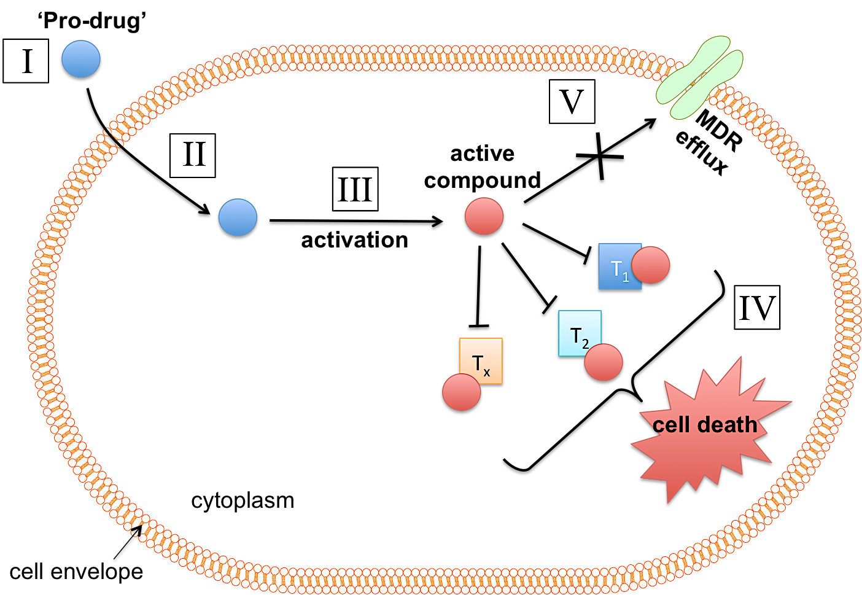

Fig.1.3. The ‘ideal’ antimicrobial compound. The above scheme illustrates the mode of action of the ‘ideal’ antimicrobial compound on a representative bacterial cell as described by Lewis, 2013 and Singh et al., 2017. The cell envelope represents either: (1) the cell wall and cytoplasmic membrane of Gram-positive bacteria or (2) the outer-membrane, periplasm and inner-membrane of Gram-negative bacteria. (I) The inactive ‘pro-drug’ is administered to the patient and is distributed to the site of infection. (II) The pro-drug gains entry into the bacterial cell via passive diffusion through the cell envelope. (III) Once inside the cell, the pro-drug is activated to its toxic form via a bacterial mediated process e.g. enzymatic hydrolysis. (IV) The active compound binds covalently to multiple intracellular targets (T₁, T₂ … T_{x}), leading to inhibition of multiple cellular processes, which cumulates in cell death. (V) Irreversible binding to cell targets prevents the efflux of the compounds by multi-drug resistance (MDR) transporters. Fig.1.3 is adapted from Fig. 3 in Lewis, 2013 and information contained within Singh et al., 2017.

enable it to diffuse through outer-membrane porins. This would permit access to the periplasm and so entry into the cytoplasm would then require further diffusion through the cytoplasmic membrane, whereby only hydrophobic or sufficiently small hydrophilic molecules are permitted (Singh et al., 2017). An alternative strategy would be that the antimicrobial agent could gain entry via active transport into the cell via a bacterial transport protein. However, this would limit the antimicrobial activity of the compound to actively growing/metabolically active cells, and thus limit the spectrum of activity of the potential antimicrobial compound.

Once inside the cell, the pro-drug would then be activated into its toxic form via a bacterial mediated process e.g. enzymatic activation (Lewis, 2013). Intracellular activation is essential in reducing the compounds interactions with host targets and thus avoiding cytotoxicity (Lewis, 2013). Once activated, the antimicrobial compound would then bind covalently to multiple intracellular targets thereby inhibiting multiple bacterial cell processes, leading to cell death (Lewis, 2013). Irreversible binding to targets would thus prevent the efflux of the compound by bacterial cells and thus mitigate MDR-efflux pump mediated resistance mechanisms (Lewis, 2013). The binding of multiple cellular targets would further reduce the likelihood of target-based resistance to the compound (Singh et al., 2017).

Unless there is a dramatic improvement in, and distribution of world-wide of diagnostic technologies to significantly reduce the time required to accurately diagnose the specific bacterial species responsible for an infection, an ideal antimicrobial compound would be broad-spectrum, targeting both Gram-positive and Gram-negative bacteria, and also both dormant persisting bacteria and actively dividing cells (Lewis, 2013; Singh et al., 2017). A narrow-spectrum compound would also be ineffective at full clearance of polymicrobial infections (Singh et al., 2017). Ideally the antimicrobial compound would target only pathogenic bacteria, leaving the host’s commensal micro flora unharmed (Singh et al., 2017).

Any potential novel antimicrobial compound should therefore be evaluated and developed with the above ideals in mind. However, it must be noted that the ‘ideal’ antimicrobial compound has never existed and, in reality, any future antimicrobial compound might be expected to only possess some of the properties outlined above and illustrated in Fig. 1.3.

1.1.7. What bacterial pathogens should we target in development of novel antimicrobial compounds?

Throughout the past decade, much of the focus into understanding the mechanisms of antibiotic resistance and the development of new antimicrobial agents has concerned the so-called ‘ESKAPE’ pathogens: Enterococcus falcium, Staphylococcus aureus, Klebsiella pneumoniae, Acinetobacter baumanni, Pseudomonas aeruginosa and Enterobacter spp. (Boucher et al., 2009; Rice, 2008). These pathogens were identified as important by the Infectious Disease Society of America (IDSA) because they caused the majority of nosocomial (hospital-acquired) infections in the US and were rapidly acquiring resistance to clinically available antibiotics (Boucher et al., 2009). Of these bacteria, Gram-negative species were of highest concern (Boucher et al., 2009).

In 2017, the WHO published a list of ‘Global Priority Pathogens’ with the aim to stimulate investment in R&D into new antibiotic therapeutics that specifically target those antibiotic-resistant bacteria of most concern to global public health (Table 1.4) (WHO, 2017). Of continued critical importance is the need to develop novel antimicrobials that are active against the Gram-negative bacteria: A. baumanii, P. aeruginosa and Enterobacteriaceae species (WHO, 2017).

1.2. Escherichia coli as an important pathogen and a model organism to evaluate novel antimicrobial agents

1.2.1. E. coli – an introduction

E. coli are Gram-negative facultative-anaerobic rod-shaped bacteria belonging to the Enterobacteriaceae, which are taxonomically placed within the γ-proteobacteria (Lukjancenko et al., 2010). They are habitants of the intestinal lumen of animals and humans, where they normally form a significant component of the intestinal microbial flora, most frequently existing within a mutual beneficial partnership within their host (Neidhardt et al., 1990). They are closely related to Salmonella spp. and Shigella spp., with many arguing that Shigella should be re-classified as E. coli (Lukjancenko et al., 2010). E. coli isolates can either be benign or virulent, with the latter representing significant pathogens of both humans and animals (see Section 1.2.3 below). E. coli strains are genetically diverse and genome sequencing has revealed that the core genome comprises around just 20 % of the total genes found within these bacteria (Lukjancenko et al., 2010; Rasko et al., 2008). E. coli isolates are typically divided based on their virulence mechanisms (e.g. UPECs, EPECs etc - see below), by where they were isolated (e.g. avian pathogenic E. coli), or via serotyping based on the presence or absence of particular

Table 1.4. World Health Organisation’s list of Global Priority Pathogens for R&D on new antibiotics 2017
Priority 1
‘CRITICAL’
Acinetobacter baumannii (carbapenem-resistant)
Pseudomonas aeruginosa (carbapenem-resistant)
Enterobacteriaceae* (carbapenem-resistant, 3rd generation cephalosporin-resistant)

Priority 2
‘HIGH’
Enterococcus faecium (vancomycin-resistant)
Staphylococcus aureus (methicillin-resistant, vancomycin- intermediate and resistant)
Helicobacter pylori (clarithromycin-resistant)
Campylobacter spp. (fluoroquinolone-resistant)
Salmonella spp. (fluoroquinolone-resistant)
Neisseria gonorrhoeae (3rd generation cephalosporin-resistant, fluoroquinolone-resistant)

Priority 3
‘MEDIUM’
Streptococcus pneumoniae (penicillin-non-susceptible)
Haemophilus influenzae (ampicillin-resistant)
Shigella spp. (fluoroquinolone-resistant)

Table 1.4. World Health Organisation’s list of Global Priority Pathogens for R&D on new antibiotics 2017. WHO’s list of Global Priority Pathogens published 2017, aimed to stimulate R&D of those antibiotic-resistant bacteria which are proposed to pose the greatest threat to global public health. Pathogens were grouped according to species and type of resistance and then arranged into tiers (critical, high and medium) depending on the urgency of the need for new antibiotics required to treat infections caused by those bacteria. Note – Mycobacterium tuberculosis was not included in this specific list but is still considered critical priority by the WHO. *Enterobacteriaceae include: Klebsiella pneumonia, Escherichia coli, Enterobacter spp., Serratia spp., Proteus spp., and Providencia spp. and Morganella spp. Table adapted from (WHO, 2017).

surface antigens (‘O’ for a somatic component of lipopolysaccharide (LPS), see below, ‘H’ for flagellar or ‘K’ for capsular antigens) (Nataro and Kaper, 1998).

No other prokaryotic organism, and arguably any other life form, has been so extensively studied (Neidhardt et al., 1996). From the early days of bacteriology, E. coli became the organism of choice for microbiologists. It was readily obtainable from stool samples and easily cultivated under laboratory conditions in both rich and defined minimal media. It is able to grow and adapt quickly to a variety of host and non-host environments, including on a variety of carbon sources, and fluctuations in nutrient availabilities and temperatures – with a preference for rich, glucose medium at 37°C (Neidhardt et al., 1996). It is easily genetically manipulated and so has become the molecular workhorse of choice for most life scientists. Many of the key breakthroughs in biological sciences were made via the employment of E. coli as a model organism, including: the elucidation of bioenergetics and cellular respiration; most biosynthetic pathways; the concept of the gene and the genetic code; the central paradigm of molecular biology; gene regulatory mechanisms; advancements in molecular cloning; the action of bacteriophages and basic virology; and also many of the molecular mechanisms of antibiotic resistance (Neidhardt et al., 1996; Rasko et al., 2008). No other organism has aided human understanding of the fundamental biological and physiological principles of life.

1.2.2. E. coli cell organisation and molecular physiology

This section is primarily focused on a representative strain of E. coli, known as K-12 MG1655, as this particular strain is employed for most of the experimental work conducted in the process of this research project. E. coli K-12 MG1655, referred herein as MG1655, is the most widely-used laboratory ‘wild-type’ (WT) strain and is derived from the original E. coli K-12, which was isolated from a stool sample of a diphtheria patient in 1922 (Neidhardt et al., 1996). MG1655 differs from naturally occurring E. coli K-12 strains in that it has been cured of bacteriophage lambda (λ) and the F-plasmid. Chromosomal mutations include rfb-50, which is significant in that it results in the absence of O-antigen synthesis (Neidhardt et al., 1996). Although the focus of this section will be the cellular organisation and molecular physiology of MG1655, the majority of the information provided here is applicable to other E. coli strains.

The cellular composition of E. coli, with quantifiable information regarding the relative abundance of its constituent components, is provided in Table 1.5. By mass, approximately 70 % of a typical E. coli cell is water. The remaining 30 % of dry mass is composed mainly of carbon (50 %), oxygen (20 %), nitrogen (14 %), hydrogen (8 %), phosphorus (3 %), potassium
Table 1.5. An estimation of the macromolecular composition of an E. coli cell, in exponential phase in glucose defined minimal medium
Macromolecule | Percentage of total dw | Weight per cell 10¹⁵ x weight (g) | Molecular weight | No. of molecules per cell
Protein | 55.0 | 155.0 | 4.0 x 10⁴ | 2,360,000
RNA  23S rRNA  16S rRNA  5S rRNA  tRNA  mRNA | 20.5 | 59.0  31.0  16.0  1.0  8.6  2.4 | 1.0 x 10⁶  5.0 x 10⁵  3.9 x 10⁴  2.5 x 10⁴  1.0 x 10⁶ | 18,700  18,700  18,700  205,000  1,380
DNA | 3.1 | 9.0 | 2.5 x 10⁹ | 2.13*
Lipid | 9.1 | 26.0 | 705 | 22,000,000
LPS | 3.4 | 10.0 | 4346 | 1,200,000
Peptidoglycan | 2.5 | 7.0 | (904)n | 1
Glycogen | 2.5 | 7.0 | 1.0 x 10⁶ | 4,360
Total macromolecules | 96.1 | 273.0
Soluble pool  (i.e. building blocks, metabolites, vitamins) | 2.9 | 8.0
Inorganic ions** | 1.0 | 3.0
Total dw | 100.0 | 284.0
Total dw/cell |  | 2.3 x 10⁻¹³ g
Water (at 70%) |  | 6.7 x 10⁻¹³ g
Total weight of one cell |  | 9.5 x 10⁻¹³ g

Table 1.5. An estimation of the macromolecular composition of an E. coli cell, in exponential phase in glucose defined minimal medium. Values in table represent the typical composition of an E. coli K-12 cell growing at 37°C in glucose defined minimal medium, in a balanced state and at a mass doubling time of 40 min. *Number of molecules of DNA is given as just over two as this representative cell is presumed to be in a state immediately prior to cell division owing to its fast doubling time. **Inorganic ions include: K⁺ (major cation), NH₄⁺, Mg(II), Ca(II), Fe(II), Ni(II), Mn(II), Mo(II), Co(II), Cu(II), Zn(II), Cl⁻, SO₄²⁻, PO₄³⁻, note that oxidation states of transition metals are variable. Adapted from Table 1 in (Neidhardt et al., 1990). Abbreviations used in table: dw = dry weight.

(2 %) and sulfur (1 %) (Neidhardt et al., 1990). Also essential for E. coli cell processes are small amounts of Ca, Mg, Cl (0.05 % of each), Fe (0.2 %) and a total of 0.3 % of other essential metals such as Mn, Cu, Cn, Co and Mo (Neidhardt et al., 1990). Together, these elements constitute the cells macromolecules (proteins, nucleic acids and lipids), small organic solutes (cofactors, precursors) and inorganic ions. By far the most abundant macromolecule is protein at around 55 % of cellular dry mass, next is RNA (20.5 %) and then lesser amounts of DNA, lipids, LPS, peptidoglycan, low molecular weight organic and inorganic solutes, and inorganic ions. An estimate of the relative proportions of each cellular component of a typical exponential-phase K-12 cell, grown at 37°C on glucose minimal medium, is provided in Table 1.5. Note – the relative proportions of each molecule in an E. coli cell will very considerably depending on: growth phase, temperature and nutrient availability (Neidhardt et al., 1990).

The cellular organisation of E. coli is illustrated in Fig. 1.4. Its intracellular components are encapsulated by a cell envelope, which consists an outer-membrane (OM), a periplasm containing a single layer of peptidoglycan, and an inner-membrane (IM) (Neidhardt et al., 1990). The IM is analogous in function to the cytoplasmic membrane of eukaryotic cells and Gram-positive bacteria. The OM functions as a selectively permeable barrier that largely excludes hydrophobic and sufficiently large hydrophilic molecules from cellular entry (Nikaido, 2003). The OM is composed of an outer-leaflet of LPS and an inner-leaflet of lipids, and is traversed by highly abundant channels known as porins and lesser amounts of selective channels (Nikaido, 2003). The IM is the site of protein export, energy conservation in the form of respiration and ATP generation (see below) and, together with the OM, facilitates the uptake and efflux of organic and inorganic molecules into and out of the cell (Nikaido, 2003; Poole and Cook, 2000). Sandwiched between the two membranes is an aqueous region known as the periplasm; a viscous compartment densely packed with enzymes and chaperone proteins which function largely in detoxification/degradation reactions and maintenance of the cell envelope (Neidhardt et al., 1990). A single layer of peptidoglycan, composed of chains of disaccharide N-acetyl glucosamine –N-acetyl-muramic acid cross-linked with oligopeptides, is located in the periplasm and acts as the cell’s cytoskeleton, providing rigidity, shape and resistance to cell lysis at dramatic changes to external osmotic pressures (Silhavy et al., 2010). A more detailed overview of the structural and functional properties of the E. coli cell envelope is provided in Fig. 1.5. The cell envelope is the distinctive feature that characterises bacterial cells as either Gram-negative or Gram-positive’ the differences between the two are illustrated in Fig. 1.6.
Fig. 1.4. Schematic representation of an E. coli cell

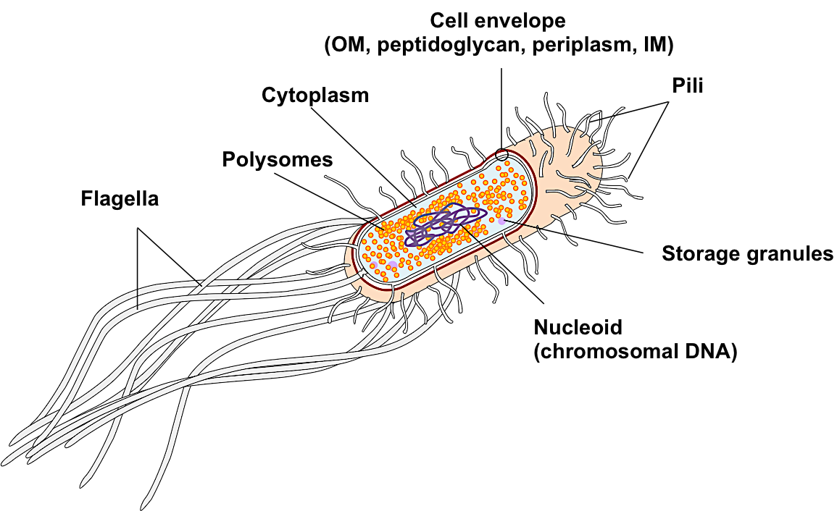

Fig. 1.4. Schematic representation of an E. coli cell. The E. coli cell envelope is compromised of: the outer-membrane (OM), the inner-membrane (IM) and an aqueous compartment between the two layers known as the periplasm, containing a thin layer of peptidoglycan (or murein). Additional detail of the E. coli cell envelope is provided in Fig. 1.5. Projecting from the cell envelope are two types of membrane-anchored protein structures known as flagella and pili. The flagella, of which there are typically 10 in E. coli, are large multi-subunit protein structures that convey motility to the cell powered via a basal motor complex at the cell surface. Pili, also known as fimbriae, are single protein polymers and function in cell adherence to surfaces or conjugation. The typical E. coli cell contains 100-300 molecules of pili. The cytoplasm is densely packed with ribosomes, DNA, transfer RNA (tRNA), proteins, macromolecule precursors (i.e. nucleotides, amino acids), inorganic ions, small osmotic solutes (e.g. glutathione) and occasionally storage granules that store glycogen when carbon is in excess. In rapidly dividing cells, 80-90% of the ribosomes exist as polysomes; multiple ribosomal units attached to a single strand of messenger RNA (mRNA). E. coli ribosomes are complex ribonucleoprotein structures composed of multiple proteins (38%) and ribosomal RNA (rRNA, 62%). They are composed of 30S and 50S subunits and catalyse the translation of mRNA into protein. The genomic DNA of E. coli K12 MG1655 is double stranded, circular and consists of 4,641.62 Kbp encoding a total of 4140 protein genes and 178 RNA genes. The chromosomal DNA is contained within a region known as the nucleoid. Some species of E. coli carry one or more extra-chromosomal self-replicating DNA elements known as plasmids, which have been omitted from this diagram. In E. coli, as with other prokaryotes, transcription (mRNA synthesis) and translation (protein synthesis) occur simultaneously. The cytoplasm is a generally reducing environment and has a pH of between 7.2 – 7.6. The cytoplasm is the site of DNA replication, transcription, translation and most biosynthetic pathways.
Fig. 1.4. was constructed from information provided in Neidhardt, 1990; Silhavy et al., 2010; Wilks and Slonczewski, 2007

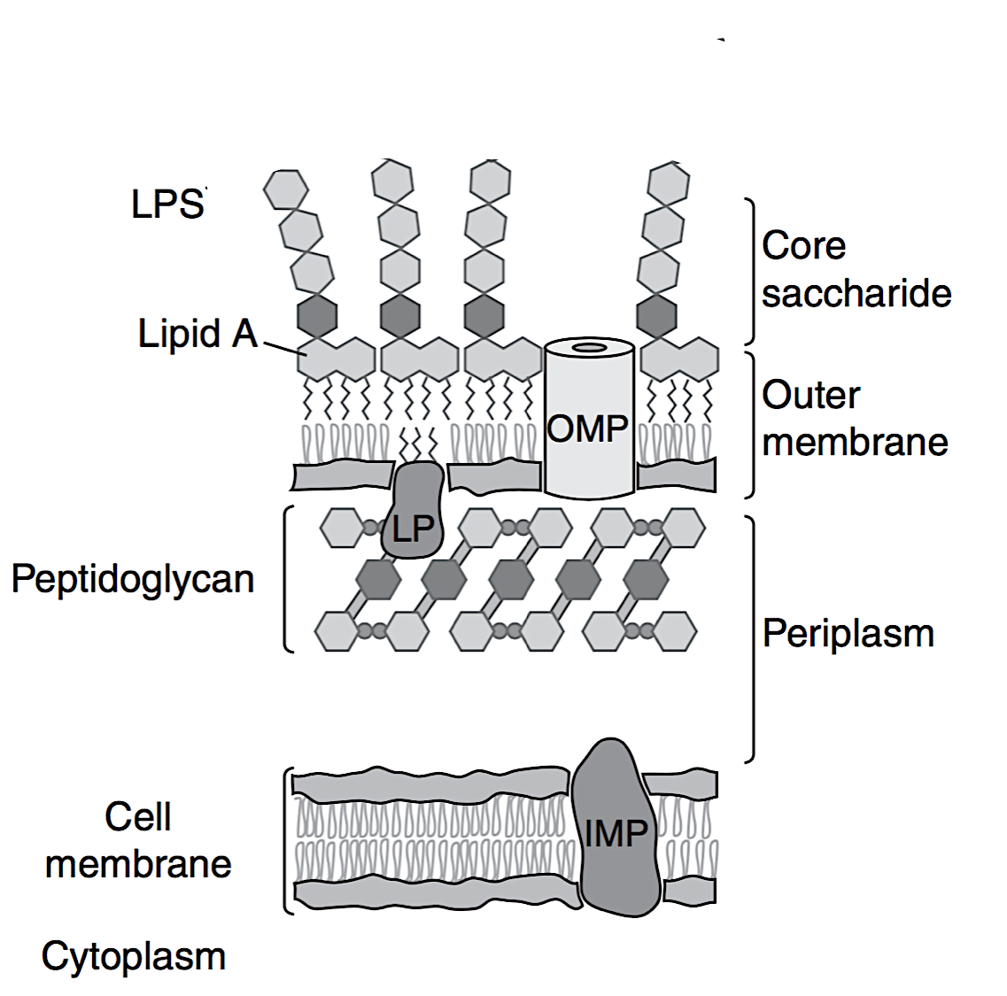
Fig. 1.5. The composition of the E. coli K-12 MG1655 cell envelope
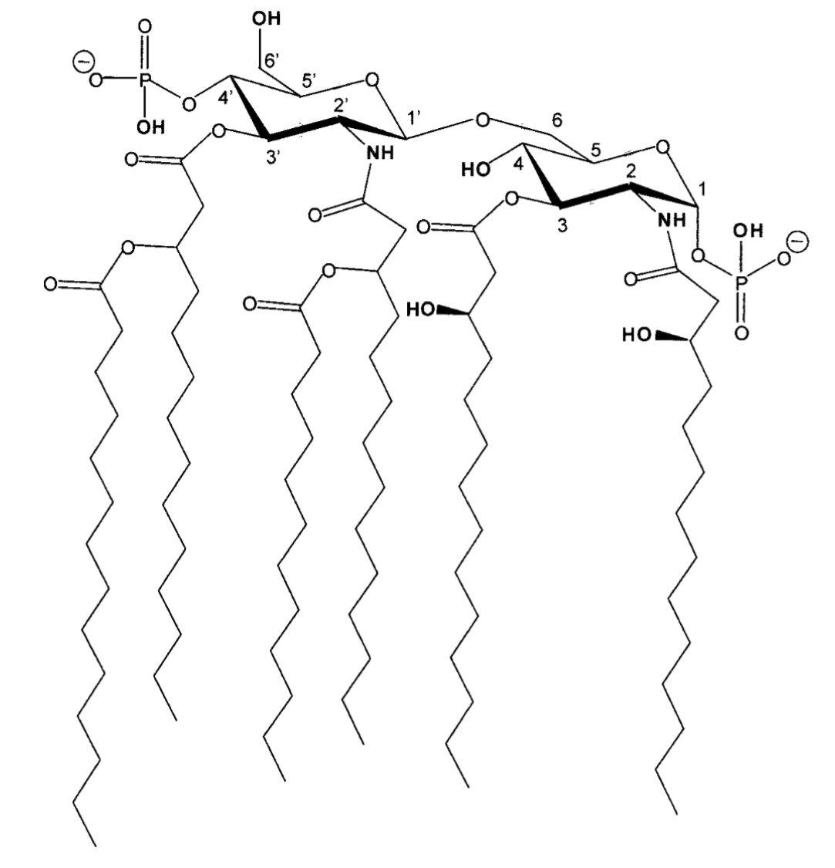
(A) (B) Lipid A

Fig.1.5. The composition of the E. coli K12 MG1655 cell envelope.
(A) The outer-membrane (OM) consists of an asymmetric bilayer of an outer-leaflet of lipopolysaccharide (LPS) and an inner-leaflet of phospholipids. LPS is composed of lipid A (shown in (B)) and a short core oligosaccharide. Most E. coli isolates also have an additional extended polysaccharide chain known as the O-antigen (displayed in Fig. 1.6) but this is not present in K-12 due to a historical mutation. LPS, being negatively charged, chelates large amounts of divalent cations, e.g. Mg(II) and Ca(II), which partly neutralise the negative charges enabling the LPS molecules to pact closely together. The hydrocarbon regions of the LPS are saturated, creating a gel-like consistency with low fluidity. Non-specific β-barrel transmembrane channels, known as porins, are abundant in the OM and enable passage of small, hydrophilic/charged molecules below 700 Da to enter the periplasm. In E. coli, OmpF, OmpC and PhoE constituent the major porins. The OM also contains smaller amounts of other porins, selective channels, lipoproteins, TonB-dependent receptors, gated channels and various secretory systems. These proteins collectively constitute the outer-membrane proteins (OMP). The OM is considered to function as a selective permeability barrier, excluding access of hydrophobic molecules and hydrophilic molecules (larger than 700 Da) from the cell.
The periplasm and peptidoglycan layer: The periplasm is a viscous aqueous region constituting 20-40 % of the total cell volume, compartmentalised between the OM and the IM. Unlike the cytoplasm where pH is controlled, the pH of the periplasm equals the pH of the external environment. It is densely packed with periplasmic proteins that carry out various functions, such as: (1) facilitation of nutrient transport; (2) membrane biosynthesis and assembly; (3) degradation of large macromolecules to aid uptake and (4) antibiotic hydrolysis. E. coli peptidoglycan is a rigid single molecule composed of repeating units of disaccharide N-acetyl glucosamine –N-acetyl-muramic acid cross-linked with short peptides. The rigidity of the peptidoglycan layer conveys E. coli its distinctive rod-like shape and prevents cell lysis under conditions of low osmolality. It is anchored to the OM by murein lipoprotein, LP, which is the most abundant protein in the E. coli cell (> 500,000 molecules per cell).
The inner-membrane: The IM consists of a phospholipid bilayer, primarily composed of phosphatidyl ethanolamine and phosphatidyl-glycerol, with lesser amounts of phosphatidyl serine and cardiolipin. Approximately 70 % of its mass is attributed to proteins and it has a semifluid-like consistency at temperatures that permit growth (20-37°C). The IM is the site of: respiration, ATP synthesis, lipid biosynthesis, protein secretion and transport (influx/efflux).
(B) The structure of lipid A of LPS. Note – Fig. 1.5. was adapted from Fig. 9 in Nikaido, 2003 and Fig. 3 in Silhavy et al., 2010. OMP = outer-membrane protein, LP = murein lipoprotein, IMP = inner-membrane protein, LPS = lipopolysaccharide. Legend text information was derived from Neidhardt et al., 1990; Nikaido, 2003; Silhavy et al., 2010; Wilks and Slonczewski, 2007.
Fig. 1.6. Key differences between Gram-positive and Gram-negative cell envelopes

(A) Gram-positive (B) Gram-negative
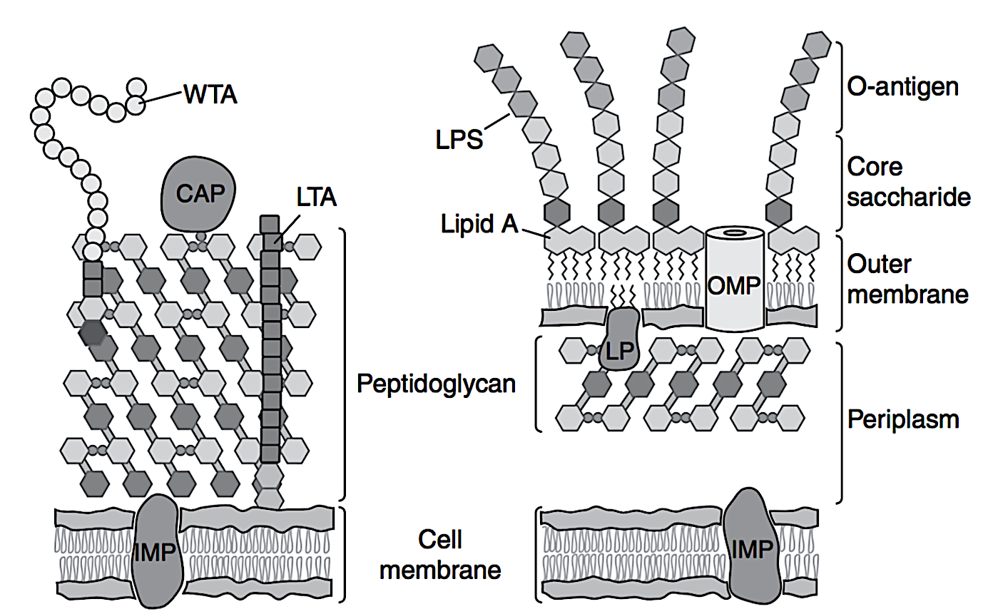

Fig. 1.6. Key differences between Gram-positive and Gram-negative cell envelopes
Schematic representations of a typical Gram-positive (A) and a typical Gram-negative (B) cell envelope. Notably, in Gram-positive cells, the OM is absent and instead, the cytoplasmic membrane is surrounded by a thick layer of peptidoglycan molecules (30-100 nm) which constituent 40 % of the cell wall. In contrast, the peptidoglycan layer of Gram-negative cell is typically 1-3 nm thick. In Gram-positives, peptidoglycan is associated with teichoic acids. Teichoic acids are composed of glycerol phosphate, glucose phosphate or ribitol phosphate repeats, and typically comprise around 60 % of the Gram-positive cell wall. There are two major types of teichoic acid: (1) wall teichoic acids (WTA) which are peptidoglycan anchored and (2) lipoteichoic acids (LTA) which are anchored to the cytoplasmic membrane. The periplasm is absent in Gram-positive bacteria. The O-antigen, i.e. an extended oligosaccharide component of LPS in some Gram-negative bacteria is included in the above diagram even though it is absent in E. coli K-12 and Fig. 1.5. Additional abbreviations: CAP = covalently attached protein, IMP = inner-membrane protein, OMP = outer-membrane protein, LP = murein lipoprotein.
Fig.1.6. was adapted from Fig. 3 in Silhavy et al., 2010. Information in legend text derived from Silhavy et al., 2010 and Neidhardt et al., 1990.

Protruding from the cell envelope are the flagella and the pili (fimbriae). Flagella are composed of multiple proteins and convey the E. coli cell with motility, whilst pili are composed of just one repeated protein unit and play a role in cell adherence and conjugation
(Neidhardt et al., 1990). DNA/RNA-mediated process and the majority of catabolic and anabolic pathways are located in the cytoplasm (Neidhardt et al., 1990). Ribosomes are highly abundant and catalyse the translation of messenger RNA (mRNA) to protein. In prokaryotes, transcription and translation occur simultaneously, with many ribosomes (known as polysomes) associating with a single strand of mRNA as it is formed at the DNA by the cell’s transcriptional machinery (Neidhardt et al., 1990). The entire genome of E. coli is contained within a single chromosome in a region known as the nucleoid. The genome of MG1655 has a length of 4641.62 kbp and encodes 4140 protein genes and 178 RNA genes (Blattner et al., 1993). In addition to chromosomal DNA, E. coli isolates may contain one or more independently replicating circular DNA elements, known as plasmids, although there are none naturally occurring in MG1655. As described in Section 1.1, plasmids are important in the transfer of antibiotic resistance genes and the propagation of AMR. The gene regulatory networks which control the adaptation of E. coli in response to changes in environmental conditions, nutrient availabilities and/or noxious agents are considered the most understood of any other living organism (Bettenbrock et al., 2014).

Unlike other more fastidious bacteria, E. coli is a prototroph and is able to completely synthesise many of its constitutive components providing it has a source of: carbon, inorganic nitrogen (assimilated as ammonia, NH₄⁺), sulfur (assimilated as hydrogen sulfide, H₂S), phosphorus (either inorganic or organic) and trace amounts of essential metal ions (Neidhardt et al., 1990). For this reason, E. coli can be grown in minimal medium without the need to supplement with amino acids or other macromolecule precursors. E. coli grows more rapidly in rich media, such as Lysogeny broth (LB) or Mueller-Hinton (MH) broth, where it is able to acquire much of its macromolecule precursors directly from the media, thus bypassing some biosynthetic pathways required otherwise for growth (Neidhart et al., 1990).

Although the guts of animals and humans are essentially anaerobic environments, E. coli is a facultative anaerobic and grows preferably via aerobic respiration (Bettenbrock et al., 2014). If oxygen is available, aerobic respiration allows for optimal energy conservation (via ATP synthesis) by proton (H⁺) translocation linked to electron transfer by membrane-bound respiratory chain components (Bettenbrock et al., 2014). In the absence of oxygen, E. coli will switch to alternative electron acceptors such as nitrate or fumarate (Bettenbrock et al., 2014). A detailed overview of how respiration in E. coli is linked to energy conservation is provided in Fig. 1.7. In the absence of terminal electron acceptors, E. coli switches to mixed-acid fermentation and conserves energy via substrate-level phosphorylation (Bettenbrock et al., 2014). The versatility of E. coli metabolic modes enables the bacterium to adapt, survive and
proliferate in response to varying nutrient and oxygen availabilities both inside and outside the host (Bettenbrock et al., 2014).

1.2.3. E. coli as an important pathogen

Although E. coli are normally innocuous and beneficial members of the host intestinal flora, some strains are significant and important human pathogens (Johnson, 1991; Nataro and Kaper, 1998). The WHO’s list of Global Priority Pathogens (Table 1.4) classifies carbapenem- and cephalosporin- resistant Enterobacteriaceae, a family that includes E. coli, as Priority 1 pathogens in which there is a critical need for new antimicrobial treatments (WHO, 2017). Pathogenic strains of E. coli possess genetic determinants known as virulence factors (VF) that enable them to adhere to and/or colonise host cells, evade host defenses and produce toxins that results in damage to host tissues (Johnson 1991; Nataro and Kaper, 1998). Such VFs are often located on plasmids or in gene clusters known as pathogenicity islands (Johnson, 1991). The genomes of pathogenic strains vary considerably from each other and commensal strains, and this remarkable genetic diversity gives rise to a broad range of intestinal and extra-intestinal infections (Escobar-Paramo et al., 2004). Even commensal E. coli strains can cause infections if the host’s gastrointestinal barrier or immune system is compromised (Nataro and Kaper, 1998).

Pathogenic E. coli are associated with urinary tract infections (UTIs), sepsis, meningitis and enteric infections/diarrhea (Nataro and Kaper, 1998). UTIs are the most common form of E. coli extra-intestinal infection and uropathogenic E. coli (UPECs) are considered to be responsible for up to 90 % of the 150 million UTIs diagnosed annually (Brzuszkiewicz et al., 2006). UPECs are the most genetically distinct from commensal stains and possess VFs which enable them to colonise the urinary tract, adhere to and invade host epithelial cells and produce hemolysins to acquire nutrients directly from host cells (Johnson, 1991). MDR-UPECs often cause severe and recurring infections in UTI patients.

Pathogenic intestinal strains include: enteropathogenic E. coli (EPECs), enterohemorrhagic E. coli (EHECs) and enteroaggregative E. coli (EAEC) (Nataro and Kaper, 1998). One particularly infamous strain of EHEC is E. coli O157:H7 (Armstrong, 1996). It is highly infectious and is spread via contaminated food or drinking/swimming water (Armstrong, 1996). E. coli O157:H7 produces a shiga-like toxin that causes symptoms of severe bloody
Fig. 1.7. The E. coli respiratory chain and ATP synthesis via the proton motive force
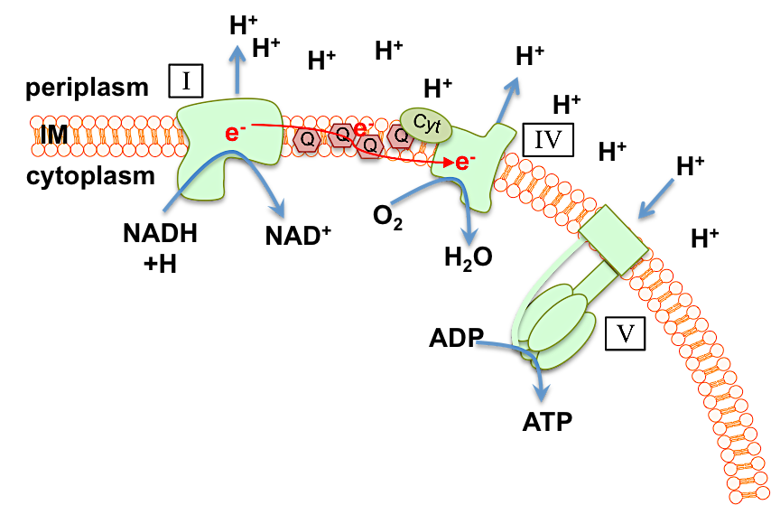

Fig.1.7. The E. coli respiratory chain and ATP synthesis via the proton motive force. The above linear scheme is provided as a simplified overview of the branched respiratory chain of E. coli to illustrate how its components translocate protons (H⁺) across the inner membrane (IM), via a series of electron (e-) transfer reactions, and thus generate a proton motive force (PMF) which enables the cell to conserve energy as ATP. Simply, electrons are transferred from an electron donor through a series of coupled oxidation-reduction reactions to a terminal electron acceptor – oxygen (O₂) in the case of aerobic respiration. Electron transfer reactions of dehydrogenases (I) and oxidases (IV) facilitate the net transfer of H⁺ from the cytoplasm to the periplasm. The inner membrane is impermeable to H⁺ and thus this process generates a difference in proton concentration (ΔpH) and electronic charge (known as membrane potential, Δψ) across the membrane. The sum of this potential energy is known as the proton motive force (PMF). The PMF enables the cell to conserve this potential energy as ATP and facilitates energy-demanding processes such as solute transport and motility. Electrons are first transferred from NADH by membrane-bound dehydrogenases (I), of which there are two in E. coli, which feed electrons into the quinol pool (Q). Electrons are transferred from the quinones to cytochromes (cyt) and then to one of three cytochrome oxidases (IV) (cytochrome bo, bd-I ad bd-II, the stoichiometries of which are not shown). These terminal oxidases catalyse the 4-electron reduction of dioxygen to H₂O. ATP is generated via the action of large, multi-subunit ATP-synthase that spans the IM and facilitates phosphorylation of ADP through proton translocation. In anaerobic respiration, an alternative electron acceptor such as nitrate, fumerate or trimethylamine-N-oxide is used. Note: the above scheme does not represent succinate dehydrogenase that also feeds electrons into the quinone pool.
Fig. 1.7. was constructed from information contained in Poole and Cook, 2000; Neidhart et al., 1990

diarrhea in those infected and can be fatal (Armstrong et al., 1996). There can be no doubt that, one the one hand, E. coli can be a harmless commensal bacterium, employed widely as a laboratory workhorse, but on the other, is a significant and prominent bacterial pathogen, of which there is a rapidly dwindling supply of anti-infectives available to treat its associated infections.

1.3. Carbon monoxide and carbon monoxide-releasing molecules – an introduction

1.3.1. The biological chemistry of carbon monoxide (CO)

Carbon monoxide (CO) is a small, odourless and colourless diatomic gas infamously known for its toxicity to humans and widely known as an atmospheric air pollutant (Davidge et al., 2009a). Man-made sources of CO include incomplete combustion of hydrocarbons such as fossil fuels and in cigarette smoke, but natural sources include the burning of biomass by natural fires and volcanic activity (Von Burg, 1999). Once inhaled, CO can diffuse rapidly through the alveolar and capillary membranes into the blood, where an estimated 80 – 90 % of inhaled CO binds haemoglobin, at an affinity 200 - 250 times greater than that of O₂, to form carbonmonoxy-haemoglobin (COHb). This severely impairs O₂ transport to major organs and tissues (Davidge et al., 2009a). Prolonged exposure to CO leads to tissue hypoxia and inhibition of mitochondrial respiration and, if left untreated, can cause permanent tissue damage and ultimately death (Blumenthal, 2001). Despite its deadly reputation, CO – along with nitric oxide (NO) and hydrogen sulfide (H₂S) – is recognised as an important gasotransmitter with diverse signaling and modulatory roles in mammalian systems (see Fig. 1.8. for an overview). It is endogenously produced in mammalian cells via the degradation of haem by haem-oxygenase (HO) enzymes (see Fig. 1.9.) (Rochette et al., 2013; Ryter et al., 2006).

The physical and chemical properties of CO are summarised in Table 1.6. CO is relatively unreactive in biological systems due to the strong triple bond between the carbon and oxygen atom (see the Lewis Bonding Structure of CO on Table 1.6.). CO is not degraded or converted to other chemical species under physiological conditions and therefore has relatively simple reaction chemistry (Fukuto et al., 2012). In biological systems, CO reacts almost exclusively with transition metal centers in low oxidation states e.g. reversibly binding to ferrous Fe(II) haem-iron in globins or terminal oxidases (Fukuto et al., 2012).

1.3.2. The development of carbon monoxide-releasing molecules (CORMs)

Fig. 1.8. Roles of CO in mammalian biological systems

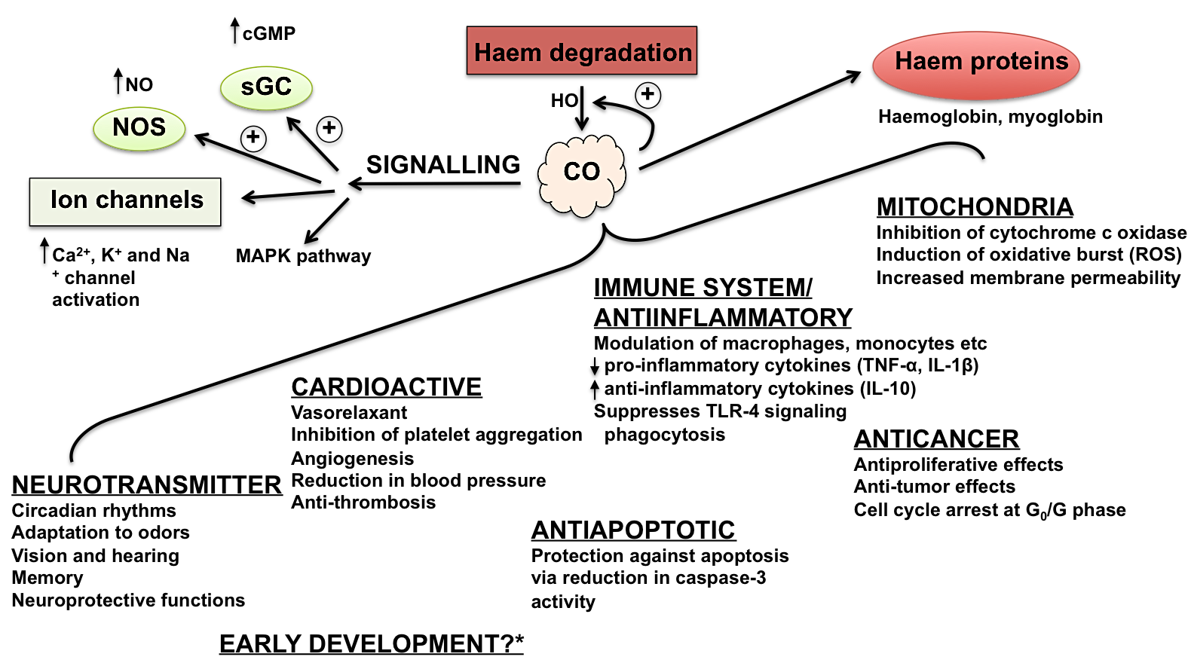

Fig. 1.8. Roles of CO in mammalian biological systems. Endogenous CO is produced by haem-oxygenases (HO) in the haem-degradation pathway. CO signaling: direct binding of CO to the Fe(II) of soluble guanylate cyclase (sGC) leads to activation of the enzyme and an increase in the level of secondary messenger, cyclic guanosine 3’,5’-monophosphate (cGMP), which acts in numerous signaling pathways. cGMP-independent signaling mechanisms include: (1) direct activation of nitric oxide synthase (NOS), leading to increased NO production, (2) activation of ion channels, and (3) indirect modulation of mitogen-activated protein kinase (MAP-K) pathways. Other targets of CO include haem proteins, such as the mitochondrial cytochrome c terminal oxidase. The consequences of CO interactions with biological targets and CO-mediated signaling are illustrated. *It is currently not known whether CO plays a role in early gamete/embryo development, but it is expected. TNF-α = tumour necrosis factor α, IL-1β = Interleukin-1β, IL-10 = interleukin-10, TLR-4 = toll-like receptor 4. Fig. 1.8. was constructed from information contained within the following reviews on the role of CO in mammalian systems: (Davidge et al., 2009a; Li et al., 2009; Nevoral et al., 2016; Olas, 2014; Rochette et al., 2013; Szabo, 2016; Wegiel et al., 2013)

Fig. 1.9. CO generation via the haem-degradation pathway

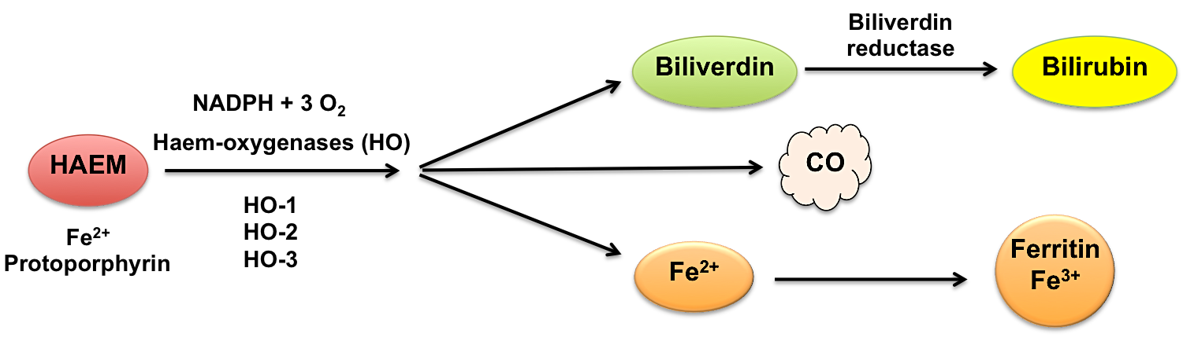

Fig. 1.9. CO generation via the haem-degradation pathway. CO is generated endogenously in mammals via the haem degradation pathway, shown above. Haem is converted to biliverdin by the action of haem-oxygenase (HO) enzymes, of which there are three isoforms in humans (HO-1, HO-2 and HO-3). The generation of biliverdin from haem results in the release of 1 mol of CO and 1 mol of Fe(II) from haem, the latter is sequestered and stored in ferritin. Biliverdin (green pigmented) and bilirubin (yellow pigmented) have numerous cytoprotective, antioxidative and antinitrosative functions. The roles of the derived CO are illustrated in Fig. 1.8. Fig. 1.9 was adapted from Fig. 1 in Rochette et al., 2013 using information contained within Ryter et al., 2006.

Table 1.6. Physical and chemical properties of CO

PROPERTY | CARBON MONOXIDE (CO)
Lewis bonding structure

Boiling point | - 191.5 °C (gaseous at RT)
Molecular weight | 28.01
Gaseous properties | Colourless, odourless, flammable
Membrane permeability | Diffusible
Solubility in H₂O | 0.0028 g/100 g H₂O (20°C) ~ 1 mM at saturation (RT)

Table 1.6. Physical and chemical properties of CO. Constructed from information contained within Li et al., 2009 and Fukuto et al., 2012. RT = room temperature.

As CO emerged as an important gasotransmitter in mammalian systems, there was a drive to find compounds that could be used to administer CO either in vitro or in vivo as experimental tools to study the effects of CO on cultured cells, isolated tissues or in animal models (Davidge et al., 2009a). Such CO-releasing molecules, or ‘CORMs’, were first developed by Motterlini, Mann and co-workers in the early 2000s (Mann, 2012). The majority of CORMs are transition metal carbonyls that are light sensitive, yet stable as solids if protected from light, and are administered for CO-delivery in solutions (Davidge et al., 2009a). The properties of an ‘ideal’ CORM for experimental or therapeutic delivery of CO are as follows: (1) non-toxic to host cells, (2) sufficiently water-soluble to be administered without the use of organic solvents, (3) sufficiently pure and stable enough to have a favourable pharmacokinetic profile and (4) have sufficiently fast and efficient CO-release for the CO to be present at a biologically active concentration in the target cells/tissues (Davidge et al., 2009a).

The earliest investigated CORMs were explored by Motterlini and co-workers: [Mn₂(CO)₁₀] (CORM-1), [Fe(CO)₅] and [Ru(CO)₆Cl₄] (CORM-2) (Mann, 2012). All three CORMs were insoluble in water, required photolysis to facilitate CO release and [Fe(CO)₅] was highly cytotoxic (Mann, 2012). To solve the issue of water-solubility, Motterlini approached Prof. Brian Mann at the University of Sheffield in 2000 and together they developed the first water-soluble CORM, Ru(CO)₃Cl(glycinate)), ‘CORM-3’ (Mann, 2012). CORM-2 and CORM-3 have become the most extensively investigated CORMs in the scientific literature with over 300 and 250 publications, respectively. Since the development and application of these early CORMs, numerous others have been developed which differ by the transition metal bound to the CO ligand(s), the number of molecules of CO released per CORM and the mechanism of CO release (Wareham et al., 2015). Examples of commonly used CORMs are shown in Table 1.7.

1.3.3. CORM-2 and CORM-3 speciation chemistry and CO release

As the subject of this thesis concerns the antimicrobial potential of CORM-2 and CORM-3, the focus herein will be on these CORMs only.

CORM-2 is a dinuclear Ru(II)-carbonyl dimer of the formulae [Ru(CO)₃Cl₂]₂ as shown in Fig. 1.10. (1). It is commercially available from Sigma-Aldrich and other suppliers, and has become the most widely investigated CORM (Mann, 2012). It is insoluble in aqueous media and most organic solvents, despite having been incorrectly referred to as a lipophilic CORM (Desmard et al., 2012). For application in biological experiments, it is prepared by solubilisation
Table 1.7. Examples of commonly used CORMs
CORM | Chemical name | Structure | mol CO released  per mol CORM | Mechanism(s) of CO release*
CORM-1 | Dimanganese decacarbonyl | 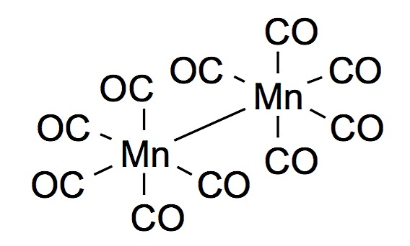 | ~ 1.0 | Photolysis
ALF-062 | Tetra ethylammonium molybdenum pentacarbonyl bromide | 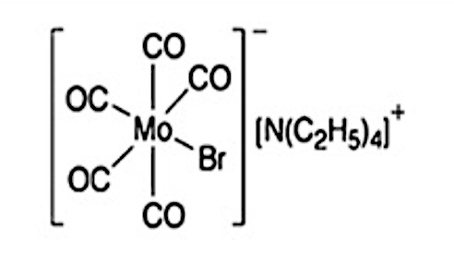 | 1.3 | Spontaneous
ALF-492 | Tricarbonyl dichloro(thiogalatopyranoside) ruthenium(II) | 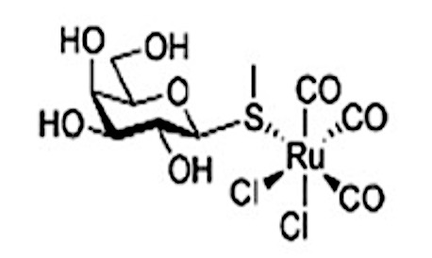 | 1.0 | Spontaneous
CORM-2 | Tricarbonyl dichlororuthenium(II) dimer | 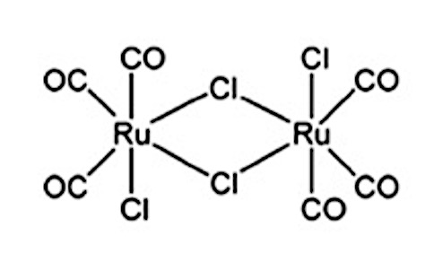 | 0.7-1.0 | DMSO substitution, promoted by dithionite/sulfite
CORM-3 | Tricarbonylchloro(glycinate) ruthenium(II) | 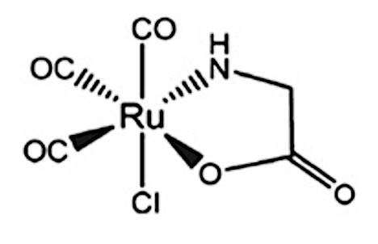 | 1.0 | Promoted by dithionite/sulfite
CORM-401 | [Mn(CO)₄{S₂CNMe(CH₂CO₂H)}] | 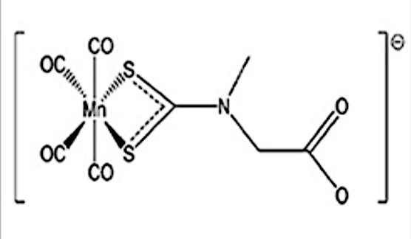 | 1.0 - 3.2 | 1 mol spontaneously, up to 3.2 mol via ligand substitution
CORM-A1 | Sodium boranocarbonate | 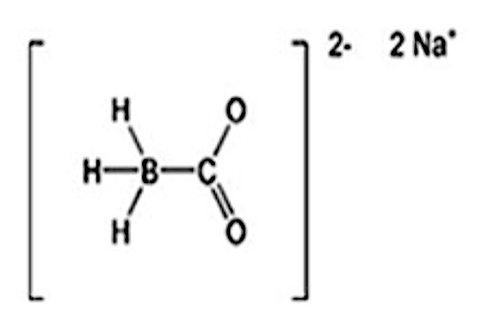 | 1.0 | Spontaneous (dependent on pH and temperature)
photoCORM  USC-CN028-31 | Mn(CO)₃(tpa-κ³N)⁺ | 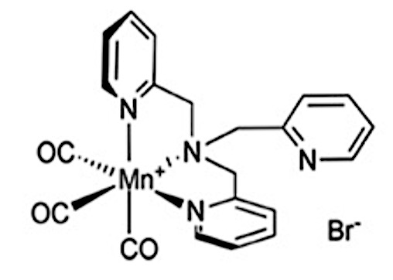 | 2.2 | Irradiation at 365nm
tryptoCORM | Tricarbonyl acetonitrile (L-2-Amino-3-(1H-indol-3-yl) propanoic acid | 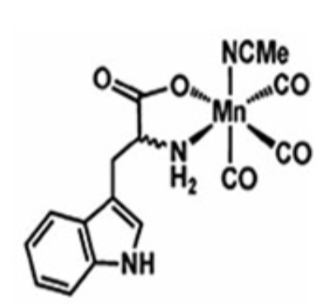 | 2.0 | Irradiation at 400nm

Table 1.7. Examples of commonly used CORMs. Adapted from Table 1 in Wareham et al., 2015 and from information contained within Davidge et al., 2009a; McLean et al., 2012. *Note – all metal-carbonyl CORMs can potentially release CO upon irradiation with light and the true mechanisms by which CO is released from most CORMs is poorly/incompletely understood.

in dimethyl-sulfoxide (DMSO). The speciation of CORM-2 in DMSO, as shown in Fig. 1.10, is not yet fully understood and is the subject of extensive investigations by two publications: Klein et al., 2014 and Seixas et al., 2015. Upon addition of DMSO, CORM-2 rapidly undergoes a transition into mononuclear Ru(II)-carbonyl complexes, of the formula [RuCl₂(CO)₃DMSO], by displacement of the chloride bridges with DMSO (Fig. 1.10. (2)) (Davidge et al., 2009a; Klein et al., 2014). These monomers then further react with DMSO, via displacement of one CO ligand by the coordination of the sulfur atom of DMSO to the Ru(II) ion, yielding [RuCl₂(CO)₂-(DMSO)₂] isomers (Fig. 1.10. 3a, 3b) (Klein et al., 2014). The [RuCl₂(CO)₂-(DMSO)₂] isomers are stable in DMSO and are unlikely to react further with the solvent (Seixas et al., 2015). As a consequence of its solution chemistry and displacement of ligands by DMSO, CORM-2 preparations are likely a mixture of 2, 3a and 3b depending on the age of the stock solution (Klein et al., 2014; Seixas et al., 2015). As previously mentioned, the speciation of CORM-2 in DMSO has yet to be fully elucidated.

CORM-3, [Ru(CO)₃Cl(glycinate)] (Fig. 1.10. (4)), is a water soluble mononuclear Ru(II)-carbonyl CORM, derived from the reaction of CORM-2 and the amino acid glycine (Clark et al., 2003). Like CORM-2, CORM-3 is commercially available from Sigma-Aldrich and other suppliers, albeit at a considerably higher cost than its precursor. For use in biological experiments, CORM-3 is solubilised in distilled water where it rapidly undergoes aquation via the attack of OH⁻ of water at one CO ligand per molecule; the initial step of the water-gas shift reaction (Clark et al., 2003; Davidge et al., 2009a). Depending on which CO ligand is attacked, this can give rise to three isomers of [Ru(CO)₂(CO₂H)Cl(glycinate)]⁻ as shown in Fig. 1.10 (5a, 5b, 5c). As a result of this, CORM-3 stock solutions are generally acidic (pH 2.5-3.0) (Clark et al., 2003). Under aerobic conditions, at pH > 3, the reaction may proceed to release the CO ligand as CO₂ via water-gas shift chemistry (Johnson et al., 2007).

Upon addition of heterogeneous mixtures of either the CORM-2/DMSO-derived complexes (Fig. 1.10., 2, 3a and 3b) and the aquated CORM-3 complexes (Fig. 1.10., 5a, 5b and 5c) to physiological buffers and biological growth media, it is likely that these complexes undergo further chemical modifications and ligand exchange. It is known that the Cl ligand of CORM-3 is labile and undergoes substitution with water at pH ranges >3 (Johnson et al., 2007). The glycinate ligand of 5a, 5b and 5c could also be labile though this has not been definitively shown. At increasingly higher chloride concentrations, the glycinate Ru-O bond could be broken by displacement by chloride substitution so that the glycinate becomes monodendate through the nitrogen (Fig. 1.10. (6)) (Johnson et al., 2007). Further increases in chloride concentration yields could feasibly lead to full displacement of the glycine ligand to yield the
Fig. 1.10. Structures and speciation chemistry of CORM-2 and CORM-3

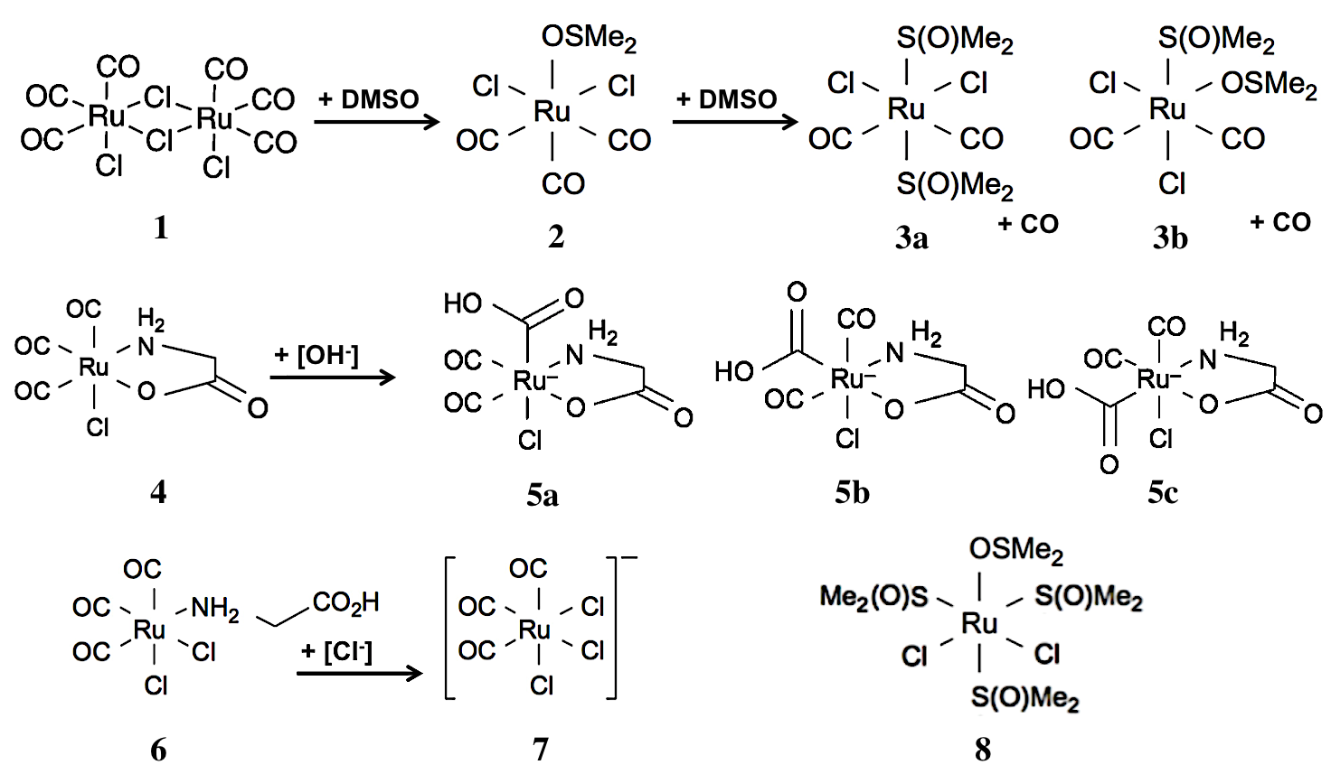

Fig. 1.10. Structures and speciation chemistry of CORM-2 and CORM-3.
(1-4) Structure of CORM-2 and speciation in DMSO. (1) Structure of CORM-2, [Ru(CO)₃Cl₂]₂. Upon addition of CORM-2 (1) to DMSO, the DMSO rapidly displaces the chloride bridges of the dimer via coordination of its oxygen atom to the Ru(II) ion yielding two [RuCl₂(CO)₃DMSO] monomers (2) Subsequently, (2) further reacts with DMSO via displacement of one CO ligand by the coordination of the sulfur atom of DMSO to the Ru(II) ion yielding stable [RuCl₂(CO)₂-(DMSO)₂] isomers (3a, 3b) and CO. (4-7) Structure of CORM-3 and speciation in aqueous solution. (4) Structure of CORM-3 [Ru(CO)₃Cl(glycinate)]. Upon addition of CORM-3 (4) to distilled water, aquation occurs via the attack of [OH⁻] from water to one CO ligand of CORM-3 resulting in the generation of [Ru(CO)₂(CO₂H)Cl(glycinate)]- isomers (5a-c). (6-7) The lability of the glycinate ligand of CORM-3. Upon addition of (5a-c) to increasingly high HCl concentrations, the glycinate Ru-O bond in broken by displacement with chloride, resulting in the glycine becoming monodendate through the nitrogen (6). Further increases in HCl yields full displacement of the glycine ligand to yield the [Ru(CO)₃Cl₃]⁻ complex (7). It is proposed that solutions of the so-called ‘inactivated CORM-3’ (iCORM-3) contain CORM-3 derivative complexes of this structure. (8) The structure of RuCl₂(DMSO)₄, sometimes referred to as ‘iCORM-2’, a commonly used ‘CO-depleted’ control compound for use in studies in assessing the biological activities of CORM-2 and CORM-3.
Fig. 1.10. was constructed using information from Johnson et al., 2007; Davidge et al., 2009a; McLean et al., 2012; Klein et al., 2014 and Seixas et al., 2015

[Ru(CO)₃Cl₃]⁻ complex (Fig. 1.10. (7) (Clark et al., 2003; Johnson et al 2007). As a result of their complex solution chemistry, the exact bioactive species of CORM-2 and CORM-3 in biological experiments is not known and could vary depending on the constituents of the medium employed. It is presumed that the biological activity observed from addition of ruthenium-carbonyl CORMs could be attributed to a range of bioactive mononuclear Ru(II) complexes derived from the complexes 2, 3a-b, 5a-b, 6 and 7 (Fig. 1.10.) and their interactions with growth medium constituents that could act as counter-ions to the Ru(II) ion via ligand substitution.

The lability of the CO ligands of CORM-2 and CORM-3 is somewhat controversial and surprisingly poorly understood given their frequent use as CO-donors. Desmard et al., classified CORM-2 and CORM-3 as ‘fast CO-releasers’ due to their ability to quickly release CO to deoxymyoglobin in the spectroscopic myoglobin assay (Desmard et al., 2012; Motterlini et al., 2002). As shown in Fig. 1.10., 1-3b, some CO is liberated from CORM-2 upon substitution with DMSO (Klein et al., 2014). However, very little or no CO can be detected upon the addition of CORM-2 stocks to phosphate buffers or growth media in the absence of sodium dithionite when analyzed via the oxyhaemoglobin assay, a CO-electrode probe, gas-phase Fourier transform infra-red spectroscopy (FTIR) or gas chromatography (GC) (Desmard et al., 2012; McLean et al., 2012; Klein et al., 2014; Nobre et al., 2007; Seixas et al., 2015). Only in the presence of an excess of sodium dithionite, or other sulfite species, is there a fast release of up to 0.7 – 1 mol CO per mol CORM-2 (Motterlini et al., 2002; Mclean et al., 2012; Klein et al., 2014). Instead, CO₂ (approximately 1.8 mol per mol CORM-2) is released, presumably via water-gas shift chemistry resulting from the attack of OH⁻ on the ligands of 3a-b (Fig. 1. 10) upon addition to aqueous solutions (Seixas et al., 2015).

Similarly, no CO can be detected from CORM-3 upon addition to phosphate buffer, growth media or serum in the absence of dithionite by the above methods (McLean et al., 2012; Rana et al., 2014; Nobre et al., 2007; Santos-Silva et al., 2011; Seixas et al., 2015). Instead only CO₂ is detected, at 0.68 equivalents per mol, most likely due to completion of the water-gas shift reaction and release of CO₂ from 5a-c (Fig. 1.10.) (Sexias et al., 2015; Santos-Silva et al., 2011; Clark et al., 2003; Johnson et al., 2007). Upon addition to phosphate buffer in the presence of excess dithionite or sulfite, CORM-3 rapidly releases 1 mol CO per CORM (Clark et al., 2003; McLean et al., 2012).

The reason for the apparent discrepancy between ‘fast CO-release’ from Ru-carbonyl CORMs in the spectroscopic myoglobin assay compared to the lack of CO measured from both CORMs either by physical or electrochemical methods described above was resolved by (McLean et al., 2012). In this landmark study, it was shown that it was the sodium dithionite, added prior to CORM-2 or CORM-3 as a reductant to myoglobin, that triggered rapid CO release from these compounds (McLean et al., 2012). In addition to this, CORM-3 has been shown to ‘lose’ its ability to release CO upon addition of dithionite or sulfite after extended incubation in phosphate buffers or human plasma (Clark et al., 2003; Motterlini et al., 2003; McLean et al., 2012). This may be due to displacement of the glycinate via the process outlined in 6-7, resulting in the generation of [Ru(CO)₃Cl₃]⁻ (Fig. 1.10. (7)), which has been shown be stable and not to release CO (Johnson et al., 2007).

If no CO can be detected from CORM-2 or CORM-3 solutions in physiological buffers or growth media in the absence of an excess of sodium dithionite or sulfite, can these compounds really be considered as ‘CO-releasing molecules’? It was initially proposed that Ru-carbonyl CORMs were stable in solution, requiring the uptake of the compound into the intracellular reducing environment, where naturally occurring sulfites would trigger CO release from CORM-2 and CORM-3. Recently, a series of publications have proposed that Ru-carbonyl based CORMs do not release CO per se, but that CO is released via the decomposition of protein-Ru(CO)₂ adducts that form as a result of reactions between CORMs and proteins (Chaves-Ferreira et al., 2015; Santos-Silva et al., 2011a, b). Indeed, administration of both CORM-3 and BSA-Ru(CO)₂ adducts, formed by reaction of CORM-3 with bovin serum albumin (BSA), to rats or mice leads to increased endogenous CO levels in the blood and tissues (Wang et al., 2014; Chaves-Ferreira et al., 2015; Seixas et al., 2015). Analysis of the urine of rats treated with CORM-3 revealed the presence of Ru but not Ru-carbonyls, indicating that the CO ligands had been lost in vivo (Wang et al., 2014).

1.3.4. Cytotoxicity of CORM-2 and CORM-3 on cultured mammalian cells and in whole animal models

CORM-2 and CORM-3 cytotoxicity has been examined by numerous studies and generally these compounds are considered to have relatively low cytotoxicity to mammalian cells (Davidge et al., 2009a; Nobre et al., 2016). The maximum concentrations of CORM-2 and CORM-3 that can be tolerated by various cultured mammalian cell types before any onset of observed cytotoxic effect depends on cell type, incubation time and the method used to assess cytotoxicity, as shown in Table 1.8. In general, CORM-2 is found to be consistently more cytotoxic to cultured mammalian cells than CORM-3, with DMSO found to be partly responsible for the enhanced inhibitory effects (Nobre et al., 2016; Bang et al., 2014; Winburn
Table 1.8. Cytotoxicity of Ru-carbonyl CORMs towards cultured mammalian cells
CELL TYPE | CORM | MAXIMUM TOLERATED DOSE BEFORE SIGNIFICANT CYTOTOXICITY | METHOD FOR VIABILITY ASSESSMENT* | REFERENCE(S)
RAW 264.7  Murine macrophage | CORM-2  CORM-3 | < 250 μM (24 h)  ≤ 100 μM (24 h)  ≤ 200 μM (24 h)  ≤ 500 μM (24 h) | MTT  MTT  Alamar blue  MTT | Nobre et al., 2016  Seixas et al., 2015  Desmard et al., 2009  Nobre et al., 2016
LLC-PK1  Porcine kidney | CORM-2  CORM-3 | < 400 μM (24 h)  ≤ 500 μM (24 h) | MTT  MTT | Nobre et al., 2016  Nobre et al., 2016
MDCK  Madin Darby Canine Kidney | CORM-2 | < 100 μM (24 h)  < 20 μM (24 h) | CVCA  Morphological  PI | Winburn et al., 2012
HeK  Human embryonic kidney | CORM-2 | < 100 μM (24 h) | CVCA | Winburn et al., 2012
HepG2  Human liver | CORM-2  CORM-3 | < 100 μM (24 h)  ≤ 500 μM (24 h) | MTT  MTT | Nobre et al., 2016  Nobre et al., 2016
Human bladder epithelial | CORM-2 | < 500 μM (8 h)  ≤ 250 μM (24 h) | LDH | Bang et al., 2014
Human bronchial epithelial | CORM-2 | ≤ 200 μM (12 h) | MTT | Murray et al., 2012
L929  Murine fibroblasts | CORM-3 | IC₅₀ ≈ 212 μM (24 h) | MTT | Wang et al., 2014

Table 1.8. Cytotoxicity of Ruthenium-carbonyl CORMs towards cultured mammalian cells. * MTT = 3-(4,5-dimethylthiazol-2-yl)-2,5-diphenyltetrazolium bromide) assay, CVCA = crystal violet cell adhesion assay, PI = propidium iodide assay, LDH = lactate dehydrogenase assay

et al., 2012). Nevertheless, the concentrations required to illicit cytotoxicity to mammalian cells in vitro are, with the exception of those reported by Winburn et al., 2012, considerably higher than those required to induce beneficial biological effects (see Section 1.3.5., below) and are considered within the acceptable therapeutic range (Nobre et al., 2016).

Given that Ru-carbonyl CORMs have been found to exhibit reportedly low toxicity to mammalian cells in vitro, there has been an examination of their activity in animal models. Chung et al investigated the effects of CORM-2 in a murine polymicrobial sepsis model, but the authors did not examine the effects of CORM-2 administration in non-infected healthy mice (Chung et al., 2008). The in vivo activity of CORM-3, being comparably less toxic than CORM-2, has been the subject of two published studies (Desmard et al., 2009; Wang et al., 2014). In one study, consecutive administration of up to 22.5 mg/kg CORM-3 to healthy mice resulted in no mortality or behavioral signs of illness within 2 weeks of treatment (Desmard et al., 2009). It has also been reported that administration of 1-4 mg/kg CORM-3 to healthy cynomologous monkeys did not produce any toxic effects up to 30 days after treatment (Vadori et al., 2009).

A more detailed examination of the pharmacological properties of CORM-3 in vivo was carried out by Wang et al., 2014. In contrast to the above, consecutive treatment of 14.7 – 36.8 mg/kg CORM-3 to rats was shown to cause severe morphological changes to liver and kidney cells indicative of tissue damage after only 21 days (Wang et al., 2014). Inductively-coupled plasma – absorption emission spectroscopy (ICP-AES) of harvested mice tissues up to 1 h post-CORM administration, revealed that CORM-3-derived Ru first accumulated in the blood and then was slowly distributed to other tissues/organs such as the liver, kidney, lung and heart, but did not cross the brain barrier (Wang et al., 2014). ICP-AES revealed the presence of Ru in urine samples, indicating that CORM-3-derived Ru is eventually secreted (Wang et al., 2014). As there are few and conflicting reports of CORM-2 and CORM-3 cytotoxicity in vivo, it remains inconclusive whether these compounds have the potential to reach clinical development. The extensive distribution of CORM-3-derived ruthenium in multiple organs in mice after just 1 h could be a limiting factor for future clinical applications (Wang et al., 2014)

1.3.5. The reported activities of CORM-2 and CORM-3 in mammalian gasotransmitter research and their potential in therapeutic CO-delivery

The reported activities of CORM-2 and CORM-3 on cultured mammalian cells, isolated tissues/organs in vitro and in whole animal models have been the subject of over 300 publications over the past 15 years. As could be expected, the effects of CORM-2 and CORM-3 have been found to largely mimic the effects of exogenous CO gas or stimulation of endogenous CO-production by induction of HO (as reviewed by: Motterlini et al., 2003; Ryter et al., 2006; Davidge et al., 2009a; Mann, 2012). For example, CORM-2 has been reported to induce vasodilation in isolated rat aortas, attenuate production of pro-inflammatory cytokines in LPS-stimulated murine macrophages and induce angiogenesis in cultured epithelial cells (Motterlini et al., 2003; Davidge et al., 2009a). CORM-3 has been also been shown to have vasorelaxant effects in isolated rat aortas and has been shown to improve cardiac performance following myocardial ischemia and reperfusion injury in isolated rat hearts ((Motterlini et al., 2003). Furthermore, CORM-3 has been shown to prolong survival of cardiac grafts in animal models, reduce symptoms of rheumatoid arthritis in mice, decrease production of pro-inflammatory cytokines in various immune cell types, and improve outcomes in diabetes and sepsis animal models (Davidge et al., 2009a; Mann, 2012). Additionally, the inclusion of CORM-2 and CORM-3 in organ preservation solutions has been shown to protect against reperfusion damage and reduce transplant rejection in various animal models (Davidge et al., 2009a).

A discussion of the molecular mechanisms by which CORM-2 and CORM-3 mediate the above effects in various mammalian experimental systems is beyond the scope of this thesis. It is important to note however, that the biological effects of CORM-2 and CORM-3 in such studies has been attributed to the released CO and not the compounds as a whole, their derived species or the Ru(II) ion(s). This has been largely due to observations that ‘negative controls’, such as DMSO, Ru(III)Cl₃, iCORM-2 and/or iCORM-3, do not produce the same biological activities as these CORMs (Motterlini et al., 2003; Davidge et al., 2009a; Mann, 2012). As will be described later, these control compounds are inadequate at assessing the potential role of the Ru(II) ion(s) and thus it is unclear whether the biological activities described in this section can be truly solely attributed to potential released CO ligands.

The therapeutic administration of exogenous CO in patients by CO gas-inhalation therapy has long been considered for potential clinical application and 4 clinical trials aimed at assessing the efficacy of its effects in various human diseases are currently in progress (Hu et al., 2016). However, a particular disadvantage of CO-inhalation therapy is that, although it is effective at raising serum carbonmonoxy-haemoblobin (COHb) concentrations to sufficiently therapeutic levels, such high systemic COHb levels are hard to control and may lead to CO intoxication via impaired O₂ transport and inhibition of mitochondrial respiration (Hu et al., 2016). The potential advantages of therapeutic delivery of CO by CORMs are as follows: (1) CO can be administrated (i.e. injected) at the target site/tissue without significantly increasing systemic COHb levels, thus reducing the possibility of CO-intoxication; (2) CO release from the CORM could be tightly controlled in order to administer CO in a time specific manner e.g. via photolysis and (3) CORMs can be stored safely as solids and/or solutions, mitigating the need for large, pressurized gas cylinders of CO gas which might pose a significant health and safety risk for medical staff and/or patients in the context of CO-inhalation therapy (Hu et al., 2016; Davidge et al., 2009a). Neither CORM-2, CORM-3 or any other CORM has yet reached clinical trials, and it is unclear whether CORM-2/3 would be suitable for clinical application due to their poorly defined solution and speciation chemistry described above in Section 1.3.3 and the cytotoxic effects reported of the Ru(II) ion(s) in studies of whole animal models (Wang et al., 2014).

1.4. CORMs as novel antimicrobial agents

1.4.1. The employment of CORMs as antimicrobial agents and as adjuvants to antibiotics in vitro

The first report of the employment of CORMs as novel antimicrobial agents was published nearly a decade ago (Nobre et al., 2007). In this study, CORM-2, CORM-3, ALF-021 (bromo(pentacarbonyl)manganese) and ALF-062 (a Mo-carbonyl CORM, shown in Table 1.7.) were found to inhibit growth and reduce viability of E. coli and S. aureus cell cultures (Nobre et al., 2007). Significantly, these CORMs exhibited more potent bactericidal effects in concentration ranges of 50-500 μM than did CO-saturated solution (~ 1mM CO) (Nobre et al., 2007). Since this first publication, there have been numerous reports of the antimicrobial activities of various CORMs against a range of bacterial strains, including clinically significant pathogenic isolates, and thus, CORMs are rapidly emerging as a potential new class of antimicrobial agents (Wareham et al., 2015).

As is the case for mammalian research, by far the most extensively examined CORMs for their antimicrobial effects are CORM-2 and CORM-3. A summary of their reported antimicrobial effects is provided in Table 1.9. In general, these Ru-carbonyl CORMs have been demonstrated to: (1) exhibit broad-spectrum bactericidal effects against bacterial cultures and biofilms both aerobically and anaerobically, (2) inhibit bacterial cellular respiration, (3) accumulate to high levels in bacterial cells, (4) cause damage to DNA and membranes, (5) induce dramatic changes to global gene-regulation and (6) cause protein-dysfunction (for references see Table 1.9.). A detailed overview of their antimicrobial effects is given below in

Table 1.9. Antimicrobial activities of CORM-2 and CORM-3

CORM | Species  Laboratory strains¹  Clinical isolates² | Reported antimicrobial activities | Reference(s)
CORM-2 | Escherichia coli ^{1/2} | Bactericidal, inhibition of aerobic respiration, decreased viability in mature biofilms, increased endogenous ROS, DNA damage, protein/enzyme dysfunction, transcriptomic effects, interference with iron homeostasis, adjuvant to antibiotics | Nobre et al., 2007 Nobre et al., 2009 Tavares et al., 2011 Jesse et al., 2013 Bang et al., 2014 Bang et al., 2016 Nobre et al., 2016 Wareham et al., 2016
 | Helicobacter pylori ² | Bactericidal, inhibition of aerobic respiration, protein/enzyme dysfunction, synergy with antibiotics | Tavares et al., 2013
 | Pseudomonas aeruginosa^{1/2} | Bactericidal, inhibition of aerobic respiration, attenuate of biofilm formation, decreased viability in mature biofilms, increased endogenous ROS, addictive with antibiotics | Desmard et al., 2012 Murray et al., 2012
 | Staphylococcus aureus ¹ | Bactericidal | Nobre et al., 2007
CORM-3 | Campylobacter jejuni ¹ | Inhibition of aerobic respiration, no loss of viability or growth inhibition | Smith et al., 2011
 | Escherichia coli ^{1/2} | Bactericidal, inhibition of aerobic respiration, membrane damage, transcriptomic effects, interference with iron homeostasis | Nobre et al., 2007 Davidge et al., 2009a McLean et al., 2013 Jesse et al., 2013 Wilson et al., 2013  Wilson et al., 2015
 | Helicobacter pylori ² | Bactericidal | Tavares et al., 2013
 | Lactococcus lactis ¹ | Bactericidal | Wilson et al., 2013
 | Pseudomonas aeruginosa^{1/2} | Bactericidal, inhibition of aerobic respiration | Desmard et al., 2009 Desmard et al., 2012
 | Salmonella enterica serovar Typhimurium ¹ | Bactericidal, inhibition of aerobic respiration | Wilson et al., 2013 Rana et al., 2014

Section 1.5. It must be noted that the concentrations of either CORM-2 or CORM-3 required to elicit these antimicrobial effects (~ 5-500 μM, depending on bacterial strain and growth
conditions) is generally far below the concentrations that have been reported to elicit cytotoxic effects on cultured mammalian cells (see Table 1.8.) (Nobre et al., 2016).

In addition to CORM-2 and CORM-3, the antimicrobial activities of another Ru-carbonyl CORM, ALF-850, an analog of CORM-2 and CORM-3 with the formula [Ru(CO)₃Cl₂(1,3-thiazole)] have been also been reported. ALF-850 has been shown to interact with proteins in vitro and is bactericidal against E. coli, although it was found to be less potent than CORM-2 or CORM-3 (Nobre et al., 2016; Santos et al., 2012). Whilst the Mo-carbonyl CORM, ALF-062 (Table 1.7), has been demonstrated to have antimicrobial activities in two studies, another Mo-carbonyl CORM, ALF-186, was found to be essentially inactive against E. coli (Nobre et al., 2007; Nobre et al., 2016).

Managanese-based CORMs have also been investigated. CORM-371, ([Me₄N][Mb(CO)₄(thioacetate)₂] inhibited growth and aerobic respiration in P. aeruginosa, but less so than CORM-2 or CORM-3 (Desmard et al., 2012). The photo-activated ‘trypto-CORM’, shown in Table 1.7, has also been demonstrated to be bactericidal against E. coli, S. aureus and N. gonorrhoeae, athough interestingly, light-induced CO release was not required for the CORM to be active against the latter bacterium (Ward et al., 2017). Another photo-activated CORM, ‘photoCORM’ Mn(CO)₃(tpa-κ³N)⁺ (Table 1.7), was shown to be active against a extended-β-lactamase producing UPEC strain (Tinajero-Trejo et al., 2016). Other CORMs examined for their antimicrobial effects include the Fe-carbonyl, [Fe(CO)(CBPy₃)]²⁺, which was essentially inactive against E. coli, and the nonmetal-based CORM-A1 (Table 1.7) which only elicited weak growth and respiratory inhibition in P. aeruginosa cells (Nobre et al., 2016; Desmard et al., 2012).

As described in Section 1.1.5, there is an urgent need to find novel antimicrobial compounds that can either replace current antibiotics or that can be employed as adjuvants to clinically established antibiotics to improve their efficacy (Kalan and Wright, 2011). Although CORMs, particularly CORM-2 and CORM-3, have been demonstrated to function as antimicrobial compounds in isolation, there has also been reports of their use as adjuvants to existing antibiotics (Murray et al., 2012; Tavares et al., 2013; Wareham et al., 2015). CORM-2 was reported to have addictive effects in combination with tobramycin, a protein-synthesis inhibitor, against P. aeruginosa (Murray et al., 2012). Additionally, CORM-2 was found to be an effective adjuvant of metronidazole (nucleic acid synthesis inhibitor), amoxicillin (cell wall synthesis inhibitor) and clarithromycin (protein synthesis inhibitor) against H. pylori (Tavares et al., 2013). CORM-2 was also found to lower the MIC of the following against E. coli: doxycycline (protein synthesis inhibitor), trimethoprim (folic-acid synthesis inhibitor) and cefotaxime (cell wall synthesis inhibitor) (Wareham et al., 2016). The molecular mechanisms underlying CORM-2 adjunctive activities have not been investigated, and there are currently no reports of the adjunctive effects of any other CORM.

1.4.2. The efficacy of CORM-2 and CORM-3 as antimicrobial agents in vivo

The efficacy of CORMs as antimicrobial agents in vivo has been demonstrated in murine infection models (Chung et al., 2008; Desmard et al., 2009; Desmard et al., 2012). In the murine polymicrobial sepsis model, injection of 10 μM/kg CORM-2 prior to infection, significantly reduced murine bacterial counts within 24 h relative to treatment with the negative control (DMSO) (Chung et al., 2008). CORM-2 also reduced signs of bacteremia and improved survival rates of mice when administered after the onset of sepsis (Chung et al., 2008). In a separate study, administration of CORM-2 (7.3 mg/kg) was found to significantly prolong the survival of mice infected with P. aeruginosa up to 72 h post-infection (Desmard et al., 2012).

The efficacy of CORM-3 bactericidal activities in vivo has also been examined (Desmard et al., 2009). In the P. aeruginosa bacteremia murine infection model, CORM-3 (7.5 -22.5 mg/kg), injected immediately following bacterial inoculation, was found to reduce bacterial count within the spleen, and thus completely prevent host mortality within 72 h of infection (Desmard et al., 2009). The survival and behavior of non-infected control mice treated with the same dose of CORM-3 was reported to be unaffected for up to two weeks following administration of the CORM (Desmard et al., 2009).

Although the bactericidal effects of CORM-2 and CORM-3 have been demonstrated in these limited studies, the mechanisms underlying the antimicrobial effects of CORM-2 and CORM-3 in vivo have yet to be elucidated. Critically, there is a lack of understanding of the distribution and cytotoxic impact of the Ru(II) ion(s) within the host (Wang et al., 2014). More extensive pre-clinical studies are required to fully assess the efficacy of CORM-2 and CORM-3 as potential antimicrobial agents in vivo before they can be considered as potential antimicrobial agents.

1.4.3. The antimicrobial effects of CO gas

As reviewed in Section 1.3, it is widely assumed that the biological activities of CORM-2 and CORM-3 in mammalian experiments are mediated by the ‘released CO’, but it is not clear whether the same mantra holds for the antimicrobial effects of CORMs (Wareham et al., 2015). This issue will be discussed in the next section. First, the literature concerning the antimicrobial effects of CO gas in isolation will be examined.

Until very recently, there had been few reports of the antimicrobial effects of CO on bacterial cells (Davidge et al., 2009a). This is perhaps surprising because, in many ways, CO is an ideal candidate for an antimicrobial agent; it is chemically inert, stable in water, freely diffusible cross biological membranes and occurs naturally in humans (Wareham et al., 2015). Furthermore, it has been long established that CO is a competitive inhibitor of oxygen binding to terminal oxidases and, at sufficiently high CO:O₂ tensions (typically ~ 9:1), blocks aerobic respiration (Warburg, 1949). In the 1960s-70s, several studies reported that CO gas could inhibit DNA replication in E. coli via a mechanism that also involved depletion in intracellular ATP (Cairns and Denhardt, 1968). It was presumed that such effects were due to inhibition of the respiratory chain by CO, leading to a decreased production in ATP and inhibition of ATP-driven cellular-processes (Weigel and Englund, 1975). Such effects were not observed in anaerobically growing E. coli (Cains and Denhardt, 1968).

Nobre et al. reported that a flux of CO gas administered to E. coli or S. aureus, markedly reduced the growth and viability of cultures compared to treatment with N₂ gas (Nobre et al., 2007). In contrast, numerous studies and work in this laboratory have shown that administration of CO saturated solution or bubbling cultures with CO is without significant effect on bacterial growth or viability in either aerobic or anaerobic conditions (Davidge et al., 2009b); Wegiel et al., 2014, Poole group, unpublished data). E. coli cells grown in a 50 % CO atmosphere exhibited significantly reduced swarming motility compared to those grown without CO (McLean et al., 2013). The affect of CO on energy-dependent swarming motility might reflect a decrease in ATP production via respiratory inhibition, as postulated for the effect of CO on DNA replication in E. coli (Weigel and Englund, 1968). However, Wegiel and co-workers have reported that CO (at 250 ppm) can stimulate ATP production in bacterial cells and cause its active release from the cell (Wegiel et al., 2014). The effect of CO on ATP levels in bacterial cells is unclear and certainly warrants further investigation.

A detailed study of the effects of CO gas on E. coli has recently been reported (Wareham et al., 2016). A 20 min burst of CO administered to mid-log phase E. coli only mildly perturbed growth in aerobic conditions (slowing culture doubling time from 1.6 h to 2.2 h post-CO exposure) (Wareham et al., 2016). Anaerobically, the growth inhibitory effects were more pronounced (Wareham et al., 2016). The transcriptomic responses to CO gas were examined. CO induced a transient downregulation of Krebs Cycle genes aerobically, this was suggested to reflect a backlog of reducing equivalents, consistent with the view that CO had inhibited aerobic respiration in these cells (Wareham et al., 2016). Cytochrome bo’ oxidase biosynthetic genes were also down-regulated by CO, yet cytochrome bd-I biosynthetic genes were slightly upregulated by CO (Wareham et al., 2016). The differential expression of oxidase genes could reflect the relative insensitivity of cytochrome bd-I to respiratory inhibitors, such as cyanide and NO, in comparison with cytochrome bo’ (Wareham et al., 2016). Despite reports that CO can lead to the generation of ROS in the mitochondria of mammalian cells (Ryter et al., 2006; Wegiel et al., 2016), CO gas did not induce ROS-responsive genes in E. coli (sodABC, katEG, oxyRS) (Wareham et al., 2016). Interestingly, genes involved in cysteine/methionine biosynthesis and those involved in the sulfur starvation response (tau and ssu operons) were upregulated in response to CO (Wareham et al., 2016). The significance of these effects are unclear, though it was shown that CO gas leads to increased siderophore production and a decrease in intracellular free iron levels (Wareham et al., 2016). The upregulation of iron acquisition systems and the depletion of intracellular free iron might reflect a response to adapt to CO binding to Fe-containing heme moieties in proteins of E. coli cells. Unlike CORM-2, CO gas did not enhance the activity of doxycycline, trimethoprim and cefotaxime antibiotics (Wareham et al., 2016).

1.4.4. The antimicrobial effects of CORMs are not due to CO gas alone

When CORMs were first investigated as potential antimicrobial agents, it was largely presumed that their antimicrobial effects were due to the release of CO from the CORM inside bacterial cells and the subsequent targeting of CO-sensitive intracellular and membrane-bound processes; the so-called ‘Trojan Horse Hypothesis’, which is illustrated in Fig. 1.11, and discussed in Section 1.5 below (Wilson et al., 2013). In recent years however, the assumption that CO solely mediates the antimicrobial activities of CORM-2 and CORM-3 has been called into question due to several observations:

- CORM-2 and CORM-3 are the most potent of all CORMs investigated for their antimicrobial effects in bacteria and yet they release less CO/mol CORM than the significantly less toxic photo-activated manganese-based CORMs, which release at double the amount of CO/mol CORM (Tinajero-Trejo et al., 2016; Ward et al., 2017). Furthermore, CORM-2 and CORM-3 are significantly more bactericidal than other
Fig. 1.11. The ‘Trojan Horse Hypothesis’ of CORM-2 and CORM-3 antimicrobial activity
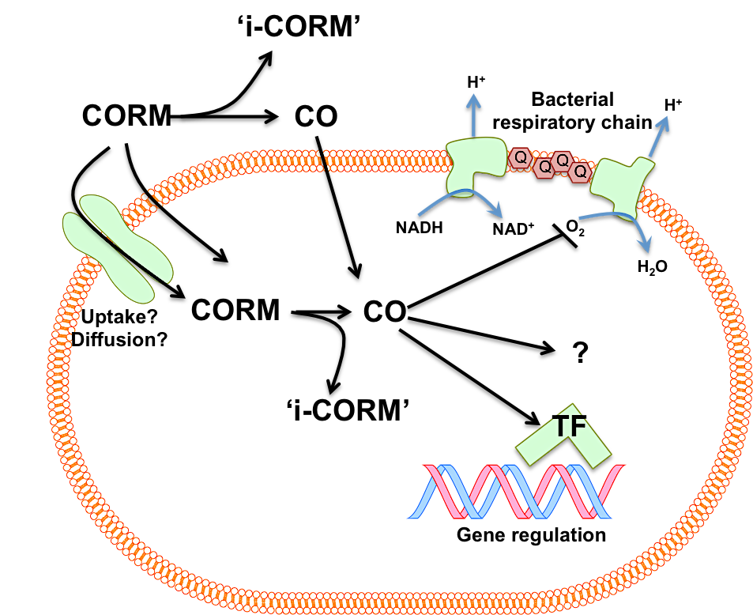

Fig. 1.11. The ‘Trojan Horse Hypothesis’ of CORM-2 and CORM-3 antimicrobial activity.
The ‘Trojan-Horse Hypothesis’ as proposed by Wilson et al., 2013. CORMs carry the ‘toxic cargo’ of CO into the cell interior where it is released. The CORM (CORM-2 or CORM-3) is applied to the extracellular milieu where it is rapidly taken up into the bacterial cell, either via diffusion or by an active transport process, where it accumulates to high concentrations. Once inside the cell, CO is released from the CORM and coordinates to CO-sensitive cell targets: haem proteins (globins, respiratory terminal oxidases), iron-containing transcription factors (TF) and other limited, unidentified cell targets ‘?’. Intracellular concentrations of CORMs and subsequent release of CO is proposed to lead to CO concentrations that exceed those which can be attained by the passive diffuse of CO gas from the exterior. The residual inactivated CORM complex, ‘i-CORM’, is not considered to play a major role in mediating toxicity. CORM-mediated bacterial cell death occurs via CO-mediated inhibition of cellular respiration, disruption to gene regulation and dysfunction of haem-containing enzymes. Additionally, CO may be released by CORMs outside of the cell and access the cell via diffusion through the membrane. Fig.1.11. is adapted from Fig. 10, Wilson et al., 2013.

CORMs which release the equivalent amount of CO (~ 1 mol CO/CORM) e.g. CORM-A1, ALF-062 (Desmard et al., 2012; Nobre et al., 2016).
- CORM-2 and CORM-3 are significantly more bactericidal than the equivalent or larger amounts of CO gas either administrated as CO-saturated solutions or via culture-bubbling (Nobre et al., 2007; Davidge et al., 2009b; Wareham et al., 2016).
- The majority of the antimicrobial activities reported for CORM-2 and CORM-3, as listed in Table 1.9, have not been observed in bacterial responses to CO gas alone (Wareham et al., 2016).
- CORM-3 has been reported to be active against haem-deficient E. coli mutants and the naturally haem-deficient bacterium Lactococcus lactis, both of which lack the classical targets of CO in bacterial cells (Wilson et al., 2015).

Together, these observations suggest that the mechanisms underlying the antimicrobial activities of CORM-2 and CORM-3 cannot be entirely explained by the ‘release’ of CO ligands alone (Wareham et al., 2015).

1.5. The mechanisms underlying CORM-2 and CORM-3 antimicrobial effects

The molecular mechanisms by which CORM-2 and CORM-3 elicit their antimicrobial effects in vitro and in vivo remain to be fully elucidated. Two key theories as to how these agents cause bacterial cell killing have been proposed:

- CORMs function as ‘carrier’ molecules to deliver the toxic ‘cargo’ of CO into bacterial cells, the ‘Trojan Horse’ hypothesis, as first proposed by Wilson et al., 2013 (Section 1.5.1.)

- CORM-2 and CORM-3 elicit their antimicrobial effects via the generation of ROS, as first proposed by Tavares et al., 2011 (Section 1.5.2.)

In this section, the literature evidence for and against these theories will be evaluated. A third theory, by which CORM-2 and CORM-3 antimicrobial activities are not mediated by CO or ROS, but instead by the Ru(II) ion(s) coordinating to bacterial cell targets is proposed by this thesis and evidence for this third theory will be presented throughout.

1.5.1. The ‘Trojan Horse’ hypothesis and a critical review of the role of CO in the antimicrobial activity of CORM-2 and CORM-3

The ‘Trojan Horse’ hypothesis, first proposed by Poole and co-workers in Wilson et al is illustrated in Fig. 1.11 (Wilson et al., 2013). After several years of intensive investigations, the hypothesis was put forward to take into account three important observations and assumptions about the antimicrobial effects of CORM-2 and CORM-3. Firstly, the antimicrobial activities of these CORMs were attributed to released CO ligands due to the observations that control compounds, i.e. inactivated CORMs (iCORMs) that do not release CO, did not induce the same toxic effects on bacterial cells (Nobre et al., 2007; Davidge et al., 2009b; Desmard et al., 2009; Wilson et al., 2013). Secondly, CORM-2 and CORM-3 were more potent bactericidal agents than CO gas, despite the ability of CO to freely diffuse through biological membranes (Nobre et al., 2007; Davidge et al., 2009b). Thirdly, it had been observed in several publications that CORMs did not release the majority of their CO outside of bacterial cells, however CORM-derived CO was observed to bind to terminal oxidases of bacterial cells via spectroscopic measurements (Desmard et al., 2009; Davidge et al., 2009b; McLean et al., 2012; Jesse et al., 2013; Wilson et al., 2013). In the ‘Trojan Horse’ hypothesis, CORM-2 and CORM-3 are CO-carrier complexes that are rapidly taken up by bacterial cells and accumulate to high intracellular concentrations (Wilson et al., 2013). Once inside the cell, CO is released from the CORMs so that intracellular concentrations of CO far exceed those that could be generated from the passive diffusion of CO gas into the cell (Wilson et al., 2013), thus providing a rationale for the potency of CORMs over CO gas alone. The residual compound after CO release, iCORM, is proposed to be non-toxic and does not play a further role in biological activity (Wilson et al., 2013). Cell death is mediated by CO coordinating to, and therefore disrupting, terminal oxidases and other haem-containing proteins (Wilson et al., 2013).

What is the evidence that CO mediates the toxic effects of CORM-2 and CORM-3? As stated above, the attribution of CO as the main mediator of CORM antimicrobial activities was largely based on observations that control compounds, which are chemically similar to CORM-2 and CORM-3 but are unable to release CO, do not cause significant antibacterial affects (Wilson et al., 2013). Due to the complex solution chemistry of CORM-2 and CORM-3 (outlined in Section 1.3.2. and Fig. 1.10), there are difficulties in the employment of appropriate control compounds to measure the relative effects of the CO ligands or the Ru(II) ion(s) in the biological activities of these CORMs. The CO devoid complex, Ru(II)Cl₂(DMSO)₄ (Fig. 1.10 (8)), sometimes referred to as ‘iCORM-2’, is generally considered the preferred control compound for CORM-2 (Davidge et al., 2009a). In comparison with DMSO (vehicle), CO gas and/or Ru(III)Cl₃ as controls, Ru(II)Cl₂(DMSO)₄ is structurally similar to the reaction products of CORM-2 speciation in DMSO (Fig. 1.10, 3a-b), and the oxidation state of the Ru(II) ion is consistent (Davidge et al., 2009a). There have been numerous reports that Ru(II)Cl₂(DMSO)₄ does not induce the same antimicrobial effects as CORM-2 or CORM-3: Davidge et al., 2009b; Desmard et al., 2009; Smith et al., 2011; Tavares et al., 2011; Murray et al., 2012; Jesse et al., 2013; Wilson et al., 2013; Bang et al., 2014; Bang et al., 2016.

Following observations that CORM-3 loses its ability to release CO to deoxyMb in the myoglobin assay after prolonged incubation in phosphate buffer, ‘inactivated’ CORM-3 or ‘iCORM-3’, is prepared by solubilising CORM-3 in PBS at pH 7.4 with periodic sparging with N₂ gas over 18 - 36 h (Clark et al., 2003; Motterlini et al., 2003). The structure of iCORM-3 is not known and the mechanisms of its inability to release CO are unclear (Davidge et al., 2009a). As with Ru(II)Cl₂(DMSO)₄, iCORM-3 exhibits little or none of the antimicrobial affects of CORM-3 (Jesse et al., 2013; McLean et al., 2013; Wilson et al., 2013; Wilson et al., 2015). Although these complexes are CO-depleted and/or cannot release CO to deoxy-Mb, their employment as iCORMs does not eliminate the role of the Ru(II) ions in the antimicrobial affects of CORM-2 and CORM-3. An alternative explanation of their inactivity could be due to their relative stability in physiological buffers and growth media. Ru(II)Cl₂(DMSO)₄ and iCORM-3 are predicted to be more chemically stable than the species derived from CORM-2 or CORM-3 following their speciation in DMSO/water as illustrated in Fig. 1.10, and therefore the availability for the Ru(II) ion(s) of these control compounds to coordinate to biological targets is likely to be markedly reduced in comparison. Thus, the employment of these ‘iCORMs’ is insufficient to rule out the role of the Ru(II) ions in the antimicrobial effects of CORM-2 and CORM-3.

It is axiomatic that CO is a competitive inhibitor of O₂ in binding to ferrous haem proteins, particularly respiratory terminal oxidases. At high ratios of CO:O₂ (typically ~ 9:1), CO inhibits aerobic respiration (Lloyd and Scott, 1983; Poole et al., 1973; Warburg, 1949). It was therefore predicted in early studies that the antimicrobial actions of CORMs were primarily due to respiratory inhibition. Indeed, CORM-2 and CORM-3 do inhibit respiration of E. coli (Davidge et al., 2009b; Jesse et al., 2013; Wilson et al., 2013), P. aeruginosa (Desmard et al., 2009; Desmard et al., 2012), C. jejuni (Smith et al., 2011), S. enterica (Wilson et al., 2013) and H. pylori (Tavares et al., 2013). In agreement with the requirement of high CO:O₂ tensions, CORM-3 was found to be a more effective inhibitor of respiration at near anoxic O₂ levels (Wilson et al., 2013).

In support of these respiratory measurements, some spectroscopic studies have shown that exposure of cells to CORM-2 or CORM-3 leads to the formation of CO-adducts of terminal oxidases in E. coli (Davidge et al., 2009b; Jesse et al., 2013), C. jejuni (Smith et al., 2013), H. pylori (Tavares et al., 2013) and S. enterica (Rana et al., 2014). However, in most studies, prior to spectroscopic measurements, cells or isolated membranes were first reduced with a large excess of dithionite before the addition of CORM-2 or CORM-3. Dithionite and sulfite species in such amounts are not present in experiments that have been used to assess CORM-2 and CORM-3 antimicrobial activities. Only in the study of intact Salmonella cells by integrating cavity dual-beam spectroscopy has CORM-derived CO been shown to bind oxidases after reduction without dithionite and under biological conditions (by glucose reduction in this case) (Rana et al., 2014). It is possible that CORM-2 and CORM-3 inhibit aerobic respiration by a mechanism mediated, in part, by the Ru(II) ion and not only CO binding to terminal oxidases. Indeed, other divalent metal cations, such as Ag(I), Zn(II), Cd(II) and Co(II) have long been known to disrupt aerobic respiration in bacteria (Beard, 1995; Rainnie and Bragg, 1973). Interestingly CORM-2 and CORM-3 have been reported to be more potent inhibitors of aerobic respiration than CO gas (Davidge et al 2009b; Desmard et al., 2009), thus supporting the role of the Ru(II) ion(s) in this activity.

Given that CO has relatively few known targets in bacterial cells other than respiration (as outlined in Section 1.4.4), the ‘Trojan-Horse’ hypothesis is also insufficient in explaining why CORMs are toxic anaerobically, where competitive inhibition of O₂ binding to terminal oxidases is obsolete (Davidge et al., 2009a). In light of the evidence presented in this section and previously in Section 1.4.4., it is likely that the ‘Trojan-Horse’ hypothesis is too simplistic to fully explain the antimicrobial effects of CORM-2 and CORM-3. It has become increasingly clear that CORM-2 and CORM-3 possess other chemical properties that mediate their antimicrobial effects, and thus the contribution of the antimicrobial effects of the Ru(II) ion(s) requires further investigation.

1.5.2. The contribution of ROS and/or exogenous thiols in the antimicrobial activities of CORM-2 and CORM-3

The hypothesis that the antimicrobial effects of CORM-2 and CORM-3 were, in part, mediated by ROS, was first explored by Desmard et al. (Desmard et al. 2012) but other researchers working in mammalian biology had shown that CORM-2 stimulated ROS production in mitochondria through inhibition of cytochrome c oxidase, presumably by blocking respiration with CO and the consequent ‘spillage’ of excess reducing equivalents to generate ROS (Taille et al., 2005; Zuckerbraun, 2008). Bacterial membranes are also known to be prolific sources of ROS generated from respiratory chain components (Messner and Imlay, 1999). In 2011, Tavares and co-workers proposed that CORM-induced formation of ROS was the main mechanism underlying the antimicrobial activity of CORMs by mechanisms that are illustrated in Fig. 1.12 (Tavares et al., 2012; Tavares et al., 2011). The role of ROS in eliciting the antimicrobial effects of CORM-2 and CORM-3 is controversial and the evidence for and against this hypothesis will be critically reviewed.

Firstly, do CORMs generate ROS as a consequence of water-gas shift chemistry? According to this proposal, described in Route 1, Fig. 1.12, Ru(II)-hydride complexes are formed by the action of water-gas shift chemistry on CORM-derived Ru-carbonyl species (Seixas et al., 2015). Such Ru(II)-hydride complexes could either: (1) react with H⁺ to produce H₂ gas or (2) lose H⁺ upon reaction with bases reducing Ru(II) to Ru(0), which subsequently reacts with O₂ to produce OH• (Seixas et al., 2015). Evidence for H₂ gas formation from Ru(II)-hydrides has been observed by GC of CORM-3 solutions but not quantified (Santos-Silva et al., 2011). CORM-2 and CORM-3 have been reported to form hydroxyl adducts on 5-tert-butoxycarbonyl 5-methyl-1-pyrroline N-oxide (BMPO) as measured by spin-trap electron paramagnetic resonance (EPR)-spectroscopy (Marazioti et al., 2011; Tavares et al., 2011) , indicating in vitro generation of OH• by these CORMs. However, without quantification of the relative amounts of H₂ and OH• formed in aerobic solutions of CORM-derived species, it cannot be determined which route of Ru(II)-hydride complex decomposition is preferred, and therefore the extent to which OH• contributes to CORM activity.

Alternative routes to detect ROS production from CORM-2 and CORM-3 in vitro have been described. Marazioti and co-workers used the chemiluminescent-based ROS/RNS (reactive nitrogen species) probe, L-012, to detect ROS generated from CORM-2 solutions. CORM-2 increased L-012 luminescence, which was abolished by the addition of the superoxide (O₂^{•-}) scavenger, Tempol, suggesting that O₂^{•-} was generated by CORM-2 in vitro (Marazioti et al., 2011). However, the amount of O₂^{•-} produced relative to CORM-2 concentration was not quantified. McLean et al. found that the addition of CORM-3 to cytochrome c in vitro led to reduction of the haem, indicating generation of O₂^{•-} as addition of superoxide dismutase (SOD) abolished this activity (McLean et al., 2013). Interestingly, the significantly less toxic iCORM-3 caused a more pronounced reduction of cytochrome c under the same conditions (McLean et al., 2013). The amount of superoxide generated from either compound was found to be only 1 % of the total CORM concentration. It is therefore not clear whether the amount of ROS, in the form of either OH• or O₂^{•-} , generated from CORM-2 or CORM-3 in vitro is significant to contribute to the bactericidal activity of these compounds.

Fig. 1.12. Theories of the generation of ROS from Ru-carbonyl CORMs

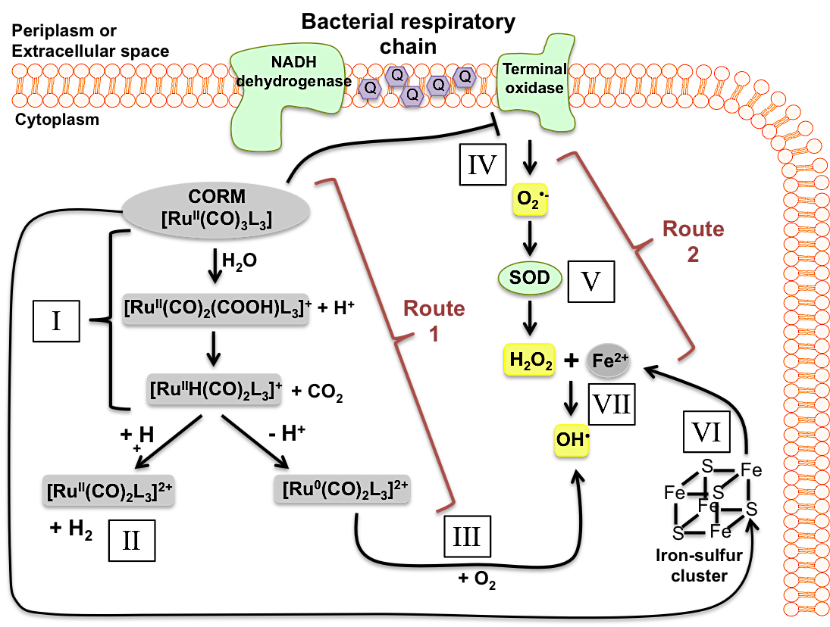
Fig. 1.12. Theories of the generation of ROS from Ru-carbonyl CORMs.
Route 1: CORMs generate ROS per se. ROS are directly generated from CORM-2 and CORM-3 derived species, represented above as [Ru^{II}(CO)₃L₃], as a consequence of water-gas shift chemistry. (I) Attack of [OH]⁻ of water on a CO ligand of [Ru^{II}(CO)₃L₃] results in, via the generation of the intermediate species ([Ru^{II}(CO)₂(COOH)L₃]⁺), CO₂ release and formation of Ru^{II}-hydride complexes ([Ru^{II}H(CO)₂L₃]⁺). (II) The Ru^{II}-hydride complexes could react with H⁺ to produce H₂. (III) Alternatively, the Ru^{II}-hydride complexes could lose H⁺ via reaction with bases, reducing the Ru²⁺ ion to Ru⁰. The electron-rich Ru⁰ centre subsequently reacts with O₂ to produce OH. Route 1 is shown to occur intracellularly in this figure though could also occur outside of the cell.
Route 2: Through inhibition of aerobic respiration and disruption of intracellular iron-sulfur clusters. (VI) Inhibition of aerobic respiration by [Ru^{II}(CO)₃L₃], perhaps via CO binding to terminal oxidases, results in the generation of superoxide (O₂⁻). (V) Superoxide dismutase (SOD) converts O₂⁻ into hydrogen peroxide (H₂O₂). (VI) Disruption of iron-sulfur clusters as a consequence of CORM exposure, results in an increase of intracellular free iron Fe²⁺. (VII) Fe²⁺ reacts with H₂O₂ via Fenton Chemistry to generate the hydroxyl radical (OH).
Route 1 is based on the proposal by Seixas et al., 2015.
Route 2 is based on the proposal by Tavares et al., 2011 and Tavares et al., 2012.

The evidence that CORM-2 and CORM-3 induce endogenous ROS formation via Routes 1 or 2 in bacteria (Fig. 1.12) will now be considered. The widely used intracellular ROS-sensitive fluorescence based dye 2’,7’-dichlorodihydrofluorescein diacetate (DCFH₂-DA) is employed to detect intracellular ROS as follows:

- The membrane-permeable non-fluorescent dye is taken up into cells, then hydrolysed to the non-fluorescent 2’,7’-dichlorodihydrofluorescein (DCFH₂), which is membrane-impermeable.
- DCFH₂ is oxidized by intracellular ROS to give the fluorescent compound, 2’,7’-dichlorofluorescein (DCF).

By employment of this dye, a dose-dependent increase in DCF fluorescence was observed in E. coli cultures upon exposure to CORM-2 and CORM-3 (Nobre et al., 2016; Tavares et al., 2011) and in P. aeruginosa biofilms to CORM-2 (Murray et al., 2012). Conversely, no increase in DCF fluorescence was observed in P. aeruginosa planktonic cultures upon exposure to either CORM (Desmard et al., 2009; Desmard et al., 2012). The underlying cause of these differences is unclear but may be due to limitations of the dye, as reviewed in Imlay, 2005 and Kalyanaraman et al., 2012. Firstly, DCFH₂ cannot be used to quantify intracellular ROS; it is not sensitive to H₂O₂ and can be oxidized only by certain ROS/RNS species, such as OH•, ONOO-, and NO• (Kalyanaraman et al., 2012). Secondly, it is prone to oxidation by redox-active metals in the presence of oxygen and is sensitive to changes in intracellular glutathione levels (Imlay, 2015; Kalyanaraman et al., 2012), which could potentially lead to experimental artefacts if metal compounds are present (Imlay, 2015). Additionally, DCF fluorescence is somewhat dependent on the permeability of DCFH₂, which can lead to artificially high emissions if the compound in question disrupts membrane integrity (see Section 1.5.4 below) (Imlay, 2015). These issues could explain the differences in the level of detected fluorescence from DCF in the above studies. To our knowledge, there have been no further reports of endogenous ROS formation by bacterial cells exposed to either CORM as measured via another fluorescence based dye, and so the occurrence of intracellular ROS production from CORM-2 and CORM-3 remains inconclusive.

An alternative method to assess whether toxicity is due to the action of ROS is to see if the addition of ROS-detoxifying enzymes and/or antioxidants can abolish the biological activities of the compound (Imlay, 2015). Addition of catalase or superoxide dismutase (SOD) did not alter the effect of CORM-3-induced inhibition of respiration in E. coli, thus implying that peroxide or O₂^{•-} are not the underlying cause of CORM-3 respiratory effects (Jesse et al., 2013; Wilson et al., 2013). In C. jejuni, pre-incubation of harvested cells with 100 M CORM-3 inhibited respiration (Smith et al., 2011). Addition of catalase partially restored oxygen uptake in C. jejuni, indicating perhaps the presence of H₂O₂ (Smith et al., 2011). However, addition of CORM-3 to C. jejuni cultures was without effect on cell growth (Smith et al., 2011), the underlying causes of the apparent resistance of C. jejuni to CORM-3 is addressed later. Addition of the antioxidant ascorbic acid did not alleviate respiratory or growth inhibitory effects of CORM-3 in E. coli and P. aeruginosa, respectively (Desmard et al., 2009; Jesse et al., 2013).

In contrast, certain thiol antioxidants - N-acetyl cysteine (NAC), cysteine or reduced glutathione (GSH) – markedly alleviate the antibacterial effects of CORM-2 and CORM-3. Addition of NAC, cysteine or GSH was found to prevent CORM-3-induced inhibition of respiration in E. coli membrane particles and P. aeruginosa cells (Desmard et al., 2009; McLean et al., 2013). Most significantly, the addition of exogenous NAC, cysteine or GSH, but not oxidized glutathione (GSSG), to either E. coli and P. aeruginosa cell cultures exposed to either CORM resulted in the complete alleviation of CORM-induced growth inhibitory and bactericidal effects (Desmard et al., 2009; Desmard et al., 2012; Murray et al., 2012; Tavares et al., 2011).

There is a clear discrepancy between non-thiol (ascorbate) and thiol-containing (cysteine, NAC, GSH) antioxidants in their ability to alleviate the antibacterial effects of CORM-2 and CORM-3. As described in an authoritative review (Imlay, 2015), ascorbic acid is most effective as an antioxidant in its role as the reductive substrate for ascorbic acid peroxidase, which is not present in these bacteria. Similarly, the antioxidant power of GSH is mostly due to its utilisation as the substrate for glutathione peroxidase; such a gene appears to be present in E. coli (BtuE) but not P. aeruginosa (Arenas et al., 2011). However, although the E. coli btuE gene is predicted to encode a glutathione peroxidase, its role is uncertain. The Imlay laboratory have been unable to detect any contribution of btuE to H₂O₂ scavenging by growing E. coli strains in which the predominant scavengers (Ahp catalases) are absent (Dr. J Imlay, personal correspondence). Neither ascorbic acid nor GSH are efficient detoxifiers of ROS in the absence of these enzymes (Imlay, 2015). The ability of antioxidants to directly decompose ROS depends on their redox potential and the availability of intracellular reductants to re-reduce the oxidised form generated as a consequence of oxidation by ROS (Imlay, 2015). It is therefore unclear how effective exogenous antioxidants would be in the extracellular environment at scavenging CORM-derived ROS, in the absence of intracellular reductant enzymes.

The coordination of divalent metal cations to thiols, e.g. GSH, is well documented (Lemire et al., 2013), and so the alleviation of CORM-2/3 antibacterial effects by exogenous thiols could be direct reaction of thiols with the CORM. Indeed, CORM-2 and CORM-3 have been demonstrated to prevent reaction of GSH, cysteine and hydrosulfide with the thiol-reactive Ellman’s reagent in vitro under the same conditions in which CORM-3 generated only very small amounts of ROS (McLean et al., 2013; Tavares et al., 2011). Addition of thiol compounds to CORM-3 did not facilitate CO release and so it is unlikely that coordination occurs through CO ligand displacement (McLean et al., 2013). It is possible that reaction of CORM-derived species with thiols outside of cells may prevent such species from exerting their antimicrobial effects, though this has not been extensively investigated. It is interesting to note that a NAC-CORM complex, derived from the reaction of CORM-2 with NAC, was found to be non-toxic to bacterial cells (Seixas et al., 2015). Strikingly, a 10-fold excess of NAC dramatically reduced Ru content of cells exposed to CORM-2 and CORM-3 (see below), indicating that NAC impaired CORM uptake into bacterial cells (Jesse et al., 2013) Taken together, these findings indicate that the alleviation of CORM-induced antimicrobial effects by thiols is not directly related to their antioxidant activity.

Finally, we must also consider that the bactericidal activity of CORM-2 and CORM-3 occurs within the range of 7.5 – 500 μM, depending on the bacterial strain and growth conditions, as described above in Section 1.4.1. Significantly higher levels of ROS are required to have the same bactericidal effects in bacteria. For example, experiments in the Poole laboratory have shown that 10 mM H₂O₂ is required to cause bacteriostasis in E. coli, with bactericidal effects observed only at concentrations exceeding 30 mM (Hassoubah, S, unpublished). Others have also shown that millimolar levels of H₂O₂ are required to kill bacteria and that ROS are likely to have more bacteriostatic effects than bactericidal activities (Imlay, 2015; Linley et al., 2012). It is difficult to conceive how relatively small amounts of Ru-carbonyl CORMs could generate sufficiently high amounts of ROS in vitro or in vivo to be responsible for such effects.

In summary, although CORM-2 and CORM-3 have been shown to generate ROS in vitro under certain conditions, there is no quantifiable evidence that these compounds generate the sufficiently high concentrations of ROS required to cause bactericidal effects. Enzymatic antioxidants and non-thiol based antioxidants do not alleviate CORM-2 and CORM-3 antimicrobial effects. Thiol compounds alleviate the antimicrobial effects of these CORMs via a mechanism independent of their antioxidant activities. Furthermore, CORM-2 and CORM-3 are also toxic anaerobically (Davidge et al., 2009b) where ROS generation from oxygen cannot occur. Taken together, it is the view of the author that the evidence does not support the hypothesis that ROS generation is the main mechanism of CORM-2 and CORM-3 bactericidal activity. A minor role of ROS in the antimicrobial actions of CORM-2 on aerobically grown E. coli cannot be ruled out however, as E. coli mutants deficient in catalase and SOD were found to be more susceptible to killing by CORM-2 (Tavares et al., 2011), thus implying that actions of intracellular ROS-detoxifying enzymes may have a role in alleviating the toxic effects this CORM. Indeed, evidence for increased transcript levels of ROS-responsive genes within the SoxRS regulon after exposure to CORM-2 have been described by some authors (Nobre et al., 2009; Tavares et al., 2012), but not in response to CORM-3 (Davidge et al., 2009b; McLean et al., 2013).

1.5.3. Measurements of uptake of Ru-carbonyl CORMs by bacteria

It is unclear to what extent the antimicrobial effects of CORM-2 and CORM-3 can be attributed to the metal ion(s) or the CO ‘cargo’. In either scenario, it is important to understand if and how these compounds enter microbial cells and whether their antimicrobial potential correlates with uptake. Poole and co-workers have investigated uptake of CORM-2 and CORM-3 by bacteria by ICP-AES to measure ruthenium content of cells following CORM-2 or CORM-3 exposure (Davidge et al., 2009a,b).

E. coli has been shown to accumulate Ru to intracellular concentrations far exceeding the concentration of CORM-3 applied to the culture: ~7-fold higher aerobically and ~2-fold higher anaerobically (Davidge et al., 2009b). It must be noted however, that all such ‘uptake’ calculations require several assumptions regarding the relationships between biomass, cell numbers and mean cell size/volume. CORM-2-derived Ru has also been shown to accumulate in E. coli cells to concentrations far in excess of those applied to the culture (Jesse et al., 2013). McLean et al. investigated the kinetics of CORM-3 uptake; uptake was rapid with initial rates of 85 μM min⁻¹ but reached a plateau at around 40 min post CORM-3 addition (McLean et al., 2013). Interestingly, the non-toxic iCORM-3 was also found to accumulate in E. coli – albeit at a lower rate and to approximately half the concentration of that of CORM-3 (McLean et al., 2013).

CORM-3-derived Ru is accumulated to a greater extent in S. enterica serovar Typhimurium (> 2-fold higher than E. coli) and at a faster initial rate (>120 μM min⁻¹); perhaps as a consequence, Salmonella is more susceptible than E. coli to cell killing by CORM-3 (Rana et al., 2014). Significantly, Jesse et al reported that a 10-fold excess of exogenous NAC administered alongside CORM-3 or CORM-2 led to significantly reduced levels of intracellular ruthenium accumulation (8-fold and 5-fold reduction, respectively) (Jesse et al., 2013). Since exogenous thiols, such as NAC, alleviate the bactericidal effects of CORM-2 and CORM-3, it is likely that the bactericidal effects of CORM-2 and CORM-3 are dependent on the uptake of Ru ions by bacterial cells and the total amount of Ru available intracellularly to coordinate to biological targets (McLean et al., 2013).

Although Ru accumulation by bacteria from CORMs is well established, the mechanisms of uptake or cell entry are unknown. However, as bacteria accumulate CORM-derived ruthenium to concentrations in great excess of those applied to the culture (with the above caveats on calculation methods), ruthenium-carbonyl CORMs either: (1) enter the cells against a concentration gradient, driven by an unidentified transporter and driving force or (2) enter the cells via facilitated diffusion and are altered once inside the cell so that influx can continue passively (Rana et al., 2014). The relative lipophobicity of CORM-2 and CORM-3 have not been reported and so it is currently unknown whether they are able to pass through biological membranes. Interestingly, haem-deficient (hemA) mutant E. coli was found to accumulate CORM-3-derived Ru to greater levels than wild type cells (Wilson et al., 2015). Such mutants also accumulate iron to higher levels than hemA⁺ strains and so it is possible that CORM-3 uptake is enhanced by up-regulation of metal acquisition systems (Wilson et al., 2015).

It is not known which of the CORM-2- or CORM-3-derived species, (illustrated in Fig. 1.10) enter bacterial cells and it may be that different species have different routes of entry. Given that Ru(II) ion binding to biological targets may be responsible for mediating CORM-2 and CORM-3 toxicity (see sections below), the role of the ligands to the Ru(II) of these complexes (such as CO) could be to facilitate Ru(II) entry into bacterial cells (Wareham et al., 2015). Once inside the cellular environment, and as a consequence of the relative instability of the ligands, the Ru(II) ion(s) could subsequently bind to biological targets via ligand exchange (Wareham et al., 2015). In the following sections, the evidence for possible intracellular targets of CORM-derived Ru(II) ion(s) after internalisation of the compounds will be presented and whether such interactions could be responsible for the antimicrobial effects of CORM-2 and CORM-3 will be considered.
1.5.4. Possible bacterial cell targets of CORMs

As high levels of CORM-derived Ru accumulation are associated with CORM-2 and CORM-3 toxicity, the bacterial cell targets of these Ru(II) ions might be expected to resemble cellular targets of other non-essential metal ions. Ionic/molecular mimicry plays a role in the antimicrobial effects of many metal ions (Lemire et al., 2013), At sufficiently high intracellular concentrations, metal ions with similar donor-ligand selectivity of essential metals, such as Fe(II), can displace the correct metal ion required by metal-containing-proteins in vivo, thus leading to their inactivation (Hughes and Poole, 1989; Lemire et al., 2013). There is currently no evidence to suggest that ionic or molecular mimicry are responsible for the antimicrobial actions of CORM-2 or CORM-3, although treatment of E. coli with CORM-3 has been shown to cause a decrease in intracellular iron levels (Wilson et al., 2015).

Given that Ru-carbonyl CORMs have been demonstrated to interact with sulfhydryl-containing compounds, such as GSH and NAC, in vitro (McLean et al., 2013; Tavares et al., 2011), it is probable that thiols are intracellular targets of CORM-derived Ru. Proteins, nucleic acids and cellular membranes may represent important targets of CORM-derived Ru, as is the case with other metal ions (Lemire et al., 2013). A review of the current literature evidence for CORM-derived Ru(II) interactions with each of these targets is presented in the relevant results chapters of this thesis (Chapters 4 – 6).

1.5.5. The effects of CORM-2 and CORM-3 on E. coli gene regulation

The transcriptional effects of CORM-2 and CORM-3 on E. coli have been the subject of several detailed studies (Davidge et al., 2009b; McLean et al., 2013; Nobre et al., 2009; Wilson et al., 2015), which will be reviewed briefly here to provide insight into potential transcriptional effects of the Ru(II) ions. In general, CORM-2 and CORM-3 effects on gene regulation are extensive and greatly exceed the transcript changes induced by CO gas (Wareham et al., 2016).

Several notable functional categories of genes are differentially regulated in response to Ru-carbonyl CORMs. Unsurprisingly, there is a general down-regulation of genes involved in aerobic respiration and energy metabolism in response to both compounds, in accordance with their inhibitory effects on aerobic respiration. There were also changes in genes involved in the homeostasis, metabolism and transport of metal ions in response to both compounds. This includes up-regulation of iron and zinc acquisition systems (Davidge et al., 2009b; McLean et al., 2013; Wilson et al., 2015). Most strikingly, expression of spy, encoding a periplasmic protein, is highly induced (up to ~ 5000-fold) by both CORM-2 and CORM-3 (Davidge et al., 2009b; McLean et al., 2013; Nobre et al., 2009; Wilson et al., 2015). The expression of spy is controlled by both the general envelope stress response regulator, CpxR and the two-component metal/envelope stress response system, BaeSR (Wang and Fierke, 2013; Yamamoto et al., 2008). These regulators also control expression of the multi-drug efflux pump, mdtABC, which was also upregulated by CORM-2 and CORM-3 in E. coli in these studies. BaeSR plays a role in responses to metal stress, for example by Zn(II) and Cu(II) in E. coli and Salmonella sp. (Leblanc et al., 2011; Nishino et al., 2007; Wang and Fierke, 2013). The upregulation of genes under control of BaeSR and CpxR is in accordance with the observed membrane damage to E. coli cells after exposure to CORM-3 (Davidge et al., 2009b; Wilson et al., 2015) and provides support for the role of the Ru(II) ion in mediating CORM-2/3 transcriptional effects.

Both BaeR and Fur, which have been implicated in the response to CORM-3, respond to other metals ions (Wilson et al., 2015). The Fe(II)-binding transcriptional repressor, Fur, binds DNA in the presence of metals such as Mn(II), Zn(II), Co(II), and Cd(II) (Althaus et al., 1999). Its analogue, Zur, is also implicated in the response to CORM-3 (Davidge et al., 2009b).

Although the transcriptomic data of E. coli cells exposed to either CORM have been analysed in view that CO mediates the majority of the compounds antimicrobial effects, a critical comparison between the data presented in these studies and the data for CO gas in isolation (as presented by Wareham et al., 2016) should be informative in assigning which responses are due to the CORMs released CO or the Ru(II) ion(s).

1.5.6. Are the antimicrobial effects of CORM-2 or CORM-3 due to the CO or Ru(II) ion(s)?

As evidenced from the above evaluation of current literatures theories of how CORMs kill bacterial cells, it is clear that the antimicrobial effects of CORM-2 and CORM-3 cannot be due to the impact of released CO alone (Wareham et al., 2015). Furthermore, the theory that CORMs induce their antimicrobial activities by production of ROS has been deemed unlikely (even by the group who first proposed the idea, see Nobre et al., 2016). All evidence presented above appears to suggest a more important role for the Ru(II) ion(s) than was originally proposed (Davidge et al., 2009b; Wilson et al., 2013). Important questions arise: (1) how do the Ru(II) ion(s) of CORM-2 and CORM-3 cause the potent bactericidal effects observed by these compounds, and (2) is there any scope to re-classify these compounds as Ru-based antimicrobial agents? A theory as to how the Ru(II) ion(s) of CORM-2 and CORM-3 may elicit bacterial cell killing as based on currently available literature evidence is presented in Fig.1.13. A review of the potential of ruthenium complexes as novel antimicrobial agents is provided in the next section.

1.6. Ruthenium compounds as potential antimicrobial agents

1.6.1. Metals as antimicrobial agents

The employment of metal-based compounds as antimicrobial agents is not a new concept and even predates the application of classical antibiotics (see Fig. 1.1). In the early 1900s, Paul Ehrlich’s quest for a ‘magic bullet’ that would selectively target the causative agent of syphilis, Treponema pallidum, over host cells led to the development of the organoarsenic compound marketed as Salvarsan or Compound 606 (Aminov, 2010). Salvarsan became the most frequently prescribed drug for treatment of antimicrobial infections until its replacement by penicillin in the 1940s resulting from the work of Fleming, Florey and Chain (Chain et al., 2005). Prior to the discovery of antibiotics, silver leaf was used to treat wound infections on injured soldiers in WWI (Dai et al., 2010). In the 1960s, the serendipitous discovery by Rosenberg that platinum complexes inhibited E. coli cell division eventually led to the clinical application of cisplatin as an antitumor drug in the 1970s (Rosenberg et al., 1967; Wong and Giandomenico, 1999).

Following the success of penicillin and other antibiotics in the 1940s-60s, organic compounds superseded metal-based antimicrobials. The increase in development of organic compounds, which rapidly became cheaper, more readily mass-produced and typically elicited fewer side effects than the early metallo-drugs, led to a decreased interest in metallo-complexes as antimicrobial agents. Since then there has been limited use of metals as antimicrobials in the clinic, though bismuth salts have been frequently used as an adjuvant to antibiotics in the treatment of Helicobacter pylori infections and silver compounds are still in clinical use in the sterilisation of wound dressings (Lemire et al., 2013; Dai et al., 2010). Despite many decades of research, scientists in academia and the pharmaceutical industry have failed to discover new classes of antibiotics, particularly against Gram-negative bacteria, based on organic chemistry alone, leading to an antibiotic development void between the 1980s-2000s (see Section 1.1). With the impeding threat of MDR-bacteria, where modern medical procedures become impossible due to untreatable multidrug-resistant infections, there has recently been a renewed interest in using transition metal-based compounds as alternatives or adjuvants to existing antibiotics (Li et al., 2015; Wareham et al., 2015).
Fig. 1.13. How do the Ru(II) ion(s) of CORM-2 and CORM-3 cause bacterial cell killing?

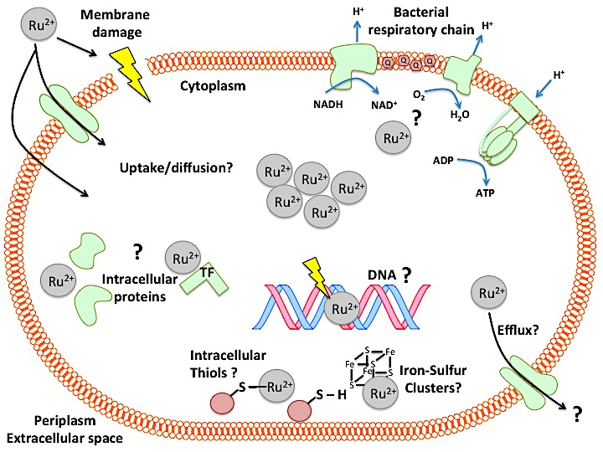

Fig. 1.13. How do the Ru(II) ion(s) of CORM-2 and CORM-3 cause bacterial cell killing? The above scheme illustrates the potential mechanisms by which the Ru(II) ion(s) of CORM-2 and CORM-3 may elicit bacterial cell killing by direct binding to intracellular targets. First, the Ru(II) of either CORM is accumulated to high levels inside bacterial cells either via diffusion or by the action of an unidentified active transport process. CORMs have been shown to elicit membrane damage in E. coli cells, but it is not known if the Ru(II) ion is directly responsible for this effect. Once inside the cell, the Ru(II) ion is then likely to coordinate to intracellular macromolecules. CORM-3 has been shown to interact with proteins in vitro, and thus intracellular proteins (including transcription factors, TF) could be potential targets. Ru(II) may inhibit respiration, analogous to other divalent metal cations via a mechanism independent of CO, although this has not been investigated. Other intracellular targets could include nucleic acids, such as DNA, as CORM-2 has been shown to cause DNA damage upon exposure to E. coli cells. Sulfur groups are proposed to be a key intracellular target of CORMs, including thiols and iron-sulfur clusters, although direct binding of Ru(II) to either inside bacterial cells has not been shown. Finally, it is not known whether CORM-derived Ru(II) is effluxed from bacterial cells. Note, CO has been omitted in the above scheme for clarity but may also contribute some antimicrobial effects.

1.6.2. The biological chemistry of ruthenium

Ruthenium (atomic symbol Ru) is seldom mentioned in microbiology texts, most likely due to the fact that this metal has no known or essential roles in biological systems, nor is it generally considered toxic. Ruthenium is a rare, hard, dense (12.1 g cm⁻³), lustrous, brittle, and silvery-white metal that does not tarnish at room temperature. It has an atomic number of 44, a relative atomic mass of 101.07, and is in Group 8, Period 5 of the Periodic Table. It is a classified as a platinum-group metal along with rhodium, palladium, osmium, iridium and platinum; all are noble, precious elements in the d-block (groups 8, 9, 10). Ruthenium was discovered in the eighteenth century. The Polish chemist Jedrzej Sniadecki investigated platinum ores from South America and, in May 1808, discovered a new metal, which he named vestium. Other chemists tried to repeat his work without success and Sniadecki withdrew his claim. However, in 1825, Gottfried Osann of the University of Dorpat (now Tartu) on the Baltic, investigated platinum from the Ural Mountains, and reported finding three new elements, which he named pluranium, polinium, and ruthenium. While the first two were never verified, the third was genuine. In 1840, Karl Karlovich Klaus at the University of Kazan extracted, purified, and confirmed its status as a new metal in 1844. He kept Osann’s name of ruthenium, derived from 'Ruthenia', the Latin name for Russia.

As is typical of transition metals, Ru can exist in many oxidation states. Ru is unique among the Pt group metals in having three oxidation states (+2, +3, +4) that are biologically accessible. Ru(II) is considered more biologically active than Ru(III), whilst Ru(IV) oxide is considered highly toxic. Ru is considered a good candidate for the rationale drug design (Gill and Thomas, 2012). It has a three-dimensional configuration, allowing ligand coordination and functionalisation to be aimed at defined biological and molecular targets (Gill and Thomas, 2012). Furthermore, the relative stability of each ligand to the ruthenium can be fine-tuned to generate either kinetically inert complexes or those with sufficiently labile ligands, depending on the desired function of the compound (Li et al., 2015). The accessibility of three redox states additionally permits the involvement of such complexes in various cell-mediated redox reactions that could influence dose and bioavailability of the drug in vivo (Gill and Thomas, 2012).

1.6.3. An introduction to ruthenium compounds as potential antimicrobial agents

Currently there exist over 200 publications on the antimicrobial activity of various Ru-based compounds in the scientific literature. A fairly comprehensive review of the antimicrobial activities of various Ru-complexes is provided in Southam, H et al (Southam et al., 2017).

The first reports of the antimicrobial activities of Ru-complexes came in the 1960s following investigations by Dwyer and colleagues although the majority of interest in Ru-based antimicrobials has surfaced within the last two decades (Li et al., 2015). Despite numerous reports of the antimicrobial activity of these complexes in vitro, there have been few in vivo infection studies and none of them have yet reached clinical development. Numerous Ru-complexes have been studied that differ in: (1) the number of Ru ions per compound, (2) the ligands coordinated to the Ru ion(s), (3) the oxidation state of the Ru ion(s), and (4) the relative stability of the complexes in solution. As a consequence of this diversity in structure, the Ru-complexes reported in the literature could have markedly different mechanisms of action in their toxicity to microbial cells.

Given the diversity of Ru-complexes reported in the literature, we proposed (Southam et al., 2017) the following classification of antimicrobial Ru-complexes based on the guidelines for the categorization of metal anticancer compounds proposed by (Gianferrara et al., 2009). The classification is based on the role of the Ru ion underpinning the antimicrobial activity of the compound. Antimicrobial Ru compounds can thus be divided into 4 classes based on their mechanism of action:

- Structural: The Ru ion(s) have a structural role i.e. the Ru provides shape to the active compound via a coordination sphere of ligands. These complexes are inert and biologically stable, the Ru interacting with the target only via non-covalent interactions.
- Carrier: The Ru ion(s) simply function as carriers for the active drug, most commonly an organic compound.
- Functional: The Ru ion(s) have a functional role i.e. the antimicrobial activity of the compound is mediated by the Ru ion directly coordinating to biological targets. These are relatively biologically unstable compounds, often pro-drugs, which contain labile ligands.
- Photo-activated: The Ru compound is active only upon illumination where it can act as a photosensitizer.

a. Class I – structural

According to the proposed classification above, the role of the Ru ion in these antimicrobial compounds is to act as a central ‘scaffold’ to which bioactive ligands are coordinated, and thus it follows that the chemical composition and properties of the coordinated ligands determine antimicrobial activity (Gianferrara et al., 2009; Gill and Thomas, 2012). The Ru ion itself may provide the molecule with a cationic charge but does not interact directly with intracellular targets, except via non-covalent interactions (Gianferrara et al., 2009). It is necessary for these complexes to be inert and stable in biological systems as the structure of the compound is key to biological activity. Ru is well suited to this structural role; its coordination chemistry is well characterised, providing a mechanism to optimize antimicrobial activity via adjustments to coordinating ligands in order to enhance target specificity and/or increase lipophilicity for enhanced bacterial cell uptake (Gill and Thomas, 2012; Li et al., 2015).

As these complexes remain unchanged in vivo, they may only interact reversibly with intracellular targets such as RNA, DNA, proteins, membranes or other metabolites. If the binding affinity to the target is high, and the rate of dissociation from the biological target sufficiently low, structural inhibition by these complexes could lead to permanent dysfunction of essential bacterial cell processes leading to bacteriostasis or cell death. As the shape of the complex determines specificity, toxic side effects of these structural Ru antimicrobials are expected to be less than for functional Ru antimicrobials whose targets are generally less specific due to direct coordination of the Ru ion to multiple biological targets (Gianferrara et al., 2009).

Although CORM-2 and CORM-3 cannot be classified as structural Ru antimicrobial compounds because they are unstable in solution and have labile ligands (see Fig. 1.10), an overview of some examples of structural Ru compounds are provided here as a comparison of their antimicrobial effects. Such complexes are also historically significant in that they represent the first demonstration of the antimicrobial potential of ruthenium complexes.

In the 1950s-1960s, Dwyer and co-workers investigated the antimicrobial activities of a range of mononuclear Ru complexes that were chemically inert in biological systems (Dwyer and Mellor, 1964). The most active complex, [Ru(Me₄phen)₃]²⁺ is shown in Fig. 1. 14 (A) and has been re-examined recently (Li et al., 2011). It was found to be active against S. aureus but largely inactive against Gram-negative bacteria (Li et al., 2011). It is accumulated by both Gram-positive and Gram-negative cells, though significantly less so by the latter, suggesting that coordination to intracellular targets is required for antimicrobial activity (Li et al., 2012). The complex has been shown to irreversibly bind DNA and proteins
Fig. 1.14. Examples of structural Ru antimicrobial compounds

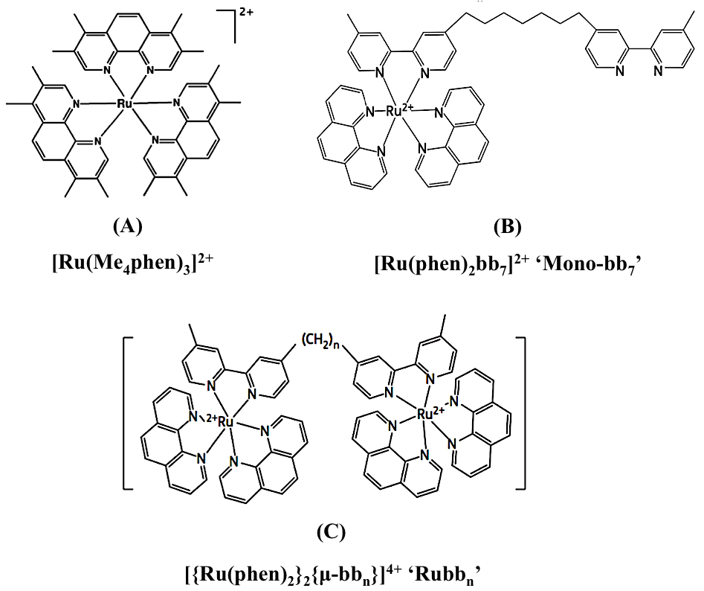

in vitro, cause membrane depolarization and inhibit respiration of isolated mitochondria ((Dwyer and Mellor, 1964; Gorle et al., 2015; Li et al., 2013a; Li et al., 2013b). Despite promising antimicrobial activities in vitro, [Ru(Me₄phen)₃]²⁺ is unlikely to reach further clinical development as it was found to induce paralysis and respiratory failure when injected into mice (Dwyer et al., 1957).

Within the past decade, various groups have developed inert mononuclear Ru(II) complexes with polypyridyl ligands (as reviewed in Li et al., 2015). In general these complexes are bactericidal to a range of Gram-positive bacteria and exhibit little or no activity against E. coli or P. aeruginosa (Li et al., 2011; Gorle et al., 2015). One particular complex, Mono-bb₇ (Fig. 1.14 (B)), was reported to be accumulated to high levels by bacterial cells, causing increased membrane permeability and depolarization (Li et al., 2013b). It has also been demonstrated to bind reversibly to DNA and proteins in vitro (Li et al., 2013a; Li et al., 2015b) and has reportedly low toxicity to cultured mammalian cells (Pisani et al., 2011).

Keene, Collins and co-workers have also investigated the antimicrobial activities of a range of kinetically inert di-, tri- and tetra-nuclear Ru(II)polypyridyl complexes, whereby each Ru(II) centre is bridged by the flexible linker bb_{n} ligand (bb_{n} = bis[4(4’-methyl-2,2’-bipyridyl)]-1,n-alkane) (Li et al., 2015). The dinuclear complex, ‘Rubb₁₂’ [(Ru(phen)₂)₂(μ-bb₁₂)]⁴⁺, is the preferred antimicrobial candidate of the series and is shown in Fig. 1.14 (C). The antimicrobial activities of Rubb₁₂ and related oligonuclear complexes have been extensively examined by the group for a number of years (as reviewed by Li et al., 2015). Two non-exclusive antimicrobial mechanisms have been proposed for the dinuclear Rubb_{n} complexes: (1) Rubb_{n} complexes elicit their antimicrobial effects via membrane damage and/or (2) they inhibit nucleic acid-mediated processes by reversibly binding RNA, specifically at polysomes (Weber et al., 2016). Additionally these complexes reversibly bind DNA and proteins in vitro and exhibit various cytotoxic effects in cultured mammalian cells, however, Rubb₁₂ has been demonstrated to be well tolerated in mice (Gorle et al., 2016; Li et al., 2015; Li et al., 2016).

b. Class II – carrier

Carrier Ru antimicrobials are organometallic complexes in which the Ru ion is coordinated to an established organic drug for the purpose of enhancing antimicrobial activities of the organic compound in question (Gianferrara et al., 2009). For the Ru ion to function as a true ‘carrier’ ligand, it should not itself elicit significant antimicrobial effects via coordination to biological targets - such a complex would be considered as ‘functional’ (Gianferrara et al., 2009). If the Ru-complex releases the active organic moiety quickly upon administration, the activities of the complex may be due to the additive or synergistic effects of both the aquated ruthenium species and the organic drug, and consequently not the organometallic complex as a whole. For this reason, a true ‘carrier’ antimicrobial Ru complex must have a sufficiently stable and inert coordinated Ru ion so that is not rapidly released from the organic compound upon addition to physiological media or buffers. The purpose of the coordinated Ru ion is simply to alter the pharmacokinetic properties of the organic complex in order to enhance its antimicrobial activities in vitro and/or in vivo (Gianferrara et al., 2009).

Initially, CORM-2 and CORM-3 could have been described as Ru carrier compounds in that they have been extensively employed in hundreds of biological studies as merely ‘CO-releasers’ both in mammalian and antimicrobial studies. However, as described in the previous sections, the antimicrobial activities of these complexes are probably due, at least in part, to the coordination of the Ru(II) ions to biological targets (Wareham et al., 2015), and so is it proposed that these complexes are more suitably classified as ‘functional’ Ru complexes (see below).

There are few examples of true ‘carrier’ Ru antimicrobials in the literature. Demirezen et al reported the synthesis and antimicrobial activities of trimethoprim-Ru(III) chelates, but these complexes exhibited less activity than trimethoprim alone (Demirezen et al., 2012). An interesting homoleptic Ru complex of the antibiotic norfloxacin, [Ru(nor)₃] has been reported recently but its antimicrobial activities are yet to be evaluated (Claro Reis et al., 2016). The antimicrobial activities of so-called ‘dual-functioning’ Ru(II)arene complexes of the antibiotic ciprofloxacin A (CipA) have also been reported by Sadler and co-workers (Ude et al., 2016). The complexes exhibited greater activity against E. coli and S. aureus than CipA alone, but were also shown to be unstable in aqueous solutions. The activity of these complexes is therefore likely to result from the additive or synergistic combination of the half-sandwich Ru(II)-arene complex and CipA; therefore, these complexes could be categorized as ‘functional’ ruthenium antimicrobials rather than ‘carrier’ complexes (Ude et al., 2016).

c. Class III – functional

The antimicrobial activity of complexes in this class is largely dependent on the covalent coordination of the Ru ion to targets within bacterial cells. At least one ligand on the Ru must be sufficiently labile to allow the metal ion to coordinate with its target(s) (Gianferrara et al., 2009). For this reason, functional Ru complexes can be referred to as ‘pro-drugs’ that require activation upon aquation in vitro and in vivo (Gianferrara et al., 2009). As the Ru ion is responsible for mediating the antimicrobial effects per se, only the metal ion is required to reach the target. Therefore the ligands to the Ru ion may assist in facilitating uptake of the ruthenium into the cell or prevent the reduction of the more bioactive oxidation state, Ru(II), to the less bioactive, Ru(III).

Metal-based functional compounds, including those of Ru, have been widely investigated as potential cancer chemotherapeutic agents (Ang and Dyson, 2006). It is well established that such metallocompounds, with sufficiently labile ligands, can coordinate irreversibly to surface exposed cysteine, histidine and tyrosine residues on proteins (Ang and Dyson, 2006; Meggers, 2009). The consequences of these interactions include inhibition of enzymatic functions involved in essential cellular processes, which in turn causes significant cytotoxicity within mammalian cells (Ang and Dyson, 2006; Meggers, 2009). It is also well known that functional metallocomplexes with labile ligands bind strongly to DNA. Cisplatin is a paradigm for this (Gill and Thomas, 2012). It binds DNA via covalent bonds formed between the Pt(II) ion and the N7 of adjacent purine bases, causing intrastrand cross-links and eventually apoptosis in the affected cell (Gill and Thomas, 2012). Ru(II)-arene complexes with labile ligands preferentially bind to guanine bases, forming Ru(II)-DNA adducts (Ang and Dyson, 2006). Therefore, the major bacterial targets of functional antimicrobial Ru compounds could be expected to include proteins and DNA.

As the Ru ion coordinating to targets is considered the major mechanism underlying the activities of this class of compounds, the consequences of exposure to functional ruthenium antimicrobials might be expected to resemble the antimicrobial consequences of exposure to other nonessential metal ions (Lemire et al., 2013), rather than those of organic drugs or structural ruthenium compounds which are designed to have specific biomolecular targets. The antimicrobial activities of non-essential (such as Au, Hg, Cd, Pt), and an excess of essential metals (such as Zn, Fe, Cu) have been shown to include the following:

- Increased generation of intracellular ROS either directly or indirectly via displacement of intracellular iron by mismetallation
- Depletion of cellular sulfhydryls and antioxidants, such as GSH
- Interference with nutrient assimilation and essential metal homeostasis
- Impairment of membrane function
- DNA damage
- Impairment of enzyme function by mismetallation (Foster et al., 2014)
As metal interactions with biological targets are indiscriminative in their reactivity towards bacterial or eukaryotic targets, functional ruthenium antimicrobial complexes may have unwanted side effects in hosts (Gianferrara et al., 2009).

The classification of CORM-2 and CORM-3 as functional ruthenium agents will depend on whether their antimicrobial effects can be assigned, at least in part, by the direct coordination of the Ru(II) ion to bacterial macromolecules. This theme will be explored throughout this thesis.

d. Class IV – photo-activated

Photodynamic therapy (PDT), photochemotherapy, or photoactive therapy involves light and a photosensitizing chemical substance that, in conjunction with molecular oxygen, generates singlet oxygen (¹O₂) and other ROS. Thus, for Class IV Ru antimicrobial complexes, cell death is caused by phototoxicity. Photoactive antimicrobial therapy is divisible into photodynamic antimicrobial therapy (PDAMT or photodynamic chemotherapy PACT) (Wainwright, 1998) and photorelease antimicrobial therapy (PRAMT) (Mizukami et al., 2010). PDAMT utilises light and oxygen in combination with a photosensitizer (PS) (Feng et al., 2015). The ground state of the PS absorbs visible light to reach a triplet excited state generating ROS whose toxicity to microbial cells is well documented (Imlay, 2015). Using PRAMT, it is feasible to determine how, both spatially and temporally, the release of a therapeutic agent to host tissues occurs. An example of this approach is the use of light-activated CO-releasing molecules (photoCORMs) (Ward et al., 2017; Tinajero-Trejo et al., 2016). However, thus far neither CORM-2 nor CORM-3 have been formally considered to be light-activated, and are sufficiently antimicrobial without irradiation.

1.7. Aims, objectives and scope of thesis

The overall aim of the work carried out in this thesis was to elucidate the mechanisms by which CORM-2 and CORM-3 kill bacterial cells and thus evaluate their potential as replacements and/or adjuvants to existing antibiotics. In particular, this project sought to address whether the biological activities of these compounds were due to the consequences of CO release or were due the Ru(II) ions of the CORMs interacting with cellular targets. Another important issue, which was not addressed prior to the beginning of this work, was how CORM-2 and CORM-3 could be so potently toxic to bacterial cells but seemingly non-toxic and beneficial to mammalian cells.

Throughout this work, MG1655 E. coli was employed as the model bacterial strain to investigate the mechanisms underlying the antimicrobial activities of CORM-2 and CORM-3. This is due to the following. Firstly, it is the most extensively studied and most understood bacterial strain in terms of its general physiology and thus provided a well-established system in order to fully evaluate the biological activities of these compounds. Secondly, MDR-virulent strains of E. coli are considered, along with other species of Enterobacteriaceae, one of the greatest bacterial threats to human health and thus there is a critical need to develop new antibiotics against these bacteria (WHO, 2017). This is further compounded by the fact that there has not been a new class of antibiotic for Gram-negative bacteria in over 40 years. Finally, most previous studies investigations of CORM-2 and CORM-3 antimicrobial effects have employed this strain.

To achieve the general aims of this research project, the aims and objectives of the work carried out in each chapter of this thesis were as follows:

The general aim of Chapter 3 (Results 1) was to determine how much of the antimicrobial activities of CORM-2 and CORM-3 were due to CO or the Ru(II) ions. First, this was achieved by investigating how cell killing by these compounds was related to CORM-derived Ru accumulation by E. coli. In addition, the reasons as to why rich growth media abrogate the antimicrobial effects of CORMs, and why iCORM-3 is relatively non-toxic to bacterial cells, were investigated.

The aims of Chapter 4 (Results 2) were to address whether amino acid/peptide components of rich media protected E. coli cells against CORMs by sequestering CORM-derived Ru(II) ions extracellularly. Interactions of the Ru(II) ions of CORM-2 and CORM-3 with selected amino acids were further investigated in vitro by ¹H-NMR to determine whether surface-exposed amino acid residues could be potential bacterial cell targets of CORM-derived Ru(II) ions.

The aims of Chapter 5 (Results 3) were to investigate if CORM-2 and CORM-3 were sulfhydryl reagents in vitro and in vivo. This involved investigating CORM-derived Ru accumulation in a glutathione-deficient mutant of E. coli to investigate whether intracellular sulfhydryls are targets of CORM-derived Ru within bacterial cells.

In Chapter 6 (Results 4), the aim was to investigate other potential targets of CORM-derived Ru inside bacterial cells by examining the subcellular distribution of CORM-derived Ru within bacterial cells upon exposure to CORM-2 or CORM-3. Chromosomal DNA and bacterial membranes were evaluated as potential targets of CORM-derived Ru by investigating the Ru content of E. coli genomic DNA extracts upon exposure to CORMs and examining whether CORMs directly induce membrane damage.

The aims of Chapter 7 (Results 5) were to re-investigate the cytotoxicity of CORMs against cultured human cells in vitro in light of the findings presented in Chapters 3 – 6 and to consider whether the reported biological activities of CORM-2 and CORM-3 in mammalian systems are due to CO release or Ru(II) accumulation by mammalian cells.

In the concluding chapter of this thesis (Chapter 8), a revised hypothesis for how CORM-2 and CORM-3 elicit their bactericidal effects against E. coli cells will be proposed which supports their re-classification from ‘carbon monoxide-releasing molecules’ to functional ruthenium antimicrobial agents. Furthermore, it will be discussed whether these compounds could potentially act as alternatives and/or adjuvants to antibiotics in the clinic. The implications of the findings of this work in the employment of these compounds as ‘CO-donors’ as experimental tools to study the effect of CO in mammalian physiology will also be presented. Ideas for future work are also suggested.

Chapter 2

Methods

2.1. General methods

2.1.1. Bacterial strains and human cell lines

a. Bacterial strains

Unless otherwise stated, all experiments were conducted with wild type (WT) E. coli K-12 derivative strain MG1655 (F(-) lambda(-) ilvG, rfb-50, rph-1). A glutathione-deficient mutant strain, RKP5908 or gshA, had been prepared previously by replacement of the gshA gene with a kanamycin resistance cassette (kan^{R}) into a MG1655 E. coli background (Jesse, H. unpublished). Correct insertion of the kan^{R} cassette was confirmed by sequencing. This gshA mutant lacks GshA (glutamate-cysteine ligase) and therefore is deficient in glutathione synthesis. E. coli MG1655 and RKP5908 were available in Poole laboratory stocks.

b. Human cell lines

Experiments with cultured mammalian cells in vitro were conducted with the Homo sapiens colon carcinoma cell line RKO (ATCC CRL-2577) and was supplied courtesy of Prof. Sherif El-Khamisy, Department of Molecular Biology and Biotechnology, University of Sheffield.

2.1.2. Preparation of buffers and growth media

a. Bacterial growth media

Glucose defined minimal media (GDMM) was prepared by addition of 4 g K₂PO₄, 1 g KH₂PO₄, 1 g NH₄Cl, 10 mg CaCl₂ and 2.6 g K₂SO₄ to 500 mL distilled H₂O. Then 10 mL Trace Elements solution was added (see below) and the pH was adjusted to 7.4 with NaOH. The total volume was made up to 1 L with H₂O and then sterilised by autoclaving at 121 °C for 15 min. After cooling, 1 mM MgCl₂ was added. Prior to the start of experiments, the medium was supplemented with 20 mM glucose. Trace Elements solution was prepared by dissolving 5 g EDTA (Ethylenediaminetetraacetic acid) in 700 mL distilled H₂O and then adjusted to pH 7.4. Next, the following amounts of trace elements were added: 0.5 g Fe(III)Cl₃.6H₂O, 50 mg ZnO, 10 mg CuCl₂.2H₂O, 10 mg CoNO₃.6H₂O, 10 mg H₃BO₃, 0.12 mg (NH₄)₂MoO₄ and 17 mg Na₂O₄Se. Note – small amounts of trace elements added as 1 g L⁻¹ stocks in distilled H₂O for accuracy. The volume was adjusted to 1 L with distilled H₂O and then the solution was sterilised by filtration through a 0.22 μm nitrocellulose membrane.

The following growth media were purchased from suppliers: (1) Lysogeny Broth (LB)-Miller was obtained from Difco and contained 10 g/L tryptone, 5 g/L yeast extract, 5 g/L NaCl; (2) Mueller-Hinton II (MH-II) or Cation-adjusted Mueller-Hinton Broth (CAMHB) was purchased from Sigma-Aldrich and contained 17.5 g/L hydrolysate of casein, 3 g/L beef extract, 1.5 g/L starch; (3) Nutrient agar was obtained from Oxoid and contained 3 g/L beef extract, 5 g/L peptone and 15 g/L agar. All were prepared in distilled H₂O and sterilised by autoclaving at 121 °C for 15 min.

b. Mammalian cell culture media

High Glucose Dulbecco’s Modified Eagle’s Medium (DMEM) and Roswell Park Memorial Institute medium 1640 (RPMI-1640 or RPMI) were obtained from Sigma-Aldrich. Supplementation of RPMI-1640 with 10 % (v/v) Fetal Calf Serum (FCS), 2 mM L-glutamine and/or antibiotics (penicillin/streptomycin) was applied where appropriate. Supplements were obtained from Sigma-Aldrich.

c. Buffers

Potassium phosphate buffer (KPi) was prepared by mixing an appropriate ratio of 0.1 M K₂HPO₄ and 0.1 M KH₂PO₄ to obtain a pH of 7.4 and then diluted in distilled H₂O to a final concentration of 0.03 M. Phosphate buffered saline (PBS), containing 0.01 M Pi buffer, 0.0027 M KCl and 0.137 NaCl at pH 7.4, was prepared by dissolution of PBS tablets obtained from Sigma-Aldrich in 200 mL distilled H₂O. Buffers were sterilised as appropriate by autoclaving at 121 °C for 15 min.

2.1.3. Preparation of CORM-2 and CORM-3 stocks

a. CORM-2, Tricarbonyldichlororuthenium(II) dimer, Ru₂Cl₄(CO)₆

Stock solutions of CORM-2, MW 512.01, (Sigma-Aldrich) were prepared by the addition of CORM-2 powder to undiluted dimethyl-sulfoxide (DMSO) (Sigma-Aldrich) to a final concentration of 10 – 40 mM. Stocks were further diluted to < 10 mM with distilled H₂O. Stock solutions were shielded from light and used within 10 – 15 min of dissolution with DMSO. CORM-2 powder was stored at – 20 °C protected from light for up to ~ 1 year from opening.

b. CORM-3, Tricarbonylchloro(glycinato)ruthenium(II), C₅H₄CINO₅Ru

CORM-3 was synthesised from CORM-2 (Sigma-Aldrich), as described in Clark et al, by Prof. Brian Mann and Mr Keith Owen at the Department of Chemistry, University of Sheffield (Clark et al., 2003). Stock solutions of CORM-3, MW 294.61, were prepared by dissolution of CORM-3 powder into distilled H₂O to a final concentration of 1 – 100 mM. Stock solutions were stored at 4 °C, shielded from light and used on the day of preparation. Solutions were filter-sterilised through a 0.22 μm prior to use in biological experiments. CORM-3 powder was routinely stored in the dark at – 20 °C.

2.2. Microbiological methods

2.2.1. Routine bacterial growth and strain maintenance

All microbiological experiments were performed under sterile conditions. Typically, E. coli cell cultures were prepared by inoculating GDMM with 5 % (v/v) washed starter cultures (see below) to a starting OD_{600nm} of ~ 0.180. E. coli cultures were grown aerobically (90 % aeration) in sterile flasks with shaking at 200 rpm at 37 °C. Under these conditions, E. coli cells were incubated for approximately 4.5 – 5.5 h until reaching early exponential phase (OD_{600nm} = 0.4 – 0.45). Growth was monitored by measuring culture turbidity at OD_{600nm} of culture samples as described below in Section 2.2.2.

E. coli inhibition screens were conducted by growing cultures in flat-bottomed 96-well microtitre plates in a working volume of 200 - 220 μL. Microtitre plates were incubated with vigorous shaking at 37 °C in a Tecan SunriseTM Platereader (Labtech, UK).

Starter cultures were prepared by inoculating 10 mL LB with a single colony of E. coli and then grown overnight (16 – 18 h) at 37 °C. For RKP5908, starter cultures were further supplemented with 35 μg/mL kanamycin. Prior to inoculation into LB, starter cultures were washed by removal of the LB medium by centrifugation at 5000 x g and then by re-suspension of cell pellets in an equivalent volume of defined minimal medium (- glucose). Cells were then re-pelleted by centrifugation and the resulting supernatant was then removed. Cells were resuspended in 10 mL fresh minimal media and then used to inoculate GDMM prior to experiments.

For short-term storage, E. coli strains were maintained for 2 – 3 weeks on nutrient agar plates, with the addition of 35 μg/mL kanamycin for RKP5908, at 4 °C. For long-term storage, E. coli cell suspensions were prepared into glycerol stocks (30 % (v/v) LB, 70 % (w/v) glycerol) and stored at – 70 °C.

2.2.2. Measurements of E. coli culture growth and viability

a. Growth

E. coli cell culture growth was monitored by measuring changes in culture turbidity (or optical density (OD)) of culture samples at OD_{600nm} via a Jenway 7305 spectrophotometer. Samples of OD_{600nm} ≥ 0.6 were further diluted with media as required. In microtitre plates, cell culture growth was measured in situ by the Tecan SunriseTM Platereader every 15 min by measuring of culture turbidity of each well at OD_{595nm}.

b. Viability

Culture viability was determined via the viable counts method, which is based on the ability of a single viable E. coli cell to form a colony when grown on solid medium. Briefly, 10-fold serial dilutions (10⁻¹ – 10⁻⁸) of cell culture samples were prepared in sterile PBS and then 4 x 10 μL of each dilution was transferred onto nutrient agar plates. Plates were incubated over night at 37 °C to permit colony growth. Cell viability was determined as the average number of colony forming units (CFU) counted per mL of culture (CFU mL⁻¹).

2.2.3. Determination of Ru content of whole E. coli cells

The Ru content of E. coli cell pellets was determined at 5, 10, 20 or 60 min after the addition of CORM-2 or CORM-3 as follows. Samples of 20 mL culture were harvested and then centrifuged at 5,000 x g for 20 min at 4 °C. Simultaneously, a measurement of culture OD_{600nm} was recorded, as described in Section 2.2.2. After centrifugation, the supernatant containing extracellular CORM was discarded and cell pellets were washed thrice in 0.5 mL 0.5 % (v/v) cold nitric acid. For Fig. 6.1 (Section 6.2.1), cell pellets were alternatively washed once in 10 mL cold 10 mM PBS pH 7.4 ‘minus nitric acid wash’. Pellets were then retained for determination of Ru content by ICP-AES as described below.

The Ru contents of cell pellets were determined as reported previously by Davidge et al (Davidge et al., 2009b). Pellets were resuspended in 0.5 mL Aristar nitric acid (69 % (w/v)) and placed in a sonicator bath for 30 min to completely dissolve cells. The resulting digest was then diluted to a final volume of 5 mL with 1 % (v/v) nitric acid. Samples were analysed using a Specro CirosCCD (Spectro Analytical) inductively coupled plasma-atomic emission spectrophotometer (ICP-AES) by Mr Neil Bramall, Faculty of Science Mass Spectroscopy Centre, University of Sheffield. Levels of Ru in the samples were determined by a calibration curve using multi-element standard solutions containing 0.1, 0.2, 5 and 10 mg L⁻¹ Ru.

To estimate the approximate amount of Ru (mg) per E. coli cell, a calibration curve to approximate the dry weight (dw) of 20 mL E. coli cell culture in GDMM by measurement of OD_{600nm} of the culture at time of sampling was determined as described in Supplementary Fig. 1. From this calibration curve, the dw of 20 mL culture = 6.704(value at OD_{600nm}). It had been determined previously that 1 mg dw of log-phase E. coli MG1655 contained approximately 3.6 x 10⁹ viable cells and thus the amount of Ru (mg) per cell was determined by:

Ru mg cell⁻¹ = $\frac{total mg Ru in pellet}{approximate no. of cells in pellet}$

Where: approximate no. of cells in pellet = $value at 600nm × 6.704 × (3.6 × {10}^{9})$

The intracellular concentration of Ru (M) per E. coli cell was further derived from Ru mg cell⁻¹ using an estimated E. coli cell volume of 0.86 μm³ (8.6 x 10⁻¹⁶ L) and the MW of Ru (101.07).

2.2.4. Assessment of buffers or growth media on the growth inhibitory effects of CORM-2 and CORM-3 against E. coli

To assess the effects of PBS or growth media on the growth inhibitory effects of CORM-2 or CORM-3 against E. coli (Fig. 3.4, Section 3.2.4), the method was as follows. Stocks of 10 mM CORM-2 or CORM-3 were prepared as above and then diluted 10-fold with sterile H₂O (as standard) or 10 mM PBS, GDMM, LB, MH-II, DMEM or RPMI-1640. The resulting CORM/media solutions were then incubated at room temperature (RT) for 10 min and then either 30 μM CORM-2 or 60 μM CORM-3 of each solution were added to early exponential phase E. coli cells cultures (OD_{595nm} ~ 0.235) that had been grown in GDMM in 96-well microtitre plates. Cell culture growth was monitored up to 12 h after addition of the CORMs via the Tecan SunriseTM Platereader, as described above.

2.2.5. Determination of the affect of casamino acids on the growth inhibitory effects of CORMs against E. coli

For Fig. 4.1, Section 4.2.1, E. coli cell cultures were grown in 96-well microtitre plates in GDMM supplementation with 0.25 % (w/v) casamino acids (Fisher Scientific). At early exponential phase (OD_{595nm} ~ 0.235), CORM-2 or CORM-3 (30 - 500 μM) was added. Cell culture growth was monitored via the Tecan SunriseTM Platereader for up to 10 h post-CORM addition as described in Section 2.2.2.

2.2.6. CORM growth inhibition screens against E. coli following pre-incubations of CORM-2 or CORM-3 with exogenous amino acids, sulfur compounds or nucleotides

a. Amino acids

For Fig. 4.2, Section 4.2.2 and Fig. 4.4, Section 4.4.3: Amino acids were purchased from Sigma-Aldrich and were prepared as 10 mM stock solutions in distilled H₂O from: L-alanine (Ala), L-arginine monohydrochloride (Arg), L-asparagine monohydrate (Asn), L-aspartic acid sodium salt (Asp), L-cysteine hydrochloride (Cys), L-glutamine (Gln), L-glutamic acid hydrochloride (Glu), Glycine (Gly), L-histidine monohydrochloride monohydrate* (His), L-isoleucine* (Ile), L-leucine* (Leu), L-lysine monohydrochloride (Lys), L-methionine (Met), L-phenylalanine (Phe), L-proline (Pro), L-serine (Ser), L-threonine* (Thr), L-tryptophan* (Trp), L-tyrosine disodium salt hydrate (Tyr), L-valine (Val). Note, those denoted with ‘*’ required heating at 55 °C for full solubilisation. L-cysteine hydrochloride stocks were prepared immediately prior to use to minimise oxidation of Cys to cystine. Stocks of CORM-2 or CORM-3 (10 mM) were prepared as standard and then diluted 10-fold to 1 mM in distilled H₂O. Amino acid stocks were sterilised by filtration through a 0.22 μm membrane and then a 2-fold excess of each amino acid (2 mM) was added to 1 mM CORM stocks. CORM/amino acid solutions were mixed vigorously by vortexing and then incubated at RT for 10 min. The CORM/amino acid solutions were then added to mid-log phase (OD_{595nm} ~ 0.4 – 0.45) E. coli cell cultures in 96-well microtitre plates to a final concentration of 30 μM CORM-2 + 60 μM amino acid or 60 μM CORM-3 + 120 μM amino acid. The equivalent doses of CORMs or amino acids were applied to control cultures. The pH of CORM solutions was unchanged by the addition of amino acids. Culture growth after addition of reagents was monitored in a Tecan SunriseTM Platereader as described previously.

b. Sulfur-containing compounds

For Fig. 5.1, Section 5.2.1 and Fig. 5.3, Section 5.2.2: 10 mM of the following stock solutions were prepared in distilled H₂O and sterilised by filtration immediately prior to use: reduced glutathione (GSH), oxidised glutathione (GSSG), L-cysteine hydrochloride (reduced Cys), L-cystine dihydrochloride (oxidised Cys), N-acetyl cysteine (NAC), sodium hydrosulfide hydrate (Na hydrosulfide). All sulfur-containing compounds were purchased from Sigma-Aldrich. Next, a 2-fold excess of each sulfur-compound was added to 1 mM CORM to a final concentration of 2 mM. CORM/sulfur-compound solutions were mixed by vortexing and then incubated at RT for 10 min. CORM/sulfur-compound solutions were then added to E. coli cell cultures grown in GDMM to mid-log phase (OD_{595nm} ~ 0.5) in 96-well microtitre plates to a final concentration of either: 30 μM CORM-2 + 60 μM sulfur-compound or 60 μM CORM-3 + 120 μM sulfur-compound. The equivalent doses of CORMs or sulfur-compounds were added to control cultures. Growth was monitored in situ after addition of reagents via a Tecan SunriseTM Platereader.

c. nucleotides

For Fig. 6.4, Section 6.2.4: 10 mM of the following stock solutions were prepared in distilled H₂O and sterilised by filtration: adenosine 5’-monophosphate disodium salt hydrate (AMP), cytidine 5’-monophosphate disodium salt (CMP), guanosine 5’-monophosphate disodium salt (GMP), thymidine 5’-monophosphate disodium salt hydrate (TMP). All nucleotide monophosphates were purchased from Sigma-Aldrich. Next, a 2-fold excess of each of nucleotide stock was added to 1 mM CORM-2 or CORM-3 stocks to a final concentration of 2 mM. CORM/nucleotide solutions were mixed by vortexing and then incubated at RT for 10 min. Then the CORM/nucleotide solutions were then added to E. coli cell cultures grown in GDMM to early-log phase (OD_{595nm} ~ 0.25) in microtitre plates to a final concentration of either: 30 μM CORM-2 + 60 μM nucleotide monophosphate or 60 μM CORM-3 + 120 μM nucleotide monophosphate. The equivalent doses of CORMs or nucleotide monophosphates were added to control cultures. Growth was monitored in situ after addition of reagents via a Tecan SunriseTM Platereader.

2.2.7. Determining the effects of exogenous amino acids or glutathione on the level of CORM-derived Ru accumulation and E. coli viability loss upon CORM addition

a. Amino acids

For Fig. 4.3 (Section 4.2.2) and Fig. 4.5 (Section 4.4.3): stocks of 200 mM of each amino acid (L-alanine, L-aspartic acid sodium salt, L-cysteine hydrochloride, L-histidine monohydrochloride and L-methionine) were prepared in distilled H₂O and sterilised by filtration. Stocks of 10 mM CORM-2 or CORM-3 were prepared as standard and then a 2-fold excess of amino acid was added to a final concentration of 20 mM. Solutions were mixed and then incubated at RT for 10 min. Solutions were then added to E. coli MG1655 early-exponential phase cells, grown in shake flasks to OD_{600nm} = 0.4, to a final concentration of 30 μM CORM-2/60 μM amino acid or 60 μM CORM-3/120 μM amino acid. Culture viability, immediately prior to and after addition of reagents, was determined via the viable count method. The viability of cultures after addition of CORMs alone, or 60 or 120 μM amino acids without CORMs, was also determined. For assessment of cellular Ru content, 20 mL culture samples were harvested at 20 min and 80 min after the addition of the CORMs and then processed as described in Section 2.2.3. The Ru content of cells after addition of 30 μM CORM-2 or 60 μM CORM-3 without amino acids were determined for comparison.

b. Glutathione

For Fig. 5.2 (Section 5.2.1) and Fig. 5.4 (Section 5.2.2), the method was as described above except that stocks of 200 mM reduced glutathione (GSH) or 200 mM oxidised glutathione (GSSG) were prepared instead of amino acids.

2.2.8. Determination of intracellular thiol content of E. coli

For determination of intracellular thiol content of gshA⁺ and gshA E. coli strains (Fig. 5.5), the method was as follows. Cell cultures were grown aerobically in GDMM at 37 °C to OD_{600nm} = 0.45 and then 40 mL culture samples were harvested in duplicate. Cells were centrifuged at 5, 000 x g for 15 min and then the resulting pellets were resuspended in 1 mL 0.1 M KPi buffer pH 8.0 containing 0.1 % (v/v) Triton-X (Sigma-Aldrich). Cells were broken by 6 – 8 sonication cycles with an amplitude of 12 μm for 20 s, followed by intervals of resting on ice for 30 sec to prevent the samples from over heating. Sonication was performed using a Sanyo Soniprep-150. The resulting cell lysates were then centrifuged at 15,000 x g for 10 min at 4 °C. Aliquots of soluble extracts were then applied to 0.1 M KPi buffer pH 8.0 containing 1 M Ellman’s reagent (5,5-dithio-bis-(-2-nitrobenzoic acid), DTNB). Thiol (-SH) content was determined via conversion of DTNB to TNB, where 1 mol TNB corresponds to 1 mol –SH. After 15 min of incubation, the concentration of TNB was determined by the absorbance of the solutions at 412 nm and the molar extinction coefficient of TNB at 412 nm (4,150 M⁻¹ cm⁻¹). Absorbance was measured on a Jenway 7305 spectrophotometer, which had been blanked with DTNB solution. The intracellular thiol content (M) per cell was thus estimated via adaptation of the equations presented in Section 2.2.2 above, using FW of –SH = 33.1.

2.2.9. Sub-cellular distribution of CORM-derived Ru in E. coli

For Fig. 6.2, Section 6.2.2, the CORM-derived Ru contents of sub-cellular fractions were determined as follows. E. coli cell cultures (250 mL) were grown to early exponential phase (OD_{600nm} = 0.4 ) in GDMM and then either 30 μM CORM-2 or 60 μM CORM-3 was added. After 1 h, cells were harvested by centrifugation at 5,000 x g for 20 min at 4 °C. Supernatants containing extracellular CORM were discarded. Cell pellets were washed once in cold 10 mM PBS and then re-pelleted by centrifugation. At this stage, a 20 mL cell pellet sample was retained for determination of Ru content of the whole cell fraction.

Next, cell pellets, representing 200 mL culture, were resuspended in 2 mL Tris-HCl pH 8.0 and broken by sonication, as described in Section 2.2.8 above. Unbroken cells/debris were removed by centrifugation of the resulting lysates at 15,000 x g for 10 min at 4 °C and then were retained for determination of Ru content of the ‘debris’ fraction. The remaining supernatant was diluted to 6 mL with buffer and then subjected to a high spin ultracentrifugation at 215,000 x g (4 °C). The supernatant from this spin was retained for determination of the Ru content of the soluble fraction. The pellet containing insoluble membranes was resuspended in 2 mL PBS and then retained for determination of Ru content of the membrane fraction.

The Ru contents fractions were determined by ICP-AES, as described in Section 2.2.3, after further preparation as follows. Whole cells and debris fractions were digested in nitric acid as described in Section 2.2.3. Membrane fractions were diluted 5-fold in a tetramethylammonium hydroxide (TMAH)/EDTA diluent to fully digest membranes prior to ICP-AES. Soluble fractions were analysed directly by ICP-AES without need of further processing.

2.2.10. CORM-derived Ru binding to E. coli chromosomal DNA in vivo

For Fig. 6.3 (Section 6.2.3), E. coli cell cultures (50 mL) were grown aerobically in GDMM at 37 °C until OD_{600nm} = 0.4, and then 30 μM CORM-2 or 60 μM CORM-3 was added. Immediately prior to, and at 1 h after CORM addition, 20 mL samples of culture were harvested by centrifugation at 5, 000 x g and washed twice in cold 0.5 mL 0.5 % (v/v) nitric acid. After a further wash in 0.5 mL 10 mM PBS pH 7.4, cell pellets were retained at 4 °C.

Genomic DNA was extracted from cell pellets using the Wizard Genomic DNA Extraction Kit (Promega) in accordance with manufacturer’s instructions. DNA was re-hydrated in 100 μL DNA rehydration solution for 1 h at 65 °C. The DNA contents of extracts were measured via a NanoDrop ND-1000 Spectrophotometer and then genomic DNA samples, which were obtained from CORM-treated cultures, were analysed for Ru content by ICP-AES (Section 2.2.3).

2.2.11. Measurements of extracellular ATP levels

The levels of extracellular ATP in E. coli cell cultures grown with or without CORM-2/CORM-3 (Fig. 6.5 and Fig. 6.6, Section 6.2.5) were determined as follows. 1 mL culture samples were harvested and centrifuged at 15, 000 x g at 4 °C to remove cells. Supernatants were recovered and retained at - 20 °C for ATP analysis.

ATP analysis was conducted using the bioluminescence-based Molecular Probes’ ATP Determination kit (Invitrogen, Fisher Scientific). The levels of ATP in supernatants were derived via a standard curve of ATP standards from 1 nM – 1 μM. Luminescence measurements of ATP standards and culture supernatants were measured in duplicate on a Lumat³ Luminometer (Berthold Technologies, UK).

2.3. Methods for measuring CO release from CORMs

2.3.1. Myoglobin assays

a. General

CO release from stocks or solutions containing CORM-2 or CORM-3 were routinely measured by the conversion of de-oxygenated myoglobin (deoxy-Mb) to carbonmonoxy-myoglobin (CO-Mb) in vitro, as described previously (McLean et al., 2012). Mb stocks were prepared by dissolution of Mb from equine skeletal muscle (Sigma-Aldrich) in PBS and then were reduced by addition of a few granules of sodium dithionite. Deoxy-Mb (11 – 17 μM) was transferred to a 3 mL cuvette and then used to baseline a Cary-50 spectrophotometer (Varian) prior to CORM addition. CORM solutions were then added to the deoxy-Mb at a final concentration of 10 μM. Samples were mixed and incubated at RT for 5 – 30 min as required. The level of CO-Mb was determined via the absorbance of the sample at 700 – 400 nm relative to a deoxy-Mb baseline. Thus, a CO-difference spectrum was obtained by measuring the conversion of deoxy-Mb to CO-Mb upon CORM addition. The level of CO released from the CORM was determined by the concentration of CO-Mb, which has molar extinction coefficient of 177 mM⁻¹ cm⁻¹ obtained from the difference in absorbance in the peak maxima (~ 421 nm) and the peak minima (~ 440 nm) of the Soret region in the spectrum (Wood, 1984). Saturated CO-Mb spectra were obtained by bubbling deoxy-Mb with CO gas for 2 min.

b. Determination of CO release from CORM-2 in various media

For Fig. 5.3, 10 mM CORM-2 was prepared as standard and then diluted 10-fold in distilled H₂O, DMSO, 30 mM Kpi (pH 7.4), GDMM, MH-II, LB, DMEM or RPMI-1640. Solutions were mixed and then incubated in the dark for 20 min at RT. Aliquots of each CORM-2 stock were then added to deoxy-Mb (17 μM) and then further incubated for 20 min before a CO-difference spectra was obtained.

2.3.1. Gas-phase Fourier transform infrared spectroscopy (FTIR)

CO release from CORM-3 was further measured by gas-phase Fourier transform infrared (FTIR) spectroscopy. CO detection was performed as described previously (Tinajero-Trejo et al., 2016) except that a White multiple-pass absorption cell (providing a total folded path length of 8 m) and a cooled IR (infrared) detector (EG&G Optoelectronics J15D14 MCT) were used. CO was quantified by Lorentzian fitting of 6 isolated lines (R3, R5, R6, R8, R9 and R10) of the CO fundamental R-branch and comparisons of the total area of the fitted Lorentzians, with the integrals of the same lines, in a 1 mbar partial pressure CO simulated spectrum, using absorption coefficients obtained from the HITRAN 2012 database (Rothman et al., 2013). FTIR spectrum analysis and CO quantification was performed by Thomas Smith and Laurie Middlemiss at the Department of Chemistry, University of Sheffield.

Measurements of CO release from CORM-3 in various growth media (GDMM, LB, MH-II, DMEM or RPMI) or 30 mM KPi buffer pH 7.4 (Fig. 3.6, Section 3.2.6) were conducted as follows. CORM-3 (100 μM) was added to 10 mL vigorously stirred, degassed, sterile media or buffer within a sealed vessel connected to the FTIR absorption cell. A peristaltic pump (flow rate of 7 L h⁻¹) was used to rapidly bring the vessel headspace and the IR absorption cell to equilibrium by cycling the gas through the system. Sodium dithionite (200 μM) was added either immediately prior to CORM-3 or at time intervals of 2.5, 5 or 10 min after CORM addition. Spectra were recorded every 60 s for up to 30 min after the addition of CORM. Longer-term measurements of up to 10 h were conducted by taking spectra every 30 min after CORM-3 addition. These experiments were conducted in collaboration with Thomas Smith.

For detection of CO release from CORM-3 in the presence of amino acids (Fig. 4.14, Section 4.2.6), experiments were performed as described above, except that 100 μM CORM-3 was added to 30 mM KPi pH 7.4 containing 200 μM of L-alanine, L-aspartic acid sodium salt, L-cysteine hydrochloride, L-histidine monohydrochloride, L-methionine or sodium dithionite (maximum CO release control). Spectra were taken every 60 s after CORM addition for 30 min. Longer-term measurements of up to 10 h were conducted by taking spectra every 30 min after CORM-3 addition to L-cysteine hydrochloride only. These experiments were conducted with Laurie Middlemiss and Thomas Smith.

2.4. ¹H-NMR experiments

2.4.1. Preparation of solutions and reagents for ¹H-NMR experiments

a. Buffer

¹H-NMR experiments were conducted in 30 mM KPi buffer prepared in distilled H₂O at pH 7.4 then freeze dried and resolublised in deuterated water (D₂O) prior to experiments.

b. CORM stocks

For assessment of CORM-3 structural changes that occur in upon dissolution in H₂O or KPi buffer (Section 3.2.7, Figs. 3.7 – 3.10), CORM-3 stocks were prepared either in H₂O (+ 10 % (v/v) D₂O) or in 30 mM KPi buffer with pH adjustment with NaOH/HCl as required. Glycine (5 mM) was added to CORM-3 solutions where necessary.

For peptide titration experiments (Chapter 4), CORM-3 stocks were prepared by dissolution of the CORM in 30 mM KPi buffer and then the pH was adjusted to 7.4 – 7.7 with NaOH. Concentrations of CORM-3 stocks were quantified by ¹H-NMR using 100 μM trimethylsilylpropionate (TSP) as an internal reference. CORM-2 stocks were prepared by solubilisation of CORM-2 in deuterated DMSO (d⁶-DMSO) and then further diluting 10-fold in D₂O. CORM stocks were stored in the dark at RT (CORM-2) or 4 °C (CORM-3) and were typically used within 1 – 2 h of preparation.

c. Peptide stocks

Synthetic peptides composed of 6 Ala residues enclosing a central amino acid residue of interest (A₃CA₃ (Cys), A₃DA₃ (Asp), A₃HA₃ (His), A₃MA₃ (Met), A₇ (Ala) were designed with N-terminal acetylation and C-terminal amidation. Peptide synthesis was carried out by Genscript. Stock solutions of peptides were prepared by solubilisation in 30 mM KPi buffer pH 7.4. Some peptides had low solubility in buffer and so were dissolved in d⁶-DMSO and then further diluted with buffer prior to titrations. A maximum of 10 % (v/v) d⁶-DMSO was present during titration experiments. Peptide concentrations were determined by ¹H-NMR relative to the internal standard TSP (100 μM).

2.4.2. ¹H-NMR experiments and spectra acquisition

¹H-NMR experiments were carried out on a Bruker Avance-1 800 MHz spectrometer. Spectra were acquired using a 90° pulse with a spectra width over 30 ppm. A pre-saturation of the residual water signal for 3 s was used before acquiring 8192 complex points over 0.9 s. Spectra were processed using 2 Hz line broadening. The number of dummy and acquisition scans varied depending on the experiment. For CORM-3 structural analysis, 8 dummy and 32 acquisition scans were used. For CORM/peptide titrations, the number of dummy and acquisition scans were typically 16 and 512, respectively. Baselines were corrected manually before spectra signals were integrated using Bruker software. Diffusion-Ordered Spectroscopy (DOSY) experiments were performed as described in Barjat et al (Barjat et al., 1995)(Barjat et al., 1995)(Barjat et al., 1995). NMR measurements and analysis (Section 2.4.3, below) were performed in collaboration with Prof. Mike Williamson at the Department of Molecular Biology and Biotechnology’s NMR facility, University of Sheffield.

2.4.3. CORM/peptide titrations and determination of K_{d}

Peptide solutions (3.2 – 125 μM) in 30 mM KPi pH 7.4 – 7.7 were titrated with increasing molar equivalents of CORM-2 or CORM-3 (Fig. 4.6 – 4.13, Chapter 4). Decreases in peak intensities that correspond to free peptides, upon increasing CORM concentrations, were indicative of CORM-peptide interactions. The appearance of new signals corresponding to CORM-bound peptide species and/or line-broadening effects were indicative of the strength and mode of binding (Williamson, 2013). Estimations for CORM-peptide binding affinities, expressed as the dissociation constant K_{d}, were determined as described previously (Williamson, 2013). Binding of free peptide ‘P’ to the Ru(II) of CORM-2 or CORM-3 ‘CORM’ at a single site (i.e. the peptide’s central amino acid residue) to generate the bound complex ‘P-CORM’ is represented by the equation [1] below, assuming that binding is reversible, where K_{on} and K_{off} represent on and off rates, respectively.

[1] $P+CORM \begin{matrix}\underset{→}{K_{on }} \\ \overset{←}{K_{off}}\end{matrix}$P-CORM

Thus, the dissociation constant K_{d} is equal to [P] [CORM] / [P-CORM] where [P], [CORM] and [P-CORM] represent the concentrations of free peptide, free CORM and bound peptide-CORM complex, respectively (Williamson, 2013). Saturation curves of changes in free peptide concentration, derived from integration of peak intensities relative to the internal TSP standard versus the concentration of CORM added, were fitted using a non-linear least squares curve fit in Microsoft Excel to the equation below [2] (Williamson, 2013):

[2] ${∆δ}_{obs}= {∆δ}_{max}\{\left({\left[P\right]}_{t}+{\left[CORM\right]}_{t}+K_{d}\right)-[({\left[P\right]}_{t}+{\left[CORM\right]}_{t}+K_{d})^{2}-4{\left[P\right]}_{t}{\left[CORM\right]}_{t}]^{\frac{1}{2}}\}/2{[P]}_{t}$

Where [CORM]_{t} is the total concentration of titrated CORM-2 or CORM-3, [P]_{t} is the total peptide concentration, K_{d} is the dissociation constant (described above), Δδ_{obs} is the change in observable shift from the free ‘unbound’ state and Δδ_{max} is the maximum shift change upon saturation.

Additional details of each CORM/peptide titration are provided in the legends of Fig. 4.6 – 4.13 (Chapter 4). Control titrations for CORM-2 were performed with equivalent levels of 10 % (v/v) d⁶-DMSO.

2.5. Experiments with human carcinoma cells in vitro

2.5.1. Routine growth and maintenance of RKO cells

All mammalian cell culture experiments were performed using RKO cells (Section 2.1.1) under strict aseptic conditions. RKO cells were routinely grown in RPMI-1640 growth medium supplemented with 10 % (v/v) fetal calf serum (FCS), 2 mM L-glutamine and 50 μg/mL Pen Strep (a mixture of penicillin G sodium salt and streptomycin sulfate, ThermoFisher). Cell layers were grown in 25 – 75 cm² canted neck, vented cap, sterile polystyrene cell culture flasks to 80 – 90 % confluence (surface coverage) prior to experiments or sub-culturing. Cell cultures were incubated at 37 °C in a humidified 5 % CO₂ atmosphere.

Sub-culturing was carried out every 2-3 days as follows. Medium was removed from the flask and then the cell layer was rinsed gently with an equal volume of pre-warmed PBS (37 °C) to removal residual medium. Next, 3 mL pre-warmed trypsin (0.25 % (w/v) trypsin + 0.53 % (w/v) EDTA) was added and cells were incubated for 5 min at 37 °C. Cell detachment was confirmed by visual inspection under a light microscope. Cells were gently re-suspended in 12 mL fresh growth medium and then aliquots of cell suspension were added to fresh growth flasks. The aliquots were then diluted 7 – 10 fold with pre-warmed fresh media then incubated for growth as described above. All mammalian cell experiments were performed in collaboration with Dr Chunyan Liao, a post-doctorate research associate in the laboratory of Prof. Sherif El Khamisy at the Department of Molecular Biology and Biotechnology, University of Sheffield.

2.5.2. Assessment of CORM-3 cytotoxicity against RKO cells via clonogenic survival assays

The cytotoxicity of CORM-3 against RKO cells were determined via clonogenic survival assays by an adaptation of the method described by (Franken et al., 2006). Prior to use in all experiments, CORM-3 was prepared as a 10 mM stock and sterilised by filtration.

For clonogenic survival assays of RKO cells treated with various concentrations of CORM-3 in PBS (Fig. 7.1, Section 7.2.1), the method was as follows. RKO cells, grown to 80 – 90 % confluence, were trypsinised (Section 2.5.1) and then centrifuged at 400 x g to remove residual growth medium. The cell pellet was then gently resuspended in warm PBS and then re-centrifuged as above to remove the supernatant. Cell pellets were then resuspended in PBS for counting on a hemocytometer slide and then further diluted in PBS to a final concentration of 1 x 10⁶ cell mL⁻¹. 1 mL of cell suspension was then added to sterile 20 mL universal tubes and then CORM-3 was added (0 – 500 μM). The lids of the tubes were loosely secured to prevent anoxia and then cell suspensions were left to incubate for 1 h at 37 °C. After this time, suspensions were diluted to 5 x 10⁵ cell mL⁻¹ by the addition of RPMI-1640 medium + supplements, and then further diluted with the same media to 5000 – 16,000 cell mL⁻¹. Next, 10 mL of each dilution was transferred to sterile cell culture dishes in triplicate and then incubated for 9 days to permit colony growth.

After 9 days, colonies were visible. The medium was removed and then the plates were allowed to air dry for 5 min. Next, cells were fixed to the plate by dehydrating in 10 mL 80 % (v/v) ethanol for 15 min. The ethanol was then removed and plates were left to air dry for 30 min. Colonies were then stained with 1 % (w/v) methylene blue for 1 h and then gently washed with H₂O.

Clonogenicity of RKO cells was determined by the average number of colonies on the plate, where one colony is representative of one viable cell after acute exposure to the CORM (Franken et al., 2006). The % clonogenicity after CORM treatment was determined by the clonogenicity of CORM-treated RKO cells relative to RKO cells treated under the same conditions without CORM.

For Fig. 7.2 (Section 7.2.2), clonogenicity assays were as conducted as described above except that cell suspensions of 5 x 10⁵ cells were treated with 25 μM CORM-3 for 1 h in the presence of PBS, PBS + 10 % (v/v) FCS, PBS + 2 mM L-glutamine, DMEM or RPMI-1640 growth media. Thus, clonogenicity of these cells after exposure to CORM-3 was compared to the clonogenicity of RKO cells treated in the same medium without CORM-3.

2.5.3. Measurements of CORM-3-derived Ru accumulation by RKO cells

For Fig. 7.3 (Section 7.2.3), confluent RKO cells were prepared as described above and then resuspended in 10 mL of either 10 mM PBS or DMEM to a final concentration of 1 x 10⁶ cell mL⁻¹ in 20 mL sterile universal tubes. CORM-3 (50 μM) was added and then cell suspensions were incubated for 1 h at 37 °C. Cell suspensions were then centrifuged at 400 x g for 5 min and the supernatants were discarded. Cells were washed once in ice cold PBS, then pellets were digested in nitric acid and analysed by ICP-AES via the same method used for determination of Ru content of bacterial cell pellets (Section 2.2.3). The approximate level of accumulated CORM-derived Ru was estimated by the amount of Ru (mg) per RKO cell, the typical volume of a mammalian epithelial cell (3000 μm³) (Milo et al., 2010) and the FW for Ru (101.07), assuming a full recovery of 1 x 10⁶ cells mL⁻¹ in 10 mL prior to ICP-AES.

2.6. Other methods

2.6.1. Determination of logP

Partition of CORM-2 and CORM-3 across GDMM and organic solvents, 1-octanol or hexane, was determined via the shake-flask method (Sangster, 1989). Organic solvents were first pre-saturated with an equal volume of GDMM by shaking over 36 h at 37 °C. After this time, the GDMM was removed. CORM-3 was prepared by dissolution into GDMM to a final concentration of 10 mM, and then the pH was adjusted to 7.4 by the addition of NaOH. CORM-3 was prepared as a 40 mM stock in DMSO and then diluted in GDMM to a final concentration of 5 mM. An equal volume of pre-saturated 1-octanol or hexane was added, and then the CORM was allowed to reach an equilibrium between the two phases by shaking at 37 °C for 20 h. For quantification of the distribution of the CORM between GDMM and hexane, the two phases were separated and the GDMM phase was retained for direct analysis by ICP-AES (Section 2.2.3). For the hexane phase, the solvent was removed by evaporation and then the remaining solution was resuspended in distilled H₂O before Ru analysis by ICP-AES. The Ru content of the 1-octanol phase could not be determined. The LogP of CORM-2 and CORM-3 between hexane and GDMM was derived from the equation below (adapted by Sangster, 1989):

LogP = log₁₀ ([Ru mg L⁻¹]^{hexane}/[Ru mg L⁻¹]^{GDMM})

2.6.2. General data handling and statistical analysis

Specific data analysis for each experiment has been described in the relevant sections above as appropriate. General data handling and analysis, including determination of means and standard deviations (SD) of data sets, was conducted in Microsoft Excel. Statistical analysis (ANOVAs, Tukey’s multiple comparisons tests, t-tests, Pearson’s correlational analysis) and graph fitting for standard curves were conducted in GraphPad Prism software. All graphs were plotted in GraphPad and figures were designed in Microsoft PowerPoint and/or GraphPad, unless otherwise stated in the legends.

Chapter 3

The contributions of CO and Ru in the antimicrobial effects of Ru-carbonyl CORMs

3.1. Introduction

3.1.1. Are the antimicrobial effects of CORM-2 and CORM-3 due to CO or Ru?

CORM-2 and CORM-3 are not only CO-releasing drugs with therapeutic applications in mammalian biology but are also potent, broad-spectrum antimicrobial agents (see Sections 1.4 and 1.5). Their numerous antibacterial effects include growth and respiratory inhibition, loss of cell viability, protein dysfunction, DNA damage, and membrane perturbation (see Table 1.9. for a summary of the literature). Despite their significant antimicrobial effects, numerous studies have reported that these compounds have relatively low cytotoxicity to cultured mammalian cells in vitro (see Table 1.8). The reason for this apparent selective toxicity towards bacterial cells over host cells is unclear, but is important in the evaluation of these compounds as potential replacements and/or adjuvants to existing antibiotics. This lack of understanding can be attributed to the fact that, although there has been extensive research on these compounds as antimicrobial agents over the past decade, the molecular mechanisms underlying their biological actions have yet to be fully understood.

An early proposal was that CORM-induced antibacterial activities could be largely attributed to the release of CO and the consequential inhibition of CO-sensitive cellular targets, such as terminal oxidases or other haem-containing proteins (Davidge et al., 2009a). This is not surprising given that these compounds were originally designed and employed to be ‘CO-carriers’ in biological experiments (Mann, 2012). This assumption was further re-enforced by observations that ‘inactivated’ control compounds that did not release CO, i.e. ‘iCORMs’, did not also induce the same antimicrobial effects (Davidge et al., 2009b; McLean et al., 2013, Wilson et al., 2013 etc., see Section 1.5.1). As will be discussed below in Section 3.1.3, these control compounds are probably inadequate for providing a basis in which to disregard the Ru(II) ion(s) in the biological activities of CORM-2 and CORM-3. The mechanisms by which CO mediates CORM-2- and CORM-3- induced bacterial cell killing are illustrated by the ‘Trojan-Horse’ hypothesis (Fig. 1.11) (Wilson et al., 2013). In brief, this proposal states that the antibacterial actions of CORM-2 and CORM-3 are due to the high intracellular accumulation of the compounds in bacterial cells, which subsequently enables high levels of the CO to be released intracellularly causing toxicity (Wilson et al., 2013). The role of the residual ‘CO-depleted’ compound was considered to be minimal – having little or no role in CORM antibacterial activities (Wilson et al., 2013).

One of the main issues with the above hypothesis is that CO is a rather poor antimicrobial agent (Wareham et al., 2016). Numerous studies have reported that administration of CO-saturated solutions to cell cultures, growing bacteria in atmospheres containing up to 50 % CO or bubbling bacterial cultures with CO gas, have little or no effects on bacterial cell growth or viability (Davidge et al., 2009b; Wegiel et al., 2014; McLean et al., 2013). The reported antimicrobial effects of CO can be summarised as follows: (1) minor growth perturbation (Wareham et al., 2016), (2) inhibition of respiration (e.g. Jesse et al., 2013), (3) transient inhibition of DNA-replication via blocking of oxidative phosphorylation (Cairns and Denhardt, 1968), (4) reduction in motility (McLean et al., 2013) and (5) various transcriptomic effects indicating disruption to terminal oxidases and other iron-containing proteins (Wareham et al., 2016). As has been extensively described in Sections 1.4 and 1.5, the antimicrobial effects of CORM-2 and CORM-3 far exceed those that could be attributed to the release of CO alone (Wareham et al., 2015). Furthermore, CORM-3 is toxic even to haem-deficient bacterial strains, hemA E. coli mutants and the naturally haem-deficient L. lactis, which lack the classical targets of CO and thus would be presumably unaffected by the antimicrobial effects of CO as described above (Wilson et al., 2015).

Another significant issue with the above hypothesis has arisen in recent years following the development and evaluation of the antimicrobial activities of other CORMs. CORM-2 and CORM-3, which have been reported to release up to ~ 1 mol CO per mol CORM, are considerably more bactericidal than photo-activated manganese-carbonyl CORMs which release ~ 2 mol CO per mol CORM (Tinajero-Trejo et al., 2016; Ward et al., 2017). Ruthenium-carbonyl CORMs are also considerably more toxic than the molybolenum-carbonyl CORM, ALF-062, and the non-transition metal based CORM, CORM-A1 (Nobre et al., 2016; Desmard et al., 2009). Therefore, if the antimicrobial effects of CORM-2 and CORM-3 cannot be attributed to the release of CO alone, what other components of these molecules could feasibly be responsible for their antimicrobial activities?

First, the chemical composition and speciation chemistry of these compounds must be considered. The structure of CORM-2 in its solid form is shown in Fig. 1. 10 (1) and is often the structure of CORM-2 that is depicted in publications. However, for application in biological experiments, CORM-2 is first solubilised in DMSO where it undergoes complex speciation chemistry via a series of reactions between the solvent and the Ru(II) ions of the CORM (as shown in Fig. 1. 10, (2-3)) (Klein et al., 2014; Seixas et al., 2015). Therefore, although CORM-2 is often considered to be a dinuclear Ru-carbonyl CORM containing only CO and Cl ligands, in biological experiments it is likely that CORM-2 exists as a heterogeneous mixture of monomeric Ru-carbonyl species composed of isomers of [RuCl₂(CO)₃DMSO] and [RuCl₂(CO)₂(DMSO)₂] (see Fig. 1.10 for structures). The relative stoichiometries of such species are unknown and are likely to vary depending on the age of the stock solution (Klein et al., 2014; Seixas et al., 2015). Could then the antimicrobial effects of CORM-2 be due, in part, to DMSO? This is possible as DMSO itself can be significantly cytotoxic to cultured mammalian cells (Winburn et al., 2012). However, numerous studies have reported that administration of DMSO to bacterial cell cultures has few or none of the antimicrobial effects observed following administration of the equivalent concentration of CORM-2 (Desmard et al., 2012; Murray et al., 2012; Bang et al., 2016).

The structure of CORM-3 in its solid form is shown in Fig. 1.10 (4). Upon dissolution with H₂O, it is likely that CORM-3 is aquated by water-gas shift chemistry, producing isomers of the structure [Ru(CO)₂(CO₂H)Cl(glycinate)] (Fig. 1.10 (4-5) (Johnson et al., 2007; Davidge et al., 2009a). Aside from CO ligands and glycine (an essential amino acid), the key component of these CORM-3 derived isomers is a Ru(II) ion, as is the case for the CORM-2 derived species in DMSO. Given that the antimicrobial activities of non-essential metal ions on bacterial cells are so well documented (Lemire et al., 2013), it is likely that the Ru(II) ions are responsible for at least some of CORM-2 and CORM-3 antimicrobial effects, as has been proposed recently (Wareham et al., 2015).

By measuring the Ru content of bacterial cells exposed to Ru-carbonyl CORMs by ICP-AES, Poole and co-workers have previously demonstrated that bacterial cells accumulate CORM-derived Ru to intracellular concentrations far exceeding the concentration of CORM-2 or CORM-3 applied to the culture (Davidge et al., 2009b; McLean et al., 2013; Jesse et al., 2013; Rana et al., 2014; Wilson et al., 2015). The mechanisms by which CORM-derived Ru is taken up by bacteria and then accumulated to milimolar levels intracellularly are unknown. Accumulation of Ru has been associated with the antimicrobial effects of CORM-2 and CORM-3 in E. coli and S. enterica serovar Typhimurium (McLean et al., 2013; Jesse et al., 2013; Rana et al., 2014). However, thus far there has been no direct link found between the extent of Ru accumulation and the extent of antimicrobial effects of CORM-2 and CORM-3. Consequently, it is currently unknown as to what extent the toxicities of these compounds are due to the Ru(II) ions or the CO ligands. Furthermore, the mechanisms by which the Ru(II) ions of these CORMs cause their reported antimicrobial activities have yet to be investigated.

3.1.2. The antimicrobial activities of CORM-2 and CORM-3 are altered depending on the choice of growth medium

Another unexplained aspect of CORM-2 and CORM-3 antimicrobial effects is that the extent of their bactericidal activities appear to be influenced by the choice of bacterial growth medium, as illustrated in Table 3.1. The concentrations of CORM-2 or CORM-3 required to inhibit bacterial cell growth or induce cell killing are lowest (~ 0.5 – 75 μM) in minimal media, such as M9 Minimal Salts (MS) or Evans defined minimal medium (Desmard et al., 2009; Davidge et al., 2009b, Rana et al., 2014). Supplementation of minimal media with 0.1 – 0.25 % (w/v) casamino acids or 5 % (v/v) LB broth has been reported to increase the level of CORM-2 or CORM-3 required to induce antimicrobial effects to ~ 100 – 500 μM (Nobre et al., 2007; Davidge et al., 2009b; Bang et al., 2014). When bacteria are grown in rich media, such as LB, Mueller-Hinton (MH) or Brain-Heart Infusion (BHI) broth, the concentrations of either CORM required to induce antibacterial effects generally exceed ~ 250 – 500 μM for CORM-2 or ~ 500 – 1500 μM for CORM-3 (Murray et al., 2012; Smith et al., 2011; Nobre et al., 2016).

The reasons why the presence of rich media, and/or supplementation of minimal media with amino acids, appear to abrogate the effects of CORM-2 and CORM-3 are not understood. One proposal by Murray et al. was that ‘the active energy pathways used by P. aeruginosa determine its susceptibility to CORM-2 and are dependent on the nutritional environment and bacterial growth rate’ (Murray et al., 2012). What the authors mean by this statement is unclear but as Table 3.1 demonstrates, this phenomenon is not just confined to the effects of CORMs on P. aeruginosa cells. In Smith et al., it was proposed that certain components of rich media could potentially act as a sink for the released CO or instead compromise CO release from CORM-3 (Smith et al., 2011). However, in this study, CO release from CORM-3 to deoxy-Mb was found to be unaffected by the presence of either defined minimal medium or MH broth (Smith et al., 2011).

Given that the effects of these compounds cannot be fully explained by the release of CO as described above, it is unclear whether the ‘protective’ properties of rich medium or supplements are due to effects on CO release from the CORM or any CO sequestration. An important question is whether CORM-2 or CORM-3 can interact directly with components of rich medium or whether aspects of bacterial cell growth in complex media are altered relative to
Table 3.1. The concentrations of CORM-2 or CORM-3 required to induce antimicrobial effects and the choice of growth medium employed
Concentration of CORM required | Growth medium employed in study | Bacterial strain(s) | Study reference(s)
0.5 – 10 μM CORM-3  10 – 100 μM CORM-2 | M9 Minimal Salts (MS) medium + glucose  Minimal medium, no supplements | P. aeruginosa (planktonic and biofilm cells) | Desmard et al., 2009  Desmard et al., 2012  Murray et al., 2012
~ 75 μM CORM-3 | Evans defined minimal medium  + 20 mM glucose  Minimal medium, no supplements | S. enterica serovar Typhimurium | Rana et al., 2014
30 – 125 μM CORM-3 (aerobically)  ~ 200 μM CORM-3  (anaerobically) | Defined minimal medium + 54 mM glycerol (aerobically)  Minimal medium, no supplements  Defined minimal medium + 50 mM fumarate supplemented with 5 % (w/v) LB + 0.1 % (w/v) casamino acids  Minimal medium + LB + amino acid supplements | E. coli | Davidge et al., 2009b
100 - 300 μM  CORM-3 | Evans defined minimal medium supplemented with 5 % (w/v) LB  + 0.1 % (w/v) casamino acids  Minimal medium + LB + amino acid supplements | E. coli  MG1655, UPEC  hemA | Wilson et al., 2015
250 - 500 μM  CORM-2  400 - 500 μM  CORM-3 | Minimal salts medium + 20 mM glucose + 0.25% (w/v) casamino acids  Minimal medium + amino acid supplements | E. coli | Nobre et al., 2007  Tavares et al., 2011  Bang et al., 2014  Bang et al., 2016  Nobre et al., 2016
250 μM CORM-2  400 μM CORM-3 | LB broth  Rich medium | S. aureus | Nobre et al., 2007
200 mg/L CORM-2 (~500 μM)  420 mg/L CORM-3  (~ 1.5 mM) | Brain Heart Infusion (BHI) rich medium supplemented with 10 % (v/v) fetal calf serum (FCS)  Rich medium + serum supplements | H. pylori | Tavares et al., 2013
Up to 100 μM not toxic | LB broth  Rich medium | P. aeruginosa | Murray et al., 2012
Up to 500 μM not toxic | Mueller-Hinton (MH) broth  Rich medium  Minimal medium + amino acid supplements | C. jejuni | Smith et al., 2011

growth in minimal media, so that bacteria growing in complex media are more resilient to CORMs. Nevertheless, given that CORM-2 and CORM-3 are employed as CO-releasing molecules in over 300 publications, the majority of which have used rich media for the cultivation of mammalian cells in vitro, the effect of rich media on CO-release from CORM-2 and CORM-3 in various media certainly warrants further investigation.

3.1.3. If CO is not fully responsible for CORM-2 and CORM-3 antimicrobial affects, why are ‘iCORM’s non-toxic?

As described earlier, a key contribution to the theory that CO release was responsible for the antimicrobial activities of CORM-2 or CORM-3 was the observation that CO-depleted or ‘inactivated’ iCORMs did not cause significant antimicrobial affects. Furthermore, because these compounds were considered to represent the ‘residual’ Ru compound after CO release had occurred within bacterial cells, the employment of iCORMs has unfortunately led to the contribution of the Ru(II) ion(s) being largely overlooked or ignored by biological studies of CORM-2 and CORM-3 activities.

One of the most commonly used of these control compounds is Ru(II)Cl₂(DMSO)₄, sometimes referred to as ‘iCORM-2’ (Fig 1.10 (8)). It is chemically similar to the speciation products of CORM-2 in DMSO, the Ru ion is in the same oxidation state as it is in CORM-2 (2+) but it does not contain any carbonyl ligands. Numerous studies have demonstrated that Ru(II)Cl₂(DMSO)₄ does not induce the same antimicrobial effects as CORM-2 and CORM-3 (Davidge et al., 2009b; Desmard et al., 2009; Tavares et al., 2011; Murray et al., 2012; Jesse et al., 2013; Bang et al., 2016). When isomers of Ru(II)Cl₂(DMSO)₄ are dissolved in H₂O, it is known that one or two of the DMSO ligands to the Ru(II) ion can be replaced by H₂O, yielding a substitutionally labile Ru(II) species (Brindell et al., 2007). However, in buffered solutions, Ru(II)Cl₂(DMSO₄) is relatively more stable as the DMSO dissociation equilibrium is inhibited by presence of chloride in the solution (Trynda-Lemiesz et al., 2000). As a consequence, although the DMSO ligands to the Ru(II) ions are substitutionally labile, reaction with biomolecules in buffered solutions is relatively slow due to the very slow aquation and displacement of these DMSO ligands (Trynda-Lemiesz et al., 2000). For example, reaction of various Ru(II)Cl₂(DMSO₄) isomers with a 10-fold excess of human serum albumin (HSA) in vitro took between 24 - 48 h in buffered solutions (Trynda-Lemiesz et al., 2000). Therefore, the accessibility of the Ru(II) ion of Ru(II)Cl₂(DMSO₄) to react with intracellular targets is likely to be markedly reduced in comparison to that of CORM-2, which rapidly undergoes complex speciation chemistry rapidly upon solubilisation with DMSO (Klein et al., 2014; Seixas et al., 2015). In summary, the inability of Ru(II)Cl₂(DMSO₄) to cause the significant antimicrobial effects elicited by CORM-2 or CORM-3 may be due to its relatively higher stability in buffered solutions and the lack of availability of the Ru(II) ion to bind to cellular targets via ligand substitution.

In contrast, very little is known about iCORM-3 and no structure is available. Early investigations into evaluating CO release from CORM-3 revealed that dissolution of CORM-3 in PBS rapidly reduced the ability of CORM-3 to release CO to deoxy-Mb (Motterlini et al., 2003). Within just 1 h of incubation of CORM-3 in PBS, the compound released only trace amounts of CO to deoxy-Mb (< 0.1 mol CO per mol CORM-3) (Motterlini et al., 2003). It was assumed that the observed lack of CO release to Mb was due to the rapid release of CO upon addition of CORM-3 to PBS, which was subsequently lost to the atmosphere above the solution. Thus, within 1 h, the compound was CO-depleted or inactivated (Motterlini et al., 2003). Based on these observations, ‘iCORM-3’ is prepared by solubilising CORM-3 in PBS at pH 7.4 with periodic sparging with N₂, presumably to remove any CO that has been released from the CORM in the buffer (Motterlini et al., 2003). Numerous studies have demonstrated that iCORM-3 exhibits little or none of the antimicrobial effects of CORM-3 (McLean et al., 2013; Jesse et al., 2013; Wilson et al., 2013; Wilson et al., 2015). However, it was later found that CO release from CORM-3 was not triggered upon dissolution in PBS in the absence of dithionite or other sulfite species (McLean et al., 2012). In addition, extended incubation in KPi buffer (10 min – 1 h) prevented CO release from CORM-3 to deoxy-Mb or deoxy-haemoglobin even after the addition of sulfite species (McLean et al., 2012). It was proposed by the authors of the study that the generation of iCORM-3 could be due to the displacement of the glycine of CORM-3 by phosphates present in KPi buffer, in a similar way that increasing chloride concentrations can lead to glycine displacement and the generation of RuCl₃(CO)₃ (Fig. 1.10 (6-7)) (McLean et al., 2012; Johnson et al., 2007). Such structural changes of CORM-3 in PBS have yet to be investigated and therefore the structure of iCORM-3 and its mechanisms of ‘inactivation’ are largely unknown. In any case, the employment of iCORM-3 is currently insufficient to dismiss the contribution of the Ru(II) ion of CORM-3 in its biological activities.

3.1.4. Aims and objectives of Chapter 3

The aims and objectives of the work carried out in Chapter 3 are as follows:

- To investigate to what extent the antimicrobial effects of CORM-2 and CORM-3 are related to the extent of intracellular Ru accumulation by bacterial cells.

- To investigate the mechanisms by which rich growth media affect the antimicrobial activities of CORM-2 and CORM-3, and whether CO release from either CORM is affected by pre-incubation in various bacterial or mammalian cell growth media.

- To investigate the structural changes that occur upon dissolution of CORM-3 in KPi buffer and contribute to the general understanding of the inability of iCORM compounds to elicit the same antimicrobial effects of CORM-2 and CORM-3.

3.2. Results

3.2.1. CORM-2 and CORM-3 are potent antimicrobial agents against E. coli MG1655 in glucose defined minimal medium

As CORM-2 and CORM-3 antimicrobial effects are variable depending on the choice of growth media employed, the first step was to establish what concentrations of each compound were required to induce antibacterial effects against E. coli MG1655 in defined minimal medium supplemented with 20 mM glucose (glucose defined minimal medium, GDMM). E. coli cell cultures were grown aerobically to early exponential phase in GDMM and then various concentrations of CORM-2 or CORM-3 were added (Fig. 3.1). Cell culture growth and viability were monitored up to 4 h following addition of each CORM via measurements of culture turbidity (culture optical density (OD) at 600 nm) and viable cell counts, respectively. For CORM-2, 7.5 μM was found to slow the growth of E. coli cultures relative to the growth of untreated control cells and cell culture viability was only slightly decreased up to 4 h after addition of the CORM (Fig. 3.1(a-b)). Concentrations ≥ 15 μM CORM-2 caused total growth inhibition. 15 – 100 μM CORM-2 elicited a dose-dependent decrease in E. coli culture viability after just 20 min following CORM addition, with 100 μM CORM-2 sufficient to cause total E. coli culture cell death within just 1 h of exposure (Fig. 3.1(a-b)). The addition of DMSO at the equivalent concentration as was administered for 100 μM CORM-2 was without deleterious effects on cell culture growth or viability (Fig. 3.1(a-b)).

For CORM-3 (Fig. 3.1(c-d)), 15 μM was sufficient to slow growth of E. coli cultures relative to the growth of untreated control cells, yet concentrations ≥ 30 μM completely inhibited culture growth up to 4 h. 15 μM CORM-3 only slightly reduced culture viability relative to untreated cells whilst 30, 60 and 120 μM CORM-3 exhibited a dose-dependent decrease in cell culture viability between 20 min and 4 h following the addition of the CORM
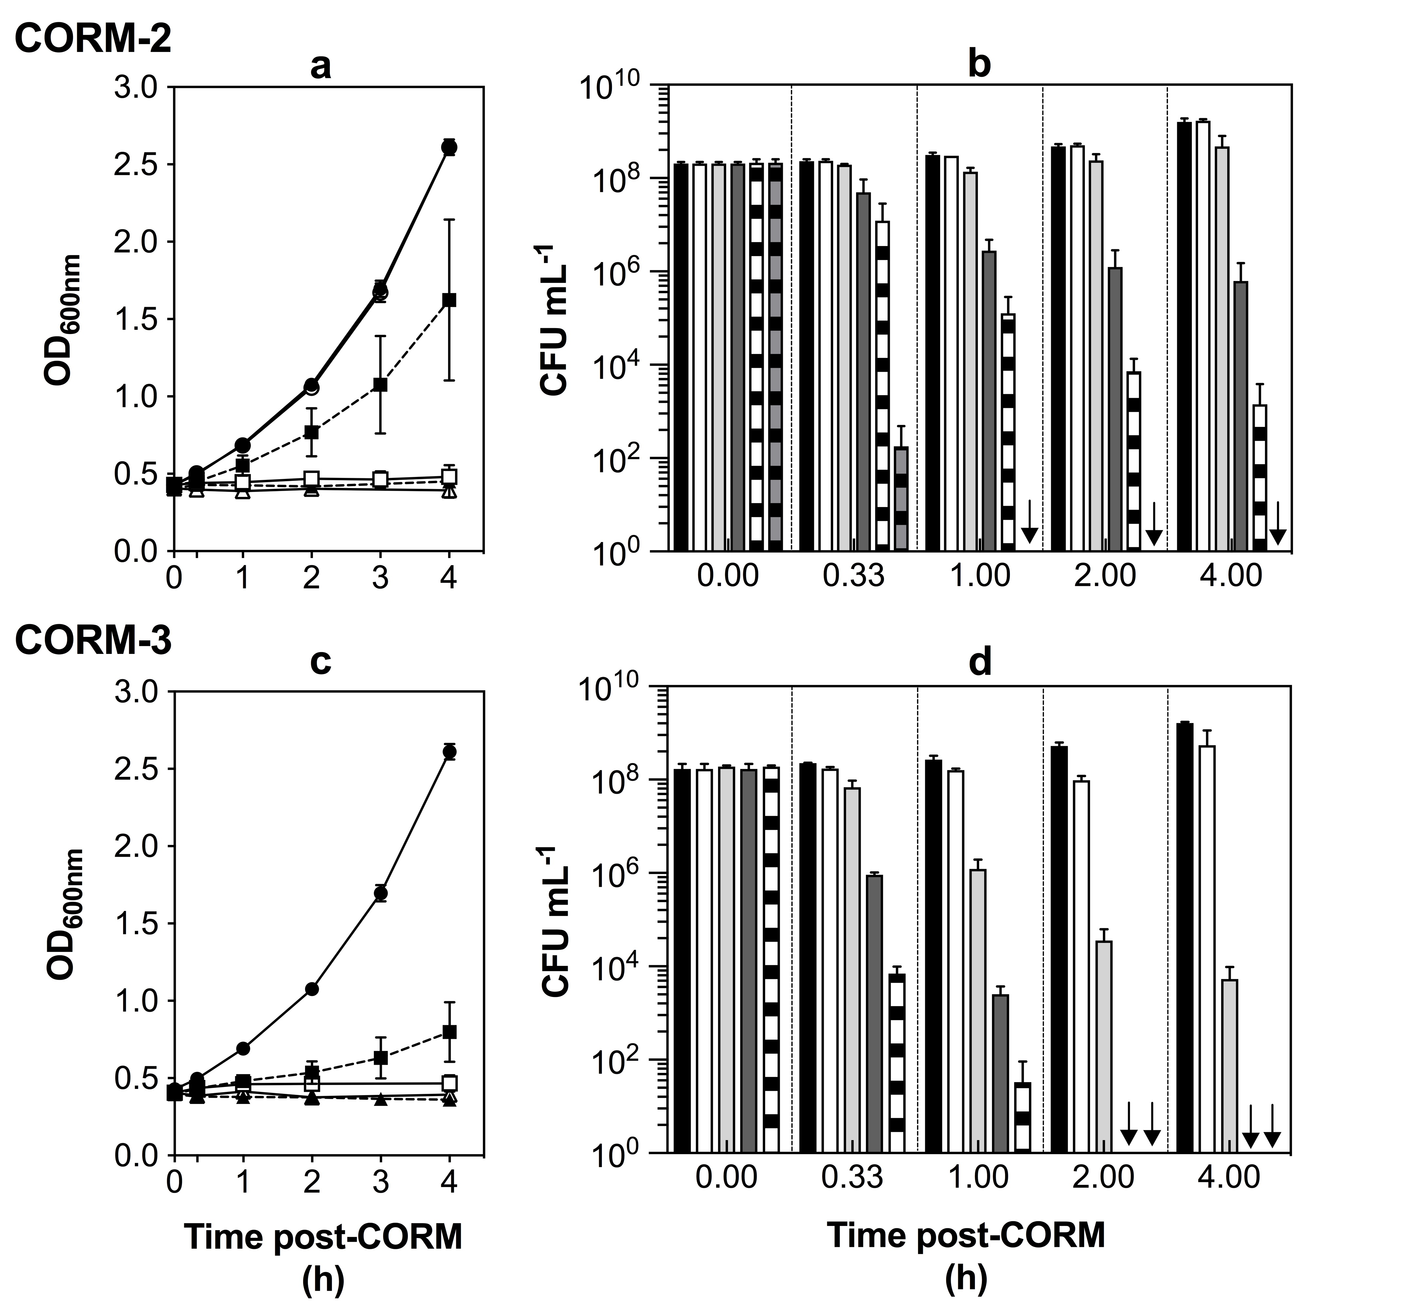

Fig. 3.1. CORM-2 and CORM-3 inhibit cell growth and are bactericidal to E. coli MG1655 in glucose defined minimal media. Cell cultures were grown aerobically on glucose defined minimal media (GDMM) to early exponential phase (OD_{600nm} ~ 0.4) and then various doses of CORM-2 or CORM-3 were added. (a): Growth in the absence of CORM (closed circles) or after the addition of DMSO (open circles) or 7.5 μM (dashed line, closed squares), 15 μM (open squares), 30 μM (dashed line, closed circles) or 100 μM (open triangles) CORM-2. (b): Culture viability in the absence of CORM (black bars) or after the addition of DMSO (white bars) or 7.5 μM (light grey bars), 15 μM (dark grey bars), 30 μM (black/white bars) or 100 μM (black/grey bars) CORM-2. Arrows represent a cell culture viability of 0. (c): Growth in the absence of CORM (closed circles) and after the addition of 15 μM (dashed line, closed squares), 30 μM (open squares), 60 μM (dashed line, closed triangles) or 120 μM (open triangles) CORM-3. (d): Culture viability in the absence of CORM (black bars) or after the addition of 15 μM (white bars), 30 μM (light grey bars), 60 μM (dark grey bars) or 120 μM (black/white bars) CORM-3. Arrows represent a cell culture viability of 0. All data are representative of three biological repeats ± SD.

(Fig. 3.1(c-d)). Furthermore, ≥ 60 μM CORM-3 was sufficient to completely eliminate all viable cells from the cell cultures within 2 h (Fig. 3.1(c-d)).

To conclude, concentrations of 7.5 μM CORM-2 and 15 μM CORM-3 were sufficient to slow E. coli MG1655 cell culture growth and slightly decrease culture viability in GDMM, whereas ≥ 15 μM CORM-2 and ≥ 30 μM CORM-3 were sufficient to cause complete growth inhibition and cause substantial and dose-dependent decreases to cell culture viability.

3.2.2. E. coli MG1655 cell cultures accumulate ruthenium to milimolar levels upon exposure to CORM-2 or CORM-3

As uptake and accumulation of Ru by E. coli cells upon exposure to CORM-2 and CORM-3 has been demonstrated previously (See Davidge et al., 2009b, Jesse et al., 2013), the next step was to determine if E. coli MG1655 could accumulate Ru upon exposure to CORM-2 or CORM-3 in GDMM. E. coli MG1655 cell cultures were grown to early log phase as described above and then 30 μM CORM-2 or 60 μM CORM-3 were added. Samples of the cultures were then harvested at time intervals following the addition of the compounds, washed with nitric acid to remove any surface-associated CORM and then analysed for Ru content by ICP-AES following digestion of cell pellets in neat nitric acid as described previously (Davidge et al., 2009b) and in Methods 2.2.3. Intracellular Ru concentrations were determined using estimates of E. coli total viable cell numbers per dry weight (dw) and estimates for cell size and volumes given in Table 1.5 (Neidhardt, 1990).

The uptake and accumulation of intracellular Ru by E. coli cells exposed to 30 μM CORM-2 (note, this corresponds to 60 μM Ru) or 60 μM CORM-3 is shown in Fig. 3.2(a). For both CORMs, uptake was fastest within the first 20 min of the addition of the compounds to the culture. The initial rates of uptake of Ru derived from CORM-2, ~ 254 μM Ru min⁻¹, were significantly faster than that for uptake of Ru derived from CORM-3, ~ 170 μM Ru min⁻¹ (p ≤ 0.05) (Fig. 3.2(b)). The level of intracellular Ru continued to increase for up to 1 h following the addition of either CORM, yet uptake appeared to slow after ~ 20 min. The final concentration of intracellular Ru derived from either CORM at 1 h was approximately 2 mM (Fig, 3.2(c)). This corresponds to an intracellular Ru concentration within E. coli cells that is approximately 33 times higher than the concentration of Ru applied to the culture. In summary, E. coli cells accumulate Ru derived from CORM-2 faster than Ru derived from CORM-3, yet the final level of intracellular Ru from either compound after 1 h is the same.

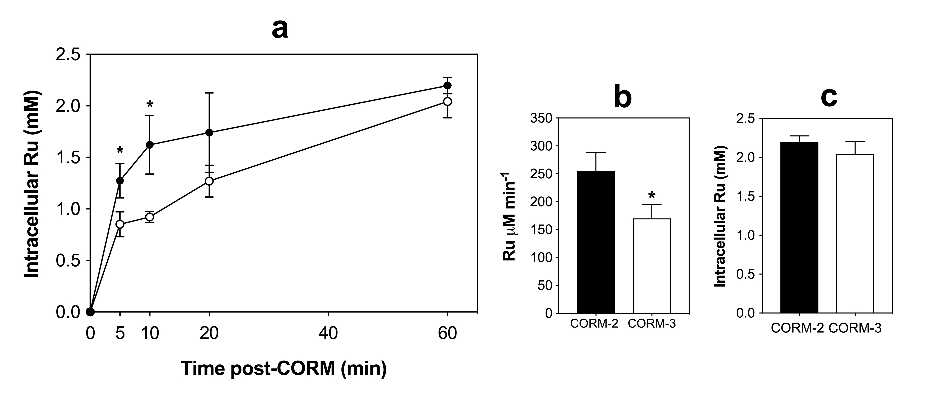
Fig. 3.2. Exposure of E. coli MG1655 cells to CORM-2 or CORM-3 results in an accumulation of milimolar levels of intracellular Ru. (a) E. coli cell cultures were grown aerobically on GDMM to early exponential phase (OD_{600nm} ~ 0.4) and then either 30 μM CORM-2 or 60 μM CORM-3 were added (t = 0). Culture samples were taken for elemental analysis via ICP-AES at time intervals thereafter. Significant differences between the intracellular Ru content of cells exposed to either CORM-2 or CORM-3 are indicated by * (p ≤ 0.05). The Ru content of untreated control cells was 0 (results not shown). (b) Initial rates of uptake of Ru by E. coli cells within the first 5 min of addition of 30 μM CORM-2 (black bar) or 60 μM CORM-3 (white bar). The initial rate of uptake of CORM-2 (~ 254 μM min⁻¹) was significantly faster than for CORM-3 (~ 170 μM min⁻¹) (p ≤ 0.05). (c) Final levels of intracellular Ru after 60 min exposure to either 30 μM CORM-2 or 60 μM CORM-3, no significant difference is observed. All data are representative of 3 biological repeats. Error bars represent ± SD. Significant differences were assessed via unpaired t-tests.
Note – work done in collaboration with Jonathan Chapman.

3.2.3. The extent of cell killing by CORM-2 or CORM-3 in E. coli is strongly correlated with the extent of intracellular Ru accumulation

As demonstrated in Fig. 3.1, CORM-2 and CORM-3 inhibit E. coli cell growth, elicit cell killing in a dose-dependent manner and lead to the accumulation of up to milimolar levels of intracellular Ru after just 1 h of exposure of cells to a toxic concentration of either CORM. To examine whether the extent of bacterial cell killing is related to the extent of intracellular Ru accumulation following exposure to CORM-2 or CORM-3, the following experiment was conducted. E. coli MG1655 cell cultures were grown as for the previous experiments and then various doses of CORM-2 or CORM-3 were added. After 1 h, the cell culture viability and the corresponding level of intracellular Ru were determined as described above in Sections 3.3.1 and 3.3.2, respectively.

As previously, CORM-2 (7.5 – 30 μM) and CORM-3 (15 – 60 μM) caused a dose-dependent decrease in viability of E. coli cell cultures relative to untreated or DMSO controls (Fig. 3.3(a)). There was also a dose-dependent effect on the level of intracellular Ru in E. coli cells after exposure to either CORM (Fig. 3.3(b)). The level of intracellular Ru after 1 h exposure to 7.5, 15 or 30 μM CORM-2 was determined to be ~ 0.8 mM, 1.36 mM or 2.44 mM, respectively. The level of intracellular Ru after 1 h exposure to the equivalent concentrations of Ru in the form of 15, 30 or 60 μM CORM-3 was determined to ~ 0.4 mM, 1.18 mM and 1.87 mM, respectively.

Next, to determine whether the extent of intracellular Ru accumulation was correlated to the extent of E. coli cell killing, the cell culture viability data in (Fig. 3.3(a)) was compared to the corresponding level of intracellular Ru (Fig.3.3(b)) as shown in Fig. 3.3(c). As is evident, there exists a strong negative correlation between culture viability and the corresponding level of intracellular Ru for both CORM-2 (r² = 0.704) and CORM-3 (r² = 0.877) (p ≤ 0.0001). Thus, the extent of bacterial cell killing by both CORM-2 and CORM-3 is directly and strongly associated with the extent of Ru accumulation by E. coli cells.

3.2.4. The antimicrobial effects of CORM-2 and CORM-3 against E. coli are alleviated by components of complex growth media

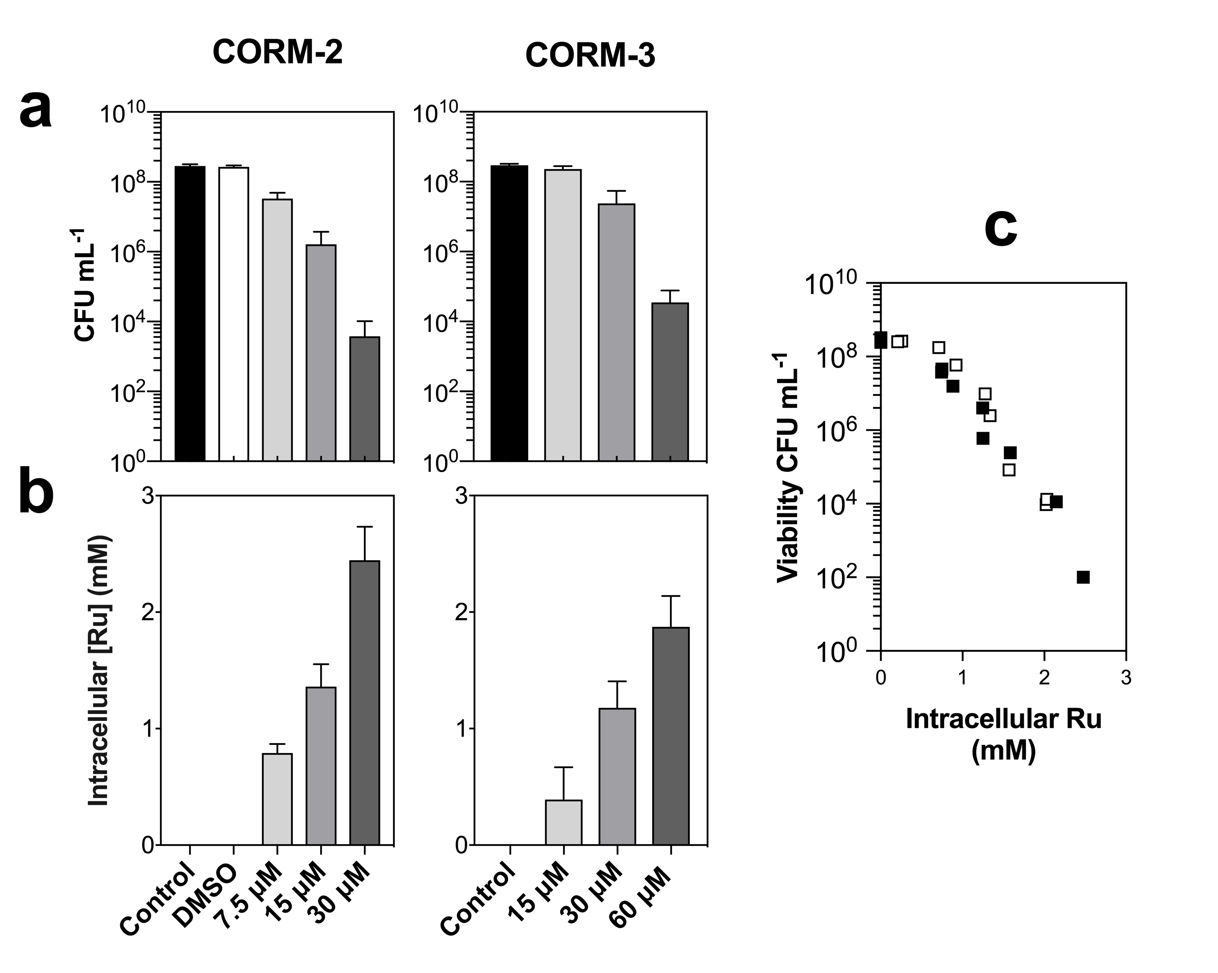

Fig. 3.3. E. coli cell killing by CORM-2 and CORM-3 is strongly correlated with the extent of intracellular Ru accumulation. E. coli cells were grown to early exponential phase (OD₆₀₀ ~ 0.4) and then various doses of CORM-2 or CORM-3 were added. Cells cultures were further incubated for 1 h and then samples for cell viable counts (a) and cellular Ru content via ICP-AES (b) were harvested, along with samples from non-CORM treated and DMSO treated control cultures. (c) The data in (a) and (b) is presented as cell culture viability (CFU mL⁻¹) plotted against the corresponding level of intracellular Ru (mM) for CORM-2 (black squares) and CORM-3 (white squares). There exists a strong negative correlation between the culture viability and the extent of intracellular Ru accumulation for both CORM-2 (r² = 0.704) and CORM-3 (r² = 0.877). Data are representative of three biological repeats and in (c) were assessed via Pearson’s (two-tailed) correlational analysis (p ≤ 0.0001). Error bars in (a) and (b) represent ± SD.

As illustrated in Table 3.1, an unexplained phenomenon in CORM-2 and CORM-3 antimicrobial effects is that their toxicity appears to be abrogated in the presence of rich growth media. It is unclear as to whether this is due to the CORMs interacting with components of rich media per se or whether bacterial cell growth in rich media somehow renders cells more resilient to CORMs. In order to investigate whether CORM-2 or CORM-3 could interact directly with the components of growth media, E. coli MG1655 cells were grown exclusively in GDMM, in which CORM-2 and CORM-3 had been previously established to cause growth inhibitory effects. Prior to addition of either CORM-2 or CORM-3 to the cell cultures, the CORM stocks were first diluted 10-fold in H₂O (as standard) or PBS (Fig. 3.4(a, d)) or in various bacterial (Fig. 3.4(b, d)) or mammalian cell growth media (Fig. 3.4(c, f)).

A 10-fold dilution of the CORM in H₂O, PBS or GDMM was without effect on the toxicity of 30 μM CORM-2 or 60 μM CORM-3 on E. coli cells. However, a 10-fold dilution of either CORM in rich bacterial growth media (LB or Mueller-Hinton II, MH-II broth) completely alleviated the growth inhibitory effects of 30 μM CORM-2 and 60 μM CORM-3 (Fig. 3.4 (b, e)). In addition, a 10-fold dilution of either compound in commonly used mammalian cell culture media – Dulbecco’s Modified Eagle Medium (DMEM) or Roswell Park Memorial Institute (RPMI) medium – also completely alleviated the growth inhibitory effects of either CORM-2 or CORM-3 against E. coli (Fig. 3.4(c, f)). As E. coli cell cultures were grown on GDMM prior to and after the addition of the CORMs, it can be concluded that the ‘protective’ effects observed in the presence of rich growth media were due to the CORMs interacting with the media rather than the effect of the media on E. coli cell growth.

To further investigate how the efficacy of CORM-2 and CORM-3 as antimicrobial agents is affected by the presence of rich nutrient media, the minimum inhibitory concentrations (MICs) of CORM-2 and CORM-3 against E. coli MG1655 were determined either in GDMM or MH-II (Fig. 3.4(g)). The MIC of both CORMs in GDMM was determined to be 4 μg mL⁻¹, corresponding to approximately 7.8 μM CORM-2 or 13.6 μM CORM-3. In contrast, the MIC of both compounds in MH-II were determined to be > 512 μg mL⁻¹ ( ~ 1 mM CORM-2 or ~ 1.74 mM CORM-3).

3.2.5. CO release from CORM-2 to deoxy-Mb is unaffected by pre-incubation in various growth media

The next step was to determine if the alleviation of the growth inhibitory effects of CORM-2 against E. coli by the components of rich media was due to changes in the ability of
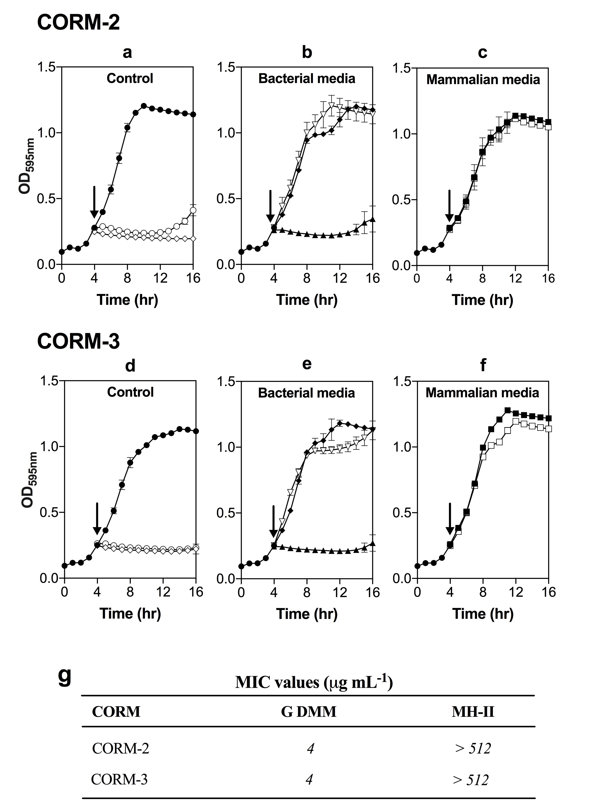

Fig. 3.4. Toxicity of CORM-2 and CORM-3 to E. coli is alleviated by the components of complex growth media. Cultures were grown aerobically in GDMM to early exponential phase (OD_{595nm} ~ 0.235), at which point, 30 μM CORM-2 or 60 μM CORM-3, prepared by diluting stock solutions 10-fold in various growth media or buffers, were added to the cultures (indicated by the arrows). Toxicity was assessed by monitoring culture growth for a further 12 h post-CORM addition. (a/d) Growth of controls without CORM (closed circles), CORMs prepared by dilution with water as standard (open diamonds) and CORMs prepared with PBS (open circles). (b/e) Growth of cultures following addition of CORMs diluted in bacterial growth media: GDMM (closed triangles) Mueller-Hinton II (MH-II) (open triangles) or Lysogeny broth (LB) (closed triangles). (c/f) Growth of cultures following addition of CORMs diluted with mammalian growth media: Dulbecco’s Modified Eagle Medium (DMEM) (closed squares) or Roswell Park Memorial Institute Medium (RPMI)-1640 (open squares). Dilution of CORM-2 or CORM-3 with PBS or GDMM had no effect on CORM toxicity. Dilution of CORM-2 or CORM-3 with complex media: LB, MH-II, DMEM or RPMI alleviated the growth inhibitory effects of the CORMs on E. coli cultures. (g) The minimum inhibitory concentration (MIC) of CORM-2 and CORM-3 against E. coli MG1655 examined either in GDMM or MH-II. All data are representative of 3 biological repeats, error bars represent ± SD.
Work done in (g) was conducted in collaboration with Jonathan Chapman.

CORM-2 to release CO. The amount of CO released from CORM-2 was measured via the conversion of deoxy-Mb to CO-Mb in the presence of sodium dithionite to facilitate CO release (McLean et al., 2012). Prior to the addition of CORM-2 to deoxy-Mb, CORM-2 stocks were first pre-incubated in a 10-fold excess of either H₂O, DMSO, 30 mM KPi buffer, GDMM, MH-II, LB, DMEM or RPMI for 20 min. After this incubation period, the various CORM-2 solutions were added to deoxy-Mb and the level of CO released from the CORM was quantified by the yield of CO-Mb (Fig. 3.5).

The level of CO released from CORM-2 following pre-incubation in DMSO or H₂O was found to be 0.55 equivalents and 0.44 equivalents of CO per CORM-2, respectively (Fig. 3.5). Following pre-incubation of CORM-2 in KPi buffer or various bacterial or mammalian growth media, the level of CO released was found to be between 0.63 – 0.73 equivalents of CO per mol CORM. There were no significant differences observed between CO released from CORM-2 following incubation in either KPi or GDMM and the level of CO released following incubation of the compound in rich bacterial or mammalian cell growth media (Fig. 3.5). Therefore, it can be concluded that the alleviation of the growth inhibitory effects of CORM-2 by components of rich nutrient media are not due to interference of CO release from CORM-2.

3.2.6. The ability of CORM-3 to release CO upon addition of sodium dithionite is rapidly diminished by pre-incubation in phosphate buffer or growth media

As the release of CO from CORM-2 was found to be unaffected by the presence of rich nutrient media, the next step was to establish whether the same could also be observed for CORM-3. As CO release from CORM-3 to deoxy-Mb following pre-incubation in phosphate buffer had been reported previously without clear conclusions (McLean et al., 2012; Motterlini et al., 2003), an alternative method was required. To quantify CO release from CORM-3 directly, CO was measured in the headspace of solutions of CORM-3 in buffer or media by gas-phase Fourier transform infrared (FTIR) spectroscopy (Fig. 3.6 (a-c)).

Without the presence of dithionite, the addition of CORM-3 to phosphate buffer or various media did not induce CO release from the compound within 30 min (data not shown). Extended incubation of CORM-3 in buffer or media resulted in the detection of only very low levels of CO after 10 h. Maximum CO release from CORM-3 was determined via the addition of 100 μM CORM-3 to 30 mM KPi buffer containing an excess of dithionite. Under these conditions, approximately 50 μM CO was recorded within 30 min (~ 0.5 equivalent CO per mol of CORM). As this was approximately half of the literature value, the maximal level of CO
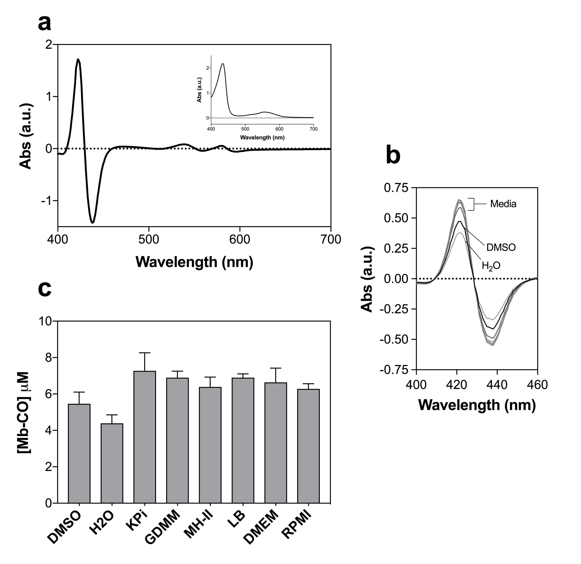

Fig. 3.5. CO release from CORM-2 is unaffected by pre-incubation in various growth media or KPi buffer. (a) CO-difference spectra of Mb-CO (17 μM) obtained by bubbling reduced Mb (shown in inset) with CO gas for 2 min. (b-c) CO-release from 10 μM CORM-2 to reduced-Mb (17 μM) after pre-incubation of the CORM in DMSO, distilled H₂O, 30 mM KPi buffer pH 7.4 or various bacterial/mammalian cell growth media (GDMM, MH-II, LB, DMEM or RPMI). (b) Mb CO-difference spectra obtained 20 min after the addition of 10 μM CORM-2, pre-incubated as described above, to 17 μM reduced-Mb. Data is representative of 1 technical repeat. (c) Maximum yields of Mb-CO from 10 μM CORM-2 as an average of 2 technical repeats, error bars represent ± SD. CO-release after extended pre-incubation of CORM-2 in DMSO yielded ~ 0.55 equivalent CO per CORM, pre-incubation in H₂O yielded ~ 0.44 equivalent CO per CORM, and pre-incubation in KPi/various media yielded ~ 0.63 – 0.73 mol CO per CORM.

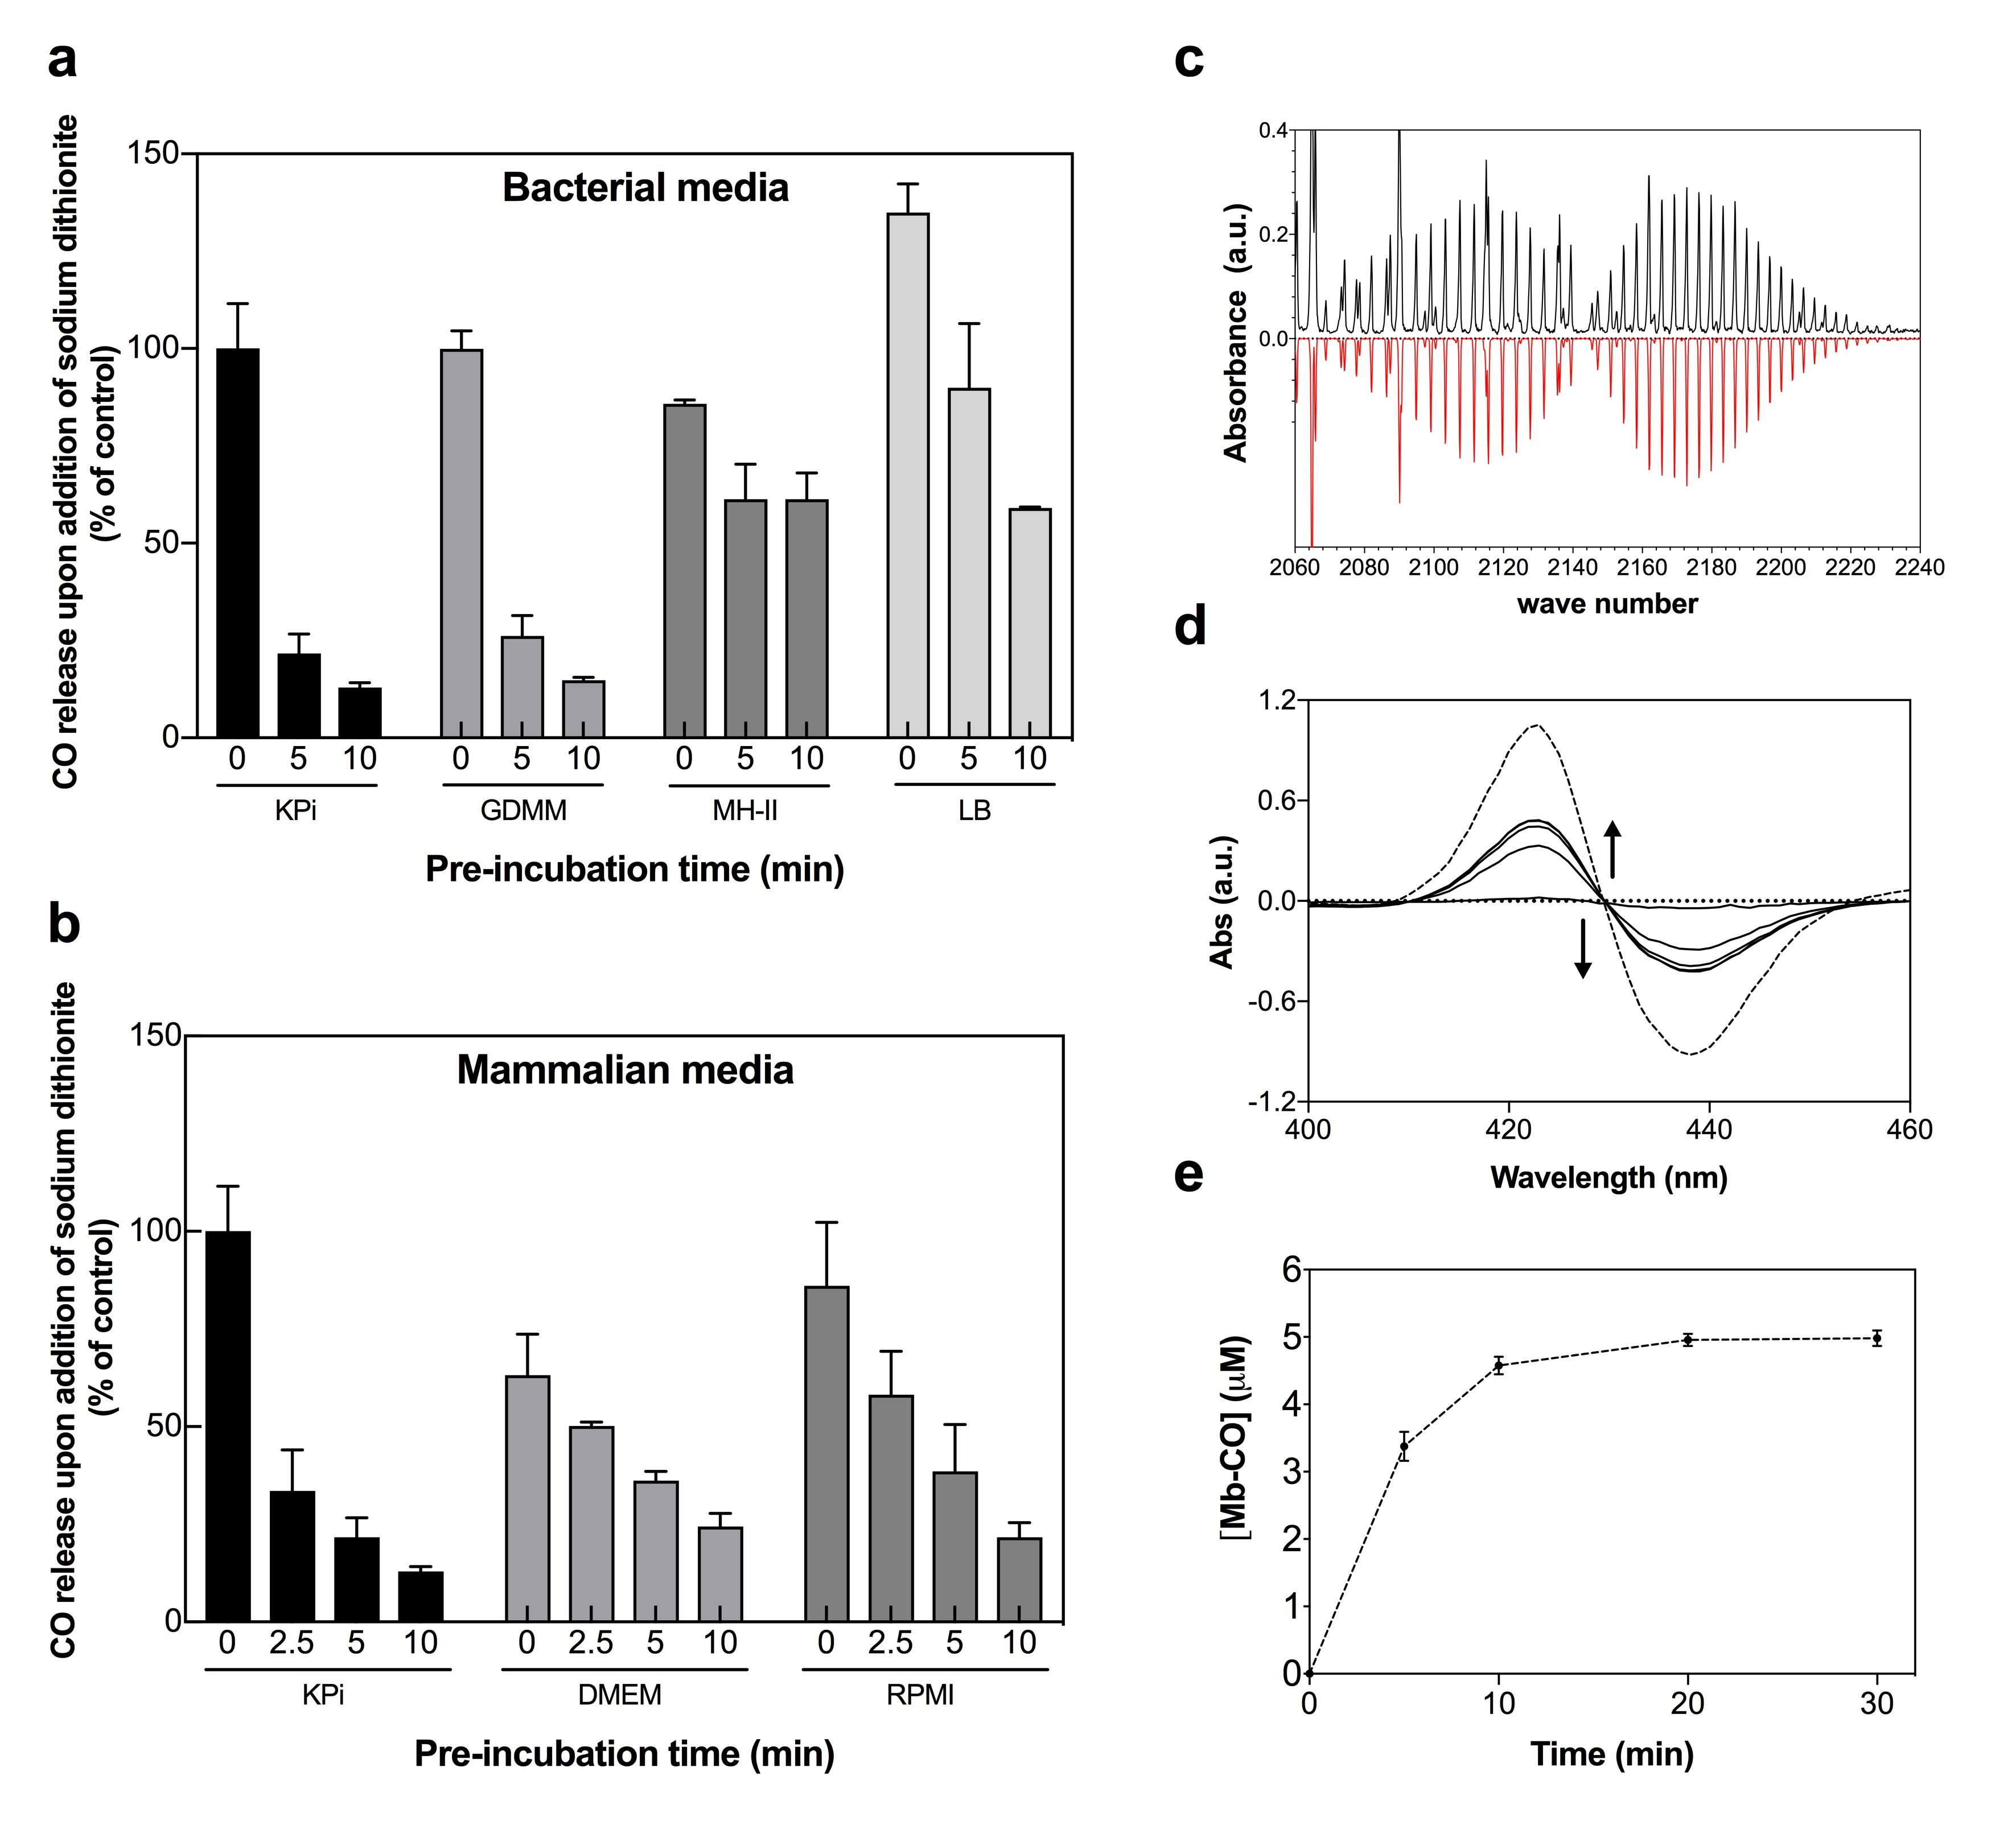
Fig. 3.6. CO release from CORM-3 is reduced by incubation in various bacterial or mammalian cell culture growth media and phosphate buffer. (a-b) CO release from CORM-3 as measured by gas-phase FTIR after incubation in various bacterial growth media (a), various mammalian growth media (b) or in 30 mM KPi buffer pH 7.4. CORM-3 (100 μM) was added to vigorously stirred, degassed, sterile media (10 mL) within a sealed vessel and CO release was monitored in the headspace over the solution. Sodium dithionite (200 μM) was added either just prior to CORM-3 (0 min) or after 2.5, 5 or 10 min pre-incubation of CORM-3 in the respective medium. CO release was monitored for 30 min following dithionite addition. No CO was observed prior to the addition of dithionite. Low levels of CO release (1 – 6 % or less than 10 %) were observed when CORM-3 was incubated for 10 h in each media without dithionite addition (data not shown). All values are quoted as % CO release relative to a control measurement whereby 100 % CO represents maximal CO release from CORM-3 following addition of 100 μM CORM-3 to 30mM KPi containing 200 μM sodium dithionite. Maximal CO release was approx. ~ 50 μM under these conditions. Data represent two technical replicates ± SD. (c) Representative FTIR spectrum of CO released from CORM-3 (100 μM) in H₂O 30 min after the addition of sodium dithionite (200 μM) (black) shown for comparison against a simulated FTIR spectrum for CO + H₂O obtained from HITRAN2012 molecular spectroscopic database (red). (d) CO-difference spectra of conversion of Mb (11 μM) to Mb-CO by the addition of 10 μM CORM-3 over a time-course of 30 min (black lines). Mb-CO (11 μM) generated by CO gas bubbling of reduced Mb for 2 min is shown for comparison (dashed lines). (e) Time-course of CO release from 10 μM CORM-3 to 11 μM Mb to form Mb-CO at room temperature. CORM-3 was found to release a maximum of 0.5 equivalents of CO per CORM. Data represent 3 technical repeats ± SD. Note - work in (a-c) was conducted in collaboration with Thomas Smith.
released from CORM-3 was further confirmed to be 0.5 equivalents CO per mol CORM by the yield of CO-Mb after the addition of CORM-3 to deoxy-Mb as shown in Fig. 3.6 (d-e). Thus, the data presented in Fig. 3.6 (a-b) are presented as % CO released from CORM-3 as compared to the maximum CO released from CORM-3 in KPi buffer containing dithionite where 100 % CO yield was approximately 0.5 equivalents CO per mol CORM-3.

To determine the effect of KPi buffer or various growth media on CO release from CORM-3, 100 μM CORM-3 was injected into media in a sealed vessel and then an excess of dithionite was added at 2.5, 5 or 10 min following addition of the CORM. Pre-incubation of CORM-3 in KPi buffer for 2.5 min decreased the yield of CO released from CORM-3 upon dithionite addition by 70 %, with a further decreases to 22 % of the control after 5 min and 13 % after 10 min. Thus, after 10 min incubation of CORM-3 in KPi buffer, only 0.065 equivalents of CO were released per mol CORM-3 after dithionite addition.

Pre-incubation of CORM-3 in bacterial growth media also prevented CO release upon addition of dithionite (Fig 3.6 (a)). After 10 min pre-incubation in GDMM, the CO yield from CORM-3 upon dithionite addition was only 14.8 % of the control (approximately 0.074 equivalents CO per mole CORM). After 10 min pre-incubation of CORM-3 in rich bacterial media (LB or MH-II), the yield of CO release upon dithionite addition was found to be approximately 59 – 61 % of the control (or ~ 0.3 equivalents per mol CORM-3). Pre-incubation of CORM-3 in rich mammalian cell culture media also decreased CO release from CORM-3 upon addition of dithionite (Fig. 3.6 (b)). After 10 min incubation of CORM-3 in DMEM or RPMI, the yield of CO released from CORM-3 was 21 – 24 % of the control (~ 0.1 – 0.12 equivalents CO per mol CORM-3).

In summary, the addition of CORM-3 to phosphate buffer or various growth media does not promote CO release in the absence of dithionite. Furthermore, pre-incubation of CORM-3 in buffer or media for just 10 min reduces the yield of CO released from the compound upon addition of dithionite.

3.2.7. CORM-3 speciation chemistry upon addition to phosphate buffers

As CO release from CORM-3 upon dithionite addition was diminished following pre-incubation of the compound in 30 mM KPi buffer at pH 7.4, the next step was to investigate if this was associated with structural changes that occurred to CORM-3 upon the addition of phosphate buffer by ¹H-NMR. First, the one-dimensional (1D) ¹H-NMR spectrum of CORM-3 in H₂O pH 2.5 was examined as shown in Fig. 3.7. The shifts at ~ 3.5 – 3.8 ppm correspond to the two Hα protons of the glycinate ligand of CORM-3, which is the only chemical feature of CORM-3 that can be observed by ¹H-NMR. The spectrum revealed the presence of low levels of contaminants, including ethanol and tetrahydrofuran (THF), both of which are used in the synthesis of CORM-3 (Clark et al., 2003).

A detailed ¹H-NMR spectrum of the glycinate region of CORM-3 in H₂O is shown in Fig. 3.8. The two glycine Hα protons are magnetically non-equivalent and thus form a 4-line AB quartet pattern in the NMR spectrum. There is also an additional singlet signal at 3.69 ppm, which is identical to the chemical shift of glycine at pH 2.5 (data not shown). Thus, upon dissolution in H₂O at pH 2.5, a proportion of CORM-3 is free glycine.

Upon adjustment of the pH of CORM-3 in H₂O to neutral (pH 7.1) with NaOH/HCl the solution changes from colourless to yellow. The ¹H-NMR spectrum of CORM-3 in H₂O pH 7.1 is shown in Fig. 3.8 and is altered in comparison to the spectrum at pH 2.5. A range of additional singlet signals are observed which may represent the glycinate ligand attached to the Ru(II) at one end. The most intense chemical shift corresponds to free glycine.

Next, the ¹H-NMR spectrum of CORM-3 in 30 mM KPi buffer after the adjustment of the pH to 7.4 was examined (Fig 3.8). This solution gave a yellow colour. The spectrum resembles that of CORM-3 in H₂O at neutral pH but is slightly altered. Singlet signals that appear to represent glycine attached at one end are present. To confirm that the most intense signal glycinate of CORM-3 in KPi buffer corresponded to free glycine, the sample was spiked with 5 mM free glycine as shown in Fig. 3.9.

To further identify the chemical species present in a solution of CORM-3 in KPi buffer, a two-dimensional (2D) ¹H-NMR Diffusion-Ordered spectroscopy (DOSY) experiment was performed (Fig. 3.10). The NMR spectrum displays the chemical shift (ppm) along the x-axis and the diffusion rate along the y-axis. The diffusion rate of each chemical species is determined via the application of a pulse gradient to the sample, enabling the molecules to be spatially labeled. The extent to which molecules diffuse through a solution via Brownian motion is dependent on their size and shape, with smaller molecules diffusing relatively faster. The extent to which the molecules in the sample move between each pulse in the DOSY experiment enables the diffusion rate of each distinct chemical species to be quantified, as shown in Fig. 3.10. The intense signal at 3.55 ppm corresponds to free glycine. The multiplet signal at 3.47 ppm corresponds to an asymmetrical glycine and thus represents the glycinate coordinated
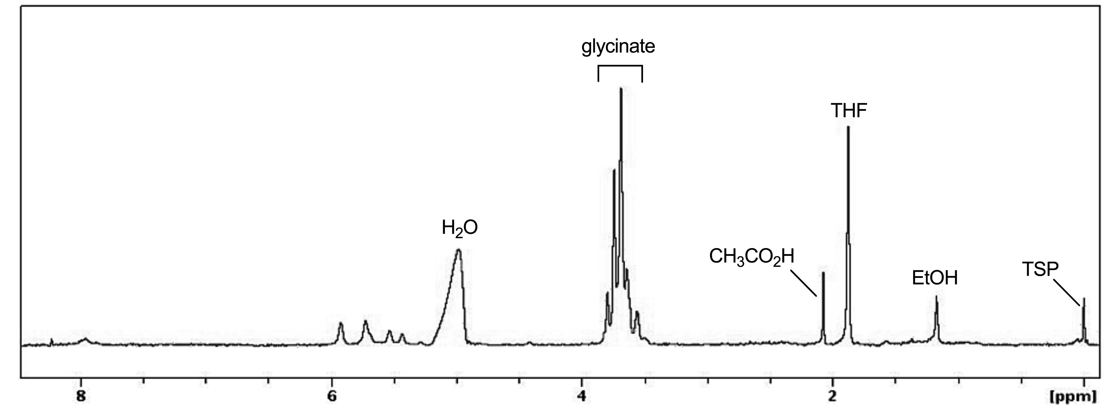
Fig. 3.7. ¹H-NMR spectrum of CORM-3 in distilled H₂O, pH 2.5. ¹H-NMR spectrum of CORM-3 (~ 7 mM) immediately after dissolution in unbuffered distilled H₂O. The pH of the solution is approximately pH 2.5. Shifts corresponding to the protons of glycinate are indicated, in addition to shifts corresponding to low levels of contaminants: acetic acid (CH₃CO₂H), tetrahydrofuran (THF) and ethanol (EtOH). Trimethylsilylpropanoic acid (TSP, 100 μM) is included as an internal reference. The spectrum is unaltered after 24 h at room temperature (data not shown).
Data collected in collaboration with Prof. Mike Williamson.

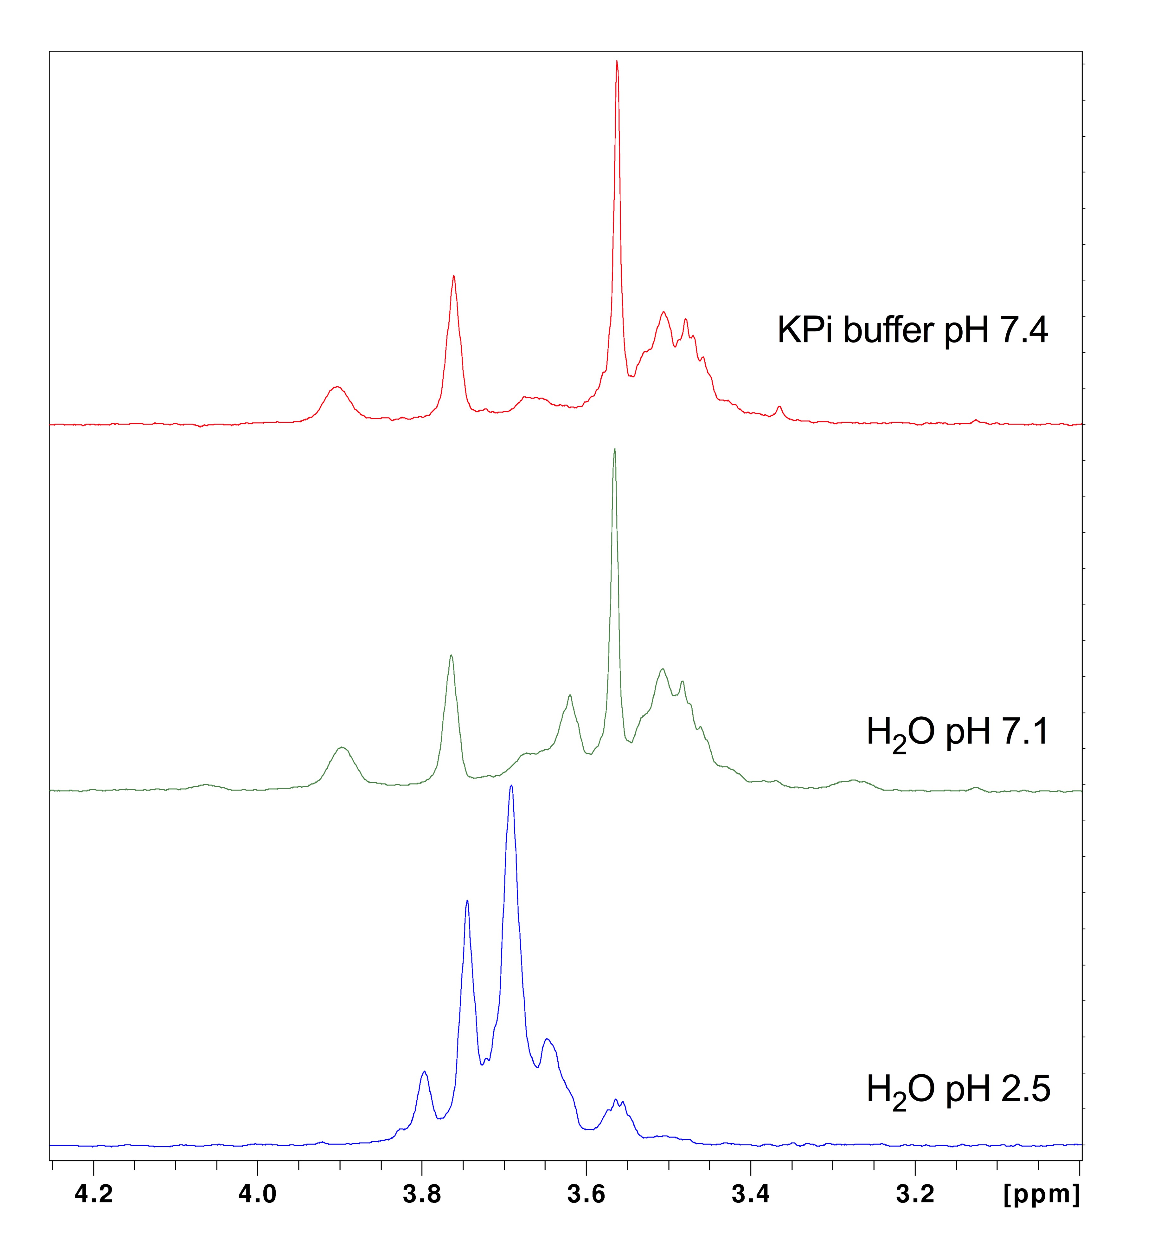
Fig. 3.8. ¹H-NMR spectrum of CORM-3 is altered upon adjustment to neutral pH or upon addition of 30 mM KPi buffer pH 7.4. ¹H-NMR spectrum of CORM-3 (~ 7 mM) immediately after dissolution in unbuffered distilled H₂O pH 2.5 (blue); after adjustment to pH 7.1 by the addition of NaOH/HCl (green); and after addition of 30 mM KPi buffer and adjustment to pH 7.4 (red). Shifts corresponding to the protons of the glycinate ligand of CORM-3 are altered upon the adjustment of the pH to 7.1 or upon addition of KPi buffer. CORM-3 in H₂O pH 2.5 is colourless; CORM-3 adjusted to neutral pH and/or in KPi buffer yields a yellow-orange solution.
Data collected in collaboration with Prof. Mike Williamson.

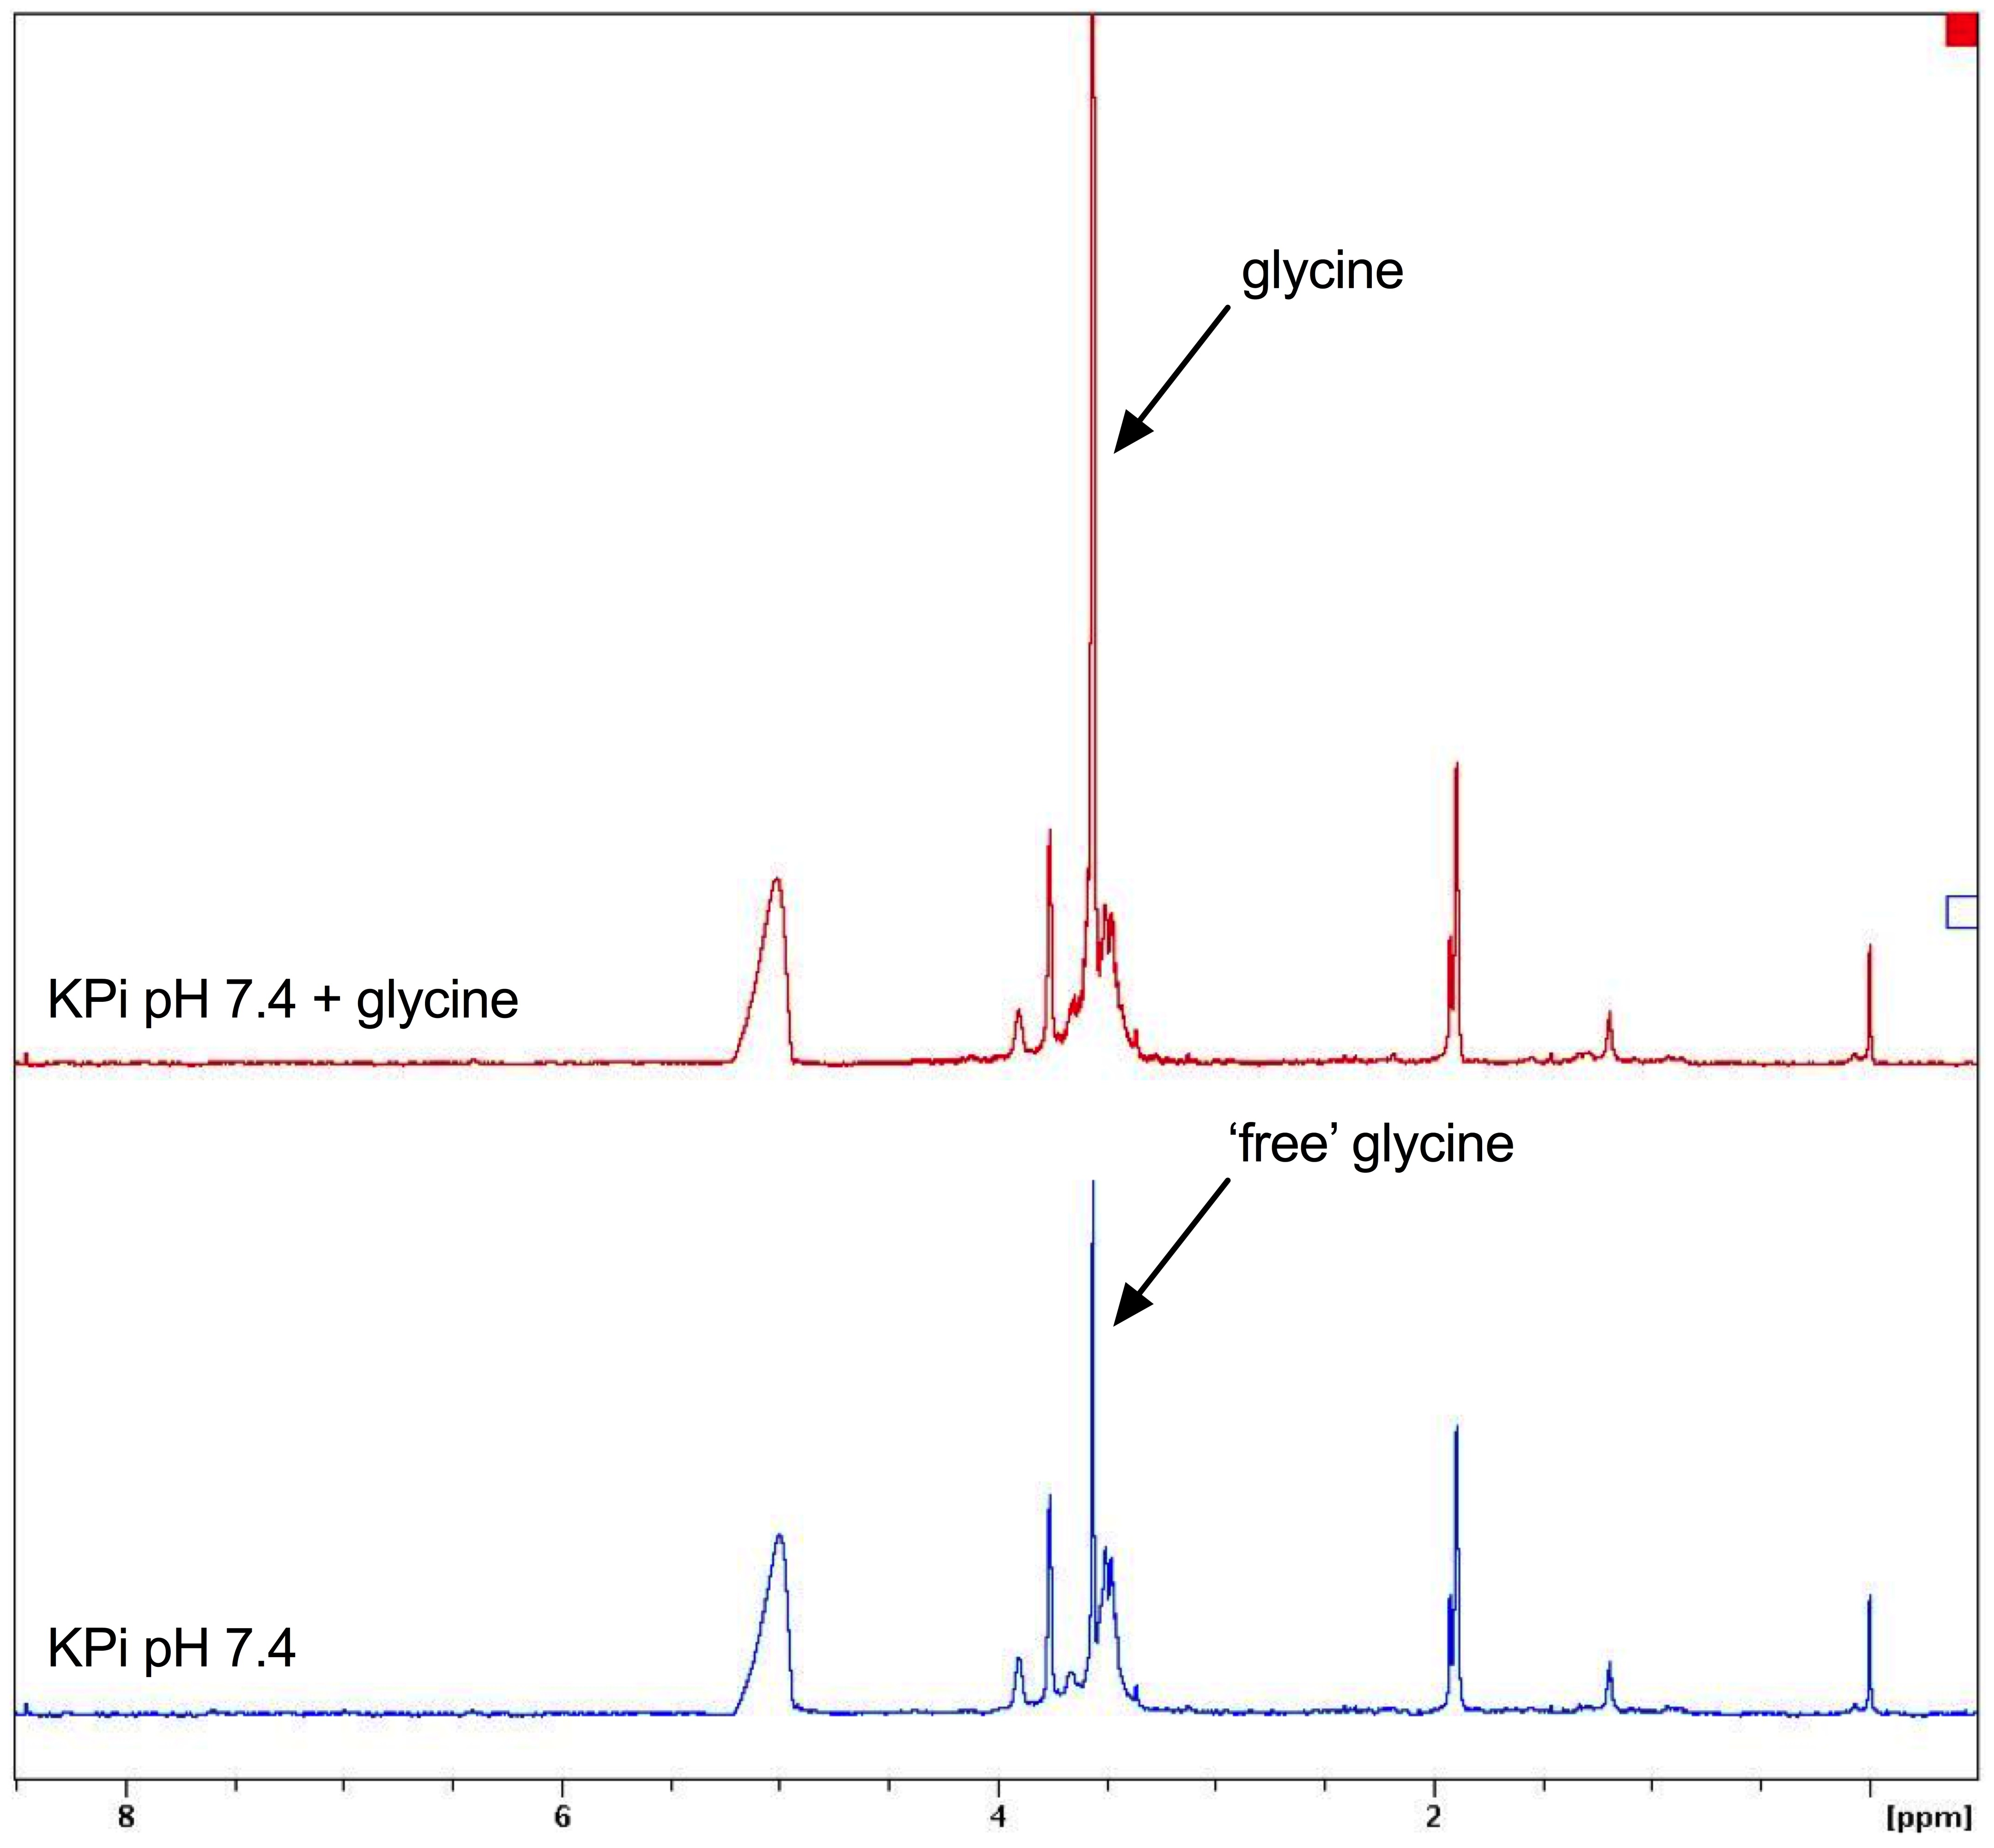

Fig. 3.9. ¹H-NMR spectra of CORM-3 in 30 mM KPi buffer pH 7.4 before and after spiking with glycine. ¹H-NMR spectrum of CORM-3 (~ 7 mM) in 30 mM KPi buffer pH 7.4 prior to (blue) and after (red) spiking the sample with glycine (5 mM). The shift corresponding to glycine (red) shows that ‘free glycine’ has been liberated from CORM-3 upon addition of KPi buffer and adjustment to neutral pH.
Data collected in collaboration with Prof. Mike Williamson.

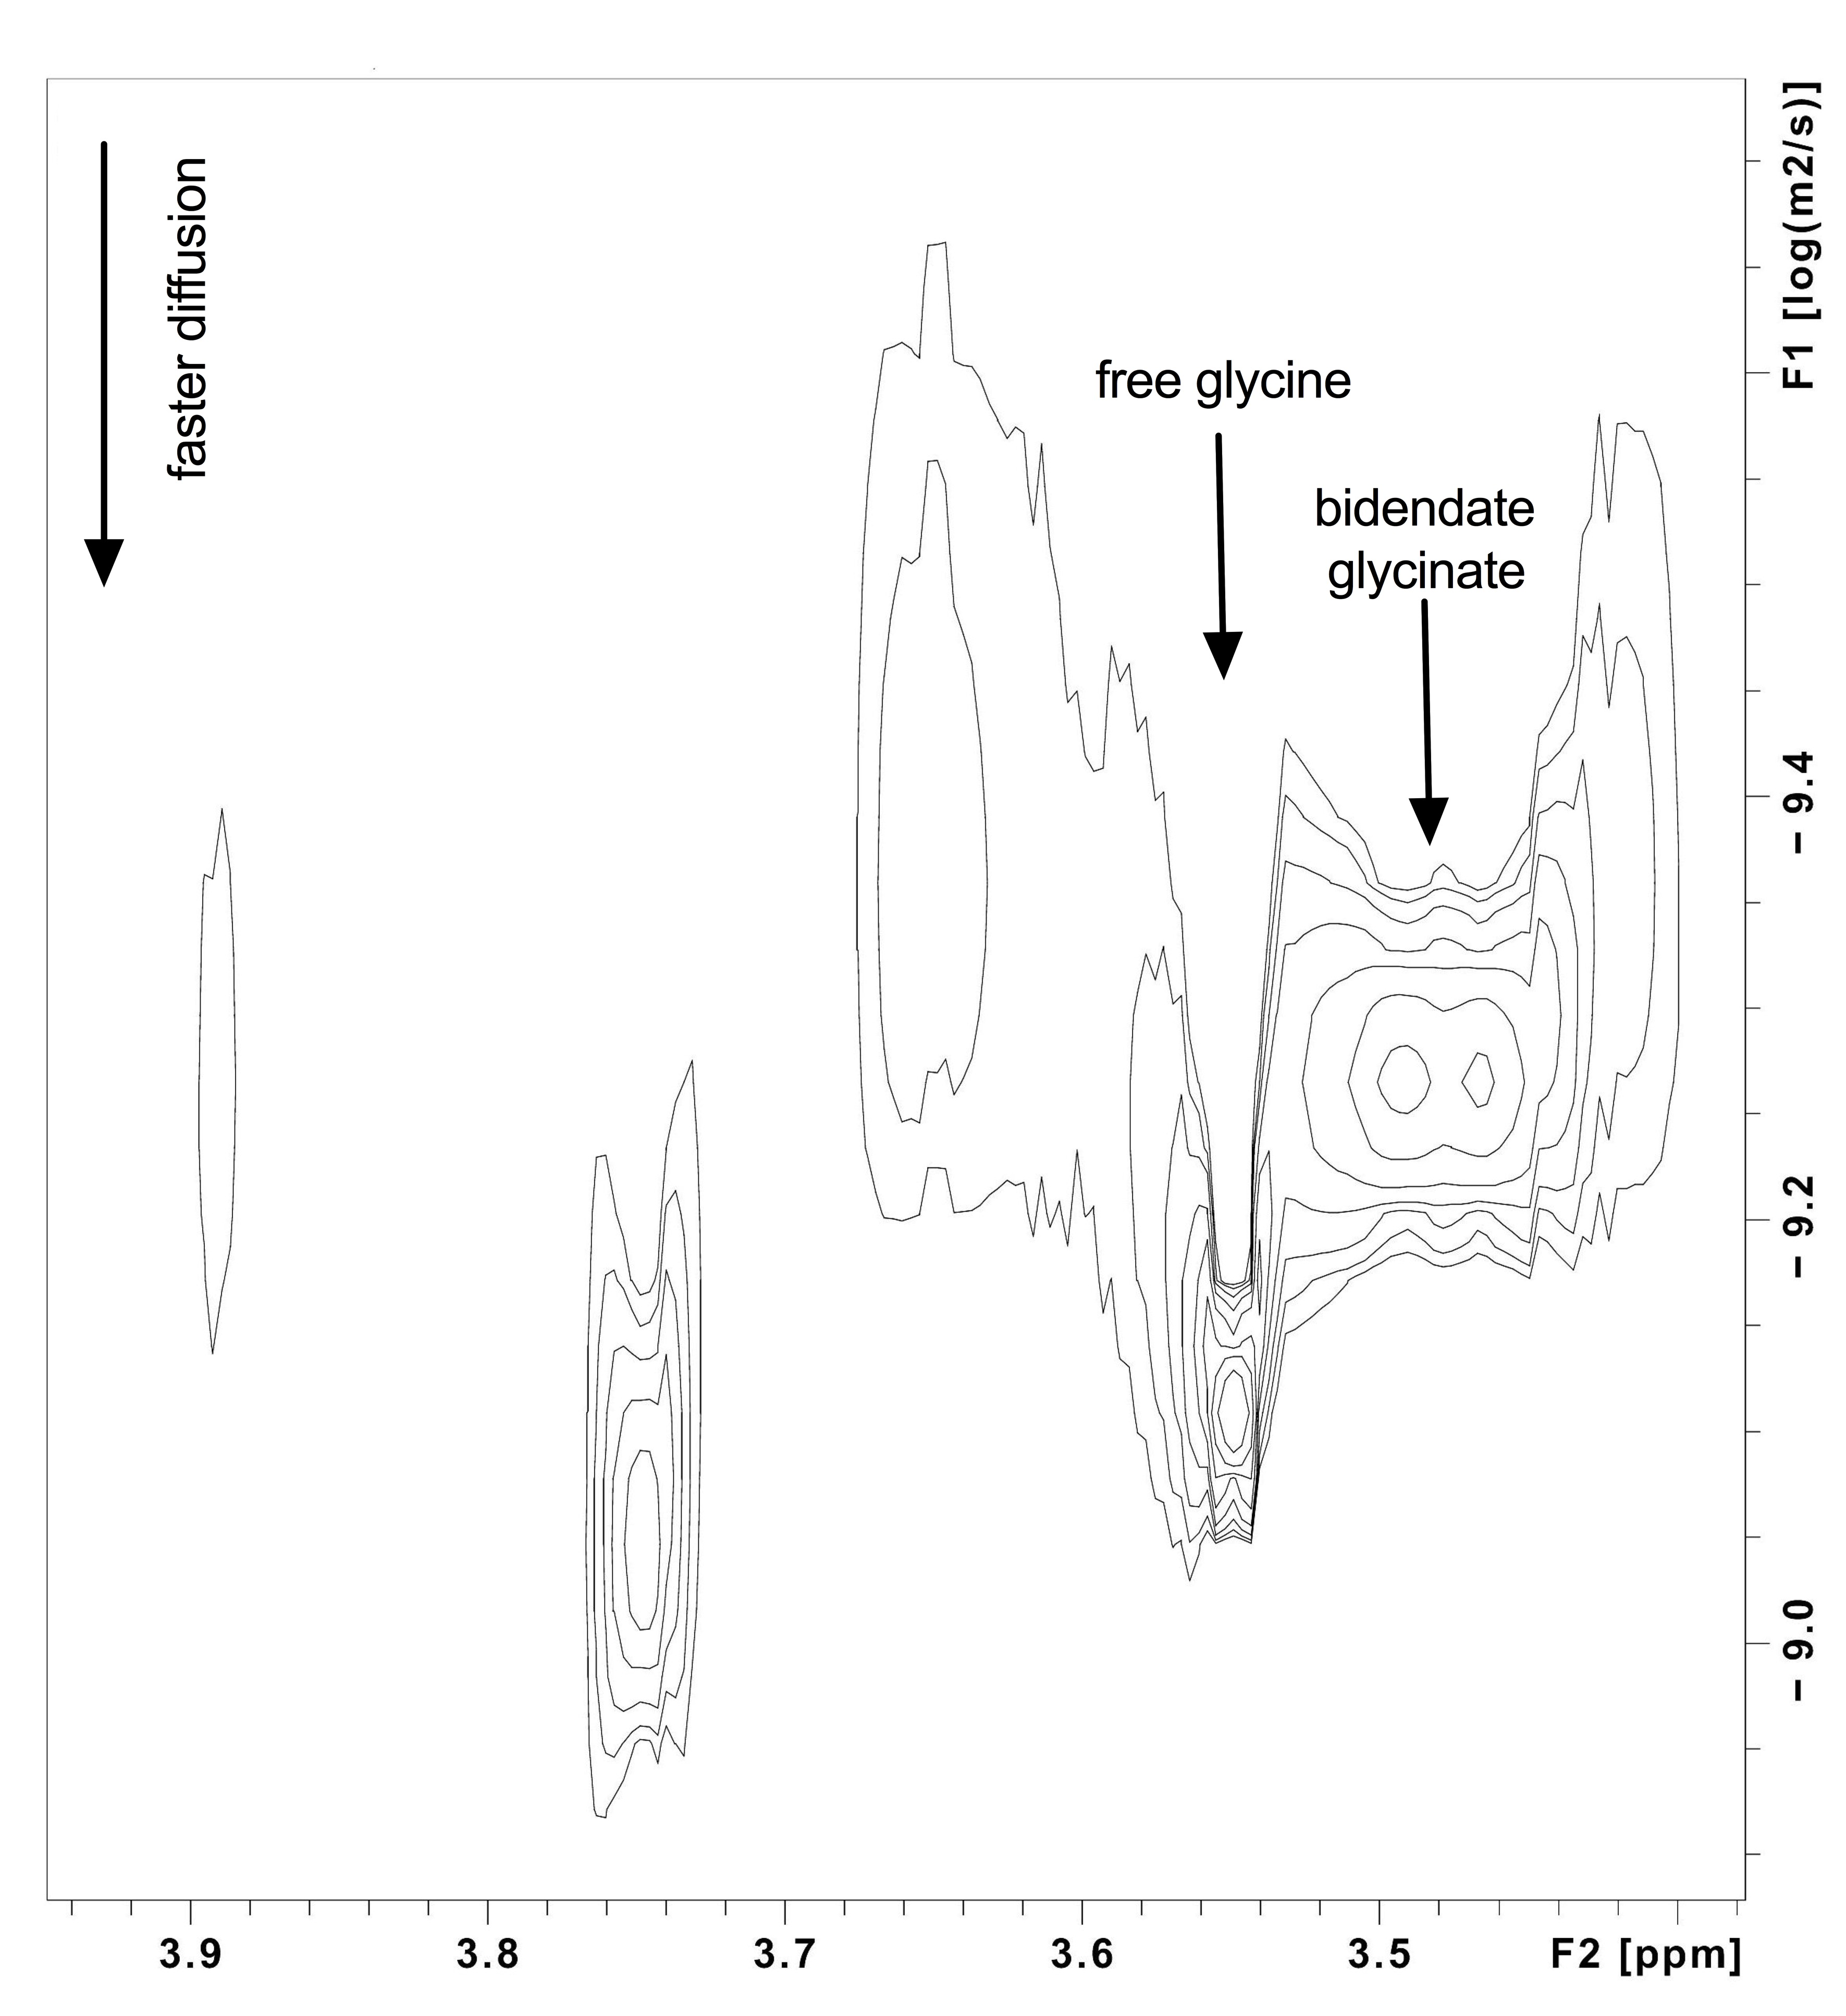
Fig. 3.10. 2D-DOSY ¹H-NMR spectrum of CORM-3 in 30 mM KPi buffer at pH 7.4. Two-dimensional (2D) diffusion-ordered spectroscopy (DOSY) spectrum of CORM-3 (~ 7 mM) in 30 mM KPi buffer with pH adjusted to 7.4. The region shown includes the ¹H signals originating from the glycine/glycinate ligand of CORM-3. The horizontal axis is ¹H chemical shift (ppm) and the vertical axis is the diffusion rate, shown as the log of the rate in m² s⁻¹. The intense signal at 3.55 ppm is proposed to correspond to free glycine that is no longer bound to the Ru(II) of CORM-3. The other singlet signals are proposed to correspond to the glycinate ligand of CORM-3, monodendate to the Ru(II) ion. The multiplet structure at 3.47 ppm corresponds to an asymmetrical glycine, most likely bidendate to the Ru(II) ion of CORM-3. Work done in collaboration with Mike Williamson.

bidendate to the Ru(II) ion. In addition, at least three chemically distinct glycine singlet signals can be identified, presumably corresponding to the glycinate ligand attached to the Ru(II) ion at one end. In summary, the speciation of CORM-3 in KPi buffer is complicated with at least five chemically distinct glycine species present.

3.3. Discussion

3.3.1. Cell killing by CORM-2 or CORM-3 is mediated, at least in part, by Ru

In order to evaluate CORM-2 and CORM-3 as potential replacements or adjuvants to existing antibiotics, it is important to elucidate the mechanisms by which they exert their antimicrobial effects on bacterial cells. As described above, the traditional view that cell killing by these compounds was entirely due to the effects of the released CO has been recently called into question (Wareham et al., 2015). This is not least because (1) CO is a poor antimicrobial in isolation (Wareham et al., 2016), (2) Ru-carbonyl CORMs are more toxic than non-ruthenium based CORMs (Nobre et al., 2016) and (3) CORM-2/3 antimicrobial effects far exceed those that can be observed for CO gas (Wareham et al., 2016). Poole and co-workers have previously demonstrated that E. coli or S. Typhimurium cells accumulate high levels of Ru upon exposure to either CORM-2 or CORM-3 (Davidge et al., 2009b; Jesse et al., 2013; McLean et al., 2013; Rana et al., 2014), but a direct link between the extent of the antimicrobial effects of these compounds and the level of Ru accumulation had not been further investigated. Thus, the first aim of this research project was to investigate to what extent the antimicrobial effects of these compounds were related to the accumulation of Ru by bacteria.

To begin, it was important to establish what concentrations of CORM-2 and CORM-3 were required to elicit antimicrobial effects against E. coli MG1655, the model bacterium employed in this investigation to evaluate the antimicrobial activities of these compounds. As CORM-2 and CORM-3 had been previously shown to exhibit different minimum toxicity ranges depending on the type of growth medium employed (Table 3.1), it was necessary to examine their relative toxicity in GDMM. As shown in Fig. 3.1, the addition of 7.5 μM CORM-2 or 15 μM CORM-3 to E. coli cell cultures caused slowed growth relative to untreated control cells and caused only negligible reductions in culture viability. However, concentrations equal to, and in excess of, 15 μM CORM-2 and 30 μM CORM-3 were sufficient to completely inhibit E. coli cell growth and cause a dose-dependent decrease in culture viability. As can be seen in Table 3.1, these toxic doses of CORM-2 and CORM-3 are similar to those reported for P. aeruginosa and S. Typhimurium when grown in M9 MS medium or Evans minimal media (Desmard et al., 2009; Desmard et al., 2012; Rana et al., 2014). They are significantly lower than the concentrations of CORM-2 and CORM-3 required to elicit antimicrobial effects on a range of bacterial species grown in minimal media supplemented with casamino acids or in rich nutrient media such as LB, MH or BHI broth (see Table 3.1). It is important to note that 1 mol of CORM-2 is reported to release approximately the same amount of CO as 1 mol CORM-3 (Davidge et al., 2009a), and yet the concentrations of CORM-3 required to cause the same antimicrobial effects as CORM-2 are approximately double those of CORM-2.

The next step was to establish whether these toxic concentrations of CORM-2 or CORM-3 could be accumulated by E. coli cell cultures in GDMM. The method by which uptake of these compounds was assessed involved assaying cell culture samples for Ru content by ICP-AES. However, this method provides no information as to which Ru-derived species of CORM-2 or CORM-3, following their speciation in DMSO or aqueous solutions (Fig. 10), is accumulated by E. coli cells. Nevertheless, it provides an estimate for how much CORM-derived Ru has been accumulated. As Ru has no natural roles in biology (see Chapter 1), all the Ru detected by ICP-AES must be derived from CORM-2 or CORM-3.

As shown in Fig. 3.2, the uptake of CORM-derived Ru by E. coli cells is fastest within the first 20 min of exposure, slowing to a maximum level of Ru accumulation at around 1 h post-CORM addition. The initial rates of Ru uptake for 30 μM CORM-2 (~ 245 μM Ru min⁻¹) were significantly faster than observed for 60 μM CORM-3 (~170 μM Ru min⁻¹), despite exposure of E. coli to the same extracellular concentration of Ru (60 μM). After 1 h of exposure to either 30 μM CORM-2 or 60 μM CORM-3, the final level of Ru accumulated by E. coli cells was found to be ~ 2 mM. This corresponds to an intracellular concentration of Ru that is approximately 33 times in excess of that applied extracellularly (60 μM). Thus, although CORM-2 derived Ru is taken up more rapidly by E. coli cells, the extent to which both compounds are accumulated by E. coli cells is the same.

A number of important implications regarding the mechanisms of uptake of these compounds arise from these results. Firstly, E. coli accumulate CORM-derived Ru to concentrations far exceeding those applied to the culture against a steep concentration gradient. This has been previously demonstrated and is consistent with literature findings (McLean et al., 2013; Rana et al., 2014). Secondly, the mechanisms by which CORM-2-derived Ru species gain cellular entry are likely to be different to those employed by CORM-3, as CORM-2-derived Ru exhibited significantly higher rates of uptake. Thirdly, the final level of intracellular Ru appears to plateau at ~ 2 mM for either CORM-2 or CORM-3. The mechanisms of uptake and accumulation of CORM-derived Ru are largely unknown and are likely to be complicated due to the complex speciation chemistry of these compounds (Fig. 10). As is illustrated in Fig. 1.5, to permeate the E. coli cell envelope, the Ru-carbonyl species must first cross the outer-membrane (OM) (Nikaido, 2003). It is likely that this occurs by diffusion through OM porins as these Ru-carbonyl species are sufficiently small and water soluble to pass through these non-specific OM channels (Nikaido 2003). Once in the periplasm, it is unclear how these compounds then permeate across the inner-membrane (IM). The higher initial uptake rates of CORM-2-derived Ru may suggest that the mononuclear Ru-carbonyl species that are derived from CORM-2 speciation in DMSO (Fig. 1.10) are able to cross the E. coli IM more readily than the species derived from CORM-3 upon aquation. DMSO is a lipophilic solvent and thus may improve membrane permeability of the bound Ru(II) ion thus aiding the compound to traverse the membrane. Further investigations on how these compounds are taken up by bacterial cells and accumulated against a concentration gradient are presented in Chapter 4 and 5 of this thesis.

Once it had been established that Ru derived from CORM-2 or CORM-3 was accumulated to milimolar levels by E. coli MG1655 in GDMM, the next step was to determine whether the extent of intracellular Ru accumulation was correlated with the extent of the compounds antimicrobial effects. To do this, E. coli cell cultures were exposed to various doses of either CORM-2 or CORM-3 for 1 h and then measurements for cell culture viability and intracellular Ru content were taken simultaneously. As shown in Fig. 3.3, the extent of intracellular Ru accumulation from CORM-2 and CORM-3 is strongly and significantly correlated with the extent of bacterial cell killing. This is the first time that CORM-2 and CORM-3 antimicrobial effects have been linked to the extent of accumulation of Ru. However, although a strong correlation is evident, a causal relationship between the level of Ru accumulation and extent of E. coli cell killing is not demonstrated in these experiments. Thus, the role of Ru(II) ion(s) in mediating the antimicrobial affects of CORM-2 and CORM-3 is likely to be much greater than was previously considered. However, from these results it is not yet clear as to how accumulation of this CORM-derived Ru leads to the antimicrobial effects observed from these compounds.

3.3.2. Components of rich growth media protect E. coli against CORM-2 and CORM-3 antimicrobial affects

As outlined in Section 3.1.2, an unexplained phenomenon in the antimicrobial activities of CORM-2 and CORM-3 is that their toxic effects are abrogated when bacterial cells were grown in rich growth media or when the growth media were supplemented with casamino acids (see Table 3.1 and references within). It was unknown whether such effects were due to direct interactions between the CORMs and the media, or whether the components of rich media could act to sequester the CO from reaching bacterial cells (Smith et al., 2011). An alternative explanation was that modes of bacterial growth in nutrient media could somehow make the cells more resilient against CORMs (Murray et al., 2012). Given that CORM-2 and CORM-3 are employed as CO-releasing molecules in over 300 publications, the majority of which have used rich media for the cultivation of mammalian cells in vitro, the effect of rich media on the biological activities of CORM-2 and CORM-3 warranted further investigation.

In order to determine whether CORM-2 or CORM-3 interacted with components of the media, it was important to design an experiment in which the cell cultures would be grown on GDMM, as under these conditions cells are susceptible to killing by CORM-2 and CORM-3. Prior to addition of CORMs, stock solutions were first diluted 10-fold in various bacterial or mammalian growth media. As shown in Fig. 3.4, CORM stocks prepared by dilution in H₂O, KPi buffer or GDMM all caused complete growth inhibition of E. coli immediately upon addition to the culture. In contrast, CORM stocks that had been diluted in rich bacterial growth media (LB or MH-II) or mammalian cell culture media (DMEM or RPMI) were without effects on E. coli growth. Thus, components of rich growth media alleviate the antimicrobial effects of CORM-2 or CORM-3 against E. coli. To further exemplify this effect, the MIC of CORM-2 and CORM-3 in GDMM were determined to be just 4 μg mL⁻¹, corresponding to 7.8 μM CORM-2 and 13.6 μM CORM-3. In contrast, the MIC of both compounds in MH-II were determined to be in excess of 512 μg mL⁻¹ or exceeding 1 mM CORM-2 or 1.74 mM CORM-3. MH-II or ‘cation adjusted Mueller-Hinton Broth’ (CAMHB) is recommended by the European Committee on Antimicrobial Susceptibility Testing (EUCAST) as the standard growth medium in which to evaluate the effectiveness of new antimicrobial agents (EUCAST, 2017). If CORM-2 and CORM-3 were examined according to these guidelines, then they would be classified as weakly antimicrobial compared to the effectiveness of existing antibiotics.

It was established earlier in this chapter that the antimicrobial actions of CORM-2 and CORM-3 were strongly associated to the extent of intracellular Ru accumulation. It is known that metal cations are precipitated by rich bacterial growth media such as LB, MH-II and their components such as tryptone, yeast extract and hydrolysed casein (casamino acids) (Hughes and Poole, 1991; Rayner and Sadler, 1990 Sep 15). It is therefore possible that the alleviation of CORM toxicity shown in Fig. 3.4 was due to sequestration of the Ru(II) ions by components of complex media, thereby preventing accumulation of the Ru by E. coli cells. The exact components of MH-II and LB broth are undefined and are likely to exhibit high levels of batch-to-batch variation. A key difference between rich growth media and GDMM is that the former contains large amounts of biomolecules such as peptides and amino acids. As shown later in Chapter 4, CORM-2 and CORM-3 interact with certain amino acids with high affinity.

The finding that components of mammalian cell culture media such DMEM and RPMI are particularly significant in the assessment of these compounds as potential antimicrobial agents. All previous examinations of the cytotoxicity of CORM-2 and CORM-3 on cultured mammalian cells have been conducted in rich growth medium, particularly DMEM plus serum supplements (see Table 1.8). Could DMEM and RPMI also protect against the cytotoxicity of these CORMs against cultured mammalian cells? This issue is addressed later in Chapter 7 of this thesis.

3.3.3. CO release from CORM-3 is rapidly ‘inactivated’ upon addition to phosphate buffer and various growth media – when does CORM-3 become ‘iCORM-3’?

As components of rich growth media protect cells from the toxicity of other metal cations (Hughes and Poole, 1991), the results obtained in Fig. 3.4 appear to support the conclusion that the antimicrobial effects of CORM-2 and CORM-3 are mediated by Ru(II) ion(s). However, it was also necessary to determine whether pre-incubation of the compounds in rich growth media could affect CO release from either CORM in order to assess the contribution of CO in mediating the compounds antimicrobial effects.

CO release from CORM-2 and CORM-3 is not completely understood. Since the discovery that dithionite was responsible for the ‘fast’ CO release observed from Ru-based CORMs upon addition to deoxy-Mb, it has been hypothesized by Poole and co-workers that naturally occurring sulfite species promote the release of CO from CORMs within bacterial cells (McLean et al., 2012). The effect of various media on the release of CO from CORM-2 had not been previously investigated. As shown in Fig. 3.5, pre-incubation of CORM-2 in a 10-fold excess of KPi buffer, GDMM, MH-II, LB, DMEM or RPMI yielded ~ 0.63 – 0.73 equivalents of CO per mol CORM as determined by the conversion of deoxy-Mb to CO-Mb. The amount of CO released from CORM-2 in the literature varies from 0.7 – 1.0 mol CO per mol CORM-2 (Motterlini et al., 2002; McLean et al., 2012; Klein et al., 2014). Thus, it can be concluded that pre-incubation of CORM-2 in KPi buffer or various growth media does not prevent release of CO from CORM-2 upon addition of dithionite. Therefore, the alleviation of the antimicrobial effects of CORM-2 by rich media is not due to prevention of CO release from the CORM. Interestingly, the yield of Mb-CO was lower (~ 0.44 – 0.55 mol CO per CORM) when the CORM-2 was pre-incubated in DMSO or H₂O. As illustrated in Fig. 1.10, CO release from CORM-2 can be caused by substitution with DMSO and thus it is likely that this reaction continued in DMSO or H₂O, but did not continue in buffer or growth media.

The next step was to determine whether CO release from CORM-3 upon addition of dithionite could be affected by pre-incubation in various growth media. It had been previously demonstrated that CORM-3 loses its ability to release CO to deoxy-Mb upon addition to PBS or KPi buffers (McLean et al., 2012; Motterlini et al., 2002). However, there was a discrepancy in the conclusions of these studies as to whether this effect was due to rapid CO release from CORM-3 upon addition to the buffer (Motterlini et al., 2002), or whether incubation of CORM-3 in buffer ‘inactivated’ the compound’s ability to release CO (McLean et al., 2012). Therefore, to fully investigate the effect of CO release from CORM-3 in phosphate buffer and various media, gas-phase FTIR was employed to be able to monitor CO release from CORM-3 upon addition to various media both prior to and after the addition of dithionite (Fig. 3.6).

No significant levels of CO release was observed from CORM-3 upon addition of KPi buffer or various bacterial or mammalian growth media prior to the addition of dithionite; thus, it can be concluded that CORM-3 does not release CO in the absence of dithionite or sulfite, consistent with the findings of McLean et al (McLean et al., 2012). However, within just 10 min of addition of CORM-3 to KPi buffer, the yield of CO upon dithionite addition was decreased to 0.065 mol CO per mol CORM-3. Thus, CO release from CORM-3 is rapidly deactivated upon addition to KPi buffer. Strikingly, the same effect was also observed following pre-incubation of CORM-3 in GDMM, with a yield of only 0.074 mol CO per mol CORM-3 upon the addition of dithionite. A significant but less dramatic decrease in the yield of CO from CORM-3 was also observed in mammalian cell culture media (~ 0.1 – 0.12 mol CO per mol CORM-3). A less pronounced effect was observed in LB and MH-II, with ~ 0.3 equivalents of CO following a 10 min incubation in these media.

These results have profound implications for what is known of the biological activities of CORM-3. If CO release from CORM-3, even upon the addition of dithionite, is rapidly inactivated following addition of the compound to commonly used bacterial or mammalian growth media, then it is highly unlikely that this compound is an effective CO releaser in these experiments. As proposed above, it is now considerably probable that the antimicrobial effects of CORM-3 are cause almost entirely to the Ru(II) ion. CO release from CORM-2 is largely unaffected by buffer or growth media and thus CO may still have a role in mediating the biological effects of CORM-2. Indeed, the correlation between the extent of Ru accumulation by bacterial cells and the extent of cell killing was stronger for CORM-3 (r² = 0.877) than for CORM-2 (r² = 0.704) (Fig. 3.3).

McLean et al suggested that the formation of ‘iCORM-3’ upon the addition of PBS may be due to displacement of the bidendate glycinate of CORM-3 to yield a stable tricarbonyl complex that could not release CO upon addition of dithionite (McLean et al., 2012). To investigate this, the structural changes of CORM-3 upon addition to KPi buffer were investigated by ¹H-NMR (Fig. 3.7 – 3.10). The ¹H-NMR studies revealed that, upon addition of CORM-3 to KPi buffer, the glycinate ligand is liberated (Fig. 3.8 – 3.10). The ¹H-NMR spectra of CORM-3 in KPi buffer also contained other singlet signals corresponding to additional glycinate species, likely representing the glycinate ligand of CORM-3 bound to the Ru(II) ion at one end only (Fig. 3.10). It is therefore hypothesized that ‘inactivation’ of CO release from CORM-3 occurs via displacement of the glycinate ligand with phosphate, first at one end so that the glycinate is monodendate to the Ru(II) ion and then fully displaced by substitution with a second phosphate anion coordinating to the Ru(II) ion. This yields a stable tricarbonyl species that is no longer able to release CO upon addition of dithionite. The extent of ‘inactivation’ of CORM-3 within 10 min in various media supports this hypothesis; the most dramatic inactivation of CORM-3 occurred in KPi buffer or GDMM, which each contain 30 mM Pi (inorganic phosphate). In contrast, the extent of ‘inactivation’ of CORM-3 in DMEM or RPMI was lower and these media contain only ~ 0.1 – 5.6 mM Pi. The amount of Pi in MH-II or LB is not known but it is likely that these media too contain a significant level of Pi in which to inactivate CO release from CORM-3. To confirm this hypothesis, the structure of CORM-3 in KPi buffer could be determined by x-ray crystallography, but this is beyond the scope of this thesis.

If CORM-3 is rapidly inactivated upon addition to bacterial growth media or Pi containing solutions, at what point does CORM-3 become ‘iCORM-3’? If 10 min is all that is necessary to almost completely prevent CO release from CORM-3 then it is possible that CORM-3 may not actually be a CO-releasing molecule. Why then, does iCORM-3 not induce the same antimicrobial affects as CORM-3, as demonstrated by McLean et al (McLean et al., 2013)? Although CORM-3 is demonstrated to undergo complex speciation chemistry upon addition to Pi containing solutions, it is unclear how long these reactions last in vitro. If ligand substitution is possible, then the Ru(II) ion of the compound could be available to bind to biological targets. Thus, in the preparation of iCORM-3, perhaps dissolution of CORM-3 in PBS over a 48 h period yields a stable species in which the ligands coordinated to the Ru(II) ion cannot be displaced by substitution and thus are unable to bind to biological targets. Thus, as with the employment of Ru(II)Cl₂(DMSO)₄ or ‘iCORM-2’, the lack of antimicrobial activities of iCORMs may be due to the their relative stability in biological solutions and the subsequent prevention of the Ru(II) ion to coordinate to biological targets.

Finally, it must be noted that the total amount of CO released per mol CORM-3 was only 0.5 equivalents when examined both by FTIR and the yield of Mb-CO (Fig. 3.6). This is approximately half the previously reported literature value. The reasons for this discrepancy are unclear at this time but 4 individual CORM-3 stocks were examined and employed during the process of this project and all yielded up to approximately 0.55 mol CO per mol of CORM-3.

3.4. Concluding remarks

The significant findings of Chapter 3 are as follows. Firstly, the antimicrobial activities of CORM-2 and CORM-3 are strongly correlated with the extent of Ru accumulation. As components of rich nutrient media alleviate their growth inhibitory effects against E. coli, it is likely that these components prevent uptake and accumulation of the Ru(II) ion(s) by bacterial cells, thus requiring higher doses of the compounds to elicit antimicrobial effects. Interestingly, if these compounds were evaluated in accordance with EUCAST guidelines, they would be deemed ineffective due to their high MICs in MH-II medium. CO release from CORM-2 upon dithionite addition is unaffected by dissolution in various growth media and thus it is possible that CO is partly responsible for the antimicrobial effects of CORM-2. In contrast, as CO release from CORM-3 is rapidly inactivated in Pi containing buffers and media, it is likely that the antimicrobial effects of CORM-3 are entirely due to the Ru(II) ion alone. Important questions remain: (1) what are the intracellular targets of the Ru(II) ions of CORM-2 and CORM-3 in bacterial cells, and (2) how does Ru(II) coordination to these targets elicit antimicrobial activities? These questions are the subject of Chapters 4, 5 and 6 of this thesis.

Chapter 4
The interactions of Ru-carbonyl CORMs with amino acids
4.1. Introduction
4.1.1. Are amino acids the components of rich media that prevent CORM-2 or CORM-3 antimicrobial affects?
In Chapter 3, it was found that components of rich growth media such as LB, MH-II, DMEM or RPMI, could alleviate the antimicrobial effects of CORM-2 and CORM-3 against E. coli cells. As CO release from CORM-2 was unaffected in the presence of rich growth media, and CO release from CORM-3 was inactivated in both minimal and rich growth media, it was hypothesized that components of rich growth media could prevent access of the Ru(II) ions of the CORMs from entering bacterial cells. Such sequestration effects have been observed for other divalent metal cations (Hughes and Poole, 1991) and could explain why the MICs of CORM-2 and CORM-3 are significantly higher in MH-II than in GDMM (see Chapter 3).
Key components of rich media are amino acids. For example, the commonly used mammalian cell culture medium, DMEM, contains between 0.03 – 0.146 g L⁻¹ of each amino acid and contains a total of ~ 1 g L⁻¹ amino acids (Sigma-Aldrich). RPMI contains 0.005 – 0.64 g L⁻¹ of each amino acid, with a total of ~ 0.65 g L⁻¹ (Sigma-Aldrich). As stated previously, the exact nutrient compositions of rich bacterial media such as LB or MH-II are unknown, and are likely to vary between different batches. However, both LB and MH-II are known to contain large amounts of peptides and/or free amino acids. LB broth contains 10 g L⁻¹ tryptone, which is composed of an assortment of peptides derived from hydrolyzed casein. Additionally, LB contains 5 g L⁻¹ yeast extract, which is composed of a plethora of organic biomolecules including a significant proportion of peptides and amino acids. MH-II contains 17.5 g L⁻¹ casamino acids, also a hydrolysed preparation of casein, but further acid-treated to contain a higher proportion of free amino acids than tryptone. In Table 3.1, the addition of casamino acids to minimal growth media appeared to increase the concentration of CORM-2 and CORM-3 required to induce antimicrobial effects. Thus, it appears likely that sequestration of CORM-2 and CORM-3 by amino acids in rich growth media may be responsible for the alleviation of the growth inhibitory effects of CORMs observed in Chapter 3 and in Table 3.1.
4.1.2. Could amino acids or proteins be bacterial cell targets of CORM-2 and CORM-3 Ru(II) ion(s)?
In the previous chapter, it was concluded that the antimicrobial effects of CORM-2 and CORM-3 were mediated largely by the Ru(II) ion(s), with CO release only partly responsible for the antimicrobial effects of CORM-2. As CO release from CORM-3 was found to be rapidly inactivated upon addition to phosphate-containing buffers and growth media, it is unlikely that CO plays a role in the antimicrobial activities of CORM-3. Moreover, the extent of E. coli killing by CORM-2 and CORM-3 was strongly correlated with the level of intracellular Ru accumulation by cells exposed to either CORM (see Chapter 3).
Throughout the duration of this thesis, it will be discussed if it is appropriate to re-classify CORM-2 and CORM-3 as Ru-based antimicrobial agents, rather than their current classification as ‘CO-releasing molecules’. As described in Chapter 1, Ru antimicrobial compounds can be classified as belonging to one of four categories depending on the role of the Ru ion in the activity of the compound: structural, carrier, functional or light-activated (Southam et al., 2017). It is unlikely that CORM-2 and CORM-3 are structural ruthenium compounds as they contain substitutionally labile ligands to the Ru(II) ion(s) and thus, these Ru ion(s) coordinating to cellular targets are likely to mediate some of their antimicrobial affects (Southam et al., 2017; Gianferrera et al., 2009). The traditional view of CORM-2 and CORM-3 as simply CO-releasing molecules might have led to their classification as carrier ruthenium complexes but, as described above, their antimicrobial effects are likely due to at least a combination of CO and the Ru(II) ion(s). As neither compound requires irradiation with light to induce antimicrobial effects, they are not classified as light-activated ruthenium complexes. Thus, CORM-2 and CORM-3 are likely to be classified as functional ruthenium compounds. The biological activities of functional ruthenium compounds are largely dependent on the covalent coordination of the Ru(II) ions to cellular targets (Gianferrera et al., 2009). This is consistent with the finding that the extent of CORM-derived Ru accumulation is strongly associated with bacterial cell killing (Chapter 3). It is possible that higher levels of intracellular Ru in bacterial cells increase the level of available Ru(II) to coordinate to intracellular targets, and thus induce bacterial cell death.
What are the bacterial cell targets of CORM-2 and CORM-2 Ru(II) ion(s)? The cytotoxicity of functional ruthenium complexes that have been developed in the context of anti-cancer chemotherapy is due, in part, to irreversible coordination of Ru(II) to surface-exposed Cys, His and Tyr residues on proteins (Ang and Dyson, 2006; Meggars, 2009). Such interactions have been shown to cause inhibition of enzymatic functions involved in essential cellular processes, leading to cytotoxicity in mammalian cells (Ang and Dyson, 2006).
Indeed, CORM-3 interacts with purified proteins in vitro (Santos-Silva et al., 2011). Incubation of serum-derived myoglobin, haemoglobin, transferrin and albumin with CORM-3 was shown to produce protein-Ru(II)(CO)₂ adducts (Santos-Silva et al., 2011). Crystallography of hen egg white lysozyme (HEWL) crystals soaked with CORM-3 solutions revealed the presence of Ru(II)(CO)₂ adducts bound to a single surface-exposed His and two surface-exposed Asp residues (Santos-Silva et al., 2011). Later, the same researchers showed that reaction of bovin serum albumin (BSA) with CORM-3 in vitro led to formation of a [BSA-(Ru(II)(CO)₂)₁₆] complex in which Ru(II)(CO)₂ adducts were bound at each of the sixteen surface-exposed histidine residues (Chaves-Ferreira et al., 2015). Thus, at least in vitro, CORM-3 reacts with proteins to produce Ru(II)(CO)₂ adducts, eliminating all other ligands to the Ru(II) ion (Santos-Silva et al., 2011; Chaves-Ferreira et al., 2015). Interactions between CORM-2 and purified proteins in vitro have not been demonstrated.
Although there have been no investigations of the direct interactions of CORM-derived Ru(II) ion(s) with bacterial proteins, it is known that proteins containing iron-sulfur clusters are targets of borderline to soft transition metals (Lemire et al., 2013). For example, bacterial [4Fe-4S] dehydratases can be destroyed by displacement of iron by coordination of Ag(I), Hg(II), Co(II), Ca(II), Ni(II) and Pb(II) to sulfur residues in iron-sulfur clusters (Xu and Imlay, 2012). Although there is currently no evidence of the Ru(II) ion of CORM-2 and CORM-3 binding to iron-sulfur proteins in vivo, there is clear evidence that CORM-2 can inhibit the activity of these enzymes in vitro (Tavares et al., 2011). The activities of iron-sulfur-containing aconitase and glutamate synthase were dramatically reduced by the addition of CORM-2 to E. coli soluble extracts (Tavares et al., 2011). Furthermore, the addition of CORM-2 to E. coli cultures led to an increase in intracellular free Fe(II), which was attributed to the breakdown of iron-sulfur clusters (Tavares et al., 2011). The authors also reported that an E. coli mutant deficient in cysteine desulfurase (IscS), an essential protein in iron-sulfur cluster biosynthesis and repair, was less sensitive to CORM-2 than the wild type strain (Tavares et al., 2011), implying that the presence of intracellular iron-sulfur clusters correlates with CORM-2 antimicrobial activity. It remains unclear as to whether CORM-2 is able to interact directly with such clusters, as is the case for borderline-soft metal cations, or if the clusters are affected as an indirect consequence of CORM-2 antimicrobial activities i.e. via ROS generation, as proposed by the authors (Tavares et al., 2011). There is currently no evidence of direct reactions between CO and iron-sulfur clusters.
In addition to iron-sulfur-containing proteins, CORM-2 inhibits urease activity in H. pylori (Tavares et al., 2013). Urease is a multimeric complex with multiple histidine-rich active sites involved in coordination of Ni(II) ions. It is feasible that inhibition by CORM-2 could be mediated by direct binding of the Ru(II) ions to the active site His residues and subsequent Ni(II) displacement, although this hypothesis has not been examined. The activities of non-metal-containing enzymes are also affected by CORM-2. The activity of E. coli glutamate dehydrogenase was decreased in cells on addition of CORM-2 (Tavares et al., 2011) and lactate dehydrogenase activity was inhibited in primary cardiocytes (Winburn et al., 2012), though the underlying mechanisms of these affects are unknown.
Thus, it seems likely that surface-exposed amino acid residues on the surface of intracellular or membrane-bound proteins could be a potential target of CORM-derived Ru(II) ions in bacterial cells.
4.1.3. Aims and objectives of Chapter 4
The aims and objectives of the work carried out in Chapter 4 are as follows:
- To investigate whether the presence of exogenous amino acids prevents the antimicrobial effects of CORM-2 and CORM-3 in E. coli and thus determine why these compounds are less effective in rich growth media. If this is the case, to further investigate whether this is due to prevention of uptake and accumulation of CORM-derived Ru by bacterial cells.

- Systematically examine the nature of CORM-2 and CORM-3 binding to selected amino acids in vitro by ¹H-NMR in order to identify which amino acid residues are likely bacterial cell targets of CORM-derived Ru(II) ions

4.2. Results
4.2.1. Addition of casamino acids to GDMM alleviates CORM-2 and CORM-3 toxicity
To address the issue as to whether it was the amino acid component of rich nutrient media that was responsible for the alleviation of the antimicrobial effects of CORM-2 or CORM-3, the effects of exogenous casamino acids on CORM antimicrobial activity was examined. E. coli MG1655 cell cultures were grown to mid-log phase in GDMM supplemented with 0.25 % (w/v) casamino acids and then various doses of CORM-2 or CORM-3 were added (Fig. 4.1). The minimum dose of CORM-2 required to completely inhibit E. coli culture growth under these conditions was 250 μM (Fig. 4.1); ~ 17-fold greater than the concentration of CORM-2 required to inhibit E. coli grown in GDMM without casamino acids (15 μM, Fig. 3.1). Similarly, the minimum dose of CORM-3 required to completely inhibit E. coli growth in the presence of casamino acids was 500 μM (Fig. 4.1); again this is 17-fold greater than the concentration of CORM-3 required without the addition of casamino acids (15 μM, Fig. 3.1). Thus, supplementation of minimal growth media with a mixture of free amino acids

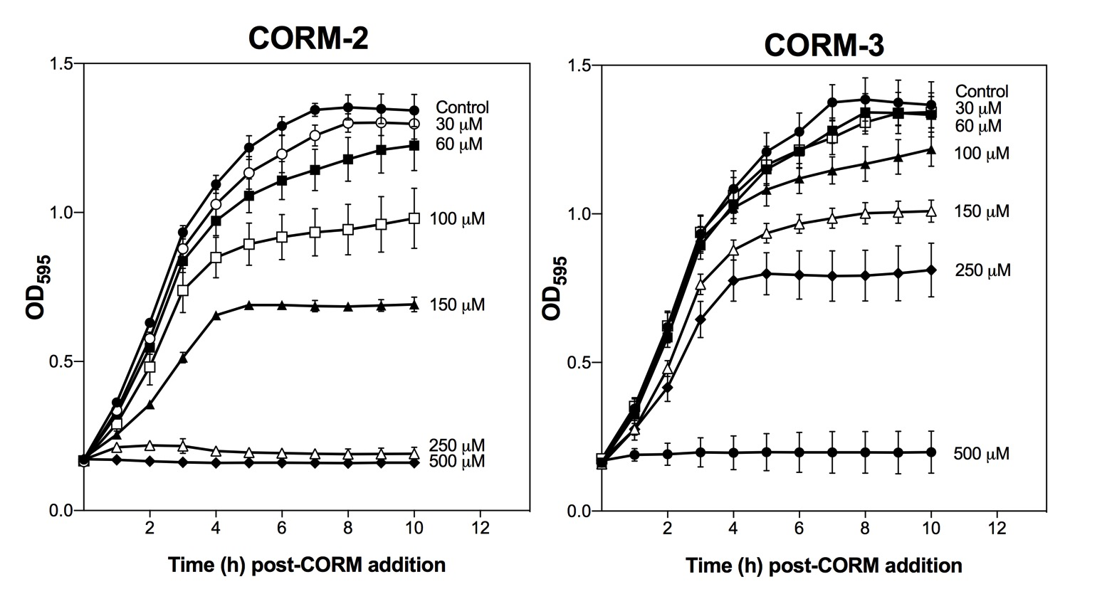
Fig. 4.1. Toxicity of CORM-2 and CORM-3 to Escherichia coli is alleviated by supplementation of growth medium with casamino acids. E. coli MG1655 cultures were grown aerobically in GDMM supplemented with 0.25 % (w/v) casamino acids to early exponential phase (OD₅₉₅ ~ 0.235), at which point, various concentrations of CORM-2 or CORM-3 were added to the culture. Data are representative of three biological replicates ± SD.

significantly alleviates the growth inhibitory effects of both compounds against E. coli MG1655.
4.2.2. Exogenous cysteine, histidine or methionine partially or fully alleviate the antimicrobial activities of CORM-2
After it was established that supplementation of the growth medium with a mixture of amino acids could alleviate the growth inhibitory effects of these compounds (see Section 4.2.1 above), the next step was to determine which specific amino acids were responsible for such effects. To achieve this, a CORM-2 growth inhibition screen against E. coli in GDMM was conducted following the pre-incubation of the compound with a 2-fold excess of each amino acid for 10 min. As shown in Fig 4.2, pre-incubation of CORM-2 with most amino acids had no significant effect on the extent of growth inhibition of 30 μM CORM-2 against E. coli. There were three important exceptions. Pre-incubation of CORM-2 with a 2-fold excess of cysteine (Cys) was sufficient to completely alleviate CORM-2 induced growth inhibition (Fig. 4.2). Likewise, pre-incubation of CORM-2 with a 2-fold excess of histidine (His) caused a significant decrease in the level of CORM-2 induced growth inhibition, but to a lesser extent than Cys (Fig. 4.2). Pre-incubation of CORM-2 with methionine (Met) also partially alleviated the growth inhibitory effects of CORM-2 but to a lesser extent than Cys or His (Fig. 4.2). Thus, it can be concluded that Cys, His and/or Met could be the components of rich medium which are responsible for alleviating CORM-2 antimicrobial activity.
To determine whether these amino acids could also alleviate CORM-2 induced bactericidal effects, viable counts of E. coli cell cultures following the addition CORM-2 pre-incubated with a 2-fold excess of selected amino acids were also measured (Fig. 4.3 (a)). CORM-2 pre-incubated with Cys or His had no significant effect on the viability of E. coli cells relative to control cells up to 4 h after CORM addition (Fig. 4.3 (a)). CORM-2 pre-incubated with Met only slightly decreased the viability of cell cultures relative to that of the controls at 80 min (p ≤ 0.05), but not at 4 h post-CORM addition. In contrast, pre-incubation of CORM-2 with aspartate (Asp) or alanine (Ala) had no effect on the bactericidal activity of CORM-2 (Fig. 4.3 (a)). Thus, pre-incubation of CORM-2 with a 2-fold excess of Cys, His or Met was sufficient to alleviate completely or partially the bactericidal activity of CORM-2 against E. coli cells. The addition of the equivalent concentration of DMSO + 60 μM of each amino acid had no effect on cell culture growth or viability (data not shown).
As the extent of E. coli cell killing by CORM-2 was strongly correlated to the extent of accumulated Ru (Chapter 3), it was hypothesized that the alleviation of the antimicrobial effects of CORM-2 by exogenous Cys, His or Met were due to prevention of intracellular Ru
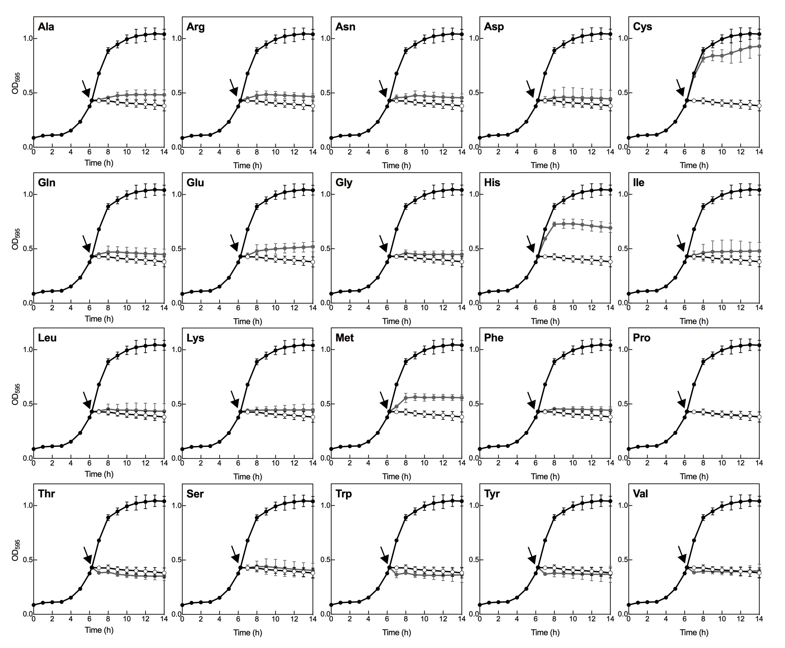

Fig. 4.2. E. coli growth inhibition screen of CORM-2 +/- exogenous amino acids. E. coli MG1655 cell cultures were grown aerobically at 37 °C in GDMM in 96-well plates until mid-exponential phase (OD₅₉₅ = 0.4-0.45) and then 30 μM CORM-2 alone (black line, open circles) or CORM-2 that had been pre-incubated for 10 min with a 2-fold excess of amino acid (grey line/symbols) was added to the cultures (indicated by the arrows). Culture growth without reagent is shown for comparison (black line, closed circles). Control growths with DMSO (vehicle) +/- 60 μM amino acid had no deleterious effects on growth and so are omitted for clarity. Growth was monitored in a Tecan SunriseTM Platereader by measuring absorbance of the cultures at 595 nm. Data shown are the means of three technical and three biological repeats. Errors bars represent ± SD.

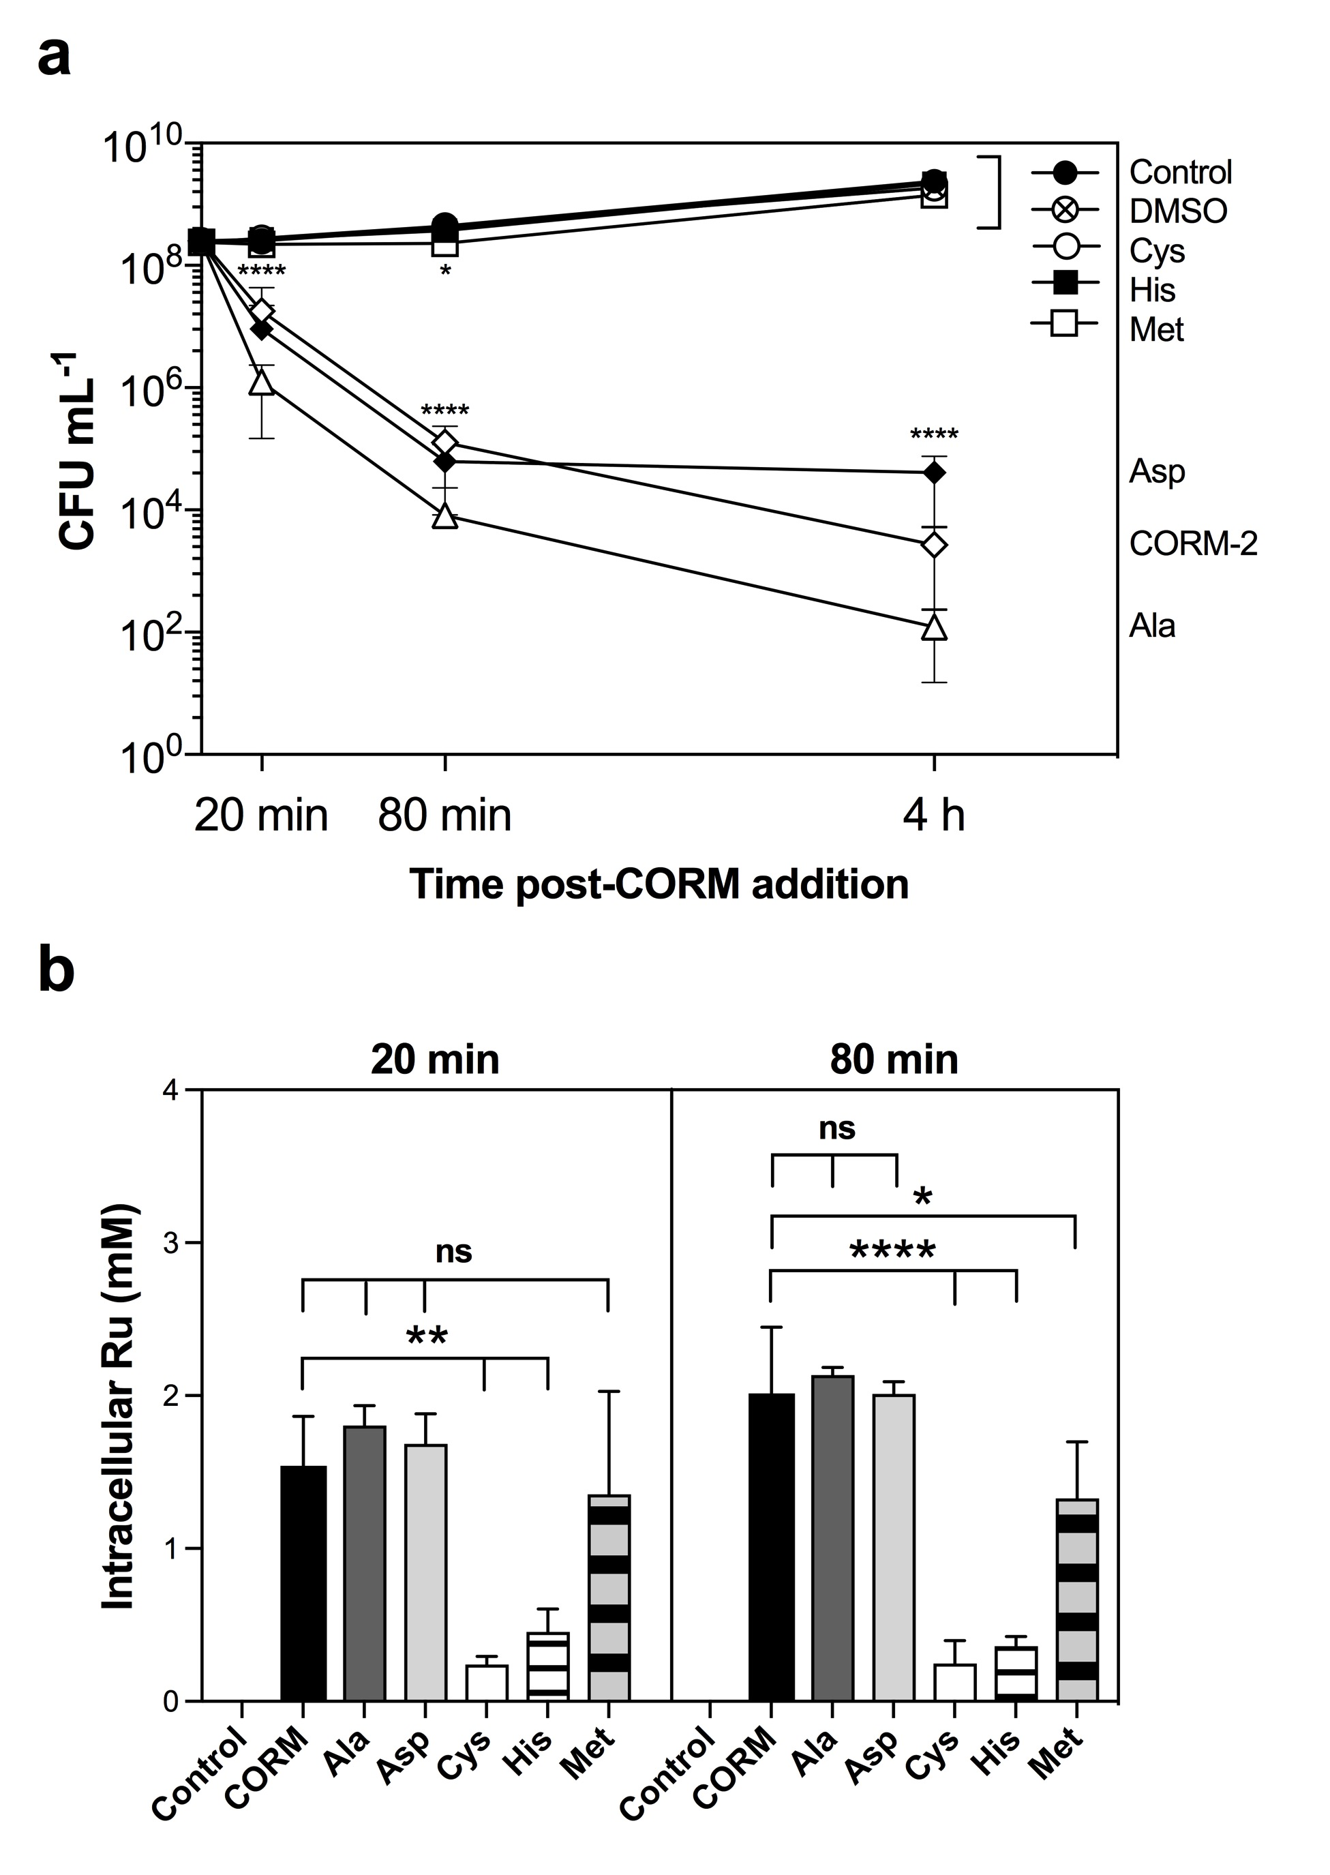

Fig. 4.3. The effects of exogenous amino acids on CORM-2-induced bacterial cell death and intracellular Ru accumulation. E. coli MG1655 cell cultures were grown aerobically at 37 °C in GDMM until early exponential phase (OD_{600nm} ~ 0.4) and then 30 μM CORM-2 alone or 30 μM CORM-2 that had been pre-incubated for 10 min with a 2-fold excess of amino acid (Ala, Asp, Cys, His or Met) were added to cell cultures (t = 0). Samples for viable counts (a) and for determination of intracellular Ru content (b) were taken at time intervals thereafter. Cultures with no reagent added (control) or with the equivalent level of DMSO were included as controls. (a) 30 μM CORM-2 alone or pre-incubated with a 2-fold excess of Ala or Asp caused a significant decrease in culture viability at 20 min, 80 min and 4 h after the addition of the compound relative to control or DMSO-treated cells (**** p ≤ 0.0001). Addition of CORM-2 pre-incubated with a 2-fold excess of Cys or His had no significant effect on viability of the cultures. Addition of CORM-2 pre-incubated with a 2-fold excess of Met slightly decreased culture viability relative to control cells at 20 min (* p ≤ 0.05) but not at 80 min or 4 h post-CORM addition. (b) the level of intracellular Ru accumulation following exposure to CORM-2 was significantly decreased following pre-incubation of the compound with a 2-fold excess of Cys or His at 20 min (** p ≤ 0.01) and 80 min (**** p ≤ 0.0001). The level of intracellular Ru accumulation following exposure to CORM-2 that had been pre-incubated with a 2-fold excess of Met was significantly decreased at 80 min post-CORM addition (* p ≤ 0.05) but not at 20 min. Pre-incubation of CORM-2 with a 2-fold excess of Asp or Ala had no significant effect on the accumulation of CORM-derived Ru. Data are representative of 3 biological repeats ± SD. Significant differences were assessed via a one-way ANOVA and Tukey’s multiple comparisons text.

accumulation. To investigate this hypothesis, the Ru content of E. coli cell cultures exposed to 30 μM CORM-2 +/- a 2-fold excess of Ala, Asp, Cys, His or Met was determined by ICP-AES at 20 and 80 min following addition of the compounds (Fig. 4.3 (b)). The level of Ru accumulation by E. coli following exposure to 30 μM CORM-2 alone was ~ 1.5 mM at 20 min and ~ 2 mM at 80 min (Fig. 4.3 (b)), consistent with earlier findings (Chapter 3). Pre-incubation of the CORM with a 2-fold excess of Asp or Ala did not prevent accumulation of Ru by E. coli, with intracellular concentrations reaching 1.7 – 1.8 mM at 20 min and 2.0 – 2.1 mM at 80 min (Fig. 4.3 (b)). In contrast, pre-incubation of CORM-2 with a 2-fold excess of Cys led to a 10-fold reduction of CORM-derived Ru at 20 and 80 min, reaching only a total of ~ 242 – 249 μM intracellular Ru accumulation after 80 min (Fig. 4.3 (b)). Likewise, pre-incubation of CORM-2 with a 2-fold excess of His significantly reduced CORM-2 derived Ru accumulation to 363 – 456 μM intracellular Ru (Fig. 4.3 (b)). Therefore the alleviation of CORM-2 growth inhibitory and bactericidal effects by Cys and His is due to a reduction in the extent of intracellular Ru accumulation from CORM-2.
Interestingly, the level of intracellular Ru accumulation by E. coli cells following exposure CORM-2 + Met was ~ 1.3 mM Ru at 20 min, which was not significantly different from the level of Ru accumulated upon exposure to CORM-2 alone (~ 1.5 mM) (Fig. 4.3 (b)). At 80 min, the level of accumulated Ru by E. coli cells exposed to CORM-2 + Met remained at 1.3 mM, thus was only slightly reduced relative to CORM-2 alone (~ 2 mM, p ≤ 0.05). Therefore the partial alleviation of CORM-2 growth inhibitory and bactericidal effects by exogenous Met is not readily explained by prevention of intracellular Ru accumulation. The implications of this finding are discussed later.
4.2.3. Exogenous cysteine, histidine or methionine partially or fully alleviate the antimicrobial activities of CORM-3
As the antimicrobial activities of CORM-2 and CORM-3 were similarly affected by the supplementation of GDMM with casamino acids, the next step was to determine if specific amino acids were also responsible for alleviating CORM-3 antimicrobial effects. As with CORM-2, a CORM-3 growth inhibition screen against E. coli in GDMM was conducted following the pre-incubation of the CORM with a 2-fold excess of each amino acid for 10 min. Pre-incubation of CORM-3 with a 2-fold excess of Cys, His or Met were sufficient to completely or partially alleviate the growth inhibitory effects of 60 μM CORM-3 (Fig. 4.4.) As with CORM-2, the effectiveness of each these amino acids on the alleviation of CORM-3 induced growth inhibition was Cys > His > Met (Fig. 4.4). Pre-incubation of CORM-3 with other amino acids had no effect on E. coli growth inhibition by 60 μM CORM-3.
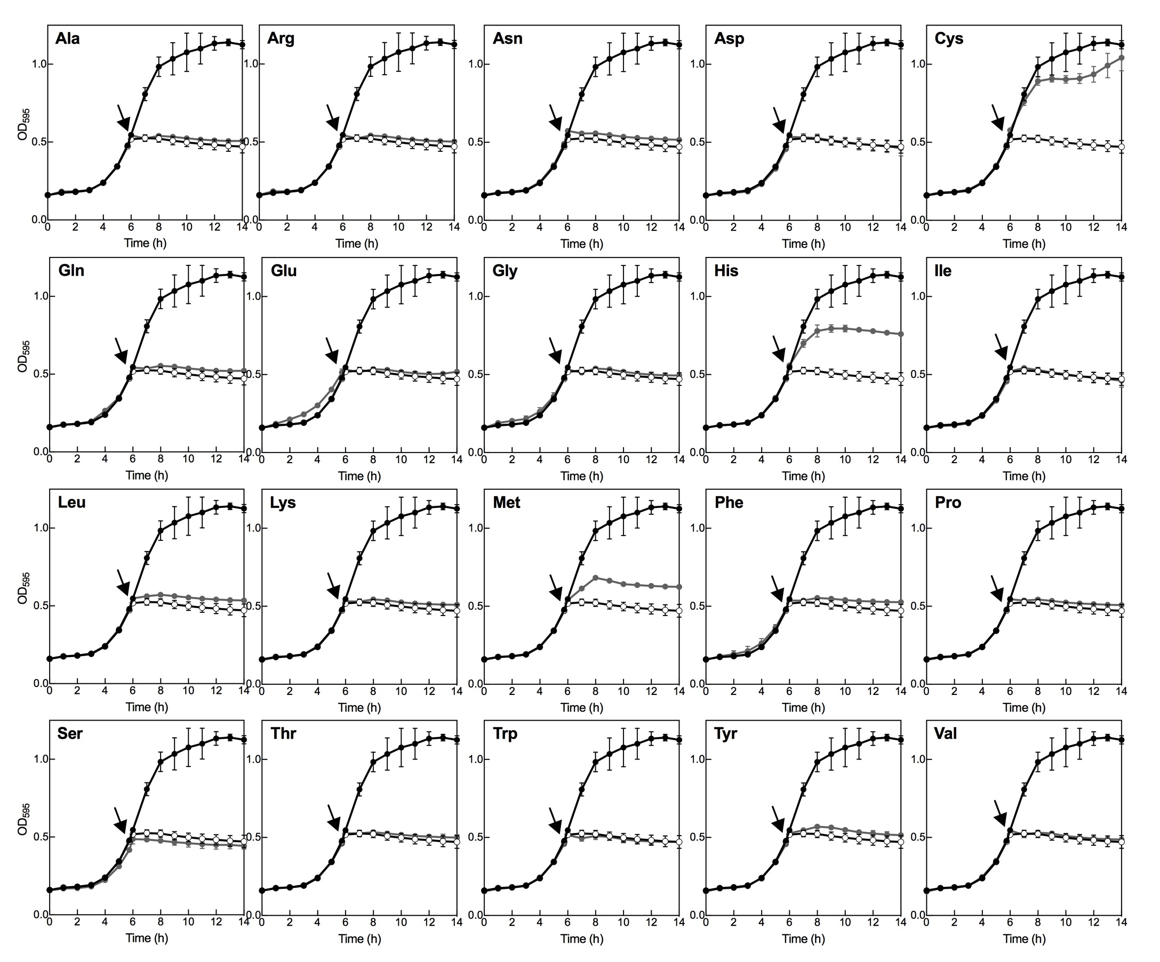

Fig. 4.4. E. coli growth inhibition screen of CORM-3 +/- exogenous amino acids. E. coli MG1655 cell cultures were grown aerobically at 37 °C in GDMM in 96-well plates until mid-exponential phase (OD_{595nm} = 0.4-0.45) and then 60 μM CORM-3 alone (black line, open circles) or CORM-3 that had been pre-incubated for 10 min with a 2-fold excess of amino acid (grey line/symbols) were added to the cultures (indicated by the arrows). Culture growth without reagent is shown for comparison (black line, closed circles). Control growths with 120 μM amino acids had no deleterious effects on growth and so are omitted for clarity. Growth was monitored in a Tecan SunriseTM Platereader by measuring absorbance of the cultures at 595 nm. Data shown are the means of three technical and three biological repeats. Errors bars represent ± SD.

To determine whether His, Cys and Met could also partially or fully alleviate CORM-3-induced bactericidal effects, the viability of E. coli cells upon exposure to CORM-3 + amino acids was also measured (Fig. 4.5 (a)). CORM-3 pre-incubated with Cys or His had no significant effect on the viability of E. coli cells relative to the control up to 4 h after addition of the compounds (Fig. 4.5 (a)). In contrast, pre-incubation of CORM-3 with Asp or Ala caused the same extent of bacterial cell killing as CORM-3 alone (Fig. 4.5 (a)). CORM-3 pre-incubated with Met also significantly decreased the viability of cell cultures relative to that of untreated control cells but not to the same extent as CORM-3 alone (Fig. 4.5 (a)). Thus, pre-incubation of CORM-3 with Cys or His was sufficient to completely alleviate the bactericidal activity of CORM-3 against E. coli cells, but pre-incubation with Met only partially alleviated CORM-3 antimicrobial effects. The addition of 120 μM of each amino acid had no effect on cell culture growth or viability (data not shown).
To investigate whether the alleviation of CORM-3 antimicrobial activity by exogenous Cys, His or Met was due to prevention of Ru accumulation by E. coli, the Ru content of E. coli exposed CORM-3 + amino acids were determined by ICP-AES (Fig. 4.5 (b)). The level of CORM-derived Ru by E. coli following exposure to 60 μM CORM-3 alone was ~ 1.1 mM at 20 min and ~ 2.1 mM at 80 min (Fig. 4.5 (b)). Pre-incubation of the CORM with a 2-fold excess of Asp or Ala did not prevent accumulation of Ru by E. coli, with intracellular concentrations reaching 1.1 – 1.2 mM at 20 min and 2.3 – 2.6 mM at 80 min (Fig. 4.5(b)). In contrast, pre-incubation of CORM-3 with a 2-fold excess of Cys or His led to a dramatic reduction in the total level of Ru accumulation by E. coli to 32 μM for (CORM-3 + Cys) and 298 μM for (CORM-3 + His), respectively (Fig. 4.5 (b)). Thus, the alleviation of CORM-3 antimicrobial effects by exogenous Cys or His is due to a reduction in the extent of intracellular Ru accumulation by E. coli.
Pre-incubation of CORM-3 with a 2-fold excess of Met significantly lowered the level of intracellular Ru accumulation at 20 min (~ 705 μM) compared with exposure to CORM-3 alone (1.5 mM) (Fig. 4.5 (b). However, at 80 min there was no significant difference between the extent of Ru accumulation upon exposure to (CORM-3 + Met) (2.04 mM) compared to CORM-3 alone (2.1 mM). Therefore, it can be concluded that the partial protection of a 2-fold excess of exogenous Met against CORM-3 antimicrobial effects were due to a partial reduction in the rate at which Ru was accumulated by E. coli cells. This will be discussed later.
4.2.4. Relative binding affinities of CORM-2 to selected amino acid residues by ¹H-NMR
The above results thus implied that CORM-2 and CORM-3 were able to interact with Cys, His and Met in vitro and, to various extents, these interactions caused alleviation of CORM
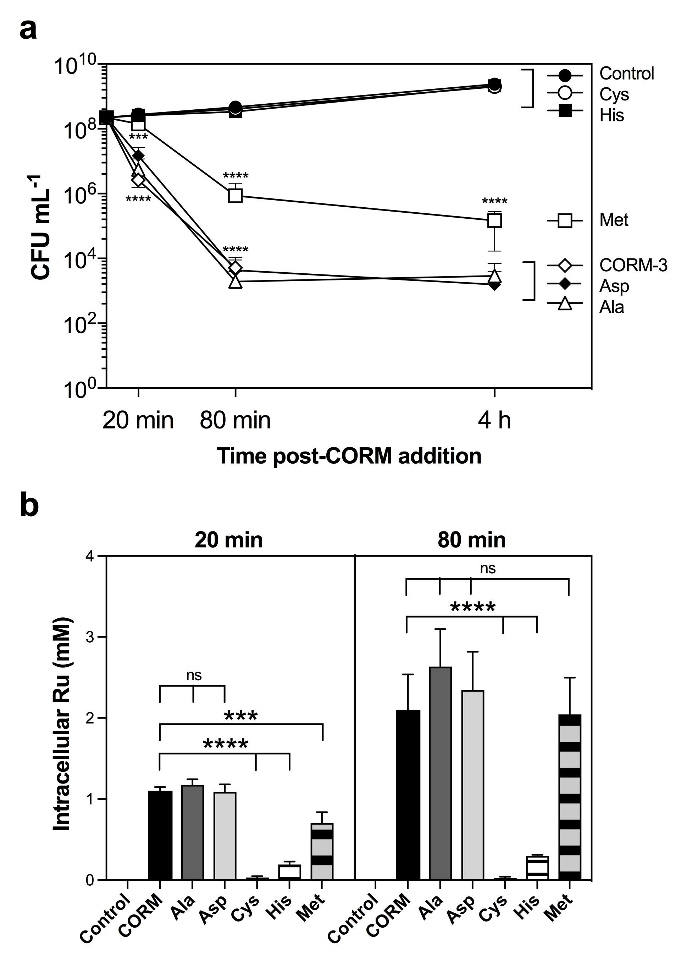
Fig. 4.5. The effects of exogenous amino acids on CORM-3-induced bacterial cell death and intracellular Ru accumulation. E. coli MG1655 cell cultures were grown aerobically at 37 °C in GDMM until early exponential phase (OD_{600nm} ~ 0.4) and then 60 μM CORM-3 alone or 60 μM CORM-3 that had been pre-incubated for 10 min with a 2-fold excess of amino acid (Ala, Asp, Cys, His or Met) were added to cell cultures (t = 0). Samples for viable counts (a) and for determination of intracellular Ru content (b) were taken at time intervals thereafter. A culture to which no CORM was added was included as a control. (a) 60 μM CORM-3 alone or pre-incubated with a 2-fold excess of Ala, Asp or Met caused a significant decrease in culture viability at 20 min, 80 min and 4 h after the addition of the compound relative to control cells (**** p ≤ 0.0001, *** p ≤ 0.001). Addition of CORM-3 pre-incubated with a 2-fold excess of Cys or His had no significant effect on viability of the cultures. (b) the level of intracellular Ru accumulation following exposure to CORM-3 was significantly decreased following pre-incubation of the compound with a 2-fold excess of Cys or His at 20 min and 80 min (**** p ≤ 0.0001). The level of intracellular Ru accumulation following exposure to CORM-2 pre-incubated with a 2-fold excess of Met was significantly decreased at 20 min post-CORM addition (*** p ≤ 0.001) but not at 80 min. Pre-incubation of CORM-3 with a 2-fold excess of Asp or Ala had no significant effect on the accumulation of CORM-derived Ru. Data are representative of 3 biological repeats ± SD.

induced antimicrobial affects via prevention of Ru accumulation by bacterial cells. The next step was therefore to investigate the nature of CORM-2 and CORM-3 binding to these amino acids and thus help to elucidate whether these amino acids were also likely bacterial cell targets of CORM-derived Ru.
Synthetic peptides were designed and synthesised (A₃XA₃), composed of 6 Ala residues (A) with a central amino acid of interest ‘X’, where X = Ala, Asp (D), Cys (C), His (H) or Met (M). Ala was selected as the main structural component of these peptides as the Ala R-group methyl is not known to interact with other metal cations. The ends of these peptides were modified by N-terminal acetylation and C-terminal amidation to stabilise the peptides by removing the charges from the end termini and thus preventing end-terminal interactions with the CORMs. Interactions of the peptides with CORM-2 were investigated by ¹H-NMR.
Peptides were solubilised in 30 mM KPi buffer at neutral pH to model binding in physiological conditions and then titrated with increasing amounts of CORM-2. The extent of binding (represented by the dissociation constant, K_{d}) of each central amino acid residue to CORM-2 was estimated by the changes in intensities of the peaks in the ¹H-NMR spectra corresponding to protons in the side chain of the residue upon addition of CORM-2. If the CORM interacts with the residue’s R-group, the chemical environment of the protons in that side chain would be altered and as a result, the intensity and position of the peaks would change (Williamson, 2013). Thus, the relative binding affinities (K_{d}) were calculated by the extent of changes to these proton peaks as function of the amount of CORM-2 added as described in Methods 2.4 (Williamson, 2013).
a. Cysteine (A₃CA₃)
Upon titration of A₃CA₃ with CORM-2, the Cys Hβ signals on the ¹H-NMR spectrum decreased in intensity as shown in Fig 4.6 (a). The level of ‘free’ (i.e. unbound) Cys decreased almost linearly with the equivalent concentration of CORM-2 added (Fig. 4.6(b)). The affinity of CORM-2 to Cys was too high to accurately calculate the dissociation constant (K_{d}), but test calculations showed that the K_{d} was greater than 1 μM and less than 0.1 μM, with a best estimate of 0.3 ± 0.3 μM. Significantly, the saturation curve of free Cys with the equivalent concentration of CORM-2 tends to zero upon the addition of 1.0 equivalents CORM-2. Therefore, only one Ru(II) ion per CORM-2 molecule interacts with the thiol of Cys with high affinity. Titration of A₃CA₃ with the equivalent level of solvent (10% d₆-DMSO/90% D₂O) did not cause a decrease in the intensity of Cys Hβ proton peaks (Fig. 4.6(a)).
b. Histidine (A₃HA₃)
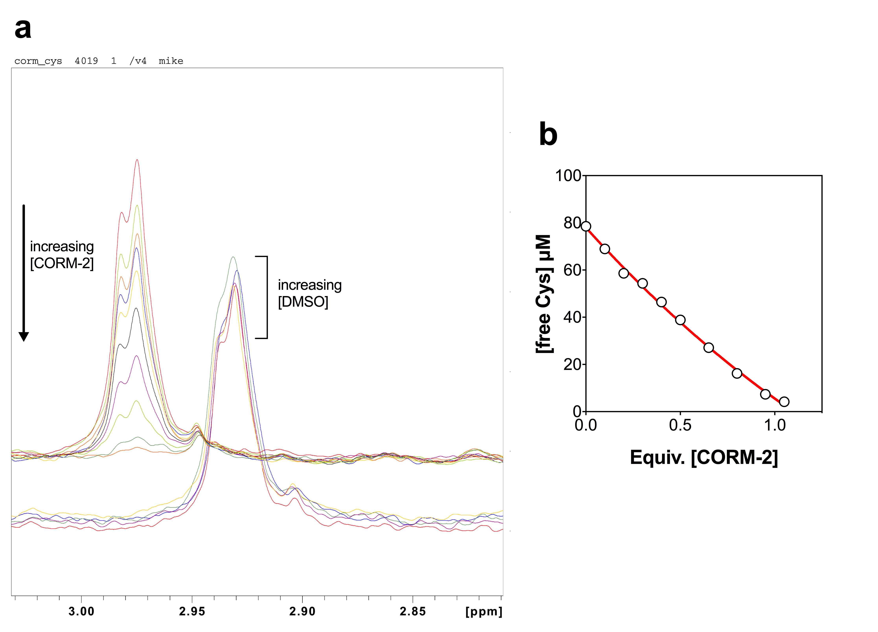

Fig. 4.6. Binding affinity of CORM-2 to cysteine as determined by ¹H-NMR. (a) Cys Hβ region of the ¹H-NMR spectrum of 78.5 μM A₃CA₃ peptide titrated with CORM-2 (upper set of signals) or the corresponding level of solvent (lower set of signals) in 30 mM KPi pH 7.7. A₃CA₃ was titrated with (from top to bottom) 0, 0.1, 0.2, 0.3, 0.4, 0.5, 0.65, 0.8, 0.95 and 1.05 equivalents CORM-2. CORM-2 was prepared as a stock solution of 10 % d₆-DMSO/90 % D₂O. The signals for Cys Hβ decreased as more CORM-2 was added as the Ru(II) of CORM-2 bound increasingly to SH of Cys. Titration of A₃CA₃ with the solvent, (10 % d₆-DMSO/90 % D₂O), corresponding to 0, 0.3, 0.5, 0.8 and 1.05 equivalents CORM-2 (lower set of signals) did not cause a reduction in the intensity of the Cys Hβ signals relative to TSP. The pH was adjusted to ~ 7.7 throughout the titrations. (b) Concentration of unbound Cys determined by the intensity of Cys Hβ of A₃CA₃ compared to the TSP standard (100 μM) as a function of equivalent level of CORM-2 added. The fitted curve (red) is approximately the best fit and corresponds to a K_{d} of 0.3 ± 0.3 μM, assuming that only 1 Ru(II) ion of CORM-2 is able to bind Cys.
Work done in collaboration with Prof. Mike Williamson.

Upon titration of A₃HA₃ with CORM-2, there was a loss in intensity of the signals corresponding to His ring and Hβ protons in the A₃HA₃ ¹H-NMR spectrum (Fig. 4.7 (a)). As the ring proton signals were sharper and more isolated, these signals were more useful than the Hβ signal for investigating the reaction of CORM-2 with His. In parallel with the loss in intensity of the His ring proton peaks there was an increase in the occurrence of new aromatic proton signals which represent His bound to the Ru(II) of CORM-2 (Fig. 4.7 (a)). As only one Ru(II) ion from CORM-2 was shown to bind Cys, it was assumed that only one Ru(II) ion per CORM-2 would bind to the imidazole of the His residue. The decrease in the level of free His upon increasing CORM-2 concentrations was determined by the average loss in intensities of the signals from the two His ring protons as shown in Fig 4.7. Fitting the saturation curve of the reduction in free His as a function of the equivalent [CORM-2] added gave an estimated K_{d} of 130 ± 25 μM (Fig. 4.7(b)). Thus, the binding of CORM-2 to His was much weaker than Cys but still significant. It is worth noting that the free-His and bound-His signals in the ¹H-NMR spectrum (Fig 4.7(a)) were in slow exchange, despite a very small chemical shift between them. This indicates that the off-rate for the bound complex is very slow, which likely indicates the formation of a covalent bound between the Ru(II) ion of CORM-2 and the imidazole side chain of His (Williamson, 2013). Titration of A₃HA₃ with the equivalent level of solvent (10 % d₆-DMSO/90 % D₂O) did not cause a decrease in the intensities of the His side chain protons (data not shown).
c. Methionine (A₃MA₃)
The titration of A₃MA₃ with CORM-2 showed a more gradual decrease in the intensity of the Met Hε proton signals in the ¹H-NMR spectrum upon increasing CORM-2 concentrations (Fig. 4.8 (a)). Along with a decrease in intensity, there was a noticeable line-broadening effect and whole spectrum shifts upon increasing titrations with CORM-2 (Fig. 4.8(a)). Titration of A₃MA₃ with the equivalent level of solvent (10 % d₆-DMSO/90 % D₂O) indicated that the spectral shifting was due to DMSO addition; however the intensity and broadness of the Met Hε proton signals were not observed with DMSO alone (Fig. 4.8(a)). Fitting of the saturation curve gave an estimated K_{d} of 2850 μM, though there is likely to be significant error due to the weakness in binding. Interestingly, there were no new distinct signals corresponding to CORM-bound Met observed in the ¹H-NMR spectrum. This implies that the proton signals for free and bound Met are in fast or immediate exchange (Williamson, 2013). The noticeable line-broadening in the spectrum is also typical of immediate exchange, suggesting an exchange rate between CORM-bound and free Met that is significantly faster than for His or Cys-bound complexes (Williamson, 2013). Thus, CORM-2 binding to Met is considerably weaker than observed for His or Cys, and unlikely involves the formation of a covalent bond between the R-group of Met and the Ru(II) ion of CORM-2.

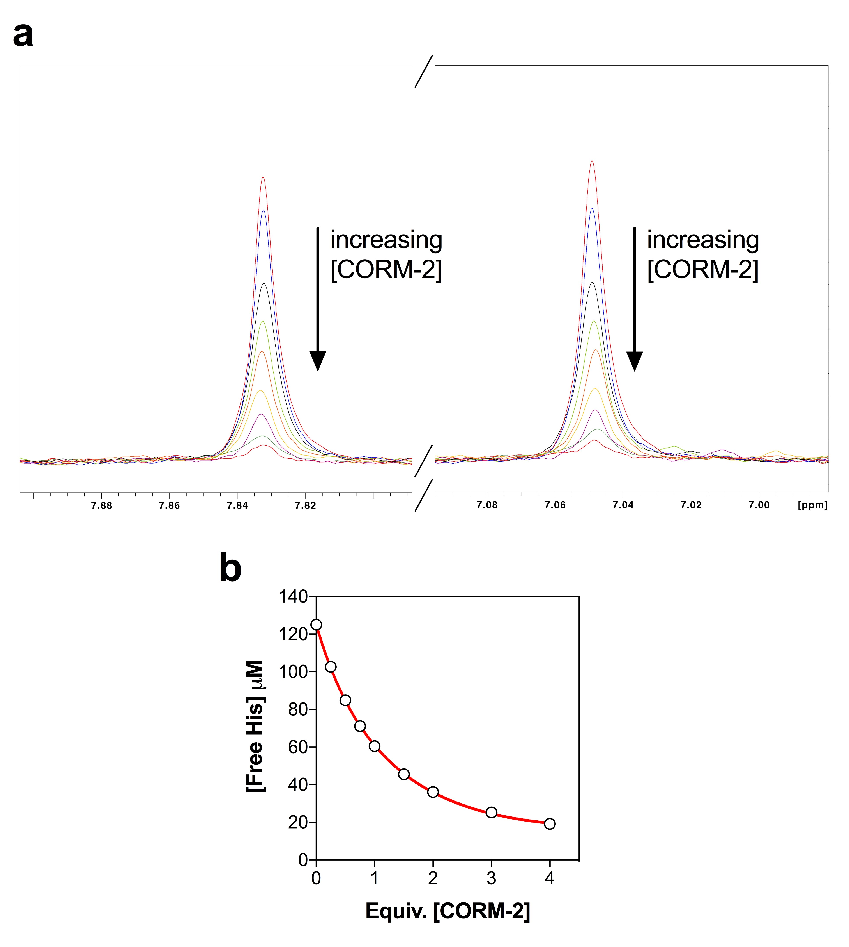
Fig. 4.7. Binding affinity of CORM-2 to histidine as determined by ¹H-NMR. (a) His aromatic ring protons region of the ¹H-NMR spectrum of 125 μM A₃HA₃ peptide titrated with CORM-2 in 30 mM KPi, pH 7.3 – 7.7. A₃HA₃ was titrated with (from top to bottom) 0, 0.25, 0.5, 0.75, 1.0, 1.5, 2.0, 3.0 and 4.0 equivalents CORM-2. CORM-2 was prepared as a stock solution of 10 % d₆-DMSO/90 % D₂O. The signals for His ring protons decreased as more CORM-2 was added indicating that a Ru(II) ion of CORM-2 was binding the imidazole of His. Titration of A₃HA₃ with the solvent, (10 % d₆-DMSO/90 % D₂O), corresponding to 0, 0.25, 0.5, 0.75, 1.0, 1.5, 2.0, 3.0 and 4.0 equivalents CORM-2 did not cause a reduction in the intensity of the His ring proton signals relative to TSP (data not shown). The pH was maintained at ~ 7.3-7.7 throughout the titrations. (b) Concentration of unbound His determined by the average intensity of His ring protons of A₃HA₃ compared to the TSP standard (100 μM) as a function of the equivalent CORM-2 added. The fitted curve (red) is approximately the best fit and corresponds to a K_{d} of 130 ± 25 μM.
Work done in collaboration with Prof. Mike Williamson.

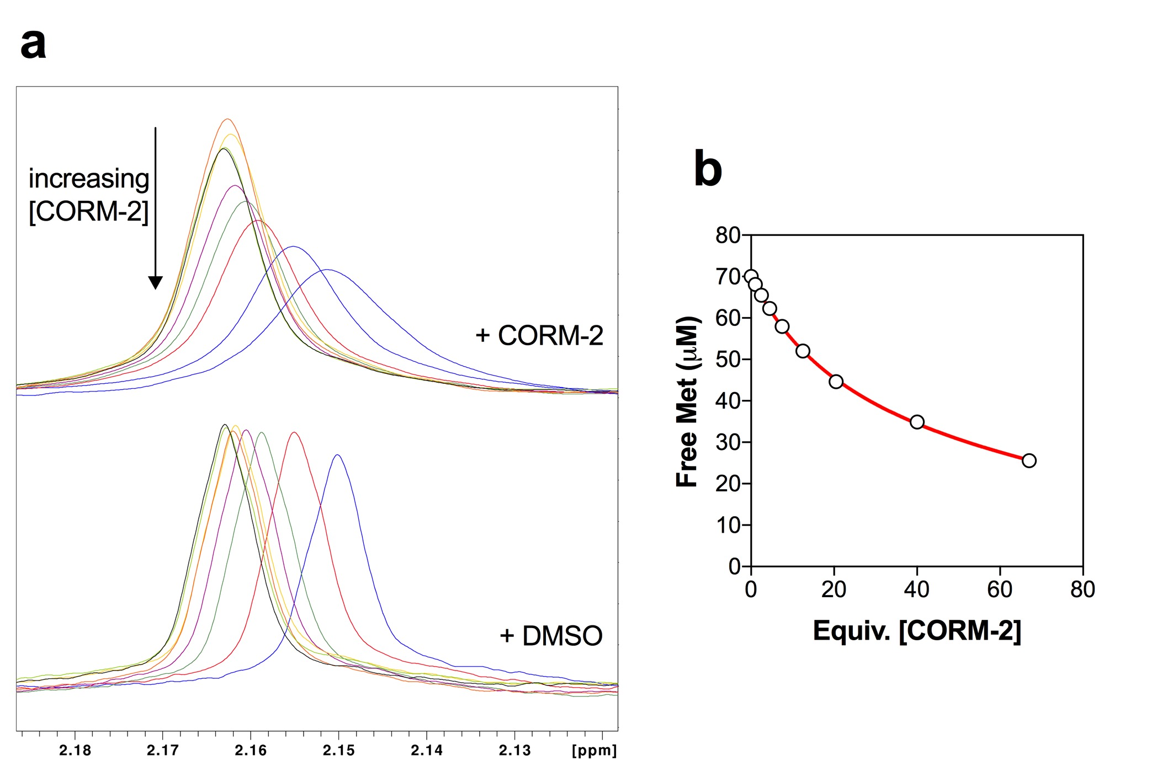

Fig. 4.8. Binding affinity of CORM-2 to methionine as determined by ¹H-NMR. (a) Met Hε region of the ¹H-NMR spectrum of 70 μM A₃MA₃ peptide titrated with CORM-2 (upper set of signals) or the corresponding level of solvent (lower set of signals) in 30 mM KPi pH 7.4 – 7.5. A₃MA₃ was titrated with (from top to bottom) 0, 1, 2.5, 4.5, 7.5, 12.5, 20.5, 40 and 67 equivalents CORM-2. CORM-2 was prepared as a stock solution of 10 % d₆-DMSO/90 % D₂O. The signal intensity for Met Hε protons decreased as more CORM-2 was added indicating that a Ru(II) ion of CORM-2 was binding the R group of Met. Loss of intensity of these signals was not accompanied by any additional signals for Met bound to CORM, indicating signals for bound and free Met are in fast or immediate exchange. Lower set of signals shown A₃MA₃ titrated with the equivalent level of 10 % d₆-DMSO/90 % D₂O. The chemical shifts induced by 10 % d₆-DMSO/90 % D₂O indicate that some of the chemical shifts that occurred upon addition of CORM-2 (upper set of signals) were caused by dilution with the solvent. The intensity of the Met Hε signals however was unchanged by titrations with DMSO. (b) Concentration of unbound Met determined by the intensity of Met Hε protons of A₃MA₃ compared to the TSP standard (100 μM) as a function of the equivalent CORM-2 added. The fitted curve (red) is approximately the best fit and corresponds to a K_{d} of 2850 μM.
Work done in collaboration with Prof. Mike Williamson.

d. Aspartate (A₃DA₃) and Alanine (A₇)
The binding of CORM-2 to Asp was also investigated by titration of A₃DA₃ with CORM-2 (Fig. 4.9(a)). Titration with CORM-2 gave rise to some chemical shift changes but these were found to be identical to those caused by titration of A₃DA₃ with the equivalent level of DMSO alone (Fig. 4.9(a)). Titration of A₃DA₃ with up to 8 equivalents CORM-2 produced no decrease in the intensity of the Asp Hβ proton signals and thus the binding of Asp to CORM-2 was undetectable by NMR at pH 7.4. To ensure that CORM-2 did not bind to Ala, a set of control titrations of A₇ with CORM-2 was also conducted (Fig. 4.9(b)). The signals for the Ala methyl Hβ protons are weak due to the low solubility of the peptide in KPi buffer. Titration of A₇ with up to 80 equivalents CORM-2 did not cause a decrease in intensity of the Ala methyl Hβ proton signal and any chemical shifts observed were also found following titration of A₇ with the equivalent level of solvent alone (Fig. 4.9(b)). In addition, there were no observable changes to the intensity of the Ala methyl Hβ proton peaks in the ¹H-NMR spectra of titrations of A₃CA₃, A₃HA₃, A₃MA₃ or A₃DA₃ with CORM-2 (data not shown). Thus, CORM-2 does not bind Asp or Ala in vitro at neutral pH.
4.2.5. Relative binding affinities of CORM-3 to selected amino acid residues by ¹H-NMR
In order to determine the relative binding affinities of selected amino acid residues to CORM-3, the same ¹H-NMR CORM-peptide binding study was subsequently conducted with CORM-3, as described above for CORM-2. CORM-3 was prepared as a stock solution in 30 mM KPi buffer, adjusted to neutral pH prior to titrations with the synthetic peptides. As with CORM-2, the relative binding affinities (expressed as K_{d}) of CORM-3 to each amino acid were calculated by the extent of changes to the intensities of spectrum peaks corresponding to the residue’s R-group protons as a function of the concentration of CORM added. For accuracy, CORM-3 concentration was determined by ¹H-NMR by quantification of the glycinate proton signals relative to a TSP standard (see Methods 2.4 for further details). As with CORM-2, the relative binding affinities (K_{d}) of CORM-3 to each peptide were calculated by the extent of changes to these proton peaks as function of the amount of CORM-3 added, as described in Methods 2.4 (Williamson, 2013).
a. Cysteine (A₃CA₃)
Upon titration of A₃CA₃ with CORM-3, the Cys Hβ proton signals in the ¹H-NMR spectrum decreased in intensity as shown in Fig. 4.10(a). As with CORM-2, the decrease in the level of free Cys was linear with the equivalent concentration of CORM-3 added (Fig. 4.10 (b)).

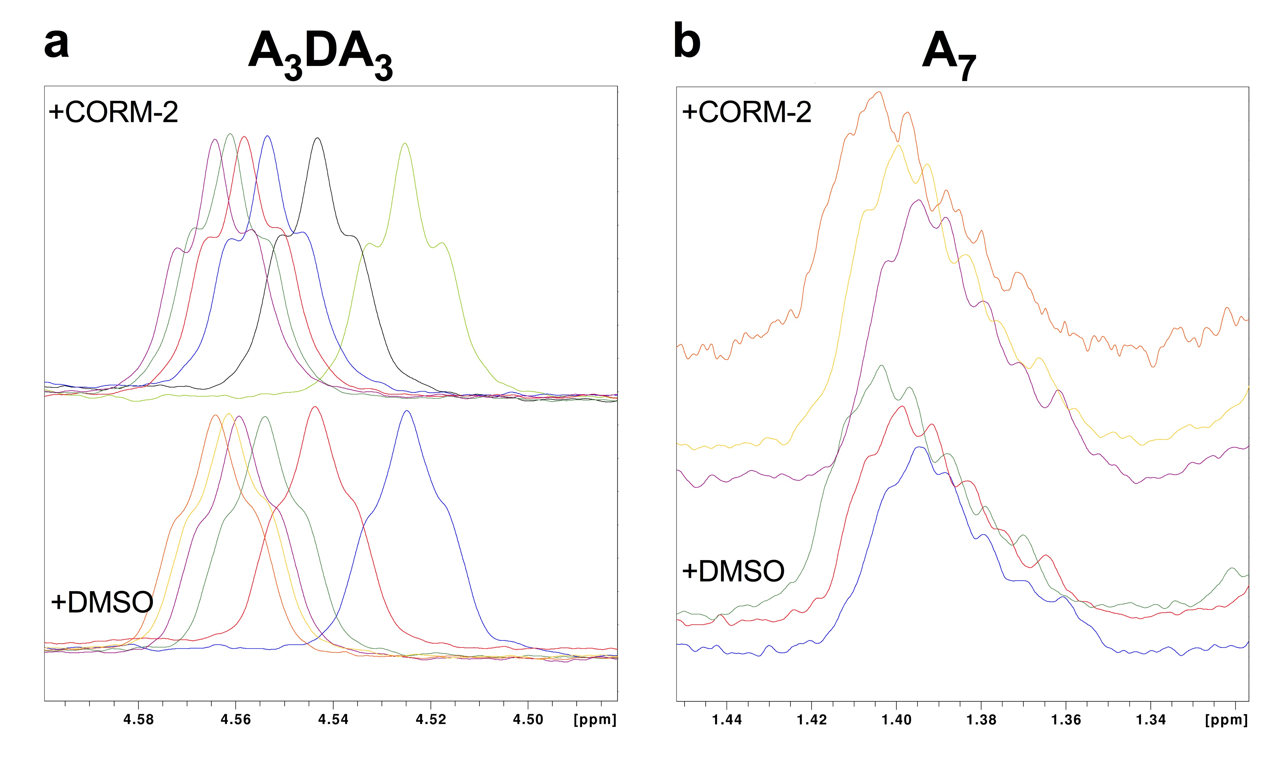

Fig. 4.9. Titrations of A₃DA₃ and A₇ peptides with CORM-2/DMSO by ¹H-NMR. (a) Asp Hβ region of the ¹H-NMR spectrum of 125 μM A₃DA₃ peptide titrated with CORM-2 (upper set of signals) or the corresponding level of solvent, 10 % d₆-DMSO/90 % D₂O (lower set of signals) at pH 7.2 – 7.5. A₃DA₃ was titrated with 0, 0.25, 0.5, 1, 2, 4 and 8 equivalents CORM-2. CORM-2 was prepared as a stock solution of 10 % d₆-DMSO/90 % D₂O. Titration of A₃DA₃ with CORM-2 induced changes to the chemical shift of the whole spectrum, including the signals for Asp Hβ, but the intensity of the Asp Hβ peak was unchanged. Lower set of signals shown A₃DA₃ titrated with the equivalent level of 10 % d₆-DMSO/90 % D₂O. The chemical shifts induced by the solvent indicate that the chemical shifts are caused by DMSO and not CORM-2. Thus, binding of CORM-2 to A₃DA₃ was undetectable by ¹H-NMR up to 8 equivalents CORM-2. (b) Ala methyl Hβ region of the ¹H-NMR spectrum of 3.2 μM A₇ peptide titrated with CORM-2 (upper set of signals) or the corresponding level of solvent, 10% d₆-DMSO/90% D₂O (lower set of signals) at pH 7.6 – 7.8. Due to the low solubility of the peptide, the starting solution also contained 3.3 % (v/v) d₆-DMSO. Titration of A₇ with 1, 2.5, 5, 10, 20, 40 and 80 equivalents did not decrease the intensity of the Ala Hβ signal relative to the TSP standard. Any shifts chemical shifts to the spectra were observed also following titration of A₇ peptide with the solvent alone (lower set of signals). For clarity, only 20, 40 and 80 titrations of CORM-2 or solvent are shown. Thus, binding of CORM-2 to A₇ was undetectable by ¹H-NMR up to 80 equivalents CORM-2
Work done in collaboration with Prof. Mike Williamson.

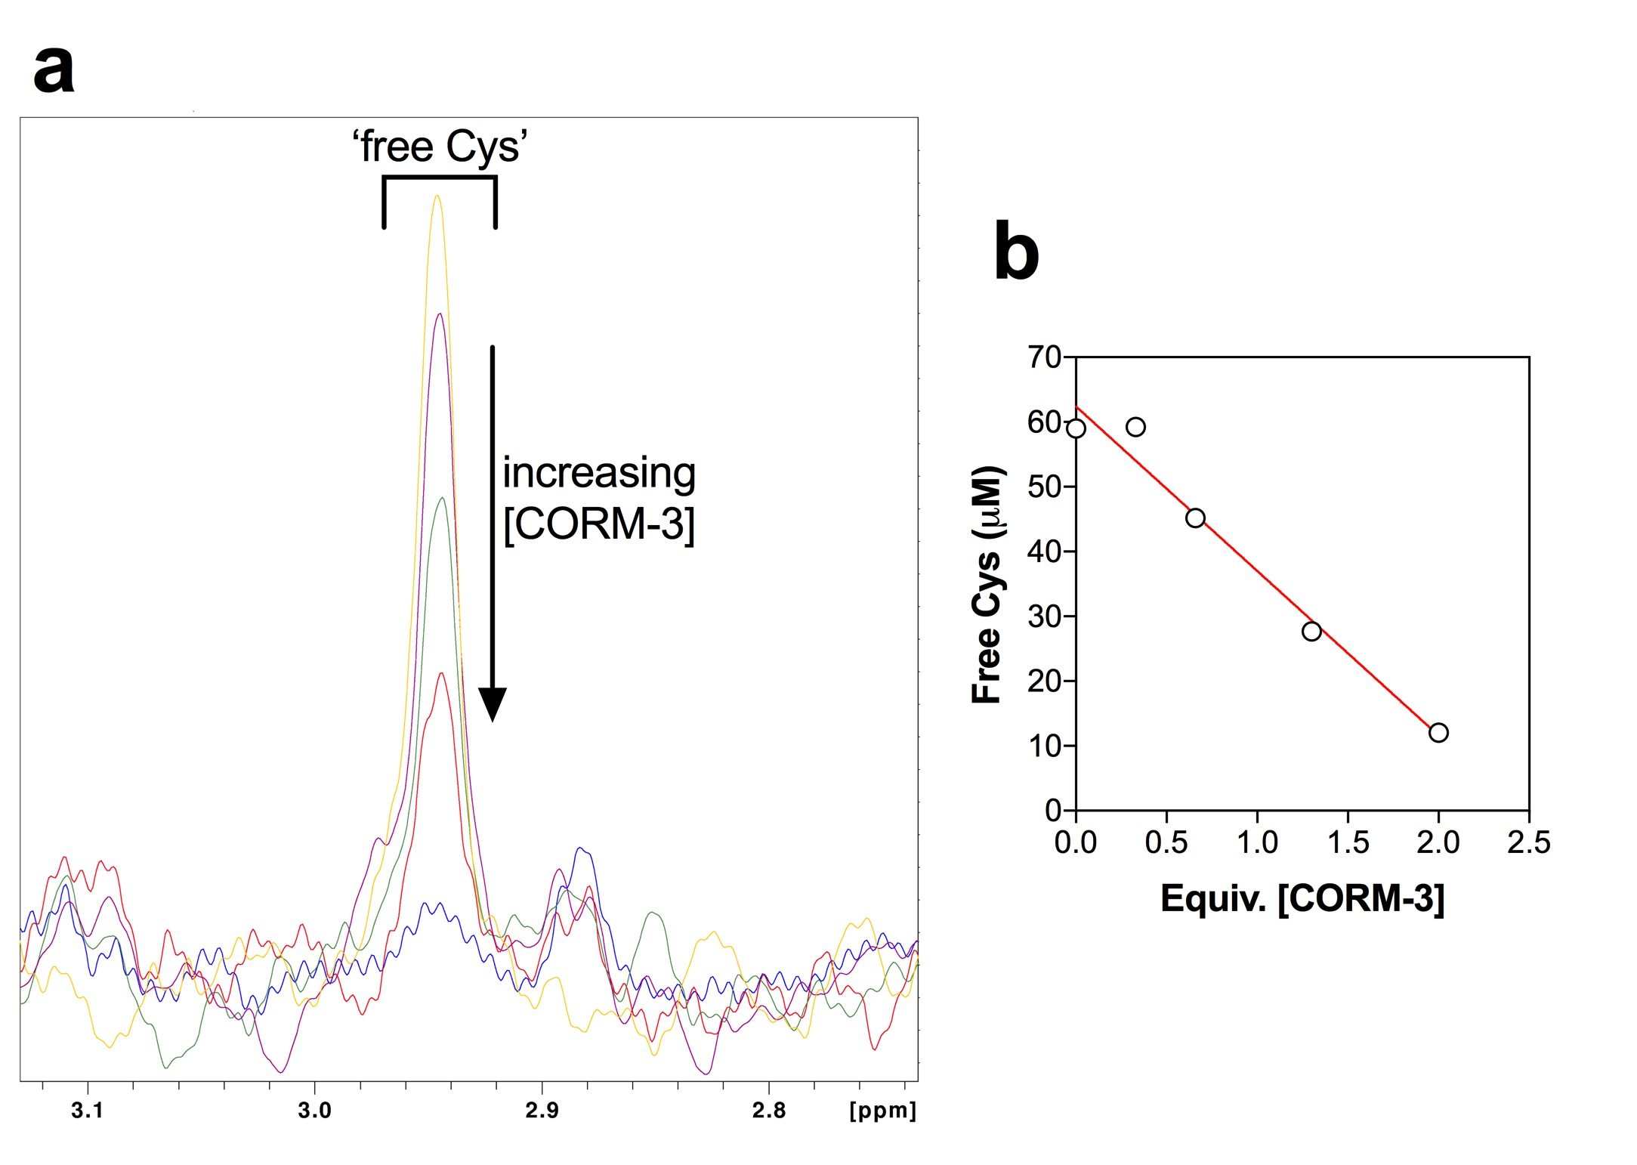

Fig. 4.10. Binding affinity of CORM-3 to cysteine as determined by ¹H-NMR. (a) Cys Hβ region of the ¹H-NMR spectrum of 59 μM A₃CA₃ peptide titrated with CORM-3 in 30 mM KPi, pH 7.4. A₃CA₃ was titrated with (from top to bottom) 0, 0.33, 0.66, 1.33 and 2.0 equivalents CORM-3. CORM-3 was prepared as a stock solution in 30 mM KPi buffer, pH adjusted to ~ 7.4 to keep the pH consistent between titrations. The signals for Cys Hβ (indicated above) decreased as more CORM-3 was added indicating that the Ru(II) ion of CORM-3 was binding the SH group of Cys. New signals can be seen coming up at approximately 2.88 ppm and 3.1 ppm as more CORM-3 was added. (b) Concentration of unbound Cys determined by the intensity of Cys Hβ of A₃CA₃ compared to the TSP standard (100 μM) as a function of the equivalent CORM-3 added. The fitted curve (red) is approximately the best fit and corresponds to a K_{d} of 5 ± 3 μM.
Work done in collaboration with Prof. Mike Williamson.

Fitting of the saturation curve indicated a very low K_{d}, estimated at ~ 5 ± 3 μM. Again, the binding of the CORM to Cys was too strong to gain an accurate estimate. As more CORM-3 was added, additional signals can be observed in the spectrum, likely corresponding to Cys bound to various CORM-3 derived species following the compound’s speciation in KPi buffer (reviewed in Chapter 3). Thus, as with CORM-2, the Ru(II) ion of CORM-3 binds the thiol of Cys with high affinity, most likely via the formation of a covalent bound.
b. Histidine (A₃HA₃)
Titration of A₃HA₃ with CORM-3 caused a decrease in the intensities of the signals corresponding to the His ring and Hβ protons in the A₃HA₃ ¹H-NMR spectrum (Fig. 4.11(a)). As with CORM-2, the decrease in these signals for free His were paralleled by an increase in new aromatic proton signals representing His bound to various CORM-3 derivatives (Fig. 4.11(a)). Fitting the saturation curve of the reduction in free His as a function of the equivalent concentration of CORM-3 gave an estimated K_{d} of 800 ± 100 μM (Fig. 4.11(b)). Thus, as with CORM-2, the binding of CORM-3 to His was much weaker than Cys but still significant. The incidence of distinct chemical shifts corresponding to free and CORM-bound His indicates that these complexes are in slow exchange (Fig. 4.11(a)). As the off-rate for the bound complex is therefore likely to be very slow, this suggests that a covalent bound is formed between the Ru(II) ion and the imidazole of His upon reaction of the compounds in vitro.
c. Methionine (A₃MA₃)
The ¹H-NMR spectrum of the titration of A₃MA₃ with CORM-3 exhibited a gradual decrease in the intensity of Met Hε proton signals upon increasing CORM additions (Fig. 4.12(a)). As observed with CORM-2, titration with increasing concentrations of CORM-3 also caused line-broadening effect on the Met Hε proton signals and the absence of additional distinctive proton signals for complexes of Met bound to CORM-derivatives (Fig. 4.12(a)). Thus, the proton signals for free and bound Met were in immediate exchange and therefore the binding of Met to CORM-3 is different to the binding of CORM-3 to Cys or His. Fitting of the saturation curve of [free Met] against [CORM-3] gave an estimated K_{d} of ~ 4700 μM (Fig. 4.12(b)). Thus, CORM-3 binding to Met is significantly weaker than for His or Cys, and is unlikely to involve the formation of a covalent bond between the R-group of Met and the Ru(II) ion of CORM-3.
d. Aspartate (A₃DA₃) and Alanine (A₇)
Titration of CORM-3 to A₃DA₃ did not cause significant changes in the intensity of the Asp Hβ proton signals up to 20 equivalents CORM-3 (Fig. 4.13 (a)); thus the binding of
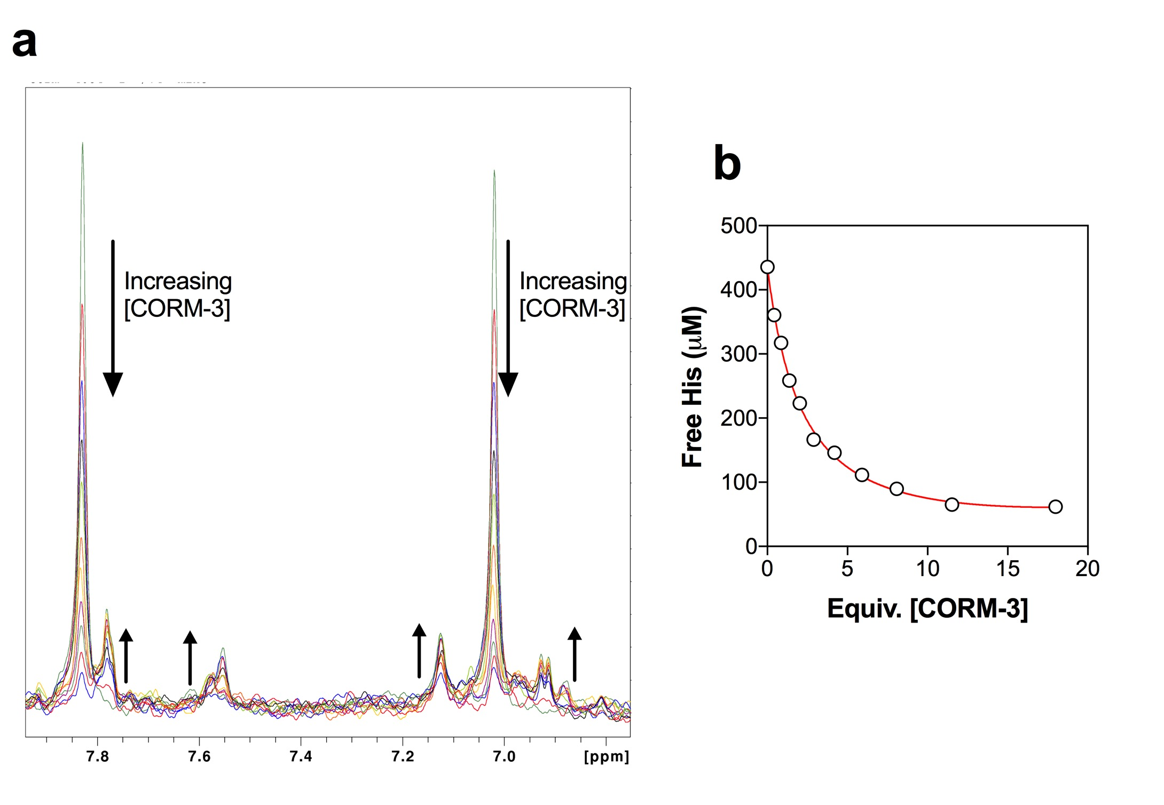

Fig. 4.11. Binding affinity of CORM-3 to histidine as determined by ¹H-NMR. (a) His aromatic ring protons region of the ¹H-NMR spectrum of 436 μM A₃HA₃ peptide titrated with CORM-3 in 30 mM KPi, pH 7.4. A₃HA₃ was titrated with (from top to bottom) 0, 0.43, 0.86, 0.14, 2.0, 2.9, 4.2, 5.9, 8.1, 11.5 and 18 equivalents CORM-3. CORM-3 was prepared as a stock solution in 30 mM KPi buffer, pH adjusted to ~ 7.4 to keep the pH consistent between titrations. The signals for His ring protons decreased as more CORM-3 was added indicating that the Ru(II) ion of CORM-3 was binding the imidazole of His. Loss of intensity of aromatic signals is paralleled by increased signals from a range of new resonances as more CORM is added. (b) Concentration of unbound His determined by the average intensity of His ring protons of A₃HA₃ compared to the TSP standard (100 μM) as a function of the equivalent CORM-3 added. The fitted curve (red) is approximately the best fit and corresponds to a K_{d} of 800 ± 100 μM.
Work done in collaboration with Prof. Mike Williamson.

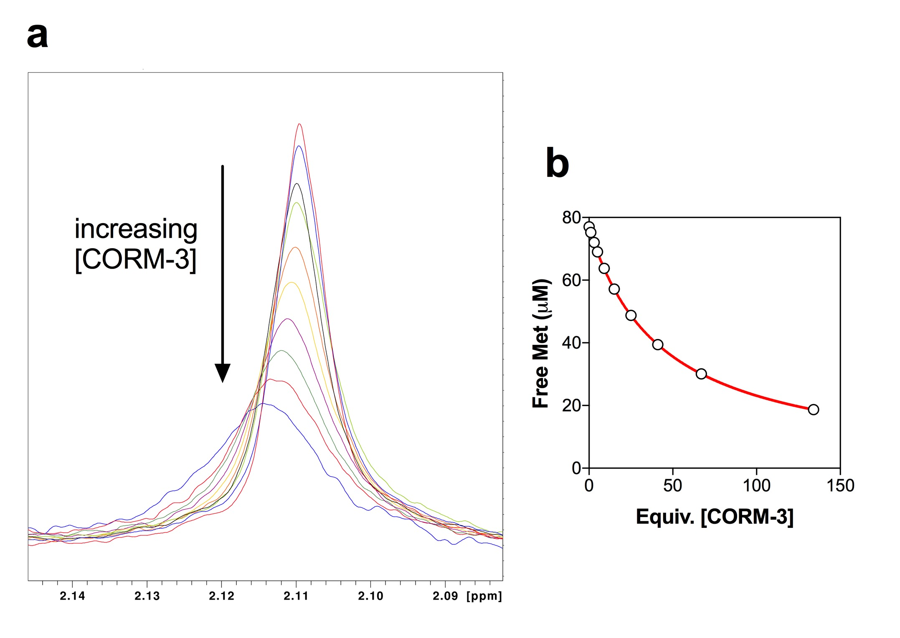

Fig. 4.12. Binding affinity of CORM-3 to methionine as determined by ¹H-NMR. (a) Met Hε region of the ¹H-NMR spectrum of 77 μM A₃MA₃ peptide titrated with CORM-3 in 30 mM KPi, pH 7.4 -7.6. A₃MA₃ was titrated with (from top to bottom) 0, 1, 3, 5, 9, 15, 25, 41, 67 and 134 equivalents CORM-3. CORM-3 was prepared as a stock solution in 30 mM KPi buffer, pH adjusted to ~ 7.4 to keep the pH consistent between titrations. The signals for Met Hε protons decreased as more CORM-3 was added indicating that the Ru(II) ion of CORM-3 was binding the R group of Met. Loss of intensity of these signals was not accompanied by any additional signals for Met bound to CORM, indicating signals for bound and free Met are in fast or immediate exchange. (b) Concentration of unbound Met determined by the intensity of Met Hε protons of A₃MA₃ compared to the TSP standard (100 μM) as a function of the equivalent CORM-3 added. The fitted curve (red) is approximately the best fit and corresponds to a K_{d} of 4700 μM.
Work done in collaboration with Prof. Mike Williamson.

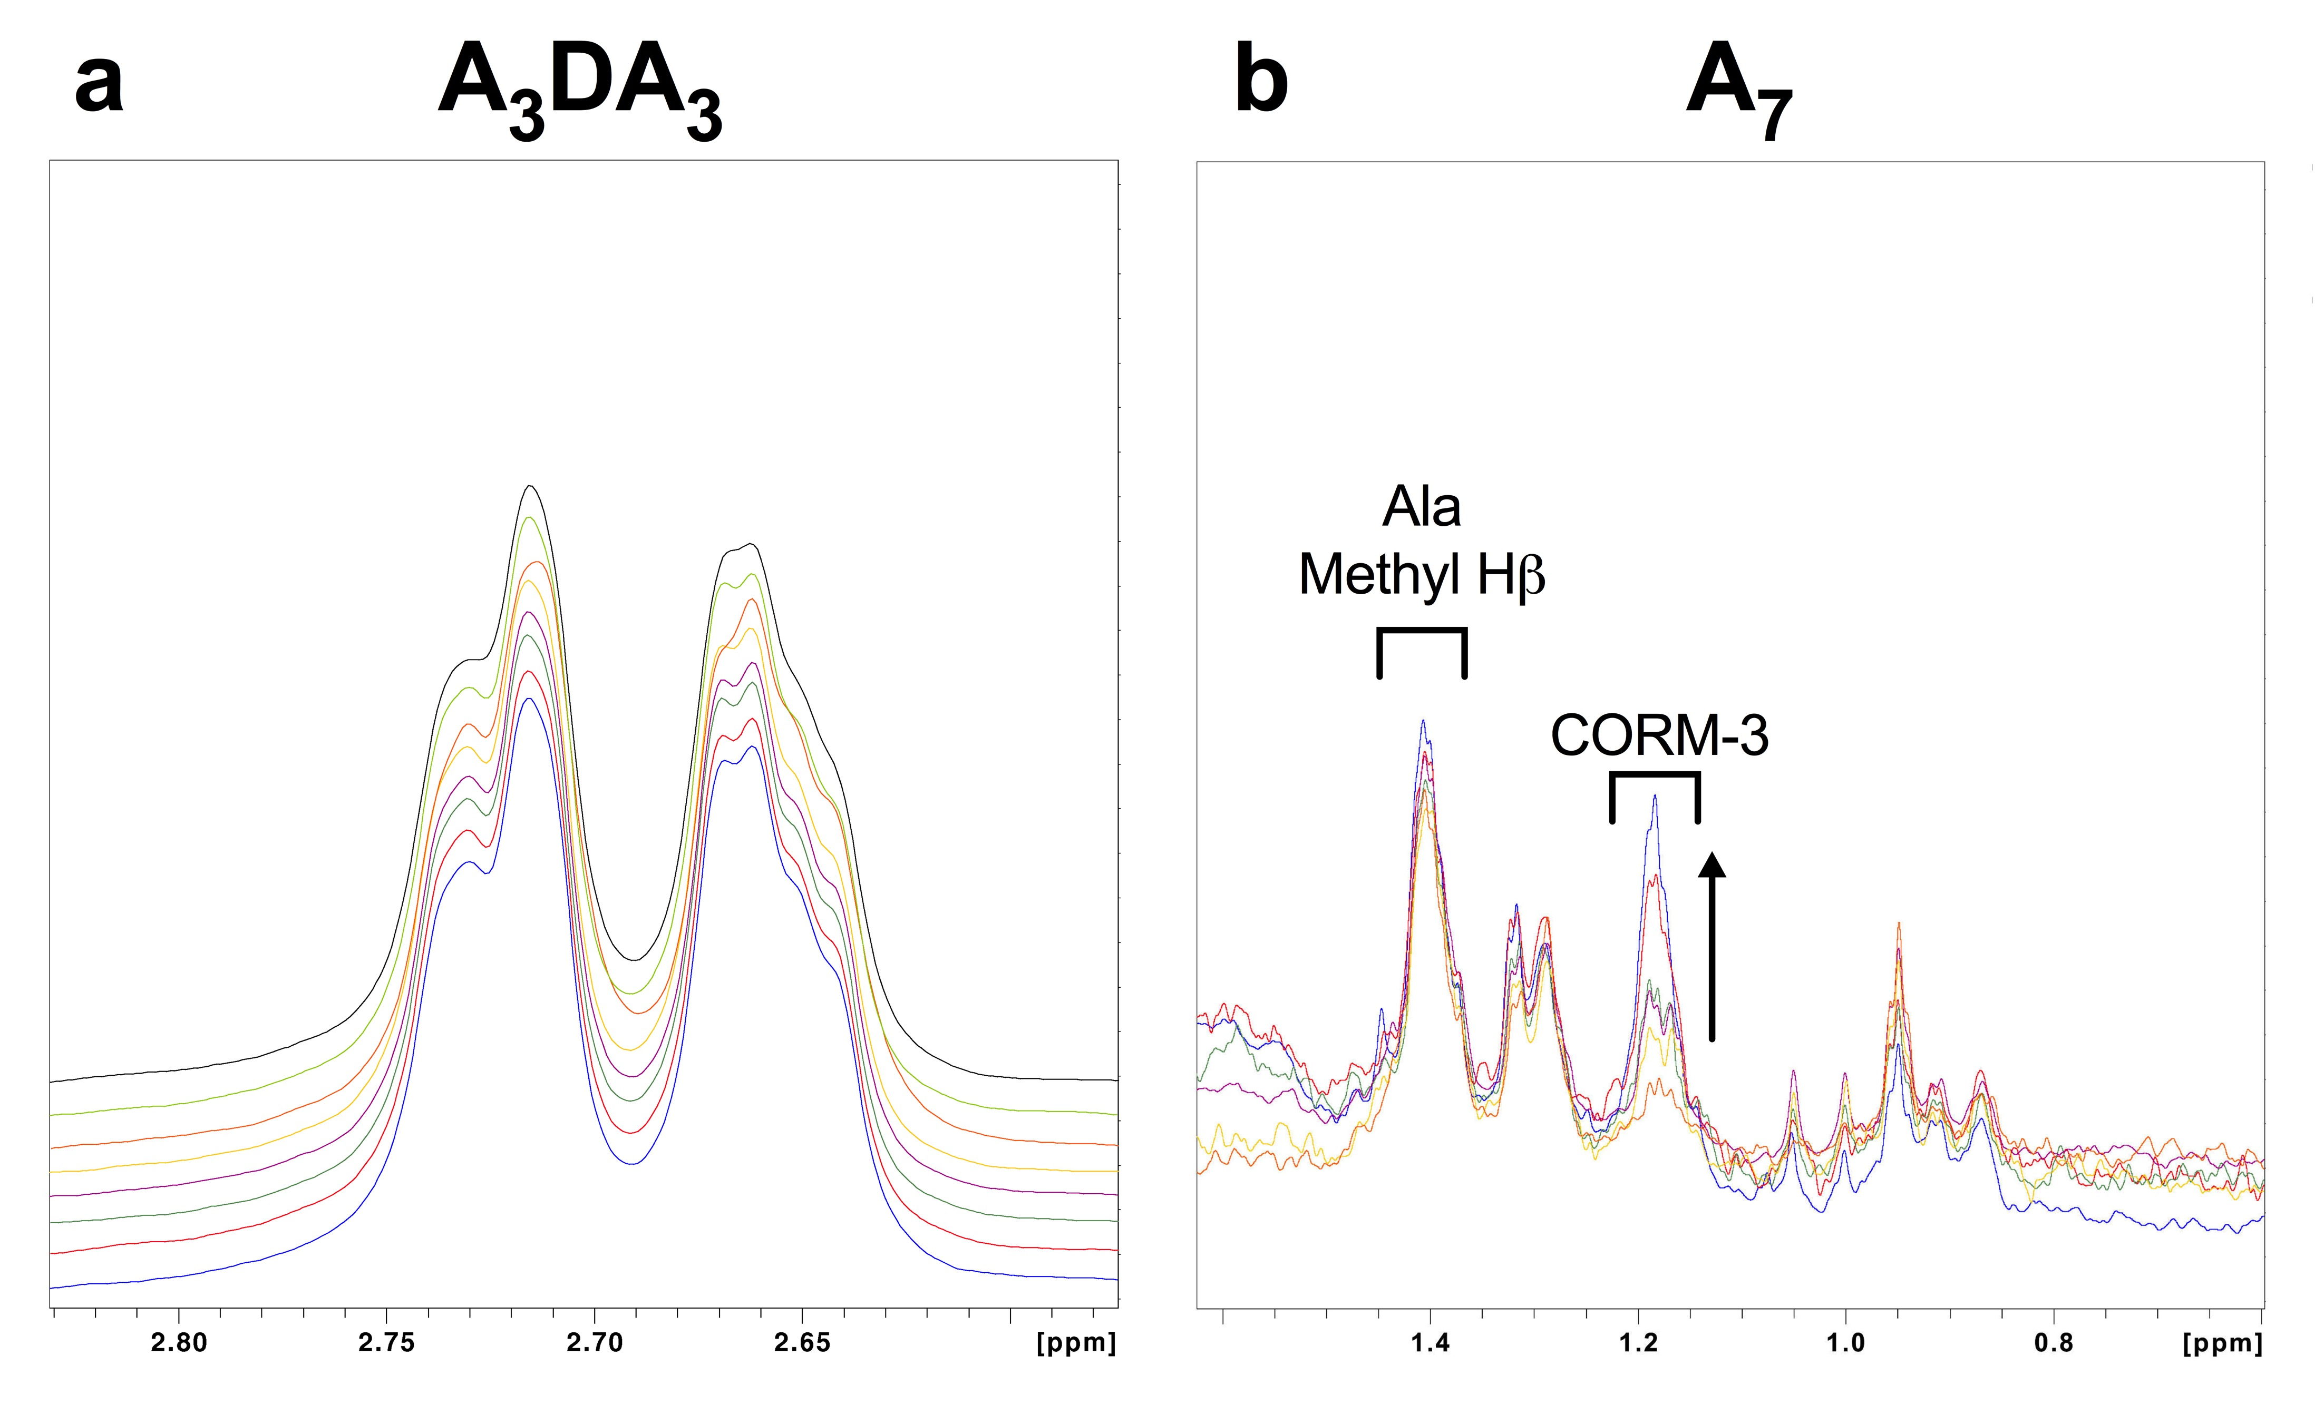

Fig. 4.13. Titrations of A₃DA₃ and A₇ peptides with CORM-3 by ¹H-NMR. (a) Asp Hβ region of the ¹H-NMR spectrum of 608 μM A₃DA₃ peptide titrated with CORM-3 in 30 mM KPi at pH 7.4. A₃DA₃ was titrated with 0, 0.33, 1, 1.5, 3.2, 6.5, 13 and 20 equivalents CORM-3. CORM-3 was prepared as a stock solution of 30 mM KPi pH adjusted to 7.4 to maintain consistent pH between titrations. The intensity of the Asp Hβ peak relative to the TSP standard was unchanged up to 20 equivalents CORM-3, thus the binding of Asp to CORM-3 is undetectable by ¹H-NMR. (b) Ala methyl Hβ region of the ¹H-NMR spectrum of 4.5 μM A₇ peptide titrated with CORM-3 in 30mM KPi at pH 7.4 – 7.6. Due to the low solubility of the peptide, the starting solution also contained 3.3 % (v/v) d₆-DMSO. Titration of A₇ with 0, 2, 8, 32, 64 and 134 equivalents CORM-3 did not decrease the intensity of the Ala Hβ signal (1.17 ppm) relative to the TSP standard, thus the binding of Ala to CORM-3 is undetectable by ¹H-NMR. Other signals in the spectrum are CORM-3 (indicated at ~ 1.4 ppm) or from impurities.
Work done in collaboration with Prof. Mike Williamson.

CORM-3 to Asp was undetectable by ¹H-NMR. A control titration of CORM-3 to A₇ also did not cause significant decreases in the intensity of the Ala methyl Hβ proton signals upon the addition of up to 134 equivalents CORM-3 (Fig. 4.13(b)). In addition, there were no observable changes to the intensity of the Ala methyl Hβ proton peaks in the ¹H-NMR spectra of titrations of A₃CA₃, A₃HA₃, A₃MA₃ or A₃DA₃ with CORM-3 (data not shown). Thus, CORM-3 does not bind to Asp or Ala in vitro at neutral pH.
A summary of the relative binding affinities of CORM-2 and CORM-3 to each amino acid residue is provided in Table 4.1.
4.2.6. CO release from CORM-3 is not promoted by reaction with amino acids
Previous studies had demonstrated that CORM-3 interactions with various isolated proteins in vitro gave rise to Ru(II)(CO)₂ adducts at surface-exposed His or Asp residues (Santos-Silva et al., 2011; Chaves-Ferreria et al., 2015). Thus, to determine whether interaction of CORM-3 with amino acids caused liberation of a CO ligand to the Ru(II) as CO gas, the level of CO released from CORM-3 upon addition to a 2-fold excess of individual amino acids in 30 mM KPi buffer was determined by gas-phase FTIR (Fig. 4.14). Consistent with previous experiments, addition of CORM-3 (100 μM) to KPi buffer containing 200 μM sodium dithionite caused ~ 50 μM CO release or 0.5 equivalents per CORM (100 % CO, Fig. 4.14). In contrast, no significant levels of CO release from CORM-3 were detected upon addition of the CORM to 200 μM Ala, Asp, His or Met within 30 min of CORM addition (Fig. 4.14). A small amount of CO was detected after the addition of the CORM to 200 μM Cys (~ 2.4 ± 0.44 % of the maximal CO release from the CORM upon addition to KPi containing sodium dithionite) (Fig. 4.14). However, further incubation of CORM-3 with Cys for up to 20 h did not yield significant levels of CO release from the CORM (Fig. 4.14). Thus, reaction of CORM-3 with a 2-fold excess of amino acids does not lead to liberation of a CO ligand as CO gas in vitro.
4.3. Discussion
4.3.1. Exogenous Cys, His and Met fully or partially protect against the antimicrobial effects of CORM-2 and CORM-3
Components of rich growth media alleviate the toxicity of CORM-2 and CORM-3 against bacterial cells (Chapter 3). As discussed in the introduction of this chapter, key components of rich media are amino acids. Therefore, the first step was to determine if supplementation of minimal media with casamino acids could reduce the toxicity of CORM-2 and CORM-3 against E. coli. As shown in Fig. 4.1, the minimum dose of CORM required to cause total growth inhibition to E. coli cultures, grown in casamino acid supplemented GDMM,
Table 4.1. Summary of the relative binding affinities of CORM-2 and CORM-3 to selected amino acids as determined by ¹H-NMR
AMINO ACID  SIDE CHAIN | STRUCTURE | CORM-2 AFFINITY  K_{d} (μM) | CORM-3 AFFINITY  K_{d} (μM) | FIGURE REFERENCE
Cysteine  (Cys) | 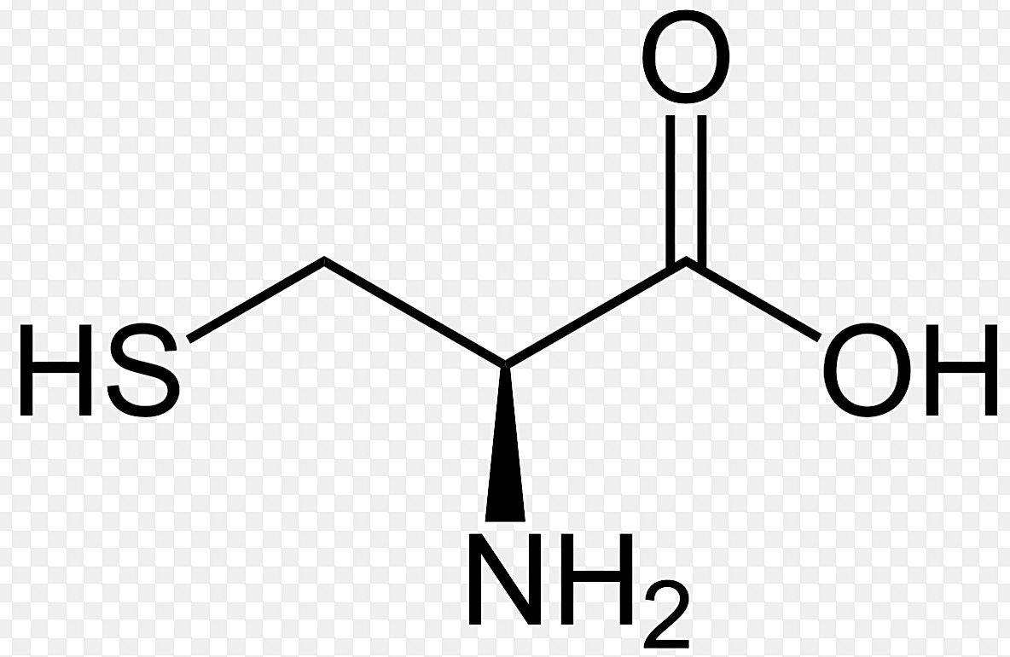 | 0.3 ± 0.3 | 5 ± 3 | 4.6 / 4.10
Histidine  (His) | 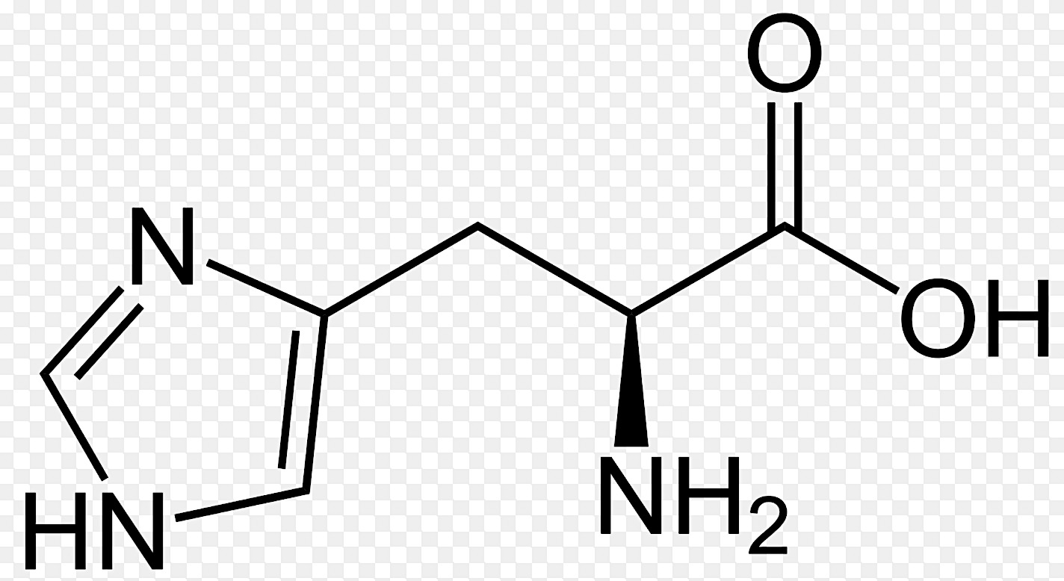 | 130 ± 25 | 800 ± 100 | 4.7 / 4.11
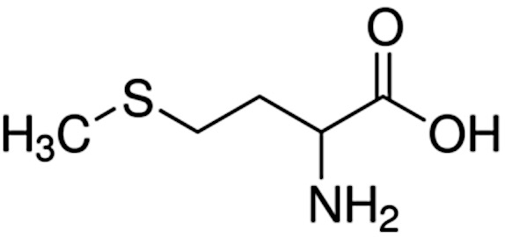  Methionine  (Met) |  | 2850 | 4700 | 4.8 / 4.12
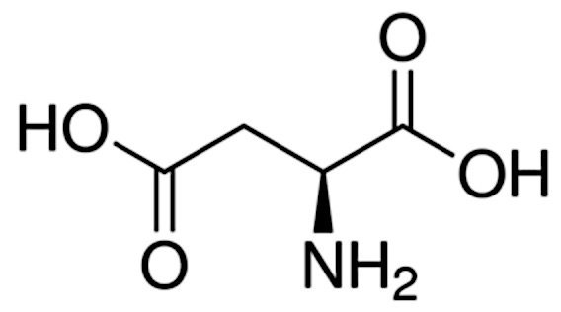  Aspartate  (Asp) |  | nd* | nd* | 4.9 / 4.13
Alanine  (Ala) | 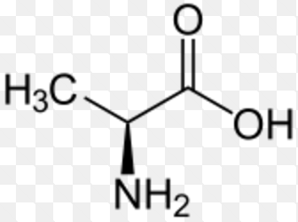 | nd* | nd* | 4.9 / 4.13

Table 4.1. Summary of the relative binding affinities of CORM-2 and CORM-3 to selected amino acids as determined by ¹H-NMR. The relative binding affinities of CORM-2 and CORM-3 to selected amino acids as determined by titrations of synthetic peptides of A₃XA₃, where X = central amino acid, in 30 mM KPi ~ pH 7 – 7.8. The affinity of the thiol group of Cys was much stronger than the next strongest amino acid tested, His. The binding of CORM-2 or CORM-3 to Met was considerably weaker than for Cys or His. *The binding of Asp or Ala to CORM-2 or CORM-3 was not detectable (nd) by ¹H-NMR. There was no detectable binding of any amino acid side chain to DMSO.
Work done in collaboration with Prof. Mike Williamson.

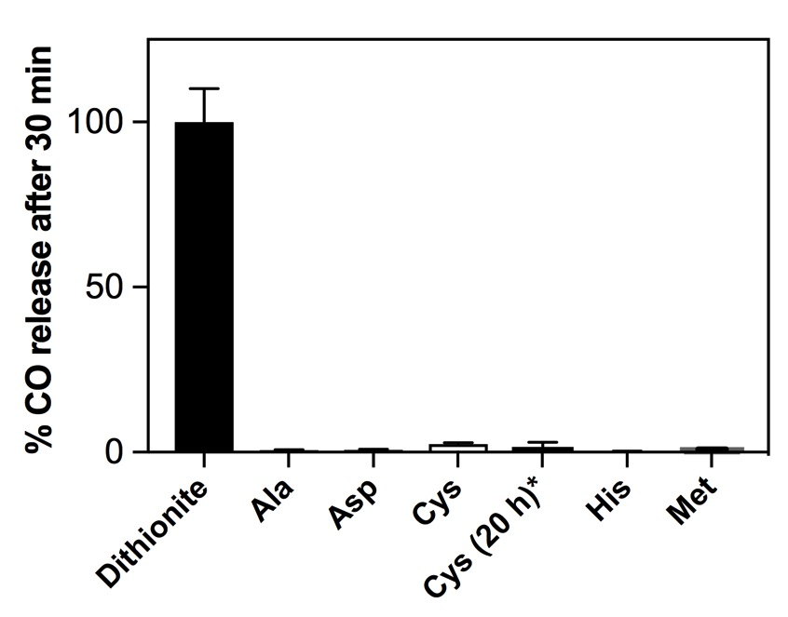

Fig. 4.14. Amino acids do not promote CO release from CORM-3. CO release from CORM-3 as measured by gas-phase FT-IR after 30 min incubation in 30 mM KPi buffer containing a 2-fold excess of Ala, Asp, Cys, His or Met. CORM-3 (100 μM) was added to vigorously stirred, degassed, sterile KPi buffer (10 mL) within a sealed vessel and CO release was monitored in the headspace over the solution. All values are quoted as % CO release relative to a control measurement whereby 100% CO represents maximal CO release from CORM-3 following addition of 100 μM CORM-3 to 30mM KPi containing 200 μM sodium dithionite. No significant levels of CO release from CORM-3 was seen after addition to KPi buffer containing 200 μM of Ala (0.35 ± 0.43 % CO), Asp (0.43 ± 0.55 % CO), Cys (2.4 ± 0.44 % CO), His (0.1 ± 0.25 % CO) or Met (0.49 ± 0.43 % CO). *Incubation of CORM-3 with Cys for 20 h did not yield significant levels of CO release (1.45 ± 1.6 % CO). Data represent two technical replicates ± SD.
Work conducted in collaboration with Thomas Smith and Laurie Middlemiss.

was 250 μM CORM-2 or 500 μM CORM-3, respectively. These concentrations are ~ 17-fold higher than the doses of either CORM required to cause the same effects in the absence of casamino acids (Fig. 3.1). As casamino acids are a mixture of free amino acids produced by acid digestion of hydrolysed casein, it was concluded that certain amino acids were responsible for the alleviation of CORM antimicrobial effects in rich media.
The next step was to therefore to identify which specific amino acids were responsible for these protective effects. A screen of the effects of individual amino acids on CORM-2 or CORM-3 growth inhibitory effects was thus conducted by pre-incubating CORM stocks in a 2-fold excess of amino acid prior to addition to E. coli cultures. As demonstrated in Fig. 4.2 and Fig. 4.4, most amino acids had no significant effect on the toxicity of either CORM, though there were notable important exceptions; Cys, His and Met. The effectiveness of each these amino acids on the alleviation of either CORM-2- or CORM-3- induced growth inhibition was Cys > His > Met, with a 2-fold excess of Cys sufficient to completely alleviate the toxicity of 30 μM CORM-2 or 60 μM CORM-3. It is possible that increasing the ratio of His or Met to CORM would also increase the extent of protection by these compounds, though this was not investigated.
4.3.2. The nature of CORM-2 and CORM-3 interactions with cysteine
A 2-fold excess of Cys also completely prevented the bactericidal effects of CORM-2 and CORM-3 on E. coli cells cultures (Fig. 4.3, Fig 4.5). Analysis of the Ru content by ICP-AES revealed that the protective effect of Cys was due to a considerable decrease in the extent of Ru accumulation by E. coli. The level of accumulated Ru by E. coli cells exposed to CORM-2 + Cys was just 249 μM after 80 min, a 10-fold reduction in the level of accumulated Ru following exposure to CORM-2 alone (Fig. 4.3). Strikingly, the level of accumulated Ru by E. coli exposed to (CORM-3 + Cys) was only 32 μM after 80 min, a 65-fold reduction compared to CORM-3 alone (Fig. 4.5). Thus the protective effects of exogenous Cys are due to prevention of intracellular Ru accumulation by bacterial cells. This is consistent with findings of a previous study in that a 10-fold excess of exogenous N-acetyl cysteine (NAC) reduced the level of intracellular Ru accumulated by E. coli cells up to 5-fold or 8-fold, following exposure to CORM-2 or CORM-3, respectively (Jesse et al., 2013). The mechanisms of how such interactions could prevent Ru(II) accumulation are discussed below.
The nature of the interaction between CORM-2/CORM-3 with Cys in vitro was examined by ¹H-NMR via titrations of A₃CA₃. In the case of CORM-2, the saturation curve of free Cys with the equivalent concentration of CORM tends to zero upon the addition of 1.0 equivalents CORM-2 (Fig. 4.6(b)). The current understanding of speciation chemistry of CORM-2 in DMSO is illustrated in Fig. 1.10 (Klein et al., 2014; Seixas et al., 2015). Upon addition of CORM-2 to DMSO, the DMSO displaces the chloride bridges linking the Ru(II) ions of the CORM dimer, yielding two identical [RuCl₂(CO)₃DMSO] monomers. Over time, these monomers further react with the solvent yielding stable isomers of [RuCl₂(CO)₂-(DMSO)₂] by displacement of one CO per monomer (Fig. 1.10). However, according to the saturation curve of Cys with CORM-2 (Fig. 4.6(b)), only one Ru(II) ion per CORM-2 dimer is able to interact with Cys. This implies that the current proposal of CORM-2 speciation chemistry in DMSO is likely to be incorrect because if two identical [RuCl₂(CO)₃DMSO] monomers were produced by attack of the dimer by DMSO, then both of these species would contain Ru(II) ions that would be able to bind the –SH of Cys. Thus, it is alternatively proposed the speciation of CORM-2 in DMSO leads to displacement of the chloride bridges, and the generation of two chemically distinct species whereby only one is able to interact with Cys. This could also explain why the maximal CO release per CORM-2 is only ever reported as 1 CO per CORM (Motterlini et al., 2003), as only one of these monomer species can release CO. The chemistry of CORM-2 speciation in DMSO thus remains to be fully elucidated but is much beyond the scope of this thesis.
Nevertheless, one Ru(II) ion of CORM-2 and the Ru(II) ion of CORM-3 interact with the thiol of Cys with considerably high affinity. The estimated K_{d} of Cys to CORM-2 was determined to be 0.3 ± 0.3 μM, and thus is slightly lower than that of CORM-3, 5 ± 3 μM (Fig. 4.6, Fig. 4.10). An accurate estimate of the K_{d} of these compounds to Cys is difficult because of the strength of binding between Cys and the Ru(II) ions. Upon addition of either CORM to A₃CA₃, additional signals arise, likely corresponding to CORM-bound Cys complexes (Fig. 4.6, Fig. 4.10). Thus, the nature of the binding of either CORM-2 or CORM-3 to Cys likely involves the formation of a covalent bound between the SH of Cys and the Ru(II) ion of the CORM. Such an irreversible reaction between Ru(II) and Cys explains why Cys is so effective at sequestering CORM outside of E. coli cells. Cys is therefore a key component of rich media that prevents the antimicrobial activity of CORM-2 and CORM-3. As the thiol moiety of Cys is responsible for such effects, it is likely that other thiol compounds, such as reduced glutathione (GSH), could interact with CORM-2 and CORM-3 with high affinity as has been demonstrated by previous studies (McLean et al., 2013). This is explored later in Chapter 5.
4.3.3. The nature of CORM-2 and CORM-3 interactions with histidine
As with Cys, a 2-fold excess of exogenous His was sufficient to completely alleviate the bactericidal effects of both compounds on E. coli cells (Fig. 4.3, Fig. 4.5). This was also associated with a dramatic decrease in the total level of intracellular Ru accumulated by E. coli cells upon exposure of (CORM-2 + His) (~ 5-fold reduction) or (CORM-3 + His) (7-fold reduction). Thus, it is also likely that E. coli cells can resist levels of Ru up to ~ 0.5 mM before the onset of deleterious affects on growth or viability (Fig. 4.3). The K_{d} of His to CORM-2 was determined to be 130 ± 25 μM (Fig. 4.7), significantly lower than the K_{d} of His to CORM-3 800 ± 100 μM (Fig. 4.11). Thus, the binding of CORM-2 and CORM-3 to His is considerably weaker than for Cys, but still biologically relevant. Upon titration of A₃HA₃ with CORM-2 or CORM-3, there was the paralleled emergence of additional proton signals corresponding to complexes of His bound to CORMs in the ¹H-NMR spectra (Fig. 4.7, Fig. 4.11). The incidence of distinct chemical shifts for free and bound His thus indicates that these complexes are in slow exchange, and therefore the off-rate for CORM-bound His is likely to be very slow (Williamson, 2013). These slow off-rates reveal that the bond between the CORM Ru(II) ion and the imidazole of His is likely to be covalent in character, hence the low K_{d}s and the potency of exogenous His to protect against CORM antimicrobial effects via extracellular sequestration. Thus, like Cys, His is likely a key component of rich nutrient media that prevents the antimicrobial effects of these compounds.
4.3.4. The nature of CORM-2 and CORM-3 interactions with methionine
The explanation of the protection afforded by exogenous Cys or His on the antimicrobial effects is thus relatively simple, the Ru(II) ions of the CORMs form a covalent and irreversible bond with exogenous Cys or His residues, which subsequently prevent the accumulation of the Ru(II) ions by bacterial cells. The protection afforded by exogenous Met is somewhat more complicated. A 2-fold excess of Met was sufficient to completely prevent CORM-2 bactericidal effects but only partially prevented the bactericidal effects of CORM-3 (Fig. 4.3, Fig. 4.5). Interestingly, the levels of accumulated Ru by E. coli cells exposed to (CORM-2 + Met) were only slightly reduced relative to CORM-2, reaching a final level of 1.3 mM (Fig. 4.3). The levels of accumulated Ru by E. coli cells exposed to (CORM-3 + Met) were not reduced relative to CORM-3 alone and reached a final concentration of ~ 2 mM. So why does Met partially alleviate the antimicrobial effects of CORM-2 and CORM-3, and yet, still enables the accumulation of milimolar levels of Ru?
Firstly, the nature of CORM-2 and CORM-3 binding to Met is considerably different from that observed for CORM binding to Cys or His. The binding affinity of either CORM to Met is much weaker with a K_{d} of 2850 μM for CORM-2 and a K_{d} of 4700 μM for CORM-3 (Fig. 4.8, Fig. 4.12). Titrations of A₃MA₃ with either CORM led to a noticeable line broadening of the Met Hε proton signals in the ¹H-NMR spectra. Furthermore, there was an absence of distinctive chemical shifts corresponding to Met-bound complexes in the ¹H-NMR spectra upon addition of either CORM (Fig. 4.8, Fig. 4.12). This phenomenon is typical of free and bound complexes in fast or immediate exchange, suggesting an exchange rate between CORM-bound Met and free Met that is significantly faster than that observed for CORM complexes of Cys or Met (Williamson, 2013). Thus, the binding of CORM-2 and CORM-3 to Met is readily reversible and is unlikely to involve the formation of a covalent bond between the Ru(II) ion of the CORMs and the R-group of Met.
4.3.5. Why do cysteine and histidine prevent CORM-derived Ru accumulation by E. coli but methionine does not?
This somewhat unusual finding can be explained by considering the mechanisms by which CORM-derived Ru species are taken up and accumulated by E. coli cells. In Chapter 3 it was established that cells accumulate intracellular Ru to levels that greatly exceed the levels of Ru applied extracellularly. Thus, E. coli cells accumulate CORM-derived Ru against what appears to be steep concentration gradient of Ru. The mechanism(s) of uptake and accumulation of CORM-derived Ru species are currently unknown, but it is likely that the routes of uptake of CORM-2-derived species are different to that of CORM-3-derived species, as uptake and accumulation of intracellular Ru by E. coli is significantly faster upon exposure to CORM-2 (Fig. 3.2). What is interesting, however, is that despite the different initial rates of uptake, the maximum level of accumulated intracellular Ru is ~ 2 mM for both compounds, thus implying that there is an upper limit in the level of Ru that can be accumulated by E. coli cells. One proposal is that uptake and accumulation of intracellular Ru by E. coli upon exposure to CORMs are driven by a diffusion-mediated process and is dependent on the availability of intracellular targets to the Ru (Rana et al., 2014). Upon entry of CORM-derived Ru species into the bacterial cell, it is likely that the Ru(II) ion rapidly interacts with and binds to intracellular targets, and thus is chemically changed relative to the ‘unbound’ complexes outside of the cell. This effectively maintains a very low level of ‘unbound’ CORM-derived Ru species intracellularly. Thus, uptake of free CORM-derived Ru species would continue, driven by diffusion, against a seemingly high concentration gradient of Ru, until all available intracellular targets of the Ru(II) ions are depleted. This hypothesis of Ru uptake and accumulation by bacterial cells upon exposure to CORMs will be evaluated throughout this thesis.
If this hypothesis is correct, sequestration of CORM-2 or CORM-3 by Cys or His could be due to two mechanisms. Firstly, sequestration of the CORM-derived Ru species outside the cells could occur as the Cys or His bound complexes may be too large to gain cellular entry. Alternatively, Cys or His complexes of these CORM-derived Ru species may be small enough to able to gain entry into bacterial cells but are thus unable to coordinate to intracellular targets due to the stability of the covalent bond between the Ru(II) ion and the Cys or His residue. For Met, the bond between the R-group and the Ru(II) of the CORM is irreversible and thus relatively less stable. Thus, Met-CORM complexes outside of the cells could dissociate over time to enable the CORM-derived Ru species to eventually gain entry and hence eventually diffuse into bacterial cells, depending on the time required to dissociate. Alternatively, these Met-CORM complexes could diffuse into cells and once inside, accumulation would be dependent on the dissociation of the Met-CORM complex and the subsequent coordination of the free Ru(II) ions to coordinate to intracellular targets and cause toxicity. This could explain why exogenous Met could protect against the bactericidal effects of CORM-2 more significantly than CORM-3, despite such high levels of intracellular Ru accumulation. The K_{d} of CORM-2 binding to Met (2850 μM) is considerably lower than the K_{d} of CORM-3 to Met (4700 μM); thus dissociation of Met from CORM-2-derived Ru-complexes is likely to be slower than the dissociation of Met from CORM-3-derived complexes. Therefore, if Met-CORM-3 complexes are accumulated by bacterial cells, the Ru(II) ion of these complexes is likely to bind to intracellular bacterial targets faster than for Met-CORM-2 complexes, hence the more significant protection of Met against the bactericidal effects of CORM-2 over the bactericidal effects of CORM-3.
4.3.6. Aspartate and alanine do not interact with CORM-2 or CORM-3 in vitro
In contrast, a 2-fold excess of exogenous Asp or Ala had no measurable effects on the toxicity of either CORM and did not prevent Ru accumulation by E. coli cells (Fig. 4.2 – 4.5). Consistent with these observations, there was no detectable binding of CORM-2 or CORM-3 to these amino acids by ¹H-NMR (Fig. 4.8, Fig. 4.13). Thus it is concluded that Asp or Ala are unlikely to interact with CORMs in vitro or under physiological conditions. These findings appear to contradict the findings of a previous study that showed Ru(CO)₂- adducts formed on surface-exposed Asp acid residues upon interaction of CORM-3 with HEWL (Santos-Silva et al., 2011). The discrepancy in the findings could be explained by the methodology employed in this study. CORM-3 binding to HEWL was investigated by soaking HEWL crystals in 0.1 M CORM-3 (Santos-Silva et al., 2011). Crystallography revealed that most of the Ru(CO)₂ adducts were located at a single surface-exposed His residue (His15), with the Ru(II) ion forming a covalent bond to the imidazole moiety, which is consistent with the findings of this thesis (Santos-Silva et al., 2011). There were also additional lower occupancies of Ru at two surface-exposed Asp residues, Asp18 and Asp52, though the crystal structure of these interactions was not resolved (Santos-Silva et al., 2011). It is likely that binding of the CORM-3-derived Ru(CO)₂ adducts at Asp acid residues is an artifact of the study and a consequence of such a high concentration of CORM-3 applied to the HEWL crystals; thus under more biologically relevant CORM-3 concentrations, it is unlikely that CORM-3 interacts with Asp.
4.3.7. Are surface exposed Cys, His or Met residues on proteins likely bacterial targets of CORM-2 and CORM-3 Ru(II) ions?
As described in Chapter 1 and Section 4.1, the antimicrobial activities of CORM-2 and CORM-3 are likely mediated by coordination of the Ru(II) ion(s) of these compounds to biological targets. Thus there is a considerable case for the re-classification of these compounds as functional ruthenium antimicrobials rather than simply ‘CO-releasing molecules’ (Southam et al., 2017; Gianferrera et al., 2009). The results of this chapter show that CORM-2 and CORM-3 interact with Cys and His residues with high affinity, most likely via the formation of a covalent bond between the Ru(II) ion of the CORM and the thiol of Cys or imidazole of His. In addition, both CORMs interact irreversibly but significantly with Met. Thus, it is highly probable that surface-exposed His, Cys or Met residues on proteins are bacterial cell targets of CORM-derived Ru(II) ions.
With this in mind, it is likely that the reported CORM-2-mediated inhibition of aconitase and glutamate synthesase activities in E. coli extracts are due to the covalent coordination of the Ru(II) ion to S groups in the Fe-S cluster of these proteins (Tavares et al., 2011). This also explains the reported increase in free intracellular Fe levels in E. coli cells exposed to CORM-2, as Ru(II) coordination to these sulfur groups would thus displace the Fe in the cluster as has been observed by other divalent metal cations (Tavares et al., 2011; Xu and Imlay, 2012). Additionally, it is likely that inhibition of H. pylori urease in vitro by CORM-2 was due to coordination of the Ru(II) ions of CORM-2 to the active site His residues, thereby displacing Ni(II) and inhibiting enzymatic function (Tavares et al., 2013). The inhibition of E. coli glutamate dehydrogenase and lactate dehydrogenase in primary cardiocytes could thus also be mediated by the covalent coordination of Ru(II) ions to active site residues (Tavares et al., 2011; Winburn et al., 2012).
Furthermore, it has been suspected for some time that Ru-carbonyl CORMs interact with proteins in vivo. Some authors have suggested that Ru-carbonyl CORMs do not release CO per se but that CO is instead released via the decomposition products of protein-Ru(CO)₂ adducts that arise from the reaction of CORMs with proteins (Santos-Silva et al., 2011; Chaves-Ferreria et al., 2015; Seixas et al., 2015). However, at least in vitro, a 2-fold excess of Ala, Asp, Cys, His or Met did not cause CO release from CORM-3 as demonstrated in Fig. 4.14. Thus, reaction of CORM-3 with amino acids does not cause CO release from the resulting compounds up to 20 h after the reaction (Fig. 4.14).
Although the results above strongly suggest that surface-exposed Cys, His or Met are likely targets of CORM-derived Ru(II) ions in bacterial cells, this study has not definitively shown that this is the case. Future work will involve analysis of proteomics datasets obtained from E. coli whole protein extracts following exposure of cell cultures to these compounds. This investigation will determine which E. coli proteins are bound to CORM-derived Ru(II) ion(s) and thus provide evidence that bacterial proteins are a key intracellular target of Ru-carbonyl CORMs. This work is ongoing in collaboration with Dr Salar Ali and Dr Mark Collins.
4.4. Concluding remarks
The significant findings of Chapter 4 are thus as follows. Firstly, the amino acid components of rich nutrient media, specifically Cys, His and Met, are likely responsible for the relative ineffectiveness of CORMs as antimicrobial compounds in LB, MH-II, DMEM and RPMI. It is also likely that surface-exposed Cys, His and Met residues on bacterial proteins are targets of CORM derived Ru(II) in bacterial cells, thus supporting their re-classification as functional ruthenium antimicrobial compounds rather than simply CO-carrier molecules. The strong interactions of the Ru(II) of CORMs with the thiol of Cys indicates that other thiol compounds are also likely to be bacterial cell targets of CORMs and will be the focus of Chapter 5. Furthermore, it is not yet determined how Ru(II) coordination to these targets induces the antimicrobial effects of these compounds.
In terms of the evaluation of these compounds as potential antimicrobial agents, the high affinity of Ru(II) ion of CORMs to amino acid residues is concerning. In vivo, the Ru(II) ions would not discriminate between bacterial cell and host cell surface-exposed amino acid residues. Therefore the consequences of Ru(II) interactions with host biomolecules requires further investigation. This is addressed in Chapter 7 of this thesis.

Chapter 5
Ru-carbonyl CORMs as sulfhydryl-reagents in vitro and in vivo
5.1. Introduction
5.1.1. Could intracellular thiols be targets of CORM-derived Ru(II) ions?
In Chapter 4, it was found that CORM-2 and CORM-3 bind with high affinity to Cys in vitro, probably via the formation of a covalent bond between the Cys thiol sulfur and the Ru(II) ion of the CORMs. Thus, it is likely that surface-exposed Cys residues on proteins are bacterial cell targets of CORM-derived Ru.
Most proteins containing surface-exposed Cys sulfhydryls (-SH) are located within the cytoplasm of E. coli, with only a few cytoplasmic proteins containing disulfide (-S-S-) (oxidised) bonds (Ritz and Beckwith, 2001). Redox homeostasis in the E. coli cytoplasm is maintained by two functionally redundant pathways, mediated by either thioredoxin or glutaredoxin, which each use the reducing potential derived from NADPH to reduce oxidised disulfide bonds on essential cytoplasmic proteins (Ritz and Beckwith, 2001). The E. coli thioredoxin pathway is composed of two thioredoxins (TrxA and TrxC) and their reductant, thioredoxin reductase (Toledano et al., 2007). Thioredoxins contain two active site Cys residues with low redox potential that function to reduce disulfide bonds, a process which results in the oxidation of the thioredoxin active site. The glutaredoxin pathway in E. coli is composed of three glutaredoxins (Grx1, Grx2 and Grx3) which are functionally analogous to thioredoxins but require reduced glutathione (GSH) for efficient reductant activity (Toledano et al., 2007).
GSH, L-γ-glutamyl-L-cysteinylglycine, is the most abundant source of thiol in E. coli (~ 5 mM intracellular concentration) (Ritz and Beckwith, 2001). Almost all of the glutathione in the E. coli cytoplasm is maintained in the reduced (GSH) state by the action of glutathione reductase (Gor). GSH biosynthesis occurs via a two-step process by the consumption of 2 molecules of ATP (Ritz and Beckwith, 2001). Firstly, γ-glutamyl-L-cysteine synthase (GshA) catalyses the ligation of L-glutamate to L-cysteine, yielding the dipeptide γ-glutamyl-L-cysteine. Next, glutathione synthase (GshB) catalyses the condensation reaction of γ-glutamyl-L-cysteine and glycine to yield the tripeptide GSH. E. coli mutants of either gshA or gshB completely lack intracellular glutathione and the latter accumulates γ-glutamyl-L-cysteine (Ritz and Beckwith, 2001). Glutathione-deficient E. coli mutants are viable and have growth rates comparable to that of wild type E. coli cells, this is because the thioredoxin system effectively maintains redox balance in the absence of GSH (Toledono et al., 2007). Inactivation of both the glutaredoxin and thioredoxin systems in E. coli is lethal. Therefore, in addition to -SH of surface-exposed Cys residues on proteins, including those of thioredoxins and glutaredoxins, the -SH of GSH is also likely to represent an important intracellular target of CORM-derived Ru(II) ions. It is worth noting that GSH is also the most abundant and significant low molecular weight antioxidant in mammalian cells (Forman et al., 2009).
In contrast, proteins in the E. coli periplasm contain mainly oxidised disulfide bonds that play important structural roles in maintaining periplasmic-protein folding and functionality. Disulfide bond formation in the periplasm is maintained by the actions of both DsbA, which oxidises thiols upon translocation of the protein into the periplasm, and DsbC, which functions as a disulfide isomerase (Ritz and Beckwith, 2001). Thus, the –SH targets of CORM-2 and CORM-3 derived Ru(II) ions are likely to be located in the cytoplasm rather than the periplasm of E. coli.
5.1.2. Thiols are known targets of metal ions
Thiols are well-established biological targets of essential and non-essential metal ions (Lemire et al., 2013). According to Pearson’s Hard-Soft Acid-Base (HSAB) theory, soft bases, such as -SH, interact strongly and form covalent bonds with intermediate (Fe(II), Zn(II), Co(II), Ni(II)) and soft (Pt(II), Hg(II), Cd(II), Ag(II)) metals. The antimicrobial activity of such intermediate and soft metal ions has been shown to be approximately proportional to their affinity for thiols (Bruins et al., 2000; Helbig et al., 2008; Lemire et al., 2013). Ru(II) is classified as ‘borderline’ according to Pearson’s HSAB theory (Hoggard and Porter, 1981) and so is predicted to have reasonably high affinity to thiols, comparable to that of other borderline metals such as Fe(II) and Zn(II). In Chapter 4 it was demonstrated that the Ru(II) ions of CORM-2 and CORM-3 have high affinity to the –SH of Cys.
The antimicrobial consequences of metal ion coordination to intracellular thiols include deactivation of thiol-containing enzymes and disruption of sulfur-mediated cellular processes such as Fe-S cluster assembly, as has been shown for Hg and Cd (Bruins et al 2000; Helbig et al., 2008). Metal ion binding to the -SH of thioredoxin, glutaredoxin and GSH is likely to have a plethora of antimicrobial effects. These include: (1) alteration of intracellular redox homeostasis; (2) depletion of cellular antioxidants leading to ROS formation; (3) increased vulnerability of protein targets to attack by metals and/or ROS and (4) prevention of repair of oxidised protein thiols (Lemire et al., 2013). It is worth noting that one of the current literature hypotheses as to how CORM-2 and CORM-3 induce their antimicrobial effects involves the formation of intracellular ROS as proposed by Tavares et al., 2011 (outlined in Figure 1.12). This hypothesis is controversial and has been evaluated in detail in Chapter 1, Section 1.5.2. It is the view of the author and the supervisors of this thesis that CORM-2 or CORM-3 antimicrobial effects are not mediated by ROS, as explained previously (see Chapter 1).
Pb(II), Hg(I), Cd(II), Zn(II), Pt(II) have been shown to covalently coordinate the sulfur atom of GSH in vitro (Krezel and Bal, 1999). Intracellular GSH is considered to have a protective role in the defence against metal toxicity in bacteria by sequestering metal ions and preventing attack of more vulnerable protein targets (Lemire et al., 2013). E. coli gshA mutants are slightly more sensitive to Cd(II) and Hg(II) than WT cells (Helbig et al., 2008; Latinwo et al., 1998 ; Pacheco et al., 2008). In addition, gshA mutants are more sensitive than WT E. coli to Co, Ag, Zn and Te salts (Harrison et al., 2009). There is currently no evidence that intracellular GSH plays such a protective role in protection against CORM-derived Ru.
It is interesting to note that metal ions also bind, albeit less strongly, to oxidised glutathione (GSSG). Although GSSG does not contain an available –SH group for metal ion coordination, it does contain two glutamate residues, which are brought into close proximity via the disulfide bond (Krezel and Bal, 1999). It has been proposed that metals could interact with this site in the absence of available –SH (Krezel and Bal, 1999). Indeed, it has been demonstrated that Zn(II), Ni (II) and Co (II) can coordinate GSSG via these glutamates at reasonably high affinity in vitro, and thus GSSG may also be a target of CORM-derived Ru inside E. coli cells (Krezel and Bal, 1999).
5.1.3. CORM-2 and CORM-3 interact with thiol containing compounds in vitro but intracellular thiol binding has not been demonstrated
As demonstrated by the results obtained in Chapter 4, the alleviation of the antibacterial effects of CORM-2 or CORM-3 by exogenous compounds is likely to be an indicator of binding of CORM-derived Ru(II) species to the exogenous compound extracellularly, thus sequestering the Ru outside the cell (see Chapter 4). As outlined in Chapter 1 (Section 1.5.2), exogenous thiol containing-compounds such as NAC, Cys and GSH (but not GSSG) have been reported to markedly alleviate the growth inhibitory effects of CORM-2 or CORM-3 against E. coli or P. aeruginosa cells (Desmard et al., 2009; Tavares et al., 2011; Desmard et al., 2012; Murray et al., 2012). In agreement with this, CORM-2 and CORM-3 have also been demonstrated to prevent reaction of NAC, Cys, GSH and sodium hydrosulfide (NaHS) with the sulfhydryl-reagent DTNB in vitro (Tavares et al., 2011; McLean et al., 2013). This was found to be due to direct interaction of the CORM with the thiol compound rather than oxidation of the –SH groups by ROS formation (McLean et al., 2013). Thus, as with Cys, it is likely that exogenous GSH, NaHS and NAC prevent accumulation of CORM-derived Ru by bacterial cells via sequestration of the Ru(II) extracellularly, although this has only been demonstrated for NAC (Jesse et al., 2013). In addition, an excess of NAC, Cys and GSH (but not GSSG) also alleviated CORM-3 induced inhibition of oxygen consumption in P. aeruginosa cells or E. coli isolated membrane particles (Desmard et al., 2009; Jesse et al., 2013). It is interesting to note that E. coli respiratory inhibition by Cd(II) is also prevented by the addition of GSH (Heilbig et al., 2008).
The transcriptomic effects observed in E. coli in response to exposure to CORM-2 or CORM-3 also suggest that sulfur-containing species are probable intracellular targets of CORM-derived Ru. Genes involved in sulfur metabolism, sulfur transport and the sulfur-starvation response (ssuABCDE and tauABCD) represent major categories of genes upregulated by both compounds. Genes involved in uptake and/or metabolism of sulfate-thiosulfate, Met, Cys and GSH were found to be upregulated by both compounds (McLean et al., 2013; Nobre et al., 2009; Wilson et al., 2015). Both isc and suf, which are involved in Fe-S cluster biosynthesis and repair, were also up-regulated by CORM-2 and CORM-3 (McLean et al., 2013; Nobre et al., 2009; Wilson et al., 2015), consistent with the inhibitory effects of CORM-2 on Fe-S cluster-containing proteins in vitro (Tavares et al., 2011). Collectively, these transcriptomic data suggest that there is a depletion of intracellular sulfur species upon exposure to CORM-2 and CORM-3, which supports the view that sulfur species, including Cys and GSH, are likely targets of CORM-derived Ru(II) ions.
Despite the strong interactions of CORM-2 and CORM-3 with –SH groups in vitro, there is currently no direct evidence to support the hypothesis that targets of CORM-derived Ru(II) include intracellular thiols. In fact, in contrast to this idea, Desmard et al found no decrease in intracellular thiols in P. aeruginosa cells after 30 or 60 min exposure to 10 μM CORM-3 (Desmard et al., 2009). Despite this finding, it is still likely that CORM-derived Ru(II) ions bind intracellular sulfhydryls inside bacterial cells and thus could be a significant mechanism underlying the antimicrobial activities of CORM-2 and CORM-3.
5.1.4. Aims and objectives of Chapter 5
The aims and objectives of the work carried out in Chapter 5 are as follows:
- To investigate whether the presence of exogenous reduced or oxidised sulfhydryl compounds prevent the antimicrobial effects of CORM-2 and CORM-3 in E. coli in order to determine if these compounds bind CORMs extracellularly. Also, to further investigate whether GSH or GSSG can prevent the uptake and accumulation of CORM-derived Ru by bacterial cells.

- To determine whether a glutathione-deficient mutant of E. coli is more sensitive to killing by CORM-2 or CORM-3, and then to determine the effect of removing this major intracellular thiol on accumulation of CORM-derived Ru.

5.2. Results
5.2.1. The impact of exogenous reduced or oxidised sulfhydryl compounds on the antimicrobial activities of CORM-2
As demonstrated in Chapter 4, the alleviation of the antimicrobial effects of CORM-2 following pre-incubation of the CORM with a 2-fold excess of Cys, His or Met was indicative of the extracellular binding affinity of the Ru(II) ion of CORM-2 with the R-group of the amino acid in vitro (see Chapter 4). Thus, to determine if reduced or oxidised sulfhydryl-containing compounds interacted with CORM-2 in vitro, a growth inhibition screen was conducted on E. coli by the addition of CORM-2 that had been pre-incubated with a 2-fold excess of reduced (Cys, GSH, NAC or NaHS) or oxidised (cystine or GSSG) sulfhydryl-containing compounds (Fig. 5.1). As previously, addition of 30 μM CORM-2 to log phase E. coli was sufficient to completely inhibit cell culture growth, whilst pre-incubation of the CORM with a 2-fold excess of Cys was sufficient to alleviate these growth inhibitory effects (Fig. 5.1). In addition, pre-incubation of CORM-2 with a 2-fold excess of GSH, NAC or NaHS completely alleviated the growth inhibitory effects of the CORM (Fig. 5.1). Interestingly, pre-incubation of CORM-2 with a 2-fold excess of exogenous cystine or GSSG caused a partial alleviation of CORM-2-induced growth inhibition (Fig. 5.1). Thus, it is likely that CORM-2 interacts with both reduced and oxidised sulfhydryl-containing compounds in vitro. The addition of 60 μM of each sulfur compound with the equivalent level of DMSO had no significant effect on cell growth relative to the growth of the no reagent control (Fig. 5.1).
Next, it was investigated whether pre-incubation of CORM-2 with a 2-fold excess of GSH or GSSG had any affect on the bactericidal activity of CORM-2. As shown in Fig. 5.2(a), addition of 30 μM CORM-2 alone caused a significant decrease in E. coli culture viability at 80 min and 4 h post-CORM addition, consistent with previous findings (Chapter 3 and 4). Pre-incubation of CORM-2 with GSH was sufficient to completely alleviate the bactericidal activities of CORM-2 (Fig. 5.2(a)). The addition of CORM-2 pre-incubated with a 2-fold excess of GSSG did not cause a dramatic reduction in cell culture viability up to 4 h post-CORM addition, but number of viable cell counted was slightly but significantly decreased relative to DMSO-treated control cultures (Fig. 5.2(a)). Thus, both a 2-fold excess of GSH and GSSG protect E. coli cells against the bactericidal effects of CORM-2.
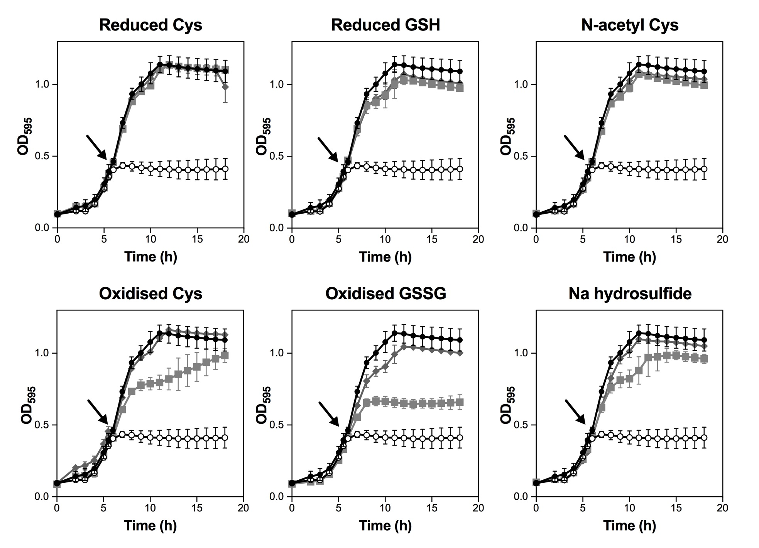

Fig. 5.1. E. coli growth inhibition screen of CORM-2 +/- exogenous sulfur compounds. E. coli MG1655 cell cultures were grown aerobically at 37 °C in GDMM in 96-well plates until mid-exponential phase (OD_{595nm} ~ 0.5) and then 30 μM CORM-2 alone (black line, open circles) or CORM-2 that had been pre-incubated for 10 min with a 2-fold excess of sulfur compound (grey line, closed squares) was added to the cultures (indicated by the arrows). Culture growth without reagent (black line, closed circles) or with the equivalent level of DMSO + 60 μM sulfur compound (grey line, diamonds) are shown for comparison. Growth was monitored in a Tecan SunriseTM Platereader by measuring absorbance of the cultures at 595 nm. Data shown are the means of 3 or more technical and two biological repeats. Errors bars represent ± SD.

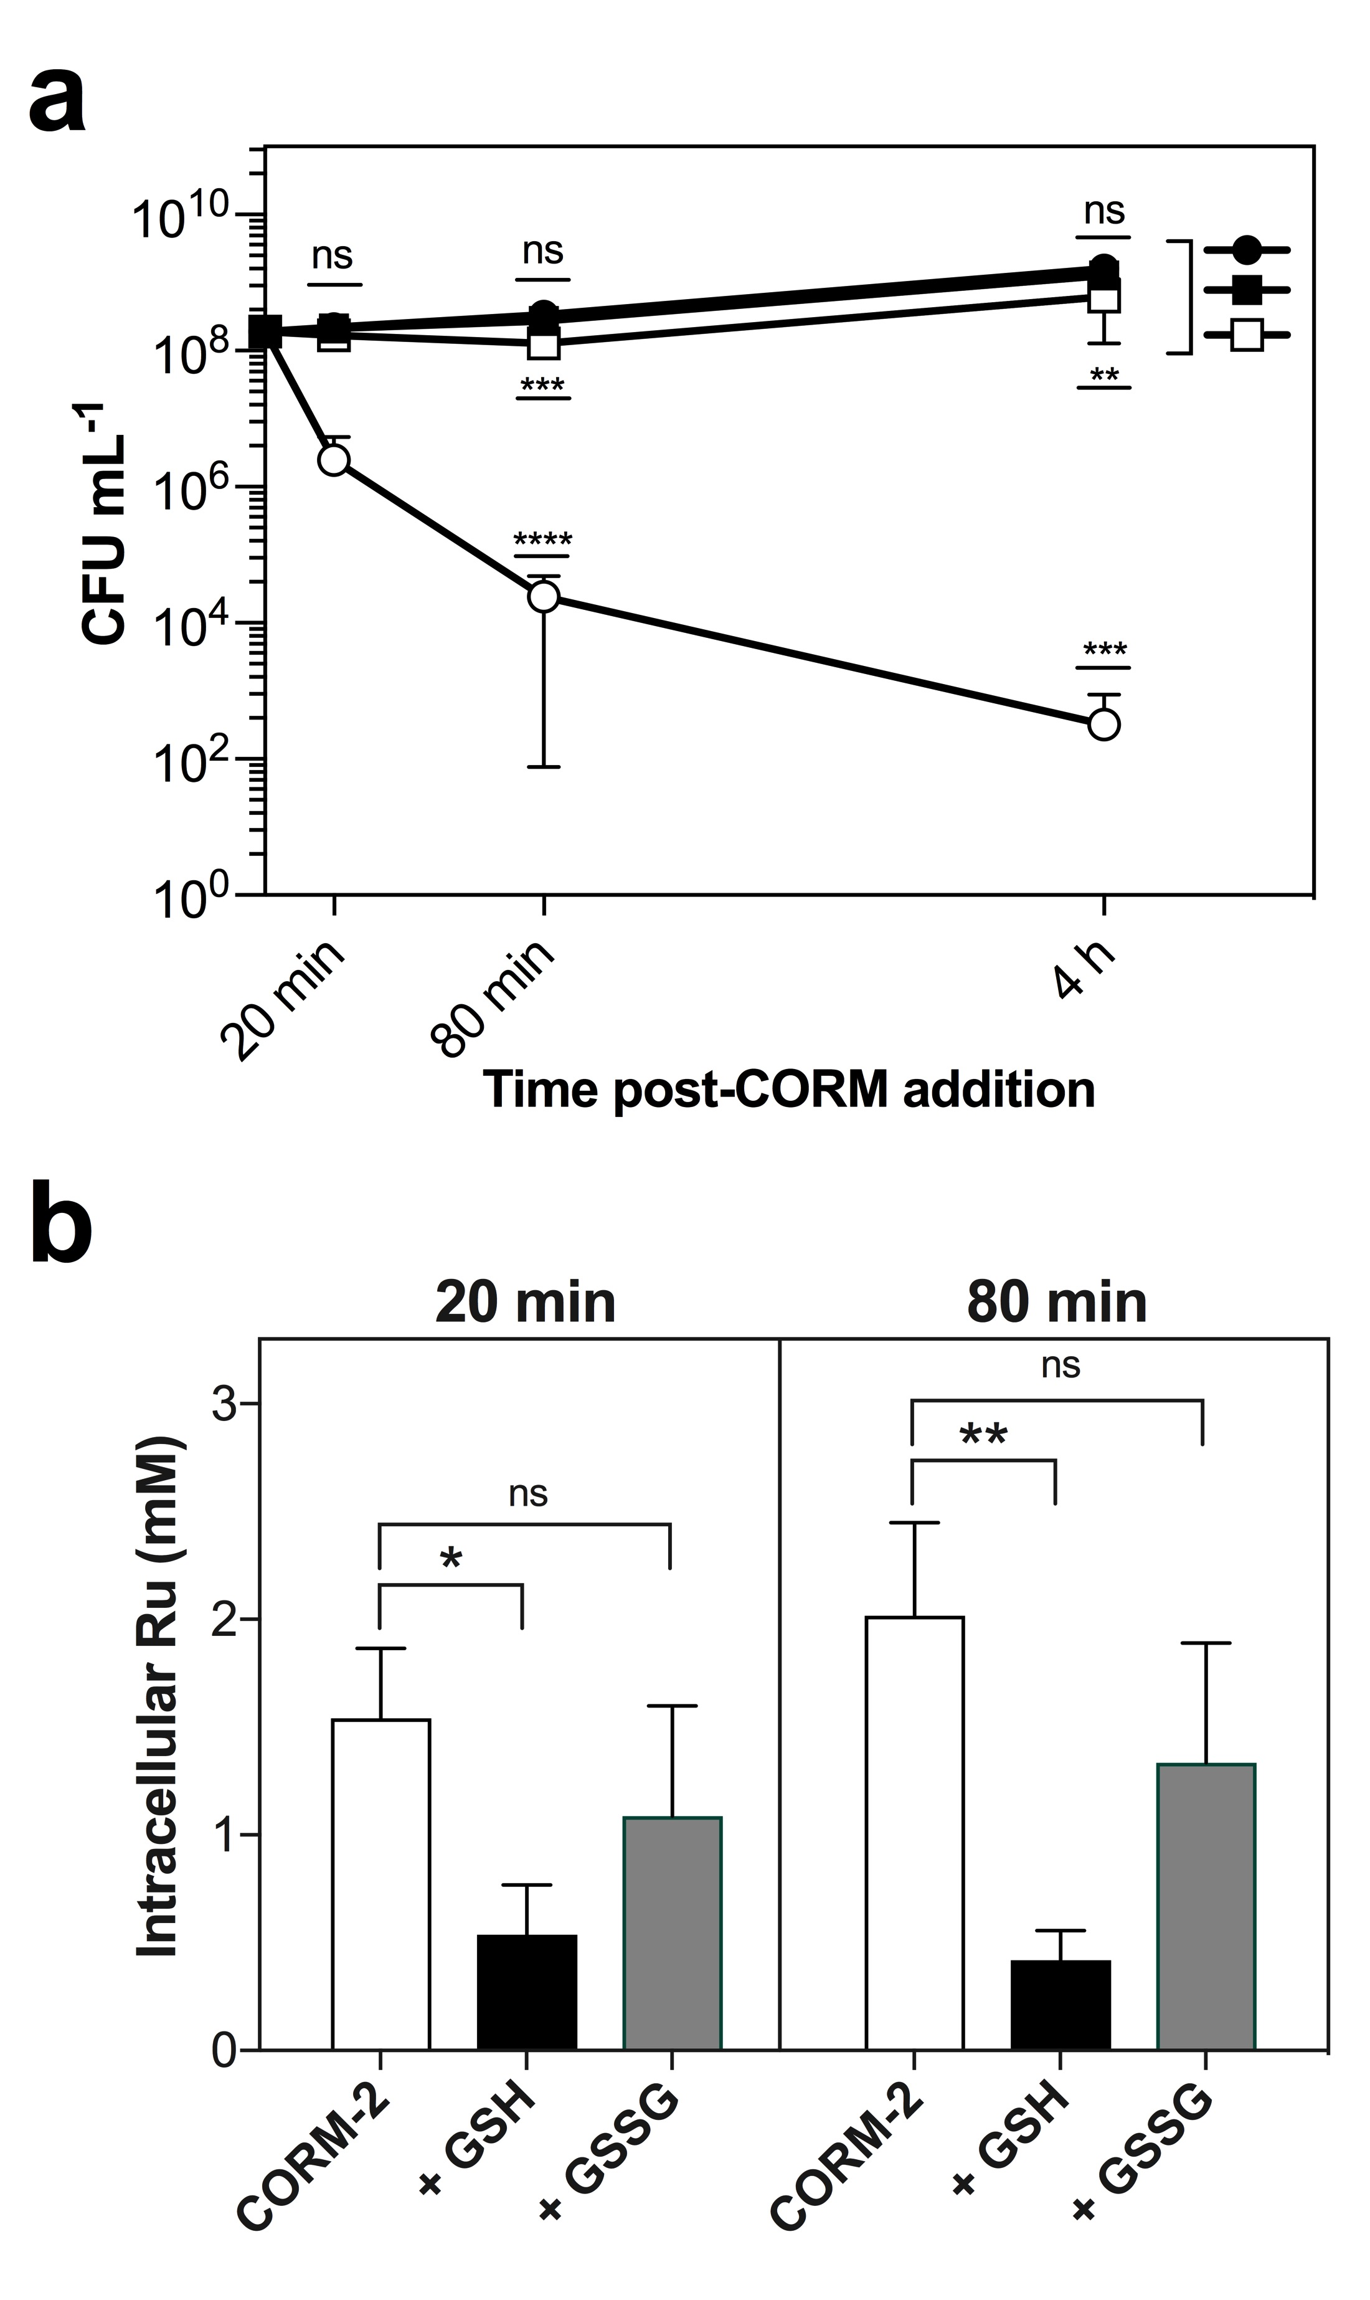
Fig. 5.2. The affects of exogenous glutathione on CORM-2-induced bacterial cell death and intracellular Ru accumulation. E. coli MG1655 cell cultures were grown aerobically at 37 °C in GDMM until early exponential phase (OD_{600nm} ~ 0.4) and then 30 μM CORM-2 alone (open circles) or 30 μM CORM-2 that had been pre-incubated for 10 min with a 2-fold excess of reduced glutathione (GSH) (closed squares) or oxidised glutathione (GSSG) (open squares) was added (t = 0). Samples for viable counts (a) and for determination of intracellular Ru content (b) were taken at time intervals thereafter. A culture with the equivalent level of DMSO (vehicle) was included as a control. (a) Administration of 30 μM CORM-2 caused a significant decrease in viability relative to control cells (*** p ≤ 0.001, **** p ≤ 0.0001). In contrast, there was no significant decrease in viability of cells after the addition of CORM-2 pre-incubated with GSH relative to the control. Addition of CORM-2 pre-incubated with GSSG caused a slight reduction in viability at 80 min and 4 h relative to control cells (***p ≤ 0.001, **p ≤ 0.01). (b) the level of intracellular Ru accumulation following exposure to CORM-2 was significantly decreased following pre-incubation of the compound with a 2-fold excess of GSH at 20 min (* p ≤ 0.05) and 80 min (** p ≤ 0.01). Pre-incubation of CORM-2 with a 2-fold excess of GSSG had no significant effect on the accumulation of CORM-derived Ru. Data are representative of 3 biological repeats ± SD. Statistical analysis was via a one-way ANOVA followed by a Tukey’s multiple comparisons test.

To determine the impact of exogenous GSH or GSSG on the level of intracellular Ru accumulated by E. coli upon exposure to CORM-2, cell culture samples were harvested and analysed for Ru content by ICP-AES following addition of the CORM (Fig. 5.2(b)). The level of intracellular Ru in E. coli exposed to 30 μM CORM-2 was determined to be 1.5 ± 0.33 mM at 20 min and 2.0 ± 0.33 mM at 80 min, in-line with previous findings (Chapter 4). The presence of a 2-fold excess of exogenous GSH significantly reduced the level of accumulated intracellular Ru to 540 ± 23 μM at 20 min and 420 ± 14 μM at 80 min (Fig. 5.2(b)). Thus, the protective effects of exogenous GSH against CORM-2 are due to prevention of intracellular Ru accumulation, as has been observed for Cys (Chapter 4) and NAC (Jesse et al., 2013). In contrast, although the intracellular level of Ru appeared to be reduced by addition of a 2-fold excess of GSSG (1.09 ± 0.51 mM at 20 min and 1.33 ± 0.56 mM at 80 min), the relatively high variance in these measurements renders this apparent difference insignificant (Fig. 5.2(b)). Thus, the alleviation of CORM-2 antimicrobial effects by GSSG appears not to be due to a significant decrease in the extent of intracellular Ru accumulation in E. coli cells exposed to CORM-2.
5.2.2. The impact of exogenous reduced or oxidised thiol compounds on the antimicrobial activities of CORM-3
To determine whether CORM-3 could also interact with reduced or oxidised sulfhydryl-containing compounds in vitro, the experiments described in Section 5.2.1 above, were also conducted with CORM-3. Fig. 5.3 shows the results obtained from the growth inhibition screen of E. coli MG1655 cell cultures exposed to CORM-3 that had first been pre-incubated with various reduced or oxidised sulfhydryl-containing compounds. As observed for CORM-2, a 2-fold excess of Cys, GSH, NAC or NaHS was sufficient to completely alleviate the growth inhibitory effects of 60 μM CORM-3 (Fig. 5.3). Also, as observed for CORM-2, a 2-fold excess of cystine or GSSG partially protected cells against the growth inhibitory effects of CORM-3, with a more pronounced effect observed for cystine than GSSG (Fig. 5.3). Thus, these results indicate that CORM-3 is likely to interact with both reduced and oxidised sulfhydryl-containing compounds in vitro. The addition of 120 μM sulfhydryl compound had no significant effects on the growth of E. coli cultures (Fig. 5.3).
Similarly, the bactericidal effects of CORM-3 against E. coli MG1655 were abolished by pre-incubation of CORM-3 with a 2-fold excess of GSH (Fig. 5.4(a)). In contrast however, the addition of CORM-3 pre-incubated with a 2-fold excess of GSSG (CORM-3 + GSSG) caused a significant and potent decrease in cell culture viability relative to that of untreated control cells at 4 h post-CORM addition (Fig. 5.4(a)). The extent of cell killing of 60 μM CORM-3 alone was found to be considerably greater than that of (CORM-3 + GSSG),
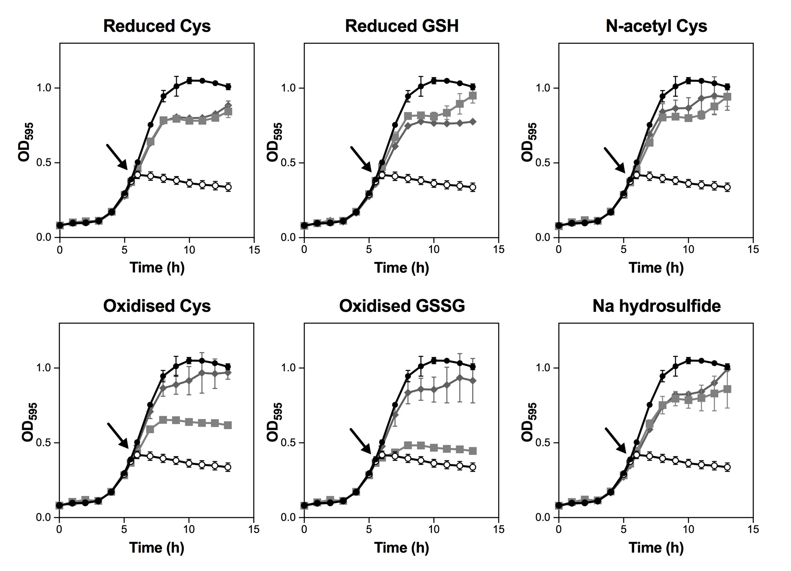

Fig. 5.3. E. coli growth inhibition screen of CORM-3 +/- exogenous sulfur compounds. E. coli MG1655 cell cultures were grown aerobically at 37 °C in GDMM in 96-well plates until mid-exponential phase (OD_{595nm} ~ 0.45) and then 60 μM CORM-3 alone (black line, open circles) or CORM-3 that had been pre-incubated for 10 min with a 2-fold excess of sulfur compound (grey line, closed squares) was added to the cultures (indicated by the arrows). Culture growth without reagent (black line, closed circles) or with 120 μM sulfur compound (grey line, diamonds) are shown for comparison. Growth was monitored in a Tecan SunriseTM Platereader by measuring absorbance of the cultures at 595 nm. Data shown are the means of 3 or more technical repeats and two biological repeats. Errors bars represent ± SD.

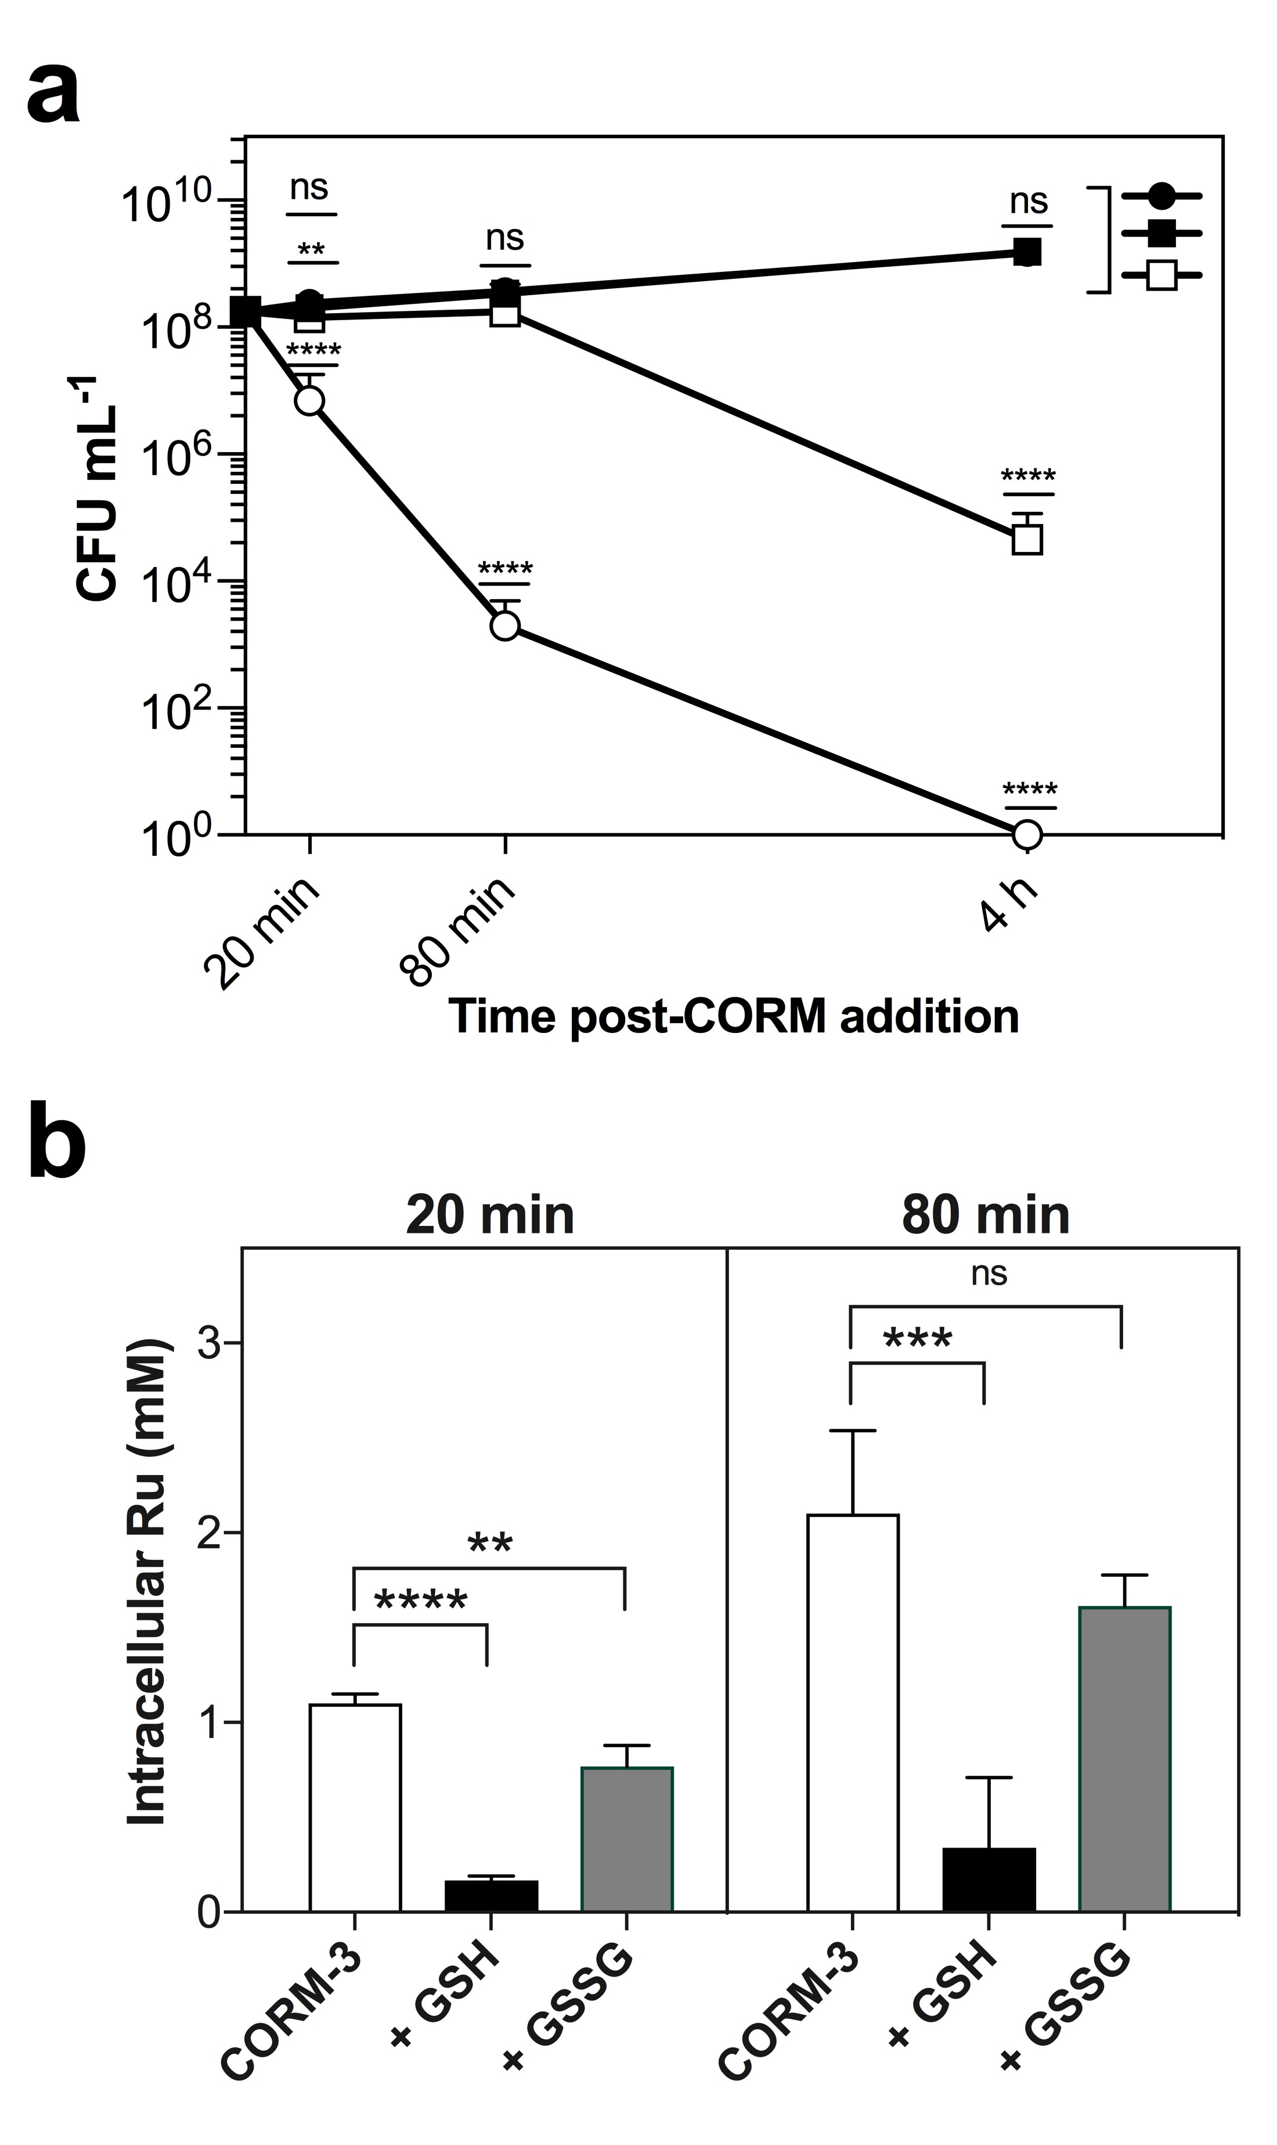
Fig. 5.4. The affects of exogenous glutathione on CORM-3-induced bacterial cell death and intracellular Ru accumulation. E. coli MG1655 cell cultures were grown aerobically at 37 °C in GDMM until early exponential phase (OD_{600nm} ~ 0.4) and then 60 μM CORM-3 alone (open circles) or 60 μM CORM-3 that had been pre-incubated for 10 min with a 2-fold excess of reduced glutathione (GSH) (closed squares) or oxidised glutathione (GSSG) (open squares) was added (t = 0). Samples for viable counts (a) and for determination of intracellular Ru content (b) were taken at time intervals thereafter. A culture with no CORM added was included as a control. (a) Administration of 60 μM CORM-3 caused a significant decrease in viability relative to control cells at all time points (**** p ≤ 0.0001). In contrast, there was no significant decrease in viability of cells after the addition of CORM-3 pre-incubated with GSH relative to the control. Addition of CORM-3 pre-incubated with GSSG caused a slight reduction in viability at 20 and 80 min relative to control cells and a dramatic decrease at 4 h (****p ≤ 0.0001). (b) the level of intracellular Ru accumulation following exposure to CORM-3 was significantly decreased following pre-incubation of the compound with a 2-fold excess of GSH at 20 min (**** p ≤ 0.0001) and 80 min (*** p ≤ 0.001). Pre-incubation of CORM-3 with a 2-fold excess of GSSG significantly decreased the level of intracellular Ru at 20 min (** p ≤ 0.01) but not at 80 min. Data are representative of 3 biological repeats ± SD. Statistical analysis was via a one-way ANOVA followed by a Tukey’s multiple comparisons test.
suggesting that the addition of GSSG to the CORM did partially alleviate the bactericidal effects of CORM-3 (Fig. 5.4(a)). This finding appears to contradict the observation that GSSG partially alleviates the growth inhibitory effects of CORM-3 in Fig. 5.3, whereby the addition of GSSG appeared to permit culture growth up to 2 h following the addition of the CORM. In Fig. 5.4(a), the viability of cell cultures exposed to (CORM-3 + GSSG) was not reduced relative to untreated control cells at either 20 or 80 min post-CORM addition. Only after 4 h of exposure to (CORM-3 + GSSG) was the viability of the cultures dramatically reduced relative to that of the untreated control. Thus, the affect of a 2-fold excess of GSSG appeared to be to delay the growth inhibitory and bactericidal effects of CORM-3, but this alleviation was abolished after 2-4 h following addition of the compounds to E. coli cell cultures. This is in contrast to what was observed for the effects of GSSG on CORM-2 antimicrobial effects (see Section 5.2.1).
In agreement with this observation, the intracellular level of accumulated Ru in E. coli cells exposed to (CORM-3 + GSSG) was found to be significantly lower after 20 min (770 ± 11 μM) relative to the level of Ru accumulated by E. coli upon exposure to 60 μM CORM-3 alone (1.1 ± 0.05 mM) (Fig. 5.4(b)). After 80 min, there was no significant difference in the level of intracellular Ru in E. coli cells following exposure to (CORM-3 + GSSG) (1.62 ± 0.16 mM) or CORM-3 alone (2.1 ± 0.44 mM) (Fig. 5.4(b)). Thus, it is likely that the delayed onset of CORM-3-induced growth inhibitory effects by the presence of GSSG appears due to a reduction in the rate at which E. coli cells accumulate CORM-3-derived Ru.
As with CORM-2, the level of intracellular Ru accumulated by E. coli cells upon exposure to CORM-3 pre-incubated with a 2-fold excess of GSH was significantly reduced at 20 min (169 ± 20 μM) and 80 min (339 ± 370 μM) post-CORM addition (Fig. 5.4(b)). Thus, the protective effects of exogenous GSH against CORM-3 antimicrobial activities is due to the prevention of intracellular Ru accumulation, as has been observed for Cys (Chapter 4) and NAC (Jesse et al., 2013).
5.2.3. Glutathione-deficient E. coli mutants are more sensitive to CORM-2 and CORM-3 and accumulate less CORM-derived Ru than WT cells
Intracellular GSH is considered to play a protective role in bacterial defences against non-essential metals by sequestration (Lemire et al., 2013). To determine if intracellular GSH has a protective role against CORM-2 and CORM-3 antimicrobial activities in E. coli, and thus determine if intracellular GSH is a target of CORM-derived Ru(II) ions, the antimicrobial effects of these CORMs against E. coli glutathione-deficient mutants (gshA, RKP5908) was investigated. The gshA strain contains a kanamycin resistance cassette (kan^{R}) in place of gshA and thus lacks a functioning γ-glutamyl-L-cysteine synthase (GshA) and is deficient in glutathione biosynthesis. A comparison of the aerobic growth of the gshA mutant strain against WT E. coli on GDMM revealed no significant differences in growth rates as determined by measurements of culture turbidity (Fig. 5.5(a)) or viable counts (Fig. 5.5(b)). Thus, the growth rate of E. coli is unaffected by glutathione deficiency, as has been reported previously, due to the functional redundancy of the thioredoxin and glutaredoxin pathways of E. coli (Toledono et al., 2007).
The estimated intracellular thiol content of E. coli cells was determined via a DTNB assay of soluble cellular extracts following breakage of the cells by sonication and removal of insoluble membranes and cellular debris by centrifugation. The intracellular thiol content of WT E. coli at early exponential phase (OD_{600nm} ~ 0.4) was determined to be 5.2 ± 0.36 mM, whilst the intracellular thiol content of gshA E. coli was determined to be approximately 54 % lower at 2.4 ± 0.37 mM (Fig. 5.5(c)). Thus, the total intracellular GSH content of WT E. coli cells can be estimated, by difference, to be approximately 2.8 mM. This is considerably lower than the reported literature value of ~ 5 mM (Ritz and Beckwith, 2001) and might be due either to differences in growth conditions of the E. coli employed in this study or to the method used to estimate intracellular thiol content. Nonetheless, the E. coli gshA strain contains significantly less intracellular thiols than WT E. coli under the standard growth conditions employed in this thesis to assess the antimicrobial effects of CORM-2 and CORM-3 (Fig. 5.5(c)).
Firstly, it was investigated whether removal of intracellular glutathione could affect the extent to which E. coli cells accumulated Ru upon exposure to CORM-2. The level of intracellular Ru upon the addition of 30 μM CORM-2 was thus determined by ICP-AES in gshA cells for comparison WT cells, as shown in Fig. 5.6(a). At all time points measured, the level of intracellular Ru in gshA cells was significantly decreased relative to the Ru content of WT cells (Fig. 5.6(a)). Significantly, both the initial rate of uptake of Ru (Fig. 5.6(c)) and the total level of accumulated Ru (Fig. 5.6(a)) was decreased in the gshA mutant relative to WT cells. The initial rate of uptake of CORM-2 derived Ru was found to be 225 ± 33 μM Ru min⁻¹ by WT cells compared to 178 ± 23 μM Ru min⁻¹ for gshA cells (Fig. 5.6(c)). The final level of accumulated intracellular Ru after 1 h of CORM-2 exposure was found to be 2.2 ± 0.08 mM for WT cells compared to 1.44 ± 0.08 mM for gshA cells. Thus, the removal of GSH from E. coli significantly decreases: (1) the rate by which CORM-2-derived Ru is accumulated by E. coli cells and (2) the total level of Ru that can be accumulated by E. coli cells upon exposure to CORM-2.
Next it was determined whether the removal of GSH could affect the uptake and accumulation of Ru by E. coli cells upon exposure to 60 μM CORM-3. As shown in Fig. 5.6(b), the level of intracellular Ru in gshA cells relative to WT cells was not significantly altered up to
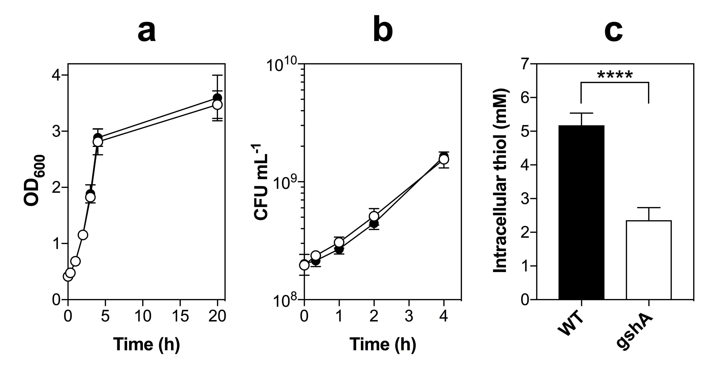

Fig. 5.5. Phenotypic characterisation of E. coli glutathione deficient (gshA) mutant strain.
(a-b) Comparison of the growth of a glutathione deficient (gshA) mutant strain of E. coli MG1655 versus the WT gshA⁺ MG1655 strain from early exponential phase (OD_{600nm} ~ 0.4) as measured by monitoring the optical density of cell cultures (OD₆₀₀) (a) or by viable cell counts (b). There was no significant difference in the growth characteristics of the gshA strain relative to the gshA⁺ WT strain when growth aerobically in GDMM. (c) Intracellular thiol levels as determined via a DTNB assay on soluble cell extracts of WT or gshA cell cultures after aerobic growth on GDMM at OD₆₀₀ ~ 0.45 (early exponential phase). The intracellular thiol level of the gshA strain (2.4 ± 0.37 mM) was significantly less than the WT strain (5.2 ± 0.36 mM) (**** p≤ 0.0001). Data in (a-b) are representative of 3 biological repeats ± SD. Data in (c) are representative of 3 biological repeats and 2 technical repeats ± SD. Significant differences were assessed via an unpaired t-test.
Work in (c) was performed in collaboration with Jonathan Chapman.

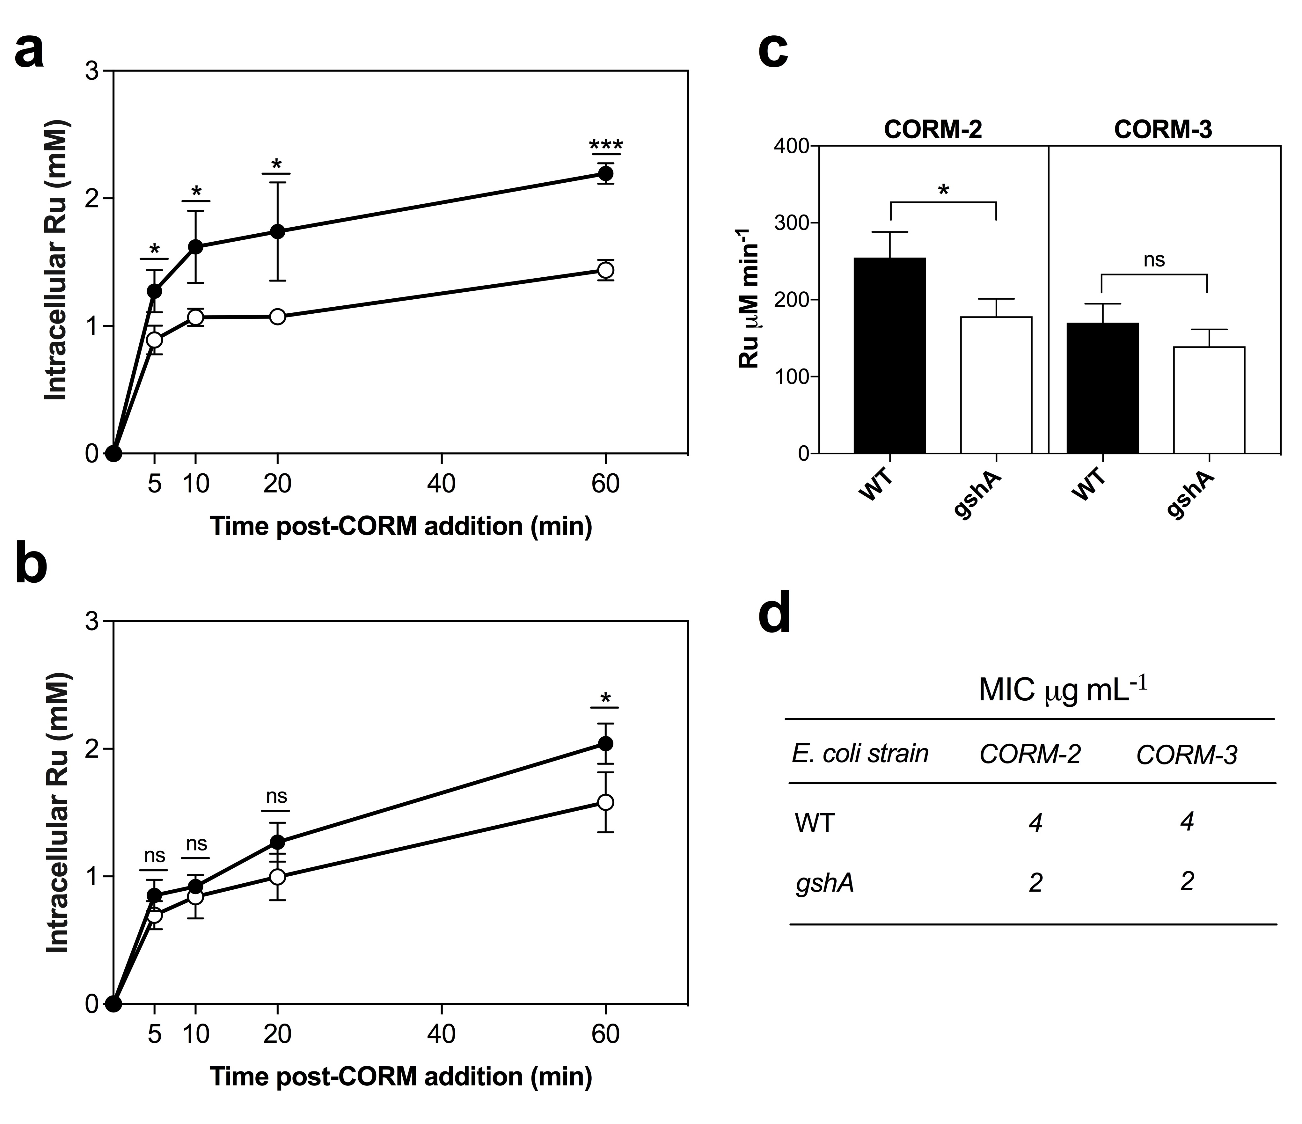

Fig. 5.6. Glutathione deficient gshA E. coli cells accumulate less Ru upon exposure to CORM-2 or CORM-3, but are more sensitive to CORMs than WT gshA⁺ E. coli.
(a-b) Level of intracellular Ru accumulation of E. coli MG1655 WT cells (closed circles) or gshA cells (open circles) as measured by ICP-AES at time intervals following exposure to 30 μM CORM-2 (a) or 60 μM CORM-3 (b). (a) The level of intracellular Ru after exposure to 30 μM CORM-2 was significantly lower in gshA cells relative to WT cells at all time points measured (* p ≤ 0.05, *** p ≤ 0.001). (b) The level of intracellular Ru after exposure to 60 μM CORM-3 was significantly lower in gshA cells relative to WT at 60 min only (* p ≤ 0.05). (c) Initial rates of Ru accumulation (μM min⁻¹) by WT (black bars) or gshA (white bars) cells after 5 min exposure to CORM-2 or CORM-3 (* p ≤ 0.05). (d) MIC of CORM-2 and CORM-3 against WT or gshA E. coli strains determined in GDMM. Note: 4 μg mL⁻¹ is 7.8 μM CORM-2 or 15.8 μM CORM-3 and 2 μg mL⁻¹ is 3.9 μM CORM-2 or 6.8 μM CORM-3. All data are averages of 3 biological repeats ± SD. Significant differences were assessed via unpaired t-tests.
Work was performed in collaboration with Jonathan Chapman.

20 min following the addition of 60 μM CORM-3 (Fig. 5.6(b)). Thus, the initial rate of uptake of CORM-3- derived Ru by gshA cells (139 ± 22 μM Ru min⁻¹) was not found to be significantly different to that of WT cells (170 ± 24 μM Ru min⁻¹) (Fig. 5.6(c)). The total level of Ru accumulated by gshA cells after 1 h of CORM-3 exposure (1.58 ± 0.24 mM) was found to be significantly decreased relative to WT cells (2.04 ± 0.16 mM) (Fig. 5.6(b)). Thus, it can be concluded that the removal of GSH from E. coli significantly decreases the total level of Ru that can be accumulated by E. coli cells upon exposure to CORM-3 but does not significantly affect the initial rate at which the cells accumulate CORM-3-derived Ru.
The next step was then to investigate if the gshA mutant strain was more sensitive to CORM-2 than WT E. coli. A comparison of the antimicrobial effects of 7.5 – 30 μM CORM-2 on the growth and viability of gshA cultures relative to WT cultures revealed no significant differences due to the high level of variance in the results (data not shown). Thus it was concluded that the difference in sensitivities to CORM-2 or CORM-3 between WT E. coli and the gshA mutant strain were likely to be subtle. To investigate the relative sensitivities of these strains, the MIC of CORM-2 and CORM-3 was determined for gshA for comparison with that obtained previously for WT cells in GDMM in Chapter 3. As shown in Fig 5.6(d), the MIC of CORM-2 against the gshA mutant strain (2 μg mL⁻¹ or 3.9 μM) was determined to be half that of the MIC of CORM-2 against WT E. coli (4 μg mL⁻¹ or 7.8 μM). Similarly, the MIC of CORM-3 against the gshA mutant strain was also 2 μg mL⁻¹ (or 13.6 μM) and half that of WT E. coli (4 μg mL⁻¹ or 13.6 μM). Thus, the removal of intracellular GSH renders E. coli cells more sensitive to inhibition by CORM-2 or CORM-3. Therefore intracellular GSH is likely to have a protective role in the antimicrobial effects of CORM-derived Ru.
5.3. Discussion
5.3.1. CORM-2 and CORM-3 interact with reduced and oxidised sulfhydryl-containing compounds in vitro and in vivo
As outlined in the introduction of this chapter (Section 1.5.3), CORM-2 and CORM-3 prevent reaction of the sulfhydryl-reagent DTNB with various –SH containing compounds in vitro (Tavares et al., 2011; McLean et al., 2013). This was initially proposed to be due to the formation of ROS from the CORMs, which would subsequently lead to oxidation of –SH and disulfide bond formation. Thus, CORM-mediated prevention of DTNB interactions with sulfhydryls in vitro was considered one of the key pieces of evidence to suggest that CORMs mediate their antimicrobial effects via ROS production (Tavares et al., 2011). Later it was demonstrated that prevention of –SH reaction with DTNB by CORMs was due to direct reaction of the CORM, most likely via the Ru(II) ion, with the –SH group, thus preventing interaction of the –SH with DTNB (McLean et al., 2013). Furthermore, numerous studies had demonstrated that certain –SH containing antioxidants, but not non-thiol antioxidants such as ascorbate, alleviate the antimicrobial effects of Ru-based CORMs (Desmard et al., 2009; Tavares et al., 2011; Desmard et al., 2012). Previously, it was demonstrated that the alleviation of CORM antimicrobial effects by Cys and NAC were due to the covalent coordination of the Ru(II) ions to the –SH of Cys extracellularly, thus preventing accumulation of CORM-derived Ru (see Chapter 4 and Jesse et al., 2013).
It was therefore expected that the previously reported alleviation of CORM-2 and CORM-3 antimicrobial effects by exogenous GSH was due also to sequestration of the compounds extracellularly. As demonstrated in Fig. 5.1 – Fig. 5.4, pre-incubation of either CORM-2 or CORM-3 with a 2-fold excess of GSH completely alleviated the bactericidal effects of these CORMs against E. coli and prevented accumulation of CORM-derived Ru by E. coli cells. This provides further support to the hypothesis that the protective effects of exogenous thiol compounds against CORMs is due to sequestration of the Ru outside of E. coli cells and is therefore not due to any ROS-scavenging or antioxidant effects, as had been proposed previously (Tavares et al., 2011; Tavares et al., 2012). Rich growth media are also likely to contain a significant proportion of other –SH containing compounds in addition to Cys, and thus sulfhydryl components of rich media are also likely to play a role in preventing the antimicrobial effects of CORMs in LB, MH-II, DMEM or RPMI (see Chapter 3). In addition, it is interesting to note that GSH, along with Cys and NAC, has been shown to protect against the inhibitory effects of CORM-3 on bacterial oxygen consumption (Desmard et al., 2009; McLean et al., 2013). It is likely that this protective effect is also due to sequestration of Ru(II) ion of CORM-3. This addition of exogenous GSH has also been demonstrated to alleviate Cd(II)-induced inhibition of E. coli aerobic respiration via sequestration of Cd(II) (Helbeig et al., 2008). Thus, the ability for –SH containing compounds to prevent the respiratory effects of CORM-3 suggests that CORM-3 induced respiratory inhibition is mediated by Ru(II) ion rather than, or at least in addition to, CO.
The above findings, and those in Chapter 4, demonstrate that alleviation of the antibacterial effects of CORMs by exogenous compounds is likely to be an indicator of extracellular binding of the CORM by the exogenous compound. As oxidised sulfhydryl-containing compounds, such as GSSG, have been demonstrated to bind other metal cations in vitro (Krezel and Bal, 1999), it was investigated whether pre-incubation of CORM-2 or CORM-3 with a 2-fold excess of GSSG or cystine (oxidised cysteine) could alleviate CORM-induced growth inhibition. As demonstrated in Fig. 5.1 and 5.3, addition of GSSG or cystine partially alleviated the growth inhibitory effects of CORM-2 and CORM-3 against E. coli. Thus, it can be concluded that both CORMs interact with oxidised sulfhydryl compounds in vitro. Furthermore, it was found that a 2-fold excess of exogenous GSSG protected E. coli cells against the bactericidal effects of CORM-2 but only delayed the onset of CORM-3 induced bactericidal effects against E. coli cells (Fig. 5.2 and 5.4). Interestingly, the presence of GSSG did not significantly decrease the extent of accumulated Ru by E. coli upon exposure to CORM-2 or CORM-3 after 80 min. It is possible, as observed for the effect of exogenous Met on CORM-derived Ru accumulation (Chapter 4), that accumulation of CORM-2/3 derived Ru by E. coli in the presence of exogenous GSSG is dependent on the rate of dissociation of the Ru(II) ions from the [CORM + GSSG] complex.
This is the first time that CORM-2 or CORM-3 binding to oxidised sulfhydryls has been demonstrated, but the nature of the interaction between the Ru(II) ions and oxidised sulfhydryls is not currently understood. However, it is known that binding of other divalent cations, such as Zn(II), Ni(II) and Co(II), to GSSG occurs at two glutamate residues of GSSG which are brought into close proximity via the formation of the disulfide bond (Krezel and Bal, 1999). This mode of binding is thus likely to be much weaker than the covalent bond formed between the Ru(II) ions of the CORMs and the sulfur atom of reduced sulfhydryl compounds such as Cys. The nature of CORM Ru(II) bonding to GSSG will be investigated by ¹H-NMR in the future to confirm this hypothesis. As described above, the majority of oxidised sulfhydryl-groups in E. coli cells are located in the periplasm and are important for maintenance of the structure and function of periplasmic proteins. Thus, the binding of CORM-2- and CORM-3-derived Ru(II)-species to periplasmic proteins via these oxidised Cys residues may also represent an important intracellular target of CORM-derived Ru(II) ions. The accumulation of CORM-derived Ru in the periplasm of E. coli has not yet been investigated.
5.3.2. Intracellular GSH is an intracellular target of CORM-derived Ru and may have a protective role against CORM toxicity in E. coli
There are several lines of evidence to support the hypothesis that sulfur species, particularly sulfhydryls, are intracellular targets of CORM-derived Ru. Firstly, CORM-2 and CORM-3 interact strongly with sulfhydryl compounds in vitro via the formation of a covalent bond between the Ru(II) ion of the CORM and the S atom of the thiol (Chapter 4). Secondly, addition of CORM-2 is known to cause a reduction in the activity of [Fe-S] containing proteins in E. coli cell extracts (Tavares et al., 2011). Thirdly, transcriptional changes upon exposure of E. coli cells to CORM-2 and CORM-3 include upregulation of genes involved in sulfur metabolism, sulfur transport and those that respond to sulfur starvation (McLean et al., 2013). All these evidence suggest that CORM-derived Ru coordinate sulfhydryl groups inside bacterial cells. However, a previous publication has shown that exposure of P. aeruginosa cells to 10 μM CORM-3 did not lead to a significant reduction in intracellular thiols (Desmard et al., 2009). Preliminary measurements conducted in the course of this project, in an attempt to measure a decrease in intracellular thiols in E. coli upon exposure to CORM-2, were unsuccessful due to technical difficulties (data not shown). Therefore, an alternative method was employed to investigate if intracellular thiols were a target of CORM-derived Ru.
The major source of intracellular -SH in WT E. coli cells is GSH. The level of intracellular GSH in WT MG1655 E. coli at early exponential phase grown aerobically in GDMM was determined to be ~ 2.8 mM (Fig. 5.5). Thus, this is the approximate level of intracellular GSH present in E. coli cells upon the addition of CORM-2 or CORM-3 in the majority of the experiments conducted in this thesis. The total level of intracellular Ru in gshA cells upon exposure to CORM-2 was found to be approximately 34 % lower than the level accumulated by WT cells (Fig. 5.6(a)). Similarly, the total level of accumulated Ru following exposure to CORM-3 was approximately 23% less in gshA cells than WT cells (Fig. 5.6(b)). Thus, removal of GSH from E. coli significantly decreases the extent of CORM-derived Ru accumulation.
In Chapter 4, the mechanism of uptake and accumulation of CORM-2- and CORM-3- derived Ru was proposed to be as follows. Firstly, upon entry of the CORM-derived Ru species into the bacterial cell, the Ru(II) ion rapidly reacts with and coordinates to intracellular targets. Thus, the CORM-derived Ru complex is now in the ‘bound’ form and is chemically changed relative to ‘unbound’ complexes outside of the cell. This effectively maintains a very low concentration of free unbound CORM-derived complexes intracellularly. Thus, cellular uptake of the unbound CORM-derived Ru complexes continues, driven by diffusion, against a seemingly high concentration gradient, until all the available intracellular targets of the Ru(II) ions are depleted. If this hypothesis is correct, the decrease in uptake of CORM-2 and CORM-3 derived Ru by removal of GSH in gshA cells suggests that GSH is a key intracellular target of CORM Ru(II) ions. To further confirm this hypothesis, future work could include investigating the extent to which CORM-derived Ru is accumulated by E. coli cells engineered to have increased levels of intracellular GSH i.e. via an overexpression vector of gshA and gshB. This would enable the extent of intracellular Ru accumulation to be correlated with both increased and decreased levels of GSH. A definitive experiment would also be to demonstrate a decrease in intracellular thiols upon an increase of intracellular Ru upon exposure to CORM-2 and CORM-3, though this was abandoned in this project due to technical difficulties and time constraints.
It is interesting that the initial rate of uptake of CORM-2-derived Ru, but not CORM-3-derived Ru, was significantly slower in gshA cells compared to WT cells (Fig. 5.6(c)). This further supports the hypothesis that pathways employed for uptake of CORM-2-derived species are different to those employed for uptake of CORM-3-derived species. Thus, uptake of CORM-2-derived Ru appears to be more dependent on the presence of intracellular GSH than uptake of CORM-3-derived Ru. It must also be noted that even with the removal of the major intracellular thiol in E. coli cells, the total level of Ru accumulated by gshA mutant cells upon exposure to either CORM was ~ 1.44 – 1.58 mM after 1 h (Fig. 5.6). This implies that there are many additional intracellular targets of CORM-derived Ru.
The gshA mutant was also found to be slightly more sensitive to CORM-2 and CORM-3 than WT E. coli, as determined by MIC measurements (Fig. 5.6(d)). Thus, although it is probable that GSH is a key target of CORM-derived Ru, it is not likely that binding of Ru(II) to intracellular GSH per se is the underlying cause of CORM-2 or CORM-3 toxicity. As has been observed for other divalent metal cations (Lemire et al., 2013), it is likely that the sequestration of CORM-derived Ru(II) by intracellular GSH has a protective role in the prevention of Ru(II) coordination to surface-exposed Cys, His or Met residues on essential proteins or other to sulfur-mediated cellular processes. In addition, depletion of intracellular thiols by CORM-derived Ru(II) ions is also likely to cause additional antimicrobial effects such as dysregulation of cellular redox homeostasis and inactivation of glutaredoxin and thioredoxin antioxidant pathways (Lemire et al., 2013). Such effects are observed following bacterial exposure to toxic metals such as Hg and Cd (Bruins et al., 2000; Helbig et al., 2008; Lemire et al., 2013). Thus, the results presented in this chapter further support the reclassification of CORM-2 and CORM-3 as functional antimicrobial ruthenium compounds.
4.5. Concluding remarks
A summary of the findings of Chapter 5 is as follows. CORM-2 and CORM-3 interact with both reduced (-SH) and oxidised (-S-S-) sulfhydryl-containing compounds in vitro. The interaction of CORM-2 and CORM-3 with –SH is likely to be stronger than for –S-S-, resulting in a covalent bond between the Ru(II) of the CORM and the S of the –SH, as observed for Cys in Chapter 4. The nature of CORM interactions with –S-S- is not understood. The alleviation of the antimicrobial effects of CORM-2 and CORM-3 by -SH containing compounds is due to sequestration of the Ru(II) complexes extracellularly and prevention of uptake of CORM-derived Ru by E. coli. Thus, the protective effecst of exogenous Cys, NAC or GSH are not due to their ROS-scavenging activities.
It is likely that both reduced (-SH) and oxidised (-S-S-) sulfhydryls represent key bacterial targets of CORM-derived Ru. GSH is demonstrated to be a key intracellular target and may have a protective role against the antimicrobial effects of CORM-2 and CORM-3 by sequestration of the Ru(II) ions. Thus, it is likely that CORM-2 and CORM-3 antimicrobial effects are mediated by Ru(II) ion coordination to numerous cellular targets including surface-exposed Cys, His and Met residues and sulfhydryl groups on proteins. These conclusions further support the re-classification of CORM-2 and CORM-3 as functional ruthenium antimicrobial compounds rather than simply ‘CO-releasing molecules’. It is important to note that GSH is the major antioxidant of mammalian cells (Forman et al., 2009) and thus any antimicrobial compound that elicits its antibacterial effects on bacterial cells by reaction with sulfhydryls is likely to have significant cytotoxicity to host cells. A re-evaluation of the cytotoxicity of these CORMs on mammalian cells is presented in Chapter 7. In Chapter 6, it will be considered whether bacterial membranes or DNA are also targets of CORM-derived Ru in E. coli cells.

Chapter 6
Are bacterial membranes and DNA overlooked targets of Ru-carbonyl CORMs?
6.1. Introduction
From the results presented so far in this thesis, it can be concluded that certain surface-exposed amino acid results (Cys, His and Met) and reduced or oxidised sulfhydryl-containing compounds (e.g. GSH or GSSG) are likely to be bacterial cell targets of CORM-2 and CORM-3-derived Ru(II) ions (see Chapter 4 and 5). Thus, Ru(II) ion coordination to these targets is likely to underlie the antimicrobial activities of these compounds. The aim of the work in Chapter 6 is to consider whether there are additional targets of CORMs in bacterial cells and how Ru(II) binding to these targets contributes to the bactericidal activities of these compounds.
6.1.1. Is DNA a previously overlooked bacterial cell target of CORM-2 and CORM-3?
It is well established that the antimicrobial consequences of an excess of intracellular Fe(II) are, in part, due to Fe-mediated Fenton chemistry that leads to ROS-mediated DNA damage (Lemire et al., 2013). However, the antimicrobial effects of many other metal ions are not linked to genotoxicity. The cytotoxicity of the chemotherapeutic drug cisplatin, [Pt(NH₃)₂Cl₂], is caused by interactions of the Pt(II) ion of the complex with DNA (Gill and Thomas, 2012). Cisplatin covalently binds to the N7 residue of purines of DNA generating intrastrand crosslinks, which ultimately blocks DNA replication and causes apoptosis in the affected cancer cell (Gill and Thomas, 2012). Cisplatin was originally discovered due to its ability to cause filamentous growth in E. coli, but later became the most widely used anticancer drug of all time (Rosenberg et al., 1967; Wong and Giandomenico, 1999). Ru(II) complexes have similar ligand exchange properties to those of Pt(II) complexes and thus it is probable that Ru(II) complexes, with sufficiently labile ligands, could also interact with DNA in a similar mechanism to complexes such as cisplatin (Gill and Thomas, 2012).
Indeed, Ru(II)-arene complexes containing labile ligands, previously evaluated for their antimicrobial and anticancer activities, have been demonstrated to bind irreversibly to guanine bases of DNA resulting in the formation of Ru(II)-DNA adducts (Ang and Dyson, 2006; Allardyce et al., 2003). Various antimicrobial Ru(II)-arene complexes of the general formula [Ru(η⁶-p-cymene)X₂(pta), where X = labile Cl, Br or I and pta = 1, 3, 5-triaza-7-phosphatricyclo[3.3.1.1.]decane, have been shown to cause DNA damage in vitro (Allardyce et al., 2003). In addition, a series of Ru(II)-complexes containing phosphine/diimine/picolinate ligands, collectively termed ‘SCAR’ complexes, have also been investigated as antimicrobial agents (De Grandis et al., 2016; Pavan et al., 2011). Upon aquation of SCAR6, [RuCl₂(dppb)(bipy)], its chloride ligands are displaced generating a species that has been demonstrated to bind irreversibly to DNA in vitro (De Grandis et al., 2016; Pavan et al., 2011). SCAR6 was also shown to induce frame-shift mutations in Salmonella spp., thus demonstrating its genotoxic effects in microbial cells (De Grandis et al., 2016).
As has been described previously, CORM-2 and CORM-3 are unstable in solution and undergo complex speciation chemistry upon addition of DMSO or aqueous solutions (see Fig. 1.10). In Chapter 3, it was further shown that upon addition of CORM-3 to H₂O or phosphate buffer, there is complete or partial substitution of the glycinate ligand. Thus, the ligands to the Ru(II) ions of these CORMs are sufficiently labile to potentially facilitate irreversible reactions of the Ru(II) ions with DNA, as has been observed with amino acids and sulfhydryl compounds in Chapters 4 and 5. Despite this, there have been no previously reported investigations of CORM-2 or CORM-3 binding to DNA in vitro or in vivo. Only in one study is treatment of E. coli cell cultures with CORM-2 shown to increase expression of the DNA repair gene recA and induce DNA damage as measured by the ROS-reactive fluorescent dye hOGGI Flare (Tavares et al., 2011). However, in this study, DNA damage was attributed to ROS-induced DNA damage rather than a direct interaction of CORM-2 with DNA (Tavares et al., 2011). Given the literature evidence that Ru(II) complexes with labile ligands bind irreversibly to DNA in vitro, the binding of CORM-2 and CORM-3 to DNA, and evaluation of DNA as a potential bacterial cell target of these compounds, warrants further investigation.
6.1.2. Do CORM-2 and CORM-3 target bacterial cell membranes?
Bacterial cell membranes are well-established biological targets of many metal cations including: Pb(II), Cd(II), Ni(II), Co(II), Cu(II), Ca(II), Mg(II), Ag(I), Al(II) and Zn(II) (Savvaidis et al., 1989; Lemire et al., 2013). The OMs of Gram-negative bacteria have an overall net negative charge due to the presence of highly electronegative anionic groups on membrane components such as LPS and phospholipids (see Fig. 1.5) (Nikaido et al., 2003). The attraction of positively charged metal cations to these anionic groups has been exploited in bioremediation for the removal and recovery of toxic metals from wastewater of industrial processes (Savvaidis et al., 1989).
Antimicrobial activities of metal ions include membrane damage and impairment of membrane function (Lemire et al., 2013). Loss of cytoplasmic membrane integrity of both Gram-positive and Gram-negative bacteria after exposure to Ag and Al has been demonstrated by electron microscopy (EM) (Lemire et al., 2013). In addition, Cd(II) and Cu(II) have been shown to directly induce lipid peroxidation in bacterial cells (Lemire et al., 2013). Metal ions such as Ag(I), Zn(II), Cd(II) and Co(II) have long been known to disrupt membrane processes such as aerobic respiration in bacteria (Bragg and Rainnie, 1974; Beard, 1995). This has been proposed to be either due to metal-mediated inhibition of respiratory enzymes or as a consequence of metal-induced leakage of H⁺ across the membrane, which subsequently leads to membrane depolarisation (Lemire et al., 2013).
As reviewed earlier in Chapter 1 (Section 1.5.1), CORM-2 and CORM-3 have been demonstrated to inhibit aerobic respiration in numerous bacteria including: E. coli, P. aeruginosa, S. enterica serovar Typhimurium, C. jejuni and H. pylori (Davidge et al., 2009b; Jesse et al., 2013; Wilson et al., 2013; Desmard et al., 2009; Desmard et al., 2012; Smith et al., 2011; Tavares et al., 2013). This was initially presumed to be due to inhibition of terminal respiratory oxidase enzymes following release of CO from the CORMs (Davidge et al., 2009). Indeed, exposure of whole cells or isolated bacterial membranes to CORM-2 or CORM-3 in vitro leads to formation of CO-adducts on terminal oxidases, as measured by absorbance spectroscopy (Davidge et al., 2009; Jesse et al., 2013; Smith et al., 2011; Tavares et al., 2013; Rana et al., 2014). However in these studies, prior to addition of the CORM, whole cells or membranes were reduced by the addition of dithionite (a known trigger of CO release from CORM-2/3) or glucose. Thus, CO binding to terminal oxidases following exposure to CORM-2 or CORM-3 in aerobic conditions has not been demonstrated. It is therefore possible that the inhibition of respiration by these CORMs is instead mediated by the Ru(II) ions, as is observed for Ag(I), Zn(II), Cd(II) and Co(II) (Bragg and Rainnie, 1974; Beard et al., 1995). In agreement with this, CORM-2 and CORM-3 have been shown to be more potent inhibitors of aerobic respiration in E. coli and P. aeruginosa than CO gas alone, which must compete with O₂ in inhibition of terminal oxidase enzymes (Davidge et al., 2009a; Desmard et al., 2009).
In addition to impairment of respiratory electron transfer, bactericidal concentrations of CORM-3 have also been shown to allow penetration of the normally membrane-impermeable fluorescent-based dyes, propidium iodide (PI) and N-phenyl-l-napthylamine (NPN) into E. coli cells, therefore indicating that CORM-3 antimicrobial activities are associated with membrane damage (Davidge et al., 2009b; Wilson et al., 2015). Furthermore, the most highly induced gene in E. coli cells in response to CORM-2 or CORM-3 is spy, a gene controlled both by the general envelope stress regulator, CpxR, and the two-component metal/envelope stress response system, BaeSR (Davidge et al., 2009b; McLean et al., 2013; Nobre et al., 2009; Wilson et al., 2015). It is worth noting that the BaeSR response is also activated upon exposure of E. coli to other metal ions such as Zn(II) and Cu(II) (Leblanc et al., 2001; Nishino et al., 2007; Wang and Fierke, 2013). It is currently not known if CORM-associated membrane damage occurs via direct interactions of the CORMs with bacterial cells or if it occurs as a breakdown of the bacterial cell’s ability to maintain membrane integrity as a consequence of CORM-induced cell death.
As demonstrated in Chapter 3, exposure of E. coli cells to CORM-2 or CORM-3 causes up to 2 mM intracellular accumulation of CORM-derived Ru. In these experiments, whole cells are washed in diluted nitric acid to remove loosely surface-associated compound and then dissolved in neat nitric acid for determination of the Ru content of the whole cell by ICP-AES. It is therefore not known whether the accumulated Ru is localised to the cytoplasm, periplasm and/or the membrane. Determining the subcellular localisation of CORM-derived Ru is thus important in identifying probable bacterial cell targets of the Ru(II) ions and therefore is essential in understanding the mechanisms by which these compounds elicit their bactericidal effects on bacterial cells.
6.1.3. Aims and objectives of Chapter 6
The aims and objectives of the work carried out in Chapter 6 are as follows:
- To examine the subcellular distribution of CORM-2- and CORM-3-derived Ru in E. coli cells and thus determine the location of bacterial targets of CORM-derived Ru.

- To investigate whether CORM-2 and CORM-3 target E. coli chromosomal DNA within cells and interact with DNA in vitro.

- To investigate if CORM-mediated membrane damage in E. coli is due to direct targeting of the complexes to the membrane or is instead a consequence of CORM-induced cell killing via the breakdown of the bacterial cell’s ability to maintain membrane integrity.

6.2. Results
6.2.1. Nitric acid washing of CORM-treated E. coli cells does not significantly decrease the level of detectable Ru in whole cells by ICP-AES
In order to determine the location of bacterial cell targets of CORM-2 or CORM-3, the subcellular distribution of CORM-derived Ru was investigated. The standard procedure employed in the literature to determine the level of Ru accumulation by E. coli cells after exposure to CORM-2 or CORM-3 is as follows. After treatment with the CORM, E. coli cells are harvested by centrifugation and then the supernatant containing extracellular CORM is discarded. The cells are then washed thrice in 0.5 % (v/v) nitric acid prior to whole cell digestion in pure (70% (v/v)) nitric acid and analysed for Ru content by ICP-AES (Davidge et al., 2009b). The rationale behind this wash step with diluted nitric acid is to remove any ‘loosely’ associated metal ions to anionic groups on the bacterial cell surface. Therefore some researchers have used the metal content of the supernatants of these nitric acid washes to quantify the amount of metal ion adsorbed to bacterial cell surfaces (Beveridge et al., 1997). However, it has also been shown that a constant amount of metal is removed whether cells are washed in very diluted nitric acid (0.01 M) or at higher concentrations of nitric acid (up to 0.5 M), and thus, at least for some metal ions, it is unlikely that washing with dilute nitric acid can remove metal ions bound to anionic groups on the bacterial cell surface (Beveridge et al., 1997). Nevertheless, the ability of nitric acid washing to remove surface-associated metals from cell surfaces will depend on the membrane composition of the bacterial strain and also the strength of the association of the particular metal complex to the cell membrane. For example, other researchers in the Poole laboratory have shown that the level of accumulated Mn by E. coli cells upon exposure to Mn-based photoCORMs is decreased by nitric acid washing (Rana, N and Tarlit, J, unpublished). Therefore, the affect of nitric acid washing on CORM-derived Ru content on E. coli was examined to determine whether the procedure could reveal the possible presence of loosely associated Ru on E. coli cell surfaces.
Fig. 6.1 shows the level of Ru accumulated by MG1655 E. coli cells after 1 h exposure to 30 μM CORM-2 or 60 μM CORM-3, as determined by ICP-AES, after washing the cells in 0.5 % (v/v) nitric acid (black bars) or in 10 mM PBS (white bars). There appeared to be a slight decrease in the level of CORM-2 or CORM-3 derived Ru accumulated by E. coli cells after nitric acid washing relative to the level of Ru detected in PBS-washed cells (Fig. 6.1). However, these differences were not found to be statistically significant. Therefore it was concluded that the majority of the Ru accumulated by E. coli cells upon CORM-2 or CORM-3 exposure is not so loosely associated cell surface as so it can be removed by washing with diluted nitric acid. This either means that CORM-derived Ru does not associate with the OM, or that the Ru(II) ions are so strongly attached to the cell surface that dilute nitric acid washing is not sufficient to break the bonds between the Ru(II) ions and surface associated groups.
6.2.2. CORM-derived Ru is distributed equally between the membrane and the soluble fraction of E. coli cells
Next, the relative distribution of CORM-derived Ru between cellular soluble fractions (cytoplasm, periplasm) and the membrane faction (i.e. OM and the IM) of E. coli cells upon exposure to CORM-2 and CORM-3 was investigated. An overview of the experimental procedure is given in Fig. 6.2(a). Briefly, E. coli cell cultures were treated with 30 μM CORM-2 or 60 μM CORM-3 for 1 h and then cells were harvested by centrifugation. Cells were washed once in PBS and then a fraction of these cells was retained for ICP-AES to determine the Ru content of whole cells. The remaining cells were suspended in buffer and then broken by
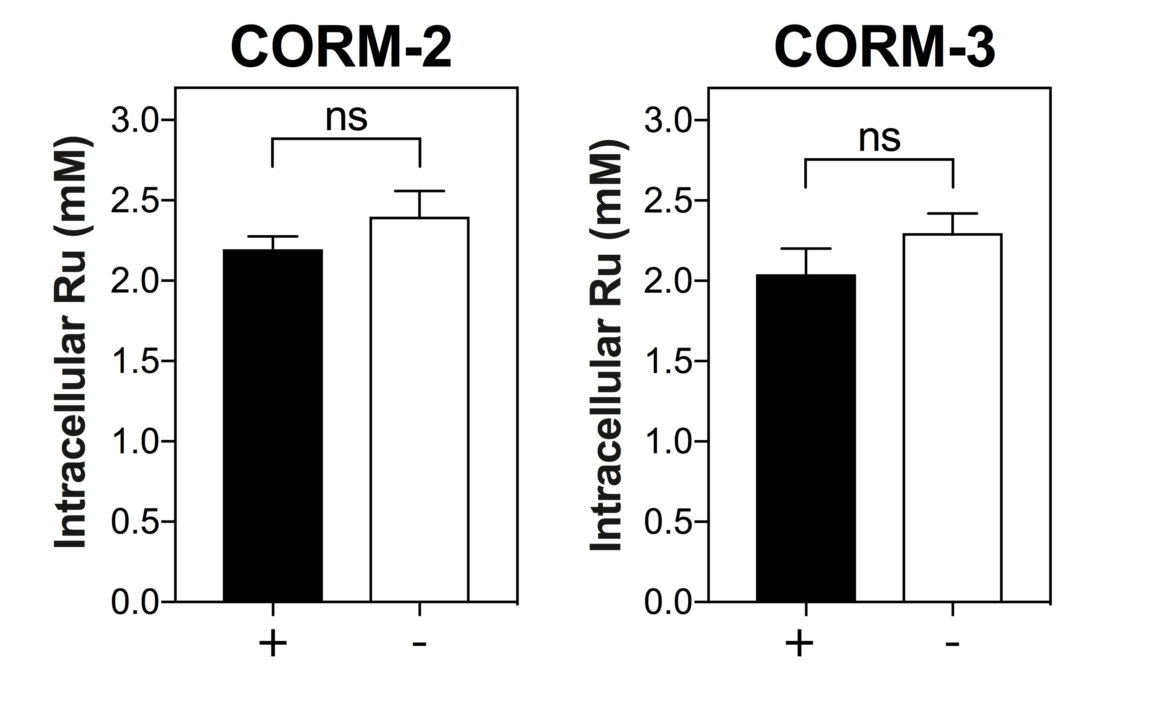

Fig. 6.1. Nitric acid washing of E. coli cell pellets does not significantly decrease intracellular Ru content. The intracellular Ru content of MG1655 E. coli cells after 1 h exposure to either 30 μM CORM-2 or 60 μM CORM-3 was determined by ICP-AES after washing of cell pellets either 3 times in 0.5 % (v/v) nitric acid (+, black bars) or once with 10 mM PBS pH 7.4 (-, white bars). The intracellular Ru content of E. coli cells after 1 exposure to 30 μM CORM-2 was 2.2 ± 0.08 mM with nitric acid washing and 2.4 ± 0.16 mM without nitric acid washing. The intracellular Ru content of E. coli cells after 1 exposure to 60 μM CORM-3 was 2.04 ± 0.16 mM with nitric acid washing and 2.3 ± 0.12 mM without nitric acid washing. There were no significant differences observed between the Ru content of E. coli cells with or without nitric acid washing. Data is representative of 3 biological repeats ± SD. Significant differences were assessed by an unpaired t-test.

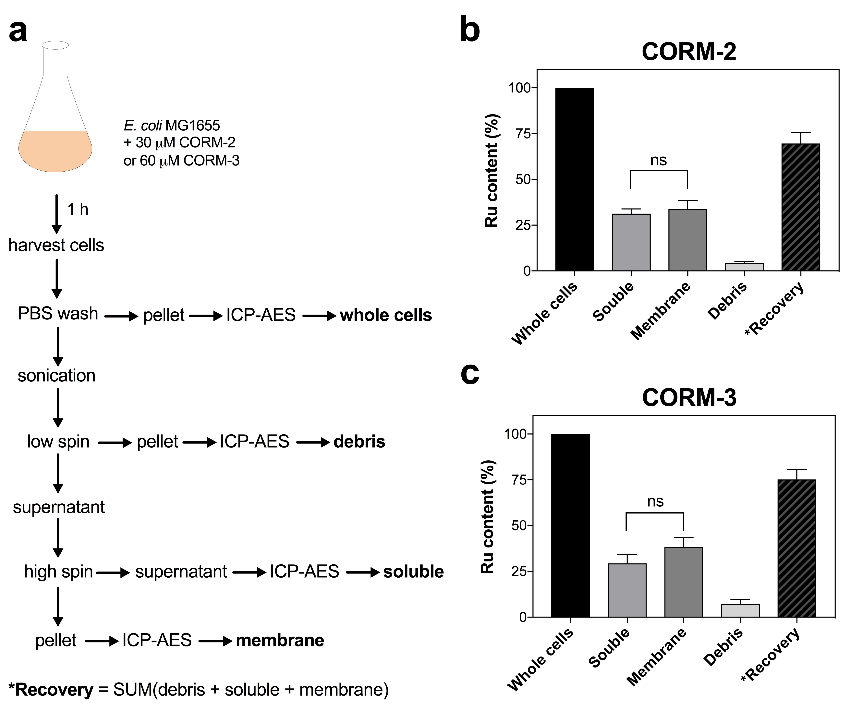

Fig. 6.2. Subcellular localisation of CORM-derived Ru. (a) Overview of experimental procedure: MG1655 E. coli cultures grown aerobically to early exponential phase in GDMM were treated with either 30 μM CORM-2 or 60 μM CORM-3 for 1 h and then harvested by centrifugation at 5,000 x g. Cells were washed once in 10 mM PBS and then re-pelleted by centrifugation. A 20 mL cell pellet was retained for ICP-AES for determination of the Ru content of ‘whole cells’. The remaining pellet (representing 200 mL culture) was re-suspended in buffer and then cells were broken by sonication. Unbroken cells/debris were removed by a low spin (~ 15,000 x g) centrifugation step and then retained for Ru analysis by ICP-AES (‘debris’ fraction). The supernatant was then subjected to a high-spin (~ 215,000 x g) ultracentrifugation. The supernatant containing the soluble fraction (cytoplasm + periplasm) was retained for Ru analysis (‘soluble’ fraction). The pellet containing insoluble cellular membranes (i.e. ‘membrane’ fraction) was also retained for Ru analysis. The ‘*recovery’ is the sum of the Ru content of the subcellular fractions. (b-c) The percentage distribution of the Ru content of each subcellular fraction of E. coli after treatment for 1 h with either 30 μM CORM-2 (b) or 60 μM CORM-3 (c). The total Ru content (μg) of 200 mL whole cells was determined to be ~ 18.9 ± 1.4 for CORM-2 and ~ 19.2 ± 1.41 for CORM-3, and thus represents 100 % Ru content (whole cells) (black bars). The Ru content of the soluble, membrane and debris fractions are expressed as a % of the Ru content of whole cells (grey bars). The % recovery (black, dashed bars) is the sum of the Ru content of soluble, membrane and debris fractions and was found to be ~ 69.7 ± 6.1 % for CORM-2 and ~ 75.2 ± 5.3 % for CORM-3. No significant differences were found between the Ru content of the soluble fractions and the Ru content of the membrane fractions following exposure to either CORM-2 or CORM-3. Data are representative of 3 biological repeats ± SD. Significant differences were assessed via an unpaired t-test.

sonication. Unbroken cells and cellular debris were removed by a low spin centrifugation (~ 15,000 x g) and then retained for ICP-AES. The resulting supernatant was further separated into a membrane pellet, containing the OM and IM, and a soluble fraction, containing the cytoplasmic and periplasmic components, by high spin centrifugation (~ 215, 000 x g). The soluble fraction was analysed directly by ICP-AES, whilst the membranes were first suspended in PBS and then fully dissolved in EDTA/TMAH prior to analysis for Ru content by ICP-AES (Fig. 6.2(a)).
The total Ru content of the cell pellet of 200 mL E. coli culture of OD₆₀₀ ~ 0.4 after 1 h exposure of the culture to 30 μM CORM-2 was determined to be 18.9 ± 1.4 μg, corresponding to an intracellular concentration of approximately 2.4 ± 0.16 mM Ru (Fig. 6.2(b)). Likewise, the total Ru content of the equivalent cell pellet after 1 h exposure to 60 μM CORM-3 was 19.2 ± 1.4 μg (or 2.3 ± 0.12 mM intracellular Ru) (Fig. 6.2(c)). The Ru contents of the soluble, membrane and debris fractions are expressed as a percentage of the Ru content of whole cells in Fig 6.2(b-c).
Fig. 6.2(b) shows the percentage distribution of the Ru in each subcellular fraction of E. coli cells relative to the total level detected in whole cells after 1 h exposure to CORM-2. Approximately 31.3 ± 2.5 % of the Ru was found to be located in the soluble fraction, whilst 33.9 ± 4.6 % was located in the membrane fraction (Fig. 6.2(b)). There was no significant difference found between the distribution of Ru in these fractions. A further 4.5 ± 0.7 % Ru was found to be located in the cellular debris following sonication and therefore the % recovery of the Ru content of these fractions was approximately 69 ± 6.1 % of the Ru content of the whole cell sample (Fig. 6.2(b)). It is not known where the remaining ~ 30 % is distributed and may have been lost during the procedure. Thus, it can be concluded that the CORM-derived Ru within E. coli cells accumulated after exposure to CORM-2 is distributed equally between the cellular membranes and the cytoplasm/periplasm. Attempts to separate the cytoplasmic and periplasmic fractions by the preparation of spheroplasts by the Witholt method (Witholt et al., 1976) failed due to whole cell lysis upon lysozyme treatment. It was therefore concluded that CORM-2 induced membrane perturbation could not permit the complete separation of cytoplasmic and periplasmic components for individual Ru analysis by ICP-AES.
The percentage distribution of Ru in the subcellular fractions of E. coli cells after 1 h exposure to CORM-3 yielded similar results (Fig. 6.2(c)). There was no significant difference found in the percentage of Ru located in the soluble fraction (29.4 ± 4.9 %) compared to that of the membrane fraction (38.5 ± 4.9 %). A further 7.3 ± 2.4 % was found in the cellular debris after sonication and thus the % recovery of the three fractions relative to whole cells was determined to be similar to that of CORM-3 at approximately 75 % (Fig. 6.2(c)). Thus, as with CORM-2, CORM-3-derived Ru is distributed equally between the membrane and soluble fractions of E. coli cells. No further attempts were made to separate the cytoplasmic and periplasmic fractions due to the reported membrane-damaging activities of CORM-3 in the literature (Davidge et al., 2009b; Wilson et al., 2015).
It can thus be concluded from these results that CORM-2 and CORM-3 Ru(II) ions localise to cell targets present both in E. coli cell membranes and within the cytoplasm and/or periplasm. It is not known from these results if more Ru is distributed within the OM or the IM of E. coli. Furthermore, it is not known whether CORMs interact directly membrane components such as LPS or phospholipids and/or interact with surface-exposed amino acid residues of membrane proteins as proposed in Chapter 4.
6.2.3. CORM-derived Ru is present in E. coli genomic DNA extracts following exposure of cells to CORM-2 or CORM-3
As a significant portion of the accumulated Ru by E. coli cells after exposure to CORM was localised to the soluble components of the cytoplasm/periplasm, it was further investigated whether this Ru was specifically localised to E. coli chromosomal DNA. The first step was to determine if treatment of E. coli cells with CORM-2 or CORM-3 caused any decrease in chromosomal DNA as a consequence of possible interactions between the accumulated Ru(II) ions and the DNA inside cells. Thus, genomic DNA extracts were harvested from MG1655 E. coli cell cultures both prior to and after 1 h exposure to either 30 μM CORM-2 or 60 μM CORM-3. The level of extracted genomic DNA was then quantified via UV-spectroscopy by the absorbance of the sample at 260 nm. As shown in Fig. 6.3 (a), there was no significant difference between the amount of genomic DNA isolated from E. coli cells prior to the addition of CORM (black bars) and after 1 h exposure of CORM-2 or CORM-3 (white bars). Thus, treatment of E. coli cells with CORM-2 or CORM-3 does not cause significant loss or precipitation of E. coli chromosomal DNA.
The next step was then to determine how much CORM-derived Ru was localised to the chromosomal DNA of E. coli cells after 1 h exposure to CORM-2 or CORM-3. After treatment with the CORM, E. coli cell cultures were harvested and washed with dilute nitric acid, as previously described. The genomic DNA from these cells was then extracted, quantified and then analysed for Ru content by ICP-AES. The Ru content of genomic DNA extracted from CORM-2 treated cells was found to be approximately 0.48 ± 0.05 ng Ru per μg of dsDNA (Fig. 6.3(b)). This was significantly higher than the Ru content of genomic DNA extracted from CORM-3-treated cells (0.28 ± 0.02 ng Ru per μg of dsDNA, p ≤ 0.01 (Fig. 6.3(b)). Thus,
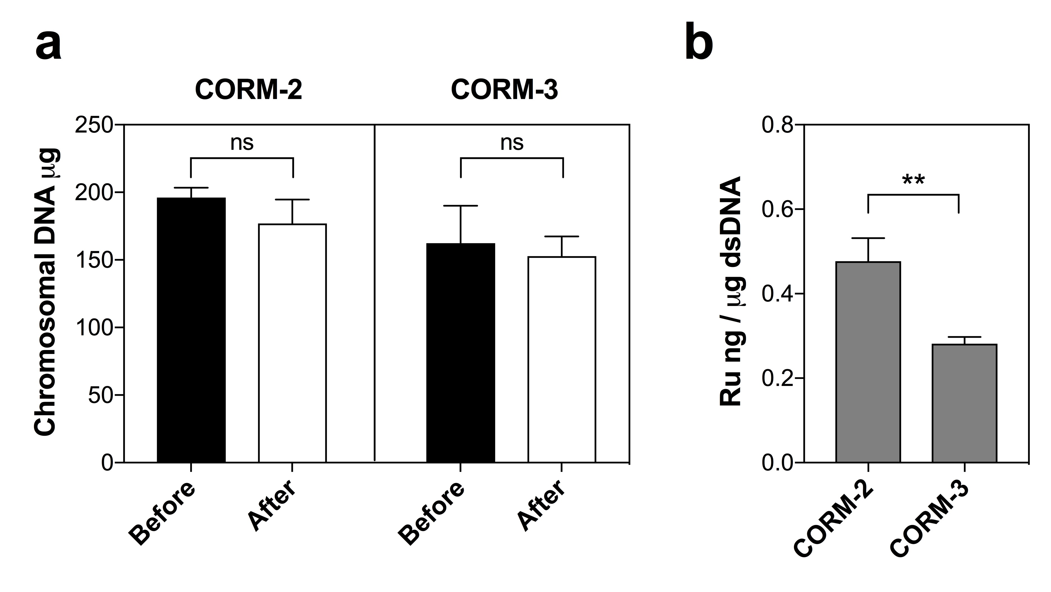

Fig. 6.3. CORM-derived Ru targets chromosomal DNA inside E. coli cells. (a) The amount of E. coli chromosomal DNA recovered from 20 mL MG1655 E. coli cell cultures immediately prior to (black bars) and after 1 h treatment of the cells with either 30 μM CORM-2 or 60 μM CORM-3 (white bars). Chromosomal DNA was extracted from cells using the Wizard Genomic DNA Extraction kit (Promega) and then quantified via a NanoDrop ND-1000 Spectrophotometer. There were no significant differences found between the amount of DNA recovered from cell cultures before or after treatment with CORM. (b) The level of Ru detected in extracted chromosomal DNA samples was determined by ICP-AES. The level of Ru is expressed as ng of Ru per μg dsDNA. The Ru content of DNA extracted from CORM-2 treated cells (0.48 ± 0.05 ng/μg DNA) was found to be significantly higher than the Ru content of DNA extracted from CORM-3 treated cells (0.28 ± 0.02 ng/μg DNA) (**, p ≤ 0.01). Data are representative of 3 biological repeats ± SD. Significant differences were assessed via unpaired t-tests.

CORM-derived Ru was localised to E. coli chromosomal DNA after exposure of E. coli cells to either CORM-2 or CORM-3.
The average amount of Ru accumulated per E. coli cell following 1 h exposure to 30 μM CORM-2 was previously determined to be 2.13 x 10⁻¹³ mg, corresponding to an intracellular Ru concentration of ~ 2.4 mM using estimations of the average cell size and volume of a typical E. coli cell given in Table 1.5 (Fig. 3.3, Chapter 3). The average amount of Ru per cell based only on the level of Ru in genomic DNA extracts following 1 h exposure to 30 μM CORM-2 was found to be ~ 9.41 x 10⁻¹⁵ mg. Thus, it can be estimated that approximately 4.4 % of the total Ru accumulated by E. coli cells upon exposure to CORM-2 was located at chromosomal DNA. Likewise, the average total amount of Ru per E. coli cell after 1 h exposure to 60 μM CORM-3 was determined to be ~ 1.63 x 10⁻¹³ mg, corresponding to an intracellular accumulation of approximately 1.9 mM (Fig. 3.3, Chapter 3). The average amount of Ru per cell, based only on the Ru content of genomic DNA extracts, after 1 h exposure to 60 μM CORM-3 was found to be ~ 4.42 x 10⁻¹⁵ mg. Therefore, approximately 2.7 % of the accumulated Ru upon CORM-3 was found to be localised to chromosomal DNA. However, these results must be interpreted with caution. Estimates of the total Ru content of E. coli cells are determined by approximations of the total number of cells per dry weight (mg) of culture pellets and thus are not useful for accurate quantification of the absolute amount of Ru (mg) per cell. Furthermore, estimates of the amount of Ru bound to chromosomal DNA are dependent on the efficiency of the genomic DNA extractions whereby it is likely that some of the genomic DNA from E. coli cells is not fully recovered. Nevertheless, these preliminary results indicate the E. coli chromosomal DNA is a possible target of both CORM-2 and CORM-3-derived Ru(II) ions.
6.2.4. Pre-incubation of CORM-2 or CORM-3 with exogenous nucleotides do not prevent the growth inhibitory effects of CORMs against E. coli
As demonstrated in Chapters 4 and 5, alleviation of the antimicrobial effects of CORM-2 and CORM-3 by pre-incubation of the CORM with a 2-fold excess of exogenous amino acid or sulfhydryl-containing compound, was indicative of extracellular sequestration of the CORM by the exogenous compound in vitro. Therefore, to determine if CORM-2 or CORM-3 also interact with the components of DNA in vitro, a growth inhibition screen was conducted on E. coli cell cultures by the addition of CORM-2 or CORM-3 that had been pre-incubated with a 10-fold excess of adenosine monophosphate (AMP), cytidine monophosphate (CMP), guanosine monophosphate (GMP) or thymidine monophosphate (TMP).

As is shown in Fig. 6.4(a), pre-incubation of CORM-2 with a 10-fold excess of each nucleotide had no effect on the growth inhibitory effects of 30 μM CORM-2 against E. coli.
Likewise, pre-incubation of CORM-3 with a 10-fold excess of each nucleotide did not prevent the growth inhibitory effects of 60 μM CORM-3 against E. coli (Fig. 6.4(b)). The equivalent level of AMP, CMP, GMP or TMP (60 or 120 μM) had no significant effects on the growth of E. coli cells (Fig. 6.4(a-b)). Thus, the results of this preliminary screen do not provide evidence that CORM-2 and CORM-3 interact with the nucleotide components of DNA (and RNA) in vitro. Therefore, despite evidence of the possible binding of CORM-derived Ru to E. coli chromosomal DNA obtained from CORM-treated cells in Section 6.2.3 above, there is currently no evidence that CORM-2 or CORM-3 interact with DNA in vitro.
6.2.5. Sub-lethal doses of CORM-2 and CORM-3 induce ATP leakage from E. coli cells into the extracellular milieu
a. Preliminary work
In Section 6.2.2, it was found that lysozyme treatment of E. coli cells following exposure to 30 μM CORM-2 - which would normally result in spheroplast formation in otherwise healthy cells - resulted in complete cell lysis. It was therefore hypothesised that CORM-2 exposure had diminished E. coli membrane integrity. To investigate the extent of membrane damage to E. coli cells following exposure to CORM-2, the cellular uptake of the normally membrane-impermeable and DNA-binding fluorescent dye, PI, by cells exposed to increasing CORM-2 concentrations was investigated by flow cytometry. Unfortunately, the presence of the CORM interfered with the binding of PI to DNA in preliminary experiments (data not shown). This was considered to be due to displacement of PI from E. coli DNA by the CORM-derived Ru. Therefore an alternative method for determination of membrane damage by CORMs was required.
An alternative method to detect membrane damage was thus to investigate if cytoplasmic components of E. coli cells could be detected in the extracellular milieu after exposure of the cells to CORM, thus indicating that the cell envelope had been compromised. Initially, this was attempted by measuring the absorbance at 260 and 280 nm of supernatants of E. coli cell cultures after removal of the cells by centrifugation. This was to determine if CORM-2 or CORM-3 exposure could cause the leakage of nucleosides (260 nm) or amino acids such as tryptophan or tyrosine (280 nm) in the supernatant of cells as a consequence of CORM exposure. However, this was also not possible due to interference of the inherent absorbances of CORM-2 and CORM-3 at these wavelengths. It was subsequently determined that ATP
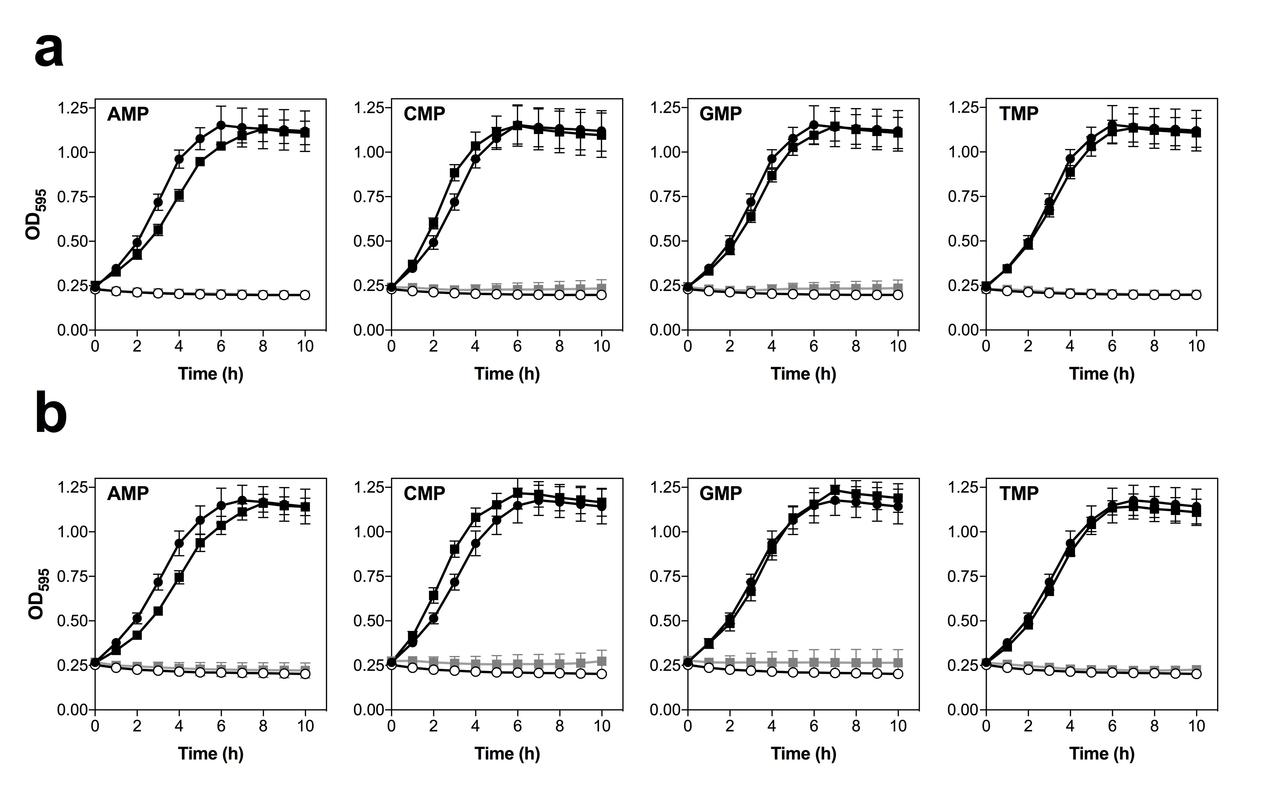

Fig. 6.4. E. coli growth inhibition screen of CORM-2 and CORM-3 +/- nucleotide monophosphates. (a) E. coli MG1655 cell cultures were grown aerobically at 37 °C in GDMM until early exponential phase (OD₅₉₅ = 0.25) and then 30 μM CORM-2 alone (black line, open circles) or CORM-2 that had been pre-incubated for 10 min with a 10-fold excess of nucleotide monophosphate (grey line/symbols) was added to the cultures at t = 0. Growths of control cultures without reagent (black line, closed circles) and with the equivalent level of DMSO + nucleotide monophosphate (black line, closed squares) are shown for comparison. (b) E. coli MG1655 cell cultures were grown aerobically at 37 °C in GDMM until early exponential phase (OD₅₉₅ = 0.25) and then 60 μM CORM-3 alone (black line, open circles) or CORM-3 that had been pre-incubated for 10 min with a 10-fold excess of nucleotide monophosphate (grey line/symbols) was added to the cultures at t = 0. Growths of control cultures without reagent (black line, closed circles) and with the equivalent level of nucleotide monophosphate (black line, closed squares) are shown for comparison. Growth was monitored in a Tecan Sunrise Platereader by measuring absorbance of the cultures at 595nm. Data shown are the means of three technical and three biological repeats. Errors bars represent ± SD. (AMP = adenosine monophosphate, CMP = cytidine monophosphate, GMP = guanine monophosphate, TMP = thymidine monophosphate)

detection via the Molecular Probes’ ATP Determination Kit (Invitrogen, ThermoFisher) was unaffected by the addition of CORM-2 or CORM-3 to ATP (data not shown).
b. Assessment of membrane damage by leakage of ATP
Membrane damage in E. coli cells after exposure to CORM-2 and CORM-3 was thus investigated by quantifying the level of extracellular ATP in the supernatant of E. coli cells in the presence and absence of CORM-2 or CORM-3. For CORM-2, E. coli cell cultures were grown to early exponential phase in GDMM and then 7.5 μM (sub-lethal dose) or 15 μM (lethal dose) of CORM-2 was added (Fig. 6.5). As expected, the addition of 15 μM CORM-2 was sufficient to completely inhibit E. coli cell culture growth and cause a substantial decrease in cell culture viability up to 4 h post-CORM addition (Fig. 6.5(a-b)). In contrast, the growth and viability of E. coli cell cultures continued to increase after the addition of 7.5 μM CORM-2 (Fig. 6.5(a-b)). The levels of extracellular ATP were quantified by measuring the ATP in supernatants of cell culture samples after removal of the cells by centrifugation. The extracellular levels of ATP in untreated or DMSO treated control cell cultures was found to be between 8 – 25 nM (Fig. 6.5(c)), consistent with the findings of a previous study that reported small amounts of ATP were released from MG1655 E. coli cells during log phase growth (Memphin et al., 2013). Strikingly, the addition of 7.5 μM CORM-2 caused a dramatic and significant increase in the level of extracellular ATP at 2 h (50 ± 16.3 nM) and at 4 h (144 ± 50 nM), but not at earlier time points (Fig. 6.5(c)). In contrast, 15 μM CORM-2 did not cause a significant increase in the level of extracellular ATP (Fig. 5.6(c)).
The levels of extracellular ATP in the supernatants of E. coli cells exposed to a sub-lethal (15 μM) and lethal (60 μM) dose of CORM-3 were also measured. As shown in Fig. 6.6(a-b), 60 μM CORM-3 was sufficient to completely inhibit growth of and kill E. coli cells, whilst cell culture growth and viability continued to increase after the addition of 15 μM CORM-3. As with the CORM-2 experiments, there was a small level of extracellular ATP present in the supernatants of E. coli cells without CORM of between 5 – 30 nM (Fig. 6.6(c)). The addition of a sub-lethal dose of CORM-3 caused a significant increase in the level of extracellular ATP at 2 h (51.6 ± 31.3 nM) and 4 h (160.7 ± 78.6 nM), but not at earlier time points (Fig. 6.6(c)). The lethal dose of CORM-3 did not cause a significant increase in extracellular ATP at any time point tested up to 4 h post-CORM addition.
Therefore it can be concluded that sub-lethal, but not lethal doses of CORM-2 and CORM-3 caused increased ATP leakage from E. coli cells into the extracellular milieu. The implications of these results in the possible membrane-damaging activities of CORM-2 and CORM-3 are discussed later in Section 6.3.
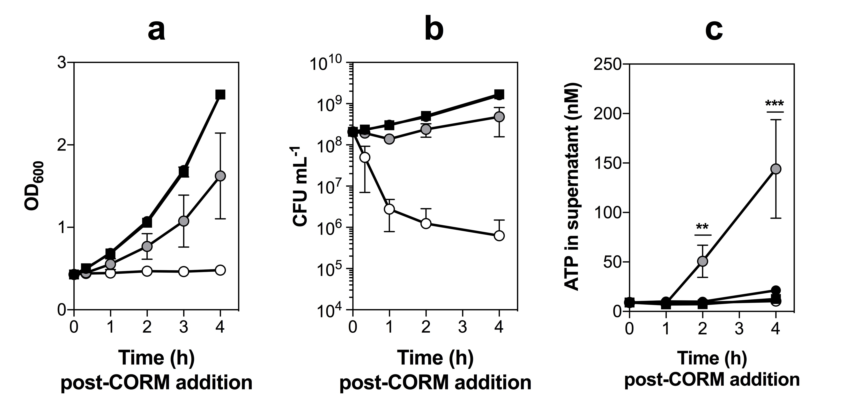
Fig. 6.5. Treatment of E. coli with sub-lethal concentrations of CORM-2 causes ATP leakage from cells. E. coli cell cultures were grown aerobically on GDMM to early exponential phase (OD_{600nm} ~ 0.4) and then 7.5 μM (sub-lethal dose, grey circles) or 15 μM (lethal dose, white circles) CORM-2 was added (t = 0). Measurements of culture turbidity to monitor culture growth (a) or cell viable counts to monitor culture viability (b) were taken at time intervals thereafter. Growth and viability of untreated cultures (black circles) or those containing the equivalent level of DMSO (black squares) are included for comparison. (c) The level of ATP (nM) detected extracellularly in the supernatant following removal of cells by centrifugation. ATP levels were determined using the bioluminescence-based Molecular Probes’ ATP Determination Kit (Invitrogen, ThermoFisher). There were no significant differences between the level of ATP found in the supernatant of untreated cells and the level of ATP found in supernatants of cells exposed to either DMSO or 15 μM CORM-2. There was a significant increase in the level of ATP detected in the supernatant of cells exposed to 7.5 μM CORM-2 at 2 h and 4 h post-CORM addition, but not at 1 hr post-CORM addition (** p ≤ 0.01, *** p ≤ 0.001). Data in (a-b) are representative of 3 biological repeats and in (c) are representative of 3 biological repeats + ≥ 2 technical repeats. Error bars represent ± SD. Significant differences were assessed via a Tukey’s multiple comparisons test following a one-way ANOVA.

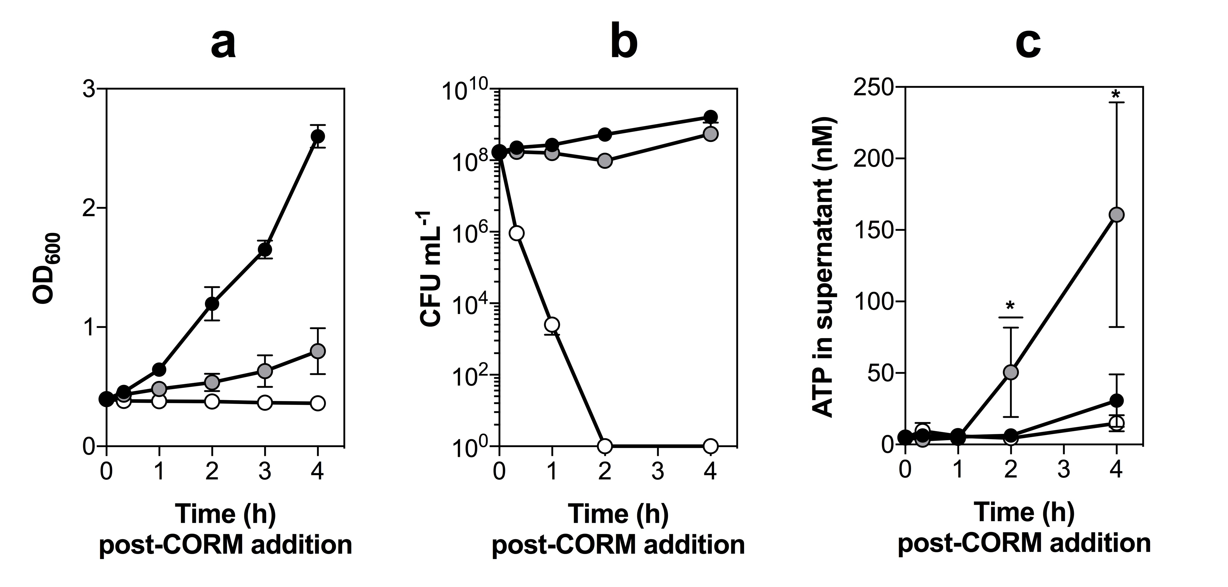
Fig. 6.6. Treatment of E. coli with sub-lethal concentrations of CORM-3 causes ATP leakage from cells. E. coli cell cultures were grown aerobically on GDMM to early exponential phase (OD_{600nm} ~ 0.4) and then 15 μM (sub-lethal dose, grey circles) or 60 μM (lethal dose, white circles) CORM-3 was added (t = 0). Measurements of culture turbidity to monitor culture growth (a) or cell viable counts to monitor culture viability (b) were taken at time intervals thereafter. The growth and viability of untreated cultures (black circles) are included for comparison. (c) The level of ATP (nM) detected extracellularly in the supernatant following removal of cells by centrifugation. ATP levels were determined using the bioluminescence-based Molecular Probes’ ATP Determination Kit (Invitrogen, ThermoFisher). There were no significant differences between the levels of ATP found in the supernatant of untreated cells and the levels of ATP found in supernatants of cells 60 μM CORM-3. There was a significant increase in the level of ATP detected in the supernatant of cells exposed to 15 μM CORM-3 at 2 h and 4 h post-CORM addition, but not at 20 min or 1 h post-CORM addition (*p ≤ 0.05). Data in (a-b) are representative of 3 biological repeats and in (c) are representative of 3 biological repeats + ≥ 2 technical repeats. Error bars represent ± SD. Significant differences were assessed via a Tukey’s multiple comparisons test following a one-way ANOVA.

6.2.6. CORM-2 and CORM-3 are not lipophilic compounds
In Section 6.2.2, it was shown that CORM-2 and CORM-3-derived Ru localised to E. coli membranes in addition to the cytoplasm/periplasm fraction. The potential of compounds to interact with biological membranes depends on their lipophilicity. Lipophilic uncharged compounds are more likely to interact with the hydrophobic fatty acid regions of membrane bilayers, whereas positively charged and/or hydrophilic compounds are more likely to interact with the anionic phosphate groups of membrane components. CORM-3 contains a cationic Ru(II) ion and is readily soluble in H₂O; therefore it is not predicted to be lipophilic. In contrast, CORM-2 has been referred to as a ‘lipid-soluble’ CORM due to its lack of solubility in H₂O (Desmard et al., 2012). To investigate whether CORM-2 is soluble in other organic solvents, its relative solubility in DMSO, methanol and ethanol was examined. CORM-2 was only soluble in DMSO, whereby the Ru-dimer is split by substitution of the chlorides with the solvent (Fig. 1.10). Thus, it is inappropriate to simply classify CORM-2 as ‘lipid-soluble’ by its lack of solubility in H₂O, as it is also insoluble in other organic solvents.
The relative lipophilicity/phobicity of a compound is determined by measuring its logP at a given temperature, where P = the partition coefficient of the compound between two immiscible solvents; one being an organic solvent and one being an aqueous solvent and thus is calculated by P = ([compound]^{organic}/[compound]^{aqueous}) (Sangster, 1989). In general, the higher the logP value, the greater the lipophilicity of the compound. Typically, 1-octanol is chosen as the preferred solvent for assessment of the relative lipophilicity of candidate drug compounds (Sangster, 1989). Therefore, the lipophilicity of CORM-3 was determined by the distribution of the CORM between GDMM at pH 7.4 (aqueous phase) and 1-octanol via the shake-flask method (Sangster, 1989). After allowing CORM-3 to distribute between the two phases to equilibrium over 20 h at 37 °C, it was determined by visual inspection that the majority of the CORM had remained in the GDMM phase, as indicated by the yellow pigmentation of CORM-3 (Fig. 6.7(a)). The Ru content of these phases could not be determined by ICP-AES due to the presence of the 1-octanol, therefore an alternative organic solvent was required for quantification of logP.
Therefore, the logPs of CORM-2 and CORM-3 were determined via the shake-flask method by the relative distribution of CORM-derived Ru between hexane and GDMM. Briefly, the CORM was added to GDMM to a final concentration of 10 mM and then the pH was adjusted to 7.4. An equal volume of hexane (pre-saturated with GDMM) was added and the mixture was agitated by shaking at 37 °C for 20 h. The two phases were separated and then the hexane was removed by evaporation. The remaining solute after solvent removal was then solubilised in H₂O and then the Ru content of the two phases was analysed by ICP-AES for
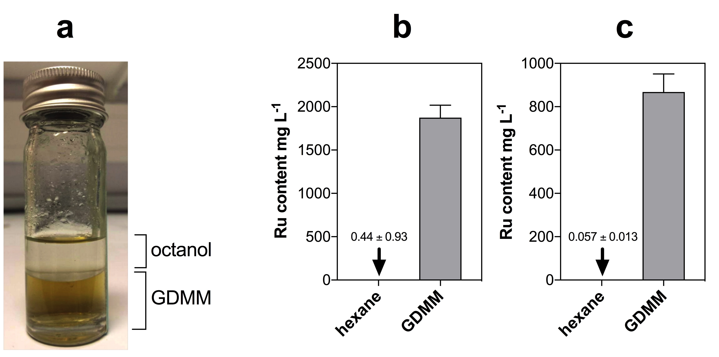
Fig. 6.7. CORM-2 and CORM-3 are not lipophilic in GDMM at 37°C pH 7.4. The lipophilicity of CORM-2 and CORM-3 in GDMM at 37 °C was determined by the relative distribution of Ru between two immiscible solvents: an aqueous phase (GDMM) and an organic phase (octanol or hexane) by the shake flask method. (a) CORM-3 (10 mM) was solubilised in GDMM and pH adjusted to 7.4. An equal volume of octanol, pre-saturated with GDMM, was added and then the CORM was allowed to reach an equilibrium of partition across the two phases by shaking at 37 °C for 20 h. By visual inspection, the majority of the CORM remained in the aqueous phase in GDMM as shown above. (b-c) to quantify the partition coefficient P of CORM-2 and CORM-3 between an organic solvent phase and an aqueous phase, ~ 10 mM of CORM-2 or CORM-3 was added to GDMM and then pH adjusted to 7.4. An equal volume of hexane, pre-saturated with GDMM, was added and the mixture was agitated by shaking at 37 °C for 20 h. The aqueous phase was then removed and analysed for Ru content by ICP-AES for CORM-2 (b) and CORM-3 (c) (grey bars). The hexane phase was isolated and then the solvent was removed by evaporation. The remaining solute was then solubilised in water and then analysed for Ru content by ICP-AES for CORM-2 (b) and CORM-3 (c), as indicated by the arrows. The logP is given by log₁₀([Ru mg L⁻¹]^{hexane}/[Ru mg L⁻¹]^{GDMM}) and was found to be – 3.63 for CORM-2 and – 4.14 for CORM-3. Data is representative of 3 technical repeats ± SD.

CORM-2 (Fig. 6.7(b)) and CORM-3 (Fig. 6.7(c)). The logP of the two CORMs was thus determined by log₁₀([Ru mg L⁻¹]^{hexane}/[Ru mg L⁻¹]^{GDMM}) and was (– 3.63) for CORM-2 and (– 4.14) for CORM-3. Thus, although CORM-2 is predicted to be relatively more lipophilic than CORM-3, neither compound is predicted to be sufficiently lipophilic to favour accumulation of the compounds within the hydrophobic fatty acid regions of bacterial cell membranes.
6.3. Discussion
6.3.1. The subcellular distribution of CORM-2 and CORM-3 in E. coli cells
The overall aim of the work conducted in this chapter was to determine if the E. coli cell envelope and/or genomic DNA were additional targets of CORM-derived Ru(II) ions. The first step was therefore to determine the subcellular distribution of CORM-derived Ru inside E. coli cells. As shown in Fig. 6.2 (b-c), the Ru accumulated by E. coli cells after exposure to CORM-2 or CORM-3 was found to be evenly distributed between the membrane and soluble fractions of E. coli cells. Thus, it is probable that CORM-mediated antimicrobial effects against E. coli is due to accumulation of Ru(II) ions at cellular targets within the both the membranes and the cytoplasm/periplasm of E. coli cells.
a. Possible membrane targets of CORM-2 and CORM-3
First, the potential targets of CORM-2 and CORM-3 in the E. coli OM and IM will be considered. Washing E. coli cells three times in diluted nitric acid did not significantly decrease the level of accumulated Ru by E. coli cells upon exposure to CORM-2 or CORM-3 (Fig. 6.1). Thus, interactions of CORM-derived species to targets located within the OM are likely to be sufficiently stable as to not be disrupted by this wash step. An alternative explanation is that CORMs do not accumulate at the OM, but instead accumulate at the IM and so such interactions of the Ru(II) ions with IM components were unaffected by nitric acid washing. Further work could thus determine the relative distribution of Ru between the two membranes by further fractionation to separate the OM from the IM of E. coli.
As described in Section 6.1.2, bacterial cell membranes are well-established targets of metal cations via electrostatic interactions with the positively charged metal ions and anionic groups on membrane components such as LPS and phospholipids (Savvaidis et al., 1989; Lemire et al., 2013; Nikaido, 2003). It is therefore possible that CORM-derived Ru(II) ions localise to bacterial cell membranes via electrostatic interactions between the positively-charged Ru(II) ions and anionic phosphate groups on membrane components. As neither CORM is predicted to be lipophilic at 37 °C as determined by their LogPs in hexane/GDMM (Fig. 6.7), it is unlikely that these CORMs accumulate directly at the hydrophobic fatty acid regions of the IM and the OM.
Alternatively, it is possible that CORMs accumulate at the membrane via coordination of the Ru(II) ions to surface exposed Cys, His or Met residues on membrane proteins given that these residues were determined to be probable targets of CORMs in vitro in Chapter 4. Such membrane-bound proteins could include components of the bacterial electron transport chain. Thus, the observed inhibition of oxygen consumption in E. coli cells upon CORM exposure could be due to Ru(II) ion coordination to respiratory components such as NADH/succinate dehydrogenases or terminal oxidases (Fig. 1.7). This has been proposed to mediate the inhibitory effects of other metal ions such as Ag(I) on bacterial respiration (Lemire et al., 2013). This could offer an explanation as to why CORM-3 is a more potent inhibitor of aerobic respiration than CO gas alone, as Ru(II)-mediated inhibition would not be competitive with O₂ for the haem Fe(II) of terminal oxidases (Davidge et al., 2009a; Desmard et al., 2009). In addition, CO-release from CORM-3, even upon addition of dithionite, was found to be rapidly inactivated upon addition to phosphate buffers and/or growth media in Chapter 3.
Future interpretation of proteomics datasets of whole protein extracts following exposure of E. coli cells to these CORMs should enable the identification of those proteins bound to CORM-derived Ru(II) ions, as described in Chapter 4. Thus, these future analyses should be informative in determining if CORM-derived Ru localises to membrane proteins within E. coli cell membranes.
b. Possible cytoplasmic/periplasmic targets of CORM-2 and CORM-3
As mentioned above, CORM-derived Ru was also distributed within the soluble fraction of E. coli cells. It was not possible to further divide this soluble phase into the cytoplasmic and periplasmic fractions due to the membrane damaging activities of these compounds. Thus, if CORM-derived Ru localises mainly within the periplasm of E. coli cells, it is predicted that targets of CORM Ru(II) ions could include surface-exposed Cys, His or Met residues or oxidised sulfhydryl-groups of periplasmic proteins (Chapter 5). Alternatively, if CORM-derived Ru localises mainly to the cytoplasm, it is predicted that targets could include reduced thiols such as GSH, surface-exposed His, Cys and Met residues on cytoplasmic proteins and also potentially DNA and/or RNA. As removal of the main intracellular thiol, GSH, was found to significantly decrease the level of CORM-derived Ru accumulation in E. coli cells in Chapter 5, it is likely that CORM-derived Ru does target intracellular GSH and thus is able to accumulate within the cytoplasm. However, further experiments are required to determine whether CORM-derived Ru localises preferentially to the cytoplasm or periplasm of E. coli cells. If CORMs are sequestered to the periplasm of Gram-negative cells only, this could explain why no decrease in intracellular thiols was detected upon exposure of P. aeruginosa cells to CORM-2 despite the strong binding of Ru(II) ions to sulfhydryl of Cys as determined in Chapter 4 (Desmard et al., 2009). The majority of cellular thiols in bacteria are localised in the cytoplasm and thus, if CORM-derived Ru was sequestered in the periplasm, then the thiols of the cytoplasm would be unaffected by the CORM.
It must be noted that the results of these subcellular fractionation experiments should be interpreted with caution. This is because the percentage recovery of the Ru content from the subcellular fractions was only found to be up to ~ 70 % of that of whole cells for both CORM-2 and CORM-3 (Fig. 6.2). It is not known where the remaining 30 % of the Ru is localised and why it was lost in the subcellular fractionation process. It is most likely that more of the membrane fraction was lost due to the difficulty in fully recovering the membrane pellet after the high-spin centrifugation step (Fig. 6.2(a)), and therefore it is predicted that an even higher proportion of Ru may be localised to the membrane fraction that is estimated in Fig. 6.2 (b-c). In addition, the procedures used to fractionate the E. coli cells may have caused disruptions to the interactions between the Ru(II) ions and cellular components, thus leading to loss of Ru or artificial association of Ru(II) to additional cell targets (Beveridge et al., 1997).
6.3.2. Are nucleic acids intracellular targets of CORM-derived Ru(II) ions?
The subcellular distribution of CORM-2 and CORM-3-derived Ru in Fig 6.2 indicated that at least some CORM-derived Ru could be localised to the cytoplasm of E. coli cells. Thus, E. coli chromosomal DNA could be a potential target of CORM-derived Ru(II) ions as has been demonstrated for other Ru(II) complexes containing sufficiently labile ligands (see Section 6.1.1, above). The presence of Ru in genomic DNA extracts of E. coli cells following exposure of the cells to CORM-2 or CORM-3 (Fig. 6.3(b)), indicated that chromosomal DNA could be an intracellular target of CORM-derived Ru. The relative level of CORM-derived Ru bound to E. coli genomic DNA compared to the total amount of Ru present in whole cells was thus estimated to be 2.7 % for CORM-3 and 4.4 % for CORM-2. Thus, only a small proportion of CORM-derived Ru is estimated to bind chromosomal DNA within E. coli cells. However, depending on the mode of binding, such interactions of the Ru(II) ions with the DNA could lead to inhibition of DNA replication and thus significantly contribute to CORM-mediated cell killing. It must be noted however, that the presence of Ru in genomic DNA extracts may not be due to binding of the Ru(II) ion to genomic DNA per se, but instead due to Ru(II) ion binding to background contaminants in the DNA extract. To further investigate this, these genomic DNA samples could be further purified to eliminate background contamination. However, to strengthen the hypothesis that DNA is an important intracellular target of CORMs, further evidence for DNA interactions with Ru(II) ions in vitro is required.
As shown in Fig. 6.4, pre-incubation of either CORM with a 10-fold excess of AMP, CMP, GMP or TMP failed to alleviate the growth inhibitory effects of CORM-2 and CORM-3 against E. coli cell cultures. Thus, unlike with Cys, His, Met or sulfhydryl containing compounds, exogenous nucleotides do not sequester CORMs outside bacterial cells and thus alleviate CORM antimicrobial activities. However, even if CORM-derived Ru(II) ions did not interact with the components of DNA in these preliminary screens, it is still possible that they interact with dsDNA. Future work will involve investigating the interactions of CORM-2 and CORM-3 with synthetic DNA oligonucleotides in vitro by ¹H-NMR to determine the relative binding affinities of the Ru(II) ions of the CORMs to specific DNA sequences. Thus, it remains to be determined if DNA is an important target of CORM-derived Ru in bacterial cells.
Another possible intracellular target of CORM-derived Ru(II) ions is RNA. Ribosomal RNA located specifically at polysomes in bacterial cells is considered to be the main intracellular target of antimicrobial Ru(II)polypyridyl complexes that have been extensively investigated by Keene, Collins and co-workers (Li et al., 2014; Li et al., 2015). Thus, the antibacterial effects of these complexes are thought to be partly due to inhibition of RNA-mediated processes such as translation in bacterial cells (Li et al., 2014). Thus, potential binding of CORM-2- and CORM-3-derived Ru to RNA/ribosomes in bacterial cells may also warrant further investigation in the future.
6.2.3. Why do sub-lethal doses of CORM-2 and CORM-3 induce ATP leakage from E. coli cells?
As outlined earlier in Section 1.6.2, the antimicrobial effects of many metal ions on bacteria include: loss of membrane integrity, lipid peroxidation and membrane depolarisation (Lemire et al., 2013). CORM-2 and CORM-3 are known to inhibit aerobic respiration (as described above) and induce the expression of envelope-stress response genes, such as spy, in E. coli cells (McLean et al., 2013). CORM-3 had been previously reported to induce membrane damage in E. coli cells (Davidge et al., 2009b; Wilson et al., 2015). As described above, the whole cell lysis upon exposure of CORM-2-treated E. coli cells to lysozyme in the subcellular fractionation experiment (Section 6.2.2) indicated that CORM-2 had compromised cytoplasmic membrane integrity. However, it was not known whether this associated membrane damage was a direct result of CORM interactions with the membrane or was a downstream effect of loss of proper membrane maintenance via CORM-induced cell death.
Therefore, the membrane damaging activities of both sub-lethal and lethal doses of CORM-2 and CORM-3 against E. coli cells were investigated on the basis that, if membrane damage was observed at sub-lethal doses, then CORMs might cause damage to the membrane directly. Membrane damage was assessed by determining the level of extracellular ATP in E. coli cell cultures exposed to CORM-2 (Fig. 6.5) or CORM-3 (Fig. 6.6). ATP is normally confined to the cytoplasm of E. coli cells, where it exists at concentrations of 0.1 – 5mM (Mempin et al., 2013). To the author’s knowledge, there exists no process in the periplasm that requires ATP to be exported from the cytoplasm to the periplasm of Gram-negative cells. However, a previous study had reported that during log-phase growth of various bacteria including E. coli, there is a detectable amount of ATP in the extracellular environment of up to 15 – 20 nM ATP/OD_{600nm} (Mempin et al., 2013). Therefore, the small amounts of ATP detected in the extracellular supernatants of untreated controls in Fig. 6.5 and Fig. 6.6 were consistent with previous findings. It is currently not understood why or how this apparent leakage of ATP from cells occurs, but it occurs only during log-phase growth (Mempin et al., 2013).
Interestingly, a sub-lethal dose of either CORM caused a dramatic and significant increase in extracellular ATP within culture supernatants after 2 h exposure of the cells to the CORM (Fig. 6.5, 6.6). In contrast, there was no significant increase in the level of extracellular ATP after treatment of E. coli cells to lethal doses of CORM. One explanation is that this is due to the upregulation of genes encoding ATP-dependent transport processes, such as the multi-drug efflux pump (mdtABC), that have been reported to occur in E. coli cells in response to CORM-2 and CORM-3 (McLean et al., 2013). This subsequently would lead to a rapid depletion of ATP in the cytoplasm of E. coli cells as the cell tries to adapt to CORM-induced toxicity. Thus, at lethal-doses of CORM-2 and CORM-3, ATP is rapidly consumed as more CORM-derived Ru is accumulated. It is well established that CORMs inhibit cellular respiration either via CO release and/or Ru(II) ion mediated inhibition, and thus this inhibition of respiration would impair the cell’s ability to produce ATP by oxidative phosphorylation. Therefore, the lack of extracellular ATP in the supernatants of cells exposed to lethal-CORM concentrations could be due a combination of rapid depletion of ATP and prevention of ATP synthesis. Thus, even if the membrane becomes compromised, there would be no increase in extracellular ATP.
In contrast, sub-lethal doses of CORM-2 and CORM-3 may be also be sufficient to cause cytoplasmic membrane perturbation, but as the cells are still able to survive, they may continue to produce ATP. Thus, there is a significant increase in the level of extracellular ATP found in E. coli cultures after sub-lethal doses of CORMs. Possibly due to enhanced ‘leakiness’ of the cytoplasmic membrane by CORM-derived Ru localisation to the membrane. In addition, upon exposure to sub-lethal doses of CORM, there could exist a mixed-population of E. coli cells; some of which are accumulating CORM-derived Ru to a greater extent relative to others relatively un-affected cells, and thus may be lysing sooner and causing release of ATP. To further explore these proposals, future work could include assaying the presence of another intracellular marker in the extracellular milieu of E. coli cells after exposure to CORM-2 or CORM-3.
An alternative theory is that somehow CORMs induce E. coli cells to actively export ATP from the cytoplasm as some kind of stress response. It has been proposed by one study that E. coli cells actively export ATP in response to exposure to CO gas (Wegiel et al., 2014). In this study, it is reported that E. coli cells could export up to 6 μM ATP in vivo in response to CO (Wegiel et al., 2014). However, work by other researchers in the Poole laboratory have previously demonstrated that bubbling E. coli MG1655 cell cultures with a mix of 50 % CO/ 50% air does not cause a significant increase in extracellular ATP (Wadsworth, E. and Wareham, L., unpublished). Given that ATP is required in numerous essential cytoplasmic processes required for E. coli cell survival, including adaptive responses to noxious agents, it is difficult to rationalise what the adaptive advantage of exporting ATP would convey to the bacterial cell. Extracellular ATP is be taken up and consumed by bacteria, so perhaps this response could aid the survival of closely-related bacteria, also present in the environment (Memphin et al., 2013).
Although ATP release from cells exposed to sub-toxic doses of CORM remains unexplained, it is still highly probable that both CORM-2 and CORM-3 induce membrane damage to bacteria as part of their antimicrobial effects. It is still not known whether this is due to direct binding of Ru(II) ions to membrane targets or as a consequence of cell death. It is interesting to note that ATP leakage from E. coli cells after exposure to sub-lethal doses of CORM only occurred after 2 h of CORM exposure.
6.4. Concluding remarks
The conclusions of the work conducted in Chapter 6 are as follows. Firstly, both bacterial membranes and soluble fractions (cytoplasm and/or periplasm) are targets of CORM-derived Ru(II) ions. Preliminary measurements of the Ru content of E. coli genomic DNA extracts indicate that a small level of CORM-derived Ru may be localised to chromosomal DNA. Further in vitro studies are required to determine the nature of interactions between CORM Ru(II) ions with DNA on order to elucidate what role CORM-DNA interactions play in the antimicrobial activities of these compounds. There exists much evidence that CORM-2 and CORM-3 antimicrobial effects are associated with membrane damage, as is the case with other metal ions (Lemire et al., 2013). Future work to determine which specific E. coli proteins are targets of CORM-derived Ru(II) should elucidate if CORMs preferentially associate to membrane proteins and/or anionic groups on membrane lipids/LPS.
In this thesis, every antimicrobial effect or activity of CORM-2 or CORM-3 against E. coli has also been observed to occur in response to other metal cations. The sequestration of CORMs by components of rich growth media has been demonstrated to occur with other metal ions (Chapter 3) (Hughes and Poole, 1991). The –SH of Cys and imidazole of His are known biological targets of other metal complexes (Meggers, 2009). GSH, GSSG and other reduced/oxidised sulfhydryls are well-established biological targets of metal cations (Lemire et al., 2013). Disruption of cellular respiration and membrane damage are known consequences of bacterial cell exposure to non-essential metal ions (Lemire et al., 2013). Furthermore, DNA is proposed to the major bacterial cell targets of other antimicrobial Ru(II) complexes with labile ligands (Allardyce et al., 2003). All these results strongly suggest that Ru(II) coordination to bacterial cell targets underlie the bactericidal effects of CORM-2 and CORM-3.
Of particular concern is that the proposed targets of CORM-derived Ru described above, with the exception of the specific components of bacterial membranes, are conserved between both prokaryotic and eukaryotic cells. According to most literature studies, with the exception of Winburn et al, CORM-2 and CORM-3 are deemed to be ‘non-toxic’ to cultured mammalian cells at concentrations up to 200 – 500 μM as summarised in Table 1.8 (Winburn et al., 2012). A re-evaluation of the cytotoxicity of these CORMs against mammalian cells in vitro is thus presented in the next and final Results chapter of this thesis.

Chapter 7
A re-examination of CORM-3 cytotoxicity
7.1. Introduction
7.1.1. The employment of CORM-2 and CORM-3 as experimental tools to elucidate the roles of CO in mammalian physiology
Despite the widely reported antimicrobial activities of CORM-2 and CORM-3 against numerous clinical isolates and laboratory strains of bacteria, as summarised in Table 1.9, these compounds are more commonly employed as experimental tools for elucidating the biological activities of CO in cultured mammalian cells, isolated tissues and in whole animal models (Davidge et al., 2009a; Mann, 2012). Investigations into the biological activities of CORM-2 or CORM-3 in mammalian systems have been the subject of over 300 publications over the past 15 years. As outlined briefly in Chapter 1, Section 1.3.5, the biological effects of CORM-2 and CORM-3 in vitro and in vivo largely mimic the effects of exogenous gas and/or stimulation of endogenous CO production by haem-oxygenase (HO) enzymes. These compounds have been thus demonstrated to have numerous vasodilatory, anti-inflammatory, angiogenic, immunomodulatory and antiseptic effects, as well as protect against reperfusion injury and transplant rejection in vitro and in vivo (as reviewed in: Motterlini et al., 2003; Ryter et al., 2006; Davidge et al., 2009a; Mann, 2012).
Although a comprehensive review of the biological activities of CORM-2 and CORM-3 in mammalian studies in much beyond the scope of this thesis, it is important to note that the employment of these compounds as mere ‘CO-donors’ has contributed significantly to the understanding of the biological roles of CO in mammalian physiology and the possible therapeutic applications of CO in human medicine (Ryter et al., 2006; Hu et al., 2016). In all of these investigations, the biological activities of CORM-2 and CORM-3 have been fully attributed to the apparent release of CO and not the Ru(II) ions. These assumptions have been largely based on observations that treatment with ‘negative controls’ such as Ru(III)Cl₃, iCORM-2 and iCORM-3, do not produce the same biological activities of CORM-2 and CORM-3 (Motterlini et al., 2003; Mann, 2012). Thus, the potential biological effects of the Ru(II) ions of CORM-2 and CORM-3 has been previously disregarded or ignored in the mammalian literature.
As described earlier in Chapter 3, iCORM-2 or Ru(II)Cl₂(DMSO)₄ (Fig. 1.10 (8)), is commonly employed as a negative Ru control compound for CORM-2 as it appears to be chemically similar to the speciation products formed upon CORM-2 dissolution in DMSO (Fig. 1.10 (1-3)). However, Ru(II)Cl₂(DMSO)₄ is relatively more stable than these CORM-2/DMSO-derived species and thus, the Ru(II) ion of Ru(II)Cl₂(DMSO)₄ reacts slowly and weakly with biomolecules such as purified proteins in vitro (Trynda-Lemiesz et al., 2000). In contrast, CORM-2-derived Ru(II) ions bind with high affinity to the –SH of Cys and imidazole of His as demonstrated by ¹H-NMR of CORM-2 interactions with synthetic peptides in Chapter 4. Although the structure of iCORM-3 is currently unknown, the ¹H-NMR spectrum of CORM-3 upon addition to KPi buffer (Chapter 3, Figs 3.7 – 3.10), shows that the glycinate ligand of the Ru(II) ion is liberated, possibly by displacement with phosphate. As dissolution of CORM-3 into phosphate buffer is the first step of iCORM-3 preparation (Motterlini et al., 2003), it was thus hypothesized that iCORM-3 was likely a stable tri-carbonyl species that is consequently unable to release CO upon addition of dithionite; hence why it considered ‘inactivated’ CORM-3. It was further proposed that solubilisation of CORM-3 in PBS over a 48 h period to generate iCORM-3 yields a stable species in which the ligands coordinated to the Ru(II) ion cannot be displaced by substitution and thus the Ru(II) ion is unavailable to bind biological targets (Chapter 3, McLean et al., 2012). In contrast, the Ru(II) ion of CORM-3 readily coordinates to the –SH of Cys and imidazole of His with high affinity (Chapter 4). Thus, the employment of iCORM-2 and iCORM-3, which possess relatively less ‘biologically accessible’ Ru(II) ions as negative controls for Ru, has led to the Ru(II) ions of CORM-2 and CORM-3 being largely overlooked in both the mammalian and the bacterial literature.
In addition to this, the gas-phase FTIR measurements of CO release from CORM-3 after addition of the CORM to KPi buffer or mammalian cell culture media (DMEM or RPMI) in Chapter 3 (Fig. 3.6), showed that the ability of CORM-3 to release CO upon addition of dithionite was rapidly diminished after just 10 min incubation of the CORM in these media. This apparent ‘deactivation’ of CORM-3 was found to be roughly proportional to the phosphate concentration of the media, and thus is likely due to generation of an ‘iCORM-3’-like species. Therefore, as CORM-3 may not even ‘release’ CO after extended incubation in mammalian culture media, it is plausible that biological activities of CORM-3 in mammalian studies could be mediated not by CO but instead by the Ru(II) ion. For CORM-2, which has at least been shown to release CO upon addition to DMSO and was found to be unaffected by pro-longed incubation in various growth media (Chapter 3, Fig. 3.7), the relative biological effects of the CO and the Ru(II) ions in mammalian studies are unclear. Nevertheless, the results obtained so far in this thesis in the process of evaluating these compounds as potential antimicrobials, could be applied to understanding the role of the Ru(II) ions of CORMs in cultured mammalian cells and/or whole animal models.
7.1.2. Do the cytotoxic effects of CORM-2 and CORM-3 against cultured mammalian cells require a re-examination?
CORM-2 and CORM-3 are generally considered to exhibit low cytotoxicity to mammalian cells in vitro (Davidge et al., 2009a; Nobre et al., 2016). In general, CORM-2 is relatively more cytotoxic to cultured mammalian cells than CORM-3, with DMSO partly responsible for the enhanced inhibitory effects (Nobre et al., 2016; Bang et al., 2014; Winburn et al., 2012). Nevertheless, the concentrations required to illicit cytotoxicity to mammalian cells in vitro are considerably higher than those required to induce beneficial biological effects (Table 1.8). Thus these compounds were considered sufficiently non-toxic to host cells to be considered as potential antimicrobial agents (Nobre et al., 2016).
As outlined earlier in Table 3.1, the level of CORM-2 or CORM-3 required to induce antimicrobial effects depends on the choice of growth medium employed. These CORMs are most effective at low concentrations in minimal media, requiring higher doses of compound to elicit bactericidal effects in the presence of casamino acids or rich growth media, such as LB or MH-II (Table 3.1). This effect was investigated in Chapter 3, where it was subsequently demonstrated that pre-incubation of CORM-2 or CORM-3 in various rich growth media completely alleviated the growth inhibitory effects of 30 μM CORM-2 or 60 μM CORM-3 against E. coli cell cultures (Fig. 3.4). These rich media included the commonly used mammalian growth media DMEM and RMPI. It was suspected that this effect was due to sequestration of the Ru(II) ions of CORM-2 and CORM-3 by media components, such as amino acids and peptides, as had been previously demonstrated with other metal ions (Hughes and Poole, 1991). In Chapters 4 and 5 it was confirmed that exogenous amino acids and peptides, such as Cys, His, Met, GSH or GSSG, could alleviate the antibacterial effects of both CORMs by prevention of CORM-derived Ru accumulation in E. coli cells.
The reported cytotoxicities of CORM-2 and CORM-3 against various cultured mammalian cell types was summarised earlier in Table 1.8. The maximum concentrations of CORM that can be tolerated by cultured mammalian cells before the onset of observable cytotoxic effects depends on: (1) the cell type examined, (2) the length of incubation time of the cells with the compound and, (3) the method employed to assess cytotoxicity (as shown earlier in Table 1.8). With the exception of Winburn et al., CORM-2 is considered to be nontoxic up to ~ 200 – 400 μM (Table 1.8). In this study, the researchers reported that CORM-2 could induce cytotoxic effects at levels as low as 20 – 100 μM (Winburn et al., 2012). CORM-3 is generally less toxic, with no cytotoxic effects reported up to 500 μM (Table 1.8). In all of these studies, the cytotoxicity of CORM-2 and CORM-3 was assessed on cultured mammalian cells grown in either DMEM or RPMI, supplemented with 10 % (v/v) FCS (sometimes referred to as FBS or fetal bovine serum) and occasionally non-essential amino acids (Nobre et al., 2016; Seixas et al., 2015; Desmard et al., 2009; Bang et al., 2014; Murray et al., 2012; Wang et al., 2014). It is interesting to note that in Winburn et al, the level of supplemented FCS was just 5 % (v/v) and CORM-2 was reportedly more cytotoxic in this study (Winburn et al., 2012).
Therefore, based on the results of Chapters 3 and 4 of this thesis, it is plausible that the reportedly ‘low cytotoxicity’ of CORM-2 and CORM-3 against cultured mammalian cells in vitro may be due to sequestration of the Ru(II) ions of the CORMs by amino acid/peptide components of rich media and/or serum supplements. In the context of evaluating these compounds as potential antimicrobial agents, it is therefore important to investigate if this is indeed the case. If these compounds were to be found to be highly cytotoxic to mammalian cells in vitro in the absence of rich media, then it would also be likely that these compounds could pose a significant risk to patient health if they were to be administered therapeutically. Thus, a re-examination of CORM-2 and CORM-3 cytotoxicity in the presence and absence of rich media/supplements is required for their critical evaluation of their potential as replacements or adjuvants to existing antibiotics.
7.1.3. Determining an appropriate cell viability test to examine the cytotoxicity of CORM-2 and CORM-3 in vitro
As also demonstrated in Table 1.8, the previously reported cytotoxicities of CORM-2 and CORM-3 depend on the methods used to assess viability. Assessment of cell viability by reduction of tetrazolium salt dye MTT has been frequently used to measure the cytotoxicity of CORM-2 and CORM-3 (Nobre et al., 2016; Seixas et al., 2015; Murray et al., 2012; Wang et al., 2014). The MTT assay is a colorimetric assay based on the reduction of the pale yellow MTT (3-(4, 5-dimethylthiazol-2-yl)-2,5-diphenyl tetrazolium bromide) by viable cells to the dark blue formazon, which has a peak maximum at 570 nm (Mosmann, 1983). The exact mechanism of reduction of MTT is unknown but has been proposed to function as a measure of mitochondrial activity of eukaryotic cells (Berridge and Tan, 1993). As low doses of CORMs have been shown to stimulate mitochondrial respiration in vitro via an uncoupling-like mechanism (Long et al., 2014), the use of MTT as a measure of eukaryotic cell viability after CORM exposure may lead to the generation of false-positive results (Winburn et al., 2012).
An increase of cytosolic lactate-dehydrogenase activity in the extracellular milieu of cultured mammalian cells as a consequence of cellular necrosis, i.e. the LDH assay, has also been employed to measure CORM-2 cytotoxicity (Bang et al., 2014). However, it was found that CORM-2 directly inhibited LDH enzymatic activity in vitro and thus this assay is unsuitable for measuring CORM toxicity (Winburn et al., 2012). Membrane-impermeable DNA-binding dyes, such as propidium iodine (PI), are used extensively as a fluorescent stains for dead or membrane compromised cells after exposure to noxious agents, including CORM-2 (Winburn et al., 2012). However, given that CORM-2 and CORM-3 potentially interact with DNA (Chapter 6), the use of PI as a determination for cytotoxicity may yield false-negative results by displacement of the dye bound to DNA by CORM-2 or CORM-3.
Thus an appropriate cell viability assay for assessment of the relative cytotoxicity of CORM-2 or CORM-3 against cultured mammalian cells, in the absence or presence of rich media components/supplements, should be as follows. Firstly, acute toxicity would need to be measured as viability of eukaryotic cells rapidly decreases upon removal from rich growth media into low nutrient buffers, such as PBS (Franken et al., 2006). Secondly, it would be preferable to exclude the use of cellular markers of viability by the employment of dyes and/or reporter enzymes, which might themselves be effected by interference with the CORM. One possibility is to assess the cytotoxic effects of CORM-2 and CORM-3 via a clonogenic survival assay, which is based on the ability of a single adherent mammalian cell to form a colony in vitro, as described by Franken et al., 2006. This assay is essentially analogous in principle to a bacterial viability assay. Cells in suspension are treated with the compound and then, after an acute treatment window, the compound is removed and dilutions of treated cells are transferred to fresh media to enable colony growth. The cytotoxicity of the compound is thus determined by the relative number of clones resulting from treated cells (clonogenicity), relative to the clonogenicity of untreated control cells (Franken et al., 2006).
7.1.4. Aims and objectives of Chapter 7
The aims and objectives of the work carried out in Chapter 7 are as follows:
- To re-evaluate the cytotoxicity of these CORMs by determining the toxicity of CORM-3 against cultured human cells in vitro in the absence of rich growth media (Section 7.2.1).
- To determine whether components of rich growth media protect human cells in vitro against CORM-3 cytotoxicity (Section 7.2.2).
- To determine if CORM-3-derived Ru is accumulated by human cells in the absence or presence of rich growth media (Section 7.2.3).

7.2 Results
7.2.1. CORM-3 is cytotoxic to human RKO cells in PBS
As CORM-3 is reportedly less cytotoxic than CORM-2, it was determined that a re-evaluation of the cytotoxic effects of these CORMs should begin with a preliminary investigation of CORM-3 cytotoxicity. The first step was therefore to examine the cytotoxicity of CORM-3, in the absence of rich growth media or supplements, against the human colon carcinoma cell line, RKO (ATCC CRL-2577). This cell line was selected because the general aim of this thesis is to evaluate these CORMs as potential replacements or adjuvants to antibiotics in human medicine. Thus epithelial cells of the human colon might be expected to come into contact with antimicrobial drugs used in the treatment of infections caused pathogenic strains of bacteria, such as E. coli, that cause disease by colonising the human gastrointestinal tract.
To begin, the acute cytotoxicity of CORM-3 against RKO cells in PBS was measured via a clonogenic survival assay (described above in Section 7.1.3). As shown in Fig. 7.1, acute exposure of 1 x 10⁶ RKO cells to 2.5 – 50 μM CORM-3 for 1 h caused a significant and dose-dependent decrease in RKO cell clonogenicities relative to the clonogenicities of untreated control cells. Most pertinently, treatment with 50 μM CORM-3, which is 10-fold lower than the previously reported non-cytotoxic dose of CORM-3, decreased RKO cell clonogenicity by 86 % (p ≤ 0.001). Concentrations in excess of 50 μM (75 – 500 μM) resulted in a total loss of RKO cell clonogenicity (data not shown). Thus, CORM-3 is acutely toxic to human RKO cells in PBS in the absence of rich growth media or serum-supplements.
7.2.2. Rich growth media and/or FCS protect human RKO cells against CORM-3 cytotoxicity in vitro
To determine if rich growth media and/or supplements protect human RKO cells against CORM-3 cytotoxicity, a range of additional clonogenic assays were performed to assess the relative cytotoxicity of CORM-3 in various growth media (RPMI-1640 or DMEM) or in the presence of commonly used supplements (2 mM L-glutamine or 10 % (v/v) FCS)) (Fig. 7.2). Treatment of 5 x 10⁵ RKO cells with 25 μM CORM-3 for 1 h in PBS resulted in a 92 % decrease in RKO cell clonogenicity relative to untreated RKO cells in PBS (Fig. 7.2 (black bars)). Treatment of RKP cells with the same dose of CORM-3 in RPMI-1640 growth medium resulted in a 23 % decrease in RKO cell clonogenicity relative to untreated control cells in the same medium (Fig. 7.2). Thus, CORM-3 cytotoxicity was significantly reduced in RPMI-1640 media relative to the cytotoxicity of CORM-3 in PBS (p ≤ 0.001). Interestingly, the clonogenicity of RKO cells exposed to 25 μM CORM-3 in DMEM was increased by 34 % relative to the clonogenicity of non-CORM treated RKO cells in DMEM (Fig. 7.2). Thus, in DMEM, 50 μM CORM-3 appeared to enhance RKO cell viability rather than induce cytotoxic effects.
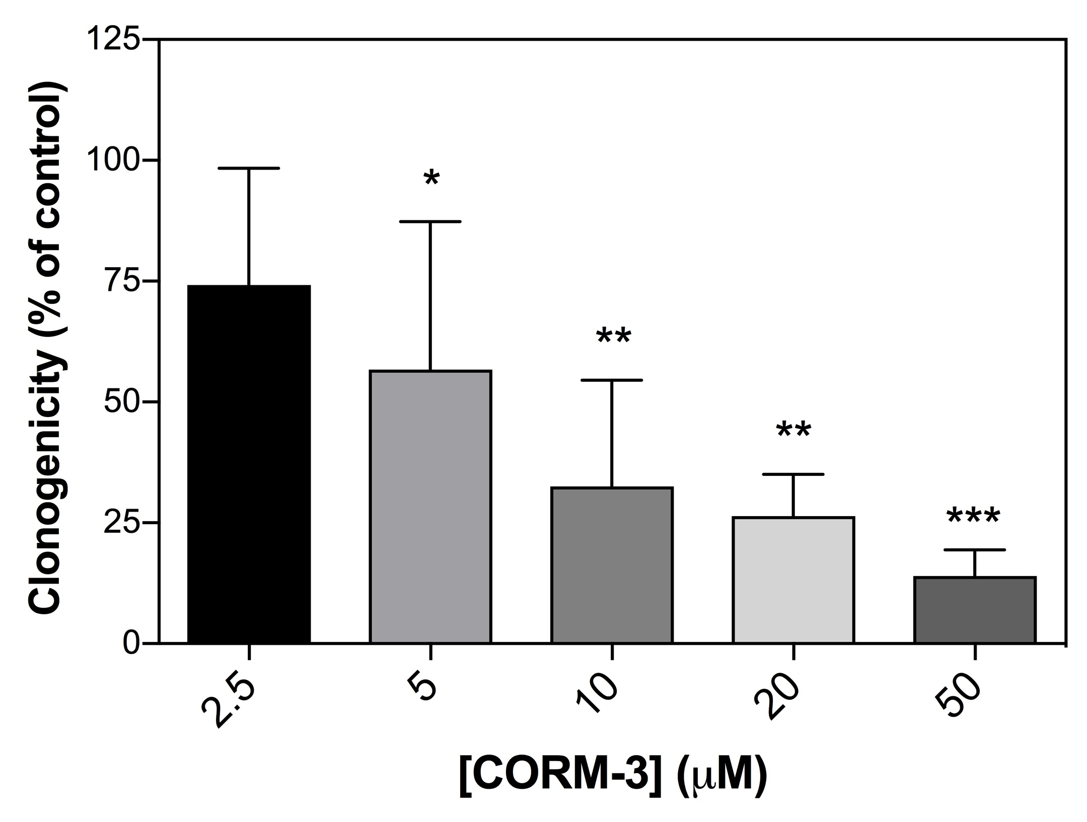

Fig. 7.1. CORM-3 is acutely cytotoxic to cultured human cells in PBS. The acute cytotoxicity of CORM-3 in the absence of rich growth media was determined via a clonogenicity assay. Confluent RKO cells were removed from the surface of growth flasks by treatment with trypsin, washed once in PBS and then resuspended to a final concentration of 1 x 10⁶ cells mL⁻¹ in PBS. CORM-3 was added (2.5 – 50 μM) and cell suspensions were treated for 1 h at 37 °C. After this time, suspensions were diluted 10-fold with RPMI-1640 growth media plus supplements, and then further diluted with the same medium to 5,000 – 16,000 cells mL⁻¹. Next, 10 mL of each cell suspension was plated in triplicate into sterile cell culture dishes and then incubated for 9 days at 37 °C in a humidified atmosphere with 5 % CO₂. After 9 days, the medium was removed. Cell clones (colonies) were fixed with ethanol and stained for counting with methylene blue. The clonogenicity of RKO cells after CORM exposure was thus measured relative to non-treated control cells in PBS, where the total number of clones counted after 0 μM CORM-3 represents 100% clonogenicity. The clonogenicity of cells treated with CORM-3 was significantly decreased relative to untreated control cells: 2.5 μM (26 % decrease), 5 μM (43 % decrease, *p ≤ 0.05), 10 μM (67 % decrease, **p ≤ 0.01), 20 μM (74 % decrease, **p ≤ 0.01), 50 μM (86 % decrease, ***p ≤ 0.001). Concentrations in excess of 50 μM CORM-3 resulted in a total loss of clonogenicity (data not shown). Data represents 3 biological repeats ± SD. Significant differences were assessed on non-normalised data via a one-way ANOVA of sample variance followed by a Tukey’s multiple comparisons test.

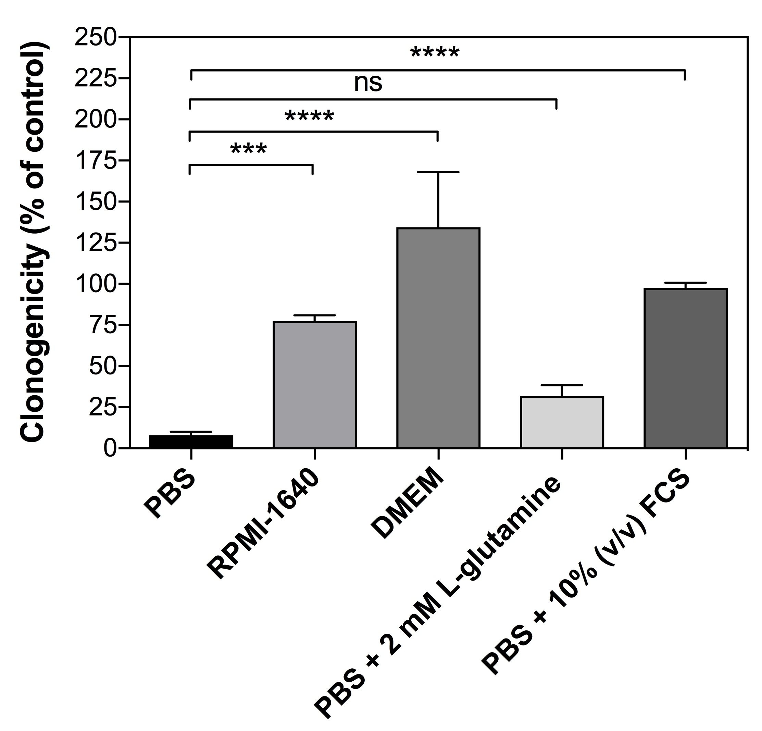

Fig. 7.2. Components of mammalian cell culture media or supplements protect human cells against the acute cytotoxicity of CORM-3 in vitro. The acute cytotoxicity of CORM-3 in the presence of rich growth media or supplements was determined by clonogenicity assays of 5 x 10⁵ RKO cells after 1 h exposure to 25 μM CORM-3 in the presence of PBS, un-supplemented DMEM, un-supplemented RPMI-1640, 2 mM L-glutamine or 10 % (v/v) FCS. The clonogenicity of RKO cells after exposure to CORM-3 was measured relative to the clonogenicity of untreated cells in the same growth medium. The clonogenicity of RKO cells treated for 1 h with 25 μM CORM-3 in PBS was decreased 92 % relative to the clonogenicity untreated cells (black bar). The relative decreases or increases in clonogenicities of RKO cells in various growth media after exposure to 25 μM CORM-3 compared to the clonogenicities of untreated cells in the same media were as follows: RPMI-1640 (23 % reduction); DMEM (34 % increase); PBS + 2 mM L-glutamine (68 % decrease); PBS + 10 % FCS (2.5 % decrease). The presence of RPMI-1640, DMEM and 10 % FCS was sufficient to significantly reduce the cytotoxic effects of CORM-3 against RKO cells relative to the PBS + CORM-3 control (*** p ≤ 0.001, **** p ≤ 0.0001). There was no significant affect on the cytotoxicity of CORM-3 by supplementation with 2 mM L-glutamine. Data represents ≥ 3 biological repeats ± SD. Significant differences were assessed via a one-way ANOVA followed by a Tukey’s multiple comparisons analysis on normalised data of the % clonogenicity change after CORM-3 in each growth medium relative to the decrease in clonogenicity of CORM-3 in PBS.
Abbreviations: DMEM = Dulbecco’s Modified Eagle’s Medium, RPMI = Roswell Park Memorial Institute medium, FCS = fetal-calf serum.

Supplementation of PBS with 2 mM L-glutamine caused no significant effects of the cytotoxicity of CORM-3 against RKO cells (Fig. 7.2). In contrast, supplementation of PBS with 10 % (v/v) FCS caused almost a complete alleviation of the cytotoxic effects of 25 μM CORM-3 against RKO cells, reducing clonogenicity by 2.5 % of that of non-CORM treated cells in the same medium (Fig. 7.2). Thus, it can be concluded that the presence of RPMI-1640, DMEM and/or 10 % (v/v) FCS partially or fully alleviate the acute cytotoxic effects of CORM-3 against human RKO cells in vitro.
7.2.3. Human RKO cells accumulate CORM-3-derived Ru to milimolar levels in vitro, but rich growth media decreases the extent of accumulation
As it was previously determined in Chapters 3 – 6 of this thesis that the bactericidal actions of CORM-3 against E. coli cells were due to the consequence of CORM-derived Ru(II) ions binding to cellular targets, it was hypothesized that CORM-3 cytotoxicity against human RKO cells could be due to similar mechanisms. Therefore, the accumulation of CORM-3-derived Ru by human RKO cells was investigated. RKO cells in suspension at a final concentration of 1 x 10⁶ cells mL⁻¹ in PBS were exposed to 50 μM CORM-3 for 1 h. After treatment, cells were pelleted by centrifugation at 400 x g and the supernatant containing extracellular CORM-3 was discarded. RKO cell pellets were washed once in cold PBS to remove any residual CORM-3 and then cell pellets were digested in neat nitric acid for determination of Ru content by ICP-AES. The level of accumulated Ru by RKO cells following 1 h exposure to 50 μM was determined to be 5.9 ± 2.0 mM based on an estimated average RKO cell volume of 3000 μM³ (Fig. 7.3, black bar). Thus, human RKO cells accumulate high levels of Ru upon exposure to CORM-3 in PBS in vitro.
As it was shown that alleviation of the antimicrobial effects of low doses of CORM-2 and CORM-3 in the presence of exogenous amino acids/peptides was due to a reduction of CORM-derived Ru accumulation in E. coli (Chapters 4 and 5), it was hypothesized that the alleviation of cytotoxicity of CORM-3 in the presence of rich media or FCS was due to prevention of CORM-3-derived Ru by RKO cells. Thus, the accumulation of Ru by RKO cells upon exposure to CORM-3 in DMEM was investigated (Fig. 7.3, grey bar). The level of CORM-3-derived Ru by RKO cells treated in DMEM was found to be 1.0 ± 0.38 mM, which is significantly lower than the level of Ru accumulated by RKO cells upon exposure to CORM-3 in PBS alone (p ≤ 0.05). Thus, treatment of RKO cells with CORM-3 either in PBS or DMEM leads to milimolar levels of CORM-3-derived Ru accumulation by RKO cells in vitro. However, the extent of Ru accumulation upon exposure to CORM-3 is significantly less in the presence of rich growth media.
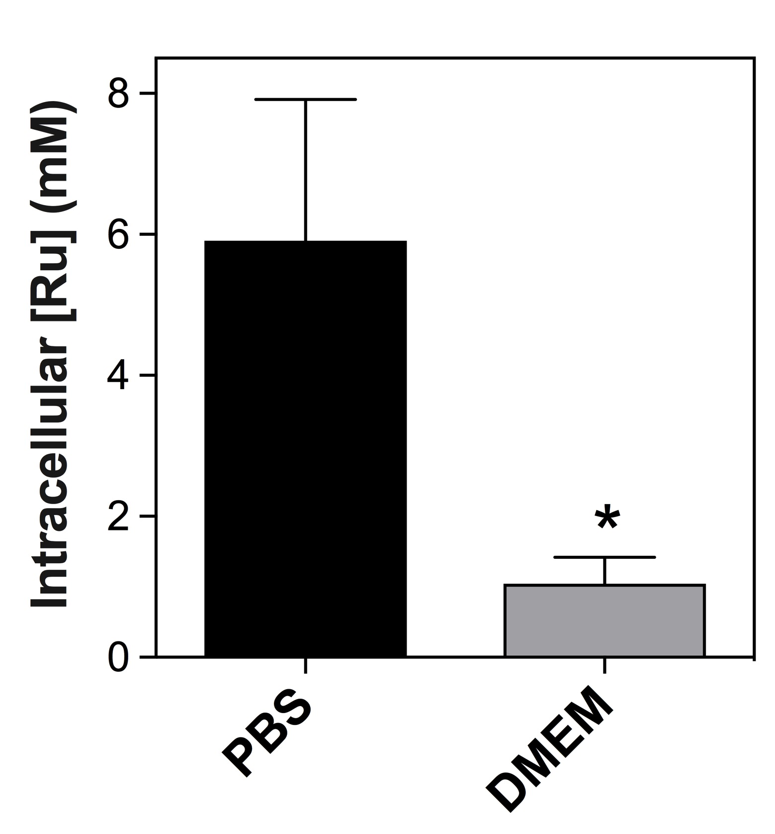

Fig. 7.3. Human cells accumulate CORM-3-derived Ru in vitro. Confluent RKO cells were removed from growth flasks by trypsin, washed once in PBS and then resuspended in either PBS or DMEM to a final concentration of 1 x 10⁶ cell mL⁻¹. CORM-3 (50 μM) was added and then cells were incubated for 1 h at 37 °C. The cell suspensions were then centrifuged at 400 x g and then the supernatant was discarded. Cells were washed once in PBS to remove residual extracellular CORM, centrifuged once more and then the resulting cell pellets were retained. Pellets were digested in neat nitric acid then analysed for Ru content by ICP-AES. Estimations of intracellular Ru concentration of RKO cells after treatment with CORM-3 in PBS (black bar) or DMEM (grey bar) were determined by the total number of cells present in the pellet, the amount of Ru (mg) in the pellet and the approximate volume of a typical mammalian epithelial cell (3000 μM³, Milo et al., 2010). RKO cells in PBS accumulated significantly higher levels of intracellular Ru upon exposure to CORM-3 than RKO cells incubated in DMEM (p ≤ 0.05). Data represents 3 biological repeats ± SD. Significant differences were assessed by an unpaired t-test.

7.3 Discussion and concluding remarks
7.3.1. CORM-3 is significantly cytotoxic to human cells in the absence of rich growth media or FCS
Up to 500 μM CORM-3 is consistently reported to be non-toxic against various mammalian cell types in vitro when cells are grown in rich growth media supplemented with 10 % (v/v) FCS (Desmard et al., 2009; Nobre et al., 2016; Wang et al., 2014). For this reason, CORM-3 is considered to be more therapeutically applicable than CORM-2, which starts eliciting cytotoxic effects at ~ 200 – 400 μM (Nobre et al., 2016). Although the Ru(II) ions of these CORMs have been largely overlooked in the mammalian literature, it was established in Chapter 3 that the antimicrobial activities of CORM-2 and CORM-3 are the consequence of CORM-derived Ru accumulation by bacterial cells. Furthermore, CORM-2 and CORM-3 toxicity to bacterial cells is alleviated in rich growth media by sequestration of the Ru(II) ions by media components such as amino acids or peptides (Chapters 4 and 5). Therefore, it was hypothesized that the previously reported relatively low cytotoxicities of CORMs against cultured mammalian cells in vitro, could have been due to the presence of the rich growth media employed for maintenance of cell cultures.
Acute exposure of human epithelial colon carcinoma (RKO) cells to 2.5 – 50 μM CORM-3 in PBS caused a significant dose-dependent reduction in RKO cell viability as assessed via the clonogenic survival assay (Fig. 7.1). As CORM-2 is reported to be considerably more toxic than CORM-3, even in rich media (Nobre et al., 2016), it is expected that CORM-2 would cause even greater cytotoxic effects in PBS, though this remains to be investigated. Clonogenic assays of RKO cells exposed to CORM-3 in the presence of rich growth media or supplements confirmed that DMEM, RPMI and FCS could all protect RKO cells against the cytotoxic effects of CORM-3 (Fig. 7.2). Interestingly, DMEM not only alleviated the cytotoxic effects of CORM-3, but also the presence of CORM-3 appeared to enhance clonogenicity of RKO cells in this media (Fig. 7.2). The reasons for this effect are unknown, especially as cells exposed to CORM-3 in DMEM were found to accumulate considerable levels of CORM-derived Ru (Fig. 7.3). To the authors knowledge, there are no reports of enhancement of proliferation of cultured mammalian cells by Ru(II)-containing complexes in the scientific literature. In contrast, the potential of many Ru(II)-containing complexes as anti-cancer agents are due to the anti-proliferative effects of these compounds against carcinoma cell lines in vitro (Levina et al., 2009). Given that there is equal alleviation of the antimicrobial effects of both CORMs by rich growth media (Chapter 3), it is also likely that DMEM, RPMI and FCS to some extent protect cultured mammalian cells against CORM-2 cytotoxicity. This remains to be investigated.
It is worth noting that only one epithelial cell type has been examined in this work, though it is probable that the alleviation of CORM-3 cytotoxicity against RKO cells is due to sequestration of the CORM by media components and thus it is not likely that this effect is cell-type specific. The conclusions of this thesis would however be strengthened by further examinations of CORM-2 and CORM-3 cytotoxicity against various cell types in the presence and absence of rich growth media and supplements.
What are the implications of these results in the potential applications of these compounds as antimicrobial agents? Firstly, the probable sequestration of CORM-3 by FCS is of particular concern. This implies that if CORM-3 were to be administered intravenously, it would likely remain bound to serum components and thus be prevented from reaching pathogenic bacteria at the site of the infection. Although the efficacy of these compounds as antimicrobial agents in vivo has been demonstrated by three studies as reviewed in Section 1.4.2 (Chung et al., 2008; Desmard et al., 2009; Desmard et al., 2012), in these experiments the CORM was injected directly into the site of bacterial inoculation/infection. It is not known how effective these compounds would by if administered systemically. The cytotoxicity of CORM-3 against RKO cells in the absence of rich media or FCS also demonstrates that CORM-3 cause pose a significant toxicity risk to the host in vivo. Unfortunately, in the above studies, the long-term survival of animal models that were administered with CORMs was not evaluated. However, Wang et al carried out a more detailed and long-term examination of the pharmacological effects of CORM-3 (Wang et al., 2014). In this study, consecutive administration of 14.7 – 36.8 mg/kg CORM-3 to rats was shown to cause severe kidney and liver damage after 21 days (Wang et al., 2014). Thus, although more work could be conducted in whole animal models to determine how CORM-2 and CORM-3 elicit their toxic effects in vivo, it is unlikely that these compounds would reach further clinical development due to their significant cytotoxicities in vitro. Thus it would not be morally justifiable to further demonstrate their unsuitability for clinical development at the expense of laboratory animals.
7.3.2. Are the underlying mechanisms of CORM-induced cytotoxicity in human cells essentially the same as the antimicrobial actions of these CORMs against bacteria?
From the results presented in Chapters 3 – 6 of this thesis, it is likely that the antimicrobial effects of CORM-2 and CORM-3 in bacteria are mediated by Ru(II) ion coordination to membrane and intracellular targets such as surface-exposed amino acid residues on proteins, reduced and oxidised sulfhydryls, membrane components and potentially DNA. A key hallmark of CORM-2 and CORM-3 antimicrobial activities is thus high levels of CORM-derived Ru accumulation upon exposure of bacterial cells to these compounds.
From the preliminary investigations conducted in this chapter, it certainly appears likely that CORM-3 cytotoxicity against human RKO cells is associated with high levels of CORM-derived Ru accumulation (Fig. 7.3). However, there must be caution with interpretation of these results as the estimated intracellular level of Ru accumulated by RKO cells is based on two overly general assumptions that: (1) the CORM-derived Ru had been completely taken up by the cells and was not bound to the outside of cells by plasma-membrane receptors, and (2) the average volume of an RKO cell is approximately that of an typical mammalian epithelial cell at 3000 μM³. In reality, it is highly likely that at least some CORM-derived Ru is bound to plasma membrane proteins, as is suspected to be the case for bacterial cells. In addition, RKO cell volume is likely to vary considerably depending on growth phase of the cells. Nevertheless, accumulation of CORM-derived Ru by RKO cells was significantly lower in the presence of DMEM compared to PBS and perhaps as a consequence, CORM-3 cytotoxicity was alleviated in DMEM.
The mechanism of uptake and accumulation of CORM-derived Ru by RKO cells is currently unknown and may therefore warrant further investigation. However, it is unlikely that the uptake mechanism is energy-dependent as cells were able to accumulate high levels of CORM-derived Ru in the absence of glucose. Therefore, it is unlikely that CORM-derived Ru is accumulated by RKO cells against such a steep concentration gradient by an active transport process. Perhaps, as with uptake and accumulation of CORM-derived Ru by bacterial cells, uptake proceeds via a diffusion-driven process dependent on CORM-derived Ru(II) binding to intracellular targets.
What are these targets of CORM-derived Ru(II) ions in mammalian cells? As described previously, it is worth noting that the proposed bacterial cell targets of CORM-derived Ru(II) ions, such as Cys, His, Met, GSH, GSSG and nucleic acids, are conserved between both prokaryotic and eukaryotic cells. In particular, the mitochondria of eukaryotic cells are closely related to bacteria and thus CORM-mediated cytotoxicity may, at least in part, be mediated by inhibition of mitochondrial function by CORM-derived Ru(II) ions. However, much more thorough investigations into the cellular targets of CORM-derived Ru(II) ions are required before these ideas can be properly substantiated.
7.3.3. Implications for the employment of CORMs as experimental tools to investigate the physiological effects of CO in mammalian cells
As described briefly in the introduction of this chapter, CORM-2 and CORM-3 have been widely employed in over 300 publications as experimental tools to elucidate the biological roles of CO in mammalian physiology. The implications of the results of this chapter and previous results of this thesis in the future application of CORM-2 and CORM-3 as mere ‘CO-donors’ is given in Section 8.4.

Chapter 8
General conclusions and future work
8.1. General conclusions
8.1.1. Ru-carbonyl based CORMs as antimicrobial agents: a revised perspective
Prior to the start of this project, it was widely assumed that CORM-2 and CORM-3 antibacterial effects were caused by intracellular CO release and the consequential inhibition of bacterial cell targets such as terminal oxidases and other haem-containing proteins. This proposal, known as the ‘Trojan Horse hypothesis’, is illustrated in Fig 1.11. There was little consideration for the biological effects of the Ru(II) ions or the residual compound remaining after CO release had occurred. There were a number of issues with this hypothesis. Firstly, CO gas is a poor antimicrobial; it possesses few targets in bacterial cells and E. coli growth is only slightly perturbed when cultures are grown at almost CO-saturated conditions (Wareham et al., 2016). Furthermore, CORM-2 and CORM-3 are considerably more toxic than other non-Ru based CORMs; many of which release comparatively more CO per molecule of CORM (Nobre et al., 2016; Tinajero-Trejo et al., 2016). An informative finding was that haem-deficient bacteria, which lack the classical biological targets of CO, were found to be more sensitive to killing by Ru-carbonyl CORMs than WT strains (Wilson et al., 2015). It was therefore proposed that at least some of the antimicrobial effects of these compounds were due to the Ru (Wareham et al., 2015). However, a comprehensive investigation into how these Ru(II) ions were responsible for CORM antimicrobial affects had not been previously attempted. Therefore addressing this issue became an important aspect of this thesis.
a. CORM-3 is not a CORM
CO release from CORM-3 has never been demonstrated in aerobic conditions when analysed by the oxyhaemoglobin assay, a CO-electrode, FTIR or GC (Nobre et al., 2011; McLean et al., 2012; Santos-Silva et al., 2011; Seixas et al., 2015). Only in the presence of dithionite or other sulfites, or in reducing conditions generated by addition of glucose to whole cells, does CORM-3 release ~ 0.5 – 1 equivalents of CO per CORM (McLean et al., 2012; Rana et al., 2014). Prior to this project, it was presumed that CORM-3 would be inactive until it was taken up into bacterial cells, where naturally occurring sulfite species would then trigger CO release intracellularly (Fig. 1.11). However, within minutes of dissolution of CORM-3 into various growth media or buffer, the ability of the compound to release CO gas upon addition of dithionite was strikingly diminished (Chapter 3). This is proposed to occur via substitution of the glycinate ligand of CORM-3 by anionic phosphates binding to the Ru(II) ions, yielding a stable and biologically inert tricarbonyl species (Chapter 3). Thus, CORM-3 is likely to be ‘inactivated’ prior to cellular entry. It highly unlikely that any of the biological effects of CORM-3 against bacteria, or indeed in against mammalian cells, are mediated by CO release. In these biological experiments at least, CORM-3 is not a CO-releasing molecule.
The situation is more complicated with CORM-2. It is known that, upon solubilisation of CORM-2 into DMSO, at least some CO is liberated (up to 0.5 equivalents per Ru dimer) by substitution with the solvent (as illustrated in Fig. 1.10). Further CO release from CORM-2 (up to 0.7 equivalents) was demonstrated upon addition of dithionite after prolonged incubation in KPi buffer or various media (Chapter 3). It is therefore possible that some of the biological activities of CORM-2, or more accurately, the speciation products of CORM-2 reaction with DMSO, can still release significant levels of CO upon contact with intracellular sulfite species. It should be noted that CO binding to cellular targets such as the terminal oxidases of E. coli, in the absence of dithionite, has never been reported.
b. iCORMs should not be used as negative controls to assess the contribution of the Ru(II) ions to the biological effects of CORM-2 and CORM-3
A significant conclusion is that iCORM-2 (Ru(II)Cl₂(DMSO)₄) and iCORM-3 should not be employed as negative control compounds for assessment of the contribution of the Ru(II) ions in the biological activities of these CORMs. Although iCORM-2 was not experimentally employed throughout this project, it had not been previously considered that the lack of biological effects of this compound was due to the inaccessibility of the Ru(II) ion to coordinate biological targets upon addition to buffers or growth media (Trynda-Lemiesz et al., 2000). Relatively little was known about the structure of iCORM-3 or the mechanisms by which it is preparation by ‘inactivating’ CORM-3 by dissolution into PBS over 48 h (Motterlini et al., 2003). The results in Chapter 3 indicate that iCORM-3 is generated from CORM-3 within minutes of addition of CORM-3 stocks to growth media or buffers, presumably by glycinate substitution with media components like phosphates. This could be resolved by determining the chemical structure of iCORM-3 by x-ray crystallography; however, even the structure of CORM-3 is poorly understood. Displacement of the glycinate of CORM-3 likely yields a stable tricarbonyl species, similar in structure to that shown in Fig. 1.10 (7). This species is predicted to be chemically inert and therefore it is likely that the Ru(II) ions are unable to interact with biological targets. Thus, iCORM-2 and iCORM-3 are poor negative controls for reactive Ru(II) species because of their biologically inert and inaccessible Ru(II) ions.
c. CORM-2 and CORM-3 antimicrobial effects are strongly associated with CORM-derived Ru accumulation by bacterial cells
In Chapter 3, it was shown that E. coli accumulated up to ~ 2 mM CORM-derived Ru upon exposure to either CORM. Significantly, the extent of CORM-derived Ru by E. coli cells was strongly correlated with the extent of cell killing. However, this result should not be taken to indicate that CORM-derived Ru accumulation is the cause of cell killing. Indeed, a glutathione deficient (gshA) E. coli mutant was found to accumulate less Ru upon exposure to either CORM, but was also found to be more susceptible to inhibition by CORM-2 and CORM-3 than gshA⁺ cells (Chapter 5).
d. CORM-derived Ru uptake and accumulation by E. coli is proposed to be driven by diffusion and is dependent on the availability of intracellular targets of Ru(II) ions
Before potential bacterial cell targets of CORM-derived Ru are discussed, it is important to consider how E. coli cells rapidly accumulate up to milimolar levels of Ru upon exposure to CORM-2 or CORM-3. From the results of this thesis, it can be concluded that uptake and accumulation of CORM-derived Ru by E. coli cells is likely to be driven by diffusion and is dependent on availability of intracellular targets of Ru(II), as is illustrated in Fig. 8.1. However, this proposal is incomplete and important questions remain. Firstly, the relative distribution of CORM-derived Ru between: (1) the OM and IM, and (2) the periplasm and cytoplasm, remains to be determined. The specific targets of CORM-derived Ru within these subcellular fractions are also unknown. For example, do Ru(II) ions coordinate to membranes via interactions with membrane proteins, anionic groups on LPS/phospholipids or both? Furthermore, it is possible that some initial uptake, prior to cell killing, is due to active transport.
e. The antimicrobial effects of CORM-2 and CORM-3 are likely to be mediated by the consequences of Ru(II) coordination to diverse targets and consequential inhibition of multiple cellular processes.
Based on the findings that CORM-Ru(II) ions bind with high affinity to Cys and His in vitro, it is highly probable that surface-exposed Cys and His residues on proteins represent key cellular targets of CORM-derived Ru(II) ions. If these Cys or His residues are located at active sites of an essential enzymes, then the effect of the Ru(II) ion might be to prevent substrate binding and thus inactivate enzymatic function. Such inhibition to enzymatic function may further inhibit essential cellular processes causing bacteriostasis. In support of this, CORM-2 has been previously reported to inhibit the activity of [Fe-S] containing proteins and H. pylori urease in vitro; these proteins contain metal binding sulfurs or His residues within their active sites (Tavares et al., 2011; Tavares et al., 2013). Additionally, Ru(II) coordinating to membrane proteins may lead to: (1) interference with nutrient assimilation inducing starvation; (2)
Fig. 8.1. Uptake and accumulation of CORM-derived Ru by E. coli cells upon exposure to CORM-2 or CORM-3

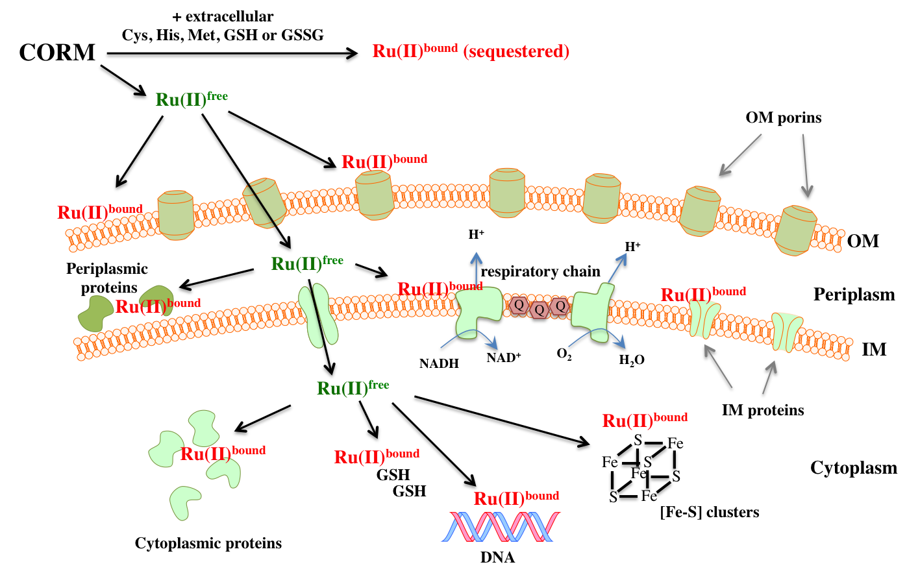

Fig. 8.1. Uptake and accumulation of CORM-derived Ru by E. coli cells upon exposure to CORM-2 or CORM-3 (1) CORM is applied to the growth medium and likely undergoes chemical reactions with media components. If extracellular peptides, amino acids (Cys, His or Met) or sulfhydryl-containing compounds (GSH or GSSG) are present, the CORM is sequestered outside of the cell and prevented from accumulating intracellularly. Unbound or ‘free’ CORM-derived Ru(II) species, referred to here as ‘Ru(II)^{free}’, are free to diffuse across the OM of E. coli through OM porins. Alternatively, Ru(II)^{free} may coordinate directly with targets on the OM e.g. anionic phosphates on LPS/phospholipids or on surface-exposed amino acids on membrane proteins. (2) Once the Ru(II)^{free} species reaches the periplasm, they may coordinate to surface exposed amino acids on periplasmic proteins or IM proteins, or oxidised sulfhydryl groups present in the periplasm. In addition, the Ru(II)^{free} species may also coordinate directly to anionic groups on IM components. (3) The Ru(II)^{free} species may then gain access to the cytoplasm, via a currently unknown mechanism, possibly facilitated by a non-energy dependent transporter due to the low lipophilicity of these compounds. Once inside the cytoplasm, the Ru(II)^{free} coordinate to cytoplasmic targets such as sulfhydryls e.g. GSH, surface exposed amino acids on proteins, Fe-S containing proteins, DNA and potentially other as yet unidentified targets. (4) Continued uptake to up to milimolar levels of CORM-derived Ru accumulation is driven by passive diffusion and is dependent on the availability of intracellular targets. Upon entry of the Ru(II)^{free} species into intracellular compartments, these species rapidly bind intracellular targets and thus are changed into a ‘bound’ CORM-derived Ru(II) species or ‘Ru(II)^{bound}’, which is chemically distinctive to the Ru(II)^{free} species outside of the cell. This effectively maintains a very low level of Ru(II)^{free} intracellurly and thus uptake of Ru(II)^{free} continues, against a high concentration of Ru, until all available bacterial cellular targets are depleted.
Note – OM = outer-membrane, IM = inner-membrane

prevention of membrane maintenance causing loss of membrane integrity and; (3) inhibition of membrane-mediated processes e.g. aerobic respiration.
Other high affinity targets are likely to include cytoplasmic thiols such as GSH. The resulting depletion of intracellular thiols would thus perturb cellular redox balance, prevent thioredoxin/glutaredoxin-mediated repair of oxidised protein-sulfhydryls and leave other cellular targets vulnerable to attack from Ru(II) ions and/or ROS. Additional lower affinity targets are likely to include surface-exposed Met residues or oxidised thiols (e.g. GSSG). Although Ru(II) interactions with these groups are probably reversible, these targets may still be significant once all available high affinity targets been depleted. DNA could also be a potential target although CORM interactions with DNA in vitro remain to be investigated.
It can therefore be concluded that the mechanisms underlying the antibacterial effects of CORM-2 and CORM-3 are likely mediated by coordination of Ru(II) to multiple and diverse bacterial cell targets. However, it is yet to be shown that exposure to Ru-carbonyl CORMs depletes intracellular thiols, or that CORM-derived Ru(II) inhibits protein activity in vivo.
8.1.2. Re-classification of CORM-2 and CORM-3 as functional ruthenium antimicrobial agents
As described in Chapter 1 (Section 1.6), there currently exist over 200 publications on the antimicrobial activities of various Ru complexes in the scientific literature. A fairly comprehensive review is provided by Southam et al (Southam et al., 2017). Antimicrobial Ru compounds are divided into 4 classes depending on their mechanism of action: structural, carrier, functional or photo-activated. It is proposed by the author of this thesis that CORM-2 and CORM-3 should be re-classified as functional ruthenium antimicrobial agents and not be considered to act merely as ‘CO-releasing molecules’. This is not least because CORM-3 does not release CO in biological experiments, but because the antimicrobial effects of these compounds in bacterial cells are mediated by the Ru(II) ion coordinating to bacterial cell targets. To further support this conclusion, the antimicrobial effects of these compounds was often found to be consistent with the behaviour of other non-essential metal ions in biological systems, including: coordination to Cys and His residues, inhibition of respiration, accumulation at the membrane, membrane damage, protein dysfunction, sulfur starvation, the increased sensitivity of gshA mutants and the alleviation of antimicrobial effects in rich growth media.
8.1.3. Could CORM-2 and CORM-3 act as potential replacements or adjuvants to existing antibiotics?
The simple answer is no. However, to present a balanced argument, it could be considered that, in many ways, CORM-2 and CORM-3 share many features with the ‘ideal antimicrobial compound’ as described in Fig. 1.3. They are potently antimicrobial to both Gram-negative and Gram-positive bacteria. They are accumulated rapidly by bacterial cells, binding to multiple cellular targets and thus, mitigating the possibility of target-mediated resistance. They are proven to act synergistically with pre-existing antibiotics (Ali, S unpublished) and currently there exists no known mechanisms of resistance. Furthermore, both CORM-2 and CORM-3 have proven efficacy in vivo in animal infection models (Chung et al., 2008; Desmard et al., 2009; Desmard et al., 2012).
However, if these compounds are in assessed MH-II medium, in accordance with EUCAST guidance, their MICs are considerably higher than pre-existing antibiotics at > 512 μg mL⁻¹ (corresponding to over 1 mM CORM-2 or 1.74 mM CORM-3). Furthermore, the speciation chemistries of CORM-2 and CORM-3 upon dissolution into DMSO or aqueous solutions are complex and not fully understood. This renders predictions of their of their pharmacological ADME (absorption, distribution, metabolism and excretion) properties difficult to achieve and raising issues on drug safety. The major limitation to their clinical application, however, is their cytotoxicity to human cells in vitro, as demonstrated in Chapter 7. All previous examinations of CORM-2 and CORM-3 cytotoxicity against cultured mammalian cells in vitro had been conducted in the presence in rich media (DMEM or RPMI) plus FCS supplements and/or amino acid supplements, which have now been demonstrated to protect both bacterial and mammalian cells against Ru-carbonyl CORMs. Although only CORM-3 cytotoxicity to mammalian cells was demonstrated in this project, it is highly likely that CORM-2 is even more toxic, given that it is generally more toxic to mammalian cells in rich media.
8.1.4. A message to mammalian scientists: It’s probably not the CO and it’s almost certainly the Ru!
Perhaps the most important conclusion that can be drawn for this work concerns the implications for the past and future applications of CORM-2 and CORM-3 as experimental tools for studying the effects of CO. These CORMs have been widely employed in over 300 publications and thus, the use of these compounds as mere ‘CO-releasers’ has contributed significantly to the understanding of the biological roles of CO in mammalian cell physiology and its potential in human medicine (Ryter et al., 2006).
Not only is it now known that CORM-3 is not an effective CORM due to its rapid deactivation upon dissolution in mammalian growth medias or buffer, but furthermore, both CORMs are likely to be significantly cytotoxic to cultured cells in vitro depending on the composition of the growth media. When small amounts of CORM-3 (50 μM) were added to human cells in the presence of DMEM, there was a considerable accumulation of CORM-derived Ru by these cells in vitro (Chapter 7). This raises the possibility that the reported biological roles of CO, which have been elucidated by the employment of these compounds as ‘CO-releasing molecules’, may not actually be caused by CO, but instead caused by CORM-derived Ru(II) ions coordinating to cellular targets, such as sulfhydryls and imidazole groups on proteins. Although it cannot be concluded that these studies should now be considered obsolete, it is worth interpreting the results of these 300 publications with informed caution. An important conclusion from this project is that CORM-2 and CORM-3 should not be considered to act as mere ‘CO-donors’ but instead should be regarded as biologically active Ru(II)-containing compounds which may, or may not, release sufficient CO to induce additional biological effects in vitro or in vivo.
8.2. Future work
Given that one of the important conclusions of this thesis is that CORM-2 and CORM-3 should not be employed as potential replacements or adjuvants to existing antibiotics, the suggested future work below may instead enhance our understanding of how similar compounds exert their antimicrobial effects and thus help contribute the either: (1) more selectively antimicrobial Ru complexes that do not also target mammalian cells or (2) more effective CORMs as experimental tools for investigating the effects of CO in biological systems.
8.2.1. How does CORM-derived Ru(II) ion coordination to multiple cellular targets induce bacterial cell killing?
As mentioned above, it is likely that CORM-2 and CORM-3 antimicrobial activities are mediated by Ru(II) coordination to cellular targets. However, the specific bacterial cell targets of CORM-derived Ru are currently unknown and therefore it is not known how CORM-derived Ru accumulation causes cell killing. Therefore, an informative experiment would be to determine which bacterial proteins bind Ru(II) in vivo after CORM exposure. This is likely to be completed in the near future by the examination of whole protein extracts obtained from E. coli cells, following CORM-2 or CORM-3 exposure, for Ru(II) ion binding by mass spectroscopy and/or ICP-AES. This will help further elucidate if membrane proteins are key targets of CORM-derived Ru.
Secondly, although intracellular thiols are strongly suspected to be key intracellular targets of CORM-derived Ru(II), there is currently no evidence to suggest that intracellular thiols are depleted upon CORM-derived Ru accumulation. Intracellular thiol depletion upon CORM exposure could thus be investigated by fluorescence microscopy by measuring decreases in the level of fluorescence emitted from of intracellular thiol-sensitive dyes, e.g. fluorescein-5-maleimide, upon exposure of E. coli cells to CORMs.
Furthermore, the membrane damaging effects of CORM-2 and CORM-3 against bacterial cells have not previously been investigated by microscopic methods. Therefore, examining changes that occur to E. coli membrane morphology by electron microscopy at sub-toxic and toxic concentrations of these compounds, might help to elucidate if Ru-carbonyl compounds damage membranes directly or if membrane damage occurs as a consequence of bacterial cell killing. Determining the mechanisms by which these Ru-based ‘CORMs’ kill bacterial cells may contribute to the understanding of how these compounds elicit biological effects to mammalian cells. Furthermore, little work has previously been done on how other functional ruthenium complexes with labile ligands interact with biological membranes.
8.2.2. Mechanisms of CORM-derived Ru uptake by bacteria
Despite the poor ability of these compounds to act as effective CORMs, it may be that the presence of these CO ligands may actually help to facilitate Ru(II) entry into bacterial cells. Many potential antibiotics fail against Gram-negative bacteria due to their inability to permeate the OM, and yet, Ru-carbonyl complexes appear to rapidly gain entry into bacterial cells and accumulate to milimolar levels. Thus, determining the mechanisms by which these compounds gain entry across the Gram-negative envelope could significantly contribute to the design of more effective antimicrobial agents against Gram-negative bacteria. Such future investigations could include examining the effect of glucose, uncouplers and/or proton pump inhibitors on the kinetics of CORM-derived Ru accumulation by E. coli. This will help further elucidate if these complexes are driven by active transport or diffusion. Furthermore, screens of the relative sensitivity of various E. coli transporter mutants to CORM-2 or CORM-3, might also help identify which specific transport proteins facilitate entry of CORM-derived Ru species across the IM. It would also be interesting to investigate if this CORM-derived Ru is then subsequently effluxed by bacterial cells.
A particularly interesting idea would be to investigate whether the addition of Ru(II) ions (or other metal ions) to existing antibiotics, which are normally impermeable through the OM porins of Gram-negative bacteria due to their high hydrophobicity, could enhance their permeability across the OM and thus render them active against Gram-negative cells.
8.2.3. Is DNA a target of CORM-derived Ru?
It remains inconclusive as to whether DNA is a target of CORM-2- and CORM-3- derived Ru in bacterial cells. However it would be interesting to determine if Ru(II) coordination to DNA occurs via a similar mechanism to cisplatin, by coordination of the metal ion to the N7 of purines and subsequently causing intrastrand cross-linking. Such interactions would represent a significant toxic effect of these compounds against both bacterial and mammalian cells. This could be achieved by examining the relative binding affinities of CORM-2 and CORM-3 to small synthetic DNA oligonucleotides by ¹H-NMR to determine whether these compounds interact preferably with particular bases, sequences of bases or duplex/non-duplex DNA structures.
8.2.4. Contribution to the design of better CORMs
There can be no doubt that, with the issues encountered by the employment of CORM-2 or CORM-3 as mere ‘CO-releasing molecules’, there will be better and more rationale design of CORMs in the future. If a CORM is to be employed as an experimental tool for studying the effects of CO release, it should be imperative that the CO-release mechanism is known and can be controlled. Furthermore, there should be an emphasis in determining chemically defined CO-depleted negative controls for assessing the potential biological effects of the CORM as a whole. From the results of this thesis, it is recommended that future CORMs should be based on transition metals of essential metals, such as Mn, which pose less cytotoxic risks to mammalian cells. Less cytotoxic CORMs could have the potential to be employed as adjuvants to enhance the efficacy of existing antibiotics.

References
Alanis, A.J. (2005). Resistance to antibiotics: are we in the post-antibiotic era? Arch Med Res 36, 697-705.

Allardyce, C.S., Dyson, P.J., Ellis, D.J., Salter, P.A., and Scopelliti, R. (2003). Synthesis and characterisation of some water soluble ruthenium(II)-arene complexes and an investigation of their antibiotic and antiviral properties. J Organomet Chem 668, 35-42.

Althaus, E.W., Outten, C.E., Olson, K.E., Cao, H., and OHalloran, T.V. (1999). The ferric uptake regulation (Fur) repressor is a zinc metalloprotein. Biochemistry 38, 6559-6569.

Aminov, R.I. (2010). A brief history of the antibiotic era: lessons learned and challenges for the future. Front Microbiol 1, 134.

Ang, W.H., and Dyson, P.J. (2006). Classical and non-classical ruthenium-based anticancer drugs: Towards targeted chemotherapy. Eur J Inorg Chem, 4003-4018.

Antibiotic Action. 2017. http://www.antibiotic-action.com/. [ONLINE] Available at: http://www.antibiotic-action.com/. [Accessed 15 March 2017].

Arenas, F.A., Covarrubias, P.C., Sandoval, J.M., Perez-Donoso, J.M., Imlay, J.A., and Vasquez, C.C. (2011). The Escherichia coli BtuE protein functions as a resistance determinant against reactive oxygen species. PLOS ONE 6, e15979.

Armstrong, G.L., Hollingsworth, J., and Morris, J.G., Jr. (1996). Emerging foodborne pathogens: Escherichia coli O157:H7 as a model of entry of a new pathogen into the food supply of the developed world. Epidemiol Rev 18, 29-51.

Baker-Austin, C., Wright, M.S., Stepanauskas, R., and McArthur, J.V. (2006). Co-selection of antibiotic and metal resistance. Trends Microbiol 14, 176-182.

Bang, C.S., Kinnunen, A., Karlsson, M., Onnberg, A., Soderquist, B., and Persson, K. (2014). The antibacterial effect of nitric oxide against ESBL-producing uropathogenic E. coli is improved by combination with miconazole and polymyxin B nonapeptide. BMC Microbiol 14.

Bang, C.S., Kruse, R., Johansson, K., and Persson, K. (2016). Carbon monoxide releasing molecule-2 (CORM-2) inhibits growth of multidrug-resistant uropathogenic Escherichia coli in biofilm and following host cell colonization. BMC Microbiol 16.

Barjat, H., Morris, G.A., Smart, S., Swanson, A.G., and Williams, S.C.R. (1995). High-Resolution Diffusion-Ordered 2D Spectroscopy (HR-DOSY) - A New Tool for the Analysis of Complex Mixtures. Journal of Magnetic Resonance, Series B 108, 170-172.

Beard, S.J., Hughes, M.N. and Poole, R.K. (1995). Inhibition of the cytochrome bd-terminated NADH oxidase system in Escherichia coli K-12 by divalent metal cations. FEMS Microbiol Lett 131, 205-210.

Berridge, M.V., and Tan, A.S. (1993). Characterization of the cellular reduction of 3-(4,5-dimethylthiazol-2-yl)-2,5-diphenyltetrazolium bromide (MTT): subcellular localization, substrate dependence, and involvement of mitochondrial electron transport in MTT reduction. Arch Biochem Biophys 303, 474-482.

Bettenbrock, K., Bai, H., Ederer, M., Green, J., Hellingwerf, K.J., Holcombe, M., Kunz, S., Rolfe, M.D., Sanguinetti, G., Sawodny, O., et al. (2014). Towards a systems level understanding of the oxygen response of Escherichia coli. Adv Microb Physiol 64, 65-114.

Beveridge, T.J., Hughes, M.N., Lee, H., Leung, K.T., Poole, R.K., Savvaidis, I., Silver, S., and Trevors, J.T. (1997). Metal-microbe interactions: contemporary approaches. Adv Microb Physiol 38, 177-243.

Blair, J.M., Webber, M.A., Baylay, A.J., Ogbolu, D.O., and Piddock, L.J. (2015). Molecular mechanisms of antibiotic resistance. Nat Rev Microbiol 13, 42-51.

Blattner, F.R., Burland, V., Plunkett, G., Sofia, H.J., and Daniels, D.L. (1993). Analysis of the Escherichia-coli Genome .4. DNA Sequence of the Region from 89.2 to 92.8 Minutes. Nucleic Acids Res 21, 5408-5417.

Blumenthal, I. (2001). Carbon monoxide poisoning. J R Soc Med 94, 270-272.

Boucher, H.W., Talbot, G.H., Bradley, J.S., Edwards, J.E., Gilbert, D., Rice, L.B., Scheld, M., Spellberg, B., and Bartlett, J. (2009). Bad bugs, no drugs: no ESKAPE! An update from the Infectious Diseases Society of America. Clin Infect Dis 48, 1-12.

Bragginton, E.C., and Piddock, L.J. (2014). UK and European Union public and charitable funding from 2008 to 2013 for bacteriology and antibiotic research in the UK: an observational study. Lancet Infect Dis 14, 857-868.

Brindell, M., Stochel, G., Bertolasi, V., Boaretto, R., and Sostero, S. (2007). Photochemistry of trans- and cis-[RuCl2(dmso)4] in Aqueous and Nonaqueous Solutions. Eur J Inorg Chem 2007, 2353-2359.

Brown, D. (2015). Antibiotic resistance breakers: can repurposed drugs fill the antibiotic discovery void? Nat Rev Drug Discov 14, 821-832.

Bruins, M.R., Kapil, S., and Oehme, F.W. (2000). Microbial resistance to metals in the environment. Ecotoxicol Environ Saf 45, 198-207.

Brzuszkiewicz, E., Bruggemann, H., Liesegang, H., Emmerth, M., Olschlager, T., Nagy, G., Albermann, K., Wagner, C., Buchrieser, C., Emody, L., et al. (2006). How to become a uropathogen: comparative genomic analysis of extraintestinal pathogenic Escherichia coli strains. Proc Natl Acad Sci U S A 103, 12879-12884.

Butler, M.S., Blaskovich, M.A., and Cooper, M.A. (2017). Antibiotics in the clinical pipeline at the end of 2015. J Antibiot (Tokyo) 70, 3-24.

Cairns, J., and Denhardt, D.T. (1968). Effect of Cyanide and Carbon Monoxide on Replication of Bacterial DNA in Vivo. J Mol Biol 36, 335-342.

Chain, E., Florey, H.W., Gardner, A.D., Heatley, N.G., Jennings, M.A., Orr-Ewing, J., and Sanders, A.G. (2005). The classic: penicillin as a chemotherapeutic agent. 1940. Clin Orthop Relat Res 439, 23-26.

Chaves-Ferreira, M., Albuquerque, I.S., Matak-Vinkovic, D., Coelho, A.C., Carvalho, S.M., Saraiva, L.M., Romao, C.C., and Bernardes, G.J. (2015). Spontaneous CO release from Ru^{II}(CO)₂-protein complexes in aqueous solution, cells, and mice. Angew Chem Int Ed 54, 1172-1175.

Chung, S.W., Liu, X., Macias, A.A., Baron, R.M., and Perrella, M.A. (2008). Heme oxygenase-1-derived carbon monoxide enhances the host defense response to microbial sepsis in mice. J Clin Invest 118, 239-247.

Clark, J.E., Naughton, P., Shurey, S., Green, C.J., Johnson, T.R., Mann, B.E., Foresti, R., and Motterlini, R. (2003). Cardioprotective actions by a water-soluble carbon monoxide-releasing molecule. Circ Res 93, e2-8.

Claro Reis, F.C., Viana Coelho, J.S., Pazin, W.M., and Nikolaou, S. (2016). A new homoleptic coordination compound of ruthenium and norfloxacin and its interaction with human serum albumin. Inorg Chem Commun 63, 96-100.

Czaplewski, L., Bax, R., Clokie, M., Dawson, M., Fairhead, H., Fischetti, V.A., Foster, S., Gilmore, B.F., Hancock, R.E., Harper, D., et al. (2016). Alternatives to antibiotics-a pipeline portfolio review. Lancet Infect Dis 16, 239-251.

D.H. Wu., A.D.C., .C.S. Johnson (1995). An Improved Diffusion-Ordered Spectroscopy Experiment Incorporating Bipolar-Gradient Pulses. Journal of Magnetic Resonance, Series A 115, 260-264.

Dai, T., Huang, Y.Y., Sharma, S.K., Hashmi, J.T., Kurup, D.B., and Hamblin, M.R. (2010). Topical Antimicrobials for Burn Wound Infections. Recent patents on anti-infective drug discovery 5, 124-151.

Davidge, K.S., Motterlini, R., Mann, B.E., Wilson, J.L., and Poole, R.K. (2009a). Carbon monoxide in biology and microbiology: surprising roles for the "Detroit perfume". Adv Microb Physiol 56, 85-167.

Davidge, K.S., Sanguinetti, G., Yee, C.H., Cox, A.G., McLeod, C.W., Monk, C.E., Mann, B.E., Motterlini, R., and Poole, R.K. (2009b). Carbon monoxide-releasing antibacterial molecules target respiration and global transcriptional regulators. J Biol Chem 284, 4516-4524.

Davies, J., and Davies, D. (2010). Origins and evolution of antibiotic resistance. Microbiol Mol Biol Rev 74, 417-433.

De Grandis, R.A., Resende, F.A., da Silva, M.M., Pavan, F.R., Batista, A.A., and Varanda, E.A. (2016). In vitro evaluation of the cyto-genotoxic potential of Ruthenium(II) SCAR complexes: a promising class of antituberculosis agents. Mutat Res-Genet Toxicol Environ Mutag 798, 11-18.

Demirezen, N., Tarinc, D., Polat, D., Cesme, M., Golcu, A., and Tumer, M. (2012). Synthesis of trimethoprim metal complexes: Spectral, electrochemical, thermal, DNA-binding and surface morphology studies. Spectrochim Acta A Mol Biomol Spectrosc 94, 243-255.

Desmard, M., Davidge, K.S., Bouvet, O., Morin, D., Roux, D., Foresti, R., Ricard, J.D., Denamur, E., Poole, R.K., Montravers, P., et al. (2009). A carbon monoxide-releasing molecule (CORM-3) exerts bactericidal activity against Pseudomonas aeruginosa and improves survival in an animal model of bacteraemia. FASEB J 23, 1023-1031.

Desmard, M., Foresti, R., Morin, D., Dagoussat, M., Berdeaux, A., Denamur, E., Crook, S.H., Mann, B.E., Scapens, D., Montravers, P., et al. (2012). Differential antibacterial activity against Pseudomonas aeruginosa by carbon monoxide-releasing molecules. Antiox Redox Signal 16, 153-163.

Dwyer, F.P., and Mellor, D.P., eds. (1964). Chelating agents and metal chelates (New York: Academic Press).

Dwyer, F.P., Wright, R.D., Gyarfas, E.C., and Shulman, A. (1957). Effect of inorganic complex ions on transmission at a neuromuscular junction. Nature 179, 425-426.

Escobar-Paramo, P., Clermont, O., Blanc-Potard, A.B., Bui, H., Le Bouguenec, C., and Denamur, E. (2004). A specific genetic background is required for acquisition and expression of virulence factors in Escherichia coli. Mol Biol Evol 21, 1085-1094.

ECDC/EMEA. 2017. ECDC/EMEA joint technical report: The bacterial challenge; time to react. Stockholm, Sweden.. [ONLINE] Available at: http://ecdc.europa.eu/en/publications/Publications/Forms/ECDC_DispForm.aspx?D=444. [Accessed 20 March 2017].
EUCAST. 2017. MIC determination of non-fastidious and fastidious organisms. [ONLINE] Available at: http://www.eucast.org/ast_of_bacteria/mic_determination/?no_cache=1. [Accessed 1 May 2017].

Evans, M.E., Feola, D.J., and Rapp, R.P. (1999). Polymyxin B sulfate and colistin: old antibiotics for emerging multiresistant gram-negative bacteria. Ann Pharmacother 33, 960-967.

FDA. 2017. Resources for information on approved drugs. [ONLINE] Available at: https://www.fda.gov/Drugs/InformationOnDrugs/ApprovedDrugs/default.htm. [Accessed 17 March 2017].

Feng, G., Yuan, Y., Fang, H., Zhang, R., Xing, B., Zhang, G., Zhang, D., and Liu, B. (2015). A light-up probe with aggregation-induced emission characteristics (AIE) for selective imaging, naked-eye detection and photodynamic killing of Gram-positive bacteria. Chem Commun (Camb) 51, 12490-12493.

Fleming, M.P., Datta, N., and Grüneberg, R.N. (1972). Trimethoprim Resistance determined by R Factors. Br Med J 1, 726-728.

Forman, H.J., Zhang, H., and Rinna, A. (2009). Glutathione: overview of its protective roles, measurement, and biosynthesis. Mol Aspects Med 30, 1-12.

Foster, A.W., Osman, D., and Robinson, N.J. (2014). Metal preferences and metallation. J Biol Chem 289, 28095-28103.

Foti, J.J., Devadoss, B., Winkler, J.A., Collins, J.J., and Walker, G.C. (2012). Oxidation of the Guanine Nucleotide Pool Underlies Cell Death by Bactericidal Antibiotics. Science 336, 315-319.

Franken, N.A., Rodermond, H.M., Stap, J., Haveman, J., and van Bree, C. (2006). Clonogenic assay of cells in vitro. Nature protocols 1, 2315-2319.

Fukuto, J.M., Carrington, S.J., Tantillo, D.J., Harrison, J.G., Ignarro, L.J., Freeman, B.A., Chen, A., and Wink, D.A. (2012). Small molecule signaling agents: the integrated chemistry and biochemistry of nitrogen oxides, oxides of carbon, dioxygen, hydrogen sulfide, and their derived species. Chem Res Toxicol 25, 769-793.

Gianferrara, T., Bratsos, I., and Alessio, E. (2009). A categorization of metal anticancer compounds based on their mode of action. Dalton Trans, 7588-7598.

Gill, M.R., and Thomas, J.A. (2012). Ruthenium(II) polypyridyl complexes and DNA--from structural probes to cellular imaging and therapeutics. Chem Soc Rev 41, 3179-3192.

Gorle, A.K., Feterl, M., Warner, J.M., Primrose, S., Constantinoiu, C.C., Keene, F.R., and Collins, J.G. (2015). Mononuclear polypyridylruthenium(II) complexes with high membrane permeability in Gram-negative bacteria in particular Pseudomonas aeruginosa. Chemistry-a European Journal 21, 10472-10481.

Gorle, A.K., Li, X., Primrose, S., Li, F.F., Feterl, M., Kinobe, R.T., Heimann, K., Warner, J.M., Keene, F.R., and Collins, J.G. (2016). Oligonuclear polypyridylruthenium(II) complexes: selectivity between bacteria and eukaryotic cells. J Antimicrob Chemother 71, 1547-1555.

Harrison, J.J., Tremaroli, V., Stan, M.A., Chan, C.S., Vacchi-Suzzi, C., Heyne, B.J., Parsek, M.R., Ceri, H., and Turner, R.J. (2009). Chromosomal antioxidant genes have metal ion-specific roles as determinants of bacterial metal tolerance. Environ Microbiol 11, 2491-2509.

Helbig, K., Grosse, C., and Nies, D.H. (2008). Cadmium toxicity in glutathione mutants of Escherichia coli. J Bacteriol 190, 5439-5454.

Hogberg, L.D., Heddini, A., and Cars, O. (2010). The global need for effective antibiotics: challenges and recent advances. Trends Pharmacol Sci 31, 509-515.

Hoggard, P.E., and Porter, G.B. (1981). Is ruthenium(II) hard or soft? J Inorg Nucl Chem 43, 185-186.

Hu, H.J., Sun, Q., Ye, Z.H., and Sun, X.J. (2016). Characteristics of exogenous carbon monoxide deliveries. Medical gas research 6, 96-101.

Hughes, M.N., and Poole, R.K. (1989). Metal mimicry and metal limitation in studies of metal microbe interactions. In Spec Publ Soc Gen Mi, pp. 1-17.

Hughes, M.N., and Poole, R.K. (1991). Metal speciation and microbial growth - The hard (and soft) facts. J Gen Microbiol 137, 725-734.

Imlay, J.A. (2015). Diagnosing oxidative stress in bacteria: not as easy as you might think. Curr Opin Microbiol 24, 124-131.

Jesse, H.E., Nye, T.L., McLean, S., Green, J., Mann, B.E., and Poole, R.K. (2013). The terminal oxidase cytochrome bd-I in Escherichia coli has lower susceptibility than cytochromes bd-II or bo' to inhibition by the carbon monoxide-releasing molecule, CORM-3: N-acetylcysteine reduces CO-RM uptake and inhibition of respiration. Biochim Biophys Acta 1834, 1693-1703.

Johnson, J.R. (1991). Virulence factors in Escherichia coli urinary tract infection. Clin Microbiol Rev 4, 80-128.

Johnson, T.R., Mann, B.E., Teasdale, I.P., Adams, H., Foresti, R., Green, C.J., and Motterlini, R. (2007). Metal carbonyls as pharmaceuticals? [Ru(CO)₃Cl(glycinate)], a CO-releasing molecule with an extensive aqueous solution chemistry. Dalton Trans 21, 1500-1508.

Kalan, L., and Wright, G.D. (2011). Antibiotic adjuvants: multicomponent anti-infective strategies. Expert Rev Mol Med 13, e5.

Kalyanaraman, B., Darley-Usmar, V., Davies, K.J., Dennery, P.A., Forman, H.J., Grisham, M.B., Mann, G.E., Moore, K., Roberts, L.J., 2nd, and Ischiropoulos, H. (2012). Measuring reactive oxygen and nitrogen species with fluorescent probes: challenges and limitations. Free Radic Biol Med 52, 1-6.

Keren, I., Wu, Y.X., Inocencio, J., Mulcahy, L.R., and Lewis, K. (2013). Killing by bactericidal antibiotics does not depend on reactive oxygen species. Science 339, 1213-1216.

Klein, M., Neugebauer, U., Gheisari, A., Malassa, A., Jazzazi, T.M., Froehlich, F., Westerhausen, M., Schmitt, M., and Popp, J. (2014). IR spectroscopic methods for the investigation of the CO release from CORMs. J Phys Chem A 118, 5381-5390.

Krezel, A., and Bal, W. (1999). Coordination chemistry of glutathione. Acta Biochim Pol 46, 567-580.

Latinwo, L.M., Donald, C., Ikediobi, C., and Silver, S. (JAN 6 1998). Effects of intracellular glutathione on sensitivity of Escherichia coli to mercury and arsenite. Biochem Biophys Res Commun 242, 67-70.

Leblanc, S.K.D., Oates, C.W., and Raivio, T.L. (2011). Characterization of the Induction and Cellular Role of the BaeSR Two-Component Envelope Stress Response of Escherichia coli. J Bacteriol 193, 3367-3375.

Lemire, J.A., Harrison, J.J., and Turner, R.J. (2013). Antimicrobial activity of metals: mechanisms, molecular targets and applications. Nat Rev Microbiol 11, 371-384.

Levina, A., Mitra, A., and Lay, P.A. (2009). Recent developments in ruthenium anticancer drugs. Metallomics 1, 458-470.

Lewis, K. (2013). Platforms for antibiotic discovery. Nat Rev Drug Discov 12, 371-387.

Li, F., Feterl, M., Warner, J.M., Day, A.I., Keene, F.R., and Collins, J.G. (2013a). Protein binding by dinuclear polypyridyl ruthenium(II) complexes and the effect of cucurbit[10]uril encapsulation. Dalton Trans 42, 8868-8877.

Li, F., Harry, E.J., Bottomley, A.L., Edstein, M.D., Birrell, G.W., Woodward, C.E., Keene, F.R., and Collins, J.G. (2014). Dinuclear ruthenium(II) antimicrobial agents that selectively target polysomes in vivo. Chemical Science 5, 685-693.

Li, F., Mulyana, Y., Feterl, M., Warner, J.M., Collins, J.G., and Keene, F.R. (2011). The antimicrobial activity of inert oligonuclear polypyridylruthenium(II) complexes against pathogenic bacteria, including MRSA. Dalton Trans 40, 5032-5038.

Li, F.F., Collins, J.G., and Keene, F.R. (2015). Ruthenium complexes as antimicrobial agents. Chem Soc Rev 44, 2529-2542.

Li, F.F., Feterl, M., Mulyana, Y., Warner, J.M., Collins, J.G., and Keene, F.R. (2012). In vitro susceptibility and cellular uptake for a new class of antimicrobial agents: dinuclear ruthenium(II) complexes. J Antimicrob Chemother 67, 2686-2695.

Li, F.F., Feterl, M., Warner, J.M., Keene, F.R., and Collins, J.G. (2013b). Dinuclear polypyridylruthenium(II) complexes: flow cytometry studies of their accumulation in bacteria and the effect on the bacterial membrane. J Antimicrob Chemother 68, 2825-2833.

Li, L., Hsu, A., and Moore, P.K. (2009). Actions and interactions of nitric oxide, carbon monoxide and hydrogen sulphide in the cardiovascular system and in inflammation--a tale of three gases! Pharmacol Ther 123, 386-400.

Li, X., Heimann, K., Dinh, X.T., Keene, F.R., and Collins, J.G. (2016). Biological processing of dinuclear ruthenium complexes in eukaryotic cells. Mol Biosyst 12, 3032-3045.

Li, X.Z., and Nikaido, H. (2009). Efflux-Mediated Drug Resistance in Bacteria: an Update. Drugs 69, 1555-1623.

Ling, L.L., Schneider, T., Peoples, A.J., Spoering, A.L., Engels, I., Conlon, B.P., Mueller, A., Schaberle, T.F., Hughes, D.E., Epstein, S., et al. (2015). A new antibiotic kills pathogens without detectable resistance. Nature 517, 455-459.

Linley, E., Denyer, S.P., McDonnell, G., Simons, C., and Maillard, J.Y. (2012). Use of hydrogen peroxide as a biocide: new consideration of its mechanisms of biocidal action. J Antimicrob Chemother 67, 1589-1596.

Liu, Y.Y., and Imlay, J.A. (2013). Cell death from antibiotics without the involvement of reactive oxygen species. Science 339, 1210-1213.

Long, R., Salouage, I., Berdeaux, A., Motterlini, R., and Morin, D. (2014). CORM-3, a water soluble CO-releasing molecule, uncouples mitochondrial respiration via interaction with the phosphate carrier. Biochim Biophys Acta-Bioenergetics 1837, 201-209.

Lukjancenko, O., Wassenaar, T.M., and Ussery, D.W. (2010). Comparison of 61 sequenced Escherichia coli genomes. Microb Ecol 60, 708-720.

Mann, B.E. (2012). CO-Releasing Molecules: A Personal View. Organometallics 31, 5728-5735.

Marazioti, A., Bucci, M., Coletta, C., Vellecco, V., Baskaran, P., Szabo, C., Cirino, G., Marques, A.R., Guerreiro, B., Goncalves, A.M.L., et al. (2011). Inhibition of nitric oxide-stimulated vasorelaxation by carbon monoxide-releasing molecules. Arteriosclerosis Thrombosis and Vascular Biology 31, 2570-U2519.

McLean, S., Begg, R., Jesse, H.E., Mann, B.E., Sanguinetti, G., and Poole, R.K. (2013). Analysis of the bacterial response to Ru(CO)₃Cl(glycinate) (CORM-3) and the inactivated compound identifies the role played by the ruthenium compound and reveals sulfur-containing species as a major target of CORM-3 action. Antiox Redox Signal 19, 1999-2012.

McLean, S., Mann, B.E., and Poole, R.K. (2012). Sulfite species enhance carbon monoxide release from CO-releasing molecules: Implications for the deoxymyoglobin assay of activity. Anal Biochem 427, 36-40.

Meek, R.W., Vyas, H., and Piddock, L.J.V. (2015). Nonmedical Uses of Antibiotics: Time to Restrict Their Use? PLoS Biol 13.

Meggers, E. (2009). Targeting proteins with metal complexes. Chem Commun (Camb), 1001-1010.
Mempin, R., Tran, H., Chen, C., Gong, H., Kim Ho, K., and Lu, S. (2013). Release of extracellular ATP by bacteria during growth. BMC Microbiol 13, 301.

Messner, K.R., and Imlay, J.A. (1999). The identification of primary sites of superoxide and hydrogen peroxide formation in the aerobic respiratory chain and sulfite reductase complex of Escherichia coli. J Biol Chem 274, 10119-10128.

Milo, R., Jorgensen, P., Moran, U., Weber, G., and Springer, M. (2010). BioNumbers—the database of key numbers in molecular and cell biology. Nucleic Acids Res 38, D750-753.

Mizukami, S., Hosoda, M., Satake, T., Okada, S., Hori, Y., Furuta, T., and Kikuchi, K. (2010). Photocontrolled compound release system using caged antimicrobial peptide. J Am Chem Soc 132, 9524-9525.

Mosmann, T. (1983). Rapid colorimetric assay for cellular growth and survival: application to proliferation and cytotoxicity assays. J Immunol Methods 65, 55-63.

Motterlini, R., Clark, J.E., Foresti, R., Sarathchandra, P., Mann, B.E., and Green, C.J. (2002). Carbon monoxide-releasing molecules: characterization of biochemical and vascular activities. Circ Res 90, E17-24.

Motterlini, R., Mann, B.E., Johnson, T.R., Clark, J.E., Foresti, R., and Green, C.J. (2003). Bioactivity and pharmacological actions of carbon monoxide-releasing molecules. Curr Pharm Des 9, 2525-2539.

Murray, T.S., Okegbe, C., Gao, Y., Kazmierczak, B.I., Motterlini, R., Dietrich, L.E.P., and Bruscia, E.M. (2012). The carbon monoxide releasing molecule CORM-2 attenuates Pseudomonas aeruginosa biofilm formation. PLOS ONE 7, e35499.

Nataro, J.P., and Kaper, J.B. (1998). Diarrheagenic Escherichia coli. Clin Microbiol Rev 11, 142-201.

Neidhardt, F.C., Ingraham, J.L., and Schaechter, M. (1990). Physiology of the Bacterial Cell: A Molecular Approach (Sunderland, Mass, USA: Sinauer Associates, Inc.).

Neidhardt, F.C., Ingraham, R J. l. . Lin E. C. C (1996). Escherichia Coli and Salmonella: Cellular and Molecular Biology, 2nd Revised edition edition edn (American Society for Microbiology;).

Nevoral, J., Bodart, J.F., and Petr, J. (2016). Gasotransmitters in Gametogenesis and Early Development: Holy Trinity for Assisted Reproductive Technology-A Review. Oxid Med Cell Longev 2016, 1730750.

Nikaido, H. (2003). Molecular basis of bacterial outer membrane permeability revisited. Microbiol Mol Biol Rev 67, 593-656.

Nishino, K., Nikaido, E., and Yamaguchi, A. (2007). Regulation of multidrug efflux systems involved in multidrug and metal resistance of Salmonella enterica serovar typhimurium. J Bacteriol 189, 9066-9075.

Nobre, L.S., Jeremias, H., Romao, C.C., and Saraiva, L.M. (2016). Examining the antimicrobial activity and toxicity to animal cells of different types of CO-releasing molecules. Dalton Trans 45, 1455-1466.

Nobre, L.S., Seixas, J.D., Romao, C.C., and Saraiva, L.M. (2007). Antimicrobial action of carbon monoxide-releasing compounds. Antimicrob Agents Chemother 51, 4303-4307.

Olas, B. (2014). Carbon monoxide is not always a poison gas for human organism: Physiological and pharmacological features of CO. Chem Biol Interact 222, 37-43.

Pacheco, C.C., Passos, J.F., Castro, A.R., Moradas-Ferreira, P., and De Marco, P. (2008). Role of respiration and glutathione in cadmium-induced oxidative stress in Escherichia coli K-12. Arch Microbiol 189, 271-278.

Pavan, F.R., Poelhsitz, G.V., Barbosa, M.I., Leite, S.R., Batista, A.A., Ellena, J., Sato, L.S., Franzblau, S.G., Moreno, V., Gambino, D., et al. (2011). Ruthenium(II) phosphine/diimine/picolinate complexes: inorganic compounds as agents against tuberculosis. Eur J Med Chem 46, 5099-5107.

Pisani, M.J., Fromm, P.D., Mulyana, Y., Clarke, R.J., Korner, H., Heimann, K., Collins, J.G., and Keene, F.R. (2011). Mechanism of cytotoxicity and cellular uptake of lipophilic inert dinuclear polypyridylruthenium(II) complexes. ChemMedChem 6, 848-858.

Poole, R.K., and Cook, G.M. (2000). Redundancy of aerobic respiratory chains in bacteria? Routes, reasons and regulation. Adv Microb Physiol 43, 165-224.

Rainnie, D.J., and Bragg, P.D. (1973). The effect of iron deficiency on respiration and energy-coupling in Escherichia coli. J Gen Microbiol 77, 339-349.

Rana, N., McLean, S., Mann, B.E., and Poole, R.K. (2014). Interaction of the carbon monoxide-releasing molecule Ru(CO)₃Cl(glycinate) (CORM-3) with Salmonella enterica serovar Typhimurium: in situ measurements of carbon monoxide binding by integrating cavity dual-beam spectrophotometry. Microbiology 160, 2771-2779.

Rasko, D.A., Rosovitz, M.J., Myers, G.S., Mongodin, E.F., Fricke, W.F., Gajer, P., Crabtree, J., Sebaihia, M., Thomson, N.R., Chaudhuri, R., et al. (2008). The pangenome structure of Escherichia coli: comparative genomic analysis of E. coli commensal and pathogenic isolates. J Bacteriol 190, 6881-6893.

Review on AMRa. 2016. Review on Antimicrobial Resistance. [ONLINE] Available at: https://amr-review.org/Publications.html. [Accessed 15 March 2017].

Review on AMRb. 2016. Review on AMR Industry Declaration. [ONLINE] Available at: https://amr-review.org/industry-declaration.html. [Accessed 15 March 2017].

Rayner, M.H., and Sadler, P.J. (1990 Sep 15). Precipitation of Cadmium in a Bacterial Culture Medium - Luria-Bertani Broth. FEMS Microbiol Lett 71, 253-258.

Rice, L.B. (2008). Federal funding for the study of antimicrobial resistance in nosocomial pathogens: no ESKAPE. J Infect Dis 197, 1079-1081.

Ritz, D., and Beckwith, J. (2001). Roles of thiol-redox pathways in bacteria. Annu Rev Microbiol 55, 21-48.

Rochette, L., Cottin, Y., Zeller, M., and Vergely, C. (2013). Carbon monoxide: mechanisms of action and potential clinical implications. Pharmacol Ther 137, 133-152.

Rosenberg, B., Renshaw, E., Vancamp, L., Hartwick, J., and Drobnik, J. (1967). Platinum-induced filamentous growth in Escherichia coli. J Bacteriol 93, 716-721.

Rothman, L.S., Gordon, I.E., Babikov, Y., Barbe, A., Chris Benner, D., Bernath, P.F., Birk, M., Bizzocchi, L., Boudon, V., Brown, L.R., et al. (2013). The HITRAN2012 molecular spectroscopic database. J Quant Spectrosc Radiat Transfer 130, 4-50.

Ryter, S.W., Alam, J., and Choi, A.M.K. (2006). Heme oxygenase-1/carbon monoxide: From basic science to therapeutic applications. Physiol Rev 86, 583-650.

Sangster, J. (1989). Octanol‐Water Partition Coefficients of Simple Organic Compounds. J Phys Chem Ref Data 18, 1111-1229.

Santos, M.F.A., Seixas, J.D., Coelho, A.C., Mukhopadhyay, A., Reis, P.M., Romao, M.J., Romao, C.C., and Santos-Silva, T. (2012). New insights into the chemistry of fac-[Ru(CO)₃ ]²⁺ fragments in biologically relevant conditions: The CO releasing activity of [Ru(CO)₃Cl₂(1,3-thiazole)] , and the X-ray crystal structure of its adduct with lysozyme. J Inorg Biochem 117, 285-291.

Santos-Silva, T., Mukhopadhyay, A., Seixas, J.D., Bernardes, G.J.L., Romao, C.C., and Romao, M.J. (2011a). CORM-3 reactivity toward proteins: The crystal structure of a Ru(II) dicarbonyl-lysozyme complex. J Am Chem Soc 133, 1192-1195.

Santos-Silva, T., Mukhopadhyay, A., Seixas, J.D., Bernardes, G.J.L., Romao, C.C., and Romao, M.J. (2011b). Towards improved therapeutic CORMs: Understanding the reactivity of CORM-3 with proteins. Curr Med Chem 18, 3361-3366.

Seixas, J.D., Santos, M.F., Mukhopadhyay, A., Coelho, A.C., Reis, P.M., Veiros, L.F., Marques, A.R., Penacho, N., Goncalves, A.M., Romao, M.J., et al. (2015). A contribution to the rational design of Ru(CO)3Cl2L complexes for in vivo delivery of CO. Dalton Trans 44, 5058-5075.

Silhavy, T.J., Kahne, D., and Walker, S. (2010). The Bacterial Cell Envelope. Cold Spring Harbor Perspectives in Biology 2.

Singh, S.B., Young, K., and Silver, L.L. (2017). What is an "ideal" antibiotic? Discovery challenges and path forward. Biochem Pharmacol 133, 63-73.

Smith, H., Mann, B.E., Motterlini, R., and Poole, R.K. (2011). The carbon monoxide-releasing molecule, CORM-3 (Ru(CO)₃Cl(glycinate)), targets respiration and oxidases in Campylobacter jejuni, generating hydrogen peroxide. IUBMB Life 63, 363-371.

Southam, H.M., Butler, J.A., Chapman, J.A., and Poole, R.K. (2017). The Microbiology of Ruthenium Complexes. Adv Microb Physiol 71, 1-96.

Szabo, C. (2016). Gasotransmitters in cancer: from pathophysiology to experimental therapy. Nat Rev Drug Discov 15, 185-203.

Taille, C., El-Benna, J., Lanone, S., Boczkowski, J., and Motterlini, R. (2005). Mitochondrial respiratory chain and NAD(P)H oxidase are targets for the antiproliferative effect of carbon monoxide in human airway smooth muscle. J Biol Chem 280, 25350-25360.

Tavares, A.F., Parente, M.R., Justino, M.C., Oleastro, M., Nobre, L.S., and Saraiva, L.M. (2013). The bactericidal activity of carbon monoxide-releasing molecules against Helicobacter pylori. PLOS ONE 8, e83157.

Tavares, A.F.N., Nobre, L.S., and Saraiva, L.M. (2012). A role for reactive oxygen species in the antibacterial properties of carbon monoxide-releasing molecules. FEMS Microbiol Lett 336, 1-10.

Tavares, A.F.N., Teixeira, M., Romao, C.C., Seixas, J.D., Nobre, L.S., and Saraiva, L.M. (2011). Reactive oxygen species mediate bactericidal killing elicited by carbon monoxide-releasing molecules. J Biol Chem 286, 26708-26717.

Tinajero-Trejo, M., Rana, N., Nagel, C., Jesse, H.E., Smith, T.W., Wareham, L.K., Hippler, M., Schatzschneider, U., and Poole, R.K. (2016). Antimicrobial activity of the manganese photoactivated carbon monoxide-releasing molecule Mn(CO)₃(tpa-kappa n-3)⁺ against a pathogenic Escherichia coli that causes urinary infections. Antiox Redox Signal 24, 765-780.

Toledano, M.B., Kumar, C., Le Moan, N., Spector, D., and Tacnet, F. (2007). The system biology of thiol redox system in Escherichia coli and yeast: Differential functions in oxidative stress, iron metabolism and DNA synthesis. FEBS Lett 581, 3598-3607.

Trynda-Lemiesz, L., Kozlowski, H., and Katsaros, N. (2000). Interaction of Cis- and Trans-RuCl2(DMSO)4 With Human Serum Albumin. Met-Based Drugs 7, 293-299.

Ude, Z., Romero-Canelon, I., Twamley, B., Hughes, D.F., Sadler, P.J., and Marmion, C.J. (2016). A novel dual-functioning ruthenium(II)-arene complex of an anti-microbial ciprofloxacin derivative - Anti-proliferative and anti-microbial activity. J Inorg Biochem 160, 210-217.

Vadori, M., Seveso, M., Besenzon, F., Bosio, E., Tognato, E., Fante, F., Boldrin, M., Gavasso, S., Ravarotto, L., Mann, B.E., et al. (2009). In vitro and in vivo effects of the carbon monoxide-releasing molecule, CORM-3, in the xenogeneic pig-to-primate context. Xenotransplantation 16, 99-114.
Von Burg, R. (1999). Carbon monoxide. J Appl Toxicol 19, 379-386.

Wainwright, M. (1998). Photodynamic antimicrobial chemotherapy (PACT). J Antimicrob Chemother 42, 13-28.

Wainwright, M., and Swan, H.T. (1986). C.G. Paine and the earliest surviving clinical records of penicillin therapy. Med Hist 30, 42-56.

Wang, D., and Fierke, C.A. (2013). The BaeSR regulon is involved in defense against zinc toxicity in E. coli. Metallomics 5, 372-383.

Wang, P.P., Liu, H.P., Zhao, Q.Y., Chen, Y.L., Liu, B., Zhang, B.P., and Zheng, Q. (2014). Syntheses and evaluation of drug-like properties of CO-releasing molecules containing ruthenium and group 6 metal. Eur J Med Chem 74, 199-215.

Warburg, O. (1949). Heavy Metal Prosthetic Groups and Enzyme Action (Oxford: Clarendon Press).

Ward, J.S., Morgan, R., Lynam, J.M., Fairlamb, I.J.S., and Moir, J.W.B. (2017). Toxicity of tryptophan manganese(I) carbonyl (Trypto-CORM), against Neisseria gonorrhoeae. Medchemcomm 8, 346-352.

Wareham, L.K., Begg, R., Jesse, H.E., van Beilen, J.W.A., Ali, S., Svistunenko, D., McLean, S., Hellingwerf, K.J., Sanguinetti, G., and Poole, R.K. (2016). Carbon monoxide gas is not inert, but global, in its consequences for bacterial gene expression, iron acquisition, and antibiotic resistance. Antiox Redox Signal 24, 1013-1028.

Wareham, L.K., Poole, R.K., and Tinajero-Trejo, M. (2015). CO-releasing metal carbonyl compounds as antimicrobial agents in the post-antibiotic era. J Biol Chem 290, 18999-19007.

Weber, D.K., Sani, M.A., Downton, M.T., Separovic, F., Keene, F.R., and Collins, J.G. (2016). Membrane insertion of a dinuclear polypyridylruthenium(II) complex revealed by solid-state NMR and molecular dynamics simulation: implications for selective antibacterial activity. J Am Chem Soc 138, 15267-15277.

Wegiel, B., Hanto, D.W., and Otterbein, L.E. (2013). The social network of carbon monoxide in medicine. Trends Mol Med 19, 3-11.

Wegiel, B., Larsen, R., Gallo, D., Chin, B.Y., Harris, C., Mannam, P., Kaczmarek, E., Lee, P.J., Zuckerbraun, B.S., Flavell, R., et al. (2014). Macrophages sense and kill bacteria through carbon monoxide-dependent inflammasome activation. J Clin Invest 124, 4926-4940.

Weigel, P.H., and Englund, P.T. (1975). Inhibition of DNA replication in Escherichia coli by cyanide and carbon monoxide. J Biol Chem 250, 8536-8542.

WHO. 2011. WHO World Health Day. [ONLINE] Available at: http://www.who.int/world-health-day/2011/en/. [Accessed 15 March 2017].

WHO. 2017. WHO publishes list of bacteria for which new antibiotics are urgently needed. [ONLINE] Available at: http://www.who.int/mediacentre/news/releases/2017/bacteria-antibiotics-needed/en/. [Accessed 15 March 2017].

Wilks, J.C., and Slonczewski, J.L. (2007). pH of the cytoplasm and periplasm of Escherichia coli: Rapid measurement by green fluorescent protein fluorimetry. J Bacteriol 189, 5601-5607.

Williamson, M.P. (2013). Using chemical shift perturbation to characterise ligand binding. Prog Nucl Magn Reson Spectrosc 73, 1-16.

Wilson, J.L., Jesse, H.E., Hughes, B.M., Lund, V., Naylor, K., Davidge, K.S., Cook, G.M., Mann, B.E., and Poole, R.K. (2013). Ru(CO)₃Cl(glycinate) (CORM-3): a CO-releasing molecule with broad-spectrum antimicrobial and photosensitive activities against respiration and cation transport in Escherichia coli. Antioxid Redox Signal 19, 497-509.

Wilson, J.L., Wareham, L.K., McLean, S., Begg, R., Greaves, S., Mann, B.E., Sanguinetti, G., and Poole, R.K. (2015). CO-Releasing molecules have nonheme targets in bacteria: transcriptomic, mathematical modeling and biochemical analyses of CORM-3 [Ru(CO)Cl(glycinate)] Actions on a heme-deficient mutant of Escherichia coli. Antioxid Redox Signal 23, 148-162.

Winburn, I.C., Gunatunga, K., McKernan, R.D., Walker, R.J., Sammut, I.A., and Harrison, J.C. (2012). Cell damage following carbon monoxide releasing molecule exposure: implications for therapeutic applications. Basic Clin Pharmacol Toxicol 111, 31-41.

Witholt, B., Boekhout, M., Brock, M., Kingma, J., van Heerikhuizen, H., and de Leij, L. (1976). An efficient and reproducible procedure for the formation of spheroplasts from variously grown Escherichia coli. Anal Biochem 74, 160-170.

Wong, E., and Giandomenico, C.M. (1999). Current status of platinum-based antitumor drugs. Chem Rev 99, 2451-2466.

Wood, P.M. (1984). Bacterial proteins with CO-binding b- or c-type haem. Functions and absorption spectroscopy. Biochim Biophys Acta 768, 293-317.

Xu, F.F., and Imlay, J.A. (2012). Silver(I), mercury(II), cadmium(II), and zinc(II) target exposed enzymic iron-sulfur clusters when they toxify Escherichia coli. Appl Environ Microbiol 78, 3614-3621.

Yamamoto, K., Ogasawarab, H., and Ishihama, A. (2008). Involvement of multiple transcription factors for metal-induced spy gene expression in Escherichia coli. J Biotechnol 133, 196-200.

Zuckerbraun, B.S. (2008). Therapeutic delivery of carbon monoxide: WO2008/003953. Expert Opinion on Therapeutic Patents 18, 1321-1325.

Supplementary information
Supplementary Figure
SFig. 1
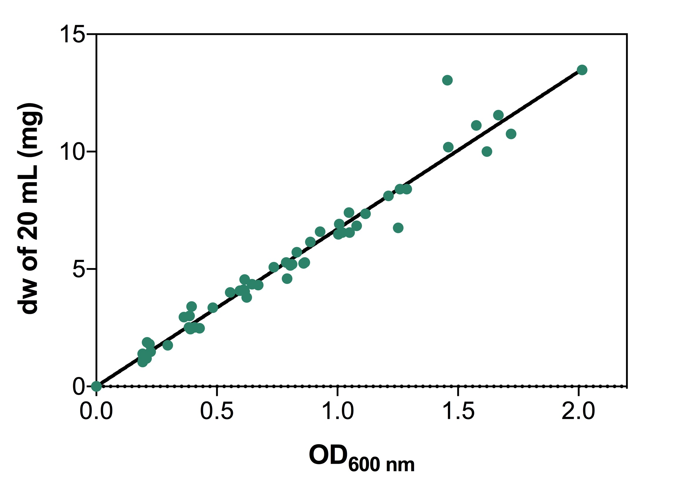

Supplementary Fig. S1. Dry weight vs OD_{600nm} calibration curve. The calibration curve used to estimate the dry weight (dw) in mg of 20 mL MG1655 E. coli cell culture in GDMM, at early to mid-log phase growth, at a measured OD_{600nm}. Dry weights of 20 mL pellets were measured from dried cell culture pellets obtained from cultures at OD_{600nm} of 0.2 – 2.0 as measured via a Jenway 7305 spectrophotometer. Cell pellets were dried at 55 °C until a constant weight was obtained by three independent weighing attempts (typically at ~ 48 h). The line (y = mx + c) is forced through the origin so that c becomes zero and the equation of the line becomes y = 6.704x. Thus, the dw of 20 mL cell culture at a given OD_{600nm} is therefore derived from the equation dw = 6.704(OD_{600nm}). Data is representative of samples from 6 independent biological repeats.

