Polymer/Montmorillonite Nanocomposites: Polyamide 6 Nanocomposites and Polyacrylamide Nanocomposite Hydrogels


Xing Su

University of Sheffield
Department of Materials Science and Engineering
April 2017

A thesis submitted to the University of Sheffield for the degree of
Doctor of Philosophy

Abstract
Polymer/clay nanocomposites have attracted great attention of researchers for two decades because they are light in weight, easy to be fabricated, and have some unique properties such as thermal barrier and corrosion resistant. Montmorillonite (MMT) is frequently chosen as the clay filler for polymer/clay nanocomposites because of its abundance, high functionality and high cation exchange capacity. This project aims to prepare novel polymer/MMT nanocomposites with adjustable microstructure, good mechanical properties and unique stimuli-sensitive properties.

As the control over the clay intercalation/exfoliation ratio is difficult for the polymer/clay nanocomposites, the effect on clay exfoliation of polyamide 6/MMT nanocomposites by using a chemical blowing agent (CBA), citric acid, during extrusion was studied. X-ray diffraction confirmed that the decomposition of CBA did improve clay exfoliation. As many surfactants used for treating clay surface are likely to degrade during the melt processing of polymer/MMT nanocomposites, a novel thermally stable surfactant was used. Polyamide 6/MMT nanocomposites were prepared by either twice or triple extrusion. And the effect on the mechanical properties and thermal stability were studied. The incorporation of clays increased Young’s modulus but decreased strain at break. There was no significant improvement on the thermal stability by the incorporation of clays and/or CBA.

Polymer nanocomposite hydrogels often showed high hysteresis when subject to cyclic tension, and their mechanical properties were hardly tested at the fully swollen state. Therefore a novel polyacrylamide (PAM)/polysaccharide-treated MMT nanocomposite hydrogel with low cyclic tensile hysteresis was successfully prepared by in situ polymerisation. This was shown to be stretchable, tough and highly compression-resistant at the fully swollen state. An interpenetrating nanocomposite hydrogel using PAM, MMT, alginate and Ca²⁺ was proposed in the same chapter. At the fully swollen state, apart from the good mechanical properties such as stretchability, toughness and resilience, it displayed significantly pH-dependant shape changes.

As for the current alginate/MMT nanocomposites in the literature, only the mechanical properties under the dry state were studied. The mechanical properties of the fully swollen alginate/MMT/Ca²⁺ nanocomposite were investigated. The nanocomposite films turned out to be stiff, strong and transparent. Also some of the nanocomposite films were ultraviolet light-proof or sensitive to acetone.

Based on the above findings, it is concluded that: firstly, there was a large amount of residual citric acid in the extruded materials, which reduced the mechanical properties and thermal stability of polyamide 6/MMT nanocomposites. Secondly, the thermally stable polymeric surfactant has the potential of enhancing the toughness and thermal stability of polyamide 6/MMT nanocomposites. Thirdly, it was likely to achieve low cyclic-tensile hysteresis, high strength, high toughness and stimuli-responsivity by the polymer/clay nanocomposite hydrogels at the fully swollen state. Those nanocomposite hydrogels can be used in a variety of applications including artificial tissues, medicine, agriculture, skin care and other aquatic uses.

Acknowledgement
The writing-up of this PhD thesis was one of the most serious challenges I have ever been confronted with. I could not finish this work without the help and support, guidance and suggestions from the following people. I would like to express my sincere gratitude to them.
- I felt proud of being supervised by Dr Biqiong Chen, who professionally guided and inspired me during my PhD study. Her knowledge, creativity and rigorous attitude toward research work helped me to understand polymer nanocomposites much better and set up the attitude of critical thinking.
- Special gratitude was given to Professor Mohan Edirisinghe's group at University College London for synthesising the nanocomposite hydrogel fibres which was the vital part of my work.
- My beloved parents supported me a lot on the research work both economically and mentally. I am deeply grateful for their financial support and encouragement.
- The research fellow, Dr Tongfei Wu shared a lot of experience and promising ideas with me when working together, which were vital for my achievement during PhD study.
- My colleagues, Dr Richard Justin, Dr Martin Frydrych, Dr Yongzhe Piao, Dr Yasemin Tamer, Yahui Wen, Xiangshuai Geng, Ehssan DJ Al-Bermany, Zaid G Mohammadsalih, Sungkwon Yoon and Ahmed A Alzahrany assisted me with my work which was necessary for me to get the current achievement.
- My friends, Chang Liu, Xingguang Liu, Wenxing Song, Wei Li and et al. also helped me with my work and my life in Sheffield which was a really unforgettable experience.

Publications
Here are one submitted conference abstract, one published paper and two paper drafts to be submitted as shown below:
1. The submitted conference abstract is based on the nylon 6/clay nanocomposites with the controllable clay dispersion by using a chemical blowing agent, citric acid:
Su, X., & Chen, B. (25/09/2014). Controlling the dispersion of clay in polymer nanocomposites using a chemical blowing agent. Clay Minerals & Environmental Mineralogy Groups’ Research in Progress Meeting, Durham University, UK (best poster awarded).

2. The published paper which is based on the polyacrylamide/MMT/chitosan nanocomposite hydrogel:
Su, X., Mahalingam, S., Edirisinghe, M., & Chen, B. (2017). Highly stretchable and highly resilient polymer-clay nanocomposite hydrogels with low hysteresis. ACS Applied Materials & Interfaces, 9(27), 22223-22234.

3. The paper draft which is based on the polyacrylamide/MMT/alginate/Ca²⁺ nanocomposite hydrogel with the title of:
“Tough, resilient and pH-sensitive interpenetrating polyacrylamide/alginate/montmorillonite nanocomposite hydrogels.”

4. The paper draft which is based on the alginate/MMT/Ca²⁺ nanocomposite hydrogel films with the title of:
“Transparent, UV-proof and mechanically strong alginate/montmorillonite/Ca²⁺ nanocomposite hydrogel films with solvent sensitivity.”

Table of Contents
Chapter 1: Introduction 1
Chapter 2: Literature review 5
2.1. Review of solid polymer/clay nanocomposite materials 5
2.1.1. Composite materials 5
2.1.2. Polymer composites 5
2.1.3. Polymer nanocomposites 6
2.1.4. Polymer/clay nanocomposites 7
2.1.5. Clays 7
2.1.6. Clay modification 10
Cation exchange reaction 10
Organic surfactants 12
2.1.7. Polymer matrix materials 13
2.1.8. Structure of polymer-clay nanocomposites 15
Conventional composites 16
Intercalated composites 16
Exfoliated composites 17
2.1.9. Preparation of polymer-clay nanocomposites 17
In situ polymerisation 18
Solution intercalation 18
Melt intercalation 19
2.1.10. Characterisation 20
2.1.11. Properties 22
Mechanical properties of plastic/clay nanocomposites 22
Mechanical properties of polysaccharide/clay nanocomposites 30
Interface 32
Barrier properties 34
Thermal stability 37
Flame retardancy 38
Biodegradability 41
Biocompatibility 42
2.1.12. Summary 43
2.2. Review of polymer nanocomposite hydrogels 44
2.2.1. Introduction of hydrogels 44
2.2.2. Classification of hydrogels 44
2.2.3. Nanocomposite hydrogels 46
2.2.4. Synthesis of nanocomposite hydrogels 47
2.2.5. Properties of nanocomposite hydrogels 47
Tensile and compressive properties 47
Swelling properties 51
Stimulus-sensitivity 52
Transparency 53
2.2.6. Summary 54
2.2.7. Future work 54
Chapter 3: The enhancement in clay exfoliation in nylon 6/clay nanocomposites by melt-intercalation using a novel polymeric surfactant and/or chemical blowing agent 56
3.1. Introduction 56
3.2. Experimental 62
3.2.1. Materials 62
3.2.2. Clay treatment 63
3.2.3. Preparation of polymer/clay nanocomposites 65
3.2.4. Characterisation 67
3.3. Results and discussion 69
3.3.1. Structural analysis of clays and nylon 6/clay nanocomposites 69
3.3.2. Thermal properties of clays and nylon 6/clay nanocomposites 84
3.3.3 Crystallinity of nylon 6/clay nanocomposites 94
3.3.4. Tensile properties of nylon 6/clay nanocomposites 97
3.3.5. Morphologies of nylon 6/clay nanocomposites 104
3.4. Summary 111
Chapter 4: Polymer/clay nanocomposite hydrogels with interesting mechanical properties and stimuli-responsive properties 114
4.1. Introduction 114
4.2. Experimental 123
4.2.1. Materials 123
4.2.2. Preparation of hydrogels 124
4.2.3. Characterisation 128
4.3. Results and discussion 131
4.3.1. Formation of nanocomposite hydrogels 131
Formation of the nanocomposite hydrogels by polyacrylamide, clay and chitosan 131
Formation of the nanocomposite hydrogels by polyacrylamide, clay, alginate and calcium chloride 133
Formation of the nanocomposite films by clay, alginate and calcium chloride 133
Structural analysis of the nanocomposite hydrogels formed by polyacrylamide, clay and chitosan 134
Structural analysis of the nanocomposite hydrogels formed by polyacrylamide, clay, alginate and calcium chloride 138
Structural analysis of the nanocomposite films formed by clay, alginate and calcium chloride 142
Calculation of Ca²⁺ content in the nanocomposite films formed by clay, alginate and calcium chloride 146
4.3.2. Mechanical properties of nanocomposite hydrogels 151
Tensile properties of the as-prepared nanocomposite hydrogels formed by polyacrylamide, clay and chitosan 151
Cyclic tensile properties of the as-prepared nanocomposite hydrogels formed by polyacrylamide, clay and chitosan 153
Tensile and compressive properties of the fully swollen nanocomposite hydrogels formed by polyacrylamide, clay and chitosan 157
Tensile properties of the fully swollen nanocomposite hydrogels formed by polyacrylamide, clay, alginate and calcium chloride 160
Cyclic tensile properties of the nanocomposite hydrogels formed by polyacrylamide, clay, alginate and calcium chloride 163
Mechanical properties of the fully swollen and dry nanocomposite films formed by clay, alginate and calcium chloride 167
4.3.3. Crosslinking densities and rheological properties of nanocomposite hydrogels 171
4.3.4. Morphologies of nanocomposite hydrogels 175
4.3.5. Fabrication versatility of the nanocomposite hydrogels formed by polyacrylamide, clay and chitosan 179
4.3.6. pH-sensitivity of the nanocomposite hydrogel formed by polyacrylamide, clay, alginate and calcium chloride 181
4.3.7. Optical properties and solvent responsivity of the nanocomposite films formed by clay, alginate and calcium chloride 185
Optical properties of the nanocomposite films formed by clay, alginate and calcium chloride 185
Solvent responsivity of the nanocomposite films formed by clay, alginate and calcium chloride 187
4.4. Summary 189
Chapter 5: Conclusions 194
Chapter 6: Future Work 198
References 199

List of Figures
Figure 2.1.1. The structure of a 2:1 clay (Reproduced from reference (Solin, 1997)). 9
11
11
Figure 2.1.2. Scheme of the modification of clay layers by organic cations and the chemical structure of a quaternary alkylammonium salt (Reproduced from reference (Zhu, 2010)). 11
Figure 2.1.3. Schematic representation of the different structures of polymer clay composites (Reproduced from reference (Duquesne et al., 2003)). 17
Figure 2.1.4. The “melt-intercalation” process (Reproduced from reference (Solin, 1997)). 19
Figure 2.1.5. Mechanical properties of nylon 6/organoclay as a function of clay content (Reproduced from reference (Cho & Paul, 2001)). 24
Figure 2.1.6. X-Ray Diffraction patterns for Cloisite 15A and nylon 6 materials with different extruder and screw configuration (Reproduced from reference (Dennis et al., 2001)). 25
Figure 2.1.7. Effect on the Young’s modulus of MMT content for nylon 6 with different molecular weight (Reproduced from reference (Fornes et al., 2001)). 26
Figure 2.1.8. Effect of clay content on Izod impact tests of nylon 6/sodium MMT nanocomposites (Reproduced from reference (Liu et al., 1999)). 28
Figure 2.1.9. Effect of clay platelets content on the ductility (Reproduced from reference (Chen & Evans, 2006b)). 29
32
Figure 2.1.10. Tensile strength/toughness of composites with different MMT content; a maximum strength was achieved for the composites with ∼40 wt % MMT content while the maximum toughness can reach 7.2 MJ m⁻³ (Reproduced from reference (Liang et al., 2016)). 32
Figure 2.1.11. Schematic illusion of three types of polymer-clay interaction (Reproduced from reference (Shi et al., 1996)). 33
Figure 2.1.12. Tensile properties of EVOH-clay and SAN-clay nanocomposites by dynamic melt intercalation (Reproduced from reference (Lee et al., 2006)). 34
Figure 2.1.13. Improvement of barrier properties by the addition of clay platelets (Reproduced from reference (Zhu, 2010)). 35
Figure 2.1.14. Flame retardant mechanism of polymer-clay nanocomposites (Reproduced from reference (Kiliaris & Papaspyrides, 2010)). 40
Figure 2.2.1. Polyacrylamide-laponite nanocomposite hydrogels and chemically crosslinked hydrogels with the same water/polymer ratio (10:1, (w/w)) (A) nanocomposite hydrogels are very tough and can withstand high level of deformations such as (i) elongation and (ii) torsion while (B) all the chemically crosslinked hydrogels are weak and brittle. (C) The stress-strain curve of nanocomposite hydrogels. The approximate data for a chemically crosslinked hydrogel are also depicted for comparison (Reproduced from reference (Haraguchi & Takehisa, 2002)). 48
Figure 2.2.2. All of the as-prepared LDH/PAM NC hydrogels exhibited extraordinary mechanical toughness, and could withstand high levels of deformation by elongation (A), torsion (B), knotting (C), and compression (D) (Reproduced from reference (Hu & Chen, 2014)). 50
Figure 2.2.3. Cyclic tensile tests of PAM-MMT nanocomposite with a clay content of 5%, tensile tests of the as-prepared hydrogels and the self-healed hydrogels (Reproduced from reference (Gao et al., 2015)). 50
Scheme 3.1. The Hofmann elimination reaction of quaternary ammonium compounds (Reproduced from reference (Chen & Chrambach, 1979)). 60
Scheme 3.2. The synthesis of CA-treated organoclay in 1:1 ethanol/water. 63
Figure 3.1. XRD patterns for clays. 69
Figure 3.2. XRD patterns for clays for the triple extrusion. 71
Figure 3.3. Typical configurations of organic oniums into the clay galleries (Reproduced from reference (Zhu, 2010)). 72
Figure 3.4. XRD patterns for the twice-extruded nylon 6 and its nanocomposites. 73
Figure 3.5. XRD patterns for the triple-extruded nylon 6 and its nanocomposites. 74
Figure 3.6. FTIR spectra of the clay samples for the twice extrusion method. 77
Figure 3.7. FTIR spectra of the twice-extruded nylon 6 and its nanocomposites. 78
Figure 3.8. FTIR spectra for Raw Nylon 6, Nylon 6 3 and Nylon 6 CA 3. 80
Figure 3.9. FTIR spectra for Nylon 6 3 and triple-extruded Nylon 6 nanocomposites. 82
Figure 3.10. TGA curves of clays for the twice extrusion, surfactant and citric acid. 84
Figure 3.11. Derivative TGA curves of clays for the twice extrusion, surfactant and citric acid. 85
Figure 3.12. TGA curves of clays for the triple extrusion. 88
Figure 3.13. TGA curves of the twice-extruded nylon 6 and its nanocomposites. 89
Figure 3.14. Derivative TGA curves of the twice-extruded nylon 6 and its nanocomposites. 90
Figure 3.15. TGA curves of the triple-extruded nylon 6 and its nanocomposites. 92
Figure 3.16. Derivative TGA curves of the twice-extruded nylon 6 and its nanocomposites. 92
Figure 3.17. DSC (a) first scans and (b) second scans of nylon 6 and its nanocomposites. 95
97
97
Figure 3.18. (a) Stress-strain curves, (b) yield, tensile strength, (c) strain at break and (d) energy at break for the twice-extruded nylon 6 and its nanocomposites. 97
Figure 3.19. (a) stress-strain curves, (b) Young’s modulus, (c) tensile strength, and (d) strain at break of the triple-extruded nylon 6 and its nanocomposites. 101
Figure 3.20. SEM images of twice-extruded nylon 6 and its nanocomposites. 107
Figure 3.21. SEM images of triple-extruded nylon 6 and its nanocomposites. 110
Scheme 4.1. Schematic illustration of the synthesis of (a) PM 5, and (b) PM 5 CHI. The brown and blue circles indicated PAM chain entanglement and PAM branching respectively. The pink dots in (b) represented the grafting points of AM onto chitosan chains. 132
Scheme 4.2. (a) Schematic illustration of the chemical structure of PMACa, (b) different shapes such as thin thread and thick cylindrical block of PMACa, (c) knotted PMACa, and (d) large extensibility of PMACa. 133
Scheme 4.3. Schematic illustration of the synthesis of AlgMMTCa. 134
Figure 4.1. FTIR spectra of PM 5, PM 5 CHI, PM 5 S and PM 5 K nanocomposite hydrogels as well as their control samples, PAM, PAM CHI and PM 5 cata. 134
136
136
Scheme 4.4. General mechanisms for (a) free radical polymerization, chain transfer and the formation of branched polyacrylamide, (b) radical graft polymerization of AM onto chitosan, (c) KPS-MMT ionic interaction, and (b) chitosan-MMT electrostatic interaction. 136
Figure 4.2. In vitro degradation results of PM 5 and PM 5 CHI. 137
Figure 4.3. FTIR spectra of alginate and the nanocomposite hydrogels. 138
Scheme 4.5. Mechanisms of covalent grafting of AM onto alginate chains. 140
Figure 4.4. EDX graphs taken from the cross-sectional surface of fully swollen (a) PMACa, (b) PMAW, (c) PMCa, and (d) PMW (scale bar: 10 μm). 141
Figure 4.5. FTIR spectra of MMT, alginate and their nanocomposites with and without Ca²⁺. 142
Scheme 4.6. (a) The “egg-box” structure of Ca-alginate fragment, and (b) hydrogen bonding between MMT and alginate (Reproduced from reference (Sartori et al., 1997)). 143
Figure 4.6. EDX graphs taken from the cross-sectional surface of (a) AlgCa, (b) AlgMMTCa82, (c) AlgMMTCa73, (d) AlgMMTCa11 and (e) sodium alginate with the same amplification (scale bar: 10 μm). 144
Figure 4.7. TGA curves of MMT, SA and alginate nanocomposites. 145
Figure 4.8. Photographs of PM 5 and PM 5 CHI nanocomposite hydrogels, (a, b) knotted PM 5 and PM 5 CHI, (c) PM 5 with and without a tensile strain of 12, (d) PM 5 CHI with and without a strain of 25, and (e) representative tensile stress-strain curves of PM 5, PM 5 CHI, PM 5 S and PM 5 K. 151
Figure 4.9. Representative cyclic tensile testing curves of PM 5. (a) cyclic tension to 50% of PM 5, (b) cyclic tension to 500% of PM 5, (c) cyclic tension to 50% of PM 5 CHI, and (d) cyclic tension to 500% of PM 5 CHI. 153
Figure 4.10. (a) Swelling ratio as a function of immersion time in distilled water at 25 ºC for PM 5 and PM 5 CHI hydrogels, and (b) tensile curves of PM 5 and PM 5 CHI hydrogels swollen in PBS at 37 ºC for 2 weeks. 158
Figure 4.11. Before, during and after compression for PM 5 CHI; compression test to 1 kN on the fully swollen (a, b, c) PM 5, and (d, e, f) PM 5 CHI. 159
Figure 4.12. (a) Typical tensile stress-strain curves of swollen hydrogels, and (b) swelling ratio in respect to immersion time in distilled water of the nanocomposite hydrogels. 160
Figure 4.13. Representative cyclic tensile testing curves of PMACa hydrogel (a) cyclic tensile to 100% and (b) cyclic tensile to 500%. (multiple tests were done and the curves were similar so that the representative curves of one test were picked out and shown above.) 163
Figure 4.14. (a) cyclic tensile curves of PMACa with the 15 minutes’ recovery interval, and (b-d) demonstration of shape-recovery properties of PMACa: (b) before stretching, (c) under stretching, and (d) 15 mins after being unloaded. 165
Figure 4.15. Typical tensile stress-strain curves of the (a) hydrated films and (b) dry films, (c) the as-prepared samples could withstand (d) bending, and (e) twist without permanent deformation. (scale bar: 25 mm). 167
Figure 4.16. Storage moduli G' and loss moduli G'' of PM 5 and PM 5 CHI. 173
Figure 4.17. Storage modulus G’ and loss modulus G’’ of PMACa, PMAW, PMCa and PMW. 174
Figure 4.18. SEM images of the cross-sectional surfaces of (a) PM 5, and (b) PM 5 CHI. 175
Figure 4.19. SEM images of cross-sectional surface of fully swollen (a) PMACa, (b) PMAW, (c) PMCa, and (d) PMW. 176
Figure 4.20. SEM images of the cross-sectional surface of (a) AlgCa, (b) AlgMMTCa82, (c) AlgMMTCa73, and (d) AlgMMTCa11. 177
Figure 4.21. (a) Photographs of PM 5 and PM 5 CHI nanocomposite hydrogels in different shapes (rods and balls), (b) PM 5 CHI microfibers obtained at 36,000 rpm rotating speed and 0.1 MPa working pressure. The inset in (b) shows the corresponding higher magnification image. 180
Figure 4.22. (a) The chemical structure of crosslinked Ca-alginate blocks, (b) chemical equilibrium of carboxyl groups in M blocks, (c-e) PMACa samples immersed in (c) HCl solution, (d) distilled water, and (e) NaOH solution, (f) The mechanism of pH-dependent swelling/shrinking behaviours of PMACa. 181
182
182
Figure 4.23. (a) Equilibrium swelling ratios of PMACa, and (b) weight of the samples after 2, 3, 4, 5 weeks. 182
Figure 4.24. (a) Transmittance UV–Vis spectra of AlgCa and AlgMMTCa films scanned from 200 nm to 800 nm, and (b) this image shows clearly the University logo beneath the circular AlgCa and AlgMMTCa films highlighted by red dash circles. 185
Figure 4.25. Solvent-responsive behaviours of AlgMMTCa in methanol or acetone: AlgMMTCa82 (a) in water, (b) in methanol, (c) recovered in water; AlgMMTCa73 (d) in water, (e) in methanol, (f) recovered in water; AlgMMTCa11 (g) in water, (h) in methanol, (i) recovered in water; AlgMMTCa82 (j) in water, (k) in acetone, (l) recovered in water; AlgMMTCa73 (m) in water, (n) in acetone, (o) recovered in water and AlgMMTCa11 (p) in water, (q) in acetone, (r) recovered in water. 187
Scheme 4.7. Schematic illustration of dehydration of (a) CMMT-ALG, and (b) AlgMMTCa. 188

List of Tables
Table 2.1.1. Summary of the mechanical properties of chitosan-MMT nanocomposite films synthesised by different methods. 31
Table 3.1. Chemical blowing agents used in polymer/MMT nanocomposites. 62
Table 3.2. Completed clay samples. 65
Table 3.3. Completed nylon 6 and its nanocomposites. 67
Table 3.4. Diffraction angles and basal plane spacings of clays for twice extrusion. 70
Table 3.5. Diffraction angles and basal plane spacing of clays for the triple extrusion. 71
Table 3.6. Diffraction angles and basal plane spacings of clays and their nanocomposites for the triple extrusion method. 75
Table 3.7. Weight remain percentages of clays, surfactant and citric acid. 84
Table 3.8. Thermal decomposition properties of the twice-extruded nylon 6 and its nanocomposites. 89
Table 3.9. Thermal decomposition properties of the triple-extruded nylon 6 and its nanocomposites. 93
Table 3.10. Melting temperature and crystallinity of nylon 6 and its nanocomposites. 95
Table 3.11. Mechanical properties of nylon 6 and its composites. 97
Table 3.12. Tensile Properties of nylon 6 Nanocomposites. 102
Table 3.13. Summary of the nylon 6/clay nanocomposites in the 3rd Chapter. 111
Table 4.1. Weight remain and estimated Ca contents of MMT, SA and alginate nanocomposites. 145
Table 4.2. Tensile properties of PM 5 and PM 5 CHI nanocomposite hydrogels. 152
Table 4.3. Hysteresis ratios of PM 5 and PM 5 CHI. 154
Table 4.4. Tensile properties of the hydrogels fully swollen in PBS at 37 ºC for 2 weeks. 158
Table 4.5. Tensile properties of the fully swollen PMACa, PMAW, PMCa and PMW hydrogels. 160
Table 4.6. Tensile properties of the fully swollen AlgMMTCa82, AlgMMTCa73 and AlgMMTCa 11 films. 168
Table 4.7. Tensile properties of the DAlgCa, AlgMMT73 and DAlgMMTCa73 films. 169
Table 4.8. UV-Vis percent transmittance of AlgCa and AlgMMTCa films at 320 nm, 400 nm and 800 nm. 185
Table 4.9. Summary of polymer/MMT nanocomposite hydrogels in the 4th Chapter. 190

Chapter 1: Introduction
Nanocomposites are defined as composite materials which contain the fillers with at least one nanometre-range dimension (Vaia, Jandt, Kramer, & Giannelis, 1996). For decades, attention has been paid on polymers for serving as matrix materials of the nanocomposites. The reasons include: first, polymers are light and easy to be fabricated; second, they have some unique properties such as excellent chemical resistance, barrier properties over gas or solvent, fire-retardant properties, biodegradability and/or optical properties (Chen et al., 2008; Vaia et al., 1996; Venkatesh, Priya, & Bhavitha, 2016; Vu, Vermogen, Gauthier, Masenelli‐Varlot, & Cavaillé, 2008). Montmorillonite (MMT) is a 2:1 clay, with the platelet thickness of about 1 nm and varied aspect ratio from 10 to 1000 (Alexandre & Dubois, 2000). Their platelets are held by electrostatic and Van der Vaals forces, which allow other molecules to enter the galleries to form intercalated and even exfoliated structures (Chin, Thurn-Albrecht, Kim, Russell, & Wang, 2001; Dixon, 1991). MMT is highly hydrophilic, able to be well dispersed in water or other polar solvents, and it can form dense hydrogen bonding with polar groups from organic chemicals or polymers (Chen, 2004). Furthermore, its surface is negatively charged and the surface or edge charge can be altered by surfactant modification (Chin et al., 2001) for interacting with polymers with less polarity. So due to those features, MMT was chosen as the nano-scale filler in this project. In situ polymerisation, solution blending and melt intercalation (Davis, Gilman, & VanderHart, 2003) can be used to fabricate polymer/clay nanocomposites with significantly improved mechanical, thermal and other properties (Manias et al., 2001; Shibayama et al., 2004) over their neat polymer counterparts.

Polyamide 6, also known as nylon 6, has been studied in the field of polymer/clay nanocomposites for decades because of the high polarity and versatility in manufacture, since nylon 6/MMT nanocomposites were prepared by in situ polymerisation in Toyota centre, 1992, for the first time (Usuki et al., 1993). By the incorporation with MMT at a content below 5 wt %, nylon 6/MMT nanocomposites can achieve significantly enhanced Young’s modulus and tensile strength without compromising the toughness (Freier, Koh, Kazazian, & Shoichet, 2005). Besides this, the thermal stability and flame retardance may also be improved (Alexandre & Dubois, 2000; Zhu et al., 2006). However, there are limitations. On one hand, the intercalation/exfoliation ratio cannot be controlled (Alexandre & Dubois, 2000; Caseri, 2006). On the other hand, the surfactant may degrade during manufacture at a high processing temperature (Chen & Chrambach, 1979). Therefore it is important to explore the effect of decomposing a non-toxic chemical blowing agent during processing on the clay exfoliation, and to study the effect of a novel thermally stable surfactant on the mechanical properties and thermal stability of polymer/MMT nanocomposites.

Hydrogels are regarded as the crosslinked hydrophilic networks which have the capability of absorbing and keeping water. They are soft, biocompatible and have unique swelling/de-swelling behaviours, which enable them to be available for a variety of applications such as drug delivery (Hoare & Kohane, 2008), agriculture (Saxena, 2010), food ingredients (Chen et al., 1995) and biomaterials such as soft tissue scaffolds (Frydrych, Roman, Green, MacNeil, & Chen, 2015; Zhang et al., 2011), wound dressings (Sirousazar, Kokabi, Hassan, & Bahramian, 2012) and biosensors (Li et al., 2015). Polyacrylamide is the most commonly used monomer for synthesising hydrogels because it is highly hydrophilic and easy to polymerise. Polyacrylamide/clay nanocomposite hydrogels have been studied for over a decade since polyacrylamide/synthetic hectorite nanocomposite hydrogels were firstly obtained in 2002 by Haraguchi’s group (Haraguchi, 2007; Haraguchi & Takehisa, 2002). However, nanocomposite hydrogels often showed high hysteresis during cyclic tension (Nakajima, Kurokawa, Ahmed, Wu, & Gong, 2013; Zhao, 2014), and the mechanical properties of the fully swollen nanocomposite hydrogels were hardly reported (Haraguchi, 2007). So it is important to improve the mechanical properties of nanocomposite hydrogels with excellent resilience in either their as-prepared and fully swollen states.

The overall aims of this project were to investigate the possibility of altering the mechanical and thermal properties of the nylon 6/MMT nanocomposite materials by adjusting the MMT intercalation/exfoliation ratios. Additionally, the polymer/MMT nanocomposite hydrogels which were strong, tough, resilient and stimuli-responsive at the fully swollen state were to be developed. The five specific objectives are as follows.
- To achieve the adjustable clay intercalation/exfoliation ratio, mechanical and thermal properties of nylon 6/MMT nanocomposites by using the thermal decomposition of a non-toxic chemical blowing agent during extrusion, which can expand the MMT galleries.
- To achieve the enhanced mechanical properties and thermal stability of nylon 6/MMT nanocomposites by using a novel thermally stable surfactant and a revised method of extrusion.
- To develop novel polyacrylamide/MMT nanocomposite hydrogels with high stretchability, high resilience and good mechanical performance at the fully swollen state, by using a polysaccharide-treat MMT and a novel synthetic method.
- To develop novel interpenetrating polyacrylamide/MMT nanocomposite hydrogels with high strength, high stretchability, high resilience and stimuli-responsivity at the fully swollen state by a polysaccharide and post-crosslinking by metallic cations.
- To develop novel polysaccharide/MMT nanocomposite films with high stiffness, high strength, optical transparency and stimuli-responsivity by using high amount of MMT and post-crosslinking by metallic cations.

Chapter 2: Literature review

2.1. Review of solid polymer/clay nanocomposite materials

2.1.1. Composite materials
Composite materials are a combination by two or more phases or components of different physical and chemical properties, often presenting a series of enhanced properties compared with each constituent. They are not the simple mixture of multiphase solid materials, such as blends or alloy, as each component acts very differently in the composite from that in bulk (Giannelis, 1996; Hull & Clyne, 1996). They can be tailored to develop specific properties to fulfil some special needs.

2.1.2. Polymer composites
The modern technique becomes more and more interested in polymer matrix materials because of their unique features such as good process-ability, light weight and acceptable ductility, though they may display inferior mechanical strength, stiffness and heat resistance compared to some metallic or ceramic materials. They can be either thermoplastic or thermosets (Bouchonneau et al., 2010) and it is crucial to find a proper reinforcement for a specific polymer in order to improve their mechanical and thermal performance. The final properties of polymer composites are strongly related to the natural properties, content, dimensions, dispersion of fillers and interface between matrix and reinforcing phases. In terms of filler dimension, polymer composites can be divided into three main classes: macrocomposites, microcomposites and nanocomposites (Hull & Clyne, 1996; Vaia & Wagner, 2004).

2.1.3. Polymer nanocomposites
Nanocomposites are referred to the composite materials where there is at least one dimension of the fillers falls into the nanometre range (Vaia et al., 1996; Vu et al., 2008). Nano-technology is a newly developed field which has been widely utilised in the material science and engineering. For instance, the usage of nanocomposites began with natural polymer nanocomposites such as wood (Li & Shimizu, 2006; Meng, Wan, Xiao, & Hay, 2004; Tjong, 2009). Recently, the polymer nanocomposites have drawn considerable attention as many nano-scale fillers have been proved to be able to alter a group of properties of polymer matrix greatly (Chen et al., 2008; Pinnavaia & Beall, 2000; Zhu, 2010). Compared with metallic materials, polymer nanocomposites are light in weight and easy to manufacture (Chen et al., 2008; Pinnavaia & Beall, 2000; Zhu, 2010). Compared with conventional polymer composites, it is well accepted that the nano-scale dispersion results in the especially large interfacial areas between the polymer matrix and fillers. And when the dimensions of the filler particles reduce down to 1 to 100 nm range, the properties of those particles change dramatically from those in the visible scale, making the overall properties of the polymer nanocomposites highly dependent on effects of filler content, aspect ratio, polymer crystallinity or morphology, distribution of filler particles and the polymer-filler interactions (Chen et al., 2008; Vaia et al., 1996; Venkatesh et al., 2016; Vu et al., 2008). According to different geometry, nanofillers can be classified into three main categories: Nanoparticles such as carbon black with three dimensions in the nano-scale, nano-fibrous materials such as nanotubes and whiskers with two dimensions in the nano-scale and one in several thousand of nanometre’s extent or, nano-layers with one dimension in the nano-scale along the thickness direction, exhibiting a plate-like structure and a high aspect ratio, such as layered silicates (Li & Shimizu, 2006; Meng et al., 2004; Tjong, 2009).

2.1.4. Polymer/clay nanocomposites
Polymer/clay nanocomposites (PCNs) technology was first developed by Toyota research centre. The derived nylon 6/MMT nanocomposite presented nearly a doubling of the tensile modulus and strength. And the heat distortion temperature increased by about 100ºC, making it possible to withstand higher temperature. One important feature of PCNs is that a small fraction of fillers (no more than 5%) can lead to the enhancement in the mechanical and thermal performance to a large extent. As a consequence, PCNs have a series of overwhelming advantages including low density and light weight, superior mechanical properties compared to conventional composites with the same silicate content and excellent barrier properties (Krishnamoorti, Vaia, & Giannelis, 1996; Usuki et al., 1993).

2.1.5. Clays
Layered silicates are a class of minerals made of very thin layers of a dimension in a nanometre range, crystalline, with atoms held together by chemical bonds and adjacent layers linked by counter ions as shown in Figure 2.1.1. A typical structure of those minerals is composed of octahedral sheets where a metal like aluminium or magnesium atom is surrounded by eight oxygen atoms and silica tetrahedral sheets where a silicon atom is surrounded by four oxygen atoms. In a 1:1 layered silicate mineral, known as kaolinite with a chemical formula of Al₂SiO₅(OH)₄·yH₂O, one tetrahedral sheet is fused together with an octahedral sheet by sharing the oxygen atoms. When a sandwich structure of two external silica tetrahedral sheets with an octahedral sheet centred in between, a 2:1 structure is formed, often called phyllosilicates. The layer is normally around 1 nm thick whilst the lateral width varies from 300 Å to several microns or larger, correlating to the nature of silicate clay and the way of synthesis. The aspect ratio of these layers can vary from 10 to 1000 (Alexandre & Dubois, 2000; Beyer, 2002; McNally, Murphy, Lew, Turner, & Brennan, 2003; Solomon, Almusallam, Seefeldt, Somwangthanaroj, & Varadan, 2001).

As for the 2:1 clay, when there is no substitution for silicon in the tetrahedral sheets and aluminium in the octahedral sheets the phyllosilicate layers won’t show any interlayer charge and appear electrostatically neutral. Such structure is called pyrophyllite (Dixon, 1991). Under such a circumstance, due to the absence of the interlayer ions, the layers don’t expand in water (Dixon, 1991). However, if silicon in the tetrahedral sheets is substituted by aluminium, this is called mica. The derived negative charge owing to substitution is balanced by introducing potassium ions in between the layers. Because the potassium ions are of the same size with the hexagonal hole created by Si/Al tetrahedral layer, leaving no interlayer spacing, the layers are then bound together by strong electrostatic forces. The strong attraction between negatively charged tetrahedral layer and the positively charged potassium cation makes it impossible for the layers to swell in water or exfoliate (Pinnavaia & Beall, 2000). When in the pyrophyllite structure, the trivalent aluminium cations are partially replaced by the divalent magnesium, the structure of smectites is formed. This time the negative charge is balanced by sodium and calcium cations inserted in between the interlayer spacing. Unlike mica, one extraordinary characteristic is that since these interlayer ions are unmatched to the tetrahedral sheets holes, the resultant layers are held by relatively weak electrostatic and Van der Waals forces, with an interlayer gap, called the gallery (Pinnavaia & Beall, 2000). With the help of the gallery, it is possible for small molecules such as water or polymer chains to enter and thus expand the interlayer spacing, making smectite clays highly applicable reinforcements for polymers (Chin et al., 2001; Dixon, 1991; Manias et al., 2001).
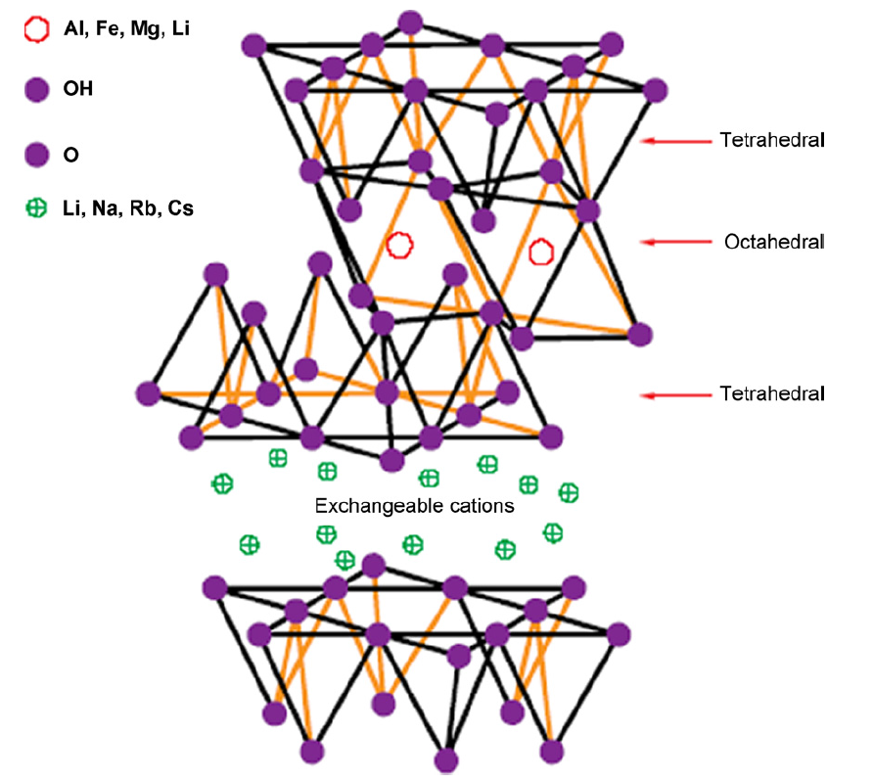
Figure 2.1.1. The structure of a 2:1 clay (Reproduced from reference (Solin, 1997)).

The interlayer ions such as Na⁺ and Ca²⁺ can be replaced by alkylammonium cations and the derived clays are defined as organo-modified clays, also called organoclays. The average layer charge can be represented by the cation exchange capacity (CEC), which is defined as the capability of a soil to absorb or exchange cations. CEC varies with different clay structures and can differ from layer to layer in the crystal. The measurement of CEC can be achieved by ignition. That is to heat the raw clay and the organo-modified clay at 1000 ºC. By the molecular weight of the alkylammonium salt and the deviation between the weight losses of the two samples during ignition, it is likely to determine the CEC of the clay in the unit of milliequivalents. There are some other methods for the calculation of CEC based on acid-base titrations and infared spectroscopy (Alexandre & Dubois, 2000; He, Ma, Zhu, Yuan, & Qing, 2010). Some of those procedures may be time-consuming, skill-required and costly. Recently, a new method using ammonia electrodes was developed. It was proved to be simple, fast and accurate to determine CEC. And it was particularly suitable for low CEC system (Busenberg & Clemency, 1973).

Among 2:1 phyllosilicates, montmorillonite, hectorite and saponite are the most commonly used for the nanomaterials because of their applicable intercalation or exfoliation ability. As for montmorillonite (MMT in short), this kind of mineral is abundant on the planet earth and have a fairly good cation exchange capacity of about 80 to 120 meq/100g. According to Okada and Usuki’s research, MMT received the best mechanical responses for nylon 6/clay nanocomposites with 5% clay reinforcement, compared with mica, sapronite and hectorite. And it is very convenient to modify the surface of MMT layers for the sake of improving compatibility between polymer matrix and inorganic fillers by using diverse chemical routes. Apart from the high cation exchange capacity, MMT is favoured for its well-understood cation exchange reaction chemistry (Alexandre & Dubois, 2000; Usuki et al., 1993). MMT was widely used in pharmaceutical products such as skin care creams, oil refining, catalyst for organic reaction, water purification, heavy metal uptake, nylon 6 nanocomposite for auto engine accessories (Gupta & Bhattacharyya, 2012; Hartwell, 1965; Solin, 1997; Usuki et al., 1993).

2.1.6. Clay modification

Cation exchange reaction
The compatibility between organic polymer matrix and inorganic clay fillers is always a limitation for natural clay to be widely used (Shi, Lan, & Pinnavaia, 1996). It is well-known that the pristine state layered silicates are only miscible with highly hydrophilic polymers such as polyethyleneoxide and polyvinyl alcohol (LeBaron, Wang, & Pinnavaia, 1999). In order to alter the polarity of the surface of clay platelets, it is necessary to carry out the cation exchange reaction by replacing the alkali counter-ions with alkylammonium cations of organic surfactants as shown in Figure 2.1.2. Surfactants for treating clays are defined as ionic compounds which consist of alkylammonium cations and acid anions as shown in Figure 2.1.2. The alkyl chains (R_{n} in Figure 2.1.2) connected to the nitrogen atom are also called alkyl tails. In this way, the surface energy of the derived organoclays will be significantly reduced so that the original polar clay surface becomes organophilic, compatible with non-polar polymer molecules. Also, the surfactant makes the interlayer galleries expand to some extent, which is beneficial for the subsequent intercalation of polymer chains during the formation of nanocomposites. The expanded interlayer spacing has been confirmed by XRD (Caseri, 2006; Jordan, 1949; Pavlidou & Papaspyrides, 2008).
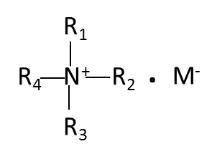
Organic surfactant: quaternary alkylammonium salt
Acid anion
Alkylammonium cation
Figure 2.1.2. Scheme of the modification of clay layers by organic cations and the chemical structure of a quaternary alkylammonium salt (Reproduced from reference (Zhu, 2010)).

The efficiency of the cation exchange reaction is closely related to the surface charge of the clay platelets, characterised by CEC. If the cation exchange capacity is too high as nearly 1 equiv/mol for mica, the electrostatic attraction is too strong and thus hinders the hydration or extension of interlayer spacing, making it impossible for cation exchange reaction to occur. In contrast to mica, the lower charge density enables MMT to have low interlayer forces. And the sodium ions present in the galleries, known as friendly to hydration and exchanging, give MMT the high potential of swelling, organic modification and intercalation. The derived structure of organoclay also depends on the geometry of organic oniums after reaction. The charge density of clay platelets has an effect on the configuration of surfactant molecules after modification. The higher the charge density is, a configuration which is monolayer, parallel to the platelets surface is more likely to form. With the increasing charge density, bilayer, trilayer or even paraffin structures with further expanded interlayer spacing can be achieved. The length of alkyl tail of the surfactant also has influence on the molecular arrangement and the resultant interlayer spacing. An organic tails with no less than 3 methylenes is the basic need for the effective organic modification (Shi et al., 1996). Last but not the least, temperature affects the interlayer structure because the mobility of the onium molecules increases when temperature goes up and thus reaching bigger gallery size. Cation exchange reaction is the most widely used method for clay modification for making polymer-clay nanocomposites (Chen, 2004; Fornes, Yoon, Hunter, Keskkula, & Paul, 2002; Kornmann, Lindberg, & Berglund, 2001; Reichert et al., 2000).

Organic surfactants
The most frequently used organic surfactants are quaternary alkylammonium salts, which are synthesized by complete alkylation of ammonia or amines. Quaternary alkylammonium ions are favoured because they are free from hydrolysis or desorption. Besides, these surfactants can reduce the density of the derived organoclay. In order to achieve optimum modification, specific polymer matrix material will require careful selection of surfactant. For instance, dialkyldimethylammonium halides are suitable for apolar polymers such as polypropylene and polyethylene, while alkyl benzyl dimethylammonium halides or alkyl hydroxyethylammonium halides are proper for polar polymers such as polyamide. Sometimes it is gainful to associate quaternary alkylammonium salts with other surfactants (Chen, 2004; Nazari, Garmabi, & Arefazar, 2012). Nowadays biomolecules have attracted more and more attention as the modifier of clay minerals because of low toxicity, bio-reactivity and compatibility with the clay base. For example, clay minerals serve as the supporters for immobilization of enzymes because clay provides stability and high mechanical properties and in the meantime, enzyme modification endows the organoclay with catalyst effect (Favre & Lagaly, 1991).

2.1.7. Polymer matrix materials
Polymers consist of a large number of repeating organic units, causing long chain length and large molecular weight. Unlike the conventional materials such as metals, the properties of polymers depend not only on the chemical composition, but also monomer arrangement, chain conformation and regularity. Linear or branched polymers are defined as thermoplastic polymers such as polyamide 6, which can be melted repeatedly. The cross-linked polymers forming 3D network are often described as thermosetting polymers. Thermosets can’t be melted after shaping like epoxy.

Polyamide 6, was also known as nylon 6. Nylon 6/MMT nanocomposites were successfully obtained by the means of in situ polymerisation in Toyota centre, 1992. Nowadays, nylon 6, as a kind of polyamide, is paid particular attention because it is prone to accomplish exfoliation through many ways. For example, melt processing in a well-designed twin screw extruder is available for synthesizing Nylon 6-clay nanocomposites. It is widely believed to be owing to high polarity of nylon 6 which results in good Polymer-clay compatibility (Liu, Qi, & Zhu, 1999; Okada & Usuki, 1995; Usuki et al., 1993). Other polymer/clay nanocomposites were also studied based on polymers such as polystyrene (Akelah & Moet, 1996; Hasegawa, Okamoto, Kawasumi, & Usuki, 1999; Vaia et al., 1996; Yano, Usuki, Okada, Kurauchi, & Kamigaito, 1993) and polypropylene (Hasegawa, Kawasumi, Kato, Usuki, & Okada, 1998; Kato, Usuki, & Okada, 1997; Kawasumi, Hasegawa, Kato, Usuki, & Okada, 1997; Usuki, Kato, Okada, & Kurauchi, 1997).

Polysaccharides are polymeric carbohydrates with monosaccharides bonded together by glycosidic linkages (George & Abraham, 2006; Meyers, Chen, Lin, & Seki, 2008). The degree of polymerisation is usually ≥ 10. Polysaccharides-clay nanocomposite materials have been studied for no more than 15 years, especially for chitosan-clay nanocomposites (Wu & Chen, 2014; Yao, Tan, Fang, & Yu, 2010) and alginate-clay nanocomposites (Abdollahi, Alboofetileh, Rezaei, & Behrooz, 2013; Vale, Justice, Schaefer, & Mark, 2005). Chitosan (CHI) is a biopolymer extracted from chitin, which is abundant in the crustacean and mollusk shells (Rinaudo, 2006). Because of its excellent biocompatibility and biodegradability, chitosan is widely used in biomedicine and pharmacy (Busilacchi, Gigante, Mattioli-Belmonte, Manzotti, & Muzzarelli, 2013; Kumar, Muzzarelli, Muzzarelli, Sashiwa, & Domb, 2004; Rao & Sharma, 1997). It is protonated and positively charged in the acidic environment, which is likely to bond to the negatively charged MMT surface (Ali & Bandyopadhyay, 2015; Chen, 2004; Chen et al., 2008) strongly by electrostatic interactions (Shchipunov, Ivanova, & Silant'ev, 2009; Wang et al., 2014). Chitosan-MMT nanocomposites are promising in the applications of structural materials (Yao et al., 2010), smart materials (Wu & Chen, 2014) and drug delivery (Ferfera-Harrar, Aiouaz, Dairi, & Hadj-Hamou, 2014). Alginate is a copolymer consisting of mannuronic acid (M unit) and guluronic acid (G unit) (Norajit, Kim, & Ryu, 2010). G blocks of different alginate chains can be easily crosslinked through the ionic interaction by the multivalent cations such as calcium cation (Ca²⁺) (George & Abraham, 2006) while M blocks do not react with other cations. Alginate is widely used in the applications of food packaging (Abdollahi et al., 2013), drug delivery (Tonnesen & Karlsen, 2002) and enzyme carrier (Gorenek, Akyilmaz, & Dinckaya, 2004) because of the biocompatibility (Baumberger & Ronsin, 2010; Kong, Wong, & Mooney, 2003; Zhao, Huebsch, Mooney, & Suo, 2010) and biodegradability (Kim, Lee, & Lee, 2011; Schaumann & Weide, 1990). Alginate can be degraded under mild conditions by either alginate lyase enzyme (Kim et al., 2011) or marine fungi (Schaumann & Weide, 1990). In order to improve mechanical and gas barrier properties (Rhim, 2004), alginate MMT nanocomposites were developed because of the strong interaction between alginate and MMT. This can be described by the Velcro effect: if the polymer matrix is rich in hydrophilic functional groups such as -OH, -COOH and -O-, it can form strong nanocomposite material with the clay nanosheets by hydrogen bonds between the tetrahedral SiO₄ geometry of clay nanosheets and the hydrophylic functional groups in polymer (Bhattarai, Li, Edmondson, & Zhang, 2006; Chen, Shi, Yue, Qi, & Guo, 2015; Sa & Kornev, 2011).

2.1.8. Structure of polymer-clay nanocomposites
The classification of polymer/clay nanocomposites usually rely on the degree of inserting polymer chains into the interlayer galleries of clay platelets. The morphology can closely depend on the nature of clay and polymer matrix, surfactant and methods of synthesis. There are three types of polymer/clay blends: conventional composites, intercalated composites and exfoliated composites as shown in Figure 2.1.3. The configuration can be characterised straightforwardly (Duquesne et al., 2003; Shokuhfar, Zare-Shahabadi, Atai, Ebrahimi-Nejad, & Termeh, 2012).

Conventional composites
In a micro-composite, clay fillers exist in the form of large aggregates and no intercalation occurs. The inter-layered spacing remains the same as that of neat clay. This situation is generally described as phase separation. Therefore the clay particles have little reinforcing influence on the properties of the overall materials. And that is why those composites are regarded as conventional materials (Alexandre & Dubois, 2000; Beyer, 2002; Giannelis, 1996).

Intercalated composites
In an intercalated nanocomposite, clay expands itself a little and polymer chains are inserted in between the adjacent layers of clay, giving the properties different from the bulk polymer matrix. The periodic, parallel layered structure remained with a slightly enlarged interlayer spacing less than 2 to 3 nm, comparable to an extended polymer chain. The intercalated polymer chains significantly reduce the electrostatic forces between the adjacent clay layers and the derived materials begin to show some different behaviors compared with the conventional composites of similar chemical composition (Alexandre & Dubois, 2000; Beyer, 2002; Chin et al., 2001; Dennis et al., 2001; Giannelis, 1996; Kim, Lee, Hoffmann, Kressler, & Stöppelmann, 2001).

Exfoliated composites
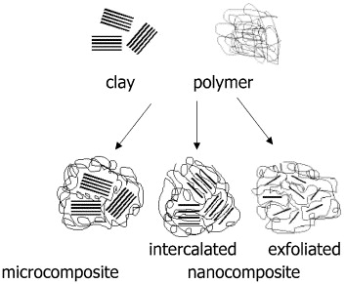
In the case of an exfoliated or delaminated nanocomposite, the polymer chains are inserted into the galleries and the layered structure of clay completely falls apart, giving a much larger interlayer separation about 8 to 10 nm in the level of the radius of gyration of the polymer. The high interfacial area gives rise to large surface interactions between polymer matrix and clay fillers and facilitates stress transfer from the matrix to the reinforcement. As a result, the exfoliated composites often show some properties much better than intercalated ones with the same composition. It is difficult to achieve 100% exfoliated structure because the polydispersity of clay platelets makes it nearly impossible for entire anisotropy. So the nanocomposites used in the industry are often the hybrid of both intercalation and exfoliation structures (Chen et al., 2008; Pinnavaia & Beall, 2000; Zhu, 2010).

Figure 2.1.3. Schematic representation of the different structures of polymer clay composites (Reproduced from reference (Duquesne et al., 2003)).

2.1.9. Preparation of polymer-clay nanocomposites
Scientists have been developing a variety of methods of preparing polymer-clay nanocomposites. The choice of synthetic method is related to a variety of factors such as polarity, molecular weight, solubility and functionality so that different polymers will undergo different procedures. The most frequently used methods are in situ polymerization, solution intercalation and melt intercalation.

In situ polymerisation
In situ polymerisation was the earliest developed method for synthesizing polymer/clay nanocomposites, either thermoplastics or thermosets. The whole process goes in the environment surrounded by liquid monomers or monomer solution. Polymerisation takes place in the galleries of clay platelets with the help of the initiator. The most significant advantage of this method is the possibility to achieve good dispersion even without clay modification. The utilisation of this method has been extended to polymer/MMT nanocomposites such as nylon 6/MMT nanocomposites in many suspension states such as solution, in bulk, emulsion or micro-emulsion (Alexandre & Dubois, 2000; Lan, Kaviratna, & Pinnavaia, 1995; Pavlidou & Papaspyrides, 2008; Usuki et al., 1993). Acrylamide is known to be able to form nanocomposite hydrogel with clay platelets by in situ polymerisation (Chen & Chrambach, 1979; Haraguchi & Li, 2006; Haraguchi & Takehisa, 2002; Okay & Oppermann, 2007) However, as the viscosity can be fairly high during in situ polymerisation, the heat generated from polymerisation is difficult to be dissipated. Heat accumulation often causes inhomogeneous polymerisation which leads to wide molecular weight distribution and residual monomers (Alexandre & Dubois, 2000; Lan & Pinnavaia, 1994).

Solution intercalation
Following this technique, polymer matrix material and clay fillers are dissolved in the same solvent. First, the organoclay has been swollen by the solvent and in the meantime polymer is dissolved in the same solvent. Second, two solutions are mixed together and polymer chains intercalate into the galleries in between the clay layers. At last, the solvent is removed by either evaporation or precipitation. As for the removal of solvent, entropy goes up and thus polymer chains enter the interlayer spacing of clay platelets. The enhanced entropy is then partially counteracted by the confinement of the intercalated polymer chains. The main advantage of this method is that it has the capability of synthesising the polymer/clay nanocomposites based on the polymers of low polarity. But this method is not suitable for the industrial scope because the large amount of solvent will be required and thus there is the potential damage on the environment (Alexandre & Dubois, 2000; Beyer, 2002; Gilman, Kashiwagi, & Lichtenhan, 1997; Ray & Okamoto, 2003).

Melt intercalation
As the most popular method of preparing polymer/clay nanocomposites, clay fillers are mixed with molten polymer by extrusion as shown in Figure 2.1.4. On one hand, compared to other methods, no solvent is needed so that melt intercalation is versatile and environmentally friendly. The properties can be conveniently tailored according to the processing conditions. On the other hand, high temperature and relatively long retention time make the nanocomposites vulnerable to degradation. And inhomogeneity often exists in the derived nanocomposites due to the high viscosity of the molten substances. This method is quite effective for thermoplastic nanocomposites. However, high temperature processing can cause polymer molecular weight degradation, and high viscosity makes it difficult for some polymers to form uniform dispersion (Alexandre et al., 2009; Alexandre & Dubois, 2000; Kornmann, Lindberg, & Berglund, 2001; Lee, Park, Sain, Kontopoulou, & Zheng, 2007; Ray & Okamoto, 2003).
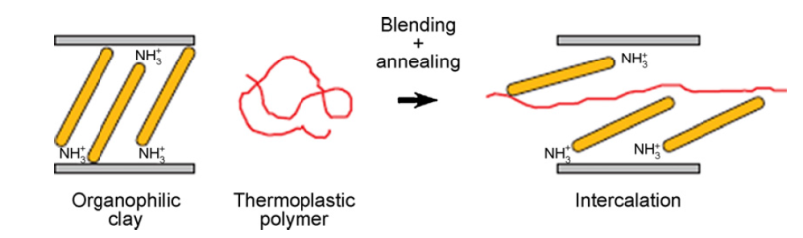

Figure 2.1.4. The “melt-intercalation” process (Reproduced from reference (Solin, 1997)).

The configuration of the extrusion screws was vital for processing nanocomposites. As for the type of extruders, the non-intermeshing twin screw extruder produced the best result. It was concluded that a co-rotating twin screw extrusion with proper residence time was applicable to achieve nano-scale dispersion of clay platelets into the polymer matrix while a single screw extrusion couldn’t (Cho & Paul, 2001). And the increased shear stress during extrusion would give rise to improved exfoliation. The extensive research on the melt processing conditions was carried out by Dennis et al. (Dennis et al., 2001), it was claimed that the increased mean residence time was beneficial for the dispersion of clay platelets because of the reduced backmixing. The tensile strength and modulus went up for the addition of organoclay with the content below 5 wt %. High molecular weight nylon 6 presented mostly a well-exfoliated structure while low molecular weight nylon 6 yielded a mixture of intercalation and exfoliation. And the mechanical test revealed that high molecular weight nylon 6 had the best tensile modulus and tensile strength (Fornes, Yoon, Keskkula, & Paul, 2001). Another investigation was on topic of the effect of organoclay structure, where they found one long alkyl tail instead of two, methyl groups on the amine rather than 2-hydroxy-ethyl groups, or appropriate amount of amine surfactant was prone to better exfoliation (Fornes et al., 2002).

2.1.10. Characterisation
For nanocomposites, it is important to know the degree of intercalation or exfoliation and thus the effects on the properties. Two most frequently used techniques for probing the structure of nanocomposites are X-Ray Diffraction (XRD) and Transmission Electron Microscopy (TEM). When it comes to XRD, the layered, periodical structure enables raw clay and modified clay to show characteristic peaks on the XRD graph. By the 2θ value corresponding to the maximum peak height, it is possible to calculate the interlayer d spacing in terms of Bragg’s equation (Hagiwara, Putra, Kakugo, Furukawa, & Gong, 2010):
2d sin θ = nλ (2.1.1)
Where λ is the wavelength of the X-Ray radiation, θ is the diffraction angle; d is the interlayer spacing of the clay lattice. The shift of the intensity, broadness of the peak, the position of 2θ indicates the change in interlayer spacing. So a lower 2θ often implies the enlarged d-spacing. For an immiscible system, the diffraction pattern doesn’t change. For an intercalated nanocomposite, there is still a strong characteristic peak for the layered clay lattice. However, it shifts to lower 2θ corresponding to an extended interlayer spacing. For an exfoliated nanocomposite, no characteristic peaks exist because the interlayer spacing expands to a large extent and the alignment of clay platelets is no longer regular. And the regularity of stacked clay layers can be monitored by full-width-at-half-maximum and the intensity. The more ordered structure there is, the smaller full-width-at-half-maximum and the shorter peak there will be.

XRD is an effective way to examine the microstructure of polymer/clay nanocomposites but can hardly tell the spatial distribution of clay platelets. Therefore, Transmission Electron Microscopy is also used as a complementary method to observe the microstructure in a more direct way. TEM can deliver a clear sketch of the spatial distribution of clay platelets. The clay platelets consist of relatively heavy elements such as Al, Si and O while the polymer matrix and the interlayer galleries are mostly made of some light elements such as C, H, N and Na. In bright-field images the silicate sheets appear as dark lines which are actually the cross sections of the silicate layers. So the interlayer spacing can be visually showed as the bright regions between those dark lines. Thus the degree of exfoliation or intercalation, distribution of clay platelets and defects are available by TEM.

There are some others means of characterization such as thermogravimetric analysis (TGA) by which the thermal stability and the content of each component can be measured, differential scanning calorimetry (DSC) by which polymer chain mobility and crystallinity can be known (Alexandre & Dubois, 2000; Beyer, 2002; Ma, Xu, Ren, Yu, & Mai, 2003; Morgan & Gilman, 2003; Ray & Okamoto, 2003; Vaia & Giannelis, 1997).

2.1.11. Properties
Nanofillers are expected to significantly change the properties of polymer materials through many factors such as aspect ratio, volume fraction of the clay fillers, interactions between polymer matrix and clay platelets, crystallinity of polymer and orientation of clay sheets. Hopefully, the addition of nano-scale fillers will cause a series of positive effects on the properties of the derived nanocomposites. The improvements are not limited to the mechanical properties such as Young’s Modulus and tensile strength, but also include thermal, barrier properties, flame-retardant properties and so on. The modern science has been giving lots of efforts on the reinforcing mechanisms of the clay platelets and still stays unclear to many issues (Ray, 2010; Zhu, 2010).

Mechanical properties of plastic/clay nanocomposites
The main purpose of incorporating fillers into the polymer matrix is to enhance the mechanical performance. These fillers are also called as reinforcement agents, which will carry the most of loading if good adhesion exists between polymer matrix and fillers. The layered silicates are known to be very effective to improve the mechanical properties of nanocomposites. The research on the reinforcing mechanism has been ongoing for decades. The first proposed mechanism was derived from the similar consideration of conventional composites, such as glass-fiber reinforced composites. It is claimed in this theory that rigid fillers usually have high moduli and thus high resistance to deformation. When these rigid fillers are swollen by a soft counterpart such as polymer, the matrix material in the vicinity of the fillers will be highly constrained in terms of the molecular mobility and display a different modulus than the bulk. So according to this theory, large interfacial surface will be extraordinarily beneficial for enhancing the mechanical properties of the composites. Therefore, it is quite intuitive to relate the significantly altered mechanical properties of the polymer-clay nanocomposites to the high aspect ratio as well as large surface area. However, this theory can’t explain the relationship between modulus increase and content of silicates. Unlike conventional composites, polymer-clay nanocomposites often display very sharp modulus-to-clay content changing regulation in the low filler concentration range (lower than 5% by weight). Above 5%, modulus won’t change a lot or even goes down to an extent (Fornes & Paul, 2003; Ray & Okamoto, 2003; Shia, Hui, Burnside, & Giannelis, 1998). The properties of binary composites are closely related to the volume fraction of fillers. For polymer-clay nanocomposites, the effective particles are represented by spatial volume occupied by the clay platelets and the interlayer galleries. Unlike conventional composites, whose nominal volume fraction is often used, intercalated polymer-clay nanocomposites usually give rise to much greater volume fraction of the true reinforcement which is called effective volume fraction because interlayer polymer molecules replace the water molecules and expand the basal spacing. For exfoliated nanocomposites, it is clay platelets which reinforce rather than clay particles. So in this case, due to the large surface area, the surface-absorbed polymer molecules which have different density and Young’s modulus with those of the bulk state must be counted into the effective volume fraction. With the correctly calculated effective volume fraction, it is likely to use conventional theories to simulate the properties of polymer-clay nanocomposites (Chen & Evans, 2006a).

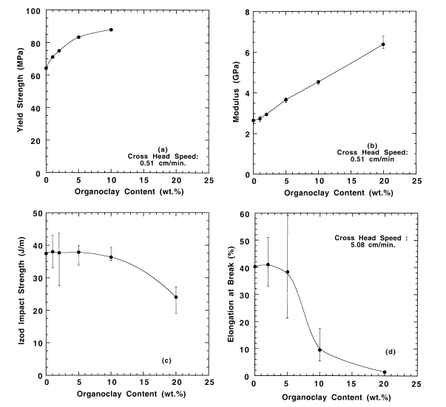
Generally, for most linear thermoplastic polymers, the addition of organoclay will significantly improve Young’s modulus, and in some cases improve tensile strength as well (Fornes & Paul, 2003; Ray & Okamoto, 2003; Shia, Hui, Burnside, & Giannelis, 1998). In 1992, Toyota Centre developed nylon 6/clay hybrid by in situ polymerisation. The intercalation of polymer chains into the interlayer galleries of MMT was proved (Usuki et al., 1993). Five years later, Yang et al. prepared nylon 6/organically modified SiO₂ nanocomposite by the same method as above. The addition of aminobutyric acid-treated silica increased the glass transition temperature. And the mechanical properties including tensile strength, impact strength and toughness were also enhanced by a low content of treated silica and reached the max at 5 wt %, while the nylon 6/untreated silica showed inferior mechanical performance (Yang, Ou, & Yu, 1998).

Figure 2.1.5. Mechanical properties of nylon 6/organoclay as a function of clay content (Reproduced from reference (Cho & Paul, 2001)).

Apart from in situ polymerisation, melt compounding was also considered in a research done by Cho &Paul, from which they concluded that a typical co-rotating twin screw extrusion with sufficient residence time was successful to achieve nano-scale dispersion while a single screw extrusion couldn’t, even for a second pass. They believed the adequate shear stress during extrusion was crucial. The tensile strength and modulus went up for the addition of organoclay within the content range < 5 wt %. And there was no apparent difference in the impact strength and elongation at break between nylon 6/organoclay nanocomposite and neat nylon 6, as shown in Figure 2.1.5 (Cho & Paul, 2001).

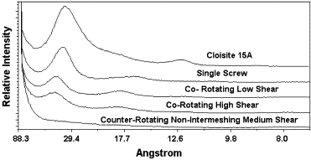
There could be several factors might have influence on the morphology and properties of nylon 6/organoclay nanocomposites. Such as the extensive research on the melt processing conditions carried out by H.R. Dennis etc., it was claimed that the mean residence time was the key to optimum dispersion. Excessive shear stress would do harm to the exfoliation of clay layers. As for the extruding parameters, the non-intermeshing twin screw extruder with medium shear resulted in the best clay exfoliation. In contrast, the co-rotating with either high or low shear, and single screw could not achieve full exfoliation as shown in Figure 2.1.6 (Dennis et al., 2001).

Figure 2.1.6. X-Ray Diffraction patterns for Cloisite 15A and nylon 6 materials with different extruder and screw configuration (Reproduced from reference (Dennis et al., 2001)).

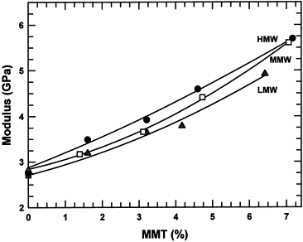
The molecular weight was expected to affect the formation of nylon 6/clay nanocomposite by a study done in the same year by Fornes etc. High molecular weight nylon 6 presented well-exfoliated structure while low molecular weight nylon 6 yielded mixture of intercalation and exfoliation. High molecular weight nylon 6 was superior to low molecular weight on improving Young’s modulus (from 2.75 GPa to 5.70 GPa with 7% MMT) and tensile strength (from 69.7 MPa to 97.6 MPa) shown in Figure 2.1.7. This contributed to the high shear stress which promoted exfoliation (Fornes et al., 2001). Not long after they did another investigation on the effect of organoclay structure, where they found a series of factors relating to better exfoliation and mechanical properties: One long alkyl tail instead of two, methyl groups on the amine rather than 2-hydroxy-ethyl groups, appropriate amount of amine surfactant with no excess (Fornes et al., 2002).

Figure 2.1.7. Effect on the Young’s modulus of MMT content for nylon 6 with different molecular weight (Reproduced from reference (Fornes et al., 2001)).

Above all, the Young’s modulus usually increases with the increasing volume fraction of clay fillers but decreases with the ascending clay particle size. The interaction between polymer matrix and clay fillers also has an effect on the Young’s modulus and yield stress. Especially for the lowly crystalline polymers, the strong interaction is often beneficial for enhancing Young’s modulus. When it comes to yield stress or ultimate stress, it will be proportional to the volume fraction of clay fillers when good interaction is found at the polymer/clay interface. On the contrary for the nanocomposites with poor interfacial interaction where the yield stress or the ultimate stress decreases when adding clay fillers (Shi et al., 1996).

As discussed before, for polyamide clay nanocomposites, the incorporation of nanoclay is known to be effective for improving all sorts of mechanical properties such as Young’s modulus and tensile strength. However, the change of toughness is often unique, independent from the variation of other mechanical properties. In nanocomposites, it is believed that there are four main factors that can affect toughness. First of all, fine particle dispersion free from agglomeration is believed to be able to maintain or even enhance toughness. Second, the mobility of filler platelets is crucial for arrangement and orientation induced by external stress. The movement of those platelets is prone to absorb extra energy and thus improve toughness above the glass transition temperature. Third, the delamination of clay layers from intercalation to exfoliation will contribute to better toughness because this process is often accompanied by the formation of micro-voids that can dissipate a lot of energy. Finally, the addition of clay platelets has the potential of altering some intrinsic properties of the polymer matrix such crystallinity, mobility of polymer chains or interaction between the adjacent polymer chains (Chen & Evans, 2009).

This has been found in many conventional composites where high rigidity can go hand in hand with embrittlement. And it is true in some of polymer/clay nanocomposites as well. Embrittlement was found to be related to the formation of microvoids resulting from debonding of clay platelets from polymer matrix. In the research done by He etc., crazing and microcracking occurred during the plastic deformation, and the toughness of nylon 6 was found to decline with the addition of clay platelets. The reason could be that: incomplete exfoliation increased the brittleness of nylon 6/clay nanocomposites. Besides, it was claimed that the cohesion between polymer matrix and clay fillers was not as important as previously thought because crack initiation was mostly found in polymer matrix near the interface, not the interface itself (He, Liu, Tjiu, Sue, & Yee, 2008). According to an investigation of Chen and Evans, acrylonitrile butadiene styrene (ABS)/clay nanocomposites underwent a drastic decrease of 90% in the toughness with the addition of 3% clay. It was described that the incorporation of clay tactoids hindered the toughening effect of the rubbery zones. Moreover, the parallel experiment on Poly (ε-caprolactone) (PCL) indicated small extent of organoclay degradation wasn’t the main reason for the reducing impact strength (Chen & Evans, 2008).

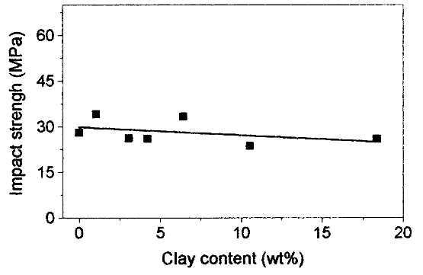
Sometimes, the addition of clay platelets only has marginal influence on the impact strength. In a study of nylon 6/sodium MMT nanocomposites by melt-intercalation, unlike tensile strength and Young’s modulus which displayed almost linear increase, the notched impact strength nearly stayed constant, about 30 MPa shown in Figure 2.1.8 (Liu et al., 1999).

Figure 2.1.8. Effect of clay content on Izod impact tests of nylon 6/sodium MMT nanocomposites (Reproduced from reference (Liu et al., 1999)).

Interestingly, there are a series of encouraging result that toughness can be improved by the incorporation of nanoclay. It is believed that clay platelets with such a small scale are too small to give rise to crack bridging or crack tortuosity which is the toughening mechanisms of the conventional composites. And one interesting proposal is that intercalated structure can do better in toughening than exfoliated structure. It is believed that the delamination of the clay tactoids during deformation contributes to the extra absorbed energy and the formation of microvoids, resulting in enhanced toughness (Chen & Evans, 2008; Zerda & Lesser, 2001).
In a research based on nylon 6/organoclay/maleic anhydride grafted polyethylene-octene elastomer ternary nanocomposites, the toughness of derived nanocomposites was significantly improved. The toughening was depicted as because of the cavitation of POE-g-MA particles allowed the crack-tip tri-axial stress to be weakened, enabling plastic deformation around the crack tip (Lim et al., 2007). Dramatic enhancement of toughness was found in a study related to epoxy molding compounds, especially for the temperature above Tg (Lan & Pinnavaia, 1994). It was declared that the main mechanism for the toughening were the non-planar crack known as crack deflection and change of failure sites known as plastic deformation. Exfoliation was found to be favored by fracture toughness enhancement.

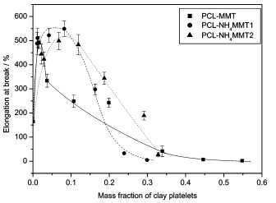
Nanocomposites based on a biodegradable polymer PCL and organoclay was found to provide drastically improved elongation at break from 165% to 550% with the clay content of 10% as shown in Figure 2.1.9, which was in contrast with the general ductility-clay loading relationship. Ammonium-treated clay reinforced nanocomposites were observed to have mostly intercalated structure (Chen & Evans, 2006b).

Figure 2.1.9. Effect of clay platelets content on the ductility (Reproduced from reference (Chen & Evans, 2006b)).

The structure-property relationships of polyamide 6 nanocomposites were also investigated. With increasing clay content, elongation at break declined gradually. High or medium molecular weight samples maintained reasonable ductility in a low clay content range. And slower tensile speed was beneficial for expression of ductility. Low ductility was believed to be related to the agglomeration of clay stacks (Fornes et al., 2001).

As for toughness of PCL clay nanocomposites and polyamide 6 clay nanocomposites, contradictory results were obtained in terms of different microstructure. In other words, some researchers revealed that intercalation was good for upgrading toughness of polymer/clay nanocomposites while some others suggested exfoliation to be superior on toughening. The toughening mechanisms haven’t been well understood yet so that more efforts will be spent on this field. Since most of the polymer/clay nanocomposites are the mixture of intercalated and exfoliated structure, it is worth thinking about if there is a possibility that partially intercalated and exfoliated structure is better than either fully intercalated or exfoliated structure in consideration of mechanical performances.

Mechanical properties of polysaccharide/clay nanocomposites
Nacre-mimicking PCNs with high amounts of clay were proposed (Mayer, 2005). By stacking the organic and inorganic building blocks in order, ultimately high Young’s modulus and tensile strength could be achieved (Fratzl, Gupta, Fischer, & Kolednik, 2007; Meyers et al., 2008). Montmorillonite (MMT), as a nice candidate (Das et al., 2015), has been utilised for making nacre-mimic nanocomposite materials with many polymers such as polyvinyl alcohol (Allison et al., 2015), chitosan (Yao et al., 2010) and alginate (Liang et al., 2016) by solvent evaporation induced self-assembly method or vacuum filtration. The resultant materials displayed the unique ordered microstructure and excellent mechanical properties compared to the conventional PCNs. As for chitosan-MMT nacre-like nanocomposite films (Yao et al., 2010), the films by mixing the chitosan solution and the MMT suspension (either vacuum filtration or evaporation) displayed 3-5-fold higher Young’s modulus and 2-3-fold higher tensile strength than those of the films by dissolving the solid chitosan and MMT together as shown in Table 2.1.1.
Table 2.1.1. Summary of the mechanical properties of chitosan-MMT nanocomposite films synthesised by different methods.
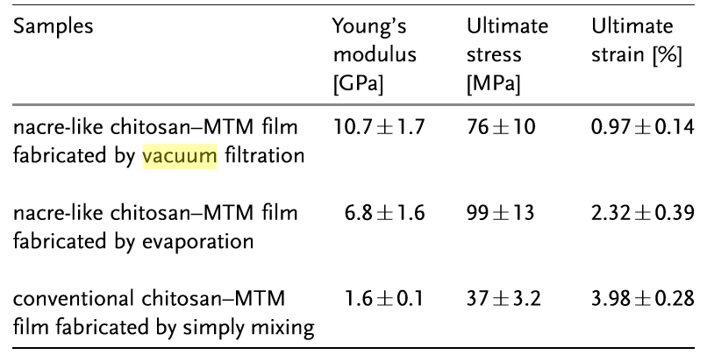

Nacre-mimicking Ca²⁺-crosslinked alginate-MMT nanocomposite films were synthesised by vacuum filtration (Liang et al., 2016). The incorporation of Ca²⁺ significantly enhanced the mechanical properties of the derived films as shown in Figure 2.1.10. They could reach a high tensile strength of 280 MPa and a high toughness of 7.2 MJ m⁻³ as shown in Figure 2.1.10, which were attributed to the good affinity between alginate and MMT, and the “egg-box” structure (Figure 4.6) formed by crosslinking alginate chains with divalent Ca²⁺ cations (Sun et al., 2012; Yang et al., 2013). Besides, the high temperature mechanical performance was also outstanding, as a maximum strength of 170 MPa could be obtained at 100 ºC.

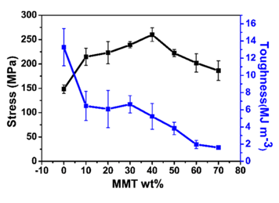

Figure 2.1.10. Tensile strength/toughness of composites with different MMT content; a maximum strength was achieved for the composites with ∼40 wt % MMT content while the maximum toughness can reach 7.2 MJ m⁻³ (Reproduced from reference (Liang et al., 2016)).

Interface
As mentioned above, the intercalation or exfoliation of polymer molecules into the interlayer galleries of clay fillers provides fairly large interfacial area so the interface plays an important role in the performance of polymer-clay nanocomposites. Some polar polymers have good compatibility with hydrophilic clay surface. Compared with the raw clay, the organic modification of clay surface often gives rise to better polymer-clay interaction. So there is often adhesive energy at the polymer-clay interface, binding the polymer chains and clay platelets together, which is usually called glue effect (Lee, Hur, Yang, Lim, & Kim, 2006). Generally, the interaction at the interface can be divided into three main groups shown in the Figure 2.1.11: Type A, direct absorbance of polymer to the siloxane basal surface. Type B, swallowing of the alkylammonium tails in the polymer matrix. Type C, bonding of the polymer with the hydroxylated edges of clay.

Long alkylammonium tails and efficient cation exchange reaction are known to be beneficial to the formation of polymer-clay nanocomposites. Surfactants with short tails of 3 carbon atoms have been proved to be applicable for achieving exfoliated structure and can display good mechanical properties. It is concluded that Type A interaction is the dominant factor relating to the properties of polymer-clay nanocomposites (Shi et al., 1996).
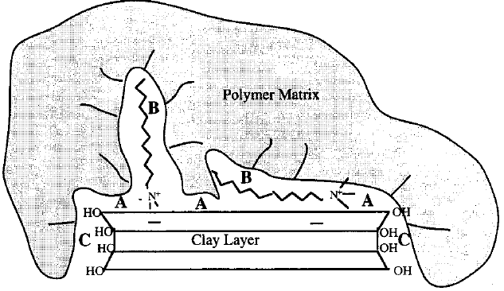
Figure 2.1.11. Schematic illusion of three types of polymer-clay interaction (Reproduced from reference (Shi et al., 1996)).

The Type C of hydrogen bonding was investigated by comparing two polar polymers: highly polar ethylene-vinyl alcohol (EVOH) copolymer and low polarity styrene-acrylonitrile (SAN) copolymer. It has been found that strong polymer-clay hydrogen bonding is effective for the initial penetration of polymer molecules into the clay galleries. However, despite of the slower initial penetration of polymer chains into the clay galleries, SAN-clay nanocomposite showed the higher level of exfoliation and superior tensile strength compared with EVOH nanocomposite as shown in the Figure 2.1.12. This could be explained by the glue effect: the hydrophilic polymers, such as EVOH, in the clay galleries tend to stick the clay layers firmly and prevent full exfoliation. So an optimum polymer-clay interaction is necessary to intercalate polymer molecules into the clay galleries and in the meantime without compromising the clay exfoliation (Lee, Hur, Yang, Lim, & Kim, 2006).

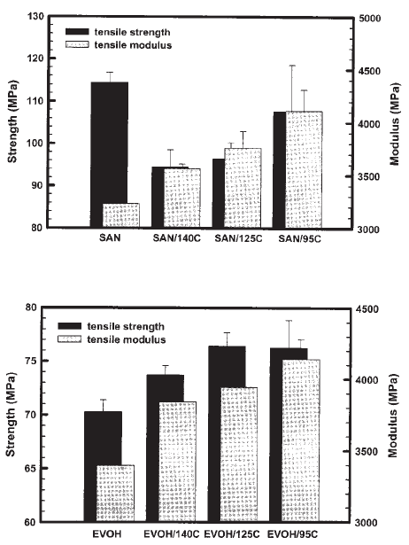
Figure 2.1.12. Tensile properties of EVOH-clay and SAN-clay nanocomposites by dynamic melt intercalation (Reproduced from reference (Lee et al., 2006)).

Barrier properties
Clay reinforced polymer nanocomposites are proved to have enhanced barrier properties which shows great promise to act as low-permeability materials. A variety of polymer matrices such as epoxy, polyimide, polycaprolactone and polyvinyl alcohol are reported to have improved barrier property when loaded by low content of clay platelets. Layered silicates are thin (approximately 1 nm), crystalline and known to be impermeable to gas or water molecules. The significant improvement of barrier properties is widely believed to be attributed to the tortuous path effect, which means when small substances enter the nano-composite system, the clay platelets serve as the physical obstacles forcing those permeating substances to zigzag around randomly as shown in Figure 2.1.13. Therefore they go through tortuous pathway which is longer and more complicated than straight pathway for a homogeneous polymer matrix. Then the possibility and efficiency of the small substances passing through the nanocomposites are drastically reduced.
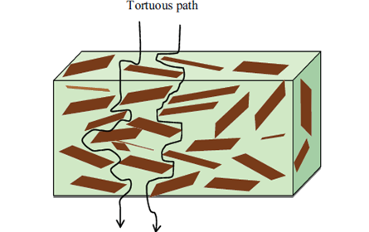
Figure 2.1.13. Improvement of barrier properties by the addition of clay platelets (Reproduced from reference (Zhu, 2010)).

Now the tortuous factor τ is introduced to illustrate this phenomenon. τ is defined as the ratio of the actual pathway distance to the possible shortest pathway distance that a penetrant must travel without fillers. Combined with the length L, the width W and the volume fraction of the barriers ϕ_{s}, one simple model can be derived:
τ = (d’/d) = 1 + (L/2W)ϕ_{s} (2.1.2)
So it is clear that the morphology of a high aspect ratio is opportune for giving rise to good barrier properties (Alexandre & Dubois, 2000; Ray, 2010; Ray & Okamoto, 2003).According to Nielson’s proposal, the permeability of nanocomposites and polymer matrix can be expressed as shown below:
P_{c}/P_{p}=(1 – ϕ_{s})/τ (2.1.3)
where P_{c} and P_{p} represent the permeability of nanocomposites and polymer matrix, respectively (Nielsen, 1967; Ray, 2010; Ray & Okamoto, 2003). One assumption must be mentioned on using the tortuous path theory: All the barriers orientate in the direction normal to the direction of diffusion. In this way, the barrier properties will reach the maximum. But in fact, such perfect alignment does not exist in most cases. Any deviation from such a direction can deteriorate the barrier properties. It is also assumed that the incorporation of clay platelets doesn’t have effect on the diffusivity of polymer matrix.

In terms of a model by Bharadwaj (Bharadwaj et al., 2002), in consideration of orientation of the clay platelets in a continuous manner, the order of parameter S can be introduced and described as S = 0.5(3cos2θ -1), where θ represents the angle between normal direction and preferred orientation, assuming the sheets orientate randomly. It was concluded that exfoliation was beneficial for achieving good permeability. Large aspect ratio contributed to reduced permeability in many aspects such as increasing the tortuosity, weakening the effect of orientation and agglomeration (Zhao et al., 2005).

Because of the change in the chain-segment immobility, the polymer chains of the nanocomposites often display a different motional behavior compared to the neat polymer materials. In a research, the relative permeability theory was combined with the detour theory. The alignment of clay platelets was simplified as uniformly ordered crystal structure. A chain-segment immobility factor was introduced to illustrate the confinement of polymer chain segments due to the embedded clay tactoids. The predicted results were in quite good agreement with the actual results in many cases when the filler volume fraction was larger than 1. Again this model proved delamination of clay tactoids, either exfoliation or intercalation, and chain confinement decreased relative permeability. Besides, when the filler volume fraction was above 5% or the layer longer than 500nm, there was little improvement for the barrier properties. This was in accordance with many experimental conclusions. Liu and Wu’s research indicated that the polyamide 66-clay (5 wt%) nanocomposite decreased the water molecule diffusion coefficient, which was characteristic for the diffusive rate of water molecules in the material, indicating a reduced permeability. The water absorption at saturation also decreased from 7.6% to 5.2% (Liu & Wu, 2002).

Thermal stability
The barrier properties mentioned above make it possible to alter the thermal stability of the polymer/clay nanocomposites. This phenomenon was first reported by Blumstein on the poly(methyl methacrylate)-Clay nanocomposites (Blumstein, 1965), where a 40 or 50 Celsius degrees’ increase of the thermal decomposition temperature was found. He argued that the incorporation of clay platelets not only altered the terminal groups of poly(methyl methacrylate) (PMMA) but also served as mass transport barrier. The addition of clay fillers influences the thermal stability of the nanocomposites mainly in three ways: superior heat insulator, mass transport barrier and the formation of char. The thermal stability of polymer/clay nanocomposites can be related to the thermal stability of polymer matrix, the content and thermal stability of surfactant as well as fillers, dispersion of clay platelets, interaction between polymer matrix and clay fillers and polymer chain mobility in the presence of clay platelets. The most common form of the thermal degradation of polymer matrix is the chain scission which can result in the reduction of molecular weight. The thermal transformation of MMT includes the removal of interlayer water molecules and dehydroxylation above 500 ºC. When it comes to organically modified MMT, the decomposition of surfactant and the probable oxidation must be considered (Davis et al., 2003; Duquesne et al., 2003; Paul & Robeson, 2008).

The incorporation of clay platelets can have contradictory effects on the thermal properties. Sometimes, the organoclay may have a catalytic effect on the degradation of nanocomposites. The existence of clay sheets impedes the dissipation of heat so that the heat generated from thermal degradation will accumulate and then be reallocated into the nearby part. And the residue products from the degradation of alkylammonium ions are likely to promote the degradation of polymer matrix. Clay platelets can also act as a catalyst. For example, Zhao et al.’s results indicated that PE/clay nanocomposites displayed a reduced thermal stability compared to that of the neat PE by thermogravimetric analysis at the initial low-temperature stage (Zhao et al., 2005). PE/clay nanocomposites degraded faster than PE. At 400 ºC, the residue of PE/clay (99.2%) was lower than that of PE (97.0%). It was claimed to result from the Hoffmann elimination reaction and the clay-catalyzed degradation. And it was also found that low content of clay was prevailing for enhancing the thermal stability. With increasing clay loading, catalyzing effect became the leading factor by which the thermal stability of nanocomposites declined.

Flame retardancy
Polymer-clay nanocomposites are required to be flame retardant in many cases. Typically, with the use of intrinsically flame retardant polymer materials such as PVC and the addition of some chemicals such as intumescent systems, the flammability of the polymer will be significantly reduced. One possible problem is that the incorporation of the flame retardant often requires high amount and may contribute to lack of strength or ductility and the decrease of mechanical properties. Some flame-retardant additives are not friendly to the environment and thus become inferior choices for some applications. Moreover, high cost makes the use of flame retardants constrained.

The improved heat resistance and decreased flammability has been reported for many polymer/clay systems as shown in Figure 2.1.14. Upon heating, the polymer matrix degrades and a thin layer of protection, carbonaceous silicate char, is formed to serve as mass transport barrier. The silicate layers are detected on the surface after burning. Two mechanisms are proposed to illustrate this phenomenon. One is quite simple that silicate sheets are left when other components degrade and gasification. The other one is that layered silicates are driven by the flow of gaseous by-products in the direction from inward to outward. As we can see the morphology and microstructure of char layer must have critical influence on the flame retardancy of the polymer-clay nanocomposites (Kiliaris & Papaspyrides, 2010).

Flame retardancy has been investigated for many polymer/clay systems such polyamide 6 (Nylon 6) and polystyrene. In a research on Nylon 6, 2% or 5% of clay platelets were not enough to provide entire cover for the burning surface. The max heat release rate which was characteristic of heat accumulation and ease of initiating flame reduced from 1512 kW m⁻² for pure Nylon 6 to 936 kW m⁻². In another research on polystyrene-MMT nanocomposite, during the charring process, clay platelets were found to rearrange themselves and a honeycomb-like porous structure formed. The surface of the material was covered by a layer of charred residue which was believed to reduce the flammability. Similarly, the max heat release rate decreased from 1487 kW m⁻² for pure polystyrene to 994 kW m⁻². More work would be needed, focusing on achieving more continuous charred region. And the entire replacement of conventional flame retardants still has a long way to go (Duquesne et al., 2003; Kiliaris & Papaspyrides, 2010; Zhao et al., 2005).
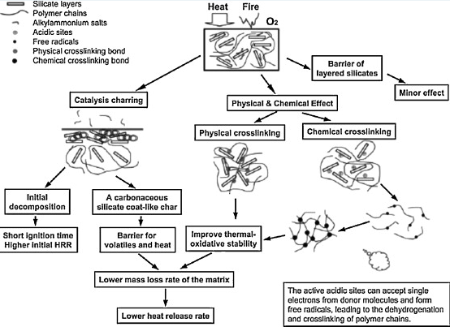
Figure 2.1.14. Flame retardant mechanism of polymer-clay nanocomposites (Reproduced from reference (Kiliaris & Papaspyrides, 2010)).

Nacre-like polymer clay nanocomposite materials with layer-by-layer structure were known to be able to achieve excellent fire retardancy (Liang et al., 2016; Liu, Walther, Ikkala, Belova, & Berglund, 2011; Sun et al., 2012; Yao et al., 2010) because of high content of thermally stable MMT platelets (Walther et al., 2010). For example, as for the chitosan MMT nanocomposite films (Yao et al., 2010), after chitosan was burnt out during the initial stage, the films turned black and became inert when exposed to the flame. There was no molten fluid coming out of the films and the layer-by-layer microstructure was not destroyed during burning. Similarly, Ca²⁺-crosslinked alginate-MMT nanocomposite films did well in fire retardancy as well (Liang et al., 2016). The pure alginate films burnt out quickly while the nanocomposite films turned black slowly and then remained inert without supporting any flame. Mesoporous layered structure was observed by SEM after burning instead of the dense layered structure before burning, which was attributed to be responsible for efficient energy dissipation and thus excellent fire retardancy.

Biodegradability
Recently biodegradable polymer composites become more and more attractive because they are friendly to the environment. The enhanced biodegradability of polycaprolactone/organoclay compared with the neat PCL was first reported by Tetto et al (Tetto, Steeves, Welsh, & Powell, 1999). This feature was also confirmed in the polylactic acid (PLA)-clay nanocomposites. PLA/clay nanocomposites displayed a higher weight loss of 80% than that (40%) of the pristine PLA after two months. The author suggested that the terminal hydroxyl groups of the silicate platelets were responsible for the improved biodegradability. And this was believed to suit many other polar polymer matrices. In this research, the molecular weight of PLA and PLA/clay nanocomposites decreased during biodegradation, from 160000 g mol⁻¹ to 40000 g mol⁻¹ after 30 days. This phenomenon confirmed that the initial stage of water absorption during degradation did exist, and then followed by ester cleavage, fragmentation. So it was clear that the enhancement of degradation was actually the improvement of hydrolysis tendency (Ray, 2010).

On the other hand, some contradictory results were also obtained (Lee et al., 2002). For example, in a study based on aliphatic unsaturated polyester, a reduced biodegradability was reported for the polymer/clay nanocomposites compared to that of the pristine polymer. After 30 days’ degradation, the polymer/clay nanocomposite incorporated with 5 wt% clay displayed a much lower weight loss (20%) than that (80%) of the pure polymer. The author attributed this phenomenon to the tortuous path theory, similar mechanism as mentioned for the barrier properties. The incorporation of clay platelets hinders the diffusion of small molecules in the nanocomposites. Till today, the relationship between the microstructure and the biodegradability is still unclear. So there is no way of knowing what effect will be on the biodegradability of the polymer-clay nanocomposites when clay platelets are added in (Harris, 1986; Paul & Robeson, 2008; Solin, 1997).

Unlike plastics, which are mostly not biodegradable, polysaccharides are widely known as biodegradable (George & Abraham, 2006; Kim et al., 2011; Meyers et al., 2008; Rao & Sharma, 1997). Among them, chitosan is widely used in the applications of biomedicine and pharmacy because of its excellent biodegradability (Busilacchi et al., 2013; Kumar et al., 2004; Rao & Sharma, 1997). Besides, Alginate can also be degraded by mild means such as alginate lyase enzyme-assisted degradation (Kim et al., 2011) and marine fungi-assisted digestion (Schaumann & Weide, 1990).

Biocompatibility
A biocompatible polymer is usually implantable and non-toxic to the tissues, which does not initiate immune response (Ogata, 1994). The biocompatibility of polymers was important in a variety of fields such drug delivery, tissue engineering and biosensors (Ogata, 1994). Alginate is often used in drug delivery because it is non-toxic to the human body as the lethal dose that kills 50% of a tested sample (LD50) ＞ 5000 mg/kg. And it displays good affinity to cell membrane (Tonnesen & Karlsen, 2002). Polyacrylamide and poly(N-isopropylacrylamide) are frequently used for nanocomposite hydrogels because they are stable, highly hydrophilic and non-toxic (LD50 > 1000 mg/kg) to the human body (Su, Mahalingam, Edirisinghe, & Chen, 2017).

2.1.12. Summary
This review summarized some general concepts, methods of synthesis and properties of polymer/clay nanocomposites. The mechanical and thermal properties are closely related to the microstructure: state of dispersion-exfoliation or intercalation, crystallinity and orientation. One dominant feature of polymer/clay nanocomposites is that they can reach significantly improved properties in many aspects with a fairly low content of silicate fillers. Therefore the low content of fillers gives rise to good dispersion and light weight. The incorporation of clay platelets brings in significant changes on the properties of the polymer-clay nanocomposites. But the effects on different systems can vary, either positively or negatively. In terms of the property-structure relationships, more well-developed theoretical systems are required to depict the mechanical or thermal responses by a nano-system with some specific microstructure. Besides, the strengthening or toughening effects are only limited in the low content of clay fillers, smaller than 5% because the higher amount of fillers often result in poor dispersion and thus decline in the mechanical performance. Under such a circumstance, further study will focus on how to obtain good dispersion as well as ideal microstructure such as intercalation/exfoliation ratio. Convincing theories and well-fitting mathematic models should also be set up to probe the mechanisms of the clay fillers’ functions. It is reasonable to believe that there is big potential to develop polymer-clay nanocomposites with superior and adjustable properties in the application of various fields in the current industry.

2.2. Review of polymer nanocomposite hydrogels

2.2.1. Introduction of hydrogels
Hydrogels are defined as the 3D crosslinked polymeric networks which have the capability of absorbing and retaining a large amount of water without being dissolved (Ahmed, 2015; Kabiri, Omidian, Zohuriaan-Mehr, & Doroudiani, 2011). The tendency of absorbing water resulted from the hydrophilic functional groups carried by the polymer backbones, while the stability in water was originated from crosslinking (Ahmed, 2015). Hydrogels can be formed by either synthetic polymers (Xiong, Hu, Liu, & Tong, 2008) such as polyacrylamide and poly(N-isopropylacryamide) or natural polymers such as gelatin (Piao & Chen, 2016) and alginate (Lee & Mooney, 2012). Due to softness, biocompatibility and swelling/de-swelling behaviour, they can be applied for drug delivery (Hoare & Kohane, 2008), agriculture (Saxena, 2010), food ingredients (Chen et al., 1995) and biomaterials such as soft tissue scaffolds (Frydrych et al., 2015; Zhang et al., 2011), wound dressings (Sirousazar et al., 2012) and biosensors (Li et al., 2015).

2.2.2. Classification of hydrogels
By the different types of crosslinking, most hydrogels can also be divided into three main groups: chemically crosslinked hydrogels, physically crosslinked hydrogels and double-network hydrogels. The chemical hydrogels are formed by chemical crosslinks (Choi et al., 2015). The physical hydrogels are synthesised by physical interaction between different polymer chains including hydrogen bonding (Haraguchi & Takehisa, 2002) and ionic bonding (Baumberger & Ronsin, 2010). The main difference between the chemically crosslinked hydrogels and physically crosslinked hydrogels is that many physically crosslinks of the physical hydrogels are stretchable (Haraguchi & Takehisa, 2002) or even self-healable (Gao, Du, Sun, & Fu, 2015; Sun et al., 2013; Tuncaboylu, Sari, Oppermann, & Okay, 2011), while the breakage of chemical bonds can’t be recovered (Haraguchi & Takehisa, 2002). In order to achieve optimum strength, toughness and water content, double-network hydrogels were developed by combining lightly crosslinked neutral polymer network and densely crosslinked polyelectrolytes network. In terms of crystallisation, hydrogels can be divided into three classes: amorphous, semi-crystalline and crystalline. In terms of electrical charge, hydrogels can be divided into neutral hydrogels and ionic hydrogels (Ahmed, 2015).

Recently, more and more attention has been attracted by stimulus-responsive hydrogels, of which the swelling/de-swelling behaviour can be regularly controlled by altering the external environment, such as pH and temperature (Yazdani-Pedram, Lagos, & Retuert, 2002). As for pH-sensitive hydrogels, it was found that hydrogels made of polymers containing either proton donating functional groups or proton accepting functional groups were able to respond to an environmental pH change (Yu & Ding, 2008). When pH changes, the degree of ionization defined as pKa or pKb will be drastically changed. When the charge of those ionized pendant groups changes, the electrostatic repulsive forces also changes and thus causes volume change in between the adjacent polymer chains. pH responsive hydrogels can be either anionic or cationic. On one hand, the pendant groups for anionic hydrogels are usually carboxylic or sulfonic acid, which will be ionised and make the hydrogels swollen when the external pH is above the pKa (Zhang, Xia, & Zhao, 2012; Zhao, 2014; Zhu, 2010). On the other hand, cationic pendent groups such as amine groups for cationic hydrogels will be ionised when the environmental pH is below the pKb. And the hydrogels will further swelled because of the increased electrostatic repulsions (Yazdani-Pedram et al., 2002). Similarly, for temperature-sensitive hydrogels, the swelling ratio will change when the environmental temperature changes (Sun et al., 2012).

2.2.3. Nanocomposite hydrogels
When the nanoparticles serve as crosslinkers, the derived hydrogels can be defined as nanocomposite hydrogels (Haraguchi, 2007). In 2002, for the first time, Haraguchi developed a novel hydrogel with a unique organic-inorganic nanocomposite structure (Haraguchi & Takehisa, 2002). It was not a simple combination of polymer chains and nanoparticles, but a firmly connected network brought by the interaction between the negatively charged polymer anions (PAM-SO₃⁻) and positively charged potassium cation absorbed onto the clay platelet surface (Takigawa, Araki, Takahashi, & Masuda, 2000). Without using any chemical crosslinker, laponite platelets act as multi-functional crosslinkers in the formation of polyacrylamide-clay nanocomposite hydrogels (Haraguchi, Li, Matsuda, Takehisa, & Elliott, 2005). The derived nanocomposite hydrogels displayed high toughness, transparency and controllable swelling ratios, which made them promising in the applications of artificial tissues and drug delivery (Haraguchi, 2007). Nowadays, many kinds of nanoparticles including laponite (Zhu et al., 2006), montmorillonite (Gao et al., 2015), hectorite (Xiong et al., 2008), layered double hydroxide (Hu & Chen, 2014), graphene oxide (Tuncaboylu et al., 2011) have been developed to synthesise polymer nanocomposite hydrogels.

The crosslinking density of physically crosslinked polyacrylamide clay nanocomposite hydrogels could be determined by the classic kinetic theory of rubber elasticity to depict the noncovalent interactions between polymer chains and clay platelets of polymer nanocomposite hydrogels (Haraguchi, Farnworth, Ohbayashi, & Takehisa, 2003; Xiong et al., 2008). The formula was given below.
F = N*RT(α – α⁻²) (2.2.1)
where F, N*, R, T and α are the force per unit original cross-sectional area of the hydrogels, effective crosslinking density, gas constant, absolute temperature and the extension ratio, respectively. The clay platelets of the nanocomposite hydrogels were assumed to be fully exfoliated.

2.2.4. Synthesis of nanocomposite hydrogels
The typical method for synthesising nanocomposite hydrogels is in situ free-radical polymerisation. For example, acrylic monomers like acrylamide and N-isopropylacrylamide, can polymerise and form an interconnected network in the presence of multifunctional inorganic fillers suspended in the aquatic medium (Haraguchi & Takehisa, 2002). The interaction between potassium cations absorbed onto the nanofiller surface and polymeric free radicals ensured that the hydrogel network is strong and stable in water (Haraguchi et al., 2005).

2.2.5. Properties of nanocomposite hydrogels

Tensile and compressive properties
With the incorporation of nanofillers, such as clay, the tensile strength and elongation at break of the nanocomposite hydrogels were significantly improved. In 2002, Haraguchi et al synthesised a novel nanocomposite hydrogel made of N-isopropylacrylamide (NIPAM) and laponite with a laponite/NIPAM weight ratio from 0.066 to 0.33 (Haraguchi & Takehisa, 2002). By a laponite/NIPAM weight ratio of 0.066, the derived nanocomposite hydrogels reached a tensile strength of 109 kPa and a strain at break over 10 while the conventional chemically crosslinked hydrogels were too weak to be tensile tested as shown in Figure 2.2.1. The reason for the extraordinary tensile properties of nanocomposite hydrogels was attributed to the long and flexible polymer chains in between the adjacent clay platelets, unlike the short, inhomogeneous chains in between the adjacent chemical crosslinks in the chemically crosslinked hydrogels. The deformed nanocomposite hydrogels could recover to their original shape within one minute.

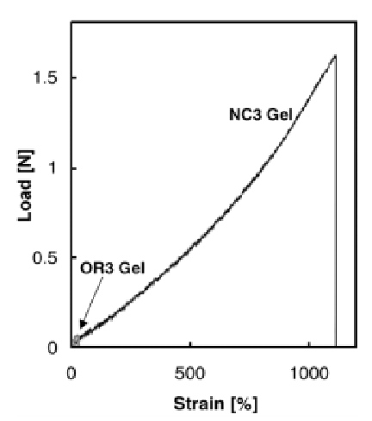
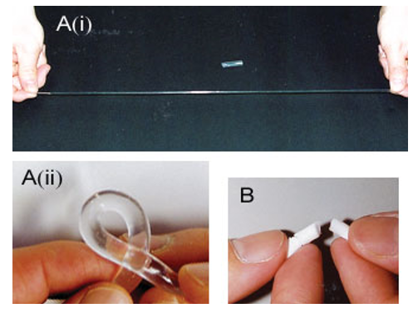
The effect of the content of clay on the properties was studied (Haraguchi, Takehisa, & Fan, 2002). The tensile strength and Young’s modulus increased proportionally as the Laponite XLG clay content increased while the elongation at break only slightly decreased. As for cyclic tensile tests of nanocomposite hydrogels, low hysteresis could be received by using high content of clay (Haraguchi & Li, 2006; Zhu et al., 2006). The hysteresis could be as low as 19% for the first cycle to a strain of 1000%. And the deformed hydrogels could recover 96% of their original shape in one minute. The high hydrophilicity and flexibility were attributed as the reasons for the excellent elasticity and low hysteresis (Zhu et al., 2006).
(C)

Figure 2.2.1. Polyacrylamide-laponite nanocomposite hydrogels and chemically crosslinked hydrogels with the same water/polymer ratio (10:1, (w/w)) (A) nanocomposite hydrogels are very tough and can withstand high level of deformations such as (i) elongation and (ii) torsion while (B) all the chemically crosslinked hydrogels are weak and brittle. (C) The stress-strain curve of nanocomposite hydrogels. The approximate data for a chemically crosslinked hydrogel are also depicted for comparison (Reproduced from reference (Haraguchi & Takehisa, 2002)).

Significantly improved tensile strength and elongation at break could be achieved by other nanoparticles. Layered double hydroxide (LDH), a positively charged clay, was incorporated with polyacrylamide and formed nanocomposite hydrogels. Ultrahigh elongation at break over 4000% was achieved with the derived hydrogels by low content of clay (≤ 2.3%). Before yielding point, the hydrogels recovered fast. The nanocomposite hydrogels could withstand various types of deformation with fast recovery as shown in Figure 2.2.2. Montmorillonite (MMT), as one of the commonly used clay (Ma et al., 2003), could also be incorporated with acrylamide to form nanocomposite hydrogels (Gao et al., 2015). By the strong hydrogen bonding between the hydroxyl groups of MMT platelets and the amine groups of polyacrylamide, the elongation at break could reach 11800% and the fracture energy could reach 10.1 MJ m⁻³. The nanocomposite hydrogels displayed strong hysteresis by cyclic tensile tests to a strain of 2000%. A residue strain of 500% was received in one minute and the full recovery could be achieved after 5 days at 25 degrees. The temporary or even permeant breakage of hydrogen bonds was attributed to be the reason for the large hysteresis and slow recovery. Graphene oxide (GO) was another choice for making nanocomposite hydrogels (Tuncaboylu et al., 2011). Hydrogen bonding, ionic bonding and physical absorption between polyacrylamide chains and GO platelets helped to form organic-inorganic hydrogel networks (Zhang, Qiu, Si, Wang, & Gao, 2011). At the GO content of 0.0079 wt %, the polyacrylamide-GO nanocomposite hydrogels displayed 4.5 times higher tensile strength than that of polyacrylamide chemical hydrogels. And the elongation at break could reach 3000%.

By the incorporation of nanoparticles in the polyacrylamide nanocomposite hydrogels, the mechanical properties such as tensile strength and elongation at break were significantly enhanced comparing to those of the conventional chemically crosslinked polyacrylamide hydrogels. Uniformly distributed stress along the long and strong polymer chains between the adjacent platelets was attributed to be the main reason for this phenomenon.
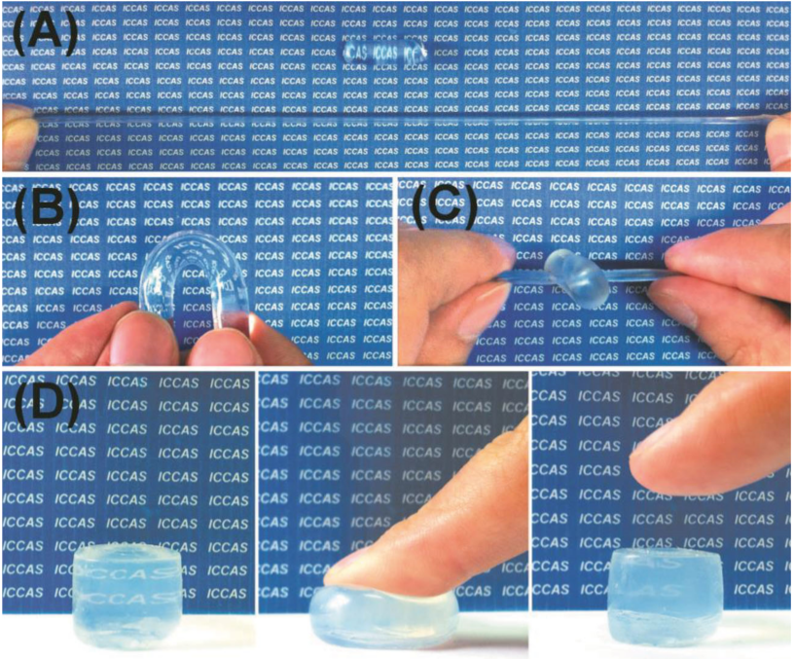
Figure 2.2.2. All of the as-prepared LDH/PAM NC hydrogels exhibited extraordinary mechanical toughness, and could withstand high levels of deformation by elongation (A), torsion (B), knotting (C), and compression (D) (Reproduced from reference (Hu & Chen, 2014)).

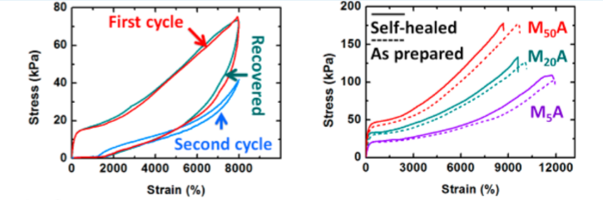
Figure 2.2.3. Cyclic tensile tests of PAM-MMT nanocomposite with a clay content of 5%, tensile tests of the as-prepared hydrogels and the self-healed hydrogels (Reproduced from reference (Gao et al., 2015)).

Double-network hydrogels are known as effective to achieve high strength as well as high toughness (Gong, 2010; Gong, Katsuyama, Kurokawa, & Osada, 2003), because of the combination of lightly crosslinked first neutral network which was elastic and stretchable and densely crosslinked second polyelectrolyte network which was rigid and tough. The concept of double-network hydrogels could also be used in the field of nanocomposite hydrogels. A novel hydrogel combining graphene oxide, polyacrylamide and alginate was synthesised in 2013 (Fan, Shi, Lian, Li, & Yin, 2013). The lightly crosslinked polyacrylamide served as the first network while the Ca²⁺ crosslinked alginate served as the second network. The graphene oxide platelets served as physical crosslinkers and reinforcing fillers. When the weight content of graphene oxide was 5%, the compressive strength of the hydrogels could reach 1.543 MPa with a compressive deformation of 70%. The compressed samples could quickly recover. The tensile strength could reach 201 kPa. The significantly enhanced mechanical properties were attributed to the double-network microstructure and the strong interface between graphene oxide platelets and polyacrylamide chains.

In terms of compressive properties, polyacrylamide nanocomposite hydrogels could withstand fairly high compressive deformation up to 90% without failure, while the conventional chemically crosslinked polyacrylamide hydrogels could easily fail and fall apart at a small strain (Haraguchi, 2007; Haraguchi & Takehisa, 2002; Hu & Chen, 2014).

Swelling properties
Nanocomposite hydrogels generally displayed much higher swelling ratio than that of the conventional chemically crosslinked hydrogels (Haraguchi, 2007; Haraguchi & Takehisa, 2002). The relative low effective network density was attributed to be the reason for the high equilibrium swelling ratio of nanocomposite hydrogels (Gao et al., 2015). The equilibrium swelling ratio of the polymer-clay nanocomposite hydrogels was directly proportional to the clay content because the increasing clay content meant the increasing crosslinking density (Gao et al., 2015; Haraguchi et al., 2003).

Stimulus-sensitivity
Poly(N-isopropylacrylamide) clay nanocomposite hydrogels have been known for its good thermo-sensitivity for years. When the external temperature changed, the volume of the hydrogels would change. Compared to the conventional chemically crosslinked hydrogels, the volume change and the deswelling rate were significantly enhanced. The thermos-sensitivity of nanocomposite hydrogels could also be altered by changing the chemical composition (Ju, Kim, & Lee, 2001).

pH-sensitivity was another important aspect of nanocomposite hydrogels. Ionic monomers such as acrylic acid and 2-acrylamido-2-methylpropane sulfonic acid (AMPS) could give rise to high pH-sensitivity (Kabiri, Mirzadeh, & Zohuriaan‐Mehr, 2010; Kheradmand, Francois, & Plazanet, 1988). By this in situ polymerisation of AMPS in the presence of chitosan-treated montmorillonite platelets, a novel nanocomposite hydrogel was synthesised in 2010. The swelling ratio was closely related to pH value. On one hand, in a basic environment, the large number of OH⁻ groups helped to ionise the sulphonic acid groups. So the negatively charged SO₃⁻ anions tend to repulse each other and thus increase the swelling ratio. On the other hand, in an acidic environment, in the presence of many H⁺, the ionisation of sulphonic acid groups was significantly inhibited. Thus the repulsive forces between the adjacent polymer chains were reduced and the hydrogels tend to shrink when pH value became lower.

Apart from the ionic monomers, the natural polyelectrolytes such as alginate could also be incorporated into the hydrogels and present pH-sensitivity (Bhattarai et al., 2006; Obara, Yamauchi, & Tsubokawa, 2010; Tonnesen & Karlsen, 2002). Calcium alginate hydrogels containing hydroxypatite displayed pH-sensitivity. Like many polymers containing COO⁻, when in an acidic environment with large number of H⁺, COO⁻ anions and H⁺ anions tend to combine because of the chemical equilibrium effect. As a result, the hydrogel shrank because of the reduced electrostatic repulsion between the negatively charged COO⁻ anions. While in an alkaline environment, OH⁻ helped to dissociate COOH into COO⁻ and H⁺ ions so that the hydrogel further swelled due to the increased electrostatic repulsion (Al-Musa, Fara, & Badwan, 1999; Obara et al., 2010; Tonnesen & Karlsen, 2002).

Transparency
For the conventional chemically crosslinked polyacrylamide hydrogels, when the dose of the chemical crosslinker (N,N'-Methylenebisacrylamide) increased to a critical value, the nanocomposite hydrogels became opaque. This phenomenon was due to the inhomogeneous distribution of the crosslinking sites. This critical value differed for different polymer matrices (Haraguchi et al., 2003; Haraguchi et al., 2002). On the contrary, the nanocomposite hydrogels were generally transparent, regardless of the clay content (Haraguchi et al., 2002). The results from structural characterisation implied that the distribution of clay platelets in the nanocomposite hydrogels was relatively uniform compared to that of the conventional chemically crosslinked hydrogels (Shibayama et al., 2004).

2.2.6. Summary
Hydrogels contain a hydrophilic 3D network which can absorb large amount of water without dissolution. With the incorporation of nanoparticles, the mechanical properties such as tensile strength, compressive strength and elongation at break were significantly enhanced in comparison with the conventional chemically crosslinked hydrogels. Besides, the equilibrium swelling ratio was also increased. Furthermore, the transparency of the nanocomposite hydrogels was excellent while the conventional chemically crosslinked hydrogels turned opaque when the content of chemical crosslinkers was high. When combined with pH-sensitive polymers, the nanocomposite hydrogels could present pH-sensitivity. Polymer nanocomposite hydrogels were therefore promising in many types of applications such artificial tissues, drug delivery, environmentally friendly elastic materials and sensors.

2.2.7. Future work
Though the nanocomposite hydrogels are stretchable and tough, there are limitations. Firstly, in many cases of nanocomposite hydrogels, the mechanical properties of the fully swollen samples in distilled water or phosphate buffer solution have not been studied probably because they were quite weak. Secondly, when submitted to cyclic tensile deformation, PAM/clay nanocomposite hydrogels tend to show remarkable hysteresis because of the reversible nature of PAM-clay hydrogen bonding. Currently, high amount of highly water-soluble clay (synthetic hectorite) was known to be effective in reducing hysteresis (Zhu et al., 2006). It will be desirable if low hysteresis can be achieved by other nanocomposite hydrogel systems. Thirdly, the current research work on polymer/clay nanocomposite hydrogels mostly focuses on the network with one single kind of polymer such as polyacrylamide or poly(N-isopropylacrylamide) and one single kind of clay. It is necessary to develop some nanocomposite hydrogels with more complexity. Many functional polymers have been utilised in the systems of hydrogels such as chitosan and alginate which are pH-sensitive, and carrageenan which is sensitive to ion strength. Many types of clay can serve as the physical crosslinkers of the nanocomposite hydrogels, which differ in shape, dimension and charge. Many ions can be incorporated into the nanocomposite hydrogels which may have an effect on crosslinking, swelling behaviour and reactivity. So if multiple monomers, clays, ions and functional polymers were combined for preparing a nanocomposite hydrogel, the resultant product may display some amazing properties.

Chapter 3: The enhancement in clay exfoliation in nylon 6/clay nanocomposites by melt-intercalation using a novel polymeric surfactant and/or chemical blowing agent

3.1. Introduction
Polyamide 6, also known as nylon 6, an engineering plastic widely known for its high strength and stiffness, good process-ability and excellent resistance to many organic solvents, is very popular as the matrix of composite materials (Herzog, Kohan, Mestemacher, Pagilagan, & Redmond, 2000). It is widely used as an important engineering plastic in the field requiring good mechanical properties for various applications such as gears, fittings, food packing and car components (He et al., 2008; Kim et al., 2001; Kohan, 1995). Clays, which are widely used as fillers, are a class of minerals made of 1 nm thick layers with atoms held together by chemical bonds and adjacent layers linked by electrostatic forces and Van der Waals force (Alexandre & Dubois, 2000). The aspect ratio of these layers can reach 1000 (Beyer, 2002; Solomon et al., 2001). As a 2:1 clay, montmorillonite (MMT in short) is abundant on the planet earth (Segad, Jonsson, Akesson, & Cabane, 2010). The average layer charge can be represented by cation exchange capacity (CEC), which is defined as the capability of a soil to absorb or exchange cations (He et al., 2010).

Polymer/clay nanocomposite was firstly raised in Toyota Centre R&D Labs by the means of in situ polymerisation (Usuki et al., 1993). This created a new field of polymer nanocomposites. It was found that MMT received the best mechanical responses for nylon 6/clay nanocomposites with 5 wt% clay reinforcement, compared with mica, sapronite and hectorite. The high surface area, high surface reactivity of MMT and effective stress transfer from polymer matrix to nanofillers were believed to be responsible for the improved mechanical properties (Alexandre & Dubois, 2000). For the upcoming decades, nylon 6-clay hybrids have attracted much attention due to the significantly increased Young’s modulus, tensile strength and heat distortion temperature (Pinnavaia & Beall, 2000). Because nylon 6 has high polarity, it is believed to be more compatible to clay platelets than polyethylene or polypropylene and many other polymers and easy to accomplish exfoliation through many ways (Akelah & Moet, 1996; Hasegawa, Okamoto, Kawasumi, & Usuki, 1999; Usuki, Kato, Okada, & Kurauchi, 1997; Yano, Usuki, Okada, Kurauchi, & Kamigaito, 1993)(Akelah & Moet, 1996; Hasegawa et al., 1999; Liu et al., 1999; Usuki et al., 1997; Yano et al., 1993).

Compared to solution intercalation and in situ polymerisation (Alexandre & Dubois, 2000), melt processing is convenient, frequently used for processing polymer/clay nanocomposites because of the absence of solvent (Ray & Okamoto, 2003). Melt processing by a non-intermeshing twin screw extruder was proved to be available for synthesizing nylon 6/clay nanocomposites with various extrusion conditions (Dennis et al., 2001). The tensile strength and modulus went up for the addition of organoclay with the content below 5 wt% (Bouchonneau et al., 2010; Chen et al., 2008; Giannelis, 1996; Hull & Clyne, 1996; Vaia & Wagner, 2004). Nanocomposites may also help to toughen the materials in some cases (Chen & Evans, 2009; Chen et al., 2008). Apart from the mechanical properties, some other properties can also be altered, such as barrier property, process-ability and biodegradability (Chen et al., 2008; Li & Shimizu, 2006; Meng et al., 2004; Tjong, 2009; Vaia et al., 1996; Venkatesh et al., 2016; Vu et al., 2008; Zhu, 2010).

However, some technical difficulties restrict the development and application of polymer/clay nanocomposites. First of all, the compatibility between the lowly polar polymer matrices (such as polypropylene or polystyrene) and the clay fillers is usually poor. So a proper surfactant should be carefully chosen for some specific polymer matrix. The most frequently used organic surfactants are quaternary alkyl ammonium salts (de Paiva, Morales, & Díaz, 2008).

Second, with the polar polymer matrix (such as polyamide 6), the microstructure of polymer/clay nanocomposites is often the mixture of intercalation and exfoliation, and the distribution of these two different structures in the polymer matrix is not controllable (Alexandre & Dubois, 2000). In order to achieve the designed structure, a creative idea of enhancing the clay exfoliation by using chemical blowing agents was proposed recently (Istrate & Chen, 2014). In this case, sodium bicarbonate and azodicarboxamide were used as chemical blowing agents (Berger et al., 2004), which were introduced inside the galleries of the clay and thermally decomposed to enlarge the galleries during extrusion. Polystyrene (PS) and polypropylene (PP) were used as the matrices. It was found that the use of blowing agents led to an increased ratio of exfoliation by about 50% for sodium bicarbonate and 56% for azodicarboxamide compared to the polymer nanocomposites without the treatment of chemical blowing agent. The thermal degradation temperature was increased by about 40 ºC compared to the neat polymers, by about 30 ºC compared to polymer organoclay nanocomposites without the treatment of clay with the chemical blowing agent. The Young’s modulus, tensile strength and elongation at break of polystyrene/organoclay/chemical blowing agent were improved by 22, 39 and 14% respectively compared to the neat polymer matrix, and 17, 88 and 50% respectively compared to the polymer organoclay nanocomposites without the treatment of clay with the chemical blowing agent. As for the two chemical blowing agents, sodium bicarbonate which had a relatively lower degradation temperature worked better on improving clay exfoliation.

Third, another major challenge for melt processing is that the thermal stability of the surfactant, especially the quaternary ammonium modified montmorillonite, was usually quite low, making it decompose during extrusion, and thus might have some detrimental effect on the polymer matrix (Chen & Chrambach, 1979). According to a research on the degradation of polyamide 6 matrix and color formation, the degradation of surfactants followed the Hofmann elimination theory, which was also defined as exhaustive methylation of a process where an amine transformed into olefin, amine and water at high temperature as shown in Scheme 3.1 (Chen & Chrambach, 1979). Degradation of surfactant could have a catalytic effect on the polyamide 6 matrix, especially nylon 6 with high molecular weight (Dabrowski, Bourbigot, Delobel, & Le Bras, 2000; Fornes, Yoon, & Paul, 2003). The byproducts from the degradation of surfactant and nylon 6 such as water and amine helped degrade the nylon 6 matrix. Hydroxyethyl groups in the surfactant as opposed to methyl groups, and tallow substituents as opposed to hydrogenated tallow substituents produced more colour effect in nanocomposite which was related to polymer degradation (Fornes et al., 2003). In order to avoid the surfactant-induced degradation and maintain the compatibility of the surfactant between polymer matrix and clay platelets, a surfactant with high thermal decomposition temperature which was higher than the processing temperature of polyamide 6 should be used.
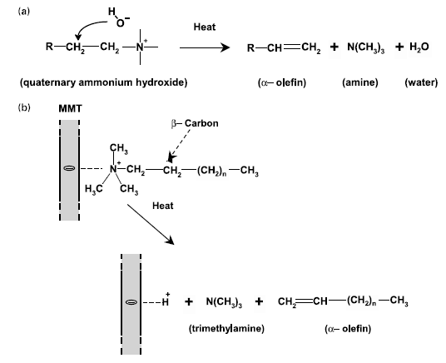
Scheme 3.1. The Hofmann elimination reaction of quaternary ammonium compounds (Reproduced from reference (Chen & Chrambach, 1979)).

Polyoxyethylene fatty ammonium ethosulphate, which is a polymeric surfactant, with a code name of ATLAS™ G-265-LQ-(MV), is a water-soluble, polymeric type of surfactant. It can form a stable suspension with clay in the aquatic environment. Besides, the Atlas surfactant has a fairly high decomposition temperature higher than 280 ºC ("Croda Coatings & Polymers, Burn out temperatures HYPERMER KD series,"), which means it is stable during the extrusion with polyamide 6.

In order to better regulate the microstructure of nylon 6/clay nanocomposites, this project was aimed to regulate the intercalation/exfoliation ratio of the extruded nanocomposites simply by varying the processing parameters and the amount of a chemical blowing agent, citric acid, inside the galleries between the adjacent clay platelets. Citric acid was chosen because: it has a degradation temperature around 170 ºC which was below the processing temperature, and is likely to be fully decomposed into non-toxic CO₂ and H₂O gas, without leaving any solid remains (Masuyama, Horikawa, & Yasuhara, 1964). Besides, it is cheap and does not release toxic gas during thermal decomposition. The thermal properties and clay exfoliation improvement in polymer/clay nanocomposites of the chemical blowing agents were summarised in Table 3.1 based on the previous study (Heck, 1998; Istrate & Chen, 2014).

Besides, in order to achieve better clay exfoliation and enhanced thermal stability, a novel surfactant was used, and enhanced clay exfoliation with the help of decomposition of the chemical blowing agent, citric acid (CA), for nylon 6/clay nanocomposites. This time, CA was mixed with the clay suspension without washing so that all the CA molecules inside the clay galleries were expected to be retained. In order to facilitate the degradation of the blowing agent in the barrel of the extruder, all the materials were extruded and chopped, and then the extruded materials were fed into the extruder again for another 2 times. Compression moulding was used to fabricate dog-bone samples for tensile test. Cloisite 30B, a widely used commercial organoclay, has good compatibility with and reinforcing effects on polyamides. Its thermal resistance up to 280 ºC is quite competitive (Dennis et al., 2001). So nylon 6/Cloisite 30B nanocomposites were also prepared for comparison. The nanocomposites were characterised by X-ray diffraction (XRD), Fourier transform infrared spectroscopy (FTIR), thermogravimetric analysis (TGA), differential scanning calorimetry (DSC), tensile tests and scanning electron microscopy (SEM). It may be a constructive way to form high content of exfoliated structure.
Table 3.1. Chemical blowing agents used in polymer/MMT nanocomposites.
Chemical blowing agents | Chemical structure | Thermal degradation temperature / ºCª | Decomposition productsª | Improvement of exfoliation ratio^{b}
 |  |  |  | PP | PS
sodium bicarbonate | 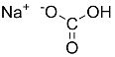 | 50 | Na₂CO₃, H₂O, CO₂ | 0.42 0.61 | 0.36 0.50
azodicarboxamide | 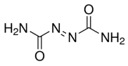 | 200 | N₂, CO, NH₃, CO₂ | 0.42 0.50 | 0.36 0.56
ªreproduced from the reference (Heck, 1998).
^{b}reproduced from the reference (Istrate & Chen, 2014).

3.2. Experimental

3.2.1. Materials
Nylon 6 with a trade name of Akulon 6-D (DSM), was purchased from Resinex UK Ltd. Montmorillonite (MMT) with a cation exchange capability of 90 meq (100 g)⁻¹ and an organoclay with a trade name of Cloisite 30B which was treated by a methyl, tallow, bis-2-hydroxyethyl quaternary ammonium, were supplied by Southern Clay Products. Hexadecyltrimethylammonium bromide (S) (assay ≥ 98%) and citric acid (CA) (purity ≥ 99.5%) were provided by Sigma Aldrich. Atlas G-265-LQ-(MV) (polyoxyethylene fatty ammonium ethosulphate), SynperonicTM 10/6-LQ-(CQ) (Fatty alcohol ethoxylate, chemical fomula: C₁₂H₂₅O(CH₂CH₂O)_{n}H) and ZephrymTM PD 7000 (NH₂(CH₂CH₂O)_{n}) were provided by CRODA. Ethanol (assay ≥ 99%) and tetrahydrofuran (THF) (assay ≥ 99%) were purchased from Fisher Scientific. All materials were used as received.

3.2.2. Clay treatment
Clay treatment was described as follows. 15 g MMT was mixed with 1000 ml distilled water for 24 hours on a table roller. The derived suspension was then left for 12 hours, letting large particles sink onto the bottom. The supernatant of the clay suspension was extracted to undergo ultrasonic treatment for 30 mins in order to thoroughly separate the clay platelets. After another 1 hour’s stirring, the stable clay suspension was obtained. Approximately 12 g clay platelets were retained in the suspension.

In terms of cation exchange reaction, the clay suspension was treated by hexadecyltrimethyl ammonium bromide serving as surfactant. Both the clay suspension and the surfactant solutions were heated up to 80 ºC and then mixed (Zhu et al., 2006). Cation exchange reaction occurred instantly and yielded white precipitates. The organoclay (OMMT) turbid liquid was stirred for 1 hour. The product was washed with 80 ºC distilled water.
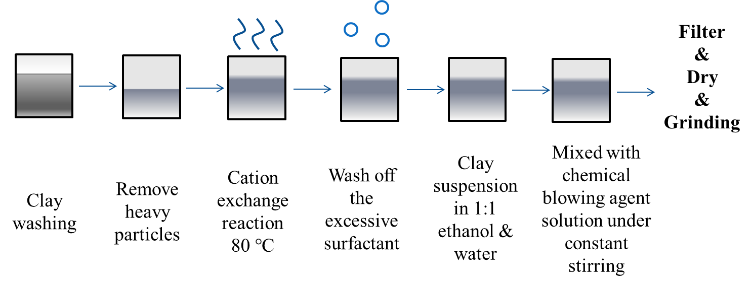

Scheme 3.2. The synthesis of CA-treated organoclay in 1:1 ethanol/water.

The OMMT was dispersed in a 1:1 (by volume) ethanol/water solvent under 24 hours’ stirring to form suspension. Then 3 wt % citric acid solution containing 12 g solute (identical to the amount of clay) was added into the system. After 24 hours’ stirring, citric acid molecules were expected to enter the interlayer galleries of MMT. The suspension was washed by distilled water and filtered. The CA-treated organoclay (OMMT+CA) was dried in the oven at 40 ºC for 24 hours and then was ground into fine powders by the Fritisch mortar and pestle as schematically illustrated in Scheme 3.2.

For comparison, different clay samples were also made. MMT suspension mixed with citric acid solution before cation exchange reaction, (MMT+CA)+S in short. MMT suspension, citric acid solution and surfactant solution were mixed simultaneously at 80 ºC, MMT+CA+S in short. MMT suspension was directly mixed with citric acid solution and then treated by centrifuge, MMT+CA(C) in short. THF rather than ethanol was used for the incorporation of citric acid to organoclay, and the product was expressed as OMMT+CA (THF), because S had higher solubility in THF than in ethanol. However, nearly no CA molecules were kept in OMMT+CA (THF) after the THF treatment. So OMMT+CA (THF) was not used for making nylon 6/clay nanocomposite material.

Besides, the clay suspension was also treated by one of the three polymeric surfactants (Atlas G-265-LQ-(MV), SynperonicTM 10/6-LQ-(CQ) and ZephrymTM PD 7000), under constant stirring for 24 hours at 80 ºC, forming white, stable suspension. The weight ratio of the surfactant and clay platelets was set to be 2:3. The organoclays (denoted as Atlas MMT, Synperonic MMT and Zephrym MMT respectively) were obtained by centrifuging in an Eppendorf 5804 at 8000 rpm for 30 mins, and then dried in the oven at 50 ºC for 24 hours. The CA-treated Atlas MMT was prepared by redispersing the centrifuged Atlas MMT in distilled water with citric acid in a weight ratio of surfactant : clay : citric acid = 2:3:3, for another 24 hours’ stirring at 80 ºC. The solvent was evaporated under stirring to yield CA-treated Atlas MMT solid, denoted as Atlas MMT CA. All the clay samples were carefully grounded into powders. All the clay materials used in this project were summarised in Table 3.2.
Table 3.2. Completed clay samples.
Samples | Synthetic Methods
Washed MMT | Neat MMT dispersed in distilled water and then centrifuged
OMMT | cation exchange reaction at 80 ºC in water
OMMT+CA | OMMT treated with citric acid
(MMT+CA)+S | MMT and CA mixed prior to cation exchange reaction
MMT+CA+S | MMT, CA and S mixed in a time
MMT+CA (C) | CA-treated MMT collected by centrifuge from the suspension
OMMT+CA (THF) | OMMT treated with citric acid in the 1:1 THF/water solvent
Cloisite 30B | Commercial clay
Atlas MMT | Clay treated with the Atlas surfactant (weight raio: A:M=2:3)
Atlas MMT CA | Atlas MMT treated with CA (weight ratio: A:M:C=2:3:3)

3.2.3. Preparation of polymer/clay nanocomposites
The equipment for extrusion used in this project was a 21 mm twin-screw extruder (25:1 L/D) C2957 produced by Rondol Company. All the polymer and clay samples were dried in the vacuum oven at 80 °C overnight prior to melt processing. In consideration of DSC data from Figure 3.17 and Table 3.10, and the melting point of industrial nylon 6 material was 220 ºC as reported (Cho & Paul, 2001; Zhao, 2014). The temperature for each zone was set to be 225 °C, 225 °C, 230 °C and 230 °C for Zone 1 to Zone 4, and 220 °C for the Die. The screw rotating speed was set to be 80 rpm. The weight ratio of nylon 6 to MMT platelets was set to be 96:4 for all the nylon 6/clay nanocomposites. Nylon 6 was also extruded with citric acid in the weight ratio of citric acid to nylon 6 as 4 : 96. Before extrusion, the nylon 6 beads and the clay samples were mixed by hand in a plastic bag. Every sample was extruded twice for nylon 6, nylon 6 with CA, and nylon 6/clay nanocomposites incorporated with MMT, OMMT, OMMT+CA, (MMT+CA)+S, MMT+CA+S, MMT+CA (C) and OMMT+CA (THF). The extruded filaments were cooled in the water tank, and chopped into pellets and dried in the oven for further uses.

The dog-bone samples of the twice-extruded materials for tensile tests were made by injection moulding machine, HAAKE minijet 2 produced by Thermo Scientific Company. The barrel temperature was set to be 240 °C. The mold temperature was set to be 70 °C. The injecting pressure was set to be 400 bars while the post-pressure was set to be 200 bars holding for 5 seconds to make the “dog-bone” samples which were for the tensile test. The derived samples are listed in Table 3.3 below.

Besides, nylon 6, nylon 6 with CA, and nylon 6/clay nanocomposites incorporated with MMT, Cloisite 30B, Atlas MMT and Atlas MMT CA were processed by a different method. Before processing, the clay powders and nylon 6 pellets with the weight ratio of nylon 6 to MMT platelets of 96 : 4 were hand mixed in the sample bag. Nylon 6 was also extruded three times with citric acid in the weight ratio of citric acid to nylon 6 as 4 : 96. All the raw materials were dried in the vacuum oven at 80 ºC for 24 hours. Then all the materials were extruded three times. The extruder, the temperature for each zone and the screw speed were the same as those for the twice-extruded materials mentioned before. After the first extrusion, the extruded material was chopped into small pellets and fed into the extrusion barrel for the second extrusion, and then the third time. The final extruded and chopped pellets were dried in the vacuum oven at 80 ºC for 24 hours. The derived samples were also listed in Table 3.3.

As for triple-extruded materials, instead of injection moulding, compression molding was used for making dog-bone samples for tensile tests. The temperature of the hot plate was set to be 235 ºC. The extruded pellets were placed in between two heatproof PTFE films, allowing them to melt between two plates without pressure. In order to make good samples free from visible voids, the extruded pellets were hot pressed into thin film at first. After making the thin, flat films, the mold was placed onto the film and held for 3 minutes under 235 ºC. Then the film and the mold were hot-pressed under a pressure of 0.2 MPa, holding for 30 seconds to form the dog-bone samples.
Table 3.3. Completed nylon 6 and its nanocomposites.
Samples | Synthetic Methods
Nylon 6 2 | Twice-extruded nylon 6
Nylon 6 CA 2 | Twice-extruded nylon 6 with citric acid (Nylon 6:CA = 96:4 by weight)
Nylon 6 MMT 2 | Twice-extruded nylon 6 with MMT
Nylon 6 OMMT 2 | Twice-extruded nylon 6 with OMMT
Nylon 6 MCS 2 | Twice-extruded nylon 6 with MMT+CA+S
Nylon 6 MC 2 | Twice-extruded nylon 6 with MMT+CA
Nylon 6 OC 2 | Twice-extruded nylon 6 with OMMT+CA (THF)
Nylon 6 3 | Triple-extruded nylon 6
Nylon 6 CA 3 | Triple-extruded nylon 6 with citric acid (N:CA=96:4)
Nylon 6 MMT 3 | Triple-extruded nylon 6 with MMT (N:M=96:4)
Nylon 6 Cloisite 30B 3 | Triple-extruded nylon 6 with Cloisite 30B (N:C=96:5.71)
Nylon 6 Atlas MMT 3 | Triple-extruded nylon 6 with Atlas MMT (N:A:M=96:2.67:4)
Nylon 6 Atlas MMT CA 3 | Triple-extruded nylon 6 with Atlas MMT CA (N:A:M:CA=96:2.67:4:4)

3.2.4. Characterisation
X-ray diffraction was carried out by the STOE STADI P (Cu, IP). Diffractometer. X-ray scans were achieved in the transmission mode with an incident X-ray wavelength of 0.154 nm at a scan rate of 1.0 degree min⁻¹. The clay samples were in the powder form. Each sample was scanned for 8 times from 2º to 100º. FTIR was conducted by the Spectrum 100 spectrophotometer (PerkinElmer) in the wavenumber region from 4000 to 400 cm⁻¹ with a resolution of 1 cm⁻¹. The clay samples in the powder state were put on the diamond ATR sensor and compressed. Each sample was scanned for 8 times.

The thermal behaviours of clay samples were measured by thermogravimetric analysis (TGA) using a Pyris 1 TGA instrument (PerkinElmer) with a heating rate of 10 ºC min⁻¹ under the protection of nitrogen ﬂow of 20 ml min⁻¹. The heating range was from 25 ºC to 800 ºC. Samples were put in the ceramic pan and then weighed. The weight was no more than 10 mg. Apart from the weight remain-to-temperature graphs, the derivative weight percentage was also recorded for analysis.

DSC characterisation was achieved by PERKIN ELMER DSC 6 within the temperature ranging from 20 to 300 ºC. Before each test, the displayed values of heat flow for baseline were eliminated. A sample of no more than 5 mg was hold by the compressed alumina pan and lid. The alumina holder with sample was put on the left side while the empty alumina holder was put on the right side as reference. The samples were held at 25 ºC for 5 mins, and then heated from 20 °C to 300 °C at a speed of 20 °C min⁻¹, then cooled from 300 °C to 20 °C, and reheated from 20 °C to 300 °C at the same rate. The whole process of measurement was under the protection of nitrogen gas.

Mechanical properties of the twice-extruded materials were evaluated by TA500 Tensometer produced by LLOYD Instruments, at the stretching speed of 5 mm min⁻¹. The tested “dog-bone” samples were prepared by injection moulding. A preload of 5 N was exerted in order to maintain the stretching state before test. The stress-strain data were automatically recorded and reported by the machine. The mean value and the standard deviation were calculated with a confidence level of 95%. Besides, mechanical properties of the triple-extruded materials were evaluated on a Hounsfield Tensometer at the strain rate of 1 mm min⁻¹. The load cell was 1 kN. A preload of 5 N was exerted in order to maintain the stretching state at the initial stage of every test to prevent the slippage between tensile samples and grips. For each material, 20 dog-bone specimens were tested.

Scanning Electron Microscopy (SEM) was utilised to observe the fracture surface topography of the tested tensile samples with gold coating. The liquid nitrogen-fractured samples were made as follows: The dog-bone samples were put into liquid nitrogen and became very brittle immediately; then the samples were broken by tweezers in the liquid nitrogen. The samples were imaged by Inspect F FEG SEM operated by a voltage of 5 kV. The images were taken at the magnification of 2000 and 5000.

3.3. Results and discussion

3.3.1. Structural analysis of clays and nylon 6/clay nanocomposites

Figure 3.1. XRD patterns for clays.

XRD was characteristic for the cation exchange reaction of the treated clays and the clay platelet dispersion in the nylon 6/clay nanocomposites. As seen from Figure 3.1, a series of characteristic peaks were shown on this graph for clays for twice extrusion, among which the first, highest peak results from the (0, 0, 1) diffraction. By means of Bragg’s law, the d-spacing values, corresponding to the interlayer galleries of clay sheets, could be calculated. The d-spacing values were summarized in Table 3.4.
Table 3.4. Diffraction angles and basal plane spacings of clays for twice extrusion.
Samples | θ (0,0,1) Peak / degree | d_{(0, 0, 1)} / nm
MMT | 3.5 | 1.27
OMMT | 2.1 | 2.13
OMMT+CA | 1.9 | 2.36
MMT+CA (C) | 2.1 | 2.13
MMT+CA+S | 2.1 | 2.13
(MMT+CA)+S | 2.1 | 2.13

As shown in the Table 3.4, the basal d-spacing of MMT is 1.27 nm which was close to the value mentioned in some other studies (Busilacchi et al., 2013; Chen, 2004; Usuki et al., 1993). When it came to OMMT, the d-spacing nearly doubled. This phenomenon confirms that the long-tail alkylammonium cations did have the capability of expanding the interlayer galleries. This was due to the replacement of small alkali counter-ions with the relatively larger alkylammonium cations of surfactant. OMMT+CA sample displayed an even larger basal d-spacing which was encouraging for the possible presence of interlayer citric acid. Interestingly, even without surfactant, MMT+CA (C) sample also showed an enlarged basal d-spacing like OMMT. This expansion of interlayer spacing resulted from the intercalation of citric acid molecules, though they were of quite small scale compared to that of alkylammonium cations. Again the presence of citric acid might be verified by FTIR and TGA subsequently. MMT+CA+S and (MMT+CA)+S samples had the same basal d-spacing value as OMMT, indicating that the extended interlayer galleries were due to the surfactant and there might be no or very little interlayer citric acid molecules.

Apparently, compared to the raw MMT, d-spacing of all the treated MMT was larger, indicating the process of intercalation occurred during the clay treatment. Among them, OMMT+CA displayed larger d-spacing than the other treated clay.
Figure 3.2. XRD patterns for clays for the triple extrusion.

Table 3.5. Diffraction angles and basal plane spacing of clays for the triple extrusion.
Samples | 2θ (0,0,1) Peak / degree | d-spacing / nm
MMT | 7.0 | 1.27
Atlas MMT | 4.4 | 1.95
Synperonic MMT | 4.6 | 1.89
Zephrym MMT | 4.4 | 1.95
Cloisite 30B | 4.2 | 2.12

As shown in Figure 3.2 and Table 3.5, like the hexadecyltrimethyl ammonium bromide surfactant, all the polymeric surfactants enlarge the interlayer spacing of montmorillonite. With the incorporation of an organic surfactant (Atlas, Synperonic or Zephrym), the d-spacing value increased by about 50%. According to a research on organoclays modified by different surfactants (He et al., 2010), Cloisite 30B was supposed to have the best expansive effect on the clay due to the largest d-spacing value than the other two. It was found that the surfactant with two alkyl chains tended to give rise to higher basal spacing than that of the surfactant with one alkyl chain, and long alkyl chains with more than 12 carbon units were beneficial for expanding the basal spacing by forming bilayer, trilayer and paraffin structure. As for paraffin structure, the alkyl chains of surfactant molecules lay densely, without close contact to the surface of clay platelets. While for short alkyl chains, mono-layer or bilayer structure could be achieved where the alkyl tails aligned parallel to the surface of clay platelets and there was no interaction between adjacent alkyl chains (He et al., 2010; Zhu, 2010) as shown in Figure 3.3. However, comparing the Atlas clay and Cloisite 30B, they presented similar enlarging effect on the basal spacing of clay platelets. The reason could be that the MMT clay used for making Atlas MMT and the bentonite clay used for synthesising Cloisite 30B were different in dimensions and/or surface functionality (Caseri, 2006; Jordan, 1949; Pavlidou & Papaspyrides, 2008).
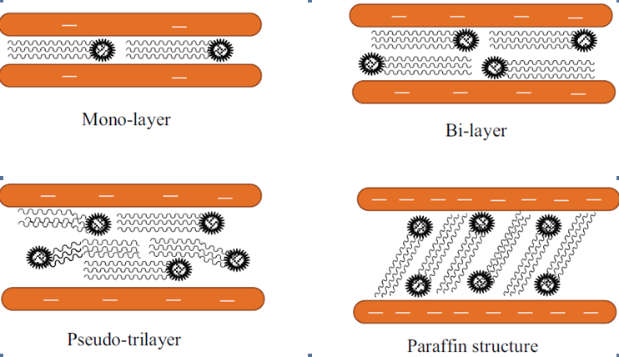
Figure 3.3. Typical configurations of organic oniums into the clay galleries (Reproduced from reference (Zhu, 2010)).

Atlas clay displayed similar interlayer gallery to Zephrym clay and Synperonic clay, indicating the similar capability of surface modification from those three surfactants. In consideration of high degradation temperature, Atlas G-265-LQ-(MV) was chosen as the surfactant in use of modifying MMT, instead of SynperonicTM 10/6-LQ-(CQ) or ZephrymTM PD 7000.

In order to know the state of dispersion for clay platelets in the nanocomposites, Nylon 6/Clay nanocomposites were also investigated by XRD.

Figure 3.4. XRD patterns for the twice-extruded nylon 6 and its nanocomposites.

From Figure 3.4, it could be seen that Nylon 6 MMT 2 displayed a significant peak at 2θ = 3.4º, which corresponded to the ordered structure of clay platelets. Because the interlayer spacing was 2.59 nm, much larger than that of MMT 1.27 nm, it was indicative that the intercalated structure formed during extrusion. This meant even the untreated clay had the ability of forming nanocomposites. The other samples did not have significant basal reflection peaks. As for Nylon 6 OMMT 2, the basal reflection peak was missing. It indicated that with the help of organic surfactant, OMMT was more compatible to the nylon 6 matrix than the untreated MMT. So under the same processing conditions, OMMT exfoliated better than MMT into the nylon 6 matrix. As for Nylon 6 MC 2, compared to Nylon 6 MMT 2, the initial stage of the XRD was quite smooth, indicating better exfoliation. So it was clear that CA improved the exfoliation of clay stacks. Similar trend could be found in Nylon MCS 2, Nylon 6 MC 2 and Nylon 6 OC 2 that CA promoted the delamination of clay into the nylon 6 matrix.

Nylon 6 is a semi-crystalline polymer. There are often two forms of the nylon 6 crystals, α form and γ form (Freier et al., 2005). Generally, α form is more stable than γ form (Freier et al., 2005; Meyvis et al., 2002). On Figure 3.2, all the samples had a peak at 2θ = 21.5º which was characteristic for γ crystalline form (Freier et al., 2005; Meyvis et al., 2002). For Nylon 6 2 and Nylon 6 CA 2, the other two peaks at 20.0º and 23.7º around the γ crystalline peak were characteristic for α crystalline form.

Figure 3.5. XRD patterns for the triple-extruded nylon 6 and its nanocomposites.

Table 3.6. Diffraction angles and basal plane spacings of clays and their nanocomposites for the triple extrusion method.
Samples | 2θ (0,0,1) / degree | d_{(0, 0, 1)} / nm
Nylon 6 MMT 3 | 3.6 | 2.40
Nylon 6 Cloisite 30B 3 | 3.4 | 2.60
Nylon 6 Atlas MMT 3 | 3.4 | 2.60
Nylon 6 Atlas MMT CA 3 | 3.4 | 2.60
Nylon 6 3 | - | -
Nylon 6 CA 3 | - | -

As shown in Figure 3.5 and Table 3.6, the basal spacing of nylon 6 MMT 3 was expanded from 1.27 nm of the neat MMT to 2.40 nm, nearly doubled. This phenomenon confirmed that MMT had the capability of intercalation when incorporated with polar polymer matrix such as nylon 6. When it came to the nanocomposites of Cloisite 30B, Atlas MMT and Atlas MMT Ca, they displayed the same basal plane spacing, which was also similar to that of Nylon 6 MMT 3. The basal spacing value was slightly larger than that of nylon 6 MMT 3. It indicated that all the clays gave rise to the partially intercalated structure. The influence on the delamination of clay platelets by the intercalation of polymer chains could also be detected by the full-width-at-half-maximum and the intensity of the basal plane diffraction (Vaia et al., 1996). As seen in Figure 3.5, the full-width-at-half-maximum of the basal plane reflection of Nylon 6 Atlas MMT 3 was significantly higher than that of the other nanocomposites, indicating more ordered structure. Nylon 6 Atlas MMT CA 3 presented a significantly lower full-width-at-half-maximum than that of Nylon 6 Atlas MMT 3, possibly implying that CA decomposed and helped to delaminate the clay stacks. Yet, even going through three times of extrusion, there could still be unreacted CA and/or solid residues left in the nanocomposite which may affect the properties of the nanocomposites. This was investigated by FTIR study subsequently. For most polymer clay nanocomposites, the microstructure is the mixture of intercalation and exfoliation because exfoliation required highly efficient dispersing method and excellent filler-matrix compatibility (Alexandre & Dubois, 2000; Caseri, 2006). As mentioned before, nylon 6 was a semi-crystalline polymer and there are often two forms of nylon 6 crystals, α form and γ form. α form is more common than γ form (Freier et al., 2005). On Figure 3.5, all the samples showed a characteristic peak for γ crystalline form at 2θ = 21.5º (Freier et al., 2005). For Nylon 6 MMT 3, the other two peaks at at 20.0º and 23.7º around the γ crystalline peak were characteristic for α crystalline form.

FTIR was used to detect the chemical structure of clays and nylon 6/clay nanocomposites. As shown in Figure 3.6, strong absorbance peaks of Si-O groups and O-H bending bands were presented in the range of 1300-400 cm⁻¹. One broad Si-O stretching band was observed at 1030 cm⁻¹. O-H stretching bands were given in the range of 950-800 cm⁻¹ for the diooctahedral type and in the range of 700-600 cm⁻¹ for the trioctahedral type. The two peaks around 900 cm⁻¹ and 850 cm⁻¹ represented Al₂OH and AlMgOH structure respectively, indicating the partially replacement of Al with Mg. The absorption at 3620 cm⁻¹ was characteristic for Al central atoms at the site of octahedral sheets (Piao & Chen, 2016; Tomihata & Ikada, 1997).

Figure 3.6. FTIR spectra of the clay samples for the twice extrusion method.

In order to make a comparison, another sample, MMT+CA was made by which MMT suspension was mixed with CA solution by stirring for 24 hours and then left to dry. For all the surfactant-containing samples (OMMT, OMMT+CA, (MMT+CA)+S, MMT+CA+S and S), two peaks at 2926 cm⁻¹ and 2850 cm⁻¹, corresponding to methylene, were found. Here were broad peaks around 3200 to 3550 cm⁻¹ for some samples. For raw clay, this peak was due to the interlayer crystal water or the surface hydroxyl groups. For the other dried samples, this peak was characteristic to the hydroxyl groups of citric acid and/or MMT. The C=O bonding (1710-1780 cm⁻¹) was probably characteristic for citric acid among these samples because only the two MMT+CA samples (MMT+CA and MMT+CA (C)) showed this peak clearly, which meant the other CA-treated samples might not contain citric acid. FTIR graphs of pure citric acid and surfactant were also obtained to make a comparison. They confirmed the deductions above.

The twice-extruded nylon 6 and its nanocomposites were also tested by FTIR as shown in Figure 3.7.
Figure 3.7. FTIR spectra of the twice-extruded nylon 6 and its nanocomposites.

As seen from Figure 3.7, the chemical structure of nylon 6 and the nanocomposites were characterised by means of FTIR. As for raw nylon 6 sample, the peak at 1550 cm⁻¹ represented the N-H bending absorption. The high peak at 1630 cm⁻¹ was due to the amide carbonyl (C=O) stretch vibration. The stretch vibration of the amine N-H groups at 3300 cm⁻¹ was also quite strong on this graph. The alkyl stretching vibration of CH₃ and CH₂ groups were detected at 2930 cm⁻¹ and 2860 cm⁻¹, respectively (Jones & Treloar, 1975; Meyvis et al., 2002).

When it came to 1st extruded Nylon 6 and Nylon 6 2, they presented similar FTIR spectra to that of the raw nylon 6 but the relative intensity of amide C=O stretching (1630 cm⁻¹) decreased referring to the peak around 1240 cm⁻¹. This might indicate the oxidation occurred because oxidation hardly had an effect on the peaks around 1240 cm⁻¹ which was characteristic to carbon-nitrogen bonds of nylon 6 (Achhammer, Reinhart, & Kline, 1951; Charles, Ramkumaar, Azhagiri, & Gunasekaran, 2009; Do, Pearce, Bulkin, & Reimschuessel, 1987; Grigg, 2006). Besides, the colour formation of the yellow Nylon 6 2 samples, comparing to the white raw Nylon 6 samples, also indicated the thermal oxidation and degradation of nylon 6 (Fornes et al., 2003). As for Nylon 6 CA 2, the intensity of amine C=O stretching decreased further. Besides, the amide N-H stretching peak shrank. The shrinkage of the amine N-H stretching (3300 cm⁻¹) indicated that the chemical changes occurred during processing to the amine groups of the nylon 6 matrix. The byproducts of thermal degradation of CA might promote degradation of Nylon 6 CA 2. Two peaks at 1714 cm⁻¹ and 1740 cm⁻¹ were detected for Nylon 6 CA 2. Those two peaks were characteristic of carboxylate bonds. Both nylon 6 and CA displayed these two peaks. Compared to the neat nylon 6, the intensity of carboxyl bonds in Nylon 6 CA 2 shrank in respect to that of secondary CH₂ at 2860 cm⁻¹. The increase of the relative content of CH₂ might be attributed to CA, possibly of the incomplete decomposition of CA. The extrusion temperature of 230 ºC was a bit higher than the melting temperature of nylon 6 in order to prevent the thermal degradation (Jones & Treloar, 1975). Therefore, it was only a bit higher than the decomposition temperature of CA and the retention time inside the extruder was quite short, about half of a minute for extrusion, which might eventually cause incomplete decomposition of CA.

Nylon 6 MMT 2 also displayed two peaks at 1714 cm⁻¹ and 1740 cm⁻¹. The reason may be that some CA powders are retained in the barrel of the extruder and are co-extruded with another patch of materials. Because there was no side feeder, polymer pellets and fillers were usually hand-mixed and then fed into the main hopper. In this way, some of the CA powders were retained in the feeding zone. Though purging could help to remove much of them, some were still left and probably extruded with the subsequent samples. As after the experiments, some white powders could be seen on the surface of the screw and the limitation of temperature and retention time mentioned above, some of the CA could be retained in the Nylon 6 MMT 2 sample.

As for the FTIR curves of Nylon 6 OMMT 2, Nylon 6 MC 2, Nylon 6 OC 2 and Nylon 6 MCS 2, there were no significant differences compared to that of the neat nylon 6, indicating that decomposition of the surfactant occurred so that there was no obvious sign of the characteristic peaks of the surfactant.

Figure 3.8. FTIR spectra for Raw Nylon 6, Nylon 6 3 and Nylon 6 CA 3.

The chemical structure of the triple-extruded nylon 6 and the nanocomposites were also characterised by means of FTIR as shown in Figure 3.8 and 3.9. As for raw nylon 6 sample, the peak at 1550 cm⁻¹ represented the N-H bending absorption. The high peak at 1630 cm⁻¹ was due to the amide carbonyl (C=O) stretch vibration. The stretch vibration of the amine N-H groups at 3300 cm⁻¹ was also quite strong. The alkyl stretching vibration of CH₃ and CH₂ groups were detected at 2930 cm⁻¹ and 2860 cm⁻¹, respectively (Jones & Treloar, 1975; Meyvis et al., 2002).

As for Nylon 6 3, like Nylon 6 2, it displayed similar pattern as the raw nylon 6 but the relative intensity of amide C=O stretching (1630 cm⁻¹) decreased with respect to the peak around 1240 cm⁻¹. This might indicate the degradation occurred because degradation or oxidation as discussed before. Multiple heating processes could help degrade the nylon 6 matrix. As for Nylon 6 CA 3, the amide C=O stretching peak decreased further. The shrinkage of the amide C=O stretching indicated that the thermal degradation occurred during processing. The exacerbated degradation of Nylon 6 CA 3 might be due to the byproduct of thermal degradation of CA (Barbooti & Al-Sammerrai, 1986). As shown in Figure 4.4, carboxylic acid C=O peaks were found in all the curves. Significantly higher carboxylic acid C=O peaks which were characteristic for citric acid (1710-1780 cm⁻¹) were detected in the FTIR curves of Nylon 6 CA 3. It was indicative of the incomplete degradation of citric acid. During compression moulding, some small bubbles formed on the surface of the compressed films while for Nylon 6 3 films there were not such bubbles. Those bubbles were due to the thermal degradation of the residual CA.
Figure 3.9. FTIR spectra for Nylon 6 3 and triple-extruded Nylon 6 nanocomposites.

Because of the low amount of the designed clay loading, there were no significant peaks for clay around 3620 cm⁻¹ for the nylon 6 clay nanocomposites. It was shown on the Figure 3.9. that apart from nylon 6 3 sample, the other samples all contained a peak near 1710-1780 cm⁻¹, which was characteristic for citric acid carbonyl groups. The citric acid peaks are present in them all due to contamination in the extrusion process. Especially for Nylon 6 Atlas MMT CA 3, the sharp peak indicated that more citric acid was retained after extrusion compared to Nylon 6 CA 3. This illustrated that the presence of clay hindered the thermal degradation of CA. First of all, when the clay fillers were co-extruded with nylon 6, the viscosity of the polymer melt increased compared to the neat molten nylon 6 matrix. The increased viscosity was detrimental to mass transport and thus made it possible for the incomplete thermal degradation of CA (Blumstein, 1965). Secondly, MMT was known as highly thermally insulated so that MMT might block the heat transmission in the extruded melt and prevent some of CA molecules, especially the ones inside the interlayer galleries of MMT, from decomposing.

Such high carboxylic C=O peaks were also found in Nylon 6 MMT 3 and Nylon 6 Atlas MMT 3. The reason might be that the residual citric acid of the previously processed Nylon 6 3 or Nylon 6 CA 3 in the barrel was co-extruded with the subsequent samples. Citric acid in those samples was attributed to incomplete purge of the extrusion barrel after each batch. Polyethylene was used for purging because it was much cheaper than Nylon 6 and large amount was required. It was apolar so that it might not do well in blending with the organic residual substances (alkane, alcohol or carboxylic acid) and cleaning the barrel of the extruder (Gilman et al., 1997). Then even after several times of purging by polyethylene, there might still be CA and/or solid residue from the thermal degradation of CA left in the barrel. The amount of citric acid remained will be evaluated by TGA.

3.3.2. Thermal properties of clays and nylon 6/clay nanocomposites
The thermal properties of the clays and nylon 6 nanocomposites were investigated by TGA. Five tests were conducted for the same material and similar curves were obtained. Therefore, only one curve was picked out and showed in Figure 3.10-3.14. And the content of MMT and CA residues could be estimated.
Figure 3.10. TGA curves of clays for the twice extrusion, surfactant and citric acid.

Table 3.7. Weight remain percentages of clays, surfactant and citric acid.
Samples | Washed Clay | OMMT | OMMT+CA | (MMT+CA)+S | MMT+CA+S | MMT+CA (C)
MMT Content | 91% | 70% | 72% | 70% | 67% | 80%
Surfactant Content | - | 30% | 28% | 30% | 30% | -
CA Content | - | - | - | - | 3% | 14%

Figure 3.11. Derivative TGA curves of clays for the twice extrusion, surfactant and citric acid.

The incorporation of clay platelets into nylon 6 matrix has been proved to be potentially beneficial for improving thermal stability (Gawad, Esawi, & Ramadan, 2010). Clay platelets were believed to increase the thermal insulation and restricted the movement of polymer chains upon heating (Gilman, 1999). The clay platelets are known to be able to influence the thermal stability in three ways. First of all, the high surface area and the low thermal conductivity of clay platelets give rise to excellent heat insulation, which makes it possible for the clay platelets to prevent fast temperature rise of the polymer/clay nanocomposites when heated. Secondly, clay platelets are known to be of low permeability for the gaseous or water molecules so that oxygen and gaseous substances by degradation can be blocked and the process of thermal degradation will be impeded. Last but not the least, the exfoliated clay platelets often align in a disordered way. According to the ‘tortuous pathway’ theory (Nielsen, 1967) which describes such a situation that when small substances enter the nanocomposite system, they will pass through the impermeable physical obstacles in a zigzag pathway. So in this way, mass transport effect is significantly reduced.

As shown in Figure 3.10, Figure 3.11 and Table 3.7, raw clay began to lose weight at 100 ºC and about 9% water was removed on heating. As for OMMT, a 70 % weight remain indicated that it contained 30% of surfactant. So it meant MMT was in excess when reacting with surfactant in terms of cation exchange capability, which was reasonable for complete reaction.

The thermal degradation of surfactant and citric acid were also evaluated. They both began to degrade around 200 ºC, turning into gaseous substances. But the patterns were quite different as seen in the weight loss rate graphs. Because the treated clay samples might contain a small amount of citric acid so that by compared their weight remains, it was possible to judge whether there is CA or not.

As for OMMT+CA, about 72% of weight left indicated that there was nearly no citric acid in this sample. Combined with XRD data, it was implied that an enlarged basal interlayer spacing did not necessarily mean the intercalation of citric acid. Due to the good compatibility between alkylammonium cations and the organic solvent (ethanol), the ethanol molecules diffused into the galleries and might change the configuration of the organic oniums. The absence of intercalated citric acid was confirmed by the weight loss rate graph where no obvious melting peak of citric acid around 200 ºC was found.

In the MMT+CA (C) sample, there was about 14% of citric acid by weight, characterised by the significant melting peak of citric acid at 200 ºC on the weight loss rate graph. It could be explained as that citric acid intercalated into the interlayer galleries of MMT in the water suspension. After centrifugation, the interlayer water was removed and the interlayer spacing decreased, making it possible for some citric acid molecules to be kept. This proved that it was likely for citric acid molecules to intercalate and be retained in the galleries.

(MMT+CA)+S was expected that inserting CA molecules inside the clay galleries and then retaining CA in the galleries after organic modification but 70% weight left and the weight loss rate graph again did not show any evidence of the presence of CA. So the introduction of organic oniums was detrimental to the intercalation and retention of citric acid.

One interesting result was that for MMT+CA+S, three things mixed together once; there could be a small amount (3%) of citric acid left. One possibility was that some citric acid molecules were embedded in between the long organic tails of the surfactant molecules before organic modification. After cation exchange reaction, those CA molecules were blocked and retained by the long-tail organic oniums. This could give a hint of making CA-treated OMMT though 3% seemed too little.

It was concluded that raw clay often contained interlayer water. Citric acid did intercalate into the galleries but in a very small amount. So subsequently, MMT+CA+S and MMT+CA (C) were selected as CA-containing clays for making nanocomposites.

The clays for triple extrusion were also studied by TGA tests as shown in Figure 3.12.
Figure 3.12. TGA curves of clays for the triple extrusion.

From Figure 3.12, nearly 10% of weight was lost from the ambient temperature to 100 ºC for MMT. This was due to the loss of water molecules trapped inside the clay galleries. Atlas surfactant had a fairly high thermal stability, compared to the conventional surfactant such as hexadecyltrimethyl ammonium bromide which started to degrade at 180 ºC and Cloisite 30B which started to degrade at 170 ºC, while the onset of the degradation of Atlas surfactant occurred at around 280 ºC, which was much higher than the extrusion temperature of 230 ºC. Though there might be oxidation by oxygen during extrusion, the surfactant was likely to be stable in the extrusion barrel. So it was likely to preserve the compatibility between clay platelets and polymer matrix by surfactant after extrusion. The TGA curve of Atlas MMT CA confirmed that a certain amount of CA was successfully incorporated as designed.

The thermal properties of the twice-extruded nylon 6 and its nanocomposites were also investigated by TGA as shown in Figures 3.13, 3.14 and Table 3.8.
Figure 3.13. TGA curves of the twice-extruded nylon 6 and its nanocomposites.

Table 3.8. Thermal decomposition properties of the twice-extruded nylon 6 and its nanocomposites.
Samples | Weight Remaining / % | Clay Platelet Content / wt % | T_{d}^{Peak} / ºC | T_{50% weight loss} / ºC | T_{onset} / ºC
Nylon 6 2 | 0.8 | - | 453 | 444 | 357
Nylon 6 MMT 2 | 2.1 | 1.31 | 441 | 433 | 348
Nylon 6 OMMT 2 | 1.7 | 0.91 | 446 | 438 | 351
Nylon 6 MCS 2 | 1.3 | 0.50 | 441 | 435 | 347
Nylon 6 MC 2 | 2.0 | 1.21 | 451 | 442 | 356
Nylon 6 OC 2 | 3.3 | 1.73 | 452 | 445 | 354

Figure 3.14. Derivative TGA curves of the twice-extruded nylon 6 and its nanocomposites.

Though clay platelets have the potential of enhancing the thermal stability of polymer/clay nanocomposites, nylon 6 MMT 2 in this project seemed to deteriorate the thermal stability by reducing the degradation onset temperature (T_{onset}) for 9 ºC, the temperature at the maximum degrading rate (T_{d}^{Peak}) for 12 ºC and the temperature at the 50% weight loss (T_{50% weight loss}) for 11 ºC. The reason could be due to the intercalated structure. The ordered clay stacks hindered the heat dissipation generated from the degradation of nylon 6 molecules inside the clay galleries. The accumulation of heat inside the clay galleries accelerated the degradation of the intercalated substances and thus decreased the thermal stability (Zhao et al., 2005).

Nylon 6 OMMT 2 also displayed reduced T_{onset} by 6 ºC, T_{d}^{Peak} by 7 ºC and T_{50% weight loss} by 6 ºC. The reduction of thermal stability by 9 ºC was also reported by Cho et. (Cho & Paul, 2001). The degradation of surfactants was believed to obey the Hofmann elimination theory (Chen & Chrambach, 1979). Hofmann elimination, also known as exhaustive methylation, was a process where an amine was converted by high temperature to generate olefin, amine and water. The degradation of quaternary alkylammonium surfactant could have a catalytic effect on the polyamide 6 matrix as shown in Figure 4.1, especially nylon 6 with high molecular weight.

Nylon 6 MCS 2 only displayed about half of clay platelets content to that of Nylon 6 MMT 2 but the similar thermal stability. Combined with XRD patterns, it was clear that MMT+CA+S exfoliated better than MMT into the nylon 6 matrix.

As for Nylon 6 MC 2, with the same clay platelets content as Nylon 6 MMT 2, it displayed much higher thermal stability than Nylon 6 MMT 2. It was due to the better exfoliation state of clay and therefore the heat accumulation effect of the intercalated structure was significantly reduced.

Nylon 6 OC 2 displayed better thermal stability than Nylon 6 OMMT 2 because of the higher clay platelets content. According to ‘tortuous pathway’ theory, dense distribution of clay platelets was beneficial for enhancing the travel distance of small gaseous molecules to go through the nanocomposites.

Similarly, the triple-extruded nylon 6 and its nanocomposites were studied by TGA tests as shown in Figure 3.15, 3.16 and Table 3.9.
Figure 3.15. TGA curves of the triple-extruded nylon 6 and its nanocomposites.

Figure 3.16. Derivative TGA curves of the twice-extruded nylon 6 and its nanocomposites.

Table 3.9. Thermal decomposition properties of the triple-extruded nylon 6 and its nanocomposites.
Samples | Weight Remain / % | T_{d}^{Peak} / º C | T_{50% weight loss} / ºC | T_{onset} / ºC
Nylon 6 3 | 0.83 | 471 | 464 | 352
Nylon 6 CA 3 | 1.41 | 469 | 464 | 352
Nylon 6 MMT 3 | 5.70 | 470 | 464 | 351
Nylon 6 Cloisite 30B 3 | 5.42 | 470 | 466 | 352
Nylon 6 Atlas MMT 3 | 7.00 | 471 | 475 | 352
Nylon 6 Atlas MMT CA 3 | 5.12 | 458 | 458 | 339

It indicated that even after the designed processing parameters of the triple extrusion, citric acid did not fully decomposed and was likely to leave unreacted CA and/or methyl maleic anhydride residues (Barbooti & Al-Sammerrai, 1986). As for percentage weight remain shown in Table 3.9, the amount of the citric acid residues in Nylon 6 CA 3 and Nylon 6 Atlas MMT CA 3 were estimated to be 1.71% and 0.73% respectively, could not be ignored. Comparing Nylon 6 3 with Nylon 6 CA 3, CA did not change the thermal stability of nylon 6. The incorporation of MMT, Cloisite 30B did not show clear enhancement on the thermal stability of nylon 6. It was known that the exfoliated structure was beneficial for achieving good thermal stability in three ways: efficient heat insulator, mass transport barrier and the formation of clay-char layer (Blumstein, 1965). Though designed as 4 wt% for the clay content for each nanocomposites, the actual weight content of clay platelets for each nanocomposites seemed to be not uniform. The poor control over the clay content could be due to the extrusion manner. Without the side feeder which was often used for incorporating powders with polymer matrix and improving the contact between the polymer matrix and solid fillers, the hand-mixed fillers could make it easy for some of the clay minerals to stick onto the surface of the extrusion screw rather than immersed in the polymer melt under high shear stress, giving rise to a diverged clay content other than 4 wt% for the nanocomposites.

Nylon 6 Atlas MMT 3 displayed significantly enhanced thermal stability after 400 ºC with an enhanced T_{50% weight loss} of 475 ºC, about 10 ºC higher than that of the other materials. This could be attributed to the higher content of clay platelets (7.00% remaining weight at 600 ºC versus 0.83%-5.70%) compared with the other nylon 6 clay nanocomposites. Another reason was that Atlas MMT had higher thermal degradation temperature than the other organoclay clay.

As for Nylon 6 Atlas MMT CA 3, T_{onset}, T_{d}^{Peak} and T_{50% weight loss} were all reduced by about 10 ºC. This phenomenon could be due to the lower clay content known from weight remaining of TGA, which reduced the barrier effect and thus the thermal stability, compared with that of Nylon 6 Atlas MMT 3.

3.3.3 Crystallinity of nylon 6/clay nanocomposites
DSC was used for measuring the crystallinity of the raw nylon 6 and its twice-extruded nanocomposites. The samples were tested by a second scan in order to eliminate the heat history. The curves between 150 and 250 ºC were analysized for nylon 6 and its nanocomposites. The value of the melting peak area is regarded as proportional to the melting enthalpy. The degree of crystallinity is obtained by the equation below:
Xc = ΔH_{m}/ ΔH₀ × 100% (3.1)
Where ΔH_{m} was the melting enthalpy of the sample, ΔH₀ was the melting ehthalpy of 100% crystalline polypropylene. Because the 100% crystalline polymer obtained by some reference material, ΔH₀ = 230 J g⁻¹ (Chen et al., 2008), with the known mass of each sample and the calibration factor, the melting enthalpy of nylon 6 could be determined by the equation below:
ΔH_{m} ∙ m = K ∙ A (3.2)
Where ΔH_{m} was the melting enthalpy, m was the mass of the sample, K was the calibration factor, A was the peak area.
(b)
(a)

Figure 3.17. DSC (a) first scans and (b) second scans of nylon 6 and its nanocomposites.

Table 3.10. Melting temperature and crystallinity of nylon 6 and its nanocomposites.
Samples | Melting Temperature / ºC | Degree of crystallinity
Nylon 6 | 214, 219 | 18%
Nylon 6 CA 2 | 213, 218 | 18%
Nylon 6 MMT 2 | 212, 218 | 17%
Nylon 6 OMMT 2 | 214, 219 | 16%
Nylon 6 MC 2 | 212, 218 | 13%
Nylon 6 OC 2 | 214, 219 | 18%

As can be seen from Figure 3.17 and Table 3.10, neat nylon 6 displayed two melting peaks corresponding to α crystal and γ crystal, respectively. α crystalline form was a fully extent and polyamide 6 molecules were held together by hydrogen bonds in the anti-parallel conformation in the monoclinic crystals. While for γ crystals, the polyamide 6 chains aligned in the parallel way (Freier et al., 2005). The amide bonds bent for 60º with the respect to the main plane for forming hydrogen bonding network. Generally, α form had a relatively lower melting point than that of γ form. For the first scans, Apart from the neat nylon 6, the other processed materials displayed significant melting peak of γ crystals. Usually, annealing and drawing is preferred to generate γ crystal form (Freier et al., 2005; Haraguchi et al., 2002). During extrusion, the polymer melts were pulled out of the die and quenched in water so that γ crystals dominated in the processed materials.

On the second scan, all the samples displayed two characteristic peaks for α and γ crystals. During DSC test, temperature was changed gradually. As for nylon 6 materials, from 130 ºC to 190 ºC, under steady temperature rise, α crystals co-existed with γ crystals.

In accordance with the knowledge discussed before from Figure 3.4, there are usually two main effects of clay platelets on the crystallisation of nylon 6 matrix: nucleating effect by which clay platelets act as nucleating agent promoting the formation of crystals and disrupting effect by which clay platelets act as physical obstacles hindering the movement of polymer chains and thus a reduced degree of crystallinity can be obtained. From those curves, clay seemed to have little influence on the degree of crystallinity. For those samples containing clay platelets, Nylon 6 MMT 2, Nylon 6 OMMT 2, Nylon 6 MC 2 and Nylon 6 OC 2 displayed higher ratio of γ crystals to α crystals than that of Nylon 6 and Nylon 6 CA 2 on the second scans. The reason was that clay platelets acted as heterogeneous nucleating agents, facilitating the formation of γ crystals.

3.3.4. Tensile properties of nylon 6/clay nanocomposites
With the help of stress-strain curves, Young’s modulus, yield strength, tensile strength, elongation at break and toughness were determined.
(b)
(a)

(d)
(c)

Figure 3.18. (a) Stress-strain curves, (b) yield, tensile strength, (c) strain at break and (d) energy at break for the twice-extruded nylon 6 and its nanocomposites.

Table 3.11. Mechanical properties of nylon 6 and its composites.
Samples | Yield strength / MPa | Tensile strength / MPa | Strain at break | Energy at break / MJ m⁻³
Nylon 6 2 | 56.2±2.3 | 66.9±8 | 3.25±0.54 | 155.09±31.00
Nylon 6 CA 2 | 49.8±5.0 | 50.5±4.0 | 0.41±0.01 | 14.84±0.40
Nylon 6 MMT 2 | 69.4±0.6 | 71.8±2.8 | 2.76±0.22 | 152.76±15.37
Nylon 6 OMMT 2 | 66.1±1.5 | 66.2±1.3 | 2.26±0.41 | 122.92±25.91
Nylon 6 MCS 2 | 64.6±1.3 | 64.6±1.3 | 1.61±0.58 | 87.52±23.95
Nylon 6 MC 2 | 58.9±0.8 | 58.2±1.2 | 0.71±0.06 | 38.47±2.44
Nylon 6 OC 2 | 62.2±1.5 | 65.6±2.6 | 1.67±0.07 | 107.70±3.80

Because there was no extensometer and the attempts to calibrate the TA500 Tensometer failed, Young’s modulus values given by the current curves were clearly incorrect and thus not shown in Table 3.11. It was observed from Figure 3.18 and Table 3.11 that Nylon 6 2 displayed fairly good ductility above 300%. Yield strength stands for the maximum stress that a material can withstand in the elastic deformation range while tensile strength is the maximum stress throughout the tensile process until fracture. After necking, the relative flat region is often called cold drawing region, corresponding to the disentanglement of polymer chains. After the necking region spread to the whole samples, strain hardening effect could be seen in the stress-strain curve of Nylon 6 2. Strain hardening effect can be seen for many ductile polymers because polymer chains began to align themselves parallel to the direction of stretching which made the sample quite stiff.

As for Nylon 6 CA 2, compared with Nylon 6 2, it displayed lower yield strength and tensile strength, and much lower elongation at break. Nylon 6 CA 2 displayed yellow colour when extruded, indicating degradation and the decrease of molecular weight occurred. The reduction of tensile strength was closely related to the reduction of molecular weight because low molecular weight samples often provided less effective fibrils which had inferior tensile strength during strain hardening (Fornes et al., 2001). Another reason for the reduced tensile strength and elongation at break was the residual CA. Unreacted CA particles could form discrete phases where weak polymer-CA interface made it easier for the formation of microcracks.

As for Nylon 6 MMT 2, it was found that the incorporation of MMT tended to enhance the yield strength but reduced the ductility. Known from XRD characterisation, the microstructure of Nylon 6 MMT 2 was made of intercalation and exfoliation. Exfoliated structure often had better stiffening and strengthening effect than intercalated one. When it came to strength, Nylon 6 MMT 2 gave rise to enhanced yield strength by 13 MPa in comparison with Nylon 6 2. In contrast, for conventional particulate fillers, there was often phase separation with poor interface and weakened the interaction of matrix molecules, reducing the yield strength. The enhanced tensile strength of Nylon 6 MMT 2 was due to the nano-scale dispersion by which large surface area and effective load transfer were presented. Because polyamide 6 was highly polar it was not surprising to have a good compatibility with MMT. Elongation at break decreased because MMT impeded the movement of nylon 6 chains during tensile test (Liu et al., 1999). The incorporation of MMT did not do much harm to the toughness of nylon 6.

As for Nylon 6 OMMT 2, with lower clay platelets content derived from TGA, displayed decreased yield strength, tensile strength and elongation at break compared to Nylon 6 MMT 2. Combined with XRD, it was clear that OMMT exfoliated better than MMT into the polymer matrix. This could be due to the degradation of polymer matrix induced by the surfactant which was indicated by the yellowish Nylon 6 and its nanocomposite samples. According to a research on the degradation of polyamide 6 matrix and color formation, the degradation of surfactants was believed to obey the Hofmann elimination theory (Fornes et al., 2003), which was also known as exhaustive methylation, was a process where an amine was converted by high temperature to generate olefin, amine and water. The degradation of surfactant had a catalytic effect on the polyamide 6 matrix. And it was convinced by several previous works that degradation of nylon is marked with yellowing and embrittlement (Karstens & Rossbach, 1990; Matsui, Arrivo, Valentini, & Weber, 2000; Shi, Ye, & Li, 2015), because reduction of molecular weight decreased the degree of entanglement and thus failure at low strain. The toughness was a bit lower than that of Nylon 6 2.

As for Nylon 6 MCS 2, with a lower clay platelet content compared to other nylon 6/MMT nanocomposites, displayed significantly enhanced yield strength and tensile strength compared to that of Nylon 6 2. Good state of exfoliation was the reason behind this. Drastically reduced elongation at break was received due to the discrete phases of unreacted CA and the blockage effect of clay platelets on the movement of polymer chains. The toughness nearly declined to half of that of Nylon 6 2, indicating the capacity of absorbing tensile energy reduced.

Comparing Nylon 6 MC 2 with Nylon 6 MMT 2, which were at the same clay platelets content, the tensile strength, elongation at break and toughness of the former reduced. The reason could be the improved clay exfoliation and the residual CA.

As for Nylon 6 OC 2, yield strength and tensile strength did not seem to be the largest with the highest clay platelet content. The elongation at break and toughness were a bit lower than those of Nylon 6 OMMT 2.

For the tensile tests by the twice-extruded nylon 6 and its nanocomposites, elongation at break was often found to be varied a lot. It was clear on the stress-strain curve that some ‘hump-like’, discontinuous testing patterns were shown. This was attributed to the uneven flow of polymer melts during injection moulding. The barrel temperature used for injection mould was quite close to the melting temperature of nylon 6 in order to prevent oxidation. It was difficult to heat and melt the polymer pellets in the core region of the barrel as well as those in the skin region, resulting in the uneven flow of polymer melts inside the necking part of the barrel. Discontinuous stress-strain curves were aroused by the polymer chains which experienced different thermal history (Dunn & Turner, 1974).

Tensile properties of the triple-extruded nylon 6 and its nanocomposites were also studied and the results were shown in Figure 3.19 and Table 3.12.
(b)
(a)

(d)
(c)

Figure 3.19. (a) stress-strain curves, (b) Young’s modulus, (c) tensile strength, and (d) strain at break of the triple-extruded nylon 6 and its nanocomposites.

Table 3.12. Tensile Properties of nylon 6 Nanocomposites.
Samples | Young’s Modulus / MPa | Tensile Strength / MPa | Elongation at Break | Energy at Break / MJ m⁻³
Nylon 6 3 | 1401±21 | 58.4±2.7 | 0.46±0.01 | 25.16±0.85
Nylon 6 CA 3 | 1110±37 | 57.1±1.7 | 0.36±0.06 | 18.40±4.38
Nylon 6 MMT 3 | 2006±42 | 60.4±0.5 | 0.07±0.01 | 3.41±0.70
Nylon 6 Cloisite 30B 3 | 1691±41 | 44.3±4.4 | 0.04±0.01 | 1.18±0.13
Nylon 6 Atlas MMT 3 | 2657±33 | 55.8±2.0 | 0.22±0.02 | 11.17±1.41
Nylon 6 Atlas MMT CA 3 | 1597±19 | 49.6±3.6 | 0.04±0.01 | 1.67±0.70

Nylon 6 3 displayed a tensile modulus of 1.4 GPa, a tensile strength of 58.4 MPa, a strain at break of 0.46. According to the industrial file of the company, Akulon^{R} 6D displayed a tensile modulus of 1.5-3.2 GPa, a tensile stress of 45-95 MPa, a strain at break from 0.15 to 0.5 ("Akulon®6-D,"). So Nylon 6 3 showed comparable tensile properties with the industrial data. Among the samples studied in this chapter, Nylon 6 3 displayed the best energy at break value, indicating fairly high toughness.

Nylon 6 CA 3 displayed similar stress-strain curves to nylon 6 3 but reduced Young’s modulus and elongation at break. This was due to the residual citric acid about 0.6%. The remained CA particles formed the separated phases. The polymer-citric acid interfaces were loosely bonded so that cracks were likely to be initiated because of stress concentration.

As for Nylon 6 MMT 3, Young’s modulus increased significantly, indicating that the untreated MMT had the ability of forming nanoscale dispersion and interacting with nylon 6 matrix. Unlike Young’s modulus, tensile strength did not show significant change. This might due to the low degree of exfoliation of clay platelets in the polymer matrix because intercalated clay did not contribute to much change on tensile strength. Elongation at break decreased for nearly 84% because the rigid clay fillers embrittled the nylon 6 matrix.

As for Nylon 6 Cloisite 30B 3, significantly reduced tensile strength and elongation at break were achieved. This was contradictory to the results of a previous research (Peeterbroeck, Alexandre, Jérôme, & Dubois, 2005). This could be due to the defects inside the compressed samples.

Compared to Nylon 6 MMT 3, Nylon 6 Atlas MMT 3 had much higher Young’s modulus and strain at break. The high decomposition temperature of the Atlas surfactant made it possible to remain in the nanocomposite materials after extrusion. The reasons could be attributed to the higher clay exfoliation ratio by the Atlas surfactant. The tensile strength of Nylon 6 Atlas MMT 3 was not significantly lower than that of Nylon 6 MMT 3. Among nylon 6 clay nanocomposites, nylon 6 Atlas MMT 3 presented the best energy at break. This could be due to the strong surfactant-filler electrostatic interaction which preserved the effect stress transfer in the organic-inorganic hybrid.

Comparing Nylon 6 Atlas MMT CA 3 and Nylon 6 Atlas MMT 3, the former showed significantly lower the elongation at break and toughness. This phenomenon was probably due to the residual CA which resulted in poor interface with the nylon 6 matrix.

Among those samples, Nylon 6 3 displayed the highest tensile strength, elongation at break and toughness. Apart from nylon 6 Cloisite 30B 3, the other samples went through ductile deformation. Nylon 6 Atlas MMT 3 displayed significantly higher toughness than the other nylon 6 clay nanocomposites. All the Nylon 6/clay nanocomposites displayed increased Young’s modulus compared to that of Nylon 6. Nylon 6 Atlas MMT 3 had the highest Young’s modulus among those materials.

From the data of tensile tests, it could be concluded that the incorporation of clay fillers tend to increase Young’s modulus but decrease strain at break and toughness, comparing to those of the neat Nylon 6 matrix. The incorporation of clay seemed to have little impact on the tensile strength of the Nylon 6/clay nanocomposites.

3.3.5. Morphologies of nylon 6/clay nanocomposites
In order to better understand the microstructure of Nylon 6 and its nanocomposites, the cross-sectional surface of the as-prepared samples fractured in liquid nitrogen, and that of the samples fractured by tensile tests were investigated by SEM as shown in Figure 3.20 and 3.21.
5 μm
5 μm
Nylon 6 2 (N₂) Nylon 6 2 (Fracture)
5 μm
5 μm
Nylon 6 MMT 2 (N₂) Nylon 6 MMT 2 (Fracture)

5 μm
5 μm
Nylon 6 OMMT 2 (N₂) Nylon 6 OMMT 2 (Fracture)
5 μm
5 μm
Nylon 6 MC 2 (N₂) Nylon 6 MC 2 (Fracture)

5 μm
5 μm
Nylon 6 OC 2 (N₂) Nylon 6 OC 2 (Fracture)
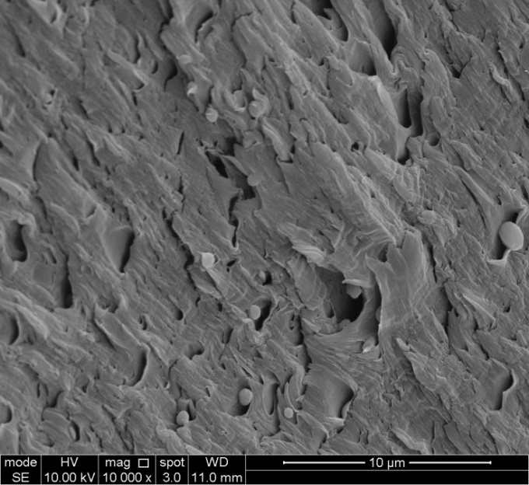
5 μm
5 μm
Nylon 6 CA 2 (N₂) Nylon 6 CA 2 (Fracture)
Figure 3.20. SEM images of twice-extruded nylon 6 and its nanocomposites.

From Figure 3.20, the surface broken by liquid nitrogen was much smoother than that of the tensile samples because under low temperature nylon 6 chains were very brittle and the original surface topography was preserved. While for the tensile samples, under tensile stress, polymer chains moved and disentangled, and finally formed microfibrils at the end of tensile test by strain hardening. For the samples that might containing CA, there were some voids on the fracture surface of tensile test. And for Nylon 6 MC 2 and Nylon 6 CA 2, there were many small particles embedded in those holes. After submerged in water, those particles disappeared, indicating they are CA particles, so it confirmed the previous assumptions made by FTIR, TGA and tensile tests that there were some CA particles unreacted in the nanocomposites.


Nylon 6 3 (N₂) Nylon 6 3 (Fracture)

Nylon 6 CA 3 (N₂) Nylon 6 CA 3 (Fracture)

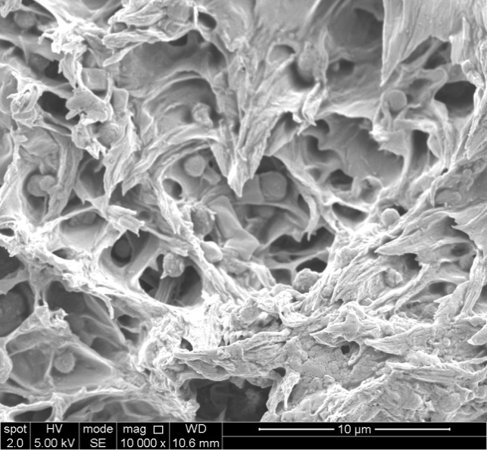

Nylon 6 MMT 3 (N₂) Nylon 6 MMT 3 (Fracture)

Nylon 6 Cloisite 30B 3 (N₂) Nylon 6 Cloisite 30B 3 (Fracture)

Nylon 6 Atlas MMT 3 (N₂) Nylon 6 Atlas MMT 3 (Fracture)

Nylon 6 Atlas MMT CA 3 (N₂) Nylon 6 Atlas MMT CA 3 (Fracture)
Figure 3.21. SEM images of triple-extruded nylon 6 and its nanocomposites.

As can be seen from Figure 3.21, apart from Nylon 6 3, the other samples all contain citric acid particles. For Nylon 6 MMT 3, Nylon 6 Cloisite 30B 3, Nylon 6 Atlas MMT 3 and Nylon 6 Atlas MMT CA 3, high densities of CA was observed. Especially for Nylon 6 Cloisite 30B 3, densely distributed CA particles contributed to the embrittlement and the decline of stiffness.

3.4. Summary
As summarised in Table 3.13, citric acid, serving as chemical blowing agent, was introduced to improve the dispersion and properties of the nylon 6/clay nanocomposites by different routes. And a thermal stable polymeric surfactant, Atlas MMT, was used in order to achieve enhanced the mechanical and thermal properties. By XRD, it was shown the surfactant molecules did have enlarged interlayer spacing of MMT. The clay content was not the same as designed. This problem could be solved by feeding the clays through the top hopper of the extruder. There were CA residues in most of the samples, indicating the incomplete decomposition of CA. Therefore the chemical blowing agents with lower degradation temperature and without solid remains, such as ammonium bicarbonate, might be able to achieve better results. Clays did not enhance the thermal stability of nylon 6 matrix.
Table 3.13. Summary of the nylon 6/clay nanocomposites in the 3rd Chapter.
Materials | Processing strategy | Clay filler | TGA remain / wt % | Change on the properties in respect to the extruded Nylon 6
 |  |  |  | Young’s modulus | Tensile strength | Strain at break | Toughness | Thermal stability
Nylon 6 MMT 2 | twice extrusion | MMT | 2.1 | - | similar | - 15% | similar | - 9 ºC for TGA degradation onset
Nylon 6 OMMT 2 | twice extrusion | Hexadecyltrimethylammonium-treated MMT | 1.7 | - | similar | - 30% | similar | - 6 ºC for TGA degradation onset
Nylon 6 MCS 2 | twice extrusion | Hexadecyltrimethylammonium, CA, MMT mixed at the same time | 1.3 | - | similar | - 50% | - 43% | - 10 ºC for TGA degradation onset
Nylon 6 MC 2 | twice extrusion | Centrifuged, CA-treated MMT | 2.0 | - | similar | - 78% | - 75% | similar
Nylon 6 OC 2 | twice extrusion | CA-treated OMMT | 3.3 | - | similar | - 48% | - 30% | similar
Nylon 6 MMT 3 | triple extrusion | MMT | 5.7 | + 43% | similar | - 85% | - 86% | similar
Nylon 6 Cloisite 30B 3 | triple extrusion | Commercial organoclay | 5.4 | + 20% | - 24% | - 91% | - 95% | similar
Nylon 6 Atlas MMT 3 | triple extrusion | Atlas surfactant-treated MMT | 7.0 | + 89% | similar | - 52% | - 56% | similar
Nylon 6 Atlas MMT CA 3 | triple extrusion | Atlas MMT and CA mixture | 5.1 | + 14% | - 15% | - 91% | - 93% | - 13 ºC for TGA degradation onset

As for the twice-extruded nylon 6 and its nanocomposites, apart from MMT, the other clays succeeded in forming well-exfoliated structure. From FTIR and TGA, it was clear that the intercalation of citric acid molecules did occur and had the chance to be retained, but for most treated clays, the intercalated citric acid molecules were removed with those outside the galleries during washing. When it came to tensile test, the incorporation of clays reduced elongation at break by 15%~78%. Without side feeder, the hand-mixed polymer and clays did not seem to be a good idea. There was possible degrading effect of CA on the nylon 6 matrix.

In terms of the triple-extruded nylon 6 and its nanocomposites, it was learnt from Nylon 6 Atlas MMT 3 that the incorporation of a novel Atlas surfactant increased T_{50% weight loss}. As for the tensile properties, the toughness of all the nylon 6/clay nanocomposites reduced by 56%~93% comparing to that of Nylon 6 3. Nylon 6 Atlas MMT 3 displayed the highest toughness among the nylon 6 clay nanocomposites. The incorporation of clays tended to increase the Young’s modulus by 14%~89%, but decrease the strain at break by 52%~91%. During the process of extrusion, polymer matrix degraded. There was large amount of residual CA molecules and/or the solid residues from the thermal decomposition of CA, even after multiple times of extrusion and purging. The incorporation of CA tended to reduce thermal stability, Young’s modulus, tensile strength and elongation at break. The degradation of polymer matrix, solid remains of CA and the limitations of the extruder were considered as the main reasons for the mechanical and thermal behaviours of the derived materials.

In short, several conclusions can be made that:
- CA is not a useful chemical blowing agent in nylon 6/clay nanocomposites.
- The clay content is inaccurate as the designed value by either twice or triple extrusion with the hand-mixed nylon 6 pellets and clay powders.
- Nylon 6 materials used in this chapter are prone to thermal oxidation and thermal degradation.
- The incorporation of clay fillers tends to enhance the Young’s modulus but reduce the strain at break of the nylon 6 matrix.

Chapter 4: Polymer/clay nanocomposite hydrogels with interesting mechanical properties and stimuli-responsive properties

4.1. Introduction
Hydrogels are a class of polymeric, hydrophilic materials which are able to absorb and keep water in their crosslinked network (Kabiri et al., 2011). They can be used as agricultural products (Saxena, 2010), food ingredients (Chen et al., 1995) and biomaterials such as tissue scaffolds (Frydrych et al., 2015; Zhang et al., 2011), drug delivery systems (Hoare & Kohane, 2008), wound dressings (Sirousazar et al., 2012) and biosensors (Li et al., 2015). However, conventional chemically crosslinked hydrogels are often weak and/or brittle, which limits hydrogels from wider applications (Gong et al., 2003; Haque, Kurokawa, Kamita, & Gong, 2011; Huang et al., 2007).

To overcome this shortcoming, polymer-clay nanocomposite hydrogels have attracted much attention in the last decade for synthesizing tough hydrogels because highly functionalized clay can form physical, reversible and dense crosslinks which are effective on dissipating energy (Huang et al., 2007; Sun et al., 2012) and stabilizing the integrity of the network (Haraguchi & Takehisa, 2002; Wang et al., 2010; Zhao, 2014). Haraguchi et al. (Haraguchi, 2007; Haraguchi & Takehisa, 2002; Haraguchi et al., 2002; Zhao, 2014) developed a series of poly(N-isopropyl acrylamide)-synthetic hectorite nanocomposite hydrogels, synthesized by in situ polymerization of N-isopropyl acrylamide in the presence of synthetic hectorite which was initiated by potassium persulfate and catalysed by N,N,N',N'-tetramethylethylenediamine. Unlike conventional chemically crosslinked hydrogels (polyacrylamide or polyisopropylacrylamide crosslinked by N,N'-Methylenebisacrylamide), these nanocomposite hydrogels could reach a tensile strength of 109 kPa and a strain at break over 800% (Haraguchi & Takehisa, 2002; Haraguchi et al., 2002). The ionic interaction between initiator molecules and clay surface was essential to hydrogel formation, which enables multiple polymer macromolecules to grow on clay surface (Haraguchi et al., 2005). Polyacrylamide (PAM) was frequently used to synthesize nanocomposite hydrogels because of its superb hydrophilicity, stability, flexibility and simplicity in synthesis (Ahmed, 2015). Montmorillonite (MMT), with the ideal chemical formula of Al₂Si₄O₁₀(OH)₂.yH₂O (Alexandre & Dubois, 2000), was usually used as a complementary physical crosslinker of chemically crosslinked PAM hydrogels (Ferfera-Harrar et al., 2014; Gao, Heimann, Williams, Wardhaugh, & Muhammad, 1999; Guilherme et al., 2010; Mahdavinia, Hasanpour, Rahmani, Karami, & Etemadi, 2013). Ultrastretchable, self-healable and tough PAM-MMT physically crosslinked hydrogels were synthesized (Gao et al., 2015), which presented an extremely high strain at break of 12000%. After being stretched to a strain of 2000%, a residual strain of 500% and a high hysteresis were observed after one minute, and a full shape recovery required 5 days’ storage at 25 ºC (Gao et al., 2015). It is considered difficult to achieve low hysteresis with physically crosslinked PAM-clay hydrogels because of temporary or even permanent breaking of some organic-inorganic crosslinks (Nakajima et al., 2013; Zhao, 2014).

Clay, as a class of multi-functional physical crosslinkers, has been studied for a decade in the area of PAM nanocomposite hydrogels. Montmorillonite (MMT) is the mostly used smectite clay for mostly solid and dry polymer nanocomposites by intercalation and/or exfoliation (Alexandre & Dubois, 2000; Chen et al., 2008). MMT was also used as a reinforcement and a complementary physical crosslinker of PAM chemically crosslinked hydrogels (Guilherme et al., 2010). Until recently, ultrastretchable, self-healable and tough PAM-montmorillonite hydrogels were synthesised (Gao et al., 2015). An incredibly high strain at break of 12000% was obtained by a MMT content of 5 wt %. However, as for cyclic tests to a maximum strain of 2000%, a residual strain of 500% was observed in the first cycle. This was attributed to the detached polymer chains from the clay platelets. A full shape recovery could only be achieved after 5 days’ storage at 25ºC. However, tensile tests of the fully swollen hydrogels haven’t been studied for PAM-clay nanocomposite hydrogels. From the previous studies, they could be too weak to be tensile tested (Gao et al., 2015; Haraguchi et al., 2002; Sun et al., 2012).

High hysteresis often means reduced mechanical properties of hydrogels after being cyclically loaded, so attempts were made to overcome hysteresis of hydrogels including well designed hydrogels composed of copolymerized tetra-armed monomers (Nakajima et al., 2013; Zhao, 2014) and physically crosslinked PAM-synthetic hectorite nanocomposite hydrogels (Zhu et al., 2006). In the latter (with a starting weight ratio of 1:1 for the monomer:clay), a hysteresis of 19% in the first cyclic testing to a 1000% strain and a reduced hysteresis of 9% in later cycles were found (Zhu et al., 2006). According to the authors, the high crosslinking density and hydrophilic, flexible nature of PAM gave rise to a small internal friction force and thus low hysteresis. These promising results indicate that it may be possible to achieve low hysteresis by PAM-MMT nanocomposite hydrogels.

Another popular way of making tough hydrogels is to synthesise double-network (DN) systems, which often combine the rigid highly crosslinked polyelectrolytes and the ductile loosely crosslinked neutral polymers (Gong, 2010; Gong et al., 2003; Huang et al., 2007). This unique structure gave rise to high mechanical strength and toughness of DN hydrogels (Gong, 2010). However, one of the main limitations for DN hydrogels was that the first-cycle tensile hysteresis was large and increased significantly with increasing strain. They could hardly fully recover after a large deformation because some of the chemical bonds broke during deformation (Webber, Creton, Brown, & Gong, 2007).

Polysaccharides are carbohydrate polymers which consist of monosaccharide units linked together by glycosidic bonds. Polysaccharides, such like chitosan and alginate, are often used for making interpenetrating network hydrogels with acrylic monomers like acrylamide because their good solubility in water, good mechanical properties, stimuli-responsibility, biocompatibility and biodegradability (George & Abraham, 2006; Ju et al., 2001; Mahdavinia, Pourjavadi, Hosseinzadeh, & Zohuriaan, 2004).

Chitosan (CHI) is a biopolymer produced from chitin, which is rich in the crustacean and mollusk shells (Rinaudo, 2006). Due to its excellent biocompatibility and biodegradability, chitosan is widely used in the realm of biomedicine (Busilacchi et al., 2013; Kumar et al., 2004; Rao & Sharma, 1997). It is positively charged in the acidic environment, which has potential of strongly bonding to the negatively charged MMT surface (Ali & Bandyopadhyay, 2015; Chen, 2004; Chen et al., 2008) by electrostatic interactions (Shchipunov et al., 2009; Wang et al., 2014). Polyacrylamide was proved to be able to be grafted onto the chitosan backbone (Al-Karawi, Al-Qaisi, Abdullah, Al-Mokaram, & Al-Heetimi, 2011). During graft polymerization, the radical initiator, potassium persulfate (KPS), was expected to attack the hydroxyl groups of the polysaccharide chains to generate alkoxy radicals, which will also initiate the polymerization of acrylamide (AM) (Yazdani-Pedram et al., 2002). A chitosan grafted PAM-MMT hydrogel was recently synthesized by grafting polymerization of AM onto the chitosan backbone at 60 ºC in the presence of MMT platelets and a chemical crosslinker N,N'-methylenebisacrylamide (Ferfera-Harrar et al., 2014). However, the mechanical properties of the hydrogels were not reported.

Alginate, a copolymer consisting of mannuronic acid (M unit) and guluronic acid (G unit), is widely used for making hydrogels, because of its biocompatibility (Baumberger & Ronsin, 2010; Kong et al., 2003; Zhao et al., 2010) and biodegradability. They are widely used in the areas of food packaging (Abdollahi et al., 2013), drug delivery (Tonnesen & Karlsen, 2002) and enzyme carriers (Gorenek et al., 2004) because of the excellent biocompatibility (Baumberger & Ronsin, 2010; Kong et al., 2003; Zhao et al., 2010) and biodegradability (Kim et al., 2011; Schaumann & Weide, 1990). Alginate can be degraded under mild conditions by different methods such as alginate lyase enzyme (Kim et al., 2011) and marine fungi (Schaumann & Weide, 1990). G blocks from different alginate polymer chains are often known as able to be easily crosslinked through the ionic bonding by the multivalent cations such as calcium cation (Ca²⁺) (George & Abraham, 2006). During the past several years, it has been discovered that polyacrylamide (PAM)/calcium (Ca)-crosslinked alginate (A) double-network hydrogels (denoted as PACa) are prone to achieve high toughness (Darnell et al., 2013; Sun et al., 2012). Typically, PAM was in situ polymerised in the aqueous environment and crosslinked by a chemical crosslinker, N,N’-methylenebisacrylamide (MBA), while by exchanging the sodium cations with divalent Ca²⁺, alginate was ionically crosslinked. As a result, alginate polymer chains and PAM polymer chains will interpenetrate each other, forming a double network. In a recent research (Sun et al., 2012), PACa with a water content of 86 wt% displayed an impressively high tensile strength up to 160 kPa, which was nearly 10 times higher than that of conventional chemically crosslinked PAM hydrogel. Besides, PACa could reach a large strain at break of 20 and a fracture energy of 9000 J m⁻². The extraordinary toughening phenomenon of PACa was attributed to the energy absorption by Ca²⁺ crosslinked alginate and the ductility of covalently crosslinked PAM (Henderson, Zhou, Otim, & Shull, 2010; Sun et al., 2012).

In another research (Yang et al., 2013), the effect of different cations on crosslinking alginate in PACa was studied. It was found that trivalent cations (Fe³⁺, Al³⁺) resulted in higher strength than divalent cations (Ca²⁺, Ba²⁺) due to their denser bonding with alginate (Al-Musa et al., 1999). Apart from mechanical properties, alginate based hydrogels were also frequently reported as pH-sensitive (Abd El-Ghaffar, Hashem, El-Awady, & Rabie, 2012; Hua, Ma, Li, Yang, & Wang, 2010; Ju et al., 2001; Obara et al., 2010). The Ca-alginate hydrogels tended to shrink in the acidic solution and swell in the basic solution. Like most of DN hydrogels, there were limitations for the performance of PACa. They couldn’t fully recover after a large deformation because of the partial breakage of the chemical crosslinks (Gong, 2010; Sun et al., 2012; Yang et al., 2013).

Nacre-mimetics paved a promising way for synthesising PCNs with high amounts of clay (Mayer, 2005). By the ordered alignment of the organic and inorganic building blocks, ultimately high Young’s modulus and tensile strength could be achieved (Fratzl et al., 2007; Meyers et al., 2008). There were many methods for synthesising nacre-mimetics, such as layer-by-layer assembly (Tang, Kotov, Magonov, & Ozturk, 2003), vacuum filtration (Yao et al., 2010) and solution casting induced self-assembly (Kochumalayil et al., 2012). Montmorillonite (MMT), as a nice inorganic filler with the sheet thickness of 1 nm (Das et al., 2015), has been utilised for making nacre-mimic nanocomposite materials with many polymers such as polyvinyl alcohol (Allison et al., 2015) and chitosan (Yao et al., 2010) by solvent evaporation induced self-assembly method. The resultant materials displayed the unique ordered microstructure and excellent mechanical properties compared to the conventional PCNs. As for chitosan-MMT nanocomposite films, with a high MMT content of 76% wt%, a Young’s modulus of 10.7 GPa, a tensile strength of 76 MPa and a low strain at break of 0.0097 were received.

Despite those advantages of alginate hydrogels mentioned before, poor mechanical and gas barrier properties, and low strength and stability in water, limit their application in the aquatic environment (Rhim, 2004). In order to overcome those drawbacks, alginate MMT nanocomposites were developed. It was reported previously that based on the Velcro effect, the tetrahedral SiO₄ geometry of MMT platelets is likely to form dense hydrogen bonding networks with many hydrophilic polymers such as polyvinyl alcohol, chitosan and alginate (Podsiadlo et al., 2007; Wang, Cheng, Lin, Chen, & Jiang, 2013; Wang, Cheng, Lin, & Jiang, 2014). Alginate is known to be able to form dense hydrogen bonds with MMT platelets because it is rich in oxygen containing functional groups such as −OH, −COO, and –O– (Bhattarai et al., 2006; Chen et al., 2015; Sa & Kornev, 2011). Alginate MMT nanocomposite films with the MMT weight percentage below 5% were reported recently (Abdollahi et al., 2013; Alboofetileh, Rezaei, Hosseini, & Abdollahi, 2013). The enhanced tensile strength and reduced UV transmittance were received at the dehydrated state. However, they were unstable in water. They could be easily dissolved in water because of the high hydrophilicity of alginate and MMT(Abdollahi et al., 2013). When alginate-MMT films were submerged in CaCl₂ solution, G-blocks of alginate were crosslinked by Ca²⁺ after solution casting (Vale et al., 2005). A low MMT content of 3 wt % was applied and the barrier property was found to be significantly improved. However, the mechanical properties were not reported.

In 2015, alginate MMT nanocomposites with high clay content were investigated (Zlopasa, Norder, Koenders, & Picken, 2015). By the solution evaporation induced self-assembly method, highly ordered microstructure was obtained by a MMT weight content as high as 50%. It was suggested that the unique nacre-mimicking structure was achieved by the specific interaction between negatively charged alginate chains and positively charged MMT platelet edges which restricted the movement of MMT platelets during solution casting. In 2016, nacre-like alginate/MMT/Ca²⁺ nanocomposite films were synthesised from the Ca²⁺ pre-crosslinked alginate/MMT turbidity by vacuum-assisted filtration method (Liang et al., 2016). The dry alginate/MMT/Ca²⁺ nanocomposite films could achieve a high tensile strength of 280 MPa and a high toughness of 7.2 MJ m⁻³, over 1.5 times of those of alginate/MMT nanocomposite films without Ca²⁺. Besides, dry alginate/MMT/Ca²⁺ nanocomposite films also showed a remarkable tensile strength of 170 MPa at 100 ºC. Furthermore, excellent fire retardant properties and shape response to alcohols might broaden the applications of those nanocomposite films as constructive materials, insulators and flame retardant cover. However, the mechanical properties of the samples fully swollen in water were not reported.

This work aimed to develop polymer-clay nanocomposite hydrogels with high mechanical performances such as high extensibility, excellent resilience, low hysteresis, and/or stimuli-responsibility such as the sensitivity to pH, UV or organic solvent. The previous work on PAM-clay nanocomposites (Gao et al., 2015; Haraguchi & Takehisa, 2002; Zhu et al., 2006) based on in situ polymersation in the presence of clay platelets, potassium persulfate (KPS) initiator and catalyst (N,N'-Methylenebisacrylamide) at ambient temperature for several days. However, in this chapter, in situ polymerisation of acrylamide, initiated by potassium persulfate (KPS) in the presence of MMT and/or polysaccharides conducted at a higher temperature of 60~80 ºC without a catalyst, instead of room temperature with a catalyst. PAM network structure synthesized at different temperature is significantly different (Fanood, 1998). In this study, no chemical crosslinker was used. PAM/MMT/chitosan nanocomposite hydrogel (PM 5 CHI), PAM/MMT/alginate/Ca²⁺ nanocomposite hydrogel (PMACa) and alginate/MMT/Ca²⁺ nanocomposite films (AlgMMTCa) were made and studied. For PM 5 CHI, it is favoured to graft acrylamide onto chitosan at a temperature of 60 ºC (Al-Karawi, Al-Qaisi, Abdullah, Al-Mokaram, & Al-Heetimi, 2011). PMACa was an interpenetrating hydrogel made of PAM, alginate, MMT and CaCl₂. The reasons for using those materials were: PAM was highly hydrophilic and easy to be polymerised for nanocomposite hydrogels; MMT was abundant, highly hydrophilic and easy be dispersed in water (Gao et al., 2015); alginate can be easily crosslinked by Ca²⁺ and the Ca²⁺-alginate hydrogel was easy to form, non-toxic, stable in water and compatible to PAM network (Sun et al., 2012). The primary network was formed by in situ free-radical polymerisation of acrylamide in the presence of MMT platelets and alginate at high temperature and the second network was formed by Ca²⁺-crosslinked alginate chains. And the mechanical properties of those nanocomposite hydrogels such as Young’s modulus, tensile strength, strain at break, hysteresis ratio and rheological properties were investigated by tensile, cyclic tensile and rheological tests. For AlgMMTCa nanocomposite films, high MMT contents (≥ 20%) were used and the mechanical and stimuli-sensitivity properties of the nanocomposite films were investigated. The usage of high amount of MMT (≥ 20 wt %) was expected to achieve excellent mechanical properties. The usage of Ca²⁺ in order to prevent the nanocomposite films from being dissolved by water and further improve the mechanical properties, without compromising the optical transparency. The results were interpreted in depth with the employment of the findings from Fourier transform infared spectroscopy (FTIR), scanning electron microscopy (SEM) and in vitro degradation tests. The mechanical properties of the as-prepared and/or fully swollen nanocomposite hydrogels were also investigated, which are often overlooked in the literature. To demonstrate the manufacturing versatility of PM 5 CHI hydrogel, various shapes of hydrogels were prepared, together with hydrogel microfibers. The pH-sensitivity of PMACa was also investigated by studying the swelling/de-swelling behaviour in media of different pH. The optical properties of AlgMMTCa films were investigated by ultraviolet–visible spectroscopy. The sensitivity to methanol and acetone of AlgMMTCa films were also studied.

4.2. Experimental

4.2.1. Materials
Acrylamide (AM) serving as monomer, and potassium persulfate (KPS) serving as initiator with an assay level ≥ 99.0%, acetic acid with a trade name of TraceSELECT® Ultra (purity ≥ 99.0%), calcium chloride anhydrous (purity ≥ 93%) serving as ionic crosslinker, hydrochloric acid (HCl, 37%), sodium alginate (purity ≥ 99.0%) from brown algae, N,N,N',N'-tetramethylethylenediamine serving as catalyst (TEMED, purity ≥ 99.0%), phosphate buffer saline (PBS) tablets and lysozyme lyophilized powder with protein content ≥ 90 % (≥ 40,000 units per mg) were purchased from Sigma Aldrich. MMT with a cation exchange capability of 90 meq (100 g)⁻¹, serving as physical crosslinker, was supplied by Southern Clay Products. Chitosan with an average molecular weight from 100,000 to 300,000 was provided by Acros Organics. Sodium hydroxide (NaOH) (assay ≥ 98.9%) was purchased from VWR International. Methanol (assay ≥ 99.8%) and acetone (assay ≥ 99%) were provided by Fisher Scientific. All chemicals were used as received.

4.2.2. Preparation of hydrogels
Following the same method of the last chapter, 15 g MMT was dispersed in 1000 ml distilled water for 24 hours on a table roller, followed by a 30 mins’ sonication using a probe sonicator with a frequency of 5 Hz and another 24 hours’ standstill settling in order to eliminate the un-exfoliated clay platelets and impurities. The precipitate was dried and weighed and the exfoliated MMT left in the supernatant was collected and its concentration in water was determined to be 0.012 g L⁻¹.

The typical process of preparing PAM/CHI MMT hydrogels, denoted as PM 5 CHI, is described below, which was inspired by the methods of Gao et al. (Gao et al., 2015) and Ferfera et al. (Ferfera-Harrar et al., 2014) for the synthesis of PAM-MMT nanocomposite hydrogels and a chitosan grafted PAM-MMT hydrogel, respectively. 21.5 ml of the above MMT water suspension (containing 0.25 g MMT) was measured and sonicated for 10 minutes, to which 0.2 ml acetic acid and 0.044 g chitosan were added. After 4 hours of stirring under 300 rpm, the suspension was sonicated for 10 minutes. Then the KPS solution (0.078 g in 3.44 ml distilled water) was added into the CHI-MMT suspension under vigorous stirring for 10 minutes. The mixture was heated at 60 ºC in a water bath for 10 minutes in order to generate free radicals. After the mixture was cooled to ambient temperature, 5 g AM was added, followed by 1 hour’s stirring. Finally, the reaction mixture was transferred into plastic tubes and sealed. Polymerization was continued in a water bath at 60 ºC for 24 hours. The preparation of PAM MMT hydrogels, denoted as PM 5, followed the same protocol as above, except that chitosan was not used. The weight ratios of MMT:AM and AM:H₂O were fixed at 0.05 and 0.2, respectively (Gao et al., 2015). The preparation of PAM/MMT/starch and PAM/MMT/k-carrageenan hydrogels, denoted as PM 5 S and PM 5 K, followed the same protocol as that of PM 5 CHI. The weight ratios of starch or k-carrageenan to MMT were the same as the weight ratio of chitosan to MMT.

PM 5 CHI hydrogel fibres were fabricated, via the precursor route, using pressurized gyration. This work was carried out by Professor Mohan Edirisinghe's group at University College London. In this method centrifugal force and solution blowing were coupled to extrude the precursor fibres, following the procedure established in our previous work (Mahalingam & Edirisinghe, 2013). The hydrogel precursor material was prepared by mixing water, MMT, chitosan, initiator and monomer using the same method and at the same ratio as for preparing the PM 5 CHI hydrogel, before being sealed in plastic tubes. It had been kept at ambient temperature for approximately 3 hours before being stored in a fridge until use. Approximately 1 ml of the precursor material was dissolved in 10 ml of deionised water under magnetic stirring for 10 minutes at ambient temperature. Thereafter, the solution was transferred to the gyration vessel and spun at 36,000 rpm rotating speed and 0.1 MPa working pressure. SEM of the resultant fibres was performed using a JSM-6301F SEM. The micrographs were recorded at an operating voltage of 20 kV and an emission current 6 μA to obtain high resolution pictures.

AM was also polymerized in water with the presence of chitosan but without MMT, denoted as PAM CHI, and in the absence of both CHI and MMT, denoted as PAM. In addition, PAM MMT nanocomposite hydrogels were prepared following Gao et al’s method (Gao et al., 2015) at 25 ºC with N,N,N',N'-tetramethylethylenediamine as the catalyst, denoted as PM 5 cata. These materials were prepared as control samples for comparison.

The typical synthetic routine of PMACa hydrogel was as follows. 0.25 g MMT (21.5 ml) suspension was ultrasonicated for 30 mins. 0.801 g of Na Alginate was added into MMT suspension by stirring for 3 hours. Then 4.827 g of AM monomer was added and stirred for another 22 hours. Finally, 0.075 g KPS initiator in 3.44 ml water was added and stirred for 30 mins. The precursor solution was transferred into plastic tubes and submerged in a water bath at 60 ºC. Reaction temperature for in situ polymerisation was increased from 60 ºC to 80 ºC within 1 hour and then held at 80 ºC for 1 hour. After finishing the reaction, the as-prepared hydrogels were washed and submerged in 0.3 M CaCl₂ solution allowing 2 days’ absorption for crosslinking. Then the surface of the fully swollen hydrogels was washed by distilled water for 3 times. The clay content and the overall solid content in all the as-prepared hydrogels were fixed at 0.008 and 0.238, respectively (Gao et al., 2015; Sun et al., 2012). The weight ratio of Al/AM was set to be 1/6, which was believed as the best ratio for PAM Al hydrogels (Darnell et al., 2013; Sun et al., 2012). The as-prepared hydrogels were also submerged in distilled water for 2 days (denoted as PMAW) for comparison.

In comparison to PMACa, PAM/MMT nanocomposite hydrogels were also synthesised. Typically, 0.25 g MMT suspension (21.5 ml) was ultrasonicated for 30 mins at first. 5.615 g AM was added under stirring for 22 hours. Afterwards, KPS solution (0.087 g KPS in 3.44 ml water) was then added and stirred for 30 mins. Reaction started from 60 ºC rising to 80 ºC for 1 hour, held at 80 ºC for 1 hour. Similarly, samples were washed and submerged in 0.3 M CaCl₂ solution (PMCa) or water (PMW) allowing 2 days’ absorption. Then the surface of the fully swollen hydrogels was washed by distilled water for 3 times. The clay content and the overall solid content in all the as-prepared hydrogels were fixed at 0.008 and 0.238, respectively. PAM was in situ polymerised following the same method without using MMT or post-swelling process, denoted as PAM80. Room-temperature polymerised polyacrylamide MMT nanocomposite hydrogel catalysed by N,N,N',N'-tetramethylethylenediamine (denoted as PM 5 cata) was synthesised by the method stated in a published paper (Gao et al., 2015).

Alginate and its nancomposite films were synthesised by the process discussed below. The predetermined amount of MMT suspension was diluted using distilled water to reach a MMT content of 1 wt%. The predetermined amount of sodium alginate was well dissolved in distilled water to make a solution with an SA content of 1 wt% by stirring for 3 hours at ambient temperature. Then MMT suspension was added to alginate solution drop by drop under vigorous stirring, which was further stirred for 24 hours to achieve homogeneous dispersion. Afterward, the SA/MMT suspension was poured into polystyrene petri dishes and allowed to dry in the oven at 40 ºC. Finally, the as-prepared SA/MMT nanocomposite films were peeled off from the petri dished after the weight stayed constant. The weight ratios of SA/MMT were varied to be 8:2, 7:3 and 1:1 and the as-prepared SA/MMT nanocomposite films were denoted as AlgMMT82, AlgMMT73 and AlgMMT11, respectively. SA films were also prepared for comparison by the same method without using MMT suspension, denoted as Alg.

Alginate/MMT/Ca²⁺ nanocomposite films (AlgMMTCa) were prepared by submerging the as-prepared AlgMMT films in a 0.3 M CaCl₂ solution for 24 hours, denoted as AlgMMTCa82, AlgMMTCa73 and AlgMMTCa11, respectively. All the AlgMMTCa films were rinsed in distilled water for another 24 hours to remove excess Ca²⁺. AlgMMTCa films were either kept in distilled water or dried for the future tests. For comparison, Alg films were submerged in CaCl₂ solution and then rinsed by distilled water to make Ca²⁺-alginate hydrogel films, denoted as AlgCa. Some of AlgMMTCa and AlgCa were dried, denoted as DAlgMMTCa and DAlgCa.

4.2.3. Characterisation
The tensile tests of PAM/MMT/chitosan nanocomposite hydrogels and PAM/MMT/alginate/Ca²⁺ nanocomposite hydrogels were conducted on a Hounsfield universal mechanical testing machine using a 10 N load cell and a crosshead speed of 100 mm min⁻¹. The test samples were rod-like with 15 mm full length and 5 mm gauge length. For each material, 20 samples were tested. For cyclic tensile tests, each sample was subject to 8-cycle tension. Different maximum strains of 50%, 300% and 500% were studied. Five samples were tested for each material. The hysteresis ratio h for a certain cycle was calculated by the equation: h = 1-(A₂)/(A₁), where A₁ and A₂ represent the areas beneath the tensile stress-strain curve and the return curve, respectively (Kinloch, 1983). For the shape-recovery tests of PMACa, the sample experienced one tensile cycle to a strain of 300%, then the tensile load was removed and the samples were allowed to recover for 15 minutes. The recovered samples were then subject to a second tensile cycle to 300% and also allowed a 15 minutes’ recovery. The stress-strain curves of the subsequent cycles were achieved by repeating this procedure.

The tensile tests for AlgMMTCa nanocomposite films were also conducted on a Hounsfield mechanical test equipment LTD but the sample dimensions were based on ISO 527 and (Bourbon et al., 2011; Wu, Farnood, O’Kelly, & Chen, 2014). The test samples were cut into dog bone shape with a gauge length of 25 mm and a width of 3.5 mm by an ISO 2075 standard test sample cutter. The thickness of the test samples was measured by a digital calliper with the resolution of 0.01 mm. A 10 N load cell was used and the crosshead speed was set to be 5 mm/min. At least 5 samples were tested for each material.

Fourier transform infrared spectroscopy was conducted on a Spectrum 100 spectrophotometer (PerkinElmer) in the wavenumber region from 4000 to 600 cm⁻¹ with a resolution of 1 cm⁻¹ using the hydrogels dehydrated in a vacuum oven at 50 ºC overnight. The samples were grinded into powders, put on a diamond ATR sensor and compressed. Before each test, a background scan was run first. Each sample was scanned for 8 times.

In vitro degradation tests for PM 5 and PM 5 CHI were carried out following the method described in the literature (Freier et al., 2005; Tomihata & Ikada, 1997). Briefly, the cylindrical hydrogel rods with a thickness of 5 mm were immersed in PBS solution (pH = 7.4) at 37 ºC containing lysozyme at a concentration of 1.5 μg ml⁻¹, simulating the internal environment of human body (Brouwer, Vanleeuwenherberts, & Ottingvanderuit, 1984; Porstmann et al., 1989). After a pre-determined period of time, samples were removed from the solution, washed with distilled water, dried in the vacuum oven at 40 ºC and weighed. The buffer solution was changed every 24 hours in order to maintain the activity of the enzyme. Five specimens of each material were tested.

Scanning electron microscopy was utilised to observe the morphology of the cross-sectional surface of the freeze-dried nanocomposite hydrogels with carbon coating. Samples were prepared by freeze-drying in a FreeZone Triad Cascade Benchtop Freeze Dry System, (Labconco Corporation) under vacuum at -15 ºC for 2 days. And then the cross-sectional area was created by submerging them in the liquid nitrogen and then broke them with tweezers. Samples were imaged using an Inspect F FEG SEM operated at a voltage of 5 kV. The characteristic elements of O, Si and Ca were detected by energy dispersive X-ray analysis (EDX).

Samples for swelling tests were freeze-dried. Swelling tests were conducted by immersing the freeze-dried samples in distilled water at 25 ºC for a period of time to reach the equilibrium state. The equilibrium swelling ratios φ were defined as φ = (W_{s} – W_{d})/W_{d} × 100%, where the weight of the fully swollen sample W_{s} and the weight of the initial freeze-dried sample W_{d} were determined using an analytical balance with an accuracy of 0.0001g.

Rheological tests were conducted on an AR2000 Advanced Rheometer (TA Instruments). At 25 ºC, the storage moduli G' and loss moduli G'' of the PM 5 and PM 5 CHI hydrogels were determined over an angular frequency range from 0.1 to 100 rad s⁻¹ under a fixed strain of 1%, which was in the linear viscoelastic region pre-determined by strain sweep tests. All tests were performed using a parallel plate geometry with a diameter of 20 mm along with a solvent trap to avoid evaporation. The gap between two parallel plates was 1.0 mm.

pH-sensitivity of PMACa was studied by submerging the dehydrated PMACa samples in HCl solution (pH = 1), distilled water (pH = 7) and NaOH solution (pH = 14), respectively. The three PMACa samples were cut off from the same cylindrical block with the same diameter and then dried in the oven at 50 ºC for 72 hours. Totally, three samples were tested. The weight and volume of the samples were measured by an analytical scale and a gas pycnometer (AccuPyc II 1340 FoamPyc V1.05) before and after swelling in different environments for two weeks in order to reach the equilibrium. The determination of the equilibrium swelling ratio φ_{ve} by volume was similar to φ, expressed as φ_{ve} = (V_{s} – V_{d})/V_{d} × 100%, where V_{s} and V_{d} represented the volumes of the fully swollen samples and the dried samples, respectively.

Ultraviolet-visible (UV-Vis) spectroscopy for AlgMMTCa nanocomposite films were conducted on a Perkin Elmer Lambda 900 spectrometer with a 1 nm resolution to measure the light transmittance of AlgMMTCa and AlgCa films in the range of 250~800 nm.

Solvent-responsivity tests of AlgMMTCa nanocomposite films were achieved by submerging flat AlgMMTCa films in methanol or acetone for 24 hours. The shape-change of the films was observed in an organic solvent. Then the solvent-treated films were put back to distilled water to see if they were able to recover to their original shape.

The calcium content in the AlgMMTCa nanocomposite films was tested by thermogravimetric analysis (TGA) using a Pyris 1 TGA instrument (PerkinElmer). The freeze-dried samples were tested under the protection of N₂ gas flow of 20 ml min⁻¹. The heating range was from 25 ºC~800 ºC and the heating rate was set to be 20 ºC min⁻¹. The calcium content of AlgCa and AlgMMTCa was calculated based on the weight remain values and the designed composition.

4.3. Results and discussion

4.3.1. Formation of nanocomposite hydrogels

Formation of the nanocomposite hydrogels by polyacrylamide, clay and chitosan
The synthesis of PM 5 and PM 5 CHI nanocomposite hydrogels is illustrated in Scheme 4.1. For PM 5, MMT was exfoliated in distilled water by means of table rolling and sonication. Then KPS initiator was added and thus absorbed onto the MMT platelets by ionic interaction shown in Scheme 4.4 (c) (Haraguchi & Takehisa, 2002). Finally, AM monomer was introduced, some of which was also absorbed onto the MMT platelets, and polymerized. For PM 5 CHI, MMT was first combined with chitosan by electrostatic interaction shown in Scheme 4.4 (d). Then some of KPS attacked the hydroxyl groups of chitosan chains to form radicals. Both chitosan radicals and KPS initiated the in situ polymerization of AM. PAM chain entanglement, PAM branches and PAM-MMT hydrogen bonding were expected in both hydrogels (Beuermann, Paquet, McMinn, & Hutchinson, 1996; Fanood, 1998; Plessis et al., 2001; Plessis et al., 2000), which is discussed subsequently.
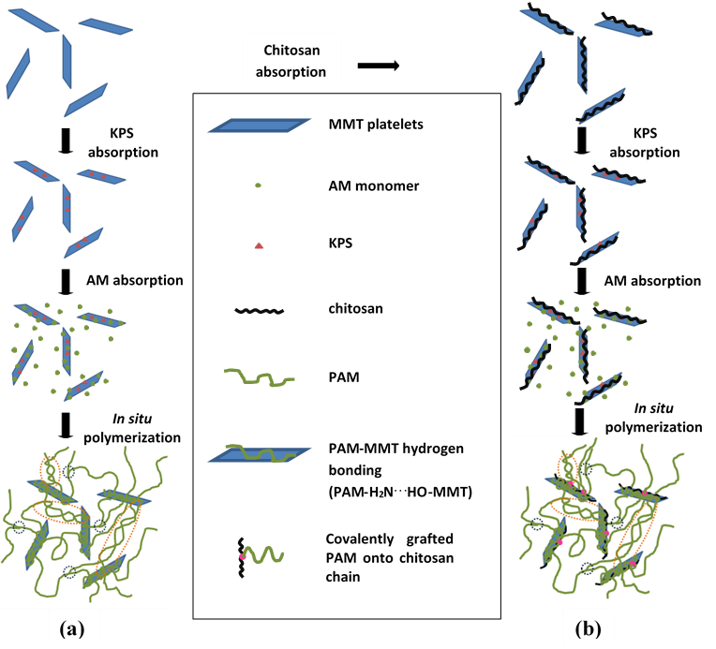

Scheme 4.1. Schematic illustration of the synthesis of (a) PM 5, and (b) PM 5 CHI. The brown and blue circles indicated PAM chain entanglement and PAM branching respectively. The pink dots in (b) represented the grafting points of AM onto chitosan chains.

Formation of the nanocomposite hydrogels by polyacrylamide, clay, alginate and calcium chloride
The novel PMACa hydrogel was synthesised by a two-step method by which AM was polymerised in the presence of MMT platelets partially covered by sodium alginate chains, and then immersed in a Ca²⁺ solution to reach the equilibrium. The unique chemical structure, fabrication versatility and extensibility of PMACa were depicted in Scheme 4.2.
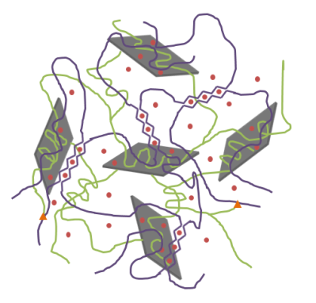
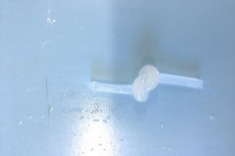
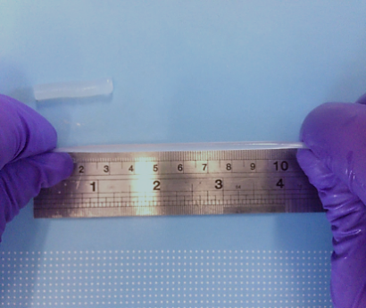
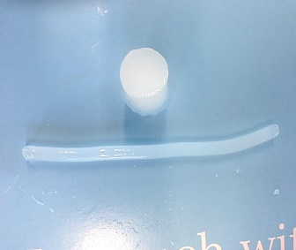
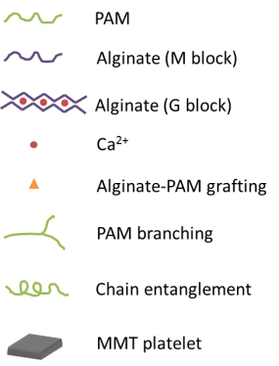
(a)
(c)
(d)
20 mm
(b)

Scheme 4.2. (a) Schematic illustration of the chemical structure of PMACa, (b) different shapes such as thin thread and thick cylindrical block of PMACa, (c) knotted PMACa, and (d) large extensibility of PMACa.

Formation of the nanocomposite films by clay, alginate and calcium chloride
As seen in Scheme 4.3, AlgMMTCa nanocomposite films were synthesised following mainly four steps. First, MMT suspension and alginate solution were mixed and stirred to achieve the fine SA-MMT adsorption and dispersion. Second, nacre-like AlgMMT films were fabricated by solution casting and SA-MMT hydrogen bonding helped to form layered structure (Zlopasa et al., 2015). Third, AlgMMT films were swollen in CaCl₂ solution and Ca²⁺ crosslinked alginate chains of AlgMMT to form AlgMMTCa. As a result, G blocks of alginate chains were crosslinked by divalent Ca²⁺ to form “egg-box” structure (George & Abraham, 2006; Liang et al., 2016). Some Ca²⁺ ions were adsorbed onto the surface of MMT platelets (Lahav & Banin, 1968; Rytwo, Banin, & Nir, 1996). At last, the excess Ca²⁺ ions were washed off by distilled water. The chemical structure of AlgMMTCa could be further depicted by FTIR as shown in Figure 4.3.
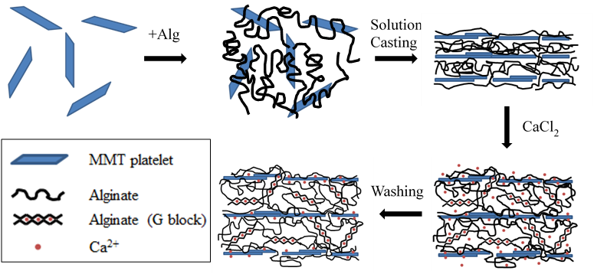

Scheme 4.3. Schematic illustration of the synthesis of AlgMMTCa.

Structural analysis of the nanocomposite hydrogels formed by polyacrylamide, clay and chitosan
Figure 4.1. FTIR spectra of PM 5, PM 5 CHI, PM 5 S and PM 5 K nanocomposite hydrogels as well as their control samples, PAM, PAM CHI and PM 5 cata.

To confirm the above postulation, FTIR was performed to investigate the chemical structure and the intermolecular interactions of the PM 5 and PM 5 CHI nanocomposite hydrogels in comparison with their control samples (Figure 4.1). There were peaks at 2852 cm⁻¹ and 2928 cm⁻¹. The former was characteristic of tertiary CH and secondary CH₂, while the latter was characteristic of primary CH₃ for all samples (Yu & Ding, 2008; Zhang et al., 2012). By comparing the relative intensity of CH and CH₂ to CH₃, it was found that the relative intensity values for PM 5 and PM 5 CHI were lower than that of PM 5 cata. Considering that CH₂ was stable during polymerization (Fanood, 1998; Gleason, Miller, & Sheats, 1959), this result implied that the amount of tertiary CH bonds reduced, confirming the chain transfer reaction and branching proposed by others for PAM (Gough, Zelinski, Wiens, Rak, & Dixon, 2003). During PAM polymerization, chain transfer reaction is rare when the polymerization temperature is below 50 ºC, but cannot be ignored at a temperature above 50 ºC which leads to a branched PAM (Beuermann et al., 1996; Fanood, 1998; Plessis et al., 2001; Plessis et al., 2000). As shown in Scheme 4.4 (a), when the hydrogen atoms from the tertiary CH are eliminated under the attack of free radicals, the polymer radicals will be formed, onto which chain propagation will lead to branches (Beuermann et al., 1996; Fanood, 1998; Gleason et al., 1959; Peck & Hutchinson, 2004; Plessis et al., 2001; Plessis et al., 2000; Starnes et al., 1998).

For the peaks characteristic for amine N-H stretching at around 3190 cm⁻¹ and 3333 cm⁻¹ for PAM, they all shifted to a low wavenumber for PM 5, PM 5 CHI and PM 5 cata compared to those of PAM and PAM CHI, confirming the hydrogen bonding between PAM and MMT (Gao et al., 2015). The peaks at 1122 cm⁻¹ was characteristic for C-O-C stretching. By comparing the relative intensity of C-O-C to N-H, it was observed that the relative intensity value for PM 5 CHI was larger than those of PM 5 and PM 5 cata, indicating the chemical grafting of PAM onto the chitosan backbones through etherification depicted in Scheme 4.4 (b) (Ferfera-Harrar et al., 2014; Mahdavinia et al., 2004).
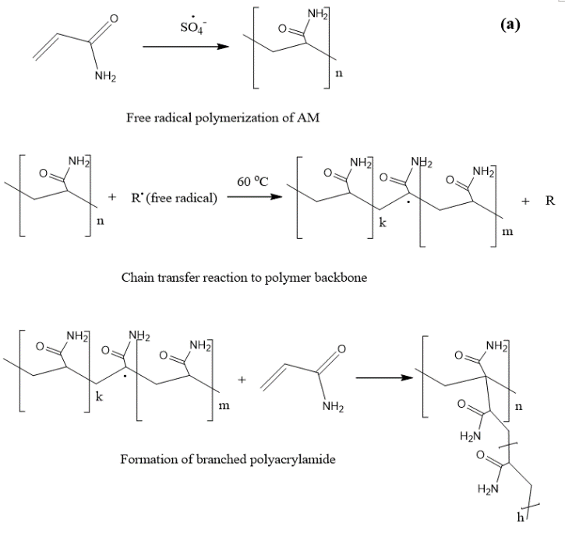
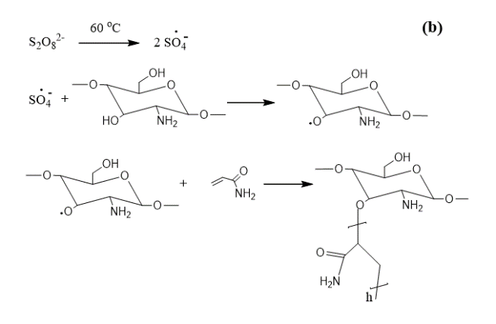

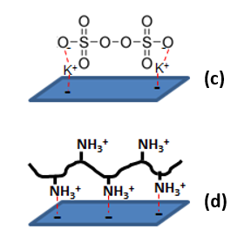

Scheme 4.4. General mechanisms for (a) free radical polymerization, chain transfer and the formation of branched polyacrylamide, (b) radical graft polymerization of AM onto chitosan, (c) KPS-MMT ionic interaction, and (b) chitosan-MMT electrostatic interaction.

With the help of chitosan-MMT electrostatic interactions and grafting of PAM onto chitosan backbones, PM 5 CHI displayed higher tensile strength, strain at break and toughness than those of PM 5. The chemical grafting of some PAM macromolecular chains onto chitosan strengthened PM 5 CHI by efficient stress transfer from PAM chains to chitosan-treated MMT platelets, so higher tensile strength was obtained by PM 5 CHI.

As shown in Figure 4.1, similar results could also be achieved by using another polysaccharide such as starch (S) or k-carrageenan (K) instead of chitosan to prepare the nanocomposite hydrogels, in which chain branching and chemical grafting of PAM onto the hydroxyl groups of the two polysaccharides also occurred due to the high reaction temperature. By comparing the relative intensity of CH and CH₂ (2852 cm⁻¹) to CH₃ (2928 cm⁻¹), it was found that the relative intensity values for PM 5 S and PM 5 K were lower than that of PM 5 cata (0.151 and 0.153 versus 0.418).
Figure 4.2. In vitro degradation results of PM 5 and PM 5 CHI.

The grafted chitosan by AM could be further confirmed by the in vitro degradation results as shown in Figure 4.2. The weight of PM 5 hardly changed because both PAM and MMT platelets were stable in lysozyme-containing PBS. The slight weight gain by PM 5 after two weeks was probably because the hydrogel samples absorbed ions from PBS solution. In contrast, PM 5 CHI decreased its weight by 25% in 5 weeks. The weight loss of PM 5 CHI was due to the decomposition of chitosan by lysozyme. Lysozyme is efficient to degrade polysaccharides including chitosan by hydrolysing the glycosidic linkages via its hexameric sugar ring at binding sites (Freier et al., 2005). Remarkably, even with such a low weight percentage of chitosan in respect to PAM, 0.88%, PM 5 CHI degraded up to 25% of its original weight. This proved that chitosan not only served as the surface modifier of MMT platelets but also the backbone onto which PAM polymer chains chemically grafted. These degradation results implied that a small amount of chitosan could lead to substantial biodegradability, and so biodegradability of PAM hydrogels could be potentially tailored by varying the amount of chitosan.

Structural analysis of the nanocomposite hydrogels formed by polyacrylamide, clay, alginate and calcium chloride
Figure 4.3. FTIR spectra of alginate and the nanocomposite hydrogels.

PMACa, PMAW, PMCa and PMW were also studied by FTIR as shown in Figure 4.3. Like PM 5 and PM 5 CHI, those four hydrogels were different from the PAM-MMT nanocomposite hydrogels synthesised by a low temperature method (Gao et al., 2015). When comparing the relative intensity of those two peaks peaks at 2852 cm⁻¹ and 2932 cm⁻¹, the relative intensity of CH₂ and CH groups in respect to that of CH₃ of PAM, PMW, PMCa, PMAW and PMACa declined compared to that of PM 5 cata synthesised at 25 ºC, being 0.182, 0.178, 0.310, 0.301 and 0.203 versus 0.418. Knowing that CH₂ was quite stable during polymerisation (Fanood, 1998; Gleason et al., 1959), this indicated that the amount of tertiary CH decreased, which is strong evidence of chain transfer reaction and branching (Gough et al., 2003), like the cases of PM 5 and PM 5 CHI discussed before.

Similar to PM 5 and PM 5 CHI, PAM formed hydrogen bonding with the MMT platelets in PMACa, PMAW, PMCa and PMW like most of PAM clay nanocomposite hydrogels, initiated by KPS which formed ionic complex with MMT platelets (Gao et al., 2015; Haraguchi et al., 2005; Haraguchi & Takehisa, 2002; Hu & Chen, 2014). the two peaks at around 3190 cm⁻¹ and 3333 cm⁻¹ were characteristic for amine N-H stretching for PAM. A shift toward a low wavenumber was observed in those two peaks for all MMT-containing nanocomposite hydrogels compared to those of PAM. This confirmed the formation of hydrogen bonding between PAM and MMT (Gao et al., 2015). The amine groups of acrylamide or other acrylic monomers were known to be able to form dense hydrogel bonding, though the surface of MMT platelets was partially covered by alginate chains (Wu et al., 2016). When alginate chains were introduced into the MMT suspension, hydrogen bonding formed between carbonyl groups of alginate and hydroxyl groups of MMT platelets. Despite the electrostatic repulse between negatively charged MMT platelets and alginate, alginate covered part of the surface of the MMT platelets despite its high amount (Liang et al., 2016; Ming et al., 2015; Podsiadlo et al., 2007; Wu et al., 2016). Besides, there were covalent bonds between alginate chains and PAM through amidation by amine groups of PAM and carboxyl groups of alginate as described in Scheme 4.5 (Sun et al., 2012). This was evidenced by the relative density of C-N peak at 1020 cm⁻¹ in respect to that of the C-O peak at 1044 cm⁻¹ because the relative intensity of C-N to C-O of PMAW and PMACa were higher than that of PM 5 cata, PMW and PMCa, being 1.089 and 1.164 versus 0.741, 0.861 and 0.901 (Ahmed, 2015; Alexandre & Dubois, 2000; Sun et al., 2012; Tripathi & Mishra, 2012). The covalent alginate-PAM grafting might lead to effective load transfer and thus good mechanical properties. When alginate chains contacted with Ca²⁺ ions, the alginate chains were crosslinked and formed the second interpenetrated ionic network. Furthermore, positively charged Ca²⁺ ions might also interacted with the negatively charged MMT platelets by electrostatic attraction (Rytwo et al., 1996).
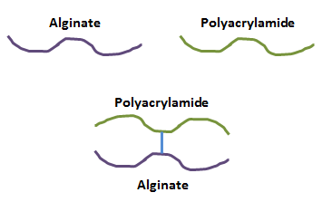
Amidation reaction between alginate and polyacrylamide

Scheme 4.5. Mechanisms of covalent grafting of AM onto alginate chains.


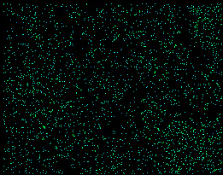
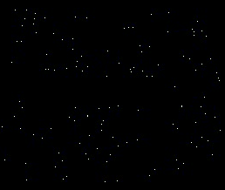
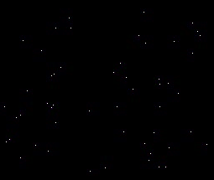
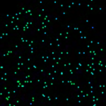
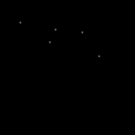

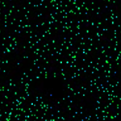


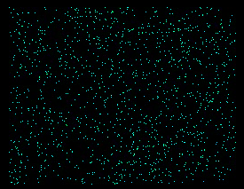
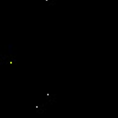
(a)
O
Si
Ca
(b)
(c)
(d)

Figure 4.4. EDX graphs taken from the cross-sectional surface of fully swollen (a) PMACa, (b) PMAW, (c) PMCa, and (d) PMW (scale bar: 10 μm).

The presence of Ca²⁺ in PMACa and PMCa was confirmed by EDX as shown in Figure 4.4. O, a characteristic element for PAM and MMT, was detected in all the samples. Similarly, Si which was characteristic for MMT platelets was also found in all the samples. There are light dots on the Ca graphs of PMACa and PMCa, while there are no light dots on the Ca graphs of PMAW and PMW. It indicated that after the immersion in CaCl₂ solution, Ca²⁺ cations were successfully incorporated into PMACa and PMCa.

Structural analysis of the nanocomposite films formed by clay, alginate and calcium chloride

Figure 4.5. FTIR spectra of MMT, alginate and their nanocomposites with and without Ca²⁺.

When it came to AlgMMTCa nanocomposite films, as seen from Figure 4.5 and Scheme 4.6, for MMT, the peak at 3625 cm⁻¹ was characteristic for hydroxyl groups, which could form hydrogen bonding with carbonyl groups of alginate (Chen et al., 2015). For alginate and its nanocomposites, there was a wide peak from 2982 cm⁻¹ to 3671 cm⁻¹ characteristic for C-O-H vibrations of alginate chains (Ming et al., 2015; Podsiadlo et al., 2007). Compared to C-O-H peak of SA and AlgCa without MMT, the intensity of the peak of AlgMMT and AlgMMTCa was reduced. This phenomenon was due to the formation of numerous hydrogen bonds between alginate chains and MMT platelets as shown in Scheme 4.6 (b) (Liang et al., 2016; Ming et al., 2015; Podsiadlo et al., 2007).

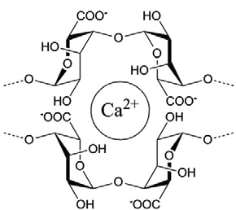
(M)
(M)
(G)
(a)

MMT
Alginate
Si
Si
Si
O
O
Si
Si
Si
O
O
OH
AlO₄
OH
OH
AlO₄
OH
COO⁻
OH

(b)

Scheme 4.6. (a) The “egg-box” structure of Ca-alginate fragment, and (b) hydrogen bonding between MMT and alginate (Reproduced from reference (Sartori et al., 1997)).

For SA and AlgMMT73, there was a peak at 1406 cm⁻¹ which was characteristic for COO⁻ symmetric stretch of alginate chains (Lawrie et al., 2007; Sartori, Finch, Ralph, & Gilding, 1997; Voo et al., 2015). It was found that this peak for AlgCa and AlgMMTCa shifted to higher wavenumbers. And AlgCa and AlgMMTCa didn’t dissolve in water and behave like hydrogels. These results confirmed the ionic crosslinking and the formation of “egg-box” structure between Ca²⁺ and carboxyl groups of two neighbouring alginate chains (Sartori et al., 1997). As for the “egg-box” structure of G blocks, alginate chains were folded and formed a dense and hydrophobic part as shown in Scheme 4.6 (a) (Yu et al., 2009). Once Ca²⁺ was introduced to replace Na⁺ of SA, the charge density, the radius and the atomic weight of the cations were altered so that a peak shift was detected (Daemi & Barikani, 2012; Dalmoro, Barba, Lamberti, Grassi, & d'Amore, 2012; Sartori et al., 1997).
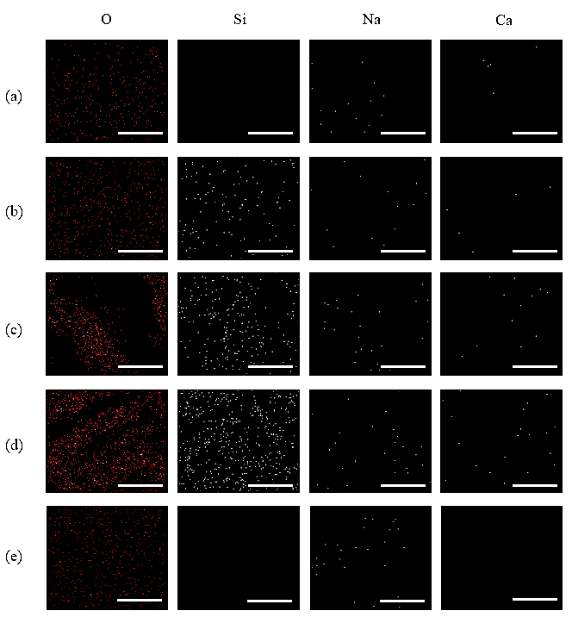
Figure 4.6. EDX graphs taken from the cross-sectional surface of (a) AlgCa, (b) AlgMMTCa82, (c) AlgMMTCa73, (d) AlgMMTCa11 and (e) sodium alginate with the same amplification (scale bar: 10 μm).

The presence of Ca²⁺ in AlgCa and AlgMMTCa was confirmed by EDX as shown in Figure 4.6. O, characteristic for alginate and MMT platelets, was detected for all the samples. For AlgCa, Ca²⁺, serving as the crosslinker of alginate, was presented while Si which was characteristic for MMT platelets was absent as expected. For AlgMMTCa, Si characteristic for MMT platelets was also presented. The detected Ca was due to Ca²⁺-alginate crosslinking and absorption of Ca²⁺ onto MMT platelets. The approximate amount of Ca was calculated and measured by TGA and the EDX spectra.

The content of Ca²⁺ in the nanocomposite films measured by TGA was shown in Figure 4.7.
Figure 4.7. TGA curves of MMT, SA and alginate nanocomposites.

Table 4.1. Weight remain and estimated Ca contents of MMT, SA and alginate nanocomposites.
Samples | Weight remain / wt % | Mass fraction of Ca²⁺ for crosslinking alginate / wt% | Mass fraction of Ca²⁺ absorbed onto MMT / wt %
MMT | 91.3 | - | -
SA | 27.7 | - | -
AlgCa | 23.7 | 3.1 | -
AlgMMTCa82 | 43.4 | 2.2 | 3.5
AlgMMTCa73 | 50.8 | 1.9 | 4.4
AlgMMTCa11 | 60.9 | 1.4 | 2.9

According to Figure 4.7 and Table 4.1, MMT displayed a weight loss of 0.09 because of the loss of water inside the galleries and hydroxide groups of crystalline lattices (Ahmad, Gharayebi, Salit, Hussein, & Shameli, 2011; Lagaly, Ogawa, & Dékány, 2006; Wu & Chen, 2014). The main residue of the decomposed SA when heated to 700 ºC was Na₂CO₃, showing a weight remain of 0.277 similar to the result previously reported (Soares, Santos, Chierice, & Cavalheiro, 2004). When it came to Ca²⁺-crosslinked alginate, CaO and Na₂CO₃ were obtained as the remaining material when heated to 700 ºC (Kong et al., 2009). The weight remain of AlgCa (23.7%) was lower than that of SA (27.7), indicating the ion exchange of Na⁺ with Ca²⁺ for alginate and formation of “egg-box” structure because the molecular weight of CaO (56) was lower than that of Na₂CO₃ (106). Therefore, Na/Ca molar ratio of AlgCa could be determined as 4.63 and thus the weight content of Ca²⁺ in AlgCa was calculated to be 0.03. With the knowledge above, the content of Ca²⁺ in AlgMMTCa was also deducted. Mass fraction of Ca²⁺ for crosslinking alginate was in the order of AlgMMTCa82 > AlgMMTCa73 > AlgMMTCa11, which was proportional to the alginate content. However, mass fraction of Ca²⁺ absorbed onto MMT platelets was in the order of AlgMMTCa73 > AlgMMTCaCa82 > AlgMMTCa11, in which AlgMMTCa11 with the highest MMT content displayed the lowest Ca²⁺ absorption. The reason was probably that the high content MMT platelets of AlgMMT11 stacked more closely than those of AlgMMT73 and thus the diffusion of Ca²⁺ was impeded during submersion in CaCl₂ solution. The calculation of Ca²⁺ content was shown below.

Calculation of Ca²⁺ content in the nanocomposite films formed by clay, alginate and calcium chloride
For SA：
The chemical formula is C₅H₇O₄COONa (AlgNa), after heat treatment till 800 ºC, Na₂CO₃ was left as the residue: 2AlgNa Na₂CO₃. The molecular weight of C₅H₇O₄COONa is 198, and the molecular weight of Na₂CO₃ is 106. So the theoretical weight remain of SA: 106/(198*2) = 0.267 which is similar to the industrial value, 0.277 (Kong et al., 2009).

For AlgCa:
AlgCa consists of C₅H₇O₄COONa (AlgNa) and (C₅H₇O₄COO)₂Ca (Alg₂Ca). The residue was mainly CaO and Na₂CO₃. 198 and 390 were the molecular weight of AlgNa and Alg₂Ca, respectively; the weight remain ratio from AlgNa to Na₂CO₃ was known as 0.277; from the molecular weight of Ca²⁺ (40), Alg₂Ca (390) and CaO (56), the weight remain from Alg₂Ca to CaO was 56/390 = 0.143; 0.237 was the weight remain ratio of AlgCa after TGA test derived from Figure 4.7.

Therefore, assuming AlgNa as m mol, and Alg₂Ca as n mol, so in the AlgCa film: (198*0.277m+390*0.143n)/(198m+390n)=0.237, and it was calculated that m/n = 4.63, the molar ratio: Ca/Na = 0.22, the mass content of Ca²⁺ in AlgCa = 40/(4.63*198+390) = 0.031, and the mass content of Na⁺ in AlgCa = (4.63*23)/(4.63*198+390) = 0.082.

For AlgMMTCa82:
It was assumed that AlgMMTCa nanocomposite films consist of AlgCa, CaCl₂ and MMT and the incorporation of MMT platelets did not affect the crosslinking of alginate by Ca²⁺. And by knowing the weight of SA and MMT used for preparing this sample was 0.8 g and 0.2 g, respectively. When SA turned into AlgCa, the molar ratio of Ca/Na was 0.22. The weight remain ratios of AlgCa, MMT and AlgMMTCa82 after TGA tests were 0.237, 0.913 and 0.434, respectively, which were derived from Figure 4.7. The amount of Na in 0.8 g of AlgCa was calculated to be 0.00287 mol.

The weight of CaCl₂ (m) could be calculated for AlgMMTCa82 as: (0.8*0.237+0.2*0.913+m)/(0.2+0.8+m) = 0.434, m = 0.109 g. So based on the molecular weight of Ca²⁺ (40) and CaCl₂ (111), Ca²⁺ absorbed onto MMT was calculated to be (0.109*40)/111 = 0.04 g, and the mass content of Ca²⁺ absorbed by MMT in AlgMMTCa82 = 0.04/(0.8+0.2+0.109) = 0.035; knowing the mass fraction of Ca²⁺ in AlgCa (0.031), the mass fraction of Ca²⁺ crosslinking alginate in AlgMMTCa82 was calculated as: (0.8*0.031)/(0.8+0.2+0.109) = 0.022.

Knowing that the chemical formula of MMT is Al₂H₂Na₂O₁₃Si₄ and the molecular weight of MMT (422), for 0.2 g MMT clay, the amount of Na was calculated as 0.00095 mol. So in the AlgMMTCa82 nanocomposite film:
the total mole of Na = 0.00287+0.00095 = 0.00387 mol,
the total mole of Ca = (0.035+0.022)*(0.2+0.8+0.109)/40 = 0.00162 mol,
the molar ratio of Ca/Na = 0.00162/0.00387 = 0.41.

For AlgMMTCa73:
Similar to AlgMMTCa82, it was assumed that AlgMMTCa73 nanocomposite films consist of AlgCa, CaCl₂ and MMT and the incorporation of MMT platelets did not affect the crosslinking of alginate by Ca²⁺. And by knowing the weight of SA and MMT used for preparing this sample was 0.7 g and 0.3 g, respectively. When SA turned into AlgCa, the molar ratio of Ca/Na was 0.22. The weight remain ratios of AlgCa, MMT and AlgMMTCa73 after TGA tests were 0.237, 0.913 and 0.508, respectively, which were derived from Figure 4.7. The amount of Na in 0.7 g of AlgCa was calculated to be 0.00251 mol.

The weight of CaCl₂ (m) could be calculated for AlgMMTCa73 as: (0.7*0.237+0.3*0.913+m)/(0.7+0.3+m) = 0.508, m = 0.139 g. So based on the molecular weight of Ca²⁺ (40) and CaCl₂ (111), Ca²⁺ absorbed onto MMT was calculated to be (0.139*40)/111 = 0.05 g, and the mass content of Ca²⁺ absorbed by MMT in AlgMMTCa73 = 0.05/(0.7+0.3+0.139) = 0.044; knowing the mass fraction of Ca²⁺ in AlgCa (0.031), the mass fraction of Ca²⁺ crosslinking alginate in AlgMMTCa73 was calculated as: (0.7*0.031)/(0.7+0.3+0.139) = 0.019.

Similarly, it could be known that 0.3 g MMT contained 0.00142 mol Na, so in the AlgMMTCa73 nanocomposite film:
the total mole of Na = 0.00251+0.00142 = 0.00393 mol,
the total mole of Ca = (0.044+0.019)*(0.7+0.3+0.139)/40 = 0.00179 mol,
the molar ratio of Ca/Na = 0.00179/0.00393 = 0.46.

For AlgMMTCa11:
Similar to AlgMMTCa82 and AlgMMTCa73, it was assumed that AlgMMTCa11 nanocomposite films consist of AlgCa, CaCl₂ and MMT and the incorporation of MMT platelets did not affect the crosslinking of alginate by Ca²⁺. And by knowing the weight of SA and MMT used for preparing this sample was 0.5 g and 0.5 g, respectively. When SA turned into AlgCa, the molar ratio of Ca/Na was 0.22. The weight remain ratios of AlgCa, MMT and AlgMMTCa11 after TGA tests were 0.237, 0.913 and 0.609, respectively, which were derived from Figure 4.7. The amount of Na in 0.5 g of AlgCa was calculated to be 0.00179 mol.

The weight of CaCl₂ (m) could be calculated for AlgMMTCa11 as: (0.5*0.237+0.5*0.913+m)/(0.5+0.5+m) = 0.609, m = 0.087 g. So based on the molecular weight of Ca²⁺ (40) and CaCl₂ (111), Ca²⁺ absorbed onto MMT was calculated to be (0.087*40)/111 = 0.031 g, and the mass content of Ca²⁺ absorbed by MMT in AlgMMTCa11 = 0.031/(0.5+0.5+0.087) = 0.029; knowing the mass fraction of Ca²⁺ in AlgCa (0.031), the mass fraction of Ca²⁺ crosslinking alginate in AlgMMTCa11 was calculated as: (0.5*0.031)/(0.5+0.5+0.087) = 0.014.

Similarly, it could be known that 0.5 g MMT contained 0.00237 mol Na, so in the AlgMMTCa11 nanocomposite film:
the total mole Na = 0.00237+0.00179 = 0.00416 mol,
the total mole Ca = (0.029+0.014)*(0.5+0.5+0.087)/40 = 0.00116 mol,
the molar ratio of Ca/Na = 0.00116/0.00416 = 0.28.

4.3.2. Mechanical properties of nanocomposite hydrogels

Tensile properties of the as-prepared nanocomposite hydrogels formed by polyacrylamide, clay and chitosan
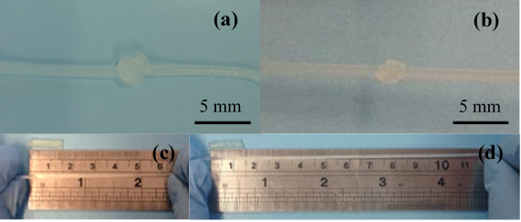

(e)

Figure 4.8. Photographs of PM 5 and PM 5 CHI nanocomposite hydrogels, (a, b) knotted PM 5 and PM 5 CHI, (c) PM 5 with and without a tensile strain of 12, (d) PM 5 CHI with and without a strain of 25, and (e) representative tensile stress-strain curves of PM 5, PM 5 CHI, PM 5 S and PM 5 K.

The as-prepared PM 5, PM 5 CHI, PM 5 S and PM 5 S nanocomposite hydrogels were tensile tested and their results are presented in Figure 4.8 and Table 4.2. The hydrogels with and without chitosan treatment were capable of achieving a high elongation at break of over 1000% without any sign of failure, similar to some previously reported nanocomposite hydrogels (Haraguchi et al., 2002). PM 5 and PM 5 CHI displayed nearly the same testing curve until the failure of PM 5, suggesting the two hydrogels have similar macroscopic tensile behaviour up to a strain of over 1000% including the same Young’s modulus. When stretched, the entangled PAM macromolecular chains were extended in both hydrogels and the clay platelets tended to orient parallel to the stretching direction (Haraguchi & Li, 2006). Upon continuous stretching, some of the hydrogen bonds formed between amide groups of PAM and silanol groups of MMT platelets started to break. As for PM 5 CHI, apart from the breakage of PAM-MMT hydrogen bonding, chitosan chains were also stretched and moved across the MMT surface (Wang et al., 2014). The tensile strength for PM 5 S and PM 5 K were 89.2 and 92 kPa, respectively, which were significantly higher than that of PM 5, indicating that acrylamide could be grafted onto different kinds of polysaccharides.

Table 4.2. Tensile properties of PM 5 and PM 5 CHI nanocomposite hydrogels.
Sample | Young’s modulus / kPa | Tensile strength / kPa | Strain at break | Energy at break / MJ m⁻³
PM 5 | 7.1 ± 0.3 | 45.9 ± 3.0 | 12.9 ± 0.7 | 0.27 ± 0.02
PM 5 CHI | 7.3 ± 0.3 | 154.8 ± 9.0 | 26.0 ± 0.6 | 1.32 ± 0.06
PM 5 S | 6.3 ± 0.4 | 89.2 ± 4.9 | 20.9 ± 0.8 | 0.67 ± 0.04
PM 5 K | 9.1 ± 0.1 | 92.0 ± 4.3 | 14.2 ± 0.2 | 0.52 ± 0.02

By comparing PM 5 and PM 5 CHI, the latter presented about 3-fold higher tensile strength, 2 folds higher strain at break and 4 folds higher energy at break, reaching a tensile strength of 154.8 kPa, a strain at break of 26.0 and a tensile energy at break of 1.32 MJ m⁻³ (Table 4.2). The high strength of the PM 5 CHI hydrogel suggested that load was transferred efficiently to chitosan-treated MMT platelets presumably through the covalent bonds between PAM chains and chitosan chains after the grafted PAM chains had been extended (Zeng et al., 2016). The increase of tensile strength could also be attributed to the strong electrostatic interactions between chitosan and MMT, which was much stronger than the hydrogen bonding between PAM and MMT platelets and so would require higher stress to detach chitosan chains from the MMT platelets to reach the final failure. The increase of the strain at break in the PM 5 CHI hydrogel was due to the additional energy dissipation by unzipping the electrostatically bonded chitosan and MMT (Wang et al., 2014). Combining the enhanced tensile strength, strain at break and the same Young’s modulus, a much higher energy at break was achieved by PM 5 CHI. The excellent flexibility and stretchability of both the hydrogels were demonstrated in Figure 4.8 (a-d), where the hydrogels could be either knotted or stretched to a large deformation. By comparing the mechanical properties of PM 5 with those of the previous PAM-MMT nanocomposite hydrogels reported in the literature (Gao et al., 2015). PM 5 displayed a tensile strength of 46 kPa and a strain at break of 13, which were lower than the tensile strength (100 kPa) and the strain at break (120) of PAM-MMT nanocomposite hydrogel with the same clay content. Branched polymers could have shorter inter-crosslinking chain lengths and worse extensibility than those of their linear counterparts (Beuermann et al., 1996; Fanood, 1998; Gleason et al., 1959; Peck & Hutchinson, 2004; Plessis et al., 2001; Plessis et al., 2000; Starnes et al., 1998).

Cyclic tensile properties of the as-prepared nanocomposite hydrogels formed by polyacrylamide, clay and chitosan

(b)
(a)

(c)
(d)

Figure 4.9. Representative cyclic tensile testing curves of PM 5. (a) cyclic tension to 50% of PM 5, (b) cyclic tension to 500% of PM 5, (c) cyclic tension to 50% of PM 5 CHI, and (d) cyclic tension to 500% of PM 5 CHI.

Cyclic tensile tests were also carried out for the as-prepared PM 5 and PM 5 CHI to investigate the resilience and hysteresis behaviour of the hydrogels. Their representative testing curves are shown in Figure 4.9. It could be seen that most of the curves were not smooth; the zigzag was due to the intrinsic properties of the hydrogels rather than the machine noise. Intermolecular friction and disentanglement of PAM chains were likely to be the main reasons for the zigzag in the curves of Figure 4.9 (Haraguchi, 2011; Liu, Huang, Luo, & Zhou, 2015).

Table 4.3. Hysteresis ratios of PM 5 and PM 5 CHI.
 |  | PM 5 | PM 5 CHI
Strain | Cycle | Hysteresis Ratio, h  Hysteresis Ratio
0.5 | 1st Cycle | -0.007 ± -0.002 | 0.10 ± 0.01
0.5 | 8th Cycle | -0.05 ± -0.01 | 0.04 ± 0.01
5 | 1st Cycle | 0.09 ± 0.01 | 0.20 ± 0.01
5 | 8th Cycle | 0.04 ± 0.01 | 0.10 ± 0.01

As we can see from Figure 4.9 (a), 4.9 (b) and Table 4.3, in terms of PM 5, the stretching and return curves for the first cycle to 50% strain overlapped each other nicely with no hysteresis, which suggested that under a maximum strain of 50%, PM 5 was very resilient and could recover instantly on the return. After 8 cycles, the material could still recover quickly meaning that even undergoing 8 cycles, the energy dissipation by the friction between PAM chains (Gao et al., 2015; Haraguchi & Li, 2006) was still negligible, showing nearly no hysteresis.

As for a cyclic tensile strain up to 500% which was beyond the yield point, hysteresis was still quite low, with 8% for the first cycle. Based on the chain length theory (Okay & Oppermann, 2007), the multiple and relatively strong PAM-MMT hydrogen bonds remained to preserve the resilience even after a strain of 500%. This value is, however, slightly higher when compared to cyclic tension to 50%, probably because many PAM-MMT hydrogen bonds broke during stretching and the disassociated PAM-MMT hydrogen bonds could not recover fully instantly. With increasing cycle number, MMT platelets tended to orientate parallel to the tensile direction so that hysteresis became lower. According to a previous study (Haraguchi & Li, 2006), under a large deformation, polymer chains were highly tensioned and clay platelets tended to orientate horizontally in respect to the stretching direction. On the return cycle, MMT platelets rotated and overcame the steric effect and friction force associated with the adjacent PAM chains for recovery (Zhu et al., 2006).

Hysteresis was also investigated for PM 5 CHI. In Figure 4.9 (c), 4.9 (d) and Table 4.3, for cyclic tension to 50%, the 1st-cycle hysteresis was still quite low, indicating fairly good resilience. Similar to PM 5, the low hysteresis of PM 5 CHI could be due to the covalent bonds brought by PAM-grafted-chitosan, as well as the strong multiple hydrogen bonds between branched PAM and MMT. However, unlike PM 5, the 1st-cycle hysteresis of PM 5 CHI by cyclic tension to 50% could not be ignored, which could be attributed to the electrostatic interactions between the negatively charged MMT and the surface-adsorbed positively charged chitosan chains. During cyclic tension to a strain of 50%, chitosan chains were stretched and aligned across the MMT surface which showed a hysteresis of 10% probably because of energy dissipation owing to the alignment of chitosan chains and the friction occurred at the chitosan-MMT interface (Wang et al., 2014; Yao et al., 2010). When unloaded, the detached chitosan-MMT electrostatic interactions were not able to recover quickly (Sun et al., 2012; Wang et al., 2014; Yao et al., 2010). After each cycle, chitosan-MMT electrostatic interactions could only partially recover within seconds during the return cycle. Subsequently, as more tensile cycles were experienced, fewer chitosan-MMT electrostatic interactions would break and contribute to hysteresis. This, together with orientation of MMT and stretching of polymer molecules as discussed for PM 5, accounts for the lower hysteresis ratio found for the 8th cycle when compared to the value for the 1st cycle. When the cyclic maximum strain increased from 50% to 500%, significant unzipping of chitosan-MMT electrostatic interactions increased hysteresis. Under high strains, more chitosan chains detached from the MMT platelets, resulting in more energy dissipation and thus larger hysteresis. Like cyclic tension to 50%, the hysteresis also became smaller after 8 cycles.

The 1st and 2nd cycle hysteresis ratios to 500% of the PM 5 (0.09 and 0.04, respectively) reported herein are much lower than most hydrogels described in the literature (Gao et al., 2015; Hu & Chen, 2014; Sun et al., 2012; Yang et al., 2013). The 1st cycle hysteresis ratio to 1000% of PM 5 was 0.15 in Figure 4.9 (c), which was lower than the lowest hysteresis ratios reported to date for PAM-clay nanocomposite hydrogels, namely PAM-synthetic hectorite hydrogels (Zhu et al., 2006), which showed a hysteresis ratio of 0.19 for the first cycle and 0.09 for the second cycle to a maximum strain of 1000%, indicating superb resilience of PM 5. As stated above, the low hysteresis could be attributed to strong polymer-clay bonding (Haraguchi, 2007; Haraguchi & Takehisa, 2002; Zhu et al., 2006), and ample covalent bonds due to polymer branching from the high temperature reaction. These strong and multiple bonding could act as memory sites for fast shape recovery (Gao et al., 2015; Haraguchi & Takehisa, 2002).

By comparing the 1st cycle hysteresis ratio to 500% and the resilience of PM 5 CHI to those of other double-network PAM hydrogels without clay (Sun et al., 2012; Sun et al., 2013), PM 5 CHI still showed significantly lower hysteresis of 0.20 for the first cycle to 500%, while 0.60 or even higher hysteresis ratios to a strain of 400% were obtained in Sun et al.’s studies. This was due to branched PAM, PAM-grafted-chitosan and the strong and multiple PAM-MMT hydrogen bonding as discussed before. Besides, similar to PM 5, PM 5 CHI were characterized with ample memory sites, leading to good resilience. Both PM 5 CHI and PM 5 were able to recover fully their original shape in 1 minute, which was much faster than the work reported by Sun et al., where 120 minutes was necessary for recovery of randomly copolymerized polyampholytes double-network hydrogels (Sun et al., 2013), and 1 day at 80 ºC was needed for recovery to 74% of the original shape of PAM-alginate double network hydrogels (Sun et al., 2012).

Tensile and compressive properties of the fully swollen nanocomposite hydrogels formed by polyacrylamide, clay and chitosan
Prior to the mechanical testing of the fully swollen nanocomposite hydrogels, swelling tests on the freeze-dried hydrogels were performed in distilled water at room temperature. As can be seen from Figure 4.10 (a) and Table 5.3, both PM 5 and PM 5 CHI were able to absorb a large amount of water with a swelling ratio over 20 after several days. The slightly decreased swelling ratio after 100 hours for PM 5 was due to the dissolution of some small molecular weight substances into water. The incorporation of chitosan significantly reduced the equilibrium swelling ratio. This was due to the higher crosslinking density of PM 5 CHI than that of PM 5 as discussed before. The higher crosslinking density of PM 5 CHI restricted the movement of PAM chains rather than that of PM 5. Compared to the equilibrium swelling ratio of the PAM-MMT hydrogels (105) reported in the literature (Gao et al., 2015), it was much smaller for PM 5 and PM 5 CHI at the same clay content of 5 wt % albeit with lower crosslinking degrees. This may be attributed to the high branching of the polymer which caused much shorter PAM chains compared to the linear PAM chains obtained in the literature.
(b)
(a)

Figure 4.10. (a) Swelling ratio as a function of immersion time in distilled water at 25 ºC for PM 5 and PM 5 CHI hydrogels, and (b) tensile curves of PM 5 and PM 5 CHI hydrogels swollen in PBS at 37 ºC for 2 weeks.

Table 4.4. Tensile properties of the hydrogels fully swollen in PBS at 37 ºC for 2 weeks.
Samples | Swelling ratio, φ | Young’s modulus / kPa | Tensile strength / kPa | Strain at break | Energy at break / kJ m⁻³
PM 5 | 64 ± 2 | 1.2 ± 0.2 | 4.5 ± 0.6 | 5.3 ± 0.2 | 13.1 ± 2.0
PM 5 CHI | 32 ± 3 | 1.2 ± 0.3 | 8.6 ± 0.8 | 11.1 ± 0.3 | 48.0 ± 3.0

For mechanical tests on the swollen samples, the as-prepared hydrogels were submerged in a PBS solution at 37 ºC for two weeks, allowing for the full swelling, to study the mechanical properties of nanocomposite hydrogels inside the simulative human body. The results were shown in Figure 4.10 (b) and Table 4.4. The fully swollen hydrogels displayed significantly inferior mechanical properties compared to their as-prepared hydrogels because of the much higher water contents. It was known that a fully swollen hydrogel consisted of dry solid material and water. The swelling ratio φ can be calculated as follows: φ = W_{water} / W_{dry}, where W_{water} represented the weight of water inside the hydrogel and W_{dry} represented the weight of the dry hydrogel. Therefore, water wt% of the fully swollen hydrogels w% = W_{water} / (W_{water} + W_{dry}) = φ / (1 + φ). So according to swelling ratios, swollen PM 5 contained 99.7 wt% water and swollen PM 5 CHI contained 99.4 wt% water (while these values may vary in simulative human body). Further, the entangled polymer chains were more extended after swelling and so lost part of their flexibility. However, compared to the conventional chemically crosslinked PAM hydrogels, which usually became extremely brittle and fragile in the fully swollen state (Gao et al., 2015; Haraguchi et al., 2002; Sun et al., 2012), PM 5 and PM 5 CHI could still be stretched to a strain over 500%. The reasons for this phenomenon could be: on one hand, relatively uniform crosslinking gave rise to the high extensibility of hydrogels, and on the other hand, PAM branching and/or grafting PAM onto chitosan chains contributed to the strength of the fully swollen hydrogels. The swollen PM 5 CHI displayed a much higher tensile strength and strain at break than those of PM 5, and it could also withstand a compression load of 1 kN without failure as shown in Figure 4.11. The superior mechanical properties of the fully swollen PM 5 CHI over PM 5 may be attributed to two factors. One is the much lower water content as shown by the swelling test, while the other is the strong bonding within the hydrogel due to the presence of CHI as mentioned previously.
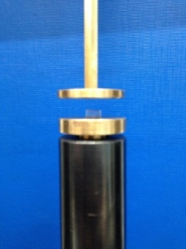
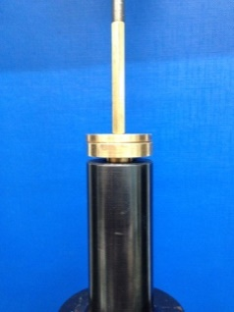
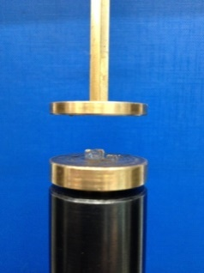
(c)
(b)
(a)

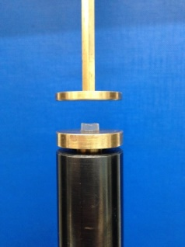
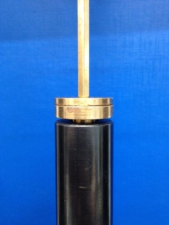
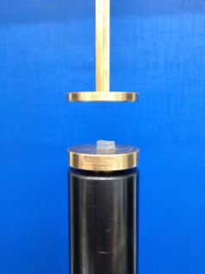
(f)
(e)
(d)

Figure 4.11. Before, during and after compression for PM 5 CHI; compression test to 1 kN on the fully swollen (a, b, c) PM 5, and (d, e, f) PM 5 CHI.

Tensile properties of the fully swollen nanocomposite hydrogels formed by polyacrylamide, clay, alginate and calcium chloride
The tensile properties of the swollen PMACa, PMAW, PMCa and PMW hydrogels were depicted in Figure 4.12 (a) and Table 4.5 as shown below. As stated before, PMACa and PMCa were swollen in 0.3 M CaCl2 solution while PMAW and PMW were swollen in distilled water at ambient temperature. The swelling properties of the nanocomposite hydrogels were shown in Figure 4.12 (b).
(b)
(a)
Figure 4.12. (a) Typical tensile stress-strain curves of swollen hydrogels, and (b) swelling ratio in respect to immersion time in distilled water of the nanocomposite hydrogels.

Table 4.5. Tensile properties of the fully swollen PMACa, PMAW, PMCa and PMW hydrogels.
Sample | Young’s modulus / kPa | Tensile strength / kPa | Strain at break | Energy at break / kJ m⁻³ | Swelling ratio / φ
PMACa | 8.0 ± 0.2 | 106.2 ± 7.6 | 10.1 ± 0.4 | 523.3 ± 41.4 | 9.8
PMAW | 0.5 ± 0.1 | 1.6 ± 0.1 | 5.7 ± 0.6 | 4.9 ± 1.3 | 47.7
PMCa | 2.4 ± 0.1 | 3.8 ± 0.3 | 2.5 ± 0.2 | 5.8 ± 1.1 | 11.7
PMW | 2.2 ± 0.1 | 2.4 ± 0.1 | 1.5 ± 0.1 | 2.2 ± 0.3 | 37.6

Even after full swelling, PMACa still presented excellent flexibility, extensibility and strength, whereas the other three hydrogels showed drastically lower strength and toughness. And the tensile strength (106 kPa) and the strain at break (10) of PMACa were much higher than the tensile strength (17 kPa) and the strain at break (3.7) of the previous reported poly(N-isopropylacrylamide)/Laponite nanocomposite hydrogel with the similar polymer/clay weight ratio (Wang et al., 2012). The mechanical properties were closely related to the equilibrium swelling ratio and thus the crosslinking network. Comparing PMACa with PMAW, at the same contents of polymer and clay, the incorporation of Ca²⁺ led to apparent differences in the structure and properties of PMACa. Firstly, Ca²⁺ crosslinked alginate chains during the diffusion of CaCl₂ solution into the as-prepared polyacrylamide/sodium alginate hydrogels and replacement of sodium with calcium cations (Yang et al., 2013).

Secondly, the swelling of alginate was significantly restricted by Ca²⁺ and thus gave rise to a lower equilibrium swelling ratio, which was confirmed by the swelling test shown in Figure 6.3 (b). The significantly lower water content of 90.7% for PMACa made it stiffer and stronger than that of 97.9% for PMAW. Secondly, Ca²⁺ crosslinked alginate forming an interpenetrating double network with the PAM/MMT network. PAM formed an elastic network with MMT which was stretchable and strong (Haraguchi, 2007; Haraguchi & Takehisa, 2002) while alginate formed an ionic network with Ca²⁺ which was weak in terms of strength but adequate in dissipating energy by unzipping the G-block Ca²⁺-crosslinked alginate chains during tensile loading (Kong et al., 2003). There were covalent bonds between PAM and alginate which was discussed previously, ensuring the efficient load transfer between the two networks (Sun et al., 2012).

Thirdly, it was possible that Ca²⁺ also interacted with MMT platelets and thus restricted the swelling process to some extent. During the swelling process of Na-MMT and Ca-MMT in water (Segad et al., 2010), because MMT platelets were negatively charged while Ca²⁺ was positively charged, the divalent Ca²⁺ had attractive energy with MMT platelets. So in this case, less swelling was received and more energy would be required to expand Ca-MMT than Na-MMT due to the electrostatic interaction. This could be also evidenced by the fact that PMCa showed only one third swelling ratio of that of PMW, and nearly one-fold higher tensile strength and strain at break than PMW.

As for PMAW, after swelling for 100 hours, the swelling ratio of PMAW began to drop slightly (Figure 4.12 (b)) probably because of the partial dissolution of the nanocomposite hydrogel, which might be some low molecular weight PAM oligomers or unreacted KPS initiator molecules. Despite the MMT surface partially covered by alginate and the covalent bonds between PAM and alginate, most of the tensile load was carried by PAM/MMT network instead of alginate chains because alginate chains were not crosslinked by Ca²⁺ and the hydrogen bonding between alginate and MMT was weak in the aqueous environment (Wu et al., 2016; Zlopasa et al., 2015). Besides, without the restriction of crosslinking, hydrophilic alginate absorbed a large amount of water which made PMAW even weaker. In consequence, lowest Young’s modulus, tensile strength and higher strain at break were obtained by PMAW. However, because alginate could flow freely during stretching, an enhanced strain at break was obtained for PMAW compared to that of PMW and PMCa.

Comparing the swelling ratio of all the hydrogels in this study to that of PM 5 cata (105) in this work, φ for the former ones was significantly lower than that of that of the latter (Gao et al., 2015). The reduced equilibrium swelling ratio was probably due to branching and higher crosslinking degree. The branching of PAM gave rise to enhanced crosslinking degree, which was significantly different from that synthesised at low temperature with a catalyst, where a linear chain of PAM was obtained (Beuermann et al., 1996; Fanood, 1998; Gao et al., 2015; Gleason et al., 1959; Peck & Hutchinson, 2004; Plessis et al., 2001; Plessis et al., 2000; Starnes et al., 1998).

Cyclic tensile properties of the nanocomposite hydrogels formed by polyacrylamide, clay, alginate and calcium chloride
(b)
(a)
Figure 4.13. Representative cyclic tensile testing curves of PMACa hydrogel (a) cyclic tensile to 100% and (b) cyclic tensile to 500%. (multiple tests were done and the curves were similar so that the representative curves of one test were picked out and shown above.)

In order to measure the elasticity and hysteresis of the hydrogels, cyclic tests were conducted on PMACa. The results were shown in Figure 4.13. As can be seen from Figure 4.13 (a), PMACa displayed excellent shape-recovery properties under a tensile deformation of 100% with a fairly low hysteresis of 0.01. PMACa showed excellent resilience at this strain. After 8 cycles, PMACa showed similar tensile curves as the first cycle, indicating that the broken PAM-MMT hydrogen bonding was able to recover on the return quickly and the elasticity of PMACa within this strain was excellent.

When the cyclic strain reached 500% as shown in Figure 4.13 (b), a higher hysteresis ratio of 0.44 was received for the first cycle. This was presumably brought by the orientation of the MMT platelets and unzipping the ionically crosslinked alginate chains. According to the previous work on polymer/clay nancomposite hydrogels (Haraguchi & Li, 2006), as large deformation was exerted, MMT platelets tended to orientate parallel to the stretching direction. During the returning cycle, the orientated MMT platelets might have difficulty on overcoming the steric effect and friction force to rotate back to their original orientation immediately, generating significantly larger hysteresis than that of first cycle to a strain of 100%. More importantly, the ionically crosslinked alginate chains were also unzipped to dissipate a lot of tensile energy, resulting in considerable hysteresis (Darnell et al., 2013; Sun et al., 2012; Yang et al., 2013). According to the inhomogeneous chain length theory for polymer-clay nanocomposite hydrogels (Okay & Oppermann, 2007), the relatively strong PAM-MMT hydrogen bonding remained to be responsible for the low hysteresis of the hydrogel. As more cycles were experienced, the strong PAM-MMT hydrogen bonds did not break. No more significant change in the hydrogel structure occurred so that a drastically reduced hysteresis of 0.04 compared to that of the first cycle was obtained by the 8th cycle.

Compared to the previous work on chemically crosslinked PAM/alginate/Ca²⁺ hydrogels with the water content of 86 wt% and the same AM/alginate weight ratio of 6 : 1 as PMACa (Sun et al., 2012; Yang et al., 2013), at a lower cyclic strain of 300%, the first-cycle hysteresis of PAM/alginate double network hydrogels was 0.76, larger than that of PMACa. The reason could be attributed to be the higher water content of PMACa, which expanded the network and reduced the intermolecular friction.

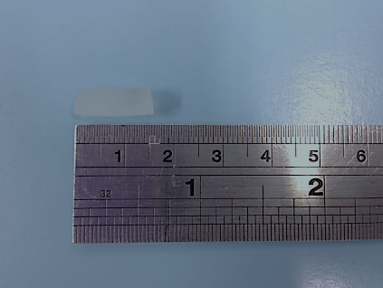
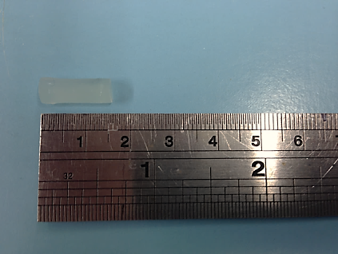
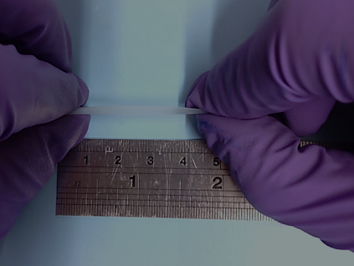
(a)
(d)
(b)
(c)
Figure 4.14. (a) cyclic tensile curves of PMACa with the 15 minutes’ recovery interval, and (b-d) demonstration of shape-recovery properties of PMACa: (b) before stretching, (c) under stretching, and (d) 15 mins after being unloaded.

Remarkable shape-recovery property was observed by PMACa as shown in Figure 4.14. A strain of 300% was used according to the previous study (Sun et al., 2012). At ambient temperature, if a fresh PMACa sample was submitted to a strain of 300% for the first time, it could accomplish 88% of recovery within 15 minutes, suggested by the curves with lower stress values shown by Figure 4.14 (a), compared to Figure 4.12 (a) and the first cycle on Figure 4.13 (b). This was indicative of partial permanent deformation of PMACa during tensile. The partial permanent deformation could result from irreversibly unzipped Ca²⁺ crosslinked alginate chains which was the same as reported for PAM/alginate/Ca²⁺ double network hydrogels (Sun et al., 2012). As for the sample recovered from a tensile strain of 300%, when subjected to more tensile cycles (such like 11th and 12th cycles in Figure 4.14) to a strain of 300% subsequently, the sample was always able to recover 88% of its original shape within 15 minutes after the load was removed as shown in Figure 4.14 (b), no matter how many tensile cycles it experienced. And each time after 15 minutes’ recovery, when subjected to another tensile cycle, the recovered sample displayed nearly overlapped hysteresis loops as shown in Figure 4.14 (a). This was different from the previous results from polyacrylamide-alginate interpenetrating double hydrogels (Darnell et al., 2013; Sun et al., 2012; Yang et al., 2013). In Sun et al.’s work, under 80 ºC, the PAM/alginate double-network hydrogels (DN) could recover to 74% of its original length in about 24 hours. However, in this work, regardless of experiencing how many tensile cycles, PMACa could make a shape recovery to 88% of its original state much faster at much lower temperature, without increasing permanent residue strain. The unique shape-recovery property of PMACa reported here was probably originated from the strong interaction between K⁺ which was brought by KPS initiator and stick onto MMT platelets and anionic PAM chains which propagated from sulfate free radicals (denoted as K⁺-anionic PAM electrostatic interaction), reversible PAM-MMT hydrogen bonding and PAM-alginate covalent bonds. The K⁺-anionic PAM electrostatic interaction, like those in many other nanocomposite hydrogels (Haraguchi & Li, 2006; Haraguchi, Ebato, & Takehisa, 2006; Haraguchi et al., 2003; Haraguchi & Takehisa, 2002; Haraguchi et al., 2002), served as memory sites for shape-recovery of the stretched samples when the tensile load was removed. Unlike chemically crosslinked PAM hydrogels with many short PAM chains in between the adjacent crosslinking sites, MMT platelets were linked by long chain PAM and alginate chains covalently bonded with PAM in PMACa. The long PAM chains in the polymer-clay nanocomposite hydrogels often displayed significantly higher strength than the short chains in the conventional chemically crosslinked hydrogels (Okay & Oppermann, 2007). Besides, the reversible PAM-MMT hydrogen bonding made PMACa capable of recovering after deformed repeatedly. Furthermore, PAM-alginate covalent bonds enabled the effective stress transfer between the PAM and alginate networks.

Under a large strain of 300%, some of chemical crosslinks of PAM chains permanently broke but the PAM-MMT hydrogen bonds were strong and reversible. So when the tensile load was removed, those strong bonds would facilitate the retraction of PAM chains in PMACa and the recovery of the broken PAM-MMT hydrogen bonding and the unzipped Ca²⁺-alginate crosslinking which the broken chemical crosslinks could not achieve.

Mechanical properties of the fully swollen and dry nanocomposite films formed by clay, alginate and calcium chloride
The mechanical properties and swelling properties of AlgMMTCa82, AlgMMTCa73 and AlgMMTCa11 were shown in Figure 4.15 and Table 4.6, respectively.
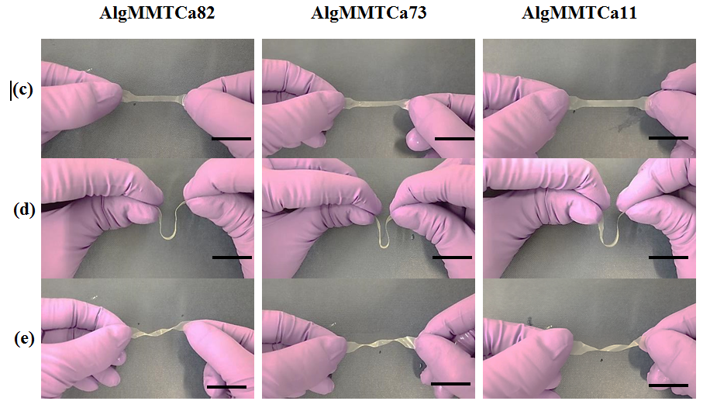
(b)
(a)

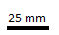
Figure 4.15. Typical tensile stress-strain curves of the (a) hydrated films and (b) dry films, (c) the as-prepared samples could withstand (d) bending, and (e) twist without permanent deformation. (scale bar: ).

Table 4.6. Tensile properties of the fully swollen AlgMMTCa82, AlgMMTCa73 and AlgMMTCa 11 films.
Samples | Young’s modulus / MPa | Tensile strength / MPa | Strain at break | Toughness / MJ m⁻³ | Swelling ratio / φ
AlgMMTCa11 | 277.3 ± 26.9 | 9.3 ± 0.3 | 0.07 ± 0.01 | 0.38 ± 0.12 | 0.55 ± 0.03
AlgMMTCa73 | 411.7 ± 15.7 | 27.9 ± 1.3 | 0.10 ± 0.01 | 1.81 ± 0.41 | 0.37 ± 0.01
AlgMMTCa82 | 57.7 ± 2.1 | 5.8 ± 0.1 | 0.20 ± 0.01 | 0.69 ± 0.03 | 0.62 ± 0.02

As seen from Figure 4.15 (a, c-e) and Table 4.6, even fully swollen, AlgMMTCa nanocomposite films were very stable, strong and flexible. Incorporated with 30 wt% MMT, the swollen nanocomposite hydrogel films could reach a Young’s modulus of 411.7 MPa and a tensile strength of 27.9 MPa, which were significantly higher than those of films with 20 wt% or 50 wt% of MMT. The swelling ratios of the films displayed an inverse order as AlgMMTCa73 > AlgMMTCa11 > AlgMMTCa82. The films displayed low strain at break no more than 0.21.

Comparing AlgMMTCa73 with AlgMMTCa82, on one hand, the former displayed a nearly 6 times higher Young’s modulus and 4 times higher tensile strength than the latter. First, rigid and strong MMT platelets (Chen & Evans, 2006) were known to enhance Young’s modulus and tensile strength of the polymer-clay nanocomposites. With the efficient load transfer from alginate matrix to MMT platelets by alginate-MMT hydrogen bonding and interlocking, significant strengthening effect of MMT platelets was presented like some other nacre-like nanocomposites (Das et al., 2015; Liang et al., 2016). So higher content MMT of AlgMMTCa73 gave rise to increased Young’s modulus and tensile strength. Second, when positively charged Ca²⁺ were absorbed onto the negatively charged MMT platelets, they interacted by the electrostatic attraction. So if higher amount of Ca²⁺ was adsorbed by MMT in AlgMMTCa73, the electrostatic attraction would also increase and lead to enhanced Young’s modulus and tensile strength (Segad et al., 2010). Third, the lower swelling ratio of AlgMMTCa73 also contributed to the higher Young’s modulus and tensile strength because water softened polymer chains and reduced the mechanical performance for polymer-clay nanocomposite films (Wu & Chen, 2014; Wu et al., 2014). On the other hand, AlgMMTCa73 displayed half of strain at break of AlgMMTCa82 due to its lower content of flexible alginate chains.

Comparing AlgMMTCa73 with AlgMMTCa11, the former displayed higher Young’s modulus, tensile strength and strain at break. On one hand, though the MMT content was higher, the reduced content of Ca²⁺ absorbed onto MMT platelets in AlgMMTCa11 reduced its mechanical properties compared to those of AlgMMTCa73. On the other hand, the higher swelling ratio of AlgMMTCa11 also deteriorated the mechanical properties compared to those of AlgMMTCa73.

In order to further study the strengthening effect of Ca²⁺ and MMT, AlgMMT73, dehydrated AlgCa and AlgMMTCa73 (denoted as DAlgCa and DAlgMMTCa73) were tested. The results were shown in Figure 4.15 (b) and Table 4.7.
Table 4.7. Tensile properties of the DAlgCa, AlgMMT73 and DAlgMMTCa73 films.
Samples | Young’s modulus / MPa | Tensile strength / MPa | Strain at break | Toughness / MJ m⁻³
DAlgCa | 671.2 ± 25.8 | 24.1 ± 1.9 | 0.03 ± 0.01 | 0.50 ± 0.02
AlgMMT73 | 2083.4 ± 87.2 | 84.5 ± 5.2 | 0.09 ± 0.01 | 4.25 ± 0.39
DAlgMMTCa73 | 2649.6 ± 143.3 | 100.7 ± 6.9 | 0.06 ± 0.01 | 4.78 ± 0.17

As seen from Figure 4.15 (b) and Table 4.7, the incorporation of MMT significantly increased the mechanical properties including Young’s modulus, tensile strength and strain at break, confirming the efficient load transfer from flexible alginate chains to rigid MMT platelets. Comparing DAlgMMTCa73 with AlgMMT73, the former increased Young’s modulus by 100% and tensile strength by 25% but decreased strain at break by 33%, confirming that Ca²⁺ strengthened the material by crosslinking alginate and interacting with MMT platelets electrostatically (Liang et al., 2016; Segad et al., 2010; Sun et al., 2012; Yang et al., 2013). Besides, AlgMMT73 nanocomposite films could be easily dissolved in water because of the absence of ionic crosslinking by Ca²⁺. As for swelling ratio, it was in the same order as that of mass fraction of Ca²⁺ absorbed onto MMT platelets, indicating that the interlayer Ca²⁺ dominated the swelling behaviour of AlgMMTCa. In terms of mechanical properties, AlgMMTCa73 displayed remarkably distinctive mechanical properties from those of the other two. This was closely related to the microstructure as discussed below.

In summary, when fully swollen, AlgMMTCa displayed distinctive mechanical properties with different alginate/MMT ratios. Among them, AlgMMTCa73 displayed the highest tensile strength around 28 MPa, higher than that (18 MPa) of some wet film reported before such as L-3,4-dihydroxyphenylalanine crosslinked chitosan immersed in PBS solution for three hours (Oh & Hwang, 2013), and that (12 MPa) of chitosan-cellulose nanocomposite films swollen in distilled water (Wu et al., 2014). As the mechanical properties of the previously reported alginate-clay nanocomposites under the fully swollen state were not tested (Abdollahi et al., 2013; Chen et al., 2015; Liang et al., 2016; Vale et al., 2005), following the same process in a previous work (Liang et al., 2016), the alginate/MMT/Ca nanocomposite films (denoted as CMMT-ALG in that paper) with the same weight content of MMT were synthesised, fully swollen in distilled water for comparison. The fully swollen CMMT-ALG films became as weak as wet paper and were too weak to test. When dried, AlgMMTCa behaved like many other nacre-like materials (Das et al., 2013; Liu et al., 2011; Podsiadlo et al., 2007; Walther et al., 2010; Yao et al., 2010). Compared to CMMT-ALG at the same MMT loading, with a tensile strength of 240 MPa and a toughness of 6 MJ m⁻³ (Liang et al., 2016), the tensile strength and toughness of DAlgMMTCa73 were lower. This was due to the different processing methods. Vacuum filtration tended to give rise to a denser alignment of MMT platelets than solution casting (Yao et al., 2010). However, as mentioned before, the fully swollen samples were not reported.

In summary, for the as-prepared PAM/clay nanocomposite hydrogels, PM 5 CHI displayed much higher tensile strength and strain at break than those of PM 5. For the fully swollen PAM/clay nanocomposite hydrogels, PM 5 CHI and PMACa still kept a strain at break of about 10. The tensile strength of fully swollen PMACa (106.5 kPa) was significantly higher than that of fully swollen PM 5 CHI 8.6 kPa), and that of the previously studied fully swollen PNIPAM/laponite nanocomposite hydrogel (< 5 kPa) (Wang et al., 2012).

4.3.3. Crosslinking densities and rheological properties of nanocomposite hydrogels
The crosslinking density was estimated by the classic kinetic theory of rubber elasticity to depict the elasticity of polymer nanocomposite hydrogels (Haraguchi et al., 2003; Xiong et al., 2008). The formula was given below.
F = N*RT(α – α⁻²) (2.2.1)
where F, N*, R, T and α are the force per unit original cross-sectional area of the hydrogels, effective crosslinking density, gas constant, absolute temperature and the extension ratio, respectively. Here α was set to be 2, corresponding to a strain of 100% and T = 298.15 K. From Figure 1, N* was calculated as 1.27 mol m⁻³ for the as-prepared PM 5 samples and 1.43 mol m⁻³ for the as-prepared PM 5 CHI samples. They are quite low compared with 2.2 mol m⁻³, which was the calculated effective crosslinking density of the PAM/MMT nanocomposite hydrogel with the same composition as PM 5 reported in the literature (Gao et al., 2015). The different polymerization conditions led to the difference in crosslinking density.

Comparing PM 5 with PM 5 CHI, the latter showed higher crosslinking density, in line with the mechanical properties discussed earlier, and it could be attributed to the number of reactive sites. In the case of PM 5 PAM interacted with MMT platelets, while in the case of PM 5 CHI PAM interacted with both MMT platelets and chitosan. Apart from PAM-MMT hydrogen bonding which was also presented in PM 5, chitosan offered additional crosslinking sites for PM 5 CHI and thus higher crosslinking density.

Similarly, N* was calculated to be 1.8 mol m⁻³, 0.076 mol m⁻³, 0.5 mol m⁻³ and 0.48 mol m⁻³ for PMACa, PMAW, PMCa and PMW, respectively. PMACa displayed a much higher N* than the others because of the dense ionic crosslinking of alginate by Ca²⁺. PMCa and PMW presented similar N* values, indicating Ca²⁺ did not crosslink either PAM or MMT and the MMT platelets were mostly covered by PAM chains. PMAW displayed significantly low density of crosslinking probably because some part of MMT platelets were covered by alginate chains when sodium alginate was mixed with MMT suspension which decreased the density of PAM-MMT hydrogen bonding. Though alginate could form hydrogen bonding with MMT platelets, it was much weaker than that between PAM and MMT platelets and could be easily destroyed during swelling process. The main reason was that both MMT platelets and alginate chains were negatively charged which would be easier to swell in the aqueous environment (Liang et al., 2016; Ming et al., 2015; Podsiadlo et al., 2007; Wu et al., 2016). Besides, amine groups of AM could be more strongly absorbed onto the MMT platelets (Kinter, 1961) than hydroxyl groups of alginate.

The crosslinking state of the nanocomposite hydrogels could also be depicted by rheological data as shown below.
Figure 4.16. Storage moduli G' and loss moduli G'' of PM 5 and PM 5 CHI.

Rheological properties were depicted in Figure 4.16 for PM 5 and PM 5 CHI. The storage modulus of both hydrogels increased slightly with increasing angular frequency. Besides, their storage moduli were significantly larger than loss moduli. These results confirm that both hydrogels are mainly elastic instead of viscous polymer solution (Choi et al., 2015). Comparing the storage moduli of PM 5 and PM 5 CHI, the incorporation of chitosan increased the storage moduli by one order of magnitude. This was due to the strong crosslinking brought by chitosan. Chitosan was responsible for introducing chitosan-MMT electrostatic interactions and chitosan-PAM chemical grafting, which were much stronger than the PAM-MMT hydrogen bonding as discussed previously.

Figure 4.17. Storage modulus G’ and loss modulus G’’ of PMACa, PMAW, PMCa and PMW.

As shown in Figure 4.17, when it came to the rheological properties of PMACa, PMAW, PMCa and PMW, the storage moduli of all the nanocomposite hydrogels increased slightly in respect to the increasing frequency. Besides, the storage moduli of all the materials were significantly greater than the loss moduli, defining all the materials as hydrogels rather than viscous polymer solution (Choi et al., 2015). PMACa displayed much higher storage modulus than the other hydrogels, about 10 times of the storage modulus of PMAW, confirming the formation of strong ionic crosslinks between alginate chains by Ca²⁺. Known that the storage moduli was proportional to the crosslinking density for nanocomposite hydrogels (Piao & Chen, 2016), by comparing the storage moduli of the four nanocomposite hydrogels, it was indicative from the rheological data that the sequence of the crosslinking density N* was expressed as: PMACa >> PMCa ≥ PMW >> PMAW, which was in accordance with the results of the classic kinetic theory of rubber discussed before (Piao & Chen, 2016).

4.3.4. Morphologies of nanocomposite hydrogels
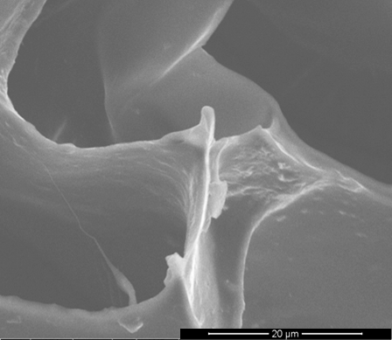
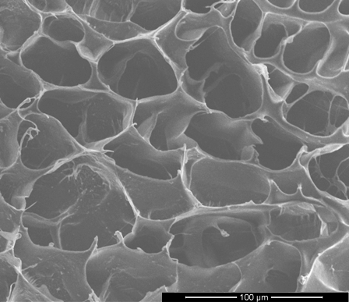
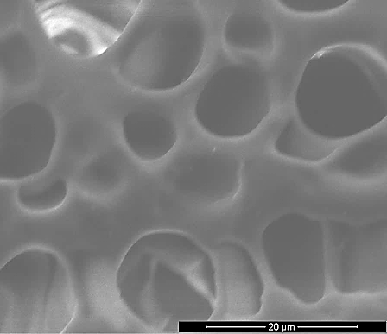
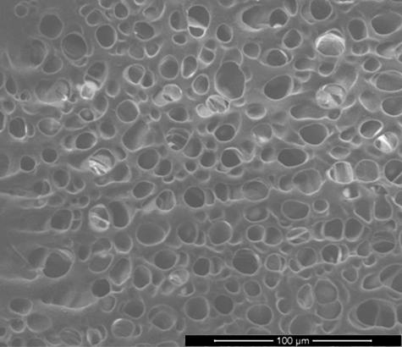
In order to better understand the crosslinking network of the nanocomposite hydrogels, the cross-sectional surface of freeze-dried nanocomposite hydrogels were observed by SEM.
10 μm
50 μm
10 μm
50 μm
(a)
(b)
(a)

Figure 4.18. SEM images of the cross-sectional surfaces of (a) PM 5, and (b) PM 5 CHI.

As shown in Figure 4.18, both PM 5 and PM 5 CHI showed interconnected porous structure. This structure was characteristic for the crosslinked network of the nanocomposite hydrogels preserved by the freeze drying process. The pore size of PM 5 CHI (51.2 ± 7.2 µm) was larger than that of PM 5 (7.7 ± 2.1 µm), which could be attributed to the fact that chitosan chains covered part of the MMT surface. Cationic chitosan chains tended to repulse each other, forming interconnected porous structure with large pore sizes (Thein-Han, Kitiyanant, & Misra, 2008).
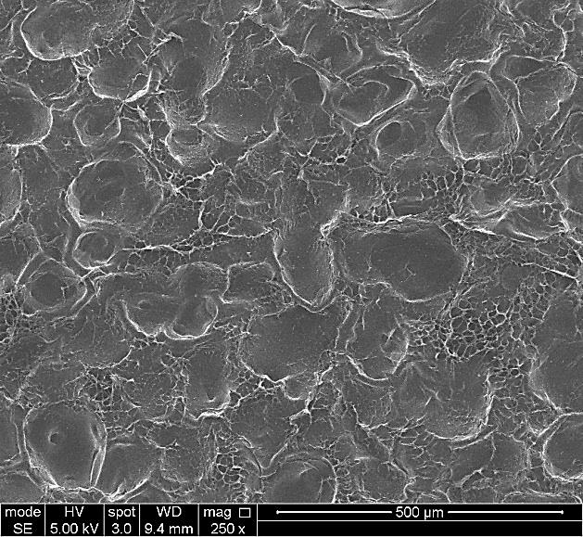
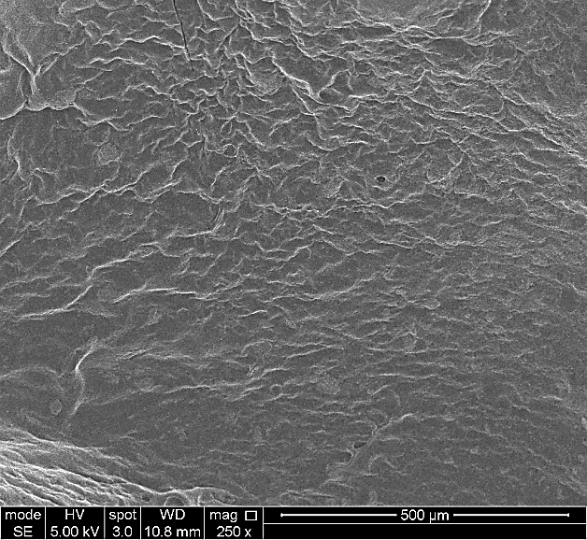
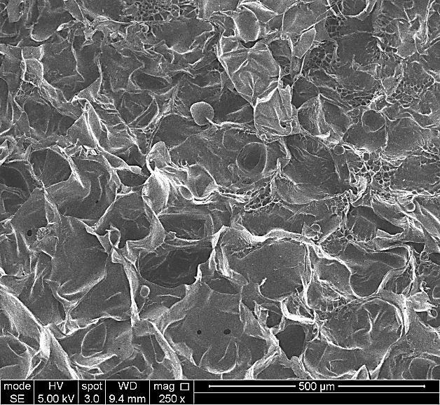
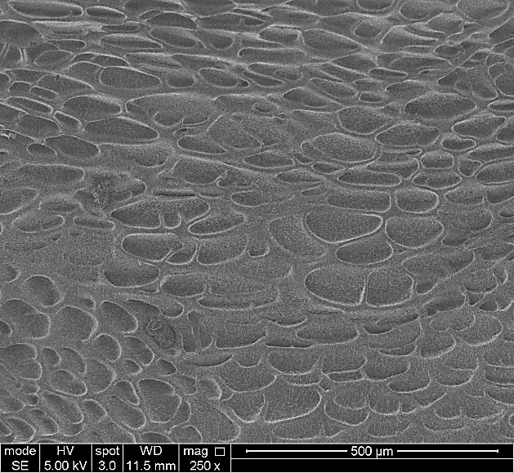
(b)
(a)
(c)
(d)

Figure 4.19. SEM images of cross-sectional surface of fully swollen (a) PMACa, (b) PMAW, (c) PMCa, and (d) PMW.

The cross-sectional features of PMACa, PMAW, PMW and PMCa were shown in Figure 4.19, PMAW, PMW and PMCa, with the water weight content of 97.9%, 97.4% and 92.1% respectively, which were free from the ionic crosslinking between Ca²⁺ and alginate, showed interconnected porous structure with pore sizes of 112.4 ± 11.7 μm, 76.1 ± 18.5 μm and 71.3 ± 13.3 μm, respectively. The pore size was in the order of PMAW > PMW > PMCa. It was indicated that the significantly lower crosslinking density of PMAW than those of PMW and PMCa allowed PMAW to absorb more water and thus a larger pore size was received. However, there was no obvious porous structure observed in PMACa. These results confirmed that polymer chains in PMACa were much more restricted than those of the other three (Zhang, Pang, & Qi, 2015). The high restriction over the polymer chains in PMACa resulting from the dense and interpenetrating crosslinking gave rise to a lower equilibrium swelling ratio of 9.8 as well as the formation of ice crystals during freezing process, and thus contributed to a significant influence on the mechanical properties.
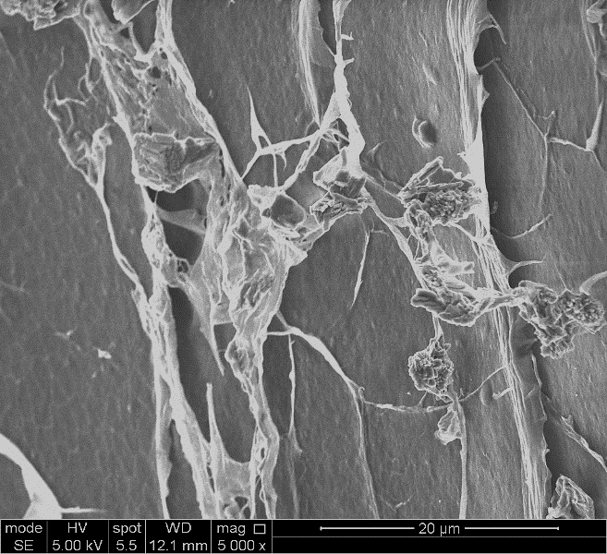
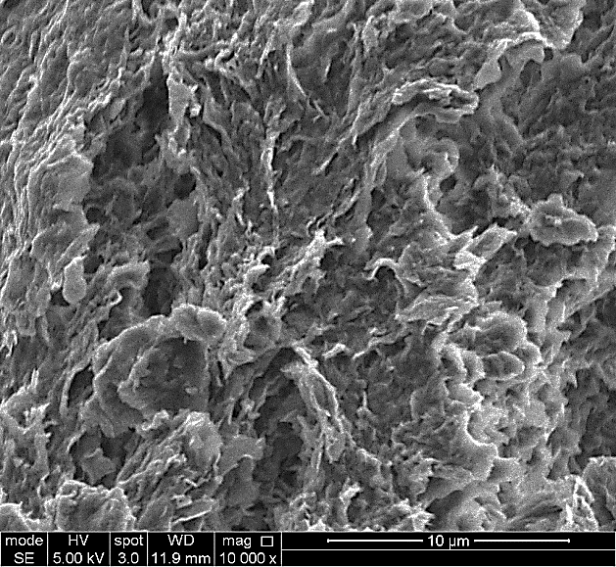
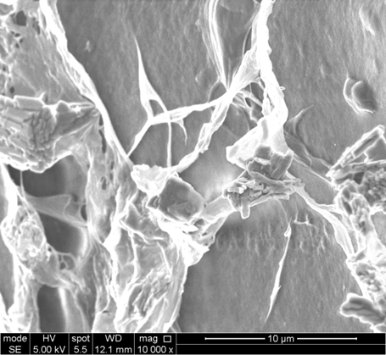
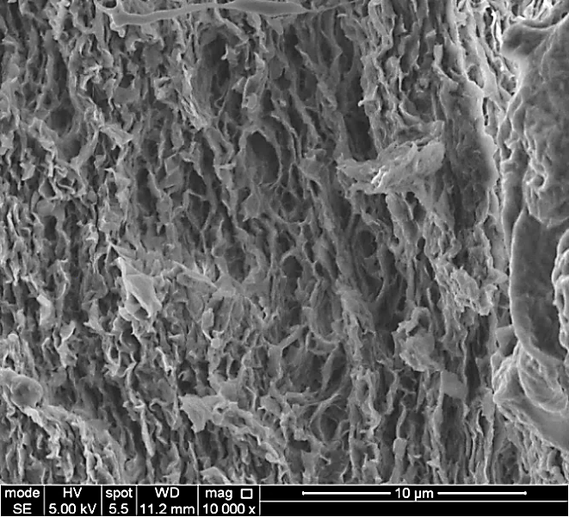
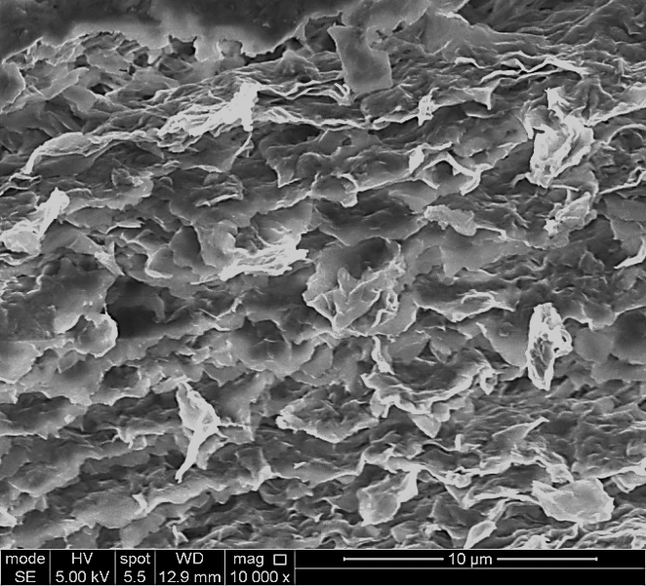
(d)
(b)
(a)
(c)

Figure 4.20. SEM images of the cross-sectional surface of (a) AlgCa, (b) AlgMMTCa82, (c) AlgMMTCa73, and (d) AlgMMTCa11.

The microstructure of AlgCa and AlgMMTCa nanocomposite hydrogel films could be further depicted by SEM as shown in Figure 4.20. On the cross-sectional surface of AlgCa, there were highly dense layers of Ca²⁺-crosslinked alginate shown as dark blocks, and loosely aligned uncrosslinked alginate chains shown as bright thread. This feature led to polymer folding and separate phases of polymer layers, forming inhomogeneous microstructure by the means of external gelation (Al-Remawi, 2012).

When it came to AlgMMTCa82, there was no obvious loose polymer thread because of the absorption of alginate chains onto MMT platelets by hydrogen bonding (Abdollahi et al., 2013; Zlopasa et al., 2015). As with a previous research (Abdollahi et al., 2013), the smoothness of the surface reduced with the incorporation of MMT platelets. Like AlgCa, the polymer blocks could also be seen on the cross-sectional surface of AlgMMTCa82 due to the same reason for AlgCa as discussed before (Al-Remawi, 2012). There was no obvious MMT alignment feature.

As for AlgMMTCa73 and AlgMMTCa11, with the enhanced MMT content compared to that of AlgMMTCa82, typical nacre-like structure with ordered alignment of MMT chunks was displayed, confirming that alginate is capable of forming nacre-like microstructure by solution casting method with a high MMT content ≥ 20% (Liang et al., 2016; Zlopasa et al., 2015). Unlike the previously reported alginate/MMT/Ca²⁺ material which were dehydrated, there were some pores embedded in between the orientated chunks of AlgMMTCa73 because it was fully swollen in water, forming Ca²⁺-crosslinked hydrogels. After freeze-drying, porous structure was preserved like some other dehydrated Ca²⁺-alginate hydrogels without MMT (de Moura et al., 2005; Topuz, Henke, Richtering, & Groll, 2012).

Comparing AlgMMTCa11 with AlgMMTCa73, the former displayed significant pull-out of MMT chunks which was common in many nacre-mimicking materials (Das et al., 2015) while the latter didn’t. This phenomenon implied that some MMT chunks on the fracture surface of AlgMMTCa11 were pulled out when the samples were fractured (Cheng, Wu, Li, Jiang, & Tang, 2013; Hao et al., 2016). At high content of clay, when the clay aspect ratio was lower than 1000 and polymer chains were interlocked with MMT chunks, nacre-mimicking materials tend to break in this “pull-out” way (Das et al., 2015; Hao et al., 2016). Besides, there was no obvious porous structure found in AlgMMTCa11 and its microstructure was denser than that of AlgMMTCa73 due to the reduced alginate/MMT relative content.

4.3.5. Fabrication versatility of the nanocomposite hydrogels formed by polyacrylamide, clay and chitosan
The PM 5 CHI nanocomposite hydrogel could be made into different shapes and dimensions, e.g. rods and balls, by using different moulds, as shown in Figure 4.21 (a). They could also be spun into microfibers using pressurized gyration. Figure 4.21 (b) shows proof-of-concept results, using the precursor route, from the pressurized gyration process at 36,000 rpm rotating speed and 0.1 MPa working pressure. The fibre diameter measured at this condition was 5.5 ± 0.6 µm. Varying the spinning conditions, e.g. the pressure, may lead to different fibre morphologies such as different fibre diameters, fibre strands and/or twisted fibres (Wang et al., 2014; White et al., 2001; Xiong et al., 2008). These fibres could be further polymerized to obtain nanocomposite hydrogel fibres.

The versatility of fabricating the nanocomposite hydrogels into different forms, shapes and dimensions will enable the hydrogels to be applied in a variety of applications such as artificial tissues (Frydrych et al., 2015; Ozawa, Onoe, & Takeuchi, 2014; Zhang et al., 2011). stimuli-responsive and superabsorbent functional nanocomposites (Ferfera-Harrar et al., 2014; Gao et al., 2015; Mahdavinia et al., 2004; Raju & Raju, 2001), drug delivery (Hoare & Kohane, 2008), and actuators (Ionov, 2014).
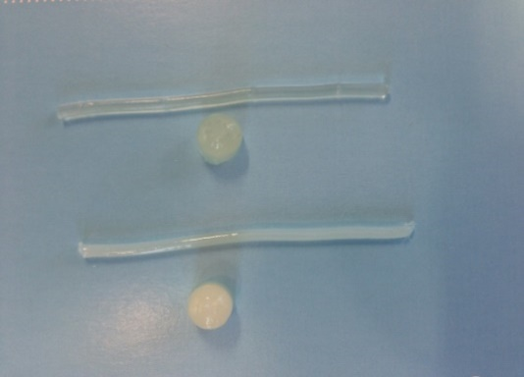
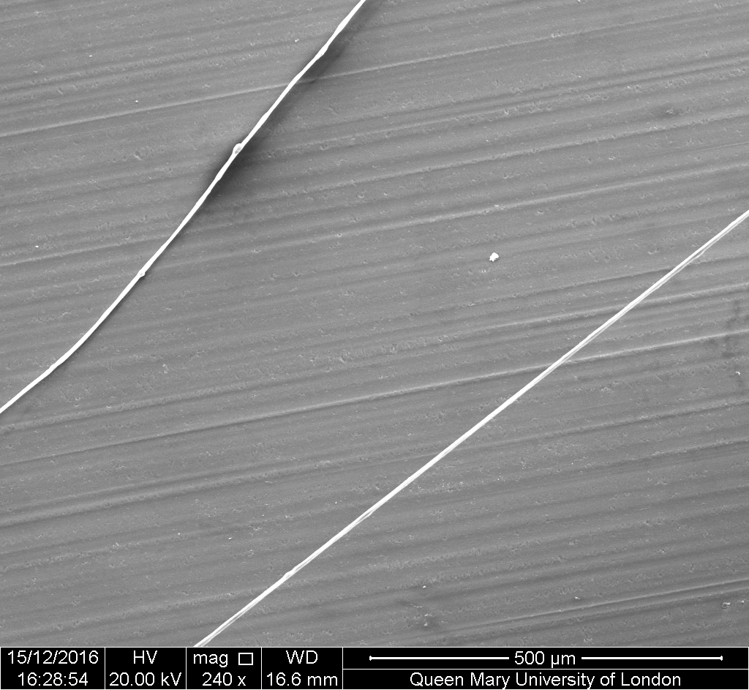
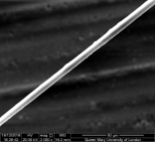
PM 5
PM 5 CHI
(a)
5 mm
20 μm

200 μm
(b)

Figure 4.21. (a) Photographs of PM 5 and PM 5 CHI nanocomposite hydrogels in different shapes (rods and balls), (b) PM 5 CHI microfibers obtained at 36,000 rpm rotating speed and 0.1 MPa working pressure. The inset in (b) shows the corresponding higher magnification image.

4.3.6. pH-sensitivity of the nanocomposite hydrogel formed by polyacrylamide, clay, alginate and calcium chloride
Apart from the remarkable mechanical properties, PMACa also displayed notable pH-sensitivity as the equilibrium swelling states were significantly different as shown in Figure 4.22 and 4.23. As seen from Figure 4.23 (b), the weight of the samples almost stayed constant after 2 weeks so that the samples reached equilibrium after 2 weeks’ swelling.
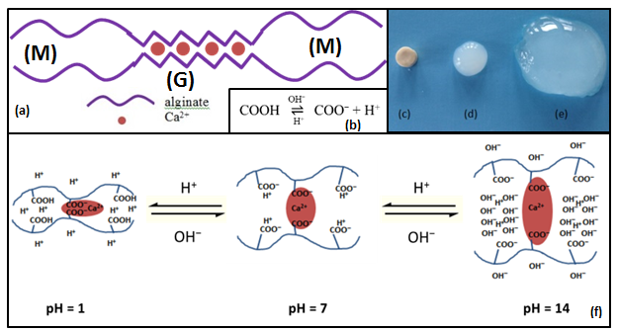

Figure 4.22. (a) The chemical structure of crosslinked Ca-alginate blocks, (b) chemical equilibrium of carboxyl groups in M blocks, (c-e) PMACa samples immersed in (c) HCl solution, (d) distilled water, and (e) NaOH solution, (f) The mechanism of pH-dependent swelling/shrinking behaviours of PMACa.

(b)
(a)

φ_{ve}
φ
Figure 4.23. (a) Equilibrium swelling ratios of PMACa, and (b) weight of the samples after 2, 3, 4, 5 weeks.

According to the previous study (Sun et al., 2012; Tonnesen & Karlsen, 2002), the structure of alginate chains crosslinked by Ca²⁺ was shown in Figure 4.22 (a). Apart from the remarkable mechanical properties, PMACa also displayed notable pH-sensitivity as the equilibrium swelling states were significantly different as shown in Figures 4.22 and 4.23 (a). Alginate is a kind of block copolymer composed of mannuronic acid (M unit) and guluronic acid (G unit). Only G-blocks were able to form ionic crosslinking by divalent cations such as Ca²⁺ (George & Abraham, 2006; Lee & Mooney, 2012; Sun et al., 2012).

Compared to PMACa swollen in distilled water, PMACa placed in acid shrank significantly while PMACa swollen in base further swelled (Figure 4.22 (c-e)). As shown in Figure 4.23, the equilibrium swelling ratios by weight (φ) of PMACa at the pH value of 1, 7 and 14 were 1.2, 8.7 and 24.2, respectively. The equilibrium swelling ratios by volume (φ_{ve}) of PMACa at the pH value of 1, 7 and 14 were 0.3, 1.5 and 15.7, respectively. The swelling/deswelling behaviours were closely related to pH-dependent carboxyl chemical equilibrium and could be described in Figure 4.22 (b) and (f) (Ju et al., 2001; Obara et al., 2010). In neutral pH environment, Ca²⁺ crosslinked the adjacent carboxyl groups of the G blocks, while for the M blocks, COO⁻ ions were surrounded by the dissociated H⁺ ions (Lee & Mooney, 2012). In the case of PMACa in the acidic environment, the dissociated COO⁻ ions and H⁺ ions of the M blocks bound together to form COOH groups under the influence of H⁺ ions donated by HCl (Ju et al., 2001; Obara et al., 2010). From COO⁻ ions to COOH groups, the electrostatic repulsion between the adjacent COO⁻ ions was neutralised so that the nanocomposite hydrogel shrank from pH = 7 to pH = 1 (Obara et al., 2010). Another reason for shrinkage of PMACa at low pH environment (pH ≤ 5) was due to the significantly enhanced positive edge charge of MMT platelets under acidic environment (Okada & Usuki, 2007). Only at low pH environment, the edges of MMT platelets are pronated and the edge charge changes from negative to positive (Wang et al., 2010). The interaction between the negatively charged MMT surface and the positively charged MMT edges induced the shrinkage (Shibayama et al., 2004; Wang et al., 2010). In the case of PMACa in the basic environment, COOH groups of the M blocks were dissociated and the dissociated H⁺ ions were surrounded by abundant OH⁻ ions donated by NaOH (Haraguchi et al., 2005; Obara et al., 2010). So the nanocomposite hydrogel further swelled from pH = 7 to pH = 14 due to the diffusion of H⁺ and the enhanced electrostatic repulsion by COO⁻ ions and OH⁻ ions (Obara et al., 2010). The pH-sensitivity of PMACa means that this nanocomposite hydrogel might be used in the applications of pH-sensitive drug delivery and agriculture. For example, in terms of drug delivery, generally, cancer cells were surrounded by a low pH environment (pH < 5) (Bhunchu & Rojsitthisak, 2014). Therefore, if PMACa hydrogel micelles were allowed to absorb drug molecules for curing cancer in a lowly alkaline environment, then the hydrogel micelles would contain large amount of drug molecules because of the fairly high equilibrium swelling ratio. When PMACa hydrogel micelles were injected into the tissue and stick onto the surface of the cancer cells with the help of the high hydrophilicity and good affinity to cell membranes of PAM and alginate, they might be able to shrink and release the anti-cancer drug inside due to the reduced pH value. Besides, due to its good stability and mechanical properties, they could be easily expelled from the body without leaving a lot of residues. Similarly, in terms of agriculture, if PMACa hydrogels were pre-swelled in some alkaline solution containing some pesticide or plant hormone, and then they would be effective in releasing the pesticide or plant hormone once put in the acidic soil.

4.3.7. Optical properties and solvent responsivity of the nanocomposite films formed by clay, alginate and calcium chloride

Optical properties of the nanocomposite films formed by clay, alginate and calcium chloride
As-prepared swollen AlgCa and AlgMMTCa nanocomposite hydrogel films with the thickness of 0.05 mm~0.077 mm were tested as-prepared by recording the transmittance within the range 250-800 nm as shown in Figure 4.24 (a) and Table 4.8.
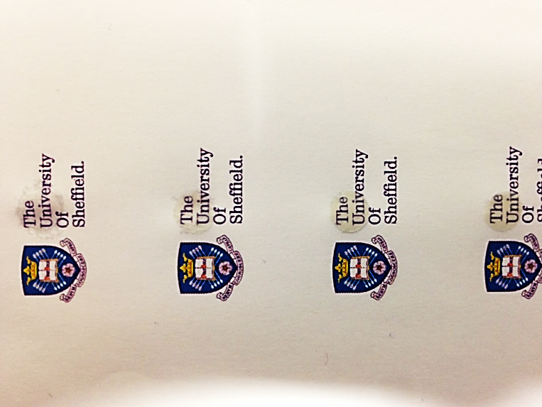
(b)
AlgCa
AlgMMTCa82
AlgMMTCa73
AlgMMTCa11
(a)
Figure 4.24. (a) Transmittance UV–Vis spectra of AlgCa and AlgMMTCa films scanned from 200 nm to 800 nm, and (b) this image shows clearly the University logo beneath the circular AlgCa and AlgMMTCa films highlighted by red dash circles.

Table 4.8. UV-Vis percent transmittance of AlgCa and AlgMMTCa films at 320 nm, 400 nm and 800 nm.
Samples | Transmittance / %
Samples | 320 nm | 400 nm | 800 nm
AlgCa | 82.2 | 96.2 | 98.9
AlgMMTCa82 | 20.2 | 40.0 | 74.3
AlgMMTCa73 | 8.6 | 25.0 | 64.6
AlgMMTCa11 | 2.8 | 17.2 | 57.9

As seen from Figure 4.24 and Table 4.8, at the wavelength of 400 nm, AlgCa had a fairly high transmittance of 96.2% while AlgMMTCa had a significant blocking effect to the light. This was due to the blocking effect of the alginate-MMT phases with the dimension larger than 400 nm, implying that AlgMMTCa films were effective in blocking ultraviolet light (wavelength ≤ 400 nm). At the wavelength of 320 nm, AlgMMTCa73 and AlgMMTCa11 displayed a fairly low light transmittance of 8.6% and 2.8% respectively, while AlgCa could still let 82.2% of light go through. It is known that solar ultraviolet radiation is harmful to human and animal skin (Armstrong & Kricker, 2001; de Gruijl, van Kranen, & Mullenders, 2001; Ichihashi et al., 2003). Especially, ultraviolet B with a wavelength from 290 nm to 320 nm is more responsible to mutation and skin cancer than ultraviolet A with a wavelength from 320 nm to 400 nm (Ichihashi et al., 2003). So combined with the biocompatibility of alginate (Baumberger & Ronsin, 2010; Kong et al., 2003; Zhao et al., 2010), AlgMMTCa might be promising in the applications of UV-proof skin care.

The text “The University” behind AlgMMTCa films could be still seen clearly as shown in Figure 4.24 (b). Because the dimension of alginate-MMT phases was smaller than the wavelength of visible light, AlgMMTCa nanocomposite films didn’t have a big blocking effect on the light passage (Siró & Plackett, 2010). At the wavelength of 800 nm, AlgCa was highly transparent with a high light transmittance of 98.9% while the light transmittance decreased as the MMT content increased. This phenomenon was quite common in alginate nanocomposite films. The reduction of transparency was little relevant to the high clay content (Abdollahi et al., 2013). The interlocking of alginate chains with MMT platelets brought in large continuous alginate-MMT phases. Some of alginate-MMT phases were of large dimension reaching the wavelength of visible light and thus caused the reduced transparency (Liang et al., 2016; Rhim, 2011; Segad et al., 2010).

Solvent responsivity of the nanocomposite films formed by clay, alginate and calcium chloride
Because sodium alginate is insoluble in alcohols or acetone (Pawar & Edgar, 2012), Ca²⁺-crosslinked alginate nanocomposites has been shown responsive to alcohols or acetone (Lee & Mooney, 2012; Wan, Heng, & Chan, 1992). The solvent-responsive tests in methanol and acetone were conducted and the results were shown in Figure 4.25.
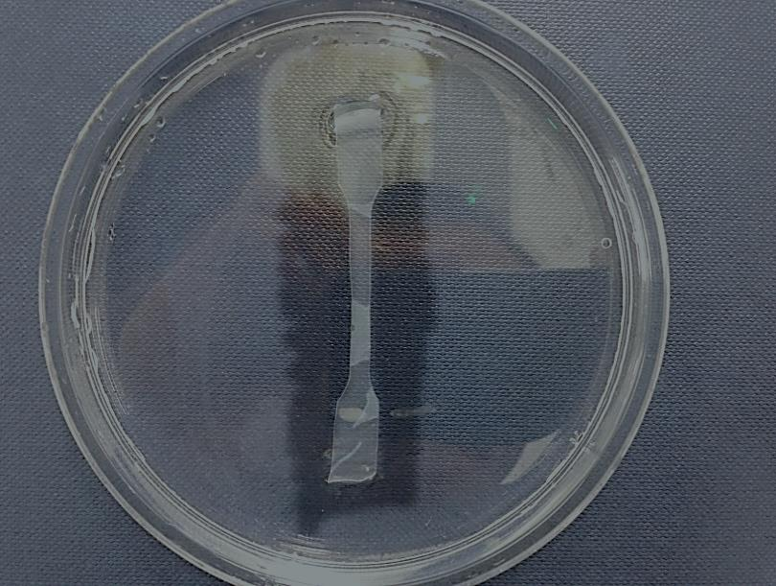
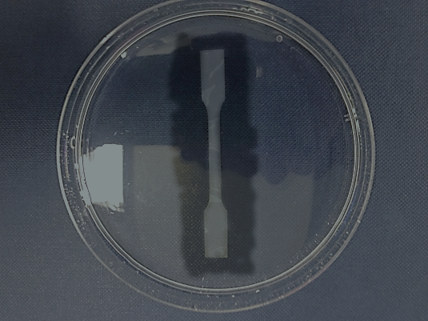
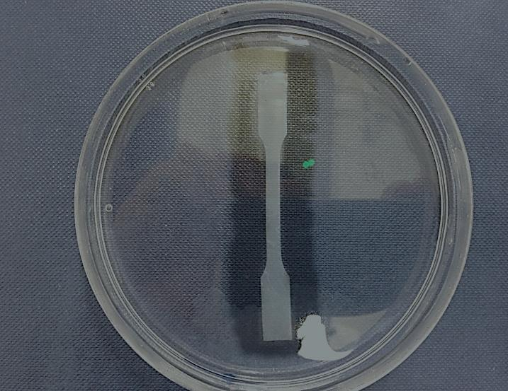
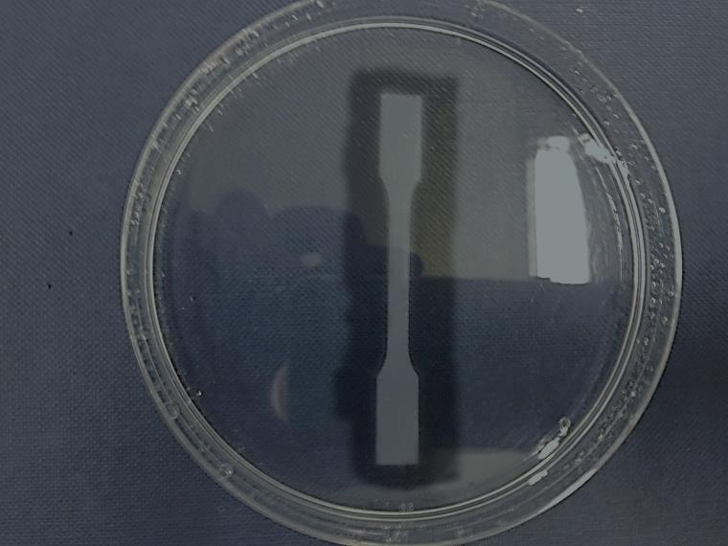
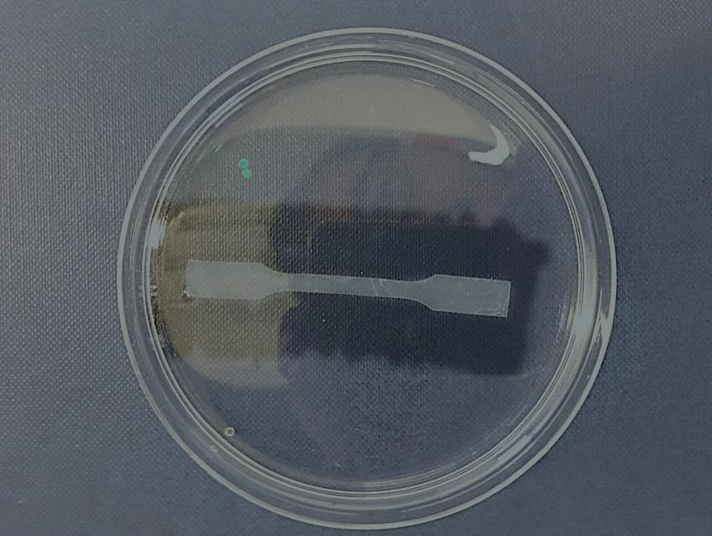
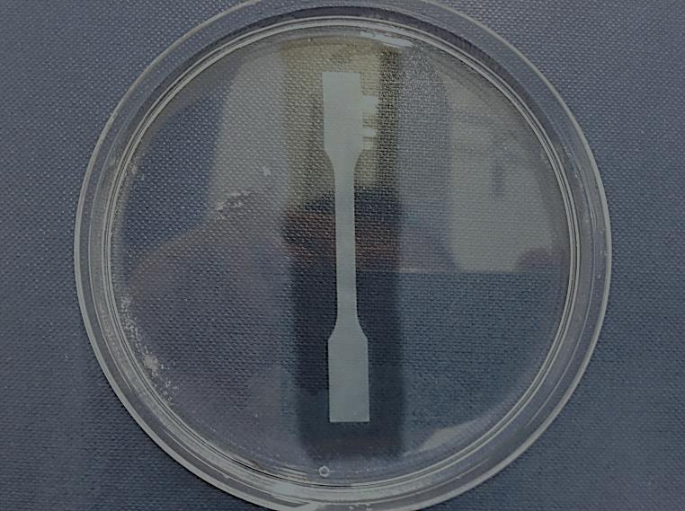
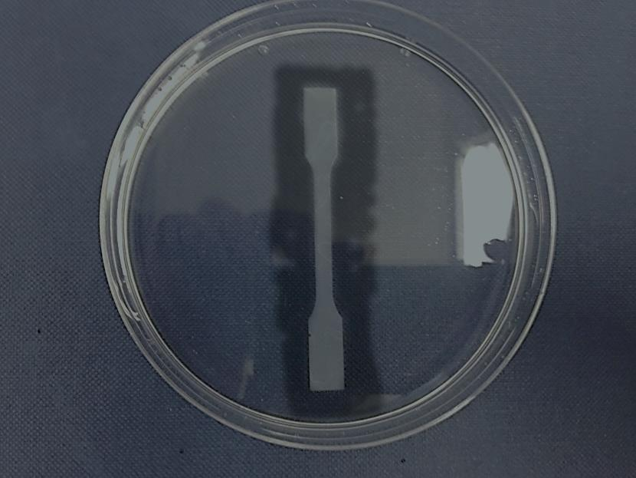
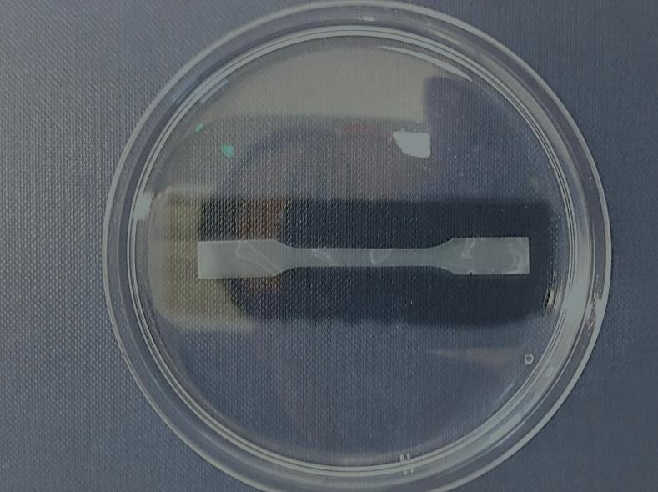
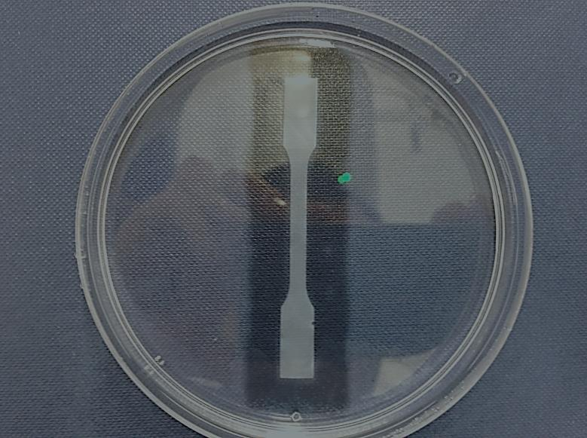
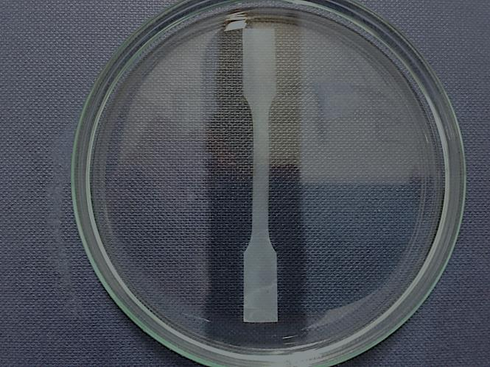
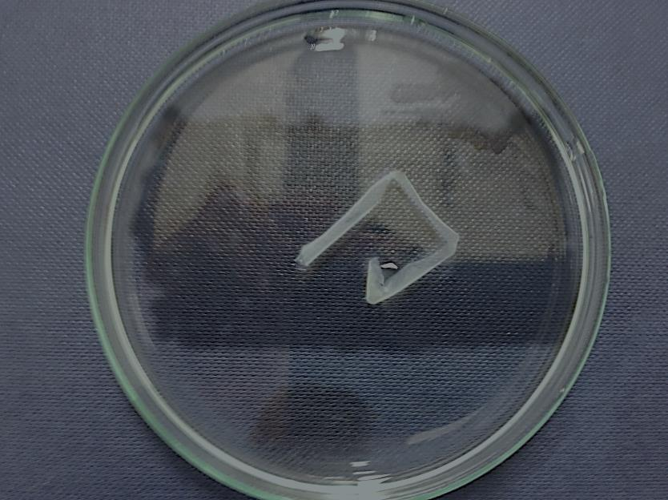
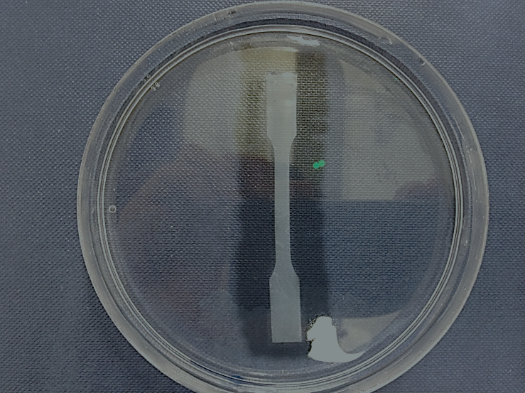
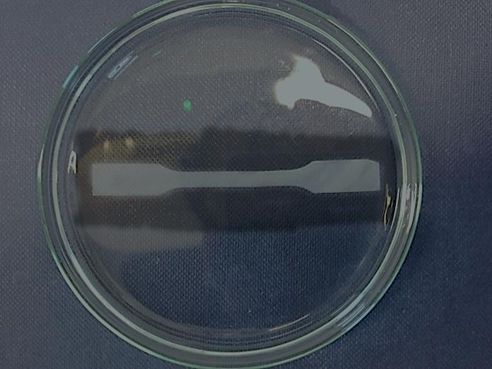
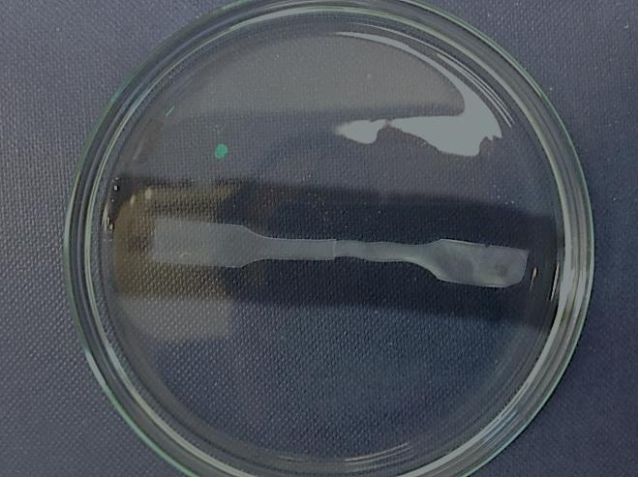
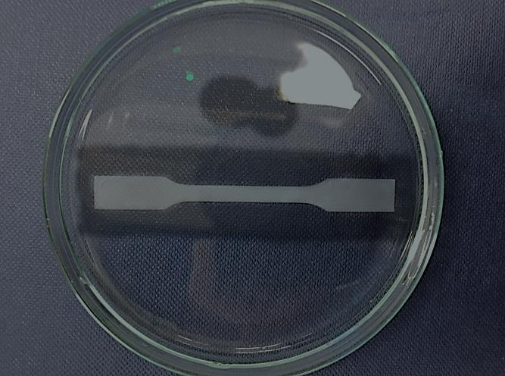
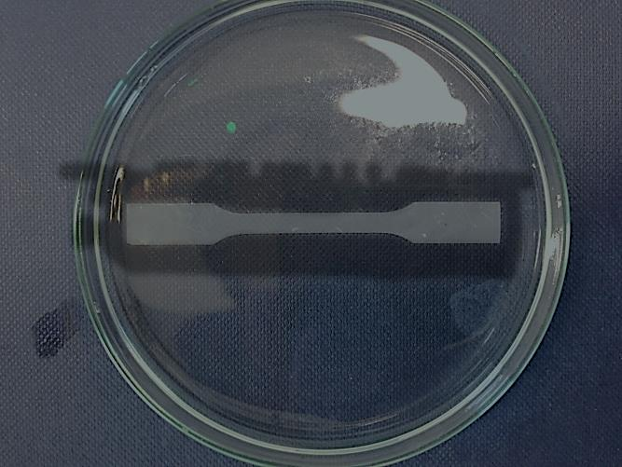
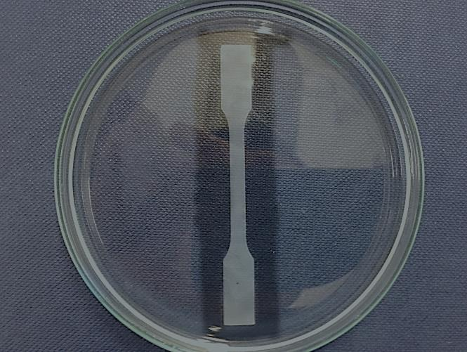
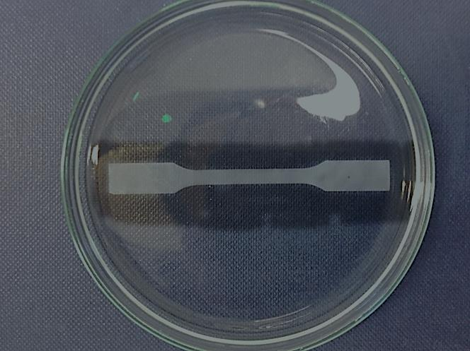
(b)
(a)
(c)
(d)
(e)
(f)
(g)
(h)
(i)
(j)
(k)
(l)
(m)
(n)
(o)
(p)
(q)
(r)

25 mm
Figure 4.25. Solvent-responsive behaviours of AlgMMTCa in methanol or acetone: AlgMMTCa82 (a) in water, (b) in methanol, (c) recovered in water; AlgMMTCa73 (d) in water, (e) in methanol, (f) recovered in water; AlgMMTCa11 (g) in water, (h) in methanol, (i) recovered in water; AlgMMTCa82 (j) in water, (k) in acetone, (l) recovered in water; AlgMMTCa73 (m) in water, (n) in acetone, (o) recovered in water and AlgMMTCa11 (p) in water, (q) in acetone, (r) recovered in water.

From Figure 4.25 (a-i), it was discovered that for methanol-treated AlgMMTCa, the films were dehydrated slightly without obvious changing the shape. AlgMMTCa82 slightly curved on the edges while AlgMMTCa73 and AlgMMTCa11 hardly changed their shape. This was different from the previous result (Liang et al., 2016), in which significant shape change was observed by the CMMT-ALG. The reason for the different solvent responses was regarded to be the different microstructure as illustrated in Scheme 4.7. Because of the dense alignment of MMT platelets by vacuum filtration (Yao et al., 2010), the movement of alginate chains in CMMT-ALG were highly restricted by MMT platelets. Once the interlayer water was removed by methanol, alginate chains coiled, causing MMT platelets to reorientate. However, as for AlgMMTCa, because the microstructure derived by solution casting and fully swelling was less dense than that of CMMT-ALG, the long free alginate chains in between the adjacent MMT platelets coiled without the reorientation of MMT platelets and gave rise to much smaller shape change.
(a)
(b)

Scheme 4.7. Schematic illustration of dehydration of (a) CMMT-ALG, and (b) AlgMMTCa.

When it came to acetone, as shown in Figure 4.25 (j-r), the films were highly dehydrated and AlgMMTCa82 coiled strongly in a few seconds. This phenomenon was in accordance with the previous research for shape responses of Ca²⁺-crosslinked alginate hydrogels to different organic solvents (Torres, Velasquez, & Brito-Arias, 2011). It was due to the aprotic nature of acetone. Acetone was able to attack positively charged Ca²⁺ by its negatively charged dipole. When some Ca²⁺ was dissociated from the –COO-Ca-OOC- crosslinking points, the originally crosslinked alginate chains were free to coil so that more water was extracted by acetone than methanol (Torres et al., 2011). In this case, AlgMMTCa82 films shrank more and displayed a denser microstructure than those in methanol, making it possible for MMT to reorientate and thus the significant bending. However, for AlgMMTCa73 and AlgMMTCa11, they didn’t coil as did AlgMMTCa82 but only slightly crumpled at the edges. This was probably due to the higher content of alginate in AlgMMTCa82 than the other two as the higher content of alginate meant more polymer coils and thus more reshaping when the interlayer water was partially removed.

No matter whether methanol or acetone was used for treating AlgMMTCa films, they became slightly dehydrated and crumple. When they were put back to distilled water, they became soft quickly and fully recover to their original state in 4 hours, indicating shape-memory effect. In summary, the shape of AlgMMTCa films was stable in either methanol or acetone except for the case of AlgMMTCa82 in acetone, in which it coiled strongly. All the treated films recovered their original state after being putting back to distilled water for 24 hours.

4.4. Summary
As summarised in Table 4.9, highly stretchable PAM nanocomposite hydrogels with low hysteresis were successfully prepared with the presence of a small amount of MMT or MMT pre-treated by either chitosan or alginate, by the means of high temperature in situ polymerisation. And novel alginate/MMT/Ca²⁺ nacre-like nanocomposite films were synthesised by solution casting alginate-MMT suspension and then followed by immersion in CaCl₂ solution. The mechanical properties of the fully swollen AlgMMTCa nanocomposite films were investigated for the first time. The rheological results confirmed resilient nature of the hydrogels. The hydrogels may be fabricated into various forms and shapes. In Table 4.9, in terms of the mechanical properties, PM 5 CHI was compared to those of PM 5; PMACa, PMAW, PMCa and PMW were compared to PMW; AlgMMTCa73 and AlgMMTCa11 nanocomposite hydrogel films were compared to AlgMMTCa82 nanocomposite hydrogel film.

Table 4.9. Summary of polymer/MMT nanocomposite hydrogels in the 4th Chapter.
Materials (special property) | Processing strategy | Clay filler | Change on the properties in respect to the PAM/MMT nanocomposite hydrogel or the fully swollen AlgMMTCa82 film |  |  |  | Equilibrium swelling ratio in distilled water
Materials (special property) | Processing strategy | Clay filler | Tensile strength |  | Strain at break |  | Equilibrium swelling ratio in distilled water
PM 5 | 60 ºC for 24 hours, in situ polymerisation | MMT | - |  | - |  | 64
PM 5 CHI (compressively resistant) | Same as PM 5 | chitosan-treated MMT | as-prepared | fully swollen | as-prepared | fully swollen | 32
PM 5 CHI (compressively resistant) | Same as PM 5 | chitosan-treated MMT | + 237% | + 91% | + 101% | + 109% | 32
PMACa (pH-sensitive) | 60 ºC-80 ºC for 1 hour, then 80 ºC for 1 hour, in situ polymerisation, swollen in 0.3 M CaCl₂ solution | Sodium alginate-treated MMT | fully swollen |  | fully swollen |  | 9.8
PMACa (pH-sensitive) |  | Sodium alginate-treated MMT | + 4325% |  | + 573% |  | 9.8
PMAW | 60 ºC-80 ºC for 1 hour, then 80 ºC for 1 hour, in situ polymerisation, swollen in distilled water | Sodium alginate-treated MMT | fully swollen |  | fully swollen |  | 47.7
PMAW |  | Sodium alginate-treated MMT | - 33% |  | + 280% |  | 47.7
PMCa | same as PMACa | MMT | fully swollen |  | fully swollen |  | 11.7
PMCa | same as PMACa | MMT | + 58% |  | + 67% |  | 11.7
PMW | same as PMAW | MMT | - |  | - |  | 37.6
AlgMMTCa82 (acetone-sensitive) | alginate+MMT solution casting, then swollen in 0.3 M CaCl₂ solution | Sodium alginate-treated MMT | - |  | - |  | 0.62
AlgMMTCa73 (UV-proof) | same as AlgMMTCa82 | Sodium alginate-treated MMT | + 381% |  | - 50% |  | 0.37
AlgMMTCa11 (highly UV-proof) | same as AlgMMTCa82 | Sodium alginate-treated MMT | + 60% |  | - 65% |  | 0.55

Highly stretchable PAM nanocomposite hydrogels with low hysteresis were successfully prepared with the presence of a small amount of MMT or MMT pre-treated by either chitosan or alginate, by the means of high temperature in situ polymerisation. And novel alginate/MMT/Ca²⁺ nacre-like nanocomposite films were synthesised by solution casting alginate-MMT suspension and then followed by immersion in CaCl₂ solution. The mechanical properties of the fully swollen AlgMMTCa nanocomposite films were investigated for the first time. The rheological results confirmed resilient nature of the hydrogels. The hydrogels may be fabricated into various forms and shapes.

Polyacrylamide was successfully grafted onto the chitosan chains, which was confirmed by that a 25% of weight loss was achieved by PM 5 CHI by biodegradation while no weight loss was observed by PM 5. PM 5 and PM 5 CHI displayed relatively high tensile strength of 45.9 kPa and 154.8 kPa, strain at break of 12.9 and 26.0, fast shape recovery within one minute and low 1st cycle hysteresis to 500% of 0.09 and 0.20. Comparing to PM 5, PM 5 CHI increased the tensile strength by 237% and the strain at break by 91%, but decreased hysteresis slightly. The tensile properties deteriorated after the hydrogels had been fully swollen in PBS for 2 days at 37 ºC. The tensile strength of fully swollen PM 5 and PM 5 CHI reduced to 4.5 kPa and 8.6 kPa, and the strain at break decreased to 5.3 and 11.1, respectively. Yet, comparing to PM 5, the fully swollen PM 5 CHI still enhanced the tensile strength by 101% and the strain at break by 109%. PM 5 CHI could be stretched by over 10 times and able to withstand a compressive load of 1 kN. PM 5 CHI had a lower equilibrium water swelling ratio (32) than PM 5 (64). The excellent mechanical properties of the hydrogels were attributed to the strong interactions within the hydrogels brought by chain branching, multiple hydrogen bonding, covalent bonding and/or electrostatic force, as confirmed by FTIR, in vitro degradation test, SEM and the replacement of chitosan with another polysaccharide, namely starch or k-carrageenan, in the synthesis. PM 5 CHI could be fabricated into microfibers using pressurized gyration via the precursor route. They could find potential applications in artificial tissues, functional films, drug delivery and actuators. These results indicated that it is possible to incorporate some functional polymers with polymer-clay nanocomposite hydrogels and alter the mechanical properties as well as other properties such as the swelling properties and sensitivity.

When it came to PMACa, after Ca²⁺ crosslinking, the resultant PMACa displayed significantly higher tensile strength of 106.2 kPa, strain at break of 10.1, and lower equilibrium swelling ratio of 9.8 than those of fully swollen PM 5 CHI, PMAW without Ca²⁺ ionic crosslinking, PMW and PMCa. At the fully swollen state, comparing to PMW, PMACa increased the tensile strength by 4325% and the strain at break by 573%. The other fully swollen hydrogels showed a tensile strength lower than 10 kPa. The hysteresis during cyclic tensile tests to a strain of 100% was 0.01, which was quite small and indicated good elasticity. PMACa could quickly recover its shape under ambient temperature within 15 minutes. PMACa showed strong pH-dependant swelling properties where it shrank by 4 times in the acidic medium and swelled by 9 times in the basic medium compared to the volume in the distilled water with the neutral pH value. The interesting properties of PMACa were closely related to the internal structure and interaction between the different components, which gave rise to a diversified field of applications in the structural materials for the aquatic environment such as artificial tendon, environmental purification such as heavy metal uptake, and agriculture such as pH-dependent pesticide release.

With the help of Ca²⁺ crosslinked alginate, alginate-MMT hydrogen bonding and electrostatic interaction between Ca²⁺ and MMT platelets, AlgMMTCa films displayed high tensile strength and toughness even after being fully swollen. And among AlgMMTCa films, AlgMMTCa73 showed the highest Young’s modulus (411.7 MPa), tensile strength (27.9 MPa) and toughness (1.81 MJ m⁻³), but lowest equilibrium swelling ratio (0.37) because of its unique chemical structure. Comparing to AlgMMTCa82, AlgMMTCa73 increased its tensile strength by 381% but reduced the strain at break by 50%. In terms of optical properties, despite high content of MMT (≥ 20 wt%), all the films displayed acceptable transparency. AlgMMTCa73 and AlgMMTCa11 showed excellent barrier effect on the ultraviolet transmittance (≤ 25% at the wavelength of 400 nm, and ≤ 8.6% at the wavelength of 320 nm). When contacting with organic solvent, only AlgMMTCa82 was very sensitive to acetone. Unlike the previously reported Ca²⁺-alginate systems, the shape of the other AlgMMTCa films was quite stable in methanol or acetone. They just dehydrated without any significant shape change. All the films recovered their original shape quickly when back to the aquatic environment, defining excellent shape-memory property. AlgMMTCa73 was very promising in the applications of skin care or other aquatic usages such as UV-proof breeding box for raising some UV-sensitive aquatic creatures. AlgMMTCa82 might be able to serve as an acetone-sensitive material.

In short, several conclusions can be made:
- High temperature in situ polymerisation of acrylamide give rise to branching and significantly different mechanical properties compared to those of the PAM/MMT nanocomposite hydrogels synthesised at ambient temperature with catalyst.
- It is possible to introduce polysaccharides into the PAM nanocomposite hydrogel network. And the significantly enhanced mechanical properties and stimuli-responsivity are likely to be obtained.
- A variety of stiffness, tensile strength, optical properties and unique solvent-sensitivity can be achieved for AlgMMTCa nanocomposite hydrogel films by varying the alginate/MMT ratio.

Chapter 5: Conclusions
In this thesis, a series of polymer/MMT nanocomposite materials were studied and the results were presented and analysed. Several conclusions can be made from those findings. As for the 3rd chapter, when twice-extruded, at a low clay content (< 2 wt%), an organic surfactant and/or chemical blowing agent helped MMT to form exfoliated structure, while intercalated structure could be found for the nanocomposite incorporated with the neat MMT. By the methods used in this chapter, the amount of citric acid which was kept in the clay galleries was quite small. During extrusion, there were MMT and citric acid left in the barrel of the extruder even after purging. Also some residual citric acid particles were found in all the samples, and polyamide 6 matrix seemed to degrade during processing. As for the triple-extruded nylon 6 and its nanocomposites, a thermally stable polymeric surfactant (Atlas) was used. The problems of retained MMT in the barrel of the extruder, nylon 6 degradation and residual citric acid in the samples were still not solved. In terms of the mechanical properties, for either twice-extruded or triple-extruded nylon 6 nanocomposites, the incorporation of clay fillers tended to increase Young’s modulus but decrease strain at break. The solid residual particles from incompletely decomposed citric acid created defects and weak interfaces, which made the mechanical properties declined. In terms of thermal properties, the incorporation of the new Atlas surfactant increased T_{50% weight loss}. The thermal stability was not increased for most of the twice-extruded and triple-extruded samples.

PAM/chitosan/MMT, PAM/alginate/MMT/Ca²⁺ and alginate/MMT/Ca²⁺ nanocomposite hydrogels were investigated in the 4th chapter. With the incorporation of a small amount of chitosan, as-prepared polyacrylamide/chitosan-treated MMT nanocomposite hydrogel with the MMT/acrylamide weight ratio of 0.05 (PM 5 CHI) displayed a significantly higher tensile strength and elongation at break than those of as-prepared polyacrylamide/MMT nancomposite hydrogel with the same MMT/acrylamide weight ratio (PM 5). Upon stretching, both materials could recover their original shape in a minute when the external load was removed, and showed relatively low hysteresis while PM 5 CHI displayed higher hysteresis. The equilibrium swelling ratio of PM 5 CHI was about a half of that of PM 5. When fully swollen in PBS at 37 ºC, PM 5 CHI still displayed an elongation at break over 10 and it could even survive after a compressive load of 1 kN. The remarkable properties of PM 5 CHI were attributed to PAM branching, PAM-MMT hydrogen bonding and PAM-g-chitosan which were confirmed by FTIR, in vitro degradation, SEM and parallel experiments using starch or k-carrageenan. PM 5 CHI could be made into microfibers using pressurized gyration via the precursor route.

The interpenetrating nanocomposite hydrogel (PMACa) using PAM, alginate, MMT and Ca²⁺ were also successfully synthesised, which showed a tensile strength of 106.2 kPa, a strain at break of 10.1 and a toughness of 523.3 kJ m⁻³ at the fully swollen state, significantly higher than those of PMAW, PMCa and PMW when fully swollen. PMACa showed negligible hysteresis during a cyclic tension to a strain of 100%, and it was able to recover 88% of its original shape when stretched to a strain of 300% in 15 minutes at ambient temperature. PMACa was pH-sensitive as it showed distinctive equilibrium swelling ratios by either weight or volume in the acidic, neutral and basic environment. This pH-dependant shape change process was reversible. The flexibility and resilience of polyacrylamide-MMT network were combined with the rigidity and effective energy dissipation, giving rise to those remarkable properties. The good mechanical properties at the fully swollen state and pH-sensitivity of PMACa made it possible to be applicable in many fields of medicine and agriculture.

The fully swollen alginate/MMT/Ca²⁺ nanocomposite hydrogel films were synthesised and their mechanical properties were studied for the first time. The alginate/MMT/Ca²⁺ nanocomposite hydrogel films with the alginate/MMT weight ratio of 7:3 (AlgMMTCa73) displayed a Young’s modulus of 411.7 MPa and a tensile strength of 27.9 MPa, significantly higher than those of AlgMMTCa82 and AlgMMTCa11 at either higher or lower MMT content. Both AlgMMTCa73 and AlgMMTCa11 showed low strain at break no higher than 0.21. The equilibrium water swelling ratio of the films displayed the opposite trend to that of the tensile strength and modulus. As for the optical properties, the transparency of visible light was acceptable for all the films. Remarkable barrier effect on ultraviolet lights was achieved by AlgMMTCa73 and AlgMMTCa11. When submerged in organic solvents, the films tended to lose some water and AlgMMTCa82 displayed strong sensitivity to acetone by showing a significant shape change. The shape of all the other films was quite stable in either methanol or acetone. Those findings suggested some potential aquatic applications such as skin care for AlgMMTCa films.

So from the work on nylon 6/MMT nanocomposites in this project, it is learnt that citric acid is not suitable for serving as chemical blowing agent because of the large amount of residues upon extrusion. Ammonium bicarbonate may be a better choice because of low decomposition temperature and absence of solid residues after decomposition. The extrusion temperature of nylon 6 needs to be lowered in order to prevent degradation. A side feeder is needed for better incorporation of MMT powder. Other bifunctional or multi-functional polymeric surfactants are worth testing for the modification of the MMT surface for the preparation of nanocomposite materials.

From the work on the nanocomposite hydrogels, it is learnt that it is likely to make grafted, interpenetrating or even more complex structure, with the MMT platelets serving as the physical crosslinker. The derived nanocomposite hydrogels can obtain not only significantly improved mechanical properties but also other stimuli-responsive properties. Ideas can be broadened to other hydrophilic and highly functional polymers to design high-performance polymer/MMT nanocomposite hydrogels. More complex structures can be made such as: PAM-clay nanocomposite hydrogel network may be incorporated with multiple networks with unique functions. It is possible to achieve multiple stimuli-responsibilities to temperature, pH, ion strength and/or electricity at the same time for the derived interpenetrating networks, without compromising their mechanical properties. It is also learnt that polysaccharides and MMT are promising for making nacre-like nanocomposite materials with high stiffness and strength, and interesting properties under either dry or wet state.

Chapter 6: Future Work
Based on the results from Nylon 6 and its clay nanocomposites, better chemical blowing agents, such as ammonium bicarbonate which can be easily absorbed by the clay platelets and have low thermal decomposition temperature and no solid residues after thermal decomposition, are worth trying for improving clay exfoliation of polymer/clay nanocomposites. Other lowly polar polymers such polystyrene and polypropylene are worth studying and significantly improvement of clay exfoliation might be received, apart from polar polymers such as Nylon 6.

According to the findings from polymer/MMT nanocomposite hydrogels, the idea of high temperature polymerisation and interpenetrating networks can be broadened to many more acrylic monomers and functional polymers. N-isopropylacrylamide which is thermally sensitive can be used to form nanocomposite hydrogels with clays. k-carrageenan which is ion strength-sensitive can be dissolved in water and form ionic crosslinking with many divalent cations. Layered double hydroxide platelets which are positively charged are promising for serving as physical, multi-functional crosslinkers for nanocomposite hydrogels. The combination of 2, 3 or more of the materials above along with acrylamide, chitosan and/or alginate is worth studying in order to achieve the interpenetrating multi-functional network with good mechanical properties, even at the fully swollen state.

References
Abd El-Ghaffar, M. A., Hashem, M. S., El-Awady, M. K., & Rabie, A. M. (2012). pH-sensitive sodium alginate hydrogels for riboflavin controlled release. Carbohydrate Polymers, 90(1), 734-734.
Abdollahi, M., Alboofetileh, M., Rezaei, M., & Behrooz, R. (2013). Comparing physico-mechanical and thermal properties of alginate nanocomposite films reinforced with organic and/or inorganic nanofillers. Food Hydrocolloids, 32(2), 416-424.
Achhammer, B. G., Reinhart, F. W., & Kline, G. M. (1951). Mechanism of the degradation of polyamides. Journal of Chemical Technology and Biotechnology, 1(7), 301-320.
Ahmad, M. B., Gharayebi, Y., Salit, M. S., Hussein, M. Z., & Shameli, K. (2011). Comparison of in situ polymerization and solution-dispersion techniques in the preparation of polyimide/montmorillonite (MMT) nanocomposites. International journal of molecular sciences, 12(9), 6040-6050.
Ahmed, E. M. (2015). Hydrogel: Preparation, characterization, and applications: A review. Journal of Advanced Research, 6(2), 105-121.
Akelah, A., & Moet, A. (1996). Polymer-clay nanocomposites: free-radical grafting of polystyrene on to organophilic montmorillonite interlayers. Journal of Materials Science, 31(13), 3589-3596.
Akulon®6-D. Retrieved from http://www.dsm.com/products/akulon/en_US/home.html
Al-Karawi, A. J. M., Al-Qaisi, Z. H. J., Abdullah, H. I., Al-Mokaram, A. M. A., & Al-Heetimi, D. T. A. (2011). Synthesis, characterization of acrylamide grafted chitosan and its use in removal of copper(II) ions from water. Carbohydrate Polymers, 83(2), 495-500.
Al-Musa, S., Fara, D. A., & Badwan, A. (1999). Evaluation of parameters involved in preparation and release of drug loaded in crosslinked matrices of alginate. Journal of Controlled Release, 57(3), 223-232.
Al-Remawi, M. (2012). Sucrose as a crosslinking modifier for the preparation of calcium alginate films via external gelation. Journal of Applied Sciences, 12(8), 727.
Alboofetileh, M., Rezaei, M., Hosseini, H., & Abdollahi, M. (2013). Effect of montmorillonite clay and biopolymer concentration on the physical and mechanical properties of alginate nanocomposite films. Journal of Food Engineering, 117(1), 26-33.
Alexandre, B., Langevin, D., Médéric, P., Aubry, T., Couderc, H., Nguyen, Q., Saiter, A., Marais, S. (2009). Water barrier properties of polyamide 12/montmorillonite nanocomposite membranes: structure and volume fraction effects. Journal of Membrane Science, 328(1), 186-204.
Alexandre, M., & Dubois, P. (2000). Polymer-layered silicate nanocomposites: preparation, properties and uses of a new class of materials. Materials Science & Engineering R-Reports, 28(1-2), 1-63.
Ali, S., & Bandyopadhyay, R. (2015). Evaluation of the exfoliation and stability of Na-montmorillonite in aqueous dispersions. Applied Clay Science, 114, 85-92.
Allison, P. G., Moser, R. D., Chandler, M. Q., Caminero-Rodriguez, J. A., Torres-Cancel, K., Rivera, O. G., Goodwin, J. R., Weiss, C. A. (2015). Mechanical, thermal, and microstructural analysis of polyvinyl alcohol/montmorillonite nanocomposites. Journal of Nanomaterials, 16(1), 135.
Armstrong, B. K., & Kricker, A. (2001). The epidemiology of UV induced skin cancer. Journal of Photochemistry and Photobiology B: Biology, 63(1), 8-18.
Barbooti, M. M., & Al-Sammerrai, D. A. (1986). Thermal decomposition of citric acid. Thermochimica acta, 98, 119-126.
Baumberger, T., & Ronsin, O. (2010). Cooperative effect of stress and ion displacement on the dynamics of cross-link unzipping and rupture of alginate gels. Biomacromolecules, 11(6), 1571-1578.
Berger, J., Reist, M., Mayer, J. M., Felt, O., Peppas, N. A., & Gurny, R. (2004). Structure and interactions in covalently and ionically crosslinked chitosan hydrogels for biomedical applications. European Journal of Pharmaceutics and Biopharmaceutics, 57(1), 19-34.
Beuermann, S., Paquet, D. A., McMinn, J. H., & Hutchinson, R. A. (1996). Determination of free-radical propagation rate coefficients of butyl, 2-ethylhexyl, and dodecyl acrylates by pulsed-laser polymerization. Macromolecules, 29(12), 4206-4215.
Beyer, G. (2002). Nanocomposites: a new class of flame retardants for polymers. Plastics, Additives and Compounding, 4(10), 22-28.
Bharadwaj, R., Mehrabi, A., Hamilton, C., Trujillo, C., Murga, M., Fan, R., Chavira, A. Thompson, A. (2002). Structure–property relationships in cross-linked polyester–clay nanocomposites. Polymer, 43(13), 3699-3705.
Bhattarai, N., Li, Z., Edmondson, D., & Zhang, M. (2006). Alginate-based nanofibrous scaffolds: Structural, mechanical, and biological properties. Advanced Materials, 18(11), 1463-1467.
Bhunchu, S., & Rojsitthisak, P. (2014). Biopolymeric alginate-chitosan nanoparticles as drug delivery carriers for cancer therapy. Die Pharmazie-An International Journal of Pharmaceutical Sciences, 69(8), 563-570.
Blumstein, A. (1965). Polymerization of adsorbed monolayers. II. Thermal degradation of the inserted polymer. Journal of Polymer Science Part A: General Papers, 3(7), 2665-2672.
Bouchonneau, N., Sauvant-Moynot, V., Choqueuse, D., Grosjean, F., Poncet, E., & Perreux, D. (2010). Experimental testing and modelling of an industrial insulated pipeline for deep sea application. Journal of Petroleum Science and Engineering, 73(1), 1-12.
Bourbon, A. I., Pinheiro, A. C., Cerqueira, M. A., Rocha, C. M., Avides, M. C., Quintas, M. A., & Vicente, A. A. (2011). Physico-chemical characterization of chitosan-based edible films incorporating bioactive compounds of different molecular weight. Journal of Food Engineering, 106(2), 111-118.
Brouwer, J., Vanleeuwenherberts, T., & Ottingvanderuit, M. (1984). Determination of lysozyme in serum, urine, cerebrospinal-fluid and feces by enzyme-immunoassay. Clinica Chimica Acta, 142(1), 21-30.
Busilacchi, A., Gigante, A., Mattioli-Belmonte, M., Manzotti, S., & Muzzarelli, R. A. A. (2013). Chitosan stabilizes platelet growth factors and modulates stem cell differentiation toward tissue regeneration. Carbohydrate Polymers, 98(1), 665-676.
Busenberg, E., & Clemency, C. (1973). Determination of the cation exchange capacity of clays and soils using an ammonia electrode.
Caseri, W. (2006). Nanocomposites of polymers and inorganic particles: preparation, structure and properties. Materials Science and Technology, 22(7), 807-817.
Charles, J., Ramkumaar, G., Azhagiri, S., & Gunasekaran, S. (2009). FTIR and thermal studies on nylon-66 and 30% glass fibre reinforced nylon-66. Journal of Chemistry, 6(1), 23-33.
Chen, B. (2004). Polymer-clay nanocomposites: an overview with emphasis on interaction mechanisms. British Ceramic Transactions, 103(6), 241-249.
Chen, B., & Chrambach, A. (1979). Estimation of polymerization efficiency in the formation of polyacrylamide gel, using continuous optical scanning during polymerization. Journal of Biochemical and Biophysical Methods, 1(2), 105-116.
Chen, B., & Evans, J. R. (2004). Preferential intercalation in polymer-clay nanocomposites. The Journal of Physical Chemistry B, 108(39), 14986-14990.
Chen, B., & Evans, J. R. (2006a). Nominal and effective volume fractions in polymer− clay nanocomposites. Macromolecules, 39(5), 1790-1796.
Chen, B., & Evans, J. R. (2006b). Poly (ε-caprolactone)− Clay nanocomposites: structure and mechanical properties. Macromolecules, 39(2), 747-754.
Chen, B., & Evans, J. R. (2008). Impact and tensile energies of fracture in polymer–clay nanocomposites. Polymer, 49(23), 5113-5118.
Chen, B., & Evans, J. R. (2009). Impact strength of polymer-clay nanocomposites. Soft Matter, 5(19), 3572-3584.
Chen, B., Evans, J. R., Greenwell, H. C., Boulet, P., Coveney, P. V., Bowden, A. A., & Whiting, A. (2008). A critical appraisal of polymer–clay nanocomposites. Chemical Society Reviews, 37(3), 568-594.
Chen, B., Evans, J. R. G., Greenwell, H. C., Boulet, P., Coveney, P. V., Bowden, A. A., & Whiting, A. (2008). A critical appraisal of polymer-clay nanocomposites. Chemical Society Reviews, 37(3), 568-594.
Chen, B. Q., & Evans, J. R. G. (2006). Elastic moduli of clay platelets. Scripta Materialia, 54(9), 1581-1585.
Chen, K., Shi, B., Yue, Y., Qi, J., & Guo, L. (2015). Binary synergy strengthening and toughening of bio-inspired nacre-like graphene oxide/sodium alginate composite paper. ACS nano, 9(8), 8165-8175.
Chen, X., Martin, B. D., Neubauer, T. K., Linhardt, R. J., Dordick, J. S., & Rethwisch, D. G. (1995). Enzymatic and chemoenzymatic approaches to synthesis of sugar based polymer and hydrogels. Carbohydrate Polymers, 28(1), 15-21.
Cheng, Q., Wu, M., Li, M., Jiang, L., & Tang, Z. (2013). Ultratough artificial nacre based on conjugated cross-linked graphene oxide. Angewandte Chemie, 125(13), 3838-3843.
Chin, I. J., Thurn-Albrecht, T., Kim, H. C., Russell, T. P., & Wang, J. (2001). On exfoliation of montmorillonite in epoxy. Polymer, 42(13), 5947-5952.
Cho, J., & Paul, D. (2001). Nylon 6 nanocomposites by melt compounding. Polymer, 42(3), 1083-1094.
Choi, B., Loh, X. J., Tan, A., Loh, C. K., Ye, E., Joo, M. K., & Jeong, B. (2015). Introduction to in situ forming hydrogels for biomedical applications. In J. X. Loh (Ed.), In-situ gelling polymers: For biomedical applications (pp. 5-35). Singapore: Springer Singapore.
Croda Coatings & Polymers, Burn out temperatures HYPERMER KD series. Retrieved from http://www.crodacoatingsandpolymers.com/home.aspx?view=dtl&d=content&s=139&r=222&p=1540&productname=&application=&subapplication=&productgroup=&prodID=282
Dabrowski, F., Bourbigot, S., Delobel, R., & Le Bras, M. (2000). Kinetic modelling of the thermal degradation: of polyamide-6 nanocomposite. European Polymer Journal, 36(2), 273-284.
Daemi, H., & Barikani, M. (2012). Synthesis and characterization of calcium alginate nanoparticles, sodium homopolymannuronate salt and its calcium nanoparticles. Scientia Iranica, 19(6), 2023-2028.
Dalmoro, A., Barba, A. A., Lamberti, G., Grassi, M., & d'Amore, M. (2012). Pharmaceutical applications of biocompatible polymer blends containing sodium alginate. Advances in Polymer Technology, 31(3), 219-230.
Darnell, M. C., Sun, J. Y., Mehta, M., Johnson, C., Arany, P. R., Suo, Z. G., & Mooney, D. J. (2013). Performance and biocompatibility of extremely tough alginate/polyacrylamide hydrogels. Biomaterials, 34(33), 8042-8048.
Das, P., Malho, J. M., Rahimi, K., Schacher, F. H., Wang, B. C., Demco, D. E., & Walther, A. (2015). Nacre-mimetics with synthetic nanoclays up to ultrahigh aspect ratios. Nature Communications, 6, 5967.
Das, P., Schipmann, S., Malho, J. M., Zhu, B., Klemradt, U., & Walther, A. (2013). Facile access to large-scale, self-assembled, nacre-inspired, high-performance materials with tunable nanoscale periodicities. ACS Applied Materials & Interfaces, 5(9), 3738-3747.
Davis, R. D., Gilman, J. W., & VanderHart, D. L. (2003). Processing degradation of polyamide 6/montmorillonite clay nanocomposites and clay organic modifier. Polymer Degradation and Stability, 79(1), 111-121.
de Gruijl, F. R., van Kranen, H. J., & Mullenders, L. H. (2001). UV-induced DNA damage, repair, mutations and oncogenic pathways in skin cancer. Journal of Photochemistry and Photobiology B: Biology, 63(1), 19-27.
de Moura, M. R., Guilherme, M. R., Campese, G. M., Radovanovic, E., Rubira, A. F., & Muniz, E. C. (2005). Porous alginate-Ca²⁺ hydrogels interpenetrated with PNIPAAm networks: Interrelationship between compressive stress and pore morphology. European Polymer Journal, 41(12), 2845-2852.
de Paiva, L. B., Morales, A. R., & Díaz, F. R. V. (2008). Organoclays: properties, preparation and applications. Applied Clay Science, 42(1), 8-24.
Dennis, H., Hunter, D., Chang, D., Kim, S., White, J., Cho, J., & Paul, D. (2001). Effect of melt processing conditions on the extent of exfoliation in organoclay-based nanocomposites. Polymer, 42(23), 9513-9522.
Dixon, J. (1991). Roles of clays in soils. Applied Clay Science, 5(5-6), 489-503.
Do, C., Pearce, E., Bulkin, B., & Reimschuessel, H. (1987). FT–IR spectroscopic study on the thermal and thermal oxidative degradation of nylons. Journal of Polymer Science Part A: Polymer Chemistry, 25(9), 2409-2424.
Dunn, C., & Turner, S. (1974). Thermal history and mechanical properties. Polymer, 15(7), 451-455.
Duquesne, S., Jama, C., Le Bras, M., Delobel, R., Recourt, P., & Gloaguen, J. (2003). Elaboration of EVA–nanoclay systems—characterization, thermal behaviour and fire performance. Composites Science and Technology, 63(8), 1141-1148.
El-Dessouky, H. M., & Lawrence, C. A. (2011). Nanoparticles dispersion in processing functionalised PP/TiO2 nanocomposites: distribution and properties. Journal of Nanoparticle Research, 13(3), 1115-1124.
Fan, J., Shi, Z., Lian, M., Li, H., & Yin, J. (2013). Mechanically strong graphene oxide/sodium alginate/polyacrylamide nanocomposite hydrogel with improved dye adsorption capacity. Journal of Materials Chemistry A, 1(25), 7433-7443.
Fanood, M. H. R. (1998). Branching in radical polymerization of acrylamide. Iranian Polymer Journal, 7(1), 59-65.
Favre, H., & Lagaly, G. (1991). Organo-bentonites with quaternary alkylammonium ions. Clay Minerals, 26(1), 19-32.
Ferfera-Harrar, H., Aiouaz, N., Dairi, N., & Hadj-Hamou, A. S. (2014). Preparation of Chitosan-g-Poly(acrylamide)/Montmorillonite Superabsorbent Polymer Composites: Studies on Swelling, Thermal, and Antibacterial Properties. Journal of Applied Polymer Science, 131(1), 1-14.
Fornes, T., & Paul, D. (2003). Modeling properties of nylon 6/clay nanocomposites using composite theories. polymer, 44(17), 4993-5013.
Fornes, T., Yoon, P., Hunter, D., Keskkula, H., & Paul, D. (2002). Effect of organoclay structure on nylon 6 nanocomposite morphology and properties. Polymer, 43(22), 5915-5933.
Fornes, T., Yoon, P., Keskkula, H., & Paul, D. (2001). Nylon 6 nanocomposites: the effect of matrix molecular weight. Polymer, 42(25), 09929-09940.
Fornes, T., Yoon, P., & Paul, D. (2003). Polymer matrix degradation and color formation in melt processed nylon 6/clay nanocomposites. Polymer, 44(24), 7545-7556.
Fratzl, P., Gupta, H. S., Fischer, F. D., & Kolednik, O. (2007). Hindered crack propagation in materials with periodically varying Young's modulus - Lessons from biological materials. Advanced Materials, 19(18), 2657-2661.
Freier, T., Koh, H. S., Kazazian, K., & Shoichet, M. S. (2005). Controlling cell adhesion and degradation of chitosan films by N-acetylation. Biomaterials, 26(29), 5872-5878.
Frydrych, M., Roman, S., Green, N. H., MacNeil, S., & Chen, B. Q. (2015). Thermoresponsive, stretchable, biodegradable and biocompatible poly(glycerol sebacate)-based polyurethane hydrogels. Polymer Chemistry, 6(46), 7974-7987.
Gao, D. Y., Heimann, R. B., Williams, M. C., Wardhaugh, L. T., & Muhammad, M. (1999). Rheological properties of poly(acrylamide)-bentonite composite hydrogels. Journal of Materials Science, 34(7), 1543-1552.
Gao, G. R., Du, G. L., Sun, Y. N., & Fu, J. (2015). Self-healable, tough, and ultrastretchable nanocomposite hydrogels based on reversible polyacrylamide/montmorillonite adsorption. ACS Applied Materials & Interfaces, 7(8), 5029-5037.
Gawad, A. A., Esawi, A. M., & Ramadan, A. R. (2010). Structure and properties of nylon 6–clay nanocomposites: effect of temperature and reprocessing. Journal of Materials Science, 45(24), 6677-6684.
George, M., & Abraham, T. E. (2006). Polyionic hydrocolloids for the intestinal delivery of protein drugs: Alginate and chitosan - a review. Journal of Controlled Release, 114(1), 1-14.
Giannelis, E. P. (1996). Polymer layered silicate nanocomposites. Advanced Materials, 8(1), 29-35.
Gilman, J. W. (1999). Flammability and thermal stability studies of polymer layered-silicate (clay) nanocomposites. Applied Clay Science, 15(1), 31-49.
Gilman, J. W., Kashiwagi, T., & Lichtenhan, J. D. (1997). Nanocomposites: A revolutionary new flame retardant approach. SAMPE Journal, 33(4), 40-46.
Gleason, E. H., Miller, M. L., & Sheats, G. F. (1959). A Radiotracer study of branch formation in polyacrylamide. Journal of Polymer Science Part A: Polymer Chemistry, 38(133), 133-139.
Gong, J. P. (2010). Why are double network hydrogels so tough?. Soft Matter, 6(12), 2583-2590.
Gong, J. P., Katsuyama, Y., Kurokawa, T., & Osada, Y. (2003). Double-network hydrogels with extremely high mechanical strength. Advanced Materials, 15(14), 1155-1158.
Gorenek, G., Akyilmaz, E., & Dinckaya, E. (2004). Immobilization of catalase by entrapping in alginate beads and catalase biosensor preparation for the determination of hydrogen peroxide decomposition. Artificial Cells Blood Substitutes and Biotechnology, 32(3), 453-461.
Gough, K. M., Zelinski, D., Wiens, R., Rak, M., & Dixon, I. M. C. (2003). Fourier transform infrared evaluation of microscopic scarring in the cardiomyopathic heart: Effect of chronic AT₁ suppression. Analytical Biochemistry, 316(2), 232-242.
Grigg, M. N. (2006). Thermo-oxidative degradation of polyamide 6. Queensland University of Technology.
Guilherme, M. R., Fajardo, A. R., Moia, T. A., Kunita, M. H., Goncalves, M. D., Rubira, A. F., & Tambourgi, E. B. (2010). Porous nanocomposite hydrogel of vinyled montmorillonite-crosslinked maltodextrin-co-dimethylacrylamide as a highly stable polymer carrier for controlled release systems. European Polymer Journal, 46(7), 1465-1474.
Gupta, S. S., & Bhattacharyya, K. G. (2012). Adsorption of heavy metals on kaolinite and montmorillonite: a review. Physical Chemistry Chemical Physics, 14(19), 6698-6723.
Hagiwara, Y., Putra, A., Kakugo, A., Furukawa, H., & Gong, J. P. (2010). Ligament-like tough double-network hydrogel based on bacterial cellulose. Cellulose, 17(1), 93-101.
Hao, W. T., Zhang, L., Wang, X. M., Wang, J., Hu, Z. H., & Yang, W. (2016). Tough and strong nacre-like composites from hyperbranched poly(amido amine) and clay nanosheets cross-linked by genipin. RSC Advances, 6(2), 1415-1421.
Haque, M. A., Kurokawa, T., Kamita, G., & Gong, J. P. (2011). Lamellar bilayers as reversible sacrificial bonds to toughen hydrogel: Hysteresis, self-recovery, fatigue resistance, and crack blunting. Macromolecules, 44(22), 8916-8924.
Haraguchi, K., & Li, H. J. (2006). Mechanical properties and structure of polymer-clay nanocomposite gels with high clay content. Macromolecules, 39(5), 1898-1905.
Haraguchi, K. (2007). Nanocomposite hydrogels. Current Opinion in Solid State & Materials Science, 11(3-4), 47-54.
Haraguchi, K. (2011). Synthesis and properties of soft nanocomposite materials with novel organic/inorganic network structures. Polymer Journal, 43(3), 223-241.
Haraguchi, K., Ebato, M., & Takehisa, T. (2006). Polymer-clay nanocomposites exhibiting abnormal necking phenomena accompanied by extremely large reversible elongations and excellent transparency. Advanced Materials, 18(17), 2250-2254.
Haraguchi, K., Farnworth, R., Ohbayashi, A., & Takehisa, T. (2003). Compositional effects on mechanical properties of nanocomposite hydrogels composed of poly(N,N-dimethylacrylamide) and clay. Macromolecules, 36(15), 5732-5741.
Haraguchi, K., & Li, H.-J. (2006). Mechanical properties and structure of polymer-clay nanocomposite gels with high clay content. Macromolecules, 39(5), 1898-1905.
Haraguchi, K., Li, H. J., Matsuda, K., Takehisa, T., & Elliott, E. (2005). Mechanism of forming organic/inorganic network structures during in-situ free-radical polymerization in PNIPA-clay nanocomposite hydrogels. Macromolecules, 38(8), 3482-3490.
Haraguchi, K., & Takehisa, T. (2002). Nanocomposite hydrogels: A unique organic-inorganic network structure with extraordinary mechanical, optical, and swelling/de-swelling properties. Advanced Materials, 14(16), 1120-1124.
Haraguchi, K., Takehisa, T., & Fan, S. (2002). Effects of clay content on the properties of nanocomposite hydrogels composed of poly(N-isopropylacrylamide) and clay. Macromolecules, 35(27), 10162-10171.
Harris, B. (1986). Engineering composite materials: Institute of metals London.
Hartwell, J. (1965). The diverse uses of montmorillonite. Clay Minerals, 6(2), 111-118.
Hasegawa, N., Kawasumi, M., Kato, M., Usuki, A., & Okada, A. (1998). Preparation and mechanical properties of polypropylene-clay hybrids using a maleic anhydride-modified polypropylene oligomer. Journal of Applied Polymer Science, 67(1), 87-92.
Hasegawa, N., Okamoto, H., Kawasumi, M., & Usuki, A. (1999). Preparation and mechanical properties of polystyrene–clay hybrids. Journal of Applied Polymer Science, 74(14), 3359-3364.
He, C., Liu, T., Tjiu, W. C., Sue, H. J., & Yee, A. F. (2008). Microdeformation and fracture mechanisms in polyamide-6/organoclay nanocomposites. Macromolecules, 41(1), 193-202.
He, H., Ma, Y., Zhu, J., Yuan, P., & Qing, Y. (2010). Organoclays prepared from montmorillonites with different cation exchange capacity and surfactant configuration. Applied Clay Science, 48(1), 67-72.
Heck, R. L. (1998). A review of commercially used chemical foaming agents for thermoplastic foams. Journal of Vinyl and Additive Technology, 4(2), 113-116.
Henderson, K. J., Zhou, T. C., Otim, K. J., & Shull, K. R. (2010). Ionically cross-linked triblock copolymer hydrogels with high strength. Macromolecules, 43(14), 6193-6201.
Herzog, B., Kohan, M. I., Mestemacher, S. A., Pagilagan, R. U., & Redmond, K. (2000). Polyamides. Ullmann's Encyclopedia of Industrial Chemistry.
Hoare, T. R., & Kohane, D. S. (2008). Hydrogels in drug delivery: Progress and challenges. Polymer, 49(8), 1993-2007.
Hu, Z. Q., & Chen, G. M. (2014). Novel nanocomposite hydrogels consisting of layered double hydroxide with ultrahigh tensibility and hierarchical porous structure at low inorganic content. Advanced Materials, 26(34), 5950-5956.
Hua, S. B., Ma, H. Z., Li, X., Yang, H. X., & Wang, A. (2010). pH-sensitive sodium alginate/poly(vinyl alcohol) hydrogel beads prepared by combined Ca²⁺ crosslinking and freeze-thawing cycles for controlled release of diclofenac sodium. International Journal of Biological Macromolecules, 46(5), 517-523.
Huang, T., Xu, H. G., Jiao, K. X., Zhu, L. P., Brown, H. R., & Wang, H. L. (2007). A novel hydrogel with high mechanical strength: A macromolecular microsphere composite hydrogel. Advanced Materials, 19(12), 1622-1626.
Hull, D., & Clyne, T. (1996). An introduction to composite materials: Cambridge university press.
Ichihashi, M., Ueda, M., Budiyanto, A., Bito, T., Oka, M., Fukunaga, M., Tsuru, K., Horikawa, T. (2003). UV-induced skin damage. Toxicology, 189(1), 21-39.
Ionov, L. (2014). Hydrogel-based actuators: possibilities and limitations. Materials Today, 17(10), 494-503.
Istrate, O. M., & Chen, B. (2014). Enhancements of clay exfoliation in polymer nanocomposites using a chemical blowing agent. Polymer International, 63(12), 2008-2016.
Jones, D. F., & Treloar, L. R. G. (1975). Properties of rubber in pure homogeneous strain. Journal of Physics D-Applied Physics, 8(11), 1285-1304.
Jordan, J. W. (1949). Organophilic bentonites. I. Swelling in organic liquids. The Journal of Physical Chemistry, 53(2), 294-306.
Ju, H. K., Kim, S. Y., & Lee, Y. M. (2001). pH/temperature-responsive behaviors of semi-IPN and comb-type graft hydrogels composed of alginate and poly (N-isopropylacrylamide). Polymer, 42(16), 6851-6857.
Kabiri, K., Mirzadeh, H., & Zohuriaan‐Mehr, M. (2010). Chitosan modified MMT-poly (AMPS) nanocomposite hydrogel: Heating effect on swelling and rheological behavior. Journal of Applied Polymer Science, 116(5), 2548-2556.
Kabiri, K., Omidian, H., Zohuriaan-Mehr, M. J., & Doroudiani, S. (2011). Superabsorbent hydrogel composites and nanocomposites: A Review. Polymer Composites, 32(2), 277-289.
Karstens, T., & Rossbach, V. (1990). Thermo-oxidative degradation of polyamide 6 and polyamide 6, 6. Structure of UV/VIS-active chromophores. Macromolecular Chemistry and Physics, 191(4), 757-771.
Kato, M., Usuki, A., & Okada, A. (1997). Synthesis of polypropylene oligomer—clay intercalation compounds. Journal of Applied Polymer Science, 66(9), 1781-1785.
Kawasumi, M., Hasegawa, N., Kato, M., Usuki, A., & Okada, A. (1997). Preparation and mechanical properties of polypropylene− clay hybrids. Macromolecules, 30(20), 6333-6338.
Kheradmand, H., Francois, J., & Plazanet, V. (1988). Hydrolysis of polyacrylamide and acrylic-acid acrylamide copolymers at neutral pH and high-temperature. Polymer, 29(5), 860-870.
Kiliaris, P., & Papaspyrides, C. (2010). Polymer/layered silicate (clay) nanocomposites: an overview of flame retardancy. Progress in Polymer Science, 35(7), 902-958.
Kim, G. M., Lee, D. H., Hoffmann, B., Kressler, J., & Stöppelmann, G. (2001). Influence of nanofillers on the deformation process in layered silicate/polyamide-12 nanocomposites. Polymer, 42(3), 1095-1100.
Kim, H. S., Lee, C. G., & Lee, E. Y. (2011). Alginate Lyase: Structure, Property, and Application. Biotechnology and Bioprocess Engineering, 16(5), 843-851.
Kinloch, Y. (1983). Fracture Behaviourof Polymers. London: Applied Science Publisher.
Kinter, E. B. (1961). Characterization of montmorillonite saturated with short-chain amine cations: 2. interlayer surface coverage by the amine cations. Clays and Clay Minerals, 10, 174-190.
Kochumalayil, J. J., Bergenstråhle-Wohlert, M., Utsel, S., Wågberg, L., Zhou, Q., & Berglund, L. A. (2012). Bioinspired and highly oriented clay nanocomposites with a xyloglucan biopolymer matrix: extending the range of mechanical and barrier properties. Biomacromolecules, 14(1), 84-91.
Kohan, M. I. (1995). Nylon plastics handbook (Vol. 378): Hanser Munich.
Kong, H. J., Wong, E., & Mooney, D. J. (2003). Independent control of rigidity and toughness of polymeric hydrogels. Macromolecules, 36(12), 4582-4588.
Kong, Q. S., Wang, B. B., Ji, Q., Xia, Y. Z., Guo, Z. X., & Yu, J. (2009). Thermal degradation and flame retardancy of calcium alginate fibers. Chinese Journal of Polymer Science, 27(06), 807-812.
Kornmann, X., Lindberg, H., & Berglund, L. A. (2001). Synthesis of epoxy–clay nanocomposites. Influence of the nature of the curing agent on structure. Polymer, 42(10), 4493-4499.
Kornmann, X., Lindberg, H., & Berglund, L. A. (2001). Synthesis of epoxy–clay nanocomposites: influence of the nature of the clay on structure. Polymer, 42(4), 1303-1310.
Krishnamoorti, R., Vaia, R. A., & Giannelis, E. P. (1996). Structure and dynamics of polymer-layered silicate nanocomposites. Chemistry of Materials, 8(8), 1728-1734.
Kumar, M., Muzzarelli, R. A. A., Muzzarelli, C., Sashiwa, H., & Domb, A. J. (2004). Chitosan chemistry and pharmaceutical perspectives. Chemical Reviews, 104(12), 6017-6084.
Lagaly, G., Ogawa, M., & Dékány, I. (2006). Handbook of clay science, F. Bergaya, BKG Theng, G. Lagaly: Elsevier, Amsterdam.
Lahav, N. t., & Banin, A. (1968). Tactoid rearrangement and the optical density of montmorillonite suspensions during Na-Ca exchange reaction. Journal of Colloid and Interface Science, 26(2), 238-240.
Lan, T., Kaviratna, P. D., & Pinnavaia, T. J. (1995). Mechanism of clay tactoid exfoliation in epoxy-clay nanocomposites. Chemistry of Materials, 7(11), 2144-2150.
Lan, T., & Pinnavaia, T. J. (1994). Clay-reinforced epoxy nanocomposites. Chemistry of Materials, 6(12), 2216-2219.
Lawrie, G., Keen, I., Drew, B., Chandler-Temple, A., Rintoul, L., Fredericks, P., & Grøndahl, L. (2007). Interactions between alginate and chitosan biopolymers characterized using FTIR and XPS. Biomacromolecules, 8(8), 2533-2541.
LeBaron, P. C., Wang, Z., & Pinnavaia, T. J. (1999). Polymer-layered silicate nanocomposites: an overview. Applied Clay Science, 15(1), 11-29.
Lee, K. Y., & Mooney, D. J. (2012). Alginate: Properties and biomedical applications. Progress in Polymer Science, 37(1), 106-126.
Lee, S. R., Park, H. M., Lim, H., Kang, T., Li, X., Cho, W. J., & Ha, C. S. (2002). Microstructure, tensile properties, and biodegradability of aliphatic polyester/clay nanocomposites. Polymer, 43(8), 2495-2500.
Lee, S. S., Hur, M. H., Yang, H., Lim, S., & Kim, J. (2006). Effect of interfacial attraction on intercalation in polymer/clay nanocomposites. Journal of Applied Polymer Science, 101(5), 2749-2753.
Lee, Y., Park, C. B., Sain, M., Kontopoulou, M., & Zheng, W. (2007). Effects of clay dispersion and content on the rheological, mechanical properties, and flame retardance of HDPE/clay nanocomposites. Journal of Applied Polymer Science, 105(4), 1993-1999.
Li, L. L., Wang, Y. Q., Pan, L. J., Shi, Y., Cheng, W., Shi, Y., & Yu, G. H. (2015). A nanostructured conductive hydrogels-based biosensor platform for human metabolite detection. Nano Letters, 15(2), 1146-1151.
Li, Y., & Shimizu, H. (2006). Effects of spacing between the exfoliated clay platelets on the crystallization behavior of polyamide‐6 in polyamide‐6/clay nanocomposites. Journal of Polymer Science Part B: Polymer Physics, 44(2), 284-290.
Liang, B., Zhao, H., Zhang, Q., Fan, Y., Yue, Y., Yin, P., & Guo, L. (2016). Ca²⁺ enhanced nacre-inspired montmorillonite–alginate film with superior mechanical, transparent, fire retardancy, and shape memory properties. ACS Applied Materials & Interfaces, 8(42), 28816-28823.
Lim, S. H., Dasari, A., Yu, Z. Z., Mai, Y. W., Liu, S., & Yong, M. S. (2007). Fracture toughness of nylon 6/organoclay/elastomer nanocomposites. Composites Science and Technology, 67(14), 2914-2923.
Liu, A., Walther, A., Ikkala, O., Belova, L., & Berglund, L. A. (2011). Clay nanopaper with tough cellulose nanofiber matrix for fire retardancy and gas barrier functions. Biomacromolecules, 12(3), 633-641.
Liu, L., Qi, Z., & Zhu, X. (1999). Studies on nylon 6/clay nanocomposites by melt-intercalation process. Journal of Applied Polymer Science, 71(7), 1133-1138.
Liu, M., Huang, J., Luo, B., & Zhou, C. (2015). Tough and highly stretchable polyacrylamide nanocomposite hydrogels with chitin nanocrystals. International Journal of Biological Macromolecules, 78, 23-31.
Liu, X., & Wu, Q. (2002). Polyamide 66/clay nanocomposites via melt intercalation. Macromolecular Materials and Engineering, 287(3), 180-186.
Ma, J., Xu, J., Ren, J. H., Yu, Z. Z., & Mai, Y. W. (2003). A new approach to polymer/montmorillonite nanocomposites. Polymer, 44(16), 4619-4624.
Mahalingam, S., & Edirisinghe, M. (2013). Forming of polymer nanofibers by a pressurised gyration process. Macromolecular Rapid Communications, 34(14), 1134-1139.
Mahdavinia, G. R., Hasanpour, J., Rahmani, Z., Karami, S., & Etemadi, H. (2013). Nanocomposite hydrogel from grafting of acrylamide onto HPMC using sodium montmorillonite nanoclay and removal of crystal violet dye. Cellulose, 20(5), 2591-2604.
Mahdavinia, G. R., Pourjavadi, A., Hosseinzadeh, H., & Zohuriaan, M. J. (2004). Modified chitosan 4. Superabsorbent hydrogels from poly(acrylic acid-co-acrylamide) grafted chitosan with salt- and pH-responsiveness properties. European Polymer Journal, 40(7), 1399-1407.
Manias, E., Touny, A., Wu, L., Strawhecker, K., Lu, B., & Chung, T. (2001). Polypropylene/montmorillonite nanocomposites. Review of the synthetic routes and materials properties. Chemistry of Materials, 13(10), 3516-3523.
Masuyama, S., Horikawa, K., & Yasuhara, S. (1964). The thermal decomposition products of citric acid added into the vegetable oils and their effect on the stability. Journal of Japan Oil Chemists' Society, 13(10), 533-537.
Matsui, H., Arrivo, S. M., Valentini, J. J., & Weber, J. N. (2000). Resonance Raman studies of photoinduced decomposition of nylon-6, 6: product identification and mechanistic determination. Macromolecules, 33(15), 5655-5664.
Mayer, G. (2005). Rigid biological systems as models for synthetic composites. Science, 310(5751), 1144-1147.
McNally, T., Murphy, W. R., Lew, C. Y., Turner, R. J., & Brennan, G. P. (2003). Polyamide-12 layered silicate nanocomposites by melt blending. Polymer, 44(9), 2761-2772.
Meng, Y., Wan, W., Xiao, M., & Hay, A. S. (2004). Synthesis of metallophthalocyanine end-capped polymers and their catalytic activity for the copolymerization of CO₂ and propylene oxide. Green Chemistry, 6(5), 249-253.
Meyers, M. A., Chen, P. Y., Lin, A. Y. M., & Seki, Y. (2008). Biological materials: Structure and mechanical properties. Progress in Materials Science, 53(1), 1-206.
Meyvis, T. K. L., Stubbe, B. G., Van Steenbergen, M. J., Hennink, W. E., De Smedt, S. C., & Demeester, J. (2002). A comparison between the use of dynamic mechanical analysis and oscillatory shear rheometry for the characterisation of hydrogels. International Journal of Pharmaceutics, 244(1-2), 163-168.
Ming, P., Song, Z., Gong, S., Zhang, Y., Duan, J., Zhang, Q., Jiang, L., Cheng, Q. (2015). Nacre-inspired integrated nanocomposites with fire retardant properties by graphene oxide and montmorillonite. Journal of Materials Chemistry A, 3(42), 21194-21200.
Morgan, A. B., & Gilman, J. W. (2003). Characterization of polymer-layered silicate (clay) nanocomposites by transmission electron microscopy and X-ray diffraction: A comparative study. Journal of Applied Polymer Science, 87(8), 1329-1338.
Nakajima, T., Kurokawa, T., Ahmed, S., Wu, W. L., & Gong, J. P. (2013). Characterization of internal fracture process of double network hydrogels under uniaxial elongation. Soft Matter, 9(6), 1955-1966.
Nazari, T., Garmabi, H., & Arefazar, A. (2012). Effect of clay modification on the morphology and the mechanical/physical properties of ABS/PMMA blends. Journal of Applied Polymer Science, 126(5), 1637-1649.
Nielsen, L. E. (1967). Models for the permeability of filled polymer systems. Journal of Macromolecular Science—Chemistry, 1(5), 929-942.
Norajit, K., Kim, K. M., & Ryu, G. H. (2010). Comparative studies on the characterization and antioxidant properties of biodegradable alginate films containing ginseng extract. Journal of Food Engineering, 98(3), 377-384.
Obara, S., Yamauchi, T., & Tsubokawa, N. (2010). Evaluation of the stimulus response of hydroxyapatite/calcium alginate composite gels. Polymer Journal, 42(2), 161-166.
Ogata, N. (1994). Biocompatible polymers and their applications frontiers of polymers and advanced materials (pp. 509-517): Springer.
Oh, D. X., & Hwang, D. S. (2013). A biomimetic chitosan composite with improved mechanical properties in wet conditions. Biotechnology Progress, 29(2), 505-512.
Okada, A., & Usuki, A. (1995). The chemistry of polymer-clay hybrids. Materials Science and Engineering: C, 3(2), 109-115.
Okada, A., & Usuki, A. (2007). Twenty years of polymer-clay nanocomposites (vol 291, 1449, 2006). Macromolecular Materials and Engineering, 292(2), 220-220.
Okay, O., & Oppermann, W. (2007). Polyacrylamide-clay nanocomposite hydrogels: Rheological and light scattering characterization. Macromolecules, 40(9), 3378-3387.
Ozawa, F., Onoe, H., & Takeuchi, S. (2014). Highly stretchable cell-laden hydrogel microfiber. Paper presented at the Chemical and Biological Microsystems Society.
Paul, D., & Robeson, L. M. (2008). Polymer nanotechnology: nanocomposites. Polymer, 49(15), 3187-3204.
Pavlidou, S., & Papaspyrides, C. (2008). A review on polymer–layered silicate nanocomposites. Progress in Polymer Science, 33(12), 1119-1198.
Pawar, S. N., & Edgar, K. J. (2012). Alginate derivatization: a review of chemistry, properties and applications. Biomaterials, 33(11), 3279-3305.
Peck, A. N. F., & Hutchinson, R. A. (2004). Secondary reactions in the high-temperature free radical polymerization of butyl acrylate. Macromolecules, 37(16), 5944-5951.
Peeterbroeck, S., Alexandre, M., Jérôme, R., & Dubois, P. (2005). Poly (ethylene-co-vinyl acetate)/clay nanocomposites: Effect of clay nature and organic modifiers on morphology, mechanical and thermal properties. Polymer Degradation and Stability, 90(2), 288-294.
Piao, Y. Z., & Chen, B. Q. (2016). One-pot synthesis and characterization of reduced graphene oxide-gelatin nanocomposite hydrogels. RSC Advances, 6(8), 6171-6181.
Pinnavaia, T. J., & Beall, G. W. (2000). Polymer-clay nanocomposites: John Wiley.
Plessis, C., Arzamendi, G., Alberdi, J. M., Agnely, M., Leiza, J. R., & Asua, J. M. (2001). Intramolecular chain transfer to polymer in the emulsion polymerization of 2-ethylhexyl acrylate. Macromolecules, 34(17), 6138-6143.
Plessis, C., Arzamendi, G., Leiza, J. R., Schoonbrood, H., Charmot, D., & Asua, J. M. (2000). A decrease in effective acrylate propagation rate constants caused by intramolecular chain transfer. . Macromolecules, 33(26), 9786-9786.
Podsiadlo, P., Kaushik, A. K., Arruda, E. M., Waas, A. M., Shim, B. S., Xu, J., Nandivad, H., Ramamoorthy, A. (2007). Ultrastrong and stiff layered polymer nanocomposites. Science, 318(5847), 80-83.
Porstmann, B., Jung, K., Schmechta, H., Evers, U., Pergande, M., Porstmann, T., Krammn, H-J., Krause, H. (1989). Measurement of lysozyme in human-body fluids - comparison of various enzyme-immunoassay techniques and their diagnostic application. Clinical Biochemistry, 22(5), 349-355.
Raju, M. P., & Raju, K. M. (2001). Design and synthesis of superabsorbent polymers. Journal of Applied Polymer Science, 80(14), 2635-2639.
Rao, S. B., & Sharma, C. P. (1997). Use of chitosan as a biomaterial: Studies on its safety and hemostatic potential. Journal of Biomedical Materials Research, 34(1), 21-28.
Ray, S. S. (2010). A new possibility for microstructural investigation of clay-based polymer nanocomposite by focused ion beam tomography. Polymer, 51(17), 3966-3970.
Ray, S. S., & Okamoto, M. (2003). Polymer/layered silicate nanocomposites: a review from preparation to processing. Progress in Polymer Science, 28(11), 1539-1641.
Reichert, P., Nitz, H., Klinke, S., Brandsch, R., Thomann, R., & Mülhaupt, R. (2000). Poly (propylene)/organoclay nanocomposite formation: influence of compatibilizer functionality and organoclay modification. Macromolecular Materials and Engineering, 275(1), 8-17.
Rhim, J. W. (2011). Effect of clay contents on mechanical and water vapor barrier properties of agar-based nanocomposite films. Carbohydrate Polymers, 86(2), 691-699.
Rhim, J. W. (2004). Physical and mechanical properties of water resistant sodium alginate films. Lebensmittel-Wissenschaft Und-Technologie-Food Science and Technology, 37(3), 323-330.
Rinaudo, M. (2006). Chitin and chitosan: Properties and applications. Progress in Polymer Science, 31(7), 603-632.
Rytwo, G., Banin, A., & Nir, S. (1996). Exchange reactions in the Ca-Mg-Na-montmorillonite system. Clays and Clay Minerals, 44(2), 276-285.
Sa, V., & Kornev, K. G. (2011). A method for wet spinning of alginate fibers with a high concentration of single-walled carbon nanotubes. Carbon, 49(6), 1859-1868.
Sartori, C., Finch, D. S., Ralph, B., & Gilding, K. (1997). Determination of the cation content of alginate thin films by FTi. r. spectroscopy. Polymer, 38(1), 43-51.
Saxena, A. K. (2010). Synthetic biodegradable hydrogel (PleuraSeal) sealant for sealing of lung tissue after thoracoscopic resection. Thoracic and Cardiovascular Surgery, 139(2), 496-497.
Schaumann, K., & Weide, G. (1990). Enzymatic degradation of alginate by marine fungi. Hydrobiologia, 204, 589-596.
Segad, M., Jonsson, B., Akesson, T., & Cabane, B. (2010). Ca/Na montmorillonite: structure, forces and swelling properties. Langmuir, 26(8), 5782-5790.
Shchipunov, Y., Ivanova, N., & Silant'ev, V. (2009). Bionanocomposites formed by in situ charged chitosan with clay. Green Chemistry, 11(11), 1758-1761.
Shi, H., Lan, T., & Pinnavaia, T. J. (1996). Interfacial effects on the reinforcement properties of polymer−organoclay nanocomposites. Chemistry of Materials, 8(8), 1584-1587.
Shi, K., Ye, L., & Li, G. (2015). In situ stabilization of polyamide 6 with reactive antioxidant. Journal of Thermal Analysis and Calorimetry, 119(3), 1747-1757.
Shia, D., Hui, C., Burnside, S., & Giannelis, E. (1998). An interface model for the prediction of Young's modulus of layered silicate-elastomer nanocomposites. Polymer Composites, 19(5), 608-617.
Shibayama, M., Suda, J., Karino, T., Okabe, S., Takehisa, T., & Haraguchi, K. (2004). Structure and dynamics of poly(N-isopropylacrylamide)-clay nanocomposite gel. Macromolecules, 37(25), 9606-9612.
Shokuhfar, A., Zare-Shahabadi, A., Atai, A. A., Ebrahimi-Nejad, S., & Termeh, M. (2012). Predictive modeling of creep in polymer/layered silicate nanocomposites. Polymer Testing, 31(2), 345-354.
Siró, I., & Plackett, D. (2010). Microfibrillated cellulose and new nanocomposite materials: a review. Cellulose, 17(3), 459-494.
Sirousazar, M., Kokabi, M., Hassan, Z. M., & Bahramian, A. R. (2012). Polyvinyl alcohol/Na-montmorillonite nanocomposite hydrogels prepared by freezing-thawing method: structural, mechanical, thermal, and swelling properties. Macromolecular Science, Part B: Physics, 51(7), 1335-1350.
Soares, J., Santos, J., Chierice, G., & Cavalheiro, E. (2004). Thermal behavior of alginic acid and its sodium salt. Eclética Química, 29(2), 57-64.
Solin, S. (1997). Clays and clay intercalation compounds: properties and physical phenomena. Annual Review of Materials Science, 27(1), 89-115.
Solomon, M. J., Almusallam, A. S., Seefeldt, K. F., Somwangthanaroj, A., & Varadan, P. (2001). Rheology of polypropylene/clay hybrid materials. Macromolecules, 34(6), 1864-1872.
Starnes, W. H., Zaikov, V. G., Chung, H. T., Wojciechowski, B. J., Tran, H. V., Saylor, K., & Benedikt, G. M. (1998). Intramolecular hydrogen transfers in vinyl chloride polymerization: Routes to doubly branched structures and internal double bonds. Macromolecules, 31(5), 1508-1517.
Su, X., Mahalingam, S., Edirisinghe, M., & Chen, B. (2017). Highly stretchable and highly resilient polymer-clay nanocomposite hydrogels with low hysteresis. ACS Applied Materials & Interfaces, 9(27), 22223–22234.
Sun, J. Y., Zhao, X. H., Illeperuma, W. R. K., Chaudhuri, O., Oh, K. H., Mooney, D. J., Vlassak, J., Suo, Z. G. (2012). Highly stretchable and tough hydrogels. Nature, 489(7414), 133-136.
Sun, T. L., Kurokawa, T., Kuroda, S., Bin Ihsan, A., Akasaki, T., Sato, K., Nakajima, T., Gong, J. P. (2013). Physical hydrogels composed of polyampholytes demonstrate high toughness and viscoelasticity. Nature Materials, 12(10), 932-937.
Takigawa, T., Araki, H., Takahashi, K., & Masuda, T. (2000). Effects of mechanical stress on the volume phase transition of poly(N-isopropylacrylamide) based polymer gels. Journal of Chemical Physics, 113(17), 7640-7645.
Tang, Z., Kotov, N. A., Magonov, S., & Ozturk, B. (2003). Nanostructured artificial nacre. Nature Materials, 2(6), 413-418.
Tetto, J., Steeves, D., Welsh, E., & Powell, B. (1999). Biodegradable poly (1-caprolactone)/clay nanocomposites. Paper presented at the ANTEC.
Thein-Han, W., Kitiyanant, Y., & Misra, R. (2008). Chitosan as scaffold matrix for tissue engineering. Materials Science and Technology, 24(9), 1062-1075.
Tjong, S. C. (2009). Carbon nanotube reinforced composites: metal and ceramic matrices: John Wiley & Sons.
Tomihata, K., & Ikada, Y. (1997). In vitro and in vivo degradation of films of chitin and its deacetylated derivatives. Biomaterials, 18(7), 567-575.
Tonnesen, H. H., & Karlsen, J. (2002). Alginate in drug delivery systems. Drug Development and Industrial Pharmacy, 28(6), 621-630.
Topuz, F., Henke, A., Richtering, W., & Groll, J. (2012). Magnesium ions and alginate do form hydrogels: a rheological study. Soft Matter, 8(18), 4877-4881.
Torres, L. G., Velasquez, A., & Brito-Arias, M. A. (2011). Ca-alginate spheres behavior in presence of some solvents and water-solvent mixtures. Advances in Bioscience and Biotechnology, 2(01), 8.
Tripathi, R., & Mishra, B. (2012). Development and evaluation of sodium alginate-polyacrylamide graft-co-polymer-based stomach targeted hydrogels of famotidine". AAPS PharmSciTech, 13(4), 1091-1102.
Tuncaboylu, D. C., Sari, M., Oppermann, W., & Okay, O. (2011). Tough and self-healing hydrogels formed via hydrophobic interactions. Macromolecules, 44(12), 4997-5005.
Usuki, A., Kato, M., Okada, A., & Kurauchi, T. (1997). Synthesis of polypropylene‐clay hybrid. Journal of Applied Polymer Science, 63(1), 137-138.
Usuki, A., Kawasumi, M., Kojima, Y., Okada, A., Kurauchi, T., & Kamigaito, O. (1993). Swelling behavior of montmorillonite cation exchanged for ω-amino acids by ∊-caprolactam. Journal of Materials Research, 8(05), 1174-1178.
Usuki, A., Kojima, Y., Kawasumi, M., Okada, A., Fukushima, Y., Kurauchi, T., & Kamigaito, O. (1993). Synthesis of Nylon 6-Clay Hybrid. Journal of Materials Research, 8(5), 1179-1184.
Vaia, R. A., & Giannelis, E. P. (1997). Polymer melt intercalation in organically-modified layered silicates: model predictions and experiment. Macromolecules, 30(25), 8000-8009.
Vaia, R. A., Jandt, K. D., Kramer, E. J., & Giannelis, E. P. (1996). Microstructural evolution of melt intercalated polymer− organically modified layered silicates nanocomposites. Chemistry of Materials, 8(11), 2628-2635.
Vaia, R. A., & Wagner, H. D. (2004). Framework for nanocomposites. Materials Today, 7(11), 32-37.
Vale, J. M., Justice, R. S., Schaefer, D. W., & Mark, J. E. (2005). Calcium alginate barrier films modified by montmorillonite clay. Journal of Macromolecular Science-Physics, B44(6), 821-831.
Venkatesh, D. N., Priya, V. K., & Bhavitha, K. (2016). Polymer-matrix nanocomposites, processing, manufacturing, and application: an overview.
Voo, W. P., Lee, B. B., Idris, A., Islam, A., Tey, B. T., & Chan, E. S. (2015). Production of ultra-high concentration calcium alginate beads with prolonged dissolution profile. RSC Advances, 5(46), 36687-36695.
Vu, H. N., Vermogen, A., Gauthier, C., Masenelli-Varlot, K., & Cavaillé, J. Y. (2008). Microstructure and fracture behavior of semicrystalline polymer–clay nanocomposites. Journal of Polymer Science Part B: Polymer Physics, 46(17), 1820-1836.
Walther, A., Bjurhager, I., Malho, J. M., Ruokolainen, J., Berglund, L., & Ikkala, O. (2010). Supramolecular Control of Stiffness and Strength in Lightweight High-Performance Nacre-Mimetic Paper with Fire-Shielding Properties. Angewandte Chemie International Edition, 49(36), 6448-6453.
Wan, L., Heng, P., & Chan, L. (1992). Drug encapsulation in alginate microspheres by emulsification. Journal of Microencapsulation, 9(3), 309-316.
Wang, J., Cheng, Q., Lin, L., Chen, L., & Jiang, L. (2013). Understanding the relationship of performance with nanofiller content in the biomimetic layered nanocomposites. Nanoscale, 5(14), 6356-6362.
Wang, J., Cheng, Q., Lin, L., & Jiang, L. (2014). Synergistic toughening of bioinspired poly (vinyl alcohol)–clay–nanofibrillar cellulose artificial nacre. ACS nano, 8(3), 2739-2745.
Wang, Q., Mynar, J. L., Yoshida, M., Lee, E., Lee, M., Okuro, K., Aida, T. (2010). High-water-content mouldable hydrogels by mixing clay and a dendritic molecular binder. Nature, 463(7279), 339-343.
Wang, S. S., Shu, Y. Q., Liang, B. L., Gao, L. C., Gao, M., Yin, P. G., & Guo, L. (2014). Nacre-inspired green artificial bionanocomposite films from the layerby-layer assembly of montmorillonite and chitosan. Chinese Journal of Polymer Science, 32(6), 675-680.
Wang, T., Liu, D., Lian, C., Zheng, S., Liu, X., & Tong, Z. (2012). Large deformation behavior and effective network chain density of swollen poly (N-isopropylacrylamide)–laponite nanocomposite hydrogels. Soft Matter, 8(3), 774-783.
Webber, R. E., Creton, C., Brown, H. R., & Gong, J. P. (2007). Large strain hysteresis and mullins effect of tough double-network hydrogels. Macromolecules, 40(8), 2919-2927.
White, S. R., Sottos, N. R., Geubelle, P. H., Moore, J. S., Kessler, M. R., Sriram, S. R., Viswanathan, S. (2001). Autonomic healing of polymer composites. Nature, 409(6822), 794-797.
Wu, D., Gao, Y., Li, W., Zheng, X., Chen, Y., & Wang, Q. (2016). Selective adsorption of La³⁺ using a tough alginate-clay-poly (N-isopropylacrylamide) hydrogel with hierarchical pores and reversible re-deswelling/swelling cycles. ACS Sustainable Chemistry & Engineering, 4(12), 6732-6743.
Wu, T., & Chen, B. (2014). Biomimetic chitosan-treated clay-elastomer composites with water-responsive mechanically dynamic properties. Journal of Polymer Science Part B: Polymer Physics, 52(1), 55-62.
Wu, T., Farnood, R., O’Kelly, K., & Chen, B. (2014). Mechanical behavior of transparent nanofibrillar cellulose–chitosan nanocomposite films in dry and wet conditions. journal of the mechanical behavior of biomedical materials, 32, 279-286.
Xiong, L. J., Hu, X. B., Liu, X. X., & Tong, Z. (2008). Network chain density and relaxation of in situ synthesized polyacrylamide/hectorite clay nanocomposite hydrogels with ultrahigh tensibility. Polymer, 49(23), 5064-5071.
Yang, C. H., Wang, M. X., Haider, H., Yang, J. H., Sun, J. Y., Chen, Y. M., Zhou, J. X., Suo, Z. G. (2013). Strengthening alginate/polyacrylamide hydrogels using various multivalent cations. ACS Applied Materials & Interfaces, 5(24), 13484-13484.
Yang, F., Ou, Y., & Yu, Z. (1998). Polyamide 6/silica nanocomposites prepared by in situ polymerization. Journal of Applied Polymer Science, 69(2), 355-361.
Yano, K., Usuki, A., Okada, A., Kurauchi, T., & Kamigaito, O. (1993). Synthesis and properties of polyimide–clay hybrid. Journal of Polymer Science Part A: Polymer Chemistry, 31(10), 2493-2498.
Yao, Tan, Z. H., Fang, H. Y., & Yu, S. H. (2010). Artificial nacre-like bionanocomposite films from the self-assembly of chitosan-montmorillonite hybrid building blocks. Angewandte Chemie International Edition, 49(52), 10127-10131.
Yazdani-Pedram, M., Lagos, A., & Retuert, P. J. (2002). Study of the effect of reaction variables on grafting of polyacrylamide onto chitosan. Polymer Bulletin, 48(1), 93-98.
Yu, C. Y., Wei, H., Zhang, Q., Zhang, X. Z., Cheng, S. X., & Zhuo, R. X. (2009). Effect of ions on the aggregation behavior of natural polymer alginate. The Journal of Physical Chemistry B, 113(45), 14839-14843.
Yu, L., & Ding, J. D. (2008). Injectable hydrogels as unique biomedical materials. Chemical Society Reviews, 37(8), 1473-1481.
Zeng, M., Feng, Z., Huang, Y., Liu, J., Ren, J., Xu, Q., & Fan, L. (2016). Chemical structure and remarkably enhanced mechanical properties of chitosan-graft-poly (acrylic acid)/polyacrylamide double-network hydrogels. Polymer Bulletin, 1-20.
Zerda, A. S., & Lesser, A. J. (2001). Intercalated clay nanocomposites: morphology, mechanics, and fracture behavior. Journal of Polymer Science Part B: Polymer Physics, 39(11), 1137-1146.
Zhang, H. J., Pang, X. J., & Qi, Y. (2015). pH-Sensitive graphene oxide/sodium alginate/polyacrylamide nanocomposite semi-IPN hydrogel with improved mechanical strength. RSC Advances, 5(108), 89073-89081.
Zhang, H. J., Xia, H. S., & Zhao, Y. (2012). Poly(vinyl alcohol) hydrogel can autonomously self-heal. ACS Macro Letters, 1(11), 1233-1236.
Zhang, L., Li, K. F., Xiao, W. Q., Zheng, L., Xiao, Y. M., Fan, H. S., & Zhang, X. D. (2011). Preparation of collagen-chondroitin sulfate-hyaluronic acid hybrid hydrogel scaffolds and cell compatibility in vitro. Carbohydrate Polymers, 84(1), 118-125.
Zhang, N., Qiu, H., Si, Y., Wang, W., & Gao, J. (2011). Fabrication of highly porous biodegradable monoliths strengthened by graphene oxide and their adsorption of metal ions. Carbon, 49(3), 827-837.
Zhao, C., Qin, H., Gong, F., Feng, M., Zhang, S., & Yang, M. (2005). Mechanical, thermal and flammability properties of polyethylene/clay nanocomposites. Polymer Degradation and Stability, 87(1), 183-189.
Zhao, X. H. (2014). Multi-scale multi-mechanism design of tough hydrogels: building dissipation into stretchy networks. Soft Matter, 10(5), 672-687.
Zhao, X. H., Huebsch, N., Mooney, D. J., & Suo, Z. G. (2010). Stress-relaxation behavior in gels with ionic and covalent crosslinks. Journal of Applied Physics, 107(6).
Zhu, J. M. (2010). Bioactive modification of poly(ethylene glycol) hydrogels for tissue engineering. Biomaterials, 31(17), 4639-4656.
Zhu, M. F., Liu, Y., Sun, B., Zhang, W., Liu, X. L., Yu, H., Kuckling, D., Adler, H. J. P. (2006). A novel highly resilient nanocomposite hydrogel with low hysteresis and ultrahigh elongation. Macromolecular Rapid Communications, 27(13), 1023-1028.
Zlopasa, J., Norder, B., Koenders, E. A. B., & Picken, S. J. (2015). Origin of highly ordered sodium alginate/montmorillonite bionanocomposites. Macromolecules, 48(4), 1204-1209.

