

Investigations into the effect of dipole moment on the photovoltaic properties of conjugated organic polymers

By:

Nathan John Rutland

A thesis submitted in partial fulfilment of the requirements for the degree of
Doctor of Philosophy

The University of Sheffield
Faculty of Science
Department of Chemistry

February 2017

‘’Our greatest weakness lies in giving up.

The most certain way to succeed is always to try just one more time.’’

- Thomas A. Edison

Acknowledgements

The pinhole of light at the end of the tunnel has rapidly developed into a blinding wall of sunshine and 3 years of hard graft has come to a head. Early mornings, late nights and weekends have been sacrificed in order for this PhD thesis to become a reality. Obviously, I didn’t make it this far just on my own and this is where all those people receive the thanks they deserve. I do apologise to anyone reading who feels their omission from this section is disrespectful, no offence is intended – it’s purely an oversight.
Where else to begin other than my supervisor, Dr. Ahmed Iraqi, who has been a major part of my university career since 2008. Throughout my undergraduate studies he steered me in the right direction and celebrated (mostly) good exam results with me along the way as my personal tutor. By good fortune, a good portion of the final year of my MChem degree was spent getting a taste of researching the field of organic photovoltaics in the Iraqi group lab. I was fortunate enough to return to the group in the following October to begin my postgraduate studies. I would like to take this chance to say thank you for investing constant patience, confidence and encouragement in me. By providing the correct balance of guidance and advice coupled with the liberty of working independently, he has made the last 3 years a very enjoyable and rewarding experience.
The master and apprentice story is one told throughout the ages: Anakin Skywalker had Obi Wan Kenobi; Daniel had Mr. Miyagi; Rodney had Del Boy and more recently I had the tutelage of Dr. Luke Cartwright. After being taken under Dr. Cartwright’s wing during my masters project (and given the label ‘’No. 1’’), the master and apprentice relationship really developed through our time as fellow postgraduates. Thank you for all of the advice and the regular sanity checks you provided throughout our banterific time in the lab together.
Thanks go to all the technicians who helped with analysis and general running of the lab. Heather and Mel have helped a great deal keeping the laboratories (and group members) in working order. Rob has never hesitated to help with GPC, TGA and DSC measurements as well as other machinery. NMR technicians past and present have helped analyse all of the monomers and polymers I have synthesised. Sharon and Simon have also helped process a lot of mass spectra and X-ray diffraction data. Life in the lab was made much more enjoyable by fellow postgraduate and undergraduates that have graced Sheffield University with their presence. Bahket has been through this journey with me from the very beginning and always has that mischievous grin on his face to brighten the day. Masters students often brought a new lease of life to the lab – as well as some very funny stories; the main perpetrators being Alan, Lois, Dangerous Danny, Gareth and Tom. A big mention goes to Martin O’Rourke whose endeavour and achievement in the lab contributed a significant amount of work to chapter 5 of this thesis. His playful banter and boundless energy made the last few months of working in the lab a fitting farewell.
Life outside of the lab has been just as influential in the production of this thesis as work life itself – to paraphrase the 1980 classic The Shining by Stanley Kubrick ‘’all work and no play makes Nathan a dull boy’’. I’ve always looked forward to Wednesday evenings for one reason: the weekly kick about with the football crew (you all know who you are) – as well as the many group outings we’ve had throughout the years. Rowan Brunswick and James Bradshaw provided me with weekends of fun and japery which were welcomed breaks from Sheffield all together. Jaunts abroad to various parts of Europe have added a zest to life and I look forward to many more in the future. A big thank you goes to the France crew for not only an awesome holiday, but for travelling to Sheffield from far flung places on regular occasions. Andy, Sash and Luke - thank you for the (rather regular) pub visits, nights out, tramlines outing, being part of the big dogs and generally being there for a chat over the past 5 years. Not only have you guys been supportive and provided a welcomed escape from work life, but you made the transition from undergraduate to postgraduate extremely easy. Jack – you gave me an almighty scare but I’m glad you pulled through; it’s always nice to see you on my trips home.
Without the opportunity of this PhD, I may not have got the chance to meet my best friend and girlfriend Dr. Sarah Canning. From letting me stay in your flat to help with complicated technology, your encouragement and support has no limits. From the awesomeness of our USA road trip to mundane nights in watching TV, you are there by my side. You put up with my more annoying personality traits and can laugh off (most of) the banter that comes your way. We’ve been through quite a bit in the last 2.5 years but I wouldn’t change anything and long may it continue.
Finally, where would I be without the members of the Rutland family? Firstly, shaping me into the person I am today was undoubtedly a challenging task – but, despite some speedbumps, I think things turned out okay and you are proud of me. Secondly, your support (verbal and financial), taxi services, holidays, rugby matches and much more helped me complete this thesis. Perhaps the best support you gave me is the knowledge that there is always a cuppa, a conversation and a warm bed waiting for me at home if things get too much. Finally, I don’t know if it’s possible to repay all that you have done for me, but I hope the hard work that has gone into this thesis is evident – and it’s mostly due to you.

Abstract

Multiple factors affect the overall efficiency of polymer solar cells, many of which are influenced by the physical and chemical properties of the polymers themselves. Through varying the chemical make-up of the polymers; the band gaps, HOMO and LUMO levels, charge transport properties and processibility can all be adjusted to increase the efficiency of devices.
One particular area of focus of in this thesis is the often overlooked effect of the dielectric constant on device efficiencies. With this in mind, manufacture of a number of materials with permanent fixed dipole moments were synthesised due to the linear relationship variance of dipole moment has with the dielectric constant. Chapters 3 to 6 particularly focus on dipole moment influence through the design of regular and random repeating structures.
Chapter 2 studied the effect of replacing benzothiadiazole units with naphtho thiadiazole units along polymer chains. It was discovered that increasing the size of the conjugated system leads to lower molecular weight materials. The extended aromatic system provides extra π-stacking ability and causes enhanced aggregation. Despite the low molecular weights, improvements were seen in the narrowing of optical band gaps and deepening of HOMO levels.
In chapters 3 and 4, the effect of adapting poly 3-hexylthiophene through the copolymerisation of thieno[3,4-c]pyrrole-4,6-dione and thiophene. Regio regular and regio random polymers were synthesised with different chain lengths on both co monomers. The electron withdrawing thieno[3,4-c]pyrrole-4,6-dione had the effect of narrowing band gaps and deepening HOMO levels. Regioregular polymers in chapter 4 formed the more crystalline structures as shown by XRD, with lamellae structures visible. It is postulated that the enhanced crystallinity led to the improved properties seen for the regio regular polymers, despite the lower molecular weights.
Chapter 5 explored the effect of using 1 and 2 naked thiophene units as donors alongside thieno[3,4-c]pyrrole-4,6-dione. Increased donor strength from bithiophene units yielded the best photochemical properties. Higher crystallinity was achieved by the bithiophene polymers, which was gained through the additional spacing between thieno[3,4-c]pyrrole-4,6-dione units and an alternating orientation.
In chapter 6 polyether side chains were attached to thiophene molecules and copolymerised with thieno[3,4-c]pyrrole-4,6-dione. The inductive effect of the ether chain led to narrow band gaps and strong intermolecular interactions. The position of attachment was also probed, with oxygen further from the conjugated system causing a widening of the band gap.

List of Abbreviations

Contraction | Expansion
Acetone d6 | Deuterated Acetone
a.u. | Arbitrary Units
BT | Benzothiadiazole
BHJ | Bulk Heterojunction
br | Broad Peak (on NMR spectrum)
Br₂ | Elemental Bromine
CDCl₃ | Deuterated Chloroform
CV | Cyclic voltammetry
Cu(II)Br₂ | Copper (II) Bromide
d | Doublet (on NMR spectrum)
D:A | Donor:Acceptor
dd | Doublet of Doublets (on NMR spectrum)
DCM | Dichloromethane
DMF | N,N-Dimethylforamide
DMSO | Dimethylsulfoxide
DSC | Differential Scanning Calorimetry
E | Energy
E_{g} (opt) | Energy of Optical Band Gap
E_{g} (elec) | Energy of Electrochemical Band Gap
EtOH | Ethanol
eV | Electron Volt
FF | Fill Factor
GPC | Gel Permeation Chromatography
HCl | Hydrochloric Acid
HNO₃ | Nitric Acid
HOMO | Highest Occupied Molecular Orbital
H₂SO₄ | Sulphuric Acid
ITO | Indium Tin Oxide
J_{SC} | Short Circuit Current
J-V | Current-Voltage
LUMO | Lowest Unoccupied Molecular Orbital
λ_{max} | Maximum Absorption Wavelength
m | Multiplet (on NMR spectrum)
M_{n} | Number Average Molecular Weight
M_{w} | Weight Average Molecular weight
NMR | Nuclear Magnetic Resonance
NBS | N-Bromosuccinimide
PC70BM | Phenyl-C₇₀-Butyric Acid Methyl Ester
PCE | Power Conversion Efficiency
PDI | Polydispersity Index
PEDOT:PSS | Poly(3,4-ethylenedioxythiophene):Polystyrene Sulfonate
P(o-tol)₃ | Tri-ortho-tolyl Phosphine
PPh₃ | Triphenylphosphine
PdCl₂(MeCN)₂ | Bis(acetonitrile) Palladium(II)dichloride
Pd(PPh₃)₂Cl₂ | Bis(triphenylphosphine) Palladium(II)dichloride
Pd(OAc)₂ | Palladium(II)acetate
Pd(dppf)Cl₂ | [1,1’-Bis(diphenylphosphino)ferrocene] Palladium(II)dichloride
s | Singlet (on NMR spectrum)
T_{d} | Temperature of Decomposition
T_{g} | Temperature of Glass Transition
TGA | Thermogravimetric Analysis
THF | Tetrahydrofuran
TLC | Thin Layer Chromatography
t | Triplet (on NMR spectrum)
UV-vis | Ultraviolet-Visible Spectroscopy
V_{OC} | Open Circuit Voltage
XRD | X-ray Diffraction

Contents

‘’Our greatest weakness lies in giving up. 1
The most certain way to succeed is always to try just one more time.’’ 1
- Thomas A. Edison 1
Acknowledgements 2
Abstract 6
List of Abbreviations 8
Contents 11
List of Figures 15
List of Tables 22
List of Equations 24
Chapter 1: 26
Introduction 26
1.1 Energy developments 27
1.2 Solar Energy 28
1.3 Organic Semiconductors 29
1.4 Photovoltaic Charge generation 31
1.5 Factors affecting cell efficiency 34
1.6 Active layer morphology 36
1.7 P-type materials 36
1.71 Conjugated Polymers used in Photovoltaic Devices 41
44
1.8 Polymerisation techniques 44
1.9 N-type materials 47
1.10 Project Aims 48
52
References 53
Chapter 2: 59
Incorporating naphtho[1,2-c:5,6-c’]-bis-[1,2,5]thiadiazole as a monomer to synthesise new, mid-band gap polymers 59
2.1 Introduction 60
63
2.2 Results and Discussion 63
2.21 Monomer synthesis 63
2.22 Polymer Synthesis 72
2.23 Optical Properties 74
2.24 Electrochemical Properties 75
77
2.25 Thermal Properties 77
79
2.3 Conclusions 80
2.4 Synthesis 81
2.5 References 94
Chapter 3: 98
Studying the effect of chain length on the photovoltaic performance of regio random thieno[3,4-c]pyrrole-4,6-dione/thiophene alternating block co-polymers 98
3.1 Introduction 99
100
3.2 Results and Discussion 101
3.21 Monomer synthesis 101
3.22 Polymer Synthesis 105
3.23 Optical properties 107
3.24 Electrochemical properties 108
3.25 Thermal Properties 110
3.26 X-ray Diffraction 112
3.3 Conclusions 115
3.4 Synthesis 116
3.5 References 123
Chapter 4: 126
Studying the effect of chain length on the photovoltaic performance of regio regular thieno[3,4-c]pyrrole-4,6-dione/thiophene alternating block co-polymers 126
4.1 Introduction 127
4.2 Results and Discussion 129
4.21 Monomer synthesis 129
132
4.22 Polymer Synthesis 132
4.23 Theoretical Calculations 134
4.24 Optical properties 136
4.25 Electrochemical Properties 138
4.26 Thermal Properties 139
4.26 X-Ray Diffraction 141
4.3 Conclusions 143
4.4 Synthesis 145
4.5 References 163
Chapter 5: 165
Studying the effect of chain branching and thiophene-based donor on the photovoltaic performance of thieno[3,4-c]pyrrole-4,6-dione/thiophene alternating block co-polymers 165
5.1 Introduction 166
5.2 Results and Discussion 168
5.21 Monomer Synthesis 168
5.22 Polymer Synthesis 171
5.23 Optical properties 174
5.24 Electrochemical Properties 176
5.25 Thermal properties 178
5.26 X-Ray Diffraction 179
5.3 Conclusions 181
5.4 Synthesis 183
5.5 References 191
Chapter 6: 193
Studying the position of oxygen on polyether side chains of thiophene donors in TPD-thienyl alternating block co-polymers 193
6.1 Introduction 194
195
6.2 Results and Discussion 196
6.21 Monomer Synthesis 196
6.22 Polymer Synthesis 198
6.23 Optical properties 200
6.24 Electrochemical properties 201
6.25 Thermal Properties 202
6.26 X-ray Diffraction 203
6.3 Conclusions 205
6.4 Synthesis 206
6.5 References 209
Chapter 7 212
Conclusions and Future Work 212
7.1 Conclusions 213
7.2 Future work 215
Chapter 8 219
Experimental 219
8.1 Instrumentation 220
8.2 Chemicals 221
Chapter 9 224
Appendix 224
¹H NMR in CDCl₃ of M2 - 2, 7-bisthiophene-9, 9-dioctylfluorene 225
¹H NMR in CDCl₃ of M3 - 2, 7-bisthiophene-9, 9-dioctylfluorene 225
¹H NMR in CDCl₃ of M4 - 2, 7-bisthiophene-9-(9-heptadecyl)-carbazole 225
¹H NMR in CDCl₃ of M5 - 2, 7-bisthiophene-9-(pentacosan-13-yl)-carbazole 226
¹H NMR in CDCl₃ of M6 - 5-octyl-4H-thieno [3,4-c] pyrrole-4,6 (5H) dione 226
¹H NMR in CDCl₃ of M8 - 5-hexyl-4H-thieno [3,4-c] pyrrole-4,6 (5H) dione 227
¹H NMR in CDCl₃ of M9 - Dibromo-5-octyl-4H-thieno [3,4-c] pyrrole-4,6 (5H) dione 228
¹H NMR in CDCl₃ of M10 - 2, 5-dibromo-3-hexylthiophene 229
¹H NMR in CDCl₃ of M11 - 3-​Hexyl-​2-​thienyl​-5-bromo-​5-​octyl-4H-​thieno[3,​4-​c]​pyrrole-​4,​6(5H)​-​dione 230
¹H NMR in CDCl₃ of M12 - 3-​Hexyl-​2-​thienyl​-monobromo-​5-​dodecyl-4H-​thieno[3,​4-​c]​pyrrole-​4,​6(5H)​-​dione 230
¹H NMR in CDCl₃ of M13 – 3-​Hexyl-​2-​thienyl​-monobromo-​5-​hexyl-4H-​thieno[3,​4-​c]​pyrrole-​4,​6(5H)​-​dione 231
¹H NMR in CDCl₃ of M14 - 2,5-dibromo-3-dodecylthiophene 231
¹H NMR in CDCl₃ of M15 - 3-​dodecyl-​2-​thienyl​-monobromo-​5-​octyl-4H-​thieno[3,​4-​c]​pyrrole-​4,​6(5H)​-​dione 232
¹H NMR in CDCl₃ of M16 - 5-(3,7-Dimethyloctyl) -4H- thieno [3,4-c] pyrrole-4,6 (5H) dione 232
¹H NMR in CDCl₃ of M17 - Dibromo-5-(3,7-Dimethyloctyl) -4H- thieno [3,4-c] pyrrole-4,6 (5H) dione 233
¹H NMR in CDCl₃ of M18 - 3-​Hexyl-​2-​thienyl​-monobromo-​5-(3,7-Dimethyloctyl)-4H-​thieno[3,​4-​c]​pyrrole-​4,​6(5H)​-​dione 233
¹H NMR in CDCl₃ of M19 - 1,​3-​Bis(5-dibromo-3-​hexyl-​2-​thienyl)​-​5-(​3,7-Dimethyloctyl) -4H-​thieno[3,​4-​c]​pyrrole-​4,​6(5H)​-​dione 234
¹H NMR in CDCl₃ of M20 - 5-​(2-​hexyldecyl)​- 4H-​Thieno[3,​4-​c]​pyrrole-​4,​6(5H)​-​dione 234
¹H NMR in CDCl₃ of M21 -5-(2-octyldodecyl)- 4H-Thieno[3,4-c]pyrrole-4,6(5H)-dione 235
¹H NMR in CDCl₃ of M22 – 2,5-dibromothiophene 235
¹H NMR in CDCl₃ of M23 - 5,​5'-​dibromo- 2,​2'-​Bithiophene 236
¹H NMR in CDCl₃ of M24 - 3-​[2-​(2-​methoxyethoxy)​ethoxy]​-thiophene 236
¹H NMR in CDCl₃ of M25 - 3-​[[2-​(2-​methoxyethoxy)​ethoxy]​methyl]​-​thiophene 237
¹H NMR in C₂D₂Cl₄ of Poly[2,7-(9,9-dioctylfluorene)-alt-4,7- bis(thiophen-2-yl)-5,10-naphthothiadiazole (PF8DTNT) 238
¹H NMR in C₂D₂Cl₄ of Poly[2,7-(9,9-didodecylfluorene)-alt-4,7- bis(thiophen-2-yl)-5,10-naphthothiadiazole (PF12DTNT) 238
238
¹H NMR in C₂D₂Cl₄ of Poly[2,7-(9,9-dioctylcarbazole)-alt-4,7- bis(thiophen-2-yl)-5,10-naphthothiadiazole (PC8DTNT) 239
¹H NMR in C₂D₂Cl₄ of Poly[2,7-(9,9-didodecylcarbazole)-alt-4,7- bis(thiophen-2-yl)-5,10-naphthothiadiazole (PC12DTNT) 239
239
¹H NMR in C₂D₂Cl₄ of Poly (3-hexyl-thiophen​yl)​-​5-hexyl​- 4H-​Thieno[3,​4-​c]​pyrrole-​4,​6(5H)​-​dione PTPD(h)regT(h) 240
¹H NMR in C₂D₂Cl₄ of Poly (3-hexyl-thiophen​yl)​-​5-octyl​- 4H-​Thieno[3,​4-​c]​pyrrole-​4,​6(5H)​-​dione PTPD(o)regT(h) 240
¹H NMR in C₂D₂Cl₄ of Poly (3-dodecyl-thiophen​yl)​-​5-octyl​- 4H-​Thieno[3,​4-​c]​pyrrole-​4,​6(5H)​-​dione PTPD(o)regT(d) 241
¹H NMR in C₂D₂Cl₄ of Poly (3-hexyl-thiophen​yl)​-​5-dodecyl​- 4H-​Thieno[3,​4-​c]​pyrrole-​4,​6(5H)​-​dione PTPD(d)regT(h) 241
¹H NMR in C₂D₂Cl₄ of Poly (3-hexyl-thiophen​yl)​-​5-(3,7-Dimethyloctyl) ​- 4H-​Thieno[3,​4-​c]​pyrrole-​4,​6(5H)​-​dione PTPD(dmo)regT(h) 242
¹H NMR in C₂D₂Cl₄ of Poly (3-hexyl-thiophen​yl)​-​5-(3,7-Dimethyloctyl) ​- 4H-​Thieno[3,​4-​c]​pyrrole-​4,​6(5H)​-​dione PTPD(dmo)altT(h) 242
¹H NMR in C₂D₂Cl₄ of Poly (3/4-hexyl-thiophen​yl)​-​5-​​hexyl- 4H-​Thieno[3,​4-​c]​pyrrole-​4,​6(5H)​-​dione PTPD(h)ranT(h) 243
¹H NMR in C₂D₂Cl₄ of Poly (3/4-hexyl-thiophen​yl)​-​5-​octyl​- 4H-​Thieno[3,​4-​c]​pyrrole-​4,​6(5H)​-​dione PTPD(o)ranT(h) 243
¹H NMR in C₂D₂Cl₄ of Poly (3/4-hexyl-thiophen​yl)​-​5-​dodecyl​- 4H-​Thieno[3,​4-​c]​pyrrole-​4,​6(5H)​-​dione PTPD(dmo)ranT(h) 244
¹H NMR in C₂D₂Cl₄ of Poly (3/4-dodecyl-thiophen​yl)​-​5-octyl​- 4H-​Thieno[3,​4-​c]​pyrrole-​4,​6(5H)​-​dione PTPD(o)ranT(d) 244
¹H NMR in C₂D₂Cl₄ of Poly (3/4-hexyl-thiophen​yl)​-​5-(3,7-Dimethyloctyl) ​- 4H-​Thieno[3,​4-​c]​pyrrole-​4,​6(5H)​-​dione PTPD(d)ranT(h) 245
¹H NMR in C₂D₂Cl₄ of Poly (3-[[2-(2-Methoxyethoxy)ethoxy]methyl]-)​-​5-octyl​- 4H-​Thieno[3,​4-​c]​pyrrole-​4,​6(5H)​-​dione PT(oxy)TPD(dmo) 245
¹H NMR in C₂D₂Cl₄ of Poly (3-[[2-(2-methoxyethoxy)ethoxy]methyl]-)​-​5-octyl​- 4H-​Thieno[3,​4-​c]​pyrrole-​4,​6(5H)​-​dione PT(oxy)TPD(dmo) PT(met)TPD(dmo) 246

List of Figures

Figure 1 A graph showing the growth of human population from year 0 AD to 2000 AD 23
Figure 2 A schematic representation of the photovoltaic effect - as observed by Becquerel 25
Figure 3 Schematic representation of band gap formation in polyacetlyene 27
Figure 4 Charge generation and separation in inorganic photovoltaics 28
Figure 5 Schematic Representation of the generation of photocurrent within a conjugated organic molecule 29
Figure 6 A graphical representation of the estimation of cell efficiencies 31
Figure 7 Schematic representations of various PSC active layers through time: 32
Figure 8 Schematic representation of the doping of polyacetylene with I₃⁻ 34
Figure 9 A Diagrammatic explanation of the aromatic and quinoidal resonance structures of PITN 34
Figure 10 Molecular orbital diagrams highlighting the effect of donor-acceptor type polymers on narrowing band gaps over more basic homopolymers 35
Figure 11 Structures of various sidechains attached to conjugated polymers 36
Figure 12 The molecular structures of a) P3BT b) P3PT and c) P3HT 36
Figure 13 The structure of poly (2-methoxy, 5-(3,7 dimethyl-octyloxy)-p-phenylene vinylene) (MDMO-PPV) 37
Figure 14 The structure of regioregular HT poly (3-hexylthiophene) 38
Figure 15 The molecular structures of a) PFDTBT and b) PCDTBT 39
Figure 16 The molecular structure of PFBT 40
Figure 17 The suspected Stille cross coupling catalytic cycle 40
Figure 18 The suspected catalytic cycle for Suzuki cross coupling 41
Figure 19 One proposed mechanism for the palladium-catalysed direct arylation of two aromatic species 43
Figure 20 Molecular structures of a) buckminsterfullerene and b) PC₆₀BM 44
Figure 21 Structures of polymers to be synthesised in Chapter 2 45
Figure 22 Chemical structures representing the polymers in a) Chapter 4 and b) Chapter 3 46
Figure 23 Proposed solid state structures adopted by a) monothiophene polymers and b) bithiophene polymers in the solid state 47
Figure 24 Chemical structures of PT(oxy)TPD and PT(met)TPD polymers from chapter 6 47
Figure 25 The molecular structure of BBTI-1 54
Figure 26 The polymeric structure of PCDT(2,1,3)NT 55
Figure 27 The polymeric structures of a) PBDT-DTNT and b) PBDT-DTBT 55
Figure 28 The polymeric structures of a) PNT4T and b) PBT4T 56
Figure 29 The generic structures of a) Carbazole polymers PC(o)DTNT and PC(d)DTNT and b) Fluorene monomers PF(o)DTNT and PF(d)DTNT 57
Figure 30 Synthetic scheme to M1 a) p-Toluenesulfonyl chloride, pyridine b) NaNO₂, HNO₃, AcOH, 25 ^{O}C c) Conc. H₂SO₄, 44 ^{O}C d) i) Sn(II)Cl₂, EtOH, HCl, 85 ^{O}C ii) SOCl₂, 45 ^{O}C e) NBS, H₂SO₄ 58
Figure 31 Mechanism showing the generation of the nitronium ion needed to make 2 59
Figure 32 Proposed mechanism for the reduction of 3 using Sn(II)Cl₂ and HCl 59
Figure 33 Proposed mechanism for the formation of 4 60
Figure 34 ¹H NMR in CDCl₃ of naphtho[1,2-c:5,6-c']-bis-[1,2,5]thiadiazole between 8.20 and 9.00 ppm showing the aromatic environments present 61
Figure 35 Synthetic scheme of M2/M3 a) Br₂, CHCl₃ b) tetrabutylammonium bromide, NaOH (aq) 1-bromododecane c) bromothiophene, KOAc, Pd(dppf)Cl₂, DMF 62
Figure 36 ¹H NMR in CDCl₃ of M3 between 7.00 and 7.80 ppm showing the aromatic environments present 62
Figure 37 Synthetic scheme to M4/M5 a) Cu, DMF 120 ^{O}C b) Sn, EtOH/HCl c) H₃PO₄, 190 ^{O}C d) Mg, THF, 0 ^{O}C e) p-toluenesulfonylchloride, NMe₃, trimethylammonium chloride, 0 ^{O}C f) KOH, DMSO, g) bromothiophene, KOAc, Pd(dppf)Cl₂, DMF 63
Figure 38 Proposed mechanism for the Ullman homocoupling of 1, 4-dibromo-2-nitrobenzene to form 4,4'-dibromo-2,2'-dinitrobeiphenyl 64
Figure 39 ¹H NMR in CDCl₃ of M4 between 7.00 and 8.15 ppm showing the aromatic environments present 65
Figure 40 Synthesis of PC(o)DTNT, PC(d)DTNT, PF(o)DTNT and PF(d)DTNT. a) PCy₃.HBF₄, Pd(OAc)₂, K₂CO₃, DMAc. 66
Figure 41 The normalised U.V.-vis absorption spectra of PC(o)DTNT, PC(d)DTNT, PF(o)DTNT, PC(d)DTNT in a) dilute chloroform solution and b) thin film 67
Figure 42 Cyclic voltammograms of PC(o)DTNT, PC(d)DTNT, PF(o)DTNT and PC(d)DTNT on platinum electrodes (area 0.031 cm²) at a scan rate of 100 mVs⁻¹ in acetonitrile/tetrabutyl ammonium perchlorate (0.1 moldm⁻³). 70
Figure 43 TGA plots of PC(o)DTNT, PC(d)DTNT, PF(o)DTNT and PC(d)DTNT with a heating rate of 10 ^{O}C min⁻¹ under an inert nitrogen atmosphere. 71
Figure 44 Differential scanning calorimetry plots PC(o)DTNT, PC(d)DTNT, PF(o)DTNT and PC(d)DTNT 72
Figure 45 A schematic representation of a donor-acceptor or ‘’push-pull’’ polymer which has been shown to dramatically increase PCEs when employed for photovoltaic applications 77
Figure 46 Schematic representation of the adopted solid state structure of crystalline polymers 77
Figure 47 The generic structure for all TPD-thienyl polymers synthesised in this chapter 78
Figure 48 Syntheses of M6, M7 and M8 a) S₈, Et₃N, DMF 50 ^{O}C b)i) t-BuONO, THF reflux ii) 2M NaOH, 90 ^{O}C c) Ac₂O, 110 ^{O}C d)i) RNH₂, THF ii) SOCl₂ 79
Figure 49 Proposed mechanism for the formation of 16 79
Figure 50 Proposed mechanism for the removal of the amine functionality from 16 80
Figure 51 Proposed mechanism for the formation of cyclic anhydride 18 80
Figure 52 Proposed mechanism for the formation of TPD molecules M6-8 81
Figure 53 ¹H NMR in CDCl₃ of M6 between 0 and 8.50 ppm showing the various proton environments present 81
Figure 54 Synthesis of di-bromo alkylthiophene monomers M10 and M14 a) NBS (2 equiv.), CHCl₃/ AcOH (1:1), dark 82
Figure 55 ¹H NMR in CDCl₃ of M10 between 0 and 7.50 ppm showing the various proton environments present 82
Figure 56 Syntheses of PTPD(o)ranT(h), PTPD(d)ranT(h), PTPD(h)ranT(h), PTPD(o)ranT(d) a) PdCl₂(MeCN)₂ (0.02 mol equiv.), L1 (0.02 mol equiv.), CsCO₃ (3 mol equiv.), PivOH (1 mol equiv.), THF, 100 ^{O}C 83
Figure 57 ¹H NMR in C₂D₂Cl₄ of PTPD(o)ranT(h) between 0 and 8.00 ppm showing the various proton environments present on the polymer 84
Figure 58 The normalised U.V.-vis absorption spectra of PTPD(h)ranT(h), PTPD(o)ranT(h), PTPD(d)ranT(h), PTPD(o)ranT(d) and PTPD(dmo)ranT(h) in a) dilute chloroform solution and b) thin film 86
Figure 59 Cyclic voltammograms of PTPD(h)ranT(h), PTPD(o)ranT(h), PTPD(d)ranT(h), PTPD(o)ranT(d) and PTPD(dmo)ranT(h) on platinum electrodes (area 0.031 cm²) at a scan rate of 100 mVs⁻¹ in acetonitrile/tetrabutyl ammonium perchlorate (0.1 moldm⁻³). 87
Figure 60 TGA plots of PTPD(h)ranT(h), PTPD(o)ranT(h), PTPD(d)ranT(h), PTPD(o)ranT(d) and PTPD(dmo)ranT(h) 88
Figure 61 Differential scanning calorimetry plots PTPD(h)ranT(h), PTPD(o)ranT(h), PTPD(d)ranT(h), PTPD(o)ranT(d) and PTPD(dmo)ranT(h) with a heating rate of 10 ^{O}C min⁻¹ under an inert nitrogen atmosphere. 89
Figure 62 Powder X-ray diffraction patterns of PTPD(h)ranT(h), PTPD(o)ranT(h), PTPD(d)ranT(h), PTPD(o)ranT(d) and PTPD(dmo)ranT(h) 90
Figure 63 A diagrammatic representation of the molecular alignment on TPD monomers contributing to the overall dipole moment of the molecular 97
Figure 64 Syntheses of PTPD(h)regT(h), PTPD(o)regT(h), PTPD(d)regT(h), PTPD(o)regT(d), PTPD(dmo)regT(h) and PTPD(dmo)altT(h) a) PdCl₂(MeCN)₂ (0.02 mol equiv.), L1 (0.02 mol equiv.), CsCO₃ (3 mol equiv.), PivOH (1 mol equiv.), THF, 100 ^{O}C 98
Figure 65 a) NBS, H₂SO₄/TFA b) Zn, EtOH/AcOH, reflux c) 3-alkylthiophene boronic ester, Pd(PPh₃)₄, K₂CO₃, Aliquat 336, Toluene, 90 ^{O}C d)NBS, AcOH/CHCl₃, dark 99
Figure 66 a) NBS, AcOH/ CHCl₃, dark b) Bis(pinacolato) diboron, KOAc, Pd(dppf)Cl₂ (0.05 mol equiv.), DMF, 100 ^{O}C 99
Figure 67 ¹H NMR in CDCl₃ of M11 between 0 and 8.00 ppm showing the various proton environments present 100
Figure 68 ¹H NMR in CDCl₃ of M19 between 0 and 7.50 ppm showing the various proton environments present 101
Figure 69 a) 3-alkylthiophene boronic ester (2 equiv.), Pd(PPh₃)₄, K₂CO₃, Aliquat 336, Toluene, 90 ^{O}C b) NBS (2 equiv.), AcOH/CHCl₃, dark 101
Figure 70 ¹H NMR in C₂D₂Cl₄ of PTPD(dmo)altT(h) between 0 and 8.00 ppm showing the various proton environments present on the polymer 103
Figure 71 Schematic representations of the electron density on a) HOMO of TPD-thienyl b) LUMO of TPD-thienyl 104
Figure 72 The normalised U.V.-vis absorption spectra of PTPD(h)regT(h), PTPD(o)regT(h), PTPD(d)regT(h), PTPD(o)regT(d), PTPD(dmo)regT(h) and PTPD(dmo)altT(h) in a) dilute chloroform solution and b) thin film 106
Figure 73 Cyclic voltammograms of PTPD(h)regT(h), PTPD(o)regT(h), PTPD(d)regT(h), PTPD(o)regT(d), PTPD(dmo)regT(h) and PTPD(dmo)altT(h) on platinum electrodes (area 0.031 cm²) at a scan rate of 100 mVs⁻¹ in acetonitrile/tetrabutyl ammonium perchlorate (0.1 moldm⁻³). 108
Figure 74 TGA plots of PTPD(h)regT(h), PTPD(o)regT(h), PTPD(d)regT(h), PTPD(o)regT(d), PTPD(dmo)regT(h) and PTPD(dmo)altT(h) 109
Figure 75 Differential scanning calorimetry plots of PTPD(h)regT(h), PTPD(o)regT(h), PTPD(d)regT(h), PTPD(o)regT(d), PTPD(dmo)regT(h) and PTPD(dmo)altT(h) 109
Figure 76 Powder X-ray diffraction patterns of PTPD(h)regT(h), PTPD(o)regT(h), PTPD(d)regT(h), PTPD(o)regT(d), PTPD(dmo)regT(h) and PTPD(dmo)altT(h) 110
Figure 77 A schematic representation to show the resonance structure of TPD (right) and the quinoidal structure it adopts in the excited state (left) 117
Figure 78 The chemical structures of PTTPD(od), PTTPD(ho), PBTTPD(od) and PBTTPD(ho) 118
Figure 79 Synthesis of amines __ a) PPh₃, NBS b) Potassium phthalimide, DMF 130 ^{O}C c) Hydrazine (65%), ethanol 119
Figure 80 The proposed mechanism for bromide formation via the Appel reaction 119
Figure 81 Proposed mechanism for the generation of an amine from a phthalimide starting material using hydrazine 120
Figure 82 ¹H NMR in CDCl₃ of M20 between 0 and 8.00 ppm showing the various proton environments present 120
Figure 83 Synthetic route to M23 a) 2-tributylstannyl thiophene b) NBS (2 equiv.) 121
Figure 84 ¹H NMR in CDCl₃ of the aromatic region of M23 between 6.80 and 7.00 ppm showing the various proton environments present 121
Figure 85 Syntheses of PTTPD(od), PTTPD(ho), PBTTPD(od) and PBTTPD(ho) a) PdCl₂(MeCN)₂ (0.02 mol equiv.), L1 (0.02 mol equiv.), CsCO₃ (3 mol equiv.), PivOH (1 mol equiv.), THF, 100 ^{O}C 122
Figure 86 ¹H NMR in C₂D₂Cl₄ of PBTTPD(ho) between 0 and 8.00 ppm showing the various proton environments present on the polymer 124
Figure 87 The normalised U.V.-vis absorption spectra PTTPD(ho), PTTPD(od), PBTTPD(od) and PBTTPD(ho) in a) dilute chloroform solution and b) thin film 125
Figure 88 The normalised Photoluminescence emission spectra of PTTPD(ho), PTTPD(od), PBTTPD(od) and PBTTPD(ho) in a) dilute chloroform solution and b) thin film 126
Figure 89 Cyclic voltammograms of PTTPD(ho), PTTPD(od), PBTTPD(od) and PBTTPD(ho) on platinum electrodes (area 0.031 cm²) at a scan rate of 100 mVs⁻¹ in acetonitrile/tetrabutyl ammonium perchlorate (0.1 moldm⁻³). 128
Figure 90 TGA plots of PTTPD(ho), PTTPD(od), PBTTPD(od) and PBTTPD(ho) 128
Figure 91 Differential scanning calorimetry plots of PTTPD(ho), PTTPD(od), PBTTPD(od) and PBTTPD(ho) with a heating rate of 10 ^{O}C min⁻¹ under an inert nitrogen atmosphere. 129
Figure 92 Powder X-ray diffraction patterns of PTTPD(ho), PTTPD(od), PBTTPD(od) and PBTTPD(ho) 129
Figure 93 monomers M24 and M25 with different polyether sidechains 136
Figure 94 Syntheses of PT(oxy)TPD(dmo) and PT(met)TPD(dmo) a) PdCl₂(MeCN)₂ (0.02 mol equiv.), L1 (0.02 mol equiv.), CsCO₃ (3 mol equiv.), PivOH (1 mol equiv.), THF, 100 ^{O}C 137
Figure 95 Formation of M24 and M25 a)NaH, THF r.t. and the proposed mechanism of formation 137
Figure 96 ¹H NMR in CDCl₃ of M24 between 0 and 7.50 ppm showing the various proton environments present 138
Figure 97 ¹H NMR in CDCl₃ of M17 between 0 and 7.50 ppm showing the various proton environments present 139
Figure 98 ¹H NMR in C₂D₂Cl₄ of PT(oxy)TPD(dmo) between 0 and 8.00 ppm showing the various proton environments present on the polymer 141
Figure 99 The normalised U.V.-vis absorption spectra of PT(oxy)TPD(dmo) and PT(met)TPD(dmo) in a) dilute chloroform solution and b) thin film 142
Figure 100 Cyclic voltammograms of PT(oxy)TPD(dmo) and T(met)TPD(dmo) on platinum electrodes (area 0.031 cm²) at a scan rate of 100 mVs⁻¹ in acetonitrile/tetrabutyl ammonium perchlorate (0.1 moldm⁻³). 143
Figure 101 TGA plots of PT(oxy)TPD(dmo) and T(met)TPD(dmo) 144
Figure 102 Powder X-ray diffraction patterns of PT(oxy)TPD(dmo) and PT(met)TPD(dmo) 144
Figure 103 Proposed chemical structure of the modified NT polymer 152
Figure 104 Proposed structure of trithienyl TPD polymer PTri(h)TPD(ho) 153

List of Tables

Table 1 A summary of Molecular weight and optical data for PC(o)DTNT, PC(d)DTNT, PF(o)DTNT and PF(d)DTNT. 66
Table 2 A summary of electrochemical data gained from PC(o)DTNT, PC(d)DTNT, PF(o)DTNT and PF(d)DTNT. 69
Table 3 A summary of thermal properties obtained from polymers PC(o)DTNT, PC(d)DTNT, PF(o)DTNT and PF(d)DTNT. 71
Table 4 A summary of the molecular weight and optical data from polymers PTPD(o)ranT(h), PTPD(d)ranT(h), PTPD(h)ranT(h), PTPD(o)ranT(d) and PTPD(dmo)ranT(h) 84
Table 5 A summary of the electrochemical data gained from PTPD(o)ranT(h), PTPD(d)ranT(h), PTPD(h)ranT(h), PTPD(o)ranT(d) and PTPD(dmo)ranT(h) 86
Table 6 ª Onset of degradation as determined by thermogravimetric analysis with a heating rate of 10 ^{O}C min⁻¹ under an inert nitrogen atmosphere.^{b} Onset of backbone degradation. 88
Table 7 Powder X-ray diffraction data harvested from figure 63 for polymers PTPD(h)ranT(h), PTPD(o)ranT(h), PTPD(d)ranT(h), PTPD(o)ranT(d) and PTPD(dmo)ranT(h) 90
Table 8 A summary of the molecular weight and optical data gained from of PTPD(h)regT(h), PTPD(o)regT(h), PTPD(d)regT(h), PTPD(o)regT(d), PTPD(dmo)regT(h) and PTPD(dmo)altT(h) 102
Table 9 A summary of the results of theoretical band gaps and dipole moment performed on PTPD(o)regT(h) 105
Table 10 A summary of the electrochemical data gained from of PTPD(h)regT(h), PTPD(o)regT(h), PTPD(d)regT(h), PTPD(o)regT(d), PTPD(dmo)regT(h) and PTPD(dmo)altT(h) 107
Table 11 A summary of the powder X-ray diffraction data gained from of PTPD(h)regT(h), PTPD(o)regT(h), PTPD(d)regT(h), PTPD(o)regT(d), PTPD(dmo)regT(h) and PTPD(dmo)altT(h) 111
Table 12 ªMolecular weights calculated on the toluene fractions of polymers using differential refractive index (DRI) characterisation. ^{b}Polydispersity Index (PDI). ^{c}Optical band gap estimated by graphically determining the onset of absorption 124
Table 13 a) Absorption coefficient measured at λ_{max} of ground state absorption curve b) Stokes shifts determined from thin film studies 125
Table 14 ªHOMO position (vs vacuum) determined from the onset of oxidation. ^{b}LUMO position (vs vacuum) determined from the onset of reduction. ^{c}Electrochemical energy gap 127
Table 15 D-spacing calculations extracted from Figure 13 130
Table 16 ªMolecular weights calculated on the toluene fractions of polymers using differential refractive index (DRI) characterisation. ^{b}Polydispersity Index (PDI). ^{c}Optical band gap estimated by graphically determining the onset of absorption 141
Table 17 ªHOMO position (vs vacuum) determined from the onset of oxidation. ^{b}LUMO position (vs vacuum) determined from the onset of reduction. ^{c} Electrochemical energy gap 143
Table 18 D-spacing calculations extracted from Figure 9 145

List of Equations

Equation 1 Equation calculating the PCE of PSCs 29
Equation 2 Equation calculating FF 31
Equation 3 Kubo Formula linking dielectric constant to the variance in the dipole of a semiconductor 93

Chapter 1:

Introduction

1.1 Energy developments
The mid-18th century saw the fires of the industrial revolution ignited, causing a transition into new, fuel powered manufacturing techniques. Initially, machines were powered by water turning turbines, but this soon evolved into the use of steam power harnessed by a steam engine. A cultural and social revolution soon followed with a large improvement in the standard of living. A mass migration from rural farming communities to urban areas was observed and led to populations increasing significantly for the first time in human history.
The population of the earth is now over 7 times that which saw the first steam engine spark into life, but is still generating roughly 80% of its energy from the combustion of fossil fuels. ^{1–5} During the burning process, water and carbon dioxide are created from the combustion fuel and oxygen in the air – a very exothermic process and the reason behind the longevity of fossil fuel consumption.¹ Created through the anaerobic decomposition of organic matter over several millions years, fossil fuels will be exhausted by the end of the 21st century due to society’s over reliance on fossil-based energy sources.
25 billion tonnes of carbon dioxide are being generated worldwide from the combustion process alone and it is impossible to ignore the effect it is having on the atmosphere.^{1,6} Gases such as carbon dioxide have strong infra-red absorption, blocking heat escaping back into space. This is known as the Greenhouse effect, which is heating up the planet and could lead to catastrophic climate change.
Many argue that there is more than one solution to this problem. Nuclear power is thought to be a temporary answer, but due to the hazardous waste it produces and the danger associated with nuclear reactors it is disregarded as a long term answer. As of yet renewable sources aren’t used widely enough to provide sufficient energy, partly due to their expensive set up costs while others suffer from a lack of efficiency.
There are initiatives like those stated in the Kyoto Protocol aimed at cutting greenhouse emissions and investment into environmentally friendly methods of power generation.⁷ Such methods of harvesting clean and renewable energy include geothermal power, biomass fuel, wind energy and solar energy. The key to a cleaner, greener future lies with not one, but a combination of these alternative energy solutions.

1.2 Solar Energy

The area of solar energy has attracted major interest from the scientific community, due to the inexhaustible nature of the power source. The sun provides the earth with 120,000 terawatts of energy, a fraction of which would easily satisfy the world’s energy needs.⁶
The photovoltaic effect was first observed in 1839 by Becquerel, who observed that an electrical potential is created between two electrodes when attached to a light absorbing component under illumination.^{8,9} In most inorganic cases this light absorption takes place in various forms of crystalline silicon, where positive and negative charges are separated in the form of holes and electrons at the respective electrodes. Upon the absorption of light quanta, electron-hole pairs are created and separated by the electrical field before recombination of this pair can happen, as demonstrated in figure 2.
Figure 2 A schematic representation of the photovoltaic effect - as observed by Becquerel

The first generation of true silicon-based p-n junction solar cells were developed at Bell laboratories in 1954 by Chaplin et al, which had a starting efficiency of 6%. An improvement in the grade of silicon available meant an increase in efficiency was quickly seen rising to 10%.^{10–12} Today silicon-based solar cells now reach 25% efficiency, almost reaching their predicted theoretical maximum of 30%.¹³ However, in order to achieve such high efficiencies production costs have increased exponentially in order to improve the grade of silicon used within cells.¹⁰ Thus, the scientific community has tried to find other alternatives to silicon-based solar cells.
Second generation devices aimed to lower production costs while keeping efficiencies high. Active layer components such as mixed phase amorphous silicon, cadmium telluride and cadmium sulphide have stoked interest.^{13–15} Good efficiencies have been achieved through use of thin film technology; however, the toxic nature associated with these materials has reduced their industrial appeal.
With cost effectiveness a much sought after quality, the field of research turned to third generation devices – organic photovoltaic (OPV) cells. Owing to new, unique properties organic devices have enhanced flexibility, durability and transparency over their inorganic counterparts.^{2,14,16–22} Thinner active layers of OPV devices are required to absorb light at peak wavelengths compared to that of silicon based devices, due to their high absorption coefficients.⁸ Lightweight and simple roll to roll solution manufacturing processes through inkjet printing are also propelling organic photovoltaics forward.^{11,19,20,23–26} Conversely, OPV devices are held back by low dielectric constants meaning more energy is required to dissociate excitons than the kinetic energy available from surroundings.^{10,26,27} Dissociation is necessary for current generation; otherwise charges recombine through the process of luminescence. Poor active layer lifetimes due to degradation on exposure to air, high light intensity and elevated temperatures have raised serious speculation.^{10,28,29} Despite the drawbacks, many believe OPVs are still more than capable of providing the low cost, easy manufacture alternatives to their inorganic cousins.

1.3 Organic Semiconductors
The origin of light absorbing organic molecules for use in Polymer solar cells (PSCs) started with non-polymeric structures derived from pigments found in nature.^{14,20} These molecules have the ability to absorb electromagnetic radiation and transport electric current and therefore exhibit the raw credentials for use as solar harvesters. The key feature all naturally occurring pigments have in common is conjugation throughout the majority of the molecule – achieved via the overlap of adjacent p-orbitals of neighbouring atoms – in particular, carbon. Molecular orbital theory can explain the basis of these properties.
If a molecule contains alternating single and double (σ and π) bonds it is, by definition, conjugated. Extra stabilisation is gained through overlap of all p-orbitals involved rather than alternating σ and π bonds. One stipulation for conjugation to be achieved is that all p-orbitals must be within the same plane, as parallel overlap is required. This is to enable the spatially extended π-bonding system along the backbone to lend itself to a more thermodynamically stable polymer.
As exhibited in Figure 3, increasing the amount of double bonds in the polymer backbone leads to the formation of continuous bands of energy levels. HOMO and LUMO levels gets closer to one another, narrowing the gap between the bands of bonding and antibonding energy levels. However, valence and conduction bands in conjugated organic molecules don’t overlap like in metallic conductors, hence band gaps appear in carbon-based molecules.
Figure 3 Schematic representation of band gap formation in polyacetlyene

1.4 Photovoltaic Charge generation
Charge generation within the active layer of an inorganic solar cell arise due to the electric field generated by the p-n junction, as shown in figure 4. Free charge carriers are generated and move to their respective electrodes. The potential difference within inorganic photovoltaics is sufficient to create isolated charge carriers.¹⁵ Positive-negative (p-n) junctions are designed to create an internal electrical field which creates free electrons and holes throughout the entire active layer. This ability has given inorganic photovoltaics a distinct advantage over other technologies in the past.

Figure 4 Charge generation and separation in inorganic photovoltaics

Charge generation and separation doesn’t occur as efficiently inside organic photovoltaic devices. Instead of electrons and holes being generated freely throughout the active layer, coulombically bound electron-hole pairs are created; colloquially known as excitons.³⁰ Low permittivities due to strong nucleus-electron attraction are partly responsible for this effect.^{8,10,26,31–33} When compared to the ‘’sea’’ of delocalised charge carriers observed in more metal-like semiconductors, charges are localised to their respective molecules. Weak π- π interactions inhibit delocalisation and free charge carrier formation.⁸
This is a fundamental problem all organic semiconductors face and one which can be partially overcome by using two materials with varying electron affinities in conjunction with one another; in a heterojunction.⁹ Typically, p and n type materials are employed much like inorganic cells, both of which are capable of photogenerating charge. Commonly used p-type materials include conjugated organic polymers and n-type materials are most usually derivatives of buckminsterfullerene. Once blended together this forms the basis of active layers seen in many PSCs. Typically, placing transparent indium tin oxide (ITO) as an anode and a calcium/ aluminium cathode on the opposite side creates a simple polymer device when linked up in a circuit.^{8,34,35}

Figure 5 Schematic Representation of the generation of photocurrent within a conjugated organic molecule

The schematic in figure 5 shows the mechanism under which charge is created in organic photovoltaics (OPVs).
- Photonic excitation of a valance electron and creation of a coulombically bound electron-hole pair.^{5,8,14} Generation can occur in both p and n type materials, however, polymer excitation tends to be converted to free charge carriers more successfully than those generated in the n-type materials.
- Exciton diffusion to the p-n interface occurs provided it is no further than 10 nm away.^{36–38} It has been shown that exciton lifetimes exist on a pico-second timescale, so recombination through both radiative and non-radiative decay of the short lived excited state is commonplace.³⁹ Bulk heterojunctions reduce recombination and raise power conversion efficiencies (PCEs). Maximum polymer: fullerene derivative interfacial area is achieved with bulk hetero junction (BHJ) architecture, increasing free charge carrier numbers.
- Electron transfer occurs from the LUMO of the polymer to the LUMO of the n-type acceptor material after successful exciton diffusion.^{40,41} The charge separation process yields free charge carriers: electrons located in the conduction band of the fullerene-based acceptor and a hole located on the polymer. In order to tip the balance thermodynamically to achieve this state, a gap of 0.3 eV (or over) is required between the two LUMO levels.⁴⁰ LUMO levels for fullerene and its derivative tend to be depressed due to the large conjugated sp² network throughout the majority of its structure.
- To create a current flow, free charge carriers diffuse to their respective electrodes away from their genesis at the p:n interface. Holes are transported through the conjugated backbone of the p-type polymer to the ITO anode. Electrons flow through fullerene derivatives to the metal cathode. The high concentration of excitons and free charge carriers at the interface drives diffusion to the electrodes where the concentration of charge carriers is low.²⁶
Inter- and intramolecular charge transfer both play vital roles in transporting charges to their respective electrodes. Charges can flow intramolecularly along the conjugated backbone of the polymer and the sp² network of fullerene. Intermolecular charge transfer occurs between two localised states on different molecules.^{32,40}

1.5 Factors affecting cell efficiency

The best method of characterising cell effectiveness is through calculation of the power conversion efficiency (PCE).¹⁴ The percentage value extracted through calculation details how much solar energy injected (P_{in}) is converted to electrical energy with in the cell. Formulaically, PCEs can be expressed as:
$$PCE= \frac{J_{SC} ×V_{OC} ×FF}{P_{in}}$$
Equation 1 Equation calculating the PCE of PSCs

J_{SC} (Short circuit current), V_{OC} (open circuit voltage) and FF (fill factor) can all be determined graphically from experimentally gained J-V curves, such as figure 6.
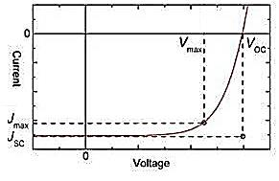
Figure 6 A graphical representation of the estimation of cell efficiencies

V_{OC} – Open circuit voltage
V_{OC} is defined as the maximum voltage produced by the device at zero current. There is a tight correlation between the V_{OC} and the depth of the polymer HOMO energy level compared to the LUMO of the n-type acceptor being used.⁴² Deeper n-type material HOMO levels lend themselves to greater open circuit voltages. However, the deepness of the HOMO level is compromised by the necessity of having a narrow band gap. A 0.3 eV gap is required between the LUMOs of the polymer and fullerene in order to facilitate exciton dissociation. Good V_{OC} values can be achieved through careful polymer design and choice of fullerene acceptor.⁸
J_{SC} - Short circuit current
J_{SC} is defined as the maximum current generated from a device under zero voltage.³⁸ Short circuit currents exhibit the effectiveness of charge separation when under solar illumination. A strong dependence on charge separation implies J_{SC} values are reliant on good active layer morphology which is able to generate free charge carriers effectively.³⁸ Materials with higher permittivities can improve short circuit current values by limiting the amount of excitonic recombination. During device manufacture attention must be given to blend polymer: fullerene blend ratios, additives, concentration and active layer thickness to ensure good processibility and high end PCEs.⁸

FF – fill factor
FF is calculated as a function of both the V_{OC} and J_{SC}. It can be expressed as a percentage from the maximum obtainable power (P_{max}) from a PSC.¹⁴
$$FF=\frac{P_{max}}{V_{OC }{× J}_{SC}}$$
Equation 2 Equation calculating FF
FF is a direct measure of charge carriers reaching the electrodes. Due to the fill factors’ dependence on J_{SC} and V_{OC}, it is highly sensitive to nanoscale morphology of the active layer and the overall charge transport character of the photovoltaic materials.
It has been shown that in metallic systems, which have no band gap, electrons are free to permeate throughout the entire molecular ensemble. The continuous partially filled conduction band allows unrestricted electronic movement and gives metals an infinite dielectric constant. As we already know semiconductor systems display an energy gap between valence and conduction bands and the bigger this gap becomes, the smaller the respective dielectric values obtained. The inverse nature of this relationship implies semiconducting materials with narrower band gaps will have higher permittivities – and vice versa. As a result of this, not only should narrow band gaps be considered when designed appropriate semiconducting materials. Greater shielding between charge carriers can be achieved through the incorporation of a fixed permanent dipole moment in the material. Narrower band gaps and increased dielectrics can lead to much higher device PCEs.

1.6 Active layer morphology

Figure 7 Schematic representations of various PSC active layers through time:
a) Monolayer b) Bilayer c) Bulk heterojunction
The inception of photoactive polymer devices began with the use of solely polymer as the photoactive material (figure 7a). With efficiencies struggling at less than 1%, Son et al postulated that the use of another material with a greater electron affinity should be incorporated into the active layer.⁸ Initially, the two components were sandwiched into the device as two separate layers (a bilayer – figure 7 b) and this bumped efficiency up to around 1%. Despite this increase in PCE, the p:n interface only equalled the surface area of the cell and a substantial amount of excitonic recombination still occurred.^{18–20,25,29} In order to solve the problem of recombination, more excitons needed to be created with in the 10 nm diffusion length of the n-type material – thus the bulk heterojunction (BHJ) was employed.³⁰
At present, BHJs are the most commonly used active layer morphology (figure 7c). Through increasing interfacial area between donor polymer and fullerene acceptor, greater exciton dissociation will occur and increase the amount of free charge carriers present in the device. Ideally, every exciton generated will be created within the diffusion length. Interpenetrating nanoscale sections of p-type and n-type materials can be made simply through inkjet printing – not only improving PCEs up to 10% but production cost and time.¹³ However, it is essential to perfect active layer mixing. Fine-tuning the ratio of the two components, choice of casting solvent and correct additives are all essential steps towards obtaining higher PCEs.³⁶

1.7 P-type materials

Discovery of most organic conductive materials is somewhat serendipitous but there is a design rationale to which many adhere. The chemical and physical properties of p-type polymers are controlled on the atomic level. Each property can be controlled with appropriate molecular engineering to maximise light harvesting qualities, oxidative stability and charge transport. In order to gain insight into how structure influences these properties, starting with the simplest building blocks of a conjugated polymer.
The most basic organic semiconductor is polyacetylene, with a single chain structure of alternating carbon σ and π bonds, with each carbon bonded to hydrogen and two other carbon atoms.¹⁹ Due to the sp² hybridised carbon atoms π electrons are able to flow more freely through the overlapping p^{z} orbitals. The trans form is thermodynamically preferred to the cis form when synthesised using Ziegler-Natta reaction conditions.¹¹ In this state polyacetylene displays conductivities bordering on that of an insulator, but upon doping with the insertion of halogens the conductivity can increase to almost metal like, as shown by Shirakawa and MacDiarmid.⁴³
Figure 8 Schematic representation of the doping of polyacetylene with I₃⁻

Manipulation to obtain the desired conductivity can be achieved by altering the amount of dopant present. A higher degree of doping leads to the polymer having better charge mobility.⁴⁴ The versatility of polyacetylene in its doped form gave a platform for organic semiconductors to be developed.
When designing p-type materials, certain design considerations must be taken into account. The absorption spectra of sun light shows that the majority of the radiation that reaches the earth falls within the visible and near infrared region of the electromagnetic spectrum (300- 1100 nm).⁹ The peak in photon flux shows the optimum point to absorb light is at approximately 700 nm, because of the high photon density at this wavelength.⁸ Band gaps should be altered to absorb as much of the solar spectrum as possible. However, as stated previously the band gap should not be too narrow as to diminish properties such as the V_{OC}.
Figure 9 A Diagrammatic explanation of the aromatic and quinoidal resonance structures of PITN
Two main strategies are utilised that have been shown to give narrower band gaps. In 1984, the first narrow band gap polymer was synthesised in the form of poly (isothianaphthene) (PITN) which showed marked improvements in both conductivity and stability.^{8,14,45} It owes its narrow band gap to quinoid resonance, which requires fused aromatic rings along the polymer backbone. Resonance along the polymer chain can occur between the more stable aromatic structure and the destabilised quinoid structure as displayed in figure 9.^{41,45}
In order to establish the quinoid structure, the aromaticity of the structure must be lost which increases the energy level of the ground state molecule. The resultant polymer displays a narrower band gap relative to one with just an aromatic network. Thus, the band gap of PITN lies 0.3 eV lower than that of the comparable polythiophene through quinoid resonance stabilisation alone. More recently, a new approach has been taken in polymer design where alternating electron-rich and electron poor monomer units are copolymerised. This creates a ‘’push-pull’’ mechanism between donor monomers and acceptor monomers, as seen in figure 10.^{46,47} The electronegativity of the acceptor pulls electrons from the donor, due to the decrease in energy. Greater delocalisation is created along the polymer backbone through formation of a quinoidal structure.^{48,49} Intramolecular charge transfer (ICT) can happen more easily between 2 units with differing electron affinities.
Figure 10 Molecular orbital diagrams highlighting the effect of donor-acceptor type polymers (on the right hand side) on narrowing band gaps over more basic homopolymers (on the left hand side)
The energy levels of the HOMO and LUMO levels of the polymer are often fine-tuned by the addition of side chains as well as to aid solubility and processibility.^{8,25,50} However, side chains can often adversely affect the nanoscale morphology and disrupt molecular alignments between the donor and acceptor (polymer and fullerene in most cases) interface. Disruption to π-stacking and crystallinity can cause drops in charge transport properties and overall photovoltaic performance.^{51,52} Increased chain length is found to increase molecular weight and improve photovoltaic performance, so the right side chains are important – a selection of which can be seen in figure 11. Alkyl side chains are attached purely to increase solubility and aim to increase molecular weight with as little disruption to morphology as possible. Branched chains tend to disrupt the co-planarity of the polymer chain as a whole, but are useful when increasing molecular weights.^{24,38,41,49} However, side chains with extra aromatic units can be attached in order to elongate the conjugation in the molecule and increase π-stacking ability further – often narrowing the band gap and deepening the HOMO level.⁵²
Figure 11 Structures of various side chains attached to conjugated polymers

3-Alkyl thiophenes were synthesised by Gadisa et al with various straight alkyl chain lengths, to study the effect on overall device performance.²⁷ Poly 3-butyl-, pentyl-, and hexyl-thiophene (P3BT, P3PT and P3HT – see figure 12) were made with weight average molecular weights of 33,400, 34,100 and 46,000 KDa respectively.
Figure 12 The molecular structures of a) P3BT b) P3PT and c) P3HT
The increased length of the alkyl chains induces more regio-randomness into the structure due to increased steric effects, visualised by proton NMR. More crystalline structures result from regio-regularity, which lead to greater inter-chain charge transfer and better electronic properties.^{53–55} However, the more interlocking structures of P3BT and P3PT lead to enhanced stability against oxidation. Transmission electron microscopy (TEM) shows an increase in the degree of phase separation between polymer and fullerene derivative with lengthier alkyl side units. It is hypothesised that increased chain length aids diffusion of fullerene derivatives throughout the active layer to form clusters of acceptor – leading to greater light absorbing qualities.²⁷ P3HT has a PCE over 1% greater than that of P3BT, due mainly to the difference seen in FF.
Substituents fine tune HOMO and LUMO levels improving the performance of the conjugated system. Lowering HOMO and LUMO levels stabilises the polymers against oxidation and high temperatures leading to longer device lifetimes. Broad absorptions and enhanced crystallinity also result from adding substituents.^{53,56} However, the addition of substituents can also bring about unwanted effects, such as unfavourable interactions between polymer and acceptor, lowering molecular weights and diminishing exciton lifetimes.

1.71 Conjugated Polymers used in Photovoltaic Devices

Conjugated polymers used in photovoltaic devices started life as homopolymers, such as Poly(phenylenevinylene) (PPV). PPVs have given rise to derivatives such as poly (2-methoxy, 5-(3,7 dimethyl-octyloxy)-p-phenylene vinylene) (MDMO-PPV) seen in figure 13, which was developed by Shaheen et al in 2001.⁵⁷ An increase to 2.5% PCE was observed for this polymer from early polymers like PITN. However, the system still needed adapting to absorb over a wider range of the solar spectrum to increase the efficiency further.
Figure 13 The structure of poly (2-methoxy, 5-(3,7 dimethyl-octyloxy)-p-phenylene vinylene) (MDMO-PPV)
P3HT is very well studied and has achieved a PCE of 5% when incorporated into PSCs.^{,59} When coupled through its 2 and 5 positions, several stereochemical outcomes are possible: head to tail (HT) (shown in figure 14), head to head (HH) and tail to tail (TT).⁴⁸ The narrowest band gaps are achieved through regioregular HT coupling as a result of enhanced planarity between thiophene rings, allowing a lower energy π-π* excitation. A greater extent of planarity increases delocalisation of π-electrons through parallel p-orbitals and decreases band gaps.
Figure 14 The structure of regioregular HT poly (3-hexylthiophene)
However, in recent years interest has declined, due to ‘’wide’’ band gaps of 1.9 eV and maximum experimental efficiencies plateauing at around 5%.⁸ This is due to the relatively high lying highest occupied molecular orbital (HOMO) of P3HT, restricting the voltage created. With maximum efficiencies reaching a ceiling for both strands of design, new conjugated polymers needed to be found to further improve efficiencies.
Figure 15 The molecular structures of a) PFDTBT and b) PCDTBT

Push-pull (or donor-acceptor) polymers have been utilised for over 20 years and have advanced the field drastically. Polyfluorenes were first used for Polymer light emitting diodes (PLED) applications, but were quickly sought after for use in PSCs.^{20,41,60} Svensson et al synthesised PFDTBT (figure 15 a) in 2003 to probe its effectiveness as a donor molecule inside the active layer.⁶² Despite the low molecular weight, (M_{n}=4800 KDa) improved device functionality was observed from MDMO-PPV.⁶⁰ This was in part due to the low lying HOMO levels associated with fluorene, giving rise to a V_{OC} over 1 V. However, low J_{SC} and FF limited the PCE to 2.5%. The stability against oxidation and temperature also lead to disappointing device lifetimes. Blouin et al reported the synthesis of new alkylated polycarbazoles in 2007, after they showed promise as active layer components.³⁴ Benzothiadiazole with bis-thiophene units were incorporated to make the alternating donor:acceptor functionality, forming PCDTBT (figure 15 b). PCDTBT displays greater environmental and temperature stability than PFDTBT, because of the stability introduced by the nitrogen heterocycle. The molecular weight is significantly improved from the aforementioned fluorene counterpart, M_{n}=37,000 KDa, possibly due to the added bulk of the alkyl chains. The optical and electrical band gaps lie at 1.88 and 1.87 eV respectively, outside of the desired range of absorption. However, a V_{OC} of 0.89 V and a PCE of 6.6% are achieved when blended with PC₇₀BM, the first polymer to achieve a higher efficiency than that of P3HT.⁸
Benzothiadiazole (BT) has been used as a co-monomer in D-A polymers for over 10 years due to its electron withdrawing nature. Kim et al reported its use polymerised with dioctyl fluorene to form a polymer blend active layer with P3HT in 2004.⁵⁸ PFBT (figure 16) was being investigated to probe its effectiveness as an electron acceptor, but because of low electron mobilities the resultant PCEs were extremely poor (0.13%).⁵⁸ However, Kim made advancements a year later when PC₆₁BM was added to the active layer blend and achieved efficiencies of 1.7%. It was postulated that improved charge carrier mobilities and active layer morphology led to this stark improvement. Since its first usage BT has been incorporated into many polymers and been used as a building block to advance from. The free 5 and 6 positions on the benzene ring are open for modification to adapt the BT monomer to yield narrow band gap polymers.

Figure 16 The molecular structure of PFBT

1.8 Polymerisation techniques

There are several polymerisation routes utilised to obtain conjugated organic polymers, many of which involve metal catalysed cross coupling reactions. Cross coupling reactions are used because of their versatility and durability, as well as producing polymers in very high yields.
Stille cross-coupling is a palladium catalysed between stannyl moieties and aryl bromides, as seen in figure 17. It can be used with a large range of functional groups and under various conditions.
Figure 17 The suspected Stille cross coupling catalytic cycle

Oxidative addition (1) between the bromine and aryl functionality occurs first with the substituents adding trans to each other. Transmetallation (2) exchanges the bromine for the thiophene unit on the palladium atom and forming tributylstannyl bromide as a side product. Cis-trans isomerism has to occur before reductive elimination (3) can take place to eliminate the product and form the desired product. However, the use of Stille coupling is often discouraged, particularly industrially, due to the toxicity of trialkylstannane compounds.
Suzuki coupling is another palladium catalysed cross-coupling using aryl-halides, however, instead of stannanes, boronic acids/esters are employed – see figure 18. Suzuki coupling holds several advantages over Stille coupling. Less toxic starting materials are used than the organostannanes prepared for Stille coupling. Purification of products is simplified by the formation of water soluble by-products which are simply removed. Finally, a large tolerance to conditions and functional groups makes Suzuki coupling a widely used polymerisation technique.
The catalytic cycle of Suzuki coupling employs an extra step compared to Stille coupling due to the activation of the boronic ester/acid group. Similar to Stille coupling, the first step to occur is oxidative addition of the aryl – halide bond across the palladium catalyst (1). The organometallic species reacts with base present to remove the halide from the palladium centre (2). The activated boron reagent participates in the transmetallation step and the second aryl unit is transferred to the palladium metal centre (3). To form the desired product reductive elimination must occur to create a carbon-carbon bond and regenerate the catalyst (4).
Figure 18 The suspected catalytic cycle for Suzuki cross coupling
Direct arylation can be used to copolymerise a wide range of D-A type compounds in palladium catalysed cycles as displayed in figure 19. Direct arylation poses a viable replacement for Suzuki- and Stille-type couplings, as less prefunctionalisation is required to synthesise monomer – saving time and producing less waste.
The same basic steps are employed in direct arylation as the cycles discussed before; Oxidative addition (1), transmetallation (2) and (3) and reductive elimination (4). However, in order for the cycle to proceed the acid present must bind to the metal centre as a bidentate ligand. The weakly bound pivalate species allows the second aryl unit to displace one of the oxygens and coordinate to the organopalladium species. It is suspected that a concerted metalation deprotonation (CMD) occurs and a biaryl species is formed. Reductive elimination of the product after CMD gives the desired product.

1.9 N-type materials
Figure 19 One proposed mechanism for the palladium-catalysed direct arylation of two aromatic species

In order to create the p:n junction present in BHJ, two materials of different electron affinities are blended together. Electron flow must only occur from p to n in order to create the diode necessary for photovoltaic applications.
Buckminsterfullerene and its derivatives are commonly used as acceptors in BHJs owing to many desirable properties. Firstly, a relatively low energy LUMO means the transfer of electrons is more energetically favourable to an orbital lower in energy. This property in turn implies electron transfer to C₆₀ happens on a very small time scale; around 45 fs as quoted by Brabec et al ⁵⁹. This is several times faster than excitonic recombination and therefore ideal to be employed as an n-type material.
Another advantage brought about by the LUMO of C₆₀ is that it is triply degenerate and can accept up to 6 electrons. Additionally, owing to the large conjugated system, buckminsterfullerene has a large affinity for electrons making it the ideal acceptor component in the active layer. It also has excellent electron mobility throughout it’s conjugated system.
However, C₆₀ displays limited solubility in most solvents so it is often adapted to remedy this problem. Phenyl-C61-butyric acid methyl ester (PC₆₁BM) is employed with a solubilising ester group attached. Buckminsterfullerene also displays no absorption in the visible range of the spectrum, a problem induced by the symmetry of the molecule. ⁵⁹ PC₇₀BM offers absorption maxima in the visible region of the spectrum, owing to comparatively less symmetry than C₆₀.
Figure 20 Molecular structures of a) buckminsterfullerene and b) PC₆₀BM
In terms of maximising efficiency it has been found that when aggregates of fullerene are present cell performance increases. Fullerene aggregates have the ability to collect photons and generate charge due to the π-system being enlarged. An increase in electron affinity is also observed in the presence of fullerene aggregates leading to the conclusion that an excess of fullerene in a solar cell is desirable.⁶¹

1.10 Project Aims

At present, crystalline silicon solar cells exceed the light harvesting ability of their polymer equivalents. However, being fragile in nature and requiring highly energy intensive manufacturing processes, a suitable replacement is being sought after. Organic photovoltaics offer the advantages of; flexibility, relative inexpensive starting materials and production and better functionality at lower light intensities. The main photoactive material employed in OPV devices are conjugated polymers.
Well studied polymers such as P3HT and PCDTBT provide good points of development, as they have reached their respective efficiency limits. P3HT has the drawbacks of having elevated HOMO levels which reduce V_{OC} values and its band gap is relatively wide which limits the light harvesting ability of sunlight, all contributing to P3HT not reaching the PCEs desired. New polymeric moieties are designed to absorb over a wider range of the solar spectrum, have better dielectric constants and higher absorption coefficients. In turn these characteristics are controlled by the molecular weight and donor:acceptor nature of the polymer.
The primary aim of this project is to address the issues faced by current organic photovoltaic technology and improve upon them. In order to produce high performing devices, current polymers can be adapted to fulfil the desired design criteria.
Chapter 2 addresses the improvement of the widely used acceptor benzothiadiazole via the extension of the aromatic system to create naphthothiadiazole. This relatively unknown acceptor will be copolymerised alongside carbazoles and fluorenes with different alkyl chain lengths to modify molecular weight (see figure 21) . Replacing benzothiadiazole with naphthothiadiazole in the well-studied polymers PCDTBT and PFDTBT should decrease band gap values, due to the increased acceptor power of the electron withdrawing unit. Additional stabilisation gained through increased aromaticity should also aid in decreasing HOMO levels – leading to increased open circuit voltage values.
Figure 21 Structures of polymers to be synthesised in Chapter 2

Chapter 3 reports the manufacture of regio random Thieno[3,4-c]pyrrole-4,6-dione (TPD)-thienyl polymers which aim to build on the properties reported for P3HT (figure 22 b). The addition of TPD should improve the light harvesting ability over the P3HT homopolymer, due to the ‘’push-pull’’ nature of the compound narrowing the band gap. Through varying chain lengths and branching between 6 and 12 carbons, it is hoped that tight control is gained over both molecular weight and nanoscale morphology. TPD has a rigid, extended aromatic system which encourages aggregation, thus longer / branched alkyl side chains are employed to increase molecular weight. It was hoped that the regio random structures would give a range of solid state microstructures affecting the overall dipole moment of the materials and its effect on the properties of the polymers.
In chapter 4, polymers were designed to probe the effect of regio regularity on photovoltaic properties (figure 22 a). It was postulated that design a polymer with a highly crystalline structure would ‘’lock’’ the conformation in the solid state. In turn this would increase the overall dipole moment of the material when all monomer units were orientated in the same direction. There is strong evidence to suggesting high, fixed dipole moments increase both charge separation and transport. Similarly to chapter 3, a range of chain lengths and branching were employed to explore this effect, alongside theoretical calculations. It is hypothesised that the shorter alkyl side chains should be more crystalline, but have diminishing photochemical properties due to decreasing molecular weight.

Figure 22 Chemical structures representing the polymers in a) Chapter 4 and b) Chapter 3
Chapter 5 explores the effect of donor strength and more precise variations in chain length and branching. A series of polymers were synthesised and their chemical and physical properties analysed. Chain lengths vary between branched hexyl-octyl and octyl-decyl alkyl side chains to fine tune the nanoscale morphology of the polymers in solid state. The increased donor strength of bithiophene units over simple thiophene spacers should improve photovoltaic characteristics and act as more of a spacer between adjacent TPD units – to encourage a more coplanar structure to be adopted. The proposed orientations of the mono- and bithiophene polymers should lend themselves to varying overall dipole moments. Structures of b) in figure 23 should have less of a dipole moment than a) due to the alternating orientations of TPD units.
Figure 23 Proposed solid state structures adopted by a) monothiophene polymers and b) bithiophene polymers in the solid state

Polyether side chains will be added to thiophene monomers in the TPD-thienyl polymers in chapter 6 (figure 24). It is hoped that the polyether chains will narrow band gaps as well as improving intermolecular interactions. However, the position of the first oxygen is varied from adjacent to the chain and a carbon adjacent to aromatic system. This should alter the amount of electron density being donated to the conjugated system.

Figure 24 Chemical structures of PT(oxy)TPD and PT(met)TPD polymers from chapter 6

References

1 T. Abbasi and S. a. Abbasi, Renew. Sustain. Energy Rev., 2011, 15, 1828–1834.
2 D. Barlev, R. Vidu and P. Stroeve, Sol. Energy Mater. Sol. Cells, 2011, 95, 2703–2725.
3 O. Kaarstad, Energy Convers. Mgmt, 1995, 36, 869–872.
4 A. Goeppert, M. Czaun, G. K. Surya Prakash and G. a. Olah, Energy Environ. Sci., 2012, 5, 7833-7853.
5 K. Rajeshwar, Encycl. Electrochem., 2001, 1, 1-23.
6 O. Morton, Nature, 2006, 443, 19–22.
7 A. Sayigh, Appl. Energy, 1999, 64, 15–30.
8 H. J. Son, B. Carsten, I. H. Jung and L. Yu, Energy Environ. Sci., 2012, 5, 8158-8170.
9 G. Yu and a. J. Heeger, J. Appl. Phys., 1995, 78, 4510-4515.
10 P. W. M. Blom, V. D. Mihailetchi, L. J. a. Koster and D. E. Markov, Adv. Mater., 2007, 19, 1551–1566.
11 A. Pron and P. Rannou, Prog. Polym. Sci., 2002, 27, 135–190.
12 L. Cartwright, A. Iraqi, RSC Adv., 2015, 57, 46386-46394
13 R. F. Service, Science, 2011, 332, 293.
14 Y.-J. Cheng, S.-H. Yang and C.-S. Hsu, Chem. Rev., 2009, 109, 5868–923.
15 D. Wöhrle and O. R. Hild, Chemie unserer Zeit, 2010, 44, 174–189.
16 P. Cuony, D. T. L. Alexander, I. Perez-Wurfl, M. Despeisse, G. Bugnon, M. Boccard, T. Söderström, A. Hessler-Wyser, C. Hébert and C. Ballif, Adv. Mater., 2012, 24, 1182–1186.
17 J. Kim, M. H. Yun, G.-H. Kim, J. Y. Kim and C. Yang, Polym. Chem., 2012, 3, 3276-3281.
18 Y. H. Lee, D. H. Kim, N. S. Arul and T. W. Kim, Appl. Surf. Sci., 2013, 268, 156–162.
19 X. Zhao and X. Zhan, Chem. Soc. Rev., 2011, 40, 3728–43.
20 H. Hoppe and N. S. Sariciftci, J. Mater. Res., 2011, 19, 1924–1945.
21 K. Lu, J. Fang, Z. Yu, H. Yan, X. Zhu, Y. Zhang, C. He and Z. Wei, Org. Electron., 2012, 13, 3234–3243.
22 K. W. Song, M. hee Choi, M. hee Han and D. K. Moon, J. Ind. Eng. Chem., 2014, 20, 426–434.
23 S. Beaupré and M. Leclerc, J. Mater. Chem. A, 2013, 1, 11097-11105.
24 A. Facchetti, Chem. Mater., 2011, 23, 733–758.
25 X. Guo, M. Baumgarten and K. Müllen, Prog. Polym. Sci., 2013, 38, 1832–1908.
26 B. C. Thompson and J. M. J. Fréchet, Angew. Chem. Int. Ed. Engl., 2008, 47, 58–77.
27 A. Gadisa, W. D. Oosterbaan, K. Vandewal, J.-C. Bolsée, S. Bertho, J. D’Haen, L. Lutsen, D. Vanderzande and J. V. Manca, Adv. Funct. Mater., 2009, 19, 3300–3306.
28 F. Krebs, J. Carle, N. Cruysbagger, M. Andersen, M. Lilliedal, M. Hammond and S. Hvidt, Sol. Energy Mater. Sol. Cells, 2005, 86, 499–516.
29 G. Dennler, M. C. Scharber and C. J. Brabec, Adv. Mater., 2009, 21, 1323–1338.
30 M. C. Scharber, D. Mühlbacher, M. Koppe, P. Denk, C. Waldauf, a. J. Heeger and C. J. Brabec, Adv. Mater., 2006, 18, 789–794.
31 H. D. de Gier, R. Broer and R. W. a. Havenith, Phys. Chem. Chem. Phys., 2014, 16, 12454–61.
32 L. Cartwright, T. J. Neal, N. J. Rutland and A. Iraqi, Polym. Adv. Technol., 2016, 27, 525-531.
33 T. M. Clarke and J. R. Durrant, Chem. Rev., 2010, 110, 6736–67.
34 N. Blouin, a. Michaud and M. Leclerc, Adv. Mater., 2007, 19, 2295–2300.
35 P. Ren, Y. Zhang, H. Zhang, X. Zhang, W. Li and W. Yang, Polymer (Guildf)., 2009, 50, 4801–4806.
36 C. B. Nielsen, R. S. Ashraf, N. D. Treat, B. C. Schroeder, J. E. Donaghey, A. J. P. White, N. Stingelin and I. McCulloch, Adv. Mater., 2015, 27, 948–53.
37 C. W. Tang, Appl. Phys. Lett., 1986, 48, 183-185.
38 L. Yang, H. Zhou and W. You, J. Phys. Chem. C, 2010, 114, 16793–16800.
39 B. Carsten, J. M. Szarko, H. J. Son, W. Wang, L. Lu, F. He, B. S. Rolczynski, S. J. Lou, L. X. Chen and L. Yu, J Am Chem Soc, 2011, 133, 20468–20475.
40 P. Shen, H. Bin, L. Xiao and Y. Li, Macromolecules, 2013, 46, 9575–9586.
41 H. Zhou, L. Yang and W. You, Macromolecules, 2012, 45, 607–632.
42 K. Vandewal, K. Tvingstedt, A. Gadisa, O. Inganäs and J. V Manca, Nat. Mater., 2009, 8, 904–9.
43 H. Shirakawa and A. G. Macdiarmid, Phys. Rev. Lett., 1977, 39, 1098–1101.
44 H. T. and D. B. F. S. Lefrant, L.S. Lichtmann, Solid State Comm., 1979, 29, 191–196.
45 W. a. Braunecker, Z. R. Owczarczyk, A. Garcia, N. Kopidakis, R. E. Larsen, S. R. Hammond, D. S. Ginley and D. C. Olson, Chem. Mater., 2012, 24, 1346–1356.
46 Y. Li, J. Hu, G. He, H. Zhu, X. Wang, Q. Guo, A. Xia, Y. Lin, J. Wang and X. Zhan, J. Phys. Chem. C, 2016, 120, 13922–13930.
47 C. Ottone, P. Berrouard, G. Louarn, S. Beaupré, D. Gendron, M. Zagorska, P. Rannou, A. Najari, S. Sadki, M. Leclerc and A. Pron, Polym. Chem., 2012, 3, 2355-2365.
48 A. Iraqi, G. W. Barker and D. F. Pickup, React. Funct. Polym., 2006, 66, 195–200.
49 J. W. Rumer, C. K. L. Hor, I. Meager, C. P. Yau, Z. Huang, C. B. Nielsen, S. E. Watkins, H. Bronstein and I. McCulloch, J. Org. Semicond., 2013, 1, 30-35.
50 M.-H. Chen, J. Hou, Z. Hong, G. Yang, S. Sista, L.-M. Chen and Y. Yang, Adv. Mater., 2009, 21, 4238–4242.
51 I. Osaka, M. Shimawaki, H. Mori, I. Doi, E. Miyazaki, T. Koganezawa and K. Takimiya, J. Am. Chem. Soc., 2012, 134, 3498–507.
52 P. Shen, H. Bin, X. Chen and Y. Li, Org. Electron., 2013, 14, 3152–3162.
53 T. Umeyama, M. Oodoi, O. Yoshikawa, T. Sagawa, S. Yoshikawa, D. Evgenia, N. Tezuka, Y. Matano, K. Stranius, N. V. Tkachencko, H. Lemmetyinen and H. Imahori, J. Mater. Chem., 2011, 21, 12454- 12461.
54 B.-G. Kim, E. J. Jeong, J. W. Chung, S. Seo, B. Koo and J. Kim, Nat. Mater., 2013, 12, 659–64.
55 T. Kaniowski, W. Łużny, S. Nizioł, J. Sanetra and M. Trznadel, Synth. Met., 1998, 92, 7–12.
56 T. Umeyama, Y. Watanabe, E. Douvogianni and H. Imahori, J. Phys. Chem. C, 2013, 117, 21148−21157.
57 S. Shaheen, D. Vangeneugden, Kiebooms R., Venderzande D. Fromherz T., Padinger F., Brabec C., Sariciftci N., Synth. Met., 2001, 121, 1583–1584.
58 Y. Kim, S. Cook, S. A. Choulis, J. Nelson, J. R. Durrant and D. D. C. Bradley, Chem. Mater., 2004, 16, 4812–4818.
59 Brabec J., Zerza G., Cerullo G., De Silvestri S., Luzzati S., Hummelen J., Saricifiti S., Chem. Phys. Lett., 2001, 340, 232-236
60 D. a. M. Egbe, S. Türk, S. Rathgeber, F. Kühnlenz, R. Jadhav, A. Wild, E. Birckner, G. Adam, A. Pivrikas, V. Cimrova, G. Knör, N. S. Sariciftci and H. Hoppe, Macromolecules, 2010, 43, 1261–1269.
61 Yuhang L., Jingbo Z., Zhengke L., Cheng M., Wei M., Huawei H., Kui J., Haoran L., Harald Ade, Nature Comm., 2014, 5, : 5293 (2014)
62 M. Svensson, F. Zhang, S. C. Veenstra, W. J. H. Verhees, J. C. Hummelen, J. M. Kroon, O. Ingana¨s, M. R. Andersson, Adv. Mater. 2003, 15, 988.

Chapter 2:

Incorporating naphtho[1,2-c:5,6-c’]-bis-[1,2,5]thiadiazole as a monomer to synthesise new, mid-band gap polymers

Four conjugated organic polymers were synthesised to probe whether they possessed the necessary properties for use in a PSC. The acceptor naphtho [1,2-c:5,6-c’]-bis-[1,2,5] thiadiazole (NT) proved to be problematic to synthesise and was made in relatively poor yield. However, the naphtho [1,2-c:5,6-c’]-bis-[1,2,5] thiadiazole was incorporated into polymers with fluorene (Poly octyl/ dodecyl-fluorene dithiophene naphtho [1,2-c:5,6-c’]-bis-[1,2,5] thiadiazole PF(o)DTNT and PF(d)DTNT respectively) and carbazole ( Poly octyl/ dodecyl-carbazole dithiophene naphtho [1,2-c:5,6-c’]-bis-[1,2,5] thiadiazole PC(o)DTNT and PC(d)DTNT) co-monomers containing different alkyl chain lengths to make novel polymers.
Many photovoltaic properties are heavily dependent on increased molecular weight, causing decreases in band gaps and charge transport properties. It was found that increasing the side chain lengths lead to higher molecular weights and improved photovoltaic properties.
With the molecular weight taken into consideration, the optical and electrochemical properties are quite promising. An improvement of almost 0.1 eV was seen in the optical band gap from the benzothiadiazole equivalents, with PC(d)DTNT having the narrowest band gap of 1.82 eV. Shoulders observed in both thin film and solution spectra indicate strong π-π stacking - desirable for intermolecular charge transport. Deepening of all HOMO levels are also observed, with PF(d)DTNT falling to -5.6 eV. This implies good V_{OC} values will arise when incorporated into a bulk heterojunction of a plastic solar cell. Promising thermal stabilities gathered from TGA and DSC show that under the high temperatures experienced in polymer solar cells, the polymers will be stable for a relatively long period of time.

2.1 Introduction

Benzothiadiazole (BT) has been used as a co-monomer in D-A polymers for over 10 years due to its electron withdrawing nature. Kim et al reported its use polymerised with dioctyl fluorene to form a polymer blend active layer with P3HT in 2004.¹ PF(o)BT was being investigated to see its effectiveness as an electron acceptor, but because of low electron mobilities the resultant PCEs were extremely poor (0.13%). It was postulated that active layer morphology led to decreased charge carrier separation resulting in this low device efficiencies.
Since its first usage BT has been incorporated into many polymers and been used as a building block to advance cell efficiencies. The free 5- and 6-positions on the benzene ring are open for modification to adapt the BT monomer to yield narrow band gap polymers.^{2,3} Nielsen et al utilised this property to full effect and achieve a PCE of 8.3% using a BT derivative as an acceptor.³ The simultaneous lowering of HOMO and LUMO levels led to increasing the V_{OC} and enhancing the electron accepting properties. Good V_{OC} and FF values and an extremely high J_{SC} lead to BBTI-1 achieving a very high efficiency.

Figure 25 The molecular structure of BBTI-1

Extending the aromatic system within conjugated polymers leads to narrower band gap materials. By modifying benzothiadiazole with the addition of an extra aromatic unit, it is expected that the photovoltaic properties will improve. 2, 1, 3 Naphthothiadiazole was incorporated into a polymer with a carbazole co-monomer to form poly (2,7-carbazole-alt-4,7-dithienyl-2,1,3-naphthothia-diazole) (PCDT(2,1,3)NT) to analyse the effect of increased conjugation over the benzothiadiazole equivalent PCDTBT.⁴ A vast improvement in band gap is observed from 1.87 eV of PCDTBT to 1.71 eV for PCDTNT due to the extended π-system. However, a drop in the intensity of the intra-molecular charge transfer (ICT) band relative to the lower energy π-π* transition band was reported. It is postulated that the extra benzene ring interacts unfavourably with the adjacent thienyl units and causes a twist in planarity diminishing charge carrier movement. The HOMO level of PCDTNT lies at -5.37 eV, higher than that of PCDTBT due to the narrowing of the band gap and the LUMO being unaffected. Poor FF values of 30% are attributed to low molecular weights and unfavourable interactions between the new naphthothiadiazole monomer and fullerene derivative in the active layer.
Figure 26 The polymeric structure of PCDT(2,1,3)NT

Wang et al used a similar concept in utilising naphtho[1,2-c:5, 6-c]bis[1,2,5]thiadiazole as a monomer.⁵ It can be considered as two BT rings fused together giving extended aromaticity and enhanced planarity. Improved electron withdrawing properties imply narrow band gap polymers should be synthesised as a result. PBDT-DTBT and PBDT-DTNT were synthesised and the physical properties were shown to be promising.
Figure 27 The polymeric structures of a) PBDT-DTNT and b) PBDT-DTBT
PBDT-DTNT has a red shifted absorbance, greater hole mobility and improved PCE compared to PBDT-DTBT. The band gap of the naphthothiadiazole polymer lies at 1.58 eV, approaching the ideal size for most efficient solar absorption. The improved number average molecular weight (Mn) (40,500 gmol⁻¹) may be partly responsible for the narrowing of the band gap of PBDT-DTNT. Evidence from the U.V.-vis spectra suggest that PBDT-DTNT aggregates form more readily due to the exaggerated shoulders observed, explained by the planarity induced by the NT monomer unit. The collective improvement in photovoltaic properties of PBDT-DTNT lead to a PCE of 6%, mainly because of the difference in fill factor. Steric clashes of the substituted hexyl chains on the thienyl units are less prevalent in PBDT-DTNT than PBDT-DTBT, improving morphology and electron-percolation.

The chemical nature of naphtho[1,2-c:5, 6-c]bis[1,2,5]thiadiazole was explored by Osaka et al by copolymerising it with alkyl quaterthiophene units.⁶ PNT4T displays a stronger and broader absorption, narrower band gap and lower energy HOMO than PBT4T, all desirable qualities in organic photovoltaics. Enhanced molecular ordering due to the NT unit is probed using X-ray diffraction (XRD), revealing that lamellar-like structures are formed by PNT4T. XRD shows that the alkylated thiophene units in PNT4T lie anti to each other, where as they adopt a syn conformation in PBT4T. A ‘’wavy’’ structure is adopted by PBT4T and is therefore less linear, causing the drop in crystallinity observed. It is clear that utilising naphtho[1,2-c:5, 6-c]bis[1,2,5]thiadiazole shows great promise with almost all photovoltaic properties improving and achieving high PCEs.
Figure 28 The polymeric structures of a) PNT4T and b) PBT4T
The main objective of this chapter is to synthesise novel organic conjugated polymers, analyse their properties and incorporate them into bulk heterojunction organic solar cells. Desirable properties such as narrow band gap, low lying HOMO levels and high molecular weight are achievable through the correct monomers. Naphtho[1,2-c:5,6-c’]-bis-[1,2,5] thiadiazole has been chosen due to its extended aromatic system and greater electron withdrawing nature. This will be polymerised with carbazole and fluorene monomer with bis-8 (PF(o)DTNT and PC(o)DTNT) and -12 (PF(d)DTNT and PC(d)DTNT) carbon chains to see the effect the chains have on photovoltaic properties. GPC analysis, solution and thin film U.V.-vis spectroscopy, cyclic voltammetry, thermogravimetric analysis, differential scanning calorimetry will all be employed to test the properties of the polymers synthesised.
Figure 29 The generic structures of a) Carbazole polymers PC(o)DTNT and PC(d)DTNT and b) Fluorene monomers PF(o)DTNT and PF(d)DTNT

2.2 Results and Discussion

2.21 Monomer synthesis

In order to prepare the naphthothiadiazole polymers, monomer 5,10-Dibromonaphtho[1,2-c:5,6-c']-bis-[1,2,5]thiadiazole M1 was required. It was synthesised from 1,5-diaminonaphthalene using the following method.
Figure 30 Synthetic scheme to M1 a) p-Toluenesulfonyl chloride, pyridine b) NaNO₂, HNO₃, AcOH, 25 ^{O}C c) Conc. H₂SO₄, 44 ^{O}C d) i) Sn(II)Cl₂, EtOH, HCl, 85 ^{O}C ii) SOCl₂, 45 ^{O}C e) NBS, H₂SO₄

The amine moieties were protected using p-toluenesulfonyl chloride in step a) to ensure that they were untouched when 1,5-di-p-toluenesulfamidonaphthalene 1 was nitrated with sodium nitrite in reaction b). Deprotection using sulphuric acid of 2 at 44 ^{O}C yielded 1,2-diamino-2,6-dinitronaphthalene 3, which was converted to naphtho[1,2-c:5,6-c']-bis-[1,2,5]thiadiazole 4 via reduction with tin chloride followed by ring closure with thionyl chloride. Finally bromination with n-bromosuccinimide produced monomer M1.
1 was prepared via the nucleophilic addition of p-toluenesulfonyl chloride.⁷ The nucleophilic amine attacks the electrophilic sulfur atom and displaces the chlorine, to make the protonated intermediate. The presence of pyridine abstracts a proton to form the product and pyridinium salt.
1,5-bis(p-toluenesulfonamido)-2,6-dinitronaphthalene was created through electrophilic aromatic substitution of hydrogen for a nitro group on the aromatic ring.⁸ The highly reactive electrophile species is created in situ by reaction of glacial acetic acid with nitric acid. The only product observed after nitration was the ortho- one, it is suspected that the steric bulk of the protecting tosyl group stopped substitution in the para- position.
Figure 31 Mechanism showing the generation of the nitronium ion needed to make 2

The intermediate formed is stabilised by the electron donating sulfonamido group present, which adds electron density to the aromatic system with the lone pair present on the nitrogen and directs the nitro group solely to the ortho position. Because of this, rings with electron donating substituents on are considered activated toward electrophilic attack.
The cleavage of the tosyl protecting groups to form 1,5-diamino-2,6-dinitronaphthalene was carried out under highly acidic conditions with heating. Protonation of the nitrogen in the sulfonamido functionality occurs, decreasing the Pk_{a} of the amine and susceptible to attack from a nucleophile – in this case water. Neutralisation with water affords the diamine- dinitro- derivative. Although the exact mechanism of nitro reduction with tin (II) chloride, it is thought the tin provides electrons for a radical process to occur, while the acid present acts as a proton ''generator''. The nitro undergoes the transformation to amine via sequential reductions and protonations. First, the nitro group is reduced and converted to a nitro anion radical and upon the addition of another electron a nitroso group is formed. A two electron reduction then occurs, followed by protonation to create the hydroxylamine functionality. The final 2 electrons are transferred to the nitrogen to create the amine and the side product of water.
Figure 32 Proposed mechanism for the reduction of 3 using Sn(II)Cl₂ and HCl

The next step of the synthesis is the ring closing between adjacent amine groups to form the thiadiazole moiety. Thionyl chloride is employed for this, due to its electrophilicity and reactivity toward nucleophiles. Both chlorine atoms are displaced via the nucleophilic substitution of the amines. Under basic conditions, one of the amines is deprotonated by triethylamine which induces the formation of aromaticity in the thiadiazole ring through a concerted elimination of water.
4
Figure 33 Proposed mechanism for the formation of 4

Bromination using n-bromosuccinimide results in addition at the 5 and 10 positions of the aromatic system – not elsewhere. Once the bromonium ion is formed between 2 of the remaining free carbons, there are two possible intermediates: both of which involve a carbocation. The most stable carbocation is preferential as it is thermodynamically favourable. Electron density from the adjacent aromatic system stabilises the positive charge, whereas with the electron withdrawing thiadiazole system adjacent, the same positive charge is destabilised. Both fluorene monomers were synthesised using the same routes, with only the chain length varying. Fluorene was brominated in the 2 and 7 positions to produce 5, for later thiophene attachment. The alkyl chains were added at the 9-position (6/7) to enhance the solubility of the monomer. Thiophenes were attached under Stille coupling conditions to replace the bromines using a palladium catalyst M2/M3.
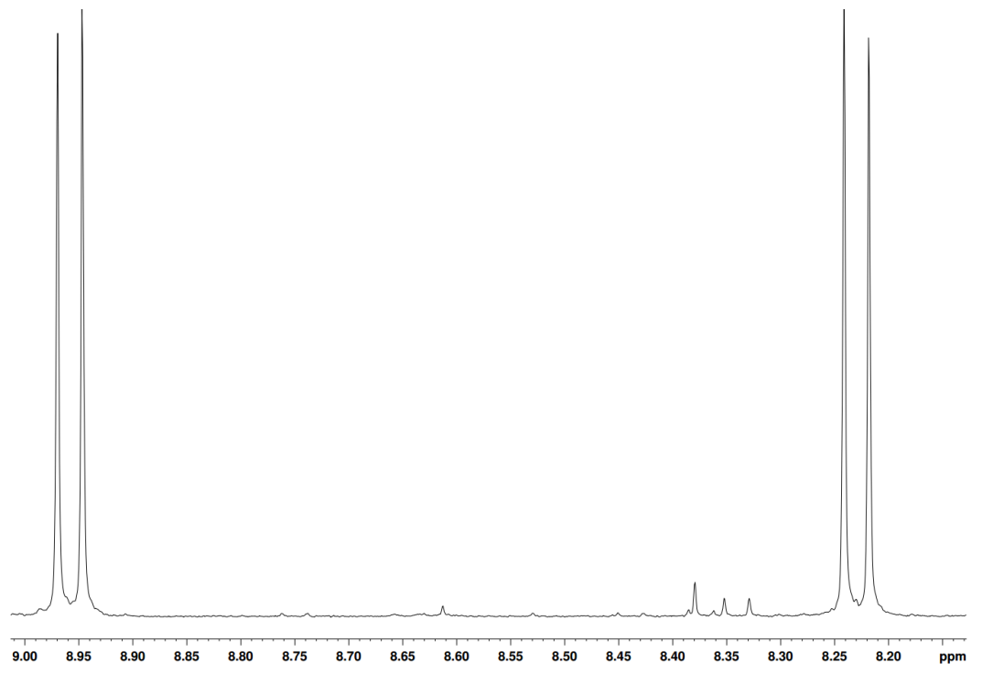
H_{a}
H_{b} H_{c}

Figure 34 ¹H NMR in CDCl₃ of naphtho[1,2-c:5,6-c']-bis-[1,2,5]thiadiazole between 8.20 and 9.00 ppm showing the aromatic environments present

Figure 35 Synthetic scheme of M2/M3 a) Br₂, CHCl₃ b) tetrabutylammonium bromide, NaOH (aq) 1-bromododecane c) bromothiophene, KOAc, Pd(dppf)Cl₂, DMF
Synthesis of this monomer began with unsubstituted fluorene and the reaction with bromine in chloroform. The addition of bromine in the absence of light implies the reaction doesn't involve the formation of any radicals. The electronics of the system dictate that the ortho- and para- positions would be open for attack; however, only the para- is observed. Steric hindrance of the other aromatic unit on the molecule blocks the electrophilic attack of the bromine, forcing attack to occur at the para positions only.
The alkylation of the fluorene moiety took place under basic conditions with the use of a phase transfer catalyst tetrabutylammonium bromide. The biphasic system of toluene and aqueous sodium hydroxide used in this reaction requires the ferrying of hydroxide ions from the aqueous phase to the organic phase. The basicity of the hydroxide ions deprotonates the only non-aromatic protons present and the negative charge left behind attacks the electrophilic alkyl bromide, to form the alkylated species.

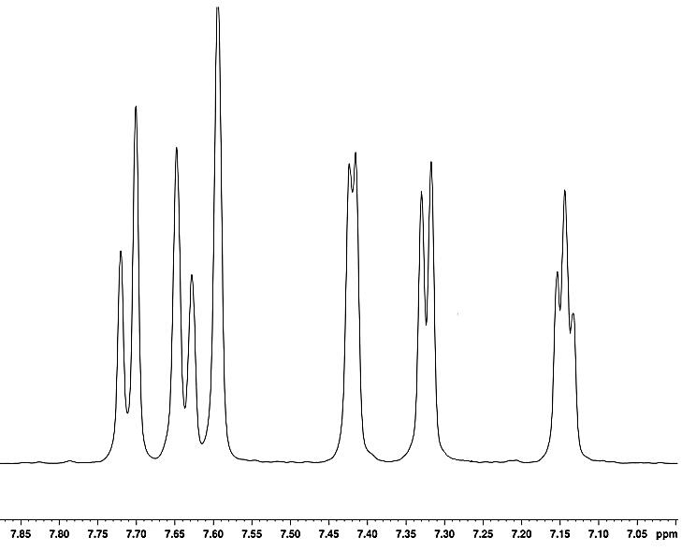
H_{a}
H_{b} H_{c}

H_{c}
H_{c}

H_{d}
H_{c}

H_{f}
H_{c}

H_{e}
H_{c}

Figure 36 ¹H NMR in CDCl₃ of M3 between 7.00 and 7.80 ppm showing the aromatic environments present
Carbazole monomers were synthesised via the same route shown below. Starting with 1,4-dibromo 2-nitrobenzene, which underwent an Ullmann coupling with a copper catalyst to form the bridged dibromo-dinitro species. Reduction with tin transformed the nitro groups into amine groups, which were set up for ring closure with phosphoric acid to form the carbazole functionality. The symmetrical alkyl chains were made via a Grignard reaction between ethyl formate and the respective alkyl bromides. Once the alcohol had been formed, a tosyl group was attached to increase the reactivity of the branch point on the chain. Using a base to deprotonate the carbazole on the nitrogen, the alkyl chain was added via displacement of the tosyl leaving group. The carbazole was then set up for polymerisation by attachment of the flanking thiophene units via Stille coupling.
Figure 37 Synthetic scheme to M4/M5 a) Cu, DMF 120 ^{O}C b) Sn, EtOH/HCl c) H₃PO₄, 190 ^{O}C d) Mg, THF, 0 ^{O}C e) p-toluenesulfonylchloride, NMe₃, trimethylammonium chloride, 0 ^{O}C f) KOH, DMSO, g) bromothiophene, KOAc, Pd(dppf)Cl₂, DMF

The Ullmann coupling is employed as the first reaction in forming 4,4'-dibromo-2,2'-dinitrobiphenyl.⁹ Oxidative addition between copper and the aryl bromide occurs at one bromine in particular due to an anchoring effect induced by the nitro group on the metal. After another equivalent of copper has removed the bromine from the central metal, another oxidative addition of 1,4-dibromo-2-nitrobenzene takes place. The final product is formed when the reductive elimination step occurs to form copper bromide as the side product.
Figure 38 Proposed mechanism for the Ullman homocoupling of 1, 4-dibromo-2-nitrobenzene to form 4,4'-dibromo-2,2'-dinitrobeiphenyl
7

The reduction of the nitro groups to amines proceeds in a similar fashion to the tin-based reduction mechanism seen in the formation of naphtho[1,2-c:5,6-c']-bis-[1,2,5]thiadiazole.
The diamine derivative is heated to 190 ^{O}C in phosphoric acid, to force the formation of the carbazole functionality. The harsh temperature and highly acidic conditions are able to force the ring closure.
The formation of the alkyl chains began with the Grignard reaction of 1-octyl/dodecylbromide with ethyl formate. Once the formation of the Grignard reagent had taken place in situ, one equivalent reacted with ethyl formate to form a tetrahedral intermediate. The loss of the ethoxy group forms an aldehyde which is in turn attacked by the second equivalent of Grignard reagent. After work up with water the alcohol is protonated and the product isolated.

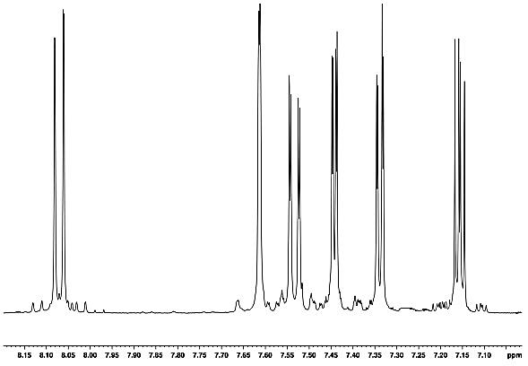
H_{a}
H_{b} H_{c}

H_{c}
H_{c}

H_{d}
H_{c}

H_{f}
H_{c}

H_{e}
H_{c}

Figure 39 ¹H NMR in CDCl₃ of M4 between 7.00 and 8.15 ppm showing the aromatic environments present

2.22 Polymer Synthesis

All polymerisations were carried out under an inert atmosphere of argon at 100 ^{O}C for the time stated in the preparation. Utilisation of direct arylation using a palladium acetate catalyst proved successful alongside the use of the ligand, PCy₃BF₄ . It is postulated that the ligand keeps the structure of the polymer more regular, while not having a detrimental effect on the molecular weight of the polymer. Dimethylacetamide (DMAc) was used as the solvent for all polymerisations, due to its high boiling nature and its inertness towards basic chemicals. Potassium carbonate was used to promote the direct arylation of all monomers used.
The work up for all polymers included being quenched with hydrochloric acid (6M), extracted with chloroform and being washed with saturated ethylenediaminetetraacetic acid salt (EDTA) to coordinate to any remaining metal and further washes to remove other reactants. After precipitation into methanol, the polymer was filtered using a membrane filter and transferred to a Soxhlet thimble.
All polymerisations were purified via Soxhlet extraction using the following solvents sequentially; methanol, acetone, hexane, toluene, chloroform and finally chlorobenzene. The toluene and chloroform fractions were targeted for analysis and manufacture due to their relatively good solubility in most organic solvents, while retaining high molecular weights. The polymer was isolated after re-precipitation into methanol and membrane filtered again (MF-Millipore Membrane, mixed cellulose Filter paper Hydrophilic, 0.22 µm).
Figure 40 Synthesis of PC(o)DTNT, PC(d)DTNT, PF(o)DTNT and PF(d)DTNT. a) PCy₃.HBF₄, Pd(OAc)₂, K₂CO₃, DMAc.

Table 1 A summary of Molecular weight and optical data for PC(o)DTNT, PC(d)DTNT, PF(o)DTNT and PF(d)DTNT.
Polymer | M_{n} / kDaª | M_{w} / kDaª | PDI^{b} | λ_{max} / nm solution | λ_{max} / nm thin film | E_{g} opt / eV^{c} (±0.02)
PC(o)DTNT | 1.70 | 1.90 | 1.05 | 359, 503 | 383, 531 | 1.83
PC(d)DTNT | 3.20 | 3.60 | 1.14 | 360, 522 | 384, 552 | 1.82
PF(o)DTNT | 1.50 | 1.50 | 1.03 | 362, 522 | 365, 540 | 1.88
PF(d)DTNT  ªMolecular weights calculated on the toluene fractions of polymers using differential refractive index (DRI) characterisation. ^{b}Polydispersity Index (PDI). ^{c}Optical band gap estimated by graphically determining the onset of absorption | 3.00 | 3.40 | 1.15 | 358, 517 | 367, 545 | 1.87

2.23 Optical Properties

The optical properties of polymers were investigated by UV-vis absorption spectroscopy on dilute chloroform solutions and drop-cast films on quartz substrates. As expected, the carbazole-containing polymers have a narrower band gap than their fluorene counterparts. This is due to the carbazole polymer having complete conjugation throughout the entire structure, potentially leading to a more planar structure and greater electronic delocalisation. Fluorenes lack this complete conjugation and thus have wider band gaps.
An interesting feature of both solution and thin film spectra is the presence of shoulders on the intramolecular charge transfer peak, as seen in figure 41.¹⁰⁻¹² This indicates that the chains are stacking and aggregates of polymer are present in solution – a direct result of strong π-orbital overlap between individual polymers. Commonly, a bathochromic shift is observed between solution and thin film U.V.-vis spectra. This is due to enhanced π to π interactions between polymer chains over BT polymer derivatives, improving charge carrier transport. The shoulder of the lowest energy absorption is an even more distinct shoulder, proving that in the solid state this polymer displays strong π-stacking abilities.
Figure 41 The normalised U.V.-vis absorption spectra of PC(o)DTNT, PC(d)DTNT, PF(o)DTNT, PC(d)DTNT in a) dilute chloroform solution and b) thin film

Upon examining the effect that replacing 2,1,3-benzothiadiazole with naphtho[1,2-c:5,6-c’]-bis-[1,2,5] thiadiazole has had on the optical band gap, it is clear a positive change has been made. The precursor PC(o)DTBT shown below has a reported optical band gap of 1.88 eV by Umeyama, significantly wider than the naphthodithiadiazole equivalent.¹³ This narrowing of the band gap is thought to have been achieved through the more planar conformation adopted by PC(o)DTNT, owing to its extended aromatic structure. This allows for extended electronic delocalisation and easier charge carrier movement throughout the structure.
Very poor molecular weights were observed for the NT polymers. Doubly 8 carbon-chained PFDTBT has a reported molecular weight of 4,800 Da, the explanation for which is due to the number of unsubstituted aromatic rings on the polymer backbone decreasing the solubility.¹⁴
Despite poor molecular weights, some patterns can be seen in the data. PF(d)DTNT and PC(d)DTNT both have higher molecular weights than PF(o)DTNT and PC(o)DTNT, proving that increasing the alkyl chain length has a positive effect on the molecular weight by disrupting intermolecular interactions. The longer alkyl chains provide the overall polymer with greater solubility in solvents. Not only does this help with the processibility in solar cell fabrication, but during polymerisation where the more soluble polymers stay in solution longer and form longer chains – increasing the band gap further.

2.24 Electrochemical Properties

Cyclic Voltammetry (C.V.) was utilised to measure the oxidation and reduction potentials of the polymers synthesised. All oxidations and reductions were run in a 3 electrode cell, using tetrabutylammonium perchlorate in acetonitrile as the electrolyte. A thin film was created on the working electrode and the electrochemical data was then extracted. The HOMO and LUMO levels were calculated using tangents to the first oxidation and reduction onset potentials, which were then converted into electron volts.

Table 2 A summary of electrochemical data gained from PC(o)DTNT, PC(d)DTNT, PF(o)DTNT and PF(d)DTNT.
Polymer | HOMOª / V (±0.04) | LUMO^{b} / V (±0.04) | E_{gec} /eV^{c} (±0.04)
PC(o)DTNT | -5.50 | -3.31 | 2.19
PC(d)DTNT | -5.52 | -3.30 | 2.22
PF(o)DTNT | -5.59 | -3.22 | 2.37
PF(d)DTNT | -5.60 | -3.22 | 2.38

ªHOMO position (vs vacuum) determined from the onset of oxidation.
^{b}LUMO position (vs vacuum) determined from the onset of reduction. ^{c}Electrochemical energy gap

The data collected from C.V. on all polymers is displayed in figure 42. The electrochemical band gaps are all substantially higher than those calculated using UV-vis spectroscopy. Not only is the energy of charge carrier generation being measured, but the cost of breaking excitons apart is also taken into account. However, similar trends are observed to the optical band gaps; the carbazole monomers have narrower band gaps than those of the fluorene monomers – explained by a more complete aromatic structure. Both fluorene monomers (2.19 and 2.22) and carbazole monomers (2.37 and 2.38) display similar band gaps as seen in table 2, as they did in their respective UV-vis spectra. Interestingly, Fluorenes display the deeper HOMO levels – indicative of a better VOC. All polymers have the required 0.3 eV of separation between LUMO levels of donor and PC₇₁BM. Compared to their 2,1,3-benzothiadiazole counterparts, PCDTNT and PFDTNT have HOMO levels 0.1 eV deeper, because of the extended planar structure, the NT substituent is mainly responsible for this effect.
A closer look at the C.V. spectra gives more detail into how the polymers behave under oxidative and reductive conditions. Carbazole polymers display a reversible reduction shown in figure 42 showing good reversibility. PF(o)DTNT and PF(d)DTNT show excellent reversibility under the same reductive conditions, having two clear reversible reductions.

Figure 42 Cyclic voltammograms of PC(o)DTNT, PC(d)DTNT, PF(o)DTNT and PC(d)DTNT on platinum electrodes (area 0.031 cm²) at a scan rate of 100 mVs⁻¹ in acetonitrile/tetrabutyl ammonium perchlorate (0.1 moldm⁻³).

2.25 Thermal Properties

Thermogravimetric analysis (TGA) offers an insight into the thermal stability of compounds. All polymers were heated to 800 ^{O}C under a nitrogen atmosphere to determine at what temperature the onset of decomposition (T_{d}) occurs. All polymers showed a T_{d} of over 350 ^{O}C (see table 3), implying that in a cell they would be capable of withstanding high temperatures experienced, for a long amount of time.
Table 3 A summary of thermal properties obtained from polymers PC(o)DTNT, PC(d)DTNT, PF(o)DTNT and PF(d)DTNT.
Polymer | T_{d} / ^{O}C ª (± 7 ^{O}C) | T_{bd} / ^{O}C ^{b} (± 7 ^{O}C)
PC(o)DTNT | 436 | 508
PC(d)DTNT | 358 | 527
PF(o)DTNT | 367 | 523
PF(d)DTNT | 375 | 511
ª Onset of degradation as determined by thermogravimetric analysis with a heating rate of 10 ^{O}C min⁻¹ under an inert nitrogen atmosphere.^{b} Onset of backbone degradation (T_{bd}) due to the corresponding % weight loss.

However, there is a marked difference between the fluorene and carbazole polymers. PF(o)DTNT and PF(d)DTNT clearly display the degradation of the side chains and then the chain backbone, due to the % weight loss matching that of each section of the polymer. Approximately 380 ^{O}C seems to cause the detachment of the side chains in PF(o)DTNT and PF(d)DTNT and 530 ^{O}C brings about the decomposition of the polymer backbone, as laid out in figure 43.

Figure 43 TGA plots of PC(o)DTNT, PC(d)DTNT, PF(o)DTNT and PC(d)DTNT with a heating rate of 10 ^{O}C min⁻¹ under an inert nitrogen atmosphere.

Differential scanning calorimetry (DSC) was employed to see whether any thermal transitions were present upon heating of the polymers. Heat flow of samples was measured as a function of temperature – any sudden changes in heat flow indicate an exo/endo-thermic process or a glass transition in the sample. As shown in figure 44 there are no sudden changes in gradient or noticeable bumps, showing there are no visible glass transitions or endothermic processes.

Figure 44 Differential scanning calorimetry plots PC(o)DTNT, PC(d)DTNT, PF(o)DTNT and PC(d)DTNT. with a heating rate of 10oC min-1 under an inert atmosphere of nitrogen.

2.3 Conclusions

Synthesis and analysis of novel naphtho[1,2-c:5,6-c']-bis-[1,2,5]thiadiazole containing polymers has given mixed results. Promising electro-chemical properties from both carbazole and fluorene polymers mean there may be a future for the NT acceptor in donor polymers. Synthesis of NT proved very problematic, certain steps proceeded with very poor yields and sometimes not working. However, these problems were overcome through the adaption of other reactions to create an alternate synthetic route with better yields and more reliable reactions.
Deep HOMO levels with respect to the common fullerene acceptors used in OPV devices, particularly in PF(d)DTNT, may lead to an excellent open circuit voltage and increased device performance. Compared to its BT counterpart, NT has deepened HOMO levels by 0.1 eV – a significant improvement to a greater V_{OC}. Excellent reversibility observed in all reductions indicate good oxidative and reductive stability; observed especially well in PF(o)DTNT and PF(d)DTNT. With an optical band gap already at 1.82 eV for PC(d)DTNT, a narrowing of the band gap compared to PCDTBT (1.88 eV) has been achieved. Despite this band gap not being as narrow as the desirable (1.5 eV), it is still a positive result due to the low molecular weights observed. Shoulder peaks observed in both solution and thin film UV-vis spectra imply good charge carrier mobility between polymer chains. The poor molecular weights (below 3 kDa) owe themselves mainly to the poor solubility of the NT monomer and the polymers it formed. It is also theorised that the direct arylation coupling route may not be suitable for certain polymers, due to the polar solvents used to facilitate the reaction and the solubility of the resulting polymers formed. All polymers displayed good stability at higher temperatures as proved via TGA. The decomposition temperature of NT polymers observed are fractionally lower than their BT rivals, but low molecular weight may play a factor in this.
NT has proven itself to induce qualities that are desirable in OPV cells. Narrower band gaps, lower HOMO levels and good stability show improvements from its BT precursor. However, low molecular weights hinder performance, which need to be overcome before materials incorporating NT are used in PSCs.

2.4 Synthesis

1,5 Di-p-toluenesulfamidonaphthalene (1)¹⁵
(1)
1,5-Diaminonaphthalene (20 g, 126 mmol) and pyridine (50 ml, 632 mmol) were dissolved in dichloromethane (200 ml) under an inert atmosphere. p-Toluenesulfonyl chloride (42 g, 220 mmol) was added slowly to the reaction mixture as a suspension in dichloromethane and stirred for 1 hour at room temperature. The reaction mixture was then filtered and washed with hydrochloric acid (5%, 150 ml), dried under vacuum and recrystallised in 1,4 dioxane to yield a peach coloured powder (54 g, 91%).¹H NMR (400 MHz, CDCl₃) δ ppm 10.17 (s, 1H), 7.89 (d, J = 8 Hz, 1H), 7.54 (d, J = 8 Hz, 2H), 7.31 (t, J = 9 Hz, 3H), 7.08 (d, J = 7Hz, 1H), 2.33 (s, 6H). Mass spectrum (EI) (m/z) 466 (M⁺) Elemental analysis calculated for C₂₄H₂₂N₂O₄S₂ : C, 61.78; H, 4.75; N, 6.00; S, 13.74 Found: C, 62.07; H, 4.68; N, 6.11; S, 13.81
1,5-Bis(p-toluenesulfonamido)-2,6-dinitronaphthalene (2)¹⁶
(2)
1,5 Di-p-toluenesulfamidonaphthalene (1) (2 g, 4.2 mmol) and sodium nitrite (0.2 g, 0.2 mmol) were dissolved in acetic acid (100%, 20 ml) under an inert atmosphere. A solution of nitric acid (70%, 3 ml) and acetic acid (100%, 2 ml) was added dropwise bringing about a slight temperature rise. The reaction mixture was stirred at 25^{O}C for 2 hours before the resulting yellow/orange precipitate was collected via filtration. After washing with cold acetic acid, the yellow/orange solid was dried to remove the acetic acid and recrystallised in hot pyridine followed by dilution with hot water to give a bright yellow solid (1.39g, 59%). ¹H NMR (400 MHz, CDCl₃) δ ppm 11.03-10.86 (m, 1H), 7.38 (d, J = 8.00 Hz, 4H), 7.89 (d, J = 8.96 Hz, 2H), 7.29 (d, J = 8 Hz, 4H), 2.37-2.34 (m, 6H), 7.83 (d, J = 8 Hz, 2H). Mass spectrum (EI) (m/z) 555 (M⁻)Elemental analysis calculated for C₂₄H₂₀N₄O₈S₂ : C, 51.79; H, 3.62; N, 10.07; S, 11.52 Found: C, 51.69; H, 3.49; N, 10.23; S, 11.34
1, 5-Diamino-2, 6-dinitronaphthalene (3)¹⁷
(3)
1,5-Bis(p-toluenesulfonamido)-2,6-dinitronaphthalene (2) (1g, 1.8mmol) was stirred in concentrated sulphuric acid (95%, 10 ml) at 44 ^{O}C for an hour under an inert atmosphere. The reaction mixture was then poured into ice (approx. 50 g) to form a purple precipitate, which was then collected via filtration. After washing with cold water, the purple solid was dried under vacuum (0.383 g, 87%). ¹H NMR (400 MHz, CDCl₃) δ ppm 8.43 (s, 4H), 8.02 (d, J = 9 Hz, 2H), 7.67 (d, J = 9 Hz, 2H).Mass spectrum (EI) (m/z) 248 (M).Elemental analysis calculated for C₁₀H₈N₄O₄ : C, 48.39; H, 3.25; N, 22.57; Found :C, 48.45; H, 3.21; N, 22.71
Naphtho[1,2-c:5,6-c’]-bis-[1,2,5] thiadiazole (4)¹⁸
(4)
1,5-Diamino-2,6-dinitronaphthalene (3) (0.7 g, 2.8 mmol) and tin (II) chloride (4.33 g, 64 mmol) were dissolved in a solution of ethanol (25 ml) and hydrochloric acid (35%, 10 ml) under an inert atmosphere. The reaction mixture was heated to 85 ^{O}C and left to stir overnight. The precipitate formed was collected via filtration under a nitrogen atmosphere (0.5g, 68%).
This was transferred to a round-bottom flask under nitrogen quickly, along with trimethylamine (2.09 ml, 15 mmol) and dissolved in dry dichloromethane. Thionyl chloride (neat, 0.8 ml, 12 mmol) was added dropwise at 0 ^{O}C, stirred for 10 minutes and then heated to reflux for 6 hours. Once cooled to room temperature, the excess solvent was removed in vacuo and water was added slowly to the remaining contents of the flask to quench excess thionyl chloride. The product was purified using column chromatography using chloroform to form a straw coloured solid (0.27 g, 52%). ¹H NMR (400 MHz, CDCl₃) δ ppm 9.08 (d, J = 9 Hz, 1H), 8.29 (d, J = 9 Hz, 22H). Mass spectrum (EI) (m/z) 244 (M+). Elemental analysis calculated for C₁₀H₄N₄S₂ : C, 49.17; H, 1.65; N, 22.94; S, 26.25 Found: C, 48.97; H, 1.55; N, 23.07; S, 26.45
5, 10-Dibromo-naphtho [1,2-c:5,6-c’]-bis-[1,2,5] thiadiazole (M1)¹⁹
(M1)
Naphtho[1,2-c:5,6-c’]-bis-[1,2,5] thiadiazole (4) (0.5 g, 2 mmol) was dissolved in sulphuric acid (95%, 10 ml) and heated to 60 ^{O}C under and inert atmosphere. N-Bromosuccinimide (0.64 g, 3.6 mmol) was added in portions over a 2 hour period and then left to stir overnight. The reaction was quenched with water and the product formed an orange precipitate which was collected by filtration and washed with chloroform. (0.52g, 64 %). Unable to obtain a proton or carbon NMR spectrum due to insolubility. Mass spectrum (EI) (m/z) 402 (M). Elemental analysis calculated for C₁₀H₂Br₂N₄S₂: C, 29.87; H, 0.50; Br, 39.75; N, 13.93; S, 15.95 Found: C, 29.62; H, 0.53; Br, 39.91; N, 13.98; S, 16.22
2, 7-Dibromo-9H-fluorene (5)²⁰
(5)
Fluorene (15 g, 90 mmol) was dissolved in dry chloroform and a solution of bromine (31.3g, 209 mmol) in chloroform (50 ml) was added dropwise at 0 ^{O}C under an inert atmosphere. The reaction was stirred at room temperature overnight and quenched with aqueous sodium thiosulfate. The mixture was separated and the organic phase was dried and excess solvent removed (17.1 g, 58%). ¹H NMR (400 MHz, CDCl₃) δ ppm 7.67 (s, 2H), 7.60 (d, J = 5 Hz, 2H), 7.52 (d, J = 5 Hz, 2H), 3.86 (s, 2H). ¹³C NMR (400 MHz, CDCl₃) δ ppm 143, 138, 130, 128, 120, 118, 37. Mass spectrum (EI) (m/z) 324 (M). Elemental analysis calculated for C₁₃H₈Br₂: C, 48.19; H, 2.49; Br, 49.32 Found: C, 48.34; H, 2.67; Br, 49.04
2, 7-Dibromo-9, 9-didodecylfluorene (6)²⁰
(6)
2,7-Dibromofluorene (5 g, 15.4 mmol) and tetrabutylammonium bromide (0.1 g, 0.3 mmol) were dissolved in toluene (45 ml)/aqueous sodium hydroxide (50% w/v, 25 ml). 1-Bromododecane (7.8 ml, 34.4 mmol) was added and stirred at 80 ^{O}C for 2 days under a nitrogen atmosphere. The reaction mixture was cooled to room temperature and extracted with ethyl acetate (4 x 200 ml), washed with brine (4 x 200 ml), dried with magnesium sulphate and the solvent removed in vacuo. The product was purified via column chromatography in petroleum ether to yield a white solid (6.8g, 66%). ¹H NMR (400 MHz, CDCl₃) δ ppm 7.50 (m, 6H), 3.49-3.37 (m, 2H), 2.02-1.80 (m, 4H), 1.58 (s, 44H). ¹³C NMR (400 MHz, CDCl₃) δ ppm 150, 140, 133, 130, 129, 122, 52, 44, 32, 30, 28, 24, 22, 14. Mass spectrum (EI) (m/z) 660 (M). Elemental analysis calculated for C₃₇H₅₆Br₂: C, 67.27; H, 8.54; Br, 24.19 Found: C, 67.05 H, 8.44; Br, 24.23
4, 4’-Dibromo-2, 2’dinitrobiphenyl (7)²¹
(7)
1,4-Dibromo-2-nitrobenzene (12 g, 42 mmol) and copper powder (2.7 g, 43 mmol) were mixed with dimethylformamide (50 ml) under an inert atmosphere and heated to 120 ^{O}C for 3 hours with stirring. The reaction was cooled to room temperature and toluene (50 ml) was added and the reaction mixture was stirred for a further hour. After being filtered/washed with brine (4 x 200 ml) and water (4x 200 ml) and dried, the organic solvent was removed in vacuo. The crude product was recrystallized in ethanol to yield yellow crystals (13.5g, 78%). ¹H NMR (400 MHz, CDCl₃) δ ppm 8.41 (d, J = 2 Hz, 2H), 7.85 (dd, J = 8, 2 Hz, 2H), 7.19 (d, J = 6 Hz, 2H). ¹³C NMR (400 MHz, CDCl₃) δ ppm 150, 139, 133, 131, 127, 121. Mass spectrum (EI) (m/z) 402 (M). Elemental analysis calculated for C₁₂H₆Br₂N₂O₄: C, 35.85; H, 1.50; Br, 39.75; N, 6.97 Found: C, 36.12; H, 1.39; Br, 39.82; N, 6.72
4, 4’-Dibromobiphenyl-2, 2’-diamine (8)²¹
(8)
4,4’-Dibromo-2,2’dinitrobiphenyl (13.5g, 33.5 mmol) and tin powder (16.1 g, 134 mmol) was dissolved in ethanol (188ml)/ hydrochloric acid (35%, 72 ml) and refluxed with stirring for 90 minutes. A second portion of tin powder (16.1 g, 134 mmol) was added and the mixture was refluxed for a further hour. The reaction mixture was then cooled, filtered to remove and tin powder and washed with sodium hydroxide (10%, 300 ml). The product was extracted with diethyl ether (4 x 200 ml), dried using magnesium sulphate and excess solvent removed. The crude product was then recrystallized in ethanol to yield yellow needle like crystals (8.55 g, 70%). ¹H NMR (400 MHz, CDCl₃) δ ppm 3.95-3.41 (m, 4H), 7.01-6.94 (m, 6H). ¹³C NMR (400 MHz, CDCl₃) δ ppm 148, 130, 122, 118, 115. Mass spectrum (EI) (m/z) 342 (M). Elemental analysis calculated for C₁₂H₁₀Br₂N₂: C, 42.14; H, 2.95; Br, 46.72; N, 8.19 Found: C, 42.08; H, 2.93; Br, 46.80; N, 8.15
2,7-Dibromo-9H-carbazole (9)²²
(9)
4,4’-Dibromobiphenyl-2,2’-diamine (2.3 g, 6.7 mmol) was dissolved in phosphoric acid (85%, 50 ml) and heated to 190 ^{O}C for 24 hours. The reaction was cooled, filtered and washed with water and first purified through a silica gel plug using chloroform. It was further purified by recrystallization in toluene/hexane (10:1) to yield a white solid (1.96 g, 90%). ¹H NMR (400 MHz, CDCl₃) δ ppm 10.72 (d, J = 1Hz, 1H), 8.12 (t, J = 13Hz, 2H), 7.77 (dd, J = 13, 6Hz, 2H), 7.48-7.30 (dd, J = 13, 6 Hz, 4H). ¹³C NMR (400 MHz, CDCl₃) δ ppm 128, 125, 123, 114, 110. Mass spectrum (EI) (m/z) 325 (M). Elemental analysis calculated for C₁₂H₇Br₂N: C, 44.35; H, 2.17; Br, 49.17; N, 4.31 Found: C, 44.41; H, 2.11; Br, 49.08; N, 4.31
Pentacosan-13-ol (10)²²
(10)
1-Bromododecane (13 ml, 50 mmol) was dissolved in dry THF (20 ml) and added to a suspension of magnesium (1.34 g, 55 mmol) and THF (30 ml) at 0 ^{O}C with stirring. The reaction mixture was heated to 66 ^{O}C and left to stir overnight.
Ethyl formate (1.235 g, 16.7 mmol) was dissolved in THF (30 ml) and cooled to -78 ^{O}C. Dodecyl magnesium bromide formed earlier was added dropwise and stirred overnight at room temperature. The reaction was quenched by adding methanol and ammonium chloride solution sequentially. The product was extracted using diethyl ether, washed with brine (3 x 100 ml) and water (3 x 100 ml), dried using magnesium sulphate and solvent removed in vacuo. (4.02 g, 70%). ¹H NMR (400 MHz, CDCl₃) δ ppm 3.61 (s, 1H), 1.67-1.16 (m, 44H), 0.90 (t, J = 6 Hz, 6H). ¹³C NMR (400 MHz, CDCl₃) δ ppm 62, 32, 29, 28, 25, 22, 14. Mass spectrum (EI) (m/z) 367 (M+). Elemental analysis calculated for C₂₅H₅₂O: C, 81.44; H, 14.22 Found: C, 82.67; H, 14.87
Pentacosan-13-yl 4-methylbenzenesulfonate (11)²³
(11)
p-Toluenesulfonylchloride (4.02 g, 25 mmol) was dissolved in dry dichloromethane (40 ml). It was then added to pentacosan-13-ol (15.1 g, 41.6 mmol), trimethylamine (4.9 ml, 41.6 mmol) and trimethylammonium chloride (0.62 g, 0.25 mmol) in dry dichloromethane at 0 ^{O}C. The reaction was warmed to room temperature and stirred for 90 minutes, before being quenched with water. The product was extracted with dichloromethane (3 x 100 ml), washed with brine (3 x 100 ml) and water (3 x 100 ml), dried with magnesium sulphate and excess solvent removed. The product was purified using column chromatography hexane/ethyl acetate (9:1) to yield a white solid (6.85 g, 52%). ¹H NMR (400 MHz, CDCl₃) δ ppm 7.94-7.81 (m, 2H), 7.47-7.23 (m, 2H), 4.55 (td, J = 12, 5 Hz, 1H), 1.69-1.11 (m, 44H), 0.88 (q, J = 7, 6H) ¹³C NMR (400 MHz, CDCl₃) δ ppm: 142, 140, 129, 125, 62, 32, 29, 28,25, 22, 21 14. Mass spectrum (EI) (m/z) 522 (M). Elemental analysis calculated for C₃₂H₅₈O₃S: C, 73.51; H, 11.18; S, 6.13 Found: C, 73.69; H, 11.11; S, 6.04
9-Heptadecanol (12)²²
(12)
1-Bromooctane (13 ml, 50 mmol) was disolved in dry THF (20 ml) and added to a suspension of magnesium (1.34 g, 55 mmol) and THF (30 ml) at 0 ^{O}C with stirring. The reaction mixture was heated to 66 ^{O}C and left to stir overnight.
Ethyl formate (1.235 g, 16.7 mmol) was dissolved in THF (30 ml) and cooled to -78 ^{O}C. Dodecyl magnesium bromide formed earlier was added dropwise and stirred overnight at room temperature. The reaction was quenched by adding methanol and ammonium chloride solution sequentially. The product was extracted using diethyl ether (3 x 100 ml), washed with brine (3 x 100 ml) and water (3 x 100 ml), dried using magnesium sulphate and solvent removed in vacuo. (4.02 g, 70%). ¹H NMR (400 MHz, CDCl₃) δ ppm: 3.58 (m, 1H); 1.42 (m, 8H); 1.27 (m, 21H); 0.87 (t, J = 7 Hz, 6H). ¹³C NMR (400 MHz, CDCl₃) δ ppm 72, 37, 32, 29, 25, 22, 14. Mass spectrum (EI) (m/z) 256 (M+). [M]+ calculated for C₁₇H₃₆O; 256.2766, found; 256.2085

9-Heptadecyl 4-methylbenzenesulfonate (13)²³
(13)
See method for Pentacosan-13-yl 4-methylbenzenesulfonate: (6.2 g, 58%). ¹H NMR (400 MHz, CDCl₃) δ ppm 7.79 (d, J = 8 Hz, 2H); 7.32 (d, J = 8 Hz, 2H); 4.53 (qt, J = 5 Hz, 1H); 2.44 (s, 3H); 1.55 (m, 4H); 1.22 (m, 24H); 0.88 (t, J = 7 Hz, 6H). ¹³C NMR (400 MHz, CDCl₃) δ ppm: 144, 134, 129, 127, 84, 34, 31, 29, 24, 22, 21, 14. Mass spectrum (EI) (m/z) 410 (M). [M]+ calculated for C₂₅H₄₂O₃; 390.3134, found; 390.2991.

2,7-Dibromo-9-(pentacosan-13-yl)-carbazole (14)²⁴
(14)
2,7-Dibromo-9H-carbazole (5 g, 15 mmol) and potassium hydroxide(4.31 g, 76.9 mmol) were dissolved in DMSO (100 ml). Pentacosan-13-yl 4-methylbenzenesulfonate (12 g, 23 mmol) was dissolved in dry THF (200 ml) and added to the carbazole solution dropwise and left to stir at room temperature overnight. The reaction was quenched by water (300 ml) and the product was extracted using hexane (3 x 100 ml), dried using magnesium sulphate and the excess solvent removed. The product was purified using column chromatography in hexane to yield a white solid (7.29 g, 70%). ¹H NMR (400 MHz, CDCl₃) δ ppm 8.12 (dd, J = 16, 8 Hz, 2H), 7.90 (d, J = 10 Hz, 2H), 7.38 (t, J = 8 Hz, 2H), 4.88-4.69 (m, 1H), 2.89 (d, J = 13 Hz, 2H), 2.44-2.17 (m, 2H), 1.86 (m, 2H), 1.51-0.77 (m, 44H), 0.73 (t, J = 6 Hz, 6H). ¹³C NMR (400 MHz, CDCl₃) δ ppm: 140, 123, 121, 121, 119, 113, 72, 37, 32, 29, 25, 22, 14. Mass spectrum (EI) (m/z) 675 (M+). Elemental analysis calculated for C₃₇H₅₇Br₂N: C, 65.77; H, 8.50; Br, 23.65; N, 2.07 Found: C, 66.17; H, 7.97; Br, 24.22; N, 1.96
2,7-Dibromo-9-(9-heptadecyl)-carbazole (15)²⁴
(15)
See method for 2,7-dibromo-9-(pentacosan-13-yl)-carbazole (14): (5.35 g, 74%). ¹H NMR (400 MHz, CDCl₃) δ ppm 12 (dd, J = 16, 8 Hz, 2H), 7.90 (d, J = 10 Hz, 2H); 7.38 (t, J = 8 Hz, 2H), 4.42 (m, 1H); 2.89 (d, J = 13 Hz, 2H), 1.90 (m, 2H); 1.14 (m, 22H); 0.97 (m, 2H); 0.83 (t, J = 6 Hz, 6H). ¹³C NMR (400 MHz, CDCl₃) δ ppm 143, 139, 122, 121, 121, 120, 119, 114, 112, 57, 33, 31, 29, 26, 22, 14. Mass spectrum (EI) (m/z) 564 (M+). [M]+ calculated for C₂₉H₄₁Br₂N; 561.1606, found; 561.2405
2,7-Ditheinyl-9,9-dioctylfluorene (M2)²⁵
(M2)
2,7-Dibromo-9,9 dioctylfluorene (1.32 g, 1.7 mmol), 4,​4,​5,​5-​tetramethyl-​2-​(2-​thienyl)​- 1,​3,​2-​dioxaborolane (0.64 g, 3.74 mmol) and potassium acetate (0.98 g, 10 mmol) were dissolved in DMF (20 ml), degassed and put under an argon atmosphere. Pd(dppf)Cl₂ (15 mg, 0.02 mmol) was added, the reaction vessel was degassed and placed under an argon atmosphere again and heated to 100 ^{O}C for 24 hours. After being cooled to room temperature, the reaction mixture was poured into water (100 ml) and extracted with diethyl ether (3 x 100 ml), washed with brine (3 x 100 ml) and excess solvent removed. The product was isolated using column chromatography hexane: ethyl acetate (9:1) as a clear oil (0.7 g, 72%). ¹H NMR (400 MHz, CDCl₃) δ ppm 7.71 (d, J = 7Hz, 2H), 7.63 (d, J = 7 Hz, 2H), 7.58 (s, 2H), 7.41 (d, J = 3 Hz, 2H), 7.32 (d, J = 5 Hz, 2H), 7.14 (t, J = 4 Hz, 2H), 2.13-1.92 (t, J=4 Hz, 4H), 1.28-0.97 (m, 24H), 0.85 (m, 2H), 0.74 (t, J = 3 Hz, 6H), 0.69 (s, 3H). ¹³C NMR (400 MHz, CDCl₃) δ ppm: 132, 129, 127, 126, 124, 123, 123, 122, 120, 120, 52, 44, 32, 30, 28, 24, 22, 14. Mass spectrum (EI) (m/z) 554 (M+). [M]+ calculated for C₃₇H₄₆S₂: 554.8911, found: 555.3402
2,7-Ditheinyl-9, 9-dioctylfluorene (M3) ²⁵
(M3)
See method for 2,7-Ditheinyl-9,9-dioctylfluorene (M2): (1.95 g, 79%). ¹H NMR (400 MHz, CDCl₃) δ ppm 7.71 (d, J = 7 Hz, 2H), 7.64 (d, J = 7 Hz, 2H), 7.59 (s, 2H), 7.42 (d, J = 3 Hz, 2H), 7.32 (d, J = 5 Hz, 2H), 7.14 (t, J = 4 Hz, 2H), 2.10-1.99 (t, J=4 Hz, 4H), 1.38-0.97 (m, 40H), 0.89 (t, J = 6 Hz, 6H), 0.71 (s, 3H). ¹³C NMR (400 MHz, CDCl₃) δ ppm 133, 131, 129, 127, 125, 124, 123, 121, 120, 119, 52, 44, 32, 30, 28, 24, 22, 14. Mass spectrum (EI) (m/z) 666 (M+). [M]+ calculated for C₄₅H₆₂S₂: 667.1038 found: 666.5927
2,7-Ditheinyl--9-(9-heptadecyl)-carbazole (M4) ²⁵
(M4)
See method for 2,7-Ditheinyl-9,9-dioctylfluorene: (1.01 g, 76%). ¹H NMR (400 MHz, CDCl₃) δ ppm 8.07 (d, J = 8 Hz, 2H), 7.61 (s, 2H), 7.54 (d, J = 8 Hz, 2H), 7.45 (d, J = 3 Hz, 2H), 7.34 (d, J = 4 Hz, 2H), 7.21 (s, 2H), 4.38 (tt., J = 7, 4 Hz, 1H), 2.00 (t, J=4 Hz, 4H), , 1.45 (m, 4H) 1.22 (m, 20 H), 0.95 (t, J = 7Hz, 6H). ¹³C NMR (400 MHz, CDCl₃) δ ppm 154, 141, 138, 131, 128, 125, 123, 121, 117, 105, 58, 33, 31, 29, 29, 29, 26, 22, 13. Mass spectrum (EI) (m/z) 569 (M+). [M]+ calculated for C₃₇H₄₇NS₂: 569.9058, found: 567.8473

2,7-Ditheinyl-9-(pentacosan-13-yl)-carbazole (M5) ²⁵
(M5)
See method for 2,7-Ditheinyl-9, 9-dioctylfluorene: (0.81 g, 78%). ¹H NMR (400 MHz, CDCl₃)δ ppm 8.08 (t, J = 9 Hz, 2H), 7.72 (d, J = 7 Hz, 2H), 7.54 (t, J = 8 Hz, 2H), 7.43 (s, 2H), 7.35 (dd, J = 7 , 6 Hz, 2H), 7.19-7.12 (m, 2H), 4.63 (tt, J = 10 , 4 Hz, 1H), 2.48-2.25 (m, 2H), 1.99 (tdd, J = 15., 10, 5 Hz, 2H), 1.42-1.01 (m, 40H), 0.88 (t, J = 6 Hz, 6H). ¹³C NMR (400 MHz, CDCl₃) δ ppm 154, 141, 138, 131, 128, 125, 123, 121, 117, 105, 72, 37, 32, 29, 25, 22, 14. Mass spectrum (EI) (m/z) 681 (M+). [M]+ calculated for C₄₅H₆₅NS₂: 684.1343 found: 682.0178
General polymerisation procedure²⁶
2,7-Ditheinyl-9-(9-alkyl)-carbazole/fluorene (0.24 mmol), 5,10-dibromo-naphtho[1,2-c:5,6-c’]-bis-[1,2,5] thiadiazole (0.24 mmol), PCy₃.HBF₄ (0.019 mmol), potassium carbonate (0.36 mmol) and Pd(OAc)₂ (0.001 mmol) were added to single neck round bottom, degassed and put under an argon atmosphere. Dimethylacetimide (10 ml) was added, the reaction was degassed and put under argon once more, before being heated to 100 ^{O}C and left for 2 hours.
The reaction was cooled to room temperature and quenched by the addition of hydrochloric acid (6M, 10 ml), then poured into chloroform (100 ml) and left to stir for 30 minutes. The organic layer was then washed with saturated ethylenediaminetetraacetic acid solution (3x 100 ml), hydrochloric acid (2M, 3x 100 ml), saturated sodium carbonate solution (3x 100 ml) and finally saturated brine solution (3x 100 ml). The organic layer was isolated and concentrated down to approximately 10 ml and precipitated in methanol.

The resulting crude polymer was purified via Soxhlet extraction to extract different molecular weights. Methanol and acetone were used sequentially to wash the polymer and hexane, toluene, chloroform and chlorobenzene were utilized to extract different molecular weights. Once extracted, the majority of the solvent was removed and the pure polymer was re-precipitated into methanol and collected via membrane filtration.
Poly[2,7-(9,9-dioctylfluorene)-alt-4,7- bis(thiophen-2-yl)-5,10-naphthothiadiazole (PF8DTNT)
Toluene fraction (38 mg, 37%), M_{n} 1.4 KDa, M_{w} 1.5 KDa, PDI: 1.04. ¹H NMR (500 MHz C₂D₂Cl₄) δ ppm: 9.20 (m, 1H), 8.90 (d, J=9 Hz, 1H), 8.40 (s, 1H), 8.15 (d, J=9 Hz, 1H), 7.80-7.05 (m, 10H), 2.10 (m, 4H), 1.80-1.10 (m, 24H), 0.90 (m, 6H). Elemental analysis calculated: C, 70.82; H, 6.07; N, 7.03; S, 16.09, found: C, 72.53; H, 5.17; N, 7.03; S, 16.09
Poly[2,7-(9,9-didodecylfluorene)-alt-4,7-bis(thiophen-2-yl)-5,10-naphthothiadiazole (PF12DTNT)
Toluene fraction (42 mg, 41%), M_{n} 3.05 KDa, M_{w} 3.41 KDa, PDI 1.15 . ¹H NMR (500 MHz C₂D₂Cl₄) δ ppm: 9.20 (m, 1H), 8.90 (d, J=9 Hz, 1H), 8.35 (m, 1H), 8.15 (d, J=9 Hz, 1H), 7.80-7.05 (m, 10H), 2.10 (m, 4H), 1.60-1.10 (m, 40H), 0.90 (m, 6H). Elemental analysis calculated: C, 72.64; H, 7.09; N, 6.16; S, 14.10, found: C, 75.32; H, 6.90; N, 6.44; S, 13.51
Poly[2,7-(9,9-dioctylcarbazole)-alt-4,7-bis(thiophen-2-yl)-5,10-naphthothiadiazole (PC8DTNT)

Toluene fraction (46 mg, 44%), M_{n} 1,77 KDa, M_{w} 1.87 KDa, PDI 1.05 . ¹H NMR (500 MHz C₂D₂Cl₄) δ ppm: 9.20 (m, 1H), 8.90 (d, J=9 Hz, 1H), 8.40 (s, 1H), 8.15 (d, J= 9 Hz), 8.10-7.20 (m, 12 H), 4.40 (m, 1H), 2.00 (m, 2H), 1.60-1.10 (m, 26H), 0.90 (m, 6H). Elemental analysis calculated: C, 69.51; H, 6.08; N, 8.62; S, 15.79, found: C, 71.81; H, 6.01; N, 7.78; S, 16.54.
Poly[2,7-(9,9-didodecylcarbazole)-alt-4,7-bis(thiophen-2-yl)-5,10-naphthothiadiazole (PC12DTNT)

Toluene fraction (49 mg, 47%), M_{n} 3.15 KDa, M_{w} 3.60 KDa, PDI 1.14. ¹H NMR (500 MHz C₂D₂Cl₄) δ ppm: 9.20 (m, 1H), 8.90 (d, J=9 Hz, 1H), 8.40 (s, 1H), 8.20-7.10 (m, 9H), 4.70 (m, 1H), 2.40 (m, 2H), 2.05 (m, 2H), 1.55-1.00 (m, 40H), 0.90 (m, 6H).Elemental analysis calculated: C, 71.46; H, 7.09; N, 7.58; S, 13.87, found: C, 70.86; H, 7.31; N, 7.79; S, 14.02.

2.5 References

1 Y. Kim, S. Cook, S. A. Choulis, J. Nelson, J. R. Durrant and D. D. C. Bradley, Chem. Mater., 2004, 16, 4812–4818.
2 C. B. Nielsen, R. S. Ashraf, N. D. Treat, B. C. Schroeder, J. E. Donaghey, A. J. P. White, N. Stingelin and I. McCulloch, Adv. Mater., 2015, 27, 948–953.
3 M. S. Almeataq, H. Yi, S. Al-Faifi, A. a B. Alghamdi, A. Iraqi, N. W. Scarratt, T. Wang and D. G. Lidzey, Chem. Commun. (Camb)., 2013, 49, 2252–2254.
4 J. Kim, M. H. Yun, G.-H. Kim, J. Y. Kim and C. Yang, Polym. Chem., 2012, 3, 3276-3281.
5 M. Wang, X. Hu, L. Liu, C. Duan, P. Liu, L. Ying, F. Huang and Y. Cao, Macromol., 2013, 46, 2–10.
6 I. Osaka, M. Shimawaki, H. Mori, I. Doi, E. Miyazaki, T. Koganezawa and K. Takimiya, J. Am. Chem. Soc., 2012, 134, 3498–3507.
7 Y.-J. Cheng, S.-H. Yang and C.-S. Hsu, Chem. Rev., 2009, 109, 5868–5923.
8 M. P. Doyle, B. Siegfried and J. F. Dellaria, J. Org. Chem., 1977, 42, 2426–2431.
9 C. Du, W. Li, Y. Duan, C. Li, H. Dong, J. Zhu, W. Hu and Z. Bo, Polym. Chem., 2013, 4, 2773-2782.
10 Q. Peng, X. Liu, D. Su, G. Fu, J. Xu and L. Dai, Adv. Mater., 2011, 23, 4554–4558.
11 P. Dutta, H. Park, W.-H. Lee, I. N. Kang and S.-H. Lee, Polym. Chem., 2014, 5, 132-143.
12 B. Carsten, J. M. Szarko, H. J. Son, W. Wang, L. Lu, F. He, B. S. Rolczynski, S. J. Lou, L. X. Chen and L. Yu, J. Am. Chem. Soc., 2011, 133, 20468–20475.
13 T. Umeyama,, Y.Watanabe, E. Douvogianni, H. Imahori, J. Phys. Chem. C, 2013, 117, 21148−21157.
14 Svensson, M., Zhang, F., Veenstra, S.C., Verhees, W.J.H., Hummelen, J.C., Kroon, J.M. Inganäs, O. Andersson, M.R., Adv. Mater., 2003, 15, 988-991.
15 P. R. Sultane, T. B. Mete, R. G. Bhat, R. M. McFadden, Org. Biomol. Chem., 2014, 12, 261–264.
16 B. Milligan, J. Org. Chem.,1983, 48, 1495–1500.
17 S. L. Cockroft, J. Perkins, C. Zonta, H. Adams, S. E. Spey, C. M. R. Low, J. G. Vinter, K. R. Lawson, C. J. Urch and C. Hunter, Org. Biomol. Chem., 2007, 5, 1062–1080.
18 J. Kim, M. H. Yun, G.-H. Kim, J. Y. Kim and C. Yang, Polym. Chem., 2012, 3, 3276-3281.
19 M. Wang, X. Hu, P. Liu, W. Li, X. Gong, F. Huang and Y. Cao, J. Am. Chem. Soc., 2011, 133, 9638–9641.
20 Suman, A. Bagui, V. Gupta, K. K. Maurya and S. P. Singh, J. Phys. Chem. C, 2016, 120, 24615–24622.
21 A. Krishna, D. Sabba, J. Yin, A. Bruno, L. J. Antila, C. Soci, S. Mhaisalkar and A. C. Grimsdale, J. Mater. Chem. A, 2016, 4, 8750–8754.
22 H. Jian and J. M. Tour, J. Org. Chem., 2003, 68, 5091–5103.
23 S. M. Zakeeruddin, K. Nazeeruddin, P. Pe, P. Quagliotto, C. Barolo, G. Viscardi, M. Gra and C.- Lausanne, Langmuir, 2002, 18, 952–954.
24 R. Dallanegra, B. S. Pilgrim, A. B. Chaplin, T. J. Donohoe and A. S. Weller, Dalton Trans., 2011, 40, 6626–6628.
25 S. Matsumura, A. R. Hlil, C. Lepiller, J. Gaudet, D. Guay, Z. Shi, S. Holdcroft and A. S. Hay, Am. Chem. Soc. Polym. Prepr. Div. Polym. Chem., 2008, 49, 511–512.
26 P. Ren, Y. Zhang, H. Zhang, X. Zhang, W. Li and W. Yang, Polymer (Guildf)., 2009, 50, 4801–4806.

Chapter 3:

Studying the effect of chain length on the photovoltaic performance of regio random thieno[3,4-c]pyrrole-4,6-dione/thiophene alternating block co-polymers

Several regio random, alternating block co-polymers of thieno[3,4-c]pyrrole-4,6-dione (TPD) derivatives and 3-alkylthiophenes were synthesised via direct arylation. Various alkyl chain lengths were attached to both TPD and thiophene units to assess the effect upon their optical, electrochemical, thermal and structural properties. The copolymers displayed good solubility in organic solvents with optical band gaps ranging from 1.84 eV to 1.73 eV, much lower than the comparative poly 3-hexylthiophene (P3HT) analogue. The greater push-pull nature of the polymer is partially responsible for the narrowing of the band gap. Highest occupied molecular orbital (HOMO) levels deepened to between -5.48 and -5.61 eV, giving better oxidative stability. It is believed that the enhanced aromaticity provided by the TPD increases conjugation, causing decreases band gaps and HOMO/LUMO levels. Structural information provided by X-Ray diffraction (XRD) show greater long range order and crystallinity with decreased chain length. Interdigitation is more achievable with shorter chain lengths due to less steric hindrance, enhancing crystallinity. It is hoped that enhanced crystallinity will induce a dipole moment into the polymeric materials, which in turn improves the permittivity of the material and overall PCE. Improved PCEs are observed with greater crystallinity in similar polymers and it is speculated a similar pattern should be observed here.

3.1 Introduction

The rise in efficiencies over the past 20 years in OPV devices has been attributed, in part, to active layer morphology. Bulk heterojunctions (BHJs) offer large interfacial area between the conjugated polymer (electron donor) and fullerene derivative (electron acceptor) in an interpenetrating network.¹⁻³ Rational design of polymers has also contributed to increasing PCE, using co-monomers of different electron affinities to increase charge transport properties. The ‘’push-pull‘’ effect is achieved through using units with electron-withdrawing and -donating abilities, in turn giving control over the band gap, as seen in figure 45.⁴
Figure 45 A schematic representation of a donor-acceptor or ‘’push-pull’’ polymer which has been shown to dramatically increase PCEs when employed for photovoltaic applications
The impact that side chains have on morphology must also be taken into consideration when designing novel conjugated copolymers. Spacing between side chains on the backbone, length and branching are all crucial to maximising efficiencies.^{5,6} Interrupting molecular alignments in the polymer: fullerene interface can adversely affect charge carrier transport in the active layer. Side chains that are too big/ bulky can also cause disruption in π-stacking and inhibit intermolecular charge transfer, which is beneficial for higher PCEs. Furthermore, close packing of polymer chains can be achieved through interdigitating side units giving the polymer crystalline properties, as seen in figure 46.⁷ In turn this can lead to enhanced permanent dipole moments, which can lead to increased device efficiencies.
Figure 46 Schematic representation of the adopted solid state structure of crystalline polymers
Thieno[3,4-c]pyrrole-4,6-dione (TPD) has been shown to form narrow band gap polymers due to its excellent electron accepting nature.⁸ As well as deepening the HOMO and enhancing intramolecular charge transfer, the extended aromatic system offers planarity and ability to π-stack increasing intermolecular charge transfer. This ability has attracted interest in the OPV research community and many TPD copolymers have been synthesised with good photovoltaic properties.⁸⁻¹⁰
TPD and thiophene have been researched before, with good efficiencies seen from Piliego et al in particular.¹⁹ TPD-thienyl polymers in particular display good planarity, due to the hydrogen bonding between the carbonyl oxygen on the TPD unit and the sulphur of the thiophene. The coplanar structure adopted increases the effective conjugation length and narrows band gaps and lowers molecular orbital energy levels. Poly 3-hexylthiophene (P3HT) is very well researched and can achieve efficiencies of up to 5%. The main holdback to efficiencies is the elevated HOMO levels, which inhibit open circuit voltage values and has limited stability against atmospheric oxygen. Exchanging a thiophene for TPD monomer should give greater ‘’push-pull’’ character to the polymer.
The objective of this chapter is to synthesise a range of alternating block co-polymers containing TPD and thiophene. Through varying chain lengths, a series of regio random polymers with different molecular weights will be manufactured, as outlined in figure 47. Investigations into how chain length and varying amounts of regio regularity affect the molecular weight, electro- and photochemical properties. The effect of structure on dipole moment will also be considered in the PCEs obtained.

Figure 47 The generic structure for all TPD-thienyl polymers synthesised in this chapter

3.2 Results and Discussion

3.21 Monomer synthesis

Alkylated TPD molecules M6-8 were synthesised from methyl 2-oxopropanoate and ethyl cyanoactetate using the following synthetic route, figure 48.
Figure 48 Syntheses of M6, M7 and M8 a) S₈, Et₃N, DMF 50 ^{O}C b)i) t-BuONO, THF reflux ii) 2M NaOH, 90 ^{O}C c) Ac₂O, 110 ^{O}C d)i) RNH₂, THF ii) SOCl₂

The initial step to form 16 step involves the formation of the thiophene ring in a reaction involving the cyanoester, ketone-ester and sulfur displayed in figure 49. Deprotonation of the cyanoester by triethylamine created a nucleophilic species which attacked the electrophilic centre on the ketone. Via tautomeric resonance, elemental sulphur was added across the double bond, which was subsequently attacked by the cyano group. Once the thiophene ring had been formed, removal of a proton led to formation of aromaticity and 16.

Removal of the amine moiety proceeded through a sandmeyer intermediate. t-BuONO was used to transform the amine into a diazonium salt and elimination of gaseous nitrogen formed the diester intermediate.
Basic removal of ester groups occurs on the resultant intermediate yielding dicarboxylic acid 17. Anhydride formation utilises the electrophilicity of acetic anhydride which induces attack by a carboxylate functional group as shown in figure 51. The intermediate formed undergoes an intramolecular ring closure with the elimination of acetic acid, thus creating 18.
18
17
Figure 51 Proposed mechanism for the formation of cyclic anhydride 18

Various alkyl chain lengths were introduced via different primary amines, as shown in figure 52. Nucleophilic primary amines attack the anhydride forming a carboxylic acid and an amide. Due to the lack of nucleophilicity and electrophilicity from the amide and carboxylic acid respectively, thionyl chloride is employed to improve the electrophilicity of the carboxylic acid. Owing to the greater electrophilicity of the acyl chloride, the amide is now sufficiently nucleophilic to attack the carbonyl centre and create TPD molecules M6-8 (M6 proton NMR shown below in figure 53).
M 6-8
Figure 52 Proposed mechanism for the formation of TPD molecules M6-8
18

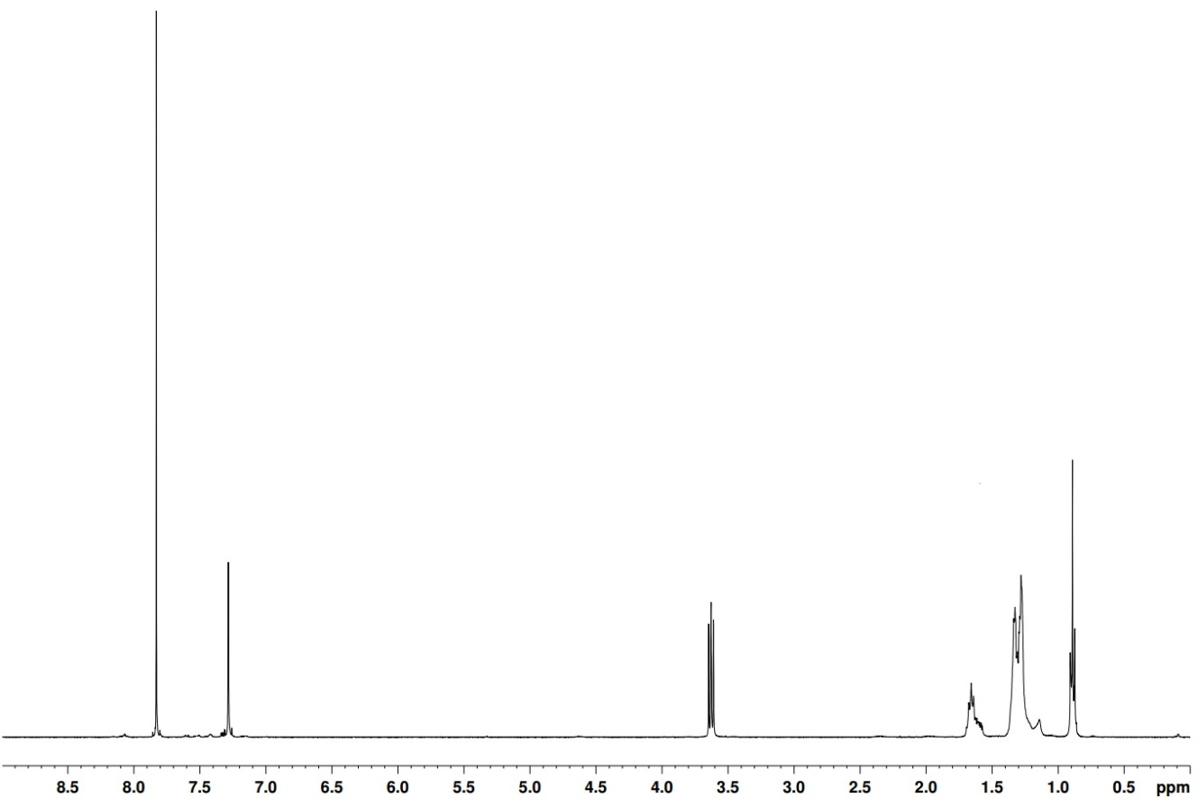
H_{a}
H_{e}
H_{c}

H_{d}
H_{c}

H_{c}
H_{c}

H_{b} H_{c}

Figure 53 ¹H NMR in CDCl₃ of M6 between 0 and 8.50 ppm showing the various proton environments present
Thiophene monomers were prepared according to the scheme in figure 54. Bromination with NBS yields both mono and di-bromo alkylthiophenes, the latter of which produced M10 (proton NMR shown in figure 55) and M14.
Figure 54 Synthesis of di-bromo alkylthiophene monomers M10 and M14 a) NBS (2 equiv.), CHCl₃/ AcOH (1:1), dark

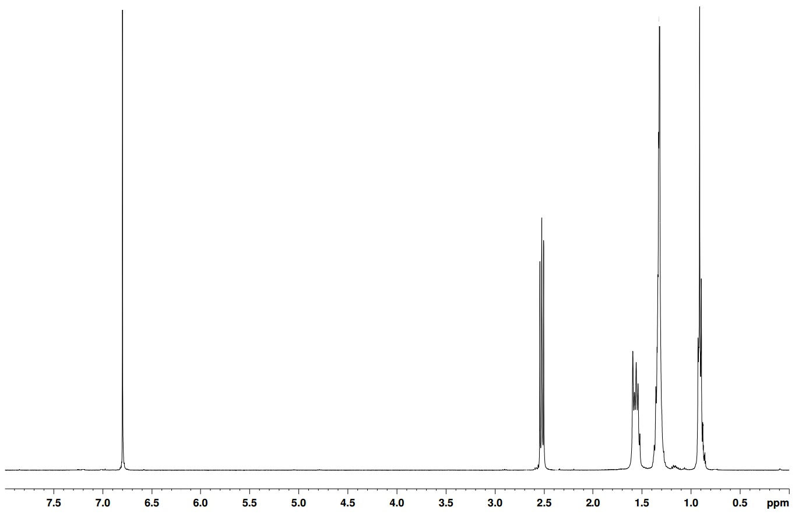
H_{a}
H_{b} H_{c}

H_{c}
H_{c}

H_{d}
H_{c}

H_{e}
H_{c}

Figure 55 ¹H NMR in CDCl₃ of M10 between 0 and 7.50 ppm showing the various proton environments present

3.22 Polymer Synthesis

Polymerisations utilised the lack of steric control on the thiophene units by having two different sites that oxidative addition of the aryl-halide bond can occur. Once coupled with the TPD unit through reductive elimination two possible orientations are obtainable; the alkyl chain of the thiophene directed away or toward the TPD moiety, as shown in figure 56. The randomness of the orientation leads to some parts of the chain experiencing steric clashes and loss of planarity. Proton NMR of PTPD(o)ranT(h) in figure 57.
Molecular weight data in table 4 shows increases with longer alkyl chains (hexyl to octyl to dodecyl) due to the solubilising effect of longer chains in common solvents. The branched dimethyloctyl (dmo) chain increases molecular weight due to increased disruption to planarity of the branched chains. Side chain length has a similar effect on the optical band gaps observed, with PTPD(dmo)ranT(h) exhibiting a band gap of 1.77 eV. The disruption in planarity brought about by the two branching points is significant and consequentially the molecular weight to double from the linear 8 carbon chain equivalent, leading to a decrease in the optical band gap. PTPD(h)ranT(h) shows a much narrower band gap than expected possibly due to enhanced π-stacking ability brought about by the short chain lengths. It is suspected that PTPD(h)ranT(h) is able to minimise steric clashes between side chains with much less loss of planarity than polymers with longer alkyl side chains.
Figure 56 Syntheses of PTPD(o)ranT(h), PTPD(d)ranT(h), PTPD(h)ranT(h), PTPD(o)ranT(d) a) PdCl₂(MeCN)₂ (0.02 mol equiv.), L1 (0.02 mol equiv.), CsCO₃ (3 mol equiv.), PivOH (1 mol equiv.), THF, 100 ^{O}C
Table 4 A summary of the molecular weight and optical data from polymers PTPD(o)ranT(h), PTPD(d)ranT(h), PTPD(h)ranT(h), PTPD(o)ranT(d) and PTPD(dmo)ranT(h)
Polymer | M_{n} / kDaª |  | M_{w} / kDaª | PDI^{b} | λ_{max} / nm solution |  |  | λ_{max} /nm thin film | E_{g} opt / eV^{c} (±0.02)
PTPD(h)ranT(h) |  | 3.10 | 4.01 | 1.29 | 572 |  |  | 580 | 1.79
PTPD(o)ranT(h) |  | 3.80 | 5.60 | 1.49 | 487 |  |  | 566 | 1.82
PTPD(d)ranT(h) |  | 4.70 | 6.90 | 1.46 |  | 480 | 563 |  | 1.81
PTPD(o)ranT(d) |  | 6.50 | 8.90 | 1.36 |  | 498 | 569 |  | 1.81
PTPD(dmo)ranT(h) |  | 10.30 | 25.90 | 2.51 |  | 512 | 577 |  | 1.77
ªMolecular weights calculated on the toluene fractions of polymers using differential refractive index (DRI) characterisation. ^{b}Polydispersity Index (PDI). ^{c}Optical band gap estimated by graphically determining the onset of absorption in thin film
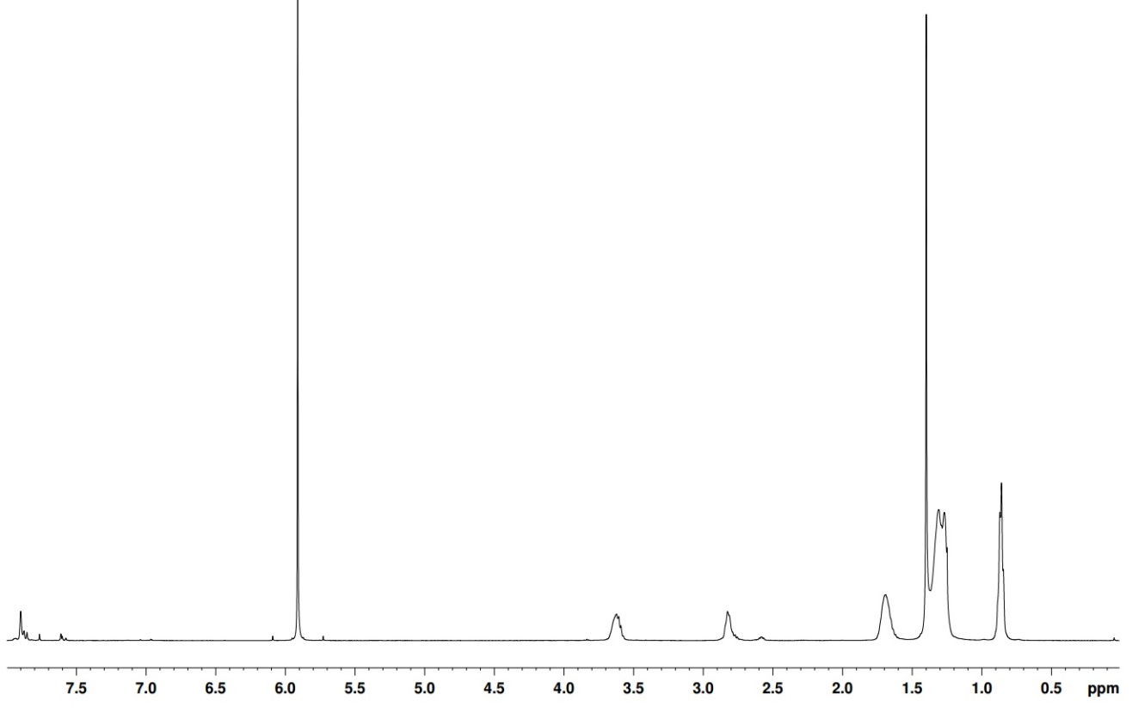
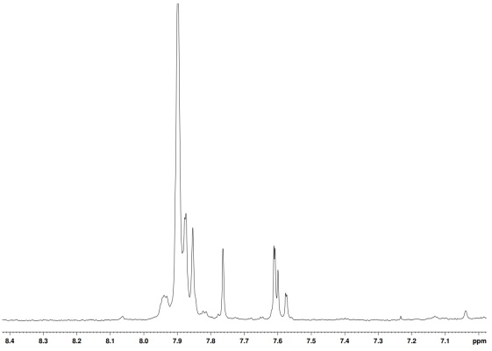
H_{a}
H_{b} H_{c}

H_{c}
H_{c}

H_{d}d_{d}
H_{c}

H_{ee}
H_{c}

H_{f}
H_{c}

Figure 57 ¹H NMR in C₂D₂Cl₄ of PTPD(o)ranT(h) between 0 and 8.00 ppm showing the various proton environments present on the polymer

3.23 Optical properties

The optical properties of polymers were investigated by UV-vis absorption spectroscopy on dilute chloroform solutions and drop-cast films on quartz substrates. Figure 58 shows the solution and thin film UV-vis absorption spectra. ICT peaks are present for all polymers, with the longer chain lengths bathochromically shifting the spectra. PTPD(o)ranT(h) and PTPD(d)ranT(h) display two shoulders on their solution UV-vis absorption curves. It is hypothesised that the alkyl sidecdhains are long enough to provide solubility for higher molecular weights, but allow enough planarity for ICT processes to be visible via spectroscopy.
Strong shoulders are present in both solution and thin film, indicating strong aggregation between polymer chains. High planarity induced by the TPD moiety encourages strong π interactions and a coplanar structure is adopted.
Figure 58 The normalised U.V.-vis absorption spectra of PTPD(h)ranT(h), PTPD(o)ranT(h), PTPD(d)ranT(h), PTPD(o)ranT(d) and PTPD(dmo)ranT(h) in a) dilute chloroform solution and b) thin film

3.24 Electrochemical properties

Cyclic Voltammetry (C.V.) was utilised to measure the oxidation and reduction potentials of the polymers synthesised. All oxidations and reductions were run in a 3 electrode cell, using tetrabutylammonium perchlorate in acetonitrile as the electrolyte. A thin film was created on the working electrode and the electrochemical data was then extracted. The HOMO and LUMO levels were calculated using tangents to the first oxidation and reduction potentials, which were then converted into electron volts. Results are shown in table 5.
Table 5 A summary of the electrochemical data gained from PTPD(o)ranT(h), PTPD(d)ranT(h), PTPD(h)ranT(h), PTPD(o)ranT(d) and PTPD(dmo)ranT(h)
Polymer | HOMOª / V (±0.04) | LUMO^{b} / V (±0.04) | E_{gec} /eV^{c} (±0.04)
PTPD(h)ranT(h) | -5.48 | -3.09 | 2.39
PTPD(o)ranT(h) | -5.55 | -3.26 | 2.29
PTPD(d)ranT(h) | -5.51 | -3.30 | 2.21
PTPD(o)ranT(d) | -5.59 | -3.06 | 2.53
PTPD(dmo)ranT(h) | -5.61 | -3.13 | 2.48
ªHOMO position (vs vacuum) determined from the onset of oxidation.
^{b}LUMO position (vs vacuum) determined from the onset of reduction. ^{c}Electrochemical energy gap

Deepening HOMO levels owe themselves to an increase in molecular weight and greater conjugation being achieved throughout the conjugated backbone. PTPD(dmo)ranT(h) displays the deepest HOMO level of -5.61 eV and when compared to P3HT, shows a decrease of 0.5 eV.¹⁸ Additional stability can be gained from deepening HOMO levels against the decomposition caused by oxidation. The reduction curves display large reversibility, proving re-oxidation can occur easily. All displayed in figure 59.

Figure 59 Cyclic voltammograms of PTPD(h)ranT(h), PTPD(o)ranT(h), PTPD(d)ranT(h), PTPD(o)ranT(d) and PTPD(dmo)ranT(h) on platinum electrodes (area 0.031 cm²) at a scan rate of 100 mVs⁻¹ in acetonitrile/tetrabutyl ammonium perchlorate (0.1 moldm⁻³).

3.25 Thermal Properties

Thermogravimetric analysis (TGA) offers an insight into the thermal stability of compounds. All polymers were heated to 800 ^{O}C under a nitrogen atmosphere to determine at what temperature the onset of decomposition (T_{d}) occurs. The trend observed shows an increase in degradation temperature with increasing size of alkyl side group, displayed in table 6.
Table 6 A summary of electrochemical values obtained for PTPD(h)ranT(h), PTPD(o)ranT(h), PTPD(d)ranT(h), PTPD(o)ranT(d) and PTPD(dmo)ranT(h)
Polymer | T_{d} / ^{O}C ª (± 7 ^{O}C) | T_{bd} / ^{O}C ^{b}(± 7 ^{O}C)
PTPD(h)ranT(h) | 342 | 423
PTPD(o)ranT(h) | 361 | 521
PTPD(d)ranT(h) | 375 | 525
PTPD(o)ranT(d) | 354 | 531
PTPD(dmo)ranT(h) | 311 | 420

ª Onset of degradation as determined by thermogravimetric analysis with a heating rate of 10 ^{O}C min⁻¹ under an inert nitrogen atmosphere.^{b} Onset of backbone degradation (T_{bd}) due to the corresponding % weight loss.
A pinnacle of thermal stability is reached with PTPD(d)ranT(h) with 95% weight loss observed at 375 ^{O}C. PTPD(h)ranT(h) and PTPD(o)ranT(h) which have shorter alkyl sidechains and lower molecular weights and as a result of this have reduced T_{d}. PTPD(o)ranT(d) and PTPD(dmo)ranT(h) also show decreased degredation temperatures. Owing to their larger alkyl side chains, it is postulated that polymer chains are forced further apart and interact more weakly with each other.

Figure 60 TGA plots of PTPD(h)ranT(h), PTPD(o)ranT(h), PTPD(d)ranT(h), PTPD(o)ranT(d) and PTPD(dmo)ranT(h)

Differential scanning calorimetry (DSC) was employed to see whether any thermal transitions were present upon heating of the polymers. Heat flow of samples was measured as a function of temperature – any sudden changes in heat flow indicate an exo/endothermic process or a glass transition in the sample.

Figure 61 Differential scanning calorimetry plots PTPD(h)ranT(h), PTPD(o)ranT(h), PTPD(d)ranT(h), PTPD(o)ranT(d) and PTPD(dmo)ranT(h) with a heating rate of 10 ^{O}C min⁻¹ under an inert nitrogen atmosphere.

The lack of any change in gradient shows no thermal transitions occur in the heat capacity of the polymers. This indicates the polymers do not have any exo/endothermic processes in this temperature range. It is speculated that transitions might be seen outside this temperature range

3.26 X-ray Diffraction

XRD data reveals important structural information about the effect chain length and regularity have on the solid state structure. This can be seen in figure 62.

Figure 62 Powder X-ray diffraction patterns of raw data of PTPD(h)ranT(h), PTPD(o)ranT(h), PTPD(d)ranT(h), PTPD(o)ranT(d) and PTPD(dmo)ranT(h)

The patterns observed for PTPD(h)ranT(h), PTPD(o)ranT(h) and PTPD(d)ranT(h) have relatively broad features, which is consistent with the random scatter of an amorphous solid. PTPD(o)ranT(d) and PTPD(dmo)ranT(h) show very little diffraction patterns, inferring that they are much more amorphous in nature. Presence of peaks in the low angle region point to the existence of lamellae structures within the solid state, which is consistent with a peak around 20-30 Å.
Table 7 Powder X-ray diffraction data harvested from figure 62 for polymers PTPD(h)ranT(h), PTPD(o)ranT(h), PTPD(d)ranT(h), PTPD(o)ranT(d) and PTPD(dmo)ranT(h)
Polymer | 2θ / ^{O} (±0.01) | D spacing / Å (±0.01) | 2θ / ^{O} (±0.01) | D spacing / Å (±0.01)
PTPD(h)ranT(h) | 4.13 | 21.37 | 24.90 | 3.57
PTPD(o)ranT(h) | 3.73 | 23.67 | 24.80 | 3.57
PTPD(d)ranT(h) | 2.93 | 30.13 | 24.90 | 3.57
PTPD(o)ranT(d) | 3.07 | 28.76 | 24.90 | 3.57
PTPD(dmo)ranT(h) | - | - | - | -

Facial backbone to backbone distances are very consistent, which points to the variance in alkyl chain has no effect on this distance. Low angle peaks are present for the more ordered structures, indicating long range order reaching up to 30.13 Å for PTPD(d)ranT(h). Increasing d-spacing lengths are seen for longer alkyl side chains, caused by less interdigitation between side-on polymer chains. Branching interferes with intermolecular interactions and as a result very supressed peaks are observed for PTPD(dmo)ranT(h).

3.3 Conclusions

Synthesis of both thieno[3,4-c]pyrrole-4,6-dione and thiophene co-monomers proved to be relatively easy and were produced with good yields in all synthetic steps. Narrower band gaps were observed, particularly for PTPD(dmo)ranT(h), with an optical band gap of 1.77 eV – a 0.13 eV improvement from poly 3-hexylthiophene. Deepening HOMO levels compared to those of P3HT, should lead to improved open circuit voltages. PTPD(o)ranT(d) displayed a HOMO level at -5.59 eV, almost 0.6 eV deeper than P3HT and should give much better V_{OC}s.⁶⁷ The high thermal stabilities of all polymers (> 300^{O}C) lend themselves to good cell lifetimes, as temperatures experienced by cells will be much lower than this. The amorphous properties are proven by XRD data, which show diffuse peaks for all polymers. Less intense low angle peaks are also present, varying between 21 -31 Å, these are indicative of some longer range order present in the solid state. DSC measurements show no thermal transition taking place over the temperature range measured, however, the amorphous nature of the polymers has been proved by XRD data.
Despite the advances made, molecular weights are still poor in comparison to those achieved by P3HT. It is postulated that the planarity induced by TPD has a negative effect on molecular weights. Only PTPD(dmo)ranT(h) has an M_{n} over 10,000 kDa. PTPD(h)ranT(h) has an M_{n} at 3.1 KDa – the equivalent 6 carbon sidechains on P3HT allow that to grow well over 10 times as large.
TPD clearly induces desirable qualities for use in OPVs. Vastly improved open circuit voltages should be observed from P3HT with much deeper HOMO levels seen in TPD-thienyl polymers. However, due to the high crystallinity observed within shorter chain polymers interphase mixing with PCBM may be affected.

3.4 Synthesis

3-Ethyl 4-methyl 2-aminothiophene-3,4 –dicarboxylate (16) ²⁰
(16)
2-Oxopropanoate (3.2g, 31.9 mmol), ethyl cyanoacetate (3.3g, 28.9 mmol) and sulphur (1.1g, 4.36 mmol) were placed in dry DMF (20 mL) under an inert atmosphere. Triethylamine (7.5 mL) in dry DMF (10 mL) was added dropwise at room temperature over 2 hours. After addition, the temperature was raised to 50 ^{O}C and stirred overnight. The reaction mixture was then cooled to room temperature and water (100 mL) was added and the reaction mixture was left to crystallise over 72 hours. White powder was obtained after filtration (4.04g, 61%). ¹H NMR (400 MHz CDCl₃) δ ppm: 6.65 (s, 1H), 6.00 (s – broad, 2H), 4.30 (q, J= 7 Hz, 2H), 3.85 (s, 3H), 1.35 (t, J=7 Hz, 3H). ¹³C NMR δ ppm: 163, 161, 130, 110, 100, 59, 52, 14. Mass spectrum (EI) (m/z): 229 (M+). Elemental Analysis calculated: C; 47.15, H; 4.84, N; 6.11, S; 13.98 found: C; 48.36, H; 5.93, N; 5.66, S; 13.08

Thiophene 3,4-dicarboxylic acid (17) ²⁰
(17)
A solution of 3-ethyl 4-ethyl 2-aminothiophene-3,4 –dicarboxylate (0.84g, 3.7 mmol) in THF (75 mL) was added dropwise to boiling tert-butyl nitrite (0.4g, 3.9 mmol) in THF under an inert atmosphere. The mixture was refluxed for 3 hours, cooled to room temperature and the solvent removed in vacuo. Purification via column chromatography with a mixed eluent of petroleum ether: ethyl acetate (7:3). The oil obtained after purification was diluted in NaOH (2M, 25 mL) and stirred at 90 ^{O}C for 24 hours. The solution was acidified to pH 3 with HCl and extracted with diethyl ether (10 x 100 mL). The organic layers were combined, dried with MgSO₄ and the solvent removed in vacuo to yield a white solid (0.32 g, 51%). ¹H NMR (400 MHz CDCl₃) δ: 8.65 (s, 2H). ¹³C NMR δ ppm: 164, 134 , 132 . Mass spectrum (EI) (m/z): 172 (M+). Elemental Analysis calculated: C; 41.86, H; 2.34, S; 18.62 found: C; 42.36, H; 2.87, S; 17.04
Thieno[3,4-c]furan-1,3-dione (18) ²⁰
(18)
Thiophene-3,4-dicarboxylic acid (3g, 17 mmol) was dissolved in acetic anhydride (42 mL, 420 mmol) and heated to 110 ^{O}C for 1 hour with stirring. After being cooled to room temperature, the product was filtered and washed with hexane to yield the yellow crystals (2.11 g, 82%). ¹H NMR (400 MHz CDCl₃) δ: 8.55 (s, 2H). ¹³C NMR δ ppm: 157, 133, 130, 64. Mass spectrum (EI) (m/z): 153 (M+). Elemental Analysis calculated: C; 46.75, H; 1.31, S; 20.80 found: C; 44.93, H; 1.11, S; 22.34

5-Octyl-4H-thieno [3,4-c] pyrrole-4,6 (5H) dione (M6) ²⁰
(M6)
Thieno [3,4-c] furan-1,3-dione (1g, 6.4 mmol) and octylamine (1.01g, 7.8 mmol) were dissolved in THF (10 mL), degassed and heated to 50 ^{O}C for 3 hours with stirring. Thionyl chloride (4 mL, 55 mmol) was added to the reaction mixture at room temperature and heated to 55 ^{O}C for 3 hours. The reaction was quenched by dropwise addition to a water: methanol (100 mL: 50 mL) and the resulting precipitate was collected by filtration. The crude product was purified via column chromatography using dichloromethane and a white solid was obtained after the solvent was removed (1.35 g, 80%). ¹H NMR (400 MHz CDCl₃) δ: 7.80 (s, 2H), 3.65 (t, J= 8 Hz, 2H), 1.65 (quint, J=7 Hz, 2H), 1.30 (m, 10H), 0.90 (t, J= 8 Hz, 3H). ¹³C NMR δ ppm: 162, 136, 125, 38, 31, 30, 29, 26, 22, 14. Mass spectrum (EI) (m/z): 265 (M+). Elemental Analysis calculated: C; 63.37, H; 7.22, N; 5.28, S; 12.08 found: C; 65.78, H; 7.57, N; 6.08, S; 11. 85
5-Dodecyl-4H-thieno [3,4-c] pyrrole-4,6 (5H) dione (M7) ²⁰
(M7)
See method for 5-octyl-4H-thieno [3,4-c] pyrrole-4,6 (5H) dione (M6) (2.41 g, 83%). ¹H NMR (400 MHz CDCl₃) δ: 7.80 (s, 2H), 3.65 (t, J= 8 Hz, 2H), 1.65 (quint., J=8 Hz, 2H), 1.30 (m, 16H), 0.90 (t, J= 8.90, 3H). ¹³C NMR δ ppm: 165, 162, 138, 133, 132, 130, 40, 31, 29, 28, 26, 22, 13. Mass spectrum (EI) (m/z): 321 (M+). Elemental Analysis calculated: C; 67.25, H; 8.47, N; 4.36, S; 9.97 found: C; 66.79, H; 8.23, N; 4.99, S; 10.66

5-Hexyl-4H-thieno [3,4-c] pyrrole-4,6 (5H) dione (M8) ²⁰
(M8)
See method for 5-octyl-4H-thieno [3,4-c] pyrrole-4,6 (5H) dione (M6) (1.15 g , 76%). ¹H NMR (400 MHz CDCl₃) δ: 7.80 (s, 2H), 3.65 (t, J= 8, 2H), 1.65 (quint., J= 7 Hz, 2H), 1.30 (m, 6H), 0.90 (t, J= 8.90, 3H). ¹³C NMR δ ppm: 165, 133, 127, 39, 32, 28, 25, 21, 14. Mass spectrum (EI) (m/z): 237 (M+). Elemental Analysis calculated: C; 60.73, H; 6.37, N; 5.90, S; 13.51 found: C; 61.62, H; 5.77, N; 5.98, S; 13.87

5-(3,7-Dimethyloctyl) -4H- thieno [3,4-c] pyrrole-4,6 (5H) dione (M16) ²⁰
(M16)
See method for 5-octyl-4H-thieno [3,4-c] pyrrole-4,6 (5H) dione (0.41 g, 76%) clear oil. ¹H NMR (400 MHz CDCl₃) δ: 7.80 (s, 2H), 3.60 (t, J=8 Hz, 2H), 1.70 (m, 3H), 1.37 (m, 3H), 1.18 (m, 4H), 1.00 (d, J=6.20 Hz, 3H), 0.85 (d, J=6.60 Hz, 6H). ¹³C NMR δ ppm: 161, 135, 125, 40, 37, 36, 35, 30, 27, 25, 22, 19. Mass spectrum (EI) (m/z): 293 (M+). Elemental Analysis calculated: C; 65.49, H; 7.90, N; 4.77; S; 10.93 found: C; 66.22, H; 7.50, N; 4.01; S; 11.53
2,5-Dibromo-3-hexylthiophene (M10) ²¹
(M10)
Under the exclusion of light, n-bromosuccinimide (4.03 g, 4.04 mmol) was added portionwise to 2-bromo 3-hexylthiophene (1g, 4.04 mmol) in acetic acid: chloroform (1:1, 20 mL). The reaction was stirred overnight at room temperature before being quenched by water (10 mL). The aqueous phase was washed with dichloromethane (3 x 100 mL) and the organic phases were combined, washed with sodium hydrogen carbonate solution (3 x 100 mL) and water (3 x 100 mL). The organic layers were combined, dried with magnesium sulphate and the solvent removed in vacuo. The crude oil was collected and purified via column chromatography (eluent: hexane) (5.06 g, 85%). ¹H NMR (400 MHz CDCl₃) δ: 6.80 (s, 1H), 2.60 (t, J=7 Hz, 2H), 1.65 (quint., J=8 Hz, 2H), 1.35 (m, 6H), 0.90 (t, J=7 Hz, 3H). ¹³C NMR δ ppm: 144, 131, 110, 108, 30, 29, 28, 22, 14. Mass spectrum (EI) (m/z): 325 (M+). Elemental Analysis calculated: C; 36.83, H; 4.33, Br; 49.01, S; 9.83 found: C; 37.93, H; 5.03, Br; 49.81, S; 9.44

2,5-Dibromo-3-dodecylthiophene (M14) ²¹
(M14)
See method for 2, 5-dibromo-3-hexylthiophene (M9) (1.70 g, 84%) clear oil. ¹H NMR (400 MHz CDCl₃) δ: 6.80 (s, 1H), 2.60 (t, J=7 Hz, 2H), 1.65 (m, 2H), 1.35 (m, 18H), 0.90 (t, J=7 Hz, 3H). ¹³C NMR δ ppm: 143, 131, 116, 114, 37, 31, 29, 29, 28, 28, 23, 15. Mass spectrum (EI) (m/z): 410 (M+). Elemental Analysis calculated: C; 46.84, H; 6.39, Br; 38.95, S; 7.81 found: C; 47.90, H; 6.00, Br; 37.95, S; 8.15
Regio-random polymers²²
5-(Alkyl)-4H-thieno [3,4-c] pyrrole-4,6 (5H) dione (0.36 mmol), 2,5-dibromo-3-alkylthiophene (36 mmol), caesium carbonate (1.08 mmol), pivalic acid (0.36 mmol), PdCl₂(MeCN)₂ (0.0072 mmol) and tris(2-​methoxyphenyl)​-phosphine (0.0072 mmol) were placed in a thick-walled Schlenk tube and degassed. THF (1 mL) was added, degassed again and heated to 100 ^{O}C until the first signs of precipitation were visible around the edge of the flask. The reaction mixture was extracted with chloroform (100 mL) and washed with saturated EDTA solution (3 x 100 mL). Solvent was removed until the solution was concentrated to ~10 mL and precipitated into methanol (75 mL). The precipitate was collected via filtration and dried over vacuum. The polymer was purified by Soxhlet extraction using methanol, acetone, hexane, toluene, chloroform and chlorobenzene sequentially. The toluene fraction was taken and used in analysis.
Poly(3/4-hexyl-thiophen​yl)​-​5-​​hexyl-4H-​Thieno[3,​4-​c]​pyrrole-​4,​6(5H)​-​dione (PTPD(h)ranT(h))
Toluene fraction (90 mg, 52%), M_{n} 3.10 KDa, M_{w} 4.10 KDa, PDI 1.27. ¹H NMR (500 MHz C₂D₂Cl₄) δ: 7.90-7.60 (m, 1H), 3.65 (m, 2H), 2.85 (m, 2H), 1.70 (m, 4H), 1.30 (m, 12H), 0.85 (m, 6H). Elemental Analysis calculated: C, 64.75; H, 6.99; N, 3.60; S, 16.46 found: C, 61.96; H, 7.88; N, 3.49; S, 17.94.
Poly(3/4-hexyl-thiophen​yl)​-​5-​octyl​-4H-​thieno[3,​4-​c]​pyrrole-​4,​6(5H)​-​dione (PTPD(o)ranT(h))
Toluene fraction (83 mg, 62%), M_{n} 3.80 KDa, M_{w} 5.60 KDa, PDI 1.47. ¹H NMR (500 MHz C₂D₂Cl₄) δ: 7.90-7.60 (m, 1H), 3.65 (m, 2H), 2.85 (m, 2H), 1.70 (M, 4H), 1.30 (m, 16H), 0.80 (m, 2H). Elemental Analysis calculated: C, 66.15; H, 7.48; N, 3.35; S, 15.35 found: C, 68.21; H, 6.97; N, 2.90; S, 16.88.
Poly(3/4-hexyl-thiophen​yl)​-​5-​dodecyl​-4H-​thieno[3,​4-​c]​pyrrole-​4,​6(5H)​-​dione (PTPD(d)ranT(h))
Toluene fraction (71 mg, 59%), M_{n} 4.70 KDa, M_{w} 6.90 KDa, PDI 1.47. ¹H NMR (500 MHz C₂D₂Cl₄) δ: 7.90-7.60 (m, 1H), 3.65 (m, 2H), 2.85 (m, 2H), 1.70 (M, 4H), 1.30 (m, 24H), 0.85 (m, 6H). Elemental Analysis calculated: C, 68.46; H, 8.30; N, 2.96; S, 13.54 found: C, 67.88; H, 7.91; N, 3.17; S; 14.60.
Poly(3-dodecyl-thiophen​yl)​-​5-octyl​-4H-​Thieno[3,​4-​c]​pyrrole-​4,​6(5H)​-​dione (PTPD(o)ranT(d))
Toluene fraction (83 mg, 51%), M_{n} 6.50 KDa, M_{w} 8.90 KDa, PDI 1.37. ¹H NMR (500 MHz C₂D₂Cl₄) δ: 7.90 (m, 1H), 3.65 (m, 2H), 2.85 (m, 2H), 1.70 (m, 4H), 1.30 (m, 28H), 0.80 (m, 6H). Elemental Analysis calculated: C, 69.42; H, 8.64; N, 2.79; S, 12.78 found: C, 71.46; H, 9.38; N, 2.55; S, 13.44.
Poly(3-hexyl-thiophen​yl)​-​5-(3,7-dimethyloctyl)​-4H-​thieno[3,​4-​c]​pyrrole-​4,​6(5H)​-​dione (PTPD(dmo)ranT(h))

Toluene fraction (91mg, 63%), M_{n} 10.30 KDa, M_{w} 25.90 KDa, PDI 2.51. ¹H NMR (500 MHz C₂D₂Cl₄) δ: 7.85 (m, 1H), 3.65 (m, 2H), 2.80 (m, 2H), 1.70 (m, 4H), 1.40-1.10 (m, 13H), 0.90 (m, 12H). Elemental Analysis calculated: C, 67.37; H, 7.92; N, 3.14; S, 14.39 found: C, 65.94; H, 6.98; N, 3.86; S, 15.67.

3.5 References

1 H. Kallmann and M. Pope, Rev. Sci. Instrum., 1958, 29, 993-994.
2 L. Cartwright, A. Iraqi, RSC Adv., 2015, 57, 46386-46394
3 L. Huo, X. Guo, S. Zhang, Y. Li and J. Hou, Macromol., 2011, 44, 4035–4037.
4 D. Barlev, R. Vidu and P. Stroeve, Sol. Energy Mater. Sol. Cells, 2011, 95, 2703–2725.
5 B. C. Thompson and J. M. J. Fréchet, Angew. Chem. Int. Ed. Engl., 2008, 47, 58–77.
6 A. Gadisa, W. D. Oosterbaan, K. Vandewal, J.-C. Bolsée, S. Bertho, J. D’Haen, L. Lutsen, D. Vanderzande and J. V. Manca, Adv. Funct. Mater., 2009, 19, 3300–3306.
7 P. W. M. Blom, V. D. Mihailetchi, L. J. a. Koster and D. E. Markov, Adv. Mater., 2007, 19, 1551–1566.
8 J. W. Rumer, C. K. L. Hor, I. Meager, C. P. Yau, Z. Huang, C. B. Nielsen, S. E. Watkins, H. Bronstein and I. McCulloch, J. Org. Semicond., 2013, 1, 30-35.
9 W. a. Braunecker, Z. R. Owczarczyk, A. Garcia, N. Kopidakis, R. E. Larsen, S. R. Hammond, D. S. Ginley and D. C. Olson, Chem. Mater., 2012, 24, 1346–1356.
10 D. a. M. Egbe, S. Türk, S. Rathgeber, F. Kühnlenz, R. Jadhav, A. Wild, E. Birckner, G. Adam, A. Pivrikas, V. Cimrova, G. Knör, N. S. Sariciftci and H. Hoppe, Macromol., 2010, 43, 1261–1269.
11 Y.-J. Cheng, S.-H. Yang and C.-S. Hsu, Chem. Rev., 2009, 109, 5868–5923.
12 P. Shen, H. Bin, X. Chen and Y. Li, Org. Electron., 2013, 14, 3152–3162.
13 H. J. Son, B. Carsten, I. H. Jung and L. Yu, Energy Environ. Sci., 2012, 5, 8158-8170.
14 A. Facchetti, Chem. Mater., 2011, 23, 733–758.
15 T. Kaniowski, W. Łużny, S. Nizioł, J. Sanetra and M. Trznadel, Synth. Met., 1998, 92, 7–12.
16 C. Ottone, P. Berrouard, G. Louarn, S. Beaupré, D. Gendron, M. Zagorska, P. Rannou, A. Najari, S. Sadki, M. Leclerc and A. Pron, Polym. Chem., 2012, 3, 2355-2365.
17 Y. H. Lee, D. H. Kim, N. S. Arul and T. W. Kim, Appl. Surf. Sci., 2013, 268, 156–162.
18 R. Kroon, M. Lenes, J. C. Hummelen, P. W. M. Blom and B. de Boer, Poly. Revs., 2008, 48, 531-582
19 Piliego C1, Holcombe TW, Douglas JD, Woo CH, Beaujuge PM, Fréchet JM., J. Am. Chem. Soc., 2010, 132(22), 7595-7.
20 P. Berrouard, S. Dufresne, A. Pron, J. Veilleux and M. Leclerc, J. Org. Chem., 2012, 77, 8167–8173.
21 Z. Xiao, K. Sun, J. Subbiah, T. Qin, S. Lu, B. Purushothaman, D. J. Jones, A. B. Holmes and W. W. H. Wong, Polym. Chem., 2015, 6, 2312–2318.
22 M. Wakioka, N. Ichihara, Y. Kitano and F. Ozawa, Macromol., 2014, 2, 626−631.

Chapter 4:

Studying the effect of chain length on the photovoltaic performance of regio regular thieno[3,4-c]pyrrole-4,6-dione/thiophene alternating block co-polymers

Six regioregular block copolymers were successfully synthesised via direct arylation with varying side chain lengths on both TPD and thienyl moieties. Theoretical calculations demonstrate regioregular TPD-thienyl should have much higher intrinsic dipole moments than the comparative P3HT polymer. Promising band gaps lie between 1.84 eV (PTPD(h)regT(h)) and 1.73 eV (PTPD(o)regT(d)), deep lying HOMO levels as low as -5.59 eV (PTPD(d)regT(h)) suggest good PCE values should be obtained. These values were obtained despite depleted molecular weights due to the highly crystalline nature of the polymers in the solid state. The regio regularity of the shorter side chain polymers is confirmed by X-ray diffraction through intense peaks in the low angle region indicative of lamellae structures. Lamellae structures become less prominent with increases in side chain length and branching. The disruption in molecular packing is also what induces higher molecular weights. PTPD(dmo)altT(h) obtains the highest molecular weights and least intense XRD peaks. It is suspected that the loss of conjugation caused by severe steric clashes between alkyl side chains increases solubility and inhibits intermolecular π-π interactions.

4.1 Introduction

Improving PCEs can be achieved through many different methods; active layer morphology, narrowing band gaps, lowering HOMO levels etc. One such method is to improve charge carrier transport. The ability of a particle to travel through a material is linked with the dielectric constant, a measure of the permittivity through the material.¹ The Kubo formula (equation 3) can be used to explore the factors affecting the dielectric constant in a semiconducting polymer. The permittivity of free space (ε₀) the volume of the unit cell (V), Boltzmann constant (k_{B}), temperature (T) and variance in the dipole moment (Var(M)) (i.e. how much the dipole fluctuates over time) all contribute to the overall dielectric constant (ε).
$$ε=1+\left(\frac{4π}{3ε_{0}Vk_{B}T}\right)Var\left(M\right)$$
Equation 3 Kubo Formula linking dielectric constant to the variance in the dipole of a semiconductor

The Kubo formula shows the linear relationship between the dielectric constant and the variance in the dipole moment. Systems with a large dipole moment are more likely to have a large variance in dipole moment and a larger dielectric constant as a result.² Larger dielectric constants provide better screening between the two oppositely charged polarons. The result of this is an increase in the likelihood of charge separation and less recombination of electron and holes to the ground state.² It has been hypothesised that eliminating charge recombination is essential in improving cell efficiencies and can be achieved through designing materials with large dipole moments. Extending exciton lifetimes can aid in travelling their diffusion length and creating photocurrent. This has led to the rational design of polymers with large dipole moments taken into consideration.^{3,4}
Creating dipoles in novel materials can be serendipitous, but using one co-monomer with a large, fixed local dipole moment can create the desired effect. Yu et al probed the relationship between dipole moments and PCEs, to find a positive correlation.² Coulombic binding energies are decreased with a change in local dipole moment from the ground state to the excited state. Positive charges localise more on the electron rich units and negative charges on the electron deficient units, which aids charge dissociation and transfer.
Thieno[3,4-c]pyrrole-4,6-dione (TPD) has been shown to form narrow band gap polymers due to its excellent electron accepting nature. As well as deepening the HOMO and enhancing intramolecular charge transfer, the extended aromatic system offers planarity and ability to π-stack increasing intermolecular charge transfer.⁵⁻⁸ This ability has attracted interest in the OPV research community and many TPD copolymers have been synthesised with good photovoltaic properties.
Recent incorporation of TPD with thiophene and bithiophene units into conjugated polymers has shown promising photovoltaic properties. Rumer et al report crystalline structures, particularly for those with less bulky side units which promote crystallinity.⁸ TPD-carbazole/benzodithiophene polymers were synthesised by Ottone et al and exhibit interdigitation of side chains as proven by X-ray diffraction.⁹
In this chapter, the effect of regioregularity on photovoltaic properties will be explored. It is hypothesised that synthesising a polymer with a regularly repeating structure by lining the monomer units in the same orientation, it will give the polymer a greater overall dipole moment.
Figure 63 A diagrammatic representation of the molecular alignment on TPD monomers contributing to the overall dipole moment of the molecular

4.2 Results and Discussion
Figure 64 Syntheses of PTPD(h)regT(h), PTPD(o)regT(h), PTPD(d)regT(h), PTPD(o)regT(d), PTPD(dmo)regT(h) and PTPD(dmo)altT(h) a) PdCl₂(MeCN)₂ (0.02 mol equiv.), L1 (0.02 mol equiv.), CsCO₃ (3 mol equiv.), PivOH (1 mol equiv.), THF, 100 ^{O}C

4.21 Monomer synthesis

Regio regular polymers were all manufactured from alkylated TPD moieties, which were synthesised according to figure 48 in Chapter 3. Alkyl chains -C₆H₁₃, -C₈H₁₃, -C₁₂H₂₅ and -3,7 dimethyloctyl were attached to TPD units M6-8 and M16 in order to study the effect of chain length and branching ( as seen in figure 64). The regio-regularity of the polymers was controlled through stereospecific reactions. Bromination of both protons on TPD (19, 21, 23 and M17) followed by reduction with zinc to remove a single bromine to form monobromo TPD derivatives 20, 22, 24 and 37. The attachment of thiophene is achieved via Suzuki coupling of 3-alkyl 2-boronic ester thiophene (27-29, 32 and 38). This step controls the regio regularity of the monomer as the addition of the thiophene can only occur at the site of the bromine atom. It also ensures the alkyl chain on the thiophene unit is attached in the same orientation on every TPD-thienyl molecule. After this, bromination of the most labile proton of the thiophene ensured creation of the final monomers M11-13, M15 and M18, as summarised in figure 65. Proton NMR spectrum of M11 can be seen in figure 67.
Figure 65 a) NBS, H₂SO₄/TFA b) Zn, EtOH/AcOH, reflux c) 3-alkylthiophene boronic ester, Pd(PPh₃)₄, K₂CO₃, Aliquat 336, Toluene, 90 ^{O}C d)NBS, AcOH/CHCl₃, dark

The regio chemistry of products 26 and 31 is controlled by the electronic properties of the substituted thiophene ring, displayed in figure 66. The major products of bromination are 25 and 30 because of the activating effect of the alkyl chain. Electron density is fed into the conjugated π-system and promotes the reactivity of the 2-position over the 4- and 5-position. Addition of the boronic ester group must occur at the same position as the bromine to ensure the stereochemistry is retained to form products 26 and 31.
Figure 66 a) NBS, AcOH/ CHCl₃, dark b) Bis(pinacolato) diboron, KOAc, Pd(dppf)Cl₂ (0.05 mol equiv.), DMF, 100 ^{O}C
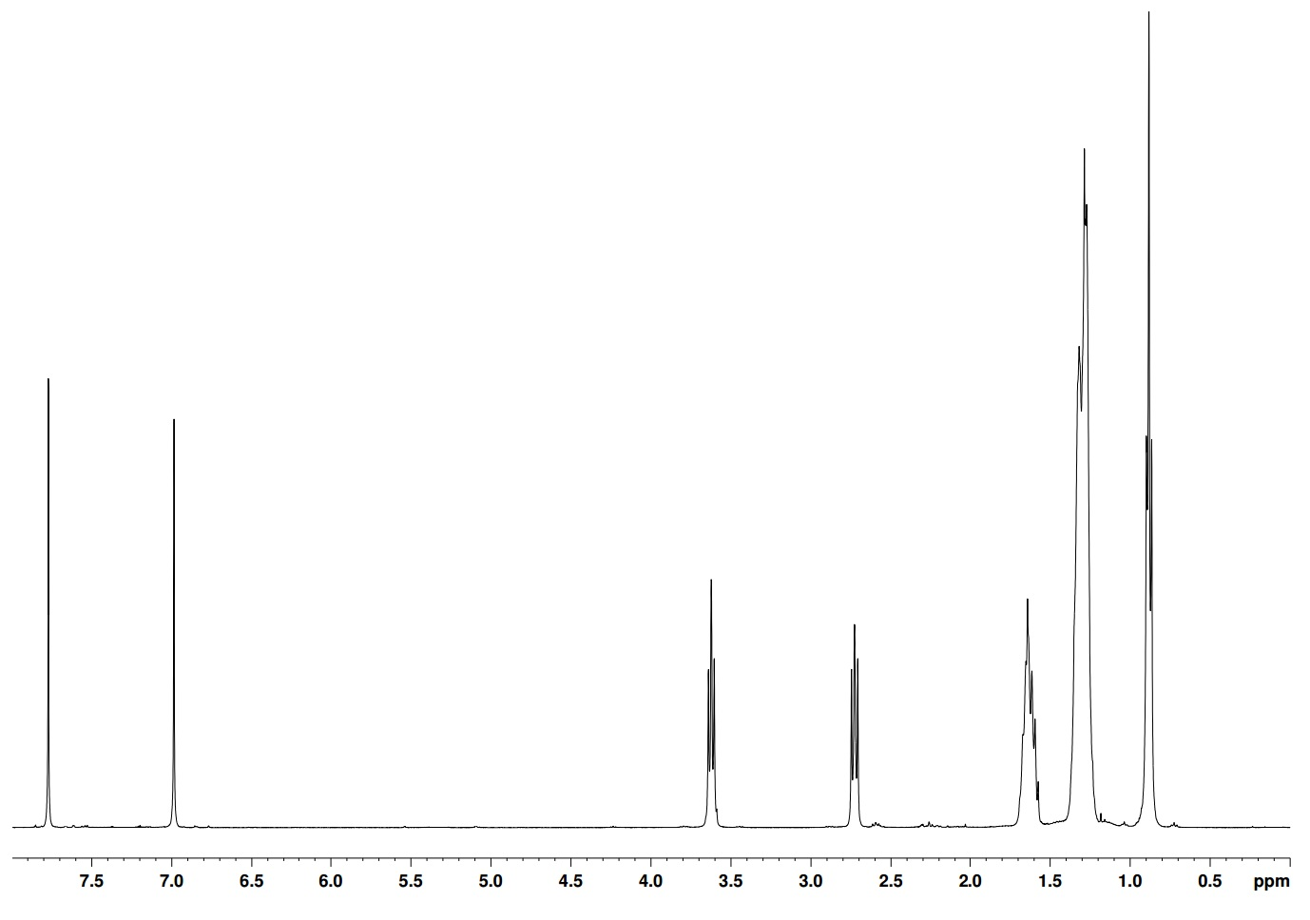
An alternating polymer was also synthesised to probe its PV properties. Synthesis proceeded in a very similar fashion to that of the regio regular monomers. However, thiophene groups were attached to either side of the dibromo TPD compound M17. Once coupled, both 5 positions of the flanking thiophenes are brominated on 39 to produce M19. ¹H NMR spectrum shown in figure 68.
Figure 69 a) 3-alkylthiophene boronic ester (2 equiv.), Pd(PPh₃)₄, K₂CO₃, Aliquat 336, Toluene, 90 ^{O}C b) NBS (2 equiv.), AcOH/CHCl₃, dark
H_{a}
H_{b} H_{c}

H_{c}
H_{c}

H_{d}
H_{c}

H_{e}
H_{c}

H_{f}
H_{c}

H_{g}
H_{c}

Figure 67 ¹H NMR in CDCl₃ of M11 between 0 and 8.00 ppm showing the various proton environments present

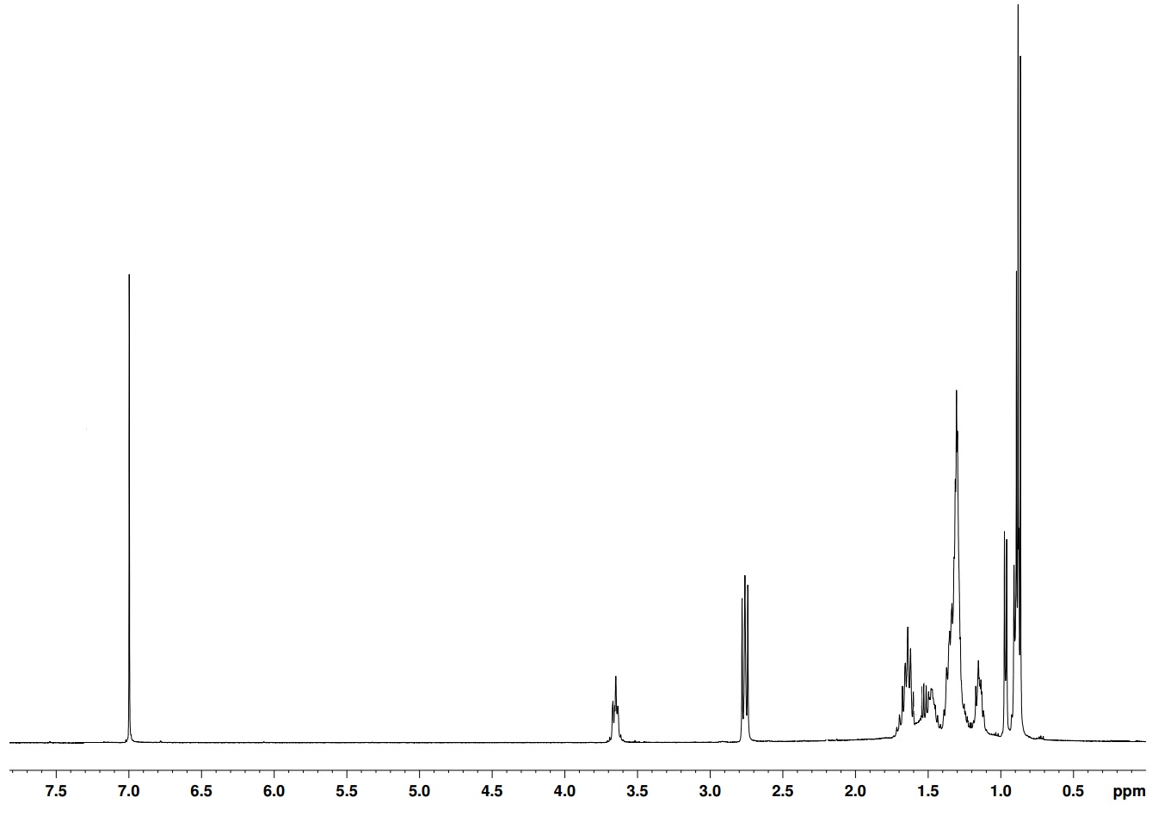
H_{a}
H_{b} H_{c}

H_{c}
H_{c}

H_{d}
H_{c}

H_{g}
H_{c}

H_{e}
H_{c}

H_{f}
H_{c}

Figure 68 ¹H NMR in CDCl₃ of M19 between 0 and 7.50 ppm showing the various proton environments present

4.22 Polymer Synthesis

Two different routes to achieve regularly alternating block copolymers were utilised. Regioregular (reg) polymers (PTPD(h)regT(h), PTPD(o)regT(h), PTPD(d)regT(h), PTPD(o)regT(d), PTPD(dmo)regT(h) and alternating (alt) PTPD(dmo)altT(h)) formed their repeating structure through coupling between the brominated position on the thiophene and the only available proton on the TPD part of the molecule. This guaranteed fixed stereochemistry as the polymerisations could only occur in a fixed motif. The alternating polymers have fixed regio regularity as addition of the unbrominated (dmo)TPD unit can occur at both protons and yield the same stereochemical outcome. (dmo)TPD was selected as a trial alternating polymer with the hypothesis that it would give a higher molecular weight polymer.
Table 8 A summary of the molecular weight and optical data gained from of PTPD(h)regT(h), PTPD(o)regT(h), PTPD(d)regT(h), PTPD(o)regT(d), PTPD(dmo)regT(h) and PTPD(dmo)altT(h)
Polymer | M_{n} / kDaª | M_{w} / kDaª | PDI^{b} | λ_{max} / nm solution | λ_{max} / nm thin film | E_{g} opt / eV^{c} (±0.02)
PTPD(h)regT(h) | 2.50 | 3.10 | 1.24 | 466 | 520 | 1.84
PTPD(o)regT(h) | 3.50 | 4.10 | 1.17 | 558 | 560 | 1.78
PTPD(d)regT(h) | 3.70 | 5.90 | 1.59 | 563 | 565 | 1.76
PTPD(o)regT(d) | 4.60 | 6.70 | 1.45 | 472 | 552 | 1.73
PTPD(dmo)regT(h) | 3.90 | 4.60 | 1.19 | 473 | 554 | 1.75
PTPD(dmo)altT(h) | 10.60 | 17.90 | 1.68 | 494 | 541 | 1.74

ªMolecular weights calculated on the toluene fractions of polymers using differential refractive index (DRI) characterisation. ^{b}Polydispersity Index (PDI). ^{c}Optical band gap estimated by graphically determining the onset of absorption

The structure of the polymers was confirmed by proton NMR. Single proton environments in the aromatic region were seen as expected, with some peaks observed for end group protons. The ratio between end group and polymer backbone protons is at its biggest on the alternating (alt) polymer PTPD(dmo)altT(h). This can be observed in figure 70, where the single proton peak Ha is much bigger relative to other peaks in the aromatic region.

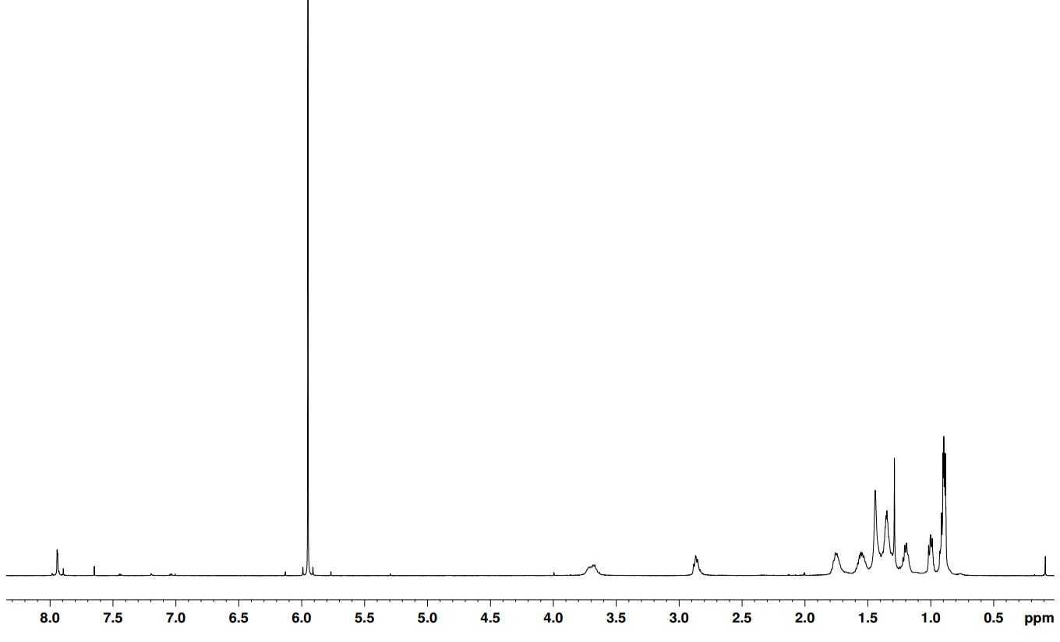
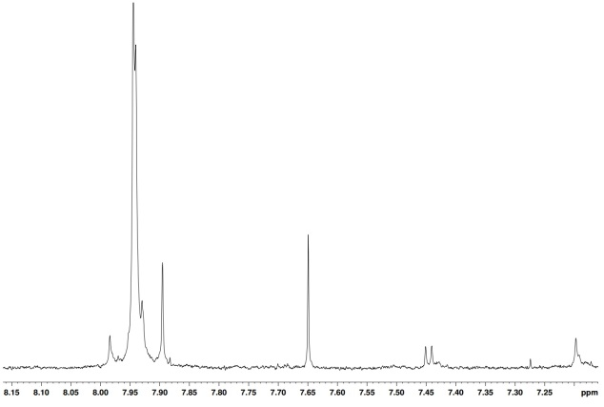
H_{a}
H_{b} H_{c}

H_{c}
H_{c}

H_{d}d_{d}
H_{c}

H_{ee}
H_{c}

H_{f}
H_{c}

H_{g}
H_{c}

Figure 70 ¹H NMR in C₂D₂Cl₄ of PTPD(dmo)altT(h) between 0 and 8.00 ppm showing the various proton environments present on the polymer

4.23 Theoretical Calculations

Theoretical calculations were carried out by Megan Rostern in the Martsinovich group at the University of Sheffield on PTPD(o)regT(h) to examine the potential effect on photovoltaic properties and dipole moment. For the initial calculations based on small molecules, Gaussian09 quantum modelling software was used to optimize the structures of monomers, dimers and trimers. Each calculation was carried out using DFT with the PBE functional (in several cases, also using the B3LYP functional) and a 6-31G* basis set. It is postulated that high dipole moments along the polymer backbone help to enhance charge separation.
HOMO and LUMO orbital calculations show that orbitals in TPD-thienyl polymers show enhanced order over P3HT polymers. For the regular and symmetric P3HT polymer, the HUMO and LUMO orbitals are well dispersed throughout the molecule. However, for the non-symmetric TTDI donor-acceptor polymer, the orbitals are much more ordered. A difference can be seen between the HOMO and LUMO, where the HOMO is mainly located on the donating thiophene rings and the LUMO is positioned more towards the accepting imide group. This highlights the presence of the two adjacent donating and accepting units on the polymer backbone. As expected, a decrease in the gap between HOMO and LUMO energy levels is observed with increasing polymer chain length (repeat units).
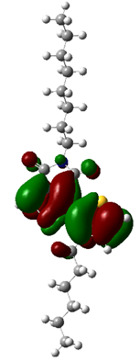
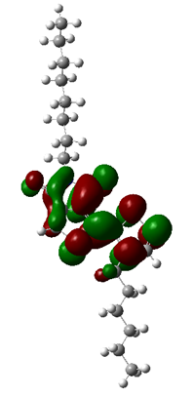
a)
b)
Figure 71 Schematic representations of the electron density on a) HOMO of TPD-thienyl b) LUMO of TPD-thienyl
In order to sample the dipole moments of the 3D systems, molecular dynamic (MD) calculations were carried out at a constant temperature and pressure of 400 K and 1.013 bar. 1000 MD steps were performed, each with a time step of 1 fs (1ps overall). and show that TPD thienyl polymers induce a much larger dipole moment than P3HT polymers, due to the polarising nature of the imide group. Inclusion of imide groups produces regions of alternating charge and enhances the dipole further, as seen in table 9. The direction of the dipole is orientated toward the electron rich thiophene rings from the electron poor imide unit. Regions of alternating charge in the polymer backbone therefore enhance the dipole moment of the system.

No. of Repeat units of PTPD(o)regT(h) | Band Gap / eV | Dipole Moment / D
Monomer | 2.57 | 3.42
Dimer | 1.78 | 5.09
Trimer | 1.65 | 6.68
Experimental | 1.78 | -

Table 9 A summary of the results of theoretical band gaps and dipole moment performed on PTPD(o)regT(h)
The dielectric constant (calculated through equation 3 assuming constant temperature and pressure of 400 K and 1.013 bar and unit cell = $1.97x{10}^{-26}$) of a PTPD(o)regT(h) monomer (1.53) was actually found to be smaller than that of P3HT (1.98), despite having a higher dipole moment. This was attributed to the lack of polymeric deformation in the direction of the dipole moment compared to P3HT, which can readily alter its dihedral angle in the direction of the dipole moment. This is thought to be as a result of TPD moiety being a lot more rigid. The Kubo formula is heavily dependent on fluctuations of dipole moment in the system, therefore the dielectric constant is reliant on the variance in dipole moment, not just the overall dipole moment.

4.24 Optical properties

Molecular weight data displays a direct relationship between side chain length and M_{n} values. Longer side-chains disrupt intermolecular interactions more than shorter chains, and growing polymer chains are able to stay in solution longer and achieve a greater degree of polymerisation. Molecular weights steadily increase moving from PTPD(h)regT(h) to PTPD(o)regT(d), owing to increases in the total number of carbons in the alkyl side chains. Branched chains PTPD(dmo)regT(h) and PTPD(dmo)altT(h) have M_{n} values of 3.10 and 10.60 KDa respectively. Differences in molecular weight can be put down to the nature of the repeat units’ molecular structure. Alternating repeat units have intrinsic steric hindrance between alkyl chains on adjacent thiophene functionalities. This twists the chain out of planarity and increases solubility, hence the vast difference in molecular weight from PTPD(dmo)regT(h). PTPD(dmo)regT(h) with its regular repeating structure has lower molecular weight due to enhanced interdigitation and planarity.
The optical properties of polymers were investigated by UV-vis absorption spectroscopy on dilute chloroform solutions and drop-cast films on quartz substrates. The trend of optical band gaps is shown in table 8. However, the narrowest band gap was achieved by PTPD(o)regT(d) at 1.73 eV, rather than PTPD(dmo)altT(h) which has over double the molecular weight and an optical band gap of 1.74 eV. It is postulated that the thiophene alkyl chains cause a departure from planarity in the solid state structure of PTPD(dmo)altT(h) and cause a reduction in conjugation length.¹⁰
The UV-vis traces in solution display many shoulders in figure 72, particularly for higher molecular weight polymers, indicating intramolecular charge transfer processes are occurring. This implies a planar structure is adopted by all polymers in chloroform solution for ICT processes to be able to happen. A similar pattern is seen in the solid state, with PTPD(dmo)altT(h) in particular displaying several ICT peaks. Charge carrier transport is an important quality for OPV device functionality and more ICT shoulders imply better charge carrier transport.¹¹⁻¹³
Figure 72 The normalised U.V.-vis absorption spectra of PTPD(h)regT(h), PTPD(o)regT(h), PTPD(d)regT(h), PTPD(o)regT(d), PTPD(dmo)regT(h) and PTPD(dmo)altT(h) in a) dilute chloroform solution and b) thin film

Electrochemical Properties

Cyclic Voltammetry (C.V.) was utilised to measure the oxidation and reduction potentials of the polymers synthesised. All oxidations and reductions were run in a 3 electrode cell, using tetrabutylammonium perchlorate in acetonitrile as the electrolyte. A thin film was created on the working electrode and the electrochemical data was then extracted. The HOMO and LUMO levels were calculated using tangents to the first oxidation and reduction potentials, which were then converted into electron volts. The deepest HOMO level is obtained by PTPD(d)regT(h), through having the highest molecular. PTPD(dmo)altT(h) has a higher energy HOMO because of its loss of planarity compared to its linear chain counterparts. LUMO levels are elevated sufficiently elevated so to enable charge transfer from polymer to PC₇₀BM when incorporated into a cell.
Table 10 A summary of the electrochemical data gained from of PTPD(h)regT(h), PTPD(o)regT(h), PTPD(d)regT(h), PTPD(o)regT(d), PTPD(dmo)regT(h) and PTPD(dmo)altT(h)
Polymer | HOMOª/V (±0.04) | LUMO^{b}/V (±0.04) | E_{gec} /eV^{c} (±0.04)
PTPD(h)regT(h) | -5.54 | -3.06 | 2.48
PTPD(o)regT(h) | -5.50 | -3.20 | 2.30
PTPD(d)regT(h) | -5.59 | -3.17 | 2.42
PTPD(o)regT(d) | -5.56 | -3.03 | 2.53
PTPD(dmo)regT(h) | -5.51 | -3.08 | 2.43
PTPD(dmo)altT(h) | -5.57 | -3.17 | 2.40

ªHOMO position (vs vacuum) determined from the onset of oxidation.
^{b}LUMO position (vs vacuum) determined from the onset of reduction. ^{c}Electrochemical energy gap

Compared to P3HT, PTPD(d)regT(h) shows a decrease of 0.5 eV in HOMO energy which means an increase V_{OC} should be observed. It is postulated this is mostly down to the imide functionality on the TPD unit inducing a decrease in HOMO energy level. Reversibility of reduction potentials should mean greater oxidative stability. The reversibility can be in the reduction potentials in figure 73.

Figure 73 Cyclic voltammograms of PTPD(h)regT(h), PTPD(o)regT(h), PTPD(d)regT(h), PTPD(o)regT(d), PTPD(dmo)regT(h) and PTPD(dmo)altT(h) on platinum electrodes (area 0.031 cm²) at a scan rate of 100 mVs⁻¹ in acetonitrile/tetrabutyl ammonium perchlorate (0.1 moldm⁻³).

4.26 Thermal Properties

Thermogravimetric analysis (TGA) probes the thermal properties of polymers up to 800 ^{O}C, plotted in figure 74. All polymers were heated to 800 ^{O}C under a nitrogen atmosphere to determine at what temperature the onset of decomposition (T_{d}) occurs. All polymers displayed a (Td) of over 320 ^{O}C, giving stability to polymers when incorporated into PSCs. Side chain detachment can be observed for most polymers between 400 ^{O}C and 600 ^{O}C, which corresponds to the weight % loss of each side chain unit. For polymers with larger side chains have this process occur at lower weight percentages.

Figure 74 TGA plots of PTPD(h)regT(h), PTPD(o)regT(h), PTPD(d)regT(h), PTPD(o)regT(d), PTPD(dmo)regT(h) and PTPD(dmo)altT(h)

Differential scanning calorimetry (DSC) was employed to see whether any thermal transitions were present upon heating of the polymers. Heat flow of samples was measured as a function of temperature – any sudden changes in heat flow indicate an exo-/endothermic process or a glass transition in the sample.

Figure 75 Differential scanning calorimetry plots of PTPD(h)regT(h), PTPD(o)regT(h), PTPD(d)regT(h), PTPD(o)regT(d), PTPD(dmo)regT(h) and PTPD(dmo)altT(h)
with a heating rate of 10 ^{O}C min⁻¹ under an inert nitrogen atmosphere

No changes in gradient are observed when probed with DSC, showing no glass transitions are present in figure 75. It is speculated that a transition may be observed outside of this temperature range.

4.26 X-Ray Diffraction

XRD reveals information about the solid state structure of polymers and the effect of side chain length and regio regularity examined. Peaks in the higher angle region at around 25^{O} 2θ correspond to π-π inter chain distances. Peaks are observed for the shorter side chain polymers PTPD(h)regT(h), PTPD(o)regT(h) and PTPD(d)regT(h) owing to less disruption to the π-orbital overlap. Low angle peaks are present between 2 ^{O} and 6 ^{O} 2θ, showing a long range order is present in all polymers.⁶ The broad, diffuse spectra observed for the rest of the spectra indicate amorphous behaviour in the solid state of the polymers.

Figure 76 Powder X-ray diffraction patterns of PTPD(h)regT(h), PTPD(o)regT(h), PTPD(d)regT(h), PTPD(o)regT(d), PTPD(dmo)regT(h) and PTPD(dmo)altT(h)

D-spacing lengths extracted from the XRD traces reveal certain patterns in relation to side chain length, as laid out in table 11. 2θ values around 24.80^{O} correlate to π-stacking interactions between adjacent polymer chains. The similarity of all polymer backbones implies the π-π d-spacing distances are all the same. However, a different pattern is seen for the low angle region which is much more dependent on side chain length. PTPD(h)regT(h) has the shortest lamellae spacing of 20.48 Å due to the 6 carbon side chains. There is an almost linear increase in d spacing distances to PTPD(o)regT(d) (28.20 Å) as this has 20 carbons in total as side chain carbons. The increases in d spacing match the increases seen in side chain length and therefore any further additions in chain length would lead to an increase in interchain separation.

Table 11 A summary of the powder X-ray diffraction data gained from of PTPD(h)regT(h), PTPD(o)regT(h), PTPD(d)regT(h), PTPD(o)regT(d), PTPD(dmo)regT(h) and PTPD(dmo)altT(h)
Polymer | 2θ / ^{O} (±0.01) | D spacing / Å (±0.01) | 2θ / ^{O} (±0.01) | D spacing / Å (±0.01)
PTPD(h)regT(h) | 4.31 | 20.48 | 24.80 | 3.57
PTPD(o)regT(h) | 3.69 | 23.93 | 24.80 | 3.57
PTPD(d)regT(h) | 3.51 | 25.15 | 24.80 | 3.57
PTPD(o)regT(d) | 3.13 | 28.20 | 24.90 | 3.57
PTPD(dmo)regT(h) | 3.82 | 23.11 | 24.90 | 3.57
PTPD(dmo)altT(h) | 3.64 | 24.25 | 24.80 | 3.57

Increase in side chain length and branching lead to an increase in interchain distances. This is partly responsible for the decrease in intensity of peaks observed in PTPD(o)regT(d), PTPD(dmo)regT(h) and PTPD(dmo)altT(h). It is proposed that greater regularity in structure is also beneficial for enhanced π interactions and interdigitation.

4.3 Conclusions

Successful synthesis of monomers and polymers PTPD(h)regT(h), PTPD(o)regT(h), PTPD(d)regT(h), PTPD(o)regT(d), PTPD(dmo)regT(h) and PTPD(dmo)altT(h) was achieved through high yielding reactions and relatively few synthetic steps. The low molecular weights obtained by all but PTPD(dmo)altT(h) was due to the insolubility in the reaction solvent. However, crystallinity was incorporated into the structure through regio regular repeat units which were designed to increase dipole moments and overall PV characteristics.
Theoretical calculations proposed that increased dipole moments would be observed in regio regular polymers compared to P3HT. Additionally, Incremental increases would be observed through the attachment of sequential repeat units. With an overall bigger dipole moment, there is a greater amount of variance possible within the structure and the resultant dielectric constant should be larger.
Mid-range band gaps decreasing from 1.84 eV (PTPD(h)regT(h)) to 1.73 eV (PTPD(o)regT(d)) show promise, with rather modest molecular weights. The shoulders that are prevalent in the UV-vis spectra indicate planar structures are adopted by polymers in both solution and solid state, which is necessary for several ICT processes to occur. Despite a doubling of molecular weight for PTPD(dmo)altT(h) from PTPD(o)regT(d), a narrowing of band gap is not observed. The steric clashes between adjacent thiophene alkyl chains twist the polymer chain out of planarity and disrupt conjugation.
Deep HOMO levels between -5.50 eV and -5.60 eV highlight the effect TPD has on the electrochemical properties compared to P3HT. Strong reduction reversibility is observed for all polymers, which points to promising atmospheric stabilities and long PSC lifetimes.
The thermal properties show high decomposition temperature in excess of 300 ^{O}C, necessary for long PSC lifetimes. DSC displays no thermal transitions over the range measured, showing no exo- or endothermic processes.
Powder X-ray diffraction highlights strong intermolecular interactions between polymer chains. Strong peaks are seen in the low angle region, particularly for PTPD(o)regT(h) and PTPD(d)regT(h) which relate to some long range order in the solid state. The long range order observed requires organisation of polymer chains and interdigitation of sidechains, which is achieved through the regio regularity of the structures.

4.4 Synthesis

1,3-Dibromo-5-octyl-4H-thieno [3,4-c] pyrrole-4,6 (5H) dione (19) ¹⁴
(19)
5-Octyl-4H-thieno[3,4-c]pyrrole-4,6(5H)dione (0.7 g, 2.6 mmol) was dissolved in trifluoroacetic acid: sulfuric acid (3:1, 12 mL) and n-bromosuccinimide (1.4g, 7.9 mmol) was added and stirred at room temperature overnight. The mixture was extracted with chloroform and washed with potassium hydroxide solution, dried with magnesium sulphate and the excess solvent removed in vacuo. The product was purified via column chromatography (eluent petroleum ether: dichloromethane 1:2) (2.83g, 85%). ¹H NMR (400 MHz CDCl₃) δ: 3.60 (t, J=7 Hz, 2H), 1.70 (m, 2H), 1.30 (m, 10H), 0.90 (t, J=8 Hz, 3H). ¹³C NMR δ ppm: 161, 133, 115, 39, 32, 29, 28, 25, 23, 14. Mass spectrum (EI) (m/z): 423 (M+). Elemental Analysis calculated: C; 39.74, H; 4.05, Br; 37.77, N; 3.31, S; 7.58 found: C; 39.01, H; 3.56, Br; 35.99, N; 3.56, S; 6.78

3-Bromo-5-octyl-4H-thieno [3,4-c] pyrrole-4,6 (5H) dione (20) ¹⁴
(20)
Dibromo-5-octyl-4H- thieno [3,4-c] pyrrole-4,6 (5H) dione (0.5 g, 1.4 mmol) was dissolved in ethanol: acetic acid (7:2) and a drop of hydrochloric acid and heated until the solid was dissolved. Zinc (71 mg, 1.1 mmol) was added and refluxed for an hour. The solution was filtered through sintered glass to remove the excess zinc and the solvent was removed in vacuo. The product was isolated via column chromatography (gradient: hexane to chloroform) (0.47g, 42%). ¹H NMR (400 MHz CDCl₃) δ: 7.75 (s, 1H), 3.60 (t, J=7 Hz, 2H), 1.65 (m, 2H), 1.30 (m, 10H), 0.90 (t, J= 8 Hz, 3H). ¹³C NMR δ ppm: 161, 137, 134, 126, 113, 38, 32, 29, 28, 27, 22, 14. Mass spectrum (EI) (m/z): 343 (M+). Elemental Analysis calculated: C; 48.84, H; 5.27, Br; 23.21, N; 4.07, S; 9.31 found: C; 47.99, H; 5.24, Br; 22.75, N; 4.56, S; 9.12
1,3-Dibromo-5-dodecyl-4H-thieno [3,4-c] pyrrole-4,6 (5H) dione (21) ¹⁴
(21)
See method for Dibromo-5-octyl-4H-thieno [3,4-c] pyrrole-4,6 (5H) dione (19) (3.51 g, 81%). ¹H NMR (400 MHz CDCl₃) δ: 3.60 (t, J=7 Hz, 2H), 1.70 (m, 2H), 1.30 (m, 18H), 0.90 (t, J=7 Hz, 3H). ¹³C NMR δ ppm: 162, 134, 116, 36, 31, 29, 29, 29, 29, 29, 29, 28, 26, 22, 14. Mass spectrum (EI) (m/z): 479 (M+). Elemental Analysis calculated: C; 45.11, H; 5.26, Br; 33.34, N; 2.92, S; 6.69 found: C; 45.83, H; 5.02, Br; 32.45, N; 3.32, S; 6.29

3-Bromo-5-dodecyl-4H thieno [3,4-c] pyrrole-4,6 (5H) dione (22) ¹⁴
(22)
See method for 3-Bromo-5-octyl-4H-thieno[3,4-c]pyrrole-4,6(5H)dione (20) (0.27 g, 46%). ¹H NMR (400 MHz CDCl₃) δ: 7.75 (s, 1H), 3.60 (t, J=7 Hz, 2H), 1.65 (m, 2H), 1.30 (m, 18H), 0.90 (t, J=8 Hz, 3H). ¹³C NMR δ ppm: 161, 137, 134, 126, 113, 38, 33, 29, 29, 29, 29, 29, 29, 29, 27, 25, 21, 14. Mass spectrum (EI) (m/z): 399 (M+). Elemental Analysis calculated: C, 54.00; H, 6.55; Br, 19.96; N, 3.50; S, 8.01 found: C, 54.46; H, 6.19; Br, 19.99; N, 3.23; S, 8.31
1,3-Dibromo-5-hexyl-4H- thieno [3,4-c] pyrrole-4,6 (5H) dione (23) ¹⁴
(23)
See method for Dibromo-5-octyl-4H-thieno [3,4-c] pyrrole-4,6 (5H) dione (19) (2.05, 88%). ¹H NMR (400 MHz CDCl₃) δ: 3.60 (t, J=7 Hz, 2H), 1.70 (m, 2H), 1.30 (m, 6H), 0.90 (t, J=8 Hz, 3H). ¹³C NMR δ ppm: 163, 135, 119, 39, 32, 28, 25, 21, 14. Mass spectrum (EI) (m/z): 395 (M+). Elemental Analysis calculated: C; 36.48, H; 3.32, Br; 40.45, N; 3.55, S; 8.11 found: C; 35.68, H; 3.87, Br; 41.25, N; 3.05, S; 8.58
3-Bromo-5-hexyl-4H- thieno [3,4-c] pyrrole-4,6 (5H) dione (24) ¹⁴
(24)
See method for 3-bromo-5-octyl-4H-thieno [3,4-c] pyrrole-4,6 (5H) dione (20) (0.34 g, 42%). ¹H NMR (400 MHz CDCl₃) δ: 7.75 (s, 1H), 3.60 (t, J=7 Hz, 2H), 1.65 (m, 2H), 1.30 (m, 6H), 0.90 (t, J=8 Hz, 3H). ¹³C NMR δ ppm: 161, 137, 134, 126, 113, 39, 32, 28, 25, 21, 14. Mass spectrum (EI) (m/z): 315 (M+). Elemental Analysis calculated: C; 45.58, H; 4.46, Br; 25.27, N; 4.43, S; 10.14 found: C; 46.03, H; 4.16, Br; 25.77, N; 4.34, S; 10.94
2-Bromo-3-hexylthiophene (25)¹⁵
(25)
Under the exclusion of light, N-bromosuccinimide (7.14 g, 5.9 mmol) was added portionwise to 3-hexylthiophene (1g, 5.9 mmol) in acetic acid:chloroform (1:1, 20 mL). The reaction was stirred overnight at room temperature before being quenched by water (10 mL). The aqueous phase was washed with dichloromethane (3 x 100 mL) and the organic phases were combined, washed with sodium hydrogen carbonate solution (3 x 100 mL) and water (3 x 100 mL). The organic layers were combined, dried with magnesium sulphate and the solvent removed in vacuo. The crude oil was collected and purified via column chromatography (eluent: hexane) (9.64 g, 92%). ¹H NMR (400 MHz CDCl₃) δ: 7.20 (d, J=5 Hz, 1H), 6.80 (d, J=5 Hz, 1H), 2.60 (t, J=7 Hz 2H), 1.65 (m, 2H), 1.35 (m, 6H), 0.90 (t, J=7 Hz 3H). ¹³C NMR δ ppm: 141, 128, 125, 108, 31, 29, 27, 22, 14. Mass spectrum (EI) (m/z): 246 (M+). Elemental Analysis calculated: C; 48.59, H; 6.12, Br; 32.32, S; 12.97 found: C; 48.76, H; 6.04, Br; 32.59, S; 12.21
2-(3-Hexyl-2-thienyl)-4,4,5,5 tetramethyl 1,3,2 dioxaboralane (26)¹⁶
(26)
2-Bromo-3-hexylthiophene (0.5g, 2.02 mmol), bispinacolatodiboron (0.76g, 3.03 mmol), potassium acetate (1.18g, 12.1 mmol) and Pd(dppf)Cl₂ (80 mg, 0.1 mmol) were placed under an inert atmosphere. DMF (10 mL) was added and the reaction heated to 100 ^{O}C for 24 hours. The reaction was quenched with water and extracted with diethyl ether. The organics were combined, washed with brine, dried with magnesium sulphate and the excess solvent removed. The pure product was isolated via column chromatography (eluent hexane: dichloromethane, 10:1) (0.43 g, 73%). ¹H NMR (400 MHz CDCl₃) δ: 7.55 (d, J=5 Hz, 2H), 7.05 (d, J=5 Hz, 2H), 2.85 (t, J=7 Hz, 3H), 1.30 (m, 16H), 0.90 (t, J=7 Hz, 3H). ¹³C NMR δ ppm: 156, 134, 122, 120, 86, 31, 30, 28, 24, 22, 14. Mass spectrum (EI) (m/z): 294 (M+). Elemental Analysis calculated: C; 65.31, H; 9.25, S; 10.90 found: C; 63.91, H; 9.88, S; 9.76

3-​Hexyl-​2-​thienyl​-​5-​octyl-4H-​thieno[3,​4-​c]​pyrrole-​4,​6(5H)​-​dione (27)¹⁷
(27)
3-Bromo-5-octyl-4H- thieno [3,4-c] pyrrole-4,6 (5H) dione (0.15g, 0.43 mmol), 2-(3-hexyl-2-thienyl)-4,4,5,5 tetramethyl 1,3,2 dioxaboralane (0.12g, 0.43 mmol), K₂CO₃ (2M, 2 mL) and aliquat 336 (2 drops) were placed under an inert atmosphere. Toluene (5 mL) and Pd(PPh₃)₄ (8mg, 0.021 mmol) were added sequentially and the reaction mixture was heated to 90 ^{O}C for 24 hours. After being cooled to room temperature the excess toluene was removed and the yellow oil product was isolated via column chromatography (dichloromethane: petroleum ether 1:1) (0.15 g, 79%). ¹H NMR (400 MHz CDCl₃) δ: 7.80 (s, 1H), 7.45 (s, 1H) 6.95 (s, 1H), 3.65 (t, J=7 Hz, 2H), 2.75 (t, J=7 Hz, 2H), 1.60 (m, 4H), 1.30 (m, 16H), 0.90 (t, J=7 Hz, 3H). ¹³C NMR δ ppm: 163, 158, 140, 135, 135, 129, 124, 121, 113, 39, 33, 32, 30, 29, 28, 28, 27, 24, 23, 14. Mass spectrum (EI) (m/z): 431 (M+). Elemental Analysis calculated: C; 66.78, H; 7.71, N; 3.24, S; 14.85 found: C; 68.06, H; 7.23, N; 3.94, S; 13.98
3-​Hexyl-​2-​thienyl​-5-bromo-​5-​octyl-4H-​thieno[3,​4-​c]​pyrrole-​4,​6(5H)​-​dione (M11)¹⁸
(M11)
3-​Hexyl-​2-​thienyl​-​5-​octyl-4H-​thieno[3,​4-​c]​pyrrole-​4,​6(5H)​-​dione (0.25g, 0.58 mmol) was dissolved in acetic acid:chloroform (1:1, 7 mL), cooled to 0 ^{O}C and excluded from light. N-bromosuccinimide (0.10g, 0.58 mmol) was added in several portions and the reaction mixture was warmed to room temperature and stirred overnight. The reaction was poured into water and extracted with chloroform. The organic phases were combined, washed with brine, dried with magnesium sulphate and the solvent removed in vacuo. Column chromatography was used to purify the crude product as a yellow oil (dichloromethane: petroleum ether 6:4) (0.21 g, 74%). ¹H NMR (400 MHz CDCl₃) δ: 7.80 (s, 1H), 6.95 (s, 1H), 3.65 (t, J=7 Hz, 2H), 2.75 (t, J=7 Hz, 2H), 1.60 (m, 4H), 1.30 (m, 16H), 0.90 (t, J=7 Hz, 3H). ¹³C NMR δ ppm: 165, 146, 137, 133, 131, 129, 114, 37, 33, 31, 29, 29, 29, 28, 28, 27, 22, 14. Mass spectrum (EI) (m/z): 509 (M+). Elemental Analysis calculated: C; 56.46, H; 6.32, Br; 15.65, N; 2.74, S; 12.56 found: C; 57.89, H; 6.97, Br; 14.75, N; 3.03, S; 11.87
3-​Hexyl-​2-​thienyl​-​5-​dodecyl-4H-​thieno[3,​4-​c]​pyrrole-​4,​6(5H)​-​dione (28)¹⁷
(28)
See method for 3-Hexyl-2-thienyl-5-octyl-4H-thieno[3,4-c]pyrrole-4,6(5H)-dione (27) (0.32 g, 72%) yellow oil. ¹H NMR (400 MHz CDCl₃) δ: 7.80 (s, 1H), 7.45 (s, 1H) 6.95 (s, 1H), 3.60 (t, J=7 Hz, 2H), 2.75 (t, J=7 Hz, 2H), 1.60 (m, 4H), 1.30 (m, 22H), 0.90 (t, J=6 Hz, 3H). ¹³C NMR δ ppm: 164,156, 139, 136, 135, 126, 122, 121, 114, 39, 33, 31, 30, 29, 29, 29, 29, 19, 29, 28, 28, 26, 24, 23, 21, 14, 14. Mass spectrum (EI) (m/z): 487 (M+). Elemental Analysis calculated: C; 68.95, H; 8.47, N; 2.87, S; 13.15 found: C; 70.10, H; 8.90, N; 2.43, S; 12.54
3-​Hexyl-​2-​thienyl​-​5-​hexyl-4H-​thieno[3,​4-​c]​pyrrole-​4,​6(5H)​-​dione (29)¹⁷
(29)
See method for 3-Hexyl-2-thienyl-5-octyl-4H-thieno[3,4-c]pyrrole-4,6(5H)-dione (27) (0.19 g, 75%) yellow oil. ¹H NMR (400 MHz CDCl₃) δ: 7.80 (s, 1H), 7.45 (s, 1H) 6.95 (s, 1H), 3.65 (t, J=7 Hz, 2H), 2.75 (t, J=7 Hz, 2H), 1.60 (m, 4H), 1.30 (m, 12H), 0.90 (t, J=7 Hz, 3H). ¹³C NMR δ ppm: 165, 158, 139, 134, 133, 127, 124, 121, 115, 42, 33, 31, 30, 28, 28, 26, 24, 23, 22, 14, 14. Mass spectrum (EI) (m/z): 403 (M+). Elemental Analysis calculated: C; 65.47, H; 7.24, N; 3.47, S; 15.89 found: C; 63.29, H; 7.66, N; 3.40, S; 16.55
3-​Hexyl-​2-​thienyl​-monobromo-​5-​dodecyl-4H-​thieno[3,​4-​c]​pyrrole-​4,​6(5H)​-​dione (M12) ¹⁸
(M12)
See method for 3-Hexyl-2-thienyl-5-bromo-5-octyl-4H-thieno[3,4-c]pyrrole-4,6(5H)-dione (M10) (0.17 g, 91%) yellow oil. ¹H NMR (400 MHz CDCl₃) δ: 7.80 (s, 1H), 6.95 (s, 1H), 3.65 (t, J=7 Hz, 2H), 2.75 (t, J=7 Hz, 2H), 1.60 (m, 4H), 1.30 (m, 22H), 0.90 (t, J=6 Hz, 3H). ¹³C NMR δ ppm: 165, 159, 141, 138, 136, 127, 124, 122, 117, 40, 35, 32, 31, 29, 29, 29, 29, 19, 29, 28, 28, 26, 24, 23, 21, 14, 14. Mass spectrum (EI) (m/z): 565 (M+). Elemental Analysis calculated: C; 59.35, H; 7.12, Br; 14.10, N; 2.47, S; 11.32 found: C; 60.35, H; 7.02, Br; 14.87, N; 2.00, S; 10.47
3-​Hexyl-​2-​thienyl​-monobromo-​5-​hexyl-4H-​thieno[3,​4-​c]​pyrrole-​4,​6(5H)​-​dione (M13) ¹⁸
(M13)
See method for 3-Hexyl-2-thienyl-5-bromo-5-octyl-4H-thieno[3,4-c]pyrrole-4,6(5H)-dione (M10) (0.13 g, 90%) yellow oil. ¹H NMR (400 MHz CDCl₃) δ: 7.80 (s, 1H), 6.95 (s, 1H), 3.65 (t, J=7 Hz, 2H), 2.75 (t, J=8 Hz, 2H), 1.60 (m, 4H), 1.30 (m, 12H), 0.90 (t, J=7 Hz, 3H). ¹³C NMR δ ppm: 164, 157, 138, 137, 134, 126, 123, 122, 117, 42, 33, 31, 30, 28, 28, 26, 24, 23, 22, 14, 14. Mass spectrum (EI) (m/z): 481 (M+). Elemental Analysis calculated: C; 54.77, H; 5.85, Br; 16.56, N; 2.90, S; 13.29 found: C; 55.16, H; 5.99, Br; 16.01, N; 2.99, S; 12.77
2-Bromo 3-dodecylthiophene (30) ¹⁵
(30)
See method for 2-bromo 3-hexylthiophene (25) (3.43 g, 82%) clear oil. ¹H NMR (400 MHz CDCl₃) δ: 7.20 (d, J=5 Hz, 1H), 6.80 (d, J=5 Hz, 1H), 2.60 (t, J=7 Hz, 2H), 1.65 (m, 2H), 1.35 (m, 18H), 0.90 (t, J=7 Hz, 3H). ¹³C NMR δ ppm: 144, 129, 126, 104, 33, 30, 31, 29, 29, 28, 28, 24, 14. Mass spectrum (EI) (m/z): 316 (M+). Elemental Analysis calculated: C; 56.78, H; 7.94, Br; 25.18, S; 10.10 found: C; 58.28, H; 7.99, Br; 23.81, S; 9.92

2-(3-Dodecyl-2-thienyl)-4,4,5,5 tetramethyl 1,3,2 dioxaboralane (31) ¹⁶
(31)
See method for 2-(3-hexyl-2-thienyl)-4,4,5,5 tetramethyl 1,3,2 dioxaboralane (26) (0.66 g, 69%). ¹H NMR (400 MHz CDCl₃) δ: 7.55 (d, J=5 Hz, 2H), 7.05 (d, J=5 Hz, 2H), 2.85 (t, J=7 Hz, 3H), 1.30 (m, 26H), 0.90 (t, J=8 Hz, 3H).¹³C NMR δ ppm: : 155, 133, 131, 85, 32, 31, 30, 29, 29, 29, 29, 29, 29, 24, 23, 14. Mass spectrum (EI) (m/z): 378 (M+). Elemental Analysis calculated: C; 69.83, H; 10.39, S; 8.47 found: C; 70.27, H; 10.13, S; 8.06
3-​Dodecyl-​2-​thienyl​-​5-​octyl-4H-​thieno[3,​4-​c]​pyrrole-​4,​6(5H)​-​dione (32) ¹⁷
(32)
See method for 3-Hexyl-2-thienyl-5-octyl-4H-thieno[3,4-c]pyrrole-4,6(5H)-dione (27) (0.22 g, 77%). ¹H NMR (400 MHz CDCl₃) δ: 7.80 (s, 1H), 7.45 (s, 1H) 6.95 (s, 1H), 3.65 (t, J=7 Hz, 2H), 2.75 (t, J=7 Hz, 2H), 1.60 (m, 4H), 1.30 (m, 26H), 0.90 (t, J=8 Hz, 3H). ¹³C NMR δ ppm: 161, 155, 138, 135, 132, 129, 122, 115, 33, 33, 31, 30, 29, 29, 29, 29, 29, 29, 29, 28, 27, 25, 23, 22, 14, 14. Mass spectrum (EI) (m/z): 515 (M+). Elemental Analysis calculated: C; 69.86, H; 8.79, N; 2.72, S; 12.43 found: C; 68.92, H; 9.55, N; 2.90, S; 12.00
3-​Dodecyl-​2-​thienyl​-monobromo-​5-​octyl-4H-​thieno[3,​4-​c]​pyrrole-​4,​6(5H)​-​dione (M15) ¹⁸
(M15)
See method for 3-Hexyl-2-thienyl-5-bromo-5-octyl-4H-thieno[3,4-c]pyrrole-4,6(5H)-dione (M10) (0.14 g, 75%) yellow oil. ¹H NMR (400 MHz CDCl₃) δ: 7.80 (s, 1H), 6.95 (s, 1H), 3.65 (t, J=7 Hz, 2H), 2.75 (t, J=7 Hz, 2H), 1.60 (m, 4H), 1.30 (m, 26H), 0.90 (t, J=7 Hz, 3H). ¹³C NMR δ ppm: 162, 157, 139, 137, 133, 130, 125, 117, 35, 33, 30, 30, 29, 29, 29, 29, 29, 29, 29, 28, 27, 25, 23, 22, 14, 14. Mass spectrum (EI) (m/z): 593 (M+). Elemental Analysis calculated: C; 60.59, H; 7.46, Br; 13.44, N; 2.36 S; 10.78 found: C; 61.32, H; 7.66, Br; 12.84, N; 2.22 S; 10.50
1-​Bromo-​3,​7-​dimethyl-octane (33) ¹⁹
(33)
3,7-Dimethyl-1-octanol (6.00 g, 37.92 mmol) and triphenylphosphine (11.86 g, 45.20 mmol) were dissolved in DCM (150 mL) under stirring. N-bromosuccinimide (7.73 g, 45.20 mmol) was added portion-wise over the course of 30 minutes and stirred for 2 hours. The resulting reaction mixture was washed with NaHCO₃ (3 x 100 mL), dried with MgSO₄ and removed under vacuum. The residue was stirred with petroleum ether for 30 minutes, filtered and the filtrate collected. After being concentrated in vacuo, the clear oil product was purified via column chromatography (hexane) (6.04 g, 72%). ¹H NMR (400 MHz CDCl₃) δ: 3.45 (m, 2H), 1.90 (m, 2H), 1.75 (m, 2H), 1.55 (m, 1H), 1.30 (m, 3H), 1.15 (m, 3H), 0.90 (t, J = 8 Hz, 9H). ¹³C NMR (400 MHz, CDCl₃) δ (ppm): 40, 39, 37, 32, 32, 28, 25, 23, 22, 19. Mass spectrum (EI) (m/z): 222. [M]+ calculated for C₁₀H₂₁Br 221.1777, found: 221.3472
2-​(3,​7-​Dimethyloctyl)​- 1H-​Isoindole-​1,​3(2H)​-​dione (34) ²⁰
(34)
1-Bromo-3,7-dimethyl-octane (7.54 g, 34.1 mmol) and potassium phthalimide (6.95 g, 37.5 mmol) were added to a 100 mL round bottom flask and placed under and inert atmosphere. Dry DMF (50 mL) was added to the reaction, degassed and heated up to 130 ^{O}C for 4 hours with stirring. After cooling to room temperature, the reaction mixture was poured into water and extracted with DCM (3 x 100 mL). The organic layers were combined and washed with water (15 x 100 mL), dried with MgSO₄ and solvent removed under vacuum (9.70 g, 90%). ¹H NMR (400 MHz CDCl₃) δ: 7.85 (m, 2H), 7.70 (m, 2H), 3.70 (t, J=8 Hz, 2H), 1.70-1.10 (m, 10H), 0.95 (d, J=6 Hz, 3H), 0.85 (d, J=6 Hz, 6H). ¹³C NMR (400 MHz, CDCl₃) δ (ppm): 168, 133, 132, 123, 39, 36, 36, 35, 30, 27, 24, 22, 22, 19. Mass spectrum (EI) (m/z): 288. [M]+ calculated for C₁₈H₂₅NO₂: 287.3966 found: 286.9163.
3, 7-Dimethyl-1-octanamine (35) ²⁰
(35)
3, 7-Dimethyl-1-octyl bromide (6.8g, 34 mmol) and potassium phthalimide (6.3g, 34 mmol) were dissolved in DMF (30 mL) and the reaction was heated to 50 ^{O}C for 2 hours. The reaction was quenched with water (100 mL), extracted with dichloromethane (3 x 100 mL) and washed with water (10 x 100 mL). The resulting phthalimide oil (8.8g, 30.6 mmol) and hydrazine monohydrate (64%, 2.75g, 68 mmol) were dissolved in ethanol (90 mL) and refluxed for 2 and a half hours. After being cooled to room temperature, concentrated hydrochloric acid (1 mL) was added and the precipitate was collected via filtration. Sodium hydroxide (20%, 10 mL) was used to neutralise the reaction mixture and the amine was extracted with dichloromethane (3 x 100 mL) (4.38 g, 82%). ¹H NMR (400 MHz CDCl₃) δ:4.85 (s, 2H), 3.60 (t, J=8 Hz, 2H), 1.70-1.20 (m, 10H), 1.00 (d, J=6 Hz, 3H), 0.85 (d, J=6 Hz, 6H). ¹³C NMR (400 MHz, CDCl₃) δ ppm: 42, 40, 38, 36, 29, 28, 25, 22, 21, 19. Mass spectrum (EI) (m/z): 157 (M+). Elemental Analysis calculated: C; 76.36, H; 14.74, N; 8.90 found: C; 76.01, H; 14.97, N; 9.02. Mass spectrum (EI) (m/z): 158. [M]+ calculated for C₁₀H₂₃N: 157.2963 found: 158.0862.

1,3-Dibromo-5-(3,7-dimethyloctyl) -4H- thieno [3,4-c] pyrrole-4,6 (5H) dione (M17) ¹⁴
(M17)
See method for Dibromo-5-octyl-4H-thieno [3,4-c] pyrrole-4,6 (5H) dione (0.22 g, 86%) clear oil. ¹H NMR (400 MHz CDCl₃) δ: 3.60 (t, J=7 Hz, 2H), 1.70 (m, 2H), 1.60 (quint. J=6 Hz, 1H), 1.45 (m, 2H), 1.20-1.40 (m, 4H), 1.10 (m, 1H) 1.00 (d, J=6 Hz, 3H), 0.85 (d, J=7 Hz, 6H). ¹³C NMR δ ppm: 163, 135, 110, 40, 37, 36, 35, 30, 27, 25, 22, 19. Mass spectrum (EI) (m/z): 450 (M+). Elemental Analysis calculated: C; 42.59, H; 4.69, Br; 35.42, N; 3.10, S; 7.11 found: C; 43.34, H; 4.82, Br; 33.15, N; 3.25, S; 7.18
3-bromo-5-(3,7-Dimethyloctyl) -4H- thieno [3,4-c] pyrrole-4,6 (5H) dione (37) ¹⁴
(37)
See method for 3-bromo-5-octyl-4H-thieno [3,4-c] pyrrole-4,6 (5H) dione (0.13 g, 54%). ¹H NMR (400 MHz CDCl₃) δ: 7.75 (s, 1H), 3.60 (t, J=7 Hz, 2H), 1.70-1.20 (m, 10H), 1.00 (d, J=7 Hz, 3H), 0.85 (d, J=7 Hz, 6H). ¹³C NMR δ ppm: 161, 137, 134, 126, 113, 40, 37, 36, 35, 30, 27, 25, 22, 19. Mass spectrum (EI) (m/z): 371 (M+). Elemental Analysis calculated: C; 51.62, H; 5.96, Br; 21.46, N; 3.76, S; 8.61 found: C; 52.77, H; 5.03, Br; 21.32, N; 3.08, S; 9.12
3-​Hexyl-​2-​thienyl​-​5-(3,7-dimethyloctyl)-4H-​thieno[3,​4-​c]​pyrrole-​4,​6(5H)​-​dione (38) ¹⁷
(38)
See method for 3-Hexyl-2-thienyl-5-octyl-4H-thieno[3,4-c]pyrrole-4,6(5H)-dione (0.17 g, 69%) yellow oil. ¹H NMR (400 MHz CDCl₃) δ: 7.75 (s, 1H), 7.45 (d, J=5 Hz, 1H), 7.05 (d, J=5 Hz, 1H), 3.65 (t, J=7 Hz, 2H), 2.75 (t, J=7 Hz, 2H), 1.70-1.10 (m, 14H), 0.95 (d, J=6 Hz, 3H), 0.85 (d, J=6 Hz, 6H). ¹³C NMR δ ppm: 163, 158, 138, 135, 135, 127, 123, 120, 114, 42, 37, 31, 30, 30, 30, 30, 30, 29, 28, 25, 25, 19, 14. Mass spectrum (EI) (m/z): 459 (M+). [M]+ calculated for C₂₆H₃₇NO₂S₂: 459.2266 found: 459.3075
3-​Hexyl-​2-​thienyl​-monobromo-​5-(3,7-dimethyloctyl)-4H-​thieno[3,​4-​c]​pyrrole-​4,​6(5H)​-​dione (M18) ¹⁸
(M18)
See method for 3-Hexyl-2-thienyl-5-bromo-5-octyl-4H-thieno[3,4-c]pyrrole-4,6(5H)-dione (0.15 g, 88%) yellow oil. ¹H NMR (400 MHz CDCl₃) δ: 7.75 (s, 1H), 6.95 (s, 1H), 3.65 (t, J=7 Hz, 2H), 2.75 (t, J=7 Hz, 2H), 1.70 (m, 3H), 1.60-1.40 (m, 2H), 1.40-1.20 (m, 8H), 1.20-1.10 (m, 1H), 0.95 (d, J=6 Hz, 3H), 0.85 (d, J=6 Hz, 6H). ¹³C NMR (400 MHz) δ ppm: 163, 158, 138, 135, 135, 133, 128, 125, 119, 42, 37, 31, 30, 30, 30, 30, 30, 29, 28, 25, 25, 19, 14. Mass spectrum (EI) (m/z): 538 (M+). [M]+ calculated for C₂₆H₃₅NO₂S₂Br₂: 537.1371, found: 538.0047
1,​3-​Bis(3-​hexyl-​2-​thienyl)​-​5-(​3,7-dimethyloctyl)-4H-​thieno[3,​4-​c]​pyrrole-​4,​6(5H)​-​dione (39) ¹⁷

(39)
Dibromo-5-(3,7-Dimethyloctyl) -4H- thieno [3,4-c] pyrrole-4,6 (5H) dione (0.1g, 0.22 mmol), 2-(3-hexyl-2-thienyl)-4,4,5,5 tetramethyl 1,3,2 dioxaboralane (0.13g, 0.44 mmol), , K₂CO₃ (2 mL, 2M), aliquat 336 (2 drops) were placed under an inert atmosphere. Tetrakis (triphenylphosphine) palladium (0.01g, 0.01 mmol) and toluene (5 mL) were added and the system was degassed, heated to 90 ^{O}C for 24 hours. The reaction was cooled to room temperature and purified via column chromatography in petroleum ether: dichloromethane (7:3) to afford a yellow oil (0.10 g, 74%). ¹H NMR (400 MHz CDCl₃) δ: 7.45 (d, J=5 Hz, 2H), 7.05 (d, J=5 Hz, 2H), 3.50 (d, J=6 Hz, 2H), 2.70 (t, J=7 Hz, 2H), 1.50-1.15 (m, 24H), 0.85 (m, 12H). ¹³C NMR (400 MHz) δ ppm: 165, 159, 141, 139, 138, 129, 125, 120, 116, 42, 37, 31, 30, 30, 30, 30, 30, 29, 28, 25, 25, 19, 14. Mass spectrum (EI) (m/z): 598 (M+). [M]+ calculated for C₃₄H₄₇NO₂S₃ : 597.9375 found: 598.8367.

1,​3-​Bis(5-dibromo-3-​hexyl-​2-​thienyl)​-​5-(​3,7-dimethyloctyl)-4H-​thieno[3,​4-​c]​pyrrole-​4,​6(5H)​-​dione (M19) ¹⁸
(M19)

1,​3-​Bis(3-​hexyl-​2-​thienyl)​-​5-(​3,7-dimethyloctyl)-4H-​thieno[3,​4-​c]​pyrrole-​4,​6(5H)​-​dione (0.15g, 0.24 mmol), NBS (0.087g, 0.49 mmol) were dissolved in AcOH: CHCl₃ (1:1) placed under darkness and stirred at room temperature for 24 hours. The reaction was quenched with water and washed with chloroform (3 x 50 mL), the organic layers were combined and washed with KOH (aq). After the excess solvent was removed in vacuo column chromatography was used to purify the product (hexane) (0.17 g, 91%). ¹H NMR (400 MHz CDCl₃) δ: 7.00 (s, 2H), 3.50 (d, J= 6 Hz, 2H), 2.70 (t, J=7 Hz, 2H), 1.70-1.60 (m, 6H) 1.60-1.40 (m, 5H), 1.40-1.20 (m, 10H), 1.20-1.10 (m, 5H), 1.00 (d, J=9 Hz, 3H) 0.85 (m, 12H). ¹³C NMR (400 MHz) δ ppm: 166, 160, 142, 139, 139, 130, 125, 120, 116, 42, 37, 31, 30, 30, 30, 30, 30, 29, 28, 25, 25, 19, 14. Mass spectrum (EI) (m/z): 756 (M+). [M]+ calculated for C₃₄H₄₅NO₂S₃Br₂: 755.7296, found: 755.5104

Polymer Synthesis
Regio-regular polymers²¹
3-​(alkyl’)-​2-​thienyl​-5-bromo-​5-​(alkyl)-4H-​thieno[3,​4-​c]​pyrrole-​4,​6(5H)​-​dione (0.20 mmol), caesium carbonate (0.60 mmol), pivalic acid (0.20 mmol), Pd(MeCN)₂Cl2 (0.002 mmol) and tris(2-​methoxyphenyl)​-phosphine (0.002 mmol) were placed in a thick-walled Schlenk tube and degassed. THF (1 mL) was added, degassed again and heated to 100 ^{O}C until the first signs of precipitation were visible around the edge of the flask. The reaction mixture was extracted with chloroform (100 mL) and washed with saturated EDTA solution (3 x 100 mL). Solvent was removed until the solution was concentrated to ~10 mL and precipitated into methanol (75 mL). The precipitate was collected via filtration and dried under vacuum. The polymer was purified by Soxhlet extraction using methanol, acetone, hexane, toluene, chloroform and chlorobenzene sequentially. The toluene fraction was taken and used in analysis.
Poly (3-hexyl-thiophen​yl)​-​5-​​hexyl- 4H-​thieno[3,​4-​c]​pyrrole-​4,​6(5H)​-​dione (PTPD(h)regT(h))
Toluene fraction (40 mg, 47%), M_{n} 2.50 KDa, M_{w} 3.10 KDa, PDI=1.25. ¹H NMR (500 MHz C₂D₂Cl₄) δ: 7.45 (s, 1H), 7.35 (d, 1H), 7.15 (d, 1H), 3.65 (m, 2H), 2.80 (m, 2H), 1.70 (m, 4H), 1.30 (m, 12H), 0.85 (m, 6H). Elemental Analysis calculated: C, 64.75; H, 6.99; N, 3.60; S, 16.46 found: C, 62.99; H, 7.28; N, 3.53; S, 17.83.

Poly (3-hexyl-thiophen​yl)​-​5-​octyl​- 4H-​thieno[3,​4-​c]​pyrrole-​4,​6(5H)​-​dione (PTPD(o)regT(h))
Toluene fraction (42 mg, 52%), M_{n} 3.50 KDa, M_{w} 4.10 KDa, PDI=1.17. ¹H NMR (500 MHz C₂D₂Cl₄) δ: 7.45 (s, 1H), 7.35 (d, 2H), 7.15 (d, 2H), 3.60 (t, 2H), 2.35 (t, 2H), 1.65 (m, 4H), 1.30 (m, 16H), 0.85 (m, 6H). Elemental Analysis calculated: C, 66.15; H, 7.48; N, 3.35; S, 15.35, found: C, 67.03; H, 7.05; N, 4.65; S, 14.56.
Poly(3-hexyl-thiophen​yl)​-​5-​dodecyl​-4H-​thieno[3,​4-​c]​pyrrole-​4,​6(5H)​-​dione (PTPD(d)regT(h))
Toluene fraction (43 mg, 57%), M_{n} 3.70 KDa, M_{w} 5.90 KDa, PDI = 1.59. ¹H NMR (500 MHz C₂D₂Cl₄) δ: 7.90 (m, 1H), 3.65 (m, 2H), 2.85 (m, 2H), 1.70 (m, 4H), 1.30 (m, 24H), 0.85 (m, 6H). Elemental Analysis calculated: C, 68.46; H, 8.30; N, 2.96; S, 13.54 found: C, 70.18; H, 7.76; N, 3.98; S, 12.49.
Poly(3-dodecyl-thiophen​yl)​-​5-octyl​-4H-​thieno[3,​4-​c]​pyrrole-​4,​6(5H)​-​dione (PTPD(o)regT(d))
Toluene fraction (55 mg, 59%), M_{n} 4.60 KDa, M_{w} 6.70 KDa, PDI=1.46. ¹H NMR (500 MHz C₂D₂Cl₄) δ: 7.90 (m, 1H), 3.65 (m, 2H), 2.80 (m, 2H), 1.70 (m, 4H), 1.30 (m, 28H), 0.85 (m, 6H). Elemental Analysis calculated: C, 69.42; H, 8.64; N, 2.79; S, 12.78 found: C, 67.27; H, 9.62; N, 3.01; S, 11.99.
Poly(3-hexyl-thiophen​yl)​-​5-(3,7-dimethyloctyl)​-4H-​Thieno[3,​4-​c]​pyrrole-​4,​6(5H)​-​dione (PTPD(dmo)regT(h))
Toluene fraction (67 mg, 53 %) Mn 3.90, Mw 4.60, PDI 1.19. ¹H NMR (500 MHz C₂D₂Cl₄) δ: 7.95 (m, 1H), 3.60 (m, 2H), 2.75 (m,2H), 1.70 (M, 2H), 1.40-1.10 (m, 13H), 0.85 (m, 12H). Elemental Analysis calculated: C, 67.37; H, 7.92; N, 3.14; S, 14.39 found: C, 63.36; H, 7.22; N, 2.91; S, 15.72.
Poly(3-hexyl-thiophen​yl)​-​5-(3,7-dimethyloctyl)​-4H-​thieno[3,​4-​c]​pyrrole-​4,​6(5H)​-​dione (PTPD(dmo)altT(h))
Toluene fraction (67 mg, 53 %) Mn 10.60, Mw 17.90, PDI 1.68. ¹H NMR (500 MHz C₂D₂Cl₄) δ: 7.95 (s, 1H), 3.70 (m, 2H), 2.85 (m, 2H), 1.75 (m, 2H), 1.55 (m, 2H), 1.40-1.10 (m, 13H), 0.85 (m, 12H). Elemental Analysis calculated: C, 67.37; H, 7.92; N, 3.14; S, 14.39 found: C, 67.20; H, 8.79; N, 2.49; S, 15.61.

4.5 References

1 H. D. de Gier, R. Broer and R. W. a. Havenith, Phys. Chem., 2014, 16, 12454–12461.
2 B. Carsten, J. M. Szarko, H. J. Son, W. Wang, L. Lu, F. He, B. S. Rolczynski, S. J. Lou, L. X. Chen and L. Yu, J. Am. Chem. Soc., 2011, 133, 20468–20475.
3 H. J. Son, B. Carsten, I. H. Jung and L. Yu, Energy Environ. Sci., 2012, 5, 8158-8170.
4 Y. Li, J. Hu, G. He, H. Zhu, X. Wang, Q. Guo, A. Xia, Y. Lin, J. Wang and X. Zhan, J. Phys. Chem. C, 2016, 120, 13922–13930.
5 W. a. Braunecker, Z. R. Owczarczyk, A. Garcia, N. Kopidakis, R. E. Larsen, S. R. Hammond, D. S. Ginley and D. C. Olson, Chem. Mater., 2012, 24, 1346–1356.
6 L. Cartwright, T. J. Neal, N. J. Rutland and A. Iraqi, Polym. Adv. Technol., 2016, 27, 525-531
7 T. Umeyama, M. Oodoi, O. Yoshikawa, T. Sagawa, S. Yoshikawa, D. Evgenia, N. Tezuka, Y. Matano, K. Stranius, N. V. Tkachencko, H. Lemmetyinen and H. Imahori, J. Mater. Chem., 2011, 21, 12454-12461.
8 J. W. Rumer, C. K. L. Hor, I. Meager, C. P. Yau, Z. Huang, C. B. Nielsen, S. E. Watkins, H. Bronstein and I. McCulloch, J. Org. Semicond., 2013, 1, 30-35.
9 C. Ottone, P. Berrouard, G. Louarn, S. Beaupré, D. Gendron, M. Zagorska, P. Rannou, A. Najari, S. Sadki, M. Leclerc and A. Pron, Polym. Chem., 2012, 3, 2355-2365.
10 T. Kaniowski, W. Łużny, S. Nizioł, J. Sanetra and M. Trznadel, Synth. Met., 1998, 92, 7–12.
11 Y.-J. Cheng, S.-H. Yang and C.-S. Hsu, Chem. Rev., 2009, 109, 5868–5923.
12 K. Mahmood, Z.-P. Liu, C. Li, Z. Lu, T. Fang, X. Liu, J. Zhou, T. Lei, J. Pei and Z. Bo, Polym. Chem., 2013, 4, 3563-3574.
13 H. Zhou, L. Yang and W. You, Macromol., 2012, 45, 607–632.
14 P. Berrouard, S. Dufresne, A. Pron, J. Veilleux and M. Leclerc, J. Org. Chem., 2012, 77, 8167–8173.
15 Z. Xiao, K. Sun, J. Subbiah, T. Qin, S. Lu, B. Purushothaman, D. J. Jones, A. B. Holmes and W. W. H. Wong, Polym. Chem., 2015, 6, 2312–2318.
16 W. J. Jo, K.-H. Kim, H. C. No, D.-Y. Shin, S.-J. Oh, J.-H. Son, Y.-H. Kim, Y.-K. Cho, Q.-H. Zhao, K.-H. Lee, H.-Y. Oh and S.-K. Kwon, Synth. Met., 2009, 159, 1359–1364.
17 C. Shi, Y. Yao, Y. Yang and Q. Pei, J. Am. Chem. Soc., 2006, 128, 8980–8986.
18 K. W. Song, M. hee Choi, M. hee Han and D. K. Moon, J. Ind. Eng. Chem., 2014, 20, 426–434.
19 Y. Matsueda, S. Xu and E. I. Negishi, Tetrahedron Lett., 2015, 56, 3346–3348.
20 X. Guo, R. P. Ortiz, Y. Zheng, M. G. Kim, S. Zhang, Y. Hu, G. Lu, A. Facchetti and T. J. Marks, J. Am. Chem. Soc., 2011, 133, 13685–13697.
21 M. Wakioka, N. Ichihara, Y. Kitano and F. Ozawa, Macromol., 2014, 2, 626−631.

Chapter 5:

Studying the effect of chain branching and thiophene-based donor on the photovoltaic performance of thieno[3,4-c]pyrrole-4,6-dione/thiophene alternating block co-polymers

Four alternating donor/acceptor copolymers with varying side chain lengths and number of thiophene units were synthesised via direct arylation polymerisation. All polymers display desirable optical band gaps, low molecular orbital energy levels and physical properties ideal for employment in PSCs. Promising properties were achieved in spite of low molecular weights. It is postulated that the low solubility of unsubstituted thiophene and bithiophene units induced increased aggregation, which inhibited the degree of polymerisation. The polymers with the longer branched alkyl chains and those with single thiophene had significantly higher M_{n} values. It is thought this is caused by greater interruption to the π-stacking interactions between adjacent polymer chains. Conversely, higher degrees of crystallinity were observed for the bithiophene units and shorter alkyl chains. Both of these properties have been shown to lend themselves to highly efficient PSCs.

5.1 Introduction

In recent years bulk heterojunction PSCs have achieved efficiencies topping 10%, which was achieved through implementing certain design rationale.¹ In particular, donor-acceptor based polymers have been explored and the inclusion of quinoid enhancing functionalities has helped achieve such efficiencies.²⁻⁴ Thieno[3,4-c]pyrrole-4,6-dione (TPD) fits the aforementioned design criteria, as it has strong electron withdrawing ability and can adopt the quinoidal thiophene maleimide structure in the excited state, as exhibited in figure 77.³
Figure 77 A schematic representation to show the resonance structure of TPD (right) and the quinoidal structure it adopts in the excited state (left)

The electron rich aromatic rings of bithiophene units are rigid through adopting a coplanar structure in the solid state.⁵ Bithiophene-based alternating polymers hold the advantage over single thiophene-based alternating polymers due to their solid state crystalline morphologies and enhanced charge carrier transport. Rumer et al have probed TPD-bithiophene polymers, which show promising photovoltaic properties.² Nevertheless, relatively elevated HOMO levels and mid-range band gaps mean they are unsuitable for PSC application.⁶
Unsubstituted thiophene has a compact formation and facile accessibility which should induce greater crystallinity than reported in Rumer et al.⁷ Less steric repulsion is observed in comparison to alkylated thiophenes/bithiophenes, leading to greater planarity and extending the π-conjugated system.
Side chain structure is a crucial factor in polymer design. Longer alkyl side chain lead to improved solubility and higher molecular weight but poorer solid state packing, blend morphology and charge carrier mobility.⁸ However, branching point and more exact chain lengths have been examined more substantially.² When branching occurs closer to the TPD unit, enhanced crystallinity and solid state packing is observed. Branching further away induces higher molecular weights.²
In this chapter, the effect of donor strength and alkyl side chain microstructure is probed. Unsubstituted thiophene and bithiophene units are employed to examine their effect upon the chemical and physical properties of the overall polymers. It is expected bithiophene will bring about better overall properties as the effective conjugation length should be larger in polymers containing this functionality. Variation within branched alkyl side chains between 2-hexyldecane and 2-octyldodecane was also examined, as laid out in figure 78.
Figure 78 The chemical structures of PTTPD(od), PTTPD(ho), PBTTPD(od) and PBTTPD(ho)

5.2 Results and Discussion

5.21 Monomer Synthesis

As discussed in Chapter 3, the route to TPD monomers were achieved with good yields and in relatively few synthetic steps. However, the amine functionalities weren’t readily available and needed to be manufactured from their equivalent alcohols. This was carried out via synthetic route below, figure 79.
Figure 79 Synthesis of amines 44 and 45 a) PPh₃, NBS b) Potassium phthalimide, DMF 130 ^{O}C c) Hydrazine (65%), ethanol

The alcohol is converted to its respective bromide via the Appel reaction. This employs triphenylphosphine to abstract bromine from NBS, which subsequently deprotonates the alcohol present. Owing to phosphorus’ affinity for oxygen, a bromide ion is displaced by the deprotonated alcohol. The stronger phosphorus-oxygen double bond (over the phosphorus oxygen single bond) is the driving force behind bromide formation. Free bromide ions nucleophilically attack the carbon adjacent to the oxygen and form the bromide and triphenylphosphine oxide, as described in figure 80.
Figure 80 The proposed mechanism for bromide formation via the Appel reaction
During the reaction with potassium phthalimide, the bromine atom is displaced by the phthalimide moiety which is necessary for final amine formation, as shown in figure 81. Reaction with hydrazine displaces the amine from the phthalimide unit as shown in the mechanism below.
Figure 81 Proposed mechanism for the generation of an amine from a phthalimide starting material using hydrazine

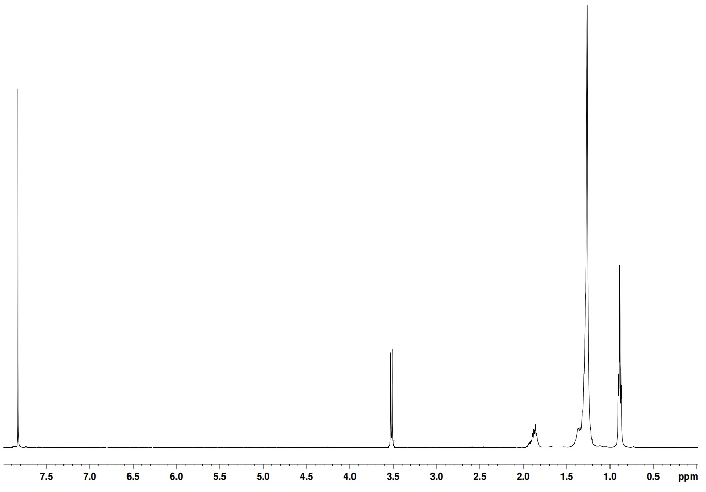
Incorporation of amines produced in this step proceeded with good yields and formed monomers M20 and M21, which are shown in in figure 85, M20 proton NMR shown below in figure 82.
H_{a}
H_{c}
H_{c}

H_{e}
H_{c}

H_{b} H_{c}

H_{d}
H_{c}

Figure 82 ¹H NMR in CDCl₃ of M20 between 0 and 8.00 ppm showing the various proton environments present

Bithiophene units were prepared in good yield using the synthetic route below. Stille coupling between 2-bromothiophene and 2-tributylstannyl thiophene forms the bithiophene functionality and bromination with 2 equivalents of n-bromosuccinimide yields M23 after steps a and b in figure 83. The structure was confirmed by NMR in figure 84.
46
M23
Figure 83 Synthetic route to M23 a) 2-tributylstannyl thiophene b) NBS (2 equiv.)

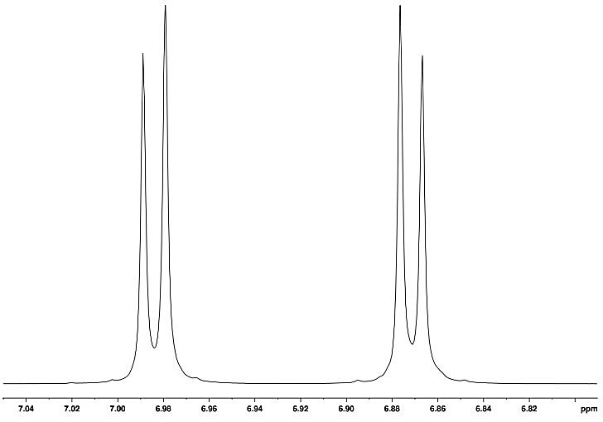
H_{a}
H_{b} H_{c}

Figure 84 ¹H NMR in CDCl₃ of the aromatic region of M23 between 6.80 and 7.00 ppm showing the various proton environments present

5.22 Polymer Synthesis

Polymerisations were carried out via direct arylation utilising PdCl₂(MeCN)₂ catalyst, tris(σ-methoxyphenylphospine) ligand (L1) and anhydrous THF, as well as pivalic acid and Cs₂CO₃. The lack of sidechains on the thiophene/bithiophene units mean there should be no regio-selectivity issues, as shown in figure 85.
Figure 85 Syntheses of PTTPD(od), PTTPD(ho), PBTTPD(od) and PBTTPD(ho) a) PdCl₂(MeCN)₂ (0.02 mol equiv.), L1 (0.02 mol equiv.), CsCO₃ (3 mol equiv.), PivOH (1 mol equiv.), THF, 100 ^{O}C

M20 R=C₈H₁₇ R’=C₁₀H₂₁
M21 R=C₆H₁₃ R’=C₈H₁₇

M20 R=C₈H₁₇ R’=C₁₀H₂₁
M21 R=C₆H₁₃ R’=C₈H₁₇

The polymers were analysed via high temperature (100 ^{O}C) proton NMR in deuterated tetrachloroethane to solubilise the polymers. Figure 86 shows the polymer NMR for PBTTPD(ho), with several aromatic peaks present. Polymer spectra become convoluted at low molecular weight due to interference from end group protons, which still have a relative intensity similar to that of protons present on the backbone.

Table 12 A summary of the molecular weight and optical data gained from spectra PTTPD(ho), PTTPD(od), PBTTPD(od) and PBTTPD(ho)
Polymer | M_{n} / kDaª | M_{w} / kDaª | PDI^{b} | λ_{max} / nm solution | λ_{max} / nm thin film |  | E_{g} opt / eV^{c} (±0.02)
PTTPD(od) | 7.30 | 13.40 | 1.82 | 526 | 514 | 1.72
PTTPD(ho) | 4.20 | 5.80 | 1.39 | 523 | 530 | 1.73
PBTTPD(od) | 4.50 | 5.70 | 1.28 | 517 | 530 | 1.70
PBTTPD(ho) | 3.00 | 4.30 | 1.48 | 511 | 530 | 1.72

ªMolecular weights calculated on the toluene fractions of polymers using differential refractive index (DRI) characterisation. ^{b}Polydispersity Index (PDI). ^{c}Optical band gap estimated by graphically determining the onset of absorption

The solubilising effect of the longer branched chains led to an increase in number average molecular weight for PTTPD(od), as seen in table 12. The large branching disrupts intermolecular π-stacking interactions and allows the chains to stay in solution and proceed to a higher degree of polymerisation. PTTPD(od) achieves the highest number average molecular weight at 7.30 KDa, as it has the most solubilising chain per repeat unit. A clear pattern is observable between the molecular weights of the thiophene and bithiophene polymers. Comparing polymers PTTPD(od) and PBTTPD(od), the M_{n} values differ substantially (with a similar pattern observed for PTTPD(ho) and PBTTPD(ho)). It is speculated that the extra planarity induced by the bithiophene functionality has a negative effect on the degree of polymerisation. Increases in π-stacking cause the polymers to precipitate out of solution sooner in the polymerisation process and inhibit chain growth. In particular with PBTTPD(ho), which only achieves a molecular weight of 3.00 kDa, proton NMR of which can be seen in figure 86.

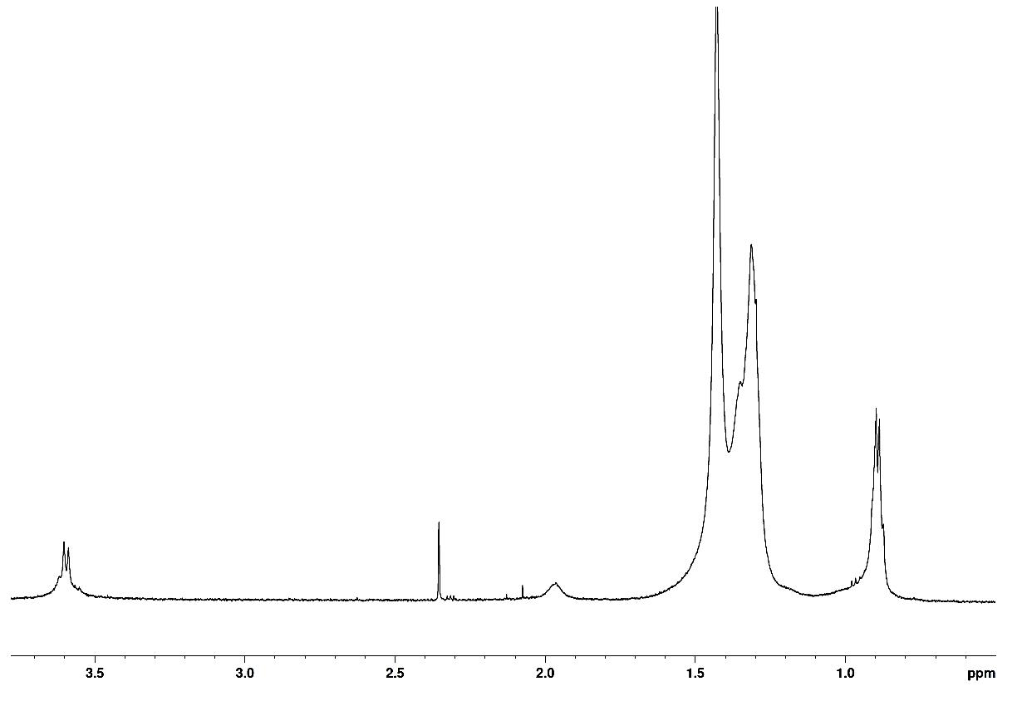
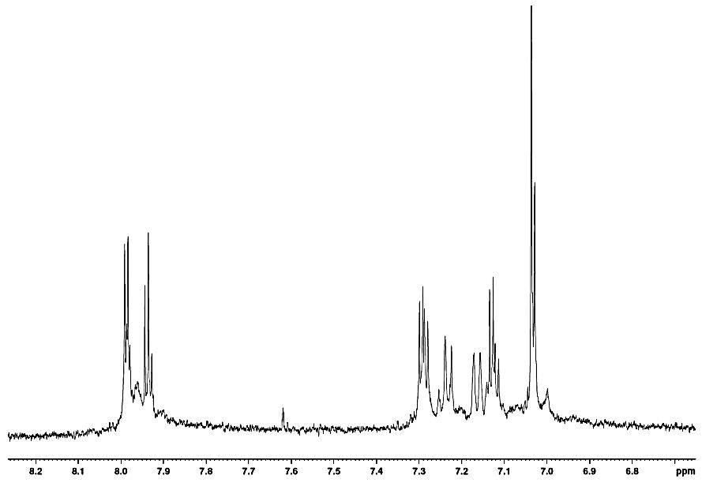
H_{a}
H_{b} H_{c}

H_{c}
H_{c}

H_{d}
H_{c}

H_{e}
H_{c}

Figure 86 ¹H NMR in C₂D₂Cl₄ of PBTTPD(ho) between 0 and 8.00 ppm showing the various proton environments present on the polymer

H_{f}
H_{c}

5.23 Optical properties

The optical properties of polymers were investigated by UV-vis absorption spectroscopy on dilute chloroform solutions and drop-cast films on quartz substrates. Optical properties show a strong dependence on molecular weight and conjugation length. Despite the monothiophene polymers having double the molecular weight of their bithiophene counterparts, optical band gaps are relatively similar for all polymers in the series in table 2. The U.V. spectra reveal all polymers have very broad absorption bands, ideal for absorbing over a broad visible light range (350 – 700 nm). An interesting shoulder feature can be seen for PTTPD(ho), PTTPD(od), PBTTPD(od) and PBTTPD(ho) on the intramolecular charge transfer peak at around 650-700 nm in figure 87, which indicates strong π-orbital overlap between adjacent polymer chains.¹⁰ The bathochromic shifts observed between solution and thin film samples arise as a result of intermolecular stacking between polymer chains and improved charge carrier transport.

Figure 87 The normalised U.V.-vis absorption spectra PTTPD(ho), PTTPD(od), PBTTPD(od) and PBTTPD(ho) in a) dilute chloroform solution and b) thin film

Further optical properties were also probed in chloroform solution and thin films in figure 88. All fluorescence spectra were recorded upon exciting the polymers at their absorption maxima. Bathochromic shifts are observed from solution to thin film because elimination of interactions between solvent environment and the fluorophore, and once the polymer has been drop cast as a thin film, solvent relaxation no longer applies and the polymers exhibit fluorescence emission at similar wavelengths.^{5,11}
Table 13 A summary of photoluminescence data gained from figure 88
Polymer | ε(M⁻¹cm⁻¹)ª (±2000) | PL λ_{max} / nm solution (±0.5) | PL λ_{max} / nm thin film (±0.5) | Stokes Shift /nm ^{b} (±0.5)
PTTPD(od) | 30,000 | 608 | 739 | 209
PTTPD(ho) | 46,000 | 583 | 731 | 201
PBTTPD(od) | 45,000 | 593 | 745 | 215
PBTTPD(ho) | 54,000 | 588 | 763 | 233
- Absorption coefficient measured at λ_{max} of ground state absorption curve b) Stokes shifts determined from thin film studies (PL thin film λ_{max} - UvVis thin film λ_{max})

Large stokes shifts are observed for all polymers, which suggests that there is a large difference in energy between the ground and excited state.^{12,13} Intramolecular reorganisation energy is required for the polymers to enter an excited state, as planarization is necessary for this process to occur and for a photon to be emitted in order for the molecule to photoluminesce. It is postulated that the large, branched alkyl side chains distort the ground state polymers out of planarity and a lot of energy is required to overcome this steric barrier. PBTTPD(od) and PBTTPD(ho) have the largest stokes shifts (215 nm and 233 nm respectively), suggesting the enhanced planarization of bithiophene in the excited state with respect to thiophene.

Figure 88 The normalised Photoluminescence emission spectra of PTTPD(ho), PTTPD(od), PBTTPD(od) and PBTTPD(ho) in a) dilute chloroform solution and b) thin film

5.24 Electrochemical Properties

Cyclic Voltammetry (C.V.) was utilised to measure the oxidation and reduction potentials of the polymers synthesised. All oxidations and reductions were run in a 3 electrode cell, using tetrabutylammonium perchlorate in acetonitrile as the electrolyte. A thin film was created on the working electrode and the electrochemical data was then extracted. The HOMO and LUMO levels were calculated using tangents to the first oxidation and reduction potentials, which were then converted into electron volts.
Deep HOMO levels owe themselves to the electron-withdrawing nature of the TPD unit.¹⁴ The deepest HOMO level of -5.56 eV is achieved by PTTPD(ho), due to a greater amount of conjugation within its backbone than PTTPD(od) and its bulkier alkyl side chains, laid out in table 14. Bithiophene units have the effect of raising the HOMO levels from their respective mono-thiophene equivalents. The lower HOMO levels seen for PBTTPD(od) and PBTTPD(ho) may also be due to reduced molecular weight. Additional stability can be gained from deepening HOMO levels against the decomposition caused by oxidation.⁷
Table 14 A summary of the electrochemical data gained from of PTTPD(ho), PTTPD(od), PBTTPD(od) and PBTTPD(ho)
Polymer | HOMOª /V (±0.04) | LUMO^{b} /V (±0.04) | E_{gec} /eV^{c} (±0.04)
PTTPD(od) | -5.53 | -3.31 | 2.22
PTTPD(ho) | -5.56 | -3.11 | 2.45
PBTTPD(od) | -5.54 | -3.13 | 2.41
PBTTPD(ho) | -5.43 | -3.07 | 2.36

ªHOMO position (vs vacuum) determined from the onset of oxidation.
^{b}LUMO position (vs vacuum) determined from the onset of reduction. ^{c}Electrochemical energy gap

Cyclic voltamogram traces (figure 89) reveal that PTTPD(ho) and PBTTPD(ho) show particularly reversible properties. With the ability to reoxidise back to a normal, uncharged state, the polymers should display good lifetimes in PSC devices.

Figure 89 Cyclic voltammograms of PTTPD(ho), PTTPD(od), PBTTPD(od) and PBTTPD(ho) on platinum electrodes (area 0.031 cm²) at a scan rate of 100 mVs⁻¹ in acetonitrile/tetrabutyl ammonium perchlorate (0.1 moldm⁻³).

5.25 Thermal properties

Thermogravimetric analysis (TGA) offers an insight into the thermal stability of compounds. All polymers were heated to 800 ^{O}C under a nitrogen atmosphere to determine at what temperature the onset of decomposition (T_{d}) occurs. All polymers showed a T_{d} of over 400 °C, indicating excellent thermal stability, as shown in figure 11. This implies that OPV devices fabricated with the four polymers synthesized are capable of withstanding high operating temperatures experienced by solar cells for prolonged periods of time.

Figure 90 TGA plots of PTTPD(ho), PTTPD(od), PBTTPD(od) and PBTTPD(ho)

Differential scanning calorimetry (DSC) was employed to see whether any thermal transitions were present upon heating of the polymers. Heat flow of samples was measured as a function of temperature – any sudden changes in heat flow indicate an exo-/endothermic process or a glass transition in the sample.

Figure 91 Differential scanning calorimetry plots of PTTPD(ho), PTTPD(od), PBTTPD(od) and PBTTPD(ho) with a heating rate of 10 ^{O}C min⁻¹ under an inert nitrogen atmosphere.

The smooth DSC curves in figure 91 show that there are no thermal processes occurring when the polymers are heated in this temperature range. It is hypothesised that the polymers may have a glass transition outside of this temperature range, much closer to the temperature of decomposition.

5.26 X-Ray Diffraction

XRD data reveals important structural information about the effect chain length and regularity have on the solid state structure.
Figure 92 Powder X-ray diffraction patterns of PTTPD(ho), PTTPD(od), PBTTPD(od) and PBTTPD(ho)

The lack of peaks in the low angle region of figure 92 (2θ 0 ^{O} -10^{O}) show that the steric bulk of large alkyl side chains inhibit any interdigitation from occurring in the solid state, as seen previously in chapters 3 and 4.^{9,15} In turn no lamellae structures are formed which would be evident by peaks in the previously mentioned region. However, there are intense peaks present at around 25 ^{O} 2θ (table 15), which is representative of π-π interactions.
Table 15 D-spacing calculations extracted from Figure 92
Polymer | 2θ / ^{O} (±0.01) | D spacing / Å(±0.01)
PTTPD(od) | 25.0 | 3.56
PTTPD(ho) | 25.5 | 3.49
PBTTPD(od) | 25.3 | 3.52
PBTTPD(ho) | 25.6 | 3.48

The pattern gathered from the data in figure 92 shows broad, diffuse peaks pointing to the amorphous nature of this series of polymers. PTTPD(od) and PBTTPD(od) have larger d-spacing values than their hexyl-octyl counterparts. The longer alkyl side chains induce more steric hindrance and therefore the π-stacking interactions are weakened and d-spacing distances become larger.

5.3 Conclusions

The synthesis of PTTPD(ho), PTTPD(od), PBTTPD(od) and PBTTPD(ho) proceeded with good yield and in relatively few synthetic steps, making the monomers used ideal for industrial development. However, polymers all displayed relatively low molecular weights, which may have reduced certain desirable photovoltaic properties. The low molecular weights owe themselves mainly to π-π stacking interactions which cause the polymer chains to precipitate early in the polymerisation. It has also been postulated that direct arylation may not be suitable for certain polymers, due to the polar solvents (THF) used to facilitate the reaction and the poor solubility of the resulting polymers formed.
All polymers displayed mid-range band gaps of 1.70-1.73 eV, in spite of the low molecular weights obtained. Shoulders present in solution UV-vis show promising charge carrier properties between chains. Broad absorption in the range of 350-700 nm in the solid state should lends itself to good OPV characteristics, as this overlaps well with the solar spectrum.
Deep HOMO levels varying between -5.43 to -5.56 eV should give excellent open circuit voltage values. Reversibility shown, particularly in re-oxidation, is indicative that good atmospheric stability can be expected from all polymers.
X-ray diffraction studies found strong π-interactions are present in the solid state structures of all polymers. D-spacing distances narrowed when shorter chains and bithiophene units were utilised, with PBTTPD(ho) achieving an inter-chain distance of 3.48Å. Side-chains were too branched and bulky for any lamellae structure to form.
Photoluminescence gave an insight to excited state structure of the polymers. Large Stokes shifts were observed, meaning a significant reorganisation energy is required to excite the polymer. Bulky side-chains are thought to be the main perpetrator for this effect.
All polymers displayed thermal stability way in excess of 400 ^{O}C, which is far in excess of the temperatures experienced in a PV cell. Bithiophene polymers PBTTPD(od) and PBTTPD(ho) displayed higher decomposition temperatures than the single thiophene equivalents, due to the stronger π-π interactions postulated by XRD data.

5.4 Synthesis

For synthesis of TPD comoners M20 and M21, please see chapter 3 Synthesis section.
2-Hexyl-1- decane bromide (40) ¹⁶
(40)
Triphenylphosphine (6.44 g, 24.60 mmol) was added to a solution of 2-hexyl-1-decanol (6.25 g, 16.40 mmol) and DCM (125 ml) and stirred. N-bromosuccinimide (4.35 g, 24.6 mmol) was added portion-wise. Upon complete addition, the resulting solution was stirred at room temperature for 90 minutes. The reaction mixture was washed with saturated NaHCO3 (3 x 100 ml), dried and the solvent removed. The resulting material was stirred in petroleum ether for 30 minutes at room temperature, filtered and the filtrate was concentrated under vacuum. The product was purified via silica column using petroleum ether as the eluent to give 2-hexyl-1- decane bromide as a colourless oil (4.15g, 83%). ¹H NMR (400 MHz CDCl₃) δ: 3.45 (d, J=6.90 Hz, 2H), 1.65 (m, 1H), 1.30 (m, 24H), 0.90 (m, 6H). ¹³C NMR (400 MHz CDCl₃) δ ppm: 39.55, 39.51, 32.58, 31.95, 31.93, 29.82, 29.67, 29.63, 29.63, 29.59, 29.38, 29.34, 26.59, 22.71, 14.11. Mass spectrum (EI) (m/z): 305.34 (M+). [M]+ calculated for C₁₆H₃₃Br: 305.3372, found: 306.1903
2-Octyl-1-dodecane bromide (41) ¹⁶
(41)
See method for 2-Hexyl-1- decane bromide (40) (6.48g, 76%). ¹H NMR (400 MHz CDCl₃) δ: 3.45 (d, J=6.80 Hz, 2H), 1.60 (m, 1H), 1.30 (m, 32 H), 0.90 (m, 6H). ¹³C NMR (400 MHz CDCl₃) δ ppm: 41.82, 40.64, 33.92, 32.17, 31.51, 29.99, 29.83, 29.71, 29. 63, 29.44, 29.20, 26.69, 23.09, 22.84, 14.2. Mass spectrum (EI) (m/z): 361 (M+). [M]+ calculated for C₂₀H₄₁Br: 361.4435, found: 363.1648
2-​(2-​Hexyldecyl)​- 1H-​Isoindole-​1,​3(2H)​-​dione (42) ¹⁷
(42)
Potassium phthalimide (2.75 g, 14.8 mmol) was added to a solution of 2-hexyl-1- decane bromide (4.11g, 13.5 mmol) in DMF (30 ml). The reaction was stirred at 130^{O}C for 4 hours, cooled to room temperature and poured in H₂O (100 ml). The product was extracted with DCM (3 x 100 ml), the organic washes were combined, washed with KOH (0.2 M, 200 ml), H₂O and saturated NH4Cl. The organic layer was dried and the solvent evapourated. The crude product was purified via column chromatography using DCM as the eluent to give the title compound as a colourless-oil (3.61 g, 72%). ¹H NMR (400 MHz C₂D₂Cl₄) δ:7.85 (m, 2H), 7.75 (m,2H), 3.60 (d, J=7.05 Hz, 2H), 1.90 (m, 2H), 1.30 (m, 24H), 0.90 (m, 6H). ¹³C NMR (400 MHz CDCl₃) δ ppm: 168.72, 133.81, 132.12, 123.14, 44.31, 39.17, 31.89, 31.85, 31.27, 29.99, 29.65, 29.60, 29.32, 26.50, 26.46, 25.01, 22.65, 17.82, 14.07. Mass spectrum (EI) (m/z): 371 (M+). [M]+ calculated for C₂₄H₃₇NO₂: 371.5561 , found: 372.7459.

2-​(2-​octyldodecyl)​- 1H-​Isoindole-​1,​3(2H)​-​dione (43) ¹⁷
(43)
See method for 2-(2-hexyldecyl)- 1H-Isoindole-1,3(2H)-dione (4.85 g, 75%) colourless oil. ¹H NMR (400 MHz C₂D₂Cl₄) δ: 7.90 (m, 2H), 7.75 (m, 2H), 3.55 (d, J=7.20 Hz, 2H), 1.90 (m, 1.90), 1.30 (m, 32 H), 0.90 (m, 6H). ¹³C NMR (400 MHz CDCl₃) δ ppm: 168.72, 133.81, 132.12, 123.14, 42.30, 37.01, 31.88, 31.81, 31.47, 29.95, 29.63, 29.54, 29.28, 26.28, 26.25, 22.66, 22.64, 14.11, 14.08. Mass spectrum (EI) (m/z): 428 (M+). [M]+ calculated for C₂₈H₄₅NO₂: 427.6624, found: 425.8363

2-Hexyl-1-decanamine (44) ¹⁶
(44)
2-(2-hexyldecyl)- 1H-Isoindole-1,3(2H)-dione (6.03 g, 21.0 mmol), hydrazine hydrate (64%, 4 ml, 65.0 mmol) and MeOH (100 ml) were stirred at reflux for 3 hours. Upon completion, excess HCl (5 M) was added and the reaction mixture was refluxed for a further hour and cooled. The precipitate was filtered off and washed with water. The methanol was removed in vacuo and the residue was diluted with DCM (100 ml). The organic extract was washed with KOH (10%, 3 x 50 ml). The combined aqueous layer was extracted with DCM (3 x 20 ml). The combined DCM solutions were washed with brine (2 x 50 cm3), dried and the solvent removed in vacuo to yield a light brown-oil which was used without further purification (4.35g, 86%). ¹H NMR (400 MHz C₂D₂Cl₄) δ: 3.40 (s, 2H), 2.64 (d, J = 5.0 Hz, 2H), 1.39 (m, 1H), 1.30 (m, 24H), 0.91 (m, 6H).¹³C NMR (400 MHz CDCl3) δ ppm: 44.60, 39.68, 31.88, 31.37, 30.93, 30.03, 29.69, 29.62, 29.34, 26.61, 26.57, 22.68, 22.68, 14.11. Mass spectrum (EI) (m/z): 242 (M+). [M]+ calculated for C₁₆H₃₅N: 241.4558, found: 242.8367
2-Octyl-1-dodecanamine (45) ¹⁶
(45)
See method for 2-Hexyl-1-decanamine (44) (5.64, 85%). ¹H NMR (400 MHz C₂D₂Cl₄) δ: 4.85 (broad, 2H), 2.60 (d, J = 5.05 Hz, 2H), 1.85 (m, 1H), 1.30 (m, 32H), (t, J =7.50 Hz, 6H). ¹³C NMR (400 MHz CDCl₃) δ ppm: 58.01, 44.99, 40.55, 36.47, 31.90, 31.46, 30.08, 29.67, 29.63, 29.34, 26.71, 22.67, 18.41, 14.09. Mass spectrum (EI) (m/z): 298 (M+). [M]+ calculated for C₂₀H₄₃N: 297.5621, found: 297.7101
5-​(2-​Hexyldecyl)​- 4H-​Thieno[3,​4-​c]​pyrrole-​4,​6(5H)​-​dione (M20) ¹⁷
(M20)
See method for 5-(2-hexyldecyl)- 4H-Thieno[3,4-c]pyrrole-4,6(5H)-dione (1.97 g, 67%). ¹H NMR (400 MHz C₂D₂Cl₄) δ: 7.80 (s, 2H), 3.55 (d, J=5.85 Hz, 2H), 1.90 (m, 1H), 1.30 (m, 24H), 0.90 (m, 6H). ¹³C NMR (400 MHz CDCl3) δ ppm: 162.95, 136.62, 125. 42, 42.75, 36.88, 31.89, 31.82, 31.44, 30.94, 29.97, 29.64, 29.55, 29.30, 26.25, 26.22, 22.67, 22.64, 14.13, 14.09. Mass spectrum (EI) (m/z): 377 (M+). [M]+ calculated for C₂₂H₃₅NO₂S: 377.5838, found: 376.1378
5-​(2-​Octyldodecyl)​- 4H-​Thieno[3,​4-​c]​pyrrole-​4,​6(5H)​-​dione (M21) ¹⁷
(M21)
See method for 5-(2-hexyldecyl)- 4H-Thieno[3,4-c]pyrrole-4,6(5H)-dione (1.87 g, 53%). ¹H NMR (400 MHz CDCl₃) δ: 7.80 (S, 2H), 3.50 (d, J=6.05 Hz, 2H), 1.85 (m, 1H), 1.30 (m, 32H), 0.90 (m, 6H). ¹³C NMR (400 MHz CDCl3) δ ppm: 162.96, 136.63, 125.42, 42.76, 36.88, 31.93, 31.44, 29.98, 29.65, 29.56, 29.35, 29.31, 26.26, 22.70, 14.13. Mass spectrum (EI) (m/z): 434 (M+). [M]+ calculated for C₂₆H₄₃NO₂S: 433.6901, found: 432.8275
2,5-Dibromo thiophene (M22) ¹⁸
(M22)
See method for 2, 5-dibromo-3-hexylthiophene (M10) (3.73 g, 78%) colourless oil. ¹H NMR (400 MHz CDCl₃) δ: 6.70 (s, 2H). ¹³C NMR (400 MHz CDCl3) δ ppm: 131.82, 112.07. Mass spectrum (EI) (m/z): 242 (M+). [M]+ calculated for C₄H₂Br₂S: 241.9317 found: 241.2846.

2,​2'-​Bithiophene (46) ¹⁹

(46)

Dry Magnesium turnings (2.14 g, 88 mmol) were suspended in dry diethyl ether (20 ml) and 2- Bromothiophene (13.17 g, 80 mmol) was added dropwise. The reaction mixture was heated to reflux for 2 hours with stirring. In another flask 2-Bromothiophene (13.17 g, 80 mmol) and Ni(dppp)Cl₂ (866 mg, 1.6 mmol) were dissolved in dry diethyl ether (60 ml) and placed under an inert atmosphere. The prepared Grignard reagent was added dropwise and the reaction mixture was heated to reflux for 3 hours, cooled to room temperature and stirred for another 72 hours. The reaction mixture was poured on acidified ice, extracted with diethyl ether (3 × 150 ml), washed with brine and dried over MgSO₄. The crude product was purified using column chromatography on silica gel with petroleum ether as the eluent (10.13 g, 80%) colourless oil. ¹H NMR (400 MHz C₂D₂Cl₄) δ:7.10 (m, 4H), 6.95 (m, 2H). ¹³C NMR (400 MHz CDCl3) δ ppm: 138.93, 128.01, 124.82, 123.52. Mass spectrum (EI) (m/z): 166 (M+). [M]+ calculated for C₈H₆S₂: 166.2632, found: 168.7238
5,​5'-​Dibromo-2,​2'-​bithiophene (M23) ¹⁸
(M23)
See method for 2, 5-dibromo-3-hexylthiophene (M10) ¹H NMR (400 MHz C₂D₂Cl₄) δ: 6.95 (d, J=5.40 , 2H), 6.80 (d, J=5.40 , 2H). ¹³C NMR (400 MHz CDCl3) δ ppm: 137.79, 130.68, 124.16, 111.54. Mass spectrum (EI) (m/z): 322 (M+). [M]+ calculated for C₈H₄Br₂S₂: 324.0554, found: 323.1083
General polymerisation technique²⁰
5-(Branched alkyl)-4H-thieno [3,4-c] pyrrole-4,6 (5H) dione (0.36 mmol), 2,5-dibromothiophene (0.36 mmol), caesium carbonate (1.08 mmol), pivalic acid (0.36 mmol), PdCl₂(MeCN)₂ (0.0072 mmol) and tris(2-​methoxyphenyl)​-phosphine (0.0072 mmol) were placed in a thick-walled Schlenk tube and degassed. THF (1 mL) was added, degassed again and heated to 100 ^{O}C until the first signs of precipitation were visible around the edge of the flask. The reaction mixture was extracted with chloroform (100 mL) and washed with saturated EDTA solution (3 x 100 mL). Solvent was removed until the solution was concentrated to ~10 mL and precipitated into methanol (75 mL). The precipitate was collected via filtration and dried over vacuum. The polymer was purified by Soxhlet extraction using methanol, acetone, hexane, toluene, chloroform and chlorobenzene sequentially. The toluene fraction was taken and used in analysis.
Poly-thien​yl​-​5-(2-hexyldecyl) ​- 4H-​Thieno[3,​4-​c]​pyrrole-​4,​6(5H)​-​dione PTTPD(ho)
Toluene fraction (82.2 mg, 67%) M_{n} 4.17 KDa, M_{w} 5.81 KDa, PDI 1.39. ¹H NMR (500 MHz C₂D₂Cl₄) δ: 7.90 (m, 1H), 3.65 (m, 2H), 2.85 (m, 2H), 1.70 (m, 4H), 1.30 (m, 28H), 0.80 (m, 6H). Elemental Analysis calculated: C, 67.93; H, 8.11; N, 3.05; S, 13.95 found: C, 69.53; H, 9.04; N, 4.11; S, 14.98.

Poly-bithien​yl​-​5-(2-hexyldecyl)​-4H-​Thieno[3,​4-​c]​pyrrole-​4,​6(5H)​-​dione PBTTPD(ho)

Toluene fraction (56.0 mg, 48%) M_{n} 2.93 KDa, M_{w} 4.33 KDa, PDI 1.48. ¹H NMR (500 MHz C₂D₂Cl₄) δ: 7.90 (m, 1H), 3.65 (m, 2H), 2.85 (m, 2H), 1.70 (m, 4H), 1.30 (m, 28H), 0.80 (m, 6H). Elemental Analysis calculated: C, 66.50; H, 7.26; N, 2.59; S, 17.75 found: C, 62.30; H, 6.66; N, 3.79; S, 18.99.

Poly-thien​yl​-​5-(2-octyldodecyl)​-4H-​Thieno[3,​4-​c]​pyrrole-​4,​6(5H)​-​dione PTTPD(od)

Toluene fraction (60.8 mg, 57%) M_{n} 7.33 KDa, M_{w} 13.37 KDa, PDI 1.82. ¹H NMR (500 MHz C₂D₂Cl₄) δ: 7.90 (m, 1H), 3.65 (m, 2H), 2.85 (m, 2H), 1.70 (m, 4H), 1.30 (m, 28H), 0.80 (m, 6H). Elemental Analysis calculated: C, 69.86; H, 8.79; N, 2.72; S, 12.43 found: C, 69.03 ; H, 8.82 ; N, 3.25 ; S, 12.80.
Poly-bithien​yl​-​5-(2-hexyldecyl) ​- 4H-​Thieno[3,​4-​c]​pyrrole-​4,​6(5H)​-​dione PBTTPD(od)
Toluene fraction (75.5 mg, 71%) M_{n} 4.48 KDa, M_{w} 5.72 KDa, PDI 1.28. ¹H NMR (500 MHz C₂D₂Cl₄) δ: 7.90 (m, 1H), 3.65 (m, 2H), 2.85 (m, 2H), 1.70 (m, 4H), 1.30 (m, 28H), 0.80 (m, 6H). Elemental Analysis calculated: C, 68.30; H, 7.92; N, 2.34; S, 16.09 found : C, 67.88; H, 7.39 ; N, 2. 22; S, 17.06.

5.5 References

1 R. F. Service, Science, 2011, 332, 293.
2 J. W. Rumer, C. K. L. Hor, I. Meager, C. P. Yau, Z. Huang, C. B. Nielsen, S. E. Watkins, H. Bronstein and I. McCulloch, J. Org. Semicond., 2013, 1, 30-35.
3 P. Berrouard, S. Dufresne, A. Pron, J. Veilleux and M. Leclerc, J. Org. Chem., 2012, 77, 8167–8173.
4 K. W. Song, M. hee Choi, M. hee Han and D. K. Moon, J. Ind. Eng. Chem., 2014, 20, 426–434.
5 Y.-J. Cheng, S.-H. Yang and C.-S. Hsu, Chem. Rev., 2009, 109, 5868–5923.
6 H. Zhou, L. Yang and W. You, Macromol., 2012, 45, 607–632.
7 T. Umeyama, M. Oodoi, O. Yoshikawa, T. Sagawa, S. Yoshikawa, D. Evgenia, N. Tezuka, Y. Matano, K. Stranius, N. V. Tkachencko, H. Lemmetyinen and H. Imahori, J. Mater. Chem., 2011, 21, 12454-12461.
8 P. Shen, H. Bin, X. Chen and Y. Li, Org. Electron., 2013, 14, 3152–3162.
9 C. Ottone, P. Berrouard, G. Louarn, S. Beaupré, D. Gendron, M. Zagorska, P. Rannou, A. Najari, S. Sadki, M. Leclerc and A. Pron, Polym. Chem., 2012, 3, 2355-2365.
10 Q. Peng, X. Liu, D. Su, G. Fu, J. Xu and L. Dai, Adv. Mater., 2011, 23, 4554–4558.
11 C.-Y. Yu, B.-T. Ko, C. Ting and C.-P. Chen, Sol. Energy Mater. Sol. Cells, 2009, 93, 613–620.
12 P. Herguth, X. Jiang, M. S. Liu and A. K.-Y. Jen, Macromol., 2002, 35, 6094–6100.
13 Y. Li, J. Hu, G. He, H. Zhu, X. Wang, Q. Guo, A. Xia, Y. Lin, J. Wang and X. Zhan, J. Phys. Chem. C, 2016, 120, 13922–13930.
14 J. Kim, M. H. Yun, G.-H. Kim, J. Y. Kim and C. Yang, Polym. Chem., 2012, 3, 3276-3281.
15 B.-G. Kim, E. J. Jeong, J. W. Chung, S. Seo, B. Koo and J. Kim, Nat. Mater., 2013, 12, 659–664.
16 X. Guo, R. P. Ortiz, Y. Zheng, M. G. Kim, S. Zhang, Y. Hu, G. Lu, A. Facchetti and T. J. Marks, J. Am. Chem. Soc., 2011, 133, 13685–13697.
17 P. Berrouard, S. Dufresne, A. Pron, J. Veilleux and M. Leclerc, J. Org. Chem., 2012, 77, 8167–8173.
18 Z. Xiao, K. Sun, J. Subbiah, T. Qin, S. Lu, B. Purushothaman, D. J. Jones, A. B. Holmes and W. W. H. Wong, Polym. Chem., 2015, 6, 2312–2318.
19 M. Wakioka, N. Ichihara, Y. Kitano and F. Ozawa, Macromol., 2014, 2, 626−631.
20 B. Massoumi, N. Alipour, S. Fathalipour and M. Jaymand, High Perform. Polym., 2015, 27, 161–170.

Chapter 6:

Studying the position of oxygen on polyether side chains of thiophene donors in TPD-thienyl alternating block co-polymers

Monomers M24 and M25 were synthesised in relatively few synthetic steps and in very good yield. PT(oxy)TPD(dmo) and PT(met)TPD(dmo) were both successfully synthesised via direct arylation cross coupling. PT(oxy)TPD(dmo) achieved an Mn of 7.00 KDa while PT(met)TPD(dmo) only grew to 2.90 KDa. A large variance in molecular weight between the two polymers can be attributed to the lack of stability of the ether chain. The optical properties of PT(met)TPD(dmo) gave wide band gaps and narrow absorption spectra. PT(oxy)TPD(dmo) has a narrow band gap of 1.55 eV which overlaps with a majority of the solar spectrum and has a broad absorption. The deep lying HOMO levels for both polymers (PT(oxy)TPD(dmo) -5.56 and PT(met)TPD(dmo) -5.58 eV) allow for good atmospheric stability and lead to good cell lifetimes. X-ray diffraction data reveals strong interfacial intermolecular interactions, reinforced by the rigid coplanar structure of TPD-thienyl polymers and the polyether side chains.

6.1 Introduction

Thieno [3,4-c]pyrrole-4,6-dione has increased in popularity vastly as a building block in photoactive polymers over the past ten years. TPD is a symmetrical, compact, rigidly fused compound with a highly coplanar structure and has great variability at the pyrrole position.¹ The ability for variability at the pyrrole nitrogen gives great control over the solubility, processibility and the energetic levels of the photoactive materials.¹⁻³
P3HT has band gaps (1.9 – 2.0 eV) too wide to overlap with all of the solar spectrum and elevated HOMO levels of over -5.2 eV, which are above the air oxidation threshold and inhibit cell lifetimes.^{4,5} These undesirable properties have led to a loss of interest in thiophene polymers; however, the copolymerisation of thiophene with TPD yields much more desirable properties.
Alkoxy functionalities have strong electron donating properties and are commonly employed in manufacturing light absorbing polymers.⁶⁻⁹ Shi et al reported a dramatic decrease in optical band gap when replacing the alkyl chain on P3HT with an alkoxy chain.¹⁰ Replacing a CH₂ with a smaller oxygen atom at the point of attachment reduces steric clashes and encourages a more coplanar structure to be adopted as well as an increase in HOMO levels. However, Liu et al have also compared the effect of changing alkoxy side chains to poly ether moieties.¹¹
Position of the oxygen atom is important in influencing photochemical properties. Attached directly adjacent to the polymer chain, the electron donating properties of the side chain will be stronger. In this chapter, the position of the oxygen will be varied between positions 1 and 2 (monomers M24 and M25 respectively in figure 93) on the thiophene side unit in order to observe the effect on the photochemical properties.

Figure 93 monomers M24 and M25 with different polyether sidechains

6.2 Results and Discussion
Figure 94 Syntheses of PT(oxy)TPD(dmo) and PT(met)TPD(dmo) a) PdCl₂(MeCN)₂ (0.02 mol equiv.), L1 (0.02 mol equiv.), CsCO₃ (3 mol equiv.), PivOH (1 mol equiv.), THF, 100 ^{O}C

6.21 Monomer Synthesis

Monomers M24 and M25 were created via the method shown below in figure 95. The same method of chain attachment was employed for both ether chains using sodium hydride to deprotonate the di(ethyleneglycol)monomethyl ether and addition of the relevant thiophene bromide yields the appropriate monomer. The bromine is displaced by the alkoxide functionality in a concerted nucleophilic substitution reaction. Proton NMR of M24 in figure 96
M24
Figure 95 Formation of M24 and M25 a)NaH, THF r.t. and the proposed mechanism of formation

However, the addition of bromine to M24 and M25 (to follow the previous synthetic routes in chapters 3-5) was not successful due to the harsh conditions of bromination. It is suspected that the thienyl monomers decompose under the acidic conditions of the chloroform/acetic acid reaction solvent. Therefore the synthesis of the TPD monomer was adapted to accommodate the lack of bromine atoms needed for direct arylation polymerisation to occur. Final monomer NMR can be seen in figure 97 of M17.
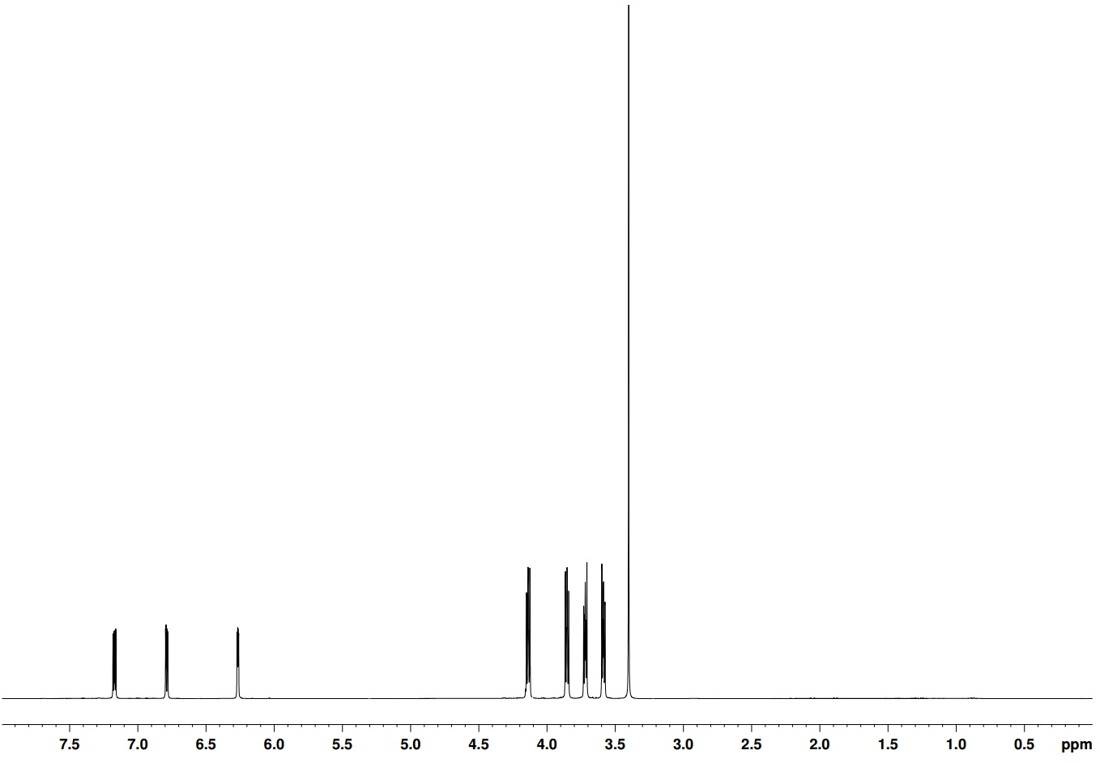
H_{a}
H_{b} H_{c}

H_{c}
H_{c}

H_{d}
H_{c}

H_{g}
H_{c}

H_{h}
H_{c}

H_{e}
H_{c}

H_{f}
H_{c}

Figure 96 ¹H NMR in CDCl₃ of M24 between 0 and 7.50 ppm showing the various proton environments present
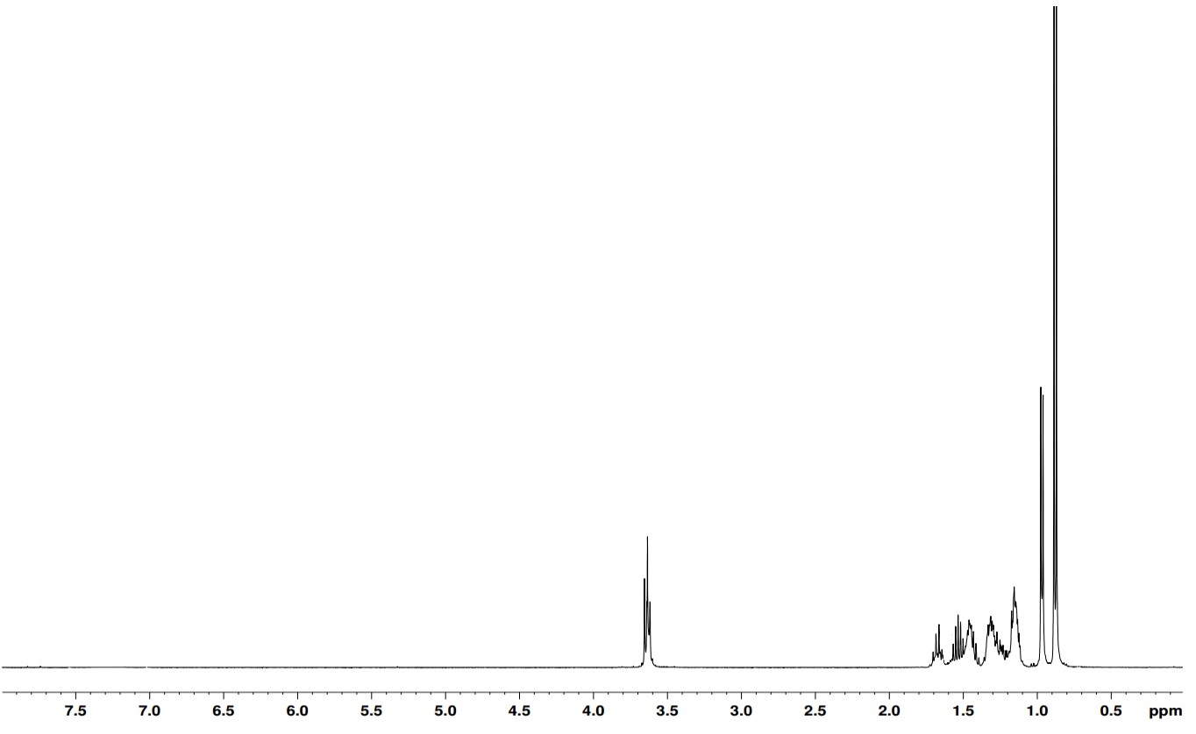
TPD monomer M17 was synthesised as described in chapter 4 and gave the following NMR spectrum.
H_{a}
H_{b} H_{c}

H_{c}
H_{c}

H_{d}
H_{c}

Figure 97 ¹H NMR in CDCl₃ of M17 between 0 and 7.50 ppm showing the various proton environments present

6.22 Polymer Synthesis

Polymerisations were carried out via direct arylation utilising PdCl₂(MeCN)₂ catalyst, tris(σ-methoxyphenylphospine) ligand (L1) and anhydrous THF, as well as pivalic acid and Cs₂CO_{3,} as seen in figure 94. Despite polymerisation conditions being different to the previously mentioned direct arylation methods, the couplings still proved successful. Conditions are also mild enough to ensure the ether side chains are able to survive the polymerization process. Regio random polymers were selected in order to enhance molecular weights and disrupt molecular alignments. PT(oxy)TPD(dmo) proton NMR is shown in figure 98.
Molecular weights vary drastically between the two polymers, with PT(oxy)TPD(dmo) achieving a respectable number average molecular weight of 7.06 KDa. However, with respect to other TPD-thienyl polymers with similar side chain lengths, the molecular weights are slightly reduced. The low molecular weight of PT(met)TPD(dmo) is likely due to the oxidative instability of starting monomer. Shown below in table 16 is a proton NMR of PT(oxy)TPD(dmo). The proton environments of the ether chain are still visible between 3.50 and 4.50 ppm and two aromatic protons (6.90ppm and 7.40 ppm) representive of the two possible regio chemical structures.
Table 16 A summary of the molecular weight and optical data gained for PT(oxy)TPD(dmo) and PT(met)TPD(dmo)
Polymer | M_{n} / kDaª | M_{w} / kDaª | PDI^{b} | λ_{max} / nm solution | λ_{max} / nm thin film | E_{g} opt / eV^{c} (±0.02)
PT(oxy)TPD(dmo) | 7.00 | 17.10 | 2.43 | 581 | 561 | 1.55
PT(met)TPD(dmo) | 2.90 | 3.50 | 1.22 | 477 | 489 | 1.93

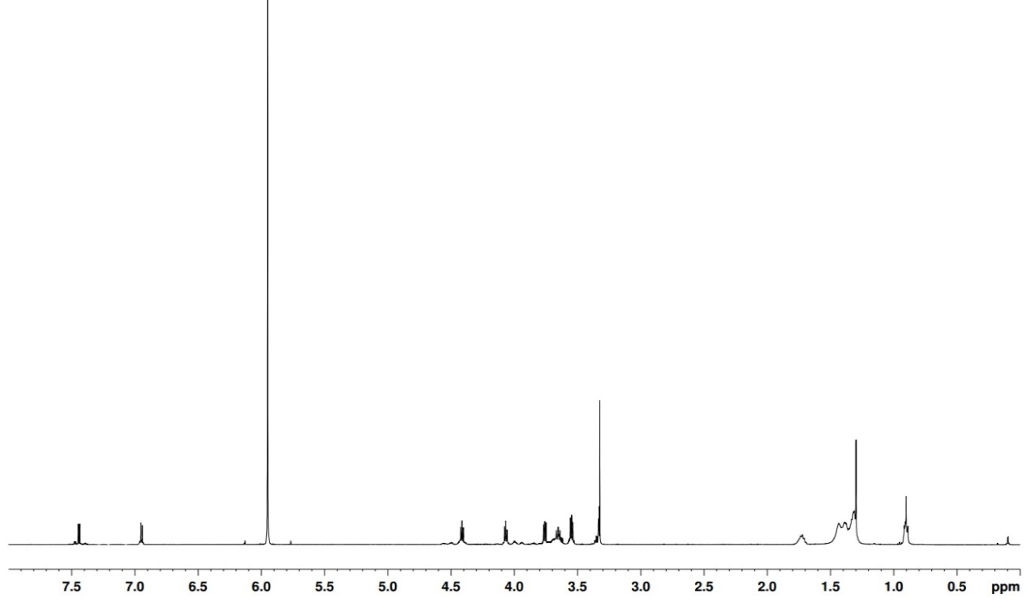
ªMolecular weights calculated on the toluene fractions of polymers using differential refractive index (DRI) characterisation. ^{b}Polydispersity Index (PDI). ^{c}Optical band gap estimated by graphically determining the onset of absorption
Figure 98 ¹H NMR in C₂D₂Cl₄ of PT(oxy)TPD(dmo) between 0 and 8.00 ppm showing the various proton environments present on the polymer

6.23 Optical properties

The optical properties of polymers were investigated by UV-vis absorption spectroscopy on dilute chloroform solutions and drop-cast films on quartz substrates. Very promising optical properties were gathered from PT(oxy)TPD(dmo), much lower than the hydrocarbon counterparts. A band gap of 1.55 eV means there is a large amount of overlap with the solar output spectrum, which increases the amount of photo generated charge carriers. The narrowing of the band gap from TPD-thienyl polymers with solely alkyl side chains is due to the influence of the ether functionality. The electron donating nature of the ether group helps to narrow energy level which increases the donor character of the thiophene. The wide band gap observed for PT(met)TPD(dmo) at 1.93 eV can be mainly put down to the low molecular weight, which is wider than the equivalent aliphatic chain equivalent. It is also hypothesised that there is a relationship between the band gap of a material and the position of the oxygen atom on the side chain. Directly adjacent to the thiophene ring, the oxygen atom feeds electron density into the conjugated aromatic system. When separated by a methylene (CH₂) group, the donating effect is suppressed with the HOMO level lowered and band gap widened. This could also be responsible for the reduced band gap seen for PT(met)TPD(dmo).
In solution, both PT(met)TPD(dmo) and PT(oxy)TPD(dmo) display relatively narrow absorption bands (figure 99) with little indication of intramolecular charge transfer processes occurring compared to the polymers in chapters 3-5. It is likely that the entire polymer is dissolved and no aggregates form while in solution. However, in thin film PT(oxy)TPD(dmo) absorption becomes very broad, while PT(met)TPD(dmo) stays relatively narrow. It is suspected that the low molecular weights obtained by PT(met)TPD(dmo) limit the effective conjugation length reached in the solid state. It could be speculated that PT(oxy)TPD(dmo) broadens its absorption as the more planar structure adopted in the solid state extends the effective conjugation length.
Figure 99 The normalised U.V.-vis absorption spectra of PT(oxy)TPD(dmo) and PT(met)TPD(dmo) in a) dilute chloroform solution and b) thin film

6.24 Electrochemical properties

Cyclic Voltammetry (C.V.) was utilised to measure the oxidation and reduction potentials of the polymers synthesised. All oxidations and reductions were run in a 3 electrode cell, using tetrabutylammonium perchlorate in acetonitrile as the electrolyte. A thin film was created on the working electrode and the electrochemical data was then extracted. The HOMO and LUMO levels were calculated using tangents to the first oxidation and reduction potentials, which were then converted into electron volts.
Table 17 A summary of the electrochemical data gathered for PT(oxy)TPD(dmo) and PT(met)TPD(dmo)
Polymer | HOMOª/V (±0.04) | LUMO^{b}/V (±0.04) | E_{gec} /eV^{c} (±0.04)
PT(oxy)TPD(dmo) | -5.56 | -3.16 | 2.40
PT(met)TPD(dmo) | -5.58 | -3.35 | 2.23

ªHOMO position (vs vacuum) determined from the onset of oxidation.
^{b}LUMO position (vs vacuum) determined from the onset of reduction. ^{c} Electrochemical energy gap
As expected the HOMO positions are very low lying due to the presence of the electron donating oxygen on the ether side chains, displayed in table 17. The additional electron density on the polymer backbone destabilises the molecule and raises the molecular orbital energy of PT(oxy)TPD(dmo).

Figure 100 Cyclic voltammograms of PT(oxy)TPD(dmo) and T(met)TPD(dmo) on platinum electrodes (area 0.031 cm²) at a scan rate of 100 mVs⁻¹ in acetonitrile/tetrabutyl ammonium perchlorate (0.1 moldm⁻³).

Reversibility is demonstrated particularly by PT(oxy)TPD(dmo) reduction potential curve in figure 100, indicating better atmospheric stability is possible from this polymer.

6.25 Thermal Properties

Thermogravimetric analysis (TGA) probes the thermal properties of polymers up to 800 ^{O}C. Both polymers display excellent thermal stability in figure 101, with 5% loss of mass occurring at approximately 400 ^{O}C for both polymers. However, shortly after the 5% weight loss a dramatic drop in weight% is seen in PT(oxy)TPD(dmo) whereas PT(met)TPS(dmo) shows greater stability to the increase in temperature. This is beneficial to cell lifetimes and should lend itself to the longevity of the polymer active layer. The plateauing of the weight percentage corresponds to the loss of side chains from both TPD and thienyl moieties.

Figure 101 TGA plots of PT(oxy)TPD(dmo) and T(met)TPD(dmo)

6.26 X-ray Diffraction

XRD data reveals important structural information about the effect oxygen chain position has on the solid state structure.

Figure 102 Powder X-ray diffraction patterns of PT(oxy)TPD(dmo) and PT(met)TPD(dmo)

It is evident that both polymers show strong π-stacking interactions due to the intense peaks around 25^{O} 2θ in figure 102. It is speculated that the oxygen in the polyether side chains enhance inter molecular interactions compared to their hydrocarbon equivalents. Peaks in the low angle region appear to be more prominent in PT(oxy)TPD(dmo) than in PT(met)TPD(dmo), possibly due to the positioning of the first oxygen on the polyether side chain.
Table 18 D-spacing calculations extracted from Figure 102
Polymer | 2θ / ^{O} (±0.01) | D spacing / Å (±0.01) | 2θ / ^{O} (±0.01) | D spacing / Å (±0.01)
PT(oxy)TPD(dmo) | 3.69 | 23.93 | 25.10 | 3.55
PT(met)TPD(dmo) | 3.95 | 22.29 | 25.80 | 3.45

Inter chain spacing distances are over 1.6 Å larger for PT(oxy)TPD(dmo) than PT(met)TPD(dmo), as displayed in table 18. It is suspected that the shorter polymer chains involving thiophene (met) have less steric contortion and can adopt a more planar structure – which aids interdigitation of side chains. This also supports the data gathered for the π-stacking distances as PT(oxy)TPD(dmo) is more contorted and less planar.

6.3 Conclusions

Polymers PT(oxy)TPD(dmo) and PT(met)TPD(dmo) were synthesised successfully after adapting the polymerisation to allow for the fact that the thiophene monomers were not able to be brominated. The large variance in molecular weight is suspected to be due to the stability and solubility of the polyether side chains. This trend is far more pronounced in this chapter than in any other chapter. Nevertheless, PT(oxy)TPD(dmo) was able to be made with a number average molecular weight of 7.10 KDa. A combination of higher molecular weight and oxygen position on the polyether side chain narrowed the banp gap of PT(oxy)TPD(dmo) to 1.55eV – approaching ideal band gap values for maximum overlap with solar spectrum. The wide band gap of PT(met)TPD(dmo) is most likely due its low molecular weight and position of the first oxygen on the polyether side unit. HOMO levels are low lying which should result in good V_{OC} values. However, PT(met)TPD(dmo) has a lower lying HOMO level (-5.58 eV) than PT(oxy)TPD(dmo) (-5.56 eV), the latter of which has its HOMO level raised by the electron donating power of an adjacent oxygen. Both polymers displayed superb thermal stability when analysed using TGA, both losing 5% weight loss just below 400 ^{O}C, which lends itself well to long cell lifetimes due to a lower rate of degradation at standard operating temperature. Solid state structure was probed via x-ray diffraction and found both PT(oxy)TPD(dmo) than PT(met)TPD(dmo) exhibited strong intermolecular interactions. It is postulated that the oxygens present in the sidechains also enhance molecular ordering.

6.4 Synthesis

For synthesis of M17 please see chapter 4
3-​[2-​(2-​Methoxyethoxy)​ethoxy]​- thiophene (M24) ¹²
(M24)
Sodium hydride (0.82g, 34.03 mmol) and dry THF were added to a round bottom flask and placed under an inert atmosphere. Di(ethyleneglycol)monomethyl ether (4.04 g, 34.06 mmol) was added dropwise to the mixture and left to stir for 30 minutes. 3-Bromothiophene (3.65 g, 22.70 mmol) was then added and the reaction left to stir for another hour at room temperature. The reaction was quenched with water and extracted with diethyl ether (3 x 100 mL), the organic layers were combined, dried with MgSO4 and solvent removed under pressure. The crude product was purified via column chromatography using DCM as the eluent to yield a colourless oil (3.81 g , 83%).¹H NMR (400 MHz CDCl₃) δ: 7.15 (dd, J=3 and 5 Hz, 1H), 6.80 (dd, J=1 and 5 Hz, 1H), 6.25 (dd, J= 1 and 3 Hz, 1H), 4.15 (d, J=6 Hz, 2H), 3.85 (d, J=6 Hz, 2H), 3.70 (d, J=6 Hz, 2H), 3.60 (d, J=5 Hz, 2H), 3.40 (s, 3H). ¹³C NMR (400 MHz, CDCl₃) 157, 124, 121, 95, 73, 71, 68, 68, 54. Mass spectrum (EI) (m/z): 202 (M+). Elemental Analysis calculated: C, 53.44%; H, 6.97%; S, 15.81%. Found: C, 52.43%; H, 7.29%; S, 15.88%.
3-​[[2-​(2-​Methoxyethoxy)​ethoxy]​methyl]​- thiophene (M25) ¹²

(M25)

See method for 3-​[2-​(2-​methoxyethoxy)​ethoxy]​-thiophene (M24) (4.02 g, 85%). ¹H NMR (400 MHz CDCl₃) δ: 7.35 (m, 1H), 7.25 (s, 1H), 7.15 (d, 1H, J = 5 Hz), 4.70 (s, 2H), 3.80 (m, 6H), 3.65 (m, 2H) 3.25 (s, 3H). ¹³C NMR (400 MHz, CDCl₃) 142, 129, 127, 124, 75, 70, 70, 69, 68, 59. Mass spectrum (EI) (m/z): 217 (M+). [M]+ calculated for C₁₀H₁₆O₃S: 216.0820; found: 216.0815
General Polymerisation technique¹³
Dibromo-5-(alkyl)-4H-thieno [3,4-c] pyrrole-4,6 (5H) dione (0.36 mmol), 3-polyether-thiophene (36 mmol), caesium carbonate (1.08 mmol), pivalic acid (0.36 mmol), PdCl₂(MeCN)₂ (0.0072 mmol) and tris(2-​methoxyphenyl)​-phosphine (0.0072 mmol) were placed in a thick-walled Schlenk tube and degassed. THF (1 mL) was added, degassed again and heated to 100 ^{O}C until the first signs of precipitation were visible around the edge of the flask. The reaction mixture was extracted with chloroform (100 mL) and washed with saturated EDTA solution (3 x 100 mL). Solvent was removed until the solution was concentrated to ~10 mL and precipitated into methanol (75 mL). The precipitate was collected via filtration and dried over vacuum. The polymer was purified by Soxhlet extraction using methanol, acetone, hexane, toluene, chloroform and chlorobenzene sequentially. The toluene fraction was taken and used in analysis.
Poly 3-​[2-​(2-​methoxyethoxy)​ethoxy]​- thienyl​-5-bromo-​5-​octyl-4H-​thieno[3,​4-​c]​pyrrole-​4,​6(5H)​-​dione PT(oxy)TPD(dmo)
Toluene fraction (50 mg, 47%) M_{n} 7.06 KDa, M_{w} 17.18 KDa, PDI 2.43. ¹H NMR (500 MHz C₂D₂Cl₄) δ: 7.45 (s, 1H), 4.35 (m, 2H), 4.05 (m, 2H), 3.75 (m, 2H), 3.65 (m, 2H), 3.55 (m, 2H), 3.35 (s, 3H), 1.70 (m, 2H), 1.55 – 1.20 (m, 10H), 0.90 (m, 3H). Elemental Analysis calculated: C, 640; H, 7.43; N, 3.13; S, 7.16 found: C, 66.20; H, 7.97; N, 2.84; S, 9.09.

Poly 3-​[[2-​(2-​methoxyethoxy)​ethoxy]​methyl]​- thienyl​-5-bromo-​5-​octyl-4H-​thieno[3,​4-​c]​pyrrole-​4,​6(5H)​-​dione PT(met)TPD(dmo)

Toluene fraction (27mg, 36%) Mn 2.87 KDa, Mw 3.52 KDa, PDI 1.22. ¹H NMR (500 MHz C₂D₂Cl₄) δ: 7.40 (s, 1H), 4.75 (m, 2H), 3.80-3.50 (m, 8H), 3.30 (s, 3H), 2.95 (m, 2H), 1.70 (m, 2H), 1.60 – 1.20 (m, 10H), 0.80 (m, 3H). Elemental Analysis calculated: C, 60.10; H, 6.94; N, 2.92; S, 13.37 found: C, 67.91 ; H, 4.23; N, 3.90; S, 17.43.

6.5 References

1 K. W. Song, M. hee Choi, M. hee Han and D. K. Moon, J. Ind. Eng. Chem., 2014, 20, 426–434.
2 P. Berrouard, S. Dufresne, A. Pron, J. Veilleux and M. Leclerc, J. Org. Chem., 2012, 77, 8167–8173.
3 X. Guo, R. P. Ortiz, Y. Zheng, M. Kim, S. Zhang, Y. Hu, G. Lu, A. Facchetti and T. J. Marks, 2011, 34, 13685–13697.
4 C. Ma, X. Bi, T. Ngai and G. Zhang, Mater. Chem., 2013, 1, 10306–10317.
5 T. Umeyama, M. Oodoi, O. Yoshikawa, T. Sagawa, S. Yoshikawa, D. Evgenia, N. Tezuka, Y. Matano, K. Stranius, N. V. Tkachencko, H. Lemmetyinen and H. Imahori, J. Mater. Chem., 2011, 21, 12454-12461.
6 W. a. Braunecker, Z. R. Owczarczyk, A. Garcia, N. Kopidakis, R. E. Larsen, S. R. Hammond, D. S. Ginley and D. C. Olson, Chem. Mater., 2012, 24, 1346–1356.
7 D. a. M. Egbe, S. Türk, S. Rathgeber, F. Kühnlenz, R. Jadhav, A. Wild, E. Birckner, G. Adam, A. Pivrikas, V. Cimrova, G. Knör, N. S. Sariciftci and H. Hoppe, Macromolecules, 2010, 43, 1261–1269.
8 C. Du, W. Li, Y. Duan, C. Li, H. Dong, J. Zhu, W. Hu and Z. Bo, Polym. Chem., 2013, 4, 2773-2780.
9 H. J. Son, B. Carsten, I. H. Jung and L. Yu, Energy Environ. Sci., 2012, 5, 8158-8170.
10 C. Shi, Y. Yao, Y. Yang and Q. Pei, J. Am. Chem. Soc., 2006, 128, 8980–8986.
11 Q. Liu, X. Bao, Y. Yan, Z. Du, V. A. L. Roy, D. Zhu, M. Sun, C. S. Lee and R. Yang, J. Mater. Sci., 2015, 50, 2263–2271.
12 M. P. Ouattara, S. Lenfant, D. Vuillaume, M. Pézolet, J.-F. Rioux-Dubé, J. Brisson and M. Leclerc, Macromol., 2013, 46, 6408–6418.
13 M. Wakioka, N. Ichihara, Y. Kitano and F. Ozawa, Macromol., 2014, 2, 626−631.

Chapter 7

Conclusions and Future Work

7.1 Conclusions

The aim of this project was to synthesise organic conjugated polymers and evaluate their organic photovoltaic properties. Several different sets of polymers were synthesised and are characterised. Each set of polymers explored a different technique in order to maximise their potential for PSC use. The vast majority of the research conducted in this thesis was based around TPD-thienyl polymers and modification therein of several different chemical properties.
Chapter 2 included work on donor/acceptor alternating copolymers comprising bithienyl-fluorenes and -carbazoles flanked by thienyl groups as donor units with naphthothiadiazole as an acceptor units to produce four novel photoactive polymers. The combination of an extended aromatic system provided by naphthothiadiazole and lack of solubilising side chains led to polymers with very low molecular weights, which is not ideal for most photovoltaic characteristics are dependent on. However, the carbazole dodecyl chained polymer PC(d)DTNT was able to achieve a mid-range band gap of 1.82 eV, which is wide enough to overlap partially with the solar spectrum. Flourene based polymers PF(d)DTNT and PF(o)DTNT both display deep HOMO levels at -5.60 and -5.59 eV, which are 0.1 eV deeper than the carbazole equivalents and deep lying orbital levels should give better oxidative stability. The enhanced OPV characteristics observed for both PC(d)DTNT and PF(d)DTNT over their shorter side chain equivalents PC(o)DTNT and PF(o)DTNT respectively, display the importance of molecular weight. It is therefore concluded that in these particular polymer systems longer side chains are beneficial to increasing molecular weights and PV properties. However, the problematic synthesis of the naphthothiadiazole led to no further research being undertaken.
Chapter 3 and 4 compare TPD-thienyl polymers and the effect of regio regularity and side chain length on photovoltaic properties. Polymers were deliberately engineered to have varying amounts of regioregularity, which is anticipated to vary crystallinity levels. The common relationship between chapter 3 and 4 is that increasing side chain length and branching increases molecular weights. The highest molecular weights are achieved by the branched, regio random polymer PTPD(dmo)ranT(h) and the alternating branched polymer PTPD(dmo)altT(h). It is postulated that the branched 3,7-dimethyloctyl causes more disruption to intermolecular interactions than linear alkyl chains. This is reflected in the band gaps obtained, as the narrower band gaps belong to those that display the best compromise between order in the solid state and molecular weight - PTPD(o)regT(d) at 1.73 eV. This is also reinforced by X-ray diffraction as the linear chain polymers display sharper peaks than the branched equivalents. The regular polymers from chapter 4 also show evidence of long range order within the solid state. There is also a similar correlation observed with HOMO levels, deepening with an increase in molecular weight for linear alkyl and rising with side chain branching. All polymers displayed good thermal stabilities. The main focus of chapter 3 and 4 was to show the effect of how regio chemistry can alter photovoltaic properties. It has been shown that regio regular polymers are much more crystalline and resultantly display better chemical properties for photovoltaic applications. However, the enhanced crystallinity could lead to a problematic cell manufacture as mixing with PC₇₀BM could be affected and a drop in J_{SC} could be the consequence.
Chapter 5 utilises highly branched alkyl chains to compensate for the unsubstituted thiophene and bithiophene used as comonomers. The large branched alkyl chains bring about a disruption to molecular ordering, in both solution and the solid state. This data is reinforced by UV-vis spectroscopy which reveals broad, smooth curves and few vibronic peaks observable. The XRD data displays interchain interaction distances of 3.50 Å – indicative of π-stacking, but little evidence of longer range order structure forming. It is suspected that the branching inhibits long range order, but the lack of alkyl chains on the thiophene units allows overlap of p-orbitals of the conjugated backbone system of adjacent polymer chains. Bithiophene polymers PBTTPD(od) and PBTTPD(ho) have better photochemical properties than their single thiophene counterparts. This is reflected by narrower band gaps – increased donor strength and higher molecular organisation are hypothesised to be responsible. The narrowest band gap obtained was by PBTTPD(od) of 1.70 eV, which is narrower than those of chapters 3 and 4. It is postulated that the increased donor strength of the bithiophene unit has the effect of narrowing the band gap more than larger molecular weights.
The inclusion of polyether side chains in chapter 6 induced a large change in the photochemical properties of TPD-thienyl polymers. Oxygen adjacent to the polymer backbone reduces the band gap to 1.55 eV which offers excellent overlap of the solar spectrum. However, HOMO levels are raised in conjunction with the band gap narrowing and as a result oxidative stability against atmospheric oxygen could be compramised. PT(oxy)TPD(dmo) shows molecular ordering somewhere between the polymers of chapter 3 and 4 and chapter 5. The presence of long range order is evident; however, the respective peak is weak in intensity and shows long range order aren’t as prevalent as in the solid state structure of PT(oxy)TPD(dmo). Both polymers in chapter 6 display thermal stability up to 400 ^{O}C, which is far in excess of standard operating temperatures and should contribute to long cell lifetimes. In theory, PT(oxy)TPD(dmo) should offer the best PCE results due to its relatively larger molecular weight, narrow band gap, relatively low lying HOMO level, good thermal stability and a crystalline structure.
The main feature of the title of this thesis is to assess the effect of the dipole moment of polymers has on the photovoltaic properties of the polymers synthesised in this thesis. The theoretical calculations in chapter 4 show that with a regular repeating structure of PTPD(o)regT(h) there is an incremental increase in dipole moment with repeat units added. In conjunction with this, there is also a decrease in theoretical optical band gap. It is hypothesised that controlling the regularity of the polymers will help in controlling the orientation of the whole molecule. Polymers synthesised in chapter 3 were designed as regio-random analogues to the regio-regular polymers in chapter 4. The regio-regular nature of the polymers in chapter 4 reduce the molecular weight with respect to chapter 3. Optical band gaps and HOMO/LUMO levels are strongly dependant on molecular weight, however, as discussed in chapter 4 other properties such as dielectric constant are not as dependant on molecular weight. Until further measurements are made on the solar cells with these polymers incorporated into them, this is just speculation based on literature precedent. The polymers in chapters 5 and 6 are not directly comparable and therefore conclusions about the effect of the dipole moment on the photovoltaic properties cannot be made from the theoretical calculations proposed in chapter 4 alone.

7.2 Future work

The work undertaken in chapter 2 may have offered poor results initially but does offer a platform to build from. Improvements to photochemical properties in relation to chapter 2 must begin with increasing molecular weights. This can be achieved by further attachment of alkyl side chains to the thiophene functionalities. Addition of these units to the NT unit before polymerisation would improve solubility and increase molecular weight. However, the choice of length/branching for the new side chains must be carefully considered. Molecular alignments and overall planarity are an essential part of achieving optimum photochemical properties. Alternatively, modification could be made to the naphthothiadiazole moiety itself through attaching side chains directly to the naphthalene rings, n-butoxy side chains are attached in figure 103. In order to modify band gaps further alkoxy side chains could be employed, in a similar fashion to the polymers in chapter 6.

Figure 103 Proposed chemical structure of the modified NT polymer
Regarding the polymers in chapters 3 to 6, improvements to molecular weights may not be crucial to improve photovoltaic properties further. Molecular weights achieved by PTPD(dmo)ranT(h) and PTPD(dmo)altT(h) were above 10 KDa, however, they did not achieve the narrowest band gap. In order to achieve the ideal band gap, a narrowing of 0.2 eV is required between HOMO and LUMO levels for the polymers in chapters 3 and 4. The hypothesis proposed in chapter 3 and 4 tried to establish the link between the regiochemistry of the polymers, their dipole moments and overall device efficiencies. Various forms of time resolved spectroscopy would provide information into the dipole moment and the effect this has on charge generation and separation. Devices can then be made in order to test the relationship between the dipole moment and PCEs.
The polymer data in chapter 5 can be enhanced further by the addition of another thiophene unit – to produce a trithiophene copolymer equivalent. It is hoped that the new orientation will lend itself to increased donor strength and dipole moment compared to the previous polymers synthesised. In theory, the tri thienyl system the band gap should be narrower and in turn this should aid the improvement in dielectric constant. As shown in figure 104, it is possible that the most favourable orientation is with the TPD units aligned in the same direction – thus increasing dipole moments. However, naked thiophene moieties may inhibit molecular weights and the inclusion of short (possibly hexyl) alkyl chains on the 1 and 3 thiophene units will increase molecular weight.

Figure 104 Proposed structure of trithienyl TPD polymer PTri(h)TPD(ho)

The polymer with the most potential to offer the best PV performance, PT(oxy)TPD(dmo), has a near optimum band gap of 1.55 eV. In order to further increase the photovoltaic properties, the use of bithiophene with polyether side chains as a donor should further improve π-stacking ability as well as narrower band gaps. Larger branched chains on TPD as used in chapter 5 may be employed in order to increase molecular weights and narrow band gaps further. In relation to the rest of this thesis, a regio regular version of the polymer could be made as a comparison. It has been shown that the enhanced crystallinity is achieved through regio regular control of polymers in chapters 3 and 4, which could be beneficial to photovoltaic properties.

Chapter 8

Experimental

8.1 Instrumentation

¹H and ¹³C NMR spectra were recorded using a Bruker AV 250 (250 MHz), Bruker AV 400 (400 MHz) spectrometers in deuterated chloroform, DMSO or acetone at 22 ^{O}C. Chemicals shifts were reported as δ values (ppm) relative to a trimethylsilane standard at 0 ppm. ¹H NMR of the polymers were recorded on a Bruker Avance III HD 500 (500 MHz) spectrometer at 100 ^{O}C using 1,2-dideutrotetrachloroethane. Both NMR devices recorded chemical shifts in parts per million (ppm) using tetramethylsilane as a reference at δ 0.00 ppm.
Number average (M_{n}) and weight average (M_{w}) molecular weights were determined by size exclusion chromatography (SEC) measurements using a Viscotek GPCmax VE2001 GPC solvent/sample module and a Waters 410 Differential Refractometer. The temperature of the system was set to 140°C and a 1,2,4 trichlorobenzene (TCB) with toluene used as the flow rate marker, with the flow rate at 1 mLmin⁻¹ and calibrated using polystyrene standards. Samples (5 mg) were dissolved in 5 mL of TCB and stirred and heated to 140°C for 1 hour to let aggregates completely dissolve. The solutions were then filtered through Nylon 0.22 μm Chromatography filters in a 2 mL chromatography vial was carried out before sample injection.
DSC curves were provided by a Perkin-Elmer Pyris DSC in the range of 40 ^{O}C to 220 ^{O}C. Sample loaded as a powder.
XRD (powder) measurements were conducted between 2 ^{O} to 40 ^{O} 2θ and on a Bruker D8 advance diffractometer with a CuKα radiation source (1.5418 Å, rated as 1.6 kW).
Elemental analysis of carbon, hydrogen, nitrogen and sulphur was performed on Perkin Elmer 2400 series 11 CHNS analyzer. Percentage calculations of bromine and chlorine were undertaken using the Schöniger flask combustion method.
Thermogravimetric analysis was used to ascertain thermal stability using a Perkin Elmer TGA Analyzer with a scan rate of 10 ^{O}Cmin⁻¹ under an inert nitrogen atmosphere. Samples analysed between 10 – 800 ^{O}C. Sample loaded as a powder.
UV-vis spectra were obtained using a Hitachi U-2010 Double Beam UV/Visible Spectrophotometer. Chloroform solutions of polymers (1 mgcm⁻³) were diluted using chloroform and measured in quartz cuvettes of path length 1x10⁻² m and a chloroform reference sample. The solid state absorption spectra were probed by drop-casting thin films on quartz plates of polymer solution dissolved in chloroform and left to evapourate. Band gaps were calculated by extrapolation from the onset of absorption and converted into electron volts using the following formula: (Eg in eV = 1240/onset wavelength). Photoluminescence spectra were recorded on a Horiba FluoroMax 4 spectrometer (Horiba, Middlesex, United Kingdom). Chloroform solutions of polymers (5 mgcm⁻³) were made and measured using quartz cuvettes (path length=1×10⁻²m). Thin films were prepared by drop-casting chloroform solutions of polymer (5 mgcm⁻³) onto quartz plates.
Cyclic voltammograms were gathered with a Princeton Applied Research Model 263A Potentiostat/Galvanostat. A three electrode set up was utilised consisting of a Pt disc, platinum wire and Ag/Ag+ as the working electrode, counter electrode and reference electrode, respectively. Tetrabutylammonium perchlorate in acetonitrile (0.1 moldm⁻³) was used as the electrolytic mixture and measurements were carried out on polymer films drop cast in a similar method to those in UV-vis analysis. All measurements were made against a ferrocene standard, the energy level of Fc/Fc+ was accepted as -4.8 eV. Fc/Fc+ has a half wave potential of 0.08 against the Ag/Ag+ reference electrode in the three electrode cell set up. Energy levels were estimated by the following formula; Energy level= – (4.8 – E1/2, Fc,Fc+ + E onset). The onset for both oxidation and reduction is gathered from their respective CV traces and can be inserted into the formula to calculate HOMO and LUMO levels respectively.

8.2 Chemicals

All dry solvents were obtained from the Grubbs solvent system under an inert atmosphere. All chemicals used were of reagent grade quality as purchased from suppliers and used without purification.

8.3 Errors

Errors for UV-vis band gaps were calculated by drawing and redrawing the tangents needed to calculate the onset of absorption 5 times. The maximum and minimum wavelengths were converted into electron volts and the error calculated through the following formula (max-min/2).
Errors for cyclic voltammetry HOMO/LUMO levels were calculated by drawing and redrawing the tangents needed to calculate the onset of oxidation/reduction 5 times. The maximum and minimum onsets in volts were converted into electron volts and the error calculated through the following formula (max-min/2).
Errors for TGA decomposition were calculated by drawing and redrawing the tangents needed to calculate the onset of degradation 5 times. For the maximum and minimum onsets in ^{O}C the error was calculated through the following formula (max-min/2).
The error for the XRD plots is the error associated with reading the maximum intensity point on the x -axis, so the error is (±0.01).

Chapter 9

Appendix

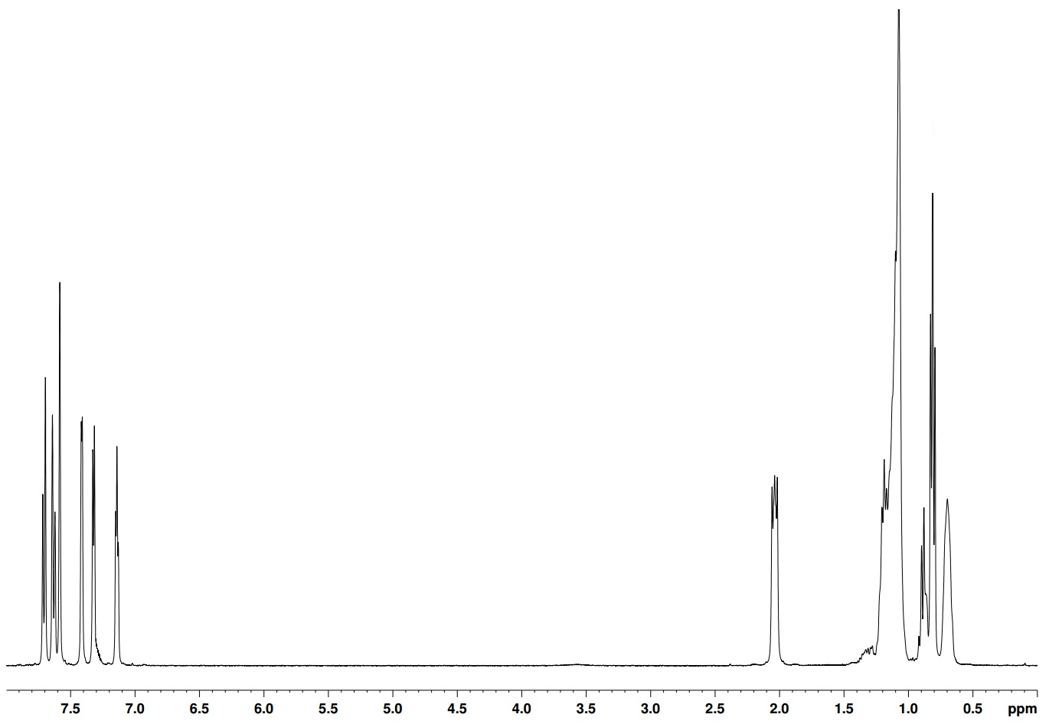
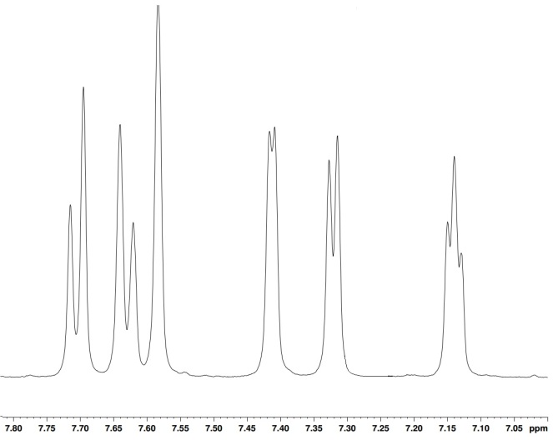
¹H NMR in CDCl₃ of M2 - 2, 7-bisthiophene-9, 9-dioctylfluorene
H_{a}
H_{b} H_{c}

H_{c}
H_{c}

H_{d}
H_{c}

H_{e}
H_{c}

H_{f}
H_{c}

H_{g}
H_{c}

H_{h}
H_{c}

H_{i}
H_{c}

¹H NMR in CDCl₃ of M3 - 2, 7-bisthiophene-9, 9-dioctylfluorene

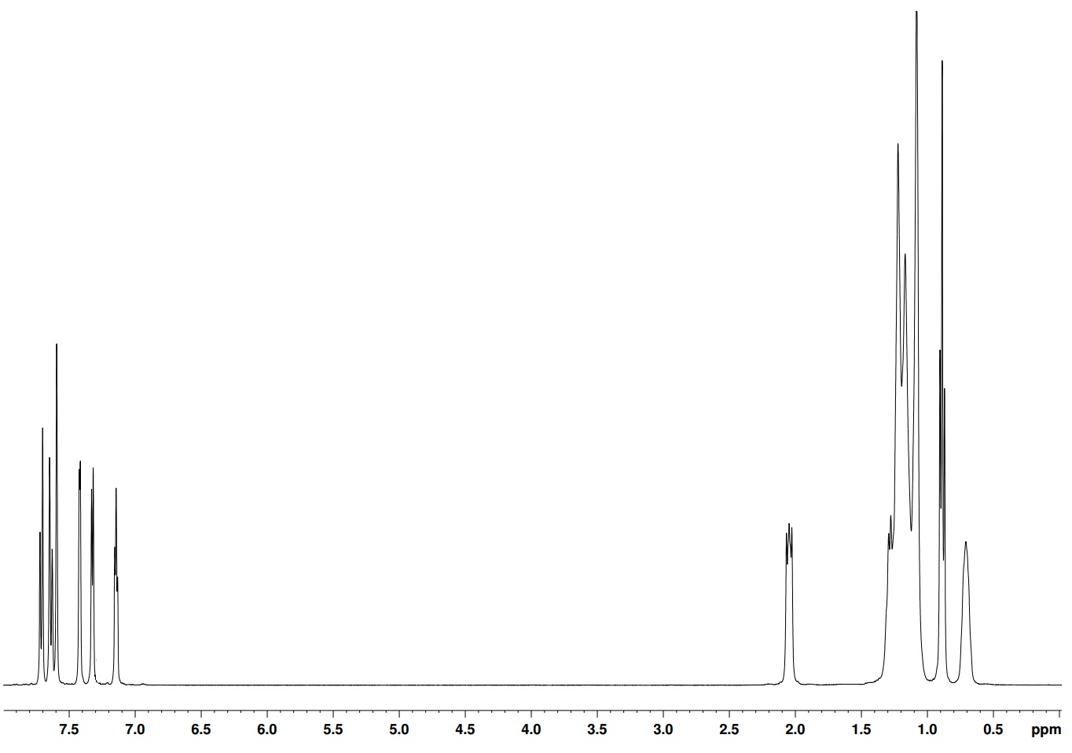
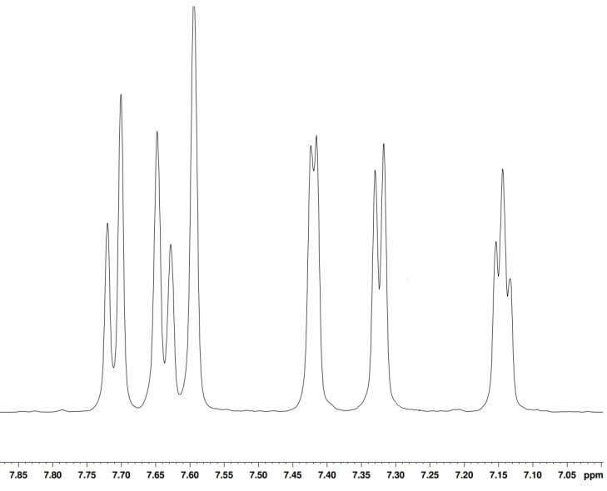
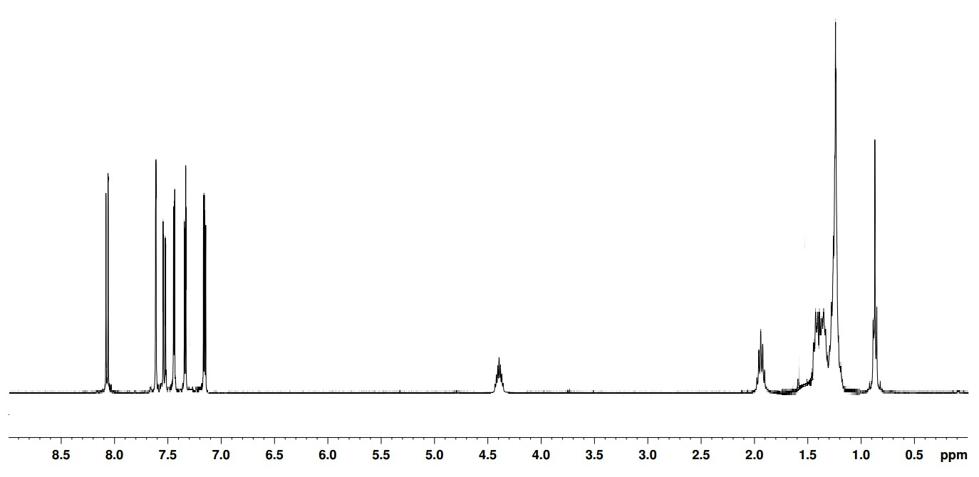
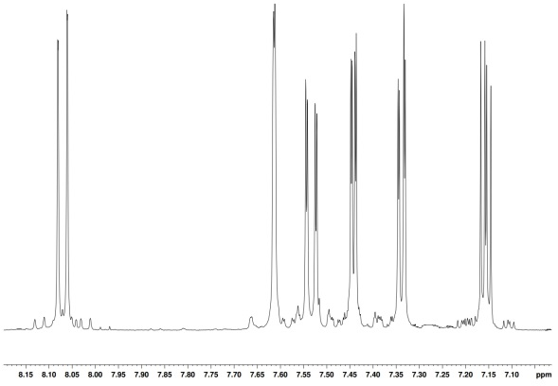
¹H NMR in CDCl₃ of M4 - 2, 7-bisthiophene-9-(9-heptadecyl)-carbazole
H_{a}
H_{b} H_{c}

H_{c}
H_{c}

H_{d}
H_{c}

H_{f}
H_{c}

H_{e}
H_{c}

H_{g}
H_{c}

H_{h}
H_{c}

H_{i}
H_{c}

H_{h}
H_{c}

H_{a}
H_{b} H_{c}

H_{c}
H_{c}

H_{d}
H_{c}

H_{f}
H_{c}

H_{e}
H_{c}

H_{g}
H_{c}

H_{h}
H_{c}

H_{i}
H_{c}

H_{j}
H_{c}

¹H NMR in CDCl₃ of M5 - 2, 7-bisthiophene-9-(pentacosan-13-yl)-carbazole
H_{h}
H_{c}

H_{h}
H_{c}

H_{g}
H_{c}

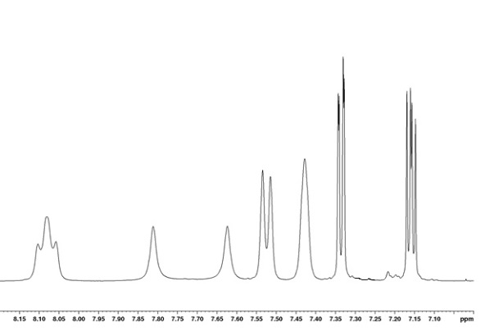
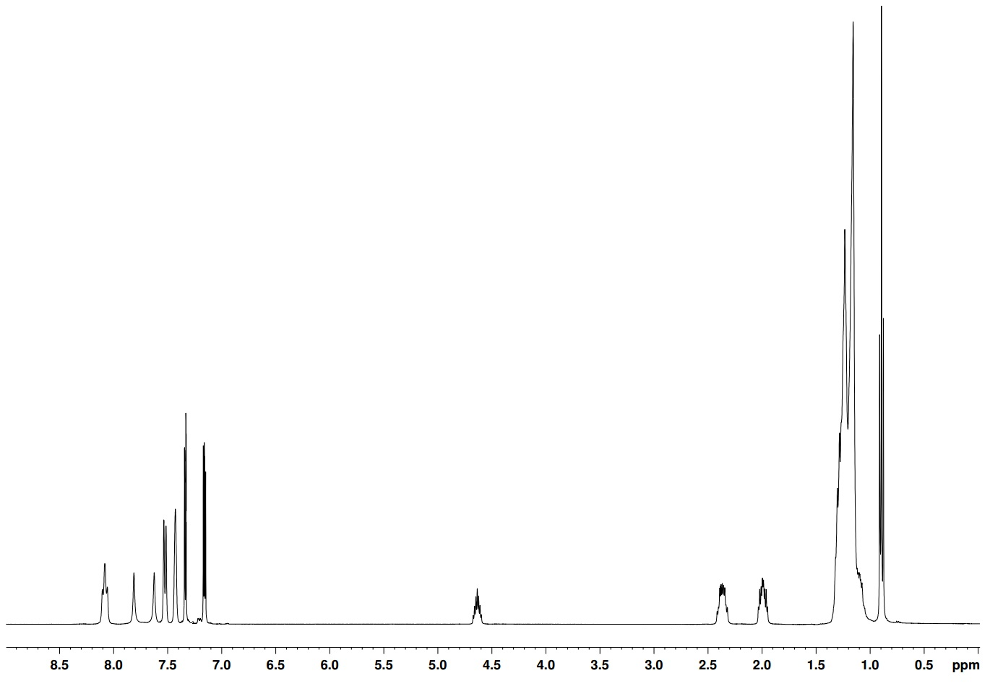
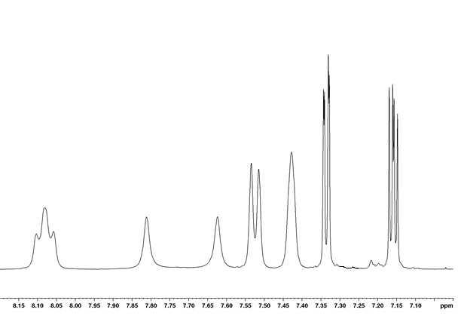
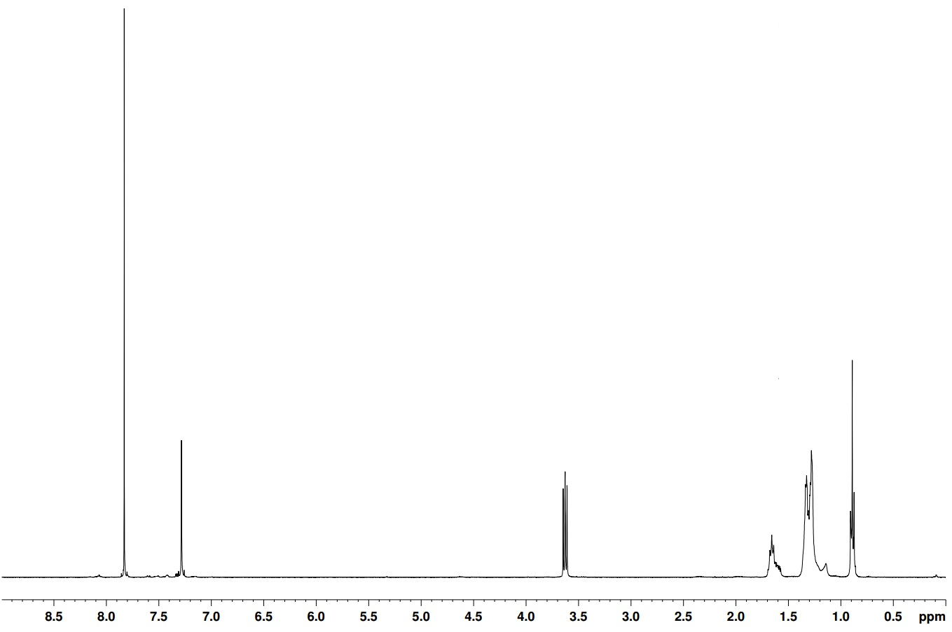
¹H NMR in CDCl₃ of M6 - 5-octyl-4H-thieno [3,4-c] pyrrole-4,6 (5H) dione
H_{a}
H_{b} H_{c}

H_{c}
H_{c}

H_{d}
H_{c}

H_{f}
H_{c}

H_{e}
H_{c}

H_{i}
H_{c}

H_{j}
H_{c}

H_{g}
H_{c}

H_{h}
H_{c}

H_{h}
H_{c}

H_{a}
H_{e}
H_{c}

H_{d}
H_{c}

H_{c}
H_{c}

H_{b} H_{c}

¹H NMR in CDCl₃ of M8 - 5-hexyl-4H-thieno [3,4-c] pyrrole-4,6 (5H) dione

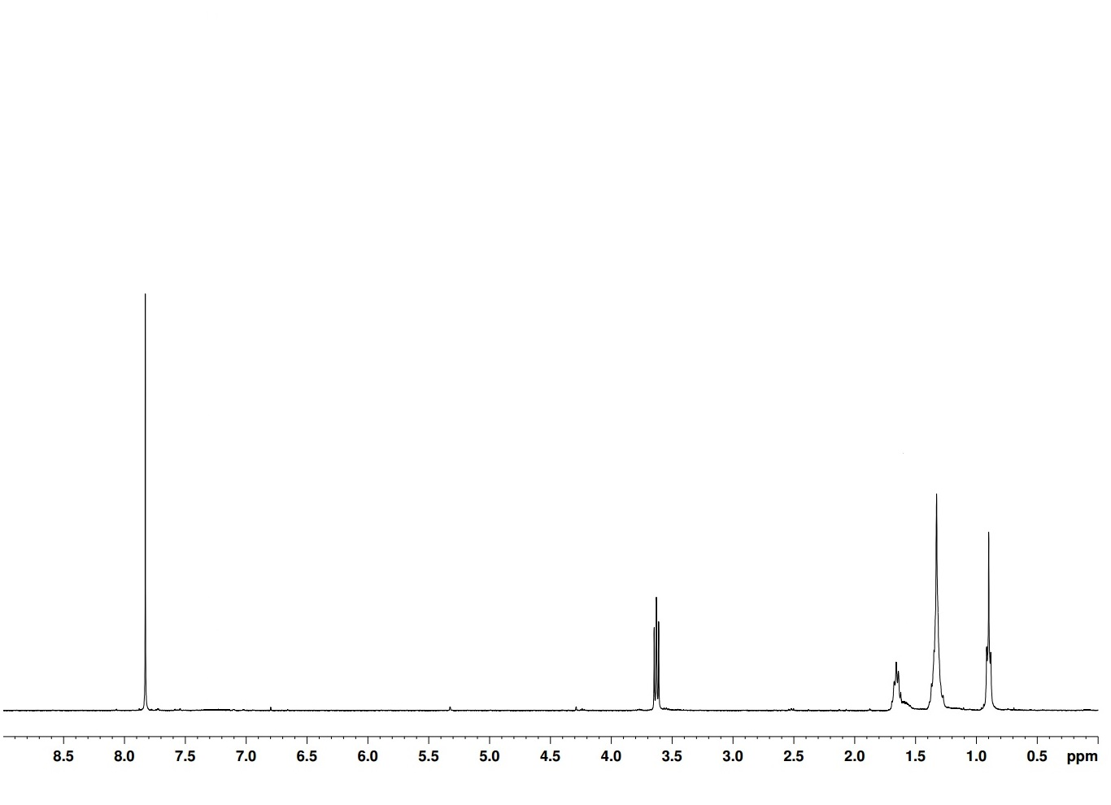
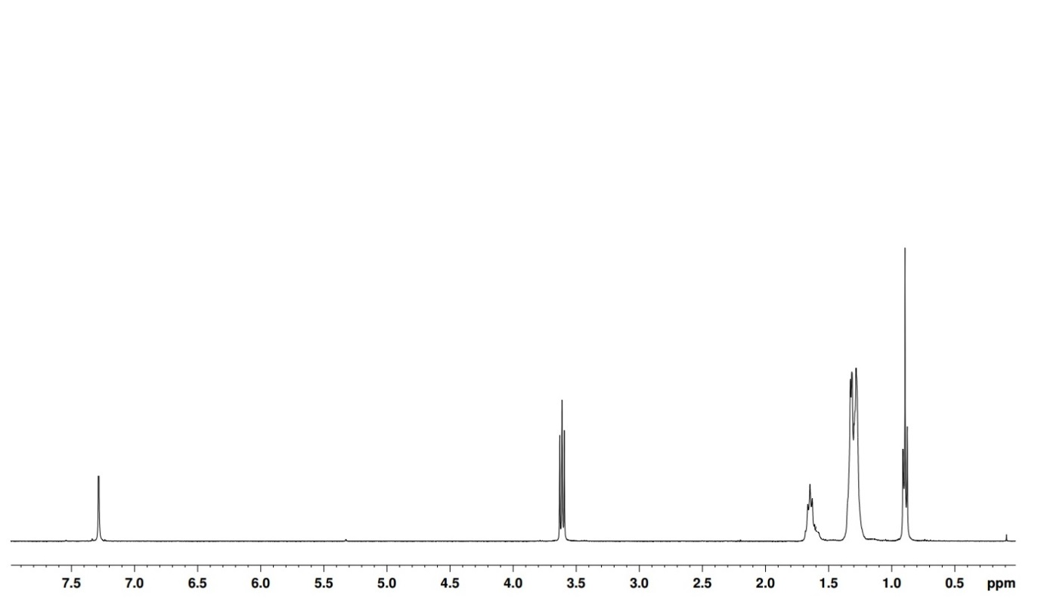
¹H NMR in CDCl₃ of M9 - Dibromo-5-octyl-4H-thieno [3,4-c] pyrrole-4,6 (5H) dione
H_{b} H_{c}

H_{c}
H_{c}

H_{d}
H_{c}

H_{e}
H_{c}

H_{a}
H_{c}
H_{c}

H_{d}
H_{c}

H_{a}
H_{b} H_{c}

¹H NMR in CDCl₃ of M10 - 2, 5-dibromo-3-hexylthiophene
H_{a}
H_{b} H_{c}

H_{c}
H_{c}

H_{d}
H_{c}

H_{e}
H_{c}

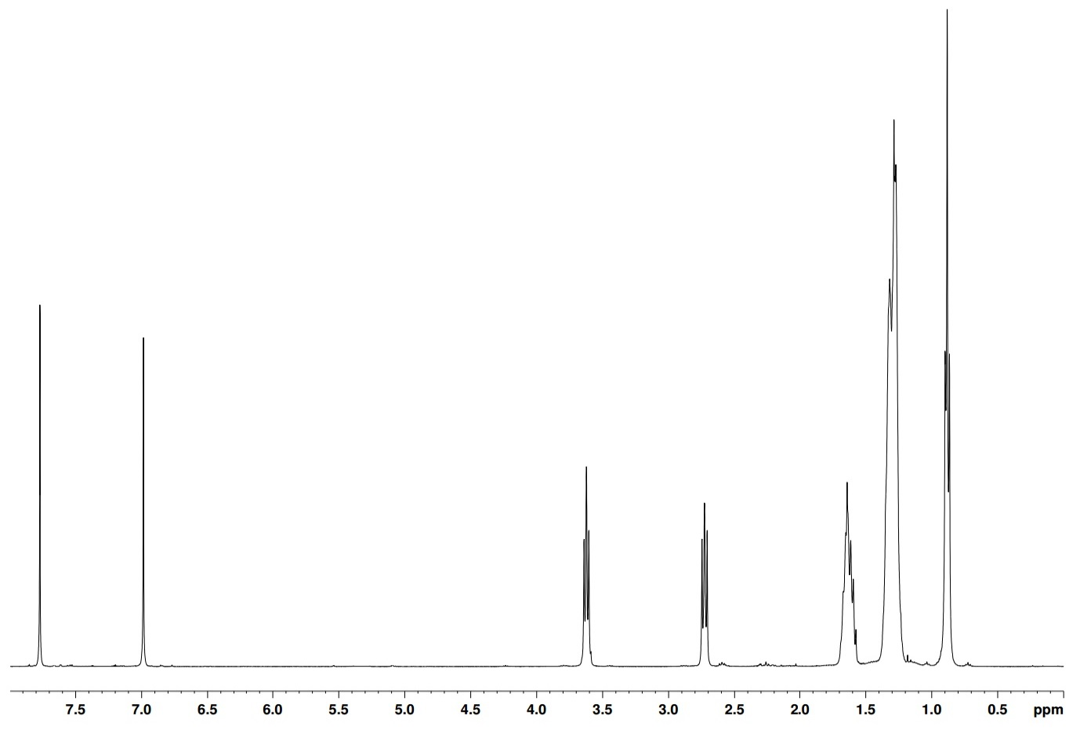
¹H NMR in CDCl₃ of M11 - 3-​Hexyl-​2-​thienyl​-5-bromo-​5-​octyl-4H-​thieno[3,​4-​c]​pyrrole-​4,​6(5H)​-​dione
H_{a}
H_{b} H_{c}

H_{c}
H_{c}

H_{d}
H_{c}

H_{e}
H_{c}

H_{f}
H_{c}

H_{g}
H_{c}

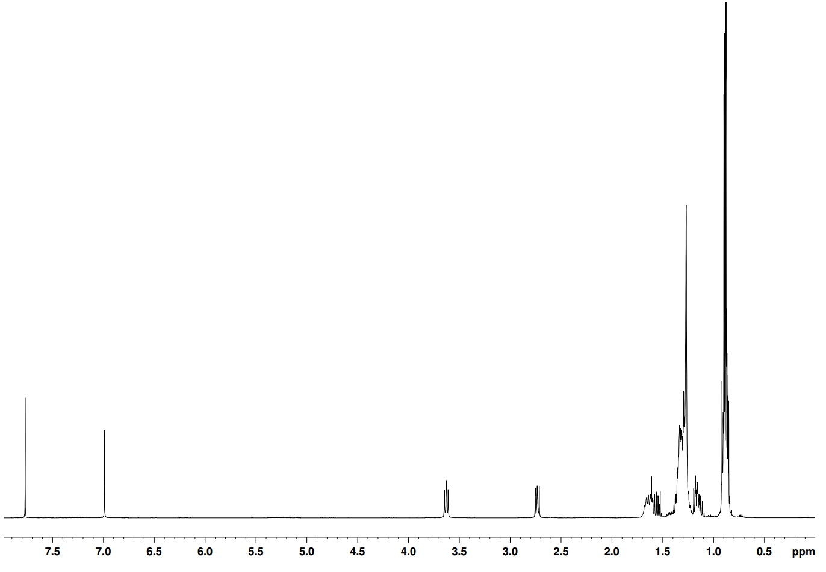
¹H NMR in CDCl₃ of M12 - 3-​Hexyl-​2-​thienyl​-monobromo-​5-​dodecyl-4H-​thieno[3,​4-​c]​pyrrole-​4,​6(5H)​-​dione
H_{a}
H_{b} H_{c}

H_{c}
H_{c}

H_{d}
H_{c}

H_{e}
H_{c}

H_{f}
H_{c}

H_{g}
H_{c}

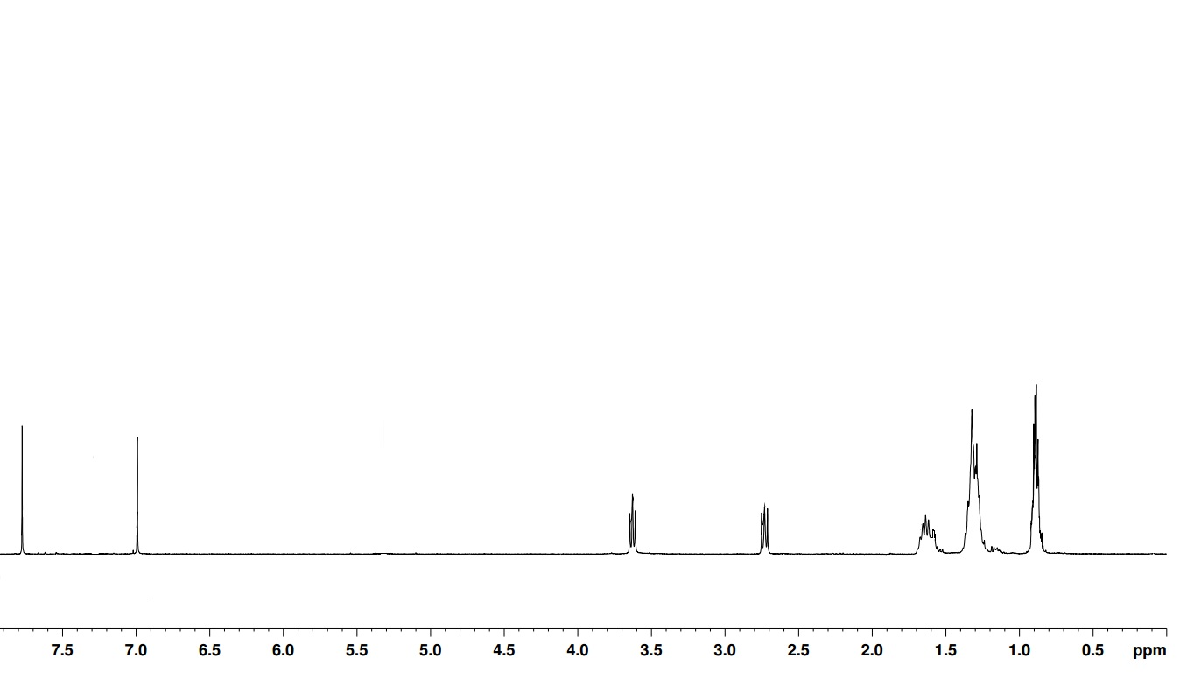
¹H NMR in CDCl₃ of M13 – 3-​Hexyl-​2-​thienyl​-monobromo-​5-​hexyl-4H-​thieno[3,​4-​c]​pyrrole-​4,​6(5H)​-​dione
H_{g}
H_{c}

H_{a}
H_{b} H_{c}

H_{c}
H_{c}

H_{d}
H_{c}

H_{e}
H_{c}

H_{f}
H_{c}

H_{g}
H_{c}

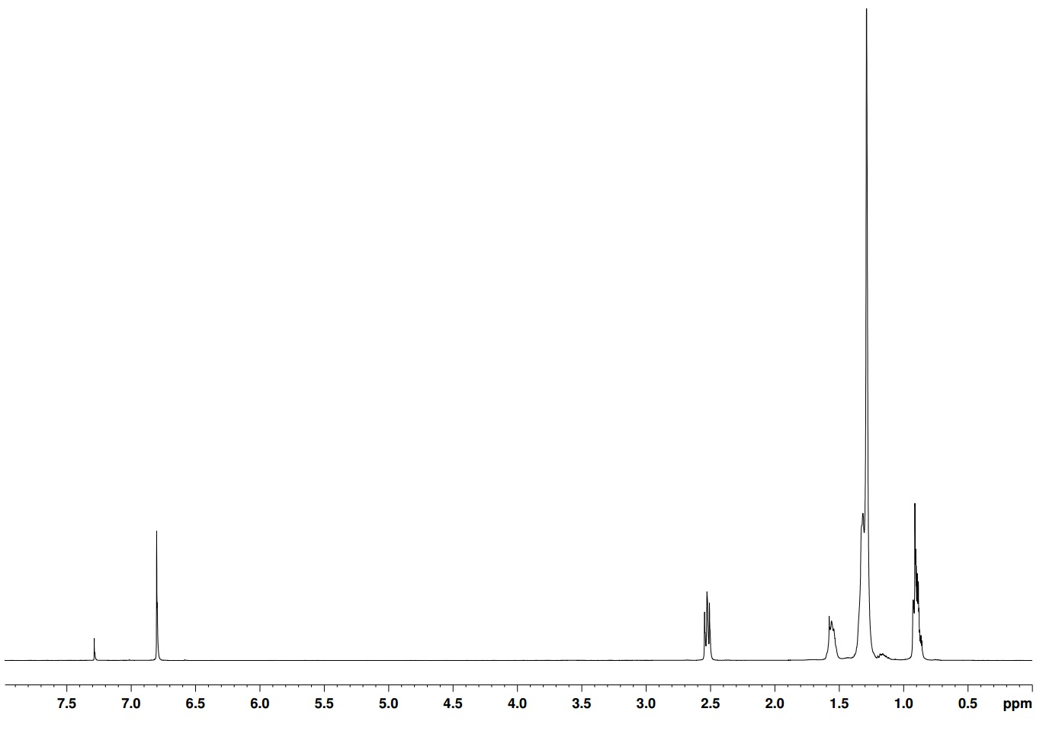
¹H NMR in CDCl₃ of M14 - 2,5-dibromo-3-dodecylthiophene
H_{c}
H_{c}

H_{a}
H_{b} H_{c}

H_{d}
H_{c}

H_{e}
H_{c}

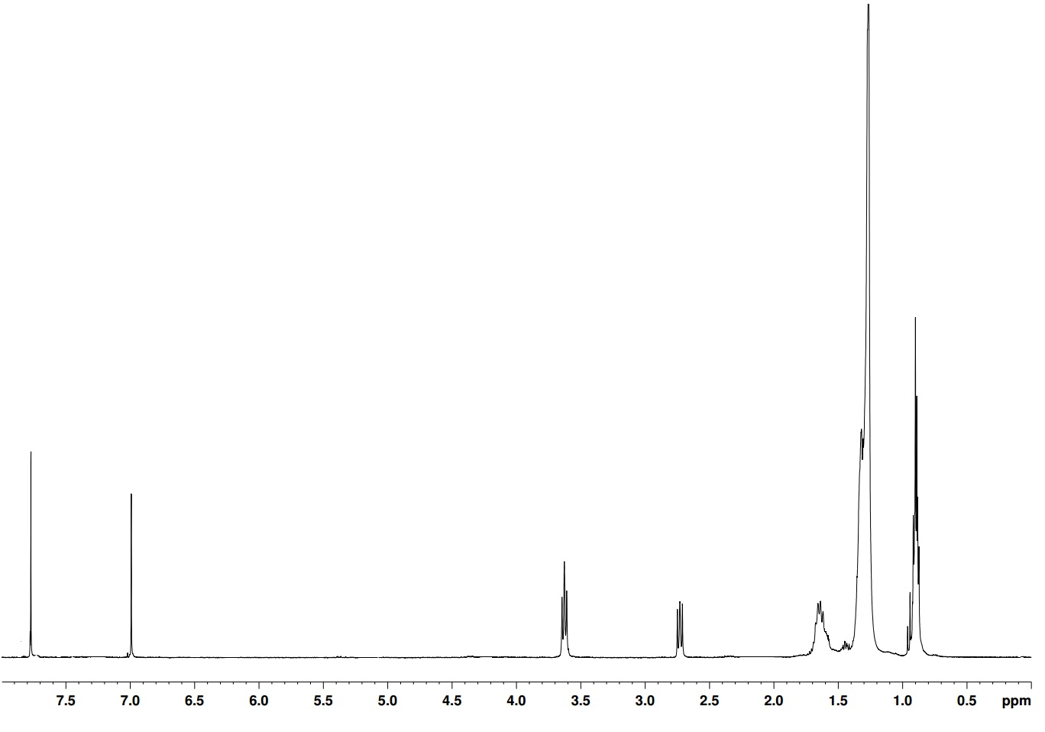
¹H NMR in CDCl₃ of M15 - 3-​dodecyl-​2-​thienyl​-monobromo-​5-​octyl-4H-​thieno[3,​4-​c]​pyrrole-​4,​6(5H)​-​dione
H_{a}
H_{b} H_{c}

H_{c}
H_{c}

H_{d}
H_{c}

H_{e}
H_{c}

H_{f}
H_{c}

H_{g}
H_{c}

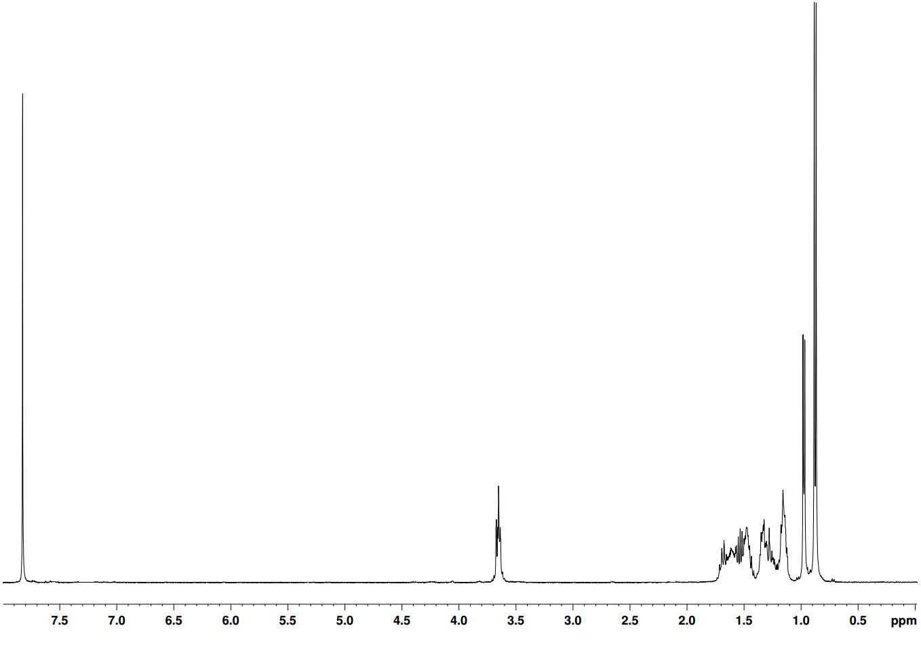
¹H NMR in CDCl₃ of M16 - 5-(3,7-Dimethyloctyl) -4H- thieno [3,4-c] pyrrole-4,6 (5H) dione
H_{a}
H_{b} H_{c}

H_{c}
H_{c}

H_{d}
H_{c}

H_{e}
H_{c}

H_{f}
H_{c}

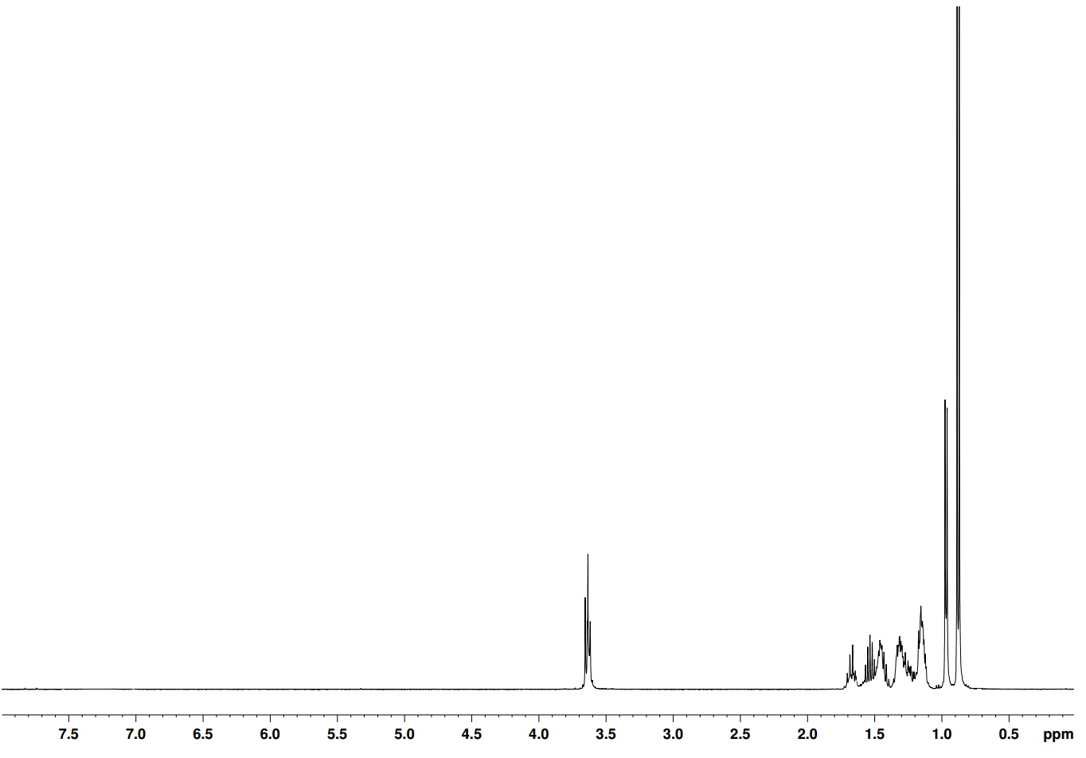
¹H NMR in CDCl₃ of M17 - Dibromo-5-(3,7-Dimethyloctyl) -4H- thieno [3,4-c] pyrrole-4,6 (5H) dione
H_{a}
H_{b} H_{c}

H_{c}
H_{c}

H_{d}
H_{c}

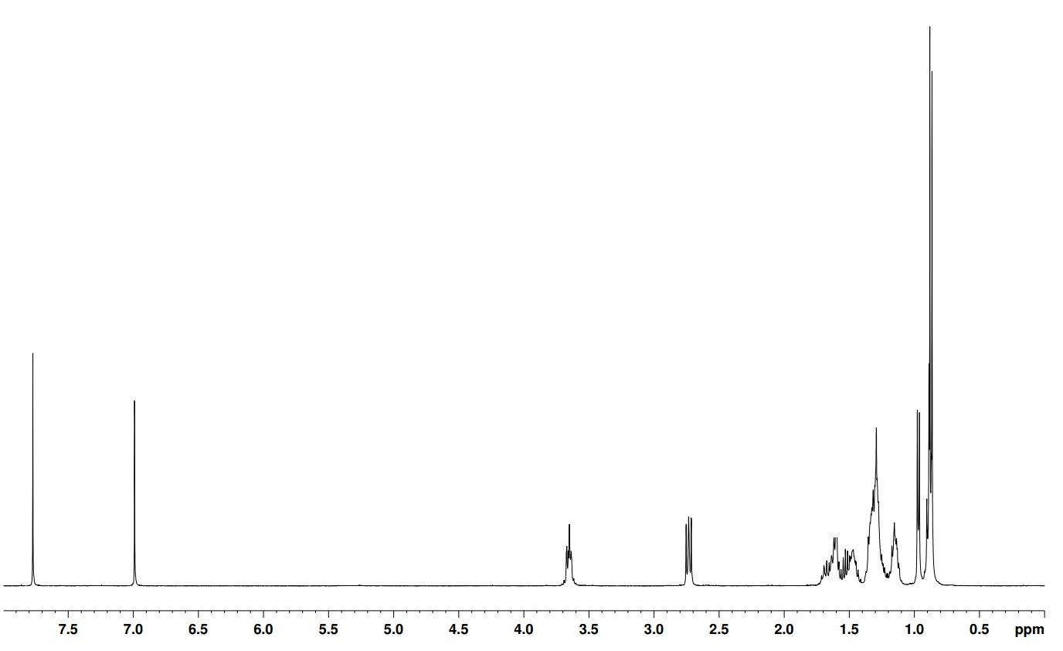
¹H NMR in CDCl₃ of M18 - 3-​Hexyl-​2-​thienyl​-monobromo-​5-(3,7-Dimethyloctyl)-4H-​thieno[3,​4-​c]​pyrrole-​4,​6(5H)​-​dione
H_{a}
H_{b} H_{c}

H_{c}
H_{c}

H_{d}
H_{c}

H_{e}
H_{c}

H_{f}
H_{c}

H_{g}
H_{c}

¹H NMR in CDCl₃ of M19 - 1,​3-​Bis(5-dibromo-3-​hexyl-​2-​thienyl)​-​5-(​3,7-Dimethyloctyl) -4H-​thieno[3,​4-​c]​pyrrole-​4,​6(5H)​-​dione
H_{a}
H_{b} H_{c}

H_{c}
H_{c}

H_{d}
H_{c}

H_{g}
H_{c}

H_{e}
H_{c}

H_{f}
H_{c}

¹H NMR in CDCl₃ of M20 - 5-​(2-​hexyldecyl)​- 4H-​Thieno[3,​4-​c]​pyrrole-​4,​6(5H)​-​dione
H_{a}
H_{c}
H_{c}

H_{e}
H_{c}

H_{b} H_{c}

H_{d}
H_{c}

H_{c}

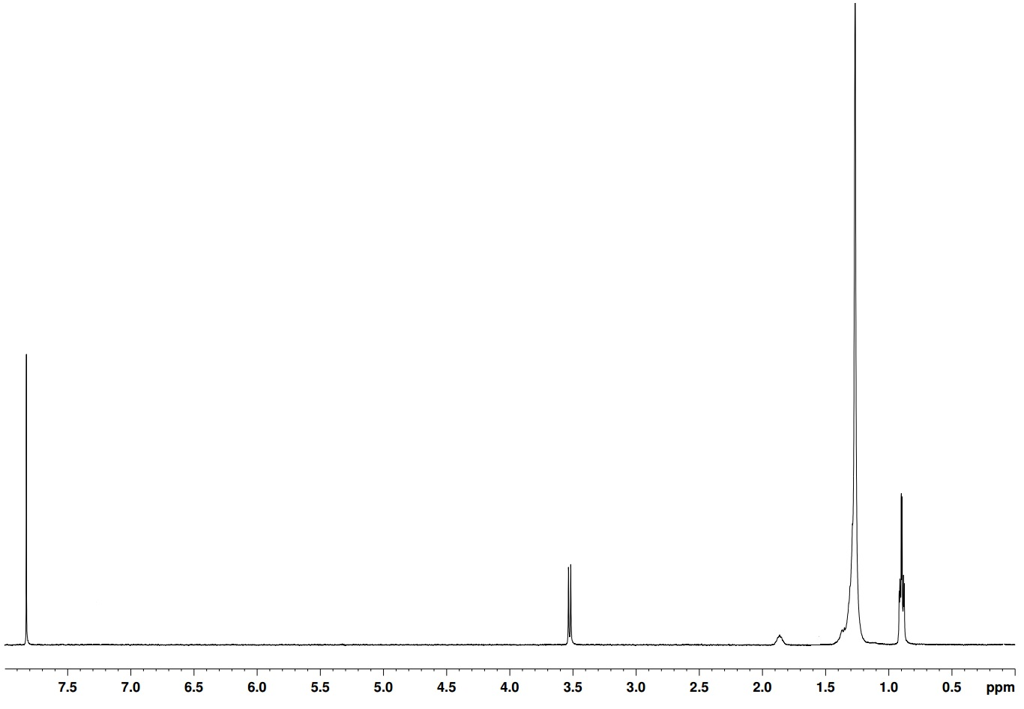
¹H NMR in CDCl₃ of M21 -5-(2-octyldodecyl)- 4H-Thieno[3,4-c]pyrrole-4,6(5H)-dione
H_{b} H_{c}

H_{a}
H_{c}
H_{c}

H_{d}
H_{c}

H_{e}
H_{c}

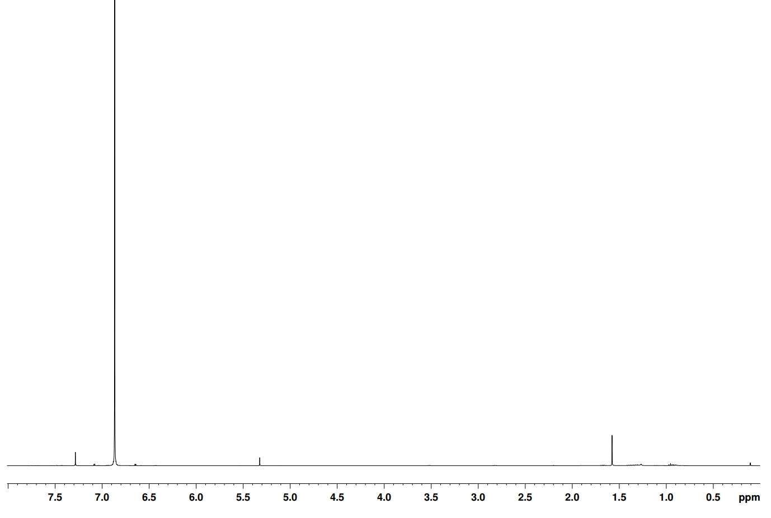
¹H NMR in CDCl₃ of M22 – 2,5-dibromothiophene
H_{a}

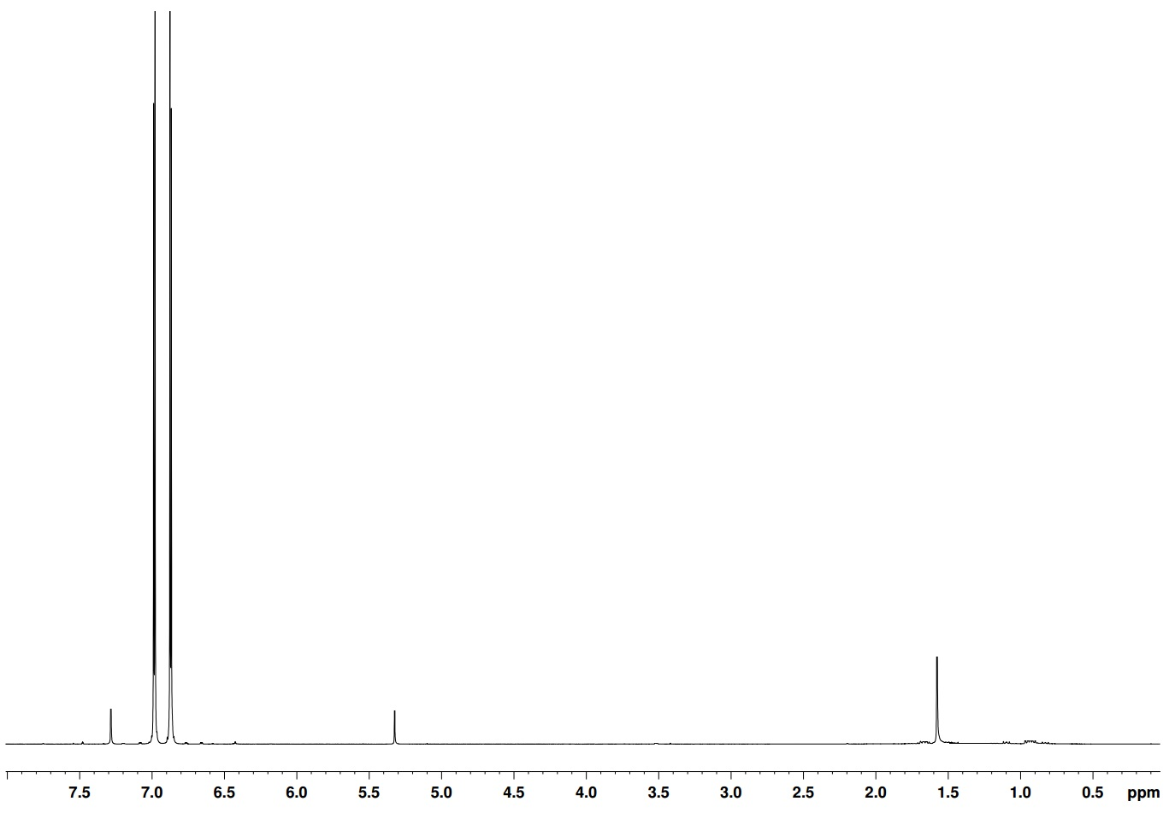
¹H NMR in CDCl₃ of M23 - 5,​5'-​dibromo- 2,​2'-​Bithiophene

¹H NMR in CDCl₃ of M24 - 3-​[2-​(2-​methoxyethoxy)​ethoxy]​-thiophene
H_{a}
H_{b} H_{c}

H_{c}
H_{c}

H_{d}
H_{c}

H_{g}
H_{c}

H_{h}
H_{c}

H_{e}
H_{c}

H_{f}
H_{c}

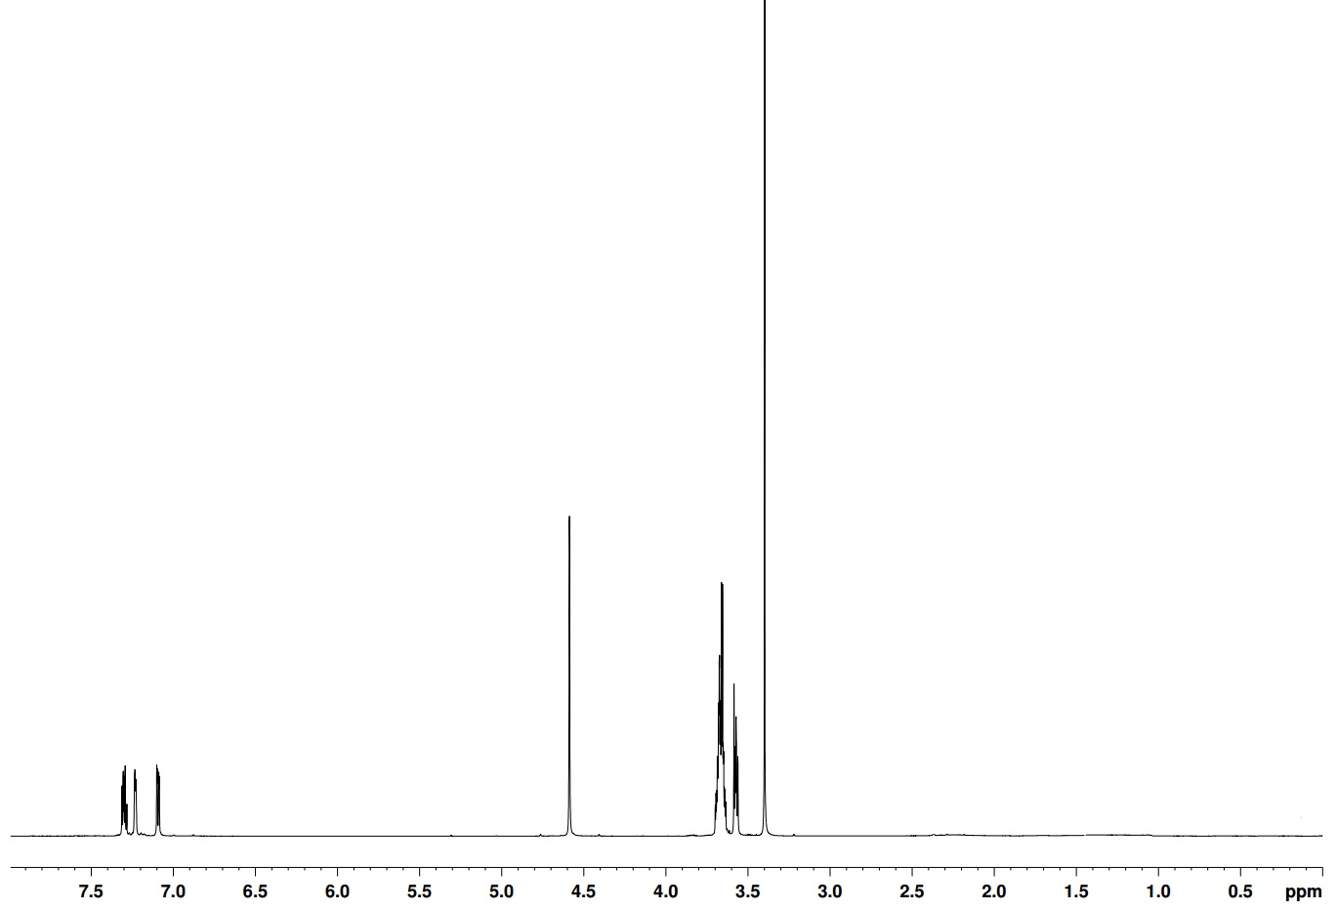
¹H NMR in CDCl₃ of M25 - 3-​[[2-​(2-​methoxyethoxy)​ethoxy]​methyl]​-​thiophene
H_{a}
H_{b} H_{c}

H_{c}
H_{c}

H_{d}
H_{c}

H_{e}
H_{c}

H_{f}
H_{c}

H_{g}
H_{c}

¹H NMR of P5 Poly (3-hexyl-thiophen​yl)​-​5-​​hexyl- 4H-​Thieno[3,​4-​c]​pyrrole-​4,​6(5H)​-​dione

¹H NMR of P6 Poly (3-hexyl-thiophen​yl)​-​5-​octyl​- 4H-​Thieno[3,​4-​c]​pyrrole-​4,​6(5H)​-​dione

¹H NMR of P7 Poly (3-hexyl-thiophen​yl)​-​5-​dodecyl​- 4H-​Thieno[3,​4-​c]​pyrrole-​4,​6(5H)​-​dione

¹H NMR in C₂D₂Cl₄ of Poly[2,7-(9,9-dioctylfluorene)-alt-4,7- bis(thiophen-2-yl)-5,10-naphthothiadiazole (PF8DTNT)
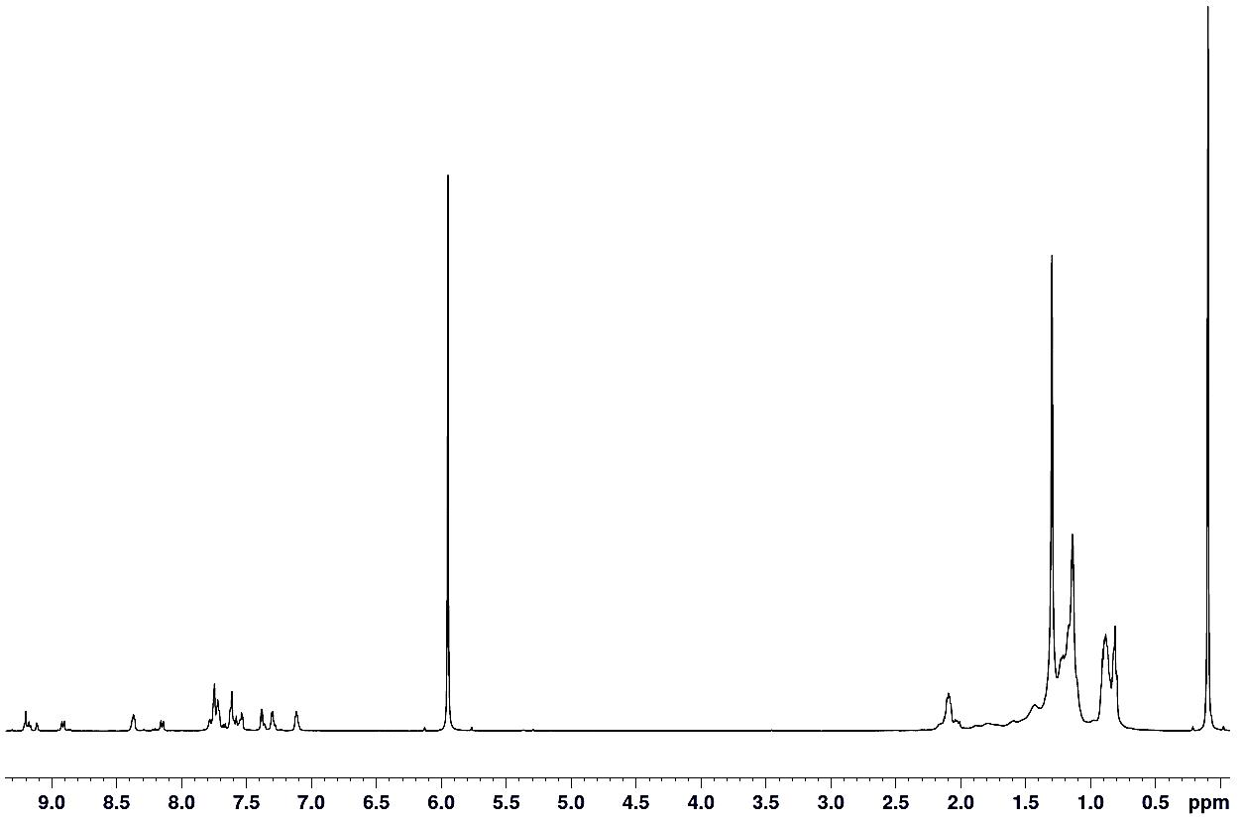
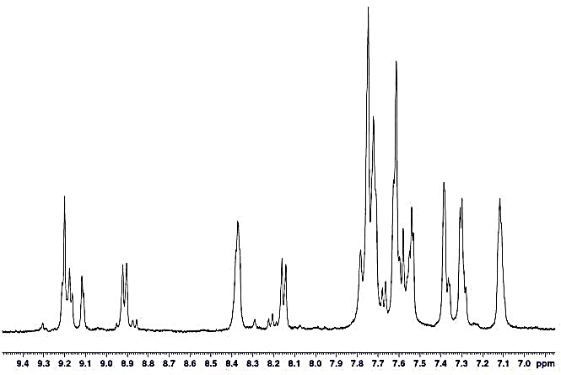
H_{a}
H_{d}
H_{c}

H_{b} H_{c}

H_{c}
H_{c}

H_{e}
H_{c}

H_{f}
H_{c}

H_{g}
H_{c}

¹H NMR in C₂D₂Cl₄ of Poly[2,7-(9,9-didodecylfluorene)-alt-4,7- bis(thiophen-2-yl)-5,10-naphthothiadiazole (PF12DTNT)
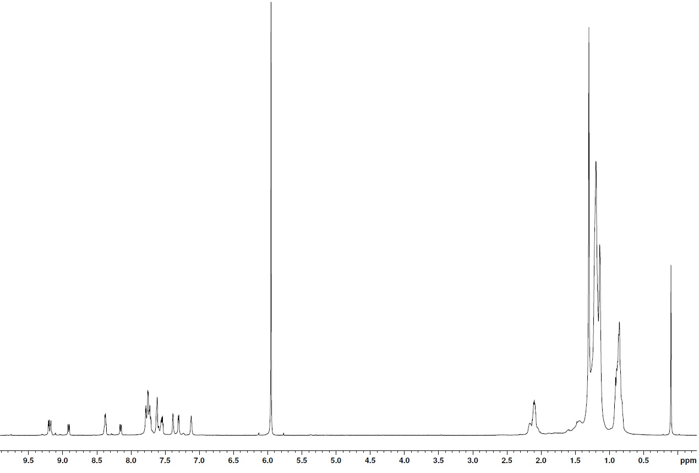
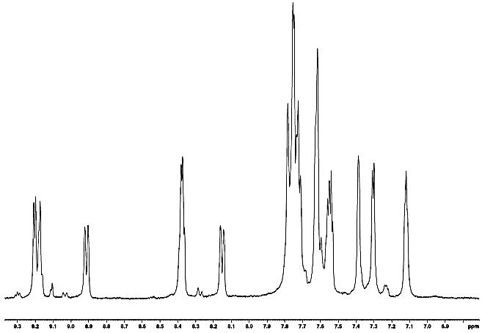
H_{a}
H_{d}
H_{c}

H_{b} H_{c}

H_{c}
H_{c}

H_{e}
H_{c}

H_{f}
H_{c}

H_{g}
H_{c}

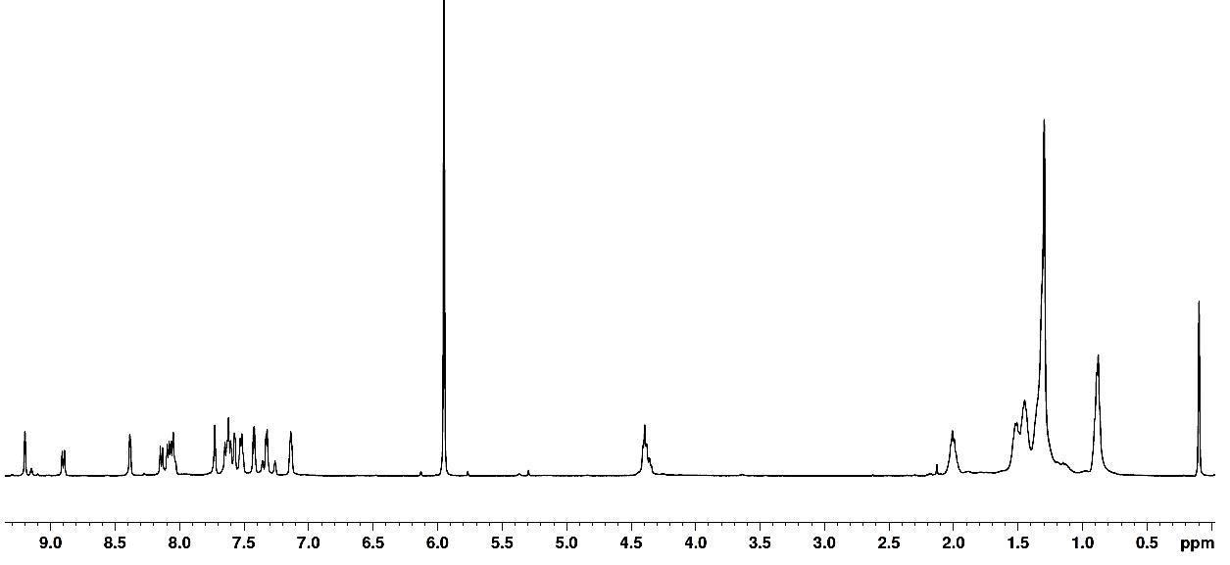
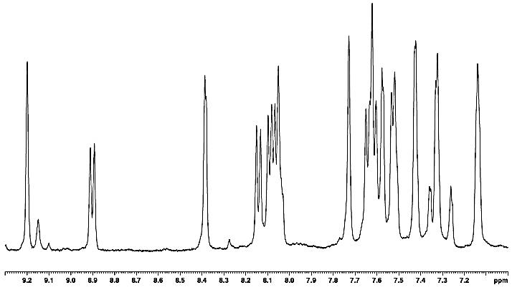
¹H NMR in C₂D₂Cl₄ of Poly[2,7-(9,9-dioctylcarbazole)-alt-4,7- bis(thiophen-2-yl)-5,10-naphthothiadiazole (PC8DTNT)
H_{b} H_{c}

H_{c}
H_{c}

H_{d}
H_{c}

H_{e}
H_{c}

H_{a}
H_{f}
H_{c}

H_{g}
H_{c}

H_{h}
H_{c}

¹H NMR in C₂D₂Cl₄ of Poly[2,7-(9,9-didodecylcarbazole)-alt-4,7- bis(thiophen-2-yl)-5,10-naphthothiadiazole (PC12DTNT)
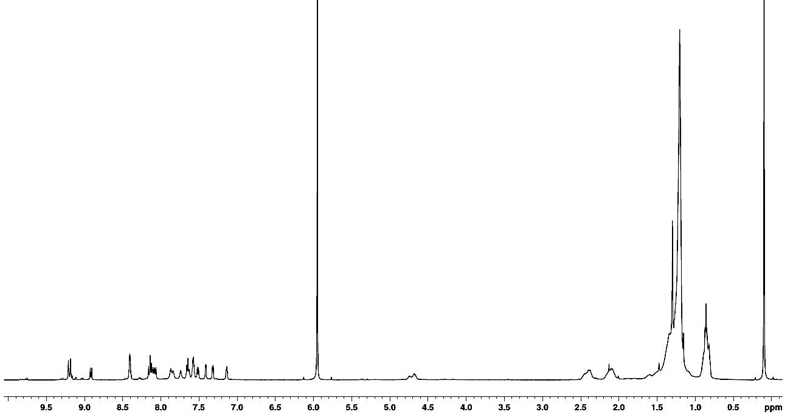
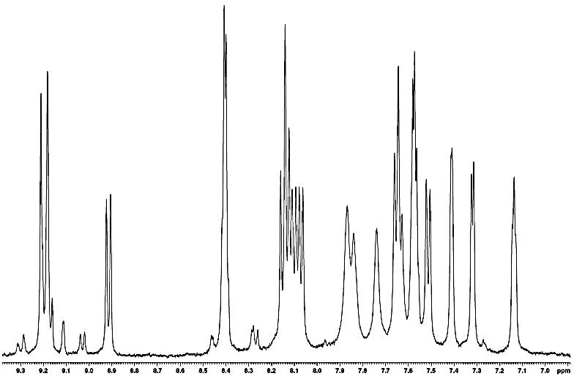
H_{a}
H_{d}
H_{c}

H_{b} H_{c}

H_{c}
H_{c}

H_{e}
H_{c}

H_{f}
H_{c}

H_{g}
H_{c}

H_{h}
H_{c}

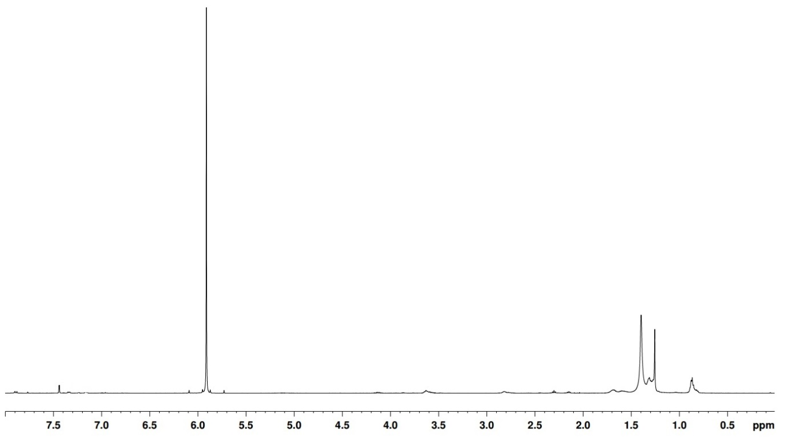
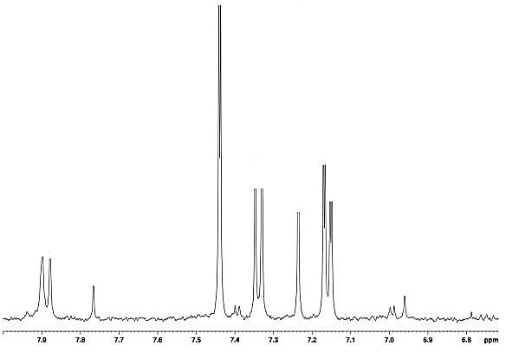
¹H NMR in C₂D₂Cl₄ of Poly (3-hexyl-thiophen​yl)​-​5-hexyl​- 4H-​Thieno[3,​4-​c]​pyrrole-​4,​6(5H)​-​dione PTPD(h)regT(h)
H_{a}
H_{b} H_{c}

H_{c}
H_{c}

H_{d}
H_{c}

H_{e}
H_{c}

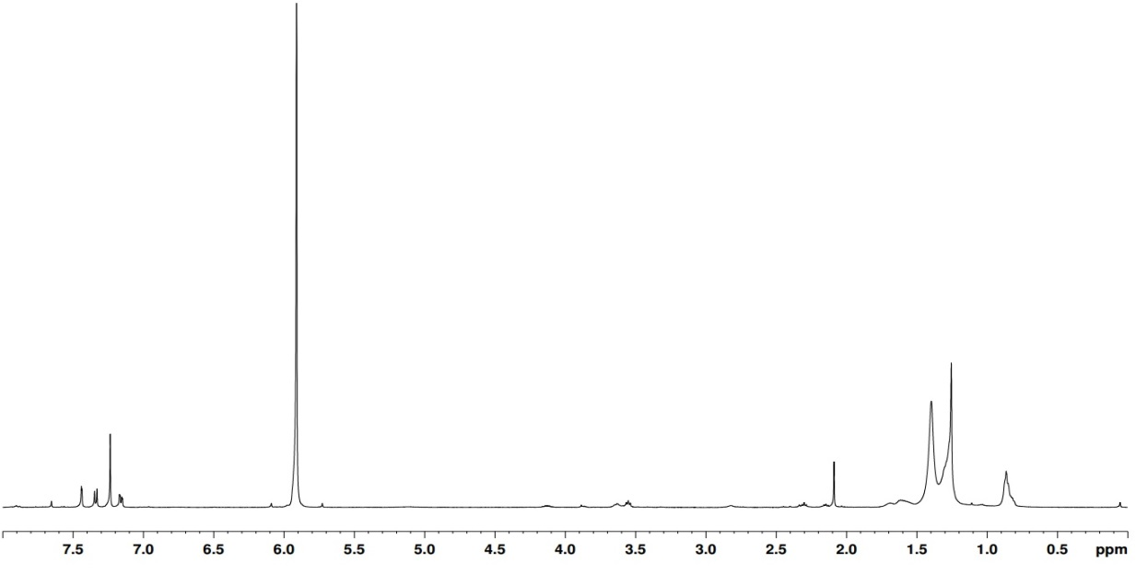
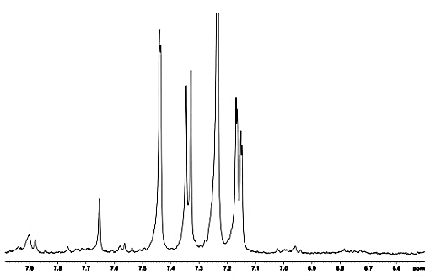
¹H NMR in C₂D₂Cl₄ of Poly (3-hexyl-thiophen​yl)​-​5-octyl​- 4H-​Thieno[3,​4-​c]​pyrrole-​4,​6(5H)​-​dione PTPD(o)regT(h)
H_{a}
H_{b}

H_{c}
H_{c}

H_{d}
H_{c}

H_{e}
H_{c}

¹H NMR in C₂D₂Cl₄ of Poly (3-dodecyl-thiophen​yl)​-​5-octyl​- 4H-​Thieno[3,​4-​c]​pyrrole-​4,​6(5H)​-​dione PTPD(o)regT(d)
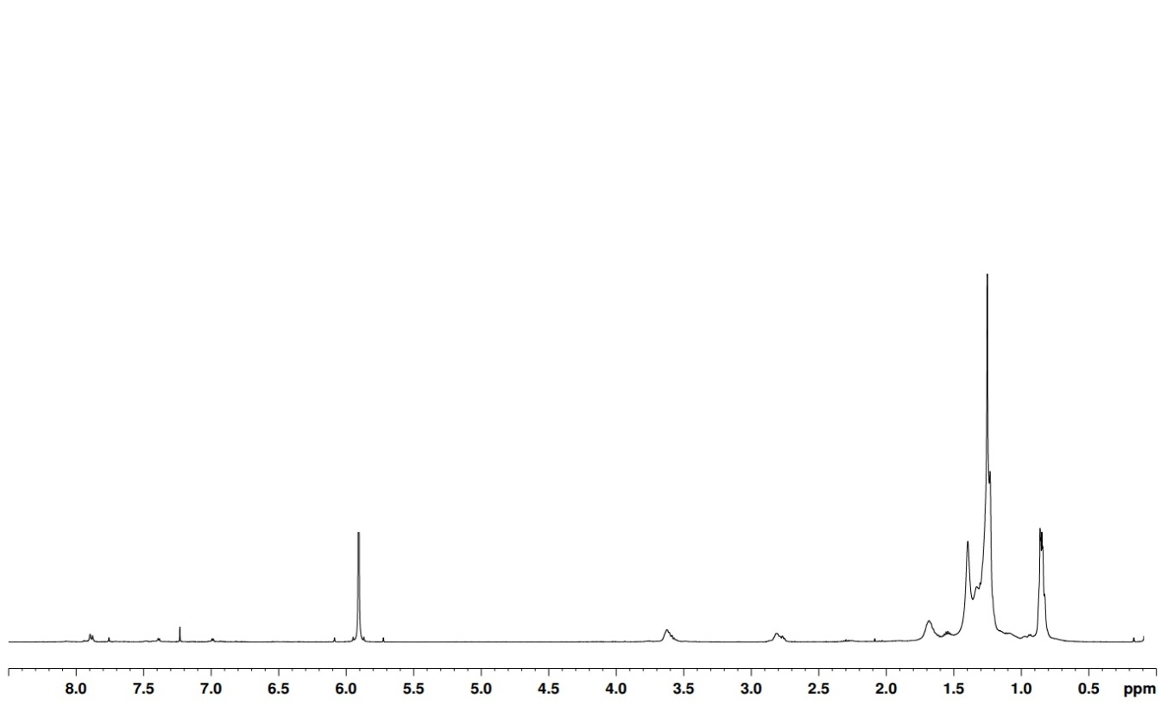
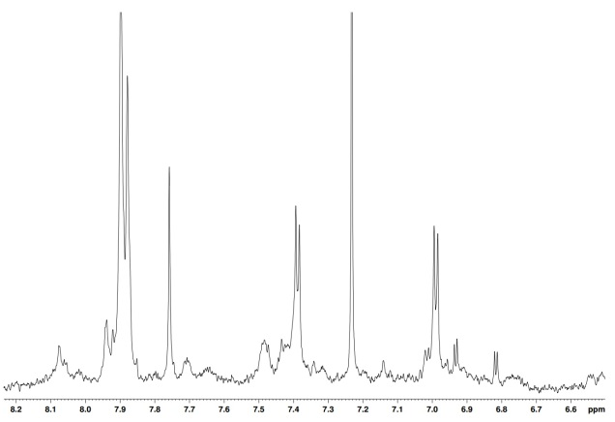
H_{a}
H_{f}
H_{c}

H_{ee}
H_{c}

H_{d}d_{d}
H_{c}

H_{c}
H_{c}

H_{b} H_{c}

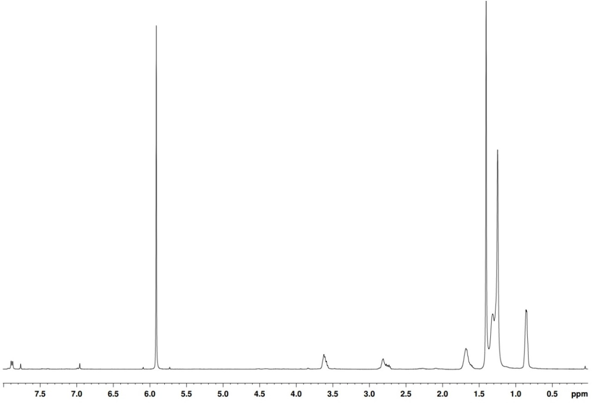
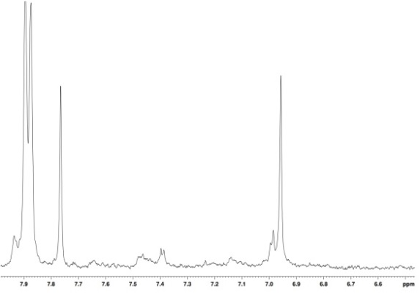
¹H NMR in C₂D₂Cl₄ of Poly (3-hexyl-thiophen​yl)​-​5-dodecyl​- 4H-​Thieno[3,​4-​c]​pyrrole-​4,​6(5H)​-​dione PTPD(d)regT(h)
H_{a}
H_{b} H_{c}

H_{c}
H_{c}

H_{d}
H_{c}

H_{e}
H_{c}

H_{f}
H_{c}

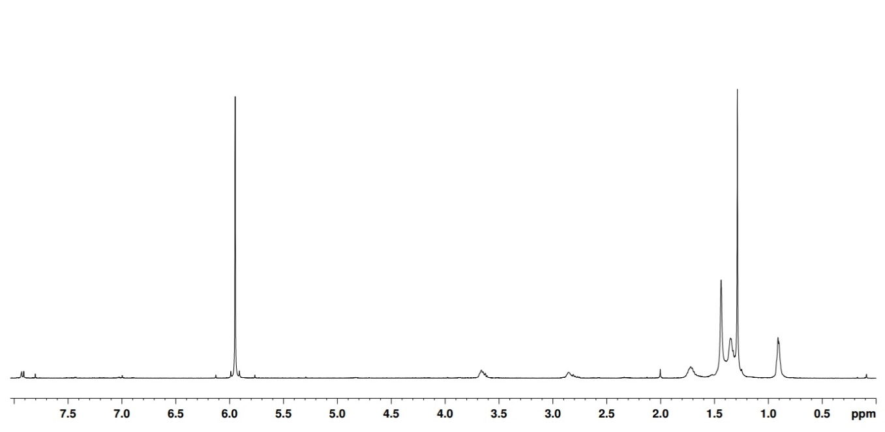
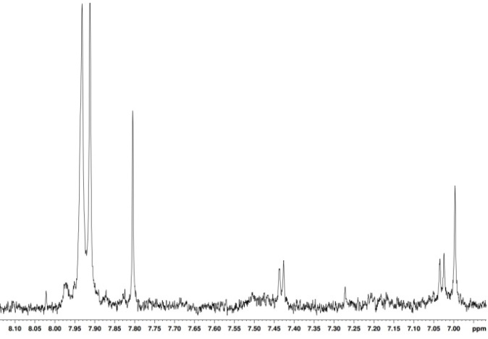
¹H NMR in C₂D₂Cl₄ of Poly (3-hexyl-thiophen​yl)​-​5-(3,7-Dimethyloctyl) ​- 4H-​Thieno[3,​4-​c]​pyrrole-​4,​6(5H)​-​dione PTPD(dmo)regT(h)
H_{a}
H_{b} H_{c}

H_{c}
H_{c}

H_{d}d_{d}
H_{c}

H_{ee}
H_{c}

H_{f}
H_{c}

¹H NMR in C₂D₂Cl₄ of Poly (3-hexyl-thiophen​yl)​-​5-(3,7-Dimethyloctyl) ​- 4H-​Thieno[3,​4-​c]​pyrrole-​4,​6(5H)​-​dione PTPD(dmo)altT(h)
H_{a}
H_{b} H_{c}

H_{c}
H_{c}

H_{d}d_{d}
H_{c}

H_{ee}
H_{c}

H_{f}
H_{c}

H_{g}
H_{c}

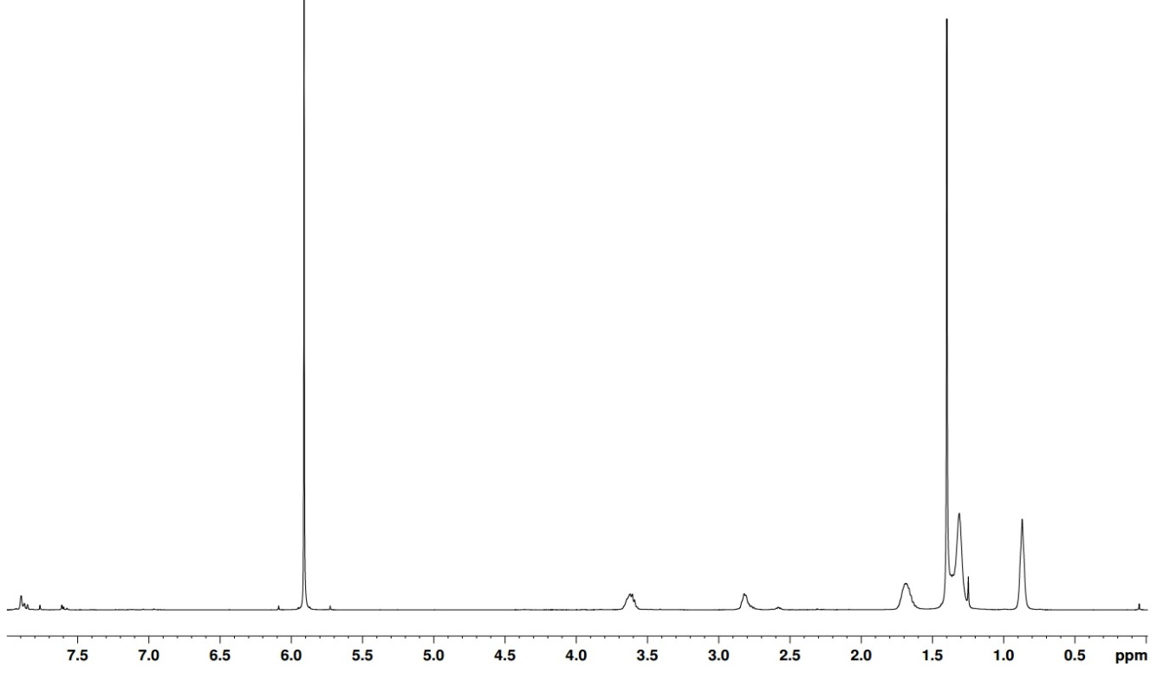
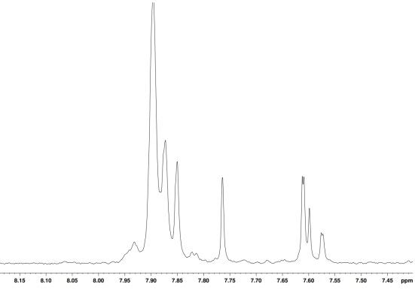
¹H NMR in C₂D₂Cl₄ of Poly (3/4-hexyl-thiophen​yl)​-​5-​​hexyl- 4H-​Thieno[3,​4-​c]​pyrrole-​4,​6(5H)​-​dione PTPD(h)ranT(h)
H_{a}
H_{b} H_{c}

H_{c}
H_{c}

H_{d}d_{d}
H_{c}

H_{ee}
H_{c}

H_{f}
H_{c}

¹H NMR in C₂D₂Cl₄ of Poly (3/4-hexyl-thiophen​yl)​-​5-​octyl​- 4H-​Thieno[3,​4-​c]​pyrrole-​4,​6(5H)​-​dione PTPD(o)ranT(h)
H_{a}
H_{b} H_{c}

H_{c}
H_{c}

H_{d}d_{d}
H_{c}

H_{ee}
H_{c}

H_{f}
H_{c}

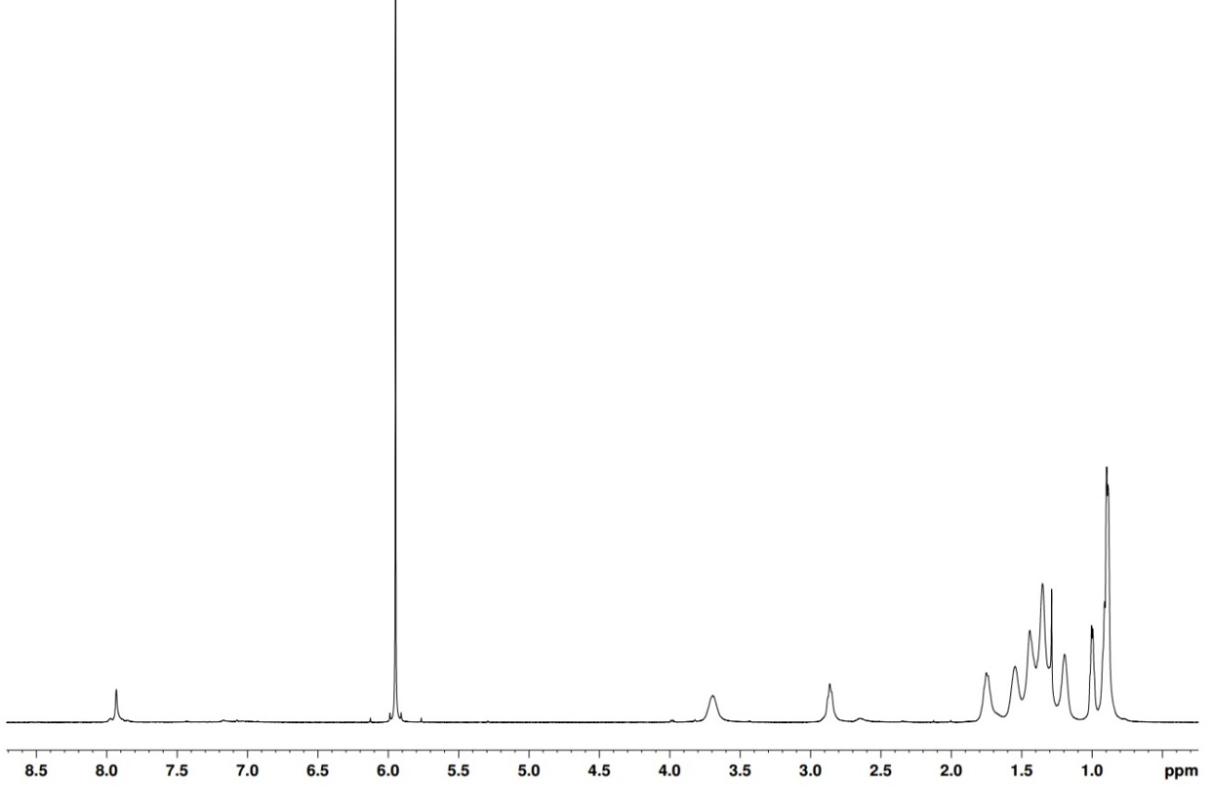
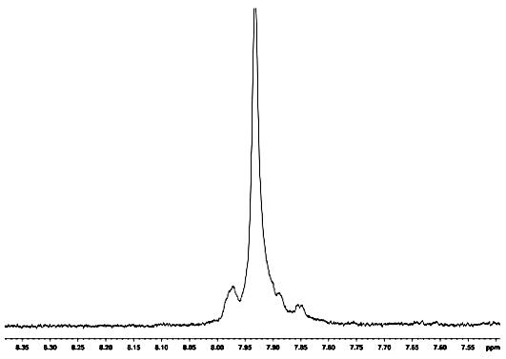
¹H NMR in C₂D₂Cl₄ of Poly (3/4-hexyl-thiophen​yl)​-​5-​dodecyl​- 4H-​Thieno[3,​4-​c]​pyrrole-​4,​6(5H)​-​dione PTPD(dmo)ranT(h)
H_{a}
H_{b} H_{c}

H_{c}
H_{c}

H_{d}d_{d}
H_{c}

H_{ee}
H_{c}

H_{f}
H_{c}

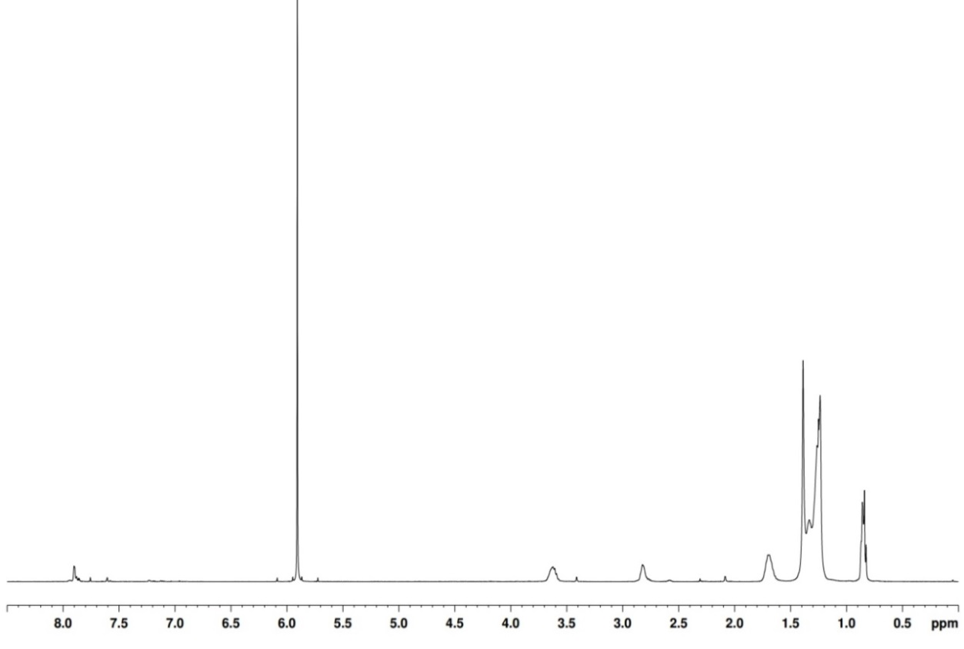
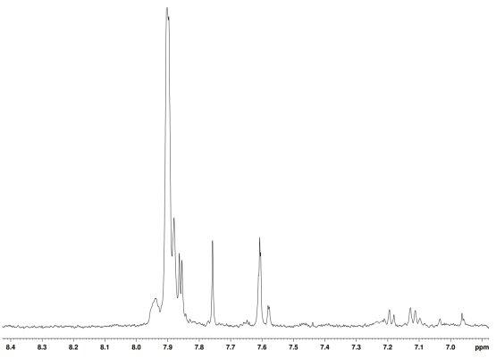
¹H NMR in C₂D₂Cl₄ of Poly (3/4-dodecyl-thiophen​yl)​-​5-octyl​- 4H-​Thieno[3,​4-​c]​pyrrole-​4,​6(5H)​-​dione PTPD(o)ranT(d)
H_{a}
H_{b} H_{c}

H_{c}
H_{c}

H_{d}d_{d}
H_{c}

H_{ee}
H_{c}

H_{f}
H_{c}

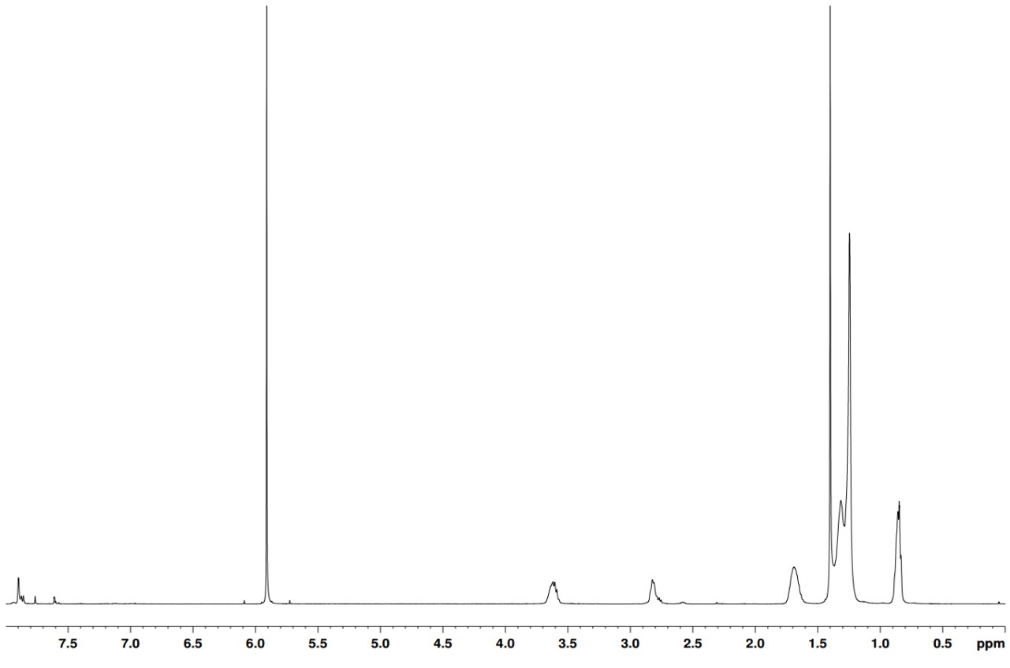
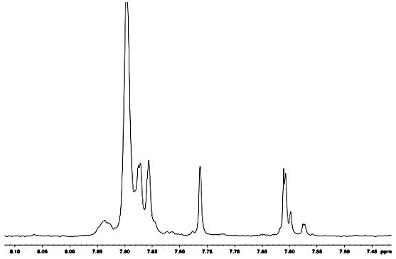
¹H NMR in C₂D₂Cl₄ of Poly (3/4-hexyl-thiophen​yl)​-​5-(3,7-Dimethyloctyl) ​- 4H-​Thieno[3,​4-​c]​pyrrole-​4,​6(5H)​-​dione PTPD(d)ranT(h)
H_{a}
H_{b} H_{c}

H_{c}
H_{c}

H_{d}d_{d}
H_{c}

H_{ee}
H_{c}

H_{f}
H_{c}

¹H NMR in C₂D₂Cl₄ of Poly (3-[[2-(2-Methoxyethoxy)ethoxy]methyl]-)​-​5-octyl​- 4H-​Thieno[3,​4-​c]​pyrrole-​4,​6(5H)​-​dione PT(oxy)TPD(dmo)
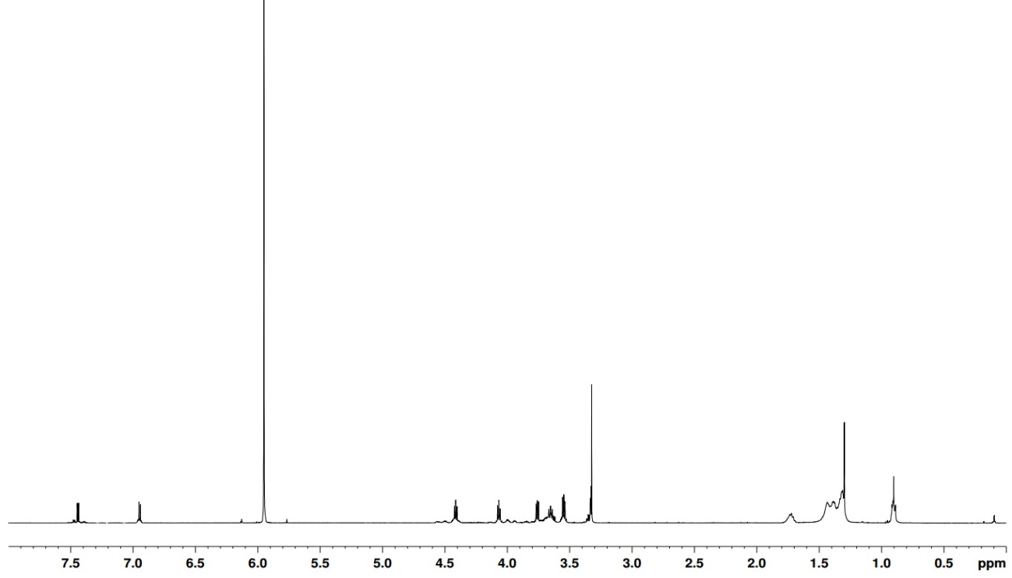

H_{f}
H_{c}

H_{g}
H_{c}

H_{i}
H_{c}

H_{j}
H_{c}

H_{a}

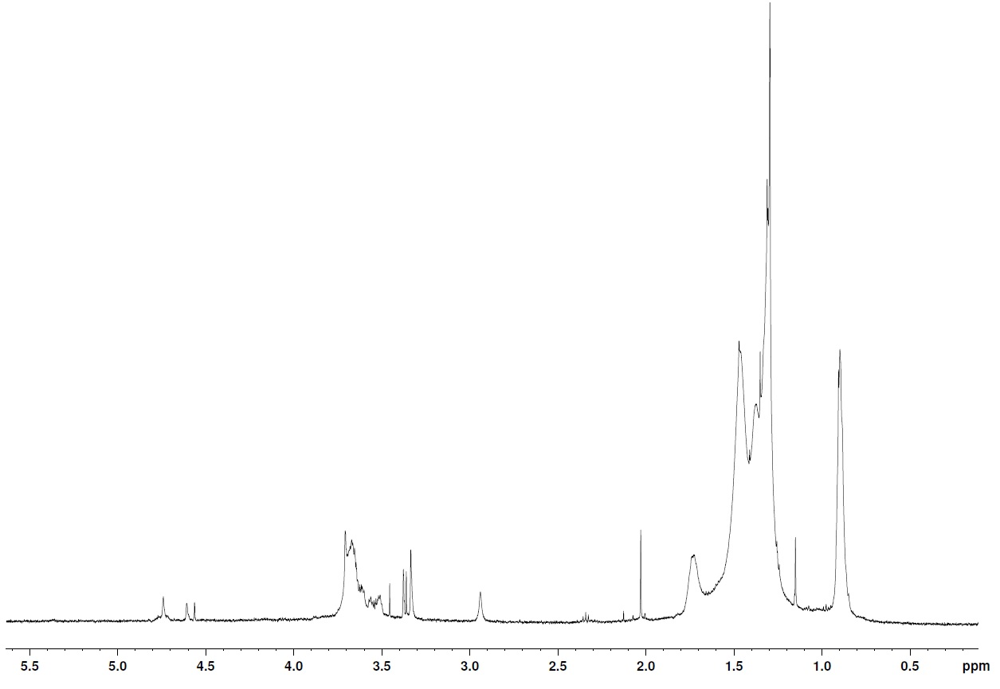
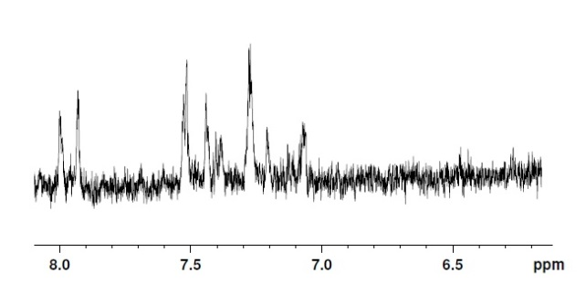
¹H NMR in C₂D₂Cl₄ of Poly (3-[[2-(2-methoxyethoxy)ethoxy]methyl]-)​-​5-octyl​- 4H-​Thieno[3,​4-​c]​pyrrole-​4,​6(5H)​-​dione PT(oxy)TPD(dmo) PT(met)TPD(dmo)

