“I know I don’t read enough or even pick up a book in the baby room sometimes”: Early Years Teacher Trainees’ perceptions and beliefs about reading with under-threes

Karen Marie Boardman

Submitted in partial fulfilment of the requirements for the
Degree of Doctor of Education

April 2017

The University of Sheffield
Faculty of Social Sciences
School of Education

Abstract

This thesis investigates how Early Years Teacher Trainees (EYTTs) support under-threes with early reading development within their daily provision. It also explores their experiences, views, perceptions and challenges of early reading. Many years, of research into the practice and pedagogy of early reading has led to copious contentious debates and reviews (Johnston and Watson, 2005; Rose Review, 2006; Wyse and Goswami, 2008; Goouch and Lambirth, 2011), resulting in an unnecessary and imperious policy investment in Systematic Synthetic Phonics (SSP) to teach reading in schools. This study suggests that this policy agenda not only influences EYTT’s views and beliefs about early reading, but also their practice with under-threes.

This thesis reports the findings of a mixed methods study, which aims to explore the experiences and practices of EYTTs. Phase one consisted of a survey to understand the experiences of practitioners working with under-threes. This was followed by the second phase, which involved five qualitative interviews, two focus group workshops and Zine data to clarify and refine the earlier quantitative results, as well as to explore the practitioners’ views and experiences in more depth (Creswell, 2005).

This study stresses the urgent need to support Early Years Teachers in understanding that babies must have access to high quality books and regular shared stories as part of their daily routine. Findings from this study indicate that the emphasis on school readiness (Moss, 2013) within the EYTS training is influencing practitioner’s perceptions of early reading and as such, practitioners may be failing to provide under-threes with the resources, activities and experiences needed to encourage children to engage with reading.

Acknowledgements

I would firstly like to thank the research participants and settings for engaging in the research activities with such passion and enthusiasm, when at times this was ‘new territory’ for some of them.

I would like to express my utmost appreciation and heartfelt thanks to my supervisor, Dr Rachael Levy, who has been my inspiration throughout the
EdD programme of study.

Thank you also to my EdD colleagues and my work colleagues.

A heartfelt thank you to all my family and friends for your support and encouragement. Special acknowledgements to my dad, my husband, my sister and my two sons, Tom and Jack, who sustained this passion for early reading.
This thesis is dedicated to my Grandson Tommy, and Lucy and Lily.

Table of Contents

Abstract 2
Acknowledgements 3
Table of Contents 4
Abbreviations 6
Chapter 1 7
1.0. Setting the scene 7
1.1. Aims of the research study 10
1.2. Research focus 12
1.3. Experiences of early years teacher trainees: A rationale 14
1.4. Contribution to the field of study 18
1.5. Structure of the thesis 19
Chapter 2 21
Review of the literature 21
2.0. Introduction 21
2.1. Quality practice and provision 25
2.2. Beginning with literacy 30
2.3. What is early reading? 34
2.4. The controversy of early reading and phonics 40
Figure 2.1: ECEC policy documents relating to ‘phonics’ 43
2.5. Perceptions of ‘reading’ for under-threes 44
2.6. Literacy through playful interactions 49
2.7. Tuning into babies: the established links between language acquisition and early reading 52
2.8. Creating literacy environments for under-threes 55
2.8.1. Babies need books 58
2.9. Early Years Teacher Status 61
2.10. Summary 66
Chapter 3 68
Methodology 68
3.0. Introduction 68
3.1. Positionality 69
3.2. Research paradigm 70
3.3. Research design 73
Figure 3.1: Data collection 73
Figure 3.2: Research design 74
3.4. The participants 75
3.5. Main respondent ‘Pen Portraits’ 77
3.6. Ethical considerations 79
3.7. Methods 80
Figure 3.3: Sample survey questions 82
Figure 3.4: Sample interview questions 84
3.8. Data Analysis 85
3.8.1. Survey questionnaire (Appendix O) 88
Figure 3.5: Initial coding frame ‘Survey’ 89
Figure 3.6: Reviewing and defining themes 89
3.8.2. Practitioner interviews 90
Figure 3.7: Initial coding frame ‘Interviews’ 90
Figure 3.8: Overview of interview participants 91
3.8.3. Focus group workshops 92
Figure 3.9: Overview of focus group workshop participants 92
3.8.4. Zines 93
Figure 3.10: Overview of Zine participants 94
3.9. NVivo data; exploration of the themes 94
Figure 3.11: Overview of NVivo text word search query 94
3.10. Reliability, validity and credibility of the data analysis 95
3.11. Limitations of the research 97
3.12. Summary 98
Chapter 4 99
The complexities of early reading with under-threes: 99
Presenting the data 99
4.0. Introduction 99
4.1. Theme 1: Accessible early reading environment for babies 100
4.2. Theme 2: Defining and understanding early reading in practice 120
Figure 4.1: Photograph of one of the definitions crafted by the participants 125
Figure 4.2: Toddler alphabet Post-it wall 143
4.3. Theme 3: Perceptions of confidence in practice 148
4.4. Theme 4: Support for early reading 155
4.5. Summary 159
Chapter 5 162
The experiences and challenges of supporting under-threes with early reading: Discussion and analysis 162
5.0. Introduction 162
5.1. How do EYTTs support very young children with early reading? 162
5.1.1. Understanding early reading: “The children are very young and not ready to read” 163
5.1.2. “The books are in the cupboard or on the shelf and staff get them out at various times” 166
5.1.3. “Too busy to read” 168
5.1.4. “We do letters and sound activities” 169
5.2. What are Early Years Teacher Trainee’s views and beliefs about reading and how does this influence their practice with under-threes? 171
5.2.1. “It’s easier with toddlers and older children”: the notion of feedback 171
5.2.2. “I know I don’t read enough or even pick up a book in the baby room sometimes” 172
5.3. What are the experiences and challenges of EYTTs in supporting very young children with early reading? 174
5.4. What influences EYTT’s practice in the settings in encouraging children’s development in reading? 176
5.5. What are the implications of this for the training of EYTs? 176
5.6. Summary 179
Chapter 6 180
Conclusion and recommendations 180
6.0. Introduction 180
6.1. Methodology insights 181
6.2. Summary of the key findings 183
6.3. Suggested recommendations 186
Recommendation 1: Babies need access to books and print daily 186
Recommendation 2: Early reading is everything ‘everyday’ 186
Recommendation 3: No phonics for under-threes! 186
Recommendation 4: Definition of early reading for under-threes 187
Recommendation 5: Under-threes do not need to be ‘school-ready’ 187
Recommendation 6: Review digital literacies pedagogy and provision for under-threes 188
Recommendation 7: Conduct further research on early reading practices with under-threes 188
Recommendation 8: Review and enhance the EYTS training content 189
6.4. My contribution to the research field 189
6.5. Dissemination, impact and future plans 190
Thesis References 192
Appendix A: Ethical Application 222
Appendix B: Ethical Approval Letter 223
Appendix C: Participant Information Sheet 224
Appendix D: Survey Consent Form 229
Appendix E: Survey Data Babies 230
Appendix F: Survey Data Toddlers 231
Appendix G: Survey Data 2-year-olds 232
Appendix H: Sample Focus Group Transcript 233
Appendix I: Sample Interview Transcript 239
Appendix J: Sample Zine Entries 240
Appendix K: SPSS Statistical ‘Participant’ Data 242
Appendix L: NVivo Text Query Results 244
Appendix M: Interview Questions 245
Appendix N: Final Coding Map 246
Appendix 0: Survey Questionnaire 247
Appendix P: Survey Responses (PDF and Screenshots) 249

Abbreviations

EYTS EARLY YEARS TEACHER STATUS
EYITT EARLY YEARS INITIAL TEACHER TRAINING
EYTT EARLY YEARS TEACHER TRAINEE
EYFS EARLY YEARS FOUNDATION STAGE
EYT EARLY YEARS TEACHER
EYP EARLY YEARS PROFESSIONAL
ECEC EARLY CHILDHOOD EDUCATION AND CARE
ECE EARLY CHILDHOOD EDUCATION
PVI PRIVATE, VOLUNTARY AND INDEPENDENT
PDN PRIVATE DAY NURSERY
QTS QUALIFIED TEACHER STATUS
DFE DEPARTMENT FOR EDUCATION
SSP SYSTEMATIC SYNTHETIC PHONICS
L&S LETTERS AND SOUNDS (DFES, 2007)
GEB GRADUATE EMPLOYMENT-BASED
NCTL NATIONAL COLLEGE FOR TEACHING AND LEADERSHIP
NQT NEWLY QUALIFIED TEACHER
ITT INITIAL TEACHER TRAINING

Chapter 1

Introduction

1.0. Setting the scene

My interest in early reading emerged at the beginning of my career in early years (over thirty years ago) within the context of my practical and professional experience. This further developed whilst teaching in nursery and reception classrooms, studying at Masters Level and subsequently at Doctoral Level. I have been influenced by the work of Goodman (1996), Hannon, (2003), Nutbrown et al., (2005) and Rogoff (2003), who have argued that literacy ‘learning’ does not necessarily always begin in educational settings, as this learning and the experiences provided is encouraged and enabled by families from birth. As such, children learn to read in a variety of ways (Clark, 2014; Flewitt, 2013; Hulme and Snowling, 2013; Turbill, 2001). As a Head of Department in a Higher Education Institution (HEI), with the responsibility for delivering and supporting Early Years Teacher Status (EYTS), I have become increasingly concerned that early reading is a concept that is often misunderstood by early years practitioners; causing some confusion about the nature of reading, the importance of book sharing with babies and the role that phonics plays in early reading. I realised that there was an urgent need to find out how Early Years Teacher Trainees (EYTTs) support under-threes with their early reading development.

For this reason, this study was designed to understand the experiences, views and perceptions of EYTTs working with under-threes.

As such, I am immersed in early reading as a research interest as one of the principal areas of my professional work. I acknowledge that it is unachievable to be totally impartial, as my values and beliefs as a practitioner/educator have inevitably affected my approach to this thesis, along with my epistemological and ontological methodology to the exploration and presentation of new knowledge. As Carr (2000) argues, “there can be no telling it as it is – there is only telling it from a theoretically partisan point of view” (p. 441). As such, working in a Higher Education Institution (HEI), I also happen to be in a privileged position of being able to access a range of trainees for this research study. Consequently, as a senior leader in the organisation, I was conscious that my position also potentially shaped the chosen methodology, analysis, interpretation and my positionality, in respect of potential interactions with trainees. Indeed Sikes (2004) suggests, positionality is “usually, the most significant factor that influences choice and use of methodology and procedures” (p. 18) and thus influences the overall research practice. As a result, objectivity is not possible (Sikes, 2004). In this instance, total impartiality is especially difficult, as early reading is such a controversial and evolving issue, inextricably linked to the teaching of phonics and notions of school readiness (Moss, 2013) and influenced by my experiences as an early years educator. I have attempted to be reflexive and at the very least identify potential conflict and concerns as they have arisen throughout the research process, given that Greenbank (2003) proposed that “research methods cannot be value-free” (p. 799). Greenbank (2003) also suggests that researchers should adopt a “reflexive approach” (p. 799) in an attempt to be honest and open about how these values influence the research.

The wider contemporary debate of teaching early reading, which encompasses the importance of providing high quality literacy experiences for very young children (Green et al., 2006; Wood, 2013) to support early reading development, has been interwoven within my professional career and practice. As an early years educator and Local Authority lead teacher for early years, this subsequently became my area of interest, in particular supporting settings in the private, voluntary and independent (PVI) sector. The essential importance and long-lasting benefits of encouraging early literacy experiences for very young children have been widely recognised by many contemporary researchers (Adams, 1990; Howard et al., 2016; Levy, 2009; Melhuish, 2014). It is these early dispositions and attitudes, which Helm and Katz (2011) claim to be of particular influence with regard to children under the age of three years.
This study is interested in understanding how the concept of early reading is perceived and handled in practice by EYTTs. Certainly, part of the rationale for conducting this study was the fact that EYTTs appeared to be drawing on the phonics discourse in their written tasks and practical work with under-threes. As such, an element of this study was designed to investigate how EYTTs perceived reading and what influenced these perceptions.

Phonics is considered an area of controversy; the nature of early reading and phonics instruction being heavily criticised by educationalists and researchers (Lewis and Ellis, 2006; Wyse and Styles, 2007; Wyse and Goswami, 2008). The terminology of phonics is often perceived by many as a ‘dirty’ word; the younger the child, the more offensive this becomes. Current understanding (Levy, 2009; Macrory, 2001; Papadimitriou and Vlachos, 2014) of early language and literacy development (reading and writing) is closely linked to children’s earliest experiences with language, books and stories, but Lindon (2013) and Flewitt, (2013) argue that it does not advocate the teaching of reading (the actual reading or words) to very young children. Given the strong association between reading and phonics, however, as well as with my own anecdotal experience, I am aware that the literacy education of children under the age of three is not isolated from phonics and indeed from some elements of phonics instruction in settings, which is a concern. In order to understand this further, this study is designed to explore and understand practitioners’ perceptions of early reading. I am also interested in discovering if phonics appears within their experiences and responses and if so, what this might mean. Ellis and Moss (2013) propose that “teaching literacy is a complex process, and phonics instruction has a clear part to play in this” (p. 3) - while this is certainly the case for older children, this is highly contentious when it comes to practice with under-threes.

This research study investigates how Graduate Employment-Based (GEB), Early Years Teacher Status (EYTS) trainees support very young children with those essential early reading skills; it “explores their experiences and challenges” (Boardman, 2012a, p. 10), views and perceptions of early reading. The purpose of this research is to share the experiences and narratives of EYTTs everyday work with under-threes. It is important to know how EYTTs perceive their role in supporting under-threes with early reading development to enable future planning and development for working with under-threes, since:
Research that informs us about how babies and toddlers spend their time and who they spend their time with, helps us to understand how to plan for their individual and holistic needs.
(Page, Clare and Nutbrown 2013, p. 14)

  - Aims of the research study

The aim of this research study is to understand the practices, opinions and challenges of a group of EYTTs on the Graduate Employment-Based EYTS training route with a view to informing the field of early years pedagogy and provision. The purpose of this study is to find out how current early years practitioners training to be Early Years Teachers (NCTL, 2015) support the early reading skills of the youngest children in their care in the context of the setting.

The aims of the study are to:

- Explore the provision currently offered to under-threes for early reading development.
- Share the experiences of the EYTTs in supporting under-threes in early years settings (state maintained, private, voluntary and independent settings).
- Consider the rationale for the strategies used to support under-threes.
- Investigate EYTTs understanding of early reading in practice.
- Identify any challenges faced by EYTTs in practice.
- Explore the nature of the support available to EYTTs.
- Analyse the experiences shared to identify common themes.
- Propose recommendations for future practice and further support.

The overarching research question, which I devised for my Assignment 6 Research Proposal (Boardman, 2012a) was:

How do Early Years Teacher Trainees support very young children with early reading?

The following two research questions were later developed, with the intention of gaining a greater understanding of the views of the EYTTs:

What are Early Years Teacher Trainees’ views and beliefs about reading and how does this influence their practice with under-threes?

What are the experiences and challenges of Early Years Teacher Trainees in supporting very young children with early reading?

It is crucial to document the everyday experiences of EYTTs, hence the ‘how’ terminology of the research question. The research question posed as ‘What are the experiences and challenges?’ aims to open the area of investigation to allow for any possible new understandings, interpretations or theories to emerge as exploratory research, as suggested by Denscombe (2010). Consequently, providing EYTTs with the opportunity to reflect upon these experiences and their pedagogy alongside any challenges faced, will offer an essential insight into current provision for early reading with very young children. Similarly, Appleby and Andrews (2011) suggest that reflective practice is a “complex, multi-faceted process which in its most effective form is personalised and owned by practitioners” (p. 57). This is intentional within the overall design of the research study.

The supplementary research questions are:
What influences Early Years Teacher Trainees’ practice in the settings in encouraging children’s development in reading?
What are the implications of this for the training of EYTs?

I will refer to ‘practitioners’ throughout the majority of this study, as the participants were employed practitioners, as well as EYT trainees.

I use the terminology of ‘early reading’ to refer to reading that happens at the very beginning of life, but this terminology does not presume that there is a ‘pre-reading’ stage and then an ‘actual’ reading stage. Early reading is ‘reading’.

  - Research focus

The focus of this research study is specific to the experiences and challenges of the trainees undertaking the part-time Graduate Employment-Based (GEB) Route, as this route is intended for graduates already working in an early years setting (Boardman, 2012a) and as argued by Brooker (2007), conceivably already leading practice and provision in their early years settings. As I have stated in the research proposal, “the rationale for this particular training route is that this cohort of trainees are already experienced practitioners” (Boardman, 2012a, p. 6). Given that early reading is such a contested debate with such “polarised views” in existence (Joliffe et al., 2012, p. ix) and is a concern for practitioners requiring further training (‘NQT Survey’, NCTL, 2014, 2015; Ofsted, 2011; ‘Bristol Online Survey’, 2014, 2015), it seems rational to focus on the experiences of EYTTs in practice, rather than those new to early years education. Subsequently, the Graduate Entry Route or Undergraduate Entry Route has no requirement for experience in early years as entry criterion. As such, it did not seem to be a viable option to ask these trainees to take part in this research. As the new EYTS programme originated in September 2013 and has since been revised for September 2014, this research study provides an exciting and current “contribution to the field of early childhood education” (Boardman, 2012a, p. 15).

I make no judgements on the value of EYTS as a status, or as a comparison to QTS, as this is beyond the scope of this particular research. Yet, in the interest of transparency and reflexivity as advocated by Greenbank (2003), I do critically reflect on quality provision for under-threes and the training of EYTs in the literature review, specifically the training related to early reading. I also engage in analysis and make recommendations for the content of the training for EYTs, again relating to supporting under-threes with early reading, as this is the core of the research.

Significantly, this appears to be an area that has not currently been explored; both the focus on early reading with under-threes and in relation to the experiences of EYTTs. It is anticipated that the findings will increase the body of knowledge about the practice and provision of early reading, through collaboration with the participants (Lassiter, 2005), with some additional explorations or possibilities for future research and impact. Additionally, this field of enquiry is contemporary and still under considerable debate, creating headlines in the media on a regular basis. For example, the BBC news presented the headline ‘Able readers damaged by phonics’ (Richardson, 2014), ‘Nursery World’, which is popular early years practitioner journal in England, claimed ‘Synthetic Phonics damages children’s love of reading’ (Gaunt, 2014) and in the daily newspaper, ‘The Independent’, Furedi (2015) reported ‘The phonics v whole-word battle has always been about politics, not pedagogy’.

Subsequently, Initial Teacher Training (ITT) is also currently under review with the introduction of the ‘Education Excellence Everywhere’ White Paper in March 2016 (DfE, 2016) and the earlier ‘Carter Review’ (DfE, 2015), which may also impact on EYITT training and curriculum content. However, the teaching of reading and phonics will undoubtedly remain a national priority for policy makers. The White Paper suggests that there may be no future place for HEIs in training teachers, yet does not mention EYTS. This is a little concerning, given that the training of teachers in the future resides with schools and that many EYTTs currently work in the PVI sector.
  - Experiences of early years teacher trainees: A rationale

The training of EYTs and the introduction of EYTS is consequential and seemingly influenced by the key themes linked to qualifications and training requirements from the ‘Nutbrown Review’ (2012) and the ‘More Great Childcare Report’ (DfE, 2013), hence the rationale for the focus on EYTTs in this study. EYTS is a training model derived from policy with the aim of improving quality for all young children. From September 2013, however, all Early Years Initial Teacher Training (EYITT) is only to be delivered by accredited Initial Teacher Training (ITT) providers who deliver both QTS and EYTS routes (Boardman, 2012a). It could be suggested that this is a judicious approach by the DfE and NCTL to connect EYTS to the current QTS training model, in an attempt to enhance the quality of the early years workforce and training. This view aligns with Parker (2013) who believes that an investment in higher qualified staff yields higher quality provision. Indeed, McDowell Clark and Bayliss (2012) suggest that the requirement for graduate-level practitioners is not consistent practice in the United Kingdom across the PVI sector, compared to international settings, suggesting that the UK is now in the ‘catching up’ phase. Similarly, in her final report, Nutbrown (2012) proposed that the diverse group of practitioners working in the PVI sector has been historically recruited as a poorly qualified workforce.

The ‘professionalism’ of the early years workforce has been the substance of policy review for many years with clear expectations for graduates leading practice (CWDC, 2007; Lloyd and Hallett, 2010; Moss, 2014). Yet, Early Years Professional Status (EYPS) (CWDC, 2006) and now EYTS (NCTL, 2013) remains a contested debate, as some academics question the value of the status in the early years workforce (Parker, 2013), the entry criteria (Gaunt, 2013) and the lack of parity in status related to QTS Early Years Teachers (Coates and Faulkner, 2013; Nutbrown, 2012), alongside the concerns surrounding ‘schoolification’ (Moss, 2013, 2014). In contrast, Gambaro (2012) recognises that difficulties do, in fact, occur for policy makers when combining quality provision with the current private sector wages, which are usually very low. Consequently, the change in sector policy to a more ‘teacher led’ profession does not appear to be a welcome reform (BERA/TACTYC, 2014) in light of all the concerns raised and the appropriateness of the Teachers’ Standards (Early Years) (NCTL, 2013), as a benchmark, which resonates with many educationalists. The ‘More Great Childcare’ (DfE, 2013) plan has been somewhat contentious and according to Coates and Faulkner (2013) has “received a mixed reception from the early years workforce and various parents’ groups” (p. 253). The DfE policy (2014), ‘Improving the quality and range of education and childcare from birth to 5 years’ is, once again, attempting to shape the quality of early education with an emphasis on a graduate-led early years workforce, as a recurring theme. Similarly, Grauberg (2014) suggests that the provision of quality ECEC remains firmly on most government agendas and it appears that the current solution continues to be an investment in the training of EYTs.

Early Years Teachers are defined by the NCTL (2013) as “graduate leaders responsible for organising and leading high-quality teaching practice in a range of early years settings” (p. 1), thus “making a lasting, positive difference to children's wellbeing, learning and development” (CWDC, 2010, p. 17). The Nuffield Report ‘Quality and Inequality; Do three-and-four-year-olds in deprived areas experience lower quality early years provision?’ (Mathers and Smees, 2014) proposes that EYTs “as graduates have an impact on quality and subsequent outcomes” (p. 6) for young children. Earlier studies of the quality of early years settings identified strong leadership as a significant factor in raising quality and in enhancing the working environment (Rodd, 2005). Moreover, the evaluation of the ‘Graduate Leader Fund’ (GLF) suggested there is in fact, little evidence that Early Years Professionals (EYPs) enhanced the overall quality for children under three (Mathers et al., 2011). Both Mathers et al., (2011) and McDowell Clark and Bayliss (2012) acknowledge that it is usually very few EYPs that work with the younger children, which means it is not possible to associate this status to their potential impact on under-threes. It is conceivable that EYTS will be also be in a similar position. This is, consequently, one of the many reasons that this research study is significant as the focus is on EYTTs and their undocumented work with under-threes to date.

In addition, the increased emphasis on the ‘Newly Qualified Teacher Survey’ (NQT) for ITT providers and the focus on phonics within Ofsted Inspections (‘Phonics Thematic Inspections’ for HEI Providers) have serious implications and ramifications for providers and settings, which also includes PVI settings, in light of EYTS converting to Early Years Initial Teacher Training (EYITT) in 2014. Ellis and Moss (2014) suggest “that the extent to which schools and university-based initial teacher education courses comply with these directions has become part of the accountability regime, with school inspections being heavily focused on how phonics is taught” (p. 243). As Simpson (2013) points out, it seems that “few educational practices have a greater ability to prompt passionate debate than the teaching of reading” (p.7). This continued emphasis on early reading and phonics creates an anxiety for teachers, tutors, professionals and for new EYTs. Standard 3 of the Teachers’ Standards for Early Years (NCTL, 2013) ‘Demonstrate good knowledge of early learning and the Early Years Foundation Stage’, states that trainees should:

Demonstrate a clear understanding of systematic synthetic phonics (SSP) in the teaching of early reading.
(NCTL, 2013, p. 3)

This has presented a particular challenge for EYTTs working within the birth to five age range. According to the findings of the ‘Bristol Online Programme Mid-Point Survey’ (2014, 2015) EYTTs comment that they often “lack confidence and the competence to support and teach early reading before embarking upon the EYTS Programme (‘Bristol Online Programme Mid-Point Survey’ 2014, 2015)” (Boardman, 2012a, p. 4). The ‘Bristol Online Programme Exit Survey’ (2014, 2015) further reported how EYTTs state that they continued to lack confidence to support and teach early reading upon completion of their training programme, which is intriguing. What is not known is how EYTTs support under-threes with early reading development on a daily basis, hence the need for this study. The preamble for this particular Teaching Standard (NCTL, 2013) does not provide an explanation of what ‘an understanding of SSP’ (p. 3) actually means in relation to working with under-threes, which could be compounding the confusion. The phrasing of this Early Years Teacher Standard (TS3), however, clearly places SSP in predominance, regardless of any age range and this does need some further clarification for EYTTs. Essentially, this research study explores the EYTTs experiences in regards to supporting under-threes with early reading as well as their perceptions and practices.

Moreover, anecdotal discussions surrounding early reading seem to cause some confusion for trainees when focusing on their work with under-threes specifically. During teaching sessions and on visits to their settings, trainees regularly express comments such as: “we don’t do any early reading because we are doing phonics later when they get to reception” or “we do Jolly Phonics with our children”, “we use Letters and Sounds Phase 1 activities to support early reading” and ask questions such as “should we be doing SSP with our children?” One aspect of my professional role is to visit settings to support Early Years QTS and EYTS trainees, which is where these initial conversations and the interest in this research study arose. A pivotal point in the focus for this research project was when I delivered a lecture and follow-up seminar about early reading and language development to EYTS trainees, NQTs and EYTS Former Trainees (but not for the cohort that are involved in this research project). In the first lecture, a reflection task is a photograph of a practitioner and a young baby, aged 3 months sitting on the practitioner’s lap and sharing a book together on the carpet. I asked the trainees for a show of hands if they had done this recently with babies and toddlers or if they had shared books with babies as regular practice in their work with under-threes. There were very few hands in the air in a lecture theatre full of experienced practitioners. The seminars also raised a lack of understanding about the terminology of early reading and phonics and what is expected of practitioners working with under-threes. This is why I believe this is an important research project, as I am genuinely interested in why this is the case. I also planned to gather the EYTTs experiences of their work with under-threes to support early reading, with the intention of sharing these experiences with a wider audience and any subsequent challenges raised.

Significantly, there is very little contemporary research on early reading development with under-threes to support practitioners. As such, this thesis will present a unique contribution to the early years education field, alongside research surrounding the role of EYTTs, as this is somewhat limited due to the newness of the status. This study aims to highlight and encourage key reflection and thinking surrounding early reading in order to improve practice and review current provision for early reading within the EYFS (DfE, 2014), with the focus on young children under the age of three. Currently, there are no research studies about what practitioners do to support under-threes with their early reading development.

  - Contribution to the field of study

This thesis will attempt to draw upon contemporary research linked to language and literacy, which focuses on emergent literacy and aligns with early reading research. Traditionally, research on early reading has centred primarily on reading difficulties and phonics instruction for children aged five and above. Therefore, the experiences of practitioners working with under-threes to support early reading development and how their views and beliefs about early reading have influenced their practice will be shared as an original contribution to this field. Clark and Teravainen (2015) suggest that their “findings from early years and school settings highlight the importance of research on teachers’ perceptions, attitudes and confidence to teach literacy” (p. 8). Given that this study is focused on early years settings and their practice with under-threes, it is valuable, as this is an unexplored area. Additionally, investigating and documenting the challenges of understanding early reading in practice for practitioners working with under-threes also presents distinctiveness as a research study, given the current lack of research in this field.

Essentially, this thesis is important because it aims to explore the everyday experiences of those working with under-threes and to identify and look closely at what practitioners actually do with under-threes to support early reading development. It is hoped that this study will lead to recommendations that could significantly impact upon children’s early reading development in the future. This study offers practitioner viewpoints, experiences and challenges surrounding early reading that have not been previously voiced.

1.5. Structure of the thesis

This thesis investigates how Early Years Teacher Trainees (EYTTs) support under-threes with early reading development; it explores their experiences, views and perceptions of early reading. The structure of this thesis is presented across six chapters.

Chapter 1 introduces the study and provides a justification for conducting research into EYTT’s perceptions of early reading and their practices with under-threes.

Chapter 2 presents a critical review of the contemporary and seminal literature surrounding early reading. This includes discussions and definitions of literacy, early reading and the continuum of the controversial phonics debate. Notions of quality provision, perceptions of reading and literacy practices are also discussed in order to frame the study. This chapter includes literature pertaining to the established links between language acquisition and early reading and the role of book-sharing with babies. The final section considers the development of Early Years Teacher Status and their professional identity in order to contextualise the research study.

Chapter 3 explores the methodology of this research study. It presents a justification for employing a mixed methodology. This is applied, combined with a survey questionnaire with interviews, focus group workshops and analysis of Zine entries. I begin this chapter by clarifying my positionality, outlining the ethical considerations and include an account, with a justification of the strategies used to analyse the data.

Chapter 4 reports the findings from this study, which are based on the data gathered from the experiences of the EYTTs. This chapter reports the findings under four themes; ‘accessible early reading environment for babies’, ‘defining and understanding early reading in practice’, ‘perceptions of confidence in practice’ and ‘support for early reading’.

Chapter 5 provides a critical discussion and reflective analysis of the findings, responding to the research questions.

Chapter 6 conveys the conclusions drawn from this research study and suggests some recommendations for future pedagogy and policy, as well as the implications for future professional development and the training of Early Years Teachers. I also discuss the impact of the research study and next steps.

The next chapter situates the literature review and explores contemporary issues of literacy, early reading and phonics, quality practice and provision for under-threes, perceptions of reading and the development of Early Years Teacher Status (EYTS).

Chapter 2

Review of the literature

2.0. Introduction

Over the past 20 years, the early years workforce in the UK has experienced some significant changes in type, organisation and, therefore, quality of the ECEC services, whilst under the leadership of various consecutive governments. Miller and Paige-Smith in 2004 suggested that “practitioners working in today’s early years settings are facing many new challenges” (p. 122). These new developments have thus continued. Penn (2011) also proposes that the ECEC workforce is largely responsive to the shifting global perspectives of children and childhood. As such, there has been a significant increase in the extension of the role of day nurseries and other provision for under-threes, with the transferral from babies being cared for within the family home to the combination of joint family and nursery (OECD, 2012) and the substantial competing changes in policy. Finnegan et al., (2016) suggest that “more and more young children are spending at least part of their day at nursery” (p. 10). Goouch and Powell (2013) propose that it is a significant fact that, in England, historically, almost half of babies up to the age of eighteen months old were cared for by adults other than parents and that many young children today are now cared for in nursery baby and toddler rooms. Elfer and Page (2015) maintain that this is, however, a “relatively new” [shift] “compared with the long history of nursery provision for three and four year olds” (p. 1763).

The ‘Effective Leadership in the Early Years Sector’ (ELEYS) Study (Siraj-Blatchford and Manni, 2007) states that “government spending on childcare and pre-school education has increased by over £1.6 billion since 1997”, to support “accessibility, affordability and quality of childcare and early education” (p. 6), with a greater emphasis being placed upon the achievement of excellence. With a considerable investment in the early years workforce; funded provision for four year olds from 1998; three year olds from 2004 and two year old funded places from deprived areas from 2010, it could be suggested that the ‘More Great Childcare’ (DfE, 2013) publication continues to present a clear commitment to enhancing the quality of the children’s workforce, despite its critics. Although these intentions are commendable, it remains to be seen whether policy makers have got this quite right and if this is the way forward in the drive for quality in early years. Moss (2013) suggests that the divisional relationship amongst the PVI sector and the state maintained sector raises concerns about the quality of provision young children experience whilst attending nursery settings in contrast to the quality of compulsory school education.

In the 2014 iteration of the ‘Early Years Foundation Stage Statutory Framework’, the Department for Education (DfE) stated that:

A quality learning experience for children requires a quality workforce. A well-qualified, skilled staff strongly increases the potential of any individual setting to deliver the best possible outcomes for children.
(DfE, 2014, p. 10)

Yet, there is no universal agreement or explicit definition within the EYFS (DfE, 2014) to indicate what it is that constitutes “a quality learning experience” (DfE, 2014, p.10).
Interestingly, the Save the Children Report ‘Lighting up young brains; how parents, carers and nurseries support children’s brain development in the first five years’ (Finnegan et al., 2016) also refers to high quality childcare on several occasions, with no definition of what this is, except to call for an “Early Years Teacher in every nursery in England by 2020” (p. 13). This certainly suggests that professional graduates are perceived as a key influence in raising quality, with some naivety about the complexity of ECEC and training, noted by Adamson and Brennan (2014) when working with inadequately subsidised private providers.
Considering that more under-threes are spending additional time in nursery settings, whether this is in the PVI or maintained sector (Gooch and Powell, 2013), it is becoming increasingly important to ensure that any improvements in the quality of ECEC provision, practice and staffing has further impact upon language and early reading development.

Lawton et al., (2016) suggest that there is “strong evidence that good quality early education has a positive impact on children’s early language skills and that this impact is stronger for children from low-income families” (p. 5). Flewitt (2013) advocates that “literacy lies at the heart of education” and is unarguably the “foundation for life-long learning” (p. 1). Given that Hedgecock and Ferris (2009) and Lindon (2013) claim that the development of literacy is aligned with the development of early reading skills, good quality early education is critical in supporting early reading development. Indeed, Hulme and Snowling (2013) propose that “learning to read is a key objective of early education” (p. 2). In addition, Finnegan et al., (2016) argue that in order “to become good readers, children first need to become confident communicators, with clear speech” (p. 3) alongside strong levels of understanding. It is widely acknowledged that this vital early reading development is most significant within the early years.

A substantial aspect of the professional role of the EYT involves creating and developing a communication and sensory environment, rich in literacy experiences for children from birth to five years, which is seemingly woven into the Teachers’ Standards (Early Years) (NCTL, 2013). Similarly, ‘The Framework for the National Curriculum’ (DfE, 2011a) and ‘The Early Years; Foundations for Life, Health and Learning Independent Review’ (DfE, 2011b) both suggest that an important feature of effective and high quality provision is providing very young children with a rich language and literacy environment and curriculum. It would seem that the dominant discourse of quality and literacy are often associated in the context of early years.

Head and Palaiologou (2016) assert that “the term literacy relates to reading and writing” and suggest the “simultaneous development and mutually reinforcing effects” (p. 292) of these two aspects of communication. Although Glenn et al., (2006) state that most children learn to read, usually in their own time and without too much difficulty, reading for some children can be the most perplexing experience (Reid Lyon, 2006). In particular, this may be the case for those young children who have not been exposed to early reading practices. Reid Lyon states:

Nearly four decades of scientific research on how children learn to read support an emphasis on phoneme awareness and phonics in a literature-rich environment. These findings challenge the belief that children learn to read naturally.
(Reid Lyon, 1998, p. 14)

Both Glenn et al., (2006) and Reid Lyon (1998) agree that it is the pre-school stage in early years (nursery) that nurtures early reading development for young children. Indeed, it is acknowledged that a strong knowledge and understanding of early reading development is significant in developing and encouraging children as readers for life. Equally, Merchant (2008) advocates that “understanding reading development is of central importance to early years practitioners” (p. 81).

Consequently, this research is focused on capturing the experiences of EYTTs in supporting early reading for under-threes as an important milestone, not just as preparation for reading, but as preparation for lifelong learning.

The next sections of the literature review will explore and discuss the research surrounding literacy through play, quality practice and provision with an emphasis on the care versus education debate in order to support the analysis and findings of the thesis. This review of the literature also includes a critical reflection on the value of positive role models in supporting early reading development and the importance of tuning into babies for language and early reading support. Finally, I present an overview of the historical perspective of the training of EYTS and their professional role to contextualise the findings and analysis.

Before discussing the literature surrounding literacy and reading, I wish to explore the concept of ‘quality provision’ for young children.

2.1. Quality practice and provision

Quality is nothing if not relative, and there are no magic formulae, only many adjustments to suit each set of circumstances.
(Penn, 2011, p. 6)

The notion of quality practice and provision in the early years has led to much reflection and debate (Penn, 2000; Dahlberg et al., 2007; Moss, 2014). The ‘Rumbold Report’ (DES, 1990) initially highlighted the conflict within the disparity of the overall quality of provision for children under the ages of five, and this discussion has since prevailed. Since then policy makers appear to have expressed a commitment to improving quality in all early years settings by means of a specific standards-based approach (Moss, 2006), attempting to unite the distinction between care and education (DCSF, 2007) in achieving quality. As such, the first iteration of the EYFS (DCSF, 2007) was presented by policy makers as a quality framework for young children from birth to five years. Commenting on the documentation, Roberts-Holmes (2012) claimed that for practitioners working in the early years, the EYFS (2010) “had universalised good practice” and had instigated “a common language of quality” (p. 36). Although, these points raised by Roberts-Holmes centred on Nursery and Primary head teachers’ experiences of the EYFS and may not necessarily be deemed the viewpoints of the wider PVI sector workforce.

It seems that a definition of quality continues to be both challenging and problematic. The definitions often take a variety of standpoints for justification, which includes aspects of value for money (Elfer and Wedge, 1996), commercialism (Moss and Petrie, 2002) and accountability (Moss, 2014). Stephen (2010) proposes that formal expectations about early years practices are often set by policy-makers and those who manage provision, which thus directly influences the overall quality. Likewise, Penn (2011) suggests within the private market, that “regulation is supposed to be the guarantee of quality, but it can have the very reverse effect” (p. 99). She continues to point out that the regulatory framework intended to prevent bad practice then becomes the mark of ‘quality’ (p. 99). Although, as Dahlberg et al., (2007) and Moss (2014) argue, any definition of quality, whatever the basis, appears to be subjective and value laden, and is often a relative concept dependent upon perceptions, cultural values and interpretations about ECEC. Moreover, the range of stakeholders; children, parents, families and practitioners, may all have differing and opposing views on what quality means. This could be based upon their own values, principles and beliefs about early years provision and pedagogy. Equally, policy makers and regulators bring their own perceptions of quality into this subjective arena (Penn, 2011). Therefore, as Moss (2010) argued, quality is “not neutral and is socially constructed” (p. 30). Likewise, Wittek and Kvernbekk (2011) suggest, the notion of quality is a “political buzzword” (p. 62), which is certainly the case relating to Ofsted and the mismatch of quality indicators between the ‘Ofsted Inspection Framework’ and other quality indicators; ‘Early Childhood Environment Rating Scale’ (ECERS, Harms et al., 2011), the ‘Infant-Toddler Environment Rating Scale’ (ITERS, Harms et al., 2006) and Local Authority schemes, such as ‘Step into Quality’ (Lancashire County Council, 2015). In addition, Cottle (2011) argues, most early years practitioners identify that having a mutual understanding of the vision, aims and ethos of the setting and how best to support children as integral to quality.

Ball (1994) defines “high quality early education as provision that leads to lasting cognitive and social benefits in children” (p. 18). To a certain extent the influential EPPE Project (Sylva et al., 2004) identified alignment between quality provision and improved outcomes for children. Additionally, the ‘Early Education Pilot for Two-Year-Old Children’ (Smith et al., 2009) highlighted that, when children attend the higher quality settings, there was a direct impact upon their outcomes, which implied that the quality of the setting is the significant factor. The ‘Children’s Workforce Strategy’ (DfES, 2006) portrayed a direct relationship between quality provision and well-qualified practitioners, which Murray (2013) suggested placed “the development of the workforce as central to raising quality in children’s services” (p. 528). The prerequisite for knowledgeable practitioners to ensure quality practice and provision is a recurring consistent theme throughout key documentation, research and reports (HMSO, 1990; Ball, 1994; Sylva et al., 2004; Smith et al., 2009; Mathers et al., 2012 and Nutbrown, 2012).

Additionally, Nupponen (2006) considers that effective leadership is also a vital aspect of the quality discourse. Leadership in early years settings, however, is somewhat ambiguous and viewed as complex in and of itself by practitioners and researchers (Dunlop, 2008; Osgood, 2004). Muijs et al., (2004) also report that effective leadership influences outcomes for young children and families, yet proposed that research on the effects of quality leadership is somewhat limited in early years. Consequently, the ‘Nutbrown Review’ (2012) acknowledged the need to develop greater leadership capacity in England, suggesting that “all early years practitioners should aspire to be leaders, of practice if not of settings, and all should be capable of demonstrating some pedagogical leadership regardless of qualification level” (Nutbrown, 2012, p. 55). As such, McDowall Clark and Bayliss (2012) advocated that such a role was envisaged for EYPs and “this is evident in the expectation that they should lead and model good practice” (p. 233). Yet, Nutbrown (2012) is suggesting that aspiring leadership ought to be regardless of any qualification level. This is challenging from a quality perspective, given the perception of the lower status of working with under-threes suggested by Manning-Morton (2006), Goouch and Powell (2013) and Elfer and Page (2015) and the lack of resources afforded to the non-maintained sector proposed by Grieshaber (2000).

Conversely, Worthington and Oers (2015) suggest that their recent research study findings continue to reinforce the impact that well-qualified staff have on the quality of children’s play and consequently upon literacy development in early years. Hence, the literature suggests that the most important factor in defining quality relates directly to the qualifications of the staff in the setting. However, if current policy is now committed to a graduate ECEC workforce and EYTs (or EYPs) are established in every setting leading practice in the future, this factor alone may not lead to quality provision in every setting in England and in particular for under-threes (Taggart, 2011). Crucially, the importance of expert practitioners working with under-threes is still relatively underestimated by society (McDowall Clark and Bayliss, 2012) and although the persistent division between care and education is becoming less pronounced (Bennett, 2003), it is still a discussion “firmly entrenched in connection with under-threes” (McDowall Clark and Bayliss, 2012, p. 231) and the cost of quality childcare for families. The ‘4Children Manifesto’ (2014) suggests that childcare costs take up “31% of the average family household disposable income” (p. 12). In addition, this Manifesto highlights that the “cost of childcare has risen 27% over the last five years” (2014, p. 12). Indeed, Mathers et al., (2011) proposed that a substantial amount of government funding has already been allocated to the ‘Transformation Fund’ (TF) and the ‘Graduate Leader Fund’ (GLF) to support the development of graduates in practice across PVI sectors. It could be suggested that this funding is still considerably lacking compared with international agendas, which McDowall Clark and Bayliss (2012) claim is because “graduate practitioners in the UK have not necessarily been the norm as they are in many other countries” (p. 231). Notably, this does not always appear to apply to working with under-threes, as Mathers et al., (2001) argued that findings from other countries highlight that these settings are less likely to be graduate led.

In addition, Pascal and Bertram (2009) contend that very particular skills and professional expertise are necessary when working with under-threes, which are often undervalued, as is often the case with babies themselves (McDowall Clark and Baylis, 2012), which also impacts upon the notion of quality provision. McDowall Clark and Baylis (2012) proposed that “all the pieces are now in place in terms of policy and frameworks to support high quality provision for young children” (p. 239). Arguably, policy and frameworks alone are not necessarily linked to quality provision or quality outcomes. The ECEC workforce is diverse, with practitioners considered by Appleby and Andrews (2011) as “thoughtful agents” (p. 59) who reflect upon and strive to improve provision. Current EYPs and new EYTs will already hold varied ideas, working practices and particular shared values, alongside a vast range of experience, regardless of their undervalued status. The ECEC workforce is just as unique as each unique child, with individual needs, thoughts and challenges. The gap appears to remain between rhetoric and practice. This is particularly evident in the PVI sector where the majority of EYPs work (NCTL, 2013) and the percentage of graduate practitioners is much lower than in the maintained sector (Badlock, Fitzgerald and Kay, 2009).

Given that quality and literacy are inextricably linked within the discourse of early years, the argument put forward by Parker (2013) that higher qualified staff provide quality provision is very much dependent upon an investment in training and the provision of professional education and on-going support, as advocated by Davis and Capes (2013) and Nutbrown (2012). Essentially, Cottle (2011) states that for many practitioners, the “concept of quality can be elusive and dynamic” (p. 261). Indeed Murray (2013) claims that many ECEC practitioners are motivated by their passion for children’s well-being and development and Osgood (2010) asserts that practitioners have a strong commitment to make an impact. Similarly, Moyles (2001) considers that this drive and passion is vital to the role of the practitioner and is an innate part of the nature of early years professionalism. This commitment and desire to make a difference (Gill, 2006) and moral purpose (Starratt, 2007) is also described as true leadership by Marquardt (2000).

It is now widely acknowledged within the literature that babies and toddlers are proficient learners from birth (David et al., 2003; DfE, 2014). To illustrate this, Gopnik, Meltzoff and Kuhl (2001) proposed that babies and toddlers are “mini-scientists, already primed to explore, investigate and explain their word” (p. 17). Throughout this vital quest to understand their world, however, very young children require support from consistent, knowledgeable adults who provide high quality interactions (Betawi, 2015). Whitehead (2009) refers to the crucial “role of the adult in supporting early reading development as literacy informants, demonstrators, scribes, reading partners, models and facilitators” (p. 79). Similarly, Goouch and Lambirth (2011) strongly suggest that practitioners and teachers “should always read to children, share books with children and guard such activities against erosion” (p. 75) in their busy curriculum environment, to continue to engage and motivate young children as readers. As motivation is a key characteristic for early communication and the later development of literacy skills, it is essential that practitioners encourage children’s talking and listening skills consistently and act as positive role models by engaging in rich literacy practices themselves (Roulstone et al., 2012; Tassoni, 2013).

In summary, this literature has explored some constructions of quality, however in order to understand what quality provision in reading looks like, I firstly need to explore what is meant by the terms ‘literacy’ and ‘reading’.

2.2. Beginning with literacy

As previously explored in an earlier stage of my Doctoral studies, (Boardman, 2012b), defining literacy is highly complex. Literacy is considered to be highly desirable and crucial for lifelong learning (Flewitt, 2013; UNESCO, 2013; Morrisroe, 2014). Hoff (2014) specifically defines literacy as the knowledge of reading and writing, while Flewitt (2013) advocates that “early literacy is a core component in the education of all young children” (p. 4). Whereas Makin (2006) suggests that “from an emergent perspective, literacy is now recognised as beginning from birth” (p. 267). There appears to be an overall accepted agreement within the literature that literacy development originates from birth and continues throughout the early childhood years (Mandel Morrow and Dougherty, 2011; Wolf, 2008). Early language and literacy development is associated with those early experiences and interactions with literacy materials such as books, paper and mark-making resources and, more recently, with technological resources such as tablets and computers, alongside adults’ communications and engagement. This agreement and understanding that early literacy development begins from birth complements contemporary research that supports the criticality of early experiences and interactions in shaping early brain development (Finnegan, 2016; Gros-Louis, West and King, 2016). The United Nations Educational, Scientific and Cultural Organisation (UNESCO) define literacy as:

Literacy is a fundamental human right and the foundation for lifelong learning. It is fully essential to social and human development in its ability to transform lives. For individuals, families, and societies alike, it is an instrument of empowerment to improve one’s health, one’s income, and one’s relationship with the world.
(UNESCO, Education Homepage, 2016)

Given this wide-ranging description, Flewitt (2013) argues that literacy can be defined as “a platform for very young children to develop their knowledge in order to participate effectively in society via diverse oral, written, printed and digital media” (p. 1). Indeed, Flewitt (2013) continues to suggest that developing early literacy is not just an issue for early educators, but is a matter of interest for “society as a whole” (p. 1) and the wider community (Stiftung Lesen, 2013), as Levy (2016) and Pahl et al., (2010) advocate that literacy is greatly valued within our culture. A valid point made by Reid, who suggests that:

Reading is the extraction of meaning from print – literacy is much wider, this involves the appreciation of the literate culture, the conversations of society and the purposes and the responsibility placed on the use of literacy by society.
(Reid, 2003, p. 19)

In essence, it is acknowledged that early literacy development is a continuous developmental process from birth with language, reading and writing skills being intimately connected and often developed simultaneously (Whitehead, 2002). As such, it is difficult to separate literacy from reading. Rose (2009) defines literacy as “four strands of language – reading, writing, speaking and listening” (p. 39). The National Literacy Trust (Literacy Trust Homepage, 2012) promote a socio-cultural approach to literacy, as children’s reading and writing skills cannot be developed in isolation, but are often underpinned with an understanding of language acquired through conversations and interactions with others. Therefore, not just about reading and writing. Subsequently, others, such as Wellman et al., (2011) suggest that the development of strong literacy skills is very much dependent upon good spoken language and good vocabulary. Similarly, Lindon (2013) suggests that getting children ready to read is about their language development; early reading is literacy and this naturally involves a great deal of talking. Nonetheless, Freire and Macedo (1987) argue that reading and writing must be accompanied by critical reflection, which is developed through these social interactions, before it can ever be truly defined as literacy. Likewise, the contemporary terminology of ‘new literacy studies’ (Street, 2008) focuses on the acquisition of skills and literacy as a social practice within the social domain (Street, 1985) and the new literacies emerging are linked to everyday practices and learning (Lankshear and Knobel 2006).

Significantly, a review of the research suggests that babies are learning the processes and patterns of language from birth (Blythe, 2011). During this early speech and language development, babies are learning skills that are essential to the development of literacy (reading and writing). This is described as ‘emergent literacy’ where young children engage purposefully and experience many different kinds of literacy activities with more experienced others, before they learn how to read and write words (Sulzby and Teale, 1991), as part of a continuous process. Whitehurst and Lonigan (1998) propose that “the acquisition of literacy is best conceptualised as a developmental continuum, with its origins early in the life of a child, rather than as an all-or-none phenomenon that begins when children start school” (p. 848). Emergent literacy is also the idea that learning literacy actually begins at a very early age when exposed to wider cultural practices and is used to describe the growing knowledge and awareness that very young children have about print before beginning formal instruction or formal schooling (Clay, 1991). This essential exposure to print or multi-media and the cultural practice of reading, although it may sound achievable, is heavily reliant upon practitioner knowledge and the understanding of the importance of building on these experiences, as well as highlighting and linking all these experiences together. The success of these early encounters, supported by responsive, attuned and important adults is the propulsion necessary to launch into the wider symbolic world where names, language, signs, symbols and patterns of language become meaningful and worthy of further interest (Goouch, 2014).

Subsequently, due to the very nature of literacy practices and emergent literacy, the definitions of literacy often change, develop and require modification over time. Literacy is not just focused on print, or is about encoding or decoding text, in the same way that language is not just about learning to talk or acquiring language. Contemporary studies of literacy development focus upon the “many modes of literacy, which include visual, information, emotional, digital technologies and multimodal texts” (Simpson, 2013, p. 16). Furthermore, Claxton and Carr (2004) suggest that the behaviours and feelings surrounding reading are already developing throughout this early learning process, which is a key aspect for practitioners working with under-threes. Razfar and Gutierrez (2003) argue that early literacy learning is both a “multidimensional and mutually engaging process between adults and children” (p. 38), yet this is not often the case with under-threes. Indeed, Scully and Roberts (2002) affirm that this mutually engaging process is noteworthy, as the interest, self-esteem, confidence and involvement of the learner are key dispositions to support literacy. Similarly, Makin (2006) argues that “early literacy is about building relationships and the development of dispositions” (p. 268). The embeddedness of literacy in everyday life, as proposed by Nutbrown (1997) sets the foundations for the confidence and development of those key dispositions which undeniably underpin later academic success (Connor et al., 2011).

To summarise, the term early literacy development refers to language, communication, reading and writing, based upon current theoretical perspectives of both emergent literacy and social practice perspectives. A review of the literature suggests that it is essential that practitioners create a literacy rich, reciprocal environment for under-threes and that they promote language and literacy within their everyday practice and provision, as these early literacy behaviours shape early reading development (Pan et al., 2005). Wolf (2008) indicates that the high quality early literacy experiences (such as enjoyment of books, positive interactions and social experiences with literacy materials) will consequently support early reading skills and begin to nurture an engagement with and a love of reading.

Working with babies and under-threes in particular is identified by Knickmeyer et al, (2008) and Goswami (2015) as a crucial stage of development which influences the early attitudes, dispositions, eagerness and enjoyment of reading. This suggests that if the focus of early reading development is left until the formal teaching of phonics, without embracing the whole literacy remit and potential experiential, ‘connecting’ learning, it could be too late for many young children, as their attitudes and perceptions may have already been shaped by those early experiences. Similarly, Byrnes and Wasik (2009) propose that the sooner practitioners, parents and families start to support early reading development, beginning with language and literacy in a meaningful context, the sooner the brain can begin to respond to this environmental input.

Notably, as this section has shown, definitions of literacy, particularly with regard to very young children, are broad and holistic, with many educationalists arguing that it is difficult to separate literacy into component parts. However, this raises important questions about what is meant by terms such as ‘reading’ and ‘early reading’ with regard to under-threes. The next section of the literature review will explore the ubiquitous definitions of early reading.

2.3. What is early reading?

Reading as a concept has often been defined in relation to specific skills. This is evident in Reid’s suggestion (2003) that specific factors are significant in learning to read, such as “word attack skills, word recognition skills, environmental considerations, development of the concepts of print, development of language concepts and the perception of reading viewed by the learner, as important factors” (p. 23). Although in 2009, Reid listed these as specific skills, the links to the wider definitions of literacy noted earlier in the chapter cannot be ignored, as each specific skill is much more complex and extremely difficult to separate in practice. Moreover, Kelly and Phillips (2011) state that it is “long recognised for many years that reading involves the two main skills of the ability to decode graphemes (printed symbols, letters) into phonemes (sounds) and comprehension skills – extracting meaning from those words” (p. 54). Similarly, Turbill (2001) also refers to learning to read as “learning to break the code of print” (p. 274), as does Roulstone et al., (2011), who proposed that reading involves cracking the code, with the knowledge that this code involves understanding the sounds that make up words, beginning or ending sounds and knowing that some words rhyme; metalinguistic skills, developed from birth. Researchers and educationalists have used different definitions over the years, including Nutbrown and Hannon (2011), who argue that “reading begins the moment young children become aware of environmental print” (p. 1) from a very early stage, which is just one important aspect of the early reading journey for under-threes, focused on print. Environmental print refers to the early meaningful print that children recognise in familiar contexts, which becomes enhanced when exposed to print in books, magazines, newspapers, letters and other printed materials (Goodman, 1980) and multi-media materials and texts (Carrington, 2005; Marsh et al., 2005). These early experiences directly influence and impact upon children’s knowledge and awareness of print and are considered as early steps towards becoming readers. Consequently, these emergent literacy skills lead to predictable reading ability, as suggested by Adams (1990), Snow et al., (1998) and Neumann et al., (2011). Moreover, Flewitt (2013) states that:

There is no doubt that when young children learn to read they usually need guidance to support their understanding of the alphabetic basis of written language, including a working knowledge of spelling conventions and phoneme/grapheme correspondence.
(Flewitt, 2013, p. 2)

Thus, phonological awareness has been vastly researched as one particular aspect of reading (Anthony and Francis, 2005; Bryant and Bradley, 1990; Hatcher et al., 1994; Liberman, 1974; Ziegler and Goswami, 2005). Phonological awareness denotes “sensitivity to the sounds of spoken language and the ability to process and analyse speech and words into smaller units and synthesise those sounds into words” (Kelly and Phillips, 2011, p. 43). Likewise, Goswami, (1993) proposed that:
Beginning readers learn to read by attending to the letters that correspond to onset and rime in print in that when children first learn to recognise written words, young children associate the spelling sequences representing the works with two phonological units, the onset and rime.
(Goswami, 1993, p. 471)

This suggests that the awareness of rhyme as an early mechanism is critical in early reading and that rhyming also supports children in becoming sensitive to phonemes (Bryant, 2002). This particular shift in knowledge at the time had implications for teaching children to read, as beginning reading activities began to include rhyming skills and rime based analogies, which was not without its criticism (Macmillan, 2002), yet did yield results for weak readers who found rime-based approaches easy to learn (Savage, 2003). Dombey (1999) proposed that learning to read involves understanding the marks on the page, which goes beyond just word identification and phoneme awareness:

Learning to read is much more than fluent, accurate word identification. Learning to read means learning to make sense of written texts, to relate them to your own first-hand experience and to other texts you have heard and read, and to mull over and reflect on them. Learning to make sense of written text is a recursive matter.
(Dombey, 1999, p. 15)

Papadimitriou and Vlachos (2014) argue that to “acquire reading skills, children must learn the code used by their culture for representing speech as a series of visual symbols” (p. 1706) and maintain that “early reading development is crucial for a child’s future reading performance and lifetime habit of reading” (p. 1706), regardless of their culture.

Undeniably, learning to read is a sophisticated undertaking, involving the “process of making sense of many different signs, symbols and codes” (Wyse and Goswami, 2008, p. 706), and using the social and cultural contexts of these varied experiences. Wyse and Goswami (2008) continue to suggest that learning to read is thought to be “one of the most complex achievements of the human brain” (p. 706) which is possibly why there is much research over numerous years, attempting to understand and identify how children learn to read and as Levy (2009) argues “why some children find it easier to learn to read than others” (p. 362). Additionally, it is noteworthy that most research on reading development is often focused on struggling readers (Clark, 2014) or readers with educational difficulties (Hulme et al., 2012) and does not account for the early reading journey, wider influences and subsequent impact. The approach to children who are struggling with reading is a vastly different approach to engaging and enthusing very young children with early reading practices and deserves to have this clearly defined and separated from the debate surrounding phonics instruction.

Goouch and Lambirth (2011) and Joliffe et al., (2015) suggest that the main components of early reading activities include:
- an awareness of language, enrichment of children’s language and vocabulary
- exploring and experimenting with patterns within rhymes and songs
- interest in and interacting with books, pictures and print
- holding books, turning pages of a book, handling and manipulating interactive technology, tablets and ICT
- shared book reading, story time
- exploring and discriminating sounds, listening games
- exploring print and words, paying attention to the text and the conventions of print
- phonological awareness
- graphemes; phoneme-grapheme correspondence.

Phonological awareness and phoneme-grapheme correspondence knowledge usually requires some direct teaching of phonics (Goswami, 2015). Yet few would argue that such teaching is an appropriate method for teaching reading to children under the age of three. Equally, phonemic awareness is developed through sharing rhymes, songs, playing interactive language and listening games, from the literature stated previously in this chapter. Developing communication and language skills and the enrichment of children’s vocabulary are crucial building blocks for later literacy competence, with established links between secure phonological awareness and vocabulary development as inter-related aspects that promote early reading development and later literacy attainment (Goswami, 2001; Snow, 2006).

In 1998, Snow et al., defined reading “as a process of getting meaning from print, using knowledge about the written alphabet and about the sound structure of oral language for the purpose of achieving understanding” (p. vi). Remarkably, this panel of researchers all approached reading from a variety of perspectives (Goouch and Lambirth, 2011) and subsequently agreed on this general definition. Additionally, Hulme and Snowling (2013) propose that in theory, learning to read “appears to depend upon at least three key cognitive skills; letter knowledge, phoneme awareness and RAN” (p. 4). RAN (rapid naming) is defined as a predicator of variations in reading development where children are asked to name “a list of pictures, colours, letters or numbers quickly” (Hulme and Snowling, 2013, p. 4). Clearly, Hulme and Snowling view reading as decoding printed text, as do other researchers with traditional viewpoints of reading as decoding text (Dombey, 1999; Goswami and Bryant, 1990; Johnson and Watson, 2004, 2005; Stannard, 2006).

In contrast, others consider much broader skills that include comprehension, reading visual images, enjoying the story and challenge this print focused perspective with more holistic definitions embracing visual modes (Carrington, 2005; Marsh et al., 2005; Meek, 1988). Ehri (2002) and Reid (2009) argued that the complex process of learning to read involves a clear knowledge and understanding of print, which is not a natural process, therefore requires support and holistic context. Additionally, Levy (2009) suggests that “reading is a broad and complex skill, which extends far beyond the ability to decode printed text within paper-based media, as modern definitions of reading include abilities to read texts on screen as well as on paper” (p. 77). Indeed, many researchers (Bearne, 2003; Ehri, 2002; Whitehead, 2002) believe that reading involves much more than extracting meaning from print or as Turnbill (2001) suggested “breaking the code” (p. 274).

Reading today, as it always has been is a collaborative and reciprocal process (Ehri, 2002) for young children, within an ever-changing society which now includes a multi-media perspective (Levy, 2009). Certainly, recent developments in multi-media and technology cannot be ignored as part of the reading debate and as essential components of children’s literary experiences. Levy (2009) argues that “accepted understandings of what is meant by the terms reading and being a reader have more recently become challenged” (p. 75). Likewise, Bearne (2004) deemed it necessary to “redefine the use of the term ‘text’, within the variety of media available, to broaden the definition of reading” (p. 16). In addition, Smith and Arizpe (2016) suggest that literacy today is a very different concept to what it was for children. They propose that “in the developed world and in many other developing countries, text is everywhere” (p.xi) within the environment, in print, text on screens and text on electronic displays (toys, resources, cars, trains, aeroplanes), with electronic words and images carried everywhere as an inseparable function of young children and their families. Consequently, Smith and Arizpe (2016) claim that it is precisely “because we are fascinated by text, we are also fascinated by reading” (p. xii).

It appears from the literature review that there is still an on-going debate about what reading actually is – especially for young children. However, it is not clear about what this means for teaching reading with under-threes or how best to provide for the needs of under-threes in practice. In order to support very young children with early reading, under-threes do need to be comfortable with print and enjoy the broader experiences of ‘reading’, but not be intimidated by it, or forced to engage with the printed letters or words. Early reading is much more complex and certainly more so for under-threes.

Fundamentally, formal instruction requiring under-threes to achieve an adult model of literacy (actual reading of words) is not developmentally appropriate and can indeed be counter-productive (Flewitt, 2013; Jolliffe et al., 2015). Consequently, formal instruction is considered to be damaging to young children (Adams et al., 2004). Indeed as Goouch and Lambirth (2011) and Osturk, Hill and Yates (2016) suggest, children then associate reading and books with failure and disengagement, given that Landerl and Wimmer (2008) highlight that “most reading intervention programs focus on phonological awareness and phonological decoding in reading” (p. 160). In fact, much of the literature focuses on the role of decoding text and phonics and this does not relate to the needs and competencies of children under the age of three.

The next section of the chapter situates the early reading and phonics wider debate as a continuum of the rationale for the research study.

2.4. The controversy of early reading and phonics

Controversy surrounding how early reading should be taught has been an on-going emotive debate for many years (Brooks 2003; Chall 1967; Ehri, 2003; Hall 1987; Gough and Turner, 1986; Liberman and Liberman, 1992; Johnson and Watson, 2005; Rose 2006; Torgeson et al., 2006). Indeed, Snowling and Hulme (2007) suggest that “there has been a long history of conflict about the best way to teach reading” (p. 502).

Early reading discourse is usually associated with and surrounded by an advocated phonics approach. Subsequently, this much debated practice of teaching phonics has led to a particular perspective (Rose 2006), that an investment in phonics training (Systematic Synthetic Phonics as the preferred approach) will impact substantially upon young children’s abilities to develop as ‘readers’. Sadly, this standpoint does not recognise the wide range of knowledge and understanding that young children already contribute to reading activities or considers the broader definition of reading. The teaching of SSP has consequently become a priority for all teachers (‘Training our Next Generation of Outstanding Teachers’, November 2013; DfE Phonics Screening Check, 2012; Ofsted, 2014, 2016) across the ‘Early Years Foundation Stage Curriculum’ (DfE, 2014) and ‘National Curriculum’ (DfE, 2014). Research publications, policy documentation and recent media articles involving early reading, teaching phonics and reading attainment has surrounded and has significantly impacted upon ITT in England. In 2011, the DfE published the Implementation Plan ‘Training our Next Generation of Outstanding Teachers’ (DfE 2011), which detailed some new proposals to strengthen ITT in the UK, highlighting SSP as the ‘only’ approach to teaching reading. Crucially, the ‘Rose Review’ (DfES, 2006) suggested that, “for most children, high quality, systematic phonic work should start by the age of five” (p. 29), yet this does not appear to be the case in many nursery and reception classrooms.

The pertinent issue of early reading and teaching phonics in a prescribed way has been heightened for teacher training providers, educationalists, researchers, teachers and parents. As such, Lancaster (2007) maintains that “for practitioners, this is yet another instance of pedagogical intervention that has, more than any other over the years, had its unwarranted share of official political interference” (p. 123). Yet, most early reading research is usually centred on children in schools, aged four or five years and above. Much of the literature on teaching reading with school aged children, places phonics at the heart of instruction, but there is actually very little literature on what teaching reading with under-threes actually looks like. This raises a query about the extent to which the phonics debate infiltrates practice with under-threes, or not. This study provided an opportunity to review the extent to which this is essentially the case in practice, if at all. Indeed, as Lancaster (2007) suggests, many very young children already have a solid foundation in early reading experiences, which ought not to be overlooked, given the intense emphasis from policy and research on phonics as a method to teach reading:

The current emphasis on the teaching of phonics as the starting point and central focus of literacy learning and teaching from the earliest stages would seem to be significantly at odds with findings such as these. Such an emphasis offers a reductive model of literacy that would seem to turn its back on a great deal of intellectual work that many children have put in well before they even reach nursery age.
(Lancaster 2007, p. 149)

Erhi et al., (2001) advocate that phonics is just one element of promoting reading development as part of a rich literacy curriculum, which appears to be emerging as a key area of tension from a review of the literature. The emerging issue here for practice seems to be when to begin formal instruction and if at all, regardless of which phonics approach is advocated. Ellis and Moss (2014) state that “there is far less agreement over many claims that it is the single, or even the most important route to becoming a proficient reader” (p. 241). Certainly, Fisher (2010) highlights that “education can feel a very confusing and conflicting place to be for practitioners and teachers” (p. 27). The particular perspective of many researchers (Johnson and Watson, 2005; Goswami, 2015; Torgeson et al., 2006) appears to advocate that phonics teaching is important. Yet I would argue that this is insufficient solely in creating fluent, motivated, critical life-long readers and is pedagogy that is certainly not necessary or good practice for under-threes.

Historically, phonics as a particular teaching approach has featured in many reports, government reviews and curriculum frameworks (‘The Bullock Report’, 1975; ‘The Cox Report’, 1989; ‘National Curriculum’, 1989; ‘National Strategies’, 1997-2011; ‘The Literacy Strategy’, ‘Progression in Phonics’, 1999; ‘The Early Years Foundation Stage Curriculum Framework’, 2007). The 1975 Bullock Report ‘A Language for Life’ determined that “there is no one method, medium, approach, device or philosophy that holds the key to learning to read” (DES, 1975, p. 521), which for many educationalists holds true today. Some researchers (Solity, 2006; Wyse and Styles, 2007) suggest that the Rose Review (2006) raised no new concerns or ideals that had not already been identified within the 1975 ‘Bullock Report’, yet did in fact, heighten the controversy. Indeed both these influential reviews were requested by the government of the day and as such could be viewed as a definite approach to legitimise their ‘framing’ of phonics as the issue within the wider literacy debate, alongside the subsequent intervention and support documents for teachers (‘National Literacy Strategy’, 1999).

‘The National Strategies 1997 – 2011, A brief summary of the impact and effectiveness of the National Strategies’ (2011) document highlights “prior to 1998, there was no systematic attempt at a national level to drive improvements in standards through a focused programme of managing changes in the way that core subjects are taught in classrooms” (p. 2) [as a key rationale for their] “professional development programme providing training and targeted support to teachers” (p. 2). The focus of this “targeted support” (p. 2) featured an increased emphasis on phonics within the EYFS (DCSF, 2007; DfES, 2008; DfE, 2012) and specified ‘Systematic Synthetic Phonics’ within the ‘Communication, Language and Literacy’ (CLLD) programme materials. As such, this emphasis was then aligned with Ofsted policies (‘Reading for purpose and pleasure, an evaluation of the teaching of reading in primary schools’, Ofsted, 2004; ‘Reading by six how the best schools do it’, Ofsted, 2010; ‘Getting them reading early’, Ofsted, 2014), which inevitably directly influences practice and provision in schools and consequently, early years settings.

Currently, the ECEC workforce is subject to a wide range of policy documents that specify phonics as the principal approach to teaching reading, which may be leading to an increased emphasis on the ‘standards agenda’ described by Roberts-Holmes and Bradbury (2016b), which is now apparent in early years settings.

Figure 2.1: ECEC policy documents relating to ‘phonics’

Figure 2.1 highlights the policy directives and resources (including both QTS and EYTS revised Teachers’ Standards) that influence and impact on early years provision, in turn leading to ‘schoolification’ (Moss, 2014; Roberts-Holmes, 2015; Vannebo and Gotvassli, 2017) and an intense, unnecessary focus on phonics.

The literature review highlights that early reading and subsequently the teaching of phonics is somewhat thorny in nature, which causes particular concern for policy makers and educationalists alike. The varying standpoints present competing paradigms, conflicting viewpoints of early reading, which is most unhelpful for practice and provision, particularly for under-threes. Having examined the literature on phonics, it must be stressed that other researchers and educationalist often have different perceptions of reading that include, but are not limited to a use of phonics. This literature is discussed in the next section of this chapter.

2.5. Perceptions of ‘reading’ for under-threes

Reading for under-threes is a broad construct. Early reading is about handling print and it is clear from the literature that young children get many opportunities to learn about print through the context of play and everyday interactions – but this is not reading. Reading for under-threes includes concepts, such as enjoying a story, reading pictures, handling paper and screen texts, comprehending and having fun with language. Levy (2016) argues that “reading is not just the decoding of print and image but includes a capacity to extract information, engage with concepts, understand ideas and form opinions” (p. 7). Evans (2011) proposes that a literate environment for under-threes is “crucial” (p. 318) and ought to offer:

Lots of talk and reasons to talk, lots of play and reasons to play,
exposure and access to stimulating texts, which make children want to read, exposure to positive role models who will read and re-read the same texts, adults reading to children, children sharing reading with adults, lots of encouragement and the chance to develop positive self-images and a positive sense of self – children need to know that they can read and they are readers.
(Evans, 2011, p. 318)

Evans (2011), although evidently focused on print, embraces the strong links between language and play as pivotal to developing children as readers. Moreover, Roskos et al., (2010) argue that there are positive outcomes when young children link their play with talk, stories and the wider literacy practices situated in real, meaningful experiences. Essentially, there appears to be a lack of literature focused on under-threes in supporting and developing early reading practices. The main focus for under-threes appears to be on emergent literacy, discussed previously in this chapter. Subsequently, many definitions and perceptions of reading with very young children appear to be influenced by the discourse on decoding print as emergent literacy and the discourse of phonics (Goswami, 2015; Whitehurst and Lonigan, 2002; Sénéchal and Lefevre, 2002).

Policy discourse is firmly situated in viewing reading as decoding (DfES, 2007; Johnson and Watson, 2005; Ofsted, 2014; Rose, 2007; Torgeson et al., 2006). In addition, Ofsted publications such as ‘Are you ready? Good practice in school readiness’ (Ofsted, 2014) and ‘Reading by six: how the best schools do it’ (Ofsted, 2010) advocate children reading early and view reading as the decoding of text. Moss (2013) describes this school readiness term as “fitting a dominant narrative of normativity and performativity, in which the purpose of education is conformity to predetermined performance criteria” (p. 5). The discourse of ‘school readiness’ is a feature in several Education Reviews and Statutory Guidance Documents (‘Unseen children: access and achievement 20 years on’, Ofsted, 2013, ‘Early Years Outcomes’, DfE, 2013, Coghlan et al., 2010) and within the EYFS. The EYFS (DfE, 2014) states that “the three prime areas reflect the key skills and capacities all children need to develop and learn effectively, and become ready for school” (p. 9).

In contrast, Swedish governments have a particular focus on pre-school being “unique”, the first step in a lifelong learning perspective and a “valid part of the school system” (Munkhammer and Wikgren, 2010, p. 6), not as the preparation for school. The focus is on caring and learning together - “good care whilst providing educational stimuli and promoting good conditions for growth” (Munkhammer and Wikgren, 2010, p. 6). The Swedish national pre-school curriculum appears to have no prescribed goals for individual children to reach by a certain age, in contrast to the UK. Evidently, assessments in “EDUCARE” (Munkhammer and Wikgren, 2010) are certainly not the top-down approach experienced by ECEC in the UK. The investment on improving children’s school readiness in the UK, for example, is evident in the DfE (2011a) policy ‘Supporting Families in the Foundation Years’:

The government has made it clear its view that teaching in the early years should be focused on improving children’s ‘school readiness’, guiding the development of children’s cognitive, behavioural, physical and emotional capabilities, so that children can take full advantage of the learning opportunities available to them in school.
(DfE, 2011a, p. 62)

This is a clear statement that early years is viewed as the preparatory stage of education, in comparison to many international perspectives on ECEC. This discourse of preparation also appears to apply to reading. This is concerning because the school discourse views reading as decoding print and also suggests that young children need to gain the skills that allow them to be ‘ready’ for school.

Certainly, policy rhetoric is that every child matters from birth, yet practice in England is often focused on early years as the ‘preparation’ for what comes next, which leads to the notion that under-threes are nurtured and cared for until they reach the stage where they are ready for school; ready for education and to be taught how to read. Emphasis on readiness for school (Parker, 2013; Tickell, 2011; Whitebread and Bingham, 2011) and targeted provision for two-year-olds continues to perpetuate the under-valuing perception of working with under-threes, as noted by Gibson (2013).

As many research studies have focused largely on the mechanics of reading (Hulme and Snowling, 2013; Wyse and Goswami, 2008; Ziegler and Goswami, 2005), there seems to be few studies that report on practitioner perceptions of reading (Clark and Teravainen, 2015). Additionally, there are even less on practitioner perceptions of early reading with under-threes. This is somewhat alarming, given that Miller and Paige-Smith (2004a) proposed that “practitioners' beliefs about how children learn literacy and their confidence to offer an 'appropriate' curriculum for young children are linked to their knowledge of how children learn and knowledge of curriculum” (p. 19) in their study of two early years settings. Clark and Teravainen (2015) also highlight the “possibility that teachers’ personal history and experience influence how they view literacy which subsequently affects how they teach it” (p. 11). Although this study is centred on teachers perceptions, confidence and awareness to teach reading, this is such a low percentage of teachers that have strategies that they feel work well for children and is significant to note, which is not surprising given the conflicting advice from research and policy suggested by Featherstone (2013) and the “increased accountability and surveillance of the early years”, particularly for literacy noted by Roberts-Holmes (2015, p. 302).

In addition, Levy (2009) argues that for the children in her study, their “perceptions of reading” were shaped by “the use of reading schemes” (p. 375) in school. Levy noted that “the dominant use of reading schemes was in fact detrimental for some of the children” involved in this study, as “the reading scheme itself influenced the ways in which the children defined reading” (p, 375). Given that most schools subscribe to a reading scheme, this may also be influencing teacher’s perceptions of reading and subsequently impacting upon the perceptions of early years practitioners.

Perceptions of reading may also be attributed to the explicit and implicit underestimated cognitive abilities of very young children (Copple et al., 2013). It is easier for practitioners to see and measure knowledge that is visible, such as language, names, numbers and labelling objects, as how babies learn is not always transparent within observations (Mandler, 2004), which could be suggested is associated with the inextricable links between language and early reading development. Children as infants and toddlers are different kinds of thinkers (Bowman et al., 2001), which may lead to the potential for an underestimation of the cognitive abilities of under-threes, as practitioners are often reliant upon explicit observed behaviours. O’Connor (2014) advocates that improving children’s cognitive thinking and language is certainly met by interactive storytelling and book sharing. This aligns with the viewpoints of Bearne (2003), Ehri (2002) and Whitehead (2002), as reading being much more than just the focus on extracting meaning from the print and not just about achieving success through the narrow approach of a reading scheme. Consequently, Clements and Sarama (2014) found that when early years practitioners underestimated children’s abilities and the many ways in which they learn, this affected those young children with the fewest prior learning experiences.

In summary, early reading for under-threes is primarily concerned with young children enjoying stories, rhymes and singing, reading pictures, handling paper and screen texts, understanding concepts (comprehension) and having fun with language in a play-based environment – not just focused on print. On the basis of the literature presented in this chapter, the concept of quality provision for early reading is complex, certainly for under-threes - for example a setting that promotes school readiness could be considered to be high quality if this is the aim, within the policy context.
Given that there is extensive literature to promote the importance of learning through play, the next section explores the literature on developing literacy (and reading in particular) through play.

2.6. Literacy through playful interactions

Wood (2013) suggests that the links between play and literacy have now become clearly established in research. The links between children’s play and consequential literacy development has also been well documented by Paley (2004) and Hall and Robinson (2003). Similarly, Lindon (2008) states that the principles of early years learning and development have evolved with a pedagogy widely accepted to have a central emphasis on play and the recognition of how play contributes to learning. The EYFS (2014) has a strong focus on play throughout and Wood (2013) argues that during play:

Children use a wide variety of literacy skills, concepts and behaviours in their play and show interest in, and knowledge of, the many functions and purposes of print.
(Wood, 2013, p. 83)

Subsequently, Roskos and Christie’s (2001) critical review of the research considering the links between play and literacy highlighted that, when children’s practical experiences with language and literacy are set within meaningful, every day, social activities, this “gives rise to the internal mental processes that are necessary to do the intellectual work of reading and writing activity” (p. 59). Flewitt (2013) suggests that it is acknowledged that “young children develop early literacy as they go about their everyday lives” (p. 2), which is in agreement with Larson and Marsh (2013), and this is mostly during their play. Gutierrez and Rogoff (2003) describe meaningful events as the ways in which young children use and apply literacies and their communicative, play narratives, within context. Play is a “potent facilitator of language” (Holland and Doherty, 2016, p. 166) and thus provides many instances of embedded uses of literacies and interactions for young children.

In essence, children’s knowledge about language, sounds and words can be developed through playful interactions with knowledgeable adults and high quality environments. Activities such as singing nursery rhymes and enjoying rhyme and alliteration patterns in songs and stories will in time support children to become readers (Goouch and Lambirth; 2013 Whitebread, 2009), as the attuning to the beating of a rhythm and sense of structure is happening naturally when young children hear and engage with nursery rhymes. As such, Evans (2011) suggests that many story books now include a variety of rhyming texts to share with young children to support this development, along with the fun of playing with language to engage readers.

Generally, very young children engage and interact with print (e.g., books, magazines, shopping lists, ICT, television, digital media) in everyday situations, often before they start nursery or school. Indeed, very young children develop a growing appreciation, engagement and enjoyment of print and environmental print (Nutbrown and Hannon, 2001) and begin to recognise words that rhyme, point out logos and street signs, name some letters of the alphabet and say the sounds as meaningful playful interactions. As such, a review of the literature suggests that young children need to have varied experiences of books and print within their play, in order to know how they work; the correct way to handle, turning the pages in order, sequencing and that text and pictures have meaning to support their development in early reading (Evans, 2011; Lysaker, 2006). These experiences are all learned from playful early experiences of sharing stories and playing with books (ICAN, 2014) and from the crucial importance of engaging with books, highlighted by Smith (1992) and Meek (1998), who proposed “that children learn from the company they keep” (Meek, 1998, p. 432) referring to readers, writers and the books themselves. It seems that it can never be too early to start sharing books and stories with young children as playful literacy experiences, both in print and multimedia versions.
Play is the “natural activity of the child, common across all cultures and culturally influenced” (Pound, 2010, p. 21). Indeed, Worthington and Oers (2015) propose that spontaneous social pretend play can also promote the emergence of a variety of literacy events, such as writing symbols and letters, texts, drawings, writing shopping lists and making maps and plans; aspects contained in their study of children’s social literacies. Their research findings suggest elevating the status of play to support children’s literacy practice. Similarly, Roskos and Christie (2007) point out that this important role of play, particularly relating to reading (and writing) may have been overlooked or, at best, misunderstood. Although, Roskos and Christie (2011) do state that both “the concepts of play and literacy have indeed proved difficult to define”, they also acknowledge that “a literacy-enriched play environment promotes literacy” (p. 205) In contrast, Miller and Paige-Smith (2004b) state that play was recognised as important in their study of “practitioners' beliefs and children's experiences of literacy in four early years settings”, “but there was also a view in two settings that literacy should be more directly taught and encouraged” (p. 128), which may be aligned with the policy agenda of school readiness, noted by Moss (2014) and Roberts-Holmes (2015).

Engaging with language within a play-based curriculum to support early reading is an emerging feature from a review of the literature, as is providing experiences that are meaningful, valuing the learner and the learner context (Hedges, 2012). Hall (1991) advocates that “play offers the chance to be literate” (p. 14) within meaningful, social exchanges. Correspondingly, Joliffe et al., (2015) describe an effective language rich environment as one that will ensure that “every playful encounter with print will support children to learn more about the nature of our language” (p. 87). Whitehead (2004) highlights the importance of engaging in meaningful conversations during play to support language development and thus extending both language and literacy development. The DfE ‘Review of the National Curriculum’ (2011) also identified the strong connection between language, cognitive development and thus educational attainment. “Oral language is inextricably linked to both word reading skills and in reading comprehension” (p. 52). Therefore, the links between playful interactions and a rich literacy environment are evidently linked to reading. In contrast, Wood and Attfield (2005) argue that play has “an idealised status in early childhood” (p. 9) and there is often a tension for practitioners in attempting to balance a play-based pedagogical approach with curriculum directives (Bradbury, 2012; Roberts-Holmes, 2012), therefore play is often marginalised and misunderstood (Moyles and Worthington, 2011). This may be an important aspect from the literature, specifically in supporting under-threes with early reading, given the policy discourse of school readiness and narrow approach of phonics from policy, discussed in previous sections of this chapter. In addition, Marsh (2014) and Marsh et al., (2016) discuss contemporary play and children’s multimodal engagement with digital play and text, recognising that text is print, picture, screen, moving image, etc. Therefore, when children play they are learning about broad constructions of literacy and reading that go way beyond ‘print’, which is important to note from the literature review.

The next section reviews the literature relating to the links between language acquisition and early reading, beginning with babies.

2.7. Tuning into babies: the established links between language acquisition and early reading

As discussed earlier in my doctoral studies (Boardman, 2014b), before birth, after birth and in the early days and weeks of their lives, babies are already processing information about sounds, patterns of language, attuning to tones and distinguishing their own familiar adult’s voices (Karmiloff and Karmiloff-Smith, 2001, Mampe et al., 2009). Indeed, Goouch (2014) maintains that “babies have a genetic predisposition to become attuned to tones, patterns and structures of language, even before birth” (p. 5). Goouch continues to state that babies’ “language development is an active and interactive process which includes attachment and attunement, communication and contingency from a very early age” (p. 5). Similarly, Blythe (2011) argues that “communication begins before birth and thus, babies are already born with an innate desire to communicate” (p. 38). In addition, Elkin (2014) suggests that educationalists are now “very aware that babies are active listeners and learners from their earliest moments” (p. 43). Wolfe and Nevills (2004) and Test, Cunningham and Lee (2010) suggest that “pre-schoolers learn about 2,500 new words a year and about 7 new words every day” (Test, Cunningham and Lee, 2010, p. 4), which is significant for educationalists to understand, encourage and support. Essentially, Hamer (2012) proposes that:

Language development is influenced by the child’s communication environment. Parents give their babies and young child an advantage when they talk with them, read with them, listen and respond to their babbles, gestures and words. More conversations increase the advantage for children in terms of their language development.
Hamer (2012, p. 20)

Language development is also a complex, systematic and natural process (Kane and Sheingold, 1980). Therefore, language and literacy for under-threes is inextricably linked and there is evidence of such strong links between language, communication and developing readers. Pahl and Allan (2011) argue that their research with nursery children “led to an understanding of literacy as connective and linked to emotional and sensory experiences” (p. 212). It is these early experiences that are clearly vital in shaping very young children’s learning and development (Kuhl et al., 2006) which has implications for the centrality of providing quality interactions.

Neuman and Dickinson (2002) argue that very young children are already “doing critical cognitive work in literacy development from birth” (p. 3). In fact, children already know a lot about reading practices before beginning formal instruction, which supports their early development (Whitehurst and Lonigan, 2002). Al-Momani et al., (2010) suggest that some parents and families are unaware of how best to encourage early reading and writing skills and how children develop as readers (Anderson 1995; Piotrkowski, Botsko and Matthews, 2000). In contrast, findings from Knowland and Formby’s (2016) ‘Early Literacy Practices at Home in 2015: Third annual survey of parents’, highlighted that the majority of pre-school children look at or read stories at home on a daily basis and spend time engaged in reading activities. The recent report by Save the Children, ‘Lighting up young brains: how parents, carers and nurseries support children’s brain development in the first five years’ (Finnegan et al., 2016) offers some useful suggestions for parents and carers to support language development as ‘top tips for parents’; responding to language, singing songs, looking at picture books, regular conversations and talking time with babies and toddlers. Researchers, such as Lally (2009), Schore (2003) and Spence et al., (1996) have highlighted “that the foundations of competence in literacy, communication, critical thinking and social interaction are all consistently shaped through the experiences babies have with those who care for them in those early years” (Lally, 2012, p. 11). Thus, participation in literacy activities and practices, as suggested by Rogoff (2003) is interwoven with experiences of daily living and life.

Given that the literature highlights a wide range of literacy activities and practice with babies, it is concerning that Goouch and Powell (2013) suggest that ECEC workers in their study attributed care values to their work with babies and prioritised the daily care routines before learning. It appears that this division between care and education is “still firmly entrenched” for practitioners working with under-threes (McDowall Clark and Bayliss, 2012, p. 231). Indeed, Taggart (2011) advocates that this caring role is essential and ought not to be overlooked by professionals working within early years settings. He argues that ‘caring’ is important and is of equal importance to ‘learning’, but in order to learn babies must first have their care needs met.

As previously discussed, there is widespread agreement amongst researchers and educationalists that early engagement with language, stories, rhyme and books is a critical aspect to reading success. Significantly, it is evident from the literature that this very early literacy development is crucial for early reading. This section of the literature review has explored the established links between literacy and language acquisition. The next sections discuss and review how practitioners can support and create literacy environments.

2.8. Creating literacy environments for under-threes

The literature has highlighted that the definitions of ‘literacy’ and ‘reading’ are varied. That said, there is some consensus within the literature on what constitutes a rich literacy environment for very young children, which is discussed in this next section.

Barton and Hamilton (1998) suggested that literacy practices are inextricably linked to geographical space and that environment is a key factor. Roulstone et al., (2011) stated, in the key findings of their research report ‘Investigating the role of language in children’s early educational outcomes’, that the “communication environment influences language development and that this is a more dominant predictor of early language than social background” (p. 37). The frequency and familiarity of sharing books with babies and young children is a vital aspect of the early language and literacy experiences. Whitehead (2010) proposes that baby rooms should have a variety of books visible and accessible; vinyl, paper and cloth books “to aid the sensory experience” (p. 81) and a range of “books and stories to share with young children” (Early Education, 2012, p. 18). I have previously voiced my agreement with the view put forward by Kummerling-Meibauer and Meibauer (2013) and Pahl, et al., (2010) who “recommend the use of books with noises and textures” (Boardman, 2012b, p. 11) and suggest that the focus for young babies at this stage is often the exploration of the book rather than listening to the story. Yet, it could be argued that sharing the story as an experience is more critical than the focus of exploration of the book, as the importance of sharing the language, rhythm, pattern, rhyme, tone of voice and the experience of sharing this together is equally important and beneficial (Harris, 2005; O’Connor, 2014; Test, Cunningham and Lee, 2010) and principally for young babies.

As previously reiterated, these early literacy skills develop in context through enabling interactions, environments and experiences and sociable others as a continuous developmental process. Sefton-Green et al., (2016) argue:

We know that for young children, success in literacy and learning pivots on the amount and quality of talk, interaction, and mentoring they receive from adults and peers, and this is often associated with activity around print, particularly the enjoyment of shared book reading.
Sefton-Green et al., (2016, p. 13)

Significantly, Braid and Finch (2015) state that the activity of sharing stories and having access to books is a “fundamental human experience” and is a key “feature of our daily lives” (p. 115) and communications. Indeed, Braid and Finch (2015) also assert that books and “stories are a way of ordering experiences, constructing realities and making sense of our lives” (p. 115). It is not to be assumed that all young children will have access to books or understand what is involved in learning to read books (Medway et al., 2014) or indeed have had shared experiences of reading books and stories as a rich literacy practice. Byrnes and Wasik (2009) propose that sharing the “language patterns and the rhythm of stories alongside shared conversations also supports the working memory” (p. 205), which is an essential component in supporting early reading and wider literacy development. Likewise, Betawi (2015), proposes that, in fact, “reading stories for toddlers is an effective activity in active learning” (p. 595), increasing thinking skills and motivation to learn (Dewing, 2010) and significantly improves social skills (Hassenzadeh Kalate, 2011).

Furthermore, Levy (2016) suggests that the “early years classroom can be a place where children are taught that literacy is a broad and dynamic concept” (p. 11); a print-rich environment where children are immersed in language and text daily and significant adults are observed reading and talking fosters children’s early language and literacy skills (Jarvis et al., 2016; Siraj-Blatchford et al., 2002). As such, Bayley and Broadbent (2010) suggest that the most important facet of the environment in early years settings is the behaviours of the significant adults. Children need to see literacy practices in daily action to support them in developing their vocabulary and to be motivated to want to have fun with reading activities (Cremin et al., 2008). Findings from Halden et al.,’s ‘Investigating communication, language and literacy development in the early years sector’ (2011) research study highlighted the general responsibility from practitioners to support young children’s communication, language and literacy, with nearly all providers regularly assessing and enhancing their provision in this particular area. This suggests that practitioners in this study value these communication, language and literacy practices and review this practice often to support young children. Holland and Doherty (2016) also strongly suggest that the environment is key to young children’s learning:

Leaders and practitioners have a huge responsibility to create stimulating environments of high quality, as it is the environment that can either enable or disable children’s progress.
(Holland and Doherty, 2016, p. 164)

It is therefore disappointing, however that within the ‘Characteristics of Effective Learning’ in the ‘Development Matters in the Early Years Foundation Stage (EYFS) non-statutory guidance material’ (Early Education, 2012) there is no mention at all of language, books or early reading. The ‘communication and language’, ‘positive relationships’ and ‘enabling environment’ sections from birth to eleven months are also somewhat sparse considering this is such a critical phase in early language development. Additionally, the ’Literacy: reading’ section from birth to eleven months advises “use finger play, rhymes and familiar songs from home to support young babies’ enjoyment and collect a range of board books, cloth books and stories to share with young babies” (Early Education, 2012: p. 28). Given the critical nature of the importance of providing high quality language, literacy and early reading experiences for babies to support and promote early reading within the literature review, it is somewhat concerning that this is what policy offers to practitioners to support babies in this section for reading. In fact, given the context of the literature and this steer from the EYFS, it seems that there is a perceived tension between theory and practice (Moss, 2014). Subsequently, Marsh asserts that:

Existing theories of literacy in the early years place undue emphasis on ‘quality’ picture books, traditional forms of print literacy, individualised writing practices and literacy-related play activities which are based on middle-class cultural norms.
(Marsh, 2003, p. 380)

She suggests that this needs to be contested to enable richer literacy practices between settings and the family environment and highlights this problematised agenda. Likewise, Levy (2009) states that the “current curriculum appears to be fostering a narrow and highly constrained definition of reading that does little to promote the value of multimodal reading skills” (p. 375).

In summary, Flewitt (2013) argues that the “current narrow political focus on early reading and phonics presented in the revised EYFS (DfE, 2014) is primarily out of tune with many international conceptions of literacy learning” (p. 2) and is also in “stark contrast to the approach of literacy as a process that begins at birth, richly embedded in diverse social and cultural practices” (Flewitt, 2013, p. 2). In addition, the Early Learning Goals for ‘Reading’ and’ Writing’ (DfE, 2014) are both heavily focused on developing phonic knowledge, which is another example of the “narrow, highly constrained” approach to reading suggested by Levy (2009, p. 375), Flewitt (2013) and Roberts-Holmes (2015).

2.8.1. Babies need books

Elkin (2014) states that “books should be available and fun from the moment a baby is able to focus” (p. 46) and engage with a book. The message here is that babies need books and as part of their earliest experiences. Arizpe and Styles (2016) suggest that “the delight a child takes from a picture book is what is most important and should be encouraged” (p. 187). Likewise, Goouch and Lambirth (2011) strongly advocate for the value and centrality of picture books in supporting children’s reading development. Roche (2015) proposes that picture books support children in becoming “real readers”, who are able “to look beneath the surface and challenge any assumptions and premises that may be hidden there” (p. 3). Picture books require very young children to “behave like active readers and begin the literary habit of helping readers to make connections between books and life” (Whitehead, 2009, p. 48) as a beneficial literacy experience, and not just as a pre-reading prop before the real skills of reading develop, as is often the opinion of teachers developing reading schemes (Millard and Marsh, 2001; Levy, 2009). The use of picture books with babies cannot be underestimated, given that Mooney (1990) noted that, when children have a series of picture books read to them and shared with them, they are then more able to develop independent reading skills. Parvin (2014) also suggests that the conversational and interactional benefits of sharing books from a very young age directly impacts on children’s language and reading development.

Butler (1995) suggests that access to books from birth is an essential introduction to reading. Evans (2012) acknowledges, nevertheless, that the skill of reading is, in fact, much more complex than just engaging with books. She advocates, however, that early reading does begin with book sharing and quality contact with print from birth. In contrast, Karras and Braungart (2005) found that there was no connection between shared reading with very young babies and their later language outcomes, yet highlighted findings from shared reading with babies from 8 months old as strongly associated with the later quality of their expressive language (from 12 months).

Moreover, the benefits of an early introduction to books and print are already well documented by researchers (Butler, 1988; Clark, 1988; Sylva et al., 2004; Wade and Moore, 1996). Subsequently, Evans (2009) advocates that talking and sharing discussions, alongside book sharing, is when learning really takes place for very young children. A review of the research suggests that adult interaction and book sharing from birth is central to supporting the early reading development of under-threes (Wilkinson, 2003). Notably, Agnew (1996) proposed that “much of the decision-making about what and when children read is often determined by adults” (p. 35), whilst Lysaker (2006) suggests that the “current focus on print related knowledge and the reduction of storytelling” (p. 53), frequent storybook reading events and literacy play activities, may actually inhibit literacy learning for young children. Given the focus on phonics in many curriculum documents discussed earlier in this chapter, this may be an issue for many early years practitioners, relating to a possible tension emerging between practice, theory and pedagogy of early reading.

What has emerged from this review of the literature is that babies do need consistent access to books to develop as readers. There is an overall agreement and alignment from researchers and educationalists that the influence of sharing books, pictures and stories is crucial in the development of early reading for under threes (Blythe, 2011; Bryant, 2002; Gopnik et al., 2000; Goswami, 2001; Weinberger, 1996; Wilkinson, 2003), yet it is possible that this knowledge and agreement does not necessarily lead to enhanced practice, as the focus is very much on developing phonic knowledge in the EYFS ‘Early Learning Goals’ for Literacy (DfE, 2014). In addition, reading stories to toddlers is also found to be an effective activity when it comes to active learning and in regards to enhancing deeper thinking skills, as well as with motivating toddlers to connect with their environment and empathise with others (Betawi, 2015; Dewing, 2010; Hassanzadeh Kalate, 2011).

The final section of this literature review presents a review of the introduction of Early Years Teacher Status (EYTS); a brief overview of the training, professional development and the positioning of EYTS as a status within ECEC to contextualise the study.

2.9. Early Years Teacher Status

Early Years Teacher Trainees (EYTTs) are the participants in this study. Given that these experienced practitioners are training to be Early Years Teachers on the Graduate Employment-Based Route (GEB), this section explores how their training fits within the wider context of training in ECE and provides a background for the introduction of Early Years Teacher Status.

Due to various shifting government policies and initiatives, the ECEC workforce has been subject to some significant changes (Faulkner and Coates, 2013). The initiative of free early years education provision for all four year olds, followed by three year olds from 2004, also led to the proposal to include two-year-olds from deprived areas in 2010. Nurseries acknowledged as ‘quality’ settings were nominated as Early Excellence Centres from 1998 and a year later Sure Start Centre Pilots were initiated. Sure Start Centres were designated as necessary integrated services for disadvantaged children, recommended by the 1989 ‘Children Act’, yet today are currently being closed in most Local Authorities, due to lack of funding. Subsequently, ‘Every Child Matters’ (HM Treasury, 2003) was later introduced and this extended the current Sure Start provision to enable all families with young children to have access to quality nursery provision and a wide range of multi-agency services. Additionally, the ‘National Standards for Under 8s Daycare and Child-minding Guidance’ (DfES, 2003) was published which documented a baseline for quality for all providers. Consequently, the 2006 ‘Childcare Act’ (DCSF, 2006) was introduced. This was followed by the EYFS (DSCF, 2007), building on and replacing earlier frameworks.

The launch of ‘Early Years Professional Status’ (EYPS) (CWDC, 2006) transformed the early years workforce significantly in the UK (Osgood, 2006). The government’s desire to develop graduate leaders in the early years sector, leading change and promoting positive impact for young children within the ‘Every Child Matters’ (DfE, 2006) policy were seen as key drivers for the EYPS, alongside the attempt to raise PVI qualifications (Roberts-Homes, 2013). Additionally, the longitudinal EPPE (Sylva et al., 2004) project and the ‘Researching Effective Pedagogy in the Early Years’ (REPEY) project (Siraj-Blatchford et al., 2002) findings recommended some connections between highly qualified staff and high quality provision that policy makers chose to embrace. These initiatives led, in part, to a recommendation that all early years settings employ an EYP with EYPS (Allen, 2011). The introduction of ‘Early Years Teacher Status’ (NCTL, 2013) aspired to transform the landscape of the ECE workforce, building upon the preceding EYPS (DfE, 2013). With the introduction of EYTS as a training route, the issue of graduates leading practice in PVI settings is still an ambivalent and somewhat controversial issue. The fact remains that the PVI sector is still the most poorly qualified, lowest paid and least valued of all professions in England (TUC and Daycare Trust, 2008; Nutbrown, 2012), yet studies show that EYPs are actually influencing change and positively influence outcomes for children (Davies and Barry, 2013). Osgood (2012) proposed that the focus on graduate status being an indicator of professionalism is somewhat complicated, given the attention is focused on achieving standards (competencies), which raises significant issues with the links between professionalism and quality.

Equally, McGillivray (2008) suggests that the ECEC workforce is “influenced by the historical separation of those who care for babies” and “those who educate them” (p. 244). These historical perceptions of ECEC have impacted upon the “professional identity” (McGillivray, 2008, p. 244) of the wider workforce, in such that the nature of professionalism is often associated with training and education itself (Osgood, 2006), leading to the creation of the ambiguous positioning of EYTS as a status within the ECEC workforce. Yet, this training and education is intrinsically linked to the outcomes agenda from regulatory policy and an idealistic viewpoint of what quality is in early years education. Quality it seems is based upon what children achieve in assessments ‘later on’ in primary school (‘EYFS Foundation Stage Profile’, 2016; DfE KS1 ‘Phonics Screening Check’, 2016; DfE KS2, SATs). Roberts-Holmes (2015) suggests that “early years is increasingly subservient to the demands of the Primary National Curriculum” (p. 313) and this is even more apparent in relation to the teaching of reading. This policy driven assessment focus leads to an assumed emphasis on the consequence of school readiness, which for many early years practitioners is often incompatible within the holistic nature of a play based early years curriculum, yet difficult to navigate away from. This governance of early years pedagogy leads to tensions between ideology, philosophy and practice that may in turn lead to vulnerability, a lack of confidence and the potential undermining of professional autonomy (Lloyd and Hallet, 2010; Moss, 2010, 2014; Roberts-Holmes, 2015). Moss (2010) suggests that the issues of “scandalous pay and working conditions” and the “continuing split between ‘childcare workers’ and ‘teachers’ urgently need addressing” (p. 8).

The fact that the title of ‘teacher’ has been initiated as a ‘one size fits all’ approach, is in itself exacerbating issues for the ECEC workforce. Oberhuemer (2005) highlighted that the discourse of teacher is “a fairly homogenous concept associated with a transmission role” (p. 7), which may or may not align with the role of the early years practitioner, yet as Lloyd and Hallett (2010) point out it does not seem to account for the “pre-existing institutional and conceptual divides between teachers and other practitioners” (p. 84).

Hargreaves and Hopper (2006) in their comparative “sense of status” (p. 172) study suggest that “EY and primary teachers perceived less respect from the general public and the media, which seems to confirm a sense of inferiority of occupational status” (p. 184). Given that these perceptions were based on qualified teachers, it could be suggested that this could apply even more so to the EYTTs in this study relating to their work with under-threes. Yet, it appears that there is still a mismatch between early years teachers’ beliefs and practices relating to teaching, play and learning, which is further compounded by Ofsted’s 2015 ‘Teaching and play in the early years – a balancing act?’ paper. Ofsted (2015) report that teachers’ perceptions in the early years “depended on how they interpreted key definitions from the Statutory Early Years Foundation Stage framework” (p. 9). In addition, Ofsted (2015) highlight that there was a “reluctance to use the word ‘teaching’” mainly from professionals working in “pre-school settings”, who “viewed teaching as a very formal approach” (p. 10):

They considered teaching to be the domain of schools and those who had qualified teacher status. As such, it held less relevance to the vast majority of professionals in pre-school settings.
(Ofsted, 2015, p. 10)

This relevance and viewpoint of teaching within the ECEC workforce is clearly problematic for professionals and their identity (Gibson, 2013; Osgood, 2010). Ofsted continue to suggest that best practice was found when “early years professionals learn from schools” (Ofsted, 2015, p. 7), therefore perpetuating the notion of schools ‘leading’ in order to support early years provision. Given that QTS training rarely involves practice with under-threes, as the focus is usually on the 3–8 age range for early years, 5-11 age range for primary, perhaps schools and school teachers are not necessarily best-placed to advise practitioners in their work with under-threes. Indeed, Osgood (2006) suggested that the “regulatory gaze” (p. 7) within the professionalisation agenda may well impact on practitioners and their professional autonomy, which appears to be the case.

The Department for Education (DfE, 2015) describes Early Years Teachers as experts in the field of ECEC, qualified to deliver the EYFS for children from birth to the age of five with the knowledge that this is a critical stage in young children’s development. EYTS is “awarded to graduates who are leading education and care and have been judged to have met all of the 8 Teachers’ Standards (Early Years) in practice” (NCTL, 2013, p. 2). They are also required to critically reflect upon the impact of their leadership on pedagogy. An EYT must demonstrate coverage of all age ranges within the ‘Early Years Foundation Stage’ (EYFS): “babies, toddlers and young children” (NCTL, 2013, p. 2). They must also “engage with the educational continuum of expectations, curricular and teaching in Key Stage 1 and Key Stage 2” (NCTL, 2013, p. 2). Training of EYTs is based upon the Teachers’ Standards for Early Years (2013), which are very similar to the Teachers’ Standards (2014) for QTS. Furthermore, the new Ofsted Framework (Ofsted, 2015) for HEIs aligns the training of QTS teachers and EYITT EYTs with EYTS, commanding a separate inspection. The content of the training is not specifically dictated by NCTL, yet is rooted in compliance documentation, relating to professional practice in settings, specific age ranges and quality assurance procedures to ensure that EYTTs meet the EYTS standards (NCTL, 2016). The ‘Early years initial teacher training requirements and supporting advice’ document (NCTL, 2016) suggest that “the content of professional programmes might include, for example:
- The role of the Early Years teacher
- Planning and assessment to ensure children’s progress
- Child development and learning
- Priorities, such as managing pupils’ behaviour, early reading, and special
educational needs and disability
- Assessing and evaluating teaching
- The use of evidence and research to inform teaching”.
(NCTL, 2016, p. 14)

Additionally, compliance criteria also state that each EYTT must have “taught in at least two schools or early years settings” to achieve Early Years Teacher Status (NCTL, 2016, p. 18). Aside from the specific criterion stated, the content of taught sessions is very much left to the accredited training provider, yet aligned with QTS provision for the purposes of Ofsted, despite the specific recommendation from the ‘Nutbrown Review’ (2012), as follows:

The Teaching Agency should develop a more robust set of full and relevant criteria to ensure qualifications promote the right content and pedagogical processes.
(Nutbrown, 2012, p. 29)

This is significant to note for the purposes of this research, as each training provider may have opposing priorities or ideologies, yet early reading seems to have been ‘slotted in’ and identified as a specific area to include in the content of the training for EYTTs. Thus, providers are free to decide how much or how little time and content is devoted to early reading, which is also very much dependent upon provider knowledge, perceptions and ideologies and is unhelpful for the outcomes of young children.

2.10. Summary

The review of the literature has highlighted some complexities in the definitions and perceptions of early reading, nationally and internationally. Yet, unarguably, literacy is critical for life-long learning (Finnegan et al., 2016; Flewitt, 2013; Howard-Jones, 2016; Morrisoe, 2014). Most research studies generally imply that children’s progress in reading development is usually attributed to their early literacy skills (phonological awareness, rhyming and segmentation skills) as a continuous process (Whitehead, 2002), yet rarely consider the impact and effects of pre-school learning experiences (Lancaster, 2007) to develop young children as readers.

The literature review also highlights that early reading and the subsequent teaching of phonics as the focus, is disconcerting for researchers and educationalists alike. EYTTs are challenged with competing paradigms, with conflicting and often compounding definitions of early reading for their practice. The debate about which phonics approach is best has been unhelpful for practice for a number of years and particularly unhelpful for early years practitioners, as there appears to be a ‘top down’ approach under the guise of the school readiness agenda (Moss, 2013; Parker, 2013; Tickell, 2011). This results in a potential unnecessary focus on phonics at the detriment of supporting early reading holistically. Equally, “children who struggle with literacy are a major concern to teachers, early years educators, parents and governments around the world” (Wyse et al., 2013, p.185), which heightens this contentiousness. Additionally, the current curriculum frameworks foster a “narrow and constrained definition of reading that does not seem to include multimodal reading skills” (Levy, 2009, p. 375), which is significantly challenging for early years education (Marsh, 2003).

Practitioners are advised to plan literacy environments from birth, offer a wide variety of books and picture books (Roche, 2015), including multi-media and digital resources that connect with home, school and cultural backgrounds. This should be done in order to support beginning readers and to engage in literacy practices themselves as positive role models (Goouch and Lambirth, 2011). It remains to be seen if this is indeed happening in practice in all settings.

In essence, practitioners working in the ECEC workforce have been subject to significant changes, having to respond to these new challenges rapidly, particularly in relation to quality (Penn, 2011) with conflicting viewpoints on what constitutes a quality learning experience for under-threes and the paradox of care and professionalism viewpoint suggested by Moss (2014). Similarly, practitioners have also been faced with advances in related research (neuroscience and language development), therefore up-to-date training and professional development is now increasingly necessary to support the ECEC workforce, in particular with regard to early reading development for under-threes, given that most seminal and contemporary theories of reading associate language development to reading achievement (Ehri, 2005; Gough and Turner, 1986; Valluteno et al., 2007).

The next chapter outlines the research methodology of the study, research design and the process of analysis.

Chapter 3

Methodology

3.0. Introduction

This chapter presents an explanation for the research paradigm, together with a rationale which describes the research strategy; design and methods employed. I begin by clarifying my positionality, outlining ethical considerations and then include an account, with a justification of the strategies applied to analyse the data. Finally, I discuss the possible limitations of the research methodology. The aim of this research is to understand the experiences, views and subsequent challenges of Early Years Teachers on the Graduate Employment-Based (GEB) Early Years Teacher Status training route, with regard to early reading development in under-threes.

Law (2004) suggests that the research method chosen “hopes to guide us more or less quickly and securely to our destination, a destination that is taken to be knowledge about the processes at work in a single world” (p. 9). Given that early reading development, practice and provision is shaped by policy, legislation and very little guidance - in contrast to the teaching of phonics, which has a plethora of guidance and programmes of study, this research study is designed to gain an insight into the processes and practice of provision for under-threes. Research into the field of practitioner experiences of supporting early reading would seem to require a methodological approach that offers an opportunity for those experiences and challenges to emerge within a mainly qualitative, constructivist paradigm, as Hesse-Biber (2010) suggests that qualitative research is about accepting the viewpoints of the participants and making meaning from those experiences. As it is the experiences, ideas, perceptions and challenges of the practitioners that I was interested in exploring, this lent itself to a mixed methods approach, depicted by Johnson and Onwuegbuzie (2004). The individual methods were predominantly qualitative and included interviews, focus group workshops and Zine entries, alongside a quantitative and qualitative initial survey. Aspin (1995) describes empiricism as “a philosophical term that outlines the epistemological theory that regards experience as the foundation or source of knowledge” (p. 21). In this study, the practitioners’ experiences are the sources of knowledge.

3.1. Positionality

As in most research studies, there are certain aspects that undoubtedly affect my positionality and the interpretation of the findings. I am passionate about supporting under-threes with early reading, both as a practitioner, teacher and through teaching and supporting trainees studying Early Years Education and Early Childhood Studies programmes in Higher Education. From personal knowledge, experience and research, I have a particular understanding of reading activity with under-threes which influences my positionality as both an “insider and outsider” as referred to by Ergun and Erdemir (2010, p. 16). As early reading with under-threes is still an under-researched field, with a great deal of pedagogy, provision, practice and practitioner perceptions still unknown, I am also very aware that I am researching practitioners with whom I have some compassions and respect, thus noted as an important consideration to acknowledge by Hammersley (2008).

The main intention of this research study is to find out what practitioners do with under-threes to support early reading and why. In order to achieve this, I used a variety of sources of data; survey, interviews, focus group workshops and examination of the Zines as a combination of methods, to achieve “complementary strengths and non-overlapping weaknesses” (Johnson and Onwuegbuzie, 2004, p. 18). Additionally, to continue to be transparent in my positionality, I also shared the findings with participants at the end of the study, wishing to continue to involve them and to seek their opinions, offering the opportunity for additional feedback, either via email or in a face-to-face meeting, if required.
The next section of the chapter will explain the research paradigm and describes the strategy and methods applied.

3.2. Research paradigm

Denzin and Lincoln (2011) define a research paradigm as a “basic set of beliefs that guide actions and define the worldview of the researcher” (p. 91). Additionally, (Hammersley 2012) suggests that the term paradigm “refers to a set of philosophical assumptions” which underpin the research and supports understanding of “the proper purpose and product of research” (p. 3). I initially situated myself within a combination of the post-positivist and the interpretive paradigms, this progressed to a primarily interpretative naturalistic approach, situated in the belief and appreciation that all people and situations are individual. Denzin and Lincoln (2005) maintain that “qualitative researchers often study things in their natural settings, attempting to make sense of, or interpret, phenomena in terms of the meanings people bring to them” (p. 3). In essence, I sought to understand the practitioners’ perspectives in supporting early reading; what the practitioners do with under-threes on a daily basis and the rationale for this. The interpretive approach taken is focused on action, intentional behaviour that Cohen, Manion and Morrison (2011) describe as “behaviour with meaning” and as such is “future orientated” (p. 17). The intention here was to understand how the perceptions of the practitioners influence the daily practice with under-threes, relating specifically to supporting early reading development. I recognised that each practitioner could potentially offer their own unique experiences and perceptions, but anticipated that there also could be some similar identifiable experiences across the sample, given that participants were working in similar contexts across the ECEC sector. With this in mind, the research strategy is based on the idea that this range of questions requires a variety of types of data in order to respond (Cresswell and Plano Clark, 2007). The questions, as such, negated the methodology in some way. These research questions were:

How do Early Years Teacher Trainees support very young children with early reading?
What are Early Years Teacher Trainees’ views and beliefs about reading and how does this influence their practice with under-threes?

What are the experiences and challenges of Early Years Teacher Trainees in supporting very young children with early reading?

The methodology necessitated opportunities for practitioners to document and explain how they support early reading development with under-threes, to articulate and explore their views and beliefs, to explain how this influences daily practice, and to discuss their experiences. Therefore, a mixed methodological approach described by Creswell (2008), Denscombe (2010) and Walliman (2016) seemed to be ideal to find out what practitioners do with under-threes and why. Mixed methods research is described by Punch (2009) as “empirical research that collects, analyses and combines qualitative and quantitative data in a way that achieves complementary strengths” (p.301). Additionally, Fraenkel et al., (2012) support this, describing mixed methods design as a hybrid of both quantitative and qualitative methodologies. Walliman (2016) suggests that there are some “real advantages in doing a mixed methods approach. Comparison of results from the different approaches, referred to as triangulation will add strength to the conclusions of the study, should the results point in the same direction” (p. 33). Given that the research questions are varied and include different aspects of the same topic, I considered this method as ideal to answer the research questions and to gain an insight into early reading practices with under-threes. In addition, I was mindful of the criticisms of interpretive approaches, which often refer to the possibility for any “inaccuracies of data collected within less structured interviews”, which may include the “impact of power relationships” and the possibility of “misunderstandings when gathering and interpreting data” (Cohen, Manion and Morrison, 2011, p. 21). I sought to address these criticisms, as discussed later in the chapter. I intended to capture and share the everyday experiences, practice and viewpoints of practitioners (Holme and Rangel, 2012), rather than access their narratives or life historical perspectives as advocated by Bold (2012) and Sikes (2006). The underlying belief system of this mixed methods approach is also aligned with a constructivist paradigm, described by Mertens (2005) and Reeves and Hedberg (2003), suggesting that researchers working within the constructivist paradigm are not required to be detached from the context of their research study. I am very aware that as a researcher, the choices of which data to collect, interpretation and reporting of the data has been influenced by this interpretative, constructivist paradigm (Creswell, 2012) and that this presents both strengths and weaknesses for the study. Mertons (2005) suggests that the “interactive approach used by constructivist researchers may, in fact, yield better interpretations of meanings attached to activities and events” (p. 15). In contrast, Cohen et al. (2011) and Reeves and Hedberg (2003) propose that this involvement may also contribute to the subjectivity of the study, thereby potentially weakening the validity of such research findings. As the purpose of the research was to find out how practitioners support under-threes with early reading and to understand what influences this practice, a mixed methodological approach with multiple sources of data was chosen. This was done in order to allow me to gain a degree of breadth and depth of understanding. Gorard and Taylor (2004) argue that the “mix of both qualitative and quantitative methods are more powerful when used in combination and make a more coherent, rational and rigorous approach” (p. 4). Additionally, this mixed methods design offered some criticality, as this constructivist approach focuses on new knowledge gained through engagement with the practitioners, with the interpretivist approach being the most appropriate methodology to gain an understanding of their experiences and perhaps even offering the opportunity for practitioners to challenge and reconsider some accepted ways of working with under-threes to support early reading development. As Cohen et al., (2011) suggest, however, that this may present an “incomplete account by neglecting the political and ideological contexts of educational research” (p. 31), given that the practitioners are working within a mandated framework with age-related expectations from the ‘Early Years Foundation Stage’ (DfE, 2014) and the accountability criteria of OFSTED, alongside many other policies in practice. These critical perspectives and implications are granted due consideration within the analysis of the findings and the conclusions presented in Chapters 4 and 5.

3.3. Research design

Walliman (2016) explains that “the research design provides a framework for the collection and analysis of data” (p. 37) and subsequently influences the most appropriate research methods. I ascribed to Law (2004), who argues that “methods, their rules, and even more methods not only describe but also help to produce the reality that they understand” (p. 5), with early reading perceived as a complex issue by many educationalists and researchers.

The mixed methods design comprises two phases: a quantitative phase followed up with qualitative (Creswell, Plano Clark et al., 2003). Phase 1 consisted of a survey in order to understand the experiences of a larger number of practitioners working with under-threes. This was followed by the second phase, which involved five qualitative interviews, two focus group workshops and Zine data in order to help to explain, elaborate and to refine the earlier quantitative results, as well as to explore the practitioners’ views and experiences in more depth (Creswell, 2005). The following charts illustrate the sequence of the data collection process, as well as the overall one:

Figure 3.1: Data collection
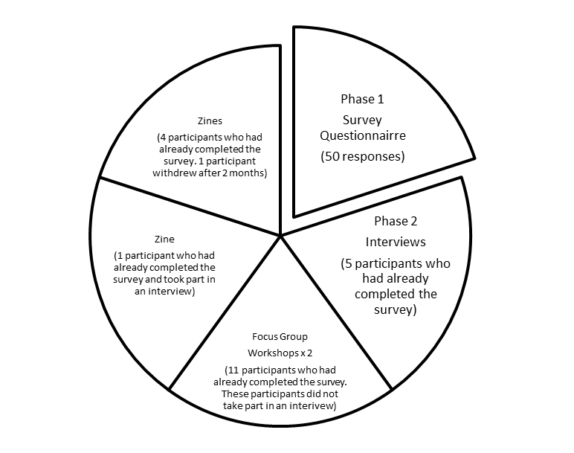

Figure 3.2: Research design

The matrix diagram in Figure 3.2 demonstrates the sequence of events, the methodology employed and the overall process of data analysis.

Initially, the whole EYTS GEB Route (68 EYTTs) were offered the opportunity to be involved in this research study. 50/68, subsequently, took part, of which 73% responded, which would be rated as a “very good response” by Mangione (1995, p. 60). This unexpected high return may, in itself, indicate that early reading with under-threes is an area of concern or genuine interest for the practitioners. After the small sample pilot study survey (6 respondents from the previous GEB cohort), I judged that the planned survey questions appeared to be appropriate and did not require any revisions. Findings from the pilot focus group (4 volunteers from the previous GEB cohort), however, led to a restructuring of the age phases in the first question. Feedback from the pilot study focus group suggested that this might make practitioners think deeper and focus more on their provision for under-threes when asked to cover these discrete age ranges, which I considered to be a valuable enhancement to the survey. Given that Bertram et al., (2016) advocate that “researchers must be prepared to reconsider the research process following feedback from participants” (p. viii), therefore I adapted the survey in light of this feedback.

3.4. The participants

The participants engaged in this research study were all enrolled on the Graduate Employment-Based (GEB) Route of the EYITT Early Years Teacher Status (NCTL, 2015) programme, which is a full-time programme, beginning from September 2015 to July 2016. Although the programme is part-time, the trainees are in full-time employment and this is considered to be their ‘professional practice’. The requirement from NCTL (2015) is that trainees must have experience in at least two settings and gain experience across the age range of birth to five years. As the research study is focused on under-threes and the nature of EYTS training is that these practitioners work predominantly in the PVI sector and are training to be specialists with an essential role in supporting children’s development between birth and the age of five to provide high-quality early education (DfE, 2015), I considered these EYTS GEB practitioners to be best placed to take part in this research. In addition, these participants already have some experience working in settings, within this age range. The majority (94%, 47) of the participants were female. 6% (3) of the participants were male, which is roughly aligned with the early years workforce data relating to gender (DfE, 2013 ‘National ECEC Workforce Census’, DfE, 2016 ‘School Workforce in England’ data). Notably, there were no male participants engaged in any follow up activities after the initial survey. Whilst the issue of males is still a concern for the ECEC workforce, this did not affect the purpose of this particular research study. Participants’ ages ranged from 21 – 45 years, with a range of time spent in an early years setting from 3 years to 24 years of experience of working with very young children from birth to five years old. Statistical data specifics from SPSS analysis on gender, age range, type of degree and employment setting are available in Appendix L. However, I did not use SPSS to analyse the quantitative data as such, just to gather an overview of the participant details.

The intention was to gain a sample of views, opinions and accounts that would be illustrative (Denscombe, 2010) of the early years practitioner workforce. It is significant to note that all participants involved in this research study volunteered and, as such, could be considered to already have an interest in early reading with under-threes, hence their voluntary involvement in this research study. The contingency plan, should I have failed to recruit any interest from this cohort, was to send out requests nationally to all EYTS providers for recruitment of participants. This was not necessary as there was, in fact, sufficient interest from this cohort, with experience across a variety of early years settings, as initially proposed. At this point in their training, I was unknown to the participants and intended to remain so, within the constraints of my job role, in an attempt to minimise bias and any conflict of power relationships. I did appreciate that as Head of Department, this could potentially present a power dynamic, yet hoped that encompassing the whole cohort with freedom of choice and anonymity (although my name and job role would in fact be on every programme handbook) may in some way alleviate this. As stated previously in this chapter, I am conscious of my own values and beliefs influencing this research study, which reinforced my decision to remove myself from any commitments to teaching or visiting any EYTS trainees for the duration of this study, which I would have otherwise completed as part of my job role. Further ethical considerations will be discussed in the next section of this chapter.

3.5. Main respondent ‘Pen Portraits’

The participants in this study where all female Early Years Teacher Status Trainee Graduate Employed Practitioners (GEB), working across a range of early years settings nationally. This EYTS GEB Route is a 12 month part-time training route designed to support experienced practitioners working with under-fives, to meet the Teachers’ Standards (Early Years, NCTL, 2015) and thus gain Early Years Teacher Status. This is a brief introduction to each of the main respondents (all names used in this study are pseudonyms):
Ella currently works in the baby room in a private day nursery as the ‘Room Leader’ and has worked with under-threes in a variety of roles within the PVI sector for approximately 16 years. Ella is aged between 26 – 40 years. Ella completed a BA (Hons) in Early Childhood Studies Degree in 2010.
Lucy is a Nursery Manager in a PVI setting and has worked across the 0 – 5 age range in a variety of settings for the past 17 years. Lucy is aged between 41 – 55 years and completed a BA Early Childhood and Education degree in 2013, on a part-time basis.
Lily works in a Children’s Centre Nursery and has 10 years of experience working with under-fives. Lily has responsibility for the ‘Stay and Play’ sessions and has a key role in supporting families. Lily is aged between 26 – 40 years and has recently completed a BA (Hons) Early Years Education degree.

Maria is the ‘Room Leader’ for the two-year-old-provision in a private day nursery and has worked with the 0-5 age range for the past 17 years. Maria is aged between 26 – 40 years and completed her BA (Hons) Early Childhood Studies degree in 2012.

Jan is a childminder and has three, under-threes in her own home. Jan has worked with under-fives for 14 years across the state-maintained and independent sector. Jan also completed Zine 3. Jan is aged between 26 – 40 years. Jan has recently completed a BA (Hons) Early Years Practice Degree on a part-time basis.

Zine 1 has been completed by a Nursery Nurse who works in a pre-school setting with under-threes, attached to a school, which has a nursery class for 3 – 5 year olds on site. Zine 1 is aged between 41 – 55 years and has worked in a range of early years settings for the past 24 years. Zine 1 has recently achieved a BA (Hons) in Early Years Leadership.

Zine 2 has been completed by a practitioner working in a private day nursery as a ‘Room Leader’, with 6 years of experience working with under-fives. Zine 2 is aged between 18 – 25 years and has recently completed a BA (Hons) Education Studies and Early Years.

Zine 4 has been completed by a practitioner working in a new private day nursery, with 13 years of experience with under-fives. Zine 4 withdrew after 2 months and agreed to share only the Zine entries presented within this study. Zine 4 is aged between 26 – 40 years and completed a BA Early Childhood and Education in 2009.

Zine 5 was completed by a Deputy Manager working in a private day nursery with over 11 years of experience working with under-fives in a variety of other PVI settings. Zine 5 is aged between 41 – 55 years and has completed a BA (Hons) Early Childhood degree in 2007.

3.6. Ethical considerations

Groundwater-Smith and Mockler (2007) suggest that “research needs to be guided by a series of ethical principles” (p. 201), which go beyond ensuring informed consent, avoiding harm and producing identifiable benefits for participants. In choosing the participants and gaining access to participants, I carefully considered any form of persuasion, coercion or power relationships as a “moral responsibility” (Ryan, 2011, p. 421) throughout the research study.

The ethical principles underpinning this study were informed by the British Educational Research Association (BERA, 2011) Ethical Guidelines for Educational Research. I also applied for ethical approval from the University of Sheffield’s Research Ethics Policy, which was granted (Appendix A and B). I presented the initial research project to the participants in writing as an announcement on the Virtual Learning Environment, with a clear explanation of what their involvement would entail, in order to reduce the possibility of misunderstandings arising at a later point (Fraenkel et al., 2012). I set up a specific email address for the return of the initial survey, which included my name as the principle researcher. I also provided hard copies for the tutor team to distribute and requested that they did not ask study participants to fill in the survey, merely highlighting the availability of paper copies and information leaflets. The tutor team are all active researchers themselves, knowing and understanding the importance of ethical practice, I was therefore reassured of any coercion or persuasion of participants as noted by Bertram et al., (2016) who advocate that “researchers must be aware that the research process may put pressure on, or lead to potentially harmful consequences for participants” (p. viii). I did not believe that there would be any harmful consequences for the participants in taking part in this study. The participant information sheet contained the process of gaining informed consent (BERA, 2011), clarity of involvement, and the right to withdraw, together with the informed consent forms (Sample in Appendix D) which Creswell describes as an acknowledgment of “the protection of their rights” (Creswell, 2012, p. 149). The information sheet also comprised the procedure of contact and conduct during interviews, data storage and anonymity, so that these issues were transparent for all participants before completing the survey and at each point of data gathering; interviews, focus group workshops and Zines. In agreement with Hill (2005) and Roberts-Holmes (2005), I considered that informed consent is an on-going process, which requires review points and the right to withdraw or not to participate is to be respected. Practitioners were advised not to use any names or photographs with children whilst completing the Zines. They were also advised to share the research aims and an overview of the research project with parents and carers, managers and governors.

I completed a research diary to document decisions made and adaptations necessary at key points in the research journey, which enabled me to effectively plan and reflect, keeping track of participants and continuing tasks. Walliman (2016) suggests that using a research diary to document decisions made is “one practical way of developing an ethics checklist” (p, 81), which ensures that any ethical or methodological considerations can be reassessed. Similarly, Miller and Bell (2002) recommend that “keeping a record of decisions made is a good safeguard for any ethical issues” (p. 67).

3.7. Methods

This research is an empirical study using qualitative and quantitative mixed methods. These consisted of an initial survey, semi-structured interviews, focus group workshops and Zines to illustrate practice.

A Zine is described as a small piece of work, presented in a small booklet format (Art Matters Blog, 2008; Desyllas and Sinclair, 2013). This is a fairly new resource and it can be adapted to gather a wealth of information. As such, the Zines could be considered to be an innovative resource, with the potential to offer creative and insightful data as an unconventional way of sharing information and reflections (Radway, 2011). Participants were provided with a small Zine (booklet) which contained a considerable amount of room for them to respond to the research questions in their own way: ‘How do you support under-threes with early reading?’, ‘What experiences are provided for under-threes to support early reading?’ The Zine format allowed the participants to write an independent range of views, methods and opinions without the restriction of limited spaces for answers and offered the possibility for immediate reflection on practice. This method also allowed for diversity of thought, as advocated by Roberts-Holmes (2014). The use of a Zine is designed to engage the participant more fully, as it can become part of their everyday practice and may support the collection of more varied information linked to the research question. However, within the context of this research study the Zines were not intended to generate change impact, as such, therefore this method does not have an action research approach. I chose Zines as a resource rather than reflective diaries, which I initially intended to do, as the participants were already being asked to complete a reflective diary as part of their EYTS training and I did not wish to confuse them or to add to their workload. The Zines were issued to every willing participant with the research question as an open-ended guideline. The expectation was that the participant could use them in any way they thought best to respond to the research question. Five participants expressed an interest in completing a Zine, which offered the opportunity for exploring practice and provision for under-threes in detail. Their personal Zines focused on the day-to-day early reading activities in practice, important or significant events and anything else that participants wished to note. The intention was to encourage printing of the Zines for participants. In essence, none of the participants actually wanted me to do this, however, despite their excitement about this aspect at the beginning.

The initial survey consisted of a self-completion questionnaire, which is deemed to be “an obvious method of collecting both quantitative and qualitative information” by Walliman (2016, p. 124). This coincided with my initial thoughts. The survey contained a selection of closed, open and multiple choice questions to capture and engage the participants practice, provision, views and opinions. Cohen, Manion and Morrison (2011) propose that “open-ended responses might contain the gems of information” (p, 392). This was indeed the case in this research study, with some rich data originating from the survey. I chose to offer the survey as a hard copy, as engagement with and access to online surveys can be problematic for busy working practitioners. Feedback from the pilot focus group suggested that access to online technology may be a challenge in some settings. Bertram et al., (2016) also raised the use of technology as a particular challenge and suggested that “the consequences of using such methods should be carefully considered” (p. viii). This proved to be the optimum method and was successful, considering the return of the hard copies. Nonetheless, these then needed to be manually uploaded onto a spreadsheet, which was very time consuming. The following table presents a sample of the survey questions asked:

Figure 3.3: Sample survey questions

How do you currently support very young children with early reading?
Please list your strategies/activities/experiences/teaching for:
- Babies
- Toddlers
- 2 year olds
- 3 – 5 year olds
What has informed these strategies/activities? How do you decide how to teach and what to teach?
Have you have had any training or staff development on early reading? How has this influenced or impacted upon your current teaching in this area?
Please provide examples.
Are there any particular challenges in teaching/supporting very young children with early reading in your setting?

The survey questions are presented in full in Appendix 0.

The other qualitative methods utilised were interviews and focus group workshops. Rubin and Rubin (2012) describe interviewing as “the art of hearing data” (p. xv), which I established as an effective description. Boudah (2011) advocates that interviews are very important within the field of qualitative research because these are a useful method to investigate a particular issue in depth and to discover how individuals or groups of people think, understand and feel about an issue. Given the aims of this study, interviews were clearly going to be a very valuable tool as I sought to understand the experiences, views and beliefs of the practitioners. Similarly, Fraenkel et al., (2012) also propose that interviews can be used to explore participants’ thoughts and feelings about a particular situation. It is these aspects that warranted the use of interviews as a research method; practitioners using their own words as either a support or contradiction to my own perceptions of their viewpoints as advocated by Wellington (2000). I interviewed practitioners to find out what they do to support under-threes with early reading and why, in order to gain an insight into their views and beliefs about reading and how this influences their practice. This was also a useful method to follow on from the survey questionnaire in order to probe respondents’ answers and to clarify any vague or incomplete answers as suggested by Fraenkel et al., (2012) and McMillan and Schumacher (2010). Given that there were many incomplete answers to what practitioners do with babies and toddlers to support early reading development, interviews and the subsequent focus group workshops offered the opportunity to delve deeper; providing the opportunity to investigate and explore the rationale for these lack of responses and to develop the quantitative survey responses. I utilised semi-structured interviews in this study to have some flexibility in order to be able to probe when it was necessary. This was done within the framework of a planned interview format, with the aim to respond to the research questions. All five of the interviews were recorded using a digital recorder. Permission to record each interview had previously been obtained from each participant alongside signed consent forms issued to all participants at the beginning of the study. These were then resent to individual interview respondents, with guidelines on the process for data collection, storage and confidentiality. I attempted to adhere to the appropriate behaviours of interviewers advocated by Fraenkel et al., (2012) when conducting the interviews; active listening, allowing participants to speak freely, make eye contact and use open body language. Whilst I acknowledged this was most appropriate, I found this to be the most difficult aspect of interviews. One interview was conducted whilst the practitioner was setting up her room for the day and thus, I was essentially following the practitioner around the room, which was not an ideal scenario. This time scale had been arranged and agreed by the practitioner and as such, I needed to accept this as the format for this particular interview. The practitioner spoke freely, but eye contact was intermittent. Another interview was interrupted by the practitioner who was upset and uncomfortable with some of the questions and their own responses, which will be discussed later in Chapter 4. A subsequent interview was also interrupted on many occasions by other practitioners in the setting asking the interviewee work-related questions, which did acutely affect the flow of the conversations, thought process and responses. Consequently, there were some difficulties with conducting the interviews with busy working practitioners, as outlined above. I ensured that the needs of the participants were my first consideration and allowed the interviews to develop naturally, which then enabled me to gain a real depth of understanding from these interviews.

The interviews lasted between 40 minutes to an hour and a half. After each interview, the audio was immediately transcribed and assigned a number to preserve anonymity and confidentiality. I shared the transcripts with each participant for clarification and authenticity, to ensure that what was recorded was as intended and as expected, given that Sikes (2010) acknowledges this to be sound practice. Consequently, all five interview participants amended their transcripts and, in fact, changed some of their responses. The final agreed versions are the only version used in the research study. At the request of participants, I have deleted the original audio recordings. Figure 3.4 presents a sample of the interview questions which are included in full in Appendix M:

Figure 3.4: Sample interview questions

Can you tell me about your work with under-threes to support early reading development?
Can you tell me a little bit more about ….?
How would you define early reading?
Could you describe the environment you provide for babies, in particular to support their early reading development please?
How often do the children under-three see you engaged in reading activities?

After the interviews I conducted two focus group workshops with eleven volunteer participants. Focus groups are defined by Bryman (2012) as a type of group interview “used to develop an understanding about why people think the way they do” about a particular subject and also provide the opportunity for participants to “bring forward ideas and opinions not foreseen by the interviewer” (p. 501). I decided to conduct focus group workshops as a follow-on from the survey and interviews to respond to the research questions. I also sought to continue with the approach of the voice and viewpoint of the participant at the heart of the data, given that Bertram et al., (2016) suggest that it is imperative to “aim to distribute power between all participants as far as possible and in a way that allows all involved to actively have a voice in the research process and contribute equitably and appropriately to the research process” (p. v). I offered the resources of a flip chart paper, pens, paper, tablets and a laptop during the workshop. The intention of the focus group workshop was to set the scene, guided by the research questions, to agree on the time constraints and then not to be involved at all until the end of the workshop. I felt that there would be greater scope for the participants to interact with each other, yielding a collective rather than an individual view as discussed by Hyden and Bulow (2003) where the “participants’ rather than the researcher’s agenda can predominate” (Cohen et al., 2011, p. 288) to gain insights that may not otherwise have arisen from either the survey or the interviews. The workshop style of recording also meant that the data was presented in the participants’ own way. Their own viewpoints and opinions were recorded, with no requirement for any transcriptions from the researcher. This also became an advantage once I had acknowledgement from eleven interested participants who had not previously been involved in the interviews for the suggested workshop dates and times, therefore, I scheduled two focus group workshops. I also wished to take the opportunity to return to the survey data with these participants where possible, to ensure that the research questions were answered in as much detail as possible.

The next section of this chapter focuses upon the sequence and tools of the data analysis process.

3.8. Data Analysis

Data analysis is the central step in qualitative research. Whatever the data are, it is their analysis that, in a decisive way, forms the outcomes of the research.
(Flick, 2014, p. 3)

Given this centrality of the analysis and the complexity of engaging in quantitative and qualitative data analysis, the process of analysing the breadth of collected data (Corbin and Strauss, 2008) was both continuous and reflexive. May and Perry (2014) advise that “reflexivity is not a method, but a way of thinking, or a critical ethos to support with the interpretation of the data and representation” (p. 111), as a continuous characteristic of good research practice. To illustrate, the practitioners in this study reflected upon their practice and adapted their provision almost immediately, which was supplementary to the research agenda - experiencing “reflexive spaces” as “decision-makers to consider the challenges and to rethink current practice and preconceptions” developing “transformative outcomes”, as discussed by May and Perry (2014, p. 120) and Beck and Beck-Gernsheim (2002). Similarly, the concept of research as “intellectual and moral exchange” argued by Lassiter (2005) developed as practitioners shared their accounts.

Consequently, Horton Mertz (2002) argue that researchers should go “beyond the limits imposed [by others] in order to develop a more in-depth way of understanding and reporting the experience” (p. 150), which I believe the overall research design and variety of methods chosen sustained. Subsequently, in agreement with Newsome (2016), the overall process of analysis was essentially an examination of the data in order to better understand it. According to Willig (2014) it is “interpretation that is the challenge for researchers, as without interpretation it is difficult to make sense of the data” (p. 136). As the intention was to find out about the practitioners’ experiences, their views and beliefs about early reading and their practice and provision for under-threes, it was necessary to make the data meaningful; to make connections and to ask questions. During the analysis stage of the research journey, I displayed some key questions that were visible to me at all times, in order to support with the analysis and interpretation of the data:

What are the practitioners doing? What does this mean?
What are they trying to accomplish? How do they do this?
What assumptions are they making? What assumptions am I making?
What is this saying to me? What do I see going on here?
What is this an example of? What is happening here?
What is trying to be conveyed? What is missing?
What did I learn from these notes?
Why did I include them?
What strikes me?
(Cresswell, 2007, p. 153)

These questions were based on Cresswell’s (2007) suggestions for data interpretation. Early analysis after the initial survey presented a challenge with some key unexplained gaps in the survey data, which were later addressed with further data from the interviews, focus group workshops and Zines. At various points in this research project, I felt overwhelmed with the volume of data generated and drawing out key themes and issues and constructing the analysis has been an arduous task.

I grouped and examined each data set as soon as I received its sources. I utilised “computer assisted qualitative data analysis (CAQDAS)” (Welsh, 2002, p. 2), as Welsh (2002) proposed that “this serves to facilitate an accurate and transparent data analysis process, whilst also providing a quick and simple way of counting who said what and when, which in turn may provide a reliable, general picture of the data” (p. 3). The ‘search’ tool in NVivo offered the possibility to cross-examine the data, which I felt “improved the rigour of the analysis process by validating (or not) some of my own impressions of the data” (Welsh, 2002, p. 3). In contrast, Seidel (1991) points out that using software packages may guide researchers in one particular direction. Alternatively, Hahmed Hilal and Alabri (2013) suggest that “NVivo, as a qualitative data analysis computer software package, has many advantages and may significantly improve the overall quality of research” (p. 182). I decided to embrace the “value of both manual and electronic tools in the qualitative data analysis” (Welsh, 2002, p. 3) process and aimed not to rely on one method in particular, making use of the advantages of each. The analysis used for each of the methods will be discussed in the next few sections of this chapter.

3.8.1. Survey questionnaire (Appendix O)

The survey data, gathered from a cohort of EYTS trainees in September 2015, was entered into a Microsoft Excel Spreadsheet to create tables and graphs as required. The initial details of the survey respondents (ages, employment setting, degree status, etc.) were analysed using a section of the SPSS Statistics Software package, as I was familiar with using this software package and this familiarity, at this point in the analysis, was a motivating strength. I did not use, however, statistical analysis for this study.

The qualitative data from the survey was then entered into NVivo Pro 11 application to develop and code the emerging themes. I also manually coded and themed the data as a thematic analysis using post-it notes and images (Appendix E) to gather the experiences noted in the survey and matched this to the NVivo codes before interpreting the final data.

Clarke and Braun (2013) describe the process of thematic analysis as a technique to identify and analyse configurations within qualitative data. Similarly, Schreier (2012) defines qualitative content analysis (QCA) as a method for “systematically describing the meaning of qualitative material, by classifying as instances of the categories of a coding frame” (p. 5). Given that Schreier (2012) described QCA as systematic, flexible and a way of reducing the data, this was a strong rationale for this approach.

Figure 3.5 presents an extract from the first QCA coding frame. These initial thoughts and the scaffold questions from Creswell (2007) and Schreier’s (2012) QCA framework led to the themes that remained consistent throughout the data analysis.

A further coding frame sample is presented in Appendix N.

Figure 3.5: Initial coding frame ‘Survey’

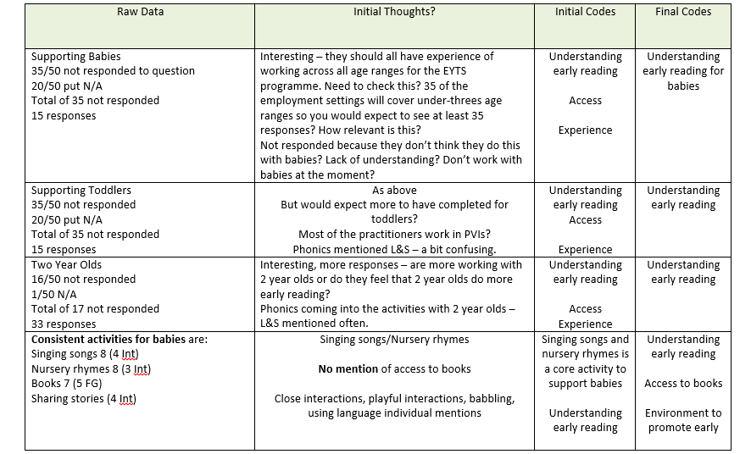

Figure 3.6 illustrates one aspect of the systematic process of ‘familiarisation’ and ‘reviewing the themes’ undertaken after analysing all the data, as part of the thematic analysis process:

Figure 3.6: Reviewing and defining themes

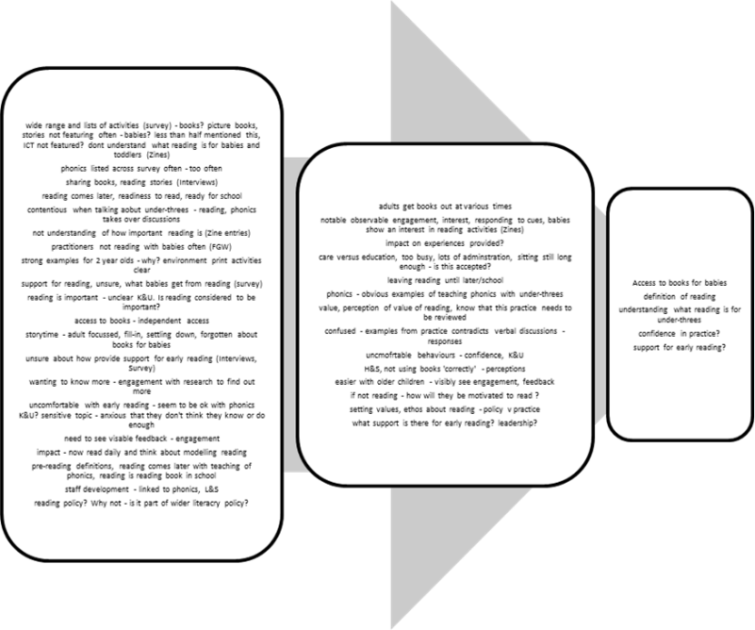

3.8.2. Practitioner interviews

The practitioner semi-structured interviews carried out in November and December 2015 produced interesting qualitative data. The interview questions are presented in Appendix M. The qualitative data was analysed by entering into NVivo Pro 11, creating category nodes and coding themes. It was also analysed using “the six phases of thematic analysis” (Braun and Clarke, 2006, p. 81) and QCA (Schreier, 2012). After listening to each audio recording, I worked through the transcript from the beginning, noting and highlighting anything that seemed of potential interest and significance, as well as any impressions, thoughts, and ideas developing that linked to the research questions. I endeavoured to include synchronous communications, but found these to be quite difficult to read and primarily noted pauses. One of the interviews required explicit detail of mannerisms as this had become fundamental to the overall interview. The transcripts were read, analysed and coded to identify emerging themes. Braun and Clarke (2006) describe a theme as “capturing something important about the data in relation to the research question, which represents some level of patterned response or meaning within the data set” (p. 83). This was initially challenging as many aspects of the data were deemed important. I analysed responses to each question across the five participants and identified emerging themes. After analysing the survey data of the experiences of the practitioners supporting early reading development, I used the same approach with the interview data to continue the thread of gathering those experiences, both manually and using NVivo to check and align the data. The initial QCA coding frame illustrates that similar themes emerged alongside new themes:

Figure 3.7: Initial coding frame ‘Interviews’

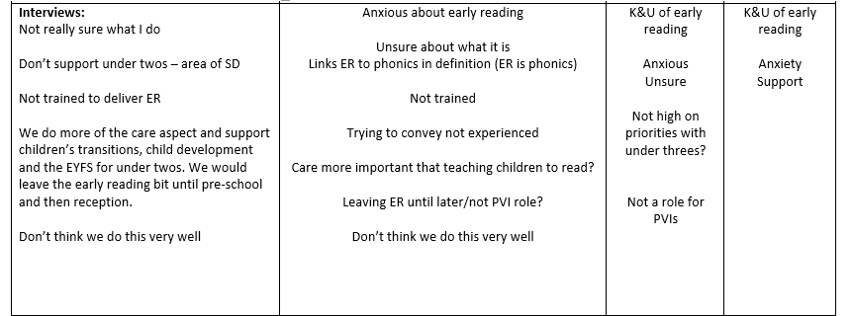
After conducting the interviews with participants and returning the transcripts for approval, I experienced a great sense of anxiety and uncertainty, as all participants reflected upon their transcripts and requested to change sections of their conversations. I went back to the reading and literature surrounding interviews to develop further confidence in my approach and ability as a researcher. The process of “unknowing” as explained by Vasudevan (2011, p. 1154) happened at pertinent points across this research study. I often revisited ethical considerations proposed by Bertram et al., (2016), ensuring that I adhered to the “ethical standards for participants, which guarantees participants their rights, choice and opportunity to express their views freely on all matters concerning them” (p. vii). The five interviews presented me with the opportunity to review the initial survey questions, as well as the ability to add some context to some of the comments raised in the survey. A sample interview transcript is included in Appendix I. An overview of the interview participants is included below:

Figure 3.8: Overview of interview participants

Participants | Setting | Age Range | Experience working with under-fives
Interview 1  Ella | PVI | 26 - 40 | 16 years
Interview 2  Lucy | PVI Nursery Manager | 41 - 55 | 17 years
Interview 3  Lily | Children’s Centre | 26 - 40 | 10 years
Interview 4  Maria | PDN | 26 - 40 | 17 years
Interview 5  Jan | Childminder | 26 - 40 | 14 years

The table highlights that these were all experienced practitioners, working predominantly in the PVI sector. I initially assigned each transcript a number and then later assigned pseudonyms for totally anonymity and confidentiality. I assured all participants that the information shared at the initial survey stage would be the only information recorded.

3.8.3. Focus group workshops

Eleven participants agreed to take part in a focus group workshop. They had all previously completed the survey. The focus group workshops were split into a group of six and five participants respectively. The practitioner focus group workshops in January and February 2016 produced qualitative data. The qualitative data was analysed by entering into NVivo Pro 11, creating category nodes and coding themes, building on the data already entered from the survey and interview data. The focus group data was also analysed by using the “six phases of thematic analysis” (Braun and Clarke, 2006, p. 81) and QCA (Schreier, 2012). The transcripts, flip chart data and definitions of early reading were read, re-read and manually coded to identify emerging themes or individual themes and reviewed alongside the codes, word clouds and word searches of NVivo Pro 11. It became apparent that I no longer needed to rely on NVivo to consolidate any manual findings, as the themes across all sources of data at this point were consistent and linked to ‘access to books’, ‘defining and understanding early reading’, ‘perceptions of confidence for early reading’ and ‘support for early reading’. Although NVivo had been worthwhile and supported me with the initial findings, it now felt far too time consuming to continue using both manual and CAQDAS. Therefore, the Zine entries were analysed using the existing coding frames and themes. I fully expected to add more themes to the framework, but this was not necessary, as no supplementary themes arose. The following table presents a brief overview of the focus group workshop participants:

Figure 3.9: Overview of focus group workshop participants

Focus Group 1 Participants | Setting | Age Range | Experience working with under-fives
1 | PVI (Deputy) | 26 - 40 | 20 years
2 | PDN | 18 - 25 | 8 years
3 | Playgroup | 41 - 55 | 6 years
4 | PDN | 26 - 40 | 19 years
5 | Nursery School | 19 - 25 | 5 years
6 | PDN Setting Manager | 26 - 40 | 12 years
Focus Group 2 Participants | Setting | Age Range | Experience working with under-fives
7 | PDN (owner) | 26 - 40 | 17 years
8 | Nursery School | 26 - 40 | 19 years
9 | PDN | 26 - 40 | 19 years
10 | Playgroup Leader | 41 - 55 | 6 years
11 | PDN | 26 - 40 | 4 years

3.8.4. Zines

The Zine entries from between October 2015 to March 2016 produced a wealth of qualitative, eclectic data, which was extremely time consuming and challenging to analyse. The Zines were analysed manually by using QCA (Schreier 2012) to identify any consistent themes, links and any individual themes. Data from the survey, interviews and focus groups had already enabled me to identify four emerging themes; these themes were used initially to analyse the Zine entries. Additionally, I then re-read the entries to identify any possible new themes. Photographs of a sample of the Zine entries are contained in Appendix J. The completed Zines have been handed back to the participants, at their request.

Figure 3.10 demonstrates that the Zine participants worked predominantly in PDN settings, with a range of previous experience of working with under-threes:

Figure 3.10: Overview of Zine participants

Participants | Setting | Age Range | Experience working with under-fives
Zine 1 | Pre-school attached to a school | 41 – 55 | 24 years
Zine 2 | PDN | 18 - 25 | 6 years
Zine 3 | Childminder | 26 - 40 | 14 years
Zine 4  *withdrew after 2 months | PDN  *only entries agreed presented | 26 - 40 | 13 years
Zine 5 | PDN Deputy Manager | 41 - 55 | 11 years

3.9. NVivo data; exploration of the themes

Once each data source had been explored and analysed independently, I reviewed the data sources of the survey, five semi-structured interviews and two focus group workshops using the coding and analysing functions of NVivo. The text search query function is designed to support searching for topics or themes from the sources of data. Welsh (2002) suggests that the “search facility in NVivo is seen by the product designers as one of its main assets when facilitating the interrogation of the data” (p. 3), ensuring that the researcher is working more methodically, more thoroughly and more attentively (Bazeley, 2007). In depth exploration of the data using the text search query function generated the following results:

Figure 3.11: Overview of NVivo text word search query

Text Word Search | References | Sources of Data | Comments
Books | 104 | All | Different types of books mentioned, 1 reference to access, 1 reference of handling books
Stories | 49 | 5 | 4 interviews and survey data  Sharing links and story props links
Nursery Rhymes | 92 | All | Covers rhymes in general also
Singing Songs | 73 | 6 | Not in Focus Group Workshop transcripts
Rhyming Games | 44 | 5 | 4 interviews and survey data
Talking and/or talking games | 4 | 2 | 1 interview and survey data
Language | 0 | 0
Speech and language | 15 | 5 | 2 interviews, focus group workshops and survey data
Letters and Sounds | 214 | 6 | 5 interviews and survey data
Jolly Phonics | 12 | 3 | Survey data, 1 interview, focus group workshop 1
Steady Beat | 10 | 3 | Survey data and focus group workshops
Access (to books) | 3 | 6 | 5 interviews and survey data
Play | 11 | 4 | 3 interviews and survey data
Communication | 10 | 4 | Survey data, 1 interview and focus group workshops
Listening Games | 52 | 5 | Survey data and 4 interviews
Music | 8 | 3 | Survey data and 2 interviews
Musical Instruments | 15 | 4 | Survey data and 3 interviews

This proved to be an effective overview as an audit of how often these words were mentioned in the various research activities as a form of structural coding, as advocated by Saldana (2009). This was beneficial because it offered me the opportunity to view the extracts and cross check with the identified themes and to ensure that I had not overlooked any key themes.

3.10. Reliability, validity and credibility of the data analysis

Bryman (2012) suggests that it is difficult to prove the reliability and validity of the qualitative research process and advocates the use of trustworthiness as an alternative criterion to authenticate the research process and findings. In order to be trustworthy, I adopted principled approaches throughout the data analysis process:
- All participants remained anonymous at all times to the EYTS group and staff at the University. I did not discuss which participants had been or were involved in any aspects of the research. I conducted interviews in settings where appropriate to maintain anonymity and arranged meetings outside of University-based training sessions.
- All interview and focus group transcripts were submitted to the participants for their review and confirmation as credible data. I requested a personal email address and did not use participants’ university email address. Every interview participant changed their individual transcripts and the only version used to analyse is the approved version of each interview transcript.
- Zines have been shared by the participants at a point that they were comfortable with. I shared the final deadline of March 2016 with participants and left it up to them to contact me, when they were ready to share. I offered the option of meeting and picking up the Zines or postal return to include the participants in the decision making consistently. I shared the Zine entries identified as significant or useful to illustrate the findings with each participant at various points of the research process.
- Detailed records of the analysis process have been maintained throughout. Samples have been included in the Appendices.
- Additionally, I adopted the practice of face validation advocated by Creswell (2012) as a method for establishing validity, as the structure of the survey, language of the questions, checklists of data, the process of SPSS and NVivo analysis have been shared with an experienced educational researcher as a critical friend.
- The use of a variety of analysis methods; both CAQDAS of SPSS and NVivo and manual thematic analysis is my attempt to achieve an accurate and transparent data analysis process (Welsh, 2002) and improve the overall quality of the research.
- The use of triangulation as a design strategy to enhance the validity of the inquiry of findings proposed by Johnson and Ongwuebuzie (2004).

Reliability is referred to by Creswell (2012) and Fraenkel et al., (2012) as the consistency of findings. I maintained a research diary throughout the study, which enabled me to review subjectivity, to be alert to bias and note observations at various points. I had always intended that the voice of the participants would be at the forefront of this study, driven by the objective to note the experiences of the participants, as referred to by Gibbs (2007). To improve validity, I also checked interpretations and accounts with the research participants (McMillan and Schumacher, 2010) at various points, to ensure participants’ viewpoints, opinions and experiences were accurate and as intended (Sikes, 2010).

3.11. Limitations of the research

The methodology held some limitations and problems; mainly in the data collection of the Zines and the wealth of the overall data analysis. Participants did not really want to part with their Zines and felt that they could continue with them for a much longer period. It took many requests to receive the final Zines. In truth, the data from the innovative Zines could have been an independent research project, without the other methods, although there would then be a concern that the findings might be unique to the practitioners involved in the study and not a representative viewpoint of practitioners working in early years settings. Similarly, the survey presented some challenges and limitations, as some sections were not completed by the participants. Conversely, this did lead to an important initial finding about the understanding of and the value of early reading with under-threes, which is explored in later chapters.

Furthermore, the data analysis sequence and overall process was extremely time-consuming. In my desire to ensure accountability and credibility I created a much more onerous task than was necessary. It could also be suggested that, given that the majority of the methods utilised were qualitative, a limitation of this study may be that the findings can be more easily influenced by my own bias and positionality, regardless of any measures taken to mitigate, which I do need to acknowledge as a possibility. Consequently, I also had to reconsider and reiterate confidentiality as a potential issue in the focus group workshops as noted by Halcomb et al., (2007) and carefully deliberated the quality of the data from the focus group workshops, given that Hopkins (2007) argues that this may be deemed shallow and of poor quality. Despite this consideration, I continue to believe that the focus group workshops yielded insightful findings.

3.12. Summary

This chapter has presented an explanation for the constructivist, interpretive research paradigm with a rationale, and a description of the mixed methods research strategy and methods chosen. I have clearly stated my positionality and my own particular understanding and viewpoints on early reading with under-threes. Ethical implications across the research strategy and design have been considered, discussed and aligned with the guidelines and recommendations from Bertram et al., (2016) within the EECERA ethical code for early childhood researchers. I have offered a justification and explanation of the strategies used to analyse the data and considered reliability, validity and the voice of the participants as reflexive practice (May and Perry, 2014) in responding to the research questions. Limitations of the research are also briefly explored.

The next chapters introduce the research findings relating to the experiences, views and beliefs of the practitioners supporting the early reading development of under-threes.

Chapter 4

The complexities of early reading with under-threes:

Presenting the data

4.0. Introduction

This chapter presents the analysis of the data regarding the experiences of the practitioners. The findings are based on the responses to the questionnaire survey, semi-structured interviews, focus group workshop discussions and the Zine entries. The data has been gathered from September 2015 onwards from a cohort of the new EYITT Early Years Teacher Status (NCTL, 2014) trainees to be as current as possible, as discussed in Chapter 3. Four emerging themes have been identified using the Qualitative Content Analysis (QCA) (Schreier, 2012) approach to manually coding and the coding systems of SPSS Statistical Software and NVivo Pro 11 produced by QSR International. A detailed explanation of the analysis process used in this study is explained in Chapter 3. In this chapter, I consider how the empirical data responds to the research questions, presented in Chapters 1 and 3.

The purpose of this research was to find out how practitioners support under-threes with early reading and to understand what influences this practice. A mixed methodological approach with multiple sources of data was therefore chosen, to allow me to gain a degree of breadth and depth of understanding. The mixed methods design comprised two phases: quantitative followed by qualitative (Creswell, 2004; Plano Clark et al., 2003). Phase one consisted of a survey to gather the experiences of a large number of practitioners working with under-threes. This was followed by the second phase, which involved five qualitative interviews, two focus group workshops and five Zines to help explain, elaborate and refine the earlier quantitative results, as well as to explore the practitioners’ views and experiences in more depth (Creswell, 2004).
This chapter will begin by explaining the themes that emerged relating to participants’ views, values and beliefs about early reading, access to books from birth onwards, the children's experiences and participants’ understanding of early reading practice and pedagogy.

The four key themes to have emerged from the analysis are:
- Accessible early reading environment for babies
- Defining and understanding early reading in practice
- Perceptions of confidence in practice
- Support for early reading.

Where appropriate, I will exemplify the findings with comments from the practitioners and samples from the Zine entries. Having analysed the detailed data sources, it became clear from the first phase of data analysis that four main themes were emerging from the data set as a whole. The themes are very much interrelated and together illustrate how practitioners are defining early reading and how these perceptions, values and definitions influence their practice and provision for under threes. These themes now require a deeper discussion, exploration and analysis, as well as a description of what each of the themes mean, the assumptions underpinning the themes and the overall story of what the different themes reveal about early reading practices with under-threes.

4.1. Theme 1: Accessible early reading environment for babies

This section will present the findings specifically relating to the theme of providing an accessible early reading environment for babies, including access to books, pictures, and printed or digital material for under-threes.

The findings indicate that practitioners support under-threes with early reading in a variety of ways, providing daily activities including; “reading stories’; ‘singing songs’; ‘nursery rhymes’; ‘sharing books’; ‘using music, sounds, rhythm, beat and percussion’; ‘sensory experiences’; ‘puppets’; ‘story props’; ‘treasure baskets’; ‘action rhymes’; ‘listening games’; ‘Toddler Talk’; ‘print in the environment’;’ story sacks’; ‘listening walks’; ‘Letters and Sounds’ and ‘Jolly Phonics” activities. There is evidence from the Zine entries of practitioners reading stories to children, children sharing reading with adults and children looking at books by themselves.

Books (reading, sharing stories, touchy-feely books, story props and interactive books) were often cited in relation to early reading activities by practitioners working with children under the age of three, across all data sources. The data also revealed, however, that babies did not always have daily access to books; the practitioners determined what, when, and how babies experienced and handled books, which aligns with Agnew’s (1996) proposal that adults are in control of when and how babies share books. Many of the practitioners in this study were not actually creating environments which included essential access to books as the foundation for literacy proposed by Dunn (2014). Dunn (2004) advocates that sharing books is an activity that is not burdened with the formality of ‘reading’. The practitioners in this study did not seem to regard reading books with babies as being an important activity; findings emphasise that practitioners are not engaging fully with the conversational interaction and sharing of books with babies as suggested by Parvin (2014), in their settings. Additionally, the findings highlighted a lack of awareness about the importance of reading and general literacy practices with under-threes, which may impact upon children’s interests, motivation and later engagement with reading activities. Moreover, the data indicated that many practitioners did not acknowledge the need to read texts with babies and toddlers. A striking example of this was evident in the following Zine entry:

Practitioner is looking at the EYFS doc today and one of the babies managed to get herself in-between the practitioner and the booklet. She squeezed under and really just wanted to look at the pictures with the practitioner. Practitioner closed the booklet and picked the baby up and took her over to the carpet to play with her.
(Zine 1)

What is interesting to note, is that this practitioner was clearly trying to be responsive to the needs of the baby, evident in the fact that she immediately went to play with her. This practitioner, however, missed the opportunity to acknowledge the baby’s interest in the booklet and engage the child in reading activity – presumably because the practitioner believed that the baby would not be interested in this ‘adult- focused’ text. This suggests that practitioners need to be made aware of the importance of everyday reading interactions with young children, and learn to respond to cues from the children. Subsequently, the data also suggests that even books designed for young children may not be being used frequently in baby rooms. For example, a practitioner in the focus group workshop stated:

I know I don’t read enough with babies or even pick up a book in the baby room sometimes.
(Focus Group Workshop 1)

While this statement suggests that this practitioner did acknowledge that babies need access to books, she is also saying that for whatever reason, she does not read books regularly with babies. This is concerning, given that the literature in Chapter 2 clearly indicates the importance of early reading activity. If, as it appears from the data, the practitioners are not valuing books for babies as a meaningful activity to support their early reading development, this misunderstanding and perception of early reading is affecting the experiences provided for under-threes.

Significantly, this data indicates that accessing books independently including; handling books, learning the properties of books and enjoying picture books, are crucial missed opportunities for under-threes and particularly for babies. Quality literacy practices detailed in the literature review (Hall, 1988; Larson and Marsh, 2013; Razfar and Gutierrez, 2003), may not have been provided consistently for babies to support their reading development, due to the perceptions and understanding of what early reading actually is and looks like in practice for children of this age range. This is troubling given that Merchant (2008) considers early reading development as a priority, as these early experiences are pivotal for the later reading development of under-threes. Young children need to experience books or handle books from the very beginning and observe significant adults reading books or using printed media in practice. Research documents how babies and toddlers respond and engage with written and printed text from a very early age (Brooker, 2002; Larson and Marsh, 2013; Marsh, 2004, 2008). The fact that practitioners do mention reading, sharing stories and books across the sources of data suggests an acceptance of these activities as identified early reading activities. The data, on the other hand, indicated that practitioners did not share books with babies often and that they did not really perceive the importance of enabling babies to independently choose and interact with books and picture books, as the important introduction to reading proposed by Merchant (2008) and Dunn (2014). There appears to be a lack of understanding of the ways in which these significant early encounters set the scene for later engagement with books, as described by Whitehead:
Babies and older toddlers respond to pictures and to print in books in a variety of ways; first with eye – gaze, smiles, gurgles and squeals, scratching at the paper, pointing and bouncing with enthusiasm. Eventually this develops into naming, joining in with the words, turning the pages and initiating real discussions about character, motives and plots as well as linguistic talk about letters, sounds and the conventions of print.
(Whitehead, 1996, p. 66)

For example, one survey respondent noted “I need more support with what babies get from looking at books and how that turns into reading”. This practitioner clearly states that she needs support with her understanding of the learning involved for babies and in perceiving book use with babies as a reading ‘activity’. The benefits of an early introduction to books and print are already well documented by Butler (1995), Clark (1988) and Wade and Moore (1996), yet seem to be unrecognised by the practitioners as developing early literacy awareness. The discourse of “what babies get” also implies that these practitioners are searching for feedback from the children so that they can see the value of the activity in terms of supporting reading development. The phrase “how that turns into reading” suggests a necessity for a knowledge and understanding of the development of early reading as described by Whitehead (1996), which has considerable consequences for practice, training and professional development.

Slightly less than half of the survey responses noted books, stories or picture books in their practice for early reading activities with under-threes. This is significant, as most researchers and educationalists accept that supporting early reading involves sharing books (Arizpe and Smith, 2016). The data suggests that whilst practitioners might have used books and told stories, they didn’t actually think of this as ‘early reading’. The data highlighted that when practitioners were asked about early reading activities with under-threes, less than half of the respondents mentioned books and stories, with only 3 specifically referring to a use of picture books. This is another critical finding, given that Roche (2015) argues that picture books are “essential in supporting children to develop as real readers” (p. 3). Nevertheless, all interview participants described sharing books or reading stories at the beginning of the interview with under-threes, in response to the question, ‘Can you tell me about your work with very young children to support early reading?’ For example, Jan reported:

I share books, read stories a lot to the children ….
A typical day would be daily story time with props, story sacks …

This data suggests that all interview participants considered sharing books and reading stories as an identifiable early reading activity by highlighting this aspect at the very beginning of each interview. The findings suggest, however, that this is not a consistent, valued practice for under-threes and that the underpinning rationale for engaging in sharing books and stories to support early reading development is not apparent or fully understood by practitioners. This is an example of the possible tensions discussed in Chapter 2 between practice and theory for busy early years practitioners within the policy burdened EYFS (Moss, 2014). When asked specifically about the environment and accessibility of books for babies, Ella explained:

We read, provide books, have lots of treasure baskets, sound mats and things, singing nursery rhymes – it’s the same in toddlers, as we tell stories and do lots of singing.

We have a mini bookcase – accessible at all times – and a basket of picture books, images on the carpet.

Ella’s comments indicate that reading activity occurred regularly with the babies and toddlers. The data collected from Lucy, Lily, Maria, and Jan revealed a very different picture. When asked about daily use of books with babies and toddlers, Maria responded:

No, they are in the cupboard and staff get them out at various times. Although having just said that early reading is about getting them interested in books and picture books, I would say I need to go back and discuss this. This happens with our two year olds – they have a few books out but not all the time. The bookcase is at their level but it doesn’t get used. This is an area to sort out, so thanks for that time to reflect.

Maria had already stated in her transcript earlier in the interview that she supports early reading development by “sharing books and stories” with under threes. She clearly knows that access to books is part of this ‘good practice’, yet is not providing independent access for babies and toddlers. The books are kept in a cupboard which is out of reach of the babies and toddlers in the setting. The data across the interviews revealed that the practitioners in this study are providing access to books “at various times”; occasionally, at various points in the day, and not consistently. In particular, it was apparent that books are not accessible for babies at all times. The practitioners are deciding when, where and how often babies interact with books. This was illustrated in Jan’s response when she was asked to describe the environment provided for babies in order to support early reading and access to books:

Books - probably not all the time, no. I put them out at various times. There are books all the time in the playroom though in the bookcase, but babies possibly couldn’t access them. (pause) I need to review this, don’t I?

Here, Jan also talks about access to books being offered “at various times” and reflects upon the fact that babies are unable to access the books in the playroom. Rayna (2004) suggests that there are differences of provision and pedagogy for babies across the variety of nurseries, despite the same policy context and curriculum documentation, which is also evident from this research data. The literature review highlighted that a wide variety and range of books need to be readily accessible for babies from birth to support early reading development (Evans, 2012; Flewitt, 2008; Kummerling-Meibauer and Meibauer 2011; Pahl et al., 2010; Straub, 2009; Whitebread, 2004) and, whilst acknowledging that this is possibly happening at home for these babies, it appears not to be happening sufficiently in the setting in this research study. Fundamentally, if this is not happening in the home environment, the role of the nursery setting becomes even more crucial in supporting young children and encouraging children to want to read.

It is a little worrying that these practitioners did not see reading activity with under-threes as important. Consequently, if practitioners are not sharing books with babies frequently, this may also affect their subsequent language development, thus becoming an inactive circle of consequence, as many researchers accept that language and early reading are interwoven (Topping et al., 2013). In support, Gilkerson et al.,’s (2015) recent study suggests that language used by adults was much higher during book sharing activities in relation to the rest of the day’s interactions, and more importantly, the proportion of conversational engagement was also considerably higher. Hepburn, Egan and Flynn (2010) argue that “sharing a book with a toddler provides parents and care-givers with a quantity of language that may not otherwise have been available to them, or may not have been otherwise shared with their child” (p. 61).

When participants were asked particularly about babies and toddlers having independent access to books in the early years environment during interviews, only Ella’s response confirmed this was the case in practice. These accounts indicate that although sharing books and stories is an early reading experience noted by the practitioners, this is at the discretion of the practitioners as ‘gatekeepers’ of books and the routine and the events of each day; as such, it does not always happen in daily practice. This data reveals that babies (and some toddlers) are unable to engage in choosing and interacting with picture books and book reading activities, as these resources are not continually accessible to them. As books or other printed materials are not available for the babies and toddlers to follow their own interests and play choices, early reading is at risk of becoming an adult focused activity, which is at the detriment of the meaningful, purposeful opportunities for babies to enjoy the full range of experiences required to become readers, advocated by many researchers (Hall and Robinson, 2003; Lysaker, 2006; Roskos and Christie, 2001). To illustrate, when Lucy was interviewed and asked the initial question ‘Can you tell me about your work with very young children to support early reading?’ Lucy responded with some uncertainty; “I’m not really sure that I do. We read books and sing songs but I would say that is it really”. Lucy was unsure about her own understanding of early reading with under-threes. Lucy stated that “We don’t really think that we do support this age range, which is one of the reasons why I wanted to take part in this research as this is a massive area for our development”. It is clear that Lucy is actively seeking to be involved in this research because she wants to think about her practice for under- threes and this encouraged her to reflect on an element of her practice that she felt could be improved. Lucy continued to explain her initial response:

Well my staff team are not really trained to deliver early reading – we do more of the care aspect and support children’s transitions, child development and the EYFS for under-twos. We would leave the early reading bit until pre-school and then reception really.

Also being on the EYTS programme has highlighted some issues that I have taken on board to improve my own practice and practice in the setting.

Lucy’s statement of needing to be “trained to deliver early reading” is noteworthy. I followed up on this particular aspect in the interview with Lucy. Lucy explained that “there are lots of training programmes for phonics, Read, Write Inc. and Phonics Counts as well as Letters and Sounds, but there is no training programme for under-threes”. This suggests that there is indeed a gap in the training needs of the practitioners for supporting under-threes. One of the survey comments also requested “a specific training programme for early reading would be good - lots of phonics training is already available”. This suggests two things – firstly, that there is clearly a need for specific training to address the needs of under-threes. Secondly, this could indicate that the expectation is that this training would be centred on teaching phonics. Consequently, these statements may be a reflection of the current landscape of practitioners working in the field of early years education with the contradictory agenda and conflicted frameworks for under-threes described by McDowall Clark and Baylis (2012), with pedagogy and practice always being determined by policy makers. The earlier ‘Statutory Framework for the Early Years Foundation Stage’ (DCSF, 2008) in England was heavily bound by statutory information, including many health and safety rules and regulations, which all practitioners were enforced to follow. The current iteration has held onto many of these to ensure good practice across all provision. Penn (2011) suggests that this “permitted very little leeway for innovation for those wishing to experiment with curricular activities and their provision” (p. 99). It is possible that these practitioners are becoming, or have already become, dependent upon curriculum frameworks that shape how to plan, support and provide for the needs of young children in their care. On balance, Penn (2011) also suggests that it is often easier for practitioners to follow curricular guidelines rather than lead their own innovative practice, alongside the strong, often inconsistent steer from Ofsted and the ever-changing statutory frameworks and curriculum guidance. It could be suggested that there is little room for interpreting the EYFS guidance in any another way, certainly in relation to early reading, with the emphasis being placed on SSP by policy makers and reinforced by Ofsted. Practitioners in this research study suggest they need extra support for early reading, in particular those working with under-threes. This will also be explored later in the chapter under the theme of ‘support for early reading’.

Lucy’s narrative also referred to practitioners doing “more of the care aspect” and supporting “children’s transitions, child development and the EYFS for under-twos”’ which suggests that the care versus education dichotomy described by Bennett (2003) is prevalent in Lucy’s practice and that early reading may be perceived as an addition to care; somehow less important for babies. This reinforces the professionalism of care referred to by Osgood (2005, 2006), Manning-Morton (2006) and Taggart (2011).

McDowall Clark and Baylis (2012) proposed that “the ‘Childcare Act’ (DfES, 2006) officially abolished the distinction between care and education but noted that historically practitioners have been viewed as caregivers rather than educators” (p. 231). These commentaries demonstrate that Lucy does indeed divide and prioritise ‘care’ from education, which may be a significant feature in her practice to support early reading development with under-threes. This issue is complex, as these pressures between care and education are very real for early years practitioners and often form part of their professional identity. Pupala, Kascak and Tesar (2016) suggest that these tensions are in fact “contemporary”; from the “traditional aims of providing early years care and the new educational challenges and criteria that early years education is increasingly expected to fulfil” (p. 656). This tension apparent in much of the data, but was perhaps particularly evident in Lucy’s case.

When asked if books were available for babies in the nursery, Lucy’s initial response was “not really, no – we have times where we get the basket of books out and we have story time and singing”. Curiously, Lucy demonstrated some uncomfortable behaviour mannerisms alongside the responses to this question. She looked down, fidgeted, got up and moved around the room and asked for the interview to stop at this point. The next extract is taken from Lucy’s revised transcript. Lucy has given permission for this paragraph to be included in her transcript and the thesis. Lucy did, in fact, change her transcript twice. The latest version is the only version being used in this research study in order to abide by ethical and moral values of the research process, as well as to ensure that I have the full involvement of all research participants as a shared enterprise, with informed consent (Brooks, Riele and Maguire, 2014).

Interviewee is now moving around the room, perhaps setting up for the day and she asks to be off interview now. Nursery Manager asks questions about types of books and where she could put them and asks for my advice on ‘most of the time they just eat the books’ and we discuss the benefit of sharing books with babies at length. (Interviewee has given permission for this paragraph to be shared as part of the interview).
(Lucy’s Transcript)

These questions linked to practice and pedagogy supporting babies with early reading visibly made Lucy feel uncomfortable and triggered uncertainty and possibly guilt. This could suggest that Lucy, as an experienced Nursery Manager, has not given as much thought as she would have liked to the practice of early reading in her setting. As a reflective practitioner, this was not a comfortable space for her. Lucy also clearly wanted to rectify this situation and asked for my advice as the interviewer, which I felt that I really needed to offer at that point in the interview. Lucy’s perception of the value of early reading with babies appeared to have been challenged during the course of the interview. Of course, it is not possible to know exactly what Lucy believed at the time, however, the data suggests that the interview triggered a concern that she was not, in fact, meeting the literacy needs of the young children in her setting. Recchia and Shin (2010) propose that practitioners working with babies, given the unknown prospect of how capable and competent they actually are, can often feel vulnerable and insecure. Lucy had not appreciated how important it was to be offering picture books and sharing stories with babies, evident from her comments of “that was something we do later with our toddlers and pre-school children”, and that “babies need care”. Early reading is perceived by Lucy as an ‘educational’ activity that happens later on, when children are older, which may be a contributory factor of the enlarged political context of the ambiguous EYTT status.

I continued to ask Lucy some questions, once she was comfortable and happy to remain in the interview. Lucy genuinely wanted to do her best for the children in her care and her staff team, and this was evident in reaction to the discussion and the reflectiveness of her responses after the ‘off the record’ discussion. These accounts suggest that Lucy ‘knows’ on some level that they ‘should’ be reading with babies and toddlers, but in practice, this is often not happening as she is prioritising care routines with babies. Lucy had already explained at the beginning of the interview that she has a managerial role, which takes up a lot of her time and often takes her away from the day to day practice she enjoys most of all. Similarly, Roberts-Holmes (2011) suggests that the EYPs in his study also “carried out a wide range of managerial and administrative responsibilities, particularly those employed in PVI settings” (p. 348). This also indicates that provision for early reading was not considered a priority for under-threes until taking part in this research for Lucy and the other interview participants.

In response to questions about her work with babies and toddlers to support early reading, Lucy responded with:

I think we certainly try to sing songs and nursery rhymes and share books when we can – it’s a busy baby room. We have treasure baskets and lots of sensory materials.

Accordingly, when asked specifically about books and accessibility of books for the toddlers, Lucy countered:

Again, not really for the toddlers, no. We have a book case with some books in for our 2 year olds and pre-school and there are always set story times.

Lucy also reflected upon the accessibility of books when asked about any challenges in supporting early reading development in the setting with under threes:

Well now you have asked about it and I have time to think about this, I am thinking oh yes, perhaps we need to look at this. I will pick this up with my staff team.

Once more, this is another example of Lucy wishing to revise and adapt her practice after some deliberation when asked about early reading with under threes specifically, which is also consistent across all the data sources. Lucy’s narrative suggests that, as a competent and dedicated practitioner, she has simply not given this matter much thought. Lucy did not appear to fully appreciate that her caregiving stance and busy working day was taking priority over the education of under-threes. This sentiment is described by Moyles (2001) as “restricting practice to a low level operation in which children receive care but which negates or rejects education” (p. 82). Likewise, Taggart (2011) refers to this potential outdated equation between caring and anti-intellectualism as a key factor in the professionalism of the early years workforce. This research has provided the space and opportunity for Lucy to consider this and the value placed upon early reading with under-threes within the context of her provision, alongside the essential developmental and emotional needs of babies.

Furthermore, the Zine entries supported the interview data, in that they suggested that practitioners were sharing books and reading with under-threes, but this was not consistent practice. The following example of an everyday interaction indicates that ‘busyness’ prevents this practitioner from engaging babies with books and reading activities:

Story time today… I read We’re Going on a Bear Hunt and the babies (12 months) loved it. I encouraged them to stamp through the mud and splash in the water. They concentrated a long time and requested the story again. I left the hard backed book out for them after lunch. Whilst I was sitting at the table completing an observation, one of our 11 month olds brought the book to me to read and when I started to read, he just wanted me to get to the splashing page. Good language ‘splosh, sploshy’. He didn’t really want me to read it – just to be next to him whilst he read it. Two of the other babies and some toddlers also came over to share the book. I shared this with his Dad at pick up time and his Dad had said they have this book at home and it is his favourite book.

Two things here for me to take on board – one, I should know this about favourite books and if I hadn’t sat down, this wouldn’t have happened. I’m always busy, standing or moving or doing something. I need to stop and just be there more!
(Zine 5)

This is a valuable example of toddlers sharing a book after story time and the vital reflection noted by the practitioner about the need to be available to the toddlers to engage in this type of meaningful activity. The entry cites moving around and being too busy as a potential barrier in the engagement of sharing books. Adult interaction is central to supporting early reading development for under threes, as suggested by Clark (1976). Similarly, Wilkinson (2003) proposes that access and opportunity are essential aspects in providing a literacy rich environment. This has strong echoes with previous data, in that this practitioner does know that this is good practice and is, in fact, reminded of this when she does the activity and sees how engaged the babies are. The baby in this entry is beginning to understand the sequence of the story and is linking some of the language to the pictures as essential early reading practice described by Clark (2014). It is intriguing that the practitioner writes “he didn’t really want me to read it – just to be next to him whilst he read it”, which leads to a sense of undervaluing the potential of books as a critical literacy resource for babies. This suggests that the practitioner would have preferred to have read the book to the child, as this would appear to be more of a learning opportunity than sitting with the baby, whilst he looked at the book independently.

Moreover, the practitioner in this particular Zine suggests in many entries that there are limited occasions in her working day when she and her colleagues engage in sitting still with babies and toddlers and that, even if books were readily accessible, the opportunity for adult and child interaction has been limited. This Zine also notes at in later entry:

I’m encouraging staff to share stories with the babies and toddlers and picture books – I just keep saying tidy the books up, have them around and sit still long enough for the toddlers to join you and to show an interest. Look at pictures with them more, use the books more.
(Zine 5)

This practitioner accepts that she has not been providing an accessible early reading environment for babies and is supporting the staff team by encouraging more interaction and engagement with books on a more regular basis. It is an interesting entry, as she has recognised that in order to improve this practice, there is the requirement for practitioners to ‘sit still long enough’ to be able to share books with babies and toddlers and that they must take time out of their current daily routine to engage in this practice. However, there could be considerable tension surrounding practitioners ‘sitting-still’, with some contested views of what skills are required for ‘sitting still’ (Elfer, 2015), to engage children in reading activities in settings. This is very much dependent upon strong quality leadership, with an ethos of child-centred pedagogy. It is also influenced by the implementation of the Key Person Approach in the setting. This requires knowledgeable practitioners who are equally able to articulate the priority of one aspect above any other – which in ‘real time’ in settings means that some jobs and administration tasks may not be fulfilled. This has ethical and emotional considerations for early years practitioners, yet is an expected aspect within the leadership role of EYTTs.

The last Zine entry notes:

Thanks for letting me take part in this research project – it has dramatically changed my practice. I noticed, and it took me a while, that we don’t sit still long enough for the babies and sometimes the toddlers to interact meaningfully with us; certainly when it comes to looking at picture books and reading books. Then, I needed to support the team in doing this – when they (the practitioners) did sit still long enough they felt they weren’t doing anything or they would begin to chatter to each other about the weekend etc. I had to really really support the team with this – its ok for them to be sitting down appearing to be doing nothing, because they are not doing nothing, obviously. So, we have addressed the issue of books available at all times – they actually are and they are being used and we are with the children long enough for it to be meaningful.

The ‘busyness’ of the practitioners and their perceptions of sharing reading practices appear to have been addressed in later Zine entries. The practitioners identified that they had been too busy to sit with babies and have also ensured daily access to books for their babies and toddlers, allowing both practitioner and child to engage and become interested in meaningful reading practices. There is still some apprehension regarding the practitioners’ perceptions of reading activity and their understanding of the value of book sharing activities, however, engaging with language and communication as a valued recognised foundation for reading proposed by many researchers (Adams, 1990; Dickinson and Tabors, 2001; Roulstone et al., 2011; Vallutino et al., 2007) within the commentaries. The practitioners felt that if they were sitting still and talking to the children, it was perceived that they were ‘not doing anything’, which has implications for leaders and managers in settings and for their understanding of quality interactions to promote early reading.

Furthermore, there is a consistent theme of “getting children interested in books” across all five interview transcripts. Books, such as “interactive books” and “lift the flap books” also appear from the focus group workshop task. Zine entries contain reflections and include experiences of “supporting children with accessing books in the reading corner”, “looking at picture books with two-year-olds” and “engaging toddlers more with sharing books and reading stories”. Some meaningful early reading experiences, including playing, talking and listening to stories, adults discussing and talking about the stories and the characters in books, are also evident from some of the Zine entries, which is notable as Evans (2009) advocates that talking and sharing discussions alongside book sharing is when deeper learning really takes place for very young children. While this may appear to be the case for under-threes in general, the lack of regular access to books for babies is a major finding of this research study. The practitioners in this study continually report that they make the decisions about when and where books are shared with babies, if at all. In fact, given time and the opportunity to reflect on this practice, they acknowledge that this is a matter requiring substantial review, as this Zine entry demonstrates:

I realised that when I am completing this Zine for Karen that I keep writing things like I put the basket of books on the carpet for our toddlers, I got the story props out today. What am I doing - these need to be out all the time? Why am I deciding when this happens? I’m really disappointed in myself, but at least I have had the opportunity to sort it out now!!!!

When I read through the entries, it is like I have forgotten about the babies and books. I have genuinely considered this and we purchased some fixed furniture so that they can get access to books themselves. It’s really noticeable now that the older babies are using books and turning the pages over to their favourite bits all the time.
(Zine 2)

This is a late Zine entry and it is noticeable that practice has changed for this participant, which is also an important finding, yet unintentional in the research design. Moreover, the practitioner openly reflects that she has possibly forgotten about babies needing access to books, which is a consistent finding across the data sources. This is also another illustration of the research being the catalyst for this practitioner to reflect on practice, as previously discussed in this chapter.

During the interviews, focus group workshops and Zine entries, the practitioners reflect and identify that access to books for babies and toddlers is an area of provision requiring action, review and future enhancement. Osgood (2010) suggests that “teachers need to be critically reflective, emotional professionals” (p. 119). This is an appropriate narrative for the practitioners involved in this research study. However, it is possible that the practitioners are only reflecting on this because they are being specifically asked to focus on one particular area of their own practice as part of this research, which suggests a distinct lack of value placed upon early reading with under-threes in general.

All the practitioners demonstrated some re-thinking of their provision for babies and books. This Zine entry also demonstrates how the practitioner has observed babies engaging more with books, highlighting that practitioners need to have some visible feedback from the babies, such as observed enjoyment, interest or learning. It is widely acknowledged that early years practitioners are required to be attuned to children’s interests, which is apparent in the EYFS ‘principles and practice’ and the ‘characteristics of effective learning’ (DfE, 2014). The notion of building on the children’s interests and supporting their play choices is a dominant discourse across ECEC, according to Lightfoot and Frost (2015). Nevertheless, young children’s interests are many and varied and none more so than the age range of under-threes, as they are different thinkers (Bowman et al., 2001). A significant factor across the data is that these babies have not being given the opportunity to become interested in ‘reading’ and reading activities, as the practitioners have largely forgotten about babies needing books.

The practitioners in this study are clearly making decisions about when and where books and stories are accessed and shared with under-threes, once again demonstrating the lack of value placed on this as a vital early reading activity. Furthermore, many of the practitioners found themselves reflecting on this aspect of their provision as a direct result of taking part in this research. This resulted in a change of pedagogy throughout the period of the study in a number of cases. The following focus group workshop statement highlights the change in practice and provision for reading activity and reading practices:

I have totally enhanced the toddler environment now – accessible books, story sacks available and accessible. I read books daily with our toddlers now. Early reading is everything I do now. I think about modelling reading all the time.
(Focus Group Workshop 1)

This is noteworthy because the practitioners involved in this research had been given the opportunity to explore their own views and perceptions of early reading experiences provided for under-threes, as well as the opportunity to spend time reflecting and annotating exactly what they did through the context of this research. Given that early reading with under-threes is a much under researched area and this resulted in a direct change of practice, the importance of this research is clear. Moreover, this example indicates that practice is changing as a result of some reflection and key involvement in this research. It is possible that the value placed upon early reading for under-threes gets lost somewhere for practitioners when they strive to carry out quality EYFS practice for all age ranges during their busy working day.
Essentially, the findings indicated that the practitioners do value sharing stories with under-threes, as this is mentioned often across the sources of data and particularly so in the Zine entries. It is the first activity mentioned consistently across all the data sources, linked to the early reading questions. Although there is strong evidence that reading stories is an essential element in learning to read (Clarke, 1976; Wells, 1986; Whitebread, 2010) and Goouch and Lambirth (2011) propose that story time is an explicit form of teaching reading, the practitioners did not seem to fully appreciate that this is a strong rationale for sharing and reading stories with under-threes. The practitioners interviewed seemed unsure and certainly not at ease with their responses regarding their definitions and views of early reading. The frequent pauses within the responses of the practitioners being interviewed indicated that early reading, with babies in particular, was a sensitive topic.

Furthermore, practitioners’ views and perceptions of early reading consistently mentioned ‘readiness’ to read and preparation for later reading in school. The overall findings highlight that the practitioners’ understanding of early reading seems to be rooted in the idea of reading as a functional skill; a traditional view of early reading based on the notion of well-established pre-reading behaviours noted by Dean (1968) and Moyle (1976), as opposed to reading as an active search for meaning (Clay, 1991; Goodman, 1970; Hall, 1987), fostering enjoyment and a love of learning to read with babies and toddlers. Evidently, these perceptions are affecting pedagogy, practice and the experiences of under-threes. This aspect will be explored later in this chapter, linked to suggestions of reading readiness and taught phonics activities with under- threes.

Additionally, the data highlighted a noticeable lack of technology and digital literacies (Marsh, 2004) in the reading experiences reported by the practitioners. One Zine entry has noted “iPads” as part of the provision for the day with toddlers, but there is no further detail included. One interview response offers “2Simple assessment” as an example of modelling early reading practice. This is an interesting factor as this may also link to the practitioners’ perceptions of what early reading activities entail and their definitions of reading, which do not include multimodal resources. When talking about reading activity, the practitioners in this study do seem to be focusing upon print-based literacy in their accounts, which may lead to an over-emphasis on the formal decoding skills of reading as described by Waller (2006a). Likewise, this perception of reading in general may be associated with the existing theories of literacies, with undue emphasis on picture books and the limited opportunities for children to experience print within the context of ICT. Subsequently, Larson and Marsh (2005) propose that the developments in technology and the recent changes in literacy practices have somewhat challenged practitioners’ understanding of literacy in general, which seems to be the case for these practitioners.

There is no evidence from the data that even digital technology in the form of enhancement or as an addition to traditional literacy practices, described by Lanksheer and Knobel (2003), has been considered as an early reading activity for under-threes, which is in itself insightful. It could be suggested that this is also reflective of the lack of change in young children’s books, despite the obvious rise of electronic literacy in everyday lives as computers, technology and mobile devices rarely feature in children’s literature (Marsh, 2010; Arizpe and Smith, 2016; Warnecke, 2016). In reality, this may also indicate that the participants did not engage with technology in early years settings in general (Marsh 2008; Yelland 2006), but this is speculative and beyond the scope of this research.

Another notable absence from the data is the use of library visits as an accessible early reading environment. One of the Zines featured an occasional library visit. Moreover, two survey participants did note visiting the library as an activity with three to five year olds.

Visited the library today, spent time choosing books with the children. I didn’t realise that the librarians have story telling sessions here. It is lovely and I will bring the children again – they absolutely loved taking the books home.
(Zine 3)
Elkin (2014) suggests that “the importance of books for babies has been understood by innovative professionals working in libraries for decades” and has been actively “demonstrated through baby and toddler story times in leading libraries for many years” (p. 52). This indicates that many library facilities are excellent environments to promote early reading, yet this data suggests that practitioners may not consider taking under-threes to the library. Certainly in this sample, the fact that visits to the library were only mentioned once is indicative of the value placed upon visiting the library as an early reading activity.

In sum, this data indicates that practitioners are not really thinking about reading as part of their daily activities with under-threes. As discussed earlier in this chapter, this may relate, in part to the practitioners’ understanding of their role in the care and education division and, as such, they have made assumptions about the competence of babies in engaging with reading activity and therefore underestimated the cognitive abilities of under-threes (Copple et al., 2013). In order to understand this, however, it is important to explore what the concept of ‘reading’ means to practitioners, as well as how they are defining the term ‘reading’. This is discussed in the next section of the chapter.

4.2. Theme 2: Defining and understanding early reading in practice

Early reading is the bit before they read in school (Ella)
Reading is so important, yet, if I am going to be really honest, so misunderstood.
(Focus Group Workshop 1)

This section analyses and presents the findings relating to the theme of the practitioners’ perceptions of early reading; what this means for them in everyday practice and how this is influencing pedagogy and provision with under-threes from the data sources.

The data reveals that a wide range of early reading experiences are being offered to under-threes in practice. This includes activities such as “nursery rhymes; puppets; story props; treasure baskets; action rhymes; listening games; Toddler Talk; story sacks; music and musical instruments” alongside examples of extending language activities. This suggests that the practitioners are supporting early reading development for under-threes with access to a range of daily early reading activities. Yet on deeper inspection of the data, the practitioners did not appear to be consciously linking these activities with the children’s development in reading. Many practitioners raised the issue of their lack of understanding surrounding early reading for under-threes as a complex challenge, which appeared to influence their practice. This Zine entry highlights one perception of reading from the practitioner:

Dear Zoo story and story props out today. Read the story to the toddlers and used the props, left them out on the carpet area with some zoo animals also for free exploration.

Lots of exploring happening – we have 2 hard back copies so the toddlers can easily turn the pages and look at the pictures. (Practitioner) sits with the children and gets them really excited in what animal comes next.

One toddler is just not interested in joining in with the story at all and doesn’t sit down to listen but goes over to the table and seems to enjoy turning the pages of the book. (The practitioner) encourages the toddler to come and join in with his friends.
(Zine 3)

This illustration emphasises that joining in with the story is perceived as more important than the act of the child enjoying turning the pages and looking at the pictures independently. The way this is annotated in the Zine denotes a negative opinion of the toddler not being interested in joining in with the story and wanting to engage more with the book by himself. Yet having stated that the toddler is enjoying this activity, the practitioner still encourages the toddler to do something he is not particularly interested in. This is another example of a practitioner missing the opportunity to respond to the cues from a toddler, when engaged in a reading activity, as previously discussed in this chapter. This toddler appears to be enjoying turning the pages of the book and looking at the pictures. It is possible, with more careful observation, to identify that the toddler may have been listening to the story and following the story as it was being told or indeed just having fun looking at the pictures of a familiar book, all of which is a valuable early reading activity in itself, described by Straub (2009) and Arizpe and Styles (2016). Another extract from one of the Zines illustrates this further:

Circle time today, shared story from yesterday and the children remembered the ending of the story. They got up and stomped like the bear. This was really exciting as the 2 year olds went straight to the back of the book to look at the ending. Having the book out all the time for them to share with each other has supported their understanding in beginnings and endings of the story and they have carried on sharing this story with each other, even though they are just looking at the pictures.
(Zine 1)

The experiences noted by the practitioners here are precious examples of learning for these two-year-olds, as it is clear that these young children are sequencing the story, linking actions to the story, picking out the key characters in the story and enjoying the pictures in the book. Nevertheless, it is worrying that the practitioner did not seem to value this learning, evident in her comment “just looking at the pictures”. Conversely, the practitioner then demonstrates her perception of reading by using the words “even though”. This strongly suggests that the practitioner did not recognise the real value in reading pictures (Arizpe and Styles, 2016). The entry continues:
I have to say that these 2 year olds spent a long time looking at the pictures and concentrated on turning the pages, going to the back to see the last picture often and then starting again from the beginning. This was really interesting for me as perhaps I wouldn’t have noticed this previously? As they were all interested, we spent a long time on this activity and it was really enjoyable – lots of language and talk and spent a long time concentrating. I took some lovely photos also.
This exemplifies the practitioner’s perception of early reading and her understanding of the value of shared interactions, as the practitioner is now noticing children enjoying looking at pictures and is also observing that these two-year-olds are engaged in this activity for a prolonged period as a learning activity of their choice. What is particularly interesting here is that this learning and concentration has encouraged her to participate with the children for longer on this activity. Trivette et al., (2010) note that the longer children stay engaged in a book reading activity, the more the adult encourages participation, often resulting in a much richer reading experience, supporting language and brain development, which is evident in this particular entry relating to “lots of language and talk” as a benefit. Similarly, Fox (2001) advocates that “read-aloud sessions, sharing the book and looking at pictures helps to develop young children’s ability to concentrate at length” (p. 16), which the practitioner noted here.

The findings also reveal that listening walks and environmental print activities are offered to young children from the age ranges of two plus to support early reading development. McMahon Giles and Wellhousen Tunks (2010) advocate that “early encounters with environmental print, words, and other graphic symbols found in children’s surroundings are acknowledged as their first concrete exposures to written language” (p. 23). Subsequently, Glen et al., (2006), Horner (2005) and Reutzel et al., (2003) propose that children who are immersed in print in context, will often thrive in their literacy development. The data and the research therefore suggest that the practitioners are supporting two-year-olds with their early reading development in providing environmental print walks as meaningful activities.

Centrally, the practitioners in this research study define early reading as the foundations or a set of activities young children engage in before they read, such as listening and communicating, singing songs, rhyming activities, sharing books and phonics. This illustrates that the practitioners obviously do not view these activities as ‘reading’ as they consider them to be ‘pre-reading activities’ and less important, which is an important finding in itself.
Ella defines early reading as:

Early reading is all those things you do to support children in their reading development – singing nursery rhymes to teach them about rhyming and that words have meaning, letters of their names and that there is print all around them.

Overall, the practitioners describe many activities to illustrate their definitions of ‘early reading’, such as “rhyming, matching sounds, singing nursery rhymes, initial sounds in their names” (Jan), “singing nursery rhymes to teach them about rhyming and that words have meaning, initial sounds in their names” (Lily), “learning to read by singing nursery rhymes to learn about rhyming and patterns in words” (Maria). Here, practitioners are referring to the patterns and sounds in language, alphabet and phonological knowledge as important aspects for supporting children with reading, which is aligned with Dunn’s (2014) suggestion that rhymes guide children to the shapes, sounds and patterns of words, which demonstrates some understanding of reading practices. Zine entries also list activities such as “clapping syllables of names”, “self-registration” and “playing rhyming games”. The following Zine entry identifies talking about the cover of the story, the illustrations and the repetition; children being encouraged to join in and read along with the story:

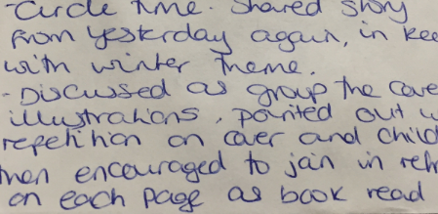
(Zine 4)

This is noticeable as this activity is with children aged 3+. There is no comparable data for practice with under-threes.
When asked to really think about what early reading is and when practitioners are asked to define this for their practice, the definitions are therefore heavily weighted to ‘pre-reading’ skills and this does not relate to what is happening in practice with under-threes. More importantly, some of these definitions contradict actual practice documented, especially when related to sharing books with babies and toddlers and their understanding of the value of reading, which demonstrates the confusion and contradictory nature of reading for these practitioners.

Both focus group workshops revealed that there appears to be a lack of understanding from the participants about what early reading actually is in practice, relating to how is it defined. The definitions to emerge from the focus group workshop were:

All forms of positive communication. The patterns, rhythm and sounds that lead to early reading.
Making sense of sounds and marks, translating their environment.
Immersing children in a literacy rich environment.
Recognising and identifying marks and pictures in the environment.
Beginning to promote a love of reading through everyday practice.
(Focus Group Workshops)

Figure 4.1: Photograph of one of the definitions crafted by the participants

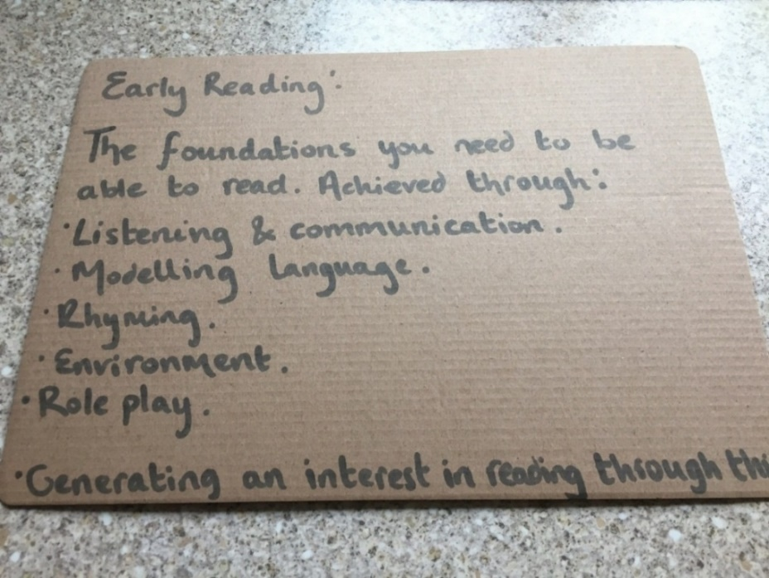
It could be suggested that these definitions may address some of the aspects of early reading practices discussed in the literature review in Chapter 2. The practitioners’ definitions of “making sense of sounds and marks”, “recognising and identifying marks and pictures in the environment” and “immersing children in a literacy rich environment” are interesting definitions, linked to print. Conversely, in order to have a wide knowledge of books and texts, children under three need access and experience of a wide range of books and texts. This access was noticeably absent from the data in this research study. These practitioners reported that they were not providing access to a wide range of books and texts for under-threes.

In addition, reading is also defined by Medwell (2014) as “the act of making meaning from text” (p. 45), which the practitioners have acknowledged, in part, within their combined definitions. The practitioners do note engaging in reading activities in their definitions, yet this is not evident across the data sources relating to their practice with under-threes – particularly related to interacting with books. A possible explanation for this contradiction may be linked to earlier findings in the sense that practitioners do know that this should be happening in practice and, when asked specifically about early reading are able to articulate this in theory, yet they have forgotten that this also applies to their pedagogy with under-threes. This contradiction also demonstrates that supporting early reading is not high on the practitioner’s agenda. This might be considered another “educational challenge that early years practitioners are expected to fulfil” (Pupala, Kascak and Tesar, 2016, p. 656) alongside the current observation, planning, assessment and reporting process, given that the focus is on phonics in many policies (detailed in Chapter 2), rather than supporting early reading development.

Subsequently, a common activity for under-threes from the survey data is the use of rhythm, nursery rhymes, music and beat, aligning with Bower and Barratt’s (2014) proposals that “rhythm, rhyme and repetition are fundamental to children’s pleasurable engagement with early reading” (p. 131). The practitioners’ definitions also acknowledge Whitebread (2009) and Goouch and Lambirth’s (2013) assertions that young children’s knowledge about language and sounds is developed by engaging in rhyming activities. The definitions written by the focus group participants do appear to have included some of these central themes of early reading development. Nevertheless, this is not reflected in their everyday practice or their perceptions of reading. Focus group participants noted a “literacy rich environment” in their definitions, yet accept that this is not happening in practice for babies in particular and seek to address this in their discussions:

Early reading should be everything we do – in all our routines, daily tasks, activities and we should be promoting more about love of books for our babies and toddlers. Looking at the definitions and discussing how this links to my practice is really helpful and I realise that just making a few small changes about how we approach this now is a good starting point.
(Focus Group Workshop 2)

Given that taking part in this research offered an opportunity for the practitioners to genuinely reflect on the extent to which they were planning for these activities to be part of their everyday practice, it appears that practitioners changed their practice. This account also relates to earlier findings about this research study being the cause of reflection and change for these participants, which will be explored later in the chapter, under the theme of ‘support for early reading’.

Additionally, the data suggests that practitioners need to see the value of an activity and experience feedback from the children, in particular babies and toddlers, in order to engage further and to enjoy the activities themselves, which is influencing their pedagogy for under- threes. One Zine entry noted:

Looking at picture books today with one of our 16 month olds, who has now stopped eating the books! I think this is because we are now using the books regularly and sitting with her. Using the books in an appropriate way, turning pages and not so much as a filler for in-between gaps in the daily routine, but more of a proper valuable activity. I’m really enjoying engaging the toddlers and babies more with these experiences.
(Zine 3)

The practitioner notes that she has observed the baby’s interest in the books that extends beyond sensory exploration and, as a result, feels more inclined to look at books more often with this child. Levy and Preece’s (2016) findings also propose similar notions of feedback being important for the parents in their study. This study is researching barriers to shared reading. The findings suggest that there is a need for many parents to see feedback, in the form of the child’s enjoyment and/or evidence of learning, in order to encourage them to continue to engage in reading with their young children. Naturally, babies offer different forms of feedback from older children and this could be attributed as a barrier to engagement, as it could be considered difficult to interpret feedback from babies (Levy and Preece, 2016). Another Zine entry notes:
I am trying to put books in all areas of the room now with our babies – it’s just difficult really as they are not looking at them, reading them – they take them to their mouths and empty and fill the book basket and then they start to play slip and slide, so we move them out of the way, because it’s dangerous as the books are slippy. It’s easier with toddlers and older children as you can see they are looking at them and pointing to the pictures, making sounds and so on.
(Zine 5)

Evidently, feedback is a key requirement for this practitioner and she uses the discourse of “it’s easier with toddlers and older children” to explain this, given that Grenier (2016) states that practitioner observations are usually focused upon interaction, language and the processes of co-construction when working with under-threes, this is understandable. Early years practitioners are expected to promote the ‘characteristics of effective learning’; “playing and exploring, active learning, creating and thinking critically” (Early Education, 2012, p. 5), within the guidelines of the EYFS (DfE, 2014). Yet, a large part of this guidance is building upon the children’s interests. Practitioners are continuously observing and planning for these characteristics and the ways that young children are engaging with their environment, which could be essentially linked to seeking feedback. In this entry, the practitioner also uses a health and safety rationale to attempt to justify putting the books away out of reach of the babies. It appears that reading is not considered a priority for this practitioner when working with babies; as she is not observing any interest from them evident in the phrase “it’s just difficult really as they are not looking at them, reading them”. This practitioner does not seem to view books as a useful activity. The practitioner observes and notes that there is value in books as an activity with older children and cites examples of toddlers pointing to pictures and making sounds. This again highlights the practitioner’s own need to see ‘evidence’ of the children’s engagement with books in order for her to value this as a reading activity with the children.

Subsequently, all the interview participants define early reading as getting children interested in books and stories to be ‘ready to read for school’, which also correlates with their perceptions of reading generally. The practitioners all consistently seem to be talking about getting under-threes ‘ready to read’ in their conversations and definitions. This implies that the reading that under-threes actually engage with is not considered to be of value in itself, but rather is only valuable in the sense of being preparatory. It is apparent that practitioners place significance upon reading books, sharing stories and singing rhymes with under threes as valuable daily activities in their own right, but not as being perceived as actual ‘reading’ activities. The practitioners consider that all things connected with letters, sounds, print and words are reading and everything else is just about getting them ready to read. The practitioners in this study do not seem to recognise the interactive and shared nature of reading for young children (Reid, 2009). Early reading is perceived by the practitioners as “the bit before they read in school” (Ella). Ella defined early reading as;
Getting them interested in books and picture books and words so that they will be ready to read, I think? (pause) Early reading is the bit before they read in school

This suggests that Ella views print awareness and phonetic understanding as being part of the whole process of encouraging an interest in books, stories and rhymes and that this precedes reading a book (which comes later in school). Consequently, Ella states that “children will read when they are ready” which appears to be based upon the model of psychological development that relates to young children being unable to read until certain prerequisite skills have been established (Merchant, 2008). Additionally, these statements also appear to be influenced by physiological viewpoints advocated by Dean (1968). Reading “when they are ready” may imply that adult interaction is not necessary for under-threes and does not pay due regard to the early stages of learning about reading or ascribe to reading as an active search for meaning promoted by Clay (1991) and Riley (1996). Ella also explains that early reading is “phonics, letters and sounds is phonics. All early reading is phonics and getting them ready and so on because they need to be able to read later”. This concept of being ‘ready’ to read raises questions about what this actually means and the extent to which phonics are present in this debate. Ella refers to the perceptions of parents in her narrative, which may also be influencing her own perception of reading and influencing her practice:
The parents like to see the phonics activities on the timetable – they always talk about this and how well they are doing with initial sounds and things and recognising their names.

This data is really thought-provoking, as it raises questions about what exactly is needed to be ‘ready’ for reading. I asked Ella if she minded explaining what she means by “the bit before they read in school”. Ella responded with:

I mean that we prepare the children with sharing stories and learning letter sounds and sound discrimination before they go to school and actually have to take home a reading book. We do Phase 1 and sometimes Phase 2 to get them ready.

This suggests that Ella’s definition of reading and being ready to read is taking home a reading book in school. She is also talking very specifically here about letters and sounds and sound discrimination. Ella also refers to her setting preparing the children to read with sharing stories and using the phases of Letters and Sounds (L&S) (DfES, 2007) activities. She described the reading scheme in her feeder school as “beginning with books without words and building up to decodable text”, which implies that Ella has some knowledge of phonics and reading schemes. Ella’s passion for “getting them ready to read” is clear; yet it is evident that her setting views their role as preparing under-threes to be ready to read ‘for school’. If this is the case, then this raises further questions about the extent to which settings such as Ella’s perceive themselves as having a role in teaching reading at all. The opinion of leaving “the early reading bit until pre-school and then reception” is consistent in all interview dialogues. Lily also offered a similar perception of preparing children to read in her setting:

(Early reading is) getting them interested in books and picture books and words so that they will be ready to read. Early reading is the bit before they do the formal phonics but I think that it merges a lot doesn’t it.

Lily talked about “doing Letters and Sounds Phase 1 activities and Jolly Phonics with our children on a daily basis”. Lily works in the nursery room with children aged between two and a half and three and a half years old. Lily reported that the staff team “just dip in and out of both (L&S and Jolly Phonics) and other things also – we do lots of different activities with our two and three year olds”. Lily also explained that she thinks “it is difficult to separate [early reading and phonics] as early reading is actually phonics, all those Letters and Sounds activities, so they are ready for school”. The practitioner’s remarks about “getting them ready to read” and “ready for school” are both intrinsically linked to the term ‘school readiness’, which is apparent in numerous Education Reviews and Statutory Guidance Documents (‘Unseen children: access and achievement 20 years on’, Ofsted, 2013, ‘Early Years Outcomes’, DfE, 2013, Coghlan et al., 2010). Ofsted (2014) highlight that “the precise characteristics of school readiness and the age of the child to which it applies are, however, interpreted differently by providers” (p. 6) and policy makers. Ofsted continue to suggest that there is “no nationally agreed definition” (p. 6). The United Nations Children’s Fund (UNICEF) propose that:

School readiness has been linked with positive social and behavioural competencies in adulthood as well as improved academic outcomes in primary and secondary school, both in terms of equity and performance.
(UNICEF, 2012, p. 6)

Allen (2011) advocates that children are school-ready at aged five. The ‘Tickell Report’ (2011) proposes that in actual fact “most children begin reception class at age four” (p. 8). Considering that most children may begin reception at age four, this may present a top down approach to school readiness, linked to Baseline Assessments and the pressure of the ‘Early Years Foundation Stage Profile’ (DfE, STA, 2016), being disseminated to those working with younger children. The practitioners are possibly referring to the definition of school readiness “pre-primary educational approach that stresses literacy and numeracy skills that would align with a primary school curriculum” (UNICEF Homepage, 2012) and are focusing upon getting them ready to read with this in mind. This discourse of ‘getting them ready’ is prevalent in many forms and is terminology often used by Ofsted in school inspections.

During the preamble for each interview the practitioners talked independently about how much they enjoy and value their work with under-threes; that two-year-olds are “a different kettle of fish and so much fun to be around” (Maria); “enjoying working with babies as it is so rewarding” (Lily). It was not evident at this point that the practitioners identified their role as preparation for the important ‘big school agenda’ that is often discussed, until the discussions centred on early reading. The practitioners ascribed mainly to McDowall Clark and Baylis’s (2012) view of a value based early years philosophy; celebrating the competence of children’s present rather than readiness for the future in preamble discussions about their practice with under- threes. It appears, however, that there is an emphasis on school readiness within the data relating to early reading. This suggests that practitioners see their role in supporting early reading as the ‘get ready stage’. It could be suggested that the practitioners consider that all the rich opportunities provided within continuous provision and the daily planning for early reading is less important than the actual reading of a book, as they are ‘not ready’ for that yet. It could also be an unconscious perception, as noted by McDowall Clark and Baylis (2012), in relation to working with older pre-school children. They proposed that working with children in nursery schools and reception class can be regarded as being ‘more important’ than working with under-threes, therefore requiring a higher calibre of staff and teachers to ‘teach’ reading. This could be related broadly to the confusing nature of the EYTS status – not being equivalent in status, pay or conditions to a qualified teacher, yet bound by the same entry, training requirements, compliance and regulatory governance (Moss, 2014). This may be a reflection on the professional identities of the EYITTs, in that they feel that teaching reading is not their role – this is better left to the ‘real teachers’ holding QTS, later in school.

The perception of the practitioners interviewed is that reading happens ‘when children are ready’ and this is usually in school, when they are given a reading book to take home. This perception may also arise from the downward pressure from school, which is often a concern noted by ECEC practitioners. McDowall Clark and Baylis (2012) also suggest that this often “feels like a one-way-street, as early years practitioners react to expectations of what children should be able to do when they reach primary school” (p. 237). Current emphasis on readiness for school from the ‘Tickell Review’ (2011) and the ‘Allen Report’ (2011) is also likely to have impacted upon this discourse of readiness. The EYTS Teachers’ Standards (Early Years) (NCTL, 2013) 3.3 also expect the EYTs to “demonstrate a critical understanding of the EYFS areas of learning and development and engage with the educational continuum of expectations, curricula and teaching of Key Stage 1 and 2” (p. 3), which in itself may lead to the notion of school readiness. Moreover, Wood et al. (2015) include a sample school readiness checklist in their ‘Early Words Together’ study. The following extract is taken from the section on reading expectations;

Looks at books or pictures on their own
Pretends to read books by reading the pictures
Tries to read in everyday situations (signs, labels, etc.)
Recognises rhyming words
Blends sounds into words
Recognises some common words in print
Recognises many uppercase and lowercase letters
Recognises some letter sounds
Describes characters’ actions and feelings in a story
Relates stories to personal experiences
Puts events of a story in order
(Wood et al., 2015, p. 39)

These are skills expected of pre-school children, linked to the EYFS Development Matters (Early Education, 2012). It could be suggested that children will certainly be ready for school with the many literacy practices and early reading activities noted in this research study for under-threes, but the vital question is, whether they will they be motivated to read.

The countless missed opportunities to share books with babies which have been previously highlighted in this chapter and the lack of value placed on reading picture books by practitioners suggests that this may be a significant issue for under-threes’ interest and engagement with early reading. If under-threes are not being offered a wide range of books and print from birth, ample experiences and interaction with knowledgeable and responsive adults (Jamison et al., 2014) to support their language and communication development, alongside other early reading practices evident from this data, then this could affect their interest and engagement with reading overall.

Furthermore, the data not only revealed that the reading that under-threes engaged with was not considered to be of value in itself, but was preparatory, there was also evidence to suggest that some practitioners actively ‘taught’ phonics to children of this age across the Zine samples and within the survey data. An example of teaching phonics early is apparent in this Zine entry:

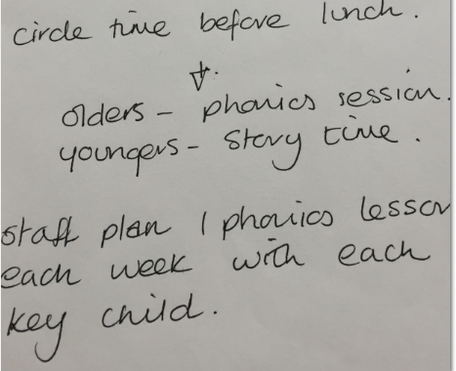
(Zine 4)

Here the ‘youngers’ (toddlers) have a story time activity and the ‘olders’ (2 year olds+) take part in a phonics session. This example shows how story time is not seen as being part of ‘real’ reading as it is separated from the ‘real’ reading lesson, which is to teach phonics. Moreover, it appears that the ‘olders’ have lost their story time in place of a taught phonics activity. Consequently, and significantly, this study revealed that phonics is appearing as a focused activity in practice with under-threes across all the sources of data. The high percentage of phonics programmes and activities mentioned in the data sources to support under-threes is a concerning factor.

For example, Jan suggests that the early reading activities in her setting include specific phonic schemes. She stated:
I do the Letters and Sounds activities with some of the older children. A typical day would be daily story time with props, story sacks, singing nursery rhymes, perhaps a messy play activity, letters in sand or foam, a L&S Phonics activity, Silly Soup, small world animals alongside ‘Dear Zoo’.

Jan is referring to her work with toddlers and two-year-olds during the interview. All the practitioners interviewed talked about or discussed phonics, Jolly Phonics, Letters and Sounds (L&S) (DfES, 2007) and the interwoven nature of early reading and phonics. This is an interesting point to note and a significant theme, as prior to each interview I re-stated the aims of the research project and reminded all participants that this research was specifically relating to their work with under-threes. From the survey data gathered, it is clear that practitioners are engaged in a wide variety of activities to support under-threes with early reading development, such as singing songs and nursery rhymes, listening games, sharing stories, books and puppet play. Out of the 35 responses to the survey question ‘How do you currently support under threes with their early reading development?’ 16 participants (46%) made reference to formal phonic schemes such as Letters and Sounds (DfES, 2007) and Jolly Phonics.

This highlights that a number of practitioners appear to associate supporting early reading development with teaching phonics. This high incidence of phonics in pedagogy with under-threes may be the result of the practitioners taking a “policy compliant approach” (Fisher and Wood, 2012, p. 121) in their pedagogy with under- threes. In fact only 1 practitioner out of 50 who completed the survey challenged the policy directive nature:

The challenge is that we are required to do this [teach phonics], but if this is not right for the children in our setting - we don't as we focus on the needs of the children in our care.
(PDN Practitioner, Survey Response)

This suggests that Fisher and Wood (2012) have a valid point to make in their assertions. Early Years settings are bound by the Ofsted ‘Early Years Compliance Handbook’ (2016, 2017) alongside the key documentation for EYFS (Figure 2.1), which repeatedly refers to phonics - specifically SSP as best practice. This is then reinforced within the ‘Early Learning Goals’ for Literacy: ‘Reading’ and ‘Writing’ (DfE, 2014). Therefore practitioners, with the very best intentions are planning activities and experiences designed to meet these ELGs, which in turn leads to formally, inappropriately teaching phonics to under-threes rather than taking the autonomous professional approach advocated by Osgood (2006).

This has implications for how the children view what reading is and how this is translated to the wider arena (which includes parents and carers), given that Levy (2009) has already demonstrated the dangers of children believing that reading is about phonics, which had many negative consequences for the young children in her study. This study also suggests that these attitudes towards reading are possibly originating in the early years and within the education of under-threes. If the children view reading as being taught phonics - an adult-led activity; something they may actually enjoy, but also know that this is something they have to join in with, this is also going to impact on the children’s engagement with reading, and consequently how parents and carers support this. It could be suggested that the focus on phonics from policy, practice, research and Ofsted is guiding practitioners away from the general communication, language, literacy and early reading activities they would have usually carried out with under-threes, which is deeply concerning. The concern may also be more about early years practitioners’ understanding and the importance of the weighting of some of these activities for under-threes, particularly as the data already indicates that many practitioners have forgotten about using books with babies.

Phonics appears to be dominating the perceptions of the practitioners, influencing their definitions of early reading and influencing pedagogy and provision. Phase 1 of the Letters and Sounds (DfES, 2007) document is very much focused upon listening and speaking activities, which falls largely within the ‘communication, language and literacy’ areas of learning in the EYFS (DfE, 2014). This may be part of the rationale for practitioners being drawn to this document, particularly if the older children in their setting or the feeder settings use this as the identified programme of study. Although the literature suggests that literacy begins from birth (Makin, 2006; Mandel Morrow and Dougherty, 2011; Wolf, 2008) this is being somewhat misinterpreted by the practitioners into ‘teaching phonics’ rather than engaging with language, rhyme, sounds and print within the play environment and reliance on a programme of study to carry out these activities. Centrally, phonics as a concept does exist from birth and children should be encouraged to identify and recognise sounds and print, but only within a meaningful context for each child as a child-led activity, proposed by Adams (1990), Lindon (2013) and Whitehurst and Lonigan (2001). Phonics can happen with under-threes but the teaching of phonics should not (Suggate et al., 2011, 2013). If children are taught that phonetic decoding is actually reading then this will undoubtedly have an adverse impact on young children’s relationship with reading, as proposed by Levy (2009).

The practitioners in this study largely identified and defined early reading as relating to phonics and they are furthermore confused about how to implement early reading practices with under-threes. Aligned with the confusion about early reading and phonics, participants’ understanding of the terminology of ‘early reading’ is raised as a challenge from the initial survey data. If practitioners see early reading as ‘being about phonics’ this might explain why they are confused about implementing early reading with under-threes. Firstly, these practitioners are (largely) not confident about teaching phonics and secondly, not sure how to do this with under-threes. Therefore, the issue here is really about their definition of reading, which also emerges from the survey data.

Essentially, focus group participants all raised the issue of their lack of understanding surrounding the concept of ‘early reading’. Additionally, 70% (35/50) survey responses did not comment on how they support early reading for babies and toddlers. 40% (20/50) wrote ‘n/a’ in both sections of this survey question. This could initially be due the fact that these practitioners do not currently work with babies or toddlers as their main employment. It is important to note, however, that the EYTS training programme requires trainees to cover all age ranges, including babies and toddlers. Yet at the point of the survey, this experience of working with babies and toddlers may not have been provided for them. Furthermore, the survey question asked how practitioners currently support very young children with early reading development and is split into age ranges of babies, toddlers, two-year-olds and a section for 3 – 5 year olds with spaces to complete each section. This may have led to some of the blank and ‘n/a’ responses, referred to as missing values within the survey data by Ruel et al., (2016).

Consequently, this might also lead to the belief that early reading is not considered to be relevant or applicable to under-threes, as so many of the participants did not respond to this question, yet do actually work with this age range. Alternatively the lack of responses to this survey question might suggest that practitioners do not actually recognise what they do in practice to support under-threes. It is not possible to know from the survey data if those participants that refused to respond to this section of the survey did so because they did not work with this age group, or because they did not feel that they supported this age group with reading, however the focus group data provided some clarification of this.

Indeed, over half (54%, 6/11) of the participants from the focus group workshops stated that they did not complete these sections of the survey because they either did not know enough about this particular age range or presumed that early reading began with phonics, so wrote ‘n/a’, which does in fact demonstrate a lack of understanding about early reading development, as well as some confusion about phonics and the experiences necessary to promote this area of development for this age range. One focus group participant commented “I just thought that early reading was the same as phonics and we don’t do phonics with under-threes, so put ‘n/a’”. Alternatively, 45% (5/11) had not worked with either babies or toddlers at that point so did not respond to this question.

In addition, 58% (29/50) of survey participants suggested that they needed more specific training and support for early reading, with 32% (16/50) stating that early reading knowledge and understanding is actually a real challenge for them in practice. Interview participants also stated that early reading with under-threes is a complex challenge:

I think it (early reading) is a complex subject – I think I said this in the survey. Just understanding it all and getting to grips with it is really complex.
(Maria)

Jan also suggests that understanding early reading is a challenge:

I think reading is difficult to get right - the confusion about how to teach reading and phonics, too early, when and what. Parents are confused and want their children to be doing something but I don’t think anyone is actually sure about what this is. You asked about accessible books – and this could be one thing that the setting and also myself just don’t get right. I think the biggest challenge for me is am I getting it right?

Maria uses the word ‘complex’ twice and Jan talks about “getting it right” and suggests that early reading is confusing for everyone including parents. This highlights some of the confusion surrounding early reading for these practitioners and how this permeates to expectations from parents and carers. Jan refers to the enduring debated question of “how to teach reading and phonics, too early, when and what”. It is no surprise that this is cited as confusing, as this is equally contested by researchers and educationalists alike (Brooks, 2003; Chall 1967; Hall 1987; Rose, 2006; Torgeson et al., 2006). In truth, there is no specific guidance to support practitioners working with under-threes to enable them to know how to teach reading, including when and what to teach and when to begin formal phonics instruction. Most of the debate surrounding phonics is based on school aged children and struggling readers, which is unhelpful for practitioners working with under-threes.

Interestingly, 78% (39/50) survey participants stated that they do not have an early reading policy in their setting to support them. This is also concerning and could be a contributing factor to the lack of understanding of early reading in practice for practitioners. The benefit of articulating and explaining the settings’ approach to early reading - their overall policy and practice - would be a valuable activity for the settings, practitioners, parents and carers alike. Certainly situating the strategies that the setting offers to support early reading development within the vision and ethos may also help to align all the high quality work that happens with under-threes to the current phonics policy agenda in schools and to support parents and carers with expectations of their children’s development in order to be able to avoid the confusion that Jan refers to in her transcript.

There seems to be two separate issues here emerging from the data; some practitioners are doing lots of reading activity with under-threes, yet they do not appear to value this because their definition of reading is that it is about phonics. The second issue, raised earlier in the previous section of this chapter, is that some practitioners are not even doing these reading activities because they do not perceive them as relevant for this age group. Practitioners will need to be supported with crafting an early reading policy and strategy, which identifies a vital training demand. The government drive and advocacy for SSP to support greater literacy attainment has resulted in a particular structured approach to teaching reading, led by schools and is trickling into practice with under-threes. This also appears to be affecting the decisions practitioners make when discussing early reading, given the policy driven nature of the EYFS (Bradbury, 2013), linked to phonics, to prepare young children for school. Additionally, it is significant to note that the literature in Chapter 2 strongly suggests that experienced teachers also struggle with the conflicting advice surrounding the teaching or early reading and phonics, therefore this is not specific to the EYTTs.

A large number of the overall survey participants (64%, 32/50) stated that there were indeed some challenges in supporting young children with early reading, such as understanding “what early reading is in everyday practice”, “the contentious nature of reading and phonics”, the fact that “children are not ready to read”, as well as “EAL concerns”. The confusion between early reading and when to formally teach phonics may also be a direct link to (lack of) understanding early reading.

Moreover, the responses to the interview question “What support or CPD do you get or are you able to access for early reading to support your own skills and knowledge?” revealed a similar theme of relating training to phonics and not specific to early reading:

Well we attend training sometimes – local authority training but that’s it really. I read, I read a lot and look online for suggestions for activities. I think Letters and Sounds has it all really – it’s all in there. Obviously EYTS programme has been really excellent CPD.
(Ella)

Ella suggests that the ‘Letters and Sounds’ (L&S) (DfES, 2007) document contains everything she needs to know about early reading and phonics, alongside her own reading and online research and Ella appears to view early reading as phonics. The L&S document is designed for schools and is adult-led with the intention of teaching oral segmenting and blending. It is not intended for children under three. There are references in the L&S document to “language-rich provision” (DfES, 2007, p. 1), “exposure to books” and “daily speaking and listening activities” (DfES, 2007, p. 2) which the practitioners have raised in their definitions of early reading. Similarly, these comments highlight the complexity of early reading and the challenging nature of the discourse surrounding early reading linked directly to phonics, as well as the fact that the practitioners are using phonics with under-threes as a teaching strategy because they may be being advised to do so. One participant noted in the survey that the biggest challenge is “the pressure from feeder schools to do phonics”, which suggests that there is indeed a top down filtering of pressure. This also relates to the wider implications of the debate surrounding phonics in general in education described by Roberts-Holmes and Bradbury (2016a) as the “datafication of early years education and its impact on pedagogy” (p, 120).

The practitioners define early reading as activities and teaching sessions that focus on letters and sounds and the teaching of letter-sound relationships in a sequential fashion, which demonstrates some understanding of teaching the early stages of phonics and a lack of understanding of the needs of under-threes regarding reading activity. Phonics and phonics programmes of study (Letters and Sounds and Jolly Phonics in particular) are mentioned by many of the practitioners in relation to supporting under-threes with early reading, which again indicates that practitioners are using phonics as a teaching strategy with under-threes. It could be suggested that there is a drive to be more phonics focused from Ofsted (‘Reading by Six’, Ofsted, 2010; ‘Getting them reading early’, Ofsted 2014) and the school readiness agenda (Field, 2010; Whitebread and Bingham, 2011). In fact, a new trainee EYT not involved in this research study has recently been involved in being observed as part of an Ofsted Inspection of her setting. She explained her session to me and shared her planning, as she was delighted to celebrate that the Ofsted Inspector had told her what a fantastic session it was and suggested this could be used as a good practice example. The session was a ‘Letters and Sounds’ (DfES, 2007) Phase 1 taught session, matching objects to letters (s, a, t, n, sounds) with a group of eight two-year-olds sitting on the carpet. This suggests that the target driven agenda from government and Ofsted (Bradbury, 2013) is filtering into practice with under-threes. This also highlights a lack of understanding about the literacy needs of under-threes. In addition, to illustrate further, I personally observed a session with two-year olds (whilst delivering Mentor Training to a new ‘outstanding’ school provider) which mirrored the use of the Busy Toddler Alphabet Post-It Wall suggested by ‘Busy Toddler’ Homepage:

Figure 4.2: Toddler alphabet Post-it wall

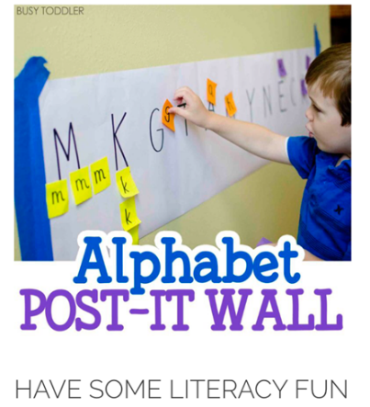

In essence, the ‘EYFS Statutory Framework’ (DfE, 2014) offers no explicit definition of what constitutes a quality learning experience for early reading. The EYTS Teachers’ Standards (Early Years) (NCTL, 2013) Standard 3.4 states that EYTs must “demonstrate a clear understanding of systematic synthetic phonics in the teaching of early reading” (p. 3), which may well be a contributory factor in the practitioners’ perceptions of pedagogy and provision. It would be helpful if NCTL could be specific about this Early Years Teaching Standard and relating amplification, with an explanation on how and indeed, if, this applies to the age range of under-threes. It is also important to situate the fact that “most pedagogical practice in early literacy education is based almost entirely on the sign system of alphabetic print in such a way that the focus of ‘natural’ reading development is tied to print concepts to the exclusion of other types of signs and symbols” (Hassett, 2006, p. 83). Consequently, House (2011), Moss (2010) and Taggart (2011) propose that there is currently a damaging top-down pressure on early years practitioners and Roberts-Holmes and Bradbury, (2016a) contend there is a move to resort to an overly formal curriculum in preparation for the next stage of achievement, which as the data confirms is reflective of these practitioners’ accounts and the use of phonics programmes of study.

The challenges noted by the practitioners in supporting under-threes with early reading link to the earlier sections of this chapter about this being a confusing and complex topic. The practitioners note that “the advice (from LA and setting) is often confusing”, “understanding and defining early reading is a challenge”, “supporting parents”, “supporting the wide range of abilities” and “supporting EAL and SEN children” are key challenges. Lily, an interview participant, explained the challenge for her was the concept of reading in general:

One of the challenges is phonics and the confusion about how to teach it, we have the resources and the timetable has phonics activities on daily or weekly, but it has to be delivered in a particular way and not all children learn in this particular way. Parents are confused with the alphabet and alphabetic code. English is tricky.

I think we get early reading right really – just need to be better with teaching phonics.

Lily works in a Children’s Centre and is explaining that the challenge for her is teaching phonics, which again associates the practitioners’ perception of early reading as being linked to phonics. Lily suggests that her setting is getting early reading right and the confusion happens with teaching phonics, with is often the view of many researchers (Harrison, 2002; Hynds 2007, Wyse and Goswami 2008; Wyse and Styles 2007). The confusion appears to be understanding how to support under-threes with early reading in practice and when to move to a more formal approach to teaching phonics and how this should be happening, if at all, with under-threes. The data suggests that practitioners overall are not understanding the everyday practice of early reading for under-threes which is linked to their perceptions of ‘reading’ being inextricably linked to phonics. It is important to note that the under-threes age range also includes two-year-olds, separate from babies and toddlers, which are now expected to be in schools as part of the two-year-old provision plan to offer flexibility and choice for parents (DfE, 2013). Therefore practitioners are supporting babies, toddlers and two-year-olds, who all have totally different needs and requirements (Green et al., 2015).

Furthermore, the data also indicated that practitioners’ perceptions of early reading and how they see themselves as role models for early reading with under-threes is also influencing their pedagogy. There is some evidence from the data that the practitioners model and demonstrate reading (and writing activities) yet this is not consistent across all data sources and does not appear to be a feature of practitioners working particularly with under-threes. Incidental literacy activities are noted by the practitioners working with under-threes from focus group workshops, such as “completing the register”, “writing notes”, “making name cards and labels” and “writing observations”. Some practitioners also reported that they read stories to the children daily. Further analysis of the data, however, revealed that this is not always the case, especially so with babies. In addition, practitioners report that they do not sufficiently model early reading habits and that under-threes do not see practitioners engaging in reading on a daily basis.

The focus group workshop definitions of early reading included “promoting a love of reading through everyday practice”, yet this particular practice is not evident from the data sources, as many practitioners noted that they do not feel that they sufficiently model reading practices with young children. This relates to earlier findings in that the practitioners are able to articulate this as a definition and know that this ought to be happening, but there is possibly some tension relating to the practitioners knowing exactly what this means and ensuring that this happens daily in their practice. A further example of this was during the focus group workshop discussions. When asked to explain ‘how to promote a love of reading through everyday practice’, responses were linked to “sharing stories, books and print”, “immersed in environmental print” and “being a good role model”, hence the tension. It is this final point that seems to cause particular tension, as evidenced in the comment below:

Unfortunately, the children don't get to see me read as much as I'd like, due to the ages of the children I find it very difficult to get down time where I can pick up a book or magazine and if I do they tend to clamber over my knee with book of their own for reading. If the reading material I do have has pictures in such as a magazine we usually look at the pictures and talk about what we see but this then becomes an activity focused on the children rather than me displaying an enjoyment of reading.
(Maria)

This is an example of a practitioner saying that she has not managed to model reading due to the ages of the children and because the child brought a book to her, thus interrupting her reading. Maria fails to acknowledge that perhaps this particular child had been motivated to bring her a book because she was seen to be modelling reading. Additionally, this child is actively engaged in reading activity and this engagement has not been recognised or valued by the practitioner, which is consistent with earlier findings. This indicates that Maria has possibly overlooked the purpose here about the harmony of displaying enjoyment of reading, leading to child interaction with books and print and vice versa. Lucy similarly notes that modelling reading is not something she feels is part of her everyday practice with under-threes:

Unfortunately, erm, no, not often I suppose. Older children do, definitely – we do lots of writing and captions and reading together, making lists and notes, recipe cards when baking. Under threes – I am really not sure about this.

Both Maria and Lucy use the word ‘unfortunately’ to begin their narrative about modelling reading with under-threes, which is informative about the value placed upon reading, linked to earlier findings of the practitioners knowing this is something they ought to do, but are just not doing it in practice. Jan’s response was equally revealing:

If you are asking me about modelling or engaging in reading with under-fives – this would be a very different response. With under- threes, this is different. We try to read with babies and toddlers and as we have already discussed, we have a lot of work to do here. I don’t think we do model reading to our under-threes – writing, yes probably more so.

Here Jan is explicit about the differences in her practice of modelling reading between the three-to-fives (under-fives) and under-threes. This may suggest that she considers this of value for older children, but not for practice with under-threes, which is influencing the nature of both her practice and provision. This is also consistent with earlier findings about the lack of significance placed upon early reading with under-threes. Additionally, there are many reasons and benefits to reading that have not been documented, appreciated or understood by the practitioners within the data, such as the emotional satisfaction of reading, reading as relaxing, reading being fun and the informative nature of reading for young children (Dungworth et al., 2004). Alternatively, Ella reported that:

I always ask practitioners to share books with the toddlers. We write in front of the children when completing observations and the children see this regularly. We write their ideas down on paper for changes to the role play area so they are seeing that print carries meaning.

Although there is data to support modelling reading and participation in literacy practices with young children, the practitioners report that is not always with under-threes, and when it does occur, it tends to be writing rather than reading activity. The data implies that under-threes do not regularly observe practitioners enjoying reading.

The next section of this chapter focuses upon the practitioners’ chosen strategies for supporting reading with under-threes.

4.3. Theme 3: Perceptions of confidence in practice

I am trained in boosting reading potential. I have a sound knowledge of phonics, I am enthusiastic and I have studied early childhood development.
(Survey, Nursery School)

This section will analyse and present the findings specifically relating to the theme of perceptions of confidence in practice to support under-threes with early reading development. This section will discuss the notions of confidence, the rationale for chosen pedagogies and the training that the practitioners are engaged in, which may influence or affect their confidence in their practice with under-threes.

The findings suggest that practitioners initially reported that they were confident in supporting early reading, because they have some knowledge or training in teaching phonics and consider themselves to be experienced practitioners. Conversely, when the focus is on supporting early reading activities with under-threes and not teaching phonics, this uncovered a tangible lack of confidence and the examples of practice become especially vague, relating to the earlier findings of examples from practice. The data also indicates that many practitioners have not accessed any specific training for early reading with under-threes and that this is not deemed a training need by the practitioners.

A curious finding from the survey data is that 70% (35/50) of participants stated they were confident to support and teach early reading, 8% (4/50) very confident and 22% (11/50) not confident. Yet during the interviews, Lucy, Lily and Jan changed their minds about being confident to support early reading with under-threes. The 22% (11) who stated they were not confident in the survey explained that:
This is still quite new and finding my feet in this area. Early reading is a bit of a mystery! (PDN with 6 years of experience)
I can sit and read with children but unsure how this promotes early reading (PDN with 4 years of experience)

Once again, the perception of early reading is noted as a ‘mystery’ with some uncertainty, particularly concerning the youngest children. The practitioners record that they sit and read with children and value this as an activity, yet are unsure of how this activity leads to reading, which is revealing in their perceptions of reading and correlates to previous findings.

Overall, 78% (39/50) of practitioners rated themselves as either very confident or confident to support under-threes with early reading, which did not align with the rest of the data set; particularly, the types of activities documented to support under-threes with early reading, the lack of reading activities and the challenges stated in the survey data, relating to reading as phonics. The practitioners largely reported that they were confident in supporting under-threes, yet the rest of the data indicated that this was not the case. If they saw reading as ‘phonics’, then there was confusion about how to do this with under-threes. Even if this wasn’t their definition, there was still some confusion about what they should be doing with children of this age. As stated previously in this chapter, the practitioners are actually struggling to define early reading in their practice for under-threes and are, in fact, linking this to the traditional phonic work expected of older children, which impacts on practitioners’ own perceptions of reading and thus the provision for under-threes. Therefore, at ‘face value’, the practitioners are reporting that they are confident with supporting early reading because they know about phonics or have been trained in a phonics programme of study. Nevertheless, when the questions delve deeper into practice specific to under-threes and early reading, real lack of confidence is uncovered, as well as uncertainty and some reflection on the necessity to change their own practice.

This is also consistent with earlier findings, which revealed that practitioners are not sharing books with babies and toddlers or creating a literacy rich environment for the youngest children. Consequently, this could be explained in that, prior to any training or critical reflection, the practitioners did feel confident to support early reading, given their past experiences, influences and perceptions of reading and this has now changed, having been given time and the opportunity to reflect. It is particularly interesting that during the interviews and focus group workshops with the opportunity to delve deeper into the survey responses, the practitioners’ perception of their confidence to support early reading for under-threes shifted. Lucy changed her mind about her confidence to support and teach early reading with under-threes during her interview. Lucy declared that she would now rate herself as not confident. Lucy explained that:
I am probably not confident at all now I have thought about it. (pause) I did think I was experienced though, which led to me putting confident.
I have found this interview and being part of this research really interesting and thought provoking. I think the first thing I am going to do is discuss what we currently do to support early reading and then perhaps enhance this in each age range – seems a missed opportunity. Thanks for that.

Similarly, Lily also changed her mind when asked to discuss this during the interview:

I think I would need to re-think this though with babies and toddlers based upon some of your questions. (pause) I don’t think I am confident in this particular age range at all.

The confidence appears to stem from the practitioners’ length and range of experience and their practice with under-fives in general. Again, when asked to focus specifically on under-threes, the perceptions do, in fact, change and become tenuous. Maria’s responses to these set of questions were particularly thought-provoking:

Interviewer: You described yourself as confident in the survey to support early reading with under threes. Could you explain your reasons please?
I think I felt I had to put confident as that would be odd with my experience over the years (long pause). I would need to re-think this. I don’t think I am confident at all now. I need to be more confident and much more secure with my knowledge of erm early reading development. Was that a trick question? (laughter)

Interviewer: No, I am genuinely interested how you would describe your knowledge and experience in supporting early reading with under threes.

Ok, well I am not confident. I will need to change that. I was, or I thought I was but not now. My reasons were based on my experience with young children, but I feel I need to know more about babies in particular and certainly more about reading with toddlers.

Maria felt obliged to state that she was confident in supporting under-threes with early reading as an experienced practitioner, yet when asked to explain this changed her mind. This demonstrates that Maria is not confident in her practice with under-threes, regardless of her years of experience, specific to supporting early reading. It could be surmised that the emphasis on early reading for the practitioners in this study has given them yet another aspect to focus on in their practice, in addition to the already challenging daily plethora of statutory requirements and regulatory compliance within the EYFS (Bradbury, 2013; Moss, 2014). This may explain why practitioners initially felt confident in their practice, yet on reflection decided otherwise.

These accounts identify that the whole concept of reading with regard to under-threes is nebulous, which highlights the importance of this research study and the focus on under-threes, signifying an urgent need for targeted training to support early years practitioners and further research in this field. Aligned with the practitioners’ review of their confidence are the responses to the survey question ‘Has any training or staff development influenced your strategies for supporting early reading with under-threes?’ This data provides key information about any training or staff development accessed to influence the strategies used by the practitioners. Significantly, only 36% (18/50) participants reported that they have accessed training which may suggest how much early reading is under-valued by practitioners and leaders at a managerial level and is not considered to be a training need. Alternatively, this finding is aligned with Goouch and Powell (2013) in that practitioners in their baby room project did not access training or development, therefore this may be a widespread concern for practitioners working with under-threes in general. However, it is important to note that all the practitioners were actually enrolled on the EYTS training programme whilst taking part in this research study and are therefore accessing training. The EYTS training programme is a part-time training route for graduates employed in a setting to train as an EYT, funded by NCTL. Subsequently, some of the practitioners mention that their recent continued professional development (CPD) or Local Authority (LA) training has influenced the strategies used to support early reading for under-threes, with comments such as:

We have all attended training and share information. We do research and take things on board which will benefit our children. We have attended school workshops for F2 and KS1 to support us with early reading.
(Survey, PVI Setting)

Another survey participant noted:

Not really for early reading, except for Toddler Talk
(Survey, PDN)

The training noted in the survey comments by the practitioners includes one day inset training, KS1, LA EYFS training, ‘Early Support’ and ‘Letters and Sounds’ training events.

A significant aspect of the practitioners’ perceptions of confidence in practice is the rationale stated for the strategies used to support early reading with under-threes. In their survey responses, the practitioners state that their rationale for supporting the early reading development of under-threes is their knowledge and understanding of ‘Letter and Sounds’ (DfES, 2007) or other phonics training programme documents, as well as the practitioners’ own knowledge of early reading development. This suggests that the participants have not been engaged in regular training to support them in practice with under-threes. This is concerning, given that Green et al., (2015) advocate for regular on-going training for early years practitioners. Yet, this is also hardly surprising given the current devolving role of Local Authorities and the under-valued perception from policy makers on provision for under-threes.

It was also interesting to note that where practitioners did report that they were confident in teaching and supporting early reading, this did not seem to be connected to training and/or support in this role. For example; half of the practitioners (50%, 25/50) stated that they felt confident to teach and support early reading development with under-threes, however they also stated that they have had no support to enable them to do this. Additionally, 10% (5/50) stated they were not confident, but have had some support. Furthermore, a small number of practitioners stated (12%, 6/50) that they were not confident and have had no support. It is somewhat confusing why participants would state that they are confident with no training or support, unless as previously mentioned, this confidence is only linked to their length of experience and they felt that this would be the most appropriate response. Additionally, the support that the participants are receiving in their setting is not necessarily impacting on the practitioners’ confidence or practice.

Subsequently, it is also noteworthy that many participants critically reflected upon their practice as part of this research study. The Zine entries all clearly demonstrate reflectiveness and change over the duration of the study, as practitioners were contemplating on their practice and purposefully adapting their provision for early reading development whilst completing the Zines. The data suggests that the practitioners were also developing their confidence in their practice as a result of this reflection. The following Zine entry is near the end of the completed Zine:

I put the basket of books on the carpet area this week again to encourage the youngest children to interact with the books and also to encourage the staff team working in the baby room!

It was almost like the babies had never seen books before – they mainly tipped the basket over and emptied and filled the basket. One 9 month old naturally ate the book and one of our 12 month olds patted each page – that was lovely.

I have just had to get the basket of books from the shelf! Apparently, they were in the way on the carpet and the babies were not doing anything with them. I think I have some staff training to deliver!!!
(Zine 2)

This Zine entry confirms that this particular practitioner has new knowledge and confidence to support and challenge the staff team and she also acknowledges that she needs to support her team with scheduled staff training, which is also evident in the Zine 1 entry. The phrase “naturally ate the book” demonstrates a good understanding of how babies learn and develop, their early relationships with books and the natural curiosity of babies. Siraj-Blatchford and Manni (2006) propose that “encouraging reflection often acts as an impetus for change and the motivation for on-going learning and development” (p. 28), thus given the opportunity for some reflection, time to focus on early reading for under-threes and being involved in the research study has led to a change in pedagogy and practice with babies in particular. Although this was not the intention of the research, it was a very pleasant outcome and as such, aligns with earlier findings which identifies an urgent need for more specific training and research on the literacy education of under-threes. Once more, the practitioner highlights the notion of feedback with the example of the 12-month old baby patting each page of the book, which correlates with earlier data that suggests that practitioners seem to engage more with babies and toddlers when they observe some feedback, discussed previously in this chapter.

A similar theme of developing and enhancing practice also emerged from the Focus Group Workshops:

I have totally enhanced the toddler environment – accessible books, story sacks available and accessible. I read books daily with our toddlers now. Early reading is everything I do now. I think about modelling reading all the time.
(Focus Group Workshop 1)
An important message from the data is that, given the opportunity to reflect on practice with under-threes with the specification of the focus just on early reading, the practitioners have the confidence and the ability to identify how pedagogy and provision for under-threes needs to change, corresponding with Larrivee’s (2000) suggestion that practitioners require an allocation of professional time for solitary reflection accompanied with the ability and confidence to question conventional practice in order to effect change and impact. The practitioners in this study demonstrated a commitment and desire to improve their practice in early reading by participating and contributing to this research. The opportunity to really think about their practice and to be open and honest about it has been beneficial for these practitioners, in conjunction with establishing a training requirement.

The final section of this chapter explores the support and training needs identified by participants for pedagogy, practice and provision.

4.4. Theme 4: Support for early reading

We really need training on early reading - all settings do different things,
which is not helpful at all.
(Survey Data, PDN)

This section will analyse and present the findings specifically relating to the theme of supporting practitioners in their understanding of early reading and what this means on a daily basis in practice for them. This section also discusses the type of support and training, or continued professional development (CPD) being offered to the practitioners, how this has impacted upon practice and identifies the nature of support requested by the practitioners.

The data identifies that many practitioners do not have any support for early reading specifically with under-threes and those that do have support denote phonics training, such as ‘Letters and Sounds’, LA phonics inset training and ‘Read, Write Inc.’ (Ruth Miskin Literacy, 2016). Consequently, practitioners consistently request additional support for early reading with under-threes.

Moreover, many participants remark that their practice has been significantly influenced by the EYTS training and by their involvement in this research study, as highlighted in the previous section of this chapter. The findings suggest that the implications for future training include embracing an urgent need for more specific early reading training and some initial good practice early reading guidelines to support practitioners and parents/carers with expectations, as well as their understanding of early reading activities. For example, Lily pronounced at the end of her interview “I think it is fairly obvious from my answers today that we need some more training!” Likewise, findings highlight that practitioners need more training which allows them to really think about what reading is with under-threes and how best to support this age range. For example:

This (research) has changed my practice and really made me think about why I do things and not just how.
(Focus Group Workshop 2)

Notably, 64% (32/50) of the survey participants stated that they do not have any support to teach or support young children with early reading. Additionally, all of the interview participants stated that they would like some additional training and support for early reading, which was echoed by the focus group participants. Those that do have support for early reading gave examples of “meetings with my manager”, “a teacher monthly visit”, “peer support”. Phonics, again, emanated into many of these statements for under threes; “we have regular inset phonics days”, “attended phonics training courses”, “L&S training” and “the Lead Teacher from the TA supports us with phonics, tracking and assessment”. It is evident from these statements that practitioners are receiving training in phonics. The findings also indicate that this focus on phonics training, together with earlier findings of a lack of understanding of what early reading is in practice for under-threes, is influencing practice and having a potentially negative impact on provision for under-threes.

Equally, the survey data question ‘what support or training do you think would help you in your work with under-threes?’ yielded very similar themed responses of further training for early reading, more specific training on early reading and in particular how best to support under-threes. Crucially, 78% (28/36) suggested more support for early reading is required for their work under-threes. Notably, 28% (14/50) did not respond to this question, which may suggest that they do not feel they need any support or further training.

Principally, there were some really interesting suggestions from survey participants of “good practice with under-threes guidelines”, “guidance on supporting babies”, “visits to see outstanding practitioners”, “share good practice experiences together”, “support for the setting and a clear strategy”, “support with developing an setting early reading policy” and “a specific training programme for early reading would be good - lots of phonics training is already available” to put into practice to support the practitioners. These are all very valuable suggestions that are not currently available or easily accessible for professionals working with under-threes. It could be argued that there is a plethora of research and publications to support early years practitioners, but I would propose that much of the research, literature and the textbooks are not focused upon supporting early reading and certainly not focused on work with under-threes. The findings imply that, because there is very little research and specific training on supporting under-threes, the focus on phonics with older children is radiated and often diffused to under-threes, thus influencing and impacting upon daily practice. I would argue for a more focused approach in the training of EYTs and a continued professional development (CPD) programme available after training. Similarly, Siraj-Blatchford and Manni (2006) also proposed that there needs to be “a commitment to ongoing professional development in order to support staff to become more critically reflective in their practice” (p. 28). It is also a concern that practitioners may not know how to access training and CPD, given the current financial situation of many LAs. Ella asked during the interview “do you know how to access any additional support or training? I would be really interested in attending”. Similarly, Maria asked “how can I find out about some early reading training for under-threes?” which suggests that this is not readily available or visible in current training schedules for these practitioners. Certainly, these practitioners intended to engage in further training and were clearly seeking support and guidance.

Essentially, I would advocate that taking part in this research study has already supported the practitioners in changing their practice in some small way, alongside the EYTS training programme. One of the final Zine entries reads:

I aim to foster a real love of books and stories with our babies and toddlers. We now have a wide range of age appropriate books always available for the children to self-select as well as for me to share with the children. Black and white and soft books for babies, textured books and books with flaps for older toddlers.
(Zine 3)

Similarly, focus group participants noted that their practice has been significantly influenced by the EYTS training and taking part in this research study:

I have led a staff development session in my setting on supporting early reading – rhythm, rhyme, steady beat etc. I feel this has had the biggest impact for me and my setting.

I started an early reading policy so that we can become consistent in our approach and explain what it is we do. When you asked me as an interview participant about the environment for early reading, I didn’t know what to say because I don’t think we did have an environment suitable to support early reading for our babies and toddlers. It is my responsibility as the EYTS in the setting to lead on practice and I have chosen to lead on early reading and in my setting – I really want to get this right.
(Focus Group Workshop 1)

Another practitioner commented:

I gained a lot more confidence after the early reading sessions and then again after the phonics sessions on EYTS. I am doing more reading and research now and looking at the environment as a whole to support early reading and not just reading books and stories etc. but this is not enough – we need more reading support and if nothing else a reminder of what we should be doing with babies, toddlers and two-year-olds.
(Survey Data, PDN)

This practitioner is commenting on her increased confidence after some taught sessions as part of the EYTS training, comparable to earlier findings of reflection on practice being key to building confidence. It is possible, however, that “needing more reading support” with babies and toddlers could be interpreted as starting phonic work which could be cause for concern, although she does continue to suggest a reminder of good practice with babies, toddlers and two-year-olds to possibly counteract this concern.

The findings highlight that contributing to this research project has led to the practitioners making vital changes. Ella commented that taking part in the research study “is making me think a bit more about reading to the children”. Similarly, Lucy reflects that her team need to continue “using books every day and just ensuring some consistency”. Undoubtedly, the time, space and opportunity to focus purely on early reading and solely on under-threes has been of benefit to practitioners involved in this research study. Interestingly, they have never been asked these questions before, specifically relating to under-threes, as Lily remarked that “these are really hard questions that I’ve never had to answer before and not about babies or toddlers”. This evokes a necessity for future training with a focus on early reading for under- threes.

4.5. Summary

This chapter has reported the findings from the data sources analysed for this research study; questionnaire survey, semi- structured interview data, focus group workshop data and Zine entries. The data offered insights into practice and provision and documented the experiences and challenges of the practitioners.

The overall issues raised within this chapter have explored how reading is perceived by practitioners in this study and the implications of these perceptions on teaching and supporting under-threes with early reading. Whilst acknowledging the wide range of learning experiences offered across all age ranges to support early reading development, the practitioners identify the need to review their practice and provision for babies. The data identifies that the practitioners are deciding what, when and how often babies interact with books, which could be considered detrimental to the quality of provision for under-threes.

The findings suggest that the practitioners consider early reading to be preparation for actual ‘later’ reading of a book in school, which suggests that the current reading that under-threes engage with is not viewed as ‘real’ reading and is therefore not valued by the practitioners in this study. There is value placed upon sharing books, reading stories, singing songs and rhymes as part of the reading journey, but there appears to be a lack of understanding as to how this is supports children as readers, thus displacing the value of those vital early experiences provided. Fundamentally, it is highly likely that the lack of early reading experiences provided for under-threes is affecting their later interest, motivation and engagement with reading.

Consequently, it is clear that the phonics debate is crucial to the practitioners’ overall perception and understanding of supporting early reading development, due to the prominence of phonics emerging from the data and the fact that phonics instruction is being offered to under-threes as part of the ‘Letters and Sounds’ (DfES, 2007) and ‘Jolly Phonics’ programme of study. Practitioners’ perceptions of reading align with the challenges noted from the data, in that they are confused about when phonics instruction ought to begin and how to support under-threes with everyday activities to develop them as lifelong readers.

The confidence noted by the practitioners to support under-threes with early reading is largely based upon their length of experience in employment and not linked to training or daily practice. Yet the practitioners acknowledge that the EYTS training has significantly impacted upon their practice. The opportunity for reflection as part of this research study has also enabled the practitioners to adapt their practice for babies and toddlers. An interesting finding from the data is the requirement for feedback noted by the practitioners in this study, linked specifically to activities with books and babies, which is again affecting provision for under-threes. Additionally, the findings identify that there is little or no support for early reading with under-threes for practitioners and practitioners note that a significant challenge for them is the confusion and complexity of the topic of early reading for under-threes, which aligns with the literature in Chapter 2.

The next chapter presents the discussion and analysis of the findings collectively to share the experiences and challenges of the EYTTs in supporting under-threes with early reading.

Chapter 5

The experiences and challenges of supporting under-threes with early reading: Discussion and analysis

Early Reading – what we should be doing with under-threes.
So many people do phonics with them but we don’t.
(Survey Data)

5.0. Introduction

The previous chapter presented the findings from the sources of data under the four key themes of ‘accessible early reading environment for babies’, ‘defining and understanding early reading in practice’, ‘perceptions of confidence in practice’ and ‘support for early reading’. These findings will now be analysed with reflections and considerations from the literature review in response to each of the research questions. The findings are now presented collectively in this discussion to share the experiences and challenges of the EYTTs in supporting under-threes with early reading.

5.1. How do EYTTs support very young children with early reading?

Practitioners are seemingly supporting under-threes with a wide range of early reading activities advocated by researchers and educationalists (Brooker, 2002; Goswami, 2005; Merchant, 2008; Snow, 2006). The findings indicate, however, that even though these activities did occur with under-threes, because the practitioners did not place value on these activities as being essential for literacy and early reading development, they did not continuously do these things and these activities were, in fact, unintentional. In reality, practitioners sometimes planned and carried out what many would claim to be, inappropriate literacy activities with under-threes, such as phonics activities and discrete phonics instruction (refer to Appendix J).
The data highlights some well-intentioned early reading experiences of sharing stories with two and three year olds, plus practitioners and children talking about stories and the characters in the stories. In addition, findings suggest that two-year-olds are being supported with environmental print activities. The evidence suggests that these practitioners, however, do not understand the mechanisms and processes of how these activities inspire and instigate under-threes in being a ‘reader’ within their provision as proposed by Wade and Moore (1996) and Evans (2012). The data suggests that the practitioners are neglecting to identify and thus value the curious natural instincts and embodiment (Syverson, 2008) that under-threes have to explore and investigate, to talk about, share and make sense of their world with the powerful resource of picture books (Arizpe and Smith, 2016), story books (Whitehead, 2007), and also digital literacies (Marsh, 2004).

A review of the literature in Chapter 2 established that it is crucial to support early reading from birth, with quality interactions with literacy materials; books, print, images and multimedia resources, that enable under-threes to develop and engage in lifelong reading practices (Wade and Moore, 2000). This appears to have been forgotten or perhaps overlooked within their busy working days, by many of the practitioners in this study, which is a troubling finding.

5.1.1. Understanding early reading: “The children are very young and not ready to read”

Syverson (2008) argues that there is little understanding that “reading, writing, speaking and listening are embodied activities” and “not merely cognitive processes” (p. 111). This is illustrated by some of the practitioners’ examples of activities to support early reading across the data set, as well as their perceptions and understanding of reading. The findings suggest that some of the practitioners’ perceptions of reading and using books with under-threes predestined that reading activity was not always valued as a significant activity, arbitrated by the infrequency and usage – rather it was more often used as a ‘fill in’ activity with under-threes. For example, as a settling down activity “before lunch and at the end of the day”. Macrory (2001) argues that this approach then becomes just a resource and not an activity to support language, communication, early reading and the wider holistic development; offering essential opportunities for connectivity. This issue of connectivity has previously been raised by Pahl et al., (2010) as an implication highlighted by Booktrust, to raise awareness for parents and carers of the fact that books also support young children in connecting to “other experiences” and everyday experiences, “promoting a higher level of connectivity for young children, whilst engaging with books and stories” (p. 30). The data in this study supports Pahl et al., (2010), who previously highlighted that this lack of awareness ought to be a consideration for future practice in early years. Equally, Goouch and Powell (2013) found that practitioners in their study of baby provision in England were also unaware of the importance of language and communication and important daily interactions, which leads to an assumption of deficit within the overall quality of the training for the early years workforce, building on the training recommendations from the ‘Nutbrown Review’ (2012).

In fact, Nutbrown (2012) states clearly that early years practitioners need to know the importance of language development and claims - “it is important that an understanding of how to encourage and support early language development, from birth, forms a core part of any qualification” (p. 19). Therefore, training for practitioners working with under-threes needs to have a much stronger emphasis on language and communication. I would also urge that this needs to be specifically related to early reading, given that many seminal theories of reading have described the inextricable link between language development and reading development (Vellutino et al., 2007). It could be suggested that NCTL have already highlighted early reading as an essential aspect of EYTS training for training providers, as the ‘Early years initial teacher training requirements and supporting evidence’ document (NCTL, 2016) states that the “content of professional programmes might include, for example” ‘early reading’ (p. 14). The discourse of ‘might’ is curious here, nevertheless, it is indeed cited as an example of the content. Yet the Teachers’ Standards (Early Years, 2013) Standard 3.4 states “demonstrate a clear understanding of systematic synthetic phonics in the teaching of early reading” (p.3), which positions the primary focus on SSP.

Consequently, I am proposing that this discourse has, in part, steered the EYTTs in this study to teach phonics with under-threes in the belief that this is what is expected of them, which is also influencing their understanding of early reading in general. I would recommend that this particular Teaching Standard is revised to ensure that the needs of under-threes are appropriately provided for, with a balance on care and education reinforced by many, such as Dahlberg and Moss (2005), Miller (2008) and Moss (2010). Early years practitioners need to understand that there is a definite distinction between supporting under-threes in their early reading development; as under-threes may already be engaging in early reading practices from birth, which is considerably different to teaching phonics.

Essentially, this research has also demonstrated that, when EYTTs were given the opportunity to think about their practice and provision, all of them quickly recognised a deficit for themselves and were extremely keen to address this in their practice. This study has demonstrated that EYTTs are influencing change and positively influencing outcomes for children (Davies and Barry, 2013) when engaged in training and research. In addition, the EYTTs were also keen to engage in further professional development. I would argue that training and professional development to support early reading for under-threes is crucial, given the findings from this research. Brownlee et al., (2015) propose that, “internationally, the field of early childhood education and care (ECEC) is prioritising professional development as a vital component in enhancing programmes for young children” (p. 411). Although there is some financial investment in professional development and training in England as EYTS is fully funded by NCTL, this appears to be aligned within the political education arena of professionalism (Moyles, 2001). Notably, this is then prescriptive (Penn, 2011), and has too much emphasis on school readiness (Moss, 2013; Parker, 2013) and assessment (Roberts-Holmes and Bradbury, 2016a), which this research has also highlighted as influencing provision for under-threes.

5.1.2. “The books are in the cupboard or on the shelf and staff get them out at various times”

Crucially, in many cases, babies and toddlers are not able to access the full range of experiences required to become readers, advocated by a plethora of researchers (Arizpe and Styles, 2016; Goswami, 2005; Makin, 2006; Snow, 2006; Straub, 2009). This is extremely disappointing, given that the literature in Chapter 2 suggests that experiences, engagement, visibility and accessibility is a key feature in young children’s learning and development. In addition, the EYFS (DfE, 2014) clearly states that “children must be given access to a wide range of reading materials (books, poems, and other written materials) to ignite their interest” (p. 8), which does not always appear to be the case for babies and toddlers in this study. Consequently, if practitioners are not sharing books regularly with babies and toddlers; assuming that all children may not have these experiences in the home, this is potentially a serious deficit which will impact upon their future development and learning. Practitioners placing the books “on the shelf” or “in the cupboard” – essentially out of reach of the children is a clear implication from the data, that reading is under-valued for under-threes.

A significant finding from the data is the lack of picture books being used routinely with babies and toddlers. Serafini (2010) describes sharing picture books as a “unique literacy experience” (p. 10). He suggests that reading picture books “offers a range of visual interpretations and advocates the power of the non-verbal responses in promoting analytical thinking in young children’s learning” (p. 10). Many of the practitioners in this study reported that the babies in their care were not (initially) being given access to books, therefore preventing them from benefiting from the vast learning opportunities advocated by many researchers, without access and engagement, as the data produced sparse examples of the use of picture books with babies and toddlers. This is a critical finding, as many researchers consider sharing a picture book with a baby as a valuable opportunity for supporting and extending language and communication (Carrington, 2005; Flewitt, 2008; Meek, 1998; Pahl et al., 2010; Wolf, 2008), in addition to books being enjoyable and fun. Therefore, babies in this study have been denied the essential language, communication and information sharing opportunities, in addition to being deprived of the fun, enjoyment and experience of picture books and sharing stories.

Given that the practitioners in this study reported that they were determining when, where and how often babies encounter and engage with books and reading activity, this suggests that many babies might have been denied access to books or important reading activities. The habit of book reading was not a dominant feature from the data. Crucially, practitioners in this study have overlooked the actuality that babies need books and that they need to engage with babies in book sharing as a regular activity.

The fundamental message of book sharing with under-threes and under-threes independently accessing books is highlighted as a key recommendation from this research study. This recommendation also builds on the findings of Pahl et al., (2010), who previously raised the concept of “sharing books accompanied by warmth and cuddles as an essential message worth reiterating to parents” (p.30). I would also add that this is a key message worthy of highlighting to all practitioners working with under-threes. Likewise, Wu and Sterling Honig (2013) also argue that “storybook reading is a multi-faceted experience that contributes to a child’s early language and literacy development, where information about story content and meaning, as well as emotions, are exchanged and enjoyed” (p. 1489), which is also highlighted in the literature review.

Subsequently, as the EYTTs have been given time to contemplate and the opportunity to take part in this research, this has enabled some critical reflection, which has also led to impact in their settings. EYTTs hence, independently acknowledge that this is a fundamental concern requiring substantial review of their practice and provision for babies and toddlers. The EYTTs’ capacity to develop their own practice through reflection and dialogue rather than the instruction and training often recommend for future practice is evident in this research, which is illustrated in the Zine entries in Chapter 4.

5.1.3. “Too busy to read”

The findings offer insights of the approaches and attitudes to early reading with babies and toddlers. These attitudes and approaches to reading with babies appear to be deterred by the practitioners’ busy working day, the behaviours of the practitioners and the prioritisation of a care dichotomy described by Bennett (2013), McDowell Clark and Baylis (2012) and Moyles (2001), despite the holistic EYFS (DfES, 2007) merge of education and care (Roberts-Holmes, 2013).

The findings denote that practitioners working with babies are often just “too busy” to read to them other than at scheduled story times. Goouch and Lambirth (2011) accept that early years practitioners have a “busy curriculum environment” and thus strongly advocate that practitioners “should always read and share books with children”, arguing that practitioners should “guard such activities against erosion” (p. 75) to engage and motivate young children as readers. Practitioners cited health and safety tasks, observation and assessment paperwork and preparation for their leadership roles; namely Ofsted, as a rationale for being busy. This ‘busyness’ also corresponds with Palmer (2010), as she advocates that practitioners being regulated by Ofsted often means that that they are often far too busy with paperwork to offer quality time with the youngest children, which is evident from some of the sources of data. Moss (2010) also highlights that early years practitioners are extremely busy, working very long hours and face “scandalous working conditions”, alongside the “lower pay and status” (p.8), comparative with teachers in schools. Likewise, Roberts-Holmes (2015) suggests that the busyness linked to the emphasis on gathering assessment data required by policy makers, is a key factor impacting upon early years settings, which is yet another aspect of the ‘school readiness’ agenda, which is clearly proving to be detrimental for under-threes.

The findings in this study are also aligned with Goouch and Powell’s (2013) baby room findings, as the practitioners frequently reported that they were too busy to engage in learning activities with children. Practitioners need to be supported and alerted to the importance of securing ‘quality time’ to share picture books and read stories with babies in their settings, with is complex in itself.

5.1.4. “We do letters and sound activities”

The data highlights that the practitioners in this study support under-threes with early reading by formally teaching phonics. Practitioners report using the ‘Letters and Sounds’ (DfES, 2007) programme of study and ‘Jolly Phonics’ as daily planned adult-led activities. This is troubling, as aside from the fact that this is not good practice, these adult-directed phonics activities, adult-led or adult-initiated tasks and activities will only be “effective in reinforcing learning if they are relevant to the child and build on previous experiences in a meaningful and engaging way” (Featherstone, 2010, p. 134). Similarly, Mandel Morrow and Dougherty (2011) argue that “learning must be functional for children and related to real-life experiences, so that it is meaningful” (p. 10). The findings highlight that this is not always the case in practice. Some of the children under the age of three in this study are being taught the concepts of graphemes and phonemes, unrelated to any real life experiences, which for many of the under-threes will be totally meaningless and may well put them off reading altogether.

Crucially, many of the practitioners seem to view early reading as phonics and they seem to define early reading as phonics, which is influencing their practice with under-threes, as they appear to be perplexed about how to implement early reading practices with these children. If this is indeed the case for many practitioners in this study, this suggests that it may be also be the case for many other practitioners. The literature review in Chapter 2 explored the numerous definitions and viewpoints of reading. The data suggests that this viewpoint of reading as decoding is actually penetrating the reading experiences of under-threes, which is not surprising given the strength of the focus on phonics from the government within policy documentation, as highlighted in Chapter 2. Phonics was discussed and illustrated as a focused activity in practice for under-threes across all the sources of data. In truth, all the practitioners interviewed raised phonics either in their definitions of early reading or in their explanations of how they support under-threes with early reading, which is a concerning finding.

Practitioners convey that they are also being advised to deliver phonics by colleagues, schools and LA advisors. One survey respondent noted this as a challenge: “I feel under pressure from the feeder schools to do phonics”. The practitioners in this study are choosing phonics as an approach for under-threes. Practitioners appear to be taking the “policy compliant approach” [of] “doing it the way” [leaders, managers and policy makers] “want it done” as suggested by Fisher and Wood (2012, p. 121), which is affecting and influencing the decisions of the practitioners to carry out phonics activities with under-threes. For example, survey responses highlighted “pressure from the government to get on with phonics early” and “children don’t always show an interest in reading, but this is the focus from the government, so we have to” as challenges for their practice to support early reading. Practitioners appear to be influenced by schools and policy that is simply not appropriate for under-threes. This pressure leads to practitioners feeling challenged and uncertain, which is clearly affecting their confidence to do what is best for under-threes, in relation to book sharing and reading. The wider context of the EYTS and the confusing positioning of this as a status in early years education (Fitzgerald and Kay, 2016) may also be impacting on practitioner confidence, leading to some vulnerability, lack of confidence and potential undermining of professional autonomy (Lloyd and Hallet, 2010; Moss, 2010, 2014), all of which were in evidence within the data. EYTTs are not necessarily in a position to challenge national rhetoric or local policy in schools, given that the context of their own parity is contestable and has not been given the equal status of QTS, pay or conditions. This may then lead to EYTTs feeling vulnerable, therefore easily influenced. On the other hand, Osgood (2006) suggests that practitioners can in fact “resist the regulatory gaze” (p. 5) and become self-governing professionals within their setting. Yet this in itself is problematic within the ECEC workforce, without guidance and support and to a certain extent ‘permission’ to do so.

5.2. What are Early Years Teacher Trainee’s views and beliefs about reading and how does this influence their practice with under-threes?

Early reading has been described as “complex” and “a mystery” by practitioners. Practitioners in this research study consider reading and books primarily as an ‘educational’ adult-led activity. They associate early reading and literacy practices as sounding out letters and preparation for later reading of ‘books’ from a school or setting reading scheme. The discourse of “getting children interested in books” and “ready to read” is prevalent in the views and beliefs about reading. Practitioners believe that children will read when they are ready, which does not align with the views of reading being an active search for meaning promoted by researchers such as Clay (1991), Riley (1996), Smith (1984) and Whitehead (2007), or as the collaborative engaging process also advocated by many researchers (Bearne, 2003; Ehri, 2002). The practitioners in this study do not fully appreciate that the activities they provide with under-threes enable a secure foundation in reading and consequently lead to improving the life chances of the children in their settings. These aspects, accompanied with the perceptions of the practitioner, are likely to impact on the reading development of under-threes.

5.2.1. “It’s easier with toddlers and older children”: the notion of feedback

The data highlights that practitioners working with babies and toddlers need to see the ‘value’ of book sharing, picture books and stories in print and to visibly observe feedback from the babies and toddlers (other than sensory exploration) in order to be able to enjoy taking part in these activities themselves. This then influenced the time and engagement these adults expended on book sharing with the children. There is evidence from the data that practitioners do perceive the value of sharing books and reading with older children when the learning opportunities are valued and are clearly visible to the practitioners. This indicates that practitioners ought to be supported in recognising and responding to cues from babies and need to be made aware of the importance of everyday reading interactions with very young children, as under-threes are “not passive organisms, but learn actively through explanation and action” (Wade and Moore, 2000, p. 40). Given that the practitioners largely did not report a perceived benefit in sharing books with babies, this notion of feedback became even more crucial in understanding the benefits of sharing books with babies.

The Zine entries highlighted that practitioners reacted to and responded to observed behaviours from babies and toddlers, such as enjoyment from and an interest in books, which therefore validated this as a worthy activity – worthy of note and further engagement. Practitioners then appeared to engage further in book sharing activities, as this is what interested the children. This concept of practitioners requiring visible feedback so that they can see the value of the activity in terms of supporting reading development builds on Levy and Preece’s (2016) recent findings. They also propose similar notions of feedback being important for the parents in their study, whilst researching the barriers to shared reading. Their findings suggest that there is a need for many parents to see feedback, in the form of the child’s enjoyment and/or evidence of learning, in order to encourage them to continue to engage in reading with their young children.

Practitioners need to be encouraged to understand the differences in the engagement of babies whilst sharing books; very young babies will demonstrate a different form of interest. In addition, babies are not able to demonstrate any engagement if books are not provided and easily accessible.

5.2.2. “I know I don’t read enough or even pick up a book in the baby room sometimes”

Practitioners report that they engage in daily incidental literacy activities but state that they do not sufficiently model good early reading habits with under-threes. Yet, they do report that they do feel that they sufficiently model good early reading practices with older children aged three plus. Wade and Moore (2000) argue that “the advent of literacy depends on adults showing children how books work” (p. 40). If the practitioners in this research study are not modelling or engaging with reading as part of their practice, or modelling reading, it could be suggested that they are not promoting reading as a worthwhile activity, which has consequences for the children’s motivation and enthusiasm for reading as a pleasurable and fun activity. This has a significant influence on the children’s perception and value of reading and will have consequences for children’s later reading practice. It appears that the practitioners in this study are not engaging with or sufficiently modelling reading in practice to support under-threes with their attitude and motivation for reading as a fun, enjoyable and worthwhile activity.

Critically, practitioners comment that they are confused about how reading and sharing books with under-threes connects with children as ‘readers’. It is evident from the data that some babies and toddlers in this study do not have access to books and are not being read to, which is in keeping with Beauman and Duffy’s (1997) view that these children are not given adequate “opportunities to read themselves, or see their caregivers read” (p. 22). The EYTTs cited reasons such as “children don’t always show an interest in reading” and “we just don’t have the cause to read during the day ourselves” to explain why they don’t model reading practices.

In addition, the evidence suggests that practitioners and under-threes are not interacting with digital literacies. The findings also highlight that the practitioners in this research are largely using paper based materials only, which is somewhat limiting to provision, given the wide range of opportunities and experiences afforded by digital literacies (Marsh et al., 2016). Under-threes, consequently, do not appear to have role models that value literacy and reading as entertainment and fun, as a fundamental influence in supporting children in being readers.

Significantly, the practitioners in this study did not appear to associate or situate early reading development within the dimensions of role play and literacy, despite this being well documented in research and training (Wood, 2013). The findings did not contain any references to play or role play for early reading experiences. These findings support Roskos and Christie (2007) who argue that the important role of play in the process of learning to read is indeed disregarded by many practitioners or, at best misjudged.

5.3. What are the experiences and challenges of EYTTs in supporting very young children with early reading?

The experiences of EYTTs are diverse and when asked to focus particularly on early reading for under-threes, this led to some key reflection and change impact. Practitioners note that they are anxious about early reading with under-threes; they use trial and error in their planning, a variety of phonics programmes of study, which in turn affected how they rated their confidence to teach and support early reading. The tension surrounding phonics and the government drive to firmly place phonics high on the curriculum agenda (DfE KS1 Phonics Screening Check; EYFS, 2012; ‘National Curriculum’, 2014) is influencing how practitioners are engaging with early reading in practice with under-threes. As such, practitioners are teaching phonics, as they believe this is the national and local policy directive.

EYTTs initially reported in the survey that they were confident with supporting under-threes with early reading, but having conducted deeper qualitative research, I discovered that this was indeed not the case. It appeared that their reported confidence was grounded in some knowledge or training in teaching phonics and it was related to their length of experience. The EYTTs changed their viewpoint on how confident they were when the focus was on supporting early reading activities with under-threes and not teaching phonics, which is an interesting finding. Once more, this suggests that the dominant discourse surrounding early reading is fixated on phonics.

The terminology of early reading, understanding reading and the confusion surrounding early reading and phonics is raised as a key challenge. EYTTs often used terms such as “complex” “challenging” and “too confusing” in their narratives. EYTTs note that the perplexity of when and how to teach phonics and the confusion of progressing from informal activities to formal teaching is also challenging for them, as they cited that the advice was “very confusing” from the LA and their own settings. Significantly, this demonstrates that they need to be supported with their knowledge and understanding of ‘reading’ overall and in particular for under-threes. Higgins (2013) suggests that “the question of what age children should start learning to read is complex, particularly in comparison with Europe and Scandinavian countries, as children start formal schooling much later that children in the UK” (p. 10). He proposes that there have been no firm conclusions drawn from research and that it is the quality of the early experiences provided that makes the most difference for many children.

Furthermore, the data highlights that a high proportion of the EYTTs reported that they do not have an early reading policy in place in their setting to support them and state that they have no support for early reading for under-threes at all, which is a worrying finding. The EYTTs in this study reported that “they wouldn’t know where to start with writing an early reading policy” and they would need “some specific training and support” in order to devise this policy for their settings.

Nevertheless, this research has revealed that practitioners have a genuine desire to do the right thing and actually really worry about getting early reading right, yet are often confused and a bit bewildered. As a consequence, the phonics debate and school readiness agenda has been allowed to penetrate their definitions of reading and their practice with young children, which is apparent in the fact that they are engaging in phonics activities with under-threes and teaching phonics, whilst not valuing the many other wider early reading activities of reading books, sharing stories or engaging in exploring the wide range of digital multimedia. One EYTT commented in the survey “I am really interested in this research as I think it is really important. We need to know if we are getting it right for early reading!” which illustrates that there is a desire to do the ‘right thing’ to support under-threes in their settings.

5.4. What influences EYTT’s practice in the settings in encouraging children’s development in reading?

As previously highlighted, the phonics political and educational agenda appears to be influencing pedagogy and provision for under-threes, which is consequently potentially detrimental to practice. Early years education is not preparation for primary provision and this notable difference alone is a strong rationale for under-threes not being subjected to phonics. Additionally, the feeder schools’ perspectives influence how practitioners support early reading development, as this external perceived pressure is often aligned with parental pressure and misconceptions of the demands of schools. Interestingly, Page, Clare and Nutbrown (2013) contend that the landscape is changing and the “boundaries of education are no longer fixed at the school starting age” (p. 14), which does not seem to be the situation with these practitioners’ perceptions associated with early reading. These pre-requisites for reading and reading readiness skills and, in effect, ‘making’ children ready to read by teaching phonics do not consider the vast experiences or information that children already hold about literacy (Mandel Morrow and Dougherty, 2011).

5.5. What are the implications of this for the training of EYTs?

The research findings have significant implications for training EYTs. This study suggests that EYTs and indeed all ECEC practitioners need to have specific early reading training. Early years practitioners need to know and understand the importance of early experiences with books, songs and rhymes as part of the wider literacy debate, together with the central importance of supporting language, since Hulme and Snowling (2013) argue that “learning to read is a key objective of early education and difficulties in learning to read can have serious adverse consequences” (p. 1). They also need to know about the impact on young children’s lifelong learning if this early exposure and engagement is not part of their daily practice and provision.

I would recommend initially producing a set of good practice guidelines for all practitioners, so that they at the very least have something to support them as a starting point, particularly for practitioners working with babies. The National Literacy Trust already produces documentation to support families to encourage reading with under-fives, called the ‘Early Reading Connects Family Involvement Toolkit’ (National Literacy Trust and DfCSF, 2009), but this needs to be addressed within all early years training and made explicit to all training providers. All early years training urgently needs to have a focus on children’s language skills foremost, as this is widely considered to be influential on reading success and wider literacy skills (Noel et al., 2008; Reese et al., 2010; Shanahan and Lonigan, 2010). Elkin (2014) argues that the “critical influence of story, rhyme and song in the development of babies’ and toddlers’ early language” (p. 60) and the significance of these early experiences is still poorly understood by many. She suggests that education and support is still lacking for parents and caregivers. I would argue that this research has demonstrated that this is indeed the case for EYTTs.

In addition, all early years training must continue to raise the profile of working with under-threes to support early reading and to ensure that practitioners working with the youngest children value the ‘right now’ in their provision – not the constant preparation for later and for school, that ECEC workers face. This is also an issue for policy, building on the recommendations previously highlighted by Roberts-Holmes (2013) who argued that, despite the fact that teachers with QTS in the maintained sector and EYPs, EYTs in the PVI sector follow a “unified Foundation Stage Curriculum”, it is absurd that the pay and conditions, “hence their professionalism” (Roberts-Holmes, 2013, p. 349) varies greatly, which devalues the fundamental work of practitioners and EYTs work with under-threes. It never ceases to amaze me that the most important first five years is where the poorest paid and often lowest qualified practitioners are working (Nutbrown, 2012).

Likewise, policy also needs to address the issue that meeting the narrow, prescriptive Teachers’ Standards (Early Years) (NCTL, 2013) and ‘suggesting’ early reading as part of the training content for all training providers is absolutely insufficient. There needs to be an urgent investment in early reading with a particular focus on under-threes.

Subsequently, a clear definition of what early reading means in practice for under-threes needs to be included in the EYFS, with some clear guidelines about what this means for practitioners and leaders. I would advocate that the content of EYTS training needs to be reviewed to address the deficit in early reading and language development. The ‘Education Excellence Everywhere’ (DfE, 2016a) white paper highlights the need for CPD for teachers, with good to outstanding schools expected to lead the way. The question remains as to where this will leave PVI settings if policy is dictating that schools hold the answers to the training needs for education excellence, as it appears from this research that schools and school readiness is compounding the issue for early reading and is possibly detrimental to practice for under-threes (Roberts-Holmes and Bradbury, 2016a).

The practitioners themselves appeared to greatly benefit from taking part in this research, suggesting that another way forward is to engage in more research with practitioners, rather than more prescriptive and at times ambiguous Teaching Standards.

Teaching in the early years is a demanding profession, which is different in many respects to teaching in general. There is much more to working in the early years than merely gaining professional knowledge and skills.
(Rekalidou and Panitsides, 2015, p. 347)

This knowledge is vital in supporting under-threes with early reading development and deserves to have more than an average of two or three sessions across the EYTS training devoted to this crucial area of development.

5.6. Summary

This chapter has discussed the findings and explained how the findings respond to each of the research questions, with some future recommendations suggested. These findings are comparable overall to Miller and Paige-Smith (2004) “practitioners' beliefs about how literacy should be taught” (p. 131). Their findings argued that there are different interpretations of the EYFS guidance, “which may be linked to training and experience; perceived external pressure from the demands of the primary school curriculum and parental pressure” (p. 131), which resonates with some of the findings from this research.

This chapter also presented the findings which offer an original contribution to knowledge, in that on the basis of these findings, it seems highly likely that many babies in these settings are not receiving the early reading activity that they need to enable them to be ‘readers’.

In addition, and fundamentally, phonics is being taught to under-threes in settings, without the wider context for meaningful reading experiences. Both these significant and original findings are potentially, considerably damaging for the future lifelong chances of under-threes.

The next chapter presents the conclusions and final key recommendations from the research.

Chapter 6

Conclusion and recommendations

The early years are crucial in fostering a love of reading for enjoyment, which runs parallel with eagerness to learn to read and self-confidence in the ability to read from an early age.
(Levy et al., 2014, p. 3)

6.0. Introduction

This chapter will reflect upon the overall research process and the methodology chosen, relating to the intended aims and purpose of the research. I will also present the key research findings and recommendations from the study for policy and practice, alongside the implications for EYTS training. In addition, I will discuss the original contribution to knowledge that this research offers and the next steps for future dissemination.

The aim of this research study was to investigate how current early years practitioners training to be Early Years Teachers support under-threes with early reading development; to understand their experiences, their views and perceptions of early reading. The purpose of this research was to find out how EYTTs support early reading skills and to share their experiences and narratives of their daily practice with under-threes. The research questions for this study were crafted to gather the experiences, views and perceptions of EYTTs.

The findings were based on the responses to a questionnaire survey (50 participants), five semi-structured interviews, two focus group workshop discussions (11 participants) and five Zine entries. The data was gathered from September 2015 onwards from a cohort of the new EYITT Early Years Teacher Status (NCTL, 2014). Four emerging themes were identified from the data set using the Qualitative Content Analysis (QCA) (Schreier, 2012) approach to manually coding and the coding systems of NVivo Pro 11 produced by QSR International. The four key themes which emerged from the analysis were; ‘accessible early reading environment for babies’, ‘defining and understanding early reading in practice’, ‘perceptions of confidence in practice’ and ‘support for early reading’.

The four themes were discussed and analysed in Chapters 4 and 5, relating to a review of the literature in Chapter 2.

6.1. Methodology insights

The chosen methodology facilitated opportunities for the practitioners to document and explain how they support early reading in practice with under-threes, to articulate and explore their views and beliefs, to explain how this influences daily practice, and to discuss their experiences. On reflection, I am satisfied overall with the methods I used to respond to the research questions. The mixed methodological approach chosen yielded some insightful qualitative data. With the benefit of hindsight, I would have reviewed and amended the survey questions and the interview questions further to be a little more open, allowing for further depth and breadth of responses from the EYTTs. I believe that using the large sample for the survey was successful and generated interesting and useful data. There were, however, limitations with some of the responses as they lacked breadth. In addition, I probably included too many questions in the survey. In retrospect, I would have preferred to conduct more interviews to follow-on from the survey questions to gain a deeper understanding of the perspectives of the participants, as suggested by Hesse-Biber (2010), as qualitative data, since interviews offer perspectives and viewpoints first-hand. For example, I still have some unanswered questions about why practitioners did not respond to some of the survey questions relating to babies and toddlers, which I intend to follow-up as part of a continuation online survey to support the EYTTs as former trainees (similar to their Newly Qualified Teacher year). I envisage that I will continue with the interpretative, constructivist naturalistic approach taken with future research, as this offered me the benefit of not having to be totally detached from this research (Mertens, 2005). This was not possible given my ontological and epistemological beliefs about early reading, as described in Chapter 1.

I am satisfied that I adopted principled approaches throughout the data analysis process, yet possibly worried too much about this aspect of the research. On reflection, I used too many approaches at each stage of analysis – I did not need to use NVivo, alongside manual analysis, at every point of data collection. Nonetheless, I learned some important skills along the research journey, which will support me in the future. Subsequently, my positionality could be considered a limitation to the study, as regardless of any measures taken to mitigate, the findings will have undoubtedly been influenced by own bias and positionality (Carr, 2000; Sikes, 2004). I have attempted to clarify my position and beliefs about early reading within this thesis and this perspective is shared at the onset in Chapter 1.

I adapted some elements of the design throughout this research, ensuring that I adhered to the ethical approval guidelines at all times. For example, I reviewed the participant information sheet after gaining ethical approval, as I felt that there were too many references to ‘early reading and phonics’. I then removed all the phonics references so that the questions and the research centred on ‘early reading’. I discussed this with my supervisor as I did not want to influence the research participants with the word phonics in this study, given that the emphasis was on under-threes. I also modified the research questions, as I enhanced my skills as a researcher during the process of my Doctoral studies.

Overall, the research design enabled me to present the experiences, insights and challenges of the EYTTs, as stated in the aims and as initially intended.

The next section of this chapter will summarise the key research findings and offers some recommendations for policy, practice and training.

6.2. Summary of the key findings

This study revealed that these practitioners support early reading development with a variety of ‘unintentional’ early reading activities, without the crucial knowledge or understanding of how these relate to reading. The findings suggest that practitioners did not often recognise or value reading activities, as reading books and sharing stories was mainly used as a ‘fill-in’ activity with under-threes, as a settling down activity. As a result, books were not frequently provided or easily accessible to babies and toddlers. Equally, the data suggests that picture books were rarely used with babies to support their early reading development. Practitioners suggested that they were “too busy” to read with them, other than at scheduled story times – often busy prioritising care routines over ‘education’ (Bennett, 2013; Roberts-Homes, 2013). These findings are consistent with research from Goouch and Powell (2013), who also found that practitioners accredited important care values to their work with babies.

In addition, the data strongly indicated that practitioners largely did not value sharing picture books with under-threes as a support for early reading, and this was especially the case with babies. Moreover, some practitioners seemed to require some observable evidence that sharing books was a worthwhile activity in order to read with young children and babies in particular. These findings are consistent with those of Levy and Preece (2016) in relation to parents shared reading behaviours. This finding is worrying for many reasons, not least because it demonstrates a lack of understanding about the importance of early reading practice with the youngest children. The findings highlight this as a tangible training issue, given that Clare (2012) argues that:

The baby room is the foundation of any nursery; it is here that the foundations for future learning and development are laid, so it is of vital importance that we place quality practitioners in this room, practitioners who see the potential of the babies in their care.
(Clare, 2012, p. 36)

Similarly, Eisenstadt (2012) proposed that we are still undervaluing the crucial nature of the essential work necessary to support under-threes, at our peril. Indeed, as a result of the findings from this research, I would argue that this is certainly the case for early reading.

What is more, the findings highlighted that practitioners in this study support the early reading development of under-threes with phonics activities and implement a formal teaching of phonics. Practitioners’ accounts and Zine entries included many references to ‘Letters and Sounds’ (DfES, 2007) and ‘Jolly Phonics’, occasional references to ‘Read, Write, Inc.’ (Miskin, 2016) as daily planned adult-led activities. This suggests that the wider phonics educational policy and practice debate is directly influencing practice with under-threes, as practitioners report that they are teaching phonics to under-threes in their settings. This is a significant finding and is very concerning for the provision for under-threes. There are many criticisms of a phonics based approach to teaching early reading, much of which is discussed within the literature review, yet most would agree that phonics should not be taught to under-threes. As a result, the EYTTs views and perceptions of early reading are permeated by phonics, evidenced in the fact that they generally defined early reading in relation to phonics. Moreover, this perception and definition of reading is having a detrimental impact on practice and provision for under-threes, a fact which ought to be addressed urgently. The annual DfE KS1 ‘Phonics Screening Check’ and the achievement results presented by the DfE perpetuate this heavy focus on phonics and as such, practitioners working with under-threes are being influenced by schools preparing for the ‘Phonics Screening Check’, rather than supporting children as ‘readers’.

In addition, the ‘school readiness’ agenda is influencing the definitions and perceptions of early reading for these practitioners. Data indicated that practitioners viewed reading as an ‘educational’ activity and they believe that children will read “when they are ready” and they usually read at school, by working through a prescribed reading scheme. This perception of reading and literacy practice is also consistent with other researchers, such as Levy (2009), Miller and Paige Smith (2004) and Roberts-Holmes (2015) who also found that the primary school curriculum was impacting upon early years pedagogy and provision. Moreover, given that further research has indicated that a “dominant use of reading schemes” with Reception age children “was detrimental to children’s perceptions of reading and engagement with reading practices” (Levy, 2009, p. 375), it is very worrying that practitioners are reporting that they are implementing phonics activities with children under the age of three.

Furthermore, there was also a noticeable absence of technology and digital literacies within the data sources, which illustrates a accompanying lack of understanding about early reading practices and the use of technology in early years, which builds upon the previous research findings of Marsh (2004) and Yelland (2006, 2011). This is also disappointing, given that Sefton-Green et al., (2016) acknowledge that “digital technology use now comprises core everyday activities for children” (p. 9).

Markedly, by taking part in this research and by engaging in an on-going reflection of practice and pedagogy, practitioners swiftly adapted their practice and considered the deficit of their provision, which is a testament to their professionalism. The practitioners are critically reflective of their own practice, demonstrating the capacity to critique and develop their practice through some thoughtful and at times challenging reflections and dialogue, rather than specific instruction or standards-based training. The EYTTs began to question and challenge their own practice as a consequence. This was particularly apparent during the interviews, where some EYTTs demonstrated anxious behaviours when asked to talk about their reading practices with under-threes. If these questions had not been asked as part of this research, then these vital findings would never have been identified, as practitioners appeared to be otherwise confident in their practice.

Reading has become a circumstance for political focus (Arizpe and Smith, 2016) and as such, there have been many studies investigating reading, yet few which explore early reading with under-threes, which this thesis presents.

6.3. Suggested recommendations

Recommendation 1: Babies need access to books and print daily

EYTTs and practitioners need to understand that babies must have access to high quality picture books and regular shared stories as part of their daily routine, in addition to ensuring that their care needs are met. This balance of care and supporting early reading development is crucial and needs to be reiterated and understood by all practitioners engaging in training and professional development programmes. Yet, this is also part of the wider national early years education debate and not so easily resolved, given the nature of the low status, low pay and working conditions referred to by Miller (2008), Moss (2010, 2014), Taggart (2011) and Roberts-Holmes (2015).

Recommendation 2: Early reading is everything ‘everyday’

Practitioners need to have more confidence in the value of the ‘everydayness’ of reading activity and to allow themselves to be led by the children and their interests. Training and professional development must also guide and support practitioners working with babies to see the value of books for babies; to recognise, understand and appreciate the non-verbal interactions and not be put off by a perceived lack of response from the child. Practitioners, leaders and managers ought to be aware that engagement with books and print for babies is a daily activity, is continuous and is the absolute minimum to support the development of early reading and the lifelong chances of all young children.

Recommendation 3: No phonics for under-threes!

All early years practitioners, leaders and managers need to understand that formal phonics teaching is potentially harmful and detrimental for under-threes in supporting reading development. I recommend that NCTL review the training content of EYTS and the Teachers’ Standards for Early Years to remove the prescriptive focus of SSP, or at the very least, compose a preamble explanation explicit in contextualising the role of SSP for older children and primary school children. I also recommend that the DfE EYFS (2014) Early Learning Goals for Reading and Writing be reviewed with much less of a focus on phonics as decoding, with a stronger emphasis on engagement and enjoyment of reading activities.

Recommendation 4: Definition of early reading for under-threes

Researchers, policy makers and educationists must decide on an early reading definition that is fit for purpose for under-threes. The literature review highlighted some polarised viewpoints, which is unhelpful for pedagogy and practice. In the same way that guidance was circulated swiftly regarding the change in pedagogy to SSP after the controversial Rose Review (2006) to all schools and settings, policy makers urgently need to support PVI settings and state maintained early years settings with some comprehensible guidelines for practitioners working with under-threes, which are not linked to phonics pedagogy or preparing under-threes to be ready for school.

Recommendation 5: Under-threes do not need to be ‘school-ready’

Government policy documentation and in particular, the DfE (2011a) ‘Supporting Families in the Foundation Years’ report requires a substantial review to remove the discourse of preparation for school to value the present ‘here and now’ of children under three, focusing on the fact that these children do not need to be ready to accommodate the school system. The perception of early years as the preparatory stage of education, in comparison to many international perspectives on ECEC (Bertram et al., 2016; Cochran, 2011) requires further consideration and action, given that the first five years of life are of utmost importance (Finnegan et al., 2016). This must be recognised and valued for all children’s learning and development; not just as preparation for school.

Recommendation 6: Review digital literacies pedagogy and provision for under-threes

It is evident from this study that many early years practitioners and settings either do not value or recognise digital technology with under-threes, or perhaps do not understand the influence of technology in supporting early reading. It would be helpful to review this aspect in relation to early reading practices and carry out further research to discover why this is the situation, as proposed by Sefton-Green et al. (2016) in their White Paper for COST Action IS1410 ‘Establishing a Research Agenda for the Digital Literacy Practices of Young Children’.

Recommendation 7: Conduct further research on early reading practices with under-threes

This study is potentially the beginning of the story of early reading for under-threes. This study has paved the way for future research in gathering and reporting on the everyday experiences and perceptions of EYTTs and highlights their confusion about ‘reading’ and their role with under-threes. The fact that the findings have uncovered that formal phonics is being taught to under-threes, due to the school readiness and SSP political agenda, is a revealing foundation for future impact studies.

Further research is required to continue to support practitioners with their experiences, pedagogy, perceptions of reading and the challenges in supporting the early reading development of the youngest children in settings. I intend to carry out a similar study on a wider, national scale with early years practitioners, to investigate if this is indeed a prevalent issue, rather than one related to the EYTS training and EYTTs. It is clear that the practitioners in this small-scale study required some guidance and support in their practice with early reading. I intend to initially revise the survey based on my experience to date and ensure that some questions are less ambiguous. I would like to continue to use the creative methodology of Zines to capture the key reflections of early years practitioners, as this worked well and engaged practitioners in independent reflective practice, rather than meeting prescribed training requirements. I also intend to carry out semi-structured interviews with practitioners to explore how early reading is supported and valued in settings for under-threes, with the aim of deconstructing practitioner perceptions of ‘reading’. The intention is to begin this future research in the Summer Term of 2017.

Recommendation 8: Review and enhance the EYTS training content

I recommend that NCTL urgently need to review the indicative content of the EYTS training and state clearly that all training providers need to ensure that training “stipulates a strong emphasis on language and communication” (Nutbrown, 2012, p. 19) and includes early reading development, distancing early reading from the teaching of phonics. I intend to disseminate the key findings with NCTL as part of the consultation on the ‘Early Years Workforce Strategy’ (DfE, 2017), as a member of the EYITT National EYTS Harmonisation Group. It is clear that aligning EYTS Teachers’ Standards with QTS is already having a detrimental effect on pedagogy with under-threes, relating specifically to early reading, given the tension of the political context and the ambiguous EYTT status. There may indeed be many other areas affected that are not yet known.

6.4. My contribution to the research field

This thesis is an important research study, offering a unique contribution to the field of research into early reading with the emphasis being on under-threes. This thesis has offered viewpoints, experiences and challenges to the support of early reading, which have not previously been conveyed. I would assert that this is possibly one of the few studies with an emphasis on early reading with under-threes. In truth, practitioners working with under-threes might not be considered to be ‘teachers’ of reading, which is a real concern for early years education. Walsh (2008) argues that “while the long-term debate about literacy pedagogy continues among politicians, policy-makers and educators, reality is often ignored” (p. 101). She continues to suggest that “we are already in a changed learning and communication paradigm, where students are encouraged to be interactive and participatory. Yet educational policy and pedagogy have not been adapted to suit this changed context” (p. 101). MacNaughton (2005) believed that there was a limited view about best practice within early education in 2005 and I would argue that this is still the case in 2016. I certainly believe that policy makers have positioned an emphasis on school readiness within the investment of EYTS training, as part of the assessment and achievement, accountability debate (Roberts-Holmes and Bradbury, 2016a), related to the objective of raising the quality of early years provision and supporting disadvantaged children and families (Fitzgerald and Kay, 2016). This study strongly indicates that this position of inequality in early years (Bradbury, 2013) is influencing practitioner perceptions of early reading. Moreover, the findings from this study indicate that, as a result, practitioners may be failing to provide under-threes with the resources, activities and experiences needed to encourage children to engage with reading and are in fact teaching phonics to under-threes, as this focus permeates across the EYFS Framework (DfE, 2014) and ‘EYFS Development Matters’ (Early Education, 2012).

6.5. Dissemination, impact and future plans

The findings of this research have already influenced and impacted on the wider partnership (HEI partnership PVI settings) and EYTS training. Given the results of this study, I have already taken measures to support practitioners in PVI partnership settings, NQTs and former trainees with ‘early reading with under-threes’ training sessions. The sessions on ‘early reading – not phonics’ have been well-received and well attended by trainees and partnership settings and qualitative feedback has been collected to demonstrate impact on pedagogy. This will be a regular session for partnership settings on a termly basis. In addition, I have met with Programme Leaders and revised the content of the EYTS university-based training to offer an early focus on language development and communication. I have also already built in practical workshop sessions to support early reading for babies and under-threes. EYTTs are also now encouraged to develop and craft an early reading policy to share with their settings as part of a taught HEI session.

I intend to publish this research to a wider audience and plan to submit a publication to ‘Early Years, International Journal of Early Years Education’, ‘Contemporary Issues in Early Education’ or ‘Early Child Development and Care Journal’. I also intend to continue this research interest and plan to source external funding if possible, initially from the BA/Leverhulme Small Research Grants (Spring 2017) or the Nuffield Foundation Trust (Summer 2017) to involve more early years practitioners in similar research in order to continue to explore their experiences, views and perceptions about early reading practices with under-threes, thus not related to EYTS training.

In conclusion, the new DfE report, ‘A framework of core content for initial teacher training’ published in July 2016, Teachers’ Standard 3 preamble now reads:

Providers should ensure that trainees who will be teaching early reading …understand the importance of mastering the fundamental building blocks of their subject: for example, systematic synthetic phonics for reading.
(DfE, 2016, p. 15)

Despite this recommendation, I would argue that SSP is not the fundamental building block for early reading and this is an acute illustration of the incessant challenges faced by early years teachers and practitioners from policy directive.

Thesis References

Adams, M. J. (1990) Beginning to Read: Thinking and Learning about Print. Cambridge MA: MIT Press.
Adams, S. Alexander, E. Drummond, M.J. and Moyles, J. (2004) Inside the Foundation Stage: Recreating the Reception Year. Final Report. London: Association of Teachers and Lecturers.
Agnew, K. (1996) You’re not Wasting your Money on that!: A Bookseller’s View, in Styles, M. Bearne, E. and Watson, V. (Eds) Voices Off: Texts, Contexts and Readers. London: Cassell.
Alexander, R. (2010) (Ed) Children, Their World, Their Education: Final Report and Recommendations of the Cambridge Primary Review. Abingdon: Routledge.
Allen, G. (2011) Early intervention: the next steps, report of the independent review of early intervention, Cabinet Office. www.gov.uk/government/publications/early-intervention-the-next-steps--2
Allington, R. L. and McGill-Franzen, A. (2013) Summer Reading: Closing the Rich/poor Reading Achievement Gap New York: Teachers College Press.
Allington, R. L. McGill-Franzen, A. M. Camilli, G. Williams, L., Graff, J., Zeig, J. (2010) Addressing summer reading setback among economically disadvantaged elementary students. Reading Psychology. 31 (5) 411–427.
Al‐Momani, I .A. Ihmeideh, F.M. and Abu Naba'h, A. M. (2010) Teaching reading in the early years: exploring home and kindergarten relationships. Early Child Development and Care. 180 (6) 767-785.
Anderson, J. (1995). Parents’ perspectives of literacy acquisition: A cross-cultural perspective. ERIC Document Reproduction Service.
Anthony, J. L. and Francis, D. J. (2005) Development of Phonological Awareness. Current Directions in Psychological Science. 14 (5) 255 – 259.
Appleby, K. and Andrews, M. (2011) Reflective practice is the key to quality improvement in Reed, M. and Canning, N. (Eds). Quality improvement and change in the early years. London: Sage Publications.
Arizpe. E. and Smith, V. (2016) Children as Readers in Children’s Literature. The power of texts and the importance of reading. Abingdon: Routledge.
Arizpe, E. and Styles, M. (2016) Children Reading Picture Books. Interpreting visual texts (2nd Ed). Abingdon: Routledge.
Art Matters (2008) What is a Zine? Art Matters Blog, Art Gallery of Ontario. [Online Blog] 27 August 2008. Available from: https://artmatters.ca/wp/2008/08/what-is-a-zine/ [Accessed 22 October 2015].
Aspin, D. N. (1995) Logical empiricism, post-empiricism and education in Higgs, P. (Ed.), Metatheories in Philosophy of Education. Johannesburg: Heninemann. 21—49.
Atkins, L. and Wallace, S. (2012) Qualitative Research in Education. London: BERA and Sage Publications.
Badlock, P. Fitzgerald, D. and Kay, J. (2009) Understanding Early Years Policy. London: Sage Publications.
Bailey, M. Harrison, C. and Brooks, G. (2002) The ‘Books for Babies’ project: impact on library registrations and book loans’. Journal of Early Childhood Literacy. 2 (1) 45–63.
Ball, C. (1994) Start Right. The importance of early learning. London: Royal Society for the Encouragement of Arts, Manufactures and Commerce.
Barton, D. and Hamilton, M. (1998) Local Literacies: reading and writing in one community. London: Routledge.
Barton, D. (2007). Literacy: An introduction to the ecology of written language: Wiley-Blackwell.
Bayley, R. and Broadbent, L. (2010) Child-initiated learning and developing children’s talk in Featherstone, S. and Featherstone, P. (Eds) Like Bees not Butterflies: child-initiated learning in the early years. London: A&C Black Publishers Limited.
Bazeley, P. (2007) Qualitative data analysis with NVivo. London: Sage Publications Ltd.
Beck and Beck-Gernsheim (2002) Individualisation. London: Sage Publications.
Bennett, J. (2013) Beyond Books in Waugh, D. and Neaum, S. (Eds) Beyond Early Reading. Northwich: Critical Publishing.
Bennett, J. (2003) Starting strong: the persistent division between care and education. Journal of Early Childhood Research. 1 (1). 21 – 48.
Betawi, I. A. (2015) What effect does story time have on toddlers’ social and emotional skills. Early Child Development and Care. 185 (4). 594 – 600.
BERA (Early Childhood Special Interest Group)/TACTYC Association for the Professional Development of Early Years Educators collaboration (2014) Policy Advice and Future Research Agendas. BERA and TACTYC.
BERA (2004) Revised Ethical Guidelines for Educational Research. UK: BERA.
Bertram, T. Formosinho, J. Gray, C. Pascal, C. and Whalley, M. (2016) EECERA ethical code for early childhood researchers. European Early Childhood Education Research Journal. 24 (1) iii-xiii.
Bertram, T. Pascal, C. Cummings, A. Delaney, S. Ludlow, C. Lyndon, H. Hencke, J, Kostek, M. Knoll, S and Stancel-Piatak, A. (2016) Early Childhood Policies and Systems in Eight Countries. Findings from IEAs Early Childhood Education Study. Hamburg: IEA.
Blythe, S. G. (2011) The Genius of Natural Childhood: Secrets of Thriving Children. London: Hawthorn Press.
Boardman, K. (2010) Assignment 1: Introduction to Educational Research. University of Sheffield.
Boardman, K. (2012a) Assignment 6: “The experiences and challenges of new Early Years Teachers; supporting under threes with early reading and phonics”. University of Sheffield.
Boardman, K. (2012b) Assignment 5: “So you think you know about babies’ literacy development in 25 days?’ A critical discussion of the importance of providing high quality literacy experiences for babies as essential in promoting early reading”. University of Sheffield.
Bold, C. (2012) Using Narrative in Research. London: Sage Publications Ltd.
Bower, V. and Barrett, S. (2014) Rhythm, Rhyme and Repetition in Bower, V. (Ed) Developing Early Literacy 0 – 8 from theory to practice. London: Sage.
Bowman, B.T. Donovan, M. S. Burns, M. S. (2001) (Eds). NRC (National Research Council) Eager to learn: Educating our preschoolers. Washington, DC: National Academy Press.
Bradbury, A. (2013) Understanding Early Years Inequality: policy, assessment and young children's identities. London: Routledge.
Braid, C. and Finch, B. (2015) “Ah, I know why..”: children developing understandings through engaging with a picture book. Literacy. 49 (3).
Braun, V. and Clarke, V. (2006) Using thematic analysis in psychology. Qualitative Research in Psychology. 3 (2) 77-101.
Brennan, D. and Adamson, E. (2014) Financing the Future: An equitable and sustainable approach to early childhood education and care. SPRC Report. Social Policy Research Centre, University of New South Wales.
Bristol Online Survey (2014) Edge Hill University Early Years Teacher Status Exit Survey Results.
Bristol Online Survey (2015) Edge Hill University Early Years Teacher Status Exit Survey Results.
Brooker, L. (2002) “Five on the first of December!” What can we learn from case studies of early childhood literacy? Journal of Early Childhood Literacy. 2 (3) 291-313.
Brooker, L. (2007) Changing the landscape of early childhood in J Moyles (Ed) Early Years Foundations: meeting the challenge. Maidenhead: McGraw Hill.
Brooks, R. te Riele, K. and Maguire, M. (2014) Ethics and Education Research. London: BERA/Sage.
Brooks, G. (2003) Sound Sense: The phonics element of the National Literacy Strategy. A Report to the Department for Education and Skills. Published on DfES. Website.www.standards.dfes.gov.uk/pdf/literacy/gbrooks_phonics.pdf.
Brownlee, J. L. Sumision, J. Irvine, S. Berthelsen, D, Farrell, A. Walsh, K. Ryan, S. and Mulhearn, G. (2015) Talking an evaluative stance to decision-making about professional development options in early childhood education and care. Early Years. 35 (4) 411-426.
Burgess, H. Sieminski, S. and Lore, A. (2006) Achieving Your Doctorate in Education. London: Open University Press.
Boudah, D. J. (2011) Conducting Educational Research. Guide to Completing a Major Project. London: Sage Publications.
Burton, D. and Bartlett, S. (2009) Key Issues for Education Researchers. London: Sage.
Bus, A. G. Ijzendoorn, M. H. and Pellegrini, A. D. (1995) Joint Book Reading Makes for Success in Learning to Read: A Meta-Analysis on Intergenerational Transmission of Literacy. Review of Educational Research. 65 (1) 1-21.
Butler, D. (1995) Babies Need Books: Sharing the Joy of Books with Your Child from Birth to Six. London: Penguin.
Bryman, A. (2012) Social Research Methods (4th Edition). Oxford: Oxford University Press.
Byrnes, J. P. and Wasik, B.A. (2009) Language and Literacy Development. What Educators Need to Know. New York: The Guilford Press.
Bryant, P. and Bradley, L. (1990) Children’s Reading Problems. Oxford: Blackwell.
Bryant, P. E. (2002). It doesn’t matter whether onset and rime predicts reading better than phoneme awareness or vice versa. Journal of Experimental Child Psychology. 82. 41–46.
Carter, A. (2015) Carter Review of Initial Teacher Training (ITT) (2015) Department for Education.
Clarke, V. and Braun, V. (2013) Teaching thematic analysis: Overcoming challenges and developing strategies for effective learning. The Psychologist. 26 (2) 120-123.
Clay, M. M. (1991) Becoming Literate: The Construction of Inner Control. London: Heinemann.
Coates, E.A. and Faulkner, D. (2013) International Perspectives on Progress, Change and Development in Early Childhood Education and Care, 1993 to 2013. International Journal of Early Years Education. 21 (2 -3) 244 – 263.
Carr, W. (2000) Partisanship in Educational Research. Oxford Review of Education. 26 (3 and 4) 437-449.
Chall, J. S. (1967) Learning to Read: The Great Debate. New York: McGraw Hill.
Chall, J. (1996) Stages of Reading Development. 2nd Edition. Texas: Harcourt Brace.
Check, J. and Schutt, R. K. (2012) Research Methods in Education. London: Sage Publications.
Children’s Workforce Development Council (CWDC) (2006) The Early Years Professional Prospectus. London: CWDC.
Children's Workforce Development Council (CWDC) (2007) Moving towards integrated working: progress report 2007.
Clare, A. (2012) Creating a Learning Environment for Babies and Toddlers. London: Sage.
Clark, M. M. (2014) Learning to be Literate: Insights from research for policy and practice Birmingham: Glendale Education; Revised Edition Abingdon: Routledge.
Clark, M. M. (1976) Young Fluent Readers. London: Heinemann.
Clarke, V. and Braun, V. (2013) Teaching thematic analysis: Overcoming challenges and developing strategies for effective learning. The Psychologist. 26 (2). 120-123.
Clark, C. and Foster, A. (2005). Children’s and young people’s reading habits and preferences: The who, what, why, where and when. London: National Literacy Trust.
Clark, C. Osborne, S. and Dugdale, G. (2009) Reaching out with role models: role models and young people’s reading. London: National Literacy Trust. 13-14.
Clark, C. and Tervainen, A. (2015) Teachers and Literacy: Their perceptions, understanding, confidence and awareness. London: National Literacy Trust.
Clay, M. M. (1979) Reading: The Patterning of Complex Behaviour. 2nd Edition. London: Heinemann.
Clay, M. M. (1991) Becoming Literate: The Construction of Inner Control. London: Heinemann Educational.
Claxton, G. and Carr, M. (2004) A Framework for Teaching Learning: The dynamics of disposition. Early Years. 24. (1) 87-97.
Cochran. M. (2011) International Perspectives on Early Childhood Education. Educational Policy. 25 (1). 65-91.
Coe, R. J. (2012) The nature of educational research in Arthur, J. Waring, M. Coe, R. and Hedges, L. (Eds) Research Methods and Methodologies in Education. London: Sage.
Cohen, L. Manion, L. and Morrison, K. (2011) Research Methods in Education. Oxon: Routledge.
Coghlan, M. Bergeron, C. White, K. Sharp, C. Morris, M. and Rutt, S. (2010) Narrowing the gap in outcomes for young children through effective practices in the early years, Centre for Excellence and Outcomes in Children and Young People’s Services. www.c4eo.org.uk/themes/earlyyears/ntg/default.aspx?themeid=1.
Connor, C. M. Morrison, F. J. Fishman, B. Giuliani, S. Luck, M. Underwood, P. S. and Bayraktar, A. (2011) Testing the impact of child characteristics x instruction interactions on third graders’ reading comprehension by differentiating literacy instruction. Reading Research Quarterly. 46 (3). 189-221.
Copple, C. Bredekamp, S. Koralek, D. G. Charner, K. (2013) Developmentally appropriate practice. Focus on pre-schoolers. Washington DC: National Association for the Education of Young Children.
Corbin, J. M. and Strauss, A. L. (2008). Basics of qualitative research: techniques and procedures for developing grounded theory. London: Sage Publications.
Cottle, M. (2011) Understanding and achieving quality in Sure Start Children’s Centres: practitioners’ perspectives. International Journal of Early Years Education. 19 (3 – 4). 249 – 265.
Cremin, T., Bearne, E., Goodwin, P. and Mottram, M. (2008) Primary teachers as readers. English in Education. 42 (1). 1-16.
Creswell, J. W. (2012) Qualitative Inquiry and Research Design. Choosing Among Five Approaches. London: Sage Publications.
Creswell, J. W. (2008) Research Design. Qualitative, Quantitative and Mixed Methods Approaches. London: Sage Publications.
Creswell, J. W. (2005) Educational research: Planning, conducting, and evaluating quantitative and qualitative research (2nd Edition). NJ: Pearson Education.
Creswell, J. and Plano Clark, V. (2007) Designing and Conducting Mixed Methods Research. Thousand Oaks, CA: Sage Publications.
Cunningham, P. (1998) Want to teach basic skills? Try brand-name phonics! Instructor. 105 (5) 44-45.
Dahlberg, G. Moss, P. and Pence, A. (2007) Beyond quality in early childhood education and care: Languages of evaluation (2nd Edition). London: Falmer Press.
Davies, G. and Barry, A. (2013) Positive outcomes for children: Early Years professionals effecting change. Early Child Development and Care. 183 (1) 37-48.
Dawson, C. (2009) Introduction to Research Methods: A practical guide for anyone undertaking a research project. 4th Edition [online]. Available from: http://lib.myilibrary.com?ID=224510> 23 July 2013.
Dean, J. (1968) Reading, Writing and Talking. London: A & C Black Publishers Ltd.
Denscombe, M. (2010) The Good Research Guide for small-scale social research projects. (4th Edition) Maidenhead: Open University Press.
Denzin, N. K. and Lincoln, Y. S. (2005) (Eds.) The Sage Handbook of Qualitative Research. London: Sage Publications.
Department of Education and Science (1975) The Bullock Report A Language for Life. London: Her Majesty’s Stationary Office (HMSO).
Department of Education (2011) The National Strategies 1997–2011. A brief summary of the impact and effectiveness of the National Strategies. London: Department for Education (DfE).
Department for Education and Skills (2005) Children’s Workforce Strategy. London: Department for Education (DfE).
Department for Education (2006) Every Child Matters Outcomes Framework. London: Department for Education (DfE).
Department for Education (2011a) The Framework for the National Curriculum. A report by the Expert Panel for the National Curriculum Review. London: Department for Education (DfE).
Department for Education (2011b) The Early Years; Foundations for Life, Health and Learning – an Independent Report on the Early Years Foundation Stage to Her Majesty’s Government. London: Department for Education (DfE).
Department for Education (2013) More Great Childcare. Raising Quality and giving parents more choice. London: Department for Education (DfE).
Department for Education (2013) Early Years Outcomes. DfE. www.gov.uk/government/publications/early-years-outcomes. London: Department for Education (DfE).
Department for Education. (2014) Graduate Leaders in Early Years. Early Years Teachers. http://www.education.gov.uk/childrenandyoungpeople/earlylearningandchildcare/h00230355/graduate-early-years-leadership/early-years-teachers. London: Department for Education (DfE).
Department for Education (2014) Statutory Framework for the Early Years Foundation Stage. March 2014. London: Department for Education (DfE).
Department for Education (2014) Improving the quality and range of education and childcare from birth to 5 years. London: Department for Education (DfE).
Department for Education (2015) Become and Early Years Teacher. https://getintoteaching.education.gov.uk/explore-my-options/become-an-early-years-teacher
Department for Education (2016a) Education Excellence Everywhere White Paper. London: Department for Education (DfE).
Department for Education (2016b) A framework of core content for initial teacher training July 2016. London: Department for Education (DfE).
Department for Education (2017) Early Years Workforce Strategy. London: Department for Education (DfE).
Desyllas, M. C. and Sinclair. A. (2013) Zine-Making as a Pedagogical Tool for Transformative Learning in Social Work Education. Social Work Education: The International Journal. Volume 33 (3) 296-316.
Devereux, J. and Cable, C. (2013) The Early Years Teacher in Miller, L. Cable, C. (Eds) Professionalism in the Early Years. Oxon: Hodder Education.
Dewing, J. (2010) Moment of movement: Active learning and practice development. Nurse Education in Practice. 10 (1) 22-26.
Dickinson, D. K., & Tabors, P. O. (Eds.). (2001). Beginning literacy with language: Young children learning at home and school. Baltimore, MD: Paul H. Brookes.
Dombey, H. (1999) Picking a path through the phonics minefield. Education 3 to 13: International Journal of Primary, Elementary and early Years Education. 27 (1). 12 – 21.
Dowling, M. (2014) Children under three years: the time of their lives. Early Education. Special Edition Article for the 90th Anniversary of Early Education.
Dungworth, N. Grimshaw, S. McKnight, C. and Morris, A. (2004). Reading for pleasure? A summary of the findings from a survey of the reading habits of year 5 pupils. New Review of Children’s Literature and Librarianship. 10. 169-188.
Dunlop, A.W. (2008) A literature Review on Leadership in the Early Years. Dundee. Learning and Teaching Scotland.
Dunn, 0. (2014) Introducing English to Young Children: Reading and Writing. Glasgow: Collins.
Ehri, L. Nunes, S. R. Stahl, S. A. and Willows, D. M. (2001) Systematic phonics instruction helps students learn to read: Evidence from the National Reading Panel’s meta-analysis. Review of Education. 71 (3) 393–447.
Ehri, L. C. (2002) Phases of acquisition in learning to read words, and implications for teaching. British Journal of Educational Psychology: Monograph Series. 2 (1) 7–28.
Eisenstadt, N. (2012) Talk to Your Baby. Talk to Your Baby Conference. Conference Paper. London: National Literacy Trust. November 2012.
Elfer, P. (2015) Emotional aspects of nursery policy and practice – progress and prospect. European Early Childhood Education Research Journal. 23 (4) 497-511.
Elfer, P. and Page, J. (2015) Pedagogy with babies: perspectives of eight nursery managers. Early Child Development and Care. 185 (11-12) 1762 –1782.
Ellis, S. and Moss, G. (2014) Ethics, education policy and research: the phonics question reconsidered. British Educational Research Journal. 40 (2) 241–260. 10.1002/berj.3039
Ellis, S and Moss, G. (2013) Ethics, education policy and research: the phonics question reconsidered. British Educational Research Journal. 40 (2) 241 –260.
Elkin, J. (2014) Babies Need Books in the Critical Early Years of Life. New Review of Children’s Literature and Librarianship. 20: 1. 40 – 63.
Elkin, J. (1982) Story in a Child’s Changing World. Proceedings of the 18th Congress of the International Board of Books for Young people (IBBY) International Congress. Cambridge. London: IBBY.
Ergun, A. and Erdemir, A. (2010) Negotiating Insider and Outsider Identities in the Field: “Insider” in a Foreign Land; “Outsider” in One’s Own Land. Field Methods. 22 (1). 16–38.
Evans, J. (2012) ‘This is me’: developing literacy and a sense of self through play, talk and stories. Education 3-13: International Journal of Primary, Elementary and Early Years Education. 40 (3) 315-331.
Evans, J. (2009) (Ed.) Talking beyond the page: Reading and responding to picturebooks. London: Routledge Farmer
Faux, K. (2010) EYP Update: EYPs are powerful agents for change. Nursery World. February 24. www.nurseryworld.co.uk/news/985768/EYP-Update-EYPs-powerful-agents-change
Featherstone, S. (2010) Practice makes perfect: how the growing brain makes sense of experiences in Featherstone, S. and Featherstone, P. (Eds) Like Bees, not Butterflies: Child initiated learning in the early years. London: A & C Black Publishers Limited.
Featherstone, S. (2013) The Phonics Debate in Featherstone, S. (Ed) Getting Ready for Phonics: L is for Sheep. London: Bloomsbury Publishing
Finnegan, J. (2016) Lighting up young Brains. How parents, carers and nurseries support children’s brain development in the first five years. London: Save the Children.
Fisher, J. and Wood, E. (2012) Changing educational practice in the early years through practitioner-led action research: an Adult-Child Interaction Project. International Journal of Early Years Education. 20 (2). 114-129.
Fitzgerald, D. and Kay, J. (2016) Understanding Early Years Policy. 4th Edition. London: Sage Publications.
Flewitt, R. (2008) Multimodal literacies. Desirable literacies: Approaches to language and literacy in the early years. 122-139.
Flewitt, R. (2013) Early Literacy: a broader vision. TACTYC Occasional Paper. TACTYC.
Flick, U. (2014) (Ed) The SAGE Handbook of Qualitative Data Analysis. London: SAGE Publications.
Fox, M. (2001) Reading Magic: Why Reading Aloud to our Children will Change Their Lives Forever. New York: Harcourt.
Fraenkel, J. R. Wallen, N. E. and Hyun, H. H. (2012). How to design and evaluate research in education. 8th Edition. New York, NY: McGraw-Hill.
Freire, P. and Macedo, D. (1987) Literacy: Reading the Word and the World. Abingdon: Taylor and Francis.
Furedi, F. (2015) The phonics v whole-word battle has always been about politics, not pedagogy. Independent Online.
Gambaro, L. (2012) Why are childcare workers low paid? An analysis of pay in the UK childcare sector 1994 – 2008. Doctoral Thesis. London School of Economics and Political Science.
Gaunt, C. (2013) Early Years Standards Ignore Sector Views. Nursery World.
Gaunt, C. (2014) Synthetic Phonics damages children’s love of reading. Nursery World.
Gibbs, G. R. (2007). Analysing Qualitative Data. London: SAGE Publications, Ltd.
Gibson, M. (2013) ‘I Want to Educate School-Age Children’: producing early childhood teacher professional identities in Contemporary Issues in Early Childhood. 14 (2) 127-137.
Gilkerson, J. Richards, J. A. and Topping, K. J. (2015) The impact of book reading in the early years on parent–child language interaction. Journal of Early Childhood Literacy. 0 (0) 1-19.
Gill, R. (2006) Theory and Practice of Leadership. London: Sage Publications.
Goodman, K. (1970) Reading: a psycholinguistic guessing game in Singer, H. and Ruddell, R. B. (Eds) Theoretical Models and Processes of Reading. Newark, DE: International Reading Association.
Goodman, K. S. (1996) On Reading. Portsmouth, NH: Heinemann.
Goouch, K. and Lambirth, A. (2011) Teaching Early Reading and Phonics. Creative Approaches to Early Literacy. London: Sage.
Goouch K. and Powell S. (2013) Orchestrating professional development for baby room practitioners: Raising the stakes in new dialogic encounters. Journal of Early Childhood Research. 11 (1). 78‐92.
Goouch, K. (2014) Baby Rooms in Bower, V. (Ed) Developing Early Literacy 0 – 8 from theory to practice. London: Sage Publications.
Gopnik, A. Meltzoff, A. and Kuhl, P. (2000) How Babies Think. London: Weidenfeld and Nicholson.
Gorard, S. and Taylor, C. (2004) Combining Methods in Educational and Social Research. Maidenhead: Open University Press.
Goswami, U. and Bryant, P. (2007) Children’s Cognitive Development and Learning. The Primary Review – children, their world, their education Interim Report. University of Cambridge.
Goswami, U. (2008) Reading, complexity and the brain. Literacy. 42 (2) 67 – 74.
Goswami, U. (2001) Early phonological development and the acquisition of literacy in Neuman, S. B. and Dickinson, D. (Eds.) Handbook of Early Literacy Research. New York: Guilford. 111-125.
Goswami, U. (2015) Children’s cognitive development and learning. Cambridge: Cambridge Review Trust.
Grauberg, J. (2014) Early years: valuable ends and effective means. London: Centre Forum. www.centreforum.org/assets/pubs/early-years.pdf
Green, S. D. Peterson, R. and Lewis, J. C. (2006) Language and Literacy Promotion in Early Childhood Settings: A Survey of Center-Based Practices. Early Childhood Research and Practice. 8 (1).
Green, V. Joshi, P. Street, C. Connor, J. Soar, S. and Kurtz, A. (2015) Two-year-olds in schools: a case study of eight schools. Research Report. National Children’s Bureau & Frontier Economics 2015. Department for Education.
Greenbank, P. (2003) The Role of Values in Educational Research: the case for reflexivity. British Educational Research Journal. 29 (6). 791-801.
Grenier, J. (2016) Early Years Assessment: how can we think less about levels and more about Learning First? Sheffield: Beyond Levels Conference Paper (May 2016).
Gros-Louis, J. West, M. J. and King, A. P. (2016) The influence of Interactive Context on Prelinguistic Vocalisations and Maternal Responses. Language Learning and Development. 12 (3). 280-294.
Groundwater-Smith, S. and Mockler, N. (2007) Ethics in practitioner research: an issue of quality. Research Papers in Education. 22 (2). 199-211.
Hadfield, M. Jopling, M. Needham, M. Waller, T. Coleyshaw, L. Emira, M. and K. Royle (2012) Longitudinal study of Early Years Professional Status: An exploration of progress, leadership and impact, Final Report. University of Wolverhampton: CeDARE.
Halcomb, E. J. Gholizadeh, L. DiGiacomo, M. Phillips, J. and Davidson, P. M. (2007) Literature review: considerations in undertaking focus group research with culturally and linguistically diverse groups. Journal of Clinical Nursing. 16 (6). 1000–1011.
Hall, N. (1987) The Emergence of Literacy. London: Hodder and Stoughton.
Hall, N. (1991) Play and the Emergence of Literacy in Christie, J. (Ed) Play and Early Literacy Development. Albany NY: State University of New York Press.
Hall, C. and Jones, S. (2016) Making sense in the city: Dolly Parton, early reading and educational policy-making. Literacy. Vol 50 (1). 40 – 48.
Hall, N. and Robinson, A. (2003) Exploring Writing and Play in the Early Years. London: Fulton Publishers.
Hamed Hilal, A. Y. and Alabri, S. S. (2013) Using NVivo for Data Analysis in Qualitative Research. International Interdisciplinary Journal of Education. 2 (2). 181 – 186.
Hamer, C. (2011) Face to Face. Why talking to babies, and giving them the chance to respond, will give them the best possible start. Early Education. Spring. 10 – 11.
Hamer, C. (2012) NCT Research Overview: Parent-child communication is important from birth in Perspective – NCTs Journal on Preparing Parents for Birth and Early Parenthood. 15 – 20.
Hammersley, M. (2012) Methodological Paradigms in Educational Research, British Educational Research Association on-line resource. Available on-line at http://www.bera.ac.uk/publication-type/online-resources Last accessed 20 August 2014.
Hammersley, M. (2008) Questioning Qualitative Inquiry. Critical Essays. London: Sage Publications.
Hannon, P. (2003) The history and future of literacy in Grainger, T. (Ed.) The RoutledgeFalmer Reader in Language and Literacy. London: RoutledgeFalmer. 19-32.
Hargreaves, L. and Hopper, B. (2006) Early years, low status? Early years teachers’ perceptions of their occupational status. Early Years. 26 (2) 171-186.
Harrison, C. (2002) Key Stage 3 English: roots and research. London, Department for Education and Skills
Hassanzadeh Kalate, Z. (2011) The effect of teaching social skills on increasing popularity in pre-school children. Thesis in Education and Psychology Faculty: Ferdowsi University of Mashhad.
Hassett, D. D. (2006) Signs of the times: The governance of alphabetic print over ‘appropriate’ and ‘natural’ reading development. Journal of Early Childhood Literacy. 6 (1). 77–103.
Hatcher, P. J. Hulme, C. and Ellis, A.W. (1994) Ameliorating early reading failure by integrating the teaching of reading and phonological skills; the phonological linkage hypothesis. Child Development. 65. 41 – 57.
Hayes, C. Daly, J. Duncan, M. Gill, R. Whitehouse, A. (2014) Developing as a Reflective Early Years Professional. A Thematic Approach. Northwich: Critical Publishing.
Head, C. and Palaiologou, I. (2016) Literacy in The Early Years Foundation Stage Theory and Practice. (3rd Edition) Palaiologou, I. (Ed) London. Sage.
Hedgecock, J. S. and Ferris, D. R. (2009) Teaching Reading of English: Students, Texts and Contexts. London: Routledge.
Hedges, L. V. (2012) Design of empirical research in in Arthur, J. Waring, M. Coe, R. and Hedges, L. (Eds.) Research Methods and Methodologies in Education. London: Sage.
Helm, J. H. and Katz, L. G. (2011) ‘Young Investigators’. The Project Approach in the Early Years (2nd Edition). NY: Teachers College Press.
Hepburn, E. Egan, B. Flynn, N. (2010) Vocabulary acquisition in young children: The role of the story. Journal of Early Childhood Literacy. 10 (2) 159 – 182.
Hesse-Biber, S. (2010) Qualitative Approaches to Mixed Methods Practice. Qualitative Inquiry 16 (6). 455–468.
Higgins, S. (2013) What can we learn from research? In Waugh, D. and Neaum, S. (2013) (Ed) Beyond Early Reading. Northwich. Critical Publishing Ltd.
Hill, M. (2005) Ethical Considerations in Researching Children’s Experiences in S. Greene and D. Hogan (Eds) Researching Children’s Experiences. Sage: London. 61-86.
Hodgson, J. Buttle, H. Conridge, B. Gibbons and D. Robinson, J. (2014) Phonics Instruction and Early Reading; Professional Views from the Classroom. NATE. www.nate.org.uk
Holme, J.J. and Rangel, V. S. (2012) Putting school reform in its place: Social geography, organisation and social capital, and school performance. American Educational Research Journal. 49 (2). 257-83.
Hopkins, P. E. (2007) Thinking critically and creatively about focus groups. AREA. Royal Geographical Society. 39 (4). 528-535.
Horner, S.L. (2005) Categories of environmental print: All logos are not created equal. Early Childhood Education Journal. 33(2) 113-119.
Horton Merz, A. (2002) A journey through an emergent design and its path for understanding. Reflective Practice. 3 (2). 142-151.
House, R. (2011) (Ed.) Too Much, Too Soon?: Early Learning and the Erosion of Childhood (Early Years). Gloucester: Hawthorn Press.
Howard, S. J. Powell, T. Vasseleu, E. Johnstone, S. Melhuish, E. (2016) Enhancing Preschoolers’ Executive Functions Through Embedding Cognitive Abilities in Shared Book Reading. Educational Psychology Review. 1-22.
Howard-Jones, P. in Finnegan, J. (2016) Lighting up young Brains. How parents, carers and nurseries support children’s brain development in the first five years. London: Save the Children.
Hoff, E. (2014) Language Development. 5th Edition. International Edition. Wadsworth: Cengage Learning.
Hulme, C. and Snowling, M. J. (2013) Learning to Read’ What We Know and What We Need to Understand Better. Child Development Perspectives. 7 (1) 1 -5.
Hyden, L. C. and Bulow, P.H. (2003) Who’s talking: Drawing conclusions from focus groups-some methodological considerations. International Journal of Social Research Methodology. 6. 305-321.
Hynds, J. (2007) Putting a spin on reading: The language of the Rose Review. Journal of Early Childhood Literacy. 7 (3) 267 – 279.
Jamison, K. R. Cabell, S.Q. LoCasale-Crouch, J. Hamre, B.K. and Pianta, R. C. (2014) Class-infant: An observational measure for assessing teacher-infant interactions in centre-based child care. Early Education and Development. 25 (4). 553-572.
Johnson, R. and Watson, J. (2005) The effects of synthetic phonics teaching on reading and spelling attainment. Scottish Executive Department. Available online www.scotland.gov.uk
Johnson, R. B. and Onwuegbuzie, A. J. (2004) Mixed Methods Research: A Research Paradigm Whose Time Has Come. Educational Researcher. 33 (7). 14-26.
Joliffe W. Waugh, D. Carss, A. (2012) (Eds) Teaching Systematic Synthetic Phonics in Primary Schools. London: Sage, Learning Matters.
Joliffe, W. Waugh, D. and Carss, A. (2015) (Eds) Teaching Systematic Synthetic Phonics in Primary Schools. 2nd Edition. London: Sage.
Kane, J. H. and Sheingold, K. (1980) Language development: A complex, systematic, and natural process. Day Care and Early Education. 8 (2) 39-54.
Karmiloff , K. and Karmiloff-Smith, A. (2001) Pathways to language: from foetus to adolescent. Harvard University Press.
Kelly, K. and Phillips, S. (2011) Teaching Literacy to Learners with Dyslexia. A Multisensory Approach. London: Oxford.
Knickmeyer, C. R. Gouttard, S. Kang, C. Evans, D. Wilber, K. Smith, K. J., Hamer, M. R. Lin, W. Gerig, G. and Gilmore, H. J. (2008) A structural MRI study of human brain development from birth to 2 years. The Journal of Neuroscience. 28 (47) 12176 – 12182.
Knowland, V. and Formby, S. (2016) Early Literacy Practices at Home in 2015: Third annual survey of parents. London: National Literacy Trust, Pearson.
Kümmerling-Meibauer, B. and Meibauer, J. (2013) Towards a cognitive theory of picturebooks. International Research in Children’s Literature. 6 (2). 143–160.
Lally, J. R. (2009) The science and psychology of infant-toddler care. Zero to Three. 30. (2). 47 – 53.
Lancaster, L. (2007) Representing the ways of the world: How children under three start to use syntax in graphic signs. Journal of Early Childhood Literacy. 7 (2). 123–154.
Lanksheer, C. and Knobel, M. (2003) New technologies in early childhood literacy research: a review of research. Journal of Early Childhood Literacy. 3 (1) 59 – 82.
Landerl, K. and Wimmer, H. (2008) Development of Word Reading Fluency and Spelling in a Consistent Orthography: An 8-Year Follow-Up. Journal of Educational Psychology. 100 (1). 150-161.
Larson, J. and Marsh, J. (2005) Making Literacy Real. London: Sage Publications.
Larson, J. and Marsh, J. (2013) (Eds) The Sage Handbook of Early Childhood Literacy (2nd Edition) London: Sage.
Lassiter, L. E. (2005) The Chicago Guide to Collaborative Ethnography. Chicago: University of Chicago Press.
Law, J. (2004) After Method: Mess in Social Science Research. London: Routledge.
Lawton, K. Warren, H. Finnegan, J. and Jenkins, G. (2015) The Power of reading. How the next generation can unlock every child’s potential through reading. London: Save the Children. Read On. Get On.
Levy, R. Little, S. Clough, P. Nutbrown, C. Bishop, J. Lamb, T. and Yamada-Rice, D. (2014) Attitudes to Reading and Writing and their Links with Social Mobility. 1914-2014. An Evidence Review. Final Report. Commissioned by Booktrust.
Levy, R. (2008) ‘Third Spaces’ are interesting places; applying ‘third space theory’ to nursery-aged children’s constructions of themselves as readers. Journal of Early Childhood Literacy. 8 (1). 43 – 66.
Levy, R. (2009) `Children´s perceptions of reading and the use of reading scheme texts´. Cambridge Journal of Education. 39 (3). 361-377.
Levy, R. (2011) Young Children Reading: At Home and at School. London: Sage.
Levy, R. (2016) A historical reflection on literacy, gender and opportunity: implications for the teaching of literacy in early childhood education. International Journal of Early Years Education. 1-15.
Levy, R. and Preece, J. (2016) Understanding the motivations and barriers to shared reading with young children. University of Sheffield: Conference Presentation.
Lewis, M. & Ellis, S. (2006) Phonics: Practice, research and policy. London: Sage.
Lightfoot, S. and Frost, D. (2015) The professional identity of early years educators in England: implications for a transformative approach to continuing professional development. Professional Development in Education. 41 (2) 401-418.
Lindon, J. (2013) A Sofa full of talkers in Featherstone, S. (Ed) Getting Ready for Phonics: L is for Sheep. London: Bloomsbury Publishing.
Lloyd, E. and Hallet, E. (2010) Professionalising the Early Childhood Workforce in England: work in progress or missed opportunity? Contemporary Issues in Early Education. 11 (1) 75-88.
Lonigan, C. J. Burgess, S. R. and Anthony, J. S. (2000) Development of Emergent Literacy and Early Reading Skills in Preschool Children: Evidence from a Latent-Variable Longitudinal Study. Developmental Psychology. 36 (5). 596-613.
LLysaker, J. T. (2006) Young children’s readings of wordless picture books: What’s ‘self’ got to do with it? Journal of Early Childhood Literacy. 6 (1) 33–55.
Macrory, G. (2001) Language Development: what do early years practitioners need to know? Early Years. 21 (1) 33 – 40.
Mahmood, S. (2013) “Reality Shock. New Early Childhood Education Teachers”. Journal of Early Childhood Teacher Education. 34 (2). 154-170.
Makin, L. (2006) Literacy 8 – 12 months: what are babies learning? Early Years. 26. (3) 267 – 277.
Mampe, B. Friederici, A. D. and Christophe, A. (2009) Newborns’ cry melody is shaped by their native language. Current Biology. 19. (23) 1994 – 1997.
Mandel Morrow, L. and Dougherty, S. (2011) Early Literacy Development: Merging Perspectives That Influence Practice. Journal of Reading Education. 36 (3). 5-11.
Mandler, J. M. (2004) The Foundations of Mind: Origins of Conceptual Thought. Oxford: Oxford University Press.
Mangione, T. (1995) Mail Surveys: Improving the Quality. Thousand Oaks, C.A.: Sage Publications.
Manning-Morton, J. (2006) The personal is professional: Professionalism and the birth to three practitioner. Contemporary Issues in Early Childhood. 7 (1) 42-52.
Marsh, J. (2003) One-way Traffic? Connections between Literacy Practices at Home and in the Nursery. British Educational Research Journal. 29 (3). 369 – 382.
Marsh, J. (2004) The technoliteracy practices of young children. Journal of Early Childhood Research. 2 (1) 51-66.
Marsh, J. (2006) Involving Parents and Carers. Lewis, M and Ellis, S. (Eds) Phonics. Practice, Research and Policy. London: Sage. 60 – 70.
Marsh, J. (2008) Desirable Literacies: Approaches to Language and Literacies in the Early Years. London: Paul Chapman.
Marsh, J. (2014) “Online and Offline Play” in Burn, A. and Richards, C. (Eds) Children’s Games in the New Media Age. Cambridge: Ashgate. 109-312.
Marsh, J. Plowman, L. Yamada-Rice, D. Bishop, J. ad Scott, F. (2016) Digital Play: a new classification. Early Years. An International Research Journal. 36 (3). 242-253.
Marquardt, M. J. (2000) Action Learning and Leadership. The Learning Organisation. 7 (5). 233 – 241.
Mathers, S. H. Ranns, A. Karemaker, A. Moody, K. Sylva, J. Graham, and I. Siraj-Blatchford (2011) Evaluation of the Graduate Leader Fund. Final Report. London: Department for Education. Available from https://www.education.gov.uk/publications/standard/publicationDetail/Page1/DFE-RR144.
May, T. and Perry, B. (2014) Reflexivity and the Practice of Qualitative Research in Flick, U. (Ed) The SAGE Handbook of Qualitative Data Analysis. London: SAGE Publications. 109-123.
McDowall Clark, R. and Baylis. S. (2010) Early Years Professionals: Leading for Change in Reed, M. and Canning, N. (Eds) Reflective Practice in the Early Years. London: Sage.
McDowall Clark, R. and Baylis, S. (2012) ‘Wasted down there’: policy and practice with the under-threes. Early Years. 32 (2). 229-242.
McGillivray, G. (2008) Nannies, nursery nurses and early years professionals: constructions of professional identity in the early years workforce in England. European Early Childhood Education Research Journal. 16 (2) 242-254.
McMahon Giles, R. and Wellhousen Tunks, K. (2010) Children Write Their World: Environmental Print as a Teaching Tool in Dimensions of Early Childhood. 38 (3). 23-30.
McMillan, J. H. and Schumacher, S. (2010) Research in Education: Evidence-Based Inquiry (7th Edition). Essex: Pearson Education Ltd.
Melhuish, E. C. (2014) The impact of Early Childhood Education and Care on Improved Wellbeing in “If you could do one thing …..” Nine local actions to reduce health inequalities. London: The British Academy.
Merchant, G. (2008) Early Reading Development in Marsh, J. and Hallett, E. (Eds) Desirable Literacies. Approaches to Language and Literacy in the Early Years. 2nd Edition. United Kingdom Literacy Association (UKLA), London: Sage Publications.
Mertens, D. (2005) Research and Evaluation in Education and Psychology: Integrating diversity with quantitative, qualitative, and mixed methods (2nd Edition). Sage: Boston.
Metcalfe, J. Simpson, D. Todd, I. and Toyn, M. (2013) Thinking Through New Literacies for Primary and Early Years. London: Sage/Learning Matters.
Miller, L. (2008) Developing professionalism within a regulatory framework in England: challenges and possibilities. European Early Childhood Education Research Journal. 16 (2) 255-268.
Miller, L. Soler, J. Foote, L. and Smith, J. (2002) Literacy in early childhood settings in two countries in Miller, L. Drury, R. and Campbell, R. (Eds) Exploring Early Years Education and Care. London: David Fulton.
Miller, T. & Bell, L. (2002) Consenting to what? Issues of access, gate-keeping and ‘informed’ consent in Mauthner, M., Birch, M., Jessop, J. & Miller, T. (2002) Ethics in Qualitative Research London: Sage Publications.
Miller, L. and Paige-Smith, A. (2004a) Literacy in the foundation stage: Literacy and play in two early years settings. Education 3-13. 32 (2). 18-24.
Miller, L and Paige-Smith, A. (2004b) Practitioners’ beliefs and children’s experiences of literacy in four early years settings. Early Years: An International Research Journal. 24 (2) 121 – 133.
Miskin, R. (2006) Fit for Purpose. RRF Conference, 3rd November 2006. Reading Reform Foundation Newsletter 59.
Miskin, R. (2016) Ruth Miskin Literacy 2016. www.ruthmiskin.com/en/.
Morrisroe, J. (2014) Literacy Changes Lives 2014: a new perspective on health, employment and crime. National Literacy Trust.
Morrow, L. and Schickedanz, J. (2006) The Relationships between Sociodramatic Play and Literacy Development in Dickinson, D. and Neuman, S. (Eds) Handbook of Early Literacy Research. Volume 2.
Moss, G. (2009) Literacy and Gender: Researching Texts, Contexts and Readers. Abingdon: Routledge.
Moss, P. (2008) The democratic and reflective professional: rethinking and reforming the early years workforce in Miller, L. and Cable, C. (Eds) Professionalism in the Early Years. Oxon: Hodder Education.
Moss, P. (2010) We Cannot Continue as We Are: the educator in and education for survival. Contemporary Issues in Early Childhood. 11 (1) 8-19.
Moss, P. (2010) We Cannot Continue as We Are; the Educator in and Education for Survival. Contemporary Issues in Early Childhood. 11 (1). 8 – 19.
Moss, P. (2013) The relationship between early childhood and compulsory education: A properly political question in Moss, P. (Ed) Early Childhood and Compulsory Education: Reconceptualising the relationship. Abingdon: Routledge. 2-51.
Moss, P. (2014) Transformative Change and Real Utopias in Early Childhood Education: A story of democracy, experimentation and potentiality. Oxon: Routledge.
Moyles, J. (2001) Passion, Paradox and Professionalism in Early Years Education. Early Years. 21 (2) 81 – 95.
Moyles, J. (2006) Effective Leadership and Management in the Early Years. Maidenhead: Open University Press.
Muijs, D. Aubrey, C. Harris, A. and Briggs, M. (2004) How do they manage? A review of the research on leadership in early childhood. Journal of Early Childhood Research. 2 (2) 157 – 160.
National College for Teaching & Leadership. (2013) Teachers’ Standards (Early Years). London: NCTL
National College for Teaching & Leadership. (2014) Early years initial teacher training requirements and supporting advice 2014 - 2015. London: NCTL
National College for Teaching & Leadership. (2015) Early Years Teacher Status https://www.gov.uk/government/publications/early-years-initial-teacher-training-itt-providers-and-school-direct-early-years-lead-organisations/early-years-initial-teacher-training-itt-providers-and-school-direct-lead-organisations.
National College for Teaching & Leadership. (2016) Early years initial teacher training requirements and supporting advice 2016 – 2017. London: NCTL
National Literacy Trust and Department for Children, Schools and Families (DfCSF) (2009) Early Reading Connects Family Involvement Toolkit. London: NLT and DfCSF.
NELP (National Early Literacy Panel) (2008) Developing Early literacy: Report of the National Early Literacy Panel (Washington, DC, National Institute for Literacy). Available online at: http:// www.nifl.gov/earlychildhood/NELP/ NELPreport.html (accessed 12 September 2015)
Neuman, S. (1996) Children engaging in storybook reading: the influence of access to print resources. Early Childhood Research Quarterly. 11. (4) 324 – 329.
Neuman, S. Dickinson, D. (2002) (Eds) Handbook of Early Literacy Research. London: Guildford Press.
Newsome, B. O. (2016) An Introduction to Research, Analysis and Writing. Practical Skills for Social Science Students. London: Sage Publications.
The Nuffield Report (2014) The Final Report of the Evaluation of the Graduate Leader Fund (DfE 2011:6)
Noel, M. Peterson, C. and Jesso, B. (2008) The relationship of parenting stress and child temperament to language development among economically disadvantaged preschoolers. Journal of Children’s Language. 35(4) 823–843.
Nupponen, H. (2006) Leadership concepts and theories; Reflections for practice for early childhood directors. Australian Journal of Early Childhood. 31 (1) 43 – 50.
Nutbrown. C. Hannon, P. and Morgan, A. (2005) Early literacy work with families: Policy, practice and research. London: Sage Publications.
Nutbrown, C. (2006) Threads of Thinking: Young Children Learning and the Role of Early Education. London: Sage.
Nutbrown, C. (2012) Foundations for Quality. The independent review of early education and childcare qualifications. Final Report.
Nutbrown, C. and Clough, P. (2014) Early Childhood Education. History, Philosophy and Experience. 2nd Edition. London: Sage.
Oberhuemer, P. (2005) Conceptualising the Early Childhood Pedagogue: Policy Approaches and Issues of Professionalism. European Early Childhood Education Research Journal. 13 (1) 5 – 16.
OECD (2012) Starting Strong III - A Quality Toolbox for Early Childhood Education and Care. Paris: OECD.
Ofsted (2013) Unseen children: access and achievement 20 years on. Ofsted. www.ofsted.gov.uk/resources/130155.
Ofsted (2014) Getting them reading early. Guidance and training for Inspectors. Version 4. Ofsted.
Ofsted (2014) Are you ready? Good practice in school readiness. Ofsted.
Opie, C. (2004) Doing Educational Research. London: Sage.
Osgood, J. (2012) Narratives from the Nursery: Negotiating professional identities in early childhood. Abingdon, Routledge.
Osgood, J. (2010) Reconstructing Professionalism in ECEC. Early Years. 30 (2). 119 – 133.
Osgood, J. (2006) Decosntructing Professionalism in Early Childhood Education: resisting the regulatroy gaze. Contemporary Issues in Early Childhood. 7 (1) 5 – 14.
Osgood, J. (2005) Who cares? The classed nature of childcare. Gender and Education. 17 (3) 289-303.
Osgood, J. (2004) Time to get down to business? The Responses of Early Years Practitioners to Entrepreneurial Approaches to Professionalism. Journal of Early Childhood Research. 2 (1) 5 – 24.
Ozturk, G. Hill, S. and Yates, G. C. R. (2016) Girls, boys and early reading; parents’ gendered views about literacy and children’s attitudes towards reading. Early Development and Care. 186 (5). 703-715.
Page, J. Clare, A. and Nutbrown, C. (2013) Working with Babies and Children from Birth to Three. (2nd Edition). London: Sage.
Pahl, K. and Allan, C. (2011) I don’t know what literacy is: uncovering hidden literacies in a community library using ecological and participatory research methodologies with children. Journal of Early Childhood Literacy. 11 (2). 190.
Pahl, K. Lewis, M. and Ritchie, L. (2010) Final Report for Book sharing in the home: an ethnographic study prepared for Booktrust.
Pahl, K. and Kelly, A. (2005) Family Literacy as a third space between home and school. Literacy. 39 (2). 91 – 96.
Palmer, S. (2010) An inconvenient truth: early childcare has to be upfront, personal and real in Featherstone, S. and Featherstone, P. (Eds) Like Bees, not Butterflies: Child initiated learning in the early years. London: A & C Black Publishers Limited.
Pan, B. A. Rowe, M. L. Singer, J. D. and Snow, C. E. (2005) Maternal correlates of growth in toddler vocabulary production in low-income families. Child Development. 76. 763-782.
Panteleo, S. (2008) Exploring Student Response to Contemporary Picture Books. Toronto: University of Toronto Press.
Papadimitriou, A. M. and Vlachos, F. M. (2014) Which specific skills developing during preschool years predict the reading performance in the first and second grade of primary school? Early Child Development and Care. 184 (11). 1706-1722.
Parker, I. (2013) Early Developments: Bridging the Gap between Evidence and Policy in Early Years Education. London: IPPR.
Parkes, J. (2016) Cameron’s life chances made a cross-party priority in Nursery World. 14 July 2016. www.nurseryworld.co.uk
Parvin, T. (2014: 106) Diverse Approaches to Language Development in Bower, V. (Ed) Developing Early Literacy 0 – 8 from theory to practice. London: Sage.
Payler, J.K. and Georgeson, J. (2013) Personal action potency: early years practitioners participating in interprofessional practice in early years settings in International Journal of Early Years Education. 21 (1) 39‐55.
Pearson, P. D. & Hiebert, E. H. (2010) National reports in literacy: Building a scientific base for practice and policy. Educational Researcher. 39 (4) 286–294.
Peer, L. and Reid, G. (2016) (Eds) Multilingualism, Literacy and Dyslexia: breaking down barriers for educators (2nd Edition). London: Routledge.
Penn, H. (2011) Quality in Early Education and Care: An International Perspective. Maidenhead: Open University Press/McGraw Hill.
Pillinger, C. and Wood, C. (2014) Pilot study evaluating the impact of dialogic reading and shared reading at transition to primary school: Early literacy skills and parental attitudes. Literacy. 48 (3) 155–163.
Piotrkowski, C. Botsko, M, and Matthews, E. (2000). Parent’s and teachers’ beliefs about children’s school readiness in a high-need community. Early Childhood Research Quarterly. 15 (4) 537–558.
Punch, K. F. (2009) Introduction to Research Methods in Education. London: Sage Publications.
Pupala, B., Kascak, O. and Tesar, M. (2016) Learning how to do up buttons: Professionalism, teacher identity and bureaucratic subjectivities in early years settings. Policy Futures in Education. 14 (6) 655-665.
Radway, J. (2011) Zines, Half-Lives, and Afterlives: On the Temporalities of Social and Political Change. PMLA. 126 (1) 140–150.
Razfar, A. and Gutierrez, K. (2003). Reconceptualising early childhood literacy: The sociocultural influence in Hall, N. Larson, J. Marsh, J. (Eds.) Handbook of early literacy development. London: Sage. 34 - 47.
Reese, E. Sparks, A. and Leyva, D. (2010) A review of parent interventions for preschool children’s language and emergent literacy. Journal of Early Childhood Literacy. 10 (1) 97–117.
Reeves, T.C. and Hedberg, J.G. (2003) Interactive learning systems evaluation. New Jersey: Educational Technology Publications.
Reid, G. (2003) Dyslexia: A Practitioners Handbook. Chichester: Wiley-Blackwell.
Reid Lyon, G. (1998) Why Reading is Not a Natural Process. Educational Leadership. 55 (6). 14 – 18.
Rekalidou, G. and Panitsides, E. A. (2015) What does it take to be a “successful teacher?” Universities’ role in preparing the future early-years workforce. Early Years. 35 (4). 333-350.
Reutzel, D.R. Fawson, P.C. Young, J.R. Morrison, T.G. and Wilcox, B. (2003) Reading environmental print: What is the role of concepts about print in discriminating young readers' responses? Reading Psychology. 24 (2) 123-162.
Richardson (2014) Able readers damaged by phonics. BBC News.
Roberts-Holmes, G. (2012) ‘It’s the bread and butter of our practice’: experiencing the Early Years Foundation Stage. International Journal of Early Years Education. 20 (1) 30 – 42.
Roberts-Holmes, G. (2013) The English Early Years Professional Status (EYPS) and the ‘split’ Early Childhood Education and Care (ECED) system. European Early Childhood Education Research Journal. 21 (3) 339 – 352.
Roberts-Holmes, G. (2014) Doing your early years research project: a step-by-step guide. London: Paul Chapman.
Roberts-Holmes, G. (2015) The ‘datafication’ of early years pedagogy: ‘if the teaching is good, the data should be good and if there’s bad teaching, there is bad data’. Journal of Education Policy. 30 (3) 302-315.
Roberts-Holmes, G. and Bradbury, A. (2016a) The datafication of early years education and its impact upon pedagogy. Improving Schools. 19 (2) 119-128.
Roberts-Holmes, G. and Bradbury, A. (2016b) Governance, accountability and the datafication of early years education in England. British Educational Research Journal. 42 (4) 600 – 613.
Roche, M. (2015) Developing Children’s Critical Thinking through Picturebooks. Oxon: Routledge.
Rodd, J. (2005) Leadership in Early Childhood. 3rd Edition. Maidenhead: Open University. Press.
Rogoff, B (2003) The Cultural Nature of Human Development. USA: Oxford University Press.
Rogoff, B. Goodman-Turkanis, C. and Barlett (2001) Learning Together: Children and Adults in a School Community. Oxford: Oxford Community Press.
Rose, J. (2005) Independent Review of the Teaching of Early Reading. Interim Report. December 2005.
Rose, J. (2006) Independent Review of the Teaching of Early Reading. Final Report. March 2006. Nottingham: DfES Publications.
Roskos, K. and Christie, J. (2001) On Not Pushing Too Hard: A Few Cautionary Remarks About Linking Literacy and Play. Young Children. 56. 64–66.
Roskos, K. and Christie, J. (2007) (Eds) Play in the Context of the New Preschool Basics in Play and Literacy in Early Childhood: Research From Multiple Perspectives. 2nd Edition.
Roskos, K. and Christie, J. (2011) The Play-Literacy Nexus and the Importance of Evidence-Based Techniques in the Classroom. American Journal of Play. 4 (2). 201-224.
Roulstone, S. Law, J. Rush, R. Clegg, J. Peters, T. (2011) Investigating the role of language in children’s early educational outcomes. Project Report. Bristol: Department for Education.
Roulstone, S. Wren, Y. Bakopoulo, I. and Lindsay, G. (2012) Interventions for children with speech, language and communication needs: An exploration of current practice. Child Language Teaching and Therapy. 28 (3) 325-341.
Rubin, H. J. and Rubin, I. S. (2012) Qualitative Interviewing the Art of Hearing Data. CA: Sage Publishing.
Ruel, E. Wagner III, W. E. and Gillespe, B. J. (2016) The Practice of Survey Research. Theory and Applications. London: Sage Publishing.
Ryan, A. (2011) Ethics and Qualitative Research in Silverman, D. (Ed) Qualitative Research. 3rd Edition. London: Sage Publishing.
Saldana, J. (2009) The Coding Manual for Qualitative Researchers. London: Sage.
Schore, A. N. (2005) Back to Basics: Attachment, affect regulation, and the developing right brain: Linking developmental neuroscience to paediatrics. Paediatrics in Review. 26. (6). 204 – 217.
Schreier, M. (2012) Qualitative Content Analysis in Practice. London: Sage Publications.
Scott, D. and Usher, R. (2011) Researching Education. 2nd Edition. Data Methods and Theory in Educational Enquiry. London: Continuum.
Scully, P. and Roberts, H. (2002) Phonics, Expository Writing, and Reading Aloud: Playful Literacy in the Primary Grades. Early Childhood Education Journal. 30 (2). 93 – 99.
Sefton-Green, J. Marsh, J. Erstad, O. and Flewitt, R. (2016). Establishing a Research Agenda for the Digital Literacy Practices of Young Children: a White Paper for COST Action IS1410. [Accessed: http:// digilitey.eu]
Seidel, J. (1991). Methods and Madness in the Application of Computer Technology to Qualitative Data Analysis. In Fielding, N. G. and Lee, R. M. (Eds.) Using Computers in Qualitative Research. 107-116. London: Sage.
Se’ne´chal, M. and LeFevre, J. A. (2002) Parental involvement in the development of children’s reading skill: A five-year longitudinal study. Child Development. 73. 445– 461.
Serafini, F. (2010: 10) Understanding Visual Images in Picture Books in Evans, J. (Ed) Talking Beyond the Page. Abingdon: Routledge. London: Sage.
Sikes, P. (2004) Methodology, procedures and ethical concerns in Opie, C. (Ed) Doing Educational Research: a guide for first-time researchers. London: Sage.
Sikes, P. (2006) On dodgy ground? Problematics and ethics in educational research. International Journal of Research & Method in Education. 29 (1). 105-117. DOI: 10.1080/01406720500537502.
Sikes, P. (2012) Some thoughts on ethics review and contemporary ethical concerns in research in education. Research Intelligence. 118. 16 - 17.
Simpson, D. (2013) What’s new about new literacies? In Metcalfe, J. Simpson, D. Todd, I. and Toyn M. Thinking Through New Literacies for Primary and Early Years. London: Learning Matters/Sage.
Siraj-Blatchford, I. Sylva, K. Muttock, S. Gilden, R. and Bell, D. (2002) Researching Effective Pedagogy in the Early Years (REPEY). London: DfES. HMSO.
Siraj-Blatchford, I. and Manni, L. (2006) Effective Leadership in the Early Years Sector; The ELEYS study. London: Institute of Education, University of London.
Shanahan, T. and Lonigan, C. J. (2010) The National Early Literacy Panel: A summary of the process and the report. Educational Research. 39 (4) 279–285.
Smith, F. (2010) Understanding Reading. 6th Edition. Taylor Francis.
Smith, V. and Arizpe, E. (2016) Introduction: The fictional portrayal of reading in Arizpe. E. and Smith, V. (Eds) Children as Readers in Children’s Literature. The power of texts and the importance of reading. Abingdon: Routledge.
Snow, C.M. Burns, M. and Griffin, P. (1998) (Eds) Preventing reading difficulties in young children. Washington, DC: National Academy Press.
Snowling, M. J. and Hulme, C. (2010) Evidence Based Interventions for Reading and Language Difficulties: Creating a Virtuous Circle. British Journal of Educational Psychology. 1 – 22. Wileyonlinelibrary.com.
Snowling, M.J. Hulme, and C. Bailey, A.M. (2011) Better communication research project: Language and literacy attainment of pupils during early years and through KS2 – Does teacher assessment at five provide a valid measure of children’s current and future educational attainments? Research Report. London: Department for Education.
Solity (2006) An Instructional Perspective on the Rose Review in Lewis, M and Ellis, S. (Eds) Phonics Practice, Research and Policy. London: UKLA.
Stannard, J. and Huxford, L. (2007) The Literacy Game: The story of the National Literacy Strategy. London: Routledge.
Starratt, R. J. (2007) Leading a Community of Learners. Educational Management Administration and Leadership. 35. 165 – 183.
Stiftlung Lesen (2013) Prepare for Life: Raising Awareness for Early Literacy Education Lepzig: Lepzig Recommendations on Early Literacy Education. Available at http://www.readingworldwide.com/fileadmin/dokumente/Leipzig_Recommendations_2013.pdf (accessed 12 April 2015)
Street, B. V. (1985) Literacy in Theory and Practice. Cambridge: Cambridge University Press.
Street, B. V. and Street, J. (1991) The schooling of literacy in Barton, D. and Ivanic, R. (Eds.) Writing in the Community. London: Sage.
Street, B. V. (2008) ‘New Literacies. New Times: Developments in Literacy Studies’ in Street, B. V and Hornberger, N. (Eds.) Encyclopaedia of Language and Education. Volume 2. Literacy. New York: Springer. 3-14.
Stephen, C. (2010) Pedagogy: the silent partner in early years learning. Early Years. 30 (1). 15-28.
Straub, S. (2009) The power of reading with babies. Infant Observation. 12 (3) 349-364.
Suggate, S. P. Schaughency, E. A. and Reese, E. (2011). The contribution of age and formal schooling to oral narrative and pre-reading skills. First Language. 31. 379–403. http://dx.doi.org/10.1177/0142723710395165
Suggate, S. P. Schaughency, E. A. and Reese, E. (2013) Children learning to read later catch up to children reading earlier. Early Childhood Research Quarterly. 28. 33–48.
Sulzby, E. and Teale, W. (1991) Emergent Literacy in Barr, Kamil, M. L. Mosenthal, P. B. and Pearson, P. D. (Eds) Handbook of Reading Research. Volume 2. New York: Longman.
Sylva. K. Melhuish, E. Sammons, P. Siraj-Blatchford, I. Taggart, B. and Elliot, K. (2004) The effective provision of pre-school education (EPPE) project: Findings from the pre-school period summary findings. London: Department for Education and Skills.
Syverson, P. (2008) An ecological view of literacy learning. Literacy. 42 (2). 109–117.
Taggart, B. Sylva, K. Siraj-Blatchford, I. Melhuish, E. C. Sammons, P. and Walker-Hall, J. (2000) The Effective Provision of Pre-School Education (EPPE) Project: Technical Paper 5 - Characteristics of the Centres in the EPPE Sample: Interviews. London: DfEE / Institute of Education, University of London.
Taggart, G. (2011) Don’t we care?: The ethics and emotional labour of early years professionalism. Early Years. 31 (1). 85-95.
Tassoni, P. (2013) Tuning in in Featherstone, S. (Ed) Getting Ready for Phonics: L is for Sheep. London: Bloomsbury Publishing.

Test, J. E. Cunnigham, D. D. and Lee, A. C. (2010) Talking with Young Children: How Teachers Encourage Learning. Dimensions of Early Childhood. 38 (3). 3-13.
Tickell, C. (2011) The early years: foundations for life, health and learning (DFE-00177-2011), report of the independent review on the early years foundation stage, Department for Education. www.gov.uk/government/publications/the-early-years-foundations-for-life-health-and-learning-an-independent-report-on-the-early-years-foundation-stage-to-her-majestys-government.
Topping, K. J. Dekhinet, R. and Zeedyk. S. (2013) Parent-infant interaction and children’s language development. Educational Psychology. 33(4) 391–426.
Torgeson, J. K. (2000). Individual differences in response to early intervention in reading: The lingering problem of treatment resisters. Learning Disabilities Research & Practice. 15. 55-64.
Torgeson, C. Brooks, G. and Hall, J. (2006) ‘A systematic review of the research literature on the use of phonics in the teaching of reading and spelling’. Research Report 711. DfES.
Trivette, C. N. Dunst, C. J. and Gormon, E. (2010) Effects of Parent-Mediated Joint Book Reading on the Early Language Development of Toddlers and Pre-Schoolers. Centre for Early Literacy Learning (CERLL) Reviews. 3 (2). 1 – 15.
Tsao, F. Liu, H. and Kuhl, P. (2004) Speech Perception in Infancy Predicts Language Development in the Second Year of Life: A Longitudinal Study. Child Development. 75 (4) 1067–84.
Turbill, J. (2001). A researcher goes to school; using technology in the kindergarten literacy curriculum. Journal of Early Childhood Literacy. 1(3) 255–279.
United Nations Educational, Scientific and Cultural Organisation (UNESCO) (2006) Literacy for Life. Education for All. EFA Global Monitoring Report. UNESCO.
United Nations Children’s Fund (UNICEF) (2012) School Readiness. A Conceptual Framework. New York: UNICEF.
United Nations Educational, Scientific and Cultural Organisation (UNESCO) (2013) Literacy Policy. UNESCO.
Vallutino, F. R. Tunmer, W. E. Jaccard, J. J. Chen, R. (2007) Components of reading ability: Multivariate evidence for a convergent skills model of reading development. Scientific Studies of Reading. 11 (1) 3 – 32.
.
Vasudevan, L. (2011) An Invitation to Unknowing. Teachers College Record. 113 (6) 1154 – 1174.
Wade, B. and Moore, M. (1996) Home Activities: The Advent of Literacy. European Early Childhood Education Research Journal. 4 (2) 63-76.
Wade, B. and Moore, M. (2000) A Sure Start with Books. Early Years. 20 (2). 39- 46.
Waller, T. (2006a) Early Literacy and ICT in Hayes, M. and Whitebread, D. (Eds) ICT in the Early Years of Education. Milton Keynes: Open University Press.
Walliman, N. (2016) Social Research Methods. London: Sage Publications.
Walsh, M. (2008) Worlds have collided and modes have merged: classroom evidence of changed literacy practices. Literacy. 42 (2). 101 – 108.
Warnecke, S. (2016) Uncovering reader expectations and concepts of readers in children’s literature of the digital age in Arizpe, E. and Smith, V. (Eds) Children as Readers in Children’s Literature. The power of texts and the importance of reading. Abingdon: Routledge. 107-119.
Weinberger, J. (1996) Literacy Goes to School. London: Paul Chapman Publishing.
Wellington, J. Bathmaker, A. Hunt, C. McCullough and Sikes, P. (2005) Succeeding with Your Doctorate. London: Sage.

Wellington, J. J. (2000) Educational Research: Contemporary Issues and Practical Approaches. London: Continuum.

Wellman, R. L. Lewis, B. A. Freebairn, L. A. Avrich, A. A. Hansen, A. J. and Stein, C. M. (2011) Narrative Ability of Children with Speech Sound Disorders and the Predication of Later Literacy Skills. Language Speech and Hearing Services in Schools. 42. 561-579

Welsh, E. (2002). Dealing with Data: Using NVivo in the Qualitative Data Analysis Process. Forum Qualitative Sozialforschung/Forum: Qualitative Social Research, 3(2) Art. 26. http://nbn-resolving.de/urn:nbn:de:0114-fqs0202260

Wilkinson, K. (2003) Children’s Favourite Books. Journal of Early Childhood Literacy. 3 (3) 275–301.

Willig, C. (2014) Interpretation and Analysis in Flick, U. (Ed) The SAGE Handbook of Qualitative Data Analysis. London: SAGE Publications. 109-123.
Whalley, M. (2008) Leading Practice in Early Years Settings. Exeter: Learning Matters.
Whitebread, D. and Bingham, S. (2011) School readiness: a critical review of perspectives and evidence. TACTYC Occasional Paper 2: TACTYC.
Whitehead, M. R. (1996) The Development of Language and Literacy. London: Hodder and Stoughton.
Whitehead, M. (2002) Developing Language and Literacy with Young Children 0 -8 Years (2nd Edition). London: Paul Chapman.
Whitehead, M. (2004) Language and Literacy in the Early Years. London: Sage.
Whitehead, M. (2007) Developing Language and Literacy with Young Children. 3rd Edition. London: Sage.
Whitehead, M. (2009) Supporting Language and Literacy Development in the Early Years. 2nd Edition. Maidenhead: Open University Press/McGraw-Hill.
Whitehead, M. (2010) Language and Literacy in the Early Years 0 – 7. London: Sage Publications.
Whitehurst, G. J. and Lonigan, C. J. (1998) Child development and emergent literacy. Child Development. 69 (3). 848-872.
Whitehurst, G. J. and Lonigan C. J. (2002) Emergent Literacy; Development from Prereaders to Readers in Neuman, S. Dickinson, D. (2002) (Eds) Handbook of Early Literacy Research. London: Guildford Press. 11 – 29.
Wilkinson, K. (2003) Children’s Favourite Books. Journal of Early Childhood Literacy. 1 (3) 275 – 301.
Wolf, M. (2008) Proust and the Squid: The story and science of the reading brain. Cambridge: Icon Books.
Wood, E. (2013) Play, Learning and the Early Childhood Curriculum. 3rd Edition. London: Sage Publications.
Wood, C. Vardy, E. and Tarczynski-Bowles, L. (2015) Early Words Together: Impact on Families and Children, National Literacy Trust, Final Report. Centre for Research in Psychology, Behaviour and Achievement, Coventry: Coventry University.
Wu, C. and Sterling Honig, A. (2013) Taiwanese pre-schoolers’ emergent reading behaviours with an unfamiliar storybook. Early Child Development and Care. 183 (10). 1486-1507.
Wyse, D. (2000) ‘Phonics - the whole story? A critical review of the empirical evidence. Educational Studies. 26. (3). 355 – 364.
Wyse, D. & Styles, M. (2007). Synthetic phonics and the teaching of reading: The debate surrounding England’s Rose report. Literacy. 41. 35–42.
Wyse, D. and Goswami, U. (2008) Synthetic phonics and the teaching of reading, British Educational Research Journal. 34 (6) 691–710.
Wyse, D. Jones, R. Bradford, H. Walpert, M. A. (2013) Teaching English, Language and Literacy. 3rd Edition. Oxon: Routledge.
Yelland, N. (2006) Shift to the future: Rethinking learning with new technologies in education. Oxon: Routledge.
Yelland, N. (2011) Reconceptualising Play and Learning in the Lives of Young Children [online]. Australasian Journal of Early Childhood. 36 (2) 4-12.
Zero to Three: Early Connections Last a Lifetime. (2014) www.zerotothree.org/early-learning/early-literacy

Appendix A: Ethical Application

Appendix B: Ethical Approval Letter

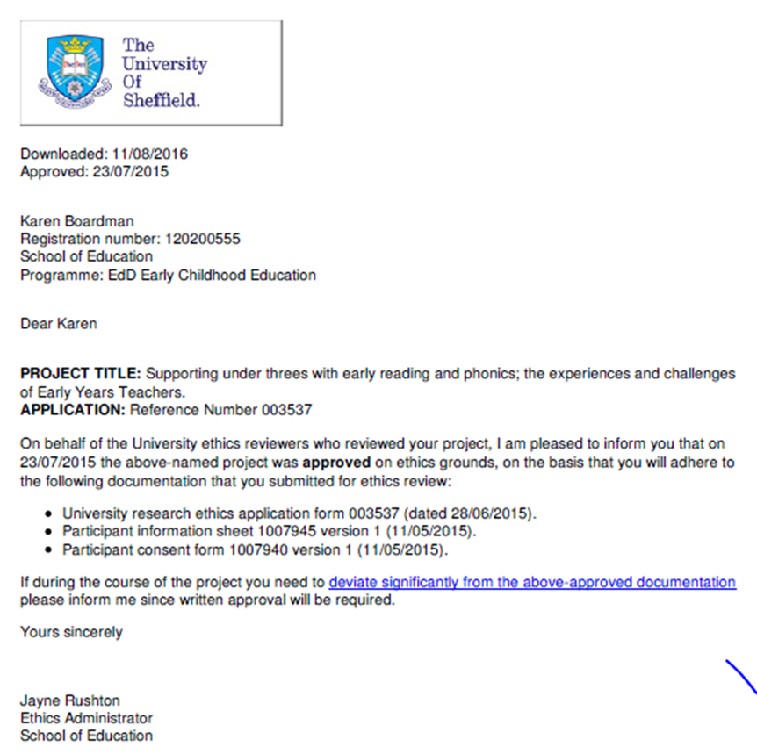

Appendix C: Participant Information Sheet

Participant Information Sheet
EdD Early Reading Research Study
Research Study Title (draft)
“‘Early Reading – is that what we do with under-threes?’
Insights, Challenges and Controversies of EYTTs”
You are being invited to take part in a research project about the experiences and challenges of Early Years Teacher Trainees supporting and teaching under-threes with early reading. Before you decide to take part, it is important for you to understand why the research is being done and what it will involve. Please take time to read the following information carefully and discuss it with others if you wish. Please do ask if there is anything that is not clear, or if you would like more information. Take time to decide whether or not you wish to take part.
Thank you for reading and for your consideration.
What is the project’s purpose?
This proposed research study is to enable a group of Early Years Teacher Trainees studying on the Graduate Employment-Based Early Years Teacher Status Route (over a part-time, 12 months training route) to explore, evaluate and reflect upon their experiences in supporting very young children with early reading in their role as an EYT in a private, voluntary, independent (PVI) or state funded early years setting.
The purpose of this study is to find out how Early Years Teachers support those early reading skills of the youngest children in their care and ‘teach’ early reading to under-threes in the context of the setting. I hope to achieve a shift in thinking about early reading and make a contribution to the field of study to enhance practice and review provision for early reading within the EYFS. The core research questions are:
- How do Early Years Teacher Trainees support very young children with early reading?
- What are Early Years Teacher Trainees’ views and beliefs about reading and how does this influence their practice with under-threes?
- What are the experiences and challenges of Early Years Teacher Trainees in supporting very young children with early reading?

It is important to know about these experiences and give Early Years Teacher Trainees the opportunity to reflect upon these experiences and any challenges faced, in order to make better provision for under-threes and plan future professional development to shape the new Early Years Teacher Status (September 2014). The purpose of the research study is to find out about the experiences of EYTTs in supporting very young children with early reading and explore any challenges that arise, which involves investigating how EYTTs approach early reading with babies and under-threes in practice.
Why have I been chosen?
I would like to gain your voluntary informed consent as a participant in the research, which includes you as a trainee and your settings. You have been chosen as participants as you are all trainees on the EYITT Early Years Teacher Status Graduate Employment-Based Route. You already have a breadth and depth of experience to contribute to this research project from your work with very young children.
Do I have to take part?
It is up to you to decide whether or not to take part. If you do decide to take part you will be given this information sheet to keep (and be asked to sign a consent form) and you can still withdraw at any time without any impact, or your study in any way. You do not have to give a reason at any point of withdrawal.

What does taking part involve for me?

Initially, you will be asked to complete a Survey, which will take approximately 15 to 20 minutes to complete. You are then asked if you would like to take part in follow up research activities. These take the form of a semi-structured interview and/or completing a journal or reflective blog (Zine) and a focus group meeting. You can choose to take part in all the follow up activities or just one, or none at all. The interviews will take place in November or December 2015 and Focus Group meetings are planned for January or February 2016.

Interview questions will be open-ended and semi-structured so that your own experiences can be captured. Some questions will follow on from the responses already offered in the initial Survey. Any inconvenience on your own time will be kept to a minimum, as participating in the interview stage of the research process may be considered an inconvenience on your busy working or spare time. Interviews can take place early morning, late afternoon and in the evening and will be as flexible as possible with time constraints and the working days of all participants.
It is important to clarify that participants have the right to withdraw at any point in the research process. The survey will have an anonymous point of return and there will also be an alternative offer of a hard copy with a box in a central position for return to attempt complete anonymity. Your choice to participate in this research at all stages is not linked in any way to your teacher training journey and there is no obligation to take part.
The research journal (Zine) will capture your day to day experiences in practice. It is entirely up to you how often you write or how much you write. It is also up to you how much you wish to share with the researcher.
In January or February 2016, a final focus group will take place with participants to finalise experiences, thoughts and impact or changes to practice and provision. All participants will also be asked to submit all research journals (Zines) to the researcher in January/February 2016.

Will I be recorded, and how will the recorded media be used?
The audio and/or video recordings of your activities made during this research will be used only for analysis and for illustration in conference presentations and lectures. No other use will be made of them without your written permission, and no one outside the project will be allowed access to the original recordings.
What do I have to do?
Please complete the survey and ensure that all consent forms are read carefully, signed and shared with the researcher. If you wish to continue to take part in the next stage of the research process, please complete the survey response form with your name, email address and contact telephone number. I will be in touch soon to discuss mutually convenient interview arrangements.
What if I have changed my job/setting?
If you have changed jobs in the meantime, this does not affect the data or research project, as it is about your experiences as an Early Years Teacher Trainee and not linked directly to the setting. Although, please be aware you will need to ask the setting’s permission to use the data using the signed consent form.
What are the possible disadvantages and risks of taking part?
I do not think there will be any potential for any physical/psychological harm or distress to participants in taking part in this research. However, please be reassured that at any point participants may withdraw from this process, without needing to give a reason.
What are the possible benefits of taking part?
Whilst there are no immediate benefits for those participating in the project, it is hoped that this work will give you as an Early Years Teacher Trainee, the opportunity to reflect upon your experiences and practice and understand any challenges faced. It is hoped that these experiences and reflections will influence and impact upon better provision for under-threes and to plan future professional development for you, as a former trainee (similar to an NQT) so that we can continue to support your professional development in all areas.
The purpose of the research study is to find out about your experiences in supporting very young children with early reading and explore any challenges that arise.
What if something goes wrong?
If you wish to discuss any aspect of the research study or raise a complaint about the research project, please contact:
Karen Boardman, Principle Researcher, Edge Hill University/EdD, University of Sheffield
Karen.boardman@edgehill.ac.uk
If you feel that your complaint has not been handled to your satisfaction by the Principle Researcher, the Supervisor will then follow the appropriate channels for the next stage of the complaint.
Dr Rachael Levy, Research Supervisor, University of Sheffield
r.levy@sheffield.ac.uk
Will my taking part in this project be kept confidential?
All the information and data collected about you during the course of the research will be kept strictly confidential. You will not be able to be identified in any reports or publications. No-one from the University Team will know that are taking part in this research, unless you discuss it, as this information will be kept strictly confidential. All data will be kept in a secure and safe place during the length of the research study. You will also be asked to approve all the data (your interview transcripts, in particular) being used and only your approved versions will be used in the research.
What will happen to the results of the research study?
The results of this research study will be part of my own Educational Doctoral Thesis. The results will be published as part of this thesis and are also likely to be contained in a Journal Publication at a later point. You may request a copy of the published results if you wish. You or your setting will not be identified in any report or publication. Findings of the research will be shared with all participants.
Who has ethically reviewed the project?
This study has been ethically approved by the University of Sheffield’s Ethics Review Procedure. The University’s Research Ethics Committee monitors the application and delivery of the University’s Ethics Review Procedure across the University.
Contact for Further Information:
Karen Boardman, Principle Researcher
Karen.boardman@edgehill.ac.uk
T: 01695 584020
Early Years Professional Support Team
EarlyYearsPartnerhsip@edgehill.ac.uk
T: 01695 654342
Finally …
You will be given a copy of the information sheet, a signed consent form to keep, a consent form to share with your setting Manager/Owner and a Letter to share with Parents, Carers and Families. Please do give all signed consent forms to the researcher on request.
Thank you to all participants taking part in this research study.

Appendix D: Survey Consent Form

University of Sheffield

Early Reading Research EdD 2015

Title of Research Project:

Supporting under-threes with early reading; the experiences and challenges of Early Years Teacher Trainees.
Name of Researcher: Karen Boardman
Participant Identification Number for this project:
Please initial box

- I confirm that I have read and understand the information sheet dated
[insert date] explaining the above research project and I have had the
opportunity to ask questions about the project.
- I understand that my participation is voluntary and that I am free to withdraw
at any time without giving any reason and without there being any negative
consequences. In addition, should I not wish to answer any particular
question or questions, I am free to decline.

- I understand that my responses will be kept strictly confidential. I give permission
for members of the research team to have access to my anonymised responses.
I understand that my name will not be linked with the research materials, and I will not be identified or identifiable in the report or reports that result from the research.

- I agree for the data collected from me to be used in future research, including
recorded media from interviews and focus groups, research journal, reflective blog

I agree to take part in the above research project.
________________________ ________________ ____________________
Name of Participant Date Signature
(or legal representative)
_________________________ ________________ ____________________
Lead Researcher Date Signature
To be signed and dated in presence of the participant
Copies:
Once this has been signed by all parties the participant should receive a copy of the signed and dated participant consent form, the information sheet and any other written information provided to the participants. A copy of the signed and dated consent form should be placed in the project’s main record (e.g. a site file), which will be kept in a secure location.

Appendix E: Survey Data Babies

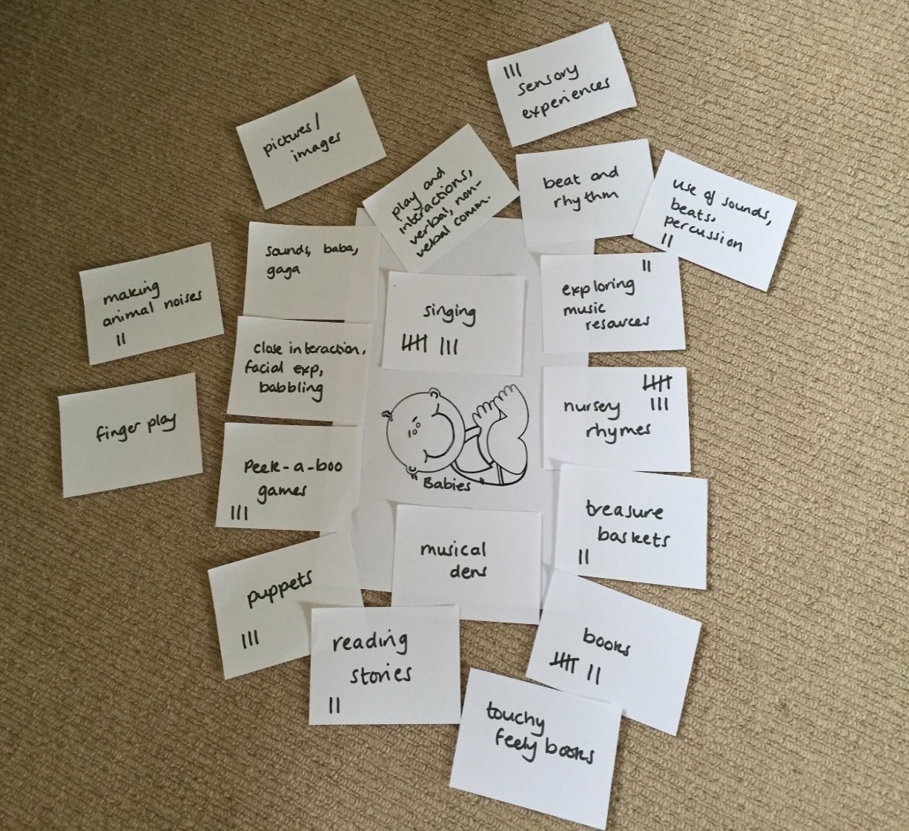

Appendix F: Survey Data Toddlers

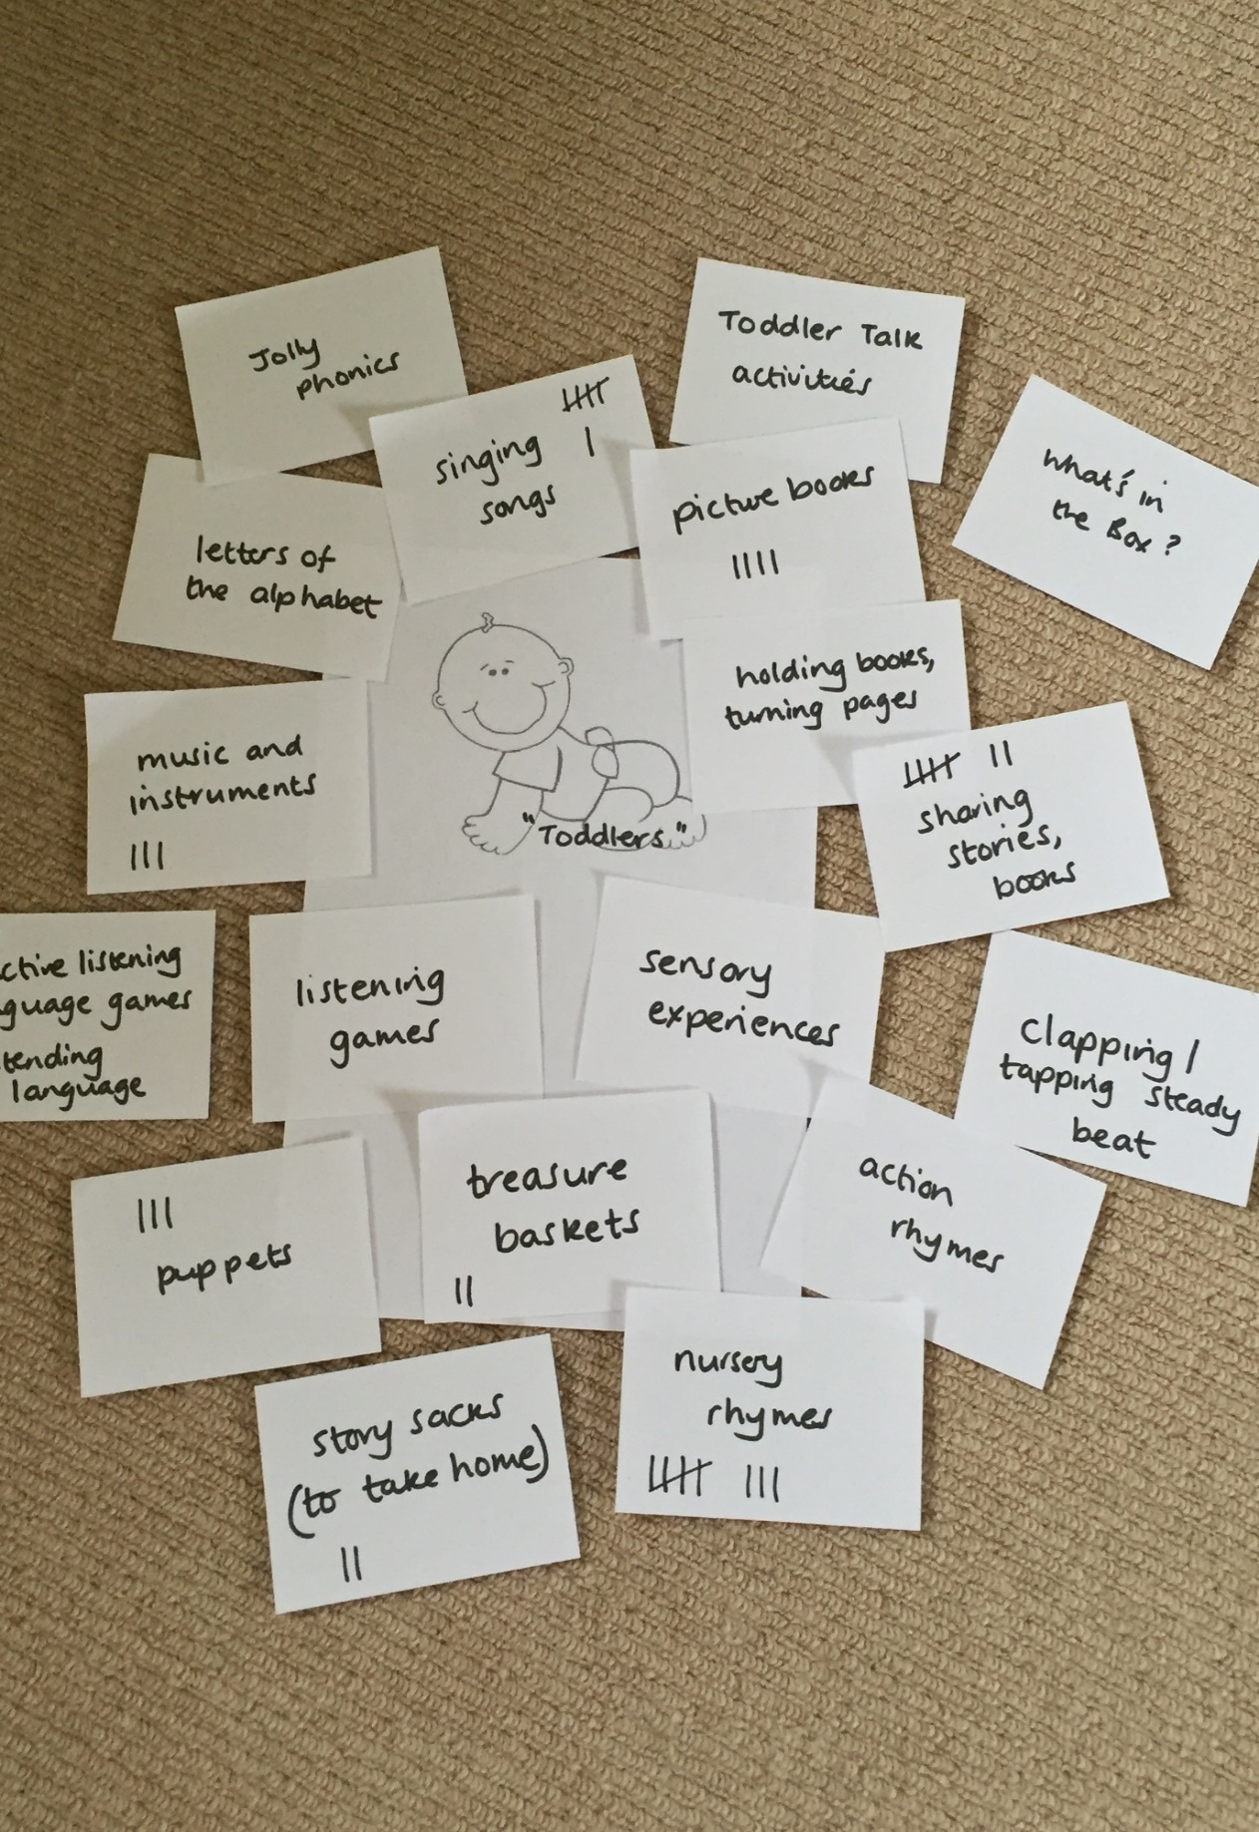

Appendix G: Survey Data 2-year-olds

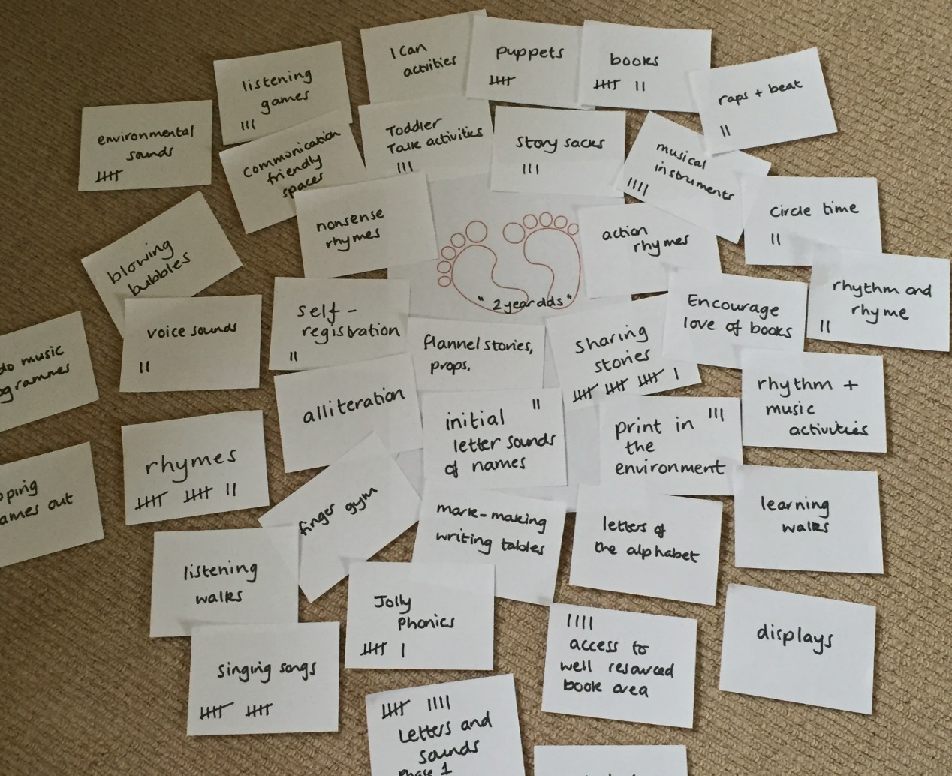

Appendix H: Sample Focus Group Transcript

Focus Group Workshop 1 (January 2016)

Participant 1 (PVI)
Participant 2 (PDN)
Participant 3 (Playgroup)
Participant 4 (PDN)
Participant 5 (Nursery School)
Participant 6 (PDN Setting Manager)

(includes 5 participants that have either put ‘n/a’ or left blank the sections from the survey questionnaire about supporting babies, toddlers, under threes with early reading)

You have kindly offered to be part of a focus group workshop and some of you perhaps did not complete the survey questionnaire sections on supporting under-threes with early reading. This was obviously at the very beginning of your EYTS training process. What were your reasons for not completing these sections of the questionnaire?

(Long pause)

Participant 1 – “I didn’t complete this because I don’t know enough about this age range”.

Participant 2 – “I hadn’t worked with babies at all up until recently”.

Participant 3 – “I just thought early reading began with phonics so put ‘n/a’”.

Participants 4 and 5 – same here really.

Participant 6 – “I completed that section, but after this and our EYTS training sessions, I could probably add more to it now”.

I explained the workshop style of the focus group – access to flip chart paper and pens (if necessary) to discuss and respond to the following questions:

- How do you support under-threes with early reading?
- What are your views and beliefs about reading and how does this influence your practice with under- threes? (if at all?)
- Do you think there are any challenges as an EYTT in supporting under-threes with early reading?

Participants split themselves into 2 groups and produced a flip chart paper of the kinds of activities to support age ranges babies, toddlers, two year olds, pre-school (and three to five, as they felt that this helped them to focus more on the task).

Photographs of flip charts:

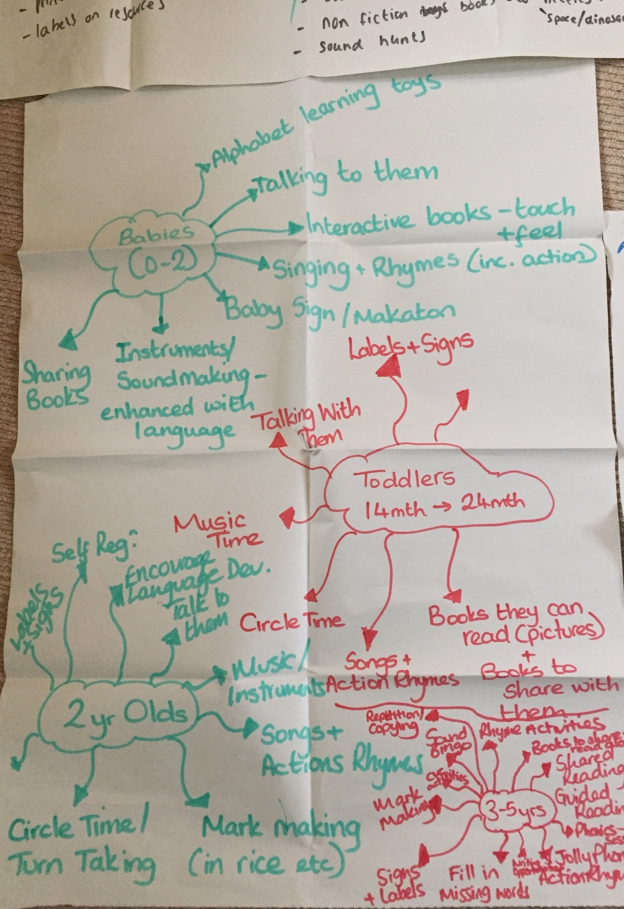

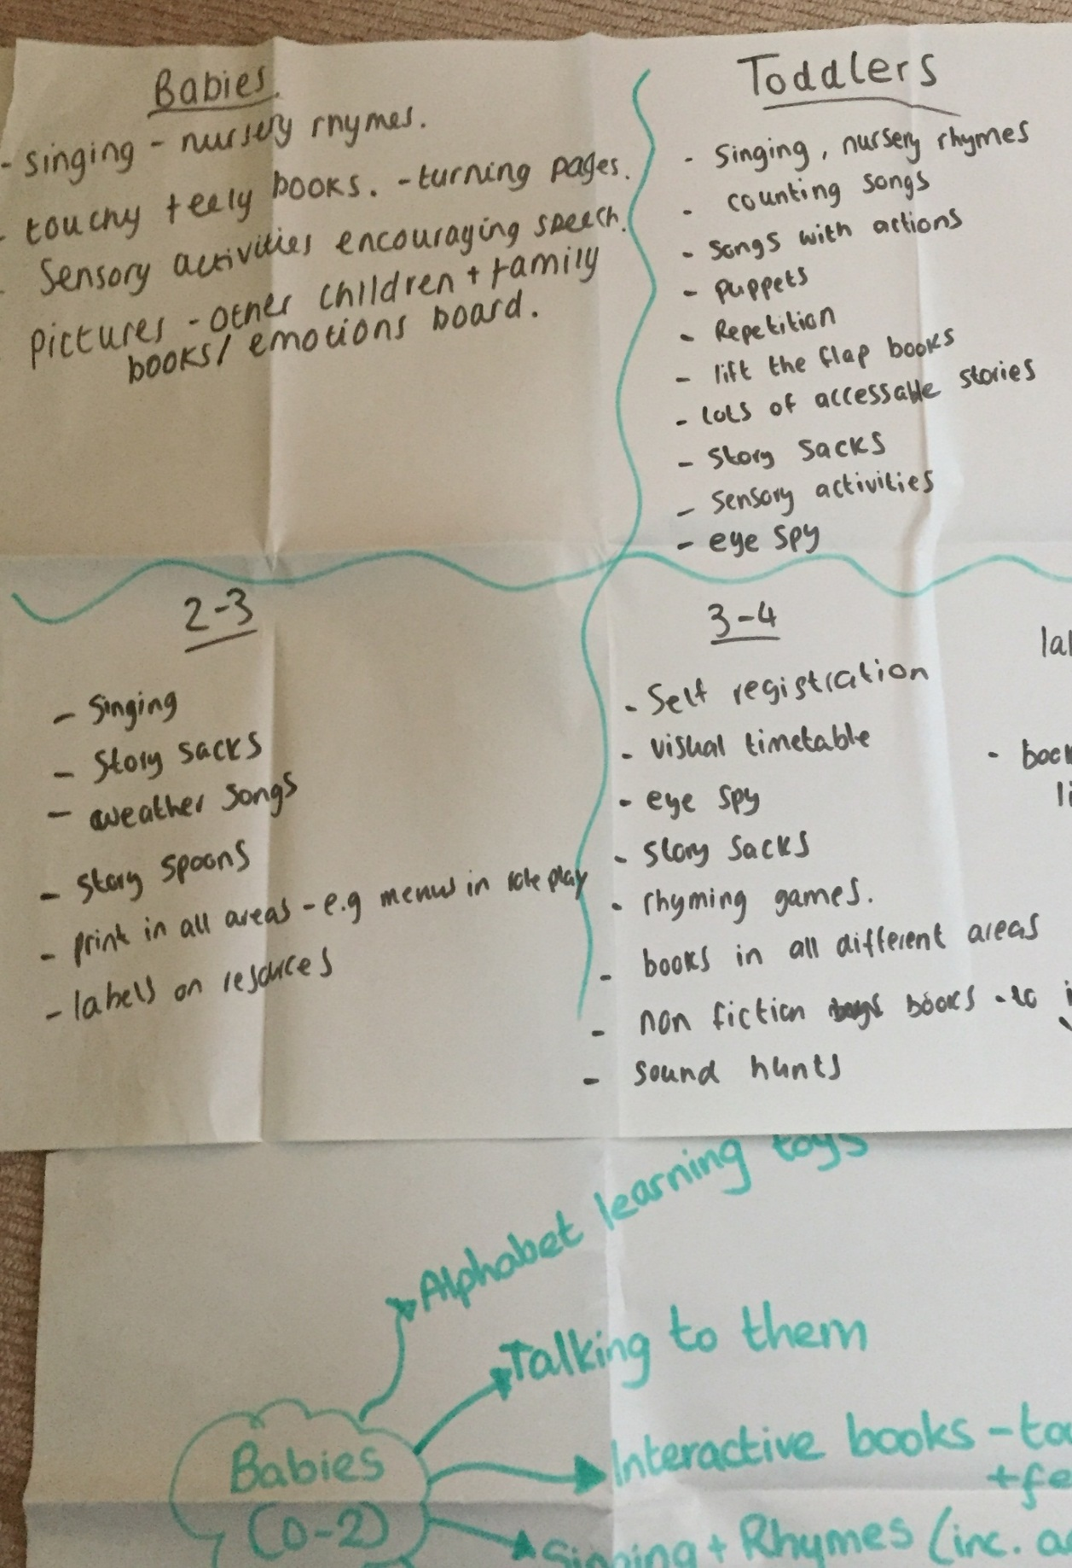

I asked participants to review their notes and to think about if they feel they have captured everything.
Participants agreed that they had.
One of the participants suggested that the group define early reading “as this would be a useful activity”. I had some cardboard and flip chart paper available – the group chose the cardboard and completed 3 definitions of early reading:

Group 1:

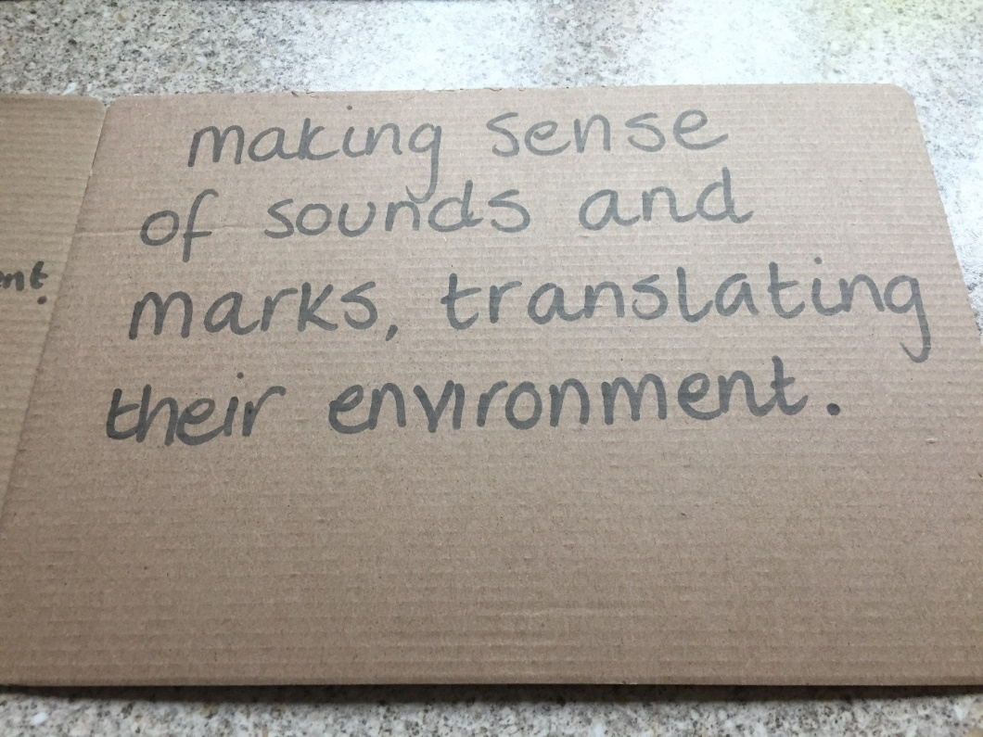

Group 2:

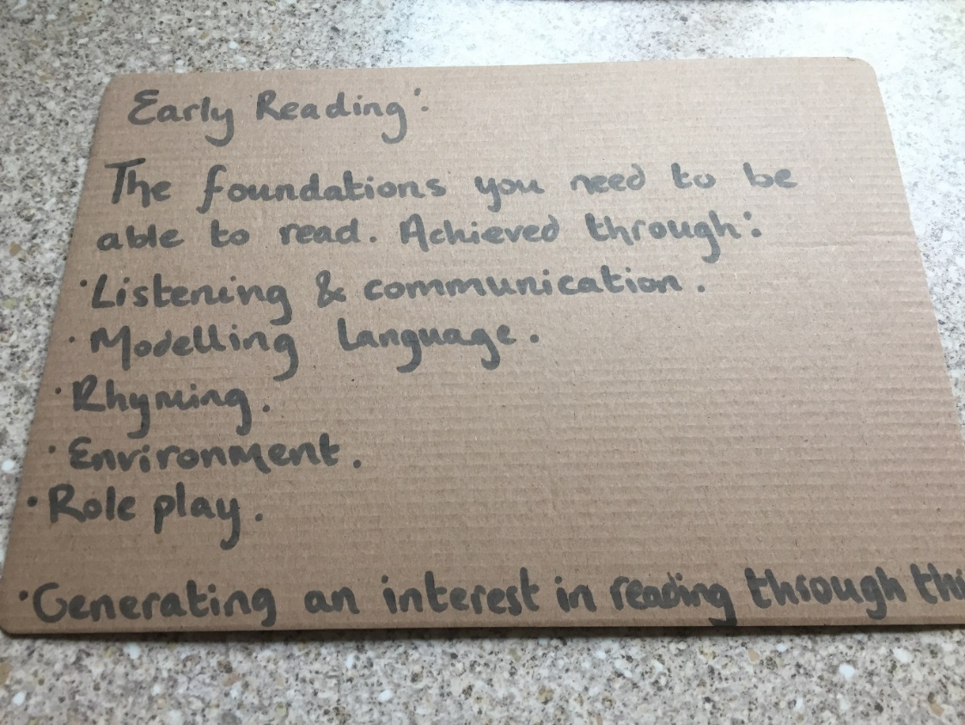
Group 3:

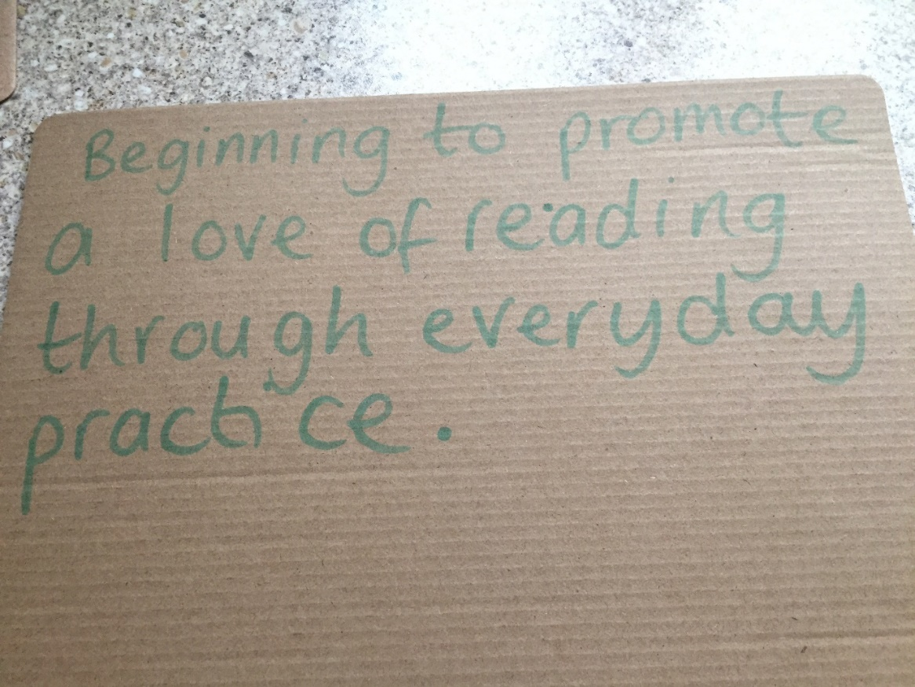

I asked the focus group participants to think about;

- What influences their practice in settings in encouraging children’s development in reading?

All participants discussed this with each other and the main points highlighted were:
- “Their environments could and should be more focused on supporting early readers – participants suggested that they don’t read enough with the children and certainly not babies (I know I don’t read enough with babies or even pick up a book in the baby room sometimes) Influences on practice are time constraints, planning, knowledge”.
- “Reading is so important, yet, if I am going to be really honest so misunderstood” Influences are “schools and policy on reading, SSP”
- “The very best settings do this well – you should be able to see and feel a literacy rich environment when you walk in.”

- Is there new knowledge and subsequent impact after the EYITT training programme? What are the implications of this for EYTS training?

All participants discussed this with each other and the main points highlighted were:
- “Absolutely, yes – this (early reading support) has been the biggest shift in practice and subsequent impact in settings”.
- “I have totally enhanced the toddler environment – accessible books, story sacks available and accessible. I read books daily with our toddlers now. Early reading is everything I do now. I think about modelling reading all the time”.
- “I have led a staff development session in my setting on supporting early reading – rhythm, rhyme, steady beat etc. I feel this has had the biggest impact for me and my setting”.
- “I started an early reading policy so that we can become consistent in our approach and explain what it is we do. When you asked me as an interview participant about the environment for early reading, I didn’t know what to say because I don’t think we did have an environment suitable to support early reading for our babies and toddlers”.
- “It is my responsibility as the EYTS in the setting to lead on practice and I have chosen to lead on early reading in my setting – I really want to get this right.”

Appendix I: Sample Interview Transcript

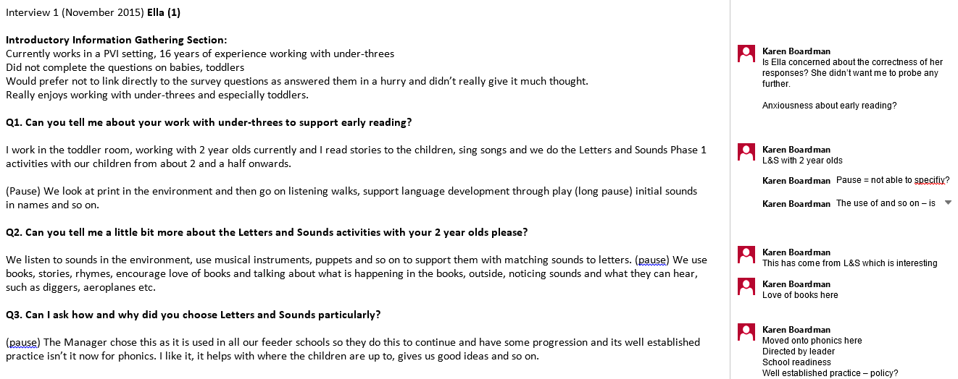
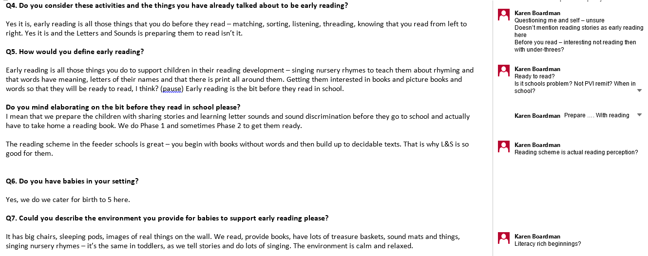
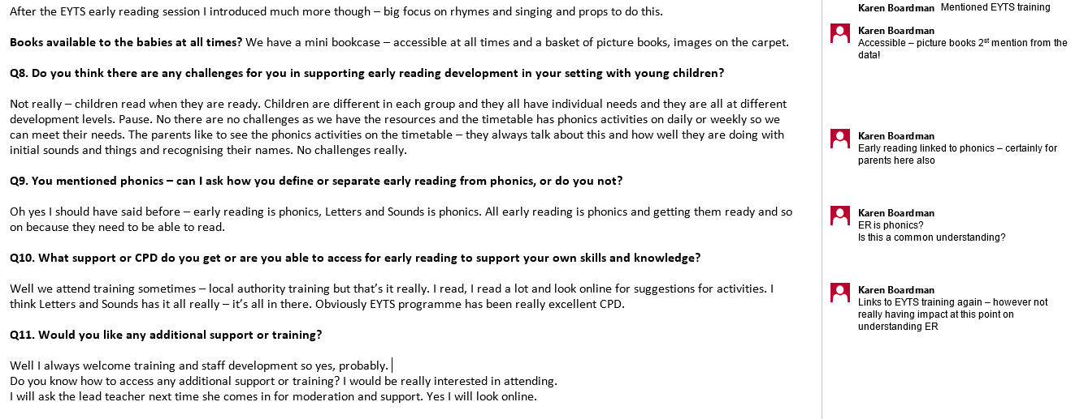

Appendix J: Sample Zine Entries

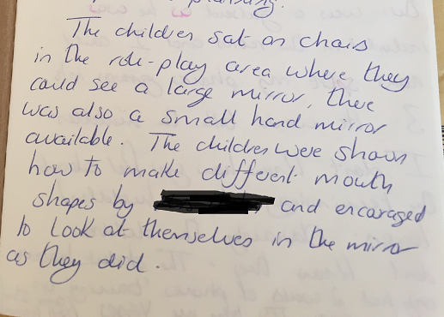

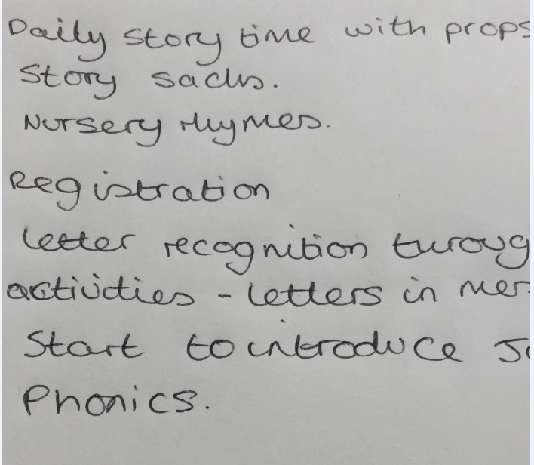
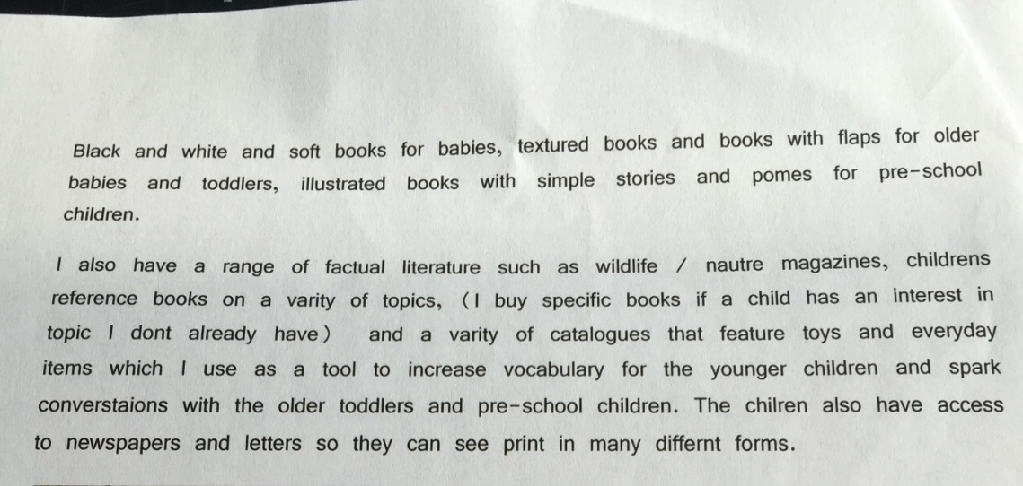
Some Zine entries included examples of ‘Letters and Sounds’ activities.This is a sample of an outdoor activity, following up on ‘letter sounds’.

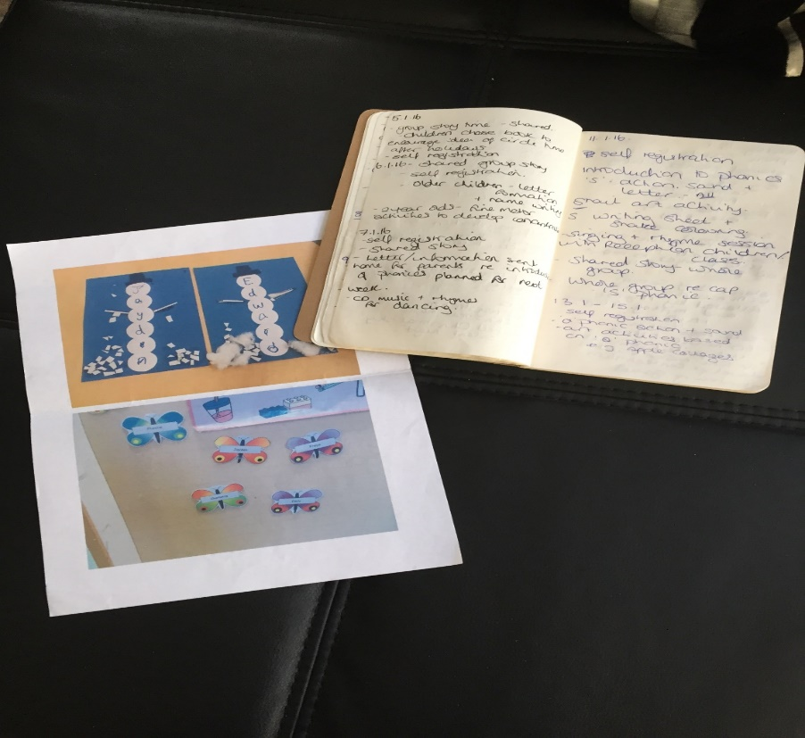

Appendix K: SPSS Statistical ‘Participant’ Data

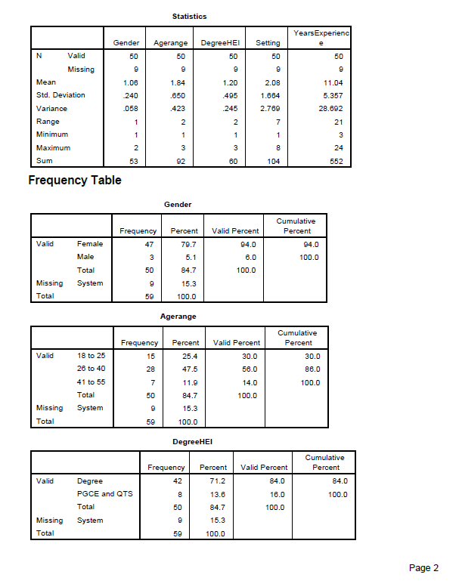

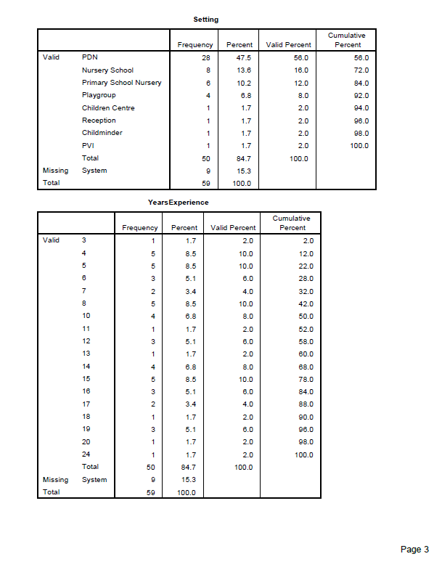

Appendix L: NVivo Text Query Results
NVivo Word Tree Books Query Results
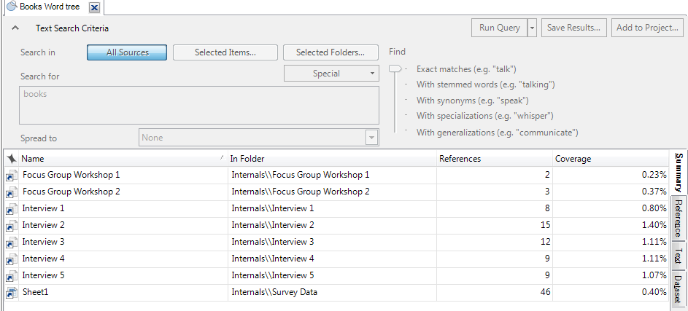
NVivo Word Tree Stories Query Results
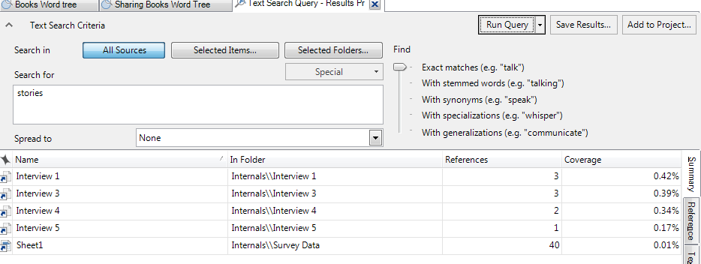
NVivo Word Tree Access Query Results
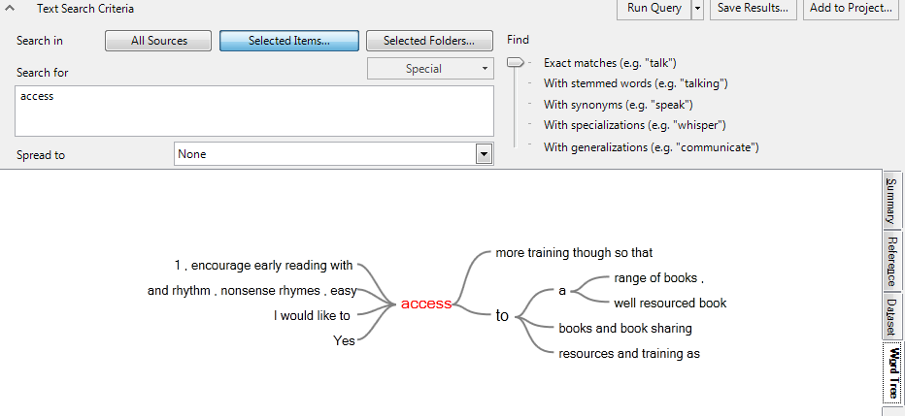

Appendix M: Interview Questions

Introductory Information Gathering Section:
Check response to survey – discuss reasons for responses or non-responses
Would you like to expand on your survey responses?

Q1. Can you tell me about your work with very young children to support early reading?

Q2. Can you tell me a little bit more about your work with babies and toddlers?
You mentioned …..

Q3. Do you consider ‘these activities’ to be early reading?

Q4. How do you choose/decide on these activities?

Q5. What do you think early reading is? How would you define early reading? (perhaps if you were explaining it to a parent, families of new staff team member)

Q6. (If not already answered previously) Do you have babies in your setting?

Q7. Could you describe the environment you provide for babies to support early reading specifically please?

Are books, picture books, images available to the babies at all times?

Q8. Do you think there are any challenges for you in supporting early reading development in your setting with young children?

Q9. You refer to/mentioned …. Could you tell me a little bit more about?

Q10. What support or CPD do you get or are you able to access for early reading to support your own skills and knowledge?

Have you attended? Found this useful etc.?

Q11. Would you like any additional support or training?

Q12. Is there anything else you would like to say about early reading with under-threes or anything else you wish to add?

Appendix N: Final Coding Map

Appendix 0: Survey Questionnaire

Profile

Gender: Female / Male Age Group: 18-25 26-40 41-55 56-70

Teaching Degree: BA BEd PGCE Other (please indicate):

University at which you studied your Degree and date acheived:

Current Education Setting Type and Employment (GEB Route) and Job Role:

Please share with us how long you have been working in early years settings:

Q1. How do you currently support very young children with their early reading/literacy development?

Please list your strategies/experiences/the kinds of things you do on a daily basis for:

- Babies

- Toddlers

- 2 year olds

- 3 – 5 year olds

Q2. What has informed these activities? How do you decide how to teach and what to teach?

Q3. Has any training or staff development influenced these strategies?

Q4. Does your setting have an early reading policy?

Yes / No

If yes, have you been involved in this policy?
Q5. Do you have support in the setting/school for developing how you support early reading development for very young children?

Yes / No

If you answered yes please describe what support you are receiving:

Q6. How confident are you in your ability to effectively teach/support very young children with early reading?

(Please circle one answer):

Very confident Confident Not confident

Please explain your answer and provide examples:

Q7. What additional training / support / resources, if any, do you think would help you to support early reading?

Please list:

Q8. Are there any particular challenges in teaching/supporting very young children with early reading in your setting?

b) In general?

Q9. Are there any other comments you would like to add?

Appendix P: Survey Responses (PDF and Screenshots)

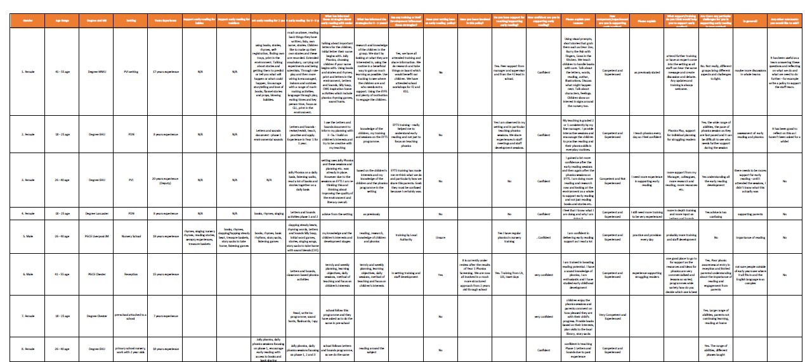
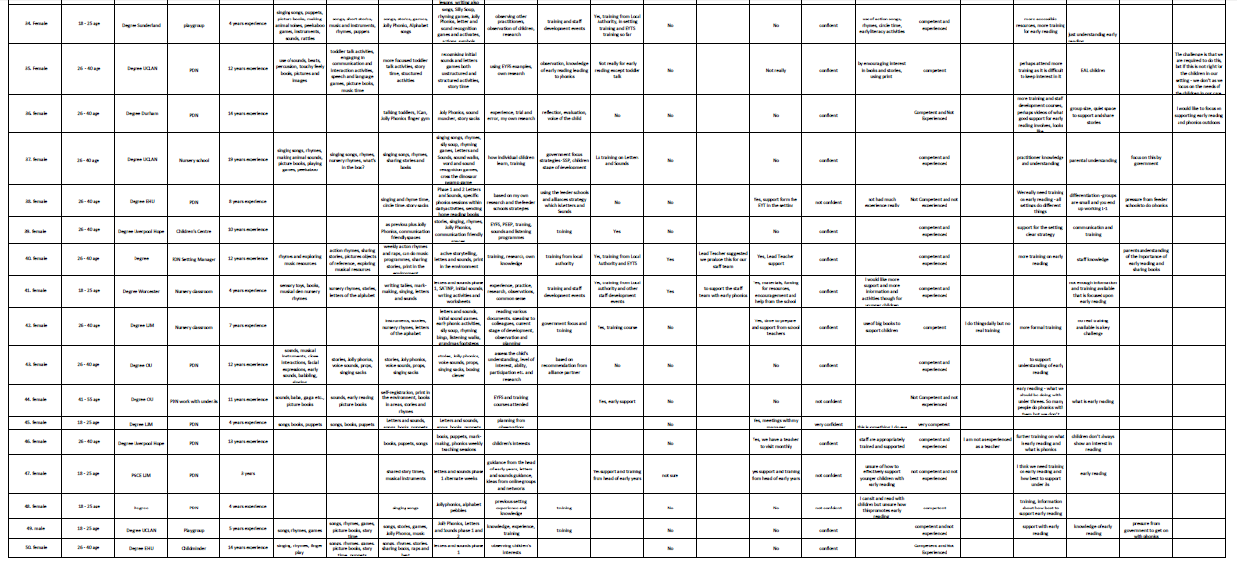

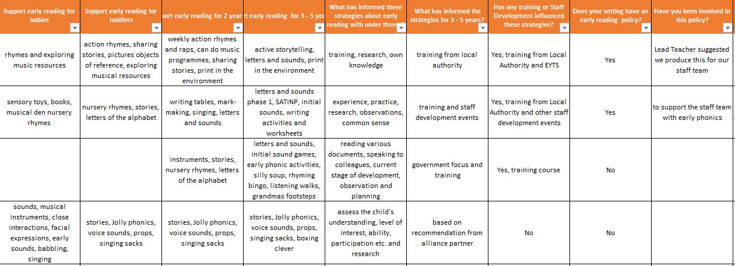
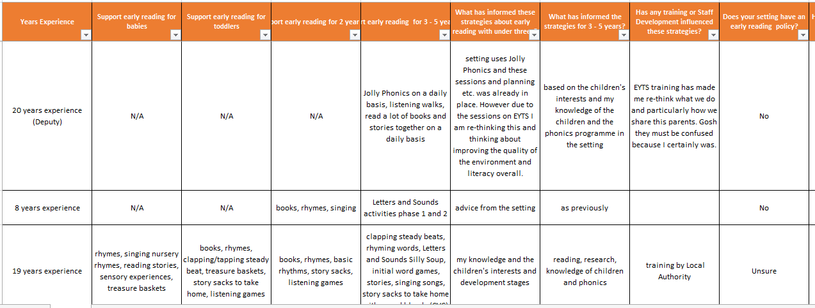
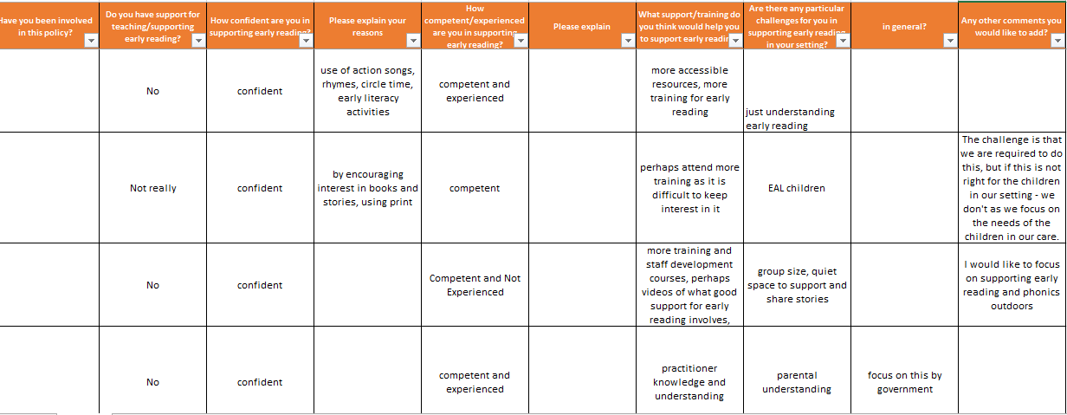

2Simple is an online assessment application, designed to gather observations and build up a formative profile of individual children, which can be linked to EYFS and NC Frameworks.

