Characterisation of the Second C5a Receptor, C5aR2

A thesis submitted for the degree of Doctor of Philosophy (PhD)

Rachel Hannah Bell
January 2017

The University of Sheffield
Faculty of Medicine, Dentistry, and Health
Department of Infection, Immunity, and Cardiovascular Disease

Acknowledgements

Firstly, I would like to thank my supervisors Dr Pete Monk and Dr Lynda Partridge for their unending support, help, and advice, and also for patiently putting up with me throughout the duration of this work. As well, thanks to all members of the research group, past and present, whose scientific support, language lessons, cultural lessons, and friendship have been greatly appreciated. Thanks to Dr(!) John for keeping me going, knowing just which freezer to find things in, and the countless sing-a-longs which got me through the LB-making sessions. Thanks to Ahmed, Fawwaz, Shaymaa, Muslim, and Ibrahim for their help with my experiments, interesting discussions, and teaching me numerous Arabic words. As well, thanks to Jenny, Tom, and Andy for their friendship and advice throughout the years. From outside of the research group I am eternally grateful to Sam and S(h)imon who have patiently listened to my molecular biology problems, have patiently offered help, and provided good chat which got me through some of the tougher days (as well as dealing with my questionable video gaming ‘abilities’!).
For the less scientific thanks it is important to mention my friends Rachel (Prime/RCDB) and Jordan who have been fantastic. I’m sure we single-handedly have been keeping Interval in the potato-wedge business with our lunches – thank you for listening to me ramble, advising me, and keeping me upbeat. Thanks to Matt for keeping my puzzling skills honed, and to the various taekwondo people who throughout my time in Sheffield have provided great memories, laughs, and an escape from work.
Finally, special thanks to Simon. Words cannot express my gratitude for his support but suffice to say his kindness, unrelenting positivity, countless walks at all hours of the night, and patience with me have played a bigger part in completing this project than almost anything else. Thank you for keeping me going during the darkest of days – I’m not sure where I’d be without that.

Thank you everyone!

Abstract

C5a is a small protein produced as part of the complement cascade with inflammatory activity. Elevated levels of C5a have been implicated in a number of inflammatory conditions such as rheumatoid arthritis, inflammatory bowel disease, and asthma. C5a is rapidly metabolised into the less active C5a des-Arg, allowing control of C5a induced inflammation. There are two receptors for C5a in humans, hC5aR1 and hC5aR2, which share around 35% sequence identity but have different affinities for C5a and C5a des-Arg. hC5aR1 is a well characterised G protein-coupled receptor that undergoes ligand-dependent internalisation, whereas hC5aR2 does not couple to G-proteins and undergoes constitutive recycling. The structural basis for these differences is currently unknown. The main aim of this work was to test the hypothesis that hC5aR2 had a different ligand binding mechanism to hC5aR1 and in addition that C5a and C5a des-Arg would be bound differently by hC5aR2.
A series of hC5aR2 receptor mutants was designed by modelling the structure of the receptor on hC5aR1 and CXCR4. After production, purification and labelling of recombinant human C5a and C5a des-Arg, ligand binding by mutant and wild type receptors stably transfected into Chinese Hamster Ovary cells was investigated by flow cytometry. Internalisation of the receptors from the cell surface in response to ligand was used as a measure of function.
Mutations in hC5aR2 were found that could affect either C5a or C5a des-Arg binding, in contrast to hC5aR1, where analogous mutations affected the binding of both ligands. Through comparisons with hC5aR1 binding data in the literature, it is apparent hC5aR2 does seem to have a different ligand binding mechanism. Some hC5aR2 mutants showed increased levels of constitutive internalisation, suggesting that the binding mechanism is also coupled to endocytic pathways, which is also not seen with hC5aR1. In addition, ligand dependent internalisation of hC5aR2 transfected into CHO cells was observed in this work.

Table of Contents

Acknowledgements i
Abstract ii
Table of Contents iii
List of Figures vii
List of Abbreviations xiii
Amino Acid Abbreviations xvi
Chapter 1 – Introduction 1
1.1 - Overview 1
1.2 - Anaphylatoxins 4
1.2.1 - What are the Anaphylatoxins? 4
1.2.3 - C5a and C5a des-Arg 5
1.2.3.1 - Structure 5
1.2.3.3 - Role in Disease 7
1.3 - The C5a Receptors – C5aR1 and C5aR2 10
1.3.1 - Structure and Cellular Localisation 10
1.3.1.1 - C5aR1 10
1.3.1.2 - C5aR2 11
1.3.2 - Ligand Binding 14
1.3.2.1 - C5aR1 14
1.3.2.2 - C5aR2 18
1.3.3 - Signalling 20
1.3.3.1 - C5aR1 20
1.3.3.2 - C5aR2 22
1.4 - A Pro-Inflammatory or Anti-Inflammatory Role for C5aR2? 25
1.5 - Aims and Objectives 27
Chapter 2 - Materials and Methods 29
2.1 - Materials 29
2.1.1 - Antibodies 29
2.1.2 - Vectors 30
2.1.3 - Primers 30
2.1.4 - Antibiotics 33
2.1.5 - Mammalian Cell Lines 34
2.1.6 - Bacterial Strains 34
2.2 – Methods 37
2.2.1 - Molecular Biology Techniques 37
2.2.1.1 - Preparation of Competent M15 p[REP4] Cell Stocks 37
2.2.1.2 - Bacterial Transformation 37
2.2.1.3 - Glycerol Stocks 38
2.2.1.4 - Midi-Prep 38
2.2.1.5 - Mini-Prep 39
2.2.1.6 - Ethanol Precipitation 40
2.2.1.7 - Agarose Gel Electrophoresis 40
2.2.1.8 - DNA Sequencing 40
2.2.2 - Polymerase Chain Reaction (PCR) Analysis of C5a mRNA Expression 41
2.2.2.1 - Bacterial Growth and Lysis 41
2.2.2.2 - RNA Extraction 41
2.2.2.3 - cDNA Synthesis 42
2.2.2.4 - PCR 43
2.2.3 - Cloning of pQE30 44
2.2.3.1 - Restriction Digest 44
2.2.3.2 - Gel Extraction 44
2.2.3.3 - DNA Ligation 45
2.2.3.4 - Colony PCR Screening 46
2.2.4 - Mammalian Cell Culture Techniques 47
2.2.4.1 - Growth and Maintenance of Cell Lines 47
2.2.4.2 - Subculture of Adherent Cell Lines 47
2.2.4.3 - Cell Counting 47
2.2.4.4 - Freezing Cells 48
2.2.4.5 - Thawing Cells 48
2.2.4.6 - Transfection of Cells 48
2.2.4.7 - β-Hexosaminidase Release Assay 49
2.2.5 - Flow Cytometry 50
2.2.5.1 - Cell Surface Receptor Expression Assay 50
2.2.5.2 - Competition Ligand Binding Assay 51
2.2.5.3 - Internalisation Assay 52
2.2.5.4 - Cell Sorting 54
2.2.6 - Protein Production, Purification, and Quantification 55
2.2.6.1 - Affinity Purification of Antibodies 55
2.2.6.2 - Purification of C5a and C5a des-Arg 57
2.2.6.3 - Bradford Assay 58
2.2.6.4 - Protein Polyacrylamide Gel Electrophoresis 58
2.2.6.5 - Coomassie Staining 59
2.2.6.6 - Fluorescent Labelling of C5a and C5a des-Arg 60
2.2.7 - Statistical Analysis 61
Chapter 3 – Production of Mutant Cell Lines and Recombinant Ligands 62
3.1 - Introduction 62
3.2 - Aims 63
3.3 – Results 64
3.3.1 - Expression and Purification of Recombinant Human C5a and C5a des-Arg 64
3.3.2 - Bacterial Expression and Purification 64
3.3.3 - Testing of Functional Activity and Binding of Purified Ligands 71
3.3.4 - Production of Mutant C5a 75
3.3.4.1 - Initial Purification Attempts 75
3.3.4.2 - Analysis of pQE30-C5a[Mutant] DNA Sequence 80
3.3.4.3 - Further Analysis of Expression Problems 82
3.3.4.4 - Purification of pQE30-C5a[M70A] in M15 [pREP4] E. coli 83
3.3.4.5 - PCR Analysis of C5a mRNA in WT and Mutant Cultures 85
3.3.4.6 - pQE30 Cloning Attempts 88
3.3.5 - Production of Transfected Mammalian Cell Lines 95
3.4 - Discussion and Conclusions 98
3.4.1 - C5a Expression 98
3.4.2 - Mutant C5a 101
3.4.3 - Transfection of CHO Cells with hC5aR2 Receptor Mutants 103
Chapter 4 – Ligand Binding Studies on hC5aR2 Mutants 104
4.1 - Introduction 104
4.2 - Aims 106
4.3 - Results 107
4.3.1 - Fluorescent Labelling of Recombinant Ligands 107
4.3.2 - Competition Ligand Binding Assays 110
4.3.2.1 - Y42F 111
4.3.2.2 - R173A 113
4.3.2.3 - E197 116
4.3.2.4 - R204 119
4.3.2.5 - E273A 121
4.3.2.6 - Summary of Ligand Binding Results 123
4.3.3 - Blocking of the Receptor N-terminus 129
4.3.4 - Peptide Binding 137
4.4 - Discussion 141
Chapter 5 – Internalisation Studies on hC5aR2 Mutants 143
5.1 - Introduction 143
5.2 - Aims 145
5.3 - Results 146
5.3.1 - Internalisation Assays 146
5.3.2 - Preliminary Test of CHO hC5aR2 Wild Type Cells 148
5.3.3 - Dose Response Curve 151
5.3.4 - Mutant hC5aR2 Internalisation Assays 152
5.3.4.1 - R173A 153
5.3.3.2 - E197A 156
5.3.3.3 - R204 159
5.3.3.4 - E273A 164
5.3.5 - Method A, Buffer Only Assays 167
5.3.6 - RHYPYWR Peptide Internalisation 169
5.4 - Discussion 170
Chapter 6 – Discussion and Future Work 172
6.1 - Discussion 172
6.1.1 - Chapter 3: Production of Recombinant Ligands 173
6.1.2 - Chapter 4: Ligand Binding Studies 175
6.1.3 - Chapter 5: Functional Studies 176
6.1.4 - Concluding Remarks 178
6.2 - Future Work 179
6.2.1 - Chapter 3: Production of Recombinant Ligands 179
6.2.2 - Chapter 4: Ligand Binding Studies 179
6.2.3 - Chapter 5: Functional Studies 181
Bibliography 183

List of Figures

Chapter 1
Figure 1.1 – Complement Activation Pathways 2

Figure 1.2 – C5a Structure 6

Figure 1.3 – Predicted Structures of hC5aR1 and hC5aR2 12

Figure 1.4 – Primary Sequence Alignment of hC5aR1 with hC5aR2 and hC5aR2 Topology 13

Figure 1.5 – Two-Site Binding Paradigm of C5a Binding to C5aR1 17

Chapter 2
Figure 2.1 – pEE6 Vector Map 31

Figure 2.2 – pQE30 Vector Map 31

Figure 2.3 – pQE30 Coding Sequence Map. 32

Figure 2.4 – Flow Chart of Internalisation Assay Protocols 53

Chapter 3
Figure 3.1 – 1% Agarose Gel of Uncut pQE30-C5a and pQE30-C5a des-Arg Plasmids 65

Figure 3.2 – C5a Expression in 4 M15 [pREP4] E.coli Cultures Over 0-16 hrs Post-Induction 66

Figure 3.3 –Rosetta Gami 2 (DE3) pLysS vs M15 [pREP4] expression of C5a Over 0-6 hrs Post-Induction 67

Figure 3.4 – Comparison of Purified C5a Against Bovine Serum Albumin (BSA) Standards 69

Figure 3.5 –Purification of C5a Under Native Conditions After Expression in Rosetta Gami 2 (DE3) pLysS E. coli 70

Figure 3.6 – β-hexosaminidase Release Assay of Natively Purified C5a vs Stock C5a on RBL Cells Transfected with hC5aR1 72

Figure 3.7– β-hexosaminidase Release Assay of Natively Purified C5a des-Arg vs Natively Purified C5a on RBL Cells Transfected with hC5aR1 73

Figure 3.8 - β-Hexosoaminidase Release Assay of Commercially Produced and In-House Purified C5a on RBL Cells Transfected With hC5aR1 74

Figure 3.9–Purification of C5a[RHYPYWR] Under Native Conditions 76

Figure 3.10 – β-Hexosoaminidase Release Assay of Purified Mutant C5a on RBL Cells Transfected With hC5aR1 77

Figure 3.11 –Comparisons of Two IPTG Stocks 79

Figure 3.12 –pQE30 Plasmid Preps From Mutagenex (M) or Prepared In-House (S). 80

Figure 3.13 – 1% Agarose Gel Showing Results of a Double Restriction Digest of pQE30-C5a and pQE30-C5a[M70A] Plasmids Using NheI and XbaI Enzymes 81

Figure 3.14 – Coomassie Stained 12.5% Polyacrylamide Gel Showing Expression of M70A Mutant C5a and Wild-Type C5a in M15 [pREP4] E. coli After Induction with 1mM IPTG 84

Figure 3.15 – 1% Agarose Gel Showing PCR Products After Amplification of C5a Sequence from RNA Samples of Induced Bacterial Cultures of C5a[WT] or C5a[D69A] 85

Figure 3.16 – Expression of 3 Colonies Each from C5a[WT] or C5a[D69A] Induced Rosetta Gami 2 (DE3) pLysS Cultures 86

Figure 3.17 – Strategy for Cloning of pQE30-C5a[WT] and pQE30-C5a[D69A] (m) 88

Figure 3.18 – Restriction Digest of pQE30-C5a[WT] or pQE30-C5a[D69A] 89

Figure 3.19 – Second Digest of Cut pQE30-C5a[WT] or pQE30-C5a[D69A]. 89

Figure 3.20 – Double Restriction Digest of pQE30-C5a[WT] and pQE30-C5a[D69A] with BamHI and KpnI 90

Figure 3.21 – Double Restriction Digest of 2µg pQE30-C5a[WT] and 2µg pQE30-C5a[D69A] for 1 hr at 37°C with BamHI and KpnI 91

Figure 3.22 - Double Restriction Digest of 2µg pQE30-C5a[WT] and 2µg pQE30-C5a[D69A] for 2 hr at 37°C with BamHI and KpnI 92

Figure 3.23 – Colony PCR 94

Figure 3.24 – Percentage Positive Cells of hC5aR2 Mutant and Wild-Type Transfected CHO Cells 95

Figure 3.25 – Median Fluorescence Intensity (MFI) of hC5aR2 Mutant and Wild-Type Transfected CHO Cells 97

Chapter 4
Figure 4.1 – hC5aR2 Mutated Residues and their Equivalent Residues in hC5aR 105

Figure 4.2 – Binding of Alexa-488 labelled C5a to hC5aR2 Transfected CHO cells 108

Figure 4.3 – Binding of Alexa-488 labelled C5a des-Arg to hC5aR2 Transfected or Untransfected (non-x) CHO cells 108

Figure 4.4 – C5a and C5a des-Arg Binding Curves for Wild-Type and Y42F Mutant hC5aR2 Receptors 112

Figure 4.5 – C5a and C5a des-Arg Binding Curves for Wild-Type and R173A, R173F, R173K Mutant hC5aR2 Receptors 114

Figure 4.6 – C5a and C5a des-Arg Binding Curves for Wild-Type and E197A Mutant hC5aR2 Receptors 117

Figure 4.7 – C5a and C5a des-Arg Binding Curves for Wild-Type and R204A, R204F, and R204K Mutant hC5aR2 Receptors 120

Figure 4.8 – C5a and C5a des-Arg Binding Curves for Wild-Type and E273A Mutant hC5aR2 Receptors 122

Figure 4.9 – Binding of C5a and C5a des-Arg to hC5aR2 WT over 60 mins 126

Figure 4.10 – C5a and C5a des-Arg Binding to hC5aR2 WT Detected Using Anti-RGS-His6 Antibody 127

Figure 4.11 – Blocking hC5aR2 N-Terminus with Antibody on C5a and C5a des-Arg 130

Figure 4.12 – Comparison of C5a Binding to hC5aR2 Mutants With and Without Addition of Antibody Directed Against Receptor N-Terminus 131

Figure 4.13 - Comparison of C5a des-Arg Binding to hC5aR2 Mutants With and Without Addition of Antibody Directed Against Receptor N-Terminus 135

Figure 4.14 – Competition Binding Curves between C5a-a488 or C5a des-Arg-a488 and either LIRLWR or RHYPYWR 139

Figure 4.16 – FAM-RHYPYWR Binding to hC5aR2 WT Transfected CHO cells and non-x CHO cells 140

Chapter 5
Figure 5.1 – Flow Diagram of Method A and Method B Internalisation Assay Processes 147

Figure 5.2 – Internalisation of hC5aR2 With/Without 15 Mins 100nM C5a Stimulation 148

Figure 5.3 – Comparison of Internalisation of hC5aR2 WT in response to C5a, C5a des-Arg, or Buffer alone in CHO and RBL Transfected Cells 149

Figure 5.4 – Dose Response Curve of Internalisation of hC5aR2 in Response to C5a after 15 mins 151

Figure 5.5 – Internalisation of R173A and Wild Type hC5aR2 With/Without 100nM C5a Stimulation 153

Figure 5.6 – Internalisation of R173A and Wild Type hC5aR2 With/Without 100nM C5a des-Arg Stimulation. 154

Figure 5.7 – Internalisation of E197A and Wild Type hC5aR2 With/Without 100nM C5a Stimulation 156

Figure 5.8 – Internalisation of E197A and Wild Type hC5aR2 With/Without 100nM C5a des-Arg Stimulation 157

Figure 5.9 – Internalisation of R204A and Wild Type hC5aR2 With/Without 100nM C5a Stimulation 159

Figure 5.10 – Internalisation of R204A and Wild Type hC5aR2 With/Without 100nM C5a des-Arg Stimulation 160

Figure 5.11 – Internalisation of R204K and Wild Type hC5aR2 With/Without 100nM C5a Stimulation 161

Figure 5.12 – Internalisation of R204K and Wild Type hC5aR2 With/Without 100nM C5a des-Arg Stimulation 162

Figure 5.13 – Internalisation of E273A and Wild Type hC5aR2 With/Without 100nM C5a Stimulation 164

Figure 5.14 – Internalisation of E273A and Wild Type hC5aR2 With/Without 100nM C5a des-Arg Stimulation 165

Figure 5.15 – Internalisation of Wild Type and Mutant hC5aR2 167

Figure 5.16 – Effect of RHYPYWR Peptide and Scrambled Control on Internalisation of hC5aR2 WT 169

Appendix
Figure 7.1 – Sequencing of Wild Type pQE30 Construct 192

Figure 7.2 – WT hC5aR2 Gating, Percentage Positive, and Fluorescence Histogram 194
List of Tables

Chapter 2
Table 2.1 – Specificity, Label, and Source of Antibodies 29

Table 2.2 – Vectors and their Usage and Origins 30

Table 2.3 – Primers and their Usage and Origin of Design 30

Table 2.4 – Antibiotic Stocks and Working Dilutions 33

Table 2.5 – Mammalian Cell Lines, Transfections, and their Applications 34

Table 2.6 – Bacterial Strains, their Genotypes, and their Manufacturers 34

Table 2.7 – Composition of Buffers and Reagents 36

Table 2.8 – gDNA Elimination Reaction Composition 42

Table 2.9 – Reverse Transcription Reaction Composition 42

Table 2.10 – Q5 PCR Running Conditions 43

Table 2.11 – Standard Restriction Digest Reaction Composition 44

Table 2.12 – DNA Ligation Reaction Composition 45

Table 2.13 – Phusion Colony PCR Screening Composition 46

Table 2.14 – Phusion Colony PCR Screening Running Conditions 46

Chapter 3
Table 3.1 – DNA Ligation Reaction Compositions and their Usage 93

Table 3.2 – Plasmid Stability Plating Strategy 102

Chapter 4
Table 4.1 – C5a and C5a des-Arg hC5aR2 Binding Data 123

Table 4.2 – Summary of Previous Ligand Binding Findings in hC5aR1 124

Table 4.3 – IC50 Values for Comparison of C5a Binding to hC5aR2 Mutants With and Without Addition of Antibody Directed Against Receptor N-Terminus 132

Table 4.4 – IC50 Values for Comparison of C5a des-Arg Binding to hC5aR2 Mutants With and Without Addition of Antibody Directed Against Receptor N-Terminus 135

Chapter 6
Table 6.1 – Effects of hC5aR2 Mutation on Receptor Internalisation and Binding of C5a and C5a des-Arg 173

Appendix
Table 7.1 – Codon Substitutions of Mutant C5a Constructs 191

Table 7.2 – Translations of Sequenced pQE30 Mutant C5a Coding Plasmids. 193

List of Abbreviations

Abbreviation | Meaning
Alexa-488 | Alexafluor-488
bp | Base pairs
BSA | Bovine Serum Albumin
C3a | Complement Factor 3a
C3aR | C3a Receptor
C4a | Complement Factor 4a
C5a | Complement Factor 5a
C5adR | C5a des-Arg
C5aR1 | C5a Receptor 1
C5aR2 | C5a Receptor 2
CDS | Cell Dissociation Solution
CHO | Chinese Hamster Ovary Cells
CVs | Column Volumes
Da | Daltons
DMEM | Dulbecco’s Modified Eagles Medium
DMSO | Dimethyl sulphoxide
DOL | Degrees of Labelling
ECL | Extra-cellular Loop
EDTA | Ethylenediaminetetraacetic acid
FAM | Fluorescein Amidite
FCS | Foetal Calf Serum
FITC | Fluorescein Isothiocyanate
g | Gravity
G418 | Geneticin 418
gDNA | Genomic DNA
GPCR | G-Protein Coupled Receptor
h / rh | Human / Recombinant Human
HBSS | Hank’s Balanced Salt Solution
HEK | Human Embryonic Kidney Cells
IPTG | Isopropyl β-D-1-thiogalactopyranoside
LB | Lysogeny Broth
MFI | Median Fluorescence Intensity
NMR | Nuclear Magnetic Resonance
Non-x | Untransfected
ns | Not Statistically Significant
OD | Optical Density
PAGE | Polyacrylamide Gel Electrophoresis
PBS | Phosphate Buffered Saline
PCR | Polymerase Chain Reaction
Pen/Strep | Penicillin/Streptomycin Cocktail
pI | Isoelectric Point
PMN | Polymorphonuclear Neutrophils
RBL | Rat Basophilic Leukaemia Cells
rpm | Revolutions per Minute
SDS | Sodium Dodecyl Sulphate
SEM | Standard Error of the Mean
TEMED | Tetramethylethylenediamine
T_{m} | Melting Temperature
V | Volts
WT | Wild Type

Amino Acid Abbreviations

One Letter | Three Letter | Meaning
A | Ala | Alanine
C | Cys | Cysteine
D | Asp | Aspartate
E | Glu | Glutamate
F | Phe | Phenylalanine
G | Gly | Glycine
H | His | Histidine
I | Ile | Isoleucine
K | Lys | Lysine
L | Leu | Leucine
M | Met | Methionine
N | Asn | Asparagine
P | Pro | Proline
Q | Gln | Glutamine
R | Arg | Arginine
S | Ser | Serine
T | Thr | Threonine
V | Val | Valine
W | Trp | Tryptophan
Y | Tyr | Tyrosine

Chapter 1 – Introduction

1.1 - Overview

The complement system is part of innate immunity. It functions as a defence against foreign pathogens as well as having a role in clearance of damaged ‘self’ matter such as necrotic cells or protein aggregates. The complement system has 30-40 different soluble and membrane associated proteins involved in a cascade of cleavage events allowing for amplification of the immune response after complement activation (Carroll and Sim, 2011). There are three complement activation pathways, the classical, lectin, and alternative pathways. The classical pathway is activated by complement proteins binding to Fc regions of antigen-bound IgG or IgM (Tegla et al., 2011). The lectin pathway is activated by the recognition of foreign carbohydrate motifs by pattern-recognition proteins such as mannose binding lectin (MBL). These pattern-recognition proteins can bind MBL associated serine proteases (MASPs) to form a complex which can cleave downstream complement factors (Degn et al., 2013). The alternative pathway involved the continual hydrolysis and subsequent cleavage of C3 molecules (Pangburn and Müller-Eberhard, 1984). An overview of these pathways is shown in Figure 1.1.

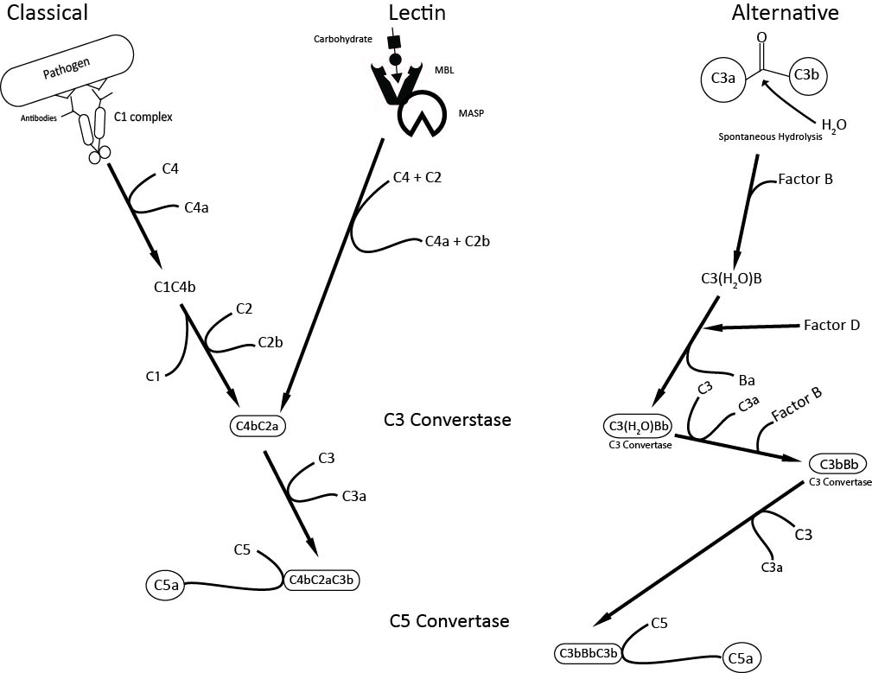
Figure 1.1 – Complement Activation Pathways
The three complement activation pathways: classical, lectin, and alternative pathways. All pathways converge on the C3a convertase which cleaves C3 into C3a and C3b. Downstream the C5 convertase is formed which cleaves C5 into C5a and C5b.
When certain complement proteins are cleaved, they release both a larger peptide which will continue to participate in the cascade and a small, active, peptide fragment with its own immune functions. These active small peptide fragments, C3a and C5a, have been called the anaphylatoxins and are inflammatory chemoattractants in function; they are rapidly modified in serum by carboxypeptidase enzymes to abrogate their function (Klos et al., 2013). A third anaphylatoxin, C4a, is known however does not appear to have an inflammatory role in humans. Elevated levels of the anaphylatoxins have been implicated in both acute and chronic inflammatory disease states. These include but are not limited to sepsis, asthma, inflammatory bowel disease (IBD), and chronic obstructive pulmonary disease (COPD) and are reviewed in Klos et al. (2009), (2013); and Monk et al. (2007).
C5a has been studied extensively and is known to have two receptors; C5aR1 (also known as C5aR or CD88) (Gerard and Gerard, 1991) and C5aR2 (also known as C5L2). C5aR1 is a well characterised G-protein coupled receptor (GPCR) however despite being discovered in 2000 (Ohno et al., 2000) neither the function nor ligand binding mechanism of C5aR2 have been confirmed. Although C5aR2 shares the same GPCR topology as C5aR1, it does not couple to G proteins and so was previously considered a non-functional, decoy receptor. However, more recent data suggests C5aR2 mediated signalling is possible but whether the receptor is pro-inflammatory or anti-inflammatory is under debate (Bamberg et al., 2010; Croker et al., 2014). Previously, attempts have been made to target the C5a axis to design new drug treatments. One treatment, eculizumab, is a humanised antibody which prevents cleavage of C5 into C5a and C5b used in the treatment of the rare blood disorder paroxysmal nocturnal haemoglobinuria (PNH) (Dmytrijuk et al., 2008). However, this antibody treatment is very expensive. A small molecule drug, an antagonist of the C5aR1 receptor, was designed known as PMX53 (Cephalon) and trialled in rheumatoid arthritis patients. Unfortunately, despite seeing reductions in inflammation and disease progression in test animals, no effect was seen in humans (Ricklin and Lambris, 2013; Vergunst et al., 2007). More promisingly, another C5aR1 antagonist, CCX168 (ChemoCentryx), has been trialled in the treatment of ANCA (Anti-Neutrophil Cytoplasmic Antibodies) Associated Vasculitis (AAV). AAV disease progression involves infiltration of neutrophils and raised inflammation levels. Blockade of C5a signalling through C5aR1 by CCX168 has shown in phase II clinical trials to be as effective as the current treatment (Bekker et al., 2016; Jayne et al., 2014). Through a greater understanding of the function of C5aR2 and the interactions between both receptors it may be possible in the future to develop further drug treatments that may be more effective while being cheaper than an antibody treatment for example.

1.2 - Anaphylatoxins

1.2.1 - What are the Anaphylatoxins?
Anaphylatoxins are small, complement derived, peptide fragments which can stimulate inflammation. They are so-called because of their ability to induce smooth muscle contraction, increase vascular permeability, and cause release of histamine by mast cells leading to anaphylactic shock-like symptoms in test animals (Fernandez and Hugli, 1978). In 1968, Cochrane & Müller-Eberhard determined that anaphylatoxin factors with distinct biological activities could be derived from cleavage products of both the complement factors C3 and C5. These factors are now known as C3a and C5a respectively. A third anaphylatoxin, C4a, was reported to have anaphylatoxic activity in 1979 after testing on guinea pigs and human blood polymorphonuclear neutrophils (PMNs) (Gorski et al., 1979) however no receptor for this molecule has been characterised to date. C3a and C5a share 36% sequence identity (Nettesheim et al., 1988) and elevated levels of these anaphylatoxins have been found in a wide range of inflammatory conditions including, but not limited to, sepsis, asthma, and rheumatoid arthritis (reviewed extensively in Klos et al., 2013). C5a has been studied in detail and is reported to be the most potent inflammatory stimulant of the anaphylatoxins.

1.2.3 - C5a and C5a des-Arg

1.2.3.1 - Structure

C5a is a 74 amino acid glycoprotein derived from the N-terminus of the complement component C5. In serum, C5a is rapidly modified to form the less active, more stable C5a des-Arg. This occurs by the cleavage of the C-terminal arginine from C5a by carboxypeptidase enzymes (Bokisch and Müller-Eberhard, 1970). C5a and C5a des-Arg are thought to have different structures (Cook et al., 2010). To date there have been three nuclear magnetic resonance (NMR) tertiary structures of C5a published (Williamson and Madison, 1990; Zhang et al., 1997; Zuiderweg et al., 1989). These structures show residues 1-63 of the peptide to form an anti-parallel 4 α-helical bundle stabilised by 3 disulphide bonds. The remaining residues form a more disordered tail, the structure of which has only been seen in one study as a 1.5 turn α-helix involving residues 69-74 and connected to the main C5a core by a short loop (Zhang et al., 1997). A structure model based on the findings by Zhang et al. is shown in Figure 1.2. One suggested reason for the previous difficulty characterising the C-terminal structure is that harsh experimental conditions of pH used in other studies caused the denaturation of any tertiary structure at the C-terminus (Zhang et al., 1997). A crystal structure of C5, which has the un-cleaved C5a structure visible, agrees with this 4-helix bundle (Fredslund et al., 2008). On the other hand, a crystal structure of C5a des-Arg has been published which shows a slightly different 3 α-helical core. The C5a des-Arg crystallised as dimers of which the first 14 N-terminal residues in both dimers were projected away from the core bundle. This is different to either the C5a NMR structures and the C5 crystal structure (Cook et al., 2010).

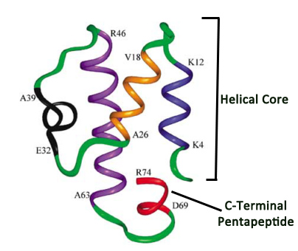

Figure 1.2 – C5a Primary Sequence and NMR Structure (Based on Zhang et al. 1997 Resolution)
(Top) The nuclear magnetic resonance (NMR) structure of C5a as seen by Zhang et al. (1997). In the figure, the four α-helices comprising the basic core of the molecule are shown in black, purple, blue and orange while green shows loops. The C-terminal pentapeptide, important for receptor activation, is shown in red. This image is modified from Monk et al., 2007. The bottom line shows the primary sequence of C5a coloured to correspond with the NMR structure. The ‘^’ beneath N64 shows the location of an N-linked glycosylation. Sequence illustrated using Jalview (Waterhouse et al., 2009).
Another structural difference reported between C5a/C5a des-Arg from different organisms is the presence of a single N-linked glycosylation attached to residue 64 which is found in human C5a but not in rat or pig C5a (Fernandez and Hugli, 1978). When tested on neutrophils, glycosylated and un-glycosylated C5a had similar effects. However, un-glycosylated C5a des-Arg was reported to be approximately 10-fold more active than glycosylated C5a des-Arg. C5a receptor binding to human neutrophils was unchanged on removal of the glycosylation. These data possibly suggest an inhibitory role for the carbohydrate moiety on human C5a des-Arg (Gerard et al., 1981). This may have implications for studies using recombinant ligands which may not have this glycosylation.
1.2.3.2 - Function
C5a is regarded as the most potent of the anaphylatoxins due to its ability to stimulate broad inflammatory immune responses such as degranulation of leukocytes, release of oxygen radicals, and smooth muscle contraction as well as being a chemoattractant for all cells of the myeloid lineage (Gerard and Gerard, 1994). C5a also contributes to inflammation by enhancing vascular permeability and promoting chemokine production in its surrounding location (Crass et al., 1999a) On the other hand, human C5a des-Arg had a greatly reduced chemotactic ability on neutrophils (Webster et al., 1980) and experimentally could no longer stimulate smooth muscle contraction (Bokisch and Müller-Eberhard, 1970). In subsequent in vitro studies on the function of C5aR1 C5a des-Arg showed a lesser ability to activate receptor than C5a. It appears that conversion of C5a into C5a des-Arg serves to regulate C5a stimulated inflammation and signalling. More recently, a paper by Reis et al., 2012 showed that low, but physiologically relevant, levels of C5a des-Arg can cause greater cellular activation than C5a at the same concentration which may imply this molecule could have its own physiological role.

1.2.3.3 - Role in Disease

Elevated levels of C5a have been found in a great number of inflammatory conditions, reviewed extensively in (Monk et al., 2007) including sepsis, rheumatoid arthritis, and asthma. Rheumatoid arthritis has been the target of anti-C5a drug trials using a small-molecule antagonist of the hC5aR1 receptor. Much of the previous study of the function of the hC5aR2 receptor has been performed using sepsis models. Finally, the role of C5a in asthma may point to C5a playing a part in linking aspects of innate and adaptive immunity. These examples shall be discussed briefly in turn.
- Sepsis. A number of the functional studies performed on hC5aR2 have used sepsis models in rodents in an effort to determine the role of this receptor. It has been suggested that C5a usually would remain localised in one tissue area as a control method, however, in sepsis, C5a is detectable in serum implying a wider loss of control of C5a signalling and potentially widespread neutrophil dysfunction (Ward, 2004). Under non-sepsis conditions brief or small exposure of neutrophils to C5a can stimulate release of superoxide anions, by influencing cell signalling and the production of NADPH oxidase, allowing killing of infecting bacteria. However, in experimental sepsis conditions, where C5a levels are higher, neutrophils showed C5a-dependent impairment of function in a manner leading to an ineffective immune response. This impairment was shown to be reversed using an anti-C5a antibody (Huber-Lang et al., 2002). Blockade of C5a signalling using antibody also has been shown reduce septic shock in macaques (Hangen et al., 1989) and improve neutrophil function and survival rates in septic rats (Czermak et al., 1999).

- Asthma. Using mouse models evidence has emerged that C5a plays a role in the development of asthma. However, blockade of C5a signalling during either the antigen sensitisation phase or the effector phase, where symptoms present, gives different effects. The airways of C5 knockout mice were more responsive after exposure to antigen than those of wild type mice. This protective role of C5 was thought to be a result of C5a influencing the cytokine signalling of T_{h}1 cells. Without C5a, there appears to be an imbalance in favour of T_{h}2 cells leading to increased atopy and a higher chance of asthma developing (Karp et al., 2000). However, when C5aR1 receptor signalling was blocked using antagonist in the effector phase, there was decreased airway inflammation, cytokine production, and airway responsiveness (Abe et al., 2001). The initial protective effect may be explained by a more recent study using dendritic cells which suggested that the presence of C5a may suppress these cells during the sensitisation phase. C5aR1 knockout dendritic cells showed impaired production of cytokines that would promote differentiation of T_{h}2 cells thus reducing the skewed T_{h}2 profile seen in asthma (Schmudde et al., 2013). These studies together suggest a role for C5a signalling within adaptive immunity as well as a purely inflammatory role.

- Rheumatoid Arthritis. Rheumatoid arthritis patients have been shown to have elevated levels of C5a both in plasma and affected joints, as well as an increased number of C5aR1 receptors on the surface of synovial mast cells (Jose et al., 1990; Kiener et al., 1998). When a cyclic peptide antagonist of hC5aR1 (PMX53), was tested on rats with induced rheumatoid arthritis there was a significant reduction in symptoms and disease progression for example reduced joint swelling (Woodruff et al., 2002). PMX53 was tested in phase 1 clinical trials on a small group of human participants but there was no reduction in inflammatory cytokine production nor was there a change to the level of infiltration of immune cells into the synovial fluid of test participants. This was despite good levels of PMX53 being present in patient synovial fluid (Vergunst et al., 2007). It is possible that there is a difference between naturally occurring rheumatoid arthritis and that induced in test animals or there may be more complex C5a signalling involved. If similar treatments targeting the complement receptors were to be investigated in the future, it would be necessary to determine the role of the C5aR2 receptor which still now is not agreed upon. This may elucidate interactions between the C5aR1 and C5aR2 receptors that could provide new insights into inflammatory disease progression.

1.3 - The C5a Receptors – C5aR1 and C5aR2
There are two receptors which bind C5a and C5a des-Arg. The first cloned receptor was C5aR1 (Gerard and Gerard, 1991) which is also known as CD88 and has been well characterised to date. The second receptor, now called C5aR2, was first cloned and sequenced in 2000 (Ohno et al., 2000) and was previously known as C5L2 (C5aR-like receptor 2). There are contradicting reports on the exact role and function of the C5aR2 receptor which shall be discussed in this section.

1.3.1 - Structure and Cellular Localisation

1.3.1.1 - C5aR1

C5aR1 belongs to the class A subfamily of rhodopsin-like G protein coupled receptors. It has 7 transmembrane alpha-helices, typical of G-protein coupled receptors (GPCRs), and has a molecular weight of approximately 39,000 kDa prior to glycosylation. It has an extracellular N-terminus and an intracellular C-terminus (Gerard and Gerard, 1991; Morgan et al., 1993). C5aR1 has been found to be highly expressed on the surface of cells derived from the myeloid lineage, including monocytes, macrophages, neutrophils, and other granulocytes. Expression has also been found at lower levels on numerous other cell types in many different organs such as the lungs, liver, and kidneys and brain. A comprehensive list of tissues reported to express C5aR1 is provided in Monk et al., 2007.

1.3.1.2 - C5aR2

The genes encoding both C5aR1 and C5aR2 are found on chromosome 19 in a cluster with similar chemoattractant receptors (Gerard et al., 1993; Okinaga et al., 2003). C5aR2 has a molecular weight of around 37 kDa without glycosylation (Ohno et al., 2000), and shares a similar structure with C5aR1, with an overall amino acid sequence identity of 35% (Cain and Monk, 2002). C5aR2 has found to be generally expressed alongside C5aR1 though usually at lower levels. As with C5aR1, C5aR2 appears to have the greatest levels of expression in cells of the myeloid lineage but has found to be present in a number of tissues including the lungs, heart, kidneys, and brain (Ohno et al., 2000; Okinaga et al., 2003).
Otto et al., 2004 found there was a wide variation in C5aR2 expression levels, as a ratio of C5aR1 expression, in neutrophils from different human donors. There has been some disagreement as to where in the cell C5aR2 is expressed. Different groups have either found C5aR2 to be localised predominantly intracellularly (Bamberg et al., 2010), predominantly extracellularly (Okinaga et al., 2003; Rittirsch et al., 2008), or have even found both results within the same study (Bamberg et al., 2010; Okinaga et al., 2003; Otto et al., 2004). It has been suggested that these differences may be artefactual, due to the antibodies used for receptor detection that are only able to bind to transfected receptor but not naturally occurring receptor on primary cells (Klos et al., 2013). In addition, the expression pattern of C5aR2 may differ between different cell types. Figure 1.3 shows predicted structures, using Phyre2 (Kelly et al., 2015) for C5aR1 and C5aR2, as well as the two structures aligned. Figure 1.4 shows an alignment of the primary sequences of hC5aR1 and hC5aR2 within which certain residues of importance within this work are highlighted.

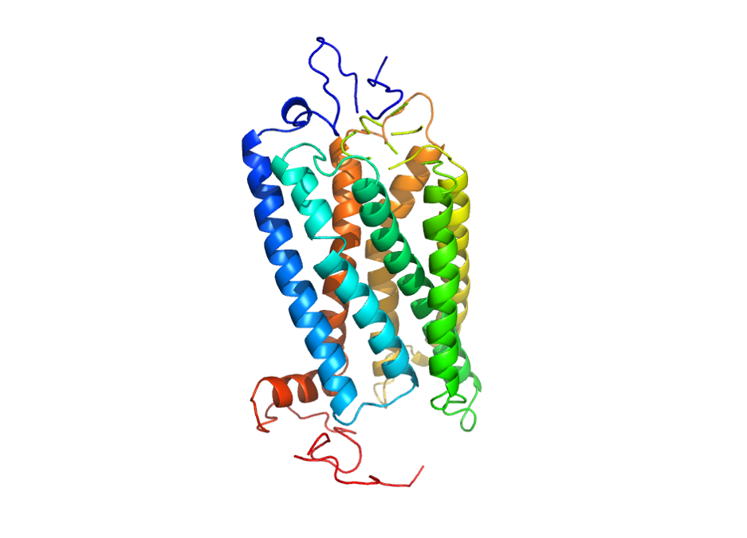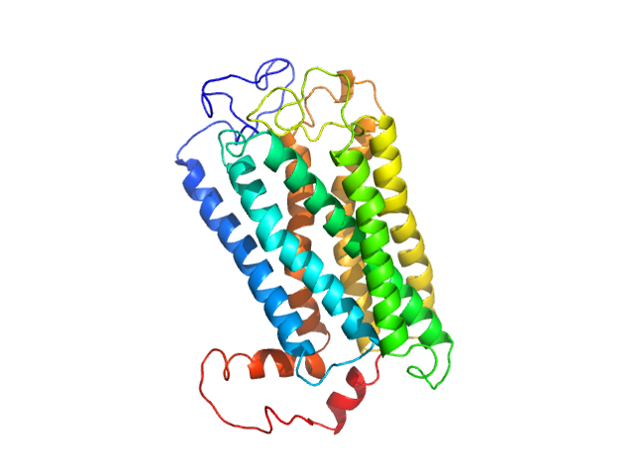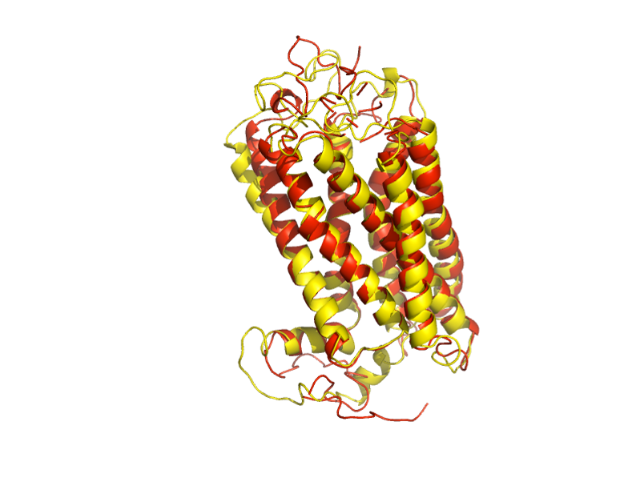
b) hC5aR2
- hC5aR11
- hC5aR1 (Red) aligned with hC5aR2 (Yellow)

Figure 1.3 – Phyre2 Generated Predicted Structures of hC5aR1 and hC5aR2 Including Alignment of Predicted Structures
Structures of hC5aR1 (a) and hC5aR2 (b) were generated using Phyre2 (Kelly et al., 2015) according to their protein sequences as listed on UniProt (www.uniprot.org) and manipulated using PyMOL (Schrödinger, 2015). The N-termini are blue and the C-termini in red. Generated sequences were then aligned to visualise the structural similarities between both receptors where hC5aR1 is shown in red and hC5aR2 in yellow.
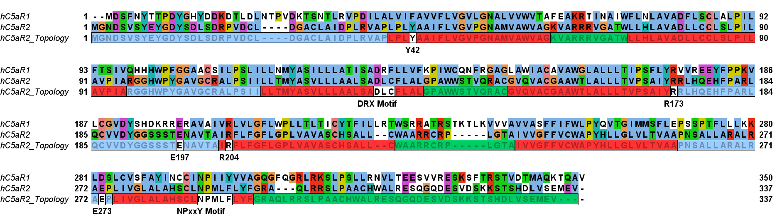
Figure 1.4 – Primary Sequence Alignment of hC5aR1 with hC5aR2 and hC5aR2 Topology
hC5aR1 and hC5aR2 primary sequences aligned and coloured using the standard ClustalW colour scheme. The bottom line, hC5aR2_Topology, is coloured to show which residues are located extracellularly (blue), in a transmembrane helix (red), or intracellularly (green). Residues studied in this work are labelled on white backgrounds in addition to the DRX and NPxxY motifs found to be important for G-protein coupled receptor signalling (see Section 1.3.3.2). Alignment performed using Clustal Omega (EMBL-EBI) and illustrated using Jalview (Waterhouse et al., 2009).

1.3.2 - Ligand Binding

1.3.2.1 - C5aR1

In humans, C5a is bound by C5aR1 with a K_{d} of approximately 1nM whereas C5a des-Arg is bound with a 10-100-fold lower affinity. Much work has been done in an attempt to elucidate how C5a binds to C5aR1 using receptor-blocking antibodies, point mutants and receptor chimeras. An early study using receptor mutants confirmed a two site binding mechanism for C5a to C5aR1. Receptors with their N-termini deleted showed large reductions in C5a binding affinity. However, peptide analogues of the C5a C-terminus could still cause receptor activation, where full length C5a only showed poor activation (DeMartino et al., 1994). In addition, polyclonal antibodies raised against a peptide analogue of the N-terminal extracellular region of C5aR1 were found to bind C5aR1 on both primary and transfected cells. These antibodies could inhibit C5a stimulated cellular activation such as chemotaxis and enzyme release without causing cellular activation by themselves (Oppermann et al., 1993). In contrast, small peptide analogues of the C-terminal sequence of C5a were able to activate C5aR1 (Ember et al., 1992) in the presence of antibodies. These data suggested firstly, that the N-terminus of the receptor is important for ligand binding affinity whereas a second site is important for receptor activation and, secondly, that the basic core of C5a interacts with the first binding site and the flexible C-terminus interacts with the second.
Mutations in the N-terminus of C5aR1 were found to reduce C5a binding, particularly the removal of multiple negatively charged Asp residues. This suggests that the negative N-terminal amino acids are required to allow high affinity binding of C5a (Mery and Boulay, 1994), presumably by electrostatic interactions with basic residues in the C5a core. Receptor chimeras have also been utilised to determine binding patterns of C5a to C5aR1. Chimeras have been made with C5aR1 being combined with parts of the C3a receptor, C3aR (Crass et al., 1999b), and the formyl peptide receptor (FPR) (Mery and Boulay, 1994; Pease et al., 1994), both of which are chemotactic receptors. In the case of the FPR chimeras, the N-terminal region of C5aR1 was substituted with the corresponding region from FPR. It was found that a complete substitution resulted in retention of the receptor in the endoplasmic reticulum. This suggests that the N-terminus of C5aR1 is required for proper folding and transport of the receptor to the cell plasma membrane although the mechanism for this is unclear. However, when a smaller section of the N-terminus was substituted mutant receptor was transported to the surface unaffected. When the first 8 residues were substituted there was no change to C5a binding but when the first 13 residues were substituted C5a binding was abolished (Mery and Boulay, 1994). Another group also designed C5aR1 chimeras with a substitution (with FPR) on one of four sites; the extracellular N-terminal region, the first extracellular loop, the second extracellular loop, or the third intracellular loop to the C-terminus. They found that substitution of the second and third extracellular loops reduced C5a binding significantly and so suggested they could be important for binding whereas the first extracellular loop showed no difference when substituted (Pease et al., 1994). Chimeras were also studied that were comprised of the C3a receptor (C3aR) and C5aR1, two closely related receptors. When the N-terminus of C5aR1 was replaced with that of C3aR there was a significant reduction in C5a binding. Likewise, in the reciprocal chimera (C5aR1 N-terminus on C3aR) there was an increased ability to bind C5a, to levels not normally seen in C3aR. This, again, suggests that the N-terminus of the receptor is responsible for ligand specificity and binding affinity (Crass et al., 1999b).
Following the discovery that the second and third extracellular loops are involved in ligand binding, these were suspected to form part of the second ligand binding site. Subsequent studies on mutant receptors have provided more insights into the residues which may interact with ligand in this second binding site, now thought to be made up of these extra-cellular loops and certain transmembrane residues. Certain residues in particular have found to be important within this second binding site including Arg175, Glu199, Arg206, and Asp282 which are discussed in more detail in Chapter 4 (Cain et al., 2001a; Crass et al., 1999a; DeMartino et al., 1995; Higginbottom et al., 2005; Monk et al., 1995; Raffetseder et al., 1996). Of these, Glu199 has been found to interact with Lys68 of C5a (Crass et al., 1999a). Arg175, Arg206, and Asp282 have all been proposed to interact directly with ligand. Subsequently it was thought Arg206 may instead be important for receptor conformation. However, a model of ligand bound C5aR1 shows Arg206 interacting directly with C5a (Nikiforovich et al., 2008). The model does not support the experimental data for Arg206 or Asp282 mutants previously obtained. Data showing reduced ligand binding of C5a to Arg175 to Ala or Asp mutants was justified in the model by the suggestion that Arg175 is important for forming a ligand binding favourable receptor conformation. The model, however, does suggest that different ligands, including C5a and C5a des-Arg, may bind to the C5aR1 receptor with different mechanisms or conformations within a ‘mutually induced fit’ system. The N-terminus of the receptor is seen as very flexible with many possible conformations. Upon binding of ligand, the N-terminus becomes fixed in place which may influence the conformation of the second binding site. In contrast, the flexible C-terminus of C5a adopts a more rigid structure in order to be accommodated by the second binding site of the receptor (Nikiforovich et al., 2008). These differences in ligand binding may also be present in the C5aR2 receptor and may explain some of the differences seen between the two receptors.

In summary, it is thought that C5a binds to C5aR1 in a two-site manner (Figure 1.5). Firstly, the basic helical core of C5a interacts with acidic residues at the N-terminal extracellular regions of C5aR1. This binding provides ligand specificity. Then, the flexible C-terminal region of C5a interacts in the membrane crevice formed by the receptor with residues on the transmembrane helices.

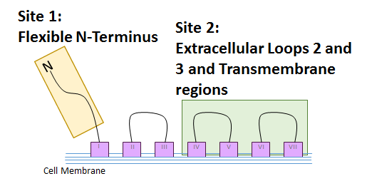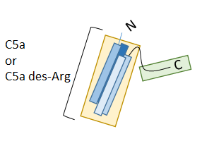

Figure 1.5 – Two-Site Binding Paradigm of C5a Binding to C5aR1
The two-site binding paradigm of C5a binding to C5aR1 suggests that the basic core of the C5a interacts with the N-terminus of C5aR1 (Site 1 - yellow boxes) to provide selectivity for C5a. The C-terminus of C5a interacts with the loops and transmembrane region of the receptor (Site 2 – green boxes) which provides the receptor activation signal.

1.3.2.2 - C5aR2

Human C5aR2 shares 35% sequence identity with human (h) C5aR1. Many of the residues shown to be important for ligand binding and receptor activation in C5aR1 are conserved in hC5aR2 (Cain and Monk, 2002). Despite this, C5aR2 shows high affinity binding of both C5a and C5a des-Arg, unlike C5aR1, which shows a much greater affinity for C5a than for C5a des-Arg. It has been reported that C5aR2 binds C5a and C5a des-Arg with similar affinities, reported previously to be 3-10nM and 12-36nM respectively. This C5a des-Arg affinity is some 10-100x greater than that of C5aR1 (Klos et al., 2013). Though C5aR2 has also been proposed to bind C3a (Cain and Monk, 2002; Kalant et al., 2003) many groups cannot replicate this binding, and it has been demonstrated that pseudo-specific binding of C3a to assay plates can give misleading results that look like ligand binding. In addition labelled C3a can displace unlabelled C3a from assay plates adding to the misleading nature of these results (Johswich et al., 2006). Another difference between the two receptors is the on/off rate of ligand. C5a binding to C5aR1 was shown to reach equilibrium within minutes whereas equilibrium binding to C5aR2 needed at least 60 minutes. Likewise, C5aR1 released C5a 3x faster than C5aR2 (Okinaga et al., 2003). The authors suggest this may mean C5a binding to C5aR2 is not detected in many binding assays if C5aR1 is also present on the same cells. In addition, C-terminal peptides that were effective at blocking C5a binding to hC5aR1 transfected receptor had little or no effect on hC5aR2 (Scola et al., 2007).
The role of the N-terminus of hC5aR2 on ligand binding has been studied in more detail. Firstly, antibodies were used to block the hC5aR2 N-terminus and then ligand binding assayed. Unlike in C5aR1, blockade of the N-terminus had no effect on C5a binding but C5a des-Arg binding was greatly reduced. However, when the N-terminus of hC5aR2 was substituted with the N-terminus of hC5aR1, C5a des-Arg binding affinity was only slightly affected (less than 2x reduction) as was C5a to a similar level. These results would suggest that the higher affinity for C5a des-Arg does not solely come from the hC5aR2 N-terminus. Finally, certain acidic or tyrosine residues in the hC5aR2 N-terminus were mutated and C5a and C5a des-Arg binding assayed again. Overall, mutation had little effect on C5a binding in most cases whereas C5a des-Arg binding affinity was usually decreased. When similar mutants of hC5aR1 were tested in the same study, binding affinity for both C5a and C5a des-Arg was equally affected (Scola et al., 2007). These data suggest C5a and C5a des-Arg have different binding mechanisms to hC5aR2 although little more is known about the exact binding of either ligand.

1.3.3 - Signalling

1.3.3.1 - C5aR1

C5aR1 expressed in neutrophils and mast cells is known to couple to G_{iα} G proteins that are sensitive to pertussis toxin (Sheth et al., 1991). However, C5aR1 responses in U937 monocytes were not all affected by pertussis toxin (Monk and Partridge, 1993). This difference implies that the receptor may be able to couple with different G-protein types in different cells leading to differing responses. Additionally, unlike many other G-protein coupled receptors, C5aR1 appears to be pre-coupled with G_{iα} G-proteins: it was found the C5aR1 from membrane preparations would appear coupled with an additional sub-unit, thought to be the G-protein, after gel filtration (Siciliano et al., 1990). This idea was reinforced when it was seen that pre-coupling of wild type and mutant C5aR1 led to increased ligand binding affinity (Raffetseder et al., 1996).
The signalling responses from the activation of C5aR1 vary widely between cell types as this receptor is now known to signal through a wide variety of pathways. This includes, but is not limited to, changes in intracellular calcium level either by influx or release of calcium stores, the MAPK/ERK pathway, and the Akt pathway to delay apoptosis of neutrophils. In addition, C5aR1 signalling can influence transcription factors such as CREB and NF-κB. C5aR1 signalling pathways have been reviewed in detail in Monk et al., 2007; Klos et al., 2009, 2013; and Lee et al., 2008. C5aR1 can be phosphorylated by G-protein receptor kinases (GRKs) (Langkabel et al., 1999). Phosphorylation by GRKs can lead to receptor desensitisation, as a signalling control measure, or the GRK can act as a scaffold for other proteins to facilitate downstream signalling (Ribas et al., 2007).
Phosphorylated G-protein coupled receptors can interact with β-arrestins. The C-terminus of C5aR1 contains six serine residues which become phosphorylated after receptor activation. After phosphorylation, β-arrestin 1 and 2 can bind and receptor is targeted for internalisation via a clathrin-dependent pathway (Braun et al., 2003). Though an interaction between C5aR1 and β-arrestin has been demonstrated by another group (Van Lith et al., 2009) there is no evidence to suggest that this receptor can signal through β-arrestin and when CHO cells transfected with C5aR1 were tested this was not seen (Gripentrog and Miettinen, 2008). Interestingly, both C3aR and C5aR2 have been shown to influence downstream signalling through β-arrestin (Croker et al., 2014; Hsu et al., 2014; Vibhuti et al., 2011). Both C3aR and C5aR2 have cysteine residues at their C-termini, which is not present in C5aR1, that are said to be important for protein interactions in other G-protein coupled receptors (Huynh et al., 2009; Klos et al., 2013). It is possible that this lack of Cys in C5aR1 accounts for some of the differences between C5aR1 and C5aR2.
Finally, it has been shown that C5aR1 can form homodimers and heterodimers with other partners. After random mutagenesis studies of helices I and II of C5aR1 showed a number of lipid-facing conserved residues which were speculated to participate in protein/protein interactions within the membrane (Geva et al., 2000). Using a system whereby receptors in close proximity would become joined by a disulphide bridge, Klco et al., 2003 showed receptor cross-linking occurring within 15 minutes in the presence of a redox catalyst for both transfected receptor and natively expressed receptor. The authors suggested possible interaction sites also in helices I and II. C5aR1 expressed in yeast was also able to show oligomerisation (assessed using fluorescence resonance energy transfer (FRET)), constitutively without the need for mammalian partner proteins. This oligomerisation was not affected by the addition of a receptor agonist (Floyd et al., 2003). Finally, bioluminescence resonance energy transfer (BRET) experiments have shown that C5aR1 can form heterodimers with another chemotactic receptor, CCR5. C5a activation of C5aR1 when dimerised with CCR5 could cause phosphorylation of unliganded CCR5. The authors observed that internalisation of C5aR1 could also cause internalisation of CCR5 when the two receptors were dimerised. They hypothesised that this cross-phosphorylation and internalisation was mediated by GRK phosphorylation and binding of β-arrestin (Huttenrauch et al., 2005).

1.3.3.2 - C5aR2

One significant difference between C5aR1 and C5aR2 is that despite having the seven-transmembrane helix structure of other G-protein coupled receptors, C5aR2 does not couple to G-proteins (Cain and Monk, 2002). In part, it is suspected this lack of coupling is due to an altered motif found to be conserved in many chemoattractant receptors. In this sequence, ‘DRX’ the consensus, found in the third transmembrane helix, the arginine has been shown to be important for G-protein coupling. Previously, Formyl Peptide Receptor (FPR) mutants where this arginine was substituted for glycine were unable to activate G-proteins but were still able to become phosphorylated and internalised in response to ligand (Prossnitz et al., 1999). In C5aR2 this sequence reads DLC and so it is possible removal of the arginine causes loss of G-protein coupling (Cain and Monk, 2002). When mutant hC5aR2 with arginine substituted for this leucine was expressed in HEK (Human Embryonic Kidney) cells co-transfected with the G_{α16} G-protein, some slight coupling ability was recovered. This was, however, less than the activation seen with hC5aR1. In addition to this, there are two other sequences that are different in hC5aR2 compared to other G-protein coupled receptors, including a shortened third intracellular loop (Cain and Monk, 2002) and an altered NPXXY motif within the seventh helix (Scola et al., 2009). A triple C5aR2 mutant was designed which had the C5aR1 sequences in all three of these regions and was tested for receptor activation. No recovery of G-protein coupling was seen for this mutant. The authors suggested the reason for this may be that while the HEK cells in the previous study were transfected with G_{α16}, in RBL cells receptor could only couple to the natively expressed, less promiscuous G_{αi}. In addition there may be other structural features which prevent the coupling of G-protein to this receptor (Scola et al., 2009).
In light of this lack of G-protein coupling, Li et al., 2013 lay out the current main hypotheses for the function and signalling ability of C5aR2: C5aR2 acts as a passive decoy receptor, sequestering C5a away from C5aR1 to reduce inflammatory signals; intracellular C5aR2 may be able to signal through β-arrestin by forming complexes with active C5aR1 at the cell surface; surface C5aR2 may be able to signal independently through an unknown mechanism, possibly through MAPK/ERK pathways via β-arrestin.
- Decoy Recycling Receptor. An early study by Okinaga et al., 2003 showed lack of transfected C5aR2 phosphorylation after ligand binding in L1.2 cells (mouse pre-B cells), contrary to C5aR1 which is rapidly phosphorylated then internalised. With the observation that C5aR2 does not internalise in response to ligand in transfected RBL cells (Cain and Monk, 2002), the authors suggested C5aR2 passively provides a way to regulate signalling by C5aR1 through the removal of C5a and C5a des-Arg away from this receptor (Okinaga et al., 2003). There are many reported decoy receptors that share this G-protein coupled receptor structure but also tend to be missing the DRX motif (Klos et al., 2013). C5aR2 is commonly compared with the chemokine receptor D6. This receptor was found to have a predominantly intracellular location but with constitutive cycling to and from the cell membrane. Ligand taken up by D6 is rapidly dissociated from the receptor and then targeted for degradation (Weber et al., 2004). When studied in transfected RBL cells, C5aR2 was shown to internalise constitutively via a clathrin dependent mechanism but not in response to ligand. In addition, this receptor was rapidly recycled to the cell surface, within 15 minutes, but within transfected cells ligand was retained within the cell and not degraded. In the same study, in C5aR2 natively expressing HL-60, HeLa, and PMN cells ligand was taken up into the cell and degraded, with C5a des-Arg being more rapidly degraded than C5a (Scola et al., 2009).

- Signalling Through β-arrestin. There has been growing evidence that C5aR2 can recruit β-arrestin upon ligand binding. The first evidence came when transfected HEK cells expressing C5aR2 and a GFP-tagged β-arrestin showed co-localisation upon treatment with C5a and C5a des-Arg (Kalant et al., 2005). Following this, time-dependent (Cui et al., 2009) and dose-dependent (Van Lith et al., 2009) β-arrestin2 recruitment upon C5a binding was reported in transfected HEK and U2OS cells by two further groups. Subsequently, Bamberg et al., 2010 showed a possible role for C5aR2 in regulating C5aR1 signalling through modulation of β-arrestin signalling. They found that in human PMNs, which natively express both receptors, C5aR1 would localise with both β-arrestin and C5aR2 after ligand binding. In addition, they showed that antibody blockade of C5aR2 would reduce C5aR1 mediated ERK1/2 phosphorylation and chemotaxis. However, calcium mobilisation, which is linked to G-protein signalling, was unaffected. One large difference is that in this study cells natively expressing both receptors were used whereas in the previous studies transfected cells were used. The overexpression of transfected protein or the non-native environment the protein will exist within may lead to behaviour that would not normally be seen. In further support of the hypothesis that C5aR1 and C5aR2 act together, a study using BRET showed that C5a but not C5a des-Arg could induce heterodimer formation in transfected HEK cells. Binding of antagonist to C5aR1 would prevent this heterodimer formation. The authors also saw that after C5a stimulated heterodimer formation in human monocyte-derived macrophages (HMDMs) there was increased levels of the anti-inflammatory cytokine IL-10. They suggested this gave an anti-inflammatory role for C5aR2 whereby heterodimer formation and subsequent influence on β-arrestin signalling could regulate C5aR2 signalling (Croker et al., 2013). In a follow-up study, it was shown using normal and competition BRET studies that β-arrestin2 preferentially bound C5aR2 over C5aR1 and, in fact, showed some constitutive coupling with C5aR2. In addition to this C5a concentrations above the EC₅₀ for heterodimer formation were shown to inhibit ERK1/2 signalling in HMDMs. In contrast, no inhibition was seen with C5a des-Arg (Croker et al., 2014).

1.4 - A Pro-Inflammatory or Anti-Inflammatory Role for C5aR2?

There is still no clear consensus as to whether C5aR2 has a pro-inflammatory or anti-inflammatory role with different studies producing conflicting results.
Anti-Inflammatory. Several studies were published in 2005 all indicating an anti-inflammatory role for C5aR2. Two studies used experimental sepsis in rats to examine the role of this receptor and though both suggested an anti-inflammatory role both also showed conflicting results. In a study by Gao et al. (2005), neutrophils isolated from septic rats showed an increase in C5aR2 levels 24hr and 36hr after sepsis induction (Gao et al., 2005). In contrast, a study by Huber-Lang et al. (2005), showed lower C5aR2 levels on the neutrophils of human sepsis patients relative to healthy volunteers. Those patients who developed multiple-organ failure had no detectable levels of C5aR2. This trend for lower C5aR2 levels with severity of sepsis suggested an anti-inflammatory role (Huber-Lang et al., 2005). In addition, Gao et al. saw that blockade of C5aR2 caused increased levels of the pro-inflammatory cytokine IL-6 whereas blockade of C5aR1 decreased levels again suggesting an anti-inflammatory role for C5aR2 (Gao et al., 2005). As well, C5aR2 knockout mice studied in a model of lung inflammation showed higher IL-6 levels than wild type mice. Cells obtained from the bone marrow of these knockout mice also showed greater levels of chemotaxis to C5a than wild type mice (Gerard et al., 2005). In addition, receptor found in rat astrocytes thought to be the rat analogue of C5aR2, when knocked out, lead to increased inflammation levels (Gavrilyuk et al., 2005). Chen et al. (2007) published evidence that C5aR2 may act as a signal modulator for C5aR1 that can have pro- and anti-inflammatory functions. For example, though most of their results showed pro-inflammatory roles for C5aR2 they also saw that deletion of the C5aR2 gene caused mice to be more sensitive to LPS-induced sepsis (Chen et al., 2007). In 2013 Wang et al. found that in a mouse model of contact sensitivity dermatitis, C5aR2 knockout mice showed increased levels of inflammation (Wang et al., 2013), and in 2016 that C5aR2 knockout mice showed a greater lung inflammatory response when exposed to LPS (Wang et al., 2016), again suggesting an anti-inflammatory role for this receptor.

Pro-Inflammatory. There has also been evidence for a pro-inflammatory role for C5aR2. In 2007, Chen et al. found that C5aR2 knockout mice showed reduced inflammatory cell infiltration and had reduced airway hyper-responsiveness when challenged with antigen. This was the first indication that C5aR2 may act as a positive modulator of C5aR1 signalling (Chen et al., 2007). This was supported by findings that blockade of C5aR1 or C5aR2 in ‘mid-grade’ sepsis, which the authors defined as 30-40% survival, in mice led to improved survival rates. In severe sepsis, 100% death, both receptors required blocking to give survival rate improvements (Rittirsch et al., 2008). In addition, in vitro studies on neutrophils isolated from human blood showed reduction in myeloperoxidase, involved in the oxidative burst of inflammation, production when C5aR2 was blocked (Hao et al., 2013). A different study saw that the human LAD2 mast cell-line endogenously expressed cell surface C5aR2 but not C5aR1. While being unable to degranulate in response to C5a, C5a could stimulate chemotaxis and release of certain chemokines. These responses could be stopped by preventing β-arrestin function using siRNA or by silencing expression of C5aR2 using shRNA (Pundir et al., 2015).

1.5 - Aims and Objectives

The main aim of this project was to provide further insights into the ligand binding mechanism of the enigmatic hC5aR2 receptor. Though these C5a receptors appear to be good targets for novel therapies for several inflammatory conditions it would seem logical to understand the function, role, and ligand binding properties of hC5aR2 prior to designing new drug molecules. Interestingly, both receptors share conserved residues in the extra-cellular loops and transmembrane regions shown to be important for ligand binding in hC5aR1 despite having different affinities for both the ligands, C5a and C5a des-Arg. In order to test our hypothesis that despite these similarities in ligand binding residues C5a and C5a des-Arg would be bound differently to hC5aR2 compared with each other and hC5aR1, a series of mutant hC5aR2 receptors was used. The receptor mutations were suggested by Dr Irina Tikhonova (Queen’s University, Belfast) based on previous hC5aR1 data and the structure of the chemokine receptor CXCR4 prior to the beginning of this work. These receptor mutants would be used in comparison with wild type receptor to test C5a and C5a des-Arg binding to investigate whether there was any difference in binding mechanism.

Recombinant ligands had previously been purified by our group and others using a protocol which involved denaturation followed by subsequent refolding of ligand during the purification process. Though it was cost-effective to produce the ligands used in this work in-house unfortunately a number of problems were faced relating to this denaturing purification protocol. As refolding was causing great losses in yield of protein, as well as the reagents used in this protocol also causing problems running samples in SDS-PAGE (sodium dodecyl sulphate poly-acrylamide gel electrophoresis) it was decided to develop a new protocol which would purify the protein under native conditions. Following this, yields were improved and recombinant ligands were purified successfully.

Ligands were fluorescently labelled for use in ligand binding assays. These ligand binding assays used competition between labelled and unlabelled C5a or C5a des-Arg to determine the effects of receptor mutation on ligand binding. Ligand binding was tested on CHO (Chinese Hamster Ovary) cells, chosen for their ease of transfection, transfected with either wild type or mutant receptor. All transfected cell lines were sorted above a threshold value for high surface expression of hC5aR2. In addition to this, previous work by Scola et al. 2007 had shown the N-terminus of C5aR2 to be important for C5a des-Arg binding but, interestingly, not C5a binding. In order to determine whether any of the receptor mutants were sufficiently disruptive that blockade of the N-terminus would abolish ligand binding, further binding assays were conducted in the presence of an antibody raised against the N-terminus of hC5aR2. However, the results were unexpected and differed greatly from those found by Scola et al. presumably due to differing affinities of the antibody used in this work and that used in the previous study. An Ala scan of the last 6 residues of C5a was then to be conducted to determine whether there were any specific receptor/ligand interactions. Unfortunately, mutant C5a encoding plasmids were synthesised by Mutagenex, USA but were not successfully purified and so these ligand binding assays were not able to be performed. Despite efforts to discover why these mutant ligands were seemingly not able to express properly in E. coli no solution was ever found and time constraints prevented this being taken further.

Finally, when hC5aR2 transfected CHO cells were tested for ligand-dependent internalisation an interesting result was obtained. Whereas it had previously been shown that C5aR2 transfected RBL (Rat Basophilic Leukaemia) cells showed no ligand-dependent internalisation (Scola et al., 2009) here a repeatable, ligand dependent effect was seen in transfected CHO cells. Selected receptor mutants were tested to determine whether mutation of the receptor disrupted the internalisation effect.

Chapter 2 - Materials and Methods

2.1 - Materials

2.1.1 - Antibodies
Antibody | Origin Organism | Target Organism | Clonality | Label | Source | Use
Anti-hC5aR2 | Rabbit | Human | Polyclonal | - | In-house,  Serum Purified | Receptor detection during sorting and internalisation assays.
Anti-hC5aR2 | Mouse | Human | Monoclonal 1D9-M12 |  | BioLegend | Receptor detection during receptor expression assays.
Anti-hC5aR1 | Mouse | Human | Monoclonal S5/1 | - | BioLegend | Receptor detection during RBL internalisation assay.
Anti-RGS-His6 | Mouse | Human | Polyclonal | - | Qiagen | Comparison of unlabelled C5a and C5a des-Arg binding to hC5aR2 WT
Rabbit IgG | Rabbit | - | Monoclonal [EPR25A] | - | Abcam | Isotype control for all rabbit antibodies
Mouse IgG | Mouse | - | Monoclonal JC1 | - | In-house,  (Muranova et al., 2004) | Isotype control for all mouse antibodies
Anti-Rabbit IgG | Goat | Rabbit | Polyclonal | FITC | Sigma | Secondary antibody used with rabbit anti-hC5aR2.
Anti-Mouse IgG | Goat | Mouse | Polyclonal | FITC | Sigma | Secondary antibody used with mouse anti-hC5aR1 and mouse anti-hC5aR2
Table 2.1 – Specificity, Label, and Source of Antibodies

2.1.2 - Vectors
Name | Use | Origin
pQE30 | Ligand expression  (Figure 2.2, 2.3) | (Paczkowski et al., 1999)
pEE6 | Mutant hC5aR2 expression  (Figure 2.1) | (Stephens and Cockett, 1989)  hC5aR2 mutant containing vectors provided by GenScript
Table 2.2 – Vectors and their Usage and Origins

2.1.3 - Primers
Sequence | Use | Source
5’-CGGATAACAATTTCACACAG | pQE30 forward  sequencing | Prior work in-house
5’-GTTCTGAGGTCATTACTGG | pQE30 reverse  sequencing | Prior work in-house
5’-ATGAGAGGATCGCATCACC | pQE30-C5a forward  qPCR | Suggested by  Mutagenex Inc.
5’-TTATGAGAGATATTAGCACGG | pQE30-C5a reverse  qPCR | Suggested by  Mutagenex Inc.
Table 2.3 – Primers and their Usage and Origin of Design

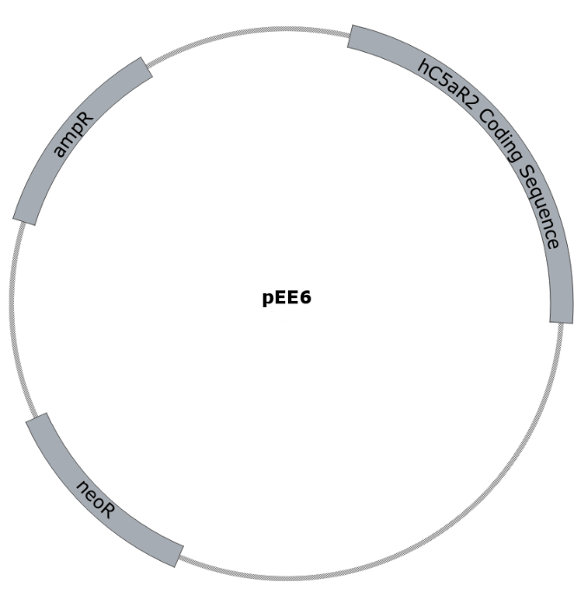

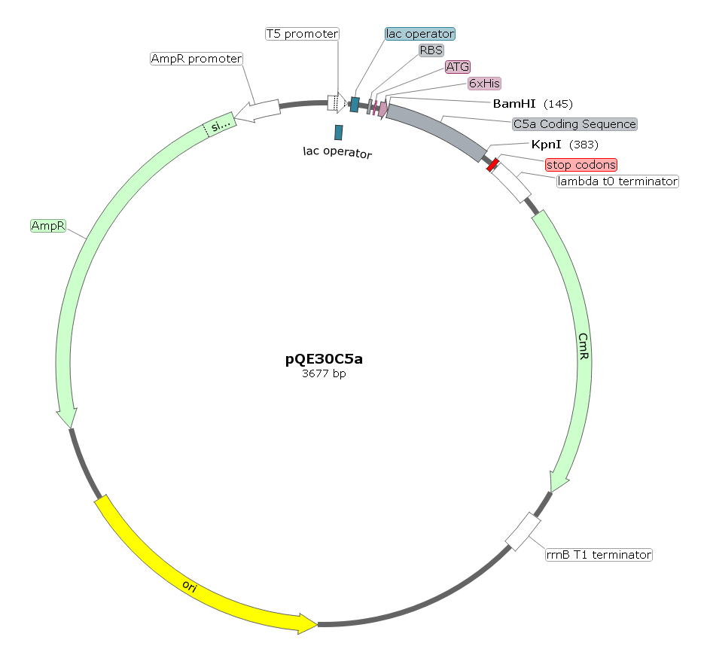
Figure 2.1 – pEE6 Vector Map
Basic vector map of pEE6 plasmid containing hC5aR2 coding sequence, ampicillin resistance gene, and neomycin resistance gene conferring resistance to Geneticin (G418). Map created using SnapGene.

Figure 2.2 – pQE30 Vector Map
pQE30 vector map with inserted C5a coding sequence. pQE30 provides ampicillin resistance, chloramphenicol resistance, as well as providing a 6-Histidine tag. The C5a insert sequence is cloned into BamHI and KpnI restriction sites. Map created using SnapGene
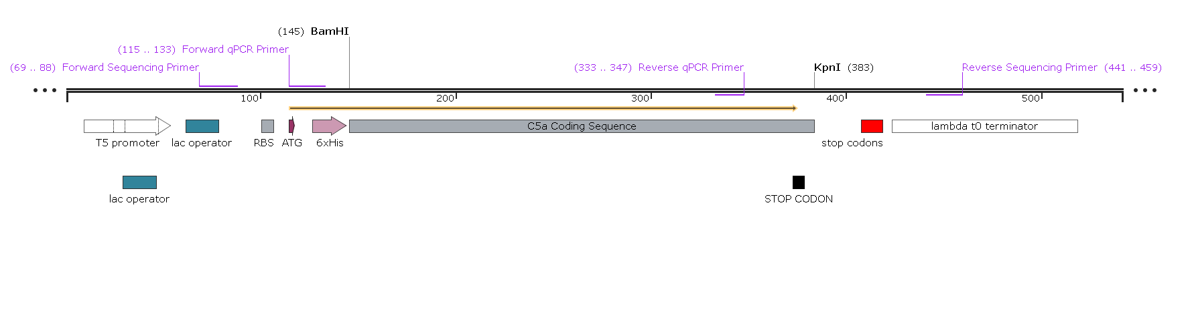
Figure 2.3 – pQE30 Coding Sequence Map
C5a insert sequence within pQE30. Included are the locations of the primers used for both qPCR and sequencing of the C5a coding sequence. The 6-Histidine tag is immediately proceeded by the beginning of the C5a coding sequence within which a stop codon is contained directly in upstream of the KpnI restriction site. Map created using SnapGene.

2.1.4 - Antibiotics
Name | Stock Concentration  (mg/ml) | Diluted In | Working Concentration  (µg/ml) | Use
Carbenicillin | 50 | Water | 50 | Bacterial selection during growth for ligand production and pEE6 DNA purification
Chloramphenicol | 34 | 100% Ethanol | 34 | Bacterial selection during growth for ligand production
Geneticin (G418) | 250 | DMEM | 300 (culture)  1000 (transfection) | Selection for hC5aR2 transfected CHO cells
Kanamycin | 25 | Water | 25 | Bacterial selection during growth for pEE6 DNA purification
Penicillin/Streptomycin | 10000 units/ 10mg/ml | DMEM | 100 units/ml | Added to mammalian cell culture medium to prevent unwanted culture infection
Tetracycline | 12.5 | Water | 12.5 | Bacterial selection during growth for ligand production
Table 2.4 – Antibiotic Stocks and Working Dilution

2.1.5 - Mammalian Cell Lines
Name | Source | Transfections | Used For
CHO | Chinese Hamster Ovary (ECACC) | hC5aR2 WT  hC5aR2 Mutants | Ligand Binding Assays  +  Internalisation Assays
RBL-2H3 | Rat Basophil Leukaemia  (Gift from Dr Birgit Helm, MBB, University of Sheffield) | hC5aR1 WT  hC5aR2 WT | Degranulation Assays  Internalisation Assays
Table 2.5 – Mammalian Cell Lines, Transfections, and their Applications
All cell lines cultured in DMEM +10% FCS, +1% Penicillin/Streptomycin Cocktail
37°C, 5% CO₂

2.1.6 - Bacterial Strains
Strain | Characteristics | Source
M15 p[REP4]  E. coli | F-, Φ80ΔlacM15, thi, lac-, mtl-, recA+ , pREP4 (Kan^{R}) | Qiagen  Made competent in-house
Rosetta Gami 2 (DE3) pLysS  E. coli | Δ(ara-leu)7697, ΔlacX74 ΔphoA, PvuII, phoR, araD139, ahpC, galE, galK, rpsL, (DE3) F′[lac⁺ lacI^{q} pro], gor522::Tn10, trxB, pLysSRARE2 (Cam^{R}, Str^{R}*, Tet^{R}) | Novagen
Table 2.6 – Bacterial Strains, their Genotypes, and their Manufacturers
*rpsL confers resistance to streptomycin, but streptomycin is not necessary to
maintain genotype in culture
2.1.7 - Buffers and Reagents
Name | Preparation
Acetate Buffer (100ml, pH 4.0) | 84.7ml 0.1M acetic acid, 15.3ml 0.1M sodium acetate
Agar Plates | 10g NaCl, 10g tryptone, 5g yeast extract, 15g bacteriological agar – made to 1l in dH₂O
Agarose Gel (1%) | 1.2g electrophoresis agarose – dissolved in 120ml 1x TAE buffer
BBN | 0.5g sodium azide, 1g BSA – made up in 500ml HBSS (+divalents)
Citrate Buffer (200mM, pH 4.5) | 5.85g citric acid, 6.47g sodium citrate – made up in 250ml dH₂O
Coomassie Blue Stain | 2.5g Coomassie Brilliant Blue R-250, 500ml methanol, 100ml acetic acid – made to 1l in dH₂O
Coomassie De-Stain | 400ml methanol, 100ml acetic acid – made to 1l in dH₂O
Coupling Buffer pH 8.3 | 0.2M NaHCO₃, 0.5M NaCl
Elution Buffer (Ligand Purification)  pH 8.0 | 50mM NaH₂PO₄, 300mM NaCl, 250mM Imidazole
EZ-Run Running Buffer 1x (Fisher Scientific) | 50ml 20x EZ-run running buffer – made to 1l in dH₂O
EZ-Run Separating Gel (12.5%) (Fisher Scientific) | 60µl 10% APS, 15µl TEMED – made in 10ml EZ-run Separating Solution
Freezing Solution | 10% DMSO in FCS
Internalisation Buffer | 1g BSA dissolved in 500ml HBSS (+divalents)
LB (Lysogeny Broth) | 10g NaCl, 10g tryptone, 5g yeast extract – made to 1l in dH₂O
Lysis Buffer (Ligand Purification)  pH 8.0 | 50mM NaH₂PO₄, 300mM NaCl, 10mM Imidazole

Phosphate Buffered Saline (PBS) 1x  pH 7.4 | 137mM NaCl, 10mM Na₂HPO₄, 2.7mM KCl, 1.8mM KH₂PO₄
Reducing Buffer 2x (for SDS-PAGE) | 50µl β-mercaptoethanol, 950µl laemmli sample buffer (Bio-Rad)
Release Buffer | 0.5g BSA dissolved in 500ml HBSS (+divalents)
Running Buffer 1x (for SDS-PAGE) | 24.8mM Tris base, 192mM glycine, 0.1% w/v SDS
Separating Gel (15%) | 2.3ml dH₂O, 5ml 30% acrylamide, 2.5ml Tris-base (1.5M pH 8.8), 100µl 10% SDS, 100µl 10% APS, 10µl TEMED
Stacking Gel (5%) | 2.75ml dH₂O, 650µl 30% acrylamide, 500µl Tris-base (1M pH6.8), 40µl 10% SDS, 40µl 10% APS, 4µl TEMED
TAE Buffer 1x | 40mM Tris base, 20mM acetic acid, 1mM EDTA (pH 8.0)
TFB-1 Buffer pH 5.8 | 100mM RbCl, 50mM MnCl₂, 30mM potassium acetate, 10mM CaCl₂, 15% glycerol – adjust to pH 5.8 then sterile filter through 0.2µm filter
TFB-2 Buffer pH 6.8 | 10mM MOPS, 10mM RbCl, 75mM CaCl₂, 15% glycerol – adjust to pH 6.8 then sterile filter through 0.2µm filter
Wash Buffer (Ligand Purification)  pH 8.0 | 50mM NaH₂PO₄, 300mM NaCl, 20mM Imidazole
β-Hexosaminidase Substrate  Stock Solution | N-acetyl-β-D-glucosaminide (Sigma) – dissolved at 50mM in DMSO
Table 2.7 – Composition of Buffers and Reagents

2.2 – Methods

2.2.1 - Molecular Biology Techniques

2.2.1.1 - Preparation of Competent M15 p[REP4] Cell Stocks
M15 p[REP4] cells were routinely stored frozen at -80°C and thawed on ice for 10 mins. 250µl of LB-broth was added to the cells which were then incubated for 1 hr in a shaking incubator at 37°C at 225rpm. Cell culture was then plated onto LB-agar plates containing the appropriate antibiotics. The plates were incubated overnight at 37°C. Single colonies were picked from the plates and inoculated into 10ml of LB-broth containing the appropriate antibiotics. These liquid cultures were incubated for 8 hrs at 37°C in a shaking incubator at 225rpm. 1ml of bacterial culture was inoculated into 100ml LB-broth and the bacteria grown at 37°C, 225rpm until an OD₆₀₀ of 0.5 was reached. The culture was then transferred to an appropriate centrifuge tube and cooled on ice for 5 mins. The culture was centrifuged at 4°C, 4000g, for 5 mins. The supernatant was discarded and the cell pellet resuspended in 30ml cold TFB1 buffer. The cells were then incubated on ice for 90 mins. The cells were centrifuged for a further 5 mins at 4°C, 4000g and the supernatant discarded. The cell pellet was resuspended in 4ml TFB2 buffer. 200µl aliquots of cell suspension were then transferred into cryovials and stored at -80°C.

2.2.1.2 - Bacterial Transformation
Competent bacteria were thawed on ice for 10 mins. Once thawed, 1.5µl of appropriate plasmid DNA was gently pipetted into the bacteria. Bacteria and DNA were incubated on ice for a further 20 mins. The bacteria were then heat-shocked at 42°C for 35 s before undergoing a further 2 mins incubation on ice. 250µl of LB-medium was added to the bacteria which were then incubated at 37°C in a shaking incubator for 1 hr at 225rpm. The transformed cells were then plated onto LB-agar plates containing the appropriate antibiotics. The plates were then incubated at 37°C overnight or until discrete colonies were clearly seen.

2.2.1.3 - Glycerol Stocks
Bacteria were transformed as in 2.2.1.2. A single colony was picked and use to inoculate 10ml of LB-medium containing the appropriate antibiotics. This culture was incubated at 37°C in a shaking incubator at 225rpm overnight. 750µl of bacterial cell culture was transferred into a cryovial and 250µl of 60% sterile-filtered glycerol was added. The glycerol stocks were then stored long-term at -80°C.

2.2.1.4 - Midi-Prep
HiSpeed Plasmid Midi kits (Qiagen) were used according to the manufacturer’s instructions. Bacteria were transformed as in 2.2.1.2 and single colonies picked then inoculated into 10ml LB-broth containing the appropriate antibiotics. Inoculated cultures were then incubated at 37°C for 8 hrs in a shaking incubator at 225rpm. 1ml of bacterial culture was then transferred into 100ml LB-broth containing the appropriate antibiotics and incubated in a shaking incubator overnight at 37°C, 225rpm. The 100ml culture was pelleted by centrifugation at 4°C, 6000g, for 15 mins. The bacterial pellet was resuspended in 6ml buffer P1. 6ml buffer P2 was added and the solution was mixed by inverting the tube 6 times. The solution was the incubated at room temperature for 5 mins. 6ml of chilled buffer P3 was added and the solution again mixed by inverting the tube 6 times. These steps serve to lyse the bacterial cells. The lysate was transferred into a QIAfilter cartridge and incubated at room temperature for a further 10 mins. During this time a HiSpeed Tip was equilibrated with 4ml buffer QBT. After the incubation the lysate was filtered through the QIAfilter cartridge into the HiSpeed Tip. The HiSpeed Tip was then washed with 20ml buffer QC. The DNA was eluted into a bijoux tube by applying 5ml buffer QF to the HiSpeed Tip. 3.5ml isopropanol was added to the DNA, mixed, and then incubated at room temperature for 5 mins. The DNA was then applied to a syringe and filtered through a QIAprecipitator. The QIAprecipitator was washed with 2ml 70% ethanol by filtration and then dried by repeatedly drawing air through it. DNA was then eluted into a 1.5ml Eppendorf tube from the QIAprecipitator by applying 500µl DNA/RNase free water. This filtrate was then refiltered through the QIAprecipitator and collected back into the 1.5ml Eppendorf tube.

2.2.1.5 - Mini-Prep
QIAprep Spin Miniprep kits (Qiagen) were used according to the manufacturer’s instructions. Bacteria were transformed as in 2.2.1.2 and single colonies picked then inoculated into 10ml LB-broth containing the appropriate antibiotics. Inoculated cultures were then incubated at 37°C overnight in a shaking incubator at 225rpm. The 10ml bacterial culture was then pelleted by centrifugation at 4°C, 6000g, for 15 mins. The bacterial pellet was resuspended in 250µl buffer P1 and then transferred into a 1.5ml Eppendorf tube. 250µl buffer P2 was added and the tube mixed by inverting 6 times or until the solution became clear. The tube was then incubated at room temperature for 5 mins. 350µl buffer N3 was added and mixed by inverting the tube 6 times. The tube was then centrifuged at 17,900g for 10 mins. The supernatant was applied to a QIAprep spin column which was then centrifuged for a further 60 s and the flow-through discarded. The column was washed by adding 0.5ml buffer PB and centrifuging again for 60 s, discarding the flow-through. The column was then washed again by adding 0.75ml buffer PE and centrifuging for 60 s, discarding the flow-through. The column was centrifuged for a further 60 s to remove any residual wash buffer, and any flow-through discarded. The column was placed into a clean 1.5ml Eppendorf tube, 50µl DNA/RNase free water added and then left to stand for 1 mins. The column was then centrifuged for 1 mins and the DNA collected.

2.2.1.6 - Ethanol Precipitation
Ethanol precipitation was used when DNA yields from plasmid purification were low. 1/10th volume of 3M sodium acetate was added to the DNA to a final concentration of 0.3M. The solution was then thoroughly mixed. 2.5x volume of ice-cold 100% ethanol was then added a mixed thoroughly. The solution was left at -20°C for 20 mins. The solution was then centrifuged at 13,400g, 4°C for 20 mins. The supernatant was carefully removed and the pellet resuspended in 1ml 70% ethanol. The solution was thoroughly mixed and centrifuged again for a further 3 mins at 13,400g, 4°C. The supernatant was removed and the remaining DNA pellet left to air-dry. The DNA was then resuspended in a suitable volume of DNA/RNase free water.

2.2.1.7 - Agarose Gel Electrophoresis
Agarose gels were prepared by dissolving 1g agarose powder in 100ml TAE buffer by microwaving. After the agarose solution had cooled, 0.5µg/ml of ethidium bromide was added. The solution was poured into a sealed gel tray with care taken to avoid air bubbles forming near the comb. Samples were prepared by adding 1/6 diluted 6x loading buffer and water. Sufficient volumes of DNA would be loaded so that bands would be clearly seen according to a 10kb HyperLadder (Bioline) standard scale. The samples (usually 12µl) and the HyperLadder (5µl) were loaded onto the gel. The gel was run in 1x TAE buffer at 100v for 55 mins. Gels were visualised under UV light.

2.2.1.8 - DNA Sequencing
pQE30 plasmids containing C5a and C5a des-Arg sequences were sequenced by the Core Genomics Facility at the University of Sheffield, UK. The facility uses an Applied Biosystems 3730 DNA Analyzer and follow a BIgDye v3.1 protocol. Sequence reads were analysed using FinchTV from geospiza and EMBOSS needle from EMBL-EBI found at http://www.ebi.ac.uk/Tools/psa/emboss_needle/.

2.2.2 - Polymerase Chain Reaction (PCR) Analysis of C5a mRNA Expression

2.2.2.1 - Bacterial Growth and Lysis
Bacteria were transformed and cultured as previously (2.2.1.2). Three colonies for both wild-type and mutant were picked. Cultures were grown to an OD₆₀₀ 0.6 and then split in half. One half was induced with 1mM IPTG for 3.5 hrs and the other half grown without IPTG for 3.5 hrs. Cultures were added to 2x volume RNAprotect Bacteria Reagent (Qiagen) and immediately vortexed for 5 s. Cell pellets were then collected by centrifugation at 5000g, 10 mins, 4°C. Supernatents were discarded. To each sample 200µl 1mg/ml lysozyme in TE buffer (30mM Tris-HCl, 1mM EDTA, pH8.0) + 10µl proteinase K was added. Pellets were disrupted by pipetting up and down. Samples were vortexed for 10 s then incubated for 10 mins at room temperature. Every 2 mins samples were vortexed for 10 s. After the incubation, 700µl buffer RLT supplemented with 10 µl β-mercaptoethanol (Qiagen – RNeasy mini kit) was added to each sample. Samples were then vortexed before adding 500µl 100% ethanol.

2.2.2.2 - RNA Extraction
RNA extraction was performed using RNeasy mini-kit (Qiagen) and according to manufacturer’s instructions. Following addition of 500µl ethanol to each sample, 700µl was transferred to a spin column placed inside a collection tube. The column was then centrifuged for 15s at ≥8000g. The flow through was discarded and 700µl buffer RW1 added to the column. The column was then centrifuged for 15 s at ≥8000g and the flow through discarded. The column was then placed in a new collection tube and 500µl buffer RPE added. The column was then centrifuged for 15 s at ≥8000g and the flow through discarded. A further 500µl buffer RPE was added and then the column centrifuged for 2 mins at ≥8000g and the flow through discarded. The column was then centrifuged for 2 mins at ≥8000g to dry it. The column was then transferred to a 1.5ml collection tube, 50µl RNase free water added to the centre of the membrane, and then centrifuged for 1 mins at ≥8000g. Extracted RNA was stored at -80°C until required.

2.2.2.3 - cDNA Synthesis
cDNA synthesis was performed using the Quantitect Reverse Transcription Kit (Qiagen) according to manufacturer’s instructions. This kit uses a series of random primers to allow reverse transcription of most of an RNA sample rather than gene specific primers. RNA templates were thawed on ice and all other components thawed at room temperature. Firstly, genomic DNA would be removed. Samples were set up according to the following:
Component | Volume per Reaction
gDNA Wipeout Buffer 7x | 2µl
Template RNA | Sufficient for up to 1µg
RNase-free water | Make up to 14µl
Table 2.8 – gDNA Elimination Reaction Composition
Samples were then incubated for 2 mins at 42°C and placed immediately on ice. Reverse transcription master mix/reaction mix was then prepared on ice according to the following:
Component | Volume per Reaction
Quantiscript Reverse Transcriptase* | 1µl
Quantiscript RT Buffer 5x* | 4µl
RT Primer Mix* | 1µl
Template RNA | 14µl
Table 2.9 – Reverse Transcription Reaction Composition
* - Part of the reaction master mix
Template RNA was added to the master mix and mixed. The reaction was then incubated for 30 mins at 42°C. To denature the reverse transcriptase the reaction was then incubated for 3 mins at 95°C. Produced cDNA was then stored at -20°C until required.

2.2.2.4 - PCR
To determine the presence or absence of the C5a transcript in cDNA samples, 10µl of each completed cDNA reaction was run through PCR using the C5a Forward and C5a Reverse primers. The High-fidelity DNA polymerase Q5 (NEB) was used and the reaction mixtures set up as follows:
Component | Volume per Reaction
5x Q5 Reaction Buffer | 5µl
10mM dNTPs | 0.5µl
10µM Forward Primer | 1.25µl
10µM Reverse Primer | 1.25µl
cDNA Sample | 10µl
High-Fidelity Q5 DNA Polymerase | 0.25µl
DNase free H₂O | to 25µl
Table 2.10 – Q5 PCR Components
PCR reactions were then run as follows:
Temperature (°C) | Time | Cycles
98 | 30s | X1
98 | 10s | Repeat x30
50 | 30s
72 | 30s
72 | 2 mins | X1
Table 2.10 – Q5 PCR Running Conditions
PCR reactions were then run on a 1% agarose gel to determine whether C5a transcript was present in the original RNA samples.

2.2.3 - Cloning of pQE30

2.2.3.1 - Restriction Digest
pQE30 vector containing either wild-type or mutant C5a gene inserts were cut with restriction enzymes from NEB, following the advice provided by the manufacturer for the usage of buffers and incubation times. Reactions for 1-2µg of plasmid DNA were generally set up as follows:
Component | Volume per Reaction
10x Buffer (1.1, 3.1, or CutSmart) | 5µl
Restriction Enzyme (NheI, BamHI, or KpnI) | 1µl
Plasmid DNA | Sufficient for 1-2µg
DNase free H₂O | to 50µl
Table 2.11 – Standard Restriction Digest Reaction Composition
Reaction components were added to an Eppendorf tube, mixed thoroughly, then centrifuged briefly to collect droplets. For double digests in CutSmart buffer both enzymes would be added together. Tubes were then incubated in a water bath at 37°C for 1 hr. Restriction digests were then run on a 1% agarose gel either for analysis or in preparation for a gel extraction of the cut fragments.

2.2.3.2 - Gel Extraction
Gel extraction of DNA bands from 1% agarose gels was performed using the QIAquick Gel Extraction Kit (Qiagen) according to manufacturer instructions. Care was taken to avoid exposure of DNA bands to UV light longer than necessary. Bands were excised using a clean razor blade and then weighed. For each extraction ≤400mg agarose was used. Agarose slices were placed into a tube and 3 volumes buffer QG added. Tubes were then incubated at 50°C for 10 mins, or until the gel slice was dissolved, with vortexing every 2 mins Following this 1 volume of isopropanol was added to each tube. The samples were then transferred into a QIAquick spin column placed into a collection tube. The column was then centrifuged in a bench-top microfuge at max speed for 1min. The flow through was discarded and 0.5ml buffer QG added to the column. The column was then centrifuged again for 1 mins and the flow through discarded. This buffer QG wash step was then repeated. Next, 0.75ml buffer PE was added to the column which was then centrifuged at max speed for 1 mins. The flow through was discarded and this buffer PE wash repeated once more. After the flow through was discarded for the second time the column was run empty in the centrifuge on max speed for 1min. To elute the DNA 30µl DNase free H₂O was added to the centre of column which was then left to stand for 4 mins. After, the column was centrifuged on max speed for 1min. A second elute using 20 - 30µl DNase free H₂O was then performed. Finally, DNA concentrations were determined spectrophotmetrically using a nanodrop device.

2.2.3.3 - DNA Ligation

DNA ligation was performed using the Rapid DNA Ligation Kit (Thermo) according to manufacturer instructions. Ligation reactions were performed in Eppendorf tubes as follows:
Component | Volume per Reaction
T4 DNA Ligase 5U/µl | 1µl
5x Rapid Ligation Buffer | 4µl
Vector DNA | 10-100ng
Insert DNA | 3:1 insert:vector
DNase Free H₂O | to 20µl
Table 2.12 – DNA Ligation Reaction Composition
Reactions were mixed and then incubated in a water bath at 22°C for 10min. After the incubation, 1-2µl of reaction mix was used to transform competent Rosetta Gami 2 (DE3) pLysS E. coli as standard. Control transformations were done to determine any background bacterial growth due to recircularisation of the vector and improper digest of the vector.

2.2.3.4 - Colony PCR Screening
Colony PCR screening was performed to determine whether the C5a encoding sequence was present in experimental and control colonies grown after transformation with ligated DNA. PCR reactions were performed using Phusion DNA polymerase (NEB) and reactions were set up as follows:
Component | Volume per Reaction
5x Phusion Buffer | 10µl
10mM dNTPs | 1µl
10µM Forward Primer | 2.5µl
10µM Reverse Primer | 2.5µl
Phusion DNA Polymerase | 0.5µl
DNase Free H₂O | to 50µl
Table 2.13 – Phusion Colony PCR Screening Composition
To each reaction tube a small amount of bacterial colony was then added directly and mixed by pipetting. Reactions are then loaded onto the machine and run as follows:
Temperature (°C) | Time (min) | Cycles
95 | 5 | X1
95 | 1 | Repeat x35
50 | 1.5
72 | 1
72 | 5 | X1
Table 2.14 – Phusion Colony PCR Screening Running Conditions
Samples were then run on a 1% agarose gel to check for the presence or absence of C5a DNA.

2.2.4 - Mammalian Cell Culture Techniques

2.2.4.1 - Growth and Maintenance of Cell Lines
Cells were cultured in Dulbecco’s Modified Eagle Media (DMEM, Lonza) supplemented with 10% Foetal Bovine Serum (FBS) and 1% Penicillin/Streptomycin cocktail at 10,000 U/ 10mg/ml. Cells were incubated at 37°C at 5% atmospheric CO₂. Transfected cells were grown in 300µg/ml G418 (all CHO hC5aR2 transfectants and RBL hC5aR1 transfectants) or 0.3µg/ml puromycin accordingly (RBL hC5aR2 transfectants).

2.2.4.2 - Subculture of Adherent Cell Lines
Cells were subcultured after reaching confluency. Media was removed from the culture flask and cells washed with Hank’s Buffered Saline Solution (HBSS) without divalents. Cells were then harvested by adding 1x Trypsin/EDTA solution and incubating at 37°C, 5% CO₂ for either 5 mins (CHO cells) or 15 mins (RBL cells). The trypsin was neutralised by the addition of an equal volume of cell culture medium. Adherent cells were then detached by agitation by pipetting and the cell suspension transferred into a centrifuge tube. The cell suspension was then centrifuged at 4°C for 5 mins at 200g. The supernatant was discarded and the cell pellet resuspended in a suitable volume of cell culture medium. An aliquot of cell suspension was returned to the cell culture flask and topped up with cell culture medium.

2.2.4.3 - Cell Counting
Cells were harvested using trypsin as in 2.2.4.2. After cell suspension had been transferred into a centrifuge tube a 20µl sample was taken and pipetted onto both sides of a haemocytometer. The cells were then examined under a light microscope at 100x magnification. The central grid of 25 squares were all counted. This was repeated for both sides of the haemocytometer and the counts averaged. Averaged counts were applied into the following calculation:
$$Average Counted Cells x 1x{10}^{4}=Average Cells/ml$$

2.2.4.4 - Freezing Cells
Cells were harvested using trypsin as in 2.2.4.2 and centrifuged for 5 mins at 200g, 4°C. The supernatant was discarded and the cell pellet resuspended in 1ml 90% FBS, 10% dimethyl sulphoxide (DMSO). The cell suspension was quickly transferred into a cryovial. Cryovials of cells were gradually cooled at 1°C per minute suspended above the liquid nitrogen for 90 mins. Cryovials were then stored submerged in liquid nitrogen long-term.

2.2.4.5 - Thawing Cells
Frozen cryovials of cells were thawed in lukewarm water. The cell suspension was removed from the cryovial and gently pipetted into 9ml cell culture medium. The cell suspension was the centrifuged for 5 mins at 200g, 4°C. The supernatant was discarded and the cell pellet resuspended in culture medium and transferred into a cell culture flask.

2.2.4.6 - Transfection of Cells
Cells were transfected using TurboFect reagent (Thermo Scientific). Untransfected cells were harvested using trypsin (2.2.4.2) and counted (2.2.4.3). Cell suspensions were centrifuged for 5 mins at 200g, 4°C. The supernatant was discarded and the cell pellet resuspended in cell culture medium then seeded into 6-well plates to a density of 2x10⁵ cells/ml at 4ml/well. Cells were then incubated overnight at 37°C, 5% CO₂. DNA samples for transfection were prepared by diluting 400µg/well DNA in plain DMEM to a final volume of 400µl. The TurboFect reagent was vortexed, 6µl added to the DNA samples, and then the DNA samples immediately vortexed. DNA samples were then incubated for 20 mins at room temperature before dropwise addition to each well of the 6-well plate. The cells were then incubated for 24 hrs at 37°C, 5% CO₂. After 24 hrs, the growth media was removed and replaced with fresh cell culture medium containing selective antibiotics. The cell culture media was then routinely changed every 2-3 days until the cells became confluent.

2.2.4.7 - β-Hexosaminidase Release Assay
Cells were harvested using trypsin as in 2.2.4.2 and counted (2.2.4.3). The cell suspension was then centrifuged for 5 mins at 200g, 4°C. The supernatant was discarded and the cell pellet resuspended in cell culture medium. A 96-well plate was seeded to a density of 50,000 cells/well in 100µl/well. Cells were then incubated overnight at 37°C, 5% CO2. Cells were then washed twice with 50μl/well of pre-warmed (37°C) release buffer (HBSS with divalents + 0.1% Bovine Serum Albumin (BSA)). 40μl of release buffer was added to each well and the plate incubated at 37°C for 10 mins. 10μl of 5x concentrated C5a was then added to each well with release buffer only added to a negative control and 0.5% Triton-X100 added to lyse cells for a positive control. The plate was then incubated for a further 15 mins at 37°C. 40μl of supernatant was taken from the top of the cells and added to 40μl of 2mM P-nitrophenyl N-acetyl β-D-glucosaminide substrate solution diluted in 0.2M Citrate buffer pH 4.5. This step was carried out in a new 96-well plate. The new plate was incubated at 37°C for 2 hrs. 120μl of 1M Tris pH 9.0 was then added to each well to terminate the reaction. The absorbance of the plate at 405nm was then recorded using a spectrophotometer.

2.2.5 - Flow Cytometry

2.2.5.1 - Cell Surface Receptor Expression Assay
Cells were kept on ice throughout the procedure to prevent internalisation, or shedding of the membrane receptors being studied. Firstly, cells were harvested as in 2.2.4.2 however using non-enzymatic cell dissociation solution (CDS) instead of 1x Trypsin/EDTA. Cells were then counted (2.2.4.3). After counting, the cells were centrifuged for 5 mins, at 200g, 4°C then resuspended in culture medium and seeded into a 96-well plate to a density of 100,000 cells/well in 100µl/well. The seeded plate was then centrifuged for 2 mins, at 400g, 4°C and the supernatant discarded. Cells were resuspended in 100µl BBN (HBSS without divalent cations, 0.2% w/v BSA, 0.1% w/v NaN₃) /well and the plate centrifuged again for 2 mins, at 400g, 4°C. The supernatant was discarded and the cells were washed again in 100µl BBN/well and centrifuged as previously. The supernatant was discarded and the cells resuspended in 50µl/well of 1D9-M12 anti-hC5aR2 monoclonal antibody or mouse IgG isotype control. The plate was then incubated on ice for 1 hour before centrifugation for 2 mins, at 400g, 4°C. The supernatant was discarded and the cells washed by resuspending in 100µl/well BNN then centrifuging for 2 mins, at 400g, 4°C. The supernatant discarded and the cells resuspended in 50µl/well of FITC labelled anti-mouse IgG secondary antibody. The plate was then incubated on ice in the dark for a further 1 hr before centrifugation for 2 mins, at 400g, 4°C. The supernatant was discarded and the cells were then washed in 100µl/well BBN by resuspending then centrifugation for 2 mins, at 400g, 4°C. The supernatant was discarded and the cells were resuspended in 150µl BBN and taken, on ice, for analysis by flow cytometry. For direct staining of cell surface receptors the second antibody binding step is omitted.

2.2.5.2 - Competition Ligand Binding Assay
Cells were prepared on ice throughout the entire procedure to prevent internalisation of the receptors and to prolong ligand binding. Firstly, cells were harvested as in 2.2.4.2 however using CDS instead of 1x Trypsin/EDTA. Cells were then counted (2.2.4.3). The cells were then centrifuged for 5 mins, at 200g, 4°C and the supernatant discarded. The cell pellet was resuspended in culture medium and seeded into a 96-well plate to a density of 100,000 cells/well in 100µl/well. The plate was centrifuged for 2 mins, 400g, 4°C and the supernatant discarded. The plate was then washed with 100µl BBN/well and centrifuged for 2 mins, at 400g, 4°C. The supernatant was discarded and the plate was washed a second time as previously. The plate was centrifuged again for 2 mins, at 400g, 4°C and the supernatant discarded. The cells were then resuspended in 50µl/well of varying concentration unlabelled ligand plus a fixed concentration of Alexafluor 488-labelled ligand. The plate was incubated on ice, in the dark for 15 mins then 100µl BBN was added to each well and the plate analysed by flow cytometry. All percentage positive data was normalised to the hC5aR2 WT + 0nM unlabelled ligand taken to be 100% binding and subject to curve fitting using GraphPad Prism.

2.2.5.3 - Internalisation Assay

Firstly, cells were harvested as in 2.2.4.2 however using CDS instead of Trypsin/EDTA. Cells were then counted 2.2.4.3. The cells were then centrifuged for 5 mins, at 200g, 4°C and the supernatant discarded. The cell pellet was resuspended in culture medium and seeded into a 96-well plate to a density of 100,000 cells/well in 100µl/well. The plate was centrifuged for 2 mins, 400g, 4°C and the supernatant discarded. The plate was then washed with 100µl internalisation buffer (IB) and centrifuged for 2 mins, at 400g, 4°C. The supernatant was discarded and the plate was washed a second time. The plate was centrifuged again for 2 mins, at 400g, 4°C and the supernatant discarded.
At this point two different methods were used. Both methods involve a ligand binding step, incubation at 37°C, a primary anti-receptor antibody binding step, and a secondary antibody binding step. The two methods have been referred to as method A and method B (Figure 2.4). Method B was most commonly used and involves the ligand binding step and washing before the addition of antibody. This was in an attempt to minimise the effect of any competition between the antibody and the ligand for binding on the assay results. Method A was most similar to the way internalisation assays have been performed on this receptor previously (Scola et al., 2009) and was used to help validate results of Method B experiments.

For all experiments internalisation is calculated as:
$$Internalisation \left(\%\right)= \frac{(0\operatorname{mins}{\% positive cells)-(x\operatorname{mins}{\% positive cells)}}}{0\operatorname{mins}{\% positive cells}} x 100$$
Where % positive cells have had background fluorescence values removed. Statistical analysis was run on mean internalisation % values unless otherwise stated.

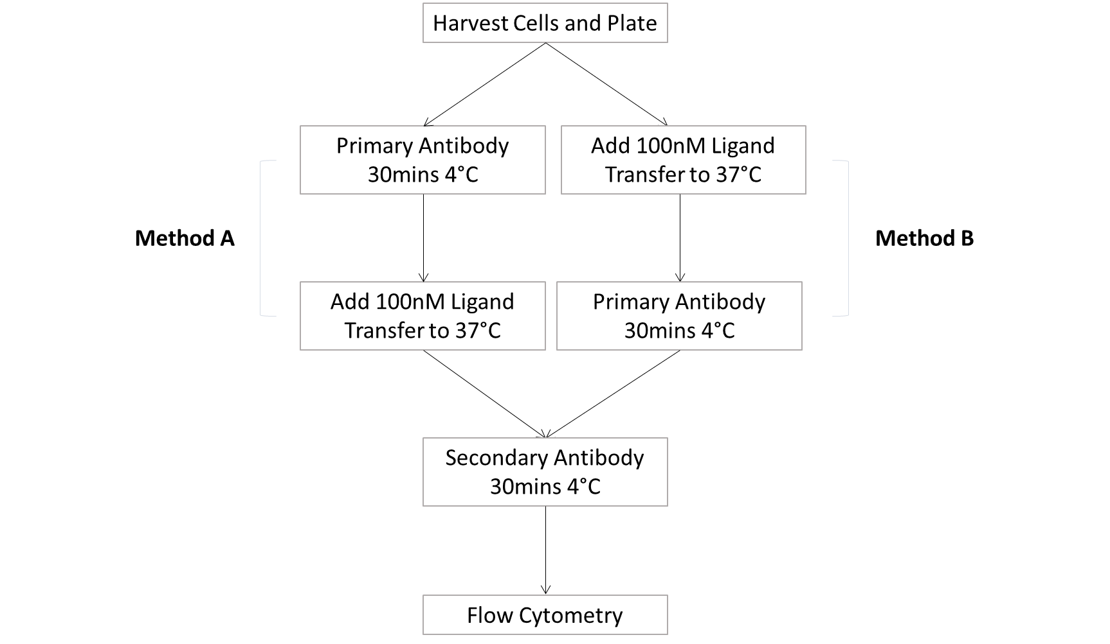

Figure 2.4 – Flow Chart of Method A and Method B Internalisation Assay Protocols
In method B, the cells were then resuspended in 50µl/well of 100nM ligand or internalisation buffer alone and the plate transferred immediately to a 37°C water-bath for 5, 10, or 45 mins. Cells for a 0 mins time-point were kept on ice throughout. Once incubation at 37°C was complete cells were quenched in 100µl ice-cold BBN. The plate was centrifuged for 2 mins, at 400g, 4°C and the supernatant discarded. The plate was then washed in 100µl BBN and centrifuged again for 2 mins, at 400g, 4°C. The supernatant was discarded and cell pellets resuspended in 20µl rabbit polyclonal anti-hC5aR2 antibody diluted 1/40 in BBN. Plates were then incubated on ice for 30 mins before washing again in BBN as previously. After washing, cell pellets were resuspended in 20µl FITC-labelled anti-rabbit IgG secondary antibody diluted 1/250 and incubated on ice, in the dark, for 30 mins. The cells were then washed as previously in BBN and resuspended in 150µl BBN before fluorescence detection using flow cytometry. Method A follows largely the same procedure except anti-hC5aR2 antibody binding is performed first, followed by washing, then the ligand binding step. Once ligand is added to the plates they are incubated at 37°C and the procedure continues as in method B with all the appropriate washing steps. In method A both anti-hC5aR2 and ligand would be made-up in internalisation buffer.

2.2.5.4 - Cell Sorting
All transfected hC5aR2 mutant cell lines produced during this work were sorted for surface hC5aR2 expression. Cells were kept on ice throughout the procedure. All HBSS used in this procedure was sterile with divalent cations to ensure viability of the cells after sorting. Cells were harvested as in 2.2.4.2 however using (CDS) instead of 1x Trypsin/EDTA. The cells were then centrifuged for 5 mins, at 200g, 4°C. The supernatant was discarded and the cell pellet was then resuspended in 5ml HBSS. The cell suspension was centrifuged for 5 mins, at 200g, 4°C and the supernatant discarded. The cell pellet was the resuspended in 500µl sterile filtered rabbit anti-hC5aR2 polyclonal antibody or sterile filtered rabbit IgG isotype control. The cell suspension was incubated on ice for 1 hr before centrifugation for 5 mins, at 200g, 4°C. The supernatant was discarded and the cell pellet resuspended in 5ml HBSS with divalents prior to centrifugation for 5 mins, at 200g, 4°C. The supernatant was discarded and the cell pellet resuspended in 500µl FITC-labelled anti-rabbit IgG secondary antibody. The cell suspension was incubated on ice, in the dark for 1 hr before centrifugation for 5 mins, at 200g, 4°C. The supernatant was discarded and the cell pellet resuspended in 5ml HBSS with divalents before centrifugation for 5 mins, at 200g, 4°C. The supernatant was discarded and the cell pellet resuspended in 1ml of cell culture medium. The cells were taken on ice to be sorted by staff at the Core Flow Cytometry Facility (University of Sheffield, UK). After sorting, the cells were centrifuged for 5 mins, at 200g, 4°C. The supernatant was discarded and the cells resuspended in fresh culture medium and then transferred to a culture dish.

2.2.6 - Protein Production, Purification, and Quantification

2.2.6.1 - Affinity Purification of Antibodies
Polyclonal anti-hC5aR2 antibody was affinity purified from rabbit serum. Sepharose beads were chemically linked to a peptide corresponding to the N-terminal sequence of hC5aR2 (sequence: MGNDSVSYEYGDYSDLSDRPVDC). This peptide sequence was identical to the peptide used as the immunogen to raise the antibodies. Two elution steps were carried out, one at pH 2.5 and one at pH 11.5 to ensure the highest yields of antibody.
Firstly, the peptide was coupled to N-hydroxysuccinimidyl (NHS)-activated sepharose beads (GE Healthcare Life Sciences) which allow binding to primary amine groups. Peptide was prepared by dissolving to 1mg/ml in coupling buffer. NHS-activated sepharose beads were washed in 15 media volumes (MVs) of cold 1mM HCl. The washed sepharose and peptide were then mixed and left to couple overnight at 4°C on an end-over-end rotating platform. After, unreacted NHS groups were blocked by incubating with MVs 0.1M Tris pH 8.5 for 2 hrs at room temperature. The sepharose beads were then washed with 3 MVs 0.1M Tris pH 8.0 followed by 3 MVs acetate buffer pH 4.0. The two washes were repeated 6 times.
Prior to purification, rabbit serum was filtered through a 0.22µm filter to remove any large particles. Serum was loaded on to the coupled beads (2ml sepharose per 30ml serum) and incubated overnight at 4°C on an end-over-end rotating platform. The next day the column was left to settle for 15 mins. The column was then washed with 20 column volumes (CVs) 20mM Tris pH 7.5 followed by 20 CVs 20mM Tris pH 7.5, 500mM NaCl. Before elution, 70µl 1M Tris pH 9.0 was added to each collection tube then 1ml of eluate collected. The pH was checked and adjusted to 7.5 to avoid disruption of the antibody structure. The first bound fraction was eluted using 100mM glycine pH 2.5. The column was then washing with 20 CVs 20mM Tris pH 8.8. For the second elution, collection tubes were prepared by adding 9µl conc. HCl and 30µl 1M Tris pH 6.8. To elute the antibody the column was then washed with 100mM trimethylamine pH 11.5. The pH of the elutes was checked and adjusted to pH 7 with 1M Tris pH 6.8. Protein concentration in eluted fractions was determined by Bradford assay (2.2.6.4). Peak fractions were pooled and then dialysed twice in 10x volume PBS.

2.2.6.2 - Purification of C5a and C5a des-Arg
Ligands were expressed with a hexahistidine sequence at the N-terminus and were affinity purified under native conditions using a charged Nickel bound resin (Ni-NTA agarose, Qiagen) for gravity-flow chromatography.
Rosetta Gami 2 (DE3)pLysS cells were transformed 2.2.1.2, single colonies picked, and then cultured into liquid LB-broth into 100ml cultures. 5ml of bacterial culture was used to inoculate 500ml LB-broth which was then incubated at 37°C, 225rpm in a shaking incubator until an OD₆₀₀ of 0.6 was reached. After this point 1mM IPTG was added and cells incubated for 3.5 hrs, 37°C, 225rpm in a shaking incubator.
Cell Lysis. 1.5l of bacterial culture was transferred into centrifuge tubes and centrifuged for 20 mins, 6000g, 4°C. The supernatant was discarded and the cells resuspended in 25ml 50mM NaH₂PO₄, 300mM NaCl, 10mM imidazole, pH 8 with 250µl Halt Protease Inhibitor Cocktail (Thermo). This lysis reaction was then incubated at 4°C for 30min on a rotating spinner. Cell suspension was then sonicated on ice for 3 rounds of 20 s at an amplitude of 15µm. Cell lysates were centrifuged for 10 mins at 15,000g, 4°C. The supernatant was retained and either used immediately, stored at -20°C short-term, or stored at -80°C long-term.
Column Elutes. Ni-NTA agarose beads were loaded into a column and allowed to settle. The beads were washed with 5 column volumes of 50mM NaH₂PO₄, 300mM NaCl, 10mM imidazole, pH 8. Lysates were added to 2ml Nickel-NTA and incubated together at 4°C overnight on an end-over-end rotator. All subsequent steps were performed on ice. The beads and lysate were transferred into a fresh column and left to settle. Once settled, the unbound lysate was allowed to flow off the column. The beads were then washed with 10 column volumes of 50mM NaH₂PO₄, 300mM NaCl, 20mM imidazole, pH 8. The ligand was then eluted from the column using 50mM NaH₂PO₄, 300mM NaCl, 250mM imidazole, pH 8 in 1ml fractions. Eluted fractions were diluted overnight in 1000x volume of 1x PBS pH 7.4. Dialysed ligand was then aliquoted and stored at -20°C.

2.2.6.3 - Bradford Assay
Bradford assays were used to determine progression of protein elution and protein concentrations. BSA standards were used on all tests. 10µl samples of protein were added to a 96-well plate in duplicate. To each well containing protein 200µl of 1/5 diluted Bradford reagent (Bio-Rad Protein Assay Dye Reagent Concentrate, Bio-Rad) was added. 96-well plates were read at 595nm using a spectrophotometer. Protein concentration was determined through comparisons with the standard curve using Graphpad Prism 6.

2.2.6.4 - Protein Polyacrylamide Gel Electrophoresis
Firstly, 1mm glass gel plates were cleaned using distilled water and industrial methylated spirits (IMS). Resolving gels were made to 15% polyacrylamide and stacking gels were made to 5% polyacrylamide. Resolving gel was poured into the glass gel cast and a small layer of isopropanol placed on top to ensure a smooth boundary between resolving and stacking gels. The resolving gel was then left to set at room temperature for 40 mins. The isopropanol was removed by pouring and the stacking gel poured on top of the resolving gel and a comb inserted. The stacking gel was left to set for 40 mins. A constant volume of protein sample was added to 1x reducing buffer to a total volume of 20µl. Samples were boiled at 95°C in a dry-heating block for 9 mins. The comb was removed from the set gel and the gel was placed into the running tank and submerged in 1x Running Buffer. Samples in were loaded (usually 16µl) alongside a standard protein ladder (usually 7µl). The gel was run at 120 V until the protein left the stacking gel then turned up to 160 V until the protein front had reached the bottom of the gel (usually after around 90 mins).

2.2.6.5 - Coomassie Staining
Polyacrylamide gels were run as in 2.2.6.5. The gel was removed from the glass cassette and carefully placed into a dish. The gel was submerged in Coomassie stain and left on a rocking platform at room temperature for 1 hr. The Coomassie stain was then poured off and the gel rinsed in deionised water. The gel was then submerged in Coomassie destain solution for 1 hr or until the background of the gel had become clear. Stained gels were then imaged using the ChemiDoc MP (Bio-Rad) imager.

2.2.6.6 - Fluorescent Labelling of C5a and C5a des-Arg
C5a and C5a des-Arg were fluorescently labelled with Alexafluor-488 (Thermo Fisher). The Alexafluor-488 moieties are linked to target proteins through TFP esters which react with primary amines. C5a and C5a des-Arg should be labelled at their N-terminal amine groups, away from key binding areas of the ligand.
200µg of 1.15mg/ml protein was incubated with 100mM NaHCO₃ pH 8.3 and 15mM Alexafluor-488 (for a 5x Molar excess of dye) for 2 hrs at 4°C on an end-over-end rotary mixer. After, 15mM Tris-HCl pH 8.8 was added, to block free primary amine groups, and incubated for 20 mins at room temparture on an end-over-end rotary mixer. During this incubation a PD SpinTrap G-25 (GE Healthcare Life Sciences) column was prepared according to manufacturer instructions. This column was used to as much as possible filter labelled protein away from free label. The column was inserted into a collection tube and pre-rinsed with 0.5ml MiliQ water by centrifuging at 1000g for 3 mins. The labelling solution was pipetted into the column which was then sealed. The column was then centrifuged at 800g for 2 mins. Labelled protein was then aliquoted and stored at -20°C. The degrees of labelling (DOL) was then determined using the following equation to ascertain the average number of dye molecules per ligand molecule:
$$Degree of Labelling=\frac{ODmax x Molecular Weight}{Concentration x Extinction Coefficient}$$
OD_{max} = absorbance at max. absorbance wavelength of dye (Alexafluor-488 = 494nm)
Molecular Weight of the protein
Concentration of the protein
Extinction Coefficient of the dye (Alexafluor-488 = 73,000)
Ligand | Degree of Labelling
C5a | 0.1
C5a des-Arg | 0.15

Table 2.16 – Degree of Labelling of C5a and C5a des-Arg

2.2.7 - Statistical Analysis

Statistical analyses were performed using GraphPad Prism 6 software. Data are shown as +/- SEM unless otherwise stated. In addition, unless otherwise stated, two-tailed unpaired t-tests were used to determine significance of results. Ligand binding assays and degranulation assays were normalised to reduce the effect of variation between experiments. For the ligand binding assays, the 0 nM unlabelled ligand condition was taken to be 100% binding in all cases. In degranulation assays, results were normalised to the Triton-X100 total release positive control. Internalisation assays were analysed using the equation stated in section 2.2.5.3 and percentage internalisation at different time-points was compared between wild type and mutant receptor using unpaired, two-tailed t-tests. This has been the standard statistical test to compare receptor binding and activation data between wild type and mutant receptors within this field (Higginbottom et al., 2005; Scola et al., 2007)

Chapter 3 – Production of Mutant Cell Lines and Recombinant Ligands

3.1 - Introduction

In order to obtain a complete characterisation of the mutant hC5aR2 receptors both ligands, C5a and C5a des-Arg, were required. To buy commercially in sufficient quantities, would have been very costly in comparison with producing them in-house. By purifiying ligands in-house care could be taken to ensure sufficient amounts of both ligands were produced such that all studies, and fluorescent labelling, could be done using the same batch. This was in an effort to reduce the effects batch-to-batch variation would have on the activity of purified recombinant ligands. Previously, purification of recombinant human (rh) C5a within the research group had been performed according to the method described in Paczkowski et al., 1999. Both rhC5a and rhC5a des-Arg were expressed in E. coli before purification. Both ligands were tagged with a hexahistidine sequence (His-tag) at the N-terminus to allow for affinity purification using Ni²⁺-conjugated beads. However, here, attempts with this protocol proved unsuccessful and both expression and purification of the recombinant ligands required optimisation.
After the results of initial ligand binding assays, eight mutant C5a constructs were designed. This was to allow further testing of the binding pocket within the mutant receptors. Mutagenesis was outsourced and mutated constructs sent back to our group for expression. Unfortunately, there followed problems with the expression of mutant C5a which will be discussed further later in this chapter.
Finally, mammalian CHO (Chinese Hamster Ovary) cells were transfected with mutant hC5aR2 receptors for use throughout the study.

3.2 - Aims

In brief the aims of this chapter of work were:
- Purification of rhC5a and rhC5a des-Arg from E. coli for use in subsequent assays throughout the project.

- Determine the activity of purified ligands using a β-hexosaminidase release assay with RBL cells transfected with hC5aR1 as a measure of function.

- Purification of eight C5a mutants from E. coli to provide further information about the binding of C5a to the hC5aR2 receptor.

- Stable transfection of CHO cells with hC5aR2 mutant receptors.

3.3 – Results

3.3.1 - Expression and Purification of Recombinant Human C5a and C5a des-Arg
C5a and C5a des-Arg genes in pQE30 plasmids were produced as previously decribed (Paczkowski et al., 1999). The coding sequences were preceded by an N-terminal His-tag and should express ligand constructs with approximate molecular weights of 11.5kDa. This His-tag was used to affinity purify the proteins on columns containing agarose beads linked to Ni²⁺ ions. At first, purification of expressed protein was attempted under denaturing conditions in order to release any expressed protein held in inclusion bodies within the E. coli. In addition, denaturation of the protein structure would be more likely to expose the His-tag and thus increase the quantity of protein able to bind the nickel column. However continually poor yields using this denaturing method necessitated further optimisation finally leading to a complete change in protocol.

3.3.2 - Bacterial Expression and Purification
Initially, M15 [pREP4] E. coli were used to attempt to express pQE30 plasmids containing ligand DNA. This strain of E. coli was chosen as the pREP4 plasmid contains the lacI gene. This gene prevents early expression of the protein of interest before induction with the allolactose analogue IPTG. This is useful as early expression of protein can cause problems with plasmid viability in bacterial cultures; whereby those cells no longer expressing plasmid/protein can overgrow within the culture.
Plasmids for rhC5a and rhC5a des-Arg were both sequenced and found to be correct. Further to this both plasmids were run on an agarose gel to determine whether they were intact or fragmented. Plasmids were run whole and uncleaved and thus would not migrate to the expected molecular weight markers due to supercoiling. The result shown in Figure 3.1 would indicate the plasmids are both intact as both lanes show one bright band with a few dimmer, larger, bands. These larger bands are most probably due to varying levels of plasmid supercoiling, and some DNA contamination, rather than fragmentation.

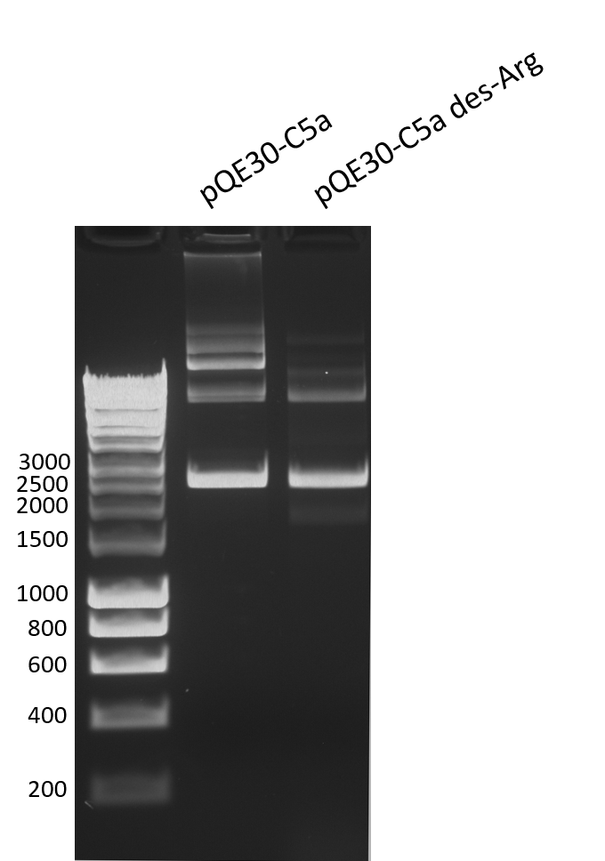
Ladder
bp

Figure 3.1 – 1% Agarose Gel of Uncut pQE30-C5a and pQE30-C5a des-Arg Plasmids
Both plasmids, pQE30-C5a and pQE30-C5a des-Arg, were run uncut on a 1% agarose gel alongside 1kb DNA Hyperladder. This was to determine whether both plasmids were in-tact or contaminated/fragmented. The brighter band at roughly 2500bp corresponds to the intact plasmid. Bands at higher bp weights most likely are due to varying levels of plasmid supercoiling causing different migration speeds through the gel or contaminating DNA.

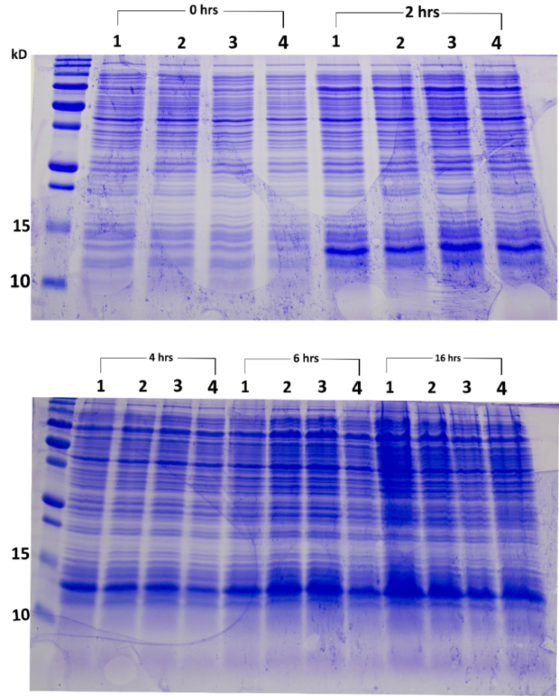
To determine whether plasmid uptake and protein expression were even throughout a population of transformed bacteria M15 [pREP4], E. coli were transformed with pQE30-C5a plasmid and plated. Four separate colonies were picked and cultured. The four cultures were then induced for up to 16 hrs in 1mM IPTG with samples taken at 0, 2, 4, 6, and 16 hrs post-induction. The results in Figure 3.2 show approximately even expression of the C5a band across all 4 colonies compared at each time point. This would indicate that in a transformed population of bacteria, plasmid is being taken up equally and so protein should be uniformly expressed. These results taken together would indicate that no direct problems with the uptake or expression of the plasmids were present.

Figure 3.2 – Coomassie Stained 15% Polyacrylamide Gel to Show C5a Expression in 4 M15 [pREP4] E.coli Cultures Over 0-16 hrs Post-Induction
15% Polyacrylamide Gel Coomassie stained to show protein bands. M15 [pREP4] E. coli cultures were transformed with pQE30-C5a, grown, and then induced with 1mM IPTG and samples taken at 0, 2, 4, 6, and 16 hrs post-induction. Culture samples were pelleted and resuspended directly into reducing loading buffer. Samples were then boiled at 95°C for 10 mins before running. Darker bands between 15 and 10kDa indicate expressed C5a (arrow).
In an attempt to improve expression levels an alternate strain of E.coli, Rosetta Gami 2(DE3) pLysS, was transformed with pQE30-C5a and protein expression compared with that in M15 [pREP4]. The decision to use this particular strain is covered in more detail in section 3.4. Cultures were induced and samples taken at 0, 2, 4, and 6 hrs post-induction (Figure 3.3). Results appear to suggest that the Rosetta Gami cultures give a higher expression of C5a relative to cell culture density than the M15 cells.
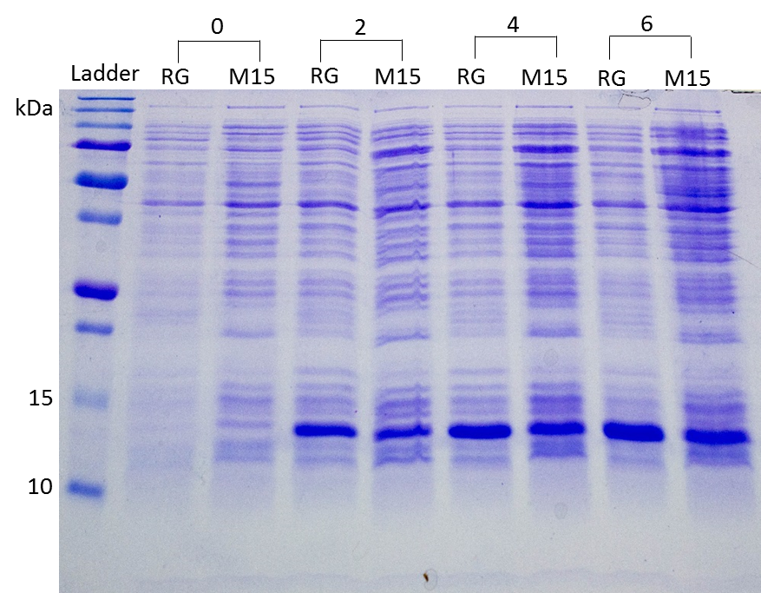

Figure 3.3 – Coomassie Stained 15% Polyacrylamide Gel Showing Rosetta Gami 2 (DE3) pLysS vs M15 [pREP4] expression of C5a Over 0-6 hrs Post-Induction
15% poly-acrylamide gel Coomassie stained to show protein bands. M15 [pREP4] and Rosetta Gami 2 (DE) pLysS E. coli cultures were transformed with pQE30-C5a, grown, and then induced with 1mM IPTG and samples taken at 0, 2, 4, and 6 hrs post-induction. Culture samples were pelleted and resuspended directly into reducing loading buffer. Samples were then boiled at 95°C for 10 mins before running. Darker bands between 15 and 10kDa indicate expressed C5a (arrow).

At this point, final yields of C5a were still low. Figure 3.4 shows C5a elutes after refolding dialysis from a representative purification run alongside bovine serum albumin (BSA) standards of a known concentration. This gel was run in order to confirm concentration results seen by Bradford assay. The same volume of each sample was loaded onto the gel, here is appears that C5a is present at less than 0.1mg/ml in each sample.
The low yields were largely attributed to protein loss at the refolding step leading to barely detectable final levels of protein. The C5a obtained after refolding was too low a concentration to use in β-hexosaminidase release assays. Without greatly scaling up the bacterial expression stage it was unlikely that sufficient yields would ever be obtained after refolding for any experimental use. After this point purification under native conditions, using a slightly modified Qiagen protocol (Section 2.2.6.3) was performed, leading to much improved yields (Figure 3.5) as well as improved activity of the purified C5a. Figure 3.5 shows a clear band at the expected weight for C5a in the eluted fractions (lanes 9 and 10). There does appear to be C5a retained within the cell pellet (lane 3) possibly indicating that a proportion of the expressed protein is contained within inclusion bodies. Unfortunately, this protein is lost using this purification protocol. Broadly, the production process follows these steps: transformation of competent bacteria, culture then induction of transformed bacteria, bacterial cell lysis, column binding, column washes, and finally elution of purified protein. The eluted protein is then dialysed into phosphate buffered saline (PBS) for use on mammalian cells. In the case of denatured purified protein, this dialysis step took place under reducing conditions to encourage refolding. Dialysed protein is functionally tested on mammalian cells in order to determine its activity.

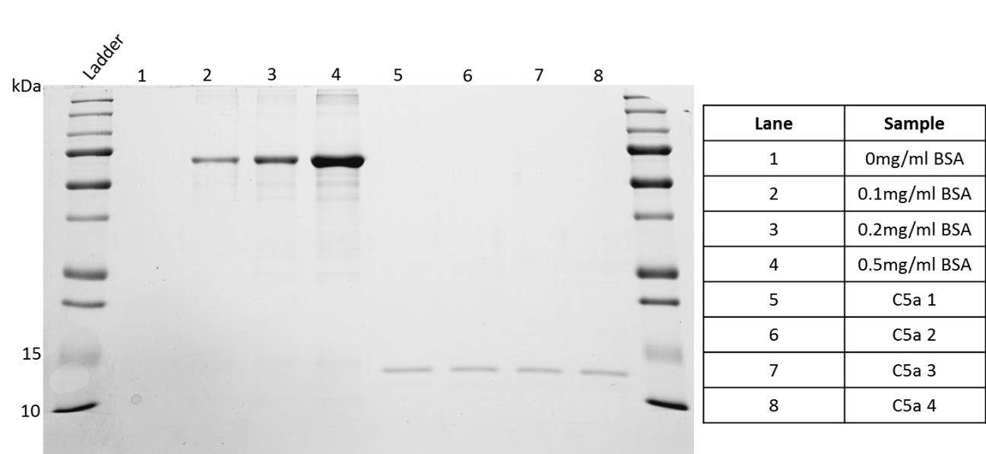

Figure 3.4 – 15% Coomassie Stained Polyacrylamide Gel Showing Comparison of Purified C5a Against Bovine Serum Albumin (BSA) Standards of Known Concentration
rhC5a was purified under denaturing conditions. Eluted protein was refolded, dialysed (lanes 5-8) and then run alongside BSA standards (lanes 1-4) in order to verify protein concentration obtained by Bradford Assay. The thicker, darker a band the higher the concentration of protein within that band. The same volume of BSA standards and C5a samples was run in each lane. Bands between 10-15kDa indicate the presence of C5a (arrow).

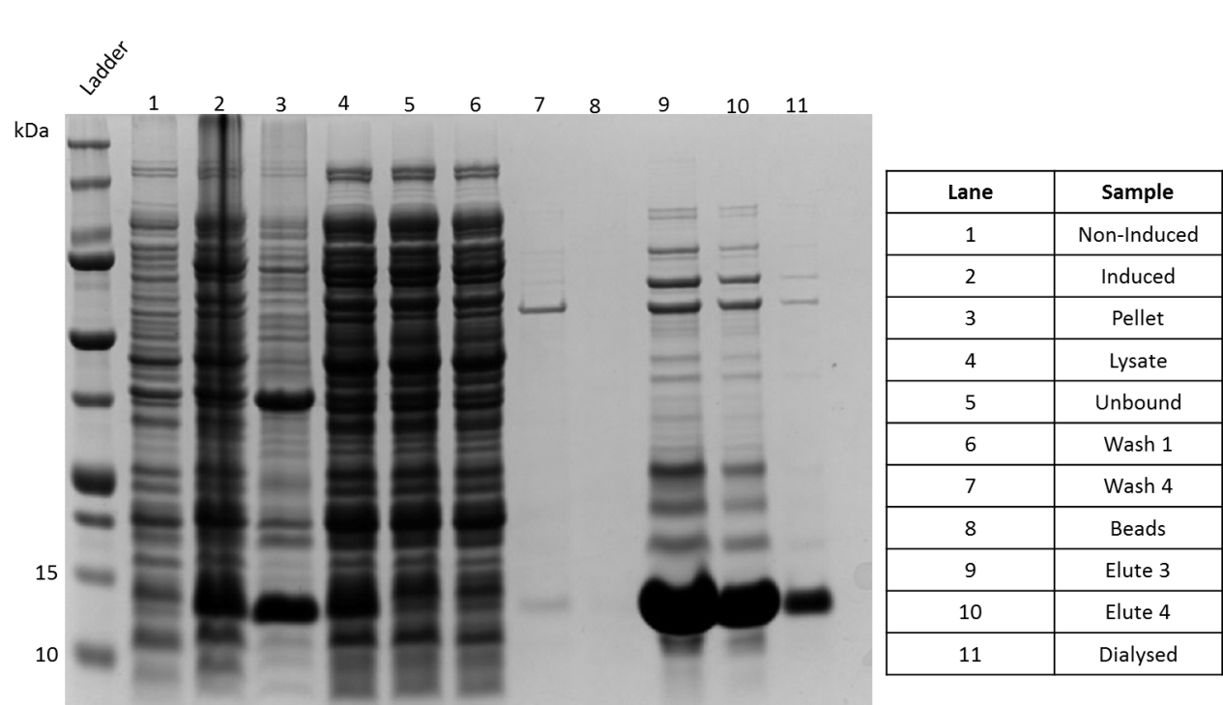
250
150
100
75
50
37
25
20
Figure 3.5 – Coomassie Stained 15% Polyacrylamide Gel Showing Results of Purification of C5a Under Native Conditions After Expression in Rosetta Gami 2 (DE3) pLysS E. coli
Rosetta Gami 2 (DE3) pLysS E. coli were transformed with pQE30-C5a. Bacteria were cultured then induced with 1mM IPTG for 3.5 hrs before affinity purification (His-tag) under native conditions as in 2.2.6.3. Samples were run on a 15% poly-acrylamide gel before Coomassie staining to show protein bands. Darker bands between 10-15kDa indicate the presence of C5a (arrow).

3.3.3 - Testing of Functional Activity and Binding of Purified Ligands
As hC5aR2 had no easily measurable signalling capability during the time of this study all purified ligands were tested for activity on rat basophilic leukaemia (RBL) cells transfected with hC5aR1. This cell line is capable of degranulation after appropriate stimulation (Maeyama et al., 1986) and hC5aR1 transfected RBL cells can be stimulated to degranulate in a dose-dependent manner by both rhC5a and rhC5a des-Arg (Cain et al., 2001b; Monk et al., 1994). Degranulation levels can be quantified by detection of levels of β-hexosaminidase, an enzyme released in this process. After ligand stimulation, a substrate for β-hexosaminidase is added and levels of the subsequent product can be determined colourimetrically. This assay has been used as a measure of receptor functionality in a number of previous publications within this field (Cain and Monk, 2002; Cain et al., 2000; Higginbottom et al., 2005), or using a similar method (Crass et al., 1999a; Monk et al., 1994, 1995), and so was suitable as a standard to determine the activity of purified ligands. Denaturing purifications of C5a and C5a des-Arg did not yield product at sufficient concentration to properly complete a dose response curve in this assay (data not shown). These concentrations would not have been sufficient for subsequent use and so these ligands were not taken forward. C5a and C5a des-Arg purified natively were tested on RBL hC5aR1 cells in a β-hexosaminidase release assay. C5a was compared with stock already held in-house (Figure 3.6) and C5a des-Arg was compared with the purified C5a (Figure 3.7). In both figures, the data has been normalised against a Triton-x detergent 100% release control. In Figure 3.6 the newly purified C5a (grey line) reaches a similar maximum release to the stock C5a but appears to be more active, as the curve is shifted to the left relatively. In Figure 3.7 C5a des-Arg, as would be expected given C5a des-Arg reportedly has 1-10% the activity of C5a (Klos et al., 2009), does not give as high a maximum release as C5a. In order to determine whether these purified ligands were comparable with those used in other research both C5a and C5a des-Arg were also compared against commercially produced recombinant C5a and C5a des-Arg at a later date (Figure 3.8). Here, the commercial C5a and C5a des-Arg have similar activities, unexpectedly, whereas the purified ligands do not.

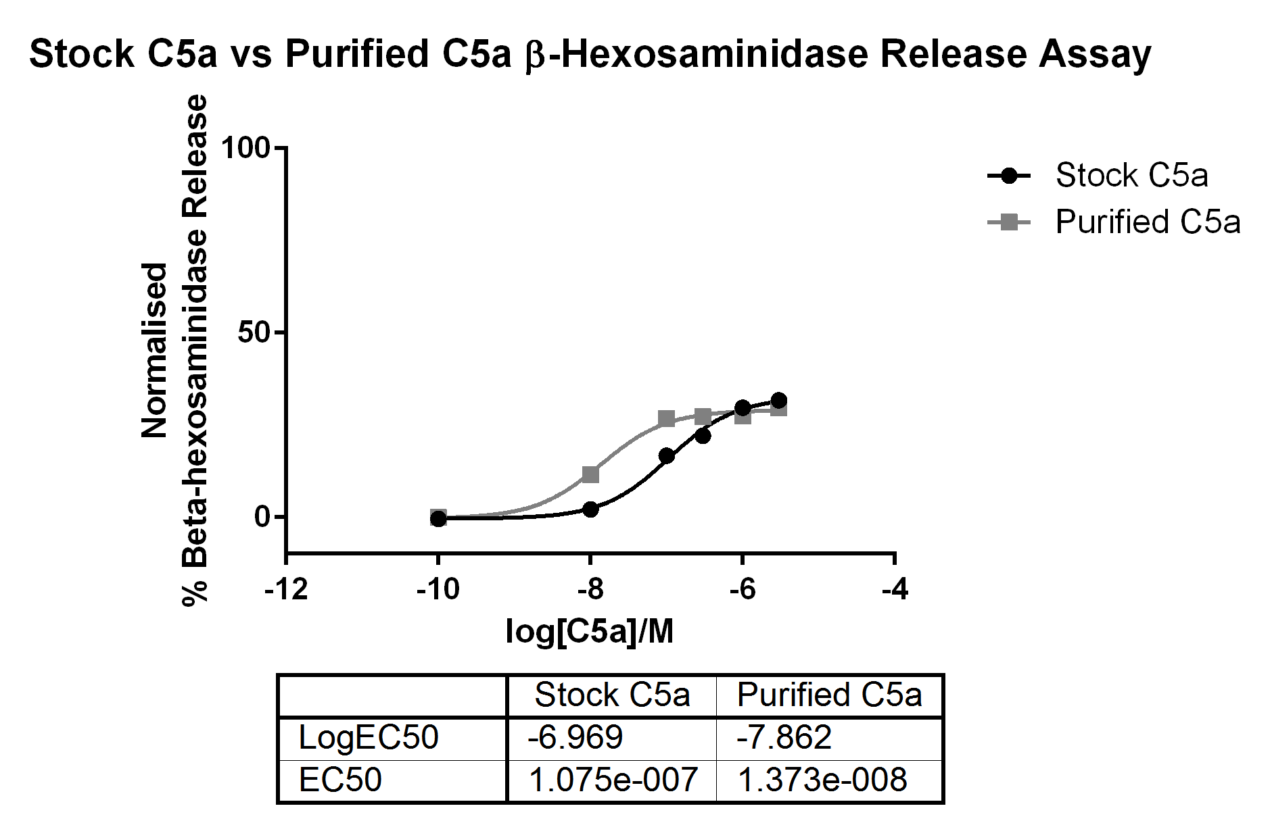

Figure 3.6 – β-hexosaminidase Release Assay of Natively Purified C5a vs Stock C5a on RBL Cells Transfected with hC5aR1
Graph showing percentage β-hexosaminidase release normalised to a Triton-X100 total release positive control. RBL-hC5aR1 cells were stimulated with ligand for 15 mins at 37°C. Purified C5a (grey squares) was compared with the previous stock of C5a (black circles). Purified C5a showed a lower EC50 implying greater levels of receptor activation at smaller concentrations.

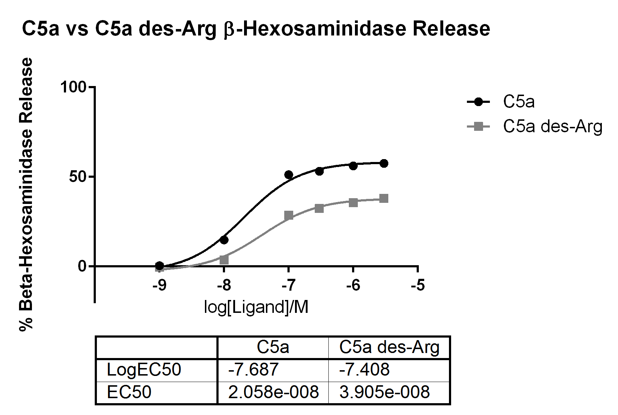

Figure 3.7– β-hexosaminidase Release Assay of Natively Purified C5a des-Arg vs Natively Purified C5a on RBL Cells Transfected with hC5aR1
Graph showing percentage β-hexosaminidase release normalised to a Triton-X100 total release positive control. RBL-hC5aR1 cells were stimulated with ligand for 15 mins at 37°C. Purified C5a des-Arg (grey squares) was compared with Purified C5a (black circles). C5a des-Arg gave lower overall levels of β-hexosaminidase release than C5a.

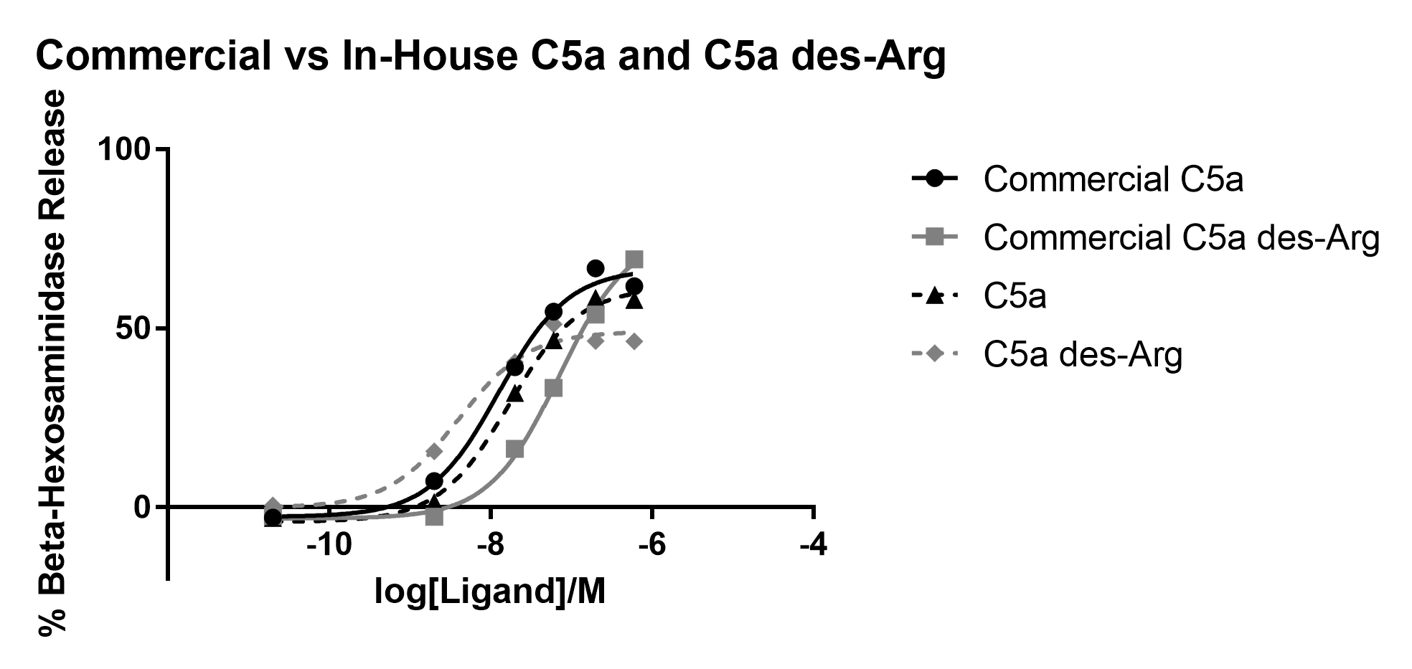
Figure 3.8 - β-Hexosoaminidase Release Assay of Commercially Produced and In-House Purified Recombinant C5a on RBL Cells Transfected With hC5aR1
Graph showing percentage β-hexosaminidase release normalised to a Triton-X100 positive control. RBL-hC5aR1 cells were incubated with the relevant ligand for 15 mins at 37°C. Commercially produced (solid lines) and in-house purified (dashed lines) recombinant C5a and C5a des-Arg (black and grey respectively) were compared. Though both C5a preparations behave similarly, the commercial C5a des-Arg appears more active, relative to the C5a. The in-house C5a des-Arg is less active than the in-house C5a, as would be expected.

3.3.4 - Production of Mutant C5a

3.3.4.1 - Initial Purification Attempts

Eight mutant C5a constructs were designed and ordered from Mutagenex in order to perform an Ala scan of the last 6 residues of C5a; the final two mutants having substitutions for two C5aR2 specific peptide sequences at their C-termini, RHYPYWR and LIRLWR. The C5a insert was removed from pQE30, mutated, and then cloned back in resulting in the 8 mutants: D69A, M70A, Q71A, L72A, G73A, R74A, C5a[69-RHYPYWR-75], and C5a[70-LIRLWR-75] (Codon substitutions shown in Appendix Table 7.1). Plasmid solutions were provided by Mutagenex and also mini-prep purified in-house from transformed bacterial cultures.
At first, mini-prep purified mutant plasmids were expressed and native protein purification attempted as previously. However, there were no C5a bands present by SDS-PAGE (Figure 3.9) and no C5a activity seen in the product on a degranulation assay (Figure 3.10). Plasmid solutions provided by Mutagenex were unable to successfully transform Rosetta Gami 2 (DE3) pLysS E. coli seen by a lack of growth of antibiotic resistant colonies whereas those mini-prepped in-house could.

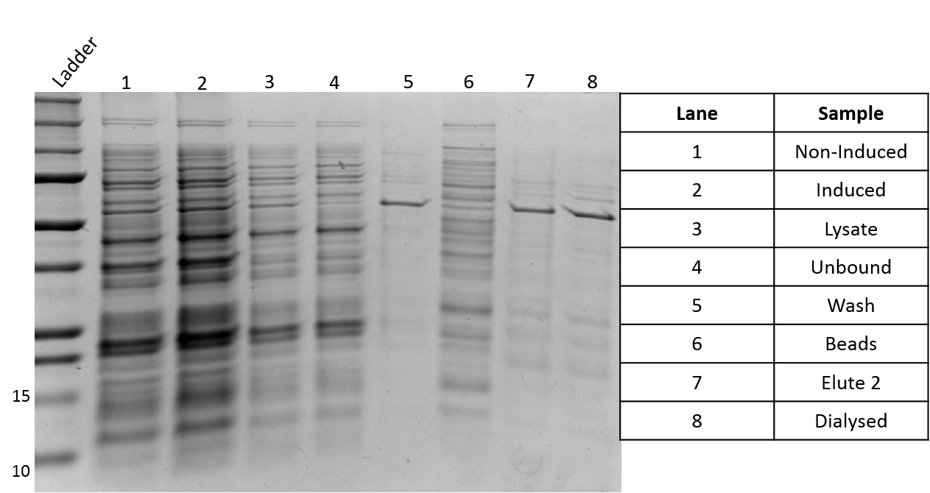
kDa

Figure 3.9 – Coomassie Stained 12.5% Polyacrylamide Gel to Show Purification of C5a[RHYPYWR] Under Native Conditions After Expression in Rosetta Gami 2 (DE3) pLysS E. coli; A Representative Example
A representative example of mutant C5a purification results. Rosetta Gami 2 (DE3) pLysS E. coli were transformed with pQE30-C5a[RHYPYWR] which had been mini-prep purified in-house. Bacteria were cultured to an OD₆₀₀ of 0.6 then induced with 1mM IPTG for 3.5 hrs before affinity purification under native conditions as in 2.2.6.3. Samples were run on a 12.5% poly-acrylamide gel before Coomassie staining to show protein bands. Absence of darker bands between 10-15kDa indicate failure of expression and purification of C5a (arrow).

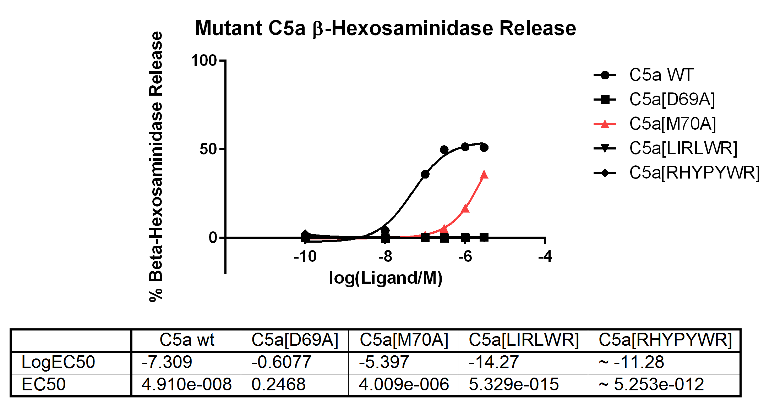
Figure 3.10 – β-Hexosoaminidase Release Assay of Purified Mutant C5a on RBL Cells Transfected With hC5aR1
Graph showing percentage β-hexosaminidase release normalised to a Triton-X100 positive control. RBL-hC5aR1 cells were incubated with the relevant ligand for 15 mins at 37°C. Wild-type C5a (black circles) shows a typical dose response curve for hC5aR1 in response to C5a in this assay. All mutants except M70A (grey upward pointing triangles) caused no receptor activation and consequently no release of β-hexosaminidase.
Another possible reason for expression of C5a to fail could be if the IPTG used to induce protein expression in bacterial cultures was not functional. To determine if this was the problem and attempt to purify wild-type C5a was made using IPTG (1) from the same stock used to purify the mutant C5a, and freshly made stock (2). Bacteria were transformed and plated, one colony was picked and then cultured in liquid LB-broth. This was split into two cultures which each received different IPTG treatment. If there was a problem with the IPTG it would be expected that wild-type C5a expression would also be affected. Purification steps were run on a 12.5% polyacrylamide gel (Figure 3.11). Neither IPTG 1 or IPTG 2 appeared to give very different expressions of wild type C5a compared with each other. As such, failure of protein expression was unlikely to be due to problems with induction caused by IPTG.

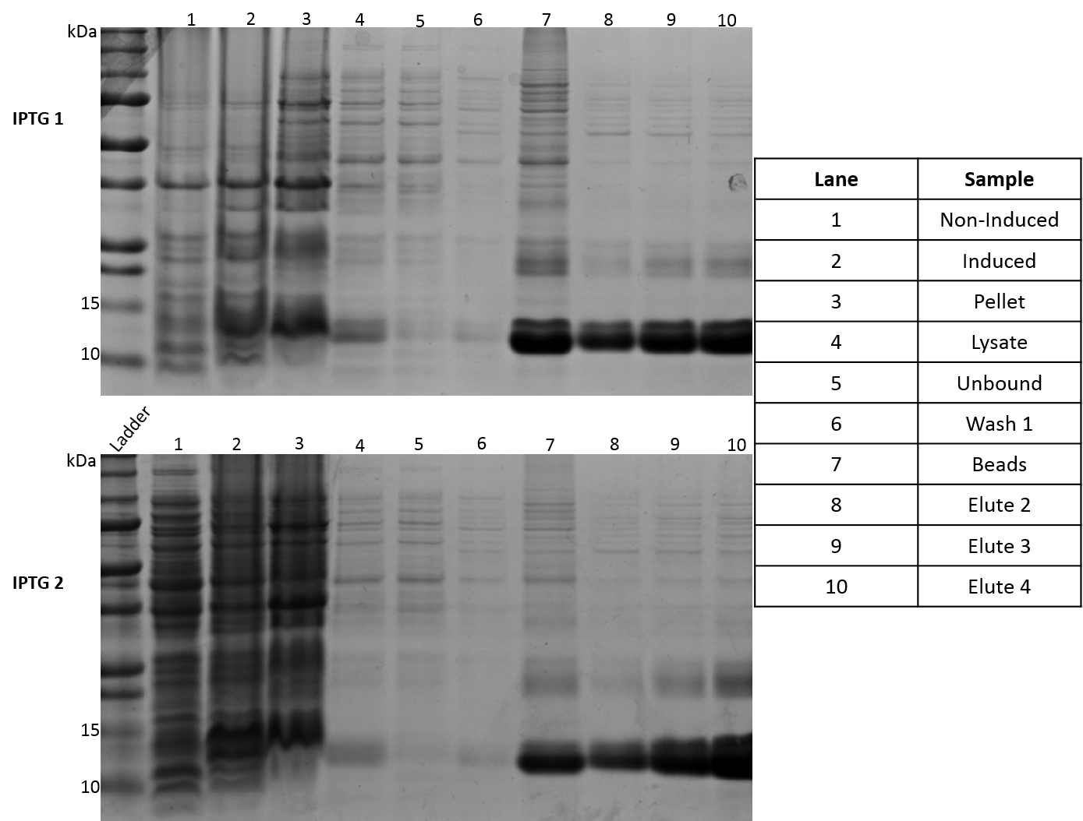

Figure 3.11 – Coomassie Stained 12.5% Polyacrylamide Gel Comparisons of Two IPTG Stocks; Purification of Wild Type C5a Under Native Conditions After Expression in Rosetta Gami 2 (DE3) pLysS E. coli
Rosetta Gami 2 (DE3) pLysS E. coli were transformed with pQE30-C5a. Bacteria were cultured then induced with 1mM IPTG 1 or IPTG 2 for 3.5 hrs before affinity purification under native conditions as in 2.2.6.3. Samples were run on a 12.5% poly-acrylamide gel before Coomassie staining to show protein bands. Darker bands between 10-15kDa indicate the presence of C5a (arrow).

3.3.4.2 - Analysis of pQE30-C5a[Mutant] DNA Sequence

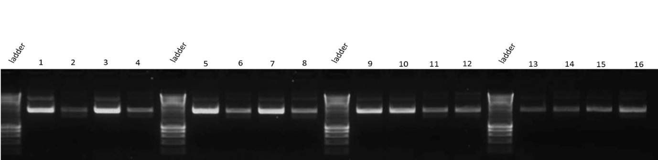
Failure to induce competent Rosetta Gami cells could be due to fragmented, or absence of, plasmid. In order to investigate this possible problem with plasmid expression, mini-prepped and Mutagenex plasmids were run on a 1% agarose gel to confirm plasmids were present and intact. Single bands were seen which suggests that they are intact (Figure 3.12). Following this, one mutant plasmid was selected (pQE30-M70A) alongside the wild-type (pQE30-C5a). Both plasmids were restriction digested for 1 hr at 37°C with NheI and XbaI enzymes in a double digest in order to determine if the commercially derived mutant plasmids had been cloned in to the correct vector (Figure 3.13). Bands would indicate that both the wild-type and M70A plasmids are the same vector as they have bands in equivalent positions. These bands at ~800bp and ~3000bp correspond with the predicted fragment sizes from cutting pQE30 including the C5a insert, with NheI and XbaI, of 856bp and 2898bp. Additionally, wild-type and mutant plasmids were sequenced and checked for the correct insert sequence, His-tag, the correct promoter sequence, start codons, stop codons, and that the insert was in-frame with the vector and cloned into the expected sites (Appendix Fig 7.1 and Table 7.2).

1 | 2 | 3 |  |  | 4 | 5 | 6 | 7 | 8 | 9 | 10 | 11 | 12 | 13 | 14 | 15 | 16
D69A |  |  | M70A |  |  | Q71A |  | L72A |  | G73A |  | R74A |  | LIRLWR |  | RHYPYWR
M | S | M |  |  | S | M | S | M | S | M | S | M | S | M | S | M | S
Figure 3.12 – 1% Agarose Gel Showing pQE30 Plasmid Preps From Mutagenex (M) or Prepared In-House (S)
1% agarose gel showing bands from pQE30 plasmids containing mutant C5a. Plasmids are either those from Mutagenex (M) or those mini-prepped in-house (S). The presence of clear single bands with few contaminants indicates that plasmids are present and in-tact.
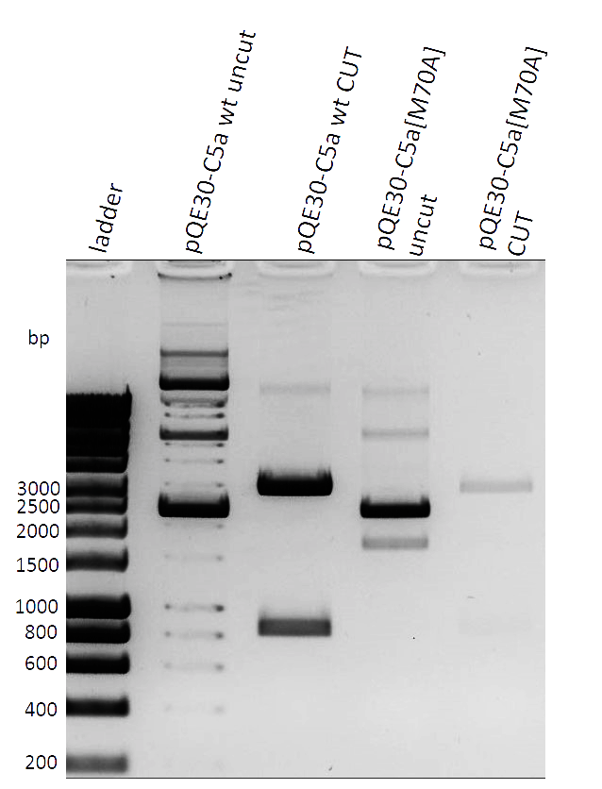

Figure 3.13 – 1% Agarose Gel Showing Results of a Double Restriction Digest of pQE30-C5a and pQE30-C5a[M70A] Plasmids Using NheI and XbaI Enzymes
1% agarose gel showing pQE30-C5a and pQE30-C5a[M70A] both uncut and cut with NheI and XbaI restriction enzymes. Plasmids were incubated with NheI and XbaI enzymes or buffer alone for 1 hr at 37°C. Bands on cut plasmid lanes at 3000bp and 800bp are as expected based on the pQE30 sequence. Predicted cut fragment sizes based on pQE30 maps (from SnapGene) are 856bp and 2898bp (colours have been inverted).

3.3.4.3 - Further Analysis of Expression Problems

Mutagenex were contacted for assistance after a number of unsuccessful attempts at mutant C5a purification as well as the analysis of the sequencing data showing no obvious problems. With the advice of Dr James Ko (Mutagenex Inc., GA, USA), three factors to further analyse were determined:
- Perform new purifications of the mutant plasmids in the target organism. Mini-preps originally made were from JM109 E. coli stab cultures provided by Mutagenex. In contrast, pQE30-C5a[WT] had been originally purified in M15 [pREP4] cells.

- PCR analysis of C5a mRNA levels in induced WT and mutant cultures to determine whether expression at the gene level is present. If no mutant gene expression were present this could indicate the plasmid is unstable. Alternatively, there could be a problem with the transformation of the bacteria.

- Re-cloning of the constructs. As the WT C5a was still able to be expressed it would be interesting to attempt to remove the WT C5a insert and replace it with a mutant C5a insert in order to determine if protein expression was recovered in this instance. In addition, if the WT C5a insert was swapped with the mutant insert in the Mutagenex derived plasmid, and protein expression was lost, this would indicate the problem lay with the vector backbone itself.

3.3.4.4 - Purification of pQE30-C5a[M70A] in M15 [pREP4] E. coli

As pQE30-C5a[WT] had previously been purified from M15 [pREP4] E. coli a new purification of the plasmid pQE30-C5a[M70A] was performed from this same strain. Bacteria were transformed and cultured by the standard protocol before midi-prepping. Fresh transformations were then made of both mutant and WT pQE30, bacteria cultured to an OD₆₀₀ of 0.6, then induced with 1mM IPTG for 3.5 hrs. Figure 3.14 shows the whole cell extract samples taken from non-induced and induced cultures for both WT and mutant transformants. In the figure, the induced WT sample (lane 2) shows an expected band corresponding to C5a between 10kDa and 15kDa which is not present in the induced M70A sample (lane 4). This suggests that C5a[M70A] expression was not recovered by re-purification of the plasmid in M15 [pREP4] E. coli.
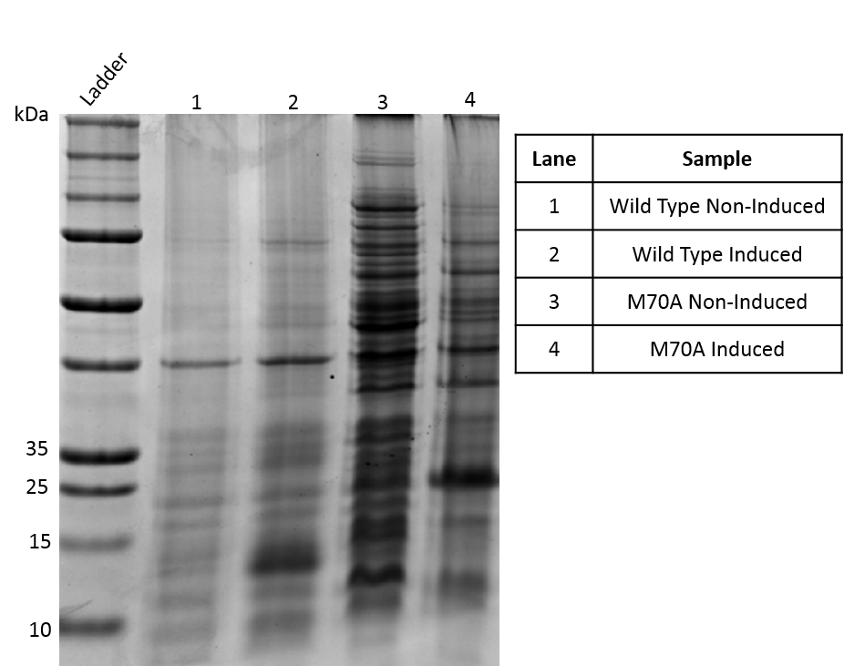
Figure 3.14 – Coomassie Stained 12.5% Polyacrylamide Gel Showing Expression of M70A Mutant C5a and Wild-Type C5a in M15 [pREP4] E. coli After Induction with 1mM IPTG
M15 [pREP4] E. coli were transformed with pQE30 containing either wild-type C5a or M70A mutant C5a insert. Cultures were grown until an OD₆₀₀ of 0.6 then induced with 1mM IPTG for 3.5 hrs. Culture samples were taken, pelleted, then boiled at 95°C in reducing loading buffer for 10 mins and then run on a 12.5% poly-acrylamide gel before Coomassie staining. C5a bands are expected to appear between 10-15 kDa (arrowed).

3.3.4.5 - PCR Analysis of C5a mRNA in WT and Mutant Cultures

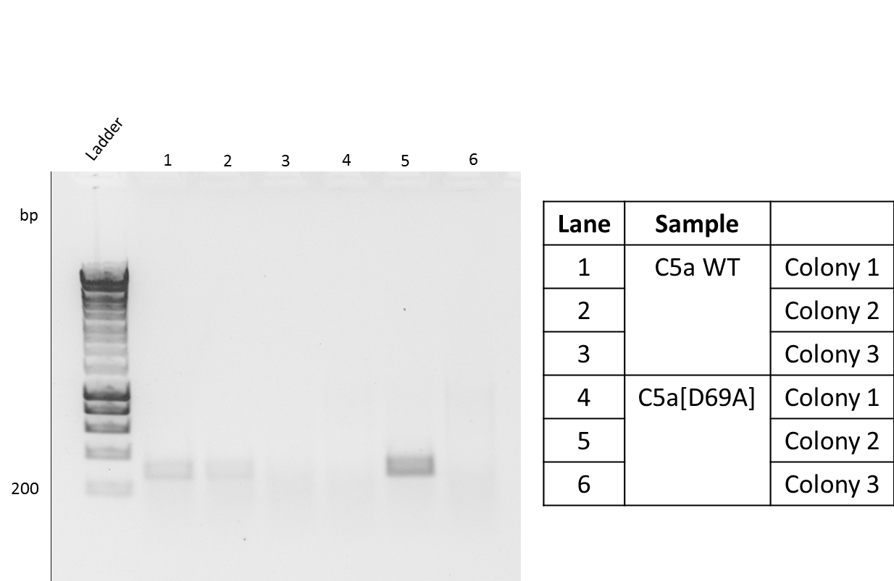
One possible reason for the lack of protein expression may be that the plasmid or its gene transcripts were unstable due to the added mutation. To test this a comparison of mRNA transcript levels was done using PCR using primers against the C5a insert sequence. Cultures transformed with either C5a WT or C5a[D69A] plasmid were grown and induced as in Section 2.2.6.3. Culture samples from three different colonies per plasmid transformation were taken, stabilised, and RNA purification performed. For each sample, 1µg RNA was used in a cDNA synthesis of which 10µl was taken and run in a PCR (Figure 3.15). Primers amplify from the start codon of the C5a insert to just upstream of the final DMQLGR sequence, leaving PCR products of 336bp. C5a bands can be seen in lanes 1, 2, and 5. This would indicate that there was no C5a transcript present in one of the colonies from the pQE30-C5a[WT] transformation (colony 3). In addition, there was no C5a transcript present in two of the pQE30-C5a[D69A] colonies (colonies 1 + 3).

400

Figure 3. 15 – 1% Agarose Gel Showing PCR Products After Amplification of C5a Sequence from RNA Samples of Induced Bacterial Cultures of C5a[WT] or C5a[D69A]
Rosetta Gami 2 (DE3) pLysS E. coli were transformed with either pQE30-C5a[WT] or pQE30-C5a[D69A], cultured, then induced 2.2.6.3. RNA samples were purified from induced cultures and then 1µg of each sample used in cDNA synthesis. 10µl of each cDNA was run in a PCR using primers against the C5a insert sequence. PCR products were run on a 1% agarose gel. Bands between 200 and 400bp correspond to amplified C5a sequence which is expected to be 336bp (colours are inverted).
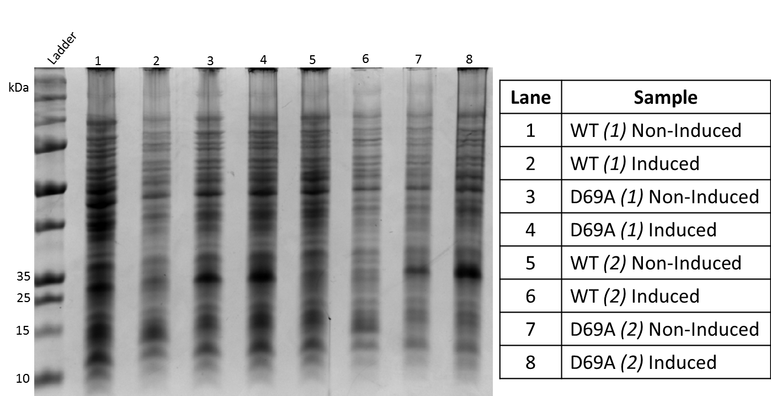
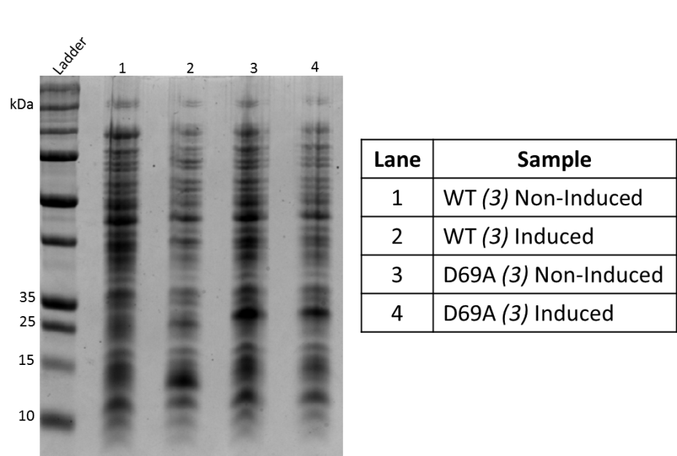
However, when induced and non-induced samples from the same cultures were run on a polyacrylamide gel the results showed a different pattern of C5a expression (Figure 3.16). C5a expression bands are present in the induced WT (colony 1) the induced WT (colony 3) sample (arrowed) contrary to the PCR results. In WT (colony 2) sample C5a expression is not apparent, though there is the possibility this is due to the small 1ml culture volumes used. This band is not seen in any of the mutant sample lanes.

Figure 3.16 – 12.5% Coomassie Stained Polyacrylamide Gels Showing Expression of 3 Colonies Each from C5a[WT] or C5a[D69A] Induced Rosetta Gami 2 (DE3) pLysS Cultures
A
B
Rosetta Gami 2 (DE3) pLysS E. coli were transformed with pQE30-C5a[WT] or pQE30-C5a[D69A]. Bacteria were cultured then induced with 1mM IPTG for 3.5 hrs. Culture samples were taken and boiled in reducing loading buffer at 95°C for 10 mins. C5a bands would be expected to appear at ~12kDa (arrows).

3.3.4.6 - pQE30 Cloning Attempts

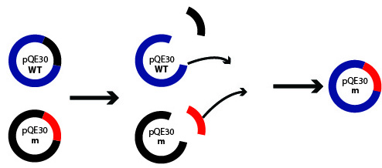
In an effort to restore protein expression in the C5a mutants, attempts were made to clone the mutant inserts into pQE30 vector which still gave protein expression. The C5a[WT] insert would be removed from its plasmid as would one test mutant, in this case C5a[D69A]. The inserts would then be swapped into the other plasmid. This is illustrated in Figure 3.17.

Figure 3.17 – Strategy for Cloning of pQE30-C5a[WT] and pQE30-C5a[D69A] (m)
The C5a insert (black small section) was to be cut out of the pQE30 vector (blue). The C5a[D69A] insert (small red) was also to be cut out of the pQE30 plasmid from Mutagenex Inc. it was contained within (black large section, m). The C5a[D69A] insert was then be ligated into the pQE30 originally containing the wild-type insert (large blue segment). The mirror of this ligation was also to be attempted.

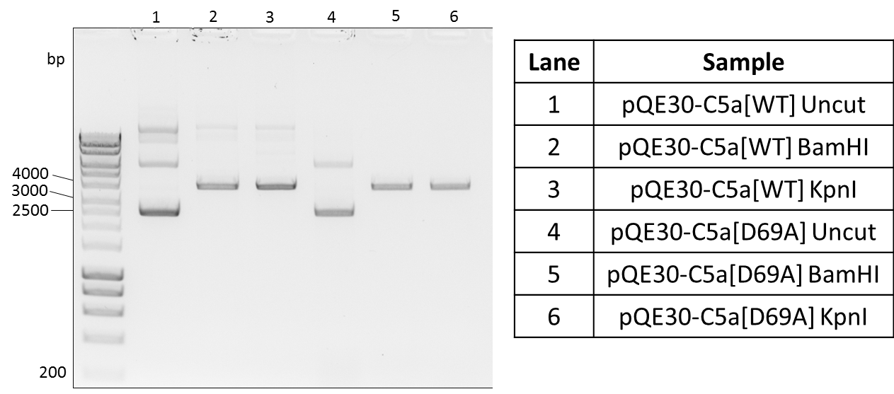
If the problem lay with the pQE30 plasmid backbone it was possible that re-cloning of the mutant insert into the vector which gave expression would rescue mutant C5a expression. Firstly, plasmids were to be restriction digested with KpnI and BamHI enzymes which were originally used when these constructs were designed (Paczkowski et al., 1999). BamHI and KpnI do not share a buffer within which both are active and do not exhibit non-specific cutting activity. To begin with two separate, single restriction digests were attempted with gel extraction and purification of the cut DNA between Figure 3.18 and Figure 3.19. In Figure 3.18 lanes 1 and 4 show the uncut, supercoiled plasmids. The restriction digests appear to have gone to completion as there looks to be little uncut plasmid remaining in lanes 2, 3, 5 and 6. The bands at 3154bp in these lanes were excised and purified before being cut for a second time. In Figure 3.19 bands should be expected at 308bp and 2846bp. Though the bands have not migrated to the correct distance with the ladder, most likely because the gel was not run for long enough, though it is clear there is no low molecular weight band in any lane.

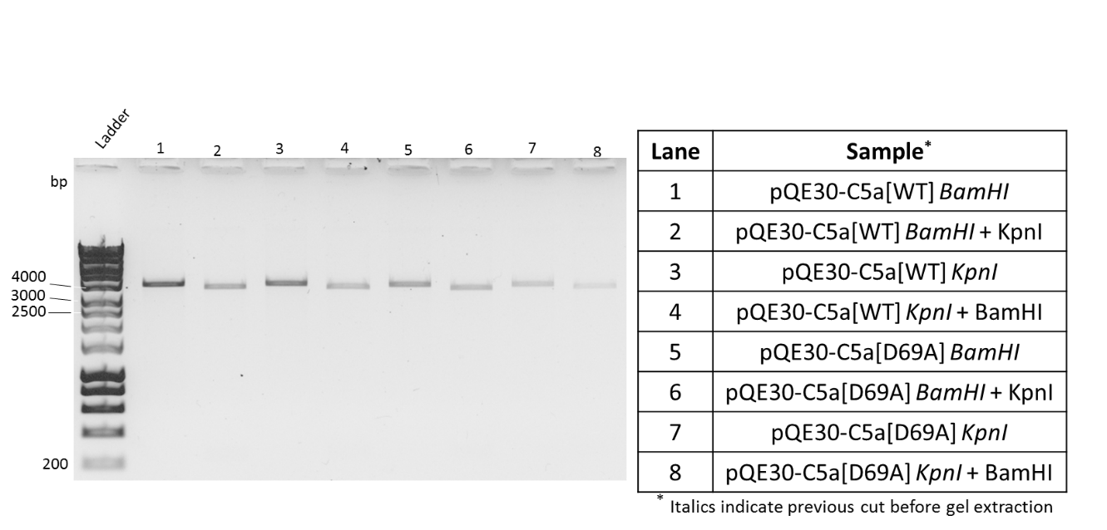
Figure 3.18 – Restriction Digest of pQE30-C5a[WT] or pQE30-C5a[D69A] with either BamHI or KpnI Enzymes; 1% Agarose Gel
Both pQE30-C5a[WT] (lanes 2, 3) and pQE30-C5a[D69A] (lanes 5,6) were cut in a single digest with either BamHI or KpnI for 1 hr at 37°C. Restriction digest samples were then run alongside the uncut vectors (lanes 1, 4) on a 1% agarose gel (colours have been inverted).

Figure 3.19 – Second Digest of Cut pQE30-C5a[WT] or pQE30-C5a[D69A] with either BamHI or KpnI Enzymes; 1% Agarose Gel
After gel extraction, cut pQE30 vectors were cut for a second time with the other enzyme, either BamHI or KpnI (even lanes) for 1 hr at 37°C. Samples were run alongside the single-cut gel extraction products (odd lanes)(colours have been inverted).
Each restriction digest was run as a 50µl reaction of which 10µl would be loaded onto a 1% agarose gel to be imaged. The remaining 40µl loaded into a separate gel to be visualised using lower wavelength UV-light to avoid excessive damage to the DNA bands. In the gel with a higher volume of DNA loaded there were no small bp bands present either, indicating very low DNA yields from the restriction digest. In the first digest, 1µg DNA was used which will gradually be lost throughout the following purifications and second digest. Either the concentration of DNA in the low bp band is too low to be visualised or it is not present at all as the restriction digest did not go to completion. In an attempt to avoid gel extraction, which was causing large losses in DNA yield, both plasmids were subject to a double restriction digest (Figure 3.20). Buffer 1.1 (NEB) was chosen in which both enzymes show reasonable activity, however BamHI may exhibit some non-specific cutting activity.
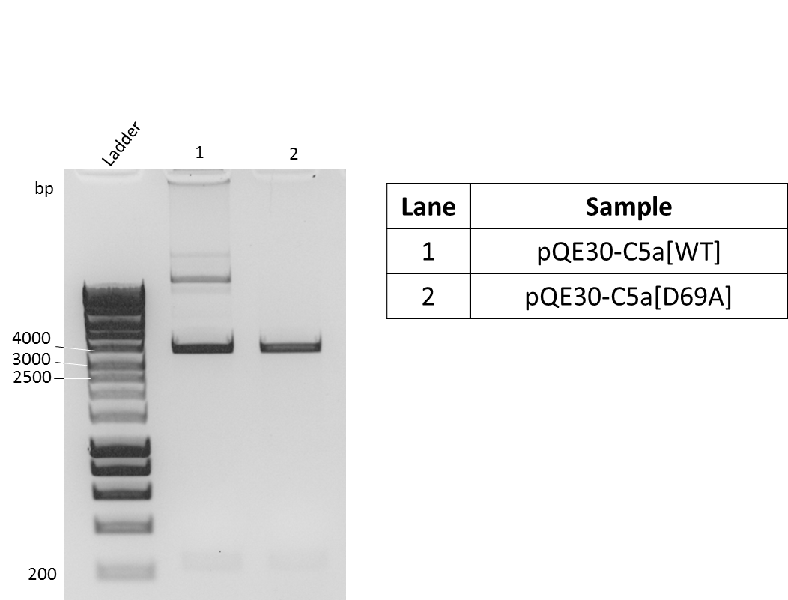
400

Figure 3.20 – Double Restriction Digest of pQE30-C5a[WT] and pQE30-C5a[D69A] with BamHI and KpnI; 1% Agarose Gel
Both 1µg pQE30-C5a[WT] (lane 1) and 1µg pQE30-C5a[D69A] (lane 2) were cut in a double digest with BamHI and KpnI in buffer 1.1 for 1 hr at 37°C. Large, vector bands were expected at 2846bp and small, insert bands at 308bp (boxed)(colours have been inverted).

In Figure 3.20 smaller insert bands are faintly present for both plasmids. However, the larger bands which were expected to be 2846bp have not migrated as far down the gel as would be expected. It is possible that this is because the plasmids are not being cut by both restriction enzymes as they should be. If so, these bands could be singly cut plasmid. As DNA yields were still low two further digests were attempted; one digest with 2µg starting DNA incubated for 1 hr at 37°C (Figure 3.21), and one digest with 2µg starting DNA incubated for 2 hr at 37°C (Figure 3.22).
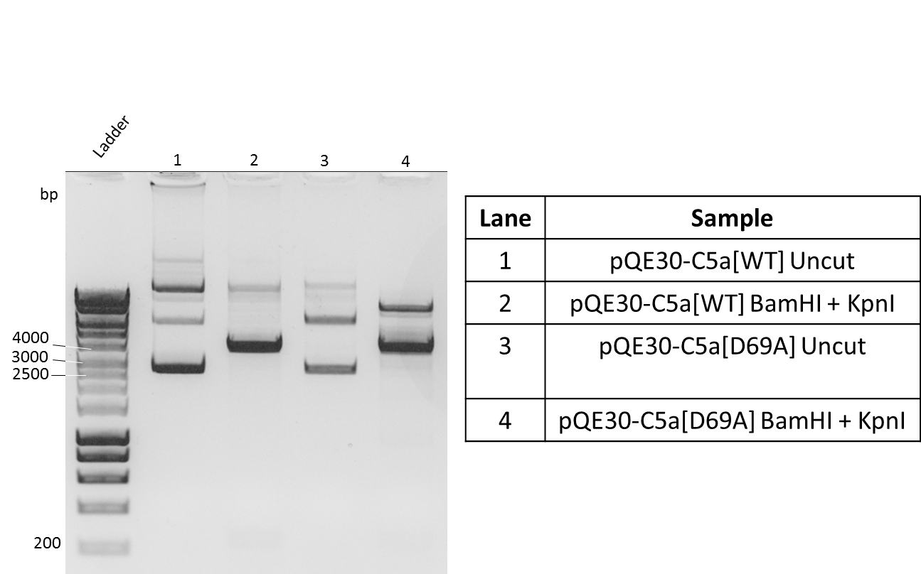

400

Figure 3.21 – Double Restriction Digest of 2µg pQE30-C5a[WT] and 2µg pQE30-C5a[D69A] for 1 hr at 37°C with BamHI and KpnI; 1% Agarose Gel
Both 2µg pQE30-C5a[WT] (lane 2) and 2µg pQE30-C5a[D69A] (lane 4) were cut in a double digest with BamHI and KpnI in buffer 1.1 for 1 hr at 37°C. Samples of restriction digests were run on a 1% agarose gel alongside uncut plasmids (lanes 1 and 3). Large vector bands were expected at 2846bp and small, insert bands at 308bp which do not appear to be present (boxed)(colours have been inverted).
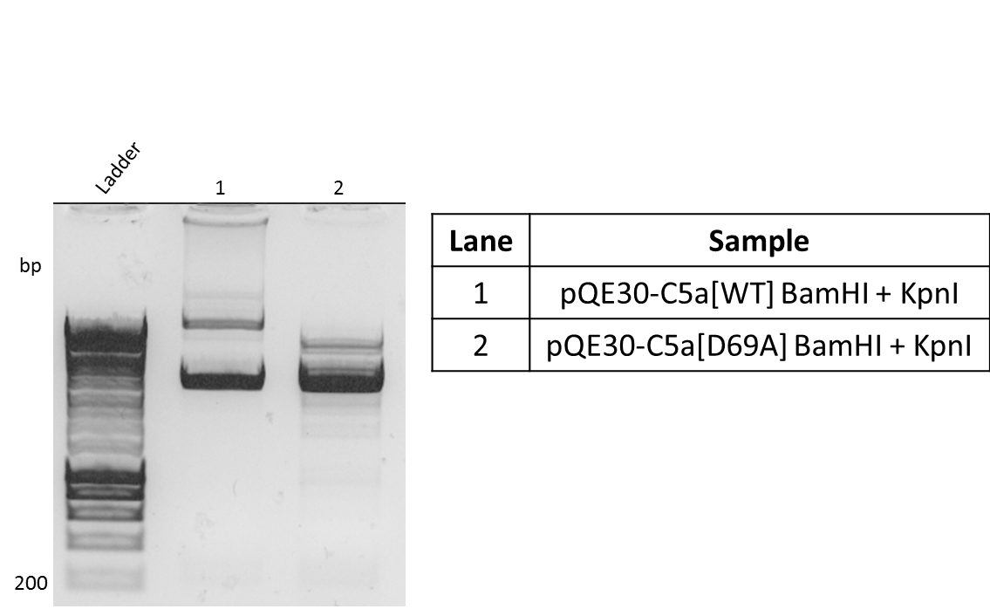
400
Figure 3.22 - Double Restriction Digest of 2µg pQE30-C5a[WT] and 2µg pQE30-C5a[D69A] for 2 hr at 37°C with BamHI and KpnI; 1% Agarose Gel
Both 2µg pQE30-C5a[WT] (lane 1) and 2µg pQE30-C5a[D69A] (lane 2) were cut in a double digest with BamHI and KpnI in buffer 1.1 for 2 hr at 37°C. Samples of restriction digests were run on a 1% agarose gel. Large, vector bands were expected at 2846bp and small, insert bands at 308bp (boxed).

Neither restriction digest gave improved yield of the smaller insert band. In Figure 3.21 lanes 1 and 3 are uncut plasmid which do seem to migrate differently to the restriction digest samples. This would imply that the plasmid is being digested to some extent but possibly still not to completion. However, when the reaction time is extended to 2 hrs as in Figure 3.22 there appears to be many contaminating bands possibly due to non-specific cutting activity from BamHI. The remaining sample from Figure 3.21 was also run on a 1% agarose gel and bands excised. The gel extraction protocol was followed with additional washing steps in an attempt to prevent high concentrations of salts being present in the final, purified DNA which can interfere with downstream processes and quantification. The purified samples of WT vector, WT insert, D69A vector, and D69A insert were used in ligation reactions as follows:

Ligation Reaction | Useage
WT pQE30 + D69A Insert | Cloning
D69A pQE30 + WT Insert | Cloning
WT pQE30 + DNA Ligase | Background re-circularisation control
D69A pQE30 + DNA Ligase | Background re-circularisation control
WT pQE30 – DNA Ligase | Background uncut vector contol
Table 3.1 – DNA Ligation Reaction Compositions and their Usage
It should be noted that a control should also have been set up of D69A pQE30 – DNA ligase, however there was not sufficient volume of DNA to do this. Following the ligation, 2µl of reaction was used to transform Rosetta Gami 2 (DE3) pLysS E. coli. Transformed bacteria were then plated on LB-agar. There was only growth of colonies on the D69A pQE30 + WT insert, and the D69A pQE30 + ligase plates. As there was growth on an experimental plate but also a control plate it was unlikely these colonies contained the desired pQE30-C5a[WT] construct. To determine whether any C5a DNA transcript was present, three colonies were picked from each plate and run in a colony PCR using primers against the C5a insert sequence (Figure 3.23).

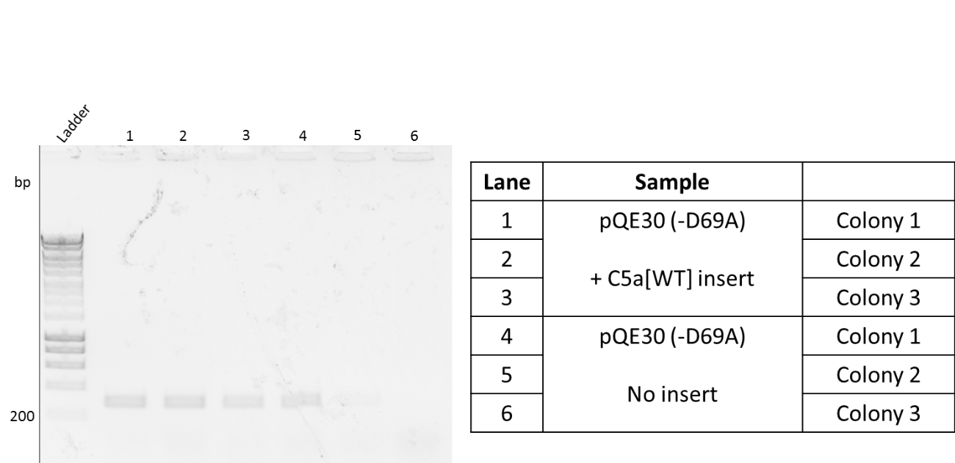

Figure 3.23 – Colony PCR of 3 Colonies Picked From pQE30 + C5a[WT] Insert Plate and 3 Colonies Picked From pQE30-DNA Ligase Plate; 1% Agarose Gel
Ligation reaction mixture was used to transform Rosetta Gami 2 (DE3) pLysS E. coli which were then plated. Three colonies were picked from the pQE30 + C5a[WT] insert plate (lanes 1-3) and three from the (D69A)pQE30 – DNA Ligase plate (lanes 4-6) and run in a colony PCR. Primers against the C5a insert sequence were used. PCR samples were run on a 1% agarose gel (colours are inverted).

In Figure 3.23 the bands corresponding to C5a DNA sequence are expected to appear at 336bp and there appears to be C5a DNA in lanes 1-5. In the pQE30 – DNA ligase control, had the restriction digest work properly, there should be no C5a DNA sequence present as this would have been digested and purified away from the vector backbone. As C5a DNA is present in lanes 4 and 5 this would imply the insert has not been cut away from the vector. Subsequently this would suggest that the colonies grown on the plate of interest did not contain the desired construct and rather were just uncut plasmid that had not had the new insert ligated in.

3.3.5 - Production of Transfected Mammalian Cell Lines

Transfected mammalian cell lines expressing hC5aR2 receptor mutants were created for long-term usage throughout the work. CHO (Chinese Hamster Ovary) cells were chosen as they were easy to transfect, hardy, and grew quickly. Transfected cells would then be sorted using flow cytometry to enrich the population with positively transfected cells. All transfected cell lines would be sorted above a threshold percentage of positive cells in the population, which was chosen to be 70% or higher (Figure 3.24). This was to ensure that varying numbers of positive cells between different cell lines had as little influence as possible on data obtained using these cells.
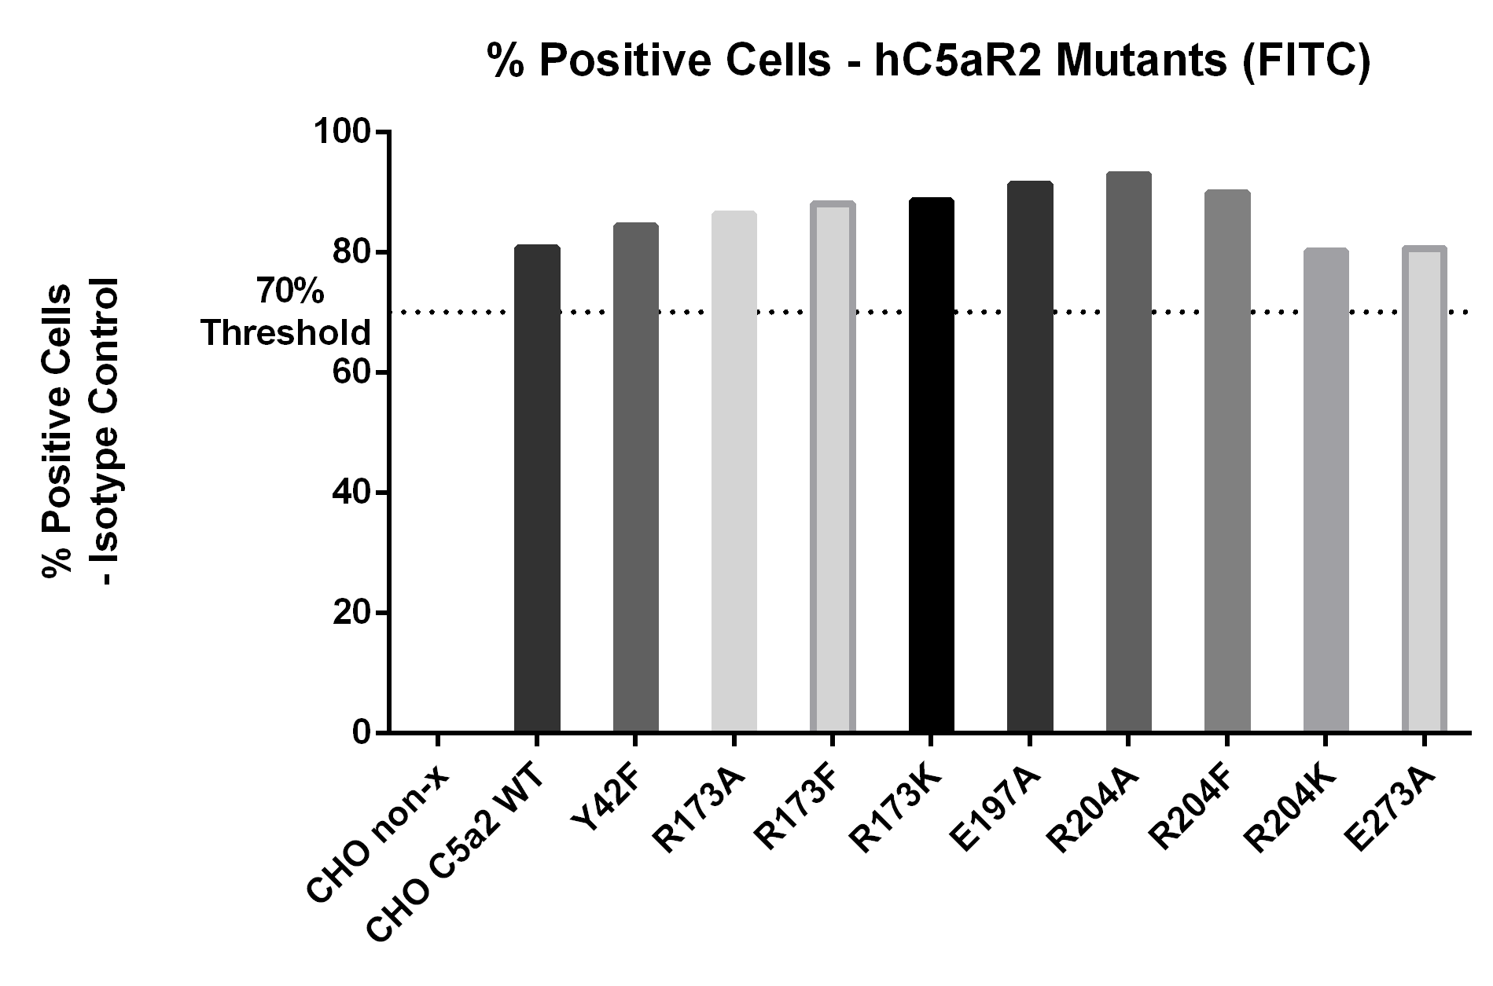
Figure 3.24 – Percentage Positive Cells of hC5aR2 Mutant and Wild-Type Transfected CHO Cells
Sorted, transfected CHO cells were prepared as in (2.2.5.1) for receptor expression analysis. Monoclonal antibody targeted against hC5aR2 was used alongside a FITC-labelled secondary antibody. Background fluorescence was determined using a secondary-antibody only control and was removed from all samples first followed by subtraction of an isotype control. Cell lines were sorted until receptor expression was present in over 70% of the cell population. Non-x = untransfected CHO cells.
In Figure 3.24 surface receptor expression is measured with background fluorescence and an isotype control removed from all values. There is no apparent surface hC5aR2 expression present in non-transfected (non-x) CHO cells implying there is no native hC5aR2 expression. Any effects seen in data gathered using these mutants would therefore be as a result of these mutant receptors only and not native receptor. All receptor mutants and the wild-type were transfected above the 70% threshold.
Data based on the ‘percentage positive’ parameter is qualitative for each cell, meaning the only factor taken into consideration is whether a cell fluoresces above a certain threshold or not. This value does not take into account differing numbers of receptor on the cell surface and thus differing amounts of fluorescence. Median fluorescence intensity (MFI) of the receptor mutant cell lines was also measured so this could be taken into account in future analysis of data obtained using these mutants. MFI takes into consideration the brightness of each cell whereby a cell with many receptors on the surface would have a larger MFI than one with few receptors on the surface. In comparison, for percentage positive both cells would be considered positive without consideration of the brightness (Appendix Fig 7.2). Figure 3.25 shows that there are differences in MFI between the transfected cells, again, possibly down to differing numbers of receptor on the surface of each cell. Positive populations of cells were measured and though some MFI values appear low, all were easily detectable.

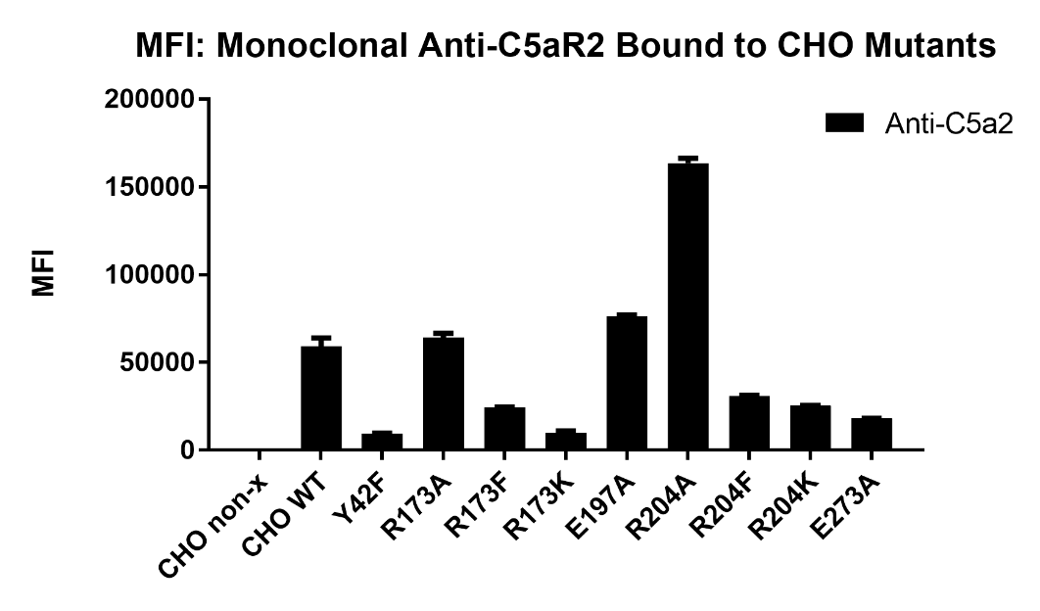

Figure 3.25 – Median Fluorescence Intensity (MFI) of hC5aR2 Mutant and Wild-Type Transfected CHO Cells
Sorted, transfected CHO cells were prepared as in (2.2.5.1) for receptor expression analysis. Monoclonal antibody targeted against hC5aR2 was used alongside a FITC-labelled secondary antibody. Background fluorescence was determined using a secondary-antibody only control and was removed from all samples first followed by subtraction of an isotype control. Median fluorescence intensity (MFI) values were measured for each population of cells two times in duplicate.

3.4 - Discussion and Conclusions

3.4.1 - C5a Expression

C5a had been previously expressed by Paczkowski et al. and by members of our group, using the same method, successfully. However, no C5a was ever successfully purified using this method during this project. Ideally, this protein purification was intended to be quick allowing for more time to be spent working on the original aims of the project. As many problems were faced with both expression of the WT C5a and the C5a mutants, in many cases, a compromise had to be reached between successful purification of protein but leaving enough time for the experimental research to be undertaken. Though functional protein was obtained using the native purification protocol there are a number of possible factors which could be investigated to improve it further which will be discussed here.
To begin with, the biggest losses in protein yield were caused by the re-folding step after purification. However, there was only small amounts of unfolded protein being purified, usually in the region of 0.3-0.5µg when analysed by Bradford assay. Firstly, it was thought that increasing the bacterial expression of the C5a such that more protein could be refolded, giving a higher yield, would be beneficial. Rosetta Gami 2 (DE3) pLysS E. coli were selected which firstly provide rare tRNAs. As there are 5 instances of rare Arg and 2 rare Ile codon usage within the coding sequence of this C5a this may cause shortages of the necessary rare tRNAs. This strain also provides an oxidative environment in the bacterial cytoplasm which is more beneficial for the formation of disulphide bridges. As C5a contains three disulphide bridges it is likely that a portion of all the expressed C5a is misfolded due to improper formation of these bonds leading to either aggregation or degradation. In addition, correct folding of the expressed C5a would be important particularly if the purification were to be switched to native conditions. When tested it appeared that though slower growing, Rosetta Gami 2 (DE3) pLysS E. coli did give a slight increase in protein yield. However, this increase was still not sufficient to provide any worthwhile changes to the overall yield after refolding. A number of other factors were altered including lysis conditions, column binding time, the column wash volume, and the elution volume all with little positive effect (data not shown). In addition, lysis buffer containing 6M guanidium-HCl; and wash and elution buffers containing 8M urea proved to crystalise out of solution frequently as well as causing problems running samples evenly and clearly on SDS-PAGE gels. Changing to purification under native conditions not only removed the need for protein refolding but also caused greater amounts of protein to be eluted from the column. However, some protein was aggregated within inclusion bodies which would be lost using this protocol as it must be denatured to be released and then purified (Figure 3.8).
When tested on a β-hexosaminidase release assay purified C5a showed greater activity than the stock C5a. However, once C5a des-Arg could be purified and performance in a β-hexosaminidase release assay tested it is apparent that the C5a had shown some loss in activity. This variability in ligand activity is apparent in Figures 3.6, 3.7, and 3.8. This was true for both protein purifications which were stored at -20°C in PBS pH 7.4. In the future, it may be beneficial to investigate whether storage at -80°C, as well as if the addition of stabilising agents such as glycerol or BSA would improve the lifetime of protein preparations. Alternatively, the C5a and C5a des-Arg molecules are cationic at physiological pH (Monk et al., 2007) and it is possible protein is being ‘lost’ due to sticking to storage plastic-ware (Goebel-Stengel et al., 2011). Within this field, previous results have been questioned due to a finding that C3a peptides would show binding to plastic-ware giving misleading results (Johswich et al., 2006). If this were the cause, the problem could be reduced by switching to low-binding plastic-ware for storage and handling of C5a and C5 des-Arg. In addition, were there any misfolded protein remaining in the preparation when it was stored there is the possibility that this is causing aggregates to form.
One further issue to note with the new purification method is the promoters. According to information from both manufacturers (Qiagen, and Novagen), the promoter utilised in pQE30 is T5, whereas the Rosetta Gami 2 (DE3) pLysS strain is optimised for use with the T7 promoter. The Rosetta Gami 2 (DE3) pLysS strain provides T7 polymerase but there is not the corresponding T7 promoter on the pQE30 plasmid to support its use. Expression is still possible, however, as the T5 promoter is recognised by the endogenous E. coli RNA polymerase (Bujard et al., 1987). In addition, inhibition and subsequent induction of transcription of the T5 promoter on pQE30 using IPTG is still possible within any strain providing the lacI^{q} mutation which is given in Rosetta Gami 2 (DE3) pLysS (Qiagen and Novagen supporting information). Despite this, it would be interesting to re-clone the C5a insert into a pET vector, optimised for T7 expression. It is possible that within this system C5a expression could be further improved.
Finally, it would be of interest to determine whether preparing the lysis, wash, and elution buffers at a slightly lower pH would improve protein activity. The theoretical pI of this recombinant C5a is 8.5. All protein purification buffers were prepared at pH 8.0. Lowering the pH of the buffers to 7-7.5 may help with protein stability as this would be closer to physiological pH, the storage pH, and further away from the C5a pI.

3.4.2 - Mutant C5a

Mutant C5a was designed in order to further test the ligand binding of the hC5aR2 mutants. An alanine scan of the last 6 amino acids on the C-terminus of C5a was undertaken by Mutagenex Inc., USA using pQE30-C5a[WT] shipped to the company from our group. However, none of the returned mutated constructs showed any protein expression when attempted under standard conditions. In comparison the wild type construct, which did not leave our group, still showed protein expression as expected. In addition, when whole cell extracts from induced mutant C5a cultures were run on Coomassie stained SDS-PAGE, there didn’t appear to be any clearly expressed C5a band. As the wild-type purification was successful, these data seemed to suggest that the protein expression problems were not caused by a problem with the actual purification protocol, its buffers, or reagents. It appeared more likely a problem at the DNA level or that any produced protein was being degraded, possibly due to misfolding.
The first suspected issues were that either the plasmids were fragmented and damaged or the mutated C5a inserts had been cloned into the wrong plasmids. After double restriction digest with BamHI and NheI of both pQE30-C5a[WT] and pQE30-C5a[M70A] fragments of similar size were released from both plasmids. This suggested both plasmids were pQE30. Sequencing data would also suggest that the mutants were cloned into pQE30 as expected, as well as showing no problems with the DNA sequence itself. For example, the coding sequence is in-frame with promoters, the His-tag, and both start and stop codons.
As well, PCR analysis of induced E. coli cultures showed that not all the wild-type and mutant samples were expressing C5a mRNA. This could be due to instability of the plasmid causing variable expression. Were more time available, plasmid stability could have been tested by growing transformed cultures to an OD₆₀₀ of 0.6, taking samples and plating as follows (Novagen, 1999):

Plate | Growth
LB Agar (1) | All viable cells
LB Agar + Antibiotics (2) | All viable cells containing plasmid
LB Agar + 1mM IPTG (3) | Cells without plasmid or ability to express target gene
LB Agar + Antibiotics + 1mM IPTG (4) | Cells retaining plasmid but lost target expression
Table 3.2 – Plasmid Stability Plating Strategy; from Novagen pET Manual 8th Edition (1999)
Any cells plated on LB agar containing IPTG alone which were still expressing the target gene would not be expected to grow as cell resources are spent on protein expression rather than cell division. Those cells able to grow on plates containing both antibiotics and IPTG must retain the plasmid, to allow growth, but have lost the ability to express the target gene as cell division is still possible. If the pQE30-C5a[WT] plasmid was stable, growth would be expected only on plates 1 and 2. In comparison if the pQE30-C5a[Mutant] plasmids were unstable, growth would be expected on plates 3 or 4. If growth was seen on plate 4 it would suggest the problem was with the protein expression itself and so this could be investigated further.
As with previously for the pQE30-C5a[WT] it appears that re-cloning and/or complete redesign of the ligand constructs would be beneficial. When cloning of the mutant inserts into the pQE30 vector that was not shipped to the USA was attempted many problems were encountered due to low yields of insert DNA after restriction digest. A complete redesign of the constructs, taking care to remove as many cases of rare codon usage as possible, could have proved valuable. Constructs could be cloned into a T7-promotor vector system, such as pET, which would be optimised for use in the Rosetta Gami 2 (DE3) pLysS E. coli. As constructs could be amplified by PCR this would avoid the restriction digest followed by gel extraction step which was causing great losses in DNA yield.

3.4.3 - Transfection of CHO Cells with hC5aR2 Receptor Mutants

CHO cells were transfected with hC5aR2 receptor mutants using TurboFect (Thermo). Stable transfections were chosen as transfected cell lines could be stored, used regularly, and would retain a constant level of receptor expression throughout a series of experiments. CHO cells did not show any native expression of hC5aR2 and so this should not be a contributing factor in any data obtained using these transfectants. In addition, CHO cells showed good transfection success rates. After each transfection cells expressing mutant receptor would be sorted away from non-transfected cells using flow cytometry. This was done until more than 70% of cells in the culture population were positive for the expression of hC5aR2 to ensure similar levels between all transfected cell lines. In ligand binding assays percentage positive cells would be the parameter measured to obtain data and so this was chosen as the value to keep consistent between cell lines. Another parameter, MFI, was also measured in the sorted transfectants. As mentioned previously, MFI gives the median measure of the brightness of a population of cells. This is more associated with the number of surface receptors present than is percentage positive. MFI data would be taken into consideration in the analysis of ligand binding studies as well.
Originally, attempts were made to transfect another mutant receptor L90D into CHO cells although no surface receptor expression was ever seen after a number of repeats (data not shown). Therefore, this mutant was unsuitable for the ligand binding assays performed in this study. It is possible that this mutant receptor could not be expressed properly and was not transported to the cell surface. It could have been of interest to perform fluorescence microscopy to determine the localisation of mutant receptor in all transfected cell lines.

Chapter 4 – Ligand Binding Studies on hC5aR2 Mutants

4.1 - Introduction

Since hC5aR2 was first discovered, there have been very few in-depth studies on the binding mechanism of this receptor. Where hC5aR1 preferentially binds C5a over C5a des-Arg, hC5aR2 binds both ligands with similar affinities. This is the case despite 35% amino acid identity between the two receptors, with many important residues for ligand binding in hC5aR1 being conserved in hC5aR2 (Cain and Monk, 2002; Scola et al., 2007). The hC5aR2 receptor has >10-fold greater affinity for C5a des-Arg than hC5aR1 (Cain and Monk, 2002). It seems apparent that the two receptors must have different ligand binding mechanisms. As hC5aR2 is not capable of signalling via G-protein pathways, it was suggested by Scola et al. (2007) that, unlike in hC5aR1, transmembrane domains of the receptor are not important for ligand binding and that perhaps stronger interactions are made elsewhere. In the Scola et al. (2007) study, the N-terminus of hC5aR2 was blocked using antibody and the effect on ligand binding measured. It was found that the N-terminus of hC5aR2 was important for binding of C5a des-Arg but blockade had no effect on C5a binding. It was suggested that not only did hC5aR1 and hC5aR2 have different ligand binding mechanisms, but the binding of C5a and C5a des-Arg to hC5aR2 was also different.

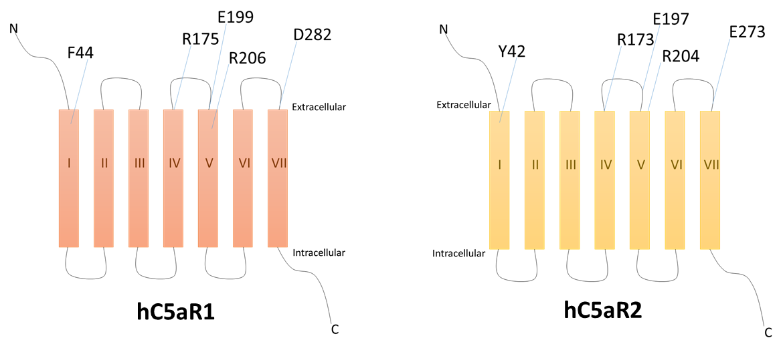Figure 4.1 – hC5aR2 Mutated Residues and their Equivalent Residues in hC5aR

Here, a series of hC5aR2 mutants were used in order to further investigate the binding mechanism of this receptor. The mutations were suggested by Irina Tikhonova (Queen’s University, Belfast) and chosen in those residues conserved, and previously found to be important for ligand binding in hC5aR1 (Figure 4.1). For all receptor mutants C5a and C5a des-Arg binding was measured and compared with wild type receptor. In addition, an attempt to investigate the effects of blocking the N-terminus of hC5aR2 on ligand binding was made. Finally, peptides able to bind hC5aR1 have been used extensively in the study of this receptor. However, until recently, there were no peptides selective for hC5aR2. In this chapter, two selective peptides characterised by Croker et al. (2016) were tested for binding to hC5aR2.

4.2 - Aims

The aims of the work in this chapter were:
- To fluorescently label C5a and C5a des-Arg using N-hydroxysuccinimidyl (NHS)-activated Alexafluor-488. In addition, determine suitable concentrations of labelled ligands to use in competition ligand binding assays.

- Test the effects of 9 different point mutations in hC5aR2 on binding by C5a and C5a des-Arg using CHO cells transfected with mutant receptor. Compare with wild type receptor ligand binding.

- Using anti-hC5aR2 antibody targeted against the N-terminus of the receptor to block this region, further test C5a and C5a des-Arg binding to wild type and mutant receptors.

- Test binding of two novel hC5aR2 selective peptides, LIRLWR and RHYPYWR, to hC5aR2 using the competition binding assay technique.

4.3 - Results

4.3.1 - Fluorescent Labelling of Recombinant Ligands

In order to perform ligand binding assays recombinant ligands were fluorescently labelled with the dye Alexafluor-488 (Alexa-488). The Alexafluor N-hydroxysuccinimide (NHS) esters can react with primary amine (NH₂) groups on peptides. As the C-terminus of the C5a and C5a des-Arg ligands has been shown to be important for ligand function and binds more deeply into the receptor, it was not suitable to conjugate the label in that region and so the primary amines at the N-terminus of both ligands was labelled. After the labelling reaction, labelled ligand is passed through a size-exclusion column in an attempt to remove as much free, unconjugated, label as possible. In order to determine what concentration of labelled ligand to use in competition binding assays binding curves were run to determine a detectable concentration of ligand without excessive levels of non-specific binding (Figures 4.2 and 4.3).

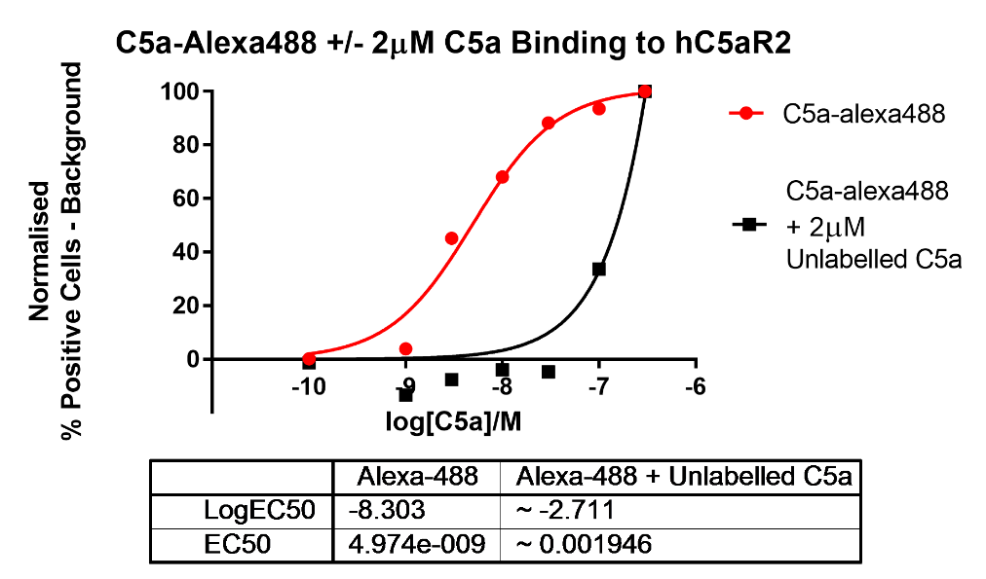

Figure 4.2 – Binding of Alexa-488 Labelled C5a to hC5aR2 Transfected CHO Cells With or Without Addition of 2µM Unlabelled C5a
hC5aR2 transfected CHO cells were prepared as in section 2.2.5.2 (n=1). Labelled C5a of varying concentrations with (black line) or without (grey line) 2µM unlabelled C5a was bound to cells at 4°C for 15 mins before detection by flow cytometry.
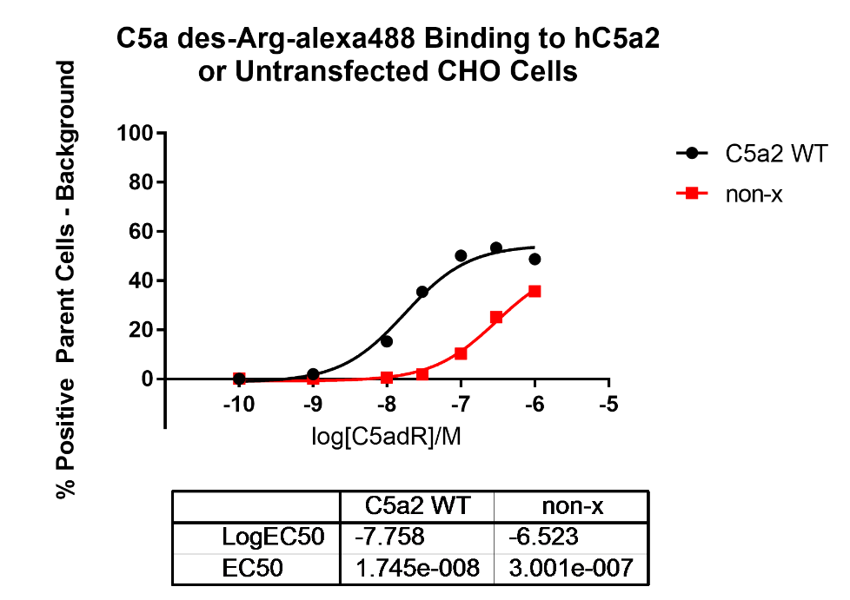

Figure 4.3 – Binding of Alexa-488 labelled C5a des-Arg to hC5aR2 Transfected or Untransfected (non-x) CHO Cells
hC5aR2 transfected (black line) and non-transfected (grey line) CHO cells were prepared as in section 2.2.5.2 (n=1). Labelled C5a des-Arg was bound to cells at 4°C for 15 mins before detection by flow cytometry.
In Figure 4.2 where a saturating concentration of 2µM unlabelled C5a is added (black line) there would not be any C5a-Alexa-488 binding expected. Therefore, any cell-associated fluorescence detected here was most likely due to non-specific binding of fluorescent ligand or free Alexa-488. At concentrations higher than 10nM labelled C5a, non-specific binding appears to increase, however at this concentration there is good binding to receptor and the fluorescence is easily detectable and so this concentration was chosen for use in binding assays. With labelled C5a-des Arg (Figure 4.3) 30nM was chosen as at this concentration there appeared to be good receptor occupancy and above this concentration non-specific fluorescence increased greatly.

4.3.2 - Competition Ligand Binding Assays

Ligand binding studies were conducted on 9 hC5aR2 mutant receptors and wild type receptor expressed in CHO cells. Competition assays were performed whereby unlabelled ligand at varying concentrations would compete with labelled ligand at a specified concentration for 15 mins before analysis by flow cytometry. These assays were performed for both C5a and C5a des-Arg and were used to compare binding between mutant receptors and wild-type. Previously, binding data has been obtained for hC5aR1 receptors mutated in equivalent positions to these hC5aR2 receptors studied here. As little research on C5a and C5a des-Arg binding by hC5aR2 has been conducted, the results found here were also compared with the previous hC5aR1 data as a means for validation of the data and comparison of the binding mechanism of both receptors. Curve fitting was undertaken in order to obtain IC50 values which would allow for numerical comparison of the mutant receptor binding data relative to wild-type for statistical analysis. In several of the hC5aR1 binding studies, IC50 was also the measured parameter (Cain et al., 2001a, 2003; Higginbottom et al., 2005). Thus, as the IC50 increases the concentration of unlabelled ligand required to displace its labelled counterpart increases, suggesting a lower ligand affinity. Here, each receptor mutant shall be taken in turn and summary data can be found in Table 4.1 (hC5aR2) and Table 4.2 (hC5aR1).

4.3.2.1 - Y42F

Y42F mutants showed no significant change in C5a binding relative to the wild-type. However, these same mutants showed a slight, but statistically significant, increase in IC50 for C5a des-Arg binding with a slight shift in the binding curve. This would imply that Y42F in this instance has little effect on C5a affinity but slightly reduces affinity of C5a des-Arg for hC5aR2 (Figure 4.4).
The analogous residue in hC5aR1 to Y42 is F44. Though this residue has not been directly studied it was present in part of a random mutagenesis screen across the hC5aR1 transmembrane helices. In this study performed by Geva et al. (2000) randomly mutated hC5aR1 receptors were expressed in yeast cells. Yeast cells would only be able to grow on a minimal media when the mutated receptor was functional. Data suggested residue F44 only tolerated hydrophobic substitutions. No data was obtained for C5a des-Arg. Here, the hC5aR2 Y42F mutants showed no significant change in C5a binding. The tyrosine to phenylalanine mutation is in keeping with the previous finding that F44 tolerated hydrophobic substitutions. However, many of the receptors in the Geva study had multiple mutations and had their function assayed as opposed to just ligand binding in single mutant receptors and thus it is difficult to make direct comparisons. As the hC5aR2 Y42F mutation caused no change to the binding of C5a but did have a small effect on C5a des-Arg binding this could suggest that the two ligands are bound in slightly different orientations at the receptor N-terminus.

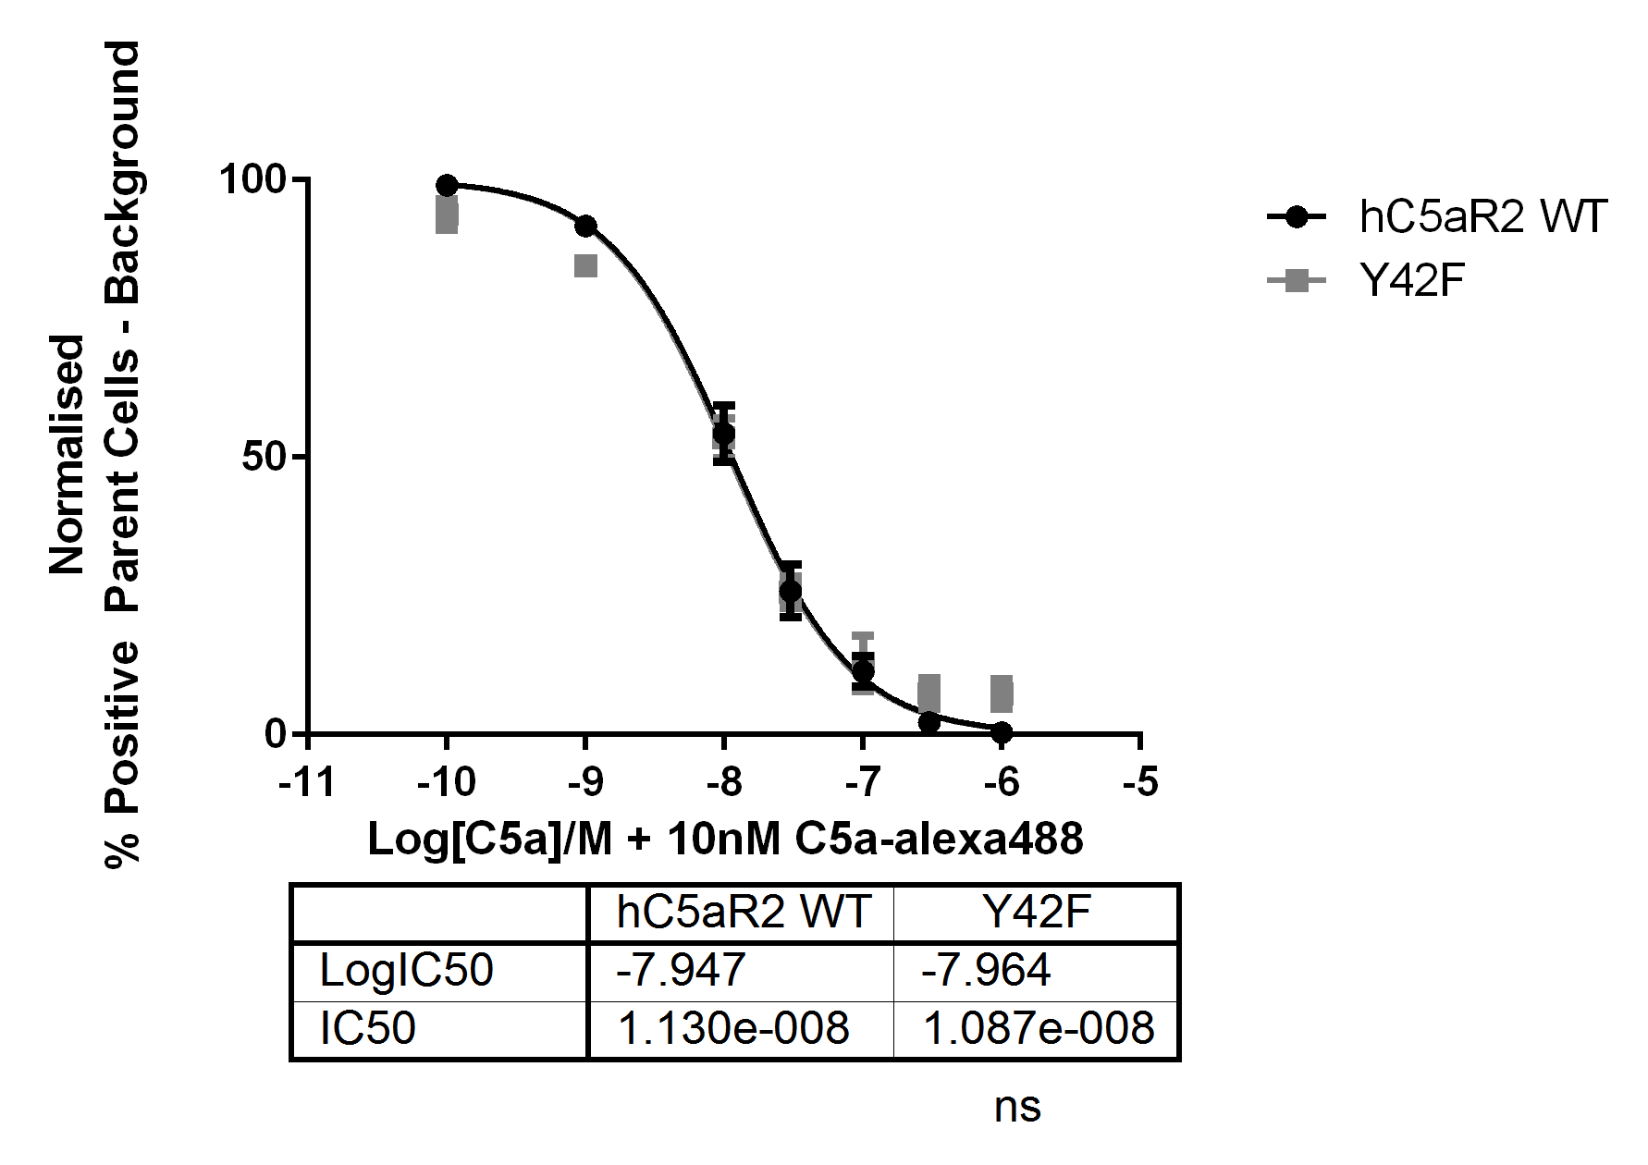
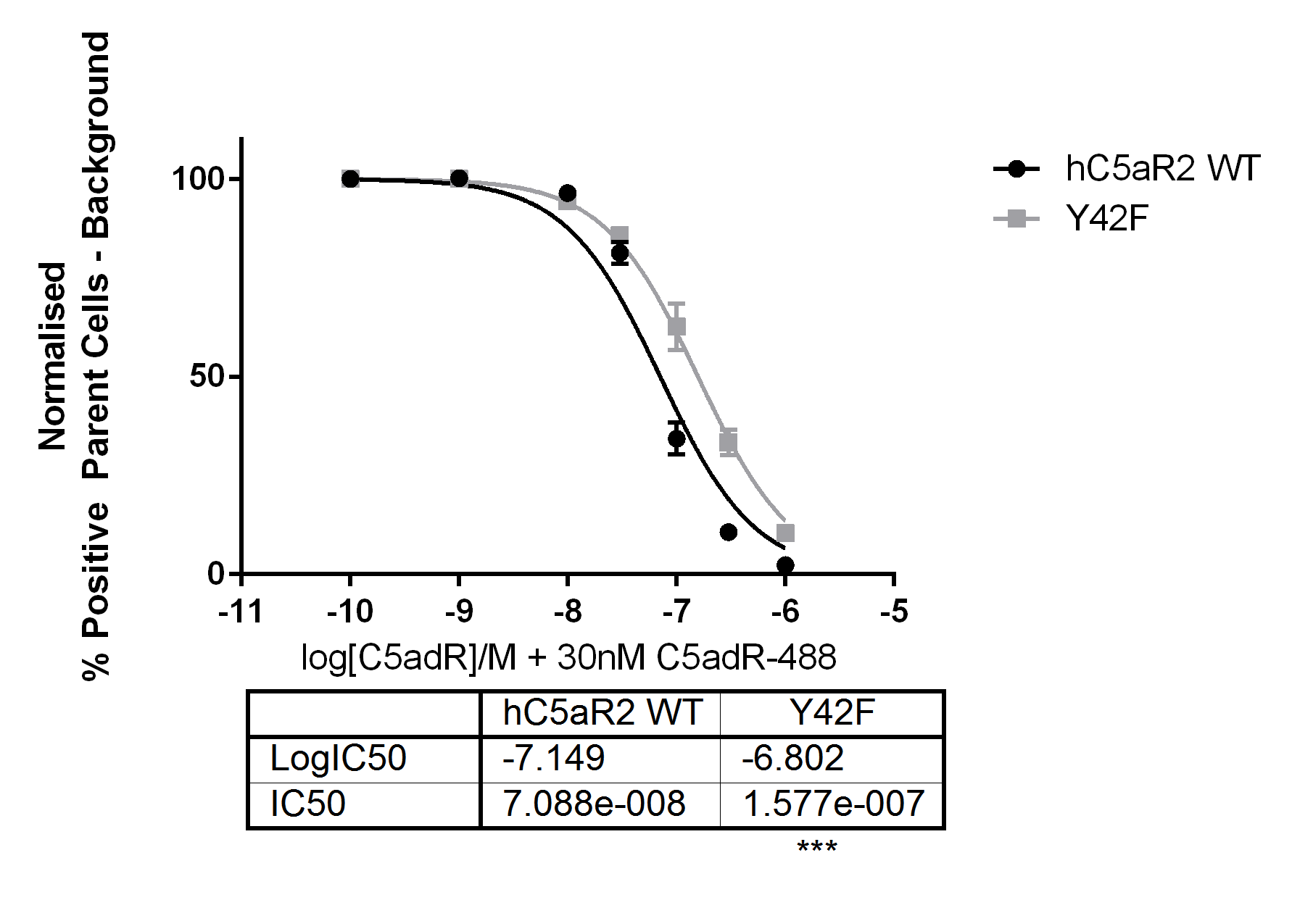

Figure 4.4 – C5a and C5a des-Arg Binding Curves for Wild-Type and Y42F Mutant hC5aR2 Receptors
Figure 4.4 depicts C5a and C5a des-Arg binding curves for both wild-type and mutant, here Y42F, hC5aR2 receptors. CHO cells transfected with the corresponding receptor were incubated with variable concentrations of unlabelled ligand with 10nM C5a-alexa488 or 30nM C5a des-Arg (C5adR)-alexa488 for 15 mins before analysis by flow cytometry. Error bars depict standard error of the mean (SEM) from three distinct repeats each in duplicate. Student’s t-tests were conducted on logIC50 values and p value statistical significance shown as ns = not significant, * = P ≤ 0.05, ** = P ≤ 0.01, *** = P ≤ 0.001, **** = P ≤ 0.0001.

4.3.2.2 - R173A

R173A, R173K, and R173F mutants were all tested. In this case, all mutants were unable to bind C5a despite maintaining above 70% receptor expression (Figure 3.24). Both R173A and R173F increased the IC50 for C5a des-Arg binding, again implying reduced receptor affinity. R173K showed a statistically significant decrease in IC50 however the curve follows very closely to that of the wild-type and large variation between repeats may be affecting the statistical analysis (Figure 4.5).
The analogous residue to R173 in hC5aR1 is R175. R175 has been studied empirically and also subject to modelling. When the ligand binding affinity of R175A and R175D mutant hC5aR1 receptors was studied, both mutations led to disruption of C5a binding whereas only R175D had significantly reduced affinity for C5a des-Arg. The suggested explanation for this was that R175 interacted directly with the carboxyl group found on the C-terminal arginine of C5a (Higginbottom et al., 2005). As this residue is missing in C5a des-Arg, mutation of R175 to alanine would be expected to have little effect on C5a des-Arg binding. The mutation to aspartate in R175D introduces a negative charge which could possibly disrupt positioning of the C-terminal carboxylate moieties on both C5a and C5a des-Arg. In the model by Nikiforovich et al., 2008, R175 was shown to be away from the ligand binding site of C5aR1, participating in a salt-bridge with another receptor residue, E179, but did not interact directly with either ligand. No ligand interactions were seen when R175D was modelled, though the interaction with E179 was lost. The suggested reasoning for the experimentally observed disruption to binding of C5a and C5a des-Arg was that R175 is important for stabilising the second extracellular loop (ECL2) of the receptor in a more open conformation and when mutated structural changes make ligand binding less favourable. In hC5aR2, mutation of R173 to A173, F173 or K173 caused complete loss of binding of C5a despite cells expressing high levels of surface receptor. This result is striking and seems unusually severe. This is possibly due to limitations of the flow cytometric ligand binding assay whereby only long-term ligand binding is detected as only ligand remaining bound to the receptor after 15 mins is measured. It is possible that mutation of R173 causes the off-rate of C5a to increase by destabilising the binding interaction such that in this assay binding is not seen. On the other hand, binding of C5a des-Arg is easily detectable
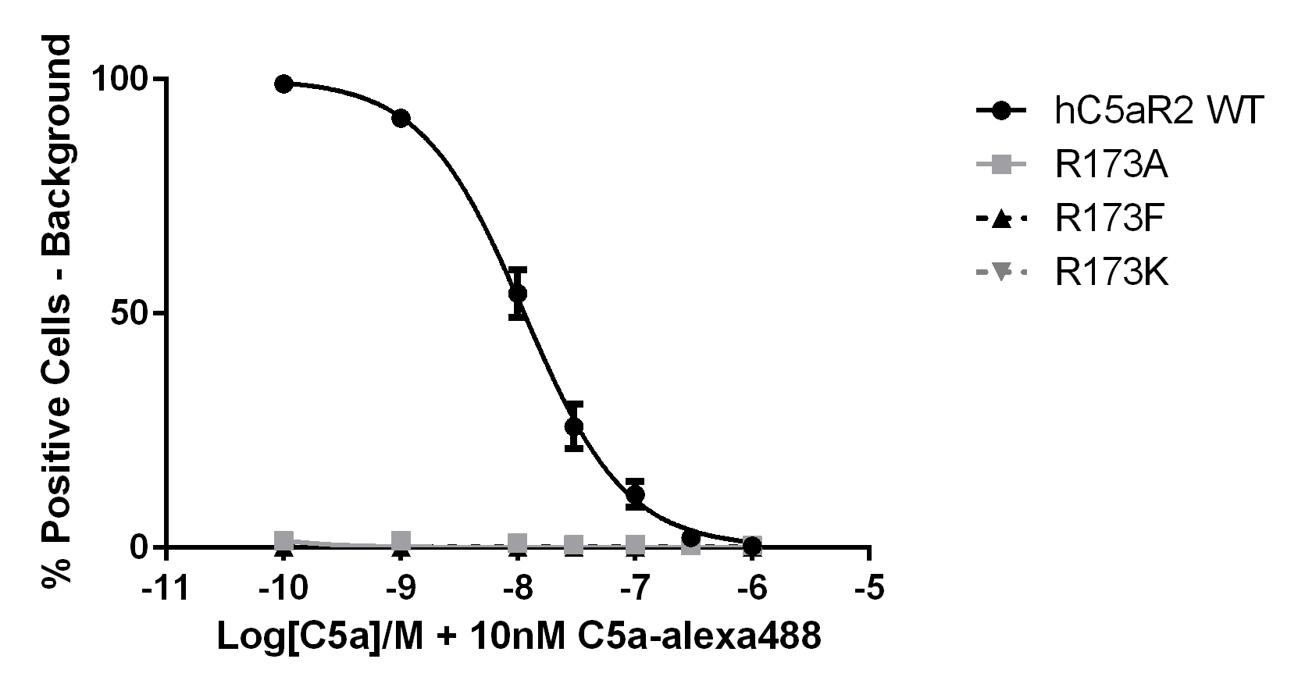
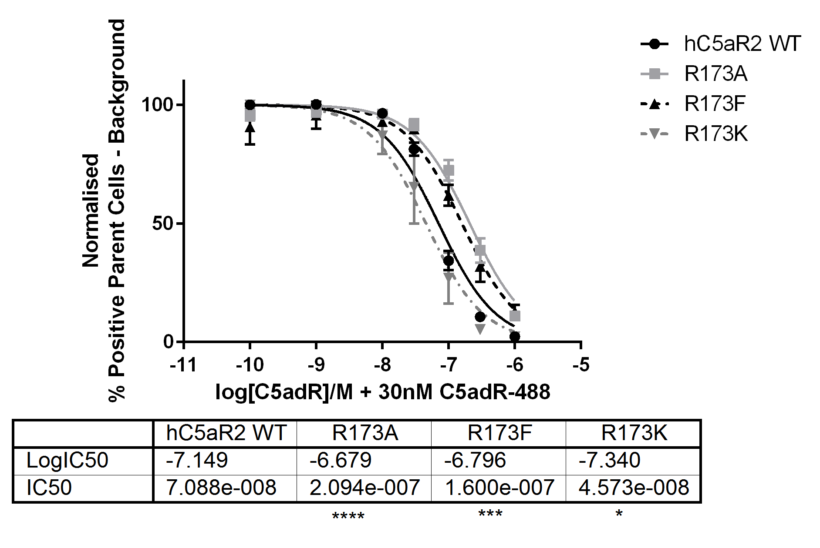

Figure 4.5 – C5a and C5a des-Arg Binding Curves for Wild-Type and R173A, R173F, R173K Mutant hC5aR2 Receptors
Figure 4.5 depicts C5a and C5a des-Arg binding curves for both wild-type and mutant, here R173A, R173F, and R173K hC5aR2 receptors. CHO cells transfected with the corresponding receptor were incubated with variable concentrations of unlabelled ligand with 10nM C5a-alexa488 or 30nM C5a des-Arg (C5adR)-alexa488 for 15 mins before analysis by flow cytometry. Error bars depict standard error of the mean (SEM) from three distinct repeats each in duplicate. Student’s t-tests were conducted on logIC50 values and p value statistical significance shown as ns = not significant, * = P ≤ 0.05, ** = P ≤ 0.01, *** = P ≤ 0.001, **** = P ≤ 0.0001.
although slightly hindered by mutation to alanine and phenylalanine which would suggest there is no major disruption of the receptor structure. Mutation to lysine caused a very slight decrease in C5a des-Arg binding affinity. The much milder effect on C5a des-Arg binding compared with C5a would suggest that C5a and C5a des-Arg are bound differently around the R173 location.

4.3.2.3 - E197

E197A again showed different effects on binding of C5a compared to C5a des-Arg. For C5a binding, E197A had no significant effect on IC50. In contrast, C5a des-Arg binding was hindered quite severely, with a significant increase in IC50 (Figure 4.6).
The analogous residue to E197 in hC5aR1 is E199. E199 is believed to form a salt bridge with residue K68 of the ligand, confirmed by the usage of the reciprocal mutants E199K and C5a[K68E] (Crass et al., 1999a). Prior to this, E199Q mutant receptors were tested for their binding and activity in response to C5a, C5a des-Arg, and a C-terminal peptide analogue of C5a. Neither C5a nor C5a des-Arg showed significant alterations in binding to E199Q mutants relative to the wild-type binding. The only residues within the C-terminus of C5a capable of interacting with E199 were K68 and R74. Based on activation data that showed C5a and C5a des-Arg affected differently by the E199Q mutation it was suggested that E199 interacts with K68 (Monk et al., 1995). Later, the reciprocal mutants were studied by Crass et al., 1999. Data showed an over seven-fold increase in IC50 of C5a binding by E199K, and very little change in IC50 for C5a des-Arg binding. In the model by Nikiforovich et al., 2008 the E199/K68 salt bridge is present and is reportedly important for receptor/ligand stabilisation. For the E199K mutants K68 of the C5a becomes pushed away from its usual position and K199 contributes to a new intra-receptor salt-bridge reducing the favourability of C5a binding. This accounts for the reduction of C5a binding seen by Crass et al., 1999. E199Q is also accounted for as hydrogen bonding between Q199 and K68 of the ligand replaces the usual salt bridge. Both Nikiforovich et al., 2008 and Crass et al., 1999 suggest C5a and C5a des-Arg have different binding modes to C5aR1 due to their different structures to explain the C5a des-Arg binding data. This work shows that the E197A mutation in hC5aR2 has no significant effect on C5a binding but causes an over 5-fold increase in IC50 for C5a des-Arg binding. The binding curve for C5a des-Arg also shows incomplete competition despite a high percentage of positive cells across all repeats (data not shown). This result would also be consistent with C5a and C5a des-Arg having different binding modes to hC5aR2.
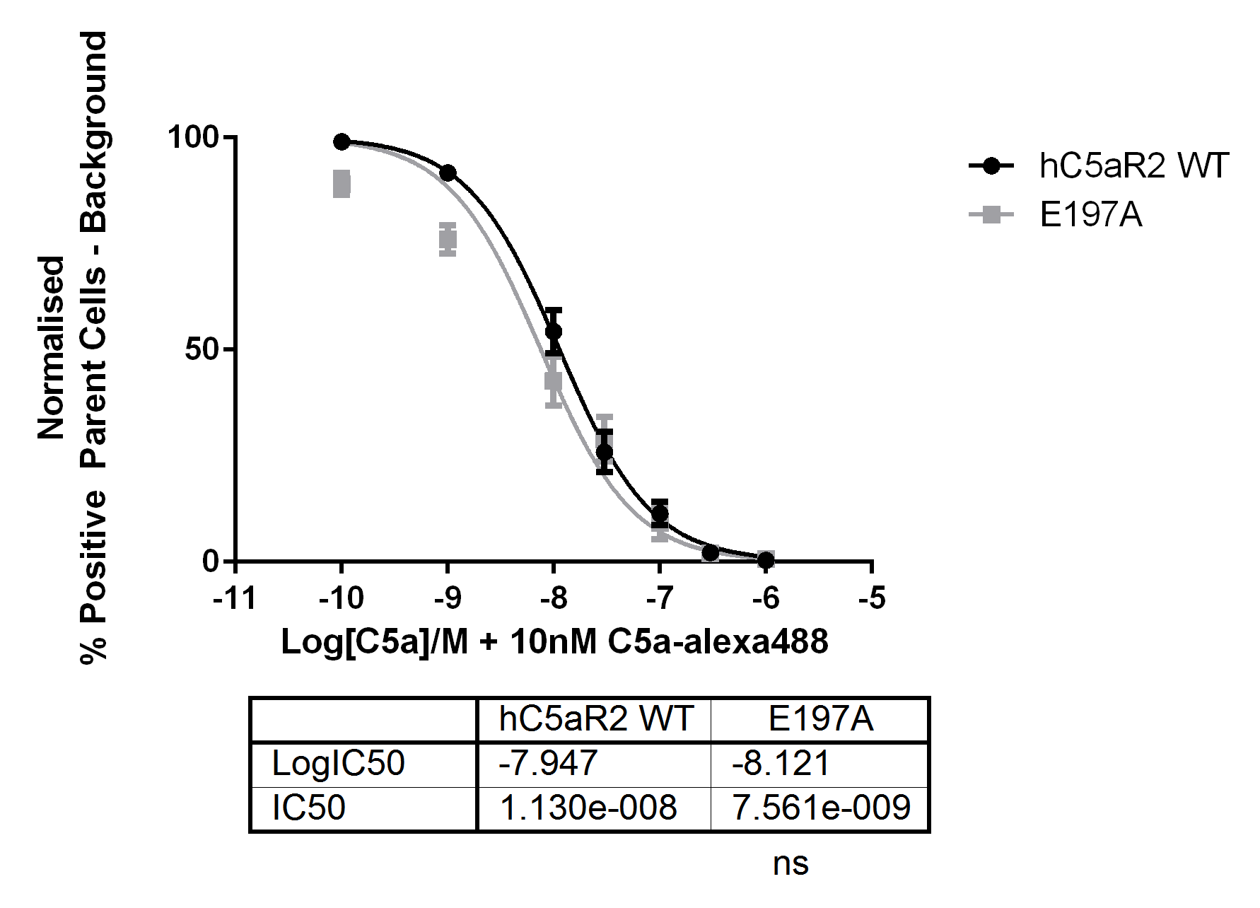
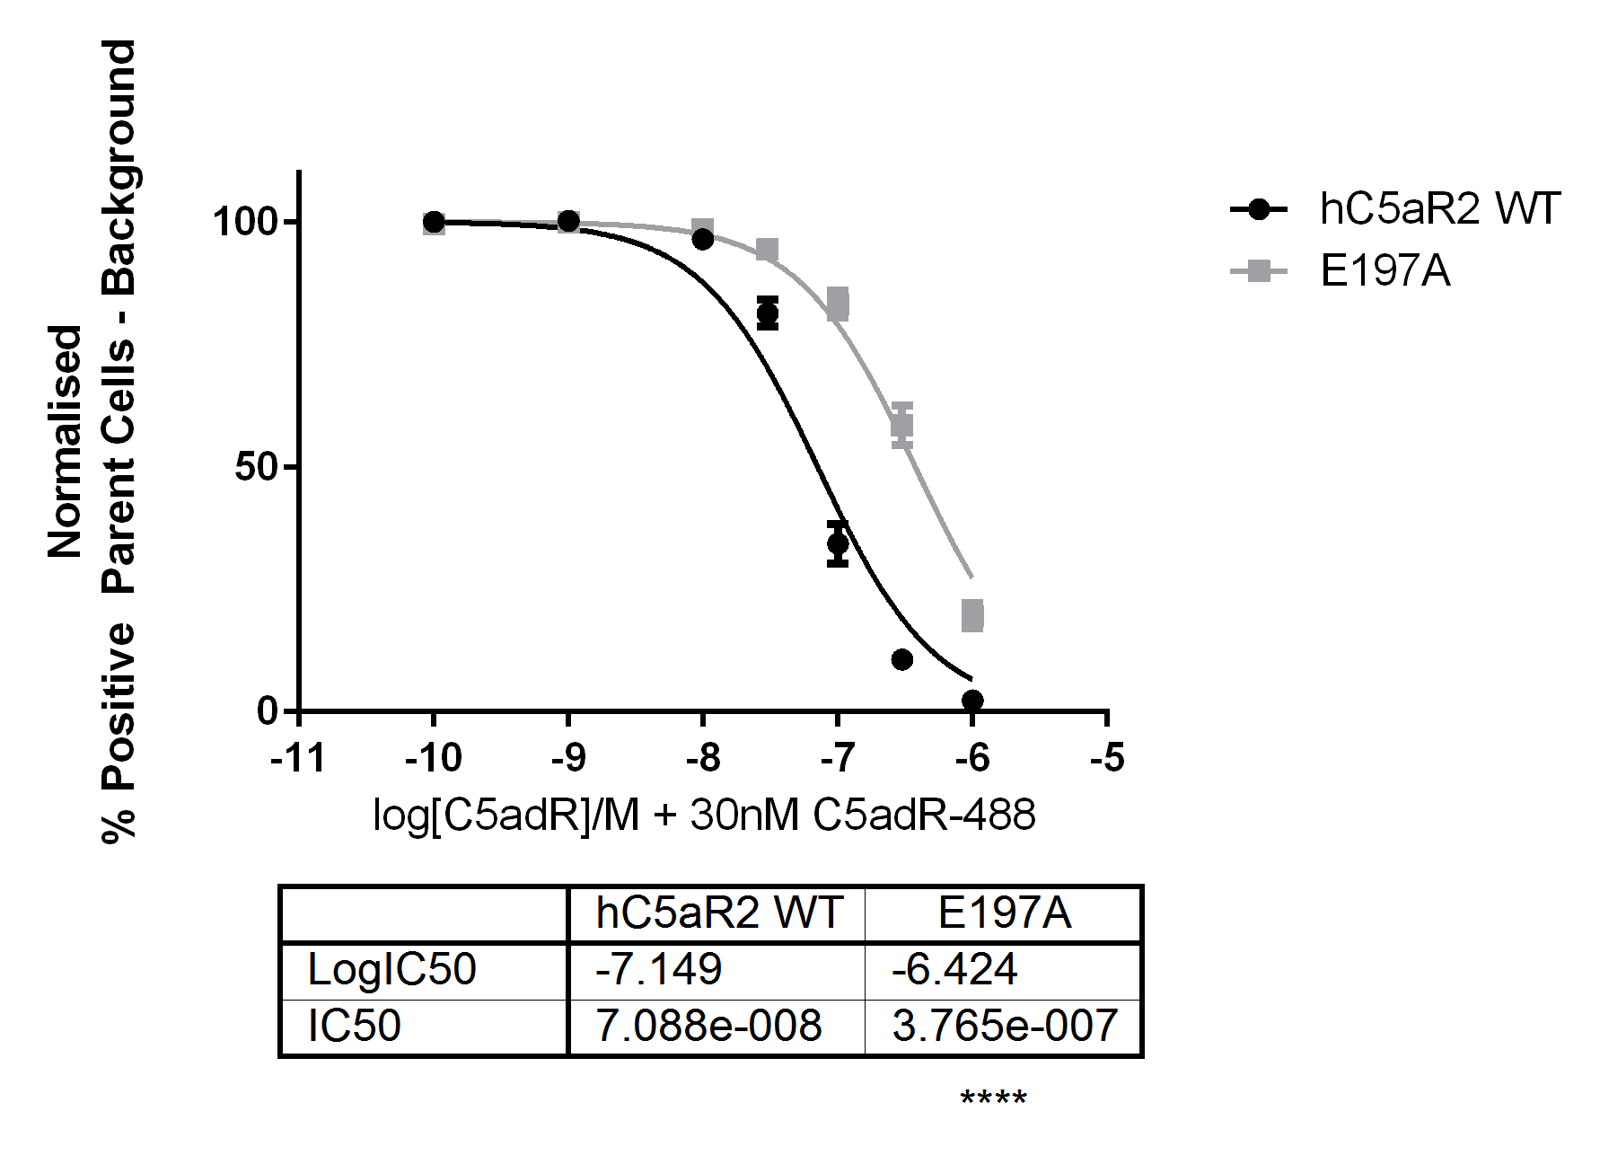

Figure 4.6 – C5a and C5a des-Arg Binding Curves for Wild-Type and E197A Mutant hC5aR2 Receptors
Figure 4.6 depicts C5a and C5a des-Arg binding curves for both wild-type and mutant, here E197A, hC5aR2 receptors. CHO cells transfected with the corresponding receptor were incubated with variable concentrations of unlabelled ligand with 10nM C5a-alexa488 or 30nM C5a des-Arg (C5adR)-alexa488 for 15 mins before analysis by flow cytometry. Error bars depict standard error of the mean (SEM) from three distinct repeats each in duplicate. Student’s t-tests were conducted on logIC50 values and p value statistical significance shown as ns = not significant, * = P ≤ 0.05, ** = P ≤ 0.01, *** = P ≤ 0.001, **** = P ≤ 0.0001.
Nikiforovich et al. (2008) predicted that hC5aR2 would have a differing binding mechanism for both ligands over hC5aR1. For example, a predicted salt bridge between D69/R200 of hC5aR1 would be lost in hC5aR2 as the R200 cognate is N198 according to CLUSTAL W analysis. In this instance, this could suggest the receptor/ligand interactions around E197 in hC5aR2 are different from those found in hC5aR1. If E197, however, was still contributing to a stabilising interaction with the ligand; mutation to E197A would be disruptive to this, despite not introducing the charge repulsion of the E199K mutations. Crass et al. (1999) suggested that the more rigid structure of the C-terminal tail of the C5a can force an interaction deep into the second binding site of the hC5aR1 receptor; despite the charge repulsion of K68/E199K in their study. A similar effect may be happening here, whereby C5a can still force an interaction but destabilisation of the receptor/ligand binding interaction is detrimental to the binding of C5a des-Arg which has the less ordered C-terminus.

4.3.2.4 - R204

R204A, R204F, and R204K mutants were tested. Here, both R204F and R204K showed no effect on C5a binding whereas R204A gave an increase in IC50 value. For C5a des-Arg binding, all three mutants showed similar, significant, negative effects with all three IC50 values being increased (Figure 4.7).
The analogous residue to R204 in hC5aR1 is R206. Originally, R206 was thought to interact directly with the carboxyl group of R74 of C5a (DeMartino et al., 1995; Raffetseder et al., 1996) which was also suggested in a more recent model (Nikiforovich et al., 2008). However, other studies tend to suggest R206 plays a role in stabilising receptor conformation (Cain et al., 2001a; Higginbottom et al., 2005) and may be important for receptor activation (Gerber et al., 2001). Most commonly R206 was mutated to A206 which showed a wide variety of effects with a trend to cause some loss of binding affinity, with the most extreme case being a total loss of C5a binding. C5a des-Arg binding affinity appears to not be changed by R206A mutation. If R206 were to interact directly with R74 it would be expected that mutation of R206 would have little effect on C5a des-Arg as the R206/R74 interaction would naturally be missing. However, in a number of cases, receptor activation by C5a des-Arg is lost in R206A mutants. This would suggest the main role of R206 is not simply to interact with R74. When C5a binding by R206K was studied little change from wild type receptor was seen. Here, R204A caused a decrease in affinity for C5a where R204K gave no change. For R204F the polar arginine has been replaced by an uncharged phenylalanine yet appears not to cause any significant change in binding affinity from the wild type. As hC5aR2 no longer couples to G-proteins it is possible that this receptor would tolerate C5a binding in a less strict receptor confirmation than hC5aR1 where ligand binding must be translated through the receptor to cause G-protein activation. For all receptor mutants binding affinity of C5a des-Arg to hC5aR2 appears to have been decreased similarly and to a greater extent than for C5a. This could also suggest R204 plays a role in receptor confirmation, and that C5a and C5a des-Arg bind to the receptor differently.

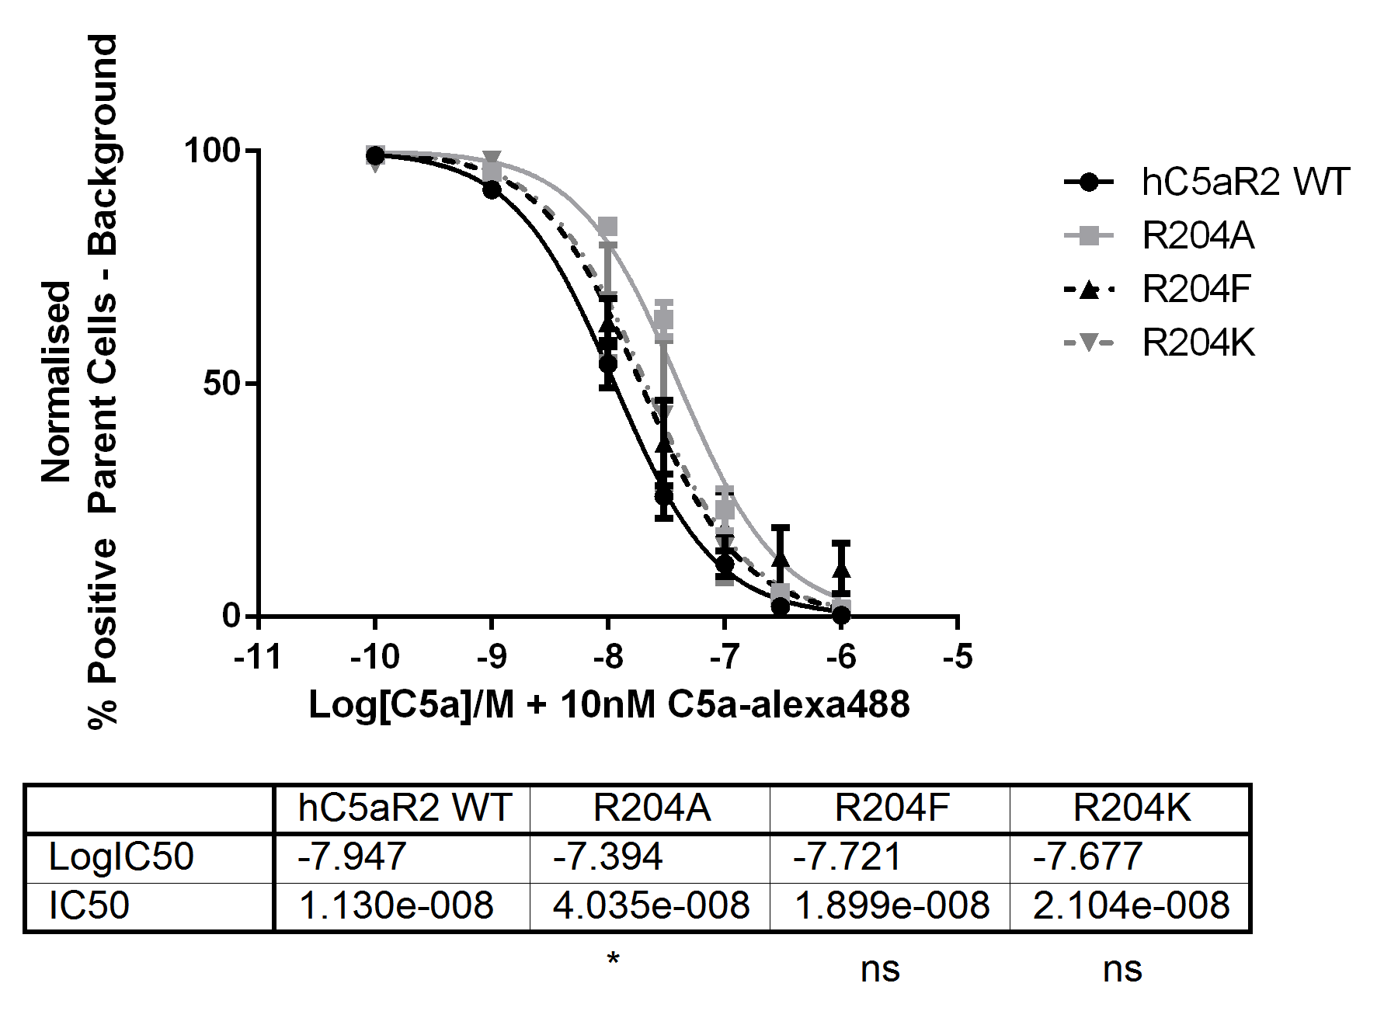
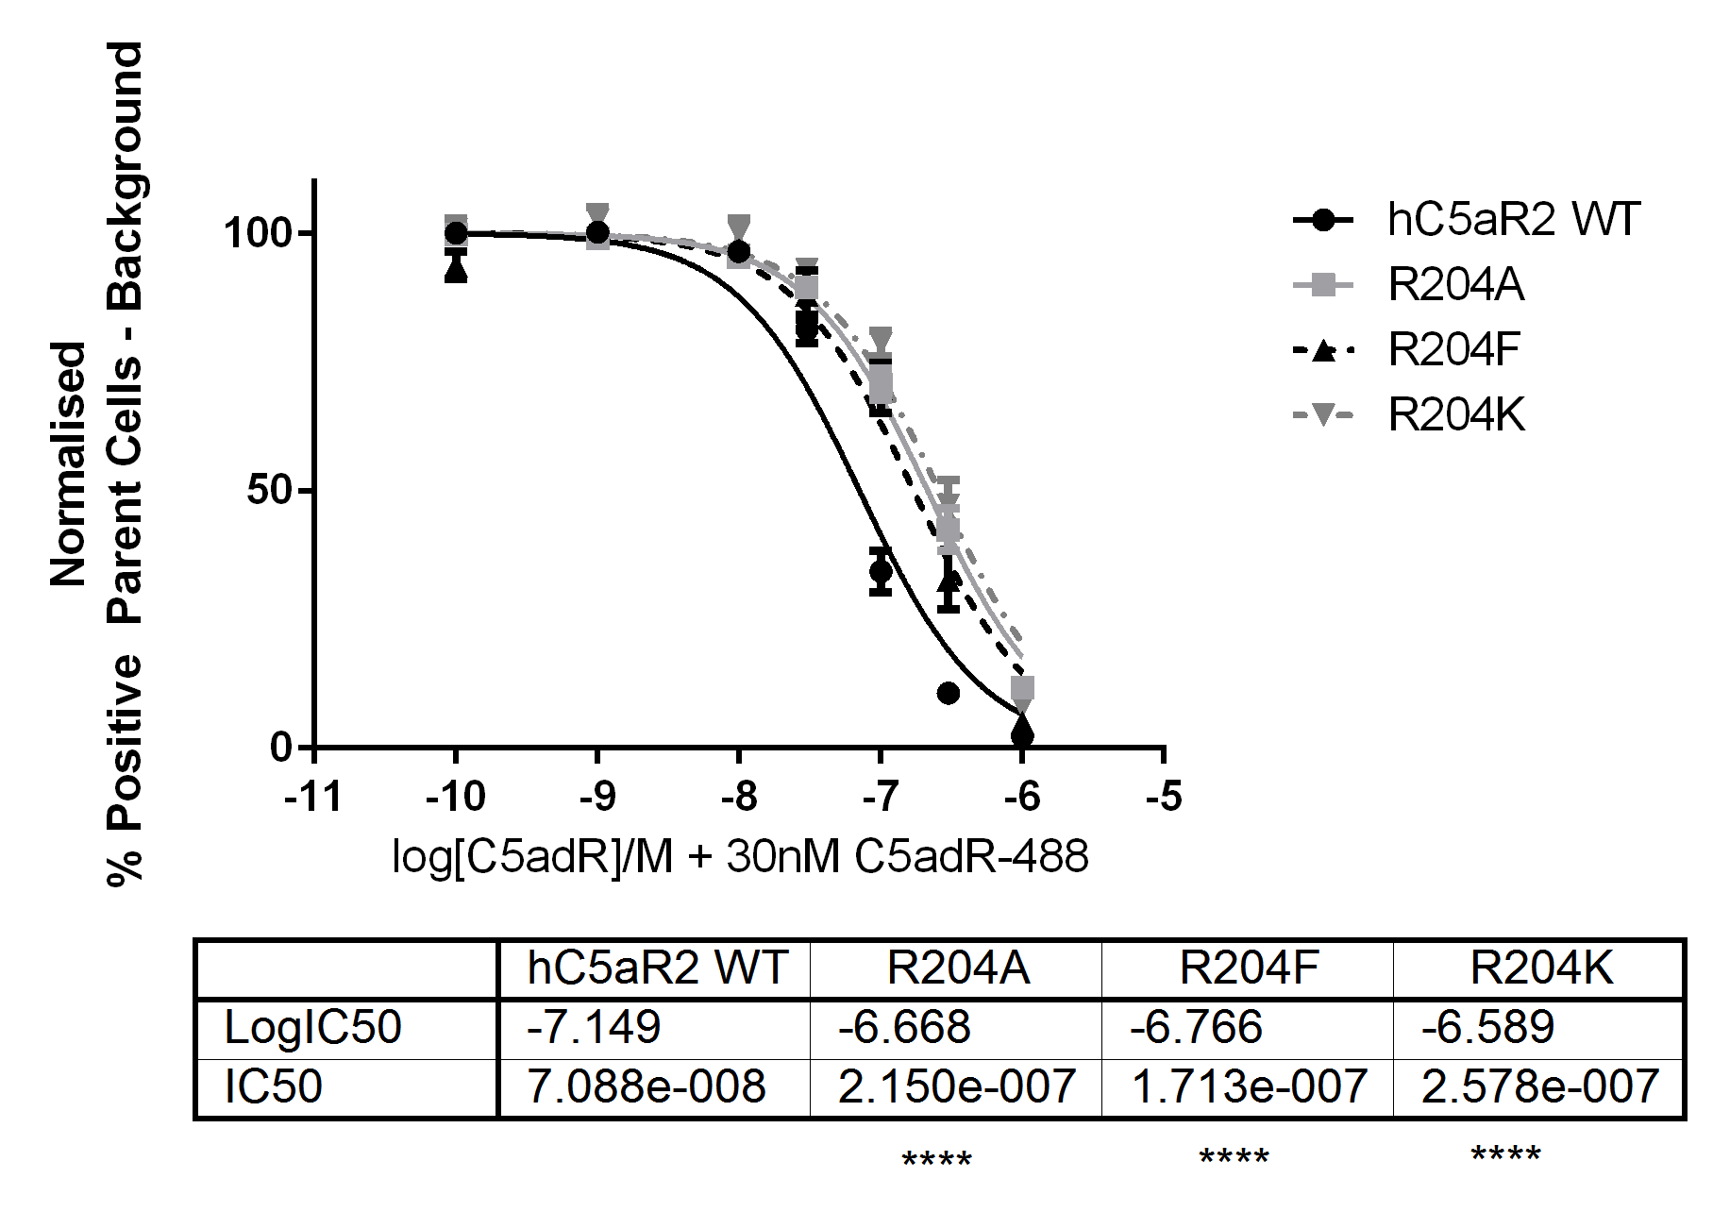

Figure 4.7 – C5a and C5a des-Arg Binding Curves for Wild-Type and R204A, R204F, and R204K Mutant hC5aR2 Receptors
Figure 4.7 depicts C5a and C5a des-Arg binding curves for both wild-type and mutant hC5aR2 receptors; here R204A, R204F, and R204K. CHO cells transfected with the corresponding receptor were incubated with variable concentrations of unlabelled ligand with 10nM C5a-alexa488 or 30nM C5a des-Arg (C5adR)-alexa488 for 15 mins before analysis by flow cytometry. Error bars depict standard error of the mean (SEM) from three distinct repeats each in duplicate. Student’s t-tests were conducted on logIC50 values and p value statistical significance shown as ns = not significant, * = P ≤ 0.05, ** = P ≤ 0.01, *** = P ≤ 0.001, **** = P ≤ 0.0001.

4.3.2.5 - E273A

E273A showed different effects on C5a and C5a des-Arg binding. C5a binding was greatly affected with little apparent competition. There were very low levels of positive fluorescent cells for C5a binding, again, despite good levels of receptor expression (data not shown). C5a des-Arg binding was not significantly affected for the E273A mutant in comparison to wild type (Figure 4.8).
The cognate residue in hC5aR1 is D282. D282 has been proposed to interact with the side-chain of R74 of C5a (Cain et al., 2001a). When ligand binding of C5a and C5a des-Arg was tested on D282A mutants there was no significant change in comparison to WT receptor for either ligand. In contrast, D282R mutant showed reduced affinity for C5a and C5a des-Arg in comparison to WT. In addition, the overall levels of C5a binding were reduced approximately 10-fold despite good expression by flow cytometry (Cain et al., 2001a). This overall reduction in C5a binding levels was also seen here (data not shown). In an earlier study performed in a different cell line, D282A mutation caused loss of C5a binding again despite good surface expression of mutant receptor able to be detected by antibody binding (Raffetseder et al., 1996). In the model, D282 was predicted not to participate in any direct interaction with the ligand, which does not match empirical data (Nikiforovich et al., 2008). Here, C5a binding to E273A hC5aR2 mutants was quite dramatically affected, in contrast to C5a des-Arg, which was not significantly different from wild type receptor. These data would may suggest that E273A may interact directly with R74 of C5a in order to cause this pronounced difference in binding affinities.

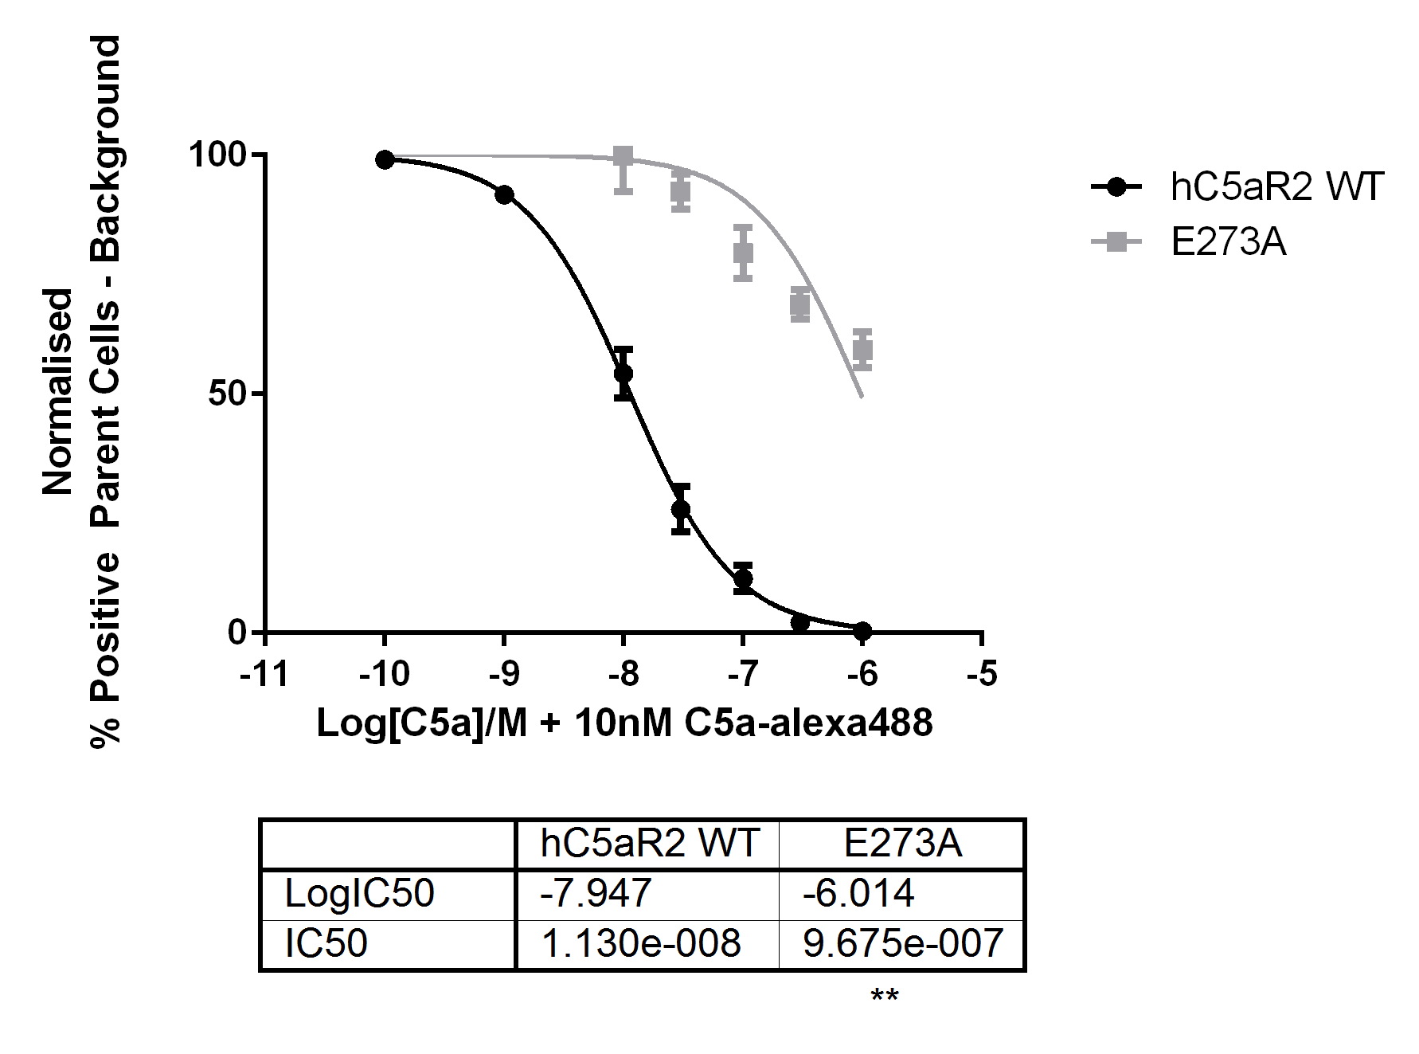
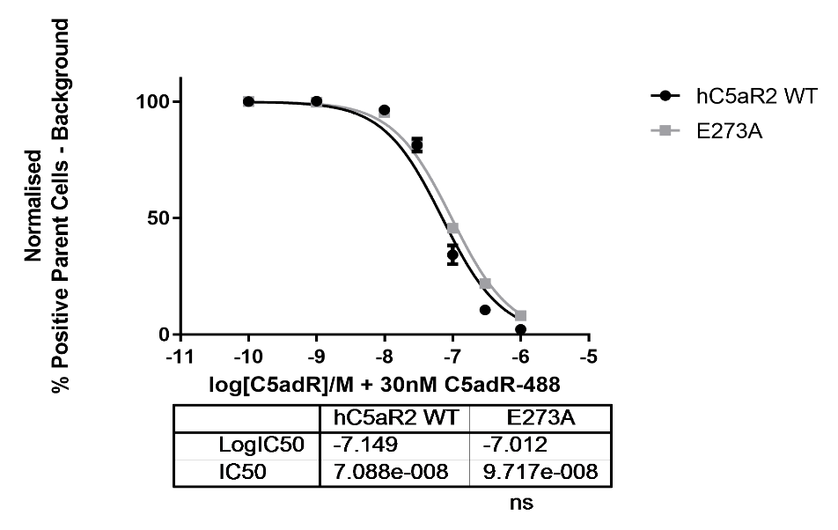

Figure 4.8 – C5a and C5a des-Arg Binding Curves for Wild-Type and E273A Mutant hC5aR2 Receptors
Figure 4.8 depicts C5a and C5a des-Arg binding curves for both wild-type and mutant, here E273A, hC5aR2 receptors. CHO cells transfected with the corresponding receptor were incubated with variable concentrations of unlabelled ligand with 10nM C5a-alexa488 or 30nM C5a des-Arg (C5adR)-alexa488 for 15 mins before analysis by flow cytometry. Error bars depict standard error of the mean (SEM) from three distinct repeats each in duplicate. Student’s t-tests were conducted on logIC50 values and p value statistical significance shown as ns = not significant, * = P ≤ 0.05, ** = P ≤ 0.01, *** = P ≤ 0.001, **** = P ≤ 0.0001.

4.3.2.6 - Summary of Ligand Binding Results
C5a |  |  |  |  | C5a des-Arg
Receptor | pIC50 | IC50 (nM) | n | Receptor |  | pIC50 | IC50 (nM) | n
hC5aR2 WT | -7.947 ± 0.04 | 11.3 | 10 | hC5aR2 WT |  | -7.149 ± 0.03 | 70.88 | 12
Y42F | -7.964 ± 0.05 | 10.87 ^{ns} | 3 | Y42F |  | -6.802 ± 0.03 | 157.70 *** | 3
R173A | - | - | 3 | R173A |  | -6.679 ± 0.04 | 209.40 **** | 3
R173F | - | - | 3 | R173F |  | -6.796 ± 0.06 | 160.00 *** | 3
R173K | - | - | 3 | R173K |  | -7.340 ± 0.08 | 45.73 * | 3
E197A | -8.121 ± 0.07 | 7.61 ^{ns} | 3 | E197A |  | -6.424 ± 0.03 | 376.50 **** | 3
R204A | -7.394 ± 0.04 | 40.35 * | 3 | R204A |  | -6.668 ± 0.03 | 215.00 **** | 3
R204F | -7.721 ± 0.07 | 18.99 ^{ns} | 3 | R204F |  | -6.766 ± 0.05 | 171.30 **** | 3
R204K | -7.677 ± 0.08 | 21.04 ^{ns} | 3 | R204K |  | -6.589 ± 0.05 | 257.80 **** | 3
E273A | -6.014 ± 0.08 | 967.50 ** | 3 | E273A |  | -7.012 ± 0.02 | 97.17 ^{ns} | 3

Table 4.1 – C5a and C5a des-Arg hC5aR2 Binding Data
pIC50 = -log(IC50) ± SEM, IC50 values are given in nM. Statistics are Student’s t-tests performed between each mutant and the corresponding wild type. ns = no significant difference, * = P ≤ 0.05, ** = P ≤ 0.01, *** = P ≤ 0.001, **** = P ≤ 0.0001

Residue | Mutation | C5a Effect | C5a des-Arg Effect | Reference
F44 | Val, Ile, Leu | In random mutagenesis of Helix I only hydrophobic residues were tolerated | - | (Geva et al., 2000)
R175 | Ala | Increased affinity  More than 10x fewer surface receptors than WT receptor | - | (Raffetseder et al., 1996)
 | Ala | Decreased affinity | No significant change | (Higginbottom et al., 2005)
 | Asp | Decreased affinity | Decreased affinity
E199 | Gln | No change | No change | (Monk et al., 1995)
 | Lys | Decreased affinity | No change | (Crass et al., 1999a)
R206 | Ala | No change | - | (DeMartino et al., 1995)
 | Ala | No binding | - | (Raffetseder et al., 1996)
 | Lys | No change | -
 | Gln | Decreased affinity  Most receptors not binding with some high affinity receptors remaining | -
 | Ala | Decreased affinity | No significant change | (Cain et al., 2001a)
 | Ala | Decreased affinity | No significant change | (Higginbottom et al., 2005)
D282 | Ala | No binding | - | (Raffetseder et al., 1996)
 | Asn | No change | -
 | Asp | No significant change | No significant change | (Cain et al., 2001a)
 | Arg | Decreased affinity | Decreased affinity

Table 4.2 – Summary of Previous Ligand Binding Findings in hC5aR1

Overall it would appear that C5a des-Arg binding was more frequently affected than C5a binding by mutation of hC5aR2. As hC5aR2 binds C5a des-Arg with a higher affinity than hC5aR1 this suggests that the binding mechanism of this ligand would be different between the two receptors. In addition, these data shown here would also suggest that C5a and C5a des-Arg are bound differently to hC5aR2.
There is no previous data from hC5aR2 binding assays using receptor mutated in the same regions and so without further study it is difficult to draw more in-depth conclusions about the C5a and C5a des-Arg binding mechanism of hC5aR2. Binding assays performed using C5a mutants may have given further insight into any specific interactions between the receptor and the ligand however problems with the expression of these ligands prevented this. In addition, there are some drawbacks to these experiments which should be taken into consideration. Cells are incubated with ligand for 15 mins prior to fluorescence detection by flow cytometry. As mentioned previously, this could mean that some short-term ligand binding is missed as only ligand still bound to receptor after 15 mins is detected. In an attempt to determine the influence of this on the data, fluorescence levels of 10nM C5a-a488 and 30nM C5a des-Arg-a488 bound to hC5aR2 wild type were measured every 5 mins for 1 hr (Figure 4.9).

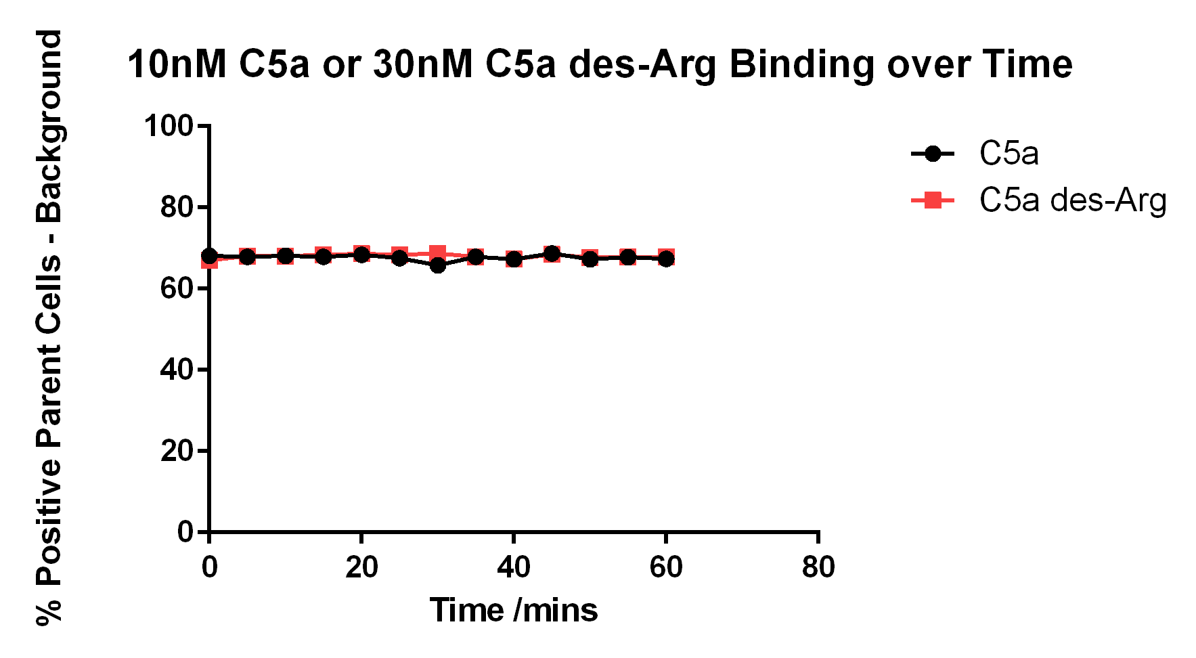

Figure 4.9 – Binding of C5a and C5a des-Arg to hC5aR2 WT over 60 mins
hC5aR2 WT transfected CHO cells were prepared for flow cytometry as in 2.2.5.2. Either 10nM C5a-a488 (black) or 30nM C5a des-Arg-a488 (grey) was added to a master batch of cells and fluorescence detected (as percentage positive cells) in samples every 5 mins across 60 mins. Background fluorescence levels were removed from all samples.
From the figure, it is apparent that within this time range there is little variation in the ligand binding levels. Within the time-scale of the ligand binding assays performed here the binding time, and time to read the samples, should have little effect on binding results. Previously the on/off rate of C5a binding to hC5aR2 transfected L1.2 mouse B-cells was measured (Okinaga et al., 2003). In the study hC5aR2 was shown to take upwards of 60 mins to reach equilibrium binding however 0.1nM radiolabelled C5a was used. In this work a 10-fold greater concentration of C5a was used which perhaps could reduce the amount of time taken for binding to reach equilibrium. Alternatively, it is possible there could be a greater number of surface expressed hC5aR2 receptors in the transfected cells in this work than in the previous study.

In addition, there is the possibility that the Alexa-488 moieties, which have a molecular weight of 643.4, could still interfere with the ligand-receptor interaction in some way. In hC5aR1 the N-terminus and core of the ligand have been shown to make interactions with the flexible N-terminus of the receptor; a summary of a number of studies is given in the review by Klos et al., 2013. The interactions at the N-terminus are important for ligand affinity. Minor disruption of these N-terminal interactions in hC5aR2 by the presence of the Alexa-488 may have affected the affinity of labelled ligands for the receptor. The role of the hC5aR2 N-terminus in ligand binding shall be discussed in more detail in the following section.
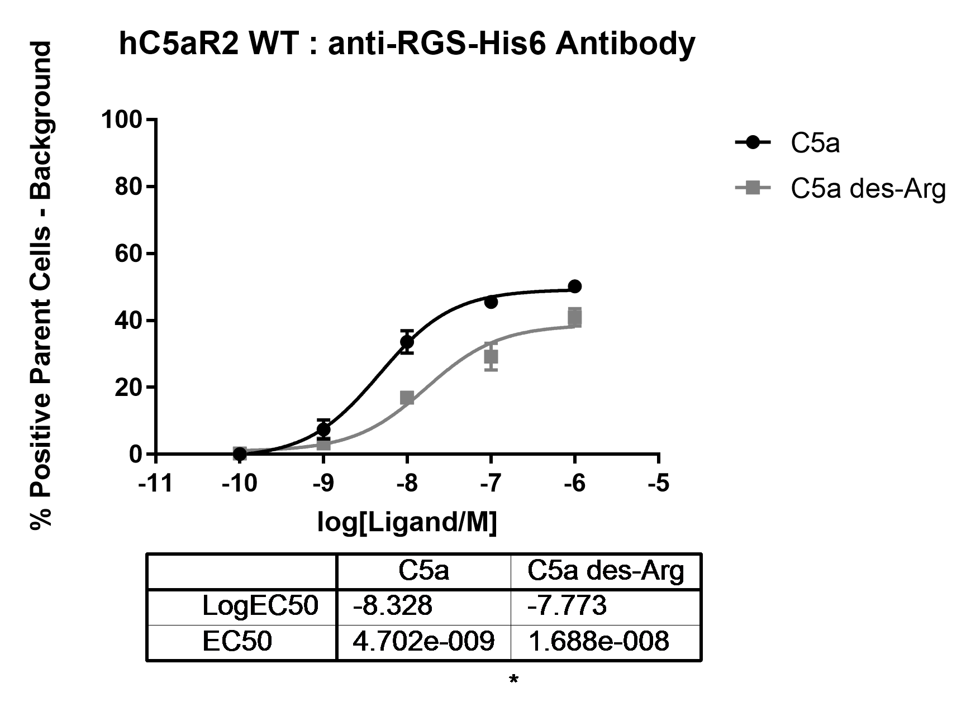
As a means for comparison, binding of unlabelled C5a and C5a des-Arg was detected using an antibody directed against the His-tag on both ligands (Figure 4.10).

Figure 4.10 – C5a and C5a des-Arg Binding to hC5aR2 WT Detected Using Anti-RGS-His6 Antibody
Cells were prepared and plated for flow cytometry as in 2.2.5.2. Cells were washed then incubated with C5a (black line) or C5a des-Arg (grey line) at 4°C for 30 mins. Cells were washed, incubated in anti-RGS-His6 antibody for 30 mins, 4°C, washed, and then incubated in FITC labelled secondary antibody for 30 mins, 4°C. A final wash was performed prior to detection by flow cytometry. Cells incubated with only secondary antibody were used as a background control. An isotype control + 1µM ligand + secondary antibody was also run to determine non-specific antibody binding. Statistics are a Student’s t-test where * = P ≤ 0.05, n=3.
The IC50 values determined here are similar to those in Figures 4.2 and 4.3 using labelled ligands which may suggest that ligand binding is not severely affected by the presence of the Alexa-488. Both the His-tag and the Alexa-488 are found at the beginning of the N-terminus of the both ligands. These data could suggest that the ligand N-terminus is not buried within the receptor, as it is visible to antibody, and so the addition of the Alexa-488, and the His-tag, is not very disruptive.

4.3.3 - Blocking of the Receptor N-terminus

For hC5aR1, a number of studies using both ligand and receptor mutants have shown that the N-terminus to be important for ligand binding affinity. The N-terminus of the hC5aR1 receptor contains a number of charged residues which interact with the core of the ligand, in particular C5a has been studied. When the first 22-30 residues of the hC5aR1 N-terminus were deleted or mutated C5a binding was reduced. Despite these findings, C-terminal C5a analogues were still able to cause receptor activation (DeMartino et al., 1994; Mery and Boulay, 1994). These data are indicative that ligand binding by hC5aR1 occurs via a two-site mechanism whereby the N-terminus is important for ligand binding affinity and selectivity, and the second site involves interactions between transmembrane and extra-cellular loop (ECL) residues on the receptor interacting with the ligand C-terminus.
In the hC5aR2 N-terminus there are similar charged residues to those in hC5aR1. In order to determine whether the hC5aR2 N-terminus plays a similar role to that in hC5aR1, Scola et al. (2006) used antibodies directed against the N-terminus in an attempt to block ligand binding. When a similar study was conducted in hC5aR1 by Oppermann et al., 1993, antibodies directed against the N-terminus of the receptor could block C5a binding. When the N-terminus of hC5aR2 was blocked using antibodies there was a slight, but non-significant, change to C5a binding but a much greater reduction in C5a des-Arg affinity. This suggested a role for the receptor N-terminus in providing the higher affinity C5a des-Arg binding by hC5aR2 in comparison with hC5aR1. In addition, mutation of certain acidic and tyrosine residues within the hC5aR2 N-terminus had greater effects on C5a des-Arg binding than C5a binding. However, interestingly, when in the same study the residues 1-32 of hC5aR2 were replaced with 1-37 of hC5aR1 there was no significant change in C5a or C5a des-Arg binding affinity. This suggests that although the hC5aR2 N-terminus is important for C5a des-Arg binding it is not the only contributing factor to the higher binding affinity in comparison to hC5aR1.
As in Scola et al. (2006), an attempt to block the hC5aR2 N-terminus for the wild type and mutant receptors was made using antibody in this work. Serum was obtained from rabbits which were exposed to a peptide corresponding to the hC5aR2 wild type N-terminus. This serum was affinity purified to obtain polyclonal antibody to be used in the experiments. However, antibodies from this batch gave unexpected results when binding of C5a and C5a des-Arg was studied (Figure 4.11).
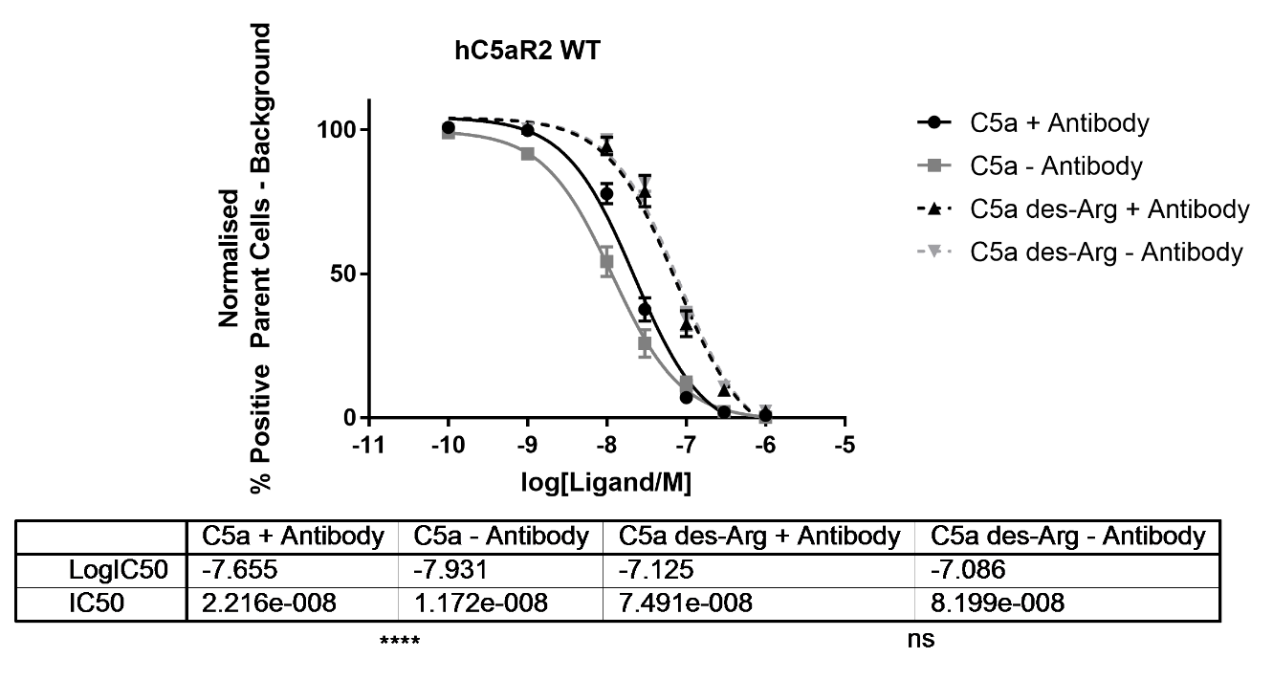

Figure 4.11 – Effects of Blocking hC5aR2 N-Terminus with Antibody on C5a and C5a des-Arg Binding
Cells were prepared for flow cytometry as in 2.2.5.2. Cells were washed then incubated with anti-hC5aR2 antibody (black lines) 15 mins at 4°C. Grey lines show previous binding data without addition of antibody. After washing, cells were incubated with C5a (solid lines) or (C5a des-Arg dashed lines) at the shown concentrations + 10nM C5a-Alexa488 or 30nM C5a des-Arg-Alexa488 at 4°C for 15 mins before detection by flow cytometry. Statistics are Student’s t-tests where ns = not significant, **** = P ≤ 0.0001.
Where previously it was found that blocking the receptor N-terminus only had an effect on C5a des-Arg binding, here the opposite was true. There is a slight, but statistically significant, decrease in the affinity of C5a for the receptor whereas C5a des-Arg binding remains unchanged. As the antibody used here and the antibody used in the study by Scola were polyclonal preparations from different batches of serum, although raised from the same peptide as stated in Kalant et al. (2003), it is possible that they bind different epitopes or bind in different conformations which could have affected the results. The same assay was carried out using C5a and C5a des-Arg on each hC5aR2 mutant (Figure 4.12, Table 4.3 – C5a, Figure 4.13, Table 4.4 – C5a des-Arg).
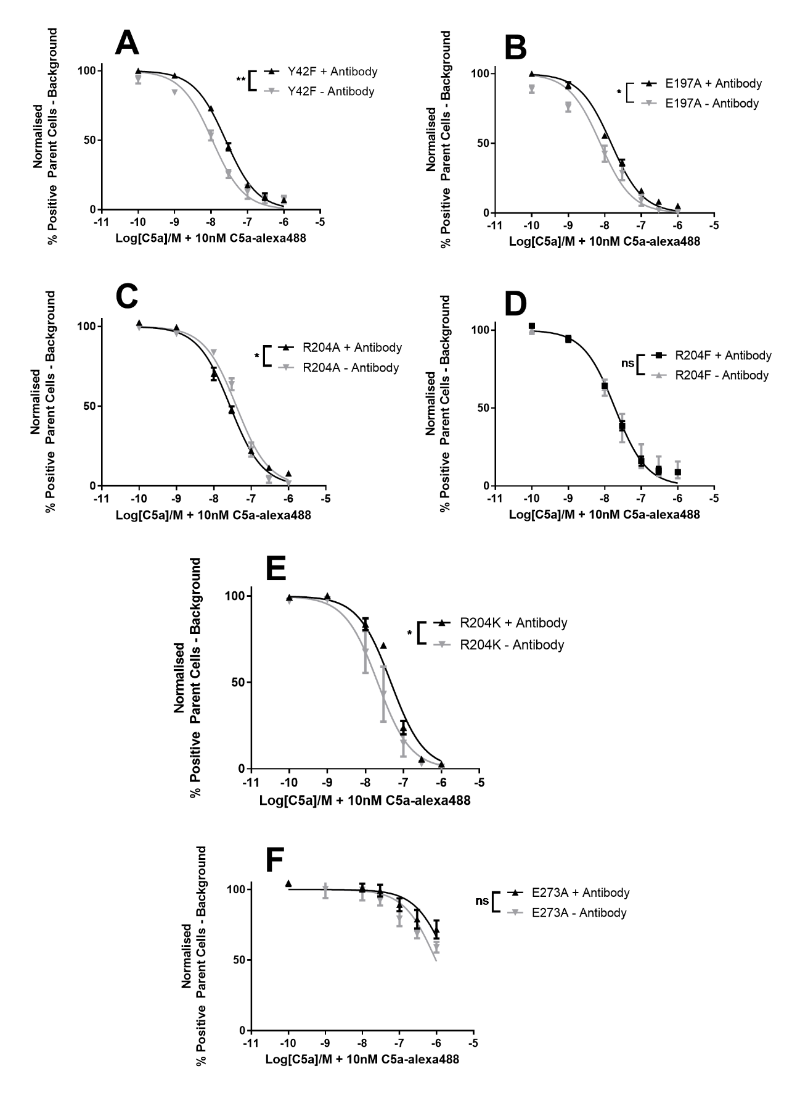

Figure 4.12 – Comparison of C5a Binding to hC5aR2 Mutants With and Without Addition of Antibody Directed Against Receptor N-Terminus
Cells were prepared for flow cytometry as in 2.2.5.2 and the experiment carried out using C5a and antibody directed against the hC5aR2 N-terminus. Panels A-F show previous competition binding data, without antibody (grey lines), compared with competition binding data with antibody (black lines) for Y42F, E197A, R204A, R204F, R204K, and E273A hC5aR2 mutants respectively. Results show data after three repeats in duplicate. Statistics are Student’s t-tests whereby ns = no significant difference, * = P ≤ 0.05, ** = P ≤ 0.01.
Receptor | + Antibody IC50 (nM) | n | - Antibody IC50 (nM) | n
hC5aR2 WT | 20.63**** | 6 | 11.3 | 10
Y42F | 25.30** | 3 | 10.87 | 3
R173A | - | - | No Binding | 3
R173F | - | - | No Binding | 3
R173K | - | - | No Binding | 3
E197A | 15.03* | 3 | 7.61 | 3
R204A | 27.46* | 3 | 40.35 | 3
R204F | 19.10^{ns} | 3 | 18.99 | 3
R204K | 46.99* | 3 | 21.04 | 3
E273A | 1990^{ns} | 3 | 967.5 | 3

Table 4.3 – IC50 Values for Comparison of C5a Binding to hC5aR2 Mutants With and Without Addition of Antibody Directed Against Receptor N-Terminus
IC50 values are given in nM. Statistics are Student’s t-tests whereby ns = no significant difference, * = P ≤ 0.05, ** = P ≤ 0.01.

In most cases, when the antibody was used, there were no severe effects on C5a binding. Both R204F (panel D) and E273A (panel F) did not show any statistically significant difference between the with and without antibody conditions. C5a binding to hC5aR2 WT was affected by the antibody, but interestingly not for the R204F or E273A mutants. For E273A this may be because the mutation caused quite a large reduction in the C5a binding ability of the receptor alone which may mask the effect of the presence of antibody. However, the R204F mutation caused no significant change in the C5a binding ability of the receptor yet is also unaffected by the presence of antibody.

Changes to the ligand binding ability of the other mutant receptors (panels A, B, and E) appear to be similar to those of the WT receptor causing an approximate 2-fold increase in IC50 values. All three of these mutants, Y42F, E197A, and R204K showed no significant change in C5a binding in comparison to WT (Table 4.3). This could explain their similar behaviour to WT in the presence of antibody and this may suggest the N-terminus of hC5aR2 has a greater role in C5a binding than the transmembrane and ECL residues shown to be important in hC5aR1. The exception to this is R204A (panel C). The mutation of R204 caused an increase in IC50 value in comparison to WT receptor for C5a binding alone, corresponding to a decrease in binding affinity. With the addition of antibody, the R204A IC50 decreased corresponding to an increased binding affinity.
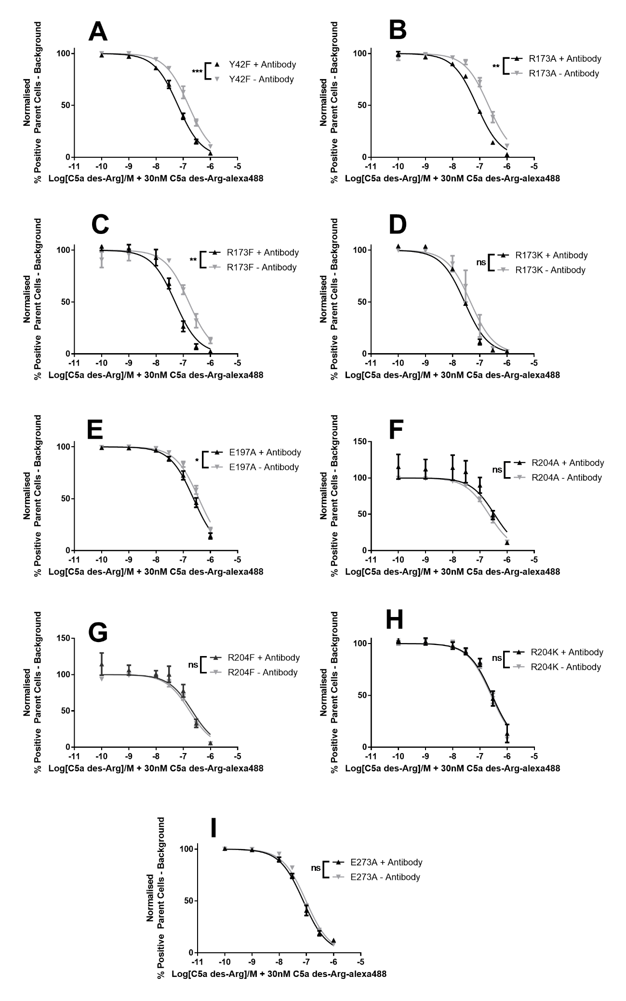

Figure 4.13 - Comparison of C5a des-Arg Binding to hC5aR2 Mutants With and Without Addition of Antibody Directed Against Receptor N-Terminus
Cells were prepared for flow cytometry as in 2.2.5.2 and the experiment carried out using C5a des-Arg and using antibody directed against the hC5aR2 N-terminus. Panels A-I show previous competition binding data, without antibody (grey lines), compared with competition binding data with antibody (black lines) for Y42F, R173A, R173F, R173K, E197A, R204A, R204F, R204K, and E273A hC5aR2 mutants respectively. Results show data after three repeats in duplicate. Statistics are Student’s t-tests whereby ns = no significant difference, * = P ≤ 0.05, ** = P ≤ 0.01, *** = P ≤ 0.001.

Receptor | + Antibody IC50 (nM) | n | - Antibody IC50 (nM) | n
hC5aR2 WT | 65.52^{ns} | 6 | 70.88 | 12
Y42F | 64.13*** | 3 | 157.7 | 3
R173A | 77.97** | - | 209.4 | 3
R173F | 50.41** | - | 160 | 3
R173K | 27.67^{ns} | - | 45.73 | 3
E197A | 239.90* | 3 | 376.5 | 3
R204A | 343.60^{ns} | 3 | 215 | 3
R204F | 212.40^{ns} | 3 | 171.3 | 3
R204K | 280.30^{ns} | 3 | 257.8 | 3
E273A | 76.89^{ns} | 3 | 97.17 | 3
Table 4.4 – IC50 Values for Comparison of C5a des-Arg Binding to hC5aR2 Mutants With and Without Addition of Antibody Directed Against Receptor N-Terminus
IC50 values are given in nM. Statistics are Student’s t-tests whereby ns = no significant difference, * = P ≤ 0.05, ** = P ≤ 0.01, *** = P ≤ 0.001.

In the C5a des-Arg assays R173K, R204A, R204F, R204K, and E273A (Figure 4.13 - panels D, F, G, H, and I) showed no significant change to ligand binding on addition of the antibody. Y42F, R173A, R173F, and E197A (panels A, B, C, and E) mutants all showed decreases in IC50 values, suggesting an increased binding affinity. This is despite every mutant, excluding E273A, showing reduced affinity for C5a des-Arg binding in comparison to WT hC5aR2 (Table 4.4). There was no significant effect on the binding of C5a des-Arg by hC5aR2 WT when the antibody was present and so it would be expected that some mutants would also show no significant change to their ability to bind ligand. However, it is interesting that the remaining mutants, (panels A, B, C, E) saw increased ligand affinity in the presence of antibody.
The caveat with this data is that the antibody used was polyclonal, purified from serum, and was not from the same batch as was previously used by Scola et al. (2007). The problem with this approach being that the two antibodies may not bind to the same epitope and so will interfere with ligand binding in different ways. Another antibody could have been raised for comparison but this would have the same problem of not knowing exactly what epitope it binds to. Instead, it may be better in the future to use mutants to study the effect of the N-terminus of hC5aR2 on ligand binding. Previously for hC5aR1 data has shown that mutation of multiple acidic N-terminus residues to Ala or Asn causes large disruption to C5a binding (DeMartino et al., 1994) whereas single mutations had little effect (Mery and Boulay, 1994). For hC5aR2 receptor mutants with single mutations in acidic or tyrosine residues have been studied. It was found, generally, that these mutants more often had altered C5a des-Arg binding than altered C5a binding (Scola et al., 2007). In the future, it could be interesting to study mutant receptors which have multiple mutations at the N-terminus instead of trying to block binding with antibody.

4.3.4 - Peptide Binding

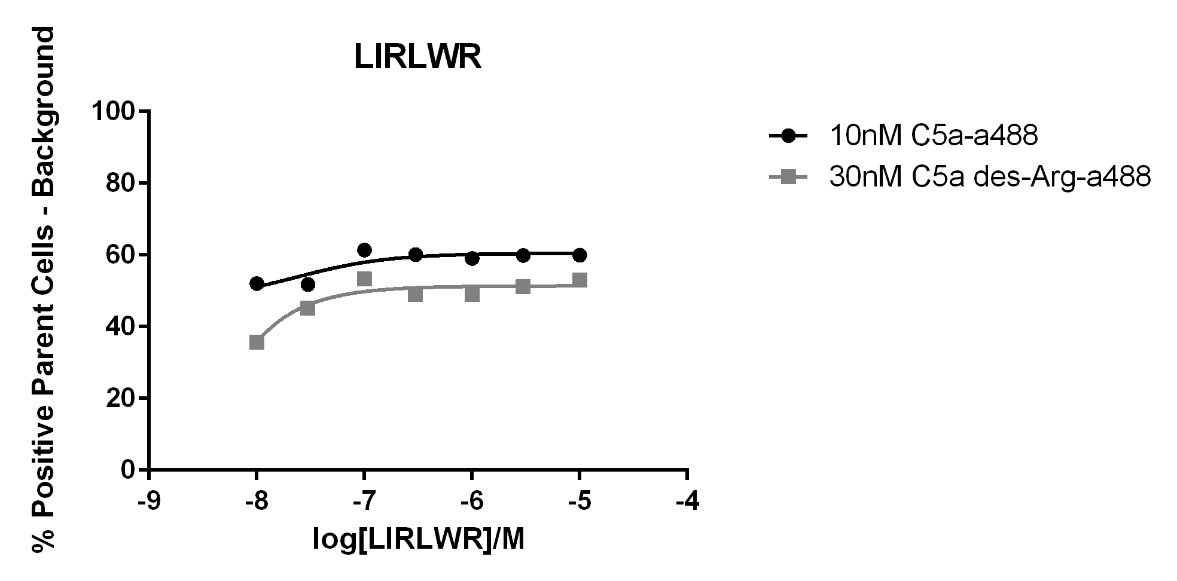
Until recently, there were no selective peptides targeted against hC5aR2 and most would only or also bind hC5aR1. After library screening, Croker et al. (2016) discovered two candidate peptides which would inhibit ¹²⁵I-C5a binding to hC5aR2 membrane preps. One peptide, RHYPYWR, had similar affinities for hC5aR1 and hC5aR2 (~200µM) whereas the other, LIRLWR, had a much higher affinity for hC5aR2 over hC5aR1 (48µM vs 466µM) (Croker et al., 2016). In this study, both RHYPYWR and LIRLWR peptides were synthesised by Genscript and their binding to transfected CHO cells tested (Figure 4.14).

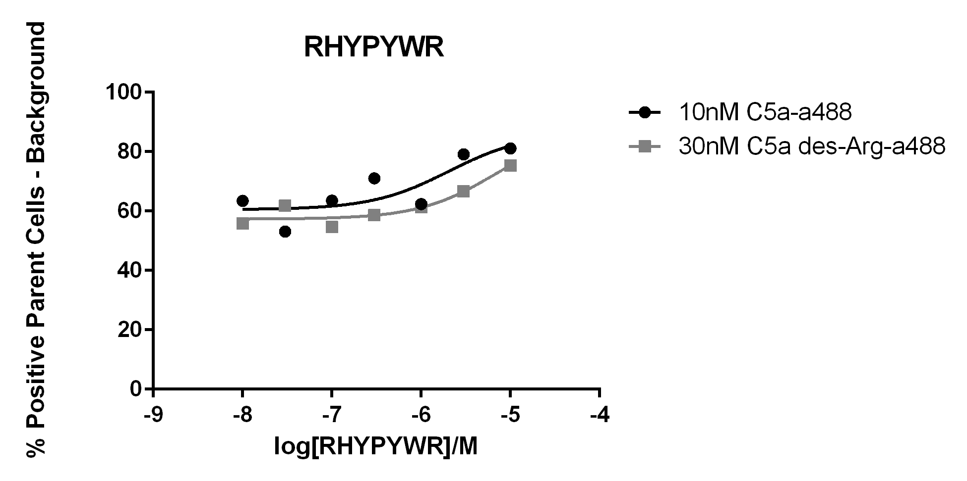

Figure 4.14 – Competition Binding Curves between C5a-a488 or C5a des-Arg-a488 and either LIRLWR or RHYPYWR hC5aR2 Selective Peptides
Prepared CHO cells transfected with hC5aR2 WT receptor were incubated for 15min at 4°C with varying concentration of either LIRLWR or RHYPYWR peptide (n=1). In addition, either 10nM C5a-a488 (black) or 30nM C5a des-Arg-a488 (grey) was added. Background fluorescence was removed from all samples.
In the figure, it is apparent that there is little to no competition between the labelled ligands and the unlabelled peptides. If the peptides were successfully competing with binding of ligand, then it would be expected to see a drop in the percentage of positive cells as the concentration of peptide increases. For both RHYPYWR and LIRLWR the percentage of positive cells remains fairly constant regardless of peptide concentration. This suggests fluorescence levels were remaining constant most probably due to labelled ligand not being competed off of hC5aR2. In the original binding screens by Croker et al. (2016) radioactively labelled C5a was used in competition assays which is able to be used at much lower concentrations (~20pM). It is possible that at the nM range the affinity of C5a and C5a des-Arg for hC5aR2 is too great to be overcome by the peptides at the tested ranges.
Fluorescein amidite (FAM) labelled versions of both peptides were synthesised by Genscript. In an attempt to avoid competition with a higher affinity ligand, direct binding studies with fluorescently labelled peptides would be attempted. Firstly, binding was assayed on CHO hC5aR2 WT transfected cells and on untransfected (non-x) cells to determine if there were high levels of non-specific fluorescence (Figure 4.15).

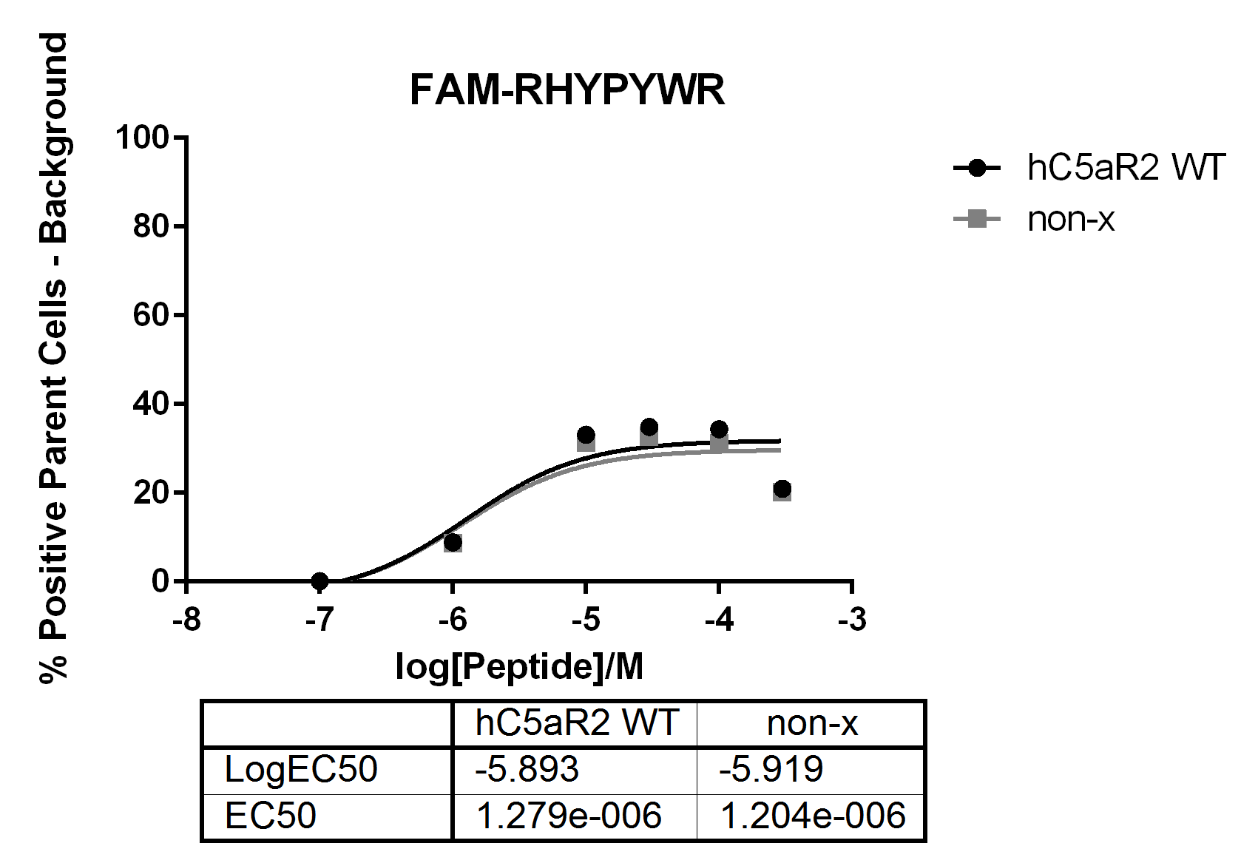

Figure 4.15 – FAM-RHYPYWR Binding to hC5aR2 WT Transfected CHO Cells and
non-x CHO Cells
Prepared CHO cells, either non-transfected (non-x) or transfected with hC5aR2 WT, were incubated with varying concentrations of FAM-RHYPYWR labelled peptide for 15 mins at 4°C before detection by flow cytometry. Background fluorescence values were removed from all values.
In the figure, both curves appear similar to each other. As non-x CHO cells do not express hC5aR1 or hC5aR2 on their cell surface it would not be expected that RHYPYWR would be able to show any specific binding. As such, this would imply that the fluorescence detected was in the most part non-specific binding. One further assay was attempted which included the addition of a washing step after the 15 mins binding incubation and before detection by flow cytometry in an effort to remove excess unbound labelled peptide (Figure 4.16).

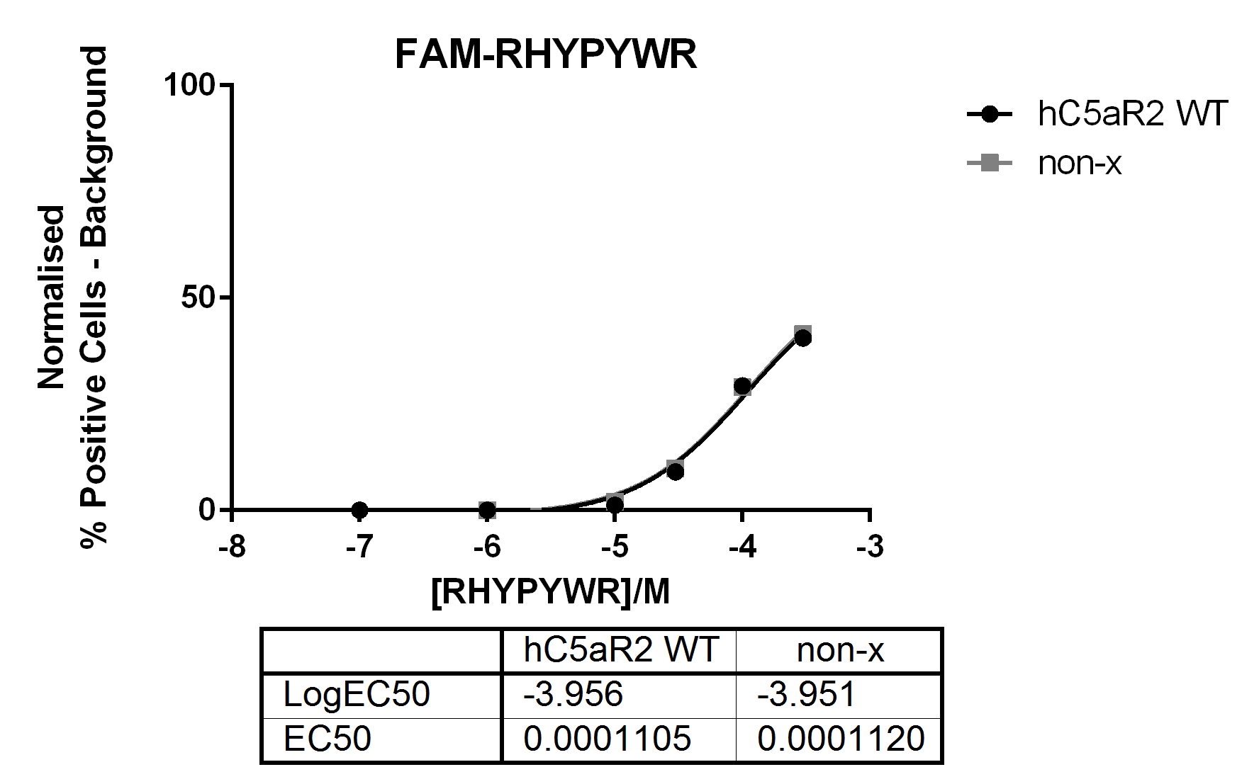
Figure 4.16 – FAM-RHYPYWR Binding to hC5aR2 WT Transfected CHO cells and non-x CHO cells with an Additional Washing Step
Prepared CHO cells, either untransfected (non-x) or transfected with hC5aR2 WT, were incubated with varying concentrations of FAM-RHYPYWR labelled peptide for 15 mins at 4°C. Cells were then washed once in buffer before detection by flow cytometry. Background fluorescence values were removed from all values.
In the figure, it appears that the addition of a washing step caused a reduction in the amount of fluorescence seen at the lower concentrations of peptide. It is possible that peptide was lost during this washing step. Though fluorescence was still detectable at higher peptide concentrations there was, again, no discernible difference between transfected and non-x CHO cells. Unfortunately, no data was able to be successfully obtained for fluorescently labelled LIRLWR as for unknown reasons this peptide caused problems with cells being lost prior to flow cytometry.
There was no obvious binding detected for either peptide through either method during this study. It is possible that the techniques used here simply are not sensitive enough to detect such low affinity binding of these peptides to hC5aR2.

4.4 - Discussion

The data presented here show preliminary studies into what the role of the transmembrane and extra-cellular loop (ECL) residues of hC5aR2 is, particularly in comparison to hC5aR1. It appears that C5a des-Arg binding is more often affected by the mutants used here than is C5a binding. This would suggest that these two ligands do indeed have different mechanisms of binding to this receptor. In addition, there are some differences between the ligand binding seen here and that seen in hC5aR1 mutants although in many cases the amino acid substitutions are different. However, in the case of the hC5aR2 residue E273 the data would suggest, like D282 in hC5aR1, that this residue interacts with R74 of C5a. The hC5aR1 data was gathered over a long period of time using many techniques and cell types. It could have been interesting to test binding to some hC5aR1 mutants using the assay and ligands from this work in order to compare data from both receptors as well as compare this assay with others. It is unfortunate that mutant C5a was never successfully purified as this could have helped provide further insights into the binding of this ligand for example if any of the receptor residues mutated here interact directly with the ligand.
Though an attempt to determine the effect of blocking the N-terminus with antibody was made this data conflicted with previously published data most likely due to differences in the affinity and specificity of the antibodies used. It may be more beneficial in the future to use hC5aR2 mutated at the N-terminus to study this as this would remove the uncertainty of which epitope the antibody binds to. As previously mentioned, mutants could be designed with multiple mutations in the acidic or tyrosine residues in the N-terminus to disrupt binding to this site. It would be interesting to compare these ligand binding results with those obtained using antibody to block the N-terminus.
For all binding assays, it is important to note, in addition, that both recombinant C5a and C5a des-Arg had His-tags and linker sequence at their N-termini leaving 28 additional amino acids. For the unlabelled, and the labelled ligands with the extra fluorescent tag added, it is quite possible that this would influence ligand binding. Though ligands from the same batch were used for all the assays within this chapter, this may influence differences seen between this work and other published data. In the future perhaps efforts should be made to reduce the size of this linker or design a cleavable sequence to remove it after purification. Finally, the result of R173A, R173F, and R173K mutants causing loss of C5a binding is potentially misleading. It is more likely that this loss of binding seen is due to the assay only detecting ligand still bound to cells after 15 mins. As the C5a des-Arg binding to these mutants is easily detectable, and surface receptor is easily detectable by antibody, it is unlikely that these mutants are misfolded.

Chapter 5 – Internalisation Studies on hC5aR2 Mutants

5.1 - Introduction

Since the original discovery of hC5aR2 by Ohno et al., 2000 there have been a number of suggestions as to what the function of this receptor could be. It was determined that hC5aR2 does not couple to G-proteins, despite sharing a similar structure to other G-protein coupled receptors (GPCRs), due to a number of missing intracellular motifs (Cain and Monk, 2002). It has been suggested that hC5aR2 is a recycling decoy receptor that passively sequesters ligand into the cell for degradation (Scola et al., 2009). However, more evidence is emerging that hC5aR2 may be able to signal through β-arrestin pathways and so may be able to perform some function (Bamberg et al., 2010; Croker et al., 2014; Kalant et al., 2005).
After ligand binding studies it was interesting to determine whether some of the hC5aR2 mutants in this work were also affected in their function. Much of the data collected using hC5aR1 mutants involves ligand binding data and receptor activation data. In these studies, relatively quick activation studies are performed utilising G-protein signalling pathways such as the β-hexosaminidase release assays used in this work (Cain et al., 2000, 2001a, 2003; Higginbottom et al., 2005). As hC5aR2 does not couple to G-proteins it is not possible to perform these assays on this receptor. As a result, many of the previous functional studies on hC5aR2 have been performed in a number of ways using a number of different cell types. Here, a standard assay that could be performed on cells transfected with mutant and wild-type receptors to allow comparisons between their behaviour was desired and so, after a number of failed attempts to measure β-arrestin signalling, internalisation assays were attempted.
The internalisation of hC5aR2 has been studied previously in polymorphonuclear neutrophils (PMNs) (Okinaga et al., 2003) and transfected RBL cells (Cain and Monk, 2002; Scola et al., 2009). When PMNs were incubated with a hexapeptide C-terminal analogue of C5a for 5 mins and internalisation measured using flow cytometry, hC5aR1 showed very rapid internalisation losing around 50% of surface receptor expression. In contrast hC5aR2 showed very little change to surface receptor levels during this time (Okinaga et al., 2003).
The internalisation of hC5aR2 expressing transfected RBL cells was measured after incubation for 10 mins with 100nM C5a and C5a des-Arg. These assays were performed using flow cytometry and showed no ligand dependent internalisation of hC5aR2 in contrast to hC5aR1 which showed internalisation in response to both ligands (Cain and Monk, 2002). Later, internalisation of hC5aR1 and hC5aR2 expressed in transfected RBL cells was measured in response to 100nM C5a after 15 mins using fluorescence microscopy. Here, no ligand dependent internalisation was seen in hC5aR2 as shown by no obvious redistribution of receptor in microscopy images, again, in contrast to hC5aR1. However, when constitutive, ligand independent, receptor recycling was measured by flow cytometry changes in surface levels of hC5aR1 and hC5aR2 were seen (Scola et al., 2009). The rate of internalisation of hC5aR1 appeared to be constant whereas the apparent rate of hC5aR2 internalisation began to decrease between 5-10 mins which could possibly be caused by re-expression of antibody at the cell surface. Blocking clathrin-dependent internalisation pathways prevented this constitutive internalisation of hC5aR2 but not hC5aR1, these data together suggesting the two receptors are internalised using different mechanisms (Scola et al., 2009).
Despite these data indicating that in RBL and PMN cells hC5aR2 does not show ligand dependent internalisation, in this work, hC5aR2 transfected into CHO cells showed internalisation in response to C5a and C5a des-Arg. The possible reasons for this shall be discussed in detail later in this chapter.

5.2 - Aims

The aims of the work in this chapter were:
- Find a suitable assay to measure the activity of hC5aR2 mutants expressed in CHO cells.

- Measure hC5aR2 activity in response to C5a and C5a des-Arg using internalisation assays.

- Determine whether hC5aR2 peptides can cause internalisation of hC5aR2 in CHO cells.

5.3 - Results

5.3.1 - Internalisation Assays

Internalisation assays were carried out using one of two methods, method A or method B (Figure 5.1). Method A is based on that used in Scola et al. (2009) and involves incubation in primary antibody prior to ligand stimulation. In this method, the disappearance of antibody from the surface of the cell over time while at 37°C is measured. Method B is similar to that used in Okinaga et al. (2003) and was developed in an attempt to avoid the primary antibody affecting ligand binding in light of the results in Chapter 4. In B, ligand stimulation and incubation at 37°C is performed prior to any antibody incubation. In this method, changes in surface levels of hC5aR2 over time while at 37°C are detected. In both methods, washing is performed between all steps.
With method A, it is possible that re-appearance of antibody at the cell surface between time-points could cause underestimation of the levels of internalisation. Antibody-bound receptors that had been endocytosed and recycled back to the surface would be measured as if they had remained at the surface for the duration of the time-course. On the other hand, in method B changes in overall surface receptor expression are measured and so disappearance or appearance of hC5aR2 that did not bind C5a would be measured in these assays.

Figure 5.1 – Flow Diagram of Method A and Method B Internalisation Assay Processes
This flow diagram illustrates two different methods of performing internalisation assays that were performed, method A and method B. Washing is performed between all steps in both methods. Primary antibody used was anti-hC5aR2 and the secondary antibody was anti-rabbit labelled with FITC. During the 37°C step samples were taken at 0, 5, 10, and 45 mins.

For all experiments internalisation is calculated as:
$$Internalisation \left(\%\right)= \frac{(0\operatorname{mins}{\% positive cells)-(x\operatorname{mins}{\% positive cells)}}}{0\operatorname{mins}{\% positive cells}} x 100$$
Where % positive cells have had background fluorescence values removed. Statistical analysis was run on mean internalisation % values unless otherwise stated.

5.3.2 - Preliminary Test of CHO hC5aR2 Wild Type Cells

CHO hC5aR2 wild-type cells were tested for internalisation after the addition of either 100nM C5a or buffer alone (Figure 5.2). These assays were performed using a modified version of Method A whereby cells were incubated in primary antibody, on ice, for 30 mins before washing and being resuspended in ligand or buffer. However, cells were incubated for 15 mins in ligand at 4°C before being transferred to 37°C to remain consistent with the ligand binding assays. The results of these experiments showed greater levels of internalisation in those cells treated with ligand than those in buffer alone. This would suggest that the addition of C5a causing some effect to the behaviour of hC5aR2 which may be altered in the mutant receptors.
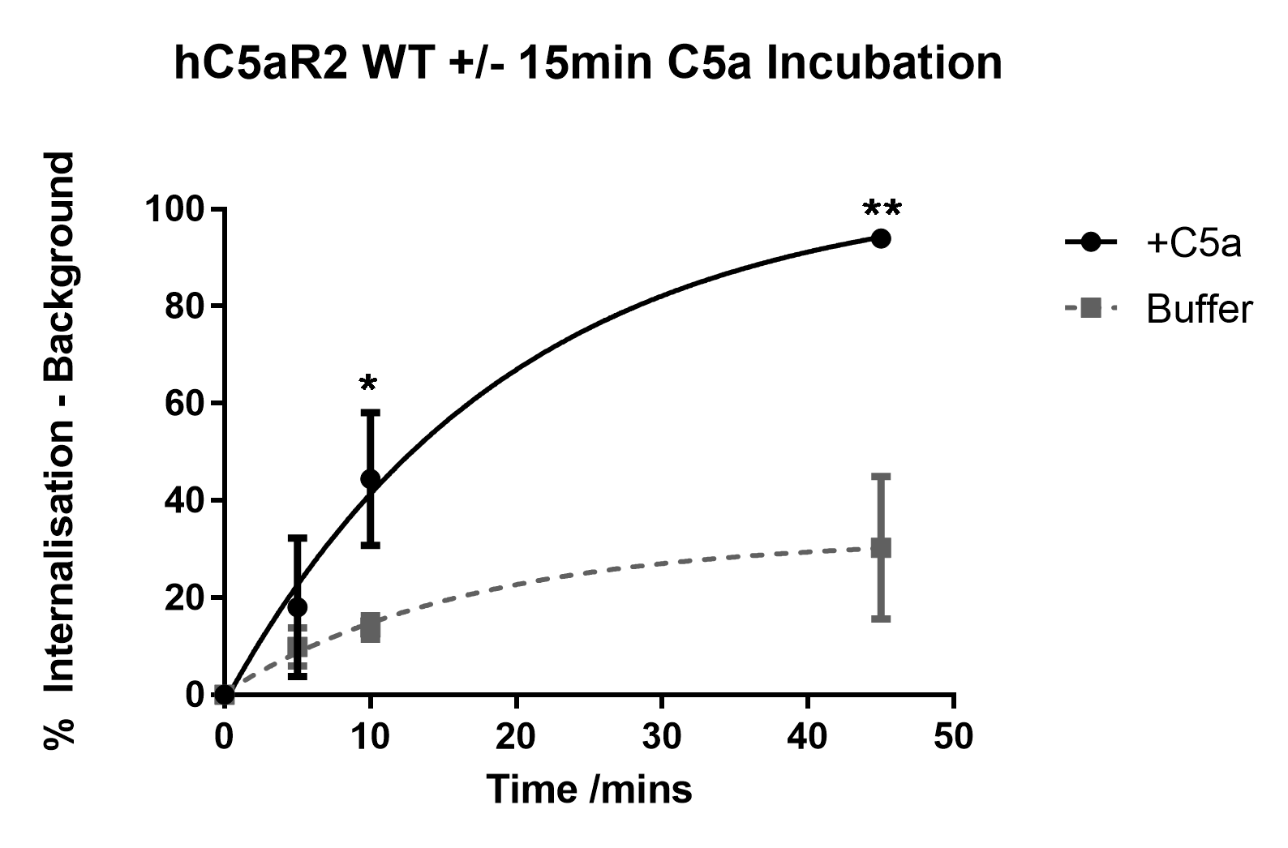
Figure 5.2 – Internalisation of hC5aR2 With/Without 15 Mins 100nM C5a Stimulation
CHO cells transfected with hC5aR2 WT were prepared for flow cytometry as in section 2.2.5.3 (n=3). The assay was performed using modified version of method A whereby cells are incubated in 100nM C5a or buffer for 15 mins at 4°C prior to incubation at 37°. Samples were taken at 0, 5, 10, and 45 mins during the incubation step at 37°C. Internalisation was calculated using the equation in 2.2.5.3. Statistics are unpaired t-tests whereby * = p ≤ 0.05, ** = p ≤ 0.01.

These results were somewhat unusual given that the previous internalisation data suggested that hC5aR2 could not internalise in response to ligand (Cain and Monk, 2002; Scola et al., 2009). However, there have been a number of instances whereby different cell types report different characteristics for hC5aR2, which is reviewed in Li et al. (2013) and discussed in more detail in Section 1.3.3.2. Internalisation assays were repeated using CHO and RBL cells to try and determine, within this assay, whether RBL cells show the same lack of ligand-dependent internalisation of hC5aR2 or if the CHO cell effect was just an artefact of the assay. Internalisation assays were performed using Method B and cells were incubated with either 100nM C5a, 100nM C5a des-Arg, or buffer alone (Figure 5.3).
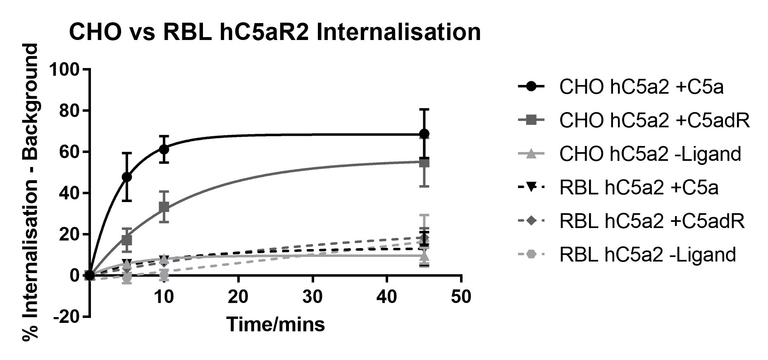
Figure 5.3 – Comparison of Internalisation of hC5aR2 WT in response to C5a, C5a des-Arg, or Buffer alone in CHO and RBL Transfected Cells
Transfected CHO (solid lines) and RBL cells (dashed lines) were prepared for flow cytometry as in section 2.2.5.3 and internalisation assays run using Method B (n=3). Cells were incubated with either 100nM C5a (black), 100nM C5a des-Arg (dark grey), or buffer alone (light grey). Assays were performed three times in duplicate.
In the figure, the CHO cells (solid lines) still appear to show some ligand dependent internalisation with C5a causing greater levels of internalisation than C5a des-Arg. In addition, the profile of the C5a and C5a des-Arg curves are different. CHO hC5aR2 WT cells treated with C5a appear to reach their maximal internalisation more quickly than those treated with C5a des-Arg. In comparison to both curves, cells treated with buffer alone show very little internalisation.
For the RBL cells all three conditions showed very low levels of internalisation, similar to the CHO buffer only condition. The RBL results appear similar to those seen in the previous studies. This would help verify that the CHO cell internalisation seen here is a real effect. One possible explanation for this difference in behaviour between the two cell types could be related to surface receptor expression levels. Microscopy has shown previously that a large proportion (~60%) of expressed hC5aR2 in transfected RBL cells was found to be intracellular (Scola et al., 2009). In the same study the expression of GFP-tagged hC5aR2 transfected into CHO cells was visualised using fluorescence microscopy and showed large levels of intracellular receptor, although the authors mention this may be an artefact due to overexpression of transfected protein (Scola et al., 2009). In addition, it could be possible that tagging of the receptor with GFP leads to improper expression of the protein. Although the proportion of intracellular/surface hC5aR2 in these transfected CHO cells used in this work was not determined, cells were sorted for surface expression of receptor. Perhaps higher levels of surface expression could influence any internalisation effect seen in this cell type.
These transfected cells may have altered receptor behaviour as these human receptors may not be in the same signalling environment, with the same concentrations of signalling partners (such as arrestins), as if they were expressed natively or even transfected into human cells. The aims of the work in this chapter were to determine whether mutation of the specific hC5aR2 residues presented here had an effect on receptor behaviour relative to wild type. These internalisation assays appear to give a means to test this but it is important to take into consideration these assays may not give accurate insights into global receptor function in a wider context. Internalisation data from the mutant receptors shall be discussed together in Section 5.4.

5.3.3 - Dose Response Curve

A dose response curve of the effect of C5a on the internalisation of hC5aR2 was performed. Assays were performed using Method B and cells were incubated at 37°C for 15 mins (Figure 5.4).
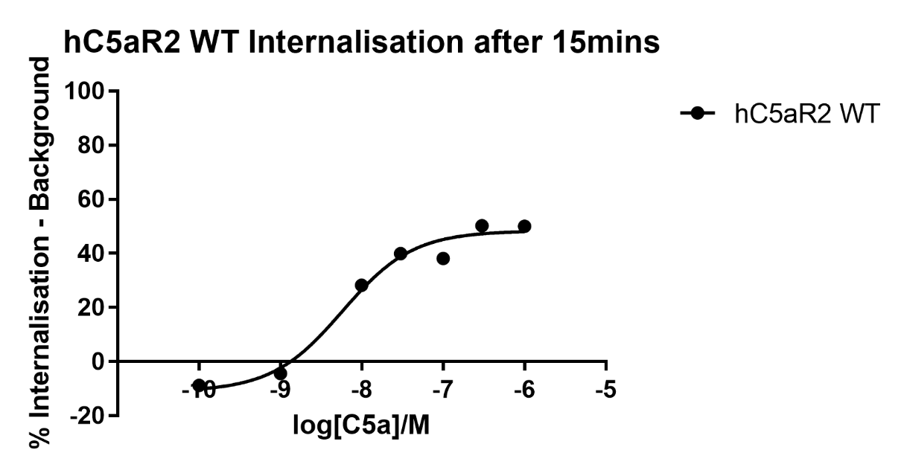

Figure 5.4 – Dose Response Curve of Internalisation of hC5aR2 in Response to C5a after 15 mins
Cells were prepared for flow cytometry as in 2.2.5.3 and internalisation measured using Method B. Cells were incubated at 37°C with varying concentrations of C5a for 15 mins. These data here represent one experiment performed in duplicate.
This assay was performed in an additional attempt to verify that ligand dependent internalisation effect seen here was real. In the figure, internalisation of hC5aR2 does seem to vary with the concentration of C5a and above concentrations of 100nM C5a the curve appears to begin to plateau. Though this assay was only done once the data would suggest that this internalisation effect is, again, specific.

5.3.4 - Mutant hC5aR2 Internalisation Assays

The internalisation of hC5aR2 wild type and 5 mutants; R173A, E197A, R204A, R204K, and E273A; was tested in transfected CHO cells. These mutants were selected for their effects on C5a and C5a des-Arg binding in Chapter 4 as well as the equivalent residues having previously being studied in hC5aR1. Cells were stimulated with 100nM C5a, 100nM C5a des-Arg, or buffer. All assays in this section were performed using Method B and represent n=3, except for the wild type which is n=14 and where otherwise stated. Given more time, internalisation assays on all receptor mutants would have been performed.

5.3.4.1 - R173A

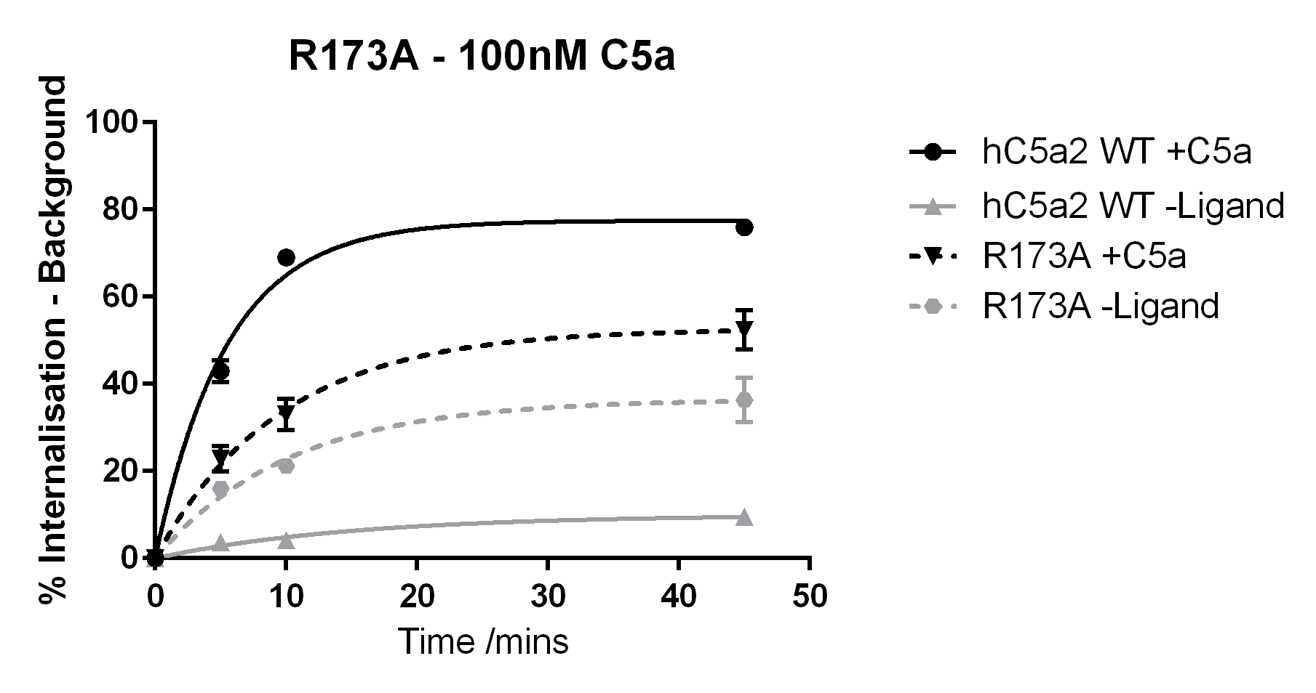
C5a. WT hC5aR2 again showed greater levels of internalisation when stimulated with C5a than when just buffer alone was added. In contrast, R173A showed similar levels of internalisation for both conditions. After 45 mins the difference between internalisation of R173A with and without the addition of C5a is not significantly different. Although the level of internalisation of R173A +C5a was lower that WT +C5a the opposite was true for the –Ligand condition (Figure 5.5).

hC5aR2 WT vs R173A |  | R173A +C5a vs R173A -Ligand
Time (mins) | Result | Time (mins) | Result
10 | **** | 10 | *
45 | **** | 45 | ns

Figure 5.5 – Internalisation of R173A and Wild Type hC5aR2 With/Without 100nM C5a Stimulation
The internalisation of hC5aR2 WT (solid lines) and R173A mutant (dashed lines) was measured after stimulation with 100nM C5a (black lines) or buffer alone (grey lines). The assay was performed using Method B as described previously. WT data is pooled giving n=14 whereas R173A is n=3. Statistical results are based on two-tailed unpaired t-tests, p ≤0.0001 (****), p ≥ 0.05 (ns) and p ≤ 0.05 (*).

C5a des-Arg. Again, R173A stimulated with C5a des-Arg showed similar levels of internalisation to R173A incubated with buffer alone with no significant difference between the two conditions. Here, the R173A curves for C5a and C5a des-Arg look quite similar, both rising to around 50% internalisation after 45 mins (Figure 5.6).
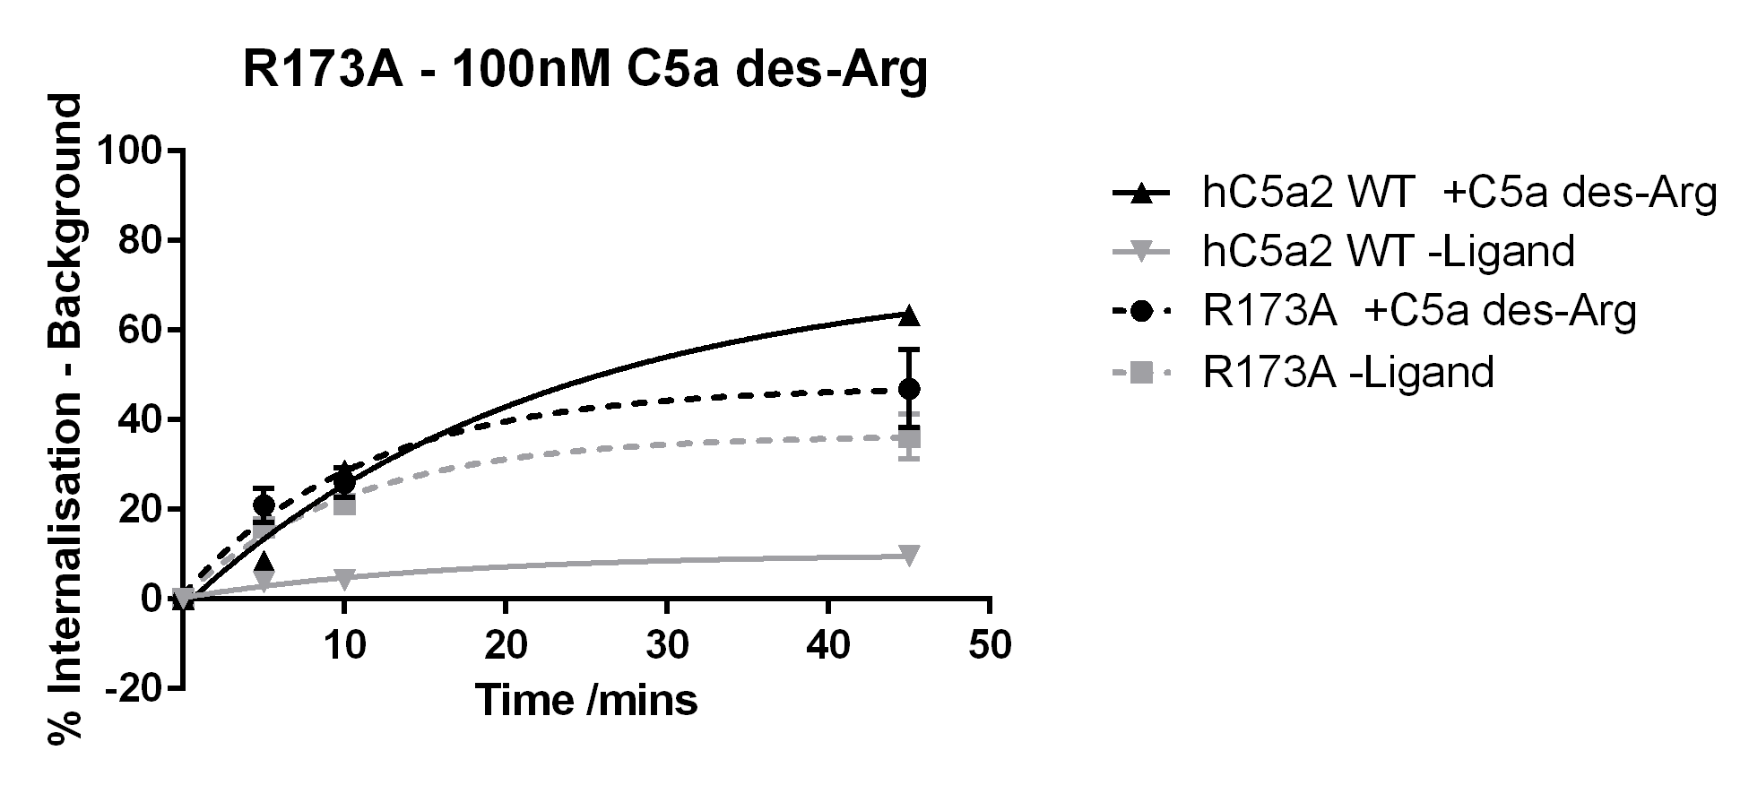

hC5aR2 WT vs R173A |  | R173A +C5a des-Arg vs R173A -Ligand
Time (mins) | Result | Time (mins) | Result
10 | ns | 10 | ns
45 | * | 45 | ns

Figure 5.6 – Internalisation of R173A and Wild Type hC5aR2 With/Without 100nM C5a des-Arg Stimulation
The internalisation of hC5aR2 WT (solid lines) and R173A mutant (dashed lines) was measured after stimulation with 100nM C5a des-Arg (black lines) or buffer alone (grey lines). The assay was performed using Method B as described previously. WT data is pooled giving n=14 whereas R173A is n=3. Statistical results are based on two-tailed unpaired t-tests, p ≥ 0.05 (ns) and p ≤ 0.05 (*).

In the ligand binding assays R173A saw no detectable C5a binding and a reduction in the affinity for C5a des-Arg. When, in hC5aR1, R175A and R175D mutant receptor activation was measured using β-hexosaminidase release assays both mutations caused significant disruption to activation by C5a or C5a des-Arg (Cain et al., 2003). After 45 mins R173A internalisation in response to C5a or C5a des-Arg was not significantly different to the background, -Ligand, condition. Both ligand and buffer only curves for both ligands follow similar profiles possibly suggesting much of the internalisation effect is due to an increased constitutive receptor activation. There is some slight difference between the +C5a and -Ligand conditions for E197A which, again, may suggest that the total loss of binding seen may be due to the ligand binding assays not detecting very short-term binding.

5.3.3.2 - E197A

C5a. E197A showed significantly lower levels of internalisation over time than hC5aR2 WT. For those cells treated with buffer alone, the internalisation levels of both E197A and WT receptors was similar. Though the internalisation of E197A is much lower than the WT receptor, it is still significantly different from the buffer only controls (Figure 5.7).
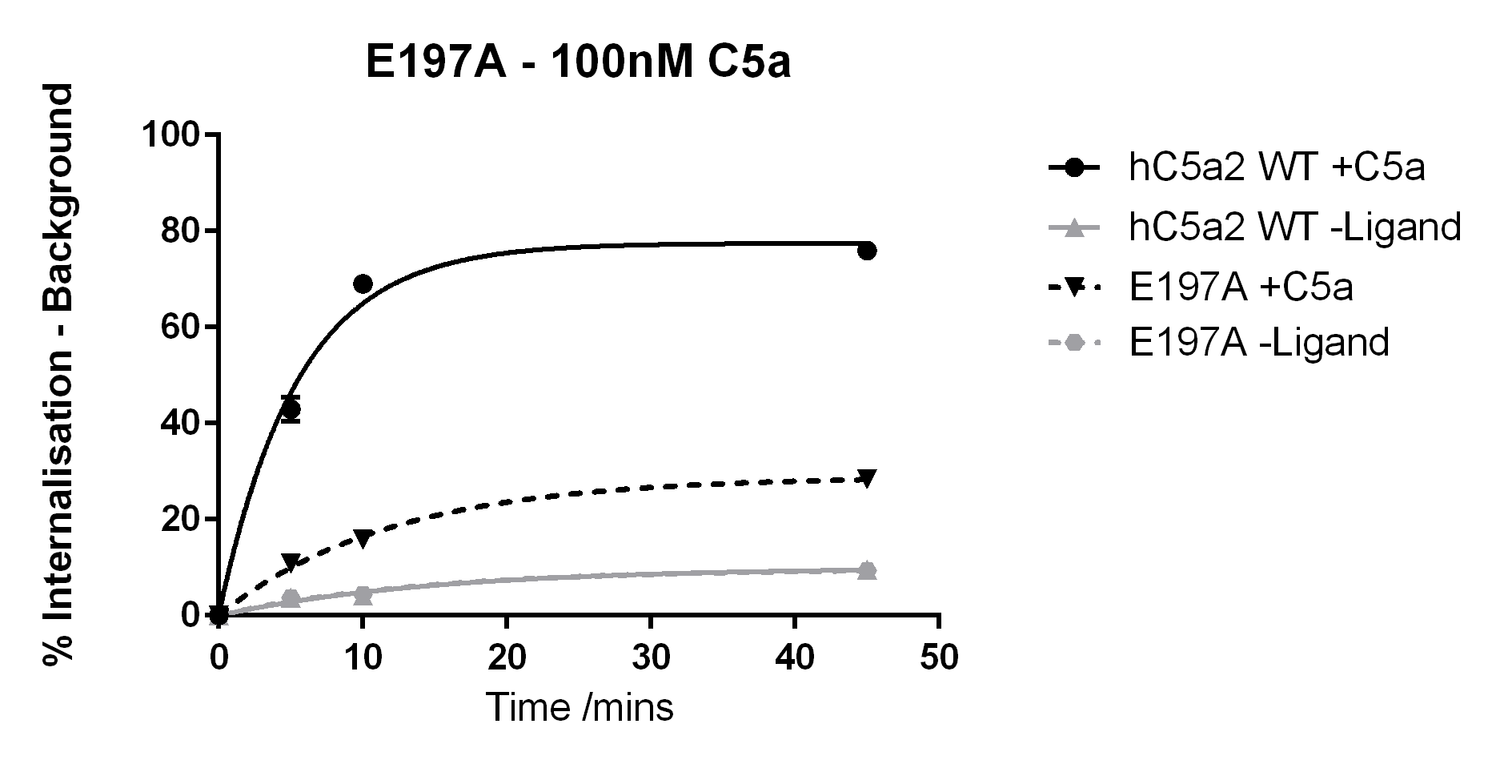
hC5aR2 WT vs E197A |  | E197A +C5a vs E197A -Ligand
Time (mins) | Result | Time (mins) | Result
10 | **** | 10 | ****
45 | **** | 45 | ****

Figure 5.7 – Internalisation of E197A and Wild Type hC5aR2 With/Without 100nM C5a Stimulation
The internalisation of hC5aR2 WT (solid lines) and E197A mutant (dashed lines) was measured after stimulation with 100nM C5a (black lines) or buffer alone (grey lines). The assay was performed using Method B as described previously. WT data is pooled giving n=14 whereas E197A is n=3. Statistical results are based on two-tailed unpaired t-tests, p ≤0.0001 (****).

C5a des-Arg. When treated with C5a des-Arg E197A shows greater levels of internalisation than when treated with C5a (approx. 40% vs 20% maximum internalisation at 45 mins). However, this is still significantly less than the internalisation of hC5aR2 WT. Like with the C5a data, both E197A and wild type receptors show similar and low levels of internalisation when treated with buffer alone (Figure 5.8). 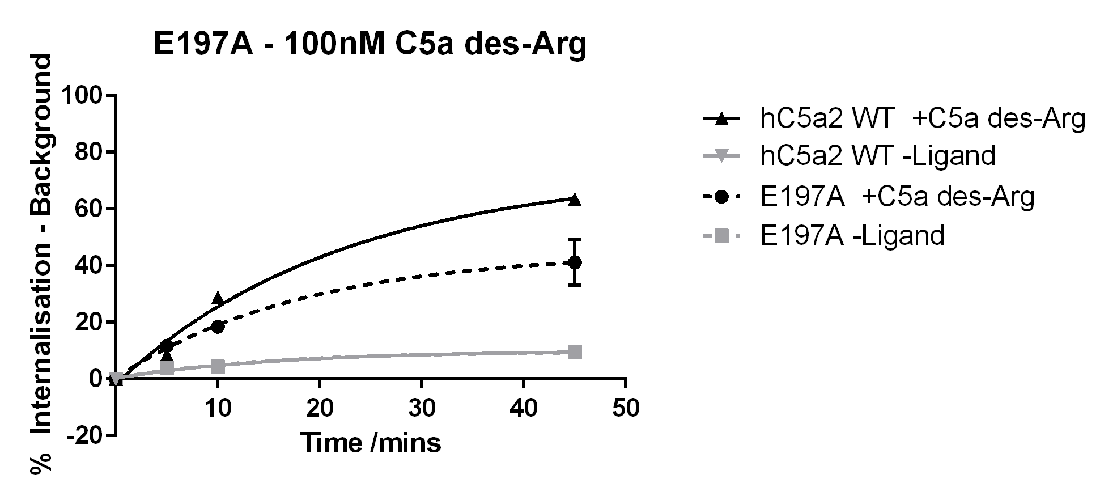
hC5aR2 WT vs E197A |  | E197A +C5a des-Arg vs E197A -Ligand
Time (mins) | Result | Time (mins) | Result
10 | * | 10 | ***
45 | ** | 45 | *

Figure 5.8 – Internalisation of E197A and Wild Type hC5aR2 With/Without 100nM C5a des-Arg Stimulation
The internalisation of hC5aR2 WT (solid lines) and E197A mutant (dashed lines) was measured after stimulation with 100nM C5a des-Arg (black lines) or buffer alone (grey lines). The assay was performed using Method B as described previously. WT data is pooled giving n=14 whereas E197A is n=3. Statistical results are based on two-tailed unpaired t-tests, p ≤0.001 (***), p≤0.01(**) and p ≤ 0.05 (*).

In the ligand binding assays E197A showed no significant change to C5a binding in comparison to WT receptor. There was a large decrease in affinity for C5a des-Arg in comparison to WT. There is receptor activation data for E199Q and E199K mutant hC5aR1. For E199Q, receptor activation by C5a was disrupted (EC50 = 60nM) in comparison to WT (20nM). Activation by C5a des-Arg was much more severely disrupted by this mutation, where the EC50 on WT receptor was 50nM, for the E199Q mutant the EC50 was >700nM (Monk et al., 1995). When E199K was studied this mutation inhibited activation by C5a des-Arg even when ligand concentrations of 30µM were tested. In contrast, E199K only caused a small disruption in activation when C5a was tested (Crass et al., 1999a). It had been proposed in the study by Monk et al. that E199 was likely to interact with K68 on the ligands as this was the only charged ligand residue suitable for such an interaction. This was confirmed when Crass et al. tested the reciprocal mutants E199K and C5a[K68E] and showed reversal of the activation effects seen using WT ligand. Here, the E197A mutant appears to behave similarly in response to C5a and C5a des-Arg despite differences in the ability to bind these ligands. It was proposed by Crass et al. that in C5a the C-terminal pentapeptide forms a helix which can force an interaction despite mutation at E199. In contrast C5a des-Arg has a disordered C-terminus and cannot force an interaction past the E199K mutation. Here mutation of E197 to A may not hinder the interaction between C5a or C5a des-Arg and other parts of the receptor for activation despite destabilising the receptor-ligand interaction to see differences in binding affinity.

5.3.3.3 - R204

R204A
C5a. Internalisation of R204A when treated with C5a is lower than that of hC5aR2 wild-type. After 45 mins the difference between internalisation of R204A treated with C5a or with buffer is not statistically significant (Figure 5.9).
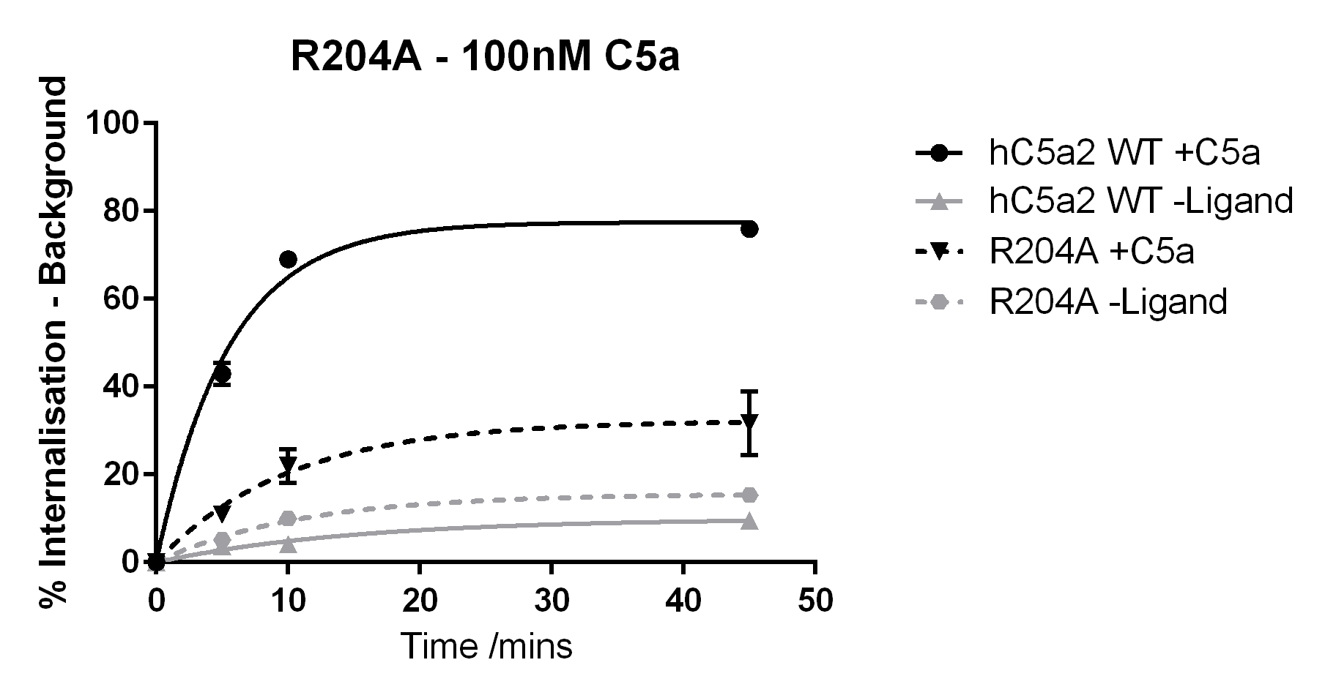
hC5aR2 WT vs R204A |  | R204A +C5a vs R204A -Ligand
Time (mins) | Result | Time (mins) | Result
10 | **** | 10 | *
45 | **** | 45 | ns

Figure 5.9 – Internalisation of R204A and Wild Type hC5aR2 With/Without 100nM C5a Stimulation
The internalisation of hC5aR2 WT (solid lines) and R204A mutant (dashed lines) was measured after stimulation with 100nM C5a (black lines) or buffer alone (grey lines). The assay was performed using Method B as described previously. WT data is pooled giving n=14 whereas R204A is n=3. Statistical results are based on two-tailed unpaired t-tests, p ≤0.0001 (****), p ≥ 0.05 (ns) and p ≤ 0.05 (*).
C5a des-Arg. When treated with C5a des-Arg, internalisation levels of R204A were not significantly different to when treated with buffer alone. In addition, R204A internalisation was lower than hC5aR2 WT internalisation when treated with C5a des-Arg (Figure 5.10).
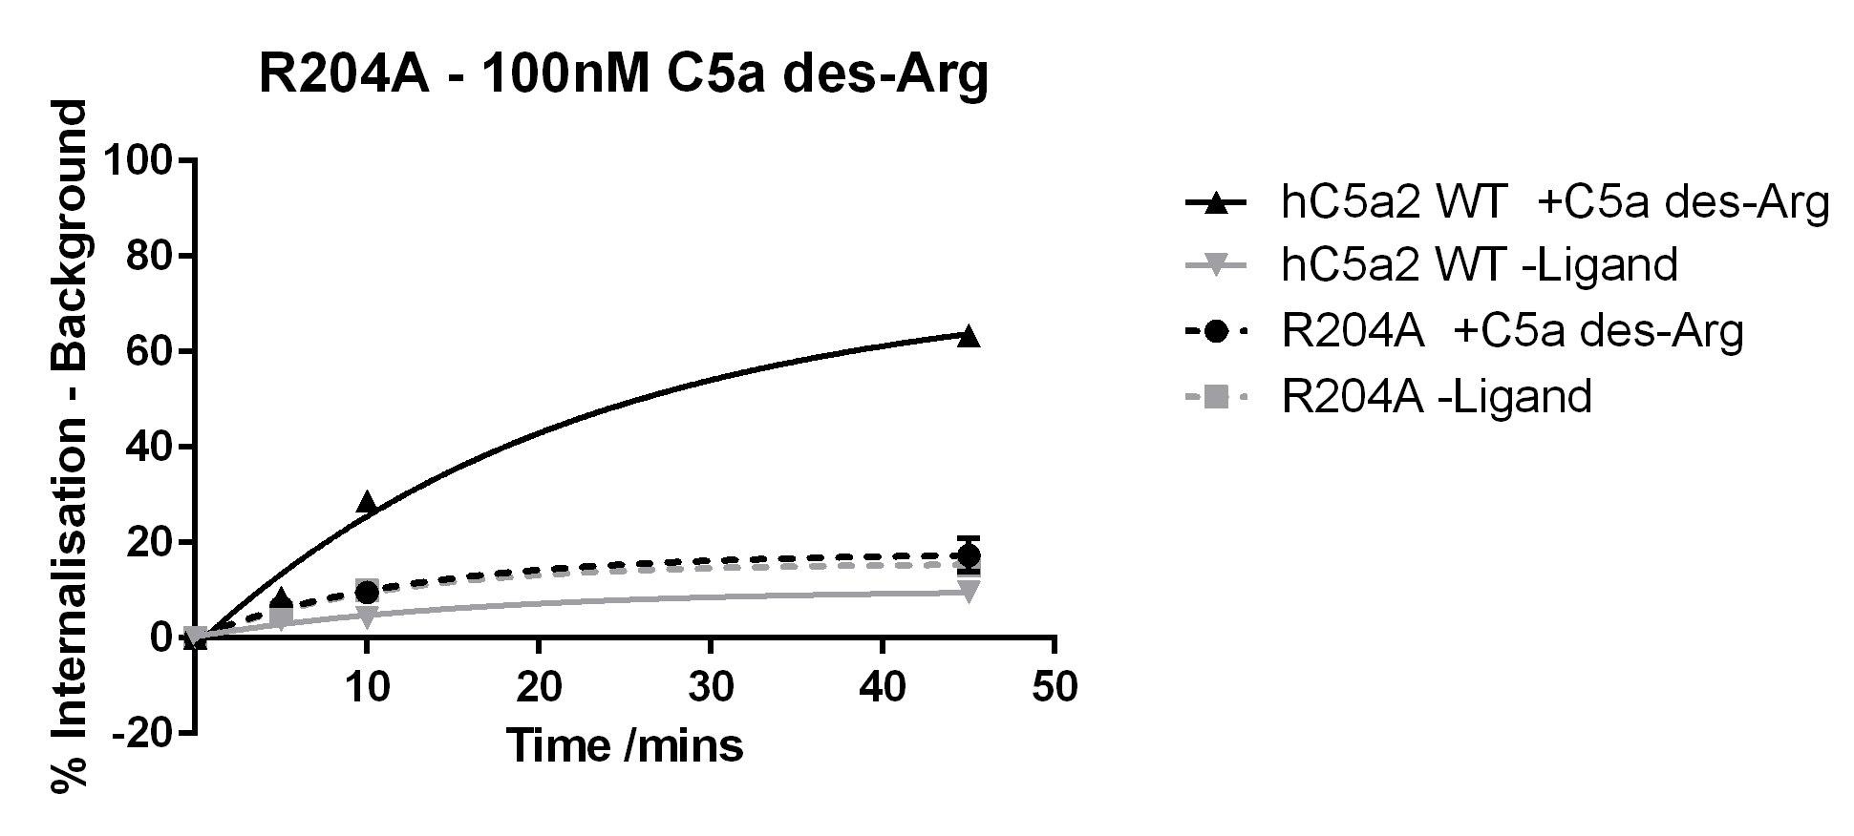
hC5aR2 WT vs R204A |  | R204A +C5a des-Arg vs R204A -Ligand
Time (mins) | Result | Time (mins) | Result
10 | ** | 10 | ns
45 | **** | 45 | ns

Figure 5.10 – Internalisation of R204A and Wild Type hC5aR2 With/Without 100nM C5a des-Arg Stimulation
The internalisation of hC5aR2 WT (solid lines) and R204A mutant (dashed lines) was measured after stimulation with 100nM C5a des-Arg (black lines) or buffer alone (grey lines). The assay was performed using Method B as described previously. WT data is pooled giving n=14 whereas R204A is n=3. Statistical results are based on two-tailed unpaired t-tests, p ≤0.0001 (****), p ≤ 0.01 (**), and p ≥ 0.05 (ns).
R204K
C5a. Again, R204K showed lower levels of internalisation than hC5aR2 wild type when treated with C5a. The R204K mutant appears to have higher levels of background internalisation than the WT receptor. However, despite this, the R204K internalisation in response to C5a is still significantly higher than the background for this mutant (Figure 5.11).
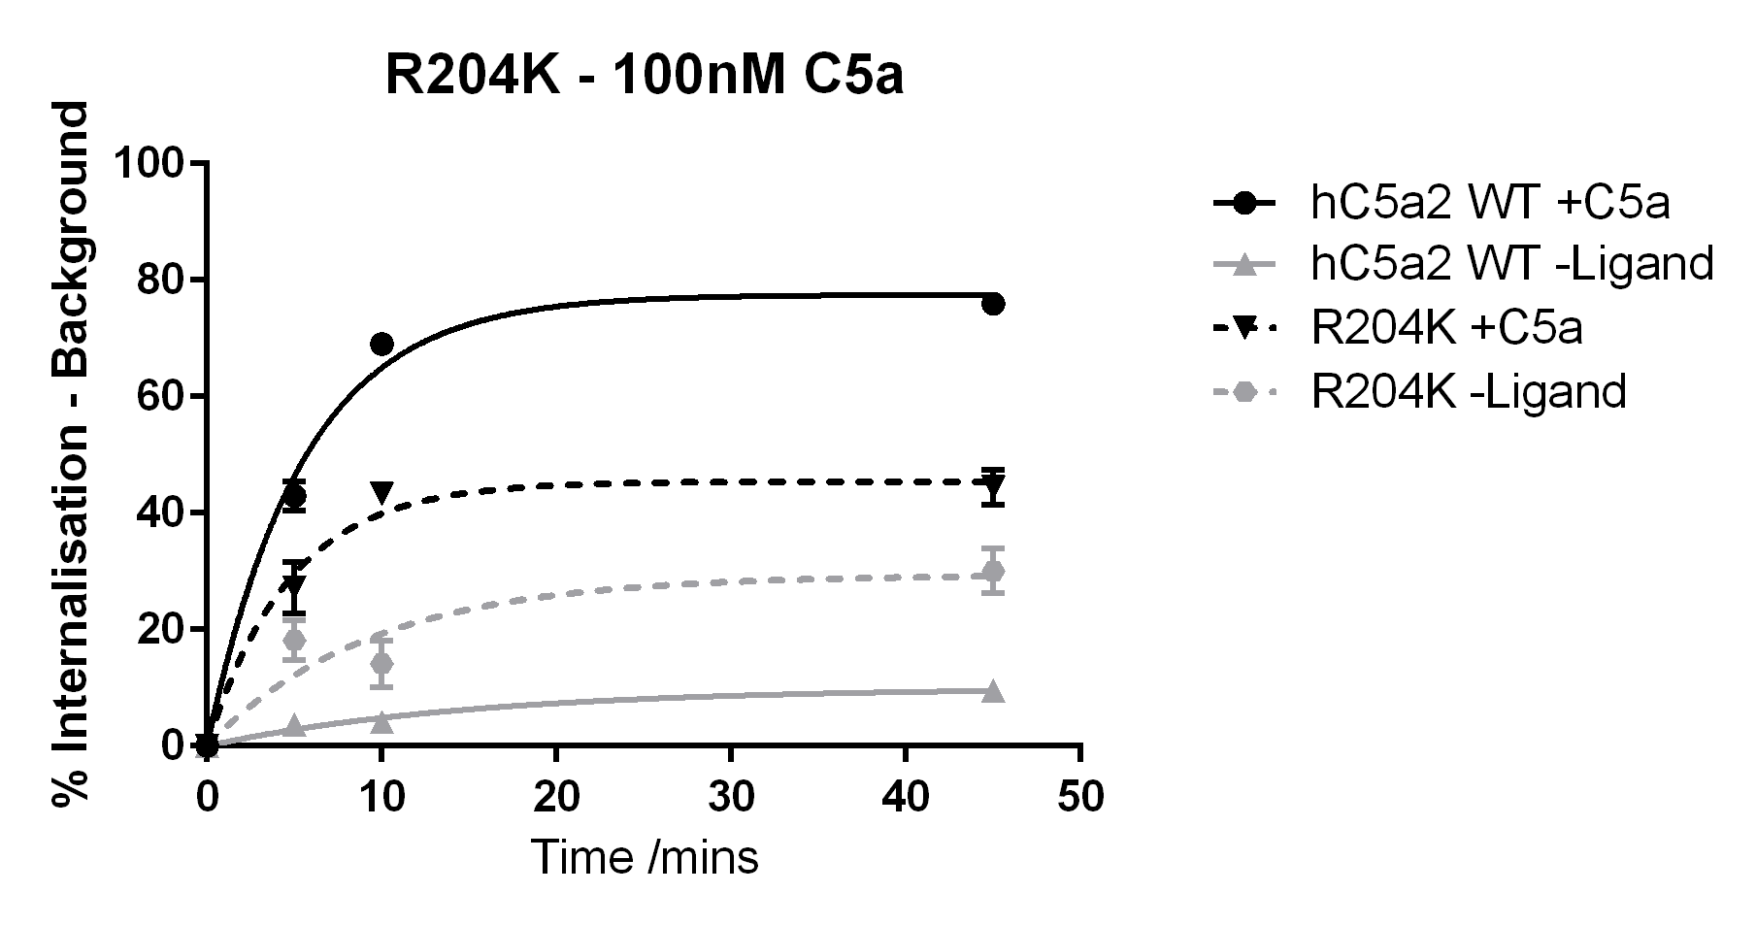
hC5aR2 WT vs R204K |  | R204K +C5a vs R204K -Ligand
Time (mins) | Result | Time (mins) | Result
10 | *** | 10 | *
45 | **** | 45 | *

Figure 5.11 – Internalisation of R204K and Wild Type hC5aR2 With/Without 100nM C5a Stimulation
The internalisation of hC5aR2 WT (solid lines) and R204K mutant (dashed lines) was measured after stimulation with 100nM C5a (black lines) or buffer alone (grey lines). The assay was performed using Method B as described previously. WT data is pooled giving n=14 whereas R204K is n=3. Statistical results are based on two-tailed unpaired t-tests, p ≤0.0001 (****), p ≤ 0.001 (***), and p ≤0.1 (*).
C5a des-Arg. R204K shows an increased rate of internalisation within 10 mins with respect to the wild type receptor. Whereas wild type receptor treated with C5a des-Arg does not reach a plateau within 45 mins, R204K appears to have reached a plateau by 10 mins at 37°C. There is no statistically significant difference between R204K treated with C5a des-Arg and R204K treated with buffer alone (Figure 5.12).
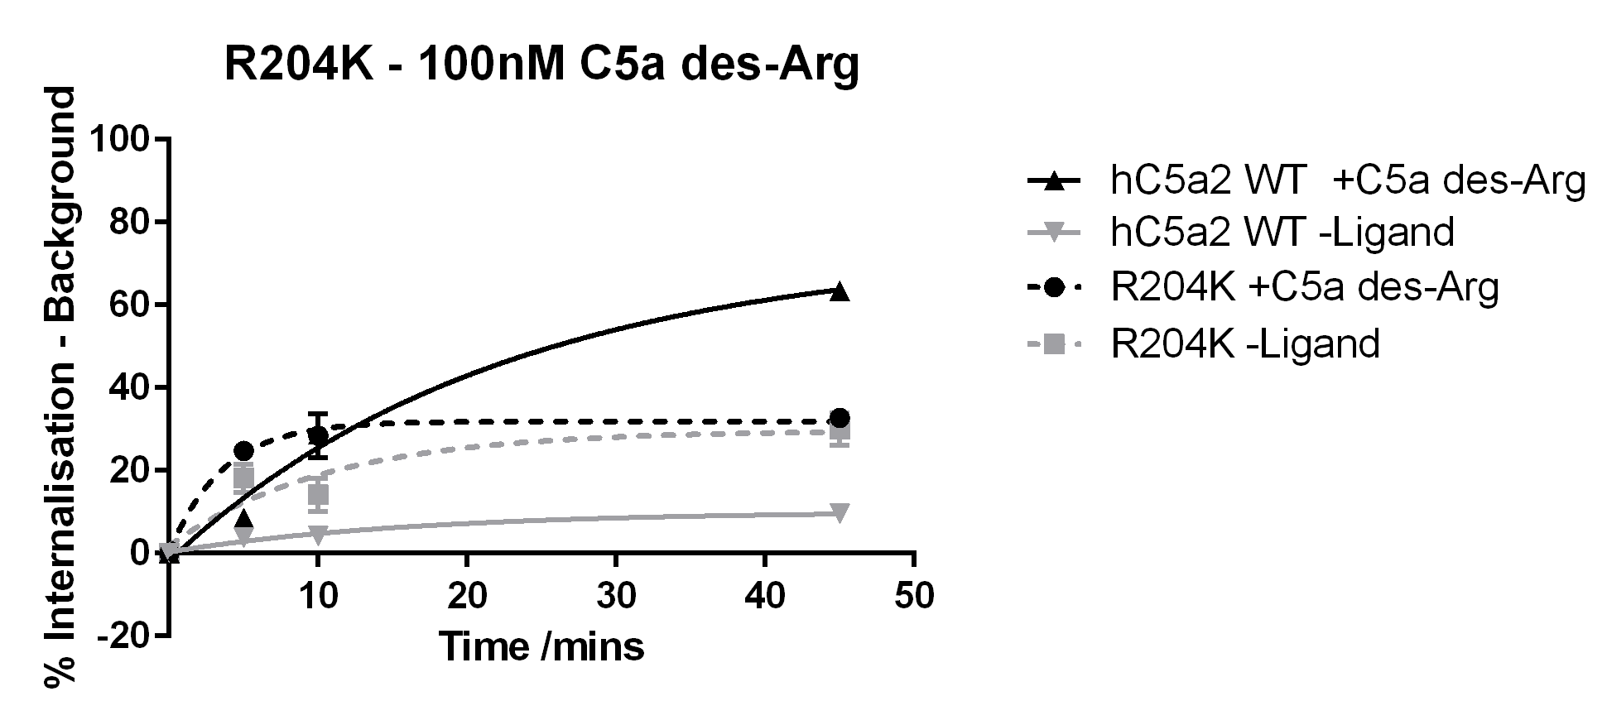
hC5aR2 WT vs R204K |  | R204K +C5a des-Arg vs R204K -Ligand
Time (mins) | Result | Time (mins) | Result
10 | ns | 10 | ns
45 | **** | 45 | ns

Figure 5.12 – Internalisation of R204K and Wild Type hC5aR2 With/Without 100nM C5a des-Arg Stimulation
The internalisation of hC5aR2 WT (solid lines) and R204K mutant (dashed lines) was measured after stimulation with 100nM C5a des-Arg (black lines) or buffer alone (grey lines). The assay was performed using Method B as described previously. WT data is pooled giving n=14 whereas R204K is n=3. Statistical results are based on two-tailed unpaired t-tests, p ≤0.0001 (****) and p ≥ 0.05 (ns).

In the ligand binding assays R204A showed a decreased affinity for C5a as well as C5a des-Arg in comparison to WT receptor. R204K showed no significant difference in the affinity of C5a when compared with WT. However, this mutant showed a reduced affinity for C5a des-Arg. When tested in hC5aR1, R206Q mutants showed less phosphorylation in response to 5nM and 250nM C5a than WT receptor (Raffetseder et al., 1996). In a later study, β-hexosaminidase release of R206A mutants was measured. Though there was a slight disruption to receptor activation by C5a in comparison to WT, these R206A mutants were completely unresponsive to C5a des-Arg (Cain et al., 2001a). It was suggested by Raffetseder et al. that R206 is important for stabilising a high-affinity receptor conformation essential for appropriate ligand binding and G-protein coupling. In their study an R206K mutant, which retains the positive charge, was less severely affected than an R206A or R206Q mutant both of which remove the charge. Though hC5aR2 does not need to couple to G-proteins in these internalisation assays it would appear that R204A is more severely affected than R204K. R204K appears to internalise to a higher maximum percentage in response to C5a when compared with R204A. Also where R204A appears almost unresponsive to C5a des-Arg, similar to the WT -Ligand, R204K appears to have higher levels of background internalisation though does not respond to C5a des-Arg. These data may agree with the previous suggestions and imply that R204 also plays a structural role in hC5aR2.

5.3.3.4 - E273A

C5a. E273A treated with C5a reaches a similar level of internalisation than wild type receptor after 45 mins. However, the buffer only treated E273A appears to not be statistically significantly different to ligand treated receptor. In part, this result is likely due to large variations in the internalisation results for the buffer only treated cells (Figure 5.13).
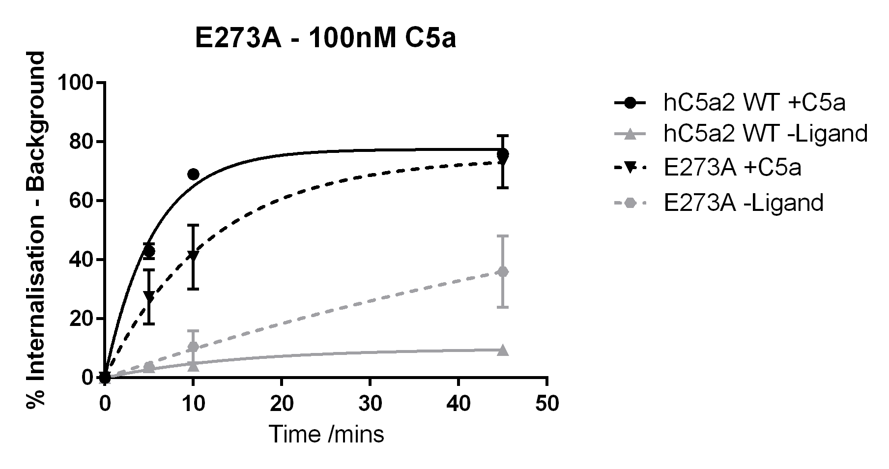
hC5aR2 WT vs E273A |  | E273A +C5a vs E273A -Ligand
Time (mins) | Result | Time (mins) | Result
10 | *** | 10 | ns
45 | ns | 45 | ns

Figure 5.13 – Internalisation of E273A and Wild Type hC5aR2 With/Without 100nM C5a Stimulation
The internalisation of hC5aR2 WT (solid lines) and E273A mutant (dashed lines) was measured after stimulation with 100nM C5a (black lines) or buffer alone (grey lines). The assay was performed using Method B as described previously. WT data is pooled giving n=14 whereas E273A is n=3. Statistical results are based on two-tailed unpaired t-tests, p ≤0.001 (***) and p ≥ 0.05 (ns).
C5a des-Arg. E273A showed greater levels of internalisation than wild type receptor when treated with C5a des-Arg. At the same time, E273A treated with buffer alone showed lower internalisation than wild type receptor treated with C5a des-Arg. The buffer alone E273A was statistically significantly lower than C5a des-Arg treated E273A internalisation (Figure 5.14).
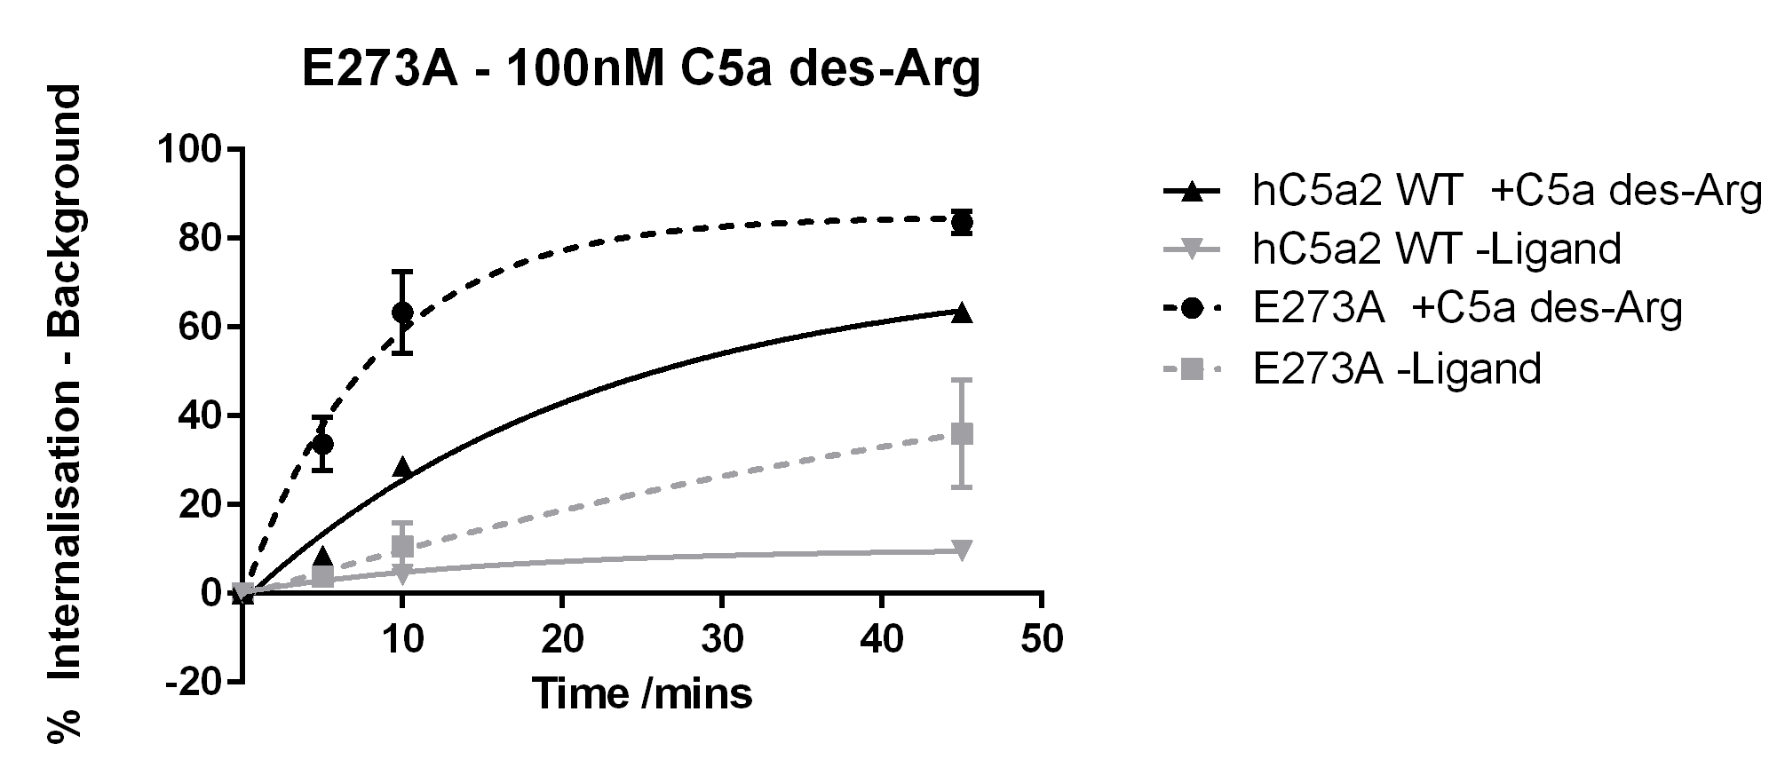
hC5aR2 WT vs E273A |  | E273A +C5a des-Arg vs E273A -Ligand
Time (mins) | Result | Time (mins) | Result
10 | **** | 10 | **
45 | *** | 45 | *

Figure 5.14 – Internalisation of E273A and Wild Type hC5aR2 With/Without 100nM C5a des-Arg Stimulation
The internalisation of hC5aR2 WT (solid lines) and E273A mutant (dashed lines) was measured after stimulation with 100nM C5a des-Arg (black lines) or buffer alone (grey lines). The assay was performed using Method B as described previously. WT data is pooled giving n=14 whereas E273A is n=3. Statistical results are based on two-tailed unpaired t-tests, p ≤0.0001 (****), p ≤ 0.001 (***), p ≤ 0.01 (**), p ≤ 0.05 (*).

In the ligand binding assays E273A showed a large reduction in C5a binding affinity but was not significantly different from WT receptor for C5a des-Arg binding affinity. Interestingly this was the only mutant receptor tested that showed similar levels of internalisation in response to C5a to the WT receptor. D282 in hC5aR1 was suggested to interact with R74 of C5a. When D282A mutants were tested for β-hexosaminidase release in response to C5a there was no significant difference to WT. However, in response to C5a des-Arg there was a slight disruption to receptor activation, leading to ~90% of the release achieved by WT receptor. For D282R mutants, activation by C5a was much more severely disrupted than activation by C5a des-Arg. This disruption to C5a activation was largely recovered by the reciprocal mutant C5a[D74} (Cain et al., 2001a). Here the E273A mutant appears to have high levels of background internalisation and, for C5a des-Arg, can show ligand dependent internalisation to a greater maximum percentage than WT receptor. This internalisation data may agree with the binding data and suggest that E273 may interact with R74 of C5a. However, additionally, this mutation may cause the receptor to adopt a more easily stimulated conformation.

5.3.5 - Method A, Buffer Only Assays

When the internalisation of the mutant receptors was tested using method B, in many cases quite high levels of internalisation were seen in the buffer only conditions. This was not the case for hC5aR2 wild type. Much of the previous work done with regard to the internalisation of hC5aR2 by Scola et al. (2009) was using a protocol more similar to method A. To determine whether high background values were as a result of the assay protocol, internalisation using buffer only was measured using method A (Figure 5.15).
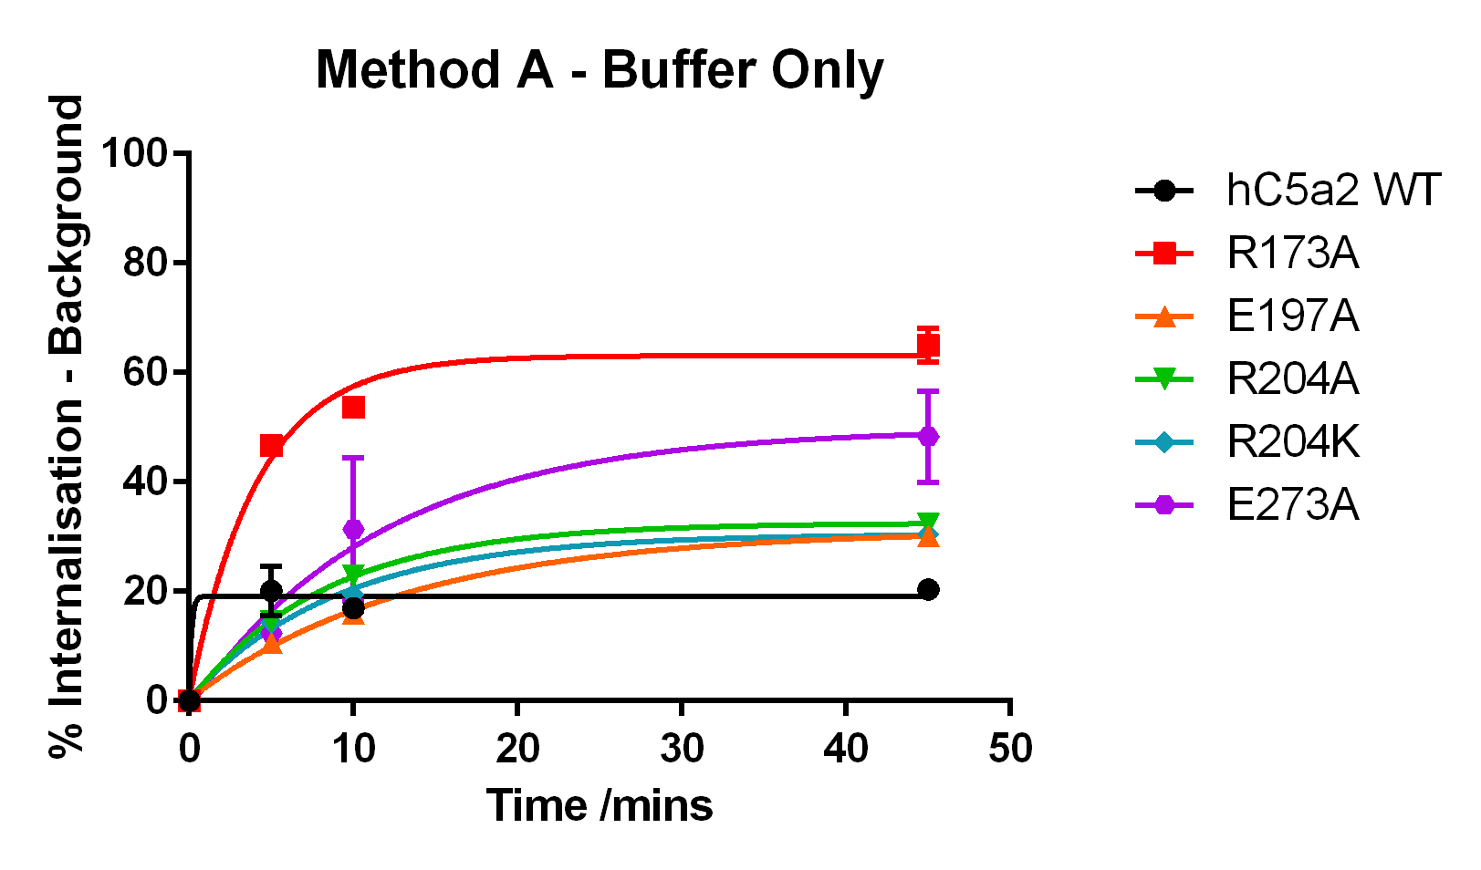
Figure 5.15 – Internalisation of Wild Type and Mutant hC5aR2
The internalisation of wild type (black) and mutant (colours) hC5aR2 receptors was measured without ligand stimulation. Cells were prepared for flow cytometry as in 2.2.5.3 and the assay performed using Method A. Assays were performed three times in duplicate.

When assays were performed on mutant receptors using Method B, R173A, R204K, and E273A mutants showed much higher levels of background internalisation than WT receptor whereas E197A and R204A showed similar levels. In Figure 5.14, all mutants show greater levels of background internalisation than WT with R173A (red) and E273A (purple) showing the highest. E197A (orange), R204A (green), and R204K (blue) all showed similar levels in these assays. These results appear to agree with the previous data that many of the mutants showed altered, higher, background internalisation behaviour in comparison to WT hC5aR2.

5.3.6 - RHYPYWR Peptide Internalisation

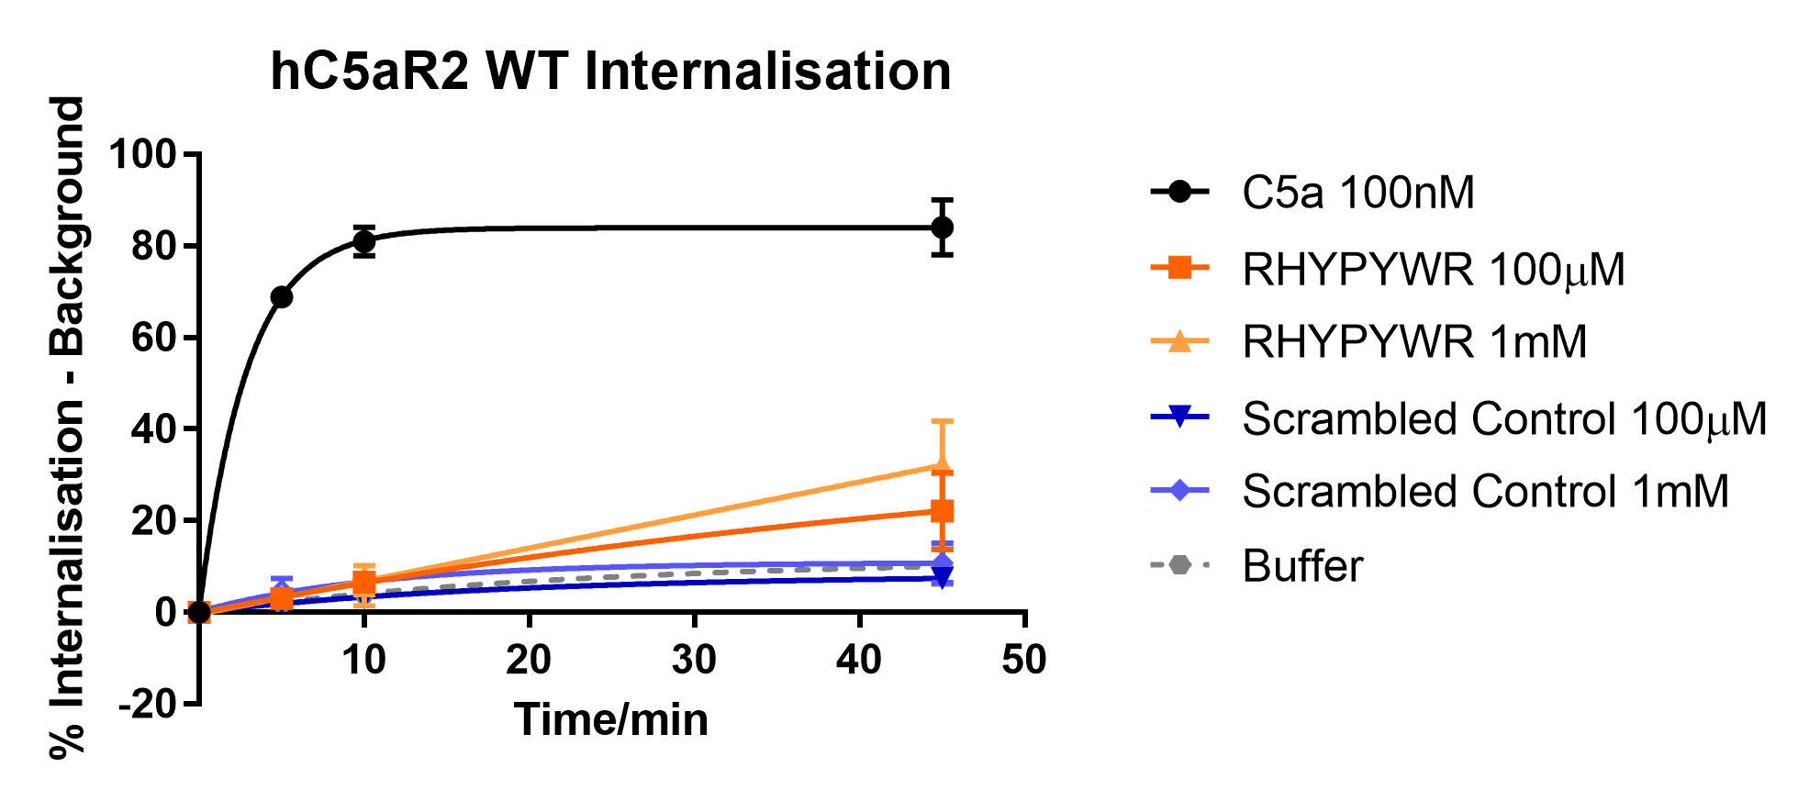
The RHYPYWR selective hC5aR2 peptide was tested to determine whether it could cause internalisation of WT receptor. Either 100µM or 1mM peptide or scrambled control (sequence: RWPYRYH) was added to prepared cells which were then incubated for 15 mins at 37°C (Figure 5.15).

Figure 5.16 – Effect of RHYPYWR Peptide and Scrambled Control on Internalisation of hC5aR2 WT
Cells were prepared for flow cytometry as in 2.2.5.3 and internalisation measured using Method B. Cells were incubated for 15 mins at 37°C with either 100nM C5a (black line), 100µM RHYPYWR (dark orange line), 100mM RHYPYWR (light orange line), 100µM scrambled control (dark blue line), 100mM scrambled control (light blue line), or buffer alone. Data here represents two repeats in duplicate.
In Figure 5.16, both concentrations of scrambled control (blue lines) appear similar to the buffer only condition as would be expected. Though the RHYPYWR peptide (orange lines) does appear to cause some increased receptor internalisation in comparison to the controls, neither internalisation value at 45 mins was statistically significantly different.

5.4 - Discussion

This ligand dependent internalisation of hC5aR2 transfected into CHO cells appears unusual in comparison to previous published data but is clearly repeatable. It would be interesting in the future to track the levels of receptor on the cell surface over a longer time period to determine over what time frame receptor is recycled back to the surface as this was not seen in any of the assays performed here. Many of the hC5aR2 mutants showed higher levels of background internalisation than WT receptor but did not show a similar reappearance of receptor within 45 mins. When previously tested by Scola et al. (2009), transfected RBL cells showed recycling of hC5aR2 constitutively to the cell surface, peaking after 15 mins. The addition 100nM C5a or C5a des-Arg had no effect on this constitutive recycling but it could be inhibited by inhibiting the clathrin internalisation pathway. It is reported in the study that transfected CHO cells showed a similar effect but this data was not shown (Scola et al., 2009). However, here, this reappearance of receptor after 15 mins is not seen. Method B measures the levels of hC5aR2 present on the cell surface at each given time point. Within this assay it is not possible to determine whether receptor has been recycled or not, but an overall loss or gain of receptor levels is measured. The plateaus seen in the internalisation graphs may be due to the rate of receptor entering the cell equalling the rate recycling to the surface and so no net change in receptor levels is detected. As there is no previous data to support hC5aR2 showing ligand dependent internalisation it is difficult to make many definite conclusions about the data in this chapter without further study. Also, the mutants here were always sorted for surface receptor expression, which may have biased the results. In this work an attempt to block clathrin mediated internalisation using the dynamin inhibitor Dynasore (Sigma) was made but was unsuccessful due to high levels of non-specific fluorescence and cell death (data not shown). In addition, studying the activation of these receptor mutants using a different assay may have been beneficial in attempt to verify the results.
More recently, functional studies on hC5aR2 have centred around β-arrestin activation and ERK phosphorylation. Within this work brief attempts to conduct BRET (Bioluminescence Resonance Energy Transfer) β-arrestin activation assays on the hC5aR2 mutant transfected CHO cells were made however were unsuccessful with inconsistent results (data not shown). While in the Scola et al. (2009) study no co-localisation of hC5aR2 to the endogenous RBL β-arrestin was seen, a number of other groups have reported interactions between hC5aR2 and β-arrestin (Croker et al., 2014; Kalant et al., 2005). BRET studies previously have been performed using HEK cells (Croker et al., 2014) which may improve the interaction between transfected human receptor and endogenous β-arrestin. It has been speculated that neither CHO nor RBL cells may contain the appropriate concentration of, in particular, endogenous β-arrestin2 to allow transfected hC5aR2 to function as it might natively (Li et al., 2013). In the future, these mutant receptors could be transfected into HEK cells and a further attempt to study BRET could be made.

Chapter 6 – Discussion and Future Work

6.1 - Discussion

Previous research on C5aR2 has provided details about where this receptor is localised and in which cell types it is expressed but not with one clear consensus. For example, previous research has shown C5aR2 to be expressed predominantly intracellularly (Bamberg et al., 2010), extracellularly (Okinaga et al., 2003; Otto et al., 2004), and both intracellularly and extracellularly in the same study (Bamberg et al., 2010). It has also been determined that hC5aR2 and hC5aR1, despite sharing conserved ligand binding residues, bind C5a and C5a des-Arg with different affinities. There has been one report previously studying ligand binding in detail in C5aR2 where it was shown that the receptor N-terminus was important for the binding of C5a des-Arg but not C5a. However, the ligand binding mechanism of hC5aR2 is not understood in any more detail than this. In addition, the function of hC5aR2 has not yet been fully determined though several suggestions have been made. In this work, attempts were made to further elucidate the ligand binding mechanism of hC5aR2 using a range of receptor mutants to try and help explain the differences in ligand binding affinities between the two receptors despite the conserved residues. Subsequently, the function of these receptor mutants was compared to wild type receptor in response to C5a and C5a des-Arg. This work was done by firstly trying to express wild-type and mutant recombinant human (rh) C5a and C5a des-Arg (Chapter 3), which would then be used in ligand binding (Chapter 4) and functional (Chapter 5) studies. A summary of the results found in this work is shown in Table 6.1.

Mutation | Effect on Ligand Binding* | Effect on Internalisation*
Y42F | C5a: No significant change  C5a des-Arg: Slight reduction in binding affinity | Not Tested
R173A | C5a: No binding detected  C5a des-Arg: Decreased binding affinity | C5a: Reduced maximum ligand dependent internalisation, increased ligand independent internalisation  C5a des-Arg: No significant change to maximum ligand dependent internalisation, increased ligand independent internalisation
R173F | C5a: No binding detected  C5a des-Arg: Decreased binding affinity | Not Tested
R173K | C5a: No binding detected  C5a des-Arg: Very slight increase in binding affinity | Not Tested
E197A | C5a: No significant change  C5a des-Arg: Decreased binding affinity | C5a: Greatly reduced maximum ligand dependent internalisation, no change to ligand independent internalisation  C5a des-Arg: Slight reduction in maximum ligand dependent internalisation, no change to ligand independent internalisation
R204A | C5a: Decreased binding affinity  C5a des-Arg: Decreased binding affinity | C5a: Greatly reduced maximum ligand dependent internalisation, slight increase in maximum ligand independent internalisation  C5a des-Arg: Greatly reduced maximum ligand dependent internalisation similar to levels of ligand independent internalisation.
R204K | C5a: No significant change  C5a des-Arg: Decreased binding affinity | C5a: Reduced maximum ligand dependent internalisation, increased ligand independent internalisation  C5a des-Arg: Reduced maximum ligand dependent internalisation, similar to ligand independent internalisation levels which are increased compared with wild type
R204F | C5a: No significant change  C5a des-Arg: Decreased binding affinity | Not Tested
E273A | C5a: Large disruption to binding  C5a des-Arg: No significant change | C5a: No change to maximum ligand dependent internalisation however reduced internalisation rate. Ligand independent internalisation is increased.  C5a des-Arg: Greatly increased maximum ligand dependent internalisation, increased ligand independent internalisation
*Compared with hC5aR2 WT
Table 6.1 – Effects of hC5aR2 Mutation on Receptor Internalisation and Binding of C5a and C5a des-Arg

6.1.1 - Chapter 3: Production of Recombinant Ligands

The decision to express and purify rhC5a and rhC5a des-Arg in-house was made as using only commercially produced C5a would have been prohibitively expensive. As large amounts of ligand were needed throughout this work it was more cost effective to produce this in-house. In addition, this would help ensure that ligand from the same batch could be used throughout all experiments to prevent any effects batch-to-batch variation would have on the results. Previously, rhC5a has been produced by members of our group using the method described in Paczkowski et al. (1999). A number of C5aR1 binding studies as well as some C5aR2 studies also used rhC5a purified by this affinity chromatography method under denaturing conditions (Cain et al., 2001a, 2003, Scola et al., 2007, 2009) or using Fast Protein Liquid Chromatography (FPLC) (Bubeck et al., 1994; Crass et al., 1999a; Higginbottom et al., 2005) after expression in E. coli. Others have used mammalian cells for expression (Gerard et al., 2005) or purified native C5a from human serum (Fernandez and Hugli, 1976). The greatest difficulty faced in this work was that while purification was attempted under denaturing conditions, there were low yields of unfolded protein, leading to even lower yields of protein after refolding. As well, there was the concern that after refolding not all C5a present would be folded into the correct conformation which would affect results. Why this protocol was never successful during this work, despite having been used previously, was never fully determined.
In an effort to increase the amount of protein being expressed, to improve yields before refolding, the strain of E. coli used for expression was changed to the Rosetta Gami 2 (DE3) pLysS. This strain provides an oxidative environment in the bacterial cytoplasm which facilitates the formation of disulphide bonds, of which C5a has three, as well as other benefits such as providing rare tRNAs. Though this provided an increase in the amount of C5a expressed this was not sufficient to produce good enough yields after refolding. A switch to purification under native conditions improved yields as well as removing the refolding step. However, when mutant C5a was designed and gene synthesis performed commercially by Mutagenex Inc., USA using site directed mutagenesis no mutant protein was able to be expressed in this system using Rosetta Gami 2 (DE3) pLysS or M15 E.coli. In the future, it could be interesting to re-clone both the wild type C5a and C5a des-Arg as well as the mutant C5a into the pET vector system, which is optimised for expression in Rosetta Gami cells. In addition many other studies have used C5a that was produced commercially (Croker et al., 2014; Pundir et al., 2015). The C5a and C5a des-Arg used in this work was tested against a sample of commercially produced C5a and C5a des-Arg for comparison as, after the difficulties faced purifying these ligands, there was a concern they would not behave as would be expected. However, the in-house purified ligands appeared to be comparable with the commercially produced ligands (Figure 3.8). C5a des-Arg is reported to have 1-10% the activity of C5a on C5aR1 (Klos et al., 2009) and, in this assay, the commercially produced C5a des-Arg appears to be unusually active in comparison with the commercially produced C5a. However the ligands purified in this work suffered from changes in activity over time possibly due to degradation of ligand during storage. This highlights a point to consider with the previous research that using different ligands from different sources, as well as receptor expressed in a range of cells, both native and transfected, may cause variations in results and should be taken into consideration during analysis.

6.1.2 - Chapter 4: Ligand Binding Studies

hC5aR2 mutants used in this work were mutated at residues analogous to those previously studied in hC5aR1. Few ligand binding studies apart from simply measuring the affinity of C5aR2 for C5a and C5a des-Arg have been previously conducted, except for the study by Scola et al. (2007), which examined the role of the receptor N-terminus in ligand binding. In this study, data was compared with that previously obtained for C5aR1. It should be taken into consideration while making these comparisons that the C5aR1 binding assays were often performed using a different assay to the one used here, for example, often radiolabelled ligand was used based on the technique used in (Crass et al., 1999a). In this work ligands were fluorescently labelled at their N-termini and this added tag may have affected the ligand binding interaction in a way that a radiolabelled ligand would not. In the 2007 study by Scola et al. antibodies were used to indirectly detect a C5a N-terminal tag following receptor binding. In the same study, antibodies raised against the N-terminus of hC5aR2 were used to study the role of the receptor N-terminus. Similar attempts were made in this work to use antibody to block the hC5aR2 N-terminus. However, different results were obtained: Here, C5a binding affinity was reduced by the presence of antibody, whereas C5a des-Arg showed no change. This was in direct opposition to the results seen by Scola et al. and it is possible that this difference is due to the differing specificities of the antibodies used. In the future, receptor mutants could be used to study the importance of certain regions of the receptor to avoid this problem, provided the added mutations allowed correct receptor expression, trafficking to the cell surface, and folding.
However, the results shown here do appear to confirm that C5a and C5a des-Arg are bound differently to C5aR2, as many of the receptor mutations had differing effects on the binding of either ligand in comparison with wild type receptor. In addition, when compared with the C5aR1 data there does appear to be some differences in the effects on ligand binding of several similar receptor mutations. However, in a number of cases the amino acid substitutions studied here are different to those studied in C5aR1 for example here E197A was tested whereas previously for C5aR1 E199Q (Monk et al., 1995) and E199K (Crass et al., 1999a) had been tested. In the case of E273A, results suggested this residue interacted with R74 of C5a. This is similar to results obtained previously in C5aR1 which suggest D282 also interacts with R74 of C5a. Had time allowed, it may have been interesting to repeat some of these binding assays in C5aR1 mutants, with the same amino acid substitutions, to more accurately compare the results between the two receptors. Without further study, for example using the C5a mutants, it is difficult to draw any more in-depth conclusions about this ligand binding data.

6.1.3 - Chapter 5: Functional Studies

The results in this chapter suggested there was some C5a and C5a des-Arg-dependent internalisation of hC5aR2. This was unexpected as previous studies had failed to show any ligand dependent internalisation of this receptor (Cain and Monk, 2002; Okinaga et al., 2003; Scola et al., 2009) although the results presented here were clearly repeatable. It could be the case that as these mutant receptors in this work were transfected into CHO cells different behaviour is seen than when transfected into RBL cells as used in both the Cain and Monk, and the Scola et al. studies (Cain and Monk, 2002; Scola et al., 2009). Again, without further study into the internalisation effect seen here it is difficult to draw any conclusions as this data is so opposed to that which came before it. As transfected cells were used it is possible that over-expression of the receptor could have caused this strange internalisation effect which would not be reflective of natively expressed receptor. Lastly on this point, C5aR2 has been speculated to have a predominantly intracellular localisation (Bamberg et al., 2010), but also found at the cell surface (Okinaga et al., 2003; Otto et al., 2004), and finally it has been suggested that where the receptor is expressed varies between individuals and between cell types (Scola et al., 2009). As the transfected cells used in this work were sorted for high levels of surface hC5aR2, to facilitate ligand binding assays, it is possible the population is enriched with cells that display an unusual amount of surface hC5aR2 also causing unexplained behaviour.
The suggested functions for hC5aR2, broadly, are that it acts as a decoy receptor that passively recycles to and from the cell surface or that hC5aR2 may have some signalling capability through interaction with β-arrestin (Li et al., 2013). It has been shown that β-arrestin preferentially couples with hC5aR2 over hC5aR1 and that this interaction can reduce ERK1/2 activation through hC5aR1 (Croker et al., 2014). It would be useful to develop a standard assay, like the β-hexosaminidase release assay for hC5aR1, that could be used as a measure of receptor activity to allow comparisons between the mutant receptors and wild type. As well, many of the published works with conflicting results use different cell types, different assay techniques, and vary between natively expressing cells and transfected cells. A standard assay may be able to provide a means for comparison between this wide range of cell types.

6.1.4 - Concluding Remarks

The eventual aim of research on hC5aR1 and hC5aR2 would ideally be to be able to provide a cheap, effective, treatment that could be used in any of the wide-range of inflammatory diseases these receptors, and their ligands, have been found to be involved in. However, until more is understood about the function and ligand binding of hC5aR2, and how both receptors interact, choosing a target for any treatment would be difficult. This work represents a small contribution to the knowledge about hC5aR2 – thus far a relatively uncertain, and contested field. Here it has been shown that C5a and C5a des-Arg appear to have different binding mechanisms to hC5aR2. In addition, both ligands appear to bind differently to hC5aR2 than they do hC5aR1. Finally, contrary to previous research, some repeatable ligand-dependent internalisation was seen in hC5aR2 transfected CHO cells possibly suggesting that a functional role for this receptor cannot be ruled out. Developing the knowledge of the ligand binding mechanism of this receptor may help develop selective receptor agonists or antagonists which could assist in the study of receptor function. Recently two such selective ligands have been discovered (Croker et al., 2016) but as of yet with low affinity. If these selective ligands can be developed further then they may provide a means to move forward with the field and allow more in-depth study of receptor function.

6.2 - Future Work

6.2.1 - Chapter 3: Production of Recombinant Ligands

Were this work to be repeated in the future it would be reccommended to completely re-clone C5a, C5a des-Arg, and the mutated C5a insert-sequences using PCR into pET vectors. It would then be interesting to see whether this recovered the expression of the C5a mutants and/or further improved the yields of protein during the purification process. As the plasmids would then be expressed in the correct system, with the intended promoters, this may prevent any premature expression in the bacteria.
It could also be further explored whether a portion of the linker sequence between the start of the ligand sequence and the His-tag could be removed or whether this tag could be cleaved post purification and removed from ligand preparations. Reducing the number of additional amino-acids before the ligand N-terminus may help remove any detrimental effects on ligand binding these extra sequences have.

6.2.2 - Chapter 4: Ligand Binding Studies

It would be beneficial in the future to perform follow-up studies to further investigate the ligand binding mechanisms of hC5aR2 such as would have been attempted using the C5a mutants. Results from these experiments could have elucidated any specific interactions between the receptor mutants and the C-terminus of the ligand. This could then be compared with the models and empirical data from hC5aR1. Further to this, it may be interesting to study hC5aR1 receptor mutants with the same amino-acid substitutions as used here with the ligand binding assay protocol used in this work also. Data from both receptors could then be compared without as many concerns relating to either differing assay methods, differing ligand batches or labels, or different cell types.
If further study into the role of the N-terminus (with the added mutations in the ligand binding pocket) was to be attempted it seems most sensible to introduce further mutations into the acidic and tyrosine residues found in the N-terminus. In this work, where attempts to block the receptor N-terminus using antibody were made, the results conflicted with those found in a previous study (Scola et al., 2007). This was most probably due to the antibodies in this work having different specificities for the receptor, or binding a slightly different epitope, than those used in the previous study. Using receptor mutants would hopefully show consistent results with those found previously and would remove the problems caused by the antibody. This would be suitable providing these mutations did not prevent the receptor being expressed, suitably trafficked to the cell surface, and being folded correctly.
With additional ligand binding data it may be possible to generate models of the ligand binding site of hC5aR2 which could be used to further develop selective ligands. The selective ligands developed by Croker et al. (2016) are promising but low affinity. When they were tested in this work for receptor binding in competition assays with C5a no binding was seen. This was most likely as they were not sufficiently high affinity to compete C5a off the receptor. Along with the alanine scan of the C-terminus of C5a mutants two mutants were also designed which substituted in each selective peptide sequence at the C-terminus of the C5a. It would have been interesting to see whether having the N-terminus and ‘core’ of the C5a present helped to improve the affinity of these peptides and then if they would behave differently to wild type C5a.

6.2.3 - Chapter 5: Functional Studies

Though in this chapter ligand dependent internalisation was seen in hC5aR2 transfected CHO cells, this was not seen in transfected RBL cells in this work (nor in previous research (Cain and Monk, 2002; Scola et al., 2009)). An attempt to block this internalisation effect using the dynamin inhibitor Dynasore was made but unfortunately due to time constraints this could not be optimised. In the future this would be a good starting to point to determine whether this effect seen could be stopped by inhibiting internalisation pathways. In addition, it may be useful to do some fluorescence microscopy to visualise the hC5aR2 at different time points after stimulation with ligand. This may help confirm whether this internalisation is a real effect or not. Further to this the time over which the assay is conducted could be extended to determine at what point receptor returns to the cell surface. If antibody was allowed to bind, internalised, and then any remaining surface antibody removed a time-course could then be studied to track the re-emergence of antibody over time. A similar method was used in Scola et al. 2009.
BRET studies examining the coupling of β-arrestin with both C5aR1 and C5aR2 have been successfully performed a number of times by Croker et al. (Croker et al., 2013, 2014, 2016). As well, β-arrestin coupling to C5aR2 has also been shown by other groups (Cui et al., 2009; Van Lith et al., 2009). This seems like a promising avenue for further study and as a starting point it could be attempted to put these receptor mutants into this BRET system and compare with wild type receptor. In addition, phosphorylation of ERK1/2 could be measured as a means for testing downstream signalling as a result of C5aR2 activation.
Finally, it may be interesting to test a panel of different cell types within one assay to determine the behaviour of hC5aR2. As much of the previously published research uses many techniques in many cell types this could provide some much needed confirmation that the activity of this receptor varies with cell type. It has been shown that sepsis patients with more severe disease progression has lower hC5aR2 levels on their neutrophils (Huber-Lang et al., 2005). As well, it has been shown that monocytes from human donors could show variations in the surface expression levels of hC5aR2 (Otto et al., 2004). It may also be interesting in the future to use this knowledge to screen human cells that natively express hC5aR2 in healthy or unwell patients as a means for finding those where hC5aR2 levels are most affected in certain diseases.

Bibliography
Abe, M., Shibata, K., Akatsu, H., Shimizu, N., Sakata, N., Katsuragi, T., and Okada, H. (2001). Contribution of Anaphylatoxin C5a to Late Airway Responses After Repeated Exposure of Antigen to Allergic Rats. J. Immunol. 167, 4651–4660.
Bamberg, C.E., Mackay, C.R., Lee, H., Zahra, D., Jackson, J., Lim, Y.S., Whitfeld, P.L., Craig, S., Corsini, E., Lu, B., et al. (2010). The C5a Receptor (C5aR) C5L2 Is a Modulator of C5aR-mediated Signal Transduction. J. Biol. Chem. 285, 7633–7644.
Bekker, P., Dairaghi, D., Seitz, L., Leleti, M., Wang, Y., Ertl, L., Baumgart, T., Shugarts, S., Lohr, L., Dang, T., et al. (2016). Characterization of pharmacologic and pharmacokinetic properties of CCX168, a potent and selective orally administered complement 5a receptor inhibitor, based on preclinical evaluation and randomized Phase 1 clinical study. PLoS One 11, 1–19.
Bokisch, V.A., and Müller-Eberhard, H.J. (1970). Anaphylatoxin inactivator of human plasma: its isolation and characterization as a carboxypeptidase. J. Clin. Invest. 49, 2427–2436.
Braun, L., Christophe, T., and Boulay, F. (2003). Phosphorylation of key serine residues is required for internalization of the complement 5a (C5a) anaphylatoxin receptor via a β-arrestin, dynamin, and clathrin-dependent pathway. J. Biol. Chem. 278, 4277–4285.
Bubeck, P., Grötzinger, J., Winkler, M., Köhl, J., Wollmer, A., Klos, A., and Bautsch, W. (1994). Site-specific mutagenesis of residues in the human C5a anaphylatoxin which are involved in possible interaction with the C5a receptor. Eur. J. Biochem. 219, 897–904.
Bujard, H., Gentz, R., Lanzer, M., Stueber, D., Mueller, M., Ibrahimi, I., Haeuptle, M.T., and Dobberstein, B. (1987). A T5 promoter-based transcription-translation system for the analysis of proteins in vitro and in vivo. Methods Enzymol. 155, 416–433.
Cain, S. a, and Monk, P.N. (2002). The orphan receptor C5L2 has high affinity binding sites for complement fragments C5a and C5a des-Arg(74). J. Biol. Chem. 277, 7165–7169.
Cain, S.A., Ratcliffe, C.F., Williams, D.M., Harris, V., and Monk, P.N. (2000). Analysis of receptor/ligand interactions using whole-molecule randomly-mutated ligand libraries. J. Immunol. Methods 245, 139–145.
Cain, S.A., Coughlan, T., and Monk, P.N. (2001a). Mapping the Ligand-Binding Site on the C5a Receptor: Arginine 74 of C5a Contacts Aspartate 282 of the C5a Receptor †. Biochemistry 40, 14047–14052.
Cain, S.A., Woodruff, T.M., Taylor, S.M., Fairlie, D.P., Sanderson, S.D., and Monk, P.N. (2001b). Modulation of ligand selectivity by mutation of the first extracellular loop of the human C5a receptor. Biochem. Pharmacol. 61, 1571–1579.
Cain, S. a., Higginbottom, A., and Monk, P.N. (2003). Characterisation of C5a receptor agonists from phage display libraries. Biochem. Pharmacol. 66, 1833–1840.
Carroll, M. V, and Sim, R.B. (2011). Complement in health and disease. Adv. Drug Deliv. Rev. 63, 965–975.
Chen, N., Mirtsos, C., Suh, D., Lu, Y., Lin, W., McKerlie, C., Lee, T., Baribault, H., Tian, H., and Yeh, W. (2007). C5L2 is critical for the biological activities of the anaphylatoxins C5a and C3a. Nature 446, 203–207.
Cochrane, C.G., and Müller-Eberhard, H.J. (1968). The derivation of two distinct anaphylatoxin activities from the third and fifth components of human complement. J. Exp. Med. 127, 371–386.
Cook, W.J., Galakatos, N., Boyar, W.C., Walter, R.L., and Ealick, S.E. (2010). Structure of human desArg-C5a. Acta Crystallogr. Sect. D Biol. Crystallogr. 66, 190–197.
Crass, T., Bautsch, W., Cain, S. a, Pease, J.E., and Monk, P.N. (1999a). Receptor activation by human C5a des Arg74 but not intact C5a is dependent on an interaction between Glu199 of the receptor and Lys68 of the ligand. Biochemistry 38, 9712–9717.
Crass, T., Ames, R.S., Sarau, H.M., Tornetta, M.A., Foley, J.J., Kohl, J., Klos, A., and Bautsch, W. (1999b). Chimeric Receptors of the Human C3a Receptor and C5a Receptor (CD88). J. Biol. Chem. 274, 8367–8370.
Croker, D.E., Halai, R., Fairlie, D.P., and Cooper, M. a (2013). C5a, but not C5a-des Arg, induces upregulation of heteromer formation between complement C5a receptors C5aR and C5L2. Immunol. Cell Biol. 91, 625–633.
Croker, D.E., Halai, R., Kaeslin, G., Wende, E., Fehlhaber, B., Klos, A., Monk, P.N., and Cooper, M. a (2014). C5a2 can modulate ERK1/2 signaling in macrophages via heteromer formation with C5a1 and β-arrestin recruitment. Immunol. Cell Biol. 92, 631–639.
Croker, D.E., Monk, P.N., Halai, R., Kaeslin, G., Schofield, Z., Wu, M.C., Clark, R.J., Blaskovich, M.A., Morikis, D., Floudas, C.A., et al. (2016). Discovery of functionally selective C5aR2 ligands: novel modulators of C5a signalling. Immunol. Cell Biol. 94, 787–795.
Cui, W., Simaan, M., Laporte, S., Lodge, R., and Cianflone, K. (2009). C5a- and ASP-mediated C5L2 activation, endocytosis and recycling are lost in S323I-C5L2 mutation. Mol. Immunol. 46, 3086–3098.
Czermak, B.J., Sarma, V., Pierson, C.L., Warner, R.L., Huber-Lang, M., Bless, N.M., Schmal, H., Friedl, H.P., and Ward, P. a (1999). Protective effects of C5a blockade in sepsis. Nat. Med. 5, 788–792.
Degn, S.E., Jensen, L., Olszowski, T., Jensenius, J.C., and Thiel, S. (2013). Co-Complexes of MASP-1 and MASP-2 Associated with the Soluble Pattern-Recognition Molecules Drive Lectin Pathway Activation in a Manner Inhibitable by MAp44. J. Immunol. 191, 1334–1345.
DeMartino, J.A., Konteatis, Z.D., Siciliano, S.J., Van Riper, G., Underwood, D.J., Fischer, P.A., and Springer, M.S. (1995). Arginine 206 of the C5a Receptor Is Critical for Ligand Recognition and Receptor Activation by C-terminal Hexapeptide Analogs. J. Biol. Chem. 270, 15966–15969.
DeMartino, J. a, Van Riper, G., Siciliano, S.J., Molineaux, C.J., Konteatis, Z.D., Rosen, H., and Springer, M.S. (1994). The amino terminus of the human C5a receptor is required for high affinity C5a binding and for receptor activation by C5a but not C5a analogs. J. Biol. Chem. 269, 14446–14450.
Dmytrijuk, A., Robie-Suh, K., Cohen, M.H., Rieves, D., Weiss, K., and Pazdur, R. (2008). FDA report: eculizumab (Soliris) for the treatment of patients with paroxysmal nocturnal hemoglobinuria. Oncologist 13, 993–1000.
Ember, J.A., Sanderson, S.D., Taylor, S.M., Kawahara, M., and Hugli, T.E. (1992). Biologic activity of synthetic analogues of C5a anaphylatoxin. J. Immunol. 148, 3165–3173.
Fernandez, H.N., and Hugli, T.E. (1976). Partial characterization of human C5a anaphylatoxin. I. Chemical description of the carbohydrate and polypeptide prtions of human C5a. J. Immunol. 117, 1688–1694.
Fernandez, H.N., and Hugli, T.E. (1978). Primary structural analysis of the polypeptide portion of human C5a anaphylatoxin. Polypeptide sequence determination and assignment of the oligosaccharide attachment site in C5a. J. Biol. Chem. 253, 6955–6964.
Floyd, D.H., Geva, A., Bruinsma, S.P., Overton, M.C., Blumer, K.J., and Baranski, T.J. (2003). C5a receptor oligomerization. II. Fluorescence resonance energy transfer studies of a human G protein-coupled receptor expressed in yeast. J. Biol. Chem. 278, 35354–35361.
Fredslund, F., Laursen, N.S., Roversi, P., Jenner, L., Oliveira, C.L.P., Pedersen, J.S., Nunn, M. a, Lea, S.M., Discipio, R., Sottrup-Jensen, L., et al. (2008). Structure of and influence of a tick complement inhibitor on human complement component 5. Nat. Immunol. 9, 753–760.
Gao, H., Neff, T. a, Guo, R.-F., Speyer, C.L., Sarma, J.V., Tomlins, S., Man, Y., Riedemann, N.C., Hoesel, L.M., Younkin, E., et al. (2005). Evidence for a functional role of the second C5a receptor C5L2. FASEB J. 19, 1003–1005.
Gavrilyuk, V., Kalinin, S., Hilbush, B.S., Middlecamp, A., McGuire, S., Pelligrino, D., Weinberg, G., and Feinstein, D.L. (2005). Identification of complement 5a-like receptor (C5L2) from astrocytes: characterization of anti-inflammatory properties. J. Neurochem. 92, 1140–1149.
Gerard, C., and Gerard, N.P. (1994). C5a anaphylatoxin and its seven transmembrane-segment receptor. Annu. Rev. Immunol. 12, 775–808.
Gerard, N.P., and Gerard, C. (1991). The chemotactic receptor for human C5a anaphylatoxin. Nature 349, 614–617.
Gerard, C., Chenoweth, D.E., and Hugli, T.E. (1981). Response of human neutrophils to C5a: a role for the oligosaccharide moiety of human C5ades Arg-74 but not of C5a in biologic activity. J. Immunol. 127, 1978–1982.
Gerard, N.P., Bao, L., He, X.P., Eddy, R.L., Shows, T.B., and Gerard, C. (1993). Human chemotaxis receptor genes cluster at 19q13.3-13.4. Characterization of the human C5a receptor gene. Biochemistry 32, 1243–1250.
Gerard, N.P., Lu, B., Liu, P., Craig, S., Fujiwara, Y., Okinaga, S., and Gerard, C. (2005). An anti-inflammatory function for the complement anaphylatoxin C5a-binding protein, C5L2. J. Biol. Chem. 280, 39677–39680.
Gerber, B.O., Meng, E.C., Dotsch, V., Baranski, T.J., and Bourne, H.R. (2001). An activation switch in the ligand binding pocket of the C5a receptor. J. Biol. Chem. 276, 3394–3400.
Geva, A., Lassere, T.B., Lichtarge, O., Pollitt, S.K., and Baranski, T.J. (2000). Genetic mapping of the human C5a receptor. Identification of transmembrane amino acids critical for receptor function. J. Biol. Chem. 275, 35393–35401.
Goebel-Stengel, M., Stengel, A., Taché, Y., and Reeve, J.R. (2011). The importance of using the optimal plasticware and glassware in studies involving peptides. Anal. Biochem. 414, 38–46.
Gorski, J.P., Hugli, T.E., and Müller-Eberhard, H.J. (1979). C4a: the third anaphylatoxin of the human complement system. Proc. Natl. Acad. Sci. U. S. A. 76, 5299–5302.
Gripentrog, J.M., and Miettinen, H.M. (2008). Formyl peptide receptor-mediated ERK1/2 activation occurs through G(i) and is not dependent on beta-arrestin1/2. Cell. Signal. 20, 424–431.
Hangen, D.H., Stevens, J.H., Satoh, P.S., Hall, E.W., O’Hanley, P.T., and Raffin, T.A. (1989). Complement levels in septic primates treated with anti-C5a antibodies. J. Surg. Res. 46, 195–199.
Hao, J., Wang, C., Yuan, J., Chen, M., and Zhao, M. (2013). A Pro-Inflammatory Role of C5L2 in C5a-Primed Neutrophils for ANCA-Induced Activation. PLoS One 8, e66305.
Higginbottom, A., Cain, S.A., Woodruff, T.M., Proctor, L.M., Madala, P.K., Tyndall, J.D. a, Taylor, S.M., Fairlie, D.P., and Monk, P.N. (2005). Comparative Agonist/Antagonist Responses in Mutant Human C5a Receptors Define the Ligand Binding Site. J. Biol. Chem. 280, 17831–17840.
Hsu, W.-C., Yang, F.-C., Lin, C.-H., Hsieh, S.-L., and Chen, N.-J. (2014). C5L2 is required for C5a-triggered receptor internalization and ERK signaling. Cell. Signal. 26, 1409–1419.
Huber-Lang, M., Sarma, J. V., Rittirsch, D., Schreiber, H., Weiss, M., Flierl, M., Younkin, E., Schneider, M., Suger-Wiedeck, H., Gebhard, F., et al. (2005). Changes in the Novel Orphan, C5a Receptor (C5L2), during Experimental Sepsis and Sepsis in Humans. J. Immunol. 174, 1104–1110.
Huber-Lang, M.S., Younkin, E.M., Sarma, J. V., McGuire, S.R., Lu, K.T., Guo, R.F., Padgaonkar, V.A., Curnutte, J.T., Erickson, R., and Ward, P.A. (2002). Complement-Induced Impairment of Innate Immunity During Sepsis. J. Immunol. 169, 3223–3231.
Huttenrauch, F., Pollok-Kopp, B., and Oppermann, M. (2005). G Protein-coupled Receptor Kinases Promote Phosphorylation and -Arrestin-mediated Internalization of CCR5 Homo- and Hetero-oligomers. J. Biol. Chem. 280, 37503–37515.
Huynh, J., Thomas, W.G., Aguilar, M.I., and Pattenden, L.K. (2009). Role of helix 8 in G protein-coupled receptors based on structure-function studies on the type 1 angiotensin receptor. Mol. Cell. Endocrinol. 302, 118–127.
Jayne, D.R., Bruchfeld, A., Schaier, M., Ciechanowski, K., Harper, L., Jadoul, M., Segelmark, M., Selga, D., Szombati, I., Venning, M., et al. (2014). OP0227 Oral C5a Receptor Antagonist CCX168 Phase 2 Clinical TRIAL in Anca-Associated Renal Vasculitis. Ann. Rheum. Dis. 73, 148.1-148.
Johswich, K., Martin, M., Thalmann, J., Rheinheimer, C., Monk, P.N., and Klos, A. (2006). Ligand specificity of the anaphylatoxin C5L2 receptor and its regulation on myeloid and epithelial cell lines. J. Biol. Chem. 281, 39088–39095.
Jose, P.J., Moss, I.K., Maini, R.N., and Williams, T.J. (1990). Measurement of the chemotactic complement fragment C5a in rheumatoid synovial fluids by radioimmunoassay: role of C5a in the acute inflammatory phase. Ann. Rheum. Dis. 49, 747–752.
Kalant, D., Cain, S. a, Maslowska, M., Sniderman, A.D., Cianflone, K., and Monk, P.N. (2003). The chemoattractant receptor-like protein C5L2 binds the C3a des-Arg77/acylation-stimulating protein. J. Biol. Chem. 278, 11123–11129.
Kalant, D., MacLaren, R., Cui, W., Samanta, R., Monk, P.N., Laporte, S. a, and Cianflone, K. (2005). C5L2 is a functional receptor for acylation-stimulating protein. J. Biol. Chem. 280, 23936–23944.
Karp, C.L., Grupe, A., Schadt, E., Ewart, S.L., Keane-Moore, M., Cuomo, P.J., Köhl, J., Wahl, L., Kuperman, D., Germer, S., et al. (2000). Identification of complement factor 5 as a susceptibility locus for experimental allergic asthma. Nat. Immunol. 1, 221–226.
Kelly, L.A., Mezulis, S., Yates, C., Wass, M., and Sternberg, M. (2015). The Phyre2 web portal for protein modelling, prediction, and analysis. Nat. Protoc. 10, 845–858.
Kiener, H.P., Baghestanian, M., Dominkus, M., Walchshofer, S., Ghannadan, M., Willheim, M., Sillaber, C., Graninger, W.B., Smolen, J.S., and Valent, P. (1998). Expression of the C5a receptor (CD88) on synovial mast cells in patients with rheumatoid arthritis. Arthritis Rheum 41, 233–245.
Klco, J.M., Lassere, T.B., and Baranski, T.J. (2003). C5a receptor oligomerization: I. Disulfide trapping reveals oligomers and potential contact surfaces in a G protein-coupled receptor. J. Biol. Chem. 278, 35345–35353.
Klos, A., Tenner, A.J., Johswich, K.-O., Ager, R.R., Reis, E.S., and Köhl, J. (2009). The role of the anaphylatoxins in health and disease. Mol. Immunol. 46, 2753–2766.
Klos, A., Wende, E., Wareham, K.J., and Monk, P.N. (2013). International Union of Pharmacology. LXXXVII. Complement Peptide C5a, C4a, and C3a Receptors. Pharmacol. Rev. 65, 500–543.
Langkabel, P., Zwirner, J., and Oppermann, M. (1999). Ligand-induced phosphorylation of anaphylatoxin receptors C3aR and C5aR is mediated by "G protein-coupled receptor kinases. Eur. J. Immunol. 29, 3035–3046.
Lee, H., Whitfeld, P.L., and Mackay, C.R. (2008). Receptors for complement C5a. The importance of C5aR and the enigmatic role of C5L2. Immunol. Cell Biol. 86, 153–160.
Li, R., Coulthard, L.G., Wu, M.C.L., Taylor, S.M., and Woodruff, T.M. (2013). C5L2: A controversial receptor of complement anaphylatoxin, C5a. FASEB J. 27, 855–864.
Van Lith, L.H.C., Oosterom, J., Van Elsas, A., and Zaman, G.J.R. (2009). C5a-stimulated recruitment of beta-arrestin2 to the nonsignaling 7-transmembrane decoy receptor C5L2. J. Biomol. Screen. 14, 1067–1075.
Maeyama, K., Hohman, R.J., Metzger, H., and Beaven, M.A. (1986). Quantitative relationships between aggregation of IgE receptors, generation of intracellular signals, and histamine secretion in rat basophilic leukemia (2H3) cells. Enhanced responses with heavy water. J. Biol. Chem. 261, 2583–2592.
Mery, L., and Boulay, F. (1994). The NH2-terminal region of C5aR but not that of FPR is critical for both protein transport and ligand binding. J. Biol. Chem. 269, 3457–3463.
Monk, P.N., and Partridge, L.J. (1993). Characterization of a complement-fragment-C5a-stimulated calcium-influx mechanism in U937 monocytic cells. Biochem. J. 295 ( Pt 3, 679–684.
Monk, P.N., Pease, J.E., Marland, G., and Barker, M.D. (1994). Mutation of Aspartate-82 of the Human C5a Receptor Abolishes the Secretory Response to Human C5a in Transfected Rat Basophilic Leukemia-Cells. Eur. J. Immunol. 24, 2922–2925.
Monk, P.N., Barker, M.D., Partridge, L.J., and Pease, J.E. (1995). Mutation of Glutamate 199 of the Human C5a Receptor Defines a Binding Site for Ligand Distinct from the Receptor N Terminus. J. Biol. Chem. 270, 16625–16629.
Monk, P.N., Scola, A., Madala, P., and Fairlie, D.P. (2007). Function, structure and therapeutic potential of complement C5a receptors. Br. J. Pharmacol. 152, 429–448.
Morgan, E., Ember, J.A., Sanderson, S.D., Scholz, W., Buchner, R., Ye, R.D., and Hugli, T.E. (1993). Anti-C5a Receptor Antibodies. Characterization of neutralizing antibodies specific for a peptide, C5aR-(9-29), derived from the predicted amino-terminal sequence of the human C5a receptor. J. Immunol. 151, 377–388.
Muranova, T.A., Ruzheinikov, S.N., Higginbottom, A., Clipson, J.A., Blackburn, G.M., Wentworth, P., Datta, A., Rice, D.W., and Partridge, L.J. (2004). Crystallization of a carbamatase catalytic antibody Fab fragment and its complex with a transition-state analogue. Acta Crystallogr. Sect. D Biol. Crystallogr. 60, 172–174.
Nettesheim, D.G., Edalji, R.P., Mollison, K.W., Greer, J., and Zuiderweg, E.R. (1988). Secondary structure of complement component C3a anaphylatoxin in solution as determined by NMR spectroscopy: differences between crystal and solution conformations. Proc. Natl. Acad. Sci. U. S. A. 85, 5036–5040.
Nikiforovich, G. V, Marshall, G.R., and Baranski, T.J. (2008). Modeling molecular mechanisms of binding of the anaphylatoxin C5a to the C5a receptor. Biochemistry 47, 3117–3130.
Novagen (1999). pET System Manual, 8th Edition.
Ohno, M., Hirata, T., Enomoto, M., Araki, T., Ishimaru, H., and Takahashi, T. a. (2000). A putative chemoattractant receptor, C5L2, is expressed in granulocyte and immature dendritic cells, but not in mature dendritic cells. Mol. Immunol. 37, 407–412.
Okinaga, S., Slattery, D., Humbles, A., Zsengeller, Z., Morteau, O., Kinrade, M.B., Brodbeck, R.M., Krause, J.E., Choe, H., Gerard, N.P., et al. (2003). C5L2, a nonsignaling C5A binding protein. Biochemistry 42, 9406–9415.
Oppermann, M., Raedt, U., Hebell, T., Schmidt, B., Zimmermann, B., and Götze, O. (1993). Probing the human receptor for C5a anaphylatoxin with site-directed antibodies. Identification of a potential ligand binding site on the NH2-terminal domain. J. Immunol. 151, 3785–3794.
Otto, M., Hawlisch, H., Monk, P.N., Müller, M., Klos, A., Karp, C.L., and Köhl, J. (2004). C5a mutants are potent antagonists of the C5a receptor (CD88) and of C5L2: position 69 is the locus that determines agonism or antagonism. J. Biol. Chem. 279, 142–151.
Paczkowski, N.J., Finch, A.M., Whitmore, J.B., Short, A.J., Wong, A.K., Monk, P.N., Cain, S. a, Fairlie, D.P., and Taylor, S.M. (1999). Pharmacological characterization of antagonists of the C5a receptor. Br. J. Pharmacol. 128, 1461–1466.
Pangburn, M.K., and Müller-Eberhard, H.J. (1984). The alternative pathway of complement. Springer Semin. Immunopathol. 7, 163–192.
Pease, J.E., Burton, D.R., and Barker, M.D. (1994). Generation of chimeric C5a/formyl peptide receptors: towards the identification of the human C5a receptor binding site. Eur. J. Immunol. 24, 211–215.
Prossnitz, E.R., Gilbert, T.L., Chiang, S., Campbell, J.J., Qin, S., Newman, W., Sklar, L.A., and Ye, R.D. (1999). Multiple activation steps of the N-formyl peptide receptor. Biochemistry 38, 2240–2247.
Pundir, P., MacDonald, C. a., and Kulka, M. (2015). The Novel Receptor C5aR2 Is Required for C5a-Mediated Human Mast Cell Adhesion, Migration, and Proinflammatory Mediator Production. J. Immunol. 195, 2774–2787.
Raffetseder, U., Roper, D., Mery, L., Gietz, C., Klos, A., Grotzinger, J., Wollmer, A., Boulay, F., Kohl, J., and Bautsch, W. (1996). Site-Directed Mutagenesis of Conserved Charged Residues in the Helical Region of the Human C5a Receptor. Arg206 Determines High-Affinity Binding Sites of C5a Receptor. Eur. J. Biochem. 235, 82–90.
Reis, E.S., Chen, H., Sfyroera, G., Monk, P.N., Kohl, J., Ricklin, D., and Lambris, J.D. (2012). C5a Receptor-Dependent Cell Activation by Physiological Concentrations of Desarginated C5a: Insights from a Novel Label-Free Cellular Assay. J. Immunol. 189, 4797–4805.
Ribas, C., Penela, P., Murga, C., Salcedo, A., García-Hoz, C., Jurado-Pueyo, M., Aymerich, I., and Mayor, F. (2007). The G protein-coupled receptor kinase (GRK) interactome: role of GRKs in GPCR regulation and signaling. Biochim. Biophys. Acta 1768, 913–922.
Ricklin, D., and Lambris, J.D. (2013). Progress and Trends in Complement Therapeutics. In Acta Obstetricia et Gynecologica Scandinavica, J.D. Lambris, V.M. Holers, and D. Ricklin, eds. (Boston, MA: Springer US), pp. 1–22.
Rittirsch, D., Flierl, M.A., Nadeau, B.A., Day, D.E., Huber-Lang, M., Mackay, C.R., Zetoune, F.S., Gerard, N.P., Cianflone, K., Köhl, J., et al. (2008). Functional roles for C5a receptors in sepsis. Nat. Med. 14, 551–557.
Schmudde, I., Ströver, H. a, Vollbrandt, T., König, P., Karsten, C.M., Laumonnier, Y., and Köhl, J. (2013). C5a receptor signalling in dendritic cells controls the development of maladaptive Th2 and Th17 immunity in experimental allergic asthma. Mucosal Immunol. 6, 807–825.
Schrödinger, L. (2015). The PyMOL Molecular Graphics System, Version~1.8.
Scola, A.-M., Higginbottom, A., Partridge, L.J., Reid, R.C., Woodruff, T., Taylor, S.M., Fairlie, D.P., and Monk, P.N. (2007). The role of the N-terminal domain of the complement fragment receptor C5L2 in ligand binding. J. Biol. Chem. 282, 3664–3671.
Scola, A.-M., Johswich, K.-O., Morgan, B.P., Klos, A., and Monk, P.N. (2009). The human complement fragment receptor, C5L2, is a recycling decoy receptor. Mol. Immunol. 46, 1149–1162.
Sheth, B., Banks, P., Burton, D.R., and Monk, P.N. (1991). The regulation of actin polymerization in differentiating U937 cells correlates with increased membrane levels of the pertussis-toxin-sensitive G-protein Gi2. Biochem. J. 275, 809–811.
Siciliano, S.J., Rollins, T.E., and Springer, M.S. (1990). Interaction between the C5a receptor and Gi in both the membrane-bound and detergent-solubilized states. J. Biol. Chem. 265, 19568–19574.
Stephens, P.E.E., and Cockett, M.I.I. (1989). The construction of a highly efficient and versatile set of mammalian expression vectors. Nucleic Acids Res. 17, 7110.
Tegla, C. a, Cudrici, C., Patel, S., Trippe, R., Rus, V., Niculescu, F., and Rus, H. (2011). Membrane attack by complement: the assembly and biology of terminal complement complexes. Immunol. Res. 51, 45–60.
Vergunst, C.E., Gerlag, D.M., Dinant, H., Schulz, L., Vinkenoog, M., Smeets, T.J.M., Sanders, M.E., Reedquist, K.A., and Tak, P.P. (2007). Blocking the receptor for C5a in patients with rheumatoid arthritis does not reduce synovial inflammation. Rheumatology 46, 1773–1778.
Vibhuti, A., Gupta, K., Subramanian, H., Guo, Q., and Ali, H. (2011). Distinct and shared roles of β-arrestin-1 and β-arrestin-2 on the regulation of C3a receptor signaling in human mast cells. PLoS One 6, e19585.
Wang, R., Lu, B., Gerard, C., and Gerard, N.P. (2013). Disruption of the complement anaphylatoxin receptor C5L2 exacerbates inflammation in allergic contact dermatitis. J. Immunol. 191, 4001–4009.
Wang, R., Lu, B., Gerard, C., and Gerard, N.P. (2016). C5L2, the Second C5a Anaphylatoxin Receptor Suppresses Lipopolysaccharide-induced Acute Lung Injury. Am. J. Respir. Cell Mol. Biol. 92328, rcmb.2016-0067OC.
Ward, P.A. (2004). The dark side of C5a in sepsis. Nat. Rev. Immunol. 4, 133–142.
Waterhouse, A.M., Procter, J.B., Martin, D.M.A., Clamp, M., and Barton, G.J. (2009). Jalview Version 2-A multiple sequence alignment editor and analysis workbench. Bioinformatics 25, 1189–1191.
Weber, M., Blair, E., Simpson, C. V, O’Hara, M., Blackburn, P.E., Rot, A., Graham, G.J., and Nibbs, R.J.B. (2004). The chemokine receptor D6 constitutively traffics to and from the cell surface to internalize and degrade chemokines. Mol. Biol. Cell 15, 2492–2508.
Webster, R.O., Hong, S.R., Johnston, R.B., and Henson, P.M. (1980). Biological Effects of the Human Complement Fragments C5a and C5a-des-arg on Neutrophil Fuction. Immunopharmacology 2, 201–219.
Williamson, M.P., and Madison, V.S. (1990). Three-dimensional structure of porcine C5adesArg from 1H nuclear magnetic resonance data. Biochemistry 29, 2895–2905.
Woodruff, T.M., Strachan, A.J., Dryburgh, N., Shiels, I.A., Reid, R.C., Fairlie, D.P., and Taylor, S.M. (2002). Antiarthritic activity of an orally active C5a receptor antagonist against antigen-induced monarticular arthritis in the rat. Arthritis Rheum. 46, 2476–2485.
Zhang, X., Boyar, W., Toth, M.J., Wennogle, L., and Gonnella, N.C. (1997). Structural definition of the C5a C terminus by two-dimensional nuclear magnetic resonance spectroscopy. Proteins 28, 261–267.
Zuiderweg, E.R., Nettesheim, D.G., Mollison, K.W., and Carter, G.W. (1989). Tertiary structure of human complement component C5a in solution from nuclear magnetic resonance data. Biochemistry 28, 172–185.

Appendix
Mutant | Wild-Type Sequence | Codon Substitution
D79A | GACATGCAATTGGGAAGG | gctATGCAATTGGGAAGG
M70A | GACATGCAATTGGGAAGG | GACgctCAATTGGGAAGG
Q71A | GACATGCAATTGGGAAGG | GACATGgctTTGGGAAGG
L72A | GACATGCAATTGGGAAGG | GACATGCAAgctGGAAGG
G73A | GACATGCAATTGGGAAGG | GACATGCAATTGgctAGG
R74A | GACATGCAATTGGGAAGG | GACATGCAATTGGGAgct
LIRLW | CATAAAGACATGCAATTGGGAAGGTAA | CATAAActgatcaggctgtggAGGTAA
RHYPYW | CATAAAGACATGCAATTGGGAAGGTAA | CATaggcattatccatattggAGGTAA

Table 7.1 – Codon Substitutions of Mutant C5a Constructs
Table showing regions of the wild type coding sequence of C5a which were mutated to produce mutant C5a constructs. Underlined codons were to be substituted with lower case codons showing the final substitution.

Wild Type C5a pQE30
RBS
Start
Lac Operator
T5 Promoter
TCATAAAAAATTTATTTGCTTTGTGAGCGGATAACAATTATAATAGATTCAATTGTGAGCGGATAACAATTTCACACAGAATTCATTAAAGAGGAGAAATTAACTATGAGAGGA
BamHI
His6
TCGCATCACCATCACCATCACGGATCTGATTACGATATCCCAACGACCGAAAACCTGTATTTTCAGGGCGGATCCACGCTGCAAAAGAAGATAGAAGAAATAGCTGCTAAATA

TAAACATTCAGTAGTGAAGAAATGTTGTTACGATGGAGCCTGCGTTAATAATGATGAAACCTGTGAGCAGCGAGCTGCACGGATTAGTTTAGGGCCAAGATGCATCAAAGCT
Stop//Stop
TTCACCGAATGTTGTGTCGTCGCAAGCCAGCTCCGTGCTAATATCTCTCATAAAGACATGCAATTGGGAAGGTAATAGGGTACCCCGGGTCGACCTGCAGCC
KpnI

Figure 7.1 – Sequencing of Wild Type pQE30 Construct
Sequencing of Wild Type pQE30 construct showing that transcription and coding sequences were in-frame.

Mutant | Translated Sequence
D69A | Met R G S H H H H H H G S D Y D I P T T E N L Y F Q G G S T L Q K K I E E I A A K Y K H S V V K K C C Y D G A C V N N D E T C E Q R A A R I S L G P R C I K A F T E C C V V A S Q L R A N I S H K A M Q L G R Stop
M70A | Met R G S H H H H H H G S D Y D I P T T E N L Y F Q G G S T L Q K K I E E I A A K Y K H S V V K K C C Y D G A C V N N D E T C E Q R A A R I S L G P R C I K A F T E C C V V A S Q L R A N I S H K D A Q L G R Stop
Q71A | Met R G S H H H H H H G S D Y D I P T T E N L Y F Q G G S T L Q K K I E E I A A K Y K H S V V K K C C Y D G A C V N N D E T C E Q R A A R I S L G P R C I K A F T E C C V V A S Q L R A N I S H K D M A L G R Stop
L72A | Met R G S H H H H H H G S D Y D I P T T E N L Y F Q G G S T L Q K K I E E I A A K Y K H S V V K K C C Y D G A C V N N D E T C E Q R A A R I S L G P R C I K A F T E C C V V A S Q L R A N I S H K D M Q A G R Stop
G73A | Met R G S H H H H H H G S D Y D I P T T E N L Y F Q G G S T L Q K K I E E I A A K Y K H S V V K K C C Y D G A C V N N D E T C E Q R A A R I S L G P R C I K A F T E C C V V A S Q L R A N I S H K D M Q L A R Stop
R74A | Met R G S H H H H H H G S D Y D I P T T E N L Y F Q G G S T L Q K K I E E I A A K Y K H S V V K K C C Y D G A C V N N D E T C E Q R A A R I S L G P R C I K A F T E C C V V A S Q L R A N I S H K D M Q L G A Stop
LIRLWR | Met R G S H H H H H H G S D Y D I P T T E N L Y F Q G G S T L Q K K I E E I A A K Y K H S V V K K C C Y D G A C V N N D E T C E Q R A A R I S L G P R C I K A F T E C C V V A S Q L R A N I S H K L I R L W R Stop
RHYPYWR | Met R G S H H H H H H G S D Y D I P T T E N L Y F Q G G S T L Q K K I E E I A A K Y K H S V V K K C C Y D G A C V N N D E T C E Q R A A R I S L G P R C I K A F T E C C V V A S Q L R A N I S H K R H Y P Y W R Stop
Table 7.2 – Translations of Sequenced pQE30 Mutant C5a Coding Plasmids
After sequencing pQE30 mutant C5a coding sequences were translated using ExPASy Translate Tool (SIB). Amino acids in bold show the substituted residues.
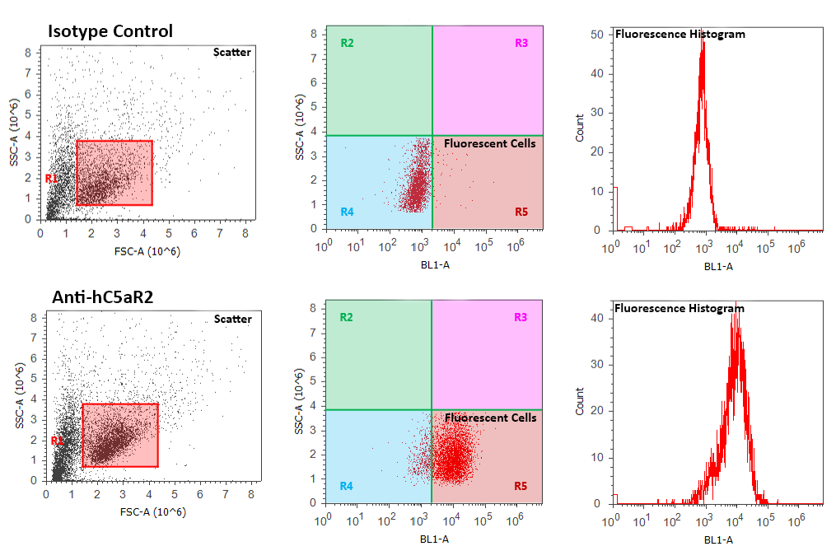
Figure 7.2 – WT hC5aR2 Gating, Percentage Positive, and Fluorescence Histogram Strategy
Live cells were gated using scatter plots. These live cells where then measured for their fluorescence against control cells. Those cells appearing in region R5 were positive for fluorescence. The percentage of these gated live cells that were positive were measured. MFI was measured from the population of live cells.

