

Economic, Social and Cultural Factors Underlying the Contemporary Revival of the Chesuo Ritual in a Jiarong-Tibetan Village

By:

Wei Qin

A thesis submitted in partial fulfilment of the requirements for the degree of
Doctor of Philosophy

The University of Sheffield
Faculty of Social Science
School of East Asian Studies

March 2017

Acknowledgements
Xiaowei Zang was my first supervisor between September 2010 and June 2012. Lucy Xia Zhao has supervised my study from 2010 to 2015 and Mei Zhang has taken part in the supervision of this thesis as my second supervisor since June 2012. Without their intellectual guidance and encouragement, this study could not have been completed.
The fieldwork data for this study, collected between 2006 and 2009, came from my previous experience as a member of the team led by Badeng Nima in the Multicultural Research Centre of Sichuan Province. As a part of the team’s project, some fieldwork data during this period came from the collaboration with David Burnett in the rural Danba area. I would like to thank Badeng Nima and David Burnett for their encouragement and support since 2006.
The fieldwork for this study during 2011 and 2012 would not have happened without the help of Bandi, Yunzhang Wen and Denzen. I am grateful to them for being my reliable friends and guides during my fieldwork in the rural Danba area. I would like to express my thanks to every informant of this study for their kindness, hospitality and trust. In order to protect the privacy of informants, their real names have been replaced by pseudonyms in this study, even though some of them would be happy to have their real names used.
I am grateful to Carey and Hilary Harmer for taking care of me in Sheffield and providing various forms of support that helped me pass through a most difficult period in my life.
This study was partially funded by the Chevening Scholarship from the British Council, to whom I am very grateful.

Abstract
This thesis is a social anthropological study that interprets the economic, social and cultural factors underlying the contemporary revitalisation of a collective ritual in a clan village of Jiarong (rGyalrong) Tibetans in the Ganzi Tibetan Autonomous Prefecture. It is based on two periods of fieldwork. The first period, between 2006 and 2009, occurred when I was conducting educational projects in this region with a team from the Multicultural Research Centre of Sichuan Province. The second period consisted of eleven months of ethnographic fieldwork in the same region between 2011 and 2012. A central question of this study is what factors motivated the Jiarong Tibetans to revive their traditions.
Chapter 3 explains that the revitalisation, which occurred in 2006, was triggered by an economic factor; traditional skills became valuable to local Jiarong people in reducing their relative poverty, which was caused by their marginalised position in local tourism development.
Chapter 4 seeks interpretations of the structural development of the ritual between 2007 and 2012. It shows that this development was motivated by a rising demand to maintain village-based kinship networks, which has been vital in sustaining the survival of the local community since 2008.
Chapter 5 explains the changes in the symbolic content of the ritual between 2007 and 2012 from a cultural perspective. A decline of Jiarong culture and identity was found to be the preeminent cultural factor that sustained the revitalisation and guided the changes.
This thesis concludes with the argument that this revitalisation, initiated by the Jiarong people in the Sino-Tibetan borderland, was a local response to the fast decline of rural Jiarong society in terms of social organisation and culture since the 2000s.

Glossary
The Jiarong people in this study use both Chinese (Sichuan dialect) and Jiarong language to express themselves in daily conversation; thus the glossary contains these languages:
C = Chinese (Sichuan dialect) and J = Jiarong language

Ber (J) | 伴儿 | Intimate friends who grown up together
Bebelala (J) |  | Someone puts a lot of effort into something but fails in the end
Ben ming nian (C) | 本命年 | The recurrence of the animal year in the twelve-year cycle
Bo (C) | 钹 | A type of cymbals that are widely used both by Han  and Tibetan people
Bu jiang li (C) | 不讲理 | Unreasonable
Daoshi (C) | 道士 | A priest in Taoism
Derge (J) | 锅庄 | A traditional collective dance in Jiarong culture
Derku (J)  gTOr-ma (J) |  | A small statue, made from a mixture of highland barely powder and yak butter in the Jiarong tradition, stands for offerings to the Buddha, spirits and ghosts.
Doerma (J) |  | Evil
Dongi (J) |  | Evil spirits
Du shu shao (C) | 读书少 | Poorly-educated
Geshe (J) |  | A degree in the monastic educational system in the Gelug sect of Tibetan Buddhism
Gengbe (J)  Daoshi (C) | 道士 | A traditional career that engages in the work of shamanism in the rural Jiarong societies
Gongtian (C) | 公田 | Collective farmland reserved by lineage villages as the shared wealth of lineage households
Gu (C) | 鼓 | A kind of drum, made of wood and animal skin
Guannei (C) | 关内 | Within the barrier
Guanwai (C) | 关外 | Outside of the barrier
Hada (J) | 哈达 | A silken scarf widely used by Tibetans for sending blessings to others
Hanhua(C) | 汉化 | the assimilation and acculturation of ethnic cultures by Han culture
Hei Jiao (C) | 黑教 | A word widely used by the believers of the Gelug sect of Tibetan Buddhism to call Yungdrung Bon in rural Danba
Huofo (C)  Sigeyok (J)  Seigeshiqi(J) | 活佛 | Tulku, also called “living Buddha”, who are believed as  reborn masters of Tibetan Buddhism
Hukou (C) | 户口 | The residential registration system required by the law in China
Hui dao song gui (C) | 挥刀送鬼 | Wave knife and send away ghosts
Jia (C) | 家 | Literally means family in Mandarin, but it in Erju Village refers to household
Jiarong Deze (J) | 嘉绒年 | The Jiarong New Year, based on the Jiarong lunar calendar
Lakang (J) |  | A sacred room, which is normally on the top floor of a Jiarong house, built specifically for Buddhist worship
Liang bian bu shi ren (C) | 两边不是人 | The target attacked by both sides
Luo hou (C) | 落后 | Laggards
Man (C) | 蛮 | Barbarian
Mani (J) |  | A prayer wheel with Buddhist scriptures carved on its surface or hidden in the middle, which implies reading the carved scriptures and increasing the merit of believers by turning it correctly.
Me-long (J) | 宝镜 | The sacred mirror, one of the classic symbols in Tibetan Buddhism
Mei ben shi (C) | 没本事 | Incapable of doing something
Mei Ren Gu (C) | 美人谷 | Literally mean “The Valley of Beautiful Ladies”, a township in the rural Danba area
Minban (C) | 民办 | Community-sponsored, manage by the public
Minsu cun (C) | 民俗村 | The folklore village, a kind of tourist attractions
Minzu (C) | 民族 | The Chinese nation, nationalities, and sometimes ethnic groups in various contexts
Minzu shibie (C) | 民族识别 | Ethnic classification, ethnic identification
Pusa (C) | 菩萨 | A word refers to Buddha
Qin (C) | 钦 | A classic instrument commonly used in activities of Tibetan Buddhism, made of copper
Secang (J) |  | A place, normally an empty ground, for collective gatherings and celebrations in every Jiarong village
Shaoshu minzu (C) | 少数民族 | Ethnic minorities
Shizi (J) |  | A small statue, made from highland barely powder and yak butter, represents the Buddha’s palace in the Chesuo ritual.
Sumchue (J) |  | A rite of the Jiarong people, lighting piles of pine branches to make smoke to worship mountain gods and as a blessing for good fortune
Szayo lama (J) | 上师 | A respectful address to the monk who as a teacher as well as a mentor guide
Tangka (J) (C) | 唐卡 | A kind of traditional Tibetan Buddhist paintings on cottons and silks
Tianshang (C)  Anmke(J) | 天上 | The heaven in Buddhist and Daoist concept
Tian bing tian jiang (C) | 天兵天将 | The warriors of the gods in Daoism and Han myths
Tusi (C) | 土司 | Local chieftains
vKhor-lo (J) | 经轮 | A symbol of golden wheel, one of the most common  symbols of Tibetan Buddhism
Weizang (C) | 卫藏 | Central Tietan region
Wu Bao (C) | 五保 | A national social welfare policy, enacted by the central government in 2006
Wuliao (C) | 无聊 | Boring
Xiang (C) | 乡 | Township
Xiejian (C) | 邪见 | Evil notions
Xuanzi (J) |  | A modern form of the Derge
Yi (C) | 夷 | Barbarians
Yeman (C)  Manzi (C) | 野蛮 | Barbarous
You guanxi (C) | 有关系 | Having connections with somebody
Zangzu (C) | 藏族 | Tibetan nationality
Zang Yi Zou Lang (C) | 藏彝走廊 | The Tibetan-Yi corridor
Zaonie (C) |  | Pitiful
Zang zu (C) | 藏族 | Tibetan nationality classified by the state in the 1950s

Note on the transliteration of Jiarong Language
All words in Jiarong language are spelled using the Pinyin system rather than Tibetan language in this study. This is because the speakers of the Jiarong language could not understand Tibetan language without training. Most Jiarong participants in this study were bilingual in the Sichuan dialect of the Han language and their Jiarong language. Conventionally, the Sichuan dialect is widely used by speakers of the various branches of the Jiarong language to communicate with each other.

All interview content in the thesis was translated from the Jiarong language and the Sichuan dialect, which was used in the interviews for the above reasons.

Table of Contents

Acknowledgements 1
Abstract 2
Glossary 3
Note on the transliteration of Jiarong Language 7
Introduction 9
Rationale of this study 9
Background knowledge of the Chesuo ritual 14
Structure of this study 17
Chapter 1 Literature Review 19
1.1 Rituals: definitions and functions 19
1.2 Previous studies of the self-initiated revitalisation of rituals 23
Chapter 2 Methodology 31
2.1 A value-neutral position 31
2.2 Ethnography as a methodology 32
2.3 Hypotheses 40
2.4 Data collection 49
2.5 Data processing 58
The interview guide 60
Chapter 3 Economic factors 65
3.1 Self-sufficient agricultural production in Erju Village 67
3.2 The transformation of the village economy since the 2000s 79
3.3 The financial reasons to revive 100
Chapter Conclusion 126
Chapter 4 Social factors 127
4.1 The evolution of the Chesuo ritual since 2006 129
4.2 The growth of the non-agricultural population since 2007 140
4.3 Kinship networks and seeking non-agricultural careers 145
4.4 The local community 155
4.5 The need for community cohesion 163
4.6 The role of the revived Chesuo ritual in maintaining kinship networks 170
Chapter Conclusion 178
Chapter 5 Cultural factors 180
5.1 To be a Jiarong Tibetan in Danba County 181
5.2 Dispute over the Tibetan nationality of Jiarong people since 2000 191
5.3 Reshaping the Chesuo ritual to reclaim the Jiarong-Tibetan identity 204
Chapter Conclusion 220
Conclusion 223
Findings 223
Implications 232
Directions for further studies 233
Bibliography 234

Introduction
This study, from a socio-anthropological perspective, explores the economic, social and cultural factors underlying the revival of a lost ritual, called Chesuo, initiated by a clan village of Jiarong (rGyalrong) Tibetans in the rural Danba County, Ganzi Tibetan Autonomous Prefecture in 2006. In a period of general decline in local traditions in the rural Danba area, this revitalisation, initiated and developed by Jiarong people, became the most significant and largest local ceremony in the township between 2007 and 2012.

Rationale of this study
Ritual refers to a group of symbolic behaviours, which are periodically repeated by their participants for purposes of self-expression and communication (Turner, 1977, 183; Terrin, 2007, 3741-3944; Smith, 2007, 3944-3946). Ritual, as an important component of tradition, is a significant form of presenting and perpetuating ethnic culture. In order to perpetuate their culture it is vital for ethnic societies without written histories, such as Jiarong Tibetans, to practice and preserve their traditions. Traditions, which refer to the inherited beliefs, customs and behavioural patterns which were generated in the past (Hobsbawm and Ranger, 1983, 2-4; McCormik and White, 1997, 800), help to shape individual thinking and actions, promote a sense of belonging, and thus preserve indigenous cultures and promote community cohesion (Tonkinson, 1993, 597-606). In this sense, rituals, especially collective rituals, have played a vital role in perpetuating culture among Jiarong Tibetans.
This study of the cultural revitalisation initiated by the Jiarong people, a small ethnic group in contemporary rural Eastern Tibet, primarily refers to the topic of the revitalisation of traditions initiated by indigenous communities. As defined by Wallace, the revitalisation is ‘deliberate, conscious, organized efforts by members of a society to create a more satisfying culture’ (1956, 279; 1966, 30). On the one hand, the revitalisation of traditions illustrates the cultural transformation and continuity of a society; on the other, it is a social phenomenon that discloses the constant progress of cultural constructions and innovations for satisfying the needs of people in dynamic social circumstances. In this sense, studying the revitalisation of traditions helps to increase our understanding of both the nature of tradition and also the larger issue of cultural change and continuity (Chau, 2011,1). Although the revitalisation of tradition is not a new topic in academia, few studies have had the opportunity to track the progress of such a phenomenon from its beginnings with first-hand data over several years. This study aims to provide an empirical case that interprets the revitalisation of tradition as a dynamic progress that displays how the ethnic culture reacts to its social context by re-employing their lost traditions. As will be explained in Chapters 4 and 5, viewing the revitalisation as a dynamic process is vital in order to find out how the renewed Chesuo ritual became a collective recreation serving multiple purposes in the Jiarong village. In this study, by comparing the changes in the procedures of the revived ritual between 2006 and 2012, I found that an increase in procedures in this ritual occurred in tandem with other cultural activities in the village declining over the same period. Thus, this revitalisation did not manifest a general growth in local ethnic culture, and a decline of Jiarong identity was found to guide the revitalisation by tracking the changes in the symbolic contents of the ritual between 2006 and 2012.
The emphasis of this study will be the various factors that motivated the revitalisation initiated by the indigenous community, which means the significance of the revitalisation will be interpreted by combining the explanations made by participants with the changes in social context. In this way, the nature of this revitalisation and the influences of the majority society on the continuity and change of indigenous social-culture can be grasped. Moreover, findings of previous studies in this field need to be discussed and examined in a different social context, so that our knowledge of the nature of traditions and the phenomenon of their revitalisation can be enriched.
Furthermore, this study intends to explore the transformations of the culture and societies of small ethnic groups in contemporary China in an era of drastic economic transformation. There was a sudden growth in the revitalisation of religion and folklore in post-Mao China, as it benefitted from the relaxation of state policy in restraining religions and traditions, as well as the economic reform (Zhang, 1997; Zhang, 2012). The state suppression of public religious practices and folklore during the period of the Cultural Revolution was a prominent reason leading to the massive disappearance of traditions in China after the 1950s, and the end of the state restriction on religious behaviour, as well as the economic reform, jointly led to a widespread revitalisation of religions, folklore and ethnicity in China since the 1980s (Litzinger, 2000; Lai, 2003; Makley, 2007; Wellens, 2010, 3-5; Chau, 2011, 3). This phenomenon attracted the interest of both domestic Chinese and international academia.
Contemporary studies on the revitalisation of religions and folklore in modern China manifest two trends. First, a large group of studies focussing on the revitalisation of the beliefs and practices of institutionalised religions (Christianity, Catholicism, Islam, Daoism, Confucianism, Buddhism) occurred in China after the 1980s (see Birnbaum, 2003; Lai, 2003; Makley, 2007; Billioud and Thoraval, 2009; Bell, 2010; Chau, 2011; Yang, 2012 and others). This is mainly attributed to three reasons: the considerable numbers of believers in these religions compared to scattered and various folklore; the personal interests of researchers, coming from the traditional vital role of religious cultures in composing and shaping Western culture; and the accessibility of data collections from organised groups in institutionalised religions, such as churches, monasteries and fraternities. Secondly, the contemporary studies on the revitalisation of folklore in China focused on those cases that occurred in Han society (Wang, 1997; Yang, 2000; Zhang, 2008; Jones, 2011; Palmer, 2011). In contrast, the revitalisations of various forms of ethnic folklore have drawn far less attention in academia. Considering the large number of diverse ethnic groups living in contemporary China and the significance of their societies and cultures in composing the diversity and integrity of Chinese society, contemporary research in this field is far from sufficient in reflecting the social transformation and cultural changes that have occurred in these ethnic groups in an era of drastic economic reform. Thus, questions remain in understanding the status quo of ethnic societies, especially those who were not registered as minzu (a state-acknowledged nationality), and their cultures in contemporary China. Did the ethnic groups undergo cultural revitalisations as the Han Chinese did under the same background of relatively loose national control of religion in the post-Mao era and the generally improved economic progress in China? Were the revivals of ethnic folklore triggered by the same underlying factors as their counterparts in the Han area? What social changes and facts in the contemporary ethnic societies were reflected by the revitalisations of ethnic folklore? Will the revivals of ethnic folklore manifest in a resurgence of ethnic culture and innovations therein? How can continuity and change in ethnic cultures be reflected in such phenomena? These questions are going to be discussed in the context of this study, leading to a more comprehensive understanding of the transformation of ethnic culture and society in contemporary China.
In addition, this study aims to contribute to the contemporary literature on the culture of the Jiarong people, an ancient group living in the ‘Tibetan-Yi corridor’ region (Fei, 1982, 1983) in the Sino-Tibetan margins. This group was categorised as Tibetan nationality in the categorisation created by the government of the People’s Republic of China (PRC) in the 1950s (Danba County Annuals, 1990; Quedan, 1995, 44; Prins, 2011, 19; Burnett, 2014, 38). As a result, this ethnic group lost its independent status as a cultural and political unit in the official count of the Chinese government. As a sub-cultural group of Tibetan nationality, the Jiarong people preserved a highland-agricultural culture that combined the traits of Tibetan and Qiang cultures as a result of the multi-ethnic co-inhabitancy history, as will be further discussed in section 2.2.2. The long history of the Jiarong people and the uniqueness of their culture has attracted scholars from various disciplines. The Jiarong Tibetan population is approximately 370,000, spread around the Qiong mountain and the river basins of Jin and Dadu, across the Ganzi and Aba Tibetan Autonomous Prefecture (Quedan, 1995, 485-487). The current study of the Jiarong people is largely limited to their ethnic history, language, architecture and local Bon tradition, a primitive local religion that used to be a dominant religion in Jiarong regions and became one of the four main genres of contemporary Tibetan Buddhism, and one of the main symbols used by present-day Jiarong people in presenting their culture (Quedan, 1995, 43-48; Zhang, 2003, 83-87). The origin of the Jiarong people has been a controversial issue in academia for decades, and whether the Jiarong language is part of the Tibetan-Burman group or a branch of the Qiang language is also in debate. However, these two academic debates have little connection with this study and will not be further discussed in this thesis. Compared to these two research clusters, the study of the social culture of this group is limited both in quantity and quality. The study of Jiarong culture is scattered in Chinese folklore studies and other non-academic articles that introduced Jiarong traditions in the 1990s, some of which had been significantly changed or even stopped when I returned to the region in 2011 to carry out the second phase of field work. Till 2014, only two works systematically introduced the culture of contemporary Jiarong people in rural areas (see G.Yu’brug and Stuart, 2012; Burnett, 2014). This thesis, which explores various factors that motivated the Jiarong people to reinitiate their lost traditions, further contributes to knowledge of the rural Jiarong society and its culture in transformation. This study focuses on exploring the impact of two major factors that have had a profound influence on the socioeconomic transformation of Jiarong people, but have not yet been studied. These are tourism development and the Sino-Tibetan dispute in politics and culture after 2008. Both have had a significant effect on cultural continuity and change among the Jiarong people. In this sense, this study, which focuses on a revival of a collective ritual initiated by a clan village in the rural Danba area, enriches contemporary literature and understanding of the changing social culture among the Jiarong people.
This revitalisation is significant firstly because it occurred in the cultural centre of Jiarong society, Danba County, which is considered by scholars to be the cradle of Jiarong culture. This can be seen from the origin of the word ‘Jiarong’, which is widely used in diverse contexts to refer to the ethnic group, their language, their culture and their geographic location. The word ‘Jiarong’ came from the word ‘rGyal-mo tsha-wa rong’. The specific meaning of the original word has been disputed by scholars as follows: ‘the valley of the Queen’(Gele, 1988; Prins, 2011), ‘the agricultural valley closed to Han region’ (Quedan, 1995, 41; Yan, 1997), and ‘the agricultural valley around Moerdo Mountain’(Gele, 1988; Quedan, 1995, 42; Daerji, 1997). Moerdo Mountain, located in Danba County, is believed by local Jiarong people as the origin of the Bon tradition. Moreover, the revived Chesuo ritual is a collective ritual, which played a vital role in representing and perpetuating the culture of Jiarong people, who had an ancient history and unique culture but had lost their written word. Furthermore, compared with a general decline of local traditions in the same geographic area, this revitalisation is meaningful as an unusual phenomenon that reflects the continuity of Jiarong culture based on their pre-existing social organisations as a clan.
This study focuses on the underlying factors of the revitalisation rather than its influence, though the latter will be mentioned as part of the progress of the revitalisation as it transformed from a ritual to a local ceremony. As Chau (2011, 3) states, a tradition ‘is always in the process of being made and remade by social actors in response to changing concrete, local circumstances’. The change in the social environment of the rural Jiarong society and its impact on the continuity and change of Jiarong culture in the rural area, as reflected by this revitalisation, is the interest of this study, and the influence of such an event on shaping the cultural transmission and social change of the Jiarong community in the long-term then can be studied on this basis.

Background knowledge of the Chesuo ritual
Although the Chesuo ritual is known by every villager in Erju, the term ‘Chesuo’ was found to be ambiguous. Although the ritual named as Chesuo was transmitted from generation to generation in the village, few villagers today can explain the meaning of the word ‘Chesuo’. Different explanations of its meaning were found between 2006 and 2012. The field notes taken in 2006 recorded that Chesuo was explained by elders as ‘the bow and sword’. However, in the interview data collected in 2012, it was explained by local elites as ‘the number thirteen’. Despite the dispute about the semantics of this word, in which neither side can provide any evidence to support their claim, these two explanations jointly reflect the traits of the ritual.
The Chesuo ritual was presented as a dance of 13 males with bows and swords, and in the eyes of local Jiarong people it is more than a dance for entertainment. The interview data collected in 2006 and 2011 both show that local people believe this dance could destroy Dongi (evil spirits) and expel Doerma (the devils) by channelling the power of ‘Tian bing tian jiang’ (the warriors of the gods, see more in section 5.3.2). These 13 dancers dress in the costume of warriors, which is significantly different from their everyday garb (see section 3.3.2). Based on this implication of the Chesuo ritual, local people believed this ritual could bless them for a peaceful and fortunate year ahead. They launched the Chesuo dance annually at a fixed place, a special ground for collective gatherings and activities in the middle of each village. Ritual, conceptualised by Turner (1977, 183), is ‘a stereotyped sequence of activities involving gestures, words, and objects, performed in a sequestered place, and designed to influence preternatural entities or forces on behalf of the actors' goals and interests.’ In brief, a ritual emerges when meaning is given to a posture or action beyond its practical meaning (Grimes, 1982, 40-45). In this sense, the dance is ritualised by local villagers as a practice of exorcism.
To what extent the nature of the revived Chesuo ritual follows its original meaning is unknown, since the history and knowledge of this ritual were lost due to the destruction of local records and the interruption of social memory caused by the Cultural Revolution between 1966 and 1978. Contemporary knowledge about this ritual mainly came from local villagers, who revived the ritual in 2006 and claimed it was one of their most ancient and unique traditions. As a matter of fact, no other similar folklore in the rural Danba area has been found so far. Nevertheless, as revealed by other studies in the social culture of the Tibetan-Yi corridor, the traditions of male dance with diverse weapons were found in the villages of both the Jiarong and Qiang people in this region (Yang, 2001, 66-71; Zhang, 2011,139-141), owing to the cultural diversity and similarity caused by the regional history of multi-ethnic inhabitancy, which will be discussed in section 2.2.2. The history and symbolic meaning of this regional tradition, however, had little connection with the revitalisation in 2006, as will be explained in section 3.3.2.
There are various versions of the origins of Chesuo ritual among the narratives of local Jiarong people, two of which are notable. According to Danba County Annuals (1990, 569), ‘villages in rural Danba area still keep a dance, Chesuo, which preserves an ancient tradition of ‘Hui Dao Song Gui (sending ghosts away by waving knives)’, as part of the funerary rites that are recorded in the history books of the Tang Dynasty’. Some Jiarong scholars argue that the Chesuo dance is a part of the folklore around A-Ni-Ger-Dong, a legendary Jiarong hero in the folktales of the Bon tradition (Zhang, 1990, 39-42; 1996b, 64-65; Zhang, E-Ma-Ta and Ge-ER-Ma, 2011, 62-69; Li, 2015, 14-21). The legend of A-Ni-Ger-Dong, which is widespread in the Jiarong region, was the origin of many significant Jiarong traditions (Zhang, 1993, 46-51; 1996a, 77-80; 1996b, 64-65; 1996c, 42-43; 1998, 16-51; Zhang, E-Ma-Ta and G-Er-Ma, 2011, 62-69; Wang, Yang and Xu, 2015, 18-22; Li, 2015, 14-21). The other explanations of the origin of this ritual came from the oral history of local people, which has significant variety. The fieldwork in 2006 found that the people in Erju village, where the ritual was revived, state that the Chesuo ritual is part of their traditional ceremony for celebrating the age of 49. Why the age of 49 is special to Jiarong Tibetans is still uncertain. The explanation made by Suolang is that ‘it [the number 49] was said to be the age at which local males retired from the army and went back to their villages’. Although this explanation cannot be proved due to lack of supporting evidence, there is no material to link the number 49 with either the funeral or the story of A-Ni-Guo-Dong. Moreover, the Chesuo ritual existed as a part of a well-known regional tradition to celebrate the age of 49 in nearby villages, rather than as a funeral rite, for decades, and the motivation of this revitalisation and its progress further manifest a different orientation from these official interpretations, as will be discussed in sections 3.3.2, 4.1 and 5.3.

Structure of this study
In the literature review, related theory about ritual and previous studies interpreting the revitalisation of collective rituals initiated by indigenous communities are discussed in order to define the nature of this study and give a comprehensive overview of contemporary knowledge on this phenomenon.
In chapter two, the methodology of this study is explained, including background knowledge on the Jiarong society, the fieldwork site of this study, hypothesises based on my previous fieldwork experiences in the region between 2006 and 2009 as a guide for data collection in the same region between 2011 and 2012, the methods for data collection and processing, and the ethical concerns.
In chapter three, the revival of the Chesuo ritual in 2006 and the social context of this event is analysed, to explore the trigger for this revitalisation. Based on previous fieldwork data collected between 2006 and 2009, economic factors are found to be the main reason for this event.
In chapter four, the development of the Chesuo ritual between 2007 and 2012 is analysed by comparing the visual records of the ritual between these dates. As the economic factors that triggered the revitalisation in 2006 no longer existed after 2008, social factors that sustained the revitalisation between 2007 and 2012 are discussed. Moreover, the influence on the revitalisation of the political tension between the Tibetan nationality and the PRC government, which dramatically increased in both 2008 and 2012, is discussed.
In chapter five, cultural factors that existed throughout the revitalisation are examined through a series of notable changes in the symbolic meaning and the significance of the Chesuo ceremony between 2006 and 2012.
Finally, in the conclusion, the findings and implications of this study are discussed and suggestions for future studies are made.

Chapter 1 Literature Review
The literature review consists of two parts. The first part reviews the theory of rituals in academic literature, and the second part reviews previous studies about the motivations of reviving lost rituals initiated by indigenous communities.
The academic literature reviewed in this thesis only includes publications in English and Chinese due to my linguistic capacity. Moreover, only the revitalisations of rituals are discussed in this thesis, rather than the revitalisations of other traditions. Rituals, as classified by Grimes (1995,61), include festivals, ceremonies, celebrations, ritualisation, liturgy, magic and decorum. This limitation of reviewing only the revitalisations of rituals is based on two considerations. Firstly, rituals belong to traditions, while traditions have various forms which are quite different from one another in their features and functions, such as beliefs, notions, poems, stories, writing styles, laws, costumes and so on. Correspondingly, revitalisations of these traditions are different from each other in their motivations, patterns and significance. Secondly, the rituals discussed in this thesis are those which are revived by indigenous communities rather than other external authorities such as government, NGOs (non-governmental organisations) and commercial companies. This is because the revitalisations that are initiated by indigenous people themselves reveal the political and social changes which affect daily life in indigenous communities and indigenous people’s perceptions of their lives, while the revitalisations organised by external organisations are commonly motivated by the interests of people outside the indigenous societies. Therefore, all of the studies reviewed in this thesis are the self-initiated revirevitalisations of rituals in indigenous communities in various sociocultural contexts.

1.1 Rituals: definitions and functions
As mentioned above, rituals, as one of the various forms of tradition, have their own features and thus are distinct from other traditions. Therefore, it is necessary to clarify the definition and traits of ritual before discussing the revival of the Chesuo ritual initiated by Tibetans in rural Jiarong.

1.1.1 The definitions of ritual
Ritual, defined by Victor Turner, who laid the cornerstone for the study of rituals and promoted it as a significant aspect in understanding diverse indigenous cultures and societies, is ‘a stereotyped sequence of activities involving gestures, words and objects, performed in a sequestered place, and designed to influence preternatural entities or forces on behalf of the actors' goals and interests.’ (Turner, 1977, 183).
Turner’s definition emphasises three features of rituals: stereotyped, sequestered, and influential. ‘Stereotyped sequence of activities’ implies that rituals can be, and need to be, repeated in order to exert their influences on the public. Rituals are commonly held, and revived, to benefit an individual or group; by proclaiming these rituals are authorised by God or other celestial beings dominant in the cosmology of participants, the individual or group achieves its ambitions by obtaining the consent of participants. Individuals are persuaded to believe in the authority of rituals by means of presenting symbolic acts or items which lead individuals to associate the authority of rituals with the mysterious workings of their god or celestial being. These symbols, including costumes, instruments, postures, sounds, smells and even the location – ‘sacred places’, jointly constitute the hypernormal scenes of rituals; thus rituals are convincing and influential to people who have internalised the culture of their societies. Rituals are therefore significant not only to ‘preternatural entities’ in the individuals’ religious beliefs but also to their social life. In other words, rituals on the one hand reflect the ambitions of their organisers and, on the other hand, influence the behaviour of participants.
Turner, Terrin and Smith consider ritual as a type of social interaction between participants (Truner, 1977, 183; Terrin, 2007, 3941-3944; Smith, 2007, 3944-3946). They agree that rituals exert their influence on the cognition of participants by arousing their emotional responses, which are irrational but more fundamental than the rational construct in human cognition. In summary, Terrin and Smith both emphasise that: (a) rituals consist of a group of symbolic behaviours; (b) the ideology of rituals is conveyed through a set of signs which constitute the entire scene of holding rituals, including costumes, body language of actors, music and even smells; (c) these signs jointly stir up the sympathetic responses of participants and therefore create the ideological significance in their cognition.
In conclusion, a ritual, including revived ritual, is a group of symbolic behaviours which are regulated culturally; it creates or recreates an emotional connection between participants; and it is periodically repeated for the purpose of communication.

1.1.2 The functions of ritual
According to the definitions discussed above, rituals are collective activities which are influential both for the individual and society. The influences of rituals, or so-called functions, need to be reviewed when examining the motivations of indigenous people in reviving their lost rituals, as those functions which link closely to the social needs of individuals may also motivate the revitalisation of rituals. Briefly, rituals show various dimensions of a society, including social realities such as social structure, hierarchy and power relations, and people’s perception of reality, such as cosmology, beliefs, history and social memory. Moreover, through evoking the participants’ emotional response, rituals can obtain the consent of the public when establishing political alliances in order to maintain or oppose the existing social order.

1.1.2.1 Ritual, social identity and social memory
On an individual level, rituals assist individuals in forming their perceptions of reality. The social identities of individuals are formed and transformed through daily rituals, such as manners and gestures, in social interaction with others (Goffman, 1976) and in rites of passage, such as baptism, initiation rites and weddings (Van Gennep, 1909). Moreover, the personal characteristics of individuals, individual cognitions of rationality, mercy and morality, and social memories are shaped by rituals (Geertz, 1973, 124; Gaster, 1961, 377). Therefore, rituals unfold indigenous cultures, from the real histories to their narratives of their own culture, and shape the social memories of participants through evoking their emotional responses and hence creating the ideological significance.

1.1.2.2 Ritual, social conflict and cohesion
On a social level, rituals reveal social reality and promote social cohesion by eliminating conflicts within societies. Rituals, although held in limited time and space, are micro-models of societies and are influential in shaping social reality. Rituals, according to Turner (1968, 8, 14), are the assemblage of symbols for social representation, which emphasise ‘making sense of participants’ experiences’ (Hinnells 2005, 46). Furthermore, rituals help to promote social cohesion by means of fostering social tolerance (Durkheim, 1995 [1912], 227), cultivating social sensitivities (Radcliffe-Brown, 1952, 176-179) and eliminating social conflicts (Gluckman, 1963; Turner, 1968).

1.1.2.3 Rituals and power relations
As collective activities, rituals inevitably involve power relations. Rituals are commonly held in order to compete for social power, due to their influence on individuals’ cognition of social reality. Political rituals, such as crowning and accessions, are held in order to announce the validity of a new power status. David Cannadine calls these political rituals ‘trapping of powers’ (Cannadine, 1983, 104), and they enable individuals or groups to achieve their ambitions for social power. For this reason, rituals are organised, revived and even created in order to mobilise the public and express political or social contests (Kertzer, 1988; Hall, 1976).

1.1.2.4 Conclusion
Collective rituals have various meanings in societies. The functions of rituals for the individual and in society distinguish them from other kinds of traditions. Moreover, these functions can be significant motivations when a ritual is revived, especially when revitalisations are initiated by an indigenous community in which the social and cultural settings are undergoing massive changes. However, to what extent these functions of rituals can appropriately explain the motivations for reviving rituals in indigenous communities will depend on the social needs of the indigenous people, which must be discussed in their specific sociocultural context.

1.2 Previous studies of the self-initiated revitalisation of rituals
As demonstrated by previous studies, the revitalisation of ritual initiated by indigenous communities in diverse sociocultural contexts is based on various motivations. Exploring these motivations helps to reveal the sociocultural environments of these indigenous communities and how indigenous people perceive their societies and cultures, which are undergoing drastic changes. Previous studies provide various explanations of the motivation behind the self-initiated revitalisations of rituals in indigenous communities; however, these theories cannot adequately explain the motivation of the revitalisation in rural Tibet, as is discussed below. The motivations proposed by these studies can be grouped into political perspectives, economic perspectives and cultural perspectives, though in reality these motivations are often interwoven.

1.2.1 Political motivations
Some studies consider the revitalisation of ritual in indigenous communities to be politically motivated. In his study of Siberian society, Leete (2005) considered the revitalisation of ritual to be motivated by the political desire to fight against colonial powers. Between the 1920s and 1940s, a shamanic ritual had been revived and temporarily intensified in Siberian societies in order to fight against the colonial power and acquire political autonomy. This ritual had been revived by shamans, who had been governors in traditional Siberian society but had suffered political repression under the Soviet government, and it had thus become a social movement. Similar to Leete’s study, Peterson (2012) explained the revitalisation of tribe tradition in Africa between the 1930s and the 1970s as the result of raised ethnic patriotism, which refers to an intention of rebuilding social orders that were disturbed by colonial powers and the expansion of the Christian religion. Herrou (2011) argued the revivals of Taoist traditions and activities in temples in China were largely promoted by the Daoist monks, who could gain potential economic and social benefits from the revitalisations.
However, neither Leete’s nor Peterson’s findings are applicable to the revival of the Chesuo ritual in 2006. When the Chesuo ritual was re-launched in the rural Danba area, there was no overt political tension between local Jiarong residents and the government. As will be discussed in section 3.3.2, the contents of the ritual oriented to a series of ceremonies and celebrations, rather than a purpose of political mobilisation. Thus other explanations need to be considered.

1.2.2 Economic motivations
Other studies have attributed the self-initiated revivals of rituals to economic motivations. One of the economic motivations, displayed by Wang and Yang in their respective studies of revitalisation in rural southern China in the 1990s, is the need to maintain the economic units of villages or lineage families (Wang, 1997, 1-85; Yang, 2000).
In Wang’s studies in rural Fujian, he argued that a revived ritual in the 1990s had been motivated by the economic need to resume the cooperation of local families in farming. By tracking the village history and the origin of the ritual, Wang proposed that the ritual enabled local families to continue cooperation in farming and had thus maintained the economic unit of the village before it had been prohibited during the Cultural Revolution in the 1970s. Through the ritual, local families exchanged their farming materials, redistributed collective wealth, and benefited from controlling the Gongtian (the collective farmlands of the villages) in turn. Hence, he considered that the revival of the ritual initiated by villagers in rural Fujian during the 1990s had been motivated by the economic need to resume the cooperation of local families in farming and further maintain their village as an economic unit.
In Wang’s theory, this revived ritual was described as a cultural reflection of the economic cooperation of farmers in rural Fujian. However, his theory is not applicable to the revival of the Chesuo ritual in contemporary rural Jiarong, because in recent years the importance of maintaining cooperation for farming has greatly declined in these villages. This decline is due to the growing numbers of local Tibetans living as migrant workers, rather than farmers, since the 1990s. Thus the revival of the Chesuo ritual in these villages occurred in a different social context from its counterpart in rural Fujian, and the motivation of the revitalisation in rural Tibet is different from the explanations proposed by Wang.
Yang’s study of the revived rituals in rural Wenzhou in the 1990s took into account the recent decline of farming in rural China (Yang, 2000). Yang proposed that the revitalisation in rural Wenzhou had been motivated by the need to maintain family lineage rather than villages as economic units. By tracking the economic change in rural Wenzhou since the 1949, Yang argued that family lineages were the economic units that had been important for individuals to maintain cooperation in farming. After this function of family lineage had broken down during the economic reforms in the 1980s, people in rural Wenzhou had to maintain their family lineage through collective consumption. The aim of maintaining family lineage had motivated the revival of the annual ritual in rural Wenzhou. In the ritual, people donated excessively to their lineage families in order to confirm and maintain their membership, and this individual behaviour had grown to be a competition in excessive spending. However, Yang cannot adequately explain why this phenomenon happened in rural Wenzhou, and she does not give a convincing explanation as to why local people preferred to insist on their lineage families as an economic unit even though they could only maintain these lineage families at great expense, in spite of the fact that these lineage families had lost their traditional function of benefiting individuals in farming.
Similar to the findings of Wang and Yang, Jiao (2001) found that the revival of fraternal polyandry in Tibetan in the 1990s was owing to an economic motivation for combining the farmland and releasing more non-agricultural wage labours. Different from Jiao’s case, the revitalisation of the Chesuo ritual in the Jiarong village in 2006 does not involve the issue of cooperative production.
As well as the motivation of maintaining economic units, developing tourism is another common reason of the revitalisation of the ethnic traditions. As revealed by Salemink, Huế festival in Vietnam was revived with the intention of attracting foreign tourists (Salemink, 2007, 580). Similarly, the study of Suntikul (2007, 128-140) and Arslan (2008) also found the influence of tourism on the restoration of ethnic traditions. However, developing tourism is not the reason for the revived Chesuo ritual in rural Tibet, because this ritual has grown despite the fact that few tourists have been attracted. Therefore, other explanations need to be found.

1.2.3 Cultural motivations
Other studies consider that the self-initiated revitalisation of rituals is motivated by the cultural needs of individuals as well as the public. These cultural motivations are commonly linked to the needs of individuals to maintain their identities and to integrate recent changes into their pre-existing identities (Wang, 1997, 1-85; Zhang, 2008, XVII, 1; Tyler, 2010). In Wang’s study of the revived ritual initiated in rural Fujian, he suggested that one of the crucial motivations for the revitalisation was the need of villagers to return to their community history when the traditional patterns of their country life had collapsed due to the political changes since the 1980s (Wang, 1997, 91-93). Echoing Wang’s theory, both Zhang (2008, 1) and Tyler (2010) also attributed the revivals of rituals to individuals’ psychological need to confirm their cultural identities in the context of rapid social and cultural changes. A rise in the importance of ethnic identities is commonly explained as the trigger for the resurgence of ethnic traditions. Moreover, raised ethnic identity, which in some cases refers to ethnic patriotism and national-identity building, has also been used to explain the cultural motivation of the revitalisation of ethnic traditions (Peterson, 2012; Maj, 2012; Tappe, 2013).
Another cultural motivation is cultural norms, which encourage individuals to maintain the core beliefs of their cultures; in this respect, rituals are revived to pass on these core beliefs. Augilar (1995) argued that the revitalisation of a pagan ritual in African tribes in the 1940s had been rooted in the internalised cosmologies of the tribe’s members, when the political power which resulted in the interruption of the ritual was no longer influential in their society.
Moreover, another explanation of why indigenous communities revive their lost rituals is for the purpose of opposing the cultural supremacy of major ethnic groups. Santasombat (2001, 155) argued that the revitalisations of some religious rituals, including some traditional festivals by Tai people in southern China in the 1990s, had been ‘an attempt to re-construct a sense of Tai ethnic identity through the creation of an historical consciousness or ideals of the Tai race […] and resisting Chinese supremacy’, in this case regarding symbolic power relations with the Chinese.
However, all of these cultural motivations are evoked in specific social contexts, while there is little academic literature examining contemporary rural Tibetan society in the PRC, including the economic, social and cultural status quos of Tibetan communities in rural areas, and how local Tibetans perceive the impacts of these changes on their daily life. Therefore, the social context of the revitalisation in the rural Jiarong area must be explored and the cultural motivations proposed by previous studies must be examined in the social context of rural Tibet.

1.2.4 Research gaps and contributions
Previous studies, outlined in the literature review, give explanations of the motivations of the self-initiated revitalisations of rituals in local communities, but none of these can adequately explain the revival of the Chesuo ritual initiated by Jiarong Tibetans in contemporary rural Tibet. This study will differ from previous studies in two main ways.
Firstly, the revival of the Chesuo ritual happened in a social setting that differs from previous studies in political, economic and cultural aspects. As discussed above, the motivations of the revived Chesuo ritual are not explained by previous theories. Therefore, this study will contribute to our knowledge of the revitalisations of rituals initiated by indigenous communities.
From a political perspective, as ethnic minority groups, Tibetans in contemporary China are ruled by a government dominated by Han people. The political conflict between Tibetans and Han Chinese still exists in contemporary China, as was evident in the social unrest that occurred in Lhasa in 2008. The revival of the Chesuo ritual occurred in 2006, and no evidence of political purpose was found in the fieldwork in this period. Thus, though it occurred in a social context of ethnic issues, this revitalisation cannot be simply explained as being motivated by the need to acquire political power, which was considered by Leete as the major reason for the revival of Shamanic rituals in Siberian society in the 1920s to 1940s. To what extent this revitalisation was motivated by raised ethnic patriotism, as Peterson (2012) proposed in his study on the revitalisation of Africa religious traditions, needs to be further examined with ethnographic data.
Economically, the social context of rural Jiarong Tibet also differs from southeast rural China due to the notable economic changes that have occurred since the 1980s. The Chinese government has been successful in bringing the rural Tibetan economy into the expanding national market economy. The Chinese government places the vast rural area of China in the role of ‘the provider’, responsible for exporting the rural labour force and essential materials into the cities in order to promote urban economic growth, especially in the south-eastern area. As one of the results of this economic policy, the economic gap between southeast China and western China, as well as between cities and rural China, became a prominent problem in the unbalanced Chinese economy (Sun, 2004, 5-6, 22-24). Compared to south-eastern China, with its economic advantages, the rural Jiarong Tibet area, which suffers from chronic poverty, had a growing number of migrant workers who were once peasants. Consequently, the importance of farming has greatly decreased in the hometowns of migrant workers, and traditional community life in the rural Jiarong Tibet area, which was the social basis of sustaining local culture, has changed. Under these conditions, the revival of the Chesuo ritual in contemporary rural Jiarong Tibet is neither rooted in nor reflects the interdependence of farmers on agriculture, which was cited by Wang (1998, 1-85) and Yang (2000) as the main factor in the revitalisations of rituals in south-eastern rural China. This study will track an economic change in the rural Jiarong area since the 1980s as a vital factor that influenced community life and cultural inheritance in the villages where the revival of the Chesuo ritual was initiated.
Moreover, the revival of the Chesuo ritual in rural Jiarong reveals the change of cultural context and cultural identity as perceived by Jiarong Tibetans, who are considered as one of the biggest ethnic minorities in contemporary China. Previous studies from a cultural perspective proposed various theories to explain why indigenous communities revived their lost rituals, such as seeking community history (Wang, 2008, 1-85), resisting cultural supremacy (Santasombat, 2001,155), expressing raised ethnic identity (Peterson, 2012; Maj, 2012; Tappe, 2013), and integrating new changes into their pre-existing identities (Wang, 1997, 1-85; Zhang, 2008, XVII, 1; Tyler, 2010). However, to what extent these individual psychological needs motivated the revival of the Chesuo ritual must be examined in the Tibetan context. However, what constitutes the Tibetan context is still unclear as few studies reveal how ethnic cultures and ethnic identities in rural Eastern Tibet in the contemporary PRC, have been influenced by the rapid economic progress in China since the 1980s. In this respect, exploring the motivations for reviving the Chesuo ritual in rural Jiarong will help to reveal how the cultural setting of rural East Tibet and the Tibetan identity have changed in recent years.
Secondly, this study is conducted in a different way from previous studies. Based on the fieldwork data collected in the area between 2006 and 2012, this study provides five years ethnographic data to interpret the revitalisation as a dynamic process. A holistic perspective, as so-called ‘thick description’ (Cannadine, 1983, 104-105), is adopted in order to comprehensively explore the social background of this revitalisation in rural Tibet.
The holistic perspective in this study firstly draws on the social context of the revived Chesuo ritual by comprehensively exploring the major social changes that have occurred in rural Tibet since the 1980s, which form the external environment of daily life in rural Jiarong and can be objectively described. This is in order to avoid subjectively presenting the social context according to the judgement of researchers. Previous studies, outlined above, tended to attribute the self-initiated revitalisation of rituals to a major factor, whether it be political, economic or cultural, according to the preference of the researchers. Nevertheless, above all, the revitalisations of rituals initiated by indigenous communities is a cultural phenomenon with complex results caused by various factors in specific social contexts. However, few of the researchers mentioned above justified their preference for their chosen major factor before they interpreted these cultural phenomena.
The holistic perspective of this study also refers to exploring how the participants themselves perceive and evaluate the external social setting according to their own culture when they are explaining their behaviour. This is for two reasons. Firstly, the revitalisations discussed in previous studies were not automatic responses to the social context but were planned and organised by people who perceived the social setting in their daily life and formed strategies to act according to their perceptions. The perception of participants is the key point to link the various objective social settings with the emergence of these revived rituals. However, in previous attempts to interpret the revitalisations of rituals, participants were rarely taken into account, even though most of these studies were cross-cultural. The nature of this study induces the second reason for emphasising the experiences of participants. I argue that valuing the experiences of participants is significant in conducting cross-cultural studies, because cultural differences between researchers and participants will lead to discrepancies in defining, evaluating, interpreting and responding to the same social event. Thus, as this study intends to explain an organised cultural revitalisation initiated by Jiarong Tibetans, it is vital that the social context seen through the eyes of Jiarong Tibetans is objectively described by researchers. This will contribute to a reliable approach in exploring the motivations of a cross-cultural study. Therefore, from a holistic perspective, the social context of contemporary rural Jiarong Tibetan villages, especially the changes that impacted the life in the rural Jiarong area and how the social context generated the demand of reviving the Chesuo ritual in the Jiarong Tibetan village, will be revealed.

Chapter 2 Methodology
This study explores the underlying factors of a revitalisation of a lost ritual in a Jiarong Tibetan village in contemporary rural Eastern Tibet. In order to understand the significance of this revitalisation for the Jiarong Tibetans who organise, participate in, and are influenced by it, ethnography is employed in this study to gather data that reveal the insiders’ interpretations of this event between 2011 and 2012. The fieldwork data provide an explanation of this revitalisation from an insider’s perspective. This chapter will discuss the methodological concerns related to the ethnography in rural Eastern Tibet.

2.1 A value-neutral position
This study refers to the culture of an ethnic minority group, Jiarong Tibetans, who are a subdivided indigenous people living on the borderlands between the realms of the Han and Central Tibetans. The culture of Jiarong Tibetans, though significantly influenced by that of the Han people and Central Tibetans, has preserved its own traits. In order to explain the revitalisation initiated in the community of Jiarong Tibetans, it is vital to value their culture on an equal basis with the culture of the two other majority groups. Therefore, a value-neutral position is adopted in this study.
The value-neutral position refers to valuing the independence of Jiarong Tibetans’ culture. Their customs, traditions and other activities are treated primarily as being within their culture system, rather than being perceived as a mixture of the Han and Central Tibetan culture.
The rationale of this position lies mainly in maintaining research morality in ethnography, which requires support for the claims of indigenous people in expressing and interpreting their culture with confidence, rather than weakening their claims with outsiders’ views. It is particularly important for cultural studies in the context of contemporary rural Eastern Tibet, where the competition for governance rights between the state and institutionalised Buddhist monasteries is based on the long-standing political controversy over ‘Tibetan territory,’ and which leaves limited space for preserving local folklore. Based on this consideration, taking a value-neutral position in this study is essential in order to reveal how cultural changes in the community of Jiarong Tibetans have been shaped by their relationship with the Han and Central Tibetans in recent years. Thus, it helps to disclose the various factors facilitating the revival of the Chesuo ritual in 2006, and its subsequent growth in the following years.
The data collected in ethnography cannot be truly value-neutral to the preconceptions of the researcher, but the validity of data representation can be approved in many ways (see section 2.5).

2.2 Ethnography as a methodology
Ethnography, based on interpretivism, interactionism and constructionism, is the main fieldwork approach used in this study. It is employed as an inductive approach to build up a coherent data pool in order to explain the social behaviour of the Jiarong Tibetans. The data was collected through everyday participation in community life, observing the daily routines of families and the social interactions of villagers in everyday life, and through local documents and interviews in various forms. The data collected from these multiple approaches was compared, to substantiate and advance the findings. Through ethnographic study of these villages, real scenes of Jiarong daily community life can be observed and the villagers’ perceptions of their cultural identities, social organisation, governance powers in their community, and their desire to revive the lost Chesuo ritual can be disclosed.

2.2.1 Entering the field
This fieldwork in Danba County, Ganzi Tibetan Autonomous Prefecture, was carried out from December 2011 to October 2012. Through this fieldwork, ethnographic data were gathered in two small villages in order to explore how Jiarong Tibetans in rural Eastern Tibet have revived the lost Chesuo ritual in response to their dramatically changing social life.
Though the fieldwork did not follow the complete annual cycle of village activities, it covered the most significant period of family reunions and the daily life of agricultural work. This fieldwork benefited from my previous experience in this region on educational projects from 2006 to 2009. During this period, I participated in a team from the Multicultural Research Centre of Sichuan Province and had contact with village leaders. I also lived in these villages and attended the annual Chesuo ritual festival at the end of each year. Therefore, I became familiar with members of the village committee and gained some general knowledge of the history and life in this region. This preliminary work enabled this study to be undertaken with more ease than if I had been completely new to the region.
Moreover, a mutual language proved advantageous when communicating with villagers. Though there are differences in local dialects, and those villagers living on the mountain speak a dialect different to others in rural Eastern Tibet, most of them also speak the common regional dialect of Sichuan, of which I am also a native speaker.
Furthermore, I enjoyed a personal relationship with a local family, as the host was a friend of my own family. I lived with this local family for the duration of the fieldwork, and I was accompanied by one of their nephews to visit other families in these villages with whom he had kinship ties. Most of the villagers therefore, perceived me as the distant niece of a local elder, an overseas student and a member of staff from a previous research team. This identity helped me to better build mutual trust with local villagers and to become more naturally involved in village life.

Map 1. The Geographic Location of Danba County
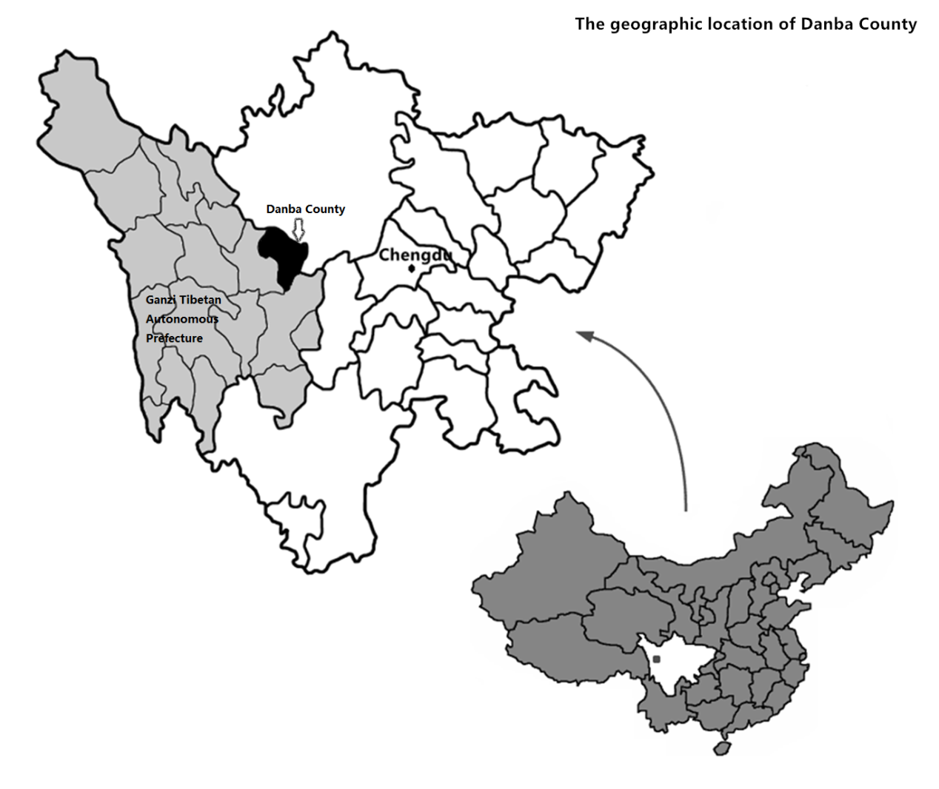

Map 2. The Erju Clan Village (Dapin Village and Xiaopin Village)

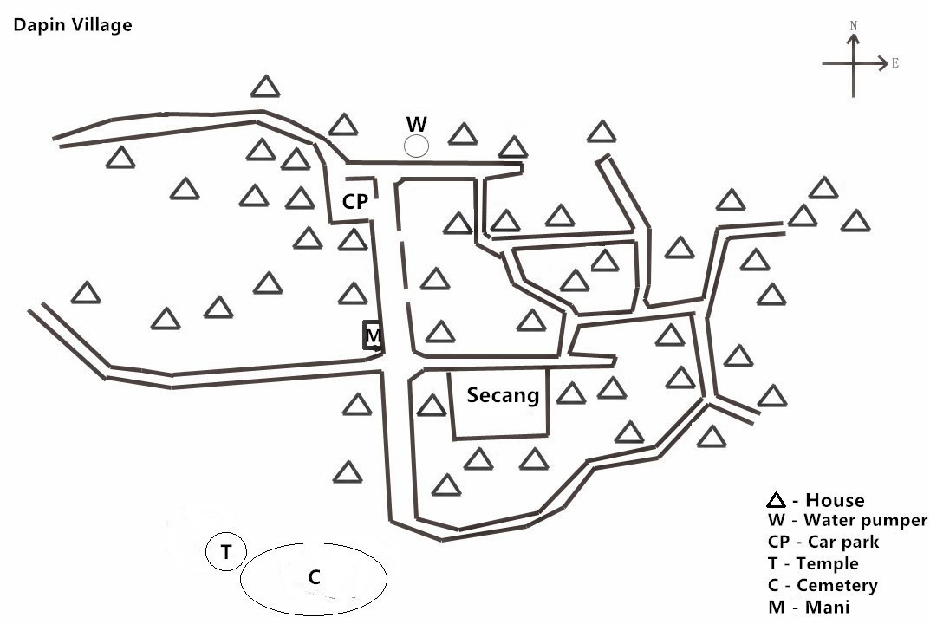

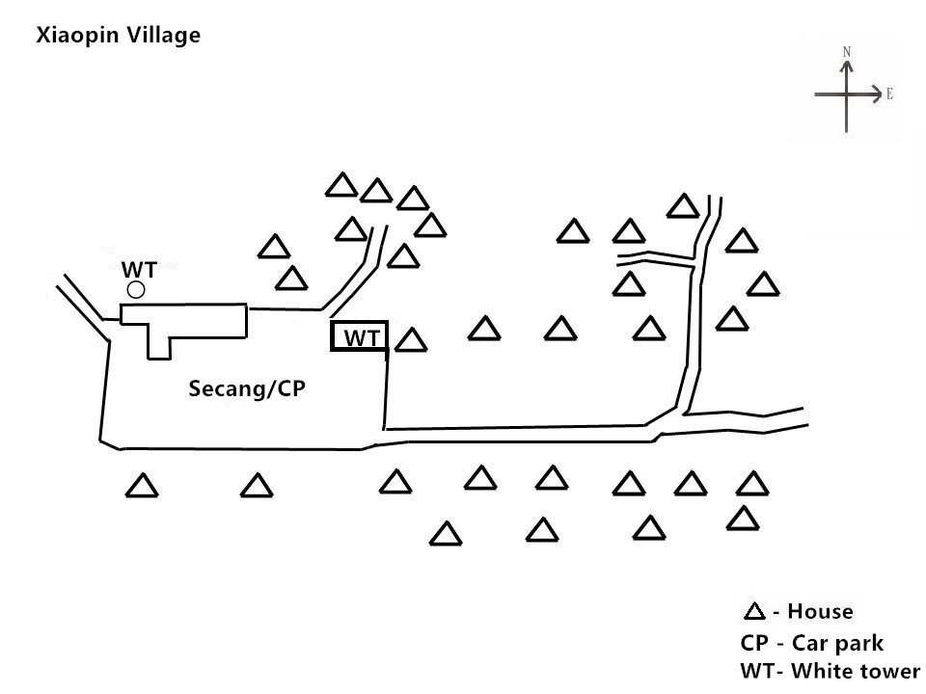

2.2.2 The ethnographic field
The ethnographic field of this study is two Jiarong Tibetan villages where the Chesuo ritual has been revived, and which lie in a county named Danba, in a mountainous area in the Ganzi Tibetan Autonomous Prefecture. The Chesuo ritual, like other local folklore, is a collective cultural creation in the local community. The characteristics of social organisations in a region, cultural traditions and other material conditions have a vital influence on deciding the form and significance of local folklore. Therefore, a brief description of the geographic traits, history, and cultural traditions of the field are necessary to form a general image of the social settings surrounding the revitalisation.

2.2.2.1 The geographic traits of Danba County
Danba County was founded in 1951 by the Chinese Communist Party in the eastern part of the Ganzi Tibetan Autonomous Prefecture (Danba County Annuals, 1996, 7). The county is located in the high mountain range of the Min and Qionglai Mountains, between the Qinghai-Tibet Plateau and the Sichuan Basin. Low-efficiency agriculture with infertile farmland predominates, and there is a long history of adverse weather in the area, such as droughts, strong winds, mudslides, hailstorms and heavy snows (Danba County Annuals, 1996, 5). Nevertheless, it continues to support a large rural population. Since the 1990s, mining, the water industry and tourism have gradually become the main sources of revenue.
Moreover, the geographic location of Danba County has made it an important part of ‘Zang Yi Zou Lang’ (the Tibetan-Yi corridor), which is crucial for population mobility and trade between ethnic minorities in the northeast of the Sichuan Basin and the Han in southern China. Accordingly, Danba County has a long history of multi-ethnic inhabitation, and about 15 minzu still live in the territory today (Danba County Annuals, 1996, 118).

2.2.2.2 Multicultural coexistence in Danba County
Multi-ethnic inhabitation results in the coexistence of diverse ethnic cultures and the diversification of local folklore. However, the history of the different ethnic groups that have inhabited the region over time has not yet been completely disclosed, due largely to a lack of written history. Historical records of this region in the Tibetan or Han languages are rare. This lack of written history is due in part to the region’s geographical marginalisation, being on the border of the Tibetan and Han lands, and also due to the lack of local archives. Contemporary scholarship of the history of this region comprises only brief records from Tibetan and Han historical documents and archaeological records.
Most historians believe that the realm of the contemporary Danba County was once dominated by an ancient ethnic group, the Zhang Zhuang people, in the 3rd Century A.D., and was later conquered by Tibetans in A.D. 644 (Stein, 1972[1962], 59; Wang and Chen, 1992, 167-168). After the area was absorbed by the Tibetan kingdom, the Zhang Zhuang culture was gradually assimilated into the culture of Central Tibet. The Tibetan language replaced the written language of the Zhang Zhuang, and Tibetan Buddhism absorbed the original Bon tradition in this area by introducing new beliefs and symbols.
In the following centuries, the Danba region underwent further ethnic fusion through war, commerce and migration. During the Yuan Dynasty (1271-1368), it was combined with other areas of eastern Tibet as an administrative unit named ‘Kham’, which means ‘the remote region of Eastern Tibet’ (Dge-vdun-chos-vphel, 1981, 6). The Kham region was divided into five regions in the 1720s and was separately incorporated into the Central Tibet, Amdo Tibet, Sichuan, and Yunnan provinces by the Qing Empire, after the Qing army defeated Dzungar Mongol invaders in eastern Kham (Chab-spel et al., 1996, 666-671; Wang and Suo, 1984, 96-98). Many indigenous people in eastern Kham were killed during the war, and some Manchu armies later settled there. As a result, in the realm of Danba and other regions in eastern Kham, the pre-existing ethnic division of living space was disrupted, and an ethnic margin took hold among Manchu, Kham Tibetan and Qiang. In 1911, the Danba region was named by the Qing government as a county of Kham, incorporating the territories of Badi, Bawang and Geshiza (Danba County Annuals, 1996, 52). In 1920, the entire realm of Kham in Sichuan was set up as the Tibetan Autonomous Prefecture, ruled by the Western Kham Province. In 1952, the Jiarong people in Danba County were categorised as one of the sub-divisions of Tibetan ethnicity, in order to be officially recorded as one of 56 ethnic groups acknowledged by the new government of the PRC.
The culture of Danba County nowadays combines many cultural elements of Tibet, Han and Qiang. Han, Qiang Tibetan and many other dialects are spoken in this region. These dialects have been grouped into four branches: Jiarong (Situ), Kham, Amdo and Ergong (Danba County Annuals, 1996, 172-178). They are so different from each other that, in most cases, speakers in these dialects cannot communicate with each other orally. Within these four branches, various local dialects exist. The Tibetan written language was only once mastered, by the Tibetan nobility, but was later abolished almost entirely in the period from the 1960s to the 1980s. Since then, the Han written language has gradually developed as the main language used, and this is used in school education in Danba County. The Sichuan dialect has become the most common spoken language in this region. Nowadays, the Tibetan language is taught as a course in elementary and secondary schools, but is not included in entrance examinations. In the region where villages revived the Chesuo ritual, the Jiarong language (Situ language) is the most popular spoken language, followed by Sichuan dialect, though many sub-branches of the Jiarong language are used in practice.
Besides language diversity, the cultural fusion of Qiang, Tibetans, and Han in Danba County is also reflected in other aspects of social life, such as costumes, customs, religious beliefs, and the ways in which these beliefs are displayed.

2.2.3 A time division of data collection
The fieldwork was divided into three periods of data collection, using informed consent forms approved by the university. In each period, interviews and observations focused on different target populations and various themes of social activities in these villages. This division was based on the change of village activities by season within the year.
The first period of ethnography was conducted from December 2011 to February 2012. These three months, which include a 7-10 day national vacation for the traditional Chinese Spring Festival, are the only period that most migrant villagers and students living in cities spend in their villages. Thus, it was also the period when most collective activities took place, including New Year celebrations, annual temple fairs, and banquets for reunions, weddings and house warmings. During these months, the main target populations for interviews were students and migrant workers. The questions focused on their stories of living outside their villages, their opinions about social and cultural changes in the villages, and their evaluations of the ceremonies held during these months. Observations focused on how the revived Chesuo ritual and other ceremonies were organised and launched, and how villagers with various social identities viewed the significance of relaunching the Chesuo ritual. Interviews were mostly semi-structured and tape recorded.
The second period was from March to July 2012. During this period, the mood of festivity came to an end and village activity returned to normal agricultural life. In this period, students and migrant workers left for the cities, and women, elders and children were the main inhabitants. Thus daily agricultural life was the focal point of the interviews and observations. Observations focused on labour divisions within and among families, families’ spending on daily commodities and services, villagers’ everyday social interactions, and the functions of village organisations in dealing with daily affairs and emergencies. Interviews in this period focused on the life stories of elders and their opinions on the economic development and social change that the villages had undergone in the past 20 years, as well as their perceptions of the changes in the Chesuo ritual and other regional traditions. Casual conversation, rather than the semi-structured tape-recorded interviews employed previously, was the main interview type used during this period. This decision was made because the interviews were mainly conducted when working outdoors with villagers, and also because of the pervasive feeling of anxiety among the villagers following the social unrest brought about by increased government supervision in rural Kham from February to April 2012.
The third period was from August to October 2012. Since most of the investigations on daily village life and local ceremonies had already been concluded, the fieldwork here mainly focused on the collective annual harvest of crops, which takes place only during this period. While observations focused on the social networks and organisations employed by villagers during harvest, the interviews sought to gain information to supplement the existing research.

2.3 Hypotheses
Based on my previous experience of doing fieldwork in the rural Danba area between 2006 and 2009, I hypothesise that the revival of Chesuo ritual can be attributed to economic, social and cultural marginalisation of local Jiarong Tibetans.
More specifically, I hypothesise that the revival of the Chesuo ritual aims to:
- acquire traditional skills for living in the marginalised local economy;
- maintain Tibetan social networks because of social isolation in the cities;
- sustain cultural identity because of cultural conflicts.
These hypotheses provides the basis and the framework for carrying out the fieldwork for this PhD in the same region between 2011 and 2012. Further fieldwork data collected between 2011 and 2012 were used to amend or verify these hypotheses, as will be discussed in following chapters, in order to provide comprehensive and reliable interpretations of the revitalisation. The underpinning assumptions of exploring the motivations of the self-initiated revival of the Chesuo ritual are:
- The needs which motivate the revival of the Chesuo ritual still exist in the village, because local villages have not undergone any significant change since they revived the ritual.
- Thus, local Tibetans continue to satisfy these needs through holding the Chesuo ritual each year.

2.3.1 Acquiring traditional skills for living
Firstly, I argue that the revived Chesuo ritual in the two Jiarong Tibetan villages is motivated by the economic need to acquire traditional skills, on which the villagers depend in order to find jobs as migrant workers.
Large numbers of Jiarong Tibetans in rural Danba have become migrant workers in cities in order to seek better incomes since the 1990s, because the income gap between them and city dwellers has expanded due to the decline of the economy in this region. When these Jiarong Tibetan farmers leave their villages and become migrant workers in cities, they commonly earn money through performances, handicrafts and manual labour. In the villages where the Chesuo ritual was revived, most young villagers work as singers and dancers in art troupes. Some males earn through handicraft skills learned from their culture, such as carpentry and religious painting, while others engage in manual labour in cities. Having traditional skills enables the performers and craftsmen to earn more than manual workers. Thus the villagers consider that learning traditional skills is important to increase their income in cities. These traditional skills are learned through practicing local traditions, and so I hypothesise that the Chesuo ritual was revived in the Erju Village in order to transmit and practice these traditional skills.
Another economic motivation for this revitalisation may be to prepare local children for their future careers using traditional skills, since these children are likely to be limited to the same careers as their parents, due to the poverty of this region.
The impact of this regional poverty on local families means that many local children do not have the opportunity to go to school, or have to cease their studies because they have to help with farm work after their parents go to cities as migrant workers, or because their families cannot afford the middle school fees. These children become migrant workers at an average age of 14 and engage in the same type of work as their parents.
Meanwhile, the regional poverty also results in poor educational quality in local schools, which hinders local children from advancing to further education and thus acquiring modern knowledge. Due to a lack of funding, local primary schools have been suffering from a shortage of teachers, poor teaching facilities and a lack of suitable learning environments. Moreover, the lack of funding means that local schools are unable to solve the problems of low educational motivation and poor educational performance amongst Tibetan children, which are caused by cultural exclusion in the national education system. The problem of cultural exclusion in schools is common in China, because the educational departments that are in charge of compiling school textbooks rarely take cultural differences between the Han and other ethnic minority groups into account. The textbooks used in the primary schools in rural Jiarong are full of Han culture whilst Tibetan culture is excluded in textbooks or described in a biased manner as primitive. The language used in teaching is Mandarin, which is difficult for Tibetan children to master, thus inhibiting their learning. Due to the poor learning environment in local schools, the educational motivation of Tibetan children in rural Jiarong is depressed, and their school performance is poor. Though these problems are common in the ethnic communities in China, they can be solved at school level by, for example, using school-based curricula and organising cultural courses. However, the schools in rural Jiarong are unable to take effective action to solve these problems due to the lack of funding. Consequently, regional poverty leads to poor education.
Furthermore, due to this poor education, local parents do not encourage their children to pursue education as an effective path to improve their standard of living. The poor quality of education in local schools cannot fulfil the parents’ aspirations for their children, such as enabling children to learn practical skills, useful in daily life, like Tibetan language and mathematics, which could lead to a career in government and a ‘better life’ (a concept that is very culturally dependent) (Postiglione et al., 2005, 1-13). Thus most local parents prefer their children to become migrant workers in cities rather than pursue formal education. Lacking education, these children are limited to the same occupations as their parents, and as a result, learning skills through traditional practices such as the Chesuo ritual is of utmost importance to these children.
In this aspect, the revival of the Chesuo ritual in these villages is motivated by the demand to acquire skills in order to improve the income of local Tibetans as migrant workers. However, how does this revitalisationl involve the majority of manual workers who do not possess these traditional skills? And why does this demand need to be satisfied by reviving the Chesuo ritual? These questions will be answered by exploring the life of these Tibetan migrant workers in cities and the status quo of social culture in rural Tibet.

2.3.2 Maintaining Tibetan social networks
Besides the economic motivation of learning skills to increase the income of local Tibetans as migrant workers, I also argue that the revival of the Chesuo ritual is motivated by the need to maintain social networks in local villages. Social networks are important to these Jiarong Tibetans in order to compete for jobs in the cities and to acquire a sense of belonging, dignity and security; however, it is difficult for them to develop and maintain such social networks in cities.
In contemporary Chinese society, many people from all areas and social strata use their social networks to compete for jobs, and those Jiarong Tibetans who depend on their traditional skills for employment must use their social connections with other Jiarong Tibetans to find jobs. The performers and craftsmen usually get jobs through introductions from other Tibetans, as a large number of Jiarong Tibetans are engaged in careers linked to Tibetan culture.
However, even without any special traditional skills, the manual workers also depend on their social connections with other Tibetans to compete for jobs in cities. Social networks are very important to them because they face fiercer competition for manual jobs, as the number of migrant workers in cities is growing. Nevertheless, it is difficult for them to develop social networks in cities for two reasons.
The first reason is that these Jiarong Tibetan manual workers cannot form social connections with the higher status groups in the cities, as other groups in Chinese society depend on their social networks to form alliances and protect their vested interests. Making social connections with these manual workers, who are the poorest group in the cities with the lowest social status, is not an attractive choice to those of higher social standing.
The instrumental value of social networks in Chinese society has emerged from the injustice of national institutions. Within national institutions, government careers can provide a stable income and potential social power. Individuals in these careers can benefit both economically and socially, by abusing the power associated with their jobs, without being subjected to public scrutiny. Consequently, competition for government jobs in fierce. In order to protect their jobs and vested interests, people in these careers cooperate with each other to form an alliance and social networks emerge that ensure they maintain their dominance. Other people, who are shut out of these networks, have to protect their interests in their own social networks. Thus people depend on developing their own social networks to form alliances, exchange resources (information, economic, social) and protect their wealth. Consequently, the social divide in contemporary Chinese society has widened and manual workers, who are at the bottom of social hierarchies in cities, are usually shut out of the social networks of the higher social groups.
The second difficulty comes from the manual workers’ identity as an ethnic minority. As members of an ethnic minority, Tibetans find it difficult to develop social networks with Han people, even groups such as the urban unemployed, farmers, and other Han manual workers, who have a similar social standing to themselves.
This difficulty exists for several reasons. Firstly, developing social networks with their competitors is difficult. Secondly, developing social networks with Han people who are not involved in the competition for manual work is also difficult, because the manual workers’ social interactions with other Han people are affected by distrust and intolerance. So these Jiarong Tibetan manual workers have suffered social discrimination in cities due to both their migrant worker status and their ethnicity. In the cities, discrimination towards migrant workers from the countryside is prevalent, regardless of origin. Moreover, there is frequent cultural discrimination from Han people towards ethnic minority groups, especially Tibetans and Mongolians. These discriminations jointly affect the Jiarong Tibetan migrant workers, and most of them have experienced discrimination at the hands of the Han residents of the cities. These experiences cause bad feeling towards Han people, and highlight the Tibetans’ emotional needs for belonging, dignity and security. For this reason, they prefer to form social connections with other Tibetans in their daily life.
However, maintaining the social networks with other Jiarong Tibetans in cities is also difficult for these manual workers. This is because migrant workers frequently need to change work location. Most manual workers seldom stay in a fixed location over a year. Thus, maintaining a social network in their villages where they were born and grew up is a more feasible choice.
It is therefore possible that the need to maintain social networks in local villages motivated the revival of the Chesuo ritual. These Jiarong Tibetans need an opportunity to come together, build social connections and satisfy their emotional need for a sense of belonging, security and dignity. However, why must learning traditional skills and maintaining social networks be achieved through the revival of the Chesuo ritual in villages? This can only be answered by exploring cultural change in rural Tibet.

2.3.3 Sustaining cultural identity
In addition to the economic motivation of acquiring work skills and the social motivation of maintaining social networks with Tibetans, I also believe that the need to sustain cultural identity motivated the revival of the Chesuo ritual in rural Jiarong. This is because local Jiarong Tibetans needed to improve their psychological wellbeing, which had been adversely affected by cultural conflicts, cultural discrimination from Han people and other Tibetans (Central and Amdo Tibetans) who question their nationality as Tibetans. Thus the revival of the Chesuo ritual becomes a means of confirming their cultural identity through collectively practising their culture. Cultural identity, as one of the most important forms of collective identity, has psychological priority in improving individual psychological wellbeing, owing to its role in forming other dimensions influencing individual psychological wellbeing: collective esteem, personal identity and personal self-esteem (Taylor, 1977, 2002; Taylor and Usborne, 2010). Yet, sustaining cultural identity in contemporary rural Jiarong has become difficult due to the rapid cultural decline in recent decades. In these circumstances, the Chesuo ritual may have been revived for the purpose of sustaining cultural identity in order to improve psychological wellbeing.
The psychological need of Jiarong Tibetan migrant workers in cities to sustain their cultural identity is induced by the cultural conflict that they suffer in cities. The cultural conflict in this study comprises two aspects.
Firstly, as mentioned above, Jiarong Tibetans, as migrants in cities which are mostly inhabited by Han people, have suffered ethnic cultural discrimination. Being labelled as an ethnic minority by Han people, and thus being treated unequally in their daily life, made the ethnic differences distinct in their own perception. If the cultural discrimination they suffered was negative to their self-image and self-esteem, this would provoke a psychological need to eliminate these negative factors by acquiring a sense of belonging, security and dignity. These needs have to be satisfied by psychologically confirming their cultural identity through being emotionally supported by others who share the same cultural values and thus support their self-concept. Though these Jiarong Tibetan migrant workers are living among Han people throughout the year, so that in theory they could form a multicultural identity accepted both by Han people and themselves, which could psychologically contribute to their wellbeing, in reality, this seems problematic. Their physical features make them easily distinguishable from Han people and their religious belief prevents them from internalising Han culture. Moreover, cultural discrimination and social isolation are discouraging factors that decrease their emotional motivation in forming a multicultural identity. Therefore, their psychological needs have to be satisfied by maintaining their own cultural identity.
Secondly, the cultural identity of Jiarong Tibetan migrant workers has also suffered from a clash with other Tibetans. Inland Tibetans (Central and Amdo) commonly criticise Jiarong Tibetans, labelling them as unorthodox due to their cultural differences. This is caused by the geographical features of Jiarong Tibetan society. Jiarong Tibetans, as an ethnic group, inhabit a transition region which links the settlements of Han people and Tibetans. Their society was conquered by Tibetans at the beginning of the 7th Century A.D., and they have preserved a unique culture distinct from that of Han and other Tibetans, including their religion. Centuries later, Jiarong Tibetans living in this area today remain proud to be one of the largest branches of the Tibetan nationality. However, as they now have more frequent contact with Han people and other Tibetans, they have experienced cultural conflicts which they rarely faced in the past. During my fieldwork in rural Jiarong, I met many Jiarong Tibetans who expressed that, while Han people viewed them as Tibetans, Tibetans from inland Tibet viewed them as Han. This confusion about their cultural identity threatens their self-image and self-esteem. In this respect, they need to confirm and sustain their cultural identity through practising and exhibiting their culture.
Cultural identity is formed and sustained through cultural practices. Cultures regulate beliefs, values, and ‘customary ways of thinking and acting’ of individuals (Herskovits, 1948, 38), and thus are essential in the individual’s formation of their concept of self. Through cultural practices, individuals internalise the beliefs and values shared in their groups and think and act under the guidance of their cultures (Haviland et al., 2005, 29). Local culture in rural Jiarong not only provides traditional skills but also helps to maintain community cohesion, which is essential in maintaining Tibetan social networks and cultural identity, and improving psychological wellbeing. However, the rapid cultural decline in the rural Jiarong area in recent decades has threatened these functions.
The sudden decline of local culture in this area started in the 1990s, because family life and village activities were threatened by the mass exodus of local villagers, who moved to the cities as migrant workers. In this area, family life and village activities are the major paths of reproducing local culture for two reasons. Tibetans living in the Jiarong area do not have their own script, although their culture is different from other Tibetans. Moreover, the traditional paths of reproducing Tibetan culture, such as Buddhist temples and large-scale social activities, have been restricted by the government since the 1950s. Therefore, the culture of Jiarong Tibetans is acquired by individuals through their daily contacts with the elders in the villages. These daily contacts happen during family events and rituals in the villages such as ceremonies, weddings and funerals. Therefore, as these family occasions and village activities have declined in recent years, local culture has suffered a sudden decline. The migrant workers live in Han society throughout the year and only return to their villages during the Han Spring Festival, which usually lasts for two weeks. For this reason, most local traditions that should be held during other seasons cannot be organised now because few villagers remain in the village. Many local traditions were lost when the elders who had mastered these traditions died before they had the opportunity to hand on their knowledge and skills to the younger generation.
The disappearance of local traditions affected the continuity of local culture and thus threatened the sustainability of the cultural identity of Jiarong Tibetans. Moreover, the competition to attract tourists in this region has intensified villagers’ anxiety over losing their cultural identity. For commercial purposes, tourist agencies, publishing houses and even local governments commonly mimic and display local traditions to tourists. However, because these traditions are mimicked and displayed by external organisations, little help can be acquired from them to enable local communities to sustain these traditions. Jiarong Tibetans felt that their culture was expropriated by others, especially when they failed to maintain their local traditions in the villages due to lack of money and knowledge.
Thus, the revival of the Chesuo ritual may have been initiated in order to perpetuate their culture and sustain the Jiarong cultural identity. The Chesuo ritual has been revived as an assemblage of local culture. As mentioned previously, the revived Chesuo ritual has not only grown in popularity in this area but also in the complexity of its performance. Since the first re-launch in 2006, this ritual has been extensively developed by local villagers. Many cultural symbols and performances which were exhibited in other lost traditions were added into the performance of the revived Chesuo ritual. In this respect, I propose that the need to sustain cultural identity also motivated the revival of the Chesuo ritual.

2.4 Data collection
Ethnography, the methodology used in this study, employs mixed qualitative methods (QUAL-qual) (see Mason, 2002; Barbour, 2006; Kvale, 2007, 46-47; Morse, 2009; Meth and McClymont, 2009; Nepal, 2010) to gather various data in the field.
In ethnography, direct observation is considered as an essential method; various other methods, however, both quantitative and qualitative, can be combined. In this study, mixed qualitative methods dominate. This is firstly because the research question explores social motivations of a collective action, which are closely related to the perceptions and thoughts of people. Also, the field of this study is in an ethnic village with a small population in which the gap in socioeconomic status is small.
While mixed qualitative methods constitute the majority of data gathering, some statistical data will also be used to make a quantitative account, drawing on the economic and educational circumstances of the villages. Qualitative methods are emphasised in this study, as the principal aim of the research is to provide an interpretative account of the self-initiated revitalisation of a lost ritual in an indigenous community. This means that appropriately reinterpreting the society of Jiarong Tibetans and their cultural system, which determines their responses to the external social reality, is crucial.
The mixed qualitative methods used in this study include document analysis, participant observation and different types of interview. Through these methods, the study hopes to disclose the vital factors in these villages that have resulted in the revival of the Chesuo ritual, such as regional poverty, social marginalisation and cultural recession. Through adopting mixed qualitative methods, the data quality can be effectively improved by the inter-supplementing and continuing comparison between various types of data.

2.4.1 Document analysis
Document analysis is employed in this study in order to collect data that reveal the status quo of these villages in a way that is independent of direct observation and interview. The documents analysed in this study comprise three types: official documents, public material and personal material.
The official documents include copies of the non-confidential statements of the work of the local government in relation to education and tourism development in Danba, copies of published policies directly shaping life in these villages, and related statistical yearbooks published by the government. Most copies of the government reports were directly collected from related local departments with help from some local friends, and other official documents were downloaded from government websites. These documents help to form an image of the institutional setting and the general social changes happening in these villages.
The public materials include published books written by Jiarong Tibetans about their regional history and cultural traditions. These books, recommended by local monks and educated villagers, have had a great influence on the cultural identity of the villagers. Through content analysis, these books will help to reveal the political and cultural orientations of the revival of the Chesuo ritual in these villages.
The personal materials include photos and visual records of scenes of daily village life and the annual ceremony of the Chesuo ritual, a working memo of a retired village leader, and some local villagers’ family account books. These personal records will provide first-hand data and details on village life, history and culture.
All of these documents, which show different writers’ reinterpretations of the social reality, are considered as supplemental materials in revealing the various factors that brought about the revival of the Chesuo ritual.

2.4.2 Participant observation
Participant observation is an essential method in ethnography. Briefly, participant observation refers to observing people in a real life social setting and participating in their daily activities in order to understand the naturally occurring behaviour of the people (Burgess 1982, 15; Fetterman, 1998, 34-35; Brewer, 2000, 59). It also serves the purpose of building a positive relationship with local villagers in order to understand their perception of their world through daily interaction.
In this study, 10 months of participant observation were conducted in two Jiarong Tibetan villages. The design of this participation was based on the need to understand the routine of daily village life based on households, customary social organisations of the village, and their interactions in dominating the collective life, and particularly the festival, ritual, and other forms of collective cultural activities in the community.
The observation of the village life routine mainly included:
- The daily routine of family life, including the division of labour in everyday work, time spent individually, daily rituals, consumption, and decision-making;
- The extension of core family, the structure of extended family and the cooperation, consumption, decision-making, rituals and ways of maintaining union in the extended family;
- The labour division and cooperation on productive activities, collective consumption, religious activities (including Buddhist activities and folklore) in the community; the interplay of various local authorities on decision-making and community governance;
- The role of social networks within the community on promoting individual wellbeing and maintaining village routine, including education, job-seeking, medical services, marriage, child-raising, retirement, and emergency handling;
- The change in the composition of the local population in terms of age, gender, education and career, and the influence of this change in the daily life of core family, extended family and village governance; the annual cycle of festivals and rituals in the community; the organisation, participation and structure of performances, and their significance.
Moreover, the observation focused on cultural life in these villages and the revival of the Chesuo ritual, including:
- Observing the ritual itself, its performances, structure and symbols. The structure of the performances of the ritual discloses the right of self-expression and the sequence of entertainment.
- The allocation of organisational power in different village authorities in the preparation of the ritual, including religious elites, administrative authorities (villager committee members and officers) and the elders. Comparing the power structure of organising the Chesuo ritual with other collective activities in the community to find out whether the revival of the ritual is socially beneficial to certain groups through consolidation of, or challenging the structure of governance power.
- The share of responsibility among families preparing and hosting the Chesuo ritual and entertaining guests. Comparing the interaction of the host families and guests with local customs to maintain social connections between relatives and families, to find out how the launch of the ritual relates to the social network in daily life.
- The social hierarchies of villagers in the liminal phase of the Chesuo ritual, manifested in the sequences of consumption, such as the arrangement of seats, distribution of food, wine and tobacco, and being the targets of comedic performances. Comparing the hierarchy in the ritual with that observed in other collective activities and in everyday village life, to find out how conventional social hierarchies and powers were changed during the liminal phase of the Chesuo ritual.
- The interactions of guests in diverse identity groups during the ritual and their response to each section of the ritual. Finding out whether the ritual is organised to entertain or satisfy certain groups more than others, or to what extent it excludes or ignores certain groups. Also examining how the change in participants’ responses during the ritual reveals their common sociocultural interests and needs.
- The use of frequency, position, and multi-sense of symbols and discourses displayed in the site and performances of the ritual. Comparing rankings of symbols and discourses employed in the ritual, in daily life, and in other activities to disclose if and how the Chesuo ritual repeats or replenishes the conventional cultural orientation reflected by other village activities.

Participant observation in the above aspects can provide rich descriptive data to explore how the revival of the Chesuo ritual satisfies the multiple needs of villagers.
The participant observation in this study satisfies the type ‘observer-as-participant’ (see more in Gold, 1958; Spradley, 1980; Dallos, 2006; Angrosino, 2007, 54-56). However, when I participated in the villagers’ collective activities I was still perceived by them as an outsider (a niece of a local family, a Han student who had a strong interest in Jiarong culture but could not speak the Jiarong language, a student of Prof. Badeng Nima, who has a high reputation in this village). Hence, there were certain disadvantages. Firstly, the data collected through direct observation were limited by my actions in these villages. Secondly, the observation could not provide any data referring to their meaning world, such as cultural values, beliefs and religious principles that motivate their actions. Therefore, besides trying to record collective activities as much as possible by using a digital camera when permitted, I also sought valuable information from videos filmed by villagers themselves, which show scenes the Chesuo ritual in the past few years and the parts of the ritual that are important in the eyes of the villagers. Interviewing different target populations can also aid in the collection of data to provide an insider’s explanation and supplement the data on the villagers’ social behaviours gained through my observation and participation.
In order to present the real social context, rather than my misunderstandings, through participant observation data, several measures were taken. Firstly, field notes were written to record observation data, while a fieldwork diary acted as a self-reflective memo to reflect on how my identity and attitudes towards it influenced the data. Thus, the observation strategy could be kept flexible to improve the quality of the observation data. Also the data collected from participant observations was supplemented by the interview data.

2.4.3 Interviews
Different types of interviews were employed in this study in order to collect data to reveal how different villagers, as decision-makers and stakeholders, perceive their lives in a community faced with rapid social change. In other words, how did the external social changes in their lives influence their cultural demands and finally result in the revival of the Chesuo ritual based on their collective efforts?
The interview, a common qualitative approach, is defined by Kvale as, ‘An inter-view, an interchange of views between two persons conversing about a theme of common interest’ (Kvale, 2007, 5). Postmodernists consider the interview as the ‘construction and reconstruction of knowledge’ (Kvale, 2007, 21). The knowledge of informants, including their experiences, views, understanding and interpretation, are meaningful properties of social reality to be explored (Mason, 2002, 63). Therefore, interviews generate situational, contextual and inter-rational qualitative data (Kvale, 2007, 21; Mason, 2002, 64).
Interviews are significant in this fieldwork for several reasons. Firstly, compared to methods using written language, face-to-face conversation using a dialect is more appropriate in seeking information from villagers with poor educational backgrounds. Secondly, different types of interviews taking place in various conversational circumstances, are more effective than direct observation for exploring the meaning-making of the villagers about their life experiences and behaviours. Thirdly, interviews with a flexible outline can be a progressive process of involving oneself in the meaning world of villagers, through expanding and deepening interview questions step-by-step. Moreover, conversations are an effective way of getting involved in the local community and building rapport with villagers.
However, interviews also have their disadvantages. They are time consuming, generate massive scattered data, and the number of informants available, especially for in-depth interviews, is limited. Furthermore, interview data are representations by informants about their realities, and as memory is selective, interview data are inherently subjective.
In order to overcome the limitations caused by these disadvantages, some strategies were applied. Firstly, interviews were conducted in a spiral pattern. In the first-run interview, I tried to interview as many villagers as possible by asking general questions. Then, based on the information collected, more detailed and intensive questions were added in interviews with different groups in terms of age, gender, education and career, as discussed below (ethnographic semi-structured interview). In-depth life history and oral history interviews were also conducted with these key informants.
Secondly, in order to improve the validity of the interview data, the accuracy of interview findings was carefully checked by asking similar questions in daily conversations with different villagers in various settings. Meanwhile, the validity of individual interview data was also tested by repeating conversations to the same informants at different times. Thirdly, environmental information and informants’ non-verbal information was recorded and added into interview transcriptions as supplementary data to confirm the validity of verbal data. Environmental and non-verbal information, such as body language and sentiments, can help to rebuild the circumstances of conversations and further provide contextual meaning in writing-up and data analysis.
The different types of interviews in this study included:
Ethnographic semi-structured interview: a conventional interview type in ethnography which is also the most basic and the frequently applied interview type in this fieldwork. Ethnographic interviewing emphasises combining face-to-face interviews with direct observation in natural settings, so it necessitates being at the scene of village events, observing villagers’ behaviour, and questioning them about the meaning making of their behaviours. It helps the researcher in becoming familiar with the community and building rapport with villagers in the early stages of the research, and it effectively collects basic data to develop new research directions for observation and other types of interview throughout the duration of the fieldwork. In this study, a semi-structured interview outline based on my background knowledge of the community was used to guide the direction of conversation; however, the outline was used flexibly in the fieldwork. More detailed questions and interview directions beyond the outline emerged in the process of interviews, to detail and explain the information collected in listed questions, and also to uncover the meaning making of participants when they were encouraged to be more active in conversations. If a participant was not very cooperative in an interview, some detailed questions about their economic, educational, political and religious circumstances, which are considered to be sensitive, were simplified or skipped, but may have been asked in another interview with the same participant when more rapport had been established through daily interaction.
The data collected in this method, though not standardised enough for statistical analysis, still generally followed the structure of the interview outline. Some sensitive questions can be asked through this method, as it takes place in a relaxed atmosphere that relieves the tension or anxiety of participants. Moreover, it effectively helped me to build rapport with local villagers and conduct other types of interviews with them to collect more in-depth and personalised data.
Most interviews lasted less than 60 minutes, and had a flexible outline. Based on the findings of the semi-structured interviews, the number of interview participants was reduced in subsequent interviews as explained above.
Distinct from the ethnographic interviews based on maximum variation sampling, in-depth interviews were based on typical case sampling. Based on the information collected in ethnographic interviews and daily observation, typical informants were selected from diverse social groups (according to the categories in the 8th participant observation aspect), according to their willingness and ability to give an in-depth narrative of the village history, village changes and their own experiences. These more in-depth interviews could then ask more sensitive and personal questions.
In-depth interview: This is a significant method to explore individuals’ meaning world, their experiences, beliefs and perceptions, motivations of behaviours, feelings of past and present, anticipations, and other personal and sensitive issues (Hennink et al., 2011, 109-110). In-depth interviews in this study were employed to seek information from informants about their individual experiences and their opinions on some sensitive questions, such as their religious beliefs, their perceptions about local poverty, their judgments on the conditions of local education, customary village organisation, their individual preferences of social networks, and other topics that had emerged in the semi-structured interviews. Accordingly, the in-depth interviews generated valuable data in explaining the motivations of villagers in reviving the Chesuo ritual. In-depth interviews were mixed with life story interviews and oral history interviews, and applied in casual environments in order to encourage informants to better express themselves.
The disadvantages of in-depth interviews made it difficult to apply them broadly in the fieldwork. Firstly, this method is very time consuming (Hennink, et al., 2011, 131). Moreover, most of the questions discussed with participants were commonly considered as culturally and politically sensitive topics in their community. The data generated in this method was very personal, and may be perceived to threaten participants’ anonymity. Thus, in-depth interviews were only applied to villagers with a high level of trust and, due to their attitudes toward tape-recorded interviews, the content of these interviews was written down in my notebook rather than tape recorded. In the in-depth interviews, oral history and life history discussions were commonly employed as secondary interview types beside question-answer pairs.
Oral history and life history interviews: these were employed as a supplement to the data gathered in in-depth interviews. Oral history interviews are a composite reconstruction of the past, especially a specific event (such as the revival of the Chesuo ritual) through the experiences of participants (Angrosino, 2007, 46). Life history interviews are a method of tracking the village history according to the memories of some informants who have extraordinary information about a certain event; for example the villager who first proposed to revive the Chesuo ritual and the elders who still remembered the scenes of the original ritual.
By applying these two types of interviews with key participants who had initiated and organised the revival of the Chesuo ritual, and who had significant influence on collective decisions and had personally experienced village life in the past, an image of the ways in which the village had changed through time could be drawn. Therefore, the data from individual oral history and life history interviews in this study was also used to examine the validity of data collected from observation and ethnographic interviews.
Due to having used ethnographic methods and the nature of this study, seeking the underlying factors of this revitalisation, which heavily relies on the perceptions of local villagers toward the social reality, the figures and data in the thesis are the findings of my fieldwork unless other sources are listed.

2.4.4 Ethical concerns
In order to protect the rights of informants, all interviews could only be conducted with informed consent. The copies of informed consent forms, approved by the university, were sent to village committees at the outset of the fieldwork in order to explain the purpose of the study and obtain permission to join in local village life.
As most of the informants in this study are incapable of reading any form of written language, oral consent was obtained before interviews in front of a witness. Children under 18 were interviewed with at least one of their parents present. Elders over 60 were interviewed with at least one of their close relatives present. No situation arose where the informant had any obvious physical or mental issues.
In the thesis, all fieldwork data is anonymised, replacing participant and specific location names with assumed names. Any information that could reveal the identities of informants is not presented.
All data collected from the fieldwork were stored in a private portable device, which only I could access. These data will be used only for writing this thesis and related academic articles in the future. No dissemination of these data will take place without the consent of the informants concerned.

2.5 Data processing
The nature of ethnographic data is autobiographical, bulk and complex (Brewer, 2000, 105; Bryman and Burgess, 1994, 216) as all these data are selectively gathered by the researcher through interaction with small samples in complex natural settings.
The ethnographic data from this study, collected through mixed qualitative methods in two Jiarong Tibetan villages over 10 months, will be presented in the form of observational field notes, a field diary, a code book of informant identities, interviews transcriptions, videos and photos. These ethnographic data will be analysed, interpreted, and represented as logically interconnected texts.
The aim of the data analysis is to reconstruct the reality of the insiders’ world and to present contextual and situated knowledge. In this study, the data analysis aims to show how the decision of reviving the Chesuo ritual in these two villages was agreed by different villagers with diverse motivations, generated from individual experiences of living in contemporary rural Eastern Tibet. For this reason, the mass of data needed to be reduced and reorganised into categories with logical interconnections. Some data were analysed in the field in order to improve forthcoming strategies of data collection, while others were analysed after fieldwork for systematic interpretation.
Because interviews and conversations were conducted in the Sichuan dialect, all tape recordings were transcribed verbatim into Chinese characters, organised in the form of Sichuan dialect, to minimise language translation error in content analysis. The content analysis of this study will follow the thematic analysis approach (Boyatzis, 1998; Grbich 1999; Ryan and Bernard, 2003; Braun and Clarke, 2006), which emphasises identifying and analysing themes within the data through encoding qualitative information. The thematic analysis in this study follows an inductive approach, which means that no effort is made to make the data ‘fit into a pre-existing coding frame or the researcher’s analytic preconceptions’ (Braun and Clarke, 2006, 83). This data-driven approach prevents the villagers’ presentations from being misinterpreted in order to satisfy the hypothesis or theory.
The contents of interview transcripts, observation notes and fieldwork diaries were initially encoded line-by-line using descriptive codes in Mandarin. These descriptive codes were interpreted into analytic codes in English for comparing, collation and correlation to potential themes based on the fieldwork data, which are related to the research question (Braun and Clarke, 2006, 82). These codes and themes, recorded in an index code book, help to break down the different forms of fieldwork materials into a data set comprised of codes and themes. The associations among various themes was drawn as a thematic map, which helped to check the validity of adequately presenting the data set through searching out negative cases among descriptive codes, and to refine the themes into potential proportions to answer the research question.
Because the process of data collection was guided by the research question, the data set is naturally related to my research question and hypothesis.
As mentioned in section 2.1, the data collected in ethnography cannot be truly value-neutral to the preconception of the researcher, but the validity of data representation can be approved in many ways. The validity of data was tested by the constant and longitudinal comparison of data throughout the process of data collection in the field and data analysis. Besides checking data validity within each method, as discussed in the above sections, data validity was also improved by triangulation (Denzin, 1970, 2012; Denzin and Lincoln, 2005). In this study, this refers to horizontally comparing the diverse forms of data collected from interviews and observations. The data collected in observations were usually applied as conversation topics in subsequent interviews so as to check their accuracy with villagers and to explore further information to supply observation data.

The interview guide

Section 1: General family information
- How many family members live in your house? What are their ages, careers and education levels? How many of them live in the village during the year? How long do others live outside of the village?
- What is the main source of your family income? How has your family income changed during the past five years?
- How much does your family save annually? What are your family’s main expenditures? How have the annual savings of your family changed during the past five years? What do you think of this change?
- How many of your children are at school? Which school do your children study at? Why did your family choose this school?
- How much money does your family spend on children’s schooling annually? How does your family cope with the cost of children's schooling? Has your family received any financial assistance from the government, relatives, friends, or other organisations or individuals for children’s schooling? How important do you think the financial assistance your family accepted is in supporting children’s schooling?
- To what extent and why do you think sending children to school is important? How has the common attitude toward children’s schooling in your villages changed over the years? Why do these changes happen, in your opinion?
- What kind of career do you hope your children will have after graduation? Why do you or your children prefer these careers?
- How many of your family members are migrant workers? What are their ages, jobs, working locations and the length of time staying away from the village?
- Why do you support or disagree with the choices of your family members about becoming migrant workers? To what extent and how do you think the growing number of migrant workers in these villages has changed your family life, village daily life, and village tradition? What are the positive and negative effects of having migrant workers in your family? Do you consider the growth of the number of migrant workers in your village as a positive or negative phenomenon, and why?
- If applicable, how does your family cope with the lack of labour in the village?
- How do you think the general attitude in your village towards becoming a migrant worker has changed in the past 10 years? Why does the change happen in your opinion? What do you think about this change?

Section 2: Village traditions
- In your memory, what are the important festivals in your village during the year?
- What are the differences between Tibetan New Year, the Spring Festival and the Chesuo? What is the most significant festival in your village? Why is it more important than others?
- Have you attended these festivals in the past three years? If not, why not? How did your family celebrate these festivals?
- In your opinion, what are the significant changes of the ways of celebrating these festivals in your family and village? Why did these changes happen? Do you think these changes are positive or negative and why do you think so?
- Is there any other change that has happened to your village customs beside these festivals? If yes, please explain these changes in detail. How do you perceive these changes in village customs?
- Did you attend the Chesuo ritual before it was forbidden in the Cultural Revolution? Can you tell me more about the Chesuo ritual before it was forbidden?
- To what extent and why do you think this revitalisation is significant to your family and village? What are the differences between the original form of the Cheuso ritual and its contemporary form? Why do these differences happen, in your opinion? Do you think these changes are positive or negative, and why do you think so?
- Does your family have experience of hosting the Chesuo ritual? What did your family do to prepare the Chesuo ritual? Can you tell me more details about this experience? Do you think the way of hosting the Chesuo ritual has changed over the years? If yes, what has changed?

Section 3: Additional section for students
- Where are you studying? Why did you choose this school? What is your major? Why did you choose this major?
- To what extend are you satisfied with the course you are studying, and why do you feel this?
- What kind of job would you like after graduation, and why do you prefer this job? Where do you prefer to work and why? Does your family support your choice of career or do they disagree with you? If they disagree, what would your family prefer? Who in your family influences your choice most and why?
- What are the differences between living in the city and in the village, in your opinion?

Section 4: Additional section for migrant workers
- What kind of migrant work do you do? Since when have you been a migrant worker? Why did you prefer to be a migrant worker in the beginning? What were your family members’ attitudes toward this choice?
- How did you find your first job as a migrant worker? Could you please tell me more about your experiences of becoming a migrant worker?
- How many jobs have you had to date? How do you find new job opportunities?
- Have you ever had difficulty in finding a new job? do you think caused this difficulty?
- To what extent do you agree that having connections with others is important to finding jobs? Who have you depended on most to find jobs in your past experience? Have you ever been introduced to a job by other people besides your relatives and Tibetan friends? If yes, please tell me more about this experience.
- How long have you stayed in your village annually since you became a migrant worker? To what extent and how has your career shift from a peasant to a migrant worker influenced the life of your family members? What are the positive and negative aspects of this change?
- To what extent are you satisfied with your experience of doing migrant work? Will you continue to be a migrant worker, or go back to your village in the future? What is your family’s attitude towards your current job and what are your plans for the future?

Common follow-up interview questions
- In your opinion, what are the most significant economic changes to occur in your family, your village, and this region during the past 10 years? To what extent are you satisfied or dissatisfied with these changes, and why?
- To what extent do you agree that your family life and village life has changed in recent years? What are the major changes in your family and in your village? Are you satisfied or dissatisfied with these changes, and why?
- What do you think about the increase of migrant workers in your village in recent years? Do you consider the growth in the number of migrant workers in your village to be a positive or negative phenomenon, and why? What do you think caused this phenomenon?
- Considering the education of children, do you think the common attitude towards children’s schooling has changed in the past 10 years? What are the major changes, and why do these changes happen, in your view? Why do you think receiving school education is important to your children? Can you rank the jobs that you expect your children might do after their graduation and explain the reason for such a ranking? To what extent are you satisfied with school education in this region and why?
- How do you perceive the major changes of your village customs, religious traditions, and regional culture in recent years? What are the reasons for these changes? What are the positive and negative aspects of these changes in your perception?
- How do you perceive the relationship of your village culture as compared to other regional cultures such as Qiang, Han and other Tibetan culture in the nearby countryside?
- If applicable, as a migrant worker, have you ever felt that you were treated unequally due to your cultural identity? If yes, please tell me more details about this experience. Can you tell me your experience of being proud of your cultural identity in interacting with other people with different cultural identities?
- Did you ever hear or experience that other Tibetans question your identity as a Tibetan? What do you think about their views? What do you think caused this phenomenon?
- Extra questions for students: Tell me more about your experience in school with teachers and classmates? Who do you usually play with? What subjects do you feel most difficult and easy to learn? Do your friends have the same difficulties or not? Do others in your class feel the same? Why do you think this subject is difficult? Do you know who can help you to solve this problem? What satisfies and disappoints you most in school? Could you please tell me about some of your experiences in school that make you like or dislike your school?
- Extra questions for migrant workers: Do you think the attitude towards being a migrant worker in your village has changed in the past 10 years? What are these changes? What do you think of these changes?

Chapter 3 Economic factors
In 2006, the Jiarong people in the Erju community, a clan village residing in the mountains in the rural Danba area, re-introduced one of their lost traditions, the Chesuo ritual, which had been discontinued for 48 years. Considering the general decline of local traditions in this region, this revitalisation, organised by local villages, raised questions. What brought about the revival of this tradition? If the uniqueness of the ritual was the main reason for the revitalisation, why did it not happen sooner? What other factors triggered this event in 2006? Did any significant changes in local society result in the revitalisation? The answers to these questions need to be found by interpreting the significant sociocultural changes that have affected individual and community life in the rural Danba area, as such changes generated a common desire in the Erju community to re-launch one of their lost traditions. Among all of the changes, the drastic economic progress in this region since 2000 is the most prominent factor needing to be discussed, since it exerted far-reaching influences on other aspects of community life in rural Danba.
The rapid economic progress in Danba County since the 2000s has drastically changed community life in Erju and other agricultural villages in rural area, and career options, the balance between household income and expenditure, cooperation among households and the traditional forms of collective consumption have changed dramatically. Economic changes led to a series of transformations occurring in other aspects of life in the Erju community. Thus, this study proposes the economic factor as the primary reason that triggered the revitalisation in 2006.
Previous related studies (Wang, 1997; Yang, 2000; Salemink, 2007 and others) found that economic benefit was one of the main reasons motivating indigenous or lineage communities to relaunch their lost rituals, festivals and ceremonies. In some cases, the economic advantages of tourism have made the government more inclined to support, or even guide, the resurgence of lost indigenous traditions (see Salemink, 2007; Suntikul, 2007, 128-140; Chan and Lang, 2007; Arslan, 2008). However, their theories could not fully explain the revival of the Chesuo ritual in the rural Jiarong area. Moreover, the revitalisation did not receive any support from the government; nor did it bring considerable profit through attracting tourists. By contrast, the cost of launching the ritual increased the economic burden on local households. The households responsible for hosting the ritual have to spend time, food and money in preparing it. Although between 2006 and 2007 villagers received financial support from the Ford Foundation as initial funding, the cost of hosting the Chesuo ritual grew annually and it had become one of the costliest events for these households throughout the year when I revisited the village in 2011. As given in literature review, this revitalisation is also different from the cases of Yang (2000) and Wang (1997, 1-85), who attributed the reappearance of rituals in linage villages in rural Fujian to an economic need to maintain the linage family as an economic unit for potential economic profit. There is no co-ownership of linage farmland and essential productivity tools in Erju Villages. Instead, farmland, the most important capital in agricultural production, is managed by households independently.
Based on previous fieldwork experience and data collected in the field between 2006 and 2009, this study proposes that the revitalisation was motivated by the desire to seek non-agricultural income by becoming performers, which was the most lucrative career for Jiarong people between the late 1990s and the early 2000s. This desire was generated because the economic value of the traditional skills of Jiarong people (singing and dancing), played a significant role in reducing the household poverty that resulted from the process of tourism development in Danba County.
This chapter aims to address three questions closely related to the revitalisation in 2006: a) How did tourism development in the county result in aggravated household poverty in the Erju clan villages? b) How did the economic value of traditional skills become vital for reducing aggravated household poverty? c) How did the desire of pursuing performance careers result in the revival of the Chesuo ritual?
In order to answer the above questions, it is necessary to form a comprehensive image of community life in the Erju clan villages in 2006. This chapter will start by describing the pre-existing traditional agricultural economy of the Erju Villages before tourism development in Danba County started in the late 1990s. Then, the impact of tourism development on household income and village economy will be discussed. Following this, the economic value of traditional skills in reducing aggravated household poverty is examined. Lastly, I explain how the desire to seek non-agricultural income to overcome household poverty resulted in the revitalisation in 2006.

3.1 Self-sufficient agricultural production in Erju Village
This section introduces the original community life of Erju Village before the change, including the basic community structure, production and consumption. During the fieldwork, I found that the cultural uniqueness of the Jiarong people makes their community very different from Han and classic Tibetan communities.
The community of Jiarong people where the Chesuo ritual was re-introduced used to be a clan village, called ‘Erju’, before it was divided into two administrative units by the government during the 1950s. The Chesuo ritual was once popular in Erju Village before it was suspended in the Cultural Revolution. The revival of the ritual in 2006 was the result of the joint efforts of these two administrative villages. Thus, the terms ‘community’ and ‘village’ in this study will be used to emphasise the clan village of the Jiarong people as a whole, and the administrative villages will be denoted by their administrative names, Dapin and Xiaopin.
For centuries, the economy of Erju Village, as in the rest of the rural Danba area, was based entirely on self-sufficient agricultural production, which heavily relied on household organisation and cooperation, and exchange within the clan. The self-sufficient agricultural life, including the cultivation of grain crops and the feeding of livestock, had been dominant in rural Danba and had sustained the life of local villages for decades, until a significant career division occurred at the beginning of the 2000s. In order to answer how the change in village economy led to the revitalisation, the traditional pattern of village economy needs to be explained first.

3.1.1 Household as the basic unit of organising community life
As a typical agricultural village of Jiarong people in the rural Danba area, people in Erju were used to a farming and livestock economy before the 2000s. Most of these tasks were accomplished by households rather than nuclear families; thus the household is the basic unit of organising village life, as well as the basic unit of organising collective activities in the community, including the revitalisation.
The household, as a traditional analysis unit in anthropology and sociology, is defined as a domestic group that jointly undertakes productive work and shares consumptive goods with each other (Carter, 1984, 44-84). A household is defined by Fei (1939, 96-97) primarily as a ‘territorial group’, composed of ‘those who live in the same house and participate in most of the economic pursuits’, while the criteria defining a family emphasise the kinship of its members (Schneider, 1968; Silva and Smart, 1999). A house may contain more than one household, and a household may include more than one family; indeed, it may even contain members unrelated by kinship, as recent studies have found households composed of a single person and of members without kinship ties (Health and Cleaver, 2003).
Households are the significant units for building social connections and practicing collective cooperation in Erju Village. When local villagers mention the word ‘family’ (Jia, 家) in conversation, they always refer to a household. It is households, rather than individuals or families, that are the basic unit for managing productive resources, organising agricultural work and taking part in diverse forms of collective activities at the village level, which even includes voting for village committee members. Therefore, interpreting the structure of households in Erju Village is vital in order to understand the underlying factors of the revitalisation.
A household in Erju Village today usually contains five to eight members across two to four kinship generations. Houses are one of the most cherished kinds of heritage that can be passed from elder generations to their descendants in the village. This is not only because it is the most valuable property that most local families can have, but also because inheriting a house symbolises the continuity of the family in the eyes of local people. The inheritance right of the house follows the line of patriarchy, following a sequence started from the eldest son of the owner couple, down to their youngest son. A core family in present-day Erju Village usually has two or three sons, while local families in the past commonly had four sons. Females used to be excluded from inheriting any land or property until about 20 years ago. Therefore, it was common in Erju Village that a house was passed from owners who had no son to one of their nephews, who would be invited to live in the house as an heir. The nephew would shoulder the corresponding responsibilities, such as taking care of the elders and continuing household rituals. In a few cases, the only daughter in a household became the heir, and had to take a husband to bear her family name and thus shoulder the responsibility of continuing the existence of her family.
Building a new house is one of the most significant events in a household. This is because of the high cost of construction work, the limitations on farmland in this mountain area, and the symbolic significance of the house in local culture. The new house must be built on part of the farmland of the household. A typical Jiarong house is built from rocks and wood, with a complex structure encompassing at least three floors with more than six rooms. Building such a house requires at least 15 males to work for a minimum of three months, and most construction work can only be done by hand. Although a household can seek help from their close relatives for labour support, building a new house is still a challenge for households living in modern-day Erju Village. The cost of construction has limited the number of houses in the village, significantly contributing to the social norm of viewing households as important units for resource storage, sharing and exchange. The importance of households in Erju Village means they are the basic units of exchange and cooperation in the village, and as such they are also the basic units for engaging in collective cultural activities.
The growth of the population in Erju Village depended on cousin marriage until the late 1990s, as this clan village resides in a remote mountain area and has poor transport connections and little immigration. Cousin marriage is also the other major factor that complicates kinship affiliations among local households. As in other villages in rural Danba, people in Erju keep up a long-standing tradition of common-law marriage. Basically, the traditional common-law marriage of Jiarong people is monogamous under the condition of having children. In other words, a traditional marriage in the eyes of Jiarong people will not be valid until a three-day wedding ceremony with banquets has been hosted after the birth of the couple’s first child, to inform other members in the clan of the establishment of their common-law marriage. This tradition, which was the conventional way of making up new families in rural Danba for centuries, is still common in Erju Village and other villages in mountainous areas. According to local legends and stories, this tradition can probably be traced back to the period of the matriarchal kingdom, the Eastern Female Kingdom in the 7th Century. In contrast, the modern pattern of registered marriage, which is admitted and protected by law, didn’t begin in Erju Village until the 1970s and became popular in this region after the 1990s as a result of government efforts. However, more than 90 per cent of couples living in the Erju community conducted a traditional marriage as their first choice, and some of them later chose not to register. This marriage tradition in Erju Village promotes the stability of marriage between individuals, as well as the social relationship among households, particularly in what used to be an environment of high infant mortality. Few Jiarong people married others outside of their village until the 1980s, which means that cousin marriage lasted for centuries here. After such a long time, this tradition effectively consolidated the solidarity of Erju Village by intensifying the kinship within the lineage clan. It resulted in the household, rather than kinship, becoming the primary practical unit of identifying individual social responsibilities in collective affairs in the village, and in many other villages in rural Danba. When I visited Erju Village in 2011, I found that local people viewed all other villagers as their kin, with diverse kinship distances, even though a small number of females had married into the village since the late 1980s. In the words of a local guide, a 26-year-old craft worker named Danba:

All people living in the village are relatives, maybe with the exception of a few young women who’ve just married into our villages, but some of them still can be counted as my distant kin in some way. Following my father’s line, I have 48 uncles in this village and more cousins than I can count. Some of my uncles can be counted as my cousins when following my mother’s line. One of my father’s distant uncles in kinship married my mother’s distant kin sister, but I also call him uncle.

In 2012 there were 89 households in Erju Village with a population of 400. 47 households at the top of the mountain belong to the Dapin village, and the other 41 households midway up the mountain make up the Xiaopin village. These two villages have functioned as two semi-independent communities in organising daily village life since the 1960s, due to their geographic separation and the administrative division made by the government. These two villages were separated by a distance that previously took 20 minutes to cover on a steep mountain trail, before the first crude road, nearly 1.5 meters wide, was built up using mud and stones in 2004. The road shortened the travelling time between the two areas to 10 minutes by car. The geographic separation of a clan is a common phenomenon in this mountainous region, since houses have to be built as close to their farmland as possible, while farmland in this region is a very limited resource due to the precipitous terrain, scarce water and dry climate. The farmlands need to have sufficient sunshine and not be too far away from a water source, so the villages in the rural Danba area are commonly settled along river valleys or scattered on the mountains, where conditions for traditional agriculture are satisfied. For this reason, Dapin village lies on the top of the Erju mountain, surrounded by farmland, while Xiaopin village is in the middle of the mountain and its farmland is scattered on steep land. Thus, the daily life in two villages is ruled independently by two distinct administrative groups, both of which include village committee members, a village head, a village party secretary and a village treasurer. However, between these two villages, cooperation at the household level remains very close, and the tradition of cousin marriage is still popular. The close social connection, based on kinship of households in Erju, results in an interdependent relationship of Dapin and Xiaopin villages in aspects of maintaining village economy, organising collective activities, and enjoying festivals. This is the reason that the Chesuo ritual was revived through the joint efforts of these two villages, which make up the Erju clan.
In 2012, the 400 people in Erju Village shared total farmland of 515.5 mu (approximately 34.4 hectares), including 308 mu (approximately 20.5 hectares) in Dapin Village and 207.5 mu (approximately 13.8 hectares) in Xiaopin Village. Correspondingly, the average farmland owned by each household in Dapin and Xiaopin was 6.55 mu (approximately 0.44 hectares) and 5.06 mu (approximately 0.34 hectares), respectively. Farming was the only career before the 1970s, when a few local villagers started to be employed by the town’s government departments.
The land history of these villages, due to a lack of written records and the damage to local folklore caused by the Cultural Revolution, depends almost entirely on the oral history narrated by the elders. The Erju clan used to belong to a Tusi (local chieftain). The best farmland, of about 40 mu (approximately 2.67 hectares) on the mountain, was owned by the chieftain, who lent it out to villagers and collected part of the harvest as rent. Other farmland was possessed by the households in the village as their household inheritance, inherited from ancestors. This land ownership structure was broken by the land revolution. From 1956 to 1958, private ownership of land was abolished and all farmland was reorganised into rural cooperatives, becoming a form of collective, communal property. In 1962, the villagers of Erju were divided into two production brigades, prototypes of the contemporary Dapin and Xiaopin villages. Similar to other Chinese peasants in the land reform era, villagers in Erju acquired their necessities according to their working credits in the community. During the land reform of 1956, two immigrant families moved into Erju Village. In the 1980s, Erju Village was formally divided into the two administrative units, Dapin and Xiaopin, and farmland was equitably reassigned to local households, since the household responsibility system started to replace the production brigade system in rural China. A household’s average farmland was 13 mu (approximately 0.87 hectares) in Dapin and 11 mu (approximately 0.73 hectares) in Xiaopin in the 1980s. The farmland space in the village was reduced in 1999 and again in 2001 due to the policy of ‘returning the grain plots to forestry’. After an average return of 6.5 mu (approximately 0.43 hectares) of farmland from each household, the farmland area of households suffered no significant change, except that each new-born child in Erju between 1978 and 1985 was assigned 0.5 mu (approximately 0.03 hectares) of farmland. This farmland was the only source of income for most local households until regional economic progress began in the late 1990s.

3.1.2 The traditional agricultural economy maintained by households
Owing to the function of households in maintaining agricultural production, they are the basic units of economic organisation in the Erju community. Most agricultural production is carried out by households, and household members jointly undertake production tasks, share their income with each other, and generally maintain their life together with an economic alliance consolidated by kinship and marriage.
This section aims to discuss the economic organisation of Erju Village before it was affected by the regional economic progress in the 1980s. The pattern of agricultural production in households, the labour allocation within households, and cooperative production within and among households before the 1980s will form the main content of this section. By illustrating the role of household production work in organising the village economy, the impact of regional economic transformations to the community life of these Jiarong people can be better understood.
Day-to-day agricultural production in Erju Village includes crop cultivation and raising livestock, which is similar to most agricultural villages in the Han and Tibetan area. However, cereal cultivation in Erju village is inefficient and unprofitable, largely due to the adverse climate and infertile land. Only a few crops can be grown in the limited farmland, including wheat, corn, Sichuan pepper, soybean, buckwheat, potato, and a very few vegetables such as chili and Chinese cabbage. Limited by the scarcity of farmland and water resources, these crops were barely enough for daily household consumption. Wheat, corn and potato were the essential sources of carbohydrate in the daily diet of the villagers. A small number of Sichuan peppers, soybeans, and walnuts could be sold to visiting pedlars for household income. Apples were the only fruit cultivated and consumed in the village and this remained the case when I returned to the village in 2011. The shortage of fruits and vegetables made them uncommon in the daily diet of local people, and moreover, these foods were seen as valuable treats for guests or for special occasions. Under this condition, household income in Erju Village used to be so low that food was limited after poor harvests.
Although the harvest was vital to feed the local population, it was time-consuming and challenging work. The farmland can only be cultivated between April and October, as it is frozen and covered by ice at other times. In the limited time of cultivation, villagers had to deal with a lack of water for irrigation. They used to have to carry water by hand from a rivulet 20 minutes walking-distance away from the village, before the first canal was built in the late 1980s. Moreover, the steep terrain meant that villagers had to walk 15 to 30 minutes to reach their farmland from their houses. Distinct from villages located in the valley area, the steep terrain on the mountainside forces the Jiarong people to build all of their houses together on the flat land and settle their farmland in the areas with higher sunshine that can prevent their crops from withering in the low temperatures on the mountain. The steep terrain also restricts the usage of machines in local agricultural production. No cultivation machines could drive on the narrow and steep mountain trails before the roads were expanded in October 2012, so the cultivation work in Erju Village relied heavily on manual labour. The harsh farming conditions and the lack of technological support led to a low agricultural output. Under this condition, local households had to spend the majority of their time in a year working on agricultural production to feed themselves.
The farming in Erju Village in a year is on a seasonal schedule, as shown in the table below.

Table 3.1 The seasonal schedule of cultivation in Erju Village
Month | Sow seed | Harvest
February | Potato
April | Corn
May |  | Potato
June | Soybean | Wheat
July | Buckwheat
August |  | Sichuan pepper, Walnut
October |  | Corn, Soybean, Buckwheat
November | Wheat
Data from observations and interviews in Erju Village between 2011 and 2012.

Besides cultivation, local villagers keep a small amount of livestock, including pigs, cattle, and a few chickens, in each household. They are fed with corn from the farmland and hay mowed from the fields. The average number of cattle, pigs and chickens kept in households in Erju at the end of 2011 was three, four and two respectively. The amount of livestock in each household is bounded by space and limits to a number that is just enough to sustain daily consumption. Jiarong people keep all of their livestock on the ground floor of their houses, leaving the second floor as the kitchen and living room, and the top floor (normally the third or fourth floor) as bedrooms and a special room (called lakang in the Jiarong language) for practicing Buddhist worship at home. This is convenient for taking care of livestock and keeping them from being eaten by wild animals, lost or stolen. On the other hand, this structure limits the number of livestock that can be contained by each household. Besides the space, local households also lack money to develop a profitable livestock business. Still, livestock is kept as a vital source of protein in local diet and an essential part of traditional Jiarong lifestyle in Erju Village.
One of the significances of livestock is that they are irreplaceable tools for farming. As the agricultural production in Erju relies heavily on manual labour, tillage cattle become an important but expensive tool for tilling land. Households in Erju could only afford to raise eight tillage cattle in 2006; each one of them was joint property, owned by five households. The households who could not afford to buy tillage cattle would borrow them from their neighbours, and repay this favour in the form of gifts or labour. Milk cows provided milk in the daily diet, and the hair from cattle was an essential material for weaving traditional Jiarong costumes for significant occasions. Besides cattle, each local household raised four to six pigs as a source of meat. Being fed on corn, leftovers, and a kind of grass collected from the farmland, the pigs took at least 12 months to mature. Then, as a local custom, at the end of each year, every household killed and butchered mature pigs, and salted and dried them to make jerky, which could be preserved as the major source of protein for household members in the following 12 months. Also, the dried pork legs are considered as a valuable gift for exchanging among households and treating important guests in Erju Village. Less than one third of households in 2006 kept chickens and collected eggs as their secondary source of protein. Feeding the livestock with crops and fertilising the farmland with the livestock waste formed the cycle of traditional agricultural production in Erju Village.
For the villagers in Erju, the daily work of maintaining such a circulation was tedious and time-consuming. To accomplish the daily chores, labour division and cooperation among all the household members was vital. Every household member, including children, women and elders, had their own duty. The division of labour within the household was affected by several standards, primarily individual ability. The main labour force of households in the conception of local villagers was individuals between the ages 16 and 55, in good physical and mental health. Normally, there were between three and five main labourers in a household. These people undertook the hardest and heaviest physical tasks in farmland, while other household members assisted with work such as pasturing cattle, feeding livestock, gathering firewood and harvesting Sichuan peppers. The secondary factor that influenced the labour division within households was the gender relationship regulated by local culture. Traditionally, female household members, especially housewives, were considered as the only group responsible for housework such as cleaning, cooking, and washing. Females were also responsible for sowing seed and weeding in farmlands. Young women normally followed their female elders in carrying out these jobs as training and preparation for their future marriage. Males, before the 1980s, were forbidden by the Jiarong culture of masculinity to engage in such ‘female duties’. Male household members conventionally only undertook heavy work such as tree-cutting, crop-fertilising and house-repairs. Since the 1980s, the tradition of gender division on agricultural production has gradually weakened in many Jiarong villages, but it still strongly prevailed in Erju Village when I visited it in 2011. As part of my observation, I found that some young males were willing to help their female house members to do assistant work, but such behaviour was still commonly viewed as ‘girly’ by other males in the village and thus sometimes it was openly ridiculed by them.
The cooperation of household members reached the peak in the days of harvest, which was the busiest time in the village. The harvest in Erju Village happens twice a year, in the middle of June and at the beginning of October (see Table 3.1). The gender division of the labour force is laid aside during this period, as all household members devote every effort to reap their crops as soon as possible, before the rainy season arrives at the end of May and lasts until mid-October. Any crop left unharvested for more than ten days in the rainy season would rot. Suffering economic losses due to failure to reap all crops before the rainy season is a common occurrence in local households. Therefore, the harvest is an urgent task and it calls not only for cooperation within households, but more importantly, cooperation among households in Erju.
The cooperation among households is realised in the form of teamwork. That is to say, all households ally with their intimate households to work as harvest teams. One team commonly includes four to five households. Conventionally the membership of teams is built on the kinship and social relationships of male household owners. In the traditions of Erju Village and other areas in rural Danba, males were decision-makers in collective affairs and females could only follow these decisions. The membership of the harvest team rarely changes once it had been formed. The harvest teams need to finish their work within five to seven days; otherwise economic losses are inevitable. Therefore, every villager in the member households of a harvest team will cooperate closely to avoid such a loss in the harvest. Males and physically strong females between the ages of 16 and 50 were the main labour force responsible for collecting crops from the farmland. Then, harvested crops were collected by others. Even children become an important labour force in the harvest. Most children above the age of twelve would absent themselves from school and engage in the harvest, and only a few female members or elders were left at home to shoulder the daily household work. The intensive cooperations of teamwork helps to reduce the economic loss of the local households in the harvest. Also, due to this intensive cooperation, the membership of a harvest team is stable, and most of them have lasted for decades in Erju Village. Moreover, at the village level, the long-term reciprocal cooperation within the harvest teams has attributed to a tradition of teamwork among households in dealing with other community affairs, such as maintaining collective resources like roads and water supplies, and preparing village ceremonies and rituals, such as the Chesuo ritual.
However, a successful harvest cannot effectively reduce the poverty of the village. The local households generally lead a difficult life with low income, limited food resources and poor material conditions, as a result of the harsh farming environment and the regionally underdeveloped transportation conditions. Before migrant worker opportunities became available in the village in the 2000s, the only cash income of households came from selling small quantities of Sichuan pepper, soybeans, and walnuts at low prices to visiting pedlars from nearby towns. Moreover, very limited medical care and educational resources have made the living conditions of Erju Villagers extremely tough, so the villagers have no extra money to spend on groceries, except for necessities such as rice, salt, and oil. Among all household spending, the cost of children’s education forms the largest part, and very few local families could afford further education after primary schools before 2001, when a policy of ‘two exemptions and one supplement’ was issued by the central government, exempting students in primary schools in rural China from fees for tuition, textbooks, and other miscellaneous items.

3.2 The transformation of the village economy since the 2000s
The poverty of Erju Village has caused it to suffer drastic economic change since the 2000s, which resulted in a desire to preserve local traditions for economic reasons. Before explaining how the desire was provoked by regional economic change and why the desire for pursuing economic benefits triggered the desire for preserving local traditions, rather than other efforts, I will firstly illustrate how the traditional village economy was impacted by the regional economic progress in Danba County. Then, in section 3.3, I will explain the causality between the village’s economic change and the revival of the Chesuo ritual in 2006.
This section starts by explaining the structural changes that have occurred in the Danba County economy, then interprets their influence on life in mountain villages like Erju, and describes how non-agricultural careers in Erju Villages arose as a result of this influence.

3.2.1 The changes in economic patterns in Danba County since 2000
Regional economic progress in Danba County refers to the modification of industry structure, which aggravated the relative poverty of the peasants in mountainous areas, and thus resulted in a trend of seeking non-agricultural careers in the countryside.
Danba County used to be a typical agrarian county, with a large population living on agriculture with low profits. The agricultural population accounted for 85 per cent of the total population of about 60,000 in 1999, and this percentage had slightly decreased to 83.7 in 2011. In the county, agriculture relies heavily on manual labour. The agricultural environment in this region is generally poor. The land in Danba County is characterised as mountainous with a lot of rocky ground and creeks among rocks, leaving scarce and thin farmland for cultivation. The agriculture in this region is also significantly affected by climate disasters, such as drought, floods, mudslides and heavy snow in winter. As already described for Erju village, Villages located in mountainous areas generally lack the basic transport networks that would allow the adoption of machinery to improve their agricultural production. For this reason, most peasant families in rural Danba have been struggling to maintain subsistence living and, as a result, the economy of Danba County heavily lagged behind other agricultural areas in Sichuan Province.
Since the late 1990s, secondary industry has been the main source of tax revenue for the county. Benefitting from the rich waterpower and mica resources in the county, mining, hydroelectric and forestry have become the pillar industries, providing tax and job opportunities. The growth of industries promoted the progress of the local economy and it greatly promoted the infrastructure in the rural Danba area, including the construction of highways and the expansion of electricity and water supplies. The improvements in infrastructure provided the opportunity to introduce tourism to Danba County. When the government of Sichuan Province endeavoured to promote tourism, Danba County was noted for its profound, unique culture and relatively good transport conditions.
The development of tourism in Danba County started in 1999. Benefitting from the will of the government, of Sichuan Province decided to develop tourism in the Jiarong Tibetan area with a series of marketing films broadcasted in diverse media throughout China. These films successfully attracted a fast growing number of tourists to Danba County. In 2000, the total number of tourists from China and overseas was just 2000, but it grew by a factor of 6.5 in 2001, reaching up to 13,000. In 2006, this number was 137 times higher, reaching 274,538. The fast growth of the tourism in Danba County significantly improved its economy in the 2000s. This change can be illustrated by the figures shown in the table below (Table 3.2). Since 1999, tertiary industry has come to make up almost 35 per cent of GDP, even after the Sichuan earthquake occurred in May 2008, which resulted in a slump of tourism across the province. In 2011, the tourism income of Danba County reached up to 220 million Yuan Renminbi (RMB). In contrast, primary industry makes up less than 30 per cent of GDP. In other words, the increase in secondary and tertiary industries has at least tripled the GDP of Danba County, formerly a typical agricultural county.

Table 3.2 The change of GDP and industries in Danba from 1999 to 2011
Data come from the official data published by the government of Sichuan Province from 1998 to 2012.

As a result of tourism development, infrastructure construction in the rural Danba area improved remarkably. As recorded in the internal reports of Danba government in 2011, the government of Danba County invested up to 2 million RMB on the construction of highways in the rural area between 2000 and 2006 in order to attract more tourists. With this investment, a total of 509 km of highway was built. Moreover, the basic living conditions in rural areas, and particularly mountainous areas, were improved. As of 2010, the electricity and water-supply system in about 70 per cent of rural areas had been remodelled. In Erju Village, local residents were suffering from a serious lack of electricity and water when I first visited the village in 2006. Even lighting systems were frequently cut off due to the unstable electrical supply. The water supply for households in Erju Village in 2006 was also very unstable, and the villagers commonly had to carry water from the nearby creek by hand. However, when I visited the villages in 2011, I found that the electricity supply was basically stable, except in winter, and all households were connected by water pipes.
Moreover, by virtue of tourism, commercial services and the variety of commodity goods in Danba County have greatly improved. Commercial services such as taxis, restaurants, hotels and different forms of entertainment were developed in the county town. As an example, the entire county had only 302 beds for tourists, with fewer than 70 total staff in 2001; this number had risen to 5,200 beds with more than 1,000 staff in 2011. The improvement of service industries in the county town has effectively enriched the variety of commodity goods in the county and improved the average income of county town dwellers.

3.2.2 Aggravated relative poverty in the rural Danba area
Income from a growing number of tourists from all over the world has significantly improved the economy of Danba County within several years. As one of the benefits of this change, the average income and living conditions of town residents had been greatly advanced. This regional economic progress can be seen in part in the published governmental statistics. From 1999 to 2006, the deposit balance of urban and rural residents in Danba County increased from 66.01 million RMB to 206.85 million RMB; the general budget expenditure of the county rose from 4.68 million RMB to 25.06 million RMB; and the general budget expenditure of Danba County increased from 51.5 million RMB to 197 million RMB.
Nevertheless, the published statistics do not reflect the impact of regional economic progress on the living conditions of peasants in the mountainous areas. This study finds, for example, that the poverty in mountainous areas such as Erju Village was not significantly alleviated by the regional economic progress, compared to towns and areas with convenient transport. While the living conditions in towns and some areas with tourist attractions significantly benefited from tourism, the rest of the population, living in mountainous areas without tourist access, is still struggling to feed themselves with unprofitable agriculture. As a matter of fact, the poverty of peasants in rural Danba was not solved by the development of tourism. It is not polssible to present the direct data comparison of the income gap between town and countryside in Danba County between 1999 and 2006 in this study, as the town per capita net income in Danba County was not released by the local government during my fieldwork study in 2011. Still, as shown in Table 3.3, the low income of peasants in rural Danba is obvious when compared to rural per capita net income across Danba, Sichuan and China.
According to table 3.3, created from government statistical data, the rural per capita net income of Danba County had a growth between 1998 and 2006, but this growth was not significant when compared to its counterparts in Sichuan and in the state during the same period. In 1998, the rural per capita net income in Danba County was 779 RMB, equivalent to 36 per cent of the rural per capita net income of the state. However, this proportion dropped to 21.7 per cent in 2006, when the rural per capita net income of Danba County and of the state was 1677 and 3587 RMB respectively. Therefore the income of the peasant in rural Danba has not obviously benefitted from tourism in this period.

Table 3.3 The rural per capita net income in Danba County, Sichuan Province and China in the year between 1998 and 2006

Data came from the unpublished statistics from the statistic department of the Danba government, and the published statistical data on the Annual Statistical Report of Sichuan Province between 1999 and 2007.

Moreover, the reliability of the statistical data on manifesting the real economic status in rural Danba is further weakened by the process of data collecting. While the statistical bureau of the county kept most of the economic statistics confidential from the public, the basic unit of the statistical data is Xiang (township). The township in which this study takes place did not have a statistical department to collect data from local villages, and so the data at the village level were reported by village leaders. I observed that commonly these figures were reported from villages to township departments without taking a grounded survey. In Erju and nearby mountain villages, the village accountant was the only person in charge of all paperwork and investigations assigned by the local township, unless the officials directly visited these villages to make investigations by themselves. As witnessed and reported during the field work in the rural Danba area, many figures reported by village accountants were based on memory or estimation, sometimes even being created without informing other villagers, to manage the requirements of the officials in townships. (In fact, none of the villagers expressed opposition to such behaviour in my private interviews or observations.) Thus, the extent to which the statistics recorded at the county level reflect the real economic status in the villages is not clear.
Moreover, the income gap within the rural Danba area, which directly shapes the peasants’ own perception of their poverty in villages like Erju, could not be reflected in published statistical data that took the township as the basic unit. This income gap mainly refers to the gap between villages with advantages in transportation and farming conditions, and other villages without these advantages. This income gap is largely due to the geographic location of the villages. Owing to the geographic features in the realm, villages situated in valley areas usually have higher agricultural income as they have less difficulty in cultivation than villages situated in mountainous areas. Moreover, life in valley areas benefits notably from better highway transportation, which brings more tourists, more commodities at lower prices, and more visiting pedlars to purchase agricultural products. By contrast, the mountain villages rarely have any tourists, and people living in mountainous areas have to pay an extra transportation fee on every commodity, resulting in disadvantages when selling their products to merchants.
Thus the economic disadvantage of villages in mountainous areas, such as in Erju Village, was not reduced by the increase of tourists in the county. On the contrary, their pre-existing economic disadvantages compared to town dwellers were, to some extent, aggravated by the tourism, which expanded the income gap not just between towns and the countryside, but also between those villages close to tourist attractions and those without transport advantages. In this regard, the relative poverty was intensified in Erju and other villages in mountainous areas.
The aggravated relative poverty of mountain villages can be primarily attributed to the homogeneity of the tourism resources in this county. To be specific, while tourism in Danba County attracted tourists by displaying the unique historic human landscape and customs of Jiarong Tibetans, these cultural features broadly exist in every village in the rural area of Danba, without any notable difference to tourists. Therefore, most tourists spent one or two days living in the county town, and then they set off to visit tourist attractions, which are equipped with commercial services, performances and other forms of entertainment designed by the tourism administration of Danba government. The tourism spots exist in the form of Minsu Cun (folklore villages, a kind of tourist attractions) in the two townships named Jiaju and Zhonglu. The data revealed by the insider reports of the tourism department of Danba government in 2011 showed that at least 60 per cent of tourists in Danba County went to the townships of Jiaju or Zhonglu. In contrast, other villages in the rural Danba area did not have significant attraction for tourists, as they were very culturally similar to Jiaju and Zhonglu, and as for the mountain villages such as Erju, located far from highways, they rarely had any tourists. Also revealed by an internal document of the tourism department of the Danba government in 2011, peasants living outside of the tourist attractions complained that the government policy on tourism aggravated the income imbalance between towns and rural areas, and between those villages with tourist attractions and those in the rural area.
Moreover, the relative poverty of peasants in Erju Village and other mountain villages was aggravated by the rise in living costs and the price of daily commodities in the entire county, which came as a result of tourism development.
Since the development of commercial services and commodity goods were primarily aimed to meet the needs of tourists, their prices were determined by the spending capacity of tourists, rather than peasants in the rural area. Consequently, the prices of commodity goods were far beyond the purchasing ability of peasants. There are two reasons for the high price of commodities. Firstly, most goods sold in Danba County have to be transported from remote cities such as Chengdu, Kangding and Maerkang, so the transportation costs raised the selling prices in Danba. Secondly, the spending capacity of tourists further led to a rise in selling prices of commodities and services in Danba. In the ranking of purchasing ability, tourists are at the top, followed by town residents, and peasants living in mountainous areas are at the bottom. Although the peasants in Danba County have little cash income (see section 3.1.2) and rarely have a chance of gaining money from tourists, they still have to pay for necessary living materials and services at the same price as the town residents, including education, transportation, medical services, groceries and other daily commodities. Thus, when the average price of services and commodity goods quickly rose due to the purchasing ability of a growing number of tourists, the poverty of peasants was relatively aggravated.
The sense of aggravated poverty was generally clearly perceived by the peasants living in Erju and nearby mountain villages during their daily contacts with town residents and tourists, leading to dissatisfaction and anxiety, and to a common desire to seek wealth by developing non-agricultural careers. Tourism development unprecedentedly exposed the economic gap between mountain villages and the external world to the Jiarong peasants in Erju and other mountain villages, and as a result, population movement in the rural Danba area has increased greatly; this is also possibly in part due to advances in transportation in rural areas. The construction of highways and roads, which aimed to promote tourism development, fomented population movement between the remote mountain villages and the wider world. Traffic conditions in Erju Village have greatly improved during this period. The first road that enabled the villagers to travel to other places by car was built in 2004, with a special fund from the Danba government for improving traffic conditions in rural areas. Using the fund of about 15,000 RMB (approximately 150 GBP) to purchase necessary materials and tools, villagers in Erju built the road together. Every household sent out their members to build the road jointly and on a voluntary basis. This road was a mere 1.5 meters wide in 2004, but it greatly shortened the travel time between Erju Village and the highway down the mountain, from 3 hours on foot to 20 minutes by car. People living in Erju can now reach the county town of Danba in two hours by car. The general improvement in transportation in rural Danba greatly improved the bidirectional flow of the population between the county town and the rural areas. Thus, it was not just convenient for the Erju villagers to visit the county town, but also convenient for the tourists to travel to the rural villages. Villagers in Erju and other remote mountain villages had more opportunities to appreciate their relative poverty when they witnessed the wealth of tourists and the rapidly increasing cost of living in the towns.
Some middle-aged villagers in Erju still remember the shock of realising the embarrassing fact that they seemed to be poorer than in the past.

Owning a television set was a sign of being rich in our village before 2002 because only a few households could afford it. In fact, it was a luxury as well, because the unstable electricity supply and poor broadcast signal meant they were merely decorations at most times. But a TV set was still an expensive commodity that every household wanted… Other electronic appliances such as fridges, freezers and washing machines were unthinkable [to afford before 2002]… It was unfair to us. We can’t compare to these people living down the mountain, not to mention the people living in towns, because we had no way to earn money. We had no other skills but farming. The income from selling produce was low, while the price of seeds and pesticides grew more and more expensive every year. We had no choice. We had to pay for these things; otherwise we would have harvested less. However, everything became expensive except the produce from farmland, and the income that we worked for in one year in farming was much less than the monthly income of one of my relatives who was working in the hotel in town…Of course the price of goods in town was expensive to us; it is even expensive now [in 2011], not to mention the situation before 2006.

The poverty of Erju Village in 2006 was very obvious to visitors. In my first visit to Erju Village at the end of 2006, most households lived in old houses with Tibetan paintings on their walls as the only decoration. Only two local households, who had members working in the government departments of nearby townships, had sets of obsolete audio equipment. A set of speakers donated by our workshop had been placed in the village-run primary school as the only entertainment equipment for the village. In the interview data collected in 2006, most informants expressed clear anxiety and shame over their poverty, and tried to avoid every question related to their economic situation by changing topics, giving vague answers with awkward expressions on their faces, or answering only after a short silence.
Undoubtedly, the improvement in the highways in rural Danba made the poverty of Erju villagers far more apparent to them than it had ever been in previous years. The poverty of Erju is a chronic problem, but the expanding income gap between the villagers and the town residents was a new phenomenon, owing to the development of tourism, and it was now more apparent than ever to the villagers. The villagers’ anxiety about their relative poverty was further aggravated by the rapid progress of tourism in rural Danba. Consequently, the demand to seek wealth and overcome poverty was aroused in a manner without precedent in Erju Village.

3.2.3 The emergence of new careers in Erju Village
Being motivated by the desire to overcome poverty and a curiosity towards the world outside the villages, people in Erju and nearby villages started to be attracted to job opportunities brought by tourism and other related service industries. As a result, new careers outside the agricultural sector appeared in Erju Village in 2000.
From 2000 to 2006, a growing number of young people in Erju and other villages in the mountainous area left their homes to seek opportunities in towns and cities. They became the first group to engage in new careers as performers and waiters in towns and cities. As will be explained in section 3.3, the emergence of new careers made local villagers start to value their traditions, and this change directly leads to the revival of the Chesuo ritual. But firstly, in this section I will explain why this career change became so important to the people of Erju Village that it made them re-value their local traditions.
The career change in Erju Village mainly refers to the emergence of performing careers in the village, the income from which has notably helped local households to reduce their poverty. These careers emerged in rural Danba in 2000 as another result of tourism development. The first group of performers came from the winners of the annual beauty contest organised by the government of Danba County since 2000, which aimed to attract tourists and to boost the popularity of Danba County in the national tourism market. The first group of performers consisted of three girls who came from a village named Qiong, about 7.8 miles from Erju Village. These girls started their performing careers when they were recruited by an art troupe after they won the beauty contest.
The beauty contest in Danba County successfully attracted the attention of the public and the county quickly became famous for its ethnic culture, the outstanding physical features of its people, and their common talents in dancing and singing. The rural area that Erju Village belonged to was named as ‘Mei Ren Gu’ (The Valley of Beautiful Ladies) in local government propaganda. By virtue of this reputation, young people from this area gained a competitive advantage and were recruited by art troupes as performers to display their cultural skills in tourist spots. Along with the growing fame of ‘Mei Ren Gu’, performing careers became popular in this region, and the regions’ young people could find performances job easily. The three girls from Qiong Village introduced more young people in Qiong Village to art troupes in the following years and being introduced by friends or relatives working in art troupes became a common way for young people in Mei Ren Gu to obtain performing jobs. As the number of local people engaging in performing increased, Mei Ren Gu became famous among art troupes in Sichuan Province. Then, any young villager pursuing a performing career could simply contact art troupes through advertisements posted in public places, or attend the recruitment drives frequently held by art troupes in their villages and towns. In this way, the number of performers in Mei Ren Gu has grown exponentially since 2000.
In Erju Village, a performance career quickly became the most desirable career among young villagers. In 2006, twenty-four young people between the ages of 16 and 21 were performers, while the number of students in the same age range was only 9. The first performer in Erju Village was a girl who had been introduced by her friend in Qiong Village to a tourist spot in Sichuan in 2001, and who returned to the village in 2010. Twenty of the performers from Erju Village started their careers in a similar way. Four performers were first introduced by their relatives to waitress jobs in hotels and restaurants in Danba County, and then became performers after being introduced by other performers from the village.
There are three reasons why a performing career is so attractive to Erju villagers. Firstly, compared to agricultural work, performers can enjoy a much more comfortable life with satisfying income and many possibilities in their future. Newly recruited performers receive free training in performing skills, although no payment during this apprenticeship period. The art ensembles provide board and lodging for them, and in return the young performers have to live an enclosed group life controlled by the art ensembles as long as they are a part of the troupe. A few lucky performers, after gaining a strong enough reputation in their performing careers, have the chance to work with famous art ensembles in big cities such as Beijing, Shanghai, even overseas. Other available job options for Erju villagers outside the village were mainly manual labour work with less pay. The fieldwork data in 2006 showed that most young people in Erju Village had no education beyond middle school and maintained their life as peasants. Occasionally, they engaged in short-term daily work in nearby towns, or construction work to build small hydropower stations in this region. The daily payment of for manual workers in this region was commonly less than 30 RMB per day in 2006. Only four male villagers in Erju could earn extra money through engaging with their family’s inherited avocations, including ‘Gengbe’ (a local religious career, also called Daoshi by local villagers, see more in section 4.6.2), Tibetan painters, carpenters and herb doctors. These traditional careers were exclusively available through inheritance in order to avoid peer competition within the village. Thus, others young villagers had no choice but to follow their parents into agricultural production.
A performing career in Erju and other mountain villages is also popular because villagers would generally not be able to obtain any other essential skills or capital to engage in other profitable careers. During my first visit to these villages in 2006, I found that it was very common for local children to quit school after the age of 14 and to become manual workers in nearby towns with a low and unstable daily salary of about 20 RMB. Without the appearance of performing careers in the villages in 2001, local children would most probably continue on into a peasant life in the village. Painting Tangka (a kind of Tibetan Buddhist paintings on cottons and silks) is another non-agricultural career choice to young villagers, but it is seen as far less admirable than being a performer and it receives much less pay. It also lacks the chance of career promotion, and still requires an introducer to get a job.
Furthermore, a performance career is an ideal future for local children in the eyes of their parents. Local parents tend to support their children, especially daughters, to pursue performance careers, even at the cost of quitting school. It is important to clarify the fact that being a student was not a wise option in the eyes of local parents in Erju Village before 2008. As I will explain in section 4.2, the parental attitude towards sending children to school underwent a significant change after 2008, and it became an important factor that influenced the progress of the revitalisation of the Chesuo ritual. But before the Chesuo ritual was revived in 2006, few parents in Erju Village were willing to support the education of their children after primary school, especially the girls. This attitude was generated from several facts, but mostly the overall poverty of households in Erju Village. Due to the number of children in a household (see section 3.1.1), the unprofitable agriculture and the constant rise in living costs in the county, only a few households in Erju could afford high school education for their children before 2006. In an interview conducted in 2006, a male farmer with three children summarised the issue:

I did my best to help my children [two girls and one boy] to finish their middle school education, but only the second daughter could go to high school with financial support from her uncle, who is living in India as a monk. The other two had to quit after they finished middle school education. It is common in our villages. Every family here faces a similar situation.

Although the state waived tuition and miscellaneous fees in primary schools and started to assign a monthly subsidy of 50 RMB to every elementary student in this region in 2001, households in Erju and other nearby villages still could not afford the cost of middle school or further education. In other words, most children in this region were limited by the pervasive poverty of households to the basic nine-year compulsory education, or only six years for some children in Erju.
The cost of receiving secondary education was relatively higher for children living in Erju and other mountain villages than those who live in towns, because all secondary education facilities were located in the county town, or even in other remote cities such as Kangding, Xinduqiao or Maerkang. This allocation of educational resources meant that the households in Erju Village had to cover the cost of sending children to schools located at least 35 miles away, and paying for their living costs in towns and cities. This implied a monthly expenditure beyond the economic capability of many households in Erju Village. Therefore, very few children could go to high schools without receiving economic assistance from others, especially when the parents could not foresee any short-term economic return on their investment. The interview data collected in 2006, 2008 and 2011 proved that all high school students in Erju Village who completed their studies before 2006 were sponsored at different levels by others, most of whom were wealthy relatives living in cities and far away in India. Between 1990 and 2011, 16 students had been sent to live with their monk relatives in India in order to receive a free school education in local schools run by Tibetan Buddhist temples. The children in Erju without such social connections only competed the second or the third grade in middle school.
The attitude of local parents towards pursuing performing careers was also influenced by local customs, which tended to consider individuals over 16 years old as adults. As such, they were generally expected to shoulder the responsibility of sustaining the household, as other adults in the villages did. Although individuals in Erju Village and surrounding villages no longer married between 16 and 18 as they had in the past, the cultural norm still affected parents’ decisions on educational investment, particularly under the conditions of household poverty and children’s poor educational performance at school.
Under these circumstances, a performing job became the best career choice that local parents could expect their children make.

3.2.4 The role of performers in changing village life
This section will explain how the emergence of performing career led to a desire to revive local traditions in Erju Village.
The influences of performing careers in shaping the villagers’ perceptions of their local traditions primarily lie in their superior income compared to other traditional careers. After the average training period of 1.5 years in art ensembles, new performers could receive a monthly salary between 400 and 600 RMB in the early years. Their income would then normally grow steadily as their experience of performing accumulated. They also had chances to earn extra money from tourists by receiving tips or by selling their CDs. In 2006, the average annual income of performers was about 6,000 RMB, while the average annual income of local households from selling agricultural products in Erju Village was less than 3,500 RMB. The breakdown of different sources of household income in Erju Village in 2006 is illustrated in table 3.4.

Table 3.4 Annual household Income in Erju Village, 2006

As seen from the table, performance income formed a large percentage of the total household income in 2006. In this chart, the income of avocations, such as craftsmen, including painters, carpenters and herb doctors, was not represented. This is due to these careers being based on skills only transmitted within three households in Erju Village, while other villagers did not have access to these family careers. Thus, the incomes of these three households were not representative cases in discussing the average annual household income in Erju Village. Moreover, the annual income of these careers is difficult to calculate in term of money, because payment of these traditional works is not fixed but agreed case by case, and may be paid in money or bartered for. Also the opportunities to work in these careers are infrequent, so their income is very unstable. Although a detailed calculation of the income from these traditional careers was not available, my observation in the village showed that these three households were better off than other households, which manifested itself in house decoration, furniture condition, food and clothes.
As well as performers taking a very large proportion of the total annual household income in Erju Village, compared to agricultural production, performing is a low cost on the labour force of local households. As discussed in section 3.1.2, the agricultural production in Erju Village is laborious, inefficient and low-profit, and it put a heavy burden on the labour force of households. Selling Sichuan pepper was the second most important income source for local households, generating an average annual income of about 2,500 RMB; however, these plants had to be carefully taken care of throughout the year, and the harvest could be easily harmed by bad weather, disease and insects. To harvest the peppers in time, all household members have to work for three to five days at full speed. Then, the peppers need to be cleaned manually and dried under the sun for about 30 days before they can be stored and sold. This process also needs the joint efforts of all household members, and they had to always keep an eye on the variable weather so that they could move the peppers into their storage before bad weather arrived. And yet the income from selling these Sichuan peppers was less than half the annual income of a performer. In this sense, although household members becoming performers reduced the labour force engaging in daily agricultural production in households, the income brought in by them easily covered the loss caused by this reduction.
Most importantly, the income of performers greatly helped to reduce the poverty of households in Erju Village. Benefiting from this income, the average living conditions of local households have undoubtedly improved since 2002. The chronic poverty of this village gave it a negative reputation in the area for its poor living conditions. The people living in Erju Village were described by other nearby villagers as bebelala, which implied that they did a lot of work but had a poor harvest. The appearance of performing careers brought hope to this village, which had been struggling with poverty for decades, and the life of villagers was remarkably improved by the income of performers.
This money was used by the households of performers in many ways. Firstly, the quality of food in daily consumption was improved. As mentioned before (see section 3.1.2), the agricultural products of households could not satisfy all of their needs, so villagers still had to purchase daily necessities, including rice, oil, seasonings, fresh meat and vegetables, in townships. All of these goods were transported from the county town, and were priced in ways that households in mountain villages were previously unable to afford. As a result, the average living conditions in Erju were extremely poor before 2002. With the money from performers, the household could afford to improve the quality and quantity of their groceries and foods. The households also commonly used the money to purchase productive materials, such as seeds, fertiliser and grain winnowing machines to improve farming efficiency. The income of performers, in other words, was used to sustain the subsistence-level agricultural production in the villages, so the households could harvest more from the farmland and feed themselves.
Secondly, the increased income improved the ability of households to cope with emergencies such as accidents and diseases, and to afford medical services. Such services in Erju Village before 2002 were provided mainly by only one herb doctor, who inherited the knowledge and skills from his parents. The long-term poverty encouraged a general notion of avoiding spending money on medical services in Erju Village, which was also common in other poor villages in this region. The villagers generally chose to cure themselves by purchasing herbs from the herb doctor when they felt uncomfortable. Only a few households could afford the cost of hospitals in the county town. The increased income enhanced the ability of households to afford medical services to some extent, though did not completely solve the problem.
Thirdly, a few households with higher incomes from performers purchased some basic electronic appliances, such as TV sets.
Last but not least, the income of performers helped their households to overcome the difficulties of children’s education caused by poverty. A peasant father recalled the change in his family in his interview:

I work hard on the farmland every day, so does my wife. But we were too poor to send our children to school. My eldest daughter quit school at the age of 15 and was brought by her cousin to the art ensembles near Kangding… We thought at least we had one less [child] to worry about then, but we did not expect that she would work well there. She has sent back money to us every month since the third year of leaving. The amount of money was not much, but it is important to us, because we can’t sell our harvest for cash……Her little sister and brother went to middle school [in the later years] with the money she sent back.

Excluding the people who received an education in India, the number of people who completed high school education or above in Erju Village was 18 at the end of 2011, and 11 of them had mainly relied on financial support from their siblings as performers during the years 2002-2006. However, while the income of performers greatly reduced the household poverty in Erju Village, more children chose to be performers than go to high school. The desire to rise out of poverty has been the main concern for the villagers in Erju since they first felt the economic advantages of the performing career.
The economic advantages brought by performers in Erju Village enabled the living conditions of their households to rapidly advance compared to other households relying on selling agricultural products. Those households that depended on agricultural income quickly felt their economic disadvantage through the daily interactions between local households. The economic superiority of households with performers manifested in many aspects of daily life in the villages. The most arresting one was the spending of households on occasions such as birthdays, weddings, and other occasions in which it is the custom for villagers to send gifts of commodities or cash to each other. The generous spending of the households with performers was not just admirable in the eyes of other villagers, but also resulted in the embarrassment of some poor households. This is because it is considered impolite if one household sends a less-valuable gift in return for gifts received from other households. This custom made the generous spending of the households of performers a burden for households relying on agricultural income. In Erju Village, sending a certain amount of cash and other daily commodities as a wedding gift is a tradition that has lasted for decades. As recorded in a family spending memo found in Dapin Village in 2011, the conventional cash gift for a wedding ceremony (along with other commodity gifts) in Erju Village was just 5 RMB in 2000, but this amount had risen to 30 RMB in 2006. This rapid rise in spending on social interactions has brought economic pressure to those households relying on agricultural income.
Moreover, the economic superiority of the households of performers is also obvious to other villagers through the different decoration of their houses, their fashionable clothes, and the diverse new-fangled technology brought to the villages by performers. Though most of the performers don’t live in village for most of the year, they return to the village annually with various gifts, to the admiration of other villagers. In the eyes of other villagers, the performers and their families have become better than others because of their fashionable clothes and makeup, their ability to talk about city life during gatherings, and the new-fangled gifts they send to others.
In addition to the economic benefits, the potential social benefits of being a performer also attracted other villagers. During my various stays in the village in 2006-2008, I witnessed many times that young girls in Erju Village gathered together in breaks from their agricultural work and talked about rumours of city life they’d heard from their relatives and friends. For these young girls growing up in a peasant village, being a performer implied a chance to enter the cities, which they had heard about from others and been curious about. More importantly, being a performer in the cities provided a prospect of upward social mobility to these girls. In most cases that occurred in Mei Ren Gu, this opportunity was realised through marriage with wealthy city residents. Between 2002 and 2006, three women in Erju Village were married in the cities where they worked as performers: Shanghai, Beijing, and Taipei. This phenomenon was common in this region after 2002. In Qiong Village, where performing careers first appeared in this area, the growth of the phenomenon had already caused an imbalance in the male to female ratio, and a growing number of older unmarried males were left in the village. Marrying city residents was considered as an esteemed opportunity as well as an effective way for these girls from mountain villages to escape from poverty.
It is not surprising that the economic and social benefits displayed by performers in their community attracted young villagers to pursue this career. From 2002 to 2006, a total number of 24 young villagers in Erju became performers working in diverse tourist spots in China. The increase of performers in the community resulted in a further expansion of career divisions. Motivated by the expanding income gap between local households, a growing number of villagers who were not capable of finding a performance career also left the mountain to seek non-agricultural income in other ways. Since 2004, a growing number of male villagers between the ages of 20 and 65 have become short-term labourers in the pastoral lands in the Ganzi or A’ba Tibetan Autonomous Prefecture, which takes three to five days of travel by bus to reach. The number of short-term labourers in Erju Village was 67 in 2006, representing 57 per cent of male villagers in this age range. The short-term labourers have a lower average income than performers from this village, as their work is highly unstable and their opportunity costs are higher than those of performers. By opportunity cost I mean that these males have to carefully balance their time on maintaining the agricultural production in the village and engaging in short-time labour outside of the village, to avoid facing a loss in the agricultural income of their households. These male workers normally engaged in simple labour tasks, each of which lasts three to five days, with an average daily salary less than 30 RMB in 2006. The chances of finding such jobs were not high for male villagers who lacked professional skills and stable social connections in the pastoral lands. Thus, most of them had to change jobs frequently, and most of them had to be out of work more than ten days in a month, leading to higher living costs. Moreover, the final income of these workers was further reduced by the travelling costs between Erju Village and the postural area. As explained in section 3.1.2, these men were the main labour force of the households in Erju Village, so they had to return to the village at least twice a year to support the agricultural work of local households, particularly the harvest. A single bus ticket to travel between Erju Village and the nearest pastoral land was 65 RMB in 2006, as recalled by four male villagers in an interview in Dapin in 2011. As a result, their final income was further decreased by travel, which also impacted on their already insufficient working hours in the pastoral areas. Therefore, short-term labour work was viewed by the people living in Erju Village as a second choice for non-agricultural income before 2008, as it was more laborious and less profitable than performing.
Performing was the most desirable career in the eyes of Jiarong people living in Mei Ren Gu between 2000 and 2008, and the people started to realise that traditional skills, such as singing and dancing would prepare local children for this career, representing the best remedy for their aggravated relative poverty.

3.3 The financial reasons to revive
Although the people in Erju Village started to value their old traditions, they quickly realised that only a few traditions linked to the performing skills remained in their village, since a growing number of local traditions had been disappearing since the 1960s. The pervasive anxiety about losing their traditions and the potential economic value of traditional skills directly led to the desire to revive lost traditions. This section aims to answer two questions: a) Why was the Chesuo ritual, rather than any other form of tradition, revived? And b) How was the ritual revived in 2006?

3.3.1 Decline of traditions in Erju Villages
After the economic benefits of traditional skills such as singing and dancing were proven through the income advantages of performers in the village, the Jiarong people’s previous prejudices towards their culture and traditions diminished. These prejudices had been brought about by the impact of the Cultural Revolution, atheistic school education implemented by the state, and the influences of local Tibetan Buddhist monks, and led to the villagers considering non-Buddhist local traditions as superstitious and outdated. After realising the economic value of local traditions, the villagers started to seek more opportunities to protect as well as practice their traditional skills of singing and dancing. Nevertheless, they quickly realised that most local traditions, including festivals, ceremonies, and other occasions of collective celebrations, had disappeared already. Affected by the long-lasting influences of the Cultural Revolution, their non-Buddhist collective traditions had not been revived in the years after the Cultural Revolution. The rapid decline of local traditions made the desire to preserve these traditional skills all the more urgent.
Before addressing the first question, why the Chesuo ritual was revived rather than other traditions, we must consider this massive disappearance of local traditions. Owing to the regional history of multi-ethnic inhabitation (see section 2.2.2), the culture of Jiarong people in Danba County is the result of cultural exchange and integration among the Tibetan, Manchu and Qiang groups, and this formed the unique physical features of Jiarong people as well as the variety of folklore in this region.
My fieldwork in 2012 found that the elders in present-day Erju and other mountain villages could still recall their many rituals, ceremonies and festivals before the Cultural Revolution. Despite the Buddhist activities organised by local monks and temples, various forms of ceremonies and festivals used to be the main forms of entertainment for Jiarong people in the rural Danba area. These ceremonies included annual worship ceremonies to the gods of local mountains, taking place mainly in spring and autumn, the ceremony for celebrating the Jiarong Deze (the Jiarong New Year, based on the Jiarong lunar calendar), a ceremony to celebrate the age of 49, and other small banquet occasions during the slack farming seasons (the period after the harvest in the middle of October, and before the annual cycle of farming resumes in the first days of April). On these occasions, collective dances and singalongs were the main entertainment, so singing and dancing were basic skills practiced and mastered by every villager.
The Chesuo ritual, which used to be one of the performances on the occasion of celebrating the age of 49, was the second most important event after the Jiarong New Year in Erju Village. As explained in the Introduction, a special celebration of one’s the 49th year was an ancient tradition in Erju Village. It was one of the most important rites of passage in the lives of people in this village before the 1960s. Moreover, it was an important occasion for banquets and entertainment in the clan village. This celebration consisted of a three-day banquet, with continuous performances staged by guests. Every household, even the poorest ones, had to hold a banquet to treat other villagers when one of their male household members reached the age of 49. The three-day banquet occurred in a fixed place, known as Secang in Jiarong language, and the host household provided free food and wine for every visitor. Correspondingly, everyone in the clan village had the duty to attend the banquet at least once as a courtesy, and every visitor had to play at least one role in the three-day performances in order to show their gratitude to the hosts. As recalled by the elders in Xiaopin Village, even the local chieftain ruling the Erju area lent his small cannons to the host family, who shot shells to the sky three times to signify his kindness and congratulations. Eight elders in Erju Village in 2006 could still recall how the ceremony was held in the clan village before it was banned in the Cultural Revolution. According to their narratives, the main performance of ceremony to celebrate the age of 49 included the Chesuo ritual, played out by 13 strong males, a dance with the 12 masks of the Chinese Lunar Calendar Animals, and a dance performed by local children with the traditional-style sleeveless upper garments. Attending the performance or giving an individual performance was considered as the appropriate way to congratulate the hosts of the ceremony and to repay the hospitality of the host household. As one elder said, ‘Nobody in the village could be a freeloader on this occasion’. As part of the celebration, all guest villagers would jointly enjoy a collective dance, singing and dancing hand-in-hand around a bonfire at night. This collective dancing, known as Derge in the Jiarong language, was the most popular element of every collective occasion for entertaining participants, regardless of their ages and gender, in the rural Danba area. Thus, Derge was usually the first dance that enabled the children in rural Danba to learn the traditional skills of singing and dancing from the older generations. The celebration of one’s the 49th year and other related ceremonies, though organised in diverse forms and on different scales, provided vital opportunities for the Jiarong people to pass on their oral history and inherit traditional skills, and perpetuated their culture.
Most of these ceremonies were forbidden, being criticised as superstitions and against ‘the revolution and social progress’ during the period of the Cultural Revolution, which started in Danba County in May 1966 (Danba County Annuals, 1996, 503). Later in the same year, in Erju Village, a group of Red Guards, composed of some teenage villagers, dashed into local temples and houses and destroyed objects linked to the old traditions. Similar situations occurred in every village in rural Danba. As recorded in Danba County Annuals (1996, 504), more than 40,000 objects were burned, destroyed or confiscated by the Red Guards in 1966. Most of the items linked with local history had been destroyed by the end of this period, resulting in the irreversible loss of local documents and materials that recorded the history and culture of the Jiarong people. In Erju Village, this movement resulted in unrecoverable losses of local culture as well, especially when the houses of intellectual elites, whose families had worked as the servants of the chieftain for generations, became the main targets of the Red Guards.
A 58-year-old male in Erju Village, who is now a devout Buddhist, recalled his story in the Cultural Revolution:

I was an impetuous member of the Red Guards when the Cultural Revolution started in this township. Now it seems to be a shameful thing, but I was too young to realise that at that time. My friends and I destroyed all the things passed on from our ancestors in our own houses, the paintings on walls, carpets and papers with Tibetan words. My grandfather used to be responsible for recording the wealth of the chieftain in his storehouse, and so did his father. They left many valuable things to my father, but I destroyed them. There were several houses that worked for the chieftain in the past. We went to every house in the village, broke the things we found, and burned the rest of them at the Secang. We heard that the Godan (the house of the herb doctor families) had buried some things at night. We dug them out and burned them too. It was a manic time. It was unfortunate that we caused these losses.

After the interview with the male villager, I visited the Godan’s house and received their narratives of the story. Their story gave an instance of the loss of regional history and knowledge in the Cultural Revolution, as recalled by the female owner of the Godan household:

The Red Guards wandered into the village and made everyone feel anxious and fearful. They even insulted my father and other elders at public trials. My father used to be the herb doctor of the chieftain. He was the only herb doctor here (in the clan village) so he also healed other villagers, sometimes for free, including the parents of some of the Red Guards in our villages. Our family served the chieftain for at least four generations. My father used to keep a handbook that recorded the knowledge of using local herbs as medicines, inherited from his father. It was burned by the Red Guards, because these people were illiterate in the Tibetan words… My parents hid some valuable treasures in the woods, including ancient-style Tibetan jewellery with gemstones, golden statues of Buddha, silver and golden teapots, and other items that I cannot remember. These things were lost in the end, since we could not find them after the sudden death of my father caused by illness … Although I don’t think the Red Guards took them all, we did not re-find all these goods. Maybe someone in the village told the Red Guards [of the hidden treasures]; people were so bad at that time.

Such losses took place in almost every household in Erju Village, with objects linked to the past being destroyed or lost. Besides the massive destruction of the material culture related to the regional history, traditional ceremonies and festivals were minimised in the Cultural Revolution. Instead, public trials to expose and punish offenders against the revolution became the most common reason for village gatherings in the Secang. Consequently, the practice of traditions in Erju Village declined to a minimum between 1966 and 1980, until folklore and Buddhist worship were no longer restricted in Danba County. In these 14 years, except for basic daily rituals and some Buddhist rites that were continued secretly by devout believers in their households, there were no occasions to practice collective traditions in Erju Village.
The official prohibition of religious activities and folklore came to an end in 1978. However, most of local traditions were not resumed in Erju Village, owing to the pervasive psychological shadow that the Cultural Revolution had cast. As a result, many local traditions gradually disappeared in Erju Village in the following decades.
Overall, the influences of the Cultural Revolution were far-reaching in Erju Village and resulted in the decline of local traditions in several ways. Firstly, the intellectual elites and elders in Erju Village stopped passing down their knowledge of local history and folklore to the younger generations after the Cultural Revolution ended in 1978, because of the trauma from their suffering during the Cultural Revolution. When I first visited Erju Village with the workshop lead by Prof. Nima Badeng of the Sichuan Normal University, to collect data about the history of Chesuo in 2006, elders were too scared to discuss anything linked to times before the 1950s. The same thing happened again in 2012, when I visited this region to collect fieldwork data. Some elders repeatedly questioned my identity as a government officer and refused to talk, before they were convinced by others in their household that I was the student of a respectable professor as well as a distant relative of a local household. Due to such long-lasting shadows of the Cultural Revolution, the transmission of oral history and social memory, which had played a vital role in preserving regional history and culture among the Jiarong people, was interrupted. This interruption of oral history and local folklore resulted in the decline of local traditions when the elders who had mastered the various areas of knowledge passed away without passing on their knowledge. A typical instance is the Jiarong New Year, which used to be the most significant festival for the Jiarong people, but disappeared in Erju Village after the last elder who had the knowledge of calculating the Jiarong calendar and hosting the ceremony passed away in 1998. The Chesuo ritual was close to becoming extinct in 2006, because there was only one elder in the villages who could still master the knowledge and skills of hosting this ritual. The elder was already 85-years-old when the Chesuo ritual was resumed in 2006, and he passed away in 2008. As other local collective traditions had been lost, the Chesuo ritual was the last collective tradition that was able to be re-introduced in Erju Village in the 2000s.
Secondly, many regional ceremonies were no longer continued after the Cultural Revolution because of the long-lasting prejudice towards local folklore in the rural Danba area, which eroded the villagers’ incentives to revive their traditions. This prejudice, rooted in the cultural tradition of Han centralism in China, started from the popularity of the slogan ‘Break the Four Olds’, which started in 1966 and lasted for 10 years during the Cultural Revolution. The Four Olds referred to the traditional ideas, culture, customs, and habits. For this reason, Jiarong culture was restricted so strictly that, even in daily village life, traditional costumes and accessories were forbidden. Although the governmental restriction was eliminated after the Cultural Revolution, the prejudice has continued in this region, owing to the ideology of school education and social propaganda, which frequently labels ethnic folklore as superstition. Thus these traditions became symbols of ignorance. Most of the villagers were hesitant to talk about their non-Buddhist traditions, even in 2006.
Moreover, the re-flourishing of Buddhism in this region, especially the 1980s rise of the Gelug sect of Tibetan Buddhism, attributed to a change in the state policy against Buddhism at that time, further reduced villagers’ motivation to revive local ceremonies relating to animism. The relaxation of policy resulted in the quick recovery of Buddhism in Danba County and since then, the number of monks, temples and Buddhist activities in Danba County has gradually increased with the support of constant special funding from the government. In 1988, the number of public places enabling Buddhist activities was 29, and the number of monks was 1,334 (Danba County Annuals, 1996, 147). During this revitalisation, the Gelug sect of Tibetan Buddhism overwhelmed the Yungdrung Bon (Bonpo) become dominant in this region. The Yungdrung Bon, which originated in the primitive Bon tradition in the Jiarong region, was the most popular religion in this area before the Cultural Revolution. The repeal of the policy opposing Tibetan Buddhism in Danba County enabled the monks to become powerful again in intervening with the spiritual life of Jiarong people, but the rise of the Gelug sect in this region has significantly changed the religious and folklore scene since then. The monks, most of whom had been educated in the temples of the Gelug sect of Tibetan Buddhism, were active and faithful promoters of ‘authentic’ Tibetan culture in this region. In Erju Village, local monks made continuous efforts to persuade the villagers to believe that the ceremonies and rituals related to animism, as a part of the Bon tradition, represented superstition and ignorance. Consequently, collective ceremonies related to animism had three different fates: some of them were simplified to become household rituals; a few of them were assimilated with the notions of Buddhism; and the rest simply disappeared.
Due to the interruption of the Cultural Revolution and other factors discussed above, the occurrences of ceremonies and festivals were sharply reduced in the period following the 1960s. The Derge dance was the only chance left to pass on village traditions and practice traditional skills like singing and dancing, while most of the ancient language that used to be sung in the Derge dance was close to extinction. Before the Chesuo ritual was re-launched in 2006, the occasions that enabled villagers to enjoy the Derge dance were limited to wedding ceremonies and some sporadic gatherings spontaneously organised by a few villagers during the slack farming periods. The opportunities for collective dancing and singing in the Derge dance were further reduced concurrently with the growth of migrant workers (mainly performers and short-term labourers).
The space for the survival of traditional ceremonies continued to diminish in Erju Village. Therefore, when people in Erju Village started to value their traditions because of their proven economic benefits, they finally realised that most of their traditions were irreversibly lost. The Chesuo ritual became the sole tradition that stood a chance of being resumed, even though the only villager who had mastered the relevant knowledge and skills was over 80 years old in 2006. This is the primary, but not the only reason, that the Chesuo was revived.

3.3.2 The re-launch of the Chesuo ritual in 2006
The revival of the Chesuo ritual in 2006 came from the collective efforts of local people in Erju Village over a number of years. This revitalisation was primarily based on an economic desire to preserve traditional skills as tools for seeking non-agricultural income, and this desire was further intensified by the decline in existing local traditions in this region.
Before it was re-launched in Erju Village in 2006, with funds from the Ford Foundation (which supported several cultural protection projects in this region from 2005 to 2011), it had made short reappearances five times. As recalled by the elders in Erju Village, in the early 1980s the county government organised the elders in Erju to perform the Chesuo ritual twice, once in the county town and once in the local township. However, the Chesuo ritual was not organised by the people in Erju Village until 2006. In the 1990s, the Cultural Affairs Bureau of Danba County decided to add the Chesuo dance to their performance list to attract tourists. They invited a male villager in Erju, which was the only place in the county practicing the ritual before the Cultural Revolution, to teach the Chesuo dance to performers in the county town. Villagers in Erju commonly viewed this dance, organised and performed by the local government, as only an inferior imitation of the Chesuo ritual in Erju Village. In a field note taken in 2006, the villagers said the teacher of the dancers was incapable of performing the ritual himself, and had not even seen the original ritual, as it had stopped being performed before he was born. The reason that he was given the job was simply because of his personal connection with local officers. In any case, the dance organised by the government stopped after being performed three times in the 1990s.
Since 2001, the Chesuo dance has once again become a common performance in the annual tourism festival organised by the county government. Nevertheless, the people in Erju Village do not receive any economic benefit from this event, either indirectly from the increased number of tourists in the county or directly as remuneration from the government. In other words, the economic value of the Chesuo ritual was verified by the fact that it was used by the local government as a strategy to attract tourists, but the villagers in Erju could not benefit from the reappearance of the Chesuo ritual organised by the government. Moreover, the local government would not support the revival of the Chesuo ritual in Erju Village, having organised the performance of this ritual in the county town. As recorded in an interview in Erju Village in 2006, between 2002 and 2004 the villagers failed twice to obtain the financial subsidies from the local government to revive the Chesuo ritual in Erju village. The officer responded that such spending fell outside the duty of the local government. I argue that failure to obtain official assistance further stirred the villagers’ desire to revive the Chesuo ritual in their own village, which was primarily based on the economic value of this tradition in tourism.
Although reviving the Chesuo became a common desire of the villagers in Erju, they could not re-launch it due to the lack of initial funding for preparing the necessary equipment and training new dancers in the villages. After being rejected by the local government in 2004, villagers in Erju tried to seek help from outside. In 2004, five villagers of Erju sought help from the workshop of the Multicultural Research Centre at Sichuan Normal University. They visited the workshop in the Centre Primary School in the local township during one of their regular visits to the school for a teacher training program. However, their problem could not be solved at that time due to lack of funds, and they received only a personal donation of 1,000 RMB (approximately 100 GBP). Encouraged by this personal donation, a small scale training of young dancers in Erju begun. In 2006, the Ford Foundation supported the workshop to operate several projects aimed at preserving local culture and traditions in rural Danba between 2005 and 2011. As part of the cultural projects, Erju Village finally received a start-up funding (approximately 300 GBP per year) in 2006, 2007 and 2008. The financial assistance from the Ford Foundation was essential of organising the revival of the Chesuo ritual in Erju Village. This fund was used by the villagers to cover the cost of making dance equipment, training new dancers and renovating the Secang, which had been abandoned since the Cultural Revolution.
With the fund from the Ford Foundation, the Chesuo ritual was re-launched at the end of 2006. Some notable changes were made by the villagers to the re-launched Chesuo ritual. As explained in section 3.3.1, the original Chesuo ritual was one of the performances to celebrate the age of 49. The old tradition is as follows: The households of people celebrating their the 49th year had to treat their relatives with banquets lasting three days at the end of the year. In return, all guests had a duty of entertaining the hosts with performances, so as to repay the hospitality of the host households. However, in the re-launched Chesuo ritual, the identity of the hosts was expanded. Beside of the age of 49, the villagers started to add their animal years as the another factor in identifying hosts of the Chesuo ritual in 2006. As the Chinese animal years rotate every 12 years, an individual will experience his Ben Ming Nian (the recurrence of the animal year of his/her birth) at every multiple of 12 years. For instance, 2006 was the year of the dog in the Chinese calendar, so the hosts included villagers who were born in the year of the dog, including unborn babies being carried by their mothers. This expansion of the host identity was explained by the villagers as a result of the chronic household poverty in Erju Village, which meant that individual households could not afford the cost of hosting the ritual. This new way of selecting host households has been adopted since 2006. Even though part of the cost was covered by the fund from the Ford Foundation and the number of the host households was expanded, hosting the ritual was still a burden for some poor households in the villages. As one of the host responsibilities, the host households had to cover all costs for each host member, including a cash sum of 50 RMB (5 GBP) per person, food and wine for treating guests, and the time and labour needed to decorate the Secang and to complete other preparations for the Chesuo ritual.
The second important change of the re-launched Chesuo ritual was that the date of performing the ritual was changed to the tenth day after the Han Spring New Year, a day particularly chosen by the villagers in 2006. The date, following local tradition, should be calculated according to the Jiarong lunar calendar by the elders. However, the skill of calculating the Jiarong lunar calendar was lost in the village. Therefore, the new date was decided by village leaders and elders when the ritual was revived in 2006. Few villagers expressed disagreement over the change of date, or over the organisation of the ritual in interviews conducted in 2007 and 2011 respectively, and few of them were able to explain the original meaning of the ritual. The notable changes in the organisation of the revived Chesuo ritual and the common lack of knowledge of its symbolic meaning in the villages both suggest that the religious significance of the Chesuo ritual was not one of the main reasons leading to its revitalisation. Nevertheless, to what extent the revived ritual with significant changes was motivated by religious or cultural demand needs to be answered by examining its symbolic significance for local villagers. This will be discussed in Chapter 5.
The Chesuo ritual, as revived in 2006, was practiced in a very basic form in Erju Village. The following photo, taken in 2006 by the workshop, shows the ritual taking place in the Secang.
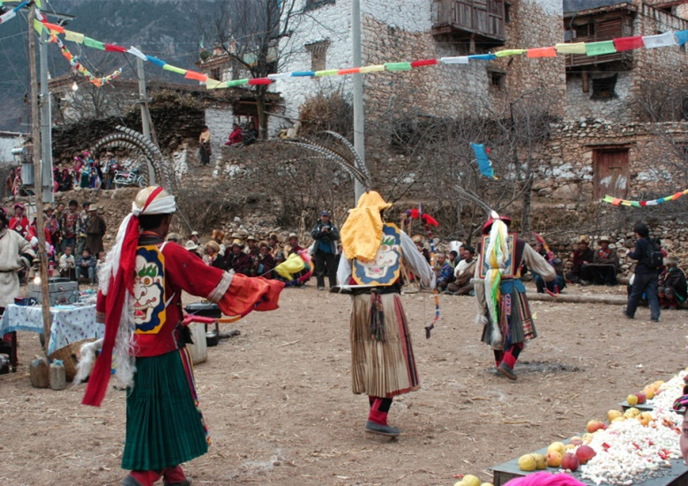
FIG.3.1 The scene of the Chesuo ritual in Erju Village in 2006. Dancers were performing the Chesuo ritual in the Dapin Secang. One of the 13 costumes was inherited from the Qing dynasty and well-preserved by local households. Most of the shields and helmets worn by the dancers were newly made by the villagers. This photo was taken by the workshop from the Multicultural Research Centre of the Sichuan Normal University in Dapin, Erju Village in 2006.

As shown in this photo, the Chesuo ritual was launched in the Secang, where all collective activities in the village took place before the Cultural Revolution (see section 3.3.1). The Secang of Erju Village had been waste ground before it was renovated between 2007 and 2008 with the fund from the Ford Foundation as well as from the state project ‘Constructing New Socialist Rural Area’. In this photo, the villagers were performing the Chesuo ritual in the un-repaired Secang in a rough form.
A field note taken in 2006 recorded basic information about the scenes of the ritual in 2006 as below. Before the ritual formally started at 13:30, villagers spontaneously gathered in the Secang, sitting around the area dressed in their traditional costumes for special formal occasions. The village guests had to sit on scattered rocks and logs on the ground, and only the hosts had seats and tables, with flowers, homemade liquor, and simple snacks such as apples, walnuts, and sweets in front of them. This difference highlighted the right of hosts to enjoy the ritual. The hosts were the first group that the ritual aimed to entertain. Other villagers, sitting on the ground, had homemade highland barely liquor and rice snacks distributed to them by members of host households.
After most of the villagers had arrived at the Secang, the Chesuo ritual started with a small entering rite of the hosts. A young man holding a fan guided a ‘white lion’, played by two males, into the Secang (See FIG 3.2).
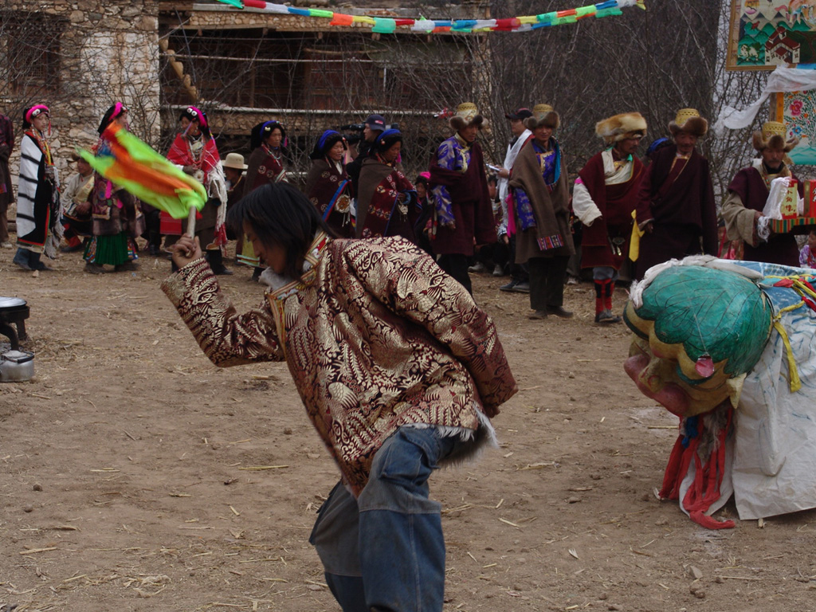
FIG.3.2 The white lion dance. A young male was leading the white lion, which was performed by two young males inside it. Behind them was the queue of the hosts, who were waiting to enter the Secang. This photo was taken by the workshop from the Multicultural Research Centre of the Sichuan Normal University in Dapin, Erju Village in 2006.

Following the ‘lion’ was an elder monk from the village temple. He was invited by the host households to attend this event as an honoured guest. After the monk came the hosts of the year, dressed in their formal costumes, lined up in an order, from oldest to youngest males, followed by oldest to youngest females. The number of hosts in 2006 was 17, 5 males and 12 females. These hosts walked around the Secang and stopped in front of the host tables. The monk was ushered by the oldest male hosts into the first seat with the best decoration; then other hosts took their seats following the order in which they walked. The elders sent Hada, silken scarves widely used by Tibetans for sending blessings, to each of the hosts. Then, a middle-aged male host, who was selected from the host households to act as the presenter, briefly introduced the purpose of the gathering to all guests in the Secang, and also expressed appreciation to the hosts for supporting and organising the event on behalf of the village guests. After a brief, five-minute introduction, the presenter announced the start of the Chesuo ritual. Thirteen strong, male dancers walked into the Secang and stood in a circle, silently watched by all the guests. Religious music was played by the local Gengbe with traditional Tibetan instruments, Bo (钹), Gu (鼓) and Qin (钦), in order to guide the Chesuo dance (See FIG 3.3 and 3.4).

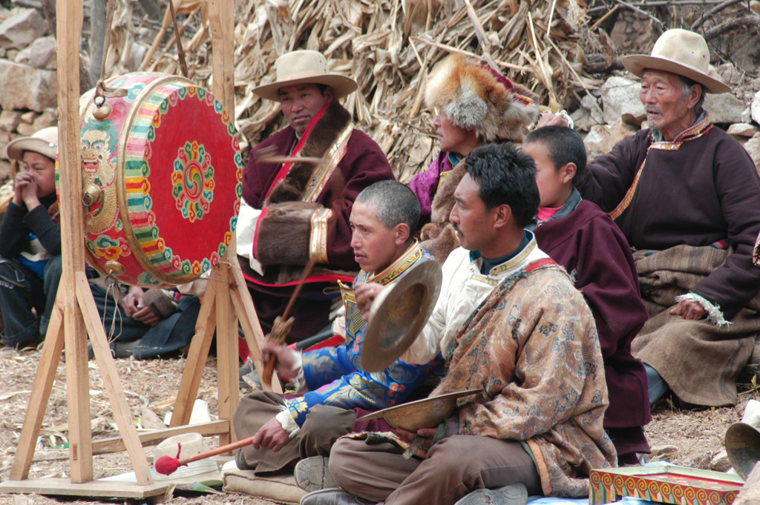
FIG.3.3 The Gengbe and his apprentice accompanied the dance of the Chesuo ritual. This photo was taken by the workshop from the Multicultural Research Centre of the Sichuan Normal University in Dapin, Erju Village, 2006. The Gengbe, the man shown on the right front of this photo, was holding a Bo. His apprentice, sitting on his right, was playing the Gu, which had been newly made using the fund from the Ford Foundation. More about the career of Gengbe, see in section 4.6.2.

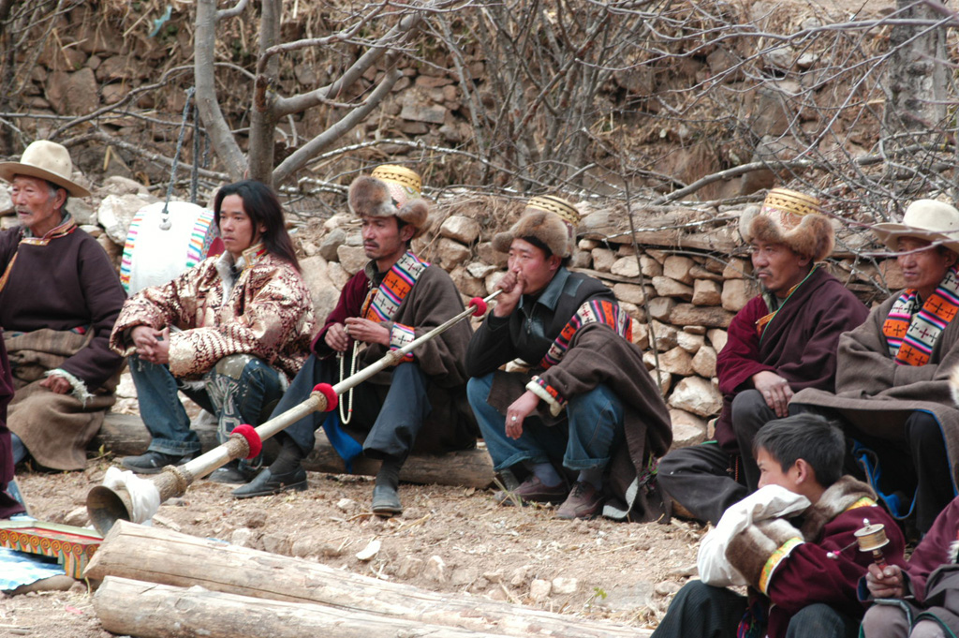
FIG 3.4 The Gengbe’s apprentice playing the Qin in the performance of the Chesuo ritual. Behind the Gengbe, the other apprentice plays the Qin to accompany the dance of the Chesuo ritual in the Dapin Secang. The Qin is commonly used in activities organised by local temples in rural Danba. This photo was taken by the workshop from the Multicultural Research Centre of the Sichuan Normal University in Dapin, Erju Village in 2006.

The music delivered a simple but clear rhythm to match the movements of the dancers. The 13 male dancers, dressed soldiers’ costume, danced in a circle around a small white statue made of highland barley flour, placed in the centre ground of the Secang. The highland barley represented the devil in the narratives of the elder, Suolang, who taught the new dancers according to his recollections of the ritual 48 years before. A series of solo dances depicted a group of skilled soldiers in battle, followed by a celebration after winning. After the dance, which lasted approximately 30 minutes, the statue was taken out of the village by the Gengbe and burned. The elders in Erju Village led all villagers in drinking the liquor placed in the middle of Secang as the last step to complete the ritual. Then the villagers danced the Derge for the rest of the day, until midnight. The total Chesuo ritual in 2006 took around eight hours.
The fact that the dancers danced anticlockwise during the ritual gave further weight to the suggestion that the revitalisation had little connection to its unique religious significance or the demand to develop religious worship in the villages. The process of moving in a circle in this region has a divine religious significance, because it is related to the correct method of Buddhist worship. Specifically, turning the Tibetan Mani, a prayer wheel with Buddhist scriptures carved on its surface or hidden in the middle, correctly implies reading the carved scriptures and increasing the merit of believers. Thus, turning the prayer wheel in the wrong direction is seen as taboo in the eyes of the villagers. They strictly follow the same direction of turning as that of the Mani wheel when they do other religious activities, such as walking around the divine mountains or lakes. The anti-clockwise direction of turning the Mani was the tradition of the Yungdrung Bon, while the followers in the Gelug sect of Tibetan Buddhism use the clockwise direction in their worship. However, most of the villagers in Erju Villages, including the monk represented in the scene of the Chesuo ritual, belong to the Gelug sect of Tibetan Buddhism, and none of the households in today’s Erju Villages follow the Yungdrung Bon. This means the direction of dancing the Chesuo ritual is the opposite of that used in religious worship, and thus, the performance in the event showed little connection to Buddhist worship in today’s Erju Villages in the eyes of local villagers.
The interview data in 2006 showed that villagers in the Erju commonly believed that this ritual was one of the most ancient local traditions, aimed at blessing the village for a safe, fruitful and peaceful year. Only a few elders remembered its original function as celebrating the age of 49. This study argues that the profound meaning attached to the revived Chesuo ritual by the local people showed a general desire to preserve local cultural traditions in the villages rather than insisting on the precise historic meaning of the ritual itself. This can be confirmed by the villagers’ perceptions of the history of the ritual and its unique garment, one of the core parts making up the whole ritual. The ritual in 2006 was performed by 13 strong, young male villagers who had been trained for one year in their spare time. The newly made dancer garments copied the style of the last well-preserved old garment wore in the original Chesuo ritual before the 1950s, which was believed by local villagers to date from the Qing dynasty (See FIG 3.5 to 3.8).

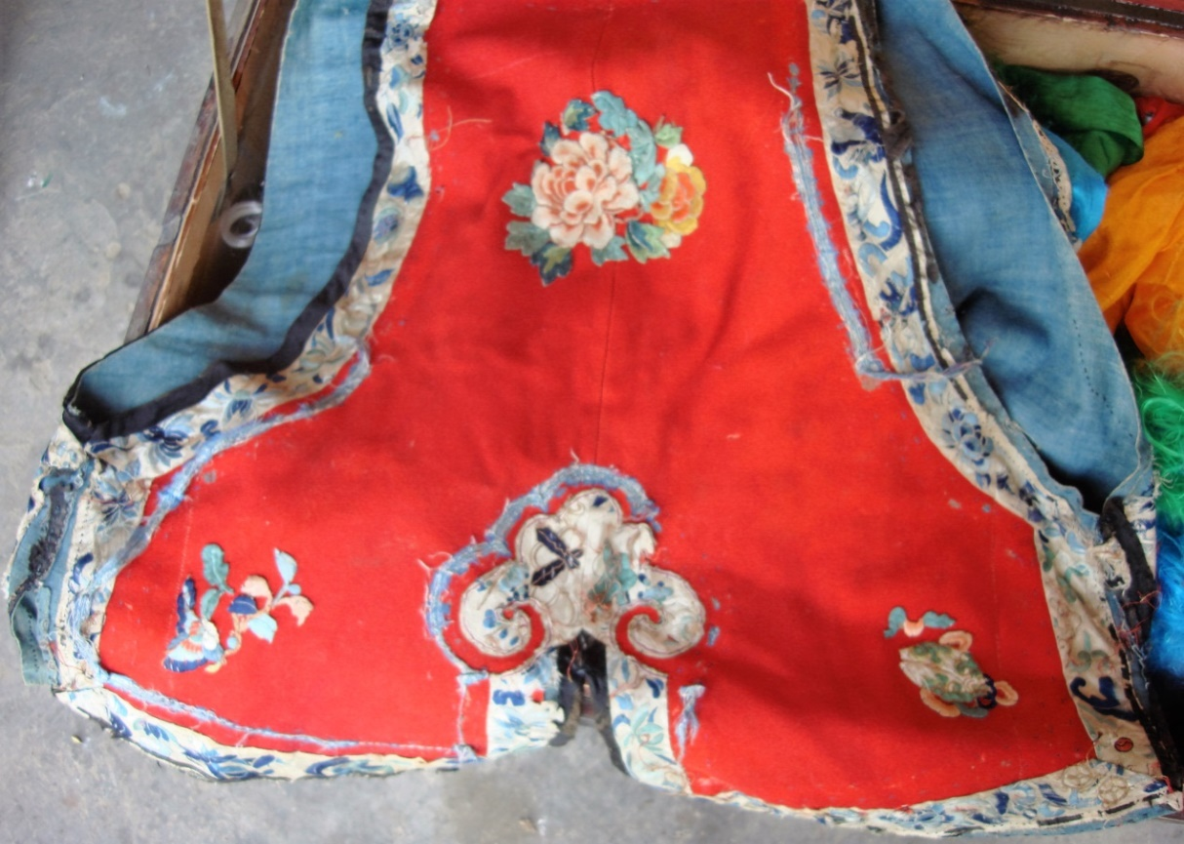
FIG.3.5 The back of the old garment kept in Erju Village. The garment displayed in this photo was the last of the old garments that were used in the Chesuo ritual before it was suspended in the Cultural Revolution. Most of the old garments were discarded or recycled by the villagers. The villagers believed this garment dated to the Qing Dynasty. This photo was taken by me in Dapin, Erju Village, 2011.
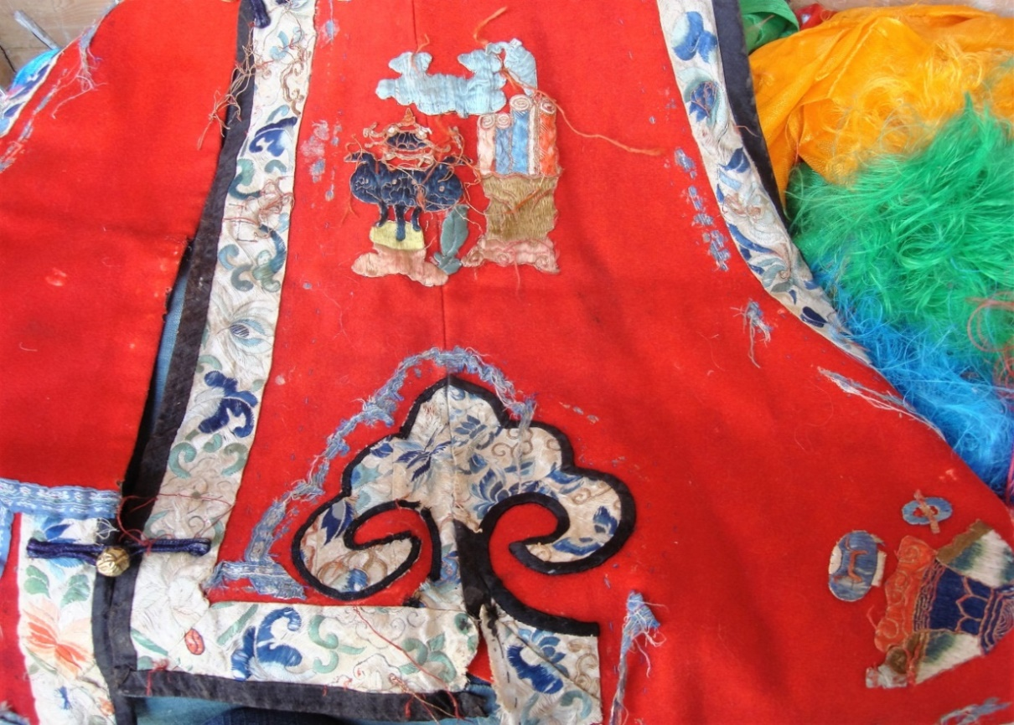
FIG.3.6 The left side of the front of the old garment. The right side of the front of this garment was not presented. This photo was taken by me in Dapin, Erju Village, 2011.
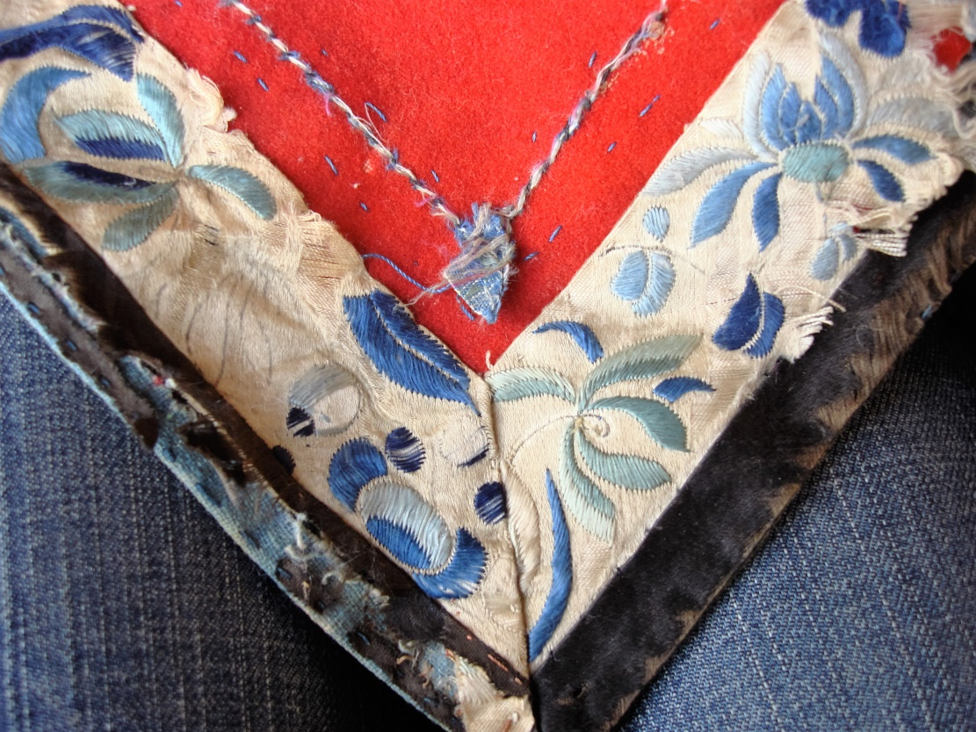
FIG.3.7 A close-up of a corner of the old garment. The close-up shows clearly that this old garment was decorated with high quality of embroidery. A worn area on the left discloses the sketch under the white and blue embroidery. The black animal fur at the edge of this garment was badly broken up and rotting away, but was still soft and smooth to the touch. This photo was taken by me researcher in Dapin, Erju Village, 2011.

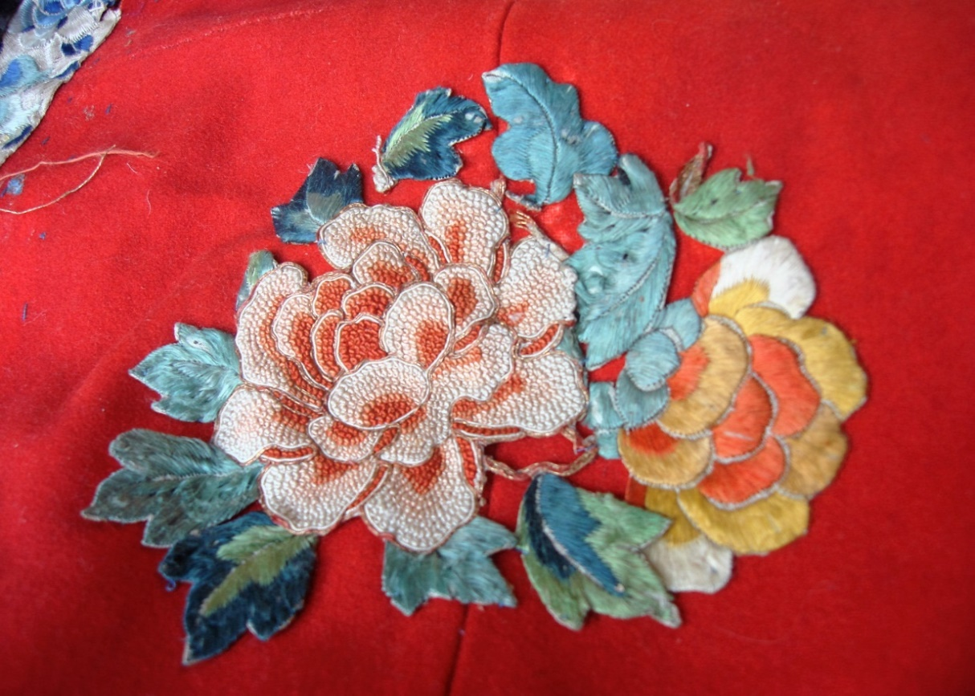
FIG.3.8 A close-up of the embroidery on the back of the garment. This piece of the embroidery was amazingly well preserved. It comprises two peonies. The peony was one of the most common cultural symbols in Han culture, and it was also popular in the Qing period. The white peony has a pattern of small protruding spots, which was created by a specific embroidery technique. This pattern was created entirely by hand. It was made of cotton thread on a cotton fabric, and the motif was then cut out and applied to the garment. The quality of this embroidery was far higher than any of its modern counterparts in the today’s Erju Village. This photo was taken by me in Dapin, Erju Village, 2011.

The Chesuo ritual garment was the only physical record remaining in Erju Village, and is therefore the most authentic part of the original Chesuo ritual. However, though villagers emphasised the Chesuo ritual as one of their proudest traditions, they could not explain the history or the symbolic meanings of the garment, which was clearly different from other Jiarong costumes.
The new garments worn by the dancers in 2006 were very basic, without any embroidery. Besides the garment, each dancer carried a shield with the face of a snow lion on his back, a bow in its right hand and a sword in his left hand, as shown in the following two photos (FIG 3.9 and 3.10). A rattan helmet was worn on the head, decorated with nine long tail feathers from wild pheasants. The costume of the dancer also included a white long-sleeved shirt with a red vest and a mid-length skirt, which was significantly different to the traditional Jiarong costumes.

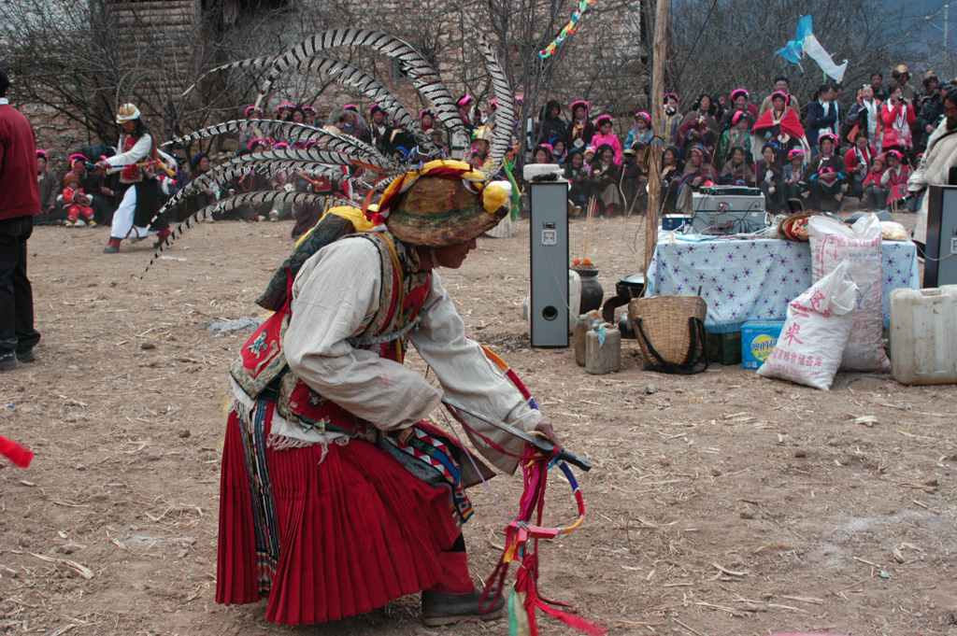
FIG.3.9 The costume of the dancer in the 2006 Chesuo ritual, showing the overall look of the dancers. On the edge of the Secang, the audience can be seen sitting on the ground. In the middle of the Secang, some simple treats were placed, to be shared with all attendees, including home-made liqueur, locally-grown apples and puffed rice purchased from the township. The audio system placed in the centre of the Secang was purchased with the fund from the Ford Foundation. This photo was taken from the workshop from the Multicultural Research Centre of the Sichuan Normal University in Dauphin, Erju Village, 2006.
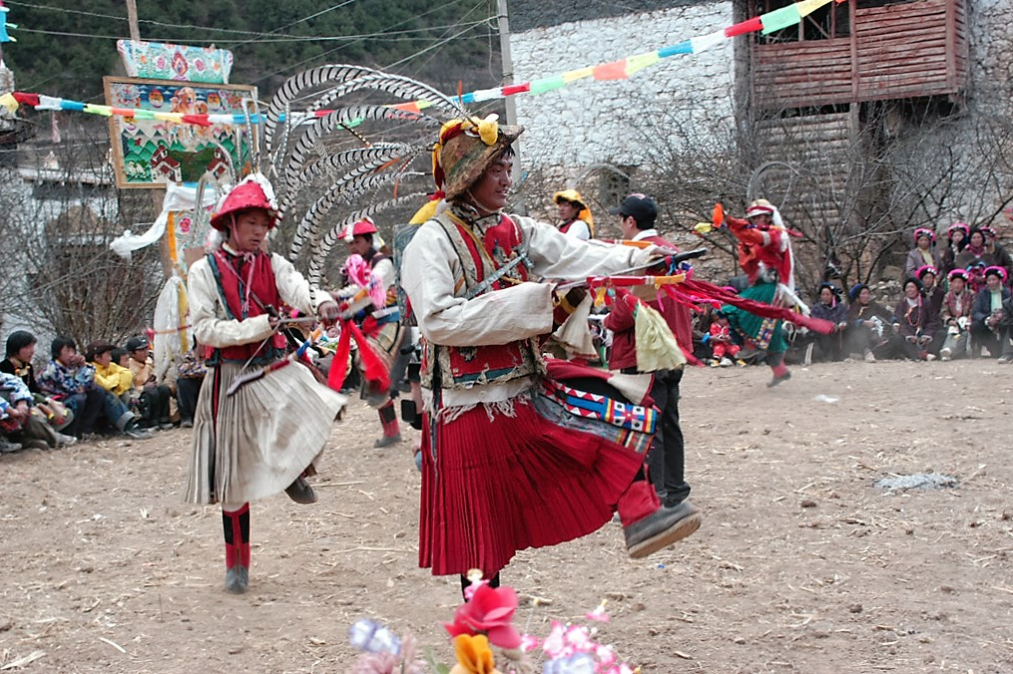
FIG.3.10 Two dancers at the Chesuo ritual. The one in front is wearing in the old garment and the one behind wears the basic new garment, showing the contrast between the two. This photo was taken from the workshop from the Multicultural Research Centre of the Sichuan Normal University in Dauphin, Erju Village, 2006.

The costume of the dancers of the Chesuo ritual is significantly different from the traditional costume of Jiarong people (FIG 3.11), as can be seen from the above photos (FIG 3.2, 3.3, 3.4, 3.9 and 3.10). Although the Jiarong costume varies across regions, it shares very few similarities with the costume of the Chesuo ritual.
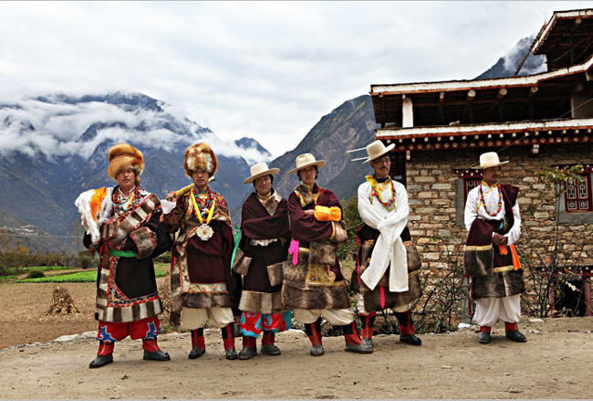
FIG.3.11 Men in traditional Jiarong costumes in Danba County. This photo came from the internet. It displays all forms of the traditional costumes of Jiarong men in present-day Danba County.

Similarly to the history and meanings of the garment, the history of the origins of the Chesuo ritual as a tradition in Erju Village could not be explained by local people, or be found in local archives, because of the loss of written histories and local records in this region. For the same reason, the routines of the dancers in the Chesuo ritual in 2006 were completely taught by an elderly man named Suolang, according to his recollection of the original Chesuo ritual. Though some elders said the dancing of the revived Chesuo ritual was different from the past, they could not recall its original form. The field notes taken in 2006 recorded that the male elder, Suolang, was the only person in the village who was able to convey the meaning of the ritual. He said that the dance was telling a story of 13 warriors sent out by the Buddhists to defeat the evils on earth. Thus, in the Chesuo ritual, the 13 strong males dressed as soldiers are symbolically defeating the evils, represented by the statue made of highland barley flour, by using their swords and bows. This elder also explained the origin of the Chesuo ritual as a local ritual celebrating the return of the soldiers, who enlisted in the army in the Qing dynasty until they retired at 49 and returned to the villages. As discussed in the Introduction, this explanation was significantly different from the interpretations given by the Jiarong scholars, which explained the Chesuo ritual as the remains of the funerary ritual from the Tang dynasty (Danba County Annuals, 1990, 569) or as a part of the Bon tradition related to the legend of a Jiarong hero A-Ni-Ger-Dong (Zhang, 1990,39-42; 1996, 64-65; Zhang, E-Ma-Ta and Ge-ER-Ma, 2011, 62-69; Li, 2015, 14-21). It should be stated that neither of the above interpretations had evidence to back them up. However, the explanation made by Suolang helped to answer two questions that could not be answered by previous interpretations. Firstly, it explained the importance of the number 49 in the Chesuo ritual, and secondly, it explained why the costume of the dancers in the Chesuo ritual was different from the Jiarong style. Besides Suolang, none of other villagers in 2006 gave an explanation on the meaning of the ritual, even though every interviewee emphasised the importance of the ritual in preserving their local traditions and village history. Apparently, the interruption of social memory and regional history during the Cultural Revolution created the irreversible loss of the Jiarong culture in Erju Village. Moreover, although every interviewee insisted that the garment belonged to part of their ancient history and tradition, none could explain the symbolic meaning of the garment, not even Suolang. Therefore, I argue that this revitalisation had little connection with the religious importance or uniqueness of the original Chesuo ritual.
In addition, neither the interview data nor the observation notes taken in 2006 could find any evidence to support the hypothesis that the villagers linked the re-launch of the Chesuo ritual with any political issues or concerns. As recorded in the observation notes taken in 2006, the only political symbol appearing at the scene of the Chesuo ritual was a metal statue of Mao Zedong. This statue was placed on the monk’s table, among other decorations such as plastic flowers, metal vases, and some bottled wine purchased from the nearby township. This statue had a cultural background; it was very common to see the images of the monks, Mao Zedong and Deng Xiaoping, in the living rooms of the Jiarong households in the early 2000s. The field notes recorded that the owners of the households commonly explained that the image of Mao Zedong had the similar power to the image of monks in ‘defeating the evils’. ‘Defeating the evils and blessing the people’ was the most common explanation by the Jiarong people to interpret the purposes of their various rites and activities in daily life. Still, the presence of this statue at the scene of the Chesuo ritual was notable, especially when it was brought deliberately by the villagers from the government of the township. Considering that the elders in the village were commonly very nervous when discussing their old traditions and their experiences during the Cultural Revolution in their interviews with the workshop, I argue that borrowing the statue and placing it in an important position at the scene of the Chesuo ritual was more or less motivated by a feeling that permission was required from the local government. In this sense, this case was significantly different from the revitalisations that served a purpose of political mobilisation through the cognitive power of rituals (see Leete, 2005, 233-245).
In contrast, the interview data from 2006 show that the incentive of attracting tourists was highlighted in the narratives of the villagers when they were asked about what changes they thought this revitalisation could bring to their villages. Of the 25 randomly interviewed villagers between the ages of 14 and 35, 12 males and two females wanted to be performers in the future and 23 interviewees hoped that the revitalisation could attract tourists to visit their villages. The interviews showed that the villagers had high expectations for the potential economic advantage of the revitalisation. Although the villagers rarely knew the history and meanings of the Chesuo ritual, it did not stop them from enjoying the revitalisation, which brought them the opportunity of collective gathering and performing.
The collective dances, which started after the Chesuo ritual was completed, allowed the villagers to practice traditional Jiarong singing and dancing skills. Every villager, regardless of their age and gender, could enjoy these ancient dances. The collective dances lasted in the Secang until most of the villagers returned to their households for dinner around 7 pm. The collective dances were the most important opportunity for local people to practice their singing and dancing, as well as for the local children to obtain these skills.
As there was no consistent tracking of the career changes among the villagers from 2006 to 2011, it is not possible to say how much individual career development can be attributed to the revitalisationl. However, the re-launched Chesuo ritual was the only event in Erju Village in which the villagers could practice their traditional skills, owning to the disappearance of other traditional festivals in Erju Village, as discussed in section 3.3.
However, the re-launch of the Chesuo ritual did not attract tourists to Erju Village. Only two groups of visitors came to watch the ritual, and no more than 500 RMB total income was paid to the villagers from 2007 to 2011. Thus, the effectiveness of the revitalisation in directly overcoming the poverty of the villages is very limited.
Nevertheless, the revived Chesuo ritual has been continually hosted in Erju Village every year, and has progressed in both its scale and procedures. In 2011, the duration of the Chesuo ritual had been extended to three days, and it had developed into the most important ceremony not just in Erju Village but in the township. This is an interesting phenomenon, especially when other folklore in this region was disappearing rapidly. Several other Jiarong traditions, such as Jiarong New Year, were also supported by the cultural project funded by the Ford Foundation, but these declined again after the funding from the Ford Foundation was withdrawn. In contrast, the Chesuo ritual progressed to be the most important festival not just for villagers in Erju but also for the people from other villages in this region, who came to join this ceremony freely. This ritual was held every year between 2006 and 2011 by the villagers in Erju, adding a number of new programs and performances over the years.
This raises two questions: What factors supported the revitalisation even though it did not fulfil the villagers’ economic hopes? Why did the re-launched Chesuo ritual survive while other traditions could not survive without external support? As will be discussed in Chapter 4, this study proposes a social factor was involved. Although less predominant than the economic factor before 2006, when the changes to the traditional village life in this region were further shifted by economic transformations, the social factor became more powerful in sustaining and promoting the progress of the re-launched Chesuo ritual.

Chapter Conclusion
This chapter interprets the economic factors that triggered the re-launch of the Chesuo ritual in Erju Village in 2006. The revival of the ritual was found to be related to the popularity of performing careers in Erju and other mountain villages in the Badi area in the early 2000s. The popularity of performing careers in these villages was mainly due to three reasons: the marginalisation of the mountain villages in the tourism development in Danba county; the low profit from traditional agriculture in these villages; limited opportunities to access other profitable careers. Performing jobs became a desirable career in these villages because the income of performers significantly helped to relieve the poverty of local households. The villagers in Erju started to revalue their traditional singing and dancing skills, encouraged by the economic advantage of performing careers. Motivated by the economic desire to reduce household poverty by obtaining performing jobs, villagers re-launched the Chesuo ritual in 2006.
The Chesuo ritual satisfied two conditions to enable its revitalisation. Firstly, it created an opportunity for collective gathering, practicing the traditional skills of singing and dancing in Erju Village. Secondly, it is the only tradition that could be revived in 2006, as other local collective traditions had disappeared, owing to the interruption of social memory caused by the Cultural Revolution and its prolonged shadow.
The revitalisation was found to have little connection with the religious importance or uniqueness of the original Chesuo ritual, which were motivations found in previous studies. Moreover, this revitalisation progressed notably from 2007 to 2012, even though it did not satisfy the villagers’ economic hopes. This progress indicates that the economic factor is not the only trigger involved in the revitalization and further explanations are necessary.

Chapter 4 Social factors
This Chapter explains the progress of the revitalisation of the Chesuo ritual in Erju Village from 2007 to 2012. The economic motivations of the revitalisation, as reflected by the fieldwork data taken from 2006 to 2009, consisted of two aspects: the desire to pursue performance careers, and the desire to attract tourists to the village. As mentioned at the end of Chapter 3, the fieldwork conducted between 2011 and 2012 found that the re-launched Chesuo ritual did not satisfy the expectations of the villagers in attracting tourists to Erju Village. It also established that performance was no longer the most favourable career path in the rural Danba area. In other words, the economic expectations of villagers when initiating this revitalisation were not realised. Nevertheless, the Chesuo ritual was not abandoned by the villagers. Indeed, it was remarkably developed, from a single ritual to a large local ceremony, with new symbols and performances introduced between 2007 and 2012.
The development of the ritual since 2006 is a vital part of the success of the revitalisation; had it been otherwise, this case would be no different from other failed revitalisations of tradition, which lasted for only a short period after their reappearance. Moreover, the ritual’s progress indicates the constant interest of local villagers in the revived Chesuo ritual, in spite of its failure to produce the economic benefits anticipated. Thus, interpreting the progress of the ritual is vital in order to understand the revitalisation as a dynamic and coherent process. If the economic factor is not the underlying reason, what reasons contribute to the continuation and further development of the revitalisation?
As stated in Section 1.2.4, the revitalisation in 2006 was not for political or religious purposes. However, the development of the revitalisation from 2007 to 2012 needs further discussion, as the rural Jiarong society in Eastern Tibet was inevitably influenced by the Sino-Tibetan political tension which arose in 2008.
The social unrest occurring in Lhasa in May 2008 resulted in political tension between Tibetans and the national government. This political tension was further aggravated by a series of self-immolation incidents by monks and ordinary Tibetans in the Ganzi and Aba Tibetan Autonomous Prefectures in 2012. To what extent the progress of the Chesuo ritual from 2007 to 2012 was motivated by political factors needs to be further examined, by analysing the changes in the revitalisation. Moreover, to what extent the local religious elites influenced the progress of the revitalisation in 2007-2012, as in Herrou’s study (2011) reviewed in section 1.2.1, will be discussed. In addition, the possibility of any other social factors that sustained the revitalisation, beside of the economic factors discussed in chapter 3 and the cultural factors which will be discussed in chapter 5, will be examined.
Analysing the representation of the renewed Chesuo ritual and the narratives of local villagers will be the main method used to explore the above questions, since the Jiarong people, through years of effort, organised the revitalisation and its progress. As a result of their efforts, the revived Chesuo ritual discloses the needs of these people, as much as the consequences of the social context in shaping the sense of social reality in their perceptions. Thus, the social factors that motivated the progress of the Chesuo ritual can be explored in the social context of Erju Village in 2006-2012.
In section 2.3.2, based on my previous fieldwork experience in the rural Danba area between 2006 and 2009, I hypothesised that social isolation and cultural discrimination from Han Chinese had a profound effect on Jiarong Tibetan migrant workers. As a result of this social factor, these migrant workers needed to maintain their social networks to compete for jobs in Han society. The result of my findings, based on fieldwork in the same region in 2011 and 2012, revealed that a part of my previous hypothesis needed to be amended. A part of the previous hypothesis holds, in that migrant workers in Erju Village still rely on social networks for job competition. However, instead of broader social networks, they rely on a more specific type of network, namely the kinship networks in the clan village. This is related to the specific migrant work these people engaged in, and will be discussed further in this chapter. Moreover, the occupational differentiation in these villages since 2008 exceeded my predictions based on my previous fieldwork. The large proportion of migrant workers in the village population had significantly changed community life, previously based on household agricultural production.
By analysing a series of increased procedures in the Cheuso since 2007, I accounted for the progress of the Chesuo ritual between 2007 and 2012 as being due to an intensified demand to maintain kinship networks. This demand was generated because kinship networks have been so important in maintaining the community after the traditional agricultural life of the village has significantly changed, through the remarkable career diversification since 2008.
This chapter focuses on interpreting how the need for enhancing kinship networks in the Erju community emerged and replaced previous economic factors underlying the Chesuo ritual. This chapter starts by tracking the progress of the Chesuo ritual between 2006 and 2011, to show the progress of the revitalisation in detail. Then the most significant change in the social context of this revitalisation, for instance, the growth of the migrant population in the Erju clan village during the same period, will be discussed. I argue that the growth of the non-agricultural population, particularly the migrant population, has reshaped the community life and resulted in the increased importance of kinship networks in the clan village from the following three perspectives: (i) non-agricultural careers; (ii) maintaining community life in the remaining permanent (non-migrant) village population, and (iii) maintaining the cohesion of the separated community.

4.1 The evolution of the Chesuo ritual since 2006
The Chesuo ritual has been continuously developed by the villagers since it was re-launched in 2006. Before exploring the underlying reasons for the further development, it is necessary to examine the changes made to the Chesuo ritual since 2006.
When the Chesuo ritual was re-launched in Erju Village in 2006 (see section 3.3.2), it was composed of three parts. It started with the dance of the white lion; then the Chesuo ritual itself was performed by 13 strong, young, male villagers, followed by the traditional Derge dance, an ancient form of collective entertainment in which all villagers participated, and which lasted until midnight.
Between 2007 and 2012 when I conducted the field work for this study, a series of changes had been made to the programme of the ritual. The fieldwork data were collected in three ways: interviews conducted in 2006 and 2011, visual records (DVDs and photos) from 2006 to 2012, filmed and kept by the villagers, and the participant observation in 2011. Through these data, I intend to depict a comprehensive picture of the series of changes that have been made to the ritual since 2006. The changes are reflected in the extension of its liminal phrase, the adjustment of the previous programme, and the shift of organisational power.
Performances have been gradually added to the Chesuo ritual since 2007, expanding the festival from a ritual of less than half a day to a ceremony lasting three days. Some previous practices were dropped. For instance, the dance of the white lion, which occurred before the Chesuo ritual in 2006, was discontinued after 2009. The leader of the dancers of the Chesuo ritual claimed that it was to ‘maintain the authentic style of the Chesuo ritual’, although no written record or any elder could support this claim.
In 2007, the host families started to use collective funding to hire staff from a photo studio in town to record the Chesuo ritual using digital cameras, and copies of the video were sent to each host family. This new procedure was explained by the organisers of the Chesuo ritual in 2007 as an aid to remember this important event. Moreover, the traditional form of Derge dance (see in section 3.3.1) was added to the Chesuo ritual after the short break for supper, when some villagers temporarily left the Secang. In the Derge dance, the hosts stand in a line according to their genders and ages, led by the oldest male host. The oldest male takes the flag placed in front of the host table and hands it to the oldest male from the group of villagers who will host the ritual in the next year, since that will be their animal year.
Furthermore, in the same year, the performance given by migrant performers to amuse the audience became an important part of the ritual. After the Chesuo dance and before the Derge dance, the host families invited the performers who had returned to the village during the Han Spring Festival to give various performances as entertainment. Their performances brought more enjoyment to the Chesuo ritual. Although no payment was given to the performers, 9 out of 12 performers interviewed in 2011 expressed their pride in taking part in the ceremony and the other 3 viewed it as a form of reciprocity and labour exchange (see more in section 4.4.1). Additionally, all hosts would take a photo together after the Derge, and copies of the photo would be sent to every host family. According to local villagers, the group photo started in 2003, when they had not yet revived the Chesuo ritual, as an alternative way of celebrating one’s the 49th year.
In 2008, a brief speech by the representative of the hosts was added right after the Chesuo dance. Students and some villagers who did not participate in migrant work joined the migrant performers in conducting the performances, which included dancing, singing and fashion shows displaying their traditional costumes. In the same year, the vKhor-lo symbol, one of the eight essential symbols used in Tibetan Buddhism (see more in section 5.3.2), started to be drawn in the centre ground before performing the Chesuo dance, later becoming the largest and most central symbol of the Chesuo ceremony.
As mentioned, the length of time taken to host the Chesuo ritual was also extended. Compared to the Chesuo ritual in 2006, which lasted for half a day in Dapin (see section 3.3.2), the Chesuo ritual in 2011 was performed twice, first in Dapin and then in Xiaopin the next day.
In 2009, some villagers started to invite the dancers of the Chesuo ritual to dance on the rooves of their houses after the ritual had finished in Secang. In doing so, the owner of the houses, which were normally newly built, could be blessed for a lucky year. The dancers decided to dance for only one house in each year, based on the ‘first-come, first-served’ principle. After dancing on the roof, the house owner would pay an optional amount of money to the dancers as an expression of gratitude. This donation increased from an average of 150 RMB in 2009 to 200 RMB in 2012.
In 2011, as a part of the programme of the Chesuo ceremony, the women of the host families started to cook a kind of mixed porridge with rice, meat and vegetables, at the side of the Secang, from the morning to the evening, in order to treat the growing numbers of visitors with free meals.
Due to the above changes to the Chesuo ritual, the general procedure of the ritual in 2012 was much more complicated than in its original form in 2006. These changes are summarised in the following table, which shows the procedure of the Chesuo ceremony in 2012.
Table 4.1 The procedure of the Chesuo ritual in 2012 in Erju Village
Time | Event | Origins and Time
10:00 | Started to decorate Secang
10:30 | Gengbe (see section 3.3.2 and 4.6.2) started the work of chanting scriptures for the ritual
10:30 | Women in the host families started to cook meat porridge to treat the audience | Since 2011
10:30 | The painter started to draw the vKhor-lo symbol on the ground | Since 2008
11:25 | The decoration works in the Secang were completed
11:40 | Gengbe finished the work of chanting scriptures
11:40 | The elders in the host families lighted piles of pine branches to make smoke to worship the gods of mountains and as a blessing for good fortune | A traditional household daily rite called Sumchue in the Jiarong language;  Added into the Chesuo in 2007
12:35 | All villagers returned to their houses to prepare for the start of the ritual. They washed their hair and changed into their formal costumes before engaging in the ceremony.
13:30 | All hosts of the ritual entered their seats in Secang
13:50 | Audience arrived and gathered around the hosts’ tables in the Secang
13:50 | The members of the host families distributed homemade liquor, candies and nuts to the audience | A customary way of treating guests in local household-organised events
14:15 | The performance of Chesuo started
15:00 | The performance of Chesuo ended
15:00 | The representative of the hosts gave a speech to the audience | Since 2008
15:00 | The self-directed shows by villagers started | Since 2007
15:00 | The Chesuo dancers were invited to dance a circle on the roof of a house | Since 2009
15:30 | The show temporarily ended and the eldest male of the hosts led all people in the Secang to dance the traditional form of Derge
17:30 | All hosts took a photo together | Since 2007
17:45 | A comparatively modern form of the Derge, with modern Tibetan popular music, started
18:30 | Passing the flag to next year’s hosts | Since 2008
19:30 | The self-directed show continued
20:30 | The show ended;  a series of improvised performances played by villagers voluntarily;  the Derge dance continued, in both the ancient and modern forms continued.
1:00 | The end of all activities in Secang.

The evolved procedure of the Chesuo ritual, as listed in the table above, actually occurred twice over two consecutive days in the clan village, as since 2008 the ceremony has been held in Dapin and Xiaopin villages respectively. As shown in the table, while the original Chesuo ritual was still the core of the ceremony, more elements were continually being added to this event, making it into more of a ceremony than a ritual.
Moreover, the increased significance of the Chesuo ceremony was also manifested in the extension of its temporal and spatial boundaries; from one day to three, and from Dapin village only to both Erju Village locations. In 2012 the first and second days of the three day ceremony took place in Dapin and Xiaopin villages respectively (which make up the clan village, see section 3.1.1). On the third day, villagers watched a basketball competition between the young males of Dapin and Xiaopin in the morning, in the Dapin Secang, and the Derge dance was performed, in both the ancient and modern forms, from the afternoon until midnight. As discussed in Section 3.3, the Derge dance is an ancient and classic Jiarong tradition still practiced in this region, and is also the most important occasion for transmitting the Jiarong traditional skills of singing and dancing. This function of the Derge dance was one of the reasons that contributed to the importance of reviving the Chesuo ritual in the Jiarong village in 2006. According to the fieldwork in Erju Village in 2012, the frequency of the Derge dance greatly increased due to the progress of the Chesuo ceremony. The Derge dance lasted for more than 6 hours on the first two days of the Chesuo ceremony and about 8 hours on the third day. The Derge dance during the period of the Chesuo ceremony lasted until midnight, which reflected a huge contrast to daily life in Erju Village, where villagers normally would not leave their houses after dinner and would go to bed between nine and ten o’clock each night.

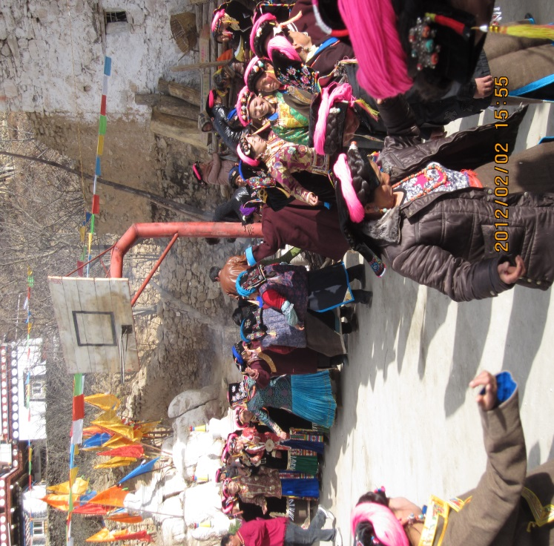
FIG.4.1 Villagers enjoying traditional Derge dance in the Secang after the Chesuo ritual in 2012. This photo was taken by the research in the Secang of Xiaopin, Erju Village.
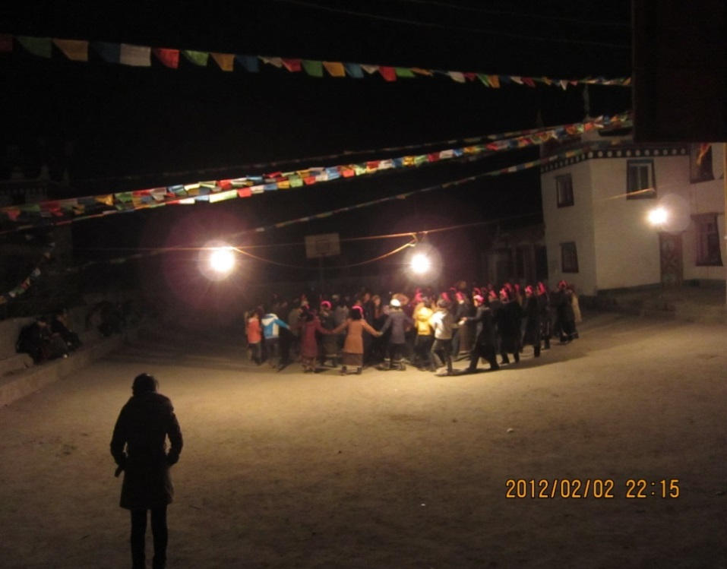
FIG.4.2 The Xuanzi in Xiaopin village at night. This photo was taken by the researcher in the Xiaopin Secang, Erju Village.

Furthermore, the boundaries of the ritual were extended by the increase in spontaneous gatherings at night in the days before and after the ceremony. This spontaneous gathering normally started five to seven days before the first day of the Chesuo ceremony, and such activity would last for days afterwards, until most of the performers and civil servants left the village for work. On these gathering occasions, villagers chatted, shared food and home-made liquor, and danced the modern form of the Derge at a fast rhythm to modern popular music in the Tibetan style. This type of dance is called Xuanzi by local villagers, and was generally welcomed by young people in the rural Danba area. In Erju Village, these gatherings normally started from eight o’clock in the Secang, and would not end until two or three o’clock the next morning. This phenomenon appeared after the ritual was revived in 2006, when the villagers were apparently excited about the renewed Chesuo ritual. This phenomenon could be considered as the boundary of the liminal phrase of the Chesuo ceremony, because the mood brought on by the ceremony did not dissipate immediately.
The celebratory mood was because the renewed Chesuo ritual was representative of the Jiarong culture in the eyes of local villagers. In comparing the scale, organisation, and the numbers of attendees across all collective activities in Erju Village between 2011 and 2012, the renewed Chesuo ritual was found to be the most flourishing festival in Erju Village during the year. This finding was consistent with the interview data, in which 38 out of 47 adult villagers, in their one-on-one interviews, selected the Chesuo ritual as the most important local festival. The importance of the Chesuo ritual was found to relate significantly to the time it takes place.
The Chesuo ritual was launched ten days after the Han Spring festival. This date was selected by local villagers as the traditional Jiarong Calendar method, based on observing the locations of the stars and the moon, had been lost. The newly selected time period for the Chesuo ritual provided an occasion for local Jiarong villagers to celebrate their own traditions during the Han Spring Festival, the longest period in a year for community reunion in Erju Village. The Han Spring Festival is the largest national holiday in China; thus most Chinese people have a legal holiday for at least seven days. Most migrant workers in the rural Danba area would return to their villages during this period. It has thus become the main period of family reunion and collective celebration. Villagers in Erju, like most Jiarong people living in the remote Danba area, do not celebrate the Han Lunar New Year, and in Erju and neighbouring villages the traditional Jiarong Lunar New Year, which is widely considered in the contemporary rural Jiarong area as the most important Jiarong festival (Zhang, 1996c; Wang, Yang and Xu, 2015), could not be celebrated beyond a household level. This is because the date of Jiarong Lunar New Year is about 30 days before the Han Spring Festival starts, and therefore few migrant workers, students and people working in the public sector (collectively referred to below as the migrant population) could return home to celebrate their own lunar new year. As a result, the Jiarong Lunar New Year has been celebrated in a rather simple way in Erju Village in recent years. The flourishing Chesuo ritual, launched during the Han Spring Festival, became a time-intensive occasion for family reunion, collective consumption and entertaining, and the presentation and reproduction of local traditions.
Finally, a series of changes has been made to the way the Chesuo ritual has been organised since 2006. Firstly, the way of selecting the host of the ritual has changed. In 2006 people with the corresponding animal year hosted the occasion, together with the people at their age 49, who were traditionally considered to be the hosts of the ritual. This was because the people at the age of 49 were not able to afford the cost of the ritual alone. Moreover, since 2007, an alliance of host families (or to be exact, the males in the host families) had full power to jointly arrange the ritual, while the Chesuo ritual in 2006 was organised with the guidance of the village committee and the elder master Suolang (see in section 3.3). Organising the Chesuo ritual takes a lot of work. The males of the host families spend one or two days together to decide on every aspect the ritual’s preparation, including the money collected from each host (whether celebrating their the 49th year or animal year), the amount of food and liquor to be provided by each household for collective consumption in the ritual, spending of the collected funds, arrangements for self-directed performances, negotiation with performers and the labour division within host households. The the host family group completely replaced the village committee in arranging this ritual.
The progress and changes in the revival of the Chesuo ritual have contributed to the success of its revitalisation and further solidified its status as a local ceremony. As an important component of the revitalisation, this progress needs to be interpreted. I argue that the progress of the Chesuo ritual since 2006 has been motivated mainly by an increasing desire for social networks based on kinship in the clan village. This desire emerged from the social fact that networks based on local kinships have become more important than ever for community survival as, since 2007, the growth of the migrant population in the village fundamentally changed the previous way of life in the clan village.

4.2 The growth of the non-agricultural population since 2007
The progress of the Chesuo ritual since 2007 cannot be understood without tracking the changes in social context, which reshaped community life in Erju Village and the motivation of local people to sustain the revitalisation. My fieldwork in 2011-2012 showed that the growth of the migrant population in Erju Village since 2007 was the most prominent social change. Other aspects of social context, including the regional economic policy, the political policy related to local folklore, tourism development in the rural Danba area, total village population and household income and spending, were examined by comparing community life in 2011 with that in 2006, through interviews and observations in the field between 2011 and 2012. No significant change in these aspects was found relating to the revived Chesuo ritual. The village was still marginalised in regional tourism development in 2012, so that the relative poverty of households continued to haunt local people. The revival of the Chesuo in 2006 did not reduce their poverty, and the villagers’ desire to seek non-agricultural income remained strong. As a result, the growth of the migrant population became the most remarkable change in the social context of the revitalisation. This change directly reduced the local resident population and impacted the continuity of their previous community life, which was based on household agricultural production.
The growth of the migrant population was manifested in four traits. Firstly, as a result of the national policy of open recruitment in civil service, the number of villagers working in the public sector or civil service slowly increased from 3 in 2008 to 12 in 2012. Secondly, attracted by the benefits of a career in the civil service, the number of children at schools in the clan village greatly increased, from only 16 in 2006 to 63 in 2012. Thirdly, owing to the low profits of agriculture in the region and the increase in students, a large number of short-term migrant labourers emerged in the village. Finally, performance careers, the most admirable job in the village in 2006, only slowly increased from 15 in 2006 to 17 in 2012. Considering the total population in Erju Village in 2012 was 400, the number of non-migrant residents (including monks) in the clan village was measured at 42.75%. By comparing the interview data with the Hukou records kept by the village treasurers, I charted the occupation differentiation in the Erju clan village:

Table 4.2 The non-agricultural population in Erju Village in 2012
Career | Males |  |  | Females |  |  | Total
Career | Xiaopin | Dapin | Total | Xiaopin | Dapin | Total | Total
Primary school student | 10 | 4 | 14 | 3 | 7 | 10 | 24
Middle school student | 0 | 5 | 5 | 0 | 6 | 6 | 11
High school student | 2 | 1 | 3 | 4 | 1 | 5 | 8
9+3 Project student | 1 | 3 | 4 | 1 | 5 | 6 | 10
College student | 3 | 3 | 6 | 1 | 3 | 4 | 10
University student | 0 | 1 | 1 | 0 | 0 | 0 | 1
Student in India | 0 | 0 | 0 | 1 | 4 | 5 | 5
Monk in India | 3 | 8 | 11 | 0 | 0 | 0 | 11
Local Monk | 4 | 3 | 7 | 0 | 0 | 0 | 7
Civil servant | 2 | 3 | 5 | 4 | 3 | 7 | 12
Performer | 3 | 6 | 9 | 5 | 3 | 8 | 17
Labourer | 24 | 22 | 46 | 5 | 3 | 8 | 54
Living overseas | 0 | 1 | 1 | 0 | 0 | 0 | 1
Total | 52 | 60 | 112 | 24 | 35 | 59 | 171
Data come form my fieldwork in Erju Village in 2011-2012.

As stated in section 3.1.1, the total population in Erju Village was 400 in 2012, across 89 households. Thus, on average, every household in Erju Village had two members in the migrant population in 2012. As can be seen from this chart, the increase in students (69) and migrant workers (83) in the clan village is the main reason for the growth of the non-agricultural population, a percentage of 40.35% and 31.58% respectively. There was a total of 171 non-agricultural people in Erju Village in 2012.
The increase in the non-agricultural population, mainly referring to students, labourers and civil servants, started from the appearance of civil services as a career option in the clan village in 2008. In this year, three young male villagers found jobs in the public sector in the Ganzi Tibetan Autonomous Prefecture via the open recruitment organised by the government. The appearance of this career in Erju Village dramatically changed villagers’ career preferences, and it quickly enlarged the group of students and short-term labourers in the following years. Public sector careers replaced performance careers as the most admirable jobs in the eyes of the villagers, as they have many advantages: a stable job with a considerable salary; sizeable positional welfare; high pension; the social capital and power brought by the position; and potential grey income (owing to the public’s awareness of the corruption issue within the government system). In fact, the same burning desire spread throughout most areas of China, from towns to the countryside. The number of candidates for the national open examinations for the recruitment of civil servants in government departments rose from more than 30,000 in 2001 to 640,000 in 2008; thus the ratio of candidates to jobs available was 46:1 in 2008, almost five times the recruitment rate in 2001. The open recruitment for government departments and the public sector, which started in 1994, has been sought after by the public in Chinese cities since 2003 but it did not reach Erju Village until late 2008. This delay was for two reasons. Firstly, the relatively remote and isolated geographic location of Erju Village meant that it underwent slower social change compared to the megacities. Then, the generally poor educational achievements of villagers limited their chances to attend the open recruitment events. The open recruitment can be categorised into three levels: the annual national examination for vacancies in national departments; the annual provincial examination for vacancies in provincial departments; and the open examination for jobs in the public sector in the provinces. The latter is organised only once or twice in each province per year. Among these three sorts of recruitment, the national recruitment is the most difficult one with fierce competition, followed by the provincial examination, and the open examination is the least difficult one. Correspondingly, the recruitment for provincial departments requires a lower educational qualification, with employees receiving a lower salary and fewer benefits. For the villagers in Erju, only the recruitment for vacancies in the public sector in the Ganzi Tibetan Autonomous Prefecture and lesser positions are seen as achievable goals, because the other two require at least an undergraduate diploma and applicants have to compete with city dwellers, who have grown up with better educational recourses. Because of this, working in the public sector was not popular in Erju Village until three young males gained jobs in the public sector in Ganzi in 2008. The success of these young men provided a strong, convincing case that illustrated the benefits of this career to other villagers. In the following years, working in the public sector quickly came to be seen as a shortcut out of poverty and a way to realise upward social mobility by people who suffer from chronic poverty in Erju and other villages in rural Danba.
The thirst for jobs in the public sector greatly motivated parents in Erju Village to change their negative attitude towards education, which was discussed in section 3.2.3. As a result, the number of students in Erju Village has increased sharply since 2008. Quitting middle or high schools became a rare phenomenon in the village. From 2008 to 2012, only two girls between the ages of 12 and 18 dropped out to become performers after graduating from middle school. These two girls dropped out of school because their families were unusually poor and they were not interested in studying. The rest of the children between the ages of 7 and 18 in the village received school education to varying degrees.
The ‘9+3’ students are a special group. They were the result of an educational project launched by Sichuan province in 2009. The name ‘9+3’ refers to the three-year free vocational education in nominated colleges in small cities in Sichuan Province after the nine-year compulsory education in the rural Ganzi area. This project was aimed at improving public support for the government in Eastern Tibet, and it enabled children to learn professional skills as an alternative to entering high school. The students who joined this project could enjoy a two-year free curriculum in vocational colleges with a monthly living stipend of 300 RMB, and a one-year trainee opportunity, with payment recommended by their colleges, in the private sector. Moreover, the ‘9+3’ students were qualified to enter the open recruitment for public sectors at the county and township levels, including county and township schools, hospitals, and other local administrative units. Compared to ordinary examinees in public recruitment, the ‘9+3’ students enjoyed another favourable policy. In 2012, 868 vacancies in the Ganzi Tibetan Autonomous Prefecture were filled exclusively by the approximately 4,000 graduates of the ‘9+3’ scheme. Benefiting from this project, the number of students in Erju Village increased. From 2009 to 2012, 15 students in Erju Village benefitted from this project, 6 of whom were performers before 2009. The total number of civil servants increased from only 3 in 2008 to 12 in 2012.
In contrast, the number of performers decreased from 29 in 2008 to 17 in 2012. This reduction is mainly because seeking jobs in the public sector became a better choice. The number of performers correspondingly reduced when the group of students and civil employees increased in the village. Local villagers started to realise the disadvantages of performing careers after some of the earliest dancers, reaching the age of 27, went back to being farmers in their villages or engaged in other less-profitable service careers in order to live in cities. The fieldwork in 2011 found that performance jobs were described by villagers in interviews as ‘poorly educated’, having a ‘worrying future’ and ‘a career profiting from youth’.
The growth of students in Erju Village resulted in the increase of short-term labourers, because the raised educational costs in local households aggravated the need for income. In order to cover the rising costs of sending children to school, more male villagers became short-term migrant workers; even the village leader and the party secretary sometimes went out to seek manual labour. Most of these migrant workers did short-term labour on the nearby pasture areas, two days’ travel by bus. These short-term labourers were mostly the male heads of households in Erju, and they chose this work for two reasons. Firstly, they were limited to labouring due to lack of skills. They explained it as ‘mei ben shi’, which literally means ‘incapable (of other careers)’ and implied a lack of professional skills due to their poor education. Secondly, they could not be long-term migrant workers because they were still the main labour force for their households, especially during the harvest and house construction, two most important aspects of peasant life in rural Danba, as discussed in section 3.1. Since 2008, the group of short-term labourers in Erju Village has expanded rapidly. By tracking the household members during different periods of the year, I found that more than 64% of males between the ages of 20 and 55 were not in Erju Village during the slack farming seasons in 2012.
The growth of the migrant population, including civil service workers, students and migrant workers, brought notable changes to the traditional village life based on household-organised agricultural production. It further generated a desire to maintain kinship networks, which was aided with the launch of the Chesuo ritual, as will be discussed in the following sections.

4.3 Kinship networks and seeking non-agricultural careers
Kinship networks, in the context of this study, refer to the social networks in the clan village. There are three main reasons for using the term ‘kinship networks’ rather than social networks. Firstly, as stated in 3.1.1, the social networks in this isolated clan village, which maintained a tradition of cousin marriage for centuries, totally overlap with kinship networks. These kinship networks have also expanded into nearby villages through marriage. Secondly, the social status and power of an individual was primarily related to his/her social status in the kinship networks, rather than other factors. Thirdly, in order to distinguish between other forms of social networks that could be developed by migrant workers in their work locations, the term ‘kinship networks’ or ‘the social networks in the clan village’ is used to specify the social interactions of village members in Erju.
The non-agricultural population in Erju Village, in the context of this study, mainly refers to performers, short-term labourers and students, as discussed in section 4.2. In analysing the income sources and career paths of the migrant workers and the educational cost of local students, the social networks in the clan village were found to play an important role in migrant workers’ job seeking and in covering students’ educational costs. In this section, the three different ways in which kinship networks benefit the careers of the migrant population is discussed, including how kinship networks became the source of job opportunities for performers, cooperation among short-term labourers and funding for children’s education costs for households in poverty.

4.3.1 Performers: job-hopping
Although being a performer was no longer the most admirable job in Erju Village after 2008, this career was still important in reducing household poverty in the village between 2008 and 2012, since local agriculture continued to be inefficient and unprofitable. As shown in the table above, there were 29 performers in Erju village in 2012. The performers, as the second-most profitable career after civil service, depended on kinship networks to get job information and opportunities.
Interviews with performers indicated that kinship networks played an important role in engaging in their career. The performers in Erju Village and other villages commonly found their jobs through connections with forerunners from this region. Among the 29 villagers who were, or used to be, performers in Erju Village in 2012, only two of them were recruited through interviews with art troupes in Danba County in 2006, with the others being introduced to the troupes by their relatives who were already performers. As stated at the beginning of this section, the professional networks of performers overlap to a large degree with their kinship networks.
Moreover, all performers in Erju Village relied on their geographic kinship networks for job-hopping even after they left the village. The geographic kinship networks were comprised of the social associations built on far kin ties and cross-village marriages, which extended the boundaries of the kinship networks from the clan village to nearby Jiarong villages. These performers were socially connected through their individual cognition of trust towards kinships and they further mutually benefited each other with job opportunities based on the principle of symmetrical reciprocity (Sahlins, 1972, 194-195), which refers to mutually beneficial behaviour in job-hopping based on the unspoken expectation of being repaid equally. The trust built on close kin ties make a bridge that extends the scope of mutually beneficial cooperation to other performers from nearby villages, because the social networks overlap with kinship networks— due in part to centuries of cousin marriage and slow population movement in the past.
The geographic-kinship networks are important to performers in job-hopping for several reasons. Firstly, the particular performing jobs that the Jiarong people engage in limit them to a narrow and closed labour field. More specifically, the performing jobs of Jiarong people are significantly different from performing careers in general, as they are exclusive to Jiarong people. The Jiarong performers make a living by displaying their unique cultural characteristics to tourists, who expect to get an exotic experience from the performances. These unique cultural characteristics, including the physical features biologically inherited from parents and the skills obtained in the process of enculturation in collective community life, represent indispensable capital in their careers. Within this narrow labour field, the career networks of Jiarong performers heavily overlap with their pre-existing kinship networks.
Moreover, the particularity of their performing jobs makes it rare for these performers to seek performing jobs outside this narrow field, as they generally lack transferable skills. Due to the particularity of their jobs, the Jiarong people received only very basic performance training in art troupes before they started performing on stage. Thus, job hopping among Jiarong performers conventionally means doing the same kind of performance in a different art troupe.
Furthermore, the competition between art troupes highlights the importance of Jiarong kinship networks in job hopping. Most of these performers work in the tourist spots, which are full of art troupes. Due to the fierce competition among art troupes, the daily social interaction of performers between different art troupes is restricted. As a male performer, Qiong, said, they were forbidden to leave the art troupes except on Sundays, and visiting other art troupes was a sensitive issue, because, ‘They [the bosses] were afraid to have [ideas and programmes] stolen’. As a result of the competition, regional cultural differences and feelings of isolation caused performers to rely more on their ‘Ber’, which they used to mean their friends as well as relatives, based on their geographic kinship networks, rather than other friends they had made outside of the villages. The performers present a common priority towards kinship networks over any other kinds of social networks they has built up in their careers. Nineteen performers from Erju Village expressed that staying within their Ber was important when considering a job, because ‘staying alone was boring (wuliao) and pitiful (zaonie).’ Only two performers had been introduced to a new job by friends met outside their Ber, for the reason that ‘the salary was high’.
Their geographic kinship networks allow performers in separate locations to exchange information on job-hopping, but most of them can only make contact by phone and barely see each other due to distance and restrictions on social activities. The only occasion for them to gather together is when they return to the village during the Chinese Spring Festival. These performers have a vacation of less than two weeks during this period, when few people are visiting the tourist spots, so most of them return to the village for the annual reunion with their families. This opportunity is significant for them to strengthen their social connections with each other through face-to-face interaction. In other words, the annual gathering is an important chance for the performers to maintain their social connections.

Short-term labourers: finding work as teams
As stated in Table 4.2, short-term labourers made up 31.5% of the migrant population in Erju Village in 2012. This group brought significant financial support to sustain the education of the growing number of students and reduce the chronic poverty of local households. The short-term labourers make their living by doing construction work in teams in the pastoral regions where the herdsmen speak Amdo Tibetan language. As will be explained in this section, the kinship networks of households in Erju Village form the basis of these teams.
The interviews with the short-term labourers in 2011 found that this career started in Erju Village in 2004, but it was not popular until 2007, when the number of students increased in the village.
The first villager to engage in short-term labour was Setanbe, a male carpenter, who was invited by one of his far-kin-tie relatives in a nearby village to build a house in the Jiarong style for a wealthy herdsman nearby. Setanbe brought three of his male relatives with him in 2004, and in the following years, more males were introduced by their kin and joined this group. These men engaged in low-skilled, heavy work, which normally lasted for less than a week. They received a daily wage of between 25 and 50 RMB, which was lower than the income of performers, but was still considerable when compared to selling agricultural products (see section 3.1.2).
In 2009, the income and work opportunities in house construction in the pasture lands increased sharply because of a government project called, ‘Settling the Herdsmen,’ which was enacted by the government of Sichuan province in the pasture area of Eastern Tibet. This project, which is part of the Sichuan government’s ‘Three central projects for improving people’s livelihoods in Ganzi and Aba region’, refers to providing a financial allocation to promote the construction of infrastructure, communities, houses, schools, hospitals, and other facilities associated with the livelihood of herdsmen, who have traditionally led a nomadic life in the pasture lands with poor living conditions. Besides tax breaks and other financial assistance, every herdsman’s family received an average stipend of 10,000 RMB to build a new house.
The sharply increased need for house construction among herdsmen in the pastoral area allowed skilled short-term labourers to start to take an upper hand in labour relations. They successfully transformed their daily labouring into contracted projects in 2009, assembling in teams of five to seven members in order to undertake this work. The income of these teams varied, corresponding to the total capability of each team. Skilled teams like those led by carpenters and painters could earn up to 50,000 RMB from herdsmen for building a house, including all the decoration work, while other teams who were only capable of basic construction work, could earn an average of 30,000 RMB for each house. The dramatically higher income from short-term labour in the pastoral area encouraged more male villagers to enter this group. Thus, more than 64 per cent of men between the ages of 20 and 55 in Erju Village were labourers in the pastoral area in 2012.
Although not working in the village, these short-term labourers are still influenced by the kinship networks in Erju Village, primarily due to the connections between these workers and their households in the village. While interviewing these labourers in 2011 and 2012, an overlap of membership and kinship networks was found. All teams were made up of members with intimate kinships, and the male line was more prominent than the female line. It is a tradition in rural Jiarong society that households with kinship ties help each other to overcome various difficulties, and the patriarchal tradition in rural Jiarong society means that heads of household are normally male. As the short-term labourers are the heads of household and the main labour force in their households, the personal memberships of these teams and the social relationships of their households in the clan village affect each other. The membership of labouring teams is, to some extent, an extension of the cooperation between households. These labourers maintain the same kinship groups in their teams as they have among the households in their village.
Moreover, these short-term labourers depend on their social norms based on kin ties, which means the elders conventionally enjoy more rights than the young people and can mediate conflicts brought about by the competition for well-paid jobs in the pastoral area. This competition has become an increasingly negative factor, threatening the solidarity of the community since 2008. Though most short-term labourers avoided mentioning this embarrassing topic in their interviews, it could be frequently heard in daily village life in 2012. The social norms based on their kinship networks are still very influential in guiding the social interactions of villagers in contemporary Erju Village.
Due to the absence of the short-term labourers and performers in daily village life, the traditional way of maintaining kinship networks, which was mainly through gatherings and collective consumption among households in the village, became difficult to practice. Such maintenance requires a reunion occasion, which is satisfied by the revived Chesuo ritual. As the observation data in Erju Village in 2012 show, the Chesuo ceremony becomes the most significant occasion for collective gathering and consumption of the village.

4.3.3 Students: securing funding and seeking upward social mobility
Compared to the kinship networks relied on by performers and short-term labourers for job-hopping, extended kinship networks, which refers to the connections between villagers and their kin members who have moved out of the village and live in townships and county towns, became vital to a growing number of students and villagers pursuing a position in the public sector to satisfy their desire for upward social mobility.
The need for kinship networks was raised by the growing number of students in the village, due to their importance in economically supporting children's education. As stated in section 4.1, the number of students in the clan village had increased to 63 by 2012, and economic support or donations from kin became an effective and important way of covering the educational cost.
Part of the educational cost was covered by the government and all students undergoing the nine-year compulsory education in Erju Village have received monthly stipends from the government since 2008. In 2008, the stipend for each primary student was 100 RMB (approximately 10 GBP), and for each middle school student it was 125 RMB. This stipend covered part of the educational costs, but the average annual expenditure of a high school student in Erju Village was about 12,600 RMB in 2008, while the average household income from selling agricultural products was less than 4,000 RMB in the same year.
The donations came from kinship group members, including performers (see section 3.3.2) and monks, and became a significant source of funds for covering educational costs. While the income of performers and short-term labourers could basically cover the costs for junior secondary students in the village, the costs of the senior secondary education and above were beyond the average ability of the households; so local parents normally covered such costs through donations or loans from relatives. Since 2008, it has been very common in Erju Village for household members to make joint efforts to keep sons in senior secondary education in towns; if their families cannot afford the educational costs for all children at the same time, the daughters tend to become performers.
An annual record of spending education subsidies, kept by a household in Dapin, Erju Village, is valuable in illustrating the education spending of local households. According to this family memo, annual spending for their only child, studying in a normal college in Kangding, the capital city of the Ganzi Tibetan Autonomous Prefecture, was about 15,600 RMB (approximately 1,560 GBP) in 2008, including a tuition fee of 5,600 RMB per year and living costs of 10,000 RMB per year. This fee was partly covered by the income of two sisters, who were performers in art troupes, and by the income of his father, who did short-term labouring in the pastoral area in Aba.
Educational assistance from kinship members is normally regarded as part of the ‘received favours’, a record of which is kept by local households, commonly in the form of simple words and symbols. Based on these simple forms of information, the importance of kinship networks in sustaining children's education in the village was disclosed. Among 24 households with children in secondary or higher education in Erju Village in 2011 (primary students and students in India were excluded because they received free education provided by local temples), 19 of them had borrowed money from relatives living in the village at least once in the past three years; 11 of them had borrowed money from relatives living in towns in the past three years; 8 of them received constant donations from their relatives (including monks) for education; and only 2 of them applied for student loans from the bank. The kinship networks of the clan village, including its extension to people who live outside of the village while still connect to their kin in the clan, provide local students with economic support that enables them to continue senior education for the purpose of upward social mobility. Along with the growth of students in the village, the importance of kinship networks to local households therefore increased.
A few students obtained even more support from their kinship networks. Through the kinship with monks in the Gelug sect of Tibetan Buddhism, a few local children received free education in India. Since the 1980s, 16 local children in Erju Village have travelled to India and received free education in a Tibetan school operated by Gelug monks in India. The school provided free secondary education (including English, Tibetan language and Buddhism), meals and accommodation to these students, and even gave some of them pocket money. As shown in table 4.2, five local children were still in India receiving free education in 2012. Between 2008 and 2012, four local children graduated from the school and one of them continued his studies in the USA.
The main reason for this phenomenon is the poverty of households, the influence of local monks in the village, and the long-term close connection between the community and the monks who are born in the village and live in India. It had been a high honour to become a Tibetan Buddhist monk in this region before the 1960s; thus sending the youngest sons to be monks in temples used to be a local tradition in rural Danba. In order to be accepted by temples, young people needed to be introduced by their older monk relatives. After becoming monks, these people still kept close contact with their family and the community, even though they normally abandoned their secular identity as sons, brothers and kin. The connection between the village and the monks in India started with two monks who were born in Erju Village and went to India with other Gelug monks, led by the 14th Dalai Lama, in 1959. Through kinship with these two monks, a total of 17 young monks in the Erju clan village were brought to India between 1959 and 2012.
Households without the assistance of performers or monks have to cover their children’s education costs by themselves. Borrowing money from others and applying for student loans are two common ways for these parents to support their children, hoping they can eventually finish higher education and find a job in the public sector.
The value of the extended kinship network in the clan goes beyond simply providing economic support for the education of the younger generation though. As stated in section 4.2, the rush to seek civil service jobs is the reason for the growth of the number of students in Erju Village. The fieldwork in 2011 and 2012 found that people in Erju and nearby villages strongly emphasised the role of their kinship networks in the competition for civil service jobs. In their words, ‘you guanxi (having connections to somebody)’, which means getting information or getting into the network of potential recruiters via their relatives living in towns, is vital in the job competition. These ‘relatives’, who have connections with some villagers through lineage or marriage, do not only help the households with whom they have intimate connections, but also benefit other households through the households’ social connections. Those households that connected ‘relatives’ living in towns and villagers living in Erju functioned as key spots for expanding the social networks in the clan village to the towns. Through the help of these households, other villagers in Erju are able to obtain assistance from people living in towns. Although it is unclear how much the assistance from the ‘relatives’ could influence the results of job competition, the villagers in Erju Village commonly view such assistance as an important factor that led to success in job hunting. During my stay in the village in 2011 and 2012, I frequently heard villagers attributing failure in open recruitment to a lack of external connections.
The phenomenon of highlighting social capital in winning the open recruitment existed in several villages that I visited in rural Danba in 2012, and this recognition by villagers had a social basis. Firstly, villagers generally doubted the fairness of open recruitment due to its history. Recruitment in the public sector in Ganzi consists of the examination followed by an interview. 80% of the examinees went on to interview, but only 20% of interviewees succeeded in getting jobs. Compared to the examination, which used standardised questions, the interviews raised concerns among the villagers about their impartiality, as the interview grading standards were not open to the public. Moreover, due to the nature of the interview, which is a process of making subjective evaluations based on face-to-face interactive communications, providing objective proofs to every interview result in the open recruitment is impractical. Thus, villagers were commonly concerned about the fairness of the open recruitment, especially when the government image in this region was seriously affected by corruption issues and religious policy. Driven by such concerns, villagers emphasised the importance of having connections with relatives in the towns in order to gain a relatively equal treatment at interview. From 2008 to 2012, a total of 12 villagers gained jobs in the public sector through open recruitment. According to the villagers, these winners, to different extents, obtained assistance from their relatives in towns. Making an agreement with interviewer(s) for favourable treatment in advance, acquiring valuable information on interview preparation, such as frequently asked questions, answering strategies and related skills, is considered not as a guarantee of success, but as an important part of the competition.
Overall, the kinship networks provide essential economic support to local students, and education is now considered as significant in achieving upward social mobility through a civil service career, which is the common purpose of local students and their parents.

4.4 The local community
While kinship networks benefit the non-agricultural population in their career development, the fieldwork found that the remaining permanent population in Erju Village depended on kinship networks to overcome the difficulties brought by the decrease of agricultural labour in 2011 and 2012. After 42.75% of the total population became migrant workers, most of whom were the main labour force in households, the remaining population face a shortage of labour in sustaining their agricultural production, which was the main source of their livelihood, as stated in 3.1.2. The kinship networks help the remaining population sustain their lifestyle in two ways. Firstly, due to the lack of a labour force, the population remaining in the village relied more heavily than in the past on social associations with kin to maintain a basic level of agricultural production to sustain their daily life. Secondly, the demand for maintaining community welfare with an insufficient resident population increased the importance of kinship networks.

4.4.1 The role of kinship networks in maintaining agricultural production
Lack of sufficient labour force in agricultural production is the first difficulty that the population remaining in the village had to cope with. Due to the increase of the migrant population in the village, the average residential population of households in Erju Village remained at three for most of the year, increasing to six during the Han Spring Festival in 2011, when almost every member returned to the village. As demonstrated by field observations in Erju Village during 2011 and 2012, 16 of the 47 households in Erju Village were sustained by elders and children below school age for most of the year. The reduction of the household residential population aggravates the productive pressure on the population remaining in the village. As discussed in section 3.1.2, all household members, including elders and children, traditionally jointly accomplished agricultural production tasks that support their daily consumption to a large degree. However, the growth in the non-agricultural population, most of whom were the main labour force in households, changed the traditional patterns of agricultural production.
At first, the labour burden on the remaining population was increased, and the previous labour division arrangements were destroyed. Female villagers between the ages of 20 and 55 had to became the main labour force for farm work. There were 111 such women in 2012, representing 27.75% of the total population of the village. They had to engage in agricultural production in place of the migrant males and shouldered a large proportion of domestic non-productive work as well. Consequently, the normal weekly working hours for a woman in the village were more than 60 in 2012, compared to only 40 hours per week when the short-term labourers returned to the village. At the same time, the amount of work shouldered by the elders and children left in the village also increased.
This observation in Erju Village helps to understand the inconsistent findings of previous quantitative studies on the issue of gender and age divisions in increased workloads in migrant families in rural China, which had mainly been caused by adopting different indices based on large-scale survey data. The statistical analysis of Chang et al. showed that the workloads of remaining elders and children in Chinese rural areas would substantially increase when a household member became a migrant worker; however, the off-farm work of the elders saw no significant change (Chang et al., 2011). The quantitative study of Mu and Walle revealed that, while the women remaining in the village took on more work than they had before, similar impact was not felt by the remaining men (2011, 87-95). The above two studies on the workloads of the remaining population in rural areas manifests inconsistent results, mainly due to the different statistical calibre applied to how the increase in the migrant population affected the workload of the remaining male elders. In Erju Village, the increased workload of the elders and young children mainly come from housework, which was previously only undertaken by women, because after the migrant population left there weren’t enough women remaining to maintain the household. By comparing observation and interview data collected in 2009 and 2012, the elders’ working time was found to have increased from at most 28 hours per week in the past to about 40 hours per week when short-term labourers were absent. This finding helps to provide a supplementary explanation to this topic. Unlike those in Mu and Walle’s study, the remaining male elders in Erju Village were found to have also taken on more work when the number of migrant workers in households increased; moreover, the increased workload of these elders came from both on- and off-farm work, which differs from the case of Chang et al. in Han rural area.
The second difficulty caused by the increase of the migrant population in Erju Village is that the varieties of crops farmed and the total production of households are both reduced. The interview and observation in Erju Village in 2012 found that every household in the village had decreased their agricultural production, to varying degrees, in order to cope with the problem of insufficient labour. 85 out of the 89 households in Erju Village grew corn and wheat, which were vital for their daily consumption, and reduced production of other crops such as soybean, buckwheat and Sichuan pepper. Two young migrant worker couples, who don’t have children or elders remaining in the village, have chosen to leave their households and corn farmland in the hands of their relatives since 2011, only returning to the villages during the harvest period or the Chinese Spring festival. For most households sustained by children and elders, maintaining the basic level of agricultural production is necessary to sustain their daily life in the villages; otherwise, they would have to spend money on food in the township market. Even so, local households frequently did not meet their needs with the reduced farm production in 2012. As an elder villager complained, ‘We are peasants, but we have to buy food from townships now. Fewer and fewer young people are willing to continue farming in the village, because farming is profitless.’
To maintain a certain quality of life in the households with less spending, the people’s dependence on clan kinship networks increased. The kinship networks support the production of the remaining population in two ways.
Firstly, the tradition of mutual assistance in the clan village, which was adopted as a way of managing collective resources in the past, enables the wives remaining in the village to achieve agricultural production by working cooperatively. The observation data in 2011 found that women from households with close kinship ties operated their farms as teams. They did the same type of work, such as sowing or weeding, starting in the farmland of one member and then moving on to another’s farmland after finishing the first. In this way, their farming efficiency is improved through cooperation. Moreover, the farming efficiency of these teams is improved through team members sharing dinners. Each household took turns to provide simple dinners to all the team members, so as to save time and allow more farming work. Thus wives remaining in the village were able to maintain basic agricultural production. As a consequence of this co-production, the population remaining permanently in the village began to depend more heavily on kinship cooperation than in the past.
Secondly, households depended on a local tradition of ‘labour loan’ to reallocate the remaining labour force in the village. ‘Labour loan’ is a tradition whereby households borrow labour forces from other closely related households during time-restricted events. The loan is measured according to the number of workers, their abilities and the intensity of the task, and the loan is expected to be paid back in the same way. This tradition was used only for house building in the past, owing to both the importance of houses in Jiarong culture and the difficulty in building a Jiarong house in Erju Village (see section 3.1.1). Since the lack of labour has become a notable problem in the Village, the ‘labour loan’ has come to be employed in sustaining daily agricultural production, including harvesting crops, managing livestock and building and maintaining houses. By comparing five household records in 2011, it was clear that there was an increasing tendency for the remaining population to depend on labour loans for sustaining daily agricultural production.
The role of teams and labour loans in maintaining the necessary agricultural production of the remaining population increased the importance of maintaining kinship networks in Erju Village. Because the value of a ‘labour loan’ cannot be exactly calculated, since it is non-quantifiable in daily life, even though almost every household in the village keep a record on labour loans among their kin households, such loans are normally paid in the form of gifts and banquets. In this sense, the labour loan is not a simple economic exchange between households; it is more perceived as a debt of gratitude. Owing to the unequal dispersion of the labour force among households, some households with more residential members became long-term creditors, while those households that frequently borrowed the labour force from others became debtors. The debt from these loans, like other exchange and cooperative relations between households, follows a norm of reciprocity. The expectation of equal returns increased inversely to the closeness of kinship ties between households, in the same way as the norm described by Sahlins that regulated social exchanges in ‘kinship-tribal groups’ (1972, 196-201). Creditor households have a duty to pay back labour favours from others; otherwise their increasing debts will reduce their opportunities to receive further labour support in the future. The creditor households normally pay back the debt symbolically, using banquets and gifts on occasions of collective consumption as an alternative ‘currency’. Banquets and gifts on these occasions play a substitute role in the exchange of labour force in the villages, while cash gifts would have been seen as unacceptable in this exchange, since they are considered an impolite way to repay the labour and gratitude debt to kin in the clan village. The collective consumption of households is a significant occasion for enabling this symbolic exchange behaviour, because households, rather than individuals, are the subject of the exchange relationships. Such symbolic exchange based on kinship networks in the village maintains the balance of labour exchange among local households, and affects the possibility of labour loans from and to local households in the long term. In this respect, the Chesuo ritual satisfied this need as it has been the biggest occasion for collective consumption and symbolic exchange in the village since 2006. Along with the reduction in collective activities in the village, as a result of the increased migrant population, the role of the Chesuo ritual became more important to the community for reunion and collective consumption. A series of new programmes have been added to the revived ritual since 2006, thus making the occasion irreplaceable in promoting symbolic exchanges in the clan village (see section 4.6.2)

4.4.2 The role of kinship networks in maintaining social welfare
Besides labour support, the population remaining in the village depended on kinship networks to maintain their social welfare in 2011 and 2012. This was because the function of local households in providing social support to members was partly transferred to the kinship networks, thus kinship members required a higher level of cooperation and cohesion in the community than in the past.
The demand is firstly caused by the decreased sense of security, owing to the reduction of the village’s residential population. It was notably reflected in daily life during the period when the migrant population was absent from the village. The increased work intensity meant that the remaining villagers had to spend more time on agricultural production in the farmland around the village, so that almost all the houses were empty during the day, and only a few elders were left as doorkeepers for the community. The villagers were very alert to any strangers showing up in the community during this period, although these strangers were more likely to be welcomed during the Spring Festival, when the village was more fully occupied. The vivid and well-organised community life during the Spring Festival is replaced by a depressed and tense atmosphere at other times. This situation lasts for months in the village, until the non-agricultural population return during the harvest period or the Chinese Spring Festival.
More importantly, the demand for cohesion is intensified by the growing dependence of individuals on kinship networks for social support in aspects of caring for the elderly and disabled members, rearing and educating children, medical services and emergency handling. Though the welfare system organised by the government has been significantly promoted in the rural Danba area in the past two decades through tax breaks, educational stipends, and village medical services, households and villages are still the main sources of social welfare in the mountain areas.
In Erju Village in 2012, the life of the elderly and disabled was sustained by households and the community. In 2012 there were 73 villagers over the age of 55, 28 males and 45 females, representing 18.25% of the total village population. Six of these received a monthly stipend of 250 RMB from the national policy of ‘Wubao (five guaranteed)’; two of them received a pension of 1300 RMB per month; the remaining 65 were economically supported by their households and the community. Besides economic support, younger generations have a duty of care toward their elders. Kinship networks became the main source of social care when the role of the households in taking care of elders was weakened by the reduction in their residential members. The remaining members of local households had to depend more on assistance from their kinship group to obtain daily care when the non-agricultural population were absent.
The same change was found to affect child-rearing in the village in 2012. Due to the absence of male heads of households, caring for and educating children became a cooperative task among households in Erju Village. In 2012, there were 51 children under 15 remaining in the village: 11 aged 0-5, 22 aged 6-10, and 18 aged 11-15. The children aged 6-15 normally spent five days a week living in the central primary schools in the township, returning to the village at weekends. It was common for local households with close kinships to take care their children in turns. While the children were gathered and looked after by one or two of their adult relatives during the daytime, the other members of these households could spend time farming. Because the responsibility for looking after children is shared by households, education within the family is replaced by collective education to a certain degree.
In order to concentrate on providing education and guardianship to children over 5, a pre-primary class was organised by the villagers in Erju in 2008. There were 14 students in the class in 2008, 11 in 2009, and 7 in 2010 and 2011. The only teacher of this class, a male villager aged 54 in 2012, used to be a min-ban (community-sponsored and managed) teacher in the primary school run by Erju Village (closed in 2007). The teacher received a monthly wage of 300 RMB (approximately 30 GBP) from the village committee, and some gifts from local parents as an alternative to education fees. Using the house in the re-built Secang, facilities from the central primary schools, and early learning textbooks donated by the Sichuan Normal University, the teacher taught young children basic Chinese and maths. Sending children to the pre-primary class is considered by some villagers as a convenient way of having them taken care of while there is a labour shortage in households.
Furthermore, the reduction of the residential population in the village increased the burden of collective resource management and medical services on the remaining population, making the social association of households more important in maintaining community life. The main difficulty of managing collective resources came from the unreliable water-supply system and roads in the village during the rainy season (mentioned in section 3.1.2). The rains, lasting for days and even weeks from the end of May to the beginning of October, frequently caused mudslides, which blocked the roads and interrupted the water-supply system. Due to the lack of labour, the repairs normally fell to the elders, who worked together to manually to fix the roads and pipes. They organised themselves into teams that took turns at repair work, so that they could also maintain their household production through mutual assistance. Still, the roads leading into the village were frequently unusable for months during the rainy season due to insufficient workers and constant rain. Moreover, the mutual assistance of kin in the village enabled the remaining population, most of whom conventionally avoid going to the town hospital in order to save time and money, to maintain a low level of medical care and nursing.

4.5 The need for community cohesion
As shown above, kinship networks in Erju Village played important roles in maintaining the life of the clan village. They made job-hopping and upward social mobility possible to the non-agricultural population and also enabled the population remaining in the village to maintain their community life in spite of a lack of labour. In this sense, kinship networks provided economic and social capital for the members of the clan village, whether or not they were permanently resident in the village.
Social capital, conceptualised as the intangible value generated from individual sociability and existing in social relationships, is closely tied in with the conception of social networks (Bourdieu, 1986 [1983]; Coleman, 1988; Portes, 1998; Nahapiet and Ghoshal, 1998; Putnam, 2000). As stated in section 4.3, the individual members of Erju clan village benefitted in various ways from the social capital existing in their kinship networks, e.g. job hopping and career promotion. Although social capital flowed through kinship networks in Erju village, this social capital is created through social interactions of individuals, rather than the existence of the networks alone. To these individual members of Erju Village, a clan community connected by trust and cohesion is far more valuable in generating social capital and bring social benefits than a merely biological kinship network.
The cohesion of the Erju clan community is therefore vital for its individual members to obtain social capital through multilateral exchange and cooperation within their kinship networks. In brief, a cohesive community with a high level of interactions and mutual trust enables a higher level of social capital among its members than a fragmented community. This is because of the nature of social capital and its connection with community cohesion. Social capital was considered to be generated by four elements: trust, reciprocity, norms and values, and networks (Coleman, 1988; Putnam, 2000; Fukuyama, 2002). Three out of the four elements (trust, reciprocity, norms and values) are related to community cohesion (also discussed as social cohesion in social theory), which is commonly conceptualised as having the following features: social inclusion; shared values, norms and identity; networks, participation and association (Jenson, 1998, 15; O’ Connor, 1998, 2; Woolley, 1998, 2-5; Forrest and Kearns, 2001, 2129). In this sense, social capital is to some extent a public good, rather than a private property (Grootaert 1998; Narayan, 1999). In Erju Village, the various benefits that the migrant and remaining populations acquired from kinship networks depended on the cohesion of the community, which generated the key factors of social capital.
The importance of social capital in promoting the life of local households in Erju Village provoked the common desire to promote community cohesion, which has been impaired by two factors caused by the diversification of careers in the clan village. Firstly, the geographical separation of the community caused by career diversification in the village since 2008 threatened the community cohesion and the generation of social capital in Erju Village, as social capital is negatively affected by geographic distance and social isolation, which limited access to the resources embedded in social networks (Edwards and Foley, 1997). Secondly, the community cohesion in Erju village was further impaired by the loss of traditional ways of maintaining community cohesion and the increasing conflicts caused by external issues. I noted the increasing complexity of the Chesuo ritual since 2008, as illustrated in section 4.1, as a collective effort to overcome these two difficulties, promote community cohesion, and thus maintain cooperation and exchange within the kinship networks. The development of the Chesuo ritual since 2008 was promoted by the need for community cohesion, as a result of the increased importance of kinship networks in maintaining community life. This section explains this fact based on two aspects. The development of the Chesuo ritual since 2008 was motivated firstly by the geographic separation of the village population and secondly by the need to eliminate conflict within the community.

4.5.1 The demand to maintain unity in a geographically separated community
The cooperation of kin members, although gaining increasing importance in maintaining a community in poverty, was threatened by the reduction of community cohesion, which provoked the desire to increase collective activities and promote community cohesion.
Theoretically, as explained at the beginning of section 4.5, the individual cognition of trust, shared norms, values, group identity, belonging, and reciprocity was dominant in evaluating community cohesion, and it was generated from concerted actions, associations, engagement, kinship networks and social inclusion, which were the objective factors in generating social capital and promoting community cohesion. The kinship networks in the clan village, although acquired as birth relationships, have been constantly enhanced by the daily social interaction of individuals and households and the collective cultural activities within the village. However, this situation was changed by the growth of the migrant population.
Due to the increase of the migrant population since 2008, the Erju Village community is divided into two geographically separated groups in daily life. Both the migrant and remaining populations rely, to different extents, on the same kinship networks. However, the geographical separation of the clan village resulted in a need to prevent the community cohesion being dissipated by geographical distance. I believe this demand is the most significant social factor that has made the re-launched Chesuo ritual such a success since 2007; it created opportunities for community reunion, collective consumption and celebration.
The migrant population, although living outside of rural Danba, still emotionally and socially connected with the family members who continued to live in Erju Village. The performers and civil servants, as stated in section 4.3, relied on the extended kinship networks for job competition. Moreover, coming back to the village is still a possible future for many performers, although staying in the cities is their first choice. The interview data found that the living costs in cities, after retiring from performing careers, had been the main reason for performers to return to their villages. Compared to performers and civil servants, the short-term labourers had a clear intention of continuing their lives in the community, as most of them engaged in the labouring jobs to sustain their families in the village. Moreover, the short-term labourers had a strong desire to be part of their own community, because they led a segmented life while working in the pastoral area. Their social interaction outside working hours with the herdsmen was limited. They were normally settled in temples outside of the herdsmen’s community, and they ate separately, and barely had any after-work entertainment. In fact, the cultural differences between the Jiarong and the herdsmen, manifested in language, religion and dietary habits, increased their desire to maintain social connections with their families and kin in Erju Village.
However, the demise of traditional village life, caused by the decrease in the residential population, has become a problem that threatens kinship networks in the village and raises general concern among villagers. The decrease in population in Erju Village, although it is not serious yet compared to nearby villages, is a chronic problem. For decades the population in Erju Village has been slowly decreasing. This village was named as a ‘One-Hundred-Households Village’ in the 1960s; however decades of out-migration had reduced the number of households to 47 in 2012. The appearance of a non-agricultural population in 2002 accelerated this change. From 2008 to 2012, there were 11 new-borns in the village but 13 deaths. There were 24 permanent out-migrants and no in-migrants. Thus the total population in the village dropped to 400 in 2012 from 426 in 2008. The decrease in population has been a common phenomenon in rural Danba since the 2000s. For instance, Qiong Village, where performance careers first started in this region (see section 3.2.3), was well known in the region for the problem of older unmarried males in 2011, which was caused by the unbalanced sex ratio due to migration of female performers. The case of Qiong village made the Erju community anxious about the eventual disappearance of their village. This anxiety intensified the need for community cohesion, and further motivated the remaining population to use the Chesuo ritual to enhance communication with the migrant population and fix the decentralising force resulting from continued geographical separation.

4.5.2 The demand to eliminate community conflict
Besides the need to maintain community cohesion, the progress of the re-launched Chesuo ritual is also found to satisfy the need to eliminate conflict among villagers.
Conflict has increased firstly due to the great reduction of the traditional occasions for solving conflict within the community during daily communication. As the growth of the migrant population increased, normal daily interactions between households decreased drastically. This is because the absence of the migrant population reduced the number of individuals involved in daily communication, and also the leisure time of the population remaining in the village decreased, significantly impacting village life. As stated in section 4.4, the heavy work-burden on the remaining population greatly reduced the opportunities for gathering and collective banqueting. These occasions, while very common during the Spring Festival, were almost non-existent at other times in the village in 2006, especially when the short-term labourers, who were the decision-makers in households, were also absent from daily community life. The reduced opportunities for gathering and collective consumption meant that conflicts between individuals and households occurring in economic exchanges, such as the between the teams of labourers or due to unbalanced labour exchange among households in ‘labour loans’, lack the chance to be resolved.
Moreover, a particularly strong conflict between households in the village since 2008 continually threatened community cohesion. This conflict came from the gradually worsening political situation between the government of China and the Tibetan monks of the Gelug sect, in exile since 2008. Since social unrest broke out in Lhasa in March 2008, there has been a political split among villagers in Erju. The long-term latent tension between the households supporting the government and the households sympathising with the Gelug monks surfaced, and community cohesion and household cooperation was frequently troubled by disagreements over the issue. The people who were close kin of monks or faithful believers of Tibetan Buddhism were strongly critical of the government. Messages were spread by word of mouth in the Eastern Tibetan area, speaking of monks and other protesters being mistreated by the police and the army, along with widely criticised problems of religious control policies and corruption. However, the people on the other side questioned the reliability of these messages and had a comparatively positive evaluation of the government, mainly because of the economic policies promoting better living conditions in the rural Danba area. The debate between the two groups gradually grew into a sustained antagonism within the village, and the political disagreement divided the community into two opposite camps. Although the cooperation of local households continued, the conflict between the two camps created tension in daily life. The antagonism was intensified by a series of events of monk self-immolation in 2011 and 2012 in the Eastern Tibet area, including Ganzi, Aba, Qinghai and Gansu provinces. Young people under thirty possessed more radical views than older villagers. They frequently expressed dissatisfaction through their talk, expressions and behaviour, and some radical youths even called the villagers who spoke for the government ‘traitors’ behind their backs, openly saying, ‘They sold out their conscience to the government,’ or ‘They were bought by the government to watch the community’. On the other side, the increasing migrant population generated more supporters for the government in the village, especially the families of civil servants. These people criticised their opponents as ‘du shu shao’ (poorly-educated), ‘luo hou’ (laggards) and ‘bu jiang li’ (unreasonable).
In the past, conflict among the villagers used to be mediated by the elders, who possessed the legitimate (French and Raven, 1959) or normative power (Etzioni, 1961, 40) to govern younger generations in the community, while the monks, though they had a powerful influence on the spiritual life of individuals, were not political leaders; indeed it was considered that they should be detached from daily village life. However, the normative governance rights of the elders were entirely diminished during the Cultural Revolution. Though the elders no longer suffered from political oppression in the reform era, their legitimate power was not recoverable. The village committee set up by the government governed the community in their place, as the agency of state will at the local level. The power of elders in deciding collective affairs was replaced by the village committee, and consequently their influence on mediating conflicts among villagers was greatly reduced. Thus, the moderator role was vacant when the political conflict between households broke out, since the village committee system and the party secretary were considered to be spokespeople of the government. Thus, the members of the village committee commonly described themselves as ‘liang tou bus si ren’ (the target attacked by both sides) in the conflict. The lack of an effective moderator in the conflict, which threatened the cohesion and cooperation of the villagers, raised the importance of promoting community cohesion through collective activities. Under this condition, the re-launched Chesuo ritual became a significant occasion to eliminate conflict and promote community cohesion. Thus, the Chesuo ritual, which was launched during the Spring Festival, when almost all villagers would return to the village, was the most important occasion for the community to reunite, celebrate and interact. The demand to eliminate conflict and promote community cohesion motivated the villagers to sustain and progress the Chesuo ritual.

4.6 The role of the revived Chesuo ritual in maintaining kinship networks
Motivated by the need to maintain kinship networks, the villagers have applied a series of changes in the procedures of the Chesuo ritual since 2007 (see in section 4.1). As a result, the Chesuo ritual developed into a major local ceremony from a half-day ritual. This section discusses how the progress of the Chesuo ritual represented the desire to maintain kinship networks in the clan village. Overall, the Chesuo ritual became the most significant occasion for enhancing social interaction, promoting community cohesion and eliminating conflict among the village members.

4.6.1 Enhancing interaction, associations and the feeling of belonging
The Chesuo ceremony was the largest occasion of reunion and celebration in Erju Village between 2007 and 2012. It created a chance for all the villagers to reunite, interact and cooperate with each other, collectively celebrate and enjoy their own traditions in an atmosphere of celebration and joy. Through collectively organising and celebrating the ceremony, the individuals, especially the migrant population, could obtain a sense of belonging, inclusion, trust and shared norms.
The progress of the revived Chesuo in 2007-2012 can be interpreted as a collective effort to enhance community cohesion, because it enlarged the scale of inclusion and cooperation. As discussed in section 4.1, the criteria of being the host of the ritual expanded from the people celebrating their the 49th year to a large group of people in their animal year. This change enlarged the scope of social exchange and cooperation in the ceremony, and this scope was further expanded when the identity of the performers of the self-organised show expanded from migrant performers to students, then to young people and other volunteers with performing talent in the village. The expanded scope of engagement reflected the cooperation and exchange happening on a large scale, which enabled individuals to build positive connections with others, thus contributing to increased trust within the group.
Moreover, the Chesuo ceremony served the need for community cohesion by promoting collective consumption within its boundaries, and thus it encouraged a celebratory atmosphere. The unusual status of individuals and groups caused by a ritual was conceptualised by Van Gennep (1909) and Turner (1968) as the liminality of a ritual. The liminality of a ritual refers to the detach-transform-reintegrate (Van Gennep, 1909) process of individuals or groups experiencing an identity shift within a certain time and space. The liminality of the Chesuo ritual, being marked by the night gatherings of villagers at the Secang, should be considered to be at least ten days. During these days, the villagers gathered spontaneously, holding small banquets and parties every night at the Secang. The gatherings provide opportunities for collective consumption and exchange between villagers in various groups, such as performers, youths, short-term labourers, close relatives, friends and housewives. In this period, more private gatherings also occurred in local households. Consequently, being host-in-turn became a custom among individuals with close friendship or households with close kin ties during the liminality of the Chesuo ritual. These gatherings and banquets enable reciprocal exchanges of information, emotions, gifts and so forth. Thus, the gatherings and banquets effectively contribute to individual affiliations, trust, belonging and inclusion, which in turn contributed to the social capital of individuals and the cohesion of the community.
Furthermore, the Chesuo ceremony promoted the scale of inclusion and the sense of individual belonging by enabling female villagers and young males to share the power of decision-making by making use of their identity as the annual hosts of the event. The females and young people were conventionally excluded from Buddhist household rituals, and it was a taboo in this region for females to enter the Buddhist worship room in others’ households. They were also usually marginalised in the decision-making process for any collective activities in the village, which has a strong tradition of patriarchy; however, the Chesuo ritual became a special case that allowed them to enter into the decision-making process, through the males in their family, when they were the hosts of the ritual in their animal years. Three housewives successfully incorporated a procedure of cooking porridge by using ingredients collected from each host family to treat all visitors to the Chesuo ritual in 2011, and it was repeated as part of the festival in 2012 and 2013. Though these females were still doing their traditional work of cooking, they acquired the right to allocate the collective resources belonging to the group of host families. Their marginalised status in the collective activity was further weakened by playing the notable role of treating and arranging visitors, as they acted as hosts of the event in the Secang.
In the same way, young male villagers got a chance to share the power of managing collective affairs with their male elders, through organising the show and displaying their talents as performers in front of all villagers and other people from nearby villages. The show, directed and performed by villagers themselves, was first started by the performers in 2007 as a way of displaying their skills in dancing and singing. The programme of the show was constantly expanded by different annual host families in the following years, and the entertainers came to include not only performers but also students and other young people in the villages. The opportunity to perform in front of other villagers enabled the youth to obtain the initiative in guiding the rhythm of the festival and the emotions of others, obtaining attention and praise for their collective activities, without challenging the power of the older males in the community.
The expansion of inclusion fertilised the revived Chesuo ritual and contributed to a joyful event of collective celebration and consumption that promoted community cohesion.

4.6.2 Symbolical compensation of social power and status, eliminating conflicts
The Chesuo ceremony served the need to eliminate community conflict through symbolic compensation of social power and status to special groups of villagers.
Firstly, the organisation of the ritual generated a sense of well-organised community life based on kinship networks and reduced the hierarchy in real everyday life based on the governance power of the village committee, by dissolving the committee’s power in its duration and enabling the villagers to share the governance rights in the collective event. This helped to relieve the tension among villagers with opposing political opinions (referring to the intensified political dispute between the monks in the Gelug sect and the government), by breaking down the image of sole governance by the village committee, which was a symbol and agent of Han dominance in the eyes of some villagers.
The ceremony is organised by different households who have members at the age of 49 or who are in their animal years. Within the temporary alliance of these households, the deciding power was divided according to a hierarchy of gender and age, which means that the older males had more power than others in deciding the significant aspects of launching the ritual. Many changes adopted into the Chesuo ritual after 2007 came from the elders’ suggestions. Due to constantly emphasising the revived Chesuo ritual as a ‘unique and historical’ tradition in the village, the elders maintained their right to assign preparative works to others, including members of the village committee. Middle-aged males in the host households were responsible for carrying out the plans made by the elders, and thus they had practical decision rights to influence the Chesuo ceremony. Taking the household duty of donating money and food as an example, the elders decided on the total amount of money and food needed and the average amount that each household and host should contribute, and the middle-aged males had the right to persuade the better off households to donate more and let the poor households donate less. Women and young people, who are traditionally excluded from the decision-making process in any collective activities at the village level, obtained the right to organise the Chesuo ceremony when they were the hosts.
Therefore, the Chesuo ceremony created a chance for villagers to share the governance rights of a village event, and more importantly, evoked the elders’ power in governing the village event as in the past, while the governance right of the village committee was temporarily dissolved by using kinship as an organising logic. The members of the village committee transferred their identities from governors to offspring of the elders and the host families; thus their political right was temporarily dissolved in the ceremony being organised in a traditional way, and they shouldered the same burden of work as normal villagers did.
In this sense, the Chesuo ceremony became a moderator of the conflicts caused by political tensions in the village, as it made the villagers unite and collaborate as a community, and it weakened the sense of hierarchy under the daily governance of the village committee and the feeling of being tightly controlled by the will of the government in daily life.
Moreover, the Chesuo ceremony relieved the dissatisfaction between the religious elites and the households pursuing economic advantage, which had been caused by the monks’ anxiety about the decline of their religion in the village, by making a symbolic compensation of social power and status to the local religious elites, including the monks of the Gelug sect in Tibetan Buddhism and the Gengbe.
The monks living in Erju Village nowadays belong to the Gelug sect of Tibetan Buddhism. These monks spend most of their time living in temples, and only stay in the village infrequently and for short periods. Inviting a monk to visit the Chesuo ritual has been a part of the ritual since 2006, because the monks had a high reputation in the community for their dominant status in religious life. Between 2007 and 2012, one of the monks was invited as the guest to the Chesuo ceremony every year. The monk was given the noblest seat, the middle seat among all the hosts’ tables, to watch the Chesuo ritual together with the other hosts. As described in section 3.3, before the hosts walk to their tables, the monk puts the white Hada on their necks as a blessing for good fortune. The monks received no payment, and they always left the Secang quietly and alone once the Chesuo dance ended. As disclosed in interviews with the monks in the village, they considered the Chesuo ritual as a superstitious peasant event without wisdom, as well as an old village tradition related to the animist worship of the past. However, the monks still to some extent supported the revitalisation of the Chesuo ritual, although they did not receive the same high position and payment as they did in the Buddhist rituals in local households and temples. Their support for the Chesuo ritual stemmed from the importance of signifying the tacit approval of their dominant religious status in the most important ceremony in the village, which was the only occasion this status was presented in front of all villagers. Although the Chesuo ritual is viewed as a village tradition rather than a religious event by the villagers, it is still an important occasion for these monks, who are very anxious about the ‘decline of Buddhist worship’ in the rural Danba area due to the increase of the migrant population. The Chesuo ceremony becomes a chance for the monks to display, confirm and restate their religious status and influence in the community. The monks in this region were commonly dissatisfied with the reduction of Buddhist rituals in local households in terms of frequency and scale, as a result of the increased migrant population. They specifically criticised the short-term labourers, who were the decision-makers in their households, for treating Buddhist rituals in a perfunctory way. The Chesuo ceremony helped to reduce this dissatisfaction by giving a symbolic compensation to the monks in the most important collective gathering in the village.
Compared to the monks, the Gengbe benefited from the Chesuo ceremony both economically and socially. The Gengbe, (also called Daoshi in the Sichuan dialect by the villagers) is the product of cultural assimilation in this region. These men played a role in combining Tibetan Buddhist monks, the Qiang shamans and Daoist prayers. While the monks had a superior status in guiding the religious life of the village, most of the religious activities took place in temples, and local households only invited the monks to host rituals related to birth and death. In comparison, the Gengbe, who inherited the skill and knowledge from their families or as apprentices of other skilful Gengbe, carried out various animist rituals for the villagers and received varied payments. Traditionally, the Gengbe tell fortunes, chant prayers for a good harvest, worship gods of mountains, and conduct other rituals related to daily life and production. From an economic perspective, the Gengbe provides a relatively cheaper, more available and convenient religious service to the villagers; an economical alternative to inviting monks from the temples.
The Chesuo ritual used to feature monks of the Yungdrung Bon before its interruption by the Cultural Revolution; however, the dominance of the Yungdrung Bon in this region was replaced by the Gelug sect of Tibetan Buddhism after the 1980s. Thus, the villagers have invited the Gengbe to pray for the ritual since 2006. Erju Village had two Gengbe and two apprentices. Between 2006-2012, one Gengbe and his two apprentices had done the chanting for the Chesuo ritual annually and they received a total payment of 250 RMB (25 GBP). Chanting for the Chesuo ritual makes the Gengbe an important part of the ceremony. Thus the Gengbe received an increased social status in the revived ritual, including respect from all villagers, which they could not get from providing other religious services to the villagers. The social status of Gengbe in Jiarong village was much lower than the monks, partly because they were considered as non-professional since they were never trained in the temples. Some Gengbe, who had once been monks, received more contempt from villagers because quitting a Buddhism temple is still widely considered as a shameful behaviour in rural Danba. The villagers perceived their relationships with the Gengbe as a ‘paid for’ service, while they considered giving money and food to the monks and temples as a way of accumulating merit for the future or the next life. Therefore, besides receiving payment, the Gengbe obtained the respect of the villagers by chanting the Chesuo ritual.
Moreover, as the core part of the ceremony, the Chesuo ritual helps to eliminate conflict among the villagers by creating a temporary space-time detachment from the everyday structured social hierarchies, conceptualised by Victor Turner as ‘communitas’ (1969, 360). Theoretically, the ritual itself is able to promote individual commitment to a group and conformance to the rules, because it creates an ideological significance for its participants. The ritual evokes their emotional responses through displaying the rhythm of body behaviour and music, visual images, and even smell, which directly touches the emotional, rather than rational, constructs (Radcliffe-Brown, 1952, 176-179; Turner, 1969, 358-347; Tonkinson, 1993, 597-606; Cronk, 1994; Terrin, 2007, 3941-3944). In other words, the ritual arouses a sense of belonging and the conformity in participants by creating individual ideological significance. The Chesuo ritual, as perceived by the villagers, aims to expel all the evil from the village, and in doing so the villagers are blessed, especially the hosts. The dancers represent the soldiers of Buddha, and narrate a battle in which they defeat the evil through their physical actions; the music follows an ancient rhythm; the atmosphere was solemn, and the audience believed the ritual would bring them good luck for the next year. According to Turner’s theory of ‘communitas’, within the space-time realm of the ritual, the everyday social identities such as being a member of the village committee, a migrant worker, a performer, a housewife or a student, are temporarily replaced by the newly established identity as beneficiaries of the sacred soldiers; moreover, the social hierarchy and power relations based on everyday social identities are replaced by a newly formed alliance with the sacred soldiers and a new conflict between the allies and the evil. In this sense, the new conflict generates the common interest of benefitting from the ritual by expelling the evil and thus a sense of community cohesion is recalled. In this way, the ritual creates individual ideological significance and commitment to the community.
Moreover, the ideological significance created by the ritual enabled the community to maintain a traditional social order based on kinship ties. During the Chesuo ceremony, villagers followed a traditional way of highlighting their kinship rankings, which replaced the conventional social hierarchy through generally accepted economic and social status. On such occasions, emphasising the common traditions, the real life social hierarchy temporarily fades out of the minds of participants, and the similarities among village members are recalled: common ancestry, a shared history, biological kin connections and unique cultural notions. The emotional resonance aroused on such occasions creates social tolerance around the conflicting political opinions in real life. The seats with the best view of the entertainment were spontaneously allocated in the hierarchy of monk, hosts, elder males, elder females, middle-aged males, middle-aged females, youths and children. This sequence was more appreciable in the line of the Derge dance after the Chesuo ritual. The oldest male host led a line of males in order of age, and the oldest female, standing in front of them, led a line of females also sequenced by age. The leaders of the two lines started to sing to each other, and then their team members followed. The sequence, once again, recalls the kin relationship and hierarchy in the community. In this way, an image of community life well organised under the traditional governing role of the elders temporarily reappeared; the significance of kinship ties in the community was recalled once more, and the identity of kinship members dominated the cognition of the villagers. In this sense, the Chesuo ceremony served the need for community cohesion and conflict elimination through suspending the political dispute and raising the villagers’ common identity as kin members for the duration of the ceremony.

Chapter Conclusion
This chapter interprets the social factors that have motivated the progress of the Chesuo ritual since 2007, by tracking the progress of the ritual from 2007 to 2012. The economic factor that triggered the revitalisation in 2006 is found to no longer sustain the revitalisation due to changes in social context; nonetheless, a series of procedures for collective celebration and consumption are seen to have been added to this ritual, developing it from a half-day ritual to a three-day ceremony. I attribute the progress of the revitalisation to the rise in the importance of kinship networks, which provide significant social support to the villagers in terms of social capital, labour force, and well-being.
The growing importance of the kinship networks in the village was due to the increase in the migrant population since 2008, which mainly refers to students, civil servants and short-term labourers. Due to the growth of the migrant population, the village is divided into two geographically separated groups — the migrant population and the population remaining in the village. This dramatic change impacted the previous mode of village life and thus the importance of kinship networks was increased. The migrant population depends on kinship networks for job seeking, career promotion and upward social mobility. The remaining population depends on the cooperation of kin households to solve the labour shortage. The importance of kinship networks resulted in a demand to increase collective activities, maintain community cohesion and eliminate community conflict, which led to the progress of the re-launched Chesuo ritual.
Between 2008 and 2012, another notable social factor found to influence the progress of the Chesuo ritual was the political conflict between Tibetans and the government, which resulted in the political divergence of local households that threatened the cohesion and collaboration of the villagers.
The progress of the Chesuo ritual served the need to maintain kinship networks in two main ways: firstly, it became the largest and the most important occasion for village reunion, gathering and collective consumption. It enlarged the scale of inclusion and promoted a sense of belonging among individuals through the way it was organised.
Secondly, the ceremony helped to moderate the conflicts among villagers caused by the political divergence and geographic separation, through generating a sense of the well-organised village life based on kinship logic rather than the political governance of the village committee. It further provided an opportunity to eliminate dissatisfaction among the religious elites, the monks and the Gengbe, by giving them symbolical compensation of social power and status.

Chapter 5 Cultural factors
Following the previous two chapters, which examined the revival of the Chesuo ritual from an economic and social perspective, this chapter interprets the revitalisation from a cultural perspective. Although the revival of the Chesuo ritual was initially triggered by the desire to pursue tourist income and overcome poverty, and was promoted by the social factor of the raised importance of kinship networks, it is undeniably also closely related to the cultural factor of peoples’ perception of their cultural status quo and cultural change. Since the recurrence of a lost ritual is primarily a cultural phenomenon, it is impossible to explain the ritual through entirely economic and social needs, without explaining the cultural factors behind the event. In fact, comparing the visual data (photos and videos) recorded the Chesuo ceremony from 2007 to 2012, a series of changes is seen to occur in the symbolic content and significance of the ritual. This chapter discusses these changes and interprets their underpinning cultural factors.
Previous studies proposed several cultural factors that could motivate an indigenous community to resume their lost rituals, including sustaining their inherited religious beliefs (Aguilar, 1995), adopting and confirming a change of cultural identities through ritualised behaviours (Wang, 1997, 1-85; Zhang, 2008, XVII 1; Tyler, 2010), resisting cultural supremacy from majority ethnic groups (Santasombat, 2008), and seeking entertainment and emotional relief by romanticising the past (Cannadine, 1983). The cultural demands of these revitalisations are embedded in the context of each case, and thus the specific social context of each indigenous society is important in interpreting these events. To examine to what extent the findings of the previous studies can explain this case in the contemporary rural Jiarong area, specific ethnographic data about the villagers’ perceptions of their identity, cultural change and cultural demands were collected in Erju Village through daily observations and interviews during the fieldwork.
By tracking the symbolic contents and changes of the Chesuo ceremony, I found that, as will be discussed in this chapter, the flourishing of the Chesuo ceremony in Erju Village did not mark the rise of Jiarong ethnic identity; in contrast, it indicated the decline of Jiarong identity, as a cultural consequence of the aggravated Sino-Tibetan political tension since 2008. This chapter discusses this finding in three stages. Firstly, it explains the historical basis of the Jiarong identity issue by reviewing government documents and academic findings. Secondly, it explains how the Jiarong identity issue arose from the desire to claim their Tibetan nationality through cultural representation. Thirdly, it tracks a series of adaptations to the changes in the symbolic content and significance of the Chesuo ceremony from 2007 to 2012, and interprets how these changes served the desire to claim Tibetan nationality for the Jiarong people, which led to the decline of the Jiarong identity.

5.1 To be a Jiarong Tibetan in Danba County
The contemporary Jiarong people living in the rural Danba area perceive their Tibetan nationality as a cultural heritage from their ancestors. However, their Tibetan nationality is denied by other Tibetans from the Central Tibet and the Amdo pastoral area, who are central in both the cultural and geographic dimensions of Tibet. The interviews in the rural Danba area in 2011 found that the divergence between the ways of the Jiarong people and other Tibetans regard the Jiarong people’s Tibetan nationality has become a noticeable problem, which was frequently discussed by the villagers in Erju. This divergence has a historical basis in the national ethnic identification project in the 1950s. This section explains how the Tibetan nationality of the Jiarong people was formed and why this way of obtaining Tibetan nationality became the root of the identity problems of the Jiarong people in the 2000s.

5.1.1 The establishment of Tibetan nationality in Danba County
The Tibetan nationality of the Jiarong people in Danba County was established in the 1950s, during the nation-state construction movement in modern China. As a result of the movement, 56 ethnic minority groups (shaoshu minzu), now are well known to the Chinese public, including the Tibetan nationality, were created as political terms.
These nationality categories in contemporary China were established by a state project, ‘ethnic identification/classification’ (minzu shibie), between 1953 and 1990 (see Bai, 1984, 2-4; Wang, 2000, 1-19; Ma, 2004, 73-89; Mullaney, 2011). Since 1953, the Chinese government initiated the Soviet model of treating domestic ethnic relationships and started ethnic identification and registration work in the realm of the PRC. According to Gladney’s study (1998, 16-18) and that of Ma (2012, 13-28), the national project was primarily based on two considerations. Firstly, the ambition of advancing the development of socialism in the newly built country. Secondly, and more importantly, the political intention of promoting national unity in the wide borderland inhabited by ethnic minorities, by enacting a series of favourable policies toward these ethnic minorities which would enhance their national consciousness and the sense of belonging. To achieve these two purposes, groups of linguists and anthropologists were sent into the vast ethnic-inhabited areas to identify ethnic categories by using the fieldwork data in sociocultural aspects, including physical features, language, history and costume. The result of the first census in 1953 created a large number of applications for national registration submitted by ethnic groups, over 400 in 1953, with Yunnan province alone having more than 260 applications (Chen, 1999, 167). The central government decided to limit the number of state-acknowledged nationalities in order to achieve their original purposes. As a result of official categorisation, nomination and even creation, 38 ethnic groups, including Tibetan, were officially acknowledged and registered in the People’s Republic of China in 1954 (The State Ethnic Affairs Commission of PRC, 2007). The large number of small ethnic groups which failed to obtain national registration in the 1950s had to fight for the advantages that the recognised ethnicities received from the state, mainly through their own efforts. From 1954 to 1979, 17 more ethnic groups were acknowledged by the state (The State Ethnic Affairs Commission of PRC, 2007). A few small ethnic groups were incorporated into one of the state-registered nationalities so that they could also enjoy the benefits brought by ethnically favourable policies in politics, economy and education.
The Jiarong people in Danba County obtained their Tibetan nationality (Zangzu) in this way. They voted to join in Tibetan nationality in 1954. The vote was among 18 representatives, who were selected ‘based on the principle of self-determination and justice’ (Danba County Annuals, 1996, 51), though the specific standards of selecting the representatives and the extent to which their political position reflected the common ethnic identity of the ordinary Jiarong people in the county was not revealed in local records. Since then, the Jiarong people in Danba County have been officially recognised as a subgroup of Tibetan nationality.
The most influential factor that led to the general commitment to Tibetan identity in Danba County was the wide spread of Tibetan Buddhism in this region. The interviews in rural Danba from 2006 to 2012 found that Tibetan Buddhism had been the most frequently mentioned factor by the Jiarong people when discussing their claim to Tibetan nationality. This provides a cultural interpretation to explain the vote in 1954. Moreover, Tibetan Buddhism is one of the most significant differences that the Jiarong people use to distinguish themselves from their neighbouring ethnic group, the Qiang people, even though other cultural factors, such as costume, language and architecture, are more similar between the Jiarong people and the Qiang people living in this region than to other Tibetan sub-groups who live a nomadic life.
Officially becoming Tibetans brought economic and social benefits to the Jiarong people. Similarly to other state-registered nationalities in China, they benefitted from favourable policies in politics, economy, and education (Zhao, 2004, 195-198), at the cost of affiliating with larger ethnic groups due to their close geographic distance, whether or not they have many cultural similarities. It transpired that being categorised as Tibetan nationality had a long-term impact on the identity and culture of the Jiarong people.
The cultures and societies of the ethnic groups in China were largely unknown among Han scholars for centuries. The ethnic groups were traditionally marginalised in a Han-centric cultural system before the 1960s. They were generally named as ‘Yi (夷)’ or ‘Man (蛮)’, both of which literally mean barbarian or savage. As a positive result of the ‘ethnic identification’ project, the ethnic groups who become state-registered nationalities obtained the opportunity to display and preserve the uniqueness of their culture. However, being categorised as Tibetan nationality marginalised the culture of Jiarong people, causing it to lose its visibility and independence in the eyes of authority and the public. Moreover, it has had a long-term influence on shaping the culture and identity of the Jiarong people. The official registration of Tibetan nationality in Danba County predominately emphasises the central place of Tibetan culture and the subordinate status of local Jiarong culture. As a result, within the Jiarong culture, the features of Tibetan culture became more influential while the other cultural features, related to the Qiang and Han cultures, were perceived as exotic and less valuable by the Jiarong people.

5.1.2 The internalisation of Tibetan nationality in rural Danba
As a result of the ethnic identification project, the nationalities created by the state, rather than the original pre-existing ethnic groups based on culture and identity differences, provided the basic framework to operate the state nationality policies in the following decades. Consequently, the Tibetan nationality has been constantly consolidated in the awareness of the Jiarong people by state policies being carried out through government departments, state-controlled economic entities and state-run social facilities. Correspondingly, the original knowledge and social memory in Jiarong society about their cultural uniqueness and identity faded away due to lack of transmitting social agencies. The younger generations of Jiarong grew up with diverse national institutions and learned to perceive their Tibetan identity as their primary cultural identity, or even their inherited cultural identity being passed down from their ancestors. The internalisation of Tibetan nationality in the common awareness of the Jiarong people is found to be the most important cultural factor that has sustained and shaped the revitalisation of the Chesuo ritual since 2007.
In order to understand how the internalisation of Tibetan nationality relates to the revitalisation, it is important to explain how the Tibetan nationality became the primary cultural identity in the perception of the Jiarong people.

5.1.2.1 The role of formal institutions in transmitting Tibetan nationality
The internalisation of Tibetan nationality in Danba County is primarily through the cultural transmission in formal institutions, including the government departments and state-run institutions.
Based on the results of the ‘ethnic identification’ project, a series of national policies and projects, which exerted a profound influence on changing the society and daily life of ethnic minorities, were enacted. In 1984, the Chinese government enacted the first ethnic law, the Regional Ethnic Autonomy Law. The law permitted a certain degree of administrative autonomy among the Shaoshu Minzu (ethnic minorities), under the supervision of the provincial or central government. Firstly, autonomous regions of minorities were decided. The Ganzi Tibetan Autonomous Prefecture was set up in October, 1955, under the governance of Sichuan Province. Its realm includes 18 counties, including Danba County. In 1963, the second national population statistics showed that 57.9% of the total population of Ganzi claimed the Tibetan nationality (Liu et al, 1988, 142-143) as did 50.4% of the Danba County population (Danba County Annuals, 1990, 72). Secondly, citizens of ethnic minorities have priority access to the core administrative positions in their autonomous regions. Thirdly, the governments of the ethnic autonomous regions have a certain degree of deciding right on the implementation of policies from higher authorities, though the final decisions still need to be ratified by the higher authorities. Fourth, the ethnic minorities are given higher representations in legislatures and at different levels of the Chinese People’s Political Consultative Conference, according to the percentage of the ethnic groups in the total population. Following this law, the state enacted a series of national policies and projects that gave the ethnic minorities privileges in economic progress, cultural heritage and social welfare (Gladney, 1995; Lai, 2009). They have constantly received fiscal subsidies directly from the central government and various forms of economic assistance from the provinces. Moreover, they are given relatively loose restrictions on the number of children allowed, more tax breaks, lower standards in school enrolment, and special fundings in sustaining their language, art and other forms of cultural heritage.
These ethnically favourable policies and projects, though they are positive discriminations toward ethnic minorities, make the nationality (minzu) of individuals to be a vital factor that decides whether they can access these privileges or not. Thus the nationality of individuals became an important part of personal identification throughout their life, and consequently, the public perception of these nationalities was inevitably enhanced.
Besides law and policies enacted by the state, the state-run institutions, especially schools, are important in internalising the notion of Tibetan nationality in the perception of the Jiarong people. Owing to the state control of information transmission in China, the discourses of ethnic minorities are disseminated from formal institutions into the daily life of the public through newspapers, radio, TV and so on. In rural Jiarong society, school is most influential in accelerating the acculturation of the Tibetan nationality. Firstly, the nine-year school education is compulsory by law. Secondly, in Danba County and other counties in the Jiarong region, state-run schools are the only schools, while a growing number of private schools are available in cities. As a result, these state-run schools are the most influential and powerful agent in transmitting knowledge and the state will to Jiarong children, who are at the vital ages for acculturation and socialisation. In the textbooks and curricula of these schools, local knowledge and history are excluded. The long-term absence of local knowledge in the school education system, along with the disappearance of almost all the traditional social agents for transmitting Jiarong culture since the Cultural Revolution, jointly resulted in the marginalisation of the Jiarong ethnic history in rural Danba. The blanking and marginalisation of local history and culture in school education and mass media leave a rich space for the Jiarong people to pursue (and indeed recreate) their own history and culture, and the traditional religious elites, monks, become powerful in representing local history and the cultural identity of Jiarong people in rural Danba.

5.1.2.2 The role of monks in internalising Tibetan identity in villages
As discussed in section 3.3.1, Tibetan Buddhist monks in the rural Danba area had historically played the role of local elites before the state-run schools were institutionalised in this region, since the monks had knowledge that ordinary people could not access, due to their experiences of having been systematically trained in Tibetan Buddhist temples. The monks’ role as the conventional cultural authority in villages in rural Danba has been, to some extent, further reinforced by the state since the 1960s. Consequentially the monks and temples of the Gelug sect, as non-state social institutions, play an irreplaceable role in promoting the Tibetan identity in rural Danba. This is because, after the Jiarong ethnic category was officially incorporated into the Tibetan nationality as a result of the state ‘ethnic identification project’, the Tibetan Buddhist monks and temples became cogent representatives of the ‘authentic’ Tibetan culture in the eyes of the Jiarong people in rural Danba. Tibetan Buddhist temples and monks, and images of Lhasa, are the three most common and important symbols representing authentic Tibetan culture in the eyes of Jiarong people, and these can be commonly found in the decorations of their houses.
Before the Gelug sect of Tibetan Buddhism became the dominant religion in rural Danba, this region had a long history of Yungdrung Bon, as mentioned in section 3.3.1. Yungdrung Bon was restricted by the Qing government after they conquered this region in 1773. In order to maintain control of the region, the Qing government enacted strict restrictions on the religious activities of local monks and temples. The Gelug sect of Tibetan Buddhism took advantage of their political alliance with the Qing government in expanding their religious influence in the region (Waley-Cohen, 1998). As recorded in Danba County Annuals (1998, 135), 13 Yungdrung Bon temples in Danba County were forced by the Qing government to shift to the Gelug sect of Tibetan Buddhism. In 1957, the statistics in the county manifested that 18 of 53 temples in Danba County belonged to Yungdrung Bon, while 14 were of the Gelug sect. Yungdrung Bon in the rural Danba area was further weakened during the Cultural Revolution, as discussed in section 3.3.1. Consequently, the Gelug sect of Tibetan Buddhism became the dominate religion in Danba County, although Yungdrung Bon traditions and temples still existed in rural Danba in 2012. In Erju Village and other nearby villages, elders still remember the transformation from Yungdrung Bon to the Gelug sect of Tibetan Buddhism in their villages over the past 30 years.
Contemporary Erju Village belongs to the Gelug sect of Tibetan Buddhism, and in the 1980s this village used to be known for the high percentage of monks in its population. Though accurate numbers or percentages of monks in Erju Village before the 1950s are not available due to the lack of records, other forms of evidence were found in the fieldwork in 2011. Every household in Erju Village kept at least two photographs of their elder family members who were monks, more photographs of regionally famous monks (called Hufo in the Sichuan dialect) and photographs of the 14th Dalai Lama. More than 80% of these photos were taken before the 1980s, and the average age of the monks in the photos is around 50. In 2011 there were 28 monks in Erju village and all of them belonged to the Gelug sect. Among these monks, only seven reported their career as monk in the Hukou system and officially registered in the temples. The other 21 monks live in India and America, and they occasionally travel back to the village.
The high percentage of monks in the Erju village population and the close kinship between community members and monks consolidates the villagers’ faith in the Gelug sect of Tibetan Buddhism, which further leads to their strong commitment to Tibetan nationality and the strong sentiment to defend their Tibetan culture from ‘Hanhua’. As a result, the monks significantly promoted the internalisation of the Tibetan nationality in Erju Village and other villages in rural Danba. The monks’ influence on the villagers’ perception of their cultural identity was generated in three ways.
Firstly, the monks and the Gelug temple play an essential role of connecting communities in the rural Danba area with the highest religious authorities of the Gelug sect in Lhasa or India, not just in creating a sentimental sense of being connected as ‘an imagined unity’ but also in practice. For instance, the economic assistance that local monks provided to Jiarong families, to enable their children to receive free school education in India, was obviously secular support rather than merely spiritual guidance. Moreover, the monks living in Erju Village help to connect the villagers to other Tibetans through delivering and sharing unofficial information by using the monastery system that linked most areas of Tibetan region, including information on their children, other monks and exiled Tibetans living overseas. Even under the strictest government restrictions on connecting with the exiled government of the 14th Dalai Lama in India, news about the exiled government in India and America was frequently spread among villagers in the rural Danba area, at least during my various visits between 2006 and 2012. This information, to some extent, help to maintain and consolidate a sense of belonging and common interest in the Tibetan nationality among the Jiarong people.
Moreover, the monks are proactive and cogent promoters of Tibetan culture and identity in their villages. The monks, who were sent to temples between the ages of 6 and 12, own a double identity that makes them very influential in guiding the religion and ideology of the other members in their birth communities. The monks were on the one hand intimate kin of other villagers, and on the other hand devout believers and positive transmitters of the Gelug sect of Tibetan Buddhism. The monks play an irreplaceable role as the representatives of ‘authentic’ Tibetan culture and religious experts in Erju Village. As the firm defenders of the legitimacy of Tibetan Buddhism and Tibetan culture, the monks view the transmission of the ‘the wisdom of Buddhism’ to the villagers, and thus helping the villagers to ‘re-find’ their Tibetan traditions, as one of their duties and a ‘virtue’ (a kindness that benefits both the villagers and the monks). When the ethnic identification project officially led the Jiarong culture to be affiliated with the Tibetan culture, the temples and monks have been, in some ways, ‘legitimated’ as promoters of the ‘authentic’ Tibetan culture and identity in the eyes of the Jiarong people in rural Danba.
Furthermore, the monks had an incomparable influence on the villagers’ perception of religious activities, cultural identity and traditions. To openly doubt and challenge the monks’ opinion, even in 2012, was considered taboo. The villagers believed that one of the basic steps of gaining wisdom in Tibetan Buddhism was ‘unconditionally listen and obey the guidance of your Shangshi (the monk as a teacher and a spiritual guide)’. Asking questions is allowed, but making an argument or debate is ‘easy to be polluted by Xiejian (evil notions)’. Xiejian, as explained by a monk who came back from India with the title of Geshe and was thus highly respected by villagers in Erju, ‘is the worst among the ten evils. It means doubting the wisdom of Buddhism, distorting the meaning of wisdom, denying the karma between one’s past and future lives, good and evil, or other rules of Buddhism. Once a person is polluted by Xiejian, he or she cannot be saved’. In order to prevent being polluted by Xiejian, obeying the monks is considered by the believers as the best choice. As a result, the monks possessed a high social status and the power to influence village life, especially in aspects of religion, culture and history.
During the fieldwork in Erju and nearby villages in 2011-2012, it was found that villagers’ perception of their identity, culture and regional history came mainly from the monks, who legitimised their views by quoting Buddhist scriptures. The villagers, including the local intelligentsia who were acknowledged by other villagers as ‘knowledgeable (in regional culture and history, but not related to school education)’, frequently aimed to prove the validity of their narratives by stating ‘the monks said’ or ‘the monks agreed with’ when they expressed their opinions about cultural identity and regional history.
65 male villagers were interviewed in Erju Village in order to understand their thoughts on the cultural identity and history of the Jiarong people. Interviews were one-to-one casual conversations in the interviewees’ homes. The results of the interviews showed that: a) no informant, regardless of age, career and educational background, had ever heard about the ‘ethnic identification’ project and they all strongly believe that the Jiarong was a historical subgroup of the Tibetan nationality and also one of the oldest Tibetan sub-groups; b) 42 of the 65 male villagers between the ages of 20 and 60, with less than secondary education, agreed with a local notion that ‘Tibetans are cleverer than others, because Tibetan Buddhism is one of the most influential religions in the world’; c) 16 of the same group of 65 villagers agreed with a local notion that ‘Mongolian used to be one of the Tibetan nationalities, because they believed in Tibetan Buddhism as well’. Based on the narratives of local villagers, it has been found that a) the lack of local history in school education and mass media result in a large space that allows local people’s imagination to fill their missing histories; b) Tibetan Buddhism plays an essential role in defining cultural identity in the eyes of the villagers. Considering that the interviewees are generally poorly educated and poor readers (Tibetan or Han) and they are all followers of the Gelug sect of Tibetan Buddhism, the information source for their narratives is very probably the monks. The narratives of monks in my interviews confirmed point a) but left the latter two points with ambiguous answers. The observation and interview data illustrated that the monks, who are acculturated with Tibetan Buddhism, are the significant promoters of Tibetan nationality in Erju village and nearby villages. Through the moralisation efforts of the monks, the Tibetan nationality was internalised in the perceptions of the villagers in Erju; Lhasa became sovereign in the eyes of local villagers and they firmly believed that they were born as Tibetans.

5.2 Dispute over the Tibetan nationality of Jiarong people since 2000
The Tibetan nationality being created by the state in the 1950s was internalised as a birth identity in the eyes of Jiarong people through the consolidation of Tibetan nationality in state and religious institutions for decades. However, the ‘ethnic identification’ project left a problem that has confused the Jiarong people since 2000. That is, the original and unique ethnic characteristics of the Jiarong people, which are generated from their transitional geographic location and the regional history of cross-ethnic interactions, become disadvantages in proving their Tibetan nationality. Due to the cultural differences of the Jiarong people and other Tibetans in aspects of language, custom, building and costume, the Tibetan nationality of Jiarong people, especially Jiarong peasants who live an agricultural life rather than the typical nomadic Tibetan life, is generally doubted and denied by other Tibetans from the Central Tibet and Amdo nomadic areas. This phenomenon become common when the communication between the Jiarong people and other Tibetans has been unprecedentedly promoted through the development of tourism and the growth of non-agricultural population in local villages.
I account this identity dilemma of the Jiarong people as the cultural factor that motivated the relaunching of the Chesuo ritual and the progress of this revival after 2006. The revitalisation, defined by Wallace, is ‘deliberate, conscious, organized efforts by members of a society to create a more satisfying culture’ (1956, 279; 1966, 30). According to Wallace, the revitalisation in a society is related to the widespread stress of individual members (1956,179). In this regard, the identity dilemma of the Jiarong people, which results in the general concern of villagers in Erju, has influenced the progress of the revitalisation since 2008. Although this identity dilemma has become a common problem in rural Danba, the villagers in Erju, as being compared to other nearby Jiarong villages, expressed a strong desire to defend their Tibetan identity with action. This difference can be attributed to their faith in the Gelug sect of Tibetan Buddhism. Due to the same reason, the villagers in Erju expressed a common strong desire to defend their qualification as Tibetans. Therefore, they chose to display their local history and traditions related to the ancient Tibetan culture. The Chesuo ritual, as the largest occasion for collective activities in the clan village since 2006, became the best chance to achieve the purpose of reclaiming their Tibetan identity.
This section explains how the identity issue of Jiarong people aroused their desire to claim their Tibetan nationality through practicing the Chesuo ceremony. More specifically, three questions are discussed. How did the dispute around the Jiarong people’s Tibetan nationality arise; how did this dispute invoke a common desire to defend the cultural identity of the Jiarong people in Erju Village; and how did the desire to defend the Jiarong-Tibetans identity become a prominent factor that has sustained the continuity and progress of the Chesuo ritual since 2006?

5.2.1 The beginning of the identity dispute in the 2000s
How does the cultural identity of Jiarong people perceived by local residents in rural Danba differ from the opinions of the other two large Tibetan nationality subgroups (Amdo and Central Tibetans)? In order to understand this question, interview data were collected from people living in Erju and nearby villages, Amdo herdsmen living in the nearby pasture lands in the Ganzi Tibetan Autonomous Prefecture and the people travelling to Ganzi from Central Tibet.
The fieldwork found that, though this issue is rooted in the national construction of Tibetan nationality in the 1950s, it was not a problem for the Jiarong peasants living in the rural Daba area until the 2000s, because they had previously lived a self-sufficient village life in remote mountainous areas. This isolated life began to collapse in the late 1980s, when population and information flow in rural Danba was greatly increased due to economic progress. Elders in Erju Village recalled that their interaction with other Tibetans started by trading with visiting Amdo Tibetan merchants in the late 1980s. However, my fieldwork in Erju and nearby villages from 2006 to 2012 indicated that the identity problem was not a general issue of concern to the Jiarong people before 2008. As recorded at the fieldwork data in 2006-2007, the biggest issues that the villagers discussed most in their conversations were economic and medical concerns related to their poverty. Since 2008, more questions referred to their identity confusion, cultural concerns and the political conflict between Tibetan exiles and the government of PRC has been recorded. The identity dilemma of the Jiarong people more recently has become a common phenomenon that raise the general concern of the villagers.
The rising concerns of their identity can firstly be attributed to the development of tourism in Danba County and the economic progress in this region. As discussed in section 3.2, the development of tourism since 1999 has fundamentally changed the economic structure in Danba County. It ended the isolated status of the rural Danba area and created an annually growing migrant population, including performers, short-term labourers, students and civil servants. The increase in the migrant population unprecedentedly expanded the geographic movement of the Jiarong people and enabled them to meet other cultural groups living outside their area. In the meantime, tourism in Danba County greatly promoted information and cultural exchange between rural Danba and other areas by bringing in a large number of tourists and indirectly advancing the progress of the mass media in rural Danba. Consequently, the underlying identity problem of the Jiarong people, initially caused by the political creation of Tibetan nationality in the 1950s, was exposed to the Jiarong people themselves. The Jiarong people commonly hold a strong belief that they are born Tibetans, which has been continually reinforced for decades by the political discourse in state institutions and sociocultural supports from the temples and monks in the Gelug sect of Tibetan Buddhism. Therefore, the Jiarong people were shocked when they found that the Amdo Tibetans and Central Tibetans, who had a superior status as the initial groups comprising the Tibetan nationality, generally disagreed with the Jiarong people on this issue.
Facing doubt as to their Tibetan nationality is a common experience in Erju village’s migrant population. The short-term labourers and performers were found to have the most negative experiences, because short-term labourers working for Amdo herdsmen and performers working in tourist spots were most likely to have contact with Amdo and Central Tibetans. Due to the sensitivity of this topic in the villagers’ perceptions and their on average low reading and writing ability, one-to-one in-depth interviews with a very simple question outline were adopted to seek the opinions of those who expressed a friendly and cooperative attitude in my previous interviews. The informants interviewed for this topic were as shown in table 5.1.

Table 5.1 The genders and careers of informants
Career | Number of males | Number of females
Performer | 12 | 8
Short-term labourer | 30 | 6
Elders aged 50-70 | 10 | 10
Civil servants | 6 | 6
Student aged 12-20 | 7 | 7
Data came from the fieldwork in Erju Village between November 2011 and October 2012.

Based on the individual narratives about their experience of suffering the identity dilemma, thematic analysis (finding synonyms expressing the same theme, see section 2.4) was applied to seek out the specific influences of the identity dilemma on their individual experiences and their attitudes toward the identity issue. Meanwhile, content analysis (counting the time and frequency of such similar words being used in a narrative) was applied to sort out the frequency of the specific influences, and the perceptions of individual informants on the identity issue.
The interview data yielded several findings. First, only 5 out of 102 informants expressed that they had never been bothered by the identity issue. Those five were all students in the schools settled in towns within Danba County and other cities in Sichuan Province. Secondly, the performers expressed the most negative individual experiences related to the identity dilemma, and this group expressed the strongest sentiment on rehabilitating their ‘historically inherited’ identity as Tibetans, followed by the group of short-term labourers. No interviewee expressed a positive experience of being identified as ‘authentic Tibetan’ by the Amdo and Central Tibetans they met. 43.75% (82.8% male and 17.2% female) of Jiarong interviewees expressed negative feelings on this issue. They stated that they had been commonly criticised by Tibetans from Amdo and Central Tibet as ‘no nationality (neither Tibetan nor Han)’, ‘fake Tibetan’ and ‘even they themselves could not figure it out (a scornful expression in Sichuan dialect)’.
In order to provide a comprehensive picture of this identity dispute that agitated the villagers, it was necessary to investigate the attitudes from the other side, the Amdo Tibetans and Tibetans from Central Tibet. I compared the interview data collected from a) my repeated field interviews with Jiarong people living in Erju and nearby three villages, b) fifteen Amdo Tibetans live in the nearby pasture lands, and c) eight Central Tibetans who grew up in Lhasa but moved to Chengdu. As reflected in the narratives of Jiarong villagers and Amdo herdsmen, words such as ‘definitely not Tibetan’, ‘impossible’, ‘never heard of them’ and ‘obviously different from us’ were frequently used.
In order to better understand the interview results in the Jiarong area, I interviewed eight Tibetan students from Lhasa in Chengdu. Compared to the Amdo interviewees, these students from central Tibet were, in fact, relatively indifferent to this issue. When asked about their personal opinions and their experiences of how their Central Tibetan friends perceived the Tibetan identity of Jiarong people, they gave polite but negative answers, using words like ‘do not look like’, ‘quite different from us in appearance’, ‘could be, but I do not know’, ‘I have heard of it’. This set of interviews, limited by my personal ability, was not a large enough sample to disclose the general attitude of the people in Central Tibet on this issue; however, it is valuable in helping to reveal the identity dilemma of the Jiarong people. These expressions, though polite, can hardly be considered as a positive attitude, supporting the Tibetan identity of the Jiarong people. It is reasonable to suppose that the Jiarong people were not likely to get more positive answers from the heavy labourers and small traders from Amdo and Central Tibet, who were the main groups that they had contact with during their migrant life.
In explaining these negative attitudes, the language difference was the most prominent factor mentioned by the three groups, then the style of individual appearance (clothing, hair and face) and community culture (building and house style, lifestyle). The importance of language difference in deciding the Tibetan nationality in this study disagreed with the findings of Chirkova in his study on Baima Tibetans (2007), another small ethnic group that was categorised as Tibetan nationality in 1951. The Baima people, who live in Sichuan and Gansu Province, with an approximate total population of 10,000, had been unsatisfied with this categorisation in 1951 and requested reclassification as a separate nationality, but that was blocked by the tenth Panchen Lama (Harrell, 1996, 285). The Baima people speak their own language as well as the Sichuan dialect, follow a religion of animism and ancestor worship, and live a lifestyle closer to Han people than Tibetans. According to Chirkova, the Baima people started to accept their Tibetan-ness from the mid-1980s and ‘generally accept their Tibetan-ness and routinely speak of themselves as Tibetans and of their language as a branch of Tibetan language’. This finding is consistent with my interviews with Baima people in the 2000s. However, referring to the role of language differences in the identity acceptance, Chirkova argued that the language distinctiveness of Baima people did not block them from being accepted as Tibetans; he indirectly quoted a Tibetan scholar who used the Baima language as a case to illustrate the inclusion and diversity of the Tibetan language. Nevertheless, the opinion of Tibetan intellectual elites on the issue of the admittance to the Tibetan nationality may differ from that of ordinary Tibetans, especially those who have a poor educational background. According to the above interview data and my previous knowledge about Baima and Jiarong people, based on four years of discontinuous fieldwork experience in the rural Jiarong areas from 2006 to 2012, the language, religious and cultural differences between the Baima people and other Tibetans meant that they faced more difficulties than the Jiarong people in being accepted by other ordinary Tibetans. In my interviews with Jiarong people in rural Danba, even they generally questioned the Tibetan identity of the Baima because of their religious differences, in spite of the fact that Baima and Jiarong people are facing the same difficulties in being admitted by Amdo and Central Tibetans.
What needs to be pointed out is that the language, religion and other cultural differences did not block the Baima and Jiarong people from considering themselves as Tibetan. I believe this is due to the influence of political discourse on the nationality categories embedded in regional ethnic policies. As discussed previously in this chapter, the Tibetan identity of Baima and Jiarong is the result of the national ‘ethnic identification’ project and has been constantly enhanced by the state, which played an essential role in shaping the identities as Baima-Tibetan and Jiarong-Tibetan through localised ethnic polices and regulations being executed by state institutions. Moreover, the sense of Tibetan identity among the Baima and Jiarong people has been constantly consolidated by the attitudes of Han whom they encountered in daily life. The Han people who live in the same region with Baima or Jiarong people are also influenced by the same regional policies, regarding their perceptions of Tibetan identity. Thus, Han people clearly distinguish the Baima or Jiarong people from themselves, and some of them even express discrimination and social exclusion towards non-Han categories, as a result of the Han-centralised sociocultural structure and tradition that has lasted in China for centuries. Thus, as a reflective result, the Tibetan identity of Baima and Jiarong people has been enhanced in their own perception, since this identity is generated from the reflection of the attitudes of others in social interactions.
However, the Jiarong people commonly expressed in interviews that their Tibetan nationality was ‘rejected’ by other Tibetans speaking the Amdo and classic Tibetan languages. This confirmed my previous field experience with the Baima people working in tourist spots in Xiaojin County in the Aba Tibetan Autonomous Prefecture. The language difference between Baima, Jiarong people and other Tibetans did lead some Tibetans speaking the Amdo and classic Tibetan languages to reject the Tibetan nationality of Jiarong and Baima people, and this phenomenon was more common in the less educated populations such as herdsmen, small businessmen and low-skill migrant labours. The Tibetan scholars and students tend to be more influenced by the discourse of Tibetan nationality in their schooling experiences and through mass media, while the less educated groups depend more on their life experience in judging this issue. The Amdo and Central Tibetans, who are more commonly perceived by others as the ‘authentic’ Tibetan nationality, are less influenced by the regional political discourse that contributes to the public awareness of Jiarong-Tibetan and Baima-Tibetan in the inhabited regions of Baima and Jiarong.
The extent to which the ordinary people in Amdo and Central Tibet accept the Tibetan nationality of Jiarong and Baima heavily depends on the degree of individual internalising of the political discourse of the state-created Tibetan nationality. In the context of my study, the nomadic Amdo Tibetans, who live in the pastoral areas and have, on average, only primary education, distinguished the Jiarong short-term labourers from themselves primarily based on appearance. This means the Jiarong migrant workers working in the pastoral lands for the Amdo herdsmen have been frequently questioned about their Tibetan nationality.
The divergence between Jiarong, Baima, Amdo and Central Tibetans on the ‘authentic’ Tibetan nationality of Baima and Jiarong people resulted in a compromised, negotiated notion that avoided the identity issue from sharping. That is, the notion of ‘Hanhua’ became the most frequently used word in the interview data of Jiarong, Baima and other Tibetans in explaining the cultural differences when comparing Jiarong or Baima to other Tibetans. Baima and Jiarong people also generally accounted their cultural differences with Amdo and Central Tibetans to ‘Hanhua’, which implied that the historically authentic Tibetan culture of Jiarong and Baima was assimilated by Han culture and thus resulted in the cultural differences between Jiarong, Baima and other Tibetans.
Nevertheless, the notion of ‘Hanhua’, though effectively avoiding conflicts raised by the identity dispute between Jiarong people and the Tibetans who speak Amdo and classic Tibetan languages, does not fundamentally protect the Jiarong people from feeling isolated, excluded and even despised due to being identified as non-Tibetans by nomadic Amdo herdsmen in the pastoral lands in Xiaojin, Seda and Qinghai, which have become the main working places for the short-term labourers in Erju and nearby Jiarong villages since 2008. As stated earlier in this section, the short-term labourers and performers suffered more negative experiences on the identity dilemma than other Erju villagers, and they therefore expressed the strongest desire to claim and sustain the authenticity of their Tibetan identity in their narratives; more so than villagers who were peasants, housewives, small-business-men and civil servants. This has resulted in common desire among the Jiarong people living in Erju Village to claim Tibetan identity, with the villagers commonly holding a strong belief in Tibetan Buddhism and Tibetan nationality.

5.2.2 Intensified demands for claiming Tibetan identity
It is not possible to know how much the desire to claim a cultural identity as Tibetans motivated the relaunch of the Chesuo ritual in 2006, due to the lack of interview data before 2006. The fieldwork in 2006-2007 found that the villagers frequently linked the revival of the Chesuo ritual with the purposes of preserving local traditions and ethnic culture, while the identity issue was not mentioned in their narratives at that time.
Given that, how long has the identity dilemma of the Jiarong people been linked to the revitalisation of the Chesuo ritual? I argue that this phenomenon started after 2008. This is firstly because the interviews in 2011-2012 found that the significance of this revitalisation, in the narratives of villagers, was frequently associated with the government restrictions on Tibetan Buddhism and on the inheritance of Tibetan culture, most of which started after the Tibetan social unrest in 2008. In other words, the Jiarong people in Erju Village felt that the government restrictions on Tibetan Buddhism and the responses of local monks to these restrictions significantly increased the importance of preserving their Tibetan nationality. Secondly, as mentioned in section 4.1, from 2008 the villagers started to add the vKhor-lo symbol in the centre of the Secang. This change attached Tibetan Buddhist significance to the ritual, which used to be only a part of the traditional local celebrations for the age of 49. Based on these two reasons, I propose that the progress of the Chesuo ritual since 2008 was also based on a demand to reclaim the ‘authentic’ Tibetan nationality of the Jiarong people.
This demand, stemming from the identity dilemma of Jiarong people created in the 1950s, was intensified by the Sino-Tibetan political tensions from 2008. Jiarong people take a Tibetan position in judging the political conflict between exiled Tibetans and the central government, which is, in their eyes, a political instrument controlled by Han people. These Jiarong people generally sympathise with the exiled Tibetans and support Tibetans on the issue of the Sino-Tibetan political conflict. They are therefore embarrassed to be seen as Han people by the Amdo herdsmen, and as such they frequently face hostile emotions from some Tibetans speaking Amdo and classic Tibetan. Meanwhile, the Jiarong people inevitably received more prejudice and social exclusion from the Han people when the relationship between Tibetans and Han people became tense after 2008. In the eyes of Han people, the Jiarong people are Tibetans because of their obviously exotic physical features and language differences with the Han. Thus the Jiarong people received negative attitudes from both sides of the conflict, Han people and Tibetans.
The fieldwork in 2011-2012 found that Erju and nearby villagers frequently complained of such embarrassing situations. They normally responded to the identity rejection from other Tibetans in two ways. Most of them tried to relieve the unhappy feeling by adopting a similar attitude towards the Amdo herdsmen. The Jiarong people call their own inhabited region as ‘Guannei (within the barrier)’ and refer to the Amdo herdsmen as barbarians in ‘Guanwai (outside of the barrier)’. When the villagers in Erju and nearby villages talked about their experiences of being treated as Han people by the Amdo herdsmen, they correspondingly criticised the herdsmen as ‘Wenmang (lack of education)’, ‘bu jiang daoli (unreasonable)’ and ‘manzi/yeman (barbarous)’. As an impact of the aggravated political tension between the Tibetans and Han people since 2008, the Jiarong people faced more pressure from the herdsmen because they were commonly identified as Han people. During my fieldwork in 2011-2012, many stories that I heard from the local villagers about the Amdo herdsmen repeated the stereotype that was described above. Tourist disappearances and the corruption of the monks in the temples of the Nyingma sect of Tibetan Buddhism in the pastoral area were the most frequently mentioned topics by the villagers, manifesting the ‘savageness’ of Amdo herdsmen. Meanwhile, physical fights between the Jiarong people and the Amdo herdsmen, leading to injuries, were also frequently heard during my stay in rural Danba in 2011-2012.
The worsening situation between the Jiarong people and the Amdo herdsmen since 2008 increased the Jiarong people’s need to defend their Tibetan nationality. Motivated by this need, the Jiarong people in Erju and nearby villages frequently chose to support their claim of Jiarong-Tibetan identity with a decorated ethnic history in their interviews. As partly given in section 5.1.2.2, in their narratives, the Jiarong people believed themselves to be one of the most ancient groups of Tibetans; the Jiarong language is considered one of the most ancient Tibetan languages, which still maintains some otherwise lost ancient Tibetan words, while other subgroups of the Tibetan language are derived from the ancient Jiarong language; and Tibetan Buddhism, they said, partly originates from the Jiarong area. Some of the young Jiarong males proudly claimed that the Tibetan nationality was biologically and culturally superior to the Han and other ethnic groups in China, and then defended the dignity of the Jiarong people by placing the Jiarong sector at the origin of Tibetan culture. Many of the informants claimed the source of this narrative to be their elder generations, the monks and local elites, and at the same times they strongly doubted the reliability of the published history materials in the Han language. As Denzen, my local guide and translator said to me, ‘[about the history of Jiarong people recorded in the published books,] you might tell the truth, but I choose to believe my own people.’ Despite the influence of the monks in shaping the perceptions of the villagers on such topics, these narratives manifest a strong need by the interviewees to claim their Tibetan nationality.
However, though the Jiarong people chose to defend their Tibetan nationality by insisting on an imagined Jiarong-Tibetan history, they were rarely able to persuade the Amdo herdsmen with their version of the Jiarong-Tibetan history. It is not surprising, because the Jiarong people are both geographically and culturally more marginalised than the nomadic Amdo Tibetans within the Tibetan nationality. The cultural difference between Jiarong people and other Tibetans needs to be solved in order for the Jiarong people to claim their Tibetan nationality. Blaming ‘Hanhua’, which could be tracked back to the period of the Cultural Revolution, was not enough to satisfy their need to defend the Jiarong-Tibetan identity and to be accepted by the Amdo and Central Tibetans. For this reason, recovering ancient Jiarong traditions with Tibetan features became a common desire in Erju Village and nearby villages. Although preserving Tibetan culture in these villages was a common desire frequently expressed by local people in their daily talks and interviews in 2011-2012, very few villages could relaunch their lost traditions, as explained in section 3.3.
In Erju Village, the villagers viewed the Chesuo ceremony as an important occasion to display their ancient Jiarong-Tibetan traditions, which were important in supporting their claim of Tibetan nationality. This is firstly because the Chesuo ritual was the only revived tradition in the village that enabled local people to link their current life with their lost ethnic history and ancient culture. Moreover, the reduction of collective activities and local traditions meant the function of cultural preservation had to be shouldered by the remaining collective activities, of which the Chesuo ceremony is the biggest. Due to the growth of the migrant population, traditional village life in rural Danba has greatly declined. The traditional ways of collective dancing, singing, banquets and religious activities were no longer sustainable, and this process had been accelerated by the popularity of television in rural Danba since the 2000s. ‘Social atomization’, proposed by Yan (2003, 2009) in his study on the changes in family life in Chinese villages between 1949 and 1999, refers to the phenomenon that, while nuclear families in villages were increasing, the collective activities between families were replaced by the family activity of spending a lot of time watching TV. Similarly, the increase in the migrant population and the popularity of television in the Jiarong villages since the 2000s had led to a reduction of collective gatherings and traditions. Thus the revived Chesuo ritual had become the vehicle for preserving traditions in Erju Village. More importantly, the lack of local records about the history, rules and taboos of the original Chesuo ritual generates the rich space that allows the villagers to use their imagination about the ancient Jiarong-Tibetan history in the relaunched Chesuo ritual, and in doing so the image of their cultural history can be re-created. Therefore, the Chesuo ceremony became an ideal tool for the Jiarong people in Erju Village to state their culture and identity proposition.

5.3 Reshaping the Chesuo ritual to reclaim the Jiarong-Tibetan identity
From 2006 to 2012, a series of changes to the Chesuo ritual were tracked by comparing the data from observation notes, photos and videos, and several notable changes were found. At first, as discussed in section 4.1, a series of new performances and programmes were added to the ritual, which had developed it into a three-day ceremony in 2012. Secondly, the participants of the Chesuo ceremony expanded from the villagers of Erju Village to nearby villages. Thirdly, the ritual was adapted to incorporate a series of symbolic changes, which mainly refer to the disappearance of old symbols and the increase of new symbols.
Through tracking the symbolic changes of the Chesuo ceremony and exploring the local villagers’ interpretations of these changes, a strong desire to emphasise the historical connections between Jiarong traditions and Tibetan culture, which was mainly perceived by local villagers as the culture of Lhasa Tibetans and the Gelug sect of Tibetan Buddhism, was noticed. Behind the symbolic changes, the decline of Jiarong identity, a cultural identity generated from their history of multi-ethnic inhabitancy, was found.
This section discusses the symbolic changes of the Chesuo ritual from 2006 to 2012. Section 5.3.1 analyses the symbols that were removed from the Chesuo ritual; section 5.3.2 analyses the added symbols; and section 5.3.3 discusses the villagers’ interpretations of these changes.

5.3.1 The reduction of non-Tibetan symbols in the Chesuo ritual
The noticeable symbolic change in the Chesuo ritual, as far as can be tracked from visual data, started in 2008. When the Chesuo ritual was relaunched in 2006, the ritual was organised according to the recollections of a village elder. Since 2008, a series of symbols which had little or no connection with the Gelug sect of Tibetan Buddhism have been removed from the scene of the ceremony.
In 2006, based on the elder’s recollection, the images of twelve animals carved into metal plates were hung in the centre of the Secang. The central location indicated the importance of these animal images in the ritual, and they were one of the largest symbols at the scene of the Chesuo ritual in 2006. Each image was carved separately on a round copper plate and hung by a rope, in a row, right above the hosts’ seats. Interview data in 2006 with the elder master recorded that these animal images represented the different Chinese animal years of every host, when the Chesuo ritual was just one of the performances for celebrating one’s 49th year in the clan village. These animal plates have not been used in the Chesuo ritual since 2008. In 2008, a painting with Tibetan Buddhist symbols replaced the animal images hanging above the seats of the hosts, as shown in figure 5.1. The dragon, the colourful cloud and the symbol of Wish-fulfilling Gem are classic symbols in Tibetan Buddhism.

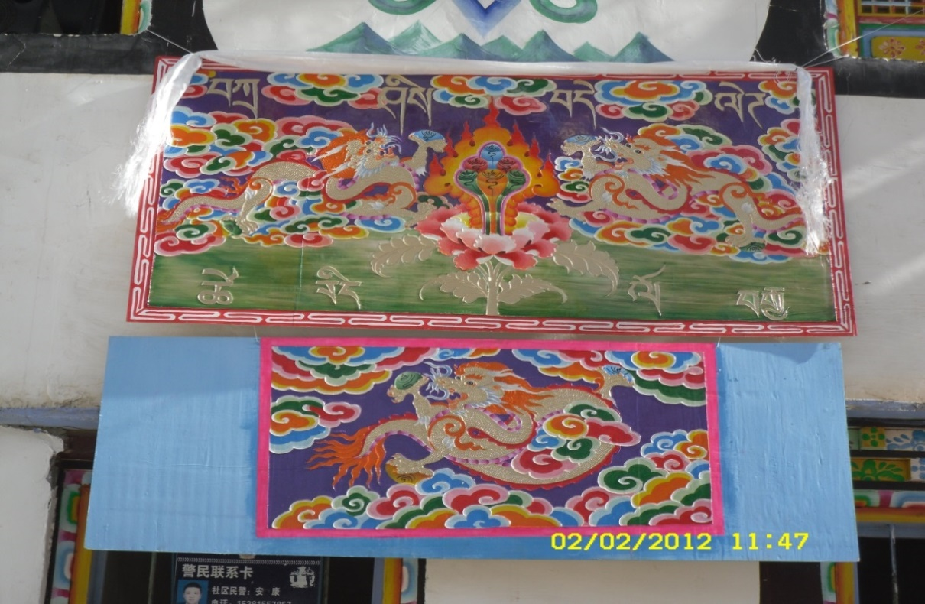
FIG 5.1 The paintings hanging above the host seats at the Chesuo ritual in 2012. This photo was taken by the author in Xiaopin, Erju Village, 2012.

Other symbols that had little connection with the Gelug sect of Tibetan Buddhism were also removed from the ritual. In 2006, the symbol of the white lion was represented in two important parts of the Chesuo ritual (see FIG 3.2), including the dance of white lion, performed before the Chesuo ritual dance, and the image of white lion pictured on dancers’ shields (see FIG 5.2). The white lion is a typical symbol of Yungdrung Bon, which is divided to the ‘white Bon’ and the ‘black Bon’ by the followers of the Yungdrung Bon in rural Danba. The white lion is a typical symbol in the ‘white Bon’. The white Bon tradition still widely exists in the culture of Jiarong and Qiang people in this region, including the white colour of their houses and the white stones placed on the rooves of Jiarong houses (Zhang, 1999). The symbol of the white lion in the Chesuo ritual represented the history of this ritual with the Bon tradition in this region. Since 2009, the symbol of the white lion was replaced by the symbol of vKhor-lo, one of the most classic symbols in Tibetan Buddhism (see section 5.3.2). In 2009, the dance of white lion before the hosts entered the Secang was cancelled, as stated in section 4.1. In the same year, the image of white lion on the dancers’ shields was replaced by the vKhor-lo symbol. Using vKhor-lo to replace the white lion symbol implies an intention to increase the commitment to Tibetan Buddhism and reduce the influence of Yungdrung Bon in local culture.
In order to understand the implication of this symbolic change in the eyes of the villagers, interviews were conducted with 80 villagers (40 males and 40 females) in Erju Village in 2012. 42 interviewees (31 males and 11 females) believed ‘it [the vKhor-lo] was part of the ancient tradition [of the Chesuo ritual]’. 14 males (10 dancers and 4 elders) explained that ‘the vKhor-lo was a part of the pre-existing Chesuo ritual, while the dance and the symbol of white lion were added by the older generations by mistake’.

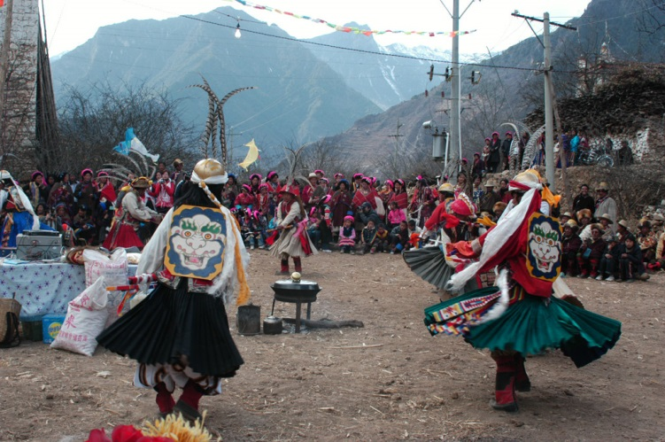
FIG 5.2 The Chesuo ritual in the Secang of Dapin, Erju Village, 2006. In this photo, the dancers carried a shield with the symbol of the white lion on their backs. This photo was taken by the workshop from the Multicultural Research Centre of the Sichuan Normal University in Dapin, Erju Village in 2006.
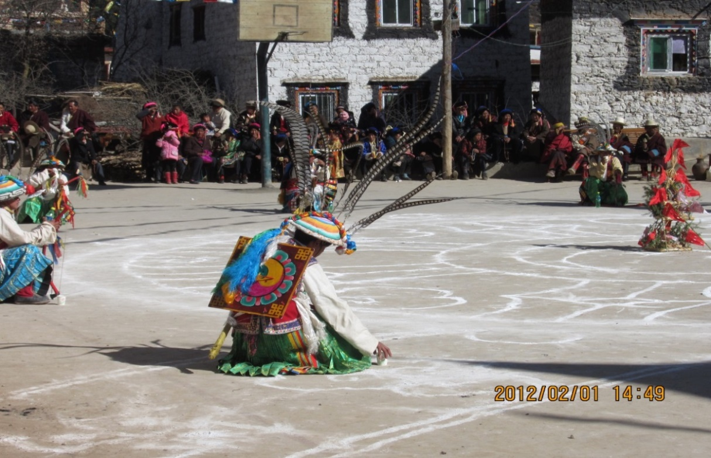
FIG 5.3 The scene of the Chesuo ritual in Dapin, Erju Village, 2012. The symbol on the shield of the dancers is a simplified image of the vKhor-lo. This photo was taken by the author in 2012.

Most females (25 females and 4 males) were ‘not clear’ or said ‘you should ask the men (or elders)’. Only 9 interviewees (5 males and 6 females) said that ‘maybe it was changed for some reason’.
Linking the interview data with the progress of the Chesuo ritual in 2006-2012 helps in understanding the implications of these changes. As discussed in section 3.3, the Chesuo ritual was re-initiated in 2006, based on the recollections of the last elder master who used to perform this ritual before it was suspended in the 1960s. The fieldwork recorded in 2006-2007 that no one else in the village claimed to have the knowledge of the pre-existing Chesuo ritual. In 2007, the elder master, Suolang, passed away. Between 2008 and 2012 a series of changes were adopted into both the procedures and symbolic significance of the Chesuo ritual. As stated at the end of section 5.2, I argue that, after Suolang died, the lack of local records about the history, rules and taboos of the original Chesuo ritual meant that it became a rich space for the villagers to put their imagined ancient Jiarong-Tibetan history into. Moreover, when the villagers were insisting the symbolic changes were part of the original Chesuo ritual rather than its re-creations, their desire to claim Tibetan identity by presenting an ancient Jiarong-Tibetan tradition was revealed.
Although the villagers insisted that they were ‘recovering the old traditions of the village’, the new elements added to the ritual made it more modern than traditional. Performances, including dances, songs and fashion parades in the style of modern Tibetan popular culture, have been increasing as a proportion of the Chesuo ceremony. These modern entertainments were explained by the villagers as for ‘inheriting our traditions and cultures’. The increase in the elements of modern Tibetan culture, as well as the removal of the non-Tibetan symbols, implies an intention to emphasise Tibetan culture in the ceremony.
This intention became more obvious when combining the symbolic changes of the ritual with the changes of symbols used in daily life. The symbols presented in villagers’ house decorations underwent similar changes. As a well-preserved local tradition, the houses of Jiarong people are normally decorated with massive paintings on the walls and ceilings, and these paintings therefore became important in cultural self-expression. The fieldwork in Erju Village in 2006 recorded that almost every household put up pictures or posters of famous Chinese politicians, monks, and the Potala Palace in their living rooms. These images include Mao Zedong, Deng Xiaopin, the Panchen Lama, the Dalai Lama and other regionally famous monks. However, in 2012, most images of Mao Zedong and Deng Xiaopin had disappeared from local houses, and the image of Potala Palace and the 14th Dalai Lama took the most important positions. Other symbols irrelevant to the Gelug sect of Tibetan Buddhism, such as the symbols of the Chinese lunar calendar animals, Yungdrung Bon and Daoism, had become uncommon in household decorations by 2012. This change of symbols in the houses of Erju Village was also found in other Jiarong villages in the rural Danba area. Although most of interviewees explained this change as ‘for better house decoration’, it is a fact that the symbols that represented the Tibetan nationality in the eyes of the villagers were remarkably increased in Erju Village between 2006 and 2012.

5.3.2 The increase of Tibetan Buddhist symbols in the Chesuo ritual
Between 2006 and 2012, the symbols of Tibetan Buddhism were remarkably increased in the Chesuo ritual. As the most significant local collective activity in the eyes of the villagers, the Chesuo ritual is an important occasion of cultural self-expression, and so the increase of symbols reveals the cultural desire of the villagers.
Since 2008, the vKhor-lo symbol became the largest and the most central symbol at the scene of the Chesuo ritual. As illustrated in figure 5.4, the 13 male dancers of the ritual were placed in 13 circles composing part of the vKhor-lo symbol on the ground. When these dancers started to dance the ritual in a circle, they were moving around the vKhor-lo symbol drawn in the middle, in sight of the audience.
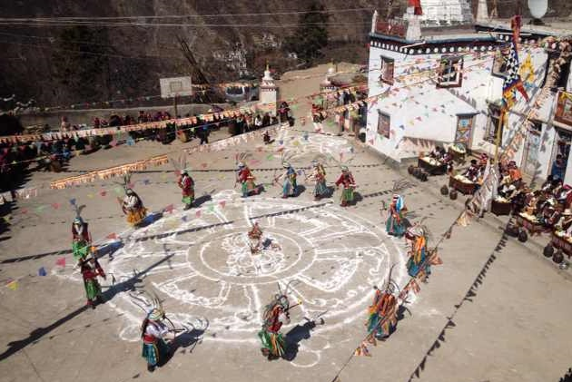
FIG 5.4 The scene of the Chesuo ritual in the Secang, Xiaopin, Erju Village, 2013. This photo was taken by a male villager on the roof of a house in Xiaopin
The vKhor-lo, or ‘golden wheel’, is one of the most common symbols of Tibetan Buddhism. It has many meanings in Tibetan Buddhism according to its various forms and where it appears. In figure 5.5, four common forms of vKhor-lo are displayed, each having a different meaning and used on different occasions (Beer, 2003, 14). Generally, the vKhor-lo represents ‘the auspiciousness of the turning of the precious wheel of Buddha's doctrine, both in its teachings and realisations, in all realms and at all times, enabling beings to experience the joy of wholesome deeds and liberation’ (Beer, 2003, 14). In Tibetan areas, including rural Danba, various forms of vKhor-lo can be seen decorating cars and houses.


FIG 5.5 Four common forms of the vKhor-lo symbol. From The Handbook of Tibetan Buddhist Symbols, by Robert Beer, 2003.
The use of the vKhor-lo symbol in the Chesuo ceremony started in 2008, as stated in interviews undertaken in Erju Village in 2011. It was added by two young trainee painters of Tibetan Tangka , who were hosts of the Chesuo ritual in that year. As the hosts change every year, each host family has a certain degree of initiative to representing the ritual according to their understandings, if they can obtain agreement from the other host families. However, such a big change as adding the vKhor-lo symbol at the centre of the ritual could not be simply decided by the hosts. They need to acquire permission from the elders and the dance leaders, who are considered cultural authorities of the Chesuo ritual.
Compared to the host families that change annually, the group of dancers is relatively stable. The team of dancers was built up spontaneously in 2007 by four male villagers with a strong interest in the Jiarong culture. These four volunteers danced in every year following, and they were also in charge of specific preparation works for performing the ritual, including training new dancers (conventionally, every male host should dance), arranging rehearsals, organising the performances and preserving the costumes. Thanks to their enthusiasm for local traditions and their voluntary work, the villagers respect their knowledge around the Chesuo ritual, and they are empowered with more right than other villagers to shape the procedures and the meanings of the ritual. By contrast, the monks and Gengbe, even though they are conventional religious elites in the village, do not engage in the organisation of the Chesuo ritual. As discussed in section 4.1, although a monk was invited to attend the Chesuo ritual every year and given the place of honour among the hosts, local monks expressed little interest in the ritual. As one monk said, ‘This is one of our ancient traditions, but it is still a superstition [as opposed to Buddhist activities]’. The monks’ attitude can be partly explained by the difference between Yungdrung Bon and the Gelug sect, as discussed in section 4.6.2. To what extent the attitude of the monks has impacted the symbolic changes in the ritual is unknown, because no villager was willing to express their thoughts about the monks’ opinions in interviews. However, as the most active villagers engaging in the ritual were also found to be the most devoted followers of the Gelug sect of Tibetan Buddhism, this may shed some light on the matter. Elderly males are the most powerful group in deciding the religious affairs in their households in Erju Village, and most of the elders and male hosts in the village are active supporters of the Chesuo ritual and devoted followers of the Gelug sect. Female villagers, even if they are also Buddhist devotees, are customarily excluded from many Buddhist activities in their households. Thus, female villagers tend to welcome every chance to be involved in collective activities, particularly collective Buddhist activities. This explains why the symbols of Tibetan Buddhism gradually took a centre place in the Chesuo ceremony between 2008 and 2012.
The vKhor-lo symbol was always used in the Chesuo ritual after 2008. Moreover, other symbols of Tibetan Buddhism started to be used along with the vKhor-lo symbol in the decoration of the Chesuo ceremony. As shown in figure 5.6, the symbol 卐 and the cloud, which are also the common symbols of Tibetan Buddhism, were draw on the central performance ground for the Chesuo ritual in 2012. The symbol 卐 is widely used by the followers of the Gelug sect in rural Danba, since they pray in a clockwise direction, while the direction of praying in the temples of Yungdrung Bon is anticlockwise. An interesting fact worth mentioning about the presence of the 卐 symbol at the scene of the Chesuo ritual is that the Chesuo ritual dance is still performed in the Yungdrung Bon anticlockwise direction. The reservation of the anticlockwise direction in the Chesuo ritual is one of the few evidences of the Bon origin of this tradition that can still be seen.
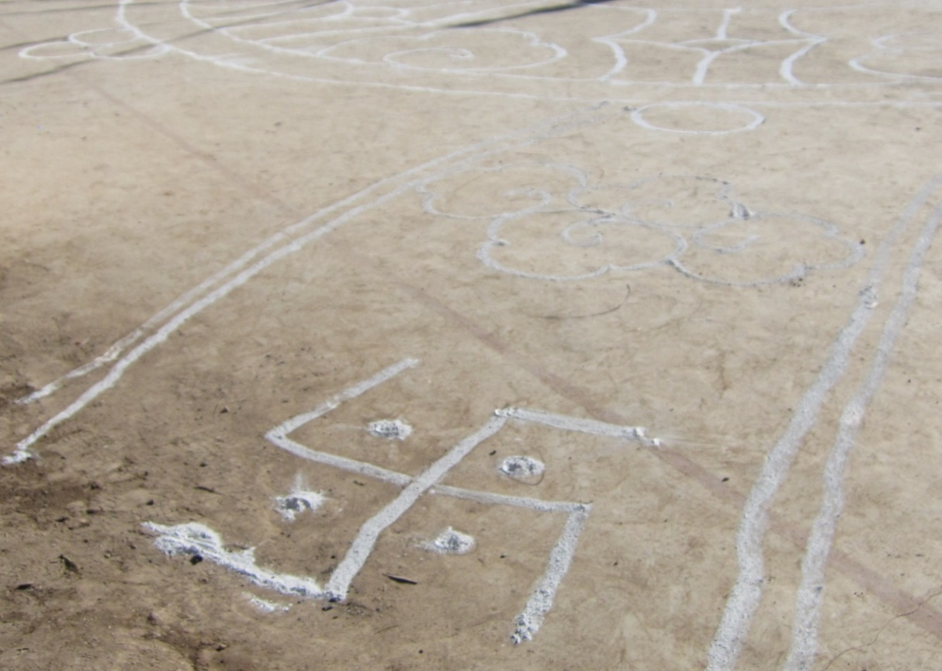
FIG 5.6 The 卐 symbol and cloud that decorated the vKhor-lo symbol. This photo was taken by the author in Dapin, Erju Village, February 2012.

Furthermore, another classic symbol in Tibetan Buddhism, the sacred mirror (also called me-long), was used in the Chesuo ritual in 2011 and 2012. (See FIG 5.7)

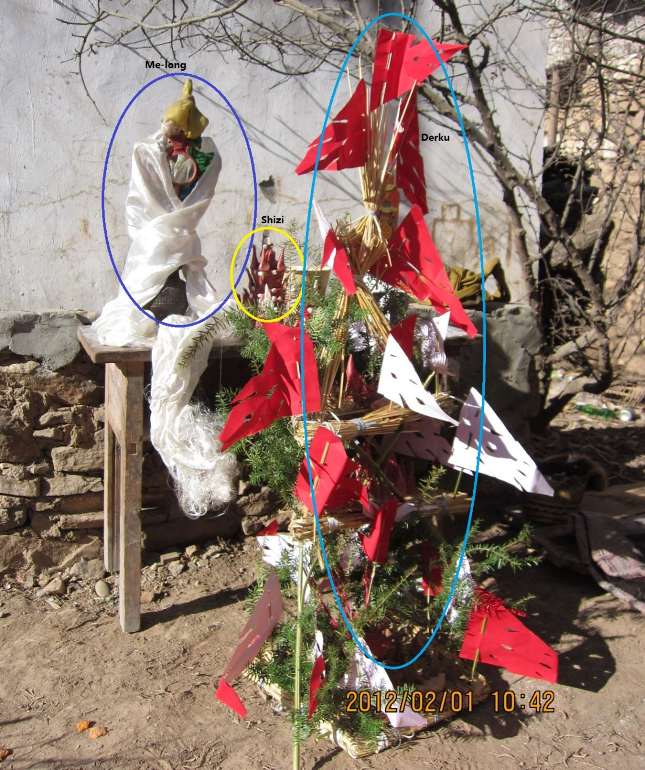
FIG 5.7 The Me-long, Shizi and Derku used in the Chesuo ritual, 2012. Photographed in Dapin, Erju village. These were chanted to by the local Gengbe on the morning of the ritual was launched, as a part of the preparation work. From the author’s fieldwork database.
The Me-long, which can be seen on the left of the table in figure 5.7, wrapped with a white Hada, was explained by the Gengbe as the representation of the power of Buddha. As shown in the photo, the Me-long, Shizi and Derku were placed together on the side of the Secang on the morning the ritual was launched. As shown in Table 4.1, in 2012, these items were prepared and brought to the Secang by the Gengbe at 10:30, and the Gengbe chanted to them for ten minutes, making them ready for use in the Chesuo ritual, which started at 14:15.
The Derku, as the most important symbol of the Chesuo ritual, has been changed to give it more of a leaning towards Tibetan Buddhism over the years. The Derku, also called gTOr-ma in Tibetan Buddhism, is a small statue, made from a mixture of highland barely powder and yak butter in the Jiarong tradition. The Derku is widely used by the local villagers in Tibetan Buddhist rituals, standing for offerings to the Buddha, spirits and ghosts, symbolising tributes to Buddha for blessings or representing the devil needing to be purified. The specific shape of the gTOr-ma symbol various from ritual to ritual.
In 2006, the Derku was simply made from a small lump of white dough placed on the side of an earthenware jar, representing the evils that needed to be expelled by the Chesuo ritual. Considering the implication of the Chesuo ritual was primarily explained by the local villagers as for expelling these evils, the Derku become one of the central symbols of the ritual. In 2006-2007, after the Chesuo ritual dance, all the hosts drank a highland barely liquor from the earthenware jar, in gender and age sequence. The Derku was then taken outside the village and abandoned. This implied that the evils that had threatened the villagers were expelled by the 13 soldiers of the Buddha, thus protecting and blessing the hosts, who had drunk the blessed liquor. In 2012, drinking the blessed liquor was no longer part of the ritual, and the earthenware jar for containing the liquor was replaced by a complicated form of Derku on the ground with a large image of the vKhor-lo symbol (see figure 5.5). This change reshaped the meaning of the Chesuo ritual. That is to say, the traditional function of the ritual for blessing for the hosts was weakened, even though the hosts’ duties in organising and preparing for the ritual were not. In 2012, the Derku was burned outside the village by the Gengbe after the Chesuo ritual, and its ashes were dispersed, symbolising that the evils were expelled. The Gengbe explained that in doing so, everyone in the village was blessed through the ritual. Therefore, the implication of the ritual shifted from blessing the hosts to seeking blessing for all present, including visitors. This change again aligns the relaunched Chesuo ritual more to Tibetan Buddhism, compared to its original implication of blessing only the hosts.
The Shizi, as another form of the gTOr-ma symbol, has been present in the Chesuo ritual since 2009; thus it can be seen as a part of the re-creation of the ritual. The Shizi, as seen in figure 5.8, was made by the Gengbe using highland barely powder and yak butter, and painted. According to local Gengbe, Shizi represents the Buddha’s palace. It was used in the Chesuo ritual after being chanted to for three days by the Gengbe, reading books inherited through his family. By doing this it was believed that he sent the villagers’ wishes to ‘Tianshang’ and then the 13 ‘Tian bing tian jiang’ (warriors of gods) were sent out by the Buddha to the earth to fight with the evils. The word ‘Tianshang’, as recorded by the fieldwork data in 2006, firstly comes from the narratives of the elder master, Suolang. ‘Tianshang’, in Chinese is天上, is a word commonly used to describe the world of the gods in the Han myths and Daosit stories; however, it is not a word used in Tibetan Buddhism. Similarly, the word ‘Tian bing tian jiang’ is a typical word describing the warriors of the gods in the Han myths and Daosit stories. Due to the death of the elder master in 2007, it is not possible to find out whether these two words expressed his meaning correctly or they were translation errors and the real meaning should be the ‘warriors of Buddha’. These two words were still being used by the Gengbe and other villagers in 2012; however, the word ‘Pusa (a way of calling Buddha in Sichuan dialect)’ was frequently used in their narratives to explain the meanings of ‘Tianshang’ and ‘Tian bing tian jiang’.
Compared to the interview data in 2006, the data in 2011 and 2012 showed that Tibetan Buddhist words and concepts were used much more often in villagers’ interpretations of the Chesuo ritual. The appearance of ‘Shizi’ in the ritual shows the influence of the Gelug sect, which is perceived not just as a religion but also as a lifestyle, on shaping this relaunched tradition.

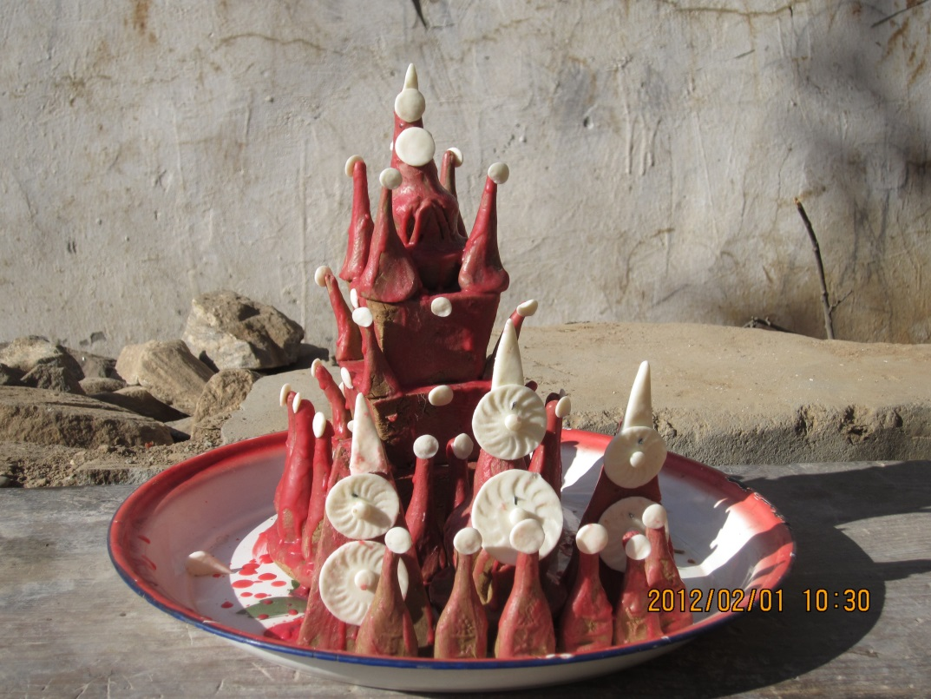
FIG 5.8 The Shizi used in the Chesuo ritual, 2012. This photo was taken by the author in Dapin, Erju Village.
The increase in Tibetan Buddhist symbols, including vKhor-lo, 卐, Me-long, gTOr-ma and other small symbols, indicates the increasing influence of Tibetan Buddhist culture, which represents Tibetan culture in the eyes of the Jiarong people in Erju and nearby villages, on shaping the revitalisation.
Several questions about the symbolic changes of the ritual are raised. Were these symbols added into the ritual with a specific purpose? If they were, under what circumstances were they were added? How did the villagers perceive these symbolic changes in the ritual?
An interesting phenomenon is that no one in Erju Village admitted these symbols of Tibetan Buddhism were ‘added into the ritual’ in their interviews, as partly discussed in section 5.3.1. Just as with the explanations of withdrawing the non-Tibetan symbols in the ritual, the interviewees believed that they were maintaining ‘the original style of the Chesuo ritual’. This phenomenon can be primarily explained as the influence of Tibetan Buddhism in the village, which makes any doubt towards these sacred religious symbols offensive and inappropriate in the eyes of the villagers. Moreover, these symbolic changes towards Tibetan Buddhism have been maintained over the years, showing the villagers’ desire to claim their Tibetan nationality through displaying the Jiarong-Tibetan history in their narratives via the Chesuo ceremony. A typical explanation was made by one of the dance leaders:

These symbols used to be part of the Chesuo ritual before it was suspended. The elder master of the Chesuo ritual was too old to remember every detail of the ritual […] his memory was not correct [...] The monks in the temple agreed with us that we should add these symbols into the revived ritual so we can better protect our traditions.

As discussed already, the lack of records and knowledge on the pre-existing Chesuo ritual generated rich space for realising the imagined regional history and cultural traditions. Since the Chesuo ritual was suspended in the 1950s, no villager under the age of 60 had been able to witness an original Chesuo ritual in the village. Thus, none of the dancers or the monks in the village in 2006, all of whom were under the age of 60, had seen the original Chesuo ritual themselves, but they were still trying to ‘fix’ the ritual into its ideal form in their own minds.
The desire to claim Tibetan identity could also can be seen in the villagers’ passion for the Chesuo ceremony, indicated by the growth of the ceremony over the years, and its increase in hosting cost. The symbolic changes of the Chesuo ritual between 2006 and 2012 changed the implication of the ritual from blessing the hosts to praying for the village. Thus, to the hosts, their symbolical benefit from the ritual seems to be reduced, while the cost of organising the extended Chesuo ceremony has continuously increased. The amount input by each host increased from 25 RMB in 2006 to 500 RMB in 2013, which means that some of the host families had to spend 1500 RMB in a year, and then further spending was required for food, wine and decorations, in order to treat the increased audience attending the ceremony. Compared to the average household cash gift of 50 RMB in this region in 2013, the spending on the Chesuo ritual was a very large outlay for the host families. Nevertheless, the fieldwork in Erju Village in 2011-2012 found that hosting the Chesuo ritual was commonly perceived by local villagers as an honour rather than a duty or a burden.
The villagers’ passion about the Chesuo ceremony, as discussed in chapter 4, can be primarily attributed to the importance of the ceremony as an occasion of collective gathering and consumption in the village. Through organising the ceremony, the host households treated their kin, as well as their collaborators, and it was a way to express gratitude and receive gratitude from other villagers in return. Moreover, it can be attributed to the villagers’ common desire to claim ‘an ancient clan history of Tibetan nationality’ through legitimating their imagined Jiarong-Tibetan history in the revived Chesuo ritual, as proved by the increase in Tibetan Buddhist symbols in the ceremony and the villagers’ interpretations of these symbolic changes.
It is clear that the villagers emphasise ‘an ancient village tradition full of traits of Tibetan cultures’ rather than insisting on preserving the cultural uniqueness of the Chesuo ritual or its meanings. While almost every interviewee believed that the ritual was one of the most important local traditions, most of them simply made vague explanations as to the purpose of the ritual, saying it was blessing the village, which in fact is a very common explanation that is suitable to most of activities in Tibetan Buddhism in this region. Only seven villagers talked about the symbolic meanings of the ritual in their interviews, and no one in the village today can tell the specific meaning of the actions and movements in the ritual.
From this point, the revitalisation has little connection with the original implications of the ritual. Thus, this study differs from Augilar’s study on a type of revitalisation initiated by indigenous communities in order to sustain certain core beliefs contained within rituals (1995). This revitalisation shares some similarities with previous studies which related to the issue of cultural identity (Santasombat 2001, 155; Wang, 1997, 1-85; Zhang, 2008, XVII 1; Tyler, 2010). This is because all these revitalisations are based on the cognitive function of ritualised behaviours in shaping individual and group identities, as shown in previous classic studies on rituals (see in Van Gennep, 1960 [1909]; Gaster, 1950; Geertz, 1973; Goffman, 1982). In this sense, the revitalisation and progress of the Chesuo ritual are linked with the desire to adopt and confirm the change of cultural identities through ritualised behaviours, as also mentioned by these studies.
However, this case could not be fully explained by previous findings. Compared with the studies of Wang (1997, 1-85), Zhang (2008, 1) and Tyler (2010), though this case also occurred in the context of rapidly changed social and cultural environment, this revitalisation was not seeking a sense of stability or continuity from genuine past history, but rather idealising the past through ritualised behaviours created by the participants of the ritual in order to create an image of an identity originally created by state ethnic categorising policies. This motivation is generated from the power relations between ethnic minority groups, the Jiarong people, and two large ethnic groups (Tibetan and Han) in the framework of Chinese ethnic categories. Thus, this case is different from Santasombat’s study on the cultural revitalisation of the Tai people in China, which is explained as ‘an attempt to re-construct a sense of Tai ethnic identity through the creation of an historical consciousness or ideals of the Tai race […] and resisting Chinese supremacy’ (2001, 155). The revitalisation of the Chesuo ritual, and particularly its progress in 2008 to 2012, manifests a strong desire to re-shape ethnic history in the perception of Jiarong people. But this revitalisation aims to manifest their qualification of Tibetan nationality, which has in fact caused the cultural supremacy issues that have troubled them. The ethnic category made by Han government is not the issue that they want to address through the revitalisation.

Chapter Conclusion
This chapter interprets the cultural factors underlying the revitalisation between 2006 and 2012 by exploring the symbolic changes of the ritual during this period and local villagers’ interpretations of these changes. By discussing the symbolic changes within their social context (including the history of Jiarong-Tibetans in Danba County, the socioeconomic changes in the villages, and the transmission of Tibetan Buddhism in rural Danba) the decline of the Jiarong identity, caused by the increasing influence of the Gelug sect of Tibetan Buddhism, is found to be the main cultural factor that has constantly guided the progress of revived the Chesuo ritual. This has resulted in a series of changes in the symbolic content of the ritual and its implications in the eyes of local Jiarong people.
The decline of the Jiarong identity first needs to be discussed by explaining the differences between the local Jiarong identity and the term ‘Jiarong Zangzu (Jiarong-Tibetans)’. The Tibetan nationality (Zangzu) of Jiarong people was initiated in 1951 as a result of the state ethnic policy of creating minzu in China between the 1950s and the 1970s. Being classified as Zangzu on the one hand enabled the Jiarong people to benefit from favourable political and economic policies; on the other hand, the society and culture of Jiarong people came to be perceived as a sub-group of Tibetans, and thus their culture lost its visibility and independence in public discourse. Moreover, the pre-existing cultural uniqueness of the Jiarong people became a disadvantage that blocked them from being admitted as Tibetans by the Amdo and Central Tibetans, who preserved a nomadic culture. Thus, when a growing number of Jiarong people, especially the short-term labourers and performers, left the rural Jiarong area and encountered the herdsmen speaking Amdo Tibetan in the pasture lands, an increasing number of Jiarong people experienced an identity dilemma caused by the state ethnic classifications in the 1950s. That is, the Jiarong people found that their Jiarong-Tibetan identity was doubted or rejected by the herdsmen speaking Amdo Tibetan or Central Tibetan, who differed from Jiarong people in terms of language, clothing, buildings and many other customs.
This identity dilemma resulted in a strong desire to legitimise the Jiarong Tibetan nationality in rural Danba, because: 1) Tibetan nationality, although it is a political creation started in the 1950s, is perceived as a birth identity by the Jiarong people, owing to decades of acculturation through state-run institutions (government departments, schools, mass media) and religious institutions (monks and temples). 2) The Sino-Tibetan political tension, intensified by the social unrest that broke out in Lhasa in 2008, meant the Jiarong people even more strongly identified themselves with the Tibetan nationality.
The desire to legitimise the Tibetan nationality led the villagers to make a series of symbolic changes to the Chesuo ritual from 2008, including the removal of symbols that were not related to the Gelug sect of Tibetan Buddhism, which is immersed in the contemporary lifestyle of the village, and the increased use of classic Tibetan Buddhist symbols. Through exploring the villagers’ interpretations of these symbolic changes, this study found that these changes in the ritual between 2007 and 2012 manifested a strong intention of the villagers to emphasise Tibetan culture in their village history; and Tibetan culture is strongly linked to the culture of Lhasa and the Gelug sect of Tibetan Buddhism in the eyes of the Jiarong people. Consequently, the implication of the original Chesuo ritual, which showed the cultural history of the Jiarong people as an ethnic group living in a transitional region of the societies of Han, Tibetan and Qiang people, was changed. The identity of Jiarong people as an ethnic group with their own cultural uniqueness was fading out of their social memories and local history. In contrast, an imagined local history of being ‘historical and authentic Tibetans’ was added into the Chesuo ritual, thus allowing it to be legitimised under the cover of an ancient tradition.
In this sense, this revitalisation marked a decline in the Jiarong identity as an ethnic group combining various cultural traits from its history of living in the Sino-Tibetan borderlands, and an increase in commitment to Tibetan nationality, a political creation by the state in the 1950s. The decline of Jiarong culture and identity reflected by this revitalisation is therefore the result of interactions between the Jiarong ethnic group and other Tibetan sub-groups, even though this decline can be partly attributed to the transformation of rural Jiarong society in an era of drastic economic reform. In this case, ethnic interactions within the politically-created Tibetan category, rather than the cultural supremacy of the Han, is found to be the preeminent reason that led to the decline of Jiarong identity and culture.

Conclusion
This study interprets the economic, social and cultural factors underlying the revitalisation of a ritual, called Chesuo, initiated by a clan village of Jiarong Tibetans in the contemporary rural area of Danba County in the Ganzi Tibetan Autonomous Prefecture in 2006. This revitalisation is interpreted as embedded in a dynamic social context, which constantly shaped the village life of the Jiarong people and their perceptions of their traditions, culture and identity.
The Chesuo ritual was re-launched by Jiarong villagers on Erju Mountain after it had been suspended for 48 years. Although the decline of the Jiarong traditions in rural Danba was a general phenomenon due to the drastic socioeconomic changes, this ritual was re-launched in 2006 through the efforts of local people, and it was developed over the following years. Therefore, studying this revitalisation helps to understand the social and cultural transformations in this society of Jiarong people, a small ethnic group living on the borderlands of Han and Tibetan societies.

Findings
Through examining the revitalisation that occurred in 2006 and tracking its progress in the following five years, this study has established three main findings.
Firstly, the revitalisation in 2006 was motivated by the economic value of the Jiarong people’s traditional performing skills in the development of local tourism. External support, in the form of encouragement and initial funding from Prof. Badeng Nima and the Ford Foundation, was important in allowing the revitalisation to occur in 2006. However, the economic factor that triggered the revitalisation in 2006 was not a crucial factor in sustaining the event between 2007 and 2012.
The second factor, the increasing importance of local kinship networks, is found to be the preeminent factor that sustained the development of the revitalisation between 2007 and 2012.
Thirdly, the decline of the Jiarong identity and culture is found to be an underlying cultural factor that has sustained and guided the revitalisation since 2006.
Through tracking the progress of the revitalisation, I found that the social and cultural factors were the main reasons that the Chesuo ritual continued and developed from 2007 to 2012.
When the revitalisation occurred in 2006, it was directly motivated by the desire to prepare local children to pursue performing careers, which played an important role in reducing the poverty of households in Erju Village. In 2006, the villagers explained the revitalisation of the Chesuo ritual as having occurred for two reasons: the cultural desire to pass on local traditions and the economic need to engage in performing careers and attract tourists. It’s worth noting that, according to the fieldwork data from 2006, neither political factors (such as being against the cultural supremacy of large ethnic groups and seeking cultural autonomy), nor cultural factors (such as reinforcing ethnic identities), were the main reasons contributing to the revitalisation of this ethnic ritual, although these are presented as significant factors in the literature.
During my fieldwork in 2006, the economic factor was found to be the most prominent factor but the cultural factor came up in the sense that the villagers thought that the Chesuo ritual was the most ancient local tradition that the village could preserve. However, this cultural factor cannot explain the revitalisation in 2006 for the following reasons. Firstly, this does not explain why the revitalisation did not happen earlier. Even during the most difficult period of the Cultural Revolution, Buddhist worship and rituals in local households were never completely expunged, and yet the Chesuo ritual was almost entirely forgotten. The question cannot be answered without analysing the social context of the revitalisation. When the Chesuo ritual was relaunched in Erju Village in 2006, this village was suffering from relative poverty caused by the unbalanced development of tourism in Danba County. While the development of tourism in Danba County greatly promoted the quantity and quality of commodities and services in towns, and thus raised the income and consumption ability of town dwellers, villagers who lived the traditional highland agricultural life in remote mountain areas faced economic difficulties in covering the rising cost of staples. On the one hand, these villages barely had any tourists, due partly to poor transport infrastructure; on the other hand, the cost of their daily spending was raised due to the average economic progress across the county. At this time performing careers became the most admirable jobs in the eyes of the Erju villagers and other villagers who were marginalised by the regional tourism development of the early 2000s. The economic change in rural Danba in 1990-2006 had a far greater impact than the regional cultural change during this period.
Secondly, as discussed in section 5.3, the revised Chesuo ritual was found not to have truly revived or preserved the original ritual. The fieldwork in 2006 found that the Chesuo ritual used to be a part of the man’s the 49th year celebrations in Erju Village. Why the local Jiarong people used to celebrate this particular age is still uncertain. (The elder master, Suolang, who played an important role in relaunching the Chesuo ritual stated that 49 used to be the age that men retired from the army and returned permanently to their villages.) In 2006, the relaunched Chesuo ritual was significantly different from the original form in terms of purpose, organisation and the specific time of the launch. More changes occurred to its programme, symbols, organisation and villagers’ perception from 2007 to 2012. These changes were not consistent with the villagers’ narratives that the revitalisation was to preserve the original and ancient Chesuo ritual. These changes also show that the event of revitalisation was more profound and important to the villagers than the ritual itself. The reason the Chesuo ritual was chosen as the one to revive is simple; it was the only lost tradition that still had an elder who knew how to organise and perform it in 2006. The other lost village traditions lacked records or knowledge to revive them.
In 2006, the re-launch of the Chesuo ritual was triggered by the desire for non-agricultural income to cope with the aggravated relative poverty of local households. The Jiarong people’s traditional agricultural life was threatened by the regional economic transformations and there was an expectation that the ritual would bring tourists to the village and increase the household income, although such economic gains were never realised. Thus, this case is different from the studies of Wang (1997, 1-85) and Yang (2000), in which the revitalisation of folklore did bring economic gain.
Compared to the burning economic needs of villagers in Erju in 2006, the cultural factor, which refers to the acculturation of the Han and Tibetan cultures, has been an ongoing process in rural Danba for decades, and was not, on its own, enough to mobilise these Jiarong peasants to take action. Even after the Tibetan social unrest in 2008 greatly raised the dissatisfaction of local peasants towards the government, and this was further aggravated by a series of tragic monk self-immolations in Eastern Tibet in 2012, the main themes discussed in daily village life were still around economic issues. Therefore, this case is also different from Leete’s study (2005), in which the motivations for the revitalisation of ethnic traditions were political and social movement.
Moreover, the other economic factor worth noting in this case is the initial external funding used to make essential equipment and garments for the ritual. The external funding was a necessary condition, but not a sufficient condition, for the revitalisation to occur and progress in the following years.
Although the re-launch of the Chesuo ritual was triggered by economic factors in 2006, the fieldwork found that the economic factors were not the reason for the continuity of the ritual since 2008. Although the external funding lasted less than two years, and the revived Chesuo ritual did not attract tourists to the village as local people expected in 2006, the ritual continued to be enacted. The relative poverty of local households was still the main problem troubling the people in Erju Village in 2008; however, the importance of the revived Chesuo ritual in preparing children to be performers weakened from 2008, when civil service jobs replaced performing jobs as the most desirable career in the eyes of the villagers. Nevertheless, the decrease of the economic value of the revitalisation did not result in the decline or suspension of the ritual. Instead this ritual was further developed by the villagers every year, both in its scale and significance, despite the fact that the economic burden of the host households in preparing the ritual was correspondingly increased. Therefore, it is obvious that other non-economic factors were sustaining the progress of the ritual.
Given that the revitalisation of the Chesuo ritual and its progress were organised by the Jiarong people consciously, with clear, if not always realised, intentions, the motivations and implications of the revitalisation are inevitably hidden in the social context of their lives, where their perceptions of social reality and reasons for social actions are formed. Due to the increase of the migrant/non-agricultural population since 2007, village life in Erju Village was notably changed, and the members of the village were geographically separated throughout most of the year. Thus local kinship networks grew in importance in sustaining the village as an economic and social unit. The desire to maintain kinship networks, which are vital in providing social support to the villagers in diverse careers, is found to be the main factor that has sustained and developed the revitalisation from 2007 to 2012.
Motivated by the social need to maintain cohesion and collaboration among the villagers, the Chesuo ritual progressed from a one-day ritual in 2006 to a ceremony lasting for three days with various performances in 2012. Due to the fact that collective activities had been greatly reduced, owing to the growth of the migrant population, the Chesuo ceremony became the most important annual celebration in the village. Through reviving the Chesuo ritual and progressing it as a ceremony with various procedures, the villagers created opportunities for collective reunion, maintaining kinship networks, eliminating social conflicts generated in daily life, and generating individual cognition of trust, shared norms, values, group identity and belonging to the community. These actions all serve the purpose of maintaining kinship networks in the clan village under the impact of the collapse of traditional village life. By examining the organisation of the renewed Chesuo ritual, this case is found to be different from Herrou’s case (2011), in which the revitalisation was promoted by local religious elites for potential economic and political benefit.
By tracking the symbolic changes of the Chesuo ritual from 2007 to 2012, the decline of Jiarong identity was found to be the preeminent cultural factor that significantly influenced the development of the revived ritual. The symbolic meaning and significance of the Chesuo ritual was reshaped by a desire to legitimate the Jiarong-Tibetan identity, which aims to respond to the identity dilemma caused by the state ethnic classification project in China since the 1950s. The identity dilemma of the Jiarong people refers to their Tibetan nationality commonly being doubted by Tibetans speaking the Amdo and classic Tibetan languages, who are known as the two main subgroups of the Tibetan nationality.
The Jiarong people were being classified as Zangzu (Tibetan nationality) through the state ethnic classification project in the 1950s and this change profoundly influenced them. On the one hand, being categorised as Tibetan brought the Jiarong people policy benefits in terms of tax, education, subsidies and so on. On the other hand, from political and cultural standpoints the Jiarong people become affiliates of Tibetan nationality. The officially classified Tibetan nationality in Jiarong society was internalised as a birth identity in the eyes of the Jiarong people, through decades of influence from political discourse in state institutions (school education, mass media and ethnic policies) and religious institutions (cultural assimilation of the monks of the Gelug sect of Tibetan Buddhism). The political discourse in state institutions, given the strong power of state control in the life of ordinary people, legitimated the Jiarong-Tibetan identity in Jiarong society. Moreover, from a religious aspect, the monks of the Gelug sect greatly promoted the transmission of Tibetan Buddhism and the culture in Central Tibet in the villages of Jiarong people.
In Erju Village, the strong faith in the Gelug sect of Tibetan Buddhism resulted in a strong commitment to the Tibetan nationality. The old tradition of sending the youngest sons of local families to be monks in temples, which lasted until the 1960s, resulted in close social connections between the local villages and the Tibetan Buddhist system through the double identity of the monks, who are close kinship members in the village as well as fierce propagators of the Tibetan Buddhist culture. Thus the people in Erju Village generally had a strong desire to claim Tibetan identity, when the identity dilemma became a common concern of the Jiarong people in rural Danba as a result of the development of tourism and the growth of the migrant population since the 2000s.
Given the fact that Tibetan nationality is a political creation of the state, started in the 1950s, and the Jiarong people were categorised as Tibetan through a vote, the pre-existing Jiarong culture is obviously different from the culture of Amdo and Central Tibetans in terms of physical appearance, language, building style, costume and social customs. The Tibetan identity of Jiarong people has been internalised through political discourse used by state institutions and in regional ethnic policies, as well as through the religious influences of the Gelug monks, to transmit the culture of Lhasa Tibetan and Tibetan Buddhism. The Jiarong people were recognised as Tibetans by the Han people also because of their physical and cultural differences from the Han. However, the cultural differences between Jiarong people and nomadic Tibetans made the Amdo and Central Tibetans consider the Jiarong people to be Han people. Most Amdo and Central Tibetans that the Jiarong migrant workers dealt with were poorly-educated groups, such as herdsmen living in the pastoral area and small businessmen from Central Tibet travelling in rural Danba and the pastoral area. The Jiarong people found their Tibetan nationality was frequently doubted by both these groups. These groups were not involved in the political discourse around the Tibetan nationality of Jiarong people, because: 1) these discourses were embedded in localised regional policies; 2) these poorly-educated groups were rarely involved with the political discourses embedded in mass media and school education, due to their lifestyles.
The cultural differences and marginalised social status of the Jiarong people made it hard for them to convince these groups of their Tibetan identity. Thus, the attitude of the poorly-educated Amdo herdsmen and small businessmen towards the Tibetan nationality of Jiarong people had an increasing impact on the Jiarong people’s own perception of their regional history and ethnic culture, when the increasing numbers of Jiarong migrant workers experienced this identity dilemma.
The revived Chesuo ritual came to be seen as good evidence to legitimate the Tibetan nationality of the Jiarong people in Erju Village. This is because: 1) the gap in written history and local records regarding the regional history of the Jiarong area made it possible for the Jiarong to display their imagined ethnic history; 2) the revitalisation of the Chesuo ritual, due to the lack of records and local elites to defend its original form, created a space for the villagers to fill with their imaginings about their Jiarong-Tibetan history. Thus, the revived Chesuo ritual became an occasion for displaying this imagined history of Tibetan culture, which particularly pointed to the Gelug sect of Tibetan Buddhism. In this way, Jiarong people can use the Chesuo ritual to evidence their Tibetan nationality through one of their ‘ancient traditions’ that is still alive in the village.
The villagers’ desire to legitimatise their Tibetan nationality resulted in a series of symbolic changes to the revived Chesuo ritual from 2007 to 2012. The original symbols and rites, which had little connection to the Gelug sect of Tibetan Buddhism, were removed from the ceremony. Meanwhile, a growing number of the classic symbols of the Gelug sect of Tibetan Buddhism and elements of modern Tibetan culture appeared in the decoration, garments, and essential tools of the Chesuo ritual. Further, the villagers perceived these symbolic changes as ‘fixing’ the Chesuo ritual to its ‘original form’. For this reason, the meaning and the significance of the Chesuo ritual has been changed, in the eyes of local villagers, from a performance to celebrate one’s the 49th year to a ritual with religious significance.
Unlike the findings of Aguilar’s (1995) study, this change has happened in spite of the fact that the initial revitalisation of the Chesuo ritual was not for sustaining inherited religious beliefs. Moreover, although this revitalisation is closely related to the issue of ethnic identity, it did not occur in order to adopt or confirm a change of cultural identity through ritualised behaviours (Wang, 1997, 1-85; Zhang, 2008, XVII 1; Tyler, 2010), nor for resisting cultural supremacy from the majority ethnic group (Santasombat, 2008). Similar to Cannadine’s study (1983), the search for entertainment and emotional relief by romanticising the past is applicable to this case. However, it is only a small part of the motivation. The annual Chesuo ritual is still a costly event for households in Erju Village and villagers expect it to achieve more important and realistic goals.
From a cultural perspective, this ritual was designed by the villagers to display an ‘ancient history with Tibetan traditions’, in order to support their claim of being ‘authentic’ Tibetans. The revival and flourishing of the Chesuo ritual in Erju Village is the result of the decline of the local Jiarong culture and identity through drastic economic transformation in rural Danba, since the village would once have had many traditions and rituals which occurred at various collective gatherings over the year, but nowadays such gatherings can only be held during the Han Spring Festival. This made the villagers attach more importance to the revived Chesuo ritual, the only remaining collective gathering ritual, and resulted in its flourishing. However, even the development of the Chesuo ritual shows the decline of the local Jiarong culture. The changes in the symbols and significance of the ritual show the increasing influence of Tibetan Buddhist culture and Han and Tibetan popular culture, while the original symbols of the Chesuo ritual, which linked with the real local history, were replaced and faded out of the sight. The absence of local records and elites able to deliver the ‘true’ knowledge about the ritual enabled the villagers express their thoughts in the revitalisation, reshaping this renewed folklore to satisfy their needs, generated in daily life, and reinterpreting this ancient tradition to support their identity claim today.
The decline of Jiarong identity is partly because of the loss of the traditional lifestyle during the economic transformation in rural Danba. Beside this, the Chinese ethnic policy is also found to be a decisive one. The ethnic classification of the state in the 1950s is the root of the current Jiarong identity problem, where they are a marginalised ‘sub-cultural’ group of Tibetan nationality. This ethnic policy eroded the cultural uniqueness of the Jiarong people as a small ethnic group, and the cultural diversity in the Sino-Tibetan borderland. The regional ethnic policies and the absence of ethnic history in public education meant that the Jiarong people internalised the Tibetan nationality as their birth identify and only cultural identity, and this identity was further enhanced by their faith in Tibetan Buddhism. Thus, when their Tibetan nationality was doubted by the Tibetan herdsmen and small businessmen, the Jiarong people of Erju Village, had a strong desire to defend their Tibetan nationality through action. However, they could not defend their Tibetan nationality by simply displaying their own traditional culture, which did not fit within the tenets of the Gelug sect of Tibetan Buddhism. Instead, the revived Chesuo ritual was promoted and reshaped as evidence of their Jiarong-Tibetan nationality.

Implications
This study presents five years of ethnographic work on the revitalisation of traditions by the Jiarong people, a small ethnic group living on the borderlands of Tibetan and Han society. Thus, in contrast to previous studies on this topic, which depended on historical archives or described a revitalisation as a state rather than a process, this study employs continuous ethnographic data to interpret the dynamic process of such a phenomenon. Based on first-hand interviews and observational field data, this study provides a comprehensive interpretation of this revitalisation by combining the narratives of the villagers with the observations of the researcher.
Moreover, this study took a grounded approach to discuss the current identity issue of small ethnic groups in the Sino-Tibetan borderland. In previous studies the Jiarong society and its culture were widely considered to be part of the Tibetan nationality, connected to other Tibetan groups by Tibetan Buddhism. This study discusses the implications of the Tibetan nationality, which was created by the state in the 1950s, on the cultural inheritance of the Jiarong people in the Sino-Tibetan borderland.
In previous studies, the Sino-Tibetan political tension was overwhelmingly emphasised in analysing ethnic issues in the broader Tibetan region. This study analysed the Jiarong people in their own right. That is to say, the Jiarong people were analysed as a unique ethnic group, separate from both the Han people and other Tibetan ethnicities. In this way, the influences of the state ethnic policies and the Gelug sect of Tibetan Buddhism on the cultural inheritance and uniqueness of the current Jiarong people, which were found to be significant cultural factor of the revitalisation, can be discussed. The interaction between the Jiarong people and other subgroups in Tibetan nationality, rather than the cultural supremacy of the Han people, was found as the reason of the decline of the Jiarong identity.
In addition, this study provides an empirical case to enrich the knowledge of the interactions between ethnic cultures and the social reality. This study tracked the constant change of the revitalisation between 2007 and 2012, which manifests the efforts of the Jiarong people to maintain their village as a social and cultural unit under the impact of drastic social transformation coming from other, larger societies on their borders.

Directions for further studies
Further studies focussing on examining the influences of the contemporary framework of Chinese ethnic policies on the development of ethnic societies and the diversity of ethnic cultures will be valuable. This study took a qualitative approach to interpret the revival, so it would be interesting to follow up with quantitative studies to explore the influence of such a revitalisation on the development of the village in the long term.
Referring to the Chesuo ritual itself, some questions still remain to be answered by more historical research, such as seeking its origins in written records, if any still exist.
As this study is not focused on understanding the integrated Jiarong culture and its presentation, further studies could explore the influences of contemporary Tibetan Buddhism and Han popular culture on shaping the presentation of Jiarong culture, using this case as a basis.

Bibliography
Aguilar, M. I., (1995). African conversion from a world religion: Religious diversification by the Waso Boorana in Kenya. Africa. 65(4), 525-544.
Alexander, J. C., (2001). Theorizing the ‘Modes of Incorporation’: Assimilation, Hyphenation, and Multiculturalism as Varieties of Civil Participation. Sociological Theory. 19(3), 237-249.
Angrosino, M. V., (2007). Doing Ethnographic and Observational Research. London: SAGE.
Arslan, A., (2008). Revival of the non-existing intangible cultural heritage in the ancient cities and its reflections on tourism in Turkey. In: V. Gekas, N. E. Mastorakis and E. Stamatiou, eds. WSEAS International Conference on CULTURAL HERITAGE AND TOURISM (CUHT'08), July 22-24, 2008, Heraklion, Crete Island, Greece.[Online]. WSEAS Press. [Viewed 3 July 2011]. Available from: http://www.worldses.org/books/2008/crete/new-aspects-of-cultural-heritage-and-tourism.pdf.
Bai, S. Y., (1984). 关于中国民族关系上的几个问题 (Guanyu zhongguo minzu guanxi shi shang de ji ge wenti), Several questions about the history of ethnic relationships in China). In: D.J. Wu, ed. 中国民族关系研究 (Zhong Guo Min Zu Guan Xi Yan Jiu), Research on Ethnic Relationships in China. Beijing: China Social Sciences Press. pp. 2-4.
Barbour, R. S., (2006). Mixing qualitative methods: quality assurance or qualitative quagmire. In: A. Bryman, ed. Mixed Methods. London: SAGE. pp. 229-241.
Beer, R., (2003). The Handbook of Tibetan Buddhist Symbols. Boston: Shambahala Publications.
Bell, D. A., (2010). Reconciling Socialism and Confucianism?: Reviving Tradition in China. Dissent. 57(1), 91-99.
Billioud, S.and Thoraval, J., (2009). Lijiao: The Return of Ceremonies Honouring Confucius in Mainland China. China Perspectives. 4, 82-100.
Birnbaum, R., (2003). Buddhist China at the Century's Turn. The China Quarterly. 174, 428-450.
Borchert, T., (2005). Of Temples and Tourists: The Effects of the Tourist Political Economy on a Minority Buddhist Community in Southwest China. In: F. G. Yang and J. B. Tamney, eds. State, Market, and Religions in Chinese Societies. Boston: Brill. pp. 87-112.
Bourdieu, P., (1986). The forms of capital. In: J. Richardson, ed. Handbook of Theory and Research for the Sociology of Education. New York: Greenwood. pp. 241-258. (Originally published in French in 1983, translated by N. Richard in 1986)
Boyatzis, R. E., (1998). Transforming Qualitative Information: Thematic Analysis and Code Development. London: SAGE.
Braun, V. and Clarke, V., (2006). Using thematic analysis in psychology. Qualitative Research in Psychology. 3(2),77-101.
Brewer, J. D. ed., (2000). Ethnography. Philadelphia: Open University Press.
Bruyn, S. T., (1966). The Human Perspective in Sociology. Englewood Cliffs: Prentice Hall.
Burgess, R. G., (1984). In the Field: An Introduction to Field Research. 2nd Revised ed. London: Routledge.
Burnett, D., (2014). Rgyalrong Conservation and Change: Social Change on The Margins of Tibet [Online]. Lulu Publishing Services. [Viewed04 January 2015]. Available from: http://www.lulu.com/shop/david-burnett/rgyalrong-conservation-and-change-social-change-on-the-margins-of-tibet/ebook/product-21917621.html.
Cannadine, D., (1983). The Context, Performance and Meaning of Ritual: The British Monarchy and the ‘Invention of Tradition’, 1820-1977. In: E. Hobsbawm and T. Ranger, eds. The Invention of Tradition. Cambridge: Cambridge University Press. pp. 104-105.
Cannadine, D. and Price, S., (1987). Rituals of Royalty: Power and Ceremonial in Traditional Societies. London: Cambridge University Press.
Carter, A., (1984). Household Histories. In: R. M. Netting, R. R. Wilk and E. J. Arnould, eds. Households: Comparative and Historical Studies of the Domestic Group. Berkeley: University of California Press. pp. 44-84.
Chab-Spel-Tshe-Brtan-Phun-Tshogs, Phuntshogs, C., and Norzang, W. J., (1996). 西藏通史 (Xi Zang Tong Shi), A General History of Tibet. Translated from Tibetan by Q. Y. Chen, Z. He, Y. Gesang and D. Xu. Lasha: 西藏古籍出版社 (Xi Zang Gu Ji Chu Ban She) Tibetan Archives Press, Tibetan Research Press, and Tibetan Autonomous Prefecture Academy of Social Science.
Chan, S. C. and Lang, G.S., (2007). Temple construction and the revival of popular religion in Jinhua. China Information. XXI(1), 43-69.
Chang, H., Dong, X.Y. and Macphail, F., (2011). Labor Migration and Time Use Patterns of the Left-behind Children and Elderly in Rural China. World Development. 39(12), 2199-2210.
Chau, A. Y. ed., (2011). Religion in Contemporary China: Revitalization and innovation. New York: Routledge.
Chen, K., (1999). Theories and Practice of Ethnic Identification in China (Zhong Guo Min Zu Shi Bie De Li Lun Yu Shi Jian). Beijing: Minzu University of China.
Chirkova, E., (2007). Between Tibetan and Chinese: identity and language in Chinese South-West. Journal of South Asian Studies. 30(3), 405-417.
Chirkova, E., (2008). The Baima Tibetans and the Di people of Chinese historical records: challenging the link. Bulletin of Chinese linguistics. 3(1), 167-180.
Coleman, J. S., (1988). Social Capital in the Creation of Human Capital. The American Journal of Sociology. 94, S95-S120.
Coleman, D. L., (1996). Individualizing justice through Multiculturalism: the liberals' dilemma. Columbia Law Review. 96(5), 1093-1167.
Cook, I., (2005). Participant Observation. In: R. Flowerdew and D. Martin, eds. Methods in Human Geography: A Guide for Students Doing a Research Project. 2nd ed. Harlow: Pearson. pp. 167.
Cronk, L., (1994). Evolutionary theories of morality and the manipulative use of signals. Zygon. 29(1), 32-58.
Daerji, (1997). 雍宗苯教圣地墨尔多山 (Yongzong Ben Jiao Sheng Di Moerdo Shan), Moerdo: the holy mountain in Yungdrung Bon. 西藏民俗 (Xi Zang Ming Su), Tibetan Folklore. 1, 15-17.
Dallos, R., (2006). Observational methods. In: G.M. Breakwell, S. M. Hammond, C. Fife-Schaw and J. A. Smith, eds. Research methods in psychology. 3rd ed. London: SAGE. pp. 124-145.
Danba Xianzhi Bianzuan Weiyuanhui (丹巴县志编纂委员会, Compilation Committee of Danba County Annals), (1996). 丹巴县志 (Danba Xianzhi), Danba County Annuals. Beijing: The Ethnic Publishing House.
Davis, S. L., (2005). Song and Silence: Ethnic Revival on China's Southwest Borders. New York: Columbia University Press.
Denzin, N. K., (1970). The Research Act in Sociology. Chicago: Aldine.
Denzin, N.K. and Lincoln, Y. eds., (2005). Handbook of Qualitative Research. 3rd ed. London: SAGE.
Denzin, N.K., (2012). Triangulation 2.0. Journal of Mixed Methods Research. 6(2), 80–88.
Dey, I., (1993). Qualitative Data Analysis: A User Friendly Guide for Social Scientists. London: Routledge.
Downey, D. J., (1999). From Americanization to Multiculturalism: political symbols and struggles for cultural diversity in twentieth-Century American race relations. Sociological Perspectives. 42(2), 249-278.
D'souza, D., (1991). Liberal Education: The Politics of Race and Sex on Campus. New York: Free Press.
Duara, P., (1991). Culture, Power, and the State: Rural North China, 1900-1942. Standford: Stanford University Press.
Durkheim, E., (1995). The Elementary Forms of Religious Life. Translated from French, by K. E. Fields, New York: Free Press. (Originally published in 1912)
Eberle, T. S. and Maeder, C., (2011). Organizational ethnography. In: D. Silverman, ed. Qualitative Research. London: SAGE. pp. 53-73.
Edwards, B. and Foley, M. W., (1997). Social Capital, Civil Society and Contemporary Democracy. The American Behavioral Scientist. 40(5), 547-667.
Etzioni, A., (1975). Comparative Analysis of Complex Organizations, Reversed and Enlarged Edition. New York: Free Press.
Fei, X. T., (1939). Peasant Life in China: A Field Study of Country Life in the Yangtze Valley. New York: E.P. Dutton.
Fei, X. T., (1982). 谈深入开展民族调查问题 (Tan Shen Ru Kai Zhan Min Zu Diao Cha Wen Ti), on how to deepen the investigation of issues on nationality. 中南民族学院学报 (Zhong Nan Min Zu Xue Yuan Xue Bao), Journal of South Central Nationality College. 3, [no pagination].
Fei, X. T., (1983). 民族识别调查的常识 (Min Zu She Hui Xue Diao Cha De Chang Shi), An investigation of ethnic-sociology. 从事社会学五十年 (Cong Shi She Hui Xue Wu Shi Nian), My study in Sociology in the past Fifty Years. Tianjin: 天津人民出版社 (Tianjin Ren Min Chu Ban She),Tianjin People’s Publishing House. pp. 82-91.
Fetterman, D. M., (1998). Ethnography: Step by Step. California: SAGE.
Flick, U., (2007). Managing Quality in Qualitative Research. London: SAGE.
Forrest, R. and Kearns, A., (2001). Social Cohesion, Social Capital and The Neighbourhood. Urban Studies. 38(12), 2125-2143.
Freedman, M. and Foley, M. W., (1958). Lineage Organization in Southeastern China. London: University of London, Athlone Press.
French, J. and Raven, B. (1959). Bases of social power. In: D. P. Cartwright, ed. Studies in Social Power. Ann Arbor: University of Michigan. pp. 150-167.
Fukuyama, F., (2002). Social capital and development: the coming agenda. SAIS Review. 22(1), 23-37.
G.Yu'brug and Stuart, C. K., (2012). AHP15: Rgyal Rong Tibetan Life, Language and Folklore In Rgyas Bzang Village [Online]. Lulu Publishing Services. [Viewed15 March 2014]. Available from: http://www.lulu.com/shop/gyu-brug-et-al/ahp15-rgyal-rong-tibetan-life-language-and-folklore-in-rgyas-bzang-village/hardcover/product-20446934.html.
Gaster, T., (1961). Ritual, Myth and Drama in the Ancient Near East. 2nd ed. New York: Harper & Row.
Geertz, C., (1973). The Interpretation of Cultures: Selected Essays. New York: Basic Books.
Geertz, C., (1984). "From the native's point of view": on the nature of anthropological understanding. In: R. A. Shweder, and R. A. LeVine, eds. Culture Theory: Eassys on Mind, Self and Emotion. Cambridge: Cambridge University Press. pp. 123-136.
Gele, (1988). 论藏族文化的起源，形成，与周围民族的关系 (Lun Zang Zu Wen Hua De Qi Yuan, Xing Cheng Yu Zhou Wei Min Zu De Guan Xi), Tibetan Culture: Origins, Emergence and the Relationships between Tibetans and Other Ethnic Groups. Guangzhou: Sun Yat-sen University Press.
Gitlin, T., (1995). The Twilight of Common Dreams: Why America is Wracked by Culture Wars. New York: Henry Holt.
Gladney, D. C., (1995). China's Ethnic Reawakening. Asia Pacific Issues [Online]. 18, 1-8. [Viewed05 August 2014]. Available from: https://scholarspace.manoa.hawaii.edu/bitstream/10125/3806/1/api018.pdf.
Gladney, D. C., (1998). Ethnic Identity in China: The Making of a Muslim Minority Naitonality. Belmont: Wadsworth Publishing Company.
Gluckman, M., (1963). Order and Rebellion in Tribal Africa: Collected Essays, with an Autobiographical Introduction. London: Cohen & West.
Goffman, E., (1976). Interaction Ritual: Essays on Face-to-Face Behavior. Chicago: Aldine Transaction.
Gold, R. L., (1958). Roles in sociological field observations. Social Forces. 36(3), 217-223.
Grbich, C., (1999). Qualitative Data Analysis: An Introduction. London: SAGE.
Grimes, R. L., (1982). Beginnings in Ritual Studies. 3rd ed. Columbia: University of South Carolina Press.
Grootaert, C., (2001). Social capital: the missing link? In: P. Dekker and E. M. Uslaner, eds. Social Capital and Participation in Everyday Life. London: Routledge. pp. 9-29.
Guan, Y. J., et al., (2011). Out-group value incongruence and intergroup attitude: The roles of common identity and multiculturalism. International Journal of Intercultural Relations. 35(3), 377-385.
Hall, S. and Jefferson, T. eds., (1976). Resistance through Rituals: Youth Subcultures in Post War Britain. London: Hutchinson.
Hammersley, M., (1990). Reading Eghnographic Research. London: Longman.
Hammersley, M. and Wilkinson, P., (2007). Ethnography: Principles in Practice. 3nd ed. New York: Routledge
Harrell, S., (1996). The Nationalities Question and the Prmi Problem. In: M. J. Brown, ed. Negotiating Ethnicities in China and Taiwan. Berkeley: University of California Press. pp. 274-296.
Haviland, W. A., et al., (2005). Cultural Anthropology: The Human Challenge. 11th ed. Belmont: Thomson Wadsworth.
Hearst, A., (2002). Multiculturalism, group rights, and the adoption conundrum. Law & Society Review. 36(2), 489-506.
Health, S. and Cleaver, E. (2003). Young, Free and Single?: Twenty-somethings and Household Change. Basingstoke: Palgrave Macmillan.
Hennink, M., Hutter, I. and Bailey, A., (2011). Qualitative Research Methods. London: SAGE.
Herrou, A., (2011). Networks and the “cloudlike wandering" of Daoist monks in China today. In: A. Y. Chau, ed. Religion in Contemporary China: Revitalization and Innovation. Abingdon: Routledge. pp. 108-132.
Herskovits, M.J. (1948). Man and his Works: The Science of Cultural Anthropology. New York: Knopf.
Hinnells, J. R. ed., (2005). The Routledge Companion to the Study of Religion. London: Routledge.
Hobsbawm, E. and Ranger, T. eds., (1983). The Invention of Tradition. Cambridge: Cambridge University Press.
Hughes, R., (1993). Culture of Complaint: The Fraying of America. New York: Oxford University Press.
Huntington, S. P., (1996). The Clash of Civilizations and the Remaking of World Order. New York: Simon & Schuster.
Irwin, K., et al., (1991). Knowledge, attitudes and beliefs about HIV infection and AIDS among healthy factory workers and their wives, Kinshasa, Zaire. Social Science & Medicine. 32(8), 917-930.
Jenson, J., (1998). Mapping Social Cohesion: The State of Canadian Research. Ottawa: Ottawa: Family Network, CPRN.
Jenson, J. and Saint-Martin, D., (2003). New routes to social cohesion? Citizenship and the social investment state. Canadian Journal of Sociology/Cahiers Canadiens de Sociologie. 28(1), 77-99.
Jiao, B., (2011). Socio-economic and Cultural Factors Underlying the Contemporary Revival of Fraternal Polyandry in Tibet. Ph.D. thesis, Case Western Reserve University.
Jinba, D.Z., (2014). In the Land of the Eastern Queendom: The Politics of Gender and Ethnicity on the Sino-Tibetan Border. Seattle: University of Washington Press.
Jing, J., (1996). The Temple of Memories: History, Power, and Morality in a Chinese Village. Standford, CA: Standford University Press.
Jones, S., (2011). Revival in Crisis: Amateur ritual associations in Hebei. In: A. Y. Chau, ed. Religion in Contemporary China: Revitalization and Innovation. New York: Routledge. pp. 154-181.
Kenneth, D., (2003). Local Communal Religion in Contemporary Southeast China. The China Quarterly. 174, 338-58.
Kertzer, D., (1988). Ritual, Politics, and Power. New Haven: Yale University Press.
Kincheloe, J. L. and Steinberg, S. R., (1997). Changing Multiculturalism. Philadelphia: Open Univeristy Press.
Kitzinger, J., (1994). Focus groups: method or madness. In: M. Boulton, ed. Challenge and Innovation: Methodological Advances in Social Research on HIV/AIDS. New York: Taylor & Francis. pp. 159-175.
Kolas, A. and Thowsen, M. P., (2005). On the Margins of Tibet: Cultural Survival on the Sino-Tibetan Frontier. London: University of Washington Press.
Kvale, S., (1996). Interviews: An Introduction to Qualitative Research Interviewing. London: SAGE.
Kvale, S., (2007). Doing interviews. London: SAGE.
Kymlicka, W., (2007). Multicultural Odysseys: Navigating the New International Politics of Diversity. Oxford: Oxford University Press.
Lai, H. H., (2003). The religious revival in China. Copenhagen Journal of Asian Studies [Online]. 18, 40-64. [Viewed 17 September 2011]. Available from: http://rauli.cbs.dk/index.php/cjas/article/view/19/18.
Lai, H. H., (2009). China's ethnic policies and challenges. East Asian Policy. 1(2), 5-13.
Leach, E., (1970). Political System of Highland Burma: A Study of Kachin Social Structure. London: Athlone Press.
Leete, A., (2005). Religious revival as reaction to the hegemonization of power in Siberia in the 1920s to 1940s. Asian Folklore Studies. 64(2), 233-245.
Levey, G. B., (2009). Review article: What is living and what is dead in multiculturalism. Ethnicities. 9(1), 75-93.
Li, F., (2015). 心像，图像，绘像：阿尼格冬与藏边社会地方历史的图像隐喻 (Xin Xiang Tu Xiang Hui Xiang: A Ni Ge Dong Yu Zang Bian She Hui Di Fang Li Shi De Tu Xiang Ying Yu), A’nigedong and the visual metaphor in the local history of societies on the Tibetan border. Journal of Southwest University for Nationalities (Humanities and Social Science). 12, 14-21.
Li, S. M., (1994), 中国西南的古代交通与文化 (Zhong Guo Xi Nan De Gu Dai Jiao Tong Yu Wen Hua),The Ancient Transport and Culture in Southwest), Chengdu: Sichuan University Press.
Li, S. M., (2006), 费孝通论藏彝走廊 (Fei Xiaotong Lun Zang Yi Zou Lang), A review of Fei Xiaotong’s work on the Tibetan-Yi corridor. Journal of Tibet Nationalities Institute (Philosophy and Social Sciences). 27(1),1-6;
Litzinger, R. A., (2000). Other Chinas: The Yao and the Politics of National Belonging. Durham: Duke Univeristy Press.
Liu, R., et al. eds., (1988). 中国人口：西藏分册 (Zhong Guo Ren Kou: Xi Zang Fen Ce), Population in China: the Tibetan Fascicule. Beijing: China Financial & Economic Publishing House.
Liu, T. T. and Faure, D. eds., (1996). Unity and Diversity: Local Cultures and Identities in China. Hongkong: Hong Kong University Press.
Ma, R., (2004). 族群问题的政治化和文化化 (Zu Qun Wen Ti De Zhengzhi Hua He Wenhua Hua), New perspective to understand ethnic relations: depoliticalisation of ethnicity. Beijing: Journal of Peking University. 1(6), 73-89.
Ma, R., (2012). Ethnic Issues and the "Nationality Recognition" Campaign in China in the 1950s. North West Ethno-national Studies. 3, 13-28.
Ma, R., (2014). ‘Research Note: Reflections on the debate on China’s ethnic policy: my reform proposals and their critics’, Asian Ethnicity. 15(2), 237-246.
Maanen, J. V., (2011). Tales of the Field: On Writing Ethnography. 2nd ed. Chicago: University of Chicago.
Maj, E., (2012). Internationalisation with the use of Arctic indigeneity: the case of the Republic of Sakha (Yakutia), Russia. Polar Record. 48(246), 210-214.
Makley, C. E., (2007). The Violence of Liberation: Gender and Tibetan Buddhist Revival in Post-Mao China. Berkeley: University of California Press.
Malinowski, B., (1922). Argonauts of the Western Pacific: An Account of Native Enterprise and Adventure in the Archipelagoes of Melanesian New Guinea. London: Routledge & Kegan Paul.
Malinowski, B., (1960). A Scientific Theory of Culture and Other Essays. 2nd ed. New York: Oxford University Press.
Mason, J., (2002). Qualitative Researching. 2nd ed. London: SAGE.
McCabe, J., (2011). Doing Multiculturalism: an interactionist analysis of the practices of a multicultural Sorority. Journal of Contemporary Ethnography. 40(5), 521-549.
McCormick, C. T. and White, K. K. eds. (2010). Folklore: An Encyclopedia of Belief, Customs, Tales, Music, and Art. 2nd ed. California: ABC-CLIO.
Meth, P. and Mcclymont, K., (2009). Researching men: the politics and possibilities of a qualitative mixed-methods approach. Social & Cultural Geography. 10(8), 909-925.
Modood, T., (2005). Multicultural Politics: Racism, Ethnicity, and Muslims in Britain. Minneapolis: University of Minnesota Press.
Modood, T., (2007). Multiculturalism: A Civic Idea. Cambridge: Polity Press.
Morgan, D. L., (1996). Focus groups. Annual review of sociology. 22(1), 129-152.
Morgan, D. L. and Krueger, R. A. eds., (1998). The Focus Group Kit. London: SAGE.
Morse, J. M., (2009). Mixing qualitative methods. Qualitative Health Research. 19(11), 1523-1524.
Mu, R. and Walle, D. V. D., (2011). Left behind to farm? Women's labor re-allocation in rural China. Labour Economics. 18 (S1), S83-S97.
Mullaney, T. S., (2011). Coming to Terms with the Nation: Ethnic Classification in Modern China. Berkeley: University of Californian Press.
Nahapiet, J. and Ghoshal, S., (1998). Social capital, intellectual capital and the organizational advantage. Academy of Management Review. 23(2), 242-266.
Nanada, S. and Warms, R. L., (2010). Cultural Anthropology. 10th ed. Wadsworth: Cengage Learning.
Narayan, D., (1999). Bonds and bridges: social capital and poverty. Policy, Research working paper [Online]. WPS 2167. [Viewed 20 Febrary 2013]. Available from: http://documents.worldbank.org/curated/en/989601468766526606/107507322_20041117172515/additional/multi-page.pdf.
Nemetz, P. L. and Christensen, S. L., (1996). The challenge of cultural diversity: Harnessing a diversity of views to understand multiculturalism. Academy of Management Review. 21(2), 434-462.
Nepal, V. P., (2010). On mixing qualitative methods. Qualitative Health Research. 20(2), 281.
O’ Connor, P., (1998). Mapping Social Cohesion. CPRN Discussion Paper No. F01. Ottawa: Canadian Policy Research Networks.
Palmer, D. A., (2011). Chinese religious innovation in the Qigong movement: the Case of Zhonggong. In: A. Y. Chau, ed. Religion in Contemporary China: Revitalization and Innovation. New York: Routledge. pp. 182-202.
Parekh, B., (2000). Rethinking Multiculturalism: Cultural Diversity and Political Theory. New York: Palgrave Macmillan.
Pauline, O. C., (1998). Mapping Social Cohesion: The State of Canadian Research [Online]. Ottawa: Canadian Policy Research Networks. [Viewed 20 March 2014]. Available from: http://www.cccg.umontreal.ca/pdf/CPRN/CPRN_F03.pdf.
Peterson, N. J., (1999). Review: Multiculturalism in theory and practice. Contemporary Literature. 40(4), 668-681.
Peterson, D. R., (2012). Ethnic Patriotism and the East African Revival: a history of dissent, c.1935-1972. Cambridge: Cambridge University Press.
Phillips, A., (2007). Multiculturalism without Culture. Woodstock: Princeton University Press.
Portes, A., (1998). Social capital: Its origins and applications in modern sociology. Annual Review of Sociology. 24, 1-24.
Postiglione, G. A., Fiao, B. and Gyasto, S. (2006). Education in rural Tibet - Development, problems, and adaptations. In: G.A. Postiglione, ed. Education and Social Change in China: Inequality in a Market Economy. New York: M.E. Sharpe. pp. 136-159.
Pratt, C., (2007). Bön. An Encyclopedia of Shamanism, Volume One: A-M. New York: Rosen. pp.64-67.
Prins, M., (2006). The Rgyalrong New Year: A case history of changing identity. In: Tibetan Borderlands. Leiden: Brill. pp. 1–27.
Prins, M., (2007). Speechmaking: contextualized teaching in the rGyalrong culture, In: W. Van Spengen and Lama Jabb, eds. Studies in the History of Eastern Tibet. Halle: IIITBS. pp. 223-260.
Prins, M. C., (2011). A web of relations: a grammar of rGyalrong Jiăomùzú (Kyom-kyo) dialects. Ph.D. thesis, Leiden University.
Putnam, R. (2000). Bowling Alone – The Collapse and Revival of American Community. New York: Simon & Schuster.
Ryan, G. W. and Bernard, H. R., (2003). Techniques to identify themes. Field Methods. 15(1), 85-109.
Quedan, (1995). 嘉绒藏族史志 (Jiarong Zangzu Shi Zhi), Histroy of Jiarong Tibetan. Beijing: The Ethnic Publishing House.
Radcliffe-Brown, A. R., (1952). Structure and Function in Primitive Society: Essays and Addresses. Illinois: Free Press.
Robson, C., (1993). Observation method. Real World Research. 2nd ed. Cambridge: Blackwell. pp. 190-225.
Sahlins, M., (1972). Stone Age Economics. Chicago: Aldine Atherton.
Salemink, O., (2007). The emperor's new clothes: Re-fashioning ritual in the Huế Festival. Journal of Southeast Asian Studies. 38(3), 559-582.
Santasombat, Y., (2001). Continuity and reconstruction of Tai ethnic. LAK CHANG: A Reconstruction of Tai Identity in DaiKong. Canberra: The Australia National University. pp. 151-157.
Schlesinger, A. M., (1991). The Disuniting of America: Reflections on a Multicultural Society. Knoxville, Tennessee: Whittle Direct Books.
Schneider, D. M., (1980). American Kinship: A Cultural Account. 2nd ed. Chicago: The University of Chicago Press.
Scott-Jones, J., (2010). Introduction. In: J. Scott-Jones and S. Watt, eds. Ethnography in Social Science Practice. New York: Routledge. pp. 1-27.
Silva, E. B. and Smart, C., (1999). The New Family?. London: SAGE.
Smith, P., (2007). Ritual. In: G. Ritzer, ed. The Blackwell Encyclopedia of Sociology. Oxford: Blackwell. pp. 3944-3946.
Smith, P. and Riley, A. eds., (2009). Cultural Theory: An Introduction. 2nd ed. Oxford: Blackwell.
Song, S., (2007). Justice, Gender, and the Politics of Mulitcutluralism. New York: Cambridge University Press.
Suntikul, W., (2007). The effects of tourism development on indigenous populations in Luang Namtha Province, Laos. In: R. Butler and T. Hinch, eds. Tourism and Indigenous Peoples: Issues and Implications. Burlington: Butterworth-Heinemann. pp. 128-140
Spradley, J. P., (1980). Participant Observation. New York: Holt, Rinehart, and Winston.
Stein, R. A., (1972). Tibetan Civilization. Translated from French, by Faber and Faber Ltd., Stanford: Stanford University Press. (Originally published in 1962).
Sun, L., (2004). 失衡：断裂，社会的运作逻辑 (Shi Heng: Duan Lie, She Hui De Yun Zuo Luo Ji), Imbalance: The Logic of A Fractured Society. Beijing: Social Science Academic Press.
Tappe, O., (2013). Faces and facets of the Kantosou Kou Xat - The Lao "National Liberation Struggle" in state commemoration and Historiography. Asian Studies Review. 37(4), 433-450.
Taylor, D. M., (1997). The quest for collective identity: the plight of disadvantaged ethnic minorities. Canadian Psychology. 38(3), 174-189.
Taylor, D. M., (2002). The Quest for Identity: From Minority Groups to Generation Xers. Westport: Praeger Publications.
Taylor, D. M. and Usborne, E., (2010). When I know who “we” are, I can be “me”: the primary role of cultural identity clarity for psychological well-being. Transcultural Psychiatry. 47(1), 93-111.
Terrin, A. N. (2007). rite/ritual. In: G. Ritzer, ed. The Blackwell Encyclopedia of Sociology. Oxford: Blackwell. pp.3941-3944.
The State Ethnic Affairs Commission of PRC., (2007). The Fourth Lecture: Ten Lectures about the Nationality Works in PRC. [Viewed 12 December 2014]. Available from: http://www.seac.gov.cn/gjmw/zwgk/2007-03-14/1176256475097398.htm.
Tonkinson, R., (1993). Understanding "Tradition" Ten Years On. Anthropological Forum (Special Issue: Custom Today). 6(4), 597-606.
Touraine, A., (2011). Many cultures, one citizenship. Philosophy & Social Criticism. 37(4), 393-399.
Turner, V., (1968). The Drums of Affliction: A study of Religious Processes among the Ndembu of Zambia. Oxford: Clarendon for the International African Institute.
Turner, V., (1969). Liminality and Communitas. In: M. Lambek, ed. A Reader in the Anthropology of Religion. Oxford: Blackwell. pp. 358-374.
Turner, V., (1977). Symbols in African ritual. In: J. Dolgin et al., eds. Symbolic Anthropology: A Reader in the Sutdy of Symbols and Meaning. New York: Columbia University Press. pp. 183-194.
Tyler, M., (2010). Revived, remixed, retold, upgraded? The heritage of the York cycle of mystery plays. International Journal of Heritage Studies. 16 (4-5), 322-336.
Upton, J. L., (2000). Notes toward a native Tibetan ethnology: Dmu-dge bSan gtan's "Dwags-po (Baima)”. The Tibet Journal. 25(1), 3-26.
Van Gennep, A., (1960). The Rites of Passage. Translated from French, by M.B. Vizedom, and G. L. Caffee. London: Routledge & Kegan Paul. (Originally published in 1909).
Verkuyten, M., (2009). Self-esteem and multiculturalism: An examination among ethnic minority and majority groups in the Netherlands. Journal of Research in Personality. 43(3), 419-427.
Volpp, L., (1996). Talking "culture": gender, race, nation, and the politics of Multiculturalism. Columbia Law Review. 96(6), 1573-1617.
Waley-Cohen, J., (1998). Religion, war, and empire-building in eighteenth-century China. The International History Review. 20(2), 336-352.
Wallace, A. F. C., (1956). Revitalization Movements. American Anthropologist. 58(2), 264-281.
Wallace, A. F. C., (1966). Religion: An Anthropological View. New York: Random House.
Wang, M. M., (1997). 美法村 (Mei Fa Cun), Meifa Village. 视野中的文化与权力：闽台三村五论 (Shi Ye Zhong De Wen Hua Yu Quan Li: Ming Tai San Cun Wu Lun), Power and Cultures in the Perspective of Villages: Three Cases Studies in Fujian. Beijing: SDX Joint Publishing Company. pp. 1-85.
Wang, M. M., (2000). The Qiang Nationality: A Critique of the Theory of Modern Invention. Mainland China Studies. 43(7), 1-19.
Wang, R. and Chen, J., eds. (1992). Tubo History Archives Found in Dunhuang (Dun Huang Tu Bo Li Shi Wen Shu). Beijing: The Ethnic Publishing House.
Wang, T., Yang, X. and Xu, J., (2015). 藏族嘉绒年民俗 (Zang Zu Jiarong Nian Min Su), The Tradition of the Jiarong-Tibetan New Year. Ethnic Today. 3,18-22.
Wellens, K., (2010). Religious Revival in the Tibetan Borderlands: The Premi of Southwest China. University of Washington Press.
Woolley, F. (1998). Social Cohesion and Voluntary Activity: Making Connections. The State of Living Standards and the Quality of Life in Canada: Perspectives and Prospective. Ottawa. [Viewed 17 June 2014]. Available from: http://www.csls.ca/events/oct98/wool.pdf
Yan, M. C., (1997). 浅论嘉绒藏族的起源与形成 (Qian Lun Jiarong Zang Zu De Qi Yuan Yu Xing Cheng), Explore the origins of Jiarong Tibetan. In: Yang-Ling-Ji-Duo ed. 四川藏学研究 (Si Chuan Zang Xue Yan Jiu), Tibetan Research in Sichuan. Chengdu: Sichuan Nationalities Publishing House. pp. 25-60.
Yan, Y. X., (2003). Private Life under Socialism: Love, Intimacy, and Family Change in a Chinese Village, 1949-1999. Stanford: Standford University Press.
Yan, Y. X., (2009). The individualization of Chinese Society. Oxford: Berg Publishers.
Yang, F. G., (2012). Religion in China: Survival and Revival Under Communist Rule. New York: Oxford Univeristy Press.
Yang, M. M., (2000). Putting global capitalism in its place - Economic hybridity, bastille, and ritual expenditure. Current Anthropology. 41(4), 477-509.
Yang, X. F., (2001). 论四川嘉绒藏族铠甲舞的藏传佛教文化背景 (Lun Sichuan Jiarong Zangzu Kai Jia Wu De Zang Chuan Fo Jiao Wen Hua Bei Jing), The underlying Tibetan Buddhist culture of the armour dances in Jiarong Tibetan region, Sichuan. 西藏研究 (Xi Zang Yan Jiu), Tibetan Research. 3, 66-71.
Zhang, C., (1990). 再谈加嘉绒藏戏 (Zai Tan Jia Rong Zang Xi), Re-discuss Jiarong Tibetan dramas. Tibetan Art Studies (Xi Zang Yi Shu Yan Jiu). 3, 39-42.
Zhang, C., (1993). The culture and festivals of Jiarong Tibetan (Jiarong Zangzu De Jie Ri Wen Hua). Tibetan Art Studies (Xi Zang Yi Shu Yan Jiu). 3, 46-51.
Zhang, C., (1996a). 也谈嘉绒锅庄 (Ye Tan Jiarong Guo Zhuang), On the Jiarong Guo Zhuang dance. 西藏艺术研究 (Xi Zang Yi Shu Yan Jiu), Tibetan Art Studies. 2, 77-80.
Zhang, C., (1996b). “阿尼郭东”嘉绒藏族图腾崇拜英雄 (‘A Ni Guo Dong’ -- Jia Rong Zang Du Tu Ten Chong Bai Ying Xiong), ‘A’ni guodong’ -- the hero in the totemism tradition of Jiarong Tibetans. 西藏艺术研究 (Xi Zang Yi Shu Yan Jiu), Tibetan Art Studies. 4, 64-65.
Zhang, C., (1996c). 嘉绒藏年的传说 (Jiarong Zang Nian De Chuan Shuo), The story of the Jiarong Tibetan New Year. China's Tibet. 1, 42-43.
Zhang, C., (1998). 嘉绒藏族的节日文化 (Jiarong Zang Zu De Jie Ri Wen Hua), The festival culture of Jiarong Tibetans. 西藏艺术研究 (Xi Zang Yi Shu Yan Jiu), Tibetan Art Studies. 3, 16-51.
Zhang, C., (1999). 嘉绒藏族, 羌族的白石崇拜 (Jiarong Zang Zu Qiang Zu De Bai Shi Chong Bai), The ‘white stone’ worship of Jiarong Tibetan and Qiang people. Ethnic Arts Quarterly. 2, 184-187.
Zhang, C., (2003). 墨尔多神山：嘉绒藏族的山神崇拜 (Moerdo Shen Shan Ji Jiarong Zangzu De Shan Shen Chong Bai), Moerdo Mountain and the traditions of mountain worship of Jiarong Tibetans. 西藏艺术研究 (Xi Zang Yi Shu Yan Jiu), Tibetan Art Studies. 2, 83-87.
Zhang, H. P., (2011). 嘉绒藏区民族体育舞蹈“铠甲舞”的多元文化特征 (Jiarong Zang Qu Min Zu Ti Yu Wu Dao, Kai Jia Wu De Duo Yuan Wen Hua Te Zheng), The multicultural characteristics of the armour dance in Jiarong Tibetan region. Forward Position. 22, 139-141.
Zhang, X. D., (1997). Chinese Modernism in the Era of Reforms: Cultural Fever, Avant-Garde Fiction, and the New Chinese Cinema. Durham: Duke University Press.
Zhang, X. F., E-Ma-Ta and G-Er-Ma, (2011). 嘉绒藏族的阿米格东文化 (Jiarong Zang Zu De A-Mi-Ger-Dong Wen Hua), The culture of A-Mi-Ger-Dong among Jiarong Tibetans. 西藏艺术研究 (Xi Zang Yi Shu Yan Jiu), Tibetan Art Studies. 3, 60-62.
Zhang, Y., (2008). What's going on China? A Cultural Analysis on the Reappearance of Ancient Jili and Hanfu in present-day China. Intercultural Communication Studies. XVII, 1.
Zhang, Y. N., (2012). Between Nation and Religion. Chinese Sociological Review. 45(1), 55-69.
Zhao, S. S., (2004). A Nation-State by Construction: Dynamics of Modern Chinese Nationalism. California: Stanford University Press.

The term ‘minzu’ has multiple meanings in diverse contexts. It is used to express the meanings of the Chinese nation, nationalities, and sometimes ethnic groups in various contexts. See more in Ma, R. (2014), ‘Research Note: Reflections on the debate on China’s ethnic policy: my reform proposals and their critics’, Asian Ethnicity. 15(2), 237-246.
What needs to be pointed out is that Parins made the mistake of confusing the two explanations of Jiarong world origins. Parins’ explanation that ‘the Queen’ referred to the Moerdo Mountain was incorrect. The Queen referred to a matriarchal kingdom in approximately 6 A.D. in this region. The related research on this matriarchal kingdom can be found in historical and archaeological studies. See more in Jinba, D. Z. (2014). In the Land of the Eastern Queendom: The Politics of Gender and Ethnicity on the Sino-Tibetan Border. Seattle: University of Washington Press.
From field-note taken in the household of Suolang, Erju Village, 2006. Chesuo was explained by elder villagers as ’the bow and sword’.
The world ‘Tian bing tian jiang’ originally came from the interview of Suolang, Dapin, 2006. This world normally used in the myths of Han people, especially in Daoism. It is not a word commonly used by the followers of Tibetan Buddhism.
The hero A-Ni-Ger-Dong (also called A-Mi-Guo-Dong or A-Ni-Ge-Dong) was described as an inhumanly strong male giant. It is said this giant was named by his peasant parents as Ger-Dong, and ‘A-Ni’ was a honor title given by the Jiarong people, which means ‘ancestor’. When A-Ni-Ger-Dong was an infant, his amazing appetite meant his parents could not afford to feed him, so he was abandoned by his father in the forest. In the following years, A-Ni-Ger-Dong grew up alone in the forest and taught himself to hunt. According to the narratives of elders in the rural Danba area, A-Ni-Ger-Dong voluntarily went out of the forest in order to save the local villagers from the devils (or in another popular version he was recruited by the local king). A-Ni-Ger-Dong told the people in his village to paint the walls of their houses white and that he would return to the village from the forest when he saw these white walls. This is believed by present-day Jiarong people to be one of the origins of their white wall tradition. A-Ni-Ger-Dong came down to the village and defeated the devils on 13th November in the Jiarong calendar. This date was believed to be the origin of the Jiarong New Year in Danba area. According to Zhang (Zhang et al., 2011, 62-69), in other places outside of Danba County, some similar festivals with various names and diverse dates, but sharing the same origin, also exist today. Moreover, the fighting between A-Ni-Ger-Dong and the devils is described in some folk songs. In one song, ‘He [A-Ni-Ger-Dong] broke the arm of the devil with an iron hammer of 113 Jin [a unit of weight, 1 Jin =1/2 kilogram]; he blinded the devil with an iron claw of 113 Jin; he trapped the legs of the devil with an iron chain of 113 Zhang [a unit of length, 1 Zhang = 3.58 metres]’. See more in Zhang, C., (1996b). “阿尼郭东”嘉绒藏族图腾崇拜英雄 (‘A Ni Guo Dong’ -- Jia Rong Zang Du Tu Ten Chong Bai Ying Xiong), ‘A’ni guodong’ -- the hero in the totemism tradition of Jiarong Tibetans. 西藏艺术研究 (Xi Zang Yi Shu Yan Jiu), Tibetan Art Studies. 4, 64-65.
Data came from an interview in Erju village in January, 2007 with an elder named Suolang, who taught the new dancers according to his recollections of the ritual 48 years ago.
Data came from the fieldwork notes taken in December, 2011. Secang, literally means the empty ground for practicing archery. It is also the place for collective gathering in other important occasions. As part of Jiarong tradition, every clan village in the rural Danba area had at least one Secang in the past, although most of them had been abandoned after the Cultural Revolution. See more in section 3.3.1. Mani, a prayer wheel with Buddhist scriptures carved on its surface or hidden in the middle, which implies reading the carved scriptures and increasing the merit of believers by turning Mani following a regulated direction. See more in section 3.3.2.
See more about the concept of ‘Zang Yi Zou Lang’ in: Fei, X. T., (1982). 谈深入开展民族调查问题 (Tan Shen Ru Kai Zhan Min Zu Diao Cha Wen Ti), on how to deepen the investigation of issues on nationality. 中南民族学院学报 (Zhong Nan Min Zu Xue Yuan Xue Bao), Journal of South Central Nationality College. 3, [no pagination]. Fei, X. T., (1983). 民族识别调查的常识 (Min Zu She Hui Xue Diao Cha De Chang Shi), An investigation of ethnic-sociology. 从事社会学五十年 (Cong Shi She Hui Xue Wu Shi Nian), My study in Sociology in the past Fifty Years. Tianjin: 天津人民出版社 (Tianjin Ren Min Chu Ban She),Tianjin People’s Publishing House. pp. 82-91. Li, S. M., (1994), 中国西南的古代交通与文化 (Zhong Guo Xi Nan De Gu Dai Jiao Tong Yu Wen Hua),The Ancient Transport and Culture in Southwest), Chengdu: Sichuan University Press. Li, S. M., (2006), 费孝通论藏彝走廊 (Fei Xiaotong Lun Zang Yi Zou Lang), A review of Fei Xiaotong’s work on the Tibetan-Yi corridor. Journal of Tibet Nationalities Institute (Philosophy and Social Sciences). 27(1),1-6;
The quotation comes from the Han translation of White Annals, which is commonly considered as the most ancient historical literature recording the term ‘Kham’. White Annals was written in Mongolia in about the 11th century by Mongolians. The author’s name and the exact year of publishing book are still debated. This quotation comes from Dge-vdun-chos-vphel’s Tibetan translation of White Annals. Dge-vdun-chos-vphel’s book was published by Northwest Ethnology Centre in 1981.
See Gele, (1988).论藏族文化的起源，形成，与周围民族的关系 (Lun Zang Zu Wen Hua De Qi Yuan, Xing Cheng Yu Zhou Wei Min Zu De Guan Xi), Tibetan Culture: Origins, Emergence and the Relationships between Tibetans and Other Ethnic Groups. Guangzhou: Sun Yat-sen University Press.
Even today the Jiarong language is mostly transmitted orally, even though a spelling system using Tibetan script has been developed in academic circles. See Prins, M., (2007). Speechmaking: contextualized teaching in the rGyalrong culture, In: W. Van Spengen and Lama Jabb eds. Studies in the History of Eastern Tibet. Halle: IIITBS. pp. 223-260. Prins, M. C., (2011). A web of relations: a grammar of rGyalrong Jiăomùzú (Kyom-kyo) dialects. Ph.D. thesis, Leiden University.
Data came from the interview recorded in Xiaopin Village on 20 November, 2011.
The Huko records in Erju Village showed a number of 448. My further interviews in the clan village found that the actual number of residents was 400 in 2012. 48 people had died or moved out of the village but somehow their huko records were kept in the village.
Mu, a unit of area, 1 mu = 0.06667 hectares. Converting data came from http://www.convert-me.com/en/convert/area/cmu.html?u=cmu&v=5.06
Data come from China Statistical Yearbooks Database, http://tongji.cnki.net/overseas/EngNavi/NaviDefault.aspx
Data come from the official report of the department of tourism administration of Danba government in 2011.
Data come from the official report of the department of tourism administration of Danba government in 2011.
Figures come from two channels: a) the interview in the statistical department of the Danba County b) China Statistical Yearbooks Database, http://tongji.cnki.net/overseas/EngNavi/NaviDefault.aspx. The per capita GDP in 1999 was absent in the state record because the statistical indices before 2000 were different from the following years.
Data come from the official report of the department of tourism administration of Danba government.
Data come from the China Statistical Yearbooks Database, http://tongji.cnki.net/overseas/EngNavi/NaviDefault.aspx
The rural per capita net income of Danba county was obtained by interviewing the government department of statistics in Danba county, while the town per capita net income was unreleased in local departments and could not be found in either the publication of annual statistics reports of Sichuan Province or the state.
Xiang (townships) are the upper administrative units of villages in Danba County. The scale of Xiang in Danba County varies according to the geographic landform and size of villages. A Xiang normally has a trading centre and other essential facilities such as a primary school, a clinic, a temple and government departments to maintain its position as a regional economic and political centre.
Data came from a group interviews with four local male villagers in Xiaopin Vilalge in December 2011. All of the informants were peasants, and their ages were 65, 52, 46 and 48.
Since 2010, the medical service of the villagers has been greatly improved by t a new national policy, ‘Xin Xing Nong Cun He Zuo Yi Liao Bao Xian’ (A New Type of Rural Cooperative Medical Care System ), in Sichuan Province. 98.65% of Danba County’s total population was covered by this medical service in 2011, according to a report published by the department of Health and Family Planning Commission of Sichuan Province: http://www.scwst.gov.cn/index.php/2012-07-24-12-50-21/3515-2011.
Interview data recorded in Xiaopin, Erju Village, in December 2011. The interviewee was a peasant, aged 48, with a wife and three children.
As stated in section 3.1, the Erju clan village is divided into two administrative villages, Dapin and Xiaopin.
Secang literally means the empty ground for practicing archery. It was the place for collective gathering on important occasions in the villages. As part of Jiarong tradition, every clan village in the rural Danba area had at least one Secang in the past, although most of them were abandoned after the Cultural Revolution.
Data came from interviews with Sebe (68, male, Xiaopin), Qungbu (58, male, Dapin), Renqi (70, male, Dapin), Nanne (72, female, Dapin), Qika(60, female, Dapin), Erju Village, 2011-2012.
Data came from fieldwork note in Erju Village, 2006.
Data came from interview with Sebe (age 68, male) in Xiaopin, Erju Village, 2011.
Derge, though commonly mentioned as a Tibetan tradition, is part of the Qiang tradition in this region as well.
Data came from interviews with Nanqi (58, female, Dapin) in Dapin, Erju Village, March 2012. The interview was in the Jiarong language and translated by her son, Renqi (30, male).
Data came from interviews in the household of Godan, Dapin, Erju Village, March 2012.
Yungdrung Bon (Bonpo) is belived by its followers to be the combination of Buddhism and the primitive Bon traditions of Tibet. Similar to Tibetan Buddhism, Yungdrung Bon has a monastic system. See more in http://www.yungdrungbon.com/.
Data came from interviews with Kata (male, 62), Qiongse ( male, 45) and Seta (male, 48) in Erju Village, 2006.
I entered this workshop, organised by Professor Nima Badeng, in 2006. I was in charge of managing the fieldwork data related to the Chesuo ritual between 2006 and 2009.
The interview data in 2006 was part of the fieldwork data collected by the workshop of the Multicultural Research Centre of the Sichuan Normal University. The interview aimed to explore the daily economic and religious life in the village, so it included the history of the Chesuo ritual and other village traditions.
Photo came from the internet: http://www.tibet.cn/2009jrb/tp/201009/t20100921_749431.htm
Data from field note taken in several villages in rural Danba, 2006.
The pre-existing rites and procedures of the Chesuo ritual in 2006 were left in blank in the table of origins and times.
The rite, called Sumchue in the Jiarong language (and Weisang in standard Tibetan), is a common custom in today’s Tibetan region. However, it has different meanings in the Yungdrung Bon and the Gelug sect of Tibetan Buddhism. The Gelug followers explain that the purpose of smoking pine trees is to make an offering to Buddha. In the Yungdrung Bon, it is to expel evil spirits and to make an offering to mountain gods. The villagers in contemporary Erju Village still commonly use the second explanation, although they consider themselves as Gelug believers. This shows that the local religion is still in transition from the Yungdrung Bon to the Gelug sect of Tibetan Buddhism. About the gods of mountains in Jiarong culture, see Zhang, C., (2003). 墨尔多神山：嘉绒藏族的山神崇拜 (Moerdo Shen Shan Ji Jiarong Zangzu De Shan Shen Chong Bai), Moerdo Mountain and the traditions of mountain worship of Jiarong Tibetans. 西藏艺术研究 (Xi Zang Yi Shu Yan Jiu), Tibetan Art Studies. 2, 83-87.Burnett, D., (2014).Mountain Gods. Rgyalrong Conservation and Change: Social Change on The Margins of Tibet [Online]. Lulu Publishing Services. [Viewed04 January 2015]. Available from: http://www.lulu.com/shop/david-burnett/rgyalrong-conservation-and-change-social-change-on-the-margins-of-tibet/ebook/product-21917621.html.
The animal year that decides who the hosts are is the well-known 12 animal years in Chinese lunar calendar. This way of selecting hosts started from 2006, as given in section 3.3.1 and 3.3.2.
This number is estimated by villagers in 2012. In 2006, this was not collected and no records could be found. Village leaders in 2012 believed this number should be between 16 and 17.
Hukou is the residential registration system required by the law in China.
As mentioned in 3.1.1, the Erju clan village was divided into two administrative villages: Dapin and Xiaopin, but these two villages still acted as one entity in significant cultural activities.
The 'fever’ of civil-service jobs in contemporary China has been the focus of mass media in recent years. It was widely discussed in diverse media from printed papers to official websites: http://news.xinhuanet.com/fortune/2013-11/07/c_125663342.htm;
A report of the government in Danba county in 2012 showed that the ‘9+3’ policy was listed in ‘Ba Da Min Xin Gong Chen (the eight important projects for gaining public support)’ of the government in Danba county in 2009.
The detailed number came from the individual contacts between local examinees with their elders who were working in the open recruitment in 2012.
Data came from group interviews with labour workers in Erju Village, January 2012.
Data came from interviews with Qiong (28, male) in Dapin, Erju Village, December 2011.
Data came from interviews with Qiong’s younger sister, Lawa, a female performer at age 19, in Dapin, Erju Village, December 2011.
Data came from a group interview with five short-term labourers in Dapin, Erju Village, December 2011.
The other two projects were ‘9+3’ free vocational education and ‘enhancing medical conditions in rural area’.
See section 3.1 regarding free education in primary students.
Public sector recruitment is organised by diverse related government departments. For more information see the website: http://www.shiyebian.net/sichuan/ganzi/. The proportion of scores in the exam and the interview is decided by the departments; see more information on the following websites: http://file.scpta.gov.cn/2007920/2007920112749_r_272.html , http://www.shiyebian.net/html/2520.html , http://www.shiyebian.net/sichuan/ganzi/5174.html
Data from interviews with Ren (64, male) in Xiaopin, Erju Village, April 2012.
The five guaranteed policy, enacted by the central government in 2006, refers to providing essential living material and care to the people living in the rural area who fall into one of the following categories: 1) disabled; 2) orphans under 16 without a fosterer; 3) incapable of working; 4) lacking an income source; 5) childless elderly people. The five guaranteed includes the guarantee provided by local governments for food, accommodation, clothing, medical care and funerals for people in these categories.
In 2007, the primary schools in the villages of Danba were closed down. The students of village-managed primary schools were incorporated into the central primary schools in each township. This change was followed by the new county regulation to enhance primary education in the rural area. According to an interview with the education bureau of Danba County in 2011, this regulation was mainly due to the decline in children of school age, along with the growth of the migrant population in the county, and also due to an aim to enhance educational quality.
As recalled by the elder Suolang (see in section 3.3.2), the Chesuo ritual was chanted by a monk of the Yungdrung Bon for three days before the Cultural Revolution, as part of rituals celebrating one’s the 49th year.
The 38 ethnic groups are蒙古(Mengu/Mongolian),回(Hui),藏(Zang/Tibetan),维吾尔(Uyghur),苗(Miao),彝(Yi),壮(Zhuang),布依(Bouyei),朝鲜(Korean),满(Manchu),侗(Tong),瑶(Yao),白(Bai),哈尼(Hani),傣(Dai),黎(Li),傈僳(Lisu),佤(Va),高山(Gaoshan),拉祜(Lahu),水(Shui),东乡(Dongxiang),纳西(Naxi),景颇(Jingpo),柯尔克孜(Kirgiz),哈萨克(kazak),土(Tu),羌(Qiang),撒拉(Salar),锡伯(Xibe),塔吉克(Tajik), 乌孜别克(Ozbek),俄罗斯(Russian),鄂温克(Ewenki),保安(Bonan),裕固(Yugur),塔塔尔(Tartar),鄂伦春(Oroqen). See more in The State Ethnic Affairs Commission of PRC., (2007). The Fourth Lecture: Ten Lectures about the Nationality works in PRC. [Viewed 12 December 2014] Aailable from: http://www.seac.gov.cn/gjmw/zwgk/2007-03-14/1176256475097398.htm.
The 17 ethnic groups are土家(Tu),畲(She),达斡尔(Daurs),仫佬(Mulam),布朗(Blang),阿昌(Achang),普米(Pumi),讫佬(Gelo),怒(Nu),崩龙(De'ang),京(Jing),独龙(Drung),赫哲(Hezhe),门巴(Moinba),毛难(Maonan),珞巴(Lhoba),基诺(Jino).
Hanhua, literally means the assimilation and acculturation of ethnic cultures by Han culture.
Data came from interviews with Renqi (28, male) and Seqi (50, male) in Dapin, Erju Village, December 2011.
A degree in the monastic educational system in the Gelug sect of Tibetan Buddhism.
Data came from an interview with the monk Gexi (45, male) in Dapin, Erju Village, February 2012.
Central Tibet, called as Weizang, generally refers to the geographic regions of Lhasa, Lhoka, Xigaze and Ngari. Central Tibet is seen as the political and cultural centre of the Tibetan area. The Jiarong people in interviews commonly used ‘Central Tibet’ to refer to the geographic reagion as well as the Tibetans who spoke the standard Tibetan language. Amdo Tibetan is normally used by the Jiarong people to refer to the Tibetans living in the pastoral lands and speaking the Amdo Tibetan language.
Only eight female performers stayed for more than a week in Erju Village during my visiting between December, 2011 and October 2012.
Six female short-term labourers went to the pastoral area with male family members, such as husbands, fathers and brothers, to do cooking and laundry for the labour-teams of their male kin.
Interview with Danzen (age 28, male) in Dapin, Erju Village, December 2011.
As discussed in section 3.3.1, the local records about the history and knowledge of the original Chesuo ritual were lost during the cultural revolution. The revitalisation of the ritual was based on the recollections of a village elder, who passed away in 2007.
The images of 12 Chinese lunar calendar animals were recorded in the video of the Chesuo ritual filmed in 2006.
In rural Danba, Yungdrung Bon is called by the believers of the Gelug sect of Tibetan Buddhism as “Hei Jiao(black religion)”. The followers of Yungdrung Bon divide the Bon worship to ‘white Bon’ and ‘black Bon’. About ‘white Bon’ and ‘black Bon’, see Pratt, C., (2007). Bön. An Encyclopedia of Shamanism, Volume One: A-M. New York: Rosen. pp.64-67.
Of the 80 interviews, 28 were conducted at the scene of performing the Chesuo ritual. This was to seek villagers’ perceptions during a natural conversational setting. Due to the time limitation of the Chesuo ritual, it was impossible to interview everyone at the scene. Thus, another 52 villagers were interviewed in the three weeks after the Chesuo ceremony.
Data came from interview with the monk Gexi (age 48, male) in Dapin, Erju Village, February 2012.
Robert Beer gave a comprehensive explanation of the meanings of gTOr-ma in his book, ‘The Handbook of Tibetan Buddhist Symbols’ (2003), Boston: Shambahala Publications, Inc.
From interview data with two dance leaders in Dapin, April 2012. (The other two were doing short-term labour in the pastoral area in Xiaojin, Aba Tibetan Autonomous Prefecture. The interviewees were Layo (46, male, peasant) and Gere (50, male, peasant).

