

Evaluating the potential of arbuscular mycorrhizal fungi for improving apple (Malus pumila) orchard sustainability

By:

Despina Berdeni

A thesis submitted in partial fulfilment of the requirements for the degree of
Doctor of Philosophy.

The University of Sheffield
Faculty of Science
Department of Animal & Plant Sciences

December 2016

Summary
Developing agricultural systems which are able to balance productivity and sustainability is critical for ensuring future food security. Arbuscular mycorrhizal fungi (AMF) are an important component of the soil microbial community and play a vital role in a range of essential ecosystem functions. Arbuscular mycorrhizal symbiosis is characterised by the exchange of carbon from host plants in return for nutrients captured in the soil by the fungi, however AMF may also provide important non-nutritional benefits such as improving host plant resistance to pathogens. AMF are known to form symbiosis with over 80% of land plants including many major crop plants and have therefore received recognition as a potential tool for improving sustainability of agro-ecosystems.
Apple is the fourth most widely planted fruit crop globally and is known to form symbiosis with AMF. The potential for AMF to improve orchard sustainability has been recognised by the cider apple industry and led to the overarching aim of this thesis which is to evaluate the potential benefits of AMF for cider apple production and sustainable management.
Using the combination of a semi-controlled growth experiment and a landscape scale sampling approach, this study has examined the benefit AMF can provide to growth, health and productivity of cider apple trees. Understanding impacts of orchard management upon AMF communities has been a key aim of this work due to the increasing body of research reporting reduced abundance and functioning of AMF within intensively managed agricultural environments. This study has characterised AMF communities naturally found within three major cider apple orchard management types and investigated how AMF communities are impacted by aspects of orchard management.
Results from this thesis provide evidence that AMF are able to provide disease resistance benefits to apple and are therefore beneficial to apple production. Furthermore data from this thesis shows that irrespective of management, cider apple orchards are able to host naturally diverse AMF communities which show similarities to the AMF communities of woodland. Results from this thesis have significant implications for orchard management and have highlighted several areas for potential future research.
Acknowledgements
Firstly, I would like to thank my primary supervisors Professor Duncan Cameron and Dr Karl Evans for their support and guidance over the course of my PhD. I would also like to thank Richard Heathcote at the National Association of Cider Makers for his role as secondary supervisor and valuable advice relating to the cider industry and apple growing network.
Additionally I am very grateful for the assistance of Professor Tim Daniell for supervision over the course of this project and for training in molecular community fingerprinting techniques at the James Hutton Institute. I would also like to thank Dr Anne Cotton for guidance with Illumina sequencing and many invaluable discussions relating to my research. I must also thank Professor Steve Rolfe for support with bioinformatics, Professor Jonathan Leake for his role as project supporter and Professor David Read for helpful discussions relating to this project.
I would also like to express thanks to all members of the C57 lab who have helped and encouraged me over the past four years. In particular I would like to thank Tom Young and Steve Muddimer for many hours of substrate mixing and tree planting to establish the experimental orchard in year one of this project. Thanks must also go to Irene Johnson for technical advice and Dr Dave Johnson for assistance with CN analysis. I would also like to thank Debbie Coldwell for help with data collection, Alex MacFarlane and Rachel Thorley for expert help in the lab and Michael Priestman for invaluable assistance with R analysis and formatting.
This project was a Natural Environment Research Council (NERC) funded CASE studentship and I gratefully acknowledge both NERC and Heineken/ National Association of Cider Makers for funding my studies.
Table of Contents
Chapter 1 Introduction 1
1.1 Food security 1
1.2 Arbuscular mycorrhizal fungi 2
1.2.1 Nutrient acquisition 2
1.2.2 Disease resistance 5
1.2.3 Drought tolerance 7
1.2.4 Salinity tolerance 8
1.2.5 Toxicity tolerance 8
1.2.6 Improved soil structure and properties 9
1.3 Impact of intensive agricultural upon arbuscular mycorrhizal fungi 9
1.3.1 Chemical application 10
1.3.2 Tillage 11
1.3.3 Crop regimes and crop selection 12
1.4 Overview of cider apples, the UK cider industry and orchards sustainability 12
1.4.1 The domestic apple Malus pumila 12
1.4.2 The UK cider industry 13
1.4.3 Arbuscular mycorrhizal symbiosis and the domestic apple 16
1.4.4 Arbuscular mycorrhizal fungi within UK apple orchards 18
1.5 Aims of thesis and structure 24
Chapter 2 Quantifying benefits of AMF inoculation for growth, health and productivity of cider apple trees 25
2.1 Summary 25
2.2 Introduction 26
2.3 Materials and Methods 28
2.3.1 Experimental design 28
2.3.2 Statistical analyses 32
2.4 Results 33
2.4.1 Mycorrhizal colonisation 33
2.4.2 Tree nutrient status 33
2.4.3 Tree growth 34
2.4.4 Tree productivity 35
2.4.5 Disease resistance 35
2.5 Discussion 43
2.5.1 Mycorrhizal effects upon apple canker resistance 43
2.5.2 Nutrient treatment effects 44
2.5.3 Mycorrhizal effects on tree nutrient status, growth and productivity 45
2.5.4 Rootstock and scion effects 47
2.6 Conclusion 47
Chapter 3 The effects of orchard management on AMF communities and comparison with intensive arable farming and semi-natural woodlands 49
3.1 Summary 49
3.2 Introduction 50
3.2.1 Aims 52
3.3 Methods 52
3.3.1 Study site selection 52
3.3.2 Study site vegetation survey and environmental data collection 54
3.3.3 Soil sampling and growth of AMF bait plants 55
3.3.4 DNA extraction 55
3.3.5 TRFLP analysis 55
3.3.6 TRFLP data analysis 56
3.3.7 Illumina Sequencing 58
3.4 Results 73
3.4.1 Comparison between AMF communities of three orchard types, woodland and arable fields using TRFLP 73
3.4.2 Characterisation and comparison of AMF communities found within three orchard management types, woodland and arable using Illumina Sequencing 82
3.4.3 Comparison of TRFLP and Illumina Sequencing for AMF richness and community structure 92
3.5 Discussion 97
3.5.1 Characterisation and comparison of AMF communities within three apple orchard management types 97
3.5.2 AMF communities of orchard and woodland soils 99
3.5.3 Contrast between arable AMF communities compared to those of orchard and woodland soils 100
3.5.4 Effect of leek bait plant system on characterising soil AMF communities 101
3.6 Conclusion 102
Chapter 4 Investigating the effects of orchard management upon AMF communities colonising apple tree roots and the relationship between AMF richness, taxa abundance and apple yield. 103
4.1 Summary 103
4.2 Introduction 105
4.3 Methods 107
4.3.1 Orchard study site selection 107
4.3.2 Orchard data collection 108
4.3.3 Apple yield data collection. 108
4.3.4 Apple tree root sampling 109
4.3.5 DNA extraction and TRFLP analysis 109
4.3.6 Data analysis 109
4.4 Results 111
4.4.1 Comparison of AMF colonising apple tree roots in three orchard management types. 111
4.4.2 Aspects of orchard management which are most important for affecting AMF colonising apple trees. 116
4.4.3 Relationship between apple tree yield and AMF richness/relative abundance 118
4.5 Discussion 121
4.5.1 Conventional bush orchards which are most intensively managed had the highest AMF richness 121
4.5.2 No relationship was found between orchard management factors and the AMF community. 122
4.5.3 No relationships between tree yield, AMF richness and composition 123
4.6 Conclusions 124
Chapter 5 General discussion 125
5.1 Overall thesis aims 125
5.1.1 Can AMF improve growth, health and productivity of cider apple trees? 125
5.1.2 What are the AMF types found in orchards and does orchard management alter AMF communities? 126
5.2 Broader implications 130
5.3 Further work 131
5.4 Summary 132
References 150

List of Figures
Figure 1.1 Simplified anatomy of arbuscular mycorrhizal fungal structures within a colonised plant root. Adapted from Brundette, 2008). 4
Figure 1.2 Summary of role of AM in plant defence highlighting that although the overall effect of AMF upon plant defence is positive it is apparent that AMF association may improve susceptibility to a select number of pathogens (Adapted from Jung et al. 2012) 7
Figure 1.3 Map of the distribution of traditional orchards in the UK showing regions with climatic suitability for apple growing (Source (DEFRA, 2008) 13
Figure 1.4 Total UK area occupied by orchards for three apple types showing the increase in cider apple orchards since 1985. Three year running means from 1985 to 2013 are presented. Data from DEFRA, 2014 14
Figure 1.5 Average annual apple production per country from 1994 to 2014. Adapted from (FAO, 2014). 15
Figure 1.6 Conventional bush orchard: (a) aerial view, (b) orchard floor view, Standard orchard (c) aerial view, (d) orchard floor view. 16
Figure 2.1 Experimental set up at Arthur Willis Environment Centre, Sheffield, spring 2015. 29
Figure 2.2 Root colonisation of apple trees inocluated with two species of arbuscular mycorrhizal fungi after three years of growth. Mean colonisation under high and low nutrient treatments and with Dabinett and Michelin scions are presented. Error bars show SE of mean (n = 20). Treatments with the same letter do not differ significantly from one another (Tukey, HSD p<0.05). 37
Figure 2.3 Total infected tree material by the fungal pathogen Neonectria ditissima. Trees were grown with and without AMF inoculation. Error bars show SE of mean (n = 20). Treatments with different letters diffe significantly from one another (Tukey HSD, p<0.05). 37
Figure 2.4 Mean total above ground dry biomass and below ground biomass for apple trees grown under high and low nutrient applications. Error bars show SE of mean (n=24). Treatments with different letters show a signfiicant difference btween nutrient applications (Tukey HSD, p<0.05). 38
Figure 3.1 Location of study orchards, woodland and arable sites within Herefordshire, UK. Twenty five sites were sampled for each of the five habitat types. All samples were collected June to August 2013. 54
Figure 3.2 Alpha rarefaction measurements of OTU number with sampling depth for reverse read sequences. Individual lines show rarefaction curves for each of the 19 sites sampled per habitat type. 63
Figure 3.3 Neighbour joining tree showing the phylogenetic relationship of OTUs identified by this study to all Glomeromycotan virtual taxa type sequences available from the MaarjAM database (Opik et al., 2010). OTU positions are indicated by coloured circles. Colour codes represent OTU abundance and are as follows; red: >1% of total sequences; orange: <1% of total sequences. Fungal genera are shaded according to classification of VTs within the MaarjAM database. 64
Figure 3.4 Neighbour joining tree showing the phylogenetic similarity of OTU1, 6 and 24 to Glomus virtual taxa type sequences from MaarjAM database (Opik et al., 2010). NCBI Genbank accession numbers and MaarjAM VT numbers are labelled for each type sequence. OTUs labelled according to relative OTU abundance within total sequences numbers; red: >1% totals sequences; orange: <1% total sequences. Blue shaded VT’s indicate Glomus outgroups. Bootstrap values >70% are shown. 65
Figure 3.5 Neighbour joining tree showing the phylogenetic similarity of OTU 7 to Glomus virtual taxa type sequences from MaarjAM database (Opik et al., 2010). NCBI Genbank accession numbers and MaarjAM VT numbers are labelled for each type sequence. OTUs labelled according to relative OTU abundance within total sequences numbers; red: >1% totals sequences; orange: <1% total sequence, pink: <1% total sequences but significantly different relative abundance shown between habitat types. Blue shaded VT’s indicate Glomus outgroups. Bootstrap values >70% are shown. 66
Figure 3.6 Neighbour joining tree showing the phylogenetic similarity of OTU 5 and 34 to Glomus virtual taxa type sequences from MaarjAM database (Opik et al., 2010). NCBI Genbank accession numbers and MaarjAM VT numbers are labelled for each type sequence. OTUs labelled according to relative OTU abundance within total sequences numbers; red: >1% totals sequences; orange: <1% total sequence. Blue shaded VT’s indicate Glomus outgroups. Bootstrap values >70% are shown. 67
Figure 3.7 Neighbour joining tree showing the phylogenetic similarity of OTU 8, 9, 10 and 15 to Glomus virtual taxa type sequences from MaarjAM database (Opik et al., 2010). NCBI Genbank accession numbers and MaarjAM VT numbers are labelled for each type sequence. OTUs labelled according to relative OTU abundance within total sequences numbers; red: >1% totals sequences; orange: <1% total sequence, pink: <1% total sequences but significantly different relative abundance shown between habitat types. Blue shaded VT’s indicate Glomus outgroups. Bootstrap values >70% are shown. 68
Figure 3.8 Glomus subgroup 5 neighbour joining tree showing the phylogenetic similarity of OTU 11 and 17 to Glomus virtual taxa type sequences from MaarjAM database (Opik et al., 2010). NCBI Genbank accession numbers and MaarjAM VT numbers are labelled for each type sequence. OTUs labelled according to relative OTU abundance within total sequences numbers; red: >1% totals sequences; orange: <1% total sequence. Blue shaded VT’s indicate Glomus outgroups. Bootstrap values >70% are shown. 69
Figure 3.9 Neighbour joining tree showing the phylogenetic similarity of OTU 3 and 4 with Claroideoglomus virtual taxa type sequences from MaarjAM database (Opik et al., 2010). NCBI Genbank accession numbers and MaarjAM VT numbers are labelled for each type sequence. OTUs labelled according to relative OTU abundance within total sequences numbers; red: >1% totals sequences; orange: <1% total sequence. Blue shaded VT’s indicate Glomus outgroups. Bootstrap values >70% are shown. 70
Figure 3.10 Neighbour joining tree showing the phylogenetic similarity of OTU20 and 25 to Archaeospora virtual taxa type sequences from MaarjAM database (Opik et al., 2010). NCBI Genbank accession numbers and MaarjAM VT numbers are labelled for each type sequence. OTUs labelled according to relative OTU abundance within total sequences numbers; red: >1% totals sequences; orange: <1% total sequence, pink: <1% total sequences but significantly different relative abundance shown between habitat types. Blue shaded VT’s indicate Paraglomus outgroups. Bootstrap values >70% are shown. 71
Figure 3.11 Neighbour joining tree showing the phylogenetic similarity of OTUs identified by this study with Acaulospora virtual taxa type sequences from MaarjAM database (Opik et al., 2010). NCBI Genbank accession numbers and MaarjAM VT numbers are labelled for each type sequence. OTUs labelled according to relative OTU abundance within total sequences numbers; red: >1% totals sequences; orange: <1% total sequence. Blue shaded VT’s are Diversispora outgroups. Bootstrap values >70% are shown 72
Figure 3.12 Mean TRF number per habitat type calculated from restriction with (a) both enzymes combined (b) Hinf-I, (c) HpyCH4-III. Mean Simpson’s diversity indices calculated from restriction with (d) both enzymes (e) Hinf-I, (f) HpyCH4-III. Error bars show SE of mean (n=25). Habitat codes are as follows; (A; arable, CB; conventional bush orchard, CS; conventional standard orchard, OS; organic standard orchard; W; woodland.). Habitats with the same letter do not differ significantly from one another (Tukey, HSD P<0.05). 77
Figure 3.13 PCA scores which were significantly affected by habitat type for (a) and (b) TRF relative abundance, (d) TRF presence/absence. PCA analysis showed that TRF relative abundance was more strongly effected by habitat type than TRF presence/absence. Percentage variation in data explained by principal components from analysis of (c) relative abundance data and (e) TRF presence/absence. Habitat types are as follows; A; Arable, CB; conventional bush orchard, CS; conventional standard orchard, OS; organic standard orchard, W; woodland. TRF data is from both restriction with both Hinf-I and HpyCH4-III restriction enzymes 79
Figure 3.14 Average relative abundance of terminal restriction fragments (TRFs) per habitat type. Habitat codes; A = Arable, CB = Conventional bush orchard, CS = Conventional standard orchard, OS = Organic standard orchard, W = woodland. Error bars show SE of mean (n = 25). Treatments with the same letter do not differ significantly from one another (Tukey HSD, P<0.05). TRFs produced from both restriction with Hinf-I and HpyCH4-III restriction enzymes are presented 80
Figure 3.15 Average relative abundance of terminal restriction fragments (TRF) per habitat type. Habitat codes; A = Arable, CB = Conventional bush orchard, CS = Conventional standard orchard, OS = Organic standard orchard, W = woodland. Error bars show SE of mean (n = 25). Treatments with the same letter do not differ significantly from one another (Tukey HSD, P<0.05). TRFs produced from both restriction with Hinf-I and HpyCH4-III restriction enzymes are presented 81
Figure 3.16 (a) Mean OTU richness per habitat and (b) Mean Simpson’s diversity indices per habitat. Both OTU richness and Simpson’s diversity indices were calculated using sampling depth of reverse reads rarefied to 1,500 reads. Habitat codes are as follows: A; arable, CB; conventional bush orchard, CS; conventional standard orchard, OS; organic standard orchard; W; woodland). Error bars show SE of mean (A; n=9, CB; n=14, CS; n=14, OS; n=9, W; n=14). Reduced sample sizes per habitat are due to exclusion of all samples with fewer than 1,500 reads from this analysis. 82
Figure 3.17 Principal Component Analysis (PCA) of OTU relative abundance data. All presented principal component scores were significantly affected by habitat type; a) PC1 and PC2 scores, b) PC4 and PC5 scores, c) PC6 and PC9 scores, d) proportion of variation in data explained by the first ten principal components showing the majority of the variation in the data was explained by the first ten principal component scores. Habitat codes are as follows: CB; conventional bush orchards, CS; conventional standard orchards, OS, organic standard orchard, A; arable, W; woodland. 86
Figure 3.18 Principal Component Analysis (PCA) of OTU presence and absence data. All presented principal component scores were significantly affected by habitat type; a) PC1 and PC2 scores, b) PC3 and PC4 scores, c) PC5 and PC7 scores, d) proportion of variation in data explained by the first ten principal components showing the majority of the variation in the data was explained by the first ten principal component scores. Habitat codes are as follows: CB; conventional bush orchards, CS; conventional standard orchards, OS, organic standard orchard, A; arable, W; woodland. 87
Figure 3.19 Average relative abundance of OTUs per habitat type. Figures (a) to (n) present relative abundance of OTUs which show significant differences between habitat types. Habitat codes are as follows: A; arable, CB; conventional bush orchard, CS; conventional standard orchard, OS; organic standard orchard, W; woodland. Error bars show SE of mean (n=25). Treatments with the same letter do not differ significantly from one another (Tukey HSD, P<0.05). 89
Figure 3.20. Classification of OTUs identified from NS31-AML2 SSU gene fragments reverse sequences by (a) order, (b) class, (c) family and (d) genus. Only samples with a read depth of ≥1500 are presented. OTU abundance is standardised to 1500 reads. Habitat codes are as follows: A; arable, CB; conventional bush orchard, CS; conventional standard orchard, OS; organic standard orchard, W; woodland. 91
Figure 3.21 TRF relative abundance against relative abundance of OTUs predicted by in silico restriction of virtual taxa to produce the corresponding TRF size. Trend lines are presented with shaded areas to show 95% confidence interval for fit. Spearman’s rank correlation coefficient was calculated to test for the strength of the correlation between OTU and TRF richness for each fragment size. 95
Figure 3.22 TRF richness against OTU richness (rarefied data) (a) TRFs combined from restriction with both enzymes against OTU richness reverse sequences reads (b) TRFs from Hinf-I restriction, (c) TRFs from HpyCH4-III restriction only . Spearman’s rank correlation coefficient was calculated to test for the strength of correlation between OTU richness and TRF richness. 96
Figure 4.1 Location of study orchards within Herefordshire, UK. Apple roots were collected from 25 orchards for each of the three orchard types. Two trees per orchard were sampled and all samples were collected June to August 2013. 108
Figure 4.2 Mean TRF richness and Simpson’s diversity for AMF colonising apple trees in three orchard management types. TRF richness calculated from restriction with (a) both enzymes combined (b) Hinf-I, (c) HpyCH4-III. Mean Simpson’s diversity indices calculated from restriction with (d) both enzymes (e) Hinf-I, (f) HpyCH4-III. Error bars show SE of mean (n=25). Orchard type codes are as follows; (CB; conventional bush orchard, CS; conventional standard orchard, OS; organic standard orchard). Orchard types with the same letter do not differ significantly from one another (Tukey, HSD P<0.05). 113
Figure 4.3 PCA scores showing differences in AMF colonising apple trees within three contrasting orchard management types. Figures (a) and (b) show TRF presence/absence data, (c) TRF relative abundance, (d) Percentage variation in data explained by principle components from analysis of relative abundance data and (e) TRF presence/absence. Orchard types are as follows; CB; conventional bush orchard, CS; conventional standard orchard, OS; organic standard orchard. Data is presented for 120 trees. Only principal components which show significant difference between orchard types have been plotted. 115
Figure 4.4 Variation in TRF relative abundance as explained by orchard management factors. Eigen values for DCA 1 (0.39) and DCA 2 (0.14). Management factors shown in red had a small but not significant (P<0.05) effect upon TRF relative abundance, arrow lengths are proportional to variation explained. 117
Figure 4.5 TRF richness and orchard age of 150 apple trees within three orchard management types. Trend line shows the result of linear regression with 95% confidence interval. R2 = 0.321, y= -0.05289x + 17.140, P = 0.003. 117
Figure 4.6 DCA analysis showing the amount of variation in tree yield explained by TRF relative abundance. Eigen values for DCA 1 (0.40) and DCA 2 (0.14). Arrow length is proportional to effect size, however no effects were significant (p<0.05). 119
Figure 4.7 Summary of measured differences between three orchard management types. Orchard type codes are as follows: CB; conventional bush, CS: conventional standard, OS: organic standard. Graphs (b) and (d) present fruit yield and tree diameter at breast height (DBH) averages respectively for 40 trees per orchard type, (h) fertiliser input for conventional bush orchards only (n=25), all other data presented is orchard averages (n = 25). Boxplots represent the median (midline), quartiles (box) and maximum and minimum values (whiskers). 120
Figure 5.1 Venn diagram to show the total TRFs found in roots from both leek trap cultures and apple roots from the field (circle overlap) and the TRFs found in each system only (circle areas with no overlap). Diagram show (a) Total TRF numbers across all orchards (b), (c) and (d) totals per orchard type. TRFs are combined from restriction with both HpyCH4-III and Hinf-I restriction enzymes. Circle sizes are proportional to TRF number. 129
Figure 5.2 Diagram to explain how differences in colonisation strategy and fungal succession could explain observed differences in AMF colonising leek bait plant trap cultures and apple roots. r selected species are classified as rapid colonisers with high growth rates, K selected species are slower growing species which are suited to competition for resources in an established community. At sampling time A, only the r selected species is above 1% relative abundance within host plant roots and therefore able to be detected by TRFLP. At sampling time B, only the k selected taxa is abundant enough to be detected by TRFLP. Diagram based on r and K selection theory (MacArthur & Wilson, 1967; Pianka, 1970) 130
List of Tables
Table 1.1 Comparison between plant roots and the hyphae of arbuscular mycorrhizal fungi. (Adapted from Smith, Grace and Smith 2009) 3
Table 1.2 Comparison between the properties of natural ecosystems and intensive agricultural systems. Adapted from Pretty (2008) 10
Table 1.3 Summary of studies upon arbuscular mycorrhizal association with domestic apple and effects upon growth 20
Table 1.4 Summary of studies upon arbuscular mycorrhizal association with domestic apple and disease resistance 22
Table 2.1 Four-Way ANOVA results for apple performance over three years. Main factor effects and all significant interactions with mycorrhiza are reported. Significant results (P<0.05) are in bold. 39
Table 2.2 Four-way ANOVA results for apple tree performance over three years. Main factor effects and all significant interactions with mycorrhiza are reported. Significant results are in bold. 41
Table 3.1 Contrasting management and characteristics of the three cider apple orchard types studied (data from NACM 1980, and UK BAP 2008) 53
Table 3.2 One-way ANOVA results for effect of habitat on TRF richness and Simpson’s reciprocal diversity index. Analysis was performed on the TRFs both grouped and separately from restriction with Hinf-I and HpyCH4-III. 75
Table 3.3 One-way ANOVA results for effect of habitat type (woodland, conventional bush orchard, conventional standard orchard, organic standard orchard and arable) on AMF community composition as measured by TRF relative abundance. 76
Table 3.4. TRFLP principal component scores which showed significant differences between the five habitat types. Statistical differences between principal component scores of habitats were calculated using a 1-way ANOVA test with PC score as the response, habitat as the predictor and site as a random factor. Habitats with the same letter do not differ significantly from one another (Tukey HSD, p<0.05). Only results for principal component scores which are significantly affected by habitat are presented. 78
Table 3.5 Reverse sequence principal component scores which showed significant differences between the five habitat types. Statistical differences between principal component scores of habitats were calculated using a one-way ANOVA test with PC score as the response, habitat as the predictor and site as a random factor. Habitats with the same letter do not differ significantly from one another (Tukey HSD, p<0.05). Only results for principal component scores which are significantly affected by habitat are presented. 84
Table 3.6 ANOVA results for effect of habitat type (woodland, conventional bush orchard, conventional standard orchard, organic standard orchard and arable) on OTU relative abundance. Relative abundance of each OTU out of the total number of sequences is also presented. 85
Table 3.7 Closest matches of OTUs to fungal virtual taxa within the MaarjAM database based on a neighbour joining phylogenetic tree. Restriction of the closest matched fungal virtual taxa was performed in silico for Hinf-I and HpyCH4-III restriction enzymes to predict the diagnostic TRF fragments that would be produced by restriction of these AMF types. In silico restriction was performed for OTUs which accounted for ≥1% of sequences in at least one habitat types (28/79 OTUs). TRFs are coloured to show where in silico fragment sizes match observed fragment sizes 94
Table 4.1 One-way ANOVA results for effect of habitat on species richness (TRF number) and Simpson’s reciprocal diversity index (1/D) of AMF colonising apple roots. Data is presented from restriction with the enzymes Hinf-I and HpyCH4-III separately and when grouped. 111
Table 4.2 TRFLP principal component scores which showed significant differences between orchard management types. Statistical differences between principal component scores of habitats were calculated using a 1-way ANOVA test with PC score as the response, orchard type as the predictor and site as a random factor. Orchard types with the same letter do not differ significantly from one another (Tukey HSD, p<0.05). Only results for principal component scores which are significantly different between orchard types are presented. 114
Table 4.3 Effect of orchard management factors on TRF richness per tree using a linear mixed effects model. Reference categories for categorical variables; Grazed = grazed, Fruit variety = mixed. Orchard type conventional standard orchard (CS) and organic standard orchard (OS) were compared to the reference value of conventional bush orchards. Site was included as a random factor in all models. (n= 150) *P < 0.05 116
Table 4.4 Effect of TRF richness and other orchard management factors on fruit yield per tree using a linear mixed effects model. Reference categories for categorical variables; Grazed = grazed, Fruit variety = mixed. Orchard type conventional standard orchard (CS) and organic standard orchard (OS) were compared to the reference value of conventional bush orchards. Site was included as a random factor in all models. (n= 120), *P < 0.05, Conditional R² = 0.376. 119

Introduction

Food security
Food security is one of the critical challenges facing human society in the 21st century with global food demand predicted to increase by over 50% as the world’s population grows from the current 6.8 billion to 9.1 billion by 2050 (Alexandratos, 1999; Pretty et al., 2010). The ability of agricultural productivity to keep pace with this demand is threatened by an increasing array of challenges including high dependency upon fossil fuel based inputs, heavy reliance upon non-renewable resources such as rock phosphate fertilisers, and the limited availability of essential requirements such as freshwater and productive agricultural land (Tilman et al. 2002). Intensive agriculture has already incurred large scale environmental impacts including degradation of approximately 40% of agricultural soils, reduced productivity of large areas of land due to salinization and toxicity (Vitousek et al., 1997) and substantial biodiversity losses due to both habitat degradation and loss (Scherr and McNeely 2008). Furthermore intensive agriculture causes harmful indirect effects, for example it is estimated that between 30% and 80% of nitrogen fertilisers are lost from agricultural soils leading to pollution of both the atmosphere and water sources (Pretty 2008). To prevent further environmental damage and ensure food security for future generations it is therefore imperative to find strategies to balance productivity with environmental sustainability (Foley et al. 2005).
Arbuscular mycorrhizal fungi (AMF) have recently been identified as one tool which could be used to improve agricultural sustainability (Fester and Sawers 2011). AMF form associations with host plant roots in a symbiosis in which the fungi receives photo-assimilates in exchange for essential nutrients such as phosphorus, which fungi are able to efficiently forage from the soil. AMF fungi belong to the phylum Glomeromycota (Schüβler et al., 2001) and are an ancient association believed to have evolved 460 million years ago when plants first invaded land (Redecker et al., 2000). AMF naturally form associations with over 80% of vascular plants and are found in all ecosystems where higher plants exist (Opik et al., 2006). Arbuscular mycorrhizal fungi are obligate biotrophs which depend entirely upon their host plant for photosynthetically derived carbohydrates .In addition to nutrient provision, AMF are able to improve host plant health and vigour by providing a range of important non nutritional benefits including substantially increased resistance to disease and pathogens (Jung et al., 2012) tolerance to drought and other adverse soil conditions (Augé, 2004; Daei et al., 2009) and improved competitive ability over non mycorrhizal plants (Cameron 2010). However, although AM have the potential to substantially improve crop health in a number of ways, in reality crop plants are rarely able to benefit from AM as standard practices of intensive agriculture including high application of chemicals such as inorganic fertilisers and fungicides in addition to physical soil disturbance by activities such as tillage, are known to severely reduce the abundance diversity and functioning of AM within agricultural soils (Fester and Sawers 2011).
The UK cider industry currently contributes an annual £0.5 billion to the UK economy with over 600 million litres of cider produced each year (NACM, 2016) and cider apple orchards occupying more than 5,300 hectares of land in the UK (DEFRA, 2014) Currently intensive orchard management is heavily reliant upon high inputs of chemicals such as fungicides and pesticides which are known to have negative environmental impacts including detrimental effects on biodiversity and pollution of water and non-target land (Tilman et al., 2002). Furthermore, increased price of inputs and enforcement of new legislation limiting the use of key pesticides including the main fungicides used to control the fungal disease apple scab has increased the urgency to find alternatives to chemical inputs (Regulation (EC) 1107/2009).

Arbuscular mycorrhizal fungi

Nutrient acquisition

Nutrient foraging
Arbuscular mycorrhizal fungi exhibit a number of properties which allow them to efficiently exploit soil nutrients and improve plant nutrition. Table 1.1 provides a summary of the physiological characteristics of AMF hyphae which make them superior to roots in terms of soil exploration and nutrient capture. AMF are able to produce extensive hyphal networks, for example it has been shown that one cubic centimetre of grassland pasture soil may contain up to 111m of extraradical hyphae (Miller et al., 1995) accounting for 20-30% of the microbial biomass of soil and up to 15% of soil organic carbon (Leake et al. 2004). The fine structure of this extensive hyphal network allows a large volume of soil to be exploited and at a lower carbon cost than by roots (Figure 1.1). Additionally, hyphae are able to grow further and more rapidly than root hairs, extending into the soil as far as 25cm and therefore increasing soil exploration and nutrient capture. Nutrient capture may also be aided by induction of increased root branching and lateral spread by AM colonised roots (Schellenbaum et al., 1991). Structurally, the diameter of hyphae which may be as small as 1-10 µm enables hyphae to penetrate soil pores which are inaccessible to root hairs (Smith & Smith, 2012). Furthermore it has been demonstrated that mycelium are able to respond to soil pore size by adjusting hyphal diameter (Drew et al. 2003) and that AM fungi are able to respond to heterogenous nutrient distribution in soils with proliferation of hyphae in response to nutrient availability (Cavagnaro et al. 2005).

Table 1.1 Comparison between plant roots and the hyphae of arbuscular mycorrhizal fungi. (Adapted from Smith et al., 2009)
Parameter | Roots | Hyphae
Diameter | >300 µmª | 1-20 µm
Length density in soilª | <0.10 m/g | 2-40m/g
Influence away from root | 0.3cm | 25.0cm
Inter-root or inter-hyphal distance | 2.0 cm | 0.13cm
ª Excluding root hairs which have a diameter of approximately 10 µm

Phosphorus
The ability of AMF to improve host plant phosphorus nutrition is most notable of all nutritional benefits (Smith & Read, 2008). Plant roots are able to actively uptake labile forms of inorganic P mainly in the form of orthophosphate from the soil solution, however labile plant available P often accounts for only a minor fraction of total soil phosphorus, with plants often unable to access the majority of the phosphorus within soils which is in an organic form or bound within insoluble compounds (Richardson et al., 2011). Uptake of orthophosphate from the rhizosphere by plant roots can lead to the formation of P depletion zones around roots due to the slow rate of diffusion of orthophosphate ions within solution. AMF hyphae have a smaller diameter than roots and for this reason depletion zones around hyphae occur to a lesser extent thus enabling improved P uptake by hyphae (Grant et al., 2005). Rapid turnover of AMF hyphae may also help avoid depletion zone formation by allowing fungi to respond to P availability within soils. Inorganic P released by microbial mineralization rapidly becomes immobilized or sorbed onto minerals however active foraging by AM fungi increases the competitive ability of plants to acquire P.
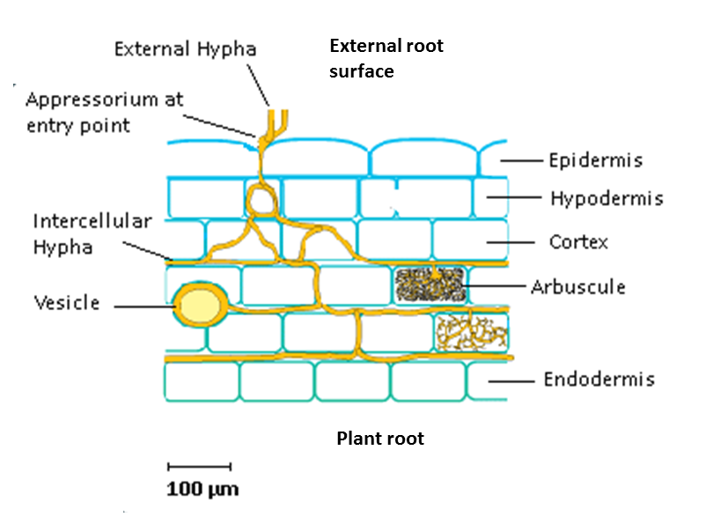
Figure 1.1 Simplified anatomy of arbuscular mycorrhizal fungal structures within a colonised plant root. Adapted from Brundette, 2008).

Nitrogen
Like plants, AMF are able to access nitrate (NO₃⁻) and ammonium (NH₄⁺) however AMF are also able to access N from organic sources (Hodge & Fitter, 2010) . Both ammonium and nitrogen are relatively mobile within the soil solution preventing the formation of N depletion zones to the same extent of those for phosphorus however although abundance and mobility of soil N is higher than that of P, plants have a great N requirement therefore host plant access to N via AMF is nutritionally important.

Micronutrients
Arbuscular mycorrhizal fungi may also improve host plant nutrition of essential micronutrients including Cu, Zn, Fe and K. Beneficial effects of AM upon Zn and Cu uptake have been most studied of all micronutrients. Like P, plant Zn uptake in soils is usually limited by the low rate of Zn diffusion within soils and notable improvement in Zn nutrition of AM plants have been explained by the beneficial effect of AM on soil nutrient exploitation by hyphae. Zn uptake by AM is slower than that of P however Zn requirements are also much lower. Studies show that AM association may help alleviate Zn deficiencies (Cavagnaro, 2008) and the positive relationship between hyphal length and Zn and P uptake has demonstrated the importance of AM in uptake of these nutrients (Jansa, Mozafar and Frossard 2003a). However effects upon micronutrients are not always positive and in several studies Mn nutrition of AM plants has been found to be reduced in comparison to non AM plants (Zuccarini & Okurowska, 2008).

Nutrition and growth responses with AM
Although beneficial effect of AM for plant nutrition and growth are widely reported, it is important to note that mycorrhizal association does not always result in a positive growth response by plants. On the contrary, plant growth responses to AM may range from highly positive to negative and are taxa specific (Klironomos 2003). Furthermore the interactions between plant and fungi are sensitive to environmental conditions such as nutrient availability which may adjust the balance between mutualism and parasitism. For example beneficial effects of AMF are known to decrease with improved nutrient availability (Collins & Foster, 2009) and in fertile soils AMF may even have a negative effect due to net carbon drain (Smith et al., 2009). However, even in cases where neither a positive effect upon growth or nutrient content is observed, it cannot be assumed that the fungi is not of benefit as a large proportion of the plants nutrient uptake - which may up to as much a 100% of P, may be obtained through the AM fungal pathway (Smith & Smith, 2012). This may be the case even in situations where neutral or negative growth responses are observed due to down regulation of direct P uptake by colonised plant roots (Smith et al., 2004).

Disease resistance
Colonisation by AMF is known to improve health and growth both protecting against pathogen infection and reducing incidence of disease (AzconAguilar & Barea, 1996; Jung et al., 2012). There are now a large number of studies documenting improved below ground protection by AMF plants to a wide range of pathogens including from pathogenic fungi (Krishna et al., 2010), nematodes and root feeding invertebrates (Hao et al., 2012). Additionally AMF may improve above ground protection against stem and leaf pathogens (Krishna et al., 2010; Campos-Soriano et al., 2012).
There are a number of mechanisms by which AMF provide protection to plants against pathogens (Figure 1.2). Improved disease resistance of AMF plants has often been explained by increased plant health due to improved nutrition (Harrier & Watson, 2004) however this cannot explain improved disease resistance entirely as studies show that enhanced nutrition of mycorrhizal plants does not always relate to improved protection to plants (Gange & West, 1994). Recently AMF have been recognised to play a major role in plant protection by inducing an elevated state of plant defence response known as ‘priming’ (Jung et al., 2012). In the primed state, plants are able to respond more quickly and/or strongly to attack therefore defence mechanisms are more effective (Jung et al., 2012). This effect is attributed to root colonisation by AMF inducing a host specific response which alters the temporal and spatial expression of a number of genes involved in plant defence and consequently synthesis of proteins, secondary compounds and metabolites which function in plant protection (Moraes et al., 2004; Harrier & Watson, 2004). AMF colonisation may induce only a small modulation of the plant defence system, however this is sufficient to prime the plant immune system both locally and systemically (Fritz et al., 2006; Liu et al., 2007). For example, in response to AM colonisation of tomato, a study by (Pozo et al., 2002) found both localised and systemic protection was provided against Phytophora parasitica, thereby significantly reducing the infection of AM tomato plants.
The modification of root exudates by AMF roots may also function in below ground protection. Vos et al, (2012) found that exudates from mycorrhiza colonised tomato roots significantly reduced root penetration by nematodes and limited nematode movement by temporarily inducing paralysis. Similarly AMF root exudates have also been found to be effective in reducing spore production by the oomycete Phytophora fragrariae (Norman & Hooker, 2000) and to reduce infection by parasitic plants (Lopez-Raez et al., 2011). The latter has been accounted for by the suppressive effect of AMF upon root strigalactone production and is particularly important as many virulent parasites of agricultural crop plants such as Striga and Orobanche which belong to the Orobanchaceae family, depend upon strigalactones for host plant detection (Lopez-Raez et al., 2011). AMF may also provide below ground protection by competing with pathogenic fungi and nematodes for colonisation sides as both require similar root tissue (Smith, 1988). This competitive effect of AMF and pathogens was found to reduce incidence of Phytophora in roots of both cotton (Davis et al., 1978) and tomato plants (Cordier et al., 1998). The effect of AMF colonisation upon systemic above ground protection has also been shown provide effective protection against shoot and leaf pathogens (Krishna et al., 2010).
Studies examining AMF colonisation upon herbivorous insects are highly variable and in particular environmental conditions and host plant and fungi taxa may determine the nature of this interaction (Pineda et al., 2010; Nishida et al., 2010). There is some evidence of reduced herbivory of AMF colonised plants by generalist insect feeders (Fontana et al., 2009). In contrast, specialist species which are highly adapted to feeding on a limited number of plant species, have been found to be more capable of responding to and overcome the defences of the host plant and may even perform better due to improved nutrition and biomass of their host. However negative effects of herbivory on plant biomass may be compensated for in AMF plants by improved recovery (Hoffmann et al., 2009). Similarly, improved nutrition of AMF plants may indirectly reduce herbivory as healthy plants are able to increase volatile production when under attack by herbivores and therefore are more effective in attracting parasitoids and predators to control the attacking species (Schausberger et al., 2012). Protection against herbivory by AMF colonised plants may also depend upon insect feeding strategy as plant defences are better able to detect and target herbivores such as leaf miners which induce large scale tissue damage (Walling, 2008). In comparison insects which induce low level localised tissue damage such as phloem sucking insects may be able to evade detection by the plant immune system (Walling, 2008) therefore incidence of herbivory by these insects may even be elevated in mycorrhizal plants due to the improved nutritional quality (Goverde et al., 2000).

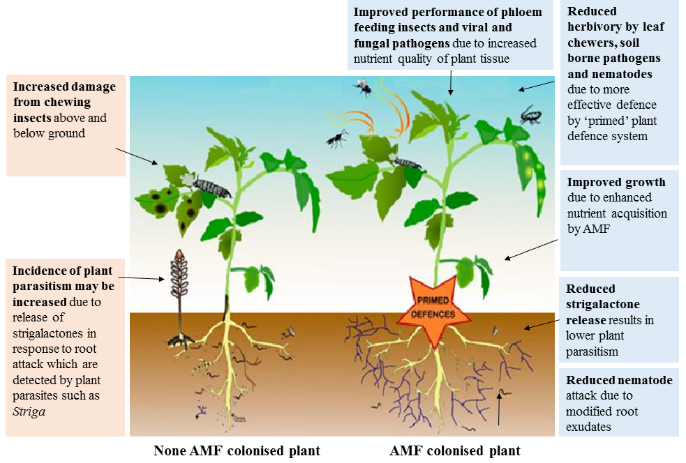
Figure 1.2 Summary of role of AM in plant defence highlighting that although the overall effect of AMF upon plant defence is positive it is apparent that AMF association may improve susceptibility to a select number of pathogens (Adapted from Jung et al. 2012)

Drought tolerance
Water deficiency may be a major limitation of plant productivity and there is evidence that AMF colonisation may allow plants to grow better under conditions of water stress (Augé, 2004) with experimental studies reporting improved growth of mycorrhizal plants under drought conditions for a number of crops (Porcel & Ruiz-Lozano, 2004). The role of improved drought resistance of crops colonised by AMF is particularly significant considering the increased frequency of drought events predicted with climate change (IPCC, 2014). AMF may help alleviate negative growth impacts from drought by a number of mechanisms. Firstly, severity of water limitation may be reduced by increased soil exploration and water uptake by extensive fungal hyphae (Augé et al., 1994). Secondly, AMF may positively influence plant hydration during drought by beneficially affecting plant physiology for example by increased root hydraulic conductance (Aroca et al., 2007) and reduced transpiration rates (Aroca et al., 2008b). It has been recently suggested that improved regulation of the hormone ABA may play an important role in superior water regulation of plants colonised by AMF (Aroca et al., 2008a).
In dry soil, water potential is reduced therefore plants must respond by modifying their internal water potential to maintain movement of water into the roots by increasing their internal concentration of osmolytes (Miransari, 2010). AMF have been found to have a beneficial effect upon the concentration of osmolyte concentrations organic solutes such as proline, betaine and sucrose and ions such as K⁺ and Cl⁻ when under drought conditions (Ruiz-Lozano et al., 2006). The ability of AM plants to access sources of N unavailable to non-colonised plants has also been found to account for improved growth under water stressed conditions (Subramanian et al., 2006). Furthermore studies show AMF colonised are better able to recover upon rehydration following drought (Miransari, 2010). However effects of AMF under drought conditions are not always positive for the host plant as conditions of severe stress may in some cases lead to reduction in arbuscular mycorrhizal performance to the extent that the fungi becomes parasitic upon the host plant (Miransari, 2010).

Salinity tolerance
Salinity is currently estimated to effect over 5% of agricultural land globally (Sheng et al., 2008) however this area has been predicted to increase to as much 50% of agricultural land by 2050 (Wang et al., 2002) with an average of 1.5 million hectares of arable land degraded by salinity each year (Foley et al., 2005). This increase in salinity arises from accumulation of soluble salts in agricultural soils due to high application of chemical fertilisers and irrigation water (Giri et al., 2003). Soil salinity may substantially reduce plant growth and productivity due to the toxic effects of excess Na⁺ and Cl⁻ within plants, reduction in plant water potential of salt stressed plants and nutritional deficiencies through induced nutrient imbalances (Evelin et al., 2009). There is some evidence that AMF colonisation may improve crop productivity within saline soils (Evelin et al., 2009; Daei et al., 2009) however this is likely to vary with AMF taxa colonising crops due species specific difference in salinity tolerance between AMF taxa (Tian et al., 2004). A number of studies have reported the negative effects of salinity upon non-tolerant AMF taxa including reductions in root colonisation, arbuscule production, hyphal growth and delayed sporulation (Juniper & Abbott, 2006; Sheng et al., 2008).

Toxicity tolerance
Heavy metals contamination of soils may adversely affect plant growth yet studies show that AMF may improve plant tolerance to soils containing heavy metals such as Pb, Zn and Cd (Vogel-Mikus et al., 2006; de Souza et al., 2012), along with toxic compounds such as arsenic (Smith et al., 2010). A number of studies report improved plant biomass and nutrient uptake of AM colonised plants growing within contaminated soils (Vogel-Mikus et al., 2006; de Souza et al., 2012). This has been attributed to the ability of AMF to protect host plants and reduce concentrations of toxic metals in plant tissue through accumulation of metals within hyphae. Hyphae are able to accumulate metals at higher concentrations than roots for example a study by Janouskova, Pavlikova and Vosatka (2006) found that AMF colonised plants growing in Cd contaminated soil were able to contain over 10 to 20 times higher levels of Cd in their hyphae than in roots and that this effectively reduced the accumulation of Cd in plant tissue. However, AMF species differ in their ability to alleviate toxicity stress (Miransari, 2011).

Improved soil structure and properties
Arbuscular mycorrhizal fungi influence soil properties through a number of mechanisms. Firstly AMF improve soil structure (the arrangement and size of soil particles and the pore size between them) by aiding the formation of soil aggregates, in particularly macro-aggregates with a diameter of 20-200µm (Hallett et al., 2009). The naturally high density and fine structure of AMF hyphae within unmanaged soils in addition to relatively long persistence of hyphae allows them to sustain an influence on soil structure and make them particularly effective at binding soil particles into aggregates (Augé, 2004). AMF are associated with the glycoprotein glomalin which is thought to contribute to soil aggregate formation (Wright & Anderson, 2000). A strong positive relationship has been found between the abundance of fungal hyphae and the number of soil aggregates (Wilson et al., 2009) which are a fundamental component of soil structure as they determine vital properties such as soil porosity, aeration, water storage capacity, nutrient retention, carbon storage and resilience to erosion (Oades, 1984). AMF may also modify soil hydrological processes as glomalin which is associated with AMF hyphae improves moisture retention and is known to improve soil stability in water (Rillig, 2004). This is particularly important for preventing loss of soils and the leaching of nutrients from fields during heavy rainfall (van der Heijden, 2010). Additionally AM play a fundamental role in storage of soil organic carbon as unlike other soil microbes fungal hyphae are able to directly access C from host plants and therefore enhance rather than deplete soil C pools (Leake et al., 2004).

Impact of intensive agricultural upon arbuscular mycorrhizal fungi
As a result of management practices, the ecology of agricultural systems contrasts with that of natural ecosystem thus affecting AMF communities (Table 1.2).

Table 1.2 Comparison between the properties of natural ecosystems and intensive agricultural systems. Adapted from Pretty (2008)
Property | Natural Ecosystem | Intensive Agro-ecosystem
Productivity | Medium | High
Biodiversity | High | Low
Dependence upon external inputs (e.g. fertilisers, pesticides) | Low | High
Nutrient recycling | Closed | Open
Soil disturbance | Low | High
Biomass accumulation | High | Low
Natural population regulation | High | Low
Resilience | High | Low
Trophic relationships | Complex | Simple
Human displacement of ecological processes | Low | High
Sustainability | High | Low

Chemical application

Fertilisers
Soil fertility is known to influence plant -AMF symbiosis due to the role of AMF in plant nutrient provision. AMF associations require a carbon cost from the host plant therefore in fertile soils in which plants are able to access adequate nutrition by their own roots, the benefit of AMF symbiosis is reduced (Smith et al., 2009) and plants may limit C allocation to AMF (Kiers et al., 2011; Johnson et al., 2013).
Studies comparing root colonisation by AMF between intensively managed agricultural land receiving high inorganic fertiliser inputs in contrast to less intensively managed land have demonstrated that intensive management results in reduced root colonisation. For example (Mader et al., 2002) found that colonisation of roots by AMF were reduced by as much as 60% in conventionally farmed soils in comparison to ones which had received lower application of inorganic fertilisers and attributed this effect to the comparatively lower levels of labile P. Similarly, (Ryan & Ash, 1999) found AM colonisation substantially reduced in intensively farmed pasture in comparison to pasture receiving lower inputs of inorganic N and P fertiliser. Application of inorganic fertilisers has also been found to result in decreased spore production (Wang et al., 2009), hyphal biomass (Bruce et al., 1994) and mycorrhizal infectivity (Kahiluoto et al., 2001).
However it is important to recognize that as plant nutrient status determines carbon allocation to AMF, addition of fertiliser application to nutrient limited soils may in some cases exert a positive effect upon AMF communities. Observations of AM community response to application of inorganic fertiliser in a low nutrient grassland showed that addition of nitrogenous fertiliser to low P soils resulted in increased allocation of resources to AMF whilst the opposite response was found when both inorganic N and P were applied (Johnson et al., 2003). Similarly (Johnson et al., 2005) report a positive effect of nitrogen fertiliser application upon AM root colonisation of the grass Agrostis capillaris in low phosphorus upland grassland plots.
A growing number of studies have documented effects of land use intensity upon AMF communities (Verbruggen et al., 2010; Fester & Sawers, 2011). Recent studies provide evidence that intensive management practices not only reduce diversity but alter structure of fungal communities by applying a strong selective pressure for fungi with functional traits which are tolerant to stress from chemical application and hyphal disruption (Oehl et al., 2004; Gosling et al., 2006). The effect of such alterations to fungal community structure upon agro-ecosystem functioning remains to be elucidated however it has been suggested that generalist species may be less beneficial to agro-ecosystems due to traits such as increased investment of energy expenditure into spore production in comparison to nutrient foraging (Verbruggen & Kiers, 2010).

Fungicides, pesticides and herbicides
Agro-chemical application for crop protection may affect many non-target organisms in soils including AMF. Despite being amongst the most widely applied fertilisers, effects of glyphosate upon AMF are still not fully understood with studies reporting mixed effects upon AMF (Ronco et al., 2008; Druille et al., 2013). Fungicide application for the control of pathogenic fungi is known reduce hyphal abundance within soils (Wilson et al., 2009). Herbicides may also alter AMF communities due to both direct effects upon fungi and indirectly by reducing host plant diversity. Hamel et al. (1994) examined the effect of three herbicides commonly used in apple orchards and found that although root colonisation was not affected by herbicide application, in vitro tests showed that application of as little as 1 µg g⁻¹ of the herbicides Paraquat and Dichlobenil was sufficient to significantly reduce hyphal extension of the fungi Rhizophagus irregularis which was isolated from orchard soils.

Tillage
Tillage physically disrupts AMF hyphal networks in the soil and is reported to reduce fungal biomass (Frey, Elliott and Paustian 1999), AMF root colonisation (McGonigle et al., 1999) and spore production (Roldan et al., 2007) and taxa richness (Helgason et al., 1998). Impact of tillage upon AMF communities have now been reported in across a range of soil types in in temperate (Jansa et al., 2002, 2003) sub-tropical (Alguacil et al., 2008) and tropical (Boddington & Dodd, 2000) regions. Tillage modifies the structure of AMF communities by favouring species which are able to tolerate disturbance (Douds et al., 1995). This was demonstrated in a recent study by (Jansa et al., 2003) which used molecular methods to compare AMF diversity between maize fields managed under different intensities of tillage and found a severe reduction in AM diversity with the most intensive tillage practices. Regular soil disturbance was found to result in increased abundance of Glomus sp whilst in non-tilled soils communities were more diverse and in particular contained a higher abundance of Scutellospora sp. Differences in AM soil communities were attributed to the effect of tillage upon hyphal disturbance, nutrient content, weed populations and microbial activity (Jansa et al., 2003). Similarly (Helgason et al., 1998) compared fungal diversity between ploughed arable land and woodland using molecular methods and found that arable field showed a large reduction in fungal diversity with communities dominated by the species Rhizophagus irregularis. It was suggested that the ability of this species to both produce large numbers of spores and to colonise rapidly from spores accounted for its success in arable soils.

Crop regimes and crop selection
Crop management strategies are an important component of intensive agriculture for maintaining soil nutrients and protecting against build-up of pests, however these strategies may impact soil AMF communities (Fester & Sawers, 2011). Rotation of crops with non-mycorrhizal crops may reduce AM populations due to lack of suitable hosts and as a result reduce the quantity of inoculum within soils (Arihara & Karasawa, 2000). Reduced mycorrhizal colonisation of subsequently planted mycorrhizal crops has been reported (Douds et al., 1997) and in some cases this has been found to correspond with reduced yield (Koide & Peoples, 2012). Similarly use of non-mycorrhizal cover crops and fallowing are known to negatively affect AM by reducing soil inoculum due to the lack of host plants available for colonisation (Jansa et al., 2003; Castillo et al., 2008). Plant diversity of intensive agro-ecosystems is typically low due the common practice of mono-cropping arable fields coupled with the enforcement of stringent weed control regimes. The reductions in biodiversity of host plants has been suggested as one reason explaining reduced AMF diversity within agricultural environments (Fester & Sawers, 2011).

Overview of cider apples, the UK cider industry and orchards sustainability

The domestic apple Malus pumila
The domestic apple Malus pumila belongs to the Rosaceae family (Juniper, 2007) along with at least 36 other species of apple (Phipps et al., 1990). Malus pumila is believed to have originated at least 5,000 years ago from Malus sieversii a wild apple species indigenous to the Tien Shan mountains of central Asia which was then transported westwards by humans into Europe and more recently to other parts of the world (Juniper, 2007). Analysis of both chloroplast and nDNA sequences provide evidence of the close relationship between M. pumila and M. sieversii (Forte et al., 2002) and has led to rejection of the previously favoured theory that M. pumila originated from the European crab apple Malus sylvestris (Dunemann et al., 1994).
Malus pumila is currently the fourth globally most widely cultivated fruit plant with 69 million tonnes of apples grown commercially in 2010 requiring approximately 4,700,000 hectares of land across 93 countries (FAO, 2014). At present the largest producer of apples globally is China which occupies 50% of the global market followed by the USA and Turkey (FAO, 2014). There are over 7,500 known cultivars of M. pumila and the characteristics of the fruits of these different varieties make them suitable for specific purposes. Broadly the fruits of M. pumila can be classed into three main categories; dessert varieties which are mainly eaten as raw fruit, culinary varieties and cider varieties used for production of cider and other alcoholic beverages. Although cider may be produced from all apple varieties, cider apple varieties are selected based upon a number of characteristics including tannin content and acidity (Williams, 1996).

The UK cider industry
The UK is the largest cider market both globally and across Europe (NACM, 2016). In the UK apples are grown upon 13,594 hectares of land with apple orchards accounting for 81% of the total area of land (16,788 hectares) used for growing orchard fruits (DEFRA, 2010a). Within the UK 78% of fruit orchards are located in the southern counties of Somerset, Kent and Cambridgeshire, Herefordshire, Gloucestershire and Worcestershire (Williams, 1996) mainly due to the climatic suitability of these areas for apple growing ().
Figure 1.3 Map of the distribution of traditional orchards in the UK showing regions with climatic suitability for apple growing (Source (DEFRA, 2008)

During the late 20th Century, apple production within the UK experienced substantial changes to both the choice of apple varieties grown and orchard management. Since the 1980’s reduction in the quantities of both dessert and culinary apples grown has mainly been attributed to increased importation of apples from abroad with imported apples now accounting for 66% of the apples consumed in the UK (DEFRA, 2014) . In contrast cider apple production has substantially increased with the cultivated area of cider apples almost doubling since 1985 (Figure 1.4). Cider apples now account for approximately 38% of UK grown apples, a large proportion in comparison to dessert apples (36%) and culinary apples (26%) (DEFRA, 2014).
Similarly, the management of orchards has undergone large scale changes over time. Although the domestic apple is thought to have been introduced to the UK by the Romans in around 43 AD it was the early 1600’s when planting of apple orchards first began to occur and by the late 17th Century orchards were a distinct part of the UK landscape particularly in the southern counties. The popularity and extent of orchards fluctuated during the 18th and 19th Century yet orchard planting was on the increase by the end of the 19thC and by the early 1900’s traditional orchards were a common feature of small mixed farms. In the aftermath of World War 2, changes in favour of agricultural intensification began to occur and the development of modern apple rootstocks such as M25 and M9 around the 1950’s by horticultural research stations such as Long Ashton, East Malling and Merton was particularly significant in this.

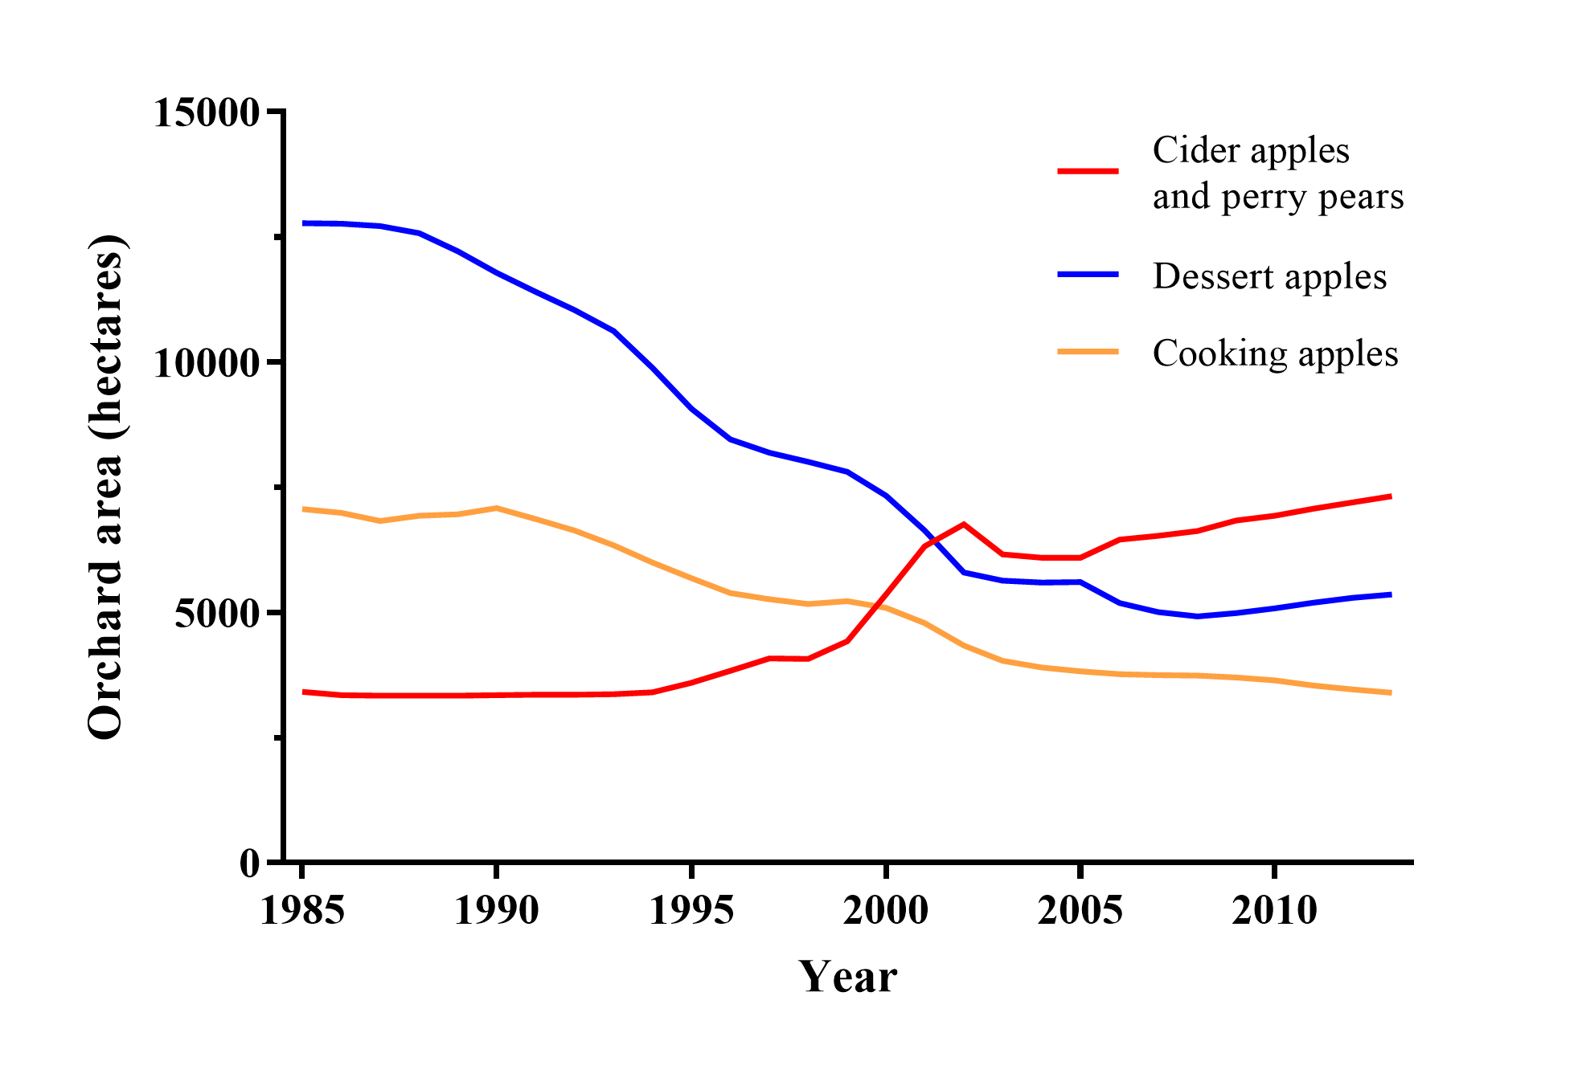
Figure 1.4 Total UK area occupied by orchards for three apple types showing the increase in cider apple orchards since 1985. Three year running means from 1985 to 2013 are presented. Data from DEFRA, 2014
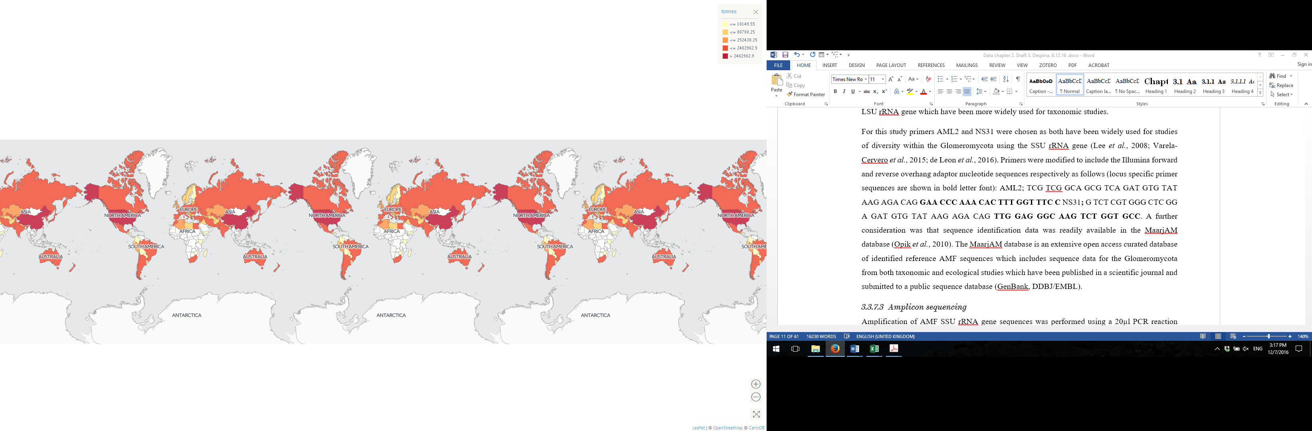
Thousand tonnes
< 10
< 80
< 252
< 2,462
> 2,462
Figure 1.5 Average annual apple production per country from 1994 to 2014. Adapted from (FAO, 2014).
Grafting of selected apple varieties onto these rootstocks allowed growers to increase orchard productivity due to both the greater uniformity of tree growth and shape and improved cropping of trees (Umpelby and Copas 2002). Grafting is an ancient and established horticultural practice, and up until the early 20th C the majority of orchard apple trees within orchards were either grown from seed or used seed grown varieties grafted onto vigorous rootstocks. Following the 1950’s many growers switched from planting traditional orchards to planting bush orchards in which apple varieties are grown on semi-dwarfing or dwarfing rootstocks in high density rows and managed intensively resulting in substantially increased yield. The smaller stature of trees on dwarfing or semi-dwarfing rootstocks helps management practiced such as the applications of chemical sprays, pruning and thinning of growth, and fruit harvesting (Webster, 2004) (Figure 1.6). The majority (75%) of UK apples are now grown in bush orchards (DEFRA 2010) and in 2007 bush orchards accounted for 73% of the 6,271 hectares of land used for cider apples in comparison to 27% of total land remaining as traditional standard orchards (DEFRA, 2008).
It is estimated that only 10% of traditional orchards that existed in the 1950’s now remain with 30% undergoing conversion to commercial bush orchards and 60% lost to other land use conversion (Natural England, 2011). Traditional orchards have a high biodiversity value which is attributed to the diversity of habitats within an orchard which include the fruit trees themselves, orchard floor habitat usually of grass sward and fallen dead wood. A survey of six traditional apple orchards in 2004 found a total of 533 invertebrate species, 131 epiphytic lichens, 50 epiphytic bryophytes and 175 fungal species a significant number of which could be classified as nationally rare or scarce (Lush et al., 2006). The biodiversity value of traditional orchards is now officially recognised with maintenance of traditional orchard habitats supported by Countryside Stewardship grants.

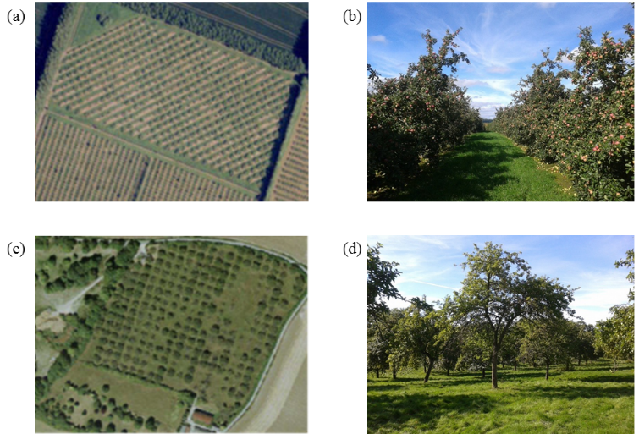
Figure 1.6 Conventional bush orchard: (a) aerial view, (b) orchard floor view, Standard orchard (c) aerial view, (d) orchard floor view.

Arbuscular mycorrhizal symbiosis and the domestic apple

Nutrition
Since Mosse, (1957) published the pioneer study reporting beneficial effect of AMF for plant nutrient acquisition using apple seedlings, several studies have examined nutritional benefits of AMF to apple. More recently, research has focused upon non-nutritional benefits of AMF to apple, in particular pathogen resistance (Table 1.4). Collectively, results from studies of AMF and apple show that particularly in low fertility soils, AMF may improve seedling height (Miller et al., 1985a) , biomass (Forge et al., 2001) and fruit production (Copas 2002). Growth benefits have mainly been attributed to improved acquisition of P (Matsubara et al., 1996) however improvements in micronutrients have also been reported (Mosse, 1957; An et al., 1993; Pinochet et al., 1993; Forge et al., 2001).
Interestingly, these early studies of AMF inoculation of apple seedlings show distinct differences between AMF taxa with growth effects ranging from null or negative, to positive (Table 1.3) and there is some evidence of differences in response to AMF between rootstocks and varieties (Matsubara et al., 1996). Distinct differences between the colonisation of apple roots between AMF species have been also shown, for example Miller et al. (1985a) found root colonisation of apple seedlings by five different taxa within the genera Glomus and Gigaspora ranged from between 26% to 100%. Similarly Covey et al., (1981) found Funneliformis mosseae successfully colonised M. pumila seedlings and increased dry biomass to over 9 times that of non-mycorrhizal seedling however seedlings inoculated with Glomus microcarpus showed very low levels of root colonisation and no growth improvements.
The majority of experiments on M. pumila and AM have involved controlled infection of apple with mycorrhiza and short to medium term growth observations of apple usually in greenhouse conditions (Table 1.3) yet longer term field studies are lacking. Furthermore with the exception of Copas 2002, no studies have examined AM and cider apple varieties and as differences have been observed between the benefits dessert apple varieties receive from association with the same species of AMF it would therefore be informative to quantify the growth effect of association between AMF and modern cider apple varieties.

Disease resistance
A growing number of recent studies now report the beneficial effect of colonisation of apple by AM on resistance to pathogens and parasites (Table 1.4). In accord with the results of nutritional studies of AM and apple, disease resistance studies also report variation in the level of benefit gained from mycorrhizal association with some species providing a greater benefit to apple than others. For example Krishna et al. (2010) studied the individual effect of seven AM species on performance of apple trees infected with Botryosphaeria canker and found that although all AMF treatments significantly improved tree survival in comparison to survival of control trees (25%), there was considerable difference in mean survival of trees colonised by the least beneficial fungi (Glomus lepotichum) (40%) in comparison to the most effective fungi Sclerocytis dussi (91%). In particular the ability of AMF to provide protection against specific apple replant disease (SARD) a common condition which can substantially reduce the establishment of newly planted trees, and to provide protection against the parasitic root nematode (Pratylenchus sp) which is a virulent pathogen of fruit trees of temperate regions, have been the focus of several studies. Although to our knowledge no studies have examined AMF colonisation and disease resistance in cider apple varieties, the rootstocks MM111, M106 and M26 are all widely used in modern cider orchards and show positive response to AMF (Table 1.4).
Many studies of apple attribute benefits of AM on tree performance in the presence of pathogens and pests to improved tree health due to improved nutrition thereby increasing the ability of the plant to defend against attack from pathogens as it is well established that trees which are weakened or stressed are more susceptible to disease (Williams, 2000). For example, incidence of Botryosphaeria stem brown canker, a fungal pathogen which may considerably reduce tree growth and fruit production is known to be increased in trees which are suffering from nutrient deficiency (Borovinova et al., 2012). However apple trees inoculated with AMF showed improved health and vigour, lower incidence of Botryosphaeria infection and improved survival following infection (Krishna et al., 2010). Direct negative effect of AM associated with apple upon soil pathogen populations have also been reported for example Forge et al, (2001) found a significant reduction in density of the nematode Praylenchus penetrans in the rhizosphere of apple trees (Forge et al., 2001).

Arbuscular mycorrhizal fungi within UK apple orchards
The ability of the domestic apple M. pumila to form association with AMF is well established however less is known about AMF communities which naturally occur within apple orchard soils. To assess whether mycorrhizae may be utilised within sustainable apple orchard systems it is therefore essential to first establish the abundance and richness of AMF found within apple orchards and identify factors which affect orchard AMF communities.
Research into the use of mycorrhizal inoculum both for nutritional and non-nutritional benefits to trees has led to the recent appearance of commercial mycorrhizal inoculum on the market such as VAMINOCTM , a commercial mycorrhizal inoculum in which trees are root dipped prior to planting. However application of mycorrhiza during planting is not routinely practiced and no measures are currently undertaken to promote AMF in cider orchards (Umpelby & Copas, 2002).
Table 1.3 Summary of studies upon arbuscular mycorrhizal association with domestic apple and effects upon growth
Overall effect of AM | M. pumila variety | AM species | Response parameter | Soil P | Greenhouse/field trial | Duration (weeks) | Reference
Positive | Unspecified | Endogone sp. | Total dry biomass | unspecified | Greenhouse | 14 | (Mosse, 1957)
Positive | Unspecified | Funneliformis mosseae | Dry shoot biomass | 8.7 mg kg⁻¹  108.7 mg kg⁻¹  208.7 mg kg⁻¹  408.7 mg kg⁻¹ | Greenhouse | 20 | (Covey et al., 1981)
Positive | Golden delicious | Glomus bitunicatum  Glomus maculosum  Glomus manihotis  Funneliformis mosseae  Glomus occulutum¹ | Tree height | 30 mg kg⁻¹ | Greenhouse | 11 | (Miller et al., 1985a)
Positive | Golden delicious | Glomus manihotis  Funneliformis mosseae  Glomus occulutum ¹ | Total dry biomass | 30 mg kg⁻¹ | Greenhouse | 11 | (Miller et al., 1985a)
Positive | Golden delicious | Glomus manihotis  Funneliformis mosseae  Glomus occulutum ¹ | Stem diameter | 30 mg kg⁻¹ | Greenhouse | 11 | (Miller et al., 1985a)
Positive | Golden delicious | Glomus maculosum | Total dry biomass | 180 mg kg⁻¹ | Greenhouse | 11 | (Miller et al., 1985a)
Positive | Golden delicious | Gigaspora calospora,  Glomus maculosum | Stem diameter | 180 mg kg⁻¹ | Greenhouse | 11 | (Miller et al., 1985a)
Positive | Unspecified | Glomus epigaeum  Glomus macrocarpum | Tree height | 25.2 mg kg⁻¹ | Greenhouse | 14 | (An et al., 1993)
Positive | McIntosh | Glomus etunicatum  Gigaspora margarita | Total dry weight | unspecified | Greenhouse | 8 | (Matsubara et al., 1996)
Positive | American Summer Permain | Glomus etunicatum  Gigaspora margarita | Total dry weight | unspecified | Greenhouse | 8 | (Matsubara et al., 1996)
Positive | Jonathathan | Glomus etunicatum  Gigaspora margarita | Total dry weight | unspecified | Greenhouse | 8 | (Matsubara et al., 1996)
Positive | Golden Delicious | Glomus etunicatum | Total dry weight | unspecified | Greenhouse | 8 | (Matsubara et al., 1996)
Positive | Starking Delicious | Glomus etunicatum  Gigaspora margarita | Total dry weight | unspecified | Greenhouse | 8 | (Matsubara et al., 1996)
Positive | Fuji | Glomus etunicatum  Gigaspora margarita | Total dry weight | unspecified | Greenhouse | 8 | (Matsubara et al., 1996)
Positive | Mutsu | Glomus etunicatum  Gigaspora margarita | Total dry weight | unspecified | Greenhouse | 8 | (Matsubara et al., 1996)
Positive | Red Gold | Glomus etunicatum  Gigaspora margarita | Total dry weight | unspecified | Greenhouse | 8 | (Matsubara et al., 1996)
Positive | Unspecified | Glomus epigaeum  Glomus macrocarpum | Total dry biomass | 25.2 mg kg⁻¹ | Greenhouse | 14 | (An et al., 1993)
No effect | Unspecified | Glomus microcarpus | Dry shoot biomass | 8.7 mg kg⁻¹  108.7 mg kg⁻¹  208.7 mg kg⁻¹  408.7 mg kg⁻¹ | Greenhouse | 20 | (Covey et al., 1981)
No effect | Golden delicious | Gigaspora calospora  Glomus occulutum ² | Tree height | 30 mg kg⁻¹ | Greenhouse | 11 | (Miller et al., 1985a)
No effect | Golden delicious | Glomus bitunicatum  Gigaspora calospora  Glomus maculatum  Glomus occulutum ² | Total dry biomass | 30 mg kg⁻¹ | Greenhouse | 11 | (Miller et al., 1985a)
No effect | Golden delicious | Glomus bitunicatum  Gigaspora calospora  Glomus maculatum  Glomus occulutum ² | Stem diameter | 30 mg kg⁻¹ | Greenhouse | 11 | (Miller et al., 1985a)
No effect | Golden delicious | Glomus bitunicatum  Gigaspora calospora  Glomus maculatum  Glomus manihotis  Glomus mossea  Glomus occulutum ² | Tree height | 180 mg kg⁻¹ | Greenhouse | 11 | (Miller et al., 1985a)
No effect | Golden delicious | Glomus bitunicatum  Gigaspora calospora  Glomus manihotis  Glomus mossea  Glomus occulutum¹  Glomus occulutum ² | Total dry biomass | 180mg kg⁻¹ | Greenhouse | 11 | (Miller et al., 1985a)
No effect | Golden delicious | Glomus bitunicatum  Glomus mossea  Glomus occulutum ¹  Glomus occulutum ² | Stem diameter | 180 mg kg⁻¹ | Greenhouse | 11 | (Miller et al., 1985a)
Negative | Golden delicious | Glomus manihotis | Stem diameter | 180 mg kg⁻¹ | Greenhouse | 11 | (Miller et al., 1985a)
Negative | Golden delicious | Gigaspora margarita | Total dry biomass | Unspecified | Greenhouse | 8 | (Matsubara et al., 1996)
Table 1.4 Summary of studies upon arbuscular mycorrhizal association with domestic apple and disease resistance
Overall effect of AM | Disease/pathogen | M. pumila variety | AM species | Effect of AM colonised apple in comparison to non AM control |  | Explanation | Tree age* | Type and Duration | Duration  (weeks) | Reference
Positive | Stem brown canker disease - Botryosphaeria ribis | ‘Oregon spur’ and MM106 rootstock | Sclerocystis dussi  Rhizophagus irregularis  Glomus fasciculatum,  Glomus bagyaraji,  Glomus leptotichum,  Glomus monosporum,  Gigaspora margarita  Funneliformis mosseae, Gigaspora gigantean Glomus manihotis | AM trees with had significantly lower incidence of canker disease, improved survival and growth | Improved tree health due to improved nutrition |  | 2 year old trees | Greenhouse | 11 months | (Krishna et al., 2010)
Positive | White root rot - Dematophora necatrix , Rosellinia necatrix | ‘Golden Delicious’ and ‘Starking Delicious’ rootstock | Glomus fesiculatum  Glomus macrocarpum  Funneliformis mosseae  Gigaspora sp | Inoculation with AMF reduced disease incidence | Improved tree health |  | Seedlings | Field | 3 years | (Raj & Sharma, 2009)
Positive | Root rot: Phytophthora cactorum, Pythium ultimum | ‘Gala’ and M9 rootstock | Rhizophagus irregularis | Significantly improved fruit yield in years 3 and 4, improved tree growth, reduced root infection | Improved tree health |  | 2 year old trees | Field | 6 years | (Utkhede & Smith, 2000)
Positive | Specific Apple Replant Disease | M26 rootstock | Scutellospora calospora, | Increased shoot and root dry weight and shoot length. | Beneficial effects on tree growth, development and health |  | Seedlings | Greenhouse | 8 months | (Ridgway et al., 2008)
Positive | Specific Apple Replant Disease | ‘Katy’ and M111 rootstock | Commercial inoculum ‘VaminocTM’ species unspecified | Small improvement in growth and fruit production, improved survival during drought in year 1 | Improved tree health |  | 1 year old trees | Field | 3 years | (Copas, 2002)
Positive | Specific Apple Replant Disease | ‘Kid’s Orange Red’ | Glomus fasciculatum Glomus macrocarpum | Increased plant height, shoot and root fresh mass, root dry matter | Improved plant health, positive interactions between AMF and soil microfauna |  | Seedlings | Greenhouse | 1 year | (Čatská, 1994)
Positive | Specific Apple Replant Disease | ‘McIntosh’ | Funneliformis mosseae | Increased tree height | Improved plant nutrition |  | Seedlings | Greenhouse | 3 months | (Utkhede & Smith, 2000)
Positive | Root lesion nematode Pratylenchus penetrans | Ottawa 3 rootstock McIntosh | Funneliformis mosseae  Rhizophagus irregularis | Increased tree dry weight | Improved tree nutrition |  | Seedlings | Greenhouse | 5 months | (Forge et al., 2001)
Positive | Root lesion nematode Pratylenchus penetrans | Ottawa 3 rootstock | Funneliformis mosseae  Rhizophagus irregularis | Increased tree dry weight,  Significantly reduced nematode numbers with G.mosseae | Improved tree nutrition, reduced nematode reproduction and invasion |  | Seedlings | Field | 2 years | (Forge et al., 2001)
Positive | Root lesion nematode Pratylenchus penetrans | EMLA – 26 rootstock | Funneliformis mosseae | Increased fresh shoot and root weight and shoot length, significantly reduced nematode numbers | Improved tree health, suggested negative effect of AMF on nematode development |  | Seedlings | Field | 6 months | (Pinochet et al., 1993)
No effect | Specific Apple Replant Disease | M26 rootstock | Funneliformis mosseae, Acaulospora laevis | No beneficial effect on growth or disease resistance in comparison to control | AMF colonisation reduced in SARD soil |  | Seedlings | Greenhouse | 8 months | (Ridgway et al., 2008)

*tree age at the beginning of the study duration

Aims of thesis and structure
The overarching aim of this thesis is to assess the potential of arbuscular mycorrhizal fungi for improving sustainability of apple orchards.
More specifically, this research has addressed the following questions:
- To what extent can symbiosis with AMF improve the health, growth and productivity of cider apple trees?
- What are the AMF communities naturally found within cider apple orchards and how are they impacted by orchard management?
To address these research questions, a combination of landscape scale sampling and controlled growth experiments were used, as detailed for the following chapters:
Chapter 2: In this chapter the effect of AMF symbiosis upon cider apple tree health, growth and productivity was experimentally tested over three years using a semi-controlled growth experiment. Cider apple trees of two widely commercially planted scions (Dabinett and Michelin) and rootstock combinations (MM111 and MM106) were grown with and without mycorrhizal inoculation under two fertiliser application levels.
Chapter 3: Using a landscape sampling approach of cider apple orchards across Herefordshire, UK, this study aimed to characterise the AMF communities within the soils of three cider apple orchard management types which differ in their management intensity. AMF communities of apple orchards where characterised using two molecular fingerprinting methods: TRFLP and Illumina sequencing, and compared with those of nearby arable and woodland reference habitats to examine effects of land management.
Chapter 4: Building on the results of chapter 3 this study using a landscape scale sampling of the apple roots across the types of cider apple orchard with the aim of characterising AMF communities colonising apple trees and understanding how these AMF communities are affected by orchard management. Furthermore this study investigated the relationship between AMF and apple tree yield.
Chapter 5: An overall synthesis of the findings of chapters 2 to 4 to present an overall picture of the symbiosis between AMF and apple, AMF communities of orchards and how they are affected by management. Ideas for further work are also presented.

Quantifying benefits of AMF inoculation for growth, health and productivity of cider apple trees

Summary
- Arbuscular mycorrhizal fungi may provide benefits to arable crop plants most notably improved nutrition and disease resistance, but far less is known about their benefits for woody perennial crops. Arbuscular mycorrhizal fungi can provide nutritional and disease resistance benefits thus helping to improve food security however empirical evidence for this is largely confined to arable systems. Here, we assess mycorrhizal benefits for woody perennial crops, in which reduced tillage provides favourable conditions for mycorrhizal fungi.
- Using a controlled growth experiment we grew apple trees of two widely commercially planted scions (Dabinett and Michelin) and rootstock combinations (MM111 and MM106) both with and without mycorrhizal inoculation under two fertiliser application levels to quantify impacts of mycorrhiza on tree growth and health. We measured parameters of growth, biomass, tissue nutrient concentrations and amount of material infected by apple canker caused by the fungal pathogen Neonectria ditissima, a major production limiting pathogen of apple orchards globally.
- The severity of disease induced by Neonectria ditissima was reduced in trees inoculated with mycorrhizal fungi despite no beneficial effect of mycorrhizal inoculum for tree nutrient status or growth. Our results also show that tree scion type can influence mycorrhizal symbiosis with apple, suggesting that breeding programmes could influence mycorrhizal status. Significant reductions in mycorrhizal colonisation and tree root biomass under high fertiliser application treatments highlight importance of targeted fertiliser application.
- This study is the first to report benefits of arbuscular mycorrhiza fungi for improving resistance of apple to Neonectria ditissima and demonstrates the importance of the role of beneficial soil organisms for developing agricultural sustainability.

Introduction
Increased use of inorganic fertilisers has made a huge contribution to growth in agricultural yields in recent decades and agricultural production needs to continue to expand to meet growing food demands (Pretty et al., 2010; Tilman et al., 2011). One of the biggest challenges to sustainable global food security is the need to find suitable replacements for inorganic fertilisers. This is because inorganic N fertiliser production consumes an increasing proportion of the global energy budget and the supply of key raw materials, primarily phosphorus, is becoming limited (Tilman et al., 2002), causing price increases that reduce the availability of fertilisers for poorer farmers and increase food prices (Cordell et al., 2009). Inorganic fertilisers have already caused extensive environmental damage including pollution of water and atmosphere (Pretty, 2008; Delgado & Scalenghe, 2008; Elser & Bennett, 2011) and reduced terrestrial biodiversity due to habitat degradation and loss (Scherr & McNeely, 2008). To prevent further environmental damage and ensure food security for future generations it is therefore imperative to find strategies to balance productivity with environmental sustainability (Foley et al., 2005; Pretty, 2008).
Arbuscular mycorrhizal fungi (AMF) are able to form symbiosis with the majority of plant species including many important crops (Öpik et al., 2006; Smith & Read, 2008). In exchange for carbon AMF are able to provide plants with essential nutrients most notably phosphorus (P) which they are able to efficiently forage from the soil via extensive hyphal networks, thus potentially reducing the need for inorganic fertiliser in agricultural systems which promote mycorrhizal symbiosis with crops (Fester & Sawers, 2011). In addition to nutrient provision, AMF may also directly benefit crop species through increased resistance to disease (Jung et al., 2012) tolerance to drought and adverse soil conditions (Augé, 2004; Daei et al., 2009) improved competitive ability over non mycorrhizal plants (Cameron, 2010; Veiga et al., 2011) and indirectly through improved soil structure (Rillig & Mummey, 2006) and increased soil nutrient retention (Bender et al., 2015; Cavagnaro et al., 2015; Köhl & van der Heijden, 2016).
Despite potential benefits, there are number of factors limiting the use of mycorrhiza in modern agricultural systems which include negative effects of physical disturbance of hyphal networks through tillage (Helgason et al., 1998; Frey et al., 1999), negative effect of high application of inorganic fertilisers and fungicides (Mader et al., 2002; Wilson et al., 2009) and evidence that selective breeding of modern crop varieties may have inadvertently reduced capacity to benefit from AMF symbiosis (Hetrick et al., 1993; Zhu et al., 2001).
Research on crop-mycorrhiza interactions has focused on arable crops, yet woody perennial crops such as some soft fruits (e.g. raspberries, currants), and a wide range of fruit and nut bearing trees are able to form symbiosis with AMF. Moreover, woody perennial crops are essential for providing nutritional food security and make an important contribution to global agricultural production, for example the domestic apple (Malus pumila) is the fourth most widely cultivated fruit crop worldwide with over 80 million tonnes grown annually occupying over 4.7 million hectares globally and of considerable economic importance (FAO, 2014).
Disease is a major threat to establishment and persistence of apple orchards (DEFRA, 2010b) Apple canker caused by the fungal pathogen Neonectria ditissima is the second most important pathogen in economic terms, after apple scab (Venturia inaequalis), and causes up to 30% loss of yield (Weber, 2014). It is particularly problematic in warm and wet regions of Europe and climate change may thus increase prevalence (Beresford & Kim, 2010). Current control methods rely on regular fungicide application and frequent pruning to remove infected material imposing economic costs and are problematic in organic systems (Cooke, 1999; DEFRA, 2010b). These control methods needs to be applied frequently as re-infections commonly occur as common tree genera, such as Crataegus, Quercus, Betula and Fagus, act as reservoirs for Neonectria ditissima (Weber, 2014).
Initial work suggests that AMF can deliver some resistance to fungal pathogens in apple, but it is not known if such benefits include resistance to Neonectria ditissima (Raj & Sharma, 2009; Krishna et al., 2010). There is also some evidence that AMF can improve apple seedling growth rates and nutritional status (Miller et al., 1985a; An et al., 1993; Matsubara et al., 1996; Forge et al., 2001) These studies are valuable scientifically, although they are not informative regarding AMF influences on key traits relating to flower production or yield. Moreover, their applied relevance is particularly limited because commercial apple trees are never grown from seedlings, but propagated clonally as rootstocks and scions which are grafted together. Both rootstock and scion are selected based upon major agriculturally important traits such as growth form, disease resistance and fruit quality although little is known about the mechanisms behind the interaction between rootstock and scion upon phenotype (Albacete et al., 2015). A key unknown is whether there are differences in any benefit of AMF association to apple between rootstock and scion types.
Here we use a unique three-year fully factorial experiment to assess how mycorrhiza influence the performance of two of the most widely planted apple rootstocks (MM106 and MM111) and the two commonest cider apple scion varieties (Dabinett and Michelin). Our treatments establish mycorrhizal apple trees and non-mycorrhizal controls, grown with industrial standard inorganic fertiliser applications recommended for commercial growers (‘high nutrient’) and reduced fertiliser conditions (‘low’ nutrient). Specifically we test the influence of mycorrhiza on i) tree nutrient status (leaf tissue nitrogen, phosphorus and carbon concentrations and chlorophyll content), ii) tree growth (height, trunk diameter, above and below ground biomass, root length, leaf and flower phenology), iii) productivity (fruit and flower production), and iv) resistance of trees to the pathogen Neonectria ditissima (amount of canker infected plant material).

This chapter specifically tested the following hypothesis:
- Mycorrhiza would positively affect tree nutrient status, growth, productivity and resistance to pathogens.
- The impact of mycorrhiza would be greater for trees receiving low fertiliser inputs.
- Rootstock and scion types would affect the symbiosis of the trees with mycorrhiza.

Materials and Methods

Experimental design
In February 2013 a fully factorial experimental design was established using four treatment levels (i) mycorrhizal inoculum (addition or no addition), (ii) fertiliser (high or low input), (iii) scion type (‘Dabinett’ or ‘Michelin’), (iv) rootstock type (MM111 or MM106). Each treatment was replicated 10 times to give a total of 160 trees within 10 blocks. Tree position was randomised within blocks to reduce potential bias from any microclimate differences across the planting site. One year old apple trees (Malus pumila) were planted in 80 L volume plastic pots (55 cm diameter, 40 cm depth) spaced 1.6 m apart in rows and 1.2 m apart in columns. Pots were filled with sharp sand (0.2-0.3 mm grade) and peat homogenised 1:1 by volume and adjusted to pH7 by addition of lime. A peat and sand mixture was selected as a substrate for tree growth due to the naturally level of AMF inoculum within these materials. A 3 cm deep layer of black polyethylene beads (3.5 mm diameter) was added to the surface of each pot to reduce the interaction between substrate and environment and minimise drying. The experiment was established at the Arthur Willis Environment Centre, Sheffield, UK was run for three consecutive growing seasons (2013, 2014 and 2015).
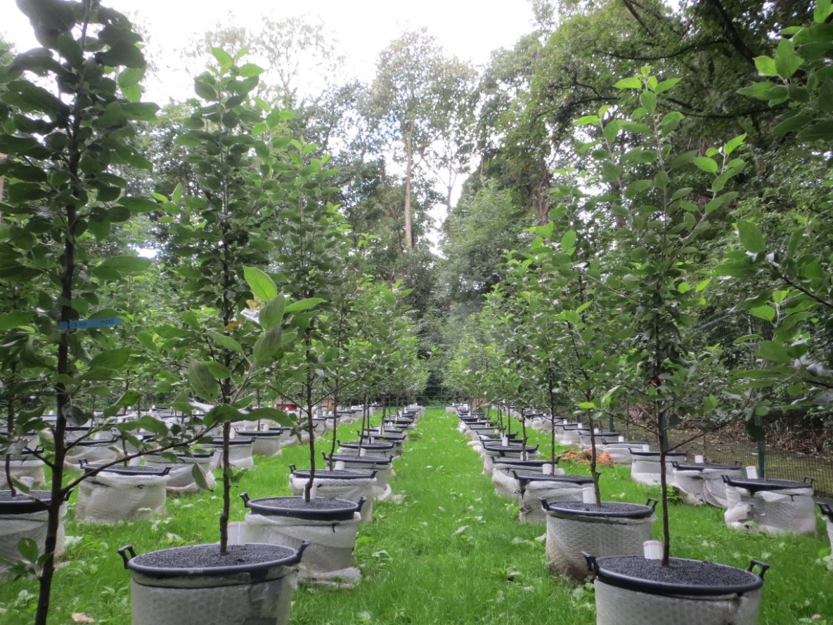
Figure 2.1 Experimental set up at Arthur Willis Environment Centre, Sheffield, spring 2015.

Mycorrhizal inoculum
All trees within the mycorrhizal treatment were inoculated with both Funneliformis mosseae and Rhizophagus irregularis (Plantworks Ltd, UK). According to supplier instruction, 400 ml of inoculum powder (comprising of fungal spores and colonised root fragments) was mixed with 9 g polyacrylamide gel powder and 1L d. H₂0 to form a thick paste applied to bare tree roots immediately before planting. Trees which were not inoculated with AMF were applied with gel and d.H₂0 only. To prevent contamination tree root systems were thoroughly washed and all fine root was removed prior to planting.

Nutrient treatment
Nutrient treatments were based on the DEFRA recommendations for a newly planted cider apple orchard (DEFRA, 2010). Trees in the ‘High’ nutrient treatment received the recommended amount of N, P, K, Mg whilst ‘Low’ nutrient trees received 1/10th of this (Appendix 1A). All fertilisers were applied in solution and to correspond with the growing season, nutrient applications were applied fortnightly over a 20 week period beginning from bud burst. Supplementary water was provided equally to all trees to prevent water stress over periods of low rainfall.

Mycorrhizal colonisation
Root sampling of all trees was conducted in September 2015 (towards the end of the final growing season but prior to leaf drop) to quantify mycorrhizal colonisation with three soils cores removed per tree using an 4.5 cm diameter corer to a depth of 20.5 cm. Roots were carefully removed from each core and washed with d.H₂0 before fine root (<1mm dimeter) was pooled per tree and cut into sections of approximately 1 cm. To visualise colonisation of roots by mycorrhiza a staining technique was used according to (Brundrett, M.C. & Bougher, N., 1996). For each tree 15 cm of root was cleared in 10% (w/v) KOH at 80°C for 4.5 hours, rinsed in d.H₂0 and acidified with 10% (v/v) HCl for 10 minutes. Roots were then stained in Trypan Blue for 20 minutes before de-staining in 50% (v/v) glycerol for 30 minutes. Mycorrhizal colonisation was quantified using a magnified intersection method according to (Mcgonigle et al., 1990). For this 15 x 1 cm root sections were laid parallel on a slide and a microscope with an eye piece crosshair is used to scan across the slide and at each intersection of the crosshair with a root the presence of hyphae, arbuscules, vesicles or absence of fungal structures is recorded. A total of 100 observations are made per slide and allowing proportion root colonisation by mycorrhiza to be estimated.

Tree nutrient status
To quantify tree nutrient status five newly developed leaves were randomly collected per tree during July of each experimental year (2013, 2014 and 2015). Leaves were oven dried (80°C, 24hrs) before being homogenised using an analytical grinder. To quantify total phosphorus, a 25 mg subsample was digested in sulphuric acid and hydrogen peroxide according to Allen (1974). After dilution (N=1:10 d.H20) Murphy-Riley colorimetric P-determination (Allen, 1989) was performed at 882 nm using a Cecil Ce 1020 spectrophotometer (Cecil Instruments Ltd, Cambridge, UK) (Appendix A.2). Total nitrogen and carbon was measured for homogenised leaf tissue subsamples of approximately 5mg per tree using an elementary analyser (VarioEl Cube; Isoprime, Hanau, Germany). Leaf tissue carbon and C:N ratios were measured as both are known to be useful indicators of plant nutrition and investment into defence (Royer et al., 2013).

Leaf chlorophyll content
As a physiological indicator of health, leaf chlorophyll was measured monthly over the growing season (April – September) of each year (2013, 2014 and 2015). At each time point a SPAD-502 chlorophyll meter (Minolta Camera Ltd, Japan) was used to quantify mean chlorophyll content per tree using measurements taken from 5 young leaves per tree. To calculate actual chlorophyll (mg g⁻¹ dry leaf tissue) values for corresponding SPAD readings, acetone extraction and quantification of chlorophyll was used according to (Cameron et al. 2009).
Twenty chlorophyll readings were recorded per leaf for six apple tree leaves. Leaves were harvested and kept on ice in the dark prior to chlorophyll extraction which was performed within 1hr of picking to prevent degradation. Leaves were cut into 5mm squares and a subsample of 25-50mg was weighed. At this stage a further subsample of fresh leaf was weighed then oven dried at 82°C for 48hrs before re-weighing to allow chlorophyll quantification per g of dry tissue weight. Subsamples for extraction were ground in a chilled pestle and mortar before adding 5ml of ice cold acetone transferring to a 25ml centrifuge tube. The pestle and mortar was rinsed twice with 2ml 80% ice cold acetone and transferred to the same centrifuge tube. Each tube was then diluted to 10ml with ice cold acetone before samples were centrifuged at 8000g for 5 mins. Absorbance was then measured at 645 and 663nm using a Cecil Ce 1020 spectrophotometer (Cecil Instruments Ltd, UK). This was repeated in batches for a total of twenty leaves to reduce holding time due to rapid degradation of chlorophyll. Chlorophyll content was calculated using the following equations according to (Arnon, 1949) and expressed as mg chlorophyll per gram of dry leaf tissue.
Chlorophyll a (mg l⁻¹) = (12.7 x OD₆₆₃) - (2.69 x OD₃₄₅)
Chlorophyll b (mg l⁻¹) = (22.9 x OD₆₄₅) - (4.68 x OD₆₆₃)

Tree growth
To quantify tree growth, height and trunk diameter measurements were recorded at the beginning of the growing season (pre bud burst) and following leaf senescence in autumn. Height was recorded from the base of the trunk vertically to the tip of the highest branch. Trunk diameter was recorded 20cm from the base of the trunk using vernier callipers. Mean diameter per tree was calculated from two diameter recordings per tree measured perpendicular one another to account for any irregularity in trunk shape.

Biomass
Destructive biomass harvest was conducted for three blocks of trees (3 reps per treatment, 48 trees in total) in December 2015 after three growing seasons (34 months). Trees were removed from pots intact and root systems were thoroughly washed. Trees were separated into above and below ground material and fresh weights recorded. To calculate dry biomass, above ground growth was chipped and a subsample of approximately 40g was weighed then oven dried at 98°C to a constant dry mass. Total dry biomass per tree was calculated based on the water content of the subsample. Roots were air dried at room temperature (fine roots are too friable for oven drying) to a constant mass before being re-weighed to obtain total root dry biomass.

Root growth
Root growth was measured over the course of the experiment using the mini-rhizotron technique. Immediately after planting 50 cm mini-rhizotron tubes made of clear acrylic 7 cm in diameter and sealed at the lower end, were installed in each pot at 45° to the soil substrate surface. The above ground section of each tube was painted with a layer of black to exclude light, then white to reduce heat absorption and was sealed with a white cap to seal as protection from precipitation. At the end of each growing season (October) mini-rhizotron tubes were scanned fully (2 images per tube, image size 19.55cm x 21.57cm, resolution 400dpi) using a CID-600 roots scanner (CID, Kansas, USA).

Fruit production
Both number of fruit and total fresh fruit biomass per tree was recorded at the end of the first growing season (2013). Due to pathogen infection fruit yield was exceptionally low for year 2014 and 2015 and therefore yield is not reported for these years and instead flower counts for spring 2014 and 2015 as an indicator of potential crop production.

Leaf and flower phenology
Leaf phenology was recorded during year 2 (2014) and year 3 (2015) of the experiment with tree leaf development was monitored closely from the 1st of March each year. At approximately 5 day intervals the number of leaf buds to have reached each of the following developmental stages was estimated. In brief, developmental stages were defined as (i) dormant, (ii) bud swollen heavily but no sign of opening, (iii) bud starting to open but less than 50% green, (iv) Over 50% bud is green but leaf tips are still inward pointing, (v) Leaf tips begin to point outward and leaf unrolling is clear, (vi) leaves are spreading and mostly unfurled, (vii) leaves are completely unfurled (Appendix A.C). Leaf bud burst date was defined as the date at which greater or equal to 50% of the flowers per tree reached stage six of development.
Flower phenology was also monitored over the second and third growing season of the experiment (2014 and 2015). Trees were monitored closely from the beginning of March. From the date of first flower opening, trees were examined every 3 days and number of buds, flowers and senescent flowers were recorded according to the following definitions (i) budding – petals are clearly visible but not distinctly unfurled (ii) flowering – when the corolla is separated sufficient for four distinct petals and the stamen of the flower to be clearly identified (in accord with Wagner et al. 2014), (iii) senescent – flower shows clear signs of senescence such as petal loss, discolouration and wilting. The day at which 50% of buds per tree were flowering/had flowered was then identified.

Pathogen incidence
Tree health was monitored over the duration of the experiment and a pathogen was observed in July 2014. Fresh tissue samples of infected plant material were outsourced to project collaborators for molecular identification and were thus identified as apple canker Neonectria ditissima. In accord with agricultural management practices the infected branches were removed from each tree. Length and number of infected material sections per tree were recorded. Two episodes of pathogen removal were necessary during July 2014 and a further removal event during July 2015.

Statistical analyses
To determine the effect of AMF, nutrient scion and rootstock treatments upon all parameters of tree growth (height, trunk diameter, above and below ground biomass and root length), health (leaf tissue P, N, C concentration, C:N ratio, chlorophyll content and pathogen incidence) and productivity (fruit and flower production) reported in Table 2.1 and Table 2.2, four -way ANOVA tests were used with ‘block’ nested as a random factor and including all two-way interactions between mycorrhizal inoculation with rootstock, scion and nutrient treatments. To determine the effects of treatment levels upon leaf and flower phenology Generalized Linear Models were used with Poisson distribution to account for the data being integer and having variances equal to means. Analysis was performed in R studio version 3.3.1 (R Core Team, 2016).

Results

Mycorrhizal colonisation
AMF inoculation was successful with all inoculated trees showing AMF root colonisation ranging from 11 to 54%. In comparison all non-inoculated treatments remained free of AMF. AMF colonisation within inoculated trees was significantly reduced by high nutrient treatment (Table 2.1, Table 2.2) with colonisation averaging at 19.7% and 42.3% under high and low nutrient treatments respectively. Scion type also significantly affected mycorrhizal colonisation (Table 2.1, Table 2.2) with Michelin trees on average showing 32.3% root colonisation compared to 29.7% in Dabinett trees (Table 2.1, Table 2.2). No differences between colonisation of rootstock types were found.

Tree nutrient status

Leaf Nitrogen
High nutrient treatment significantly increased leaf N concentration from 22.1 to 23.0 mg g⁻¹ in year 2 (4% increase) and from 18.8 to 24.2 mg g⁻¹ in year 3 (28% increase), (Table 2.1, Table 2.2). A significant effect of rootstock upon leaf N concentration was shown for both years 2 and 3 with MM111 rootstocks showing higher leaf N concentrations in both years (year 2: MM111 23.0 mg g⁻¹ compared to MM106 22.2 mg g⁻¹ and year 3: MM111 22.2 mg g⁻¹ compared to MM106 20.7 mg g⁻¹ ), (Table 2.1, Table 2.2). Scion type had a small but significant effect upon leaf N in year 2 with leaf concentration of Dabinett trees averaging at 21.8 mg g⁻¹ compared to 21.1 mg g⁻¹ in Michelin trees. No significant difference between inoculated and non-inoculated trees was shown for leaf N concentration for any year of the experiment.

Leaf Phosphorus
No significant effect of AMF inoculation, or scion or rootstock type upon leaf phosphorus concentration was shown. In year 3 trees receiving high nutrient treatments showed a significantly increased leaf P concentration of 2.8 mg g⁻¹ compared to 1.8 mg g⁻¹ in low nutrient trees (Table 2.1, Table 2.2).

Leaf carbon and C: N ratio
Trees inoculated with AMF showed no differences in leaf C or C: N ratio compared to non-inoculated trees (Table 2.1, Table 2.2). In the third year of the experiment trees receiving high nutrient treatment showed a reduced C: N ratio compared to low nutrient trees which corresponded with increased leaf N and reduced leaf C compared to low nutrient trees (Table 2.1, Table 2.2). Some differences in leaf C and C: N were shown between rootstock and scions although these effects were not constant across the three years of the experiment.

Leaf Chlorophyll
No effect of AMF upon leaf chlorophyll was reported however consistent effects of rootstock and scion were shown across all years of the experiment. Michelin trees showed higher chlorophyll content than Dabinett and trees with MM106 showed on average higher leaf chlorophyll than those on MM111 rootstocks. For year 3 only, trees receiving high nutrient application showed higher leaf chlorophyll (2.40 mg g⁻¹) compared to trees receiving low nutrient treatment (2.53 mg g⁻¹ ).

Tree growth

Growth
AMF inoculated trees showed a significant increase in height (8% increase) compared to non-inoculated trees during year 2 (193 cm compared to 179 cm respectively) (Table 2.1, Table 2.2), however this positive effect on growth was not shown for year one or three. No effect of nutrient application was found for tree height. Rootstock and scion type both significantly affected tree height; trees with Michelin scions were on average taller for all years of the experiment (Table 2.1, Table 2.2) and trees with MM106 rootstocks were significantly taller in year two and three although significantly shorter than MM111 during year 1 (Table 2.1, Table 2.2).
Trunk diameter was significantly affected by scion type with Michelin trees consistently larger than Dabinett trees for all years (Table 2.1, Table 2.2). Rootstock also had a significant effect with M111 rootstock trees showing larger trunk diameter in year two and three of the experiment (Table 2.1, Table 2.2). There was no significant effect of mycorrhizal inoculation or nutrient treatment upon trunk diameter.

Biomass
There was no significant effect of nutrient, scion or mycorrhizal treatment on tree above ground biomass (Table 2.1, Table 2.2) however above ground biomass was significantly affected by rootstock with trees on MM106 rootstock on average of 14% greater biomass than those on MM111 (Table 2.1, Table 2.2). Root biomass was no effected by AMF treatment but was significantly reduced by 17% with high nutrient application in comparison to low nutrient application (Table 2.1, Table 2.2). Scion and rootstock type also significantly affected root biomass with on average larger root systems found for trees with the Michelin scion in comparison to Dabinett and for trees with MM111 rootstock in comparison to MM106 (Table 2.1, Table 2.2).

Root length
Mycorrhizal inoculation reduced root length by 19% compared to non-inoculated trees. Colonised trees showed on average 119 cm of root over a surface area of 860 cm² compared to non-inoculated trees which showed on average 96 cm of root over the same area. Scion type also affected root length with trees with Dabinett scion showing on average 97 cm of root over the measured soil area compared to Michelin trees which showed 118 cm of root (Table 2.1, Table 2.2).

Leaf and flower phenology
Rootstock had a significant effect upon leaf phenology in year 2 with MM106 trees coming into leaf on average 2 days earlier than MM111 trees (F_{1,143}=4.208, P<0.001) however this effect was not shown the following year. No effect of mycorrhiza, nutrient or scion was found for either year. On average trees came into leaf after 59.6 days in year 2 (60th day = 29th March 2014) and 76.7 days in year 3 (77th day = 16th May 2015) reflecting the colder spring temperatures of 2015. No significant effect of treatment was found upon flowering date for any year of this experiment.

Tree productivity

Fruit and flower production
The first crop of fruit produced by trees in autumn 2013 after the first season of growth was very low however this is to be expected from newly planted trees due to their young age and recent plant date (Williams, 1996).Trees without mycorrhiza yielded on average 133g of fruit which was a significant 35% increase compared to the 85g yielded on average by mycorrhizal trees (Table 2.1, Table 2.2). However no significant difference was shown in fruit number produced for mycorrhizal and non-mycorrhizal trees with all trees yielding on average one fruit per tree.
First year fruit biomass was also significantly affected by tree scion and rootstock type with 83% greater fruit biomass produced by Dabinett scions in comparison to Michelin and 56% greater fruit biomass produced by MM106 rootstock in comparison to MM111 (Table 2.1, Table 2.2). The same patterns of significance were shown from analysis of fruit number as for fruit biomass for scions and rootstock effects (Table 2.1, Table 2.2) No significant effect of mycorrhizal inoculation or nutrient treatment upon flower production was shown (Table 2.1, Table 2.2). Rootstock type significantly affected flower number during both year 2 and year 3 (Table 2.1, Table 2.2) with MM106 rootstock trees producing 77 and 65% more flowers than MM111 rootstock trees during year 2 and year 3 respectively.

Disease resistance
AMF inoculation significantly reduced the amount of plant material infected by the fungal pathogen N. ditissima by 18%, with non-inoculated trees showing on average 570 cm of infected material compared to 465 cm of inoculated trees (Table 2.1, Table 2.2). Differences in pathogen susceptibility between scion types were also found with 27% lower canker incidence shown by Michelin scion types (average of 434 cm infected material) in comparison to Dabinett (600 cm infected material). Furthermore, trees with MM106 rootstock has significantly lower pathogen damage compared to MM111 trees with on average 578cm and 456 cm of infected material shown for MM111 and MM106 rootstocks respectively (Table 2.1, Table 2.2, Figure 2.3). No effect of nutrient treatment on the amount of pathogen infected material was shown.

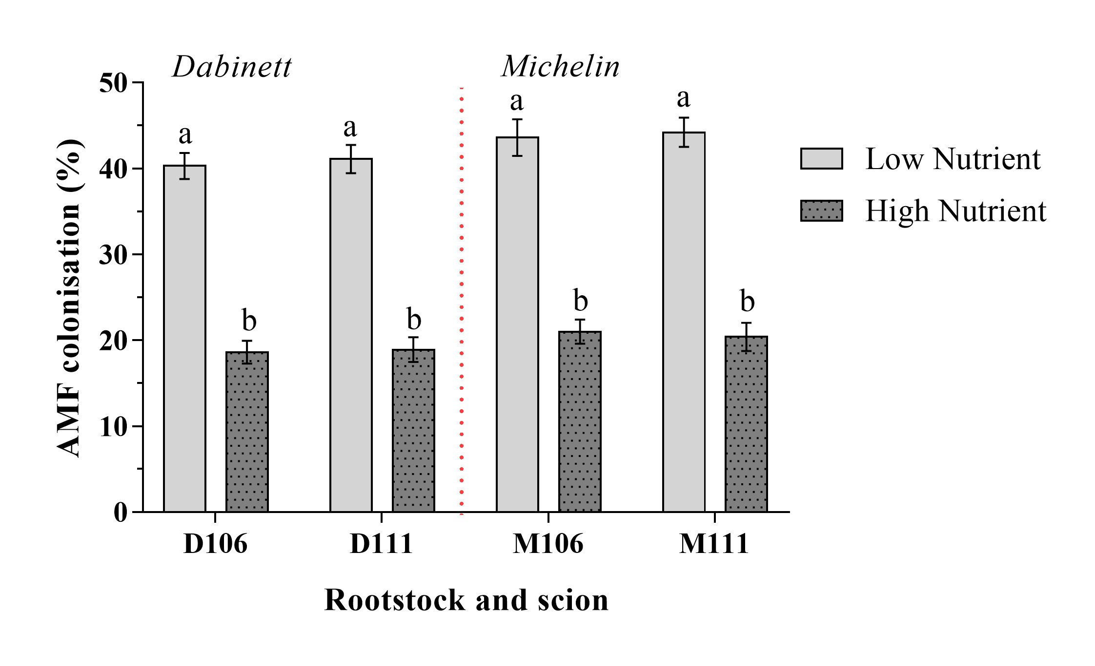

Figure 2.2 Root colonisation of apple trees inocluated with two species of arbuscular mycorrhizal fungi after three years of growth. Mean colonisation under high and low nutrient treatments and with Dabinett and Michelin scions are presented. Error bars show SE of mean (n = 20). Treatments with the same letter do not differ significantly from one another (Tukey, HSD p<0.05).
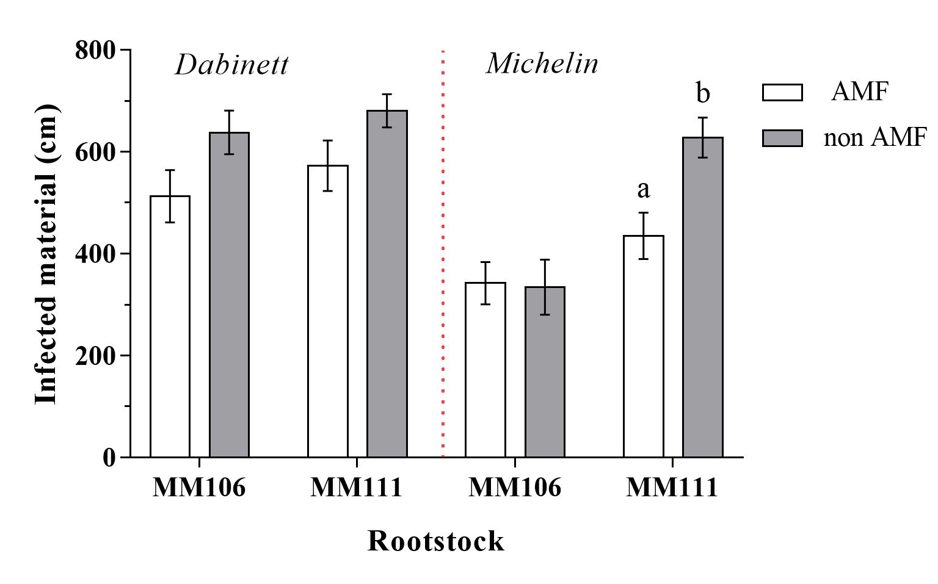
Figure 2.3 Total tree material infected by the fungal pathogen Neonectria ditissima. Trees were grown with and without AMF inoculation. Error bars show SE of mean (n = 20). Treatments with different letters differ significantly from one another (Tukey HSD, p<0.05).
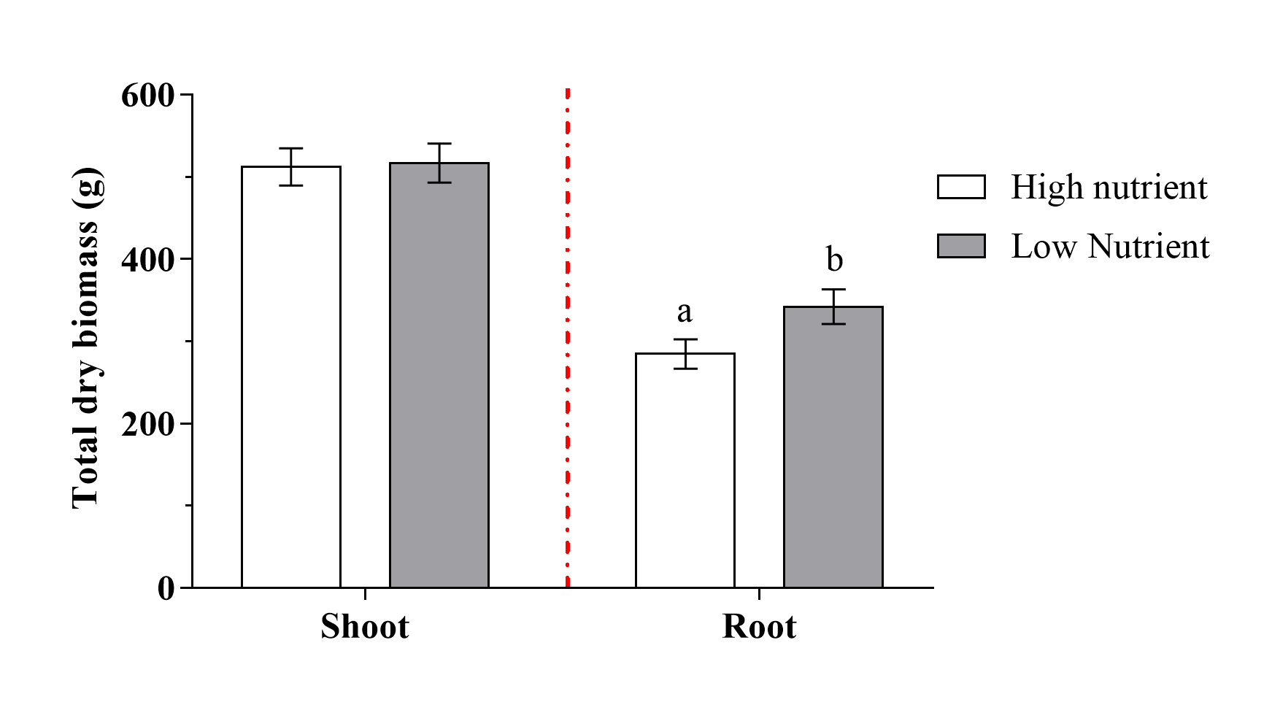
Figure 2.4 Mean total above ground dry biomass and below ground biomass for apple trees grown under high and low nutrient applications. Error bars show SE of mean (n=24). Treatments with different letters show a signfiicant difference btween nutrient applications (Tukey HSD, p<0.05).

Table 2.1 Four-Way ANOVA results for apple performance over three years. Main factor effects and all significant interactions with mycorrhiza are reported. Significant results (P<0.05) are in bold.
Response |  |  | Mycorrhiza |  | Nutrient |  | Scion |  | Rootstock |  | Mycorrhiza x Nutrient |  | Mycorrhiza x Scion
 | Year | df | F | P | F | P | F | P | F | P | F | P | F | P
Leaf P (mg g⁻¹) | 1 | 1,151 | 1.206 | 0.274 | 0.232 | 0.631 | 0.479 | 0.490 | 0.001 | 0.975 | - | - | - | -
 | 2 | 1,151 | 0.425 | 0.516 | 0.137 | 0.712 | 1.551 | 0.215 | 1.337 | 0.249 | - | - | - | -
 | 3 | 1,151 | 2.581 | 0.110 | 111.64 | <0.001 | 3.039 | 0.083 | 1.699 | 0.194 | - | - | - | -
Leaf N (mg g⁻¹) | 1 | 1,151 | 1.027 | 0.313 | 1.236 | 0.268 | 0.734 | 0.393 | 2.603 | 0.109 | - | - | - | -
 | 2 | 1,151 | 0.001 | 0.977 | 5.132 | 0.0249 | 2.303 | 0.131 | 3.952 | 0.048 | - | - | - | -
 | 3 | 1,151 | 0.001 | 0.979 | 236.709 | <0.001 | 4.586 | 0.033 | 17.466 | <0.001 | - | - | - | -
Leaf C (mg g⁻¹) | 1 | 1,151 | 3.560 | 0.0611 | 0.168 | 0.682 | 1.443 | 0.231 | 0.073 | 0.786 | - | - | - | -
 | 2 | 1,151 | 0.072 | 0.788 | 0.182 | 0.669 | 9.029 | 0.003 | 5.737 | 0.788 | - | - | - | -
 | 3 | 1,151 | 1.069 | 0.302 | 10.808 | 0.001 | 1.779 | 0.184 | 0.430 | 0.513 | - | - | - | -
Leaf C:N | 1 | 1,151 | 0.933 | 0.335 | 1.750 | 0.187 | 1.484 | 0.225 | 3.074 | 0.081 | - | - | - | -
 | 2 | 1,151 | 0.287 | 0.592 | 2.941 | 0.088 | 0.653 | 0.420 | 10.327 | 0.001 | - | - | - | -
 | 3 | 1,151 | 0.611 | 0.435 | 246.57 | <0.001 | 5.140 | 0.024 | 20.295 | <0.001 | - | - | - | -
Leaf chlorophyll (mg g⁻¹) | 1 | 1,151 | 1.377 | 0.242 | 1.252 | 0.264 | 88.097 | <0.001 | 12.516 | <0.001 | - | - | - | -
Leaf chlorophyll (mg g⁻¹) | 2 | 1,151 | 0.023 | 0.878 | 2.543 | 0.112 | 8.155 | 0.004 | 4.182 | 0.042 | - | - | - | -
Leaf chlorophyll (mg g⁻¹) | 3 | 1,151 | 0.559 | 0.456 | 82.613 | <0.001 | 79.759 | <0.001 | 79.759 | <0.001 | - | - | - | -

Table 2.1 (cont) Four-Way ANOVA results for apple performance over three years. Main factor effects and all significant interactions with mycorrhiza are reported. Significant results (P<0.05) are in bold.
Response |  |  | Mycorrhiza |  | Nutrient |  | Scion |  | Rootstock |  | Mycorrhiza x Nutrient |  | Mycorrhiza x Scion
 | Year | df | F | P | F | P | F | P | F | P | F | P | F | P
Tree height (cm) | 1 | 1,151 | 1.922 | 0.167 | 1.092 | 0.297 | 69.97 | <0.001 | 5.296 | 0.022 | - | - | - | -
 | 2 | 1,151 | 6.464 | 0.012 | 0.525 | 0.470 | 11.973 | <0.001 | 12.429 | <0.001 | - | - | - | -
 | 3 | 1,151 | 0.687 | 0.409 | 0.407 | 0.525 | 65.700 | <0.001 | 27.268 | <0.001 | - | - | - | -
Trunk diameter (cm) | 1 | 1,151 | 0.037 | 0.849 | 2.054 | 0.154 | 27.612 | <0.001 | 0.228 | 0.634 | - | - | - | -
 | 2 | 1,151 | 0.004 | 0.948 | 0.346 | 0.558 | 36.111 | <0.001 | 17.475 | <0.001 | - | - | - | -
 | 3 | 1,151 | 0.136 | 0.712 | 0.968 | 0.326 | 19.069 | <0.001 | 13.618 | <0.001 | - | - | - | -
Root length (cm) | 3 | 1,151 | 6.307 | 0.0131 | 0.202 | 0.654 | 5.521 | 0.020 | 0.175 | 0.676 | - | - | - | -
Fruit biomass (g) | 1 | 1,151 | 4.347 | 0.038 | 0.141 | 0.708 | 46.275 | <0.001 | 13.883 | <0.001 | - | - | - | -
Fruit number | 1 | 1,151 | 2.357 | 0.126 | 0.013 | 0.910 | 37.260 | <0.001 | 8.315 | 0.004 | - | - | - | -
Flower number | 2 | 1,151 | 0.208 | 0.649 | 1.964 | 0.163 | 45.746 | <0.001 | 43.472 | <0.001 | - | - | - | -
 | 3 | 1,151 | 0.511 | 0.475 | 0.105 | 0.745 | 2.379 | 0.125 | 13.755 | <0.001 | - | - | - | -
Total dry shoot biomass (g) | 3 | 1,39 | 0.656 | 0.422 | 0.024 | 0.878 | 1.366 | 0.249 | 6.374 | 0.015 | - | - | - | -
Total dry root biomass (g) | 3 | 1,39 | 0.947 | 0.336 | 7.213 | 0.010 | 7.854 | 0.007 | 14.849 | <0.001 | - | - | - | -
Pathogen infected material (cm) | 2&3 | 1,151 | 10.535 | 0.001 | 0.559 | 0.456 | 26.555 | <0.001 | 14.361 | <0.001 | - | - | - | -
AMF colonisation (%) | 3 | 1,151 | 3101.206 | <0.001 | 410.821 | <0.001 | 5.345 | 0.022 | 0.061 | 0.805 | 410.821 | <0.001 | 5.345 | 0.0221
ª Subsample of the tree root system measured using mini-rhizotron imaging; Mini-rhizotron tubers were 7cm diameter x 47 cm depth with an imaging area of 869cm²

.
Table 2.2 Four-way ANOVA results for apple tree performance over three years. Main factor effects and all significant interactions with mycorrhiza are reported. Significant results are in bold.
Response | Year | Mycorrhiza: None |  | Mycorrhiza: Inoculated |  |  | Nutrient: Low |  | Nutrient: High |  |  | Scion: Dabinett |  | Scion Michelin |  |  | Rootstock: MM106 |  | Rootstock: MM111
 |  | Mean | SE | Mean | SE | % change | Mean | SE | Mean | SE | % change | Mean | SE | Mean | SE | % change | Mean | SE | Mean | SE | % change
Leaf P (mg g⁻¹) | 1 | 2.95 | 0.10 | 3.10 | 0.10 | 5.08 | 2.99 | 0.10 | 3.06 | 0.10 | 2.34 | 2.98 | 0.10 | 3.07 | 0.09 | 3.02 | 3.03 | 0.10 | 3.02 | 0.010 | -0.33
Leaf P (mg g⁻¹) | 2 | 2.23 | 0.05 | 2.18 | 0.05 | -2.24 | 2.16 | 0.04 | 2.25 | 0.05 | 4.16 | 2.17 | 0.05 | 2.25 | 0.05 | 3.68 | 2.22 | 0.05 | 2.19 | 0.05 | -1.35
Leaf P (mg g⁻¹) | 3 | 2.28 | 0.08 | 2.44 | 0.09 | 7.01 | 1.85 | 0.05 | 2.87 | 0.08 | 55.13 | 2.45 | 0.09 | 2.28 | 0.08 | -6.93 | 2.30 | 0.09 | 2.43 | 0.08 | 5.65
Leaf N (mg g⁻¹) | 1 | 27.50 | 0.26 | 27.13 | 0.33 | -1.33 | 27.11 | 0.32 | 27.51 | 0.27 | 1.48 | 27.16 | 0.31 | 27.47 | 0.29 | 1.14 | 27.02 | 0.30 | 27.60 | 0.29 | 2.16
Leaf N (mg g⁻¹) | 2 | 22.62 | 0.25 | 22.63 | 0.30 | 0.04 | 22.19 | 0.26 | 23.06 | 0.28 | 3.92 | 22.92 | 0.32 | 22.34 | 0.23 | -2.53 | 22.25 | 0.23 | 23.01 | 0.31 | 3.41
Leaf N (mg g⁻¹) | 3 | 21.53 | 0.37 | 21.52 | 0.42 | -0.04 | 18.85 | 0.24 | 24.20 | 0.28 | 28.38 | 21.89 | 0.41 | 21.15 | 0.38 | -3.40 | 20.79 | 0.39 | 22.25 | 0.39 | 6.99
Leaf C (mg g⁻¹) | 1 | 469.31 | 0.97 | 466.68 | 1.01 | -0.5 | 467.71 | 1.037 | 468.28 | 0.96 | 0.121 | 468.83 | 1.05 | 467.16 | 0.94 | -0.35 | 468.18 | 0.99 | 467.81 | 1.013 | -0.07
Leaf C (mg g⁻¹) | 2 | 467.24 | 1.18 | 466.82 | 1.05 | -0.08 | 467.36 | 0.91 | 466.7 | 1.30 | -0.14 | 469.33 | 1.09 | 464.73 | 1.08 | -0.98 | 468.86 | 1.01 | 465.20 | 1.177 | -0.780
Leaf C (mg g⁻¹) | 3 | 476.13 | 1.30 | 477.33 | 1.35 | 0.252 | 479.58 | 1.30 | 474.33 | 1.28 | -1.09 | 475.89 | 1.33 | 478.02 | 1.31 | 0.44 | 477.48 | 1.38 | 476.43 | 1.26 | -0.21
Leaf C:N ratio | 1 | 17.18 | 0.15 | 17.4 | 0.21 | .28 | 17.44 | 0.20 | 17.14 | 0.16 | -1.720 | 17.43 | 0.19 | 17.15 | 0.18 | -1.60 | 17.49 | 0.19 | 17.09 | 0.183 | -2.28
Leaf C:N ratio | 2 | 20.97 | 0.24 | 20.79 | 0.27 | -0.85 | 21.18 | 0.25 | 20.58 | 0.25 | -2.83 | 20.74 | 0.29 | 21.02 | 0.21 | 1.35 | 21.44 | 0.25 | 20.32 | 0.248 | -5.22
Leaf C:N ratio | 3 | 22.65 | 0.40 | 22.96 | 0.49 | 1.36 | 25.79 | 0.35 | 19.82 | 0.24 | -23.14 | 22.37 | 0.44 | 23.23 | 0.45 | 3.84 | 23.66 | 0.48 | 21.95 | 0.40 | -7.22
Leaf chlorophyll (mg g⁻¹) | 1 | 2.92 | 0.12 | 2.94 | 0.01 | 0.58 | 2.94 | 0.01 | 2.92 | 0.01 | -0.50 | 2.87 | 0.01 | 3.00 | 0.01 | 4.52 | 2.96 | 0.01 | 2.91 | 0.01 | -1.65
Leaf chlorophyll (mg g⁻¹) | 2 | 2.57 | 0.01 | 2.58 | 0.01 | 0.11 | 2.59 | 0.01 | 2.56 | 0.01 | -0.84 | 2.55 | 0.01 | 2.59 | 0.00 | 1.56 | 2.59 | 0.01 | 2.56 | 0.01 | -1.07
Leaf chlorophyll (mg g⁻¹) | 3 | 2.47 | 0.01 | 2.46 | 0.01 | -0.44 | 2.40 | 0.01 | 2.53 | 0.01 | 5.36 | 2.40 | 0.01 | 2.53 | 0.01 | 5.27 | 2.50 | 0.01 | 2.43 | 0.01 | -2.91

Response | Year | Mycorrhiza: None |  | Mycorrhiza: Inoculated |  |  | Nutrient: Low |  | Nutrient: High |  |  | Scion: Dabinett |  | Scion Michelin |  |  | Rootstock: MM106 |  | Rootstock: MM111
 |  | Mean | SE | Mean | SE | % change | Mean | SE | Mean | SE | % change | Mean | SE | Mean | SE | % change | Mean | SE | Mean | SE | % change
Tree height (cm) | 1 | 196.20 | 1.42 | 193.70 | 1.69 | -1.29 | 195.90 | 1.53 | 194.00 | 1.60 | -0.96 | 187.30 | 1.28 | 202.60 | 1.34 | 8.16 | 192.80 | 1.42 | 197.10 | 1.67 | 2.23
Tree height (cm) | 2 | 179.10 | 4.26 | 193.70 | 4.36 | 8.15 | 188.50 | 4.34 | 184.40 | 4.42 | -2.17 | 176.50 | 4.07 | 196.40 | 4.41 | 11.27 | 196.60 | 4.60 | 179.30 | 3.8 | -10.32
Tree height (cm) | 3 | 171.10 | 3.38 | 174.50 | 3.92 | 1.98 | 174.10 | 3.86 | 171.55 | 3.45 | -1.49 | 156.40 | 3.03 | 189.20 | 3.30 | 20.97 | 183.40 | 3.70 | 162.50 | 3.22 | -11.39
Trunk diameter (cm) | 1 | 1.86 | 0.03 | 1.85 | 0.03 | -0.26 | 1.84 | 0.03 | 1.87 | 0.03 | 2.00 | 1.79 | 0.01 | 1.92 | 0.03 | 7.64 | 1.86 | 0.02 | 1.85 | 0.03 | -0.69
Trunk diameter (cm) | 2 | 2.30 | 0.03 | 2.31 | 0.03 | 0.12 | 2.29 | 0.03 | 2.32 | 0.03 | 1.00 | 2.19 | 0.01 | 2.42 | 0.03 | 10.47 | 2.23 | 0.02 | 2.39 | 0.03 | 7.17
Trunk diameter (cm) | 3 | 2.59 | 0.01 | 2.58 | 0.02 | -0.57 | 2.56 | 0.02 | 2.60 | 0.01 | 1.55 | 2.49 | 0.01 | 2.67 | 0.02 | 7.12 | 2.51 | 0.02 | 2.66 | 0.02 | 5.97
Root length(cm)ª | 3 | 119.60 | 7.28 | 96.47 | 5.71 | -19.33 | 106.0 | 6.28 | 110.1 | 7.04 | 3.86 | 97.21 | 6.69 | 118.9 | 6.43 | 22.31 | 110.0 | 6.81 | 106.1 | 6.25 | -3.64
Fruit biomass (g) | 1 | 133.66 | 23.13 | 85.59 | 15.68 | -35.00 | 113.95 | 22.03 | 105.30 | 17.60 | -7.59 | 88.04 | 23.20 | 31.21 | 10.08 | -83.40 | 152.58 | 23.30 | 66.68 | 14.36 | -56.29
Fruit number | 1 | 1.80 | 0.31 | 1.28 | 0.22 | -28.88 | 1.56 | 0.28 | 1.52 | 0.25 | -2.56 | 2.56 | 0.29 | 0.52 | 0.18 | -79.60 | 2.02 | 0.30 | 1.06 | 0.23 | -47.50
Flower number | 2 | 32.55 | 5.49 | 33.88 | 5.47 | 4.08 | 26.07 | 4.46 | 40.36 | 6.24 | 54.81 | 51.72 | 6.06 | 14.71 | 3.84 | -71.55 | 54.12 | 6.27 | 12.31 | 3.11 | -77.25
 | 3 | 7.75 | 1.73 | 13.23 | 2.45 | 70.70 | 10.47 | 2.11 | 10.51 | 2.17 | 0.38 | 11.85 | 2.13 | 9.13 | 2.14 | -22.95 | 15.51 | 2.60 | 5.47 | 1.33 | -64.73
Total dry shoot biomass (g) | 3 | 526.83 | 22.23 | 501.89 | 23.55 | -4.73 | 516.73 | 23.66 | 512.00 | 22.41 | -0.91 | 496.37 | 19.63 | 532.36 | 25.47 | 7.25 | 553.24 | 22.49 | 475.49 | 20.62 | -14.05
Total dry root biomass (g) | 3 | 323.75 | 20.11 | 302.91 | 20.58 | -6.43 | 342.08 | 20.99 | 284.58 | 18.03 | -16.80 | 283.33 | 14.76 | 343.33 | 23.27 | 21.17 | 354.58 | 18.32 | 272.08 | 18.81 | -23.26
Pathogen infection (cm) | 2&3 | 570.11 | 26.09 | 465.50 | 25.02 | -18.34 | 505.76 | 26.86 | 529.85 | 25.52 | 4.76 | 600.85 | 23.03 | 434.76 | 25.90 | -27.64 | 456.73 | 27.36 | 578.87 | 23.08 | 26.74
AMF colonisation (%) | 3 | 0.00 | 0.00 | 31.02 | 1.39 | 31.02 | 42.30 | 0.88 | 19.73 | 0.71 | -53.36 | 29.73 | 1.89 | 32.3 | 2.03 | 8.64 | 30.88 | 1.95 | 31.15 | 2.00 | 0.87
ª Subsample of the tree root system measured using mini-rhizotron imaging; Mini-rhizotron tubers were 7cm diameter x 47 cm depth with an imaging area of 869cm²

Discussion
In addition to their various nutritional benefits, the ability of arbuscular mycorrhizal fungi (AMF) to modulate the immune function of their host plants, conferring broad-spectrum disease resistance, is becoming increasingly recognised (Cameron et al., 2013). To date, the majority of this evidence comes from non woody annual crop plants (Gange & West, 1994; Pozo et al., 2002; Fritz et al., 2006; Campos-Soriano et al., 2012) while little is known about the effects of AMF on the immune function of longer lived plants such as apples. Here, we provide the first evidence, in a simulated orchard setting, that AMF can significantly reduce the disease severity of the apple canker pathogen Neonectria ditissima.

Mycorrhizal effects upon apple canker resistance
In our study, inoculation with mycorrhiza improved resistance of apple trees to the fungal pathogen Neonectria ditissima on average reduced the amount of infected material by 18% (Figure 2.3).To our knowledge, this is the first study to report the benefit of mycorrhiza for resistance to this pathogen. Previous studies based on apple seedlings have reported beneficial effect of AMF inoculation for above ground protect against stem brown canker (Botryosphaeria ribis) (Krishna et al., 2010) and for below ground defence of apple against white root rot (Dematophora necatrix) (Raj & Sharma, 2009) infection by the root rot pathogens (Phytophthora cactorum and Pythium ultimum) (Utkhede & Smith, 2000), reduced infection by the root lesion nematode Pratylenchus penetrans and improved growth in nematode infested soils (Forge et al., 2001). These studies report a corresponding increase in growth with reduced pathogen damage of AMF plants an effect which is partly attributed to beneficial effects of AMF to plant health arising from positive effects on plant nutrition. For example Krishna et al.,(2010) found inoculation with R. intraradices on averaged increased tree survival by 49% compared to non-inoculated trees and that AMF trees also showed substantially increased shoot growth and leafiness (Krishna et al., 2010). In contrast our results show no beneficial effect of AMF on root or shoot growth or N and P leaf nutrient concentrations or changes in C: N ratios suggesting that mycorrhiza induced resistance may not be nutritionally related. It is also unlikely to be related to water stress as trees were provided with supplementary watering where necessary over dry periods.
The role of AMF in plant defence may partly explain reduced infection of AMF inoculated trees shown by data from this study. AMF colonisation may induce a systemic enhanced defensive capacity to pathogens which is independent of reduced pathogen susceptibility due to improved plant nutrition (Fritz et al., 2006; Liu et al., 2007; Jung et al., 2012). Colonisation by AMF triggers some of the same initial defence responses that are elicited by the plant immune system in response to biotrophic pathogens (Paszkowski, 2006) and AMF must modulate the plant defences to be able to effectively colonise the host plant. This modulation which is known as priming, pre-conditions the plant immune system so that although defences are not actively expressed, in response to attack the defence system can respond more efficiently (faster and stronger) than a plant which is not in a primed state (Pozo & Azcón-Aguilar, 2007).
Although the molecular basis for AMF induced response is not fully understood, colonisation of roots by AMF is known to result in priming of salicylic acid dependent genes in a similar way to systemic acquired resistance (Gallou et al., 2011). Mycorrhiza induced resistance is also known to be associated with activation of jasmonic acid related defences which are thought to play a prominent role in plant defence (Pozo & Azcón-Aguilar, 2007; Hao et al., 2012) and cell wall related defences (Pozo et al., 2002; Abdel-Fattah et al., 2011). Primed jasmonate regulated defences are known to be effective in restricting development of nectrotrophic fungi which include Neonectria ditissima (Jung et al, 2012) and have been reported for nectrotrophic pathogens infecting tomato (Fritz et al., 2006) and rice (Campos-Soriano et al., 2012). Mycorrhiza induced resistance is thought to result from culmination of both the direct plant response to mycorrhizal infection by priming and also synergistic interactions between mycorrhiza and rhizobacteria within the rhizosphere. (Cameron et al., 2013). Mycorrhizal infection of host plants may influence recruitment of rhizobacteria through alteration of host root exudes within the soil (Frey-Klett et al., 2007) some of which are known to have an important effects upon plant growth and systemic resistance (Lioussanne, 2013; D’Alessandro et al., 2014). Recent work by (Pérez-de-Luque et al., in press) has demonstrated how synergistic interactions between R. intraradices and rhizobacteria may affect growth and priming response (callose deposition) thus highlighting the importance of both direct and indirect effects of AMF upon host plant health.
Interestingly, our results reveal that the degree of pathogen suppression we reported was not negatively influence by nutrient–induced reductions in mycorrhizal colonisation. Specifically, mycorrhizal colonisation was on average reduced by 50% under high nutrient treatment, nutrient application did not significantly affect pathogen infection levels. This suggests that even at relatively low levels of colonisation (~20%) mycorrhiza are able to induce a significant response in the host immune system.

Nutrient treatment effects
Our results show a clear negative effect of nutrient application rates upon mycorrhizal colonisation (Figure 2.2). Similar reductions in mycorrhizal colonisation in response to routine agricultural fertiliser application have been reported by studies examining AMF crop symbiosis in the field (Johnson et al., 2005; Gosling et al., 2006; Li et al., 2006). Reduced colonisation of apple treated within inorganic NPK fertiliser has also been found in apple seedlings (Miller et al., 1985a) and for newly planted apple trees receiving inorganic NPK fertilisers at standard rates in comparison to mulch treatments (Sumorok et al., 2011). Reduced colonisation under high fertility conditions can be explained by resource allocation theory (Johnson et al., 2013) whereby plant invest more energy into capture of resources which are most limiting for growth, therefore reducing carbon allocation to AMF under non nutrient limited conditions (Smith et al., 2009).
Resource allocation theory may also explain the observed 17% reduction in tree root biomass for trees receiving recommended agricultural fertiliser rates (‘high fertiliser treatment) in comparison to low nutrient application (1/10th of this) (Figure 2.4). This result shows that nutrient applications to young trees should be carefully considered to make sure they are not it excess of requirement as reductions in root development may reduce the ability of trees to tolerate water stress during drought periods. This is particularly significant given that drought frequency and severity is predicted to increase with future climate change (IPCC, 2014).
No differences in tree growth and productivity were shown between trees receiving high and low fertiliser treatments although by year 3 trees in the high nutrient treatment showed increased foliar P, N and chlorophyll. Lack of benefit of high fertiliser application to tree performance suggests that nutrient application received by trees in the lower nutrient treatment was adequate to supply all necessary nutrients and implies the high nutrient treatment which is based upon recommended application for one year old cider apple trees is in fact in excess of the trees growth requirement. Therefore reducing fertiliser inputs to young orchards may provide both economic and environmental benefit.

Mycorrhizal effects on tree nutrient status, growth and productivity

No effect upon nutrient status, growth and productivity
We hypothesised that AMF would positively affect tree nutrient status, growth and productivity and that the benefits of AMF would be greater for trees receiving low, in comparison to high, nutrient application. However we found no benefit of AMF for the nutrient status, growth, or productivity and no difference in mycorrhizal response was found between trees under different nutrient treatments.
Our hypothesis regarding the benefit of AMF to apple trees was based on the ability of AMF to improve tree nutrient uptake by AMF trees thus improving growth and productivity. Several mechanisms make AMF more efficient than roots at nutrient capture including mycorrhizal ability to rapidly respond to nutrient availability (Cavagnaro et al., 2005), finer diameter of AMF hyphae allowing greater access to soil pores (Drew et al., 2003) and ability of AMF to efficiently exploit large areas of soil. Lack of effect of AMF upon tree nutrient uptake in our system could be due to lack of nutrient limitation to trees due to the pot based system used for this experiment which limits the growth of mycorrhizal hyphae into a wider soil area and thus limits the area of soil hyphae can forage nutrients. Interestingly, our results showed decreased root length of AMF trees compared to non AMF trees despite no differences in overall root biomass. This may have been due to a reduced investment in fine root production by mycorrhizal trees in response to nutrient provision by their AMF symbionts and suggests that despite no net benefit to nutrition, AMF may have been contributing to overall nutrient uptake however AMF contribution to total plant P uptake was not quantified by this study. Downregulation of plant nutrient uptake in response to colonisation by AMF resulting in no net nutrition gain to AMF host plants has been demonstrated in other study systems (Smith et al., 2004, Nagy et al., 2009). For example Smith et al., (2004) clearly demonstrated that even in situations where the majority/all of plant P uptake is acquired by AMF, this may not result in increased plant P status or growth as direct P uptake by the host plant roots may be down regulated or even completely inactivated in response to AMF colonisation. Furthermore AMF P contribution and corresponding downregulation in host P uptake and growth response is known to vary between host plant and AMF symbiont combinations (Smith et al., 2004; Smith & Smith, 2011b).
It is also possible that the two AMF species used for inoculation for our study (R.irregularis and F.mosseae) may partly explain lack of growth and nutritional effects upon host apple plants as differences in functioning between AMF taxa are known (Hetrick et al., 1993; Zhu et al., 2001). For example Maherali & Klironomos, (2007) showed R. intraradices and F. mosseae were able to function in pathogen protection against Pythium sp of but provided less benefit to plant growth than other taxa. Similarly experiments of the effect of inoculation of different AMF taxa upon apple seeding growth has shown differences in apple plant growth and nutrient response to different taxa (Covey et al., 1981; Miller et al., 1985b; Forge et al., 2001). Further work to investigate the effect of inoculation of apple with different AMF taxa would help identify those which are most beneficial and therefore optimal choices for AMF inoculum.
We investigated effect of AMF upon leaf and flower phenology based upon recent work which has suggested that microbial communities have a role in determining plant flowering time through potential effects upon phenotypic plasticity of flower phenology (Lau & Lennon, 2011; Wagner et al., 2014). Timing of leaf and flower development is of agronomical importance due to potential effects on growth and flower production and consequently therefore effects upon fruit yield. In particular flowering date is critical as climate conditions and pollinator activity during this period determine flower set and the annual fruit crop (Williams, 1996). However in contrast to the results of Wagner et al., (2014) our data showed no difference between mycorrhiza inoculated and non-inoculated trees for timing of leaf or flower phenology. Delayed timing of leaf and flower phenology in year 3 (2015) of the experiment in comparison to year 2 (2014), corresponded with lower spring temperatures which are known to delay leaf and flower phenology (Williams, 1996; Aikawa et al., 2010).

AMF and tree yield
The first crop of fruit yield from all trees in autumn 2013 following the first growing season was very low (averaging at roughly 1 fruit per tree). This is a result of the immaturity of the tree ages and recent plant date as cider apple orchards take several years to become established and reach full crop production (Williams, 1996). Mycorrhizal trees showed significantly reduced yield in the first year of the experiment (35% reduction) compared to non-inoculated trees. One explanation for reduced fruit yield in mycorrhizal trees in comparison to non-mycorrhizal trees could be the carbon cost of AMF symbiosis draining C that would otherwise be allocated to fruit production (Guo et al., 1994) however this is not supported by the other measures of growth made during this study which showed no differences in growth between AMF and non AMF trees. It was not possible to measure fruit yield for the subsequent two years of the experiment due to very low fruit production as result of pathogen infection. However, measurement of flower production in year 2 and year 3 showed no difference between inoculated and non-inoculated trees suggesting that yield potential was similar.

Rootstock and scion effects
Previous research with herbaceous species has suggested that crop breeding in agricultural soils with high nutrient levels and low soil mycorrhizal loads may have impaired the ability to form mycorrhizal associations in subsequent germplasm (Hetrick et al., 1993, 1996). Given apples have been subject to significant artificial selection during breeding (specifically in terms of rootstock), we investigated the effects of root stock type on mycorrhizal functioning. In our study rootstock type did not affect mycorrhizal colonisation, with mean colonisation in low nutrient soils at 42% for MM106 and 43% for MM111 and at high nutrient 20% for MM106 and 21% for MM111. Thus these two widely planted rootstocks are able to achieve high levels of colonisation. This is of significance as both rootstocks are widely planted in modern orchards therefore demonstrating that these modern rootstocks trees have the capacity to form high levels of AMF colonisation dependent upon soil fertility. However colonisation results must be interpreted with caution given that they are not consistently a good predictor of mycorrhizal activity (Hetrick et al., 1993; Zhu et al., 2001).
Interestingly, our results show that in contrast to the lack of effect of rootstock type upon AMF colonisation, scion type has a significant effect with Michelin trees showing an overall 9% higher colonisation than trees with Dabinett scions. The relative influence of the scion upon AMF in grafted apple trees is not well understood, but recent studies in citrus have demonstrated that the scion genotype may play a greater role than the rootstock in impacting mycorrhizal community structure (Song et al., 2015). In this study it was suggested that primary and secondary metabolites synthesised in the scion would function in selective symbiosis of mycorrhiza when exuded from the trees’ roots into the rhizosphere (Broeckling et al., 2008; Kiers et al., 2011). This may explain differences in mycorrhizal colonisation we observed despite the fact that trees were inoculated with only two mycorrhizal species; F. mosseae, and R. irregularis, therefore limiting the potential for the scion to modify mycorrhizal community structure and thus indirectly effect the tree physiology. Further research into below ground impact of scion type and signalling mechanisms would help to elucidate the role of scion types upon AMF symbiosis.

Conclusion
This study aimed to test the following hypothesis:
- Mycorrhiza would positively affect tree nutrient status, growth, productivity and resistance to pathogens.
- The impact of mycorrhiza would be greater for trees receiving low fertiliser inputs.
- Rootstock and scion types would affect the symbiosis of the trees with mycorrhiza.
The results of this study show some support for hypothesis one due to positive effects of AMF inoculation on pathogen resistance however no observed benefits were shown for measures of tree nutrient status, growth or productivity. Hypothesis two was not supported by our data as no interaction was shown between AMF inoculation and nutrient treatment and must therefore be rejected. Hypothesis three was partially supported by the data from this study as we observed significant differences between AMF colonisation of trees with Dabinett and Michelin scions however no effect of rootstock upon AMF symbiosis was reported.
Our results clearly show beneficial effect of AMF upon disease resistance against N.ditissima and the importance of managing soils to promote AMF populations within orchards. The ability of AMF to reduce pathogen damage may particularly be useful in the control of N.ditissima in organic orchards where chemical control methods are limited. Our results also suggest that scion type may influence mycorrhizal symbiosis with apple in terms of colonisation and tree performance although currently little is known about the mechanisms underpinning these interactions. Although in our study the benefit of AMF symbiosis to trees was not found to be sensitive to fertiliser application, nutrient application rates should be carefully considered due to their negative effect upon root biomass which may be particularly detrimental to tree health under drought conditions.

The effects of orchard management on AMF communities and comparison with intensive arable farming and semi-natural woodlands

Summary
- Arbuscular mycorrhizal fungi (AMF) are an important component of the soil microbial community and play a vital role in a range of ecosystem functions that are essential within agro-ecosystems. AMF communities are known to be sensitive to land management practices and understanding these responses is important as changes in AMF community structure and composition may ultimately affect productivity and sustainability of agriculture due to functional differences between taxa.
- UK cider apples are grown in three major orchard types which differ in their management intensity primarily levels of chemical input: conventional bush orchards (high intensity), conventional standard orchards (medium intensity) and organic standard orchards (low intensity). Although apple is known to host a diverse range of AMF and may gain benefit from AMF symbiosis (see Chapter 2), little is known about the how differences in orchard management influence AMF community composition or richness relative to intensive arable agriculture or the original woodland land cover.
- Soil samples were collected from 25 groups of sites located across Herefordshire, a major apple growing county of the UK. Within each group of sites, multiple soil samples were obtained from the three major orchard types, an intensively managed arable field and semi natural woodland. AMF communities were compared between orchard, woodland and arable soil samples using a leek bait plant trap culture system and two molecular community fingerprinting techniques: terminal restriction fragment length polymorphism (TRFLP) and Illumina sequencing.
- The results show that relative abundance and community composition of AMF taxa were highly similar within soils of the three apple orchard types and that despite receiving higher application rates of inorganic fertilisers and herbicide, negligible effects upon AMF taxa relative abundance and community composition were found in conventional bush orchard. Furthermore orchard communities showed similar levels of AMF diversity and similarities in taxa relative abundance and community composition with those of broadleaved woodland soils suggesting that orchards are able to sustain relatively natural AMF communities. In contrast arable habitats showed reduced richness of AMF and distinct differences in relative abundance and community composition when compared to both orchards and woodland showing that AMF are limited within intensive arable agricultural systems. Interestingly a varied response of AMF types within the genera Glomus to land management intensity was found with some AMF types far more abundant in arable than orchards and woodlands and vice versa.
- This study is amongst the first to use Illumina sequencing technology to study AMF communities. Overall it provides the first large-scale characterisation of AMF communities within commercial cider apple orchards in the UK and shows that irrespective of management type orchards are able to host relatively high levels of AMF richness which are comparable to those of native woodland.

Introduction
Soil microbial communities underpin soil health, provide vital ecosystem functions and are fundamental to the productivity of all agricultural systems (Barrios, 2007; van der Heijden et al., 2008) yet studies of responses to land-use change have largely overlooked belowground effects (Bardgett & van der Putten, 2014). Understanding soil microbial community responses to land management is of critical importance as reductions in biodiversity and changes in community structure may be detrimental to agro-ecosystem sustainability and food security due to functional differences between taxa and the services they provide (van der Heijden et al., 2008).
Arbuscular mycorrhizal fungi (AMF) are one group of soil organisms known to have a vital role in the functioning of agroecosystems (Gianinazzi et al., 2010). Arbuscular mycorrhizal fungi belong to the phylum Glomeromycota, forming symbioses with over 80% of land plants including majority of crop plants (Smith & Read, 2008). AMF symbiosis is characterised by the exchange of carbon from host plants for nutrients captured from the soil by the fungi (Smith & Read, 2008). AMF can affect plants through improved nutrition most notably that of improved phosphorus supply (Smith & Smith, 2011a), can enhance plant productivity and diversity (van der Heijden et al., 2008), alter competitive interactions (Cameron, 2010) and enhance resistance to drought and pathogens (Augé, 2004; Jung et al., 2012). AMF are integral to soil health due to the beneficial role of the fungal mycelium on soil structure and AMF derived glomalin-related soil protein on the stability of soils (Bedini et al., 2009) and in the formation of water stable aggregates (Wilson et al., 2009). Furthermore they influence sequestration of soil carbon and have been estimated to account for up to 15% of the organic carbon content of soils (Leake et al., 2004). AMF are known to improve the nutrient retention of soils and reduce leaching losses (Cavagnaro et al., 2015) most notably for nitrogen and phosphorus (Bender et al., 2015; Köhl & van der Heijden, 2016) an effect which is thought to be due to efficient uptake of nutrients through extensive exploration of soil by hyphal networks and nutrient immobilisation within fungal and plant biomass (Hart & Reader, 2002).
Arbuscular mycorrhizal fungal communities are sensitive to both natural and anthropogenic changes in land-use, particularly agricultural land management due to substantial alteration in biological, chemical and physical properties of the soil environment. Negative impacts of intensive agricultural management practices upon AMF may result in reduced provision of key ecosystem services (Gosling et al., 2006) and this is therefore a critical area of research. Reductions in AMF diversity and alterations in AMF community structure with intensive arable agricultural management has been well documented (Helgason et al., 1998; Oehl et al., 2004; Wang et al., 2009; Verbruggen et al., 2010) although with some exceptions (Hijri et al., 2006). Intensive arable systems are heavily reliant on inorganic fertiliser inputs which are known to reduce AMF colonisation (Wang et al., 2009) and diversity (Verbruggen et al., 2010; Fester & Sawers, 2011), presumably via suppression of carbon allocation to the fungus as a consequence of enhanced plant nutrition (Field et al., 2017). Reductions in AMF diversity and colonisation in addition to changes in community composition have been reported for physical disturbance of agricultural soils through tillage (Helgason et al., 1998; Bowles et al., 2016) high application rate of inorganic fertilisers (Wang et al., 2009; Verbruggen et al., 2010), crop monoculture (Verbruggen & Kiers, 2010) and periods of fallow (Lekberg & Koide, 2005).
In comparison to arable systems far less is known about the AMF communities of tree based cropping systems despite the important contribution of these systems to agricultural production worldwide (Bainard et al., 2011). Apples are the fourth most widely grown fruit crop with orchards utilising over 4.7 million hectares worldwide for apple production (FAO, 2012) and are known to be both responsive to AMF (Miller et al., 1985b; Matsubara et al., 1996) and able to host relatively high diversity of AMF (Cavallazzi, et al., 2007). Despite this little is known about the diversity or community structure of AMF within apple orchards. In comparison to arable systems, orchards may be more favourable environments for supporting diverse AMF communities (Bainard et al., 2011) as due to the perennial nature of tree crops, orchards have a lower level of soil disturbance and greater diversity and cover of vegetation. Fertiliser application rates vary across orchard management types (Table 3.1) and are likely to result in differences in AMF communities between orchard management types (van Geel et al., 2016).
Understanding the ability of orchards to maintain a functionally diverse AMF community is important as functional differentiation between AMF taxa has been reported to result in taxa specific differences in functions such as plant biomass production (van der Heijden et al., 1998; Hart & Reader, 2002; Uibopuu et al., 2012; Köhl & van der Heijden, 2016), plant nutrient uptake (Jansa et al., 2005; Kohl et al., 2014), nutrient leaching (Köhl & van der Heijden, 2016) and soil glomalin concentration and aggregate stability (Bedini et al., 2009) and therefore may ultimately effect sustainability and productivity of orchards. Results from a recent study comparing the AMF communities colonising apple tree roots within organic versus standard orchards in Belgium showed greater diversity of AMF under organic management (van Geel et al., 2015) however this study was hampered by the small sample size of organic orchards studied and only compared between two of the three major apple orchard management types. Source of fertiliser input has been shown to influence AMF communities in apple roots with organic P sources promoting richer AMF communities and difference in community structure compared to AMF communities in orchards receiving inorganic P sources (van Geel et al., 2016).

Aims
This chapter aims to characterise how AMF communities vary between three orchard management types which differ in their management intensity and compare these AMF communities with those of broadleaved woodland and intensive arable sites. Arable sites were sampled as a reference habitat as intensive arable agriculture is known to be associated with reduced AMF diversity. In contrast sampling of broadleaved woodlands enables comparison with a more natural habitat and one that is similar to the original land cover type in this region. AMF communities were compared between land use types by measuring changes in AMF using (i) richness, (ii) Simpson’s diversity, (iii) presence/absence, and (iv) relative abundance.
Specifically in this chapter the following research questions are addressed:
- What is the richness, Simpson’s diversity, community composition and taxa relative abundance of AMF within cider apple orchards under the three main management types: conventional bush orchards, conventional standard orchards and organic standard orchards and how does orchard management effect the AMF community?
- How do AMF communities within soils from each orchard type compare to soils collected from the two reference habitats: intensive arable fields and broadleaved woodlands?
Based upon the current understanding of AMF responses to agricultural management it was hypothesised that:
- Intensive orchard management would impact the AMF community with conventional bush orchards showing reduced AMF richness and evenness and significant differences in community composition and taxa relative abundance when compared to conventional standard and organic standard orchards.
- AMF communities of orchards show greater similarity with those of woodlands to those of arable fields.

Methods

Study site selection
All 125 studied orchards, woodland and arable fields were located within Herefordshire, a major apple growing county of the UK and were distributed over an area of approximately 30km². Twenty five replicate cider apple orchards belonging to each of the following management categories were studied: (i) conventional bush orchard (ii) conventional standard orchard, (iii) organic standard orchard (Table 3.1) summarises the main differences between these orchard management types). Organic orchards were classified as those that had been registered as Soil Association Organic for a minimum of 10 years. ‘Bush’ vs ‘Standard’ were categorised according to tree rootstocks with dwarfing/semi-dwarfing belonging to ‘bush’ and standard rootstocks classified as ‘standard’. To minimise differences between topographic, edaphic and climatic conditions between sites under comparison habitat types were grouped into 25 groups each containing one of all five of the habitat types under comparison and the maximum distance between any two habitat types within a group was 4km. Twenty five arable and woodland sites were also sampled to enable comparison of AMF communities with an environment which is more intensively and less intensively managed relative to the apple orchards.
Table 3.1 Contrasting management and characteristics of the three cider apple orchard types studied (data from NACM 1980, and UK BAP 2008)
Characteristic | Bush Orchard | Conventional Standard Orchard | Organic Standard Orchard
Planting density (trees hectare ⁻¹⁾ | 400-600 | 100-150 | 100-150
Tree height | 1.8-4.6m | 6-12m | 6-12m
Canopy Spread | 6m | 7.6m | 7.6m
Crop yield (approximate tonnes hectare ⁻¹) | 25-50 | 10-12 | 10-12
Tree cropping frequency | Annual | Annual or biannual | Annual or biannual
Tree age (years) at which full cropping is reached | 8 | 15 | 15
Average life span (years) | 40 | >80 | >80
Diversity of tree age | All trees same age | Range of tree ages | Range of tree ages
Rootstock | Dwarfing /Semi dwarfing rootstocks (e.g. MM111, MM106) | Vigorous standard rootstocks (e.g. M25) | Vigorous standard rootstocks (e.g. M25)
Scion | Modern commercial variety, budded close to ground | Traditional variety, budded/grafted from cutting or seedling | Traditional variety, budded/grafted from cutting or seedling
Orchard floor management | Frequent mowing of grass alley | Grazed by livestock/cut for hay | Grazed by livestock/cut for hay
Herbicide strips | Present | Absent | Absent
Pruning | Frequent and intense pruning to remove all dead/decaying wood | Low level | Low level
Fertiliser input | Frequent | Occasional/none | none
Chemical control inputs | Frequent (10-14 applications year⁻¹ ) | Occasional/none | none

To select study sites (Figure 3.1) a random stratified sampling method was used. Firstly 25 organic standard orchards (the least abundant orchard type) were randomly selected from a directory of contract growers belonging to Westons Cider Ltd, one of the major organic cider producers in the area. Secondly using a directory of conventional bush and conventional standard orchards belonging to contract farmers for Bulmers Cider, the closest possible conventional bush and standard orchards were matched to each organic standard orchard. All study orchards fit the following criteria (i) orchard age of over 10 years, (ii) orchards had to be under the classified management for a minimum of 10 years (iii) orchard were larger than 100m² in area. All farmers were then contacted to gain permission for use of their orchards for the study.
Woodland ‘reference’ sites were selected by locating the closest woodland to the orchard groups that met the following selection criteria: (i) broadleaved woodland dominated by native species; oak (Quercus sp), ash (Fraxinus excelsior), beech (Fagus sylvatica) and hazel (Corylus avellana), ii) woodland had been established for over 10 years (ii) woodland area was greater than 100m². Similarly, the nearest arable fields were chosen as a ‘reference’ site based on the following selection criteria (i) field was sown with winter cereals (either winter wheat (Triticum aestivum) or winter barley (Hordeum vulgare), (ii) field had been under conventional arable cultivation for a minimum of 2 years, (iii) field area was greater than 100m². In arable fields cores were taken a minimum of 1m away from the ‘tramlines’ where tractor wheels passed through the field to avoid any effects of compaction. All sample and data collection was carried out during June, July and August 2013 and groups of habitat types were systematically visited to minimise differences in time of sampling over the season. Permission to access land was obtained from all landowners prior to sampling.
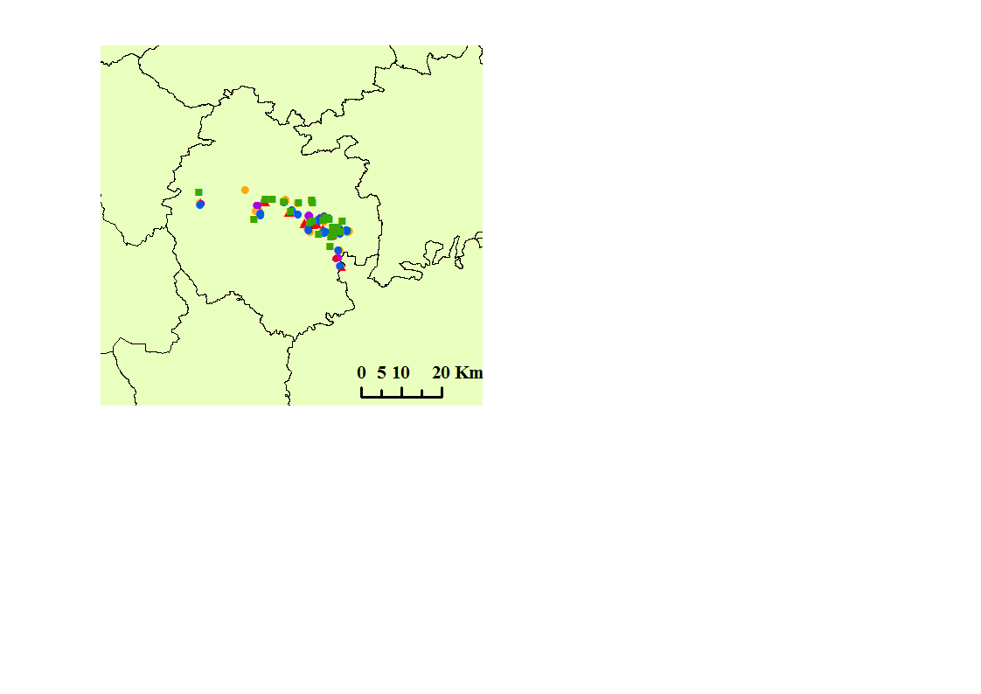
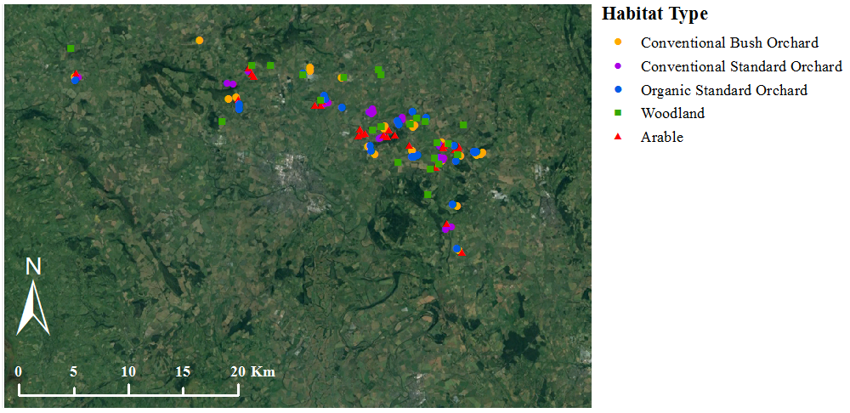
Herefordshire
Figure 3.1 Location of study orchards, woodland and arable sites within Herefordshire, UK. Twenty five sites were sampled for each of the five habitat types. All samples were collected June to August 2013.

Study site environmental data collection
For each of the study orchards the following details were recorded (1) tree scion varieties, (2) tree rootstock varieties, (3) date of planting in orchard, (4) orchard size, (5) names and amounts of all chemicals (fertilisers, pesticides, herbicides or fungicides) treatments applied to orchards over the current and previous growing season, (6) estimate of yield per orchard, (7) whether the orchard is grazed or had been grazed within the past 2 years and if so the type of livestock which had been present.

Soil sampling and growth of AMF bait plants
Six soil cores to a depth of 30 cm and diameter of 6 cm were collected from each site. Within orchards six trees were randomly selected for sampling; cores were collected 0.5m from the base of three trees and 2.5 m from the base of three trees. All cores were collected perpendicular to tree rows to ensure that in bush orchards three samples were collected from both within the herbicide strip and from the grass alley between tree rows. Within woodland or arable sites soil core locations were selected randomly. To reduce the possibility of ‘edge effects’ no samples were collected within 20 m from the boundary of any of the habitat types. Similarly no samples were collected within 10m from any footpaths crossing sites. Soil cores were homogenised by passing through a 1 cm x 1 cm mesh sieve. Soil was then mixed with sterilised sharp sand at a ratio of 1:5 sand to soil, to improve drainage of the clay soil and potted in 50 ml pots. Leek (Allium porrum var. ‘Musselburgh’) was selected as a bait plant due to its ability to host a diverse range of AMF species and common use in AMF trap cultures (Hart & Reader, 2002; Jansa et al., 2016). Ten leek seeds were planted per pot and grown for 16 weeks in a temperature controlled greenhouse (day period: 16 hours 20°C, night period: 8 hours 15°C). This lengthy period of growth was selected to ensure that AMF species with slow rates of colonisation would be represented in the AMF community by allowing sufficient time for colonisation of bait plant roots (Hart & Reader, 2002). Supplementary lighting was used where necessary to ensure the required day length (Helle Lamps, IR400 HPS, 400 W). After 16 weeks of growth the leek plants were harvested and roots were thoroughly washed and air dried at room temperature.

DNA extraction
Root systems were then cut into 1cm sections, a random subsample of roughly 10 pieces were selected and placed in 2ml eppendorf with approximately 20 x 1 mm sterile stainless steel beads and homogenised to a fine powder using a Qiagen Tissue Lyser (Retsch®, Germany) for four minutes at a frequency of 30 beats per second. Genomic DNA was then extracted from a 0.1g ± 0.05g subsample using NucleoSpin 96 Plant II Kits (Macherey Nagel, Germany) following manufacturer instructions.

TRFLP analysis
Amplification of partial small subunit (SSU) ribosomal DNA (850bp) was performed for each DNA extract in a 12 µl reaction using 2 µl of DNA extract, 6 µl of Quaigen Mastermix and 4 µl of 0.4mM of each of the fungal specific primers AML1 (5’-ATC AAC TTT CGA TGG TAG GAT AGA-3’) and AML2 (5’-GGA CCC AAA CAC TTT GGT TTC C-3’) (Lee et al., 2008). The AML1 primer was labelled with FAM fluorescent marker at the 5’ end. PCR conditions were as follows: 95°C for 15 minutes, 35 cycles at 94°C for 30 seconds, 58°C for 90 seconds, 72°C for 60 seconds; followed by a final elongation of 72°C for 10 minutes on a Life-ECO thermal cycler (Bioer Technology Co., China). Gel electrophoresis using 2% agarose and SYBR® Safe DNA stain (Invitrogen) was used to verify the success of PCR amplification.
PCR products were digested separately with the restriction enzymes HpyCH4-III and Hinf-1 (New England Biolabs, Inc) which were shown in preliminary tests to be more discriminatory than other commonly used restriction enzymes which had previously been used to separate out AMF genotypes. Restriction digests were carried out separately for Hinf-I and HpyCH4-III enzymes in a 5µl reaction volume which contained 2.5 units of enzyme, 3µl of PCR product and manufacturer’s buffer. Samples were digested at 37°C for two hours and then denatured for 10 minutes at 65°C. In preparation for capillary DNA analysis 1µl of digest was added to 9µl of formamide containing 1% GeneScanTM LIZ 1200 size standard (Applied Biosystems, UK) and heated at 94°C for 3 minutes before immediate cooling on ice. Samples were then run on an ABI 3730 PRISM® capillary DNA analyser (Applied Biosystems, UK) to determine size and abundance of FAM labelled terminal restriction fragments (TRFs).
TRFLP data was initially analysed using GeneMapper® v3.7 (Applied Biosystems, UK) using a local southern size calling method in comparison with the internal LIZ 1200 size standard (Osborn et al., 2000). Each electropherogram was visually inspected and where peak fluorescence within a sample was not in the range of 3,000 to 30,000 fluorescent units which was the range for the majority of sample profiles, samples were repeated using digest product that was concentrated/diluted accordingly. Samples were also repeated where size standard amounts were too low to be accurately used.
To exclude noise resulting from the capillary electrophoresis all TRFs smaller than 100bp and those with heights fewer than 100 fluorescent units were excluded from analysis as in (Cotton et al., 2015). Bin sizes of 5bp were used for TRF size. A data table was produced including the TRF size and peak area. To measure peak frequency, peak areas were used rather than peak heights as abundance measured from peak area is known to more accurate due to down weighting of peak height in longer fragment sizes (Sipos et al., 2007; Dickie & FitzJohn, 2007). Raw peak areas were relativized to account for differences in DNA quantities between samples. This was calculated by dividing the area of each peak within a sample by the total sum of peak areas for that sample therefore converting peak area to a percentage of the total area of peaks within the sample (Culman et al., 2008). Peaks which accounted for less than 5% of the peak area per sample were classed as noise and excluded from analysis as per Culman et al., (2008) and (Dumbrell et al., (2010). Proportional peak area was then re normalized per sample (Culman et al., 2008). Following alignment two matrices of data were produced: i) relative abundance of all peaks expressed as a percentage of total peak area ii) a binary data matrix of TRF presence or absence.

TRFLP data analysis

TRFLP data; Richness and diversity analysis
TRF richness was calculated as the total TRFs found within the six replicate samples collected per site for each habitat. Simpson’s diversity index was used as a measure of richness and evenness of the TRFs within each habitat and was calculated using (Equation 1) (Magurran, 2004) from the summed average relative abundance of TRFs within each habitat for each site. The reciprocal of the diversity index (1/D) was used throughout analysis as this is more intuitive as communities with greater diversity have higher reciprocal Simpson’s diversity indices values in comparison to communities which have lower species richness and evenness.
$$D=\sum_{i=1}^{s}{}\frac{n_{i}(n_{i}-1)}{N(N-1)}$$
Equation 1
Equation for Simpson’s diversity index where N is the total number of TRFs and n_{i} is the number of occurrences of TRF_{i}
The effect of habitat type (arable, conventional bush orchard, conventional standard orchard, organic standard orchard and woodland) upon AMF richness and evenness within leek bait plant roots was tested using one-way ANOVA models with habitat type as the predictor, TRF number or Simpson’s reciprocal diversity index for each of the 25 sites per habitat type as the response variable and site group number as a random effect. Data which did not meet requirements of the ANOVA model was Log₁₀ transformed so that data was normally distributed. Analysis was performed in R Studio V 3.3.1 (R Development Core Team, 2016). Richness and Simpson’s diversity was analysed both separately for TRF data from each restriction enzyme and on the combined TRF data from both restriction enzymes to allow comparison between the two enzymes.

TRFLP data; Relative abundance and presence/absence using Principal Component Analysis
To examine differences TRF presence/absence and relative abundance between habitat types Principal Component Analysis was performed on the TRF relative abundance data matrix and binary TRF presence/absence data matrix using a sum of squares model in Genstat V18.1.0.12005 (VSNi International Ltd). The effect of habitat type upon principal component score was tested using one-way ANOVA models with habitat types as a fixed effect, site group number as a random effect and principal component scores as the response variable. Percentage values of data variation explained by each principal component were visually inspected and ANOVA tests were performed on all principal component scores which accounted for the over 5% of the variation in the data.

TRFLP data; OPLS-DA approach for TRF relative abundance effects
Orthogonal partial least square discrimination analysis (OPLS-DA) was used to initially examine the differences in the relative abundance of each of the 20 TRFs between the five contrasting habitat types and to identify TRFs which showed significant differences in abundance between habitat types (SIMCA 14.0, Sweden). OPLS-DA is a multivariate supervised analysis which identifies relationships in the data by using a linear regression model to correlate the X data matrix with a Y data matrix (Bylesjö et al., 2006; Jandrić et al., 2015). The OPLS-DA method is conducive to identification of relationships between variables as it reduces noise in the data that is shown by alternative multivariate analysis methods such as PCA. Use of OPLS-DA on large data sets may cause random associations therefore for this analysis any TRFs identified by OPLS-DA analysis to differ significantly in abundance between habitats were subsequently tested using one-way ANOVA tests followed by Tukey HSD tests where significant effects were shown (R studio version 3.3.1 R Core Team 2016). TRF relative abundance data which did not meet the assumptions of the ANOVA test was Log₁₀ transformed.OPLS-DA loading plots for TRFLP data analysis are presented in Appendix B.1.

Illumina Sequencing

Subsample selection for Illumina Sequencing and pooling
A subsample of 19 groups was randomly selected from the 25 study site groups for Illumina sequencing. This gave a total of 95 samples for sequencing with 19 from each of the following five habitats: conventional bush orchard, conventional standard orchard, organic standard orchard, arable and woodland. DNA extracts from leek bait plant roots from each of the six replicate samples collected per habitat per site were pooled to produce DNA sample.

Marker selection
The nuclear ribosomal operon has several sections which are commonly used as molecular markers for AMF fungal identification; the SSU rRNA gene (Simon et al., 1992), ITS and LSU rRNA gene (Öpik et al., 2013a). For this study the SSU rRNA gene was selected as a molecular marker due to its prevalence of use in sequence based studies of AMF ecology (Öpik & Davison, 2016; Thiery et al., 2016) in comparison to other markers such as the ITS and LSU rRNA gene which have been more widely used for taxonomic studies.
For this study primers NS31 and AML2 were chosen as both have been widely used for studies of diversity within the Glomeromycota using the SSU rRNA gene (Lee et al., 2008; Varela-Cervero et al., 2015; de Leon et al., 2016). Primers were modified to include the Illumina forward and reverse overhang adaptor nucleotide sequences respectively as follows (locus specific primer sequences are shown in bold letter font): NS31; G TCT CGT GGG CTC GG A GAT GTG TAT AAG AGA CAG TTG GAG GGC AAG TCT GGT GCC, AML2; TCG TCG GCA GCG TCA GAT GTG TAT AAG AGA CAG GAA CCC AAA CAC TTT GGT TTC C A further consideration was that sequence identification data was readily available in the MaarjAM database (Opik et al., 2010). The MaarjAM database is an extensive open access curated database of identified reference AMF sequences which includes sequence data for the Glomeromycota from both taxonomic and ecological studies which have been published in a scientific journal and submitted to a public sequence database (GenBank, DDBJ/EMBL).

Amplicon sequencing
Amplification of AMF SSU rRNA gene sequences was performed using a 20µl PCR reaction containing 0.4 (1U/ul) KAPA HiFi HotStart DNA Polymerase (Illumina Inc., USA), 4µl of 5xKAPA HiFi Fidelity Buffer, 0.4 µl 25mM MgCl₂, 0.6 µl 10mM KAPA dNTP Mix (dATP, dCTP, dGTP and dTTP), 0.4 µl of 10mM NS31 primer, 0.4 µl 10mM AML2 primer, 2.0 µl 5 ng/ µl of DNA extract and 11.8 µl H₂0. The following PCR program was run on a on a Life-ECO thermal cycler (Bioer Technology Co., China): 95°C for 3 min, 25 cycles of: 95°C for 30 s, 58°C for 30 s and 72°C for 30 s followed by 72°C for 5 mins. Three separate PCRs were performed for each sample to reduce the effects of stochastic amplification bias in the final product and a negative control sample containing nuclease-free water instead of DNA was run alongside each set of samples during PCR. Success of amplification was then verified using gel electrophoresis with 4µl of PCR product and 1.5% agarose.

PCR purification
Amplicon PCR products were then cleaned using AMPure XP bead purification (Beckman Coulter Inc., USA). For purification, the three replicate amplicon PCR products per sample were pooled to produce one 25 µl sample which was transferred to a 96-well reaction plate. 20 µl of mixed AMPure XP beads were added per reaction before 5 minutes of incubation at room temperature before the reaction plate was placed on a Agencourt SPRI Super Magnet Plate (Beckman Coulter Inc., USA) and incubated for a further 2 minutes. The supernatant was then carefully pipetted off each sample and the beads were washed twice by two cycles of addition of 200 µl of freshly prepared 80% (v/v) ethanol solution per sample and incubation for 20 seconds before removing excess ethanol. Beads were then air dried for 10 minutes at room temperature before being removed from the magnetic stand and re-suspended in 27.5 µl 10mM Tris pH 8.5 buffer and incubated at room temperature for 2 minutes. The plate was then placed back on the magnetic stand for a further 2 minutes. 25 µl of the clear supernatant was then pipetted off each sample and into a fresh 96-well reaction plate and stored at -20°C.

Index PCR
Amplicons were then indexed/barcoded using an index PCR using Nextera XT primers (Illumina Inc., USA) which added unique 8-base pair barcodes to the ends of the PCR products. 12 index primer 1 types and 8 index primer 2 types were used in combination such that all samples had a unique combination of indexes thus enabling all of the sequences from the 95 individual samples used in this research to be identified following pooling.
The index PCR was carried out in a 50 µl reaction volume using the following reagents: 10 µl 5x KAPA HiFi Buffer, 1.0 µl 25mM MgCl_{2,} 10mM of each dNTP (dTTP, dGTP, dCTP and dATP) supplied within a KAPA dNTP mix, 5 µl Nextera XT Index primer 1 5 µl Nextera XT Index Primer 2 1 µl KAPA HiFi Hotstart DNA polymerase (1U/ µl) and 5 µl purified amplicon PCR product. A negative control containing nuclease free water was run alongside each PCR sample set. The PCR was run on an on a Life-ECO thermal cycler (Bioer Technology Co., China) under the following conditions: 95°C for 3 min, 8 cycles of: 95°C for 30 s, 55°C for 30 s and 72°C for 30 s and finally 72°C for 5 mins. was PCR products were visualised using gel electrophoresis with 4µl of PCR product and 1.5% agarose before cleaning of the amplicon PCR product using AMPure XP bead purification (as detailed in 3.3.7.4 with the exception that 45µl of PCR products was cleaned with 56µl of beads and was re-suspended in 27.5µl of buffer).

DNA quantification
Index PCR amplicon DNA concentrations were then quantified using Quant-iTTM PicoGreen® dsDNA (Molecular Probes, Inc., Eugene OR USA). First TE Buffer (pH 7.5, 1mM EDTA, 10mM Tris-HCL) was filtered through a 0.2 µm cellulose acetate syringe filter (Nalge Nunc International, Rochester, NY, USA) to remove any particles which may interfere DNA detection by the spectrofluorometer. A working solution of PicoGreen was then prepared by 200-fold dilution of PicoGreen in TE Buffer. 2 µl of DNA extract or herring sperm DNA standard (0 to 400 ng µl⁻¹), 100 µl of PicoGreen solution and 98 µl of TE buffer were pipetted into each well of a 96 well black microplate (BMG LABTECH, Ltd, UK). Plates were incubated for 5 mins in the dark at 20°C before sample DNA concentration was measured using a FluoStar Optima spectrofluorometer (BMG LABTECH, Ltd, UK) set at 485nm excitation and 545nm fluorescence emission. Sample DNA concentrations were then calculated using the fluorescence emission measured for the DNA standards.

Illumina sequencing
Index PCR amplicons were diluted to 15 nM by the addition of 10mM Tris buffer (pH 8.5) and 4µl of each sample was then pooled to produce a single final DNA sample. The sample DNA concentration was confirmed using PicoGreen quantification before being sequenced using a paired end 2 x 250 bp cycle kit v2 on a MiSeq machine at The Genome Analysis Centre in Norwich (TGAC).

Bioinformatics
Demultiplexed sequence data was supplied by TGAC with primers still attached. Forward and reverse reads had to be analysed separately as the amplicon was too long to allow sequences to be paired. During sequencing the amplicons were first sequenced from the AML2 (3’) end as the modified AML2 primer used in the first PCR included the forward overhang adaptor. The reverse sequences were then generated from the NS31 (5’) end of the amplicons. Due to the current Illumina sequencing platform technology forward reads are of better quality than reverse reads. However, despite lower quality of reverse reads, better taxonomic resolution was likely to be obtained from the sequences from the NS31 end as the 250bp of sequence nearest the NS31 primer is less highly conserved among AMF taxa in comparison to the 250bp nearest the AML2 end (Lee et al., 2008). This was confirmed in analysis of the sequences whereby 79 AMF OTUs were identified from the reverse sequences (the NS31 end) in comparison to just 22 AMF OTUs from the forward sequences (the AML2 end). Moreover, for the forward reads 91% of sequences were classified as the same OTU, and alignments with the MaarjAM database showed this part of the amplicon was highly conserved between many diverse AMF species. Analysis presented in this thesis therefore focusses on the reverse reads (NS31 5’ end).

Reverse read bioinformatics
Sequence data was processed using QIIME (Caporaso et al., 2010) and sequence quality examined using FastQC (Babraham Bioinformatics). Sequences were identified using a de novo OTU referencing approach using USEARCH 9.0 (Edgar, 2010). Firstly the reverse reads were stripped of the 21bp NS31 primer and converted from fastq to fasta format. Sequences were then filtered using the ‘fasq_filter’ command with a maxEE value of 2 which equates to a threshold of 2 base pair error within 1000 base pairs. Unique sequences were identified from the filtered sequence set using the ‘fastx_uniques’ command. This yielded 88770 sequences of which 22768 (25.6%) were unique and 18821 (21.2%) were singleton sequences. Singleton sequences were subsequently discarded as this is known to improve diversity estimate accuracy (Waud et al., 2014; van Geel et al., 2015). Unique sequences were then clustered using the ‘cluster_otus’ command at 97% similarity which has been previously used by many ecological studies of AMF as a threshold of similarity for SSU-based OTUs (Hiiesalu et al., 2014; Varela-Cervero et al., 2015; de Leon et al., 2016). This resulted in a set of 106 high quality sequences which were re-labelled as OTUs. The original raw sequence set was then matched against the OTU database with a 97% match threshold. Of the 277182 original reverse sequences, 368288 (75.3%) matched the database OTU set and the remaining 24.7% of sequences which were unmatched were discarded.

Identification of OTUs using phylogenetic trees
To identify the 106 OTUs identified by Ilumina sequencing, type sequences of all AMF virtual taxa were downloaded from the MaarjAM database (Opik et al., 2010) from which 252 virtual taxa (based on SSU sequences) were available using the most up to date available version (02.04.2015). All virtual taxa type sequences were aligned with the 106 OTUs using the online multiple sequence alignment tool Muscle (Muscle, EMBI-BI, Welcome Genome Campus, 2016) which aligns sequences using multiple sequence comparison by log expectation (Edgar, 2004). Both neighbour joining (1000 bootstraps) and maximum likelihood trees were produced from the alignment using Topali (v.2.5, Biomathematics and Statistics Scotland) (Milne et al., 2009) for both the 250bp sequence length matching the sequence length of the OTUs and for the full AML1 to AML2 820bp sequence length. This allowed identification of the virtual taxa which showed closest similarity for each OTU (Figure 3.3 to Figure 3.11). Out of 106 OTUs, 79 OTUs were identified as AM fungal. OTU identity was then checked by an independent BLAST search for each OTU sequence against the NCBI database (National Centre for Biotechnology Information., USA) and against the MaarjAM database.

Rarefaction
Per sample read depth ranged from 72 to 16776 with a mean of 2592. To check that the sequencing depth was suitable to detect all OTUs per habitat rarefaction curves were produced (Figure 3.2). Rarefaction curves of OTU accumulation with sequencing depth show that sequencing depth of over 1,500 was sufficient to capture to majority of OTUs.

Sequence data analysis (reverse sequence reads)
OTU richness and Simpson’s diversity was calculated as for the TRFLP data (see 3.3.6.1) using OTU abundance data rarefied to 1500 sequences per sample. To check for effects of rarefaction OTU richness and Simpson’s diversity was also analysed using the none-rarefied data which showed the same patterns of significance. Community composition analysis of sequence data was performed using the same analysis methods as detailed for the TRFLP data in section (3.3.6) but using OTU relative abundance per sample instead of TRF relative abundance. For community composition analysis OTU relative abundance per sample was calculated from the proportion of sequences identified as each OTU out of the total number of sequences per sample using non-rarefied data.
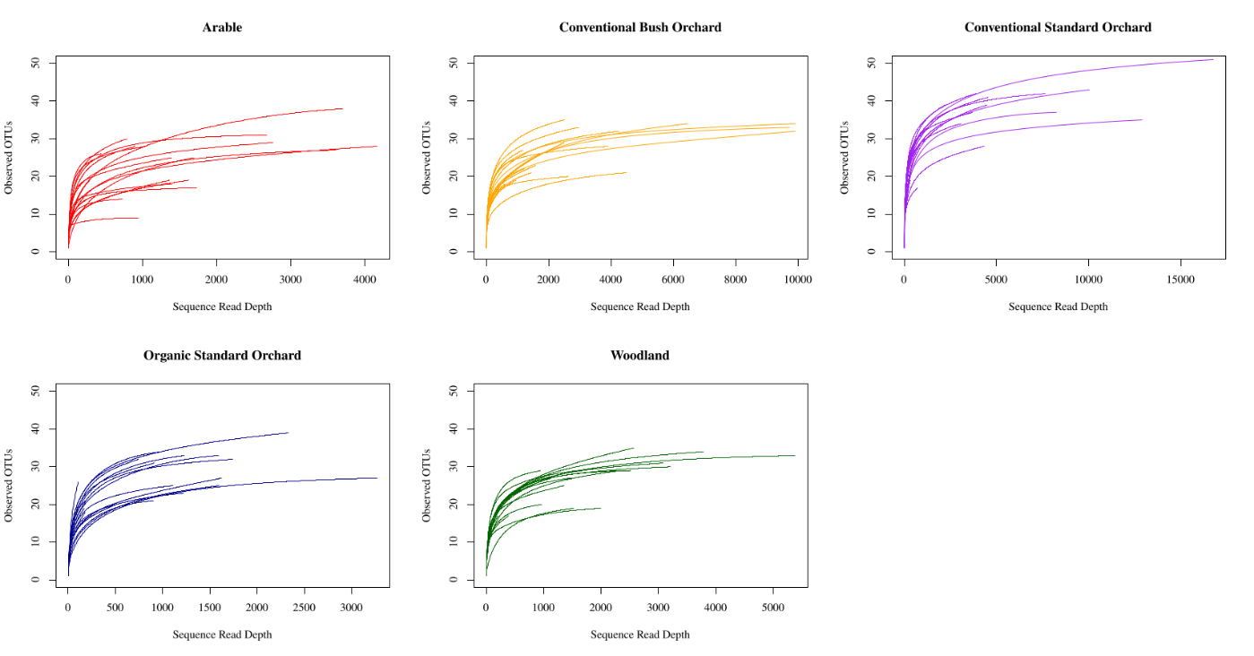
Figure 3.2 Alpha rarefaction measurements of OTU number with sampling depth for reverse read sequences. Individual lines show rarefaction curves for each of the 19 sites sampled per habitat type.

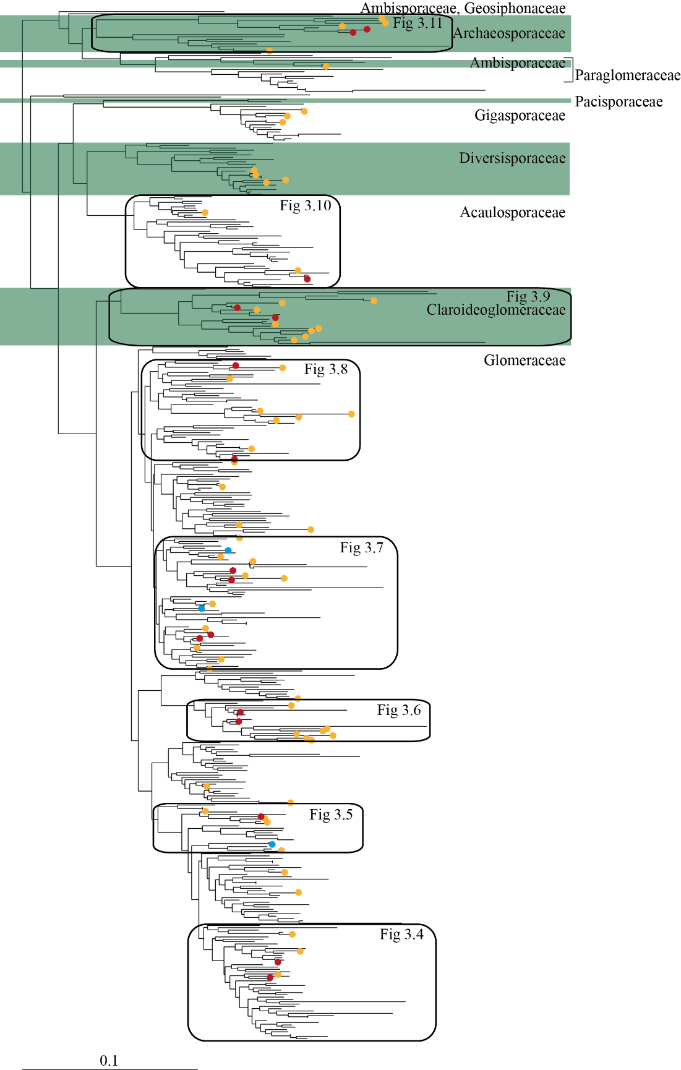
Figure 3.3 Neighbour joining tree showing the phylogenetic relationship of OTUs identified by this study to all Glomeromycotan virtual taxa type sequences available from the MaarjAM database (Opik et al., 2010). OTU positions are indicated by coloured circles. Colour codes represent OTU abundance and are as follows; red: >1% of total sequences; orange: <1% of total sequences. Fungal genera are shaded according to classification of VTs within the MaarjAM database.
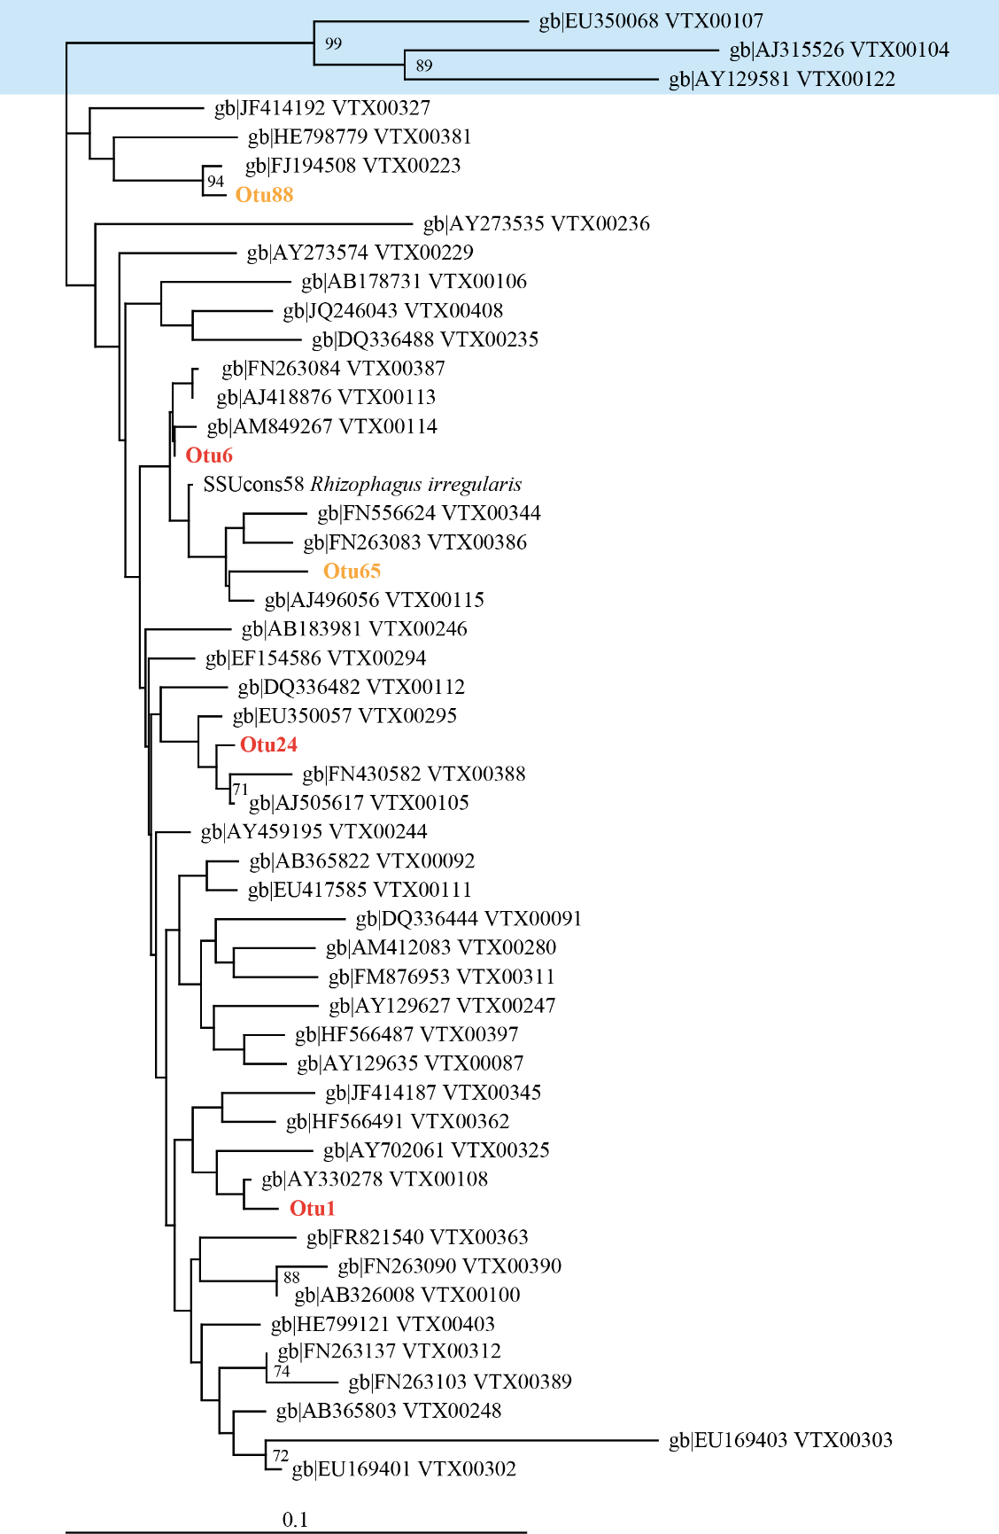
Figure 3.4 Neighbour joining tree showing the phylogenetic similarity of OTU1, 6 and 24 to Glomus virtual taxa type sequences from MaarjAM database (Opik et al., 2010). NCBI Genbank accession numbers and MaarjAM VT numbers are labelled for each type sequence. OTUs labelled according to relative OTU abundance within total sequences numbers; red: >1% totals sequences; orange: <1% total sequences. Blue shaded VT’s indicate Glomus outgroups. Bootstrap values >70% are shown.

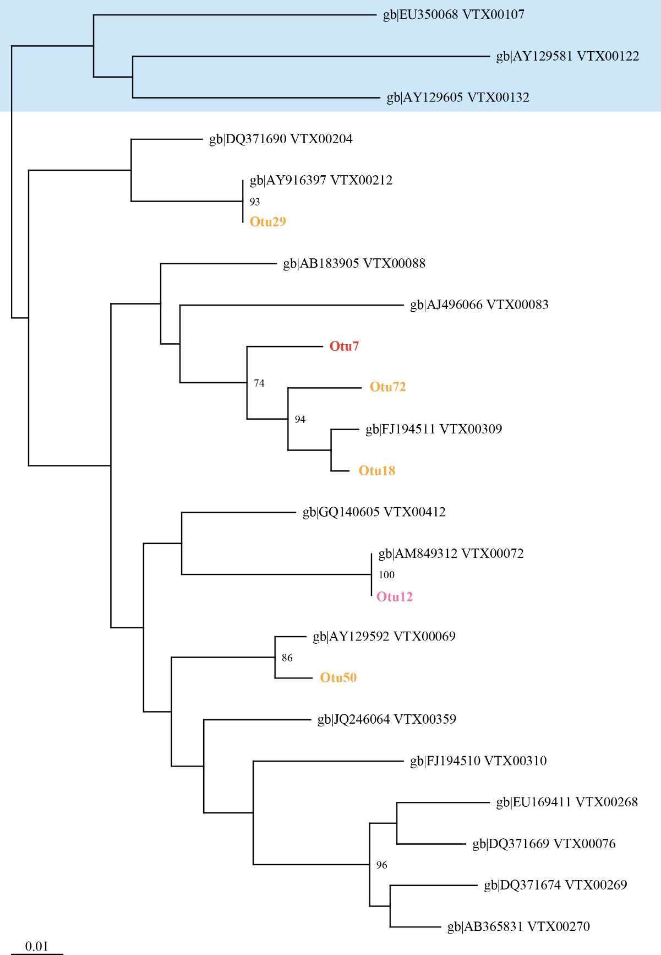

Figure 3.5 Neighbour joining tree showing the phylogenetic similarity of OTU 7 to Glomus virtual taxa type sequences from MaarjAM database (Opik et al., 2010). NCBI Genbank accession numbers and MaarjAM VT numbers are labelled for each type sequence. OTUs labelled according to relative OTU abundance within total sequences numbers; red: >1% totals sequences; orange: <1% total sequence, pink: <1% total sequences but significantly different relative abundance shown between habitat types. Blue shaded VT’s indicate Glomus outgroups. Bootstrap values >70% are shown.
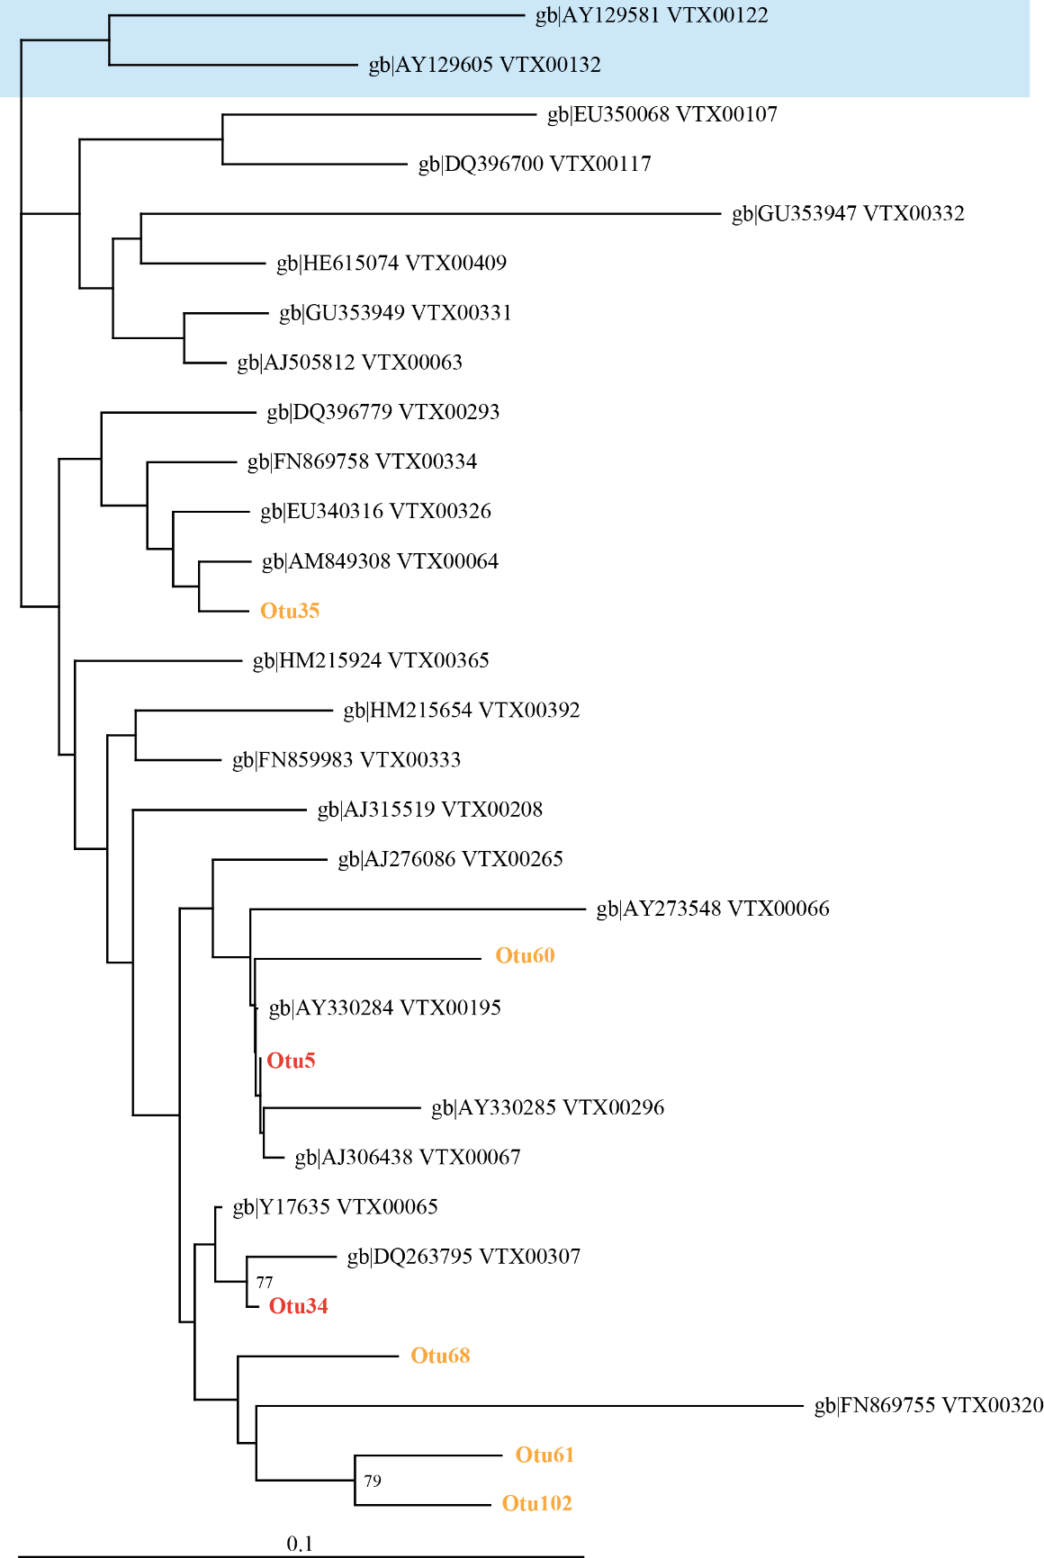

Figure 3.6 Neighbour joining tree showing the phylogenetic similarity of OTU 5 and 34 to Glomus virtual taxa type sequences from MaarjAM database (Opik et al., 2010). NCBI Genbank accession numbers and MaarjAM VT numbers are labelled for each type sequence. OTUs labelled according to relative OTU abundance within total sequences numbers; red: >1% totals sequences; orange: <1% total sequence. Blue shaded VT’s indicate Glomus outgroups. Bootstrap values >70% are shown.

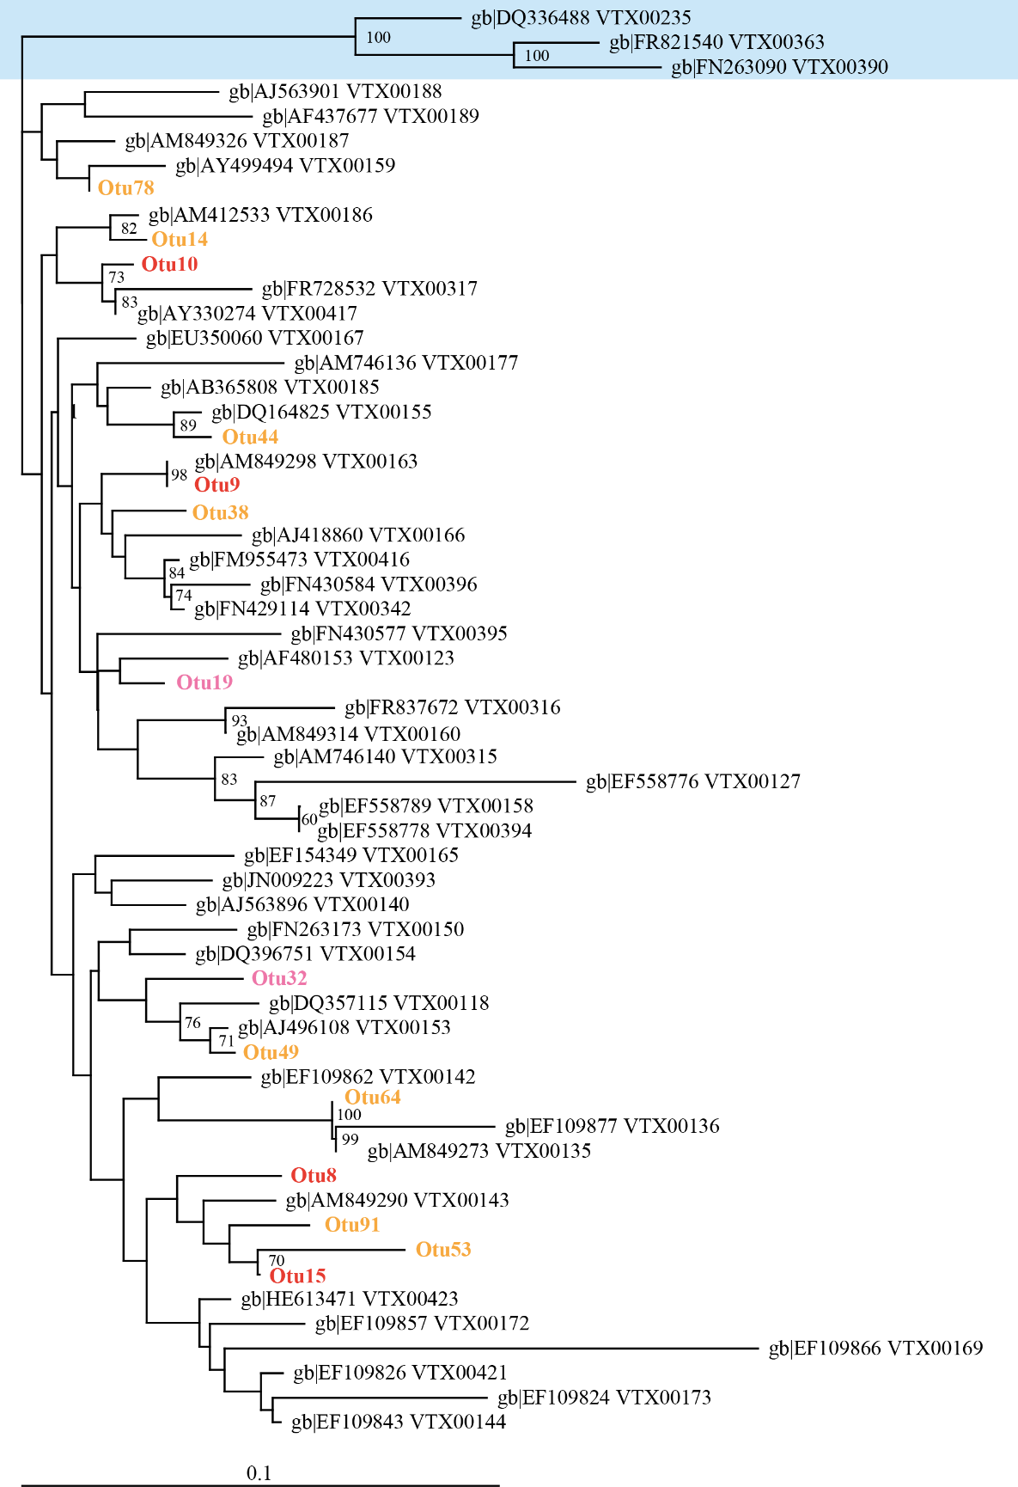

Figure 3.7 Neighbour joining tree showing the phylogenetic similarity of OTU 8, 9, 10 and 15 to Glomus virtual taxa type sequences from MaarjAM database (Opik et al., 2010). NCBI Genbank accession numbers and MaarjAM VT numbers are labelled for each type sequence. OTUs labelled according to relative OTU abundance within total sequences numbers; red: >1% totals sequences; orange: <1% total sequence, pink: <1% total sequences but significantly different relative abundance shown between habitat types. Blue shaded VT’s indicate Glomus outgroups. Bootstrap values >70% are shown.
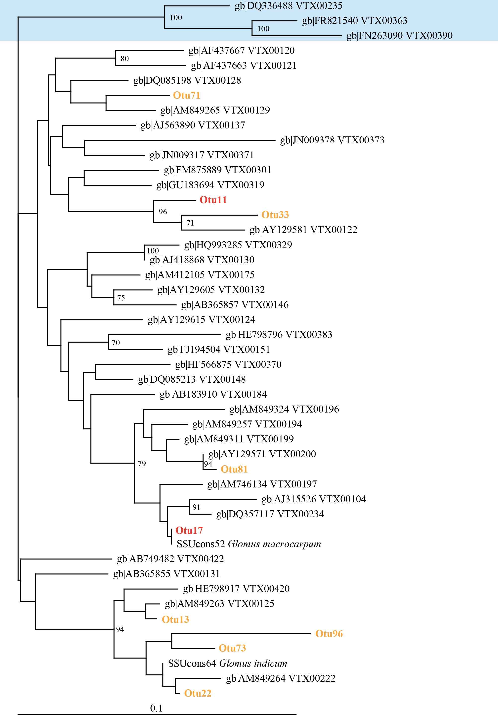

Figure 3.8 Glomus subgroup 5 neighbour joining tree showing the phylogenetic similarity of OTU 11 and 17 to Glomus virtual taxa type sequences from MaarjAM database (Opik et al., 2010). NCBI Genbank accession numbers and MaarjAM VT numbers are labelled for each type sequence. OTUs labelled according to relative OTU abundance within total sequences numbers; red: >1% totals sequences; orange: <1% total sequence. Blue shaded VT’s indicate Glomus outgroups. Bootstrap values >70% are shown.

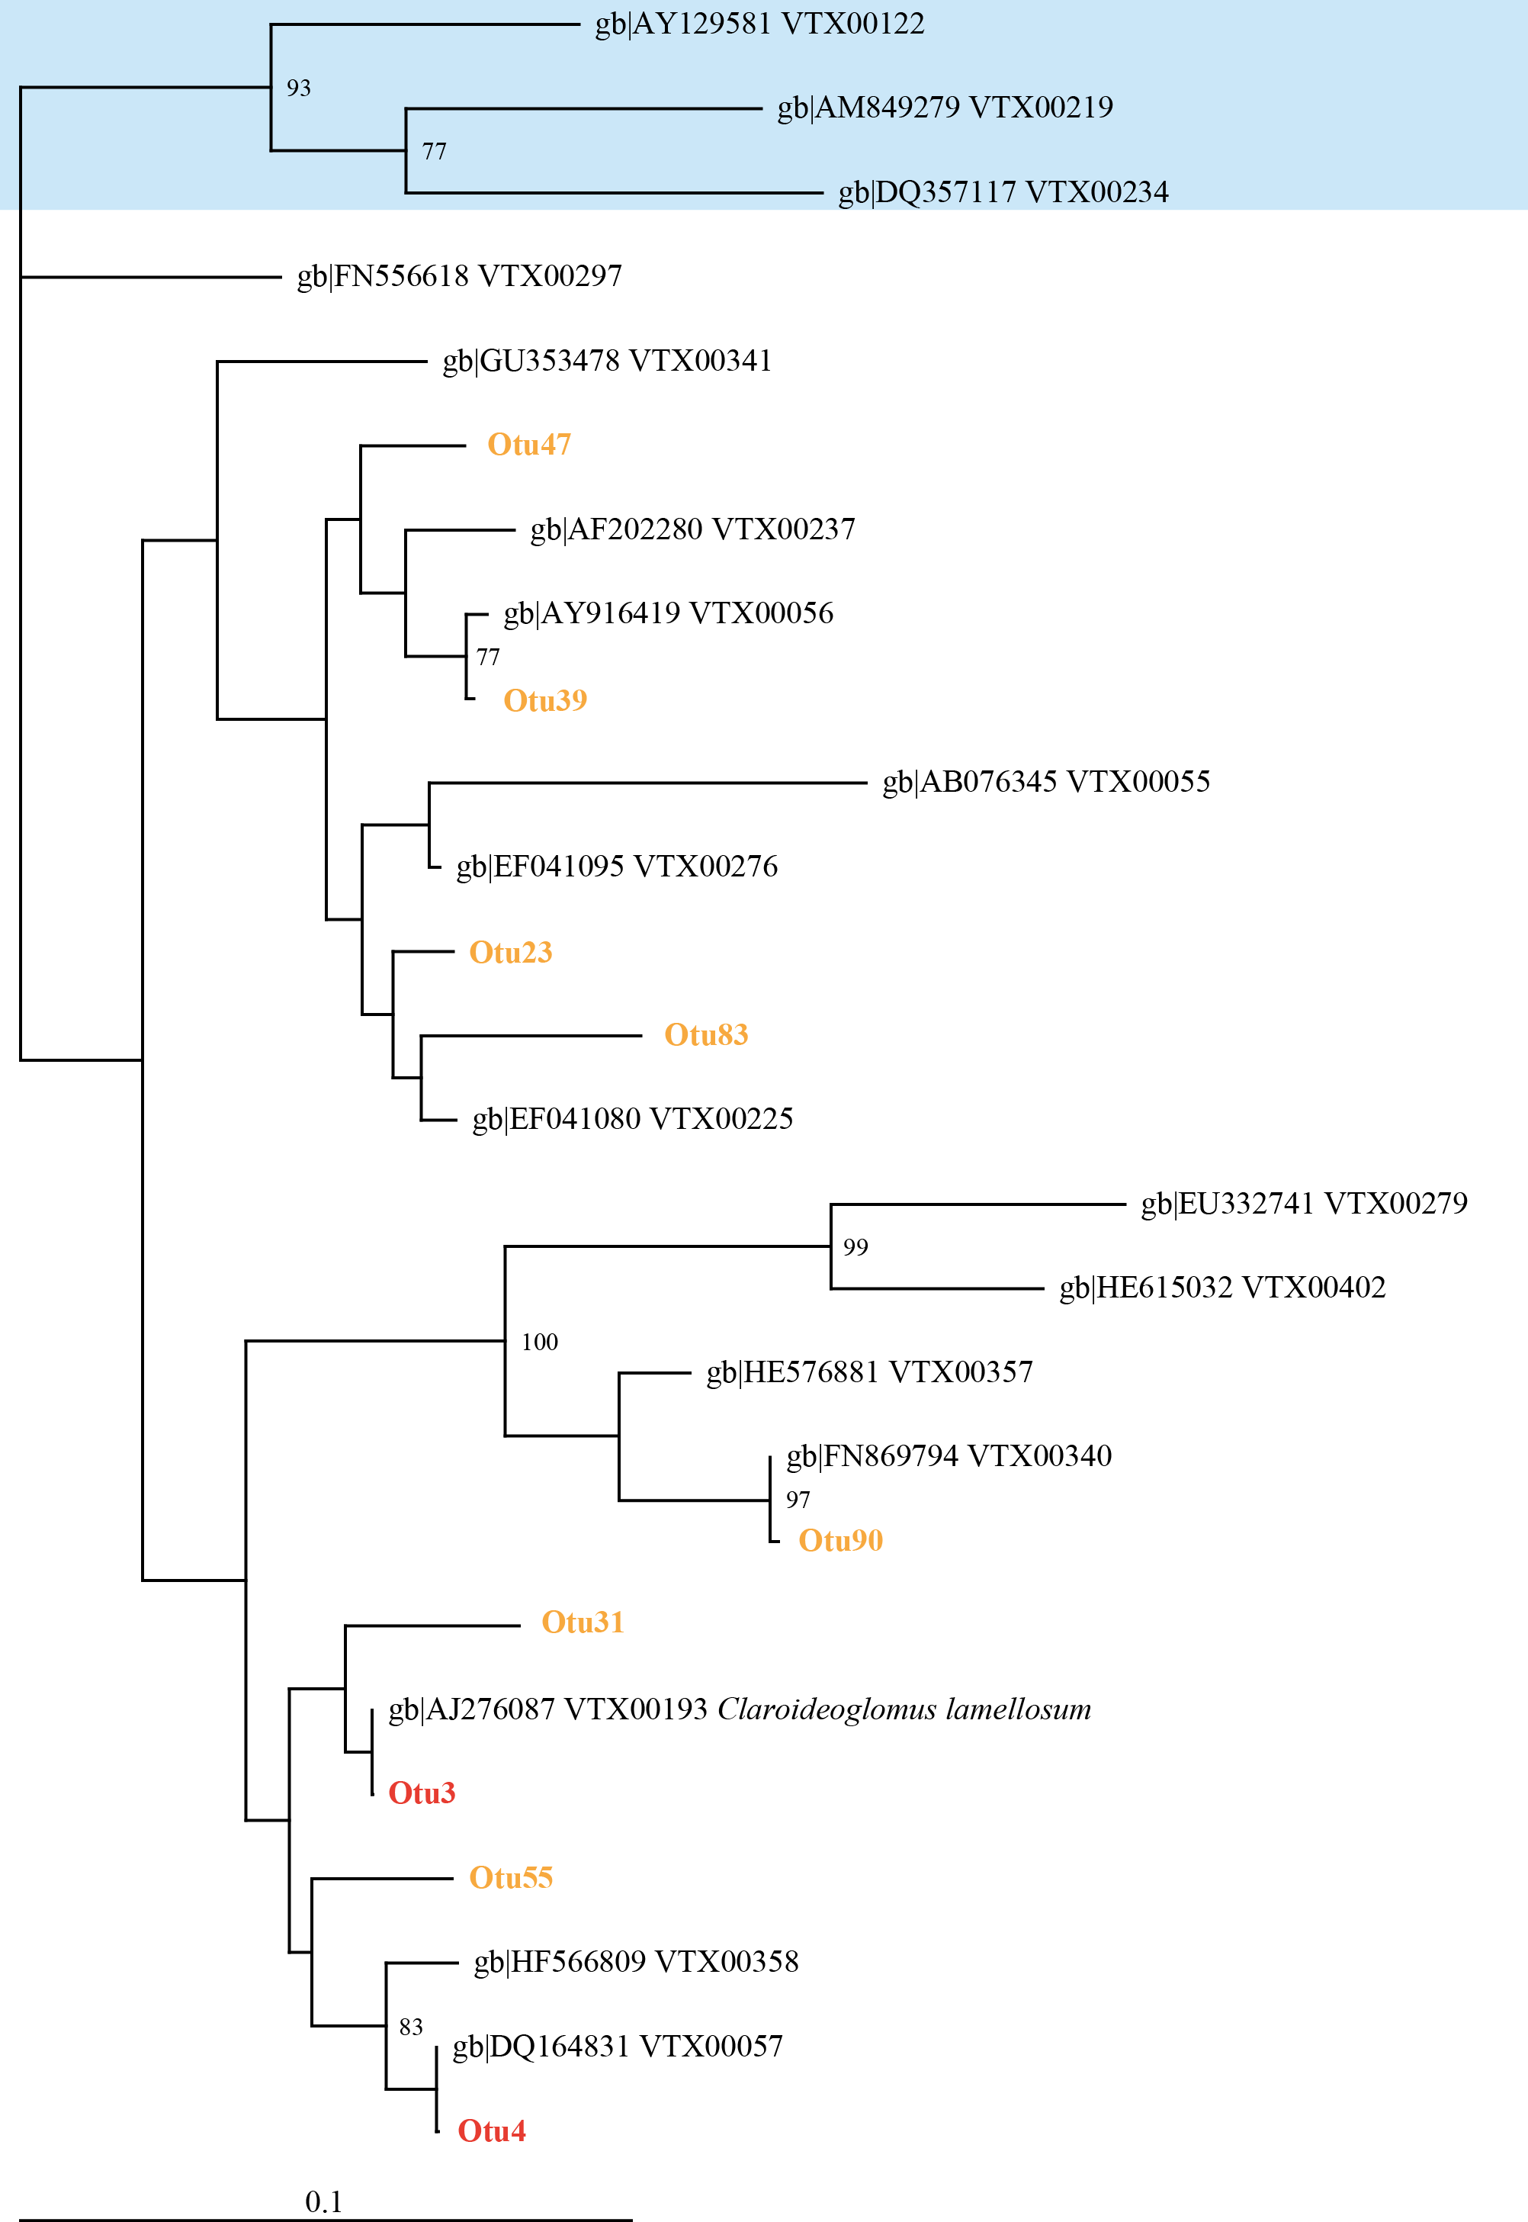
Figure 3.9 Neighbour joining tree showing the phylogenetic similarity of OTU 3 and 4 with Claroideoglomus virtual taxa type sequences from MaarjAM database (Opik et al., 2010). NCBI Genbank accession numbers and MaarjAM VT numbers are labelled for each type sequence. OTUs labelled according to relative OTU abundance within total sequences numbers; red: >1% totals sequences; orange: <1% total sequence. Blue shaded VT’s indicate Glomus outgroups. Bootstrap values >70% are shown.

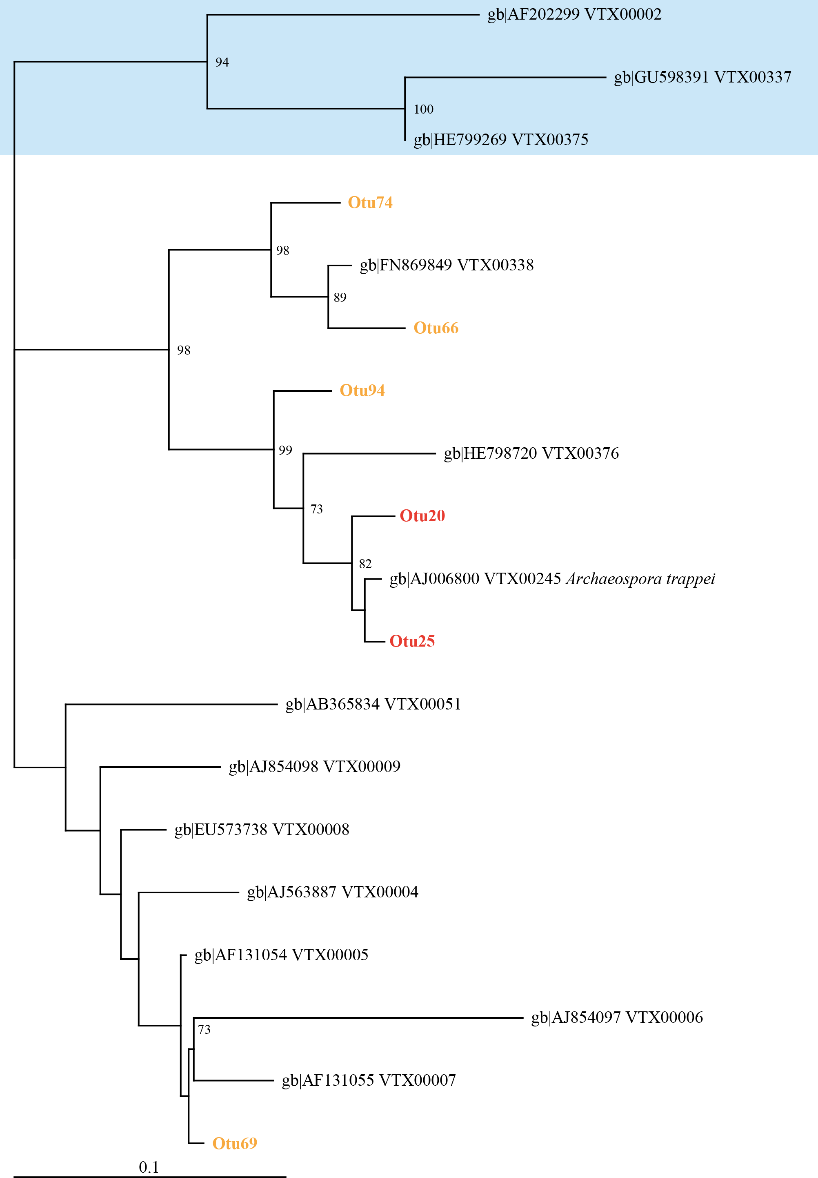
Figure 3.10 Neighbour joining tree showing the phylogenetic similarity of OTU20 and 25 to Archaeospora virtual taxa type sequences from MaarjAM database (Opik et al., 2010). NCBI Genbank accession numbers and MaarjAM VT numbers are labelled for each type sequence. OTUs labelled according to relative OTU abundance within total sequences numbers; red: >1% totals sequences; orange: <1% total sequence, pink: <1% total sequences but significantly different relative abundance shown between habitat types. Blue shaded VT’s indicate Paraglomus outgroups. Bootstrap values >70% are shown.
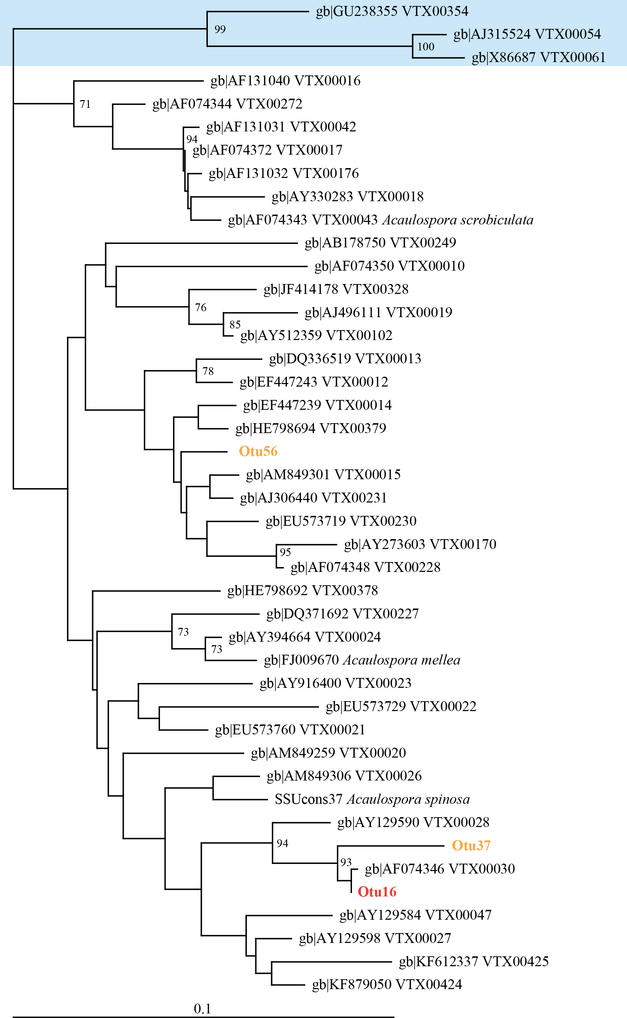

Figure 3.11 Neighbour joining tree showing the phylogenetic similarity of OTUs identified by this study with Acaulospora virtual taxa type sequences from MaarjAM database (Opik et al., 2010). NCBI Genbank accession numbers and MaarjAM VT numbers are labelled for each type sequence. OTUs labelled according to relative OTU abundance within total sequences numbers; red: >1% totals sequences; orange: <1% total sequence. Blue shaded VT’s are Diversispora outgroups. Bootstrap values >70% are shown

Results

Comparison between AMF communities of three orchard types, woodland and arable fields using TRFLP

Richness and Simpson’s diversity
TRFLP analysis of the AMF colonising leek bait plant roots produced a total of 20 distinct TRFs with 10 unique TRFs produced from restriction with both Hinf-I and HpyCH4-III enzymes. Habitat type was shown to significantly affect the TRF richness of both the TRFs grouped from restriction with both enzymes and TRFs from restriction with Hinf-I only (Table 3.2, Figure 3.12). For the combined restriction analysis arable habitats had the lowest TRF richness of all habitats and showed a small but significantly reduced average TRF number of 12.4 TRFs in comparison to conventional standard orchards which were the most TRF species rich habitat with 13.2 TRFs on average per orchard (Figure 3.12). Conventional bush orchards, organic standard orchard and woodland were intermediate in their TRF richness with average TRF richness values of 12.7, 13.0 and 12.6 TRFs respectively (Figure 3.12a). A highly similar pattern was showed for TRF richness from Hinf-I only restriction (Figure 3.12b) however no significant difference between TRF richness of habitats was shown for HpyCH4-III restriction (Figure 3.12c).
A significant effect of habitat type was also shown for Simpson’s diversity index values when analysed both for the grouped TRF data and for separate restriction enzymes (Table 3.2, Figure 3.12). In most cases arable habitats showed a small but significant reduction in Simpson’s diversity values in comparison to woodland and orchard habitats. For grouped TRF data from restriction with both enzymes, arable habitats showed an average Simpson’s diversity index of 4.6 in comparison to values of 5.32, 5.31, 5.41 and 5.57 found for woodland, conventional bush orchards, conventional standard orchards and organic standard orchards respectively (Figure 3.12d).
Comparison of TRF richness and Simpson’s diversity index for both grouped and separate restriction show that similar effects of habitat are found by the separate restriction enzymes. The increased level of significance when grouping TRFs produced by restriction with Hinf-I and HpyCH4-III combined in comparison to separate analysis (Table 3.2) demonstrates the advantage of using two restriction enzymes.

Community structure
Principal component analysis of relative TRF abundance showed a clear effect of habitat upon PC1, PC2, PC4 and PC5 which when combined, account for 77% of the variation in the relative abundance data (Table 3.4, Figure 3.13). No difference in principal component scores was shown between orchards. Arable habitats differed from all orchards for PC1, organic standard orchard for PC4 and conventional bush orchards for PC5 (Table 3.4).
TRF presence/absence data showed that habitat had far less effect on the presence/absence of TRFs with a significant effect of habitat type only found for PC4 which accounted for 8.1% of the data variation (Table 3.4, Figure 3.13). PC4 showed separation of arable from both orchard and woodland habitats (Table 3.4). A marginal effect of habitat was shown for PC2 which accounts for 16.8% of the data variation (Table 3.4, Figure 3.13). Principal component analysis shows that habitat has a larger effect upon the relative abundance of TRFs than their presence/absence i.e. greater differences are seen within the relative abundance of TRFs between habitats than the presence/absence of TRFs.

TRF relative abundance
OPLS-DA and subsequent ANOVA tests on the effect of habitat type upon relative abundance of fungal TRFs showed that 12 TRFs were significantly affected by habitat type (Table 3.3). Arable habitats showed a distinct difference in relative abundance of TRFs compared to all other habitat types with arable TRF relative abundance being significantly different to all orchard and woodland habitats for 7 of the 12 TRFs which were found to be affected by habitat and significantly different to at least one other habitat for the remaining 5 (Figure 3.14, Figure 3.15). Of the three orchard types, arable habitats were found to be most similar to the conventional bush orchards with four TRFs showing no significant difference in relative abundance (Hinf-I 765, and HpyCH4-III 393, 547 and 699). In comparison conventional standard orchards had only two TRFs which showed similar relative abundance to arable habitats (Hinf-I 765 and HpyCH4-III) and organic standard orchards only one TRF with a similar relative abundance to that of arable (Hinf-I 765). Arable and woodland habitats showed the least similarity with all 12 of the TRFs with relative abundance affected by habitat type showing significantly different relative abundance within these two habitats.
In comparison the three orchard types compared (conventional bush, conventional standard and organic standard) showed highly similar relative abundances of fungal TRFs with a significant difference in TRF relative abundance between orchard types only found for one TRF; HpyCH4-III 699bp (Figure 3.14). Conventional bush orchards showed a significantly lower relative abundance of the 699bp TRF when compared to its relative abundance within organic standard orchards. To check for the effect of extreme values of woodland and arable habitats TRF relative abundance values masking significance of more subtle differences in TRF relative abundance between the three orchard types, ANOVA tests for TRF relative abundance were repeated but with exclusion of woodland and arable sites. This analysis also showed a significant difference in TRF relative abundance between the three orchard types for HpyCH4-III 699bp only.
Relative abundance of TRFs within woodland habitats in general showed similarity to those of the three orchard types and was only found to be significantly different to one or more of the orchard types in 2 (HpyCH4-III 393bp and HpyCH4-III 547bp) of the 12 TRF sizes significantly affected by habitat (Figure 3.14c and e). For the HpyCH4-III 393bp fragment relative TRF abundance within woodlands was significantly lower than that of conventional bush and conventional standard orchards but not significantly different to organic orchards. Contrastingly relative abundance of the HpyCH4-III 547 fragment within woodland was significantly higher than that of all other habitats. Therefore organic standard orchards were most similar to woodlands of the three orchard types in terms of TRF relative abundance.
Table 3.2 One-way ANOVA results for effect of habitat on TRF richness and Simpson’s reciprocal diversity index. Analysis was performed on the TRFs both grouped and separately from restriction with Hinf-I and HpyCH4-III.
Diversity Measure | Restriction enzymes |  | F_{1,4} | P
Richness | Hinf-I and HpyCH4-III (grouped) |  | 3.56 | 0.009
 | Hinf-I* |  | 3.42 | 0.012
 | HpyCH4-III |  | 1.39 | 0.243
Simpson’s reciprocal diversity index | Hinf-1 and HpyCH4-III (grouped) |  | 5.27 | 0.001
 | Hinf-I |  | 3.86 | 0.006
 | HpyCH4-III |  | 3.44 | 0.011
*values were log transformed prior to analysis to meet test assumptions

Table 3.3 One-way ANOVA results for effect of habitat type (woodland, conventional bush orchard, conventional standard orchard, organic standard orchard and arable) on AMF community composition as measured by TRF relative abundance using two restriction enzymes: Hinf-I and HpyCH4-III.
Restriction enzyme | TRF size (bp) | F_{1,4} | P
Hinf-I | 376 | 1.918 | 0.112
 | 424 | 7.634 | <0.001
 | 512 | 1.822 | 0.129
 | 518 | 17.14 | <0.001
 | 689 | 1.399 | 0.238
 | 699 | 2.466 | 0.048
 | 704 | 1.916 | 0.112
 | 723 | 0.973 | 0.425
 | 765 | 3.933 | 0.004
 | 771 | 10.12 | <0.001
HpyCH4-III | 340 | 17.14 | <0.001
 | 353 | 4.465 | 0.002
 | 393 | 9.331 | <0.001
 | 431 | 7.271 | <0.001
 | 547 | 11.21 | <0.001
 | 699 | 7.461 | <0.001
 | 705 | 12.35 | <0.001
 | 744 | 1.00 | 0.410
 | 764 | 2.086 | 0.086
 | 771 | 2.054 | 0.091

Figure 3.12 Mean TRF number per habitat type calculated from restriction with (a) both enzymes combined (b) Hinf-I, (c) HpyCH4-III. Mean Simpson’s diversity indices calculated from restriction with (d) both enzymes (e) Hinf-I, (f) HpyCH4-III. Error bars show SE of mean (n=25). Habitat codes are as follows; (A; arable, CB; conventional bush orchard, CS; conventional standard orchard, OS; organic standard orchard; W; woodland.). Habitats with the same letter do not differ significantly from one another (Tukey, HSD P<0.05).

Table 3.4. TRFLP principal component scores which showed significant differences between the five habitat types. Statistical differences between principal component scores of habitats were calculated using a 1-way ANOVA test with PC score as the response, habitat as the predictor and site as a random factor. Habitats with the same letter do not differ significantly from one another (Tukey HSD, p<0.05). Only results for principal component scores which are significantly affected by habitat are presented. TRFs produced from both restriction with Hinf-I and HpyCH4-III restriction enzymes are presented.
 |  |  |  | Principal component score mean and (±SE) per habitat
Data | PC | F_{1,4} | P | Arable |  | Conventional Bush orchard |  | Conventional Standard Orchard |  | Organic Standard Orchard |  | Woodland
TRF Relative abundance | 1 | 24.63 | <0.001 | -26.28 ^{A} | (3.42) | 6.23 ^{B} | (3.05) | 5.55 ^{B} | (2.48) | 4.55 ^{B} | (2.36) | 9.93 ^{B} | (3.16)
TRF Relative abundance | 2 | 2.78 | 0.031 | 1.69^{AB} | (2.81) | -5.96^{A} | (2.44) | -0.30^{AB} | (2.92) | -1.18^{AB} | (2.63) | 5.75^{B} | (2.77)
TRF Relative abundance | 4 | 4.52 | 0.002 | 5.90^{B} | (1.96) | 1.98^{AB} | (1.84) | -1.55^{AB} | (1.74) | -1.65^{A} | (1.60) | -4.67^{A} | (2.71)
TRF Relative abundance | 5 | 6.09 | <0.001 | -2.20^{A} | (1.61) | 5.14^{B} | (1.14) | -2.33^{A} | (1.13) | 1.15^{AB} | (1.37) | -1.76^{A} | (1.30)
TRF Presence absence | 2 | 2.38 | 0.050* | 0.07^{A} | (0.01) | 0.05^{A} | (0.01) | -0.14^{A} | (0.09) | -0.01^{A} | (0.07) | 0.02^{A} | (0.03)
TRF Presence absence | 4 | 4.35 | 0.003 | 0.133^{B} | (0.07) | -0.04^{A} | (0.00) | -0.01^{A} | (0.03) | -0.02^{A} | (0.00) | -0.03^{A} | (0.01)

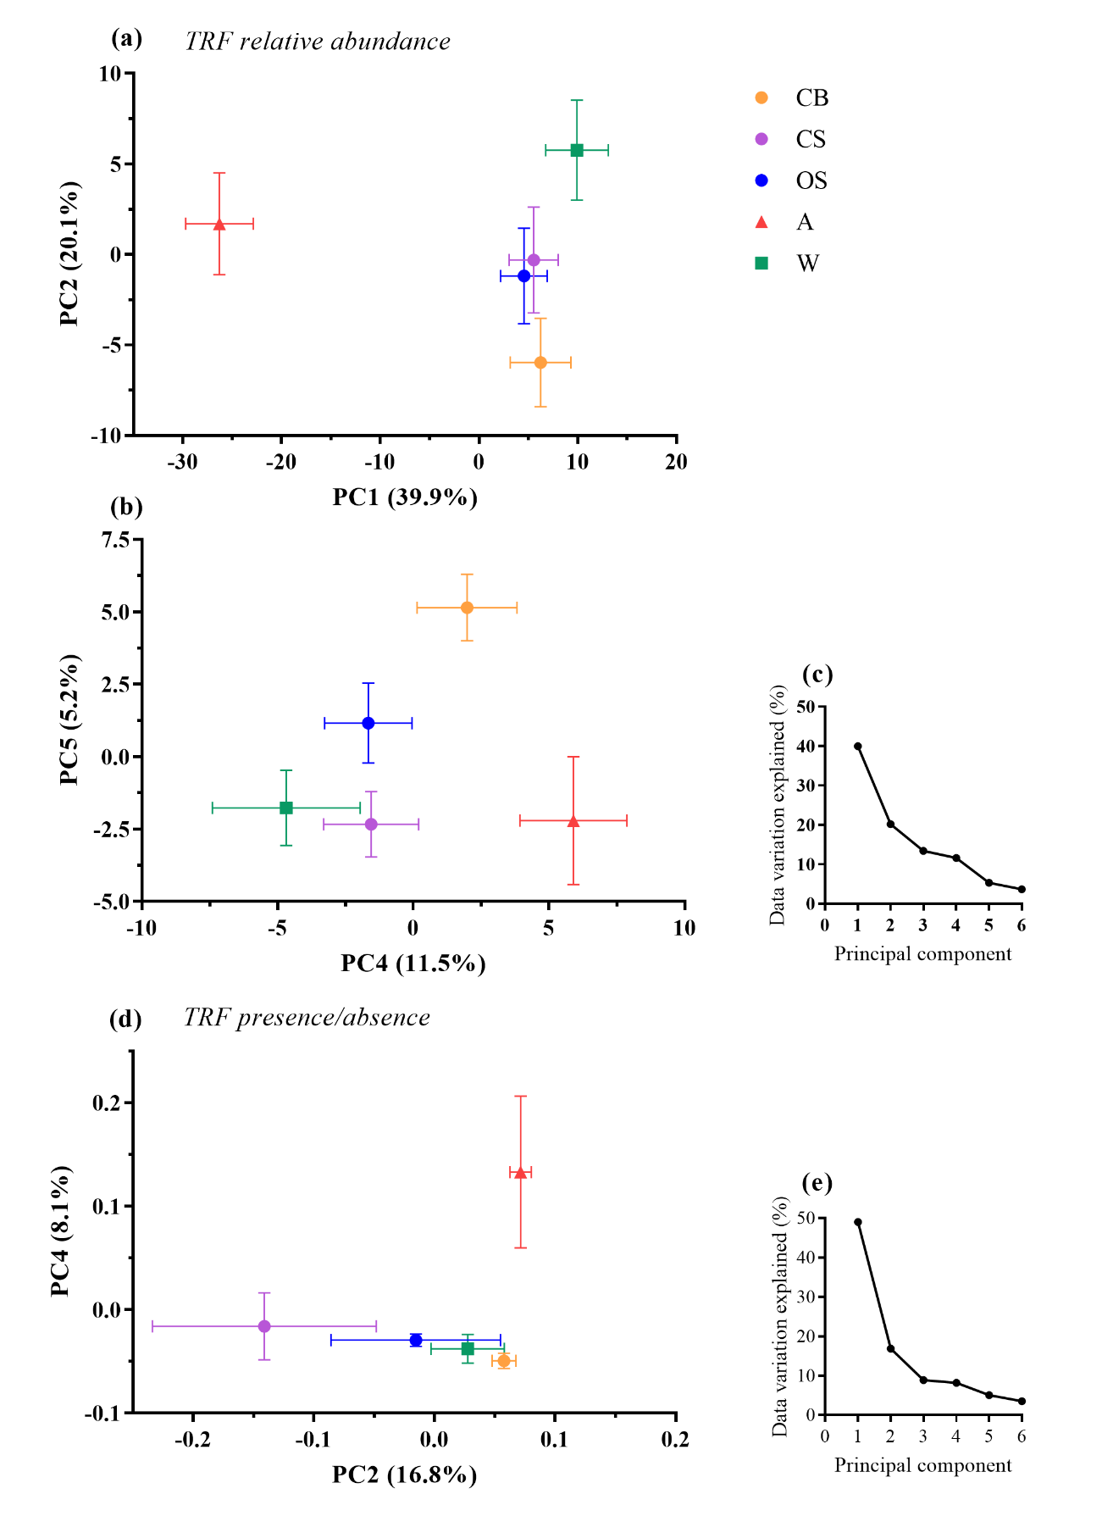
Figure 3.13 PCA scores which were significantly affected by habitat type for (a) and (b) TRF relative abundance, (d) TRF presence/absence. PCA analysis showed that TRF relative abundance was more strongly effected by habitat type than TRF presence/absence. Percentage variation in data explained by principal components from analysis of (c) relative abundance data and (e) TRF presence/absence. Habitat types are as follows; A; Arable, CB; conventional bush orchard, CS; conventional standard orchard, OS; organic standard orchard, W; woodland. TRF data is from both restriction with both Hinf-I and HpyCH4-III restriction enzymes
Figure 3.14 Average relative abundance of terminal restriction fragments (TRF) per habitat type. Habitat codes; A = Arable, CB = Conventional bush orchard, CS = Conventional standard orchard, OS = Organic standard orchard, W = woodland. Error bars show SE of mean (n = 25). Treatments with the same letter do not differ significantly from one another (Tukey HSD, P<0.05). TRFs produced from both restriction with Hinf-I and HpyCH4-III restriction enzymes are presented
Figure 3.15 Average relative abundance of terminal restriction fragments (TRF) per habitat type. Habitat codes; A = Arable, CB = Conventional bush orchard, CS = Conventional standard orchard, OS = Organic standard orchard, W = woodland. Error bars show SE of mean (n = 25). Treatments with the same letter do not differ significantly from one another (Tukey HSD, P<0.05). TRFs produced from both restriction with Hinf-I and HpyCH4-III restriction enzymes are presented

Characterisation and comparison of AMF communities found within three orchard management types, woodland and arable using Illumina Sequencing

Richness and Simpson’s diversity
One-way ANOVA tests for the effect of habitat type (woodland, conventional bush orchard, conventional standard orchard and arable) on OTU richness using sequence read data rarefied to a depth of 1500 reads showed a significant effect of habitat type upon OTU richness (ANOVA (F_{1,4} =2.80, P=0.034) (Figure 3.16a). On average OTU richness was highest in conventional standard orchards (mean of 34 OTUs) and lowest in arable (mean of 27 OTUs). CB =28, OS =31, W = 32. There was no significant effect of habitat type upon Simpson’s diversity index (F_{1,4} =2.07, P=0.097) (Figure 3.16b).

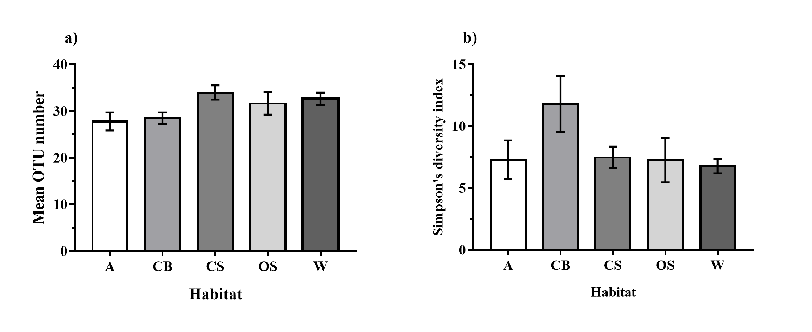

Figure 3.16 (a) Mean OTU richness per habitat and (b) Mean Simpson’s diversity indices per habitat. Both OTU richness and Simpson’s diversity indices were calculated using sampling depth of reverse reads rarefied to 1,500 reads. Habitat codes are as follows: A; arable, CB; conventional bush orchard, CS; conventional standard orchard, OS; organic standard orchard; W; woodland). Error bars show SE of mean (A; n=9, CB; n=14, CS; n=14, OS; n=9, W; n=14). Reduced sample sizes per habitat are due to exclusion of all samples with fewer than 1,500 reads from this analysis.

Community composition analysis
Principal component analysis of OTU relative abundance showed a significant effect of habitat for PC1, PC2, PC4, PC5, PC6 and PC9 (Figure 3.17a, b, c) which combined explain 66% of the data variation (Figure 3.17b). PC scores of orchards were highly similar with differences only reported between conventional bush orchards and conventional standard orchards for PC1 (Table 3.5). In comparison significant differences were found between the principal component scores of orchards and woodland habitats for PC2 and PC4. Arable habitats showed greater dissimilarity from orchard types with significant differences reported for principal component scores 1, 6 and 9 (Table 3.5).
Principal component analysis of OTU presence and absence data also showed habitat significantly affected PC1, PC2, PC3, PC4, PC5 and PC7 scores which together account for 40.56 % of the variation in the data (Table 3.5, Figure 3.18). Post hoc Tukey HSD tests on all principal components significantly affected by habitat showed significant differences between conventional bush and conventional standard orchards PC1 scores and PC5 scores (Tukey HSD, P<0.05) but no other differences between orchards types were found. In comparison to woodlands orchards showed significant different in principal component scores for PC1, PC2 and PC3 (Table 3.5) which combined account for under 31% of the variation in the data. Significant differences between principal component scores of orchards and arable were reported for PC1, PC5 and PC7 under 25% of data variation.

OTU relative abundance
OPLS-DA analysis and subsequent ANOVA tests showed 14/79 OTUs had significant differences in relative abundance between habitat types (Table 3.6, Figure 3.19). (OPLS-DA loading plots for sequencing data anlysis are presented in Appendix B.2). A clear difference was seen between woodland and arable habitats which showed significant differences in OTU relative abundance for 11/14 OTUs (Figure 3.19).
The three orchard management types showed a high level of similarity in OTU relative abundance with no differences in relative abundance of any OTUs found between conventional standard and organic standard orchards. Differences between conventional bush orchards and conventional standard orchards weres shown in relative abundance of OTU 4 and OTU 7 (Figure 3.19c and e) and between conventional bush orchards compared to both conventional standard orchard and organic standard orchards for relative abundance of OTU 32 (Figure 3.19m).
A general trend of orchards showing intermediate relative abundance between arable and woodland habitats was shown. Differences between arable and orchard OTU relative abundances were as follows; conventional bush orchards (four OTUs: 7, 5, 25, 34), conventional standard orchards (five OTUs: 3, 4, 25, 32, 34) and organic standard orchards (two OTUs: 25, 34). Differences between woodland and orchards OTU relative abundance were as follows; conventional bush orchards (Six OTUs: 4, 7, 8, 9, 10, 19), conventional standard orchards (six OTUs: 1, 5, 8, 9, 10, 19), organic standard orchards (three OTUs; 9, 10, 19).

Table 3.5 Reverse sequence principal component scores which showed significant differences between the five habitat types. Statistical differences between principal component scores of habitats were calculated using a one-way ANOVA test with PC score as the response, habitat as the predictor and site as a random factor. Habitats with the same letter do not differ significantly from one another (Tukey HSD, p<0.05). Only results for principal component scores which are significantly affected by habitat are presented.
 |  |  |  | Principal component score mean and (±SE) per habitat
Data | PC | F_{1,4} | P | Arable |  | Conventional Bush orchard |  | Conventional Standard Orchard |  | Organic Standard Orchard |  | Woodland
OTU Relative abundance | 1 | 8.87 | <0.001 | 10.85^{C} | (2.88) | -10.40^{A} | (4.95) | 6.20^{BC} | (1.88) | -4.72^{AB} | (2.90) | -1.92^{AB} | (1.57)
OTU Relative abundance | 2 | 11.23 | <0.001 | -5.14^{A} | (2.97) | -7.90^{A} | (3.44) | 0.06^{A} | (2.54) | -0.78^{A} | (2.18) | 13.78^{B} | (1.77)
OTU Relative abundance | 4 | 4.05 | 0.005 | -3.63^{A} | (2.55) | -1.67^{A} | (2.10) | -3.00^{A} | (3.00) | -0.34^{AB} | (1.77) | 8.65^{B} | (2.06)
OTU Relative abundance | 5 | 3.09 | 0.021 | -4.49^{A} | (4.00) | 0.77^{AB} | (1.59) | 0.00 ^{AB} | (0.08) | -1.98^{AB} | (1.44) | 5.70 ^{B} | (1.39)
OTU Relative abundance | 6 | 6.34 | <0.001 | -7.66^{A} | (1.91) | 4.55^{B} | (2.40) | 3.85 ^{B} | (1.21) | 0.86^{B} | (2.11) | -1.60^{AB} | (2.09)
OTU Relative abundance | 9 | 4.30 | <0.004 | 3.99 ^{B} | (1.49) | 0.40^{AB} | (0.90) | -2.95^{A} | (0.97) | -1.35^{A} | (0.74) | -0.09^{AB} | (2.27)
OTU Presence absence | 1 | 7.05 | <0.001 | -0.80^{A} | (0.25) | -0.17^{A} | (0.17) | 0.99 ^{B} | (0.31) | 0.06^{AB} | (0.21) | -0.07^{A} | (0.18)
OTU Presence absence | 2 | 10.74 | <0.001 | -0.05^{A} | (0.21) | -0.33^{A} | (0.18) | -0.07^{A} | (0.18) | -0.54^{A} | (0.07) | 1.00^{B} | (0.17)
OTU Presence absence | 3 | 4.46 | 0.003 | -0.34^{A} | (0.18) | -0.29^{A} | (0.16) | -0.14^{A} | (0.21) | 0.18^{AB} | (0.20) | 0.60^{B} | (0.12)
OTU Presence absence | 4 | 3.01 | 0.023 | 0.28^{A} | (0.16) | 0.21^{A} | (0.16) | -0.26^{A} | (0.14) | 0.07^{A} | (0.14) | -0.30^{A} | (0.17)
OTU Presence absence | 5 | 6.26 | <0.001 | 0.37^{C} | (0.11) | -0.40^{A} | (0.12) | 0.31^{BC} | (0.20) | -0.09^{ABC} | (0.12) | -0.18^{AB} | (0.12)
OTU Presence absence | 7 | 4.57 | 0.002 | 0.38^{B} | (0.10) | -0.36^{A} | (0.15) | -0.05^{AB} | (0.11) | 0.01^{AB} | (0.15) | 0.01^{AB} | (0.11)

Table 3.6 ANOVA results for effect of habitat type (woodland, conventional bush orchard, conventional standard orchard, organic standard orchard and arable) on OTU relative abundance. Results are presented for all OTUs with relative abundance >1% of total sequence reads.
OTU number | Family |  | Relative abundance (%) |  | F_{1,4} | P
OTU 1 | Glomeraceae |  | 12.18 |  | 4.14 | 0.004
OTU 6 | Glomeraceae |  | 11.96 |  | 0.81 | 0.525
OTU3 | Claroideoglomeraceae |  | 9.05 |  | 3.49 | 0.012
OTU4 | Claroideoglomeraceae |  | 8.04 |  | 5.03 | 0.001
OTU5 | Glomeraceae |  | 7.73 |  | 3.18 | 0.018
OTU8 | Glomeraceae |  | 7.55 |  | 7.39 | <0.001
OTU7 | Glomeraceae |  | 7.09 |  | 7.52 | <0.001
OTU9 | Glomeraceae |  | 6.18 |  | 8.11 | <0.001
OTU34 | Glomeraceae |  | 4.17 |  | 13.54 | <0.001
OTU16 | Acaulosporaceae |  | 2.90 |  | 1.42 | 0.237
OTU10 | Glomeraceae |  | 2.70 |  | 9.23 | <0.001
OTU15 | Glomeraceae |  | 2.66 |  | 3.23 | 0.017
OTU25 | Archaeosporaceae |  | 1.21 |  | 9.05 | <0.001
OTU12 | Glomeraceae |  | 0.85 |  | 3.05 | 0.022
OTU19 | Glomeraceae |  | 0.39 |  | 6.43 | <0.001
OTU32* | Glomeraceae |  | 0.24 |  | 4.19 | 0.004
*Log10 +1 data transformation for analysis

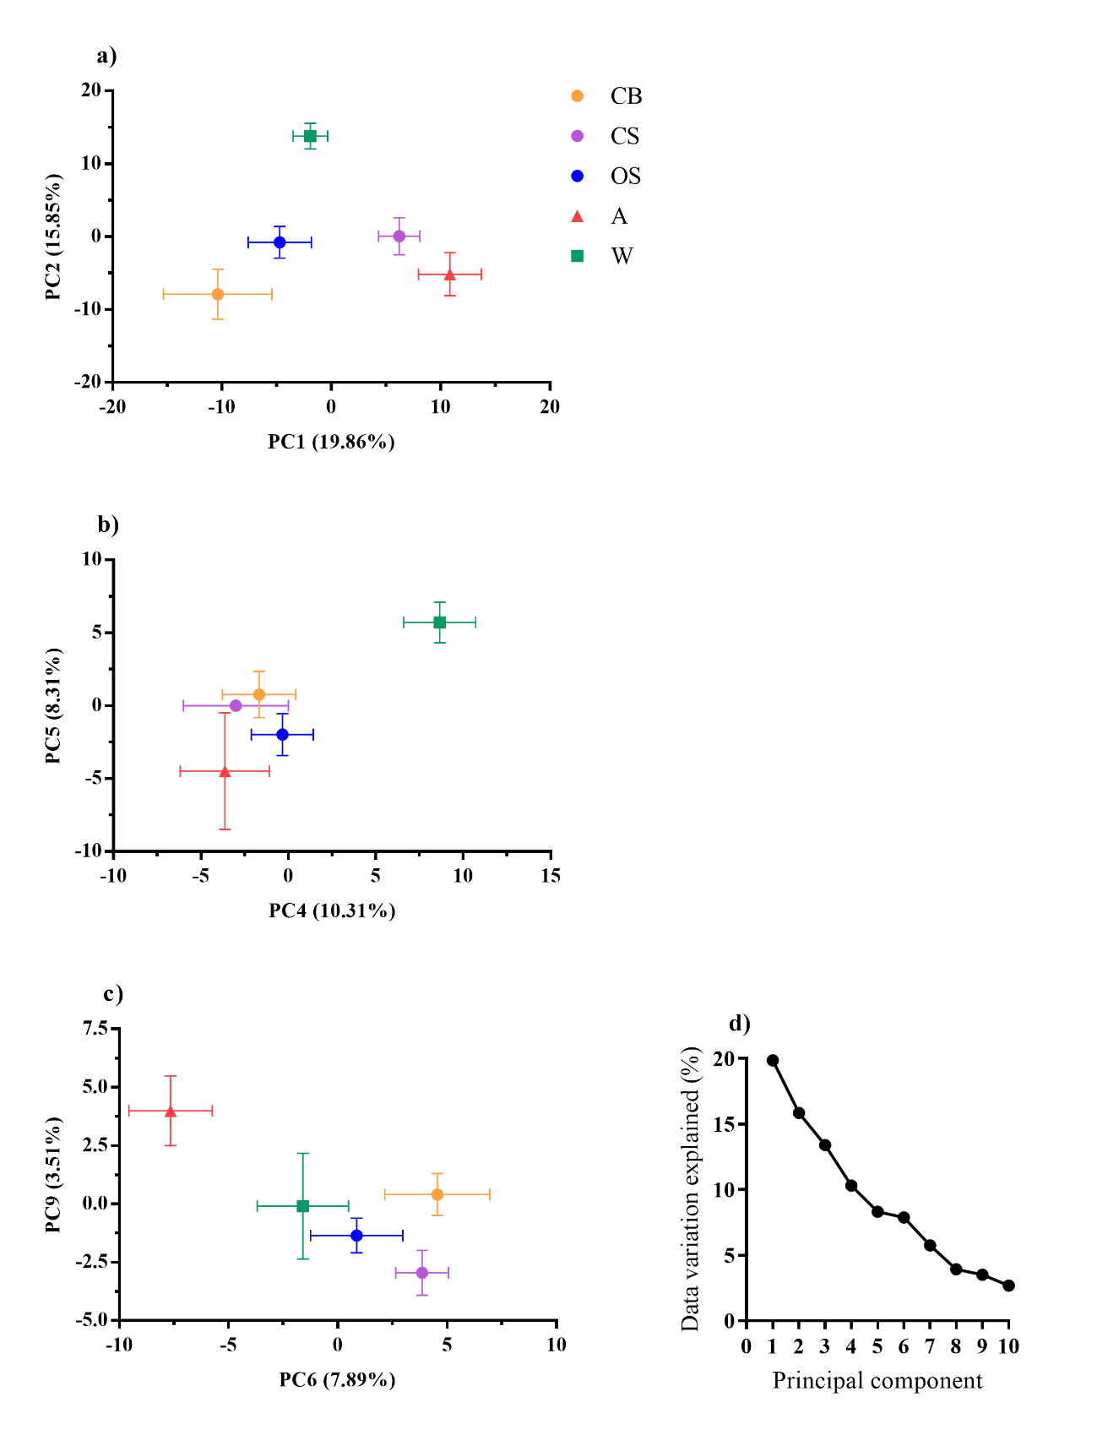

Figure 3.17 Principal Component Analysis (PCA) of OTU relative abundance data. All presented principal component scores were significantly affected by habitat type; a) PC1 and PC2 scores, b) PC4 and PC5 scores, c) PC6 and PC9 scores, d) proportion of variation in data explained by the first ten principal components showing the majority of the variation in the data was explained by the first ten principal component scores. Habitat codes are as follows: CB; conventional bush orchards, CS; conventional standard orchards, OS, organic standard orchard, A; arable, W; woodland.
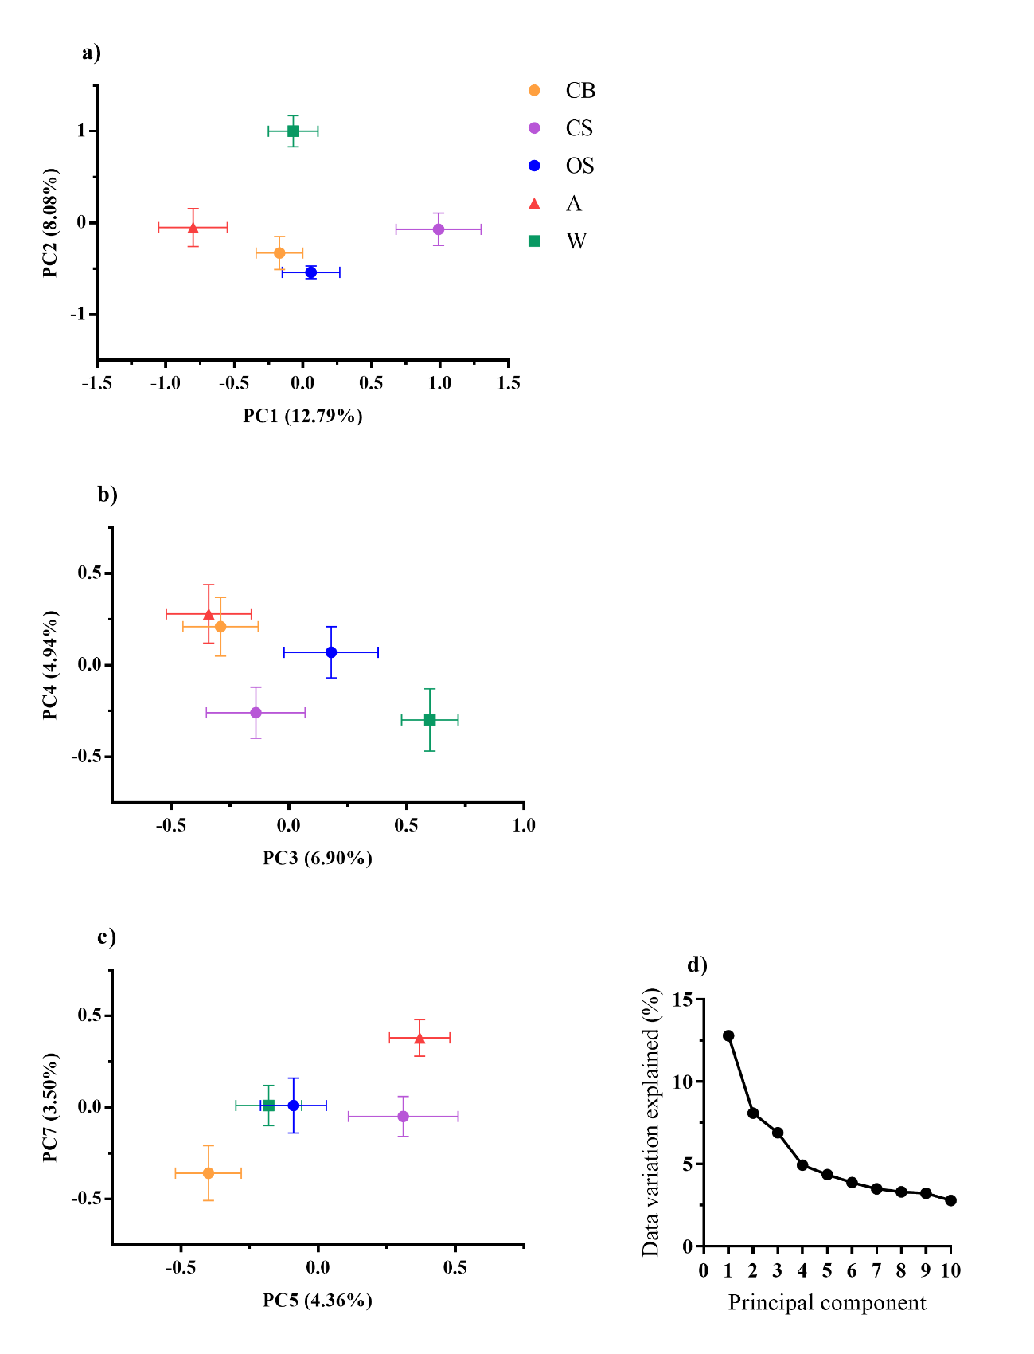
Figure 3.18 Principal Component Analysis (PCA) of OTU presence and absence data. All presented principal component scores were significantly affected by habitat type; a) PC1 and PC2 scores, b) PC3 and PC4 scores, c) PC5 and PC7 scores, d) proportion of variation in data explained by the first ten principal components showing the majority of the variation in the data was explained by the first ten principal component scores. Habitat codes are as follows: CB; conventional bush orchards, CS; conventional standard orchards, OS, organic standard orchard, A; arable, W; woodland.

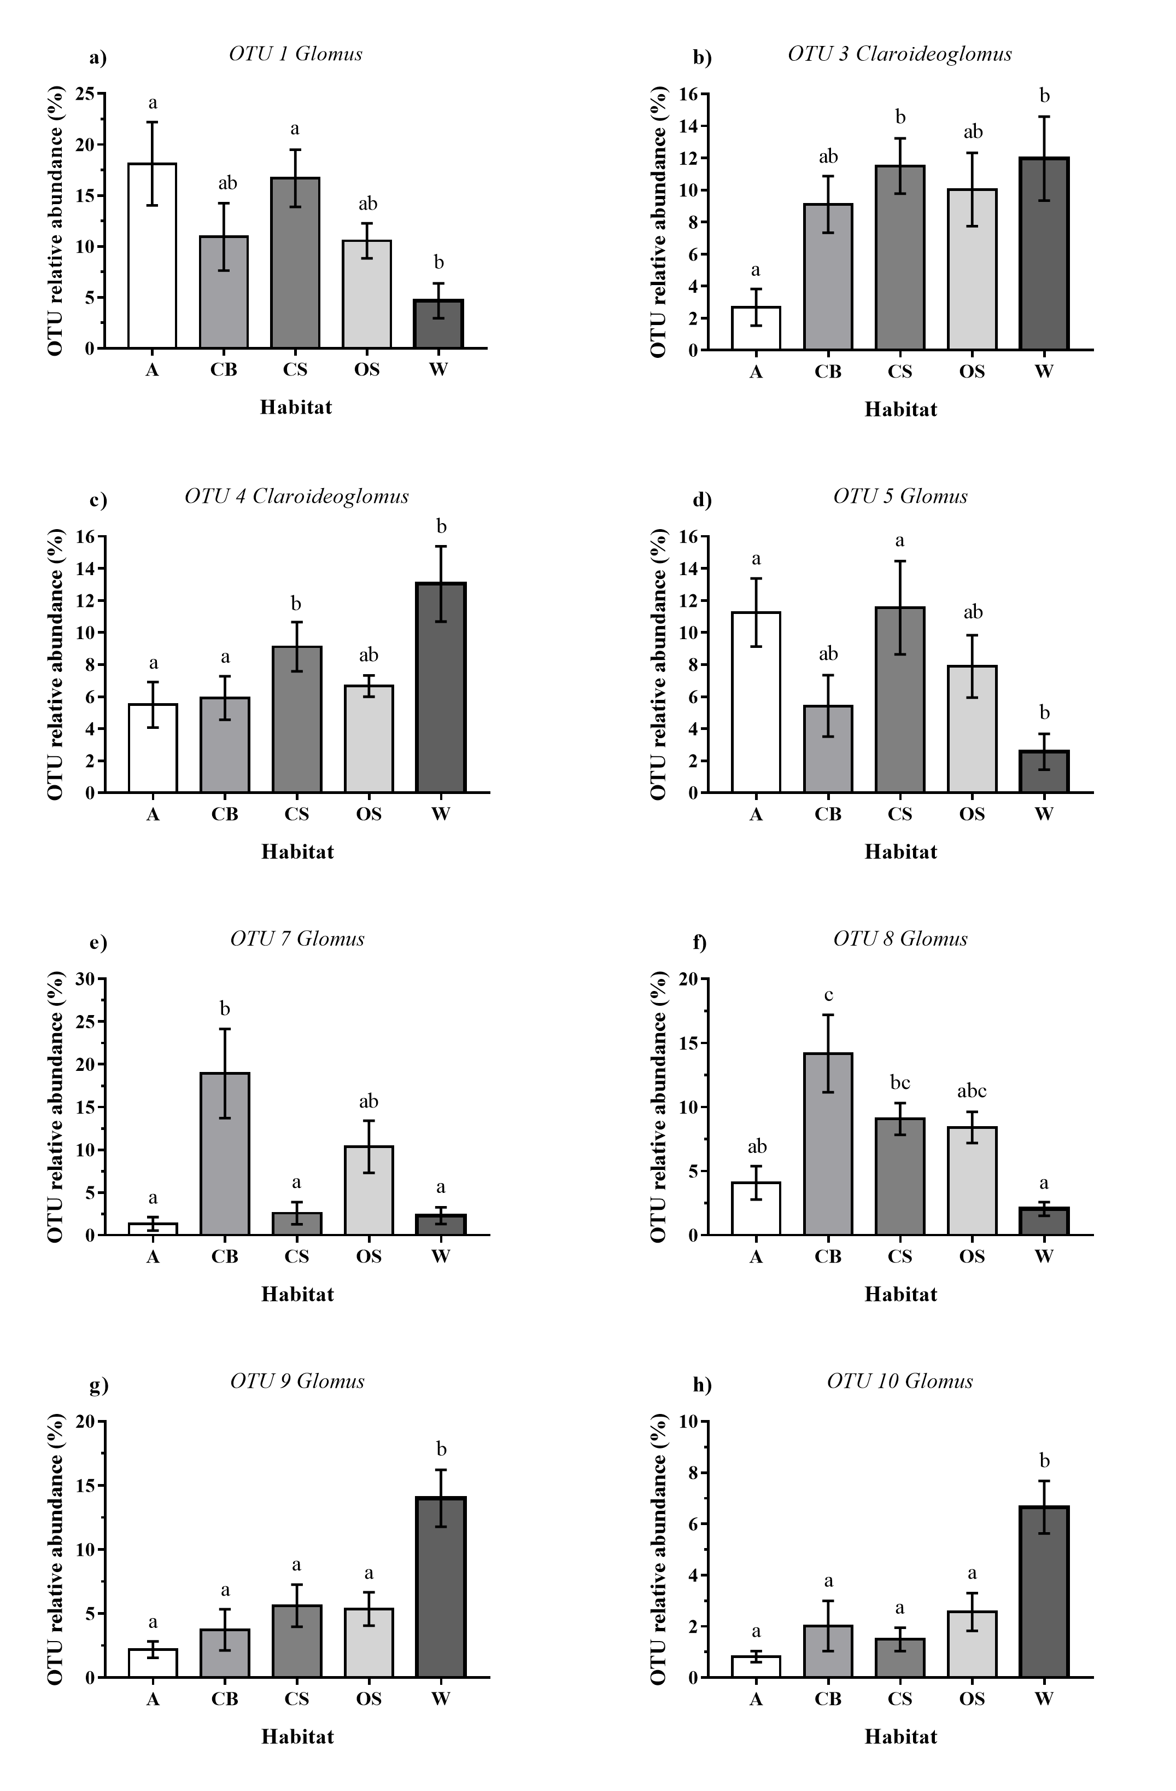

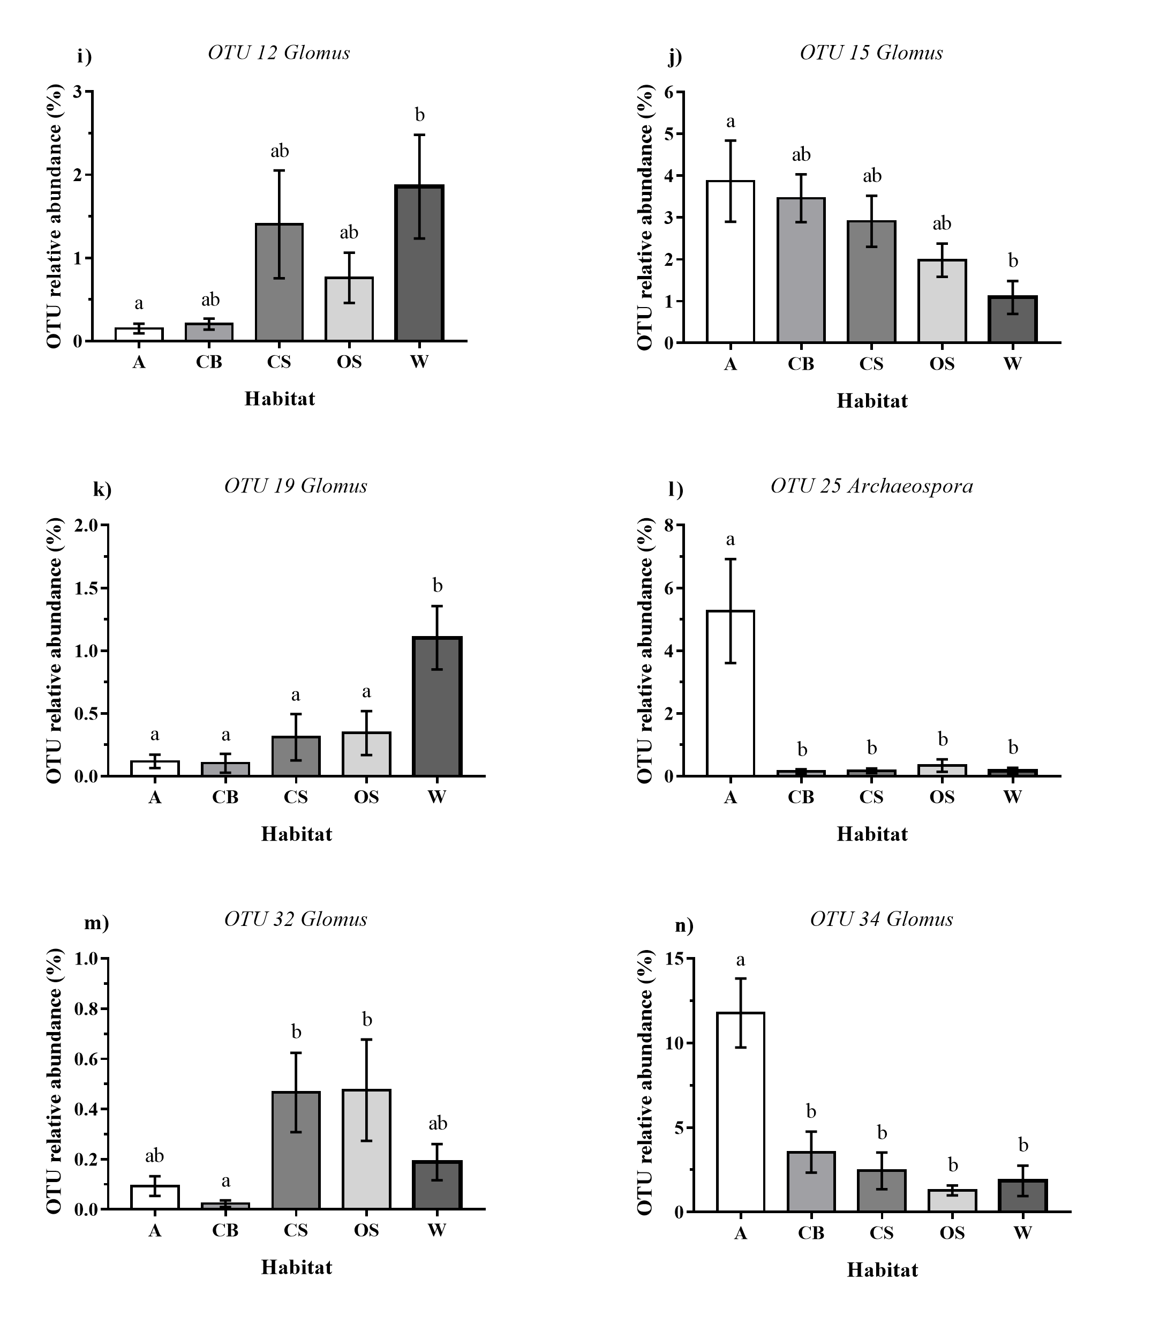
Figure 3.19 Average relative abundance of OTUs per habitat type. Figures (a) to (n) present relative abundance of OTUs which show significant differences between habitat types. Habitat codes are as follows: A; arable, CB; conventional bush orchard, CS; conventional standard orchard, OS; organic standard orchard, W; woodland. Error bars show SE of mean (n=25). Treatments with the same letter do not differ significantly from one another (Tukey HSD, P<0.05).
(a)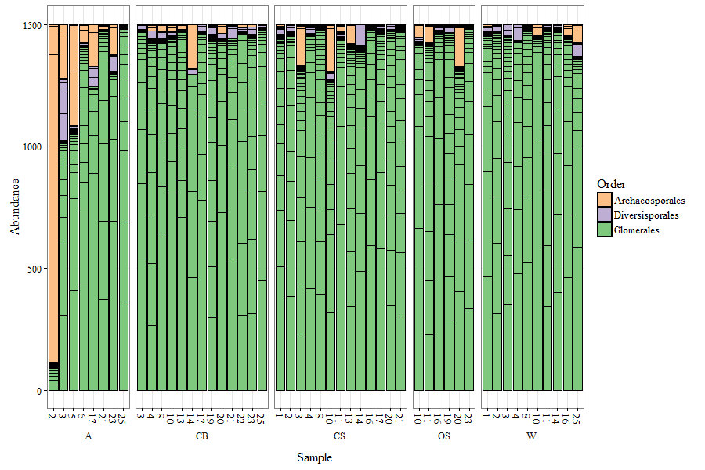
(b)
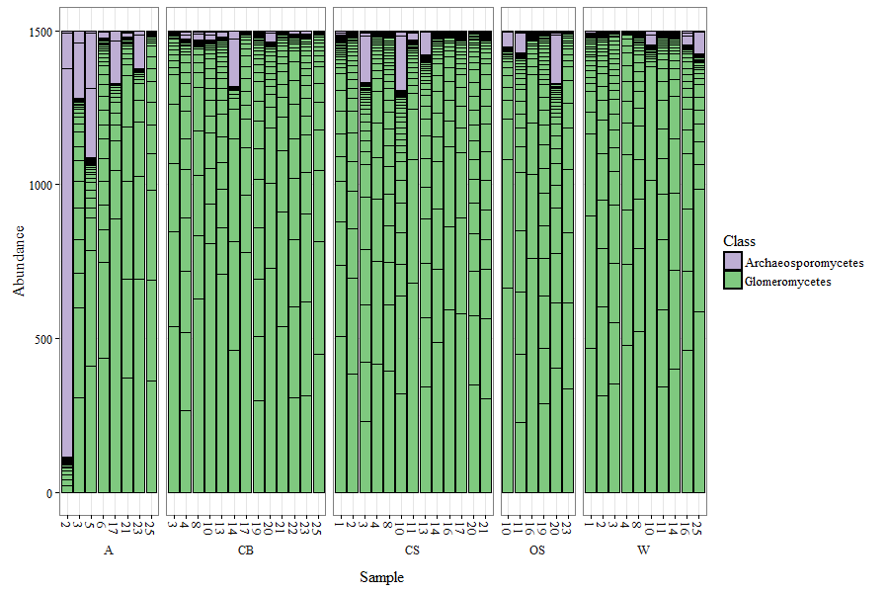

(c) 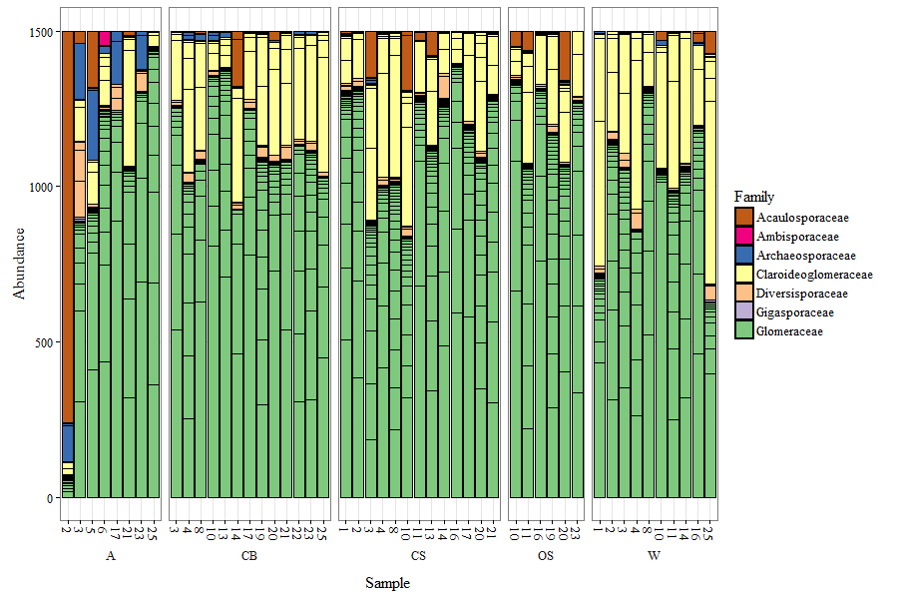
(d) 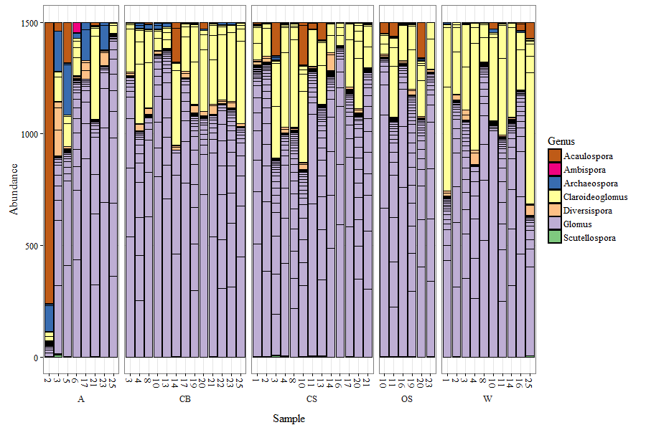
Figure 3.20. Classification of OTUs identified from NS31-AML2 SSU gene fragments reverse sequences by (a) order, (b) class, (c) family and (d) genus. Only samples with a read depth of ≥1500 are presented. OTU abundance is standardised to 1500 reads. Habitat codes are as follows: A; arable, CB; conventional bush orchard, CS; conventional standard orchard, OS; organic standard orchard, W; woodland.

Comparison of TRFLP and Illumina Sequencing for AMF richness and community structure
This study used a combination of two molecular methods to characterise AMF communities; TRFLP analysis and Illumina sequencing. TRFLP is a high throughput community fingerprinting technique and therefore a relatively quick and inexpensive method for assessing the AMF communities within all 750 leek bait root samples (6 replicates per habitat x 5 habitats per site group x 25 site groups). Furthermore using two restriction enzymes is known to improve separation of fungal taxa. The advantage of using two restriction enzymes was demonstrated by the increased level of significance shown when examining differences in richness and Simpson’s diversity using grouped TRFs from restriction with Hinf-I and HpyCH4-III (e.g. see Figure 3.12) in comparison to analysis using TRFs produced by either enzyme separately.
Illumina sequencing is a powerful molecular technique for studying AMF communities due to the higher resolution of AMF type separation per sample. However Illumina sequencing is costly and required a significant amount of time for sample preparation and therefore it was only possible to sequence 95 samples. This meant that a subset of 19 out of the original 25 site groups were selected. Per site group, one pooled sample comprised of the six replicates from each of the habitat types was sequenced. Therefore for this study, Illumina sequencing could not allow the same level of replication as TRFLP. As sequencing of large sample sizes becomes more affordable and rapid, it is likely to replace TRFLP due to its higher precision.
Overall, analysis results for the two methods were consistent and the combined use of these two molecular methods allowed both replication and a relatively high level of resolution for taxa identification.

Identification of predicted restriction sites for most common OTUs
To compare the separation of taxa by Illumina sequencing with that of TRFLP analysis we carried out in silico restriction of OTUs as follows. For the 28 OTUs which accounted for over 1% of sequences in at least one habitat type (Table 3.7) all sequence accessions of the closest matching virtual taxa were downloaded from MaarjAM and aligned with the OTU using Muscle (EMBI-BI, Welcome Genome Campus, 2016) . The alignment was then uploaded to Genedoc (Multiple sequence alignment editor and shading utility version 2.7) (Nicholas & Nicholas, 1997). In silico restriction was then performed separately for both the restriction enzymes used for the TRFLP analysis; Hinf-I which has a 5’-GˇANTC-3’ site restriction site and HpyCH4-III which has a 5’-ACNˇGT-3’ restriction site. Predicted restriction fragment lengths (bp) for the AML1 to AML2 820bp sequences were recorded for restriction with both Hinf-1 and HpyCH4-III (Table 3.7). Although the selected VTs matched closely for the 250bp aligned per OTU (see phylogenetic trees: Figure 3.3 to Figure 3.11) it is recognised that VT matches are not certain due to the short length of the OTU sequence and therefore restriction sites of the matched virtual taxa are referred to as “predicted” restriction sites per OTU. Certainty of virtual taxa matches with OTUs could be improved by using longer OTU sequences however here this was not possible due to the poor quality of the reverse reads from the Illumina Miseq analysis.
Spearman’s rank correlation coefficient was used to test how well TRF fragment relative abundance correlated with corresponding OTU relative abundance (Figure 3.21). A positive correlation was shown for 6/7 TRF fragment sizes demonstrating that there is consistency between AMF type relative abundances predicted by TRFLP and Illumina Sequencing. TRF richness and OTU richness were not correlated (Figure 3.22) however this is to be expected due to far higher resolution of AMF type separation by Illumina sequencing.

Table 3.7 Closest matches of OTUs to fungal virtual taxa within the MaarjAM database based on a neighbour joining phylogenetic tree (Fig 3.3). Restriction of the closest matched fungal virtual taxa was performed in silico for Hinf-I and HpyCH4-III restriction enzymes to predict the diagnostic TRF fragments that may be produced by restriction of these AMF types. This in silico restriction was performed for the closest matched virtual taxa of all OTUs which accounted for ≥1% of sequences in at least one habitat type (28/79 OTUs). Observed TRFs of the same size are coloured the same to highlight the range of different AMF types which could potentially produce each observed TRF

OTU | Proportion of total sequences (%) | TRF length of fragments produced from in silico digestion of closest matched fungal virtual taxa from the MaarjAM database and the closest matching TRF size produced from TRFLP restriction. All TRF lengths are in base pairs (bp) |  |  |  | Closest matched virtual taxa from MaarjAM database
 |  | Hinf-I in silico | Hinf-I observed) | HpyCH4-III in silico | HpyCH4-III observed
1 | 12.18 | 375, 424 | 376, 424 | 434, 698 | 431, 699 | VTX00345 Glomus
6 | 11.96 | 375, 758 | 376 | 396, 434, 697 | 393, 434, 699 | VTX00114, VTX00113Glomus
3 | 9.05 | 67, 520, 738 | -, 518 | 549, 704 | 547, 705 | VTX00193 Claroideoglomus
4 | 8.04 | 67, 739, 765 | -, 765 | 550, 705 | 547, 705 | VTX00057 Claroideoglomus
5 | 7.73 | 515, 759 | 512, 518 | 366, 397 435, 699 | 353, 393, 699 | VTX00067, VTX00195 Glomus
8 | 7.55 | 422, 512, 755 | 424 512 | 432, 695 | 431, 699 | VTX00143 Glomus
7 | 7.09 | 375, 424, 755 | 376, 424 | 396, 434, 698 | 393, 431, 699 | VTX00309 Glomus
9 | 6.18 | 423, 513, 757 | 424, 512 | 433, 697 | 431, 699 | VTX00163 Glomus
34 | 4.17 | 515, 759 | 512, 518 | 397, 435, 698 | 393, 393, 431, 399 | VTX0065 Glomus
16 | 2.90 | 67, 376, 760 | -, 376 | 357, 545, 700 | 353, 547, 700 | VTX00030 Acaulospora
10 | 2.70 | 424, 515 | 424 | 434, 700 | 431, 699 | VTX00417 Glomus
15 | 2.66 | 67, 423, 513 | -, 424, 512 | 432, 697, 757 | 431, 699 | VTX00143 Glomus
11 | 1.86 | 424, 758 | 424 | 434, 698 | 431, 699 | VTX00122 Glomus
17 | 1.56 | 757, 513 | 765, 512 | 433, 697 | 431, 699 | VTX00234 Glomus
25 | 1.21 | 67, 331, 756 | - | 544, 698 | 547, 699 | VTX00245 Archaeospora
20 | 1.08 | 67, 331, 756 | - | 544, 698 | 547, 699 | VTX00245 Archaeospora
26 | 0.92 | 67, 375, 516 | -, 375, 518 | 435, 545, 700 | 431, 547, 705 | VTX00061 Diversispora
12 | 0.87 | 424, 757 | 424 | 396, 434, 697 | 393, 431, 699 | VTX00072 Glomus
22 | 0.82 | 423, 513, 757 | 424, 512 | 433, 697 | 431, 699 | VTX00222 Glomus
13 | 0.79 | 391, 423, 757 | 424 | 433, 698 | 431, 699 | VTX00125 Glomus
24 | 0.66 | 375, 424, 758 | 376, 424 | 434, 698 | 431, 699 | VTX00345 Glomus
23 | 0.64 | 67, 740, 766 | -, 765 | 344, 368, 551, 706 | 431, 547, 705 | VTX00225 Claroideoglomus
81 | 0.62 | 331, 758 | - | 434, 698 | 431, 699 | VTX00200 Glomus
38 | 0.61 | 423, 513, 757 | 424, 512, | 433 , 697 | 431, 699 | VTX00163 Glomus
40 | 0.44 | 376, 424, 755 | 376, 424, | 435, 697 | 431, 699 | VTX00219 Glomus
18 | 0.42 | 424, 756 | 424 | 434, 697 | 431, 699 | VTX00309 Glomus
19 | 0.39 | 424, 758 | 424 | 434, 698 | 431, 699 | VTX00123 Glomus
33 | 0.32 | 424, 758 | 424 | 434, 698 | 431, 699 | VTX00122 Glomus

(a) Hinf-I 376 (R_{s}² =0.346, P=<0.001, n =95)  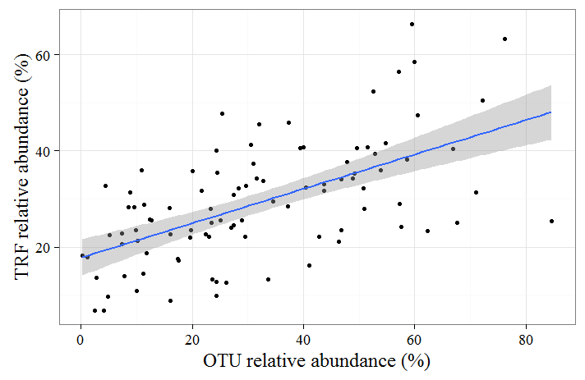 | (b) Hinf-I 434 ( R_{s}²=0.361, P=<0.001, n = 95  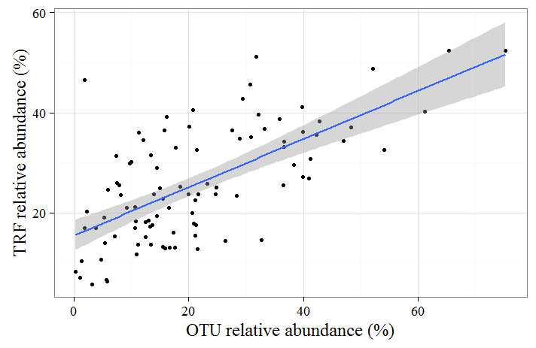
(c) Hinf-I 512, 518 ( R_{s}²=0.577, P<0.001, n=95)  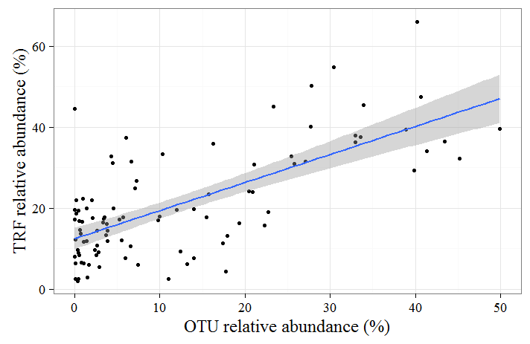 | (d) HpyCH4-III 353 ( R_{s}²=0.160, P=0.121, n=95)  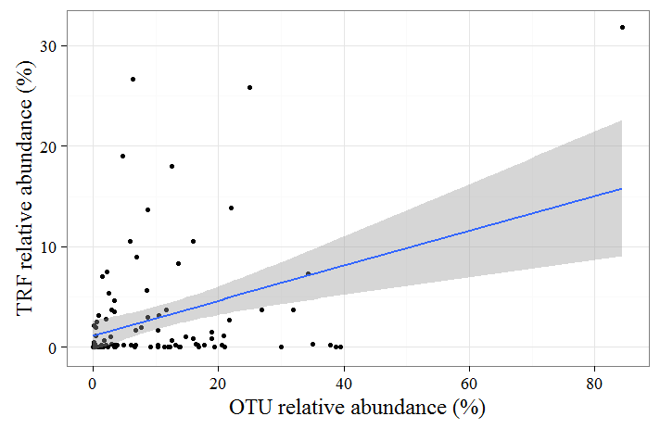
(e) HpyCH4-III 393 ( R_{s}²=0.137, P<0.001, n=95)  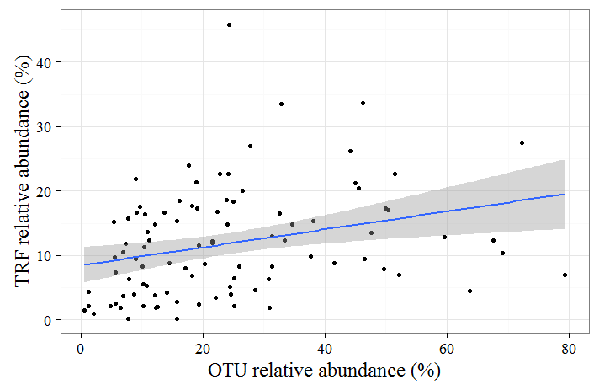 | (f) HpyCH4-III 431 ( R_{s}²=0.091, P=0.003, n=95)  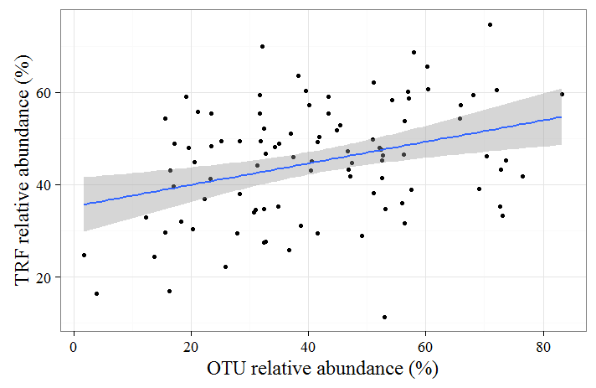
(g) HpyCH4-III 547 ( R_{s}²=0.274, P<0.001, n=95)
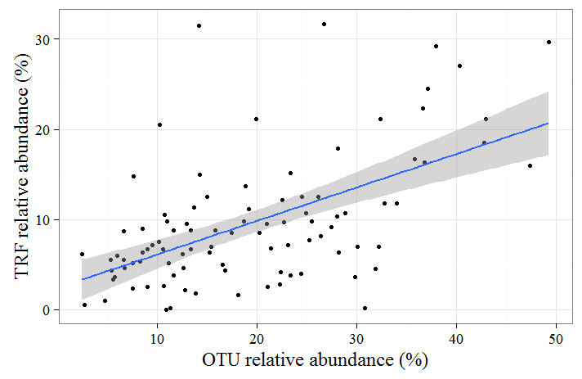
Figure 3.21 TRF relative abundance against relative abundance of OTUs predicted by in silico restriction of virtual taxa to produce the corresponding TRF size. Trend lines are presented with shaded areas to show 95% confidence interval for fit. Spearman’s rank correlation coefficient was calculated to test for the strength of the correlation between OTU and TRF richness for each fragment size.
- ( R_{s}²=0.081, p=0.027, n=60)
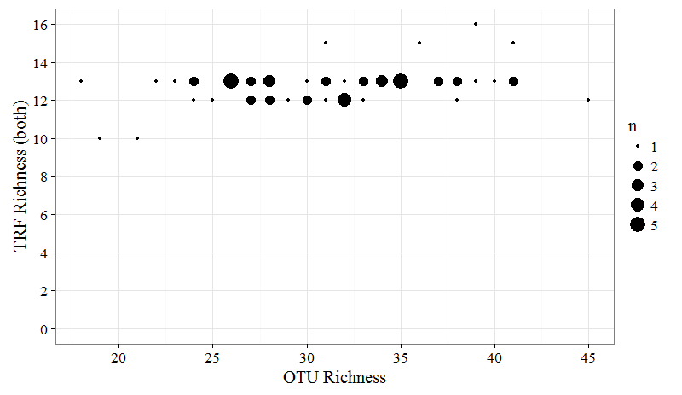
- ( R_{s}²=0.174, p=0.001, n=60)
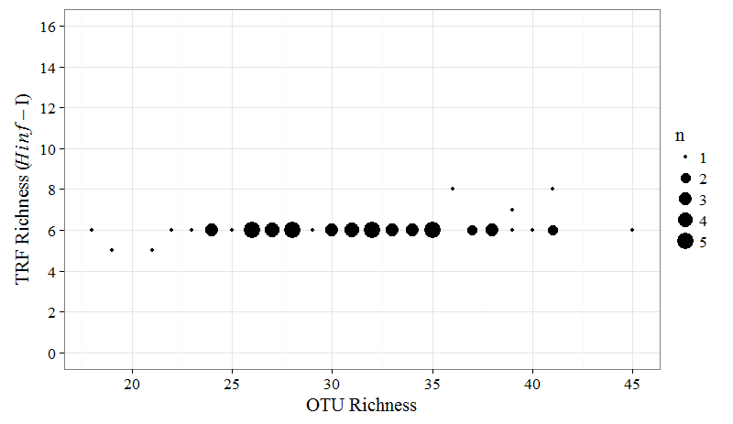
(c) ( R_{s}²=0.056, p=0.067, n=60)
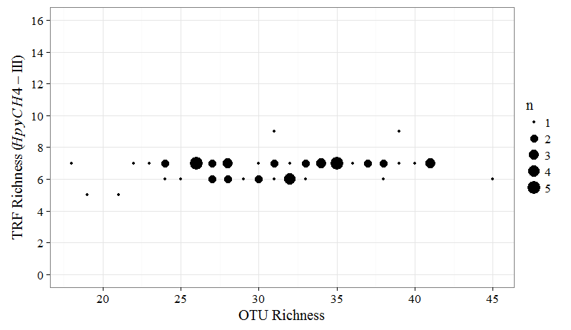
Figure 3.22 TRF richness against OTU richness (rarefied data) (a) TRFs combined from restriction with both enzymes against OTU richness reverse sequences reads (b) TRFs from Hinf-I restriction, (c) TRFs from HpyCH4-III restriction only . Spearman’s rank correlation coefficient was calculated to test for the strength of correlation between OTU richness and TRF richness.

Discussion
The aim of this experiment was to characterise richness, community structure and relative abundance of AMF taxa found within the three most widely planted cider apple orchard types: conventional bush orchards, organic standard orchards and conventional standard orchards. Secondly the aim was to investigate how the intensity of orchard management effects the diversity and composition of AMF communities within apple orchards. To allow for a more full comparison of the effects of agricultural management upon AMF community structure and composition within the three orchard types, comparison was also made between AMF within soils sampled from intensively managed arable winter cereal fields and soils from deciduous woodlands which are a less managed habitat.

Characterisation and comparison of AMF communities within three apple orchard management types
This study clearly shows a high level of similarity in the AMF communities within soils collected from orchards under the three management types. No differences in any measures of species richness or Simpson’s diversity were found between the three orchard types. Furthermore a high similarity in AMF community composition was also found between all orchard management types with no differences shown between conventional and organic standard orchards. Conventional bush orchards showed a small level of variation in community composition when compared to organic and standard orchards and differed in relative abundance of 3/79 OTUs (two of which were identified as belonging to the genera Glomus and one to Claroideoglomus), when compared to conventional standard orchards and 1/79 OTUs in comparison to organic orchards (identified as Glomus). Only one TRF differed in relative abundance between orchard types (HpyCH4-III 699) which was lower in conventional bush orchards than in conventional and organic standard orchards.
Results from this study suggest that differences in the increased intensity of management within conventional bush orchards, including the high application of inorganic phosphorus and nitrogen based fertilisers has little impact upon any measure of the AMF community (richness, Simpson’s diversity, relative abundance of taxa or community composition). This is in contrast to a considerable number of studies which have shown AMF communities within agricultural environments to be sensitive to application rates of inorganic phosphorus (Wang et al., 2009; Verbruggen et al., 2012; van Geel et al., 2015). In a comparison of AMF community structure and composition within 18 conventional bush and 6 organic bush apple orchards located in Belgium using 454-pyrosequencing of apple roots, Van Geel et al., (2015) showed 34% of the variation in AMF species richness observed between organic and conventionally managed orchards could be explained by differences in plant available P within soil and that significantly higher AMF diversity was reported within orchards that had soil P levels lower than 100 mg kg⁻¹ soil (van Geel et al., 2015). Similarly, strong reductions in AMF diversity and genera specific change in the relative abundance of fungi with the application of inorganic P were reported by (Wang et al., 2009) who used spore based methods to measure AMF community responses within wheat and maize field soils which received applications of inorganic fertiliser over 26 years.
The underlying mechanisms by which AMF richness is reduced in response to increased nutrient availability are still largely unknown however optimal resource allocation theory predicts that both AMF and plants will increase allocation of energy towards capture of the resources which are most limited in availability (Johnson et al., 2013). Therefore in response to enrichment of soil fertility, plants may reduce allocation of carbon to AMF. Increased competition for carbon between AMF taxa could result in competitive exclusion of some fungi ultimately leading to reduction in AMF richness (Liu et al., 2012) as AMF taxa are known to differ in their competitive ability to access host carbohydrates (Hepper et al., 1988; Bennett & Bever, 2009).
However our study did not quantify soil nutrient status within orchards therefore it is not possible to determine whether similarity of AMF communities between orchards corresponded with similarity in soil fertility between sites. Van Geel et al, (2015) reported differences AMF communities of organic and conventional orchards however they specifically selected study orchards which showed a large range in soil fertility levels (30 to 220 ppm plant available P) in order to examine differences in effects of inorganic P and N upon the AMF community. In contrast orchards selection for our study aimed to cover a representative range of orchard types within the region of study (Herefordshire, UK) without prior knowledge of soil fertility levels of inputs. Therefore we may not have sampled such a broad range in soil fertility levels making it harder to detect differences that may have arisen due to soil nutrient status. Additionally the contrasting results of our study in comparison to that of Van Geel et al., (2015) could arise from variation in factors such as soil type and pH and also broader differences in geography and climate, all of which may affect AMF communities.
All conventional bush orchards within this study were routinely treated with herbicide to keep the ‘herbicide strip’ a 1 to 2 meter strip at the base of each tree, free of weeds which may compete with trees for growth resources. The impact of glyphosate which is currently the most widely used herbicide for this purpose, upon AMF is still not fully resolved with studies reporting effects ranging from neutral to negative effects on spore viability and AMF colonisation of roots (Ronco et al., 2008; Druille et al., 2013). Despite sampling soil from within the herbicide strip within conventional bush orchards for this study, no differences in the AMF community of herbicide treated soils were found.
No benefit of organic orchard management for improving AMF richness in comparison to conventional management was found. Whilst the benefit of organic farming systems for preservation of biodiversity has been debated, positive effects of organic farming upon biodiversity have been demonstrated for a range of taxa (Mader et al., 2002; Hole et al., 2005; Bengtsson et al., 2005; Tuck et al., 2014). A recent meta-analysis of 94 studies comparing species richness of conventional with organic farming for a diverse range of taxa showed that organic farming practices on average increased species richness by circa 30% (Tuck et al., 2014). Organic farming practices have been generally considered as more favourable for AMF (Gosling et al., 2006) however many of the studies comparing organic versus conventional practices upon AMF have been based on arable fields (Oehl et al., 2004; Verbruggen et al., 2010, 2012; Säle et al., 2015) which are heavily disturbed systems. For example, in a study of AMF communities colonising crops in 26 arable field using TRFLP, Verbruggen et al., (2010) found conventional arable fields to host on average 3.9 AMF taxa compared to 6.4 taxa in organic fields,. Given the importance of disturbance for shaping AMF communities (Schnoor et al., 2011), the comparatively low levels of disturbance in orchard systems may partly explain lack of differences in AMF communities of orchards under organic versus conventional management as reported by this study in comparison to those based on arable systems.

AMF communities of orchard and woodland soils
This study has shown that AMF communities (richness, Simpson’s diversity, taxa abundance and community composition) within soils of broadleaved woodland were similar to that of apple orchards. Fungi from the genera Acaulospora, Archaeospora, Claroideoglomus, Glomus and Scutellospora were found in all orchard types and woodland. Generally similarities were shown in taxa relative abundance between woodlands and orchards however a small number (6/79 OTUs) showed significant differences in relative abundance within woodland soils compared to one or more orchard types. To our knowledge this is the first study to compare orchard AMF communities with that of woodlands and the similarity shown here between woodland and orchard habitats suggests that despite agricultural management of orchards systems a relatively natural AMF community is conserved. Similarity in AMF community richness and composition between native broadleaved woodlands and apple orchards shows that despite agricultural management of orchards, a relatively natural AMF community is conserved. In accord with the taxonomy of AMF found within woodlands by this study, AMF of the genera Acaulospora, Glomus and Scutellospora have previously been identified from the roots of three herbs (genera Ajugar, Hyacinthoides and Epilobium) growing within British oak and sycamore dominated broadleaved woodland (Helgason et al., 1998).
Of all orchard types, organic orchards showed the greatest similarity in community composition to woodlands with differences in relative abundance only observed for three Glomus AMF types out of the 79 AMF types found in both woodland and organic. In comparison, conventional bush and conventional standard orchards both differed in the relative abundance of 6/79 AMF types in comparison to woodland showing that although differences in community composition between orchards and woodland was minor, conventional management resulted in greater dissimilarity.

Contrast between arable AMF communities compared to those of orchard and woodland soils
This study shows clear contrasts between AMF within arable soils to those of orchards. Arable fields showed both reduced AMF species richness and Sampson’s diversity and significant differences in community composition and taxa abundance in comparison to orchards and woodland soils. The levels of AMF diversity within winter wheat and barley fields reported by this study ranged from 19 to 35 AMF types per field and is similar to the 18 to 21 AMF types found in arable field soils by Moora et al., (2014) (using soil DNA extraction) and the 28 to 33 AMF types reported in conventionally managed winter wheat fields by Säle et al., 2015 (spores from field samples and trap cultures). Reduction in diversity and evenness of AMF within arable habitats in comparison to less managed ecosystems has been previously reported by studies using both molecular (Helgason et al., 1998; Moora et al., 2014) and spore based AMF identification methods (Oehl et al., 2003; Säle et al., 2015).
It is likely that increased soil disturbance within the arable habitat is an important factor in explaining differences in the AMF communities of arable fields in comparison to orchards. Sensitivity of AMF communities to soil disturbance has been previously reported by studies comparing ploughed arable land within undisturbed pasture (Oehl et al., 2003; Verbruggen et al., 2010) and those which compare high and low disturbance levels through different arable tillage regimes (Jansa et al., 2003; Alguacil et al., 2008).
The main differences in composition following disturbance arise from differences in the resilience of fungal types to disturbance and regeneration strategies. The ability of Glomus species to dominate in disturbed arable habitats (Helgason et al., 1998; Daniell et al., 2001; Jansa et al., 2003; Borriello et al., 2012) may be explained by both rapid colonisation rates of fungi in the Glomus genera and ability to recolonise from root fragments (Hart & Reader, 2002). Furthermore Glomus species show tolerance to fertiliser application and have been reported to increase in relative abundance in response to fertiliser application in comparison to other AMF genera (Treseder & Allen, 2002; Wang et al., 2009; Borriello et al., 2012). However the Glomus genera is not solely restricted to domination of disturbed high fertility habitats; in a recent study which compared soil AMF communities of spruce forest, intensive arable and pasture land using 454-pyrosequencing Moora et al., (2014) found Glomus species were more strongly associated with forest habitats than Archaeospora, Diversispora and Claroideoglomus species.
The genera Glomus was found to be the most abundant in all habitats sampled by this study (Figure 3.20). Interestingly our study showed a varied response of Glomus types to land management intensity with clear differences were shown between the relative abundance of specific Glomus types between arable habitats in comparison to orchard and woodland habitats (Figure 3.14, Figure 3.15, Figure 3.19). This may be explained by the varied ecology of the Glomus genera which is a large and functionally diverse group (Smith & Read, 2008). Unexpectedly our results showed that AMF belonging to the genera Archaeospora were most abundant in arable habitats in comparison to orchards and woodland. This is surprising as Archaeospora are known to be macrospore formers which are slower to regenerate from hyphal fragments than fungi such as those of the genus Glomus (Oehl et al., 2003) and therefore would be expected to be less abundant in frequently disturbed habitats in comparison to those of lower disturbance.

Effect of leek bait plant system on characterising soil AMF communities
In this study we measured the AMF community using a leek bait plant trap culture as this allowed equal comparison to be made between the AMF communities of contrasting habitat types by controlling for factors such as host plant age, genetics and growth environment. Furthermore comparison between all five habits using root samples collected from the field would not have been possible due to lack of common species between all habitats.
However the use of bait plant systems to study AMF communities has several caveats (Sýkorová et al., 2007; Jansa et al., 2016) and it is recognised that by using a leek bait plant system this study has filtered a subset of AMF from those that were present in the habitat soils. AMF species identified within the leek roots are those which are (i) able to form symbiosis with leek, (ii) are able to colonise the leek rapidly enough following soil disturbance to be observed within the roots after 4 months of growth. Leek bait plants may therefore have caused over representation of competitive AMF types which are resilient to disturbance in comparison to slow growing, sensitive species.
Apple orchard AMF communities were composed mainly of Glomeraceae (66%), Claroideoglomeraceae (13%), Archaeosporaceae (9%) and a small proportion of Diversisporaceae (6%), Gigasporaceae (3%) Acaulosporaceae (3%) and Ambisporaceae (1%). Dominance of Glomeraceae and Claroideoglomeraceae within apple orchards has also been reported in a recent study by Van Geel et al., (2015) which used 454-pyrosequencing to identify AMF within apple roots collected from 18 conventional and 6 organic dessert apple orchards in Belgium and found out of the 110 AMF OTUs identified, AMF were classified as Glomeraceae (73%), Claroideoglomeraceae (19%), Gigasporaceae (4%), Diversisporaceae (3%), Acaulosporaceae (1%), Paraglomeraceae (1%). This shows that despite use of leek bait plants as trap cultures by our study, AMF genera captured from the leek bait plant system were representative of those which have previously been found within apple roots by Van Geel et al., (2015).
When comparing the colonisation strategies of three AMF families (Glomeraceae, Acaulorsporaceae and Gigsasporaceae) Hart and Reader, (2002) found that three months was sufficient for species from all three families to be represented in the roots of leek trap culture plants despite the slower rate of colonisation by species of Gigasporaceae, which regenerate from spores. However although all species were represented when comparing colonisation strategies of fungal isolates of AMF families; (Glomeraceae, Gigasporaceae and Acaulosporaceae) over 12 weeks using four bait plant species (2 x Plantago sp, 2 x Poa sp) fungal biomass within bait plant roots was found to be highest for Glomeraceae isolates (mean of 1.74-4.64 ug g⁻¹ root d.wt.) compared to Acaulosporaceae and Gigasporaceae (mean range from 0.82-1.41 ug g⁻¹). Fungi within the Glomeraceae are known to be rapid colonisers and able to produce high within-root biomass. Thus, the fact that the Glomeraceae family are shown to be well represented in all habitats within our study may be partly due to the ability of Glomus to thrive in trap culture environments due to the colonisation strategy of this group.

Conclusion
This study compares for the first time AMF community composition between three cider apple orchard management types with those of arable and woodland habitats, specifically testing the following hypotheses:
- Intensive orchard management would impact the AMF community with conventional bush orchards showing reduced AMF richness and evenness and significant differences in community composition and taxa relative abundance when compared to conventional standard and organic standard orchards.
- AMF communities of orchards show greater similarity with those of woodlands to those of arable fields.
The results from this study show that hypothesis one should be rejected as all three orchard management types showed high similarity in AMF diversity, structure and composition irrespective of management type. Despite receiving higher application rates of inorganic fertilisers and herbicide, negligible negative effects upon AMF structure and composition were found in conventional bush orchards and in contrast to previous studies no evidence of improved AMF diversity within organic orchard types was shown. Similarity between AMF community composition and diversity of orchards in comparison to broadleaved woodland soils suggests that all orchard types are able to sustain relatively natural AMF communities.
In contrast, hypothesis two was supported by the data from this study which showed a greater difference between orchard AMF communities when compared to arable soils than those of woodland. Similarity of orchard AMF communities to those of “natural” woodland habitats suggests that even under intensive management, orchard production systems do not impact AMF communities to the same extent as arable agriculture.

Investigating the effects of orchard management upon AMF communities colonising apple tree roots and the relationship between AMF richness, taxa abundance and apple yield.

Summary
- Developing agricultural systems which are able to balance productivity and sustainability is critical for ensuring future food security. Arbuscular mycorrhizal fungi (AMF) play an important role in many key ecosystem functions and are able to form symbioses with apple (Malus pumila) which is amongst the most widely grown fruits globally. To assess the potential for utilising AMF to enhance apple orchard sustainability several key questions must be addressed (i) what are the AMF communities naturally found within apple orchards? (ii) are they impacted by orchard management? (iii) do AMF communities affect tree productivity at the field scale?
- This study used terminal restriction fragment length polymorphism (TRFLP) analysis- a high throughput community fingerprinting technique to characterise the AMF communities colonising the roots of 150 apple trees within 75 apple orchards under three contrasting orchard management types. Using data collected per orchard relating to management factors including nitrogen and phosphorus fertiliser application rates, the effect of orchard management upon AMF diversity, community structure and taxa abundance were examined. The relationship between tree yield (mean annual fresh fruit weight) and AMF richness and taxa relative abundance was examined using yield data collected for a subset of 120 trees over two consecutive harvests.
- Our results show that AMF richness within apple roots is highest in conventional bush orchards which are most intensively managed; a result which may partly be explained by the younger age of these orchard types. In contrast, community composition and taxa relative abundance showed only minor differences between all orchard management types. No relationship between the AMF communities colonising apple trees (richness or taxa relative abundance) and fruit yield of trees was found.
- Overall, this study presents the first large scale characterisation of AMF colonising apple trees within UK cider orchards and is the first to investigate the relationships between AMF richness and taxa abundance and apple tree productivity. Our results show that irrespective of management, apple trees across a range of orchard types are able to support a relatively complex/rich AMF community which may largely be due to the low soil disturbance within orchard systems.

Introduction
Developing sustainable agricultural systems which are able to balance both productivity and environmental sustainability is a critical challenge for humanity (Pretty, 2008). Awareness of the environmental impact of high input intensive agriculture has driven research interest in developing agricultural sustainability through utilising components of natural ecosystems (Tilman et al., 2002). Arbuscular mycorrhizal fungi (AMF) are an important constituent of the soil microbial community and play a vital role in many ecosystem functions including plant productivity (van der Heijden et al., 2008). However there are still many unknowns relating to AMF functioning within sustainable agro-ecosystems (Fester & Sawers, 2011).
A key research priority regarding the potential role of AMF within sustainable agro-ecosystems is understanding the extent to which AMF may improve crop plant productivity. AMF are known to affect plant productivity principally through direct effects on host plant nutrient supply (Smith & Read, 2008; Smith & Smith, 2011a) (as detailed in Chapter 2) but also indirectly through effects on plant competitive interactions (Cameron, 2010) and the rhizosphere environment (Wilson et al., 2009; Bedini et al., 2009; Cavagnaro et al., 2015) however the relationship between AMF communities and plant productivity is complex.
Due to taxa specific differences in AMF functioning (e.g. variability in nutrient provisioning and defence induction) it has been hypothesised that systems with a greater diversity of AMF will be more productive due to functional complementarity between taxa (van der Heijden et al., 2008). This notion has been supported by several microcosm experiments testing AMF diversity and plant productivity relationships (van der Heijden et al., 1998; Maherali & Klironomos, 2007) which attribute improved productivity of plants colonised by more AMF taxa to functional complementarity and improved efficiency of resource access within a more functionally diverse AMF community. AMF community composition may also affect plant productivity due to inter-taxa differences in functionality (Maherali & Klironomos, 2007) which relate to contrasts in ecology of AMF taxa including differences in carbon requirements, nutrient foraging ability and nutrient storage ability (Kiers et al., 2011). Alternatively, there is evidence that the identity and functionality of the AMF taxa present, rather than their number, may determine the overall benefit to plant productivity. Consequently symbiosis with a single beneficial AMF taxa may result in similar benefit to plant productivity as symbiosis with a more diverse AMF community which includes the single most productive AMF taxa (Vogelsang et al., 2006).
Few studies have examined AMF diversity - productivity relationships at the field or landscape scale and those which have report AMF richness to be associated with a range of effects on plant productivity from positive (Vogelsang et al., 2006), to negative (Hiiesalu et al., 2014; Holste et al., 2016). This is probably because at the landscape scale many other factors may also have strong effects on plant productivity for example differences in soil pH, fertility, topography, rainfall and microclimatic differences (van der Heijden et al., 2008; Jansa et al., 2014).
Apple orchards are amongst the most widely planted tree-based cropping systems (FAO, 2014) yet there are many knowledge gaps relating to the AMF which occur naturally within orchards regarding both their community assembly (diversity and composition) and functioning. Apples are responsive to AMF and may derive benefits from AMF symbiosis (as detailed in Chapter 2), furthermore data from Chapter 3 of this thesis has shown the ability of apple orchard soils to harbour a relatively high number of AMF taxa (79 OTUs belonging to seven genera). Comparison of the AMF communities within orchard soils in Chapter 3 showed little differences in the AMF communities between orchard types. However, this does not necessarily reflect the AMF colonising trees within the orchards due to biases associated with trap culture systems caused by factors such as differences in host preferences and inter taxa differences in disturbance tolerance (Sýkorová et al., 2007; Uibopuu et al., 2012). As detailed in Chapter 3, many agricultural management practices are known to affect diversity and community composition of AMF colonising crops. Therefore a key question is whether orchard management practices are able to affect the AMF communities colonising apple roots and furthermore whether changes in the AMF community due to management will result in reduced productivity benefits.
The aim of this chapter is to characterise the AMF colonising apple trees within three main commercial apple orchard type and to test how measured differences in management including application of inorganic phosphorus and nitrogen, affect the AMF colonising apple tree roots. Furthermore, this chapter aims to examine the relationship between AMF colonising apple tree roots and tree productivity using measurement of tree yield collected for two subsequent growing seasons for the trees for which the AMF communities were characterised. Using terminal restriction fragment length polymorphism (TRFLP) analysis - a high throughput molecular community fingerprinting technique, the following measures of the AMF community were made: (i) richness (ii) Simpson’s diversity index (iii) community composition (measured as presence/absence and relative abundance of individual taxa.
Specifically this chapter addresses the following research questions:
- What is the richness, Simpson’s diversity and community composition of AMF colonising the roots of cider apple trees within orchards under three management types and how does this differ between orchard type?
- Which aspects of orchard management are most important for determining the richness and community composition of AMF colonising apple trees?
- Is there a relationship between fruit yield of apple trees and the richness or community composition of AMF colonising the tree?

The following hypothesis were tested:
- Intensive orchard management reduces AMF richness and Simpson’s diversity and alters community composition (presence/absence of taxa present and their relative abundance).
- Increased inorganic fertiliser application is associated with reduced AMF richness and changes in community composition of the fungal taxa colonising apple trees.
- There is a positive relationship between AMF richness and abundance with tree fruit yield.

Methods

Orchard study site selection
A total of 75 orchards belonging to three main commercial cider apple orchard management types were used for this study. Apple tree roots were collected from two trees per orchard to give a total of 150 apple trees. Orchard sites were the same as described in Chapter 3 where full details of sample site selection are provided (see 3.3.1 and 3.3.2). In brief, twenty replicate cider apple orchards belonging to the following management categories were studied: (i) conventional bush orchard (ii) conventional standard orchard, (iii) organic standard orchard. Main differences in these orchard types related to the intensity of management with conventional bush orchards (most intensively managed) receiving higher application of fertilisers, herbicide and chemical controls than conventional standard orchards (intermediate management intensity) and organic standard orchards (low management intensity). Full details of differences in orchard management practices are provided in Chapter 3 Table 3.1. Organic orchards were classified as those which had been registered as Soil Association Organic for a minimum of 10 years. Orchards were categorised as ‘Bush’ versus ‘Standard’ according to tree rootstocks with dwarfing/semi-dwarfing belonging to ‘bush’ and full sized rootstocks referred to as ‘standard’. All study orchards fit the following criteria (i) age of over 10 years, (ii) a minimum of 10 years under the classified management system (iii) an area of over 100 m².
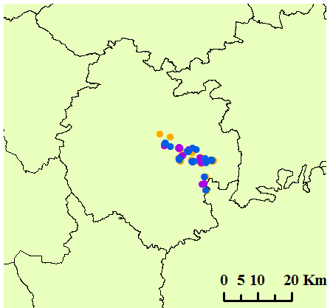
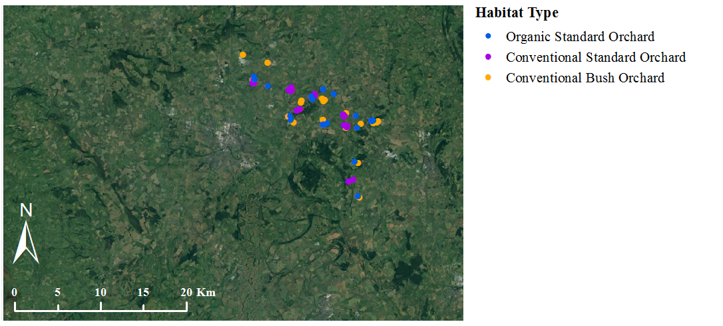
Herefordshire
Figure 4.1 Location of study orchards within Herefordshire, UK. Apple tree yield data was collected from 20 orchards for each of the three orchard types. Fruit yield data was collected from two trees per study orchard during autumn 2013 and 2014.

Orchard data collection and vegetation survey
For each of the study orchards the following details were recorded (1) tree scion varieties, (2) tree rootstock varieties, (3) date of planting in orchard, (4) orchard size, (5) amounts of fertiliser applied over the previous two growing seasons, (6) estimate of yield per orchard, (7) whether the orchard is grazed and if so the type of livestock. All plant species present at the location from which soil cores were removed were recorded using a 1m x 1m square quadrat centred on the coring location. Species abundances were measured by recording species presence/absence within each of the 64 (12.5 cm x 12.5 cm) squares of the quadrat. Eight measurements of maximum vegetation height were recorded across the quadrat (excluding flowering spikes of grasses). An estimate of the bare ground per quadrat was also recorded.

Apple yield data collection.
Due to logistical constraints, apple yield was recorded from all focal trees from orchards in 20 of the 25 orchard groups which were distributed over an area of approximately 20 km² (Figure 4.1) (giving a total of 40 trees per orchard type for each of the three orchard types, therefore a total of 120 trees). Following root sampling in June-August 2013, fruit yield of all 120 study trees was quantified for two consecutive harvests (autumn 2013 and 2014) to take into account the bi-annual cropping pattern of some apple varieties. Fruit yield was measured in October, shortly after maturation of the crop and whilst the vast majority of the crop was still retained on the tree. The number of apples on each tree were counted twice, and if numbers were within 10% of each other we used the mean of the two counts as an estimate of the number of apples. If the two counts differed by more than 10% counts were repeated until this accuracy threshold was met. This method is based on preliminary data that compared visual estimates of fruit number with that obtained from harvesting the fruit, which found no significant differences between these two methods with all values being within 10% of each other. The cider apple industry also harvests fruit from the ground, and we thus also counted any apples lying underneath the canopy of each tree. Twenty-five apples from each tree were then picked and weighed (in groups of five apples) to calculate the average apple weight (g) which was combined with the estimate of the number of apples to estimate total yield (kg) per tree. Diameter at breast height (DBH) was also recorded for each tree.

Apple tree root sampling
Root samples were collected from two randomly selected trees per orchard. To collect roots, soil pits were dug to a depth of 30 cm at two separate locations 1 m from the base of each tree. Roots were carefully cleaned to remove soil without wetting and a 1 g subsample of fine root (diameter <2mm) was removed and preserved by wrapping in tissue and placing in an air tight sealed bag with silica gel. Silica gel is effective in the preservation of fungal DNA for ecological studies of AMF (e.g. as used in Öpik et al., (2013b)). Simultaneously, soil samples were also collected 0.5 m from the base of each of the root sampled trees to allow quantification of the soil AMF community (see sampling method details Chapter 3, section 3.3.3).

DNA extraction and TRFLP analysis
Root systems were cut into 1 cm sections and a random subsample of roughly 10 pieces were selected and placed in 2ml eppendorf tubes with approximately 20 x 1 mm sterile stainless steel beads. Roots were homogenised to a fine powder using a Qiagen Tissue Lyser (Retsch®, Germany) for four minutes at a frequency of 30 beats per second. Genomic DNA was then extracted from a 0.1g ± 0.05g subsample using NucleoSpin 96 Plant II Kits (Macherey Nagel, Germany) following manufacturer instructions. TRFLP analysis was performed using the same methods as for analysis of the leek bait plant roots described in Chapter 3. Full details of methods are provided in Chapter 3 section 3.3.5.

Data analysis

TRFLP data analysis: Richness and Simpson’s diversity
TRF richness was calculated as the total number of unique TRF lengths detected from the two root samples analysed per tree. As a measure of richness and evenness, Simpson’s Diversity index was calculated per tree using the same method as detailed in Chapter 3 (section 3.3.6). The relative abundance of individual TRFs per tree were calculated as the average from both samples analysed per tree. To test for a difference in TRF number and Simpson’s diversity index between the three orchard types a one-way ANOVA test performed with orchard types as a predictor, TRF richness/Simpson’s diversity index as the response variable and site included as a random factor. All ANOVA analysis was performed in R studio version 3.3.1 (R Core Team 2016).

TRF relative abundance and presence/absence principal component analysis
Principal Component Analysis was performed on the TRF relative abundance (calculated as the mean across both samples per tree) and binary TRF presence/absence data using a sum of squares model in Genstat V18.1.0.12005 (VSNi International Ltd) to test for compositional differences in AMF communities between orchard types. To examine differences in principal component scores between orchard types, we used one-way ANOVA models with orchard type as a fixed effect and orchard group number as a random effect. Percentage values of data variation explained by each principal component were visually inspected and ANOVA tests were performed on all scores which accounted for over 2% of the variation in the data; whilst this 2% threshold is low, it is used to ensure a more complete analysis of differences between orchard types than would be achievable using a higher threshold.

OPLS-DA approach identifying individual TRFs which differ in relative abundance between orchard types
Orthogonal partial least square discrimination analysis (OPLS-DA) was used to initially examine the differences in the relative abundance of each of the 37 TRFs between the three orchard types and to identify TRFs which showed significant differences in abundance between habitat types (SIMCA 14.0 Umetrics, Sweden). OPLS-DA showed no significant differences in TRF relative abundance between the three orchard types, therefore no subsequent ANOVA tests were required. Full details of OPLS-DA and its suitability for examining differences in relative abundance of individual TRFs between orchard types are detailed in Chapter 3, section 3.3.6.

Data analysis of orchard management factor effects upon TRF richness and relative abundance per tree
A single linear mixed effects model was used to analyse the relationship between TRF richness and the following orchard management factors: N input kg/ha/yr⁻¹, P input kg/ha/yr⁻¹, orchard age (years), vegetation height within orchard (cm), bare ground average (%), botanic species richness (quadrat mean per orchard), grazing (livestock present in past two years versus no livestock present), orchard type (conventional bush, conventional standard or organic standard) and tree variety (mixed versus single). Site was included as a random factor. Analysis was performed in R studio version 3.3.1 (R Core Team 2016) using the ‘lme4’ R package.
The effect of orchard management factors upon AMF community composition was analysed using De-trended correspondence analysis (DCA) with down weighting of rare taxa. This analysis method tests the amount of variation in the primary data matrix (TRFLP relative abundance for each of the 37 TRFs per sample) that was explained by the secondary data matrix (measures of orchard management as above listed). All DCA analysis was performed in PC-ORD (v 6.9, MjM software, USA).

Data analysis of the relationship between tree yield, AMF community composition and richness
A single linear mixed effects model was used to examine the effect of TRF richness on apple tree yield for the 120 trees from which yield data over 2 years was collected. The model included the following management factors as predictors (N input kg/ha/yr⁻¹, P input kg/ha/yr⁻¹, orchard age (years), vegetation height within orchard (cm), bare ground average (%), botanic species richness (quadrat mean per orchard), grazing (livestock present in past two years versus no livestock present), orchard type (conventional bush, conventional standard or organic standard) and tree variety (mixed versus single), TRF richness (total mean TRFs produced from both restriction enzymes) and tree DBH (cm). Site was included as a random factor. Analysis was performed in R studio version 3.3.1 (R Core Team 2016) using the ‘lme4’ R package.
DCA analysis was used to examine the relationship between AMF composition and tree yield. The primary data matrix contained relative abundances of TRFs per tree whilst the secondary data matrix contained tree yield (kg yr⁻¹ average) and DBH measurements per tree. DCA analysis was performed in PC-ORD (v 6.9, MjM software, USA).

Results

Comparison of AMF colonising apple tree roots in three orchard management types.

Richness and Simpson’s diversity
A total of 37 TRFs were identified within the apple root samples, 21 from restriction with Hinf-I and 16 from restriction with HpyCH4-III. Conventional bush orchards showed the highest TRF richness of all orchard types (average of 16.7 TRFs) which was significantly greater than that of organic standard orchards (average of 13.3 TRFs) (Table 4.1). Conventional standard orchards showed an intermediate level of TRF richness (average of 15.1 TRFs). No significant differences in Simpson’s diversity index were shown between orchard types (Figure 4.2, Table 4.1).
Table 4.1 One-way ANOVA results for effect of habitat on species richness (TRF number) and Simpson’s reciprocal diversity index (1/D) of AMF colonising apple roots. Data is presented from restriction with the enzymes Hinf-I and HpyCH4-III separately and when grouped.
Diversity Measure | Restriction enzymes | df | F | P
Richness | Hinf-I and HpyCH4-III (grouped) | 2 | 5.95 | 0.003
 | Hinf-I | 2 | 6.46 | 0.002
 | HpyCH4-III | 2 | 3.09 | 0.049
Simpson’s reciprocal diversity index | Hinf-I and HpyCH4-III (grouped)* | 2 | 0.38 | 0.685
 | Hinf-I* | 2 | 0.66 | 0.520
 | HpyCH4-III | 2 | 0.43 | 0.651
*SRDI values which were log transformed prior to ANOVA analysis to meet test assumptions

AMF community composition
Minor differences in TRF relative abundance were observed; PC2 (20.16% data variation) showed significant separation of conventional bush and conventional standard orchards (Table 4.2, Figure 4.2). PC 7 and PC9 scores also showed significant differences between orchard types (Table 4.2) however combined these principal components only explain 4.8% of the data variation. Significant differences in principal component scores from TRF presence/absence data were shown between conventional bush orchards and organic standard orchards for PC2 (14.95% of data variation) (Table 4.2, Figure 4.2). OPLS-DA analysis showed no significant differences in the relative abundance of individual TRFs between the three orchard types. The detection of significant differences in communities by PCA in contrast to OPLS-DA shows that although no individual taxa differed significantly in abundance between habitats, when abundances of all taxa were considered together, minor differences in AMF composition between orchard types became apparent.
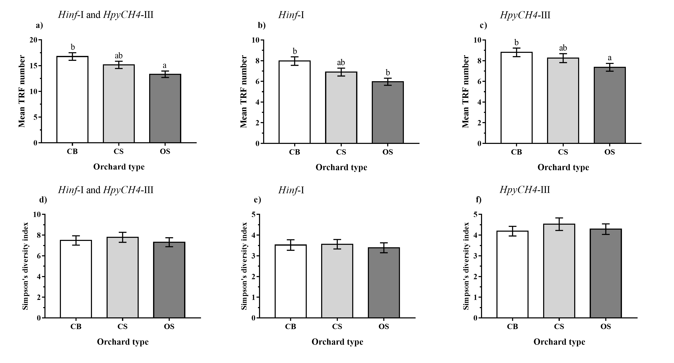
Figure 4.2 Mean TRF richness and Simpson’s diversity for AMF colonising apple trees in three orchard management types. TRF richness calculated from restriction with (a) both enzymes combined (b) Hinf-I, (c) HpyCH4-III. Mean Simpson’s diversity indices calculated from restriction with (d) both enzymes (e) Hinf-I, (f) HpyCH4-III. Error bars show SE of mean (n=25). Orchard type codes are as follows; (CB; conventional bush orchard, CS; conventional standard orchard, OS; organic standard orchard). Orchard types with the same letter do not differ significantly from one another (Tukey, HSD P<0.05).
Table 4.2 TRFLP principal component scores which showed significant differences between orchard management types. Statistical differences between principal component scores of habitats were calculated using a 1-way ANOVA test with PC score as the response, orchard type as the predictor and site as a random factor. Orchard types with the same letter do not differ significantly from one another (Tukey HSD, p<0.05). Only results for principal component scores which are significantly different or showed borderline significance values (*) between orchard types are presented.
Principle component score mean and (±SE) per habitat
Data | PC and ( % data variation explained) | F_{1,4} | P | Conventional Bush Orchard |  | Conventional Standard Orchard |  | Organic Standard Orchard
TRF relative abundance | 2 (20.16%) | 3.02 | 0.052* | -6.986^{A} | (4.212) | 6.515^{B} | (3.522) | 0.470^{AB} | (3.977)
TRF relative abundance | 7 (2.66%) | 2.97 | 0.055* | 0.418^{AB} | (1.095) | 1.926^{B} | (1.136) | -2.344^{A} | (1.504)
TRF relative abundance | 9 (2.14%) | 4.11 | 0.019 | 1.636^{B} | (0.880) | 0.883^{AB} | (1.148) | -2.519^{A} | (1.298)
TRF presence  /absence | 2 (14.93%) | 5.63 | 0.005 | 0.297^{B} | (0.118) | -0.013^{AB} | (0.127) | -0.284^{A} | (0.130)
TRF presence  /absence | 6 (3.94%) | 6.62 | 0.002 | -0.140^{A} | (0.070) | 0.175^{B} | (0.064) | -0.035^{A} | (0.057)
TRF presence  /absence | 7 (3.64)% | 4.06 | 0.020 | -0.056^{AB} | (0.063) | -0.084^{A} | (0.061) | 0.141^{B} | (0.061)

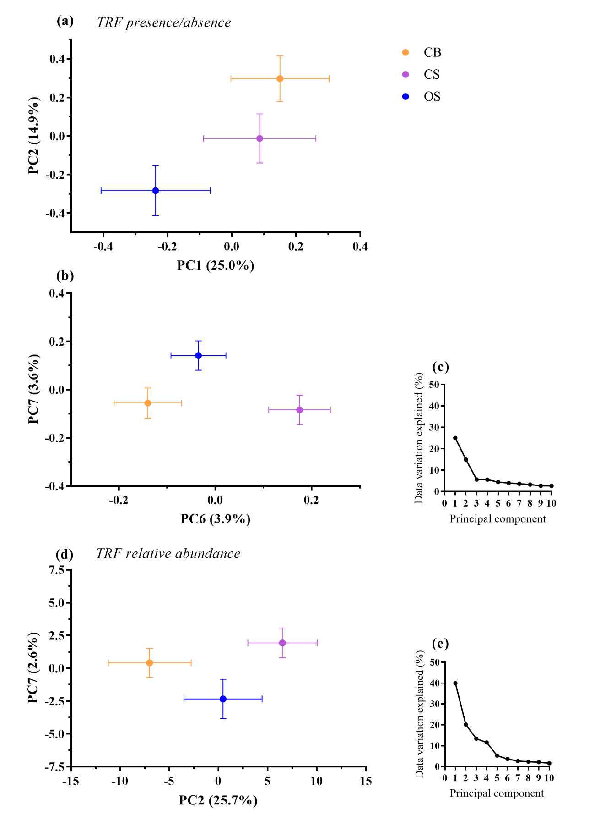
Figure 4.3 PCA scores showing differences in AMF colonising apple trees within three contrasting orchard management types. Figures (a) and (b) show TRF presence/absence data, (c) TRF relative abundance, (d) percentage variation in data explained by principle components from analysis of relative abundance data and (e) TRF presence/absence. Orchard types are as follows; CB; conventional bush orchard, CS; conventional standard orchard, OS; organic standard orchard. Data is presented for 120 trees. Only principal components which show significant difference between orchard types have been plotted.

Aspects of orchard management which are most important for affecting AMF colonising apple trees.

TRF richness and orchard management
Measured differences in orchard characteristics and management between the three orchard types examined by this study are summarised in Figure 4.7. Of the nine management factors examined, orchard age was the only management factor which showed a significant effect upon TRF richness (Table 4.3). A significant negative relationship between orchard age and TRF richness was shown (Figure 4.5).

AMF community composition and orchard management
DCA1 (eigenvalue: 0.39312) and DCA2 (eigenvalue: 0.14006) scores accounted for the majority of the variation in the data (>50%) and showed little separation between orchard types (Figure 4.4). Of the ten management factors examined, only the following four explained any of the variation in community composition between orchards however all effects were minimal; bare ground area (DCA1: R² =0.014, DCA2: R² =0.003), P input (DCA1: R² = <0.001, DCA2: R² =0.020), orchard age (DCA1: R² = 0.005, DCA2: R² =0.007), and understorey botanical richness (DCA1: R² = 0.006, DCA2: R² =0.020) (Figure 4.4).

Table 4.3 Effect of orchard management factors on TRF richness per tree using a linear mixed effects model. Reference categories for categorical variables; Grazed = grazed, Fruit variety = mixed. Orchard type conventional standard orchard (CS) and organic standard orchard (OS) were compared to the reference value of conventional bush orchards. Site was included as a random factor in all models. (n= 150) *P < 0.05
Management factor | Parameter estimate | ±SE | P value
Orchard type | CS -0.552, OS -1.879 | CS 2.490, OS 2.521 | 0.401
N input | -0.010 | 0.040 | 0.794
P input | -0.098 | 0.136 | 0.471
Orchard age | -0.042 | 0.021 | 0.046*
Vegetation height | -0.035 | 0.042 | 0.398
Bare ground (%) | 0.014 | 0.040 | 0.728
Botanical species richness | -0.006 | 0.079 | 0.940
Grazing (grazed v non grazed) | -0.837 | 1.347 | 0.534
Tree variety (mixed v single) | 0.697 | 1.849 | 0.706

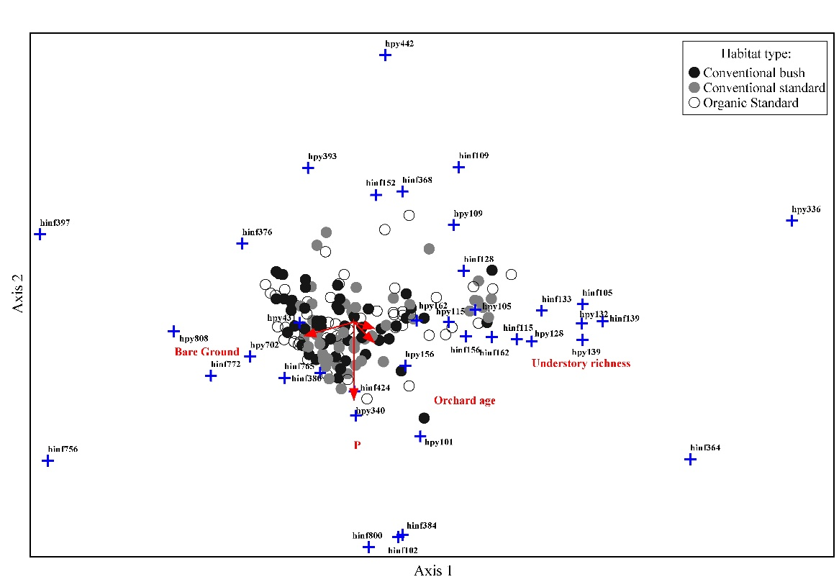
Axis 1
Axis 2
Figure 4.4 Variation in TRF relative abundance as explained by orchard management factors. Eigen values for DCA 1 (0.39) and DCA 2 (0.14). Management factors shown in red had a small but not significant (P<0.05) effect upon TRF relative abundance, arrow lengths are proportional to variation explained.
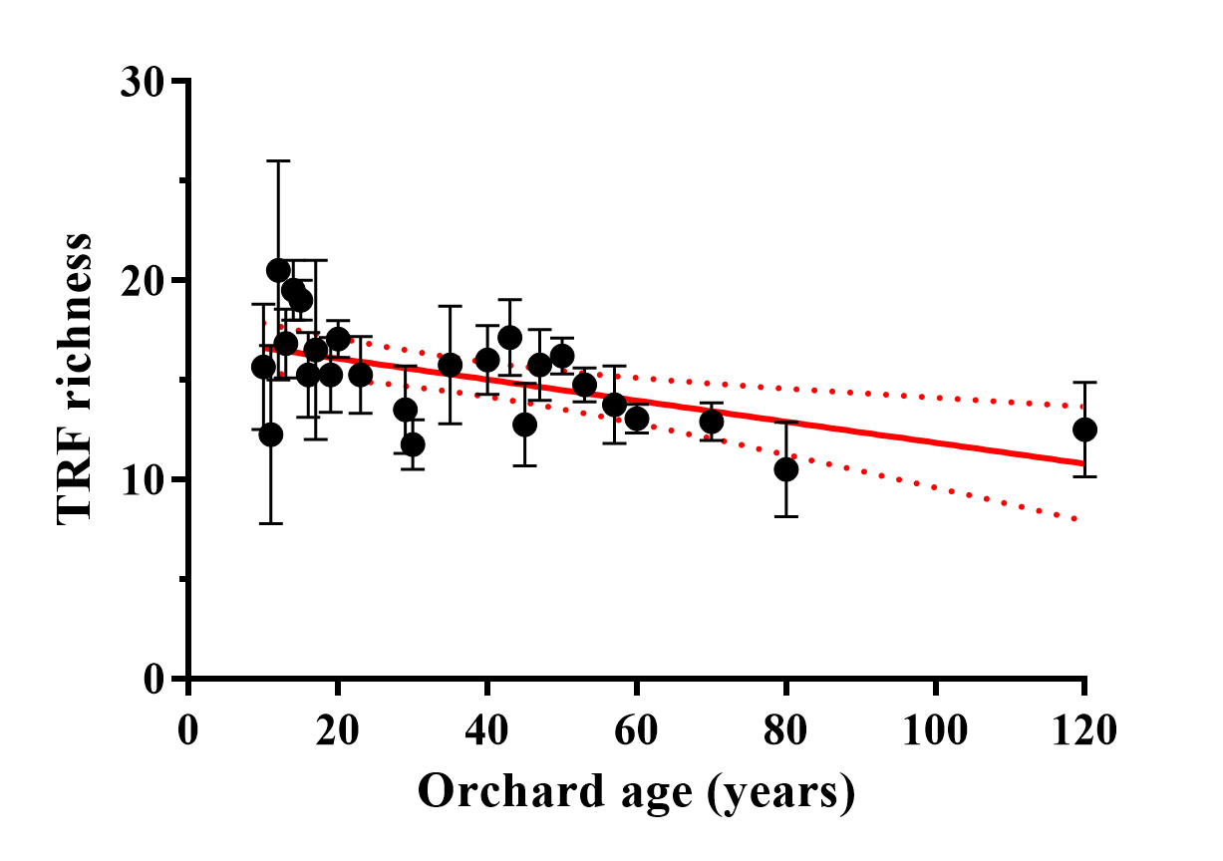
Figure 4.5 TRF richness and orchard age of 150 apple trees within three orchard management types. Trend line shows the result of linear regression with 95% confidence interval. R2 = 0.321, y= -0.05289x + 17.140, P = 0.003.

Relationship between apple tree yield and AMF richness/relative abundance

Tree yield and TRF richness
No effect of TRF richness upon tree yield was found (Table 4.4). Of all orchard management factors measured, significant effects were shown for only grazing (presence/absence) and botanical species richness with grazed orchards and those of greater botanical richness showing a positive relationship with tree yield (Table 4.4). Fruit yield annual averages per tree were as follows: conventional bush orchards: 25.2kg (SE± 1.58), conventional standard orchards 29.6 kg (SE± 2.48) and organic standard orchards; 27.0 kg (SE± 2.84).

Tree yield and AMF community composition
AMF community composition explained a negligible amount of the variation in tree yield (tree yield; DCA1 R² = 0.032, DCA2 R² = 0.002), DBH (DCA1: R² = 0.029, DCA2: R² = 0.033) (Figure 4.6).

Table 4.4 Effect of TRF richness and other orchard management factors on fruit yield per tree using a linear mixed effects model. Reference categories for categorical variables; Grazed = grazed, Fruit variety = mixed. Orchard type conventional standard orchard (CS) and organic standard orchard (OS) were compared to the reference value of conventional bush orchards. Site was included as a random factor in all models. (n= 120), *P < 0.05, Conditional R² = 0.376.
Management factor | Parameter estimate | ±SE | P value
TRF richness | 0.410 | 0.233 | 0.078
Orchard type | CS -18.986 , OS -16.817 | CS 8.592, OS 8.367 | 0.095
N input | -0.141 | 0.119 | 0.235
P input | -0.095 | 0.474 | 0.840
D.B.H | 0.068 | 0.042 | 0.112
Orchard age | -0.030 | 0.067 | 0.654
Vegetation height | -0.152 | 0.137 | 0.264
Bare ground (%) | -0.092 | 0.135 | 0.493
Botanical species richness | 0.497 | 0.241 | 0.039*
Grazing (grazed v non grazed) | -13.857 | 5.219 | 0.012*
Tree variety (mixed v single) | 8.008 | 7.125 | 0.265

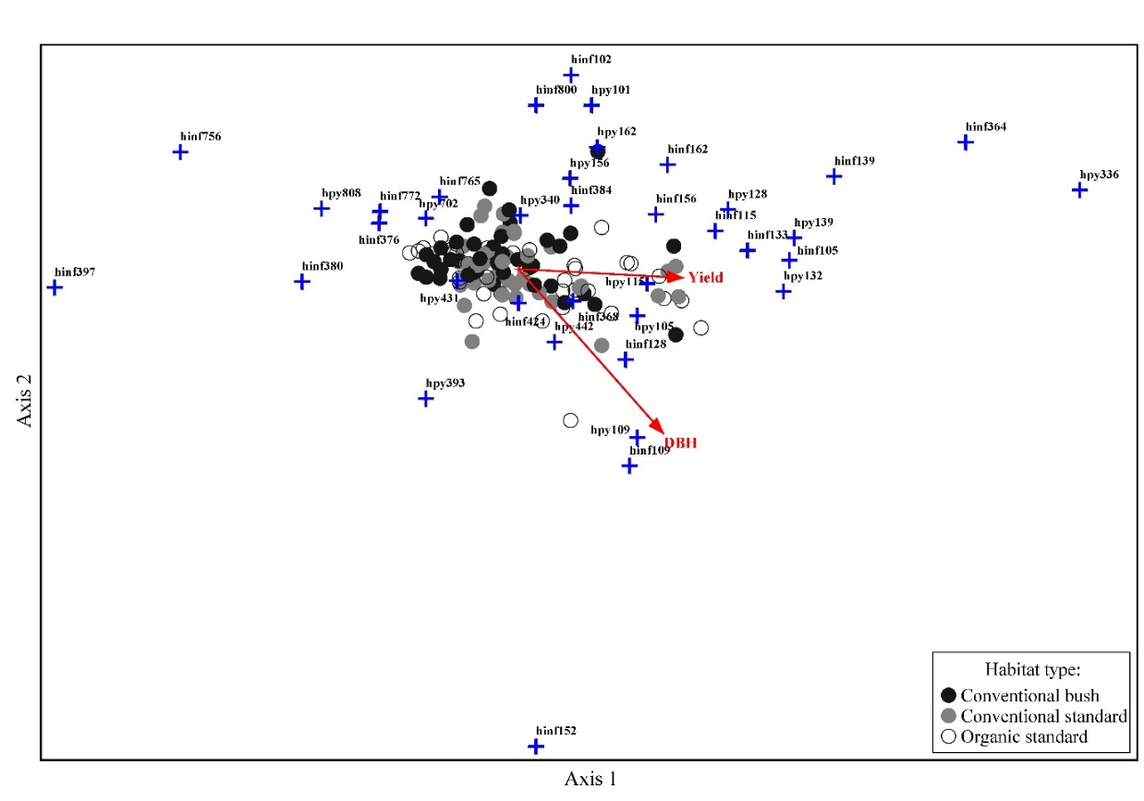
Axis 1
Axis 2
Figure 4.6 DCA analysis showing the amount of variation in tree yield explained by TRF relative abundance. Eigen values for DCA 1 (0.40) and DCA 2 (0.14). Arrow length is proportional to effect size, however no effects were significant (p<0.05).
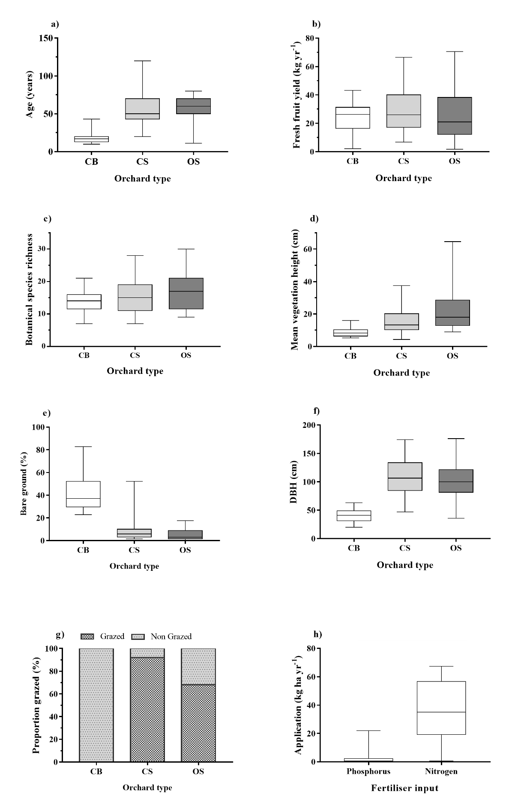
Figure 4.7 Summary of measured differences between three orchard management types. Orchard type codes are as follows: CB; conventional bush, CS: conventional standard, OS: organic standard. Box plots (b) and (d) present fruit yield and tree diameter at breast height (DBH) averages respectively for 40 trees per orchard type (n=20), (h) fertiliser input for conventional bush orchards only (n=25), all other data presented is orchard averages (n = 25). Boxplots represent the median (midline), quartiles (box) and maximum and minimum values (whiskers).

Discussion
This chapter aimed to characterise the AMF communities colonising apple roots in cider orchards and test whether they differed between orchards of different management types. A further aim was to examine the relationship between AMF richness and community composition with tree yield.

Conventional bush orchards which are most intensively managed had the highest AMF richness
Conventional bush orchards showed the highest level of AMF richness (16.7 TRFs) and were significantly richer than organic standard orchards (13.3 TRFs) (Figure 4.2). This is an unexpected result as it contrasts with many published studied which report reduced AMF richness in more intensively managed agricultural systems (Gosling et al., 2006; Valyi et al., 2015). However analysis of management effects on AMF richness showed that orchard age has a significant negative relationship with AMF richness. Therefore difference between AMF richness between orchards may be partly explained by differences in the average age of trees within different orchard types as conventional bush orchard are on average the youngest of the orchards systems (19 year since planting date) in comparison to the more traditional orchard systems conventional standard (average 58 years) and organic standard (average 57 years) (Figure 4.7a).
Our field sampling approach meant orchards were only selected if they were more than 10 years of age as this is the age at which most apple varieties begin to reach a mature size. However, trees are still actively growing at this stage (Williams, 1996). Increased allocation of carbon to root systems has been shown for trees during early stages of growth (Raich et al., 2014) to allow capture of nutrients and resources needed to sustain growth rates. It is therefore possible that due to differences in growth, younger trees may be allocating more C below ground thus affecting AMF community dynamics within roots in comparison to older trees (Génard et al., 2008) resulting in increased richness of AMF.
Furthermore a small proportion of the conventional standard orchards (12%) sampled by this study were exceptionally old with trees circa 120 years of age which is nearing the end of the life span of an apple tree (Williams, 1996). It is possibly that increased root senescence or a reduction in net carbon fixation by old trees might result in reductions in abundance and diversity of AMF due to reduction in C supply. Other studies have previously reported differences in the community composition of AMF colonising young trees in comparison to mature trees. However, these show contrasting results with some reporting increased diversity in mature trees (Rodríguez-Morelos et al., 2014) and others reporting the opposite (Husband et al., 2002). These differences have been attributed to differences in AMF species recruitment and tree belowground C allocation.

No relationship was found between orchard management factors and the AMF community.
Our results showed no measured differences in orchard management affected richness or community composition other than the weak negative relationship between AMF richness and orchard age. These results are in accord with those reported in Chapter 3 which showed highly similar AMF communities within the soils of the same orchards using a leek bait plant trap culture system.
Although agricultural habitats undergoing severe soil disturbance such as ploughing show reduced richness of AMF (Helgason et al., 1998; Daniell et al., 2001) there is evidence that habitats which undergo moderate levels of management intensity (i.e disturbance), can still host relatively high levels of AMF richness. This has been found across a range of systems from restored contaminated land (Vallino et al., 2006), arable land (Hijri et al., 2006) and managed forest plantations (Opik et al., 2008). Our results are in accord with those of Opik et al., (2008) who found AMF communities colonising herbaceous plants within boreal coniferous forest soils with different management types did not differ. This was attributed to there being few/little differences in soil disturbance between management practices. Similarly, in the orchards studied, soil disturbance regimes did not differ between orchards management types which may explain the lack of differences identified.
As discussed in Chapter 3, lack of effects of P inputs upon AMF community composition contrasts to many studies showing strong effects of fertilizer application upon AMF communities (e.g.(Wang et al., 2009). Although soil nutrient status has not been measured by this study it is likely that increased addition of P and N fertiliser to soils would increase soil nutrient status. Soil type may be important for AMF responses to fertiliser application. Jansa et al., (2014) found that soil type and geography were more important in determining AMF communities than agricultural management practices (including available P) when comparing AMF communities across crop and pasture land in a landscape scale study in Switzerland (Jansa et al., 2014). In particular soil pH, and to a lesser extent texture, fertility, soil organic carbon and microbial biomass affected community composition. The authors suggested that the importance of soil type for affecting community composition could explain why studies examining fertilization response of AMF on a single soil type showed no response (e.g.Wang et al., 2011). Similarly, our study examined AMF across an area of predominantly clay-loam soil. The ability of clay to bind available P may explain less responsiveness to P addition as P rapidly becomes bound in unavailable forms due to the soil chemistry of clays. Similarly in a landscape scale study of AMF distribution across Ireland, Hazard et al (2013)., found that local environmental factors such as rainfall and soil pH filtered the AMF community more than land use despite sampling a wide range of land use types which included arable and pasture land (Hazard et al., 2013).

No relationships between tree yield, AMF richness and composition
This study showed no effect of AMF richness or taxa relative abundance upon fruit yield of apple trees. Our hypothesis that increased AMF diversity would improve yield was based on the premise that in more diverse AMF communities, complementarity between AM fungi which occupy different ecological niches and facilitative interactions between taxa will improve resource use efficiency and therefore improve plant productivity (van der Heijden et al., 1998; Loreau & Hector, 2001; Wagg et al., 2015). In our study system (apple orchards), increased diversity may therefore result in improved provision of nutrition and health to apple trees and consequently improved fruit production. However this hypothesis makes many assumptions which may explain why no effect of richness upon yield was observed.
Firstly, positive AMF diversity – productivity relationships are largely dependent on the fact that higher diversity of AMF will improve acquisition of resources. Van der Heijden et al., (2008) hypothesised that the benefit of microbial diversity to plant productivity is greatest when resources are limited due to the ability of a diverse range of organisms to more efficiently obtain limiting nutrients from the soil for example by accessing different forms of nutrients. In contrast, under high nutrient levels, taxa can become functionally redundant and provide no additional benefit therefore increased diversity may not correspond with increased plant productivity. Therefore, if nutrient availability was not limited within the orchards sampled for this study, benefits of diversity may be smaller. In addition, other studies which have examined relationships between AMF diversity and plant productivity at the landscape scale show that interactions are complex as many other biotic and abiotic factors may influence biodiversity productivity relationships in particular environmental differences such as nutrient availability and soil pH (Holste et al., 2016).
Functional differences between AMF and taxa identity may also explain why in some cases diversity does not improve productivity. Vogelsang et al., (2006) demonstrated using a microcosm experiment that diverse communities containing the single most productive species may be equally as productive as the single most productive species in monoculture. Similarly other studies have shown the importance of taxa identity rather than richness for driving ecosystem functions (Klironomos, 2003; Cavagnaro et al., 2005).
A further consideration is that there are several reasons why improved nutrient acquisition by a more diverse AMF community may not result in increased fruit production. For example this may be the case if access to nutrients were not a limiting factor for fruit production or if nutrient uptake by the tree itself is down-regulated in response to mycorrhizal colonisation, leading to no net gain in nutrition (Smith, 2000). Furthermore, it is known that excessive supply of nutrients to apple trees may lead to increased vegetative growth but reduced allocation of resources to reproduction (i.e reduced fruit production) and therefore not be beneficial for improving yield (Williams, 1996).
Finally, annual apple yields are known to be affected by a range of environmental and biological factors over the course of the growing season. These include environmental factors such as rainfall, temperature and wind in addition to biological factors such as pollination effects and pathogen incidence (Williams, 1996; Beresford & Kim, 2010). Particularly at specific times of the season such as during flowering and fruit set, variance in conditions can have a large effect upon the annual crop. In comparison to these factors, minor effects of AMF upon productivity may be difficult to detect.

Conclusions
This study aimed to test the following hypothesis:
- Intensive orchard management reduces AMF richness and Simpson’s diversity and alters community composition (presence/absence of taxa present and their relative abundance).
- Increased inorganic fertiliser application is associated with reduced AMF richness and changes in community composition of the fungal taxa colonising apple trees.
- There is a positive relationship between AMF richness and abundance with tree fruit yield.
The results of this study do not support hypothesis one, two or three which must therefore be rejected. The lack of response of AMF communities colonising apple trees to management practices and the high richness of AMF colonising apple trees suggests that orchard management practices have little impact on AMF communities. Lack of relationship between the AMF community and tree yield suggests that AMF are not one of the main drivers of tree productivity.

General discussion

Overall thesis aims
The overarching aim of this thesis was to assess the potential of arbuscular mycorrhizal fungi (AMF) for improving sustainability of apple orchards.
More specifically, this research addressed the following questions:
- To what extent can symbiosis with AMF improve the health, growth and productivity of cider apple trees?
- What are the AMF communities naturally found within cider apple orchards and how are they impacted by orchard management?
The findings of this thesis in relation to these aims are discussed below.

Can AMF improve growth, health and productivity of cider apple trees?

Tree health
The data from this thesis have demonstrated a positive effect of mycorrhizal inoculation with Funneliformis mosseae and Rhizophagus irregularis for resistance to the fungal pathogen Neonectria ditissima (apple canker) for young trees. This is the first study to report the benefit of mycorrhizal inoculation for defence against this pathogen which is a major production limiting pathogen of apple orchards globally. This result is in accord with a growing body of literature reporting beneficial effects of AMF for plant disease resistance (Jung et al., 2012; Cameron et al., 2013). Interestingly a relationship between colonisation of plants colonised with both these species and reduced pathogen incidence has previously been reported (Maherali & Klironomos, 2007) for protection of Plantago lanceolata against root rot pathogen Pythium sp suggesting that these AMF species may also function in plant protection against other fungal pathogens. The role of AMF in protection against this pathogen may be particularly useful for organic orchard systems where chemical control of N. ditissima is prohibited.

Growth and productivity
This study has found no evidence of improved yield of experimental trees inoculated with two AMF taxa (Chapter 2) although it is important to note that the immaturity of the trees used for this experiment (1 year) meant that trees had not reached yet reached full cropping. Similarly the observed lack of relationship between the AMF community and tree yield from our landscape scale study suggests that AMF communities are not a main driver of tree productivity (Chapter 4). Inoculation of experimental trees (Chapter 2) showed no clear benefit of improved nutrition (indicated by improved leaf tissue concentration of either N or P) or any measure of above or belowground growth.

Scion and rootstock AMF interactions
Both MM111 and MM106 rootstocks which are the among the most widely planted for cider apple trees, were capable of being well colonised by AMF (up to 48% root colonisation) thus demonstrating that selective breeding of these rootstocks has not reduced the ability to form AMF symbiosis as has been observed in some crop varieties (Hetrick et al., 1996; Zhu et al., 2001). Interestingly our results show AMF colonisation of trees differs between scion types (Dabinett and Michelin), although both types were able to reach high colonisation levels of up to 48 and 54 % respectively. To our knowledge this is the first study to report the effects of scion type on AMF colonisation of apple trees. Our results support recent work in citrus which demonstrated scion genotypes have a greater effect upon AMF communities than rootstocks (Song et al., 2015). Although the mechanisms for below ground effects of scion genotypes are not fully understood it has been suggested that metabolites synthesised in the scion and transported to the rootstock could function as a chemical cue for AMF recruitment, thus affecting the AMF community colonising the rootstock (Song et al., 2015).

What are the AMF types found in orchards and does orchard management alter AMF communities?

What AMF types were found
Our results from Chapter 3 show apple orchards are able to host a diverse range of AMF with taxa from six genera identified from orchard soils: Acaulospora, Ambispora, Archeospora, Claroideoglomus, Diversispora and Glomus. In line with other studies of agricultural systems Glomus taxa were most dominant within all orchard types. Although it was not possible to identify the taxa found in apple root samples from the TRFLP analysis, seven TRFs found in apple roots were of sizes predicted from restriction of Glomus sequences from the orchard soil samples suggesting that Glomus types accounted for some of the AMF taxa colonising apple roots.
Both Rhizophagus irregularis and Funneliformis mosseae which were used to inoculate the experimental trees in our growth trial (Chapter 2) were also present in orchard soils. This was shown by putative identification of OTU6 and OTU5 from sequencing of leek bait plant trap cultures as R. irregularis and F. mosseae respectively (both virtual taxa were closest matches for these OTUs respectively although bootstrap support was low) and suggests that these taxa were naturally present in orchard soils with on average a relative abundance of 12% (R.irregularis) and 8% (F.mosseae). Diagnostic TRF sizes for Funelliformis mosseae (Hinf-I 376 and HpyCH4-III 393) were produced by apple root TRFLP analysis suggesting that this AMF type may also have been colonising apple. The peak predicted for Rhizophagus irregularis using one sequence of this species found in the MaarjAM database was not detected in TRFLPs derived from apple roots. This may suggest that this species may have either been absent or was too rare to be detected by TRFLP analysis (relative abundance <1%). However, there is known to be genetic variation within Rhizophagus irregularis, potentially causing the production of multiple TRFs from this species (Cotton et al., 2015) so it is also possible this species was present but not identified from the TRFLP analysis. Sequencing of the apple roots would allow this to be investigated further.

Orchard AMF communities and management effects
Our results consistently showed similarity between AMF communities within the three orchard management types compared in this study. Firstly characterisation of the AMF communities within orchard soils from all three orchard types using a leek bait plant trap culture system and two molecular community fingerprinting techniques (TRFLP and Illumina sequencing) showed no differences in richness or Simpson’s diversity and only minor differences in taxa relative abundance and community composition (Chapter 3). Secondly the same pattern was shown when comparing the same measures of the AMF community (richness, Simpson’s diversity, taxa relative abundance and community composition) colonising apple roots colonising a total of 150 trees within the three study orchard types using TRFLP analysis (Chapter 4). Thirdly, analysis of the effect of individual management factors measured for all 75 orchard sites upon TRF richness and relative abundance showed no effect of any management measures we recorded (Chapter 4).
It is likely that the similarity between AMF communities found within both orchard soils (Chapter 3) and colonising apple roots (Chapter 4) is partly explained by low levels of soil disturbance within the orchard systems. Evidence of AMF sensitivity to soil disturbance is provided by several results from this thesis. Firstly comparison between AMF communities of orchard and woodland soils in Chapter 3 showed similarity in both richness and composition of the AMF in contrast to the AMF communities for arable sites. One of the main differences between arable sites in comparison to orchards and woodland is increased frequency and severity of soil disturbance through regular ploughing. Secondly the AMF communities colonising leek bait plant trap cultures from orchard soils (Chapter 3) show a distinctly reduced richness and differences in community composition when compared to the AMF communities colonising apple roots sampled in situ from the same soil (Chapter 4) (and see Figure 5.1 and later discussion). One of the main differences between these two systems is increased disturbance of the leek trap culture soils and relatively short time for AMF establishment following this disturbance. Finally, as discussed in Chapter 3 and Chapter 4 physical disturbance of soils is known to be one of the major factors affecting AMF communities as has been shown for several studies of agricultural environments (Jansa et al., 2003; Alguacil et al., 2008; Säle et al., 2015). This is largely due to taxa specific differences in ecology of AMF types particularly relating to their regeneration strategies and growth rates (Hart & Reader, 2002; Maherali & Klironomos, 2007; Sýkorová et al., 2007)
Our data from the Herefordshire orchards report no effect of the nutrient input to orchards upon AMF communities (Chapter 3 and Chapter 4). In contrast, application of inorganic fertilisers reduced colonisation of two fungal types on average from 42% when recommended levels were applied to 20% when one tenth of this amount was applied (Chapter 2). This raises the question of whether colonisation was also reduced in bush orchards despite similarity in AMF community composition as we made no measure of fungal abundance between orchard types. Nutrient input did reduce colonisation significantly in experimental trees (Chapter 2) however this did not result in significantly reduced benefit to trees with regard to the lower incidence of N. ditissima in AMF inoculated trees.

Explaining differences between AMF found in apple tree roots versus orchard soils
Comparison of the AMF communities colonising leek bait plant roots and those of field sampled apple showed distinct differences in the AMF colonising each plant with 13 TRFs and 30 TRFs found uniquely in leek and apple roots respectively and only 7 TRFs found in both systems (Figure 5.1). We expected that leek bait plant trap systems would select a subsample of the AMF shown in apple roots due to the nature of trap culturing which selects disturbance tolerant taxa with rapid colonisation and growth rates. Only seven TRFs were found that colonised both apple and leek. By comparing the restriction sites to those of sequences it was possible to identify these as belonging to the genera Glomus which is known to be well represented in disturbed arable habitats (Helgason et al., 1998; Daniell et al., 2001; Cotton et al., 2015) therefore fitting our expectation of the types that would be represented in both systems.
Interestingly many TRFs were only found in either leek or apple with few taxa found in both. We suggest that the differences in AMF types may partly be explained by differences in the ecology of these fungi. According to classic ecology theory, species may be classified into two general groups: R strategists which are typified by rapid colonisation rates, high growth rates and high reproductive output and K-strategist which are slow growing, competitive species able to persist in climax communities (MacArthur & Wilson, 1967; Pianka, 1970). Applying this theory to our study system would predict the leek trap culture to particularly represent R selected species. In contrast due to far longer establishment time, the AMF communities within apple roots have undergone succession allowing the K selected strategists to become more dominant (Figure 5.2). It is possible that all taxa were present in both plants but that these were not detected due to the TRFLP methodology where all TRFs under 1% in relative abundance are excluded from further analysis.
There are a number of other reasons why AMF colonising apple and leek could be different which are not mutually exclusive with each other or the above explanation. Firstly although it is generally assumed that there is low specificity in plant-AM fungal symbiosis (Smith & Read, 2008) studies have shown evidence of preferences of plants in the fungal partners with which they form symbiosis (Vandenkoornhuyse et al., 2003; Uibopuu et al., 2012; Torrecillas et al., 2012). For example Uibopuu et al., (2012) found that different plants grown under controlled conditions with the same soil inocula became colonised by distinct communities of AMF. Therefore differences in host preferences of leek and apple plants could partially explain differences in AMF communities found. Additionally factors such as lack of tolerance to greenhouse growth conditions (e.g. temperatures) could also explain differences in the communities colonising leek and apple plants (Heinemeyer & Fitter, 2004).
Making the assumption that the main differences between AMF colonising leek and apple is due to their ecology, this raises the interesting question of whether communities of AMF colonising apple change over time and how this affects the host apple tree. Data from Chapter 3 showed a negative relationship between tree age and AMF richness however all trees were over 10 years old. Young trees may particularly benefit from AMF symbiosis due to less developed roots systems and greater nutrient requirement during early stages of growth. Therefore it would be interesting to see if the AMF which naturally colonise first are most beneficial. This could be particularly of relevance to producing inoculum which is most beneficial for young trees i.e. making sure we are inoculating with types that are (a) most beneficial (b) unlikely to already be in the soil in large amounts.
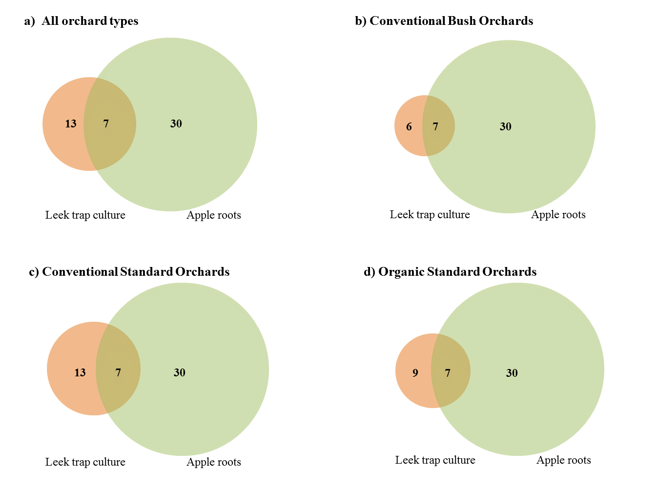
Figure 5.1 Venn diagram to show the total TRFs found in roots from both leek trap cultures and apple roots from the field (circle overlap) and the TRFs found in each system only (circle areas with no overlap). Diagram show (a) Total TRF numbers across all orchards (b), (c) and (d) totals per orchard type. TRFs are combined from restriction with both HpyCH4-III and Hinf-I restriction enzymes. Circle sizes are proportional to TRF number.
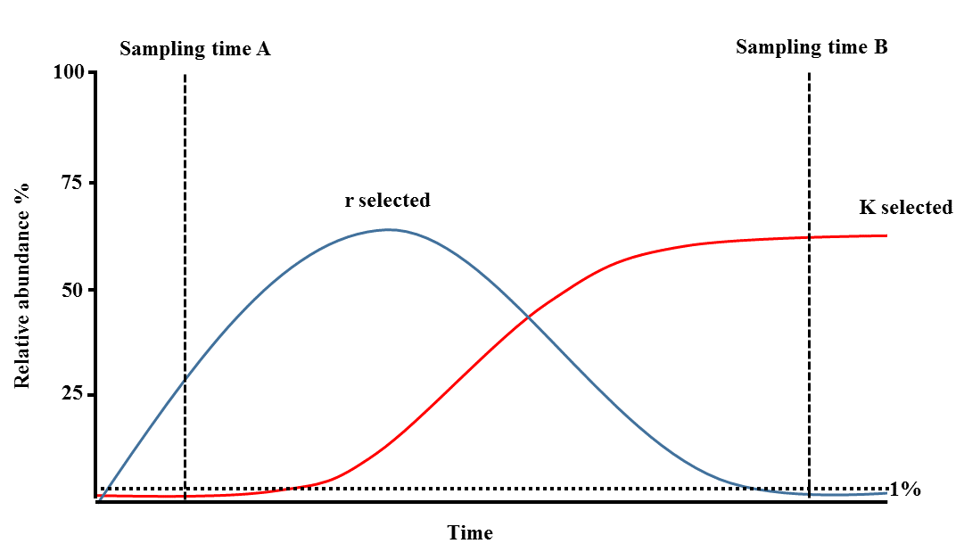
Figure 5.2 Diagram to explain how differences in colonisation strategy and fungal succession could explain observed differences in AMF colonising leek bait plant trap cultures and apple roots. r selected species are classified as rapid colonisers with high growth rates, K selected species are slower growing species which are suited to competition for resources in an established community. At sampling time A, only the r selected species is above 1% relative abundance within host plant roots and therefore able to be detected by TRFLP. At sampling time B, only the k selected taxa is abundant enough to be detected by TRFLP. Diagram based on r and K selection theory (MacArthur & Wilson, 1967; Pianka, 1970)

Broader implications

Applied findings relevant to apple growers
This study provides evidence that care should be taken to ensure trees are not supplied with excess fertiliser application. Our results from Chapter 2 show a clear effect of inorganic fertiliser application upon tree root development with a 17% reduction in root biomass of trees receiving recommended chemical inputs in comparison to low input fertiliser treatment. This is particularly important given that trees with smaller root systems are likely to be more susceptible to stress during drought events which are predicted to increase in frequency and severity with future climate change (IPCC, 2014). Nutrient applications to newly planted trees should be particularly carefully considered due to negative effects upon AMF colonisation and root development. Young trees are more vulnerable to drought stress and effects of nutrient limitation due to less developed root systems and higher growth rates.
Data from this thesis demonstrates inoculation with AMF was able to provide benefits to tree health. However there are important differences between out experimental study system and that of apple orchards in the field. Both of the species used in this study are common of agricultural habitats and therefore are likely to be rapid colonisers of newly planted trees, therefore adding additional inoculum may not improve colonisation. Inoculation of newly planted trees may be beneficial in sites which have undergone periods of fallow, high levels of disturbance or been planted in monoculture with a non AMF plant crop e.g. Brassica sp, all of which are known to reduce AMF inoculum potential of soils. Minimising soil disturbance prior to planting may also allow more rapid colonisation of disturbance sensitive taxa.
The results from this thesis suggest that apple orchards are able to support a similar level of soil microbial diversity to that of woodland habitats. Furthermore this study shows that cider apple orchard cultivation is better for maintaining diverse AMF communities than that of other intensive agricultural systems in particular the conventional cereal cultivation with which orchards were compared in this study. Similarity in AMF communities between apple orchards which ranged in intensity of management with regard to chemical inputs and fertiliser application but were consistent in levels of soil disturbance, suggests that perennial nature of orchards (particularly the low soil disturbance and long term nature of these production systems) may make these systems better at preserving soil microbial diversity than those with higher soil disturbance. These findings support other studies demonstrating the improved sustainability of tree based crop systems due to reduced impact on beneficial soil organisms (Chifflot et al., 2009; Lacombe et al., 2009; Bainard et al., 2011). On a broader scale, the findings of this work support the growing body of research demonstrating how soil disturbance may impact beneficial soil organisms such as AMF. This highlights benefit of low perennial cropping systems such as apple orchards for maintaining soil microbial diversity and the importance of developing agricultural systems where soil disturbance is kept to a minimum, to avoid detrimental effects on AMF and other beneficial soil organisms such as earthworms.

Further work
This study has shown intriguing results relating to effects of orchard age on AMF richness and also differences in AMF tolerance to disturbance. This paves the way for several areas of future research.
Firstly, relating to differences in richness between orchards of different ages, further work could investigate the difference in AMF communities colonising apple over time. This could be done using a sampling approach similar to the design for this study to sample apple roots and to characterise the AMF communities colonising them across a range of ages from newly planted to the oldest age range sampled here (120 years). Understanding the rate at which taxa are able to naturally colonise trees within apple orchards could be particularly useful for informing which species would be most beneficial to increase in abundance artificially though application of inoculum. Currently commercial inoculum types available include readily cultured species such as Funneliformis mosseae and Rhizophagus irregularis, however these are likely to be R selected species which are able to naturally colonise rapidly. Furthermore they are likely to already be present in soils which have previously been under agricultural land use (Helgason et al., 1998; Daniell et al., 2001) which is often the previous land use for orchard planting sites.
Following from this, a screening program to investigate the functional differences of taxa colonising apple with the aim of identifying species which are able to provide the greatest benefit to young apple trees could be used to develop work which has demonstrated functional differences between AMF taxa (Maherali & Klironomos, 2007). Given that AMF vary in their benefit to different host plants (Hart & Reader, 2002; Uibopuu et al., 2012) it is important to investigate functional difference of AMF when colonising apple for this to be of use for cider apple growers.
Other work which would build on the results of this thesis are outlined below.

Quantification of AMF abundance within orchards.
Chapter 2 showed that application of inorganic fertilisers at recommended levels reduced AMF colonisation of two AMF species by circa 50% compared to a lower nutrient application. However measurements of the AMF community composition and richness within orchards receiving fertiliser applications showed no difference when compared to orchards receiving no chemical inputs. An interesting question arising from this result is whether fertiliser application is reducing abundance of AMF within established orchards in the same way as reported for young trees in Chapter 2. AMF abundance could be measured using qPCR or by using PLFA/NFLA analysis (Olsson et al., 1997) of apple root samples from the same trees and orchards as sampled in Chapter 4. This would be more accurate than using traditional measures of root colonisation such as staining which is problematic in apple roots due to tannin content making visualisation of fungal structures difficult.

Illumina sequencing of apple root DNA samples
Applying the sequencing methodology described in Chapter 3 to sequence apple root DNA samples which were analysed using TRFLP analysis in Chapter 4 would be very informative for identifying the AMF taxa colonising apple roots. This would allow us to (i) understand more fully the AMF communities colonising apple trees (ii) have a better understanding of the ecology of these AMF taxa by comparing those colonising apple roots collected from the field to those which are represented in the leek bait plant trap culture systems. Additionally collection of data relating to plant available nutrients (particularly N and P) and pH from the sampled orchard, woodland and arable sites would be useful for improving understanding of the drivers of AMF communities. Plant available N and P could be easily measured from fresh soils samples using KCl extraction (NO3₋ and NH4⁺) and Ohlsens P extraction, followed by colorimetric measurements on a spectrophotometer/ Flow Injection Analyser.

Summary
This thesis provides evidence that AMF are able to provide disease resistance benefits to apple and are therefore beneficial to sustainable apple production. Furthermore this work has shown that irrespective of management types, the three most common types of cider apple orchards planted within the UK are able to naturally host a diverse AMF community that shows similarity to woodland AMF communities. These results have significant implications for management practices and suggests several areas of potential fruitful research.

Fertiliser Application Treatments
Nutrient applications for the first growing season were based on the DEFRA recommended nutrient application for cider apple orchards in the first year following planting for soil index of 0 (DEFRA, 2010c). Application rates per tree were calculated using recommended application per hectare and assuming that trees were planted at a density of 750 trees per hectare following industry recommendations for the planting of the selected varieties and rootstocks within a commercial bush orchard (Williams, 2000). This was then reduced to 1/4th to account for the improved efficiency of tree nutrient uptake due to the trees growing in pots and therefore a restricted area in comparison to an orchard. Trees in the ‘low nutrient’ treatment received 1/10th of the macronutrient applications applied to the ‘high’ nutrient treatment. All nutrients were applied in the fertiliser forms as used for a commercial bush orchard: Yara Krista MgS (16% MgO), Yara Krista Plus K (13.7% N, 46.3% K₂O), Yara Krista MAP (12% N, 61% P₂O₅) To reduce leaching losses which would be expected to be higher from pots than from field soils, total nutrient application was divided into weekly treatments applied for 20 weeks over the growing season (May to mid-September). All trees were provided with the same micro nutrients (Fe, Mn, S, B, Mo, Zn, Cu) which were applied weekly in solution (see micronutrients table).
Cider apple tree macronutrient applications
Nutrient | DEFRA advised annual application (g per tree) | Total nutrient application per tree (g yr⁻¹ |  | Weekly application per tree(g)*
 |  | High nutrient | Low nutrient | High nutrient | Low nutrient
N | 93.00 | 23.25 | 2.32 | 1.16 | 0.16
P | 85.30 | 21.32 | 2.13 | 1.07 | 0.10
K | 166.00 | 41.51 | 4.15 | 2.08 | 0.20
Mg | 165.00 | 41.25 | 4.12 | 2.06 | 0.20
*Divided into 20 weekly nutrient applications over the growing season

Micronutrients were applied weekly over 2 weeks as Rorisons’s stock solution
Cider apple tree micronutrient applications
Nutrient | Total application year 1⁻¹ (µg) |  | Weekly application (µg) | Form of nutrient application
Fe | 152.15 |  | 7.61 | FeEDTA
Mn | 25.46 |  | 1.27 | MnSO₄.4H₂O
B | 20.02 |  | 1.00 | H₃BO₃
Mo | 5.59 |  | 0.28 | (NH₄)6Mo₇O₂.4H₂O
Zn | 4.00 |  | 0.20 | ZnS0₄.7H₂0
Cu | 4.00 |  | 0.20 | CuSO₄.5H₂0
S | 18.84 |  | 0.94 | MnSO₄.4H₂O

Colorimetric determination of phosphorus
Colorimetric determination of phosphorus (adapted from Murphey & Riley 1962)
Table A2 Calibration curve preparation for phosphorus quantification from leaf tissue acid digests. Addition of 0.5ml NaOH solution was necessary to neutralise acidity of the digest samples and enable colour development
P (ppm) | 10 ppm Stock (ml) | Digest blank (ml) | D H₂O (ml) | 0.1M Ascorbic acid (ml) | Dev Solution (Molybdate)  (ml) | 3.44M NaOH – after 15 mins (ml)
0 | 0 | 0.5 | 2.100 | 0.2 | 0.5 | 0.5
0.50 | 0.025 | 0.5 | 2.075 | 0.2 | 0.5 | 0.5
1.00 | 0.050 | 0.5 | 2.050 | 0.2 | 0.5 | 0.5
1.50 | 0.075 | 0.5 | 2.025 | 0.2 | 0.5 | 0.5
2.00 | 0.100 | 0.5 | 2.000 | 0.2 | 0.5 | 0.5
3.00 | 0.150 | 0.5 | 1.950 | 0.2 | 0.5 | 0.5
4.00 | 0.200 | 0.5 | 1.900 | 0.2 | 0.5 | 0.5
5.00 | 0.250 | 0.5 | 1.850 | 0.2 | 0.5 | 0.5

After Kjehdahl digest, leaf tissue samples were measured using the following: 0.5ml acid digest sample, 0.5ml 3.44M NaOH, 0.5ml ammonium molybdate (colour developer), 0.2ml 0.1 M ascorbic acid, and 2.1ml dH₂0
Optical density was measured at 882 nm on a Cecil Ce 1020 spectrophotometer after 45 minutes.

Appendix A3
Apple bud burst phenology – the seven stages for scoring apple leaf development
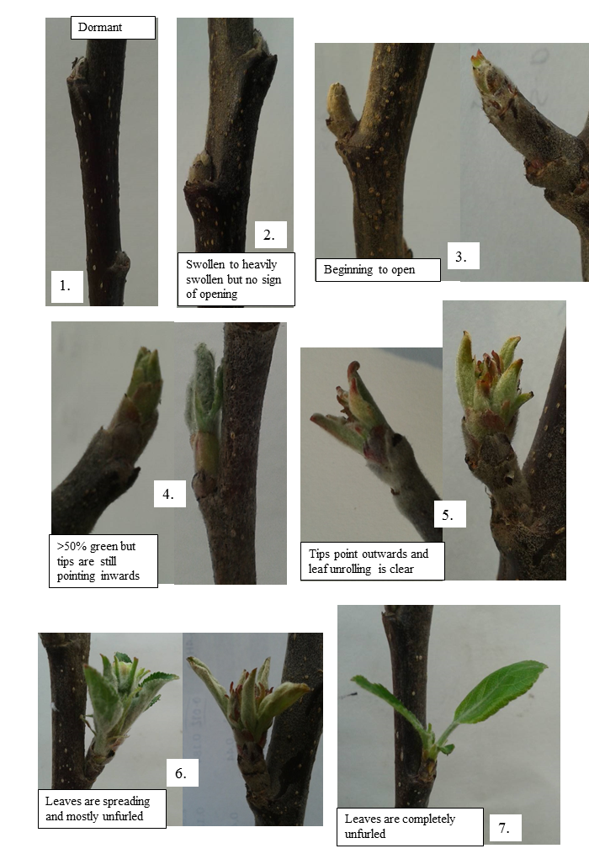

TRFLP OPLS-DA loading plots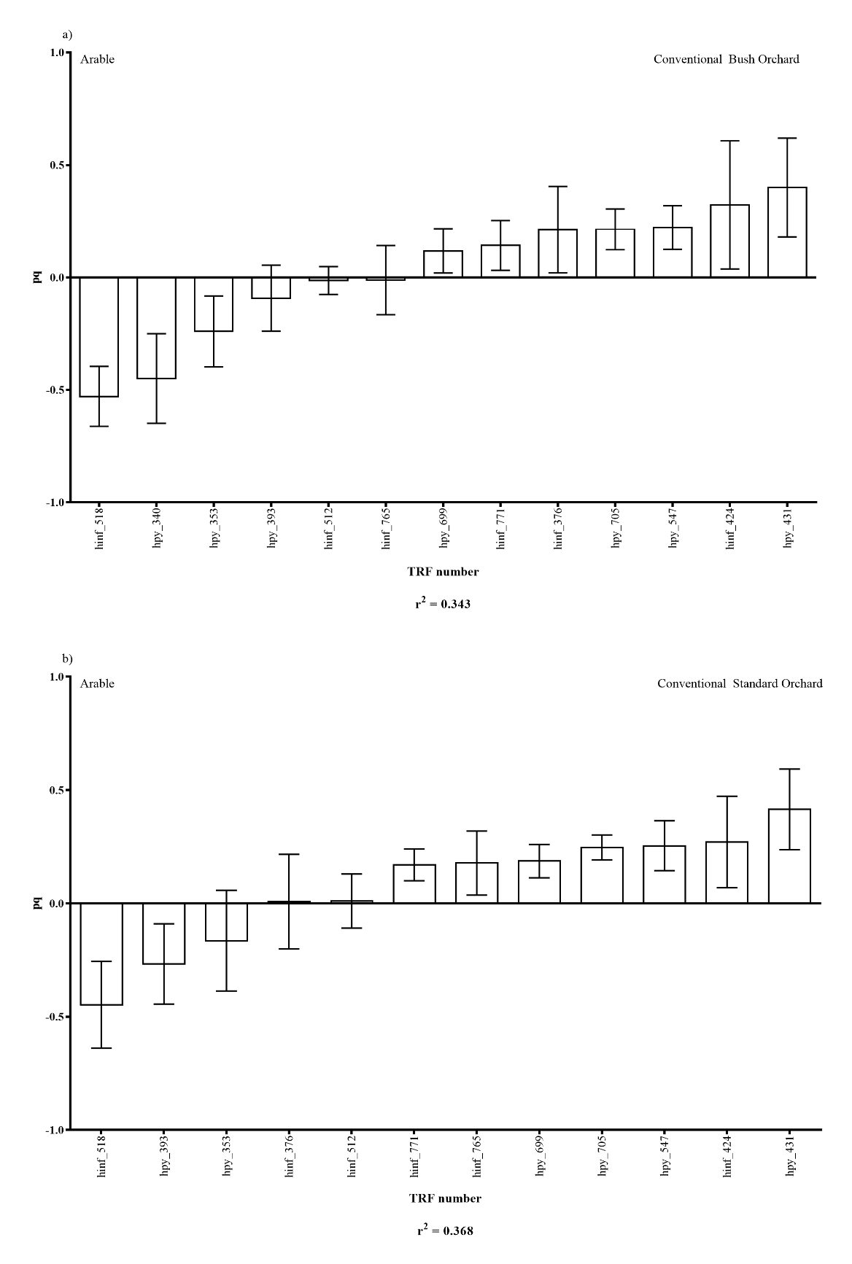
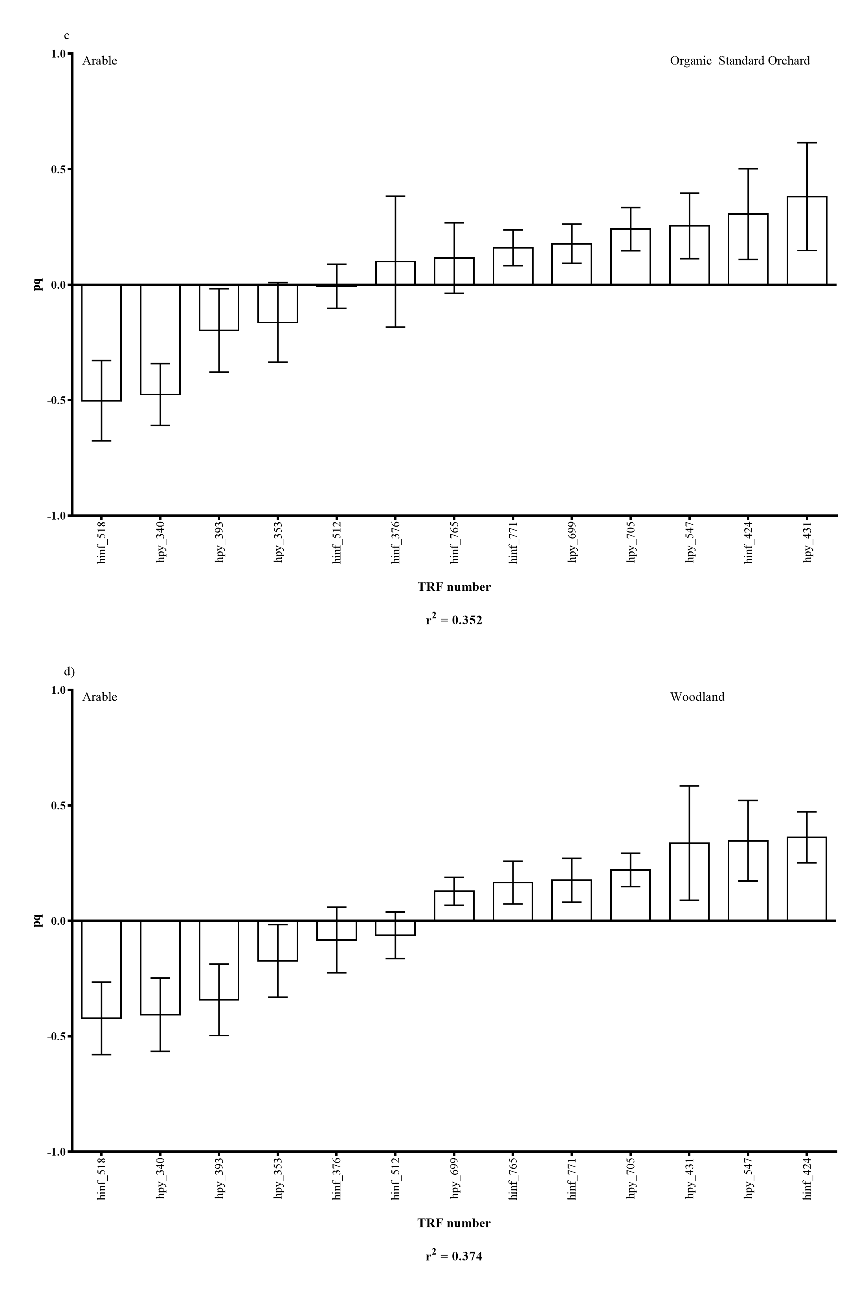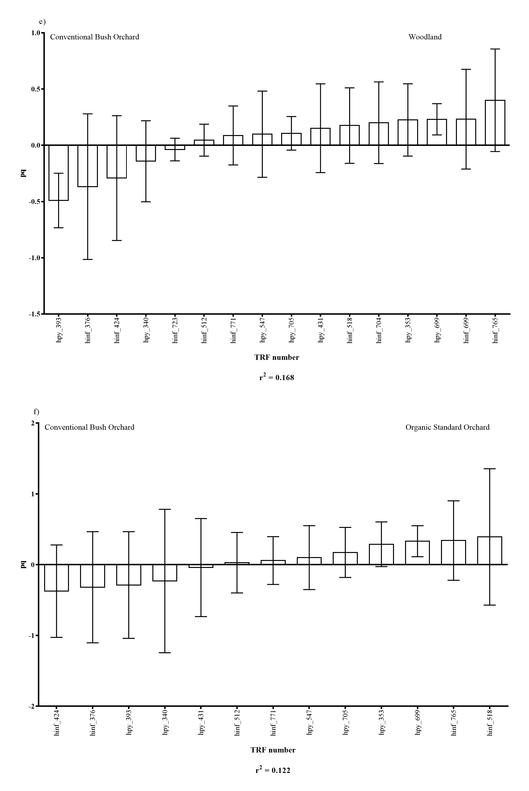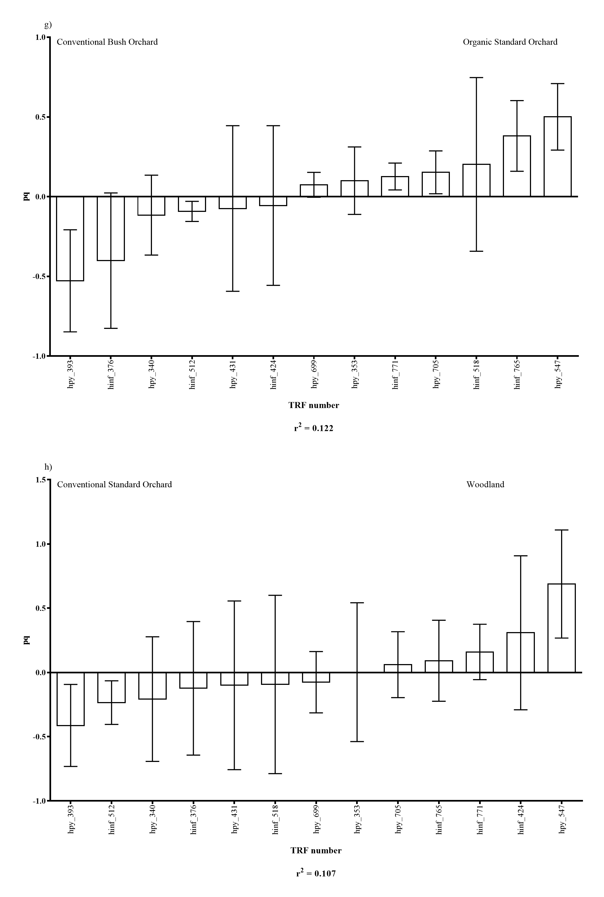
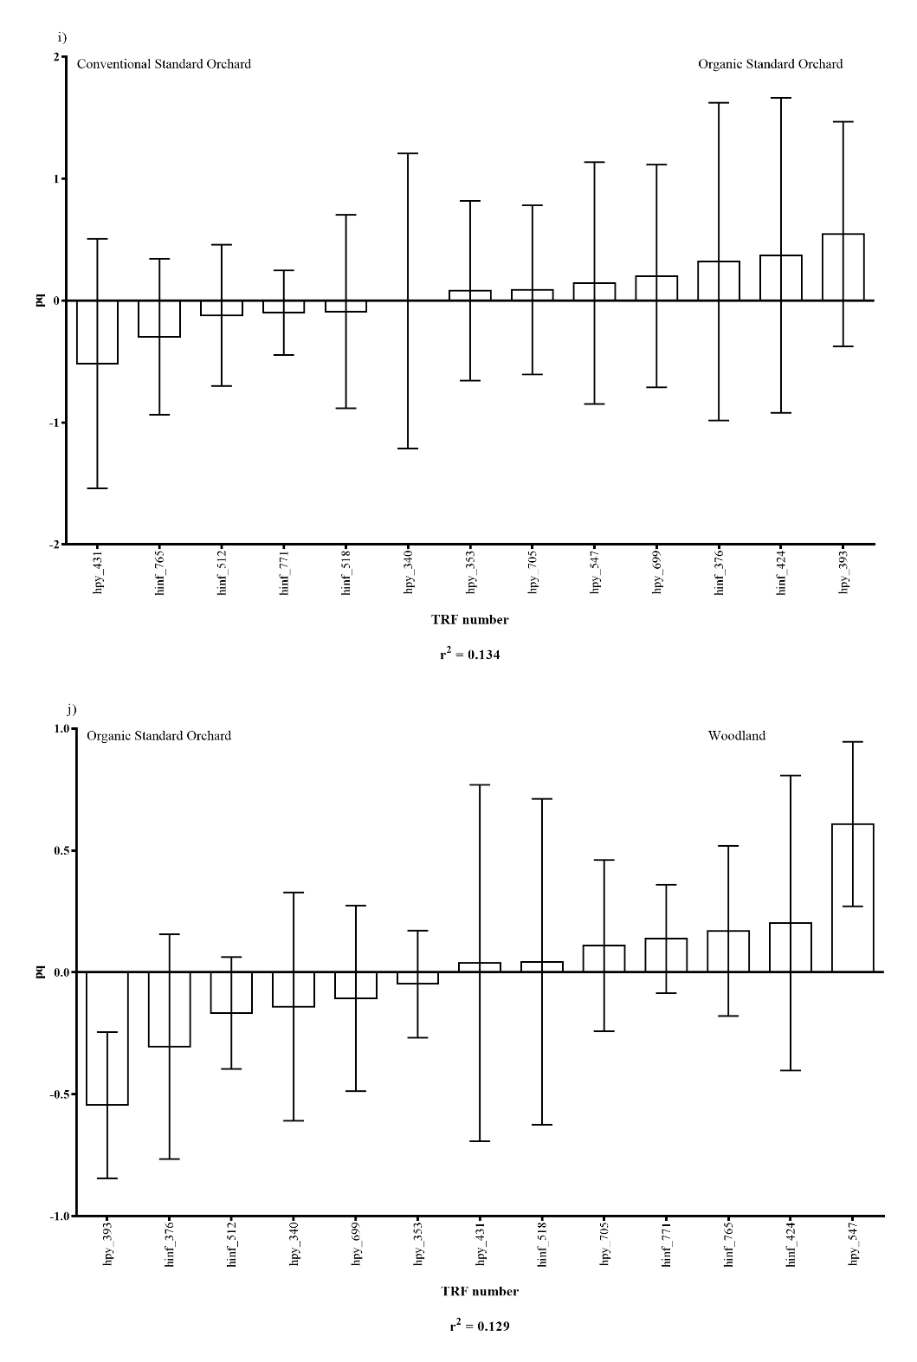
Figure B.1. Plots (a) to (j) show OPLS-DA loading plots showing TRFs which were driving differences in community structure when comparing habitat types. Plots (a) to (j) show pairwise comparison of each of the five habitat types (arable, conventional bush orchard, conventional standard orchard, organic standard orchard and woodland) with one another. R² values show the proportion of variation in the data that is explained by differences in the two habitat types compared. Pq = cumulative loading vector which is proportion to the amount of variation explained by each individual TRF.

Illumina sequencing reverse sequence OPLS-DA loading plots
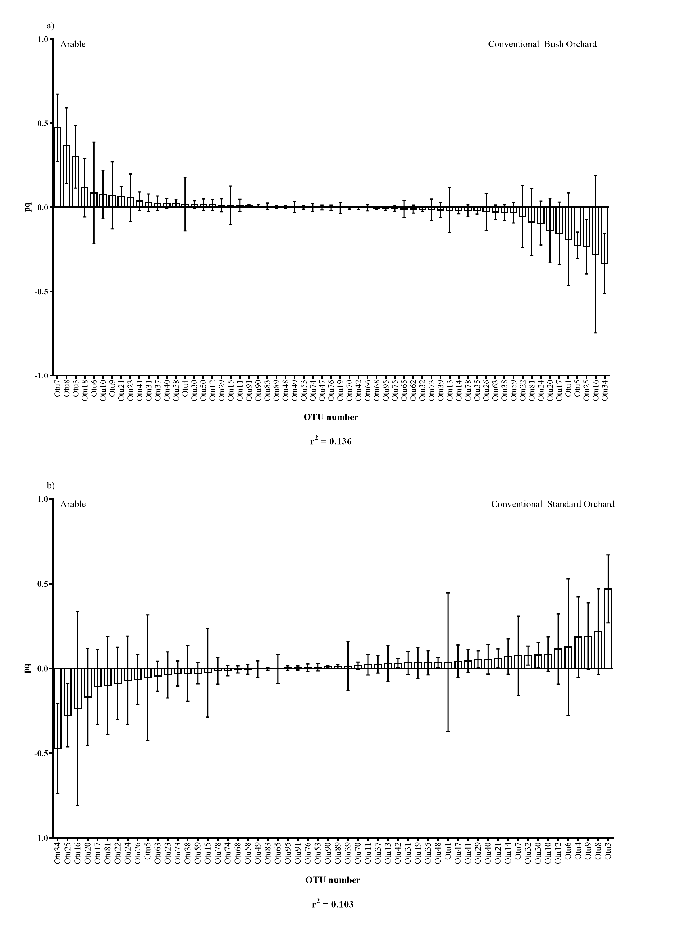
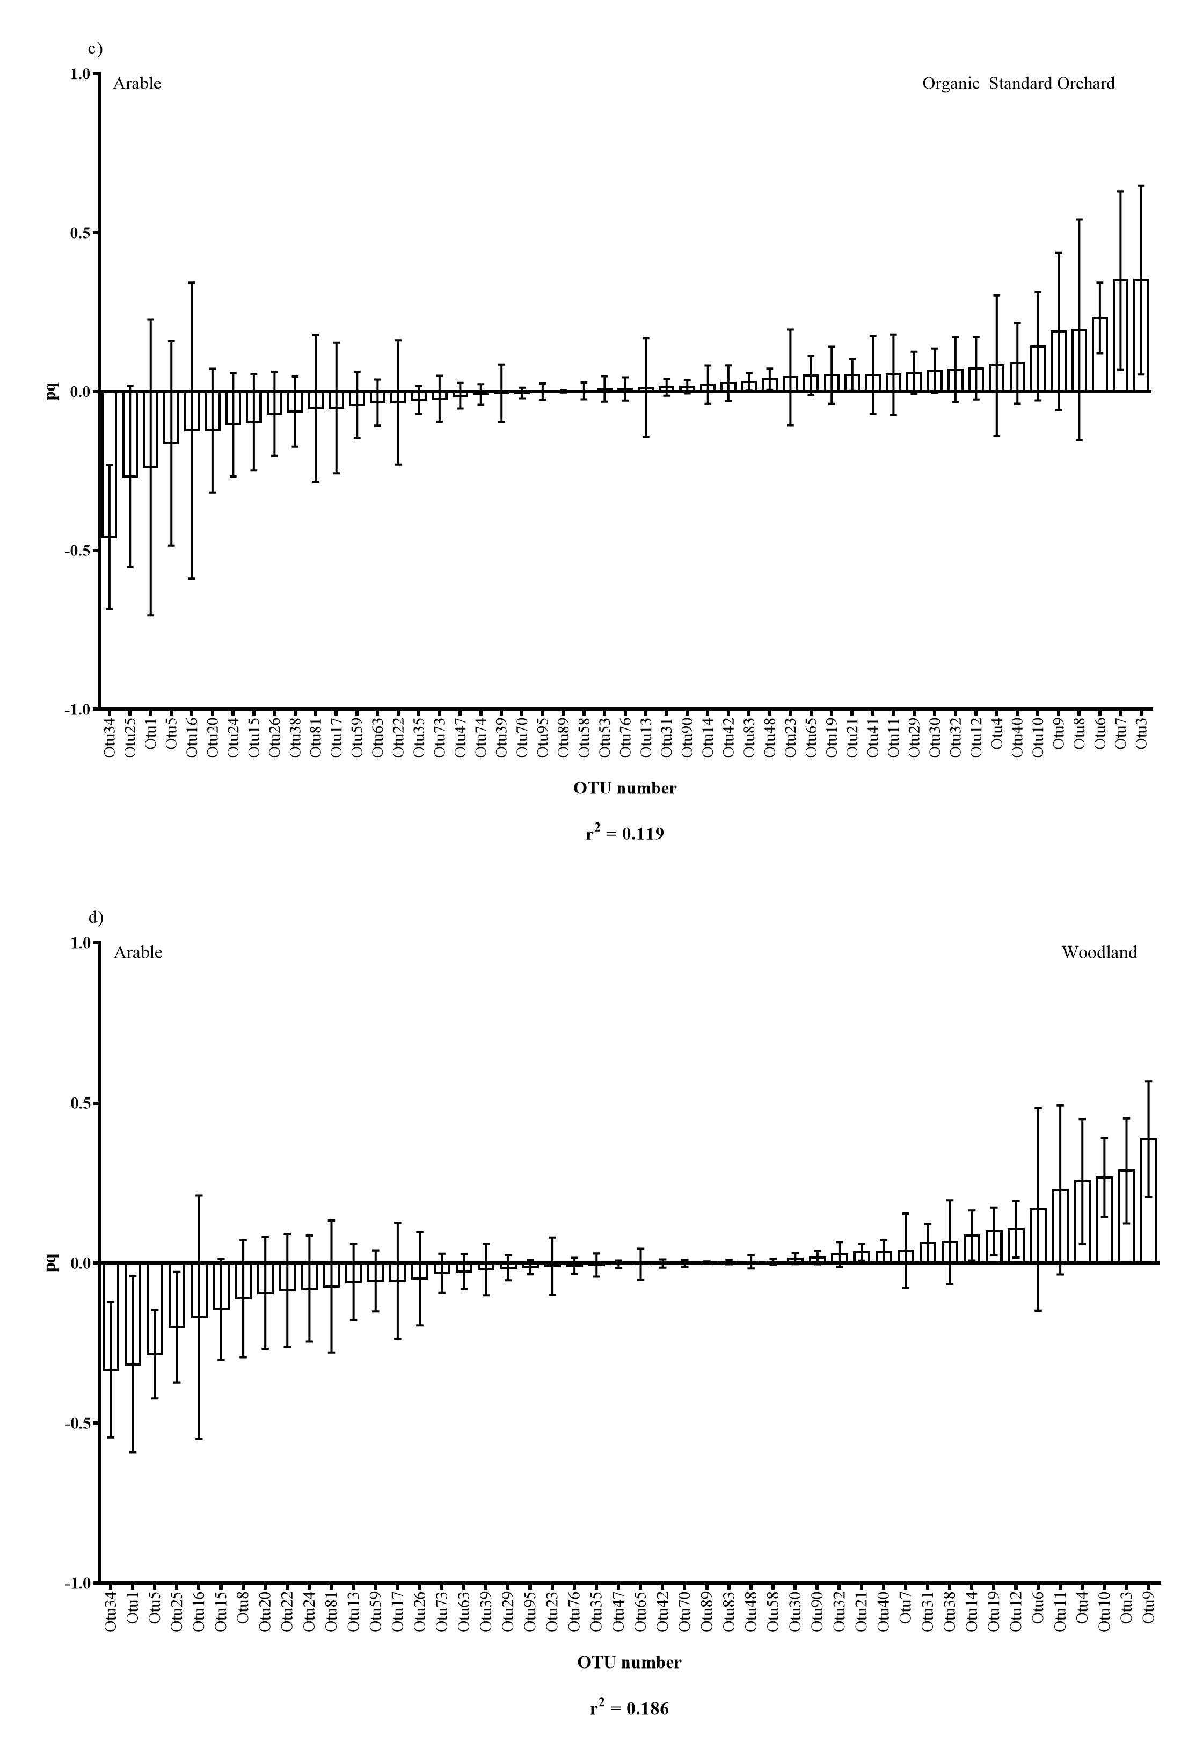
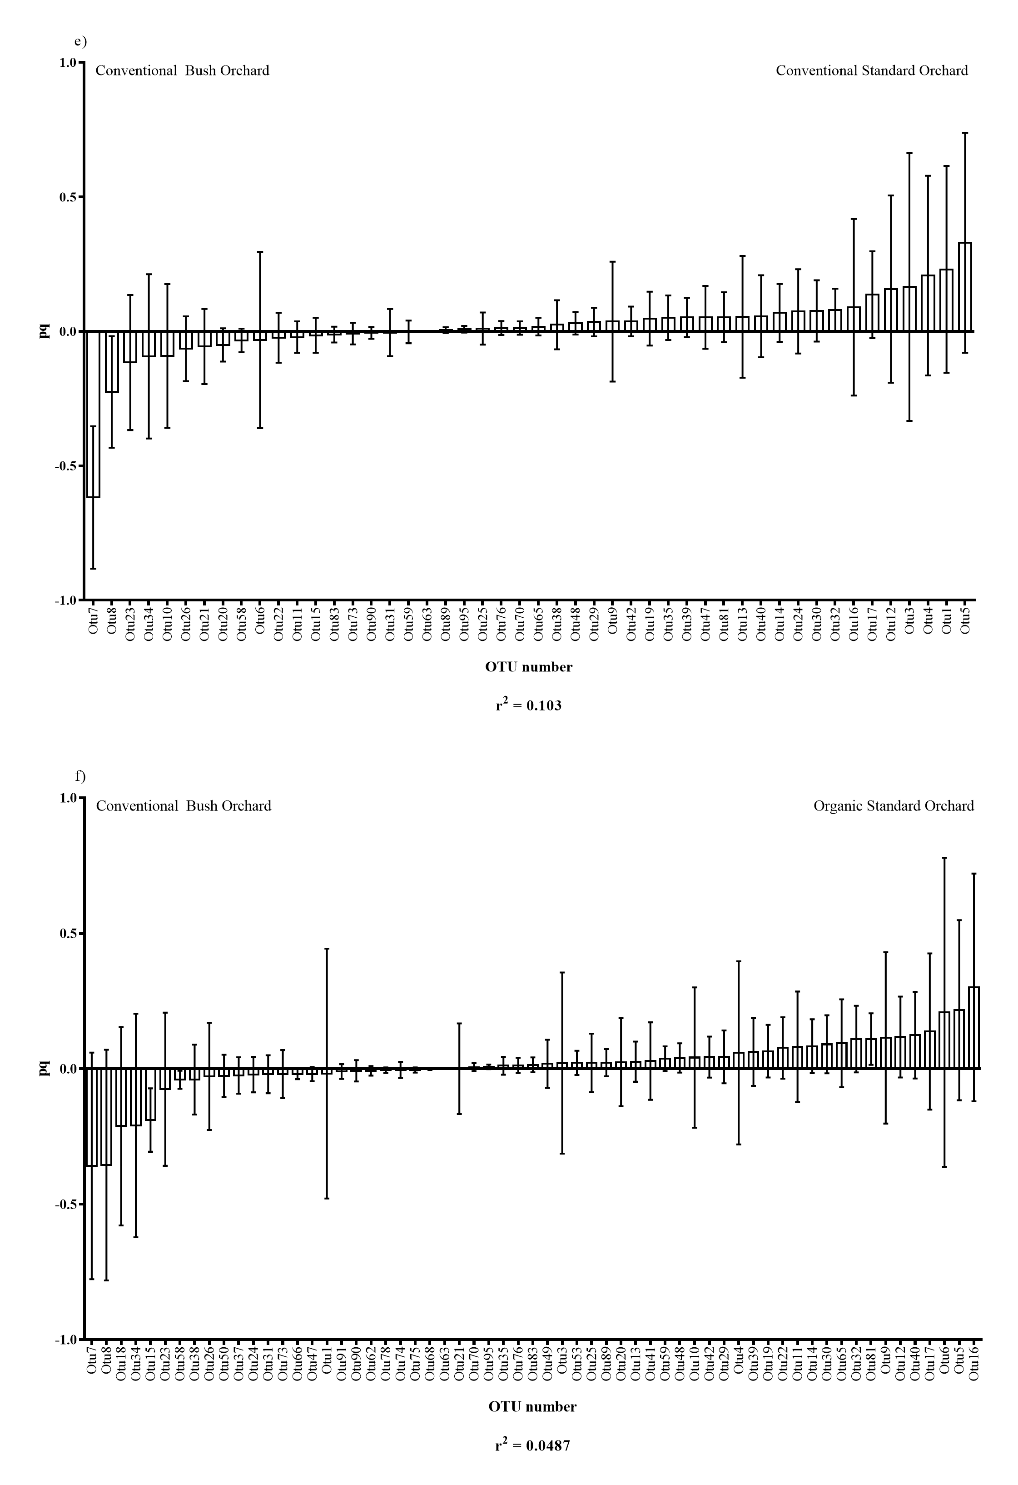

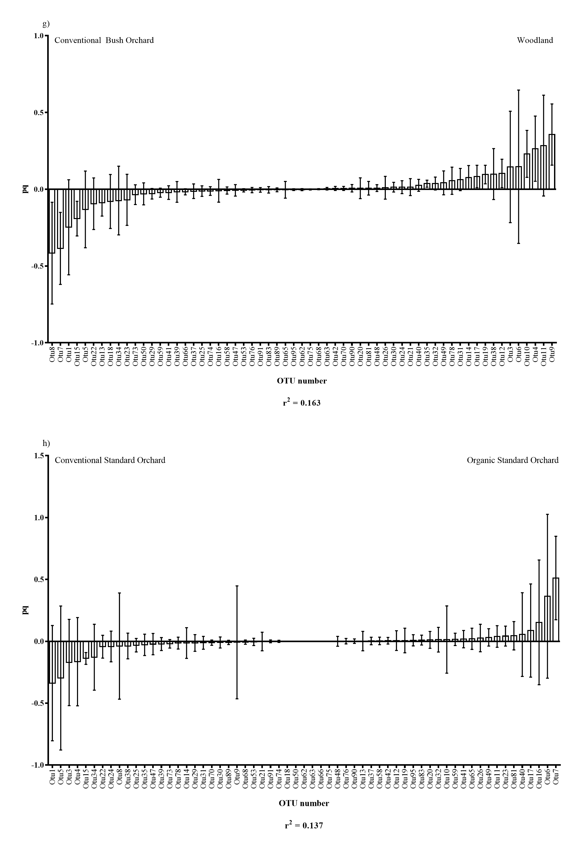
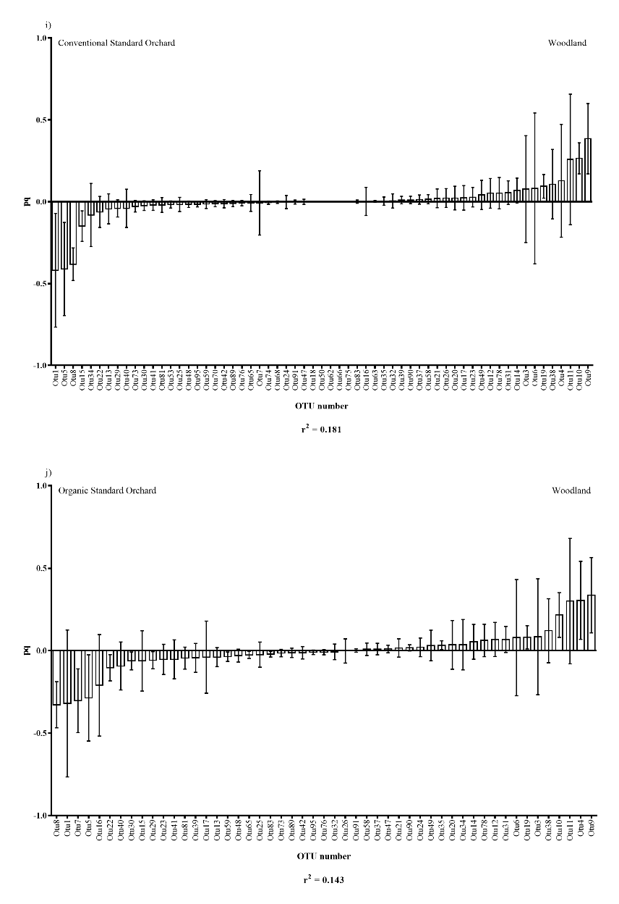
Plots (a) to (j) OPLS-DA loading plots showing OTUs which were driving differences in community structure when comparing habitat types. Plots (a) to (j) show pairwise comparison of each of the five habitat types (arable, conventional bush orchard, conventional standard orchard, organic standard orchard and woodland) with one another. R² values show the proportion of variation in the data that is explained by differences in the two habitat types compared. Pq = cumulative loading vector which is proportion to the amount of variation explained by each individual OTU.

References
Abdel-Fattah GM, El-Haddad SA, Hafez EE, Rashad YM. 2011. Induction of defense responses in common bean plants by arbuscular mycorrhizal fungi. Microbiological Research 166: 268–281.
Aikawa S, Kobayashi MJ, Satake A, Shimizu KK, Kudoh H. 2010. Robust control of the seasonal expression of the Arabidopsis FLC gene in a fluctuating environment. Proceedings of the National Academy of Sciences 107: 11632–11637.
Albacete A, Martinez-Andujar C, Martinez-Perez A, Thompson AJ, Dodd IC, Perez-Alfocea F. 2015. Unravelling rootstockxscion interactions to improve food security. Journal of Experimental Botany 66: 2211–2226.
Alexandratos N. 1999. World food and agriculture: Outlook for the medium and longer term. Proceedings of the National Academy of Sciences 96: 5908–5914.
Alguacil MM, Lumini E, Roldán A, Salinas-García JR, Bonfante P, Bianciotto V. 2008. The Impact of Tillage Practices on Arbuscular Mycorrhizal Fungal Diversity in Subtropical Crops. Ecological Applications 18: 527–536.
An ZQ, Shen T, Wang HG. 1993. Mycorrhizal fungi in relation to growth and mineral nutrition of apple seedlings. Scientia Horticulturae 54: 275–285.
Arihara J, Karasawa T. 2000. Effect of previous crops on arbuscular mycorrhizal formation and growth of succeeding maize. Soil Science and Plant Nutrition 46: 43–51.
Arnon DI. 1949. Copper Enzymes in Isolated Chloroplasts. Polyphenoloxidase in Beta Vulgaris. Plant Physiology 24: 1–15.
Aroca R, Alguacil MD, Vernieri P, Ruiz-Lozano JM. 2008a. Plant Responses to Drought Stress and Exogenous ABA Application are Modulated Differently by Mycorrhization in Tomato and an ABA-deficient Mutant (Sitiens). Microbial Ecology 56: 704–719.
Aroca R, Porcel R, Ruiz-Lozano JM. 2007. How does arbuscular mycorrhizal symbiosis regulate root hydraulic properties and plasma membrane aquaporins in Phaseolus vulgaris under drought, cold or salinity stresses? New Phytologist 173: 808–816.
Aroca R, Vernieri P, Ruiz-Lozano JM. 2008b. Mycorrhizal and non-mycorrhizal Lactuca sativa plants exhibit contrasting responses to exogenous ABA during drought stress and recovery. Journal of Experimental Botany 59: 2029–2041.
Augé RM. 2004. Arbuscular mycorrhizae and soil/plant water relations. Canadian Journal of Soil Science 84: 373–381.
Augé RM, Duan XG, Ebel RC, Stodola AJW. 1994. NONHYDRAULIC SIGNALING OF SOIL DRYING IN MYCORRHIZAL MAIZE. Planta 193: 74–82.
AzconAguilar C, Barea JM. 1996. Arbuscular mycorrhizas and biological control of soil-borne plant pathogens - An overview of the mechanisms involved. Mycorrhiza 6: 457–464.
Bainard LD, Klironomos JN, Gordon AM. 2011. Arbuscular mycorrhizal fungi in tree-based intercropping systems: A review of their abundance and diversity. Pedobiologia 54: 57–61.
Bardgett RD, van der Putten WH. 2014. Belowground biodiversity and ecosystem functioning. Nature 515: 505–511.
Barrios E. 2007. Soil biota, ecosystem services and land productivity. Ecological Economics 64: 269–285.
Bedini S, Pellegrino E, Avio L, Pellegrini S, Bazzoffi P, Argese E, Giovannetti M. 2009. Changes in soil aggregation and glomalin-related soil protein content as affected by the arbuscular mycorrhizal fungal species Glomus mosseae and Glomus intraradices. Soil Biology and Biochemistry 41: 1491–1496.
Bender SF, Conen F, Van der Heijden MGA. 2015. Mycorrhizal effects on nutrient cycling, nutrient leaching and N2O production in experimental grassland. Soil Biology & Biochemistry 80: 283–292.
Bengtsson J, Ahnström J, Weibull A-C. 2005. The effects of organic agriculture on biodiversity and abundance: a meta-analysis. Journal of Applied Ecology 42: 261–269.
Bennett AE, Bever JD. 2009. Trade-offs between arbuscular mycorrhizal fungal competitive ability and host growth promotion in Plantago lanceolata. Oecologia 160: 807–816.
Beresford RM, Kim KS. 2010. Identification of Regional Climatic Conditions Favorable for Development of European Canker of Apple. Phytopathology 101: 135–146.
Boddington CL, Dodd JC. 2000. The effect of agricultural practices on the development of indigenous arbuscular mycorrhizal fungi. II. Studies in experimental microcosms. Plant and Soil 218: 145–157.
Borovinova M, Petrova V, Maneva S. 2012. Effect of Different Growing Systems of Apple on Trunk and Branch Diseases and Pests. Notulae Botanicae Horti Agrobotanici Cluj-Napoca 40: 159–162.
Borriello R, Lumini E, Girlanda M, Bonfante P, Bianciotto V. 2012. Effects of different management practices on arbuscular mycorrhizal fungal diversity in maize fields by a molecular approach. Biology and Fertility of Soils 48: 911–922.
Bowles TM, Jackson LE, Loeher M, Cavagnaro TR. 2016. Ecological intensification and arbuscular mycorrhizas: a meta-analysis of tillage and cover crop effects. Journal of Applied Ecology.
Broeckling CD, Broz AK, Bergelson J, Manter DK, Vivanco JM. 2008. Root Exudates Regulate Soil Fungal Community Composition and Diversity. Applied and Environmental Microbiology 74: 738–744.
Bruce A, Smith SE, Tester M. 1994. THE DEVELOPMENT OF MYCORRHIZAL INFECTION IN CUCUMBER - EFFECTS OF P-SUPPLY ON ROOT-GROWTH, FORMATION OF ENTRY POINTS AND GROWTH OF INFECTION UNITS. New Phytologist 127: 507–514.
Brundette. 2008. Mycorrhizal Associations: The Web Resource. Section 4 Arbuscular mycorrhizas.
Brundrett, M.C., Bougher, N. 1996. Working with Mycorrhizas in Forestry and Agriculture. Austrailian Centre for International Agricultural Research.
Bylesjö M, Rantalainen M, Cloarec O, Nicholson JK, Holmes E, Trygg J. 2006. OPLS discriminant analysis: combining the strengths of PLS-DA and SIMCA classification. Journal of Chemometrics 20: 341–351.
Cameron DD. 2010. Arbuscular mycorrhizal fungi as (agro)ecosystem engineers. Plant and Soil 333: 1–5.
Cameron DD, Neal AL, van Wees SCM, Ton J. 2013. Mycorrhiza-induced resistance: more than the sum of its parts? Trends in Plant Science 18: 539–545.
Campos-Soriano L, García-Martínez J, Segundo BS. 2012. The arbuscular mycorrhizal symbiosis promotes the systemic induction of regulatory defence-related genes in rice leaves and confers resistance to pathogen infection. Molecular Plant Pathology 13: 579–592.
Caporaso JG, Kuczynski J, Stombaugh J, Bittinger K, Bushman FD, Costello EK, Fierer N, Peña AG, Goodrich JK, Gordon JI, et al. 2010. QIIME allows analysis of high-throughput community sequencing data. Nature Methods 7: 335–336.
Castillo C, Astroza I, Borie F, Rubio R. 2008. Effect of the host and non host crops on arbuscular mycorrhizal propagules. Revista De La Ciencia Del Suelo Y Nutricion Vegetal 8: 37–54.
Čatská V. 1994. Interrelationships between vesicular-arbuscular mycorrhiza and rhizosphere microflora in apple replant disease. Biologia Plantarum 36: 99–104.
Cavagnaro TR. 2008. The role of arbuscular mycorrhizas in improving plant zinc nutrition under low soil zinc concentrations: a review. Plant and Soil 304: 315–325.
Cavagnaro TR, Bender SF, Asghari HR, van der Heijden MGA. 2015. The role of arbuscular mycorrhizas in reducing soil nutrient loss. Trends in Plant Science 20: 283–290.
Cavagnaro TR, Smith FA, Smith SE, Jakobsen I. 2005. Functional diversity in arbuscular mycorrhizas: exploitation of soil patches with different phosphate enrichment differs among fungal species. Plant Cell and Environment 28: 642–650.
Cavallazzi, J.P.R, Filho OK, Stürmer SL, Rygiewicz P, Mendonça NM. 2007. Screening and selecting arbuscular mycorrhizal fungi for inoculating micropropagated apple rootstocks in acid soils. Plant Cell Tissue and Organ Culture 90: 117–129.
Chifflot V, Rivest D, Olivier A, Cogliastro A, Khasa D. 2009. Molecular analysis of arbuscular mycorrhizal community structure and spores distribution in tree-based intercropping and forest systems. Agriculture Ecosystems & Environment 131: 32–39.
Collins CD, Foster BL. 2009. Community-level consequences of mycorrhizae depend on phosphorus availability. Ecology 90: 2567–2576.
Cooke LR. 1999. The Influence of Fungicide Sprays on Infection Of Apple cv. Bramley’s Seedling By Nectria galligena. European Journal of Plant Pathology 105: 783–790.
Copas L. 2002. Pre planting treatments to aid tree establishment Vaminoc mycorrhiza and Rindomil plus dips. NACM short report 2.8.
Cordell D, Drangert J-O, White S. 2009. The story of phosphorus: Global food security and food for thought. Global Environmental Change 19: 292–305.
Cordier C, Pozo MJ, Barea JM, Gianinazzi S, Gianinazzi-Pearson V. 1998. Cell defense responses associated with localized and systemic resistance to Phytophthora parasitica induced in tomato by an arbuscular mycorrhizal fungus. Molecular Plant-Microbe Interactions 11: 1017–1028.
Cotton TEA, Fitter AH, Miller RM, Dumbrell AJ, Helgason T. 2015. Fungi in the future: interannual variation and effects of atmospheric change on arbuscular mycorrhizal fungal communities. New Phytologist 205: 1598–1607.
Covey R, Koch B, Larsen H. 1981. Influence of Vesicular Arbuscular Mycorrhizae on the Growth of Apple and Corn in Low-Phosphorous Soil. Phytopathology 71: 712–715.
Culman SW, Gauch HG, Blackwood CB, Thies JE. 2008. Analysis of T-RFLP data using analysis of variance and ordination methods: a comparative study. Journal of Microbiological Methods 75: 55–63.
Daei G, Ardekani MR, Rejali F, Teimuri S, Miransari M. 2009. Alleviation of salinity stress on wheat yield, yield components, and nutrient uptake using arbuscular mycorrhizal fungi under field conditions. Journal of Plant Physiology 166: 617–625.
D’Alessandro M, Erb M, Ton J, Brandenburg A, Karlen D, Zopfi J, Turlings TCJ. 2014. Volatiles produced by soil-borne endophytic bacteria increase plant pathogen resistance and affect tritrophic interactions. Plant, Cell & Environment 37: 813–826.
Daniell TJ, Husband R, Fitter AH, Young JPW. 2001. Molecular diversity of arbuscular mycorrhizal fungi colonising arable crops. Fems Microbiology Ecology 36: 203–209.
Davis RM, Menge JA, Zentmyer GA. 1978. INFLUENCE OF VESICULAR-ARBUSCULAR MYCORRHIZAE ON PHYTOPHTHORA ROOT-ROT OF 3 CROP PLANTS. Phytopathology 68: 1614–1617.
DEFRA. 2008. UK Biodiversity Action Plan Priority Habitats Descriptions: Traditional Orchards.
DEFRA. 2010a. Apple best practice guide.
DEFRA. 2010b. Reccommendations for controlling Neonectria ditissima in cider apple orchards (Agriculture and Horticultural Development Board).
DEFRA. 2010c. Fertiliser Manual (RB209) 8th Edition.
DEFRA. 2014. Basic horticultural statistics 2014.
Delgado A, Scalenghe R. 2008. Aspects of phosphorus transfer from soils in Europe. Journal of Plant Nutrition and Soil Science 171: 552–575.
Dickie IA, FitzJohn RG. 2007. Using terminal restriction fragment length polymorphism (T-RFLP) to identify mycorrhizal fungi: a methods review. Mycorrhiza 17: 259–270.
Douds DD, Galvez L, Franke-Snyder M, Reider C, Drinkwater LE. 1997. Effect of compost addition and crop rotation point upon VAM fungi. Agriculture Ecosystems & Environment 65: 257–266.
Douds DD, Galvez L, Janke RR, Wagoner P. 1995. EFFECT OF TILLAGE AND FARMING SYSTEM UPON POPULATIONS AND DISTRIBUTION OF VESICULAR-ARBUSCULAR MYCORRHIZAL FUNGI. Agriculture Ecosystems & Environment 52: 111–118.
Drew EA, Murray RS, Smith SE, Jakobsen I. 2003. Beyond the rhizosphere: growth and function of arbuscular mycorrhizal external hyphae in sands of varying pore sizes. Plant and Soil 251: 105–114.
Druille M, Cabello MN, Omacini M, Golluscio RA. 2013. Glyphosate reduces spore viability and root colonization of arbuscular mycorrhizal fungi. Applied Soil Ecology 64: 99–103.
Dumbrell AJ, Nelson M, Helgason T, Dytham C, Fitter AH. 2010. Relative roles of niche and neutral processes in structuring a soil microbial community. The ISME journal 4: 337–345.
Dunemann F, Kahnau R, Schmidt H. 1994. Genetic relationships in Malus evaluated by RAPD ‘fingerprinting’of cultivars and wild species. Plant Breeding 113: 150–159.
Edgar RC. 2004. MUSCLE: multiple sequence alignment with high accuracy and high throughput. Nucleic Acids Research 32: 1792–1797.
Edgar RC. 2010. Search and clustering orders of magnitude faster than BLAST. Bioinformatics 26: 2460–2461.
Elser J, Bennett E. 2011. Phosphorus cycle: A broken biogeochemical cycle. Nature 478: 29–31.
Evelin H, Kapoor R, Giri B. 2009. Arbuscular mycorrhizal fungi in alleviation of salt stress: a review. Annals of Botany 104: 1263–1280.
FAO. 2014. FAOSTAT database collections. Food and Agriculture Organization of the United Nations.Rome.
Fester T, Sawers R. 2011. Progress and Challenges in Agricultural Applications of Arbuscular Mycorrhizal Fungi. Critical Reviews in Plant Sciences 30: 459–470.
Field K, Davidson S, Alghamdi S, Cameron D. 2017. Magnitude, Dynamics, and Control of the Carbon Flow to Mycorrhizas. Mycorrhizal Mediation of Soil : Fertility, Structure, and Carbon Storage. Elsevier Science Publishing, USA., .
Foley JA, DeFries R, Asner GP, Barford C, Bonan G, Carpenter SR, Chapin FS, Coe MT, Daily GC, Gibbs HK, et al. 2005. Global Consequences of Land Use. Science 309: 570–574.
Fontana A, Reichelt M, Hempel S, Gershenzon J, Unsicker SB. 2009. The Effects of Arbuscular Mycorrhizal Fungi on Direct and Indirect Defense Metabolites of Plantago lanceolata L. Journal of Chemical Ecology 35: 833–843.
Forge T, Muehlchen A, Hackenberg C, Neilsen G, Vrain T. 2001. Effects of preplant inoculation of apple (Malus domestica Borkh.) with arbuscular mycorrhizal fungi on population growth of the root-lesion nematode, Pratylenchus penetrans. Plant and Soil 236: 185–196.
Forte AV, Ignatov AN, Ponomarenko VV, Dorokhov DB, Savelyev NI. 2002. Phylogeny of the Malus (Apple Tree) Species, Inferred from the Morphological Traits and Molecular DNA Analysis. Russian Journal of Genetics 38: 1150–1161.
Frey SD, Elliott ET, Paustian K. 1999. Bacterial and fungal abundance and biomass in conventional and no-tillage agroecosystems along two climatic gradients. Soil Biology and Biochemistry 31: 573–585.
Frey-Klett P, Garbaye J, Tarkka M. 2007. The mycorrhiza helper bacteria revisited. The New Phytologist 176: 22–36.
Fritz M, Jakobsen I, Lyngkjær MF, Thordal-Christensen H, Pons-Kühnemann J. 2006. Arbuscular mycorrhiza reduces susceptibility of tomato to Alternaria solani. Mycorrhiza 16: 413–419.
Gallou A, Lucero Mosquera HP, Cranenbrouck S, Suárez JP, Declerck S. 2011. Mycorrhiza induced resistance in potato plantlets challenged by Phytophthora infestans. Physiological and Molecular Plant Pathology 76: 20–26.
Gange A, West H. 1994. Interactions Between Arbuscular Mycorrhizal Fungi and Foliar-Feeding Insects in Plantago-Lanceolata L. New Phytologist 128: 79–87.
van Geel M, Beenhouwer MD, Ceulemans T, Caes K, Ceustermans A, Bylemans D, Gomand A, Lievens B, Honnay O. 2016. Application of slow-release phosphorus fertilizers increases arbuscular mycorrhizal fungal diversity in the roots of apple trees. Plant and Soil 402: 291–301.
van Geel M, Ceustermans A, van Hemelrijck W, Lievens B, Honnay O. 2015. Decrease in diversity and changes in community composition of arbuscular mycorrhizal fungi in roots of apple trees with increasing orchard management intensity across a regional scale. Molecular Ecology 24: 941–952.
Génard M, Dauzat J, Franck N, Lescourret F, Moitrier N, Vaast P, Vercambre G. 2008. Carbon allocation in fruit trees: from theory to modelling. Trees 22: 269–282.
Gianinazzi S, Gollotte A, Binet M-N, van Tuinen D, Redecker D, Wipf D. 2010. Agroecology: the key role of arbuscular mycorrhizas in ecosystem services. Mycorrhiza 20: 519–530.
Giri B, Kapoor R, Mukerji KG. 2003. Influence of arbuscular mycorrhizal fungi and salinity on growth, biomass, and mineral nutrition of Acacia auriculiformis. Biology and Fertility of Soils 38: 170–175.
Gosling P, Hodge A, Goodlass G, Bending GD. 2006. Arbuscular mycorrhizal fungi and organic farming. Agriculture, Ecosystems & Environment 113: 17–35.
Goverde M, van der Heijden MGA, Wiemken A, Sanders IR, Erhardt A. 2000. Arbuscular mycorrhizal fungi influence life history traits of a lepidopteran herbivore. Oecologia 125: 362–369.
Grant C, Bittman S, Montreal M, Plenchette C, Morel C. 2005. Soil and fertilizer phosphorus: Effects on plant P supply and mycorrhizal development. Canadian Journal of Plant Science 85: 3–14.
Guo BZ, An ZQ, Hendrix JW. 1994. A mycorrhizal pathogen (Glomus macrocarpum Tul. & Tul.) of tobacco: effects of long- and short-term cropping on the mycorrhizal fungal community and stunt disease. Applied Soil Ecology 1: 269–276.
Hallett PD, Feeney DS, Bengough AG, Rillig MC, Scrimgeour CM, Young IM. 2009. Disentangling the impact of AM fungi versus roots on soil structure and water transport. Plant and Soil 314: 183–196.
Hamel C, Morin F, Fortin A, Granger RL, Smith DL. 1994. MYCORRHIZAL COLONIZATION INCREASES HERBICIDE TOXICITY IN APPLE. Journal of the American Society for Horticultural Science 119: 1255–1260.
Hao Z, Fayolle L, Tuinen D van, Chatagnier O, Li X, Gianinazzi S, Gianinazzi-Pearson V. 2012. Local and systemic mycorrhiza-induced protection against the ectoparasitic nematode Xiphinema index involves priming of defence gene responses in grapevine. Journal of Experimental Botany 63: 3657–3672.
Harrier LA, Watson CA. 2004. The potential role of arbuscular mycorrhizal (AM) fungi in the bioprotection of plants against soil-borne pathogens in organic and/or other sustainable farming systems. Pest Management Science 60: 149–157.
Hart M, Reader R. 2002. Host plant benefit from association with arbuscular mycorrhizal fungi: variation due to differences in size of mycelium. Biology and Fertility of Soils 36: 357–366.
Hazard C, Gosling P, van der Gast CJ, Mitchell DT, Doohan FM, Bending GD. 2013. The role of local environment and geographical distance in determining community composition of arbuscular mycorrhizal fungi at the landscape scale. The ISME journal 7: 498–508.
van der Heijden MGA. 2010. Mycorrhizal fungi reduce nutrient loss from model grassland ecosystems. Ecology 91: 1163–1171.
van der Heijden MGA, Bardgett RD, Van Straalen NM. 2008. The unseen majority: soil microbes as drivers of plant diversity and productivity in terrestrial ecosystems. Ecology Letters 11: 296–310.
van der Heijden MGA, Klironomos JN, Ursic M, Moutoglis P, Streitwolf-Engel R, Boller T, Wiemken A, Sanders IR. 1998. Mycorrhizal fungal diversity determines plant biodiversity, ecosystem variability and productivity. Nature 396: 69–72.
Heinemeyer A, Fitter AH. 2004. Impact of temperature on the arbuscular mycorrhizal (AM) symbiosis: growth responses of the host plant and its AM fungal partner. Journal of Experimental Botany 55: 525–534.
Helgason T, Daniell TJ, Husband R, Fitter AH, Young JPW. 1998. Ploughing up the wood-wide web? Nature 394: 431–431.
Hepper CM, Azcon-Aguilar C, Rosendahl S, Sen R. 1988. Competition Between Three Species of Glomus Used as Spatially Separated Introduced and Indigenous Mycorrhizal Inocula for Leek (Allium porrum L.). The New Phytologist 110: 207–215.
Hetrick B, Wilson G, Cox T. 1993. Mycorrhizal Dependence of Modern Wheat Cultivars and Ancestors - a Synthesis. Canadian Journal of Botany-Revue Canadienne De Botanique 71: 512–518.
Hetrick B a. D, Wilson GWT, Todd TC. 1996. Mycorrhizal response in wheat cultivars: Relationship to phosphorus. Canadian Journal of Botany-Revue Canadienne De Botanique 74: 19–25.
Hiiesalu I, Pärtel M, Davison J, Gerhold P, Metsis M, Moora M, Öpik M, Vasar M, Zobel M, Wilson SD. 2014. Species richness of arbuscular mycorrhizal fungi: associations with grassland plant richness and biomass. New Phytologist 203: 233–244.
Hijri I, Sykorova Z, Oehl F, Ineichen K, Maeder P, Wiemken A, Redecker D. 2006. Communities of arbuscular mycorrhizal fungi in arable soils are not necessarily low in diversity. Molecular Ecology 15: 2277–2289.
Hodge A, Fitter AH. 2010. Substantial nitrogen acquisition by arbuscular mycorrhizal fungi from organic material has implications for N cycling. Proceedings of the National Academy of Sciences of the United States of America 107: 13754–13759.
Hoffmann D, Vierheilig H, Riegler P, Schausberger P. 2009. Arbuscular mycorrhizal symbiosis increases host plant acceptance and population growth rates of the two-spotted spider mite Tetranychus urticae. Oecologia 158: 663–671.
Hole DG, Perkins AJ, Wilson JD, Alexander IH, Grice PV, Evans AD. 2005. Does organic farming benefit biodiversity? Biological Conservation 122: 113–130.
Holste EK, Holl KD, Zahawi RA, Kobe RK. 2016. Reduced aboveground tree growth associated with higher arbuscular mycorrhizal fungal diversity in tropical forest restoration. Ecology and Evolution 6: 7253–7262.
Husband R, Herre EA, Young JPW. 2002. Temporal variation in the arbuscular mycorrhizal communities colonising seedlings in a tropical forest. FEMS Microbiology Ecology 42: 131–136.
IPCC. 2014. Climate Change 2014: Synthesis Report. Contribution of Working Groups I, II and III to the Fifth Assessment Report of the Intergovernmental Panel on Climate Change. Geneva, Switzerland: Core Writing Team R.K. Pachauri and L.A. Meyer (eds.).
Jandrić Z, Haughey SA, Frew RD, McComb K, Galvin-King P, Elliott CT, Cannavan A. 2015. Discrimination of honey of different floral origins by a combination of various chemical parameters. Food Chemistry 189: 52–59.
Janouskova M, Pavlikova D, Vosatka M. 2006. Potential contribution of arbuscular mycorrhiza to cadmium immobilisation in soil. Chemosphere 65: 1959–1965.
Jansa J, Erb A, Oberholzer H-R, Šmilauer P, Egli S. 2014. Soil and geography are more important determinants of indigenous arbuscular mycorrhizal communities than management practices in Swiss agricultural soils. Molecular Ecology 23: 2118–2135.
Jansa J, Mozafar A, Anken T, Ruh R, Sanders IR, Frossard E. 2002. Diversity and structure of AMF communities as affected by tillage in a temperate soil. Mycorrhiza 12: 225–234.
Jansa J, Mozafar A, Frossard E. 2005. Phosphorus Acquisition Strategies within Arbuscular Mycorrhizal Fungal Community of a Single Field Site. Plant and Soil 276: 163–176.
Jansa J, Mozafar A, Kuhn G, Anken T, Ruh R, Sanders IR, Frossard E. 2003. Soil Tillage Affects the Community Structure of Mycorrhizal Fungi in Maize Roots. Ecological Applications 13: 1164–1176.
Jansa J, Rezacova V, Smilauer P, Oberholzer H-R, Egli S. 2016. Root colonization of bait plants by indigenous arbuscular mycorrhizal fungal communities is not a suitable indicator of agricultural land-use legacy. Agriculture Ecosystems & Environment 231: 310–319.
Johnson NC, Angelard C, Sanders IR, Kiers ET. 2013. Predicting community and ecosystem outcomes of mycorrhizal responses to global change. Ecology Letters 16: 140–153.
Johnson D, Leake JR, Read DJ. 2005. Liming and nitrogen fertilization affects phosphatase activities, microbial biomass and mycorrhizal colonisation in upland grassland. Plant and Soil 271: 157–164.
Johnson NC, Rowland DL, Corkida L, Egerton-Warburton LM, Allen E. 2003. Nitrogen enrichment alters mycorrhizal allocation at five semiarid grassland. Ecology 84: 1895–1908.
Jung SC, Martinez-Medina A, Lopez-Raez JA, Pozo MJ. 2012. Mycorrhiza-Induced Resistance and Priming of Plant Defenses. Journal of Chemical Ecology 38: 651–664.
Juniper BE. 2007. The Mysterious Origin of the Sweet Apple: On its way to a grocery counter near you, this delicious fruit traversed continents and mastered coevolution. American Scientist 95: 44–51.
Juniper S, Abbott LK. 2006. Soil salinity delays germination and limits growth of hyphae from propagules of arbuscular mycorrhizal fungi. Mycorrhiza 16: 371–379.
Kahiluoto H, Ketoja E, Vestberg M, Saarela I. 2001. Promotion of AM utilization through reduced P fertilization 2. Field studies. Plant and Soil 231: 65–79.
Kiers ET, Duhamel M, Beesetty Y, Mensah JA, Franken O, Verbruggen E, Fellbaum CR, Kowalchuk GA, Hart MM, Bago A, et al. 2011. Reciprocal Rewards Stabilize Cooperation in the Mycorrhizal Symbiosis. Science 333: 880–882.
Klironomos JN. 2003. Variation in Plant Response to Native and Exotic Arbuscular Mycorrhizal Fungi. Ecology 84: 2292–2301.
Köhl L, van der Heijden MGA. 2016. Arbuscular mycorrhizal fungal species differ in their effect on nutrient leaching. Soil Biology and Biochemistry 94: 191–199.
Kohl L, Oehl F, van der Heijden MGA. 2014. Agricultural practices indirectly influence plant productivity and ecosystem services through effects on soil biota. Ecological Applications 24: 1842–1853.
Koide RT, Peoples MS. 2012. On the nature of temporary yield loss in maize following canola. Plant and Soil 360: 259–269.
Krishna H, Das B, Attri BL, Grover M, Ahmed N. 2010. Suppression of Botryosphaeria canker of apple by arbuscular mycorrhizal fungi. Crop Protection 29: 1049–1054.
Lacombe S, Bradley RL, Hamel C, Beaulieu C. 2009. Do tree-based intercropping systems increase the diversity and stability of soil microbial communities? Agriculture, Ecosystems & Environment 131: 25–31.
Lau JA, Lennon JT. 2011. Evolutionary ecology of plant-microbe interactions: soil microbial structure alters selection on plant traits. The New Phytologist 192: 215–224.
Leake J, Johnson D, Donnelly D, Muckle G, Boddy L, Read D. 2004. Networks of power and influence: the role of mycorrhizal mycelium in controlling plant communities and agroecosystem functioning. Canadian Journal of Botany 82: 1016–1045.
Lee J, Lee S, Young JPW. 2008. Improved PCR primers for the detection and identification of arbuscular mycorrhizal fungi. FEMS Microbiology Ecology 65: 339–349.
Lekberg Y, Koide RT. 2005. Is plant performance limited by abundance of arbuscular mycorrhizal fungi? A meta-analysis of studies published between 1988 and 2003. The New Phytologist 168: 189–204.
de Leon DG, Moora M, Opik M, Neuenkamp L, Gerz M, Jairus T, Vasar M, Bueno CG, Davison J, Zobel M. 2016. Symbiont dynamics during ecosystem succession: co-occurring plant and arbuscular mycorrhizal fungal communities. Fems Microbiology Ecology 92: UNSP fiw097.
Lioussanne L. 2013. The role of the arbuscular mycorrhiza-associated rhizobacteria in the biocontrol of soilborne phytopathogens: a review. Spanish Journal of Agricultural Research 8: 51–61.
Liu J, Maldonado-Mendoza I, Lopez-Meyer M, Cheung F, Town CD, Harrison MJ. 2007. Arbuscular mycorrhizal symbiosis is accompanied by local and systemic alterations in gene expression and an increase in disease resistance in the shoots. Plant Journal 50: 529–544.
Liu Y, Shi G, Mao L, Cheng G, Jiang S, Ma X, An L, Du G, Johnson NC, Feng H. 2012. Direct and indirect influences of 8 yr of nitrogen and phosphorus fertilization on Glomeromycota in an alpine meadow ecosystem. New Phytologist 194: 523–535.
Lopez-Raez JA, Charnikhova T, Fernandez I, Bouwmeester H, Pozo MJ. 2011. Arbuscular mycorrhizal symbiosis decreases strigolactone production in tomato. Journal of Plant Physiology 168: 294–297.
Loreau M, Hector A. 2001. Partitioning selection and complementarity in biodiversity experiments. Nature 412: 72–76.
Lush M, Robertson HJ, Alexander KNA, Giavarini V, Hewins E, Mellings J, Stevenson M, Storey M, Whitehead P. 2006. Biodiversity studies of six traditional orchards in England. In Natural England Research Information Note RIN025.
MacArthur RH, Wilson EO. 1967. The theory of island biogeography. Princeton: Princeton University Press.
Mader P, Fliessbach A, Dubois D, Gunst L, Fried P, Niggli U. 2002. Soil fertility and biodiversity in organic farming. Science 296: 1694–1697.
Magurran AE. 2004. Measuring biological diversity. Oxford, UK: Blackwell Publishing.
Maherali H, Klironomos JN. 2007. Influence of Phylogeny on fungal community assembly and ecosystem functioning. Science 316: 1746–1748.
Matsubara Y, Karikomi T, Ikuta M, Hori H, Ishikawa S, Harada T. 1996. Effect of arbuscular Mycorrhizal fungus inoculation on growth of apple (Malus ssp) seedlings. Journal of the Japanese Society for Horticultural Science 65: 297–302.
Mcgonigle T, Miller M, Evans D, Fairchild G, Swan J. 1990. A New Method Which Gives an Objective-Measure of Colonization of Roots. New Phytologist 115: 495–501.
McGonigle TP, Miller MH, Young D. 1999. Mycorrhizae, crop growth, and crop phosphorus nutrition in maize-soybean rotations given various tillage treatments. Plant and Soil 210: 33–42.
Miller D, Domoto P, Walker C. 1985a. Mycorrhizal Fungi at 18-Apple Rootstock Plantings in the United-States. New Phytologist 100: 379–391.
Miller D, Domoto P, Walker C. 1985b. Colonization and Efficacy of Different Endomycorrhizal Fungi with Apple Seedlings at 2-Phosphorus Levels. New Phytologist 100: 393–402.
Miller RM, Reinhardt DR, Jastrow JD. 1995. EXTERNAL HYPHAL PRODUCTION OF VESICULAR-ARBUSCULAR MYCORRHIZAL FUNGI IN PASTURE AND TALLGRASS PRAIRIE COMMUNITIES. Oecologia 103: 17–23.
Milne I, Lindner D, Bayer M, Husmeier D, McGuire G, Marshall DF, Wright F. 2009. TOPALi v2: a rich graphical interface for evolutionary analyses of multiple alignments on HPC clusters and multi-core desktops. Bioinformatics (Oxford, England) 25: 126–127.
Miransari M. 2010. Contribution of arbuscular mycorrhizal symbiosis to plant growth under different types of soil stress. Plant Biology 12: 563–569.
Miransari M. 2011. Hyperaccumulators, arbuscular mycorrhizal fungi and stress of heavy metals. Biotechnology Advances 29: 645–653.
Moora M, Davison J, Öpik M, Metsis M, Saks Ü, Jairus T, Vasar M, Zobel M. 2014. Anthropogenic land use shapes the composition and phylogenetic structure of soil arbuscular mycorrhizal fungal communities. FEMS Microbiology Ecology 90: 609–621.
Moraes RM, De Andrade Z, Bedir E, Dayan FE, Lata H, Khan I, Pereira AMS. 2004. Arbuscular mycorrhiza improves acclimatization and increases lignan content of micropropagated mayapple (Podophyllum peltatum L.). Plant Science 166: 23–29.
Mosse B. 1957. Growth and chemical composition of mycorrhizal and non-mycorrhizal apple seedlings. Nature 179: 923–924.
NACM. 2016. UK Cider Market | The National Association of Cider Makers.
Nagy R, Drissner D, Amrhein N, Jakobsen I, Bucher M. 2009. Mycorrhizal phosphate uptake pathway in tomato is phosphorus-repressible and transcriptionally regulated. New Phytologist 181: 950–959.
Natural England. 2011. Traditional orchard project in England. Natural England commissioned report NEC077.
Nicholas K, Nicholas H. 1997. GeneDoc: a tool for editing and annotating multiple sequence alignments. Distributed by the author. http://www.psc.edu/biomed/genedoc.
Nishida T, Katayama N, Izumi N, Ohgushi T. 2010. Arbuscular mycorrhizal fungi species-specifically affect induced plant responses to a spider mite. Population Ecology 52: 507–515.
Norman JR, Hooker JE. 2000. Sporulation of Phytophthora fragariae shows greater stimulation by exudates of non-mycorrhizal than by mycorrhizal strawberry roots. Mycological Research 104: 1069–1073.
Oades JM. 1984. SOIL ORGANIC-MATTER AND STRUCTURAL STABILITY - MECHANISMS AND IMPLICATIONS FOR MANAGEMENT. Plant and Soil 76: 319–337.
Oehl F, Sieverding E, Ineichen K, Mäder P, Boller T, Wiemken A. 2003. Impact of Land Use Intensity on the Species Diversity of Arbuscular Mycorrhizal Fungi in Agroecosystems of Central Europe. Applied and Environmental Microbiology 69: 2816–2824.
Oehl F, Sieverding E, M�der P, Dubois D, Ineichen K, Boller T, Wiemken A. 2004. Impact of long-term conventional and organic farming on the diversity of arbuscular mycorrhizal fungi. Oecologia 138: 574–583.
Olsson PA, Baath E, Jakobsen I. 1997. Phosphorus Effects on the Mycelium and Storage Structures of an Arbuscular Mycorrhizal Fungus as Studied in the Soil and Roots by Analysis of Fatty Acid Signatures. Applied and Environmental Microbiology 63: 3531–3538.
Öpik M, Davison J. 2016. Uniting species- and community-oriented approaches to understand arbuscular mycorrhizal fungal diversity. Fungal Ecology.
Öpik M, Davison J, Moora M, Zobel M. 2013a. DNA-based detection and identification of Glomeromycota: the virtual taxonomy of environmental sequences. Botany 92: 135–147.
Öpik M, Moora M, Liira J, Zobel M. 2006. Composition of Root-Colonizing Arbuscular Mycorrhizal Fungal Communities in Different Ecosystems around the Globe. Journal of Ecology 94: 778–790.
Opik M, Moora M, Liira J, Zobel M. 2006. Composition of root-colonizing arbuscular mycorrhizal fungal communities in different ecosystems around the globe. Journal of Ecology 94: 778–790.
Opik M, Moora M, Zobel M, Saks U, Wheatley R, Wright F, Daniell T. 2008. High diversity of arbuscular mycorrhizal fungi in a boreal herb-rich coniferous forest. The New Phytologist 179: 867–876.
Opik M, Vanatoa A, Vanatoa E, Moora M, Davison J, Kalwij JM, Reier U, Zobel M. 2010. The online database MaarjAM reveals global and ecosystemic distribution patterns in arbuscular mycorrhizal fungi (Glomeromycota). The New Phytologist 188: 223–241.
Öpik M, Zobel M, Cantero JJ, Davison J, Facelli JM, Hiiesalu I, Jairus T, Kalwij JM, Koorem K, Leal ME, et al. 2013b. Global sampling of plant roots expands the described molecular diversity of arbuscular mycorrhizal fungi. Mycorrhiza 23: 411–430.
Osborn AM, Moore ER, Timmis KN. 2000. An evaluation of terminal-restriction fragment length polymorphism (T-RFLP) analysis for the study of microbial community structure and dynamics. Environmental Microbiology 2: 39–50.
Paszkowski U. 2006. Mutualism and parasitism: the yin and yang of plant symbioses. Current Opinion in Plant Biology 9: 364–370.
Pérez-de-Luque A, Tille S, Johnson I, Pascual-Pardo D, Ton J, Cameron DD. in press. A call to arms: resolving the interactive effects of arbuscular mycorrhiza and plant growth promoting rhizobacteria (PGPR) on plant health.
Phipps JB, Robertson KR, Smith PG, Rohrer JR. 1990. A CHECKLIST OF THE SUBFAMILY MALOIDEAE (ROSACEAE). Canadian Journal of Botany-Revue Canadienne De Botanique 68: 2209–2269.
Pianka ER. 1970. On r- and K-Selection. The American Naturalist 104: 592–597.
Pineda A, Zheng S-J, van Loon JJA, Pieterse CMJ, Dicke M. 2010. Helping plants to deal with insects: the role of beneficial soil-borne microbes. Trends in Plant Science 15: 507–514.
Pinochet J, Camprubi A, Calvet C. 1993. Effects of the Root-Lesion Nematode Pratylenchus-Vulnus and the Mycorrhizal Fungus Glomus-Mosseae on the Growth of Emla-26 Apple Rootstock. Mycorrhiza 4: 79–83.
Porcel R, Ruiz-Lozano JM. 2004. Arbuscular mycorrhizal influence on leaf water potential, solute accumulation, and oxidative stress in soybean plants subjected to drought stress. Journal of Experimental Botany 55: 1743–1750.
Pozo MJ, Azcón-Aguilar C. 2007. Unraveling mycorrhiza-induced resistance. Current Opinion in Plant Biology 10: 393–398.
Pozo MJ, Cordier C, Dumas‐Gaudot E, Gianinazzi S, Barea JM, Azcón‐Aguilar C. 2002. Localized versus systemic effect of arbuscular mycorrhizal fungi on defence responses to Phytophthora infection in tomato plants. Journal of Experimental Botany 53: 525–534.
Pretty J. 2008. Agricultural Sustainability: Concepts, Principles and Evidence. Philosophical Transactions: Biological Sciences 363: 447–465.
Pretty J, Sutherland WJ, Ashby J, Auburn J, Baulcombe D, Bell M, Bentley J, Bickersteth S, Brown K, Burke J, et al. 2010. The top 100 questions of importance to the future of global agriculture. International Journal of Agricultural Sustainability 8: 219–236.
Raj H, Sharma SD. 2009. Integration of soil solarization and chemical sterilization with beneficial microorganisms for the control of white root rot and growth of nursery apple. Scientia Horticulturae 119: 126–131.
Redecker D, Kodner R, Graham LE. 2000. Glomalean fungi from the Ordovician. Science 289: 1920–1921.
Richardson AE, Lynch JP, Ryan PR, Delhaize E, Smith FA, Smith SE, Harvey PR, Ryan MH, Veneklaas EJ, Lambers H, et al. 2011. Plant and microbial strategies to improve the phosphorus efficiency of agriculture. Plant and Soil 349: 121–156.
Ridgway HJ, Kandula J, Stewart A. 2008. Arbuscular Mycorrhiza Improve Apple Rootstock Growth in Soil Conducive. New Zealand Plant Protection 61: 48–53.
Rillig MC. 2004. Arbuscular mycorrhizae, glomalin, and soil aggregation. Canadian Journal of Soil Science 84: 355–363.
Rillig MC, Mummey DL. 2006. Mycorrhizas and Soil Structure. The New Phytologist 171: 41–53.
Rodríguez-Morelos VH, Soto-Estrada A, Pérez-Moreno J, Franco-Ramírez A, Díaz-Rivera P. 2014. Arbuscular mycorrhizal fungi associated with the rhizosphere of seedlings and mature trees of Swietenia macrophylla (Magnoliophyta: Meliaceae) in Los Tuxtlas, Veracruz, Mexico. Revista Chilena de Historia Natural 87: 9.
Roldan A, Salinas-Garcia JR, Alguacil MM, Caravaca F. 2007. Soil sustainability indicators following conservation tillage practices under subtropical maize and bean crops. Soil & Tillage Research 93: 273–282.
Ronco MG, Ruscitti MF, Arango MC, Beltrano J. 2008. Glyphosate and mycorrhization induce changes in plant growth and in root morphology and architecture in pepper plants (Capsicum annuum L.). The Journal of Horticultural Science and Biotechnology 83: 497–505.
Royer M, Larbat R, Le Bot J, Adamowicz S, Robin C. 2013. Is the C:N ratio a reliable indicator of C allocation to primary and defence-related metabolisms in tomato? Phytochemistry 88: 25–33.
Ruiz-Lozano JM, Porcel R, Aroca R. 2006. Does the enhanced tolerance of arbuscular mycorrhizal plants to water deficit involve modulation of drought-induced plant genes? New Phytologist 171: 693–698.
Ryan M, Ash J. 1999. Effects of phosphorus and nitrogen on growth of pasture plants and VAM fungi in SE Australian soils with contrasting fertiliser histories (conventional and biodynamic). Agriculture Ecosystems & Environment 73: 51–62.
Säle V, Aguilera P, Laczko E, Maeder P, Berner A, Zihlmann U, van der Heijden MGA, Oehl F. 2015. Impact of conservation tillage and organic farming on the diversity of arbuscular mycorrhizal fungi. Soil Biology & Biochemistry 84: 38–52.
Schausberger P, Peneder S, Jurschik S, Hoffmann D. 2012. Mycorrhiza changes plant volatiles to attract spider mite enemies. Functional Ecology 26: 441–449.
Schellenbaum L, Berta G, Ravolanirina F, Tisserant B, Gianinazzi S, Fitter AH. 1991. INFLUENCE OF ENDOMYCORRHIZAL INFECTION ON ROOT MORPHOLOGY IN A MICROPROPAGATED WOODY PLANT-SPECIES (VITIS-VINIFERA L). Annals of Botany 68: 135–141.
Scherr SJ, McNeely JA. 2008. Biodiversity Conservation and Agricultural Sustainability: Towards a New Paradigm of ‘Ecoagriculture’ Landscapes. Philosophical Transactions: Biological Sciences 363: 477–494.
Schnoor TK, Lekberg Y, Rosendahl S, Olsson PA. 2011. Mechanical soil disturbance as a determinant of arbuscular mycorrhizal fungal communities in semi-natural grassland. Mycorrhiza 21: 211–220.
Schüβler A, Schwarzott D, Walker C. 2001. A new fungal phylum, the Glomeromycota: phylogeny and evolution. Mycological Research 105: 1413–1421.
Sheng M, Tang M, Chen H, Yang BW, Zhang FF, Huang YH. 2008. Influence of arbuscular mycorrhizae on photosynthesis and water status of maize plants under salt stress. Mycorrhiza 18: 287–296.
Simon L, Lalonde M, Bruns TD. 1992. Specific amplification of 18S fungal ribosomal genes from vesicular-arbuscular endomycorrhizal fungi colonizing roots. Applied and Environmental Microbiology 58: 291–295.
Sipos R, Székely AJ, Palatinszky M, Révész S, Márialigeti K, Nikolausz M. 2007. Effect of primer mismatch, annealing temperature and PCR cycle number on 16S rRNA gene-targetting bacterial community analysis. FEMS Microbiology Ecology 60: 341–350.
Smith GS. 1988. THE ROLE OF PHOSPHORUS-NUTRITION IN INTERACTIONS OF VESICULAR-ARBUSCULAR MYCORRHIZAL FUNGI WITH SOILBORNE NEMATODES AND FUNGI. Phytopathology 78: 371–374.
Smith SE, Christophersen HM, Pope S, Smith FA. 2010. Arsenic uptake and toxicity in plants: integrating mycorrhizal influences. Plant and Soil 327: 1–21.
Smith FA, Grace EJ, Smith SE. 2009. More than a carbon economy: nutrient trade and ecological sustainability in facultative arbuscular mycorrhizal symbioses. New Phytologist 182: 347–358.
Smith SE, Read D. 2008. Mycorrhizal Symbiosis. London: Academic Press.
Smith SE, Smith FA. 2011a. Roles of Arbuscular Mycorrhizas in Plant Nutrition and Growth: New Paradigms from Cellular to Ecosystem Scales. In: Merchant SS,, In: Briggs WR,, In: Ort D, eds. Annual Review of Plant Biology, Vol 62. Palo Alto: Annual Reviews, 227–250.
Smith FA, Smith SE. 2011b. What is the significance of the arbuscular mycorrhizal colonisation of many economically important crop plants? Plant and Soil 348: 63–79.
Smith SE, Smith FA. 2012. Fresh perspectives on the roles of arbuscular mycorrhizal fungi in plant nutrition and growth. Mycologia 104: 1–13.
Smith SE, Smith FA, Jakobsen I. 2004. Functional diversity in arbuscular mycorrhizal (AM) symbioses: the contribution of the mycorrhizal P uptake pathway is not correlated with mycorrhizal responses in growth or total P uptake. New Phytologist 162: 511–524.
Song F, Pan Z, Bai F, An J, Liu J, Guo W, Bisseling T, Deng X, Xiao S. 2015. The Scion/Rootstock Genotypes and Habitats Affect Arbuscular Mycorrhizal Fungal Community in Citrus. Frontiers in Microbiology 6.
de Souza LA, de Andrade SAL, de Souza SCR, Schiavinato MA. 2012. Arbuscular mycorrhiza confers Pb tolerance in Calopogonium mucunoides. Acta Physiologiae Plantarum 34: 523–531.
Subramanian KS, Santhanakrishnan P, Balasubramanian P. 2006. Responses of field grown tomato plants to arbuscular mycorrhizal fungal colonization under varying intensities of drought stress. Scientia Horticulturae 107: 245–253.
Sumorok B, Paszt LS, Gluszek ED, Zurawicz E. 2011. The effect o mycorrhization and mulching of apple trees ‘Glod Millenium’ and blackcurrant bushes ‘Tiben’ on the occurrent of arbuscular mycorrhizal fungi. Journal of Fruit and Ornamental Plant Research 19.
Sýkorová Z, Ineichen K, Wiemken A, Redecker D. 2007. The cultivation bias: different communities of arbuscular mycorrhizal fungi detected in roots from the field, from bait plants transplanted to the field, and from a greenhouse trap experiment. Mycorrhiza 18: 1–14.
Thiery O, Vasar M, Jairus T, Davison J, Roux C, Kivistik P-A, Metspalu A, Milani L, Saks U, Moora M, et al. 2016. Sequence variation in nuclear ribosomal small subunit, internal transcribed spacer and large subunit regions of Rhizophagus irregularis and Gigaspora margarita is high and isolate-dependent. Molecular Ecology 25: 2816–2832.
Tian CY, Feng G, Li XL, Zhang FS. 2004. Different effects of arbuscular mycorrhizal fungal isolates from saline or non-saline soil on salinity tolerance of plants. Applied Soil Ecology 26: 143–148.
Tilman D, Balzer C, Hill J, Befort BL. 2011. Global food demand and the sustainable intensification of agriculture. Proceedings of the National Academy of Sciences 108: 20260–20264.
Tilman D, Cassman KG, Matson PA, Naylor R, Polasky S. 2002. Agricultural sustainability and intensive production practices. Nature 418: 671–677.
Torrecillas E, Alguacil MM, Roldán A. 2012. Host Preferences of Arbuscular Mycorrhizal Fungi Colonizing Annual Herbaceous Plant Species in Semiarid Mediterranean Prairies. Applied and Environmental Microbiology 78: 6180–6186.
Treseder KK, Allen MF. 2002. Direct nitrogen and phosphorus limitation of arbuscular mycorrhizal fungi: a model and field test. New Phytologist 155: 507–515.
Tuck SL, Winqvist C, Mota F, Ahnström J, Turnbull LA, Bengtsson J. 2014. Land-use intensity and the effects of organic farming on biodiversity: a hierarchical meta-analysis. Journal of Applied Ecology 51: 746–755.
Uibopuu A, Moora M, Öpik M, Zobel M. 2012. Temperate forest understorey species performance is altered by local arbuscular mycorrhizal fungal communities from stands of different successional stages. Plant and Soil 356: 331–339.
Umpelby R, Copas L. 2002. Growing Cider Apples: A guide to good growing practice. National Association of Cider Makers (NACM) in association with ADAS, Horticultural Research International (HRI) and the Farming and Wildlife Advisory Group (FWAG).
Utkhede RS, Smith EM. 2000. Impact of chemical, biological and cultural treatments on the growth and yield of apple in replant-disease soil. Australasian Plant Pathology 29: 129–136.
Vallino M, Massa N, Lumini E, Bianciotto V, Berta G, Bonfante P. 2006. Assessment of arbuscular mycorrhizal fungal diversity in roots of Solidago gigantea growing in a polluted soil in Northern Italy. Environmental Microbiology 8: 971–983.
Valyi K, Rillig MC, Hempel S. 2015. Land-use intensity and host plant identity interactively shape communities of arbuscular mycorrhizal fungi in roots of grassland plants. New Phytologist 205: 1577–1586.
Vandenkoornhuyse P, Ridgway KP, Watson IJ, Fitter AH, Young JPW. 2003. Co-existing grass species have distinctive arbuscular mycorrhizal communities. Molecular Ecology 12: 3085–3095.
Varela-Cervero S, Vasar M, Davison J, Barea JM, Öpik M, Azcón-Aguilar C. 2015. The composition of arbuscular mycorrhizal fungal communities differs among the roots, spores and extraradical mycelia associated with five Mediterranean plant species. Environmental Microbiology 17: 2882–2895.
Veiga RSL, Jansa J, Frossard E, Heijden MGA van der. 2011. Can Arbuscular Mycorrhizal Fungi Reduce the Growth of Agricultural Weeds? PLOS ONE 6: e27825.
Verbruggen E, Kiers ET. 2010. Evolutionary ecology of mycorrhizal functional diversity in agricultural systems. Evolutionary Applications 3: 547–560.
Verbruggen E, Röling WFM, Gamper HA, Kowalchuk GA, Verhoef HA, van der Heijden MGA. 2010. Positive effects of organic farming on below-ground mutualists: large-scale comparison of mycorrhizal fungal communities in agricultural soils. The New Phytologist 186: 968–979.
Verbruggen E, Van Der HEIJDEN MGA, Weedon JT, Kowalchuk GA, Röling WFM. 2012. Community assembly, species richness and nestedness of arbuscular mycorrhizal fungi in agricultural soils. Molecular Ecology 21: 2341–2353.
Vitousek PM, Mooney HA, Lubchenco J, Melillo JM. 1997. Human domination of Earth’s ecosystems. Science 277: 494–499.
Vogel-Mikus K, Pongrac P, Kump P, Necemer M, Regvar M. 2006. Colonisation of a Zn, Cd and Pb hyperaccumulator Thlaspi praecox Wulfen with indigenous arbuscular mycorrhizal fungal mixture induces changes in heavy metal and nutrient uptake. Environmental Pollution 139: 362–371.
Vogelsang KM, Reynolds HL, Bever JD. 2006. Mycorrhizal fungal identity and richness determine the diversity and productivity of a tallgrass prairie system. The New Phytologist 172: 554–562.
Wagg C, Barendregt C, Jansa J, van der Heijden MGA. 2015. Complementarity in both plant and mycorrhizal fungal communities are not necessarily increased by diversity in the other. Journal of Ecology 103: 1233–1244.
Wagner MR, Lundberg DS, Coleman-Derr D, Tringe SG, Dangl JL, Mitchell-Olds T. 2014. Natural soil microbes alter flowering phenology and the intensity of selection on flowering time in a wild Arabidopsis relative. Ecology Letters 17: 717–726.
Walling LL. 2008. Avoiding effective defenses: Strategies employed by phloem-feeding insects. Plant Physiology 146: 859–866.
Wang FY, Hu JL, Lin XG, Qin SW, Wang JH. 2011. Arbuscular mycorrhizal fungal community structure and diversity in response to long-term fertilization: a field case from China. World Journal of Microbiology and Biotechnology 27: 67–74.
Wang M-Y, Liang-Bin H, Wei-Hua W, Shu-Tang L, Min L, Run-Jin L, Miao-Yan W, Liang-Bin H, Wei-Hua W, Shu-Tang L, et al. 2009. Influence of Long-Term Fixed Fertilization on Diversity of Arbuscular Mycorrhizal Fungi. Pedosphere 19: 663–672.
Wang LX, Zhang YS, Zhang HQ, Xu JT, Li XY. 2002. Changes of soil characteristics in process of land desertification. In: Technol CCAS,, In: Technol SOACMACNNSFCCACS,, In: Technol CGHMACNJ, eds.187–192.
Waud M, Busschaert P, Ruyters S, Jacquemyn H, Lievens B. 2014. Impact of primer choice on characterization of orchid mycorrhizal communities using 454 pyrosequencing. Molecular Ecology Resources 14: 679–699.
Weber RWS. 2014. Biology and control of the apple canker fungus Neonectria ditissima (syn. N. galligena) from a Northwestern European perspective. Erwerbs-Obstbau 56: 95–107.
Williams R. 1996. Cider and Juice Apples: Growing and Processing. Unviersity of Bristol Printing Unit.
Williams. 2000. Cider and Juice Apples: Growing and processes. University of Bristol Printing Unit.
Wilson GWT, Rice CW, Rillig MC, Springer A, Hartnett DC. 2009. Soil aggregation and carbon sequestration are tightly correlated with the abundance of arbuscular mycorrhizal fungi: results from long-term field experiments. Ecology Letters 12: 452–461.
Wright SF, Anderson RL. 2000. Aggregate stability and glomalin in alternative crop rotations for the central Great Plains. Biology and Fertility of Soils 31: 249–253.
Zhu YG, Smith SE, Barritt AR, Smith FA. 2001. Phosphorus (P) efficiencies and mycorrhizal responsiveness of old and modern wheat cultivars. Plant and Soil 237: 249–255.
Zuccarini P, Okurowska P. 2008. Effects of mycorrhizal colonization and fertilization on growth and photosynthesis of sweet basil under salt stress. Journal of Plant Nutrition 31: 497–513.

