Conservation planning, urban change and social life in Sulaimaniyah, Kurdistan-Iraq

By: Hanaw Mohammed Amin

A thesis submitted in partial fulfilment of the requirements for the degree of
Doctor of Philosophy

The University of Sheffield
Faculty of Social Sciences
Department of Urban Studies and Planning

Submission Date: January 2017

Acknowledgements
First of all, I extend my sincere gratitude to my supervisor Dr. Alasdair Rae for his continued support through my PhD journey. Thank you for your patience and on-going assistance throughout this process. I appreciate your advice and everything you said in each of the aspects of my journey and how you inspired me. Thanks for making all of this happen. I also thank my second supervisor Dr. Sarah Payne for her constructive comments and critique of my work through this process.
I am also grateful to Dr. Aidan While and deeply appreciate his valuable and continuous feedback. Your interest in my topic has been a continual motivation. Thanks a lot.
I would also extend my thanks to my beloved husband, Najm. Your support will be always remembered, especially in my first year when you left your job behind back home, and accompanied me to pursue my dream. Thanks for your patience, support, and unconditional love to me and our precious son, Dano. Thanks for being there; I cherish all our moments together. Having you around is my greatest inspiration to complete this study.
Thank you also to my Mum who never stopped praying for my success. To my Dad, while you are no longer in this life, you were a very strong foundation for getting to the place I am now. My deepest appreciation also goes to my both sisters and brothers for their continued support and encouragement, without your support this process wouldn’t be completed. Thanks to Dr. Dedan, for your continuous accompaniment during my fieldwork. I am grateful for this support.
Thank you to many people and friends that have supported me in my own country, people from the Directorate of Sulaimaniyah Municipality and other institutions involved in this case study for their openness and willingness to participate in my study. Thanks for being part of this process.
I also thank the people, moments and challenges in my department, Urban Studies and Planning at the University of Sheffield - they allowed organising my thoughts and skills through workshops and seminars that have contributed towards the completion of this thesis.
Finally, I deeply appreciate the kindness of the staff at the University of Sheffield for their support and patience with my funding issue during this process. Without this, my journey would never have been completed.

Abstract
This thesis examines how significant redevelopment of the historic centre of Sulaimaniyah in Kurdistan-Iraq has impacted on the social life of established residents. A key starting point for the thesis is concern that the city has weak frameworks for managing rapid urban change. The impacts are being felt in terms of displacement of residents, but changes to historic buildings have implications for patterns of everyday social life, belonging and identity. The thesis documents the changing character of Sulaimaniyah, exploring patterns of change and their implications for everyday life and lived experience in the city. Detailed interviews with residents are used to explore those experiential impacts, focusing particularly on individuals and groups who are negatively affected by change. Central to that experience is the embedded nature of everyday spiritual experience that is embedded in the cultural built environment. The thesis makes a distinctive contribution in a number of ways. First, it offers a rare and important example of research on Kurdish cities (and cultural built heritage in the global Middle East). Second, researching those contexts highlights forms of lived experience that are not always addressed in conceptions of cultural built heritage based on ‘western’ experience. Third, the thesis provides further evidence of the importance of cultural built heritage in protecting the living space and ontological security of vulnerable residents.

Table of contents
Acknowledgements………………………………………………………………………….ii
Abstract……………………………………………………………………………………...iii
Table of contents……………………………………………………………………….……iv
List of tables…………………………………………………………………………….……x
List of figures………………………………………………………………………………..xi
CHAPTER 1: Introduction
  - Motivation……………………………………………………………………………..….1
  - A brief overview of the historic centre of Sulaimaniyah ……………………….…….….3
  - Aims and objectives……………………………………………………………………....5
  - Theoretical framework ……………………………………………………………..….....7
  - Structure of the thesis…………………………………………………………….…….....9
CHAPTER 2: Urban social change and urban conservation
2.1Introduction…………………………………………………………………………….... 11
2.2 Conceptual framework …………………………………………………………….….....12
2.2.1 Key aspects and definitions……………………………………………….…….….15
2.2.2 The historic environment………………………………………………….….……15
2.2.3 Concepts of place……………………………………………………….……….…16
2.3 The historic environment and concepts of place…………………………….………..….20
2.3.1 Place distinctiveness and continuity based on built heritage, religion, and urban space ……………………………………………………………………………….……...…21
2.3.2 The historic environment and place dependence…………………………………24
2.3.3 Non heritage dimensions as urban change……………………………………..…27
2.4 Urban social change and environmental disruption…………………………………..….28
2.5 Social values of conservation of historic built environment…………………………......32
2.5.1 Concepts, values and principles of conservation…………………………………..33
2.5.2 Reasons for conservation………………………………………………………..…37
2.5.3 Building conservation……………………………………………………………...40
2.6 Conservation management and stakeholder interactions………………………………...41
2.7 Summary…………………………………………………………………………….…...45
CHAPTER 3: The Context of Sulaimaniyah City
3.1 Introduction……………………………………………………………….…….………..47
3.2 Geographical location……………………………………………………………………47
3.3 History and political context of Sulaimaniyah……………………………………….…..48
3.3.1 Social structure………………………………………………………….………….49
3.3.2 Religious, social and spiritual life and urban space…………………………….….50
3.3.3 Economic structure…………………………………………………………………53
3.4 Geopolitical and the urban structure of Sulaimaniyah……………………………….…..54
3.5 Heritage Site in Sulaimaniyah……………………………………………………………59
3.5.1 The architecture style of historic residential buildings…………………………….62
3.5.2 Urban planning in Sulaimaniyah………………………………………………..….65
3.5.3 Lack of conservation planning policy………………………………………...……66
3.6 Overview of the management of the historic neighbourhood……………………………68
3.6.1 Sulaimaniyah City Masterplan……………………………………………...………68
3.6.2 Regulations and the City Centre Office……………………………………...….….74
3.6.3 City Centre Guidelines…………………………………………………………...…74
3.7 Summary…………………………………………………………………………………76
CHAPTER 4: Research Questions and Methodology
4. 1 Introduction………………………………………………………………………..……77
4.2 Research questions……………………………………………………………………….78
4.3 Conceptual framework…………………………………………………………...………80
4.4 Research methodology…………………………………………………………..…….…83
4.5 The case study approach…………………………………………………………………86
4.6 Research methods………………………………………………………………..………89
4.6.1 In-depth interviews…………………………………………………………………90
4.6.2 Interview Strategy………………………………………………………….….……94
4.6.3 Focus groups…………………………………………………………….….………97
4.6.4 Documentary Analysis…………………………………………………….….…….99
4.6.5 Visual data: photography……………………………………………….…………101
4.7 Selection of participants………………………………………………………..………102
4.7.1 Access to participants…………………………………………………….….……105
4.7.2 Sampling frame…………………………………………………………………….107
4.7.3 Analysis………………………………………………………………….…………110
4.8 Research ethics and integrity…………………………………………….………..……111
4.9 Strength and limitations of the research methodology…………………………………112
4.10 Conclusion……………………………………………………………………….….…113
CHAPTER 5: Documenting the physical impacts of urban change in Sulaimaniyah
5.1 Introduction…………………………………………………………………….…….…115
5.2 Definition of the historic environment of Sulaimaniyah city centre…………..….……116
5.2.1 Definition of ‘listed’ buildings…………………………………………..……..…117
5.2.2 Definition of historic non-listed buildings………………………………….….…120
5.3 Drivers of urban change………………………………………………………….…..…121
5.3.1 Key aspects of commercial uses………………………………………………….123
5.3.2 Economic value of the built environment……………………………………..…126
5.3.3 Lack of awareness of heritage value………………………………………….….131
5.4 The quality of the built environment…………………………………………….….….134
5.4.1 The poor condition of buildings…………………………………………………..135
5.4.2 Poor quality of the built environment and life-threatening……………………….138
5.4.3 The traditional style of buildings………………………………………………….141
5.4.4 Structural defects………………………………………………………………….143
5.5 Limitations of conservation planning policy……………………………………...…….145
5.6 Implications of urban change …………………………………………………….…….150
5.6.1 Implication for urban space, in terms of architecture and spirit of place……..….173
5.6.2 Physical structure and expression of identification based on architectural format...................................................................................................................................174
5.6.3 Implications for lifestyle; local resident’s social life and culture elements……...176
5.7 Summary……………………………………………………………………………..…178
CHAPTER 6: Documenting the actions of local residents as agents of urban change
6.1 Introduction………………………………………………………………………….….182
6.2 Impacts of commercial and retail provision in acceptance of urban change………..…184
6.2.1. Inconsistent commercial building styles………………………………………....185
6. 2. 2 Rebuilding the vacant sites with inconsistent style of houses…………………...192
6.2.3 Emergence of car parking………………………………………………………….194
6.3 The actions of local residents in both acceptance and opposition to the urban change...195
6.3.1 Embarking alteration with new technologies……………………………………...196
6.3.2 The blockage of narrow roads and its impact…………………………………………202
6.3.2 The blockage of narrow roads and its impact………………………………..…….190
6.4 Actions/behaviours of residents in opposition to the urban change…………………….205
6.7 Summary………………………………………………………………………………..208
CHAPTER 7: The limitations of urban conservation planning
7.1 Introduction………………………………………………………………………….….209
7.2 The historic environment conservation management…………………………….….....210
7.3 The historic environment management in Sulaimaniyah city centre……………...……213
7.3.1 Lack of conservation projects in the neighbourhood……………………………..215
7.3.2 Policies regarding the protection of historic Sulaimaniyah city centre………..…218
7.3.3 Organisations concerned with urban conservation of the neighbourhood……....220
7.3.4 Finance……………………………………………………………………………221
7.4 Capacity and power in the management of the neighbourhood……………………......223
7.4.1 Political intervention…………………………………………………...…………223
7.4.2 National government and local government authorities………………………….227
7.4.3 Lack of expertise and conflicts among local officials……………………………229
7.4.4 Local officials and conflicts due to corruption…………………………………...232
7.5 Attitudes and conflicts between stakeholders…………………………………………..234
7.5.1 Local residents and conflict with local officials based on inequality and trust.....235
7.5.2 Conflict with local officials and lack of resources…………………………….…237
7.5.3 Conflict with local officials and lack of participation……………………………240
7.6 Conflicts between local residents and merchants………………………………………241
7.7 Conclusion……………………………………………………………………...……….243
CHAPTER 8: Implications for the social life of residents
8.1 Introduction……………………………………………………………………….…….247
8.2 Definitions…………………………………………………………………………...….247
8.2.1 Place attachment……………………………………………………..……………248
8.2.2 Place disruption…………………………………………………...……………….249
8.2.3 Place attachment factors……………………………………………………..…….250
8.3 Analytical framework…………………………………………………………………...251
8.4 Impacts of urban change / decline on local residents’ response…………………..…….255
8.4.1 Place identity and dependency……………………………………………………256
8.4.2 Local residents’ response as acceptance and place definition………………..….260
8.4.3 Acceptance and financial benefit………………………………………………....261
8.4.4 Acceptance as a need for development and better life condition………………....262
8.4.5 Local resident’s response as opposition to the change………………………...….264
8.4.6 Opposition to the change and the damage of built heritage and religious life……265
8.4.7 Opposition to the change and traditional social life……………………………....267
8.4.8 Opposition to the change and difficult life circumstances………………..………268
8.5 Affective response and types of place attachment…………………………………..….272
8.5.1 Types of place attachment and acceptance of change………………………….....274
8.5.2 Active and traditional place attachment and opposition to the change………...…275
8.5.3 Affective response and non- place attachment……………………………………278
8.6 Summary……………………………………………………………………………..…279
CHAPTER 9: Conclusions
9.1 Introduction…………………………………………………………………………..…281
9.2 Summary of findings of the study……………………………………………………....282
9.3 Findings based on research questions…………………………………………..………285
9.3.1 Appearance of built heritage and its implications for identification, religious and spiritual life………………………………………………………………………………....287
9.3.3. Aspects regarding community in terms of social life…………………………..…289
9.3.3 Satisfaction with urban change……………………………………………………..291
9.3.4 Implications of social life/place attachment…………………………………..……292
9.4 Contribution to knowledge……………………………………………………………...294
9.5 Theoretical and methodological implications…………………………………………..296
9.6 Reflections………………………………………………………………………………297
9.7 Limitations of this study and further research areas…………………………………....299
9.8 Future research……………………………………………………………………….…300
List of References…………………………………………………………………………..302

List of tables
Table 4.1 Analytical framework based on the process of the change and its implications…..83
Table 4.2 Links between theoretical framework, research questions and research method (semi-structured interview)………………………………………………………………….93
Table 4.3 Strategic plan for asking questions in practice by separating urban change, social life and heritage dimensions…………………………………………………………………96
Table 4.4 Links between theoretical framework, research questions and research method (focus groups)………………………………………………………………………………..98
Table 4.5 Outline of informants for the research…………………………………………...104
Table 4.6 Detailed sample frame……………………………………………………………110
Table 5.1 Drivers of urban change in the neighbourhood is based on perceptions of respondents in the neighbourhood……………………………………………….………….122
Table 5.2 Implications related to space, place, and religious and spiritual life based on place meaning and values based on appearance, based on age, gender, and investment in the neighbourhood……………………………………………………………………………....152
Table 5.3 Implications related to community based on place meaning and values, based on age, gender, and investment in the neighbourhood…………………………………………160
Table 5.4 Implications related to inconvenience based on place meaning and values, based on age, gender, and investment in the neighbourhood……………………………………,,….164
Table 5.5 Implications related to the place based on place meaning and values, to aspects of satisfaction for variables and options, based on age, gender, and investment in the neighbourhood………………………………………………………………………………169
Table 6.1 Actions/Behaviours of local residents to the neighbourhood change in relation with their response to the change…………………………………………………………….…..183
Table 8.1 Typology of urban change based on the disruption to place attachment, relying on perceptions of local residents (based on Devine-Wrights’ (Devine-Wright, 2009; Devine-Wright and Howes, 2010; Mihaylov and Perkins, 2014) stages of psychological response to place change)…………………………………………………………………………….….252
Table 8.2 Impacts of urban change relating to place identity and place dependence………259
Table 8.3 Place definition based on local residents’ response to the urban change………...260
Table 8.4 Place definition based on local residents’ response to the urban change………...264
Table 8.5 Types of place attachment and effective responses………………………..…….273
List of figures

Figure 2.1: Conceptual framework…………………………………………………….……..14
Figure 3.1 Map of Iraq (black big circle indicates Sulaimaniyah City). Source: Sulaimaniyah Municipality, Masterplan Department archive, 2011)……………………………………….48
Figure 3.2 Topographic Map of Sulaimaniyah City in 2006. Source: Sulaimaniyah Municipality, Masterplan Department archive, 2011…………………………..……………57
Figure 3.3 The development of Sulaimaniyah in 1927, 1960 and 2009. Source: depended on map of 1927, air photograph of 1958 and Sulaimaniyah Map of 2009, Masterplan Department archive, 2011………………………………...……………………………………………….57
Figure 3.4 Map of Sulaimaniyah City centre (Case study) in 2009, which consisted of six neighbourhoods: Kani-askan, Malik Kandi, Goizha, Chwarbax, Sarshaqam, Dargazen. Source: depended on Sulaimaniyah Municipality aerial photo, Masterplan Department archive, 2011. …………………………………………….………………………………….58
Figure 3.5 Historic buildings in the area. Source: Sulaimaniyah Municipality-Masterplan Department archive, 2006)…………………………………………………………………..59
Figure 3.6 Heritage buildings (Listed buildings) in the city centre neighbourhoods Sabwnkaran. Source: Sulaimaniyah Municipality-Masterplan Department archive, 2006)……………………………………………………………………………………...…..60
Figure 3.7 a- A view of Sarae Slemani. b- Opening ceremony for the newly renovated Sarae Slemani Museum (Retrieved June 22, 2014, from http://www.facebook.com/photo.php?fbid=382955705177200&set=pcb.382957178510386&type=1&theater).........................................................................................................................61
Figure 3.8 a- A view of Sarae Slemani in1940s. b- A view of Sara Square in 1940s (Historical archive)…………………………………………………..……………………….61
Figure 3.9 A view of a- Square in front of Great Mosque (Retrieved January 12, 2010, from http://www.images.google.com). b- Sara Square in 2013 as a gathering place (Retrieved June 22, 2013, from http://www.images.google.com).....................................................................61
Figure 3.10 A view of traditional market (Retrieved June 22, 2014, from https://www.facebook.com/slemanyjaran?fref=photo)............................................................62
Figure 3.11 Courtyard houses with Tarma and exterior facade. Source: Sulaimaniyah Municipality-Masterplan Department archive, 2006)………………………………...……..63
Figure 3.12 Exterior facade. Source: Sulaimaniyah Municipality-Masterplan Department archive, 2006)……………………………………………………………………………..…64
Figure 3.13 Exterior facade. Source: Sulaimaniyah Municipality-Masterplan Department archive, 2006)……………………………………………………………………………...…65
Figure 3.14 Land use in the historic Sulaimaniyah city centre in 2006. Source: Slemani-Master plan report………………………………………………………………………..…..71
Figure 3.15 Sara Square Proposal: There are surfaces from stone for pedestrians. The streets will be equipped with rows of trees. There is a water fountain in the middle as part of a sequence of water steps (basins) in the northern part of the square. Parallel to the water steps are stone arcades with greenery that provide shade to this area and seating facilities……………………………………………………………………………………....73
Figure 4.1 Location of the case study, (Source: Sulaimaniyah Municipality-Masterplan Department archive, 2010)…………………………………………...………………………88
Figure 4.2 Sulaimaniyah city centre old fabric faces demolition and deterioration. (Source: Sulaimaniyah Municipality-Masterplan Department archive, 2006)………………………...88
Figure 4.3 Conversion of deteriorated houses to car parking and new buildings. (Source: The photos are taken by the author, 2011)………………………………………………….……89
Figure 5.1 plan of the city centre neighbourhoods in Sulaimaniyah (reproduced based on the aerial photograph of Sulaimaniyah city (Source: Sulaimaniyah Municipality)………….....118
Figure 5.2 A prototype web-portal that provides listed buildings in Sulaimaniyah: the historic residences have been georeferenced, placed on the web cartography and indexed (Source: http://hhs.routes-assn.org/en/)................................................................................................118
Figure 5.3 This house is listed, where the owner has undertaken maintenance several times, including filling and blocking, and changing windows and doors………………….……...120
Figure 5.4 Old and non-listed houses in Dargazen neighbourhood…………………..…….121
Figure 5.5 shows the replacement of the historic house that faced the main street of Sabwnkaran. (Source: Author, 2014)…………………………………………………….…129
Figure 5.6 a,b,c,d show the listed house which is a property of Sulaimaniyah Directorate of Antiquity in a very worse and demolished state……………………………………..……137
Figure 5.7 the house of the interviewee where the wall collapsed at mid-night and produced a fear for the household in Shexan neighbourhood………………………………….………..140
Figure 5.8 the old houses in Shexan neighbourhood that I observe when people passing through the roads turn their face to the walls and show their fear of demolition…………..139
Figure 5.9 The deteriorated house was evacuated and prepared for sale. According to the owner, the house was repaired many times, including replacing doors and windows and modifying walls……………………………………………………………………………..140
Figure 5.10 the old house in Shewe qazi which is under demolition and deterioration…….143
Figure 6.1 the commercial buildings in the main streets of the city centre neighbourhoods, 2014 (Source: is taken by the author)…………………………………………………….....185
Figure 6.2 The figure shows the usage of the site of the old houses as a market place that serves a big bazaar, and contributes to the spread of bazaar towards the heart of the neighbourhoods……………………………………………………………………………..187
Figure 6.3 the spread of bazaar has reached into the heart of the neighbourhoods of the city centre……………………………………………………………………………………..…188
Figure 6.4 shows the commercial buildings in the centre of the neighbourhoods (bazaar) with different new building construction from the traditional place………………………..……189
Figure 6.5 Shows the new and old commercial buildings together…………………………190
Figure 6.6 shows several new constructed houses in the cul-de-sac in Malkane…………...193
Figure 6.7 shows the new style of houses that have replaced the deteriorated buildings. This house was built on a site of a demolished old house with new building construction materials………………………………………………………………………………….…193
Figure 6.8 Shows the irregular car parks in the neighbourhoods of the city centre as are resulted from demolished old buildings in the area………………………………………...195
Figure 6.9 shows house that attached to a historic house deteriorated with new building construction materials…………………………………………………………………...….197
Figure 6.10 Shows the old houses in the process of change and maintenance with a new product……………………………………………………………………………………..199
Figure 6.11 The house in Malkane shows the new product has been fixed in to the structure of the old house……………………………………………………………………………..…199
Figure 6.12 the new style of house in Sarshaqam neighbourhood, the owner said “no body informed me to use a similar facade to the historic houses” (Male, 30, Sarshaqam, 2014). The photo is also shows a new house in the old neighbourhood of Sarshaqam without applying the planning regulations of Sarshaqam neighbourhood………………………………………...201
Figure 6.13 shows the blockage of the narrow roads by using the roads as a car parking….203
Figure 6.14 shows the ruined scheme of narrow roads…………………………………..…203
Figure 6.15 shows the blockage of the narrow roads by residents…………………………204
Figure 6.16 shows the blockage of the narrow roads by residents, keeping their goods outside their home…………………………………………………………………………………...204
Figure 6. 17 Najmadine Mala Building that blocked the view of the resident house..……..207
Figure 7.1 Hotel Farah in the process of renewing…………………………………………215
Figure 7.2 Show how the residential houses locked by commercial buildings……………..257
Figure 8.1 Residential homes surrounded by commercial buildings…………………..…...267
Figure 8.2 the old house in Malkane, which was locked and no one lived in the house……270

Chapter 1: Introduction
1.1 Motivation
This thesis is a study of why the historic centre of Sulaimaniyah has faced a dramatic change in terms of the destruction of its heritage despite the existence of urban conservation policy, and what this has meant for the lived experiences of residents within the city. Between 1990 and 2010 the lack of an effective management strategy for the historic centre of Sulaimaniyah, in Kurdistan-Iraq, has arguably led to the destruction of the traditional urban character of the area. Since 2003 in particular, the area’s residential properties have been increasingly converted into commercial use, and the replacement of historical buildings with new construction has created an area featuring different architectural styles and often out-of-place facilities. In this PhD I argue that the loss of Sulaimaniyah’s vibrant physical and cultural heritage because of the changing urban environment is due to an inconsistent planning policy that neglects the views and opinions of residents and a weak local state unable to enforce planning guidelines.
This phenomenon has had a very significant impact on the development of the urban area. Many of the original residents have started to move out of the city centre, resulting in a growing commercial usage of the city centre. This has contributed significantly to the deterioration of historic buildings and has arguably threatened social stability in Sulaimaniyah city centre, lowering the quality of life for the remaining residents and affecting living conditions in the area. However, while this has the potential to undermine the capacity of the community, the uncontrolled land use changes and the absence of a comprehensive conservation planning policy offers a business opportunity for some residents of Sulaimaniyah city due to the characteristics of the neighbourhood as an accessible central location.
In view of these observations, the basic aim of this research is to explore the impacts of change in the historic built environment on the social life of residents. This study aims to identify the effects of lack of effective management of the historic centre of Sulaimaniyah, in Kurdistan-Iraq, and the consequent conflicts among stakeholders that result in the destruction of the traditional urban fabric of the town. Of particular interest is the relationship between change in the historic built environment and the lived experience of residents in cities.
The motivation for this research is to understand why the historic centre of Sulaimaniyah has faced urban change in terms of the destruction of its heritage, despite the existence of an urban conservation policy. The study will explore the limitations of conservation planning and its implications in terms of the significant transformation of the built environment and social life of Sulaimaniyah city centre. The study demonstrates the importance of the public response to conservation towards the urban change in historic environments which contributes to the literature of conservation planning practice, its social value, and psychology of place via connections between disruption of place attachment and the historic built environment. Thus, this study can have real practical use. As an example, public consultations were used to explore the issues considered to be appropriate policy responses for residents. Public opinions have been ignored in the past as the relationships between stakeholders are typically weak. The city authorities do not usually engage in a collaborative approach to planning and often exclude local stakeholders from discussions involving cultural heritage and the conservation planning process. However, it has been argued that society should place value on what is to be preserved in the process of urban culture heritage (Zancheti and Hidaka, 2011).
This research fills a gap within the academic literature in examining the perceptions and values of residents, and their views on processes of urban change, within a non-Western culture. It is clear that the local Sulaimaniyah government has failed to include local residents in decision making processes, overlooking their views on what is valuable to the urban centre and what is in need of conservation. However, the literature focusing on concepts of place, place attachment and the conflicts and tensions inherent within many planning institutions (ie ignoring planning regulations and an inability for government authorities to undertake enforcement) focuses largely on the Western, developed world. This PhD seeks to change that with an attempt to offer a Kurdish study.
Methodologically, this research is a qualitative study, in order to examine the role of government,, resdients and associated stakeholders within the regulation and management of the change in the neighbourhood. Qualitative research can be used to explore a sense of the implications for social life beyond individual buildings and can engage in the attitudes and behaviours of residents. The study is an in-depth exploration of why the historic centre of Sulaimaniyah has underwent urban change and the destruction of a large part of its cultural heritage despite the existence of urban conservation policy. I hope to be able to define the responses and reactions of residents and to develop appropriate policy responses that may prove useful elsewhere. The project is based on 15 interviews with public officials and 40 interviews and 4 focus groups with local residents
To help address the research aim, I have adopted a case study approach in order to construct an intensive examination of a specific neighbourhood in a city with complex phenomena and context-specific roles and meanings that can influence wider society. The historic centre of Sulaimaniyah city, introduced in Chapter 3,was selected on the basis of its heritage and historical background as well as the ongoing processes of intensive urban change. For the rest of this chapter I will briefly describe the urban centre of Sulaimaniyah and outline the aims and objectives of this research.

  - A brief overview of the historic centre of Sulaimaniyah
The historic centre of Sulaimaniyah is located in the northern part of Iraq within the Kurdistan Region. The city was first established in 1784 and the original pattern of the urban area was a compact organic arrangement around a palace and influenced architecturally by the principles of Islam. However, from 1991 new, settlements have emerged without conclusive development planning and, especially after 2003, Sulaimaniyah’s social and economic systems have developed with concomitant rises in land and property prices. The resulting property redevelopment sector has led to the dismemberment of the historic city centre and buildings (Slemani City Master-Plan- Final Report, Directorate of Sulaimaniyah Municipality, 2011), leading to many buildings being demolished and the residential districts of the city centre becoming more and more commercialised. To try and tackle the rapidly increasing changes, the city authorities have issued a number of policies, such as a 1998 order by the Council of Ministries-Ministry of Municipality to survey the historic centre of Sulaimaniyah leading to the designiation of the historical zone in 2000.

A plan for protection of the city centre and registration of listed buildings was initiated with the creation of an autonomous regional administration in Kurdistan, especially for the provincial capital Slaimaniyah.A Masterplan for the whole city was created in February 2006 (Slemani City Master-Plan- Final Report, Directorate of Sulaimaniyah Municipality, 2011). While the designation of the historic urban centre and the creation of formal planning documents was welcome, I will argue in this thesis that the views and experiences of residents were largely ignored. The main criteria provided as a reason for listing a building as historic were: unique architectural interest, historic interest, and buildings with a relationship to a historic figure or event (Interview with the Director of Sulaimaniyah Directorate of Antiquity, 2014). It is also true that, before many historical buildings were officially registered, a number of demolished: Many owners justified the demolitions with claims of poor quality. Growing aspects of political and economic instability also led to an acceleration in demolition.
The lack of financial resources for restoration and conservation projects proved a key problem for the neighbourhood. Out of the 106 listed buildings, funding was only provided to purchase 17 houses, which are currently under the ownership of the Directorate of Sulaimaniyah Antiquity. Only two or three are in the process of restoration, depending on the limited budget that is provided by local Governorate of Sulaimaniyah (Interview with Head of Sulaimaniyah Directorate of Antiquity, December 2014). A further 89 listed buildings are empty or still have residents living in them, but they remain under the threat of demolition and conflicts among stakeholders, especially their owners, are preventing repair and maintenance. During the fieldwork, it became apparent that there are no plans for addressing issues regarding to maintenance, the repair of listed buildings or to provide consultancies and technical assistance to owners (Restoration architect and official in Directorate of Sulaimaniyah Antiquity, December 2014).
Thus, a financial system for funding heritage conservation in Sulaimaniyah has not yet been developed in the sense of a stable or specific funding. The budget for urban and building conservation is provided by Sulaimaniyah Governorate at a local level, however revenue returns to central office, which neglects the local level of government. However, the local authority laws for the preservation of the whole neighbourhood and listed buildings enables the Directorate of Sulaimaniyah Municipality to manage the historic Sulaimaniyah centre under special planning regulations. The City Centre Guideline provides guidelines and planning permissions for new constructions on the sites of historic non-listed buildings (Rename Nawandi Shar-City Centre Guideline Report, 2010). However, these guidelines produced an opportunity for further urban change towards commercial uses, enhancing conflicts among stakeholders, as these regulations failed to be applied due to the fact that they established based on a developed land-use change.

Apart from providing planning permission for new construction, the Directorate of Sulaimaniyah Municipality is also responsible for the urban conservation management of the neighbourhood. However, responses from interviewees demonstrate that financial resources can influence the power and capacity to implement and manage the historic city centre, for example the failure of implementing a Masterplan for the provincial capital Sulaimaniyah in February 2006, which was supposed to include decisions and solutions for the historic Sulaimaniyah centre (Slemani City Master-Plan- Final Report, Directorate of Sulaimaniyah Municipality, 2011). In the absence of a specific organisation deal to cover the historic built environment of the neighbourhood, the management project of the restoration of listed buildings is led by both Sulaimaniyah Directorate of Antiquity and Directorate of Municipality, leading to several departments acting as the planning overseer for new constructions and projects in the historic city centre. These include the Technical Department, the Master Plan Department, the Municipality Council, the Municipality Supervision Committee and the Directorate of Sulaimaniyah Antiquity.

1.3 Aims and objectives
The aim of this research is to explore the strengths and limitations of conservation planning in Sulaimaniyah and its implications for social and spiritual life within the city.
Underlying this are five key objectives to the research:
- To map and understand processes of urban change in Sulaimaniyah city centre.
- To explore the factors that influence urban change, including the role of development control and conservation planning.
- To examine the impact of urban change on the social and spiritual life of residents.
- To contribute to wider debates about the social role of conservation planning in the management of change.
- To draw lessons for conservation planning in urban contexts similar to Sulaimaniyah.
Therefore the main research question in this research is:
-Who gains and who loses from the weak conservation planning practice in Sulaimaniyah city?
In order to achieve this, the following research questions are asked:
1. How has urban change occurred in Sulaimaniyah city centre and what is causing it?
This question will be answered by addressing the following sub questions:
- How has the built environment changed in the city centre? (e.g. what has changed and why?)
- What are the implications for heritage? (e.g. What has been lost? Has anything been gained?)
2. What are the impacts of built environment change on the daily lives of local residents?
To answer this we have to understand the role of urban heritage in the social life of residents by considering the following questions:
- What have been the main heritage impacts? (e.g. who is likely to be most affected by those impacts, and why?)
- How do people talk about the impacts of change in cultural built heritage?
- What change is most important and why? (e.g. impacts upon the social and/or spiritual life of local residents)
- How have built environment changes impacted upon place attachment?
3. How might conservation planning policy respond to the impact of urban change on social life and place attachment in the neighbourhood?
- What factors have influenced the regulation of urban change?
- What have been the strengths and weaknesses of those approaches?
- What might be done to address concerns arising from the study of the impact of urban change on residents in terms of processes and policies?

  - Theoretical framework
This study explores the social value of conservation: the implications of the lack of conservation planning practice in terms of urban change and its implications for social life through affective, cognitive, and behavioural components of attachment. This is based on the theory of environmental disruption/ disruption to place attachment. In this sense, the historic built environment and conservation practices contribute significantly towards people’s perception about the place in terms of distinctiveness, place continuity and place dependence, and social outcome in terms of wellbeing (see section, 2.3). Implications for social life are based on cognitive, affective and behavioural responses as three dimensions of place attachment (Scannell and Gifford, 2010). This is done through place identity, place continuity, and place dependence that are components of place attachment and feeds into the interpretative process of disruption in the response to environmental disruptions, leading to a response to the disruption in terms of action, adaptation, or acceptance of the disruption (Mihaylov and Perkins, 2014, p.63).
Therefore, it is important to understand urban change as a non-historic dimension in the historic environment, a change in the historic built environment. To do that, the relationship between urban change as a non-heritage dimension and the historic built environment is needed through concepts of place based on the perceptions of local residents. This is done in order to define implications for social life beyond individual buildings. It is operationalised through the concepts of place, by relying on the theory of environmental disruption, disruption to place attachment in terms of cognitive, affective and behaviour response as three dimensions of place attachment. This is based on the fact that components of place attachment: place identity, continuity and place dependence feed into the interpretative process of disruption in the response to environmental disruptions or threats in terms of cognitive, affective and behaviour response as three dimensions of place attachment (Scannell and Gifford, 2010).
The rationale for adopting this framework is that it enhances our understanding of the implications of significant transformations of the built environment and social life of Sulaimaniyah city centre. Given this, it represents the key drivers of urban change and how that can create problems for the historic built environment. It emphasises the social value of conservation, the role of government and stakeholders in the regulation and management of urban change. In the context of this study, ‘urban change’ relates to demolition and a destruction of the historic built environment and the changing residential areas into commercial ones. Thus, urban change is identified based on interpreting environmental disruption: framing it in terms of physical and symbolic aspects of the place, and evaluating it (Devine-Wright, 2009; Devine-Wright and Howes; 2010; Mihaylov and Perkins, 2014). Urban change as a non-historic dimension and its implications require an understanding of the link between concepts of place and the historic environment to understand key aspects of the built environment and implications for social life. The links provide implication for social aspects beyond the physical built environment.
The rationale for this research is based on the relationships that define concepts of place, factors of historic environment, and factors and implications of urban change (see: Figure 2.1, Chapter 2). The implications are important for urban conservation policy in general, but also from a contextual perspective in which the urban change process takes place. This can contribute to understanding the limitations of conservation planning and its implications in terms of the significant transformation of the built environment and social life of Sulaimaniyah city centre. Given that, the framework of this study is based on the interpretation of responses to urban change based on factors that shape responses and aspects of place attachment. This is based on studies of local reactions to place disruption, building upon a “serious of stages involving identification, interpretation, evaluation and forms of coping response” (Devine-Wright and Howes, 2010, p.277). It also focuses on “the place related dimensions of the disruption and factors that shape the response process” (Mihaylov and Perkins, 2014). Therefore, in this study, respondents’ feelings of urban change, how urban change is interpreted, evaluated, and how coping responses are created and evolve, is based upon factors that shape the sequence of stages. These place-related psychological factors and their influences on community response processes are classified into cognition, affective/emotion and behaviours (Mihaylov and Perkins, 2014). The evaluation of urban change depends upon the interpretative process and interpretation of the environmental disruption is conducted by identifying the change, framing it in terms of the physical and symbolic aspects of the place, and evaluating it with regard to the centrality of the place and its disrupted features (Devine-Wright, 2009).
In this study, I aim to identify conflicts of interest and values between residents who support the urban change process and those who oppose it. Perceptions of residents include symbolic meanings and functional meaning: symbolic meanings being values relating to the heritage of Sulaimaniyah city centre, and functional meanings such as the economic value of the city centre. These are base values and interests that are significant for local residents and need to be considered for any appropriate policy response to urban change. Deepening understanding of community responses to the destruction of the historic built environment along with the social value of conservation can offer a lesson for future regulations that attempt to tackle urban change: an issue that has not been generally acknowledged by the government of Sulaimaniyah. Finally, the implications learned from the case study might be beneficial for other historic districts that face urban change in terms of access to finance, necessary legislative frameworks and the collaborative relationship between key stakeholders, especially in Middle Eastern countries.

Incorporating concepts such as local values and interests within urban conservation policy is based on a theory of disruption to place attachment. Positive and negative responses towards urban change can predefine individuals to be either in support or opposition to specific changes and it can encourage certain actions by local agents or government. This study also supports Brown and Perkins’ claim of “a study of disruptions in the psychological process [which] can provide unique insight into their disruption functioning as well as the disruption themselves and their consequences” (Brown and Perkins, 1992, p.279). This attempt provides community cohesiveness as a potential challenge to the community by government and state in case of the management of urban change.

1.5 Structure of the thesis
The main perspective of this research is based on the literature of the psychology of place, urban heritage and the conservation and management of historic environments is examined in Chapter 2. This identifies the main elements to define the implications for the social life of residents. The drivers and consequences of urban change will be introduced based on a literature review of studies relating to the impacts on the historic environment. In addition, reactions to historic environment change in western countries and the reasons for conservation and conservation policy will be explained. Chapter 2 discusses the research theoretical approach, which is primarily based on the theory of disruption of place attachment and the theoretical background relating to urban conservation management. A theory of disruption of place attachment is used as a framework for analysis. The theoretical framework is adopted and is based on urban change as a non-historic dimension linked with the historic environment by concepts of place to understand key aspects of the built environment and implications for social life. It is to understand the interpretation of responses to urban change based on the constructs of place attachment.
Chapter 3 focuses on the historical development of Sulaimaniyah (its geographical location, urban, social and economic structure) I will discuss the city’s religious, social and spiritual life before identifying the factors associated with urban change. Chapter 4 justifies the theoretical contexts and questions in the PhD and further outlines the research methodology. I describe the research design based on philosophical assumptions grounded on the psychology of place, environmental disruption in terms of destruction of heritage and conservation and management of historic environments. Conservation and management of historic environments are based on philosophical assumptions regarding the role of stakeholders in the management of urban change in historic environments. I describe the methods used as a strategy to implement the research. I also explain the qualitative approach to data collection and analysis, and justify the selection of a case study approach for the analysis of an urban change in the historic centre of Sulaimaniyah city.
Chapters 5, 6, 7, and 8 are the empirical chapters of this PhD and present the results of the qualitative study undertaken in this research. This involves a descriptive analysis of disruption to place attachment based on place identity and place dependency in the case study selected for this research, besides a theoretical background for urban conservation management and the role of stakeholders in the management of the case study. Chapter 5 is about documenting the physical impacts of urban change. Chapter 6 explains local residents’ reaction to change as agents of urban change. Chapter 7 deals with the limited protection offered by conservation planning, and finally, Chapter 8 is about the implications for the social life of residents. Chapters 5, 6, and 7 explore the process of change, and Chapter 8 asks if it matters whether or not there is weak conservation planning seeking to explore who is most affected, who gains, and who loses. This chapter also explores what aspects of social life or place attachment have changed and why.
Chapter 9 presents the conclusion of the research analysis. It presents answers to the research questions, including lessons for policy and practice based on reflections on wider implications. It also represents reflections on the research process and questions for future research.

Chapter 2: Urban social change and urban conservation
2.1 Introduction
In this chapter, I will explore the processes of urban change in the historic built environment and its implications for social life. Urban change and the historic environment are explained through the concepts of place in order to understand the implications for social life. Implications for social life and social factors are explored in relation to networks and relationships between people in places. This is explored based on residents’ responses to urban change, building upon response to the environmental disruption or threats from previous studies (Mihaylov and Perkins, 2014; Devine-Wright and Howes; 2010; Devine-Wright, 2009).
First, the historic environment in terms of key aspects of the built environment and implications for social life is explained by looking at physical and social experiences in the sense of history in a place under the influence of urban change. They define implications for social life, depending on constructs of place dependency, place identity and place identification, while, understanding of physical and social drivers of urban change that influenced on people’s perception about disruption to place attachment as a framework of analysis. The literature review is related to factors of the historic environment and conservation (Ruskin, 1849; Rowles, 1996; Jokilehto, 1999; Putnam, 2000; Dicks, 2000; Waterton, 2005; Pendlebury et al. 2004, 2009; Mazumdar and Mazumdar, 2004, Degnen, 2005; Smith, 2006; Graham et al., 2009), concepts of place (e.g. Tuan, 1974, Agnew 1987; Altman and Low, 1992, Uzzell and Twigger‐Ross, 1996; Relph, 1976; Giuliani 2003; Shamai and Ilatov, 2005), factors of neighbourhood change (Saegert, 1989; Werner et al., 1989; Evans et al., 2002; Brown et al. 2002; Sheppard and Cheshire, 2004) and its implication for social life based on disruption to place attachment (Mihaylov and Perkins, 2014; Devine-Wright and Howes; 2010; Devine-Wright, 2009).
Non-historic drivers of urban change in land use change due to property’s strategic location based on the economic value of property, quality of built environment is associated with the collected data in the context of this research are reviewed. However, the role of government in planning regulations dealing with urban change in the historic environment is another factor acting as a driver of urban change. The research draws upon discussions and corresponding solutions for heritage and social value of conservation planning policy in Western countries. These are introduced and reviewed in this chapter.
2.2 Conceptual framework
The conceptual framework for this research is shown in Figure 2.1 and shows the rationale of this study. It defines the social value of conservation: implications of the lack of conservation planning practice in terms of urban change and its implications for social life through affective, cognitive, and behavioural components of attachment. This is based on the theory of environmental disruption/ disruption to place attachment. In this sense, the historic built environment and conservation contribute significantly towards people’s perception about place in terms of distinctiveness, place continuity and place dependency, and social outcome in terms of wellbeing (see section, 2.3). This is based on the fact that place identity, place continuity, and place dependency are components of place attachment and feed into the interpretative process of disruption in the response to environmental disruptions or threats in terms of cognitive, affective and behaviour response. This leads to a response to the disruption in terms of action, adaptation, or acceptance of the disruption (Mihaylov and Perkins, 2014, p.63).
Therefore, in this context urban change (i.e. physical change in the built environment) relates to rapid demolition, deterioration and changing residential land use from residential to commercial due to lack of conservation planning practice. Urban change is identified in terms of identifying environmental disruption, framing it in terms of physical and symbolic aspects of place as indicated by the concept of ‘environmental disruption’ (Devine-Wright, 2009). This is based on evaluating it using components of place attachment that feed into the interpretative process of disruption in the response to environmental disruptions or threats. (e.g. Mihaylov and Perkins, 2014; Devine-Wright and Howes, 2010; Devine-Wright, 2009).
Urban change as a non-historic dimension and its implications on people’s perception of place are important requirements for an understanding of the concepts of place. Concepts of place link urban change to the historic environment to understand key aspects of the built environment and implications for social life. In this sense, the link based on affective, cognitive and behaviour component of attachment/ place identity, place dependence and place continuity allow for the interpretation of responses to urban change based on the constructs of place attachment. The links provide implication for social aspects beyond physical built environment. Therefore, the rationale of this research is defined based on the relationships that define concepts of place, factors of the historic environment, and factors and implications of urban change, as shown in Figure 2.1. The purpose is to explore urban change and the historic environment of the historic centre of Sulaimaniyah city, and its effect on local residents’ social life. This is important because, in non-Western culture, there is little literature on historic place and related concepts; whether it is the same compared to the West and understanding how these concepts look like in Kurdish and similar cultures. Therefore, the research seeks to fill a gap relating to understanding the historic urban environmental change in a non-Western context.
Thus, the understanding of implications for social life is based on affective, cognitive, and behavioural components of attachment as three dimensions of place attachment: (Scannell and Gifford, 2010; See Figure 2.1).

Lack of conservation planning practice/ Urban change

Environmental disruption/ Disruption to Place attachment
Implications for social life
Affective, cognitive, and behavioural elements (Dimensions of place attachment)

Behavioural Response
Actions and behaviours

Cognitive response (place identify and place dependency
Affective Response (emotional bond) Place attachment

Social change:
-In this context (Social interactions, Social connections)
- In general sense (mobility, social mix, social crime)

Physical change:
-In this context (Quality of built environment, land use change)

Change in Tangible and intangible aspects -e.g.:
Tangible culture heritage: symbolic value/meaning (Distinctiveness of culture built heritage)
Buildings and valued urban features, controlling development
Intangible culture heritage: affection/feeling. (Religious and spiritual life)

Non-Heritage Dimension/Urban change

Heritage Dimension/ The historic environment and social value of conservation

Concepts of place: place identity, place continuity and place dependenci

Response to urban change Opposition

Response to urban change Acceptance

Negative Actions to the culture built heritage/ Alteration of the historic built environment

Figure 2.1: Conceptual framework

2.2.1 Key aspects and definitions
The link between urban change (i.e. physical change in the built environment) and the historic environment is made through the concept of place. To do this, physical and social aspects of the historic environment are explained (Graham et al., 2009, p.30; Pendlebury et al., 2004, p. 27; Putnam et al. 1993, p.38; Shamai and Ilatov, 2005). In the sense of urban change in Sulaimaniyah, it relates to a physical change in the built environment due to rapid demolition, deterioration and changing land use from residential into commercial.
Environmental disruption is identified to frame and analyse urban change based on the interpretation of responses to urban change relying on the constructs of place attachment. Thus, relationships are defined with respect to concepts of place, factors of the historic environment, and factors and implications of urban change. In the next section the historic environment, sense of place and social aspects of heritage, and urban change are defined.

    - The historic environment
The historic environment explains the relationship between tangible objects such as buildings, and intangible objects such as our imaginations and memories (English Heritage, 2000a; UNESCO n.d.). The academic literature definition of historic heritage focuses on the construction, the power of what is heritage and what counts as heritage by experts (Waterton, 2005; Dicks, 2000; Smith, 2006). From the definitions of the historic environment, it is in a general sense not distinctive from heritage as especially includes intangible elements beyond physical materials such as music and oral history (UNESCO n.d.). However, in the context of this study the historic environment is used to refer to the built environment and intangible elements, whereas, heritage as the broader term can refer to both tangible and intangible objects. Heritage in terms of academic definitions focuses on the construction of heritage, as Hewison (1987) and Wright (1985) defined heritage in the sense of elite power such as that of experts. It has been recognised as “authorised heritage discourse” (Smith, 2006, see also Dicks 2000; Waterton, 2005). Smith (2006) argues:
“heritage itself becomes a resource of power . . . because of its representational power, but also because it is a process of meaning making where the ability to challenge and change received ‘expert’ and authorized notions of history and heritage can be worked out and enacted” (2006, p. 298).

According to Graham et al. (2000) and Ashworth et al. (2007), non‐official aspects of heritage are important against when it is only controlled by institutions and social elites. Despite academic debates about cultural politics of the heritage sector and public sector, Robert Hewison and John Holden (2004) emphasise public participation to define what they value for the past and future. On this basis, the recent challenge in the field of heritage is the involvement of people to define what heritage is (Heritage Lottery Fund, 2008, p. 7; Roberts et al, 2007, p14). However, according to Hewison and Holden (2004, pp. 11‐17), this has influenced the definition of heritage in terms of shifting from a fixed definition to a more fluid one, but the definition might not represent less powerful groups. It is, rather, determined by groups in a position to make decisions.
Moreover, heritage is about sense of place (Smith, 2006, p.75). According to Koboldt (1997), heritage is “an expression or representation of the cultural identity of a society in a particular period” (Koboldt 1997, p. 68). Tangible elements of the historic environment are identified based on basic characteristics of historic buildings and structures, such as authenticity, value and quality. Ruskin, in his famous book, the Seven Lamps of Architecture, argued about these basic characteristics and defined seven principles that contribute to the importance of historic buildings, namely: Truth, Sacrifice, Beauty, Obedience, Life, Power, and Memory (Ruskin, 1849, p.179). Due to the importance of the historic environment, its management and control have been criticised, such as in conservation policies that have restricted social life. According to John Radcliffe “what society suffers from the taste of people, who control what is good to be preserved based on aesthetic standards that are only known to themselves, but which are needed to have absolute value” (Radcliffe, 1974, p.296).

    - Concepts of place
Concepts of place are used to explain the character of a place, the conceptualisation of place, emotional attachments to place, and the uses and experiences of place. An overarching concept with place identity and place dependency is a concept of sense of place (Williams et al., 1992). Before explaining place identity and place dependency, it is important to recognise that a sense of place is widely used to explain a slightly different conceptualisation of place (Shamai and Ilatov, 2005). According to Agnew (1987), the sense of place is related to subjective and emotional attachments that people have to a place. Jorgensen and Stedman (2006) believed that the sense of place is made up of place attachment, place dependency and place identity. However, others believe that place identity comes after place attachment (Hernandez et al., 2007). On the other hand, the sense of place has been seen as an overarching concept with place identity and place dependency (Williams et al., 1992). In the literature, sense of place is used in two ways. However, in non-Western culture, there is little written on the sense of place; whether it is the same compared to the West and understanding how these concepts look like in Kurdish and similar cultures is an important component of this thesis. The following are the main ways sense of place has been defined:
-Sense of place or genius loci allows the production of character of a place (shaped in a supportive way) where people can participate and engage with a place by exploring distinctiveness of place, including all different aspects of the built environment, topography, and experience of people (Shamai and Ilatov, 2005; Jiven and Larkham, 2003, p. 70; Graham, 2002; Miles, 2005).

-To explore how people use, experience and understand a place that leads to place attachment, place identity, dependence and insiderness. People make up place based on their uses and understanding; it is based on living experience as emotional attachment, spiritual unity, values and beliefs (Stewart, 1996; Relph, 1976; Tuan, 1974; Proshnsky et al., 1983, p. 66‐76; Williams and Vaske, 2003).

The sense of place as genius loci is related to architecture and it is used in urban design. It is used to refer to symbolic values and physical structures in environment and nature (Jiven and Larkham 2003, p.70). In the practice of urban, new developments produce local character through all parts concerning authenticity, in the sense of local character is produced by the sum of its parts (Ouf, 2001). This is to encourage peoples’ engagement with place and define a sense of place by actively shaping it. Apart from the materiality of place, as lived experience in place, people inhabit place through experience, feeling and bodies based on unconscious thought (Relph, 1976; Tuan, 1974).

Places are constructed by the physical form, activity and meaning (Montgomery, 1998). Meaning is associated with an individual’s internal psychological and social processes that generate perception (Stokol and Shumaker, 1981; Steadman, 2002). Hull (1994) argued that meaning and identity of urban elements are crucial because they contribute to a sense of community, a sense of place and self-identity (Hull, 1994, p. 46). The sense of place and effective perception are related to the psychological process of meaning and attachment (Bott, 2003).
The identity of place does not completely rely on physical elements, but also the meaning and association developed between place and people. Csikszentmihalyi and Rochberg-Halton (1981) believed that meaning is created through interactions between objects and people, which are heavily influenced by cultural background. It is argued that cultural characteristics impact on people’s perception about a place and influence place identity (Bott, 2003; JBPD, 2006). Cultural characteristics are expressed through feelings and emotions, knowledge, behaviour, actions and beliefs (Prohansky et.al., 1983). Hull (1994) believes that changes in the traditional setting and physical environment transform the constructed place, the meaning of place, sense of place and cultural setting. According to Rapoport (1977), culture impacts on the environment, which involves shared meanings associated with the environment and activities related to the place (Gustafson, 2001; Altman and Low, 1992). Place identity is also related to the symbolic importance of a place in relation to emotion and relationships that give purpose and meaning to life. It supports the sense of belonging that is why it is important to individuals’ well-being (Proshansky et al., 1995; Shamai 1991). Uzzell et al. (2002) believe that place identity is an aspect of social identity and place-related social identity.

In the perspective of a sense of place related to emotional attachments that people have to a place, place attachment is an emotional bond between individuals or groups and their location (Altman and Low, 1992). Place attachment is defined as a link between individuals and specific places (Hidalgo and Hernandez, 2001; Low and Altman, 1992). Relph (1976) noted that place attachment can be used as an identification of a place by measuring its dimensions. Giuliani (2003) argued about emotional place attachment, which refers to the moods, feelings and emotions people have about certain places; and it can relate to the community and the place itself (Shumaker and Taylor, 1983). In much of the literature place attachment is viewed as contributing to people’s social life and helping to enrich people’s lives in terms of wellbeing and mental health. For instance, research on two Dutch neighbourhoods found that place attachment was a strong predictor of social capital of people (Kleinhans et al., 2007). Moreover, according to Relph (1976), place attachment is considered as an ontological requirement, in part because place identity is a component part of self-identity (Proshansky et al., 1983).

Place dependence reflects the functional bonding between places and people. It is developed when a place fulfils a user’s functional needs, supporting their behavioural goals (Stokols; Shumaker 1981; Williams et al., 1992). According to Kalevi Mikaela (1989), place dependence has been linked to place identity through the idea of self-efficacy. The link between place dependency and place identity is through the notion of self-efficacy, which means individuals use their physical environment as part of the maintenance of self (Korpela, 1989). Clare Twigger‐Ross and David Uzzell (1996) defined three principles of place identity: distinctiveness, continuity, and self-esteem.

Distinctiveness means people use place identifications to distinguish themselves from others. Place continuity is the way that the place supports a sense of continuity through person’s desire to maintain a link to a place. This link is via the character of a place that is called place-congruent continuity and place-referent that refers to a reference to past selves, experiences and actions (Korpela, 1989; Feldman, 1990). Self-efficacy reflects place identity, according to self-esteem, people obtain a feeling of social value and positive evaluation of themselves through a sense of pride by association or the quality of the place they are associated with (Uzzell, 1995). In a sense of place and place attachment research, place dependency and place identity were used for measurement (William, et al., 1995; Moore and Graefe, 1994). Therefore, place identity is impacted by functional and emotional aspects of the environmental experience. In addition, place attachment can produce place continuity, distinctiveness and self-efficacy, which are three principles of identity (Twigger-Ross and Uzzell, 1996).

According to Massey (1995), the relationship between past, present and future conceptualises geographical places. She says many aspects of place-conservation are about nostalgic visions of the past, and she says these aspects are “too often attempts to freeze a (particular view of a) place at a (selected) moment” (Massey, 1995, p.185). Massey believed that place allows the vision of an evolving idea where the new merges with the past. The present character of a place depends on interpretations of its past. For instance, in 1991, the development project in Wye Valley on the borders of England and Wales allowed the integration of two visions of local people and newcomers. For local people, their place means where they lived and made their living from farming. On the other hand, for those who migrated there such as professional people in the arts and media, they viewed the place in relation to a romantic association with nature. However, for local people nature was the physical basis for agricultural activities. According to Massey, histories of the past confirm the views and convictions of the present. It is this that “enables them to warrant the building of particular futures. It is indeed a form of the 'invention of tradition' discussed by such authors as Benedict Anderson and Eric Hobsbawm” (Massey, 1995, p.186). She explained this again in the example of a working-class defence of London’s docklands against the building of Canary Wharf. It is a way of relating past and present. She further explains that “tradition does not only exist in the past. They are actively built in the present” (Massey, 1995, p.186).

2.3 The historic environment and concepts of place
In this section, the historic environment and its connection to the concepts of the place is explained through research on place distinctiveness, place dependency, and place continuity. On the basis of previously described concepts, distinctiveness allows individuals to use place identifications to differentiate themselves from others. However, place continuity is a way that a place can support a sense of continuity through an individual’s desire to maintain a link to place. Finally, place dependency reflects the functional bonding between places and people (as further explained in the following sections). In a broader sense, the historic environment positively contributes towards a sense of place. However, in the case of disrepair or a lack of care for heritage, the historic environment might help create a negative sense of place.

2.3.1 Place distinctiveness and continuity based on built heritage, religion, and urban space

The historic environment supports distinctiveness and special characteristics of a place, which due to this, in the literature (e.g. phenomenological studies: see Relph, 1979) the historic environment is linked to the concept of a sense of place. Graham et al. (2009) explained that the historic environment and sense of place are linked through place distinctiveness, place continuity and place dependency. Accordingly, place distinctiveness is what makes a place distinctive and place continuity is the way a place supports people’s sense of continuity. They believe that definitions and perceptions may change over time because of the factors relating to individuals - how long they have lived in a place and their involvement in an activity or event. The historic environment allows a distinctive sense of place and a sense of continuity, which can enhance place attachment and a greater sense of people’s self-esteem.

The distinctive built heritage and its characteristics are significant in the religious and spiritual life of residents that allows place identity and attachment to place. This is through the relationship between religion and place as religion fosters attachment to place, in terms of socialisation due to religious practice: “the emotions experienced and expressed are in large measure influenced by the characteristicsics of the place which in turn helps to connect the believer to the place as well as to religion itself” Mazumdar and Mazumdar (2004, p.385-391). Mazumdar and Mazumdar add “religion not only invests place with symbolic meaning as expressed through its physical location, architectural design, layout and aesthetics but also actively engages the believer to experience its history and geography” Mazumdar and Mazumdar (2004, p.385-391). The distinctive physical elements such as the graceful minarets of the mosque beckon Muslims to prayer (Delaney, 1990), the mihrab (prayer niche) orients prayers in the direction of Mecca, and the calligraphic inscriptions provide visual reminders of the Quranic teachings. According to Mazumdar and Mazumdar (2004, p.385-391), sacred structures are places of prayer, meditation, veneration, and education. Through their design, decor, and aesthetics, they “help bring a person closer to religious ideals, spirituality, community, and place” (2004, p.385-391). They believed the physical elements of the built structure and architectural design can transport the believer to a different place and realities, enabling him/her to find heaven on earth (Smith, 1978). In the development of religious place ties, religious specialists, such as imams, and priests play important roles in socialising the uninitiated into their religion-based place identity (Mazumdar and Mazumdar, 2004). Moreover, religion and religious values affect the layout of cities and the use of land, the orientation of streets and buildings, the structure of neighbourhoods, and the designs of homes, places of worship, cemeteries, and gardens (Sopher, 1967; McDannell, 1986; Mazumdar and Mazumdar, 1993, 1999, 2004).
Therefore, the distinctiveness defines what makes a place unique, which produces the aspects of place identity. The role of historic places allows place distinctiveness and defining the identity of people and production of self. This is explained through the potential of place attachment in generating a sense of self and self-esteem, for example, how people make their choices about where to live (Savage et al., 2004; Korpela, 1989). According to them the perception of people in terms of self-esteem is dependent on what makes the area desirable, such as physical characteristics, green area, and so on (Uzzell and Twigger‐Ross, 1996, p. 216). According to Smith (2006, p. 237-8), the built environment has been valued through the process of culture that privileges the performativity of being and doing, rather than the value and distinctiveness of material and built environment. For instance, in a case study of Castleford in the UK, people realised the value of their built environment despite their perception of its lack of distinctiveness, which was not impacted on people’s sense of place through heritage practices (Smith, 2006, p. 237-8).
In another case study, Bella Dicks (2000) found that the distinctiveness of place enhances both the local community and the tourist market. She defines the difficulties of negotiating a sense of place in terms of distinctiveness because of the importance of both tourist market and local community (Dicks, 2000, p. 123). The historic environment has a crucial role to play in generating economic benefit and tourist interest due to its distinctiveness, which is explained by Graham (2002, p.156). According to Pendlebury et al. (2004, p.26), the historic built environment supports social inclusion as a learning tool because it is historic. For instance, it allows better place attachment opportunity so people experience a sense of place. It helps regeneration to occur in a prestigious historic environment through economic regeneration that brings money in to where place as a market exists. In this case, the historic environment brings out the benefits of social and economic capital (Miles, 2005, p. 921).
A survey by the Allen Consulting Group found that heritage is important for creating jobs and boosting the economy (Heritage Councils of Australia and New Zealand, sub. 187, p. 25). McLean and Newman (2006, p.62) in their case study explained that the historic environment has been linked with social capital through the outcomes that heritage work produces. For instance, on the work of museums that supports citizenship, identity building, and combating of social exclusion. For instance, museums contribute towards enhancing an individual’s feel of connection between the past and present that gives the sense of part of something. According to Smith (2006, p. 290), the historic environments can become a resource for power and control in the process of meaning making to make a challenge and allows notions of identity through the power of its representations.

However, in the case of development, the place can be actively significant because of the interest in the ways of preservation of historic character in a new development context and as a distinctive place for visitors to visit (Cornelius n.d. and Trueman, 1999, p. 424). In the study of Grainger Town in Newcastle, Pendlebury (2004, p.425) outlined distinctiveness of place: using different ways to explain the sense of place. For instance, the need and importance of conservation of ancient buildings, respect for the historic environment (materials) that encourage development, and the importance of considering a design style and its authenticity.
In a sense, the historic environment has been significant in terms of distinctiveness to support place making, place identity and self-esteem in urban regeneration. Miles (2005) explained the importance of locality of a place in supporting place making. The historic environment in terms of place distinctiveness produces the idea of local pride, for instance in the link of place attachment and the production of identity when individuals experience distinctiveness, continuity, and efficacy (Twigger‐Ross and Uzzell 1996, p. 216). In their study, self-esteem is related to the distinctiveness of a place (e.g. desirable area and physical characteristics). In a study of the museum, they found out the historic environment produces a positive self-image that benefits from the identification of the place when individuals visit the based on their conscious experience and search for identification of the place (Uzzell, 1995, p. 227).
Heritage projects are considered an important element of the sense of place, defining local identity, the reason for the sense of attachment and local pride, and enhancing the feeling of relations between the local community members (Newman and Jennings, 2008). Heritage produces a stronger feeling of local pride and belonging when it acts as a catalyst for regeneration. It improves their social milieu and local links (English Heritage, 2005; Murzyn, 2006). Kupisz and Dzialek (2013) believe that heritage can be considered as a “constitutive part and an expression of identity, pride, sense of place and belonging at different spatial scales; heritage as the reason for common celebrations and festivities” (Kupisz, Dzialek, 2013, p.45). The British Urban Regeneration Association (BURA) notes “historic buildings can act as focal points around which communities will rally and revive their sense of civic pride” (BURA, 2002).
The historic environment plays a vital role in the setting and daily experiences in a less conscious way, which supports a sense of place and produces the form of memory (Rowles, 1996; Degnen, 2005). However, Lynch (1960) explained a community’s perception and behaviour of its urban surroundings: “every citizen has had long associations with some part of his city, and his image is soaked in memories and meanings” (Lynch, 1960). Smith, focused on the feeling; how a place feels, for instance, how preservation of the historic environment allows the sense of continuity that is produced by material continuity in the place. This material continuity supports sharing and telling local stories (Bird, 2002). The feeling for the place is explained in the traditional work of phenomenology that Rowles (1996) says the place is pre-represented (first noted) and then experienced by people through the promotion of stories and local experiences about the place. According to Rowles, in the historic area the sense of space in the setting of people’s life exist through social, physical, and psychological dimensions as he noted this in his study in an Appalachian town in West Virginia, USA (Rowles, 1996). Thus, engagement in the historic environment and how people experience the place in terms of less conscious experiences helps the individual to tell stories about their life as an outcome of heritage and sense of place (Savage et al., 2004).

2.3.2 The historic environment and place dependence
Place dependency is the way in which a place enables people to realise and achieve their goals (Graham et al., 2009; Schreyer et al. 1981; Stokols and Shumaker 1981). According to a MORI poll, the historic environment allows learning and for the creation of knowledge about the past, especially when the use of heritage places is active (Smith, 2006). In the study of the Northumbria National Park, Waterson (2005, p.315) explained the potential of national park for local community’s life as it allows people to interact and learn about nature. Besides that, the historic environment allows non-heritage activities, for instance, the sense of community in the historic environments belongs to the experience of meeting people with others in parks and shops (Robertson et al., 2008). Curtis et al. (2006), in their report about different forms of public spaces in the East End of London, defined that public spaces impact on people’s social life through the possibility of making social contacts and providing reflective time for people. When Stedman (2002, p. 577-278) wanted to find out about how place fills people’s need for their life satisfaction, he discovered that people eager to preserve the place that creates a link with their emotion. Graham believes that heritage agencies consider different ways in which “people are using sites and how these different uses might then link to people’s perception of the importance about the site’s role in their lives” (Graham et al., 2009, p.22). According to them, heritage might support accessible, safe, and open meeting place that help people navigate them due to their iconic place markers.
Kupisz and Dzialek (2013) argued that “heritage institutions and sites as places of encounters, leisure, interaction and discussion, functioning as community hubs” (Kupisz, Dzialek, 2013, p.45). They believe that heritage site and heritage institution may be a place where dialogue and interaction between the new and old (long term) inhabitants of a given locality take place. According to their study, the new inhabitants who have just moved in and have no knowledge of local networks may appreciate its historic environment. At the same time, participation in heritage activities makes outsiders (new inhabitants) turn into locals (Simon Jaquet Consultancy Services, 2009). The historic environment creates a chance to maintain interactions between diverse social groups and ages, including developing trust and stronger links (Deth, 2003; Westlund and Adam, 2010). According to Allaert and Ludtke (2007), any cooperation on heritage projects may integrate many partners and actors at a local and regional level. In Poland, the activities of non-governmental organisations, including public benefit organisations are seen as a good indicator of social capital. They promote heritage preservation, education, health protection, social integration and helping the disabled. Moreover, Conservation and preservation projects provide unemployed persons with new conservation related skills and possibility to socialise (Murzyn-Kupisz, 2010).
Research on the role of heritage institutions in the creation of local identity and feeling of cohesion points to the fact that “museums, libraries and heritage sites may function as community hubs– spaces where trust is built and social networks are created” (Kupisz and Dzialek 2013, p. 42). These heritage projects and institutions create the feeling of pride of the municipality and its heritage among the local community (Simon Jaquet Consultancy Services, 2009). These institutions enhance social capital by providing their programs to include activities that stimulate special events, discussions, artistic workshops, and organised tours such as for families with children. This enhances bonding and bridging capital when family members deepen their relations and meet other people (Kinghorn and Willis, 2008; Sandell and Janes, 2007; Watson, 2007). Research on the social impact of projects supported by the Heritage Lottery Fund in Great Britain displayed that participation in heritage related projects gives personal and group benefit and gives a volunteer a chance to develop skills, improves their health and feeling of well-being. It also supports participation in public life and the life of the local community, which leads to its stronger integration and enhancing social capital (Naylor et al., 2009).
Moreover, participation in heritage projects enhances social interaction and brings people from different backgrounds together. They can discover more about their place and take responsibilities for the historic assert (English Heritage, 2008). For instance, volunteering activity gives a positive benefit and boost individual’s confidence as “building trust and confidence as well as promoting equality and cohesion”(Paxton and Nash, 2002). This, in turn, gives a feeling of wellbeing and strengthens a community. The evaluation of heritage projects conducted by the Heritage Lottery Fund’s Your Heritage and Heritage Grants schemes to determine if the participants have a social benefit has shown that 19 out of 30 of specific projects increased community cohesion (Applejuice, 2008; English Heritage, 2008). Besides this, the evaluation of the outcomes of Townscape Heritage Initiatives (THI) shows that heritage led regeneration have the benefit of increasing social capital. Heritage led regeneration projects does have health and education benefit, and it supports a safe environment. For instance, this has been proven based on evaluations of some heritage projects. For instance, historic park regeneration improved people’s quality of life (Social Policy Research, MORI, 2004). Historic heritage places generate cultural benefits for individuals. For instance, according to Burra Charter, heritage value of a place is related to the culture significance of a site (Marquis-Kyle and Walker 2004). Places of cultural heritage provide a sense of connection between the community and places and it enriches people’s lives (Australia ICOMOS, sub. 122, p. 6). According to Sandell (1998), heritage type activities in museums play an important role in social equality in terms of tackling the cultural dimension of exclusion, and their accessibility. The links between built heritage and quality of life are recognised by the UK government. The Office of the Deputy Prime Minster (ODPM) established the organisation of renewal.net to develop and regenerate the places throughout England. According to them, “The preservation of heritage not only contributes to the state of health of the built environment but also crucially to community and cultural identity and helps to define the character of a place” (Renewal.net, 2005).

The British Urban Regeneration Association BURA (2002) noted that heritage has beneficial impacts on social capital. Moreover, English Heritage states that “regeneration has to have the support of local people otherwise it is likely to fail. People are often immensely proud of their local heritage” (English Heritage, 2005). It is also noted that heritage preservation projects bring benefits by “reducing crime and vandalism... and making [areas] safer at night” (Catling, 2003). Furthermore, around 98% of people in England consider that the historic environment is a “vital educational asset” (English Heritage, 2000). Thus, many aspects of building social capital pertain heritage institutions and cultural heritage. This may include oral history concerning community character; volunteering, participating in events in local libraries, museums or other heritage institutions; visiting heritage sites (walking tours of the local historic area and participating in community actions).

2.3.3 Non heritage dimensions as urban change
In the context of this study, the relationship between urban change and perception of place is examined in relation to other factors such as non-historic dimensions. The factors that influence places with better and significant living and influence of people’s response are the landscape and the built environment. For instance, economists rely on different variables to define what influences house prices. Non-historic dimensions also have influences. The historic environment is typically not used as a variable to assess value (Sheppard and Cheshire, 2004b; Ross and Clapp, 2004). Urban change involves key aspects of neighbourhood change, which are not related to the historic dimensions impact on people’s experience about a place such as built environment quality. Looked at more broadly, social aspects of neighbourhood decline include relationships with other people, crime, social mix, and mobility (Graham et al., 2009, p.30; Uzzell et al., 2002; Livengstone, 2008; Brown et al., 2003). However, based on the collected data for this research, urban change includes physical aspects of the environment. To summarise these factors the research relied on the literature of neighbourhood change/decline and sense of place.
In their study, Sheppard and Cheshire found that the focus of people’s perception is on having a good school in the neighbourhood, while the quality of the built environment, housing age was not seen as significant (Sheppard and Cheshire, 2004b, p. F394). The quality of education impacts on people’s perspective and their decision about the neighbourhood. Bartik et al. (1990) found that when the quality of schools is improved then mobility would decline. Related to social aspects, Livengstone et al. (2008, p. 3) explored factors that impacted on place attachment other than built environment and social network, for instance, ethnic diversity. They discovered crime and high population departure have an effect on the loss of sense of place. However, in neighbourhoods with a high range of home ownership place attachment is strong (Brown et al., 2003).
Physical incivilities, such as litter or graffiti, crumbling sidewalks, and poor roofs are examples of physical aspects of neighbourhood decline (Brown et al. 2002, p.260). Such built environment decay has an influence on place attachment and lack of maintenance, which is due to the cost increase of maintenance, reflects a decline of physical aspects of neighbourhood. Urban decay and abandonment decrease the desire of living in these areas (Cohen, 2001, p. 11). Myers (1983) found that neighbourhood decline impacts on place attachment as housing stock, owned homes convert to rentals, and poor renters move in. For instance, homeowners stay longer than renters stay and maintain their houses (Rohe and Stewart, 1996). The well-maintained housing is a signal of higher place attachment (Saegert, 1989; Werner et al., 1989; Evans et al., 2002). Thus, residents are less attached to neighbourhoods that are perceived to be physically deteriorated (LaGrange et al., 1992).
Thus, the above non-historic dimensions as social and physical aspects influence on sense of place. However, in the context of this research, the main aspects of urban change and factors have drawn upon physical change such as land use change due to the economic value of properties and factor of quality of built environment. For instance decay of the built environment without access to finance, and lack of role of government in terms of planning regulation and management of change defines (See: the empirical chapters). These aspects and factors frame the non-historic dimensions and urban change based on the main aspects and drivers of urban change in Sulaimaniyah. On this basis, the following section looks at the role of planning regulation and management of change as a factor in urban change.

2.4 Urban social change and environmental disruption.
In this section place and its disruption is explained. In the context of this study, disruption to place attachment is used as a framework of analysis of place, heritage and urban social life. It feeds to the understanding of implications for social life. It is based on affective, cognitive, and behaviour components of attachment as three dimensions of place attachment: (Scannell and Gifford, 2010).
- Cognitive and behaviour elements as place identity and place dependency-Social life
- Affective/Effective elements as emotional bond-Place attachment.
Urban change is based on interpreting, framing and evaluating it in terms of physical and symbolic aspects of place as indicated by the concept of ‘environmental disruption’ (Devine-Wright, 2009). It draws upon disruption to place attachment based upon the psychology of place (Devine-Wright, 2009; Devine-Wright and Howes, 2010; Mihaylov and Perkins, 2014). This is used to understand the implications of urban change on social life, as the impact of change on place labelled as a ‘disruption’ to place attachment (Brown and Perkin, 1992) or ‘threat’ to place identity (Bonaiuto, et al., 1996). Opposition is commonly used to describe opponents and their actions and referred to the NIMBY (not in my back yard) concept is used to explain public opposition, which has been extensively critiqued (e.g. Burningham, et al., 2007). For example, due to the pejorative nature and concerns about its explanatory utility, the concept has sometimes been abandoned (e.g. Devine-Wright, 2005; Wolsink, 2006). Therefore, impacts of urban change rely upon a definition of ‘disruption of place attachment’, by understanding the meaning of place attachment itself, and relying on a representative definition of place attachment and related terms such as place identity and place dependency. In this sense of place attachment that was previously described, is an affective bond with the place (Altman and Low; 1992, Giuliani, 2002; Manzo, 2005). The model by Scannell and Gifford (2010) is about three dimensions of place attachment the affective, cognitive, and behavioural feed into an interpretative process of disruption in the response to environmental disruptions or threats. This leads to response to the disruption in terms of action, adaptation, or acceptance of the disruption (Mihaylov and Perkins, 2014, p.63). The model of place attachment by Scannell and Gifford (2010) defined three dimensions of place attachment as:

“The person dimension of place attachment refers to its individually or collectively determined meanings. The physiological dimension includes the affective, cognitive, and behavioural components of attachment. The place dimension emphasises the place characteristics of attachment, including spatial level, specificity, and the prominence of social or physical (both built and natural) elements” (Scannell and Gifford, 2010, p.1).

Devine-Wright and Howes (2010) used a series of stages to study local relations to place disruption, involving identification, interpretation, evaluation and forms of coping responses” (Devine-Wright and Howes, 2010, p. 277). Building on Devine-Wright’s model, Mihaylov and Perkins, (2014, p.64), used a model including place attachment and related constructs in relation to local relations to place disruption as well. In studies about the disruption of place attachment, change makes explicit bonds between location and person (Brown and Perkins, 1992), with emotional responses such as loss, and anxiety (Fried, 2000). Change also results in a sense of displacement associated with psychological trauma (Fullilove, 1996). The factors that influence on change or disruption include ecological change such as landslides, or floods (Brown and Perkins, 1992). It also includes humans’ alteration such as demolition of neighbourhoods and homes (Fried, 2000; Speller, 1999), neighbourhood decline (Brown et al., 2003), burglary (Brown and Perkins, 1992), workplace relocation (Inhalan and Finch, 2004; Milligan, 2003), voluntary migration (Brown and Perkins, 1992), and intergroup conflict (Dixon and Durrheim, 2000; Possick, 2004).
Disruption influences not only the physical aspects of places but also the social relationships, social networks that make support to individuals in low-income societies (Fried, 2000). Disruption related to gradual change, associated with political or economic processes. It is characterised by “extent, rapidity and control, and unfolds over time as individuals make sense of what has happened or is about to happen, and attempt to cope accordingly” (Devine-Wright, 2009, p. 429). Brown and Perkins (1992), and Inhalan and Finch (2004) presented a model of place disruption, including three distinguished stages: pre-disruption, disruption, and post-disruption. The models are about how change is interpreted and argued in a social environment, based on interpersonal communication and media sources. They also considered that change before embarking on any physical change might have a psychological disruption. For instance, sense of threat as an outcome of change.
Place disruption can be connected to specific behaviours based on the importance of meanings in the form of behavioural responses, and residents’ willingness to involve in ‘place-protective’ actions. This is revealed by Stedman’s (2002) study about planned new housing in a lakeshore area of Wisconsin. The results of this study showed that how the opposition depended on upon strong place attachments and the adoption of specific meanings: representing the place as ‘up north’ rather than as a ‘community of neighbours’ (pp. 570–571). Stedman determined ‘we are willing to fight for places that are central to our identities. This is especially true when important symbolic meanings are threatened by prospective change’ (p. 577). However, Stedman’s’ work was lacking due to a failure to an emphasis on explaining place related meanings, as a lack of explaining emotions and socio-cognitive approach.
Then, Devine-Wright (2009) worked towards a multi-level approach, based on the assumption that knowledge is constructed through interactions between individuals and the institutionalised structures that produce society, and among individuals (Wagner and Hayes, 2005). Devine-Wright (2009) here depended on social representation theory (Moscovici, 2000). This theory addresses aspects of content, power in the construction of knowledge, and process, to include individual and social aspects of knowledge construction (Moloney and Waler, 2007). This helps us understand how change can lead to perceptions of threat in the context of individuals’ life. It impacts on identity processes (Timotijevic and Breakwell, 2000). Theory helps to explain how a proposed change to a place produces communication about the impacts of change on individuals and groups and the physical environment of the place, which leads towards specific attitudes and behavioural responses. Research depending on social representations theory can examine how proposed changes are interpreted, evaluated and contested amongst individuals and between individuals and organisations, aware of the unequal power relations between different actors. The interpretation is in terms of anchoring and objectification, and evaluation as a threat or opportunity (Devine-Wright, 2009, p.430). This theory has been applied to the study of environmental concern (Castro, 2006), and it also applied to the study of disruption to place (Devine-Wright, 2009). From this perspective, place attachment factors and their relationships to the interpretative process include the definition of place attachments’ factors: place definition and factors of place attachments in summary:
- Place definition, a related construct influences on an understanding of the change and decline, as “place definition and place identity are related because significant features defining a place are likely salient aspects of identity grounded in that place” (Mihaylov and Perkins, 2014, p.67). Place definition is based on attitudes and feathers that give it a distinctive identity in the minds of residents (Schneider, 1986): for instance what makes unique, what belongs to the place, and what fits in the place, as the importance of identification of place. Devine-Wright (2010), demonstrated the significant of the definition of place for the evaluation of change, for instance, in terms of opposition and acceptance.

- Place identity is based on “our symbolic dependency on a place, the extent to which it serves a meaning-making function about who we are” (Mihaylov and Perkins, 2014, p.67). According to Mihaylov and Perkins, it affects the negative and positive valence of one’s attitudes to environmental change. Place identity as “a cognitive mechanism, a component of self-concept and/ or of personal identity in relation to the place one belongs to” (Hernandez et al., 2010, p.281). The interpretation of self is explained by Bonaiuto et al., (1996) as “the interpretation of the self would use environmental meanings to symbolise or situate individual identity” (Bonaiuto et al., 1996, p.160).

- Place dependence as a “functional connection based specifically on the individual physical connection to a setting” (Raymond et al., 2010, p.426) conceptualised for their model of place attachment. In this study, one’ place dependency in the sense of disturbance is evaluated as well, and in terms of urban change enhanced the way the place is used. Moreover, it has been stated that place dependency is a multi-dimensional (Scannell and Gifford’s dimension of place attachment, 2010).

2.5 Social values of conservation of historic built environment
Urban conservation can play a valuable social role in preserving what is valuable about a place. The social value of heritage includes the use of the heritage site for social gathering: meeting, markets, celebration, and picnic. Heritage site allows social activities that share the quality of public space but are not directly capitalise the site in terms of its historic value. Social groups include families, groups of neighbourhood, and any special interest groups. The social value of the historic environment considers social aspects of urban environment such as social network, connections, and other relations that not necessarily related to heritage. Social value is related to place attachment: the aspects of heritage value that refer to community identity, cohesion, and feel of belonging to the historic environment (The Getty Conservation Institute, 2002, p.12). Outcomes of place attachment contribute towards pride in a place and higher levels of self-esteem, and outcomes of active participation and engagement such as exploration of the past to support citizenship and shared values in case of the historic environment. The outcome of place dependence is through the kind of social interactions a place facilitates (Graham et al., 2009, p.14).
The historic environment allows the production of social capital through the interactions between people. This is through engagement in history itself and sharing this with others, active involvement, the possibilities of place‐making and the historic environment as enabling people to realise their goals (this may be heritage‐specific type activities or unrelated activities, e.g. walking) (Graham et al., 2009). Social capital is described by Putnam (2000, p.19), and it focuses on all social groups through social interactions. The type of interactions he describes provides benefits such as wellbeing, civil engagement, and good health as the benefits for individuals. He defined two types of social capital: bonding (within certain groups) and bridging (connects groups) (Woolcock, 2001, p. 14; Putnam, 2000, p. 22). Forest and Kearns (2001, p. 2140) broke down social capital into constitutive aspects, empowerment, associational activity, participation, common purposes supporting networks, and collects values and norms, safety, trust, belonging. Social capital is linked to a sense of place through the outcomes of place attachment and place dependency. The historic environment allows social interactions via sharing knowledge about the past (place continuity), involvement in heritage type activities (place dependency), and as a site which gives opportunity to support other kinds of unrelated interactions (place dependency), for instance, a meeting of people in a landmark (Graham et al., 2009, p. 28). However, investment in a run-down historic environment is often in terms of gentrification that impacts on forms and abilities of social life in the area. Moreover, the historic environment is defined as it might present some negative and problematic issues for social life, in terms of infrastructure such as thermal comfort, poor drainage, and power. Wallsgrove (2007) found on a study that carried out on court buildings in England, that historic buildings have lower energy bills than modern buildings. Improving energy efficiency standards in listed buildings can be complex due to limited solutions that apply to older properties. For instance, many of solutions that apply to modern buildings cannot be applicable for old buildings (Changeworks, 2008).
Therefore, this section defines reasons for heritage preservation. It defines how historic environments are dealt with in western countries, as well as responding to historic environment decline in western countries. The section starts with a brief summary of the historical background of conservation. First, concepts, values and principles of historic environment preservation are defined, and then reasons for conservation and building conservation are introduced.

2.5.1 Concepts, values and principles of conservation
Theories of conserving buildings initially appeared to question the appropriateness of various principles and procedures for building conservation that emerged in England. John Ruskin and William Morris argued against some architects who were purely pragmatic such as Sir George Gilbert Scott. For instance, Scott and some others were conducting the radical restoration. They were the two main proponents of this school of thought. These two competing schools of thought became known as “Scrape and anti-Scrape” (Stubbs, 2009, 135). The first one provided substantial evidence against restoration practice. For instance, their philosophy embraces the idea that buildings should be maintained and protected to prevent more deterioration and damage. Ruskin, in his famous work, the Seven Lamps of Architecture, advocated preservation over restoration, because he thought restoration destroys the history of a building (Ruskin, 1849, p.179). Ruskin claimed that “one should value the patina of age and the sense of continuity produced over time above a pure restoration” (Ruskin, 1849, p.179). According to Ruskin, no age is more important than another is, and all the ages are crucial in the story of the structure of buildings. Theory to preserve historic physical objects draws from testing the concepts and ideas of John Ruskin, who is considered the father of conservation.
Thus, this school emerged as a response to the appearance of the modern architecture, which was incompatible with a new building in historic contexts. The buildings were inferior in workmanship, inadequate in function and lacking in aesthetic quality. When this approach expanded, new conservation technologies, methodologies and creative programs were developed. In some countries like France, Portugal and Spain, government funding buildings supported conservation and today the private sector is involved. Today all European countries have listing procedures, heritage awareness, action schemes and developed legislation. Government offices have been established to oversee and advise on conservation issues. Broadened concept adapted practices used to define what is valuable and what needs to be protected. Besides government support, non-profits and public advocacy groups have appeared to monitor government activities in the field of conservation. From this perspective, each country's conservation has a distinctive character with specific weakness and strengths.
However, similarities in the architectural conservation experiences of Western European countries appeared as development. In her research, Frank finds that historic preservation in Germany is based on the reinforced relationship between religious and private institutions and it is based on major culture concerns. Historic preservation is in favour of the public in mind and aims to have a communal function. She concluded that historic preservation in Germany, for the above reason, “represents a unique and extremely sensitive area of urban planning, as it must simultaneously give a sense of identity and satisfy the current needs of the general urban population” (Frank, 2002, p.182).
However, in the United States, historical preservation is more a social tool and can simply influence political decisions, whilst also reinforce existing structures. According to Zeynep Aygen, the main reason that contributed to the high heritage awareness in new EU countries is the establishment of an independent identity (Aygen, 2013, p.265). Aygen emphases how identity issues and historic building conservation are linked together. According to Aygen, in China, Brazil, and Russia pioneers of heritage preservation were seeking national identity, for instance, Egypt’s national identity has tied with Pharaonic heritage. She also explained this issue in Beijing, as they defined “its national identity through modernity a while ago can now look forward to rediscovering its traditional heritage; unlike Hong Kong, which still needs to define it” (Aygen, 2013, p.115). Moreover, historic preservation in the United States was born in the inner cities as a business (Stubbs, 2011, p.451). Today, according to John H Stubbs, architecture conservation in Europe and America heavily depend on “an electronic and institutional network and there has been a significant movement towards institutionalised pan-European, and to a lesser extent, Pan-American heritage protection program and forums” (Stubus, 2011, p.xv). The principal interests of the field in both Europe and the United States evolved in recent years to noticeably include concerns for energy conservation both in building a new and rehabilitating green as well as on sustainable heritage conservation in general. Stubbs believes that sustainability refers to an investment in conserving human knowledge as much as historic buildings.
Therefore, a strong argument of preservation resulted in the 1877 Manifesto of the Society for Preservation of Ancient Buildings, founded by William Morris. This became the basis for other followers of conservation charters and doctrines. After that, the five influential architecture conservation charters and documents are serious attempts to produce codes of architecture preservation practice:
- The society for the protection of ancient buildings manifesto defines the basic ideas of architecture conservation. It argues that preserving buildings is a sound proposition, which is better than most alternatives.
- The Venice Charter illustrates procedures for the restoration and conservation of historic buildings and places by stating definitions and defining principles.
- US secretary of the interiors standards and guidelines describes conservation issues and guidelines and offers a detailed solution.
- The Burra Charter concentrates on details of the principles, processes, practices, and guidelines for historic places rather than single historic buildings.
- BS 7913:1998: the important features of this document are that it addresses the need of maintenance over restoration.

The restoration school of thought emerged to advocate that a historic building in need of improvement, whether it is allowed to be completed by distinctive material or modern design and technology. Viollet-le-Duc was a French architect, who had a strong feeling and admiration about this idea in the nineteenth century. The unity of style movement was the merged school of thought for architectural restoration. Viollet-le-Duc was a pioneer of this school of thought and elevates the restoration approach from merely merging artistic additions to historic structures through scientific and methodological practice. His approach quickly spread around the world. This idea was adopted by architects and government agencies in restoring, correcting and improving their historical monuments. This approach emerged as a combination of rationalism and creative license. This was seen as the best solution for the treatment of unfinished or damaged historic structures. This approached was mostly taken in Western Europe, particularly in The Netherlands and Belgium (Stubbs, 2011, p. 11).
According to Stubbs, the approaches of restoration, rehabilitation, conservation are the common interventions in architectural conservation (Stubbs, 2011, p. 125). Stubbs explained the three approaches thus:
- Restoration returns a building, site, or work of art to appear what it has at an earlier time. It involves major interventions to a part or all of it. Justified restoration to an original appearance may involve the alteration or removal of subsequent changes. This can only be successfully achieved, if the decision emerges from a sound, objective, and comprehensively conceived conservation policy.
- Rehabilitation or renovation: rehabilitation makes efficient, contemporary use of a portion or features of the property that are significant to its historical, architectural and cultural values. Rehabilitation entails the extensive renewal or modifications of the elements of a building, which requires adapting it to a new purpose. For instance, when modern services are introduced. Sensitive rehabilitations include the reuse of original materials when possible.
- Conservation aims “to preserve or conserve as much historic building fabric as possible” (Stubbs, 2009, p.121). However, based on theoretical standpoint this approach is considered conservative. The most common approach, which has been used frequently in the context of objects conservation, is preservative conservation. Preservative conservation is used for conserving historic building complexes. Stubbs (2009) explained, “each architectural conservation problem can be viewed in terms of its typology and relative physical magnitude. Each possible solution can be viewed in terms of its level of impact, or degree of intervention. Decisions about these conceptual parameters define the physical scale of any conservation project and set the physical basis for the proposed work. Because conservation is the art of controlling change. The decision about when and how to repair are crucial decisions (Stubbs, 2009, p.121).

Ratcliffe (1974) believes that implementing conservation, rehabilitation, and renovation are cheaper than comprehensive redevelopment. For example, old buildings, in spite of their historical value, are able to be adaptable (Ratcliffe, 1974, p.296).

2.5.2 Reasons for conservation
In Western countries, historical city centres are valued for their economic, political and social significance. Rehabilitation and revitalisation are adapted by many countries to maintain the historic urban fabric and the potential quality of the historic urban areas and of the social life of the residents living there. However, these aspects are often studied separately: “the allied fields of cultural heritage conservation and social development have traditionally worked independently and with little collaboration, despite countless common interests and a shared sense of purpose” (Calame and Sechler, 2004, p.57). Urban planners, heritage specialists and municipalities in every part of the world have been trying to control new developments since the constant change of traditional dwellings is continuous around the world. According to Markova (2000), policy makers “control new developments and give them certain direction through legislations or development controls” (Markova, 2000, p.30).
Historic preservation emerged as an alternative to urban renewal to restore the economic viability of cities. However, historic preservation as a practice can help with strengthening the formation of a community’s identity and social relations (Hurley, 2010, p. 2). According to Hurley, historic preservation is an active tool to strengthen a local economy; besides that, it invigorates communities by enhancing a deeper attachment to place, greater level of social cohesion and collective agenda for local development. Historic preservation has economic value in practice, for instance, a continually used historic place allows tangible economic value on several different levels (Stubbs, 2009, p.4). Moreover, preservation of historic buildings supports the social benefit and creates an active community in a historic place. Karolin Frank states that existing historical buildings should be preserved in order to learn from them and take pleasure in them (Frank, 2002, p.28). Stubbs explains that the reasons for preserving architectural heritage related to the reasons why it is valued, according to him “a significant work of architecture is a remarkable thing regardless of its function, representing the creative abilities of its builders and their culture. Historic buildings have educational values in that they are a tangible representation of human accomplishment and past ways of life. They illustrate the cultural history of places” (Stubbs, 2009, p.51). Furthermore, Hodder was quoted in (Frank, 2002, p.176), and explained that the reasons for allowing historical preservation to be introduced are different from one city to another, however, the main aim is almost the same, which is a historical preservation in favour of “the meaning of place and community identity”(Hodder,1999, p.439).
According to Jokilehto (1999), “the new concept of historicity led to consideration of works of art and historic buildings as unique, and worthy of conservation as an expression of a particular culture and a reflection of national identity” (Jokilehto, 1999, p. 17). Moreover, Andrew Hurley expresses this very well: historic preservation has great potential for enriching the urban experience (Hurley, 2010, p. ix). It prevents a region from being imitated by keeping its unique features. According to Frank, historic preservation is a means of allowing accessible culture and residential building of interest (Frank, 2002, p.28). She states that globalisation allows cities strive towards more popular and more local forms of identity through a variety and multiplicity and diversity. However “as a direct consequence of the growing similarities and common characteristics between different cultures due to the new media and the accompanying over-regionalisation of individual architectural features and landmarks, historic preservation within the field of urban planning is experiencing a renaissance” (Frank, 2002, p.28). She believes that, in the CBDs empty, disused and run-down historic buildings are still worthy of preservation and are a noticed part of the urban landscape (Frank, 2002, p.43).
According to Orbasli, urban conservation consists of three interrelated objectives: physical, spatial, and social (Orbasli 2000). Physically, it is related to building preservation and new development to that combine town’s past, its present, and its future to allow its growth can be felt to be continuous (Worskett 1969). This involves bringing old environments into modern use by adapting the townscape, but without wasting some of the investment of previous societies as Larkham (1996) suggests, this is hard to achieve. Spatially, the townscape is seen as a holistic entity by relationships between its spaces and their use, as well as traffic and circulation. The social concerns the urban population, the users and local community. Orbasli (2000) addresses the importance of social dimension in terms of continuity in conservation that can be gained only through the continuation of urban life, in spite of it is most difficult to define.
In urban conservation, “factors of selection, restriction and expansion, efficient use, and viability are rather more product focused, concerned with the physical attributes and their commercial potential, and not with the users, residents, property owners, and those who depend on the area for their livelihoods” (Nasser, 2003, p.470). These factors provide a guiding framework on how historical qualities and individual identities can be retained without unnecessarily inhibiting a reasonable degree of essential growth and modernisation. Legislation has been used associated with the selection process, “putting conservation area allocations in place and creating building listings” (Nasser, 2003, p.470). Creating listing is based on categories, Miller and Rachel (2008, p.38), addressed seven categories when assessing historic structures, which defined by National Park Service: design, setting, materials, workmanship, feeling, and association. However, according to Radcliffe (1974), in the process of producing listed buildings special advertisement and consultative procedures are necessary to be involved, especially in some countries around the world this process is not sufficient such as in the context of this research (Radcliffe, 1974, p.296), which in recent debates about this involves public participation.
On the other hand, legal regulations can diminish the value of listed buildings. Haughey and Basolo (2000) identified the positive impact of historic preservation on property values, whereas, in the case of a restrictive law, historic preservation may decrease the values of properties. They defined the fall of property values in historic districts in New Orleans due to rigid local regulations. The importance of balance between property rights and public needs is suggested by Nahkies (1999) and Staley (2006), as owners of historic properties believe that heritage regulations negatively might impact on the economic value of properties. Staley (2006, p.4) in case of Australia, addressed the actions of landowners of historic properties to prevent controls, that allowed historic buildings deteriorate, ‘affected landowners go to extraordinary lengths to avoid the controls, . . . by letting buildings deteriorate . . .and risking the consequences’(2006, p.4). She suggests that compensation strategy would prevent the tensions related to historic buildings between government and historic property owners; if governments forced to pay compensation to owners.
The concept of heritage provides “the link between the preservation of the past for its intrinsic value, and as a resource for the modern community as a commercial activity” (Ashworth and Tunbridge 1990, p. 24). It is the modern phase of conservation. In some cases, there is a shift to a market orientation that “focuses upon the relics of history as a product, selected according to criteria of consumer demand and managed through the intervention in the market” (Ashworth and Larkham 1994, p. 16). Heritage is difficult to define since it is a multi-faceted concept. Heritage can be defined as “a process of engagement, an act of communication, and an act of making meaning in and for the present” (Smith, 2006, p. 3).
Modern conservation does not mean a return to the past; rather, it demands courage to undertake sustainable human development within the reality and the potential of existing cultural, physical, and environmental resources” (Jokilehto, 2006, p. 318). Stovel (2002) explains that conservation is to facilitate repair and restoration work, and to provide funding and the authenticity and integrity of a built heritage (pp. 36–37); and McKercher et al. (2005, p. 541) defined a sustainable conservation as a process for the long-term viability and safeguarding of heritage resources in order to facilitate maintenance and management.

2.5.3 Building conservation
Architecture conservation law should provide at least the value and significant criterions of what is needed to be preserved, and adjust effective sanctions against offenders (Stubbs, 2009, p.120). Conservation of buildings and sites should begin by considering all related characteristics of culture, environment, structure, and spatial. Planning of conservation should begin after having enough understanding of various values and holistic planning. Stubbs (2009) explained how in the recent years architecture conservation is more broadened from dealing with individual buildings and sites. For example, planning and architectural heritage protection agencies conserve entire neighbourhoods, whole districts, small towns, and even entire cities and cultural landscapes (Stubbs, 2009, p.123). John Stubbs (2009) argued that “conservation policy developed for the treatment of historic architectural resources, in fact, frequently combines more than one philosophical approach. For example, urban conservation may entail carefully restoring building facades while taking more liberties with their interior spaces” (Stubbs, 2009, p. 131), because conservation is largely the art of controlling change. The decision about when and how to repair them are crucial decisions. When a decision about architectural conservation is made and after getting owner’s permission to proceed, it is necessary to define a scenario to implement the project. Key points are defining the physical and philosophical parameters of the work.
Doing research about the current situation and the history of the building or the site is essential (Stubbs, 2009, p.121). According to Stubbs (2009, p.95-120), it is important to understand what causes the physical aspects of the cultural property to deteriorate. For instance, there are distinctive deterioration causes such as the destructive actions of time and nature, destructive actions of humans and so on. This allows making a right decision about conservation. The solution for conservation requires careful observation. Frank states that planners and investors need to work together to find a lasting function for these buildings. However, some factors impact on this decision on buildings such as economic and authentic considerations, which are varying greatly (Frank, 2002, p.28).

2.6 Conservation management and stakeholder interactions
In the context of this research, this section identifies a factor of urban change related to planning regulation and management of change that influence perceptions of residents in historic neighbourhoods. It deals with conservation management in relation to interactions with stakeholders. John Schofield (2008, p.15), identified heritage management as being associated with a system and control of it since according to him management implies,

“…putting in place systems to oversee and control the heritage, as well as providing opportunities for it to contribute to quality of life and sustainable living. These systems exist at various levels : at an international level, through conventions and protocols introduced by ICOMOS for example; nationally or state wide through legislation; and locally through planning guidance, through local and amenity societies, and by the enthusiasm, commitment and engagement of local communities”
(Schofield, 2008, p.15)

Management is ‘taking conscious decisions, with an eye to the future, about ongoing operations or the use of assets, or both in combination within a structured organisation’ (Lichfield, 1988:38). It encompasses ‘a large number of players in a variety of roles, from a wide range of disciplines and backgrounds, and often with conflicting interests and agendas’ (Orbaşlı, 2000, p.99). According to the Orbaşlı, decision making emerges from ownership and key management roles. The overlapping relationships involve legislative framework, a relationship among national, state, and local government. An effective management establishes a participatory relationship between decision makers and those who receiving change. It needs finance that involves most of the key players. Each player has a policy, finance and implementation (Orbaşlı, 2000, p.99). Therefore, urban conservation key players involve national, local government, local public officials or local policy makers and professionals. It also includes local government consultants and professionals, non-government organisations, social agencies, private sector, and resident community (Orbaşlı, 2000, p.100).
Lack of collaboration defines the complexity of relationships. Therefore, a heritage management approach requires answering the demands of key stakeholder groups, such as special interest groups (e.g., conservation groups; the private sector (e.g., tourism businesses); the public sector (e.g., heritage management agencies and elected officials); and the wider community (Tweed and Hall 1991). According to Pearson and Sullivan, a management plan consists of four sections: maintenance strategies, conservation strategies, visitor management strategies and other strategies (Pearson and Sullivan 1995, p.187).
In principles of governance, power is used to influence and make decisions (IOG 2003). Governance is associated with the links between power and accountability (IOG 2003, Shipley and Kovacs 2005). Fairness in decision-making as a vital component of modern governance is defined by Mackie (2003). Taylor (2000) has also identified transparency in governance. In the heritage sector, Shipley and Kovacs (2005) documented a list of good governance principles, which are direction, performance, accountability, fairness and the right to have a say. Regarding heritage conservation, Medeiros de Araujo and Bramwell (1999) stated the importance of engagement of all related parties in the decision-making process. According to Orbaşlı, national governments’ responsibility is associated with policy and fiancé (Orbaşlı, 2000, p.102). The role of government is important in the maintenance of the heritage and environmental assets (Paszucha, 1995, p.40). The financial aspects of conservation are very important in the strengthening of conservation policy, and without financial support conservation policy can achieve little, which is basically granted towards the enhancement of conservation areas, maintenance and repair of individual buildings.
In terms of the importance of the tourist industry, it needs to be considered in the study of the economics of conservation (Ratcllife, 1974, p.302). Successful attempt at conservation policy should enhance the participation of private sector investment and recognition of independent organisations (Ratcllife, 1974, p.302). In the context of western countries, role international organisations, the Council of Europe, the World Bank, United Nations agencies such as UNESCO, and aid agencies involves the funding of urban development projects in the historic environments. The heritage management responsibility of national and local governments in western countries highlights issues related to falling of funding for heritage. For instance, until the late 1970s heritage management was concentrated on conserving the heritage resource itself, however, in the 1980s visitors became a crucial tool as they contributed towards providing financial resources for conserving heritage. In this sense, the problem changed to finding an appropriate balance between visitors and heritage resources (Hall and McArthur, 1998, p.5).
However, Smith (2006) argued that all heritage is political. Politics is related to power and authority, as it “can be thought of as the formal processes by which groups of people make decisions, and of course, there is a strong relationship with authority and power” ( Harrison, 154). In contemporary society, the power to control heritage is used as a power to remake the past to facilitate certain actions or viewpoints in the present. In heritage management, power is used in relations and conflicts between global, national, and local politics. According to Harrison, “once heritage moves into the political arena it becomes a symbol of something else – nationalism, culture, class – a touchstone around which people can muster their arguments and thoughts” (Harrison, p.191). This is particularly in the context of the current study.
On this basis, heritage management and the systems and controls can operate to good effect, requires community support to implement whatever the national government imposes. However, how local communities and the state interact is concerned (Thomas, 2008, p. 139). There are concerns about community participation and public engagement in heritage management, conservation work, and interpretation work (Smith and Waterton 2009; Waterton and Watson 2010). Hodges and Watson (2000) argue that communication, consensus and management, and group organisation are important for realising heritage conservation goals. Conflict arise between organisations and individuals, as ‘tensions arise between players’ and participants’ objectives and priorities, including within organisations providing services and the levels at which individuals interact’ (Orbaşlı, 2000, 101). Participation among stakeholders of the historic environment, community participation in local decision-making promotes conservation management. Community participation and their ability of involvement are important in decision making about the historic environment.
For instance, place shaping in the context of the historic environment is an attempt in the English Heritage through the idea of characterisation. This means the desire of overall feeling for the totality of a place, and the focus is on the meaning of the place for the community. This involves the characteristics of the physical built environment and collects information about the buildings: who built them and what they tell the community about predecessors (Grenville and Fairclough 2004‐5, p. 2). For example, in Salford, the use of Townscape and heritage appraisals program (use of notions of identity and local character through a participatory process in 2008), featured the project of Chimney Pot Park. The project emphasised on the participation of the community in mapping and defining the significant and specific character of the place through the understanding of a spirit of the place. This project proposed a newly designed interior with the retaining of the historic frontages. The attempt for shaping place by community participation produces social impact enabling self-knowledge and shared purpose, identity and capability. The main idea is the interaction of community increases well- being (EH and CABE, 2008, p. 7).
According to Frank, historic preservation planning projects are sufficient in a way, involving ‘‘public institutions and local authorities and neighbourhood organisations specifically. In this way, history is a helpful tool to define social identity and allows location-specific identity to be present” (Frank, 2002, p.28). The role of local government is supporting local belonging. According to the Department for Communities and Local Government policy (DCLG, 2009 a) in England, there are ideas generating shaping place, however, the focus is more on the gaining public trust and accountability. Public trust is achieved through the involvement of the community in local decision making by arranging and participating in social events: sharing interests; history, key buildings; and symbolic events. This promotes community empowerment (DCLG, 2009a). The heritage and culture are key points and methods for enhancing local belonging, for instance, heritage and the historic environment are evoked to an emphasis on place and enhance local belonging (DCLG, 2009a, p. 19). The English Heritage (EH) report recognises the importance of place, there is an obvious demonstration supporting the potential of the place and its contribution towards wider social outcomes. It is believed that the historic environment strengthens the sense of community and promising neighbourhood renewal.
2.7 Summary
In this chapter, the role of the historic environment through concepts of the place was explained. The value of the historic environment was introduced and its contribution towards place attachment, distinctiveness, continuity and social life of people was identified. However, to separate the implications of urban change and heritage on social life and place attachment, the concept of place provided the link between factors of historic and factors of neighbourhood change. Factors of urban change are non-historic aspects of neighbourhood change such as land use change in favour of the economy value of properties for commercial uses, and poor quality of physical built environment and the role of planning regulation in managing urban change. Thus, the literature review provides justification for the rationale of this study, implications of urban change on social and physical aspects. Implications of heritage in terms of disruption to place attachment, and its contribution towards what to be preserved and valued in terms of heritage by individuals dependent on constructs of place attachment based on an empirical study in the following chapters.
The discussions about concepts values and reasons of heritage and conservation of historic built environment in Western countries aimed to define social roles of conservation and planning regulations and management of heritage change in the social value of historic environments. It is to preserve heritage by focusing on the social value of heritage. This has been accomplished through the establishment of preservation planning policy for the historic environments. Finally, the implications of key aspects of built environment for social, spiritual life, as an outcome of the historic environment and neighbourhood change through concepts of place and disruption to place attachment is used as a framework. The concepts of place provide some promising links between neighbourhood change and the historic environment. Physical and social aspects of neighbourhood change are indicated based on the factors of urban change in the context of Sulaimaniyah. Land use change from residential into commercial has been a widespread phenomenon in the neighbourhood due to the economic value of properties. The role of planning regulations and management of the change is the factor of urban change in connection with the poor quality of the built environment.
Moreover, concepts of place and review of western literature allow understanding the basis for the context of this study through recognising their differences in Kurdish culture context in terms of the significant role of built heritage in the religious and spiritual life of residents (See Chapter 3 for Kurdish culture context and religious life). Thus, this review leads to understanding aspects of the social value of heritage and conservation in non-Western culture. This is in terms of disruption to place attachment as a framework of analysis and social outcome that bring out the link between protecting buildings and social life/place attachment. This is in terms of understanding how this literature related or different from Kurdish culture context of this research, and what we can learn from the Western literature. It contributes towards understanding the fundamental basis of these western concepts of the social value of heritage.
Finally, this study seeks to provide a contribution to knowledge in relation to understanding aspects that influence the social life of residents, in relation to what is valued for historic preservation and aspects of the social value of heritage in a non-Western context. It contributes to understanding how a lack of enforced planning policy in historic urban centres can lead to significant impacts on the built environment in relation to social cohesion, and place attachment. Based on this, this research is an example of neighbourhood change that is caused by the lack of planning policy in historic urban centres.
Chapter 3: The Context of Sulaimaniyah City
3.1 Introduction
This chapter introduces the context of Sulaimaniyah’s historic city centre. Its geographical location, social and economic structure are explained. The architectural style of residential buildings is introduced in order to demonstrate the significance of the historic environment in Sulaimaniyah. In order to set the scene and provide the context for later empirical chapters, this chapter provides information about urban planning in Sulaimaniyah, focussing on heritage management and conservation planning policy. The information in this chapter is based on my personal and professional experience, local planning and policy documents and field visits.

3.2 Geographical location
Sulaimaniyah city is part of the autonomous region of Kurdistan, located in the northeast of Iraq, about 40 km from the Iranian border (Figure 3.1). It is located at the eastern end of a high plain of approximately 15 km extension in an East-West direction and 10 km in a North-South direction (IGCO, 2009). In the south-east, it is surrounded by the Zagroz Mountains and Azmar mountains in the North. Access into the city is mainly from Kirkuk from the west, Dukan from the North and Arbat from the south. There are some minor access routes from the east (Iran) as well. The city’s urban boundary has been limited, since its extension towards the northeast and the east is prevented by Azmar, Goizha (extensions of the Zagros Mountains). A small forest in the same region protects the city from strong winds.
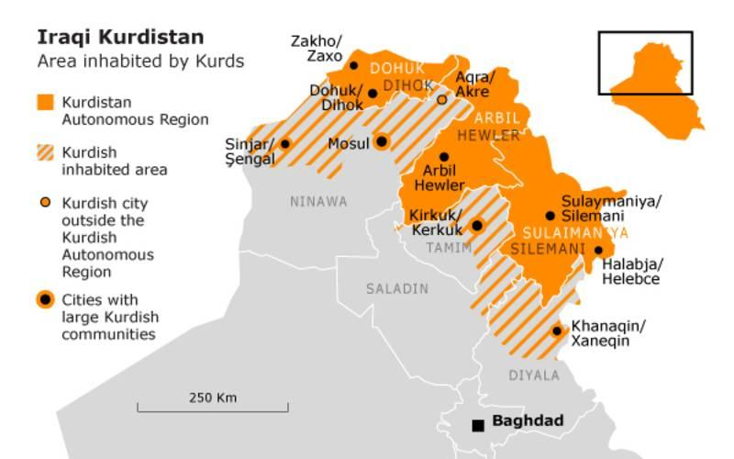
Figure 3.1 Map of Iraq (black big circle indicates Sulaimaniyah City). Source: Sulaimaniyah Municipality, Masterplan Department archive, 2011).

3.3 History and political context of Sulaimaniyah
Sulaimaniyah, throughout its history, has been part of a different administrative context: the rule of Baban, Ottoman Empire, British rule, Iraqi rule, and Kurdish regional government. Kurdish regional government started ruling the area after the cruel activities by Saddam Hussein’s regime against Kurdish people ended in 1991: including a certain amount of people in a small town were executed. During the “Anfal-operation” that began in 1988 approximately 180, 000 Iraqi Kurds were executed (Human Rights Watch, 1993, p.7-10). The use of chemical weapons in the Kurdish town of Halabcha came to be known internationally (Resool, 1990, p.108; Galbraith and Van Hollen, 1989). After the first Gulf War, large parts of Kurdistan were put under the protection of the International Federation of States and an air blockade was initiated. The embargo against the Iraqi government and an economic blockade inside the country by the Saddam regime resulted in far-reaching independence for Kurdistan and the Kurdish regional government was established. When international troops had liberated the country, the United Nations applied sanctions on the country. This, combined with the economic mismanagement of the country made large parts of the population very poor (Dulmage, 1992). Disease and high child mortality were the consequences of the embargo and the destruction of the water supply and sewage systems, the hospitals and the pharmaceutical industry (Shields, 1994, p.47). Kurdistan includes the three northern provinces of Dohuk, Erbil and Sulaimaniyah. In the Iraqi constitution, it has the status of an autonomous region with its own governance and administration. The official name is Kurdistan Regional Government (KRG). The capital of the Kurdish Regional Government under Prime Minister Nechervan Idris Barzani is Erbil. The area of influence of the Kurdish administration includes the three provinces Dohuk, Erbil and Sulaimaniyah (Ahmed, 2012, p.9).
3.3.1 Social structure
Different ethnic groups lived in Sulaimaniyah city; Muslims, Christians and Jews live in the city (Jamal Rashid Ahmed, Fawzi Rashid 1990). Longrigg (1953) addresses that "Christians are hardly distinguishable in their manner of lifestyle and customs from the Kurds, in who’s truculent and tolerant midst they had existed for many centuries" (Longrigg, 1953). According to Longrigg, Jews were different by following their traditions in the city that defined their separate ethnic culture group.
These different ethnic groups established the form of the city’s settlement pattern (Meena, 2007, p.24). The Jews formed the south-west neighbourhood of the city, which is today the Jwlakan district. The eastern part of the city was accommodated by Christian communities; however, other parts of the city were occupied by Muslims. A comfortable and secure collaboration among them were shown by their support to poorer groups in the area. The social network between Muslims, in terms of the social aspects of human behaviour based on Tariqat (literary- the way, the path), helps to define distinct identities (Lukitz, 1995). For example, in the 1860s, the holy family of Barzinji Saydi (Sheikh) and wealthy families were dominant groups in the sense of power. Town life and politics were dominated by Sheikhs; these wealthy classes were members of the authority and merchants and large landowners in the city. Today, the area is a place for poorer families and migrant families from rural areas. However the centre of Sulaimaniyah is still a dominant area for commercial activity in the city; for example, commercial functions such as business offices, retail, restaurants, multipurpose commercial centres and hotels have incrementally increased their proportion of land use in the area. Therefore, this area captivated the attention of individuals who are looking for valuable locations for their business, especially in the outskirt of the centre. Landowners of this area prefer to convert their courtyard houses into commercial uses and leave the area. However, this has increased the difficulty in accessing the area due to the rapid increase of private car ownership, causing congestion. Therefore, the growth of commercialization in this area has impacted on the social life of people, the consequence of such has been the deterioration of heritage in the neighbourhood and the reduction of the residential function as well.

3.3.2 Religious, social and spiritual life and urban space
Islamic culture rooted in traditional life in Sulaimaniyah city. This culture impacted on architecture design, in a way that Quranic verses defined the significant of family privacy. This influenced the layout of urban spaces in the city, especially visual privacy was important for protecting female members of the household from the eyes of male strangers. Spatially structural layout consists of one or two story courtyard houses within narrow and irregular roads including cul-de-sacs. Cul-de-sacs were shared among neighbours for daily gathering and chit chatting as private places. This provided the built structure of the neighbourhood with socio-cultural pattern linked with privacy in the neighbourhood. The physical structure of religious institutions such as mosques defined the layout of the neighbourhood, as residential uses are located around mosques in each district of the neighbourhood provide a communal place and spiritual and social environment for the individuals of the neighbourhood. It has been stated that religion and religious values affect the layout of cities and the use of land, the orientation of streets and buildings, the structure of neighbourhoods, and the designs of homes, places of worship, cemeteries, and gardens (Sopher, 1967; McDannell, 1986; Mazumdar and Mazumdar, 1993, 1999, 2004). In other contexts, according to Mumford (1961), the medieval was the focal point of the medieval European city and indicative of the centrality of religion, and with its spire dominating the cityscape. According to Sopher, (1967), Places of worship in Islam and some others, are significant primarily as ‘‘places of assembly’’ (Sopher, 1967). ‘In these religions, “only the community can provide the proper context of worship, and it is this which invests synagogue and mosque with their sanctity’’ (Sopher, 1967:28). This provides close relationships and spirituality to the residents, as Islam religion requires all believers to visit the place and experience its physical qualities.
Religion through the experience of the place in the learning of stories, prayers, and listening to Imams play a significant role in socialisation, place attachment and identity (Mazumdar and Mazumdar, 2004). Religion and architecture design and symbols of these structures inform what is important to this context and the neighbourhood, as the division of prayer space into female-male sections in mosques define the important of gender separation in prayer and define the influence of built heritage in the spiritual life of residents.
In addition, according to information collected during the fieldwork houses were having a courtyard in the middle or on a side of the house, with some rooms opening off it. The rooms are small, with small windows and doors. Some other rooms are dark, does not have windows opening off to another room, having storage, which were built into the structure itself. Stairs are sometimes a wooden ladder used to reach the top roof. In the ground floor, the rooms divided for guest rooms and kitchen. The guest room was located near the main gate and semi-separated from the courtyard. There are different forms of using courtyard spirituality such as practising religious life based on their spiritual and visual communication with religious organisations. This allowed residents to hear azan and get a sign for pray time from the mosques when the lights on from the mosque minaret. Different sorts of daily activities, such as food preparation, drying food or textile, spinning, and weaving, welcoming guests, and flat roofs for drying foods and sleeping.
Therefore, architectural style of these houses is a traditional style. Buildings with traditional style constructed with mudstone, bricks, wood, and mud and straw for mud bricks. Spiritual living practice in these houses linked to the comfortable life around these materials, brick walls and wood ceiling of their previous historic properties. The brick blocks are recognised as brings warm and cool atmosphere to the houses. Moreover, the structure of the houses was built with this spirituality, the beams, usually are wooden connect two walls and covered with a woven branches and clay. The interior facade of walls elaborated with gypsum plaster, and with a rich decoration of frescoes in the house of rich and famous people. However, lime- based plastering work has been used in the decorative mouldings on a ceiling or walls, and they used gypsum plastering to cover the rough surface of stone and mud bricks. Shutters rarely used to cover windows opening.
In spite of the influence of Islamic culture, privacy and hospitality were linked to a friendship that exists among all residents of Sulaimaniyah centre. This is by emphasising on the significant of the relationship between the member of society, all members of neighbourhood lived like one family, supporting and visiting one another. This impacted on daily lives, for example, spiritual traditional pattern and close relationships of residents in the neighbourhood emphasised on having close interactions in the case of visiting one another without knocking the door, eating in one another’s house, and exchanging dishes with each other. Unconditional support and interaction reflected in resident’s spiritual daily life for doing daily chores related to social and spatial aspects.
In addition, squares were public and civic places, where people gathered for social meetings. They were used for historical, social and political reasons, besides entertaining residents. They used to show power and authority of government. These squares were important as administrative and religious institutions were built beside them. Public places linked a big market for the neighbourhood. Bazaar (market) consisted of small shops and open markets. The spiritual traditional market atmosphere was practised by selling and buying traditional hand-made goods for a convenient price by local residents as dominated business in the neighbourhood. Traditional Bazaar was important for accommodating social and cultural activities of residents. Bazaar was a place for walking, social communications, and cultural interactions as public spaces. Mosques as religious institutions in spite of their religious function were used for relaxation as a public urban space. They had more than one entrance to residential narrow roads and to Bazaar. They were used as a passage entering one narrow road to another. Another place that played an important part in the social life of residents was hammam (bath). Hammam as a place for cleaning and relaxation, it was a significant social place for interaction among residents. It was a place for sharing stories about their daily lives, finding new friends and even finding partners for their sons, especially in women’s quarters. According to residents of the neighbourhood, once they decided to have a bath, spent the whole day in the bath, as a mother and children used to go there together.
Baths in the area architecturally consisted of a cool room and hot room. Bathers before moving into a cleansing space (hot room) in the bath, they were having a relaxing time: chatting and interacting with each other and having refreshments such as drinking and eating snacks. These rooms used for massaging and beauty tips, dying their hairs for women as well. Often baths were located in every district, were not exclusive to men as males and females were admitted at separate times, related to individual’s privacy, which was required by the Islamic religion. This influenced on the architecture attributes, for example, facades were windowless. The popularity of baths in the area was linked to the fact that, the houses were accommodating no spaces for hammam or consisting of only one hammam. Since several families lived in one house, and the house accommodated with only one bathroom, the families needed to go to outdoor bathrooms. Finally, another social place was tea shops. There were inclusive for men. Tea shops were a place for sharing knowledge, a place for reading poems and sharing art with one another. Therefore, religious life and culture were built into the fabric of the city where people live and therefore it forms an important contextual background to this study.

3.3.3 Economic structure
Sulaimaniyah grew as a market town, which connected the two agricultural lands of Bazyan and Shahrazwr to an agricultural community. Tobacco, wheat, fruit, crops, and barley were cultivated based on irrigation methods (Rasha, 1987, p.86). Markets and Khans formed a trading centre for doing business with Baghdad, Mosul, and Iran through Rawanduz and Halabja trade routes (Rasha, 1987, p.46). According to Rasha (1987), several factories have appeared since 1939. In 1939, in the northern part of Sulaimaniyah province, a tobacco factory was established and sugar factory was established in the 1950s. A further tobacco factory was established in 1958, followed by a cement plant in 1961. With the establishment of these factories, the economy of the area has developed since. Furthermore, with the modernisation of lifestyles, the city became a social, culture, and political centre associated with the appearance of major projects such as schools, hospitals, universities, and free –trade zones near the Iranian and Turkish borders. With the growth of literacy, these aspects impacted on the development of the economy, reforming it and enhancing its recognition.
In the past, most of the institutions and companies in Iraq belonged to the government. The same was true of education. There were no private schools or universities, just public schools. Education was free, but the quality was poor. However, the current system came from that outdated model and as a result, there has been only limited emphasis placed on competition. This has limited development and allowed things to remain somewhat stagnant (Economic Finance and Fact Sheet, 2003).
The stability and security situation of the Kurdish areas gave the opportunity to the government to sign a number of contracts with foreign companies. The portion of oil revenue from Iraqi’s oil export allowed the region to start development projects (Economic Finance and Fact Sheet, 2003). The ensuing economic development in the Kurdish region attracted many workers around the world to come to Kurdistan. Almost half of all the registered foreign companies in Iraqi Kurdistan are from Turkey - 1,100 companies and 30,000 citizens registered with a residency permit (Economic Finance and Fact sheet, 2003). The economy of this area has been upgraded by approximately 12% due to the continuous investment in the gas and oil (Kurdistan Review Report, 2003). Because of the socialist system of the previous regime, there were no large private companies in Iraq. The establishment of private, local companies did not really happen until 2000. In 2012, The Kurdish Regional Government started to build a pipeline project to export oil and was expected to be finished in 2014 (Kurdistan Review Report, 2003). This has a significant impact on the economic development of the area (Kurdistan Region Oil and Gas Law contract, 2007). In spite of all these developments, since 2015, the Iraqi Kurdish regional government has been under a financial crisis, which has shut down development projects, and even civil servants are not getting their salaries. According to an interview with Safeen Dizayee, published on the Kurdistan Regional Government (KRG) website (http://cabinet.gov.krd), the financial crisis has halted 6,000 projects.

3.4 Geopolitical and the urban structure of Sulaimaniyah
The foundation of Sulaimaniyah city started in the village of Malkandi in 1784 and extended south-west based on the geographical conditions in the area. As, throughout its history, has been ruled by a different administrative context: the rule of Baban, Ottoman Empire, British rule, Iraqi rule, and Kurdish regional government. In this sense, Sulaimaniyah city was founded by Ibrahim pashae Baban and grew around the palace of Mahmud Pasha (Kareim Zandw Dashte, 2000, p.12). The original population was 1,000 people. In 1820, after the extension of the city, there were 10,000 people and 2144 houses in the area (Rasha, 1987, p.46). Bazaar was developed from a central point towards the south-west. In terms of function and structure, the city comprised a compact organic arrangement around the palace and was influenced principally by traditional architecture depicting the community's culture and bearing the principles of Islam. Initially, the city consisted of a dominant central part and then different neighbourhoods surrounded it. The map of 1927 shows this initial pattern of the city (See figure 3.3). This is why Sulaimaniyah city developed without any planning control until 1921 and irregular housing layouts and narrow roads resulted from this uncontrolled planning.
However, during the period of the Iraqi regime, through modifications and the influence of modernisation of the city, the neighbourhoods in the surrounding parts of this historic city centre started with organised straight patterns. According to Doxiades Masterplan in 1957, a new axis towards the north-west direction the limited development of the city towards the south-east and east (Interview with a former engineer in Sulaimaniyah Municipality, December 2014). Furthermore, during Sadam regime, the urban structure of Sulaimaniyah under a political plan against the development of Kurdish cities restricted development of Sulaimaniyah through a 60-meter ring road, a political move to avoid more development (Interview with a former head of Technical Department, Sulaimaniyah Municipality). Again, due to political plans, the historic city centre and heritage of the area was ignored by the Iraqi government. This is why; the protection of these neighbourhoods was started with independent of Kurdistan, as in 1998 by a project led by the Council of Ministers in the Kurdish Regional Government (Sulaimaniyah Masterplan Department’s archive, 2006).
Moreover, the cruel activities by Saddam Hussein’s regime against Kurdish people were including people in small towns were executed. During the “Anfal-operation” that began in 1988 approximately 180, 000 Iraqi Kurds were executed (Human Rights Watch, 1993, p.7-10). The use of chemical weapons in the Kurdish town of Halabcha came to be known internationally (Resool, 1990, p.108; Galbraith and Van Hollen, 1989). This also included many towns and villages around Sulaimaniyah city destroyed and many people moved into Sulaimaniyah city, especially historic city centre as it was the oldest part of the city and housing rent was cheaper compared to the other parts of the city. However, cruel activities of Iraqi regime against Kurdish people did not influence on Kurdish identity of Sulaimaniyah city, and especially historic city centre, where kept its Kurdish residency. This was opposite from some other parts of Kurdish cities were brought in Arabic residences to diminish their Kurdish identity.
Therefore, independent of Kurdistan was started as after the first Gulf War, large parts of Kurdistan were put under the protection of the International Federation of States and an air blockade was initiated. The embargo against the Iraqi government and an economic blockade of the country by the Saddam regime resulted in far-reaching independence for Kurdistan and the Kurdish regional government was established. When international troops had liberated the country, the United Nations applied sanctions on the country. This, combined with the economic mismanagement of the country made large parts of the population very poor (Dulmage, 1992). Disease and high child mortality were the consequences of the embargo and the destruction of the water supply and sewage systems, the hospitals and the pharmaceutical industry (Shields, 1994, p.47).
Since 1991 until 2006, the rapid growth of city’s settlements has shaped the city like amoeba without any conclusive development planning. Before the production of City Master plan in 2006, several planning authorities were acting without much coordination that allowed for settlement activities that were not connected to the infrastructure systems of Sulaimaniyah. The city’s urban development started to develop in a structured pattern. New settlements developed in the northeast, in the north and in the south. From 2003, after the Second Gulf War, since 1991 until today, new districts were established surrounding the city. Towards the north-west, the settlements of Bakrajo, Raparin and Tasluja expanded. In addition, the building of the new Sulaimaniyah University, the American University and an International Airport has further impacted the development of the city. Furthermore, new investment planning projects for housing were developed in the surrounding city, where high-rise housing in these new development districts, introduced to the existing urban fabric, are distinctive in terms of the ownership pattern of plots and building types.
Therefore, the protection of historic city centre was due to after, 2003, as Sulaimaniyah‘s social and economic systems developed with concomitant rises in land and property prices. The resulting property redevelopment business led to the dismemberment of the historic city centre and buildings that escalated the alterations to the urban structure of the area. Especially from 2003 until the city master plan was produced in 2006, many old buildings have been torn down to construct modern buildings and public parking.
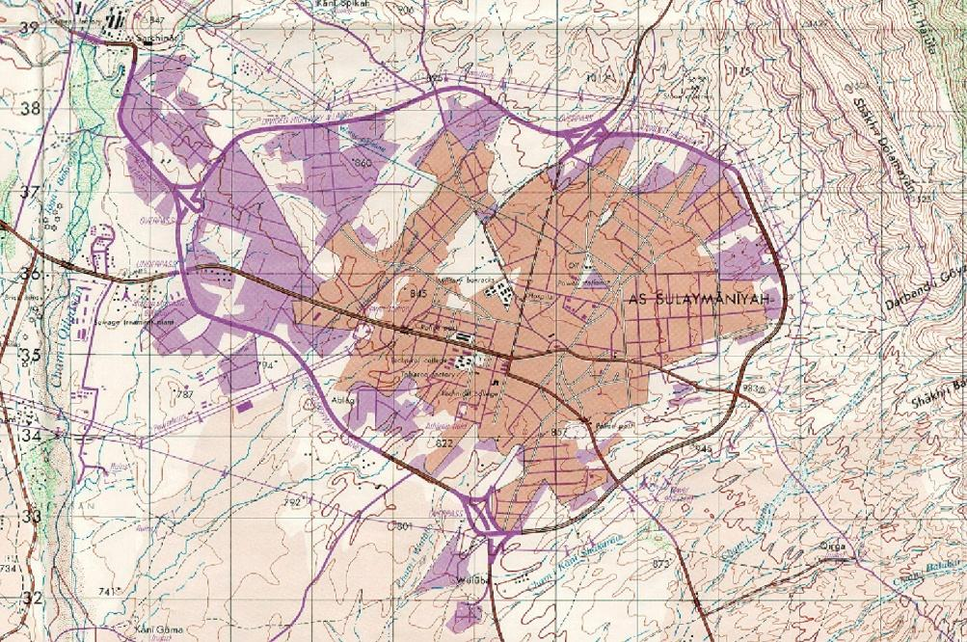
Figure 3.2 Topographic Map of Sulaimaniyah City in 2006. Source: Sulaimaniyah Municipality, Masterplan Department archive, 2011.
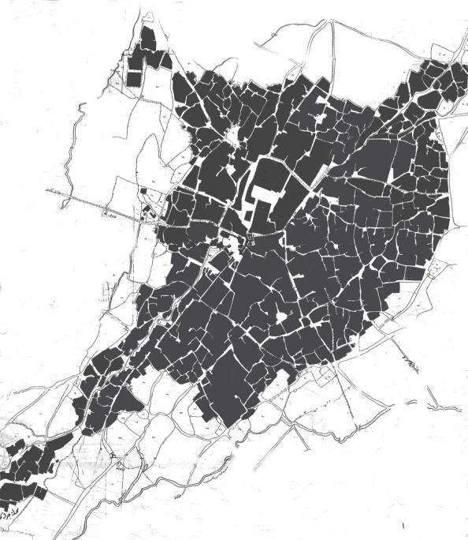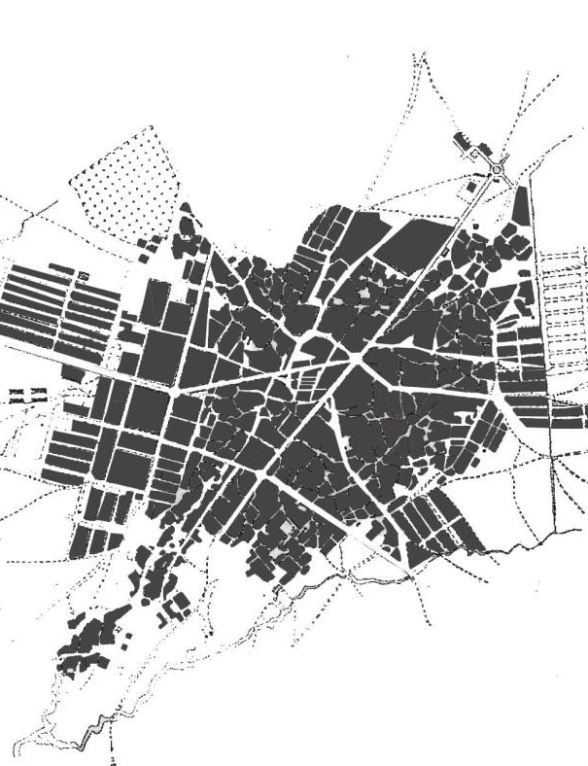
1927 1958
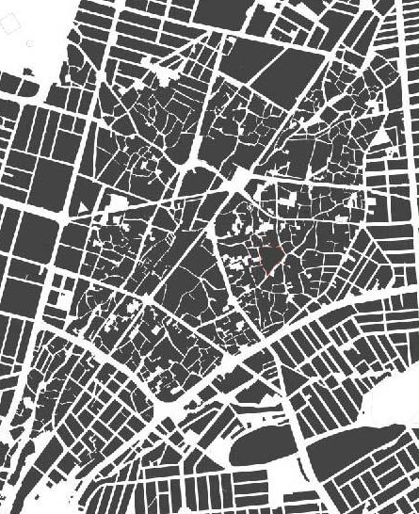
2009
Figure 3.3 The development of Sulaimaniyah in 1927, 1960 and 2009. Source: depended on the map of 1927, air photograph of 1958 and Sulaimaniyah Map of 2009, Masterplan Department archive, 2011.
Figure 3.4 Map of Sulaimaniyah City centre (Case study) in 2009, which consisted of six neighbourhoods: Kani-askan, Malik Kandi, Goizha, Chwarbax, Sarshaqam, Dargazen. Source: depended on Sulaimaniyah Municipality aerial photo, Masterplan Department archive, 2011.

3.5 Heritage Site in Sulaimaniyah
The historic environment of Sulaimaniyah is located in the city centre (case study), which consists of eight districts: Kani Askan, Bazrgani, Dargazen, Jwlakan, Malkandi, Sabunkaran Sarshaqam, and Shekhan. All historic buildings located in this area. The protection of these neighbourhoods started in 1998 as a project led by the Council of Ministers in the Kurdish Regional Government (Sulaimaniyah Masterplan Department’s archive, 2006). Irregular paths and streets along with social and cultural criteria produced an organic urban pattern that emerged over the time of the city’s urban development. However, the neighbourhoods in the surrounding parts of this area started with organised straight patterns that were influenced by the modernisation of the city (based on my professional experience and site visit). A functional infrastructure of shops, small workshops, services, handicraft enterprises and flats in these historic neighbourhoods spread along the traffic arteries (IGCO report, 2009). Along the main axis’s, there is a mixture of uses, including two storey buildings consisting of small flats and commercial uses. The core of each neighbourhood accommodates old houses with its own mosque and one Christian church in the whole city centre in the neighbourhood of Sarshaqam. Today, there are countless shops from Shekhan towards the southern end of Barzgani.
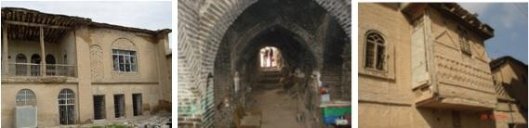
Figure 3.5 Historic buildings in the area. Source: Sulaimaniyah Municipality-Masterplan Department archive, 2006).

In 2006, a survey by the Masterplan team and Ministry of Culture -Museum of Sulaimaniyah defined 74 listed buildings. They are under a heritage order for preservation in Sulaimaniyah city centre. Five of them are located in Bazrgani, six in Kani- askan, nine in Malikandi, 24 in Sabunkaran, 14 in Sarshaqam, three in Shekhan (Sulaimaniyah Master plan 2009).
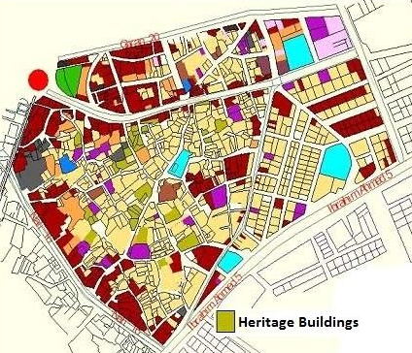
Figure 3.6 Heritage buildings (Listed buildings) in the city centre neighbourhoods-Sabwnkaran. Source: Sulaimaniyah Municipality-Masterplan Department archive, 2006).
Today, these historic buildings are empty and remain under the preservation order. Most of the listed buildings are privately owned. The Sulaimaniyah administration does not allow for any intervention in these historic buildings, however, there are not any preservation projects by the government or private agencies for these historic houses (based on my professional experience and site visit). Some of these historic buildings still accommodate local residents as their original function such as houses and baths, mosques and churches. Some of the unlisted buildings in the area have been demolished and reconstructed in a modern style; however, there is conservation planning policy in the area. Today the old fabric of this area consists of many modern buildings. The largest historic mosque is located in this area, which is one of the most important architectural monuments in the old city and has been renovated many times since its construction. The road that connects two neighbourhoods of the city centre is a civic space of the traditional city, where people gather for social meetings. It is facing the central square, which is called Sara Square. This Square connects all the neighbourhoods together and consequently, the road is a character node for all neighbourhoods (Amin, 2010, p.3). Sarae Slemani, which was used as a historic administration office, is located in this square. It has since been renovated and turned into a historic museum ( Jaf, 2014).
a- 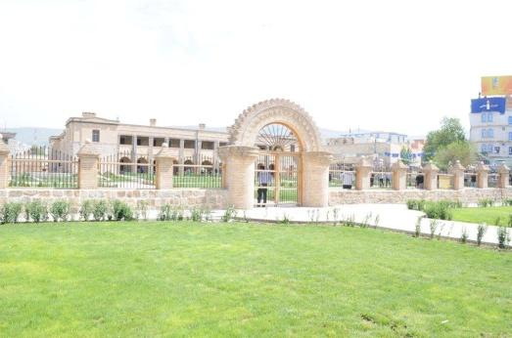 b- 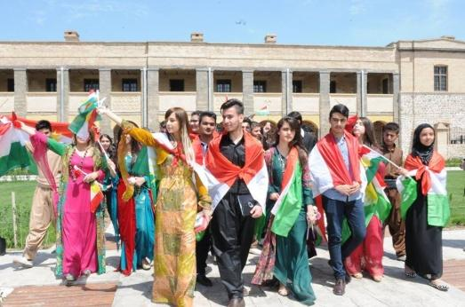
Figure 3.7 a- A view of Sarae Slemani. b- Opening ceremony for the newly renovated Sarae Slemani Museum (Retrieved June 22, 2014, from http://www.facebook.com/photo.php?fbid=382955705177200&set=pcb.382957178510386&type=1&theater).

a-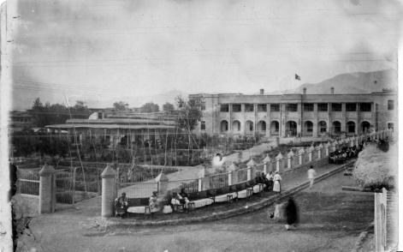 b-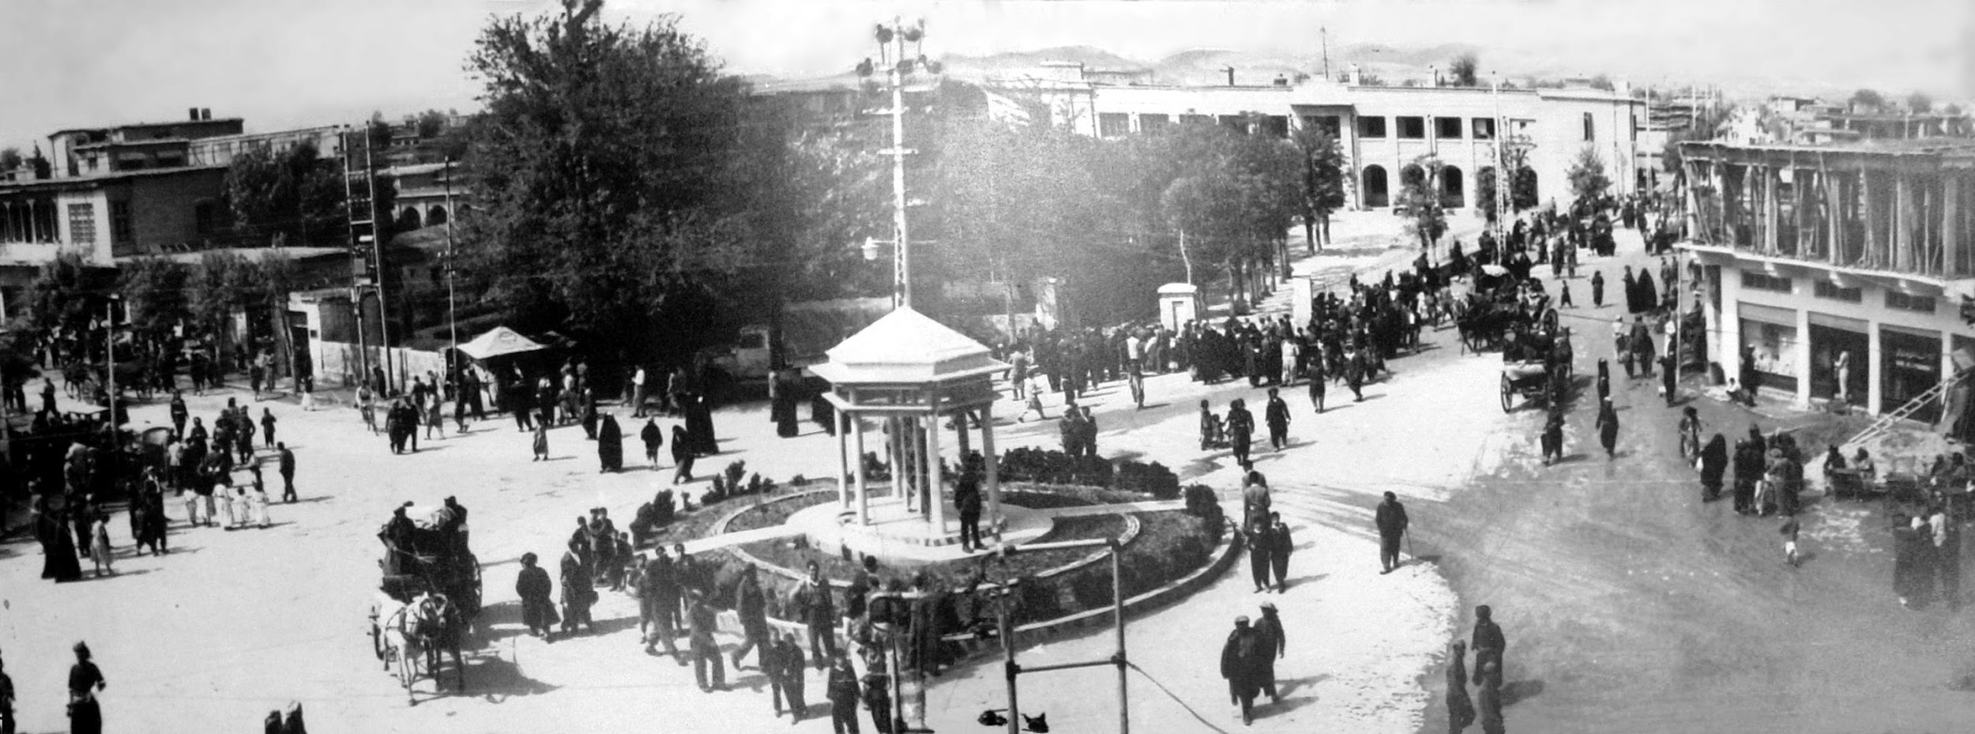
Figure 3.8 a- A view of Sarae Slemani in1940s. b- A view of Sara Square in the 1940s (Historical archive).

a-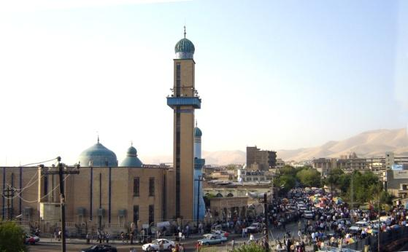 b-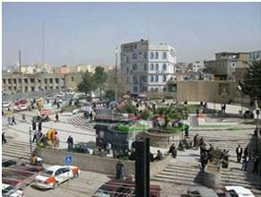
Figure 3.9 A view of a- Square in front of Great Mosque (Retrieved January 12, 2010, from http://www.images.google.com). b- Sara Square in 2013 as a gathering place (Retrieved June 22, 2013, from http://www.images.google.com).
The major streets that connect the neighbourhoods in the city centre developed into Bazaar, which extends from Shekhan in the south-west towards Sarshaqam. Along the major streets are a mixture of shops, merchandises, clinics, surgeries, pharmacies, a few industrial uses, a few small bus stations, parking lots, several baths (hammam), bus parking, and petrol stations are available. There is also a big traditional market with small shops. All the neighbourhoods in the city centre show traces of the demolition and construction of new buildings.
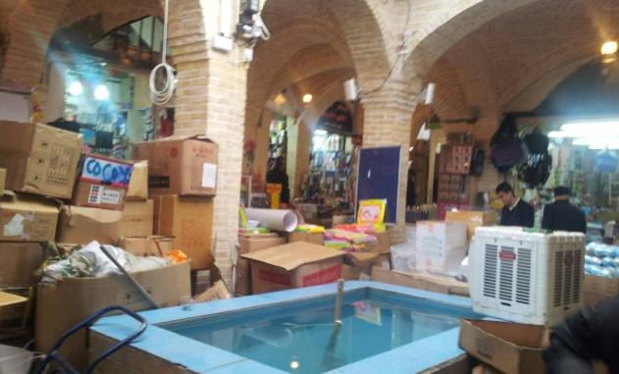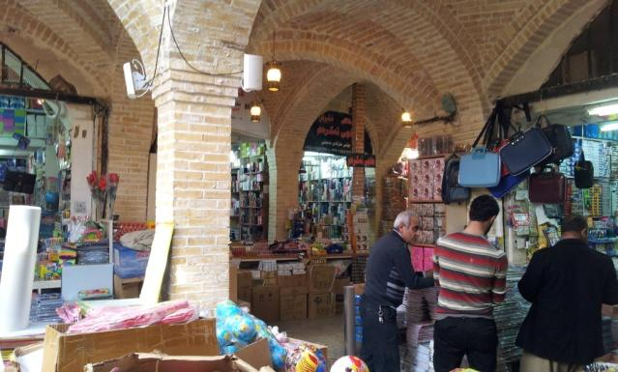
Figure 3.10 A view of the traditional market (Retrieved June 22, 2014, from https://www.facebook.com/slemanyjaran?fref=photo).

3.5.1 The architecture style of historic residential buildings
Traditional historic residential buildings are courtyard houses that are built from burnt bricks and joined with mud (reinforced with straw) or wickerwork (Rasha, 1987, p.400). The core of these houses is a space (Tarma), which opens up towards a courtyard with two to four columns around which the rooms (Oda) are grouped. The columns are embellished with artful capitals and ceilings display plentiful ornaments. These houses usually consist of two storeys. The Tarma is usually built in the second storey of the house. The ground floor mostly consists of kitchens, stores, two wing rooms of Tarma and a central room (Diwan), which is bigger than the other rooms (IGCO report, 2009). These traditional houses are separated from streets by a gate or a gated building. Sometimes, the houses have a separate courtyard from the street; in this case, the courtyard is located in the middle or the side of the buildings, which gives access to auxiliary rooms and a second floor. Stairs and bathrooms are separately located within a courtyard. However, the stairs lead towards the Tarma on the first floor.
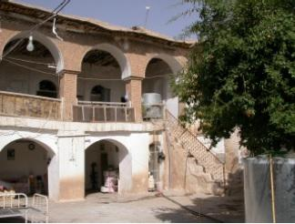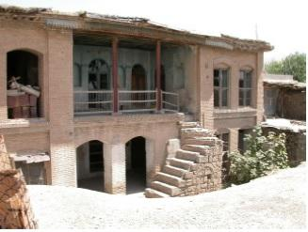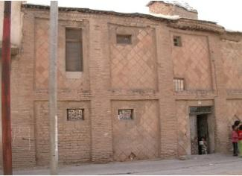
Figure 3.11 Courtyard houses with Tarma and exterior facade. Source: Sulaimaniyah Municipality-Masterplan Department archive, 2006)

Today, many of these houses are uninhabited and in a state of deterioration. Some of the broken parts of these houses have been blended with new building materials such as concrete. Gypsum mortar was used for more enduring parts, arches and thin walls. The monotonous structure of the layers of bricks is often covered by a dressing of gypsum or clay mortar. Clay bricks are sensitive to humidity and in dry and arid climatic regions; they have the advantage of thermal storage in spite of their missing insulation. During the day, the bricks store heat from the sun and at night the stored heat is gradually passed to the environment. Through this process, buildings made from clay brick stay cool during the day and warm at night. Over time, burnt bricks were replaced by blocks of sandstone, cement bricks and nowadays by concrete blocks. Exterior walls were often built from quarry stones that were covered by bricks afterwards (IGCO report, 2009).

The focus of these decorative facades is in the courtyard and not on the exterior walls. In traditional buildings with a Tarma on the first floor, the rooms of the lower floor open up to one room, which is connected to the courtyard by an arch (Rasha, 1987). These arches are either open as blind windows or closed with glass. In many of the floor plans that vary from the standard layout, the simple and clear form cannot be used. However, they have tried to replace the columns between the Tarma and the courtyard by lateral, closed wall pieces. The courtyard is a habitable room. This shows why the decoration of the courtyard facades is of higher aesthetic quality than those of the exterior walls. The exterior wall along the street is often a plain, straight wall, which only has one door and a few windows in order to achieve a separation between public and private areas.

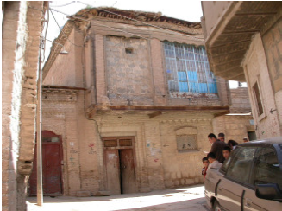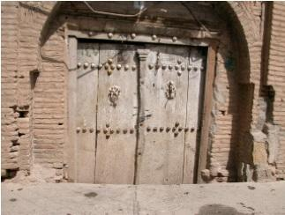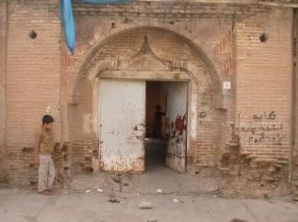
Figure 3.12 Exterior facade. Source: Sulaimaniyah Municipality-Masterplan Department archive, 2006)

In Sulaimaniyah, all the buildings have a flat roof, except hammams (bath) and mosques. The joists are usually used for the roof construction. The second layer is covered with a layer of straw and reed for thermal reasons and there is a further layer of clay, which is necessary to keep the rain out. Roof terraces are additionally covered with tiles. The roof covering materials are tiles, clay, straw, wood, reed and mats. Many entrance doors of traditional houses are decorated with the arches, which is called Asam in Sulaimaniyah. Windows and doors in traditional houses are limited in size and numbers and the width of the door is reduced to a minimum. Some special elements in buildings under a preservation order are richly decorated arched windows with coloured glass. Doors are usually made from wood or iron and the windows usually, have wooden or iron steel frames and are usually without window panes.

The Tarmas that open up to the courtyard with wooden columns is in all traditional houses in the city. They are both corridor and living space. The Tarma provides access to the rooms that have no interlocking doors. Daily life happens in these open spaces, with shadow provided by verandas, while the rooms are for sleeping and representation. One family occupies one house. In a few houses, there is a secret room hidden behind the living room – a treasury. There are no normal doors towards the treasury and access is usually through a cupboard or behind a piece of furniture. There is not much emphasis on the decoration of the floors, which are usually made from clay or stone and not wood. In recent decades, the floors have been made from concrete slabs placed on a layer of clay and the joint filled with gypsum. The most frequently used material for courtyards, floors of rooms and roof terraces is the common brick.
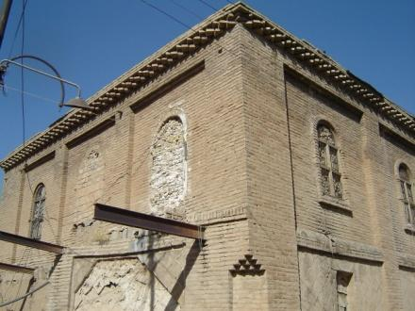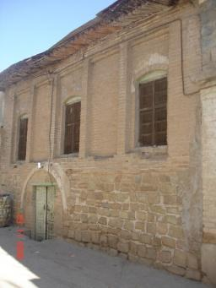
Figure 3.13 Exterior facade. Source: Sulaimaniyah Municipality-Masterplan Department archive, 2006)

3.5.2 Urban planning in Sulaimaniyah
Urban planning in Sulaimaniyah city is concerned with architecture, urban design, strategic plan, policy recommendations, implementation and management. The plans cover regulatory and preservation plans for neighbourhoods (Municipality of Sulaimaniyah, 2013). In 2006, a Masterplan Department/Sulaimaniyah Municipality was established to tie together departments that manage urban planning processes for Sulaimaniyah city. This department takes control of planning developments in Sulaimaniyah to route the planning processes in the city in a well-regulated way. Today, it has the responsibility and power for urban design, architecture and planning projects that are managed by other related departments. It is linked with stakeholders: the Ministry of Planning, Ministry of Agriculture, the Governorate of the Province and other authorities in the context of developing the region.

Before 2006, several planning authorities were acting in parallel and without much coordination, at least not with so much coordination as is usual in western countries. For instance, settlement activities by the Ministry of Planning were undertaken which were not connected to the infrastructure systems of Sulaimaniyah. Furthermore, a Tourist Masterplan was elaborated including areas directly connected to the city under the responsibility of the Ministry of Agriculture. The planners of the Municipality did not have influence and could only react to these plans. However, until today all urban planning developments are not totally tied to the administration as one of the main departments to link to the other departments.

Today, Sulaimaniyah city is managed by three municipalities, comprising 54 neighbourhoods. The historical city centre (case study) is inside a 60-meter ring road and divided into 8 neighbourhoods (Rename Nawandi Shar-City Centre Guide Line, 2010). The management of the city centre (case study) is led by a number of departments within the directorate of Sulaimaniyah Municipality, including the Technical Department, Masterpaln Department, Municipality Council and Heritage Museum.

3.5.3 Lack of conservation planning policy
The architectural features of Sulaimaniyah city centre have faced demolition and degradation that have had an impact on the social lives of residents in the area. This is due to the lack of management and comprehensive conservation planning policies that allow land use change from residential to commercial. The absence of conservation planning policies, with the exception of the urban fabric that conserves its organic, narrow and irregular roads, allowed the penetration of modern buildings (with different architecture style and new facilities) into the historic Sulaimaniyah city centre and with it, the deterioration of its built environment. Government planning policy has mostly dealt with the problems of urbanisation and these policies are similar to what is happening in developing world countries. Governments in developing countries, due to modernisation and problems of new housing, neglected the value of inner cities. Consequently, the areas became a place for a sizable poor community and witnessed more physical degradation (Elsheshtawy, 2008, p. 275). However, preservation efforts in some countries to resolve this issue have emerged that have focused on profitable projects, such as historic areas with tourist potential. The low-income residents have been ignored at best or pushed out by existing renewal policies” (Steinberg, 1996, p. 472).
Sulaimaniyah city developed without any planning control until 1921. Irregular housing layouts and narrow roads resulted from this uncontrolled planning, which remains evident today in the historic town. Through the modification in the 1980s and Masterplan of 1957, the city’s urban development started to develop in a structured pattern. This plan restricted development of the city through a 60-meter ring road, a political move to avoid more development. After the establishment of the Kurdish Regional Government in 1991, and the fall of Saddam Hussein, the rapid growth of the city’s settlements shaped the city like amoeba around a 60-meter ring road without any conclusive development planning to coordinate the newly developed settlements (planned separately). The 2006 Sulaimaniyah Masterplan was established to assist and produce a 2009 Masterplan tender, which was approved in 2011 by the Ministry of Municipality and Tourism. The plan recommends the protection of the historic city centre; however, the Masterplan was not implemented until now due to financial problems.
In 1976, an international agreement was signed to protect old neighbourhoods around the world. The protection of old neighbourhoods was included in the worldwide culture agreement, which was signed by the united nations in 1972, and it was signed by Iraq as well (Sulaimaniyah Masterplan Department’s archive, 2006). In 1998, the protection of old neighbourhoods started as a project led by the Council of Ministers in the Kurdish Regional Government. Kurdish culture and its old neighbourhood and buildings are now included in the worldwide cultural agreement and they must be protected. Although this project was started by the Sulaimaniyah Administration Office in 1998, it has not been implemented completely. Many old buildings have been torn down to construct modern buildings and public parking. Especially after, 2003, Sulaimaniyah‘s social and economic systems developed with concomitant rises in land and property prices. The resulting property redevelopment business led to the dismemberment of the historic city centre and buildings.
The demolition of historic buildings and the increase of the historic area’s degradation quickly became a nationwide concern. On August 26, 2005, ten parties and organisations along with a hundred individuals in Sulaimaniyah wrote a petition to the Kurdish parliament and asked them to issue a law to protect the old neighbourhoods in all the cities of Kurdistan, which should include a severe punishment for those who do not obey. In 1998, by order of the Council of Ministers, the Ministry of Municipality conducted a survey of the old neighbourhoods in Sulaimaniyah and some other cities; these neighbourhoods were marked on a map and the map was approved by Council of Ministers at a meeting on March 29, 2000, by order no. 290 issued on April 9, 2000. There were some official decisions by Sulaimaniyah Administration Office regarding the protection of the old neighbourhoods; for instance, four memos were approved between 1998-2000 by the Ministry of Municipality and Tourism and four memos by the Ministry of Council between 1999 and 2000.
After that in 2010, Sulaimaniyah Municipality decided to make a land use preservation plan for the city centre based on the actually existing situation (expansion of illegal majority of shops). As a result, the majority of the city centre’s roads were commercialised. Municipality council approved it and called it Rename Nawandi Shar-City Centre Guide Line (My office observation in Sulaimaniyah Municipality, 2010). Today, the historic city centre (case study) is managed by this plan. The plan gives detailed guidelines for new construction in the area, the protection of the heritage listed old buildings from demolition and protection of its land use zoning. Unfortunately, the plan does not cover all the detailed concept for the preservation of the area (see: the following sections). Most demolished old buildings have been replaced with modern buildings built by merchants. Developments such as shopping malls (Caso mall) stand on the sites of the historical city centre.

3.6 Overview of the management of the historic neighbourhood

The irregular urban structure of historic Sulaimaniyah city centre is associated with an uncontrolled planning system. It's organic irregular narrow roads and housing layout are formed differently from the rest of the city. However, by development plans of the Masterplan of 1957 and the modification in the 1980s, Sulaimaniyah’s urban development started to develop in a structured pattern. A serious effort managing the historic neighbourhood began with the development of ‘Slemani City Masterplan’- in 2006 by the Directorate of Sulaimaniyah Municipality. Then, conservation projects were actually carried out by Sulaimaniyah Governorate, Directorate of Sulaimaniyah Municipality and Sulaimaniyah Directorate of Antiquity. Examples of these projects will be addressed in the following subsections: plans and projects of Sulaimaniyah City Masterplan, guidelines and process of management by City Centre office, City Centre Guideline, revitalising projects, and building conservation will all be analysed.

3.6.1 Sulaimaniyah City Masterplan

The project of Sulaimaniyah Masterplan started in 2006 and was approved in 2011 by the Ministry of Municipality and Tourism. The project aimed to provide a plan for the whole of Sulaimaniyah city, but it also consists of developing proposals for the historic centre of Sulaimaniyah. The proposals are developed to protect parts of the centre as ensembles (Slemani City Masterplan’- in 2006). They aimed to give a detailed description of Kurdish heritage architecture. It also recommended that not only singular buildings should be preserved, but also the neighbourhood and structure have a value for tourist attraction. However, the Masterplan was not only aimed at the historic Sulaimaniyah city centre Master Conservation Plan but was planned for the whole of Sulaimaniyah city (ref-see around world strategic plan). Today the Masterplan is used as a guideline for developments in the city, but not considerably for development projects of historic Sulaimaniyah city centre. The proposal for developing the historic centre and recommendations for the historic city centre are at present just drawn up, but not implemented. This is because of the financial difficulties of dealing with private ownership properties. Nonetheless, it is important to understand the content of the plan and its recommendations, as below.

The following are recommended by the Masterplan:
- Building documentation is urgently required in cases where buildings disappear.
- The whole neighbourhood has a value as a tourist attraction and should be preserved, and preservation should contribute to the built environment.
- It might not be possible to preserve the historic town as some parts have been destroyed. This has been addressed: “some parts have already fallen to pieces or have been destroyed by uncontrolled building measures, alteration works or simply by age. In these cases at least a few consistent structures or buildings should be preserved” (Slemani City Master-Plan- Final Report, IGCO, 2011).
- New buildings in the area should be granted permission that is consistent with the traditional architecture.
- The building mass, the size and the plot ratio should be controlled and theses rules and consideration should receive legal status. Besides that, development laws have to be adopted and controlled for a building order for the city centre
- The historic city centre suffers from traffic, as there are no traffic restrictions in place; therefore, the area needs to be accessible for residents and traffic volumes should be restricted.
- To relieve the historic city centre from traffic, large-scale markets need to be relocated to areas with a better transport access, particularly for large goods vehicles. It is also advisable to decentralise administration and services that attract much traffic to the area.
- By down scaling the traffic via relocating administrations and services that contribute to traffic, more spaces will be created for developing urban uses and better air quality will be reached when traffic is down scaled.

However, to date, these recommendations have not been implemented completely. The following activities for the area have been implemented during the process of the Masterplan:
1-Listed buildings are defined: during the process of preparing Sulaimaniyah Masterplan, a survey took place by the Masterplan Team and Ministry of Culture- Sulaimaniyah Directorate of Antiquity. They defined 74 listed buildings, which today are under a heritage order for preservation. Five of them are located in Bazrgani, six in Kani- Askan, nine in Malikandi, 24 in Sabunkaran, 14 in Sarshaqam, and 3 in Shekhan (Slemani Master Plan Report. 2006). Based on my recent interviews, the listed buildings are updated by Directorate of Sulaimaniyah Antiquity. This has been confirmed by the head of Directorate of Sulaimaniyah Antiquity:

“we listed 106 buildings in Sulaimaniyah city”
(Head of Sulaimaniyah Directorate of Antiquity, December 2014).

2-Producing a land use plan of the area in 2006: A Land Use Map was created showing the use of all buildings at the time of undertaking the survey. According to the land use map (see Figure 3.14), the historic city centre is occupied by housing, commercial activities. Education, health, administrations, religious institutions are located in the neighbourhood. The most important commercial activities are concentrated in the historic centre. Many small workshops and handicraft enterprises are located in the neighbourhood. There are also a few bus terminals and parking lots.
They also defined large-scale stores, a few mixed land uses of shops and services on the ground floor and flats and storage space in the upper floors. A mixture of shops and merchandises were also defined. There are also blocks of various clinics and their administration. There are three Christian churches in the city. In the area, there is a shopping centre of four to seven stories and an administrative building with a quarter. There are also baths, which are located in the middle of the bazaar. There are also many workshops and a covered bazaar extends from Kani Ashkan and Shekhan towards Bazrgani. In the area, there are also a few repair garages and parking lots that are mostly located in the inner areas. Additionally, there are some handicraft enterprises and one museum. Along Sivar there are shops and a petrol station.
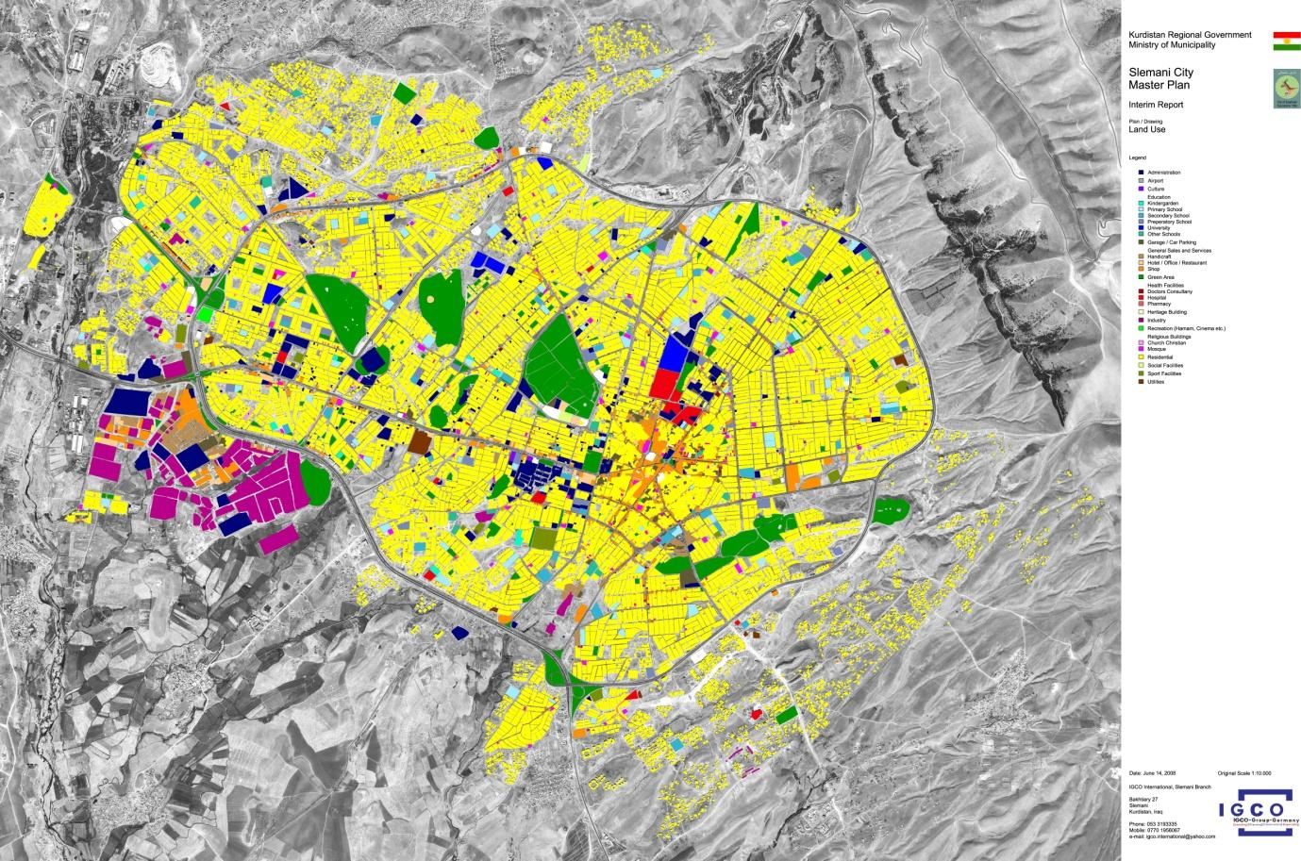
Figure 3.14 Land use in the historic Sulaimaniyah city centre in 2006. Source: Slemani-Master plan report.

A third proposal, which has not actually been implemented yet but contains four sub-proposals, is shown below.
The proposed projects for the development of the area: the proposals intended to design for pedestrians and keep as much as possible of the centre free from traffic. For instance, buses will be allowed to enter the pedestrian areas at lower speeds to respect pedestrians. In the morning until 09:00 and in the evening from 19:00, delivery of traffic to the shops is allowed without restriction. In the long term, the bazaar area should be transformed into attractive areas for tourists but remain in its general character. The existing buildings have to be painted in more lively earth colours to bring variety and a warm atmosphere. Walls with concrete blocks have to be plastered or covered with natural stone or burned clay tiles to prevent the impression of being provisional. New buildings with modern architecture should not be allowed because they are strange elements in the city centre. Those new developments have to adapt the traditional style even if they are equipped with modern infrastructure and new uses. In order to preserve the cultural heritage, it is important to maintain the rest of historic buildings, which remain. When people or the government wishes to replace heritage buildings with modern buildings, it is necessary to at least make a documentation of the old building. Photos and a description will conserve the building in this way for the future generations. If documentation does not occur, the building will be lost forever. To make the centre attractive for visiting people it is proposed to design paths connecting heritage buildings and the Museum of Slemani as well, where some heritage buildings in a group or single outstanding buildings are located. Thus, it is proposed to design smaller places with pavements, trees and new uses, such as a café, a gallery and so on. The following detailed proposals for the design of smaller places have been extracted from the Masterplan:

- First Detailed Proposal The existing buildings will be completed by new architectural elements, which will be adapted to the surrounding environment in terms of height, size and style. The buildings should be well integrated with the paved streets and these should be opened and where possible trees should be planted and green areas developed (see: Figure 3.15).

- Second Detailed Proposal A heritage school building in Sarshaqam has to be renovated and re-used as a café for literature and arts, or as a tea shop. The courtyard can be integrated as open space with tables under trees to sit and communicate. Some furniture together with the trees will protect from the sun and give a nice atmosphere to meet. There can be stands for selling goods to give people of the surrounding houses a possibility to earn some money. In the street leading to the school, parking places for cars are located. The pavements will change from pavements to semi-paved areas and thus give the area a kind of zoning.

- Third Detailed Proposal It is a design proposal for the area in front of the entrance to the bazaar with the old hotel and the hammam in Bazrgani. The hotel should be renovated and revitalised as a tourist attraction to be hosted as in the 19th century. The place in front will be changed into pavements of natural stones (local material to be used). The entrance to the hammam will get a big tree as a special sign and the market stands will be designed in a unique manner and installed permanently.

The fourth Proposal for Sara Square Sara Square is an important urban space in the historic Sulaimaniyah city centre. Six streets meet in Sara Square and the buildings along these streets are three and four stories high. In the east section of the Square is a bus terminal with a large number of buses. The design concept for Sara Square is to remove all through traffic from this area, except traffic for loading and unloading and access to the bus terminal.

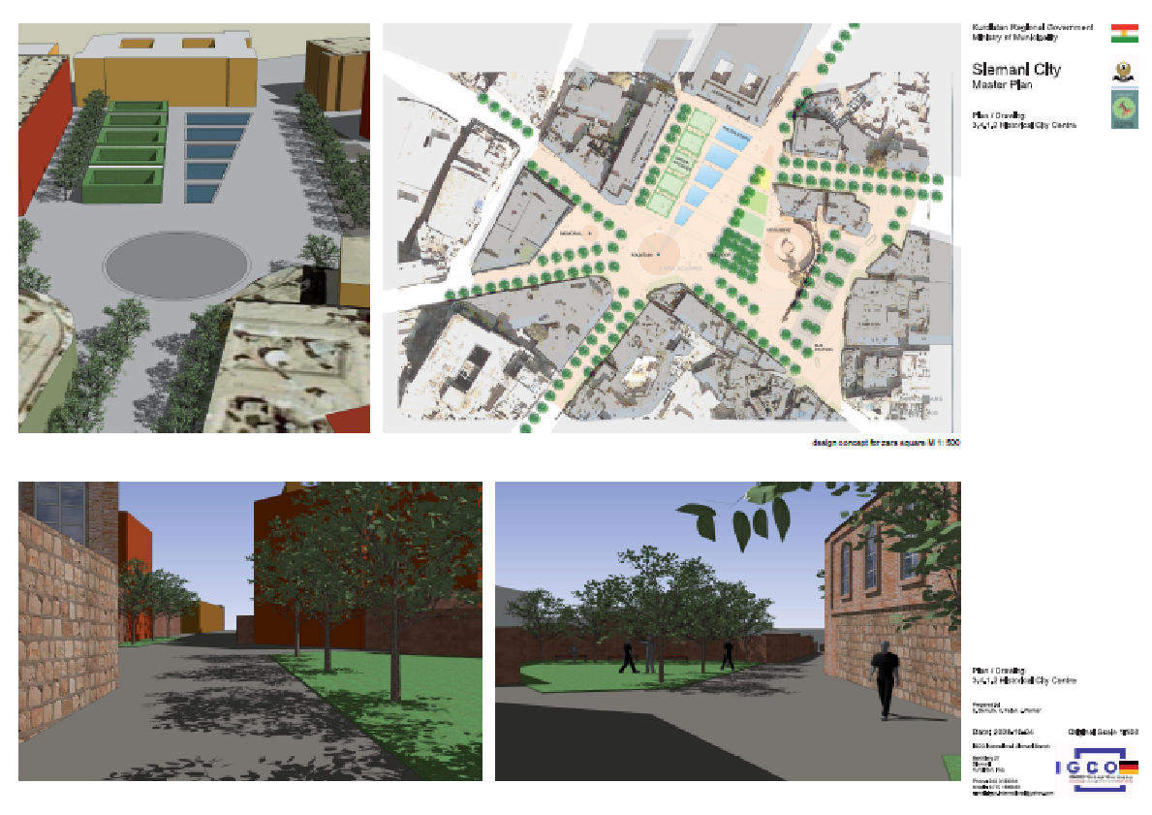
Figure 3.15 Sara Square Proposal: There are surfaces from stone for pedestrians. The streets will be equipped with rows of trees. There is a water fountain in the middle as part of a sequence of water steps (basins) in the northern part of the square. Parallel to the water steps is stone arcades with greenery that provides shade to this area and seating facilities.

However, the first project of revitalising Sara Square by Directorate of Sulaimaniyah Municipality recently started and aimed to produce a new proposal plan for the physical development of the Square. The project’s main objective is to represent the neighbourhoods’ culture, tradition, architecture and historical environment of the place. It also aims to attract tourism, increase pedestrian traffic and downscale of motor traffic in the neighbourhood. The project should reflect the neighbourhood’s tradition and culture of the city. This has been developed based on the two separate reports, namely “Terms of Reference for Reorganizing Bardarkey Sara Project- August 2013” and “Suleymaniah Bar Darky Sara: DATA COLLECTION AND SITE ANALYSIS- 13 April 2014”.

3.6.2 Regulations and the City Centre Office
During the process of producing a Masterplan project, the concept of establishing a team within the Directorate of Sulaimaniyah Municipality-Technical Department in Sulaimaniyah Municipality emerged. The office was led by several architects in Sulaimaniyah Municipality, but not specialists in the field of urban conservation, as one member (during the interviews) confirmed that they do not have experience in the field of heritage. During their time of administration, they produced some surveys for the neighbourhood. They also developed special regulations for the neighbourhood, but these were not completed compared with the recent City Centre Guidelines. The City Centre Guideline involves specific regulations for the whole neighbourhood (Rename Nawandi Shar-City Centre Guideline Report, 2010). The team took responsibility for producing photography and documents for most of the listed buildings for the whole historic Sulaimaniyah Centre, as well as participating in producing the land use map for the neighbourhood along with a Masterplan of 2006. The office was in charge of permission for all planning applications in the neighbourhood. However, the team of the City Centre failed to continue as a specific office for urban conservation management of the neighbourhood. This has been confirmed by comments of the Team architect, which will be further discussed in the Ch.8.

3.6.3 City Centre Guidelines
Formal City Centre Guidelines for Sulaimaniyah were produced in print format in 2010 by the Directorate of Sulaimaniyah Municipality to provide planning regulations for any new construction in the historic centre of Sulaimaniyah. The Guidelines define land-use in the neighbourhood based on a developed land-use map for the neighbourhood. It involves specific regulations that provide consistency with the old fabric of the neighbourhood: the number of building floors and car parking for newly constructed buildings is defined; the facade and building materials of any new buildings should be consistent with the old fabric of the neighbourhood.
Moreover, the size and ratio of new buildings should be controlled based on General Guidelines that provide guidance for new construction in the whole city. Therefore, new developments in the historic centre of Sulaimaniyah should be built based on both:
- City Centre Guideline and,
- General Guideline for new construction such as residential and commercial buildings in the whole of Sulaimaniyah city.

3.6.4 Revitalising projects and building conservation
Other efforts have started to revitalise the historic environment of the city centre by the Directorate of Sulaimaniyah Municipality and Sulaimaniyah Governorate. Pedestrianising one of the main roads in the area was initiated by Sulaimaniyah Governorate. Sulaimaniyah Governorate established a team to pedestrianise Mawlawe Street. Apart from this project for the redevelopment of the physical environment of historic Sulaimaniyah city centre, in November 2013, Directorate of Sulaimaniyah Municipality developed another project of “Sulaimaniyah Bar Darky Sera” as a redevelopment plan for the Bar Darky Sara Square in the historic Sulaimaniyah city centre. According to the Terms of Reference of the project, this will be the first step for future efforts for the redevelopment of the neighbourhood. NMA as a local office and CULD as an International office were commissioned to prepare the project on behalf of the Municipality of Sulaimaniyah (Sulaimaniyah Bar Darky Sera: Data collection and site analysis, Prepared for Suleymaniyah Urban Planning Council, 13 April 2014). This has been initiated in accordance with the Terms of Reference of the Project Tender as issued by the Directorate of Sulaimaniyah Municipality November 2013. The above revitalization projects are developed by Directorate of Sulaimaniyah Municipality apart from restoration projects by Sulaimaniyah Directorate of Antiquity.

Sulaimaniyah Directorate of Antiquity began with the conservation of historic buildings in Sulaimaniyah city centre in 2006 by putting a lot of effort into heritage conservation. However, the restoration of listed buildings for the first time was started with the Sara Building, and then Hotel Farah. The Sara Building was a governmental institution and a historical landmark in the historic Sulaimaniyah city centre. It is located in Sara Square. Conservation by Sulaimaniyah Directorate of Antiquity is only concerned about restoration of the built environment, which is limited to listed buildings that are under Directorates’ ownership and others are mostly ignored. Therefore, the numbers of listed buildings that have been restored up to date are limited (This has been developed during the fieldwork. (This will be future explained in Ch8).

3.7 Summary
In this chapter, the condition and development history (political, social, and economic) of Sulaimaniyah city was reviewed. The urban context of Sulaimaniyah was introduced along with the current state of heritage management of the case study (city centre). The architectural style of the area was reviewed. The focus was on the development of the city centre in recent years. Urban planning management in Sulaimaniyah showed the existing planning and management in the city. The lack of conservation planning policy showed the short outcome of conservation planning policy in the area.
The urban and social structures were discussed by focussing on the historical environment and historical urban places. This is explained for the purpose of understanding the cultural context, including social structures, social activities and social interactions. Furthermore, explaining the different ethnic social groups in the neighbourhood, and religious organisations, aimed to address aspects of social behaviour and distinctive identity for the community. However, in the context of this research, Muslim groups as a majority will be the focus of this research.
This Chapter provides a base for taking into account urban culture and structures as it provides the basis for understanding the aspects of the social value of heritage and sense of place in non-Western culture. Furthermore, historical architectural monuments such as mosques, churches, traditional baths (Hammam) and historical public places provide a contribution towards distinctive aspects of the place. They are experienced based on a daily culture and religious activities in the Kurdish culture context (see: Chapter 4 for concepts of heritage in Western Culture), which contribute towards understanding the fundamental basis of these western concepts of the social value of heritage and sense of place for the context of this study.

Chapter 4: Research Questions and Methodology
4. 1 Introduction
This chapter outlines the research methodology by justifying the research aim, objectives and research questions. I explain the research methods and case study contexts followed by an explanation of my epistemology. Besides that, I discuss the ethical issues that arose in this research proposal. The purpose of this research methodology is to demonstrate how the aim of this research is achieved and to provide a possible answer to the research questions. The aim is to explore the impacts of urban change on the social life of local residents, focusing particularly on issues of cultural built heritage. An important part of the research is to consider appropriate policy responses to issues raised in the empirical research.
In this context, this research examines urban change (conceptualised in relation to a shift from residential to commercial use) and then explores the impact on key aspects of the built environment. The theoretical framework builds upon the model of Devine-Wright’s stages of psychological response to disruption to place attachment as a framework of analysis, based on perception about place disruption, and to understand the implications for social life in the historic centre of Sulaimaniyah. For this purpose, this study relies on concepts of place definition, place identification and place dependency as constructs of place attachment and place-related dimensions and factors that shape the response to urban change. In this sense, the research emphasises local residents’ perceptions about urban change, as it deals with the study of environmental disruption (see Devine Wright, 2009). It relies on local residents’ response to urban change, residents’ actions in terms of both acceptance and opposition to urban change, or restoring the disrupted place in opposition to urban change. Responses to place disruption associated with a cope of residents with the threat, denial or emotional or physical detachment to place; or engagement of individuals and collective action (Devine-Wright and Howes, 2010; Mihaylov and Perkins, 2014; Devine-Wright, 2009).
The research concludes by looking at the role of government in the regulation and management of change, depending on ideas in experiencing the management of urban change in historic towns (Orbasli, 2000; Ashworth and Howard, 1999; Tweed and Hall 1991; Hall and McArthur, 1996b; Pearson and Sullivan 1995; Wates and Knevitt (1987; Larkham 1996). A qualitative methodology was employed to explore the impacts of urban change on local residents. This chapter begins by discussing theoretical underpinnings of the methodology and followed qualitative methods. The research questions, case study, and analysis of data collection are explored below.

4.2 Research questions
As the previous chapters proposed, several factors influence urban change, raise problems or represent urban change as an opportunity. Inadequate management and lack of effective policy formulation produce conflicts among stakeholders in terms of responses and actions towards urban change. As discussed, lack of financial aid creates problems of social conflict, and loss of culture built heritage. In Sulaimaniyah, the absence of management policy and political intervention reflect the main problem with this approach that while it prevents residents from improperly modifying historic properties, it lack the ability to provide guidelines for historic preservation, as well as to regulate new construction inside the historic city centre. The regulations merely provided a brief set of codes, not effective regulation. These vaguely limited guidelines allowed the employment of inconsistent building material. Furthermore, rich applicants can get away from these regulations, which create an unfair situation for poorer residents. To explore this research setting, the existing theories from the academic literature may be insufficient to fully illuminate urban change of historic city centre in Sulaimaniyah in terms of the historic environment decline, its urban change, and its management.
To explore the impacts of urban change on key aspects of cultural built heritage and impacts of urban change on social life, responses of local residents has been emphasised and the role of government institutions in the conservation management of the neighbourhood, as described previously. Then what is learned through the analysis of local residences responses to the change and their place attachment is to influence the conservation management in the neighbourhood. However, academic views of these problematic approaches proposed that it is necessary to deal with the lack of management plans, and lack of collaboration among responsible organisations, and insufficient social awareness. Giving this research setting in Sulaimaniyah, the following research objects and questions were established. The objectives of this research study are:
- To map and understanding processes of urban change in Sulaimaniyah city centre.
- To explore the factors that influenced urban change, including the role of development control and conservation planning.
- To examine the impact of urban change on the social and spiritual life of residents.
- To contribute to wider debate about the social role of conservation planning in the management of change.
- To draw lessons for conservation planning in urban contexts similar to Sulaimaniyah.
In order to achieve this the following questions are asked:
1. How has urban change occurred in Sulaimaniyah city centre and what is causing it?
This question will be answered by addressing the following sub-questions:
- How has the built environment changed in the city centre? What has changed and why?
- What are the implications for heritage? What has been lost? Has anything been gained?

2. What are the impacts of built environment change on the daily lives of local residents?
To answer this we have to understand the role of urban heritage in the social life of residents by considering the following questions:
- What have been the main heritage impacts? Who is likely to be most affected by those impacts and why?
- How do people talk about the impacts of change in cultural built heritage?
- What change is most important and why? (e.g. impacts upon the social and/or spiritual life of local residents)
- How have built environment changes impacted upon place attachment?

3. How might conservation planning policy respond to the impact of urban change on social life and place attachment in the neighbourhood?
- What factors have influenced planning regulation of urban change?
- What have been the strengths and weaknesses of those approaches?
-What might be done to address concerns arising from the study of the impact of urban change on residents in terms of processes and policies?

4.3 Conceptual framework
Research approaches and their differences rely on the way of understanding their object and their methodological focus (Flick et al. 2004) and explained by the idea and nature of phenomena under the characteristics of knowledge, and examination or evidence (Mason 2002). This research concentrates on conservation planning practice, its impact on key aspects of the built environment and social life of residents. It emphasises on the social role of urban conservation and heritage and roles of government in the regulation and management of change. It represents the key drivers of urban change and how that created problems for the historic built environment.
In this sense, theoretical framework builds upon the model of Devine-Wright’s (2009) stages of psychological response to place change (Environmental disruption/Disruption to place attachment) as an analytical framework. This is based on three dimensions of place attachment, affective, cognitive, and behavioural components of attachment that defines implications for social life. This relies on constructs of place definition, place identification and place dependency as constructs of place attachment. Given the fact that place identity, place continuity, and place dependency are components of place attachment that feed into the interpretative process of disruption in the response to environmental disruptions or threats in terms of cognitive, affective and behaviour response. This leads to a response to the disruption in terms of action, adaptation, or acceptance of the disruption (Mihaylov and Perkins, 2014, p.63) to define implications for social life.
Psychological response to place change is based on residents’ perception of change. Local residents’ response to urban change represents actions of residents due to acceptance and opposition to change or restoring actions to the disrupted place in opposition to the change. Responses to place disruption associated with coping strategies of residents with the threat with denial or emotional or physical detachment to the place; or engagement of individuals in collective actions (Devine-Wright and Howes, 2010; Mihaylov and Perkins, 2014; Devine-Wright, 2009).
For looking at the role of government in the regulation and management of change, concepts and ideas of the management of change in experiencing the management of historic towns have been explored (Wates and Knevitt 1987; Lichfield, 1988; Tweed and Hall 1991; Hall and McArthur, 1996b; Pearson and Sullivan 1995; Larkham 1996; Healey, 1998; Ashworth and Howard, 1999; Smith, 2006; Orbasli, 2000; Hunter, 2015). Differential powers of decision making, access to finance, and political interference created conflicts among stakeholders. It produced a lack of trust and corruption among stakeholders. The conflicts influenced on the historic built environment of Sulaimaniyah city centre. The relationship among stakeholders is not based on a collaboration and participatory approach. However, it is stated that the role of National and local government, and public and private stakeholders are significant in the management of historic towns (Orbasli, 2000).
Given the theoretical framework of the research defines relationships between urban change and historic built environment through perceptions of residents about urban change (see Figure 2.1: Section 2.2, Chapter 2). It is through concepts of place and ideas of this theoretical background, the response of residents to the place disruption (Devine-Wright, 2009). In an ontological sense, the relationship between historic built environment for one broad camp of local residents losses its contribution towards people’s social life and finally loses its value for preservation in the case of urban change towards commercialization.
The social value of conservation is diminished in the case of the lack of role of government in the regulations and management of the neighbourhood. However, the historic built environment contributes significantly towards people’s perception about the place in terms of distinctiveness, place continuity and place dependency, and social outcome in terms of well-being (see Chapter 3). In developed countries, urban development in historic towns is controlled and managed for urban conservation and enhancing social life as in contrary in this context, increased conflictual among stakeholders for historic built environment linked with the lack of conservation planning policy. The discussions about the decline of historic built environment in Western countries aimed to preserve heritage by focusing on the social value of the historic environment. This has been accomplished through the establishment of conservation planning policy for the historic environments.
Based on these theoretical backgrounds outlined above, the research methodology needs to explore how urban change occurred and its impact on the social life of local residents, as well as historic built environment. Given the ideas of these theoretical backgrounds presented in Chapter Two: Literature review, basically, historic built environment contributes significantly towards people’s perception of place in terms of distinctiveness, place continuity and place dependency. It is positive consequences for stronger emotional bond and positive social outcome in terms of well-being. As this study suggested that the lack of conservation planning policy and planning by government linked to the impacts of urban change on a social, spiritual, and emotional bond of local residents to place, linked to the diminishing of the role of historic built environment. As theoretical background based on local residents perception, for instances theoretical analysis of interviews of stakeholders to response to the change is useful to explore the impacts of the change and how the historic built environment is ignored and not valued for conservation, and its demolition in the case of urban change.
In this sense, a qualitative methodology seems most appropriate for this research to explore urban change, its impact on key aspects of the built environment, social and emotional bond. A brief discussion about aspects of the qualitative approach is provided in the following sections. Before that analytical framework of this study consists of:
- Analytical framework
The form of analysis of this empirical study consists of:
Understanding the process of the urban change and its implications for social life and drivers of the urban change, actions of local residents, and weak conservation planning practice of Sulaimaniyah city centre was analysed to define the process of the change. However, the form of responses of local residents as one of acceptance or adaptation and opposition to urban change will be based on various place-related cognitions, including place definition: place identification, place dependency, and place identity to define the impacts of neighbourhood change/ decline on the social life of local residents of Sulaimaniyah city. The form of responses of local residents is also relying on behaviour and affective response that define implications for a social, spiritual and emotional bond of residents (See Table 4.1).
The analytical framework of this study builds on Devine-Wright’s (Devine-Wright, 2009; Devine-Wright and Howes, 2010) stages of psychological response to place change, but in the different context that focuses on place-related factors, place identity and place dependency. This is based on three dimensions of place attachment, affective, cognitive, and behaviour components (Mihaylov and Perkins, 2014, p.63) and factors that shape the change and decline. This framework is set out more formally in the following table:
Table 4.1 Analytical framework based on the process of the change and its implications
Process of urban change | Implications for social life
Implications for built heritage)  Drivers of the urban change/Chapter 5  Actions of local residents/Chapter 6  Weak Conservation Planning practice/Chapter 7 | Aspects of social life/ place attachment in Chapter 8
Conceptual framework
Disruption to place attachment : cognitive, affective, behavioural component/Perception of local residents’ response: Place identity, place dependence,
emotional response, actions and behaviour response of local residents

In this Table, Based on the conceptual framework, local people’s response to the urban change will define implications for social life based on place related cognitions: place definition, place identity, place dependence and affective response. Then Actions/ behaviour response of local residents towards the built environment change will be defined in terms of positive and negative behaviour to the change, which defines the process of the urban change. Drivers of the change and limitations of conservation planning practice in the area will also show the process of the urban change.

4.4 Research methodology
This research adopts a qualitative approach, based on a theoretical framework in this research informed by the use of qualitative methodology to explore urban change, and its impact on key aspects of historic build environment and the role of government attitudes and behaviours of actors in the regulation and management of the change in the neighbourhood. Qualitative research supports the exploration of a sense of the implications for social life beyond individual buildings.
The epistemological position is embedded in the research’s theoretical perspective and as a result of that in the methodology as well. Since the research depends on people’s perception of urban change that created conflicts in the historic environment and obstacle for the historic built environment, the ability of the qualitative approach to capture people’s feeling supports well suited to the research objectives. The epistemology here is therefore related to ‘what can be known’ in relation to the views and perspectives of local residents. Its ability to examine key drivers of urban change, and why might create obstacles for the historic built environment of the neighbourhood.
Qualitative methodology explores “a wide array of dimensions of social world” based on “from inside out” depending on the perspective of people who play a part (Mason 2002, p.1; Flick et al. 2004, p.3). This allows for the exploration of “new obscurity” in the diversified life worlds (Flick 2006, p.11-12). As in this research, people’ perception about urban change will be explored depends on research strategies that provide various subjective views of people who engage with their world in terms of identification, definition, and their experience. This requires subjective views about social constructs of their world, rather than depending on the objective and quantifiable notions categorised into normative concepts (Flick et al. 2004). By adopting a constructivist epistemology and employ qualitative methods is to understand the discourses characterizing communication between actors (Barry, Ellis and Robinson, 2008; Ellis, Barry, and Robinson, 2007; Haggett and Smith, 2004), actors in urban change and its conflicts in the sense of culture heritage management, planning authorities, investors, local residents, and developers.
This offers significant perspectives about individuals’ view and their experience about urban change and place attachment. A methodology that relates to individuals’ views, experiences, and meanings and attitudes relating behaviour may provide and explore patterns of choices (Hakim 1992, p.26). From this perspective, Flick et al. (2004) addressed that the specific description of life-worlds contributes towards an understanding of forms of actions of social and specific culture phenomena that allows the recognition of patterns and structures of social and their rationale reproduction.
In a practical sense, Flick believes that qualitative research is based on “a spectrum of methods belonging to different approaches that may be selected according to the research questions and the research tradition” (ibid, p.8). Interpretivism is considered in generating data in a philosophical sense, based on flexible and sensitive methods to understand detail, complexity and context (Mason, 2002, p.3). In this sense, Burr (2003), addressed that in social constructionist there are intrinsic methods would be erroneous. He agrees with the importance of the social meaning of interpretations is a logical connection analysing interview transcripts in practice by using qualitative methods. Flick et al. (2004) recognised the predominant view of text-based of qualitative research, along with the importance of visual data. Thus, given this broad aim of qualitative research design and strategy is mainly informed.
Qualitative research deals with individual’s attitudes and behaviours that allow a rich description more than quantitative research, which focuses on numbers and official statistics (Hakim, 1987). According to Maxwell (2005, p.20), the strengths of qualitative research came from its inductive approach, which is based on words rather than numbers through the study of specific situations or people. This is by understanding mechanisms and processes, rather than emphasising on regularities and relationships between variables. According to Maxwell, a qualitative approach is used to understand the meaning of social phenomena. It is used to study a small number of situations and individuals in order to produce a better understanding of a particular context (Maxwell, 2005, p.22).
Thus, qualitative methods are beneficial and applicable for this research, they are open and flexible that allows the researcher to define unanticipated phenomena. However, qualitative methods have been criticised for their difficulties to generalise and excessive idealism, lack of rigour (Reynold, 1993; Barbour, 2000). For instance, Mason (2002) believes that “qualitative interviewing tends to direct our research gaze away from visual, special and observational social worlds” (Mason, 2002, p.83). Therefore, these limitations should be considered, for instance, any questions addressed for residents should not be biased. In order to promote and facilitate an in-depth exploration of the research questions, the research needs to be confined to particularly bounded case study sites, which the changes took place in particular contexts (Mason,2002). To deeply understand the implications of urban change and conflicts among actors, a case study strategy is adapted. This is based on giving the broad aim, setting research questions and theoretical basis of this research approach, as it allows proper interactions, understand complex social phenomena and analyse the causal relationships.
The aim of using a case study to conduct the project depending on precise description and reconstruction of a case study through meaningful ideas of real-life events by potential of researchers to understand the social and its complex phenomena (Yin, 2003). Case studies assist researchers in examining the research problem as it allows richness, depth-detail, and completeness (Flyvbjerg, 2011, p.310). According to Leedy and Ormrod (2005), in a case study, in-depth data are collected relative to events, organisation, group, and individuals. This enhances gaining unknown information or learning more about unclear situations. It is believed this much of strength of case study is resulted in dealing with a variety of evidence, research methods of documents, interviews, and observations. However, lack of rigour remains in concerning about the strength of case study in the sense of scientific generalisation. Despite that Yin (2003), addressed that in terms of theoretical proposition case studies are generalizable, when it does not represent sample in the conventional positivist sense, to develop and “generalise theories (analytic generalisation), not to enumerate frequencies (statistical generalisation)” (ibid, p.31-2). Therefore, case studies are used to examine theories and hypotheses (Bates et al., 1998; Flyvbjerg, 2006). In this sense, the case study as an indicator to define a meaningful practice towards the culture meanings of the case, which is discussed in the following section.

4.5 The case study approach
Based on the characteristics of the research context and research questions, a case study approach has been adopted. In this research, a case study is chosen that represents a single case study as the only place that under a preservation order by Sulaimaniyah Municipality. It is the oldest place in Sulaimaniyah City in terms of its history. Then it is based on the fact that this research interested on the link between conservation and particular historic place that is impacted by conservation planning policy. On the other hand, conservation, planning policy only covers this research area and does not exist in the other places in the city. The case study is undertaken in the historic centre of Sulaimaniyah city, introduced in Chapter One, which was selected based on its heritage and historical background as targeted for an intensive urban change, and conflicts among actors managing it that impacted on place attachment. The selection of the case study is based on the current city map, in which old fabric of city centre exists and roughly separated from the whole city by several straight roads. However, different style and different characteristics’ of buildings define the boundary of the case study.
The case study is to construct an intensive event in a specific neighbourhood in the city with complex phenomena and particular roles and meanings to influence the wider society. Patton (1990) argues that it is crucial to choose information-rich cases for study in depth, as “information-rich cases are the purpose of the research, thus the term purposeful sampling” (Patton, 1990, p.169). This means the essential criteria for choosing what sites are to be chosen for research purpose and who is to be interviewed. Sulaimaniyah city centre case study has over 300 years’ history. In ancient times, this area was a stable old city, which was occupied by the original people of Sulaimaniyah (native residents). Today, it is a part of a mixed and poor community, which is ignored by its original residents and occupied by immigrants from rural areas moving in or poor communities who looking for cheap rent.
The case study is located in the east part of Sulaimaniyah and consists of eight neighbourhoods: Malik Kandi, Sabwnkaran, Kani Askan, Sarshaqam, Jwlakan, Dargazen, Bazrgani and Shexan (See: Figure 4.1). They cover 2.2 km² in total and the area is still the main commercial centre of Sulaimaniyah (the site of the busiest market in Sulaimaniyah). Generally, the study area consists of plots, which are served by narrow alleys and cul-de-sacs. The project on the protection of Sulaimaniyah’s old city centre was started by the Sulaimaniyah Administration Office in 1998, but it has not been implemented completely. Many old buildings have been demolished to construct a modern building and to make space for public parking. Especially after 2003, Sulaimaniyah‘s social and economic system have been improved with concomitant rises in land and property prices.
Given the very specific heritage characteristics of the area, based on historic buildings different formal and functional arrangements, I will conduct research in this special characteristics’ site. The mission of focusing on this site as the oldest part of Sulaimaniyah is the consideration of the role of urban change creates obstacles for historic development and conflicts in people’s social life and place attachment. The demolition of the historic residential area into commercial use and outflow of native people in this area was the main reason that I chose this site. This site allows me to explore how cultural built heritage and people’s life is affected by the urban change, their experience in the historic environment and their place attachment in the sense of the change of the historic environment. The engagement with the case study is connected to the examining it based on interviews as the main method and other methods of the research, which are described in the next section.

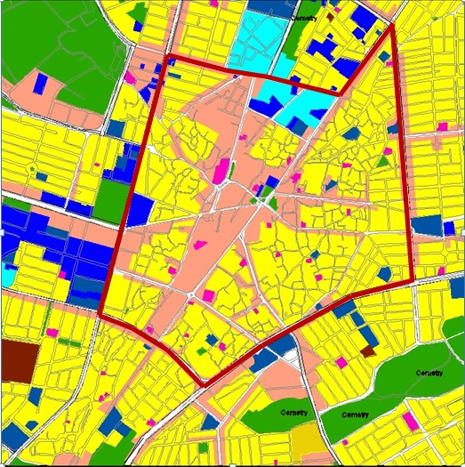
Figure 4.1 Location of the case study, (Source: Sulaimaniyah Municipality-Masterplan Department archive, 2010)

A thick line in Figure 4.1 surrounds the case study area. The yellow part indicates historical houses, and the pink part is commercial land use. However, the other colours are religious, education and health facilities.
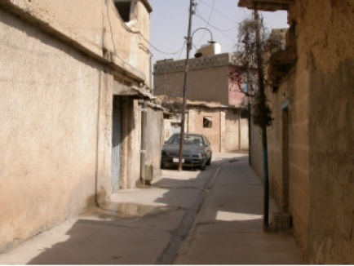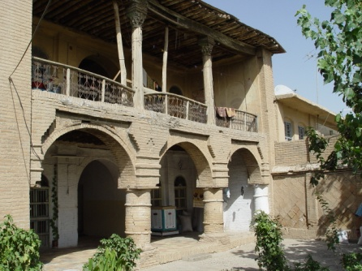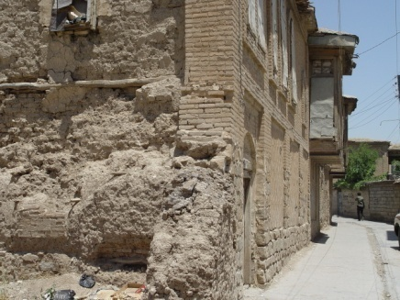
Figure 4.2 Sulaimaniyah city centre old fabric faces demolition and deterioration. (Source: Sulaimaniyah Municipality-Masterplan Department archive, 2006)
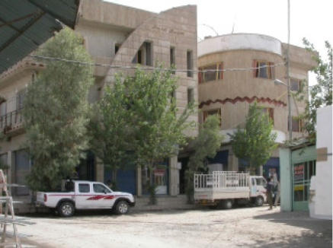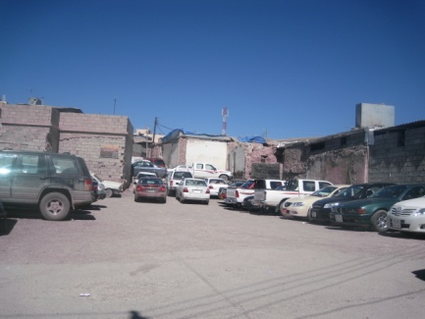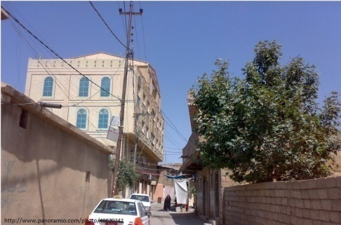
Figure 4.3 Conversion of deteriorated houses to car parking and new buildings. (Source: The photos are taken by the author, 2011)

4.6 Research methods
The research methods within the case study framework are mainly based on in-depth semi-structured interviews, but it also includes photography as an important method illustrating events in the fieldwork. Secondary data on the process of planning and heritage was collected to complement contextual background and the interview process. Other methods were considered, they generally a combination of different methods to explore the research questions including document analysis, in-depth interview, participant observation and photography. According to Merriam (2002, p.11), the use of more than one method of data collection allows the validity of research findings to be increased. Collecting and analysing data based on a range of methods can be related to the research perspective, which here is fundamentally qualitative (Flick, 2006).
The research was conducted between 2013-2016, with one visit to Sulaimaniyah for the duration of five months in July 2014 to January 2015. The aim of visit Sulaimaniyah was to complement the research process, conducting interviews, gathering documents and collecting other secondary data, as well as taking photos with the purpose of further emphasising on evidence in the fieldwork for supplementing the research data. During this period, three phases of semi-structured interviews were conducted from the end of July 2014 to January 2015. In the first stage of interviews, the purpose was to develop the interview questions through a serious of pilot interviews, which took place in the UK with Kurdish students from Sulaimaniyah city who were pursuing graduate study in UK universities. During the two main periods of fieldwork, a serious of semi-structured interviews took place. The first visit of the fieldwork took place with pre-arranged contacts, based on contacting colleagues from their relationship with the fieldwork, whilst conducting interviews appropriately for the next phase, making further contacts. Within this case study, a large volume of interview data was gathered along with other materials, which further explained in later sections.

4.6.1 In-depth interviews
Interviews as the main research method were employed for this study based on the research perspectives to examine actors’ behaviours and attitudes in relation to urban change, about the historic environment and how urban change has been responded and managed. Based on a theoretical background employing interpretative inquiry enables us to reconstruct subjective views of personal feelings and experiences, using in-depth exploration (Flick, 2006). Especially, semi-structured interviews built up ideas based on specific themes and in connection with cultural circumstances the meaning of interviews can be analysed (May 2001), as exposes underlying beliefs, strategies and constraints’ shaping people or organisation’s behaviour (Francis, 1992). Semi-structured interviews were very effective here, as a qualitative interviewing is likely to state the interviewed subjects’ viewpoints than a questionnaire or a standardised interview (Mason 2002; Flick, 2006).
Given these potentials is to justify the complexity of people’s roles and the implications for social life beyond individual buildings, impact on collective facilities, the changing role and nature of public space. Implications for social life needs an interview, this method was considered as a focus of the study on perceptions of impacts of urban change on place attachment and complex relationship among actors in the historic environment. Investigation of the relationships, preferences and intentions of actors can be used to understand the change and its impacts and complexities as opportunities and challenges for the proper management of the historic environment of the neighbourhood. From this perspective, interviews were based on purposeful conservation with an open in nature as are guided by questions (Burgess 1984 in Mason 2002). Qualitative in-depth interviews allow enough space for interviewees to help them uncover their views by providing some predetermined response categories and general topics. However, participants view in terms of their response structure and frame will be respected (Marshall and Rossman, 1999, p.108).
In the interviews, closed questions will be asked by providing choices or implied choices to participants. Closed questions allow participants to provide their view about the importance of the impacts of urban change in the city centre. Moreover, it shows the importance of the impacts of heritage change on social life. For instance, how local residents considering the historic environment made their place special and good place to live.

- Semi-structured interviews
Semi-structured interviews were the most effective and convenient means of gathering information in the context of the research setting (Kvale and Brinkmann, 2009). Semi-structured interviews provide possibilities for participants to explain unlimited information and for me, as a researcher, to ask questions and explore useful components of the interview. Conducting interviews will, therefore, generate truly meaningful knowledge (Mason, 2002, p.68). Mason described a semi-structured interview like a conversation with a purpose and work towards the structure and flow of the interview. In this interview, researchers must be able to give an open and honest account of their views, since there is not any rigidly pre-structured set and sequence of questions by developing their intellectual ability and social skills. This has to be done “quickly, effectively, coherently and in ways which are consistent with their research question” (Mason, 2002, p.67). Therefore, interviewers need to monitor in a way how to generate their data to assure they are relevant.
The qualitative interview requires asking whom I want to interview and how I gain access to them (Mason, 2002, p.67). The decision about the interview design process must be carefully considered by the researcher. For instance, the researcher should be careful about who to interview and how many interviewees will be required, what type of interview to conduct and how the data will be analysed (Doyle, 2004, p.14). The researcher should respect for what people say and “a systematic effort to really hear and understand what people tell you” (Rubin and Rubin, 1995, p. 17).
According to Morse (1991b), the researcher based only on a broad knowledge of the topic made the decision of initially choosing interviewees. In this research to get a different perspective, I talked to a mix of people between the ages of 20 and 60 and over 60 both male and female. This is because I want to interview all the age group to understand the experience of all the age groups. However, the age group is not a reflection of demography, but by taking into consideration of all age group to define who is affected by the change. This is why in-depth interviews with 40 (20 male and 20 female) participants were carried out. The number of interviews was based on the fact that the researcher thought enough data was collected with 40 interviewees:

- Between 20-30 years old (10 participants: 5 males and 5 females)
- Between 30-40 years old (10 participants: 5 males and 5 female)
- Between 40-50 (10 participants: 5 males and 5 females)
- Between 60-70 (10 participants: 5 females and 5 males).
I also wanted to generate interviews with officials to understand all stakeholders that involved in the management of the area , as the researcher collected enough data by interviewing (15) officials.
Each interview was typically between 30 minutes and 1 hour, however, some lasted over 1 hour. The local government officials were interviewed: those who are in charge with the management of the case study. Since I have been working in Sulaimaniyah Municipality, I already established a link with Sulaimaniyah Municipality-Technical Department for the purpose of conducting semi-structured interviews. For more details (see Sample frame: Section: 4.7.2 and Access to participants: Section 4.7.1- Chapter 4).
When approaching participants, I explained the main research aims and objects of the research to help participants understand the nature of the research. The semi-structured interviews are a flexible environment, which gives more opportunity to participants expressing their feelings that I might not think about them. The interviews were in general conducted using a topic guide; however, the intention was to give room for participants to express issues and opening the conservation up. Gerson and Horowitz, (2002) addressed that, “in-depth interviews should, of course, always leave room to discover the unexpected and uncover the unknown” (Gerson and Horowitz, 2002). This was more practical with local residents than officials as they tended to have more limited time available. Inevitably, the experience of previous interviews, topic guide, and a list of questions used to inform new interviews, and conversational flow changed each time.
Interviews should provide related circumstances, experiences between interviewee and interviewer in a way that the interviewer is sensitive to the interviewee and their needs and rights, in accordance with interviews ethical position and moral practice (Mason, 2002, p.74). From this perspective, I produced an open and active collaboration for achieving related data. However, the development of this collaboration took time. My respondent and me as an interviewer agreed about the ground rules of this collaboration.
My task is to control the environment to help the respondent to develop a particular event and situation. In the interviews, I have to provide a concrete data. According to Weiss (1993) “in the great majority of research interviews, you will want the respondent to provide concrete descriptions of something he or she has witnessed. This included both sense and events external to the respondent and the respondents own thoughts and feelings” (Weiss, 1993, p.66). That is why in every interview I tried to capture every relevant marker and develop it in favour of achieving rich data for my research questions. This method provides a better understanding of the impacts of urban change the social life of local residents and place attachment. The following table is used to link research questions to methods of this study.
Table 4.2 Links between theoretical framework, research questions and research method (semi-structured interview).
Research Method | Research Question | Sub -question | Theoretical Framework
Semi-structured Interview & Focus groups | 1. How has urban change occurred in Sulaimaniyah city centre and what is causing it? | How has the built environment changed in the city centre? What has changed and why? | Aspects of urban change  Concepts of Place/Disruption to place attachment-social and emotional bond  Social value of conservation &Historic environment
 |  | What are the implications for heritage? What has been lost? Has anything been gained?
Semi-structured Interview & Focus groups | 2. What are the impacts of built environment change on the daily lives of local residents? | What have been the main heritage impacts? Who is likely to be most affected by those impacts and why?
 |  | How do people talk about the impacts of change in cultural built heritage? Have there been any positive consequences?
 |  | What change is most important and why? (e.g. impacts upon the social and/or religious and spiritual life of local residents)
 |  | How have built environment changes impacted upon place attachment? What are the consequences of urban change, in terms of moving out, quality of life, and retail provision etc?
Semi-structured Interview | 3. How might conservation planning policy respond to the impact of urban change on social life and place attachment in the neighbourhood? | What factors have influenced planning regulation of urban change? | Urban culture heritage management & The social value of heritage
 |  | What have been the strengths and limitations of those approaches?
 |  | What might be done to address concerns arising from the study of the impact of urban change on residents in terms of processes and policies?

4.6.2 Interview Strategy
In this research, to reflect the research questions different sets of questions were prepared to allow getting the right answers about different dimensions. To achieve the aim of this research the links between built heritage and urban change is made through concepts of place. Moreover, the link between the historic environment and concepts of place is made through aspects of place identity, distinctiveness, continuity, and place attachment. The link between urban change (physical and social factors) and concepts of place made through other factors of neighbourhood change and place attachment. The above links should be separated to avoid complexity as in literature is defined in terms of how people react to their place is complex, and due to different other factors. In practice, this is based on the fact that there are two dimensions and they will be explored separately but also in relation to each other. For instance, the research will separate out the impacts of urban change (i.e. physical change in the built environment) on social life (e.g. what people do) and place attachment (i.e. what they feel). The heritage dimension is about physical change but also the impact of heritage loss on place attachment, identity and a sense of wellbeing. Heritage is about what people feel about things they do.

Thus, different sets of questions should reflect the different dimensions:
1-Physical changes in the neighbourhood for instance shops, retails, and public spaces impact on the way people live and do things which are a social dimension.
2-The physical change impact on people's attitude: how they feel about doing things, which reflects heritage dimension.
3-Social condition in the area impact on both social and heritage dimension: what people do and how they feel about it.
Thus, questions that reflect impacts of urban change (i.e. physical change in the built environment) on social life of residents and place attachment will be about the what people do and what they feel about it. The following strategies will be used:
- The questions were less directly about things other than heritage and impacts. I asked about things relate to heritage (e.g. historic building). In this respect the name of things were used:
1-Built heritage (listed buildings and demolished buildings) was mentioned to approach the questions related to heritage.
2-Local built environment (newly constructed building in the area) were mentioned as a thing to start a conversation about urban change.
Thus, the questions were indirect, for instance how people think about their identity in a place, are they proud of the place, what they might proud of, and how they feel about it.
- Moreover, the questions were varied based on different ages as heritage is varies based on different ages and groups. However, this was a difficult process; some trails were done in advance. Questions tested with my fellow students in Sheffield.
- I tried to ask questions that do not make assumptions to provide a possibility for negative and positive outcomes. Through this process, I thought carefully about each question and discussed with my supervisor.
The following question frame was used to separate the different dimensions:

Table 4.3 Strategic plan for asking questions in practice by separating urban change, social life and heritage dimensions.
Impacts of urban change on social life | What people do? | Urban change
 | Have they changed what they are doing in the place? | Physical change | Social conditions
 | How they use the area in terms of (e.g: Playing, shopping, meeting, praying, working, studying, future plan -displacement)? | E.g.: shops, retails, public places, public buildings, and mosques | Social conditions in the area (mobility, social mix) and the way people live
Impacts of urban change on heritage. | How do they feel about it? | Urban change and Heritage
 | How do they feel about the demolition of a historic building or the demolition of their favourite place? What has been lost?
 | What did they like about the place?
 | What the place meant to them?
 | How is the demolition of a building impacted in the way of people’s feeling (their view) about the place?
 | How is the demolition of a building impacted in the way of people’s feeling about themselves?
 | Are they proud of themselves?
Impacts of heritage change on social life via disruption to place attachment | How do they feel about heritage change? | Heritage
 | How they feel about themselves; (or how they describe their identity that they have in the place?) | Tangible |  | Intangible
 | How do they feel about the neighbourhood? | culture built heritage |  | Identity,  place attachment,  ontological  security,  feel of  belonging,  special and uniqueness
 | what the neighbourhood means to them ?( this question was reinforced by providing options very important, important, and not important )
 | What they like about the place?
 | What the place means to them?
 | What makes their area a good place to live? This question will be reinforced by asking what is their favourite place. Is it important for them to be historic or not? Options such as shop, buildings and etc will be used to enhance the conversation.
 | Are they proud of themselves?
 | Are they proud of their place?

4.6.3 Focus groups
Focus groups were used to understand the factors of the neighbourhood change, and to find out how the built environment change has occurred in the area. According to Kizinger (1995), the interaction within groups generates a particular type of data: “focus groups explicitly use group interaction as part of the method” (Kitzinger 1995: p. 299). Focus groups were useful, provided a better understanding of how the neighbourhood change occurred by asking participants what they did before and what they do now, and comparing their responses. The benefit of this is to allow getting a large amount of data about the topic in a short time, and it might allow accessing the unobserved topics. According to Merton et al. (1956), this method is productive in terms of widening the range of responses, releasing inhibitions, and activating forgotten details of the experience.
In this research, focus groups will be conducted to explore people’s perception about the place. In the focus of interpretation the attitude of interviewees towards urban change, assessment of positive and negatives of their current social life, the way they live and how they feel about it. When conducting the focus groups, the researcher needs to control the discussion and awareness of deviated information from the original one to manage it properly in a short time.
The focus groups are carried out with residents of the neighbourhood in historic public places in the area, where people meet and have a chat or I arranged time and place with my participants. According to Morgan (1997), in selecting participants for a focus group project, “it is often more useful to think in terms of minimizing sample bias rather than achieving generalizability” (Morgan, 1997, p.37). According to Morgan, more groups seldom provide meaningful new insights. However, there were not an enough number of people to participate in this focus group, which was required each focus group to consists at least 5- 10 people, and wanted to talk to a mix of people between the ages of 20 and 60 and over 60 both men and women to get different perspectives. Male and female participated in the focus groups because there are potentially important differences in terms of gender, social class and age. The genders and different ages were not be mixed in the focus groups.
That is why conducting focus groups with this requirements was not achieved, as I reduced the number of people in each focus group, and a number of focus groups to (4), which did not take longer than 60 minutes. The groups were arranged to consist of the same age and same gender. This is to provide a comfortable environment and to avoid any dominated conversation by male or female. That is why sounds were only recorded for transcribing. Since there are not different ages and genders, there was not matter for me to know who said what. I tried to maintain balance and allowed each participant to have a chance to participate in the conversation, especially each participant followed the other, and this might encourage more conversations by participants. However, there were obstacles in achieving these criteria. Moreover, when I transcribed the focus groups, I translated the important parts to English to avoid losing the meaning of the conversations. However, after each focus group I wrote down the important points. When I started transcribing and coding, other patterns defined. Following this, I started arranging the data into themes to allow responding research questions. Therefore, to allow a better understanding of questions of this research and these methods, questions that used for focus groups are linked with the research method based on the following table.
Table 4.4 Links between theoretical framework, research questions and research method (focus groups).
Research Method | Research Question | Sub -question | Theoretical Framework
Focus groups &Semi-structured Interview | 1. How has urban change occurred in Sulaimaniyah city centre and what is causing it? | How has the built environment changed in the city centre? What has changed and why? | Aspects of urban change  Concepts of Place/Disruption to place attachment-social and emotional bond  Social value of conservation &Historic environment
 |  | What are the implications for heritage? What has been lost? Has anything been gained?
Focus groups &Semi-structured Interview | 2. What are the impacts of built environment change on the daily lives of local residents? | What have been the main heritage impacts? Who is likely to be most affected by those impacts and why?
 |  | How do people talk about the impacts of change in cultural built heritage? Have there been any positive consequences?
 |  | What change is most important and why? (e.g. impacts upon the social and/or religious and spiritual life of local residents)
How have built environment changes impacted upon place attachment?
What are the consequences of urban change, in terms of moving out, quality of life, and retail provision etc?

4.6.4 Documentary Analysis
The analysis of a variety of sources of data as a secondary source of information that collected to support themes and ideas arises in interviews to frame the contextual knowledge of the study. The official documents, reports, news and personal stories had become important in the context of this research to set up distinctive issues relating to urban change of the historic centre of Sulaimaniyah is considered, which are briefly described below. Any events or incidents associated with land use change of the area were reviewed for discussion about the issues of urban change of the neighbourhood. The information was gained through the reviewing official documents, including archives, detailed planning schemes, reports and conservation planning policies. This is to explore any attempts for managing and enhancing the social life of the local people in the historic environment. This is in order to draw attention to any active involvement of government dealing with the social condition, protection and investment, and designation of the historic built assets in the historic area.
Therefore, all these allow exploring how an urban change in the neighbourhood is happening, and how social life in the historic area is reinforced. Analysing plans and policies that produced for managing the area, conservation planning policy and land use planning, is to compare with what is actually happening in the field. According to May (2001), document analysis is an effective way that in which the researcher searches for a correspondence between its description and the events to which it refers (May 2001, p.182). Any institutional activities are likely associated with producing documentary information, as “documentary information is likely to be relevant to every case study topic” (Flick, 2006, Yin 2003). The use of documents was to verify evidence of other sources, producing other details and confirming the correct titles and spellings of institutions that have been addressed in interviews (Flick, 2006). Therefore, Flick (2006) highlighted the purpose of producing documents for practical purpose and some form of use above simple representations of reality and facts. Thus, documents can provide “clues worthy of further investigation rather than as definitive findings” (Yin 2003, p.86). Documents can become communicative devices for specific practical purposes to prevent bias-free data and to provide an instructive addition to interviews for a better understanding of institutional contexts (Flick, 2006). For instance, City Centre Guideline-special planning regulation for new constructions in the historic city centre, newspaper posting and media articles provided good information to direct interviews and to set up the subjective idea of interview data.
Glaser (1992) suggests that it is essential reviewing data of non-professional literature at any stage of study as a supplement to the case study. According to Merriam (2002), the strength of reviewing documents is their existence; “they do not intrude upon or alter the setting in ways that the presence of the investigator might. Nor are they dependent upon the whims of human beings whose cooperation is essential for collecting data through interviews and observations” (Merriam, 2002, p.13).

4.6.5 Visual data: photography
In addition to documentary information, in this research, spatial maps and visual data were a supplementary tool and useful objects to gain perception about geographical characteristics and giving insights of conflicts and changes in built environment. Spatial maps helped in a more depth understanding of subjective ideas as inconsistent with factual sense, understanding land use change from residential into commercial uses, especially from land use map of the area. Visiting the case study to observe the Factual sense of urban change of the area, and gain information based on Land use map of the area provides useful insights about urban change. Land use maps from the City Centre Guideline, 2010, was considered as a relevant source that provides land use map of the area. In this research, photographs of sites were given useful insights as a supplementary tool; especially illustrate the destruction and change of historic built environment as a source of evidence to provide a precise understanding of responses and actions regarding the change of the area.
However, across academic disciplines, photography emerged along with other visual tools (Purcell, 2009). They are considered for their empowering potential (Boeck and Thomas, 2010). They have a potential for inclusive and greater reach, they reflect lived experience of those who involved (Wang and Killion, 2000; Jones, 2006). Basically, working with photography has two traditions in social sciences: ethnography (e.g. Collier, 1957), and applied social research (e.g. Wang et al., 1996). Participatory photography focuses on the interpretation and generating of photos by participants, and researchers deal with it as a research method that hand over the cameras to individuals to inform a research project and stimulate self-reflection and interactions with others (Hughes, 2012, p.30). Participatory photographs used to understand cultures, beliefs, social relations and traditions (Heisley and Levy 1991). For instance, this method has been used in the work of Elisabeth Gotschi and colleagues in 2008 with farmers in Mozambique, the photographs were taken by participants and then they become the basis for discussion in later interviews. The photographs represented participant’s understanding and meaning of life (Gotschi et al.2008, p. 220). This method is considered a flexible one and it has been employed in geographically and culturally diverse groups.
Moreover, cultural anthropologists are working with photographs. They produce images in relationships to traditional ethnographic texts by making the text as a secondary source of the image; they hand over cameras to individuals and groups or they study images, which produced by other cultures. Photographs have “a material existence; they are stored, displayed and talk it about” (Roze, 2007). The discussion of photographs has a material existence as an object, “in essence treating photographs as objects which have a social life” (Roze, 2007, p.18). According to Emmison, two-dimensional visual data such as directional signs, maps and instructional diagrams can be used to explicate the claims of ethnomethodologists about the significance of common sense reasoning. He believes that “the objects, people and events, which constitute the raw materials for visual analysis, are not encountered in isolation, but rather in specific contexts” (Emmison, 2010). In this context, the photographs used to display the deteriorated historic built environment. However, photographing skills by a researcher was not always successfully illustrating the factual sense.
Television programmes and broadcasting on website were also useful in the sense that they influence responses and actions of actors who involved in the response of urban change of the neighbourhood as well as part of reflections of residents attitudes. These could tell a key moment of history, social values and relations, certain institutions, domains of everyday life, and emotions as the social constructions of reality (Flick, 2006). For example, local TV programs and shows have been remarkably addressed the destruction of the historic city centre of Sulaimaniyah. Usually, in these programs, historic built environment of the neighbourhood illustrated as an object to describe the damage of culture built heritage in the city. A popular Facebook page, Slemani Jaran as a useful source of broadcasting against the destruction of the neighbourhood and the loss of culture built heritage for the purpose of influencing residents of Sulaimaniyah city to take actions against and during the destruction of historic built environments. These objects were supportive in the sense of argument the analysis of interview data, especially photography as a supplementary tool used to documenting the destruction of the area that is taken by the researcher.

4.7 Selection of participants
Key respondents were identified and divided into two groups:
- Local residents who already live in the neighbourhood
- Local officials
1-Local residents were selected with the criteria of being a resident of the historic centre of Sulaimaniyah. The random approach and snowball method was thus useful as the research framed to recruit particular people and groups with purpose. Within this categorization of interview group, future criteria such as age and gender were carried out with help of snowball and through direct access to some participants. The traditional and historic environment of the neighbourhood depending on people’s social networks to introduce the researcher to other people for identifying further interviewees, adapting snowballing selection was helpful for hidden population or power-elite groups, which are difficult to reach using direct or immediate contacts (Atkinson and Flint, 2001). This had strong advantages for recruiting residents. Although, local residents were not a hidden population, except the remained difficulties of the quality of interviews due to the recent political instability in the country that influenced trust relationship. This produced matter of trust associated with individuals’ privacy in case of being talking to the alien. Although to overcome with the issue of trust, the researcher went to the neighbourhood accompanying one person each time to conduct the interviews. The researcher considered the role of accompanying the person in terms of not being involved in the interview material, except getting support for casual chatting. As companion persons were informed to play a marginal and played an important role for being supportive for casual chatting with interviewee before conducting the interviews. This selecting strategy was very successful in terms of reducing the incidence of being reluctant to participant in the interviews, as two people’s eroded strangeness and developed social network between the researcher and the respondents. During the interviews, it was perceived that this developed hospitality and rapport without their privacy being disturbed talking about their condition in terms of their social networks by being involved in the interviews.
2-Government officials were those who mostly involved with conservation planning policy, conservation management of the neighbourhood. Selecting local officials and their role in the management of the neighbourhood is potential, in terms of their plans and supports’ of government for the development of the neighbourhood dealing with urban change, as discussed in Chapter 5 and 7. This group of the participants was not limited but successful in terms of quality and participants selection, basically, due to the position of researcher within the network of power relationship as an urban architect in the Department of Master Plan- Sulaimaniyah Directorate of Municipality. This positionality, fortunately, accelerated access in terms of widening the selection of interviewees. The adapting snowballing selection was also used for recruiting local officials. For this reason, interviews were conducted with varying departments in local government institutions such as Sulaimaniyah Directorate of Municipality and Sulaimaniyah Antiquities Directorate officials. Sample framework is discussed in the following section (See Table 4.5).
Table 4.5 Outline of informants for the research
 | Roles | Departments and Institutions
1 | Director of Commercial Building | Permission Department, Technical Department, Directorate of Sulaimaniyah Municipality
2 | Director of Masterplan Department-Member of Revitalization Project for City Centre. | Directorate of Sulaimaniyah Municipality
3 | Surveyor of Sulaimaniyah City Centre Team | Technical Department, Directorate of Sulaimaniyah Municipality
4 | Director of Housing Permission and Approval Department | Housing Permission and Approval Department, Technical Department, Directorate of Sulaimaniyah Municipality
5 | Former Director of Technical department | Technical department in Directorate of Sulaimaniyah Municipality
6 | Former member of City Centre Team | City Centre Team, Technical Department. Architect in Directorate of Sulaimaniyah Municipality-Master Plan Department
7 | Engineer and planning officer | Directorate of Sulaimaniyah Municipality-Master Plan Department
8 | Former member of City Centre Team | Technical Department. Directorate of Sulaimaniyah Municipality-Master Plan Department
9 | Architect and officer | Directorate of Sulaimaniyah Municipality-Master Plan Department
10 | Restoration Architect- officer | Directorate of Sulaimaniyah Antiquities
11 | Member of Supervision Committee | Member of Supervision Committee in Directorate of Sulaimaniyah Municipality
12 | Head of Municipality Council Committee, | Directorate of Sulaimaniyah Municipality
13 | Head of Sulaimaniyah Directorate of Antiquities | Sulaimaniyah Directorate of Antiquities
14 | Engineer and planning Permission officer | Housing and Approval Department, Technical Department, Directorate of Sulaimaniyah Municipality
15 | Member of Supervision Committee | Member of Supervision Committee of Municipality council, Directorate of Sulaimaniyah Municipality

Therefore, given that analysis, the selection of the participants is necessary to show reasons for choosing the above groups, and the characteristics of key respondents within each group.

4.7.1 Access to participants.
- Local residents
The selection of participants (local residents) was possible by means of obtaining access participants by personal visits in the first instance, and then the snowball method was also used to access residents– in line with Merkens (2004; see below).
“Significance is attached to the accessibility of events, activities, or individuals that form the object of the investigation (Burgess 1991). With individuals this problem can be characterised by their willingness to be reached: it is often the case that groups of people who are to be investigated, or individual members of these groups, refuse to cooperate.” (Merkens 2004).
The interviews were initiated by approaching local residents in the historic public and public- private places with those who made themselves available in their homes and cul-de-sac, where they interact in the neighbourhood for casual chatting with their neighbour, then, in their houses by going to the area and knocking their doors. I planned to arrange time and place in any available rest places for those who cannot meet in public places or in their neighbourhoods, where people meet and have a chat. Although, in most of the time, arrangements was not necessary as participants showed their desire to involve in the interviews at the time of approaching. Generally, it was not difficult approaching local people in their available places (their home) and in the historic public places, because the neighbourhoods consist of traditional community. Local people mostly know each other and their close relationships are not formally arranged in their daily life. For instance, when I approached any person in public places he introduced me to more people right away to participate in the interviews.
By knocking on their doors, I had a chance to conduct my in-depth interviews in their available place, and this was especially useful for engaging with women. This is based on my previous experience in community engagement in Sulaimaniyah Municipality. I knew local residents will not be surprised if strangers approaching them, especially when they are aware of that the state of their neighbourhood as a heritage site. Besides that, the old fabric and physical structure of the neighbourhood allow residents to gather outside their home in cul-de-sacs and semi-private open spaces and it was, therefore, a good place to make contact with residents. Although approaching participants in their home by knocking doors was successful was found that sympathetic responses to interview requests were different in this group, compared to those respondents recruited in their cul-de-sacs, who were less forthcoming. This was perhaps due to trust issues arising from political instability, which arose when immigrants from the south of Iraq moved into to the neighbourhood. However, this is a common feature of qualitative neighbourhood research and was not a significant problem here. Moreover, for conducting focus groups, I arranged time and place for meeting with my participants. These took place in historic public places in the local area and lasted for 60 minutes.
Approaching male participants showed gender issues in the neighbourhood, public squares, and teashops. However, this was a challenging experience for a researcher. Since the area is traditional, public places and tea shops are mostly dominated by men, this is why approaching them in these places as a female researcher was difficult due to having no women in tea shops and public squares. This exposed researcher to men’s eye as in most of the cases was not comfortable. However, this was solved by a companion person.

- Local officials: and then the snowball method was used to access both residents and local officials thereafter – in line with Merkens (2004; see below).
For conducting interviews with officials, recruitment started with personal acquaintances related to participant groups of local officials. This was useful to a snowball effect in local government officials group. Links had been made previously with Sulaimaniyah Municipality-Technical Department for the purpose of conducting semi-structured interview except in several cases, interviews were carried out from direct relationships as friends of the researcher. The direct interviews were carried out by making calls and making visits to their offices. This direct method was very successful as I anticipated that access to administrative participants would be easier since I am officially employed by Sulaymaniyah municipality. I had also been in contact with the architects and surveyors in Technical-Department, who are dealing with the construction and functional conversion of buildings in the old city. We worked on establishing these links before I began my fieldwork. The interviews were fixated in official’s offices for 30 minutes. There have been some interviews, I arranged a time with them in their field work-building conservation site in the neighbourhood.
The nature of interviews was comfortable and flexible, and I tried to minimise stress and pressure facing these people. However, recording interview can enhance nervousness or decrease openness (Hammersley and Atkinson, 1995). Therefore, writing down full notes and observing important facts from noticing the behaviour of respondent, their body language and facial expression, was not simply easy (Henn et al., 2009). In spite of these difficulties, I recorded interviews. Since people in Sulaimaniyah speak Kurdish language, and I am a native speaker of the language, I interviewed them in Kurdish language and then translated the important part to English. This is to avoid losing the meaning of the interviews, as due to the difficulty of transcribing of the words, quotes were used in a sense of culture and social contexts.
For instance, after each interview, I made a dairy to define what is important. Following these steps, I started conducting transcriptions and coding the interviews, in doing this other patterns have being defined when I was transcribing. The listening to the interviews allowed more understanding how participants talk and what they say for better analysis. Charmaz added “the openness of initial coding should spark your thinking and allow new ideas to emerge” (Charmaz, 2006, p. 48). After these procedures, I worked towards arranging the data into themes to allow responding research questions. I also discussed transcripts and interviews by analysing them discursively.

4.7.2 Sampling frame
The data sample for this research is based on interviews with 55 participants (40 local residents, and 15 local government officials) and 4 focus groups. The number of interviews was based on the fact that the researcher thought enough data was collected with 55 interviewees. It was also based on the fact that I wanted to interview all the age group to understand the experience of all the age groups. However, the age group is not a reflection of demography, but by taking into consideration of all age group to define who is affected by the change. Therefore, the data that collected from local residents gained by conducting semi-structured interviews and focus groups with four participants of those who still live in the area. The strategy of testing the experience of the biggest number of residents among the research respondents was related to the research focus is based on the impacts of urban change on local residents’ social and emotional bond to the place. Residents were essential parts of the residential neighbourhood who influenced by the urban change of the neighbourhood. Thus, the research sought to include a good range of resident backgrounds and experience for example in terms of age, gender and livelihoods. The proportion of residents is divided:
- Between 20-30 years old (10 participants: 5 males and 5 females)
- Between 30-40 years old (10 participants: 5 males and 5 female)
- Between 40-50 (10 participants: 5 males and 5 females)
- Over 60: 60-70 (10 participants: 5 females and 5 males)
The division is based on the fact that I wanted to do in-depth interviews with both male and female to get a different perspective. There was also planned to conduct (8) focus groups with (40) people for the same reason, but (4) focus groups were carried out with 10, due to difficulties finding respondents. I used the same proportion of the focus groups. It was divided among male and female:
- Between 30-40 years old: 6 people participate in two focus groups. One of them consists of 3 males and other consists of 3 females.
- Over 60: 60-70: 4 people participate in two focus groups. One of them consists of 2 males and other consists of 2 females.
Aside from gender, other important variables in constructing the sample of residents included:
1-Religion – the research mainly involved Muslim residents. This is because the area’s heritage is primarily Islamic and the majority of social local groups in the historic area are Muslim, however, there are other ethnic groups such as Christians and other minorities. That is why other groups were not included in this research to avoid more complications.
2-Investment in the neighbourhood was another variable that was used to understand the impacts of the change on social life since this ought to have a bearing on their strength of feeling regarding changes to this historic built environment. Residents of the neighbourhood were asked about if they started their own business in the neighbourhood or their job that they found it in the process of the change.
3-Length of time that resident stay in the area is also another factor that was taken into account because research questions are related to the changes in 13 years from 2003. The reason of this is related to the economic development that impacted on the area (see Chapter 3). Moreover, one key issue in literature is how people understand the historic environment because their view and values that they attach to the place change over time. This is due to the duration of their lives in the place, for instance how long they have lived in a place. In research studies about the sense of place, it is believed that definitions and perceptions may change over time because of the factors relating to individuals: how long they have lived in a place and involvement in an activity or event.
The following table shows the detailed sample frame:

Table 4.6 Detailed sample frame
Numbers | Local residents (40 participants)  Those who are staying |  | (10 )participants | Officials (15)
Gender | Female 20 participants | Male 20 participants | 4 Focus Groups | Mixed gender
Methods | 40 Semi-structured interviews |  |  | Semi-structured interview
Ages | Between 20-30 years old ( 10 participants: 5 males and 5 females) |  | -Between 30-40 years old: 10 people participate in two focus groups. One of them consists of 5 females and other consists of 5 males.  -Over 60: 60-70: 10 people participate in two focus groups. One of them consists of 5 males and other consists of 5 females.
 | Between 30-40 years old ( 10 participants: 5 males and 5 females)
 | Between 40-50 (10 participants: 5 males and 5 females)
 | Over 60 ( 5 females and 5 males)
Groups | Muslim
Investment in the area | Those who accepted the urban change

4.7.3 Analysis
In the sense of practical analysis, a diary of interviews was maintained for important points along with conducting transcriptions and coding the interviews, other patterns emerged when I was transcribing. Transcribing was a very helpful process since by listening to interviews as recalling the time of interviewing for better understanding topics along with the diary of the interviews, allowed grouping, subgrouping and themes, and headings aroused for the analytical framework. Transcribing by me was critically more helpful than by automatic method for continues listening and the process of transcribing. After these procedures, I worked towards arranging the data according to themes to allow responding research questions. I also discussed transcripts and interviews by analysing them discursively. In general, and contrary with my anticipation, the analytical process of this research was complex and repetitive associated with rearranging the framework and analytical process of this research. Flick (2002) addressed this point that “in respect of decisions about the transition points between the different phases of coding, there are scarcely any fixed rules” (Flick, 2002, p.185).
Thus, the analytical framework discussed here was a complicated and diverse process of interpretation and writing process for producing results and answers to the research through ordering and thinking through materials.

4.8 Research ethics and integrity
When I started the research, I follow the formal University of Sheffield ethics procedure. I conducted interviews with my participants who were between 20 and 60 years old and over 60 (60-70). I initially, made sure that I get permission to interviewing them and recording the interviews. All the interviews saved as computer text files inside my computer, which I open with a secure password. The address of participants (their name and age) is kept separately from the content of the interviews. The interviews were labelled as participant no 1, participant no 2 and so on. I also gave my name, my telephone number, and my University of Sheffield email address to all the participants.
I conducted an interview with residents of the case study, those who already live in the area and focus groups as well. I asked their permission to conduct the interview in their available areas if possible, otherwise, I arranged time and place for them in the city centre (tea shop or any available rest place). However, I made other interviews with officials in Sulaimaniyah Municipality offices. It was easy for me to arrange time and location with them as I have been working in there since 2006. After each interview, I gave a break to myself, to keep me fresh again for another interview because I had to make sure I would get the efficiency of the data and collecting concrete data.
There were illegal changes (demolition or functional change) in the site, and even I noticed corruption while I was waiting to conduct interview with the official who was doing paperwork done for reconstruction permission; I was very sensitive addressing this issue that their information does not reach to any institution or any monitoring organisation in Sulaimaniyah Municipality. I gave a right to all the participants withdraw from the interviews if they found it risk for their business potential; however, there was not any case in this regard. Therefore, based on the methodological approach that is explained in this chapter, limitations and strengths of this approach are significant which is explained in the following section.

4.9 Strength and limitations of the research methodology
In this study, local residents who lived in the neighbourhood were interviewed; however, this study could not carry out with those who left the neighbourhood because of difficulties recruiting them. The view of these residents might influence on overall perceptions of residents and may have resulted in different outcomes. Besides based on data analysis, participants who were involved in corruption and illegal activities were difficult to access. Conducting interviews and focus groups with these participants may have provided a wider range of outcomes. Another limitation of this study is a limited number of focus groups with participants within the same demographic groups; as due to difficulties finding participants, only (4) focus groups were conducted, however, participants shared a wide range of experiences.
On the other hand, all the interviews with local residents were carried out with accompanied person due to problems of political instability and security and safety. However, participants felt more secure about talking to two people instead of one person. As a professional in Directorate of Sulaimaniyah Municipality, I had some background bout planning regulations and conservation of the neighbourhood as I previously worked as a local official involved in giving building permissions. This had a positive influence on the way of asking questions to get fruitful information to fill out the gaps and allowed me to be more confident the interviews. I conduct, However, during the interviews with local residents I tried to not to make any assumption by listening to participants and avoiding of giving any opinions about the issues raised during the interviews by residents.
However, accessing local officials was easier, as due to my positionality as a former local official in Directorate of Sulaimaniyah Municipality. This allowed me to access participants based on friendship and the outcome was more productive. During interviews, I was allowed to attend meetings and have experience with a local official engaging with local residents for passing their paperwork. On contrary, sometimes interviews with local residents were not productive as some of them were upset about government for ignoring the heritage of the neighbourhood. This made them angry and disappointed and thought there is no solution for that that made them avoid speaking about this issue.

4.10 Conclusion
This Chapter has addressed the methodological approach to the link between research process and research questions based on contextual and theoretical framework discussed in earlier chapters. The research questions were set with the aim of exploring impacts of urban change- development of inconsistent built environment on the site of demolished historic built environment on local residents’ social life, using concepts associated with model of Devine-Wright’s stages of psychological response to place change to understand impacts of urban change on social, spiritual and religious life. Using concepts related to place attachment, place definition, place identification and place dependency as constructs of place attachment and place related dimensions and factors that shape responses. The framework emphasised on local residents’ perception about urban change, as it deals with the study of environmental disruption (see Devine Wright, 2009).
The framework relies on ideas related to regulation and management of change in the historic environments, depending on roles of stakeholders in the management of urban change in historic towns (Orbasli, 2000; Ashworth and Howard, 1999; Tweed and Hall 1991; Hall and McArthur, 1996b; Pearson and Sullivan 1995; Wates and Knevitt (1987; Larkham 1996). This led to the qualitative methodology conducting in-depth interviews as the main method of the case study of historic central of Sulaimaniyah city. The data was collected through interviews with residents and government officials as key actors and stakeholders in the managing of urban change in the historic environment. Secondary methods such as documents, visual texts and archive records were gathered to support the main methods as well as frame the contextual background in corresponding to research questions. Strengths and weaknesses were revealed, and associated with random approach, snowballing and the power position of the researcher in the government institution to access government local official that might otherwise not be easy to access. Given this, it was helpful to understand in deeper the impacts of urban change on social life, reactions to urban change in terms of management of the historic environment and conflicts among stakeholders. The biased selection of respondents from the random selection strategy-related to trust security social relationships might have potentially resulted in the lack of quality of research findings if this danger was not acknowledged.
The other chapters of thesis comprise three analytical chapters structured based on subsequent research questions. Chapter Five focuses on the analytical approach evidenced by data collection, mainly in-depth interviews and other secondary data such as photographs, documentary source, and maps. It examines urban change and then explores the impact on key aspects of the built environment. It looks at the role of government in the regulation and management of change. The start of the chapter focuses on the key drivers of urban change in different parts of the city and how that created problems for the historic built environment, then, the implications for social life beyond individual buildings. Chapter 6 discusses the actions of local residents in response to urban change. It examines the responses of local residents to urban change. Chapter 7 looks at the role of government in the regulation and management of change, depending on ideas in experiencing the management of urban change in historic towns. Chapter 8 sets out the impacts of urban change on the social life of local residents. Finally, Chapter 9 provides the conclusions to the research based on the discussion about the key drivers of urban change and why that might create problems for the historic built environment, and implications for social life beyond individual buildings.

Chapter 5: Documenting the physical impacts of urban change in Sulaimaniyah

5.1 Introduction
This chapter introduces the process of urban change in Sulaimaniyah city centre and its drivers. It examines urban change and its implications for key aspects of the built environment. It identifies what has been demolished and rebuilt in the neighbourhoods of the city centre. It concentrates on what is happening in the process of urban change in the area and how the built environment has changed in Sulaimaniyah city centre. It defines what has been lost, what has changed or what has been gained and in doing so, answers the first research question:
- How has urban change occurred and what is causing it?
- How has the built environment changed? What has changed and why?
- What are the implications for heritage?
- What has been lost? Has anything been gained?
More specifically, the chapter examines what has happened to the area’s heritage and how commercialisation and the increasing number of retail units have fundamentally changed the historic residential use of the neighbourhood. This process follows the experience of the tradition of demolishing the historic built environment around the world (e.g.: Fergusson, A. and Mowl, T, 1989; Diefendorf, 1990, 1993; Larkham, P. J., 2003; Grenville, 2007). For example, in the redevelopment of Britain, expressions of Grenville, (2007): “the planners’ did more damage in the 30 years after the end of the war than the German Luftwaffe had achieved during hostilities is common” (Grenville, 2007, 451). The content of this chapter also draws upon knowledge from the study and the areas of research on neighbourhood decline, neighbourhood change (e.g.: Myers, 1983; Brown et al, 2003) and concepts of place, such as distinctiveness, place dependence and place identity (e.g. Tuan, 1974, Agnew 1987; Altman and Low, 1992, Uzzell and Twigger‐Ross, 1996; Relph, 1976; Giuliani 2003; Shamai and Ilatov, 2005).
Therefore, the process of urban change of the area is approached by analysing drivers and consequences of the change and serves as a background for a deeper understanding of the role of regulation planning policies in the protection of cultural built heritage and cultural heritage management (this will be examined in here and subsequent chapters). Identifying drivers of physical change will significantly contribute to the content of future recommendations for decision-making regarding conservation planning policy in the area. This will also have important policy implications in other historic centres experiencing similar processes of neighbourhood change, especially in Middle East countries with deteriorated historic city centres.
Thus, the chapter begins by laying out the drivers of physical change of historic neighbourhoods of the city centre based on face-to-face interviews conducted with 40 participants living in the neighbourhoods of Sulaimaniyah city centre; additionally, the views of 10 local officials in the Directorate of Sulaimaniyah Municipality and the two officials of Sulaimaniyah Directorate of Antiquity, who are involved in the conservation projects of the built environment in the area, will also be discussed. Drivers of the change define as an introduction to the conflicts between residents over a conservation planning practice in the neighbourhood. The photographs that have been taken in the fieldwork are also added to offer more detail of the process of the neighbourhood change and built environment change.
Section 5.2 defines the historic environment of the city centre. Section 5.3, 5.4, 5.5 explore the major and minor drivers of demolition and degradation of the built environment in the neighbourhood and address the process of the urban change and demolition of the historic built environment in the area. Section 5.6 explores the implications for residents as an outline of the implications; however, the implications will be further explained in Chapter 8. Finally, the summary of the chapter argues that the failure of government is a significant factor that influenced the demolition of the built environment and the actions of local residents, which contributed to conflicts and changes in the historic environment and social life of local residents. This links to the original aim of this research, as it examines the impact of the change on local residents. Thus, the results highlight the process of the change and reasons for the demolition of the built environment that precipitated the departure of local residents.

5.2 Definition of the historic environment of Sulaimaniyah city centre
In this section, it is important, to begin with, simple definitions of listed and non-historic listed buildings, since the process of ‘listing’ differs considerably across the world and it is not the same as in other western developed nations (e.g. the United Kingdom). Importantly, the ‘listing’ of buildings in Sulaimaniyah is formal, but without providing planning regulations in case of embarking any alteration to the listed buildings. The owners of listed buildings are not informed about the status of their buildings. The definitions will be outlined, primarily based on my observation and my fieldwork experience due to the lack of local documents and literature defining the historic environment of the neighbourhood, as explained below.

5.2.1 Definition of ‘listed’ buildings
Listed buildings are buildings located in the districts of the city centre: Malkane, Sabwnkaran, Sarshaqam, Dargazen, Shexan, and Jwlakan (as defined in Figure 5.1, 5.2, below). According to information collected during the fieldwork, the main criteria for listing are architectural interest, historic interest, and places of importance in relation to people or events. The government keeps a formal register of buildings and selects those to be ‘listed’ by relying on local experts (Interview with the Head of Sulaimaniyah Directorate of Antiquity). Therefore, it is important to recognise the impact of having no guidelines in the case of modifying listed-houses associated with ‘listing’ and how this might differ from traditional, western understandings of the term.
According to the head of Sulaimaniyah Directorate of Antiquity, after 1992, 1993, and again after 1996, his directorate, Municipality, and Sulaimaniyah Governorate participated in providing a professional team to select listed buildings. The team listed 106 buildings in Sulaimaniyah city (Interview with the head of Sulaimaniyah Directorate of Antiquity, 2014). According to him, the team of experts who knew the city very well defined listed buildings based on three main criteria: buildings that have rich architectural elements with a strong structure; buildings that have a historical significance; and buildings of famous and well-known people in the city, for instance the house of famous poets in the city (Interview with the Head of the Directorate of Sulaimaniyah Antiquity, September 2014).
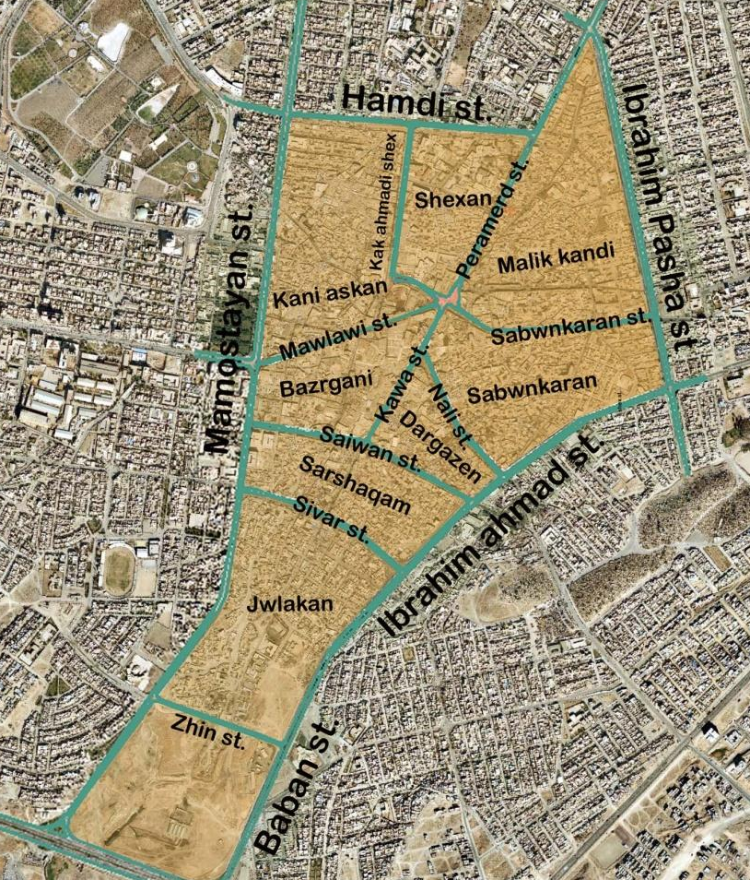
Figure 5.1 plan of the city centre neighbourhoods in Sulaimaniyah (reproduced based on the aerial photograph of Sulaimaniyah city (Source: Sulaimaniyah Municipality).
Figure 5.2 A prototype web-portal that provides listed buildings in Sulaimaniyah: the historic residences have been georeferenced, placed on the web cartography and indexed (Source: http://hhs.routes-assn.org/en/)
Kani askan, Shexan, Malik kandi, Sabwnkaran, Jwlakan, Dargazen, Sarshaqm and Bazrgane are districts in which listed and old non-listed buildings are located. However, the main streets such as Peramerd, Mawlawe, Kawa, Nali, Goran and Sabwnkaran roads that connect the historic neighbourhoods of the city centre are the location of a large bazaar. Since 2003, these districts faced a significant urban change. In particular, most of the Kani askan district to the north-west of the centre was turned into the bazaar and the spread of commercial uses has reached into the heart of areas that were formerly predominantly residential areas.
Listed buildings are protected in their entirety. In recognition of the importance of listed buildings, they become subject to special planning controls aimed at preserving their special status and law protects them all. It is an offence in any way to alter a listed building that affects its appearance or its character. The record of listed buildings consists of the names of the buildings with no further explanation about the components of the listed buildings. This becomes relevant in the case of residents embarking on any alteration, which will be explained in the next sections. This was confirmed during the research fieldwork by the Head of the Sulaimaniyah Directorate of Antiquity, who commented that “we documented the name of listed houses and sent the copy of it to the Sulaimaniyah Housing Registration Office to avoid any sort of alteration with these houses, and even selling and purchasing the houses” (Interview with the Head of Sulaimaniyah Directorate of Antiquity, September 2014). According to a Sulaimaniyah Municipality officer, the demolition of a listed building or any part of it is not allowed and requires planning permission, which will normally only be granted in exceptional circumstances, such as the poor state of a building threatening the life of its inhabitants (Interview with Sulaimaniyah Municipality Officer, September 2014).
In reality, most of the listed buildings are owned by local residents and in a poor state, as shown in Figure 5.3 below. In spite of that, the owner of a listed house cannot sell the house with the exception of selling the house to the Sulaimaniyah Directorate of Antiquity (Interview with the Head of Sulaimaniyah Directorate of Antiquity, 2014).
a-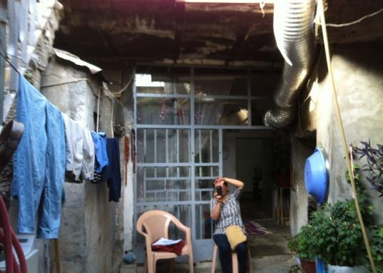 b-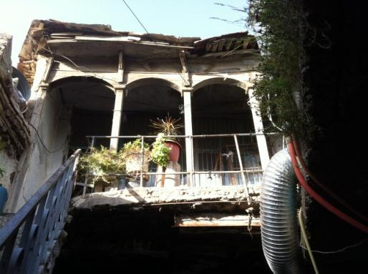
- The ground floor of this listed house is in a deteriorated condition and displays the house after many amendments that diffused the original view of the house.
- The first floor of this listed house provides a side facade of the house and the view towards the courtyard.
Figure 5.3 This house is listed, where the owner has undertaken maintenance several times, including filling, blocking, and changing windows and doors.

  - 2 Definition of historic non-listed buildings

In Sulaimaniyah historic city centre neighbourhoods, there are historic non-listed buildings, which can be demolished and rebuilt in a way that maintains a consistent facade to the old fabric of the neighbourhood. Buildings listed and non-listed provide areas with a historic environment that are under the conservation order to have distinctive characteristics separating them from the rest of the city neighbourhoods. However, urban change has impacted on the architecture, texture and even colour of these structures, and they have been kept in a very poor condition.
According to Sulaimaniyah municipality-city centre regulation guidelines (2010), old and non-listed buildings can be demolished and replaced with residential or commercial use. They need to follow the traditional facade of the neighbourhood, including architectural elements of arches, columns and bricks.

The floor plan layout of unlisted buildings is more or less same as listed buildings, but without any rich architectural elements. Figure 5.4 displays old houses and non-listed houses in the neighbourhoods of the city centre.
a-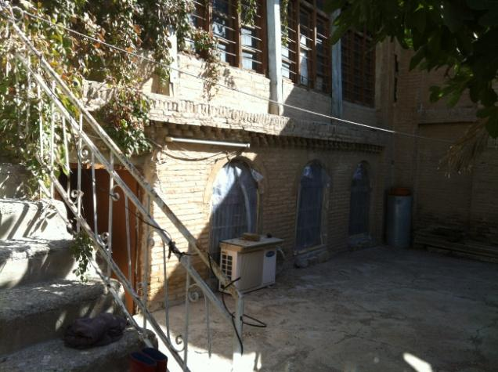 b-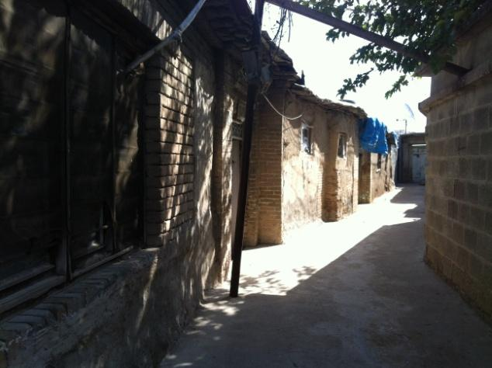
- An old and non-listed house in Dargazen neighbourhood.
- A cul-de-sac in the Dargazen neighbourhoods of the city centre.
Figure 5.4 Old and non-listed houses in Dargazen neighbourhood.
For non-listed housing, owners can make any decision regarding their property in terms of demolition, modification and renewal. New styles should be incorporated in a way so the elevation shows a consistent facade to the historic fabric of the neighbourhood. However, most of the new construction does not follow these planning regulations of the neighbourhood, and over time has produced an inconsistent style which has been justified by reasons of low quality, aged houses in favour of economic benefit (further explanation will be in the subsequent sections).

5.3 Drivers of urban change
Urban change in Sulaimaniyah city centre involving the commercialisation of residential listed and non-listed historic buildings is contributing towards the decline of the historic environment in Sulaimaniyah city centre and social life of the local residents. This urban change in Sulaimaniyah started after 2003 when Sulaimaniyah‘s social and economic systems developed with concomitant rises in land and property prices in every part of the city. During the time, new neighbourhoods were established surrounding the city, including renewing and new reconstructions in every neighbourhood in the city (See: Chapter 3, Section 3.3.3). The resulting property redevelopment has led to the dismemberment of the historic city centre and buildings.
To understand drivers of urban change, the perceptions of local residents on urban change of historic Sulaimaniyah city centre were examined, which focused on attitudes to the urban change, personal behaviours and values by asking “why do you demolish your properties?” or “why has commercialisation occurred?”, or “why have you put a for sale sign on the wall of your house?”. Responses, based on behaviours and values, provide an explanation of the actions and conflicts of local residents to induce urban change and the factors that are closely associated with people’s place identity and place dependency (they will be examined in the following chapters).
Table 5.1 Drivers of urban change in the neighbourhood is based on perceptions of respondents in the neighbourhood.
Major factors |  | Minor factors
Residents who against the urban change | Residents who in favour of the urban change | Residents who against the urban change | Residents who in favour of the urban change
1-Failure of government in the management of the neighbourhood  - lack of financial resources  -planning regulations provide an opportunity for commercialisation of residential uses | 1-Economic value of location of the neighbourhood allows investment in their neighbourhoods (their own business) | 1-Owners are ignorant in maintaining their houses | 1-Low quality of the built environment  (poor condition, sanitation),
2-The appearance of commercial uses resulted in traffic congestion, damage to physical historic structure and traditional life circumstances, and departure of original residents | 2-Development  (new style of buildings, high rise buildings) |  | 2-Difficulty of maintaining traditional house  (high cost, lack of labour skills)
3-Lack of awareness of heritage value  -Illegal actions of local residents and merchants regarding demolition of listed buildings. |  |  | 3-Traditional style of buildings and inherited properties,  (small, not adaptable for one family)

Based on the majority of respondents’ views, failure of government in the management of the neighbourhood and economic value of the neighbourhood are influencing factors of urban change. The Economic value of the area is linked to the fact that city centre still represents the main trade, market and business centre for the whole of Sulaimaniyah. However, the lack of government responsibility in the sense of regulations and conservation planning policy for heritage management has influenced the actions of local residents.
On the other hand, minority concerns of respondents were expressed about urban change based on the perception of two groups: those who in favour of urban change; and, those in opposition to urban change. Low quality of the built environment, inherited properties and the difficulty of maintaining a traditional house are reasons of urban change for the group of residents who accepted the change of the place. Whereas, for other groups with opposite concerns aroused by the appearance of commercial uses in their residential environment resulted in traffic congestion and departure of original residents. This is why the lack of awareness of heritage value was a factor of urban change (see Table 5. 1).
Based on the above table, the drivers will be highlighted in the following sections:
5.3.1 Key aspects of commercial uses
Key aspects and consequences associated with commercial uses indicate a factor of urban change. Most of the listed and non-listed houses are given to the hands of new arrivals when local owners sell their property due to the spread of commercial uses for the purpose of redeveloping into further commercial use. This created traffic congestion, difficult life circumstances and damage to traditional, spiritual and social life in the neighbourhood. This is explained by Myers (1983), who states that neighbourhoods eventually decline as housing stock and residents’ age, owned homes convert to rentals, and poor renters move in. This factor of urban change influenced participants with mixed genders and age groups. Those who mentioned this factor were concerned about “congestion” due to the spread of “commercial buildings” and “car parks”, and “pharmacies”, and clinics”. A participant expressed her feeling about “car congestion” and “passes through strangers” that created difficulties for practising their social life in terms of “interaction with neighbours” and difficulties for practicing their spiritual and religious life in their own courtyard space due to “the height of commercial buildings” that “blocked their view from mosques to see lights and hear azan”. This made her hang a for sale sign on the wall of her house in the hope of leaving the neighbourhood. She blamed the government for the lack of management and conservation and confirmed her conflict with several merchants. She explained that several merchants approached her to buy her house for the purpose of “demolition and rebuilding commercial uses” on the site of her property, and disturbed her. Another participant who commented on this was a 40-year-old male, who talked about a recently sold house, Mirza Ali Kotal Frosh House opposite to his house, which the new owner demolished and rebuilt with a new house with cement block walls and rendered with plaster. (Male, aged 40, Sarshaqam district, August 2014).
Therefore, urban change has involved transforming residential to commercial uses, developing irregular car parks, mixed uses, and building new houses on the site of demolished buildings, which are then in the hands of new owners. These affected the social, religious and spiritual life of residents. Another participant talked about the same issue, as most of her neighbours sold their houses and new arrivals turned them into car parks. She mentioned about a car park next to her door that used to be a non-listed but historic house before demolition (Female, aged 70, Sarshaqam district, August 2014). Another interviewee said local people sell their property, even for less money: “this house was the nicest place for its time, but the owner sold it to a merchant because of crowd in our neighbourhood, which the new owner will rebuild it with a big market” (Male, aged 70, Malkane district, 2014).
Consequences of the spread of commercial uses are related to aspects of the departure of local residents and due to that, their social life and their behaviours are influenced by these consequences. This process led to owners selling their properties and leaving the neighbourhood, or abandoning their houses or renting them to low-income people. This led to a further urban change in terms of demolition and the building of commercial uses on the site of the historic residential environment. The reason for their departure is related to these negative consequences of changing the neighbourhood to commercial uses and the abandonment of historic houses by their owners.
This situation leads to more deterioration and further departure of residents in the neighbourhood. Myers (1983) explained that when the neighbourhood declines, residents who can afford to move might leave, stimulating vacancies, rental conversions, and high residential turnover. The author found that neighbourhood decline impacted on place attachment and the housing stock - owned homes were converted to rentals, and poor renters moved in. However, homeowners stay longer than renters stay and maintain their houses (Rohe and Stewart, 1996). Taylor (1995), also addressed that departure and the abandonment of the houses as poor housing upkeep and appearance relates to other social indicators of decline, such as residents wanting to move out of the neighbourhood (Taylor, 1995).

5.3.2 Economic value of the built environment
The strategic location of listed and historic non-listed houses close to the city centre - as the main market for the whole Sulaimaniyah - is associated with the economic value of the properties. Producing a strategic location out of linking several properties of the historic (non-listed) and listed houses that are facing main streets in the area. This process replaced many properties and represented illegal actions by the local residents. There are examples of demolished listed-house caused by the economic value the property, and comparable properties hold. During the fieldwork visit, I have observed many vacant lands, for instance, most of the non-listed historic houses in the residential neighbourhoods, which are mostly demolished and replaced by irregular car parking. For instance, a respondent asked me to go to the top of his house and showed me a big and empty land that was used as a car park. He said, “this land was three houses before they demolished them, all owners sold their houses together because they made more money selling it in that way” (Male, aged 30, Sabwnkaran district, September 2014). Another respondent talked about how linking several properties and building tall commercial uses for the sake of profit diminished the spiritual value of her courtyard as they blocked the view of her court-yard. She claimed that she could not see minaret of a mosque in the area from the courtyard of her house (Female, aged 70, Sabwnkaran district, September 2014).
Linking several properties to produce a strategic location for commercial buildings and parking lots is a significant phenomenon controlled by merchants as actors who encourage or push residents to sell their property. This occurs by offering a convenient amount of money purchasing the properties and even illegally purchasing listed houses. The owners of listed houses are illegally selling their houses, as the selling and purchasing of their houses have been prevented by Directorate of Antiquity of Sulaimaniyah. The powerful, rich or merchants convince local residents to sell their properties, including properties that offer a strategic location. Tradesmen are recently become popular in the area due to their frequent business, selling and buying properties in the area, especially when they bought several historic properties in the area and demolished them. For instance, a participant blamed a merchant as he demolished several historic houses in the area (Female, aged 50, Malkane district, August 2014). Another interviewee who was s 60-year-old explained this issue in relation to the rich people: “Zire karema rash bought almost all the houses and even Barxi Hamam. He demolished them and built commercial properties and car parks in place of them” (Female, aged 60, Malkane district, Agust 2014).
This uncritical love of profit highlights the changing economics of land use, which it seems local residents of Sulaimaniyah city centre are practising. Case studies around the world also experience this situation. The demolition of Beijing city central area was decided by policy makers, however not necessarily by community or merchants and as in this context, where the poor condition was an official reason for the demolition. However, the real factor was to host the Olympic games of 2008, and according to Wheatley, (2008), was for generating revenue from the hordes of visitors and athletes in Beijing for the games.
Local residents of the area expressed further concerns, such as “a rich man buys three to four cheap inherited properties in this neighbourhood and replaces them with car parking and later when they buy three- to four properties they have power to demolish them together, which we do not have that power” (Male, aged 70, Malkane district, August 2014). As this process is mostly controlled by merchants who buy an old property and rebuild them with commercial use. The merchants force the owners who live near their new commercial building to sell their property by offering them a better deal of money. A respondent said, “it has been two times, the owner of this commercial building behind us asks us to sell our property to him, and even we got a good deal of money for him” (Female, aged 50, Mlakane district, August 2014).
In this context, merchants, powerful people and local residents play a role in changing the land use of the neighbourhood towards commercial uses. Residents for the sake of financial benefit participate in the process of urban change of the neighbourhood by selling their properties. If any property faces the main street, it has the potential to make money due to its commercial land use, which is why any property on the back side (normally back side properties are residential) attached to it would be expensive too, because the owners link them together and sell it as one property. Sometimes the residents reach an agreement among each other. This factor of urban change mostly influenced on male participants with mixed age groups. An interviewee explained this:
“ we decided with two of our neighbours sell our property together, because it makes more money and especially our property is making more money as it is facing the main street, that is why other two owners asked as to inform them whenever we wanted to sell the property” (Male, aged 50, Shexan district, August 2014) .

Today, the appearance of many new retail shops, markets and commercial buildings are evident in the neighbourhoods and they penetrated into the heart of the neighbourhoods due to the linking of demolished houses into sites. That is why almost all listed or non-listed properties that facing the main streets are turned into commercial buildings by their owners. This linking of several properties and replacing them with commercial buildings consequently influenced further residential areas to be turned into commercial land use. This is due to the spread of the commercial buildings in the road of the neighbourhood one after another. The interviewee further explained this situation: a respondent explained the loss of listed and non-listed houses in her street, “I witnessed the disappearance of uncountable houses and families who left the area, for example, the House of Baba Raswl and House of Saraf Family. They replaced by commercial building and car parking” (Female, aged 40, Sabwnkaran district, September 2014). As Figure 5.5 shows the resident’s street that her neighbour’s house turned into a commercial building. The commercial building is almost blocking the front view of her house and was her concern. The implications of urban change will be further explained in the following subsections.

a-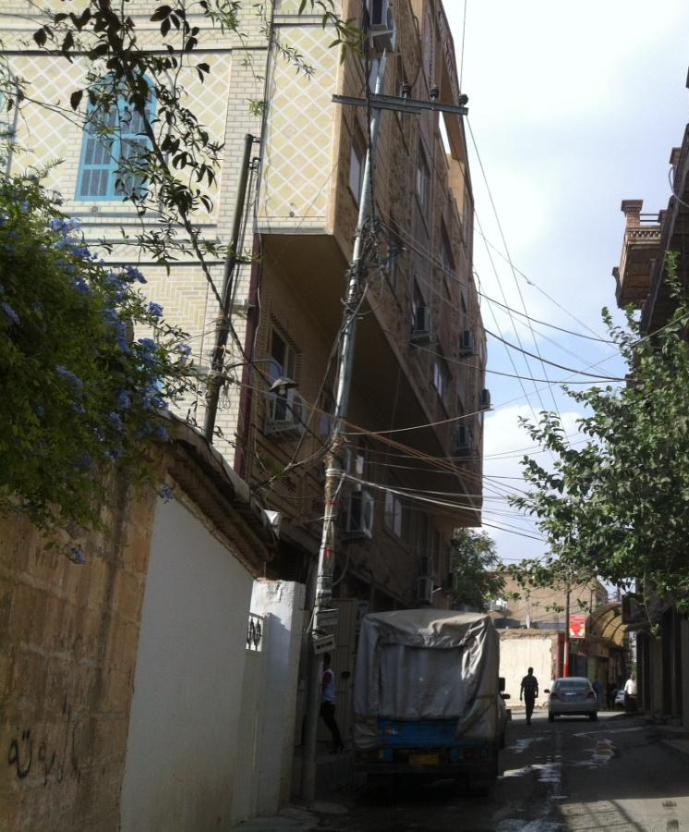
b-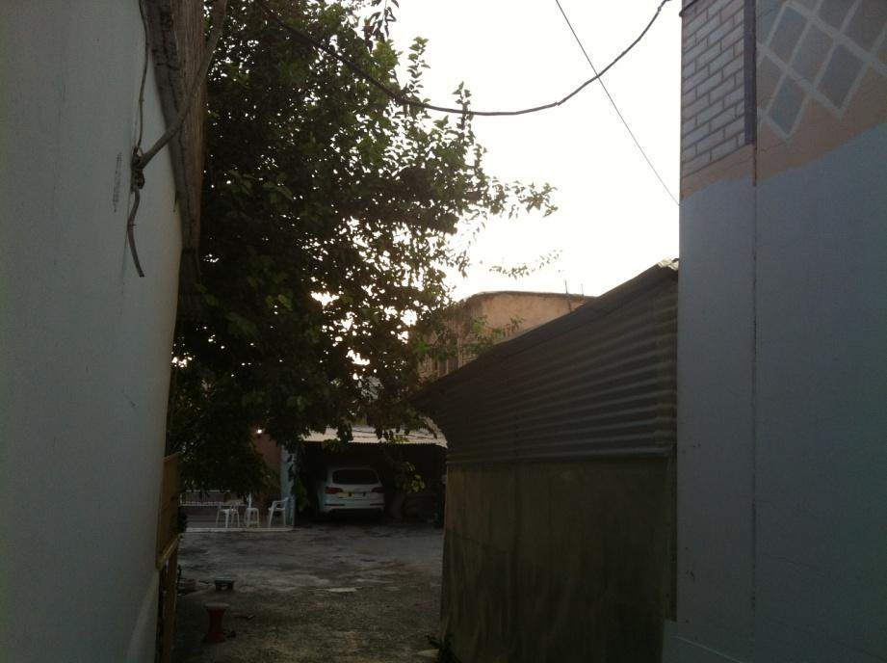

c-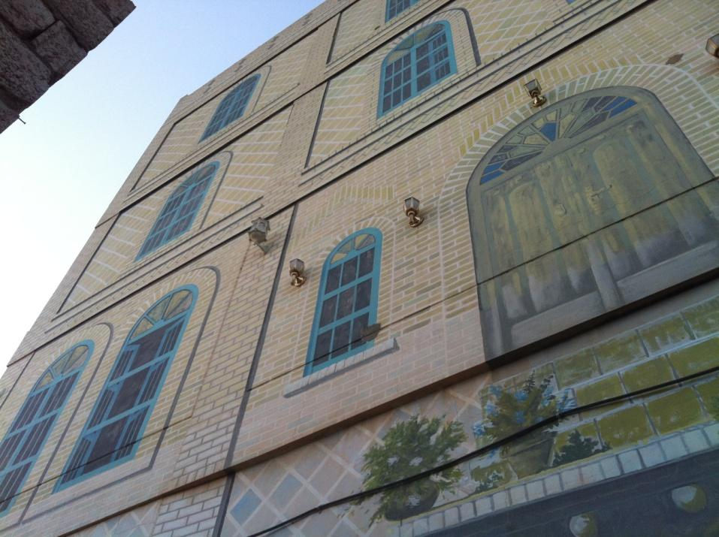
- Njmadeen Mala Building, which is facing Sabwnkaran Street and a narrow road of a respondent. The building has replaced a historic house in the area.
- The same building that blocked the view of the courtyard and narrowed the front corridor to the courtyard.
- The wall of the same building from the corridor of the respondent’s house as she explained the merchant painted the wall to convince the respondent who claimed the construction of the building and as a favour instead of a long concrete wall (Female, 40s, Sabwnkaran, Local resident, 2014).
Figure 5.5 shows the replacement of the historic house that faced the main street of Sabwnkaran. (Source: Author, 2014)
Concerns about the same issue are explained by more respondents views regarding demolition of the historic houses due to their strategic location of the houses both listed and non-listed historic houses: “there are a lot of houses are just disappeared very quickly one by one, and the rest are soon disappearing and become garages” (Female, 30s, local resident of Dargazen, 2014). Another resident commented on this as residents demolish their non-listed houses: “just beside my door two houses turned into car parking and one front of us was demolished completely, they damaged the privacy of our cul-de-sac that I used to sit down every afternoon and repeat verses of Quran” (Female, aged 40, Sarshaqam district, August 2014). This respondent concerned about her religious practice in an urban space that damaged due to the demolition and building car parks.
More interviewees explained this condition; a respondent talked about her surroundings that turned into hotels, casino, and tea shops. She emphasised the disappearing of her neighbours’ houses around them except two houses at the opposite of their road (Female, aged 50, Malkane district, August 2014). Moreover, almost all participants of 20 year-old-male and female participants emphasised the economic factor of urban change; for instance, a 24-year-old female talked about the appearance of some garages in her narrow road and pointed to a vacant land front of her house which was an old house, and the owner demolished it, she concerned about their exposure to the public due to several garages in the area.

“Shexan neighbourhood was full of historic houses, but now there are two to three car parks available in one short and narrow road that exposed all the houses to strangers. For instance, you cannot find 10 houses in the whole neighbourhood, and a bunch of houses was demolished. I saw this neighbourhood in some old pictures; it was full of houses which are now replaced with this garage” (Female, aged 24, Shexan district, August 2014).

Another female in her 20s said “in our surrounding 3 to 4 houses were demolished and rebuilt it again, and one of them its ground floor is retail and the first and second floor is a residential” (Female, aged 20, Malkane district, August 2014). Another example of how the houses turned into car parks was an interview with a respondent, who talked about this issue:

“This neighbourhood was historic houses, but now you can see they all turned into car parks and new buildings. Rich people buy the houses and demolished them to build a new one. For instance, the owner our early house kicks us out from his house and he sold it, and now it is a Garage. They bulldoze the houses” (Male, aged 20, Sarshaqam district, August 2015).

Focus group respondents had the same concern; a respondent counted many historic houses that had been demolished and turned into car parks (Male, aged 21, Sarshaqam district, Focus group, August 2014). A male respondent commented, “the old houses are getting demolished and leave them for car parks” (Male, aged 20, Sarshaqam district, Focus group 3, August 2014).
Thus, the interview materials shows how the selling and linking of historic houses influenced urban change of the neighbourhood by disrupting the scheme, urban space, and land uses of the area, namely the appearance of new uses in the heart of the neighbourhoods in the hands of residents and merchants for the purpose of economic opportunity and financial reasons. It affected the spiritual life of residents in their traditional houses. The discussion of the literature in the sense of increased land demand for competing uses is linked to the growth of the economy and population explosion, where “these pressures often promote change and change can imply the destruction of existing things and their replacement by new” (Ratcliffe, 1974, p. 295). This also shows that local residents, for the sake of financial reasons, are ready to take action and ignore the value of heritage (See: the following section).
This has also shown that the residents and merchants have control over the features of the neighbourhood, which is enabled by the lack of government plans for the neighbourhood. This poses a question about having any strategic plan, planning regulation, and policy for the development of the neighbourhood, as it was shown individuals randomly initiated the change in the overall structure of the neighbourhood.

5.3.3 Lack of awareness of heritage value
The illegal actions of the local residents in replacing their listed houses influenced the perceptions of participants about urban change with mixed genders and age groups. This has been shown based on interview evidence in the fieldwork. The lack of awareness of heritage value has been noticed throughout the process of neighbourhood change and enhanced by the drivers of the change, especially the economic value of properties. The historic city centre has changed in the hands of local residents; listed houses are getting demolished by owners; however, it breaks the laws and conflict with conservations and regulations of the area that are meant to prevent any change in the listed houses. The process is continuous in a secret way, for instance, listed houses are secretly turning down at night using different ways to enforce the building’s future demolition by owners. This is based on the fact that the demolition of listed houses is allowed once the condition of the house produced a threat to residents; however, residents use this rule to justify their illegal demolition (Interview with Sulaimaniyah Municipality official, November 2014). In other contexts, this issue has been underlined by the factors of societies that practice a form of individualism that makes economic prosperity the key to the meaning of life, that provide a cause of chaos (Toffler, 1971). Especially, communities distort their past when there is not appropriate regulation (Talen, 2011). More importantly, the decisions were made at the local level, by all those residents who were directly affected, not by government agents or rulers (Bosworth, 2008). A respondent witnessed the situation and when I interviewed him, I noticed the trick of her neighbour even from her expression.

“The house of our neighbour which was not in a poor state, but the owner wanted to replace it with a big market. Until one day when we woke up, half of the house was demolished and the owner said we want the government to allow us to demolish it completely. They turned the houses into a vacant parcel and used as a car park later. I cannot do that with my property, but they informed municipality the house collapsed by itself, as they cannot live in that house anymore. However, Sulaimaniyah Municipality is not allowing any changes in our listed houses, and even not maintenance”
(Female, aged 24, Shexan district, August 2014).

Another concern is merchants do not value the heritage of the neighbourhood. This concern has been based on the interview with an engineer in the Directorate of Sulaimaniyah Antiquity who was a project engineer of a renewed listed house and said:

“There is a very new trick that people learnt from a merchant who bought many of the houses in the area. That merchant buys properties in the area and builds a new three to four storey buildings. This man destroyed the area. He buys a listed house, however, he knows he cannot buy it, knows the house is a valuable and knows the house has still a strong structure, but he buys it from the owner” (Project engineer, Sulaimaniyah Directorate of Antiquity, December 2014).

He mentioned that people sell their house to him because they look for an opportunity to get a good deal. What he does is ask the renters get out of the houses and he leaves the house until the house is damaged because of inclement weather and no maintenance. Later he secretly asks low-income families and offers them free windows, doors and anything in the house. He allows people to take anything, even the woods of the ceiling. This increased damage to the houses and in some cases, the house is burnt without knowing who did it. He said, “Of course, his answer will be because of the accident. This is his secret plan”.
There are examples of these collapsed listed houses, for instance, in Sarshaqam district, as the same interviewee commented about a listed house in there that purchased by a merchant. He confirmed, “we quickly bought it back from him even with an extra benefit. He wanted to demolish it in his own tricks. However, the house was partially damaged because of his plan” (Project engineer of a renewed listed house, Directorate of Sulaimaniyah Antiquity, December 2014).
To collect further evidence, I personally approached the same merchant, and he denied the demolition of any house on purpose. However, he further appreciated the “economic value of the city centre” and believed the physical structures in Sulaimaniyah city centre “are not heritage” (Interview with a merchant, December 2014). This concern is further explained by Sulaimaniyah Municipality officer, who commented, “the owners demolish their houses secretly and then try to get permission to build a new house, because there is not a serious punishment and people do not care about laws and regulation” (Municipality officer who was ahead of Design and Technical department of Sulaimaniyah City, 2014). He mentioned, “there was a house that all architecture students took a photo of the house, but now it is demolished and is a garage. People do not inform municipality. According to the regulations, any change should not be done without getting planning permission from the municipality” (Municipality officer who was a Head of Design and Technical Department of Sulaimaniyah Municipality, November 2014).
Further concerns relate to arrangements between residents and merchants for marketing the listed house. An interview with a respondent showed an example of how the residents of the area make an agreement with merchants,

“My neighbour couldn’t sell his house, but he arranged to sell it to a rich man without having a legal paper. A merchant who bought almost all the historic houses in the area does not care to have legal paper or not, he can do impossible that is why he tries to convince owners to make deals with him if he finds out their property is precious for replacing them with commercial buildings”
(Male, aged 30, Sabwnkaran district, September 2014).

Thus, the cheating of residents and merchants show the conflicts with planning regulations and lack of conservation. It shows the lack of awareness of the value of heritage, which has produced a threat to the historic environment of the area and accelerated the process of urban change and damaged urban space of the area. It is clear that the development of illegal actions has been noticed in the area, and that residents do not follow regulations and guidelines that have been defined by conservation planning policy in spite of their existence. This shows a failure of government in the management of the historic environment of the neighbourhood as the main factor of urban change. Schuster et al, (1997) argued that regulations and guidelines are only useful if an audience appreciates the value they contribute to heritage. This means that conservation planning policy and regulations are not working properly, which is why change, decline, demolition and degradation of the urban space and in the social life of residents has been noticed in the area. For details about the main factor of the urban change see (Chapter 6: Actions of local residents).

5.4 The quality of the built environment
The quality of the built environment is a minor factor concerning respondents with mixed genders and ages, especially those who are in favour of the urban change. The poor quality of the built environment is used as a justification for urban change and demolition of even listed buildings. The poor quality of the historic built environment is seen as a threat to the security of local residents’ life. In addition to that, in this section, the traditional style of historic houses as another factor enhanced the neighbourhood change. Primarily, because the urban change introduced inconsistent architecture style to the old fabric of the neighbourhood, this impacted on the demolition of the traditional style of the built environment as explained below.
5.4.1 The poor condition of buildings
This factor was mentioned by more than 40% of participants. A respondent justified the demolition of her house with; “our house was a very old house, and we couldn’t manage to live in there, that is why we demolished it and rebuilt it again” (Female, aged 50, Malkandi district, August 2015), or “because the house was small and very old, we demolished it, and rebuilding it again was necessary” (Female, aged 50, Malkane district, August 2014).
The poor state of the houses was further explained by a participant as for a lot of them their walls are falling down and many of them have been abandoned by their owners (Female, aged 50, Shewe Qazi street, August 2014). This situation pushed some respondents to prefer new houses, “concrete houses are better because the old houses are in poor state and are not suitable for living” (Female, aged 20, Sarshaqam district, August 2014), and “the houses are very old and not a place for living” (Female, aged 24, Shexan district, August 2014).
In addition, the poor quality of the houses enhanced their demolition and degradation and the consequent rebuilding of them. Responses of local residents, in terms of the reconstruction of the demolished buildings, are evidence of demolition by many of them. As rapid change throughout the Middle East has led to the disappearance and often without any recognition of what is being lost of infrastructure by of important cultural landmarks (Bosworth, 2008). (See: Figure 5.6) For instance, the distinctive and historic parts of listed houses disappeared, as interviewees responded:

“I know our house is listed, and it is right that our neighbourhood has a different and a nice environment due to all the houses are still the same and mud brick wall, but I see our house is in a poor state that makes our life hard for a living. We repaired it, at least, five times, and just go look at it nothing nice remains, it is still in a poor state”
(Female, aged 20, Malkane district, August 2014).

In addition, many of participants added further construction to the listed houses. A participant repaired her house several times and built two more rooms due to it needing continuous care and maintenance (Female, aged 40, Sabwnkaran district, August 2014). Participants confirmed that they transformed the indoor of their listed houses (Female, aged 60, Malkane district, August 2014), and even some expressed thoughts of the disappearing of the historic built environment:

“These historic houses are very old, and day after day they disappear, for instance, the walls of our house are cracking, the ceiling is dripping. If we did not care about it and did not cover the roof with Nylon sheet, it was probably being fallen down by now. We have to modify it as it is dangerous, and it might fall down abruptly”
(Female, aged 20, Jwlakan district, August 2014).

This therefore also shows the concerns of respondents about the dangerous situation of the poor state of the buildings and their surroundings. Many more respondents stated the same concern (Male, aged 20, Jwlakan district, focus group, September 2014) and even talked about the sanitation of the houses (Female, aged 50, Malkane district, August 2014; Female, aged 40, Malkane district, August 2014). These issues will be further explained in the subsequent sections.

a-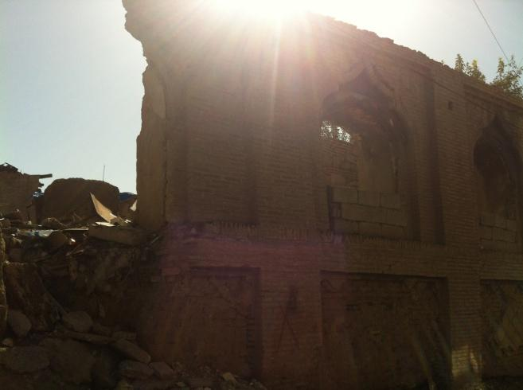b-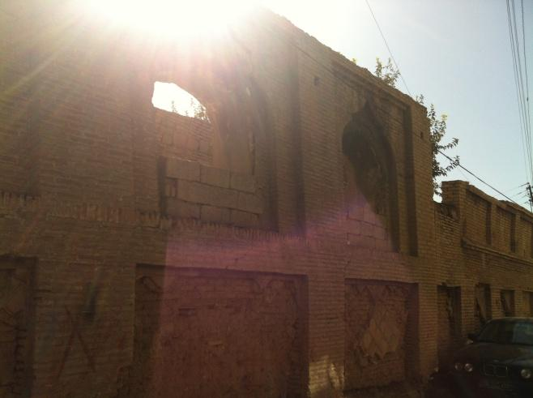
c-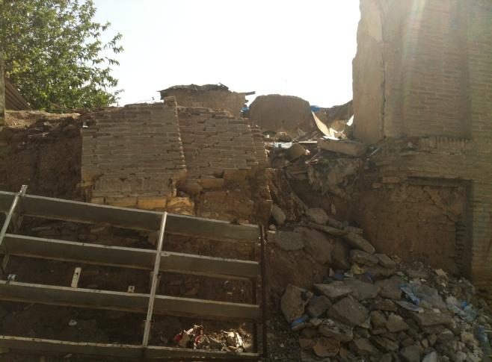d-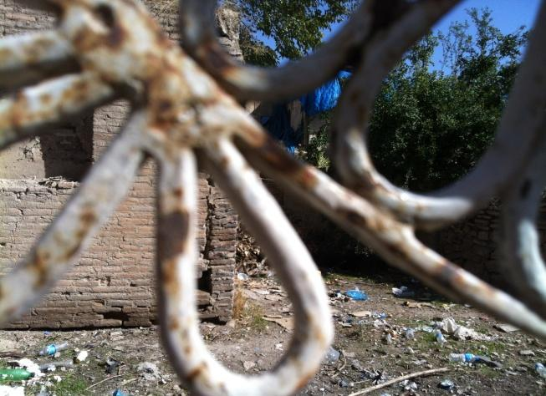
Figure 5.6 a, b, c, d shows the listed house which is a property of Directorate of Sulaimaniyah Antiquity in a very worse and demolished state.

Thus, the examples show the poor quality of the built environment as evidence of a perceived decline of the neighbourhood and a factor of urban change. This also shows local residents’ action in terms of reconstruction and improper maintenance. According to Markova, (2000), this transformation is the response of local residents in historical neighbourhoods to the need of time, which erodes identity and urban character due to non-historic environment activities that are unmatched with traditional activities; negative environmental impacts are also the factors of neighbourhood change (Markova, 2000).
It is clear from the interview excerpts above, and from the photographic evidence, that the quality of the built environment in the historic neighbourhoods of Sulaimaniyah has led individuals to take action, which has, in turn, led to a significant transformation of these areas. The nature of this transformation is explored in further detail from the perspective of local perceptions, but here we are able to understand something more about the nature of the relationship between people’s perception of building quality and their response to it. This is an important part of the story of neighbourhood decline in the historic districts of Sulaimaniyah, but it is not the whole story. For example, the situation which has led to the degradation of listed buildings, the lack of proper governance, and the actions of key individuals are all important additional aspects that need to be examined, as identified below. The important point here is that the physical transformation of listed buildings is undertaken by residents who feel they have no choice but to take action; however, it also related to lack of awareness of the heritage of the area, which is also associated with the weak conservation planning policy by the government. When there is not appropriate regulation, it is very common for communities to distort their past (Talen, 2011).

5.4.2 Poor quality of the built environment and life-threatening
Respondents were concerned about the negative implications of the ageing listed historic houses, including the danger to the quality of their lives. Local residents were threatened by the decline of the abandoned residential properties. This has been addressed around the world, for example in Harlem, US, residents were threatened by a decline from landlord abandonment (Brown et al., 2003, p.260).
An example of this is an interview with a respondent who was 21 years old and said, “the houses make a lot of dust in the neighbourhood, which is really dirty and unhealthy. The floor and walls of the houses are old mud bricks. We rebuilt our house because of dirt and dust” (Male, aged 21, Sarshaqam district, Focus group, September 2014). Besides that, the old houses are in a poor state that puts residents’ life in danger. A female in her 20s commented, “we afraid one day our house wrecked down” (Female, aged 20, Malkane district, August 2014). Besides what I heard from the interviewees, during the site visit, I personally noticed some walls were partially demolished, while people were still living in them, when I approached one of them and asked the owner about “how the wall was demolished?”, the participant confirmed, “it was wrecked down by itself” (Male, aged 30, Shexan district, August 2014). What I observed was a fear on the face of his wife, while her husband talking about the accident. This poor condition of the houses provided fear and threat for the community (see: Figure 5.7, 5.8).
The above interviews show that the listed houses are facing increased deterioration and consequently are a factor for urban change, causing people to take action. For instance, a 50-year-old female commented, “if you saw the house that demolished front of us, you would be frightened that the rest of the walls might fall down on you. People feel scared when they pass through the road” (Female, aged 50, Malkane district, August 2014). In addition, a 30-year-old female noted: “sometimes the houses are in a very bad condition if someone passes nearby the wall, he has to be aware that the walls might fall down over him” (Female, aged 30, Dargazen district, October 2014).

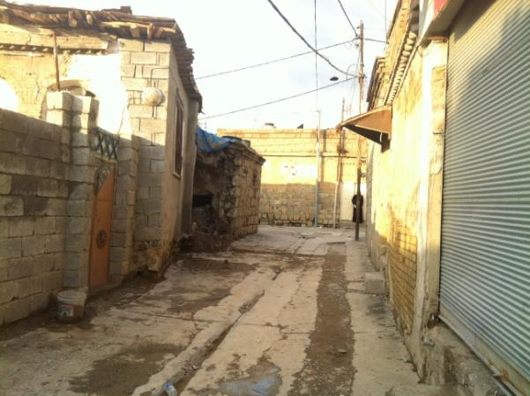
Figure 5.7 the house of the interviewee where the wall collapsed at midnight and produced a fear for the household in Shexan neighbourhood.
a-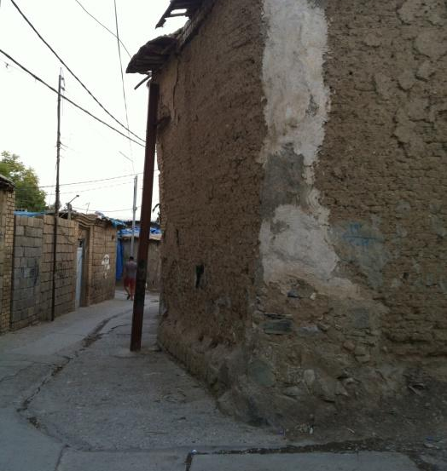b- 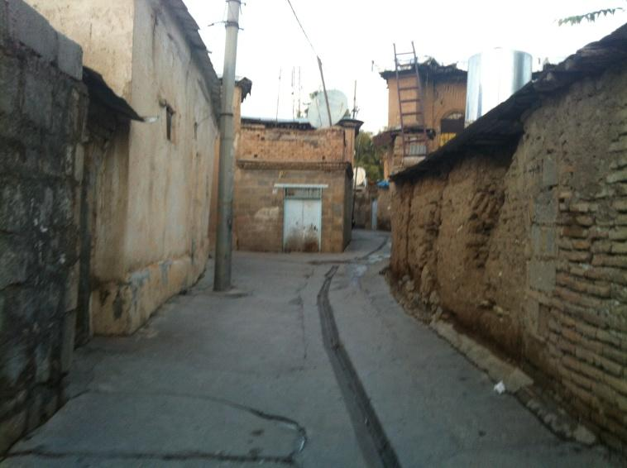
- The house in Shexan that the wall was supported to stand with a jack.
- The deteriorated walls that produced fear for residents and passers-by.
Figure 5.8 the old houses in Shexan neighbourhood that I observe when people passing through the roads turn their face to the walls and show their fear of demolition.

Another 50-year-old participant showed his anger regarding the poor condition of the houses, especially, and had started to call them a dirty house when the interview continued and I observed he got angrier in the face during the interview. He commented,

“the houses are dirty and not suitable for a human being, and I am looking for a clean house and healthy and good life for my family. These houses are a source of diseases and have a lot of mice and insects. That is why for I am selling my house, however, in every day some people come to this house and take photos of it because they think it is a beautiful house” (Male, aged 50, Sarshaqam district, October 2014).

In spite of the poor condition of these houses, it seems there is still some value attached to these aged houses, especially those who stand opposed to urban change (See: Chapter 6). For instance, one respondent talked about how his house is still distinctive for some people. See Figure 5.9, which shows the front side of the house of the participant.
a-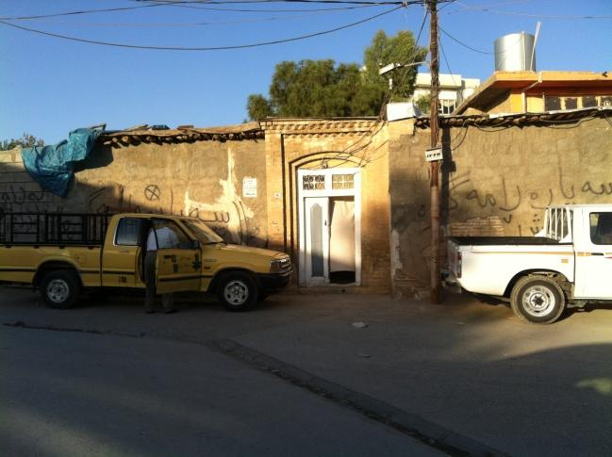b-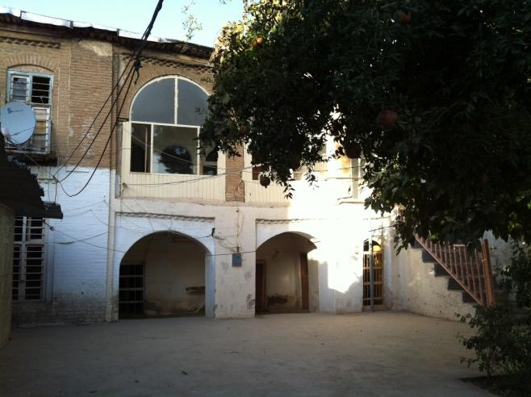
- Exterior facade of the house of the interviewee
- The interior and from courtyard view of the house.
Figure 5.9 The deteriorated house was evacuated and prepared for sale. According to the owner, the house was repaired many times, including replacing doors and windows and modifying walls.

5.4.3 The traditional style of buildings
The diversity of architectural style in the urban fabric of Sulaimaniyah city, due to the pace redevelopment, is overwhelming the historic city centre. Consequently, the traditional style of houses and aged buildings has become an issue for local residents. For example, the influence of urban change, which is perceived as development for some residents (See: Chapter 6), has encouraged residents to demolish their properties to catch up with the pace of development. For instance, according to Cohen (2001), there has been a profound rupture between the traditional attitudes toward life and social function and the modern tension of fast paced living (Stubbs, 2009) (Cohen, 2001). This is also addressed by Stubbs (2009), who suggests that modern life seems to promise vast improvements in transportation, sanitation, the design of appropriate living quarters and so forth, but also takes a destructive toll on the ways of the past (Stubbs, 2009). This has influenced the transformation of the traditional buildings in the area in the same way as in other middle east countries, as a tendency among some elites to simply imitate Western styles and methods (Amirahmadi, 1993) (AlSayyad, 1999). In this sense, there are concerns about abandoning the traditional structure of houses in the entire neighbourhood and considering listed and non-listed houses as an undesired structure and style of buildings comparing with new developments in the city. Preferences for new technologies and new construction materials enhance the alteration and demolition of the listed and non-listed buildings in the area.
This desire for modern and new technologies is also linked to the lack of awareness of the value and identity of the historic built environment. Participants’ view about the traditional style of buildings perceived this fact: “local people build nice houses by replacing their ugly, dirty and old house” (Male, aged 23, Jwlakan district, Focus group, November 2014). He showed me the house of his neighbour and described it as a better and a nice house. Moreover, during the interviews and taking photos, the interviewees showed me some properties that were demolished and replaced with the new houses with a differently constructed building facade and different materials from the traditional architecture of the place, and they preferred them to the old houses. However, according to Sulaimaniyah Municipality-City Centre Regulation Guidelines, 2010, the non-listed houses in the historic city centre can be demolished and replaced with a new building that has a traditional facade, including architecture elements of arches, columns and bricks. Another example of this situation is a story of a woman who was 50-year-old complained about the layout of the old houses, and said:

“The old houses are not easy for us in winter, for instance, our small kitchen is in the opposite of the living room, which opens off into the courtyard. Reaching there is through the courtyard and most of the time it is raining. We concreted the courtyard which was a garden and mud, and now I used for cooking”
(Female, aged 50, Interview, Shewe Qazi Street, August 2014).

The house of the interviewee is shown in the Figure 5.10 below. She also said, “the old houses are getting old and no one can live in them. We cannot afford to renew it, but our neighbour demolished his house and rebuilt it again” (Female, aged 50, Shewe Qazi Street, interview, August 2014).
a-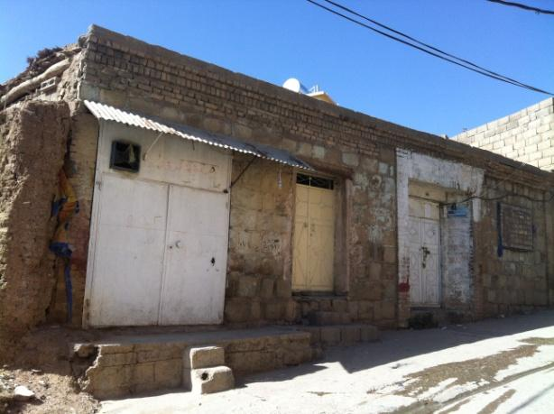b-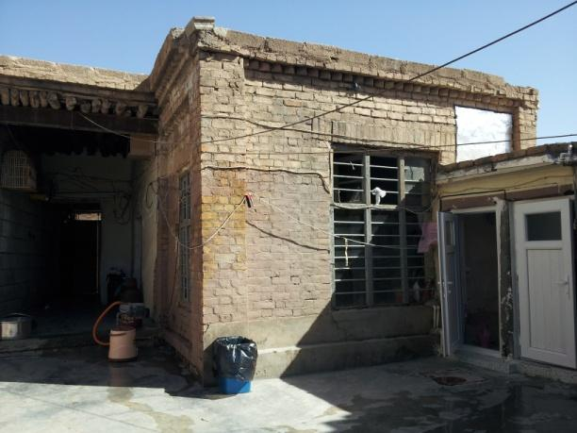
c-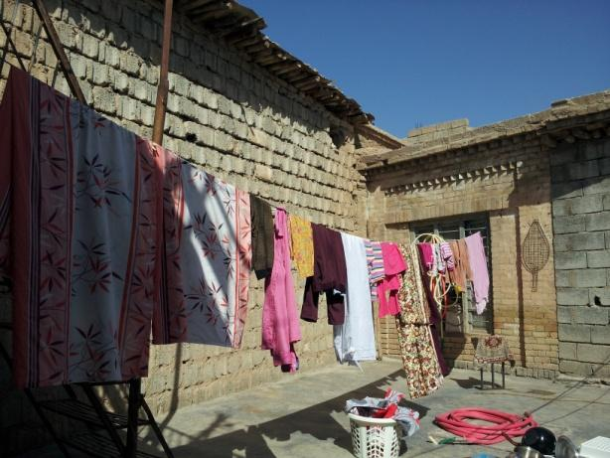d-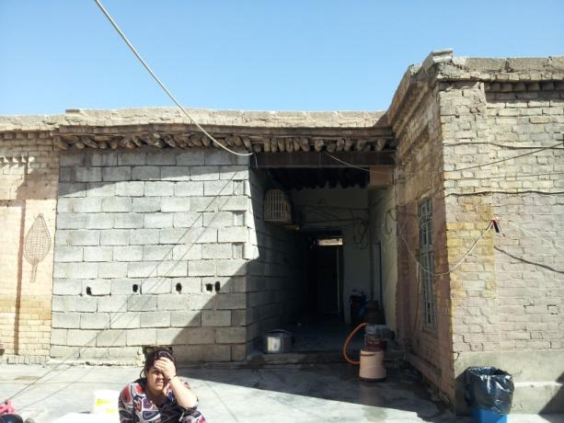
- The outdoor facade of the house of the interviewee, which is left-part demolished and exposed to the outside.
- The interior of the house, which shows the courtyard. The new part added to the courtyard.
- The small spaces in the house created difficulties for a living, and according to interviewee, the green space of the courtyard replaced to a concrete slab to support doing their daily chores in the courtyard.
- The demolished wall of one of the rooms in the house repaired with a concrete block.
Figure 5.10 the old house in Shewe qazi, which is under demolition and deterioration.

It seems financial resources is an important factor for the owners and is linked to the process of built environment change; the family’s income is essential for modifying and rebuilding their house. These participants seem to prefer the urban change, with its new styles and new houses if their financial income supports it. Thus, the traditional and old style of the houses as an issue for residents resulted in the change, alteration and demolition of the historic built environment due to the actions of the residents and their perception of the historic built environment, which will be explained in the following chapters. Whereas the management of the local residents’ actions in the historic environment is linked to the responsibility of government (will be explained in the following chapters).

5.4.4 Structural defects
The traditional structure of buildings is vulnerable to inclement weather compared to those constructed using new technologies, and as such has resulted in the decay of the area, causing the loss of architecture elements and contributed to the demolition of the built environment. Chase (2004) addresses this as inclement weather impacts on a loss of reusable components and the authentic parts that belong to specific structures. Stubbs also believes that the destructive actions of time and nature cause built environment deterioration (Stubbs, 2009, p.121).

The traditional structure provided residents with difficulties maintaining buildings in the sense of relevant building materials to the historic environment of the area, and provisional labours in the markets of Sulaimaniyah city. This became a factor in the deterioration and abandonment of such buildings, due to insufficient work on repair as, according to Perenyi (1973); many buildings have required repair work and continuous maintenance. This work has often been less than adequate. Respondents confirmed that this affected the demolition and degradation of listed and non-listed historic buildings, as a consequence of difficulties relating to the need for continuous maintenance and the hard work needed in maintaining the decayed structure. Residents, previously, used a heavy roller to the smooth roof of a house and prevented it from dripping in wintertime, but today the practice has been replaced by covering the roof with Nylon sheet. For instance, a participant emphasised this issue concerning their ability, and being lazy in maintaining their house “the old houses are needed a lot of care and hard work to keep them clean” (Female, aged 23, Shewe Qazi Street, Focus group, August 2014). Another participant addressed:

“Today people are lazy. They cannot fix their houses. I remember when I was a child people were on the top of their house smoothing the roof and fix it for winter. The floor was muddy and needed some care to avoid entering water to the house but now all these behaviours are disappeared, today they use Nylon sheet to cover the roof”
(Male, aged 20, Jwlakan district, Focus group, August 2014).

Another participant commented, “the old houses need a lot of care. They need someone who does not mind getting tired and have a lot of spare time for maintaining his house every winter. Today, people do not have moods for that” (Male, aged 20, Jwlakan district, Focus group, September 2014). Another local interviewee said “I cannot take care of the house; I am getting old I cannot go to the top of the roof and smooth the top floor. I also cannot clean the garden. They are all over wood and mud” (Male, aged 70, Malkane district, August 2014). More participants talked about the need for special care for the houses, “the old houses need a lot of care, we have to buy Nylon sheet to cover the floor and protected from snow and rain, in every winter” (Female, aged 50, Local resident, Shewe Qazi Street, September 2014).
Thus, this shows the respondents reluctance towards practising the traditional way of maintaining houses and the alternative ways they have found to maintain their properties. This is influenced by the availability of new construction materials or any practically available materials on the market that match their financial situation. This links to the factor of urban change in terms of reactions of local residents influencing on genius loci and the character of the architectural format of the area. This will be further explained in the following sections.

5.5 Limitations of conservation planning policy
The failure of government in the management of the neighbourhood is a main factor of the urban change. Based on the data collection, the failure of government controlling the urban change and lack of conservation planning policy and funding support for maintaining the historic environment led to enhanced processes of demolition and degradation. The role of government has not been sufficient to avoid unregulated development.
There have been concerns by residents that government failed to provide resources to prevent owners making any alteration and maintenance of their listed houses. A renewing project manager commented on this, as “the only thing we can do is avoiding the demolition of listed houses” (Interview with a renewing project manager, Directorate of Sulaimaniyah Antiquity, December 2014). This has been discussed based on Historic districts in different contexts, in the poor countries experiencing rapid deterioration, and the lack of resources related to the city’s development policies without the consideration of poor communities wills and needs (Razzu, 2005, p.400). According to Directorate of Sulaimaniyah Antiquity and head of the municipality committee, government “does not have funding” for maintaining of the listed houses or buy them or even support owners maintaining the houses (Interview with the head of Directorate of Sulaimaniyah Antiquity and head of Sulaimaniyah Municipality Committee, 2014).
Therefore, private listed houses, including those under Directorate of Antiquity’ ownership are under the threat of disappearing due to demolition in the process of urban change. However, financial support is very important for the strengthening of conservation policy, and without financial support, conservation policy can achieve little more than maintenance and repair of individual buildings (Ratcllife, 1974, p.302). Examples of these complaints are explained by all participants, especially those who are in opposition to the urban change with mixed gender and age, as their houses “day after day face more deterioration”. A participant commented on why he needs to sell his property related to the failure of government:

“The houses are not giving a deserved care as they needed. The government ignored them. That is why, the owner has to do something on his own, for instance, sell or demolish them. Sometimes, the owners are rich, they leave and abandoned or for a rent” (Male, aged 21, Sarshaqam district, Focus group, August 2014).

More views of participants showed the same concern, for instance, focus group respondents about the urban change concentrated on the failure of government. A 22-year-old respondent said:
“Government does not allow us to maintain our listed houses and government doesn’t provide funding, even if we want to repair our house, is very difficult” (Male, aged 22, Jwlakan district, Focus group, November 2014).

When I asked the same respondent “why is it difficult maintaining the listed houses?” he commented:

“we went to the officer in Sulaimaniyah Municipality, they said we cannot change the facade of the building, however, they didn’t show us any way how to repair the facade if we wanted to repair it, besides that it is very hard finding old materials and modifying the old decoration of the house, as the materials are cost much and hard to find them in the bazaar. That is why we maintained on our own and changed a little bit” (Male, aged 22, Jwlakan district, Focus group, November 2014).

In spite of financial deficiencies, this indicated the lack of capacity of government in managing the neighbourhood in terms of guidelines for proper conservation regulations relating to its historic environment. This suggests that there are no guidelines for alteration maintaining the listed houses, except avoiding local residents intervening houses (For further details see: Chapter 7).
Moreover, the concern regarding the lack of financial resources, including the lack of trust in government, is leaving local residents unsatisfied: respondents claim that the government promised to buy the houses in the area, but failed. According to a 50-year-old respondent government promised to buy her listed property, which is empty, but until now no one purchased it from her. She believes that if the government does not play a significant role finding solutions, their old house may be wrecked down totally (Female, aged 50, Malkane district, August 2014).
Another interviewee added, “our house is listed, and the government informed us the house should be kept, but they do not buy the house from us. If they do not let us repair it and they don’t buy it, the house might wreck down soon” (Female, aged 20, Malkane district, August 2014). Another female in her 50s pointed to some houses beside her house, which one of them was demolished and two of them were empty, and claimed that:

“I do not think government feels responsibility solving this problem, and he does not buy the houses or do something about this demolition, as they are about to fall down, even Sulaimaniyah Directorate of Sulaimaniyah Antiquity bought some of the listed houses and left them and empty. They may fall down soon” (Female, aged 50, Shewe Qazi Street, November 2014).

Another concern focused on the lack of government’s support for “involvement of locals” in their “decisions making”. In the literature, the government’s support for the community is necessary to avoid illegal actions, for instance, according to the Department for Communities and Local Government policy (DCLG) in England, the role of local government is supporting and gaining public trust and accountability. Public trust is achieved through the involvement of the community in local decision making by arranging and participating in social events: sharing interests, history, key buildings and symbolic events. This promotes community empowerment (DCLG, 2009a). In addition, another issue that influenced the perception of local residents is inequality among local residents by local officials. Applicants are encouraged to initiate further illegal actions by breaking laws when rebuilding their properties. This is related to the failure of government regarding implementing the municipality’s conservation planning regulations, in the sense of “changing regulation” to suite “merchants’ demands” for their planning applications. Respondents believed for some applicants, officials allow “decoration with new building materials” in the historic neighbourhood. A young male who believes that government does not exist in the area, commented: “a merchant built Caso mall and used modern materials in the middle of these historic neighbourhoods” (Male, aged 22, Focus group 2, Jwlakan district, November 2014).
Respondents claimed that merchants and rich applicants are “supported by government” as they “might work for political leaders”. Respondents confirmed that, when they want to transfer any property in the area to commercial uses, they “can do the impossible” (Female, aged 50, Local resident, Interview, 2014; Female, aged 60, Malkane district, August 2014; Female, aged 24, Shexan district, August 2014). Another female complained about the power of the merchants and showed how municipality staffs support merchants illegally by adjusting regulations according to their benefits. However, for ordinary people, they implement the required regulations:

“Merchants purchase several properties together and bribe municipality, making them change regulations to demolition and replacing old houses with commercials in their location. When their jobs were done, the staffs change back the regulation to the previous one. (Female, aged 50, Local resident, Interview, August 2014).

The power of merchants over the municipality regulations is mentioned by all the participants “a rich man is powerful, and he easily demolishes the old houses and built them again” (Female, aged 30, Dargazen district, August 2014). Whereas, ordinary people “should follow the regulations”, If “they do not know anyone from government”, they have to “follow regulations” until they “find support” to rebuild it again (Male, aged 21, Sarshaqam district, Focus group, August 2014; Female, aged 30 Dargazen district; Female, aged 20, Malkane district, August 2014; Female, aged 24, Shexan district, August 2014).
The government failure in terms of the control of urban change in the city centre allowed unregulated urban change that created conflicts among stakeholders (for further detail see: Chapter 7). This induces illegal actions by local residents as to build commercial uses by finding different ways: “to build commercial if they find a similar application for earlier permission, they can force a municipality committee to accept their applications” (Head of Technical department, Sulaimaniyah Municipality, Interview 2014). This issue has been confirmed by seven municipality staff during the field interview and even some local residents explained this; for instance, how they forced Sulaimaniyah Municipality committee to accept their application due to the similarity of previously allowed cases or they got permission without following building regulations due to bribery, friendship with municipality staff (Female, aged 50, Shexan district, August 2014; Female, aged 40, Sabwnkaran district, September 2014).
This shows a weakness of government, which, without having a plan for the neighbourhood, leaves the neighbourhood for merchants and ordinary people to decide upon the change of the area. The concern regarding corruption and bribery was of further concern to local officials “our staffs accept bribes from applicants” (Head of Technical department, Sulaimaniyah Municipality, Interview 2014). On the other hand, municipality staff work with emotion with poor applicants and allow simplistic and economic terms, for instance using cheap materials or low –skilled labourers in the historic neighbourhood” (Head of Technical department, Sulaimaniyah Municipality, Interview 2014).
The failure of government in terms of the control of the urban change of the neighbourhood allowed unregulated urban change. However, in the western contexts, inner cities managed to regenerate the city by reconceptualisation of their historic environment. For instance, the insight into how urban change and a profound transformation of Castlefield, a district of inner city Manchester at the end of the twentieth century managed to change was by the reconceptualisation of the historic environment under the guise of urban regeneration; as the local-national policy agenda that drove the process and the way in which urban agencies used the historic environment not only to regenerate the city but also to legitimate and consolidate their positions within the changing institutional framework (Madgin, 2010, p. 32).
Thus, in this context of managing the neighbourhood, the conservation planning policy failed in terms of providing resources for maintaining the heritage of the neighbourhood, which allowed conflicts among stakeholders: residents, merchants, and local government. Due to this, local government, local residents, and merchants played a role in the change of the neighbourhood. This situation allowed merchants and local residents to take actions and consequently, open the door to illegal actions. Besides that, the government has been in a weak position and residents do not trust it. The weakness of government staff towards managing the planning regulation in the neighbourhood is by forcing poor residents to follow the rules and supporting merchants for doing illegal actions. This is gained by bribing the government staff for implementing their projects. This allows the involvement of municipal staff, merchants and local owners in the process of the urban change in the neighbourhood. Thus, the question about the responsibility of government managing the change of the neighbourhood, allowing residents make their own choice regarding selling, demolition, deterioration, rebuilding and consequently impacting on the urban change. This will be further explained by examining the role of the government through interviews with local officials in chapter 7.

5.6 Implications of urban change
This section starts by examining the implications for key aspects of the built environment and implications for social life beyond individual building issues that affect people’s perception of place and physical structures. It investigates the implications as they affect place identity and place dependency (For further detail see: Chapter 8). The implications are based on perceptions and behaviours of two groups of local residents that are separated based on assessing their responses (See: Chapter 8). The first group of respondents are those who are in opposition to urban change. They are in favour of the value of the neighbourhood, while the second group did not in favour of the value of the neighbourhood in the process of urban change. They consist of those who accepted urban change. These two groups were distinguishable based on their perceived value of the neighbourhood in the process of neighbourhood change.
Different perceptions and behaviours of local residents indicated the implications for perceptions of a place, space, social, spiritual and religious practice. Dissatisfaction and satisfaction with values of the neighbourhood in the process of urban change are primary indicators to identify individuals’ perception about the place. Unfavourable aspects in the process of urban change were perceived by the first group of local residents. They were perceived as negative aspects of urban change. These aspects of urban change were unsatisfied and threatening to the overall value and distinctive character of the neighbourhood. The implications for those who are in opposition to the neighbourhood change is the area is driven by merchants and owners with interests in private gain, the result of which transforms the place to commercial use based on structure changes by merchants and new modern buildings by owners. While private owners with opposition to urban change oppose the urban change, however in terms of inconsistent structures (actions) participated in urban change due to having no choice (See: Chapter 8). In turn, the socio-cultural and heritage aspects of the neighbourhood are threatened by the process of urban change. Residents identified their sense of loss as the neighbourhood has undergone the urban change; they identified their neighbourhood as an original place for the city and called themselves son and daughter of the districts of Sulaimaniyah city centre (e.g. Malkane, Sabwnkaran, etc.).
This is reflected the question, “what do you dislike about urban change”? and responses included too many private cars in the neighbourhood, which creates traffic congestion. This issue was expressed by respondents, as one respondent replied, “if I step onto the road, a car wheel goes over my feet very quickly” (Male, 50, Sarshaqam, August 2014).
Other concerns related to the site of demolished buildings, which created a lot of unregulated parking lots; however, there remained concerns about limited regular car parking availability. The unregulated parking lots provided inconsistency regarding the appearance of the old fabric of the neighbourhood, besides aspects regarding community (See: Table 5.2, Table 5.3). These aspects affected the expectations and values of residents regarding urban change of the area and created dissatisfaction, alienating residents in the neighbourhood. Therefore, the value of appearance in terms of consistency was a concern of residents, as numerous local residents claimed that commercial and residential buildings that have been built on the site of demolished historic buildings are not in a consistency with the historic character of the neighbourhood. According to respondents, these buildings and their “inconsistent architecture style” influenced the “uniqueness and historic quality of the neighbourhood”. More residents also referred to the inconsistency of maintenance of structures in the area (See: Chapter 6). These newly created structures and high storey buildings reduced visual access, blocked narrow roads or diminished the scheme of the roads in the city centre, and consequently affected the organic building fabric in the neighbourhood (See: Chapter 6). These buildings influenced the religious and spiritual life of residents in their neighbourhood. They blocked the view of courtyards where residents practised their daily religious activities in their houses by hearing azans and seen lights of mosques as a sign of pray time. On the other hand, widening narrow roads and buildings garages in the neighbourhood exposed cul-de-sacs to public and interrupted resident’s spiritual and religious practice in near their home. Residents claimed that they could not spend time in their cul-de-sac repeating phrases of Quran. A resident concerned about the new style of buildings that do not have an outdoor- space or a courtyard for sitting down and paying when they hear azan.

In addition, the demolition of properties in the process of urban change increased vacant properties in the neighbourhood. Thus, this contributed to the dissatisfaction and sense of loss of authenticity and loss of sense of the residential neighbourhood. Moreover, the further inconvenience was noted regarding the newly created commercial buildings and unclean roads in the neighbourhood, as well as sidewalks. Besides service in the newly structures were not satisfied as well as not reasonable prices (See: Table 5.2)
Table 5.2 Implications related to space, place, and religious and spiritual life based on place meaning and values based on appearance, based on age, gender, and investment in the neighbourhood.
Implications related to space, place, and religious and spiritual life based on place meaning and values |  | Age-range |  | Number of participants-Gender | Total participants | District
negative aspects of the neighbourhood in the process of urban change by the first group - those who are in opposition to the neighbourhood change | Appearance
 | 1-Unregulated parking lots and vacant properties  e.g.: not recognising layout of roads because demolition and making car parking | 20-30 | Male (1) | 1 p | 20p
 |  |  | Female (0)
 |  | 30-40 | Male (2) | 3p
 |  |  | Female (1)
 |  | 40-50 | Male (4) | 6p
 |  |  | Female (2)
 |  | 50-60 | Male (3) | 5p
 |  |  | Female (2)
 |  | 60-70 | Male (4) | 5p
 |  |  | Female (1)
 | 2-Introducing inconsistence architecture style to the historic environment | 20-30 | Male (2) | 3p | 25p
 |  |  | Female (1)
 |  | 30-40 | Male (2) | 4p
 |  |  | Female (2)
 |  | 40-50 | Male (5) | 9p
 |  |  | Female (4)
 |  | 50-60 | Male (1) | 2p
 |  |  | Female (1)
 |  | 60-70 | Male (4) | 7p
 |  |  | Female (3)
 | 3-Building structures and maintenance with the inconsistency of construction materials.  e.g. replacing brick by concrete | 20-30 | Male (0) | 2p | 21p
 |  |  | Female (2)
 |  | 30-40 | Male (2) | 2p
 |  |  | Female (0)
 |  | 40-50 | Male (5) | 8p
 |  |  | Female (3)
 |  | 50-60 | Male (3) | 5p
 |  |  | Female (2)
 |  | 60-70 | Male (3) | 4p
 |  |  | Female (1)
 | 4-Building low quality structures | 20-30 | Male (0) | 0p | 15p
 |  |  | Female (0)
 |  | 30-40 | Male (0) | 0p
 |  |  | Female (0)
 |  | 40-50 | Male (5) | 6p
 |  |  | Female (1)
 |  | 50-60 | Male (3) | 5p
 |  |  | Female (2)
 |  | 60-70 | Male (3) | 4p
 |  |  | Female (1)
 | 5- Blocking visual access and disrupting the religious and spiritual life of residents.  e.g. by building high-story structures, five to six story buildings visual access is reduced | 20-30 | Male (1) | 2p | 24p
 |  |  | Female (1)
 |  | 30-40 | Male (1) | 1p
 |  |  | Female (0)
 |  | 40-50 | Male (4) | 7p
 |  |  | Female (3)
 |  | 50-60 | Male (3) | 6p
 |  |  | Female (3)
 |  | 60-70 | Male (4) | 8p
 |  |  | Female (4)
 | 6-Changing appearances of residential building for commercial uses | 20-30 | Male (0) | 1p | 24p
 |  |  | Female (1)
 |  | 30-40 | Male (1) | 2p
 |  |  | Female (1)
 |  | 40-50 | Male (5) | 9p
 |  |  | Female (4)
 |  | 50-60 | Male (5) | 7p
 |  |  | Female (2)
 |  | 60-70 | Male (4) | 5p
 |  |  | Female (1)
 | 7-unclean roads that attached to commercial uses  -Due to commercial structures | 20-30 | Male (0) | 0p | 11p
 |  |  | Female (0)
 |  | 30-40 | Male (1) | 3p
 |  |  | Female (2)
 |  | 40-50 | Male (1) | 1p
 |  |  | Female (0)
 |  | 50-60 | Male (2) | 3p
 |  |  | Female (1)
 |  | 60-70 | Male (4) | 4p
 |  |  | Female (0)
 | 8-Destruction the layout of narrow roads due to demolition and linking plots  e.g. creating unregulated parking lots that changed the role of residential roads from private to public places | 20-30 | Male (0) | 1p | 9p
 |  |  | Female (1)
 |  | 30-40 | Male (1) | 1p
 |  |  | Female (0)
 |  | 40-50 | Male (1) | 3p
 |  |  | Female (2)
 |  | 50-60 | Male (0) | 1p
 |  |  | Female (1)
 |  | 60-70 | Male (2) | 3p
 |  |  | Female (1)

The other concerns raised during the research were about the community in terms of the departure of original residents and arrival of newcomers. The value of neighbours was perceived to be threatened in the neighbourhood as an increased number of strangers arrived in the neighbourhood due to newcomers and low-income renters, and the high number of visitors passing through to visit the vibrant markets in the city centre. Residents perceived this as a reduction in the quality of friendliness of residents and the quality of interaction among residents. These undermined the values were seen as an indicator of the disappointment of these residents with the place (See: Table 5.3). In spite of these claims and dissatisfactions, this group of respondents valued the place for its safe environment.

Table 5.3 Implications related to community-based on place meaning and values, based on age, gender, and investment in the neighbourhood.
Implications related to community-based on place meaning and values |  | Age-range |  | Number of participants-Gender | Total participants | District
negative aspects of the neighbourhood in the process of urban change by the first group - those who are in opposition to the neighbourhood change | Community
 | 1-Less friends  e.g. due to the departure of local residents | 20-30 | Male (0) | 3p | 27p
 |  |  | Female (3)
 |  | 30-40 | Male (0) | 0p
 |  |  | Female (0)
 |  | 40-50 | Male (4) | 9p
 |  |  | Female (5)
 |  | 50-60 | Male (4) | 8p
 |  |  | Female (4)
 |  | 60-70 | Male (4) | 7p
 |  |  | Female (3)
 | 2- Less contact and interaction with neighbours  e.g. due to newcomers based on low renters.  e.g. due to unaccepted behaviours, carelessness of each other. E.g: in case one neighbour built 4 storey building and lock the others view. | 20-30 | Male (0) | 0p | 22p
 |  |  | Female (0)
 |  | 30-40 | Male (1) | 2p
 |  |  | Female (1)
 |  | 40-50 | Male (5) | 9p
 |  |  | Female (4)
 |  | 50-60 | Male (2) | 6p
 |  |  | Female (4)
 |  | 60-70 | Male (5) | 5p
 |  |  | Female (0)
 | 3- fewer chit chats in outside door between neighbours  e.g. due to the crowd, a lot of visitors, cars and strangers passing through the neighbourhood to the city centre.  e.g. due to this neighbours meet at night. | 20-30 | Male (2) | 5p | 23p
 |  |  | Female (3)
 |  | 30-40 | Male (0) | 2p
 |  |  | Female (2)
 |  | 40-50 | Male (5) | 8p
 |  |  | Female (3)
 |  | 50-60 | Male (2) | 7p
 |  |  | Female (5)
 |  | 60-70 | Male (1) | 1p
 |  |  | Female (0)
 | 4- Locked inside the houses  e.g. due to crowd and fast passing cars  Implication: is danger for children to play outdoor | 20-30 | Male (2) | 4p | 11p
 |  |  | Female (2)
 |  | 30-40 | Male (0) | 0p
 |  |  | Female (0)
 |  | 40-50 | Male (0) | 3p
 |  |  | Female (3)
 |  | 50-60 | Male (0) | 4p
 |  |  | Female (4)
 |  | 60-70 | Male (0) | 0p
 |  |  | Female (0)

Furthermore, participants defined inconvenience of the high price of goods, discomfort due to the noisy and crowded environment, dirty environment and blockage of air in the neighbourhood due to the process of urban change (See Table 5.4).

Table 5.4 Implications related to inconvenience based on place meaning and values, based on age, gender, and investment in the neighbourhood.
Implications related to inconvenience based on place meaning and values |  | Age-range |  | Number of participants-Gender | Total participants | District
negative aspects of the neighbourhood in the process of urban change by the first group those who are in opposition to the neighbourhood change | Inconvenience
 | 1- High price and cost of goods | 20-30 | Male (1) | 1p | 9p
 |  |  | Female (0)
 |  | 30-40 | Male (1) | 1p
 |  |  | Female (0)
 |  | 40-50 | Male (3) | 4p
 |  |  | Female (1)
 |  | 50-60 | Male (0) | 1p
 |  |  | Female (1)
 |  | 60-70 | Male (0) | 2p
 |  |  | Female (2)
 | 2- Discomfort due to noisy commercial uses | 20-30 | Male (2) | 3p | 27p
 |  |  | Female (1)
 |  | 30-40 | Male (1) | 4p
 |  |  | Female (3)
 |  | 40-50 | Male (4) | 7p
 |  |  | Female (3)
 |  | 50-60 | Male (4) | 7p
 |  |  | Female (3)
 |  | 60-70 | Male (5) | 6p
 |  |  | Female (1)
 | 3- Dirty environment due to light industrials and commercial uses in the area | 20-30 | Male (1) | 1p | 20p
 |  |  | Female (0)
 |  | 30-40 | Male (0) | 0p
 |  |  | Female (0)
 |  | 40-50 | Male (5) | 7p
 |  |  | Female (2)
 |  | 50-60 | Male (2) | 5p
 |  |  | Female (3)
 |  | 60-70 | Male (5) | 7p
 |  |  | Female (2)
 | 4- Buildings blocked the air for old houses. | 20-30 | Male (1) | 1p | 24p
 |  |  | Female (0)
 |  | 30-40 | Male (0) | 3p
 |  |  | Female (3)
 |  | 40-50 | Male (4) | 7p
 |  |  | Female (3)
 |  | 50-60 | Male (3) | 6p
 |  |  | Female (3)
 |  | 60-70 | Male (5) | 7p
 |  |  | Female (2)
 | 5- Crowded neighbourhood | 20-30 | Male (0) | 1p | 22p
 |  |  | Female (1)
 |  | 30-40 | Male (1) | 1p
 |  |  | Female (0)
 |  | 40-50 | Male (4) | 7p
 |  |  | Female (3)
 |  | 50-60 | Male (4) | 6p
 |  |  | Female (2)
 |  | 60-70 | Male (5) | 7p
 |  |  | Female (2)

Comparatively, those who accepted urban change valued the area under the process of urban change for different reasons. Values that were attached to the area related to aspects of satisfaction for a lot of variables and options, particularly due to starting their own business and the availability of everyday goods via answering the question of, “what do you like about the change of the area?” The responses are illustrated in Table 5.5. Urban change of the area in terms of convenience and practicality was valued by residents. This included the location in relation to their residency and variety of options: including business functions and establishments such as stores, retails, restaurants, grocery shops, pharmacies, and clinics. Some residents listed specific institutions including hospitals, clinics, pharmacies, markets, retail and groceries. However, the concern of inconsistent appearances of these new structures in the process of urban change was not a concern (See: Table 5.5).
Table 5.5 Implications related to the place based on place meaning and values, to aspects of satisfaction for variables and options, based on age, gender, and investment in the neighbourhood.
Implications related to the place based on place meaning and values |  | Age-range |  | Number of participants-Gender | Total participants | Investment in the neighbourhoods
Favourable values of the historic city centre by those who accepted the urban change | values relate convenience
 | 1- Variety of options- a lot of retails and stores for shopping | 20-30 | Male (0) | 0p | 4p
 |  |  | Female (0)
 |  | 30-40 | Male (0) | 0p
 |  |  | Female (0)
 |  | 40-50 | Male (0) | 1p
 |  |  | Female (1)
 |  | 50-60 | Male (0) | 1p
 |  |  | Female (1)
 |  | 60-70 | Male (2) | 3p
 |  |  | Female (1)
 | 2- Economic-benefit  e.g. due to  Opportunity for finding jobs and starting their own business  -providing  e.g. opportunity for reaching a better service e.g. making more journeys near their home. | 20-30 | Male (2) | 4p | 13p | 13p
 |  |  | Female (2)
 |  | 30-40 | Male (1) | 1p
 |  |  | Female (0)
 |  | 40-50 | Male (1) | 2p
 |  |  | Female (1)
 |  | 50-60 | Male (0) | 1p
 |  |  | Female (1)
 |  | 60-70 | Male (2) | 5p
 |  |  | Female (3)
 | 3-Appearance  1-Value newly built structures for development  e.g. due to new architecture style  e.g. clean buildings and preferring high storey buildings | 20-30 | Male (1) | 5p | 16p
 |  |  | Female (4)
 |  | 30-40 | Male (1) | 2p
 |  |  | Female (1)
 |  | 40-50 | Male (1) | 1p
 |  |  | Female (0)
 |  | 50-60 | Male (4) | 4p
 |  |  | Female (0)
 |  | 60-70 | Male (2) | 4p
 |  |  | Female (2)

Therefore, to examine the implications of urban change due to different perceptions and behaviours of local residents, respondents were separated by age, gender, and their level of investment in the neighbourhood. From Table 5.5, it is obvious that implications for those who accepted the urban change are considered positive, whereas, the implications for the other group are negative.
From the table, participants those who accepted the urban change in the 60-70 and 20-30 years of age category, appear to be seeking economic benefits of the neighbourhood and they were those who started their own business or found a job in their neighbourhood. Furthermore, the same group 60-70 years old of age more appreciated the variety of options related to all sorts of retail and stores in the area that had resulted from the urban change. Finally, the 20-30, 50-60, and 60-70 years of age groups were concerned about the appearance as it related to the financial value of new structures for development. On the other hand, those who were in opposition to the urban change, between 40 and 50, 50 and 60, and 60 and 70 years old age categories, were further concerned about values associated with appearance, community and conveniences. However, between 20 and 30 age group categories, felt they were locked inside the houses due to the crowd and the passing through of strangers.
However, males and females had mixed perceptions. More females were concerned about contacting their neighbours through their outside door. In the process of urban change due to the increased crowd and changing properties from residential into car parking or commercial uses, cul-de-sacs are now becoming public routes through the area. Respondents confirmed that they get in contact with their neighbours at night or via phone calls. Therefore, these values will be explained more in Chapter 8.
In general, from the interviewees that provided responses, 35 participants out of 50 participants opposed the urban change and demolition of the built heritage. 35 participants thought the demolition of the built environment in the neighbourhood is matters and the rest of the participants thought the demolition of listed and non-listed built environment is not matters. A number of concerns about the demolition of historic built environment centred on the demolition of the historic built environment as a whole neighbourhood matters, however, some believed that only listed buildings should be preserved, especially the buildings with a rich architecture element. 17 of the participants thought the demolition of the listed buildings are matters, and 18 participants thought the entire built environment listed and non-listed buildings are matters. However, (48) participants expressed over the spread of new buildings and car parks, that brought the crowd to the area. The difficult situation in the area is mentioned by 30 participants (16 female, and 14 male) by all ages. From the 30 participants 6 males and 8 females concerned about their spiritual and religious life, especially they were all around 50-60 and over 60 years old. The following sections show the detailed implications.

5.6.1 Implication for urban space, in terms of architecture and spirit of place
Owing to significant demolition and the rebuilding of physical structures with inconsistent architectural style in Sulaimaniyah historic city centre, respondents expressed their concerns regarding the loss of the distinctive character of the historic city centre. The concerns regarding the spatial structure of the historic city centre and its narrow and organic roads were the results of cases where several historic properties had been demolished and linked together (See: Economic value of properties in previous sections). The layout of roads and cul-de-sacs had been transformed in the sense of straitened or blocked for private needs. This was also because of car parking being established on the site of demolished historic structures. The spiritual and religious life in the cul-de-sacs is disappeared, as they were a semi- private place for females that sat down in their step-doors and repeated verses of Quran. Moreover, the spatial relationship between buildings has changed. The newly built structures are vertical; however, the spatial fabric of the historic city centre was likely based on historical dimension. Moreover, the residential function in the neighbourhood has been transformed into a more dominant commercial function. The design of new structures reflects a sense of private gain by owners and is based on potential commercial uses of the properties, particularly where the linking of several properties has taken place. These issues were expressed by a respondent, as they commented, “when I walk in the historic city centre, I feel I am walking in any place outside in the city. These days buildings everywhere are the same” (Male, 40s, Sarshaqam district, August 2014).
Another concern expressed by respondents related to public places in the historic city centre. Bardarki Sara is a civic place in the central part (See: Chapter 4), where people gather daily for social meetings. It has political, social and historical meaning. Respondents claimed that newly inconsistent structures have been added and have transformed the civic centre from a traditional civic place to a modern place. A number of respondents expressed their disappointment with the improperly designed new structures, blaming particularly “using Alcobond for the facade of buildings”. Several mentioned that the civic place has “changed” and doesn’t feel like it is located in a “historic environment “or no longer holds a “historic meaning”. A respondent complained that it provides “confusing and completely different view compared with historic buildings in the area” (Male, 40s, Malkane district, August 2014).

5.6.2 Physical structure and expression of identification based on architectural format

The architectural style in historic Sulaimaniyah city centre is a traditional style and buildings with this traditional style are constructed with mudstone, bricks, wood, and mud and straw for mud bricks. They have a courtyard, in the middle or on the side of the house, with some rooms opening off it. The rooms are small, with small windows and doors. The beams usually are wooden, which connect two walls and are covered with woven branches and clay. They usually smooth the roof with a stone roller. The interior facades of walls are elaborated with gypsum plaster and have a rich decoration of frescoes representing rich and famous people. However, lime- based plastering work has been used in the decorative mouldings on ceiling or walls, and they used gypsum plastering to cover the rough surface of stone and mud bricks. Shutters rarely used to cover window openings, even in the listed houses. Some rooms are dark and do not have windows opening off to other rooms. Storage is built into the structure itself. Stairs are sometimes a wooden ladder used to reach the top roof. Courtyards are used for different sorts of daily activities, such as food preparation, drying food or textiles, spinning and weaving, welcoming guests, and flat roofs are used for drying foods and sleeping. Courtyard spaces in the historic houses are used for religious and spiritual life, for example in females practised their religious and spirituality in their courtyard by hearing azan and do their prayer on time with mosques.
Since there is no written documentation about the heritage of the area, including a guideline for listed buildings except selecting them officially, the required information here is based on the author’s fieldwork experience and interviews with officials. An irregular pattern of the neighbourhood separates the rest of the city through its organic pattern of irregular-narrow roads and traditional styles. This organic and irregular pattern of the whole city centre can easily be differentiated from the rest of urban fabric in the city. However, in the process of the urban change, the built environment is targeted for demolition and deterioration by owners, as historic non-listed or listed buildings that face main streets in the neighbourhood are turned into commercial buildings. The change is reached towards the heart of the neighbourhood, and residential use is mostly under the process of urban change in the neighbourhood. Rebuilding in an inconsistent style, where inconsistent building materials are being used for maintenance or extensions are been added to listed houses, has impacted the urban space of historic fabric of the neighbourhood. For example, courtyard houses are disappeared as the new styles of houses are built in the process of the urban change.
The original materials of traditional shops and commercials are Malkane stone and mud bricks. Alterations with new technologies reflected in the modification of buildings with concrete blocks and facades are decorated with new products, using PVC windows and doors. The finishing is repaired with wallpaper and paintings. New structures were built with glass and Alucobond with no variations, no brick or stone. In addition, traditional maintenance using a heavy roller to smooth the roof a house to prevent dripping in winter time has been replaced by covering the roof with Nylon sheet, replacing the traditional practice as well. For detailed implications of urban change on architecture format, meaning and texture, see the following section and Chapter 6 for actions of local residents towards historic built environment.

5.6.3 Implications for lifestyle; local resident’s social life and culture elements
The transformation of Sulaimaniyah historic city centre through the changing of residential use to commercial use has influenced its character and atmosphere. Original structures - one or two story courtyard houses within narrow and irregular streets - have been changed into new, straight buildings with four and five story commercial uses, or houses without courtyard as a new style of residential. In this sense, the spatial aspects of change have led to different behavioural patterns, in terms of the relationship between people and place, spiritual and social life. The data suggests that urban change has influenced the socio-cultural life of locals, where the collaboration among the community in the neighbourhood has been replaced by individual functioning. This is associated with a sense of isolation and a preference for individual social behaviours in the neighbourhood and highlights the importance of the physical environment in the relationship between place, individuals and community.
Urban change impacted the social and cultural life of local residents. The demolition of historic built structures and their rebuilding as commercial use has resulted in outward migration and brought newcomers to the neighbourhood. As a result, these structural changes have weakened social interaction among locals of the neighbourhood, and even spiritual and religious activities in the area. Unwanted urban change has also negatively influenced social support as well, which has yielded a sense of isolation for some of the residents. For instance, the previously built structure of the neighbourhood maintained a socio-cultural pattern linked with privacy in the neighbourhood. This was reflected in daily gatherings in cul-de-sacs for chit chatting, which are a special part of their lifestyles. The previously built structure of the neighbourhood maintained a religious and spiritual life of residents linked with urban and spatial arrangements in the neighbourhood. This was reflected in spending time in cul-de-sacs for repeating verses of Quran and doing and hearing prayers from mosques in their courtyards, which are a special part of their lifestyles.
The data suggests that the values and behaviours of residents are based on perceptions of two groups associated with a place for the urban change of the neighbourhood: those who are not in favour of urban change and those who are in opposition to neighbourhood change. For both groups, an urban change influenced the social life in the area and transformed it from collective functioning to individual functioning.
Local residents who are in opposition to the urban change expressed the sense of loss of place as avoiding their social life around the newly added structures. They had been managing to maintain, more or less, their socio-culture life in the still remaining traditional structures in the neighbourhood. As a consequence, the socio-cultural and heritage of the neighbourhood has been threatened by the process of urban change. The traditional living environment is influenced by an urban change in the sense of community interactions. For instance, due to newcomers to the neighbourhood or the departure of original residents, social interaction has diminished; a resident expressed the transformation of her social life in the sense of isolation from her neighbours. She was concerned with the departure of old friends as they used to live like a family; visiting their house “without knocking the door”; eating in their house, and exchanging dishes with their neighbours. Another respondent confirmed the lack of support as he commented on how he previously used to get support from their neighbours by giving an example about previous smoothing their roof but today the practice has disappeared due to covering roofs with Nylon sheets.
There are claims that urban change produced difficult life circumstances for local residents, such as disrupting their religious life engagement. Residents blamed the construction of vertical structures that undermined their spiritual and visual communication with religious mosques. A respondent complained that high story structures blocked the view of her property, as she used to get a sign for pray time from the “Big mosque” when the “lights on”. Another resident commented on the urban change that brought “crowd” and caused “traffic congestion” in the area that “blocked their way” to religious places, particularly the “Big Mosque” (Mizgawte gawra). They also complained about the over crowdedness due to commercial uses, car parking, stores in the area, which influenced their interaction with their neighbours. A resident stated that they communicate with her neighbour through “cell phones” and even through the opening of windows towards the courtyard of his neighbour. The household confirmed that she does a daily chit chat via that window. A resident commented on that, “we used to have a chat every day in our cul-de-sac”, but the cul-de- sac is exposed to a car park that has interrupted the interactions of local residents. Moreover, others difficult life circumstances have been brought about by this crowdedness, as expressed by a resident that claimed her husband cannot park his car due to the crowd and a lot of parked cars. Further concerns about difficulties for practising daily lives such as “exposure to strangers” when doing house chores “in their courtyards” or “sleeping on the roof” of their houses were also noted. Another concern was related to genius loci, the architecture of the buildings and their texture. Residents mentioned their hard time adapting to new modern materials, as they expressed their comfortable life around the brick walls and wood ceilings of their previous historic properties. The brick blocks are recognised as bringing a “warm atmosphere” to the houses, while concrete blocks were perceived as a “cold material”. Since the traditional commercial atmosphere is not obeyed and not practised, modern goods are a dominating business in the neighbourhood, due to a high number of new structures with modern business, such as selling modern and western goods. There are concerns that traditional hand-made goods by local residents of the neighbourhood are not selling for a convenient price.
In summary, those who accepted the urban change managed their business near their accommodation. Their lifestyle was shaped around a considerable economic benefit that was brought out by commercial characteristics of the urban change. This includes investment in the neighbourhood, making several journeys to the city centre for shopping without spending money. Thus, urban change enhanced a commercial atmosphere, allowing residents to access all kinds of modern goods.

5.7 Summary
In summary, the built environment is in a process of significant change, including any alterations, demolition and rebuilding of it. In this chapter, commercialisation of historic listed and non-listed properties facilitates the urban change has been shown the process of urban change, as residents are led to conflicts over conservation planning practice and actions towards neighbourhood change, as this impacted on built heritage, the social and spiritual life of residents.
In similar studies, Grenville (2007) addressed the effects of this unsatisfaction of individuals in terms of ontological security. In this context, commercialisation of historic properties in the main streets of the neighbourhood produced the process of the change towards the heart of neighbourhoods and enhanced the outcomes in the sense of the negative consequences of urban change. Inappropriate management of the area by the government is the main factor for urban change influenced conflicts between residents over conservation. That is also influenced by urban space, religion and spirituality in the social life of residents.
Residents’ desire for private gain by taking advantage of the economic value of the city centre and their lack of awareness of the heritage value are also main factors perceived by local residents that induced urban change. However, other factors of quality of the built environment, poor condition, traditional style of buildings and their negative impacts facilitated the change that enhanced local residents to take actions. In other studies, this issue has been underlined as same reasons influencing the factors of societies that practice a form of individualism, making economic prosperity the key to the meaning of life that provides a cause of chaos (Toffler, 1971). In particular, communities distort their past when there is not appropriate regulation (Talen, 2011). More importantly, the decisions were made at the local level, by all those residents who were directly affected, not by government agents or rulers (Bosworth, 2008).
Dissatisfaction and satisfaction with values of the neighbourhood in the process of urban change are primary indicators to identify individuals’ perception of place and their social life. This contributes towards the implications for physical place, spiritual and religious and social style beyond individual buildings to identify the factors associated with place attachment, which is based on values and behaviours of local residents.
A lack of financial resource is a significant factor in the management of the urban change, which has not been provided for the maintenance of the historic environment by the government. Local owners take action when they are able to afford to rebuild their house or demolish their properties, and others sell them or make changes inconsistently, including modifying, removing and adding some parts of the houses. This provides conflict among stakeholders.
The argument in this chapter identifies that local residents’ social style are influenced by the negative impacts of the urban change. Demolition, deterioration and rebuilding with commercial uses created further negative consequences owing to abandoned houses and local resident’s alteration, selling, abandoning, and rebuilding the houses. The main clear point is local residents are influenced by their supportive actions towards changing the neighbourhood, and government towards the management of the neighbourhood.
The findings of drivers of urban change in central Sulaimaniyah provide a clear understanding of the process of demolition and degradation of the built environment. This process is particularly evident in the number of drivers, which involved in the demolition and degradation of historic built environment. Replacing the historic houses with commercial uses on the main roads was enhanced by local business interests, which initially included the houses to make a better location for business. The poor condition of the listed houses, embarking the alteration of community, abandonment and rent the listed houses, growing illegal behaviour of the community, and business interest are influenced by a strategic location of the houses, besides the difficulties of taking care of the houses in terms of the need for continuous maintenance.
Embarking any alteration of the listed houses, selling and purchasing of the houses and the consequences of abandonment and renting out of the listed houses are tied to the factors of urban change. Commercialising historic properties facilitated the abandonment and deterioration of the built environment in terms of the poor condition of the houses. The lack of government reflects a deficiency in providing resources for maintaining the listed houses. This is beside the lack of conservation planning regulations that are useful to guide local owners in case of embarking any alteration of their listed houses, which will be further explained in the next Chapter.
Furthermore, the lack of enforced conservation planning policy allowed rich and powerful residents to control the neighbourhood. Residents were left hopeless when rich people gained planning permission, as a result of their power, to replace historic houses with new developments; or when they used their resources to enhance the process of demolition of the built environment.
Thus, drivers of physical change of the historic built environment are particularly significant for understanding what influenced the demolition of the historic built environment. The historic built environment is under the threat of increased demolition and degradation due to the diverse range of drivers that conservation planning policymakers may benefit from considering when making future decisions about an urban change of the area. For instance, the main three factors that have created the current situation are:
1-Lack of regulation and lack of financial resources of most residents
2. In favour of gaining benefit through economic value of the historic city centre and;
3. Lack of valuing the historic built environment.
The failure of government providing resources and the lack of conservation planning policy guiding local residents when embarking any alteration resulted in an increased amount of deterioration and demolition of the built environment. A preference for the value of the economic benefit of the historic city centre by local owners induced demolition and degradation in the process of urban change. Therefore, to further our understanding of how the above factors contribute to the responses and implications is to be studied in the next chapter.

Chapter 6: Documenting the actions of local residents as agents of urban change

6.1 Introduction
As the previous chapter has shown the process of the urban change, drivers of the change and its implications have been defined, this chapter provides a deeper understanding of the process of the change. It particularly provides attitudes to urban/ heritage, the form of responses of local residents to the change/decline, by exploring their actions in terms of both acceptance and opposition to the change. Their actions/behaviours are based on Devine-Writes’ (2009) serious stages of environmental disruption (See analytical framework in Chapter 3). According to the theory and in studies of environmental disruption, the form of actions is explained: “include signing petitions, writing letters to political representatives or newspapers and engaging in collective protest” (Devine-Wright, 2009, p.435). The responses to place disruption show residents cope with the threat, denial, emotional or physical detachment from the place; or engagement of individuals and collective action in opposition to the change or restoring the disrupted place (see Devine Wright, 2009).
In this context, the actions/behaviours of individuals who are in opposition to the change are associated with the significant of physical built environment and lack of conservation practice that shows their conflict over conservation. This is due to the lack of planning regulations management previously explained in Chapter 5 that influenced individual’s engagement in the damaging of the heritage of the neighbourhood. However, there are actions in terms of protecting listed houses from demolition, but all residents those who against the change and those who are in favour of the change engaged in the damaging of the heritage of the area, as they have no choice due to the lack of conservation practice. Given that, actions supported the change in terms of rebuilding new style of houses and alteration to the historic built environment with inconsistent building material to the historic fabric of the area. Therefore, this chapter shows the process of the change by showing actions/behaviours of local residents and these actions/behaviours identify the implications for heritage of the place, its urban space, architecture format, meaning, texture, and colour, and even implications for social and spiritual life of residents (For spiritual and social life of residents see: Chapter 5 and Chapter 8). This information is presented to answer the following research question:

- What are the impacts of urban change on the historic built environment?
Actions of individuals who accepted the change reflected attitudes considering the change as a source of economic benefit and development to the neighbourhood, especially they were residents who started their own business in the neighbourhood (See: Section 5.6 ,Chapter 5). For example, with the spread of a new built environment, many markets joined to the big bazaar in the neighbourhood, which was associated with new buildings, apartments and commercial buildings. This change affected the historic neighbourhood and contributed to the demolition of historic residential and the rebuilding of commercials in an inconsistent style to that of the existing residential buildings. The loss of the historic built environment had an impact on the social and physical aspects of the place such as the narrowing of roads, producing blockages and increased traffic. The form of actions of local residents also shows the process of the urban change as explained in Chapter 5. Thus, this chapter by defining actions/behaviours of local residents as a response to the change defines the impacts of urban change on the historic built environment. (See Table 6.1).
Table 6.1 Actions/Behaviours of local residents to the neighbourhood change in relation with their response to the change.
Acting/Behaviour

Opposition | Acceptance of the change
-Protecting historic built environment from demolition (staying in the neighbourhood).  -Alteration of the historic built environment with inconsistent building materials. | - Land use change: commercial uses  -a new style of buildings: commercial uses and houses  -Alteration of the historic built environment with inconsistent building material
In this chapter, the form of local residents’ actions will be explained based on the impact of the spread of commercial buildings, car parking and retail provision, new houses, and new building constructions on a vacant land will be explained.

6.2 Impacts of commercial and retail provision in acceptance of urban change
In this section, the form of local resident’s action in acceptance to the neighbourhood change resulted from the development of more markets, apartments, irregular car parking, and the construction of inconsistency of styles of new buildings. The increased number of shops, shops, and the spread of the bazaar appeared in the initial city centre, resulting from the actions of local owners who turned their properties into commercial uses (see: Figure 6.1). This is linked to the issues raised in Chapter 5, where the lack of conservation practice allowed this change and perceived lack of value for the historic built environment succumbed to the economic benefits of redevelopment in the neighbourhood (see: Chapter 5).
However, initially and before the process of the neighbourhood change, the main arteries provided city centre with a big bazaar, which was elaborated with small retailers, and one-floor buildings including some old built markets (Qaisares). It appears, based on the majority of respondents’ responses, that the most popular places for shopping were Qaisare Naqib, Qaisare Osman Pasha, Orzde, Salahadin, Zewar, Bar baladyaka, and near Mahkama. Main arteries were Goran Street, Sabwnkaran, Peramerd, Kawa, and Mawlawe Street.

a-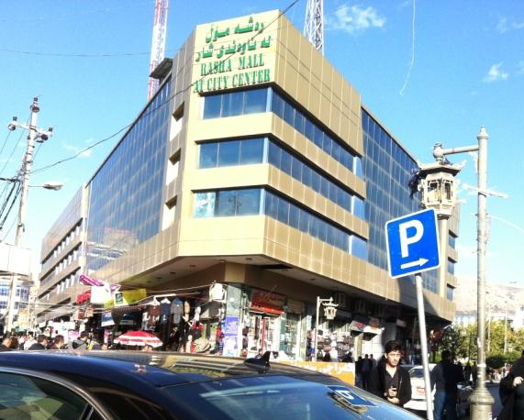b- 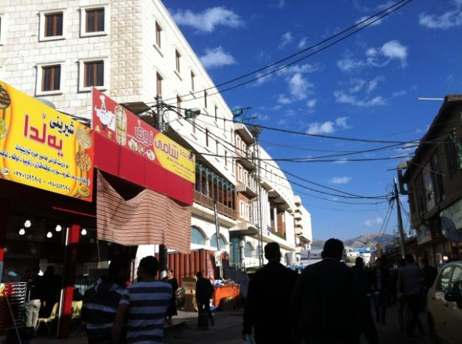
c-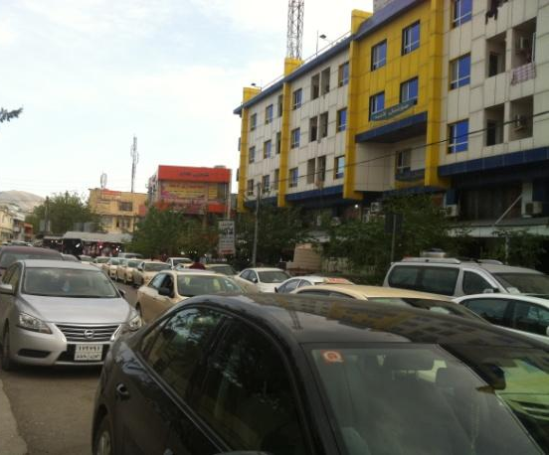 d-
- The commercial building in the Kaneskan neighbourhood, which is located on one of the main streets’ of the neighbourhood and in the bazaar.
- The commercial building in the Shexan neighbourhood, which is located on one of the main streets’ of the neighbourhood and in the bazaar.
- , d- Commercial buildings in the main streets of the city centre
Figure 6.1 the commercial buildings in the main streets of the city centre neighbourhoods, 2014 (Source: is taken by the author).

6.2.1. Inconsistent commercial building styles
Today the main bazaar is widened to the whole city centre and is even reaching the heart of the neighbourhoods (see Figure 6.1, 6.2, 6.3). For instance, respondents believe there are changes in today’s commercial uses, recognising the increase of commercial properties and more shops: “new bazaars have been built near us and in every corner as well, people in this neighbourhood, and especially those possess properties on the main streets demolish them and build markets and apartments. All the old bazaars such as Naqib, Salahadin, and Orzdi are all changed” (Female in her 50th, Malkane, 2014). They think supermarkets are everywhere, and even inside neighbourhoods:
“There are small markets and apartments beside us inside the neighbourhood, and many stores on the ground floor of the newly rebuilt houses. People rebuilt new houses and turn the ground floor into a supermarket or rent it for a store. They get a changing application for turning the garage into a supermarket inside residential neighbourhoods” (Female in her 60th, Malkane, 2014), and

“In Sarshaqam, commercial buildings are spreading around us. New buildings are appearing in everywhere, even in our neighbourhood narrow roads, are selling all stuff” (Male, 21, Local resident, Sarshaqam, Focus groups, 2014).

This was even more defined during the visit of the site, where the spread of commercial properties was observed, especially as they reached towards the heart of the neighbourhoods of Malkane. There are currently apartments and stores being built and houses turned into stores. This is shown in Figure 6.2.

a-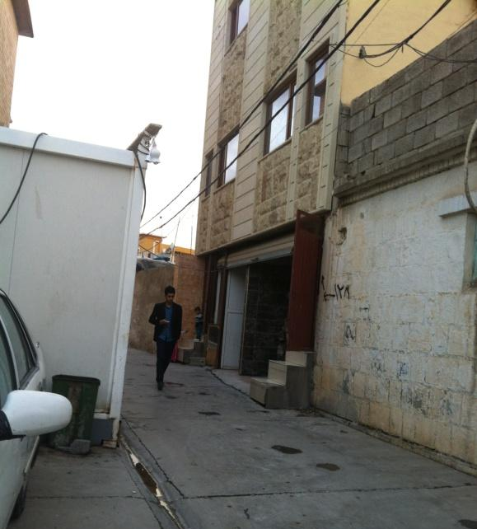b- 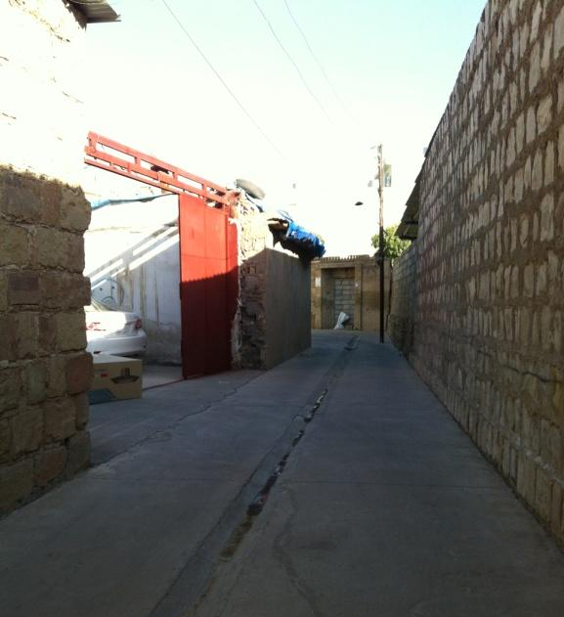
c-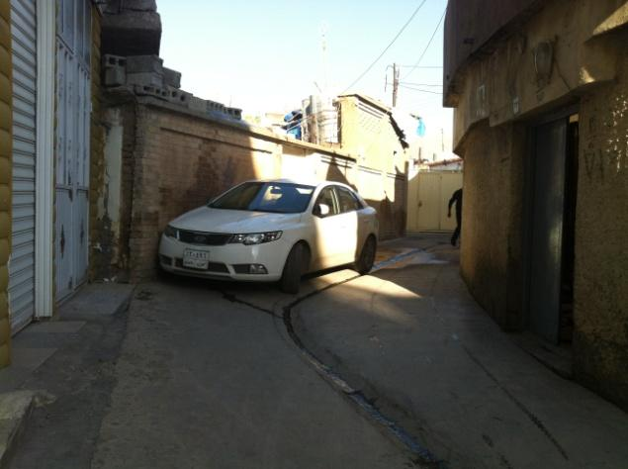d- 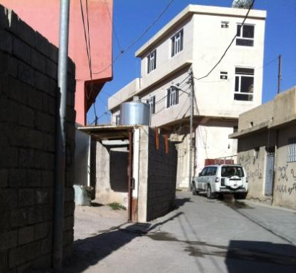
- The ground floor of a new commercial flat in Sabwnkaran, which is a store. The owner rents it to the retailer in the big bazaar, and consequently, the goods will be saved and served as an extension to the retailers in the main roads.
- The site of a demolished old house in Sarshaqam, which has been turned into a big garage for storing goods and selling goods to retailers in the big bazaar.
- Stores in the Kaneaskan neighbourhood, where goods are saved and served in a big bazaar.
- The photo is taken in Sarshaqam neighbourhood, which shows a demolished house that has been turned into a car park for a big bazaar, and the ground floor of the flats that have been turned into retail and supermarkets.
Figure 6.2 The figure shows the usage of the site of the old houses as a marketplace that serves a big bazaar and contributes to the spread of bazaar towards the heart of the neighbourhoods.
a-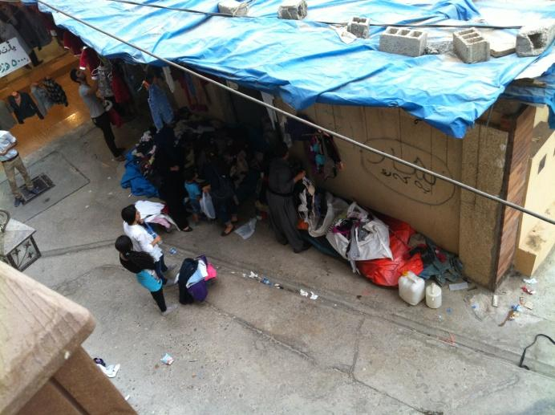b-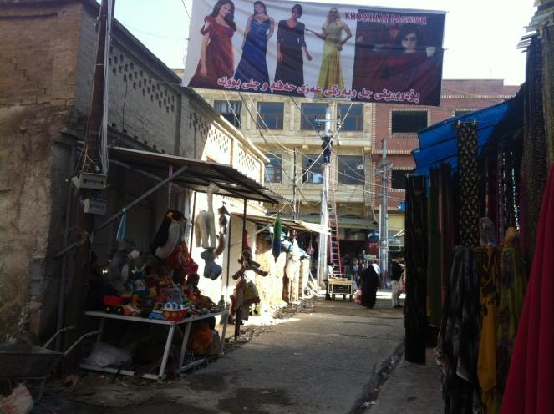
- A house in Shexan neighbourhood, which has turned into retail for selling second-hand goods.

- The front side of the houses in Shexan neighbourhood, which are used by owners or vendors as a selling market due to the spread of the big bazaar to the residential narrow roads. The consequences of the use of the roads for commercial use, due to the increasing number of retailers and commercial building, were discussed in the interviews with officials and will be discussed in further detail in the sections regarding the regulation policy of the neighbourhood.
Figure 6.3 the spread of bazaar has reached into the heart of the neighbourhoods of the city centre.

The responses indicated that the emergence of increased commercialisation, apart from being as a result of the local community’s action, is also part of the local government’s plan in the area, which shows conflict between residents and local government: “in these days Sulaimaniyah Municipality is building a big Family Mall in this old district, they seems planned for step by step commercialising the neighbourhood” (Male, 23, Local resident, Jwlakan, Focus groups, 2014).
In addition to local residents’ action in response to the urban change, where they have demolished or sold their properties, (See: Chapter. 5), an increased prevalence of decline and disruption was also observed during the site visit. For those who accepting the change, disruption to the sense of the historic environment of the neighbourhood, was found to be related to the lack of appreciating the value of historic built environment of the neighbourhood by residents (see: Chapter 5); or, due to the failure of government managing urban planning regulations in the neighbourhood (see: Chapter 5, and will be more discussed in Chapter 7). For instance, there was an increased amount of construction taking place that did not follow conservation planning regulation for the area, where the facade of buildings were inconsistent with the character of the area (see: Figure 6.4), or which used western classical elements that were not directly relevant to the area ( see: Figure 5.4). This activity not allowed according to the conservation planning regulations: any constructions in the historic city centre should follow the traditional facade of the neighbourhood, such as using bricks and traditional elements such as arches (City Centre Guide Line, 2010, Sulaimaniyah Municipality, December 2014). The original material of the traditional shops and commercial properties are Malkane stone and mud bricks, and for this purpose see (Figure 6.5). This construction activity shows the interruption of the traditional pattern of the neighbourhood and reveals a disrupted sense of place as a form of response to the urban change in the area. Semes’s point of view about the sense of place is that historic districts usually contain buildings with different styles that create continuity over time, rather than contrast and disruption. This is achieved by following an approach to design that reflects the sense of the specific place, as it is this continuity over time that is crucial to maintaining the character of historic districts. (Semes, 2006, pp.18-21).
For Semes, buildings that are designed in the modern style would not be appropriate for historic environments. Any buildings that select “classical” elements that are not directly relevant to the district in which they are located are not used to create continuity of character. According to Semes, there are examples of using classical elements that do not belong to the district, among some houses built in Society Hill in the 1950s and 1960s. In the context of this study, the interviewee addressed this issue: “a lot of buildings in different styles and materials have been built on the site of demolished old buildings, such as Caso mall which is recently been built in a site of Citizenship office” (Female, 40s, Local resident, Interview, Sabwnkaran, 2014). Caso mall is made entirely of glass and alucobond with no variations, no brick or stone (see: Figure 6.4). However, when the respondents talked about the appearance of new buildings, they were still living with the memory of the demolished buildings and used them to define places identity (will be explained in the following chapter).

a-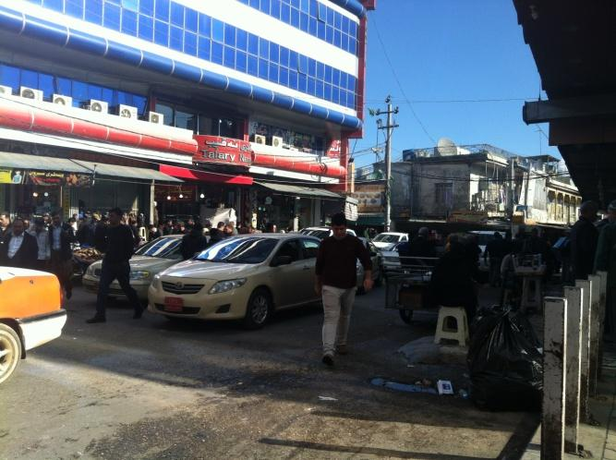b-
- Naqib Bazaar in the middle of the neighbourhoods with an alcobond facade.
- Several commercial buildings in Kawa street (bazaar) with alcobond and different elements from the traditional building elements in the place (in right side of the photo: building with a different style element).
Figure 6.4 shows the commercial buildings in the centre of the neighbourhoods (bazaar) with different new building construction from the traditional place.
a-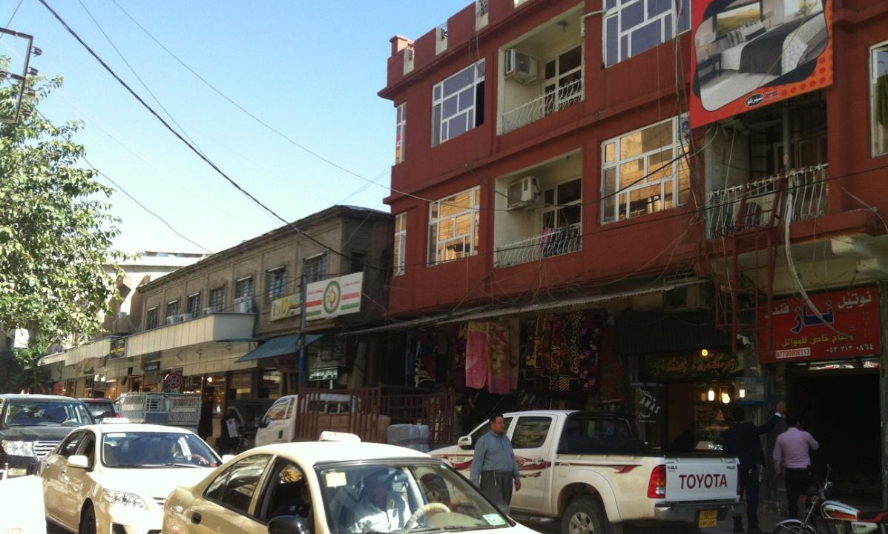

b-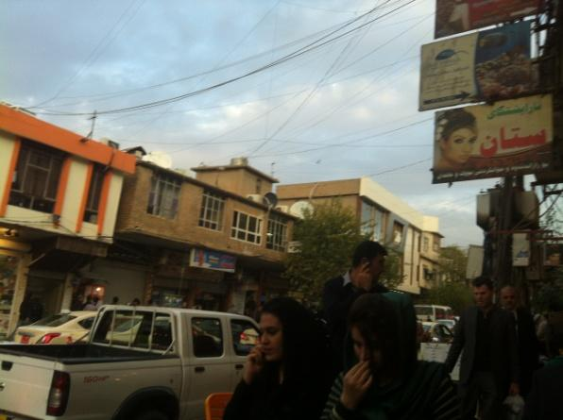
- , b- Two buildings one is still standing with its traditional style and another one is built with a different facade in Kawa Steet and Goran street.
Figure 6.5 Shows the new and old commercial buildings together.

This process of rebuilding, according to the residents’ responses, produced an area with an irregular change in the built environment. The rebuilding of demolished properties together with still standing deteriorated properties (those that are owned by one with a limited financial income) interrupts the sense of place as a sense of continuity. The change abandoned the deteriorated old buildings, except the construction of new extra commercial buildings and increased the number of businesses, offices, and clinics. It also included repairing old retail, decorating the interior of buildings with new technologies and new building materials. This has been expressed by interviewees as unregulated development:

“ I do not see a proper and planned change in the area, except some decoration and new constructed commercial buildings, for instance in Sabwnkaran roads, many retailers were selling Klashs and traditional stuff, all together but now there are newly rebuilt buildings, markets standing in the road with these buildings” (Male, 60, Malkane, Interview, Local resident, 2014)

Thus, the appearance of commercial buildings and retail in the process of the neighbourhood change is illustrated on the main arteries and linked with a big bazaar of Sulaimaniyah city. The new buildings are built on the site of demolished historic non-listed houses. However, this covers the heart of neighbourhoods, where demolished properties widened the narrow roads and consequently, joined on to the big bazaar. Commercial buildings and car parks were developed as properties were demolished and linked together, which widened the narrow roads and this impacted the production of main streets and consequently commercialised them (see: Chapter 5). The use of empty land on the site of demolished properties as car parking was mentioned by almost all the respondents and the photos show that as evidence. The use of the ground floor of new buildings in the residential neighbourhoods is also a feature of neighbourhood change and the ensuing commercialisation of the neighbourhood. The change in terms of the spread of commercial buildings and car parking is more considered than the change of the whole bazaar, which is dominated by merchants and owners. However, the area has become mixed with rebuilding, where deteriorated buildings are abandoned due to financial reasons. The future of the area is in the hands of the private owners and merchants, which shows the lack of conservation practice. The actions of local residents to the process of the change suggest that the change seems inconsistent with the traditional pattern of the neighbourhood and has interrupted the sense of continuity of the historic built environment. The management of the neighbourhood change also raises a question about the government management plan for the area, which will be discussed in more detailed in the following sections.

6. 2. 2 Rebuilding the vacant sites with inconsistent style of houses
Residents who accepted the neighbourhood change and chose to remain living in the neighbourhood started to rebuild their properties with new styles different to the old and historic fabric of the neighbourhood. There are constructions, regarding rebuilding houses in the neighbourhood on the site of the demolished, which I have observed during the fieldwork. The figures show evidence of buildings with new styles that local residents have built on the site of demolished poor condition properties. See Figure 6.6, which shows newly constructed houses and inconsistent building construction materials when compared to the old fabric of the neighbourhood. The use of new products for the construction of houses can be seen almost everywhere in the neighbourhoods of the city centre (see Figure 6.7).
A respondent explained how he demolished his house and rebuilt it with a new style (to see his house see Figure 6.7, and said “this neighbourhood is fortune for me, is close to bazaar and to my own shop, that is why I rebuilt it just like any new modern house in the city that satisfied me and my family” (Male, 35, Sabwnkaran district, August 2015). This showed the case of a supportive action that resident show in acceptance of the neighbourhood change and in favour of the ensuing economic opportunity to the area as a result of the change.

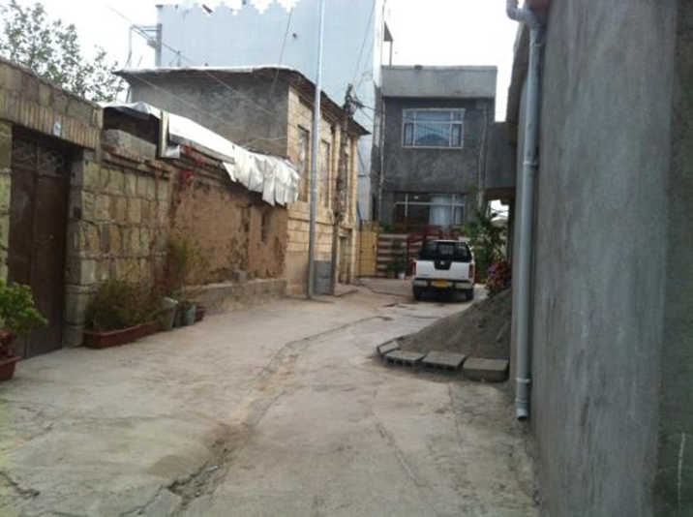
Figure 6.6 shows several new constructed houses in the cul-de-sac in Malkane.
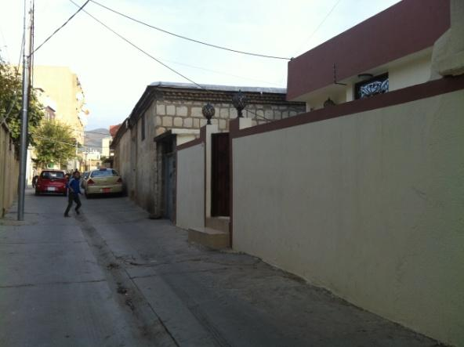
- The new style of house in Sabwnkaran neighbourhood that attached to an old house with stone, brick and wood.
Figure 6.7 shows the new style of houses that have replaced the deteriorated buildings. This house was built on a site of a demolished old house with new building construction materials.

6.2.3 Emergence of car parking
The form of local resident’s action in the process of urban change focused on the production of vacant lands that resulted from the demolition of listed and non-listed buildings and which were used mainly for irregular car parking. Figure (6.8) shows the vacant lands that private owners produced in an opportunistic way to capture demand for parking from the active bazaar in the neighbourhood. This shows a lack of value for the historic built environment. During the fieldwork, respondents mentioned about uncountable vacant lands, where local owners have demolished their properties and turned them into irregular car parking: “this neighbourhood contained historic houses, but now you can see empty lands everywhere full of cars, markets, and apartments. They do not care about this historic neighbourhood” (Male, 25, Sarshaqam, Local resident, Interview, 2014). An example of a resident who produced vacant land for a car park mentioned “my anti demolished her house, but she couldn’t rebuild it right away, that is why she turned into a car park” (Female, 24, Local resident of Shexan neighbourhood, interview 2014). Sometimes, the properties are abandoned to become a site of litter collection and anti-social behaviours “the listed houses are abandoned and now they are a place of dirt, rubbish bin and doing bad behaves by strangers (Male 20, Focus group 3, Sarshaqam).

a-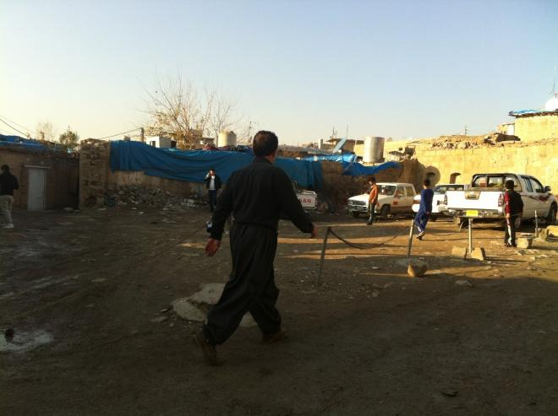b-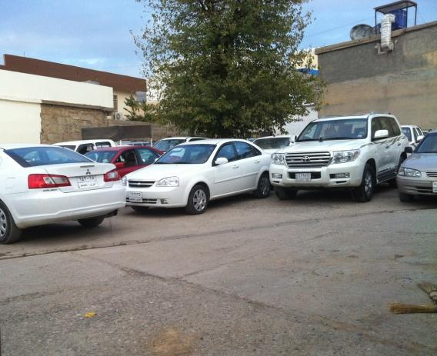
c-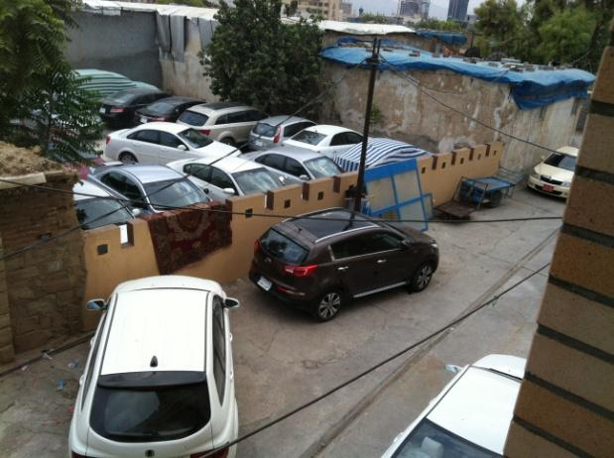d-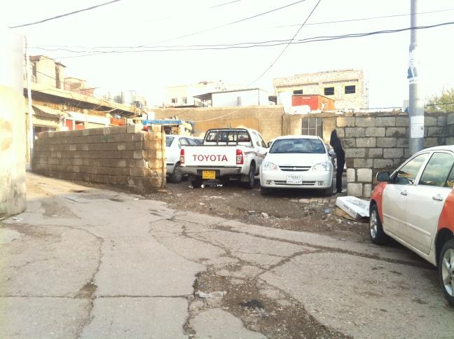
- A demolished house that is used as a car park in the Kaneaskan neighbourhood.
- The site of a demolished house that is used for a car parking in Malkane neighbourhood
- The demolished house replaced with an irregular car park in Shexan neighbourhood
- The demolished site turned into a vacant land and is used as a car park in Malkane neighbourhood.
Figure 6.8 shows the irregular car parks in the neighbourhoods of the city centre as are resulted from demolished old buildings in the area.

Thus, the actions of local residents who demolished their properties by any process (e.g. selling and purchasing them by merchant: see Chapter 5) produced a decline to the historic built environment, which had negative impacts on other residents. The role of government managing the neighbourhood and the role of residents in their lack of value are therefore factors behind the process of urban change.

6.3 The actions of local residents in both acceptance and opposition to the urban change
The rebuilding of houses in an inconsistent style to that of the historic built environment on the site of demolished historic non-listed houses and using new materials reflects another inconsistent action to the sense of continuity of the historic environment of the neighbourhood. Any alterations regarding the maintenance of the listed and historic and non-listed houses in the neighbourhood using new technologies sped up the decline in the area. This action responded to the on-going urban change, which itself included active building construction of commercial properties and land use change of the city centre. Through this process, local private owners’ responsibilities for maintaining their poor or traditional style of the houses, or choosing to rebuild their houses with their own choice. However, the lack of heritage value, and consequently, the lack of management, was a key concern of this urban change (see: Chapter 5, and Chapter 7) and left residents with no choice except to engage in supportive action to change the area. The depth analysis of semi-structured interviews, photos of the area and the observation during the fieldwork visit provide an analytical discussion in terms of the intervention action to the old fabric of the historic neighbourhood.

6.3.1 Embarking alteration with new technologies
Residents who were in acceptance and opposition to the change supported the change. Those who saw the change as a threat to the historic built environment had no choice but to be involved in a supportive attitude to the neighbourhood change. This was due to the lack of regulation and planning management and the provision of financial resources supporting residents to protect the historic houses (see: Chapter 5 and Chapter 7). Houses were modified with concrete blocks and the facades were decorated with new products, for instance, see Figure no (6.9). The interview offers examples about this issue by discussing the rebuilding of homes with new technologies:

“Most of the mud houses replaced with concrete houses. We built two rooms in the courtyard of our house with concrete blocks and plastered with gypsum, but we still prefer spending our time in the old part” (Female, 23, a local resident of Shewe Qazi, 2014, Focus group).

The respondent realised that the differences of unmatched construction in the house produced sense of discontinuity inside the house, and especially after changing everything during several modifications: “we repaired our house many times and we changed its inside, we replaced the windows and doors with PVC” (Female in her 60^{s}, Malkane, 2014). The use of new building construction materials to maintain their old houses meant they had not been built according to the planning regulations of the neighbourhood. However, when I asked the residents how they were allowed to use PVC windows and doors, she said “no need to get permission for changing windows and doors, as the houses are quite old, and they turn down by themselves if we don’t do actions. However, we cannot rebuild it because of our financial situation” (Female in her 60^{s}, Malkane, 2014). Others believe: “our house is repaired several times, everything is changed in the house” (22, Female, local residents of Sabwnkaran), and “we painted our house, and blocked some windows, doors and opened one window in the kitchen” (20, female, Jwlakan, 2014). See Figure 6.10, 6.11 that shows the maintenance of the old houses with new building products.

a-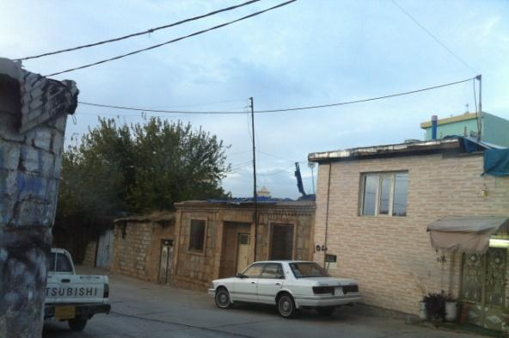
- The facade of an old house replaced with new material products, however, the roof is still wood.
Figure 6.9 shows house that attached to a historic house deteriorated with new building construction materials.

a-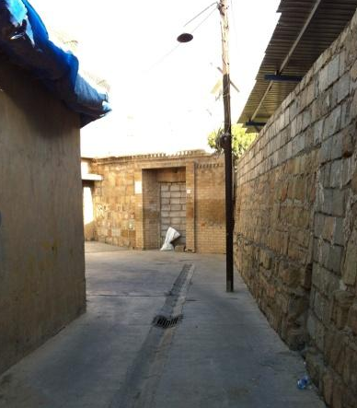
b-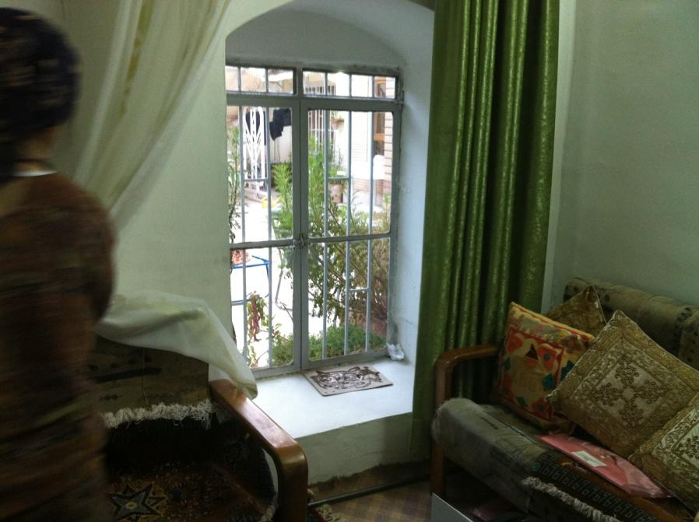
- The photo shows the blockage of the door in Sarshaqam neighbourhood.
- The finishing walls with a gypsum plaster and painting in Sabwnkaran

c-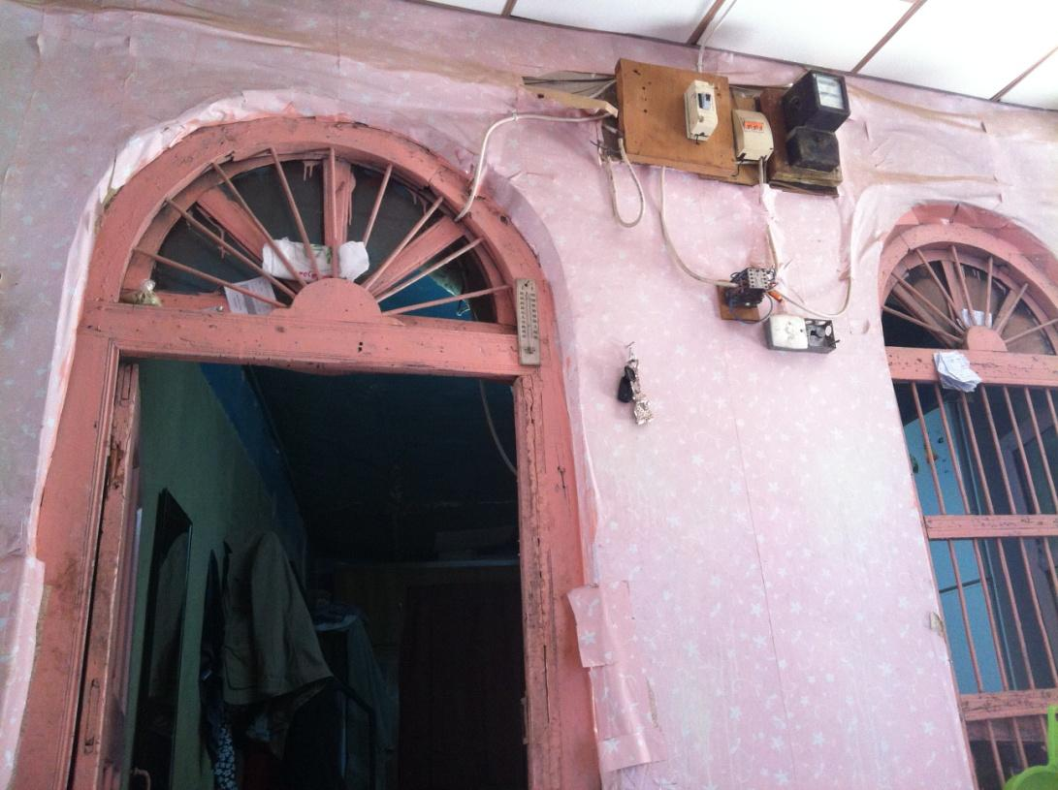
- The finishing with wallpaper and painting in the old house in Dargazen
Figure 6.10 Shows the old houses in the process of change and maintenance with a new product.

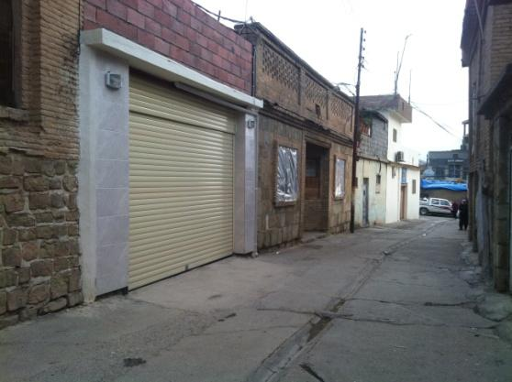
Figure 6.11 The house in Malkane shows the new product has been fixed into the structure of the old house.

The lack of financial support is a significant issue for the residents’ action: they depend on their financial sources to maintain the houses. The role of government managing the process of urban change in the neighbourhood is questionable, for instance, respondents talked about the failure of local government officials applying the conservation planning policy in the neighbourhood:

“The officer wrote it down on my house application, I should finish the house facade with brick or similar materials that illustrate the traditional style of the neighbourhood, after I informed them about my poor financial income. They allowed me to use any cheap finishing materials” (Male, 50, Sarshaqam, 2014).

There are houses that were built earlier and have not used anything that provides a sense of continuity to the old fabric of the area. A respondent complained that at the time when he rebuilt his house, no government officials talked about the building facade decoration needing to be similar to the historic houses of the area: “I wish someone in Sulaimaniyah Municipality asked me to decorate my house with brick, when I see some houses are built with brick, feel regret” (Male, 30, Sarshaqam, Local resident, Interview). See Figure 6.12, which shows the house of the respondent. This situation shows the role of government officials have in the process of built environment change, as it is shown that the municipal officers showed kindness and support in the process of the housing application.

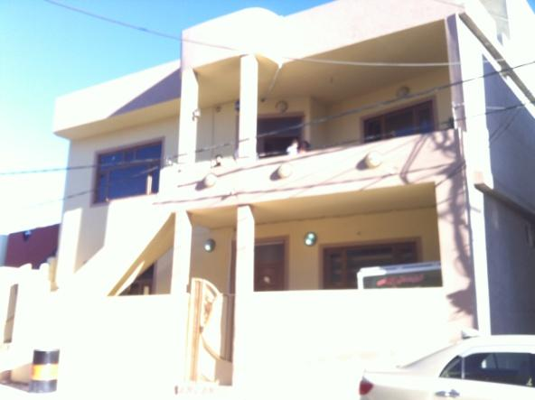
Figure 6.12 the new style of house in Sarshaqam neighbourhood, the owner said: “nobody informed me to use a similar facade to the historic houses” (Male, 30, Sarshaqam, 2014). The photo also shows a new house in the old neighbourhood of Sarshaqam without applying the planning regulations of Sarshaqam neighbourhood.

Thus, the building of new styles in the historic neighbourhood, and the interruption of the old fabric of the neighbourhood by modifying the houses with a new material, adds more decline and discontinuity to the sense of place. However, the change and the interruption of the old fabric require an examination of the governments’ management plan for the area (see: Chapter 7). The poor and dirty condition of the houses was a factor that pushed residences to use cheap materials to modify deteriorated houses and municipality officers made it easy for them. However, the state of residents’ financial status is an important factor affecting the demolition and rebuilding of historic and non-listed houses, as financial support by the government was not provided. This shows why some local residents choose to rebuild their houses and stay in the neighbourhood or others modify them (the transformation of the form of place attachment of local residents will be explained in Chapter 8). Based on the interviews, it is obvious that financial sources play a big role deciding residents’ choices. After all, this section serves the outline of local resident’s action/behaviour in response to the urban change, shows their conflict over conservation, and examines the impacts of the change on the heritage of the neighbourhood.

6.3.2 The blockage of narrow roads and its impact
The implications of the change on the physical built environment of the neighbourhood can be seen in the road layout. As the roads in the neighbourhood of the city centre are usually narrow with unregulated paths, and most are dead-end and cul-de-sacs. During the fieldwork, the blockage of roads was clear, particularly due to irregular car parking, apartments, offices and businesses that had widened the scheme of the neighbourhood and consequently brought crowds into the neighbourhood with associated car parking. A local resident of Shexan aged 24, explained the widening of her narrow road “our narrow road is widened, look at that vacant land, it was an old house, but the owner demolished” (Female, 24, a Local resident of Shexan neighbourhood, Interview, 2014). See Figure 6.14, to see the house that widened respondent’s narrow road.
This spread of commercial activities in the area created a blockage of narrow roads by bringing more crowds to the area, especially as they used the narrow roads for parking cars (see: Figure 6.13). The roads were busy due to the traffic of cars and passengers reaching the city centre and bazaar because properties had been demolished and used as car parks by owners (see Figure 6.14). Respondents spoke about the crowded situation of the neighbourhood, including the blockage of the roads of the area, “the roads are very narrow. They cannot accommodate today’s crowd” (Male, 21, Local resident, Sarshaqam, Focus group, 2014). He said there are some small car parks, which are empty lands but being used as car parking in the area, which blocked the passage of people.
In some parts of the neighbourhoods, the roads were intentionally blocked by the residents who were against the urban change, especially to prevent the parking of cars using their cul-de-sacs and roads (see Figure 6. 15, 6. 16). Roads were also blocked by building a concrete block wall to cut the passage of people and cars, or by producing a private path to the houses, “there was a very long narrow road was reaching us to the outdoor door, we thought we put an extra door and make it private space for my family. Now it is a corridor of our house” (Female, 30, Malkane, Local interview, 2014). Others responded against the change “we put some big stones front of our doors and blocked the cul-de-sac to avoid any car parking” (Male, 30, Malkane, 2014). Another respondent in her 50th said, “when we wake up, our cul-de-sac sometimes is getting occupied by cars, even sometimes there is no place for our car, people when come to bazaar park their car here because of crowd” (Female in her 50th,Malkane,2014).
The action of local residents widening the roads for car parking, and consequently blocking them, interrupted the irregular scheme of the roads that led to the disappearing sense of distinctiveness of the irregular pattern of the narrow roads in the neighbourhoods.

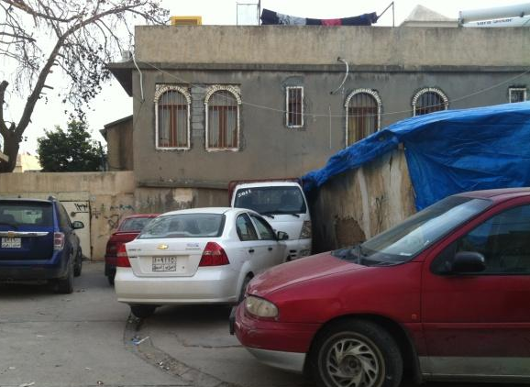
Figure 6.13 shows the blockage of the narrow roads by using the roads as a car parking.
a-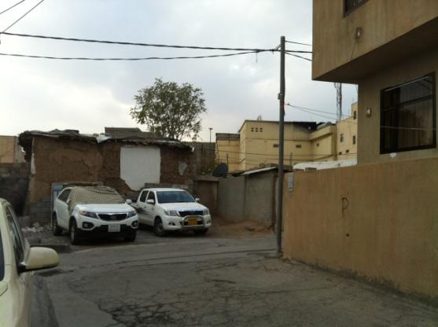b- 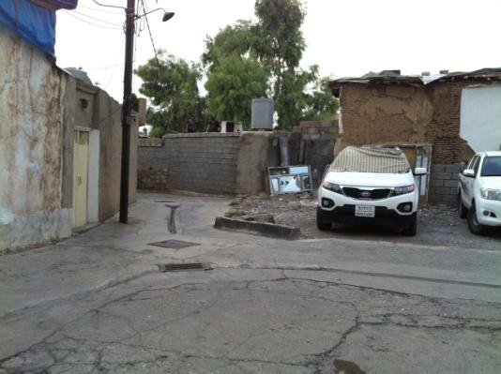
- Putting their goods outside in Shexan neighbourhood
- Keeping the goods outside in Sarshaqam neighbourhood.
Figure 6.14 shows the ruined scheme of narrow roads

a-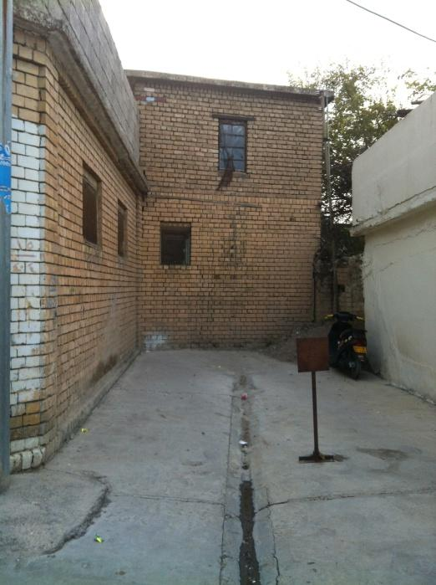b- 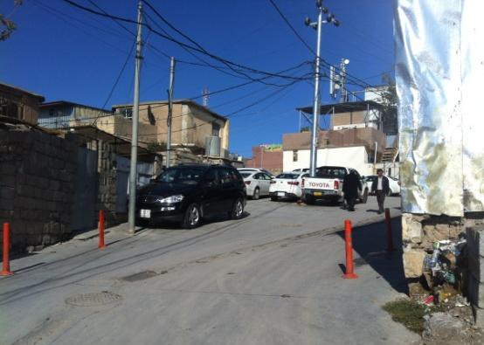
a, b- The owners fixed signs to avoid car parking front of their properties.
Figure 6.15 shows the blockage of the narrow roads by residents

a-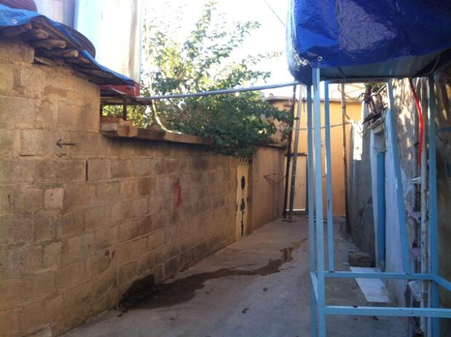 b-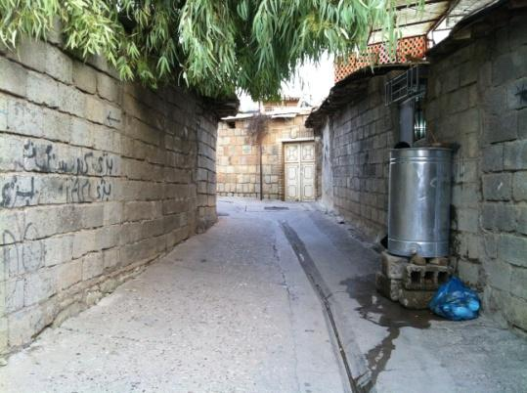
- Putting their goods outside in Sarshaqam neighbourhood
- Keeping the goods outside in Shexan neighbourhood.
Figure 6.16 shows the blockage of the narrow roads by residents, keeping their goods outside their home.

The actions of local residents have not been the only response to the urban change that has affected the historic built environment - government officials have participated in this action. For instance, the pattern of the narrow roads has been interrupted by Sulaimaniyah staff decision making. During my working experience in Sulaimaniyah municipality from 2006 until 2013 and by observing the staff of Technical Department, and based on the Sulaimaniyah Municipality City Centre Regulations Guideline map, I saw that some of the unregulated roads were reshaped and straightened in the new map of the area (Municipality city centre regulation guideline 2010-Renmae Nawande Shar). According to the guidelines, the new design of roads will be implemented when owners apply the application of house amendment, whether it is for demolition or for repairing the building (Interview with a Sulaimaniyah Municipality officer, 2010).
In summary, the demolition in the area by local residents has impacted on the scheme of the irregular roads and widened them for building irregular car parking. The roads are blocked by the consequences of the spread of the crowd and traffic jams in the area. In spite of the blockage of the roads by residents, the new map for straightening the roads was devised for the sake of providing more spaces for rebuilding applications for both residential and commercial uses. The municipality’s’ new schemes for the area also is evidence that the officials play a role in the process of urban change in the neighbourhood, for which there will be more detailed data in the next chapters. This shows conflicts in the actions towards the change of the neighbourhood and related to weak conservation practice.

6.4 Actions/behaviours of residents in opposition to the urban change
The loss of heritage affected residents that lived in the neighbourhood. The active residents who seek to protect the area have produced a web page (e.g.: Slemani Jaran: https://www.facebook.com/slemanyjaran; and Sulaimaniayah historic photos (Wena Konakane Slemani), where they post up to date photos of any demolition and changes in the area. They are encouraging local residents and the whole residents of Sulaimaniyah city, to support them in protecting historic houses from demolition. They also meet with government officials to try to influence their decision towards doing actions against demolition in the historic neighbourhood (Interview with the member of the page, February 2015). For instance, some investment companies maintained abandoned and deteriorated houses such as the house of famous Poet Peramerd
Moreover, listed houses are kept from demolition as residents try to prevent their neighbours selling their properties to merchants, “we went to my neighbour’s house when I heard he is selling his property to a merchant to purchase the house and kept it away from demolition and commercial uses with many floors” (Female, aged 42, Sabwnkaran district, August 2014). The house bought by a resident and according to her, the owner wanted to sell it to a merchant who buys properties to turn them into commercial buildings. Another respondent addressed the issue of her opposition towards the rebuilding of a commercial building (Najmadine Mala Building: see: Figure 6. 17) that blocked the view from her house, as:

“We (all members of my family) tried to make a merchant who built Najmadine Mala Building, to make him understand that the building of six-story blocks the view of the neighbourhood and our house, until he decided to paint some pictures of architecture elements on the back side of the building to give a better impression than the solid tall wall” (Female, aged 40, Sabwnkaran district, August 2014).

a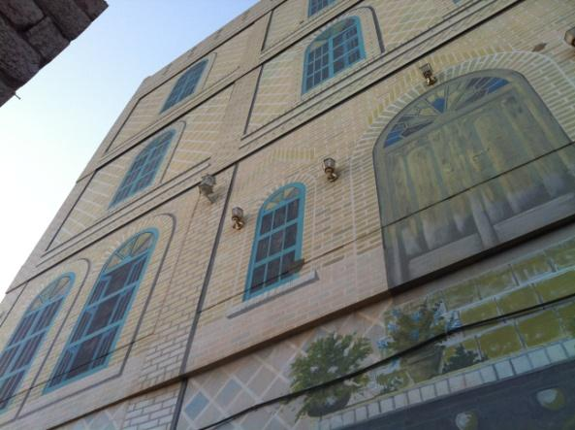 b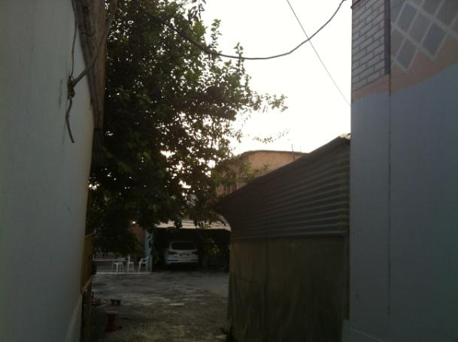
c 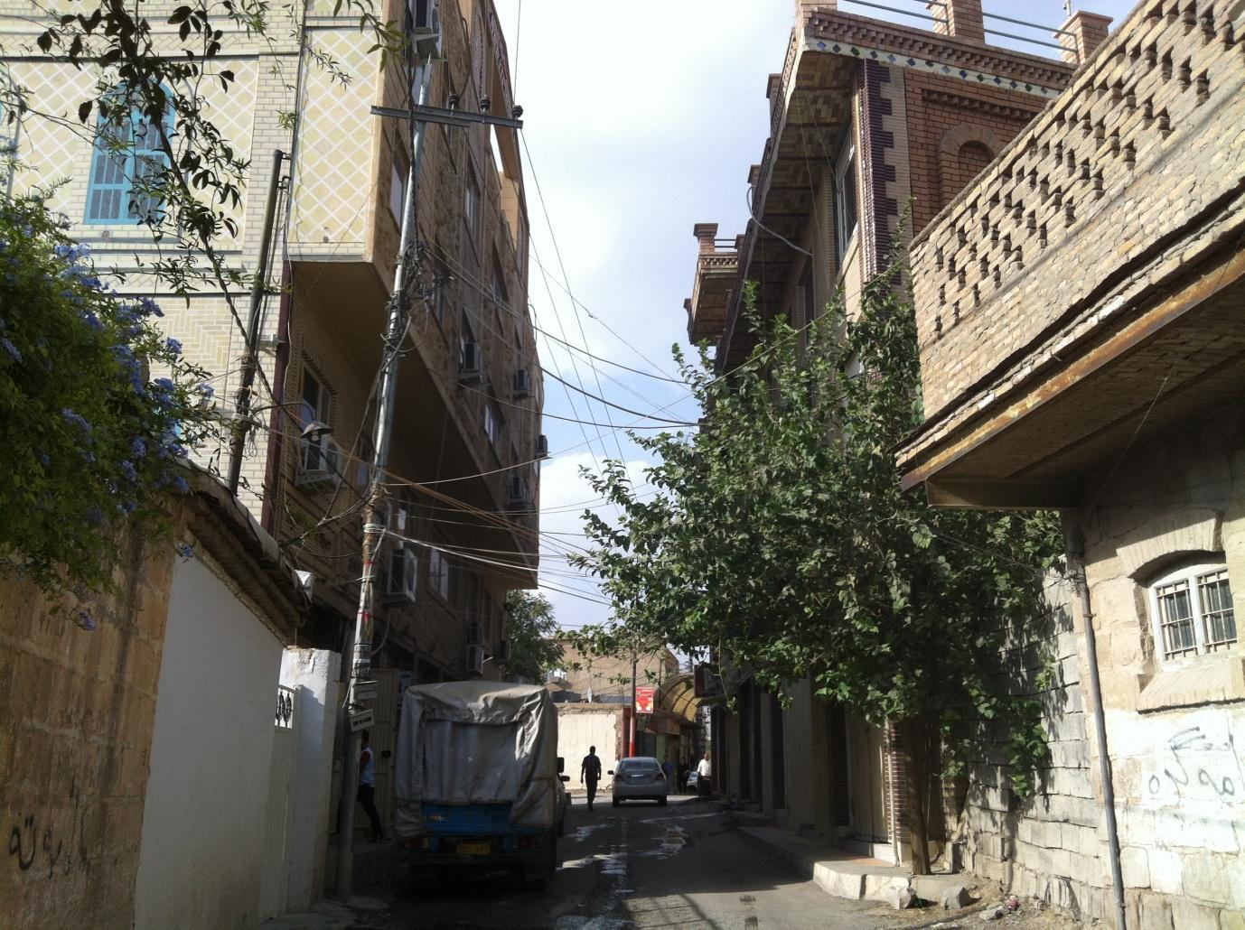
a- the courtyard and the corridor gate of the house that is attached to the Najmadin Mala buildings, as it has blocked the view of the courtyard
b- Side view of the building, which is inside the corridor of the resident’s house
c- Front view
Figure 6. 17 Najmadine Mala Building that blocked the view of the resident house.

Thus, the residents who were living in the neighbourhood are standing up against the urban change of the neighbourhood faced conflicts over the weak of conservation practice. They responded with their own action in a different sort of ways. However, they make an impact on officials and organising charity to renew the deteriorated historic houses in the neighbourhood.

6.7 Summary
This chapter showed the deeper understanding of the process of the change by relying on actions/ behaviours of local residents as showed conflicts due to the weak conservation practice. The spread of commercial buildings in the main arterials and even in the heart of the neighbourhoods by merchants and developers through demolition and the linking serial historic properties to widen the initial bazaar (see: Chapter 5) has had an effect on local residents. The weak conservation planning practice (e.g. financial sources) provided conflicts between residents and consequently influenced on the damage of heritage of the area. Therefore, the content of this chapter serves the outline of local resident’s action/behaviour in response to the urban change, shows their conflict over conservation, and examines the impacts of the change on the heritage of the neighbourhood.
Some local residents embarked on actions by demolishing their own non-listed historic houses and turning them into commercial buildings, car parks or rebuilding them in acceptance of the change for its economic opportunity. The residents’ action in acceptance and opposition to the neighbourhood change and decline resulted in the appearance of a new built environment and showed the impacts of urban change on the historic built environment in terms of loss and threat due to demolition and deterioration of the abandoned historic built environment.
The form of the change suggests actions of local residents related to negative attitudes and supportive behaviours of local residents who were in acceptance and opposition to the change. For those in opposition to the change, they have no choice except to engage with supportive action to the change (e.g.; alteration with inconsistent building materials to the historic built environment). The implications of these actions on the historic built environment have resulted in the inconsistent alteration to the historic environment of the neighbourhood, the blockage of the roads and the widening of the scheme of the area. However, the construction of commercial uses and the inconsistent style of the residential areas in the neighbourhood represent the actions of those who are in acceptance to the neighbourhood change.
Thus, this chapter makes a contribution to knowledge in relation to the impacts of the change on the historic built environment in the form of conflicts due to the weak conservation practice (is explained in the following Chapter) that allowed for actions/behaviours of local residents and their response in acceptance and opposition to the change.
Chapter 7: The limitations of urban conservation planning

7.1 Introduction
Earlier chapters showed that there are significant conflicts in the process of urban change and conservation in the central neighbourhood of Sulaimaniyah. This conflict resulted in the demolition of historic residential buildings and construction of poor quality commercial buildings. The new buildings had a significant impact on the historic built environment, culture and community, in several important respects. Given this situation, it is clear that urban management in the historic neighbourhood is problematic. Therefore, this chapter deals with urban conservation management by emphasising historic neighbourhood conservation guidelines and planning regulations relating to the historic neighbourhood of Sulaimaniyah city centre. As urban conservation management is becoming a contentious activity in the sense of contemporary global and local forces of production and consumption exert pressure on how the historic environments are to be redefined leading to a compromise in the conservation and cultural values of these places (Nasser, 2003). Therefore, urban conservation management associated with “a large number of players in a variety of roles, from a wide range of disciplines and backgrounds, and often with conflicting interests and agendas” (Orbasli, 2000:99). This conflict has been noted even in World Heritage Sites (WHS), as Pendlebury et al. noted this potential conflict: “all WHS have a particularly complex set of governance arrangements. We have noted the potential for conflict between the international regulatory bodies and local decision-makers” (Pendlebury et al., 2009, p.357). Participatory deliberations and relationship are required between decision makers and those at the receiving end of needed change (Healey, 1998; Hunter, 2015). This is for an effective management which according to Lichfield (1988:38) “taking conscious decisions with an eye to the future about on-going operations or the use of assets, or both in combination within a structured organisation”. This decision-making emerges from those in key management roles with activities that are constrained by access to finance, legislative frameworks and the overlapping relationship between national, state and local government.
This chapter aims to examine the role of stakeholders in the decision-making process of the management of the historic Sulaimaniyah city to identify why conservation management is increasing conflictual; however, conflicts are an inevitable part of any stakeholder relationship. This is based on differential powers of decision making amongst stakeholders, access to finance and political interference associated with stakeholder conflicts in the conservation management of Sulaimaniyah historic centre. Therefore, this chapter identifies issues brought about by the lack of the historic environment management. In doing so, this chapter is intended to provide a detailed understanding of historic neighbourhood management in Sulaimaniyah. It also aims to answer the research question about the lack of planning policy in a historic urban centre and the challenges and opportunities for local planning:
- What factors have influenced planning regulation relating to urban change in Sulaimaniyah’s historic centre? And, following this, what have been the strengths and limitations of those approaches?
- What might be done to address concerns arising from the study of the impact of urban change on Sulaimaniyah residents in terms of processes and policies?
To respond to these questions, a qualitative methodology combining participant observation, document analysis, photography, focus groups and in-depth interviews were used (See: Chapter 4). Ten interviews were conducted with local officials, who are in charge of the management in the case study area, and forty interviews were conducted with residents of the neighbourhood. To achieve the aims outlined above, the next section of the chapter deals with the evaluation of the existence conservation management in the neighbourhood. The third section introduces the overview and assessment of the management of the historic neighbourhood. The following sections introduce the attitudes of local residents and officials about urban management of the historic neighbourhood. The chapter concludes with a summary and reflection on key messages emerging. Finally, such a study can also enhance our understanding of historic built environment conflicts in other parts of the world.

7.2 The historic environment conservation management
Based on reviewed literature (see: Chapter 2) stakeholders notwithstanding their differing vested interests do realise that conserving historic environments increases value to these places (Baarveld et al., 2013). However, for conserving the historic environments, it is important to define what is to be preserved. Zancheti and Hidaka (2011) addresses that heritage is made up of objects and their attributes and processes that people place value on. According to them, it is those that society perceives to be significant and so are passed on from one generation to the next. however, this can be achieved when that certain urban cultural heritage through a long collective process gain significance and worth. Given that the issue of ownership exist when it comes to tangible physical aspects of urban cultural heritage – e.g. buildings– can be in private ownership, while the intangible aspects in the sense of the history of buildings and places can only be owned by the local community. This local community ownership of the history of heritage is gained through communal attachment and belonging (Orbasli, 2000). There is, however, the issue of appreciation of communally owned urban cultural heritage assets for private gain. This is why planning is increasingly becoming crucial in historic conservation and management activities. Based on this, conservation is “the careful planning and management of limited and selected resources. It is a conscious process to control and manipulate change to a minimum – to ensures the survival of heritage over a long time” (Fethi, 1993:161 as quoted in Orbasli, 2000:17). Therefore, the importance of planning in ensuring effective conservation management practices cannot be overemphasised given the heterogeneous nature of stakeholders involved in the process. Furthermore, Orbasli (2000) defined dimensions of urban conservation which are; the physical dimension associated with building conservation, the spatial dimension linked to the relationship between place and space – i.e. relationship between spaces and their use – and the social dimension which linked to local community and the urban population. However, there are overlaps in the responsibilities of key actors and stakeholders who have to undertake work in a given dimension that requires managing stakeholder interactions through collaboration and coordination of activities. This is especially so in this context of lack of financial resources and power among stakeholders.
To do this, managing stakeholder interactions needs to define who stakeholders are so that none is overlooked in the process of conservation and management. Freeman (1984:46) identified a stakeholder as being “any group or individual who can affect and is affected by the achievement of the organisations objectives”. In this context, stakeholders involve all state and nono-state organisations as well as local residents and community groups who are influenced by the decisions of the state and non-state organisations. In urban conservation management although not all stakeholders can be equally involved it is crucial for the leading organisation to define and understand the interests of all stakeholders (Donaldson and Preston, 1995).
Conflicts arise in any conservation management especially when conflicts between professional advice and commercial pressures exists. Effective stakeholder collaboration and interactions are needed to manage and reduce conflicts and misunderstanding between stakeholders. Inadequate institutional collaboration can lead to divisions between stakeholders (Adu-Ampong, 2014). Effective stakeholder interactions and collaboration require a joint formulation of objectives for a shared vision of future goals. A lack of a shared vision between stakeholders with regard to the form and nature of urban conservation will result in conflict, mistrust, and misunderstanding between key stakeholders. It is within this context that historic Sulaimaniyah city centre is analysed.
In this context, in spite of the existence of planning regulations and guidelines for the management of the historic Sulaimaniyah city centre, illegal activities and special dispensations for building and demolition have accelerated the demolition and deterioration of the historic built environment in the neighbourhood. Local owners and developers who start business projects on a small scale as stakeholders have also enhanced the process. In Sulaimaniyah, developers and owners of heritage properties changed the historic built environment through new construction for commerce to get profits, such as markets, hotels, restaurants but without cooperation from the government. Therefore, the historic built environment is not only influenced by decision-makers, it also under the influence of local residents as internal actors due to the lack of management in the historic environment of Sulaimaniyah city centre.
Local residents are in favour of cheap concrete materials compared to the high cost of materials consistent with the old fabric of the neighbourhood. They also want to adapt to a modern lifestyle by changing the historic fabric of the neighbourhood. This has resulted in many local residents moving out of the neighbourhood, especially those who do not take part in the process of built environment change. However, urban conservation in most European countries involves consultation between private and public sectors and public awareness that allows participation in urban conservation. In this context, local owners of the historic built environments and developers tend to respect heritage. The limited resource of government for urban conservation in Sulaimaniyah impacts on the management and conservation plans of the neighbourhood. This is because governments at various levels provide funding and put money into protecting the historic environments. This process varies considerably across the world in different national contexts. In the UK, for instance, governments’ responsibility for elements of heritage in East Devon is the responsibility of East Devon District Council for the planning regulations and provides funding for maintenance of the list of historic buildings. It also responsible for and supports museums. Whereas Devon County Council makes strategic policies which define which parts of the county are to be designated as a Conservation Areas and which are to be developed, or in governments responsibility in rural England is the support of Parish Council for maintaining the village green and footpaths. The County Council also helps church building and gives a grant to the History Society (Ashworth and Howard, 1999, p.18). This formal, multi-tiered process differs quite considerably from the Sulaimaniyah context, where regulation and governance are much weaker. In addition, political interventions and corruption in the management of the neighbourhood in Sulaimaniyah enhanced the process of damage to the historic neighbourhood as well. For instance, commercialization of the neighbourhood and demand for cheap building construction materials disrupted the consistency of the old fabric of the neighbourhood.

7.3 The historic environment management in Sulaimaniyah city centre
Today the neighbourhood is under a preservation order owing to its historic listed buildings. However, its urban structures are under the process of destruction, but the remaining structures and layout still represent a historically important area of Sulaimaniyah. It still keeps the integration of historic fabric, and its narrow road systems and layouts can still exist. At present, 106 listed buildings are banned from demolition or alteration and other physical structures in the neighbourhood such as historic non-listed buildings are under special planning regulations (City Centre Guideline).
These guidelines provide regulation for any new building construction in the neighbourhood on the site of demolished historic non-listed buildings. Of the 106 listed buildings, 17 are under the ownership of the Directorate of Sulaimaniyah Antiquity, and fewer still (2 or 3) are in the process of restoration (Interview with Head of Sulaimaniyah Antiquity Directorate, December 2014). The other 89 listed buildings are empty or still have residents living in them, but remain under the threat of demolition. This situation is also associated with the lack of awareness about the value of the historic environment and lack of respect given to the historic environment of the neighbourhood. It is related to actions of residents in favour of economic opportunity in the neighbourhood as is still exists as a main commercial centre in Sulaimaniyah. It also contributes towards commercial development as local owners and private business developers take advantage of the economic benefits of the neighbourhood through development projects (see Chapter 5).
The limited effort of conservation projects is only focused on the architectural restoration without revitalisation of the whole environment and infrastructural improvements. Local communities, social and cultural integration and even tourism of urban conservation are ignored with respect to their impact on the residents of the neighbourhood. This was established during the fieldwork based on interviews and official institutional reports. For instance, there is only physical restoration by Sulaimaniyah Directorate of Antiquity and revitalization project of Sara Square by the Directorate of Sulaimaniyah Municipality, which is still in process. Besides that, in relation to planning regulations, The City Centre Guidelines for new development in the historic neighbourhood exists for new construction only. However, in the case of any alteration in listed buildings by their owners, there are no proper guidelines for maintenance of the listed buildings. By contrast, non-listed buildings are allowed for demolition or alterations as long as the new construction is consistent with the old fabric of the historic neighbourhood based on planning regulations currently in place (City Centre Guideline Report, 2010). However, new construction with inconsistent architectural styles exists in the neighbourhood.
The situation described above is not helped by the fragmented management structures currently in place. The management of the neighbourhood is not under the responsibility of one specific office. The Directorate of Sulaimaniyah Municipality-Technical Department is responsible for approving any planning applications in the area for demolition and new constructions in the neighbourhood, while the Directorate of Sulaimaniyah Antiquity deals with the conservation project of listed buildings. Recently 17 of the listed houses were bought by the Directorate of Sulaimaniyah Antiquity as the listed buildings were in private ownership. The Directorate of Antiquity is renewing some of them depending on the limited budget that is provided by local Governorate of Sulaimaniyah (Head of Sulaimaniyah Directorate of Antiquity, Interview, 2014). An example of this can be seen in Figure 7.1, which shows the renewing of Hotel Farah-Barbaladyaka in the historic centre of Sulaimaniyah.
a-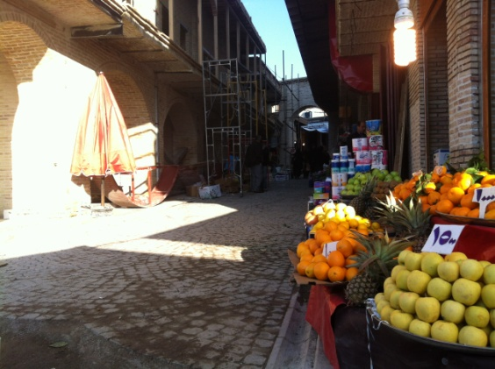b- 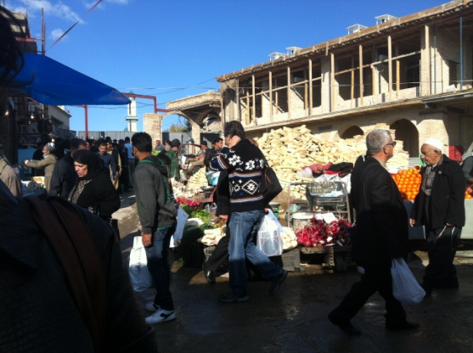
- The side views of the Hotel Farah.
- The front view of Hotel Farah.

Figure 7.1 Hotel Farah in the process of renewing.

In addition, the rest of the listed properties are giving urgent care, if it is needed. This situation emerged clearly during the fieldwork and was commented on by officials in charge of preserving the historic built environment in the city. For example, an official in the Directorate of Sulaimaniyah Antiquity commented that:
“…sometimes we find out that one of our listed buildings is under the threat of demolition whether it is due to ageing or inclement weather. In this case, we offer a quick care such as providing nylon sheet to cover the ceiling or finding a solution to provide a quick amendment for the buildings.”
(Restoration architect and official in Directorate of Sulaimaniyah Antiquity, December 2014).
He also commented that:
“Once, I got a call from the Head of our Directorate that Hotel Farah was under threat of demolition … when I arrived there … I saw one of the columns was bent due to ageing. What I did was fix the column”
(Restoration architect and official in Directorate of Sulaimaniyah Antiquity, December 2014).

7.3.1 Lack of conservation projects in the neighbourhood
Conservation projects by the Directorate of Sulaimaniyah Antiquity only consist of the restoration of listed buildings that are owned by them, as head of the Directorate of Antiquate stated: “we can only restore our properties” (Restoration architect and official in Directorate of Sulaimaniyah Antiquity, December 2014).
Therefore, the remaining listed buildings without restoration need urgent maintenance. Moreover, any new construction that takes place in the neighbourhood involves giving permission for planning applications for building commercial uses or residential uses on the site of demolished historic non-listed buildings in the neighbourhood. It also includes the permission planning application for demolition of the listed buildings that may be impossible for owners to keep preserve them from demolition or for those listed buildings that collapse accidentally due to ageing. This new construction in the neighbourhood is managed based on special planning regulations (City Centre Guideline Report, 2010) by the Directorate of Sulaimaniyah Municipality.
Besides these guidelines, a new and first step of the revitalization of the area was initiated in 2003 by the Directorate of Sulaimaniyah Municipality, which involved the revitalising of historic Sara Square. The project involves redesigning the square, including demolition and construction of new shops. New constructions in the project are supposed to be designed with consistency to the old fabric of the neighbourhood (Revitalisation of Bardarky Sarah Report-Submitted to Masterplan Department-Directorate of Sulaimaniyah Municipality, 2014). The project at the plan approval stage (Interview with Head of the Masterplan, 2014). This highlights the concern of local officials with only the historic built environment as based on the above reports of the project. That is, it only involves physical revitalization. However, in developed countries, urban revitalization is a much more comprehensive process, and deals with sustainable development issues such as the revitalisation of local community, economy, and culture along with the regeneration of the built environment (Ashworth and Howard, 1999).

The current state of historic built environment preservation in Sulaimaniyah, therefore, equates to two kinds of activity, as follow:
- Projects of restoring listed buildings by Directorate of Sulaimaniyah Antiquate

- Redevelopment projects by Directorate of Sulaimaniyah Municipality who manage the neighbourhood based on special planning regulations (City Centre Guidance) and any special revitalization projects by Sulaimaniyah Municipality-Supervision committee. Or redevelopment projects by Sulaimaniyah Governorate.

This shows separate plans for conservation of the neighbourhood based on various responsible agencies. However, the management of the historic environments around the world, especially in Europe, works by a defined conservation plan by local authorities. As the conservation system involves central governments, state governments, and finally local governments (Ashworth and Howard, 1999). Plan for historic conservation involves the development of the community by relying on conservation management plan. In Sulaimaniyah city, however, local institutions must initiate their own plans. For instance, the Directorate of Sulaimaniyah Municipality’s responsibility elaborated in a series of affords such as a future plan for the neighbourhood within the Sulaimaniyah Master plan. However, there is a lack of connection implementing their plans with other responsible government agencies such as Sulaimaniyah Directorate of Antiquity. Their plan involves physical restoration that also lacks proper guidelines for physical restoration. This has been noted during my interview with a restoration project engineer who emphasised on this:

“As a field engineer and architect for a restoration project I have many roles, as an architect to produce a plan for renewing the house. I also choose and purchase building construction materials that consist of the old fabric of the neighbourhood in the market. There is nothing prepared for restoration of the houses in advance”
(Restoration architect and official in Directorate of Sulaimaniyah Antiquity, December 2014).

Although, the physical restoration limits for few of listed buildings, but, other remaining listed buildings are insisted on to remain untouched in terms of any building construction alteration by private owners. As management of a heritage as a significant concern that “English Heritage believes that conservation is about managing not preventing change” (English Heritage, 2004, p.1).
Nevertheless, the value of the historic built environment of the neighbourhood is recognised, but there is a lack of proficiency in governmental agencies in the field of heritage conservation and management of the historic environments. I discovered that during my fieldwork study, depending on the content of author’s interviews with both officials and residents and the lack of guidelines and documentations about the historic neighbourhood. For instance, in the case of replacement of elements of listed- buildings, there are not specific guidelines set up by responsible agencies, or there is a lack of guidelines for restoration projects of the listed buildings. On the other hand, the value of historic built environment by local residents is not fully respected due to the value of economic opportunity of the neighbourhood. Besides that decision makers due t0 worse political and social stations are lenient with their responsibilities (will be discussed in more detail).

7.3.2 Policies regarding the protection of historic Sulaimaniyah city centre
The value of the historic environments was recognised since the international agreement to protect old neighbourhoods around the world which was signed in the united nations in 1972, and it was signed by Iraq as well (Sulaimaniyah Masterplan Department’s archive, 2006). However, during the Baath regime government due to political reasons, there have not been any efforts regarding conservation projects. Even political situation in the country reflected in the development of Sulaimaniyah city. For instance, the modification in the 1980s and Masterplan of 1957, which planned the city’s urban development in a structured pattern, and the plan restricted development of the city by 60-meter ring road as a political plan to avoid more developments of the city. Any development plans was not allowed, as this has been addressed by Former Head of Technical Department-Directorate of Sulaimaniyah Municipality:

“All the policies and regulations were made because of political reasons, which were directly made by Bath regime as a central government”
(Former Head of Technical department in Sulaimaniyah Municipality-last year).
After the establishment of the Kurdish Regional Government in 1991, and the fall of Saddam Hussein, the protection of the neighbourhoods was more recognised. For instance, in 1998 by order from Council of Ministers-Ministry of Municipality made a survey over the old neighbourhoods in Sulaimaniyah, and some other cities, these neighbourhoods were marked on a map and the map was approved by Council of Ministers at a meeting on March 29, 2000, by order no. 290 issued on April 9, 2000. Until then are some official decisions by Sulaimaniyah Administration Office regarding the protection of the old neighbourhoods were initiated. For instance, four memos were approved between 1998-2000 by Ministry of Municipality and Tourism and four memos by Ministry of Council between 1999-2000.
However, a plan for protection of city centre was initiated with the creation of an autonomous regional administration in Kurdistan. This is by one of development projects of the provincial capital Slaimaniyah that was a Master plan for the whole city in February 2006 (Slemani City Master-Plan- Final Report, Directorate of Sulaimaniyah Municipality, 2011). In the plan, recommendations and future developmental plans proposed to the historic city centre. Until then plans and projects for protecting the area elaborated in various ways by responsible institutions (will be discussed in the following sections). In spite of these, there has not been a serious effort for implementing conservation policies completely. According to Orbasli (2000), urban environments are not undertaken centrally, while the listing of historic buildings is seen as a heritage at the national level along with monuments and archaeological sites. The author addressed this issue in developing countries:

“For many overworked and underfunded heritage departments, historic buildings become a name on a protection list rather than a cause for action”
(Orbasli , 2000, p.102).

The lack of policy and management has been discovered during my fieldwork, based on interviews with officials and related documents. According to Slemani City Master-Plan- Final Report, 2011, many old buildings have been demolished, especially after, 2003, Sulaimaniyah‘s social and economic systems developed with concomitant rises in land and property prices. The resulting property redevelopment business led to the dismemberment of the historic city centre and buildings (Slemani City Master-Plan- Final Report, Directorate of Sulaimaniyah Municipality, 2011).
7.3.3 Organisations concerned with urban conservation of the neighbourhood
Today, three municipalities, comprising 54 neighbourhoods, manage Sulaimaniyah city. The historical Sulaimaniyah city centre (case study) is inside 60-meter ring road which is divided into 8 districts (Rename Nawandi Shar-City Centre Guideline Report, 2010), and led by Directorate of Sulaimaniyah Municipality. The management project of the restoration of listed buildings is led by Directorate of Antiquate. A number of departments within the Directorate of Sulaimaniyah Municipality are playing the main role in passing planning regulation for new projects in historic city centre such as Technical Department, Master plan Department, Municipality Council, Municipality Supervision committee and Directorate of Sulaimaniyah Antiquate.

In Sulaimaniyah the Ministry of Municipality and Tourism is more concerned about producing memos, consisting conservation of historic neighbourhoods. However, the local officials from Directorate of Sulaimaniyah Municipality have the power to make decisions regarding urban conservation work once it is funded by Governorate of Sulaimaniyah. As there is no specific organisation deal with historic built environment in the neighbourhood. In Europe, almost every historic city, there is a specific bureau working on urban heritage conservation. However, until now there has not been any serious effort to establish offices for heritage conservation. However, within Directorate of Sulaimaniyah Municipality, a department and several teams for dealing with a planning application in the historic city centre were created. Nawandi Shar (City Centre Team) was established, but failed to continue and ended up with closure.

Besides that, there is not enough connection among institutions that play role in management and doing projects in historic city centre. A member of Supervision Committee in Directorate of Sulaimaniyah Municipality addressed that:

“We do not work cooperatively. There is no one action agency to be responsible for management of required work. Water, electricity, telephone institutions are working separately without informing us”

(Member of Supervision Committee in Sulaimaniyah Municipality, December 2014).

For instance, Sulaimaniyah Directorate of Antiquate initiated restoration of listed buildings, and Sulaimaniyah Municipality has not involved in the project or revitalization project of Sara Square by Sulaimaniyah Municipality without involving Directorate of Sulaimaniyah Antiquate.

7.3.4 Finance
A financial system for funding heritage conservation in Sulaimaniyah has not yet been developed. There is no stable or specific funding supply for the conservation of the neighbourhood and funding for urban conservation has only been provided for the restoration of listed buildings. This fund is provided by Sulaimaniyah Governorate, which directly goes to the restoration of listed buildings by Sulaimaniyah Directorate of Antiquity. However, the whole neighbourhood is under a preservation order, but funding has only been provided for the listed buildings that belong to Sulaimaniyah Directorate of Antiquity’s properties. Besides that, the finance provided for listed buildings is limited to a few of the listed buildings that are under the Sulaimaniyah Directorates of Antiquity’s ownership. The role of national government in financing the historic environments is very important. Governments play a significant role in the maintenance of environmental and cultural heritage assets (Paszucha, 1995; Roders and van Oers, 2011). For example, Baarveld et al (2013:164) have noted, “the preservation of cultural-historical values has usually been financed by governments, often as an incentive for urban redevelopment projects.
Therefore, there have not been any plans regarding providing financial aid for households to restore their listed buildings, in spite of their deteriorated conditions. In the management of neighbourhood conservation, there is no system of bank loans, as in some countries around the world. For instance, in China, the management company, The Heritage Conservation and Management Committee (HCMC), which is the only conservation office in Lijiang, has the highest decision power on the management of the town. HCMC has cooperation with two banks offer loan for building restoration: China commercial bank and China Construction Bank, that lend money to the committee company of the HCMC every year which is the only office that responsible for urban conservation management in the town of Lijiang (Li, F. and Y. Shao. 2005 ).
Whereas limited effort has been made by local media and local residents to keep the neighbourhood from demolition and even provide finance for restoration, but these efforts have been very limited. For instance, until so far one company in Sulaimaniyah sponsored the restoration of one historic house in the neighbourhood. In the area, the private financial resources include funds from real estate developers and homeowners. Real estate developers make arrangements with house owners and buy their property to get profit return, and rebuilt it with new constructions. The private fund is also provided by homeowners who mostly demolish their houses and rebuilt it with a new style of residence. However, new construction is inconsistent with the old fabric of the neighbourhood. This has been demonstrated based on the photographic evidence presented in previous chapters. In the fieldwork, one of the respondents contributed her own money for restoration; however, the restoration was combined with new building construction materials so the restoration was not consistent with the historic build environment.
From this perspective, the lack of financial support impacted on residents’ desire for their buildings’ restoration. Their desire for restoration will not be fulfilled, as in countries around the world where financial support by government enhanced homeowners to maintain their properties. For instance, real estate developers in the historic environments such as the old town of Lijiang in China restore the residences for commercial uses by collaboration with the Heritage Conservation and Management Committee (HCMC) (Li, F. and Y. Shao. 2005). Given the lack of finances, management of the historic neighbourhood is even more important, and this topic is now explored below. Besides that, the experience of heritage management problems by western countries helps tackle issues of falling of funding for heritage. For instance, until the late 1970s heritage management was concentrated on conserving the heritage resource itself, however, in the 1980s visitors became a crucial tool as they contributed towards providing financial resources for conserving heritage. In this sense, the problem changed to finding an appropriate balance between visitors and heritage resources (Hall and McArthur, 1998, p.5).
This experience is also explained by Tweet and Hall, 1991, according to them heritage management in case of a cut in government spending have been experienced the adaptation of commercial orientation, especially in the case of management of many traditionally ‘public’ assets such as historical monuments and sites, national parks, museums, zoos and art galleries ( Tweed and Hall 1991). For instance, this has been reflected in the toursts’ money as a management goal, in spite of the unwanted effects of visitation such as the increased risk of fire, pilferage, graffiti, risk of car accidents, traffic congestion and parking.(English Tourist Board and the Department of Employment, 1991).

7.4 Capacity and power in the management of the neighbourhood

In this section, conflicts among local officials will be highlighted, in terms of capacity and power in the management of the neighbourhood. Conflicts occur among local officials and other stakeholders and then local residents, as there is a lack of professionals implementing their duties. Political interventions interrupted the management of the neighbourhood and allowed the conflict among local officials. The corruption among professionals-local officials is concerned in the management of the historic neighbourhood. Lack of power and capacity, in terms of roles and duties of stakeholders especially among local officials, influenced the management of the historic city centre in Sulaimaniyah. The conflict among national and local authorities and then residents due to the lack of power of local authority allowed merchants control the development of the neighbourhood.

7.4.1 Political intervention

The power of local government authorities, especially Directorate of Sulaimaniyah Municipality is under the influence of economic, social and political instability in the country. The national government is more demanding that requires local government authorities to be supportive -lenient with local residents of the neighbourhood due to the pressure of political intervention, associated with the special situation. This impacted on the lack of power and capacity control of municipal services. According to Low (1993), planning is an inherently political activity (Low, 1991), which associates with multiple choices that are not guided by “one right answer or a fixed set of rules” (Greed, 1993 p. 3).

The lack of power and capacity of local government institutions in the implementation of projects is addressed by local officials in Directorate of Sulaimaniyah Municipality. A local official complained that Sulaimaniyah Directorate of municipality is being silent and powerless authority against breaking planning rules, as national government requires this:

“Municipality cannot preserve old houses in the area; even he cannot preserve his own properties. When he wants to make any decisions people and his renters make a riot. The government wants to calm down people and support them. This situation and political situation can not punish people... residents are very strong...initiate the change, and is not based on a planning strategy for the neighbourhood”
(Member of Sulaimaniyah Supervision committee, December 2014)

This situation is addressed by another official:

“Before applicants were punished if they showed improper behaviour, but today employers get investigated. They require us to stay silent even if applicants misbehave against the authority. Residents demolish their house without getting permission for demolition and later get permission for new constructions because there is not sufficient punishment. People do not care about laws and regulations…there was a house that all architecture students took a photo of the house, but now it is demolished and is a garage. People do not afraid from municipality”

(Interview with a local official, Sulaimaniyah Municipality, December 2014)

In western countries, local planning authorities can serve an enforcement notice on one who has broken planning control rules. As they consider what will be done will be harmful to the area, and it is illegal to disobey an enforcement notice (Planning and building regulations resource for England and Wales, Building Regulations 2010, September 2010). Therefore, due to the lack of policy and power in local government authorities, the above conflicts arise, as the focus of local government should be the management in terms of policy and active implementation providing municipal services and managing urban development.

Within local government institutions, local officials-professionals failed to do their duties and implement the initial information and guidance that are provided to them. The predominately local professionals who are significantly influential in decision making are influenced by politicians. Conflicts are likely to arise between political aims and professional duties, and then conflicts arise among local officials. A body of local officials –professionals complain about the complexity of their job due to political intervention that allows corruption among local officials: especially those who employed within local government institutions, in Sulaimaniyah Directorate of Municipality, and implement the initial information and guidance that is provided.

The corruption among local officials is enhanced due to political, social, and economic instability in the country. Corruption associated with local professionals who are significantly influential in decision making are under the pressure of political, social, and economic situation in the country, need to seek a direct solution to cover for specific problems. Exceptions should be made, for instance, to gather votes for political complaint in the city, or to support victims of political instability in Kurdistan and conflicts in Iraq, providing land for them. Due to temporary solutions and quick decisions, other local professionals who implement guidelines and regulations are having difficulties doing their duties (see the following section). This encourages corruption among officials by taking advantages of the situation and justified with political, social, and economic instability. According to Orbasli,

“Most notably, political choices are more likely to be short-term, aimed at quick and visible results, depending on the power available to each post”.

(Orbasli, 2000, p.113)

Corina (1975) points out that the council officers in the options they present to elected members may be selective, though where a council officer finds a direct solution to a specific problem, the politician is more likely to opt for more global criteria or policy.

In local government authorities such as, Sulaimaniyah Directorate of Municipality, as corruption associated with the pressure of political intervening in decision-making and planning regulations, creates difficulties implementing duties, changing the City Centre Guideline and planning regulation to match with requirements of politician and powerful applicants is a sort of corruption that exists among local officials. A member of Supervision Committee in Sulaimaniyah Municipality pointed out that:

“Some officials who are in top positions are working for politicians and the members of Council Committee change planning regulations and guideline to fit politicians demand... and then ask the lower professional staff to apply it or ask them to find a way to justify the new change. That is why you see some projects are allowed to be build and in fact are not according to our regulations”

(Member of Sulaimaniyah Supervision committee, December 2014).

This further pointed out by a local official in Sulaimaniyah Directorate of Municipality that many officials are involved in corruption, as some of them have to accept the command from politicians and other are bribed:

“I personally saw applicants who brought a letter of present and members of Patriotic Union of Kurdistan (PUK), asked us to approve applicants’ demand”

(Interview with former Head of Technical Department, Sulaimaniyah Municipality, December 2014).

Therefore, corruption among members of Sulaimaniyah Municipality Council committee was been addressed by eight officials out of ten. Head of Commercial Application Department confirmed this issue:

“.. The committee took advantages of the social and political situation and I witnessed many scandals among the members of the Sulaimaniyah Municipality Committee”

(Head of Municipality council committee, Directorate of Sulaimaniyah Municipality, December 2014)

Corruption among local officials created conflicts that are likely to arise in the management of the neighbourhood. See the following section. Especially it spread out among all the staff who responsible for the management of the neighbourhood. For further detail, see the following section.

7.4.2 National government and local government authorities
The protection of Sulaimaniyah city centre has been recognised as an urban the historic environment since 1998 by a protection order from Council of Ministers-Ministry of Municipality and Tourism and Ministry of culture and Antiquity (see: Section 7.3). However, there has been a lack of policy and finance in the management of the neighbourhood by the national and local government that produced conflicts. According to Orbasli (2000), the role of national government “is one of policy and finance” (Orbasli, 2000, p.102). According to the author, ministries of culture and antiquities, environment, tourism, transport or housing are dealing with law and policy relating to historic towns.
In Sulaimaniyah, the government planning policy has mostly dealt with the problems of urbanisation. The planning policy is similar to what is happening in developing world countries: the value of the inner city is neglected due to modernisation and problems of new housing. Consequently, the areas became a place for a sizable poor community and witnessed more physical degradation (Elsheshtawy, 2008, p. 275). However, preservation efforts in some countries to resolve this issue has been a small preservation effort that focused only on “the most profitable projects, such as historic areas with tourist potential. The low-income residents have been ignored at best or pushed out by existing renewal policies” (Steinberg, 1996, p. 472).
According to Orbasli (2000), at a national level, conservation of historic towns often initiate with “the acknowledgement of international charters, and the designation or listing of historic buildings and the protection of major monuments may be the responsibility of the national administration” (Orbasli, 2000, p.102). Governments play a clear role in the maintenance of the heritage and environmental assets (Paszucha, 1995, p.40). One of the national government’s targets is increasing foreign revenue by concentrating on tourism as a prime resource.
The limited resource for urban conservation by the government in Sulaimaniyah -Sulaimaniyah Governorate, associated with the lack of a proper management and conservation plan of the neighbourhood. The budget for urban conservation and building conservation is provided by Sulaimaniyah Governorate at a local level, however, revenue returns to central office, which means the incentive of local authorities is lost. Local officials of both the Directorate of Sulaimaniyah Municipality and the Directorate of Sulaimaniyah Antiquity concerned about the lack of budget for urban conservation projects in terms of building restoration, revitalization projects, and issues of ownership in the neighbourhood. Due to this, conflicts arise among authorities and community, implementing projects and maintaining the built environment or insisting on applying planning regulations (see: Section 7.4). One of the local officials commented on this:

“A significant cause of conflict is funding. Sulaimaniyah Directorate of Municipality does not have its own budget to manage the area, we dependent on Sulaimaniyah Governorate for the budget allocation, which is impacted the implementation of our plans and projects. If government provide funding for historic properties in the area, we could avoid people demolish their properties or make them follow City Centre Guideline. Therefore, owners find ways on their own to maintain or change their own properties”.

(Member of Supervision Committee in Sulaimaniyah Municipality, December 2014).

According to Orasli (2000), the process of providing funds for the historic environments varies considerably across the world in different national contexts:

“The relationship between national or state governments and local government is
based on central and local control of services and the distribution of tax revenue. A
a significant cause of conflict is financial as local administrations are dependent on
national governments for the budget allocation on which the financing of initiatives
depends on: if revenue simply returns to central office, the incentive at the local level is
lost”
(Orbasli, 2000, p.111)

The task and responsibility of the management of the neighbourhood are controlled by a number of departments, within the local administration such as Directorate of Sulaimaniyah Municipality, Governorate of Sulaimaniyah, and Directorate of Sulaimaniyah Antiquity the interests of which overlap and conflicts arise. Each of the departments and directorates has development priorities, a separate agenda, and budgets to realise its objectives. For instance, construction work approved by City Centre Guideline may not comply with building regulations, may not refer to Sulaimaniyah Directorate of Antiquity. The absence of link among authorities has been commented by an official in Sulaimaniyah that cause the improper outputs for project implementations:

“to finalise any project there is no connection among all responsible institutions, for instance, Directorate of Telephone and Communication are separately working on their own. This makes hard implementing projects properly in the city”

(Member of Sulaimaniyah Municipality Supervision Committee, December 2014).

Therefore, creating cross-departmental teams is the main task (Middleton 1982), and establishing the integration of services among departments is crucial, as “effective urban management requires more than competence in running individual services” (Davey 1993).

7.4.3 Lack of expertise and conflicts among local officials
There is a lack of proficiency among the local government and its institutions in Sulaimaniyah. Conflicts occur due to the lack of a proper management in the sense of quality control and implementing their duties. The role of professional expertise within local government “ranges from the direct execution of works to more distant quality control, management and regulatory duties” (Orbasli, 2000, p.106). According to the author, the role of the professional is based on implementation. Larkham (1996), determined direct and indirect agents of change on townscape, whereby designers and architects as a most influential in making changes are seen as the professional group; on the other hand, local authority planners and amenity societies become only indirectly influential in their role of development control and processing of planning applications. The quality of professional expertise is crucial to the sensitive development and to effective management (Orbasli, 2000, p.106). Conservation and development and townscape management are all important social tasks of spatial planning (Conzen, 1981).
In the context of the historic city centre of Sulaimaniyah, the City Centre Team-Directorate of Sulaimaniyah Municipality, described previously, due to the absence of proficiency failed in the management of the historic city centre, as well as Sulaimaniyah Municipality Council Committee Team are criticised by the majority of local officials for the same reason. Furthermore, poor quality restoration by Sulaimaniyah Directorate of Antiquity is also expected to be recognised in future, especially with the first step towards building conservation in the neighbourhood. This has been found during fieldwork, interview examples and based on documentations. The lack of detailed guidelines and standards were obstacles in the management of the neighbourhood. The continuous change of guidelines and land use change of the neighbourhood, related to the insufficient existing Guidelines as a planning regulation and the lack of professionals providing proper guidelines and standards (see: Section 7.3). It is also linked to the failure of planning regulation in terms of applying guidelines for conservation of historic built environment. However, planning regulation was initially produced by officials to preserve the historic built environment, avoiding demolition and land use change of the neighbourhood. This has been confirmed by municipality official:

“We planned to change the land use of many roads into commercial at the same time avoided widespread changes of commercial uses, resulted by the demolition of historic properties by locals, but the change cannot be controlled”.

(Former manager of Technical Department-Directorate of Sulaimaniyah Municipality, December 2014).

Conflicts occur, concerning the lack of proficiency of Sulaimaniyah Municipality Council Committee Team. An official complained about the quality of professional expertise that produced the lack of management of the neighbourhood in the sense of making fault decision-making and create significant obstacles to implementing our duties:

“…they are not professionals, except one or two …, even some have no education…, they even do not understand applications and making us implement their decision….resulting unregulated changes”.
(A local official, Sulaimaniyah Municipality, December 2014)

Lack of professional expertise also includes local officials in the Directorate of Sulaimaniyah Antiquity: building conservation project which is initiated by Sulaimaniyah Directorate of Antiquity is criticised due to the lack of professional staff and sufficient support in many and various ways especially in terms of the lack of providing standards and guidelines for restoring historic buildings that allowed the creation of a false sense of history and conflicts (see Section 7.3.5.: Building conservation). A building restoration manager described building conservation as a complicated procedure that creates obstacles to implementing projects due to many issues including the lack of professions:

“ .. we were restoring a house, suddenly the wall falls down...I think our project lacks of accurately going through all procedures of building conservation that needed due to the lack of professional staff for the restoration project. we used to have a foreign consultant, but the due to the high fee, projects are running by our staff”

(Restoration Architect and official in Directorate of Sulaimaniyah Antiquity, December 2014)

Based on the experience of developed countries, the building conservation team needs to be promoted in terms of providing Training. Restoration proficiency requires management tools based on providing training to enable participants to acquire knowledge of documentation, monitoring of conservation works, and to provide guidelines related to conservation projects. According to Orbasli (2000), “training of local professional expertise must, however, be seen as a priority over importing high-fee foreign consultants” (Orbasli, 2000, p.106). The author explained the absence of proficiency, “in developing countries, obstacles to planning and running conservation programmes often stem from a lack of qualified or expert staff, combined with limited resources to finance projects or control implementation” (Orbasli, 2000, p.107). In Western Europe, there is a strong network of conservation bodies that provide assistance and supervision. In England, for instance, the English Historic Towns Forum, the Civic Trust and other locally based organisations are directly involved with the historic environments (Orbasli, 2000, p.107)
International organisations, for example, the Council of Europe, the World Bank, United Nations agencies such as UNESCO, and aid agencies play a significant role in the training of professionals, in monitoring programmes, and even in the funding of urban development projects. For instance, with the Revitalization Project of Erbil Citadel by UNESCO located in Iraqi Kurdistan and neighbour city to Sulaimaniyah, a training course was organised by UNESCO Iraq Office in coordination with the International Centre for the Study of the Preservation and Restoration of Cultural Property (ICCROM) to precede rehabilitation and restoration project of Erbil Citadel. The training covered the Introduction to Conservation of Architectural Heritage in Iraq: International Principles of Protection and their Application in a National Context, Introduction to Investigation and Conservation of Structural Failures in Historic Buildings, and finally Introduction to Maintenance Management Systems, Supervision, and Monitoring of Preservation Project (UNESCO Office of Iraq, January 2010).

The experience of countries around the world shows that a lack of professional knowledge will have an effect on the authenticity of the place, as, due to this, the poor quality architecture will be built in future: “some historical incidents are emphasised, others are forgotten” (Larkham 1994, p.269). According to Orbasli, (2000), “poor-quality restoration, for example, can be equivalent to demolishing a building, and although the recognition of the specialist expertise is central to the project, it cannot be enforced, only controlled”. (Orbasli, 2000, p.106). Thus, the restoration projects involve an absence of professional control imposed by authority results in the built heritage being destroyed by failing to provide professionals .

7.4.4 Local officials and conflicts due to corruption
Due to corruption in the management of the neighbourhood, local officials who are in low position complained about being powerless. They concerned about being obliged to complete improper decision-making due to the corruption of high-position officials. A local official explained this situation:

“Getting orders from the Directorate of Sulaimaniyah Municipality Committee Council to approve improper applications in the neighbourhood. Municipality committee does not consider our opinions. We are not satisfied with some municipal actions but we had to obey them...If we are serious, they start hating us”

(Interview with a local official, Sulaimaniyah Municipality, December 2014)

Another official in Directorate of Sulaimaniyah Municipality commented on this:

“Municipality Committee council are bribed by applicants. It has been cases that I personally as a head of Technical-Department didn’t approve them, but they approved them, then I had to finish their applications without following guidelines”

(Former manager of Technical Department-Directorate of Sulaimaniyah Municipality, December 2014)

Bribery is a popular phenomenon in the practising management of the neighbourhood that produced conflict among local officials. Getting permission for new construction applications depends on offering cash and presents to the members of municipality committee. Officials who are in the charge of giving permission to planning applications in the neighbourhood involved in this process as well, before the application goes through Municipality committee council. According to the Head of Technical Department-commercial building applications:

“…most of the employees are corrupt… they do not approve people’s application unless they are bribed by them. Today what they do is informing investors about good spots in the area for commercial opportunities and empty lands. In exchange, this gives them the opportunity to get bribed from investors”.
(A local official, Sulaimaniyah Municipality, December 2014),

There are new constructions in the area without applying municipality regulations; this has been commented by an official in Directorate of Sulaimaniyah Municipality:

“I witnessed countless cases that are permitted by the committee. The applicants are either relatives’ of the member or relative of politicians… Committee members are bribed by applicants. ”
(Interview with a former Head of Technical Department, Sulaimaniyah Municipality, and December 2014),

Corruption is also involved in the monitoring of implementing constructed projects, for example, in Sulaimaniyah Directorate of Municipality, due to the corruption of municipality staff, fails to punish applicants who do not apply guideline properly during project constructions. The punishment is not applied equally if applicants gain support from local officials. As according to a member of Sulaimaniyah Municipality Supervision Committee:

“those who have relatives or support, or they know municipality staff, they will not be punished as one who does not know anyone”

(Member of Sulaimaniyah Municipality Supervision Committee, December 2014).

The above attitudes of local officials, especially changing regulation and guideline to fit with political aims and demands of powerful politicians, merchants, relatives, and friends emphasises on the actions of local officials towards the change of the neighbourhood through corruption. According to Orbasli (2000), in many places, corruption has become an accepted part of the development process:

“Corruption ranges from small tips in order to complete or circumvent a tedious bureaucratic process, to the determination of land use plans to suit the interests of the ruling classes, against professional advice and often at the cost of the environment. Citizens’ lack of confidence in the authorities often stems from stifling application procedures, complicated paperwork and known cases of corruption”

(Orbasli, 2000, p. 113)

These conflicts among local officials and in a relationship with local residents are impacted on the decision-making process and management of the neighbourhood. According to Page, 1995 it is not that easy to identify the local government responsible for urban management (Page, 1995).

7.5 Attitudes and conflicts between stakeholders
As in the previous chapters the process of change of historic city centre of Sulaimaniyah is explained, and associated with the responses of individuals in terms of leaving the neighbourhood, enhancing the change, accepting the change, or opposing the change of the neighbourhood (see Chapter 5 and Chapter 7). In this section, local residents and their relationship with other stakeholders help explain the conflict among residents and local government, public, and private sectors. The conflicts allowed change of the neighbourhood due to the actions of local residents, associated with a lack of proper management. The relationship among residents and stakeholders and their role in the process of the neighbourhood change will be analysed. The intention is to highlight conflicts and powers among stakeholders that influenced the decision making. This draws upon existing knowledge on the process of decision-making in the planning process. For example, according to Orbasli (2000), “community action, either actively or passively, has an influence on projects and planning” (Orbasli, 2000, p.109).

7.5.1 Local residents and conflict with local officials based on inequality and trust
The conflict between residents and local government reflects the role of residents in the management of the historic city centre of Sulaimaniyah. Conflicts between local residents and local government were found during the field work: 90% of residents who were interviewed had a negative opinion about government due to inequality among local residents by the government. The existing knowledge of dissatisfaction with planners and planning is a “feeling that trust in planning processes is somewhat diminished” (Swain and Tait, 2007). The lack of maintenance and limited restoration project previously is described, for some properties, including public and private listed buildings determined by local residents, while others are ignored. In spite of that, the government is not trusted by local residents that created conflict, as the government promised to local owners buy listed houses in the area, but he failed to do any actions. The lack of service and inequality among applicants is a common issue and encouraged all residents illegally initiate rebuilding their properties or breaking rules regarding conservation planning regulations. This was also confirmed by the head of Sulaimaniyah Directorate of Antiquity in the previous sections, as the restoration project is only covered Directorate’ ownership. Regarding this conflict, a respondent was concerned about selecting some of the listed houses and ignoring others, explaining that he had to act quickly to maintain his property on his own with cheap materials:

“the Directorate of Archaeology selected some of the listed houses to renew them... I believe is a very good step. But, they ignored others, however, he promised us too... we hoped they purchase our listed house, and until now it is empty and no one asks about it. I maintained on my own”

(Female, 50, Local resident, Malkani district, Interview, 2014).

Another participant explained the same situation about public and private listed buildings:

“government is doing something great renewing old buildings, but I think he cares about public buildings in some extent than the old houses. He renewed the old school in our area.”
(Female, 24, Shexan district, Interview, 2014).
More concerns about trust in government reflected in the governments’ payment plan for buying listed houses for conservation project, while owners has been rejected the offer due to owners’ fear to manipulate their properties (Female, aged 20, Malkane district, August 2014; Female, aged 40, Sabwnkaran district, September 2014, Female, aged 20, Malkane district, August 2014; Female, aged 60, Malkane district, August 2014). Others worried about trusting government’s ability to renew the neighbourhood as they described in a weak position or they think the renew might not serve the local residents wellbeing, or in other words they might manipulate the area for their own sake for instance provide benefit for a certain people (Female, aged 30, Dargazen district, August 2014; Male, aged 21, Left the area, Focus group, August 2014). The absence of local government in the context of other countries has been reflected in various kind of conflicts, providing a better service for tourists than for local residents in the historic environments (Orbasli, 2000, p.118). According to Davey, local government has to command public respect determined by an “efficiency” and “culture of performance” of the service provided ( Davet, 1993).
In spite of conflicts among residents and government, 90% of participants gave positive opinions about the same project, building conservation project, previously described in section 7.3, by the government. This shows that the lack of awareness of the value of heritage is enhanced by the government as the limited project of building conservation was appreciated by almost all of the research participants. For instance, a young female expressed her feeling for the project:

“government renewed one of the listed houses which are facing the back side of Sabwnkaran road, and it is a good step. The house now is a guest house of Sulaimaniyah Directorate of Archaeology for archaeologists who visiting the city”
(Female, 22, local residents of Sabwnkaran, Interview, 2014).

A 70-year-old male also praised government and said:

“Directorate of Sulaimaniyah Antiquity is repairing the old houses, and I feel good about their decision”
(Male, 70s, Malkane, Local resident, Interview, 2014).

Therefore, the lack of awareness of the value of the historic environment in the neighbourhood was enhanced by the lack of management by local officials. The local resident’s appreciation for the limited restoration project showed that conflicts arise due to the shortage of government in the sense of responsibility towards residents’ needs.

7.5.2 Conflict with local officials and lack of resources
Residents of the neighbourhood in the absence of grant aid, and to avoid the high cost of traditional building materials, continue to repair, alter, and rebuilt their properties with cheap concrete materials that not necessarily in the best interest of historic buildings. This situation involved conflict with local officials, using tricks to break rules. The trick involved those who are in favour of the economic benefit of the area and justified with the lack of their financial situation. Being kind or being confused is expressed by a local official in Directorate of Sulaimaniyah Municipality judging an applicant:

“some applicants pretend to be a low-income applicant that make me give a sense of mercy dealing with their applications…when they ask me to forgive them for using bricks, while they only afford cheap concert construction material, I accept it. However, I am not sure if they are truly low-income families, or they simply do not respect the value of the historic environment of the neighbourhood”
(Municipality officer, Directorate of Sulaimaniyah Municipality, 2014).

Local residents who are in favour of the economic benefit of the area secretly damage their properties, using different ways to enforce the building’s future demolition, and justified their action in terms of danger of a worse condition of their properties as life threatening. This includes collaboration among residents and merchants due to concomitant rises in land and property prices. The resulting property redevelopment business led to the dismemberment of the historic city centre and buildings. This issue is further explained by Sulaimaniyah Municipality officer, he said:

“Owners demolish their houses secretly and then try to get permission to build a new house. They say the house was in a worse condition that threatened their life”
(Municipality officer, Head of Design and Technical Department-Directorate of Sulaimaniyah Municipality, 2014).

Moreover, local residents secretly make arrangements with merchants selling their listed property, which is not allowed according to conservation planning policy (Interview with a renewing project manager, Directorate of Sulaimaniyah Antiquity, December 2014). The lack of financial aid influenced conflict between local residents and government. It damaged the historic environment of the neighbourhood and enhanced corruption among local officials, at the same time enhanced local residents to initiate illegal actions, besides creating inequality among local residents. The cheating of residents shows the lack of awareness of the value of heritage, which increased the damage of the historic environment of the neighbourhood (See: Chapter 5). Regulations are not applied properly by local officials. The corruption among local officials will be discussed in following sections. According to Lyon, Municipal interest in the historic environment raise awareness encourages local residents to upgrade and invest in their properties. The role of government for heritage is “through the purchase and restoration of redundant historic buildings, setting an example for conservation and a standard for works to be undertaken” (Orbasli, 2000, p.105). Thus, governments play a main role in the maintenance of the heritage and environmental assets (Paszucha 1995:40). Historic districts in the poor countries experiencing rapid deterioration, and the lack of resources related to the city’s development policies without the consideration of poor community’s wills and needs (Razzu, 2005, p.400).

Another conflict rises as residents take advantage of the failure of planning regulations by government. The protection of the historic built environment of the neighbourhood from illegal actions, and producing the City Centre Guideline by local officials (See Section: 7. 3) created conflict between residents and local officials. The step of producing the City Centre Guideline associated with the change of land use from residential into commercial, which influenced local residents to be encouraged changing their properties from residential into commercial uses. The city Centre Guideline produced new land use based on majority uses in the neighbourhood, included actual existing situation as well as illegal expansions. This situation was commented on by a member of the team who produced the Guideline:

“Sulaimaniyah Municipality defined a team to make a land use preservation plan for city centre based on the actually existing situation...expansion of illegal majority of shops, or many commercial uses that got temporary planning permission”

(Former manager of Technical Department-Directorate of Sulaimaniyah Municipality, December 2014)

Therefore, the majority of roads’ land use was changed to commercial uses based on the existing dominant uses in each road in the neighbourhood. Based on the updated City Centre Guideline, changing residential uses to commercial uses is still a continual problem. It involved commercialising many more roads and even some blocks in the neighbourhood. (See Section 7.3). This shows that planning and regulations are not working properly. Schuster et al, (1997), argued that regulations and guidelines are only useful if an audience appreciates the value they contribute to heritage. This means the conservation planning policy and regulations are not working properly that is why the change, decline, demolition and degradation have been noticed in the area by local residents. For more details see (Chapter 7: actions of local residents). Therefore, the lack of management of the neighbourhood created conflicts among stakeholders and allowed residents to complain against the government.

7.5.3 Conflict with local officials and lack of participation
Local authorities failed in the sense of local residents’ participation in the creation of plans and decision-making process for the neighbourhood. This resonates with previous work on the subject, albeit in a different context. For example, Wates and Knevitt (1987), pointed out that the benefit of communities participation in management:

“The environment works better if the people who live, work and play in it are actively involved in its creation and management instead of being treated as passive consumers”

(Wates and Knevitt, 1987, p.5)

In the historic city centre of Sulaimaniyah, a respondent claimed that government ignores local residents in terms involvement in their plans for the neighbourhood (Male, 21, Sarshaqam District, Focus group, August 2014). The participant confirms that:

“They can’t fix their own problems, how they ask us what we want?”
(Male, aged 20, Sarshaqam district, Focus group, August 2014).

In the management of the neighbourhood, local residents are ignored, while local authorities are under the corrupt influence of politicians. Local government plans according to the demands of political leaders to turn the area into a commercial use (Female, aged 24, Shexan District, Interview, August 2014; Male, aged 50, Shexan district, August 2014). There are concerns about the failure of government regarding the needs of community: what the community really wants (Male, aged 21, Sarsaqam district, Focus group, August 2014; Male, aged 23, Jwlakan district, Focus group 2, November 2014 ; Female, aged 24, Shexan district, Interview, August 2014; Male, aged 50, Shexan district, August 2014). According to Orbasli (2000), the local community has to have a say “in conservation issues and planning for tourism, and that local involvement in planning will actually optimise a town’s development potential” (Orbasli, 2000, p.118). Therefore, community involvement is the main issue that enforces management.

7.6 Conflicts between local residents and merchants
Conflicts between local residents and merchants associated with the role and actions of private stakeholders in the change of the neighbourhood. The concern of participants is about the failure of the government to avoid merchants in the sense of demolition of historic properties and replacing them with commercial uses. Respondents of this study expressed conflicts based on putting profit before heritage and before the livelihoods of the people who own live and work in these neighbourhood’s houses, shops and building. Merchants turned these historic houses and shops into city centre hotels, offices, and chain commercial buildings, pushing the tenants vacant the houses and destroying well-loved neighbourhoods of the city centre. A respondent commented on a merchant, who purchased many properties in the area:

This has been commented on by a local resident:

“...he built a six-story building and blocked my view. I tried to avoid him...but he said he is free what to do, and government gave him permission”
(Male, aged 70, Malkane District, August 2014; Female, aged 50, August 2014).

Another participant concerned about the same issue:

“...we believe our properties indirectly controlled by rich men, who agreed among each other to not give a good deal to these deteriorated houses. However, when they buy them with a cheap price, they link three to four properties, and have the power to demolish and build them again”
(Male, aged 70, Malkane district, August 2014).

Another local resident addressed the same issue and said:

“our neighbour sold their house to a merchant and he demolished it and rebuilt this six storey beside us. We tried to avoid him constructing the six-story building, but he did not listen to us”
(Female, aged 40, Sabwnkaran district, September 2014).

Another respondent explained his conflict with a merchant who witnessed his trick to demolish a listed property and turned into a rubbish bin before commercial uses:
“ he bought a listed house and left it until it collapsed by itself,..now is a garbage area. Which I saw young teenagers spending time there drinking and misbehaving...”
(Female, aged 40, Sabwnkaran district, September 2014).
This shows the absence of partnership among public and private sectors that created conflict between residents and private investors. In the case of developed countries, private ownership plays an important role in the nature of public-private partnerships in terms of a partner to the community and necessary resources (Orbasli, 2000, p.115). On the other hand, other conflicts arise among residents of the neighbourhood: in the consequence of convincing one another to avoid property business with merchants. Tensions arise among residents as some residents fight or against the demolition of historic buildings have become alienated as merchants dominated the area by purchasing historic properties. Actions are responses to the disruption of the physical structure of the area. For instance, according to a participant, her family worked hard to convince their neighbour not selling their house. She pointed out to a house that located the front of them: the house was bought by her family to avoid selling it to investors. They even tried to blame their neighbour, involving the damage of the neighbourhood (Female, aged 40, Sabwnkaran District, September 2014).
Respondents explained the conflict in terms of losing their neighbours, bringing strangers into the neighbourhood, and converting properties into car parking spaces. A respondent commented on conflicts among residents in the neighbourhood:
“There are a lot of houses which are abandoned now, their owners left them and now most of them are falling down, and used for a car parking. Just beside them, the house was demolished and two are empty. There were four renters in the house, owners kick them out, and now the house is falling down”

(Male, aged 60, Sabwnkaran district, September 2014).
Further evidence about abandoned houses was explained in Chapter 5. Therefore, this section showed conflicts between residents and merchants.

7.7 Conclusion

Essential arguments around heritage management highlight the interest in urban conservation and the importance of participatory relationship among stakeholders. Given opportunities and problems in the managing, conservation approach has seen the important role of stakeholders, which often is with conflicting interests and agendas (Orbasli, 2000). This is why it is important to understand the interests of all stakeholders (Donaldson and Preston, 1995). This leads to effective stakeholder collaboration through a joint formulation of objectives and a shared vision of future goals. In this sense, effective management requires issues of planning and conscious decisions that emerge from key management roles associated with access to finance, legislative frameworks and the collaborative relationship between key stakeholders (Lichfield, 1988; Healey, 1998; Hunter, 2015; Orbasli, 2000).

The findings of this chapter show that the urban conservation management of the historic centre of Sulaimaniyah is contested by different stakeholders influenced on the increase in conflict and a failure of meeting conservation aims. This is due to differential powers of decision making among stakeholders, access to finance and political interference in the work of local government agencies. The power differential between stakeholders is in both financial and political terms. Inadequate of financial resources influenced the power and capacity of key stakeholders in managing of the historic city centre in terms of the lack of consultancies and technical assistance to local stakeholders. This has been identified linked with the political intervention from central government to overcome issues of financing that increased conflictual between politicians at the central government and the local officials. Consequently, it is influenced by power and capacity of local government in decision making, controlling and implementing of plans and policies, related to planning permissions.
These findings confirm arguments of literature that highlight the effective management requires issues of participatory planning and conscious decisions that emerge from key management roles linked with access to finance, legislative frameworks and the collaborative relationship between key stakeholders (Lichfield, 1988; Healey, 1998; Hunter, 2015; Orbasli, 2000). The findings in terms of policy implications highlight the government’s responsibility towards urban heritage conservation. The government is less concerned about whether policies are implementing or not, that provided an opportunity for further conflicts between stakeholders. However, financing urban cultural heritage conservation in terms of maintenance of environmental and cultural heritage assets relies on the role of national government (Paszucha, 1995; Roders and van Oers, 2011; Baarveld et al (2013).

Thus, the relationship between stakeholders is in low collaboration, is not one with a collaborative approach, as local stakeholders excluded from decisions about preserving their cultural heritage and conservation planning process. However, it is stated that society put value on what is significant to be preserved in the process of urban culture heritage (Zancheti and Hidaka ,2011). Local Sulaimaniyah government failed to include local residents in decision making that let to their views are not included in defining what is valuable and so in need of conservation efforts. This is why the research analysis defines that conflicts and tensions are generated among various stakeholders in the sense of breaking rules and planning regulations and the inability of the local government authorities to enforce them. In the consequence of these conflicts, inconsistent structures are being allowed to be constructed in the historic centre of Sulaimaniyah, which shows that conflicts have consequently risked the appreciation of culture heritage for the sake of private gain. This is why effective stakeholder collaboration among stakeholders remains an essential element by emphasising on the importance of these issues of culture heritage management.
The failure to prevent an urban change in the historic city centre in Sulaimaniyah towards unregulated development in terms of demolition and more deterioration reflects the lack of conservation planning policy, planning regulation and urban conservation management. It is believed that the government has not initiated any truth and serious actions regarding management of the area. The lack of conservation planning policy to guide the management of the neighbourhood, associated with conflicts among stakeholders and consequently changing the neighbourhood towards unregulated development. Lack of financial resources of most residents created problems in terms of support to avoid actions that not in the interest of the historic environment of the neighbourhood. Political intervention allowed for a lack of power and capacity that powerful owners make a change in the neighbourhood produced unfair, lack of trust for local residents or imbalance in the conservation policy. Conflicts confirm the weakness of conservation approach due to the lack of control and implementing control and management of the neighbourhood. The problems in the managing conservation approach highlighted conflicts based on the role of national government, as conservation regulation needs to be nationally imposed. This allows local residents’ action to happen due to the political, social, and economic instability of the country.
The weakness of conservation approach reflected in the lack of effective designation of regulations: that only imposes strength in terms of preventing a change of the neighbourhood for poor residents but a subject for corruption and lack of providing resources. The weakness of conservation regulation allows conflicts among residents, officials, private investors and consequently resulting in an improper action by residents that influenced the historic environment of the neighbourhood. The conflict between residents and local officials associated with lack of ignorance and awareness of residents as well. The lack of management played a significant role in the lack of awareness of the value of heritage by local residents. City authorities have to work towards “enhancing the values of the place and the lived-in environment through the resource best available to them, the local Community” (Orbasli, 2000, p.187). According to the author, in the historic environment, urban management involves a thorough understanding of the area and the aspirations of the people who live in it.
Professionalism and capacity of local officials within powerful local government institutions is a concern in the failure of conservation regulation system. This contributes to the weak position of the government that allows merchants defining the future of the neighbourhood due to the absent of main conservation and management plan, implementing policies.
Given this situation, one powerful institution to manage the neighbourhood as a historic neighbourhood is needed. In historic neighbourhoods around the world, the establishment of conversation office is significant for the management of historic town, for instance, The Heritage Conservation and Management Committee (HCMC) in Lijiang the management of (Li and Shao, 2005). However, in the management of historic city centre in Sulaimaniyah there is a lack of collaboration among responsible authorities. The dysfunctional of conservation policy is due to weaknesses in terms of financial aid, lack of professionals and power and capacity, associated with political intervention and corruption, “managing a historic town centre and visitors within it may be dependent on national, regional and particularly local policy” (Orbasli, 2000, p.182).
In this context described above, there are many conflicts among stakeholders, between local residents and officials, local residents and private investors, among local residents, among local officials, and between the local and national government in historic city centre of Sulaimaniyah. At the local level, balancing need is necessary for collaborative decision making (Orbasli, 2000, p.182). There are concerns about political intervention, enhancing corruption among local government officials in the management of the neighbourhood. The conservation of the historic Sulaimaniyah city centre policies are dealing with conservation of the old town, but not the necessary development of the old town. There is a lack of policy dealing with the management of heritage tourism. According to Aylin Orbasli, 2000, policy and law associated with historic towns are likely to be issued by a number of different departments or ministries such as those dealing with culture and antiquities, environment, tourism, transport or housing. One of the main targets is the importance of tourism as it seen as a prime resource (Aylin Orbasli, 2000, p.102).
Thus, what it is learned through the analysis of conflicts and lack of conservation planning policy of historic city centre, is to influence on conservation policy. It contributes the role of government in regulation and management of change in the historic city centre in Sulaimaniyah. To understand the implications of the lack of urban conservation management the next chapter deals with implications for the social life of residents.

Chapter 8: Implications for the social life of residents

8.1 Introduction
In the previous chapters the processes of, and reasons for, urban change and decline were defined. This chapter explores the question of ‘so what?’ e.g. does it matter that there is weak conservation planning? Who is most affected? Who gains and who loses? What aspects of social life or place attachment have changed and why? This chapter considers the impacts of urban change on social life by considering residents’ responses to change. It is aimed at identifying the form of resident’s response to urban change as a ‘disruption’ in terms of their actions/behaviours. To explain the form of responses of, this chapter deals with the study of environmental disruption in relation to urban change in the built environment - in this context: place definition, place identification and place dependency as constructs of place attachment to understand local residents’ responses to urban change/decline (e.g. Devine-Wright and Howes, 2010; Mihaylov and Perkins, 2014; Devine-Wright, 2009). From this perspective, the response to urban change as acceptance, adaptation and opposition will be based on various place-related cognitions, including place definition and place identification, place dependency, and place identity to define the impacts of neighbourhood change/ decline on the social life of local residents of Sulaimaniyah city. Thus, this chapter aims to define the impacts of cultural built heritage decline and change on social life, and provide a possible answer to the following research questions:
- What is the impact of urban change on social life?
- What change is most important and why?
- Who is most affected? Who gains, who loses?
- What aspects of social life or place attachment have changed and why?

In this chapter, the definitions of the concepts for the analytical framework will be explained. Following this, section 8.4 explores local residents’ responses to urban change, and section 8.5 defines local residents’ affective response and types of place attachment.
8.2 Definitions
To explore the impacts of urban change on place attachment it is important to start by defining the ‘disruption of place attachment’. It is to define urban change that is brought about by the demolition of the historic built environment, resulting in both the physical and social aspects of decline. To do this, we start with the meaning of place attachment itself and an understanding of ‘place disruption’. By relying on a representative definition for place attachment and related terms such as place identity and place dependency, we can then proceed.

8.2.1 Place attachment
Place attachment is a process of attaching oneself to a place (Giuliani, 2002). It is a positive emotional bond with places such as home or neighbourhood (Manzo, 2005). It is also related to the length of residence in a place (Brown and Perkins, 1992). It is an affective bond towards a place associated with social and physical sub-dimensions. Affective bond leads to action at the levels of individual and collective bond, “affective bonds to places can help inspire action because people are motivated to seek, stay in, protect, and improve places that are meaningful to them” (Manzo and Perkins, 2006, p.374). Therefore, place attachment involves:

“Positively experienced bonds, sometimes occurring without awareness, that are developed over time from the behavioral, affective, and cognitive ties between individuals and/or groups and their sociophysical environment. These bonds provide a framework for both individual and communal aspects of identity and have both stabilizing and dynamic features” (Brown and Perkins, 1992, p. 284)

Further, place attachment is multi-dimension, and the model of place attachment by Scannell and Gifford (2010) identifies three dimensions of place attachment as:

The person dimension of place attachment refers to its individually or collectively determined meanings. The physiological dimension includes the affective, cognitive, and behavioural components of attachment. The place dimension emphasizes the place characteristics of attachment, including spatial level, specificity, and the prominence of social or physical (both built and natural) elements. (Scannell and Gifford, 2010, p.1).
The three dimensions of place attachment: the affective, cognitive, and behavioural components of place attachment feed into an interpretative process of disruption in the response to environmental disruptions or threats in this context. This leads to a response to the disruption in terms of action, adaptation, or acceptance of the disruption (Mihaylov and Perkins, 2014, p.63). Devine-Wright and Howes used a series of stages to study local relations to place disruption, involving “identification, interpretation, evaluation and forms of coping responses” (Devine-Wright and Howes, 2010, p. 277). Building on Devine-Wrights’ model, Mihaylov and Perkins, (2014, p.64), use a model including place attachment and related constructs (place identity and place dependency) in relation to local relations to place disruption, which will be used in the context of this study for interpreting local residents’ response to the change. Therefore, this study builds upon the model of Devine-Wright’s stages of psychological response to place change to understand impacts of the urban change on social life. For this purpose, this study relies on three dimensions of place attachment: the affective, cognitive, and behavioural components of place attachment, which feed into an interpretative process of disruption to the change. Thus, this study relies on the place-related dimensions of the disruption and factors that shape the response process. This is by building upon local reactions to place disruption in the studies of Mihaylov and Perkins, 2014, Devine-Wright, 2009).

8.2.2 Place disruption
For the definition of ‘disruption of place attachment’, the impact of change on place can be labelled as a ‘disruption’ to place attachment (Brown and Perkin, 1992) or a ‘threat’ to place identity (Bonaiuto, et al. 1996). In several studies, change can affect the explicit bonds that exist between location and person (Brown and Perkins, 1992), and can create emotional responses such as loss, and anxiety (Fried, 2000). Aspects of change can also result in a sense of displacement associated with psychiatric trauma (Fullilove, 1996). The factors that influence change or disruption include ecological change such as landslides or floods (Brown and Perkins, 1992). It can also include human alterations such as through the demolition of neighbourhoods and homes (Fried, 2000; Speller, 1999), neighbourhood decline (Brown et al., 2003), burglary (Brown and Perkins, 1992), workplace relocation (Inhalan and Finch, 2004; Milligan, 2003), voluntary migration (Brown and Perkins, 1992), and intergroup conflict (Dixon and Durrheim, 2000; Possick, 2004).
Disruption influences not only the physical aspects of places but also the social relationships that exist, such as social networks that provide support to individuals in low-income societies (Fried, 2000). Disruption can relate to gradual change through evolving political or economic processes, however it can also be immediate and drastic, or as Devine-Wright describes, it can be characterised by “extent, rapidity and control, and unfolds over time as individuals make sense of what has happened or are about to happen, and attempt to cope accordingly” (Devine-Wright, 2009, p. 429). Brown and Perkins (1992), and Inhalan and Finch (2004) present a model of place disruption, including three distinguished stages: pre-disruption, disruption, and post-disruption. The models are about how change is interpreted and argued in a social environment, based on interpersonal communication and media sources. They also consider how physical change may have a psychological disruption. For instance, the sense of threat that can be experienced due to change.
Place disruption can be connected to specific behaviours based on the importance of meanings in the form of behavioural responses, and residents’ willingness to involve in ‘place-protective’ actions. This is revealed by Stedman’s (2002) study about planned new housing in a lakeshore area of Wisconsin. The results of this study showed how the opposition depended on strong place attachments and the adoption of specific meanings: representing the place as ‘up north’ rather than as a ‘community of neighbours’ (pp. 570–571). Stedman found respondents were “willing to fight for places that are central to our identities", which can be “especially true when important symbolic meanings are threatened by prospective change” (p. 577). However, Stedman’s work was lacking due to a failure to emphasise on explaining place related meanings, as a lack of explaining emotions and socio-cognitive approach. Therefore, this research requires a more useful concept to build upon.
Thus, the understanding of factors of place attachment as they are used in the interpretative process of local residents’ response are explained in the following sections.

8.2.3 Place attachment factors
Interpreting environmental disruption can be undertaken by identifying change, framing it in terms of the physical and symbolic aspects of place, and evaluating it (Devine-Wright, 2009). Place attachment factors and their relationships to the interpretative process include the definition of place attachments’ factors. Place definition as a related construct influences on an understanding of the change and decline, as “place definition and place identity are related because significant features defining a place are likely salient aspects of identity grounded in that place” (Mihaylov and Perkins, 2014, p.67).
Place definition is based on the attitudes and emotions that give it a distinctive identity in the minds of residents (Schneider, 1986): for instance, what makes a place unique, what belongs to the place, and what fits in the place, are important factors in the identification of place. Devine-Wright (2010) demonstrates the significance of the definition of place for the evaluation of change, for instance, in terms of opposition and acceptance
According to Mihaylov and Perkins (2014) “place identity is based on our symbolic dependency on a place, the extent to which it serves a meaning-making function about who we are” (Mihaylov and Perkins, 2014, p.67). It affects the negative and positive valence of one’s attitudes to environmental change. Place identity can be defined as “a cognitive mechanism, a component of self-concept and/ or of personal identity in relation to the place one belongs to” (Hernandez et al., 2010, p.281). The interpretation of self is explained by Bonaiuto et al., (1996) as “the interpretation of the self would use environmental meanings to symbolize or situate individual identity” (Bonaiuto et al., 1996, p.160).
Place dependence can, therefore, be seen as a “functional connection based specifically on the individual physical connection to a setting” (Raymond et al., 2010, p.426) conceptualised for the model of place attachment. In this study, as place identity affects one’s attitudes to environmental change and one’s place dependency in the sense of disturbance will be evaluated, and in terms of the neighbourhood change enhanced the way the place is used. It has already been stated that place dependency is multi-dimensional (Scannell and Gifford 2010).

8.3 Analytical framework
The form of responses of residents as one of acceptance or adaptation and opposition to urban change will be based on various place-related cognitions, including place definition: place identification, place dependency, and place identity to define the impacts of neighbourhood change/ decline on social life of residents of Sulaimaniyah city.
The analytical framework of this study builds on Devine-Wright’s (Devine-Wright, 2009; Devine-Wright and Howes, 2010) stages of psychological response to place change, but in the different context that focuses on place-related factors, place identity and place dependency (Mihaylov and Perkins, 2014, p.63) and factors that shape the change and decline. This framework is set out more formally in table 8.1:

Table 8.1 Typology of urban change based on the disruption to place attachment, relying on perceptions of local residents (based on Devine-Wrights’ (Devine-Wright, 2009; Devine-Wright and Howes, 2010; Mihaylov and Perkins, 2014) stages of psychological response to place change.
residents ‘response | Perception of local residents’ response: place identity, place dependence, emotional response |  |  | Types of place attachment | Behaviour  Acceptance/  Opposition
 | Place definition cognitive | place dependence | Emotional response
Acceptance | Economic benefit  Improvement of living condition  Development | The use of new markets  Shopping near their home  Investment in the neighbourhood  Ownership in the area | Happy  Hopeful | Place attachment dependent on economic | Land use change: commercial uses  New style of buildings: commercial uses and houses  Alteration of the historic built environment with inconsistent building material
opposition | The damage of historic built environment,  as a symbolic and unique phenomenon.  The damage to traditional living environment  Producing difficult life circumstances | -The diminish of their religious practice  Avoid using new development: malls and new markets in the area  Still try shopping in old retails and their favourite places, practising their traditional life by visiting baths, and mosques. | Loss  Without hope  Disappointed  Angry | Active attachment  traditional attachment  non-place attachment or alienated attachment | Land use change: commercial uses  New style of buildings: commercial uses and houses  Alteration of the historic built environment with inconsistent building material

In this table, local people’s response to urban change as acceptance, adaptation and opposition to urban change was evaluated based on place related cognitions: place definition, place identity, place dependence and affective response to understand implications for social life. The factors influencing respondent’s perception of the place, by relying on residents’ response about the place, and their affective and types of attachment will be examined.
A behavioural response towards the built environment change was defined in terms of positive and negative behaviour to the change. This is displayed in behaviours due to the acceptance and opposition response to the change. The different elements of Table 8.1 are now explained further below.
- Residents who accepted the change
Diverse symbolic and functional meanings of place-related meanings are showed. Meanings that emerged due to an acceptance of the change include:
- The change provided the neighbourhood with a development and economic benefit for residents. Economic value of the change is often seen as a functional meaning as individuals benefited from the change
- Being an employee in or near their homes, starting their own business and reaching markets and retails without spending money. This all shows economic benefit, the improvement of living conditions, and change towards development.
Place dependency for residents who accepted the change is enhanced in terms of the usage of the developments that created by the change. As the change is enhanced there can be an increase in the usability and functional value of the place, such as through easier shopping and reaching nearby retail areas, the use of new malls, markets, and shops, investment in the neighbourhood, and ownership in the area.
Emotional responses for the residents who accepted and adopted the change include having choice attached with a place with hope and happiness. The impacts of change influenced the place attachment and allowed for different types of place attachment. For residents who accepted the change, their place attachment was dependent upon economic benefit of the neighbourhood. The diagram also shows these residents behavioural response to the change in terms of:
- Impact on land use change by changing residential uses to commercial uses
- Creating new style of buildings: commercial uses and houses
- Alteration of the historic built environment with inconsistent building material

- Residents opposed to change
The neighbourhood’s place identity is based upon the functional and symbolic meaning associated with the historic and unique residential area. This serves as the historic symbol, spiritual and traditional social life for the neighbourhood. This can be illustrated in the damage of historic built environment as a symbolic and unique place, the damage to the traditional living environment, and the production of difficult life circumstances. Place dependency for residents in opposition to the change is disturbed by the increase in crowds that are brought to the area by the changes. For many residents this disrupted the concept of place dependency and impacted upon the practice of daily routes. In this sense, place dependency is demonstrated by:
- the diminishing of one’s religious practice,
- avoiding using new developments: malls and new markets in the area,
However, these residents still shop in the old retail sectors and still frequent their favourite places, practising their traditional life by visiting traditional places such as baths and mosques. Their affective response to the change left them with loss, a lack of hope, a sense of anger disturbance and disappointment. This reflects the impact on one’s place identity as place dependence is related to place identity. In the table place identity for these residents changed in a way that it does not enhance their place dependency. These also impacted upon one’s place attachment that produces different types of place attachment: active attachment, traditional attachment, and non-attachment or alienated attachment. The table also shows their behavioural response is defined in terms of alteration to the historic built environment with inconsistent building materials.
From the interviewees, 35 out of 50 participants opposed the ongoing urban change and demolition of the built heritage. 35 participants thought the demolition of the built environment in the neighbourhood is important, while the rest did not see it as a primary concern. Several concerns were raised about the demolition of historic built environment, however, some interviewees believe that only the area’s listed buildings should be preserved, particularly buildings with a rich architectural element. 17 participants thought the demolition of the listed buildings matter, while 18 participants thought the entire built environment (including listed and non-listed buildings) are important. However, 48 participants expressed over the spread of new buildings and car parks that increased crowds in the area. The difficult situation was raised by 30 participants (16 female, and 14 male) by all ages. Within this, 6 men and 8 women raised concerns about their spiritual and religious life, especially those over the age of 50
8.4 Impacts of urban change / decline on local residents’ response
In this section, the perception of respondents is separated based on the themes raised during the semi-structured interviews, including viewing urban change as a process of development and a process of unregulated development. These are defined based on the functional meaning of the place and include the interviewees’ justifications for having that perception. The perception of respondents has been examined based on the meaning of the place. Interviews have been conducted based on the significant meanings of the physical change of the built environment. To explore distinctiveness of a place, the built environment, topography, and experience of people produce character of that place (shaped in a supportive way) where people can participate and engage with a place (Shamai and Ilatov, 2005; Jiven and Larkham, 2003, p. 70; Graham, 2002; Miles, 2005). As place identity and place dependencies have been used to understand any environmental disruption, here, and of a specific concern for this thesis, diverse responses were perceived by local residents are described below.
Throughout the research study, respondents of varying ages discussed the implications of urban change /decline, and the importance of making sense of the changes by creating and adopting symbolic meanings that contributes to the negative evaluation of the change and which can consequently lead to the denying or opposition to the change (see: Chapter 6 for actions of local residents). On the other hand, supportive attitudes towards the change included providing the neighbourhood with new developments and producing an economic benefit for residents. These diverse mixed positive and negative responses based on attitudes via place identity and dependencies are used for analysing behaviour and social life of residents. The diverse meanings were explored based on an interpretation of place changes, using a multi-stage framework developed by Devine-Wright and Howes (2010, p.272). This framework proposes a multi-stage process, encompassing identification, interpretation, evaluation, coping and acting (Devine-Wright, 2009 p.272). The detailed diverse symbolic and functional meanings or place-related meanings are shown in the following sub-sections.

8.4.1 Place identity and dependency
Impacts of urban change, in terms of the demolition of the historic built environment, on social life represented with place dependency as an established dimension of place attachment on the individual level (Kyle et al., 2004), and place identity (Williams and Roggenbuck, 1989) can influence the interpretation of environmental disruptions. In the context of this study, place dependency is based on the individual’s physical connection to the place.
The functional connection has been defined based on the economic value of the neighbourhood as individuals benefited from it and reflects a functional meaning of the place. For instance, residents work in or near their houses and reach markets without spending money on transportation: “I am working near my home because today is a bazaar and many shops and markets have been built. I can visit my home four and five times a day without spending paying for transportation. I even can go back home for my lunch” (Male, aged 37, Shexan District, August 2014). Another respondent addressed this situation: “this change made my life easy: I turned my mother’s house to a store, and I put my shops’ stuff in it. I can get any stuff from the store to my shop anytime is needed” (Male, aged 45, Sarshaqam district, August 2014). Functional meaning is also related to the residents’ investment in the neighbourhood. An individual’s influence over a place as an extension of the self is related to the cognition of the place and is a dimension of place identity (Droseltis and Vignoles, 2010), a dimension of identity-related symbolic meaning (sense of ownership of a place), or functional meaning (investment in place).
Place dependence and place identity have an opposite effect on attitudes when the change enhances the usability and functional value of a place (Kyle et al., 2004). For instance, residents who perceived their neighbourhood as a place for its economic value produced a sense of dependency, acknowledging they cannot imagine living in another place with their neighbourhood’s current economic benefit. Some find it easy to reach shops nearby their houses. Therefore, this change offers enhanced usability and a functional value of the place and this place dependency is opposite to place identity (as a symbolic dependence) of others who are in opposition to the change. For example, place identity related to the negative attitudes of residents to environmental change and their responses as disturbance (e.g., Devine-Wright and Howes, 2010; Kyle et al., 2004). As another example, the neighbourhood’s place identity is based on functional and symbolic meaning, associated with a historic and unique residential area, which serves as a historic symbol for not just the neighbourhood, but the whole city as well. However, the new change in the neighbourhood often disturbed and disappointed residents.
These residents’ place dependency is disturbed by negative attitudes brought by the change in terms of the increased number of crowds. This increase disrupted the place dependency for some residents who cannot practice their normal routine daily activities, which can impact upon social life via the behaviours of local residents via their behavioural responses. One respondent said: “I cannot go to Xanaqa mosque and practice my religious life, because of a traffic jam, I am afraid of car accident” (Female, aged 70, Sarshaqam, August 2014). At the same time, her self-identity was transformed as she complained about how the change impacted on her religious practice: “one’s identity can be partly formed, maintained and transformed in relation to features and uses of the everyday environment(s)” (Bonaiuto et al., 1996, p.160). Another female addressed how the change impacted upon her religious, spiritual life as her identity changed and consequently influenced her behaviours, her attitudes and her daily activities: “I used to sit down on the second floor and see the Big Mosque hear Friday Prayer, but today, these big buildings blocked the view of my house” (Female, aged 60, Malkane district, August 2014).
Others were concerned about inconsistent constructions such as the new malls and markets in the neighbourhood within the historic area, “I went to Caso mall only once, just wanted to see it, but it was very ugly and five story building. This nature of this place was used to be out-doored: retails and shops. It is not about malls and indoor activities. I do not think I will ever go there again” (Female, aged 40, Sabwnkaran district, September 2014). This affects her daily activities, her spiritual shopping practices and her place identity, and these relate to place identity as they are transformed: the change did not enhance place dependence. Another respondent complained about the demolition of the historic neighbourhood that influenced the social ties and networks:

“I don’t think of any remaining historic houses in the neighbourhood, they all are demolished, and all my friends are gone. Right now, I only think about my house, because I still call myself son of Sarshaqam district as we are original settlers of this neighbourhood, however, I do not care about the others who moved in recently and recent malls and new ugly markets. But I daily still pass the narrow roads of the neighbourhood” (Male, aged 37, Sabwnkaran district, September 2014).

This shows the transformation of self-identity as residents’ place dependence is disturbed: the demolition disrupted the historic area with new changes, as the respondent avoided his daily activities in the new places that were built, while he practices his daily routines within the unchanged historic built environments. On the other hand, the respondents’ place dependence is disturbed, as he is concerned about the disappearance of his friends, diminishing his social networks. This influences his attitudes and behaviours by caring about his house and ignoring others and his surrounding environment. Another resident concerned about protecting his house from demolition said: “I want to protect my house. I like these old and traditional buildings. I still go to my neighbourhood’s bath” (Male, aged 30, Sarshaqam District, December 2016). This defines how this participant practices his traditional life by visiting his favourite traditional-remaining historic places. The residents who still practice their traditional life are securing place dependency, and then securing their place identity: they are proud of keeping their property from demolition and having an interest in the history of the place via the history of their family’s reputations. The detail of respondent’s social life and behaviour is explained via place identity and place dependency in the following table (see table 8.2)

Table 8.2
Impacts of urban change relating to place identity and place dependence.
 | Place identity | Place dependence
Functional meaning | Urban change enhances usability and functional value of the place (place as an economic value ) | take advantageous of the economic value of the case study in terms of:  Investment in the area : turning historic houses into shops for benefit  Finding jobs near their home  Reaching market in walking distance  Ownership of the place: dealing with their own properties, turning them into commercial uses.
Symbolic meaning | Negative attitudes and behaviours in relation to the change  Disruption of symbolic meaning, associated with a historic and unique architecture  Loss of place distinctiveness  Disruption of spatial aspects of traditional built environment  Destruction of the layout of narrow roads due to demolition and linking plots/ creating unregulated parking lots that changed the role of residential areas | Place dependence is disturbed  Replacing residents’ favourite places -  Shops, Mosques, Baths  Disturbing residents’ daily routines:  Spiritual and religious practice  Living in a calm residential area  Convenient price of goods in the place  Disruption of traditional living environment  Disruption of neighbourhood interactions  Inconvenience of the environment  unclean roads and sidewalks that attached to commercial uses, due to commercial  Blocking the view of the area  New buildings block the air for old houses
Restoring symbolic meaning | Try to secure place identity and self-identity | Struggling to secure place-dependency by avoiding the usage of inconsistency- new constructions as replaced their favourite places.

Thus, some participants described the change as a disturbance and others as an economic opportunity and evaluated its cognitive based on meaning. For the former, place and self-identity is transformed due to their place dependency disturbed: the use of the place is changed, place identity is transformed, and it is associated with an interest in place history, family history, and spiritual and traditional social connections. This affects the struggle to maintain self-identity in relation to refusal to use the rebuilt built environment as the form of urban change in the neighbourhood. However, for the latter residents, the opposite is true, as the changes enhanced residents’ attitude towards the environmental change. This defines how place identity affects the positive and negative attitudes and social life of residents.

8.4.2 Local residents’ response as acceptance and place definition
In this section, impacts of the change/ decline in residents’ response are showed based on the importance of place definition and how the change can impact upon enhancing forms of place dependency and influencing supportive attitudes and behaviours. This is associated with the acceptance of the change due to:
- the benefit of a fantastic opportunity,
- the development of meaning
- Improving residents’ living conditions (see Table 8.2).
In previous studies by scholars (Devine-Wright, 2011, p.336) of environmental disruption, the supportive attitudes towards tidal energy converters in one case study found that the change enhanced the place attachments of residents rather than disrupting it, with “contrasting sets of meanings proving significant in each context” (Devine-Wright, 2011, p.336). Moreover, in other studies (such as a new nuclear plant, conducted by Venables et al (2010) the acceptance of change depended upon the relationship between the changes of the place and its symbolic, culture, historic, and functional meanings in terms of compatibility.

Table 8.3 Place definition based on local residents’ response to the urban change.
Place definition/Acceptance | Development | The neighbourhood | The area represents a deteriorated place with historic buildings that are ignored by their owners and government.
 |  | The change | There is a need for development  Change represents a newly constructions with a new architecture style, tall and clean buildings
 | Living conditions are better | The neighbourhood | It represents deteriorated historic buildings.
 |  | The change | It provides a better service in terms of having a variety of options in terms of shops, apartments, clinics, hospitals.
 | Economic benefit | The neighbourhood | It represents deteriorated historic buildings.
 |  | The change | It represents a financial and business centre  It gives opportunities for finding jobs and starting businesses  The cost of living is cheap, as it allows residents do shopping in their area.

8.4.3 Acceptance and financial benefit
Supportive attitudes towards the change have been defined (see: Table 8.3), that provide significant place identification:
- The change can provide a financial and business opportunity for residents: residents represented place with a centre of business and as an opportunity for financial benefit rather than keeping the deteriorated historic houses as only some of the houses might hold rich architecture elements.
For instance, a respondent explained urban change as the spread of commercial uses that allowed residents to be advantageous and yield benefits from turning neighbourhoods into a big bazaar. The concern is the low cost of living, getting a good deal of money, and how easy it is to find a job near their home since many shops and bazaars have appeared in the neighbourhood. Other interviewee said:

“It is good when this area changes to commercial uses because the neighbourhood is a bazaar and these houses are near bazaars. We can get a good deal selling our house, besides because it is quite close to everywhere, such as bazaar, hospitals, the water supply and electricity is better than the rest of the neighbourhoods in the city as the cost of everything is cheaper” (Female, aged 50, Malkane district, August 2014).

“The change made our houses close to a big bazaar and close to clinics, hospitals, and we can save more budgets instead of paying transportation fees. It has the best service in terms of electricity and water supply, transportation compared to the rest of the neighbourhoods” (Female, aged 50, Local resident, August 2014).
Therefore, the financial benefit was significant for residents who accept urban change that provided business and a low cost of living for them.

8.4.4 Acceptance as a need for development and better life condition
Another functional meaning that is used by residents is one that sees urban change as an opportunity to provide better living conditions in terms of sanitation, services, the authenticity of new building styles and designs, and new landscape environments to cope with the increasing crowds in the urban centre. Alongside the easier access to the centre that the change offered, it also offered easier access to the new commercial centres and facilitated the daily needs of residents without costing them money. One interviewee said:

“Today everything is available in the area; our house is close to shops, supermarkets, and a big bazaar. Everything can be found around us” (Female, aged 20, Shexan district, a local resident, Interview, August 2014).

Moreover, focus groups responses were largely in in favour of the new designs and buildings: “I prefer the building of new houses, they are nice and better” (Male, aged 23, Focus group 2, Jwlakan district, November 2014). Some believed the old houses were “dirty” and “ugly”, and replacement was a better option: “the changes for new houses are better, clean, and does not need care as much as the old ones requires” (Female, aged 23, local resident of Shewe Qazi, Focus group, November 2014). The respondent that represented urban change as an improvement said:

“It is not important to keep this neighbourhood as a historic site. The houses, shops, and narrow main roads are needed some improvements to cope with the crowd. They need to be rebuilt again with regular and better design, just like we rebuilt our house, which was quite old, and small. The neighbourhood right now is very crowded and irregular” (Female, aged 50, Malkane district, August 2014).

One woman in her 50s said: “I like shopping in new markets and like new developments in the area” (Female, aged 50, August 2014). A 50-year-old man said “building commercials in the neighbourhood are development, Sulaimaniyah city centre needs that nice development, just same as everywhere around the world” (Male, Sarshaqam district, August 2014). According to another respondent that adopted with the change:

“Change is important for development, and everybody likes changes. It believes it is necessary. This area should be changed after some years, even if it is not happening today. I like changes, and I am adapted with the changes and these high buildings, even I still live in my deteriorated listed house. I went twice to Caso Mall. I like it. These kinds of stories are necessary, they should be built, and especially today, people are not satisfied with their needs. It is not like old days we satisfied with what we had. I may not go there, and I may not buy things there. But they need to be there for others” (Male, aged 70, Malkane district, August 2014).

Thus, the concentration of financial benefits within the commercialised new urban centre can offer a functional meaning for interviewees who respond positively to the change, and the place can be represented in evolving terms of economy resources that offers job opportunities, attractive housing conditions and a low cost of living for residents. The changes offered the neighbourhood improvements in living conditions, while historic environment is often described as being deteriorated and a failed idea that belonged to the past.

8.4.5 Local resident’s response as opposition to the change
Opposition to the changes to the urban centre is often based on a belief that the historic residential area offers specific religious, spiritual and cultural aspects for residents. The city centre is a place representing the city’s history. However, the development changes led to the loss of the historic built environment, traditional cultural life and the heritage of the whole city. The change has also negatively impacted upon local residents in terms of increasing traffic within the urban centre, higher noise levels and arguably turning the city centre into a “rubbish tip” (see table 8.4).

Table 8.4 Place definition based on local residents’ response to the urban change
Place definition/Opposition | Loss of heritage: loss of historic built environment/ religious and spiritual life | The neighbourhood | The area represents a distinctive historic built environment.  It represents narrow roads and cul-de-sacs.  Distinctive courtyard buildings  One and two-floor buildings.  Construction materials were bricks and stones.  Distinctive and symbolic religious institutions
 |  | The change | Disrupted a sense of continuity in the area due to Introducing inconsistence architecture style to the historic environment.  Inconsistent new style of buildings influenced by Western styles different from a traditional style of buildings.  Building structures and maintenance with inconsistent construction materials  Building low-quality structures.  Unregulated parking lots and vacant properties; changing the role of residential roads from private to public places  Destruction of the layout of narrow roads due to demolition and linking several properties after demolition.  Blocking visual access of residential and then spiritual life by building multi--storey structures, five to six storey buildings.  Changing appearances of residential buildings for commercial uses.  Dirty roads outside commercial uses
 | Disappearing traditional life circumstances | The neighbourhood | The neighbourhood represented strong bonding in terms of traditional social life  The close relationship among neighbours based on watching and taking care of each other.  Exchanging dishes.  Offering free rides.  Giving physical and psychological support for one’s need.  Living like a family.
 |  | The change | Resulted in isolated environments for residents due to newcomers and departure of old inhabitants and friends.  Outdoor chatting disappeared due to the crowds, a lot of visitors, cars, and strangers passing through the neighbourhood to the city centre.  Exchanging dishes disappeared between neighbours.  Less contact and interaction with neighbours due to the departure of local residents and arrival of newcomers based on low renters.  Unacceptable behaviours lack of care for each other.  Stuck inside the houses due to strangers and crowds, 5this is why neighbours meet at night Danger environment due to crowds and fast passing cars.
 | Difficult life circumstances | The neighbourhood | The neighbourhood provided a calm environment  The neighbourhood had a clean environment.  Inhabitants embraced the value of the neighbourhood and maintained it well
 |  | The change | The change represented crowds due to car parking and commercial uses that diminished the practice of daily life, religious and spiritual life  The change is expressed in unhealthy life circumstances as it turned the neighbourhood into a rubbish tip.  The threat to the life of residents due to abandoned deteriorated houses that face more demolition  The threat to the life of residents due to the low quality of construction materials.  The high price of goods.  Discomfort due to noisy commercial uses.  Dirty environment due to light industrial and commercial uses in the area.  New buildings block air circulation

8.4.6 Opposition to the change and the damage of built heritage and religious life
One problem with the developments is the inconsistency within construction materials. New constructions and materials in the historic neighbourhood disrupted the historic fabric and sense of continuity in the neighbourhood. For example, a respondent in the Jwlakan district said, “commercial buildings should be built with bricks instead of alcobonds and new materials. Today in the area, many commercial buildings are decorated with alcobonds. They look odd and strange among these historic buildings” (Male, aged 23, Focus group 2, Jwlakan district, November 2014). Focus group respondents were similarly concerned with the spread of new building construction materials and new styles in the historic area:

“Caso mall which is built recently on a site of a historic building is a modern mall, which supposed to have some historic elements that represent the traditional neighbourhood of the area, but it even does not have an interesting stuff or things that attract people or relate the building into the historic city centre. I do not like such big buildings and odd modern building in the historic neighbourhood” (Male, aged 20, Focus group 3, Sarshaqam district, August 2014).

In addition, urban change is presented with the negative consequences of new designs and new materials. Which can disrupt the views of the skyline for many homes: for instance, a respondent discussed how the view of the neighbourhood is now ruined because of the growth of tall commercial buildings compared to the surrounding one or two flour homes (see: Figure 8.1). She said, “commercial buildings are not suitable here with these one-floor houses. They should be built in the surrounding of the city as they blocked the view of our house” (Female, aged 40, Sabwnkaran district, August 2014). Another respondent said: “new commercial buildings blocked the sky view” (60th female, Malkane, 2014). A male interviewee also said “they built five story commercials next to my wall; they blocked our view” (Male, aged 70, Malkane district, August 2014).

a-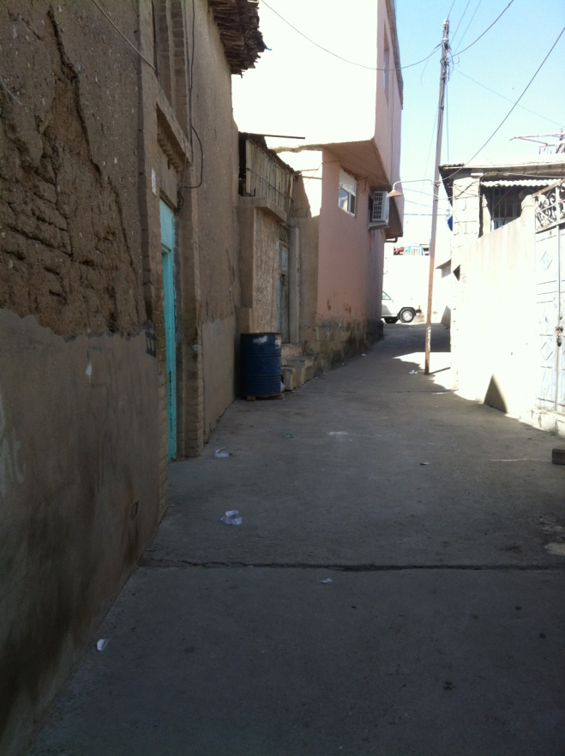b- 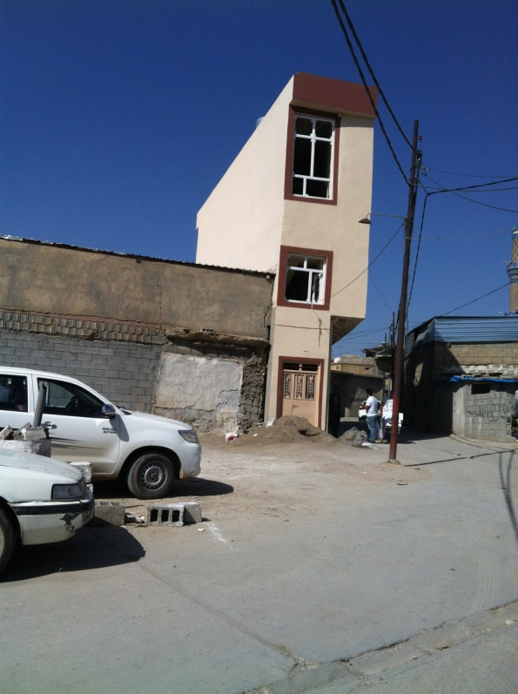
c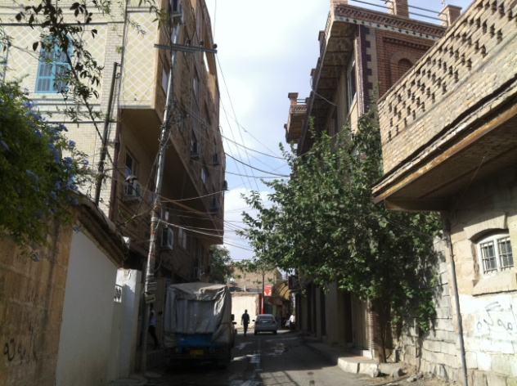 d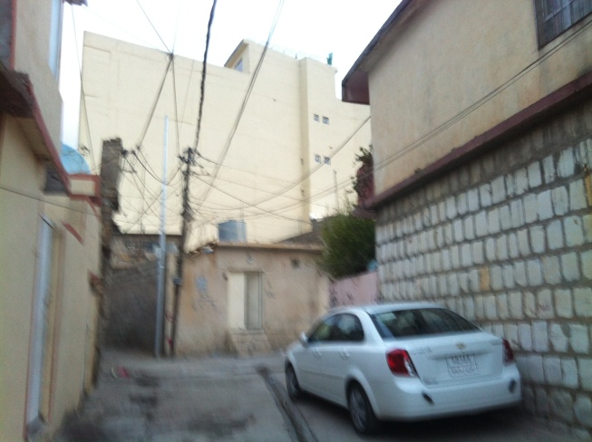
a-In the photo, the commercial building locked the view of the courtyard of some house in Malkane neighbourhood, 2014, (Source: taken by the author)
b- Three story building locked the view of the other one and two story buildings in the neighbourhood, Sarshaqam, 2014, (Source: taken by the author).
c- The Najmaden mala building locked the view of the houses in Sabwnkaran. The owner of the house was 40 years old said, “the building is five stories and locked our view and we only see the sky. They also wanted to lock the front view, but we bought the house and didn’t let the owner sell it to merchants” (Female, 40, interview, Sabwnkaran)
d- The houses in Malkane neighbourhood surrounded by high commercial buildings.
Figure 8.1 Residential homes surrounded by commercial buildings.
Blocking the view of courtyards by building high commercial buildings influenced the religious and spiritual life of residents, as residents can no longer practice their religious and spiritual life in their courtyards. They cannot see the distinctive symbolic minarets of nearby mosques from their courtyard. On the other hand, they cannot hear the azan and they cannot see when the lights go on from the minaret of mosques as a symbol of prayer time. A resident said: “this six-floor building blocked my view, I cannot see minaret of the mosque front of us. I used to sit down from here and practice my religious life repeating Quranic verses” (Male, aged 70, Sabwnkaran district, September 2016). This shows the important of a distinctive built heritage in the religious and spiritual life of residents.

8.4.7 Opposition to the change and traditional social life
Urban change has influenced the traditional social life of the city: for instance, social networks and close relationships among neighbours have been diminished, due to the departure of neighbours and influx of new arrivals. The original residents left the area due to the change of the neighbourhood into commercial areas that brought in crowds. According to several respondents, in every cul-de-sac one or two original residents are still living, but others are immigrants who fled from the south of Iraq due to the political situation, or low income families from elsewhere.One interviewee said:
“We do not interact with each other like an olden day as we had a lot of close neighbours, and my mum had so many friends. They all left the area, and we do not like the new neighbours as they do not know about our family history and reputation, besides nobody knows who they are” (Female, aged 30, Dargazen district, August 2014).
Another respondent expressed the change as being damaging to their networks and relationships: “right now we are four houses in here, all the other neighbours left the area. We do not have neighbourhood environment to meet our friends” (Female, 22, Sabwnkaran, Interview, 2014). More respondents explained, “today our neighbourhood is empty, and we are three houses here. All the other properties are empty as we used to visit and exchange dishes with each other like one family” (Female, aged 60, Dargazen district, August 2014). This has shown the disruption of traditional life in the area linked to the change of the neighbourhood.

8.4.8 Opposition to the change and difficult life circumstances
The change is also represented with difficult life circumstances. Residents expressed concerns about the increasing traffic levels that brought difficulties in terms of practising daily, religious and spiritual life. This is due to new car parking facilities and commercial uses in their neighbourhood. This is associated with abandoned historic houses and empty neighbourhoods that turned into car parking and commercial uses. During the site visit, many doors were locked, and I observed no one living in the houses in one area, (see Figure 8.1). For instance, one respondent explained how there were 6 houses in one cul-de-sac, but today they are only two houses left (Male, aged 70, Kani askan district, August 2014). Another respondent explained the same situation, as Arab migrants who fled from the south of Iraq due to political reasons are now renters in his neighbourhood; he also explained that original residents leave the area and then rent to the incoming refugees or poor income families (male, aged 30, Malkani district, August 2014).
Another respondent explained the same situation: “our neighbourhood was all houses. In every house, 3 to 7 families were accommodated in one big house. People in our neighbourhood sold or demolished their properties for the car park, that bring this car traffic to our roads” (Female, aged 70, Sarshaqam district, August 2014), and she pointed to her neighbours’ house that was replaced with car parking. Another interviewee addressed the condition as commercial buildings and car parking facilities produced the growing crowds and created difficult situations in the area, especially in terms of practising religious life:

“Life in this neighbourhood is very disturbing; it is very noisy and nobody respects those who live here. It is crowded 24 hours and there are cars passing through all the time, as in his neighbourhood two houses turned into car parking and one front of his house was demolished completely. Besides a lot of cars and car parking, many strangers are passing through and I do not know them. Right now, this place is so crowded that if you step outside, your feet get under the tire of car. That is why most of the time I prefer to do my pray in home and avoid myself going to mosques” (Male, aged 40, Sarshaqam district, August 2014).

In addition, the change also produced an unhealthy environment, whereas the neighbourhood featured a better environment before the changes and decline of the area. For instance, as local residents addressed the problems of empty properties, concentrated on the abandoned houses of the neighbourhood , “the neighbourhood is becoming a rubbish bin, due to the listed abandoned house front of us, which is bought by Sulaimaniyah Directorate of Antiquate, but it is a rubbish bin” (Female, aged 60, Dargazen district, August 2014). Moreover, the Haji-han road in the area became a rubbish bin, as “the road was not a rubbish bin like today that every corner is deteriorated and demolished building materials” (Female, aged 60, Malkane district, August 2014).
Besides that, the change of the neighbourhood is linked to the dangerously deteriorated conditions as introduced with the threatening environment for residents and passengers who pass through the abandoned and properties. An example of this is an interview with a respondent who believed “the outside walls of an abandoned deteriorated house are fallen down, which might fall down anytime, it is scary for anyone passing nearby the house” (Female, aged 60, Interview, Local resident, Dargazen district, August 2014). Another respondent concerned about her living conditions “If you see the house that demolished front of us, you would be frightened that it might fall down to you” (Female, aged 50, Local resident, August 2014). (For more details see: table 8. 2)

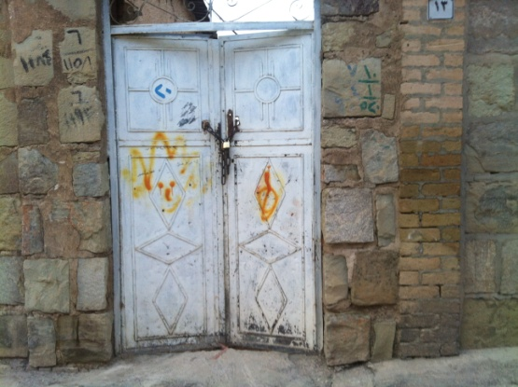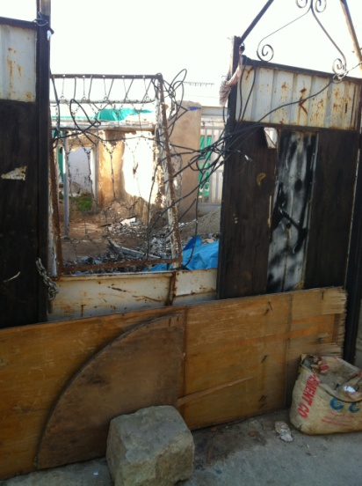
Figure 8.2 the old house in Malkane, which was locked and no one lived in the house.

Residents also expressed their concerns over the new developments favouring financial returns with a low quality building construction, and residents considered them as a source of trouble. Low-quality building constructions for rebuilding commercial buildings and the modification of residential areas is considered unregulated in terms of standard building constructions, as they do not fulfil people’s demands: including features such as unregulated parking lots and commercial buildings without the required building standards. For instance, the buildings are not designed to meet fire safety standards and do not often use high quality materials. A respondent represented the change towards unregulated development in terms of low-quality rebuilding:

“Any new buildings need plenty of space for car parking, but here is a disaster when they turn down the old and heritage houses and build new commercials or just leave the land for car parking in a messy way without standards or using low-quality materials. They do not build like what we see around the world. They demolish them and stop their car on a muddy ground, or they build commercial buildings without a car parking. In winter, the weather turns car parking into puddles and dirty place. I believe Caso mall as an example is not looking like a building. It is very destructing”
(Female, aged 40, Sabwnkaran district, October 2014).

Another respondent said the new buildings represented a threat to the life of residents: “the low quality of building materials in these new houses and commercials are terrible, even I heard many times buildings got fire and people burned due to low quality of building construction” (Male, aged 54, Malkane district, August 2014).
Thus, respondents represented the place with the historic built environment and saw change as damaging the heritage of the whole city, replacing historic neighbourhoods with ugly and unregulated commercial zones. New buildings are often seen and spoken about in a negative way. From the interviewees, 48 participants expressed concerns over the spread of new buildings and car parks that brought the crowds to the area. The difficult situation in the area is mentioned by 30 participants (16 female, and 14 male) by all ages. From these 30 participants 6 males and 8 females were concerned about their spiritual and religious life, especially if they were all around 50-60 and over 60 years old. A number of concerns about the demolition of the historic built environment centred on the demolition of the historic built environment as a whole neighbourhood matters, however, some believed that only listed buildings should be preserved, especially the buildings with a rich architecture element: 35 participants out of 50 participants thought the demolition of the built environment in the neighbourhood mattered and the rest of the participants thought the demolition of listed and non-listed built environment does not matters. 17 of the participants thought the demolition of the listed buildings matter, and 18 participants thought the entire built environment listed and non-listed buildings matter. This mismatch that is produced by the change in places contributes towards debates about environmental disruptions such as the limitations of conservation planning and conflicts between residents who were recognised as opposing the changes. For instance, as Devine-Wright (2010), found the opposition to change: an offshore wind farm caused an opposition due to the contradiction “between a place represented in terms of science beauty that provides a restorative environment for residents and visitors, and a wind farm that will industrialize the area and ‘fence’ in the bay” ( Devine-Wright and Howes, 2010, p.271).
Thus, the neighbourhood change disrupted the historic value of the neighbourhood, damaged the unique physical built environment and its culture. It disrupted the religious and spiritual life of residents and their traditional social life. It produced difficult life conditions that created fears over the potential loss of the whole residential area and departure of residents (note: the affective bond will be further discussed in the next section).

8.5 Affective response and types of place attachment
In the previous sections, the residents' response towards urban change was analysed. In this section, I explore how place attachment “affective-emotional bond” with a place (Hernandez et al., 2010) is transformed. Place attachment is a construct comprising place identity and place dependence (William and Roggenbuck, 1989). Changes that involve large extent, high rapidity, and low control can be associated with the greatest disruption to place attachment (Devine-Wright, 2009), as issues of change and continuity “lie at the roots of processes of place attachment” (Devine-Wright, 2014, p.165). As local residents’ place attachment due to the impacts of urban change can be transformed into different types of place attachment, those who accept and adopt the change may have a choice to stay in the area and become attached to new evolving place. Others opposed to the change may have no choice and become non-attached to the area, or may become angry and disappointed (see Table 8.5). For instance, some are traditionally attached to the historic built environment but disappointed, frustrated, and angry at the threat posed to the historic built environment. Others who find their place attachment dependent on the economic benefit of the neighbourhood are often happy and hopeful.
From this perspective, interview examples demonstrated qualitative differences and different types of place attachment. For instance, Lewicka (2011b, 2012) uncovered qualitative differences of place attachment and developed qualitative work by David Hummon (1992), using a general-population survey from Poland, she defined five different orientations to place: two types of place attachment (every day and ideological rootedness) and three types of non-attachment (alienation, place relativity, and placelessness). Attachment may be either “active” or “traditional”. Traditional attachment is about unconscious rootedness and continuity, possibly based on a passive choice -the traditionally attached person has high levels of place attachment and local identity. Whereas an actively attached person has high levels of attachment and a local identity but is more reflective of ideological rootedness and continuity, based on a conscious choice of where to live (Lewicks, 2011b). This is also shown in the study of Savage ‘s (2010) concepts of elective belonging versus dwelling. According to Lewicka, these differences in attachments to place were related to the socio-demographic, culture and educational resources, differences in mobility, differences in economy, measures as residence length, number of residential moves, and number of cities/ towns where respondents had lived (Lewicks, 2011b).
Table 8.5 Types of place attachment and effective responses
Attachment  and perception of change | Attachment/  Acceptance | Attachment /Opposition
Types of attachment | Attachment dependent on economic benefit of the area | Traditional attachment  Family history  Family reputation | Active attachment  History of the place  Family history | Non-attachment  Alienated attachment  If they have a choice they leave the area
Affective and emotional response to the change | Happy  Hopeful  Relaxed | Affective and emotional response to change  Threatened by changes to the historic built environment  Angry  Disappointed  Frustrated  Nostalgic  Scared  Annoyed
Choices | Having choice |  |  | No-Choice

Thus, residents of the neighbourhood developed different types of place attachment to respond to urban change as they accept, adopt or oppose it by indicating emotional and diverse reasons defining their choice staying in the neighbourhood. This is further explained in the following sub-sections.

8.5.1 Types of place attachment and acceptance of change
Residents who accept urban change have an attachment based on economic components, as they support the change with positive and supportive behaviour alongside hope and happiness about the future. Devine-Wright (2011) and Venables et al (2012) defined cases where stronger place attachment was linked to acceptance of development. Place attachment is seen as central, and used as “place bonding has a judgment function similar to that of place identity for attitudes towards the change” (Mihaylov and Perkins, 2014, p.67). For instance, residents based on functional meaning developed their place attachment. A male respondent who was positive and happy about the outcomes of the change, as he was a seller with a barrow in a big bazaar just close to his house, said:

“Everywhere in these neighbourhoods is a big market and very good place for finding jobs and making money. I think old historic houses are not useful standing there near this big market as a source of money. Owners demolish them and now they are markets and apartments, just very close to my house. That is why I like my neighbourhood and rebuilt my house. I never want to leave it”
(Male, aged 40, Malkane district, August 2014).

Another respondent addressed the improvement of their living circumstances, resulting from the change in terms of spreading markets and commercial uses, and making the residents more relaxed:

“I make several journeys to provide my family’s daily needs. My house close to everywhere, and we have many choices getting our stuff. Then why we should lose this place. If I go any neighbourhood, I have to spend four to five hours until I reach here and even I have to pay for transportation, but now I am relaxed living near everywhere”
(Male, aged 30, Sabwnkaran district, September 2014).

Some others felt hopeful and waited for an opportunity to get a good deal in selling their property. They considered the development as a necessity for the place:

“I think this neighbourhood sooner or later will change completely. It is dominated by commercial uses, and this house is a fortune for us, we do not leave here. I am sure we get a good deal and then we start our own business in the neighbourhood. For instance, I built mixed use commercial and residential uses in the area to accommodate my family and rent the rest of the building, and I believe it is development building tall and wide roads as needed for the area”
(Male, aged 40, Malkane district, August 2014)

Here the change was seen as a positive feature, in opposition to the view that the historic neighbourhood was in decline. The functional meanings associated with this are based on improving living conditions, rising employment in the neighbourhood, and a sense of general development. In general terms, the improving economic conditions allow residents to feel relaxed, happy and hopefully attached to the evolving place.

8.5.2 Active and traditional place attachment and opposition to the change
Place attachment for residents with an opposition to the neighbourhood change is a traditional and active attachment. Those with “stronger emotional connection to place begets a more negative attitude to disruption” (Mihaylov and Perkins, 2014, p.67). Those who oppose the change are attached based on an active choice but can become disappointed and angry. However, they are still proud to stay in the historic neighbourhood, resulting from their interest in their family history, their family reputation and history of the place. For instance, a participant who rejected the neighbourhood change as causing damage to the historic built environment said:

“I think these new markets in the area caused disappearing and demolition of these nice and old houses, turning them into markets and bazaars and brought such a crowd that even these days blocked all the roads and make it hard for us pass the road to reach the mosque. Everyone leave, all my good neighbours sold their houses”
(Female, aged 60, Dargazen district, August 2014).

Here, the urban change is perceived as a threat to the place, with an emphasis on aesthetic beauty and distinctive characteristics of the buildings in the area. However, the change is turning residential uses into commercial uses. It is a threat to the historic built environment and social networks between residents and their safety. The above respondent said she felt threatened, but she developed traditional attachment to the “inherited place”, the statements are used to be agreed with such as “even if there are better places, I am not going to move out of this city”, “I have never considered if living somewhere else would be better” (Lewicks, 2011b). Reasons of the respondents’ attachment are further explained by arguments about family history and the spiritual value of the neighbourhood. Despite her opposition, she seems resigned to the changes:

“I am proud and like my neighbourhood and my life in this warm house make me never leave it. It is because of Xenia mosque, which I used to go there all the time and still go there and I feel it all the time, and may be after my funeral leaves this place. I am well known here, people know all my family and grandparents. My parents and my husband were very well known in the area. My neighbours give respect to me. I cannot take a risk go to a place that no one knows who I am”
(Female, aged 60, Dargazen district, August2014).

This suggests the participant has adopted the change, but developed both traditional and active attachment based on historical bonds with the place and her biographical relationships as she has grown up in the area (Low, 1992). Lewicka (2005) used another measure in the survey study: a standard scale of place attachment and diagnostic of emotional bonds that people have with their residence places such as: “This place is a part of me”, “I am proud of this place”, and both as a measure that corresponds to the correlated both with traditional and active attachment. However, correlation with the former was stronger than with the latter. The above respondent’s place identity in the sense of functional and symbolic meanings of the place and dependency was disrupted. These are characterised by a strong sense of identification with place and a long-time residence. Moreover, she emphasised on her continuity in the place.
According to Lewicka, (2014, p. 50 ) a review of the literature associated with place attachment revealed the importance of continuing to reside within the location: it was found that attached people stay longer in place than those who are unattached (Riger and Lavrakas, 1981). The length of residence and intention to continue being in the place has been reflected in the study of place attachment, for instance, time in the residence as a predictor of place attachment is presented in popular place attachment scales (e.g., “I would regret having to move to another neighbourhood/house/city,” Hernandez, Hidalgo, Salazar-Laplace, and Hess, 2007; “it would be very hard for me to leave the neighbourhood,” Bonaiuto et al., 2006; or “ I would like to stay in Heidelberg indefinitely,” Lalli, 1992). However, in this context, all respondents are residents who lived in the area since the research is related to changes since 2003. The above resident’s relationship is based on physical, emotional, and cognitive connections. Besides that, the above participant seems to have a spiritual relationship as a significant relationship with the mosque based on intangible relationship.
Moreover, the active attachment of the resident is developed based on a conscious rootedness (Hummon, 1992; Savage, 2010, 2011a, 2012). The respondent’s active attachment appeared in her interest to the history of her family, as she is well known in the area because of the history of her residence and history of her family. The lady was uneducated but attached to the place. Besides that, her local identity is defined through her emotional bond and her spiritual identity to the value of the religious place. It was assumed that attached people stay longer than those who are unattached (Riger and Lavrakas, 1981).
Social ties and mutual support networks were also a significant relationship to the place, and Lewicka (2011a) suggests that attachment to primary residences may more often rely on social ties. However, amenities and physical characteristics of the place may be more significant for attachment to leisure settings. That is why the low quality of her house was not a dominant factor to relate to her attachment. In addition, her spiritual and historical bond is significant despite having the choice to leave the area, as she said: “I believe after my funeral my kids leave this place” (60-year-old Female, Dargazen, 2014). This shows that the family are capable of leaving the neighbourhood, but stayed due to the respondent’s active attachment. For instance, she said, “the house is close to everything than anywhere in the city” (60th Female, Dargazen, 2014). She is further keen to stay in the area because of distinctiveness of the built environment and the structure of the houses: “the house is mud, brick and wood which is warm and is very comforting, I do not like to live in new houses” (60th Female, Dargazen, 2014). This means that the character of the place (a material that gives a distinctive character of the place) separates it from other places in the city that indicate the importance of place identity. In this case, the links between individual identity, place attachment and place identity propose a relationship between the historic environment (physical build environment) and place attachment.
Thus, the historic built environment is an indicator in securing place attachment, against economic factors of change. This might add knowledge to the fact that low quality of the built environment might not influence on the reduction of the place attachment and the departure of local residents. This is due to the distinctive character of the historic built environment and other influencing factors such as influencing social factors of the neighbourhood change.

8.5.3 Affective response and non- place attachment
The non-attached or alienated attachment produced for residents with an opposition to the neighbourhood change without having a choice to leave the place, as according to Stokols and Shumaker, some residents stay in the declined neighbourhood because they have no choice (Stokols and Shumaker, 1981). The factor corresponding to a measure of non-attachment is a statement such as “people should not get attached to any place”, “this city has many advantages, but if I find a better place, I will move” (Lewicka, 2011b). For these residents the impact upon their bonds and relationships within the area is reflected in the anger shown towards urban change. For instance, in terms of blocking roads by traffic and car parks. A resident living in Malkane talked about the crowds and strange passengers that avoided him while he carried out his social and traditional life:
“Sometimes, I feel disturbed by the crowd, because I cannot step out as is full of men. Even they park their car in our cul-de-sac that occupies our cars’ spot. I know, this corner was all historic and nice houses. Someone should stop these people who demolish them. I am freaking out when I see they demolish them. However, I still enjoy looking at the historic remaining houses, but I think this place is no longer suitable for living, and if I get a chance I will definitely departure the area”
(Female, aged 50, Malkane district, August 2015)

Thus, the respondent’s non-place attachment is reflected by a desire to leave the neighbourhood.

8.6 Summary
Responses of residents to urban change showed a disruption to the historic built environment and changes to the religious, spiritual and social life of residents, despite a number benefitting from many aspects of the developments, especially those who started their own business. Particular concern was raised amongst interviewees over the age of 50. The affected residents’ demonstrated behavioural responses in terms of conflict over conservation and the transformation of residents’ place attachment. The links between place attachment and oppositional responses is made (Stedman, 2002; Vorkinnand Riese, 2001) by indicating how change can threaten place identities for individuals with an emotional bond to the place. Individuals opposed to change show pride in the neighbourhood’s distinctive historic built environment and knowledge about their own family history leads to actions in protecting the built environment. At the same time, a majority of individuals (those who supported and those who were opposed to change), have no choice but to accept urban change, showing negative behaviour in terms of the damage to the historic built environment by involvement inconsistent physical alterations to the historic built environment (see: Chapter 6: actions of local residents). This is due to having no choice linked with the lack of conservation planning practice and planning regulations of the area (see: Chapter 7).
The impacts of change on social life is explored in the definitions of neighbourhood, place identity and dependency. New developments and demolitions occurring within the neighbourhood influence residents’ place identity and place dependency as a loss of the physical historic environment acts as a symbolic and provides unique meaning for residents. The change influences residents’ place identity and the transformation of their self-identity. For instance, place dependency is disturbed as some residents avoid using new built constructions – the change has a negative influence on their place identity and negative effects on their attitudes and social life towards change. However, place dependency for a minority of residents acts in opposition to the place identity of the majority of residents who are against the change. Place dependency for the minority who are in favour of change enhances the usage of the place as a functional economic meaning in the neighbourhood. Thus, place identity is transformed for the majority due to change being viewed as a way to enhance economic growth.
This chapter contributes to knowledge in relation to understanding people’s social life in the neighbourhoods in relation to the weak conservation practice inherent within a region. This has influenced the departure of some residents but allows makes others to choose to stay in the neighbourhood, albeit with a transformation in their place attachment. A mix of different types of responses showed that most respondents are in favour of the historic built environment, and the historic built environment is attached with value. However, change is represented by providing economic resources for some residents. In this sense, historical bonds, biographical and spiritual relationships, and religious practices were all cited as important factors in forming self-identity and one’s place dependence. In the response to processes of change, social ties and mutual support networks became significant in residents’ place attachments based on the places’ functional and symbolic meaning.
Therefore, this study shows supportive behaviours to the environmental disruption despite oppositional responses to the disruption. Consequently, these negative responses might increase the threat to residents’ place identity and place dependence. It is important to provide options for residents in case of urban changes in historic environments. Besides, it is neither possible to demolish historic environments nor is it desired to ignore evolution, but it is possible to consider perceptions’ of residents and considering the role of aspects of heritage in a way that allows for satisfying people. Especially when this research showed mixed responses to the urban change in terms of acceptance and opposition. It can be noticed that identifying these perceptions, behaviours and implications might be able to reduce negative consequences. Finally, this study is important for conservation policy, especially to draw lessons for conservation planning in urban contexts similar to Sulaimaniyah.
Chapter 9: Conclusion
9.1 Introduction
In this study, I have attempted to explore the strengths and limitations of conservation planning in Sulaimaniyah and examine its implications for the social and spiritual life within the city. This thesis is concerned with documenting the changes in terms of identifying the limitations of conservation planning and its implications on the transformation of the built environment and social life of Sulaimaniyah city centre, a part of the world where those issues have not been widely researched.

Further, one aim of this research was to consider what appropriate policy responses could be developed in response to the issues raised. In the previous four chapters, I explored the issues that could be considered for appropriate policy responses in terms of responses of local residents to the urban change in Sulaimaniyah city centre. The implications for social life are assessed using the theory on disruption to place attachment as an analytical framework for analysis. This research contributes to the work of cultural built heritage, conservation policy and urban change in Kurdistan-Iraq, in particular the juxtaposition of its rich urban heritage with the impacts of conflict and reduced state power. Therefore, the thesis contributes to wider debates about the social role of conservation, especially when conservation is a potentially progressive element of development control in terms of who gains and who loses from strong/weak conservation planning. The study also contributes to the literature on religion and urban space, as it emphasises the significant role of built heritage in the social, spiritual and religious life of residents. Indeed, religious practice has a significant role in strengthening the social and emotional bond between residents.
Therefore, this chapter will present a summary of the findings based on the research questions and reflect on the implications of the issues learned from this research. This chapter first presents a summary of the research findings, followed by possible responses to the research questions, reflections, as well as the contribution to knowledge. Theoretical and methodological implications along with reflections, limitations of this study and further research areas are also discussed.

9.2 Summary of findings of the study
Based on the study undertaken, there are issues in relation to the implications, tensions and conflicts within the practices of conservation planning in Sulaimaniyah. The findings demonstrated the limitations of conservation planning and its implications in terms of the significant transformation of the built environment by existing residents and the implications for social life in Sulaimaniyah city centre. This is reflected in terms of the impacts of conflict and reduced state power. The limitations of conservation planning created conflicts between residents owing to their different opinions about urban change, with e some residents in favour of its differential opportunity for personal gain.
On the other hand, the findings showed the important role of the built heritage in the social and spiritual life of residents. The built heritage is more significant in the religious institutions and the traditional spiritual courtyard houses than in other places. Qualities of physical characteristics and symbols of built heritage in terms of religious institutions influenced residents’ spiritual and social development via their experience of religious institutions, largely through the quality of sounds of imams of religious institutions especially in Friday prayers, stories, and place rituals. The symbolic meanings of these institutions, such as the quality of unique sights of mosque minarets, their high ceilings, and their communal halls for prayers, foster social bonds among residents generate emotional attachment to their place while practising prayer. In addition, the built heritage and its unique characters are important in the spiritual life of residents, especially old-aged residents. This is in terms of traditional construction materials that provide a comfortable thermal environment. Therefore, conservation can play a valuable social role in preserving what is valuable about a place. Religion is important in the life of local residents: their decision to stay in the neighbourhood; communal gatherings; social support; their choice in selecting traditional styles of homes (having a spiritual courtyard: practising their religion via hearing the sound of prayer from nearby mosques).
Furthermore, the layout of the built heritage of the neighbourhood, courtyard spaces and cul-de-sacs were a significant feature of communal gathering, spiritual and religious practice, and daily chatting, especially for women. The location and layout of religious institutions in the residential areas in every district is important for religious activities and communal gathering. Easy access and daily practice in these religious structures play a significant role in the social life of residents as they foster communal bonds by the daily gathering. Their design and space requires a prayer hall which provides a communal bond; for instance, in Friday mosques the community of male believers and female sections in the mosques stand together to do their prayer, but a separate section for females and males is important for gender separation in prayer, which define the influence of the built heritage on the spiritual life of residents. In addition, religion and religious values were affected by the design and layout of traditional homes, as small windows are facing outdoor and wider windows face the courtyard, which is important in ontological security and the social life of residents for protecting their family members from the eyes of strangers.
Moreover, the research findings relating to the limitation of conservation planning indicate that urban conservation policy has not been successful in delivering the effective management of urban change and regulation in Sulaimaniyah city centre. Rather, urban conservation management is contested by different stakeholders and is influenced by growing conflict and a failure to meet conservation aims. In large part, these problems are due to the differential powers of decision making among stakeholders, access to finance and political interference in the work of local government agencies. This power differential between stakeholders is in both financial and political terms. Inadequate financial resources influenced the power and capacity of key stakeholders in managing the historic city centre in terms of the lack of consultancies and technical assistance available to local stakeholders. This has been identified as being linked with political intervention from central government in seeking to overcome issues of financing, which increased conflict between politicians at central government and the local officials. Consequently, urban conservation management is influenced by the power and capacity of local government in decision making, and in their controlling and implementation of plans and policies related to planning permissions. To this date, this issue is not taken seriously by the government.
The findings from this research confirm arguments within the literature which highlight that effective management requires issues of participatory planning and conscious decisions that emerge from key management roles linked with access to finance, legislative frameworks and the collaborative relationship between key stakeholders (Lichfield, 1988; Healey, 1998; Hunter, 2015; Orbasli, 2000). The relationship between stakeholders is in low collaboration and is not one with a collaborative approach, as local stakeholders are excluded from decisions about preserving their cultural heritage or in the conservation planning process. However, it is stated that society places value on what is significant to be preserved in the process of urban culture heritage (Zancheti and Hidaka, 2011). The local Sulaimaniyah government failed to include local residents in decision-making, which led to their views not being included in defining what is valuable in conservation efforts. This is why the research sought to define the perceptions and values of local residents as relying on both conservation planning practice and the process of the urban change, to get the balance between conservation and change as too much conservation can prevent change and evolution. This was achieved by defining the implications for the social life of residents on their responses to urban change. This has been defined based on concepts of place and disruption to place attachment, as well as conflicts and tensions that are generated among various stakeholders in the sense of breaking rules and planning regulations and the inability of the local government authorities to enforce them. In the consequence of these conflicts, inconsistent structures are being allowed to be constructed in the historic centre of Sulaimaniyah, which have consequently risked the appreciation of built heritage for the sake of private gain. This is why effective stakeholder collaboration among stakeholders remains an essential element by emphasising the importance of these issues of cultural heritage management. The findings in terms of policy implications highlight the government’s responsibility towards urban heritage conservation. The government is less concerned about whether policies are implementing or not, that provide an opportunity for further conflicts between stakeholders. However, financing urban cultural heritage conservation in terms of the maintenance of environmental and cultural heritage assets relies on the role of national government (Paszucha, 1995; Roders and van Oers, 2011; Baarveld et al (2013).
The implications for the social life of residents demonstrates aspects of values by local residents that are important for being considered when making recommendations for urban conservation policy; as well as from a contextual perspective in which urban change takes place and the way that social religious bonds contribute to emotional bonds and attachment of residents. With the change of built heritage, social, religious and emotional bonds are transformed.
The implications highlight the conflict of interest and values between residents who are in support or opposition to the urban change. The case study showed that the perceptions of local residents about the urban change included symbolic meanings, as values related to the heritage of Sulaimaniyah city centre and functional meanings such as the economic value of the city centre. These values and interests were significant for local residents and need to be considered for appropriate policy responses to the urban change in the long run. Deepening the understanding of community responses to the large demolition of historic built environment offers policy lessons for future regulation dealing with the urban change, which has not been generally acknowledged by the government of Sulaimaniyah. However, the community is defining what is valued and is significant to them to be preserved in the process of urban culture heritage, including the relationship between stakeholders and their collaboration. Finally, the implications from the case study might be a benefit for other case studies with similar circumstances of historic building demolition, since these findings hold important implications for other communities in Middle East countries where their historic city centres face urban change in terms of access to finance, legislative frameworks and the collaborative relationship between key stakeholders.

9.3 Findings based on research questions
According to the literature review and the empirical case study, the following findings in this section offer answers to the research questions:
Question 1: How has urban change occurred in Sulaimaniyah city centre and what is causing it?
The answer to this question, based on perceptions and behaviours of local residents, provides an explanation of the process of urban change and sets the context for a more detailed investigation into the essential drivers of the change. In this section, sub-questions were simultaneously addressed through answering the following sub-questions:
- How has the built environment changed in the city centre? What has changed and why?
- What are the implications for heritage? What has been lost? Has anything been gained?
These questions were answered through the analysis of the case study in chapters 5 and 6, which indicated factors based on personal behaviours and values to explain the behaviours and actions of local residents associated with concepts of place and constructs of place attachment: place dependency and place identity. This was defined in the analytical framework (See: Chapter 4). Therefore, based on the majority of respondents’ views, the influencing factors of the urban change are:
- Failure of government in the management of the neighbourhood
- Conflict between residents in the differences of their opinions about the change - some opposed the change and some accepted it as a differential opportunity for personal gain and economic value of the neighbourhood
The economic value of the city centre was linked to the fact that the city centre still represents the main trade, market and business centre for the whole of Sulaimaniyah city. However, the lack of the government’s responsibility, in the sense of regulations and conservation planning policy for heritage management of the city centre, impacted on the actions and behaviours of local residents.
On the other hand, some minority concerns were expressed about the urban change based on the perceived values of two groups - those who were in favour of urban change and those who were in opposition to urban change. The concerns of urban change for the group of residents who accepted the urban change were:
- Low quality of the built environment; inherited properties,
- The difficulty of maintaining traditional houses due to high costs and a lack of labour skills. This is linked with the lack of awareness of heritage value being a factor of the urban change (See Table 5. 1: Chapter 5).

Whereas, for the other group, who were in opposition to the urban change, some concerns were aroused by:
- The transformation in terms of the appearance of their residential environment such as new structures and commercial uses that resulted in traffic congestion and consequently the departure of original residents and difficult social life circumstances, particularly religious and spiritual life.
The different perceptions, actions and behaviours of local residents indicate how the built heritage was transformed in the city centre, showed what has changed, what has been lost and what has been gained. In Chapter 5 and 6, the change of the historic built environment and its implications were defined by utilising Devine-Wright’s stages of psychological response to the place change (2009) but focuses on place- related factors of place attachment, place identity and place dependency (Mihaylov and Perkins, 2014). These factors shaped local residents’ responses, actions and behaviours to the urban change (See Chapter 4 for the conceptual and analytical framework). Therefore, these implications defined local residents’ responses to the urban change. The responses to the urban change as acceptance / adaptation and opposition to the urban change was interpreted based on the various place- related cognitions, including place definition and place identification, place dependency and place identity as constructs of place attachment and affective response (Mihaylov and Perkins, 2014). Thus, the primary indicators of dissatisfaction and satisfaction with values of the neighbourhood in the process of the urban change are as follows:
- Change in the appearance of the built heritage and its implications for religious and spiritual life
- Aspects regarding community in terms of social life
- Satisfaction with the urban change.
These values and meanings based on perceptions, actions, and behaviours of local residents will be further discussed in the following sub-sections:

9. 3. 1 Appearance of built heritage and its implications for identification, religious and spiritual life
Those in favour of the urban change ignored the historic value of the city centre while those in favour of the historic value of the neighbourhood were concerned by its change. The value based distinctiveness showed the negative impacts of the built heritage transformation on the social, religious and spiritual life of residents. For example, one’s religious life engagement was interrupted as the construction of vertical structures undermined their spiritual and visual communication with religious institutions. The high storey buildings also reduced visual access, blocked the view of properties and disrupted the religious and spiritual life of residents. Further, commercial uses and new markets also brought about a “crowd” and caused “traffic congestion” in the area that “blocked residents’ way” to religious places, particularly the “Big Mosque” (Mizgawte gawra).
There were also implications for the architectural format, meaning the texture and spirit of a place due to the demolition and rebuilding of physical structures in a way inconsistent with the historic architecture style. This resulted in the loss of the distinctive character of the historic city centre. The appearance in terms of traditional building style consistency (courtyard buildings) or building material consistency (bricks, woods and stones) were a particular concern of residents. Those local residents who opposed the change claimed that commercial and residential buildings which were built on the site of demolished historic buildings were not consistent with the historic character of the neighbourhood. The redevelopment and alteration of commercial and residential buildings with inconsistent building materials or the adding more construction to listed houses affected the historic fabric of the neighbourhood. The original material of the traditional shops and commercials are Malkane stone and mud bricks, whereas, alterations with new technologies involves modifying buildings with concrete blocks. Facades are decorated with new products, using PVC windows and doors, and the finishing is repaired with wallpaper and paintings. New structures were built with glass and alucobond with no variations, no brick or stone. In addition, traditional maintenance, using a heavy roller to smooth the roof of a house to prevent dripping in wintertime, due to the inconsistency of using materials, is replaced by covering the roof with a Nylon sheet, replacing the traditional practice as well.
Further, the newly built structures and high storey buildings reduced visual access, blocked air, and blocked narrow roads and reduced the number of roads in the city centre. This consequently affected the organic building fabric in the neighbourhood. The spatial structure of the historic city centre, with its narrow and organic roads, were particularly affected when several historic properties were demolished and linked together for building larger commercial uses. The layout of roads was transformed by either being straightened or blocked for private use and the use of car parking on the site of demolished historic structures. Moreover, the spatial relationship between buildings also changed. The newly built structures were vertical; however, the spatial fabric of the historic city centre was based on historical dimension. When the residential function in the neighbourhood was transformed into a commercial function, the design of new structures was reflective of their owners seeking private gain through commercial uses, especially where they linked several properties. These newly built inconsistent structures added in public places’ surrounding then, which transformed the space from a traditional civic place to a modern place. In addition, the demolition of properties through this process of urban change increased the number of vacant properties in the neighbourhood. Other concerns found were related to the site of demolished buildings, where unregulated parking lots emerged and limited regular car parking.
These changes resulted in the inconsistency of the built heritage in regard to the appearance, architecture and spirit of the place and of the old fabric of the neighbourhood. This led to dissatisfaction and sense of loss of authenticity and loss of sense of residential neighbourhood. These aspects of urban change left residents unsatisfied by the process of urban change and threatened the overall value and distinctive character of the built heritage. In turn, the socio-cultural and heritage value of the neighbourhood were shown to be threatened by the process of urban change. Residents highlighted their sense of loss and belonging to the place as it had undergone the process of urban change. These expectations and values regarding the process of change of the built heritage created dissatisfaction and induced alienation for the residents of the neighbourhood. These participants, from this group of residents who were opposed to the change - those between 40 and 50 , 50 and 60, and 60 and 70 years old age categories - were further concerned about values associated with appearance, community and convenience. However, those in the 20 and 30 age group categories felt they were locked inside the houses due to the increased crowds and the passing through of strangers.
On the other hand, the group of residents who in favour of the urban change valued the process of urban change for enhancing the appearance of the built environment, the value of the new structures and their proximity to their residence. They also valued the variety of stores, markets and commercial uses being developed, including new business functions such as stores, retails, restaurants, grocery shops, pharmacies, clinics, and an enhanced variety of choices offered. Some residents listed specific institutions including hospitals, clinics, pharmacies, markets, retails, groceries as positive outcomes. However, the inconsistent appearances of these new structures which resulted from the process of urban change were not a concern. The residents who were in the 60-70 and 20-30 years of age category appeared to be seeking economic benefits of the neighbourhood and they were those who started their own business or found jobs in their neighbourhood. Furthermore, the same group 60-70 years old of age further appreciated the variety of options related to all sorts of retail and stores in the area that had resulted from the urban change. The 20-30, 50-60, and 60-70 years of age groups were concerned about the appearance of the new structures.

9.3.3. Aspects regarding community in terms of social life
The transformation of the spatial aspects of Sulaimaniyah historic city centre has allowed for different behavioural patterns in terms of the relationship between people and their lifestyle. The data about social life suggested the values and behaviours of residents were based on the perceptions of two groups. For both groups, urban change affected their social life, which was transformed from collective functioning into individual functioning. This is associated with a sense of isolation and preference for individual social behaviours in the neighbourhood, which highlights the importance of the physical environment in a sense of the relationship between place and individuals and community. However, local residents who are in opposition to the urban change avoided their social life activities around newly added structures by maintaining more or less their socio-culture life based on the remaining traditional structures in the neighbourhood. On the other hand, those who accepted the urban change managed to do business near their accommodation and their lifestyle was shaped around the considerable economic benefit that was brought about by commercial characteristics of the urban change. This included investment in their neighbourhood or gaining economic benefit from the process of urban change, such as it being easier to make several journeys to the city centre for shopping. Besides this, the urban change enhanced the commercial atmosphere, which allowed residents to reach all kinds of modern goods.
The implications of urban change for those who opposed it weakened their social interaction and affected place meaning and values. The departure of local residents affected the quality of friendliness and resulted in residents having fewer friends and less contact or interaction with their neighbours. This generated a sense of isolation for some residents, particularly where old friends, who have lived like a family, visiting each other’s house anytime, joining each other's family for a meal in anytime, and exchanging dishes with neighbours, had departed. Newcomers who were low renters brought with them unaccepted behaviours and carelessness of each other. For example, in one instance, a neighbour built a 4 storey building which blocked the others visual view. The unwanted urban change affected social support as well; previously, residents used to get support from their neighbours unconditionally but today the practice has disappeared.
The implications for social life also resulted in fewer conversations taking place outside between neighbours in their cul-de-sacs. For example, the previously built structure of the neighbourhood enabled a socio-cultural pattern linked with privacy in the neighbourhood, where daily gatherings in cul-de-sacs for chit chatting were an important part of their lifestyles. Now, this is reduced due to increased crowds of strangers and visitors passing through to the vibrant market and new commercial uses. This has led to residents being locked inside the houses, especially due to the crowds of strangers. Furthermore, fast passing cars are feared by residents in terms of the danger they present to their children when playing outdoors as we all them meeting and spending time with their neighbours at night in their cul-de-sacs or communication via cell phones. Therefore, the crowdedness due to commercial uses, car parking, and stores in the area, has affected residents’ interaction with their neighbours and caused changing behaviours of local residents who have adapted to new modern ways of communication with their neighbours, even changing the design scheme of buildings by opening windows into the courtyard of each other for daily chit chats. The disappearing of daily gatherings in their cul-de-sacs is caused by the cul-de- sacs being exposed to car parks, which has disrupted the interactions of local residents.

9.3.3 Satisfaction with urban change
The urban change brought about crowdedness, which interrupted local residents’ life activities; for instance, residents had to park their cars at an inconvenient distance from their properties due to the crowd and parked cars. Further, there were concerns about difficulties for practising daily lives, regarding privacy inside resident’s property, especially exposure to strangers during household chores in their courtyards or sleeping on roofs during summer nights. Another concern found was residents were having a hard time adapting to new modern materials, as residents were comfortable around brick walls and wood ceilings. The brick blocks were recognised as a warm material while concrete blocks do not provide a warm atmosphere in their houses. Further, the inconvenience was felt, especially from the traditional commercial atmosphere, which is not practised anymore; modern goods are a dominating business in the neighbourhood due to the high number of new structures in the neighbourhood, which are conducting modern business and selling modern and western goods. This is why there were concerns about traditional hand-made goods by local residents of the neighbourhood not being sold for a convenient price. Moreover, the inconvenience was explained regarding the newly built commercial buildings creating unclean roads in the neighbourhood as well as sidewalks.
For these reasons, the majority of respondents in the second group, 35 participants out of 50 participants, opposed to the demolition of the built heritage. They were concerned about the distinctiveness of the built heritage, its role in the cultural, religious, and spiritual life of residents. They expressed a sense of loss of social life and the loss of calm in the residential neighbourhood due to commercial uses involving too many private cars, which created traffic congestion. In addition, participants identified the inconvenience of the high price of goods; discomfort due to the noisy and crowded environment; a dirty environment and the blockage of air in the neighbourhood due to the process of urban change. (48) Participants expressed dissatisfaction over the spread of new buildings and car parks that brought the crowd to the area. This difficult situation in the area was mentioned by 30 participants (16 female, and 14 male) of all ages. From the 30 participants, 6 males and 8 females were concerned about their spiritual and religious life; they were all around 50-60 and over 60 years old (See the following section for further details).
Thus, the limitation of conservation planning practice allowed for conflict between residents which formed the basis for the difference in opinion about the change; some opposed and some accepted the change for differential opportunities for personal gain. In some respects, the changes have improved the livelihoods and wellbeing of some residents, especially for those who started their own business. However, some changes were not acceptable, as identified by the implications on built heritage, social life, and the religious and spiritual life of residents. Therefore, what this PhD document are the contestation around the balance between conservation and change amongst residents.

9.3.4 Implications of social life/place attachment
The implications of urban change on social life and place attachment have been defined via local residents’ response to urban change based on disruption to place attachment. The responses were interpreted based on various place related cognitions including place definition and place identification, place dependency and place identity as constructs of place attachment and affective response (Mihaylov and Perkins, 2014). For those residents with an opposition, the implication is considered a disruption to place attachment and transformation of their place attachment. This is through the disruption to their place dependency, sense of continuity and transformation of their place identity, as these residents value the built heritage in the practice of their daily life that enhances their emotional attachment to place. For instance, the role of symbolic distinctiveness of religious institutions is significant for religious, spiritual life and social life of residents with an emotional attachment to the place. The built heritage and characteristics are significant in playing a significant role in the religious, spiritual and social life of residents and consequently, through this process, place identity and attachment to place was developed by the relationship between religion and place, as religion foster attachment to place. It also allows for social interaction and social bonds, for instance standing for pray all together in religious institutions. According to Mazumdar and Mazumdar (2004), “the emotions experienced and expressed are in large measure influenced by the characteristics of the place which in turn helps to connect the believer to the place as well as to religion itself” Mazumdar and Mazumdar (2004, p.385-391). Given that, the historic built environment is linked to a physiology of place and supports a sense of distinctiveness. A sense of distinctiveness is related to the historic built environment identified in the literature (especially those working in a phenomenological tradition) (e.g. Relph 1979).

New structures and buildings being demolished in the neighbourhood affected the place identity and place dependency of people based on a loss of the historic built environment as a symbolic meaning in the neighbourhood. For instance, the practice of traditional social life among local residents influenced their place identity and transformation of a self-identity. One’s place dependency was disturbed as they avoided using the newly constructed buildings. Where place dependence is enhanced for those who accepted the change, this was based on the usage of the place as a functional economic meaning. Thus, place identity was affected for some residents who opposed the urban change due to it disturbing their dependency, in contrast with others who accepted the urban change in the sense of the usage of a place as an economic opportunity and evaluated its cognitive value based on its functional meaning.

Thus, place attachment for the group of residents who accepted the change was based on economic dependency, which enabled personal gain and investment in the area with hope and being happy as an effective response to the change. In environmental disruption studies, this supports the study by Devine-Wright (2011), who found that respondents with supportive attitudes to the project of a tidal energy converter enhanced place attachment rather than disrupted it “with contrasting sets of meaning proving significant in each context” (p.336). However, those in opposition to the urban change saw the city centre with a built heritage as a unique and distinctive symbolic meaning for the whole city, where the urban change was expressed as a threat to the built heritage, as well as the disturbance, anger and frustration that resulted from the difficult life circumstances that emerged from inconsistency of new built environment in their area. This left this group of residents with disappointment that their responses based on opposition suggested that contradiction between the urban change and the built heritage of the city centre was experienced as a threat to their identity. These residents’ traditional or active place attachment to the neighbourhood was transformed into alienated attachment. Their emotional attachments were linked to the history of the place and its distinctiveness. It also linked to the protecting of their reputation due to the significance of their family history as original residents of the area. Their non-attachment resulted in opposition and frustration, as they had no choice except to stay in the neighbourhood in spite of their negative attitudes and actions/behaviour toward the destruction of the built heritage. These residents, in spite of their struggle in securing their identity and dependence in the neighbourhood, led to negative attitudes and behaviour such as the destruction of the built heritage.

9.4 Contribution to knowledge
This study is about the limitations of conservation planning and its implications in terms of the significant transformation of the built environment and social life of Sulaimaniyah city centre, a part of a world where those issues have not been researched very widely, using ideas from western world that have been adapted based on the conceptual model. This study is an example of work on culture built heritage, conservation policy and urban change in Kurdistan-Iraq, with a particular interest given to its rich urban heritage, the impacts of conflict and reduced state power. What this study has documented is the contestation around the balance between conservation and urban change amongst residents, especially the conflict between existing residents as agents of urban change. Their conflict was the basis for the difference in opinion about the change, where some of them opposed the change and others accepted it for personal gain where the changes have improved livelihoods and wellbeing. Therefore, the thesis makes a contribution to wider debates about the social role of conservation and especially when conservation is a potentially progressive element of development control. Given that, the findings define the significant role of the built heritage in the social, spiritual and religious life of residents. The spiritual and religious life around the built heritage as a distinctive symbolic meaning allows for residents emotional attachment to the place. Therefore, this shows the contribution to the literature on religion and urban space in a way that religion and urban space of religious institutions allow social and emotional attachment to a place.
Thus, the findings of this study also contribute to conservation planning policy, as they signify what is necessary to be done about the urban change situation. In addition, in this thesis, a theoretical and conceptual contribution is made in relation to demonstrating how some of the western concepts are applicable in this context, but in a different way that has led to a methodological contribution as well. Therefore, the research builds upon theory and research across multi-disciplines on disruption to place attachment (Devine-Wright, 2009) as an analytical framework for implications of and relationships to social life in the process of urban change and built heritage. There have been studies about disruption of place attachment (e.g. Brown and Perkins, 1992) or threat to place identity (e.g. Bonaiuto, et al., 1996), as in these studies change can make explicit the bonds between person and location that are typically latent (Brown and Perkin, 1992), as well as based on emotional responses such as loss and anxiety (Fried, 2000). Further, studies of geographical relocations to identify physiological experiences of the loss of one place and the cultivation of place attachments to a new place, and a sense of displacement with a consequence of psychiatric trauma (Fullilove, 1996). In the studies, the reasons of disruption include ecological change (Brown and Perkins,1992), burglary as a human-induced change (Brown and Perkins, 1992), demolition of homes and neighbourhoods (Fried, 2000; Speller, 1999), voluntary migration (Brown and Perkins, 1992), workplace relocation (Inhalan and Finch, 2004; Milligan, 2003), neighbourhood decline (Brown et al., 2003) and intergroup conflict (Dixon and Durrheim, 2000; Possick, 2004), as well as the study of place disruption that lead to specific behaviours (Stedman, 2002), and place protective actions based on social representation theory (Devine-Wright, 2009).

However, this study offers an empirical study of the implications for social life based on physiological aspects of place change with an analytical framework that links place attachment and social life through constructs of place attachment, place identity, place dependence in the study of built heritage. Therefore, it fills a gap in the literature in relation to building heritage, conservation and social life based on disruption to place attachment. Therefore, it contributes to the lack of knowledge in this subject area on urban conservation management, physiology of place, and social life in a study of heritage, as the study of heritage is mostly dominated by knowledge on historic environments in Western countries and other parts of the world.

In terms of the theoretical contribution, the research offers a way of understanding how physiological concepts of place contribute towards what is to be valued by people for conservation, based on people’ response to the urban change in the context of Middle East countries. This is in relation to disruption of place attachment in the neighbourhoods that faced demolition of its historic built environments, as place attachments are profoundly disrupted when environments change rapidly (Brown and Perkin, 1992). Given that, the findings showed how this affected the departure of some residents, and made others choose to stay in the neighbourhood for a mix of different reasons. Accordingly, the historic built environment has value and can still compete against the economic forces of the neighbourhood change, despite the change providing economic resources. This may further enhance the urban change in terms of commercialisation of the historic built environment in future, in association with the lack of regulation planning policy in the neighbourhood.

9.5 Theoretical and methodological implications
This research builds upon theory and research across multi-disciplines on disruption to place attachment and its relationship to social life and built heritage in the process of urban change. The implications of the theory as an analytical framework is via constructs of place attachment: place identity and place dependence in response to the change. Having reviewed the key concepts and the literature review that focused on heritage, conservation and concepts of place, there is not much focus placed on a direct relationship between heritage and urban change, or its social and physical factors. However, in the theoretical and conceptual framework of this research, these concepts are connected via concepts of place. The links have been made through concepts of place distinctiveness (e.g. Relph 1979), continuity (e.g. Smith, 2006; Casey, 1996; Bird, 2002), and place identity and place dependence (Waterton, 2005; Stedman, 2002). In the links between concepts of place and urban change, key aspects which are not related to the historic dimensions are physical quality and social aspects of neighbourhood decline (e.g. Graham et al., 2009; Uzzell et al, 2000, Livengstone, 2008). However based on the data collected in this research on the key aspects of urban change, physical and social were minor indicators and had not been emphasised much in responses of locals. Therefore, these concepts were used to define the implications and discover the perceptions of locals towards urban change in historic environments and, especially what is to be valued for the heritage that can benefit the conservation planning policy and the management of urban change.
Further, in studies about urban conservation management, policy and planning regulation for historic environments, the emphasis is placed on how the issues of regulations and policies play a significant role in managing historic environments and control urban change. However, the findings of this study explored the limitation of conservation planning policy and how it increases conflict between residents and stakeholders, especially for locals in critical situations of financial crises based on political interventions that decreased the value of historic properties. Consequently, this encouraged residents to take the opportunity for increasing the economic value of properties over historic value of properties. However, in a limited literature, it has been addressed that rigid conservation planning regulation stimulates conflicts and enhances actions (Staley, 2006).
Therefore, for understanding the implications of limited conservation planning practice, as introduced in Chapter 4, and 8, a conceptual model was developed that links non-historic and historic dimensions. It is through concepts of place via constructs of place identity and place dependence (Mihaylov and Perkins, 2014) to understand responses to the urban change in the disruption to place attachment (Devine-Wright, 2009), as the theory of disruption to place attachment leads to specific behaviours (Stedman, 2002), and place protective actions (Devine-Wright, 2009). This is to identify what people’s response to urban change that contributes to the study of built heritage, social life, and conservation. In this sense, the response of people based on environmental disruption can identify what is valued for heritage by the community. The concept of environmental disruption provides an analytical framework that allows an understanding of how social life /place attachment is changed. It also allows the community to respond to the urban change in historic environments in terms of acceptance and opposition for considering values of heritage and conservation. However, the current knowledge of the concepts of this study is mainly carried out in a western context, as these studies limit these concepts to the western context. In spite of that, this study is carried out through defining how these concepts are distinctive in the context of Middle Eastern countries, as well as how these concepts can be applied in relation to urban change in this context. Sulaimaniyah is a distinctive case for Middle Eastern countries, providing insights into these western concepts with a distinctive outcome but is applicable to other contexts.

9.6 Reflections
This research demonstrates it is possible to obtain lessons for considering appropriate policy response in the context of conservation policy and management of the city centre through the analysis of the process and perception of locals about what is to be done and what is important to be valued. Consequently, these insights provide some lessons learned from this research to policy makers, especially considering the limited qualitative research utilising perceptions of both local residents and policy makers. The use of a qualitative approach was efficient for discovering more influential aspects than it was initially anticipated and was useful for revealing unclear aspects involved in the process of urban change. When this research process began, there was no research regarding the urban change in respect of the management of urban conservation for historic Sulaimaniyah city centre or the interactions among stakeholders.
Initially, and based on a literature review in the sense of the value of heritage, it was expected that urban change was caused by the lack of appreciation by a local resident. Nevertheless, a lack of an appreciation of the historic value of properties was not the only driver of urban change and urban conservation management for the city centre increased the process of urban change. This also linked to a further anticipation that the urban change might influence local responses based on opposition to the urban change; however, the case study analysis showed that responses that were based on acceptance were also found, as the implications of urban change on place attachment. Moreover, social factors of urban change, such as social mix and crime, were also expected to be explored based on literature review as a driver of the urban change. However, these concepts did not take over the data analysis, whereas, other aspects were revealing as more important aspects of the drivers of urban change.
Further, initially during the data collection, especially conducting interviews with locals, it was expected that the interviewer could provide trust and a friendly environment to the extent that all interviews might be done in the interviewee’s home. This is due to the area being traditional and an original neighbourhood of Sulaimaniyah city and the community used to be friendlier and hospitable (founded based on researchers’ previous practical experience as an architect in the neighbourhood). However, four to five interviews were not productive, as respondents chose to do the interviews on their doorstep due to the lack of trust and recent negative outcomes of the urban change. Therefore, the interview environment was not supportive for deep down discussions about the interview topics unless interviews with locals were conducted with an accompanied person. The interviews that were conducting inside their house were based on trust with participants and were easier and productive, with participants offering more information than of it was with one interviewer. However, to avoid misleading any of the participants, companions of the researcher agreed to avoid any intervention during the interviews.
Finally, the lessons from this case study were substantially useful to highlight the relevance of reflecting on urban change in historic environments, and its capacity to obtain lessons to other cases in the country or Middle East countries with similar situations.

9.7 Limitations of this study and further research areas
There are a number of limitations in this study. This study depended on perceptions of local residents of the neighbourhood, which means it was only carried out with local residents who live in the neighbourhood. However, perceptions of those residents who already departed the area was important to understand how it might influence the perceptions of residents. However, this study could not be carried out with those who had left the neighbourhood due to difficulties recruiting them. Therefore, this study took part without residents who moved out from the area, and, including them may have resulted in better outcomes in terms of bringing a wider range of experiences as to why they left the area, which might enhance understanding the drivers of the urban change.
Moreover, based on the findings of the empirical data in chapter 8, schemes related to corruption by government officials and illegal actions by locals were found to be factors in the process of urban conservation management. Conducting interviews and focus groups with these participants may have provided a wider range of outcomes. Further, the age criteria were adapted for making a balance between age groups who participated in this study, while conducting interviews with the age group of 20-30s may have resulted in bias, as participants might not have a better life experience before the process of urban change occurred in the area.
Another limitation of this study, due to difficulties in conducting focus groups with same aged participants for this study, only 4 focus groups were conducted, which is relatively a small sample for focus groups. However, participants shared a wide range of experiences. Finally, in the collected data, interviews were conducted, especially those with locals, with accompanied person. This was related to security, especially when interviews were conducting inside their house, and was based on trust with participants. It was easier and more productive, as participants offered more information in contrast to if it was with one interviewer. Having company during interviews with interviewees might allow bias, however, accompaniers and the researcher agreed to avoid any intervention during the interviews to avoid any misleading of participants.

9.8 Future research
This research was focused on exposing and stimulating the reflection on the process of urban change by stakeholders involved in the process of change in historic Sulaimaniyah city centre. Future research is needed to provide detailed recommendations for policy makers who are involved in the management of change in the neighbourhood. Further, research is needed to explore the role of recent conservation projects in the neighbourhood and examine conservation policies and building conservation regulations. Therefore, future research is required to explore the role of stakeholders and implications of issues arising in this research, especially in the case of corruption in conservation planning policy for the area.
Moreover, for future research, districts in the historic city centre could be studied separately for comparison to provide better insight into local people’s perspective about the change and for measuring place attachment and comparing them. This would be to explore the possibility that other themes and elements not unravelled in this study are also examined. Thus, future research based on this research can specifically focus on the following issues separately:
1-The policy of conservation and urban management in the neighbourhood
2- The influence of political forces on the management of the city centre.
3-The influence of the financial situation on the management of the city centre.
4- Policy related to the social life of residents, since there is no specific social policy for the neighbourhood
5- Further Implications of urban change in historic built environments on social life,
6- Further research on the influence of urban change on place attachment
The final point might best be approached by examining the local contexts within Sulaimaniyah in further case study research. This could make an important contribution to understanding the links between urban decay and social responses in parts of the world where conservation management is weak and local planning systems are ill equipped to protect the historic built environment.
However, such further research might also provide a useful framework for exploring the heritage-conservation-living space nexus in other contexts. For example, it might allow us to shed more light on situations where conservation practices (or a lack of them) are closely connected to patterns of social, economic, cultural and religious life. Alternatively, it might help us understand areas where conservation practice is strong but less effective with respect to the rights and interests of local residents.

List of References
Abel, C. (1997): Architecture and Identity: Towards a Global Eco-Culture. Oxford University Press.Oxford.
Agnew, J. (1987). The United States in the World Economy. Cambridge University Press, Cambridge.
Al-hasani, M. (2012). Urban Space Transformation in Old City of Baghdad–Integration and Management. Retrieved from http://www.journalagent.com
Allison, E. W., & Peters, L. (2010). Historic Preservation and the Liveable City. John Wiley & Sons.
Alonso, W. (1964). Location and land use: toward a general theory of land rent. Harvard University Press.
Altinyildiz, N. (2007). The Architectural Heritage of Istanbul and the Ideology of Preservation, 24, 281–305. Retrieved from http://www.jstor.org/stable/25482464.
Altman, I. and Low, S. M. (ed.) (1992). Place Attachment. New York: Plenum Press.
Amit-Cohen, I. (2005). Synergy between urban planning, conservation of the cultural built heritage and functional changes in the old urban centre—the case of Tel Aviv. Land Use Policy, 22(4), 291–300.
Andersen, H. S. (2003). Urban Sores: On the Interaction Between Segregation, Urban Decay, and Deprived Neighbourhoods . Ashgate Publishing, Ltd.
Ashworth G. and Howard P. 1999, European Heritage Planning and Management. Exeter: Intellect.
Ashworth, G. J. and Larkham, P. J. (1994). Building a New Heritage:Tourism, Culture and Identity in the New Europe. London: Routledge.
Ashworth, G. J. and Tunbridge, J. E. (1990). The Tourist-Historic City, Belhaven Press, London.
Ashworth, G. J., & Tunbridge, J. E. (2000). The Tourist-historic City: Retrospect and Prospect of Managing the Heritage City. Routledge.
Ashworth, G., B. Graham and J. Tunbridge (2007) Pluralising Pasts: heritage, Identity and Place in Multicultural Societies. London: Pluto.
Association, A. P. (2006). Planning and Urban Design Standards (p. 720). John Wiley & Sons.
Atkinson, P., & Hammersley, M. (1994). Ethnography and participant observation. In N Denzin & Y. Lincoln (Eds.) Handbook of qualitative research. (pp. 248-261).
Atkinson, P., & Silverman, D. (1997). Kundera’s Immortality: The Interview Society and the Invention of the Self. Qualitative Inquiry, 3(3), 304–325.
Aygen, Z. (2013). International Heritage and Historic Building Conservation: Saving the World’s Past (p. 321). Routledge.
Barlow H. B, Raleigh. (1972). Land Resources Economy, Second Edition. Prentice Hall.
Bauman, Z. (2001) Community: Seeking Safety in an Insecure World. Oxford, Polity.
Beckmann, M. ( 1968 ), Location Theory, New York, Random House,Inc.
Bibby P. (2009). Land use change in Britain. Retrieved August 25, 2010, from web site: http://www.foresight.gov.uk/Land%20Use/jlup/03_Land_use_change_in_Britain.pdf.
Bird, E. S. (2002). It Makes Sense to Us: Cultural Identity in Local Legends of Place. Journal of Contemporary Ethnography, 3, 519-547.
Blowers, A., et. al. (1982). Urban Change and Conflict: An Interdisciplinary Reader. London. The Open University Press
Bonaiuto, M., Bilotta, E., Bonnes, M., Ceccarelli, M., Martorella, H., & Carrus, G. (2008). Local identity and the role of individual differences in the use of natural resources: the case of water consumption. Journal of Applied Social Psychology, 38(4), 947–967.
Bonaiuto, M., Breakwell, G. M., and Cano, I. (1996). Identity processes and environmental threat: The effects of nationalism and local identity upon perception of beach pollution . Journal of Community & Applied Social Psychology, 6, 157–175.
Bonaiuto, M., Carrus, G., Martorella, H., & Bonnes, M. (2002). Local identity processes and environmental attitudes in land use changes: the case of natural protected areas. Journal of Economic Psychology, 23, 631–653.
Bott, S. (2000). Development of psychometric scales to measure sense of place. Unpublished dissertation. Colorado State University
Bott, S., Cantrill, J. G., and Myers, O. E. (2003). Place and the promise of conservation psychology. Human Ecology Review, 10(2), 100-112.
Bourdieu, P. (1997) ‘The forms of capital’ in A. H. Halsey, H. Lauder, P. Brown, A. Stuart Wells (eds) Education: Culture, Economy, Society. Oxford: Oxford University Press.
Bourne, ed. L. S. (1982). Internal Structure of the City: Readings on Urban Form, Growth, and Policy. Second edition. New York: Oxford University Press.
Bourne, L. S. (1974). A descriptive Typology of Urban Land Use Structure and Change. (Vol.50,issue 3, pp.271-280). Retrieved September 10, 2010, from University of Wisconsin Press website: http://www.jstor.org/stable/pdfplus/3145037
Bourne, L. S. (1976). Inner City Residential Structure and Decline. (Vol.66,No.4,pp.531-547). Retrieved September 10, 2010, from Taylor & Francis, Ltd. on behalf of the Association of American Geographers website: http://www.jstor.org/stable/2569254
Boussaa, D. (2005). A future to the past : the case of Fareej Al-Bastakia in Dubai , UAE. Archaeopress, 36, 125–138.
Braimoh, A. K.& Onishi, K. (2006). Spatial determinants of urban land use change in Lagos, Nigeria. Retrieved August 14, 2010, from web site: http://www.sciencedirect.com
Bridge, G. (2010).The Blackwell City Reader. (2010) John Wiley & Sons.
Broward County Environmental Protection and Growth Management Department, Planning and Redevelopment Division, (2009). Broward County: Industrial/Residential Land Use Compatibility Study. Retrieved September 4, 2010, from web site: http://www.broward.org/PlanningAndRedevelopment/Documents/industrial_residential_compatibleuse_study.pdf
Brown, B. B., Perkins, D. D., & Brown, G. (2004). Incivilities, place attachment and crime: Block and individual effects. Journal of Environmental Psychology, 24(3), 359–371
Brown, B.B., & Perkins, D.D. ( 1992). Disruption in place attachment. In I. Altman & S. W. Low (Eds.), Place attachment (pp. 279-304). New York: Plenum.
Brown, B., Perkins, D. D., & Brown, G. (2003). Place attachment in a revitalizing neighborhood: Individual and block levels of analysis. Journal of Environmental Psychology, 23(3), 259–271.
Brown, B., Perkins, D. D., & Graham, B. (2004), Incivilities, place attachment and crime: Block and individual effects
Brown, E., Brownlie, I., Kiss, A. C., & Chayes, A. (2014). Protection of the Global Heritage. American Society of International Law, 75, 32–55.
Brueckner, J. K., & Rosenthal, S. S. (2009). Gentrification and Neighborhood Housing Cycles: Will America’s Future Downtowns Be Rich? Review of Economics and Statistics, 91(4), 725–743.
Brueckner, J. K., & Zenou, Y. (1999). Why is central Paris rich and downtown Detroit poor ? An amenity-based theory, 43, 91–107
Burningham, K., Barnett J., Carr, A. , Wehrmeyer, W. , and Clift, R. (2007). Industrial constructions of publics and public knowledge: A qualitative investigation of practice in the UK chemicals industry. Public Understand. Sci. 16(1), 23–43.
Button, K., et al. (2007). Land Use Planning. USA. Edward Elgar Publishing, Inc.
Calame, J., & Sechler, K. (2014). APerspective Kirstin ls Preservation Missing Cultural Heritage the Point ? of in the Service Social Development, 1(1), 57–63.
Carrus, G., Bonaiuto, M., & Bonnes, M. , (2005). Environmental concern, regional identity, and support for protected areas in Italy. Sage Publications, 37 (2), 237-257
Castro, P. (2006). Applying social psychology to the study of environmental concern and environmental worldviews: Contributions from the social representations approach. Journal of Community and Applied Social Psychology, 16, 247–266.
Change Works. (2008). A guide to improving energy efficiency in traditional and historic homes.
Chapin, F. Stuart (1979). Urban Land Use Planning, Third Edition, University of Illinois Press.
Charles, C.Z. (2003). Dynamics of residential segregation, American Review of Sociology, (Vol. 29, pp.167-207).
Cheshire, P. And S. Sheppard (2004a) ‘Introduction to feature: The price of access to better neighbourhoods’, The Economic Journal 114 (November): F391‐396.
Cheshire, P., and Sheppard S. (2004a). Introduction to feature: The price of access to better
Cheshire,P.,and Sheppard S. (2004b). Capitalising the Value of Free Schools:The Impact of Supply Characteristics and Uncertainty. The Economics Journal, 114 (November):F397-F424.
Choudhury, M. A. (1994). Economic Theory and Social Institutions: A Critique with Special Reference to Canada. University Press of America.
City Centre Guidance (2013), Sulaimaniyah Municipality, Sulaimaniyah.
Clapp,J.and Ross, S.(2004).Schools and Housing Markets: An Examination of School Segregation and Performance. The Economics Journal,114 (November): F425-F440.
Clark, E. (1988). The rent gap and transformation of the built environment: Case studies in Malmö 1860-1985. Geografiska Annaler. Series B. Human Geography, 70(2), 241–254.
Clark, Tom (2009) ‘Mixed blessing’, The Guardian, Society Supplement, 1st April. Available at http://www.guardian.co.uk/society/2009/apr/01/ethnic‐diversity‐uk‐us‐obama .
Cohen, A.P. (1985) The symbolic construction of community, London: Routledge.
Consultants, P. B. (2013). Culture, Creativity and Regeneration in Bristol. Nihon Ronen Igakkai Zasshi. Japanese Journal of Geriatrics, 51(3). Retrieved from http://www.ncbi.nlm.nih.gov/pubmed/24999207.
Crankshaw, N. (2008). Creating Vibrant Public Spaces: Streetscape Design in Commercial and Historic Districts (Google ebook) (p. 238). Island Press.
Csikszentmihalyi, M., & Rochberg-Halton, E. (1981). The meaning of things: Domestic symbols and the self. Cambridge, UK: Cambridge University Press.
Davis, A. W., & Rypkema, D. D. (2009). The Sustainability of the Rehabilitation of Urban Heritage Literature Review Prepared for the Inter-American Development Bank.
Degnen, C. (2005)‘Relationality, place, and absence: a three‐dimensional perspective on social memory’, The Sociological Review 2005, 53(4), 729‐744.
Delaney, C. (1990). The Hajj: sacred and secular. American Ethnologist, 17(3), 513–530.
Department of Communities and Local Government (2009a) Guidance on building a local sense of belonging. Available at: http://www.communities.gov.uk/documents/communities/pdf/1112832.pdf
Department of Communities and Local Government.(2009b). Why Place Matters and Implications for the Role of Central. Regional and Local Government: Economic Paper 2. Available at http://www.communities.gov.uk/publications/citiesandregions/whyplacematters.
Development, R., & Republic, T. C. (2000). Changes in the internal spatial structure of post-communist Prague.
Devine-Wright, P. (2009). Rethinking NIMBYism. Journal of Community and Applied Social Psychology, 19, 426–441.
Devine-Wright, P., & Howes, Y. (2010). Disruptions to place attachment and protection of restorative environments: A wind energy case study. Journal of Environmental Psychology, 17, 271–281.
Dicks, B. (2000) Heritage, Place and Community. Cardiff: University of Wales Press.
Dicks, B. (2000b). Heritage, Place and Community. Cardiff: University of Wales Press.
Dines, N. And V. Cattell with W. Gesler and S. Curtis (2006) Public spaces, social relations and well‐being in East London. Joseph Rowntree Foundation.
Directorate of Sulaimaniyah Municipality (2006). Slemani City Masterplan –Final Report (2006-2013), Sulaimaniyah, Kurdistan-Iraq.
Directorate of Sulaimaniyah Municipality (2011). City Centre Guidance, Sulaimaniyah, Kurdistan-Iraq.
Dixon, J., Durrheim, K. (2000). Displacing place identity: A discursive approach to locating self and other. British Journal of Social Psychology, 39, 27–44.
Dixon, T. (2009).Urban land and property ownership patterns in the UK: trends and forces for change. Retrieved September 8,2010, from website: www.elsevier.com/locate/landusepol.
Dupree, N. H. (2002). Cultural heritage and national identity in Afghanistan. Third World Quarterly, 23(5), 977–989.
Elsheshtawy, Y.(2008).The Evolving Arab City: Tradition, Modernity and Urban Development. Routledge.
Emmison, M. (2010). Conceptualizing visual data. Qualitative Research, p. 233–249.
Engelhardt, A. (2010). First Principles in Conservation : The UNESCO Heritage Awards, 41(2), 57–65.
English Heritage and Commission for the Built Environment. (2008). Character and Identity: Townscape and heritage appraisals in housing market renewal area. Available at http://www.cabe.org.uk/publications/character and identity.
English Heritage. (2000b). Power of Place: the future of the historic environment. London. Available at http://www.english heritage.org.uk/server/show/conKnowledgeItem.528.
English Heritage. (2005). Retail Development in Historic Areas. Ldn: English Heritage.
English Heritage. (2008). Focus on Retail. Ldn: English Heritage.
English Heritage.(2000a). Government Review of Policies Relating to the Historic Environment. Available onlinehttp://www.english heritage.org.uk/discovery/heritage review/consultation/index.asp.
Fay, B. (1996). Contemporary Philosophy of Social Science: A Multicultural Approach. Wiley-Blackwell.
Felson, M. (1987). Routine activities and crime prevention in the developing metropolis. Criminology, 25, 911–931.
Fitzpatrick, S. (2004) Poverty of Place. York: Joseph Rowntree Foundation.
Flyvbjerg, B. (2011). Case Study, 301–316.
Foot, J. (2001). Milan Since the Miracle: City, Culture and Identity. Berg.
Forrest, R. And A. Kearns (2001) ‘Social Cohesion, Social Capital and Neighbourhood’, Urban Studies 38 (12): 2125‐2143.
Forrest, R., and Kearns, A. (2001). Social Cohesion, Social Capital and the Neighbourhood. Urban Studies, 38(12), 2125-2143.
Forrest, Ray and Ade Kearns. (2001). "Social Cohesion, Social Capital and the Neighborhood." Urban Studies 38(12): 2125-2143.
Francis-lindsay, J. (2009). Value of Cultural Heritage and The Intrinsic to Sustainable Tourism its Relationship The Contrasting Experiences of Development : Jamaica and Japan, 55(2), 151–168.
Frank, K. (2002). Historic Preservation in the USA. Springer.
Franquesa, J. (2013). On Keeping and Selling. Current Anthropology, 54(3), 346–369.
Fried, M. & Gleicher, P. (1961). Some sources of residential satisfaction in an urban slum. Journal of American Institute of Planners, 27, 305-315.
Fried, M. (2000). Continuities and discontinuities of place. Journal of Environmental Psychology, 20, 193–205.
Fujita, M. (1989). Urban Economic Theory: Land Use and City Size (p. 366). Cambridge University Press.
Fullilove, M. T. (1996). Psychiatric implications of displacement: Contributions from the psychology of place. The American Journal of Psychiatry. 153 (12), 1516-1523.
Furubotn, E. G., & Richter, R. (2005). Institutions and Economic Theory: The Contribution of the New Institutional Economics (p. 653). University of Michigan Press.
Geertz, C. (1996) ‘Afterword’ In Senses of Place S. Feld and K. H. Basso (eds.). Santa Fe: New Mexico School of American Research Press.
Gentile, M., Tammaru, T., & van Kempen, R. (2012). Heteropolitanization: Social and spatial change in Central and East European Cities. Cities, 29(5), 291–299.
Getty Conservation Institute (GCI), (2002). Assessing the Values of Cultural Heritage. Los Angeles: Getty Conservation Institute.
Ghasemi, R., Baghal, D., & Asadi, M. (2013). Defining solutions and strategies for organizing deteriorated urban fabrics ( Case study : Joomhoori Neighborhood , Tehran , Iran ), 2(6), 24–42.
Giessen, A. Van Der, Weelden, M. Van, & Becker, J. (2012). Future of Cultural Heritage, (December), 1–20.
Giuliani, M. V. & Feldman, R. (1993). Place attachment in a developmental and cultural context. Journal of Environmental Psychology, 13, 267‐274.
Giuliani, M. V. (1991). Towards an analysis of mental representations of attachment to the home. Journal of Architectural and Planning Research, 8, 133‐146.
Giuliani, M.V. (2003). Theory of attachment and place attachment, in Bonnes, M., Lee, T. And Bonainto, M. (Eds.) Psychological Theories for Environmental Issues, pp.137-170. Aldershot: Ashgate.
Giuliani, M.V. and Feldman, R. (1993). Place attachment in developmental and cultural context, Journal of Environmental Psychology, 13, pp.267-274
Giuliani, V. (2002). Theory of attachment and place attachment. In M. Bonnes, T. Lee, & M. Bonaiuto (eds.), Psychological Theories for Environmental Issues (pp.137–170). Aldershot: Ashgate.
Gnedovsky, M., & Dümcke, C. (2013). The Social and Economic Value of Cultural Heritage. European Expert Network on Culture (EENC), (July).
Goetz, E. G. (2003). Clearing the Way: Deconcentrating the Poor in Urban America. The Urban Insitute.
Gordon, P., & Richardson, H. W. (1997). Are Compact Cities a Desirable Planning Goal? Journal of the American Planning Association, 63(1), 95–106.
Graham, B. (2002). Heritage as Knowledge: Capital or Culture?, Urban Studies, 39, 5‐6: 1003‐1017.
Graham, B., Ashworth G. J., and Tunbridge, J. E. (2000). A Geography of Heritage: Power, Culture and Economy. London, Arnold.
Graham, j. , Amos, B. and Plumptre, T. (2003). Principles for Good Governance in the 21st Century. Institute on Governance, Policy Brief No. 15.
Grenville, J (2007), 'Conservation as psychology: ontological security and the built environment' International Journal of Heritage Studies, vol 13(6), 447-461
Grenville, J. and Fairclough, G. (2004-5). Characterisation: Introduction, Conservation Bulletin 47: Winter: 2-3.
Gustafson, M. V. (2001). Meanings of place: Everyday experience and theoretical conceptualizations. Journal of Environmental Psychology, 21, 5–16
Haase D., et. Al. (2007). Land use impacts of demographic change – lessons from eastern German urban regions. In Use of Landscape Sciences for the Assessment of Environmental Security. Springer.
Haase, A., Grossmann, K., & Steinführer, A. (2012). Transitory urbanites: New actors of residential change in Polish and Czech inner cities. Cities. (Vol. 29, No.5, p.318–326).
Haase, A., Steinführer, A., Kabisch, S., Grossmann, K., Hall, R., (2011). Residential Change and Demographic Challenge: The Inner City of East Central Europe in the 21st Century. Ashgate Publishing, Ltd.
Hall, C. M., and McArthur S. (1998). Integrated Heritage Management. London: Stationary Office.
Hall, C.M. and McArthur, S. (1996b) Introduction; the human dimension of heritage managemnet: different values, different interests... different issues, in C.M. Hall and S. McArthur (eds) Heriatge Managemnet in Australia and New Zealand: The Human Dimension, Oxford Dimension, Oxford University Press, Melbourne, 2-21.
Hamilton, F., Andrews, K., & Pichler-Milanović, N. (2005). Transformation of cities in Central and Eastern Europe: towards globalization. Vasa.
Hanchett, T. W. (1998). Sorting out the New South city: race, class, and urban development in Charlotte, 1875-1975 .University of North Carolina Press
Harrison Rodney, (ed.) Understanding the Politics of Heritage, United Kingdom: The Open University (2010) p. 25.
Hartshorn, T. A. (1971). Structure and Land Use Decisions. (Vol.61,No.1, pp.72-96). Retrieved September 10, 2010, from Taylor & Francis, Ltd. On behalf of the Association of American Geographers website: http://www.jstor.org/stable/2569319
Hartshorn, T. (1971). Inner city residential structure and decline. Annals of the Association of American Geographers, Vol.61, No1, p.72–96.
Harvey (ed.). Cognition, social behavior, and the environment. N.J.: L. Erlbaum
Harvey, J. (1996) Urban Land Economics, Fourth Edition, Macmillan Press.
Hatch, K. (1988). A Heritage at Risk : An Agenda for the Future. The Journal of Museum Education, 13(2), 4–7.
Haughey, P., and Basolo V. (2000). The Effect of dual local and national register historic district designations on single-family housing prices in New Orleans. Appraisal Journal 68.3: 283-289.
Healey, M. J.& Iibery, B. W.(1990), Location and Change, New York.Oxford University Press.
Hernández, B., Hidalgo, M.C., Salazar-Laplace, M.E., Hess, S. (2007), “Place Attachment and Place Identity in Natives and Non-natives”, Journal of Environmental Psychology, 27(4): 310–319.
Hernández, B., Martín, A.M., Ruiz, C., and Hidalgo, M.C. (2010). The role of place identity and place attachment in breaking environmental protection laws. Journal of Environmental Psychology, 30(3), 281–288.
Hewison, R. (1987). The Heritage Industry: Britain in a climate of decline. London: Methuen London.
Hewison, R. and Holden, J. (2004). Challenge and Change: HLF and Cultural Value. London: Demos.
Hickman, P., Robinson, D., Casey, R., Green, S. And Powell, R. (2007). Understanding Housing Demand: Learning from Rising Markets in Yorkshire and Humber. Coventry: Chartered Institute of Housing and Joseph Rowntree Foundation.
Hidalgo, M. C. & Hern´andez, B. (2001). Place attachment: Conceptual and empirical questions. Journal of Environmental Psychology, 21, 273–281.
HLF annual report 2008-2009 | Heritage Lottery Fund (2014). Retrieved from https://www.hlf.org.uk/hlf-annual-report-2008-2009.
Hodder, R. (1999). Redefining a southern city’s heritage: Historic Preservation Planning, Public Art, and Race in Richmond, Virginia. Journal of Urban Affairs, 21 (4), 437-453.
Holland, C., A. Clark, J. Katz and S. Peace (2007) Social Interactions of Urban Public Places. York: Joseph Rowntree Foundation.
Hooper‐Greenhill, E. (2000) Museums and the interpretation of visual culture. New York: Routledge.
Hull, B.R., Lam, M., & Vigo, G. (1994). Place-identity: Symbols of self in the urban fabric. Landscape and Urban Planning, 28, 109-120.
Hurley, A. (2010). Beyond Preservation: Using Public History to Revitalize Inner Cities. Temple University Press.
ICOMOS. (2005). Monuments and Sites in Their Setting Conserving Cultural Heritage in Changing Townscapes and Landscapes “Xian Decleration”, ICOMOS, Xian.
Inalhan, G., & Finch, E. (2004). Place attachment and sense of belonging. Facilities, 22, 120–128.
Jackson, W. A. (2009). Economics, Culture and Social Theory. Edward Elgar Publishing.
James, B. (2004). Community attachment: Determinants, indicators and measures, (November), 1–30. Retrieved from http://www.cresa.co.nz/wp
Jim Berry, Stanley mcgreal, B. D. (1993). Urban Regeneration: Property Investment and Development . Taylor & Francis.
Jiven, G. And P. J. Larkham (2003) ‘Sense of Place, Authenticity and Character: A Commentary’, Journal of Urban Design 8 (1): 67‐81.
Johnson, D. P. (2008). Contemporary Sociological Theory: An Integrated Multi-Level Approach. Springer.
Jokilehto, J. (1999). A History of Architectural Conservation, Amsterdam: Elsevier, Butterworth, Heinemann Press.
Jokilehto, J. (2007). History of Architectural Conservation. Routledge.
Jordan, D. P. (1995). Transforming Paris: The Life and Labors of Baron Haussman . Simon and Schuster.
Jorgensen, B. S. And Stedman, R. (2001) ‘Sense of place as an attitude: Lakeshore property owners' attitudes toward their properties’, Journal of Environmental Psychology 21(3): 233‐248.
Jorgensen, B. S. and Stedman, R. (2001) A comparative analysis of predictors of sense of place dimensions: Attachment to, dependence on, and identification with lakeshore properties, Journal of Environmental Psychology 79, 316-327.
Jorgenson, B. S. & Stedman, R.S. (2006). A comparative analysis of predictors of sense of place dimensions: Attachment to, dependence on, and identification with lakeshore properties. Journal of Environmental Management, 79: 316–327
Kagawa, T., Jinfeng, Ch.(2007). Residential Space Change and Restructure in Shanghai: Downtown Area with the Case of Luwan District. Shanghai. Retrieved August 15, 2011, from web site: http://lib1.kyokyo-u.ac.jp/kiyou/kiyoupdf/no111/bkue11104.pdf
Kaltenborn, B. P. And D. R. Williams (2002) ‘The meaning of place: attachments to Femundsmarka National Park, Norway, among tourists and locals’, Norsk Geografisk Tidsskrift – Norwegian Journal of Geography, 56, 189‐198.
Kasarda, J.D. and Janowitz, M. (1974). Community attachment in mass society, American Sociological Review, 39, pp.328-339.
Kitzinger J. (1994). The methodology of focus groups: the importance of interactions between research participants.Sociology of Health and Illness. (16;103–21).
Kivell, P.(1993). Land and the City: Patterns and Processes of Urban Change. Routledge, London.
Kleinhans, R., Priemus, H. And Engbersen, G. (2007) ‘Understanding social capital in recently restructured urban neighbourhoods: two case studies in Rotterdam’, Urban Studies, 44, 5/6, pp.1069-1091
Kleniewski, N., & Thomas, A. R. (2010). Cities, Change, and Conflict: A Political Economy of Urban Life. Cengage Learning.
Koboldt, C. (1997). Optimizing the use of Cultural Heritage. In Hutter, M e Rizzo, I.; (eds.), Economic Perspectives on Cultural Heritage. New York: St. Martin’s Press.
Korpela, K. M. (1989) ‘Place‐Identity as a product of environmental self‐regulation’, Journal of Environment Psychology 9: 241‐256.
Kupisz, M. M., and Dzialek, J. (2013). Cultural heritage in building and enhancing social capital, Journal of Cultural Heritage Management and Sustainable Development, 3 (1),35-54.
Kyle, G., A. Graefe, R. Manning (2005) ‘Testing the Dimensionality of Place Attachment in Recreational Settings’, Environment and Behaviour 37: 153‐177.
Kyle, G., A. Graefe, R. Manning and J. Bacon (2004) ‘Effects of place attachment on users’ perceptions of social and environmental conditions in a natural setting’, Journal of Environmental Psychology 24: 213‐225.
LaGrange, R. L., Ferraro, K. F., & Supancic, M. (1992). Perceived risk and fear of crime: Role of social and physical incivilities. Journal of Research in Crime and Delinquency, 29, 311–334.
Larkham, P. J. (1996). Conservation and the City. UK: Routledge
Larkham, P.J. (1990) ‘Conservation and historical townscapes’ in T.R.Slater (ed.) The Built Form of Western Cities, Leicester: Leicester University Press.
Larson, S., De Freitas, D. M., & Hicks, C. C. (2013). Sense of place as a determinant of people’s attitudes towards the environment: implications for natural resources management and planning in the Great Barrier Reef, Australia. Journal of Environmental Management, 117, 226–34.
Lewicka, M. (2005) ‘Ways to make people active: The role of place attachment, cultural capital, and neighbourhood ties’, Journal of Environmental Psychology 25: 381‐395 .
Lewicka, M. (2011a). Place attachment: How far have we come in the last 40 years? Journal of Environmental Psychology, 31, 207-230.
Lewicka, M. (2011b). On the varieties of people’s relationships with places: Hummon’s typology revisited. Environment and Behavior, 43, 676-709
Li, Fan and Shao, Yong (2005) The impact of tourism on core area and buffer zone: heritage management in the Old Town of Lijiang, China. In: 15th ICOMOS General Assembly and International Symposium: ‘Monuments and sites in their setting - conserving cultural heritage in changing townscapes and landscapes’, 17 – 21 oct 2005, Xi'an, China. [Conference or Workshop Item]
Lichfield N. (1988). Economics in urban conservation, Cambridge University Press, Cambridge.
Livingstone, M. And N. Bailey and A. Kearns (2008) People’s Attachment to Place: The Influence of Neighbourhood Deprivation. York: Joseph Rowntree Foundation.
Lord, L. E. (2014). The Historical Value of Tradition. The Classical Association of the Middle West and South, 19(5), 264–281.
Low, S. M. & Altman, I. (1992). Place attachment: A conceptual inquiry. In Altman, I., and Low, S. M. (Eds.), Place attachment. New York: Plenum Press, pp. 1–12.
Lunden, Th. (1977). Land Use Decisions in a Time-Space Framework: Some Stockholm Examples. (Vol.59,No 1,pp. 1-13). Retrived September 8, 2010, from Blackwell Publishing on behalf of the Swedish Society for Anthropology and Geography website: http://www.jstor.org/stable/490943
Lusiani, M., & Zan, L. (2013). Planning and heritage. Journal of Cultural Heritage Management and Sustainable Development, 3(2), 108–115.
Lynch, K. (1960). The image of the city. Harvard University Press.
M. Murzyn-Kupisz,(2012). “Cultural quarters as a means of enhancing the creative capacity of Polish cities? Some recent evidence from Cracow”, Quaestiones Geographicae, no 4, p. 63-76.
Manchester City Council (n.d.) Manchester: Sense of Place Available at: http://www.manchester.gov.uk/site/scripts/download_info.php?Fileid=1012 (accessed 21.3.09).
Manzo, L. (2005). For better or for worse: exploring multiple dimensions of place meaning. Journal of Environmental Psychology, 25, 67–86.
Manzo, L., & Perkins, D. (2006). Finding common ground: the importance of place attachment to community participation in planning. Journal of Planning Literature, 20, 335–350.
Marková, I. (2000). Améndée or How to Get Rid of It: Social Representations from a Dialogical Perspective. Culture & Psychology, 6(4), 419-460.
Marquis-Kyle, P., and Walker, M. (2004). The Illustrated Burra Charter. Good Practice for Heritage Places, Melbourne: Australia ICOMOS.
Mason, J. (2002). Qualitative Researching. SAGE.
Mason, R. (2003). Fixing Historic Preservation: A Constructive Critique of“ Significance.” Places-Massachusetts.
Massey, D. (1995). Places and Their Pasts. History Workshop Journal, 39, (1), 182-191.
Mazumdar, S.& Mazumdar, S. (2004). Religion and place attachment: A study of Sacred places. Journal of Environmental Psychology. 24: 385-397.
Mazumdar, S., & Mazumdar, S. (1993). Sacred space and place attachment. Journal of Environmental Psychology, 13(3), 231–242.

Mazumdar, S., & Mazumdar, S. (1994). Of gods and homes: sacred space in the Hindu house. Environments, 22(2), 41–49.
Mccool, S. And S. Martin (1994) ‘Community attachment and attitudes towards tourism development’. Journal of Travel Research. (Issue 32. No3. P.29‐34).
McDannell, C. (1986). The Christian home in Victorian America, 1840–1900. Bloomington, IN: Indiana University Press.
Mcgovern, S. J. (1998). The Politics of Downtown Development: Dynamic Political Cultures in San Francisco and Washington, Part 3. University Press of Kentucky.
Mcgregor, A. (2005). Negotiating nature : exploring discourse through small group research, 423–432.
McKercher, B., Ho, P., and Cros, H. (2005). Relationship between tourism and cultural heritage management: evidence from Hong Kong. Tourism Management, 26, 539–548.
Medeiros de Araujo, L., and Bramwell, B. (1999). Stakeholder Assessment and Collaborative Tourism Planning: The Case of Brazil’s Costa Dourada Project. Journal of Sustainable Tourism, 7, 356–378.
Miles, S. (2005) ‘”Our Tyne”: Iconic Representation and the Revitalisation of Identity in Newcastle Gateshead’, Urban Studies 42 (5/6): 913‐926.
Miller, R. E. (2008). Through Changing Scences: Architecture and Community Values in Little Rock’s Historic Urban Churches. Proquest.
Miller, Z. L. (2001). Visions of Place: The City, Neighborhoods, Suburbs, and Cincinnati’s Clifton, 1850-2000. Ohio State University Press.
Milligan, M. (2003). Displacement and Identity Discontinuity: The Role of Nostalgia in Establishing New Identity Categories. Symbolic Interaction, 26, 381–403.
Mills, E. S., & Lubuele, L. S. (1997). American economic association (k1). Science (New York, N.Y.), 35(2), 727–759.
Ministry of Lands and Human Settlements Development. (2009). Physical Development Plans. Retrieved August 18, 2010, from website: http://www.ardhi.go.tz/physical-development-plans.html.
Mitchell, D. (2003). The Right to the City: Social Justice and the Fight for Public Space. Guilford Press.
Mohan, J. And L. Twigg (2007) ‘Sense of Place, Quality of Life and Local Socioeconomic Context: Evidence from the Survey of English Housing, 2002/03’, Urban Studies 44 (10): 2029‐2045.
Moloney, G., and Walker, I. (2007). Introduction. In G. Moloney, & I. Walker (Eds.), Social representations and identity: Content, process, and power (pp. 1–8). Hampshire: Palgrave Macmillan.
Montgomery, J.(1998), Making a city: urbanity, vitality and urban design, journal of urban design 3(1):93-116.
Moore, R.L., and A.R. Graefe (1994). Attachment to recreation settings: The case of rail-trail users Leisure Sci. 16:17-31.
Morgan, David L. (1997). Focus Groups as Qualitative Research: planning and research design for focus groups. SAGE Research Methods. (P. 32–46).
Morrison, & Allies. (2013). The Changing Face of the High Street : Decline and Revival A review of retail and town centre issues in historic areas, (June).
Moscovici, S. (2000). Social representations: Explorations in social psychology. London: Polity Press.
Mu, Y. (2006). Developing a Suitability Index for Residential Land Use: A case study in Dianchi Drainage Area. Retrieved August 17, 2010, from web site: http://uwspace.uwaterloo.ca/bitstream/10012/2912/1/ymu2006.pdf
Mumford, L. (1961). The city in history. New York: Harcourt, Brace and World.
Munoz-Vinas, S. (2005). Contemporary Theory of Conservation. Routledge.
Murtagh, W. J. (2005). Keeping Time: The History and Theory of Preservation in America. Wiley.
Murzyn, M. A. (2006b). New Interpretations and Commercialization of Heriatge in Krakow after 1989, in S. Schroder-Esch (ed.), Practical Aspects of Cultural Heriatge –Presentation, Revaluation, Development, Hermes Project, Volume 1 (Weimar: Bauhaus-Universitat), 167-88.
Murzyn-Kupisz, M. (2012). The socio-economic impact of built heritage projects conducted by private investors. Journal of Cultural Heritage.
Myers, D. (1983). Population processes and neighborhoods. In P. L. Clay, & R. M. Hollister (Eds.), Neighborhood policy and planning ,113–132. Lexington, MA: Lexington Books
Nadia, B., & John, F. (2010). Residents’ Perceptions of Neighbourhood Change and its Impacts, (February).
Nasser, N. (2003). Planning for Urban Heritage Places: Reconciling Conservation, Tourism and sustainable Development. Journal of Planning Literature, 17(4), 467-479.
Newman, A. and McLean, F. (2004a). Presumption, policy and practice: the use of museums and galleries as agents of social inclusion in Great Britain, International Journal of Cultural Policy 10(2),167-181.
Newman, A. and McLean, F. (2004b) Capital and the Museum Experience, International Journal of Cultural Studies 7(4), 480-498.
Newman, A. and McLean, F. (2006). The Impact of Museums on Identity, International Journal of Heritage Studies 12(1), 49-68.
Newman, A., McLean, F. and Urquhart, G. (2005). Museums and the active citizen: tackling the problems of social exclusion, Citizenship Studies, 9(1), 41-57.
Newman, P. and Jennings, I. (2008). Cities as Sustainable Ecosystems: Principle and Practices, Washington, DC: World Watch Institute, pp. 68-85.
Orbaşlı, A. 2000. Tourists in Historic Towns: Urban Conservation and Heritage Management. London and New York: E. & F. N. Spon.
Ouf, A. and Salah, M. (2001). Authenticity and the Sense of Place in Urban Design’, Journal of Urban Design 6 (1), 73-86.
Paddison, R. (2001). Handbook of Urban Studies. London. SAGA Publications Ltd.
Page, S. (1995) Urban Tourism, London: Routledge.
Parkes, A., Kearns, A. And Atkinson, R. (2002).What Makes People Dissatisfied with their Neighbourhoods?’ Urban Studies.( Vol. 39, issue.13, pp. 2413-2438).
Paszucha, M. (1995) ‘Managing places—Krakow’, Historic Cities and Sustainable Tourism, ICOMOS-UK.
Pearson, M. and Sullivan, S. 1995 Looking After Heritage Places: The Basics of Heritage Planning for Managers, Landowners and Administrators, Melbourne University Press, Carlton.
Peet, R., & Hartwick, E. (2009). Theories of Development, Second Edition: Contentions, Arguments, Alternatives. Guilford Press.
Pendlebury J. R. (2004). Reconciling history with modernity: 1940s plans for Durham and Warwick. Environment and Planning B: Planning and Design, 31(3), 331–348.
Pendlebury, J. (1999) ‘The conservation of historic areas in the UK: A case study of ‘Grainger Town’, Newcastle upon Tyne’, Cities 16 (6): 423‐433.
Pendlebury, J., Short, M. & While, A. (2009). Urban World Heritage Sites and the problem of authenticity. Cities 26: 349-358.
Pendlebury, J., T. Townshend & R. Gilroy (2004). ‘The Conservation of English Built Heritage: A Force for Social Inclusion?’, International Journal of Heritage Studies, 10 (1): 11‐31.
Planning Journal, vol. 10, No.2, page 108-123
Possick, C. (2004). Locating and relocating oneself as a Jewish Settler on the West Bank: Ideological squatting and eviction. Journal of Environmental Psychology, 24, 53–69.
Press, C., Council, N., History, P., Press, C., Council, N., & History, P. (2014). History , Memory , and Historic Districts in Chicago, 32(4), 33–41.
Proshansky, H. M., Fabian, A. K. , and Kaminoff, R. (1983) Place-identity: Physical world socialization of the self. Journal of Environmental Psychology, 3, 57-83.
Putnam, R. D. (2000) Bowling Alone: The Collapse and Revival if American Community. New York: Simon and Schuster.
Raff, M. J. (2003). Private Property and Environmental Responsibility: A Comparative Study of German Real Property Law . Kluwer Law International.
Rapoport, A. (1977). Human Aspects of Urban Form, Pergamon Press, Oxford.
Ratcliffe, J. (1974). An Introduction to Town and Country Planning . Routledge.
Raymond, C.M., Brown, G., and Weber, D. (2010). The measurement of place attachment: Personal, community, and environmental connections. Journal of Environmental Psychology, 30(4), 422–434.
Reddy, K. N. (1996). Urban Redevelopment: A Study of High-rise Buildings (p. 151). Concept Publishing Company.
Relph, E. (1976) Place and placelessness. London: Pion, Lt.
Riddell, R. (2008). Sustainable Urban Planning: Tipping the Balance. John Wiley & Sons.
Roberts, S, K. Emerick, A. Drake, B. Willis‐Brown, P. Cullen, K. Condy and P. Burke, J. Sell, K. Clarke (2007) ‘Communities and Heritage’, Conservation Bulletin 55: 4‐13.
Robertson, D., J. Smyth and I. Mcintosh (2008) Neighbourhood identity: Effects of time, location and social class. York: Joseph Rowntree Foundation.
Robinson, D. (2005).The search for community cohesion: key themes and dominant concepts of the public policy agenda, Urban Studies. (Vol.42, issue.8, pp.1411-1427).
Rodwell, D. (2008). Conservation and Sustainability in Historic Cities. John Wiley & Sons.
Rohe, W. M., and Stewart, L. S. (1996). Homeownership and neighborhood stability. Housing Policy Debate, 7, 37–81.
Rowles, G. D. (1983). "Place and Personal Identity in Old Age: Observations from Appalachia." Journal of Environmental Psychology 3: 299‐313.
Ruskin, J. (1849). The Seven Lamps of Architecture (Google ebook) (p. 186). J. Wiley.
S. Low (Eds.), Place Attachment. (pp.279–304). New York: Plenum.
Saegert, S. (1989). Unlikely leaders, extreme circumstances: Older black women building community households. American Journal of Community Psychology, 17, 295–316.
Sampson, K.A., Goodrich, C.G., (2009). Making place: identity construction and community formation through “sense of place” in Westland, New Zealand. Society and Natural Resources.
Sampson, R., Raudenbush, S.W., and Earls, F. ( 1997). Neighborhoods and violent crime: a multilevel study of collective efficacy, Science, 277: pp.918-24
Sandell, R. (1998), ‘Museums as Agents of Social Inclusion’, Journal of Museum Management and Curatorship, 17(4): 401-418
Sandell, R. (2003) ‘Social Inclusion, the Museum and the Dynamics of Sectoral Change’ Journal of Museums and Society, 1(1): 45-62
Sandell, R. (2007) Museums, Prejudice and the Reframing of Difference, Oxon: Routledge
Sandell, R. (ed) (2002) Museums, Society, Inequality, London and New York: Routledge
Sandell, R, (2007) Museums, Prejudice, and the Reframing of Difference. New York: Routledge.
Sandell, R. (2002) Museums, Society, Inequality. New York: Routledge.
Savage, M. (2010). The politics of elective belonging. Housing, Theory and Society, 27,
Savage, M., G. Bagnall and B. J. Longhurst (2005) Globalization and Belonging. London: Sage.
Sax, J. (1990). Heritage preservation as a public duty: the Abbé Grégoire and the origins of an idea. Michigan Law Review, 88(5), 1142–1169.
Scannell, L., & Gifford, R. (2010). Defining place attachment: A tripartite organizing framework. Journal of Environmental Psychology, 30(1), 1-10.
Schneider, G. (1986). Psychological identity of and identification with urban neighbourhoods. In D. Frick (ed.), The quality of urban life (pp.203-218).Berlin: Walter de Gruyter.
Schofield, J. (2008). Heritage management, theory and practice. In G. Fairclough et. al. (Ed.), The Heritage Reader. (pp. 15-30). Routledge.
Schreyer, R., Jacob, G., and White, R. (1981) ‘Environmental meaning as a determinant of spatial behavior in recreation’ In Proceedings of the applied geography conferences 4: 294–300.
Schuyler, D. (2002). A City Transformed: Redevelopment, Race, and Suburbanization in Lancaster, Pennsylvania, 1940-1980 . Penn State Press.
Shamai, S. (1991) ‘Sense of place: An empirical measurement’, Geoforum, 22 (3): 347‐358.
Shamai, S. And Z. Ilatov (2005) ‘Measuring Sense of Place: Methodological Aspects’, Tijdschrift voor Economicshe en Sociale Geographie 96 (5): 467‐476.
Shamai, S. (1991) ‘Sense of place: An empirical measurement’, Geoforum 22 (3): 347‐358.
Sharp, C. (2006). House prices in a heritage area: the case of St. John's, Newfoundland.(Report), Canadian Journal of Urban Research. Article date: 1 January 2006.
Shipley, R. and Kovacs, J. (2005). Principles for the governance of the heritage conservation sector in Canada: lessons from international experience. Heritage Resources Center, Waterloo, ON.
Shumaker, S. A., & Taylor, R. B. (1983). Toward a clarification of people-place relationships: A model of attachment to place. In N. R. Feimer & E. S. Geller (Eds.), Environmental psychology: Directions and perspectives (pp. 219-256). New York: Praeger
Sieverts, T. (2003). Cities Without Cities: An Interpretation of the Zwischenstadt.Spon Press.
Slater, T. (2002). Looking at the “North American City” Through the Lens of Gentrification Discourse. Urban Geography.
Smith, H. (1978). Let there be light. In Severy, M. (Ed.), Great religions of the world (pp. 260–270). Washington, DC: National Geographic Society.
Smith, L. (2006) Uses of Heritage. London: Routledge.
Smith, N. (1979). Toward a Theory of Gentrification A Back to the City Movement by Capital, not People. Journal of the American Planning Association, 45(4), 538–548.
Smith, P.J.& Mccan. L. D. (1981).Residential Land Use Change in Inner Edmonton. (Vol.71,No.4, pp.536-551). Retrieved September 2, 2010, from Taylor & Francis, Ltd. On behalf of the Association of American Geographers website: http://www.jstor.org/stable/2563046
Sopher, D. E. (1967). Geography of religions. Englewood Cliffs, NJ: Prentice-Hall.
Sorensen, A., & Okata, J. (2010). Megacities: Urban Form, Governance, and Sustainability.Vol. 2010, p. 432). Springer.
Speller, G. (1999). Residential re-location, place and threats to identity processes. Unpublished PhD Thesis, Department of Psychology, Surrey: University of Surrey.
Staley, L., (2006). Heritage through property: after being heritage listed, private property rights exist in name only. IPA Review, April, 4–5.
Steadman, R. C. (2002). Toward a social psychology of place: Predicting behavior from place-based cognitions, attitude, and identity. Environment and Behavior, 34, 561-581.
Steinberg, F. (1996). Conservation and rehabilitation of urban heritage in developing countries. Habitat International, Vol 20, No. 3, p. 463–475.
Steuer, N. And N. Marks (2008) Local Wellbeing: Can we measure it? London: Young Foundation with New Economics Foundation.
Stewart, K. (1996). A place on the side of the road’ in S. Feld and K. H. Basso (eds.) Senses of Place. Santa Fe: New Mexico School of American Research Press.
Stipe, Robert E (2003). A Richer Heritage: Historic Preservation in the Twenty-first Century. University of North Carolina Press.
Stokols, D. And S. A. Shumaker (1981) ‘People in places: A transactional view of settings’ in J. H. Harvey (ed.) Cognition, social behavior, and the environment. N.J.: L. Erlbaum.
Stovel, H., (2002). Approach to managing urban transformation for historic cities. Review of Culture, 4, 35–44.
Stubbs, J. H. (2009). Time Honored: A Global View of Architectural Conservation (p. 434). John Wiley & Sons.
Stubbs, J. H., & Makaš, E. G. (2011). Architectural Conservation in Europe and the Americas. John Wiley & Sons.
Suleymaniah Bar Darky Sera (2014): Data collection and site analysis, Prepared for Suleymaniyah Urban Planning Council,. 115-161.
Taub, R. P., Taylor, D. G., & Dunham, J. (1984). Paths of neighborhood change race and crime in urban america. Chicago: University of Chicago Press.
Teitz, M. B., & Chapple, K. (1999). The Causes of Inner-City Poverty: Eight Hypotheses in Search of Reality. SSRN Electronic Journal, 3(3), 33–70.
Thomas, D. (1983). Flexibility and commitment in planning: a comparative study of local planning and development in the Netherlands and England.
Thuborn, C. (1969). Jerusalem. Boston, MA: Little, Brown and Company.
Timotijevic, L., and Breakwell, G. M. (2000). Migration and threat to identity. Journal of Community and Applied Social Psychology, 10, 355–372.
Todaro, M. (1997). Economic Development. Sixth ed. Longman. New York.
Townshend T, Gilroy RC, and Pendlebury JR. (2004). The conservation of English cultural built heritage: a force for social inclusion?. International Journal of Heritage Studies 10(1), 11-31.
Trueman, M. Andn. Cornelius (not published) ‘Identity and a Sense of Place: Accessing Intangible economics to built city brands.
Tuan, Y.‐F. (1977). Space and place: the perspective of experience. Minneapolis: University of Minnesota Press.
Tweed, C., & Sutherland, M. (2007). Built cultural heritage and sustainable urban development. Landscape and Urban Planning, 83(1), 62–69.
Tweed, D. M., and Hall, C.M. (1991) The management of quality in the service sector : an end in itself or a means to an end? In Australian and New Zealand Association of Management Educators Conference Proceedings , Bond University, Queensland.
Twigger-Ross, C. L., & Uzzell, D. L. (1996). Place and identity processes. Journal of Environmental Psychology, 16, 205–220.
Ujang, N. (2010). Place Attachment and Continuity of Urban Place Identity, 61–76.
Unesco (n.d.). Intangible Heritage. Available at: http://portal.unesco.org/culture/en/ev.php URL_ID=34325&URL_DO=DO_TOPIC&URL_SECTION=201.html.
Urry, J. (1994) Consuming Places. London: Routledge.
Uzzell, D. L. (1995). Conferring a sense of place identity: the role of museums. The International Journal of Heritage Studies, 1, 4.
Uzzell, D.L. (1995). Creating Place Identity Through Heritage Interpretation. The International Journal of Heritage Studies, 1 (4), 219-228.
Uzzell, D.L., Pol, E., and Badenes, D. (2002). Place identification, social cohesion and environmental sustainability, Environment and Behavior, 34 (1): 26-53.
Uzzell, David L. (1996) ‘Creating Place Identity Through Heritage Interpretation’, International Journal of Heritage Studies 1: 219‐28.
Van Deth, J. (2003). Measuring social capital: Orthodoxies and continuing controversies. International Journal of Social Research Methodology, 6, 1, 79 — 92.
Vorkinn, M., & Riese, H. (2001). Environmental concern in a local context: The significance of place attachment. Environment and Behavior, 33, 249-263.
Wagner, W., and Hayes, N. (2005). Everyday discourse and common sense: The theory of social representations. Hampshire: Palgrave Macmillan.
Walker, R.& Solecki, W.(2004). Theorizing Land-Cover and Land-Use Change. (Vol.94,No.2, pp.311-328). Retrieved September 2, 2010, from Taylor & Francis, Ltd. On behalf of the Association of American Geographers website: http://www.jstor.org/stable/3693990
Wallsgrove, J. (2007). Age Energy Research: A study of the Energy Use of Buildings Relative to their Age (forthcoming on www. justice.gove.uk).
Waterton E., and Watson, S. (eds) (2010), Culture Heritage and Representation: Perspectives on Visuality and Past, Farnham: Ashgate.
Waterton, E. (2005). Whose Sense of Place? Reconciling Archaeological Perspectives with Community Values: Cultural Landscapes in England, International Journal of Heritage Studies 11 (4), 309-325.
Wates, N. and Knevitt, C.(1987). Community Architecture How People Are Creating Their Own Environment. Penguin Books Ltd
Watson Vanessa (2009), Seeing from the South: Refocusing Urban Planning on the Globes Central Urban Issues. Retrieved Martch 8, 2013, from website: http://www.jstor.org/stable/3693890
Watson Vanessa (2013), Planning and the stubborn realities of global south-east cities: some emerging idea. Retrieved Martch 8, 2013, from website: http://plt.sagepub.com/content/12/1/81
Webber, M. M, et. Al. (1964), Explorations into Urban Structure, The University of Pennsylvania.
Werner, C. M., Peterson-Lewis, S., & Brown, B. B. (1989). Inferences about homeowners’ sociability: Impact of christmas decorations and other cues. Journal of Environmental Psychology, 9, 279–296.
Westbury, P. (2007) A Sense of Place: What Residents Think of Their New Homes. London: Commission for the Built Environment.
Westlund, H. & Adams, F. (2010). Social capital and economic performance: A meta-analysis of 65 studies. European Planning Studies, 18 (6), 893-919.
Whitzman, C. (2009). Suburb, Slum, Urban Village: Transformations in Toronto’s Parkdale Neighbourhood, 1875-2002 (p. 222). UBC Press.
Wilder, M. (1985). Site and situation determinants of land use change: An empirical example. Economic Geography, 61(4), 332–344.
Williams, D. R., & J.W. Roggenbuck. (1989). Measuring place attachment: some preliminary results. P.32. National recreation and Park Assoc., Alexandria, VA.
Williams, D. R., & Vaske, J. J. (2003). The measurement of place attachment: Validity and generalizability of a psychometric approach. Forest Science, 49, 830-840.
Williams, D. R., M. E. Patterson and J. W. Roggenbuck (1992) ‘Beyond the Commodity Metaphor: Examining Emotional and Symbolic Attachment to Place’, Leisure Sciences 14: 29‐46
Wolfe, A. (1989). Whose Keeper?: Social Science and Moral Obligation (p. 371). University of California Press.
Wolff, R. D., & Resnick, S. A. (2012). Contending Economic Theories: Neoclassical, Keynesian, and Marxian. MIT Press.
Woolcock, M. (2001) The place of social capital in Understanding Social and Economic Outcomes. ISUMA Canadian Journal of Policy Research 2 (1) 11‐17.
Worskett, R. (1969). The Character of Towns. London: Architectural Press.
Wright, P. (1985) On Living in an old Country: The National Past in Contemporary Britain. London: Verso.
Wyner, S., B.S., M.S., & C.E. (2010). Standardized Guidelines by Building Type: Alterations Type I and Directive 14, Volume 2.
Yatt, B. D. (1998). Cracking the Codes: An Architect’s Guide to Building Regulations. John Wiley & Sons.
Zhang, Y. (2009). Perceived Impacts of Tourism Oriented Urban Historic District Revitalization : Case Study of Yangzhou , China.
Zhou, B., & Kockelman, K. (2008). Neighborhood impacts on land use change: a multinomial logit model of spatial relationships. The Annals of Regional Science, (in 2005). Retrieved from http://link.springer.com
Zulkaidi, D. (1999). Understanding of City Land Use Changes, City and Space Area

