Investigating the Interactions of Pex3p in Saccharomyces cerevisiae

John Hutchinson BSc (Hons)

This thesis is submitted to the University of Sheffield for the degree of Doctor of Philosophy



Department of Molecular Biology and Biotechnology
University of Sheffield

September 2016

Abstract
Active partitioning of organelles during cell division is conserved throughout the eukaryotic kingdom and has been suggested to play roles in both ageing and cellular fate determination. However, the mechanisms by which each organelle is segregated vary depending on the organelle in question.
Like most organelles, a myosin motor, Myo2p, is required for peroxisomal transport in S. cerevisiae and a cellular anchor, Inp1p, is required for retention. Furthermore, the method for segregation of peroxisomes during cell division relies on proteins found to be within the interactome subnetwork of Pex3p (i.e. proteins found to interact with, or be reliant on another protein’s interaction with, Pex3p).
Pex3p is an integral peroxisomal membrane protein that acts as a hub to which a number of proteins bind. The processes it is involved in encompass the whole lifespan of a peroxisome, ranging from the de novo formation at the endoplasmic reticulum, continuing through growth and peroxisomal membrane protein import through its interaction with Pex19p; during the maintenance of peroxisomes during cell division to provide equal segregation through its interactions with Inp1p for retention and its involvement in Myo2p recruitment via Pex19p; and ending in selective peroxisomal breakdown, also known as pexophagy via its interaction with Atg36p. There are already precedents for individual proteins acting as such a hub for other proteins which are regulators of different aspects of an organelle’s function.
Through a truncation screen, a region within Inp1p required for co-localisation to Pex3p was identified (aa310-317). This region was found to be conserved throughout other Inp1ps found in different budding yeast species. Furthermore, in vivo and in vitro techniques determined that this region was required for interacting with Pex3p.
Further research found that this binding motif bares close similarity to the known Pex3p binding motif contained within Pex19p in H. sapiens. This motif too appears conserved throughout eukaryotic Pex19ps. In vivo and in vitro techniques were again used to determine that this motif within Pex19p was required for Pex3p interaction in S. cerevisie, and therefore required for Pex19p function.
It was demonstrated in vivo that overexpression of Inp1p traps Pex3p at the periphery of the cell, leading to an absence of peroxisomes. In vitro and in vivo data suggests that this may be due to Pex19p being unable to access Pex3p when there is an overwhelming presence of Inp1p, due to saturation of a possible shared binding site. However, it was also shown that other Pex3p binding proteins, such as Atg36p, are still able to access Pex3p under these conditions.
However, attempts to unravel the coordination of these processes have thus far yielded no concrete solution for the underlying mechanism of how the variety of processes in which Pex3p is involved are orchestrated.

Acknowledgements

“If I have seen a little further, it is by standing on the shoulders of Giants.”
- Sir Isaac Newton

“You must never feel badly about making mistakes ... as long as you take the trouble to learn from them. For you often learn more by being wrong for the right reasons than you do by being right for the wrong reasons.”
- Norton Juster

"It's only a mistake if you can't rescue it"
- Dr James Michael Nuttall, 2012

“Jimmy taught me that.”
- William ‘The Bunk’ Moreland, The Wire

My never-ending gratitude goes to my supervisor Dr Ewald Hettema, for his guidance, patience, and the infectious enthusiasm with which he has endeavoured to help me toward the completion of this project. I would also like to thank Dr Alison Motley for being readily available with her enormous wealth of experience and talent to discuss experiments and help with technical details for innumerable parts of this work. Thirdly, I wish to express my utmost and heartfelt appreciation for Dr James Nuttall, who was both a friend and mentor and who, along with Dr Joanne Munck, laid the solid foundation on which this project was built.

A massive thankyou also to all the remaining members of the Hettema Group in MBB who have been there during my time for their camaraderie and, especially, their friendship.

I would like to thank Professor Jeremy Craven for his help with the MST side of the project, along with Andrea Hounslow who runs the facility in MBB.

Special thanks to Agata for remaining a constant during both the good and the bad, and for her love and understanding during the most stressful times of this project.

Lastly, but not leastly, I would like to thank my family for their continual encouragement, support, and pride in my achievements throughout this PhD and always.

Contents

Chapter 1: Introduction

1.1 Microbodies 1
1.2 Peroxisomes 1
1.3 Peroxisomal Enzymatic Deficiencies 2
1.4 Peroxins 4
1.5 Peroxisomal Biogenesis Disorders 7
Zellweger Syndrome Disorders (ZS) 7
Non-Zellweger PBDs (NALD, IRD) 8
Rhizomelic Chondrodysplasia Punctata (RCDP) 8
1.6 Regulation of Peroxisomes 10
1.6.1 Matrix Protein Import 10
PTS1 10
PTS2 11
Docking onto the Peroxisomal Membrane 11
Translocation Across the Peroxisomal membrane 12
Recycling of the PTS receptors 12
Piggy Back Transport 13
Non-PTS Import 13
1.6.2 Peroxisomal membrane biogenesis 15
Class I PMP Import 15
Class II PMP Import 15
1.6.3 Models of Peroxisome biogenesis 16
1.6.4 Maintenance of Peroxisomal Size and Number 18
The Pex11 Family of Proteins 18
The Fission Machinery 19
Other Peroxins of note 19
Pex34p 19
1.7 The Role of Pex3p 20
1.7.1 Proteins of many functions 20
1.7.2 Vac8p 20
1.7.3 Pex3 as a Hub 23
Autophagy 23
Atg36p 23
Formation and Growth 25
Pex19p 25
Segregation During Cell Division 27
Inp1p 28
Pex19p, Inp2p, and Myo2p 29
1.11 Aims 31

Chapter 2: Materials and Methods

2.1 Chemicals and Reagents Used 32
2.2 S. cerevisiae Protocols 32
2.2.1 Growth and Maintenance 32
2.2.2 Growth Media 32
2.2.3 One Step Transformations 34
2.2.4 High Efficiency Transformations 34
2.2.5 Genomic DNA isolation 35
2.2.6 Fluorescence Microscopy 36
2.2.7 Pulse-chase experiments 36
2.2.8 Fixation of yeast cells for microscopy 36
2.2.9 Mating Assays 37
2.2.10 SGA 38
2.2.11 5-FOA selection 41
2.2.12 Calcofluor staining 41
2.2.13 S. cerevisiae Strains 42
2.3 E. coli Protocols 43
2.3.1 Bacteria Growth Media 43
2.3.2 Growth and Maintenance 43
2.3.3 Preparation of chemically competent BL21 (DE3) E. coli 44
2.3.4 Preparation of Electrocompetent DH5α E. coli 44
2.3.5 Transformation to chemically competent BL21 (DE3) E. coli 45
2.3.6 Transformation to electrocompetent DH5α E. coli 45
2.3.7 Preparation of plasmid DNA 45
2.3.8 E. coli Strains 46
2.4 DNA Protocols 47
2.4.1 Plasmid design 47
2.4.2 Primer design for Homologous Recombination 47
2.4.3 Polymerase Chain Reaction 49
2.4.4 Agarose Gel Electrophoresis 50
2.4.5 Restriction digest 50
2.4.6 DNA recovery from agarose gels 51
2.4.7 Ligations 51
2.4.8 Sequencing 51
2.4.9 Plasmids Used 52
2.5 Protein Protocols 56
2.5.1 Fusion Tags 56
2.5.2 Growth and Induction of Tagged Proteins 56
2.5.3 Protein Extraction 57
2.5.3.1 TCA extraction (yeast) 57
2.5.3.2 Preparation of spheroplasts (yeast) 57
2.5.3.3 Yeast breakage machine (yeast) 58
2.5.3.4 Sonication (E. coli) 58
2.5.3.4 French Pressing (E. coli) 58
2.5.4 Preparation of Protein Columns 59
2.5.4.1 PreScission protease cleavage 59
2.5.5 SDS-PAGE 60
2.5.6 Coomassie staining 61
2.5.7 Western Blotting 61
Western Blot Transfer 61
Ponceau staining 61
Detection of Proteins 61
Enhanced Chemiluminescence 62
Antibodies Used 62

Chapter 3:

Finding sites of interest in Inp1p

3.1 Introduction 63
3.2 Results 64
3.2.1 Confirmation of phenotypes associated with Inp1p 64
3.2.2 A Synthetic Genetic Interaction screen of INP1 68
3.2.3 An Inp1p truncation screen 69
3.2.3.1 Areas required for Inp1p co-localisation to peroxisomes 69
3.2.3.2 Areas required for Inp1p function 69
3.2.3.3 Areas required for Pex3p binding 72
3.2.4 A truncation screen for loss of Inp1p overexpression phenotype 75
Truncations under the control of TPI1 75
3.2.5 Bioinformatics to elucidate potential sites of interest found in screens 79
Inp1p aa310-317 is a highly conserved region 79
Inp1p aa308-317 is an amphipathic helix 79
Inp1p aa312-316 is a solvent accessible region 79
3.2.6 Inp1p Leu315Pro can no longer co-immunoprecipitate Pex3p. 82
3.2.9 Discussion 84

Chapter 4:

Characterisation of the LxxLL motif required for Pex3p binding

4.1 Introduction 86
4.2 Results 87
4.2.1 An Alanine Scan Reveals Leucines in Inp1p as key for Pex3p binding in vitro 87
4.2.2 Mutation of Key Leucine residues lead to a loss of Pex3p binding in vivo 90
4.2.3 Mutation of Key Leucine residues leads to loss of Inp1p function in vivo 92
4.2.4 Inp1p Leu mutants do not cause loss of peroxisomes when overexpressed 95
4.2.4.1 TPI1 promoter driven overexpression of INP1 95
4.2.4.2 CTA1 promoter-driven overexpression of INP1 97
4.2.5 A Pex3p Binding site in S. cerevisiae Pex19p 99
4.2.6 Mutation of Key Leucine residues leads to loss of Pex19p function in vivo 102
4.2.7 Mutation of Key Leucine residues lead to a loss of Pex3p binding in vivo 105
4.2.8 Thermophoretic analysis of Pex3-Pex19 interaction 107
Microscale Thermophoresis 107
Thermophoresis using a GFP tagged protein 109
Purification of Pex3p 111
Thermophoresis of GFP-Pex19p with GST-Pex3p 111
4.2.9 A Potential Pex3p binding site in S. cerevisiae Myo2p 113
Pattern-match results of potential Pex3p binding motif 113
Myo2p contains a similar motif to Inp1p and Pex19p 113
4.2.10 Discussion 115
Discussion of Thermophoresis 116

Chapter 5:

Preliminary investigations into regulation of interactions involving Pex3p and its associated partners

5.1 Introduction 118
5.2 Results 119
5.2.1 Pex19p cannot bind Pex3p in the presence of overexpressed Inp1p 119
5.2.2 Mutants in Inp1p are unable to co-localise to Pex3p in pex19Δ cells 121
5.2.3 A small library screen using an Inp1p mutant 123
5.2.3.1 Pex11/25/27/34 123
5.2.3.2 Pex13/14 123
5.2.5 Pex3p can bind Inp1p and Atg36p simultaneously 126
5.2.6 Pexophagy is not dependent on Atg1p phosphorylation of Pex3p Ser426 128
5.2.7 Inp1p and Atg36p are modified when bound to Pex3p 130
Discussion 132

Chapter 6:

General Discussion

6.1 Introduction 134
6.2 A Leucine based motif in Pex19p and Inp1p binds Pex3p 135
6.3 Inp1p and Pex19p share a binding site on Pex3p 136
6.4 The current model of Inp1p tethering 137
6.5 Future Directions for studying Pex3p interactions 138
6.451 How is Inp1p/Pex19p-Pex3p binding regulated? 138
Competition/Stoichiometry between Pex19p and Inp1p 138
Modification of Pex3p binding partners 139
Pex3p modification 139
6.5.2 How is inheritance regulated? 140
6.5.3 Are there other proteins involved in these interactions? 141

Abbreviations

3AT 3-amino-1, 2 ,4-triazole
aa Amino acids
AD Activation domain
ADP Adenosine diphosphate
APS Ammonium persulphate
ATP Adenosine triphosphate
CHO Chinese hamster ovary
C-terminal Carboxyl-terminal
DBD DNA binding domain
DNA Deoxyribonucleic acid
dATP Deoxyadenosine triphosphate
dCTP Deoxycytidine triphosphate
dGTP Deoxyguanosine triphosphate
dH₂O Deionised water
dNTPs Equimolar mixture of dATP, dTTP, dCTP, dGTP
DTT Dithiothreiol
dTTP Deoxythymidine triphosphate
DRP Dynamin related protein
E.coli Escherichia coli
ECL Enhanced chemiluminescence
EDTA ethylenediaminetetraacetic acid
ER Endoplasmic reticulum
GFP Green fluorescent protein
GSH Glutathione
GST Glutathione S-transferase
Hc Heteractis crispa
hr Hour(s)
HRP Horseradish peroxidase
IgG Immunoglobulin G
IPTG Isopropythio-β-D-galactoside
IRD Infantile Refsum disease
MDC Mouse dendritic cell
mPTS Peroxisomal membrane protein targeting signal
mRNA Messenger RNA
MST MicroScale Thermophoresis
MVB Multivesicular body
NALD Neonatal adrenoleukodystrophy
N-terminal Amino-terminal
nt Nucleotides
OD Optical density
ORF Open reading frame
PEG Polyethylene glycol
P.pastoris Pichia pastoris
PBD Peroxisome biogenesis disorder
PCR Polymerase chain reaction
PED Single peroxisomal enzyme deficiency
PMP Peroxisomal membrane protein
PTS Peroxisome targeting signal
RCDP Rhizomelic chondrodysplasia punctata
RFP Red fluorescent protein
S.cerevisiae Saccharomyces cerevisiae
SDS Sodium dodecyl sulphate
SDS-PAGE Sodium dodecyl sulphate-polyacrylamide gel electrophoresis
TEMED N, N, N-Tetramethylethlenediamine
UAS Upstream activation signal
YFP Yellow fluorescent protein
WB Woronin body
WSC Woronin sorting complex
WT Wild type
X-gal 5-Bromo-4-chloro-3-inolyl-β-D-galactosidase
ZS Zellweger syndrome

Amino Acids

Ala A Alanine
Cys C Cysteine
Asp D Aspartic acid
Glu E Glutamic acid
Phe F Phenylalanine
Gly G Glycine
His H Histidine
Ile I Isoleucine
Lys K Lysine
Leu L Leucine
Met M Methionine
Asn N Asparagine
Pro P Proline
Gln Q Glutamine
Arg R Arginine
Ser S Serine
Thr T Threonine
Val V Valine
Trp W Tryptophan
Tyr Y Tyrosine
X Unknown

List of Tables and Figures

Chapter 1: Introduction

Table 1.1: Single peroxisomal deficiencies and their disorders 3
Table 1.2: The Peroxins 5
Table 1.3: Peroxisome Biogenesis Disorders. 9
Fig 1.1: Currently understood model of Peroxisomal Matrix Protein Import Error! Bookmark not defined.
Fig 1.2: Models of Peroxisome Biogenesis 17
Fig 1.3: The Many Interactions of Vac8p 22
Fig 1.4: The 3 known interactions of Pex3p in S. cerevisiae 24
Fig 1.5: Pex3p and its interactions Error! Bookmark not defined.
Fig 1.6: Current Peroxisomal inheritance Models Error! Bookmark not defined.

Chapter 2: Materials and Methods

Table 2.1: S. cerevisiae culture media, amino acid final and antibiotic concentrations. 33
Fig 2.1: Creation of an SGA library 39
Table 2.2: S. cerevisiae strains used in this study 42
Fig 2.2: Homologous recombination in yeast 48
Table 2.3: Polyacrylamide gel composition 60
Table 2.4: Antibodies used in this study 62

Chapter 3:

Fig 3.1: Confirmation of phenotypes associated with Inp1p 65
Fig 3.2: Confirmation of overexpression phenotypes associated with Inp1p 67
Fig 3.3: Galactose inducible Inp1p-GFP C-terminal truncations 70
Fig 3.4: Galactose inducible Inp1p-GFP N-terminal truncations 71
Table 3.1: Summary of Inp1p-GFP truncation screen 72
Fig 3.5: Western Blot analysis of Inp1p-GFP truncation binding of Pex3p 74
Fig 3.6i: TPI1 C-terminal Truncations of Inp1p-GFP 76
Fig 3.6ii: TPI1 N-terminal Truncations of Inp1p-GFP 77
Table 3.2: Summary of Inp1p-GFP truncation screen 78
Fig 3.7i: Regions of conservation within Inp1p in species of budding yeast 80
Fig 3.7ii: Bio-informatic analyses of Inp1p region of interest 81
Fig 3.8: Leu315Pro mutation in Inp1p-GFP leads to loss of Pex3p co-purification 83

Chapter 4:

Table 4.1: Alanine scan mutations introduced into INP1 88
Fig 4.1: Western blot analysis of GST-Inp1p mutants interacting with Pex3p-GFP 89
Fig 4.2: Pex3p is unable to co-immunoprecipitate with Inp1p leucine mutants 91
Table 4.2: Leucine substitution strains created for in vivo analysis of Inp1p 93
Fig 4.3: Point mutants introduced into the genome exhibit an inp1Δ phenotype 94
Fig 4.4: TPI1 overexpression of Inp1p mutants does not lead to a loss of peroxisomes 96
Fig 4.5: CTA1 overexpression of Inp1p mutants does not lead to a loss of growth on oleate 98
Fig 4.6 A conserved LxxLL motif in Pex19p 100
Fig 4.7: Confirmation that ScPex3p interacts with ScPex19p by western blot analysis 101
Table 4.3: Leucine substitutions created for analyses of Pex19p 103
Fig 4.8: Leucines in the LxxLL motif of Pex19p are required for Pex19p function 104
Fig 4.9: Pex3p is unable to co-immunoprecipitate with Pex19p leucine mutants 106
Fig 4.10: Microscale Thermophoresis 108
Fig 4.11: Quenching of background fluorescence in Yeast lysates. 110
Fig 4.12: GFP-Pex19p GST-Pex3p thermophoretic analysis 112
Fig 4.13: Myo2p is a candidate for Pex3p binding in S. cerevisiae 114

Chapter 5:

Fig 5.1: Pex19p cannot co-immunoprecipitate Pex3p in the presence of overexpressed Inp1p 120
Fig 5.2: mutants in Inp1p are unable to localise to Pex3p in pex19Δ cells 122
Fig 5.3: A small screen of peroxisome mutants using and Inp1p mutant 124
Fig 5.4: Pex14p is a candidate for Inp1p binding 125
Fig 5.5: Pex3p can bind Inp1p and Atg36p simultaneously 127
Fig 5.6: Pexophagy is not dependent on Pex3p phosphorylation at Ser426 129
Fig 5.7: Inp1p and Atg36p are modified when trapped in complex with Pex3p 131

Chapter 1: Introduction

1.1 Microbodies

First found in mouse Kidneys and described as ‘microbodies’, this term has since been coined for the organelle family to which peroxisomes are part (Rhodin 1954). Due to the evolution of eukaryotes leading to increased compartmentalisation within the cell, microbodies are found in almost all eukaryotes. Microbodies are said to be evolutionary related due to their import machinery and targeting signals being highly conserved between species.
All members of this family of organelles are defined by and can be described as single phospholipid bilayer bound organelles, with the distinction between these organelles being in their contents. Within the lipid bilayer, the organelles contain a wide variety of enzymes that control many vital cellular processes that are often specialized by organism and cell type.
Within the microbody family are organelles such as glyoxysomes, found in germinating seeds and crucial for lipid metabolism and their early development; glycosomes, found in protists and involved in glycogen metabolism; Woronin bodies, found in filamentous yeasts and vital for plugging septal pores after hyphal wounding; and peroxisomes, an organelle named for its involvement in hydrogen peroxide reduction (For a review please see (Platta & Erdmann 2007)).

1.2 Peroxisomes

The two most prevalent and conserved functions of peroxisomes are Fatty Acid β-oxidation, and Hydrogen Peroxide reduction (Lazarow & Fujiki 1985). This second process being the reason they were dubbed ‘peroxisomes’, after being isolated and biochemically described in 1966 (De Duve & Baudhuin 1966).
In yeast, the process of β-oxidation of Fatty Acids is exclusively carried out within peroxisomes. However, that is not their only function, as other pathways also carry out (at least some) steps within the peroxisome. These pathways include, but are not limited to, degradation of amino acids, methanol, hydrogen peroxide and other oxidative species (Johnson et al. 1994; Gonzalez et al. 1997; Karpichev & Small 2000; Poirier et al. 2001; Yang et al. 2001; Veenhuis et al. 1976).
In mammalian cells, mitochondria are the main site of fatty acid beta-oxidation but peroxisomes are responsible for degradation of VLCFAs, and branched chain fatty acids. Peroxisomes are also involved in plasmalogen synthesis, and contain glyoxylate amino transferase (AGT1), the enzyme which converts glyoxylate to alanine (Wanders & Waterham 2006).

1.3 Peroxisomal Enzymatic Deficiencies

Due to the specialised nature of peroxisomes, and their involvement in numerous pathways, several human diseases and disorders are caused by single Peroxisomal Enzyme Deficiencies (PEDs). These are usually the result of a mutation in a gene encoding a peroxisomal enzyme which leads to a loss of function for the resultant protein. Furthermore, the majority of these deficiencies usually affect the pathways involved in plasmalogen synthesis, fatty acid oxidation, or glyoxylate detoxification (table 1.1) (Wanders & Waterham 2006; Waterham et al. 2016).
The most illustrative, and arguably most crucial as it is the most common, of these single protein deficiencies is a result of mutations to the ABCD1 gene and leads to the disease X-Linked Adrenoleukodystrophy (X-ALD). ABCD1 encodes for the adrenoleukodystrophy protein (ALDP), which is a transporter required for VLCFA transport across the peroxisomal membrane. Non-functioning ALDP, leads to an accumulation of saturated VLCFAs which then leads to demyelination of nerve cells and neurodegeneration. The molecular mechanisms and pathogenesis of how this accumulation of VLCFAs leads to such outcomes is currently unclear, however, as X-ALD (1 in 20,000) has a higher incidence than ALS (1 in 50,000) there appears to be increasing focus in developing models for the disease (for a review of X-ALD, please see (Berger & Gärtner 2006)).

Gene | Disorder | Affected Function
GNPAT | Rhizomelic chondrodysplasia punctata Type 2 | Plasmalogen synthesis
AGPS | Rhizomelic chondrodysplasia punctata Type 3 | Plasmalogen synthesis
FAR1 | Rhizomelic chondrodysplasia punctata Type 4 | Plasmalogen synthesis
ABCD1 | X-linked adrenoleukodystrophy | Peroxisomal β-oxidation
ABCD3 |  | Peroxisomal β-oxidation
ACOX1 | Acyl-CoA oxidase deficiency | Peroxisomal β-oxidation
HSD17B4 | D-bifunctional protein deficiency | Peroxisomal β-oxidation
AMACR | 2-MethylacylCoA racemase deficiency | Peroxisomal β-oxidation
SCP2 | Sterol carrier protein X deficiency | Peroxisomal β-oxidation
PHYH/PAHX/PEX7 | Refsum disease | Peroxisomal α-oxidation
AGT | Hyperoxaluria Type 1 | Glyoxylate detoxification
CAT | Acatalasaemia | H₂O₂-metabolism
BAAT | Neonatal choleostasis | Bile acid metabolism

Table 1.1: Single peroxisomal deficiencies and their disorders
Usually the result of a mutation in a gene encoding a peroxisomal enzyme which leads to a loss of function for the resultant protein. The majority of these deficiencies usually affect the pathways involved in plasmalogen synthesis, fatty acid oxidation, or glyoxylate detoxification

(Adapted from Wanders and Waterham, 2006 using (Waterham et al. 2016))

1.4 Peroxins

As well as housing enzymes, peroxisomes also contain several proteins which are crucial for peroxisomal biogenesis. These proteins have since been dubbed “Peroxins”, but were initially described and named based on how they were discovered, or what their specific role in peroxisome biogenesis and/or function was related to. Peroxins were eventually grouped under one nomenclature in 1996 and the genes given the acronym ‘PEX’ (Distel et al. 1996) .
Research into peroxisome biogenesis was initially founded on the discovery that S. cerevisiae cells grown on media containing oleic acid have an increased number of peroxisomes (Veenhuis et al. 1987). It was also reported that peroxisomes are indeed essential for the growth of S. cerevisiae on media containing oleate as the sole carbon source and that mutants lacking peroxisomal structures could be screened for by the development of an assay to exploit this negatively selectable trait (Erdmann et al. 1989; Rachubinski et al. 1987). The first 2 genes identified were the PEX1 and PEX4 (initially termed PAS-1 and PAS-2), genes which code for two proteins that have since been shown to be essential in Pex5p recycling and Peroxisomal Matrix Protein import.
This research was then used to develop similar approaches for the identification of mutants of peroxisome biogenesis in a variety of other yeast, including Hansenula polymorpha, Pichia pastoris, and Yarrowia lipolytica (Liu et al. 1992; Gould et al. 1990).
A similar approach was also employed for investigations in higher eukaryotes, such as the screening of Chinese Hamster Ovary (CHO) cells to find mutants that could not synthesise plasmalogens, showing peroxisomes to be essential in the process (Tsukamoto et al. 1990; Morand et al. 1990).
As well as these negative selection screening assays, some positive selection screens were also developed. These studies largely used chimeric proteins that offered antibiotic resistance when cytosolic, but were unable to provide resistance when imported into peroxisomes leading to cell death if peroxisomes were present and able to import proteins(Elgersma et al. 1993; Van der Leij et al. 1993; Zhang et al. 1993).
The more recent development of modern proteomic assays and DNA arrays has led to even further Peroxins being identified and the number of PEX genes currently stands at 34 (Table 1.2).

Table 1.2: The Peroxins
Red shaded cells are proteins not found in S. cerevisiae.
Protein | General Function | Molecular Function/Features | References
Pex1p | Matrix protein import | AAA-ATPase required for the recycling of Pex5p | (Erdmann et al. 1989)
Pex2p | Matrix protein import | RING-finger protein | (Van der Leij et al. 1992)
Pex3p | PMP targeting and de novo synthesis | Membrane docking factor for Pex19p | (Höhfeld et al. 1991)
Pex4p | Matrix protein import | E2-ubiquitin-conjugating enzyme required for the mono-ubiquitylation and recycling of Pex5p | (Erdmann et al. 1989)
Pex5p | Matrix protein import | PTS1-receptor | (Van der Leij et al. 1993)
Pex6p | Matrix protein import | AAA-ATPase required for the recycling of Pex5p | (Voorn-Brouwer et al. 1993)
Pex7p | Matrix protein import | PTS2-receptor | (Marzioch et al. 1994a)
Pex8p | Matrix protein import | Forms the connection between the docking and RING complex of the importomer | (Rehling 2000)
Pex10p | Matrix protein import | RING-finger protein, links Pex4p to the importomer | (Warren et al. 1998)
Pex11p | Regulation of peroxisome size and number |  | (Marshall et al. 1995)
Pex12p | Matrix protein import | RING-finger protein | (Chang et al. 1997)
Pex13p | Matrix protein import | Component of the docking complex of the importomer | (Erdmann & Blobel 1996)
Pex14p | Matrix protein import | Component of the docking complex of the importomer | (Brocard et al. 1997)
Pex15p | Matrix protein import | Membrane anchor for Pex6p | (Elgersma et al. 1997)
Pex16p | PMP targeting and de novo synthesis | Recruitment of proteins to the peroxisomal membrane in human cells | (Eitzen et al. 1997)
Pex17p | Matrix protein import | Component of the docking complex of the importomer | (Huhse et al. 1998)

Protein | General Function | Molecular Function/Features | References
Pex18p | Matrix protein import | PTS2 co-receptor in yeast | (Purdue et al. 1998)
Pex19p | PMPII targeting and de novo synthesis | PMPII chaperone and import receptor | (Gotte et al. 1998)
Pex20p | Matrix protein import | PTS2 co-receptor in most fungi | (Titorenko et al. 1998)
Pex21p | Matrix protein import | PTS2 co-receptor in yeast | (Purdue et al. 1998)
Pex22p | Matrix protein import | Membrane anchor for Pex4p | (Koller et al. 1999)
Pex23p | Matrix protein import | Matrix protein import in Yarrowia Lipolytica | (Brown et al. 2000)
Pex24p |  | Required for peroxisome assembly in Yarrowia lipolytica | (Tam & Rachubinski 2002)
Pex25p | Regulation of peroxisome size and number |  | (Rottensteiner et al. 2003)
Pex26p | Matrix protein import | Membrane anchor for Pex6p in Human cells | (Matsumoto, Tamura & Fujiki 2003)
Pex27p | Regulation of peroxisome size and number |  | (Rottensteiner et al. 2003)
Pex28p | Regulation of peroxisome size and number |  | (Vizeacoumar et al. 2003)
Pex29p | Regulation of peroxisome size and number |  | (Vizeacoumar et al., 2003)
Pex30p | Regulation of peroxisome size and number |  | (Vizeacoumar et al. 2004)
Pex31p | Regulation of peroxisome size and number |  | (Vizeacoumar et al. 2004)
Pex32p | Regulation of peroxisome size and number |  | (Vizeacoumar et al., 2004)
Pex33p | Matrix protein import | part of the peroxisomal docking complex in Neurospora crassa. Its function is similar to Pex17 | (Managadze et al. 2010)
Pex34p | Peroxisome size and number |  | (Tower et al. 2011)

1.5 Peroxisomal Biogenesis Disorders

The importance of peroxisomes and their association with human disease was initially unveiled by the observation that the kidney and liver cells of patients with Zellweger syndrome contained no peroxisomes (Goldfischer et al. 1973). Since then, two major classes of hereditary disease involving all or partial loss of function of peroxisomes associated metabolic pathways were compiled and studied. The first are the single enzyme deficiencies (discussed previously) and the second are known as the Peroxisomal Biogenesis Disorder (PBDs), of which Zellweger syndrome (ZS) is one. These PBDs are said to be on a spectrum with a range of severity (with ZS being most severe).
PBDs manifest in a wide range of peroxisomal defects. Total loss of peroxisomes is most severe, however, loss of peroxisomal import of matrix proteins (leading to a phenomenon called ‘ghosts’) can also present extreme defects. This loss of import can also present similarly to the Peroxisomal Enzyme Deficienceies, due to the loss of their import into peroxisomes.
There are four autosomal recessive disorders associated with aberration of peroxisome biogenesis: Zellweger syndrome (ZS) Neonatal adrenoleukodystrophy, Infantile Refsum disease (IRD), and rhizomelic chondrodysplasia punctata (RCDP). The mutations that are responsible for these diseases have been mapped to 14 different Peroxins and grouped into 14 complementation groups. PEX1 (responsible for about 59% of clinical phenotypes) and PEX6 (responsible for 16% of cases) are genes in which mutations leading to PBDs are occur most frequently (Table1.3) (Steinberg et al. 2006; Waterham & Ebberink 2012).

Zellweger Syndrome Disorders (ZS)

ZS is an autosomal-recessive inherited disease, and is a consequence of the function of peroxisomes being severely compromised and often completely lost in almost all tissue types. Neonatal and in utero diagnoses are possible. New-borns with ZS often show craniofacial anomalies, with eyes that are underdeveloped (often leading to blindness), hypotonia (‘floppy baby’ syndrome), and stippled epiphysis (deformed long bones). Patients are also prone to seizures and have difficulty feeding. As well as the visible results of these disorders, due to the almost universal lack of peroxisomes, there are systemic problems, which include: neuronal migration is inhibited, cysts occur in the kidneys, hepatomegaly often presents in the liver, and adrenal gland function is impaired. The majority of babies born with ZS die within the first 12 months.

Non-Zellweger PBDs (NALD, IRD)

As well as mutations leading to a complete loss of functional peroxisomes, some defects in peroxisome biogenesis can lead to a milder phenotype being displayed by patients. These diseases include neonatal adrenoleukodystrophy (NALD), infantile Refsum disease (IRD) and hyperpipecolic acidemia.
The symptoms apparent in ZS are present in milder patients, but the skeletal and organ symptoms are often far less severe. Neurological symptoms vary in severity, however, hearing loss is often diagnosed in patients.
Whereas ZS is fatal in infancy, sometimes milder patients survive to adulthood. However, symptoms present in ZS that are initially less severe in Non-ZS PBDs tend to worsen later in life, leading to increased neurological degeneration, kidney and liver disease, and eventually premature death.

Rhizomelic Chondrodysplasia Punctata (RCDP)

RCDP is a rather distinct and quite specific PBD. It is an eponym based on the symptoms presented by patients, namely Rhizomelia and chondrodysplasia (epiphyseal stippling), both of which are representations of abnormal bone formation. The classic PBD symptoms of disfigurement of the face and eyes, impairment of hearing, seizures, and brain atrophy are also present.
As with other less severe PBDs, while patients with RCDP may survive to adulthood, their condition often deteriorates with age and ultimately leads to premature death.

Table 1.3: Peroxisome Biogenesis Disorders.

Gene | Complementation Group | Phenotype
PEX1 | 1 | ZS, NALD, IRD
PEX2 | 10 | ZS, IRD
PEX3 | 12 | ZS, IRD, NALD
PEX5 | 2 | ZS, NALD
PEX6 | 4 (6) | ZS, NALD, IRD
PEX7 | 11 | RCDP
PEX10 | 7 (5) | ZS, NALD
PEX11β | 16 | ZS
Pex12 | 3 | ZS, NALD, IRD
PEX13 | 13 | ZS, NALD
PEX14 | 15 | ZS
PEX16 | 9 | ZS
PEX19 | 14 | ZS
PEX26 | 8 | ZS, NALD, IRD

(Adapted from Steinberg et al., 2006)
ZS = Zellweger Syndrome
NALD = Neonatal Adrenoleukodystrophy
IRD = Infantile Refsum Disease
RCDP = Rhizomelic Chondrodysplasia Punctata

1.6 Regulation of Peroxisomes

1.6.1 Matrix Protein Import

This most well-characterized area of peroxisomal molecular biology is that of translocation of matrix proteins across the peroxisomal membrane. Studies have been and continue to be carried out in a variety of different model organisms, and much current research involves investigation of some of the processes involved, with heavy links to peroxisomal diseases spurring interest.
Several proteins are understood to be synthesized on free ribosomes in the cytosol and post translationally imported across the peroxisome membrane into the matrix (Lazarow & Fujiki 1985). Loss of function mutations in genes that are required for this transport across the peroxisomal membrane therefore lead to accumulation of peroxisomal matrix proteins in the cytosol of cells. Significantly reduced or complete loss of transport has been investigated through assays linked to the function of matrix proteins, specifically enzymes. Non-functional Peroxin alleles involved in this pathway have been shown to be able to form peroxisomal ‘ghosts’, which consist of a complete but hollow peroxisomal membrane lacking matrix proteins (Ribeiro et al. 2012; Santos et al. 1988).
Specific sorting of proteins into peroxisomes is dependent on peroxisomal targeting signals (PTS), of which there are two known types (PTS1 and PTS2). In the cytosol, soluble receptor Peroxins Pex5p and Pex7p engage and bind to PTS1 and PTS2 respectively (Fig 1.1A), and direct the proteins to the peroxisomal membrane (Girzalsky et al. 2010).

PTS1

The PTS1 sequence is a tripeptide located on a protein at the extreme of the Carboxy-terminus (Gould et al. 1987). The consensus sequence is currently (S / A / C) - (K / R / H) - (L / M), the strongest signal comprising of SKL of which the L is the terminal residue (Gould et al. 1989; Van der Leij et al. 1993).

PTS2

The second peroxisomal targetting signal, PTS2, comprises of a nonapeptide with the consensus (R / K) - (L / V / I / Q) -XX- (L / V / I / H / P ) - (L / S / G / A / K), -X- (H / P) - (L / A / F) (Petriv et al. 2004). The signal and mechanism of translocation is not as well characterised as the aforementioned PTS1 and its corresponding pathway. This is, in part, due to it being involved in the translocation substantially fewer proteins. Nevertheless, the PTS2 pathway is ubiquitous in eukaryotes, except C. elegans and D. melanogaster, which rely solely on the PTS1 pathway for matrix protein translocation (Motley et al. 2000; Faust et al. 2012).
The PTS2 signal is recognised by Pex7p (Marzioch et al. 1994b). Unlike in PTS1 binding to Pex5p, however, in addition to the initial receptor, co-receptors are required to deliver proteins to the peroxisomes. In S. cerevisiae, Pex18p and Pex21p are the aforementioned co-receptors, in Yarrowia lipolytica it is Pex20p in, and this co-receptor requirement can be fulfilled in plants and mammals by the Pex5 long splice variant (Purdue et al. 1998; Titorenko et al. 1998; Braverman et al. 1998).
As mentioned, Pex5p is the cytosolic receptor which recognises the PTS1 peptide. In higher eukaryotes, two splice variants of PEX5 exist, namely PEX5S and PEX5L. The paralog PEX5L has potential functionality in the PTS2 translocation pathway due to an interaction with PEX7-PTS2 complex prior to docking with the complex found on the peroxisomal membrane (described below) (Braverman et al. 1998). In yeast, however, the two PTS complexes are distinct and direct proteins to the peroxisomal membrane separately (reviewed by (Holroyd & Erdmann 2001)).

Docking onto the Peroxisomal Membrane

The next step in both import pathways is the recruitment of the receptor to the receptor docking complex at the peroxisome membrane. This docking complex comprises the Peroxins Pex13p, Pex14p and Pex17p (Fig1.1B) (Erdmann & Blobel 1996; Brocard et al. 1997; Huhse et al. 1998).
This docking complex has also been found to be associated with the RING-finger Peroxins (Pex2p, Pex10p, and Pex12p) in a Pex8p dependent manner. Together, these 2 complexes form the importomer that is necessary for translocation of proteins across the peroxisomal membrane (Agne et al. 2003; Rayapuram & Subramani 2006; Platta et al. 2009).

Translocation Across the Peroxisomal membrane

For translocation across the peroxisomal membrane, a pore is formed. Interestingly, for PTS1 protein import this pore has been found to consist of the PTS1 receptor Pex5, and for PTS2 protein imprt, the pore consists of the PTS2 co-receptor Pex18. Both PTS receptors have been reported as changing their topology from that of a soluble cytosolic receptor into an integral membrane protein. How they achieve this is unknown, however, it has been demonstrated that in both cases the docking Peroxin, Pex14p, aids it in forming a distinct gated ion-conducting channel, which opens to allow PTS containing proteins into the peroxisomal matrix (Fig 1.1C) (Meinecke et al. 2010; Montilla-Martinez et al. 2015). This model has also been suggested to involve the RING-finger Peroxins (Pex2, 10, and 12), linked to the pore via Pex8p (Fig 1.1D) (for a review see (Erdmann & Schliebs 2005))

Recycling of the PTS receptors

After translocation of the PTS containing protein, Pex5p is recycled back to the cytosol to be the receptor for further PTS containing proteins. To achieve this, Pex1p, Pex6p, Pex4p, and Pex22p (the peroxisome exportomer), and Pex2p, Pex10p, and Pex12p (The RING-finger complex), through a series of ubiquitylation steps, are able to cause the release of Pex5p from the peroxisomal membrane (Platta et al. 2013).
Initially, Pex4p (which is fixed to the surface of the peroxisomal membrane through association with Pex22p) acts as a ubiquitin conjugation enzyme, mono-ubiquitylating Pex5p (Fig1.1E). After ubiquitylation two AAA-ATPase Pex1p and Pex6p, which form a complex consisting of a trimer of their heterodimers, are responsible for the release of Ub-Pex5p from the peroxisomal membrane in an ATP dependent manner (reviewed in (Brown & Baker 2003)). This process also requires Pex15p in S. cerevisiae (PEX26 in humans) (Fig 1.1E) (Matsumoto, Tamura, Furuki, et al. 2003). However, even though it has been established that UB-Pex5p is recycled to the cytosol for further binding to PTS1 proteins. Candidates for this de-ubiquitylating enzyme have been identified in Humans as USP9X and in S. cerevisiae as UBP15 (Fig 1.1E/F)(Debelyy et al. 2011; Grou et al. 2012).
An alternative route, is that of Pex5p degradation, instead of its recycling. After initial mono-ubiquitylation of Pex5p, further ubiquitylation steps are performed. This further ubiquitylation involves the RING-finger (Pex2p, Pex10p, and Pex12p) complex (Fig 1.1D). Pex5p isthen removed from the peroxisomal membrane and degraded.
For a review of this process, please see (Kim & Hettema 2015).

Piggy Back Transport

Initially, it was discovered that thiolase lacking its PTS was able to be imported into peroxisomes through heterodimerising with a full-length version of thiolase (which still contained the PTS) (Glover et al. 1994). This type of oligomeric import has been reported for several peroxisomal proteins (McNew and Goodman, 1994; Elgersma et al., 1996; Lee et al., 1997; Jung et al., 2010; Thoms et al., 2008; Schueren et al., 2014).
Recently, a subset of peroxisomal matrix proteins that are directed to peroxisomes and yet lack a PTS has been uncovered. Some of these proteins appear to be imported into peroxisomes using other PTS containing proteins and essentially piggy-back on those proteins for co-import (Kumar et al. 2016; Effelsberg et al. 2015).

Non-PTS Import

A further method of import into peroxisomes independent of a PTS signal has also been found. This small collection of matrix proteins lack a PTS and appear to interact directly with the N-terminus of Pex5p (Klein et al., 2002; Gunkel et al., 2004).

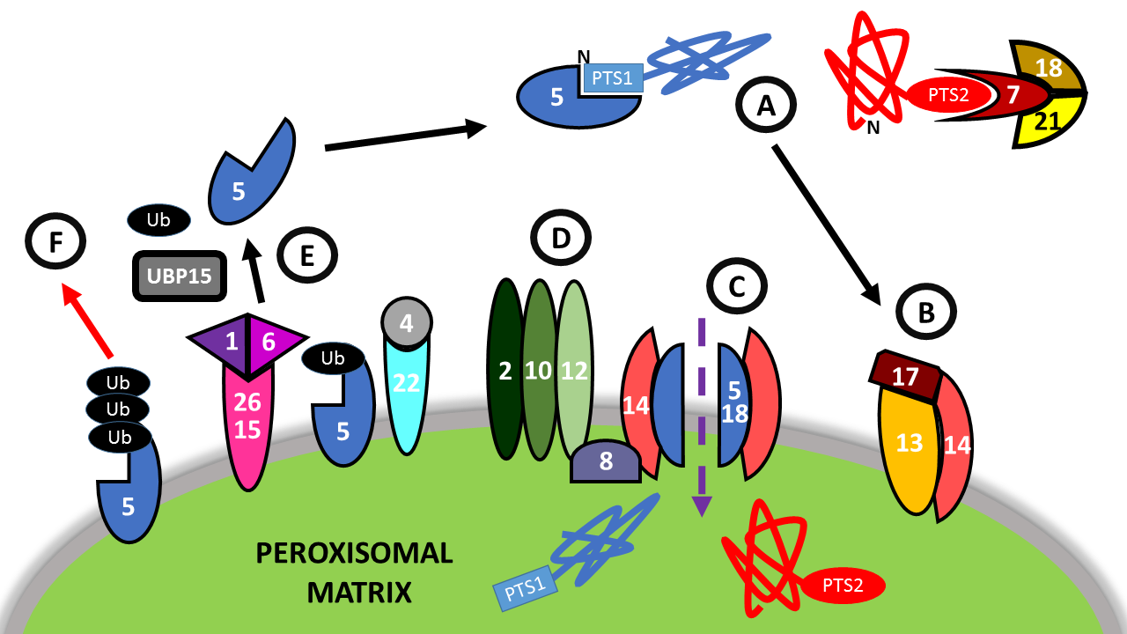

Fig 1.1: Models of Peroxisome Matrix Protein Import
A: Cargo Receptor Binding: Free, cytosolic Pex5p (PTS1) or Pex7p (PTS2) bind to Peroxisomal matrix proteins and transport them to the peroxisome.
B: Receptor Docking: The receptor-PTScargo complex binds to the docking complex comprising of Pex13, Pex14, and Pex17 at the peroxisomal membrane.
C: Channel formation and translocation of matrix protein: A gated ion channel consisting of Pex14p and either Pex5p (PTS1) or Pex7p (PTS2) forms and the metrix protein is translocated across the peroxisomal membrane.
D: Receptor Ubiquitylation: Pex4p, and Pex22p (the peroxisome exportomer), and Pex2p, Pex10p, and Pex12p (The RING-finger complex), through a series of ubiquitylation steps, are able to cause the release of Pex5p from the peroxisomal membrane either via its Recycling (E) or Degradation (F).
E: Receptor Removal for Recycling: Mono-ubiquitylated Pex5p is removed from the membrane via a Pex1/Pex6 mediated mechanism and recycled via UBP15p.
F: Receptor Removal for Degradation: Poly-ubiquitylated Pex5p is removed from the membrane and broken down.

1.6.2 Peroxisomal membrane biogenesis

Peroxisomal membrane proteins (PMPs) have a distinct method of transport and integration to that of peroxisomal matrix proteins. Most PMPs are synthesized on free ribosomes in the cytoplasm and post-translationally imported into the peroxisome membrane. This pathway, although known to be distinct from the matrix protein import pathways, is far from well defined. Many PMPs contain a membrane peroxisome targetting signal (mPTS), which directs them to the peroxisomal membrane, however, this signal is poorly defined in comparison to its PTS counterparts. Generally, mPTSs consist of a cluster of basic amino acids, mixed with hydrophobic residues and may be situated next to membrane-spanning segments (Dyer et al. 1996; Baerends 2000; Fang et al. 2004a; Honsho & Fujiki 2001; Honsho et al. 2002; Rottensteiner et al. 2004; Ghaedi et al. 2000). As a result of their different pathways for reaching the peroxisomal membrane, two distinct classes of PMPs have been proposed. Class 1 (mPTS1) PMPs are directly imported from the cytosol in a Pex19p dependent manner, whereas Class 2 (mPTS2) PMPs have been found to initially locate to the endoplasmic reticulum (ER), and are directed to the peroxisome independently of Pex19p (for a review, please see (Kim & Hettema 2015)).

Class I PMP Import
The initial stage of import requires recognition mPTS1 by Pex19p in the cytosol. Pex19p functions as both a soluble receptor protein and a chaperone for directing newly translated PMPs to the peroxisomal membrane (Hettema et al. 2000). Then the complex Pex19-PMP is directed to the peroxisome membrane, where it binds to Pex3p (Fang et al. 2004a; Matsuzono et al. 2006). Even though the Pex19p-Pex3p interaction has been the subject of several recent studies, it is not yet known how the PMP is integrated with the peroxisomal membrane, although it has been posited that a series of amphipathic helixes within Pex19p play some role in membrane insertion (Chen et al. 2014). To date, it has not been established what the export mechanism for Pex19p is.
In mammalian cells, Pex16 acts as a docking site for the complex Pex3-Pex19 on the peroxisomal membrane, however, there has been no PEX16 orthologue discovered in S. cerevisiae (Matsuzaki & Fujiki 2008).

Class II PMP Import
Class 2 PMPs, are proposed to be directed to the peroxisomes via the ER, however, the actual mechanism of transport is unknown (Tam et al. 2005; Hoepfner et al. 2005; Hua et al. 2015). To date, only a few Class II PMPs have been identified: Pex3, Pex15, Pex16, and Pex22, and of these, only Pex3 import has been studied in any great detail (for a review, please see (Kim & Hettema 2015)).

1.6.3 Models of Peroxisome biogenesis

Characterising peroxisomes and defining those proteins which are involved in their biogenesis has been a constant theme for investigative research in the peroxisome field since its inception. However, there is still contentious debate about the actual mechanisms by which peroxisome biogenesis is achieved in S. cerevisiae, with several models being proposed. While all share similarities, in that at least some PMPs and lipids come from the ER, and matrix proteins are post-translationally imported, the initial formation of the peroxisomal membrane remains a bone of contention.
As peroxisomes are independent organelles, it has been argued that they can proliferate autonomously. This line of thought, has led to the development of the growth and division model (Fig 1.2.1)(Motley & Hettema 2007; Lazarow & Fujiki 1985). The model posits that the majority of PMPs and Matrix Proteins are post-translationally imported into pre-existing peroxisomes, which then grow and mature due to the increased material, eventually dividing for the process to repeat. The ER is involved as a source of membrane lipids, and for glycosylation of Class II PMPs (Lazarow & Fujiki 1985).
However, the model of growth and division alone cannot explain the de novo formation of peroxisomes that occurs when a gene deletion which causes a total loss of peroxisomes is rescued through restoration of the gene in question. Specifically, the deletion of either PEX3 or PEX19 has been shown to result in total loss of peroxisomal structures, a phenotype which can be rescued through re-introduction of the protein through an inducible promoter (Motley & Hettema 2007).
Several studies have shown that the ER plays a role in this de novo synthesis of peroxisomes (Hoepfner et al. 2005; Kragt et al. 2005; Motley & Hettema 2007; Tam et al. 2005). During early research on peroxisomes it was thought that peroxisomes were in fact extension of the ER, which led to the formulation of the de novo synthesis model (Fig 1.2.2). In this model, peroxisomes form on the ER, and then bud off before importing further PMPs and matrix proteins. Support from this model came from electron microscopy showing peroxisomes in close proximity to the ER (Novikoff & Novikoff 1972), and the that some PMPs and peroxisomal enzyme first locate to the ER before being transported to peroxisomes. However, while these two models may exist, the growth and division of peroxisomes from existing peroxisomes has been reported as the dominant mechanism present (Knoblach et al. 2013; Motley & Hettema 2007; Motley et al. 2015).
A debate has been caused by a recent study purporting a vesicle fusion model (Fig 1.2.3 (van der Zand et al. 2012)). As an extension of the de novo synthesis model, the vesicle fusion model shows evidence that two biochemically distinct vesicles fuse. Crucially, the matrix protein translocation machinery is divided between these vesicles, and so only fusion could result in mature peroxisome formation. This is unmarriable with the growth and division model, and attempts have been made to debunk the vesicle fusion theory (Motley et al. 2015; Knoops et al. 2015; Yuan et al. 2016).

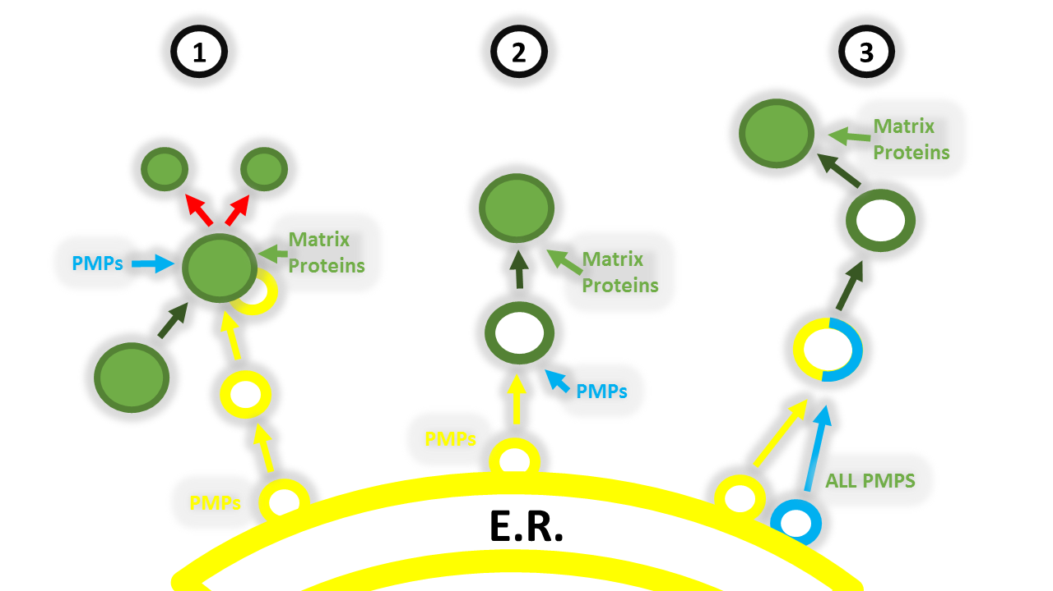

Fig 1.2: Models of Peroxisome Biogenesis
1: The Growth and Division model: PMPs and lipid containing vesicles bud from the ER (yellow) and fuse with pre-existing peroxisomes in the cytosol (green). Further PMPs are imported into the peroxisome from the cytosol (blue), along with further matrix proteins (green). The peroxisome then divides into 2 separate daughter peroxisomes (red arrows).
2: The de novo synthesis model: PMPs and lipid containing vesicles bud from the ER (yellow) and import other PMPS (blue) to form a preperoxisome (hollow green). Matrix proteins (green) are imported from the cytosol.
3: The vesicle fusion model: All PMPs bud from the ER in vesicles. There are at least 2 distinct vesicle types (blue and yellow). Vesicles fuse to form a preperoxisome (hollow green). Matrix proteins are imported from the cytosol (green).

1.6.4 Maintenance of Peroxisomal Size and Number

As shown in Table 1.2, a number of Peroxins have been identified as being involved in the regulation of peroxisome size and abundance. While deletion of the genes that code for these Peroxins appears to have no impact on peroxisomal function, nor on protein import, manipulation of these proteins has been shown to influence peroxisome number and/or peroxisomal size (for a review, please see, (Yan et al. 2005)).

The Pex11 Family of Proteins

A sub-group of Peroxins exists, namely the Pex11p family, consisting of Pex11p, Pex25p, and Pex27p. There are 3 known homologues of PEX11 found in humans – PEX11alpha, beta, and gamma, however, only a single PEX11 is present in S. cerevisiae (Tanaka et al. 2003).
The family is called such, as the C-termini of PEX25 and PEX27 contain homology to PEX11 (and each other). PEX25 and PEX27 are also assumed to be paralogs (Byrne & Wolfe 2005). The sub-grouping of these proteins has also been strengthened as successive deletions of these genes has been shown to have an apparent cumulative impact, as the phenotype of a triple knockout is more severe than that of any double knockouts, which in turn are more severe than that of the individual knockouts (Rottensteiner et al. 2003; Huber et al. 2012).
Deletion of the Pex11 family of Peroxins leads to an increase in size of peroxisomes, as well as a growth defect on oleate media (cells lacking PEX11 fail to grow completely). Overexpression of these genes leads to an increase of peroxisomes, however, these more abundant peroxisomes appear smaller in size than one would observe in a wildtype cell (Erdmann & Blobel 1995; Marshall et al. 1995). The family of proteins has also been implicated in the de novo formation of peroxisomes (Huber et al. 2012). Functionally, Pex11p has been shown to be involved in the extension and curvature of the peroxisomal membrane prior to division, and is required for the recruitment of the fission machinery (Opalinski et al. 2011; Koch et al. 2010; Kobayashi et al. 2007; Nagotu et al. 2008).

The Fission Machinery

The machinery involved in peroxisome fission differs between organisms. In H. polymorpha, Pex11p recruits Dnm1p, which leads to peroxisomal cleavage (Nagotu et al. 2008). In S. cerevisiae Dnm1p and Vps1p are both dynamin related proteins (DRPs) responsible for cleavage, and have been found to show some redundancy, as the absence of both is required for complete loss of peroxisomal cleavage (Kuravi et al. 2006). These dynamin related proteins have also been reported as being required for maintenance of peroxisome number by fission (Hoepfner et al. 2001; Motley et al. 2008).

Other Peroxins of note

As well as the Pex11 family of proteins, other Peroxins have also been presented as having a role in the maintenance in peroxisomal size and number. Largely, these studies have focussed on a phenotypic change in either peroxisomal abundance or size when these Peroxins are absent or apparently non-functional. An absence of Pex27p, Pex28p, Pex29p, Pex30p, Pex31p, or Pex32p has been shown to lead to larger peroxisomes that appear clumped together, with Pex31p and Pex32p appearing to perform their function downstream of the others listed (Tam et al. 2003; Vizeacoumar et al. 2003). A phenotype which showed enlarged peroxisomes has been reported for the absence of Pex30p (Vizeacoumar et al. 2004).
This family of Peroxins have also been implicated in the formation of contact sites through an interaction with the COPI caotomer complex (David et al. 2013).

Pex34p
The most recently discovered Peroxin has been given the name Pex34p. It has been shown to interact with all of the Pex11 family proteins (Pex11p, Pex25p, and Pex27p) through a yeast two hybrid screen (Tower et al. 2011). Interestingly, although it has been linked to control over peroxisome size and division, and has been shown to link to the Pex11 family, Pex34p has been shown to have no interaction with Vps1p.

1.7 The Role of Pex3p

1.7.1 Proteins of many functions

Many proteins throughout the proteome have a singular function, be that through a protein binding partner, or through another specific interaction with a substrate, protein or structure. However, the relatively small size of the proteome and the numerous (and growing) known functions required to be fulfilled within a cell has exposed the need for some proteins to perform a role in multiple different pathways. For a basic example, a kinase may phosphorylate more than one protein, or a transport motor protein such as myosin can be involved in the transport of completely unrelated proteins, or even organelles. However, there is emerging evidence for the existence of hub-like proteins, which orchestrate several pathways. These hub-like proteins are oft bound to membranes of organelles and regulate their position, content and even destruction. One such protein is Vacuolar Protein 8 (Vac8p).

1.7.2 Vac8p

Vac8p is a known vacuolar protein, and has been described as containing multiple armadillo repeats. It was initially discovered and named for its essential role for correct targeting of proteins to the vacuole (Wang et al. 1996; Wang et al. 1998). However, it has since been discovered that Vac8p is involved in at least three mechanisms that regulate several diverse vacuolar functions, inheritance, and cell position.
Initially discovered for its involvement in the cytoplasm to vacuole targeting (CVT) pathway, the first function of Vac8p that was elucidated, was its role in vacuole-vesicle fusion. It was initially posited that Vac8p is involved during vesicle formation and its phosphorylation is key in regulating the autophagy through its interaction with Atg13p (Scott et al. 2000).
In addition, a second, distinct interaction has also been shown that palmitoylation of Vac8p results in its targeting to a specialised lipid domain, known to promote membrane fusion, and that Vac8p itself associates with SNARE complex proteins, which are also known to mediate vesicle fusion (Veit et al. 2001; Wang et al. 2001).
As well as being involved in vesicle fusion and the CVT pathway (processes related to the function of the vacuole), Vac8p has also been implicated in vacuolar transport through a separate protein-protein interaction. Through an interaction with Vac17p, Vac8p appears able to couple the vacuole to the myosin V motor Myo2p, allowing for transport of the vacuole to the bud during cell division (Tang et al. 2003; Ishikawa et al. 2003). Vac17p itself is degraded by a Dma1p dependent ubiquitylation mechanism, leading to the termination of vacuole transport (Tang et al. 2003; Yau et al. 2014).
A fourth, distinct, interaction of Vac8p is with the Nuclear envelope protein Nvj1p. Vac8p maintains its position on the vacuolar membrane and interacts with Nvjp1, which embeds into the nuclear envelope forming the nucleus-vacuole junction (Pan et al. 2000). These junctions not only fix the vacuole in position within the cell, but also facilitate piecemeal micro autophagy of the nucleus, which consists of small pieces of the nucleus being degraded by the vacuole (Roberts et al. 2003)
The control and interplay of all these processes has been studied and focus has tended towards modification of Vac8p. Several different modifications including myristoylation, palmitoylation, and phosphorylation have all been put forward as required for Vac8p’s involvement in its numerous biological processes (Wang et al. 1998; Smotrys et al. 2005; Peng & Weisman 2008; Schneiter et al. 2000; Subramanian et al. 2006).

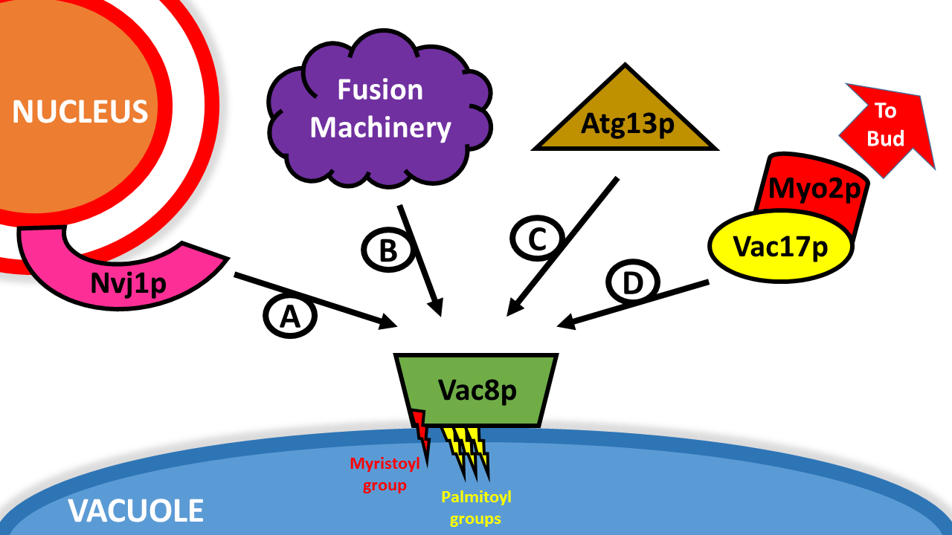

Fig 1.3: The Many Interactions of Vac8p
- Nvj1p: Interacting with Nvj1p creates the Nuclear-Vacuole Junction, allowing for micro autophagy of the nucleus
- Vacuole Fusion Machinery: Interaction with SNAREs facilitates vacuole-vacuole and vacuole-vesicle fusion
- Atg13p: Interacting with Atg13p allows for the vacuole to link with the CVT pathway, facilitating selective autophagy
- Vac17p: Interacting with Vac17p connects the vacuole to the transport machinery, by which the vacuole can be transported to and then inherited by the daughter cell during cell division.

1.7.3 Pex3 as a Hub

Just as Vac8 is important for many areas of vacuole regulation (with many more possible interactions yet to be fully characterised), so Pex3p is being increasingly featured as an integral protein in many steps throughout the regulation of peroxisomes. Interestingly, the three distinct functions and mechanisms involving Pex3p discovered so far show some similarity to those found to be carried out through Vac8p binding, as Pex3p’s partners facilitate the regulation of organelle localisation, through interactions with Inp1p; in organelle growth through its interaction with Pex19p; and in linking the organelle to an autophagic pathway (Fig1.4) (Motley et al. 2012b; Hettema et al. 2000; Munck et al. 2009). A fourth interacting partner, Pex16p, has also been found to be involved in de novo synthesis of peroxisomes in mammalian cells, however, no PEX16 orthologue has been discovered in S. cerevisiae (Hua et al. 2015; Kim et al. 2006; Voorn-Brouwer et al. 2001).

Autophagy: Atg36p

Atg36p was found as a novel Pex3p binding protein and cells lacking in Atg36p are unable to perform selective breakdown of peroxisomes (pexophagy) (Motley et al. 2012b). Atg36p acts as a specific autophagy receptor by coupling peroxisomes to the autophagic machinery through interactions with Atg8p and Atg11p, and these interaction has been found to be dependent on the Hrr25p kinase and the phosphorylation of Atg36p (Tanaka et al. 2014).
Regulation of the Pex3p-Atg36p interaction has not been investigated.

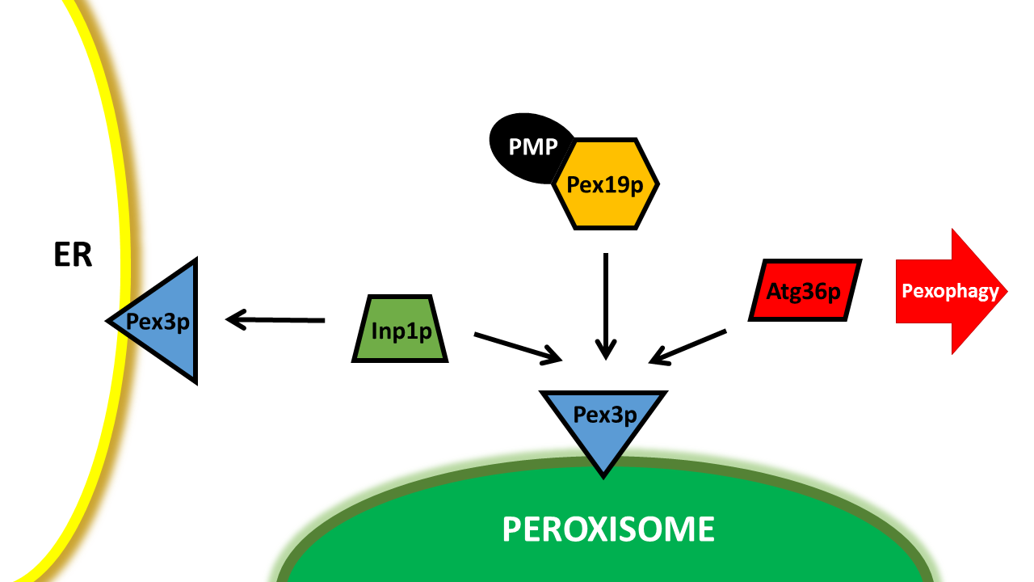

Fig 1.4: The 3 known interactions of Pex3p in S. cerevisiae
Pex3p-Inp1p-Pex3p: This interaction in which Inp1p forms a bridge between two Pex3ps is suggested to be the mechanism by which the peroxisome is tethered to the ER.
Pex3p-Pex19p: a) Pex3p acts as a dock on the peroxisomal membrane for Pex19p to deliver PMPs
b) Pex19p is required for the release of Pex3p from the ER
Pex3p-Atg36p: Atg36p couples the peroxisome to the cell’s selective autophagy machinery.
How these different interactions occur are shown in more detail in Fig 1.5.

Formation and Growth: Pex19p

Peroxisomes have been shown to form de novo through forming a pre-peroxisome on a specific part of the endoplasmic reticulum, known as the peroxisomal endoplasmic reticulum, and then budding off when a critical point is reached (Hoepfner et al. 2005). Pex3p has been highlighted as a protein of key importance in this formation. Through tracking a YFP tagged version of Pex3p, it was shown that Pex3p appears to anchor the forming peroxisome to the ER, firstly forming foci, through an as yet unknown interaction or mechanism. The peroxisome is then released from the ER via a Pex19p dependent process, allowing the peroxisome to move away from the ER in a budding fashion. These results were consistent with and supported previous findings that Pex3p acts as the receptor protein for Pex19p, and that without either of these proteins being present, peroxisome biogenesis is unable to occur (Hettema et al. 2000).
During this initial formation, Peroxisomal Membrane Proteins (PMPs) are required to be imported into the peroxisome, as they are synthesised on free ribosomes in the cytosol. However, there are 2 classes of PMPs, Class II are imported via the ER and independently of Pex19p, but Class I are transported to the peroxisome by a Pex19p chaperone system (Chen et al. 2014; Fujiki et al. 2006). Class I PMPs bind to Pex19p at its C terminal globular region (Fang et al. 2004b), the complex is then directed to the Peroxisome, where Pex19p binds to Pex3p through an N terminal helix and completes delivery of the PMP to the peroxisome (Schmidt et al. 2010; Chen et al. 2014). Deletion of PEX19 results in a very noticeable phenotype in which peroxisomal structures are absent and PMPs are mislocalised to the cytosol and quickly degraded (Gotte et al. 1998; Hettema et al. 2000).
The mechanism by which Class I PMPs are inserted into the peroxisomal membrane after their delivery, however, is currently unknown. A study recently reported that Pex3p itself promotes manipulation of the immediate membrane surrounding it, and that this phenomenon along with hydrophobic regions contained within Pex19p are responsible for the insertion of transmembrane domains of tail-anchored PMPs into the peroxisomal membrane (Chen et al. 2014). This data is supported by studies that highlight Pex3p’s ability to bind amphipathic molecules and membrane lipids (Pinto et al. 2009), which in turn have been supported by structural studies highlighting that purification of Pex3p requires an absence of lipids and detergents (Schmidt et al. 2012; Sato et al. 2010; Schmidt et al. 2010).
The regulation of Pex19p binding to Pex3p has not been defined, and the mechanisms required are still undiscovered. However, farnesylation of Pex19p has been debated as a modification that is essential for its function (Rucktäschel et al. 2009; Vastiau et al. 2006).

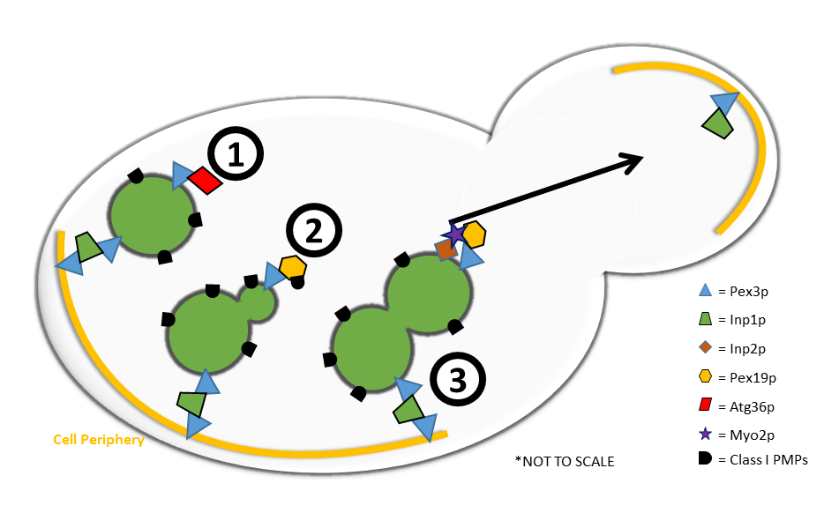

Fig 1.5: Pex3p and its Interactions
Pex3p has 3 known interacting partners in S. cerevisie:
- Atg36p, through which it tags the peroxisome for degradation by selective autophagy (pexophagy)
- Pex19p, through which Class I PMPs are targeted to the peroxisomal membrane
- Inp1p, through which retention of the peroxisome in the mother cell during cell division is achieved via a Inp1p-Pex3p-Inp1p bridge.

Segregation During Cell Division

Proper segregation of organelles is highly important during cell division, and yet appears much less structured than inheritance of genetic material (Ouellet & Barral 2012). Some organelles are crucial for the viability of the daughter cell and therefore it is imperative that they segregate correctly during cell division. For example, a bud which fails to properly inherit the endoplasmic reticulum or any mitochondria will be non-viable. Furthermore, even if the cell has the ability to synthesise the organelles de novo (as is the case with peroxisomes), inheritance still adds a competitive advantage in nature, more so if cells or organisms are under pressures or stress (Warren & Wickner 1996). This is of particular importance in single celled organisms such as yeast due to their natural environment being liable to dramatic change. With peak fitness comes the ability for the cell to respond quickly and most efficiently to stimuli. For example, sudden changes to the available energy source from sugar to fatty acid would prove a struggle to a newly formed S. cerevisiae bud if it were lacking peroxisomes as peroxisomes are their sole site of beta-oxidation of fatty acids.
Increasingly, it has been found that organelles apply an ordered mechanism for their segregation during cell division, and so models are increasingly leaning towards ordered inheritance and away from theories involving stochastic inheritance, in which organelles are tethered and dispersed uniformly within a cell and their inheritance dependent on where in the cell they happen to be upon cell division (Pruyne et al. 2004; Barbara Knoblach & Rachubinski 2015; Fagarasanu et al. 2010; B. Knoblach & Rachubinski 2015).
Regulation of organelle segregation has also been increasingly found to be linked to regulation of organelle growth and division, which is extremely apparent to be the case in peroxisomes due to Pex3p being crucial in the two processes through its distinct interactions with Pex19p and Inp1p respectively.
In S. cerevisiae, segregation of peroxisomes during cell division is regulated via an antagonistic partnership formed between two proteins – Inp1 and Inp2 (INheritance of Peroxisomes 1 and 2 respectively). Inp2p has been shown to be required for correct transport of peroxisomes to newly formed buds, while Inp1p performs a seemingly opposite action and retains the peroxisome in the mother (Munck et al. 2009; Knoblach et al. 2013; A. Fagarasanu et al. 2006; Fagarasanu et al. 2005). Studies have shown that null mutations in INP1 lead to transport of most peroxisomes from the mother to the bud during division, with the opposite occurring in null INP2 mutations, where most peroxisomes are retained in the mother during cell division. As a consequence, in either of these null mutations, after budding many cells will be devoid of peroxisomes. A balance is apparent between these two counteracting proteins, as overexpression of either skews the segregation pattern seen, with increased levels of Inp1p or Inp2p leading to greater or lower retention in the mother during cell division respectively.

Inp1p

Inp1p is a peripheral membrane protein and is responsible for the retention of peroxisomes in S. cerevisiae (Fagarasanu et al. 2005). Inp1p protein and mRNA levels fluctuate throughout the cell cycle, reaching their peak at the transition point between the G2 and M phase. This suggests that during this phase, retention of peroxisomes within the mother is at its peak. However, the exact relationship between changes in the levels of Inp1p and their coordination with the cell cycle is yet to be determined. Despite this fluctuation, Inp1p never appears to be absent from the cell. This suggests that there is a continuing need for a retention or tethering of peroxisome.
During cell division in S. cerevisiae, approximately half of the population of peroxisomes is retained inside the mother cell. In contrast to mitochondria, which are anchored in certain "retention zones" in the parent cell (Yang et al. 1999), peroxisomes do not appear to preferentially locate to any specific area of ​​the periphery of a cell.
In most inp1Δ cells, the entire peroxisome population is transported to the newly forming daughter cell, resulting in a mother cell that is completely devoid of peroxisomes. Conversely, overexpression of Inp1p usually results in the total population of peroxisome assuming static positions at the periphery of the mother cell, thus showing a capacity for preventing the transportation of peroxisomes to the bud (Fagarasanu et al. 2005).
Inp1p’s interaction with Pex3p has been shown to be essential for performing its function (Munck et al. 2009), with recent models indicating that not only does the interaction occur on the peroxisomal membrane, but Inp1p forms a bridge by binding to Pex3p on the peroxisome and to a separate Pex3p located on the cortical ER, thus creating the tether for peroxisomes at the periphery of the cell (Fig 1.6) (Knoblach et al. 2013), with evidence for this relying heavily on both N-terminal and C-terminal truncated forms of Inp1p being shown to interact with N-terminally GST tagged fusions of Pex3p in vitro.

Pex19p, Inp2p, and Myo2p

Inp2p is an integral membrane protein that interacts directly with the cargo-binding globular tail of Myo2p (A. Fagarasanu et al. 2006). Inp2p recruits Myo2p to the peroxisomal membrane via a Pex19p mediated mechanism (Otzen et al. 2012), which in turn binds to actin and transports the peroxisome from the mother to the newly formed daughter cell during budding. There is also evidence suggesting that in other species, which do not contain an INP2 orthologue, that Myo2p binds directly to Pex3p to perform this function (Chang et al. 2009).
Inp2p levels and mRNA levels fluctuate during the cell cycle, and the changes in expression levels correlate with the movement of peroxisomes (i.e. peak protein level occurs at the same time as initial transport to the bud, with levels decreasing as peroxisomes reach their target [the bud] and transport nears completion). This suggests that as Vac17p expression and degradation appear responsible for vacuolar inheritance, regulation of synthesis and degradation of Inp2p is responsible for the coordination of peroxisome transport during the cell cycle.
In most inp2Δ cells, peroxisomes appear to lack the ability for transport to the emerging bud during cell division, often leading to buds that are devoid of peroxisomes. Conversely, in cells in which INP2 is overexpressed, peroxisomes appear to display increased transport to the bud, and the mother cells appear unable to retain them.
Inp2p has been shown to have a non-uniform distribution and is not present in equal amounts on all peroxisomes, but preferably supplements those that are located in the newly formed daughter cell. This suggests that Myo2p preferentially transports peroxisomes that have the highest levels of Inp2p. However, peroxisomes which have already been transferred to the bud have also been shown to present Inp2p. It has been postulated that this makes already transferred peroxisomes remain attached to Myo2p and are thus retained at the bud tip (with Myo2p) (A. Fagarasanu et al. 2006; M. Fagarasanu et al. 2006). Utilisation of Myo2p in this way is consistent with mechanisms found for transport of mitochondria and Golgi apparatus to the bud during cell division (Boldogh et al. 2004; Rossanese et al. 2001).
There is also evidence to suggest that the entire peroxisome is not removed from the ER during this transport, rather the peroxisome is pulled via a myosin motor, whilst still being anchored to the ER by Inp1, causing the peroxisome to stretch. Peroxisomal fission is then facilitated by Vps1p (which is chaperoned to the peroxisome by Pex19p) to divide the peroxisome, and ensure equal segregation of peroxisomes during cell division (Fig 1.5:3) (Hoepfner et al. 2001).

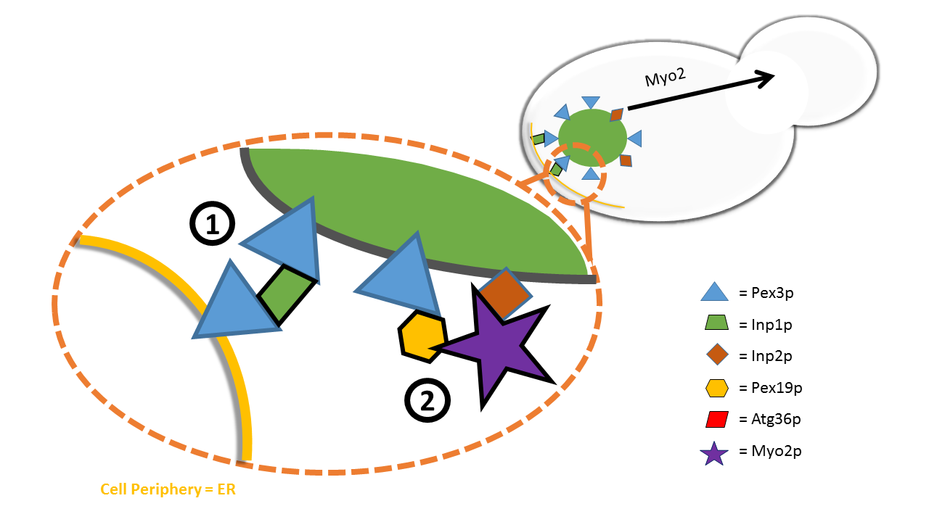

Fig 1.6: Current Peroxisomal inheritance Models
Peroxisomal inheritance relies on two antagonistic mechanisms.
- Retention in the mother is achieved through a Inp1p-Pex3p-Inp1p bridge which tethers the peroxisome to the cortical ER and therefore the periphery of the mother cell.
- Inp2p is the specific receptor of Myo2p required for transport of the organelle to the bud during cell division. Myo2p is directed to the peroxisome by a Pex19p dependant manner.

1.11 Aims

Pex3p is a significant protein which is essential for the three key parts of peroxisome regulation: biogenesis, inheritance, and degradation. The three interacting partners it requires to achieve these three functions are known to be Pex19p, Inp1p, and Atg36p, respectively (Fang et al. 2004a; Munck et al. 2009; Motley et al. 2012). However, the mechanisms by which it achieves and orchestrates such a diverse range of functions are largely uncharacterised.
The parallels with other hub proteins such as Vac8p and the increasing evidence for links between organelle growth, division and segregation may also act as a guideline of how to proceed, with recent evidence suggesting that further investigations into the potential binding partners of Pex3p and how their interactions are regulated could prove fruitful.
Ultimately, a complete understanding of how peroxisomes are formed, replicate, and are destroyed would be invaluable knowledge in the pursuit of possible treatments for Peroxisomal Biogenesis Disorders.
As a poorly conserved protein, clues to Inp1p’s function cannot be taken from other organisms. However, the function of Inp1p is conserved in the yeast Yarrowia lipolytica (Chang et al. 2007), an organism known to contain two PEX3 homologues. The products of these genes have been shown to divide Pex3p functions between them, suggesting that the mechanisms by which Pex3p regulates each function are distinct (Chang et al. 2009).
Using its interaction with Inp1p as a guide, this study aims to elucidate the method by which Pex3p facilitates peroxisomal retention and subsequently determine how this mechanism relates to the other known functions of Pex3p, namely in its interactions with Pex19p and Atg36p.

The initial investigation, documented in Chapter 3, will focus primarily on determining regions within Inp1p which are required for its function, colocalisation to peroxisomes, and its interaction with Pex3p. A conserved region required for Pex3p binding is reported.

Chapter 4 will then aim to further characterise this conserved Pex3p binding region found in Inp1p, and also highlight its presence in Pex19p and other potential Pex3p binding candidates.

As the conserved Pex3p binding motif is reported in Pex19p and Inp1p but not Atg36p, Chapter 5 will present a collection of preliminary studies aiming to gain insight into the possible mechanisms by which binding to Pex3p is orchestrated. Several different paths of investigation will be attempted and reported on.

Chapter 2: Materials and Methods

2.1 Chemicals and Reagents Used

Unless otherwise stated, chemicals, reagents and materials used during this work were supplied by Sigma-Aldrich. Restriction enzymes and buffers were supplied by New England Biolabs. PCR buffers and DNA polymerases were supplied by Bioline.Plasmid Miniprep kits were supplied by Sigma-Aldrich. Agarose Gel Extraction kits were supplied by Qiagen.
Unless otherwise stated, growth media components were supplied by Difco Laboratories and Formedium. D-Glucose was supplied by Fisher Scientific UK.
Equipment and buffers used for biochemical assays were provided by BioRad and Geneflow respectively.

2.2 S. cerevisiae Protocols

2.2.1 Growth and Maintenance

Yeast was cultured on YPD or minimal media D-glucose plates at 30°C for 1-2 days (some strains required longer). Oleate plates required incubated at 30°C for up to 1 week. Strains were stored at room temperature for a maximum of 1 week, before being re-streaked onto fresh plates.
For long-term storage, strains were stored in sterile 15% (v/v) glycerol in an appropriate cryogenic vial (Nunc) at -80°C.
Liquid yeast cultures were inoculated from their respective culture plate and incubated at 30°C in a shaking incubator (180rpm) observing an approximate 1:5 liquid:air ratio in an appropriately sized tube or flask.

2.2.2 Growth Media

Unless otherwise stated, the sterilisation of culture media was conducted by autoclaving at 121°C for 15 minutes. All culture media was dissolved in Millipore water. Amino acid stocks were prepared according to Guthrie and Fink (2002). Antibiotic stocks were prepared at 100x final concentration in Millipore water and stored at -20°C, unless otherwise stated. Media was allowed to cool to 50°C after sterilization before the addition of amino acids or antibiotics.
Amino Acid | Final Concentration  (ng/ml)
Uracil | 20
Leucine | 30
Lysine-HCl | 30
Tryptophan | 20
Methionine | 20
Histidine-HCl | 20
Adenine hemisulfate | 20
Antibiotic | Final Concentration  (µg/ml)
Ampicillin | 75
Kanamycin | 50
Hygromycin B | 500
Geneticin (G418) | 200
Chloramphenicol | 50
Nourseothricin (CloNAT) | 100

Culture Media | Description
YPD | 1% peptone, 1% yeast extract, 2% glucose.
YPG | 1% peptone, 1% yeast extract, 2% galactose.
Yeast Minimal Media 1  (For the selection of all auxotrophic markers). | 0.17% yeast nitrogen base (without amino acids and ammonium sulphate), 0.5% ammonium sulphate, 2% glucose (or galactose, as required). Adjusted to pH 6.5.
Yeast Minimal Media 2  (For the selection of uracil and tryptophan) | 0.17% yeast nitrogen base (without amino acids and ammonium sulphate), 0.5% ammonium sulphate, 1% casamino acids, 2% glucose (or galactose, as required). Adjusted to pH 6.5.
Solid Media | 2% agar was added to the dissolved liquid media. The media was poured into sterile petri dishes (Sterilin) and allowed to set at room temperature. Set plates were stored at 4°C.
Oleate Media | 0.1% yeast extract, 0.5% ammonium sulphate, 0.125% oleate, 0.5% Tween40 (oleic acid/Tween40 were pre-mixed), 0.0016% yeast nitrogen base
5-FOA plates | - 4% agar solution. Autoclave. Cool to 50°C.  - 0.34% yeast nitrogen base (without amino acids and ammonium sulphate), 1% ammonium sulphate, 4% glucose, 0.2% 5-FOA, 0.05% Uracil. Filter sterilise.  Add equal volumes 1 and 2 and appropriate amino acids. Final pH must be <pH 4. Pour into sterile petri dishes (Sterilin) and allow to set at room temperature. Set plates were stored at 4°C.
Low-Fluorescence Media | 6.61mM KH₂PO₄, 1.32mM K₂HPO₄, 4.06mM MgSO₄·7H₂O, 26.64mM (NH₄)SO₄, 2% glucose.

All percentage concentrations are stated as w/v.

Table 2.1:
S. cerevisiae culture media, amino acid final and antibiotic concentrations.

2.2.3 One Step Transformations

Yeast cells were transformed with plasmid DNA using the one step method (Chen et al., 1992).
A 3ml yeast culture was inoculated from a plate and grown overnight at 30°C. 200μl of the culture was harvested through centrifugation for 1 minute at 600rcf. The supernatant was removed and the pellet washed by resuspension in 1ml of Millipore water. The cells were again pelleted through centrifugation for 1 minute at 600rcf. The supernatant was removed and the pellet resuspended in 5μl (50μg) Salmon testes DNA. 2μl (0.5μg-1μg) of the appropriate plasmid and 50μl one-step buffer (0.2M LiAc pH 5.0, 40% (w/v) PEG 4000, 0.1M DTT) were added and the mixture incubated at room temperature for 2-4 hours, with periodic vortexing. After incubation, the cells were heat shocked at 42°C for 30 minutes in a water bath, before being spread onto solid minimal media and incubated at 30°C for two days.

2.2.4 High Efficiency Transformations

Methods requiring homologous recombination, such as creation of knockout strains and plasmids, utilised the High Efficiency Transformation method (Gietz et al., 1992).
A 3ml yeast culture was inoculated into appropriate media from a plate and grown overnight at 30°C to act as a primary culture. The OD₆₀₀ of the primary culture was measured and used to inoculate a secondary 5ml yeast culture to OD₆₀₀ 0.1. The secondary culture was grown to mid-log phase (OD₆₀₀ = 0.5-0.6) at 30°C with shaking (180rpm), taking approximately 4-5 hours.
The cells were then harvested by centrifugation for 5 minutes at 600rcf and the supernatant was removed. The pellet was resuspended in 1ml sterile water and centrifuged again for 1 minute at 600rcf. The supernatant was again removed and the pellet resuspended in 1ml TE/LiAc buffer (10mM Tris-Cl pH7.5, 0.1mM EDTA, 0.1M LiAc pH7.5). The cells were centrifuged again (2.5 minute, 450rcf) and the pellet resuspended in 50μl TE/LiAc. 2 µl plasmid (0.5μg-1μg), 5μl (50µg) Salmon testes DNA and 300µl sterile 40% PEG 4000 solution (40% w/v PEG 4000, 10mM Tris-Cl pH 7.5, 0.1mM EDTA pH8.0, 0.1M LiAc pH7.5) were added to the cells and the sample was vortexed thoroughly. The cells were incubated at room temperature for 30minutes, then 30°C for 30 minutes, before being heat shocked at 42°C for 15 minutes. The cells were centrifuged for 1 minute at 600rcf and the supernatant removed. The cell pellet was resuspended in 100μl TE (10mM Tris-Cl pH7.5, 0.1mM EDTA) and the cell suspension spread onto appropriate solid media and incubated at 30°C for two days.

2.2.5 Genomic DNA isolation

Genomic DNA isolation was used to rescue plasmids from yeast that had been created by homologous recombination. As well as for extracting genomic DNA for use as a PCR template.

A 3ml yeast culture was incubated overnight at 30°C and the cells harvested by centrifugation at 13,000rcf for 1 minute (using a micro-centrifuge). (All subsequent centrifugation steps were performed at 13,000rcf using a micro-centrifuge). The supernatant was removed and the pellet resuspended in 1ml sterile water and transferred to a 2ml screw-cap tube. The cells were centrifuged for 1 minute and the supernatant removed. The pellet was resuspended in 50μl sterile water. From this stage onwards the cells were kept on ice. 200μl TENTS (20mM Tris-Cl pH 8.0, 1mM EDTA, 100mM NaCl, 2% (v/v) Triton X-100, 1% (w/v) SDS), 200μl of 425-600μm acid washed glass beads and 200μl Phenol:Chloroform:Isoamyl Alcohol (25:24:1) was added to the cells. The cells were lysed using a mini bead beater (Biospec Products) at full speed for 45 seconds. The cells were centrifuged for 1 minute and a further 200μl of TENTS was added then vortexed and subsequently centrifuged for 5 minutes. Following centrifugation, 350μl of the resulting aqueous phase was retained and transferred to a new micro-centrifuge tube. 200μl of Phenol:Chloroform:Isoamyl Alcohol (25:24:1) was added and vortexed thoroughly. The sample was centrifuged for 5 minutes. 300μl of the aqueous phase was retained and 30μl 3M Sodium Acetate (pH 5.2) and 700μl of 100% ethanol (precooled) was added and the mixture incubated at -20°C for 30 minutes.
The mixture was centrifuged for 15 minutes. The supernatant was removed and the pellet resuspended in 500μl 70% (v/v) ethanol. The sample was centrifuged for 1 minute and the supernatant removed. The pellet was subsequently resuspended in 200μl RNase/TE (10μg/ml) and incubated at 37°C for 10 minutes. 20μl 3M Sodium Acetate, pH 5.2 and 500μl 100% ethanol (precooled) was added to the sample, which was then incubated at -20°C for a further 30 minutes.
The sample was centrifuged for 15 minutes, and the supernatant removed. The pellet was resuspended in 200μl 70% (v/v) ethanol and centrifuged again for 5 minutes. The supernatant was removed and the pellet air-dried in a 50°C incubator in order to remove all traces of ethanol. The pellet was subsequently resuspended in 50μl TE (10mM Tris-Cl pH 7.5, 0.1mM EDTA).

2.2.6 Fluorescence Microscopy

Routinely, yeast cultures were grown to log phase and images captured on a Zeiss Axiovert 200M microscope (Carl Zeiss MicroImaging, Inc.) equipped with an Exfo X-cite 120 excitation light source, band pass filters (Carl Zeiss MicroImaging, Inc. and Chroma Technology Corp.), an α plan-Fluor 100x/1.45 NA, plan-pochromat 63x /1.40 oil immersion lens, or A-plan 40x/0.65 NA Ph2 objective lens (Carl Zeiss MicroImaging, Inc.), and a digital CCD camera (Orca ER, Hamamatsu). 525nm and 700nm filters were used for Green Channel (GFP, and NeonGreen) and Red Channel (RFP, HcRed, mCherry, mKate, mRuby) respectively. Image acquisition was performed using Volocity software (PerkinElmer). Live cells were imaged in non-fluorescent media at room temperature. Unless otherwise stated, fluorescence images were collected as 0.5µm Z-stacks, merged into one plane after contrast enhancing in Openlab (Improvision), and processed further in Photoshop (Adobe). Brightfield images were collected in one plane and added into the blue channel in Photoshop (Adobe). The level of the brightfield images was modified, and the image was blurred and sharpened before further level adjustment.

2.2.7 Pulse-chase experiments

Pulse-chase experiments were used in order to follow the change in localisation of a fluorescently tagged protein (expressed under the control of the GAL1 promoter) with time (Motley and Hettema, 2007).
Cells were grown overnight in selective glucose minimal medium and transferred to appropriate selective galactose minimal medium containing CSM (Formedium) at an OD₆₀₀ of 0.1 to allow induction. Routinely, expression was achieved after cells were induced for 3 hours (pulse). Expression was shut down by switching the cells to selective glucose medium (chase). The chase period varied between experiments and is stated within the text. Live-cell imaging was performed at regular intervals throughout this period, to check the progression of the fluorescently tagged protein.

2.2.8 Fixation of yeast cells for microscopy

Formaldehyde was added to cells to a final concentration of 3.7% (v/v) and incubated for 5 minutes at room temperature. Cells were centrifuged in a micro-centrifuge for 1 minute at 13,000rcf. The supernatant was removed and the pellet resuspended in 0.1M ammonium chloride/PBS. Imaging was performed within 1 hour of fixing.

2.2.9 Mating Assays

Mating assays were used for both microscopy and tetrad dissection.
For microscopy, haploid cells of different genetic backgrounds (e.g. MATa pex3Δ and MATα pex19Δ) containing different fluorescently tagged proteins were mated, in order to track the change in localisation of the aforementioned proteins after conjugation.
Tetrad analysis was used to discern spore viability of potentially lethal gene mutation and/or gene knockout combinations.
3ml log phase cultures of opposite mating types were added to 4ml YPD. The mixture was incubated at 30°C for 30 minutes, before being transferred to a YPD plate.
If required for microscopy, plates were incubated at 30°C for 2 hours. In order to remove the cells for analysis, cells were harvested and placed into a 1.5ml micro-centrifuge tube containing 1ml of non-fluorescent media.
If required for eventual tetrad dissection, plates were incubated at 30°C overnight, and then replica plated onto sporulation plates (containing 1% potassium acetate), and incubated for 1-3 days at 30°C. Cells were checked for tetrads by light microscopy (100x) and sporulated strains determined for dissection. Sporulated cells were resuspended in 20µl final volume of diluted stock ß­glucuronidase (Roche) and incubated at 30˚c for 20 minutes to release spores from the ascus. Following treatment, the cell density was diluted by addition of 200µl sterile water. Cells were transferred onto a fresh YPD plate and dissected using a Micromanipulator (Singer MSM system series 200). Plates containing the individual tetrad colonies were incubated at 30°C for 1-3 days, and then photographed.

2.2.10 SGA

Small libraries of knockout strains were created using the Synthetic Genetic Array procedure (Tong and Boone, 2006). The methodology described allows for large numbers of strains to be constructed in a relatively short period of time.
A MATα query strain containing a gene modification (a deletion or point mutation, flanked by natMX cassette) and a small knockout MATa library (Created via the KanMX cassette) were grown separately in relevant liquid media overnight at 30°. The next day Secondary cultures were inoculated to OD₆₀₀0.2 and grown for 3 hours at 30° with shaking (180rpm). 25µl of query strain culture was mated with 25µl of each MATa mutant culture in 150µl YPD, and left at 30°C for 1 day (Fig 2.1A). Diploids were selected on YPD medium containing cloNAT and G418 at 30°C for 2 days. Diploids were then pinned onto an enriched sporulation medium (1% potassium acetate) and incubated at 25°C for 5 days (Fig 2.1B).
The SGA selection step relies on the selectable growth of only one meiotic progeny (MATa). To facilitate this, the STE2 promoter was linked to the HIS3 open reading frame and integrated at the CAN1 locus of the query strain, allowing resultant MATa cells carrying this reporter to grow on synthetic media lacking histidine. As the STE2 promoter is not switched on in MATα and MATa/α cells, even cells of this type containing STE2pr-HIS3 are unable to grow in media that lacks histidine.
In MATa/α diploid cells, mitotic crossover events can occur between homologous chromosomes. Of special concern are crossover events of the MAT locus (centromere on chromosome III). Two recessive drug markers were introduced at LYP1 and CAN1 gene loci. The LYP1 gene encodes the lysine permease (Sychrova and Chevallier, 1993), which permits a toxic analogue of lysine (thialysine) to be imported and kill the cells. In the same way, the arginine permease, encoded by the CAN1 gene, allows the toxic analogue of arginine (canavanine) to kill the cells (Tong and Boone, 2007; Baryshnikova et al., 2010). Therefore, introducing these mutations allows the MATa/a diploids to be killed by thialysine and canavanine because they carry a wild type copy of these genes.
Duly, when formed, spores were pinned onto His- Synthetic Dropout (SD) media plates for meiotic progeny selection. These haploid-selection plates were incubated at 30°C for 2-3 days (Fig 2.1C).
The MATa meiotic progeny were pinned onto His-/Arg-/Lys-/+canavanine/thialysine/G418 SD plates and incubated at 30°C for 2 days to select for single gene deletion haploids (Fig 2.1D). Finally, the MATa meiotic progeny were pinned onto His-/Arg-/Lys-/+canavanine/thialysine/G418/cloNat SD plates for MATa kanR-cloNatR meiotic progeny selection and left at 30°C for 2 days, resulting in spores that contain both the gene deletion and the gene modification of the initial query strain (Fig 2.1E).

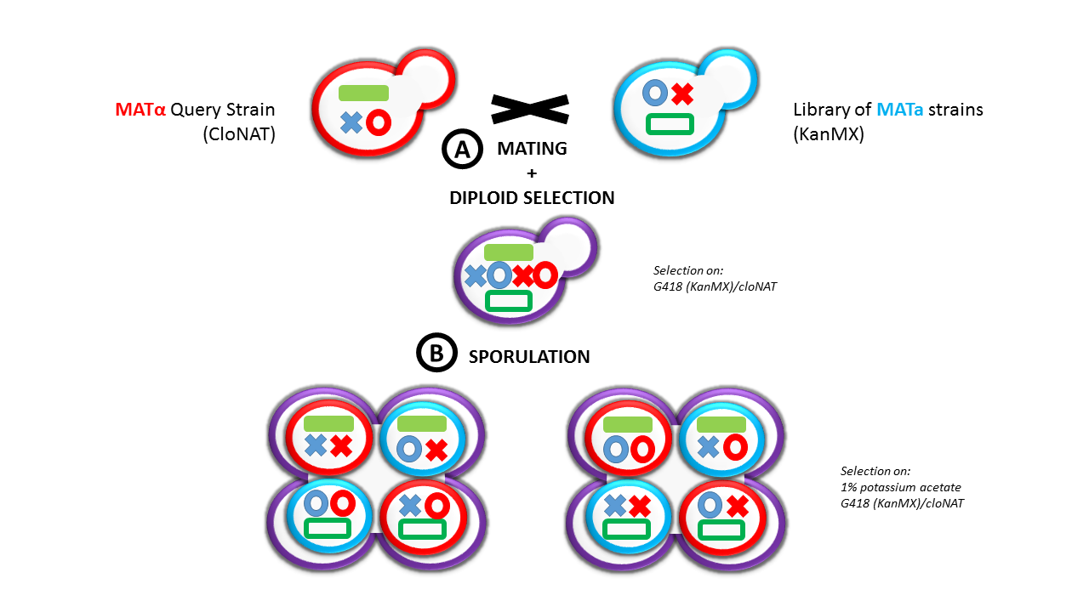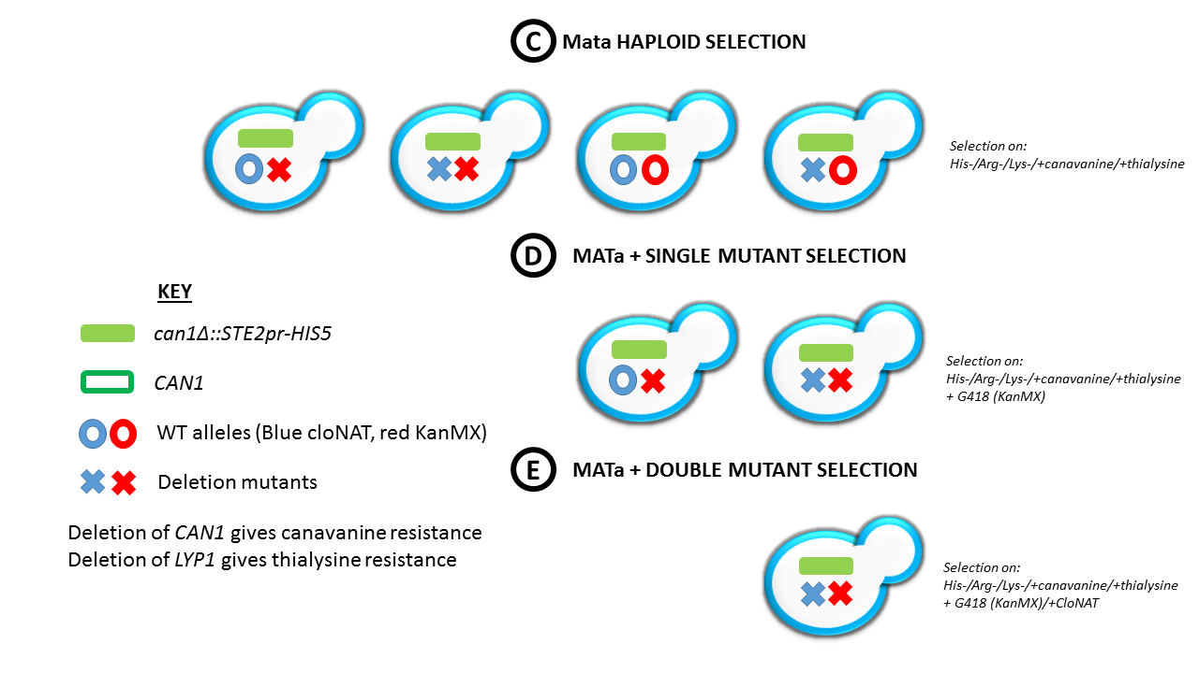
LYP1
Lyp1∆

FIG 2.1: Creation of a mini SGA library
A: Mating/ Diploid Selection: MATα query strain containing a gene modification (deletion or point mutation, flanked by NatMX cassette) and a small knockout MATa library (created via the KanMX cassette) were mated. Diploids containing both cassettes are selected on YPD medium containing cloNAT and G418.
B: Sporulation: Diploids pinned onto an enriched sporulation medium (1% potassium acetate).
C: Mata Haploid Selection: Spores pinned onto His-/Arg-/+canavanine/+thialysine Synthetic Dropout (SD) media plates for meiotic progeny selection. Only MATa haploids will grow on His- media due to STE2-HIS5 only being produced in MATa cells. The lack of Arginine and Lysine and addition of their toxic analogues canavanine and thialysine will prevent growth of MATa/α and MATa/a diploids.
D: Single mutant selection: MATa haploids pinned onto G418 containing media (kept under MATa selection).
E: Double mutant selection: MATa haploids containing Kan cassette repinned onto CloNAT for final selection (kept under MATa selection).

2.2.11 5-FOA selection

Knock-ins were created using a URA cassette knockout, homologous recombination, and then 5-FOA selection of the potential knock-in.
The High Efficiency method of transformation was used to promote homologous recombination.
Cells that had undergone High Efficiency transformation in order to knock into a gene that had been disrupted by a URA cassette were plated on YPD and incubated for 1 day at 30°C. Replica plates were then produced using sterile velveteen and incubated at 30°C for 2 days. Individual colonies were screened through gDNA isolation and PCR for presence of a knock-in.

2.2.12 Calcofluor staining

Calcofluor-white is a fluorescent stain that strongly binds to chitin in yeast cell walls. Staining was used to analyse S. cerevisiae cell division as bud scars contain a larger amount of chitin than the cell wall, and so bind more calcofluor, giving a stronger signal.
Cells were grown overnight in the desired conditions. Cells were then subcultured to OD₆₀₀0.4 into fresh media and grown at 30°C for 4 hours with shaking at 180rpm. After growth, cells were fixed by addition of formaldehyde to 3.7% (from 37% stock), and incubated at 30°C for 30minutes. Calcofluor was then added to a final concentration of 0.1mg/ml (from a stock of 1mg/ml in Millipore water), and cells were again incubated for 30 minutes at 30°C. Cells were then washed twice with Millipore water and resuspended in a final volume of Millipore water before viewing with a fluorescent microscope using a filter for DAPI or a blue excitation filter set. Cells containing 4-6 bud scars were counted and the following criteria used for determining bud patterns:
Bipolar – at least 2 scars on opposite ends of cell
Unipolar – 1 scar on one end, 3 or more on opposite end
Axial – 4 or more scars grouped together on one side
Random – scars occurring randomly and ungrouped around cells.

2.2.13 S. cerevisiae Strains

Strain | Genotype | Usage | Source
BY4741 | MATa; his3D1, leu2D0, met15D0, ura3D0 | Microscopy, yeast expression plasmid construction and source of genomic DNA. | EUROSCARF, Johann Wolfgang Goethe-University, Frankfurt
BY4742 | MATα; his3D1, leu2D0, lys2D0, ura3D0 | As above. | EUROSCARF, Johann Wolfgang Goethe-University, Frankfurt
BJ1991 | MATa; leu2, ura3-251, trp1, prb1-1122, pep4-3, gal2 | Yeast spot plate and oleate growth assays. | Jones,  (1977)
c13- ABYS-86 | MATa; ura3-5, leu2-3, 112, his3, pra1-1, prb1-1, prc1-1, cps1-3 | Yeast lysates for in vitro binding assay | Heinemeyer et al., (1991)
Y7092 INP1∆::Hyg | MATa; can1∆::STE2pr-Sp-his5 lyp1∆, his3D1, leu2D0, met15D0, ura3D0; ymr204c::Hyg | Starting strain for creation of inp1∆ SGA library | A. Tong and C. Boone, (2007)

Table 2.2:
S. cerevisiae strains used in this study.

All other yeast strains used during this study were derivatives of BY4741 and BY4742 obtained from the EUROSCARF consortium or created using homologous recombination in the above strains as mentioned in the text.

Templates for Knockout creation were from the pUG/pAG vector series.
Templates for GFP and mCherry fluorescent tagging in the genome were based on the Longtine and pBS vector systems respectively (Longtine et al. 1998).

2.3 E. coli Protocols

2.3.1 Bacteria Growth Media

Unless otherwise stated, the sterilisation of culture media was conducted by autoclaving at 121°C for 15 minutes. All culture media was dissolved in Millipore water.

Culture Media | Description
2TY  (for DNA protocols) | 1.6% Bacto tryptone, 1% yeast extract, 0.5% NaCl.
LB  (for protein protocols) | 1% Bacto tryptone, 0.5% yeast extract, 1% NaCl.
Solid Media | 2% agar was added to the dissolved liquid media. The media was poured into sterile petri dishes (Sterilin) and allowed to set at room temperature. Set plates were stored at 4°C.

Where antibiotic-resistance selection was required, the appropriate antibiotics were added to their final concentration (Table2.1) after sterilisation and after the media had cooled to 50°C.

2.3.2 Growth and Maintenance

Escherichia coli (E. coli) was routinely cultured on solid media plates at 37°C overnight. Strains that had been transformed with plasmids containing a gene for one or more antibiotic resistances were grown on media containing the appropriate antibiotics. Strains on plates were stored at 4°C for a maximum of 1 week. For long-term storage, strains were stored in 15% (v/v) glycerol at -80°C in an appropriate cryogenic vessel (Nunc).
E. coli liquid cultures were grown at 37°C in a shaking incubator (180rpm), observing an approximate 1:5 liquid: air ratio in an appropriately sized tube or flask.

2.3.3 Preparation of chemically competent BL21 (DE3) E. coli

A 200ml culture of the required BL21 (DE3) E. coli was grown in 2TY at 30°C with shaking (180rpm). Upon reaching mid-log phase (OD₆₀₀0.5-0.6), the culture was cooled on ice for 10 minutes (all further steps were performed on ice or at 4°C). The cells were harvested by centrifugation using a pre-cooled centrifuge (Sigma 4-16K, rotor 12256) at 1,000rcf for 5 minutes. The supernatant was discarded and the pellet resuspended in 50ml precooled 0.1M MgCl₂. The cell suspension was placed on ice for a further 10 minutes, before being centrifuged as described above. The supernatant was removed and the pellet resuspended in 25ml precooled 0.1M CaCl₂. Following a 30-minute incubation on ice, the cells were centrifuged as described above and the pellet resuspended in 10ml precooled 0.1M CaCl₂, 15% (v/v) glycerol. The cell suspension was placed on ice for 10 minutes before being dispensed into 200μl aliquots and flash-frozen in liquid nitrogen. The aliquots were stored at -80 °C.

2.3.4 Preparation of Electrocompetent DH5α E. coli

A 1L culture of E. coli DH5α was grown in 2TY. Upon reaching mid-log phase (OD₆₀₀ = 0.5-0.6) the culture was incubated on ice for 15 minutes. The cells were harvested by centrifugation using a pre-cooled centrifuge (Sigma 4-16K, rotor 12256) at 1,000rcf for 5 minutes at 4°C. All further centrifugation steps were carried out at 4°C. The supernatant was removed and the pellet resuspended in 500ml ice cold 10% (v/v) glycerol. The cells were subjected to two more cycles of harvesting and resuspending in 10% (v/v) glycerol, as described above. After the first cycle, the cells were resuspended in 250ml 10% (v/v) glycerol and after the second cycle they were resuspended in 50ml 10% (v/v) glycerol. Finally, cells were harvested by centrifugation for 5 minutes. The supernatant was removed and the pellet resuspended in 700μl 10% (v/v) glycerol. 40μl aliquots of cells were transferred into 1.5ml micro-centrifuge tubes, flash-frozen in liquid nitrogen and stored at -80°C.

2.3.5 Transformation to chemically competent BL21 (DE3) E. coli

50μl of competent cells were thawed on ice per transformation. The cells were subsequently added to either 2μl (0.5μg-1μg) plasmid DNA, 10μl of 10 x diluted yeast genomic DNA (section 2.2.5), or a 10μl ligation reaction (section 2.4.7) which had been incubated on ice for at least 1 minute. Following a 20-minute incubation on ice, the sample was heat shocked for 2 minutes at 42°C and incubated on ice for a further 5 minutes. 900μl 2TY was added to the cells, and they were incubated at 37°C for 30-45 minutes, before being centrifuged in a micro-centrifuge for 1 minute at 1,000rcf. 800μl of the supernatant was removed and the cells were resuspended in the remaining supernatant. The cell suspension was spread onto a solid media plate containing made from media containing the relevant selective antibiotic and incubated overnight at 37°C.

2.3.6 Transformation to electrocompetent DH5α E. coli

Electroporation-competent E. coli cells (40μl aliquot) were defrosted on ice and 10μl of a mutagenized plasmid (section 2.4.3) 10μl of 10 x diluted yeast genomic DNA, or a 10μl ligation reaction (section Error! Reference source not found.) was added. The cells were gently mixed and incubated on ice for 1 minute. The cells were then transferred to a precooled 2mm electroporation cuvette (Cell Projects), which was placed in the Easyject Plus electroporation chamber (Equibio) and a 5ms pulse applied at 2.5 kV, 201 Ω, 25μF. 700μl 2TY media was immediately added to the cuvette and the cells were transferred to a 1.5ml micro-centrifuge tube. The cell suspension was incubated at 37°C for 30-45 minutes, before being spread onto a relevant selection plate and incubated overnight at 37°C.

2.3.7 Preparation of plasmid DNA

A single bacterial colony was picked from a 2TY selection plate and grown overnight in 3ml 2TY (containing the appropriate selection antibiotic). Plasmid DNA was purified using the GenElute Plasmid Miniprep Kit (Sigma). A copy of the protocol can be found online at: https://www.sigmaaldrich.com/content/dam/sigma-aldrich/docs/Sigma/Bulletin/pln70bul.pdf

2.3.8 E. coli Strains

Strain | Genotype | Usage | Source
Escherichia coli  DH5α | supE44 ΔlacU169 (φ80 lacZ ΔM15) hsdR17 recA1 endA1 gyrA96 thi-1 relA1 | Recovery of plasmid DNA from S. cerevisiae following in vivo homologous recombination. | Hanahan, (1983)
Escherichia coli  BL21 DE3 | hsdS gal (λcIts857 ind1 Sam7 nin5 lacUV5-T7 gene 1) | Expression of GST and fusion proteins. | Studier and Moffat, (1986)

2.4 DNA Protocols

2.4.1 Plasmid design

All plasmids for yeast studies that were created were based on the parental plasmids ycplac33, ycplac111, ycplac22, yiplac204 (Gietz and Sugino, 1988).
Promoters, open reading frames (ORFs) and tags were inserted into the ycplac system using the restriction sites shown below. Tags and ORFs were inserted in the frame indicated below:

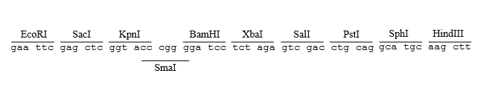

For C-terminal tagging the stop codon of the ORF was replaced with a restriction site.

All plasmids used for expression in E. coli were created based on the parental plasmids pET42a (Rosenberg et al., 1987), pET30a, pGEX6p-2, and pMAL-c5X.

2.4.2 Primer design for Homologous Recombination

The majority of constructs used in this study were generated by homologous recombination within yeast BY4741 (Uetz et al., 2000). The open reading frame (ORF) of interest was amplified by PCR (section 2.4.3) using primers designed to anneal to each end of the ORF of interest. The primers also included 18 nucleotide extensions, which were homologous to the regions of plasmid flanking the intended site of insertion. Upon transformation of the PCR product and plasmid (which had been linearized at the site of insertion), homologous recombination occurs (Figure 2.2). Recombinant vectors were selected for on minimal medium based on the auxotrophic marker of the linearized plasmid used.

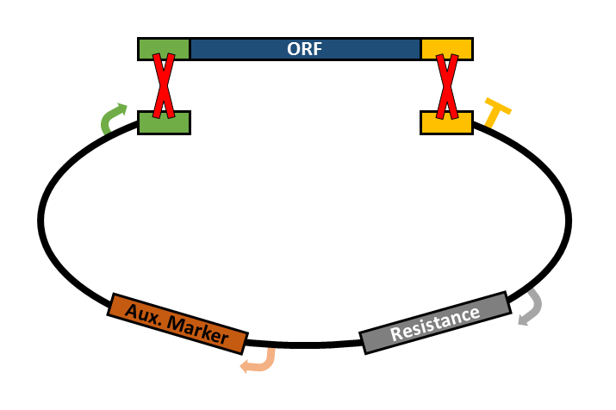

FIG 2.2:
Homologous recombination was utilised in plasmid creation. The required ORF (blue) insert was amplified by PCR using primers which extended beyond the ORF (Green and Yellow). These extensions were homologous to regions within the target plasmid. The linearization of the vector stimulated homologous recombination between these regions (red crosses) after both the insert and vector were transformed to yeast using the high efficiency method (Section 2.2.4). Downstream procedures utilised the auxotrophic marker (orange) for procedures carried out in yeast, and the antibiotic resistance (grey) for procedures using E. coli.

2.4.3 Polymerase Chain Reaction

PCR was routinely used to amplify specific regions of DNA or whole plasmids during Site Directed Mutagenesis. 50µl reaction mixture was prepared for Taq and Accuzyme reactions, 25µl reactions were prepared mutagenesis reactions. When proofreading PCR was required, AccuzymeTM polymerase (Bioline) was used instead of Taq DNA polymerase. Promega Pfu was used for mutagenesis.

Bio-Taq/Accuzyme PCRs contained:
10-50ng template DNA (1µl of genomic DNA, 1:50 dilution of plasmid DNA, or sample from plate) 1mM forward primer (5µl from a 5µM working stock)
1mM reverse primer (5µl from a 5µM working stock)
0.15mM dNTPs (3µl of 2.5mM stock)
1.5mM MgCl2
1x Taq/Accuzyme Polymerase buffer (5µl of 10x buffer)
1 unit Taq/Accuzyme DNA polymerase

Reactions were run in a thermocycler as follows:
1. Initial DNA denaturation – 5mins at 95°C
2. DNA denaturation cycle – 30sec at 95°C
3. Primer Annealing cycle – 30secs at 56°C
4. Chain Elongation cycle – 1min/kb for Taq, 2min/kb for Accuzyme/Pfu at 74°C
5. Final Elongation – 5mins @ 74°C.

Depending on the base composition of the primers, the annealing temperature (step 3) was occasionally altered. In such cases, the annealing temperature was calculated using the equation: annealing temperature (°C) = 4 x (#G + #C) + 2 x (#A + #T). In some cases, the PCR reaction was first performed in a gradient thermocycler (Biometra), in which individual aliquots of the PCR mixture were subjected to a different annealing temperature in order to determine the most appropriate. Routinely, a small aliquot of the PCR was analysed on an agarose gel to see if a product of the required size had been produced.

2.4.4 Agarose Gel Electrophoresis

Digested DNA was size-fractionated on agarose gels. Agarose was melted in TBE buffer (0.045M Tris-borate, 1mM EDTA, pH8.0) at concentrations ranging from 0.5-2% (w/v) depending on the size of the DNA fragments to be separated. Ethidium bromide was added to a final concentration of 2.5μg/ml and the mixture poured into the gel tray to set. The gel was placed in a gel tank and covered with TBE buffer. DNA was loaded onto the gel, after mixing with 6x DNA Loading Buffer (Bioline) and Millipore water. A DNA ladder (Bioline Hyperladder I) was loaded alongside the samples in order to estimate the size of the DNA fragments. The gel was run at 80V and its progress followed by the position of the loading buffer dye. The bands of DNA were visualised using an ultraviolet transilluminator imaging system and a picture recorded digitally using Genesnap software (SynGene).

2.4.5 Restriction digest

Plasmid DNA was cut using restriction endonucleases (New England Biolabs). Typically, 0.5μg-1μg DNA was digested in a 20μl volume containing 5 units of restriction enzyme per μg DNA and 2μl of the manufacturers 10x stock digestion buffer. The digestion mixtures were incubated at 37°C for periods varying from 1 hour to overnight. When larger amounts of DNA were digested, the amount of enzyme and the volume of the digestion mixture were increased.
For sequential digestions using multiple enzymes, DNA was cut with one enzyme in the appropriate buffer. The buffer was subsequently removed using a QIAquick Gel Extraction Kit (Qiagen) according to the PCR Purification Kit Protocol. This protocol is described in the manufacturer’s instructions (obtainable from www.qiagen.com). A digestion mixture was then set up including the second enzyme in its preferred buffer.
When a partial digest was required, the digestion mixture was incubated in a thermocycler for 10 minutes at 37°C and then 20 minutes at 80°C. DNA was then analysed on and the appropriately sized band recovered from an agarose gel (Section 2.4.4).

2.4.6 DNA recovery from agarose gels

The agarose gels were viewed on a UV shortwave transilluminator and the DNA band(s) of interest were excised from the gel. The DNA was recovered from the gel using the QIAquick Gel Extraction Kit (Qiagen), according to the manufacturer’s instructions (obtainable from www.qiagen.com).

2.4.7 Ligations

Ligations were carried out in a final volume of 10 µl, comprising 2µl of 5 x T4 DNA ligase buffer, 2µl agarose purified, linearized vector (25-50ng/µl), 1µl T4 DNA ligase (1 unit) and varying ratios of purified insert DNA/vector (e.g., 3:1, 1:1) calculated using the NEB online calculator (found at http://nebiocalculator.neb.com/#!/). The reactions were incubated at room temperature for 3 hours or overnight at 16 °C.

2.4.8 Sequencing

The sequencing of cloned constructs was performed by Beckman Coulter Genomics. This was performed on plasmid DNA prepared as described in section 2.3.7.

2.4.9 Plasmids Used

Description | Promoter | Parental plasmid | Lab reference | Source
GST- PreScission Protease | T7 |  | pKA672 | Ayscough lab
SEC66-HcRed | TPI1 | ycplac33 | pAG317 | Lab Stock
HcRed-PTS1 | HIS3 | ycplac33 | pAS5 | Lab Stock
PEX3-GFP | GAL1 | ycplac33 | pAS54 | Lab Stock
PEX3-RFP | GAL1 | ycplac33 | pAS62 | Lab Stock
HcRed-PTS1 | HIS3 | Ycplac111 | pAS63 | Lab Stock
GFP-PTS1 | TPI1 | ycplac33 | pEH012 | Lab Stock
Pex11p-GFP | PEX11 | ycplac111 | pEH05 | Lab Stock
GST-PEX3 | T7 | pET42a | pEH114 | Lab Stock
INP1 | TPI1 | ycplac111 | pJM01 | Lab Stock
INP1 | GAL1 | ycplac111 | pJM02 | Lab Stock
INP1 | CTA1 | yiplac204 | pJM04 | Lab Stock
INP1 | CTA1 | Ycplac211 | pJM05 | Lab Stock
INP1 | TPI1 | ycplac22 | pJM06 | Lab Stock
INP1-HA | TPI1 | ycplac33 | pJM08 | Lab Stock
INP1-GFP | TPI1 | ycplac33 | pJM09 | Lab Stock
INP1 - GFP | TPI | Ycplac111 | pJM10 | Lab Stock
INP1-GFP | GAL1 | ycplac111 | pJM15 | Lab Stock
INP1-GFP | INP1 | ycplac111 | pJM21 | Lab Stock
GFP-PEX19 | GAL1 | ycplac111 | pJM22 | Lab Stock
PEX3 | PEX3 | ycplac111 | pJM26 | Lab Stock
INP1 - GFP | INP1 | Ycplac33 | pJM36 | Lab Stock
TOM70 - PEX3 (∆aa1-48) - RFP | GAL1 | Ycplac33 | pJM37 | Lab Stock
SEC66-PEX3 | GAL1 | ycplac33 | pMF4 | Lab Stock
GST INP1 | pTAC | pGEX-6p-2 | pNUT03 | Lab Stock
INP1 (aa1-400) - GFP | GAL1 | Ycplac111 | pNUT08 | Lab Stock
INP1 (aa1-282) - GFP | GAL1 | Ycplac111 | pNUT09 | Lab Stock
INP1 (aa1-315) - GFP | GAL1 | Ycplac111 | pNUT10 | Lab Stock
GST - PEX19 | T7 | pET42a | PNUT100 | Lab Stock
INP1 (aa1-340) - GFP | GAL1 | Ycplac111 | pNUT11 | Lab Stock
INP1 (aa1-370) - GFP | GAL1 | Ycplac111 | pNUT12 | Lab Stock
INP1 (aa281-400) - GFP | GAL1 | Ycplac111 | pNUT13 | Lab Stock
INP1 (aa315-400) - GFP | GAL1 | Ycplac111 | pNUT14 | Lab Stock
INP1 (aa340-400) - GFP | GAL1 | Ycplac111 | pNUT15 | Lab Stock
INP1 (aa295-420) - GFP | GAL1 | Ycplac111 | pNUT19 | Lab Stock
INP1 (aa300-420) - GFP | GAL1 | Ycplac111 | pNUT20 | Lab Stock
INP1 (aa311-420) - GFP | GAL1 | Ycplac111 | pNUT21 | Lab Stock
INP1 (aa1-360) - GFP | GAL1 | Ycplac111 | pNUT22 | Lab Stock
INP1 (aa1-350) - GFP | GAL1 | Ycplac111 | pNUT23 | Lab Stock
INP1 (aa100-420) - GFP | GAL1 | Ycplac111 | pNUT24 | Lab Stock
INP1 (aa170-420) - GFP | GAL1 | Ycplac111 | pNUT25 | Lab Stock
INP1 (aa240-420) - GFP | GAL1 | Ycplac111 | pNUT26 | Lab Stock
INP1 (aa315-420) - GFP | GAL1 | Ycplac111 | pNUT27 | Lab Stock
INP1 (aa311-370) - GFP | GAL1 | Ycplac111 | pNUT29 | Lab Stock
INP1 (aa315-370) -GFP | GAL1 | Ycplac111 | pNUT30 | Lab Stock
INP1 (aa311-360) - GFP | GAL1 | Ycplac111 | pNUT31 | Lab Stock
INP1 (aa1-296) - GFP | GAL1 | Ycplac111 | pNUT32 | Lab Stock
PEX3 | PEX3 | Ycplac111 | pNUT34 | Lab Stock
Pex3 W128L | PEX3 | Ycplac33 | pNUT95 | Lab Stock
INP1(aa311-420 L312A) - GFP | GAL1 | Ycplac111 | pHUT01 | This Study
INP1 LL315316AA -GFP | INP1 | Ycplac33 | pHUT02 | This Study
INP1 L315AL - GFP | INP1 | Ycplac33 | pHUT03 | This Study
INP1 NY313314DD - GFP | INP1 | Ycplac33 | pHUT04 | This Study
INP1 L312A - GFP | INP1 | Ycplac33 | pHUT05 | This Study
INP1 LL315316AA - GFP | GAL1 | Ycplac111 | pHUT06 | This Study
INP1 L312A - GFP | GAL1 | Ycplac111 | pHUT07 | This Study
INP1 - GFP | INP1 | Ycplac111 | pHUT09 | This Study
GFP-PEX19 | GAL1 | Ycplac111 | pHUT10 | This Study
INP1 L312A | CTA1 | Ycplac204 | pHUT11 | This Study
INP1 LL315316AA | CTA1 | Ycplac204 | pHUT12 | This Study
INP1 L312A | TPI1 | Ycplac33 | pHUT13 | This Study
INP1 LL315316AA | TPI1 | Ycplac33 | pHUT14 | This Study
PEX19 | PEX19 | Ycplac111 | pHUT15 | This Study
GFP - PEX19 | PEX19 | Ycplac111 | pHUT16 | This Study
INP1 LL315316AA | INP1 | Ycplac111 | pHUT17 | This Study
INP1 L312A | INP1 | Ycplac111 | pHUT18 | This Study
INP1 L312K - GFP | GAL1 | Ycplac111 | pHUT19 | This Study
INP1 L312K - GFP | TPI1 | Ycplac33 | pHUT20 | This Study
INP1 L312A - GFP | CTA1 | Ycplac211 | pHUT21 | This Study
INP1 L312D - GFP | INP1 | Ycplac33 | pHUT22 | This Study
INP1 L312K | CTA1 | Ycplac211 | pHUT23 | This Study
GST - PEX3 | T7 | pET42a | pHUT24 | This Study
INP1 (aa311-420) -GFP | TPI1 | Ycplac33 | pHUT25 | This Study
INP1 (aa350-420) - GFP | TPI1 | Ycplac33 | pHUT26 | This Study
INP1 (aa1-100) - GFP | TPI1 | Ycplac33 | pHUT27 | This Study
INP1 (aa1-282) - GFP | TPI1 | Ycplac33 | pHUT28 | This Study
INP1 L315P - GFP | TPI1 | Ycplac33 | pHUT29 | This Study
INP1 L312K - GFP | INP1 | Ycplac33 | pHUT30 | This Study
INP1 LL315316KK - GFP | TPI1 | Ycplac33 | pHUT31 | This Study
INP1 L312D GFP | TPI1 | Ycplac111 | pHUT32 | This Study
INP1 L315P -GFP | INP1 | Ycplac111 | pHUT33 | This Study
SEC66 - HcRed | TPI1 | Ycplac111 | pHUT34 | This Study
INP1 NY313314DD - GFP | TPI1 | Ycplac111 | pHUT35 | This Study
INP1 LL315316AA - GFP | GAL1 | Ycplac111 | pHUT36 | This Study
INP1 L315P - GFP | GAL1 | Ycplac111 | pHUT37 | This Study
INP1 LL315316AA | CTA1 | Ycplac211 | pHUT38 | This Study
INP1 LL315316KK | CTA1 | Ycplac211 | pHUT39 | This Study
INP1 L315P | CTA1 | Ycplac211 | pHUT40 | This Study
INP1 (aa100-420) | CTA1 | Ycplac211 | pHUT42 | This Study
INP1 (aa282-420) | CTA1 | Ycplac211 | pHUT43 | This Study
INP1 (aa311-420) | CTA1 | Ycplac211 | pHUT44 | This Study
INP1 (aa315-420) | CTA1 | Ycplac211 | pHUT45 | This Study
INP1 (aa100-420) | TPI1 | Ycplac33 | pHUT46 | This Study
PEX19 | PEX19 | Ycplac111 | pHUT47 | This Study
INP1 (aa300-420) L315P - GFP | GAL1 | Ycplac33 | pHUT48 | This Study
INP1 (aa300-420) L312A - GFP | GAL1 | Ycplac33 | pHUT49 | This Study
PEX19 L12A | PEX19 | Ycplac111 | pHUT50 | This Study
PEX19 L15P | PEX19 | Ycplac111 | pHUT51 | This Study
INP1 (aa311-360) - GFP | GAL1 | Ycplac33 | pHUT52 | This Study
INP1 (aa300-420) LL315316AA - GFP | GAL1 | Ycplac33 | pHUT53 | This Study
INP1 (aa311-370) - GFP | GAL1 | Ycplac33 | pHUT54 | This Study
INP1 L315P - GFP | INP1 | Ycplac33 | pHUT55 | This Study
GFP - PEX19 | PEX19 | Ycplac111 | pHUT56 | This Study
INP1 - GFP | GAL1 | Ycplac33 | pHUT57 | This Study
PEX19 LL1516AA | PEX19 | Ycplac111 | pHUT58 | This Study
GFP - PEX19 L12A | PEX19 | Ycplac111 | pHUT59 | This Study
GFP - PEX19 L15P | PEX19 | Ycplac111 | pHUT60 | This Study
GFP - PEX19 LL1516AA | PEX19 | Ycplac111 | pHUT61 | This Study
GST - INP1 DD310311AA | pTAC | pET42a | pHUT62 | This Study
GST - INP1 L312A | pTAC | pET42a | pHUT63 | This Study
GST - INP1 NY313314AA | pTAC | pET42a | pHUT64 | This Study
GST - INP1 LL315316AA | pTAC | pET42a | pHUT65 | This Study
GST - INP1 DE317318AA | pTAC | pET42a | pHUT66 | This Study
GST - INP1 L315A | pTAC | pET42a | pHUT67 | This Study
GST - INP1 L316A | pTAC | pET42a | pHUT68 | This Study
MBP - INP1 (aa1-280) | L7 | pMALc5x | pHUT69 | This Study
MBP - INP1 (aa281-420) | L7 | pMALc5x | pHUT70 | This Study
MBP - INP1 | L7 | pMALc5x | pHUT71 | This Study
INP1 L312A - 3xHA | TPI1 | Ycplac33 | pHUT72 | This Study
INP1 LL315316AA - 3xHA | TPI1 | Ycplac33 | pHUT73 | This Study
INP1 L315p - 3xHA | TPI1 | Ycplac33 | pHUT74 | This Study
ATG 3xHA | TPI1 | Ycplac33 | pHUT75 | This Study
SEC66 - HcRed | TPI1 | Ycplac33 | pHUT78 | This Study
6xHIS - PEX3 W128A | T7 | pET30a | pHUT79 | This Study
6xHIS - PEX3 W128L | T7 | pET30a | pHUT80 | This Study

2.5 Protein Protocols

2.5.1 Fusion Tags

Fusion Tag | Use | Column used
GFP | Immunoprecipitation of GFP tagged proteins from yeast. | GFP-Trap  (ChromoTek)
3xHA | Immunoprecipitation of 3xHA tagged proteins from yeast. | Anti-HA agarose from Mouse  (Sigma-Aldrich)
TAP  (Tandem Affinity Purification) | Immunoprecipitation of TAP tagged proteins from yeast. | IgG Sepharose  (GE Healthcare)
ProteinA | Immunoprecipitation of ProteinA tagged proteins from yeast. | IgG Sepharose  (GE Healthcare)
6xHis | Purification of proteins from E. coli | Ni Sepfast  (BioToolomics)  His Select Cobalt  (Sigma-Aldrich)  His Select Nickel  (Sigma-Aldrich)
GST | Purification of proteins from E. coli | Glutathione Sepharose 4B  (GE Healthcare)
MBP | Purification of proteins from E. coli | Amylose Resin  (NEB)
- | Purification of untagged proteins from yeast, through conjugation to relevant antibody. | ProteinA Agarose (Roche)

2.5.2 Growth and Induction of Tagged Proteins

For a standard expression protocol, a 1L E. coli culture was grown to log phase (OD₆₀₀0.5-0.6) in a 30°C shaking incubator. 1mM IPTG (MP Biomedicals) was added to the culture and it was incubated for a further 3 hours. The cells were harvested by centrifugation 2,000rcf for 15 minutes, the supernatant aspirated, and pellets frozen at -80°C. Other proteins may have required different expression parameters which will be discussed within the text.

2.5.3 Protein Extraction

2.5.3.1 TCA extraction (yeast)

A yeast culture was grown to OD₆₀₀0.5. 10ODs of cells were harvested by centrifugation and the supernatant was removed. The pellet was flash frozen in liquid nitrogen or stored overnight at -80°C. All further steps were carried out on ice or at 4°C with precooled buffers.
Frozen pellets were resuspended in 500μl 0.2% (v/v) β-mercaptoethanol, 0.2M NaOH and incubated for 10 minutes. 42μl of 50% (v/v) trichloroacetic acid was added and the sample incubated for a further 10 minutes. The sample was spun in a micro-centrifuge for 5 minutes at 11,000rcf. The supernatant was removed and the pellet resuspended in 15μl 1M Tris base (pH9.4).
85μl 1X PLB (62.5mM Tris-Cl pH 6.8, 2.3% (w/v) SDS, 10% (v/v) glycerol, 0.05% (w/v) Bromophenol blue 0.025M DTT) was added to the sample and the pH checked (sample should appear blue. If green or yellow, pH should be adjusted through further addition of 1M Tris base [pH9.4]).

2.5.3.2 Preparation of spheroplasts (yeast)

A 50ml yeast culture was grown to log phase. The cells were harvested by centrifugation in a Sigma 4-16KS centrifuge for 5 minutes at 500rcf and the supernatant was removed. The pellet was resuspended in 10ml 10mM Tris-Cl pH 9.4, 10mM DTT, transferred to a 50ml falcon, and incubated at room temperature for 15 minutes on a roller, before being centrifuged again as described above. The supernatant was removed and the pellet resuspended in 5ml 1.2M sorbitol, 50mM Potassium Phosphate pH7.4, zymolyase (zymolyase added to 5mg/g harvested cells). Following a 45-minute incubation at room temperature on a roller, cells were checked for spheroplast formation by light microscopy (spheroplasts appear more spherical than untreated yeast cells and form clusters of cells. They also easily lyse upon addition of water to the microscope sample). The treated sample was spun for 5 minutes as previously described. The spheroplasts were then subjected to two cycles of washing without resuspension of the pellet in 10ml 1.2M sorbitol, 50mM potassium phosphate pH7.4 and re-centrifugation. After the final wash, the supernatant was removed and the pellet was flash-frozen in liquid nitrogen and stored at -80°C.

Lysis buffer (150mM KCl, 20mM Tris-Cl pH 8.0, 5mM MgCl₂, 1 protease inhibitor tablet per 25ml) was used and cell lysis and homogenization achieved through use of a glass dounce.

2.5.3.3 Yeast breakage machine (yeast)

A cabinet cell disruptor (Constant Systems), connected with a cooling system (Grant) was used for lysis of larger yeast pellets. Pre-frozen pellets were completely resuspended in lysis buffer (150mM KCl, 20mM Tris-HCl (pH8.0), 4mM, +Roche complete EDTA free), and the sample passed through a sieve into the input sample basin. Yeast cells were lysed at 37Kpsi and collected in a precooled duran. 0.5% Triton was added and lysates were incubated for 30minutes on ice. Lysates were then centrifuged for 10minutes at 11,000rcf and the resultant supernatant treated as the soluble fraction.

2.5.3.4 Sonication (E. coli)
Cell pellets were resuspended in an appropriate 15ml ice-cold lysis buffer containing 1mM PMSF and including a protease inhibitor cocktail (Roche). Lysis buffers were either PBS based or TBS based and relevant additions such as reducing agents or detergents are mentioned within the text.
From this stage onwards the sample was kept ice-cold. The cells were lysed using a Soniprep 150 sonicator (MSE) at an amplitude of 16 microns for 30 seconds and the sample returned to ice to avoid overheating. The sonication was then repeated 3 more times for 15 seconds, and was returned to ice between each burst. Following sonication, and if relevant to the experiment, 1% Triton-X-100 was added and the sample was mixed for 30 minutes at 4°C. The cell lysate was purified by centrifugation for 5 minutes at 2,500rcf (This centrifuge was also used for the following centrifugation steps). The supernatant was retained as the soluble fraction, and the pellet retained as the insoluble fraction.

2.5.3.4 French Pressing (E. coli)
For larger E. coli pellets, a French press was used for lysis. Pellets were resuspended in 20ml-50ml lysis buffer containing 1mM PMSF and including a protease inhibitor cocktail (Roche). Lysis buffers were either PBS based or TBS based and relevant additions such as reducing agents or detergents are mentioned within the text. The appropriate cylinder was used for the press and lysis was performed at 15Kpsi (medium setting), with the fine valve of the French press being manually adjusted as appropriate during the lysis. The lysate was collected in a precooled Falcon tube and then pressed again. The twice pressed cell lysate was centrifuged at 11,000rcf for 10minutes. The resulting supernatant was treated as the soluble fraction for downstream procedures.

2.5.4 Preparation of Protein Columns

Appropriate beads were washed three times in 5-10x the volume of the appropriate lysis buffer for the experiment (the same as the buffer as used for cell lysis) and added to the soluble fraction (cell lysate). The lysate/bead mixture was mixed for 1 hour at 4°C with end over end mixing, before being centrifuged for 5 minutes at 200rcf and the supernatant removed (and kept as a flow through fraction if relevant). The pelleted column was resuspended in 10x volume of the lysis buffer, transferred to a 2ml microcentrifuge tube and centrifuged for 1 minute at 200rcf in the new micro-centrifuge. Two further cycles of washes were performed. After the final wash the pellet was suspended in an appropriate volume of lysis buffer determined by expected protein content of the column and 4x protein loading buffer (200mM Tris-HCl pH 6.8, 400mM DTT, 8% (w/v) SDS, 0.4% (w/v) bromophenol blue and 40% (v/v) glycerol) and boiled at 95°C for 10 minutes prior to gel loading.

2.5.4.1 PreScission protease cleavage

PreScission Protease was expressed (from a plasmid pKA672, courtesy of the Ayscough lab) using the method described (2.5.2). As the PreScission protease construct contains a GST tag, a GS4B column was prepared and used to purify the PreScission protease. The GST-PreScission protease fusion was first bound to a GS4B column (PBS pH7.3) and then eluted (10mM GSH, 50mM Tris-HCl) and stored at -20°C in 20μl aliquots of 1mg/ml until required.
Some experiments required purification of untagged protein. This purification was achieved through first expressing a GST tagged fusion construct of the desired protein, and then preparing a column as previously described. The prepared GST-fusion protein column was then washed 3 times in wash buffer (PBS, 1% Tween20, 300mM NaCl).
An aliquot of PreScission Protease was added to 1ml of elution buffer (BUFFER) and 500μl added to the washed GST-fusion protein column. The column/elution mix was incubated for 4 hours at 4°C with end over end mixing, after which it was centrifuged for 1 minute at 500rcf at 4°C. The supernatant was taken and kept as the first elution and the second 500μl of elution buffer containing PreScission protease added to the column. The elution procedure was repeated and the second elution recovered.

2.5.5 SDS-PAGE

SDS-PAGE was performed according to the method of Laemmli, (1970). The gels were made by mixing the stock solutions as shown in Table 2.3. TEMED was added last to initiate polymerisation, before the gel mixture was poured between two glass plates and allowed to set. The gel tanks’ upper and lower reservoirs were filled with running buffer (25mM Tris base, 250mM glycine, 0.1% (w/v) SDS). The gels were loaded with 2-25μl sample, mixed with 4X protein loading buffer (250mM Tris-Cl pH 6.8, 9.2% (w/v) SDS, 40% (v/v) glycerol, 0.2% (w/v) Bromophenol blue 0.1M DTT) up to a maximum volume of 30μl. Prior to loading onto the gel, the protein sample (mixed with loading buffer) was heated at 95°C for 5-10 minutes, and then centrifuged at 13,000rcf for 1 minute (in a micro-centrifuge). Pre-stained markers (Pageruler) were also loaded onto the gel, in order to estimate the size of the detected proteins. The gels were run at 100V, until the marker dye had reached the bottom of the stacking gel. The voltage was then increased upto a maximum of 150V and the gels were run until the marker dye had reached the bottom of the resolving gel.

Stock Solution | Resolving Gel |  | Stacking gel
Stock Solution | 8.0% | 10% |  | 5%
Polyacrylamide (National Diagnostics)  (30% (w/v) acrylamide, 2% (w/v) bisacrylamide) | 4.0ml | 5.0ml |  | 1.25ml
1.5M Tris-Cl pH 8.8 | 3.8ml | 3.8ml |  | -
0.5M Tris-Cl pH 6.8 | - | - |  | 1.9ml
H₂O | 6.9ml | 5.9ml |  | 4.2ml
10% (w/v) SDS | 150μl | 150μl |  | 75μl
10% (w/v) APS | 150μl | 150μl |  | 75μl
TEMED | 15μl | 15μl |  | 7.5μl

Table 2.3:
Table showing composition of Polyacrylamide gels.

2.5.6 Coomassie staining

Polyacrylamide gels were stained for one hour with Coomassie Blue stain (50% (v/v) methanol, 10% (v/v) acetic acid, 0.1% (w/v) Coomassie Blue R-250) followed by several washes of destain (10% (v/v) methanol, 10% (v/v) acetic acid) until the pale blue background of the gel had been removed.

2.5.7 Western Blotting

Western Blot Transfer

Samples separated by SDS-PAGE, were blotted onto a nitrocellulose membrane (Schleicher and Schuell) using a Trans Blot Mini Cell (Bio-Rad), as described in the Bio-Rad Trans Blot manual (obtainable from www.bio-rad.com). The blot buffer consisted of 12.5mM Tris base, 125mM glycine, 20% (v/v) methanol. Transfer was carried out at 200mA for 2 hours.

Ponceau staining

Detection of total protein was carried out using Ponceau staining. Transferred nitrocellulose membranes were incubated in 0.1% Ponceau S (w/v) in 5% acetic acid (v/v) (Sigma) for 1 minute before washing in TBS-T (0.05% (v/v) Tween20, 1xTris buffered saline (TBS) (20mM Tris, 500mM NaCl pH 7.6))

Detection of Proteins

The blotted membrane was incubated with 4% blocking buffer (4% (w/v) fat-free Marvel milk, 1x TBS-T) on a shaking table at room temperature for 1 hour or overnight at 4°C, after which the membrane was transferred to fresh block buffer containing an appropriate dilution of primary antibody (determined experimentally) and incubated at room temperature for a further 1 hour. The membrane was washed three times in TBS-T, with each wash lasting 5 minutes. After the final wash, if required, the membrane was incubated for 30-60 minutes in 2% blocking buffer containing anti-rabbit or anti-mouse IgG-HRP secondary antibody (depending on the origin of the primary antibody, see table 2.4). The membranes were washed three times in TBS-T as previously described and proteins detected by Enhanced Chemiluminescence (ECL).

Enhanced Chemiluminescence

ECL was performed using the EZ-ECL Chemiluminescence detection kit for HRP (Biological Industries), according to manufacturer’s instructions. The detection of proteins on the blotted nitrocellulose membrane was captured using a CCD camera in a G:box Gel dock system (SynGene) using Genesnap software (SynGene) according to the manufacturer’s instructions. Exposure times were determined experimentally.

Antibodies Used

Antibodies were stored at -80°C in a 50% glycerol stocks. The following antibodies were used during this study:

Primary | Dilution | Company | Secondary | Dilution
Anti-PAP | 1/5000 | Sigma-Aldrich, P1291 | ----- | --------
Anti-HA | 1/5000 | Sigma-Aldrich, H9658 | Goat-anti-Mouse (GαM) | 1/4000
Anti-GFP | 1/3000 | Roche, 11814460001 | Goat-anti-Mouse (GαM) | 1/4000
Anti-Pex3 | 1/5000 | Raised with Eurogentec | Goat-anti-Rabbit (GARP) | 1/5000
Anti-Pgk1 | 1/7000 | Invitrogen, A6457 (discontinued) | Goat-anti-Mouse (GαM) | 1/4000

Goat-anti-Mouse (GαM): Bio-Rad, 1706516)
Goat-anti-Rabbit (GARP): Sigma-Aldrich, A0545)

Table 2.4:
Table of antibodies used in this study

Chapter 3:

Finding sites of interest in Inp1p

3.1 Introduction

In S. cerevisiae, the maintenance of peroxisomes relies heavily on the regulation of de novo synthesis, growth, division, proper inheritance, and degradation (Hoepfner et al. 2001; Fagarasanu et al. 2005; Motley & Hettema 2007; Motley et al. 2012b). As discussed during the introduction, the integral peroxisomal membrane protein Pex3p has been shown to play a crucial role in all of these processes through interacting with distinct proteins which either perform one of these processes themselves (as with Pex19p bringing new PMPs to the peroxisomal membrane) or coupling the peroxisome to the relevant machinery to perform the process (as with Atg36p coupling the peroxisome to the autophagic pathway machinery) (Fang et al. 2004a; Motley et al. 2012b).
Inp1p is essential for the retention and correct segregation of peroxisomes during cell division in S. cerevisiae (Fagarasanu et al. 2005). It is a peripheral peroxisomal membrane protein that is recruited to peroxisomes by Pex3p (Munck et al. 2009). In inp1Δ cells, during cell division mother cells fail to retain any peroxisomes. However, in wildtype cells, when expression of INP1 is increased through the addition of a second copy of the gene on a plasmid, the reverse is apparent. At this increased level of Inp1p mother cells show increased retention of peroxisomes during cell division, resulting in daughter cells which fail to inherit any peroxisomes (Fagarasanu et al. 2005). However, constitutive overexpression of INP1 (from TPI or CTA1 promoters) has been shown to lead to a total absence of peroxisomes (Munck 2008).
The mechanism by which Inp1p performs its function (the retention of peroxisomes at the periphery of the mother cell during cell division) is still poorly characterised, however, data has been published that suggests Inp1p is able to tether the peroxisome at the cell periphery by forming a bridge between two Pex3p molecules, one located on the peroxisomal membrane, and a separate molecule located on the Endoplasmic Reticulum (Knoblach et al. 2013). Therefore, it has been hypothesised that Inp1p contains two Pex3p binding sites.
The aim of this study is to identify the regions of Inp1p required for these interactions to occur.

3.2 Results

3.2.1 Confirmation of phenotypes associated with Inp1p

The distribution of peroxisomes in inp1Δ cells and wild type cells (strain BY4742, henceforth referred to as ‘Wildtype’) were analysed through fluorescence microscopy (Figure 3.1A). Results showed a loss of retention of peroxisomes in inp1Δ cells. These results corroborated the findings reported by Fagarasanu et al., (2005).
Peroxisomes were labelled in Wildtype and inp1Δ cells by transforming the cells with a yeast centromeric plasmid (section 2.2.3) expressing a peroxisomal marker: a chimera consisting of a fluorescent protein appended with a peroxisome targeting signal type 1 (HcRed-PTS1) (Motley and Hettema, 2007). Unless otherwise stated, all constructs used for fluorescence microscopy in yeast during this study are yeast centromeric plasmids.
Two HcRed-PTS1 constructs were used throughout this study with their expression under the control of either the TPI1 or the HIS3 promoters (Motley & Hettema 2007; Hoepfner et al. 2001). The promoter used is specified in the relevant figure legends. Expression from the TPI1 promoter is constitutively strong when cells are grown on glucose medium. Expression from the HIS3 promoter is also constitutive (though not as high as TPI1) on glucose medium, but not as effective in rich media as it may be susceptible to nutrient-rich media repression (Arndt & Fink 1986).
Cells were grown exponentially in liquid culture prior to live-cell imaging by fluorescence microscopy (section 2.2.6). For conditional expression, the GAL1/10 intergenic region was used. This region contains a strong bidirectional promoter that can be supressed by glucose, derepressed in the absence of glucose, and induced when galactose is the sole carbon source. Henceforth, constructs that are controlled through the GAL1 promoter will be indicated as ‘galactose-inducible’.
In order to confirm the overexpression phenotype reported by Fagarasanu et al., (2005), Wildtype cells expressing the peroxisomal marker HcRed-PTS1 were co-transformed with a second plasmid expressing Inp1p-GFP under the control of the GAL1 promoter (Fig 3.1B). Cells were grown in galactose containing media for 4 hours and then imaged. Results confirmed findings as reported, as this method of overexpressing INP1 led to an increased in peroxisome retention in the mother cell during cell division.
In order to test whether the GFP tag was interfering in Inp1p function, inp1Δ cells were transformed with a plasmid containing INP1-GFP under the control of its endogenous promoter. Results show complete rescue of the inp1Δ phenotype and a restoration of wildtype segregation. This suggests the GFP tag does not interfere with Inp1p function (Fig 3.1C).
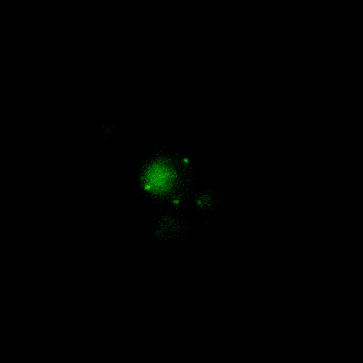
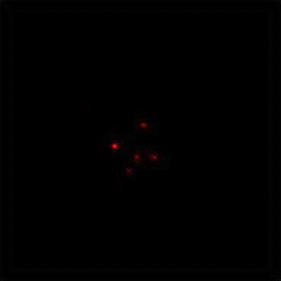
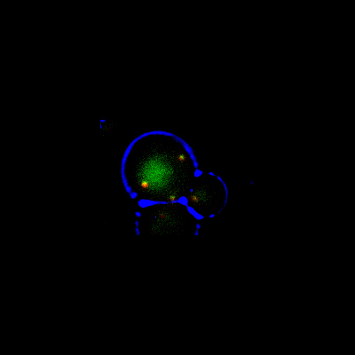
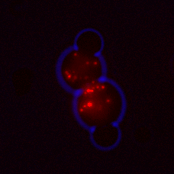
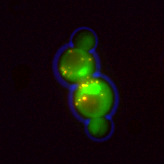
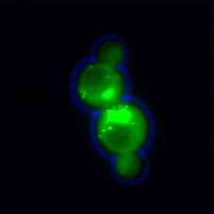
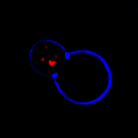
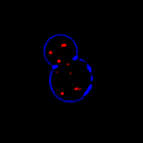
WT
Merged
Inp1p-GFP
HcRed-PTS1
C
Inp1Δ
A
B
HcRed-PTS1
Inp1p-GFP
Merged

Fig 3.1: Confirmation of phenotypes associated with Inp1p
A) In Wildtype (WT) and inp1Δ cells peroxisomes were labelled with HcRed-PTS1 expressed from the TPI1 promoter. The cells were imaged whilst in log phase. Images show, in WT cells, peroxisomes are evenly distributed between mother and daughter cells, whereas in inp1Δ cells, peroxisomes segregate completely to the daughter cell. Bar 5µm.
B) Wildtype cells expressing HcRed-PTS1 were transformed with galactose inducible Inp1p-GFP. The cells were imaged after 4hour galactose induction. Cells expressing Inp1p-GFP were shown to exhibit increased retention of peroxisomes at the periphery of mother cells and a lack of peroxisomes in buds (white arrows). Bar 5µm.
C) inp1Δ cells expressing HcRed-PTS1 were transformed with a plasmid encoding Inp1p-GFP under the control of its own promoter. Cells were imaged while in log phase. Images show rescue of the inp1Δ phenotype and reversion to WT. Bar 5µm.

Subsequently, Wildtype cells expressing HcRed-PTS1 were co-transformed with Inp1p-GFP under the control of the TPI1 promoter. Inp1p-GFP was used so that only cells expressing INP1 would be included in the findings (Fig 3.2 A).
Fluorescence microscopy revealed that constitutive overexpression of INP1 from the TPI1 promoter results in a lack of peroxisomes in all cells, and is therefore in agreement with previous observations by the Hettema lab (Munck, 2008).
To further this investigation, INP1 under the control of the CTA1 promoter was integrated into the TRP1 locus of BJ1991 cells. The CTA1 promoter leads to high induction when cells are grown in oleate containing media, conditions which require functional peroxisomes for cell growth (Elgersma et al. 1993).
BJ1991 Wildtype, pex3Δ, inp1Δ, and CTA1-INP1::TRP1 cells were grown in 0.3% glucose media to log phase. A serial dilution was then performed and cells spotted at OD₆₀₀0.01 to 0.001 onto solid oleate containing media. After growth, if peroxisomes are present and functional, a clear halo was observed around colonies, as the oleate in the media had been broken down (Fig 3.2B).
As reported by Munck, (2008) pex3Δ and INP1 overexpression cells were unable to grow and showed no breakdown halo, whereas inp1Δ cells showed no growth defect.

In order to marry the overexpression phenotype reported by Fagarasnu et al., (2005) with the overexpression phenotype reported by Munck (2008), galactose-inducible Inp1p-GFP was co-transformed into Wildtype cells with the peroxisomal marker HcRed-PTS1. Cells were grown to log-phase on glucose containing medium before switching to galactose containing medium. Cells were continually grown for up to 32 hours, with media being changed to fresh galactose containing media and cell density reduced every 12 hours. Images were taken at intervals of 4, 8, 16, and 32 hours, and any phenotypes observed (Fig 3.2C).
Findings show that there is a progression of phenotype from the increased retention reported by Fagarasnu et al., (2005) to loss of peroxisomes reported by Munck (2008).
At 4 hours a wildtype INP1 phenotype is observable, with Inp1p-GFP completely co-localising with HcRed-PTS1 and segregation appearing equal in all cells. After 8 hours’ growth on galactose containing medium, an Inp1p overexpression phenotype is observable. Peroxisomes show greater retention at the periphery of mother cells, with Inp1p-GFP only observable in mother cells. After 32 hours, a complete INP1 overexpression phenotype is observable. No HcRed-PTS1 is detectable, indicating a loss of peroxisomes, or at least, a loss of peroxisomal protein import.

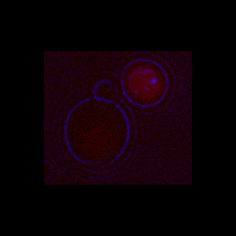
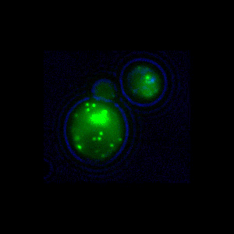
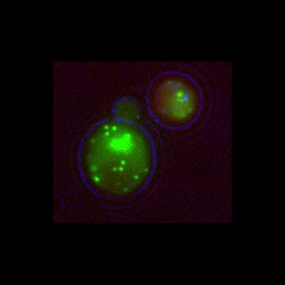
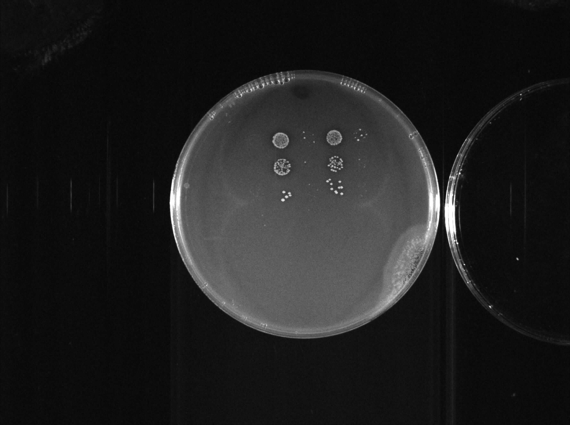
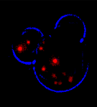
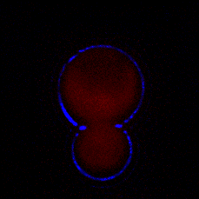
WT
pex3Δ
WT + CTA1-INP1
B
inp1Δ
Merged
Inp1p-GFP
HcRed-PTS1
A
C
T=8
T=32
T=4
T=0

Fig 3.2: Confirmation of overexpression phenotypes associated with Inp1p
A) Wildtype cells expressing HcRed-PTS1 were transformed with Inp1p-GFP expressed under the TPI1 promoter. Cells were imaged while in log phase. Cells expressing Inp1p-GFP were shown to lack peroxisomes. HcRed-PTS1 is seen to be cytosolic. Bar 5µm.
B) BJ1991 Wildtype, pex3Δ, inp1Δ, and CTA1-INP1::TRP1 cells were spotted onto oleate plates. Cells lacking PEX3 and overexpressing INP1 were shown to be unable to grow on oleate.
C) inp1Δ expressing HcRed-PTS1 were transformed with galactose inducible Inp1p-GFP. Cells were grown to log phase and then transferred to galactose media. Samples were taken from a constantly grown culture and images taken at 4, 8, and 32 hours after induction began. Images show rescue of the inp1Δ phenotype after 4 hours, the increased retention Inp1p phenotype after 8 hours (white arrow indicates empty bud), and total loss of peroxisomes after 32 hours. Bar 5µm.

3.2.2 A Synthetic Genetic Interaction screen of INP1

Most null mutations in S. cerevisiae have been shown as viable under rich medium growth conditions. This fact highlights S. cerevisiae ability to cope with genetic variation and the robustness and redundancy employed within most biological circuits (Hartman et al. 2001; Hartwell 2004). These apparently non-essential genes still provide a valuable resource for systemic genetic analysis, however, a method is required in order to screen large quantities relatively quickly. Synthetic genetic array (SGA) analysis has been developed as a method to isolate yeast double mutations to evaluate the function of these genes (Tong et al. 2001).
Genetic interactions are defined as mutations that present a phenotype associated with a separate gene (Baryshnikova et al. 2010). Therefore, Synthetic genetic interactions are usually identified through creation of a second mutation, or increased dosage of an original gene (such as overexpression) which leads to suppression or enhancement of the original mutant phenotype ((Tong & Boone 2006).
Given that overepression of INP1 presents a phenotype appearing to interefere with biogenesis, it is possible to simply describe this overepression mutation as akin to pex19Δ or pex3Δ, however, there are multiple points at which this interference could be taking place.
A typical SGA involves the crossing of a query strain containing the gene under investigation (and may include other essential conditional genes) with a library of other gene deletions to form a double mutant array, which is examined for specific phenotypes (Tong et al. 2001; Baryshnikova et al. 2010). An array was created to analyze inp1Δ in conjunction with a small library of peroxisomal gene knockouts (for a list of knockouts created, please see Appendix I).
Results from this screen gave no firm evidence that there are further synthetic genetic interactions associated with the loss of INP1. Therefore, the immediate course of this investigation shall focus on Inp1p’s interaction with Pex3p and the regions required for that interaction.

3.2.3 An Inp1p truncation screen

3.2.3.1 Areas required for Inp1p co-localisation to peroxisomes

In order to find regions of Inp1p that are required for its co-localisation to peroxisomes a library of galactose-inducible Inp1p-GFP truncations was created. This truncation library was co-transformed into inp1Δ cells expressing HcRed-PTS1 under the control of the HIS3 promoter and analysed by fluorescent microscopy (Fig 3.3 and Fig 3.4).
Expression of constructs was verified through TCA extraction, SDS-PAGE, and western blotting of total cell lysates, probing the membrane with anti-GFP antibody (Roche) (Section 2.5). Truncations were found to be at comparable levels, however, C-terminal truncations removing greater than 80 amino acids were found to be instable when extracted using TCA precipitation methods.
Results show C-terminal truncations of Inp1p still co-localise to peroxisomes when truncated down to amino acid 340 (truncation aa1-340 still partially co-localises), however, the cytosolic pool of Inp1p-GFP was noticeably increased in comparison to the full length protein at the same time of induction (Fig 3.3). Truncations beyond this point are instable and so were unable to be analysed.
Results show that N-terminal truncations of Inp1p still co-localise to peroxisomes up to amino acid 311 (truncation aa311-420 still co-localises). However, truncations beyond this point do not appear to co-localise to peroxisomes (truncation aa315-420 does not co-localise with peroxisomal marker HcRed-PTS1).
Results are summarised in 3.4A.

3.2.3.2 Areas required for Inp1p function

In order to find regions of Inp1p that are required for its function in the retention of peroxisomes at the periphery of the mother cell during cell division, the library of transformed galactose-inducible Inp1p-GFP truncations was analysed further.
Cells were grown to log phase and then transferred to galactose containing media. Cells were grown in galactose media for 4 hours prior to imaging.
Results indicated that a 100aa deletion of the N-terminus of Inp1p results in loss of Inp1p function presenting an inp1Δ phenotype.
These results are summarised in Fig 3.4A and suggest several areas within Inp1p that are required for complete function in retention of peroxisomes.

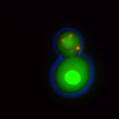
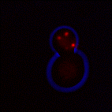
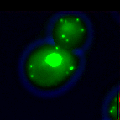
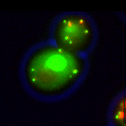
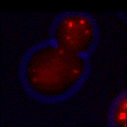
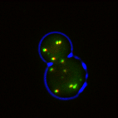
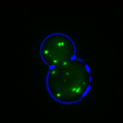
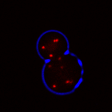
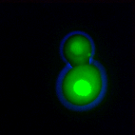
1-420
1-370
1-340
Merged
Inp1p-GFP
HcRed-PTS1

Fig 3.3: Galactose inducible Inp1p-GFP C-terminal truncations
inp1Δ cells expressing HcRed-PTS1 were transformed with a small library of Inp1p-GFP truncations expressed under the GAL1 promoter. Cells were transferred to induction media containing galactose while in log phase. Cells expressing Inp1p-GFP were analysed, and localisation of Inp1p-GFP noted. Inp1p-GFP stopped co-localising with peroxisomes at truncations shorter than 1-340 amino acids. Truncation aa1-340 itself still partially co-localises (white arrow). HcRed-PTS1 is seen to be in puncta. Bar 5µm. Analysis was performed by fluorescence microscopy (63x objective).

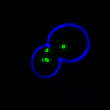
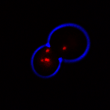
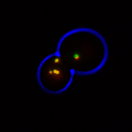
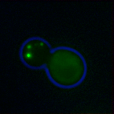
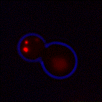
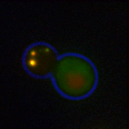
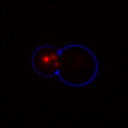
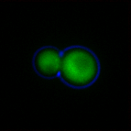
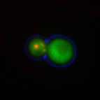
100-420
311-420
315-420
Merged
Inp1p-GFP
HcRed-PTS1

Fig 3.4: Galactose inducible Inp1p-GFP N-terminal truncations
inp1Δ cells expressing HcRed-PTS1 were transformed with a small library of Inp1p-GFP truncations expressed under the GAL1 promoter. Cells were transferred to induction media containing galactose while in log phase. Cells expressing Inp1p-GFP were analysed, and localisation of Inp1p-GFP noted. Inp1p-GFP was no longer determined to be co-localising with peroxisomes at truncations shorter than 311-420 amino acids. Truncation aa315-420 does not co-localise with HcRed-PTS1. The cytosolic pool of Inp1p-GFP again increases as further truncations are made. HcRed-PTS1 is seen to be in puncta in all cases. Bar 5µm. Analysis was performed by fluorescence microscopy (63x objective).

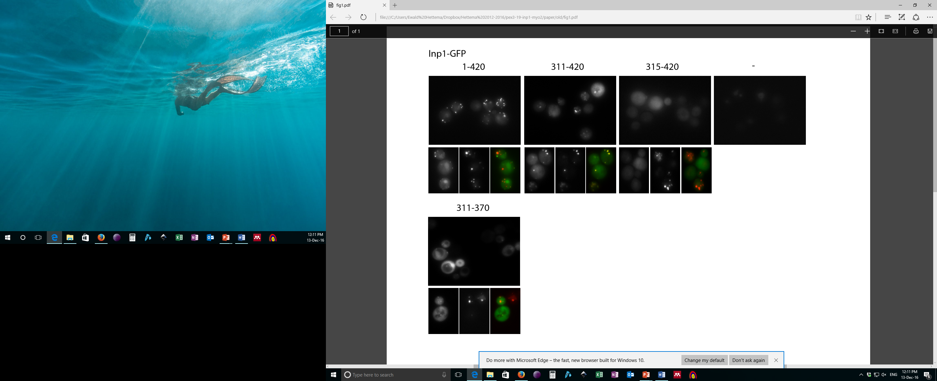

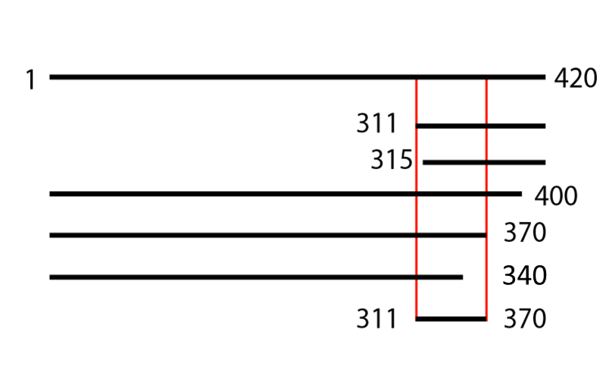
Peroxisomal | Functional
+ | +
+ | -
- | -
+ | +
+ | +
- | -
+ | -

Figure 3.4A: Summary of Inp1p-GFP truncation screen
Microscopy images of Key truncations showing loss of localisation to peroxisomes requires region 311-370 are shown in the top panel.
Line diagram and corresponding table show key truncations in Inp1p-GFP from Fig 3.3 and 3.4. The minimal region required for Inp1-GFP localisation to peroxisomes is indicated by the 2 red lines shown. The corresponding table highlights their localisation (peroxisomal [+] or cytosolic [-]) and functionality (able to retain peroxisomes in mother [+] or the majority of peroxisomes are transported to bud [-]).

3.2.3.3 Areas required for Pex3p binding

To investigate areas required for Inp1p binding to Pex3p, a co-immunoprecipitation of the Inp1p-GFP truncation library with endogenously present Pex3p was performed (Fig 3.5). The Inp1p-GFP truncation library was transformed into C13-ABYS-86 cells, and grown on galactose media. Spheroplasts were created (section 2.5.3.2), lysed, and total soluble fractions incubated with GFP-Trap agarose beads (Chromotek) (section 2.5.4). Columns were washed, boiled in 1xPLB and loaded onto a 10% polyacrylamide gel (section 2.5.5). After electrophoresis, western blots were performed (section 2.5.7). Anti-GFP (Roche) antibody was used to detect Inp1p-GFP truncations that bound to the column and a custom made Anti-Pex3p antibody was used to detect endogenous Pex3p co-purified with Inp1p-GFP.
From this data, Inp1p-GFP is shown to be able to co-immunoprecipitate Pex3p. Co-purification is lost, or at least severely reduced, in several truncations investigated. However, loss of co-immunoprecipitation with a truncation itself is not concrete evidence of loss of binding within those regions removed. From the anti-GFP blot, we can see that truncations 315-420 and 311-370 are not stably present on the GFP-Trap column. These truncations, therefore, may not be stable themselves, and that could explain the lack of ability to co-immunoprecipitate Pex3p. While truncation 1-340 appears stable and on the GFP-Trap column in concentrations comparable to that of the full length Inp1p-GFP, this truncated form itself may be structurally altered, and so again, loss of co-immunoprecipitation is not indicative that regions from 340-420 are required for binding to Pex3p.
It can be concluded with clarity, however, that region 282-400 is able to co-immunoprecipitate and therefore assumed to bind to Pex3p.
The limitations of this assay are apparent. As with using fluorescent microscopy to detect these samples, it appears as if the limits of the technique are being reached in their usefulness for determining interactions between truncations of Inp1p-GFP and Pex3p.
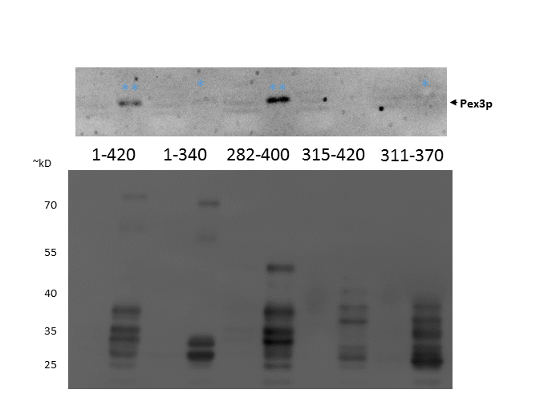
αPex3
αPex3
*
*
*
*
*
*

Fig 3.5: Western Blot analysis of Inp1p-GFP truncation binding of Pex3p
Spheroplasts of C13-ABYS-86 cells expressing Inp1p-GFP truncations were lysed and soluble extracts incubated with GFP-Trap agarose beads. Columns were washed and resuspended in 1x PLB before analysis by SDS-PAGE and Western Blotting. Separate membranes were probed with Anti-GFP and Anti-Pex3p. AntiPex3p blot shown above.
TLs represent 1/150 of total soluble fractions which were incubated with GFP-Trap columns. IP represents 1/10 of boiled beads in 1xPLB.
Results indicated that Inp1p-GFP truncations are still capable of binding endogenous Pex3p, with binding undetectable at truncation aa315-420 and at a minimum for truncations aa1-370 and aa311-370 (single blue asterix).

3.2.4 A truncation screen for loss of Inp1p overexpression phenotype

To investigate areas of Inp1p which may be responsible for the reported constitutive overexpression phenotype (lack of peroxisomes), two small libraries of truncations of Inp1p-GFP under the control of the TPI1 promoter, and Inp1p under the control of the CTA1 promoter were created.

Truncations under the control of TPI1

The library of constructs under the control of the TPI1 promoter was co-transformed into inp1Δ cells expressing HcRed-PTS1. Cells were grown in glucose media and imaged whilst in log phase (Fig 3.6).
Results show that N-terminal truncations of Inp1p-GFP from amino acid 100 are not able to cause the INP1 constitutive overexpression phenotype. These truncated forms of Inp1p also appear non-functional, as peroxisomes are unable to be retained in the mother cell during division. However, these truncated forms of Inp1p are still seen to co-localise to peroxisomes.
Results also indicate that C-terminal truncations of Inp1p-GFP also appear unable to produce the constitutive overexpression phenotype, however, they do appear functional in peroxisomal retention and co-localised to peroxisomes.
Truncations after amino acids 315 and before amino acids 282 appear unable to co-localise to peroxisomes.

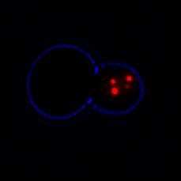
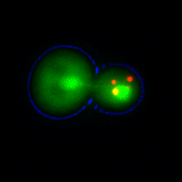
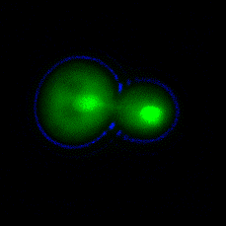
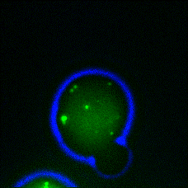
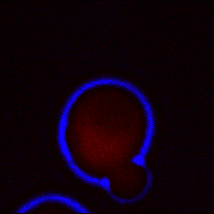
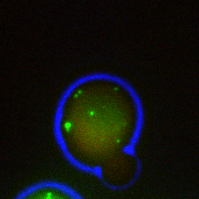
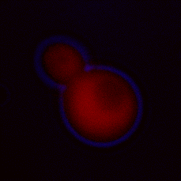
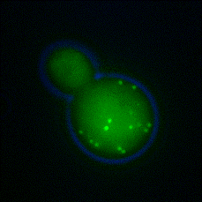
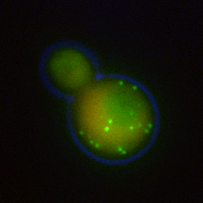
1-282
1-420
1-400
Merged
HcRed-PTS1
Inp1p-GFP

Fig 3.6i: TPI1 C-terminal Truncations of Inp1p-GFP
A library of truncated Inp1p-GFP under the control of the TPI1 promoter was co-transformed into inp1Δ cells expressing HcRed-PTS1. Analysis was performed by fluorescence microscopy (100x objective). Bar 5µm.
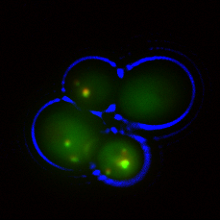
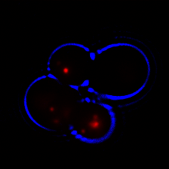
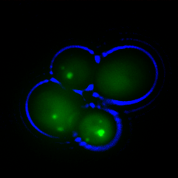
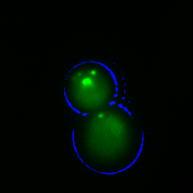
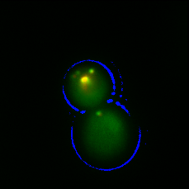
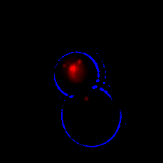
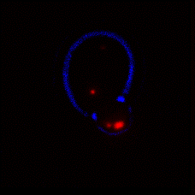
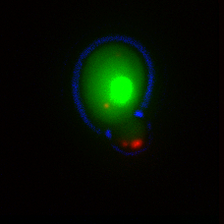
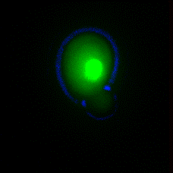
100-420
315-420
311-420
Merged
HcRed-PTS1
Inp1p-GFP

Fig 3.6ii: TPI1 N-terminal Truncations of Inp1p-GFP
A library of truncated Inp1p-GFP under the control of the TPI1 promoter was co-transformed into inp1Δ cells expressing HcRed-PTS1. Analysis was performed by fluorescence microscopy (100x objective). Bar 5µm.

Truncation | TPI1 expression
 | Presence of peroxisomes | Retention in Mother | Colocalisation to Peroxisomes
WT | 0 (no peroxisomes) | 0 (no peroxisomes) | 0 (no peroxisomes)
1-400 | 0 (no peroxisomes) | 0 (no peroxisomes) | 0 (no peroxisomes)
1-370 | 0 (no peroxisomes) | 0 (no peroxisomes) | 0 (no peroxisomes)
1-282 | + | - | -
100-420 | + | +/- | +
311-420 | + | +/- | +
315-420 | + | - | -

Table 3.2: Summary of Inp1p-GFP truncation screen
Table of Inp1p-GFP truncations:
Column 1 indicates whether truncations produce the constitutive overexpression phenotype (no peroxisomes) (0), or whether peroxisomes ar epresent (+).
Column 2 indicates functionality of Inp1p in retaining peroxisomes in mother (+) or not (-). +/- indicates partial colocalisation
Column 3 indicates colocalisation of truncations to peroxisomes (+) or not (-)

3.2.5 Bioinformatics to elucidate potential sites of interest found in screens

To study regions of Inp1p required for its function, the amino acid sequence of Inp1p was analysed through numerous bioinformatics tools.
Previous results indicate that a region between amino acids 282-400 is required for Pex3p binding (Fig 3.5). This area corroborates Yeast two Hybrid data (Hybrigenics) performed on Pex3p in which an area of Inp1p between amino acids 301-378 was highlighted as a minimal region required for Pex3p interaction. ClustalW alignments highlighted several regions of Inp1p that were conserved between budding yeast species (Fig 3.7i), however, only one area appears conserved in this region, the sequence between amino acids 310-317. Interestingly, this is right at the boundary of where further N-terminal truncations strongly reduced association of Inp1p with peroxisomes (Table 3.1).

Inp1p aa310-317 is a highly conserved region

ClustalW (http://www.ebi.ac.uk/Tools/msa/clustalw2/) was used to align multiple sequences of Inp1p found in budding yeast species (Fig 3.7i and Fig3.7iiA). Results show that amino acid residues 311-317 are highly conserved, with a consensus sequence of ELNYLLE (Fig 3.7iiB).

Inp1p aa308-317 is an amphipathic helix

Helical Wheel predictions (http://www.tcdb.org/progs/?tool=pepwheel) were used to determine possible distribution of residues within the predicted helix containing the potential binding motif (Fig 3.7iiC). When viewed by helical wheel projections, hydrophobicity in this segment consists of three leucine residues. The acidic residues appear to form a surface on the opposing side to these hydrophobic residues.

Inp1p aa312-316 is a solvent accessible region

Solvent accessibility can be used to elucidate a relationship between protein sequence and its structure. As no crystal structure of Inp1p is known, however, accessibility of a region can be estimated through the use of a solvent accessibility predictor (Fig3.7iiD). Results show that the region of interest is predicted to be accessible.

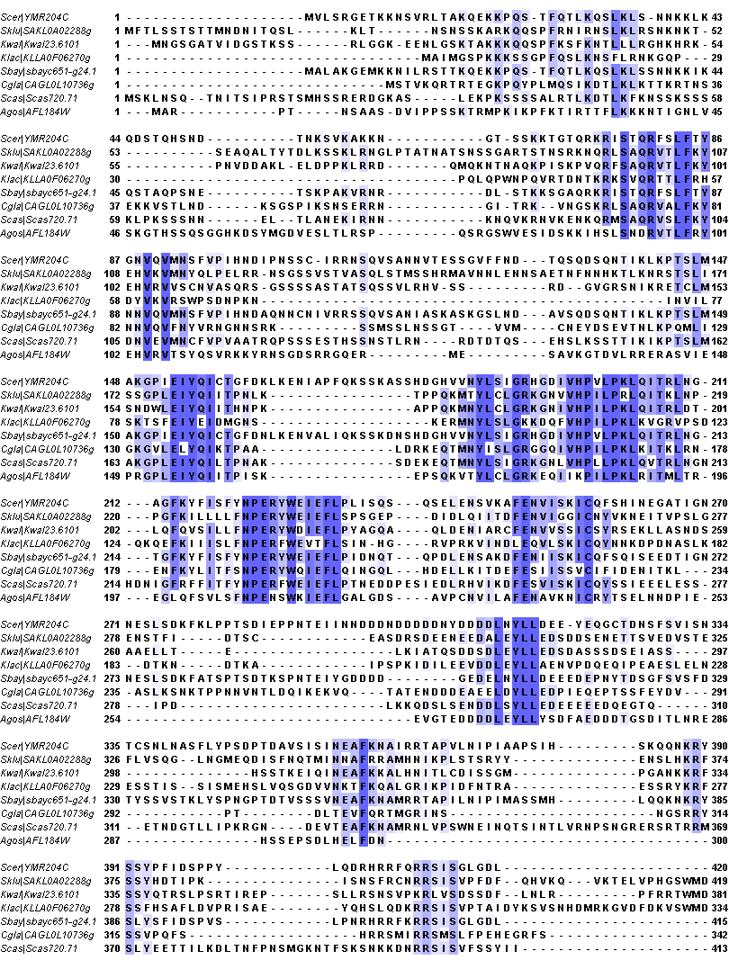

Fig 3.7i: Regions of conservation within Inp1p in species of budding yeast
ClustalW of Inp1 Proteins from related yeast species highlight several conserved regions throughout the protein. The region of 311-317 is shown to be highly conserved.

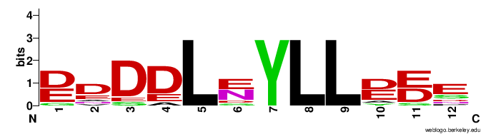
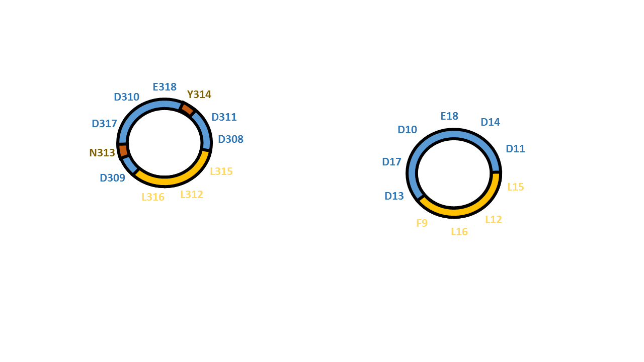
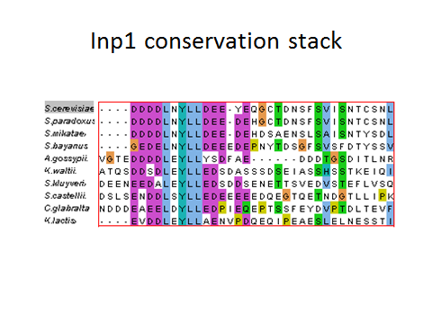
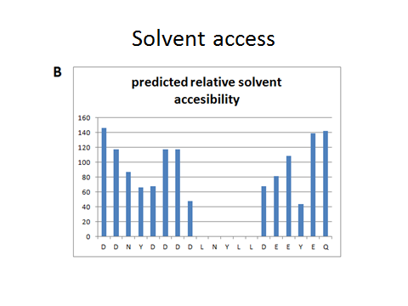
D
C
B
A

Fig 3.7ii: Bio-informatic analyses of Inp1p region of interest
A) ClustalW alignment (http://www.ebi.ac.uk/Tools/msa/clustalw2/) of region of interest in species of budding yeast.
B) Consensus sequence of region of interest based on conservation in budding yeast.
C) Helical wheel projection of region of interest in S. cerevisiae, a potential amphipathic helix is apparent.
D) Solvent accessibility of region of interest in S. cerevisiae. T=Shows region of LNYLL as accessible to solvents.

3.2.6 Inp1p Leu315Pro can no longer co-immunoprecipitate Pex3p.

Truncation and Bioinformatic analyses identify the sequence of DDLNYLLDEE between amino acids 310-319 as a possible site of interest meriting exploration. To further this investigation, an attempt was made to disrupt this potential binding site through the introduction of a proline residue with the aim to locally disturb the predicted amphipathic helix, and observe any effect on Pex3p binding. To achieve this, a binding assay involving co-immunoprecipitation on Inp1p-GFP and Pex3p was designed.
Accordingly, site directed mutagenesis was performed on a construct containing a galactose inducible Inp1p-GFP to create a galactose inducible Inp1p-L315P-GFP construct. Inp1p-GFP and an Inp1-L315P-GFP constructs were transformed to and expressed in C13-ABYS-86 cells.
A co-immunoprecipitation assay was executed through creation of spheroplasts and extraction of Inp1p-GFP through their homogenisation. Soluble Inp1p-GFP was immunoprecipitated from cell lysates using GFP-Trap Agarose beads, and the samples analysed through SDS-PAGE and western blotting for their ability to co-immunoprecipitate endogenous Pex3p (Fig 3.8).
Results show that wildtype Inp1p-GFP was able to co-purify endogenous Pex3p, however, mutants in which leucine 315 was substituted for a proline were unable to achieve this.

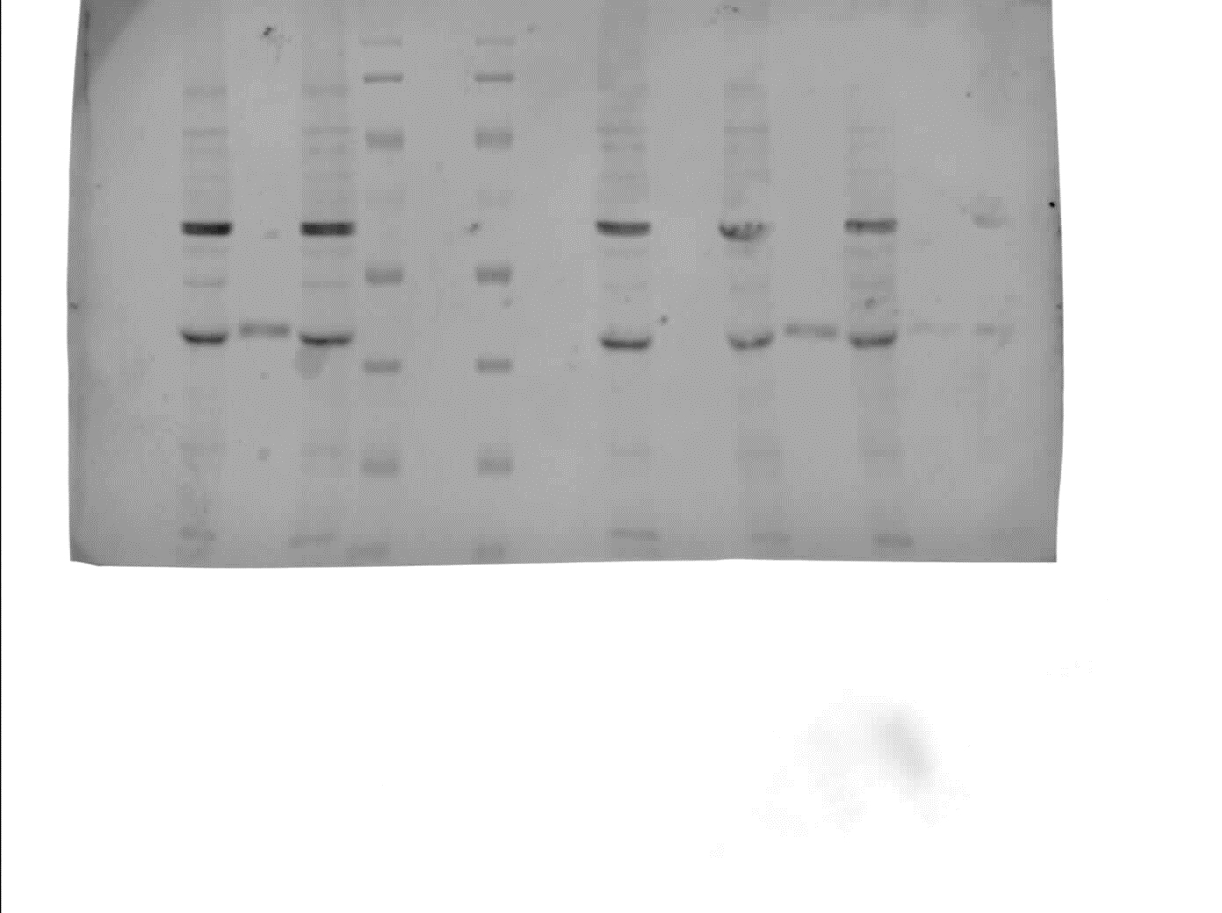
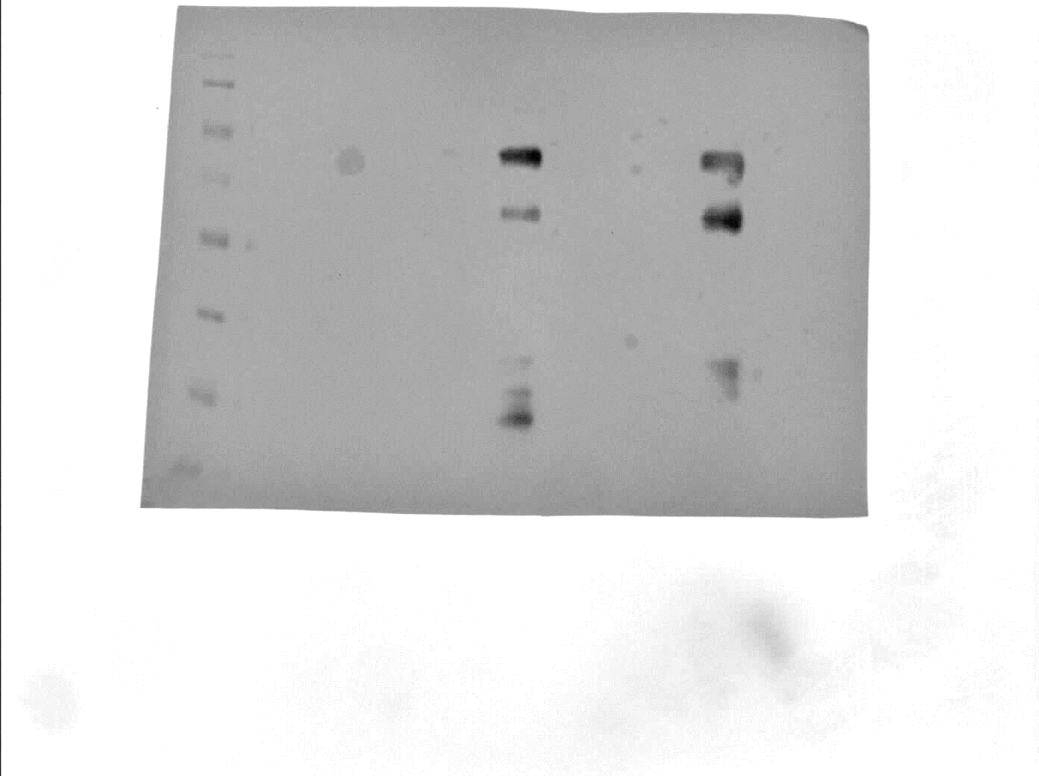
55
A
B
70
100
~kD
Inp1p-GFP
Inp1p-L315P-GFP
Inp1p-GFP
TL
IP
TL
IP
TL
IP
TL
IP
35
40
Pex3p
Inp1p-L315P-GFP
Inp1p
-GFP
αGFP
αPex3

Fig 3.8: Leu315Pro mutation in Inp1p-GFP leads to loss of Pex3p co-purification
Spheroplasts of C13-ABYS-86 cells expressing Inp1p-L315P-GFP were lysed and soluble extracts incubated with GFP-Trap agarose beads. Columns were washed and resuspended in 1x PLB before analysis by SDS-PAGE and Western Blotting. Separate membranes were probed with Anti-GFP (A) and Anti-Pex3p (B).
TLs represent 1/150 of total soluble fractions which were incubated with GFP-Trap columns. IP represents 1/10 of boiled beads in 1xPLB.
Results indicated that Inp1p-GFP is capable of co-purifying endogenous Pex3p, however, Inp1p-L315P-GFP is unable to co-purify Pex3p to detectable levels.

3.2.9 Discussion

The previously reported role of Inp1p in peroxisomal inheritance and its binding of Pex3p (Fagarasanu et al. 2005; Munck et al. 2009) were confirmed (Fig 3.1A and Fig 3.3, 3.5, and 3.8 respectively). The phenotypes associated with inp1Δ cells reported by Fagarasanu et al., (2005) was confirmed, as was overexpression of INP1 leading to increased retention at the periphery of mother cells during cell division. These phenotypes were also shown to be compatible with the constitutive overexpression phenotype observed by Munck (2008), as galactose inducible Inp1p-GFP was shown to progress through rescuing the inp1Δ phenotype, to increased retention, to lacking peroxisomes as induction time increased (Fig 3.2C).
Inp1p is very poorly expressed, with detection of Inp1p-GFP proving to be close to the limit of available apparatus (Fig 3.1C). The use of a triple GFP tag was considered, however, as Inp1p itself is only 47kD, the addition of a 75kD fluorescent tag onto its C-terminus has potential for affecting both Inp1p’s function and structure. This line of thought was exacerbated by Knoblach et al., (2013) reporting that both C and N termini are required for correct function of Inp1p in tethering peroxisomes at the periphery of the mother cell during cell division. Therefore, for screens involving truncation of Inp1p, galactose inducible Inp1p was preferred over Inp1p expressed from its own promoter with investigation and analysis relying heavily on the clear phenotypes associated with Inp1p, the loss of Inp1p function, and Inp1p overexpression.
The N terminus of Inp1p appears to be required for correct function of the protein in retention (Fig 3.3), as peroxisomes are unable to be retained in mother cells during cell division upon removal of the first 100 amino acids of Inp1p. There also appears to be increased localisation to an unknown structure (possibly the nucleus) upon removal of the C terminus of Inp1p (Fig 3.4). This possible mislocalisation of Inp1p is seen in overexpression of the full length protein. It has been confirmed that this localisation of Inp1p to what is possibly the nucleus is not tag dependent as both Inp1p-GFP and Inp1-mCherry have been shown to localise to this structure when expressed from the TPI1 promoter (Data not shown).
As posited in Knoblach et al., (2013), Inp1p may contain 2 binding sites for Pex3p, one N-terminal (within amino acids 1-280), and one C-terminal (within amino acids 280-420). With this as a basis, the region of amino acids 310-317 highlighted through the truncation screen and then bio-informatic research would appear to be a solid candidate for the suggested C-terminal binding site.
Western blot analyses of truncated forms of Inp1p-GFP proved problematic due to high levels of Inp1p-GFP breakdown products being detected, even in C13-ABYS-86 cell lysates containing increased quantities of protease inhibitors. Detection of co-immunoprecipitated Pex3p also proved to be close to the detection limit of the assay used (Fig 3.5). Binding was clear between full length Inp1p-GFP and a total N terminal truncation (amino acids 282-420), however, partial binding was barely detectable in C terminal truncations (aa1-340) and minimal regions (aa311-370) that were detectable through fluorescent microscopy as still localising to peroxisomes. Crucially, a truncated form of Inp1p-GFP only containing amino acids 315-420 was seen not to interact with Pex3p, however, it remains unclear whether this is due to loss of the interaction, or if the interaction is merely too weak to be detectable by this method.
However, the minimal region of Inp1p (amino acids 311-370) being crucial for Pex3p binding is supported by Yeast 2 Hybrid data in which a region of amino acids 301-378 from Inp1p was found to interact with Pex3p (Hettema and Munck: unpublished data).
The disruption of this site was achieved through introduction of a proline at residue 315 (Fig 3.8). This heavily indicates that this region and LxxLL motif is required for Pex3p binding.
This site will be further explored and attempts at its characterisation will be reported in Chapter 4.

Chapter 4:

Characterisation of the LxxLL motif required for Pex3p binding

4.1 Introduction

The data reported in Chapter 3 suggests that there is an alpha helix present in Inp1p which is required for interaction with Pex3p. A truncation screen of Inp1p-GFP highlighted the region as required for localisation to peroxisomes, and a point mutant in this region was shown to be unable to co-purify Pex3p.

A second known interacting partner of Pex3p in S. cerevisiae is Pex19p (Gotte et al. 1998). Structural studies of human Pex3 in complex with part of Pex19, revealed that an amphipathic helix in Pex19 with an LXXLL motif at its core, is binding Pex3. (Schmidt et al. 2010; Sato et al. 2010; Schmidt et al. 2012). The alpha helix required for Inp1p interaction with Pex3p reported in Chapter 3 bears similarity to the reported binding site of HsPex19p for HsPex3p.

Although this motif in HsPex19 is conserved to S. cerevisiae Pex19p, no data has been reported on the site present in Inp1p. Nor has data confirmed that in S. cerevisiae the LxxLL site present in ScPex19p is definitively a site for ScPex3p interaction.

Further analysis of this motif in Inp1p and Pex19p is required to elucidate its involvement in the respective proteins’ interaction with Pex3p, and the impact on associated phenotypes. The aim of the following chapter is to further investigate the role of this LxxLL motif through employment of in vitro and in vivo assays.

4.2 Results

4.2.1 An Alanine Scan Reveals Leucines in Inp1p as key for Pex3p binding in vitro

As was reported in Section 3.2.6, the introduction of a proline residue at position 315 of Inp1p leads to an inability to co-purify Pex3p. To further characterise the LxxLL motif and its potential requirement for Pex3p binding a range of alanine substitution mutants was created within the region of Inp1p aa310-316 in a GST-Inp1p construct. Site directed mutagenesis PCR was performed on the original GST-Inp1p construct and the resultant alanine mutations and their corresponding nucleotide substitutions are given in table 4.1.
Constructs were expressed in BL21 E. coli, with induction through addition of 1mM IPTG being performed after cells had grown to OD₆₀₀=0.8. Induction lasted for 2 hours at 30°C with shaking at 180rpm before cells were pelleted and stored at -80°C prior to lysis.
Cell pellets were lysed through sonication in PBS containing appropriate protease inhibitors before addition of Triton X-100 to 0.5% total volume. Cells were centrifuged at 13,000rpm at 4°C and the soluble fraction incubated with Glutathione Sepharose beads (Roche) for 2 hours at 4°C. Galactose inducible Pex3-GFP had been expressed and was extracted from spheroplasts before incubation with the GST-Inp1p mutant columns. Bound proteins were analysed by SDS-PAGE followed by Coomassie Brilliant Blue staining and Western Blotting (Fig 4.1).
Results show that the substitutions DD310,311AA and NY313,314AA, bind Pex3p-GFP. However, binding was reduced to the level of the negative control in the substitutions L312A and LL315316AA, i.e. no specific binding was observed. This indicates the leucine residues L312, 315, and 316 may have some importance in the binding of Inp1p to Pex3p.

Nucleotide | Amino Acid
GACGAC927-933GCCGCC | DD310,311AA
CT934,935GC | L312A
AATTAC936-942GCTGCC | NY313,314AA
TTGCTG943-948GCTGCA | LL315,316AA

Table 4.1: Alanine scan mutations introduced into INP1
A range of amino acids between aa310-316 of Inp1p were substituted for alanines through site directed mutagenesis of a GST-INP1 construct. The table indicates nucleotides that were mutagenized and the resultant amino acid substitution.

Coomassie Blue
αPex3
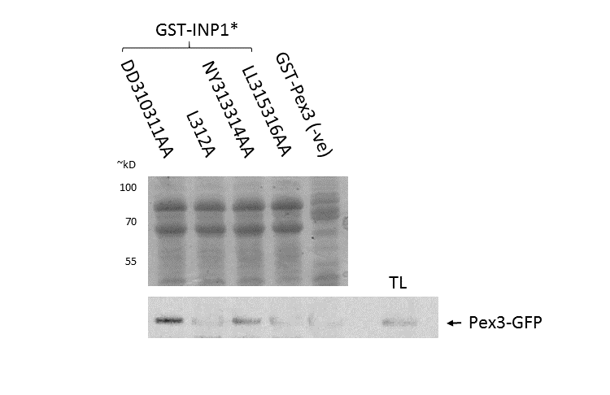

Fig 4.1: Western blot analysis of GST-Inp1p mutants interacting with Pex3p-GFP
GST-Inp1p mutant constructs were expressed and extracted for BL21 E. coli. Soluble cell lysates were incubated with Glutathione-sepharose (GE Healthcare) for 1 hour at 4°C. Pex3-GFP was extracted from C13-ABYS-86 spheroplasts after galactose induction. After homogenisation, total soluble yeast cell lysate was incubated with GST-Inp1p columns. Coomassie stain is shown on top. GST-Inp1 constructs are shown to be equally loaded. Western blot analysis by probing with anti-GFP (Roche) is shown below. IPs are equivalent to 1/10 total column volume. TL is 1/75 of input that was incubated with GST columns. Reduced binding is observed in GST-Inp1p constructs in which leucine to alanine residue substitutions have been made.

4.2.2 Mutation of Key Leucine residues lead to a loss of Pex3p binding in vivo

Results indicate that mutation of the leucine residues in the LxxLL motif of Inp1p lead to a lack of peroxisome retention in mother cells during cell division, due to assumed loss of function of Inp1p. As Inp1p’s function is also heavily reliant on its interaction with Pex3p, confirmation that the leucine residues are involved in Pex3p binding was sought.
A co-immunoprecipitation assay was performed in the same way as mentioned in section 3.2.6, except the constructs used were of Inp1p-GFP containing amino acid substitutions of L312A and LL315316AA (Fig 4.2).
Results confirm that amino acid substitutions in the LxxLL motif that change the Leucine residues to Alanines result in a loss of detectable co-immunoprecipitation of Pex3p. Thus, it is assumed that these mutants have either lost, or have a severely lowered affinity for Pex3p.

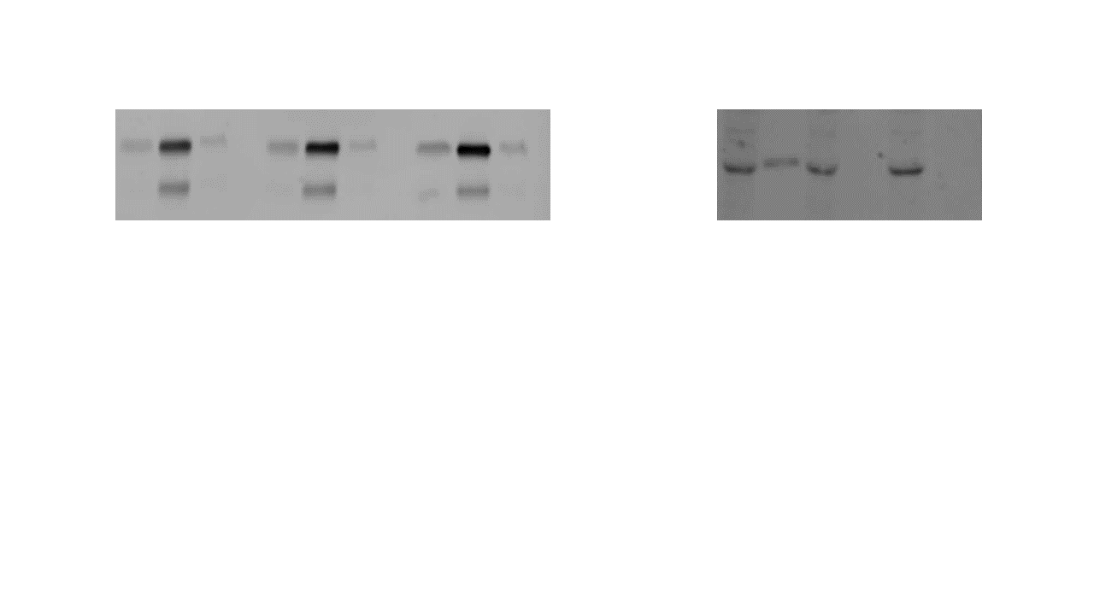
αGFP
αPex3
Inp1p
-2-GFP
Inp1p
-1-GFP
Inp1p
-GFP
Inp1p-2-GFP
Inp1p-1-GFP
Inp1p-GFP
Inp1p-GFP
Pex3p
B
TL
IP
IS
TL
IP
IS
TL
IP
IS
TL
IP
TL
IP
TL
IP
55
70
100
55
40
~kD
~kD
A

Fig 4.2: Pex3p is unable to co-immunoprecipitate with Inp1p leucine mutants
Galactose inducible Inp1p-GFP constructs were expressed in C13-ABYS-86 cells. Spheroplasts were created and lysed. The resultant soluble fraction was incubated with GFP-Trap agarose beads (Chromotek) for 1 hour at 4°C. SDS-PAGE and western blot analysis was performed. Anti-GFP blot pertaining to the GFP-Trap column are shown in A. Anti-Pex3p blots to show co-immunoprecipitation are shown in B. Insoluble fractions (IS) were not probed with anti-Pex3p antibody.
A) Anti-GFP blot to show GFP tagged protein extraction and GFP-Trap column: The soluble fraction input (TL), created column (IP), and insoluble fraction (IS), are shown. The blot shows that Inp1p-GFP and mutants are evenly enriched on the created GFP-Trap column. Inp1p, Inp1p-1, and Inp1p-2 refer to the wildtype protein, L312A mutation, and LL315316AA mutation constructs, respectively.
B) Anti-Pex3p blot to show co-immunoprecipitaton: The soluble fraction input (TL) and immunoprecipitation (IP) on the created GFP-Trap-Inp1p-GFP column are shown.
Results indicate that mutants in Inp1p-GFP lose the ability to co-immunoprecipitate Pex3p at detectable levels.

4.2.3 Mutation of Key Leucine residues leads to loss of Inp1p function in vivo

As results have shown, the region between aa310 and aa316 of Inp1p is required for Pex3p binding. Furthermore, the leucine residues contained within this sequence appear to be essential for Inp1p binding to Pex3p in vitro.
To establish that these residues and the effect of their mutation is also required in vivo, a group of INP1 mutated strains was produced and named INP1-1, INP1-2, and, INP1-3. A table summarising these strains is present as Table 4.2.
Strains were created by firstly creating an INP1 deficient strain. Homologous recombination was utilised to introduce a URA3 cassette at the INP1 locus in Wildtype (BY4742) cells. This strain was used as inp1Δ for this assay, as well as for the basis for introducing point mutants into the genome.
Through high efficiency transformation and homologous recombination with the inserted URA3 cassette, PCR products of mutated INP1 were able to be introduced into the newly created inp1Δ strain at the INP1 locus. Strains now containing mutated INP1 were selected for by loss of the URA3 cassette on solid media containing 5-Fluoroorotic Acid (5-FOA). 5-FOA is converted into a toxic form in cells with a functional URA3 gene, and therefore is used as a positive selection for inserted INP1 mutants. To check correct insertion, positive colonies were subjected to gDNA isolation, PCR of the INP1 region, and subsequent sequencing of PCR products.
A reformed Wildtype strain was also created in this manner, through re-introduction of an un-mutated INP1 PCR product. This strain was used as Wildtype in this assay.
Cells of the created strains were transformed with HcRed-PTS1 under the control of the TPI1 promoter and exponentially growing cells were analysed through fluorescence microscopy (Fig4.3).

Results show that amino acid substitutions of leucine residues L312, 315, and 316, lead to cells presenting the classical inp1Δ phenotype. In all mutants, peroxisomes are unable to be retained by the mother cell during cell division. The reformed Wildtype strain appeared as Wildtype, and Inp1p is assumed to be functioning as normal due to equal segregation of peroxisomes during cell division.
This data confirms the leucine residues 312, 315, and 316 are required for Inp1p function.

INP1 mutant | Nucleotide | Amino Acid
INP1-1 | CT934,935GC | L312A
INP1-2 | TTGCTG943-948GCTGCA | LL315,316AA
INP1-3 | TT943,944CC | L315P

Table 4.2: Leucine substitution strains created for in vivo analysis of Inp1p
A URA3 cassette was introduced into BY4742 cells at the INP1 locus. PCR products of INP1 containing nucleotide substitutions were created. Through homologous recombination and subsequent 5-FOA selection, mutations of INP1 were introduced into the BY4742 genome at the INP1 locus. The nucleotide mutations performed and the resulting residue changes in Inp1p are noted in the above table.

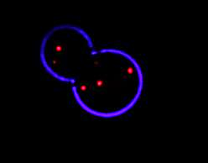
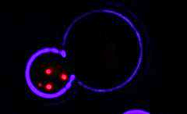
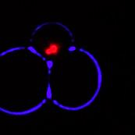
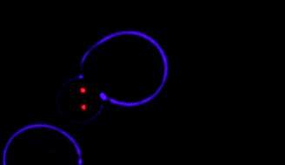
WT
Inp1Δ
INP1-1
INP1-2

Fig 4.3: Point mutants introduced into the genome exhibit an inp1Δ phenotype
Mutants in INP1 were transformed with the peroxisomal marker HcRed-PTS1. Cells were analysed through fluorescence microscopy whilst in log phase. Results show that mutations causing amino acid substitutions L312A (INP1-1) and LL315316AA (INP1-2) lead to a loss of peroxisomal retention in the mother cell during cell division, and all peroxisomes being transported to the bud. Bar 5µm.

4.2.4 Inp1p Leu mutants do not cause loss of peroxisomes when overexpressed

4.2.4.1 TPI1 promoter driven overexpression of INP1

As has been established, and confirmed, constitutive overexpression of INP1 leads to a lack of peroxisomes (Fig 3.2). This has been reported as being due to trapping Pex3p in the ER, and preventing Pex19p binding thus preventing de novo formation of peroxisomes (Munck 2008). As we have reported, Inp1p and Pex19p share a similar motif required for binding to Pex3p. If, therefore, these two binding partners of Pex3p are vying for binding at a similar position on Pex3p, it could be suggested that the overexpression and therefore overabundance of Inp1p is outcompeting and thusly blocking Pex19p access to Pex3p.
As has been reported in this study, Inp1p constructs containing substitutions at Leucine residues 312, 315, and 316, cannot retain peroxisomes at the periphery of the cell and cannot co-immunoprecipitate Pex3p.
A construct of Inp1p-GFP under the control of the TPI1 promoter was subjected to site directed mutagenesis to create mutants in the LxxLL motif (Table 4.2). These constructs were co-transformed to inp1Δ cells along with peroxisomal marker HcRed-PTS-1 under the control of the HIS3 promoter. Exponentially growing cultures were analysed through fluorescence microscopy (Fig 4.4).
Results show that HcRed-PTS1 appears in puncta in cells overexpressing of the LxxLL motif mutants, in contrast to cells overexpressing WT Inp1-GFP. This suggests that the mutants do not interfere with peroxisome biogenesis.
To our surprise although, the mutants 1) do not interfere with peroxisome biogenesis upon overexpression, 2) do not form a stable complex with Pex3, and 3) are unable to rescue the peroxisome retention defect in inp1Δ cells during cell division, the Inp1p-GFP LxxLL mutants do co-localise with HcRed-PTS1. This will be further investigated in chapter 5.
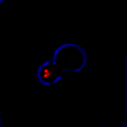
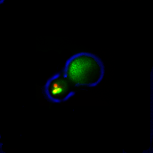
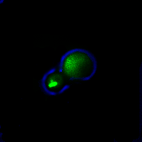
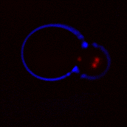
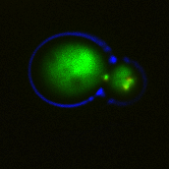
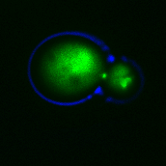
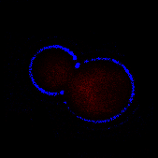
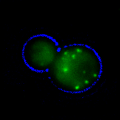
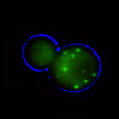
Inp1p-2
Inp1p
Inp1p-1
Merged
HcRed-PTS1
Inp1p-GFP

Fig 4.4: TPI1 overexpression of Inp1p mutants does not lead to a loss of peroxisomes
Constructs containing Wildtype Inp1p-GFP, Inp1p-1-GFP, and Inp1p-2-GFP under the control of the TPI1 promoter were co-transformed to inp1Δ along with a peroxisomal marker (HcRed-PTS1). Cells were grown in liquid culture containing glucose. Exponentially growing cells were analysed through fluorescence microscopy. Results show that Inp1p-GFP overexpression leads to a loss of peroxisomes, however, mutants in the LxxLL motif in Inp1p do not. In addition, the mutants still colocalise with HcRed-PTS1.

4.2.4.2 CTA1 promoter-driven overexpression of INP1

As has been established, and confirmed (Fig 3.2), overexpression of INP1 when under the control of the CTA1 promoter leads to a loss of growth on oleate media (Munck 2008). This is assumed to be due to the observable loss of peroxisomes when INP1 is overexpressed, and caused through an overabundance of Inp1p outcompeting Pex19p for binding to Pex3p, and thus blocking peroxisome biogenesis.
As has been reported in this study, Inp1p constructs containing substitutions at Leucine residues 312, 315, and 316, cannot retain peroxisomes at the periphery of the cell and cannot co-immunoprecipitate Pex3p (Fig 4.2 and 4.5 respectively). On glucose media, a condition where peroxisome number is low and peroxisomes are not required for growth, overexpression of these mutants does not lead to loss of peroxisomes (Fig 4.4).
In order to investigate if overexpression of these mutants interferes with growth under conditions where peroxisomes are required, overexpression of INP1 and LxxLL mutants was analysed on oleate medium. A construct was designed for integration into the URA3 locus encoding INP1 under the control of the peroxisomal catalase, CTA1, promoter. This construct was then subjected to site directed mutagenesis to create mutants akin to INP1-1, INP1-2, and INP1-3 (Table 4.2). The mutations were introduced by homologous recombination into the genome of BJ1991 cells at the URA3 locus.
Cells were grown in liquid culture of 0.3% glucose media until reaching a point of exponential division. A serial dilution was then performed and cells spotted at OD₆₀₀=0.01 to 0.001 onto solid oleate containing media. After growth, if peroxisomes are present and functional, a halo was observed around colonies, as the oleate in the media had been broken down (Fig 4.5).
As reported by Munck, (2008) pex3Δ and cells overexpressing INP1 were unable to grow and showed no breakdown halo, whereas INP1-2 and INP1-3 cells showed no growth defect. INP1-1 cells, however, still show an inability to grow on oleate containing media.

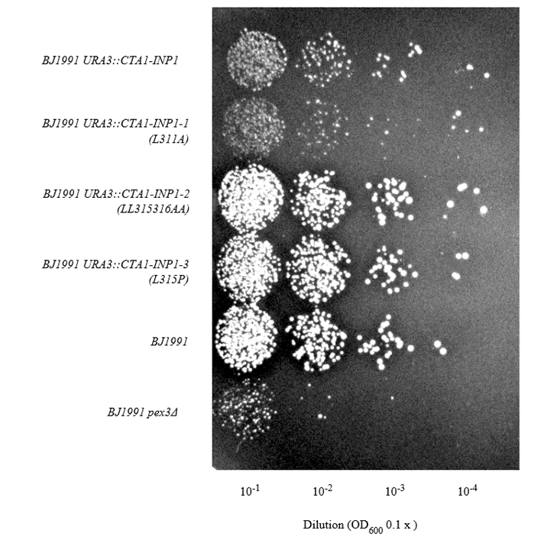
Fig 4.5: CTA1 overexpression of Inp1p mutants does not lead to a loss of growth on oleate
BJ1991, pex3Δ, and cells with integrated CTA1-INP1::URA3, CTA1-INP1-1::URA3, CTA1-INP1-2::URA3, and CTA1-INP1-3::URA3 were spotted onto oleate plates. Cells lacking PEX3 and overexpressing INP1 were shown to be unable to grow on oleate. Cells overexpressing INP1-1 were also shown to be unable to grow on oleate. Cells overexpressing INP1-2 and INP1-3¸ however, were shown able to grow.

4.2.5 A Pex3p Binding site in S. cerevisiae Pex19p

Although well characterised in humans (Schmidt et al. 2010; Sato et al. 2010; Schmidt et al. 2012), the Pex3p-Pex19p interaction site has not been confirmed in yeast. However, the motif reported in humans does appear to be highly conserved throughout species (Fig 4.6A).
A short BLAST search reveals that this motif also bears similarity to the predicted binding site in Inp1p (Fig 4.6B), and helical wheel projections for this region of S. cerevisiae Pex19p show an amphipathic helix with similarity to the prediction of the Inp1p motif that is under investigation (Fig 4.6C).
To confirm the previous reported interaction of Pex19p with Pex3p in S. cerevisiae, a GST-fusion protein of an N-terminal GST tag and Pex3p lacking its N terminal transmembrane domain (Δ1-48) and expressed in E. coli (henceforth referred to as GST-Pex3p). Lysates containing these products were incubated with a Glutathione Sepharose 4B (GS4B) column (section 2.5.4). Spheroplasts of C13-ABYS-86 S. cerevisiae expressing galactose inducible GFP-Pex19p, were lysed, and their soluble fraction incubated with the created GS4B-GST-Pex3p column. SDS-PAGE and western blot analyses were performed (section 2.5.5 – 2.5.7) (Fig 4.7).
Results confirm Pex3p interacts with Pex19p in S. cerevisiae. Results also eliminate queries of a Pex19p-Inp1p interaction or Pex19p-Pex19p dimerisation.
These findings together with previously reported results from Fang et al., (2004) indicate that the N-terminal helical motif found in Pex19p is an ideal candidate for further study of Pex3p binding in S. cerevisiae (Fang et al. 2004a).

A
B
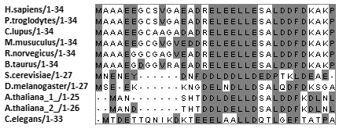

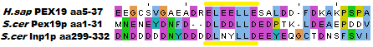
C

Fig 4.6 A conserved LxxLL motif in Pex19p
A) Pex19 is a highly conserved protein. ClustalW of Pex19s from a wide range of eukaryotic species shows the N terminal region, specifically the potential Pex3 binding motif, of Pex19 to be highly conserved.
B) The potential Pex3p binding motif in ScPex19p bears similarity to the known HsPex19-HsPex3 binding site. It also shows similarity to the potential ScPex3p binding motif in ScInp1p. Conserved Leucine residues (light blue) and surrounding negative residues (purple) appear to be crucial for this site.
C) The projected helical wheels of ScInp1p aa308-318 and ScPex19p aa9-18 showing potential amphipathic properties. Acidic residues (blue) appear to form on one surface of the helix, whereas hydrophobic residues (yellow) form on the opposite surface.

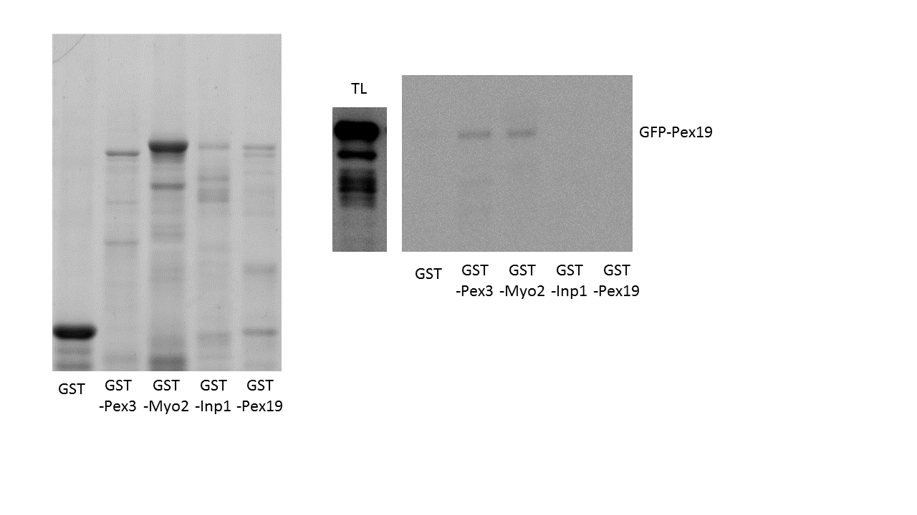
Coomassie Blue
αGFP
55
70
40
35
25
1000
~kD0
55
70
~kD0
40
IPs

Fig 4.7: Confirmation that ScPex3p interacts with ScPex19p by western blot analysis
Coomassie stain (top) and western blot analysis (bottom) of samples created to investigate Pex3p-Pex19p binding in S. cerevisiae. GST and GST-fusion proteins of Pex3p (lacking its first 48 amino acids), Myo2p, Inp1p, and Pex19p were created and expressed in E. coli BL21 (DE3). Coomassie staining confirms presence of GST-fusion proteins on the column. A total soluble fraction of spheroplasts expressing galactose inducible GFP-Pex19p was incubated with each individual column. Western blot analysis was performed using Anti-GFP (Roche) antibody from mouse, and a goat anti-mouse secondary. Total lysate (TL) is the input. TLs represent 1/32 of total soluble fractions which were incubated with GS4B-GST columns. IPs represents 1/10 of boiled beads in 1xPLB.
Results indicate that the GST tag does not bind to Pex19p nor the GFP tag (Column 1), GST-Inp1p and GFP-Pex19p do not interact (column 4), and GST-Pex19p and GFP-Pex19p do not dimerise (Column 5). Therefore, Pex19p is shown to not interact with GFP. With these controls in mind, Pex3p is shown to interact strongly with Pex19p (Column 2). Myo2p also is confirmed as interacting with Pex19p (column 3) and acts as a positive control for this assay.

4.2.6 Mutation of Key Leucine residues leads to loss of Pex19p function in vivo

Although the site in Pex19p has been reported as a binding site in HsPex19 for HsPex3 (Sato et al. 2010; Schmidt et al. 2010), no data has been reported on the site present in Inp1p. Nor has data currently reporting the interaction between Pex3p and Pex19p confirmed that in S. cerevisiae the LxxLL site present in ScPex19p is definitively a site for ScPex3p interaction.

The leucine residues present in the LxxLL motif in human Pex19 have been the subject of mutational analysis, and it was indeed found that substitutions of these residues resulted in decreased affinity for Pex3p (Sato et al. 2010). To confirm this data an ScPex19p construct was created under the control of its own promoter. This construct was subjected to site directed mutagenesis to create mutants in PEX19 that resulted in amino acid substitutions of L12A and LL1516AA (Table 4.3).
These constructs were co-transformed into pex19Δ cells along with the peroxisomal marker HcRed-PTS1 and analysed for complementation of the null phenotype (Fig 4.8). Cells lacking functional Pex19p are unable to form peroxisomes and peroxisomal matrix proteins are mislocalised to the cytosol (Gotte et al. 1998).

The results show that the construct containing un-mutated PEX19 was able to rescue the pex19Δ phenotype and presented as wildtype with HcRed-PTS1 in puncta. However, L12A and LL1516AA Pex19p appear unable to restore the cell to wildtype and lead to cytosolic labelling with HcRed-PTS1.
This data confirms that the leucine residues are required for Pex19p function in the formation of peroxisomes.

PEX19 mutant | Nucleotide | Amino Acid
PEX19-1 | TT34,35GC | L12A
PEX19-2 | CTTTTA43-49GCTGCA | LL15,16AA
PEX19-3 | TT44,45CT | L15P

Table 4.3: Leucine substitutions created for analyses of Pex19p
The nucleotide mutations performed in constructs required for in vivo and in vitro analyses of Pex19p and the resulting residue changes in Pex19p are noted in the above table.

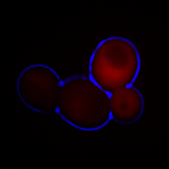
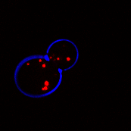
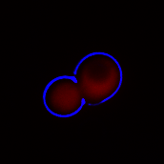
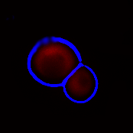
pex19Δ
Pex19p
Pex19p-1
Pex19p-2

Fig 4.8: Leucines in the LxxLL motif of Pex19p are required for Pex19p function
Unlabelled Pex19p constructs were co-transformed into pex19Δ cells along with the peroxisomal marker HcRed-PTS1. Fluorescence microscopy was performed on logarithmically growing cultures. Pex19p, Pex19p-1, and Pex19p-2 refer to the wildtype protein, L12A mutation, and LL1516AA mutation constructs respectively.
Complementation of the pex19Δ phenotype was achieved by the Pex19p construct, as seen through the punctate pattern of HcRed-PTS1. Pex19p-1 and Pex19p-2 were unable to restore the wildtype phenotype, and HcRed-PTS1 labels the cytosol.

4.2.7 Mutation of Key Leucine residues lead to a loss of Pex3p binding in vivo

As stated, results indicate that mutation of the leucine residues in the LxxLL motif of Pex19p lead to a lack of peroxisomes in cells, and therefore an assumed loss of function of Pex19p. As Pex19p’s function is heavily reliant on its interaction with Pex3p, confirmation that the aforementioned leucine residues are required for Pex3p binding is the logical progression of this study.
Accordingly, a co-immunoprecipitation assay was executed in which GFP-Pex19p constructs containing relevant amino acid substitutions were transformed to and expressed in C13-ABYS-86 cells, and then extracted through creation of spheroplasts and their homogenisation. Soluble GFP-Pex19p was immunoprecipitated from cell lysates using GFP-Trap Agarose beads, and the samples analysed through SDS-PAGE and western blotting for their ability to co-immunoprecipitate endogenous Pex3p (Fig 4.9).
Results indicate that GFP-Pex19p can co-immunoprecipitate Pex3p, however, GFP-Pex19p constructs containing L12A, LL15,16AA, and L15P amino acid substitutions are unable to co-immunoprecipitate Pex3p at detectable levels. This indicates that the leucine residues Leu12, Leu15, and Leu16 are indeed required for Pex3p binding.

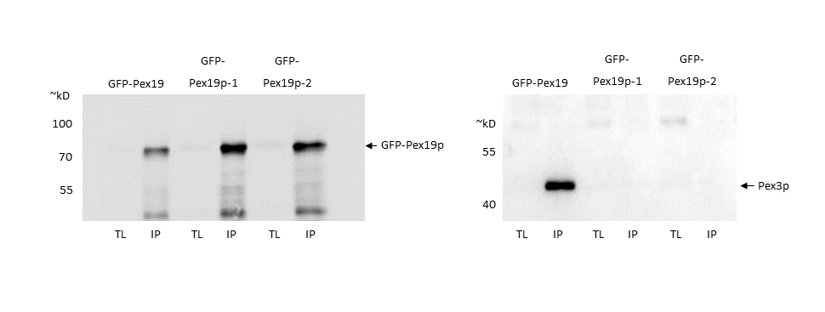
αGFP
αPex3

Fig 4.9: Pex3p is unable to co-immunoprecipitate with Pex19p leucine mutants
GFP-Pex19p constructs were expressed in C13-ABYS-86 cells. Spheroplasts were created and lysed. The resultant soluble fraction was incubated with GFP-Trap agarose beads (Chromotek) for 1 hour at 4°C. SDS-PAGE and western blot analysis was performed. Anti-GFP blot pertaining to the GFP-Trap column are shown in A, Anti-Pex3p blots to show co-immunoprecipitation are shown in B. Insoluble fractions (IS) were not probed with Anti-Pex3p antibody.
A) Anti-GFP blot to show GFP tagged protein extraction and GFP-Trap column: The soluble fraction input (TL), created column (IP), and insoluble fraction (IS), are shown. The blot shows that GFP-Pex19p and mutants are evenly enriched on the created GFP-Trap column. Pex19p, Pex19p-1, and Pex19p-2 refer to the wildtype protein, L12A mutation, and LL1516AA mutation constructs respectively.
B) Anti-Pex3p blot to show co-immunoprecipitaton: The soluble fraction input (TL) and immunoprecipitation (IP) on the created GFP-Trap-GFP-Pex19p column are shown. Results indicate that leucines in the LxxLL motif of Pex19p are required for binding to Pex3p.

4.2.8 Thermophoretic analysis of Pex3-Pex19 interaction

The lack of detectable Pex3p in GFP-Pex19 and Inp1-GFP co-immunoprecipitation assays contrast the observations with fluorescence microscopy, where these mutants still localise to peroxisomes. One explanation for this could be that a decrease in binding affinity results in a destabilisation of the complex. This complex does not survive the harsh treatments of the purification assay that leads to a large increase in volume compared to the intracellular volume. Therefore, a more quantitative method for analysing these interactions was sought.

Microscale Thermophoresis

Thermophoresis is the phenomenon by which molecules in solution migrate along a temperature gradient. Similar to electrophoresis, a molecules migration is dependent on its own properties, such as size, conformation, charge, and hydration shell. Any change in a molecule’s properties will influence its migration during thermophoresis. Through quantifying these changes, thermophoresis can therefore be used to study molecular interactions, as any binding event will ultimately change the size, conformation, charge, and hydration shell of a molecule.
MicroScale Thermophoresis (MST) is a burgeoning and powerful technique which harnesses the theory of thermophoresis and enables an investigator to study molecular interactions on a very small scale (microscale). The assay takes place in a series of capillary tubes, in which a fluorescently labelled target protein is at a constant concentration, and a protein of interest is titrated in each as a serial dilution across the series of capillaries. A temperature gradient is induced by an infrared laser in each individual capillary, and the movement of the fluorescently labelled protein tracked (Fig 4.10A).
Through measuring this movement of a molecule, and analysing changes that occur through the serial dilution, MST has the capability to quantify interactions and enables realisation of dissociation constants (K_{d}s) at low picomolar (pM) ranges.
To date, MST studies have focussed primarily on assays using chemical dyes to fluorescently label proteins of interest which have been purified from E. coli. Aside from the limitations of using proteins from E. coli to study eukaryotic interactions (lack of modifications, etc.), the nature of MST assays, in that they are in a closed system using purified proteins, often necessitates the addition of Bovine Serum Albumin (BSA) to buffers in order to prevent precipitation of protein or interactions occurring with the capillary wall. Therefore, the potential of utilising a system in which MST is used to analyse fluorescently tagged proteins that are extracted from Yeast Lysates instead of purified proteins from E. coli conjugated to chemical dyes, has obvious potential and benefits.
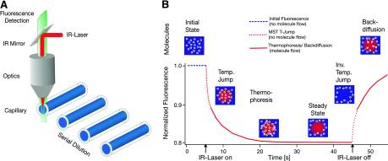
B
A

Fig 4.10: Microscale Thermophoresis
A) Microscale thermophoresis uses an infra-red laser to induce a temperature gradient across a solution held in a capillary tube. A serial dilution of a protein of interest is added across a series of capillaries containing a constant concentration of a fluorescently labelled potential interacting partner. As molecule migrate across the temperature gradient, the movement of the fluorescently labelled protein is tracked.
B) The fluorescently labelled molecule is tracked from its initial steady state, before the temperature gradient is induced, through its migration, and during its back diffusion when the temperature gradient is removed.
(Used with permission from (Jerabek-willemsen et al. 2014))

Thermophoresis using a GFP tagged protein

C13-ABYS-86 cells were transformed with a galactose inducible GFP-Pex19p construct. Cells were grown to log phase in glucose containing media before switching to galactose containing media for induction. Cells were induced for 6 hours before harvesting and storing at -80°C. Fluorescence was checked by fluorescence microscopy prior to harvesting.
Cells were lysed by bead beating in RIPA buffer (25mM Tris pH7.5, 150mM NaCl, 0.5% Sodium Deoxycholate, 1% Triton X−100, protease inhibitors). Cells were beaten for 30 seconds and then cooled for 1 minute on ice. This process was repeated 3 times. Cells were then centrifuged at 4°C for 5 minutes at 6,000rpm. The soluble fraction was taken and used as the yeast cell lysate. This process was repeated in all future cell lysis for experiments relating to MST.
The yeast cell lysate was analysed via a capillary scan in the Nanotemper Monolith NT.115. Capillary scans measure base fluorescence and are routinely used for ensuring samples are homogenous and have similar fluorescence levels before MST analysis. Preliminary results showed that recorded GFP signal was between the required range of 300-2500units. However, background fluorescence was shown to be high in the control sample (yeast lysate not expressing GFP-Pex19).

To combat this unwanted background fluorescence, various methods of quenching were investigated. GFP is known to have a pKa of 4.5 with its highest fluorescence intensity being shown when in solution at >pH7.5 (Campbell & Choy 2001). Small molecules such as FAD and Riboflavin were seen as potential causes of background fluorescence. Efforts to quench these focussed primarily on the addition of small molecules known to interact and possibly aid in their removal: Adenine, Adenosine, and Caffeine (Dutta Choudhury et al. 2010). Potassium Iodide has also been posited as a quencher of background fluorescence (Najbar & Mac 1991; Chmyrov et al. 2010).
As before, a yeast cell lysate containing GFP-Pex19p was extracted from C13-ABYS-86 cells expressing galactose inducible GFP-Pex19p. The sample was then divided and subjected to various treatments. Analysis focussed on not only reduction of background fluorescence in the control sample, but also in maintenance of fluorescent signal from the fluorescently tagged protein. Results indicated optimal quenching was achieved through the addition of 80mM Potassium Iodide (Fig 4.11).

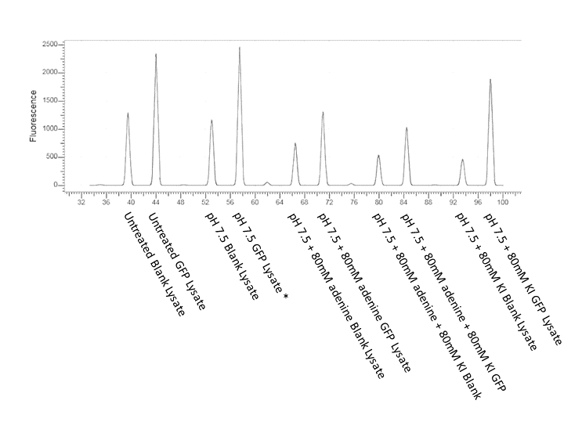

Fig 4.11: Quenching of background fluorescence in Yeast lysates.
C13-ABYS-86 cells expressing galactose inducible GFP-Pex19p were lysed through bead beating in RIPA buffer. The sample was then divided and subjected to various treatments. Treatments were eventually narrowed down and an optimised quenching found through correcting the pH of the sample to pH7.5 and the addition of 80mM Potassium Iodide (*Asterix indicates a reading that was above the range of detection). X-axis labelling denotes the capillary position in the rack upon scanning. Y-Axis is the measure of fluorescence.

Purification of Pex3p

MST analysis of GFP-Pex19p binding to Pex3p would require a source of Pex3p. The ultimate goal of the study is the analysis of co-expressed GFP-Pex19p and Pex3p-mCherry in a single yeast lysate. However, initial MST analyses would require Pex3p in a titratable form. A construct of an N-terminal GST tag and Pex3p with a deletion of amino acids 1-49 was used for this purpose (called GST-Pex3p henceforth). GST-Pex3p expressed has previously been shown to interact with GFP-Pex19p (Fig 4.7).
During this investigation purification of Pex3p proved troublesome. Common extraction methods utilising detergents for removal of proteins from E. coli do not appear to impact on Pex3p’s ability to be immobilised on Sepharose or Agarose beads, therefore immunoprecipitation assays involving such methods are still employable. However, if extraction has involved detergents, Pex3p is irremovable (without denaturing) from a column once it has been immobilised (Data not shown), suggesting the protein has precipitated and possibly aggregated during its immobilisation. This finding corroborates the results of Pinto et al., (2009), in that Pex3p precipitates when incubated with detergents.
Whilst solubilisation of Pex3p was achieved through low yield expression, lysis methods lacking detergents, and high salt buffers (>500mM NaCl), upon concentration via a spin-column (Nanosep) Pex3p once again was seen to visibly precipitate. Ultimately, the concentration of GST-Pex3p available for this investigation has proven to be the limiting factor, and will be discussed.

Thermophoresis of GFP-Pex19p with GST-Pex3p

A dilution series of GST-Pex3p was created and combined with a diluted yeast lysate containing GFP-Pex19p (lysate was diluted so that capillary scan readings showed fluorescence within the range of 400-500units). Concentration of GST-Pex3p was estimated through Coomassie stain comparison with known amounts of BSA, OD₅₉₅ spectrophotometry, and analysis by a Nanodrop.
The highest concentration of Pex3p that remained soluble was 3µM. Binding assays were performed in a range from 1.25µM to 250pM (given as 1250nM, 250nM, 50nM, 10nM, 0.1nM, and 0.25nM).
Capillary scans show that addition of GST-Pex3p to the yeast lysate does not affect fluorescence levels and confirms an absence of protein aggregates prior to MST analysis.
MST data consistently showed that as concentration of GST-Pex3p increases, rate of GFP migration decreases. This strongly indicates that a recordable binding event occurred between GST-Pex3p and GFP-Pex19. The K_{d} reported by Schmidt et al., (2010) of 330nM lies within the recorded range, however due to an incomplete concentration curve, estimation of a K_{d} value using this MST data would require an uncomfortably large margin of error (Fig 4.12). It was decided to abandon this approach till better conditions were found for Pex3 purification.
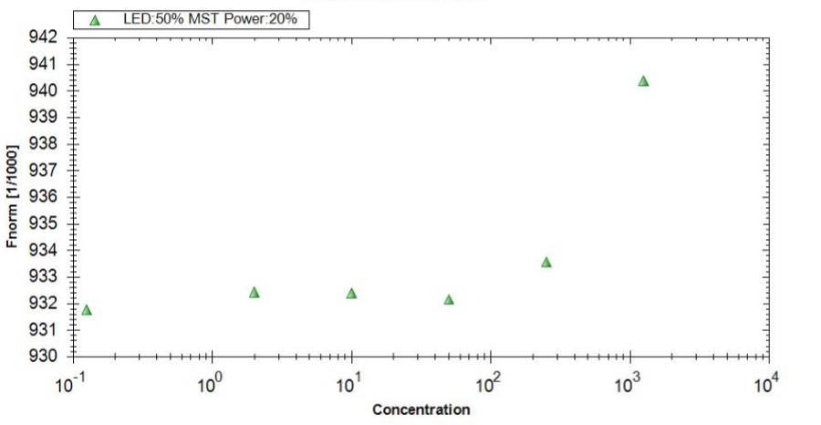
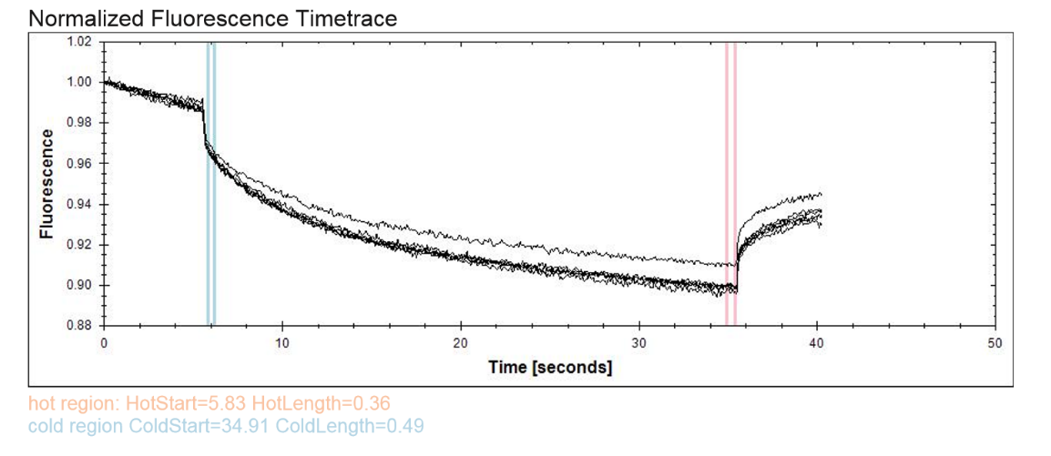
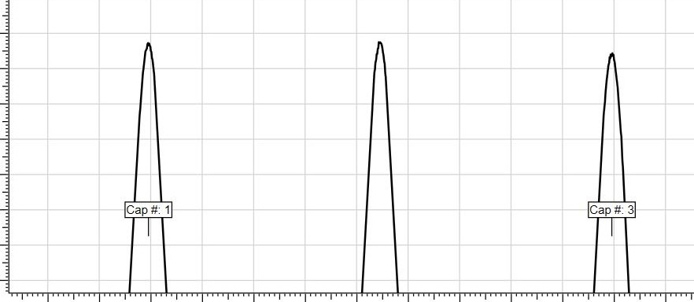
C
B
A

Fig 4.12: GFP-Pex19p GST-Pex3p thermophoretic analysis
A) Capillary scan of GFP-Pex19p lysate after combination with GST-Pex3p dilution series (Zoomed). All samples show comparable fluorescence levels, indicating combination does not affect GFP fluorescence. The smooth curve peak indicates no protein aggregates are present in the samples.
B) Thermophoresis analysis of GFP-Pex19p in combination with dilution series of GST-Pex3p. Each combination of GFP-Pex19p is individually analysed through MST and the change of fluorescence (and therefore the migration of fluorescent molecules) recorded. Change over time is plotted for each sample (C). Results show increasing concentration of GST-Pex3p leads to decreased migration of GFP-Pex19p, indicating a binding event is occurring. Concentration of GST-Pex3 is given in nM.

4.2.9 A Potential Pex3p binding site in S. cerevisiae Myo2p

Pattern-match results of potential Pex3p binding motif

Having established that the minimal region in Inp1p required for Pex3p binding site contains a conserved motif, a pattern match query was performed to find possible further partners of Pex3p in S. cerevisiae (http://www.yeastgenome.org/cgi-bin/PATMATCH/nph-patmatch).
A stringent query limited to DDLxxLLDE returns only two hits: Inp1p and Pex19p. Both of these proteins are known to bind Pex3p in S. cerevisiae (Munck et al. 2009; Gotte et al. 1998).
A less stringent search querying [DE]LxxLL[DE] returns 63 hits. The results were scored from 1-3 based on their composition, conservation, and likelihood of being a true interaction. Likelihood of being a true interaction was determined through protein location and function. A table of all results can be found in Appendix II. increasing the stringency of this search to [DE][DE]LxxLL[DE][DE] yields 7 candidates, including Myo2p and YIL089w.
A broad query of LxxLL returned over 3000 hits. This highlights the popularity of hydrophobic motifs within the S. cerevisiae proteome and reinforces the need to biochemically check any possible interacting partners.

Myo2p contains a similar motif to Inp1p and Pex19p

Myo2p is an ideal candidate for further investigation. Myo2p is the myosin motor involved in organelle inheritance in S. cerevisiae, and has been shown to be the myosin motor protein by which peroxisomes are transported to the newly formed bud (Hoepfner et al. 2001; Boldogh et al. 2004; Fagarasanu et al. 2009; Wang et al. 1998). Myo2p has also shown to be involved in the inheritance of peroxisomes in S. cerevisiae through an interaction with Inp2p and an interaction with Pex19p, a known binding partner of Pex3p (Otzen et al. 2012). In Yarrowia lipolytica, it has been reported that Myo2p interacts with Pex3Bp directly to facilitate the transport of peroxisomes (Chang et al. 2009).
A construct consisting of an N-terminal GST tag and Myo2p (henceforth referred to as GST-Myo2p) was created and expressed in BL21 (DE3) E. coli. An E. coli lysate containing GST-Myo2p was incubated with a Glutathione Sepharose 4B (GS4B) column (section 2.5.4). Spheroplasts of C13-ABYS-86 S. cerevisiae expressing galactose inducible Pex3p-GFP, were lysed, and their soluble fraction incubated with the created GS4B-GST-Myo2p column. SDS-PAGE and western blot analyses were performed (section 2.5.5 – 2.5.7) (Fig 4.13).
Results indicated potential binding between GST-Myo2p and Pex3p-GFP, although at a much weaker level than that of GST-Inp1p and Pex3-GFP.

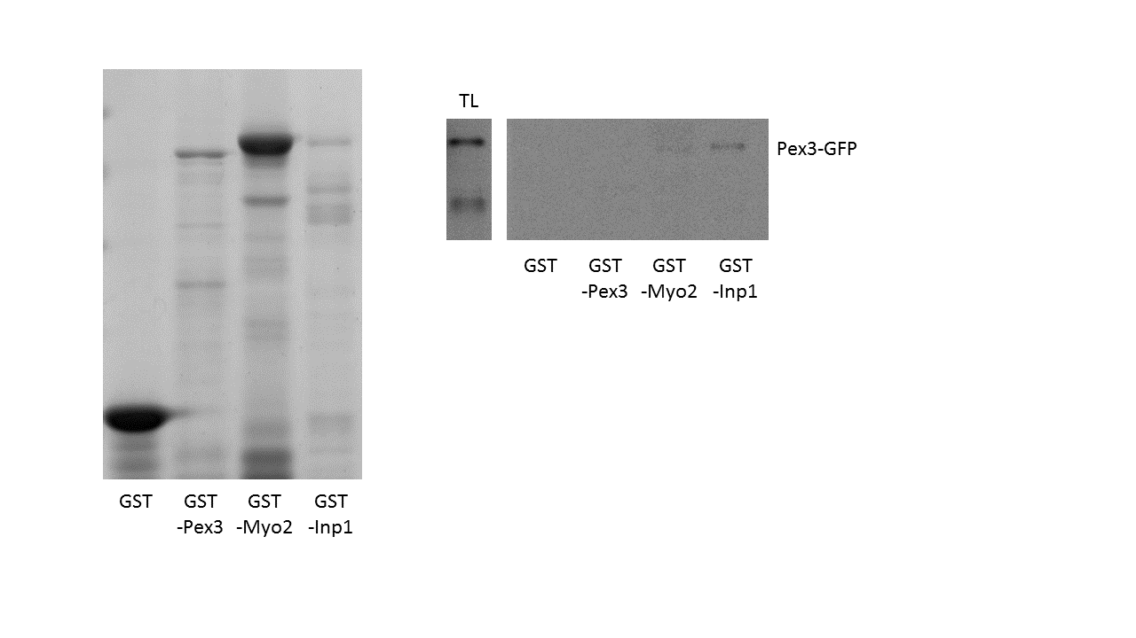
Coomassie Blue
αPex3
55
70
40
35
25
1000
~kD0
55
70
~kD0
IPs
70

Fig 4.13: Myo2p is a candidate for Pex3p binding in S. cerevisiae
Coomassie stain (top) and western blot analysis (bottom) of samples created to investigate Myo2p-Pex3p binding in S. cerevisiae. GST and GST-fusion proteins of Pex3p (lacking its first 48 amino acids), Myo2p, and Inp1p were created and expressed in E. coli BL21 (DE3). Coomassie staining confirms presence of GST-fusion proteins on the column. A total soluble fraction of spheroplasts expressing galactose inducible Pex3p-GFP was incubated with each individual column. Western blot analysis was performed using Anti-GFP (Roche) antibody from mouse, and a goat anti-mouse secondary. Total lysate (TL) is the input. TLs represent 1/32 of total soluble fractions which were incubated with GS4B-GST columns. IPs represents 1/10 of boiled beads in 1xPLB.
Results indicate that the GST tag does not bind to Pex3p nor the GFP tag (Column 1) and the GST-Pex3p and Pex3p-GFP do not dimerise (Column 2), and therefore Pex3p is shown to not interact with GFP. With these controls in mind, Inp1p is shown to interact strongly with Pex3p (Column 4). Myo2p does appear to interact with Pex3p, however, signal strength is considerably weaker than that of the Inp1p-Pex3p interaction.

4.2.10 Discussion

Pattern match data highlighted a few possible proteins of interest that may contain a similar motif to that of Inp1p and Pex19p (Appendix II). Recently it has been reported that YIL089w localises to the peroxisome (Yofe et al. 2016), suggesting that further investigation into whether it is an interacting partner of Pex3p could prove fruitful. However, Myo2p was deemed the strongest candidate for further investigation at the time of study, due to its interaction with Pex3p in Y. lipolytica and its involvement in peroxisomal inheritance in S. cerevisiae (Chang et al. 2009; A. Fagarasanu et al. 2006).
A binding assay in which GST-Myo2p appears to interact with Pex3p-GFP indicates a possible interaction between these two proteins (Fig 4.13). However, it is not beyond the realms of possibility that this supposed interaction is indirect. The yeast lysate expressing Pex3p-GFP that was used still contains other endogenous proteins. In particular, Pex19p and Inp1p are still present. This casts doubt over a direct binding event, as Pex19p is known to bind to both Pex3p and Myo2p. This doubt is heightened when we revisit the hub-like protein model of Vac8p. Although Myo2p is involved in vacuolar inheritance, it facilitates transport to the bud through binding to an organelle specific receptor, Vac17p. Much like vacuolar inheritance, peroxisome inheritance also involves Myo2p binding to an organelle specific receptor in Inp2p. It therefore seems more likely that if Myo2p is indeed binding directly to Pex3p, it is not the mechanism of peroxisomal transport that occurs during cell division. Though initial results in the investigation of Myo2p binding to Pex3p are promising, further study and in vivo analysis is required, as doubt still remains over the veracity of these findings.
Interestingly, the results of the Myo2p-Pex3p binding assay highlight another finding: Pex3p is unable to form an interaction with itself. Not only is the lack of Pex3p dimerisation in and of itself a notable observation, but it also leads to doubts over the proposed model of peroxisomal tethering from Knoblach et al., (2013). The current model states that one Inp1p molecule forms a bridge between two Pex3p molecules, however, GST-Pex3p’s inability to form a detectable relationship with Pex3p-GFP suggests that this bridge is not formed. Of course, as previously discussed, endogenous Inp1p is expressed at very low levels, and therefore it is possible that the bridge does indeed exist between GST-Pex3p-Inp1p-Pex3p-GFP but is undetectable in this assay.
The pattern match search also confirmed that the region of interest contained in Inp1p bears striking similarity to the reported binding site found in the human orthologues of Pex3 and Pex19. This site reported to be highly conserved in Pex19ps from a wide range of eukaryotes (Fig 4.6A). Pex19 is also functionally conserved, as is Pex19p binding to Pex3p. This interaction was biochemically confirmed, along with the Pex19p interaction with Myo2p (Fig 4.7). In this investigation, it is also shown that Pex19p does not form a dimer, and neither does it appear to interact with Inp1p. These are key observations, as overexpression of Inp1p leads to a loss of peroxisome formation, and the trapping of Pex3p in the ER. The current model is that Pex19p is required for Pex3p budding from the ER and our data on the overexpression of INP1 suggests that Inp1p overexpression somehow inhibits Pex19p’s ability to remove Pex3p from the ER (Munck 2008; Hoepfner et al. 2005). It could be theorised that Inp1p, therefore, interacts with Pex19p, sequestering it away from Pex3p and therefore removing its ability to release Pex3p from the ER. However, Pex19p’s inability to interact with Inp1p removes this thought from any possible model. The lack of interaction with GST-Inp1p and GFP-Pex19p also hints that Pex3p may not be able to bind Inp1p and Pex19p at the same time. This, along with sharing the same motif, suggests that Inp1p and Pex19p compete for binding of Pex3p, and that both proteins aim to occupy a similar area of Pex3p itself.

Discussion of Thermophoresis

Due to the previously discussed limitations of classical biochemical assays for elucidating the nature of the interaction between Pex3p and its binding partners, it became apparent that a more sensitive and quantitative method could prove invaluable.
Microscale thermophoresis is a burgeoning field of study with scope for utilisation for a wide range of interaction studies. One major benefit of MST analysis is that, unlike other commonplace methods for kinetic analyses (such as ITC, which require very high concentrations of sample), the requirement for MST is very little in terms of the concentration of interacting partners one wishes to investigate. Another consideration is the time taken for each analysis. Most modern techniques involving investigation of protein-protein interactions can take between 1 – 12 hours per assay, not including the time taken to produce the material to be investigated in the first place. MST greatly reduces this time, as after initial preparation (including creation of the dilution series), a single experiment can be completed within 1 hour, and is fully automated.
Crucially, the MST system as it currently stands is fully enclosed. Unlike other prevalent methods currently being employed, such as the Biacore Surface Plasmon Resonance (SPR) system, the interacting partners are not subjected to extreme outside forces (such as the mass transport in SPR), which will directly influence any kinetic analysis.
The technology also has the potential to be developed for measuring protein interactions that are completely label-free. Although this technology is a much more recent advance and has yet to be fully realised, the creation of an enclosed system for studying unaltered proteins would appear to be a far purer method for investigating protein interactions than techniques currently employing chimeric constructs.
One major issue with MST however, is the requirement for unadulterated soluble protein. This proved to be the sticking point in this investigation, as Pex3p is largely insoluble and tends towards formation of aggregates and precipitation even at the moderate concentrations required for MST analysis.
The use of a GFP tagged protein expressed in a yeast lysate, however, proved successful. Capillary scans showed protein at the required level for analysis, and crucially no aggregates or interaction with the capillary itself was observed (Fig3.12A). The quenching of background fluorescence associated with a yeast lysate was achieved through addition of 80mM Potassium Iodide to samples (Fig 3.11). These two results indicate that the use of GFP tagged proteins from a yeast cell lysate could be utilised effectively in future MST investigations.
One major assumption that has been made during this work is that the concentration of GST-Pex3p used for the dilution series is greater than that of the GFP-Pex19p present in the yeast lysate, and that the dilution series, therefore, is able to span the binding range and develop a reliable value for the dissociation constant (K_{d}). Efforts were made to ensure that GFP-Pex19p was at the lowest levels possible for reliable detection in the MST assay through dilution, however, the point remains that an assumption was made. Future assay development will introduce quantification of GFP tagged protein present in yeast lysates, with a kit available from Qiagen a possibility for fulfilling such a purpose.
The purification of Pex3p proved the most challenging aspect of developing a reliable MST assay. GST-Pex3p was chosen as the titrant due to considerations focussed on downstream assay development. With GST-Pex3p (and its dilution series) as a constant, MST experiments could use GFP tagged fusion proteins of Pex3p’s binding partners (Inp1p, Pex19p, Atg36p, and other potential partners such as Myo2p and YIL089w). This would greatly reduce potential complications found in optimising expression of each individual partner in E. coli, as well as allowing for greater validity in comparisons of results.
However, due to Pex3p’s insistence on precipitating even at moderate concentration levels, this avenue of investigation appears closed in its current form and further analysis will not be included in this report. In other studies, where high concentrations of Pex3p were required, co-expression or co-purification with a ligand appears to have stabilised Pex3p, allowing for the development of quantitative binding assays. A future assay that may utilise this aspect is the co-expression through a dicistronic vector and then co-purification of Pex3p with one of its binding partners (for example, Pex19p), and then an attempt at disrupting this binding through titration of a second binding partner (Inp1p).
Immediate future assay development, however, will utilise purified Pex19p from E. coli. Pex19p has been shown to be extremely soluble, and a GST-PP-Pex19 (PP=contains a PreScission Protease cleavage site) construct has been tested for expression and purification (Data not shown).

Chapter 5:

Preliminary investigations into regulation of interactions involving Pex3p and its associated partners

5.1 Introduction

The data reported in Chapter 4 suggests that there is a common, leucine based motif present in Pex19p and Inp1p which is required for interaction with Pex3p. A truncation screen of Inp1p-GFP highlighted the region as required for localisation to peroxisomes, and further bioinformatics research revealed a similar site present in Pex19p.

Due to two known interacting partners of Pex3p sharing a similar binding motif, a further question of how these interactions are regulated is poised. It has been reported in human cells that the interaction between HsPex3 and HsPex19 contains a Tryptophan reside (Trp104) (Schmidt et al. 2012). Although this region of Pex3p appears poorly conserved at the sequence level, Knoblach et al., (2013) used this data and structure prediction software to highlight a Tryptophan in Pex3p is S. cerevisiae (Trp128). They reported that mutation of this site to a leucine residue removed Pex19p binding, but not Inp1p binding to Pex3p. Data from Munck (2008) also suggests Trp128 as a region of interest in Pex3p for binding to Pex19p and Inp1p. Firstly, this chapter will aim to present some data to corroborate that Inp1p and Pex19p compete for binding to Pex3p.

The third reported interacting partner of Pex3p, Atg36p, does not appear to contain an LxxLL motif required for Pex3p binding. Therefore, preliminary investigations will be reported in this chapter aimed at uncovering a mechanism by which this interaction is regulated. Atg36p is reported as being phosphorylated (Motley et al. 2012b), and therefore initial investigations will focus on this modification and its potential role in regulating Atg36p interaction with Pex3p.

5.2 Results

5.2.1 Pex19p cannot bind Pex3p in the presence of overexpressed Inp1p

To biochemically test whether Inp1p overexpression is indeed causing loss of Pex19p binding to Pex3p, and thus a loss of peroxisome biogenesis, an attempt was made to co-purify Pex3p with GFP-Pex19p under conditions in which Inp1p was overexpressed (Fig 5.1).
C13-ABYS-86 wildtype, and pex3Δ cells were co-transformed with constructs of GFP-Pex19p under the control of its own promoter and either a control construct with no expressible protein, or a construct encoding INP1 under the control of the TPI1 promoter. Spheroplasts were created (section 2.5.3.2), lysed, and total soluble fractions incubated with GFP-Trap agarose beads (Chromotek) (section 2.5.4). Columns were washed, boiled in 1xPLB and loaded onto a 10% polyacrylamide gel (section 2.5.5). After having electrophoresis, western blotting analysis was performed (section 2.5.7). Anti-GFP (Roche) antibody was used to detect GFP-Pex19p bound to the column. A custom made anti-Pex3p antibody was used to detect endogenous Pex3p that co-purified with GFP-Pex19p.
Results show that when Inp1p is overexpressed, GFP-Pex19p is unable to co-purify Pex3p.

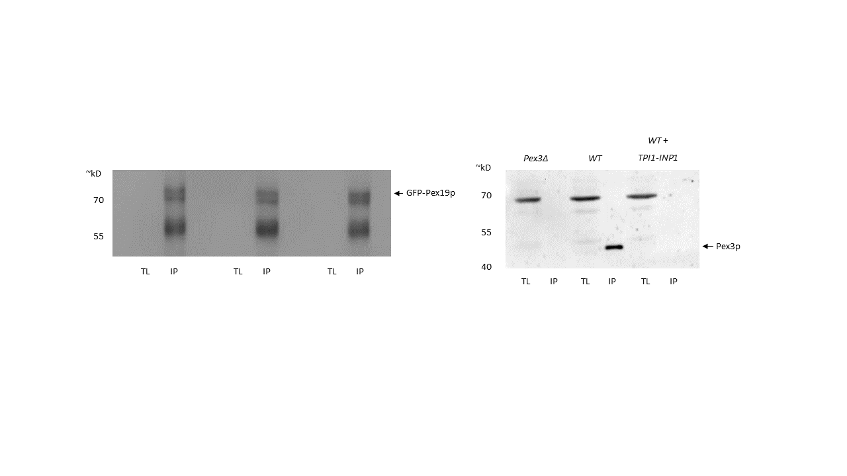
αGFP
αPex3
B
A
pex3Δ

Fig 5.1: Pex19p cannot co-immunoprecipitate Pex3p in the presence of overexpressed Inp1p

A GFP-Pex19p construct was expressed in C13-ABYS-86 cells. Spheroplasts were created and lysed. The resultant soluble fraction was incubated with GFP-Trap agarose beads (Chromotek) for 1 hour at 4°C. SDS-PAGE and western blot analyses were performed. Anti-GFP blot pertaining to the GFP-Trap column is shown in A. Anti-Pex3p blots to show co-immunoprecipitation are shown in B. Insoluble fractions (IS) were not probed with Anti-Pex3p antibody.
A) Anti-GFP blot to show GFP tagged protein extraction and GFP-Trap column: The soluble fraction input (TL) and created column (IP), The blot shows that GFP-PEx19p is evenly enriched on the created GFP-Trap column.
B) Anti-Pex3p blot to show co-immunoprecipitaton: The soluble fraction input (TL) and immunoprecipitation (IP) on the created GFP-Trap-GFP-Pex19p column are shown. Backgrounds in which lysates were extracted from are labelled above the corresponding lanes.
Results indicate that overexpression of INP1 leads to GFP-Pex19p being unable to co-purify Pex3p to detectable levels.

5.2.2 Mutants in Inp1p are unable to co-localise to Pex3p in pex19Δ cells

Overexpression if INP1 leads to a phenotype in which cells lack peroxisomes but Inp1p-GFP still localises to foci (Fig 3.2 and 3.6). GFP-Pex19p being unable to co-purify Pex3p under these conditions explains this phenomenon, and also corroborates previous data from the Hettema Lab which shows the overexpression of INP1 traps Pex3p in the ER (Fig 5.1) (Munch, 2008). Pex3p is reported to bud from the ER in a Pex19p dependent manner, and therefore, as INP1 overexpression blocks the interaction between Pex19p and Pex3p, this budding mechanism is hindered and Pex3p remains in the ER (Hoepfner et al. 2005). This phenotype is similar to that of pex19Δ, where the mechanism by which Pex3p exits the ER is also removed.
As Inp1p-GFP is still in foci during its overexpression, it is assumed that it is still binding to Pex3p at the ER. However, as mutants in Inp1p appear unable to present this overexpression phenotype, unable to retain peroxisomes in the mother cell, and unable to co-purify Pex3p, questions remain on if mutant Inp1p’s are still able to interact with Pex3p at the ER in this way.
To investigate this question, Wildtype and pex19Δ cells were co-transformed with the peroxisomal marker HcRed-PTS1 and either Inp1p-GFP or Inp1p3-GFP (containing the Leu315Pro substitution). Cells were grown in liquid culture and imaged when dividing exponentially (Fig 5.2).
In Wildtype cells, Inp1p3-GFP is still on foci and colocalises with HcRed-PTS1. Results show that in pex19Δ cells, HcRed-PTS1 consistently labels the cytosol, indicating a lack of peroxisomes (or at least import of matrix proteins). Inp1p-GFP still appears in foci in these cells and is assumed to be localising to Pex3p on the ER. Inp1p3 however, is cytosolic in pex19Δ cells.
These results indicate that disruption of the LxxLL motif in Inp1p leads to a loss of binding of Pex3p at the ER.
Merge
HcRed-PTS1
GFP
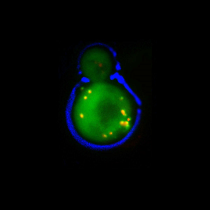
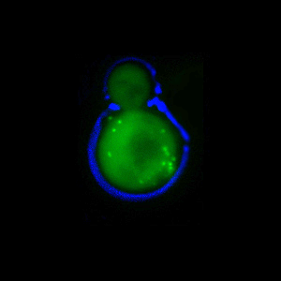
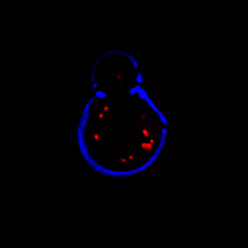
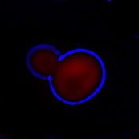
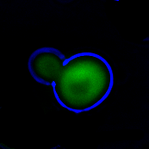
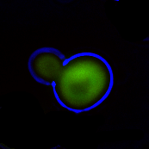
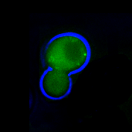
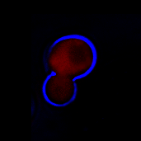
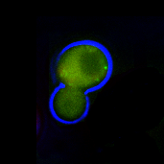
WT
+ Inp1p3
pex19Δ
+ Inp1p3
pex19Δ
+ Inp1p

Fig 5.2: mutants in Inp1p are unable to localise to Pex3p in pex19Δ cells
Wildtype and pex19Δ cells were co-transformed with the peroxisomal marker HcRed-PTS1 and either Inp1p-GFP or Inp1p3-GFP (containing the Leu315Pro substitution). Cells were grown in liquid culture and imaged when dividing exponentially. Results indicate that Inp1p-3-GFP appears in foci in WT cells, but presents cytosolic labelling in pex19Δ cells.

5.2.3 A small library screen using an Inp1p mutant

Disruption of the LxxLL motif in Inp1p not only leads to a loss of Inp1p function (Fig4.2), it also abolishes Pex3p binding at the ER (Fig 5.2) and these mutants are unable to bind Pex3p (Fig 4.3). However, non-functional LxxLL mutants still appear in foci in wildtype cells. This poses a few potential models on the mechanism for Inp1p localisation to the peroxisome (which will be discussed at the end of this chapter).
Due to the inability to co-purify Pex3p and yet still localise to peroxisomes, it could therefore be suggested that there is another factor involved in Inp1p’s localisation to the peroxisomal membrane. To investigate this possibility, Inp1p-3 was transformed into a small library of peroxisomal protein knockouts, with the aim of finding strains in which Inp1p-3 was not in foci.
Interestingly, along with pex19Δ, the quadruple knockout mutant pex11Δ/ pex25Δ/ pex27Δ/ pex34Δ showed that Inp1p3-GFP was no longer in foci (Fig 5.3). Inp1p-3-GFP was localised to foci in the single knock outs and in the triple pex11/25/27 mutant. Foci number were also reduced in pex13Δ/pex14Δ cells.

5.2.3.1 Pex11/25/27/34

Follow up investigations revealed no loss of Inp1p-3 foci in either pex11, pex25 pex27 or peex11/pex25/pex27 cells. In the quadruple mutants peroxisomes are absent. Also, Inp1p-GFP was found unable to co-immunoprecipitate any of the four Pex11 family proteins.

5.2.3.2 Pex13/14

The slight reduction in Inp1p-3-GFP foci in this strain background highlighted Pex13p and Pex14p as possible proteins of interest for interaction with Inp1p at the peroxisomal membrane (Fig 5.4A).
Bioinformatic screening of these candidates revealed a conserved potential Pex14p binding motif present in Inp1p of WxxxFL between amino acids 227 and 232 (Fig 5.4B). This investigation, however, has not been pursued further to date.

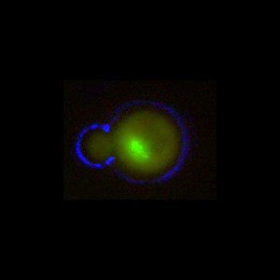
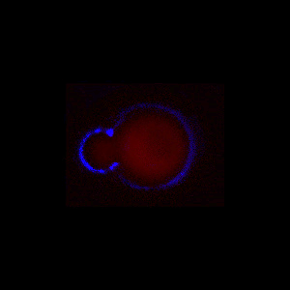
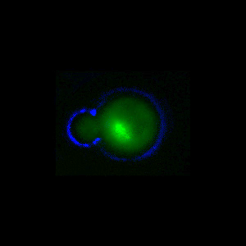
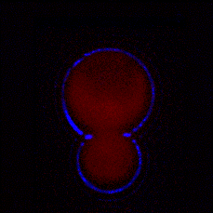
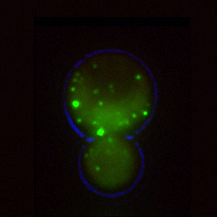
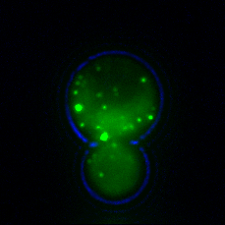
pex11Δ/ pex25Δ/ pex27Δ/ pex34Δ

+ Inp1p-3-GFP
pex11Δ/ pex25Δ/ pex27Δ/ pex34Δ

+ Inp1p-GFP

Fig 5.3: A small screen of peroxisome mutants using and Inp1p mutant
Inp1p-3 was transformed into a small library of peroxisomal protein knockout strains. Results show that in the quadruple knockout of pex11Δ/ pex25Δ/ pex27Δ/ pex34Δ Inp1p3-GFP was no longer in foci.

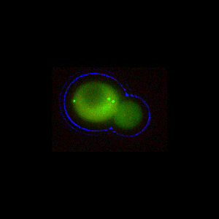
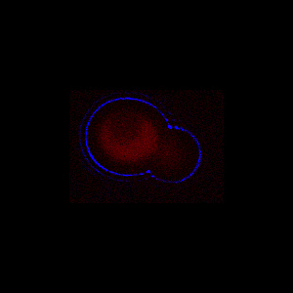
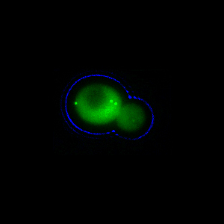
Merge
HcRed-PTS1
Inp1p-3-GFP
B
A

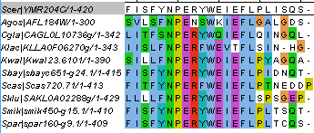

Fig 5.4: Pex14p is a candidate for Inp1p binding
A) pex13Δ/pex14Δ cells co-transformed with Inp1p-3-GFP and HcRed-PTS1 were analysed for loss of GFP foci. Results indicate a reduction in foci as compared to Wildtype.
B) ClustalW alignment of Inp1p’s from related species show a conserved potential Pex14p binding site in Inp1p.

5.2.5 Pex3p can bind Inp1p and Atg36p simultaneously

Pex19p’s inability to co-purify Pex3p in the presence of overexpressed Inp1p allows for the conclusion that Inp1p and Pex19p directly compete for binding to Pex3p. It therefore follows, that Inp1p and Pex19p most likely bind to a similar region on Pex3p itself.
Pex3p has been reported as having a third binding partner in Atg36p (Motley et al. 2012b), however, no motif similar to that of the Pex19p or Inp1p LxxLL has been identified.
To confirm that Atg36p does not participate in the competition for Pex3p binding with Inp1p and Pex19p, a co-immunoprecipitation assay was performed.
Constructs of galactose inducible Inp1p-GFP and Inp1-3p-GFP (containing the L315P substitution) were individually transformed into C13-ABYS-86 cells which have an insertion of ProteinA at the C-terminus of Atg36p, allowing for stable expressing of Atg36p-ProteinA. Induction of Inp1p constructs was achieved through growth on galactose media. Spheroplasts were created (section 2.5.3.2), lysed, and total soluble fractions incubated with GFP-Trap agarose beads (Chromotek) (section 2.5.4). Columns were washed, boiled in 1xPLB and loaded onto a 10% polyacrylamide gel (section 2.5.5). SDS-PAGE and western blots analysis was performed (section 2.5.7). Anti-GFP (Roche) antibody was used to detect Inp1p-GFP bound to the column. A custom made anti-Pex3p antibody was used to detect endogenous Pex3p that co-purified along with Inp1p-GFP and anti-PAP antibody (Sigma) was used to detect Atg36-PA (Fig 4.9).
Results show Inp1p-GFP is able to co-purify Pex3p and Atg36p-PA, but Inp1-1p-GFP fails to co-purify Pex3p and also fails to co-purify Atg36p-PA. As no direct interaction with Inp1p and Atg36p has been found, it is assumed that Inp1p and Atg36p are both bound to Pex3p, allowing for co-purification and with the loss of Inp1p interaction with Pex3p so too the co-purification of Atg36p is lost.
Results also show that in samples containing Inp1-1p, the pool of Atg36p in the total lysate is greatly increased. Possible reasons for this will be mentioned in the discussion section of these results.

Inp1p-3
-GFP
Inp1p
-GFP
Inp1p-3
-GFP
Inp1p
-GFP
Inp1p-GFP
Inp1p-3-GFP
C
B
A
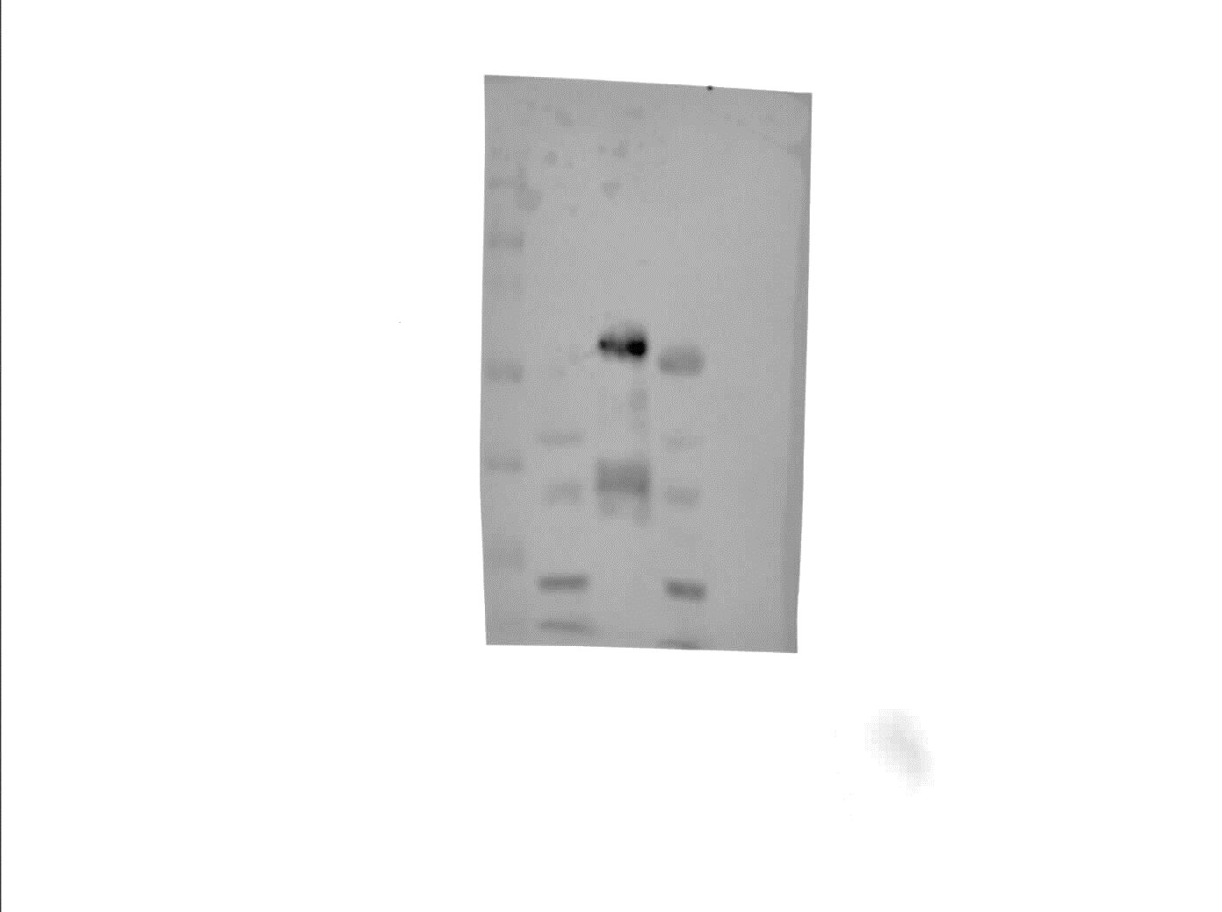
PαP
αGFP
αPex3
Atg36p-pA
Pex3p
IP
IP
TL
TL
TL
IP
TL
IP
TL
IP
TL
IP
100
35
40
55
70
Inp1p-GFP
~kD

Fig 5.5: Pex3p can bind Inp1p and Atg36p simultaneously
Galactose inducible Inp1p-GFP constructs were expressed in C13-ABYS-86 cells containing a ProteinA tagged Atg36p. Spheroplasts were created and lysed. The resultant soluble fraction was incubated with GFP-Trap agarose beads (Chromotek) for 1 hour at 4°C. SDS-PAGE and western blot analysis was performed.
A) Anti-GFP blot indicates equally loaded GFP-Trap column: The soluble fraction input (TL), created column (IP), and insoluble fraction (IS), are shown. The blot shows that Inp1p-GFP and mutants are evenly enriched on the created GFP-Trap column. Inp1p and Inp1p-3 refer to the wildtype protein L315P mutation constructs respectively.
B) Anti-Pex3p blot shows co-immunoprecipitaton of Pex3p by WT Inp1p-GFP but not by L315P Inp1p-GFP: The soluble fraction input (TL) and immunoprecipitation (IP) on the created GFP-Trap-Inp1p-GFP column are shown.
Inp1p and Inp1p-3 refer to the wildtype protein and L315P mutation constructs respectively.
C) Anti-PAP blot to show co-immunoprecipitaton of Atg36p-PA by WT Inp1p-GFP but not by L315P Inp1p-GFP: The soluble fraction input (TL) and immunoprecipitation (IP) on the created GFP-Trap-Inp1p-GFP column are shown.
Results indicate that mutants in Inp1p-GFP cannot co-purify Pex3p at detectable levels and that this in turn leads to a loss of Atg36p co-purification.

5.2.6 Pexophagy is not dependent on Atg1p phosphorylation of Pex3p Ser426

As Atg36p does not appear involved in the competition for Pex3p as Pex19p and Inp1p are, the mechanism by which its binding to Pex3p is regulated still remains elusive. The Serine/Threonine Kinase Atg1 was suggested as a possible contributor to this as it was reported that Atg1p organises the formation of the autophagosome through phosphorylation of Atg9p (Papinski & Kraft 2014). In the same report, several other candidates were suggested as possible targets for phosphorylation by Atg1p. Pex3p was among these potential targets with a site of phosphorylation predicted to be at Serine 426.
To investigate if Atg1p phosphorylation of Pex3p affected pexophagy, the potential target for phosphorylation, Ser426, was substituted for a non-phosphorylatable alanine residue and a pexophagy assay performed.
A construct of Pex3p under the control of its own promoter and terminator was created. Site directed mutagenesis was performed on this construct to give create a construct of Pex3p containing an amino acid substitution of Ser426Ala. These constructs were co-transformed with Pex11p-GFP separately to C13-ABYS-86 pex3Δ and pex3Δ/atg36Δ cells.
Pex11-GFP will act as a trackable marker for pexophagy.
To perform a pexophagy assay, cells were grown on glucose containing media overnight before switching to starvation media. 10ODs of cells were harvested before switch to starvation (T=0), 6 hours after starvation (T=6), and 24 hours after starvation (T=24). TCA extraction was performed on harvested cells, and SDS-PAGE and western blot analysis performed on samples (Fig 4.10).
Results show that there is no difference in Pex11-GFP degradation in cells containing wildtype Pex3p or Pex3p(S426A). Pexophagy is not prevented as it is in atg36Δ cells and remains at wildtype levels. This result confirms that phosphorylation of Ser426 in Pex3p is not required for pexophagy in S. cerevisiae. As no significant data was produced from this assay, further pursuit of this investigation towards any potential increase in pexophagy through the creation of phosphomimetic construct of Pex3p Ser426Asp was not deemed necessary.

atg36Δ
+ WT
pex3Δ
+Ser426A
pex3Δ
+ WT
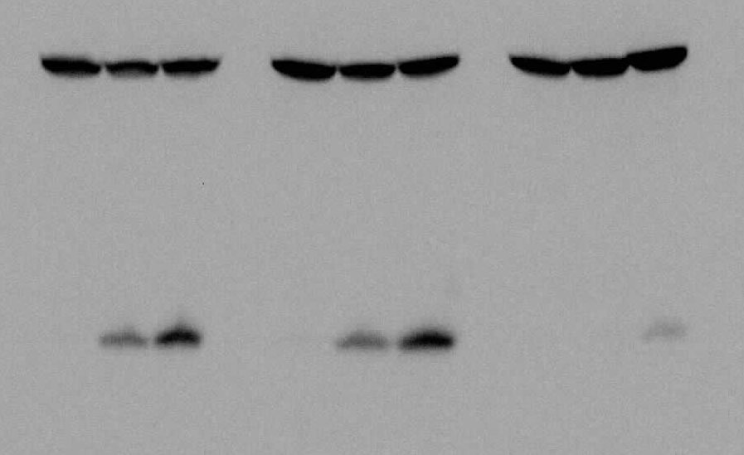
αGFP
GFP*
Pex11p-GFP
24
6
0
0
6
24
24
6
0
25
40
35
55
~kD

Fig 5.6: Pexophagy is not dependent on Pex3p phosphorylation at Ser426

atg36Δpex3Δ and pex3Δ cells were co-transformed with a construct containing Pex11p-GFP along with a further construct of either Pex3p or Pex3p(S426A). The cells were grown for 12 hours in glucose medium before transfer to starvation medium. Samples were taken at 0h, 6h, and 24h intervals post starvation and processed for anti‐GFP western blotting. GFP* indicates the relative protease‐resistant degradation product and reflects vacuolar breakdown.

5.2.7 Inp1p and Atg36p are modified when bound to Pex3p

Split-GFPs are proteins that have been separated into two polypeptides that together compose the entirety of GFP. Because the split GFPs require fused interacting proteins to form the completed chromophore, and thus fluoresce, the primary use of split GFPs is for imaging protein-protein interactions in vivo (Kent et al. 2008). However, a complication with utilising split-GFPs for investigating protein-protein interactions at the peroxisomal membrane, is the close proximity of the proteins one may be investigating. This can lead to false positives.
Interestingly, once the fluorophore has been completed, the interaction is irreversible. Thus the complete GFP and the connected proteins of interest are locked in complex. During the course of another study using split-GFP constructs of peroxins, a potential band shift was noticed (E Hettema: personal communication). It was therefore proposed that split-GFP could be used to investigate possible modifications of proteins as they are trapped in complex. Specifically, an assay could be developed and employed in investigation of the interactions of Pex3p.
Constructs of galactose inducible Pex3p-nGFP, Atg36p-c-GFP, cGFP-Pex19p, Inp1p-cGFP, and Atg11p-nGFP were created and combinations of N and C GFP tagged constructs were co-transformed to C13-ABYS-86 cells. Cells were grown to exponential culture before galactose induction. Cells were induced in galactose containing media for 4 hours prior to harvesting of equal amounts (measured by optical density) and freezing at -80°C. TCA extraction was performed on samples and SDS-PAGE and western blot analysis performed (Fig 4.11). It had previously been established that Anti-GFP antibody only recognised the C-terminal portion of the Split-GFP tag (data not shown) and therefore western blot analysis was performed with Anti-GFP (Roche) antibody and a custom made Anti-Pex3p antibody.
Results indicated that Pex19p does not appear modified when bound to Pex3p. However, a clear band shift was observed when Inp1p-cGFP was in complex with Pex3p-nGFP. An observable band shift was also apparent when Atg36p-cGFP was trapped in complex with Pex3p-nGFP. This data suggests Inp1p is modified when in complex with Pex3p. The data also corroborates findings that Atg36p is modified when in complex with Pex3p (Motley et al. 2012b).

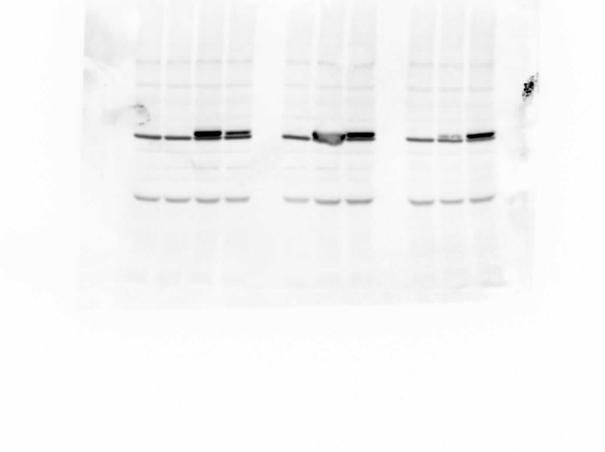
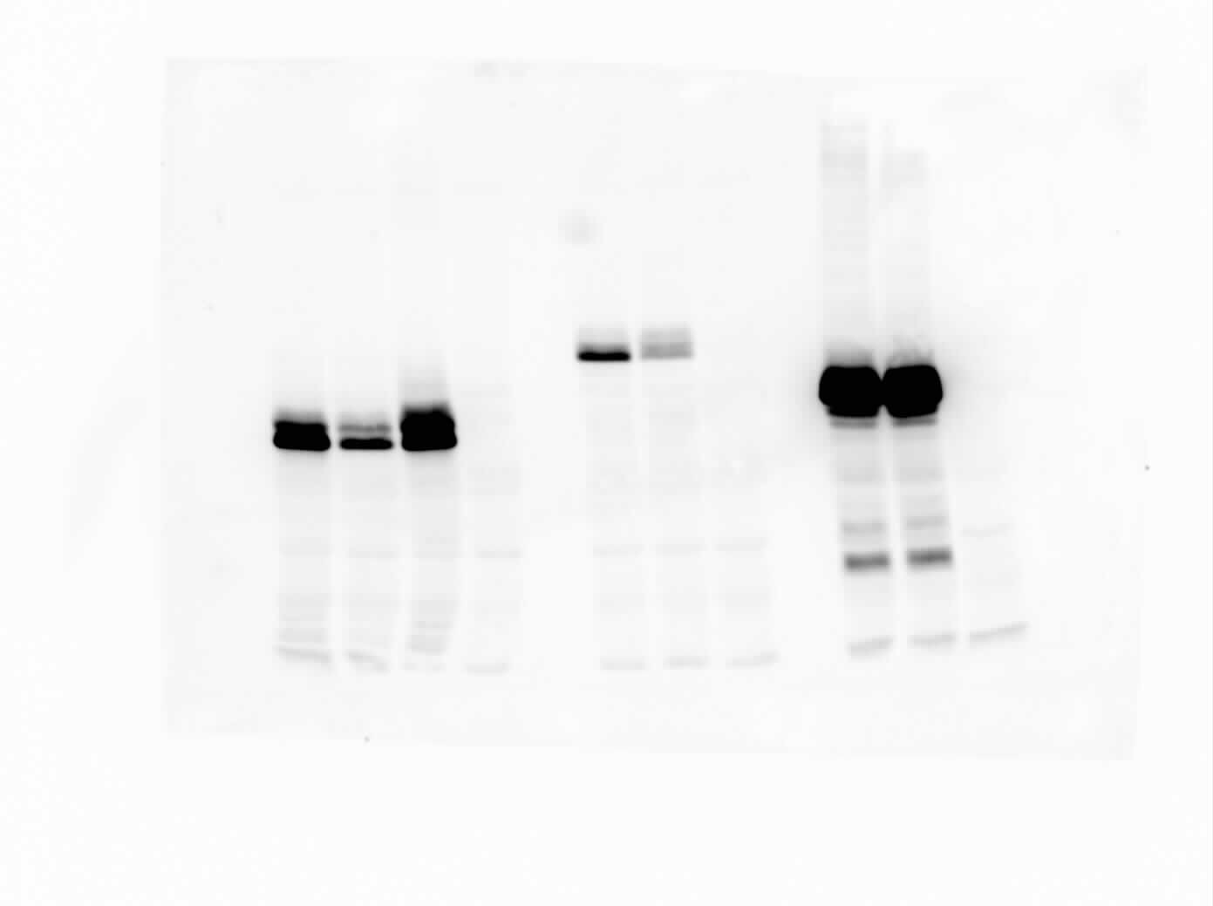
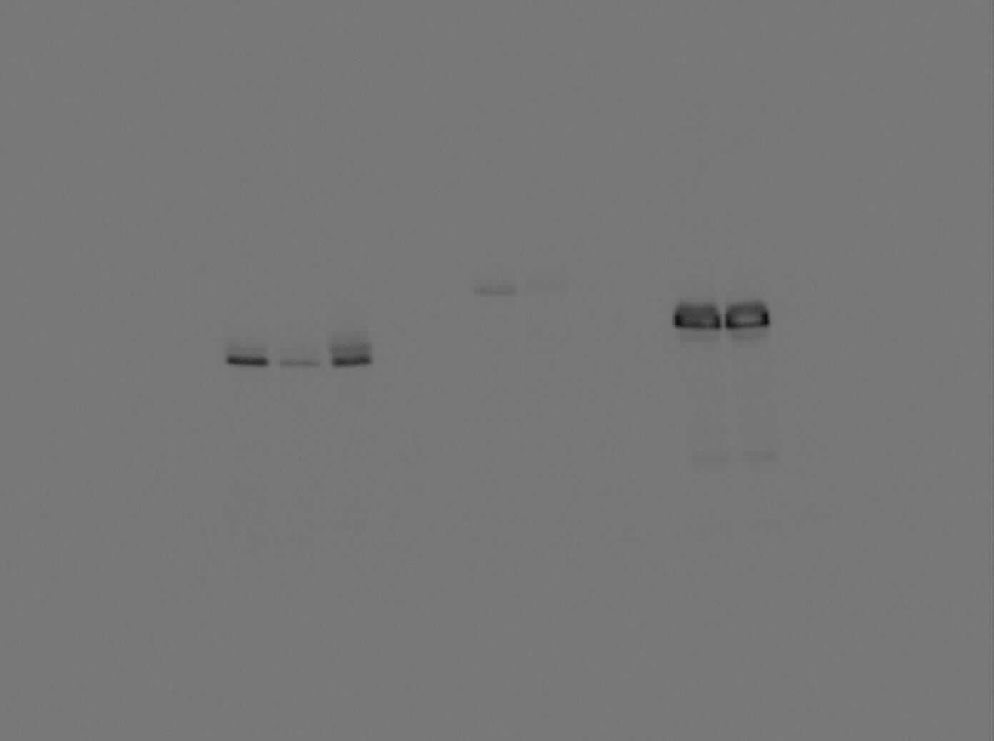
Atg36p-cGFP
Inp1p-cGFP
cGFP-Pex19p
αGFP
αPex3
Pex3p-nGFP
1 2 3 4 5 6 7 8 9 10
705
40
55
705
~kD
~kD
55
40

Fig 5.7: Inp1p and Atg36p are modified when trapped in complex with Pex3p

A) Anti-GFP western blot showing cGFP tagged partners of Pex3p in complex with Pex3p-nGFP: cGFP-Pex19p does not appear modified as there is no detectable bandshift between samples when it is locked in complex with Pex3p-nGFP (lane 2) and when there is an absence of Pex3p-nGFP (lane 3). Inp1p-cGFP has a shift in band composition when trapped in complex with Pex3p-nGFP (lane 5) when compared to cells lacking Pex3p-nGFP (lane 6). Atg36p-cGFP appears to show a change in band composition when in complex with Pex3p-n-GFP (lane 8) and Atg11p-nGFP (lane 9) when compared to an absence of an n-GFP partner (lane 10). Anti-GFP antibody only recognises the cGFP tag, not the nGFP.
B) Anti-Pex3p western blot showing Pex3p-nGFP and equal loading of samples: The blot shows that samples were loaded comparatively equally and the presence of Pex3-nGFP is detectably expressed. The lowermost band is endogenous Pex3p. The uppermost band present in lanes 1,2,4,5,7, and 8 is Pex3p-nGFP. Atg11-nGFP is unable to be detected by this antibody (lane 9).

Discussion

Inp1p has been reported as having two binding sites for Pex3p (Knoblach et al, 2013). Our data shows that the LxxLL motif contained in Inp1p between amino acids 312 and 316 is a strong contender as being one of those sites. Mutations in this motif in Inp1p are unable to colocalise to the cell periphery in pex19Δ cells (Fig 5.2), but do colocalise to peroxisomes in cells that are able to form them (when Pex19p is present) (Fig 4.4). Also, the loss of overexpression phenotype reported in chapter 4 suggests these mutations are no longer trapping Pex3p in the ER. As discussed in Chapter 4, Inp1p does not appear to interact directly with Pex19p, and therefore is unlikely to be localising to peroxisomes via binding to Pex19p. However, it is likely that if there are two binding sites within Inp1p for Pex3p, forming a bridge between Pex3p on the ER and a separate Pex3p molecule on the peroxisome, that this LxxLL motif binds to Pex3p on the ER.
This, of course, leads to further questions. Firstly, if Inp1p is unable to bind Pex3p on the ER, and yet can bid to Pex3p on the peroxisomal membrane, does this mean that two distinct populations of Pex3p exist? If so, is it through a regulatory modification, such as phosphorylation, or through the involvement of a further as yet unknown protein. In human cells, Pex16 plays a role at the peroxisomal membrane in conjunction with Pex3p. However, there has been no Pex16 orthologue discovered in S. cerevisiae.
This chapter aimed to elucidate this quandary by first transforming Inp1p-3-GFP into a library of knockout backgrounds (Section 5.2.3). Whilst candidates have been identified, further studies have not been able to confirm their involvement with Inp1p.

The mechanisms by which the interactions of Pex3p are regulated are still poorly understood. Thusly, the mechanisms by which peroxisome biogenesis, retention, and degradation are regulated also still remain elusive.
In this chapter, we report a possible competition dynamic between Pex19p and Inp1p for their binding to Pex3p (Section 5.2.1). Inp1p overexpression blocks Pex19p’s interaction with Pex3p, however the reciprocal assay, in which Pex19p is overexpressed, has not been shown to lead to a retention defect in any literature to date. This suggests that there is another mechanism beyond straight competition, by which the binding to Pex3p by Inp1p and Pex19p is regulated. As previously mentioned, this could take the form of the involvement of an as yet undefined protein, or through modification of one or more of the interacting proteins in question.
The third known interacting partner of Pex3p, Atg36p, does not contain the LxxLL motif of Inp1p and Pex19p. We report that it does not compete with Inp1p for Pex3p binding, and can co-purify with Inp1p. This is assumed to be via Pex3p, as atg36Δ cells do not exhibit a loss of retention phenotype. Therefore, a distinct means of regulation of Atg36p binding seems likely.
During the course of this study, Pex3p was proposed as a possible candidate of phosphorylation by Atg1p at Serine 426 (Papinski & Kraft 2014). We report, however, that Serine 426 phosphorylation is not required for pexophagy (Fig5.6).
Genome wide studies highlight several serines in Pex3p as candidates for phosphorylation, particularly in the cluster of 5 serines between Ser112 and Ser119. This site is of particular interest as it is in close proximity to the proposed binding site within Pex3p for both Inp1p and Pex19p of Tryptophan 128 (Knoblach et al. 2013). This site will be discussed in further detail in the general discussion.

Atg36p modification was reported in Motley et al., (2012), however, incomplete sequence coverage led to difficulties on confirming data. Therefore, the development of a new tool with the hope of being able to investigate regions of modification was attempted.
Utilising split-GFP as a tool to investigate the modification of Pex3p’s three binding partners gave data to suggest that Atg36p and Inp1p are modified when in complex with Pex3p (Fig5.7). Split-GFP is a tool commonly used for investigating interactions via fluorescence microscopy. However, preliminary data suggest that further use of it could be made through the development of a biochemical assay designed to investigate proteins trapped in complex. Therefore, any modifications that may be involved in complex formation, would also be trapped. Of course, further assay development is required, as by manipulating proteins and forcing them to remain in complex their regulation and functions may be affected, and synthetic results may be generated.

This chapter reports several areas of study which may be of interest for further investigation of Pex3p and its interacting partners.

Chapter 6:

General Discussion

6.1 Introduction

The main aim of this study was to investigate the interactions that occur in S. cerevisiae between Pex3p and it’s known binding partners at the peroxisomal membrane, namely Inp1p, Pex19p, and Atg36p.

The results of this investigation highlight a key area, predicted to comprise of an LxxLL motif found on an alpha helix in both Inp1p and Pex19p. This sequence is shown to be required for their binding to Pex3p, although knowledge about the regulation of binding of this shared motif still proves elusive.
In this section, the data on the LxxLL motif shall be discussed in terms of its significance to the field of peroxisomal research, its implications with regards to the current model of peroxisomal inheritance, and the future directions that research within this field could follow. Particular attention will be paid to the impact on peroxisomal regulation of biogenesis, inheritance, and autophagy as these are the three known areas in which Pex3p has been reported to be involved in.

The attempt at developing an assay utilising MicroScale Thermophoresis will not be discussed in this section. For a discussion on that topic, please refer to the relevant discussion within the text (Section 3.9).

6.2 A Leucine based motif in Pex19p and Inp1p binds Pex3p

As reported in Chapter 3, results indicate that the region of amino acids 310-318 in Inp1p is required for Pex3p binding (Fig 3.8). Mutational analysis of INP1 within the yeast genome showed a loss of function inp1Δ phenotype (Fig 4.2). These mutations introduced into galactose inducible Inp1p constructs also showed a loss of ability to co-immunoprecipitate endogenous Pex3p (unmutated Inp1p was shown capable of co-immunoprecipitation of Pex3p) (Fig 4.3). Inp1p mutants were also shown to lack the ability to elicit the overexpression phenotypes associated with Inp1p. Specifically, mutants leading to codon changes in the leucines 315 and 316 of Inp1p were shown to allow peroxisome formation when expressed from the TPI1 promoter (unmutated Inp1p shows a loss of peroxisomes) (Fig 4.4), as well as rescuing growth on oleate when expressed from the CTA1 promoter (unmutated INP1 leads to a loss of growth on oleate when overexpressed) (Figs 4.5).
Pex3p binds at least 3 proteins at the peroxisomal membrane in S. cerevisiae, namely Pex19p, Inp1p, and Atg36p (Hettema et al. 2000; Munck et al. 2009; Motley et al. 2012b). To date however, how these proteins interact with Pex3p, and each other, at the peroxisomal membrane is poorly understood or characterised.
Interestingly, this study reports that another Pex3p interacting partner in S. cerevisiae, Pex19p, also contains an LxxLL motif. In human cells, the binding site between HsPex19 and HsPex3 has been characterised as containing an LxxLL motif (Schmidt et al. 2010; Sato et al. 2010). In this study, it has been demonstrated that a similar motif in a similar region of ScPex19p Is not only present, but also is required for binding to Pex3p, and therefore Pex19p function in peroxisomal biogenesis (Chapter 4). The motifs requirement for this purpose was analysed through point mutations and loss of function via fluorescence microscopy (Fig4.8), as well as through co-immunoprecipitation assays (Fig 4.9).
No such motif has been found in Pex3p’s other known binding partner: Atg36p. The ability of Atg36p to be co-immunoprecipitated with Inp1p, seemingly via its interaction with Pex3p indicates that Inp1p and Atg36p are able to interact with the same Pex3p molecule at the same time (Fig 5.2). This information could prove vital in further studies aimed at the elucidation of the regulation of the three main areas of peroxisome research, namely Biogenesis via Pex19p, inheritance via Inp1p, and Pexophagy via Atg36p, as it appears pexophagy may have a different mechanism of regulation, removed from that of the other two areas. The lack of cross-interaction between the three binding partners of Pex3p could also remove possible complications in future investigations.

6.3 Inp1p and Pex19p share a binding site on Pex3p

As Inp1p and Pex19p appear to share the same LxxLL motif, and it has been shown to be required for Pex3p binding in both proteins, it is not a great leap to therefore assume that both motifs are capable of binding the same region of Pex3p.
The interaction site between HsPex19 and HsPex3 has also been reported and the crystal structure solved (Sato et al. 2010; Schmidt et al. 2010). Using this data in combination with Pex3 alleles deficient in peroxisome retention (Munck 2008) residue Tryptophan128 with ScPex3p was decided to be an ideal candidate for investigation.
Our data shows that mutations of W128A lead to a total loss of peroxisomes. However, Pex3(W128A)-GFP is seen to localise to peroxisomes in Wildtype cells (Appendix IV).
Since the undertaking of this study, it has since been reported that W128 in ScPex3p is indeed a site required for Pex19p and Inp1p binding in S. cerevisie. It has also been reported that mutations of W128 to L removes Pex19p binding (and therefore peroxisomal biogenesis), but not Inp1p binding, as Inp1p-GFP foci are still visible (Knoblach et al. 2013). This suggests that Inp1p possesses greater affinity for Pex3p than Pex19p, as It is able to overcome a slightly less detrimental mutation to the Pex3p binding site. This data somewhat corroborates with the findings of this study, as mutations in any part of the Pex19p LxxLL motif appear to lead to a total loss of biogenesis, whereas in Inp1p under the control of the CTA1 promoter, a mutation of L312A appears unable to rescue the overexpression phenotype (loss of growth on oleate) (Fig 4.5).

Future investigation into the orchestration and regulation of peroxisome biogenesis and inheritance via Pex3p may not be as heavily influenced by this data as it may at first appear. This data suggests that retention of existing peroxisomes is preferable to their loss and subsequent creation of new peroxisomes. This idea gains traction if it is rephrased as ‘growth and division of existing peroxisomes is preferable to de novo formation’, an idea already covered at length by (Motley & Hettema 2007) who showed that newly produced Peroxins located to pre-existing peroxisomes, and supported through an elegant photoconversion assay in (Knoblach et al. 2013), which confirmed that not only did daughter cells inherit peroxisomes from their mothers, but subsequent peroxisomes in subsequent daughter cells contained material from the original mother’s peroxisomes.

6.4 The current model of Inp1p tethering

This study produced data on two interacting partners of Pex3p: Pex19p and Inp1p. With regards to the current model of Pex19p, and its necessity to bind Pex3p not only for its release from the ER, but to perform its function as a chaperone of PMPs for their delivery to the peroxisomal membrane, this study has found no data to suggest that this model is flawed (Hettema et al. 2000; Hoepfner et al. 2005). Data generated regarding Myo2p also confirms its interaction with Pex19p (Fig 4.7) (Otzen et al. 2012). The interaction site and motif in Pex19p investigated in this report also corroborates interactions reported from the crystal structure of the human proteins by Sato et al., (2010) and Schmidt et al., (2010).
An inconsistency found in this study with the results of Knoblach et al., (2013), is in the mutant Inp1p LL315316AA being unable to co-immunoprecipitate Pex3p (Fig 4.3). If there were two binding sites for Pex3p within Inp1p, upon removal of one site (in this case the LxxLL between amino acids 311-316), Inp1p would still be able to bind to Pex3p via the other.
One explanation for the loss of detectable binding could be that Inp1p’s second Pex3p binding site is masked. It therefore only becomes functional due to a conformational change upon initial Pex3p binding. Thusly, if the initial binding event is removed, then the second will not take place. This theory could explain the data of Knoblach et al., (2013), as binding assays were performed using half proteins, therefore removing any potential masking of binding sites or need for conformational change in Inp1p. Further investigation is required to shed light on this and the other potential binding site within Inp1p.
However, GST-Pex3p being seemingly unable to produce a detectable interaction with Pex3-GFP indirectly through Inp1p also calls in to question this model (Fig 4.1 and Fi 4.14).
A galactose inducible Pex3(W128A)-GFP localising to peroxisomes (peroxisomes which are assumed to have been pre-existing prior to galactose induction) in wildtype cells does not marry with mating assays performed in Knoblach et al., (2013) (Appendix IV). The claim that Pex3(W128L) is on the ER bound to Inp1p-1/2GFP, which upon mating is able to bind to a separate Pex3p mutant Pex3(V81E)-1/2GFP on the peroxisome causing the completion of the GFP and therefore fluorescence, is fundamentally flawed in its design. Crucially, upon mating a wildtype cell is produced, and therefore Pex3(W128L) bound to Inp1p-1/2GFP would be able to locate to the pre-existing peroxisomes containing Pex3(V81E)-1/2GFP and thusly fluorescence would be observed due to the two halves of the split GFP being on the peroxisome.
This is not to say that the current model of Inp1p acting as a bridge between two Pex3p molecules is not correct, but further investigation is required to clarify that Pex3p remains at the ER to act as a tethering point.

6.5 Future Directions for studying Pex3p interactions

6.451 How is Inp1p/Pex19p-Pex3p binding regulated?

As Inp1p and Pex19p appear to not only share a similar binding motif, but also a binding site on Pex3p, it must be assumed that some regulation must occur in order to control and balance retention of existing peroxisomes, their growth, and the formation of new peroxisomes by de novo synthesis as either one or both of Inp1p and Pex19p are required for each of these processes (Fagarasanu et al. 2005; Hettema et al. 2000). However, the nature of this mechanism is not yet fully characterised.

Competition/Stoichiometry between Pex19p and Inp1p
Overexpression of INP1 has been shown to block Pex3p in the ER and lead to a lack of peroxisomes (Munck 2008). This hints at a possible competition mechanism between Inp1p and Pex19p for Pex3p binding, as Inp1p is simply blocking Pex19p from accessing Pex3p (and it has been shown that Inp1p does not directly interact with Pex19p (Fig 4.7)).
As previously mentioned, mutations introduced into the Pex19p LxxLL motif appear to have a much stronger effect than those introduced into the Inp1p LxxLL, with overexpression of Inp1p containing a single L312A mutation being unable to rescue the loss of growth on oleate found during overexpression of Inp1p from the CTA1 promoter (Fig 4.5). This would appear to make sense, as Inp1p is involved in anchoring an organelle and therefore the interaction between itself and Pex3p would need to be strong and robust enough to withstand the pressures exerted onto it by Myo2p attempting to transport the peroxisome to the bud (discussed in further detail later) (A. Fagarasanu et al. 2006). Conversely, Pex19p functions largely as a chaperone of PMPs, and so would not require such a strong interaction with Pex3p, as the main requirement of that role is in actually delivering the cargo to the peroxisome, not in remaining on the peroxisome itself (Fang et al. 2004a).
Further evidence that a competition mechanism may exist between Inp1p and Pex19pIt could be found in the report that Inp1p levels fluctuates throughout the cell cycle (Fagarasanu et al. 2005). A spike in Inp1p level when it is required most, and its greater affinity for Pex3p, would see focus shift from growth of existing peroxisomes, to retention during cell division.
This could prove to be quite an elegant system for the regulation of these two interacting partners. However, Inp1p-GFP expressed at endogenous levels is shown to be present on all peroxisomes, even those transported to the bud during cell division (Fig 3.1C). This indicates that the regulation of Inp1p binding to Pex3p may not be solely down to the regulation of its expression and competition with Pex19p.

Modification of Pex3p binding partners

It has been shown that phosphorylation of Atg36p triggers autophagy in S. cerevisiae (Tanaka et al. 2014). Atg36p, therefore, is modified when bound to Pex3p, as it would be if tagging a peroxisome for degradation (Motley et al. 2012b). Our data is consistent with this, in that a clear band shift is shown when Atg36p is trapped in complex with Pex3p (Fig 5.4). This shift is also observable when Atg36p is trapped in complex with Atg11p, suggesting that the modified form is indeed what recruits Atg11p and the autophagy machinery to the peroxisome. However, this assay is limited as it traps Atg36p in a specific state, possibly removing functionality. Future experimental design will aim to analyse if proteins trapped in complex in this way are still functional.
This data could also be interpreted as suggesting Inp1p is also modified, as the composition and distribution of Inp1p-1/2GFP bands has an observable shift when incubated with Pex3p-1/2GFP. However, no observable band-shift is seen when Pex19p is trapped in complex with Pex3p.
This is a new tool being developed from an existing system, however. As such, results garnered from this assay should be viewed with a large amount of scepticism until further assay development can confirm its application in this manner.

Pex3p modification

Whole genome phosphorylation screens have highlighted several candidates for phosphorylation within Pex3p. This study finds that one such potential target, Ser26, is not involved in the regulation of autophagy (Fig 5.3). It is therefore assumed to not be required for Pex3p interaction with Atg36p. However, this study did not confirm if Ser426 is required for other interactions to occur with Pex3p. Future studies may address this query.
Future studies may also focus on the cluster of serines found in Pex3p between amino acids 112 and 119 and at first glance they appear to form a binding groove (Appendix IV). However, preliminary assessment of these residues through phosphomimetic and non-phosphorylatable mutations and their analysis by fluorescence microscopy has found no obvious observable phenotypes associated with these residues (J. Nuttall: Personal Communication).

6.5.2 How is inheritance regulated?

During cell division peroxisomes are equally segregated between the mother and daughter cell. An apparent antagonistic partnership is present between two Inheritance of peroxisome (Inp) proteins: Inp1p acts in their retention in the mother; and Inp2 is required for their transport to the bud (Fagarasanu et al. 2005; A. Fagarasanu et al. 2006).
Due to the number of peroxisomes appearing to remain constant during cell division, and the growing importance being placed on organelle inheritance, it is becoming more widely accepted that peroxisomal inheritance involves some sort of regulation, and does not occur randomly (Warren & Wickner 1996; Barbara Knoblach & Rachubinski 2015).
Initial studies have put forward transcriptional regulation as playing a part in both Inp1p and Inp2p regulation (Fagarasanu et al. 2005; A. Fagarasanu et al. 2006), as the levels of both proteins fluctuates throughout the cell cycle: peaking when retention and transport are most required. It is posited that regulation of Inp2p is the control for peroxisome segregation, however, as inp1Δ cells show an almost total loss of retention, it would appear that every peroxisome has the potential to be transported to the newly forming daughter cell. Therefore, regulation of Inp1p could be seen as a release mechanism. An alternate view could be that of the model proposed by Fagarasanu et al., in which Inp1p tethers the peroxisome, which is then stretched by the Inp2p-Myo2p dependent transport to the bud, and cleavage of the peroxisome is what causes equal segregation. This model has also been advanced by Knoblach and Rachubinski (2014) reporting that Inp1p-5xGFP travels independently of the peroxisome to the newly forming daughter cell, where it attaches to the ER and acts as the receptor for transported peroxisomes. This model would also suggest that there needs to be a method of release from Inp2-Myo2p transport and re-attachment to Inp1p at the periphery of the daughter cell. However, a small flaw in this model is that Inp1p-GFP is located to all peroxisomes during cell division, even those transported to the newly formed daughter cell.
The potential involvement of Myo2p in interacting directly with Pex3p poses even more interesting questions for the regulation of inheritance and the interplay between Inp1p mediated retention and Inp2p mediated transport to the bud. If it is indeed true that Myo2p interacts with Pex3p through the same LxxLL motif, then regulation of retention and transport could be achieved through regulating which protein is able to bind Pex3p.

6.5.3 Are there other proteins involved in these interactions?

The presence of this LxxLL motif in Myo2p not only raises questions about the regulation of inheritance of peroxisomes, but also on the nature of Pex3p binding itself. The immediate future work of this investigation will focus primarily on Myo2p and the other potential binding partners of Pex3p as suggested through the patternmatch query. Specifically, Myo2p and YIL089w.
These two candidates prove most interesting as Myo2p is already involved in inheritance through its interaction with Inp2p for transport to the daughter cell, and YIL089w has recently been found to be located on the peroxisome and shows dual localisation to the ER and vacuole (Yofe et al. 2016).

Independent of the investigation into further interaction partners of Pex3p, another branch of study for this topic will focus on a possible second binding partner for Inp1p at the peroxisomal membrane. Briefly discussed in the text (Section 5.2.3) disruption of the LxxLL motif in Inp1p leads to:
- a loss of Inp1p function in retention of peroxisomes (Fig 4.2)
- a loss of localisation to Pex3p in pex19Δ cells which are lacking peroxisomes (Fig 5.2),
- a loss of Pex3p binding (Fig 4.3).
However, non-functional LxxLL mutants still appear to colocalise to peroxisomes in wildtype cells. This poses a few potential models on the mechanism for Inp1p localisation to the peroxisome.
Firstly, the current model would suggest that there is a second binding site within Inp1p for Pex3p. To fit this model, this second site appears only able to bind Pex3p on the peroxisome. This would imply that there exist two distinct populations of Pex3p, one at the ER and one on peroxisomes. This distinction could be achieved in several ways, namely modification of Pex3p itself, or through attenuation of Pex3p through another protein.
Preliminary attempts to find this possible attenuating protein have identified a few candidates in the Pex11 family of proteins and Pex14p. Future endeavours will aim to evaluate these candidates for their requirement in peroxisome retention and impossible interaction with Inp1p or Pex3p and its other interacting partners.

Appendix

I
Strains crossed with inp1Δ for creation of mini SGA library.
Library was screened using Pex11-GFP and Pex13-mRFP

Strain Crossed
pex17Δ
pex19Δ
pex8Δ
pex10Δ
pex12Δ
pex13Δ
pex15Δ
pex1Δ
pex2Δ
pex3Δ
pex4Δ
pex5Δ
pex6Δ
pex7Δ
ygr168cΔ
inp2Δ
vps1Δ
sfb2Δ
pex30Δ
pex34Δ
pex11Δ
pex29Δ
pex22Δ
dnm1Δ
fis1Δ

Appendix

II

Pattermatch query candidates: +++ = Known interactor. ++ = Strong candidate. + = weak candidate

+ | YDR325W | YCG1 | ALDGDLIELLEKLDVS | 306 | 321 | Subunit of the condensin complex
+ | YFL052W |  | LCYDDLYELLEKRYDE | 96 | 111 | Putative zinc cluster protein that contains a DNA binding domain
+ | YJL082W | IML2 | RAADDLISLLDISDWS | 473 | 488 | Protein of unknown function
+ | YKL015W | PUT3 | LNDDDLQQLLEDLGNI | 924 | 939 | Transcriptional activator
+ | YLR049C |  | KIDCDLVILLEDLRSR | 409 | 424 | Putative protein of unknown function
+ | YLR172C | DPH5 | CHELELEYLLEFADDK | 256 | 271 | Methyltransferase required for synthesis of diphthamide
+ | YLR359W | ADE13 | PIWEELDSLLEPSTFV | 432 | 447 | Adenylosuccinate lyase
+ | YMR197C | VTI1 | QQQDELFDLLDQMDVE | 43 | 58 | Protein involved in cis-Golgi membrane traffic
+ | YOR195W | SLK19 | EEKQELLKLLENEKK | 807 | 822 | Kinetochore-associated protein
+ | YOR337W | TEA1 | EIIDDLKTLLDNFGKK | 634 | 649 | Ty1 enhancer activator involved in Ty enhancer-mediated transcription
++ | YAL001C | TFC3 | VEELDLIKLLDIWTSF | 818 | 833 | Subunit of RNA polymerase III transcription initiation factor complex
++ | YAL035W | FUN12 | DVMDDLTGLLDSVDTT | 736 | 751 | Translation initiation factor eIF5B
++ | YCL035C | GRX1 | RETGELEELLEPILAN | 95 | 110 | Glutathione-dependent disulfide oxidoreductase
++ | YDR069C | DOA4 | AKDQDLSSLLDKCIDI | 43 | 58 | Ubiquitin hydrolase that deubiquitinates ILV cargo proteins
++ | YEL061C | CIN8 | LYNEELKDLLDSNSNG | 183 | 198 | Kinesin motor protein
++ | YHR171W | ATG7 | PRVVDLSSLLDPLKIA | 283 | 298 | Autophagy-related protein and dual specificity member of the E1 family
++ | YIL089W |  | DQTVDLNRLLELFFWQ | 148 | 163 | Protein of unknown function found in the ER and vacuole lumen
++ | YOR326W | MYO2 | QINEELYRLLEDTEIL | 1155 | 1170 | Type V myosin motor involved in actin-based transport of cargos
+++ | YDL065C | PEX19 | DNFDDLDDLLDEDPTK | 7 | 22 | Chaperone and import receptor for class I PMPs
+++ | YMR204C | INP1 | YDDDDLNYLLDEEYEQ | 307 | 322 | Peripheral membrane protein of peroxisomes
x | YBR297W | MAL33 | LSYDDLHKLLDEEYND | 101 | 116 | MAL-activator protein
x | YAL019W | FUN30 | NNLKELMSLLEFIMPN | 737 | 752 | Snf2p family member
x | YAR019C | CDC15 | RKSYELYILLEYCANG | 90 | 105 | Protein kinase of the Mitotic Exit Network
x | YAR042W | SWH1 | AIDIELKKLLERATRE | 252 | 267 | Protein similar to mammalian oxysterol-binding protein
x | YBL009W | ALK2 | NILIELTHLLDPARKH | 635 | 650 | Protein kinase
x | YBR017C | KAP104 | DSDKELWPLLECLSCV | 600 | 615 | Transportin or cytosolic karyopherin beta 2
x | YDL031W | DBP10 | VAENELPYLLDLELFL | 536 | 551 | ATP-dependent RNA helicase of the DEAD-box protein family
x | YDL129W |  | ASSAELRPLLERPLKR | 167 | 182 | Protein of unknown function
x | YDL190C | UFD2 | RMLNDLTFLLDEGLSN | 679 | 694 | Ubiquitin chain assembly factor (E4)
x | YDR129C | SAC6 | KLHPELYRLLEDDETL | 266 | 281 | Fimbrin, actin-bundling protein
x | YDR484W | VPS52 | KKSNELQSLLEYNSTK | 100 | 115 | Component of the GARP complex
x | YEL055C | POL5 | VGLEELQILLDILKAR | 677 | 692 | DNA Polymerase phi
x | YER172C | BRR2 | EEKRELKQLLEKAPIP | 1049 | 1064 | RNA-dependent ATPase RNA helicase (DEIH box)
x | YGL062W | PYC1 | VDSSDLLVLLEDQVPV | 1159 | 1174 | Pyruvate carboxylase isoform
x | YGL206C | CHC1 | GLKLELIELLEKIILE | 1005 | 1020 | Clathrin heavy chain
x | YGR288W | MAL13 | LSYDDLHKLLEEKYND | 106 | 121 | MAL-activator protein
x | YHR132C | ECM14 | ALPRDLENLLELSYGL | 326 | 341 | Similarity to zinc carboxypeptidases
x | YJL080C | SCP160 | KAHEELKALLDFEMEN | 766 | 781 | Essential RNA-binding G protein effector of mating response pathway
x | YJR007W | SUI2 | TEDAELQALLESKELD | 274 | 289 | Alpha subunit of the translation initiation factor eIF2
x | YJR031C | GEA1 | YFEQELLFLLEISIIL | 1052 | 1067 | Guanine nucleotide exchange factor for ADP ribosylation factors
x | YJR043C | POL32 | KNNDDLEDLLETTAED | 245 | 260 | Third subunit of DNA polymerase delta
x | YJR118C | ILM1 | NGVHDLIPLLENNVKY | 69 | 84 | Protein of unknown function
x | YKL173W | SNU114 | LLPRELPKLLDALNKI | 610 | 625 | GTPase component of U5 snRNP
x | YKR036C | CAF4 | YSRIDLTHLLEDVETN | 156 | 171 | WD40 repeat-containing protein associated with the CCR4-NOT complex
x | YLL048C | YBT1 | LRNAELVVLLEDGRVK | 899 | 914 | Transporter of the ATP-binding cassette (ABC) family
x | YLR086W | SMC4 | TEIKDLTQLLEKERSI | 517 | 532 | Subunit of the condensin complex
x | YLR387C | REH1 | SYLIDLNGLLEFLIKM | 217 | 232 | Cytoplasmic 60S subunit biogenesis factor
x | YLR408C | BLS1 | NRSEELDRLLDKIINS | 18 | 33 | Subunit of the BLOC-1 complex
x | YMR079W | SEC14 | KALAELRKLLEDAGFI | 35 | 50 | Phosphatidylinositol/phosphatidylcholine transfer protein
x | YMR098C | ATP25 | LIREDLIALLEMVLKT | 413 | 428 | Mitochondrial protein required for the stability of Oli1p (Atp9p) mRNA
x | YMR208W | ERG12 | GLSQELVSLLDPLLAQ | 90 | 105 | Mevalonate kinase
x | YNL027W | CRZ1 | DTSKDLGILLDIDSLG | 508 | 523 | Transcription factor
x | YNL289W | PCL1 | DLILDLQPLLEPIKQD | 157 | 172 | Cyclin, interacts with cyclin-dependent kinase Pho85p
x | YNL298W | CLA4 | CDPKDLTSLLEWKE | 829 | 844 | Cdc42p-activated signal transducing kinase
x | YOL040C | RPS15 | YRGVDLEKLLEMSTED | 17 | 32 | Protein component of the small (40S) ribosomal subunit
x | YOR051C | ETT1 | EAYIDLGNLLDNESAE | 364 | 379 | Nuclear protein that inhibits replication of Brome mosaic virus
x | YOR058C | ASE1 | LISKDLEKLLENLNVI | 96 | 111 | Mitotic spindle midzone-localized microtubule bundling protein
x | YOR324C | FRT1 | LLSGELTLLLDEMTTL | 471 | 486 | Tail-anchored ER membrane protein of unknown function
x | YPL059W | GRX5 | ARSGELADLLEEAQAL | 124 | 139 | Glutathione-dependent oxidoreductase
x | YPL167C | REV3 | TINDDLQLLLDRFCDF | 233 | 248 | Catalytic subunit of DNA polymerase zeta
x | YPL167C | REV3 | EALTDLVLLLDPDILS | 750 | 765 | Catalytic subunit of DNA polymerase zeta
x | YPL231W | FAS2 | IAPAELEGLLDLERVI | 1004 | 1019 | Alpha subunit of fatty acid synthetase
x | YPR196W |  | LSYDDLYKLLEENYED | 101 | 116 | Putative maltose-responsive transcription factor

III
Knockouts screened through transformation with Inp1p-3-GFP
Strain
∆Atg11/Pex3
(YEH215)
∆13/14
(YEH )
∆1/5/18/21
(YEH487)
∆MSP1
(YEH383)
∆30/31/32
(YEH022)
∆28/29/30/31
(YEH238)
∆28/29/30/32
(YEH237)
∆Vps1/Dnm1
(YEH057)
∆Vps1/Dnm1/27
(YEH271)
∆34
(YEH179)
∆34/Fis1
(YEH188)
∆11/25/27/34
(YEH303)
∆19
Euroscarf

IV

Pex3 W128

Pex3p W128A cannot complement pex3Δ but localises to peroxisomes in WT

The interaction site between HsPex19 and HsPex3 has been reported and the crystal structure solved (Sato et al. 2010; Schmidt et al. 2010). A site within HsPex3 has also been reported as being required for this binding interaction (Sato et al. 2008). Munck et al., (2009) reported several PEX3 alleles deficient in peroxisomal inheritance. The mutations present in these alleles have since been separated and analysed (E Hettema: personal communication). Using this data Tryptophan128 within ScPex3p was decided to be an ideal candidate for investigation as a possible site within Pex3p required for its interaction with Pex19p and Inp1p in S. cerevisiae.
The construct of Pex3p under the control of its own promoter and terminator was subjected to site directed mutagenesis to produce a construct containing Pex3p(W128) under the control of its own promoter and terminator. The two constructs were separately co-transformed to pex3Δ cells with a construct expressing the peroxisomal marker GFP-PTS1 under the control of the TPI1 promoter. Cells were grown to exponential growth phase in liquid culture and analysed through fluorescence microscopy (Fig IV.1A).
Results show wildtype Pex3p is able to rescue the pex3Δ phenotype as expected. However, cells containing the Pex3p(W128A) construct were lacking in peroxisomes, and therefore it is reported that the substitution Trp128Ala in Pex3p leads to a loss of peroxisome biogenesis.
To further this study a construct was made for the expression of galactose inducible Pex3p-GFP. This construct was then subjected to site directed mutagenesis to create the galactose inducible construct Pex3p(W128A)-GFP.
These constructs were co-transformed to Wildtype cells with the peroxisomal marker HcRed-PTS1, and analysed whilst in exponential growth phase by fluorescence microscopy (Fig IV.1B).
Results show that both Pex3p-GFP and Pex3p(W128A)-GFP co-localise with the peroxisomal marker HcRed-PTS1. We conclude, therefore, that Pex3p(W128A)-GFP localises to peroxisomes in Wildtype cells.
The region immediately before W128 contains several seriens predicted as phosphorylation sites through genome wide studies. Further analyses of this region through swissprot modelling reveals Serines around the W128 region may form a binding groove and warrant further investigation (Fig IV1C and D).

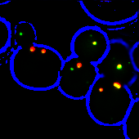
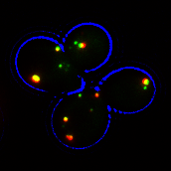
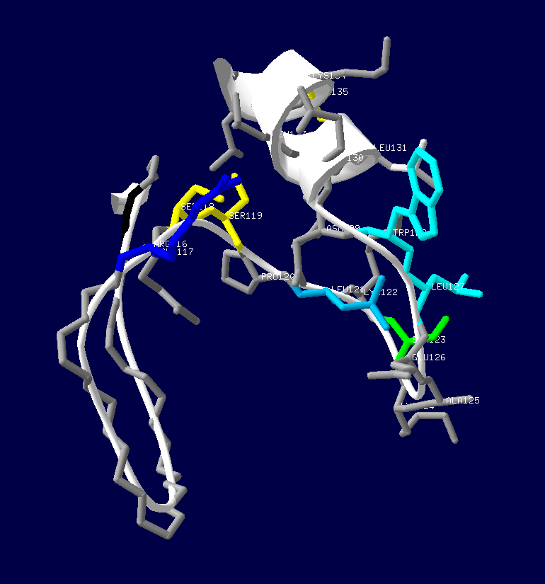
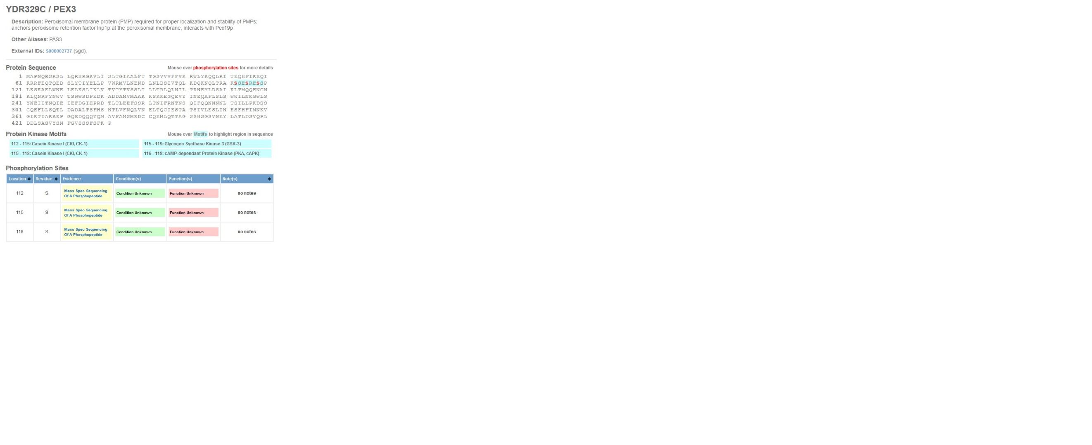
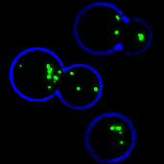
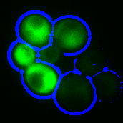

Fig IV.1: W128 in S. cerevisiae Pex3p
- W128A mutants cannot restore pex3Δ cells to WT
- W128A mutants still colocalise to peroxisomes in WT cells
- Genome wide phosphorylation screens highlight serines between amino acid 112 and 119 as possible sites of phosphorylation
- The cluster of serines prior to W128 may form a binding groove

D
C
A
pex3Δ
GFP-PTS1
Pex3pW128A
Pex3p
B
WT
HcRed-PTS1
Pex3pW128A-GFP
Pex3p-GFP

References

Agne, B. et al., 2003. Pex8p: an intraperoxisomal organizer of the peroxisomal import machinery. Molecular cell, 11(3), pp.635–646.
Arndt, K. & Fink, G.R., 1986. GCN4 protein, a positive transcription factor in yeast, binds general control promoters at all 5’ TGACTC 3' sequences. Proceedings of the National Academy of Sciences of the United States of America, 83(22), pp.8516–8520.
Baerends, R.J.S., 2000. A Stretch of Positively Charged Amino Acids at the N Terminus of Hansenula polymorpha Pex3p Is Involved in Incorporation of the Protein into the Peroxisomal Membrane. Journal of Biological Chemistry, 275(14), pp.9986–9995. Available at: http://www.jbc.org/content/275/14/9986.long [Accessed January 5, 2016].
Baryshnikova, A. et al., 2010. Synthetic genetic array (SGA) analysis in Saccharomyces cerevisiae and Schizosaccharomyces pombe. Methods in enzymology, 470, pp.145–179.
Berger, J. & Gärtner, J., 2006. X-linked adrenoleukodystrophy : Clinical , biochemical and pathogenetic aspects. , 1763, pp.1721–1732.
Boldogh, I.R. et al., 2004. A type V myosin (Myo2p) and a Rab-like G-protein (Ypt11p) are required for retention of newly inherited mitochondria in yeast cells during cell division. Molecular biology of the cell, 15(9), pp.3994–4002.
Braverman, N. et al., 1998. An isoform of pex5p, the human PTS1 receptor, is required for the import of PTS2 proteins into peroxisomes. Human molecular genetics, 7(8), pp.1195–1205.
Brocard, C. et al., 1997. Pex14p is a member of the protein linkage map of Pex5p. The EMBO journal, 16(18), pp.5491–500. Available at: http://www.pubmedcentral.nih.gov/articlerender.fcgi?artid=1170181&tool=pmcentrez&rendertype=abstract [Accessed January 5, 2016].
Brown, L.-A. & Baker, A., 2003. Peroxisome biogenesis and the role of protein import. Journal of cellular and molecular medicine, 7(4), pp.388–400.
Brown, T.W., Titorenko, V.I. & Rachubinski, R.A., 2000. Mutants of the Yarrowia lipolytica PEX23 gene encoding an integral peroxisomal membrane peroxin mislocalize matrix proteins and accumulate vesicles containing peroxisomal matrix and membrane proteins. Molecular biology of the cell, 11(1), pp.141–152.
Byrne, K.P. & Wolfe, K.H., 2005. The Yeast Gene Order Browser: combining curated homology and syntenic context reveals gene fate in polyploid species. Genome research, 15(10), pp.1456–1461.
Campbell, T.N. & Choy, F.Y.M., 2001. The Effect of pH on Green Fluorescent Protein : a Brief Review Further Reading. , 2, pp.1–4.
Chang, C.-C. et al., 1997. Isolation of the human PEX12 gene, mutated in group 3 of the peroxisome biogenesis disorders. Nature Genetics, 15(3), pp.385–388. Available at: http://www.nature.com/naturegenetics.
Chang, J. et al., 2009. Pex3 peroxisome biogenesis proteins function in peroxisome inheritance as class V myosin receptors. The Journal of cell biology, 187(2), pp.233–46. Available at: http://jcb.rupress.org/content/187/2/233.long [Accessed January 5, 2016].
Chang, J., Fagarasanu, A. & Rachubinski, R.A., 2007. Peroxisomal peripheral membrane protein YlInp1p is required for peroxisome inheritance and influences the dimorphic transition in the yeast Yarrowia lipolytica. Eukaryotic cell, 6(9), pp.1528–37. Available at: http://www.pubmedcentral.nih.gov/articlerender.fcgi?artid=2043367&tool=pmcentrez&rendertype=abstract.
Chen, Y. et al., 2014. Hydrophobic handoff for direct delivery of peroxisome tail-anchored proteins. Nature communications, 5, p.5790. Available at: http://www.nature.com/ncomms/2014/141217/ncomms6790/full/ncomms6790.html [Accessed January 5, 2016].
Chmyrov, A., Sanden, T. & Widengren, J., 2010. Iodide as a fluorescence quencher and promoter--mechanisms and possible implications. The journal of physical chemistry. B, 114(34), pp.11282–11291.
David, C. et al., 2013. A combined approach of quantitative interaction proteomics and live-cell imaging reveals a regulatory role for endoplasmic reticulum (ER) reticulon homology proteins in peroxisome biogenesis. Molecular & cellular proteomics : MCP, 12(9), pp.2408–25. Available at: http://www.mcponline.org/content/12/9/2408.abstract [Accessed January 5, 2016].
Debelyy, M.O. et al., 2011. Ubp15p, a ubiquitin hydrolase associated with the peroxisomal export machinery. The Journal of biological chemistry, 286(32), pp.28223–34. Available at: http://www.jbc.org/content/286/32/28223.long [Accessed December 3, 2015].
Distel, B. et al., 1996. A unified nomenclature for peroxisome biogenesis factors. The Journal of cell biology, 135(1), pp.1–3.
Dutta Choudhury, S. et al., 2010. A fluorescence perspective on the differential interaction of riboflavin and flavin adenine dinucleotide with cucurbit[7]uril. The journal of physical chemistry. B, 114(33), pp.10717–10727.
De Duve, C. & Baudhuin, P., 1966. Peroxisomes (microbodies and related particles). Physiological reviews, 46(2), pp.323–57. Available at: http://www.ncbi.nlm.nih.gov/pubmed/5325972 [Accessed November 4, 2015].
Dyer, J.M., McNew, J.A. & Goodman, J.M., 1996. The sorting sequence of the peroxisomal integral membrane protein PMP47 is contained within a short hydrophilic loop. The Journal of cell biology, 133(2), pp.269–280.
Effelsberg, D. et al., 2015. Role of Pex21p for Piggyback Import of Gpd1p and Pnc1p into Peroxisomes of Saccharomyces cerevisiae. The Journal of biological chemistry, 290(42), pp.25333–42. Available at: http://www.jbc.org/content/290/42/25333.long [Accessed January 5, 2016].
Eitzen, G.A., Szilard, R.K. & Rachubinski, R.A., 1997. Enlarged peroxisomes are present in oleic acid-grown Yarrowia lipolytica overexpressing the PEX16 gene encoding an intraperoxisomal peripheral membrane peroxin. The Journal of cell biology, 137(6), pp.1265–1278.
Elgersma, Y. et al., 1993. An efficient positive selection procedure for the isolation of peroxisomal import and peroxisome assembly mutants of Saccharomyces cerevisiae. Genetics, 135(3), pp.731–740.
Elgersma, Y. et al., 1997. Overexpression of Pex15p, a phosphorylated peroxisomal integral membrane protein required for peroxisome assembly in S.cerevisiae, causes proliferation of the endoplasmic reticulum membrane. The EMBO journal, 16(24), pp.7326–41. Available at: http://www.pubmedcentral.nih.gov/articlerender.fcgi?artid=1170333&tool=pmcentrez&rendertype=abstract [Accessed January 5, 2016].
Erdmann, R. et al., 1989. Isolation of peroxisome-deficient mutants of Saccharomyces cerevisiae. Proceedings of the National Academy of Sciences of the United States of America, 86(14), pp.5419–5423.
Erdmann, R. & Blobel, G., 1995. Giant peroxisomes in oleic acid-induced Saccharomyces cerevisiae lacking the peroxisomal membrane protein Pmp27p. The Journal of cell biology, 128(4), pp.509–523.
Erdmann, R. & Blobel, G., 1996. Identification of Pex13p a peroxisomal membrane receptor for the PTS1 recognition factor. The Journal of cell biology, 135(1), pp.111–21. Available at: http://www.pubmedcentral.nih.gov/articlerender.fcgi?artid=2121012&tool=pmcentrez&rendertype=abstract [Accessed January 5, 2016].
Erdmann, R. & Schliebs, W., 2005. Peroxisomal matrix protein import: the transient pore model. Nature reviews. Molecular cell biology, 6(9), pp.738–742.
Fagarasanu, A. et al., 2010. Molecular mechanisms of organelle inheritance: lessons from peroxisomes in yeast. Nature reviews. Molecular cell biology, 11(9), pp.644–54. Available at: http://dx.doi.org/10.1038/nrm2960 [Accessed January 5, 2016].
Fagarasanu, A. et al., 2009. Myosin-driven peroxisome partitioning in S. cerevisiae. Journal of Cell Biology, 186(4), pp.541–554. Available at: http://www.pubmedcentral.nih.gov/articlerender.fcgi?artid=2733749&tool=pmcentrez&rendertype=abstract [Accessed January 5, 2016].
Fagarasanu, A. et al., 2006. The Peroxisomal Membrane Protein Inp2p Is the Peroxisome-Specific Receptor for the Myosin V Motor Myo2p of Saccharomyces cerevisiae. Developmental Cell, 10(5), pp.587–600. Available at: http://www.sciencedirect.com/science/article/pii/S1534580706001730 [Accessed January 5, 2016].
Fagarasanu, M. et al., 2005. Inp1p is a peroxisomal membrane protein required for peroxisome inheritance in Saccharomyces cerevisiae. The Journal of cell biology, 169(5), pp.765–75. Available at: http://jcb.rupress.org/content/169/5/765.long [Accessed January 5, 2016].
Fagarasanu, M., Fagarasanu, A. & Rachubinski, R. a., 2006. Sharing the wealth: Peroxisome inheritance in budding yeast. Biochimica et Biophysica Acta - Molecular Cell Research, 1763(12), pp.1669–1677. Available at: http://www.sciencedirect.com/science/article/pii/S0167488906002370 [Accessed January 5, 2016].
Fang, Y. et al., 2004a. PEX3 functions as a PEX19 docking factor in the import of class I peroxisomal membrane proteins. The Journal of cell biology, 164(6), pp.863–75. Available at: http://jcb.rupress.org/content/164/6/863.long [Accessed January 5, 2016].
Fang, Y. et al., 2004b. PEX3 functions as a PEX19 docking factor in the import of class I peroxisomal membrane proteins. The Journal of cell biology, 164(6), pp.863–875.
Faust, J.E. et al., 2012. An inventory of peroxisomal proteins and pathways in Drosophila melanogaster. Traffic (Copenhagen, Denmark), 13(10), pp.1378–1392.
Fujiki, Y. et al., 2006. Import of peroxisomal membrane proteins: The interplay of Pex3p- and Pex19p-mediated interactions. Biochimica et Biophysica Acta - Molecular Cell Research, 1763(12), pp.1639–1646. Available at: http://www.sciencedirect.com/science/article/pii/S0167488906003041 [Accessed November 28, 2015].
Ghaedi, K. et al., 2000. PEX3 is the causal gene responsible for peroxisome membrane assembly-defective Zellweger syndrome of complementation group G. American journal of human genetics, 67(4), pp.976–81. Available at: http://www.sciencedirect.com/science/article/pii/S0002929707632893 [Accessed January 5, 2016].
Girzalsky, W., Saffian, D. & Erdmann, R., 2010. Peroxisomal protein translocation. Biochimica et biophysica acta, 1803(6), pp.724–731.
Glover, J.R., Andrews, D.W. & Rachubinski, R.A., 1994. Saccharomyces cerevisiae peroxisomal thiolase is imported as a dimer. Proceedings of the National Academy of Sciences of the United States of America, 91(22), pp.10541–10545.
Goldfischer, S. et al., 1973. Peroxisomal and mitochondrial defects in the cerebro-hepato-renal syndrome. Science (New York, N.Y.), 182(4107), pp.62–64.
Gonzalez, F.J. et al., 1997. Molecular cloning of TvDAO1, a gene encoding a D-amino acid oxidase from Trigonopsis variabilis and its expression in Saccharomyces cerevisiae and Kluyveromyces lactis. Yeast (Chichester, England), 13(15), pp.1399–1408.
Gotte, K. et al., 1998. Pex19p, a farnesylated protein essential for peroxisome biogenesis. Molecular and cellular biology, 18(1), pp.616–628.
Gould, S.G., Keller, G.A. & Subramani, S., 1987. Identification of a peroxisomal targeting signal at the carboxy terminus of firefly luciferase. The Journal of cell biology, 105(6 Pt 2), pp.2923–2931.
Gould, S.J. et al., 1989. A conserved tripeptide sorts proteins to peroxisomes. The Journal of cell biology, 108(5), pp.1657–1664.
Gould, S.J. et al., 1990. Peroxisomal protein import is conserved between yeast, plants, insects and mammals. The EMBO journal, 9(1), pp.85–90. Available at: http://www.pubmedcentral.nih.gov/articlerender.fcgi?artid=551633&tool=pmcentrez&rendertype=abstract [Accessed January 5, 2016].
Grou, C.P. et al., 2012. Identification of ubiquitin-specific protease 9X (USP9X) as a deubiquitinase acting on ubiquitin-peroxin 5 (PEX5) thioester conjugate. The Journal of biological chemistry, 287(16), pp.12815–12827.
Hartman, J.L. 4th, Garvik, B. & Hartwell, L., 2001. Principles for the buffering of genetic variation. Science (New York, N.Y.), 291(5506), pp.1001–1004.
Hartwell, L., 2004. Genetics. Robust interactions. Science (New York, N.Y.), 303(5659), pp.774–775.
Hettema, E.H. et al., 2000. Saccharomyces cerevisiae pex3p and pex19p are required for proper localization and stability of peroxisomal membrane proteins. The EMBO journal, 19(2), pp.223–33. Available at: http://emboj.embopress.org/content/19/2/223.abstract [Accessed January 5, 2016].
Hoepfner, D. et al., 2001. A role for Vps1p, actin, and the Myo2p motor in peroxisome abundance and inheritance in Saccharomyces cerevisiae. The Journal of cell biology, 155(6), pp.979–90. Available at: http://www.pubmedcentral.nih.gov/articlerender.fcgi?artid=2150915&tool=pmcentrez&rendertype=abstract [Accessed January 5, 2016].
Hoepfner, D. et al., 2005. Contribution of the Endoplasmic Reticulum to Peroxisome Formation. Cell, 122(1), pp.85–95. Available at: http://www.sciencedirect.com/science/article/pii/S0092867405004058 [Accessed January 5, 2016].
Höhfeld, J., Veenhuis, M. & Kunau, W.H., 1991. PAS3, a Saccharomyces cerevisiae gene encoding a peroxisomal integral membrane protein essential for peroxisome biogenesis. The Journal of cell biology, 114(6), pp.1167–78. Available at: http://www.pubmedcentral.nih.gov/articlerender.fcgi?artid=2289127&tool=pmcentrez&rendertype=abstract.
Holroyd, C. & Erdmann, R., 2001. Protein translocation machineries of peroxisomes. FEBS letters, 501(1), pp.6–10.
Honsho, M. & Fujiki, Y., 2001. Topogenesis of peroxisomal membrane protein requires a short, positively charged intervening-loop sequence and flanking hydrophobic segments. study using human membrane protein PMP34. The Journal of biological chemistry, 276(12), pp.9375–9382.
Honsho, M., Hiroshige, T. & Fujiki, Y., 2002. The membrane biogenesis peroxin Pex16p. Topogenesis and functional roles in peroxisomal membrane assembly. The Journal of biological chemistry, 277(46), pp.44513–44524.
Hua, R. et al., 2015. Multiple Domains in PEX16 Mediate Its Trafficking and Recruitment of Peroxisomal Proteins to the ER. Traffic (Copenhagen, Denmark), 16(8), pp.832–52. Available at: http://www.ncbi.nlm.nih.gov/pubmed/25903784 [Accessed January 5, 2016].
Huber, A. et al., 2012. A subtle interplay between three Pex11 proteins shapes de novo formation and fission of peroxisomes. Traffic (Copenhagen, Denmark), 13(1), pp.157–67. Available at: http://www.pubmedcentral.nih.gov/articlerender.fcgi?artid=3245845&tool=pmcentrez&rendertype=abstract [Accessed January 5, 2016].
Huhse, B. et al., 1998. Pex17p of Saccharomyces cerevisiae is a novel peroxin and component of the peroxisomal protein translocation machinery. The Journal of cell biology, 140(1), pp.49–60. Available at: http://www.pubmedcentral.nih.gov/articlerender.fcgi?artid=2132588&tool=pmcentrez&rendertype=abstract [Accessed January 5, 2016].
Ishikawa, K. et al., 2003. Identification of an organelle-specific myosin V receptor. The Journal of cell biology, 160(6), pp.887–897.
Jerabek-willemsen, M. et al., 2014. MicroScale Thermophoresis : Interaction analysis and beyond q. Journal of Molecular Structure, 1077, pp.101–113.
Johnson, D.R. et al., 1994. Saccharomyces cerevisiae contains four fatty acid activation (FAA) genes: an assessment of their role in regulating protein N-myristoylation and cellular lipid metabolism. The Journal of cell biology, 127(3), pp.751–762.
Karpichev, I. V & Small, G.M., 2000. Evidence for a novel pathway for the targeting of a Saccharomyces cerevisiae peroxisomal protein belonging to the isomerase/hydratase family. Journal of cell science, 113 ( Pt 3), pp.533–544.
Kent, K.P., Childs, W. & Boxer, S.G., 2008. Deconstructing green fluorescent protein. Journal of the American Chemical Society, 130(30), pp.9664–9665.
Kim, P.K. et al., 2006. The origin and maintenance of mammalian peroxisomes involves a de novo PEX16-dependent pathway from the ER. The Journal of cell biology, 173(4), pp.521–532.
Kim, P.K. & Hettema, E.H., 2015. Multiple pathways for protein transport to peroxisomes. Journal of molecular biology, 427(6 Pt A), pp.1176–90. Available at: http://www.sciencedirect.com/science/article/pii/S0022283615000996 [Accessed November 11, 2015].
Knoblach, B. et al., 2013. An ER-peroxisome tether exerts peroxisome population control in yeast. The EMBO journal, 32(18), pp.2439–53. Available at: http://www.pubmedcentral.nih.gov/articlerender.fcgi?artid=3770948&tool=pmcentrez&rendertype=abstract [Accessed January 5, 2016].
Knoblach, B. & Rachubinski, R. a., 2015. Sharing the cell’s bounty - organelle inheritance in yeast. Journal of Cell Science, 128, pp.621–630. Available at: http://jcs.biologists.org/cgi/doi/10.1242/jcs.151423.
Knoblach, B. & Rachubinski, R.A., 2015. Motors, Anchors, and Connectors: Orchestrators of Organelle Inheritance. Annual review of cell and developmental biology, 31, pp.55–81. Available at: http://www.annualreviews.org/doi/full/10.1146/annurev-cellbio-100814-125553?url_ver=Z39.88-2003&rfr_id=ori%3Arid%3Acrossref.org&rfr_dat=cr_pub%3Dpubmed& [Accessed January 5, 2016].
Knoops, K. et al., 2015. Yeast pex1 cells contain peroxisomal ghosts that import matrix proteins upon reintroduction of Pex1. The Journal of cell biology, 211(5), pp.955–62. Available at: http://www.ncbi.nlm.nih.gov/pubmed/26644511 [Accessed December 30, 2015].
Kobayashi, S., Tanaka, A. & Fujiki, Y., 2007. Fis1, DLP1, and Pex11p coordinately regulate peroxisome morphogenesis. Experimental cell research, 313(8), pp.1675–1686.
Koch, J. et al., 2010. PEX11 family members are membrane elongation factors that coordinate peroxisome proliferation and maintenance. Journal of cell science, 123(Pt 19), pp.3389–400. Available at: http://jcs.biologists.org/content/123/19/3389.long [Accessed December 31, 2015].
Koller, A. et al., 1999. Pex22p of Pichia pastoris, essential for peroxisomal matrix protein import, anchors the ubiquitin-conjugating enzyme, Pex4p, on the peroxisomal membrane. The Journal of cell biology, 146(1), pp.99–112.
Kragt, A. et al., 2005. Endoplasmic reticulum-directed Pex3p routes to peroxisomes and restores peroxisome formation in a Saccharomyces cerevisiae pex3Delta strain. The Journal of biological chemistry, 280(40), pp.34350–7. Available at: http://www.jbc.org/content/280/40/34350.long [Accessed January 5, 2016].
Kumar, S. et al., 2016. Stress exposure results in increased peroxisomal levels of yeast Pnc1 and Gpd1, which are imported via a piggy-backing mechanism. Biochimica et biophysica acta, 1863(1), pp.148–56. Available at: http://www.sciencedirect.com/science/article/pii/S0167488915003705 [Accessed January 5, 2016].
Kuravi, K. et al., 2006. Dynamin-related proteins Vps1p and Dnm1p control peroxisome abundance in Saccharomyces cerevisiae. Journal of cell science, 119(Pt 19), pp.3994–4001.
Lazarow, P.B. & Fujiki, Y., 1985. Biogenesis of Peroxisomes. Annual Review of Cell Biology, 1(1), pp.489–530.
Van der Leij, I. et al., 1992. Isolation of peroxisome assembly mutants from Saccharomyces cerevisiae with different morphologies using a novel positive selection procedure. The Journal of cell biology, 119(1), pp.153–162.
Van der Leij, I. et al., 1993. PAS10 is a tetratricopeptide-repeat protein that is essential for the import of most matrix proteins into peroxisomes of Saccharomyces cerevisiae. Proceedings of the National Academy of Sciences of the United States of America, 90(24), pp.11782–6. Available at: http://www.pubmedcentral.nih.gov/articlerender.fcgi?artid=48068&tool=pmcentrez&rendertype=abstract [Accessed January 5, 2016].
Liu, H. et al., 1992. An efficient screen for peroxisome-deficient mutants of Pichia pastoris. Journal of bacteriology, 174(15), pp.4943–4951.
Longtine, M.S. et al., 1998. Additional Modules for Versatile and Economical PCR-based Gene Deletion and Modification in Saccharomyces cerevisiae. , 961(February), pp.953–961.
Managadze, D. et al., 2010. Identification of PEX33, a novel component of the peroxisomal docking complex in the filamentous fungus Neurospora crassa. European journal of cell biology, 89(12), pp.955–964.
Marshall, P.A. et al., 1995. Pmp27 promotes peroxisomal proliferation. The Journal of cell biology, 129(2), pp.345–355.
Marzioch, M. et al., 1994a. PAS7 encodes a novel yeast member of the WD-40 protein family essential for import of 3-oxoacyl-CoA thiolase, a PTS2-containing protein, into peroxisomes. The EMBO journal, 13(20), pp.4908–4918.
Marzioch, M. et al., 1994b. PAS7 encodes a novel yeast member of the WD-40 protein family essential for import of 3-oxoacyl-CoA thiolase, a PTS2-containing protein, into peroxisomes. The EMBO journal, 13(20), pp.4908–18. Available at: http://www.pubmedcentral.nih.gov/articlerender.fcgi?artid=395431&tool=pmcentrez&rendertype=abstract [Accessed January 5, 2016].
Matsumoto, N., Tamura, S., Furuki, S., et al., 2003. Mutations in novel peroxin gene PEX26 that cause peroxisome-biogenesis disorders of complementation group 8 provide a genotype-phenotype correlation. American journal of human genetics, 73(2), pp.233–246.
Matsumoto, N., Tamura, S. & Fujiki, Y., 2003. The pathogenic peroxin Pex26p recruits the Pex1p-Pex6p AAA ATPase complexes to peroxisomes. Nature cell biology, 5(5), pp.454–460.
Matsuzaki, T. & Fujiki, Y., 2008. The peroxisomal membrane protein import receptor Pex3p is directly transported to peroxisomes by a novel Pex19p- and Pex16p-dependent pathway. The Journal of cell biology, 183(7), pp.1275–86. Available at: http://jcb.rupress.org/content/183/7/1275.long [Accessed January 5, 2016].
Matsuzono, Y., Matsuzaki, T. & Fujiki, Y., 2006. Functional domain mapping of peroxin Pex19p: interaction with Pex3p is essential for function and translocation. Journal of cell science, 119(Pt 17), pp.3539–3550.
Meinecke, M. et al., 2010. The peroxisomal importomer constitutes a large and highly dynamic pore. Nature cell biology, 12(3), pp.273–7. Available at: http://dx.doi.org/10.1038/ncb2027 [Accessed November 29, 2015].
Montilla-Martinez, M. et al., 2015. Distinct Pores for Peroxisomal Import of PTS1 and PTS2 Proteins. Cell reports, 13(10), pp.2126–2134.
Morand, O.H. et al., 1990. A rapid selection for animal cell mutants with defective peroxisomes. Biochimica et biophysica acta, 1034(2), pp.132–141.
Motley, A.M. et al., 2000. Caenorhabditis elegans has a single pathway to target matrix proteins to peroxisomes. EMBO reports, 1(1), pp.40–46.
Motley, A.M. et al., 2015. Reevaluation of the role of Pex1 and dynamin-related proteins in peroxisome membrane biogenesis. The Journal of cell biology, 211(5), pp.1041–56. Available at: http://jcb.rupress.org/content/211/5/1041.long [Accessed January 5, 2016].
Motley, A.M. & Hettema, E.H., 2007. Yeast peroxisomes multiply by growth and division. The Journal of Cell Biology, 178(3), pp.399–410. Available at: http://www.pubmedcentral.nih.gov/articlerender.fcgi?artid=2064844&tool=pmcentrez&rendertype=abstract.
Motley, A.M., Nuttall, J.M. & Hettema, E.H., 2012a. Atg36: the Saccharomyces cerevisiae receptor for pexophagy. Autophagy, 8(11), pp.1680–1. Available at: http://www.tandfonline.com/doi/full/10.4161/auto.21485 [Accessed January 5, 2016].
Motley, A.M., Nuttall, J.M. & Hettema, E.H., 2012b. Pex3-anchored Atg36 tags peroxisomes for degradation in Saccharomyces cerevisiae. The EMBO Journal, 31(13), pp.2852–2868. Available at: http://emboj.embopress.org/cgi/doi/10.1038/emboj.2012.151.
Motley, A.M., Ward, G.P. & Hettema, E.H., 2008. Dnm1p-dependent peroxisome fission requires Caf4p, Mdv1p and Fis1p. Journal of cell science, 121(Pt 10), pp.1633–40. Available at: http://www.pubmedcentral.nih.gov/articlerender.fcgi?artid=2579327&tool=pmcentrez&rendertype=abstract [Accessed January 5, 2016].
Munck, J., 2008. Molecular Characterisation of the Maintenance of Peroxisomes in Saccharomyces cerevisiae.
Munck, J.M. et al., 2009. A dual function for Pex3p in peroxisome formation and inheritance. The Journal of Cell Biology, 187(4), pp.463–471. Available at: http://www.pubmedcentral.nih.gov/articlerender.fcgi?artid=2779223&tool=pmcentrez&rendertype=abstract [Accessed January 5, 2016].
Nagotu, S. et al., 2008. Peroxisome proliferation in Hansenula polymorpha requires Dnm1p which mediates fission but not de novo formation. Biochimica et biophysica acta, 1783(5), pp.760–9. Available at: http://www.sciencedirect.com/science/article/pii/S0167488907002637 [Accessed January 5, 2016].
Najbar, J. & Mac, M., 1991. Mechanisms of Fluorescence Quenching of Aromatic Molecules by Potassium Iodide and Potassium Bromide in Methanol-Ethanol Solutions. , 87(10), pp.1523–1529.
Novikoff, P.M. & Novikoff, A.B., 1972. Peroxisomes in absorptive cells of mammalian small intestine. The Journal of cell biology, 53(2), pp.532–560.
Opalinski, L. et al., 2011. Membrane curvature during peroxisome fission requires Pex11. The EMBO journal, 30(1), pp.5–16.
Otzen, M. et al., 2012. Pex19p contributes to peroxisome inheritance in the association of peroxisomes to Myo2p. Traffic (Copenhagen, Denmark), 13(7), pp.947–59. Available at: http://www.ncbi.nlm.nih.gov/pubmed/22486971 [Accessed January 5, 2016].
Ouellet, J. & Barral, Y., 2012. Organelle segregation during mitosis: lessons from asymmetrically dividing cells. The Journal of cell biology, 196(3), pp.305–313.
Pan, X. et al., 2000. Nucleus-vacuole junctions in Saccharomyces cerevisiae are formed through the direct interaction of Vac8p with Nvj1p. Molecular biology of the cell, 11(7), pp.2445–2457.
Papinski, D. & Kraft, C., 2014. Atg1 kinase organizes autophagosome formation by phosphorylating Atg9. Autophagy, 10(7), pp.1338–1340.
Peng, Y. & Weisman, L.S., 2008. The cyclin-dependent kinase Cdk1 directly regulates vacuole inheritance. Developmental cell, 15(3), pp.478–485.
Petriv, O.I. et al., 2004. A new definition for the consensus sequence of the peroxisome targeting signal type 2. Journal of molecular biology, 341(1), pp.119–134.
Pinto, M.P. et al., 2009. The cytosolic domain of PEX3, a protein involved in the biogenesis of peroxisomes, binds membrane lipids. Biochimica et biophysica acta, 1793(11), pp.1669–75. Available at: http://www.sciencedirect.com/science/article/pii/S0167488909002110 [Accessed January 5, 2016].
Platta, H.W. et al., 2009. Pex2 and pex12 function as protein-ubiquitin ligases in peroxisomal protein import. Molecular and cellular biology, 29(20), pp.5505–16. Available at: http://www.pubmedcentral.nih.gov/articlerender.fcgi?artid=2756880&tool=pmcentrez&rendertype=abstract [Accessed October 22, 2015].
Platta, H.W. & Erdmann, R., 2007. Peroxisomal dynamics. Trends in Cell Biology, 17(10), pp.474–484.
Platta, H.W., Hagen, S. & Erdmann, R., 2013. The exportomer: The peroxisomal receptor export machinery. Cellular and Molecular Life Sciences, 70(8), pp.1393–1411. Available at: http://www.ncbi.nlm.nih.gov/pubmed/22983384 [Accessed January 5, 2016].
Poirier, Y., Erard, N. & Petetot, J.M., 2001. Synthesis of polyhydroxyalkanoate in the peroxisome of Saccharomyces cerevisiae by using intermediates of fatty acid beta-oxidation. Applied and environmental microbiology, 67(11), pp.5254–5260.
Pruyne, D. et al., 2004. Mechanisms of polarized growth and organelle segregation in yeast. Annual review of cell and developmental biology, 20, pp.559–591.
Purdue, P.E., Yang, X. & Lazarow, P.B., 1998. Pex18p and Pex21p, a novel pair of related peroxins essential for peroxisomal targeting by the PTS2 pathway. The Journal of cell biology, 143(7), pp.1859–1869.
Rachubinski, R.A., Fujiki, Y. & Lazarow, P.B., 1987. Isolation of cDNA clones coding for peroxisomal proteins of Candida tropicalis: identification and sequence of a clone for catalase. Biochimica et biophysica acta, 909(1), pp.35–43.
Rayapuram, N. & Subramani, S., 2006. The importomer--a peroxisomal membrane complex involved in protein translocation into the peroxisome matrix. Biochimica et biophysica acta, 1763(12), pp.1613–9. Available at: http://www.sciencedirect.com/science/article/pii/S0167488906002503 [Accessed January 5, 2016].
Rehling, P., 2000. Pex8p, an Intraperoxisomal Peroxin of Saccharomyces cerevisiae Required for Protein Transport into Peroxisomes Binds the PTS1 Receptor Pex5p. Journal of Biological Chemistry, 275(5), pp.3593–3602. Available at: http://www.jbc.org/content/275/5/3593.long [Accessed January 5, 2016].
Rhodin, J., 1954. Correlation of ultrastructural organisation and function in normal and experimentally changed proximal convoluted tubule cells of the mouse kidney. Stockholm, Aktiebolaget Godvil.
Ribeiro, D. et al., 2012. Peroxisome morphology in pathology. Histology and histopathology, 27(6), pp.661–676.
Roberts, P. et al., 2003. Piecemeal microautophagy of nucleus in Saccharomyces cerevisiae. Molecular biology of the cell, 14(1), pp.129–141.
Rossanese, O.W. et al., 2001. A role for actin, Cdc1p, and Myo2p in the inheritance of late Golgi elements in Saccharomyces cerevisiae. The Journal of cell biology, 153(1), pp.47–62.
Rottensteiner, H. et al., 2003. Conserved function of pex11p and the novel pex25p and pex27p in peroxisome biogenesis. Molecular biology of the cell, 14(10), pp.4316–28. Available at: http://www.pubmedcentral.nih.gov/articlerender.fcgi?artid=207022&tool=pmcentrez&rendertype=abstract [Accessed January 5, 2016].
Rottensteiner, H. et al., 2004. Peroxisomal membrane proteins contain common Pex19p-binding sites that are an integral part of their targeting signals. Molecular biology of the cell, 15(7), pp.3406–3417.
Rucktäschel, R. et al., 2009. Farnesylation of pex19p is required for its structural integrity and function in peroxisome biogenesis. The Journal of biological chemistry, 284(31), pp.20885–96. Available at: http://www.jbc.org/content/284/31/20885.long [Accessed January 5, 2016].
Santos, M.J. et al., 1988. Peroxisomal membrane ghosts in Zellweger syndrome--aberrant organelle assembly. Science (New York, N.Y.), 239(4847), pp.1536–1538.
Sato, Y. et al., 2008. Characterization of the Interaction between Recombinant Human Peroxin Pex3p and Pex19p: IDENTIFICATION OF TRP-104 IN Pex3p AS A CRITICAL RESIDUE FOR THE INTERACTION. Journal of Biological Chemistry, 283(10), pp.6136–6144. Available at: http://www.jbc.org/content/283/10/6136.abstract [Accessed January 5, 2016].
Sato, Y. et al., 2010. Structural basis for docking of peroxisomal membrane protein carrier Pex19p onto its receptor Pex3p. The EMBO Journal, 29(24), pp.4083–4093. Available at: http://dx.doi.org/10.1038/emboj.2010.293 [Accessed January 5, 2016].
Schmidt, F. et al., 2010. Insights into peroxisome function from the structure of PEX3 in complex with a soluble fragment of PEX19. Journal of Biological Chemistry, 285(33), pp.25410–25417.
Schmidt, F. et al., 2012. The role of conserved PEX3 regions in PEX19-binding and peroxisome biogenesis. Traffic (Copenhagen, Denmark), 13(9), pp.1244–60. Available at: http://www.ncbi.nlm.nih.gov/pubmed/22624858.
Schneiter, R. et al., 2000. A novel cold-sensitive allele of the rate-limiting enzyme of fatty acid synthesis, acetyl coenzyme A carboxylase, affects the morphology of the yeast vacuole through acylation of Vac8p. Molecular and cellular biology, 20(9), pp.2984–2995.
Scott, S. V et al., 2000. Apg13p and Vac8p are part of a complex of phosphoproteins that are required for cytoplasm to vacuole targeting. The Journal of biological chemistry, 275(33), pp.25840–25849.
Smotrys, J.E. et al., 2005. The vacuolar DHHC-CRD protein Pfa3p is a protein acyltransferase for Vac8p. The Journal of Cell Biology, 170(7), pp.1091–1099.
Steinberg, S.J. et al., 2006. Peroxisome biogenesis disorders. Biochimica et biophysica acta, 1763(12), pp.1733–48. Available at: http://www.sciencedirect.com/science/article/pii/S0167488906002874.
Subramanian, K. et al., 2006. Palmitoylation determines the function of Vac8 at the yeast vacuole. Journal of cell science, 119(Pt 12), pp.2477–2485.
Tam, Y.Y.C. et al., 2003. Pex11-related proteins in peroxisome dynamics: a role for the novel peroxin Pex27p in controlling peroxisome size and number in Saccharomyces cerevisiae. Molecular biology of the cell, 14(10), pp.4089–102. Available at: http://www.pubmedcentral.nih.gov/articlerender.fcgi?artid=207002&tool=pmcentrez&rendertype=abstract [Accessed January 5, 2016].
Tam, Y.Y.C. et al., 2005. Pex3p initiates the formation of a preperoxisomal compartment from a subdomain of the endoplasmic reticulum in Saccharomyces cerevisiae. The Journal of biological chemistry, 280(41), pp.34933–9. Available at: http://www.jbc.org/content/280/41/34933.long [Accessed January 5, 2016].
Tam, Y.Y.C. & Rachubinski, R.A., 2002. Yarrowia lipolytica cells mutant for the PEX24 gene encoding a peroxisomal membrane peroxin mislocalize peroxisomal proteins and accumulate membrane structures containing both peroxisomal matrix and membrane proteins. Molecular biology of the cell, 13(8), pp.2681–2691.
Tanaka, A., Okumoto, K. & Fujiki, Y., 2003. cDNA cloning and characterization of the third isoform of human peroxin Pex11p. Biochemical and biophysical research communications, 300(4), pp.819–823.
Tanaka, C. et al., 2014. Hrr25 triggers selective autophagy-related pathways by phosphorylating receptor proteins. The Journal of cell biology, 207(1), pp.91–105. Available at: http://jcb.rupress.org/content/207/1/91.long [Accessed January 5, 2016].
Tang, F. et al., 2003. Regulated degradation of a class V myosin receptor directs movement of the yeast vacuole. Nature, 422(6927), pp.87–92.
Titorenko, V.I. et al., 1998. Pex20p of the yeast Yarrowia lipolytica is required for the oligomerization of thiolase in the cytosol and for its targeting to the peroxisome. The Journal of cell biology, 142(2), pp.403–420.
Tong, A.H. et al., 2001. Systematic genetic analysis with ordered arrays of yeast deletion mutants. Science (New York, N.Y.), 294(5550), pp.2364–2368.
Tong, A.H.Y. & Boone, C., 2006. Synthetic genetic array analysis in Saccharomyces cerevisiae. Methods in molecular biology (Clifton, N.J.), 313, pp.171–192.
Tower, R.J. et al., 2011. The peroxin Pex34p functions with the Pex11 family of peroxisomal divisional proteins to regulate the peroxisome population in yeast. Molecular biology of the cell, 22(10), pp.1727–38. Available at: http://www.pubmedcentral.nih.gov/articlerender.fcgi?artid=3093324&tool=pmcentrez&rendertype=abstract [Accessed January 5, 2016].
Tsukamoto, T., Yokota, S. & Fujiki, Y., 1990. Isolation and characterization of Chinese hamster ovary cell mutants defective in assembly of peroxisomes. The Journal of cell biology, 110(3), pp.651–660.
Vastiau, I.M.K. et al., 2006. Farnesylation of Pex19p is not essential for peroxisome biogenesis in yeast and mammalian cells. Cellular and molecular life sciences : CMLS, 63(14), pp.1686–99. Available at: http://www.ncbi.nlm.nih.gov/pubmed/16791427 [Accessed January 5, 2016].
Veenhuis, M. et al., 1987. Proliferation of microbodies in Saccharomyces cerevisiae. Yeast (Chichester, England), 3(2), pp.77–84.
Veenhuis, M., van Dijken, J.P. & Harder, W., 1976. Cytochemical studies on the localization of methanol oxidase and other oxidases in peroxisomes of methanol-grown Hansenula polymorpha. Archives of microbiology, 111(1-2), pp.123–135.
Veit, M. et al., 2001. Vac8p release from the SNARE complex and its palmitoylation are coupled and essential for vacuole fusion. The EMBO journal, 20(12), pp.3145–3155.
Vizeacoumar, F.J. et al., 2004. Pex30p, Pex31p, and Pex32p form a family of peroxisomal integral membrane proteins regulating peroxisome size and number in Saccharomyces cerevisiae. Molecular biology of the cell, 15(2), pp.665–77. Available at: http://www.pubmedcentral.nih.gov/articlerender.fcgi?artid=329287&tool=pmcentrez&rendertype=abstract [Accessed January 5, 2016].
Vizeacoumar, F.J. et al., 2003. YHR150w and YDR479c encode peroxisomal integral membrane proteins involved in the regulation of peroxisome number, size, and distribution in Saccharomyces cerevisiae. The Journal of cell biology, 161(2), pp.321–332.
Voorn-Brouwer, T. et al., 2001. Peroxisomal membrane proteins are properly targeted to peroxisomes in the absence of COPI- and COPII-mediated vesicular transport. J. Cell Sci., 114(11), pp.2199–2204. Available at: http://jcs.biologists.org/content/114/11/2199.long [Accessed January 5, 2016].
Voorn-Brouwer, T. et al., 1993. Sequence of the PAS8 gene, the product of which is essential for biogenesis of peroxisomes in Saccharomyces cerevisiae. Biochimica et Biophysica Acta (BBA) - Gene Structure and Expression, 1216(2), pp.325–328. Available at: http://www.sciencedirect.com/science/article/pii/016747819390166B [Accessed January 5, 2016].
Wanders, R.J.A. & Waterham, H.R., 2006. Peroxisomal disorders: The single peroxisomal enzyme deficiencies. Biochimica et Biophysica Acta (BBA) - Molecular Cell Research, 1763(12), pp.1707–1720.
Wang, Y.X. et al., 2001. Fusion of docked membranes requires the armadillo repeat protein Vac8p. The Journal of biological chemistry, 276(37), pp.35133–35140.
Wang, Y.X. et al., 1996. Multiple classes of yeast mutants are defective in vacuole partitioning yet target vacuole proteins correctly. Molecular biology of the cell, 7(9), pp.1375–1389.
Wang, Y.X., Catlett, N.L. & Weisman, L.S., 1998. Vac8p, a vacuolar protein with armadillo repeats, functions in both vacuole inheritance and protein targeting from the cytoplasm to vacuole. The Journal of cell biology, 140(5), pp.1063–1074.
Warren, D.S. et al., 1998. Identification of PEX10, the gene defective in complementation group 7 of the peroxisome-biogenesis disorders. American journal of human genetics, 63(2), pp.347–59. Available at: http://www.pubmedcentral.nih.gov/articlerender.fcgi?artid=1377304&tool=pmcentrez&rendertype=abstract [Accessed December 3, 2015].
Warren, G. & Wickner, W., 1996. Organelle inheritance. Cell, 84(3), pp.395–400.
Waterham, H.R. & Ebberink, M.S., 2012. Genetics and molecular basis of human peroxisome biogenesis disorders. Biochimica et Biophysica Acta (BBA) - Molecular Basis of Disease, 1822(9), pp.1430–1441.
Waterham, H.R., Ferdinandusse, S. & Wanders, R.J.A., 2016. Human disorders of peroxisome metabolism and biogenesis. Biochimica et biophysica acta, 1863(5), pp.922–933.
Yan, M., Rayapuram, N. & Subramani, S., 2005. The control of peroxisome number and size during division and proliferation. Current opinion in cell biology, 17(4), pp.376–383.
Yang, H.C. et al., 1999. A retention mechanism for distribution of mitochondria during cell division in budding yeast. Current biology : CB, 9(19), pp.1111–1114.
Yang, X., Purdue, P.E. & Lazarow, P.B., 2001. Eci1p uses a PTS1 to enter peroxisomes: either its own or that of a partner, Dci1p. European journal of cell biology, 80(2), pp.126–138.
Yau, R.G. et al., 2014. Release from myosin V via regulated recruitment of an E3 ubiquitin ligase controls organelle localization. Developmental cell, 28(5), pp.520–33. Available at: http://www.sciencedirect.com/science/article/pii/S1534580714000744 [Accessed January 5, 2016].
Yofe, I. et al., 2016. One library to make them all: streamlining the creation of yeast libraries via a SWAp-Tag strategy. Nature methods, 13(4), pp.371–378.
Yuan, W., Veenhuis, M. & van der Klei, I.J., 2016. The birth of yeast peroxisomes. Biochimica et biophysica acta, 1863(5), pp.902–910.
van der Zand, A. et al., 2012. Biochemically distinct vesicles from the endoplasmic reticulum fuse to form peroxisomes. Cell, 149(2), pp.397–409. Available at: http://www.sciencedirect.com/science/article/pii/S0092867412002917 [Accessed January 5, 2016].
Zhang, J.W., Han, Y. & Lazarow, P.B., 1993. Novel peroxisome clustering mutants and peroxisome biogenesis mutants of Saccharomyces cerevisiae. The Journal of cell biology, 123(5), pp.1133–47. Available at: http://www.pubmedcentral.nih.gov/articlerender.fcgi?artid=2119869&tool=pmcentrez&rendertype=abstract [Accessed January 5, 2016].

