

Investigation of vasomotion oscillations in
spontaneous cortical haemodynamics

By:

Priya Patel

A thesis submitted in partial fulfilment of the requirements for the degree of
Doctor of Philosophy

The University of Sheffield
Faculty of Pure Science
Department of Psychology

Submission Date: September 2016

Summary
Vasomotion, defined as the slow rhythmic oscillations observed in spontaneous cortical haemodynamic is a signal that not completely understood. The presence of vasomotion in the haemodynamics observed in this study prompts questions as to the possible function of these oscillations. Studies conducted using urethane typically report the presence of vasomotion oscillations following urethane anaesthesia induction present in the spontaneous haemodynamics (Mayhew et al., 1996). As urethane anaesthesia is known to lower blood pressure (Maggi and Meli., 1986), this was used as a construct to measure the magnitude of vasomotion oscillations during periods of lowered and normal blood pressure. The imaging technique 2D-OIS provided measurements of changes in the haemodynamics from the whisker ‘barrel’ somatosensory cortex of anaesthetised rats and concurrent electrophysiological recordings of neural activity measurements was also recorded. In chapter 3, the magnitude of the vasomotion oscillations was assessed during periods of lowered and normal systemic blood pressure. Indeed, it was found that larger magnitudes of vasomotion were observed during periods of lowered blood pressure, indicating a possible concomitant relationship between the two. Chapter 4 extended the findings from chapter 3 and also observed blood oxygen saturation levels and changes in neural activity (known as cortical state). An interesting temporal relation between the two was observed whereby during periods of lowered blood pressure; the neural activity was seen to change from a state of quiescence to arousal in addition to this temporal increases in the blood oxygen saturation levels were also observed. Chapter 5 replicated the experimental paradigms of chapters 3 & 4 with the addition of an oxygen probe which was able to measure oxygenation levels in the tissue (from the same cortical region). The tissue oxygenation measurements provided additional information about the relation between cerebral tissue oxygen levels and magnitudes of vasomotion oscillations, in particular during periods of hyperoxia, as tissue oxygenation levels increases, the magnitudes of vasomotion oscillations were seen to decrease; indication of a concomitant relationship. This study showed how the magnitudes of vasomotion oscillations can be altered following changes in systemic blood pressure and tissue oxygenation levels; indication of a linked relationship. This thesis found during lower levels of systemic blood pressure, larger magnitudes of vasomotion oscillations were observed, suggestive that vasomotion could be acting as a protective mechanism under conditions of low perfusion, acting to increase oxygen delivery to tissue when blood pressure is reduced. An interesting temporal observation was found between changes in neural state and increases in blood oxygen saturation levels. This study has provided a novel investigation in investigating vasomotion and also why it is important to understand for resting state research investigating functional networks in both healthy and pathological condition such as Alzheimer’s disease (AD) to consider vasomotion in the data.

Glossary of terms
Term Definition
µm Micro-molar
2D-OIS Two dimensional optical imaging spectroscopy
BOLD Blood oxygenation level dependent
CBF Cerebral blood flow
CBV Cerebral blood volume
CCD Charge coupled device
CO₂ Carbon dioxide
EEG Electroencephalography
FFT(s) Fast Fourier transform
FMRI Functional magnetic resonance imaging
FWHM Full width half maximum
HbO₂ Oxyhaemoglobin
Hbr Deoxyhaemoglobin
Hbt Total blood volume
Hz Hertz
LFP Local field potential
MABP Mean arterial blood pressure
MRI Magnetic resonance imaging
ROI Region of interest

Glossary of terms 2
mmHg Millimetres of mercury
MRI Magnetic resonance imaging
NO Nitric oxide
ROI Region of interest
SMC Smooth muscle cell

Contents
Summary ii
Acknowledgements iii
Glossary of terms v
Glossary of terms 2 vi
1. Introduction 1
1.1. Cerebral autoregulation 1
1.1.1. Vascular fluctuation: Vasomotion 2
1.1.2. What is it? 2
1.1.3. Is there any function to vasomotion? 2
1.1.4. Where are these oscillations generated? 3
1.1.5. Mechanism underlying vasomotion in cerebral arteries 3
1.1.6. Myogenic mechanisms 3
1.1.7. Vascular characteristics of vasomotion 4
1.1.8. Why is there interest in vasomotion? 4
1.1.9. Can vasomotion have implications for disease? 4
1.1.10. Can vasomotion affect resting state functional connectivity studies? 5
1.1.11. Vasomotion as a potential biomarker 7
1.2. How can vasomotion be investigated? 7
1.2.1. Vasomotion manipulation by systemic parameters 7
1.2.2. Nitric Oxide as a mediator 7
1.2.3. Vasomotion modulation by blood pressure 8
1.3. Somatosensory Cortex of the Rat 8
1.3.1. Animal models 8
1.4. Optical Imaging 10
1.4.1. Two Dimensional – Optical Imaging Spectroscopy (2D-OIS) 10
1.5. Manipulations of systemic physiology 11
1.5.1. Manipulations of systemic blood pressure 12
1.5.2. Manipulations with oxygen levels in the brain 14
1.5.3. What if any of these manipulations cause changes in neural activity? 14
1.5.4. Local field potentials (LFPs) as a measure of cortical state 15
1.6. Measurement of Tissue Oxygenation 16
1.6.1. Brain tissue oxygenation 16
1.6.2. Measurement of brain tissue oxygenation: early studies 17
1.6.3. Oxygen tissue measurements 17
1.6.4. Inclusion of tissue oxygen measurement in studies 18
1.6.5. Tissue oxygen and vasomotion 18
1.6.6. Tissue oxygen probe used within studies in this thesis 18
1.7. Final Summary and aims 19
2. Methodology 21
2.1. Abstract 21
2.2. Animal Preparation 21
2.2.1. Animals 21
2.2.2. Surgery Preparation 21
2.2.3. Surgery 22
2.2.4. Management and monitoring of physiology 24
2.3. Concurrent 2D-OIS, multi-channel electrophysiology and tissue oxygen probe 25
2.4. Optical Imaging Spectroscopy (OIS) 25
2.4.1. Theory of 2D-OIS 26
2.4.2. Monto Carle Simulations of path length 27
2.4.3. Using a homogenous or heterogeneous tissue model 29
2.4.4. Application of the 2D-OIS 30
2.4.5. 2D-OIS data analysis 30
2.4.6. Stimulus Presentation 31
2.4.7. Localisation of right whisker barrel cortex 31
2.4.8. Optical Imaging Data Analysis 33
2.4.9. Region of Interest (ROI) analysis 33
2.4.10. Time series analysis 33
2.4.11. Spatial map analysis 33
2.4.12. Surface vessel identification 33
2.5. Neural Activity 34
2.5.1. Electrophysiology Theory 34
2.5.2. Electrophysiology Hardware 35
2.5.3. Electrode placement 35
2.6. Oxygen probe sensor 36
3. The magnitude of vasomotion (~0.1Hz) in cortical haemodynamics of the somatosensory cortex of the anaesthetised rodent measured using 2D-OIS following lowered and normal systemic mean arterial blood pressure (MABP) 38
3.1. Abstract 39
3.2. Introduction 40
3.3. Aim 42
3.4. Methods 43
3.4.1. Subjects 43
3.4.2. Surgery and measurement of systemic physiology 43
3.4.3. 2 Dimensional – Optical Imaging Spectroscopy (2D-OIS) 43
3.4.4. Experimental protocol 44
3.4.5. Region of Interest (ROIs) analysis 44
3.4.6. Time series analysis 45
3.4.7. Spatial map analysis 45
3.5. Results 46
3.5.1. Magnitude of MABP in the pre-phenylephrine and phenylephrine periods 48
3.5.2. Magnitude of power of ~0.1Hz oscillations in Hbt, Hbr, HbO₂ in the pre-phenylephrine and phenylephrine periods 50
3.5.3. Association between inter-animal variability in MABP and the power of cerebral haemodynamic oscillations 52
3.5.4. Changes in Blood Oxygen Saturation levels 58
3.5.5. Spatial map showing the magnitude of power between 0.08-0.12 Hz of the haemodynamic cortical oscillations. 59
3.6. Discussion 62
3.6.1. Investigation into the magnitude of vasomotion oscillations during periods of normal and lowered systemic MABP 62
3.6.2. Spatial maps 63
3.6.3. General discussion 64
4. The vasomotion oscillations (0.08-0.2Hz) in cortical haemodynamics of the somatosensory cortex of the anaesthetised rodent measured using 2D-OIS following cessation of phenylephrine infusion and change in fraction of inspired oxygen (FiO2) to 100% 65
4.1. Abstract 66
4.2. Introduction 67
4.3. Aim 68
4.4. Methods 69
4.4.1. Subjects 69
4.4.2. Surgery and measurement of systemic physiology 69
4.4.3. 2 Dimensional – Optical Imaging Spectroscopy (2D-OIS) 70
4.4.4. Electrophysiology 70
4.4.5. Experimental paradigm 70
4.4.6. Region of Interest (ROI) analysis 72
4.4.7. Time series analysis 72
4.4.8. Spatial map analysis 72
4.5. Results 73
4.5.1. Magnitude of MABP during the three periods (phenylephrine infusion on, phenylephrine infusion off and hyperoxia) 76
4.5.2. Magnitude of ~0.1Hz oscillations in Hbt, Hbr, HbO₂ in three different periods (phenylephrine infusion on, phenylephrine infusion off and hyperoxia) 77
4.5.3. Changes in Blood Oxygen Saturation 78
4.5.4. Associations between inter-animal variability in MABP and the power of cerebral haemodynamics oscillations 79
4.5.5. Changes in blood oxygen saturation within the two groups 92
4.5.6. Comparison of the magnitude of ~0.1Hz oscillations in Hbt, Hbr, HbO₂ in three different periods (phenylephrine infusion on, phenylephrine infusion off and hyperoxia) 94
4.5.7. Spatial map showing the magnitude of power between 0.08-0.2 Hz of the haemodynamic cortical oscillations. 100
4.6. Discussion 103
4.6.1. Investigation into the magnitude of vasomotion oscillations during periods of normal and lowered systemic MABP 103
4.6.2. Induction of hyperoxia in animals 103
4.6.3. Change in blood oxygen saturation and brain cortical states 104
4.6.4. Spatial maps 105
4.6.5. General discussion 105
5. Baseline measures of tissue oxygenation and 2D-OIS measures of the magnitude of vasomotion (0.1Hz) in cortical haemodynamics of the somatosensory cortex of the anaesthetised rodent 106
5.1. Abstract 107
5.2. Introduction 108
5.3. Aim 109
5.4. Methods 110
5.4.1. Subjects 110
5.4.2. Surgery and measurement of systemic physiology 110
5.4.3. 2 Dimensional – Optical Imaging Spectroscopy (2D-OIS) 111
5.4.4. Electrophysiology 111
5.4.5. Oxygen Probe 111
5.4.6. Experimental protocol 112
5.4.7. Region of Interest (ROI) analysis 114
5.4.8. Time series analysis 114
5.5. Results 1 115
5.5.1. Magnitude of MABP in the pre-phenylephrine and phenylephrine periods 117
5.5.2. Magnitude of power of ~0.1Hz oscillations in Hbt, Hbr, HbO₂ in the pre-phenylephrine and phenylephrine periods 118
5.5.3. Magnitude of tissue oxygen measurement in the pre-phenylephrine and phenylephrine periods 120
5.5.4. Changes in Blood Oxygen Saturation levels 121
5.5.5. Associations between inter-animal variability in MABP and the power of cerebral haemodynamics oscillations 122
5.5.6. Associations between inter-animal variability in tissue oxygen measurement and the power of cerebral haemodynamics oscillations 124
5.6. Result 2 128
5.6.1. Magnitude of MABP in the pre-phenylephrine and phenylephrine periods 130
5.6.2. Magnitude of power of ~0.1Hz oscillations in Hbt, Hbr, HbO₂ in three periods (phenylephrine on, phenylephrine off and hyperoxia) 131
5.6.3. Tissue oxygen measurement 132
5.6.4. Changes in Blood Oxygen Saturation levels 133
5.6.5. Associations between inter-animal variability in MABP and the power of cerebral haemodynamics oscillations 134
5.6.6. Associations between inter-animal variability in tissue oxygen measurement and the power of cerebral haemodynamics oscillations 138
5.7. Discussion 147
5.7.1. Investigations into changes in tissue oxygen measurement during periods of normal and lowered systemic MABP 147
5.7.2. Induction of hyperoxia in animals 148
5.7.3. Changes in tissue oxygen measurement and brain cortical states 148
5.7.4. General discussion 148
6. Discussion 150
6.1. Summary 150
6.2. Research aims 150
6.3. Summary of principal research findings 150
6.4. Vasomotion and MABP 152
6.5. Observations: Blood oxygen saturation 152
6.6. Issues: Cortical desynchronization 153
6.7. Issues: How can hyperoxia affect vasomotion? 155
6.8. Tissue oxygen measurement 156
6.9. Spatial maps 158
6.10. Implications for research 158
6.11. Limitations of this study 160
6.12. Future work 163
6.13. Conclusion 168
7. References 169
Appendices A (Individual animals presented in Chapter 3) 183
Appendices B (Individual animals in chapter 4) 209
Appendices C (Individual animals in chapter 5 – results 1) 230
Appendices D (Individuals animals in chapter 5 – results 2) 242

Introduction
The aim of this chapter is to outline the needs for the research presented in this thesis and provide the relevant theoretical and experimental background. This chapter will begin by outlining the mechanisms behind vascular fluctuations such as vasomotion. The mechanisms that could generate vasomotion and how it can be implicated in disease and resting state analysis will be discussed. How vasomotion can be manipulated by systemic parameters, animal research model and techniques used to measure vasomotion will be outlined. How does vasomotion relate to neural activity and tissue oxygenation in the brain will be described. Finally, the aims for this thesis and how these will be addressed will be presented.

Cerebral autoregulation
Neurovascular homeostasis in the brain is maintained through the inherent ability of vascular resistance to adapt to changes in blood pressure, thereby preserving an adequate and stable cerebral blood flow (CBF) (Paulson et al., 1989). This adaptive mechanism, termed autoregulation, is essential to the brain as it has a high metabolic demand (Di Marco et al., 2015) and lack of an energy reserve means that the brain is highly dependent on continual blood flow.
In order to maintain this autoregulation the brain is able to counteract for instance during reduced levels of brain perfusion. In this case, when cerebral perfusion is threatened, the brain through its humoral and neural influences can redirect flow from other circulatory districts towards cerebral circulation (Van Lieshout et al., 2003). Another example is using the cerebral blood flow to regulate the distribution of blood according to functional activity of the different brain region, so that when the activity of a brain increases, flow to that region increases (Iadecola., 2004). Maintaining a stable homeostasis is essential for the cerebral microenvironment and an increasing body of evidence indicates that neurons, glia and cerebral blood vessels all act as an integrated unit and also have a very crucial role in this process (Iadecola., 2004). In particular, the goal of the vascular adjustments (made by blood vessels) is to maintain stable cerebral perfusion despite changes that can take place in arterial pressure (Iadecola., 2004).
Arterial resistance, especially found in the arteriolar circulation, is also modulated by spontaneous rhythmic variations in the vessel lumen resulting from smooth muscle dilation and constriction (Di Marco et al., 2015). This intrinsic mechanism is known as vasomotion (Pradhan and Chakravarthy., 2011, Intaglietta., 1991, Aalkjaer et al., 2011).

Vascular fluctuation: Vasomotion
Vasomotion was first reported in the venular networks of the bat’s wing in vivo (Jones, 1852). This phenomenon has been studied in different parts of the body including the brain, and known to exist in both intact animals and isolated larger arteries in both in vivo and in vitro studies (Ross et al., 1980, Funk et al., 1982., Meyer et al., 1987). Since it was first described, vasomotion has been demonstrated in a variety of species including bats, frogs, guinea pigs, rats and in a number of organs including skin, skeletal muscle, intestine and brain (Funk and Integlietta., 1983). Vasomotion has also been extensively studied in the cerebral arteries (Haddock and Hill., 2002, Haddock and Hill., 2005) and has been well characterised in some cerebral vessels of anaesthetised cats (Auer and Gallhofer., 1981). Vasomotion is known to be local to each vessel segment, generated from within the vessel walls and is independent of heart beat, neuronal influences and respiration (Nilsson & Aalkjaer., 2003).

What is it?
Vasomotion is a rhythmical oscillation in blood flow that has been measured in many tissues and species (Hudetz et al., 1992). Generally vasomotion has been shown to have a distinct frequency centred around 0.1Hz (nearly sinusoidal), one cycle every ten seconds. However oscillations have also been seen to vary from 0.74Hz (Hundley et al., 1988) to over 20 cycles per minute (Achakri et al., 1995). The cause of these oscillations is unknown but the main two theories suggest that they are produced by either neurogenic (Golanov and Reis., 1995) or myogenic (Folkov., 1964) mechanisms. Mayhew et al., (1996) showed that a pervasive signal (~0.1Hz) in cortical haemodynamics from a rat somatosensory cortex is the largest compared to other oscillations such as those arising from breathing or heart rate.

Is there any function to vasomotion?
Although, many studies have been done into the nature of vasomotion and the mechanisms that generate it, a limited amount is still known about the mechanisms generating vasomotion, even little is known about its functions. The belief that vasomotion oscillations could help to maintain fluid exchange with the capillary bed and surrounding tissues proposed by some prominent studies (Hudetz et al.,1992). Also that this oscillatory flow in the capillary bed could ensure better tissue oxygenation than that obtained from a steady blood flow (Nilsson and Aalkjaer., 2003). However, despite significant theoretical studies in this direction; experimental evidence to support this notion, especially in in vivo studies is inadequate (Pradhan and Chakravarthy et al., 2011). Therefore, there is a greater need of experimental data to assess these functions.

Where are these oscillations generated?
The central mechanism in how vasomotion is generated is that the presence of a specific smooth muscle pacemaker cell, which spontaneously depolarises and produces rhythmic discharge of action potentials (Folkow., 1964, Johansson and Mellander., 1975, Johnson., 1986) is activated. The activity of the cell would then propagate though the tissue, causing a wave of contraction along the artery. Studies on propagation of vasomotion in the microcirculation suggest that the pattern of vasomotion is the combined effects of signals that originate at various branching terminals of arterioles and spread downstream and upstream in the microvasculature (Colantuoni et al., 1985). Studies on vasomotion in the testes by Damber et al.,(1983) using LDF suggested that the oscillations are generated in small arteries or arterioles and not major arteries. This study placed two LDF probes into the testes of the rat a few millimetres apart. Both probes detected oscillations of a similar size and frequency; however, they were out of phase with each other. If vasomotion was generated in a major artery the oscillations in both probes would have been in phase. As they were not, the generation of vasomotion must be on a finer scale for example in a small artery or common feed arteriole supplying separate capillary beds.

Mechanism underlying vasomotion in cerebral arteries
The ongoing debate on the mechanisms underlying vasomotion reflects the inherent complexity of this phenomena, this involves the processes interacting with each other that are difficult to target experimentally (Aalkjaer and Nilsson., 2005). In fact, the mechanisms contributing to the contraction and relaxation of smooth muscle of vessel walls are not exhaustively known (Pradhan and Chakravarthy., 2011). However, it is accepted that vasomotion is initiated when asynchronous oscillations or waves in Ca²⁺ concentration within the vascular smooth muscle cells (SMC’s) that become synchronised along the vascular wall (Aalkjaer et al., 2011, Haddock and Hill., 2005).

Myogenic mechanisms
The myogenic theory (Achakri et al., 1994, Johansson and Mellander., 1975) suggests that vasomotion is generated by the intrinsic ability of the vasculature (particularly arterioles) in response to contractile activity of the vascular smooth muscle. According to some authors, vasomotion could be caused by the action of pacemakers (Hermsmeyer., 1973) and the SMC located in blood vessel walls act as pacemakers continually contracting and relaxing. Neighbouring cells pick signal up and pass it on and in a resulting wave of contraction that travels down the vessel. Direct evidence for this that come from studies looking at small arteries in vitro (Segal., 1994).

Vascular characteristics of vasomotion
Cerebral oxyhaemoglobin (HbO₂) was seen to possess frequencies similar to that identified with vasomotion oscillations within an intact, resting adult brain (Elwell et al., 1999). These oscillations, which appear predominately arterial were seen to have oscillations every 9 -17 seconds (Elwell., 1999). Vern et al., (1997) showed the presence of oscillations (<0.5Hz) both blood volume (Hbt) and underlying metabolism using single wavelength optical imaging. A recent paper by Rayshubskiy et al., (2014) reported sinusoidal, large amplitude ~0.1Hz oscillations in the cortical haemodynamics in the cortex of an awake human undergoing surgical resection of a brain tumour. This direct observation of the ~0.1Hz frequency wave, confirms that slow sinusoidal haemodynamic oscillations can occur in the human brain and it can be detected by functional magnetic resonance imaging (fMRI). In general, cerebral large oscillations within the haemodynamic data have been shown in a variety of species; rat (Golanov et al., 1994, Mayhew et al., 1996, Saka et al., 2010), cat (Spitzer et al., 2001), awake rabbit (Hundley et al., 1988) and non-invasively in humans using near-infared spectroscopy (NIRS)(Elwell et al., 1999, Obrig et al., 2001), and fMRI BOLD (Mitra et al., 1997, Majeed et al., 2009).

Why is there interest in vasomotion?
Vasomotion is an interesting phenomenon, its physiological and pathophysiological roles are not so clear (Pradhan and Chakravarthy., 2011). In addition, the underlying mechanisms and functional implications behind vasomotion are not yet fully understood and to some extent remains unclear.

Can vasomotion have implications for disease?
A further reason to understand the function of vasomotion is its possible role in certain diseases. Some studies suggest that vasomotion may not be present under normal physiological conditions (Schmidt-Lucke et al., 2002), making the investigations of how vasomotion can manifest all the more important for neurodegenerative diseases. Alzheimer’s disease (AD) being the most prevalent cause of dementia in the older population accounting for 65-70% of the cases (Wilson et al., 2011). Autopsy studies carried out show symptoms of vascular pathology in the majority of AD cases, suggestive of a vascular component to the pathophysiology (Zlokovic., 2011). A cerebrovascular disorder called cerebral amyloid angiopathy (CAA) is a disorder associated with vascular smooth muscle cell degeneration and loss of cell wall integrity resulting in impaired regulation of cerebral circulation (Thal et al., 2008). As vasomotion is thought to play an important role in cerebral autoregulation, it could be that vasomotion is impaired in the case of CAA; although the experimental evidence for this is limited in humans (Di Marco et al., 2015). However, some studies have found some links between impaired vasomotion and development of some cases of AD or CAA. For instance, some sporadic cases of AD have found that a breakdown in arterial pulsation could be the driving force in the development of AD, to which the question could arise if vasomotion could contribute to such a force (Hawkes et al., 2014). Similar for CAA, as the disease impairs the intracellular Ca²⁺ dynamics as well as the membrane potential (Hermes et al., 2010) resulting in the loss of synchronisation of cytosolic Ca²⁺ waves, a prerequisite of vasomotion (Haddock and Hill., 2006), could mean that the inability for vasomotion manifest, affecting cerebral autoregulation.
Increasing incidence and magnitude of vasomotion oscillations have been observed with a range of conditions, such as low blood pressure (Integlietta., 1991) and hypoxia (Mayevsky and Ziv., 1991), suggesting that vasomotion may play a protective role in the attempt to preserve homeostasis in acute conditions (Di Marco., 2015). However, in chronic conditions such as diabetes (Stansberry et al., 1996), obesity (De Boer et al., 2014) vasomotion appears to be depressed or have reduced prevalence (Aalkjaer et al., 2011). Reasons for this could be suggestive of a ‘peripheral vascular abnormality that extends past the capillary network to arterial vessels’ (Stansberry et al., 1996) with regards to diabetes.
Similarly a prominent study by Integlietta (1991) showed that vasomotion is present in the normal tissues; however, the introduction of haemorrhage, ischemia and hypoxia induces vigorous vasomotion giving the suggestion that this enhanced activity (vasomotion) could be beneficial and necessary reaction of the microcirculation to abnormal or pathological conditions.

Can vasomotion affect resting state functional connectivity studies?
Techniques such as blood oxygenation level dependent (BOLD) functional magnetic resonance imaging (fMRI) can be used to investigate normal and abnormal functional processes within the whole brain in human subjects. A great advantage of this technique is the ability to non- invasively investigate the human brain. Due to the non- invasive manner, many studies have utilised this technique to be able to understand brain function and to map brain activation. Many neuroimaging studies within research or for clinical investigations of normal or abnormal processes employ BOLD fMRI to detect ‘activations’ within a specific brain region in response to a stimulus or cognitive task. A rapidly growing field are studies where BOLD fMRI data are taken from subjects at rest with no stimulation preformed defined as ‘resting’ that have also started to investigate the BOLD signal acquired in the absence of an external stimulus or a cognitive task to represent what is called the ‘resting state’ or can also be referred to spontaneous activity (Gusnard and Raichle, 2001).
The theoretical motivation for studying spontaneous activity stems from forming an understanding of brain energy metabolism (Fox and Raichle., 2007). The resting human brain represents only 2% of the total body mass but consumes 20% of the body’s energy, most of which is used to support ongoing neuronal signalling (Fox and Raichle., 2007). With task-related increases in neuronal metabolism are usually small (<5%) when compared with this large resting energy consumption (Raichle and Mintun., 2006). To be able to understand brain function it is important to understand the component that consumes the majority of the brain’s energy: spontaneous neuronal activity (Fox and Raichle., 2007) and maintaining the resting potential requires a lot of energy. The motivation to study spontaneous BOLD activity arose from the observation made by Biswal et al.,(1995) where he first observed correlations in slow (<0.1Hz) spontaneous fluctuations in the BOLD time series taken from different brain regions and found strong correlations between the human right motor cortex and left motor cortex. Through this study, Biswal et al., (1995) was able to find other functionally connected regions, such language and visual cortices showing similar degrees of correlation at rest. This technique clearly was starting to show evidence of synchronicity between spatially distinct areas of the brain within BOLD fluctuations at rest (Salvador et al, 2005). Advantageously, studies have utilised this synchronicity to create functional connectivity maps.
Resting state functional connectivity maps of these kinds have been demonstrated in rats (Pawela et al., 2008), non-human primates (Mantini et al., 2011) and humans (Fox and Raichle., 2007) and is increasingly being applied to study the difference between normal and diseased brain states including early stages of Alzheimer’s disease (Sheline and Raichle., 2013), traumatic brain injuries (Mayer et al., 2011) and schizophrenia (Garrity et al., 2007). However, it has long been known that there is evidence to suggest that different functional systems within the brain have different dominant resting state frequencies (Von Stein and Sarnthein., 2000, Zhang and Chiang-Shan., 2012). With this evidence also extending to BOLD low frequency fluctuations (<0.1Hz), as different combinations of brain regions emerge when investigating functional connectivity over a variety of different frequencies (Raichle and Snyder, 2007, Magnuson et al., 2010, Majeed et al, 2011, Handwerker et al, 2012). With this in mind, it could be possible that the presence of various vascular fluctuations present at differing frequencies in blood flow could possess myogenic properties that could have a role in functional connectivity analysis.

Vasomotion as a potential biomarker
It has been suggested that vasomotion can improve or assist in perfusion (Sakurai and Terui., 2006, Rucker et al., 2000) especially during periods of vascular altered metabolism or perfusion pressure (Haddock and Hill 2005). In addition, improvements to local tissue oxygenation have been identified by some studies (Nilsson and Aalkjaer., 2003, Tsai and Integlietta., 1993). Although experimental evidence for this is currently limited, mathematical computational models also support the role of vasomotion in oxygen (O₂) delivery (Coca et al., 1998, Goldman and Popel., 2001, Pradhan and Chakravarthy., 2007).

How can vasomotion be investigated?
There have been a range of methods used to investigate vasomotion, for example altering systemic parameters such as blood pressure (Hudetz et al., 1994). This is one construct in which vasomotion can be investigated. As it has been demonstrated that blood pressure is a reliable construct in Hudetz et al., (1994), using this as a premise, the influence systemic blood pressure can have on vasomotion oscillations will be explored.

Vasomotion manipulation by systemic parameters
Vasomotion is susceptible to the physiological status of tissues, where many physiological factors can affect vessel tone (Pradhan and Chakravarthy., 2011). The following section will discuss some of these examples that are present within the literature.

Nitric Oxide as a mediator
Nitric oxide (NO) is a molecule that is continuously released from the endothelium of blood vessels causing vasodilation. It is believed to be involved in the regulation of vascular tone, which made it an attractive candidate as the mediator of vasomotion. Morita-Tsuzuki et al., (1992) showed that the reversible inhibition of NO reduced vasomotion frequency but doubled its amplitude. Dirnagl et al.,(1993) speculated that inhibition of NO would abolish vasomotion. In fact the reverse was true when NO was inhibited, oscillations were actually induced. This was supported by Hudetz et al., (1995) where investigations into if NO played a role in the generation of cerebrocortical flow oscillations. The results suggest that NO synthase activity inhibits cerebrocortical flow oscillations. Lindauer et al., (1999) also found vasomotion oscillations to be significantly reduced after restoration of basal NO levels. However, given the equivocal role of NO in stimulus evoked neurovascular coupling (Lindauer et al., 1999), further experimental manipulation of NO is unlikely to shed more light on the function of vasomotion.

Vasomotion modulation by blood pressure
Where a range of different factors have been shown to promote the presence of larger magnitude oscillations at ~0.1Hz, an important one includes conditions where microcirculation is at lower levels of the systemic auto regulatory pressure range (Ren et al., 1994, Schmidt et al., 1992).
An important study by Hudetz., et al (1992) showed how the magnitude of spontaneous oscillations present in blood flow can change following reductions in mean arterial pressure through various means e.g. stepwise haemorrhagic hypotension and unilateral carotid occlusion. This study was able to show that oscillations in the blood flow are determined primarily by cerebral arterial pressure. An increase of transmural pressure was predicted to increase the frequency and amplitude of the vasomotor response. Numerous studies have investigated both in vitro (Osol and Halpern., 1988, Achakri et al., 1995) and in vivo (Morita- Tsuzuki et al., 1992, Hudetz et al., 1992). Pressure was found to be a strong modulating factor, in fact in some preparations blood pressure had to be lowered to induce regular oscillations (Achakri et al., 1995). Morita-Tsuzuki et al.,(1992) found that generally decreasing blood pressure within sustainable limits decreases the frequency of oscillations while increasing their size and amplitude.
As such, blood pressure is the easiest way to manipulate the magnitude of low frequency oscillations found in the cerebral haemodynamics. Hence this thesis will investigate how the magnitude of cerebral oscillations can be changed through manipulation of systemic blood pressure using high resolution optical imaging techniques combined with other technologies.

Somatosensory Cortex of the Rat
To be able to measure cerebral oscillations such as vasomotion in the cortical haemodynamics at high temporal and spatial resolution, an invasive technique that utilises optical imaging is required to use an animal model.

Animal models
Animals are widely used within research studies for a variety of reasons, some being to be able to understand the brain better, investigate human disease and psychological states. Researchers use a variety of animal models to suit the research demands, for example non-human primates, rodents, fish, birds to name a few. The use of animal models provides many advantages for example they allow for more invasive experimental designs and greater control of changes to aspects such as anatomy and functional connectivity. In particular, many neuroimaging studies use the rodent model in particular rats and/or mice, use of these models offer a great amount of flexibility to study aspects such as health and disease. Also a range of research can be carried out such as resting state fMRI and studies that involve stimulation evoked responses. In addition, animal models are ideal in that they allow for invasive procedures to be able to discern underlying components of fMRI, which cannot be conducted in human subjects.
A commonly used animal model for neurovascular research is the somatosensory cortex of the rat, in particular the use of whiskers. The area that is functionally connected to the rodent whiskers within the brain is usually called the somatosensory whisker ‘barrel’ cortex. This model is well characterised and frequently used for neurovascular coupling research. Rats are able to build neuronal representation of their environment by seeking out and palpating objects with their whiskers (Diamond et al., 2008). Through the active process of moving the whiskers (called whisking) they are able to collect information as to the size, shape and surface in dark surroundings. Within the somatosensory cortex, there is a region that has been defined as the whisker ‘barrel’ region; this is because each whisker follicle is able to respond specifically to the rotation of the follicle by its muscles and also encode information about direction, etc. A significant amount of the somatosensory cortex related to the whisker representation which has been named the ‘barrel’ cortex. The barrel cortex replicates the pattern of whiskers on the face of the animal such that each whisker corresponds to a single barrel (Fox, 2008). The topological position of the barrels within the barrel cortex is identical to the topological position of its corresponding whisker (Fox, 2008) (Figure 1.1). The rodent whisker-to-barrel cortex is an experimentally well - established model to study neurovascular interdependences (Zehendner et al., 2013). Known to be a well-established sensory system in order to investigate neurovascular coupling (Mayhew et al., 2000; 2001; Jones et al., 2001; 2002, 2005; Berwick et al., 2002; Martin et al., 2002; Berwick et al., 2004; Hewson-Stoate et al., 2005; Boorman et al., 2010; Devonshire et al., 2012; Martin et al., 2013; Masamoto and Kanno., 2012), there are many advantages to using this a model system. For example: sensory stimulation can be induced in a non-painful physiological manner by whisker deflection (Ma et al., 1996; Ayata et al., 1996) and also it is a well-studied sensory system regarding anatomical representation of cortical columns as well as synaptic connectivity (Feldmeyer et al., 2013; Petersen and Crochet., 2013).
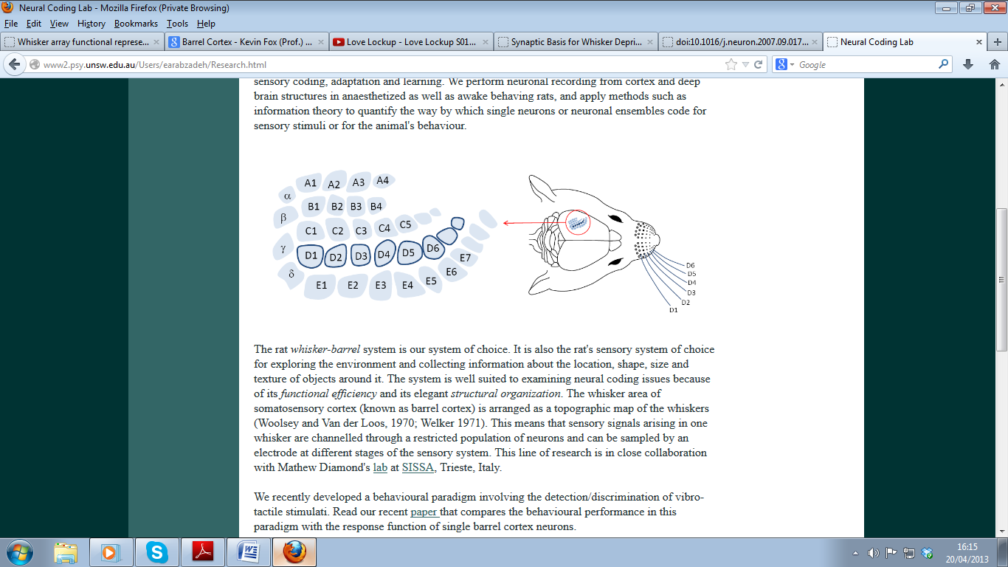
Figure 1.1 – Mapping between the rodent whisker pad and whisker barrel cortex. The individual whisker locations have been marked and can be seen to correspond to the defined barrel locations of the rat somatosensory cortex. The large whiskers on a rats face are arranged in a set pattern. They consist of five rows labelled A to E, A located dorsally, E ventrally. Within each row the whiskers are numbered in a caudal to rostral direction. This figure is adapted from Fox et al., (2008).
Within an experimental set up, the whiskers (on the whisker pad) can be easily stimulated and act as functional localisers of the ‘barrel’ cortex region within the somatosensory region.

Optical Imaging
One way in which the underpinnings of fMRI and cerebral haemodynamics in general have been investigated is through optical techniques in animal models. Indeed, the Sheffield laboratory has shown through numerous studies that optical imaging is a good method to be able to investigate cortical haemodynamics using the whisker ‘barrel’ region following stimulation (of whisker pad) and spontaneous recordings.
Optical imaging is a technique where basically video images are taken from the surface of the brain. Optical properties have been seen to change when the cortex becomes activated through sensory stimulation. The cortical changes are due to changes that occur in blood volume, blood oxygen saturation and the light scattering properties of the activated tissue. The cortical changes can be detected by a charge coupled device (CCD) camera.

Two Dimensional – Optical Imaging Spectroscopy (2D-OIS)
2D-OIS allows for the simultaneous measurements of blood volume and oxygenation levels and can be used to record these blood based changes simultaneously with neural activity within the brain. Within the Sheffield laboratory, 2D-OIS is used to localise the whisker ‘barrel’ region and to measure the haemodynamic changes from this cortical region. 2D-OIS is performed by illuminating the cortex with four different wavelengths of light (575, 559, 495, 587nm) (more details in the methodology chapter). The number of wavelengths allows for better discrimination between blood volume (Hbt), oxyhaemoglobin (HbO₂) and deoxyhaemoglobin (Hbr) (Berwick et al., 2005). In addition to measuring the blood volume, 2D-OIS also allows for spatial visualisation of the cortical region, where maps showing the haemodynamic changes occurring in the cortical surface (Berwick et al., 2008). Thus, 2D-OIS can make measurements of cortical haemodynamics at high spatial and temporal resolution and this is ideally suited to study spontaneous cortical haemodynamics such as vasomotion.

Manipulations of systemic physiology
As identified there are vascular fluctuations present within the cerebral haemodynamics such as vasomotion and it also been established that systemic changes in blood pressure is able to alter the magnitude of this fluctuation. Therefore, this study will look into methods that involve manipulating the magnitude of vasomotion fluctuations and thus investigate the relation between systemic physiology and vasomotion. Indeed, as highlighted previously Hudetz et al., (1992) was able to show considerable reductions in the magnitude of spontaneous oscillations in blood flow whilst low levels of mean arterial pressure were created through haemorrhagic hypotension and carotid occlusion.
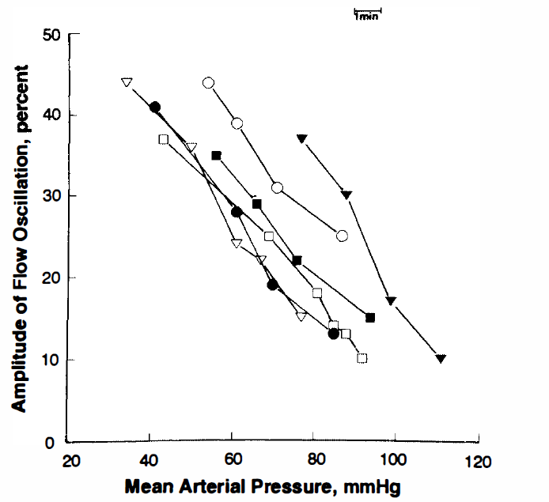
Figure 1.2 Comparison between mean arterial pressure (mmHg) and amplitude of oscillation in blood flow. Each connected symbol indicates the sequential n withdrawal of 1ml of blood. Figure from Hudetz et al., (1992)
With the amplitude of the vascular oscillations was negatively correlated with the level of mean arterial pressure, this study was able to show a concomitant relation between the two (fig ga1.2).

Manipulations of systemic blood pressure
Hudetz et al (1992) was able to show changes in systemic blood pressure through inducing haemorrhage and carotid occlusion. However, the animal preparation used in the Sheffield laboratory has an intrinsic change in the systemic blood pressure via the anaesthetic preparation used. Urethane has been commonly used as an anaesthetic in neurovascular coupling research using rodents, some key examples comprise of Mayhew et al., 2000, Jones et al., 2001, Devor et al., 2003, Jones et al., 2004, Berwick et al., 2004, Jones et al., 2005, Boorman et al 2010, Slack et al., 2016. There are several advantages to the use of urethane anaesthesia for example, it can provide a long-lasting steady level of surgical anaesthesia and has been seen to have minimal effects on autonomic and cardiovascular systems (Maggi and Meli., 1986). Animals anaesthetised with urethane can represent similar physiologic and pharmacologic behaviours to those observed in un-anaesthetised models (Hara and Harris., 2002). Despite the wide use of urethane, little is known about the mechanisms that underlie its actions. In general, urethane is known to exert its effects via enhancement of inhibitory synaptic neurotransmission in particular on the GABA receptors (Krasowski and Hudson et al., 1999), although, the effects of urethane on GABAergic transmission are not so clear (Hara and Harris., 2002). Urethane is not known to influence the central GABAergic mechanism involved in the cardiovascular functions, although it reduced the depth of the anaesthesia (Maggi and Meli., 1986). Urethane also has been known to produce only a minimal enhancement on GABAergic neurotransmission at the central nervous level (Maggi and Meli., 1986). Other than this, only a limited amount of information is available about the effects of urethane on neurotransmitter release, where, urethane has not been shown to modify the uptake or release of GABA from rat thalamus (Kendall and Minchin., 1982) making urethane a suitable for physiopharmocological studies.
However, a property of urethane exists that can be considered to a disadvantage but for this particular study can be considered fortuitous in that the administration of urethane lowers the systemic blood pressure (Maggi and Meli., 1986). A marked decrease in blood pressure was seen in urethane anaesthetised rats (Leenen and Provost., 1981). Under the urethane anaesthetic preparation, to be able to maintain the systemic blood pressure within normal physiological levels (Golanov et al., 1994, Nakai and Maeda., 1999) a drug called phenylephrine was included. Phenylephrine is an alpha (α1) – adrenergic receptor which causes a direct increase in systemic vascular resistances and arterial pressure (Thiele et al., 2011). Phenylephrine is widely used during anaesthesia for arterial pressure control (Thiele et al., 2011). Phenylephrine is not known to cross the blood –brain barrier (BBB) (Olesen., 1972) with extracranial pathways being able to auto-regulate cerebral blood flow in response to phenylephrine-induced changes in mean arterial pressure or cardiac output. Rapid changes in mean arterial pressure are postulated to activate a sympathetically mediated reflex from the superior cervical ganglion, causing cerebral vasoconstriction (Cassaglia et al., 2008).
A study by Meng et al., (2012) proposed that the flow velocity in arteries is increased by a phenylephrine- induced increase in perfusion pressure. At the same time, the arterioles regulating CBF constrict due to stretch or increased transmural pressure-mediated vasoconstriction (Meng et al., 2012). Cerebral vasoconstriction is therefore thought to be a product of indirect autoregulation-mediated consequence, as phenylephrine does not cross the BBB and it cannot constrict the blood vessels directly (Olesen., 1972), this is illustrated by fig 1.2.1 which shows hypothetically how phenylephrine treatment can induce vasoconstriction.
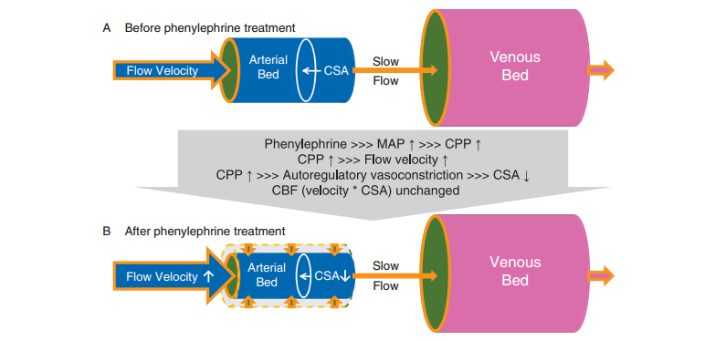
Fig 1.2.1 – Hypothetical explanation of how phenylephrine treatment induces cerebral auto-regulatory vasoconstriction in blood vessels. CSA: cross-sectional area; MAP: mean arterial pressure; CPP: cerebral perfusion pressure; CBF: cerebral blood flow. Figure taken from Meng et al., (2012).

The mechanisms of how phenylephrine can induce cerebral vasoconstriction is quite complicated. However, a recent finding by Cassaglia et al., (2008 & 2009) has shown that the sympathetic nerve activity (SNA) from the superior cervical ganglion is increased after pharmacological induction of phenylephrine which creates a large increase in arterial pressure; suggestive that SNA plays a role in cerebral circulation regulation (Meng et al., 2012). Increased levels of SNA to the brain leads to cerebral vasoconstriction and further prevents over-perfusion and haemorrhage (Cassaglia et al., 2008 & 2009).

Manipulations with oxygen levels in the brain
With this in mind, an increase in oxygenation in the brain tissue might also have effect on the vasomotion. Increasing oxygenation or exposing the tissue to an excess of oxygen (O₂), also known as hyperoxia has the ability to increase brain tissue partial pressure of oxygen (pO₂) (Hlatky et al., 2008) as well as increase arterial oxygen tension and the oxygen gradient between capillaries and cerebral tissue without concurrent systemic alterations (Longhi et al., 2002). Studies investigating hyperoxia, in particular a study by Wolf et al, (1997) showed that increasing oxygen supply to the brain (inducing hyperoxia) increased blood oxygenation.

What if any of these manipulations cause changes in neural activity?
Whether systemic parameters such as changes in blood pressure or hyperoxia can cause changes in ongoing local field potential (LFP) neural activity or cortical state have seldom been investigated. However, it is well known that some systemic alterations can change cortical state. For instance Jones et al., (2005) showed that the effects of hypercapnia (elevated of carbon dioxide (CO₂) on ongoing neural activity and found periods of cortical arousal (desynchronisation) state. The desynchronised brain state is described as having high frequency and low amplitude neuronal oscillations (Steriade et al., 2001), while synchronised brain state is described as having large amplitude and low frequency neuronal oscillations. These changes in cortical state have been noticed as early as 1949, by Moruzzi and Magoun, which showed that the brain can interchange between quiescence (synchronised) and activation (desynchronised). Similarly, Harris and Thiele., (2011) also made suggestions that brain states can change between the two states spontaneously. Of particular relevance is that the desynchronised state has been seen to be associated with increases in baseline haemodynamics (cerebral blood volume, CBV) and blood oxygen saturation (Slack et al., 2016). Similarly, Kennerley et al., 2012 was able to find that induction of hypercapnia also caused desynchronisation in the neural activity following sensory stimulation. The knowledge regarding brain states, is regarded to be important as many brain imaging techniques are widely used in humans and ultimately, conditions that could deviate from baseline brain function (Lecrux and Hamel., 2016).
As stated, whether manipulating systemic blood pressure could alter cortical state has seldom been investigated. However, one mechanism in which systemic blood pressure levels could be communicated to the brain is via baroreceptors. Blood pressure is constantly monitored by the body and tightly adjusted constantly to meet the needs of your body. This monitoring is performed by baroreceptors, which are able to detect changes in blood pressure (Akselrodt et al., 1985) and influence respiratory function (Schmidt., 1932). Baroreceptors are found within the walls of the blood vessels. The baroreceptor in the carotid sinus transmits information to the central nervous system. If blood pressure within the carotid sinus increases, the baroreceptors are stimulated with the information being sent to the medulla which can work to decrease blood pressure back to normal levels. Baroreceptors are a type of mechanoreceptors which has specialised nerve endings that are built to detect a change in pressure or tension and relay that information to the brain through neurons in the nervous system (Akselrodt et al., 1985). Mechanoreceptors are present within the blood vessels so that the brain is able to understand where the blood is flowing and what the pressure is in different parts of the brain. As baroreceptor activity has been related directly to levels of arterial pressure and the response to baroreceptors activation leads to reciprocal changes in sympathetic outflow, it was quickly recognised that baroreceptors constitute an important mechanism in the control of arterial pressure (Heymans & Neil., 1958). Ever since the work of Cushing in 1901 that found the existence of brain baroreceptors capable of eliciting increases in sympathetic outflow and blood pressure has been hypothesised (Mc Bryde et al., 2016).
Arterial baroreceptors provide the afferent input to a
medullary circuit that controls sympathetic drive to the
heart and peripheral vasculature. As baroreceptor activity
is related directly to the level of arterial pressure and the
response to baroreceptor activation leads to reciprocal
changes in sympathetic outﬂow, it was quickly recognized
that baroreceptors constitute an important mechanism
in the control of arterial blood pressure (Heymans &
Neil, 1958).
The possibility of cortical state changes with accompanying changes in haemodynamics highlights the need to measure ongoing electrophysiological activity (e.g. LFP) investigating vasomotion. Studies in Sheffield laboratory have used concurrent multi-laminar electrophysiological recording and 2D-OIS to investigate research such as neurovascular coupling (Martindale et al., 2003, Jones et al., 2004, Hewson-Stoate et al., 2005, Jones et al., 2005, Jones et al., 2008), and have also proved successful in measuring ongoing LFP (Jones et al., 2008, Slack et al., 2016).

Local field potentials (LFPs) as a measure of cortical state
Measurement of Local field potentials (LFP) allow as cortical states to be easily identified by observation of the ongoing LFPs rather than other neural metrics. Indeed, Jones et al., (2008) and Slack et al., (2016) showed that cortical state changes were easily observed in LFP. The activation of different types of neuronal circuits and neurons is able to produce a wide range of electrophysiological activity. LFPs, typically represent exclusively slow events reflecting cooperative activity in neural populations (Logothetis., 2003). The LFPs primarily reflect a weighted average of a strong dendrite activated by synchronous neural activity from a population of pyramidal cells (James and Stevenson., 2012). In pyramidal cells, the majority of dendrites run vertically down through the cortex (perpendicular to the cortical surface), this then generates a maximum LFP signal (Legatt et al., 1980, Logothetis and Wandell., 2004). LFPs measure the sub-threshold neural activity, which includes synaptic processing. LFP’s of significant amplitudes can be found in the low frequency range (30-130Hz).

Measurement of Tissue Oxygenation
Although 2D-OIS allows measures of blood oxygenation making inferences about actual oxygen delivery to the brain is difficult as the relationship between blood and brain is complex (e.g. Zheng et al., 2002). As one of the ideas about the function of vasomotion relates to oxygen delivery, it is important to know the levels of brain tissue oxygenation when investigating vasomotion.
Indeed, the key aspects of microcirculation is being able to supply adequate amounts of nutrients and oxygen to tissues and clearing unwanted metabolic by-products (Pradhan and Chakravarthy et al., 2011). Where numerous studies have been performed to understand substance exchange in various tissues, little is known about the contribution of vasomotion to the regulation of microcirculation (Pradhan and Chakravarthy., 2011). Although, an intriguing suggestion is that vasomotion can enhance tissue oxygenation (Tsai & Intaglietta., 1993, Sakurai & Terui., 2006).
To be able to understand vascular fluctuations such as vasomotion, 2D-OIS would provide a measure of blood volume (Hbt), oxyhaemoglobin (HbO₂) and deoxyhaemoglobin (Hbr) and oxygen saturation levels in the blood from the somatosensory whisker ‘barrel’ cortex. Systemic parameters such as blood pressure have been identified to be able to measure changes in the magnitude of vasomotion. In addition to 2D-OIS, the electrophysiological recordings will be taken from the same cortical region to be able to get a measure of ongoing local field potential (LFP) and through this would be able to see if changes in neural activity are related to systemic changes. As identified, measurements of blood based changes in the brain can be taken; however, a good question would also be if the systemic manipulations have an effect on tissue oxygenation?

Brain tissue oxygenation
The mammalian brain is a highly oxidative organ and although it only makes up for a small percentage of total body weight (2%), it accounts for a disproportionately large percentage of total bodily oxygen consumption (20%) (Rolfe & Brown, 1997). Oxygen is essential component in maintaining normal brain function, in fact a large body of evidence suggests that the partial pressure of oxygen (pO₂) in brain tissue physiologically maintained within a narrow range in accordance with region –specific brain activity (Masamoto., 2009).
As identified in a previous section (BOLD fMRI), the fundamental basis of BOLD fMRI signal is centred on inferring changes in blood oxygenation and deoxyhaemoglobin, although this measure might not truly reflect the increase in oxygen consumption (Hathout et al., 1999). It seems that a more direct measure of brain oxygenation might be needed to be able to understand tissue oxygen (O₂) levels in the brain.
The MRI signal intensity is sensitive to the amount of O₂ carried by haemoglobin: so a change in the amount of O₂ can change degree of increase in the haemoglobin oxygenation and greater deoxygenation leading to the BOLD response (Westerink and Cremers., 2007). As oxygen delivery from blood to brain is complex (Zheng et al., 2002) oxygen delivery is difficult to infer from measuring blood oxygenation alone and a measure of tissue oxygenation is also useful for inferring oxygen delivery during different perturbations of systemic physiology.

Measurement of brain tissue oxygenation: early studies
Since the pioneering efforts with microelectrodes of Davies and Brink in 1942, the oxygen tension in the brain has been measured using a variety of techniques. Electrode measurements of brain tissue oxygen have been made for over half a century with Clark et al.,(1953) being the first to use metal polarographic cathodes implanted into the brains of cats to continuously measure oxygen availability in the brain tissue of un-anaesthetised animals. Clark et al.,(1953) was able to observe cyclic fluctuations in oxygen availability which bore no resemblance to fluctuations in respiration, heart –rate or blood pressure. Travis and Clark.,(1965) implanted platinum cathodes into various cortical regions in the rat brain. The amplitude of the oxygen responses were seen to be varied across brain regions, through increases in oxygenation were commonly observed. In contrast, recent studies using optical methods have demonstrated that the first event after sensory stimulation in the human cortex is a fall in pO₂ (i.e. a rise in oxygen consumption) which is then rapidly followed by an increase in blood flow and tissue oxygen level (Vanzetta and Grinvald., 1999). More recent studies examining tissue oxygen within the somatosensory cortex have been able to demonstrate a stimulus evoked increase in tissue oxygenation (Ances et al., 2001).

Oxygen tissue measurements
Measurements made by polarographic electrodes have until lately been considered as the ‘gold standard’ for measuring oxygen tension (Stone et al., 1993). Oxygen electrodes for the measurement in tissue have traditionally been used using Clark’s electrode (Clark., 1958). Although, a disadvantage is that the electrode consumes oxygen during measurement process, therefore to obtain reliable measurements, O₂ consumption by the electrode should be minimal compared to the O₂ tension within the tissue, otherwise the electrodes alter their own O₂ environment (Brizel et al., 1994, Carreau et al., 2011).
To overcome such limitations of polarographic electrodes, in which O₂ consumption of the electrode could affect the signal itself (Shaw et al., 2002), an alternative technique could be to use a technique based on fluorescence quenching, which would provide a way to overcome the limitations of the current polarographic technique. Fluorescence quenching works as oxygen will quench fluorescence; it does this by colliding with the fluorescent molecule when the latter is the excited state. Since the number of collisions will be proportional to the amount of oxygen present per unit volume, this phenomenon can be used to measure the amount of oxygen in the solution (Oxford Optronix Ltd). The process of fluorescence quenching does not consume the quencher as does the polarographic method, making this technique have a clear advantage over polarographic methods. Therefore I will use the fluorescence quenching method to measure the tissue oxygen partial pressure (pO₂) measurements from the somatosensory whisker ‘barrel’ cortical region of the rat brain.

Inclusion of tissue oxygen measurement in studies
Breathing elevated levels of O2 (hyperoxia) can enhance tissue oxygen supply by increasing the blood oxygen content (Cheng., 2012). To investigate the regulation of local oxygen supply in the cortex (rabbits) during arterial hyperoxia, Wenzel et al., (1999) measured tissue oxygen tension alongside with local cerebral blood flow using near – infrared spectroscopy. An increase in tissue oxygen tension during hyperoxia was reported.

Tissue oxygen and vasomotion
An accurate estimation of the pO₂ within the tissue is physiologically important for understanding many functional aspects of microcirculation, including possible influences of vasomotion on tissue oxygenation (Prakash and Chakravarthy., 2011).To address the relation of vasomotion to tissue oxygenation, Rücker et al., (2000) devised a study where the metabolic state of tissues can be assessed in the rat hind limb. A reduction in perfusion saw an increase in vasomotion suggestive that it could be present to promote oxygenation. The idea that vasomotion could be beneficial for tissue oxygenation, especially in situations where perfusion is critically limited (Nilsson and Aalkjaer., 2003, Turalska et al., 2008) could be a noteworthy aspect of vasomotion that would require more experimental evidence.

Tissue oxygen probe used within studies in this thesis
To measure tissue oxygen levels in the somatosensory whisker ‘barrel’ cortex alongside 2D-OIS and electrophysiology, a tissue oxygen sensor was used. A commercially available method that uses fluorescence based technique (pioneered at Oxford Optronix Ltd) was used. The oxygen sensor is intended to measure the pO₂ in regional tissue.

Final Summary and aims
The brain is highly dependent on a highly regulated vascular supply for rapid, on demand regional delivery of oxygen (Hudetz et al., 1987). Being able to understand how changes in vasculature occur within the brain is important. The brain being a complex and dynamic system it is capable of generating multitudes of oscillatory waves in the blood in support of brain function. Investigations in haemodynamic fluctuations such as vasomotion could help in understanding many aspects of brain function, such as cerebral autoregulation, relation to systemic parameters such as blood pressure and tissue oxygen supply. Investigations into vasomotion could show how fluctuations such as vasomotion could affect modern brain imaging techniques and analysis such as resting state fMRI and connectivity mapping respectively.
The aims for this thesis are:
- Identify the vasomotion oscillation (~0.1Hz) within the spontaneous cortical haemodynamics and within spatial analysis measured with 2D-OIS
- Assess the relation between the magnitude of vasomotion oscillations and changes in systemic blood pressure.
- Measure ongoing electrophysiological recordings of LFP to assess changes in neural activity
- Assess the relationship between the magnitude of vasomotion oscillations during differing levels of oxygen tissue levels

Therefore, in this thesis, I will measure vasomotion and neural activity in the rodent somatosensory whisker ‘barrel’ cortex with 2D-OIS, multi-channel electrode and tissue oxygen sensor probe.
In chapter 3, the investigation of the magnitude of vasomotion and systemic blood pressure will be conducted.
In chapter 4, the investigation of vasomotion and blood pressure will be conducted as well as the induction of hyperoxia to be able to increase the amount of oxygen in the brain. The relation between vasomotion and hyperoxia will be assessed.
In chapter 5, the experimental paradigm (used in chapter 3 & 4) will be repeated, but with the addition of a tissue oxygen probe. Tissue pO₂ measurements with a tissue oxygen sensor in combination with simultaneous recordings of neural activity and local cerebral blood volume in an anaesthetized animal model, within the somatosensory whisker ‘barrel’ cortex of a rat.

Methodology

Abstract
This chapter provides the background information on the materials and methods used in the experimental procedures, reported in this thesis. All methods were performed in compliance with the Home Office Animals Scientific Procedures Act 1986. The methods used for monitoring and controlling the animals’ physiology are also detailed. The theory, method of application, configuration of equipment, details of data acquisition and analyses are presented. All surgery and experiments were non–recovery, under terminal anaesthesia. On completion of experiments, animals were euthanised using schedule 1 technique (Home Office Act 1986) of overdose followed by cervical dislocation.

Animal Preparation

Animals
Female Hooded Lister rats weighing between 250-330g were used in all experiments. Animals were kept in a 12 hour dark/light cycle at a temperature of 22◦ C, with food and water supplied ad libitum. Female rats were chosen for these experiments due to many logistical purposes for example; smaller increases in weight have been recorded across rats and throughout the experiment timeline and the position in the estrus cycle has been shown to not affect the animal’s response to urethane (Golder et al., 2003).

Surgery Preparation
Rats were first placed into an anaesthesia induction chamber for about ~30s, whilst isoflurane a gaseous anaesthetic was administered (at 3%) with medical air (21% oxygen, 79% nitrogen) through anaesthetic machine. The brief use of isoflurane ensured that the animals experienced minimal stress during the administration of anaesthesia, urethane.
Animals were anaesthetised with urethane at 1.25g/kg (intraperitoneally,IP). Additional doses of 0.1ml urethane were administered if required. The depth of anaesthesia was monitored throughout the surgical and experimental stages using the hind paw pinch reflex and blink reflex. Urethane is known to have a number of advantages; it is a long lasting and stable anaesthetic. Regarding its suitability, urethane is apt for measuring neural and vascular responses as it is known to produce minimal cardiovascular and respiratory depression. Urethane anaesthesia is also known to include a high degree of analgesia. Atropine (0.4mg/kg) was administered to reduce mucus secretion, as under anaesthesia excessive respiratory secretions could be build-up within the animal. Animal temperature (37◦C) was maintained using a homoeothermic blanket (Harvard Apparatus, UK) and monitored with rectal temperature monitoring during surgery and experimental procedures.

Surgery
I was trained to perform all surgical techniques described in this chapter by senior members of the team. All data collection was carried out by myself with the guidance and troubleshooting assistance from: Dr Jason Berwick, Dr Sam Harris, Dr Luke Boorman and Dr Myles Jones. All surgical tools used, including clothing and equipment were sterilised and checked before the experimental procedures took place.

Tracheotomy and Ventilation
Animals were tracheotomised to facilitate artificial ventilation and recording of end-tidal CO₂ (CWE systems Inc.). Each animal was first placed on its back (supine position) and with forelimbs secured to the operating table for ease of access to the trachea. First, a swab of sterile saline was used to clean the neck area. Using a scalpel, a ~20mm incision was made from approximately 10mm below the mouth to the top of the rib cage. Following this, a blunt dissection was created in the superficial skin and the overlying muscle to expose the trachea. A short length of suture was loosely placed around the trachea. Using micro scissors, a small incision was made in the trachea between two cartilage rings. Holding the trachea with forceps, a bevelled cannula (Portex 2.8mm, outer diameter, 40mm long) was inserted into the incision. The cannula was then secured in place with the loose suture previously placed around the trachea. Once the normal a breathing rhythm had been confirmed the surrounding tissue and skim was sutured to close the incision and further hold the cannula in place. This procedure allowed for subsequent ventilation for the animals and to maintain normal physiological limits of blood oxygen saturation and CO₂ levels.

Vessel Cannulation
The left hand side femoral artery and vein were cannulated to allow for the measurement of mean arterial blood pressure (artery) and allow for intravenous infusion of phenylephrine (vein) at 0.13 to 0.26mg/h being able to maintain MABP within normal physiological levels.

Procedure
To start the surgical section to carry out the cannulation, first the hind limbs were secured onto the operating table with tape. First a swab of sterile saline was used to clean the incision area. Using a scalpel, an incision (~30mm) was made from the top of the thigh in a 45◦ downwards direction towards the midline of the animals (rostro-medial direction). The incision was then further exposed using a blunt dissection, removing the fat and fibrous tissue. Once clear access to the femoral artery and vein was made, both were separated and extra tissue (fissure) removed. First the vein vessel was sutured as far distally as possible from the hind limb; this was done to prevent blood escaping from the downstream vessel. A sprung micro-clamp was then placed at the proximal end of the vessel, to prevent blood escaping. Using sprung micro scissors, a small V-shaped incision was made in the vessel approximately ~20mm from the placement of the micro-clamp. A pre–bevelled cannula was then inserted into the V-shaped incision, once the cannula was inserted within the vessel the sprung micro clamp was removed which allowed the cannula to be pushed further into the vessel (~ 10mm). The cannula was then secured with sutures at both ends of the vessel. The above steps were then repeated for the artery. Once vessels were successfully cannulated and secured the main incision was sutured and sealed with suture and glue (Cyanoacrylate, Locitite). Both cannulas were attached to a 1ml syringe, filled with 50 units of heparin per ml of saline. The heparin was included to prevent clotting of the blood inside the small bore cannula.

Thinned Cranial Window
The thinned cranial window is a translucent area of the skull which allows for direct optical imaging over the cerebral cortex of the animals. Animals were secured in position via a stereotaxic frame (Kopf Instruments, Inc.), and metal bars were inserted into the ear canals either side to hold the head in place and a bite bar with an adjustable clamp to secure the upper jaw. An incision was then made using a scalpel down the midline of the head, with blunt dissection used to remove the fascia and skin tissue, to expose the surface of the skull. In order to expose this area, the temporalis muscle covering the lateral aspect of the right hand side of the skull was pulled back and sutured to the side. The skull overlying whisker ‘barrel’ cortex was thinned to translucency (bone approximately 100-200um thick), allowing the vasculature to be observed while preserving the integrity of the brain surface. Thinning was performed using dental drill, and saline was applied to cool the skull during drilling. Once the bone had been thinned evenly, the vessels covering the cerebral cortex became visible. The bones sutures and window edges were sealed using superglue, which aids in maintaining the structural integrity and preventing ‘leakage’ of blood from small surface vessels. Once the glue had dried a cannula similar to that used for the cannulations of the femoral vein and artery was affixed to the skull, with only 5mm of the cannula overlying the cortex, so as not to obstruct the thinned cranial window. A plastic chamber (in–house design, 17mm interior diameter) was placed over the window and attached with dental cement to produce a watertight seal containing the thinned window area. The chamber was then filled with saline (~20◦C) to maintain a constant level of saline and also to prevent optical specularities from the skull’s surface corrupting the data.

Management and monitoring of physiology
Following attachment of well, the surgery was considered complete. The animal was then placed (attached to the stereotaxic frame) into a faraday cage, which is a large metal cage that surrounds the equipment. The cage is earthed and acts to exclude electrostatic or electromagnetic influences.

Artificial ventilation
All animals were first put under artificial ventilation. A ventilator was used to control the subjects breathing and indirectly the blood oxygen saturation levels, which is essential for reliable experimental results. Subjects were artificially ventilated at 70-80(1.15-1.3Hz) breaths per minute using an animal lung ventilator (Zoovent, Harvard Ltd). The ventilator required compressed air at a maximum pressure of 4 bar. The compressed air was filtered and supplied from an air compressor (150/500 BAMBI) and was medical grade air (21% oxygen, 79% nitrogen). The natural breathing rate for each subject was monitored and the ventilator breathing rate adjusted to match, before starting the artificial ventilation. Controlling the breathing rate helped to maintain normal blood oxygen saturation which is an essential component to this experimental study which examines vascular responses, and is also important to maintain the health of the anaesthetised animal throughout the experiment.

Blood oxygen saturation
End-tidal CO₂ (CWE systems) monitoring and blood gas measurements were taken to allow correct adjustment of ventilator parameters and to keep the animal within physiological limits (normally between 70-80 breaths per minute). Blood gas measurements were performed by letting approximately 120µl of arterial blood into a heparin-coated glass capillary tube (3mm outer diameter, Chiron Diagnostics). The blood was analysed using a blood gas analyser (ABL Radiometer, Copenhagen), which measured pCO₂, pO₂ and sO₂. If the analysis had found the values to be outside the nominal ranges, experiments were stopped and the ventilator parameters were adjusted until the blood gases returned to normal levels.

Arterial blood pressure
Mean arterial blood pressure (MABP) was constantly monitored throughout all the experimental stages. MABP is the average arterial blood pressure and this is calculated using the following formula:
MABP = Systolic blood pressure + 2 x (Diastolic blood pressure)
3
MABP was measured using a diaphragm unit containing 50 units of heparin per ml and attached to the end of the arterial cannula. The diaphragm unit was connected to a pressure transducer (NL108T1, Neurolog). This signal from the transducer was amplified (NL108, Neurolog) and fed into a high speed data acquisition system (Plus 1401, Cambridge Electronic Devices (CED) Ltd), which was connected to a computer. The MABP was recorded and real time visualisation of changes could be made using Spike2 software for all experiments.
Note:
It is important to note that during the experimental paradigms presented, the lowered MABP levels is within normal physiology as hypotension is not being induced in the rat model; similarly, increasing blood pressure (following phenylephrine infusion) does not create hypertension.

Concurrent 2D-OIS, multi-channel electrophysiology and tissue oxygen probe
To measure the blood based changes, 2D-OIS was used. To measure neural activity, a multi-channel electrode was used. A tissue oxygen probe was used to measure tissue oxygenation levels. All three techniques will take measurements from the rat somatosensory whisker ‘barrel’ cortex. The following sections will describe the theory and analysis of each of these techniques in detail.

Optical Imaging Spectroscopy (OIS)
Two-dimensional Optical Imaging Spectroscopy (OIS) is a well-established technique that uses the absorption spectra of oxyhaemoglobin (HbO₂) and deoxyhaemoglobin (Hbr) to approximate the changes in blood volume (Chance, 1991). Hence this technique has been termed 2D-OIS. This has been used previously in many studies carried out at the Sheffield laboratory (Berwick et al., 2005, Berwick et al., 2008, Boorman et al., 2010, Jones et al., 2008, Bruyns-Haylett et al., 2013., Slack et al., 2016). Although 2D-OIS is limited in its depth resolution of the cortical surface, it does boast of some advantages of being significantly cheaper to investigate blood based changes in the rat model and has good spatial and temporal resolution compared to BOLD fMRI. In addition, 2D-OIS can be combined easily with other techniques such as electrophysiology (see section 2.6) and tissue oxygen measurements (see section 2.7).

Theory of 2D-OIS
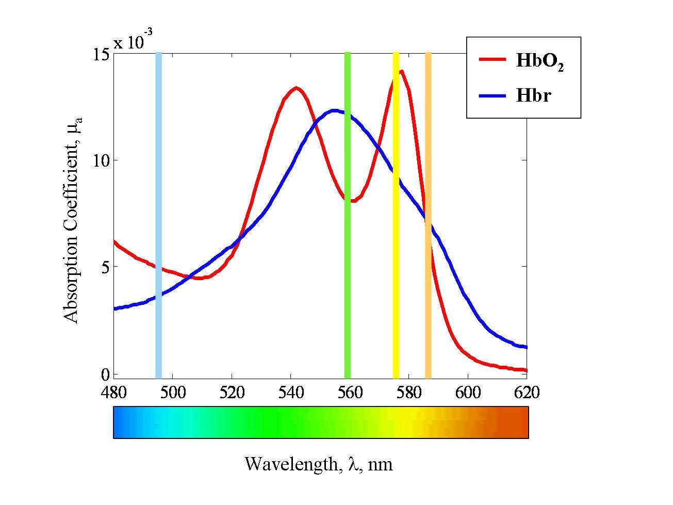
Different wavelengths of light have different absorption coefficients (ε) for HbO₂ and Hbr. The 2D-OIS technique applied here uses four different wavelengths (495nm, 559nm, 575nm, 587nm at full width half maximum, FWHM). The wavelengths were carefully chosen to maximise the differential absorption spectra of HbO₂ and Hbr (figure 2.1).
Specific Absorption Coefficient, ε

Supposing white light will have an intensity of I_{o} shines upon the sample (such as the cortex), some of the light will be absorbed by the sample and the rest of the light will be remitted at an intensity of I, which can be measured. Therefore, the attenuation (level of absorbance) can be calculated as long as the photons of light are not assumed to scatter. However, within a medium such as brain tissue, the fact that photons of light will scatter is assumed, therefore creating longer path lengths than in a non-scattering medium. The calculation of the path lengths in this instance cannot be exact, as an ongoing measurement of the pathways, that the photons of light take through the brain tissue is not possible. Instead, a Monte Carlo simulation (MCS) model estimates the unknown differential path length ($∆l$) that a photon of light would take at different concentrations of absorbents (∆c) taking into account the different scattering angles (u) and therefore scattering coefficients ($µ_{s}$) that may occur. This is related to the differential attenuation ($∆A)$.
Figure 2.1 – Simplified HbO₂ and Hbr absorption spectra adopted from Kennerley (2006). The spectra for the absorption co-efficients (ε) of Oxy (HbO₂) and deoxy (Hbr) haemoglobin can be observed on the y-axis, withwavelength (nm) is shown on the x-axis (λ). The four wavelengths (495, 559, 575, 587nm) have been highlighted as coloured vertical lines.

Monto Carle Simulations of path length
The MCS used in this experimental study uses a ‘random walk’ function, where each step in the path of the photon has a non-isotropic angle (fig 2.2). The simulation creates estimations of how many steps a photon will take before it is remitted. In figure 2.2, the green path length is shorter as it only takes one step before being remitted whereas; the blue path length has four steps in it. Therefore, the scattering coefficient (µ_{s}) of the two will be different: the blue scattering coefficient will be larger than the green scattering coefficient. To estimate the path length, the MCS algorithm requires the angle of scattering (g) as well as the aforementioned scattering coefficient (µ_{s.}).
The angle of scattering (u) can be estimated. The Henyey-Greenstein probability function can be used to create a weighting factor, g:
$g=\int_{0}^{2π}{\cos{ϑ.p\left(ϑ\right).dϑ}}$ (1)
If g = 0, random erratic movement is expected
g = 1, no scattering occurs
g = -1, the photon reverses its previous movement
Within the model, the scattering angle of g = 0.85 is assumed, which should ensure a large proportion of forward scattering (Cope and Delany, 1988). The assumption is based on in-vivo measurements by Johns et al., (2005) that indicate that the scattering is largely homogenous over a superficial 1.5mm of cortex that the 2D-OIS is known to be most sensitive to.
The following equation is used to create the scattering angle, (u) by calculating a randomised weighting (t) for each path length, where s is a randomly generated number.
$t=\frac{(1+g^{2}- {(\frac{1-g^{2}}{1+\left(g*s\right)})}^{2}}{2*g}$ (2)
$∴u=arccos⁡(t)$ (3)
The scattering angle, (u) can be used to create the reduced scattering co-efficient $µ_{s}‘$.
$µ_{s}‘ = µ_{s}(1-u)$ (4)
Once the scattering co-efficient has been created, it is used within the MCS to create a density function $φ\left(x\right)$of path lengths, that can be binned into segments$\left(x\right)$. Again, in Fig 2.2, L1 has two paths, and L2 has 5. An exponential decay function is included that includes the baseline attenuation coefficient, μ_{a}. The density function can therefore be used to calculate the differential path length:
$∆l=\frac{\int_{0}^{∞}{φ\left(x\right)*x*e^{-xμ_{a}}dx}}{\int_{0}^{∞}{φ\left(x\right)}.dx}$ (5)
Different wavelengths will have altered differential path lengths ($∆l\left(λ\right)$). These different path lengths will be used within a modified Beer-Lambert equation where
$∆A\left(λ\right)=∆l\left(λ\right).\left(ε_{{HbO}_{2}}\left(λ\right).∆\left[Hbo\right]+ε_{Hbr}\left(λ\right).∆\left[Hbr\right]\right)$ (6)
Within this equation presented, the change in attenuation is a measured variable for each wavelength of light used ($∆\tilde{A}\left(λ\right)$), the path lengths for the wavelengths can be calculated as detailed above ($∆l\left(λ\right)$) and the specific absorption coefficients (ε) for oxy (HbO₂) and deoxy (Hbr) haemoglobin are known for the different wavelengths (see Fig. 2.2), this leaves equation 6 with two unknowns; the change in the concentration of HbO₂ ($∆\left[HbO2\right]$) and the change in the concentration of Hbr ($∆\left[Hbr\right]$). Using four wavelengths generates four equations, whereby it becomes possible to solve for the unknown concentrations by way of simultaneous equations.

Light Source (I_{O})
Remitted light (I) captured by the CCD camera
L₂
L₂

Cortical surface

Figure 2.2 – The random paths that photons of light may take within a tissue sample. The two photons of light are remitted (neither are absorbed). However, the path lengths of the two photons is different, with L₂ having a longer path length than L₁. Figure adapted from Kennerley (2006)

Using a homogenous or heterogeneous tissue model
Initially, it was assumed that the baseline levels of cerebral blood volume (Hbt) and oxygenation (HbO₂) and the resultant changes of these variables were same throughout the layers of tissue. However, the brain actually displays a heterogeneous distribution of vascular structures (Pawlik et al., 1981) which indicates that the model needed to update to be able to improve the estimation accuracy. Work carried out by Kennerley et al., (2009) used fMRI data to parameterise a layered heterogeneous tissue model. In the heterogeneous model, a reduced scattering coefficient is given by the following equation from Van der Zee et al., (1992):
$µ_{s}‘ \left(λ\right)=2.7*{\left(\frac{λ}{560}\right)}^{-1}$ (7)
Therefore the coefficients that vary as the layers vary are as follows:
- The coefficient of absorption ($µ_{a}$). Rather than being a single homogenous value, $µ_{a}$ now has five values, each value for one of the previous five layers in the model.
μ_{a}(λ) ∝ (ɛ_{Hbo}(λ)Hbo + ɛ_{Hbr}(λ)Hbr) (8)
- Baseline values of total haemoglobin (Hbt₀)
- Baseline values of oxygen saturation (Hbo₀)
The total blood volume/haemoglobin is a summation of the values for the oxy and deoxy haemoglobin together:
$∆\left[Hbt\right]=∆\left[Hbo\right]+∆\left[Hbr\right]$ (9)
The baseline haemoglobin concentration was estimated as 104µmol; while the average baseline blood saturation was calculated on a pixel by pixel basis with an average saturation of 50% (Berwick et al., 2008).

Application of the 2D-OIS
Following surgery, the optical imaging system was set up. The cortex was illuminated with a white light source (400 watt halogen) and this was filtered through a switching galvanometer system (Lambda DG-4, Sutter Instruments Company). The four wavelengths described above were presented sequentially as follows: 575, 559, 495 and lastly 587nm. This provided the required spectrographic sequence, with each filter giving enough information to extract estimates of Hbt, HbO₂ and Hbr changes, as well as blood oxygen saturation values. Each wavelength was presented 8 times a second, and recorded with a 32Hz camera. This resulted in an overall sampling rate of 8Hz (32/4).The remitted light passed through a lens (focal length 100mm, Leica) then followed by a microscope with magnification 0.63-6x (MX9.5) and finally into a charge coupled device (CCD) camera recording at 32Hz (Dalsa 1M30P, Silicone Mounted Design: SMD, USA). The camera operated in a 4x4 binning mode. The size of the thinned cranial window provided the restraints for the size of the region of interest recorded, and was of size 128*128 pixels.

2D-OIS data analysis
The studies presented in this thesis investigated resting state activity and therefore recorded data in the absence of stimuli. Stimuli were presented at the beginning of the experimental day to be able to localise the somatosensory whisker ‘barrel’ cortex. Other experiments involving whisker pad stimulation were also carried out from the same animals, however, the data from these have been used in other projects, of which some data has been published recently; Slack et al., (2016).

Stimulus Presentation
In order to localise the right hand somatosensory ‘barrel’ cortex, the contralateral left whisker pads of animals were stimulated with stainless steel electrodes (Plastics one Inc.). A stimulation frequency of 5Hz for 2 seconds was used as it has been shown to produce the strongest haemodynamic response (Ngai et al., 1999).

Localisation of right whisker barrel cortex
An initial 2D-OIS experiment was conducted in each animal to locate the right somatosensory whisker ‘barrel’ cortex to be able to approximate cortical haemodynamics (HbO₂ and Hbr). Localisation of this area also allows for accurate placement of a multi-channel electrode (NeuroNexus Technologies Inc.) (Berwick et al., 2008).
In each animal, 1.2mA intensity electrical pulses were delivered to the whisker pad via electrodes at 5Hz for 2 seconds. 30 stimulus presentation trials were collected and each stimulus was presented after 5 seconds (this duration allowed for the haemodynamics to return to baseline prior to initiation of the next stimulus). To localise areas of activity (i.e. the contralateral whisker ‘barrel’ cortex), an in-house software tool which contains a pre- programmed design matrix optimised for the typical haemodynamic responses expected for specific whisker stimulation paradigms (fig 2.3B- shows the activation map). Activation maps were generated and co-registered with camera images of the cortical surface, to enable accurate insertion of an electrode, to a depth of 1600µm. Insertion of the electrode involved drilling a very small hole in the thinned skull directly above the detected activation area (overlying the whisker ‘barrel’ region), piercing the dura with a fine needle, and then inserting the multi-channel electrode (fig 2.3A-B). For chapter 5, an oxygen sensor probe was inserted (~500µm) into the same cortical region to measure tissue oxygen levels from the whisker ‘barrel’ cortex (fig 2.3C-D).

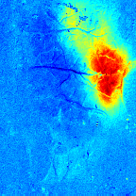
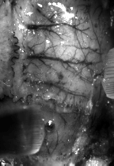
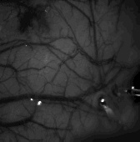
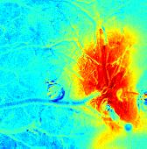
D
Stimulation of whisker pad creates changes in total blood volume (Hbt) in the contralateral whisker ‘barrel’ region
A
Grey scale image taken during experiment with electrode placement in whisker ‘barrel’ region
B
Stimulation of whisker pad creates changes in total blood volume (Hbt) in the contralateral whisker ‘barrel’ region
C
Grey scale image taken during experiment with electrode and oxygen sensor in whisker ‘barrel’ region
Electrode
Tissue oxygen probe
Figure 2.3 – Location of whisker barrel cortex after presentation of electrical stimulation of contralateral whisker pad and insertion of electrode/ tissue sensor. A) The thinned cranial window illuminated at 575nm, with surface vessels clearly visible and electrode placement in whisker ‘barrels’. B) Total blood volume (Hbt) change as shown by 2D-OIS. Redder colour represents the increase in blood volume in the whisker barrel region during electrical stimulation of the whisker pad. C) Same as A) but with tissue oxygen sensor in the whisker ‘barrels’. D) Same as B). Data from a representative subject

Optical Imaging Data Analysis

The 2D-OIS data analysis has been split into localisation of regions of interest (ROI) and haemodynamic time series analysis for clarity.

Region of Interest (ROI) analysis
The ROIs within the somatosensory whisker ‘barrel’ region, across the animals, were selected using an automated method. This allowed for fair inclusion of haemodynamic data from each subject. The method first eliminated noisy pixels (typically seen in the periphery of the image) it then finds the peak of the response in the somatosensory cortex following sensory stimulation of the whiskers. The method then draws an initial region of interest (ROI) around these pixels and increases its size by encompassing the neighbouring pixels, stopping at 2000 total pixels for each animal.

Time series analysis
The automatically generated ROIs were used to extract haemodynamic data (Hbt, HbO₂ and Hbr for each animal). To carry out frequency analysis on the haemodynamic data, the data was first windowed to include an equal amount of data in each window; allowing for a Fast Fourier Transformation (FFT(s)) to be applied on the windowed data so that the magnitude of the frequencies present can be measured.

Spatial map analysis
To be able to quantify the magnitude of vasomotion oscillations across the cortical surface of the surface, the following steps took place. First, a time period of 260s was examined across the recording. 2 time periods were examined for chapter 3 for prior to and during phenylephrine. 3 time periods were examined for chapter 4 & 5 for during and after cessation of phenylephrine and during hyperoxia. Within each time frame, an averaged spatial map of the cortex was generated and FFT analysis was carried out across each pixel within the spatial map. The FFT analysis quantified the magnitude of the frequencies between 0.08-0.2Hz. The spatial image was then reconstructed an image for every frequency present within the selected time range. An example of these can be seen in chapter 3 (fig 11& 12), chapter 4 (fig 19 & 20).

Surface vessel identification
A key aim of this thesis was to identify the differences between arteries and veins on the surface of the thinned cortical region (overlying whisker ‘barrel’ region). There are a few different ways in which the differences between arteries and veins can be discriminated. The methods used here were based the 2D-OIS measurements of blood oxygenation and the normal topology of the vasculature. 2D-OIS is able to discriminate between arteries and veins as both are known to have different amounts of oxygenated and deoxygenated haemoglobin within them. The topological differences are based on knowledge of the vessel locations, for example, the middle cerebral artery (MCA) comes from the lateral aspect of the cortex and this arterial branch feeds in from this aspect onto the cortex (fig 2.5). The vein vessels generally all come from the midline and are generally larger in width to the eye when compared to arteries (fig 2.5). In addition, to be able to confirm differences between arteries and veins, using in house software, drawing a ROI around arteries and veins show differences in haemodynamics e.g. ROIs around arteries show greater change in HbO₂ and veins show a greater response in Hbr.
Rostral
Caudal
MCA
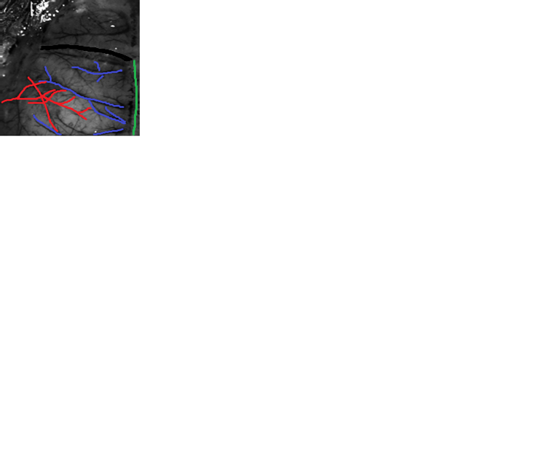

Medial
Lateral

Figure 2.5 - Grey scale image of the thinned window overlying the right hand side somatosensory barrel cortex of the rat. Image captured using a CCD camera. Highlighted areas refer to the Bregma (black), arteries (red), draining veins (blue) and midline (green). The middle cerebral artery (MCA) is highlighted, usually has a Y like shape. This image is from a representative subjects

Neural Activity
Neural activity was recorded simultaneously, with 2D-OIS, using a linear array electrode (fig 2.6) with 2D-OIS.

Electrophysiology Theory
Neural activity was recorded using 16-channel electrodes inserted perpendicular to the cortical surface (fig 2.6). The electrophysiological recording probes have 16 linearly arranged recording sites (100µm spacing between the site), each with an area of 177µm², an impendence of 1.5-2.7MΩ, the uppermost recording site (CNCT, University of Michigan) (fig 2.6). Each electrode site independently recorded neural activity at a sampling rate of 24.4 KHz.

Electrophysiology Hardware
An electrode head stage was attached to a stereotaxic arm (that would hold the multi-channel electrode). A reference (indifferent) electrode was connected to the head stage, with the other end was inserted through the skin of the subject’s neck. The headstage was also connected to a ground point on the faraday cage. Indeed, all significant metal and electrical items inside the faraday cage was grounded using earth leads. The faraday cage also prevented contamination from any radio–frequency (RF) interference as well as from the 50Hz common mode signal, arising from the electrical mains, which could be found in much of the nearby lab equipment. The 16 channel electrode probe (NeuroNexus Technologies), was attached to the lower 16 pins of the ‘headstage’, which was attached via an isolated pre-amp device (Medusa Bioamp, Tucker-Davis Technologies (TDT)). Two data acquisition modules shared the responsibility of recording from one 16-channel electrode. A custom written MATLAB (The Mathworks Inc.) interface was used to collect and perform basic proceedings on the data.

Electrode placement
Following functional localisation of the right whisker barrel region using 2D-OIS, a map of haemodynamic activation from 2D-OIS was spatially registered and overlaid onto a reference grey scale camera image of the cortex. The map was used to guide electrode placement and the placement tried to avoid bruises, bone sutures and major dural or cortical vessels. The electrode was lowered and inserted perpendicular to the cortical surface (through the hole created on the skull using a drill bit) using the stereotaxic arm adjusters whilst monitoring its progress via microscope. The probe tip was inserted to a cortical depth of 1550µm. This resulted in the highest recording site being 50µm above the cortical surface. The preparation was allowed to stabilise for up to an hour after placement of the electrode to avoid any effects of cortical spreading depression (Lauritzen et al., 1982, Ba et al., 2002). All electrophysiological data was recorded at a sampling frequency of 24.4KHz. The electrophysiological data will be analysed, by investigating the local field potentials (LFPs) throughout this thesis.

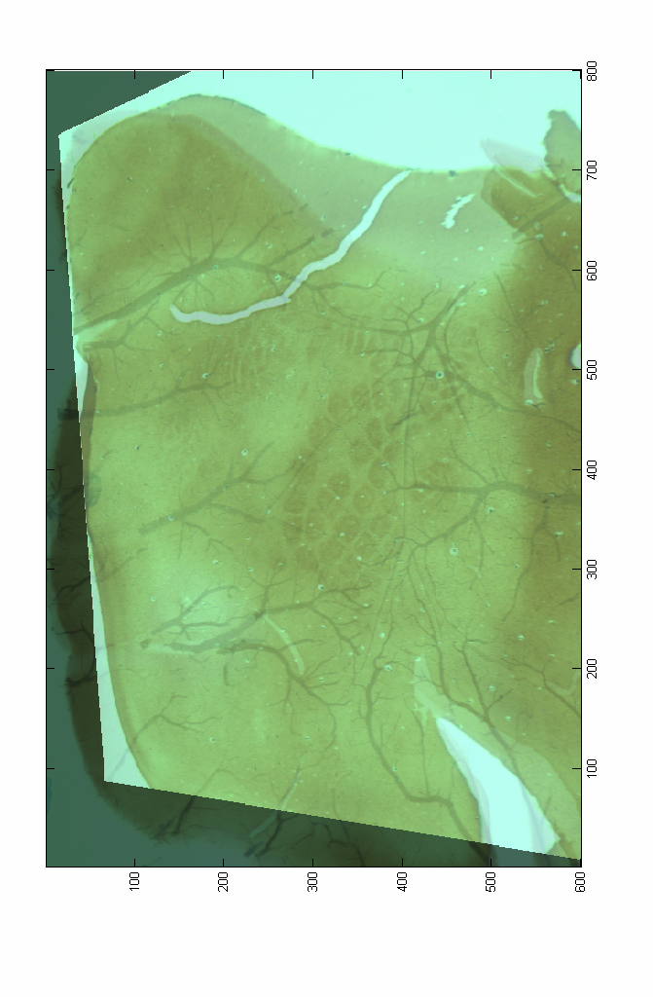
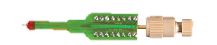
Figure 2.6 – Recording of the electrophysiology with a multi-channel electrode. A) 16- channel electrode inserted perpendicular to the whisker barrel cortex. B) Image of cortical tissue, stained using cytochrome oxidase for whisker ‘barrels’. C) Schematic of the electrode tip having equal site spacing.
C
A
B

Oxygen probe sensor
The information in this section was obtained from Oxford Optronix Ltd manual for the oxygen sensor called OxyLiteTM.
The oxygen sensor used within this study was based on the optical fluorescence technology (Oxford Optronix Ltd) for continuous, quantitative monitoring of regional cerebral oxygen in tissues. This sensor is able to provide direct in-vivo readouts of oxygen availability to cells and tissue partial pressure of oxygen (pO₂), in contrast to blood oxygen saturation (which merely describes the haemoglobin oxygenation status of blood). The sensitivity and accuracy of the sensor (pO₂ range) is 0-200mmHg (~0- ~25% oxygen). In contrast to a lot of other oxygen sensors (outlined in the introduction), the one used in this study does not consume oxygen at the point of measurement, thus allowing for continuous oxygen measurement. The sensor is minimally invasive for in-vivo applications. The measurement resolution is 0.1mmHg and accuracy for oxygen ±0.7mmHg (0 – 7mmHg), ±10% of reading (7 – 150mmHg), ±15% of reading (150 – 200mmHg). Measurement response time is <20s and sampling rate of 1Hz. The fluorescence-based technique employed by the oxygen monitor provides an absolute measurement of dissolved oxygen in mmHg. The sensor has provided a readout of the oxygen availability to cells and tissue. The oxygen sensors are based on fluorescence quenching and fibre –optic technology. It works by emitting short pulses of light via a light emitting diode (LED), which is transmitted along the fibre optic guide, to excite a platinum-based fluorophore bonded to the sensor tip. The resulting emission of fluorescent light, quenched by the presence of oxygen molecules is detected by the instrument (Oxford Optronix Ltd). The oxygen sensor is constructed from optical fibres with an outside diameter of 230 microns, in a robust needle-encased format (approx. diameter 650 microns). The surface area of the tip of the fibre-optic oxygen sensors is estimated to be approx. 0.25mm². In a typical tissue this surface area may correspond to direct exposure to around 1000 neuronal cells (Oxford Optronix Ltd manual). The oxygen sensor was inserted into the cortex of a depth of 500µm from surface.
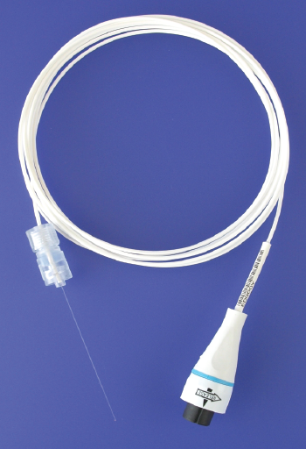

Figure 2.7 – Image of the oxygen sensor used. Tissue oxygen sensor used to quantitatively measure the quantitative monitoring of regional cerebral oxygen in tissues, obtained from Oxford Optronix Ltd

Several cell layers are likely to contribute to the dissolved oxygen diffusing in and out of the sensor tip, and assuming typical cell volume (size) and tissue cell densities, the volume of tissue sampled by our oxygen sensors in vivo is estimated to be in the region of 0.5-1 mm³ (Oxford Optronix Ltd manual). The advantages of the fibre-optic sensors allow them to be minimally invasive as well as light weight and physically flexible (fig 2.7).

The magnitude of vasomotion (~0.1Hz) in cortical haemodynamics of the somatosensory cortex of the anaesthetised rodent measured using 2D-OIS following lowered and normal systemic mean arterial blood pressure (MABP)

Abstract
This chapter investigates the spontaneously occurring oscillations centered around ~0.1Hz, commonly observed in cortical haemodynamics and termed as vasomotion. An anaesthetised rodent animal model was chosen to investigate vasomotion oscillations as this allows for the application of invasive neuroimaging techniques such as two dimensional – optical imaging spectroscopy (2D-OIS), which is able to record the haemodynamic changes across the cortex. Haemodynamic changes were recorded while the magnitude vasomotion oscillations were manipulated through the systemic infusion of phenylephrine, which is known to produce alterations in systemic mean arterial blood pressure (MABP). The recorded haemodynamic changes were then evaluated both spatially and temporally to compare the magnitude of vasomotion oscillations and systemic MABP.
Large magnitude vasomotion oscillations (0.08 to 0. 2Hz) were observed in cortical haemodynamics from the somatosensory whisker ‘barrel’ cortical region, for periods prior to phenylephrine infusion across all subjects. In contrast, following phenylephrine infusion smaller or negligible magnitudes of vasomotion oscillations were observed (fig 3.2D). In addition to reductions in the magnitude of vasomotion, a slight increase in blood oxygen saturation levels were seen during phenylephrine infusion. Maps were generated to evaluate the spatial spread of vasomotion oscillation magnitudes (0.08-0.2Hz) over the cortical region. These maps were able to show, a greater magnitudes of vasomotion oscillations within the pre-phenylephrine infusion period when compared to the phenylephrine infusion period. Interestingly, spatially distinct patterns were observed in the cerebral haemodynamics, i.e. larger magnitudes of vasomotion was seen in the arteries for Hbt, veins for Hbr and both arteries and veins for HbO₂ (fig 3.11 & 3.12).
This data suggests for periods of lowered systemic MABP, larger magnitudes of vasomotion oscillations are present. This study has provided an insight into a possible association between changes in systemic MABP and magnitude of vasomotion oscillations. In addition, slight increases in blood oxygen saturation levels were observed following phenylephrine infusion, this could be suggestive that cortical oxygenation levels could be related to vasomotion oscillations. Therefore, this is further investigated by manipulating the fraction of inspired O₂ (chapter 4) and by measuring tissue oxygenation directly (chapter 5).

Introduction
This chapter investigates the magnitude of vasomotion oscillations during periods of lowered and normal systemic MABP. This study is important for a number of reasons. Firstly, the role of vasomotion is poorly understood, particularly in the brain (Murphy et al., 2013). Secondly, although there have been some investigations into this vascular signal, it is largely unknown what cellular mechanisms generate it and more importantly what the physiological consequences of this signal are. Thirdly, it is important to be able to understand if the role of vasomotion changes within healthy and altered conditions e.g. investigations within various neurodegenerative diseases. Lastly, investigations of this signal maybe important due to the affects it could have on inferences of functional connectivity from correlations in resting-state fMRI data. A necessary prerequisite to address these issues was to first repeat a classic study (Hudetz et al., 1992) with modern techniques capable of measuring cerebral haemodynamics with sufficient spatial and temporal information. Hudetz et al., (1992) demonstrated that the magnitude of spontaneous oscillations in cerebral blood flow as measured by Laser Doppler flowmetry (LDF) is related to the value of systemic arterial blood pressure. In this current chapter, this study is replicated using 2D-OIS to measure cerebral haemodynamics: Hbt, Hbr, HbO₂ in the thin windowed neocortex of anaesthetized rodents thus providing spatial information and measurements of the individual components of cerebral haemodynamics that underlie the BOLD fMRI signal. Establishing this preparation will also provide the opportunity to further investigate the genesis of vasomotion oscillations with additional experimental paradigms, techniques and analyses in subsequent chapters.

Vasomotion is commonly identified to be a spontaneous oscillation in the tone of blood vessels (generated from within vessel walls) (Nilsson and Aalkjaer., 2003). For instance, Mayhew et al in 1996 found an oscillation in the remitted light from the cortical surface with a frequency of ~0.1Hz (oscillating once every ten seconds) measured using non- spectroscopic variant of optical imaging that was seen to exhibit many of the characteristics of the low frequency vasomotion signal commonly observed in the cerebral microcirculation. Mayhew et al., (1996) measured this oscillation using a single wavelength of light which makes it difficult to understand in terms of isolating the individual components (Hbt, Hbr, HbO₂) and blood oxygen saturation levels. Thus the present chapter investigates the vasomotion oscillations in an identical animal model with 2D-OIS that allows estimation of changes in cerebral haemodynamics (Hbt, Hbr, HbO₂). Furthermore, Mayhew et al., (1996) did not attempt to manipulate the magnitude of vasomotion oscillations, thus the physiological factors that may influence the magnitude of vasomotion oscillations remained uncertain.

Rayshubskiy et al., (2014) was able to measure large-amplitude sinusoidal ~0.1Hz haemodynamic oscillations in the cortex using multi-spectral optical intrinsic signal imaging (MS-OISI) in a human undergoing neurosurgery. This suggests that vasomotion oscillations are not just present in animal models (Mayhew et al., 1996) but also present in human subjects. This work is suggestive that optical spectroscopy techniques can measure ~0.1Hz oscillations and this is present in different aspects of haemodynamics (Hbt, Hbr, HbO₂). However, similar to Mayhew et al., (1996) there were no experimental manipulation involved and thus again the origin of vasomotion has remained uncertain. However, earlier by Hudetz et al., (1992) measured cerebral blood flow with LDF whilst manipulating systemic blood pressure. They were able to demonstrate that un-physiologically lowered levels of blood pressure resulted in higher magnitude of ~0.1Hz oscillations in blood flow compared to that observed during normal systemic blood pressure. However, the measures acquired from the LDF lacked any spatial information. As such, the current study investigates vasomotion in the rodent neocortex with the 2D-OIS technique that will allow for spatial information of the cerebral haemodynamics to be obtained.

Hudetz et al.,(1992) altered blood pressure by performing haemorrhagic hypotension and unilateral carotid occlusion. However, the animal preparation used in our laboratory has an intrinsic fortuitous change in systemic blood pressure. Urethane anaesthesia is commonly used as an anaesthetic in neurovascular coupling research in rodents (Jones et al., 2001, Devor et al., 2003, Jones et al., 2004, Berwick et al., 2004, Jones et al., 2005, Boorman et al 2010). However, a property of urethane which is usually considered to be a disadvantage is that its administration typically lowers blood pressure below normal physiological values. Thus, in our laboratory we typically administer phenylephrine (continuous intravenous systemic infusion) to maintain blood pressure within the normal physiological values. Phenylephrine is a α1 – adrenergic agonist and works as a vasoconstrictor on vascular smooth muscle. Phenylephrine does not cross the blood brain barrier (Olesen., 1972) and thus does not affect other variables that could affect cerebral haemodynamics such as brain activity. The typical animal preparation within our laboratory offers the opportunity to replicate the findings of the Hudetz et al.,(1996) paper with modern techniques.

This study will show the magnitude of the vasomotion oscillation at ~0.1Hz within two distinct periods; first: period of low MABP following urethane administration which inherently lowers the systemic MABP within the rat model was called the pre-phenylephrine period. The second condition: period in which phenylephrine was infused intravenously, increasing the systemic MABP and therefore called the phenylephrine period.

In the current study, simultaneous electrophysiological measurements were made in 14 of 19 animals. This allowed us to ensure that there were no changes in general cortical ‘state’ (i.e. a change from quiescence to that of arousal synchronised versus desynchronised) during the recording period in which systemic MABP was deliberately pharmacologically manipulated. This ensured that differences in cerebral haemodynamics observed during different levels of systemic MABP were not due to changes in cortical arousal. This is important as previous research has shown that changes in cortical state are accompanied by changes in baseline cortical haemodynamics (Jones et al., 2008, Slack et al., 2016). The 5 animals that did not have the concurrent recordings, the haemodynamics were qualitatively similar to those that did have electrophysiological recordings (i.e. they did not show sudden or profound changes in baseline haemodynamics which are indicative of cortical state changes) suggesting that no cortical state changes occurred in these animals.

Aim
Using 2D-OIS, the aim of this study is to measure the magnitude of vasomotion oscillations (~0.1Hz) within the cortical haemodynamics (Hbt, Hbr, HbO₂) prior to and following infusion of phenylephrine. Changes in the blood oxygen saturation levels following phenylephrine infusion will also be examined as well as maps showing spatial distribution of the cortical haemodynamics (Hbt, Hbr, HbO₂) over the whole cortical region. This study should therefore allow for understanding the possible association between systemic MABP and magnitude of vasomotion oscillations, thus allowing for subsequent investigations in understanding this association in greater detail.

Methods

Subjects
All subjects were female Sprague –Dawley rats weighing between 200 – 350 grams, n=18.

Surgery and measurement of systemic physiology
All procedures are described here in brief (for additional detail see Methodology chapter 2). Subjects were initially anaesthetised with isoflurane, before being anaesthetized with isoflurane; all subjects were anaesthetized with urethane (1.25g/kg i.p). Atropine was injected subcutaneously (0.4g/kg) under the neck to reduce mucus secretions during surgery. Following anaesthesia, animals were placed on a homoeothermic heating blanket (Harvard Instruments, UK) with rectal monitoring to maintain the core body temperature at 37 ºc until the end of the experiment. All animals were tracheotomised, allowing for artificial ventilation (Harvard Instruments) and to record and monitor end-tidal CO₂ recordings. Animals’ left hand side femoral artery and vein were exposed and cannulated for measurement of MABP and for intravenous infusion of phenylephrine respectively. The arterial cannulation also allowed blood samples to be taken for measurement of blood oxygen saturation. This measurement allowed the ventilator parameters to be adjusted to maintain the animal within normal physiological limits. Animals were then placed in a Kopf instruments stereotaxic frame, and the right hand side of the head’s surface was exposed using a blunt dissection. Following this, the skull overlying the whisker barrel region (right hand side) was thinned to translucency. To maintain the optical translucency, a plastic well was placed surrounding the thinned areas of the skull and secured with dental cement. In addition, a cannula was fixed in place near to the periphery of the thinned window; this cannula would then be used to provide a continuous infusion of saline. The physiological parameters of the subject were allowed to stabilise before the imaging and electrophysiological recording techniques were performed.

2 Dimensional – Optical Imaging Spectroscopy (2D-OIS)
2D-OIS was used to measure the total haemoglobin concentration and blood oxygen saturation across the thinned skull overlying the cortical surface (covering the somatosensory whisker ‘barrel’ cortical region). The following imaging procedure is detailed in Berwick et al, 2008 and will be described in brief here. Haemodynamic data were captured using a CCD camera (Dalsa 1M30P, USA) recording images at 32Hz from the cortical surface. Four wavelengths (495 ± 31, 559 ± 16, 575 ± 14 and 587 ± 9nm, full-width and half maximum) with contrasting absorption coefficients were used by a high speed Lambda DG-4 filter changer, to illuminate the cortex, providing an effective image sampling rate of 8Hz. From this multi-wavelength data, estimates of Hbt, HbO₂ and Hbr were obtained using a modified Beer-Lambert law (Berwick et al, 2005). In a prior experimental run, a 2 second electrical stimulation was applied every 25 seconds to the whisker pad of the animal. The somatosensory whisker ‘barrel’ region was thus located and the cortical area delineated using in house programs within MATLAB.

Experimental protocol
All subjects underwent the same experimental protocol:
After the 30 mins of stabilization period, and optimum positioning of the 2D-OIS and CCD camera the recording commenced. All data presented is of spontaneous recordings i.e. no stimulation was applied to the subject within this time.
After 290s of baseline recording, the subjects were then infused with phenylephrine at a dose of (0.13-0.26mg/hr) through the intravenous cannula (0.6 -0.7ml/h). Phenylephrine infusion ensures systemic MABP was kept within normal physiological limits (Golanov et al., 1994, Nakai and Maeda., 1999). The pre-phenylephrine recording period was 290s, with the complete spontaneous recording carried out for 2100s (Fig 3.1).
0
290 (s)
2100 (s)
Recording starts
Phenylephrine infusion starts
Recording stopped

Figure 3.1 – Diagram shows the timeline of the experimental paradigm Phenylephrine was infused at 290s and recording stopped after 2100s

Region of Interest (ROIs) analysis
The ROIs within the somatosensory whisker ‘barrel’ region, across the animals, were selected using an automated method. This allowed for fair inclusion of haemodynamic data from each subject. The method first eliminated noisy pixels (typically seen in the periphery of the image), then finds the peak of the response in the somatosensory cortex following sensory stimulation of the whiskers. The method then draws an initial region of interest (ROI) around these pixels and increases its size by encompassing the neighbouring pixels with them stopping at 2000 total pixels for each animal.

Time series analysis
The automatically generated ROIs were then used to extract haemodynamic data (Hbt, HbO₂ and Hbr for each animal).
To carry out analysis on the frequency analysis on the haemodynamic data, first the data was windowed to allow for equal amount of data for each window, this allows for a FFT to be applied on the windowed data so that the magnitude of the frequencies present can be measured.

Spatial map analysis
To be able to quantify the magnitude of vasomotion oscillations across the cortical surface of the surface, the following steps took place. First, a time period of 260s was examined across the recording. 2 time periods were examined for chapter 3 for prior to and during phenylephrine. 3 time periods were examined for chapter 4 & 5 for during and after cessation of phenylephrine and during hyperoxia. Within each time frame, an averaged spatial map of the cortex was generated and FFT analysis was carried out across each pixel within the spatial map. The FFT analysis quantified the magnitude of the frequencies between 0.08-0.2Hz. The spatial image was then reconstructed an image for every frequency present within the selected time range.

Results
The complete time series of MABP and cortical haemodynamics as measured by 2D-OIS from a recording lasting 2100s taken from a single representative animal is shown (fig 3.2). Phenylephrine infusion began at 290s (fig 3.2) and was associated with a slow increase in MABP (fig 3.2A). Insets display 140s of data (Hbt) (fig 3.2C & 3.2D) for the two periods (prior to phenylephrine infusion and during phenylephrine infusion) from the haemodynamic recording (fig 3.2B). Visibly, there was a distinct oscillation in haemodynamics approximately every 10s (0.1Hz) (fig 3.2C, pre-phenylephrine), that appeared to be reduced in magnitude following phenylephrine infusion (fig 3.2D). To examine changes in power in haemodynamic oscillations during the both the periods (pre-phenylephrine and phenylephrine), the haemodynamic recording (fig 3.2B) was divided in 14 temporal windows so each window contained sufficient time to obtain a reliable estimate of power but also sufficient number of windows to examine the changes with the phenylephrine infusion. The magnitude of power at ~0.1Hz is seen to gradually decrease over the recording period (windows 1-14, fig 3.2E), following phenylephrine infusion. The FFT analysis (fig 3.2F) shows a comparison between two temporal windows (1 & 13) within both the periods and there is a greater magnitude of power within the pre-phenylephrine period compared to the period when phenylephrine was infused and blood pressure had been restored to physiological levels. Note: To be able to view similar figures for the other animals used within this chapter (chapter 3) please refer to Appendices A

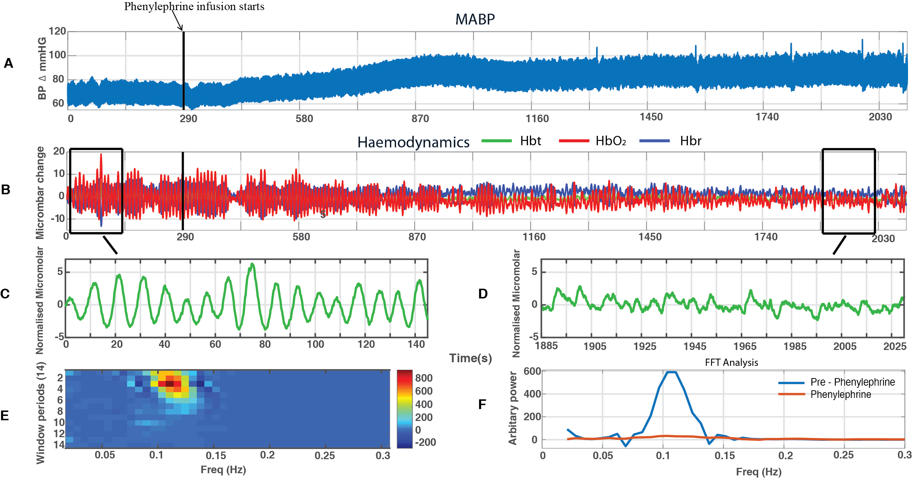
Figure 3.2 – Data from an individual animal (total recording 2100s) showing A – MABP, B – Haemodynamics; Hbt (Green), Hbr (Blue), Hbo (Red), C – Pre-phenylephrine - window shows the first 145s of the recording (Hbt), D – Phenylephrine - window shows 145s time period within the phenylephrine period (Hbt), E - Image scale of the change in frequency (Hz) across the recording (14 windows), F - Graph showing the change in frequency (FFT) within the two periods (window 1 &13) – pre-phenylephrine and phenylephrine. Note: The black line at 290s demonstrates the start of the phenylephrine infusion.
1
13
To examine whether these phenomena observed in a single animal were reliably present across subjects, the following analyses take metrics of MABP and cortical haemodynamics from each animal (n=18). 290s of data was recorded prior to phenylephrine infusion (fig 3.1 & fig 3.2), for the subsequent analyses a smaller time period of 260s was examined in order to exclude any initial small changes occurring from the recording or the setup. Within the phenylephrine period, another 260s was taken to be examined before the end of the recording period. Data was averaged across the 2 time periods in each animal and thus provided values of MABP and magnitude of power of ~0.1Hz oscillations for the 2 time periods for each animal.
Note: To control for this experiment, I had taken recordings of MABP and haemodynamics without phenylephrine and no change in the MABP and LFP was observed during this time. Also physiological parameters such as end-tidal CO₂ and breathing rate were measured and these were monitored to ensure that these were stable throughout remains within the normal physiological limits whilst maintaining deep anaesthesia. In addition to this, I recorded for a long time so the effects seen in the MABP are not due to a natural drift of time. Once the phenylephrine was turned off, every time there was a marked difference in the MABP.

Magnitude of MABP in the pre-phenylephrine and phenylephrine periods
MABP levels were averaged across animals for the two periods. MABP was higher during phenylephrine infusion period than in the time period prior to phenylephrine infusion (pre-phenylephrine) (fig 3.3). Indeed, a paired one-tailed t-test showed MABP was significantly higher in the phenylephrine period (M=88.32, SE=2.99) compared to the pre-phenylephrine period (M =69.76, SE=2.33); t (17) =14.12, p<0.0001.

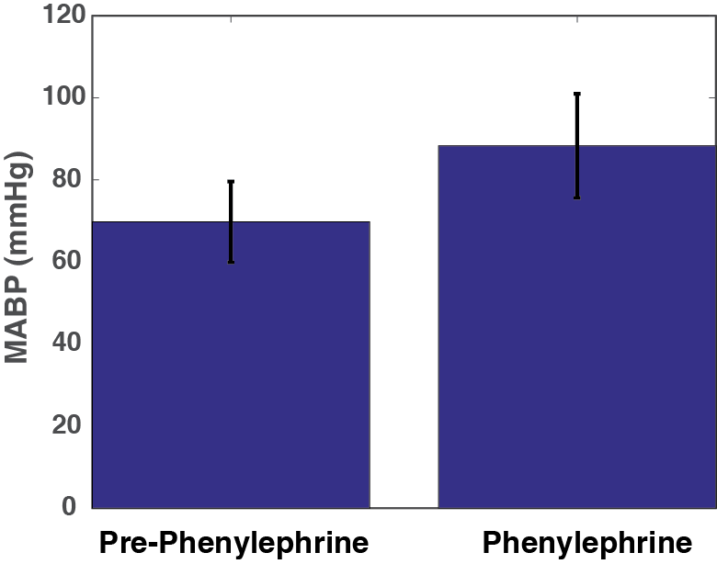
***
Figure 3.3 – Bar chart shows the mean differences in MABP (n=18) between the two periods: pre-phenylephrine infusion and during phenylephrine infusion

Magnitude of power of ~0.1Hz oscillations in Hbt, Hbr, HbO₂ in the pre-phenylephrine and phenylephrine periods
FFTs allowed for the magnitude of power in oscillations in cerebral haemodynamics: Hbt, Hbr and HbO₂ to be estimated. The mean power between 0.08Hz-0.12Hz was higher during period prior to the phenylephrine infusion (pre-phenylephrine period) than during phenylephrine infusion (phenylephrine period) (fig 3.4). Indeed, a paired one-tailed t-test showed that the mean power from FFT for Hbt between frequencies 0.08 – 0.12Hz was significantly higher in the pre -phenylephrine period (P-P) (M =0.06, SE=0.009) compared to the phenylephrine (P) period (M=0.02, SE=0.003); t (17) = 4.34, p<0.001 for Hbt (fig 3.4A). A paired one–tailed t-test also showed significant differences between the two periods for Hbr in the pre-phenylephrine period (P-P) (M =0.10, SE=0.02) compared to the phenylephrine (P) period (M= 0.04, SE=0.004); t (17) = 3.72, p<0.01 (fig 3.4B) and HbO₂ in the pre-phenylephrine (P-P) period (M=0.15, SE=0.028) compared to the phenylephrine (P) period (M=0.05, SE=0.006) ; t (17) = 3.99, p<0.001 (fig 3.4C). Post hoc tests using the Bonferroni correction further revealed statistically significant differences between the two periods (pre-phenylephrine and phenylephrine) across Hbt (p = 0.0001), HbO₂ (p = 0.0003) and Hbr (p =0.0006).

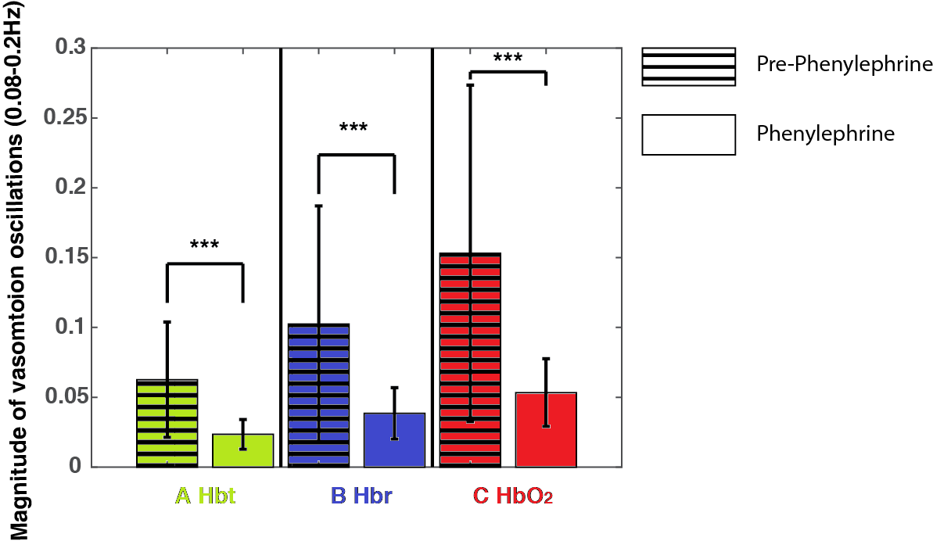
Figure 3.4 – Comparison between magnitude of vasomotion oscillations across haemodynamics (Hbt, Hbr, HbO₂) (n=18); in the pre-phenylephrine and phenylephrine periods
Hbt – Total blood volume, Hbr – deoxygenated haemoglobin, HbO₂ – Oxygenated haemoglobin

The ROIs were taken over a mixed tissue sample (2000 pixels) overlying the somatosensory ‘whisker’ barrel cortex.

Association between inter-animal variability in MABP and the power of cerebral haemodynamic oscillations
To be able to examine whether there is a relation between MABP and power of the cerebral haemodynamic oscillations for individual animals, the following figures display the comparision between the individual MABP values and magnitude of vasmotion oscillations (Hbt) power on a scatterplot graph (figs 3.5-3.8).
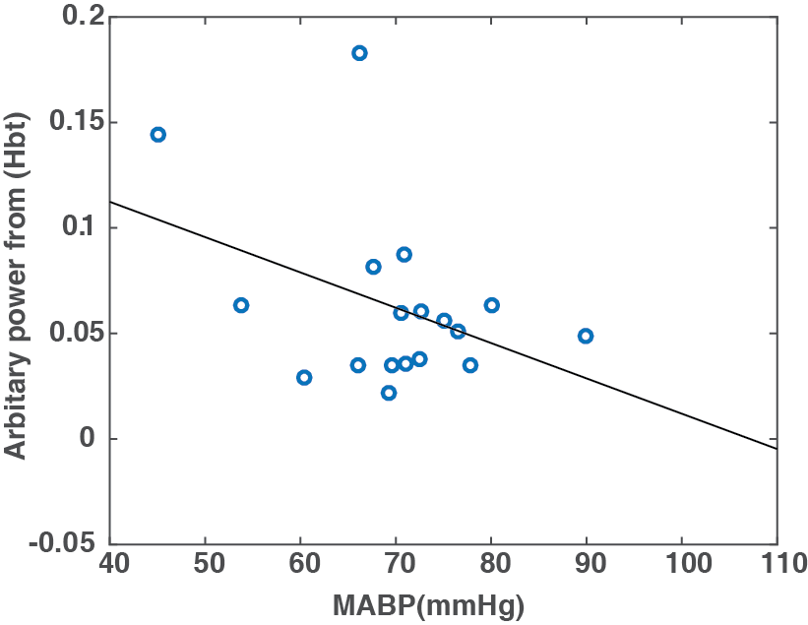
Within the pre-phenylephrine period, generally, lower MABP values can be seen to correspond to higher mean power from FFT values (0.08-0.12Hz). However, a Pearson’s correlation coefficient did not show a significant correlation, r(16) = -0.4002, p>0.05 for Hbt (fig 3.5). A Pearson’s correlation coefficient also showed no significant correlation for HbO₂, r(16) = -0.2844, p>0. 05 and Hbr, r(16) = -0.1895, p>0.05.
r = - 0.4002
p = 0.0999

Magnitude of vasomotion oscillations 0.08-0.12Hz

Figure 3.5 – Correlation between MABP and magnitude of vasomotion oscillations (0.08-0.2Hz) (n=18) in the pre-phenylephrine period only.

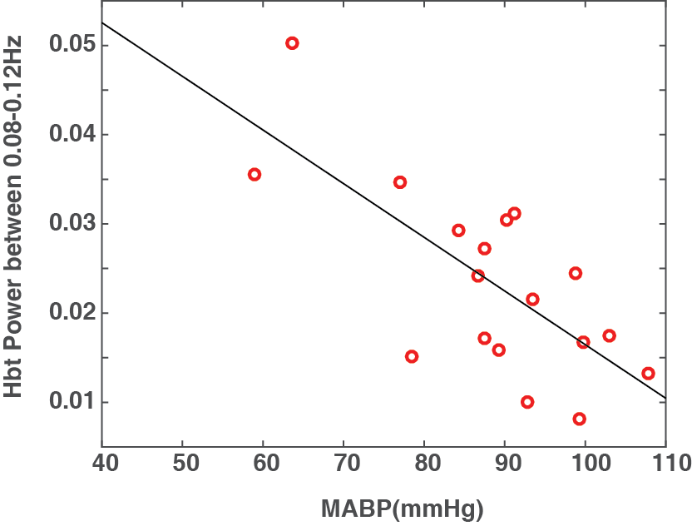
Within the phenylephrine period, generally, high levels of MABP can be seen to correspond to lower mean power from FFT values. Indeed, a Pearson’s correlation coefficient showed a significant correlation, r (16) = -0.7189, p<0.001 (fig 3.6) for Hbt. A Pearson’s correlation coefficient also showed a significant correlation for HbO₂, r (16) = -0.6004, p<0.01 and Hbr, r (16) = -0.5012, p<0.05.
r = -0.7189
p = 0.0008

Magnitude of vasomotion oscillations 0.08-0.12Hz

Figure 3.6 - Correlation between MABP and magnitude of vasomotion oscillations (0.08-0.2Hz) (n=18) in the phenylephrine period only.

If data from both the pre-phenylephrine and phenylephrine periods are displayed together then again, MABP values across animals showed an association with the magnitude of power of cortical haemodynamic oscillations, Hbt is shown for example (fig 3.7),r (16) = -0.5988, p>0.001. Similarly, an association was found for the other cortical haemodynamics, Hbr, r (16) = -0.4377, p<0.01 and HbO₂, r (16) = -0.5015, p<0.01. The Pearson correlation coefficient has negative values indicated as expected that lower MABP values were associated with higher magnitudes of cortical haemodynamic oscillations between 0.08-0.12Hz.
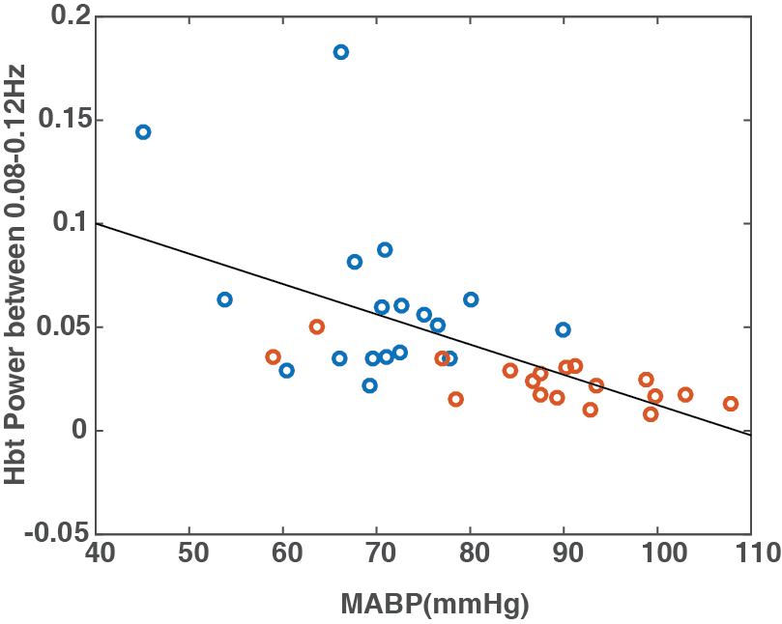
r = -0.5988
p = 0.0001

Magnitude of vasomotion oscillations 0.08-0.12Hz

Figure 3.7 Correlation between MABP and magnitude of vasomotion oscillations (0.08-0.2Hz) (n=18) in the two periods; pre-phenylephrine (blue circles) and phenylephrine periods (orange circles).

To investigate whether there was an increase in MABP and concomitant decrease in magnitude of cerebral haemodynamic oscillations following phenylephrine infusion in each animal the data from figure 3.7 is displayed again (fig 3.8) with the data from each animal displayed as a single colour. Although, there is variability in MABP values and the magnitude of the associated cortical haemodynamic oscillations, it can be seen that each animal has an increase in MABP and associated decrease in the magnitude of oscillations.
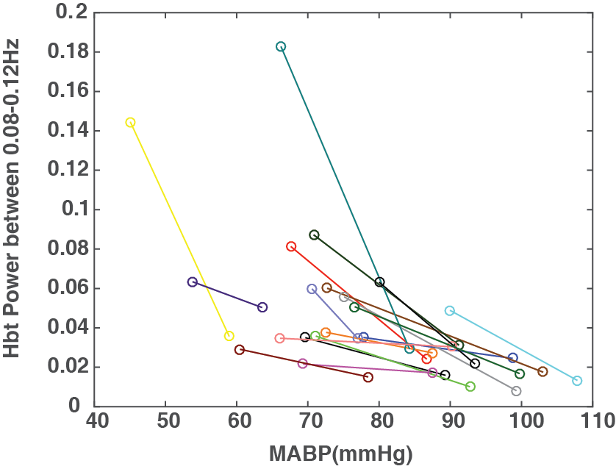
Magnitude of vasomotion oscillations 0.08-0.12Hz
Figure 3.8 – Correlation between MABP and magnitude of vasomotion oscillations (0.08-0.2Hz) (n=18) in the two periods. Each animal’s values for both periods (pre-phenylephrine and phenylephrine) are displayed as one colour.

To further display the changes in the baseline levels of cortical haemodynamics: Hbt, HbO₂, Hbr and blood oxygen saturation levels were altered following phenylephrine infusion, the entire time series of 2100s was averaged across animals (n=18). The mean MABP is shown for comparison and again phenylephrine infusion began at 290s (fig 3.9) and was associated with an increase in MABP (fig 3.9A) across all animals. As the phase of the 0.1Hz oscillations was obviously different across animals for a single time point, averaging the time series together removes the appearance of the oscillations. Similarly, the haemodynamics, in particular a slight increase in HbO₂ and slight decrease in Hbr (fig 3.9C) was seen, possibly showing an association with the phenylephrine infusion. A slight increase can be observed in blood oxygen saturation levels following phenylephrine infusion (9B) across all animals. For comparison as with the individual animal shown in figure 3.2, the haemodynamic recording was divided in 14 temporal windows across the average recording. The magnitude of the power at ~0.1Hz is seen to gradually decrease over the recording period (windows 1-14), following phenylephrine infusion (fig 3.9D).

Figure 3.9 – Comparison between MABP and haemodynamics (n=18): A – MABP, B – Change in blood oxygen saturation level, C – Haemodynamics; Hbt (Green), Hbr (Blue), Hbo (Red), Windows 1 and 13 highlighted by black border D – Image scale of the change in frequency (Hz) across the recording, E - Graph showing the change in frequency (FFT) within the two periods – pre-phenylephrine (window 1) and phenylephrine (window 13). Note: The black line at 290s demonstrates the start of the phenylephrine infusion.

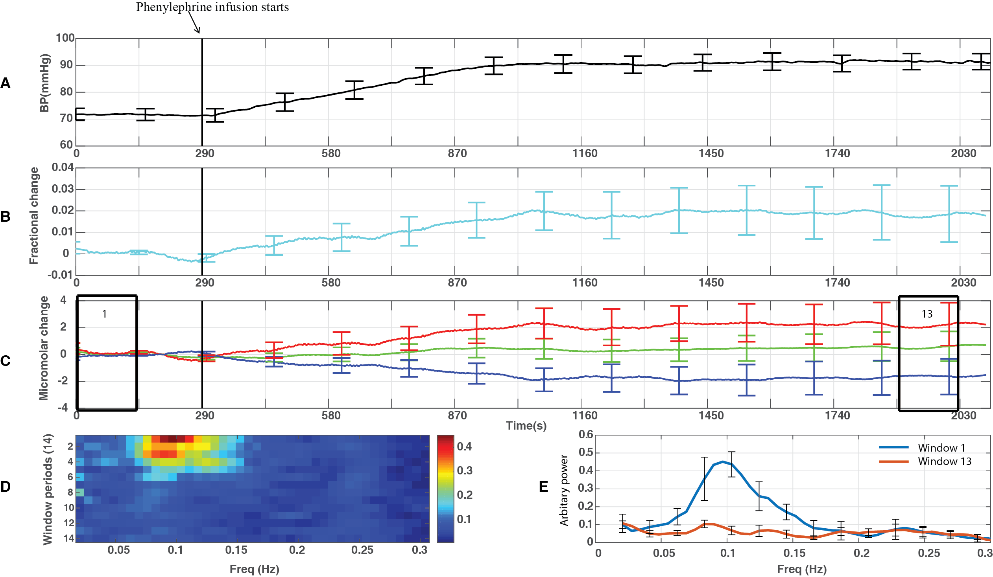

Changes in Blood Oxygen Saturation levels
In addition to measuring the total blood volume, the oxygen saturation levels in the blood were also recorded and this data was extracted using the same ROI for each individual animal. A comparison was made between the two conditions (pre-phenylephrine and phenylephrine) and the mean blood oxygen saturation levels compared; pre-phenylephrine (M=0.488, SE =0.052), phenylephrine (M=0.5, SE=0) (fig 3.10). No significant difference was found between blood oxygen saturation levels between the two conditions, t (17) = 0.94, p>0.05.
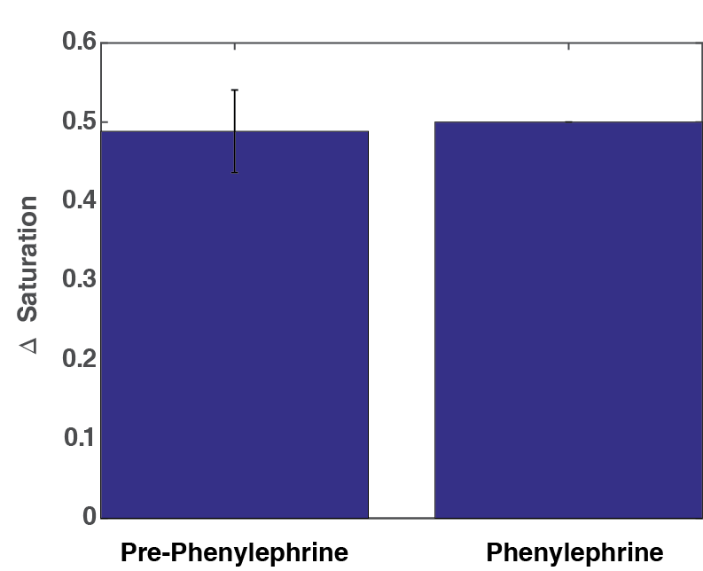

Mean Blood Oxygen Saturation Levels

Figure 3.10 – Comparison of mean blood oxygen saturation (n=18). Bars shows the mean differences in blood oxygen saturation levels (n=18) between the two conditions pre-phenylephrine infusion and during phenylephrine infusion.

Spatial map showing the magnitude of power between 0.08-0.12 Hz of the haemodynamic cortical oscillations.
Fourier analysis was carried out across every pixel over the cortical surface to quantify the magnitude of power of the frequencies centred around (0.08-0.2Hz) within haemodynamic oscillations. Spatial maps were created from this information showing this for the two periods (pre-phenylephrine and phenylephrine) (fig 3.11 &3.12) and also for the cerebral haemodynamics: Hbt, Hbr, HbO₂ (fig 3.11A1-C1, fig 3.12A1-C1). A greater magnitude of power was seen in the pre-phenylephrine period with distinct spatial patterns between cerebral haemodynamics i.e. stronger magnitude of power was seen in the arteries for Hbt, veins for Hbr and both arteries and veins for HbO₂. The colour bar displays the power value (Hz). There were differences qualitatively and the two animals chosen (fig 3.11 & 3.12) particularly show a marked reduction in the vasomotion power and were illustrated to show the spatial spread of 0.1Hz across the cortical surface.

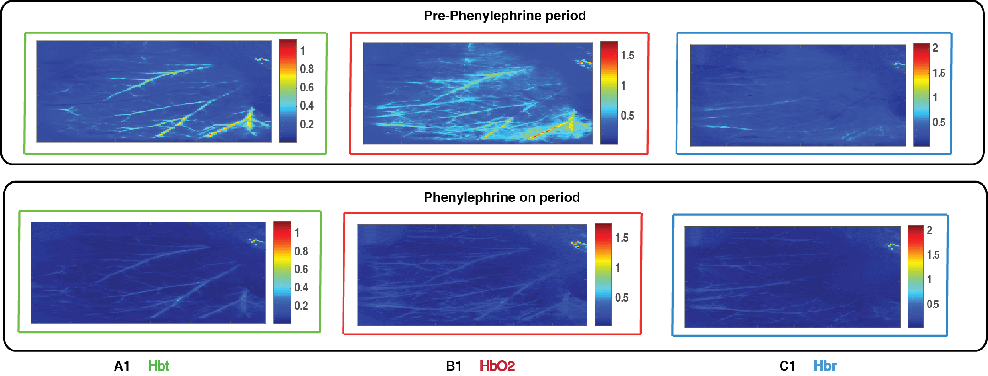
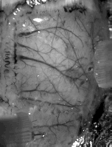
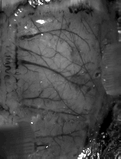
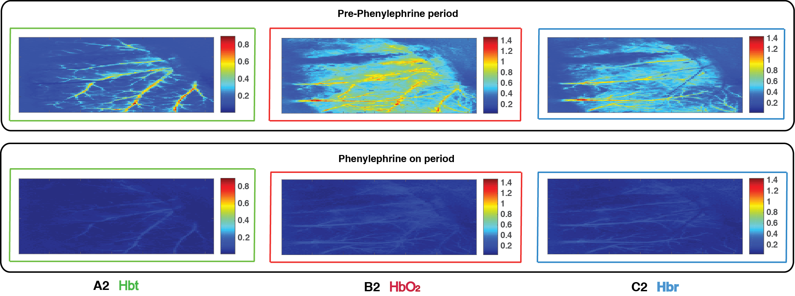
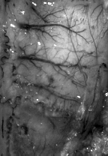
Figure 3.11 – Spatial maps of oscillatory power (0.08-0.2Hz) in the recorded haemodynamics across the cortical surface for one animal. A – In-vivo image of the thinned cortical cortex, B – Visible blood vessels (arteries (red) and veins (blue)) placed on the in-vivo image, C – Map for blood vessels and electrodes. Each spatial map shows the magnitude of the oscillations across the cortex (encompasses the whisker barrel region) For Hbt (A1), HbO₂ (B1) and Hbr (C1) for both the periods (pre-phenylephrine infusion and during phenylephrine infusion)
Electrode
Artery
Vein
C
Visible blood vessels
In-vivo image
B
A
Figure 3.12 – Spatial maps of oscillatory power (0.08-0.2Hz) in the recorded haemodynamics across the cortical surface for one animal. A – In-vivo image of the thinned cortical cortex, B – Visible blood vessels (arteries (red) and veins (blue)) placed on the in-vivo image, C – Map for blood vessels and electrodes. Each spatial map shows the magnitude of the oscilliations across the cortex (encompasses the whisker barrel region) for Hbt (A2), HbO₂ (B2) and Hbr (C2) for both the periods (pre-phenylephrine infusion and during phenylephrine infusion)
Visible blood vessels
Vein
Artery
C
B
In-vivo image
A

Discussion
The study in this chapter investigates the magnitude of the vasomotion oscillations during periods of lowered and normal systemic MABP. This study was able to demonstrate a statistically significant difference in the MABP levels and cortical haemodynamics (Hbt, HbO₂, Hbr) between the two periods; pre-phenylephrine infusion and during phenylephrine infusion. The period where the MABP is lowered (following urethane anaesthesia and called the pre-phenylephrine period) was seen to be significantly increased following intravenous infusion of the drug phenylephrine (called the phenylephrine period). Within this period, larger magnitude of oscillations 0.1Hz frequency was observed in the haemodynamics. Indeed, Hudetz et al., (1992) also reported ‘frequent occurrence of large- amplitude flow oscillations that were enhanced whenever arterial pressure was reduced’. Observations made by using Fourier analysis (method of defining periodic waveforms in frequency) also supported this finding in which larger magnitudes of oscillations were observed at 0.1Hz when MABP levels were lower (prior to phenylephrine infusion). Similarly, Rayshubskiy et al (2014), observed similar large-amplitude sinusoidal oscillations (0.1Hz) present in the cortical haemodynamics of a human a day before surgery for tumour resection during periods of lower blood pressure using similar optical imaging techniques as 2D-OIS.
As there were minimal changes in cortical desynchronisation observed in these animals they not presented in this chapter (refer to appendix A for individual animals).

Investigation into the magnitude of vasomotion oscillations during periods of normal and lowered systemic MABP
Since the cerebrovascular system can be regarded a part of the circulation system, oscillations such as vasomotion within the cerebral haemodynamics could be affected with the systemic control of blood circulation (Katura et al., 2006). Systemic blood pressure has been linked to cerebral autoregulation, in the aim to preserve neural-vascular homeostasis in the brain. Cerebral autoregulation is an outcome of a series of complex components in response to blood pressure, known as the myogenic response (Johansson and Mellander., 1975)). In situations where systemic blood pressure is lowered, it might be possible that mechanisms such as vasomotion play an important role in maintaining brain tissue oxygenation and cerebral autoregulation (Turalska et al., 2008).
Vasomotion oscillations are sometimes referred to as low frequency oscillations as these oscillations are known to exhibit across a range of frequencies (Sundberg., 1984). Generally, the range is often seen to be centered around 0.1Hz (Mayhew et al., 1996). For this study, the range of frequencies used to investigate vasomotion is 0.08-0.2Hz, this should allow for vasomotion oscillations to be observed.
The magnitude of these oscillations can be seen to be considerably reduced following increases in MABP (figs 3 & 9). Correlation analysis between MABP and magnitudes of vasomotion oscillations showed some general trends occurring across animals. During phenylephrine infusion, as MABP levels were seen to increase, vasomotion oscillations can be seen to reduce in magnitude. The correlation analysis performed has allowed for individual values to be seen for each animals as well as observations regarding general trends can be made in particular following the manipulations made. During the period of increased MABP (following phenylephrine infusion), slight increases were also observed in the blood oxygen saturation, indications that this could also be linked to reducing the magnitude of oscillations seen within 0.08-0.2Hz. Although, this is hard to differentiate at this point in the study, further chapters will explore this more detail.
It is important to note that recordings without phenylephrine for the same time (~35 mins) were made and there was no visible change in BP and LFP. The physiological parameters were also measured for the experiments shown for example end-tidal CO2, MABP and breathing rate so this was used measure for maintaining the correct physiological ranges.

Spatial maps
Spatial maps were created using FFT analysis to show the magnitude of oscillations between 0.08-0.2Hz. The spatial maps were created using images (obtained from 2D-OIS) overlying the somatosensory cortical region (including whisker ‘barrel’ cortex). Spatial maps show the surface vessels – arteries and veins, outlined in red and blue respectively.
The spatial maps presented show greater magnitudes of frequencies within 0.08-0.2Hz in the pre-phenylephrine period when compared to phenylephrine infusion period (fig 11 & 12). Interestingly, differences between the cortical haemodynamics were also observed. Greater magnitudes of frequencies between 0.08-0.2Hz were predominately seen in the arteries for Hbt, the same was observed in the veins for Hbr and both the arteries and veins for HbO₂. This was a consistent finding across both periods. Indeed, this finding has shown that the vasomotion signal could be predominant within the arterial network creating significant volume changes, which could then have a concomitant effect on the blood oxygen saturation levels in the veins, producing large changes.

General discussion
This study showed large magnitude oscillations around 0.1Hz in the cortical haemodynamics. These vasomotion oscillations were predominately seen when lowered levels of MABP was present. Increasing systemic MABP saw a reduction in the magnitude of these vasomotion oscillations. In the same time period, blood oxygen saturation levels were also seen to be increased; perhaps indicating a link between cerebral oxygen supply, systemic MABP and also the magnitude of vasomotion oscillations.
This study has given some interesting initial insights into the nature of vasomotion oscillations occurring within the cortical haemodynamics. It’s concomitant relationship with systemic MABP and association with oxygen saturation levels in the blood. This is suggestive that the magnitude of cerebral vasomotion may be related to brain oxygenation levels. This is further investigated by manipulating the fraction of inspired O₂ (chapter 4) and by measuring tissue oxygenation directly (chapter 5).

The vasomotion oscillations (0.08-0.2Hz) in cortical haemodynamics of the somatosensory cortex of the anaesthetised rodent measured using 2D-OIS following cessation of phenylephrine infusion and change in fraction of inspired oxygen (FiO2) to 100%

Abstract
In the previous chapter (chapter 3), slight increases in blood oxygen saturation were observed during phenylephrine infusion period suggestive that a link between cortical oxygenation and vasomotion oscillations could exist. To further investigate if the magnitude of vasomotion oscillations is dependent on the amount of oxygen delivered to the brain, during periods of lowered mean arterial blood pressure (MABP), the fraction of inspired oxygen (FiO₂) was increased to 100% oxygen only from normal air (mixture of oxygen and nitrogen). Haemodynamic changes overlying the somatosensory whisker ‘barrel’ cortex were measured with 2D-OIS, with concurrent measure of electrophysiological activity. The haemodynamics were evaluated both spatially and temporally, before being compared to the magnitude of the vasomotion oscillations (0.08-0.2Hz) and the concomitant changes in systemic MABP.
Smaller magnitudes of vasomotion oscillations (0.08-0.2Hz) were observed during phenylephrine infusion; whereas, larger magnitudes of vasomotion oscillations were observed within the 0.08-0.2Hz frequency range in cortical haemodynamics. These magnitudes were then seen to decrease again within the period where FiO₂ was increased to 100% also known as the hyperoxia period.
Increases in blood oxygen saturation were observed when the FIO2 was increased to 100%, however, unexpectedly, slight increases in blood oxygen saturation (rather than decreases) were observed following cessation of phenylephrine. Inspection of individual animals suggested that in 6 subjects (total of n=11), phenylephrine infusion cessation was associated with long periods of cortical desynchronization and concomitant increases in blood oxygenation. Similarly, animals that were seen to have small/minimal changes within the blood oxygen saturation had much smaller periods of cortical desynchronization (n=5).
This data suggests that during periods of lowered systemic MABP (due to phenylephrine infusion cessation), an increase in the magnitude of vasomotion oscillations can be observed but only when these manipulations are not accompanied by changes in cortical state. Robust reductions in magnitudes of vasomotion oscillations were observed during hyperoxia, which suggests cortical oxygenation, could be related to the magnitude of vasomotion oscillations.

Introduction
The previous chapter replicated Hudetz et al’s., (1992) study which used Laser Doppler Flowmetry (LDF) to observe cerebral blood flow (CBF), with 2D-OIS which is capable of measuring cerebral haemodynamics (Hbt, Hbr, HbO₂) with high spatial and temporal resolution. Hudetz et al., (1992) were confirmed and extended, as large magnitude spontaneous oscillations (~0.1Hz) were observed in each aspect of the cerebral haemodynamics (i.e. HbO₂, Hbt, Hbr) during periods of low mean arterial blood pressure (MABP). However, unlike LDF, 2D-OIS also provides spatial information.
As the previous chapter showed that a possible association could be present between magnitude of cerebral vasomotion oscillations and systemic MABP. One of the key aspects of vasomotion that remains incompletely understood is the physiological consequences of vasomotion (Nilsson and Aalkjaer., 2003). Examining the physiological parameters (e.g. systemic blood pressure) that could promote vasomotion could perhaps help in understanding it purpose. The manipulation of systemic MABP (chapter 3), demonstrated an association between increased blood oxygen saturation and increased magnitude of the vasomotion, which was suggestive of a possible route of modulation of vasomotion. Indeed, the magnitude of the vasomotion oscillations has been closely related to oxidative metabolism (Vern et al., 1997).
Thus this chapter investigates the possible link between cerebral oxygen delivery and the magnitude of vasomotion oscillations. This is achieved using modulation of systemic MABP, through differential infusion of phenylephrine, while altering the fraction of inspired oxygen (FiO₂). The FiO₂ was elevated to 100% to produce hyperoxia, which occurs when tissues are exposed to an excess of O₂ or a higher than normal partial pressure of oxygen (pO₂). Hyperoxic ventilation (>21% O₂) is widely used to improve tissue oxygen delivery (Macey et al., 2007) and create elevated tissue pO₂ (Clark et al., 1958) in the brain. The effects of different of pO₂ on the brain have been investigated previously, for example, Wolf et al., (1997) investigated the influence of hyperoxia on somatosensory stimulation and found an increase in blood oxygenation.
In this chapter, spontaneous haemodynamic oscillations will be examined, following the cessation of phenylephrine infusion, as this will likely increase the magnitude of cortical vasomotion oscillations. Following the change in MABP administration, hyperoxia will be induced by changing the FiO₂ to 100% from normal air. An increase in MABP and blood oxygen saturation as well as a decrease in vasomotion was observed following the administration of phenylephrine (chapter 3), thus it is hypothesised that here hyperoxia will decrease the manipulation of the vasomotion oscillations, even after the cessation of MABP administration. This would potentially further understanding of the possible relationship between vasomotion oscillations and cerebral tissue oxygenation.
In addition to measuring the spontaneous haemodynamic oscillations, the spontaneously occurring neural activity will also be recorded from the somatosensory cortex, during the different experimental stages outlined. The effects of the pharmacological and gaseous manipulations on the neural activity will be then assessed, as any changes in neural activity are likely to affect the haemodynamic changes of interest.

Aim
The aim of this study is to measure the magnitude of vasomotion oscillations (~0.1Hz) within the cortical haemodynamics (Hbt, Hbr, HbO₂), using 2D-OIS, during and then following cessation of phenylephrine infusion and during the hyperoxia period. This should therefore allow for understanding the possible association between oxygen delivery and magnitude of vasomotion oscillations. The principal hypothesis for this study is that when phenylephrine infusion is terminated and the MABP reduce accordingly, larger magnitude haemodynamic oscillations at ~approximately 0.1Hz should be seen. It is further hypothesised, that the introduction of hyperoxia will likely reduce these haemodynamic oscillations through, increase in blood oxygen saturation.

Methods
The following section details the methods used within this study here, these are surgical procedures, techniques used and details of experimental paradigm. For more detailed notes on these refer to Methodology chapter 2.

Subjects
All subjects were female Sprague –Dawley rats weighing between 200-350 grams, (n=11).

Surgery and measurement of systemic physiology
All procedures are described here in brief (for additional detail see Methodology chapter 2). Subjects were initially anaesthetised with isoflurane, before being anaesthetized with isoflurane; all subjects were anaesthetized with urethane (1.25g/kg i.p). Atropine was injected subcutaneously (0.4g/kg) under the neck to reduce mucus secretions during surgery. Following anaesthesia, animals were placed on a homoeothermic heating blanket (Harvard Instruments, UK) with rectal monitoring to maintain the core body temperature at 37 ºc until the end of the experiment. All animals were tracheotomised, allowing for artificial ventilation (Harvard Instruments) and to record and monitor end-tidal CO₂ recordings. Animals’ left hand side femoral artery and vein were exposed and cannulated for measurement of MABP and for intravenous infusion of phenylephrine respectively. The arterial cannulation also allowed blood samples to be taken for measurement of blood oxygen saturation. This measurement allowed the ventilator parameters to be adjusted to maintain the animal within normal physiological limits. Animals were then placed in a Kopf instruments stereotaxic frame, and the right hand side of the head’s surface was exposed using a blunt dissection. Following this, the skull overlying the whisker barrel region (right hand side) was thinned to translucency. To maintain the optical translucency, a plastic well was placed surrounding the thinned areas of the skull and secured with dental cement. In addition, a cannula was fixed in place near to the periphery of the thinned window; this cannula would then be used to provide a continuous infusion of saline. The physiological parameters of the subject were allowed to stabilise before the imaging and electrophysiological recording techniques were performed.

2 Dimensional – Optical Imaging Spectroscopy (2D-OIS)
2D-OIS was used to measure the total haemoglobin concentration and blood oxygen saturation across the thinned skull overlying the cortical surface (covering the somatosensory whisker ‘barrel’ cortical region). The following imaging procedure is detailed in Berwick et al., (2008) and will be described in brief here. Haemodynamic data were captured using a CCD camera (Dalsa 1M30P, USA) recording images at 32Hz from the cortical surface. Four wavelengths (495 ± 31, 559 ± 16, 575 ± 14 and 587 ± 9nm, full-width and half maximum) with contrasting absorption coefficients were used by a high speed Lambda DG-4 filter changer, to illuminate the cortex, providing an effective image sampling rate of 8Hz. From this multi-wavelength data, estimates of Hbt, HbO₂ and Hbr were obtained using a modified Beer-Lambert law (Berwick et al., 2005). In a prior experimental run, a 2 second electrical stimulation was applied every 25 seconds to the whisker pad of the animal. The somatosensory whisker ‘barrel’ region was thus located and the cortical area delineated using in house programs within MATLAB.

Electrophysiology
These delineated regions were then used as a reference to guide insertion of a multi-channel electrode into the right somatosensory whisker ‘barrel’ cortex. The electrode used had 16 linearly arranged recording sites or channels in which neural activity can be recorded across the cortical layers. Within this chapter, ongoing local field potentials (LFP) will be shown. The electrode was inserted perpendicular to the somatosensory ‘barrel’ cortical surface

Experimental paradigm
All subjects underwent the same experimental paradigm:
After the 30 mins stabilization period, and optimum positioning of the 2D-OIS and CCD camera the recording commenced. All data presented is of spontaneous recordings i.e. no stimulation was applied to the subjects, over the whole recording time.
Phenylephrine was continually infused (0.13-0.26mg/hr) through the intravenous cannula (0.6 -0.7ml/h), as phenylephrine infusion ensures systemic MABP was kept within normal physiological limits (Golanov et al., 1994; Nakal and Maeda., 1999). 290s after the onset of recording - phenylephrine infusion was stopped, then after 1340s the FiO₂ was changed from normal air (21% oxygen, 79% nitrogen) to 100% oxygen. This was called the hyperoxia period, and the 100% FiO₂ was maintained until the end of the recording. The complete spontaneous recording was for 2100s (fig 4.1).
2100s (s)
0
Recording starts (Phenylephrine is on, infusion at 0.6 -0.7ml/h)
Phenylephrine infusion stopped
290s (s)
Hyperoxia
1340s s(s)
Recording stopped
Figure 4.1 –Timeline of the experimental paradigm. Phenylephrine infusion was stopped at 290s and the FiO₂ changed to 100% from medical air (21% oxygen & 79% nitrogen) (hyperoxia) at 1340s, recording was stopped at 2100s

Region of Interest (ROI) analysis
The ROIs within the somatosensory whisker ‘barrel’ region, across the animals, were selected using an automated method. This allowed for fair inclusion of haemodynamic data from each subject. The method first eliminated noisy pixels (typically seen in the periphery of the image), then finds the peak of the response in the somatosensory cortex following sensory stimulation of the whiskers. The method then draws an initial region of interest (ROI) around these pixels and increases its size by encompassing the neighbouring pixels with them stopping at 2000 total pixels for each animal.

Time series analysis
The automatically generated ROIs were then used to extract haemodynamic data (Hbt, HbO₂ and Hbr for each animal).
To carry out analysis on the frequency analysis on the haemodynamic data, first the data was windowed to allow for equal amount of data for each window (14 windows), this allows for a FFT analysis to be applied on the windowed data so that the magnitude of the frequencies present can be measured.

Spatial map analysis
To be able to quantify the magnitude of vasomotion oscillations across the cortical surface of the surface, the following steps took place. First, a time period of 260s was examined across the recording. 2 time periods were examined for chapter 3 for prior to and during phenylephrine. 3 time periods were examined for chapter 4 & 5 for during and after cessation of phenylephrine and during hyperoxia. Within each time frame, an averaged spatial map of the cortex was generated and FFT analysis was carried out across each pixel within the spatial map. The FFT analysis quantified the magnitude of the frequencies between 0.08-0.2Hz. The spatial image was then reconstructed an image for every frequency present within the selected time range.

Results
The complete time series of MABP and cortical haemodynamics as measured by 2D-OIS from a recording lasting 2100s taken from a single representative animal is shown (fig 4.2). Phenylephrine infusion was stopped at 290s (fig 4.2) and was associated with a slow decrease in MABP (fig 4.2A) this then was followed by a slight increase in MABP as hyperoxia is induced. Visual inspection of the haemodynamic time course shows, there is little or negligible vasomotion oscillations (~0.1Hz) in the total blood volume during 0-290s (fig 4.2C, phenylephrine infusion on), although, during 290-1340s there is a visible distinct oscillation (in Hbt) occurring approximately once every 10s (~0.1Hz) (fig 4.2B, phenylephrine infusion off). The magnitude of the oscillation was then seen to reduce when FiO₂ was changed to 100% (fig 4.2C, hyperoxia). To examine changes in power of the haemodynamic oscillations during these three periods (phenylephrine infusion on, phenylephrine infusion off & hyperoxia), the haemodynamic recording was divided into 14 temporal windows, so that each window contained sufficient time to obtain a reliable estimate of power but also contained a sufficient number of windows to examine the changes following cessation of phenylephrine and the change in FiO₂. The magnitude of power at ~0.1Hz is seen to gradually increase over the recording period between windows 5 -9 (fig 4.2F), following cessation of phenylephrine. The FFT analysis (fig 4.2G) shows a comparison between three temporal windows (1,8,13) and there is a greater magnitude of power following cessation of phenylephrine compared to the other two periods; phenylephrine infusion on and hyperoxia. Note: To be able to view similar figures for the other animals used within this chapter (chapter 4) please refer to Appendices B

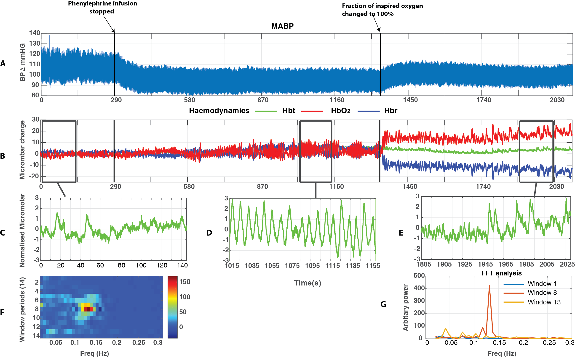
1
8
13
Figure 4.2 – Changes in MABP & haemodynamic oscillations across the three periods for one animal (total recording 2100s). A – MABP, B – Haemodynamics; Hbt (Green), Hbr (Blue), HbO₂ (Red), C – Phenylephrine on – window shows the first 145s of the recording (Hbt), D – Phenylephrine off – window shows a 145s of the recording within this period (Hbt), E – Hyperoxia- window shows a 145s of the recording within this period (Hbt), F – Image scale of the change in frequency (Hz) across the recording (14 windows), G – Graph showing the magnitude of frequencies ranging from 0-0.3Hz, for each period (phenylephrine on (window 1), phenylephrine off (window 8) and increases FiO₂ (window 13)) within haemodynamics. Note: The first black line at 290s demonstrates the end of the phenylephrine infusion and the second black line at 1340s demonstrates the start of the hyperoxic period.

FiO₂ changed to 100%
Figure 2

To examine whether these phenomena observed in a single animal were reliably present across subjects, the following analyses take metrics of MABP and cortical haemodynamics from each animal (n=11). To enable accurate analyses and comparisons of the three different periods within the recording, a smaller time period of 260s was examined in order to exclude any initial small changes occurring from the recording or the setup. 260s of data was taken and examined from each of the three periods (phenylephrine infusion on, phenylephrine infusion off and hyperoxia). Data was averaged across the three time periods in each animal and thus provided values of MABP and magnitude of power of ~0.1Hz oscillations for each animal.

Magnitude of MABP during the three periods (phenylephrine infusion on, phenylephrine infusion off and hyperoxia)
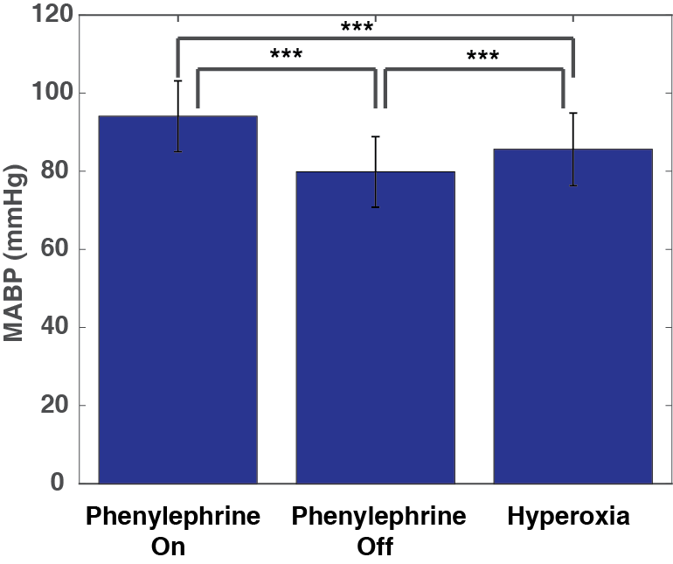
MABP were averaged across animals for the three periods (stated above). Averaged MABP was higher during the phenylephrine infusion period than compared to the other two periods (phenylephrine infusion off and hyperoxia, fig 4.3). Indeed, a one-way within subjects ANOVA was conducted to compare the effect of the three periods phenylephrine infusion on (M=94.07, SE=2.73), phenylephrine infusion off (M=79.83, SE=2.73) and the period where hyperoxia is induced (M=85.60, SE=2.80) on MABP. There was a significant effect of the three periods on MABP at the p<0.01 level (f(2,20)=86.426, p<0.001). Post hoc tests using the Bonferroni correction revealed that turning the infusion of phenylephrine off resulted in a statistically significant reduction in the mean MABP values (p<0.001), and changing the FiO₂ to 100% from medical air (hyperoxia) when the phenylephrine was turned off also resulted in a statistically significant increase in the mean MABP values (p<0.001).
Figure 4.3 – Comparison of MABP in the different conditions. Bars show the mean MABP (n=11) between the three periods: phenylephrine infusion on, phenylephrine infusion off and hyperoxia.
**

Magnitude of ~0.1Hz oscillations in Hbt, Hbr, HbO₂ in three different periods (phenylephrine infusion on, phenylephrine infusion off and hyperoxia)
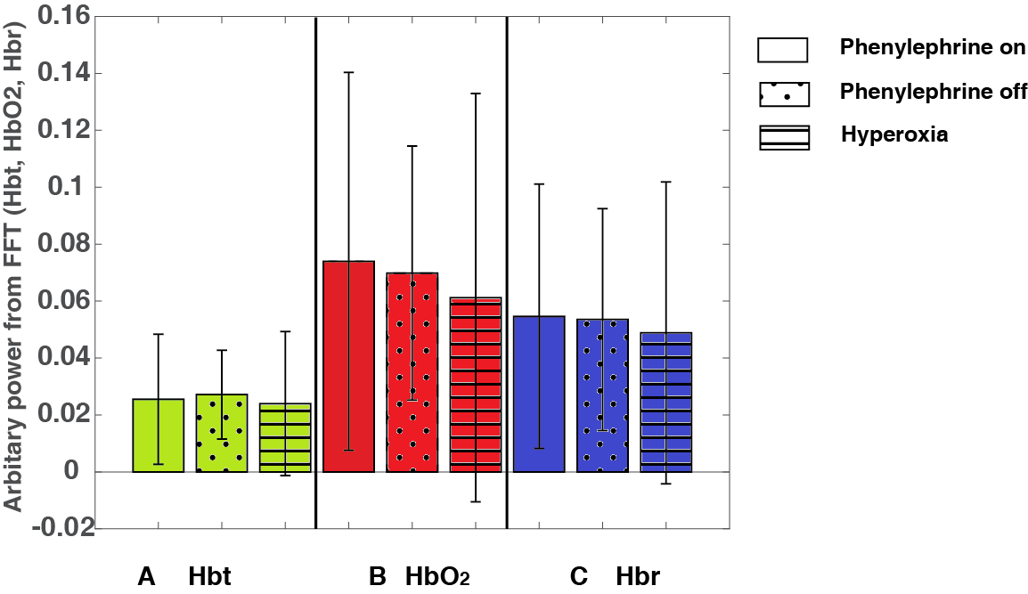
FFT analysis allowed the magnitude of cortical oscillations in cerebral haemodynamics: Hbt, Hbr and HbO₂ to be estimated. The mean power from FFTs between 0.08-0.2Hz was slightly higher during the phenylephrine infusion off period for Hbt (M =0.03, SE=0.01, fig 4.4A), slightly higher for phenylephrine infusion on period for HbO₂ (M=0.07, SE=0.02) and Hbr (M=0.05, SE=0.01, fig 4B & 4C). However, a one way within subjects ANOVA conducted to compare effect of the three periods on the mean magnitude of cortical oscillations from FFT between frequencies 0.08-0.2Hz was not significant, (F(2,20)=0.125, p>0.05) for Hbt, HbO₂ (F(2,20)=0.144, p>0.05) and Hbr (F(2,20)=0.058, p>0.05).
Power of oscillations within 0.08-0.2Hz
Figure 4 – Comparison of magnitude of haemodynamic oscillations between 0.08-0.2Hz. Bars shows the mean power between 0.08-0.2Hz (n=11) in haemodynamics (Hbt, HbO₂, Hbr); in the three periods; phenylephrine infusion on, phenylephrine infusion off and hyperoxia

Changes in Blood Oxygen Saturation
The oxygen saturation in the blood was also recorded using 2D-OIS. The mean blood oxygen saturation was compared between the three conditions (phenylephrine infusion on, phenylephrine infusion off and hyperoxia). The hyperoxic period has a higher average level of blood oxygen saturation (M=0.67, SE=0.02) than compared to the other two periods; phenylephrine infusion on (M=0.50, SE=0.00) and phenylephrine infusion off (M=0.56, SE=0.03, fig 4.5). A one way within subjects ANOVA was conducted to compare the effects of the three periods on the mean blood oxygen saturation and there was a significant difference in blood saturation was found, (f(2,20)=14.310, p<0.001) across the three periods. Although not significant, there was an unexpected trend towards an increase in blood oxygen saturation following cessation of phenylephrine. Post hoc tests using the Bonferroni correction revealed a statistically significant increase from turning the phenylephrine off and changing the FiO₂ to 100% (hyperoxia)(p=0.001).
Figure 4.5 – Comparison of MABP in the different conditions. Bars show the mean blood oxygen saturation (n=11) between the three conditions: (phenylephrine infusion on, phenylephrine infusion off and hyperoxia).
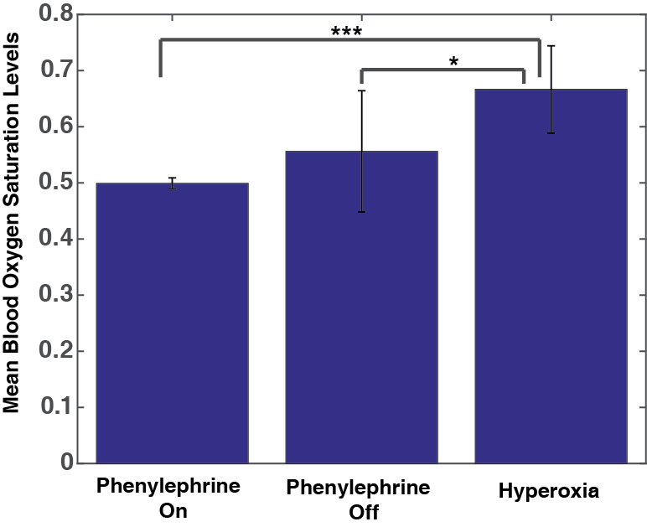

Associations between inter-animal variability in MABP and the power of cerebral haemodynamics oscillations
To examine whether there is a relation between MABP and power of the cerebral haemodynamic oscillations for individual animals, the individual recorded MABP and power of the haemodynamic oscillations were compared across the subjects for the different conditions (figs 4.6A-4.6D).
In general, the individual values (plotted on the correlation graph, figs 4.6A-4.6D) show that when phenylephrine infusion was on, animals have higher of MABP, which corresponds to lower of power of vasomotion oscillations (fig 4.6A). However, a Pearson’s correlation coefficient did not show a significant correlation, (r(9) = -0.3138, p>0.05) for Hbt (fig 4.6A). A Pearson’s correlation coefficient also showed no significant correlation for HbO₂, (r(9)= -0.3293, p>0.05) and Hbr, (r(9) = -0.3478, p>0.05).
Conversely, when the phenylephrine infusion was turned off, the individual values (plotted on the correlation graph) show a general decrease in the MABP which corresponds to slightly higher of power of vasomotion oscillations (fig 4.6B). However, a Pearson’s correlation coefficient did not show a significant correlation, (r(9) = -0.1350, p>0.05) for Hbt (fig 4.6B). A Pearson’s correlation also did not show a significant correlation, (r(9) =0.2112, p>0.05) for HbO₂ and (r(9)=0.2664, p>0.05) for Hbr. For illustrative purposes, these values are displayed within a scatterplot (fig 4.6A-D).

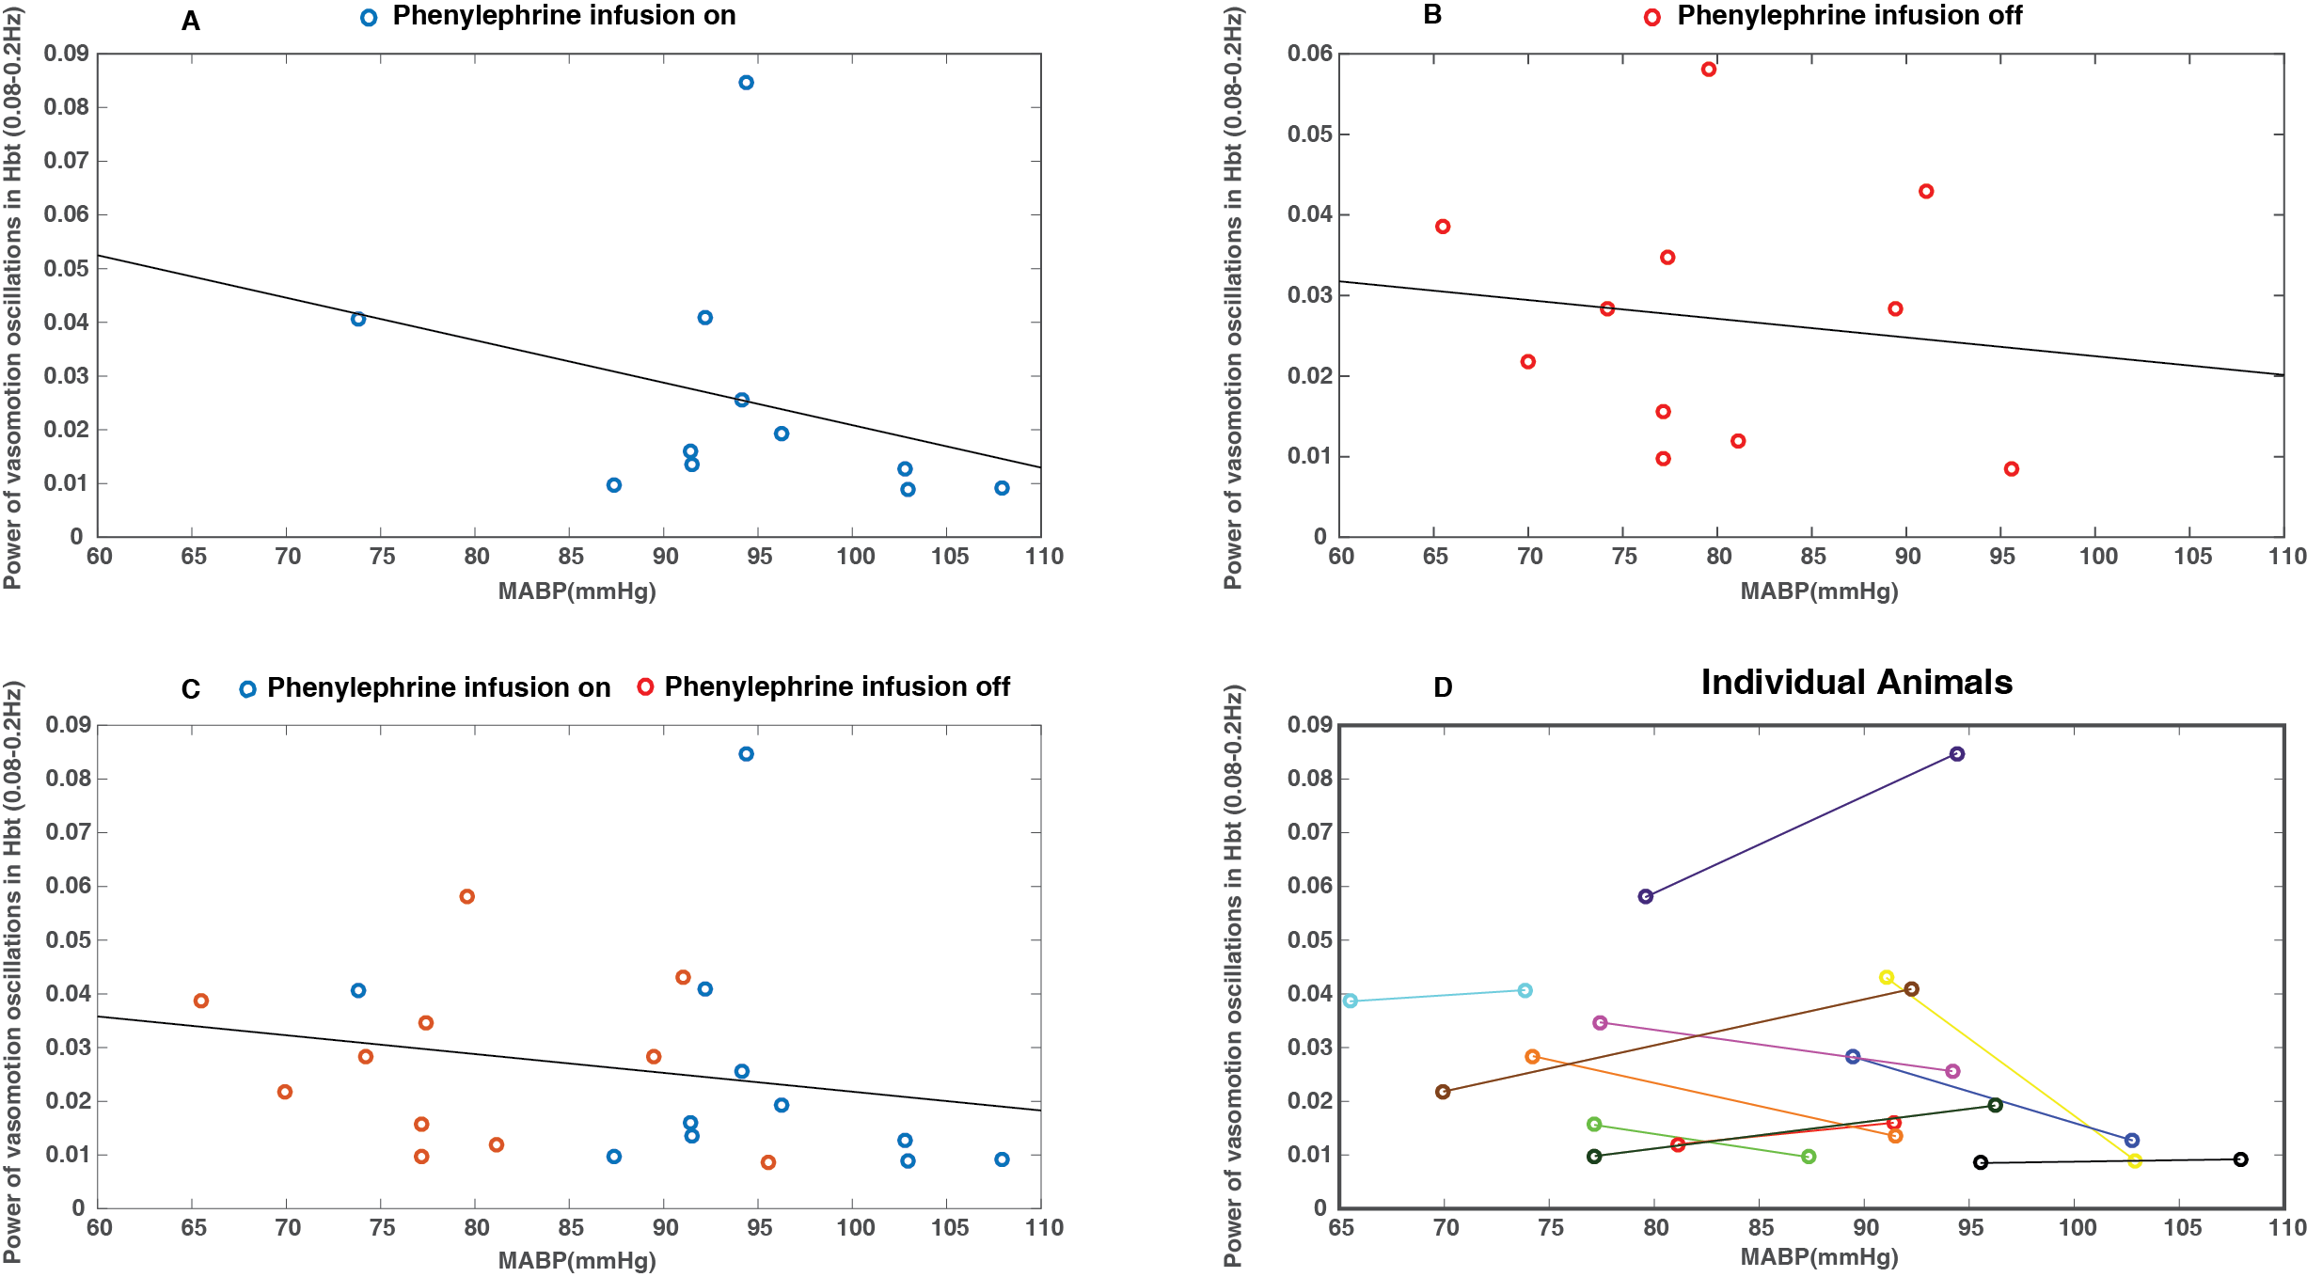
r = -0.3138
p = 0.3474
r = -0.1350
p = 0.6924
r = -0.2100
p = 0.3481
Figure 4.6 – Comparison between MABP and power of vasomotion oscillations in Hbt. Scatterplots show MABP and corresponding power in haemodynamics between 0.08-0.2Hz (n=11). A – Scatterplot shows the values within the period with phenylephrine infusion only. B - Scatterplot shows the values within the period without phenylephrine infusion only. C – Values displayed for both periods. D – (Fig C is repeated) data from each animal displayed as a single colour. r and p scores are shown for Hbt.

Within the hyperoxia period, the same correlations were made with the phenylephrine on period and hyperoxia (fig 4.7A-4.7D). During hyperoxia, generally, higher levels of MABP can be seen to correspond to lower power of vasomotion oscillations (0.08-0.2Hz). However, a Pearson’s correlation coefficient did not show a significant correlation, (r(9) = -0.1026, p>0.05 for Hbt) (fig 4.7B). A Pearson’s correlation coefficient also showed no significant correlation for HbO₂, (r(9)= -0.0240, p<0.05) and Hbr, (r(9) = -0.0142, p>0.05). For illustrative purposes, these values are displayed within a scatterplot (fig 4.7A-D).
Figure 4.7 – Comparison between MABP and power of vasomotion oscillations in Hbt Scatterplots displaying MABP and corresponding Hbt power between 0.08-0.2Hz (n=11). A –- Scatterplot shows the values within the period without phenylephrine infusion only B - Scatterplot shows the values within the hyperoxic period only. C – Values displayed for both periods. D – (Fig C is repeated) data from each animal displayed as a single colour. r and p scores are shown for Hbt.

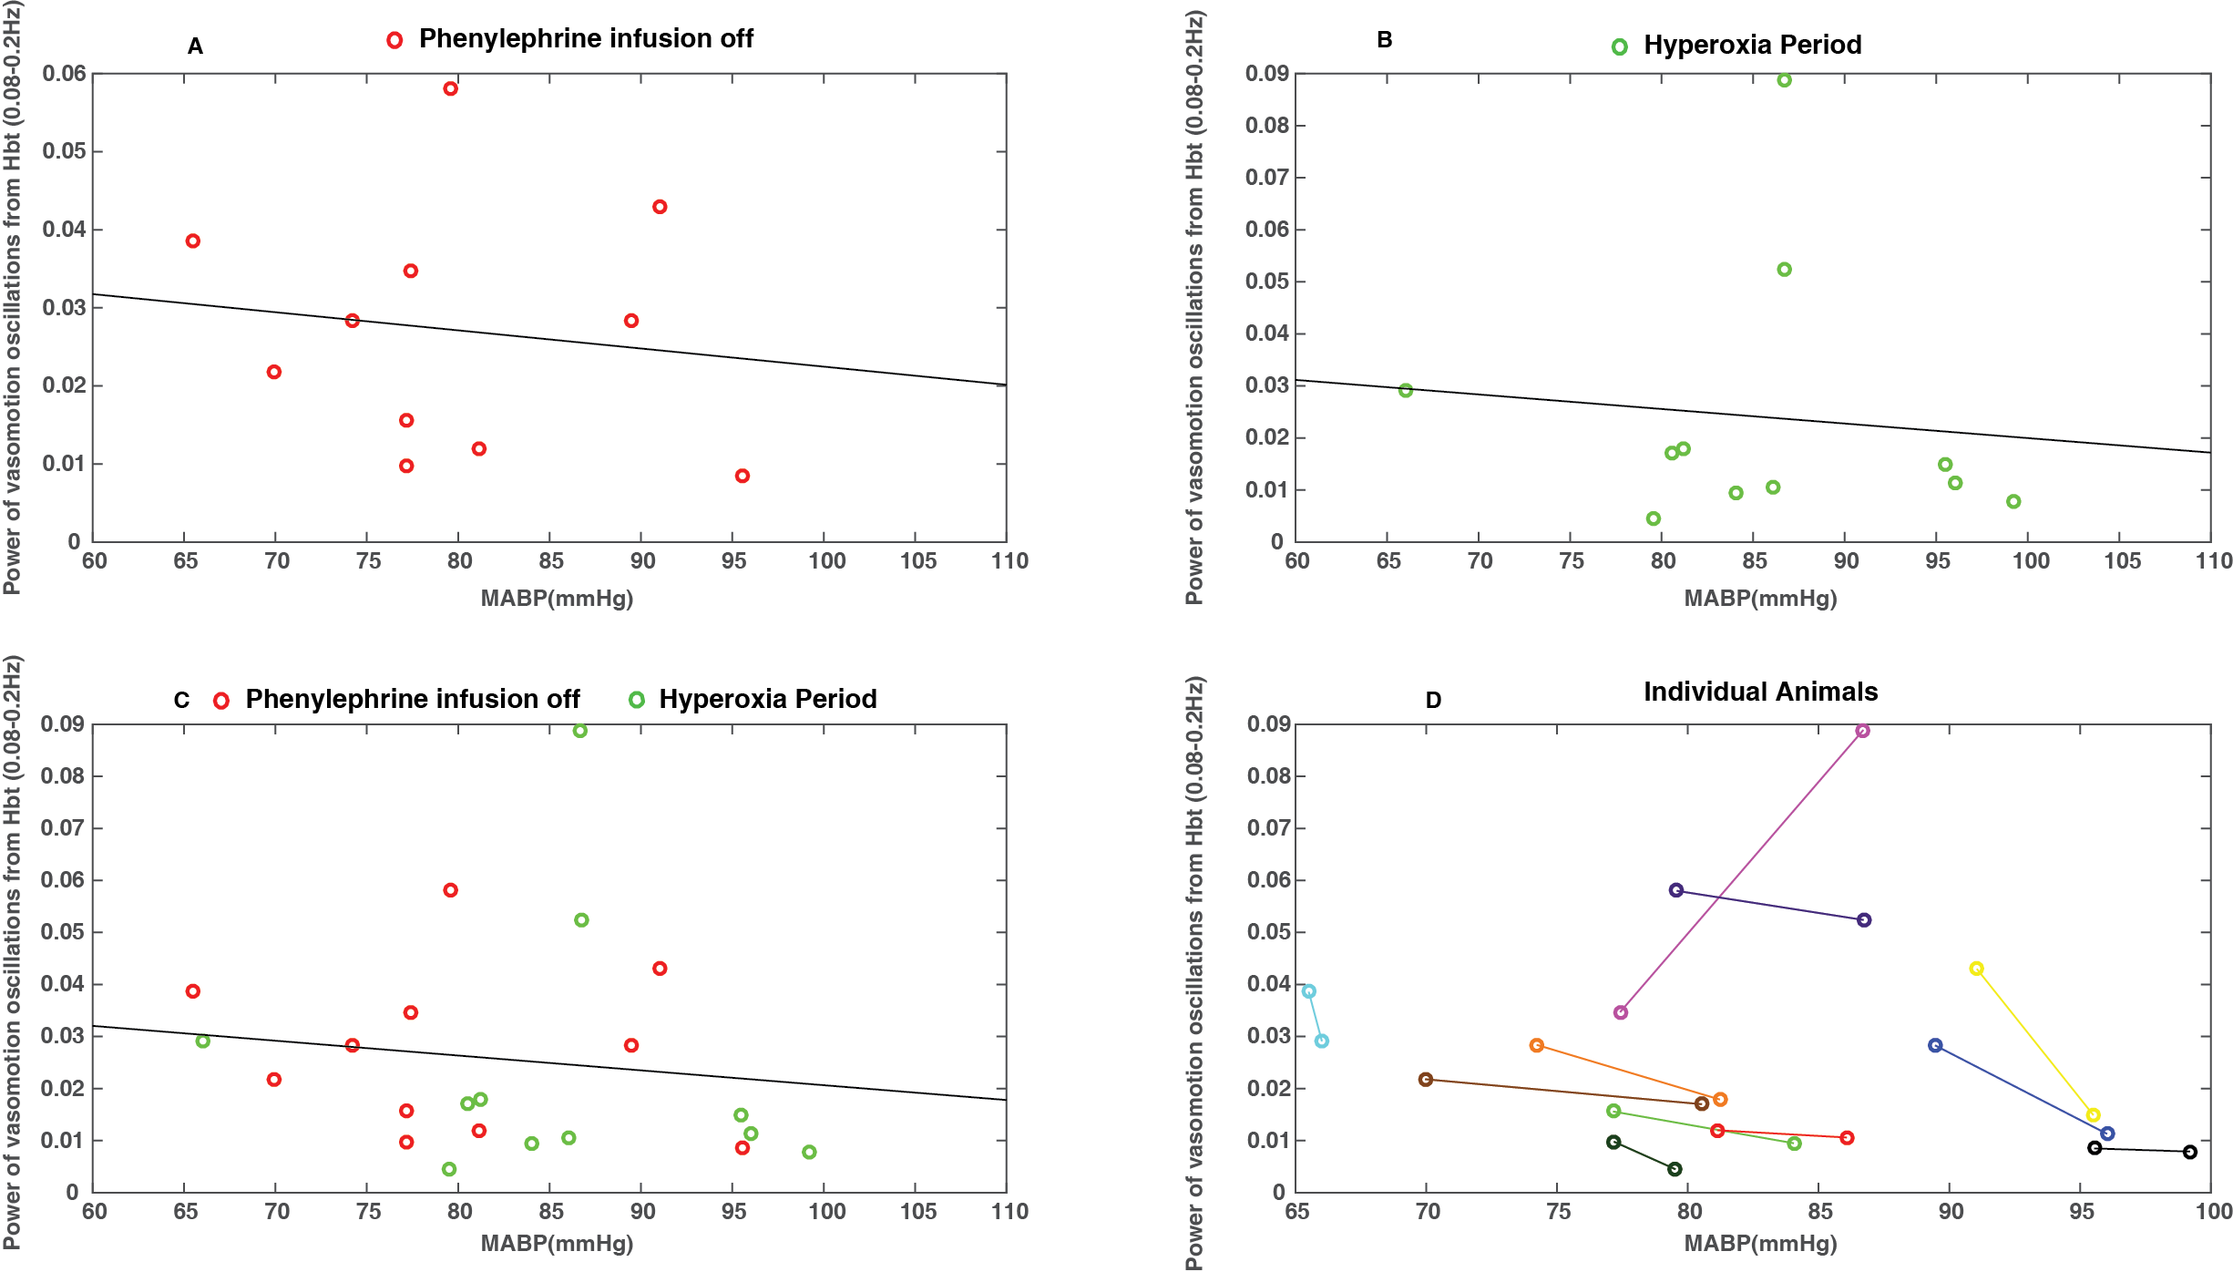
r = -0.1026
p = 0.7641
r = -0.1350
p = 0.6924
r = -0.1306
p = 0.5625

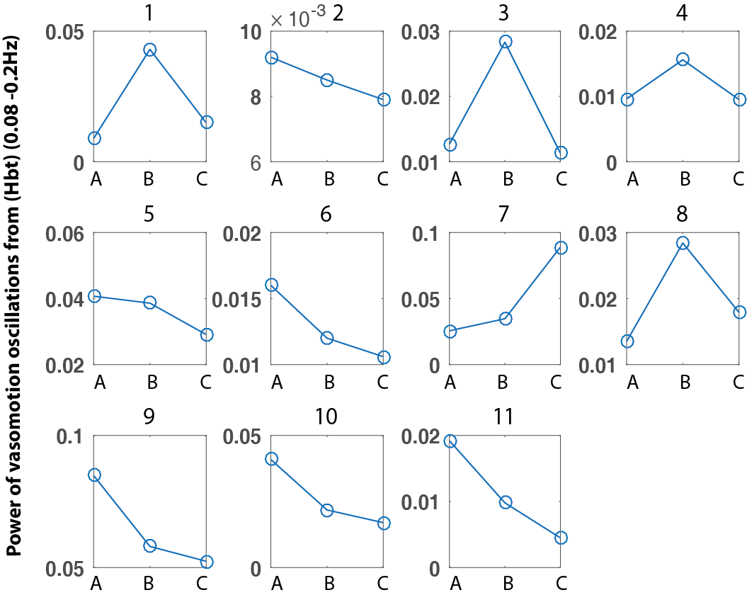
Being able to visualise the power of the vasomotion oscillations (0.08-0.2Hz) changing across the three periods (phenylephrine infusion on (fig 4.8A), off (fig 4.8B), and hyperoxia (fig 4.8C)) in each animal, showed that 5 animals showed an increase in the power of the vasomotion oscillations when phenylephrine infusion is turned off (fig 4.8 (animal numbers - 1,3,4,7,8)). Whereas, 6 animals showed a decrease in power in vasomotion values during the same period (fig 4.8 (animal numbers - 2,5,6,9,10,11)).
Figure 4.8 – Changes in power of haemodynamic oscillations across periods from Hbt between 0.08-0.2Hz (n=11). A – Phenylephrine infusion on period, B – Phenylephrine infusion off period, C – Hyperoxia. Numbers correspond to the animal number

To be able to visualise the average MABP, haemodynamics and blood saturation across the three periods, the entire time series of 2100s was averaged across animals (n=11). The mean MABP time series is shown to decrease after phenylephrine infusion is ceased (at 290s) and then increases following hyperoxia across all animals (at 1390s, fig 4.9A). Blood oxygen saturation showed an increase following cessation of phenylephrine and then an increase within hyperoxia, fig 4.9B). The haemodynamics show an increase in HbO₂ following the cessation of phenylephrine infusion and a concomitant decrease in Hbr (fig 4.9C). For comparison as with the individual animal (fig 4.3), the haemodynamic recording was divided into 14 temporal windows across the average recording. From this, FFT analysis allowed for visualisation of power of frequencies present within haemodynamic oscillations (fig 4.9D & 4.9E). The magnitude of haemodynamic oscillations at ~0.1Hz is seen to gradually increase once the phenylephrine infusion is ceased and is seen to decrease within hyperoxia (fig 4.9D).
Figure 4.9 – Comparison of MABP and Haemodynamics averaged across 11 animals A – MABP, B – Change in blood oxygen saturation level, C - Haemodynamics; Hbt (Green), Hbr (Blue), HbO₂ (Red), D – Image scale of the change in frequency (Hz) across the recording (14 windows), E – Graph showing the magnitude of frequencies ranging from 0-0.3Hz, for each period (phenylephrine on (window 1), phenylephrine off (window 8) and increases FiO₂ (window 13)) within haemodynamics. Note: The first black line at 290s demonstrates the end of the phenylephrine infusion and the second black line at 1340s demonstrates the start of the hyperoxic period.

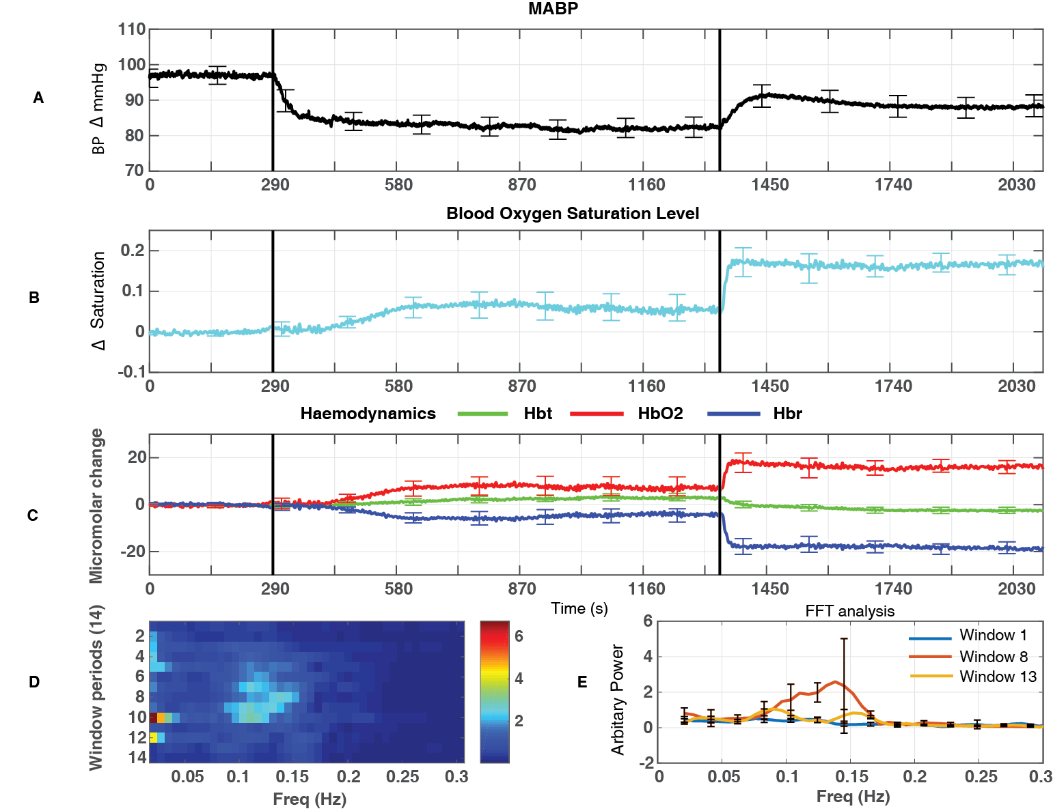
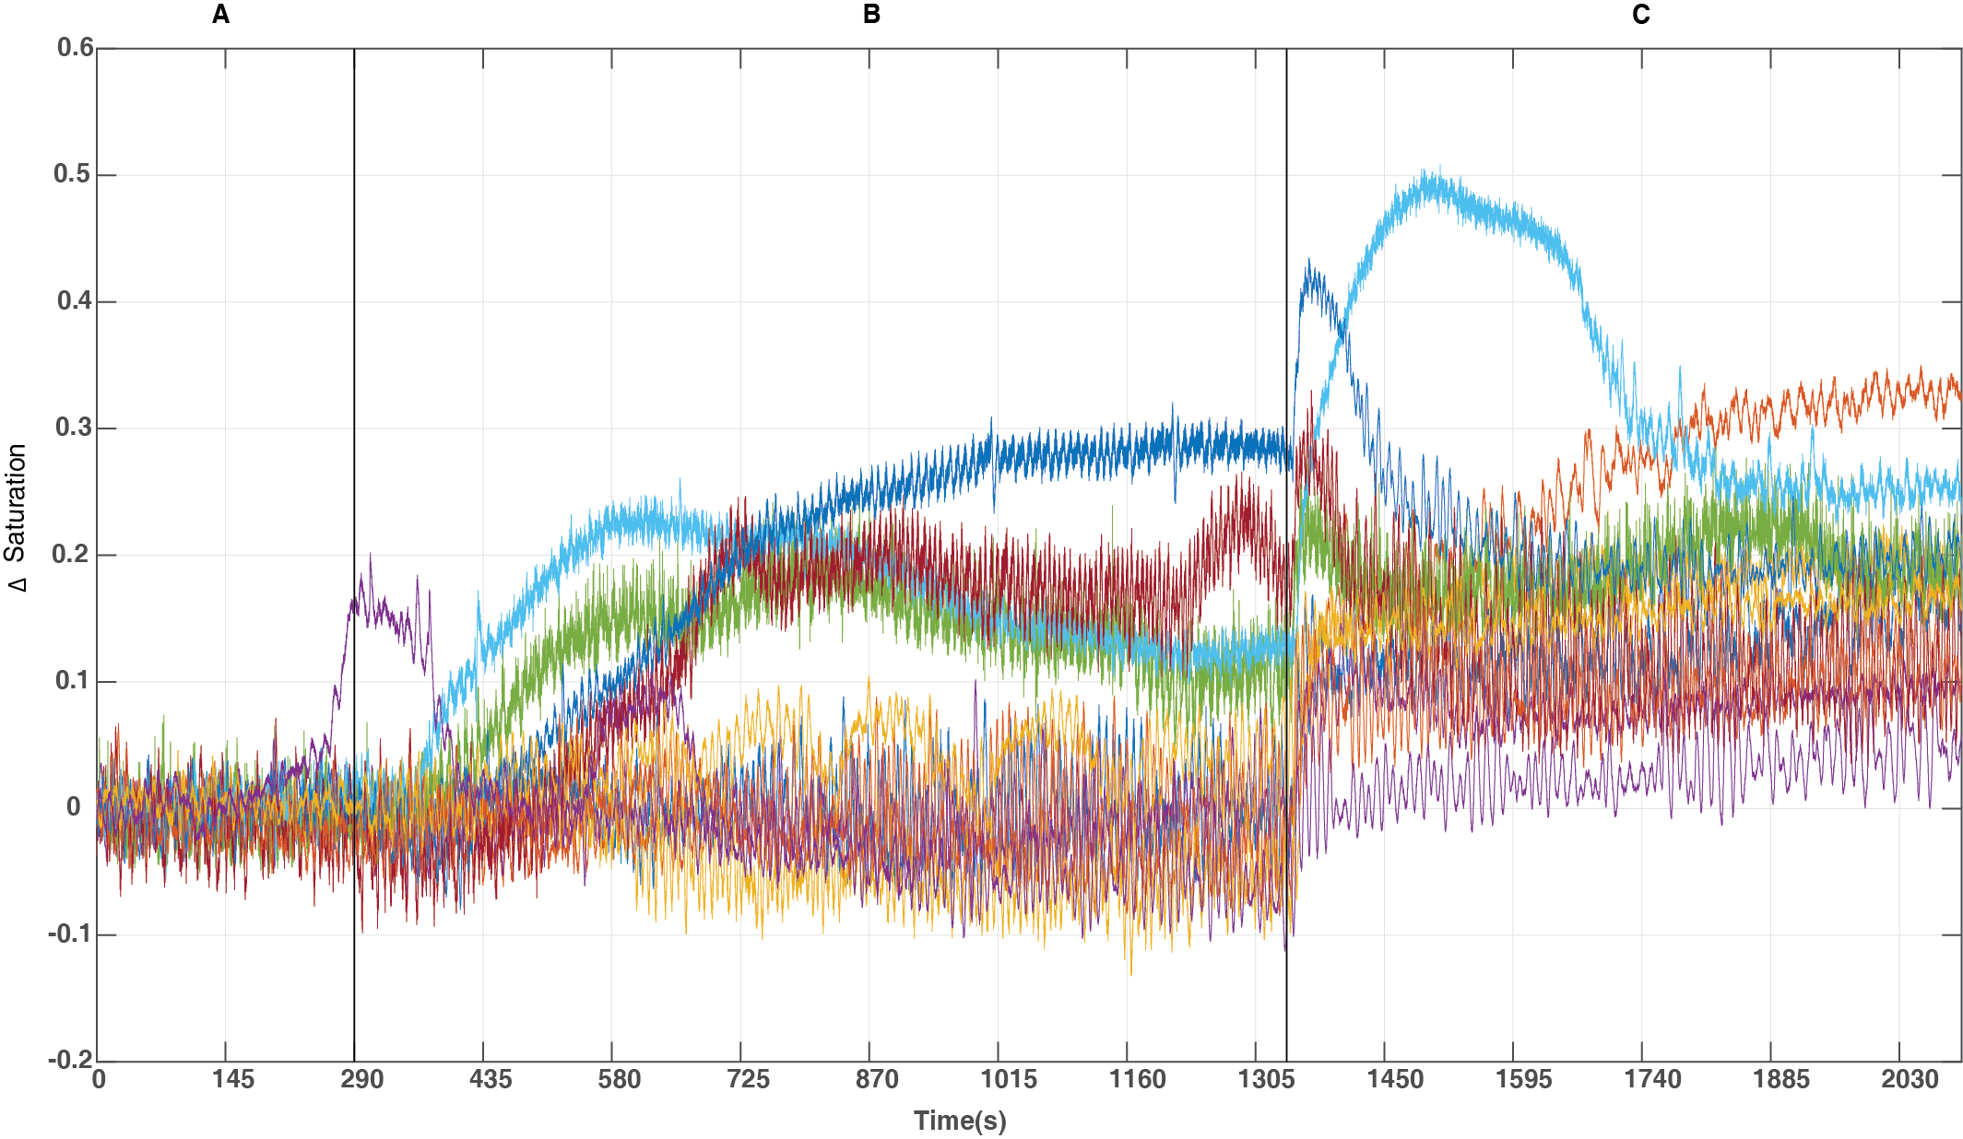
The overall average blood saturation across all subjects showed an overall increase in blood saturation when phenylephrine infusion was stopped. This increase was unexpected as phenylephrine infusion cessation decreases MABP levels. This was therefore investigated further by looking at the blood saturation time series for each individual animal (fig 4.10).

Figure 4.10 –Blood oxygen saturation levels for all individual animals (n=11). Each colour represents the recording for each animal across the three periods; A - phenylephrine infusion on (0-290s), B - phenylephrine infusion off (290-1340s), C - hyperoxia (1340-2100s).
Having observed the individual time series’ for showing blood oxygen saturation level for each animal, it is clear there are distinct differences in the time series during the period when phenylephrine was turned off (290-1340s, fig 4.10).
To investigate the differences in the blood oxygen saturation further, animals that showed increases in blood saturation during phenylephrine infusion off period were separated into the first group (group 1) and the animals that showed minimal changes to blood saturation during phenylephrine infusion were put into a second group (group 2). Further to this, recent research by Slack et al, (2016) has found that differences in baseline neural activity were associated with changes in baseline haemodynamics. More specifically, Slack et al., (2016) has shown that increases in blood oxygen saturation can be observed during periods of cortical desynchronisation (associated with cortical arousal). So to investigate this further, simultaneously recorded electrophysiological activity and blood saturation will be compared in a similar manner top that used by Slack et al.,(2016) (figs 4.11 & 4.12).

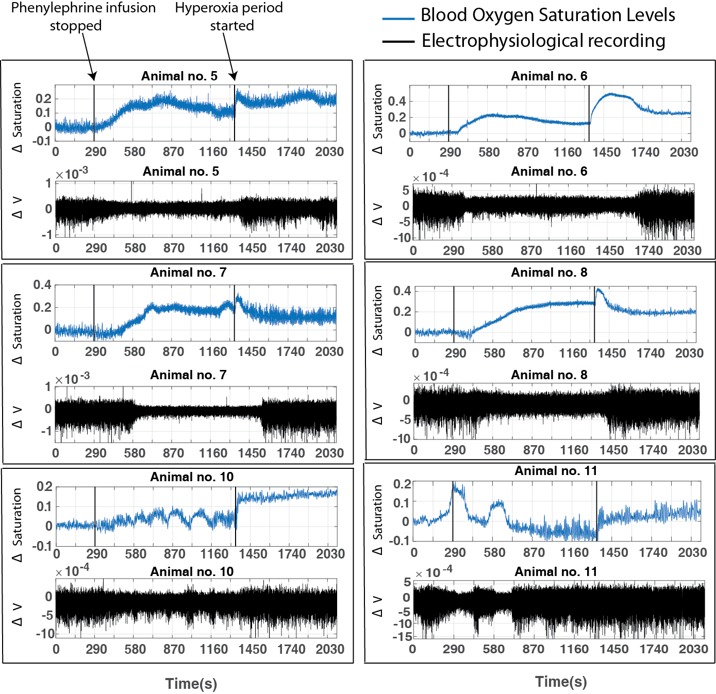
Figure 4.11 –Comparison of electrophysiological recording and blood saturation- Group 1 – Time series’ shows the animals’ (n=6) blood oxygen saturation levels (blue) and corresponding electrophysiological recording (LFP) (black) from channel 7. All animals presented show a ~10-20% increase in blood oxygen saturation levels at some point when the phenylephrine infusion is stopped (290s-1340s). Animals 5, 6, 7, 8, 10, 11 all fit these criteria.
Group 1
A temporal relation between the electrophysiological recordings and the concomitant increases in blood oxygen saturation can be observed (fig 4.11). Also, the electrophysiological recordings can be seen to show changes in the amplitude and frequency across the recording. These changes have been termed in Slack et al., 2016 where periods of small amplitude and high frequency are called desynchronisation period and periods with large amplitude and small frequency is called synchronised periods.
Similarly, animals within group 2 (n=5) will be presented with the corresponding electrophysiological recording (fig 4.12).

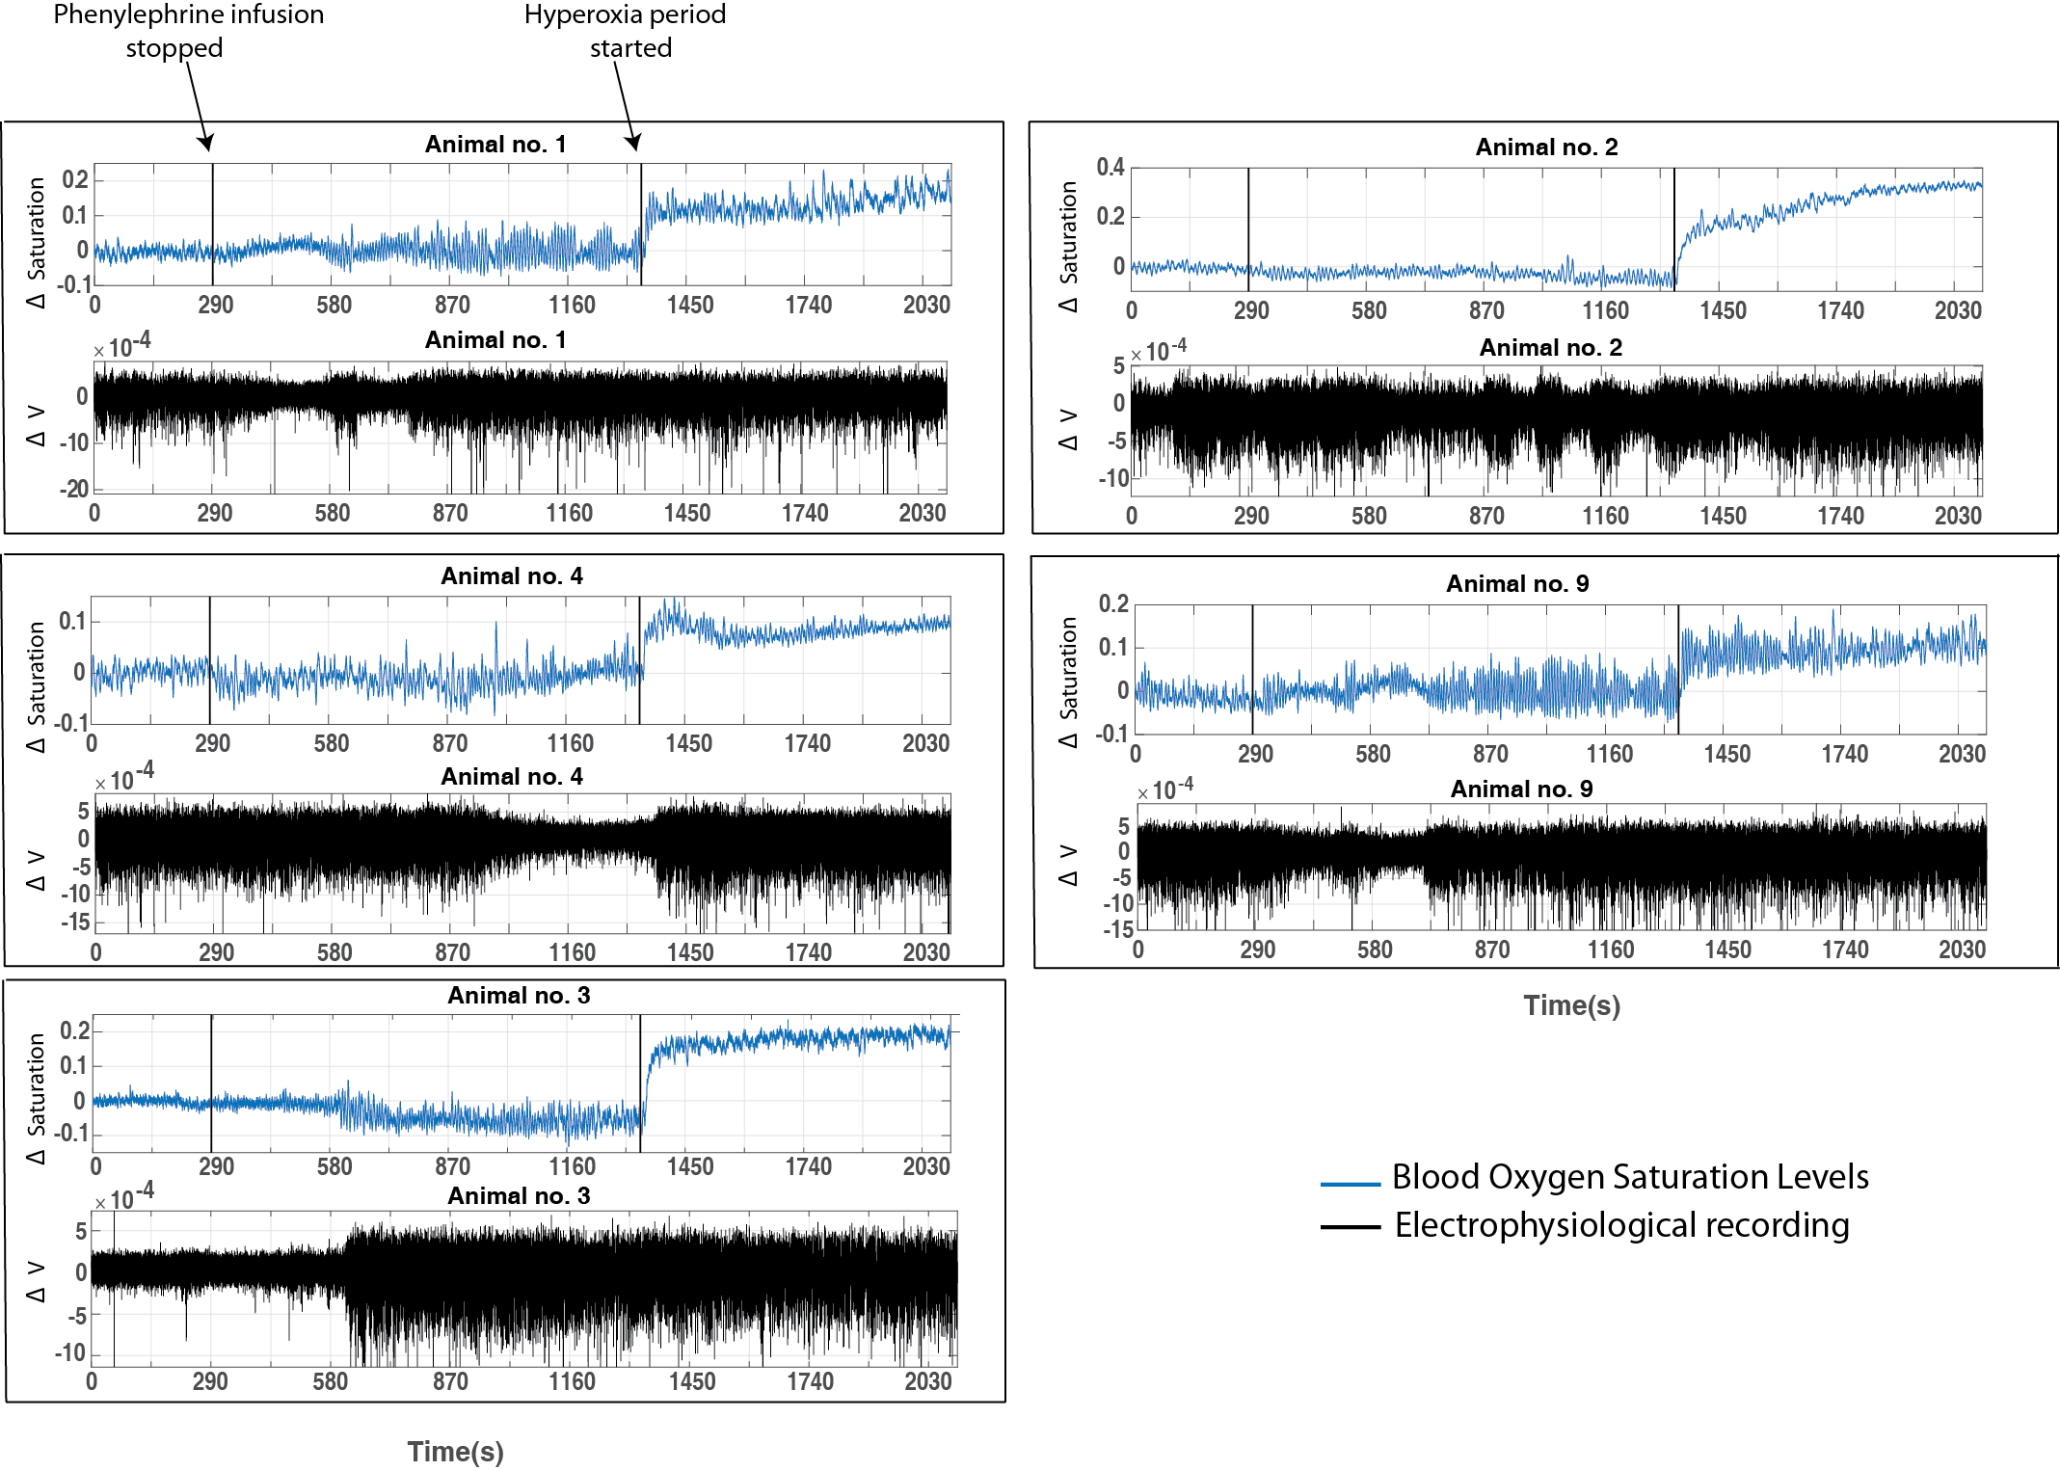
Group 2
Figure 4.12 – Comparison of electrophysiological recording and blood saturation - Group 2 - Time series’ shows the animals’ (n=5) blood oxygen saturation levels (blue) and the corresponding electrophysiological recording (black) from channel 7. All animals presented show small/minimal changes in the blood oxygen saturation levels when the phenylephrine is stopped (290s – 1340s). Animals 1, 2, 3, 4, 9 all fit these criteria.

Animals were classified into group 2 (n=5) displayed small/minimal amounts of change in the blood oxygen saturation within the period where phenylephrine infusion is ceased (fig 4.12). The corresponding electrophysiological activity for each animal does show changes in the neural activity (e.g. changes from synchronised (high amplitude, small frequency) to desynchronised (small amplitude, high freqency) (fig 4.12). Although, the changes in neural activity were not seen to have a significant temporal relation on the blood oxygen saturation.

Changes in blood oxygen saturation within the two groups
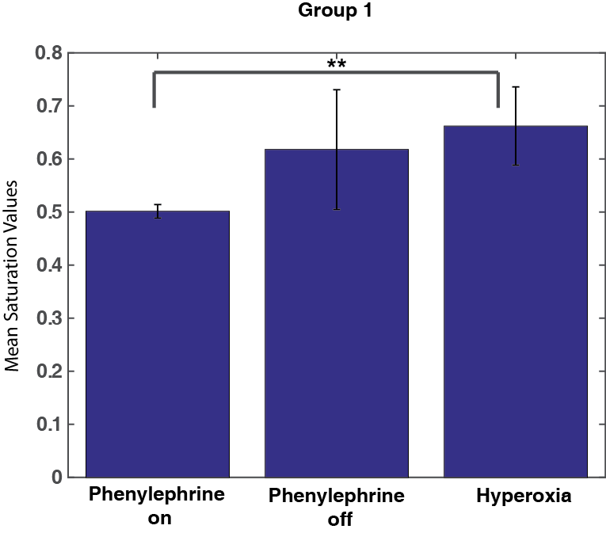
The mean values of blood oxygen saturation values were compared for group 1 (n=6), across the three periods (phenylephrine infusion on, off and hyperoxia, fig 4.13). A one way ANOVA was conducted to compare the effects of the three periods on the mean blood oxygen saturation and a significant difference was found, (f(2,10) = 8.290, p<0.01). Post hoc tests using the Bonferroni correction revealed that within group 1, there is a statistically significant difference in the mean blood oxygen saturation between when phenylephrine was on and when hyperoxia was induced (p =0.013).

Figure 4.13 – Comparison of mean saturation values - Group 1 - Bars show the mean difference in blood oxygen saturation levels (n=6) between the three conditions (phenylephrine infusion on, phenylephrine infusion off and hyperoxia)

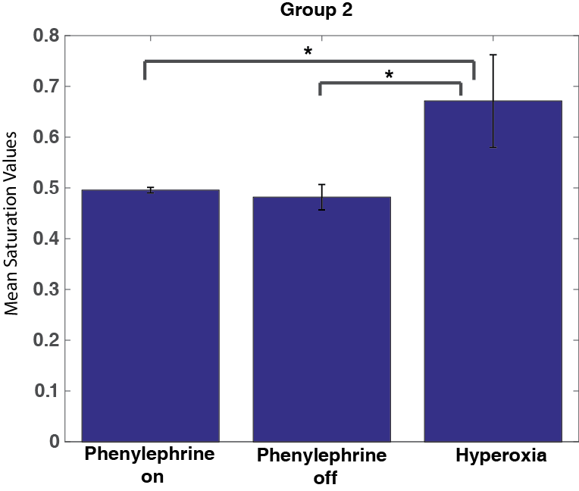
The mean values of blood oxygen saturation values were compared for group 2 (n=5), across the three periods (phenylephrine infusion on, off and hyperoxia, fig 4.14). A one way ANOVA was conducted to compare the effects of the three periods on the mean blood oxygen saturation and a significant difference was found, (f(2,8) = 16.648, p<0.01). Post hoc tests using the Bonferroni correction revealed that within group 2, a statistically significant difference was found in the mean blood oxygen saturation between when phenylephrine was on and when hyperoxia was induced (p =0.038). Also a statistically significant difference was found between when the phenylephrine was turned off and when hyperoxia was induced (p =0.047).
Figure 4.14 – Comparison of mean saturation values Group 2 - Bars show the mean difference in blood oxygen saturation levels (n=5) between the three conditions (phenylephrine infusion on, phenylephrine infusion off and hyperoxia)

Comparison of the magnitude of ~0.1Hz oscillations in Hbt, Hbr, HbO₂ in three different periods (phenylephrine infusion on, phenylephrine infusion off and hyperoxia)

Group 1
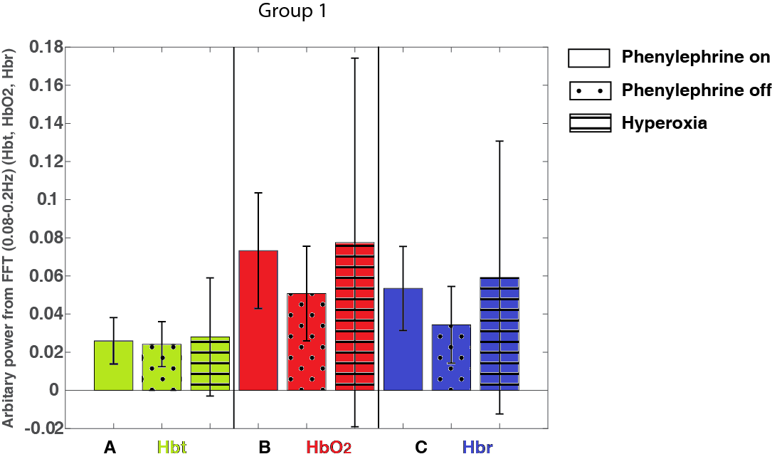
The mean power in the haemodynamic oscillations between 0.08-0.2Hz was higher during the phenylephrine on and hyperoxia period and lowest within the period where phenylephrine infusion was ceased across Hbt, Hbr and HbO₂ (fig 4.15A, B, C). However, a one way within subjects ANOVA was conducted to compare the effect of three periods on the mean power in the haemodynamic oscillations (0.08-0.2Hz) and this was not significant, (f(2,10)=0.073, p>0.05) for Hbt, HbO₂ (f(1.018,5.091)=0.440,p>0.05) and Hbr (f(1.008,5.038)=0.622, p>0.05).
Figure 4.15 - Comparison of magnitude of haemodynamic oscillations between 0.08-0.2Hz. Group 1 – Bars show the mean power between 0.08-0.2Hz (n=6) in haemodynamics (Hbt, HbO₂, Hbr); in the three periods; phenylephrine infusion on, phenylephrine infusion off, hyperoxia

Power of oscillations within 0.08-0.2Hz

Group 2
The mean power in the haemodynamic oscillations between 0.08-0.2Hz was higher when the phenylephrine infusion was ceased across Hbt, Hbr and HbO₂ (fig 4.16A, B, C). A one way within subjects ANOVA was conducted to compare the effect of three periods on the mean power in the haemodynamic oscillations (0.08-0.2Hz) and this was not significant, (f(2,8)=1.160, p>0.05) for Hbt, HbO₂ (f(2,8)=0.955,p>0.05) and Hbr (f(2,8)=1.110, p>0.05).
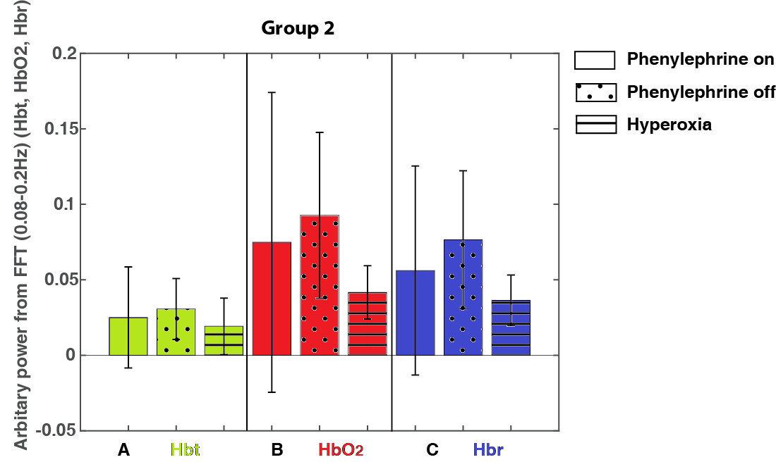

Power of oscillations within 0.08-0.2Hz
Figure 4.16 – Comparison of magnitude of haemodynamic oscillations between 0.08-0.2Hz– Bars show the mean power between 0.08-0.2Hz (n=5) in haemodynamics (Hbt, HbO₂, Hbr); in the three periods; phenylephrine infusion on, phenylephrine infusion off, hyperoxia

To be able to visualise the average MABP, haemodynamics and blood saturation across the three periods, the entire time series of 2100s was averaged across animals in both groups; group 1 (n=6, fig 4.17), group 2 (n=5, fig 4.18). Group 1 (n=6), showed a mean decrease in MABP phenylephrine infusion is ceased (at 290s) then increases following change in the FiO₂ to 100% (hyperoxia period) (at 1390s) (fig 4.17A). Blood oxygen saturation was seen to increase after cessation of phenylephrine and slight increase within the hyperoxia period (fig 4.17B). Similarly, the haemodynamics show an increase in HbO₂ and a concomitant decrease in Hbr (fig 4.17C) following cessation of phenylephrine and again a slight increase in HbO₂ within the hyperoxia period. The magnitude vasomotion oscillations at ~0.1Hz were seen to gradually increase once the phenylephrine infusion was ceased and this was seen to decrease within the hyperoxia period (fig 4.17D). There is a distinct difference between the magnitude of frequencies between the three chosen time periods (phenylephrine on - window 1, phenylephrine off -window 8 and hyperoxia -window 13, fig 4.17E).
Figure 4.17 – Changes in MABP & haemodynamic oscillations across the three periods - Group 1 - Data from an average of 6 animals (total recording 2100s) showing A – MABP, B – Change in blood oxygen saturation level, C - Haemodynamics; Hbt (Green), Hbr (Blue), HbO₂ (Red), D – Image scale of the change in frequency (Hz) across the recording (14 windows), E – Graph showing the magnitude of frequencies ranging from 0-0.3Hz, for each period (phenylephrine on (window 1), phenylephrine off (window 8) and increases FiO₂ (window 13)) within haemodynamics. Note: The first black line at 290s demonstrates the end of the phenylephrine infusion and the second black line at 1340s demonstrates the start of the hyperoxia period.

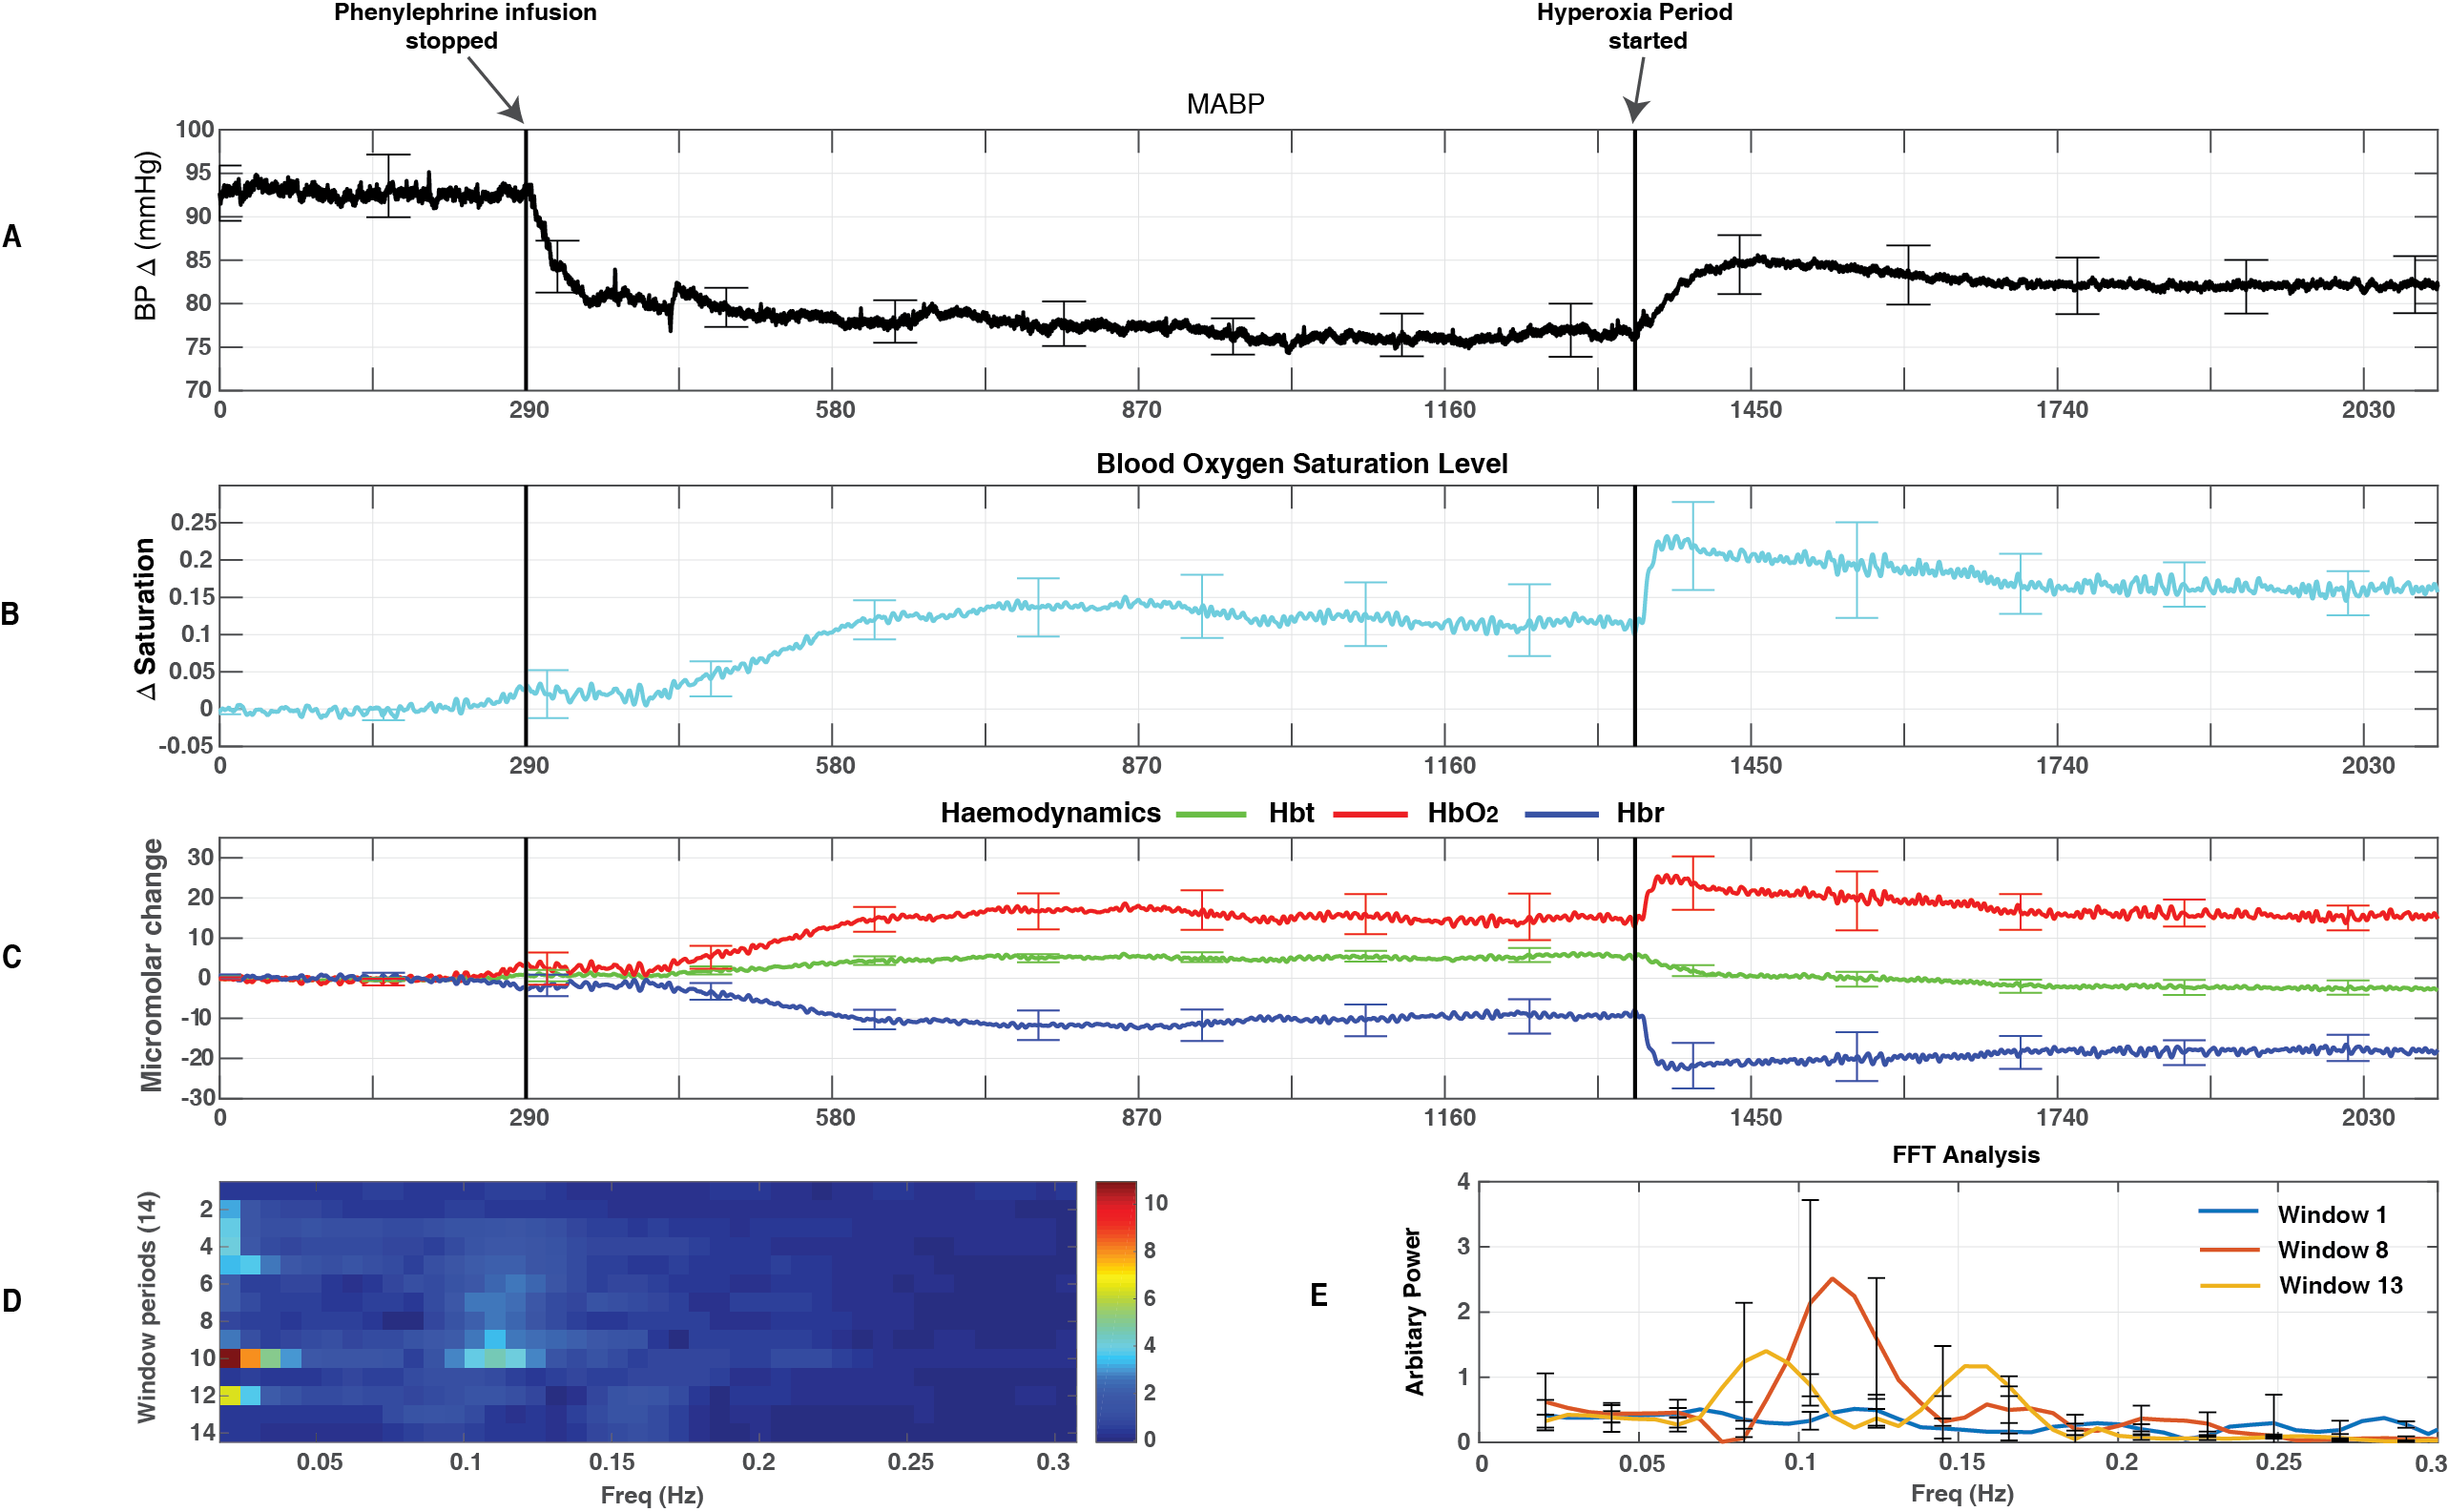

The second group (n=5) showed a decrease in MABP when the phenylephrine infusion was ceased (290s) and a slight increase following the change in the FiO₂ to 100% (at 1390s, fig 4.18A). Blood oxygen saturation and haemodynamics both show a very slight decrease within the period when phenylephrine infusion was ceased and then an increase within the hyperoxia period (increase in HbO₂ for haemodynamics) (fig 4.18B &4.18C). The magnitude of vasomotion oscillations (~0.1Hz) was seen to gradually increase once the phenylephrine infusion was ceased and seen to decrease within the hyperoxic period (fig 4.18D). There is a distinct difference between the magnitude of frequencies between the three chosen time periods (phenylephrine on - window 1, phenylephrine off -window 8 and hyperoxia -window 13, fig 4.18E).
Figure 4.18 – Changes in MABP & haemodynamic oscillations across the three periods - Group 2 - Data from an average of 5 animals (total recording 2100s) showing A – MABP, B – Change in blood oxygen saturation level, C - Haemodynamics; Hbt (Green), Hbr (Blue), HbO₂ (Red), D – Image scale of the change in frequency (Hz) across the recording (14 windows), E – Graph showing the magnitude of frequencies ranging from 0-0.3Hz, for each period (phenylephrine on (window 1), phenylephrine off (window 8) and increases FiO₂ (window 13)) within haemodynamics.. Note: The first black line at 290s demonstrates the end of the phenylephrine infusion and the second black line at 1340s demonstrates the start of the hyperoxia period.

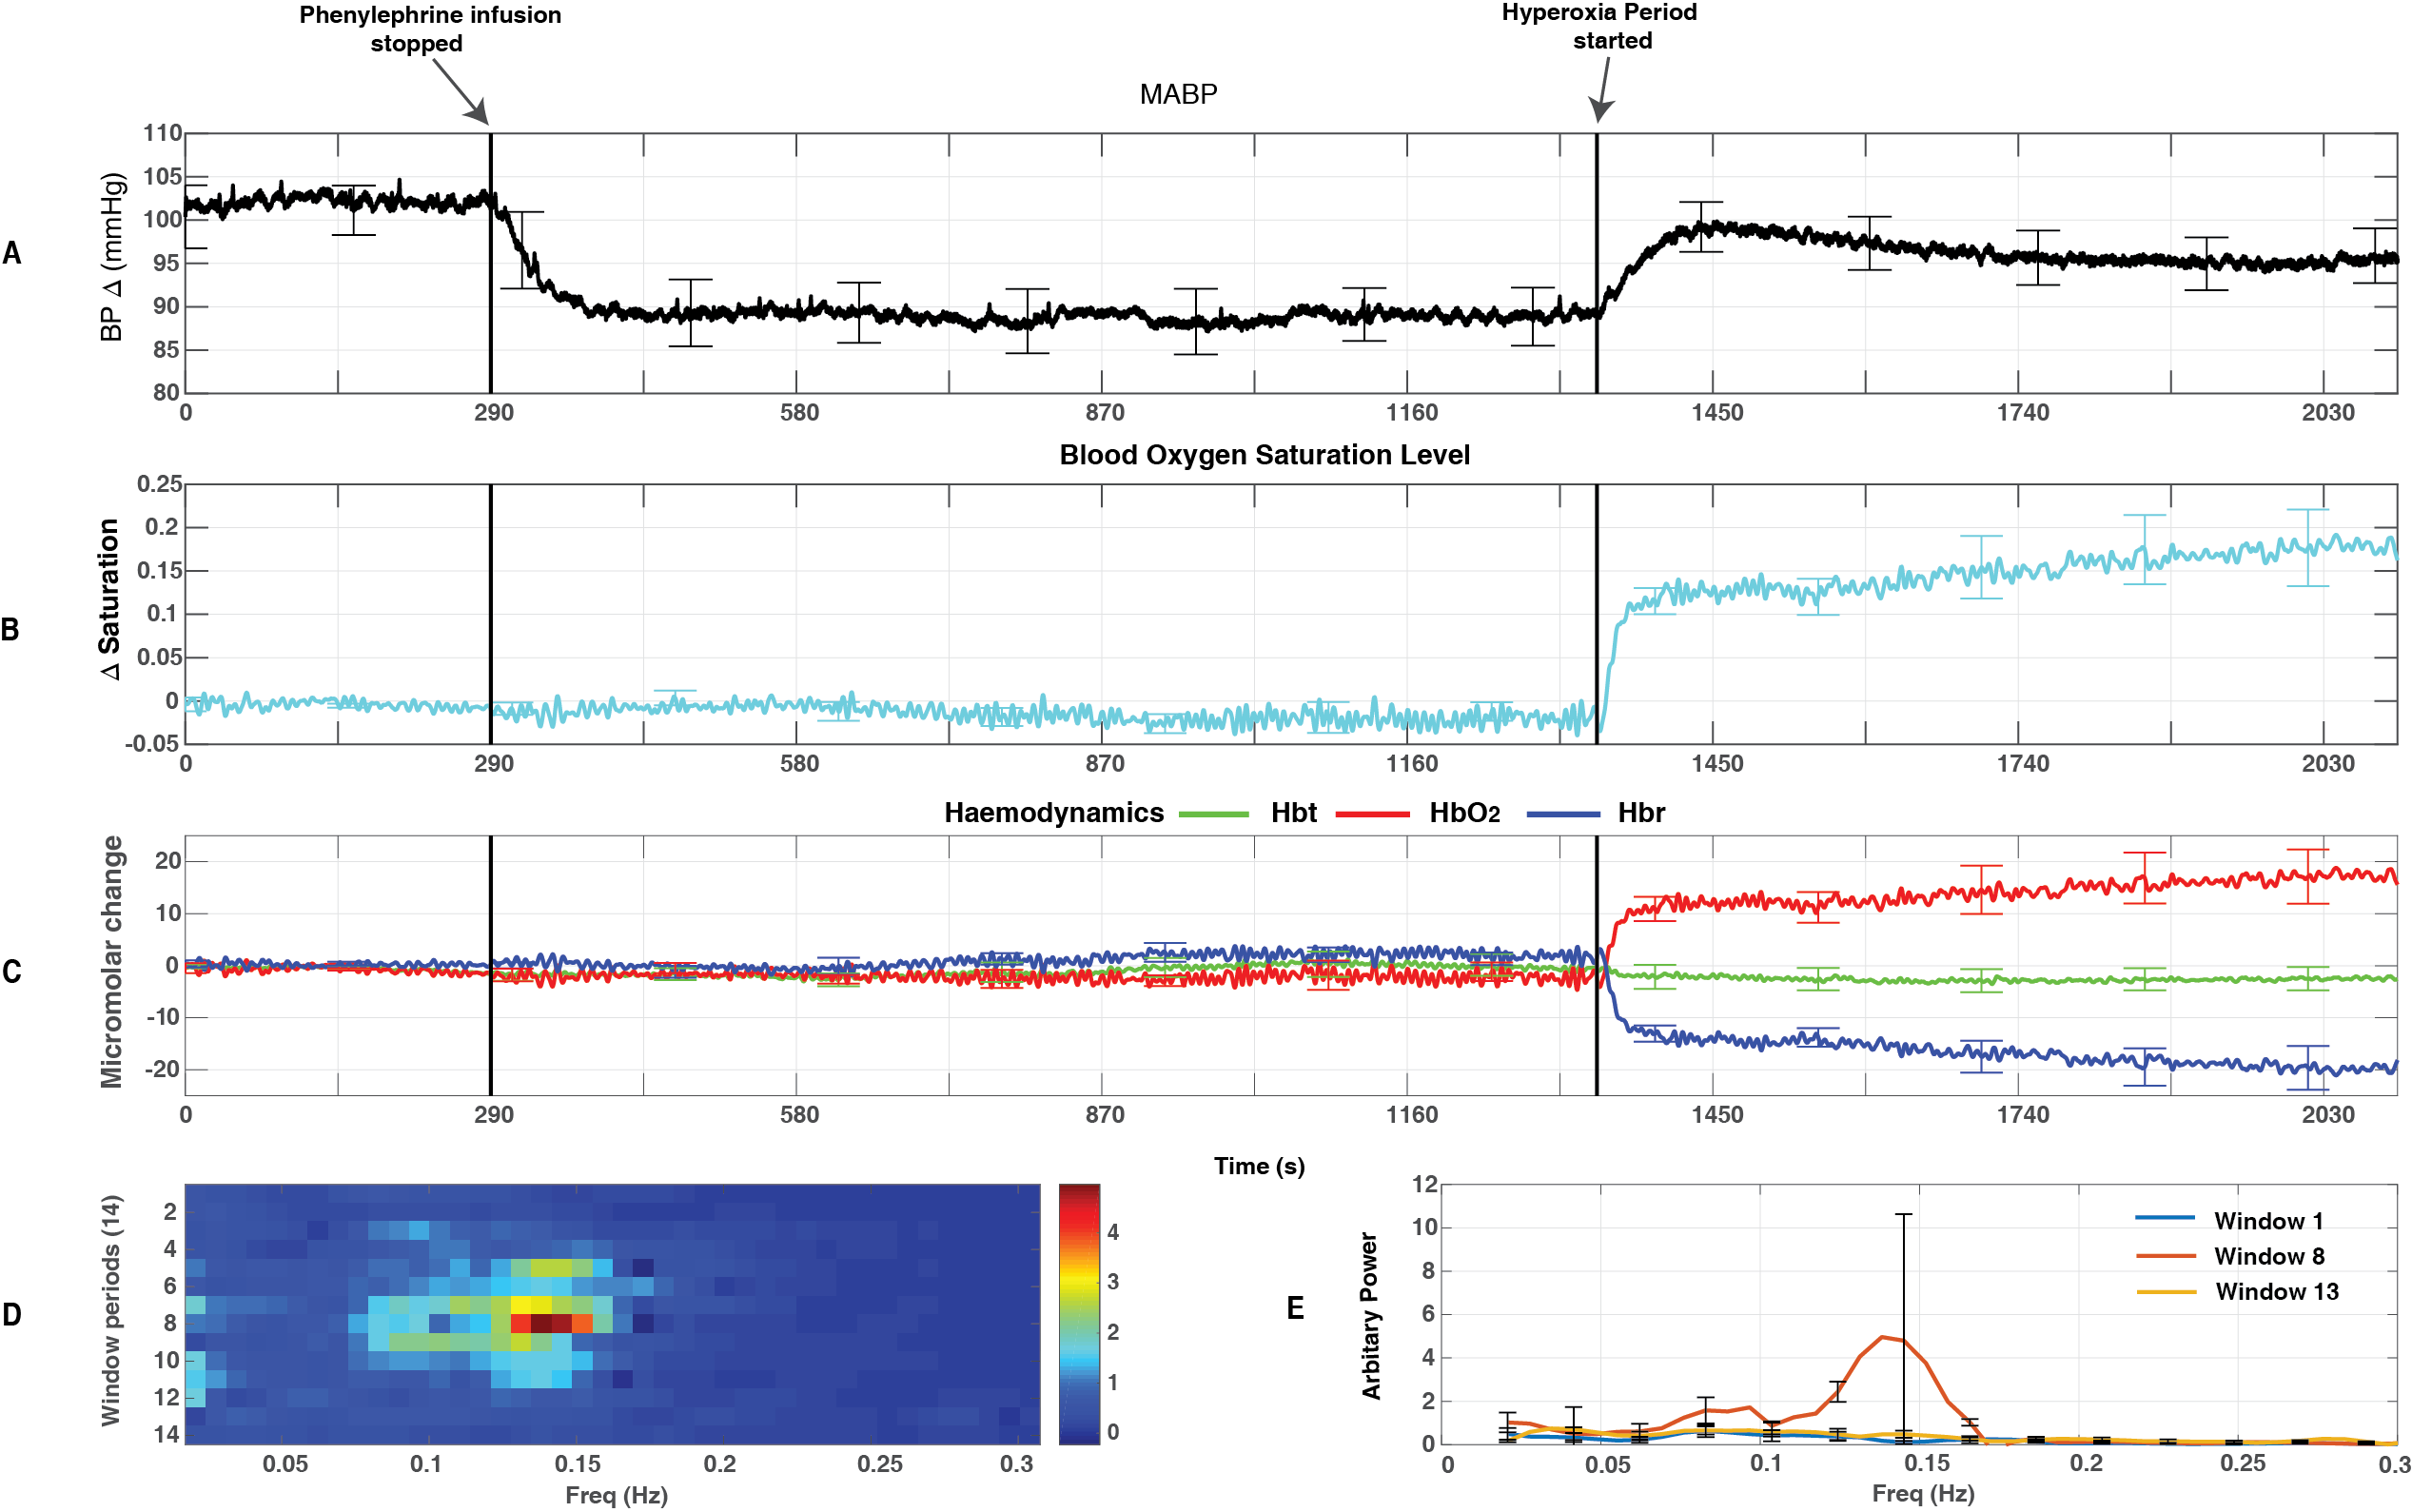

Spatial map showing the magnitude of power between 0.08-0.2 Hz of the haemodynamic cortical oscillations.
Fourier analysis was carried out across every pixel over the cortical surface to quantify the magnitude of power of the frequencies centred around (0.08-0.2Hz) within haemodynamic oscillations. Spatial maps were created from this information and are shown for the three periods (phenylephrine on, phenylephrine off and hyperoxia) for two animals (figs 4.19 &4.20) and also for the cerebral haemodynamics: Hbt, Hbr, HbO₂ (figs 4.19 A-C & 4.20 A-C). A greater magnitude of power was seen in the period when phenylephrine infusion was ceased showing distinct spatial patterns between cerebral haemodynamics i.e. stronger magnitude of power was seen in the arteries for Hbt, veins for Hbr and both arteries and veins for HbO₂.
Figure 4.19 & 4.20 – Spatial maps of oscillatory power (0.08-0.2Hz) in the recorded haemodynamics across the cortical surface for one animal. Each spatial map shows the magnitude of power of the frequencies from FFTs across the cortex (encompasses the whisker barrel region). The grey scale image shows the thinned cranial window of the cortex. A spatial map was created for Hbt (A1), HbO₂ (B1) and Hbr (C1) for all three periods (phenylephrine infusion on, phenylephrine infusion off and hyperoxia). Colour bar represents power

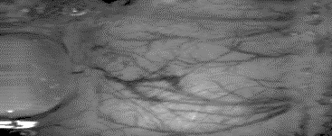
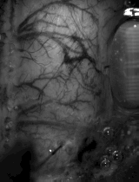
Artery
Vein
C
B
A
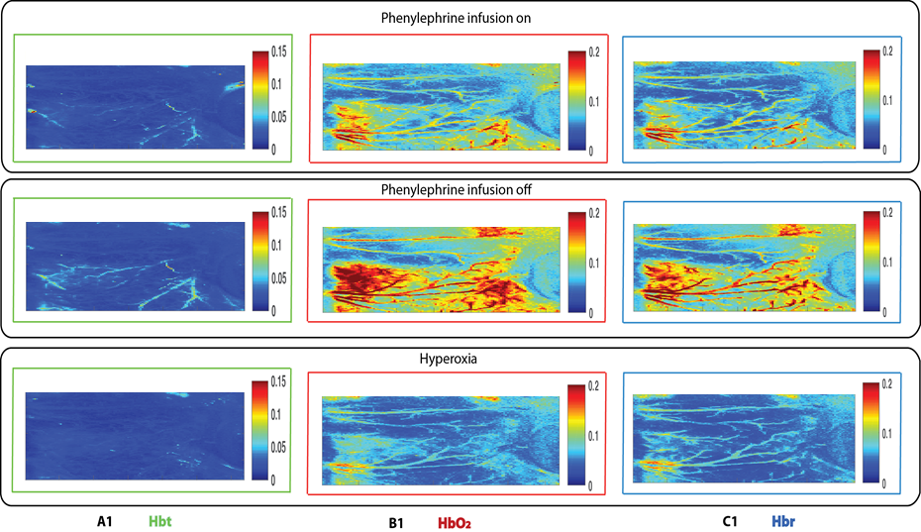
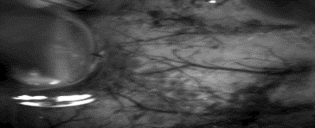
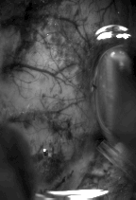
Electrode
Vein
Artery
C
B
A
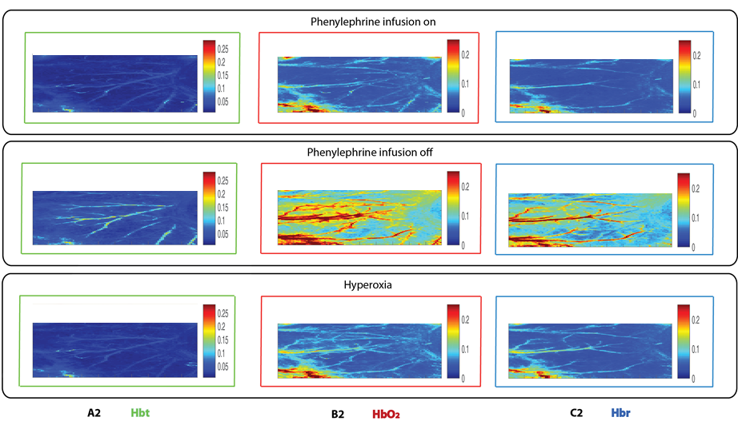

Discussion
This chapter investigated the magnitude of vasomotion oscillations within cortical haemodynamics during periods of normal and lowered systemic MABP. In addition to this, to investigate the relationship between the magnitude of vasomotion oscillations and cerebral oxygen supply, the FiO₂ was changed from normal air to 100% oxygen only (hyperoxia). This study includes three distinct periods within the experimental paradigm, these are 1) phenylephrine infusion, 2) phenylephrine infusion is ceased, 3) hyperoxia following phenylephrine infusion cessation. The results show a statistically significant difference between the three periods (phenylephrine on, phenylephrine off and hyperoxia) for the mean MABP values. In addition, the blood oxygen saturation were seen to have statistically significant differences between the three periods, indicating changes with the oxygenation of the blood are taking place with each manipulation.

Investigation into the magnitude of vasomotion oscillations during periods of normal and lowered systemic MABP
The experimental paradigm demonstrated in chapter 3 was modified and replicated here, whereby manipulating the levels of systemic MABP (lowered and normal) has allowed for further observations into the relationship between systemic MABP and the magnitude of vasomotion oscillations. Similar to chapter 3, this study found larger magnitudes spontaneous oscillations within the cerebral haemodynamics during periods of lowered MABP compared to the other two periods (normal MABP and hyperoxia). This is similar to that reported by Hudetz et al (1992), in which spontaneous cerebral blood flow oscillations were enhanced by a slow fall in mean arterial pressure.

Induction of hyperoxia in animals
To investigate if the magnitudes of vasomotion oscillations are dependent on the amount of oxygen supplied in the brain, this study induced hyperoxia (changing FiO₂ to 100%) in the animals during periods lowered MABP. The previous chapter (chapter 3) showed a slight increase in blood oxygen saturation when systemic MABP was increased during intravenous infusion of phenylephrine. In addition, the magnitudes of vasomotion oscillations were seen to be reduced in magnitude with the increase in MABP. This study found an increase in systemic MABP and a decrease in the magnitude of vasomotion oscillations within the hyperoxic period. Kety and Schmidt (1948) also saw increases in MABP when FiO₂ was increased to 100%. Hudetz et al., (1992) found MABP having a significant negative effect on the amplitude of oscillations during variations of FiO₂; indicating that the elevation of FiO₂ could possibly increase the arterial pressure, affecting the amplitude of the oscillations. Inducing hyperoxia can increase the brain tissue partial pressure of oxygen (pO₂) (Hlatky et al., 2008). This study does not have the measurement for tissue oxygen tension in the brain, but instead using 2D-OIS to assess the changes in the blood oxygen saturation.
Induction of hyperoxia was seen to raise the MABP thus raising the possibility that the reductions in the magnitude of vasomotion oscillations could be associated with hyperoxia rather than increases in MABP alone. However, this seems unlikely as inspection of the averaged MABP values (figure 4.3) suggests that the induction of hyperoxia did not produce MABP values, which were same as those observed during phenylephrine infusion. This suggests that oxygen has some independent effects on the magnitude of vasomotion oscillations. This will be further investigated in the next chapter by measuring brain tissue oxygenation directly.

Change in blood oxygen saturation and brain cortical states
This study was able to provide an interesting observation; significant increases in the blood oxygen saturation (rather than decreases) were observed in the total animal average time series during the period of lowered MABP. Further inspection showed animals with a significant increase in blood oxygen saturation also had a concomitant temporal association with cortical desynchronization within the electrophysiological recordings (fig 4.11). Animals that were seen to have minimal changes in blood oxygen saturation were also seen to have smaller periods of cortical desynchronization (fig 4.12). Indeed, recent research carried out within the Sheffield laboratory, Slack et al., (2016) identified that changes in cortical state are accompanied by significant increases in baseline cerebral blood volume (CBV) and blood oxygen saturation; in particular, cortical desynchronization (small amplitude, high frequency) is associated with increases in baseline haemodynamics (Jones et al., 2008, Slack et al., 2016). Animals showing a significant increase in blood oxygen saturation and animals that did not were (classified and split into groups – 1&2, fig 4.13 & 4.14) were able to show a statistically significant difference in the blood oxygen saturation across the three conditions (phenylephrine on, off and hyperoxia); indicating that there are significant changes occurring in the oxygenation levels in the blood with each manipulation.
Lowered levels of systemic blood pressure leads to reduced perfusion in the brain (Akselrodt et al., 1985). Baroreceptors are able to sense the changes in systemic blood pressure through mechanoreceptor sensors located in the blood vessels (Heymans & Neil, 1958) and then relay this information to the brain, so that normal blood pressure can be maintained (Akselrodt et al., 1985). During periods of low systemic blood pressure, knowing that changes in blood pressure could affect cerebral autoregulation, the baroreceptors could work to activate the brain e.g. inducing an arousal (desynchronization). This in turn could raise the blood oxygen saturation.

Spatial maps
Spatial maps of cortical haemodynamics show greater magnitudes of oscillations within 0.08-0.2Hz in the period where MABP was lowered. Larger magnitudes of frequencies were observed (0.08-0.2Hz) in the arteries for Hbt, the same observed in the veins for Hbr and both the arteries and veins for HbO_{2.} This was a consistent finding across all three periods. These findings were also seen by Elwell et al., (1999) where larger oscillations in cerebral HbO₂ was associated with the vasomotion frequency (~0.1Hz) were found. This study also observed oscillations between 0.08-0.2Hz primarily seen in the HbO₂, and less prominently in the Hbr signal. Indeed, this finding again supports the idea that perhaps the vasomotion oscillations (0.08-0.2Hz) could be predominant within the arterial network creating significant volume changes, which could then have a concomitant effect on the blood oxygen saturation in the veins.

General discussion
This study provides good insight into the relation between changes in systemic MABP and the magnitudes of spontaneously occurring vasomotion oscillations. Increases in systemic MABP were seen to have a negative effect on the magnitude of vasomotion oscillations. In addition, induction of hyperoxia also resulted in changes in the levels of systemic MABP and the also the magnitude of vasomotion oscillations. As previously outlined in this discussion, unexpected increases in blood oxygen saturation levels showed a concomitant temporal relation with cortical desynchronization.
Devor et al., 2011 was able to show that neural activity evoked haemodynamics are there to maintain baseline tissue oxygenation. Changes in cortical state have been reported by Devor et al., (2011) and those also seen in this study, have an effect on the blood oxygen saturation levels. Although, being able to observe a change in the blood oxygen saturation levels does not give an idea to the amount of change in oxygenated blood. Therefore to move this forward, a measurement of tissue oxygenation will be included in the next chapter. This measurement will provide tissue pO₂.

Baseline measures of tissue oxygenation and 2D-OIS measures of the magnitude of vasomotion (0.1Hz) in cortical haemodynamics of the somatosensory cortex of the anaesthetised rodent

Abstract
This chapter investigates whether the tissue oxygen tension in the somatosensory whisker ‘barrel’ cortex of the anaesthetised rodent changes during the experimental paradigm of the previous two experimental chapters (chapter 3 & 4), where the systemic parameters of blood pressure and FiO₂ were altered. Tissue oxygen tension has been measured with the addition of a fluorescence quenching oxygen sensor simultaneously with cortical haemodynamics recorded using 2D-OIS from the same cortical region. Electrophysiological recordings have also been measured from the same cortical region.
This chapter has the inclusion of a tissue oxygen probe to be able to provide a measurement of tissue oxygenation from the somatosensory whisker ‘barrel’ cortical region. The first part of this chapter (replication of the experimental paradigm used in chapter 3) showed that following phenylephrine infusion, the MABP as well as the tissue oxygen levels were increased. Again, the magnitudes of the vasomotion oscillations were seen to be reduced during this period.
The second part of this chapter (replication of the experimental paradigm used in chapter 4) showed that following cessation of phenylephrine, tissue oxygenation was seen to be reduced with magnitudes of vasomotion oscillations seen to be larger. During the hyperoxia period, the tissue oxygenation levels were seen to increase, MABP levels were also seen to increase. Again, some indication of changes in tissue oxygen levels having a temporal relation with changes in cortical states can be observed following phenylephrine cessation in some animals. Similar to the data presented in chapter 4, the magnitude of vasomotion oscillations were seen to be reduced during hyperoxia, suggestive that vasomotion magnitudes may in part be related to tissue oxygenation.

Introduction
The results of chapter 4 suggested that phenylephrine infusion cessation was associated with on average, increases in cortical blood saturation oxygenation; this unexpected rise was due to changes in cortical state, namely a change from cortical synchronisation to desynchronisation. In animals that showed minimal increases in blood saturation oxygenation were seen to also have little changes in cortical state. Due to the complexities of cortical state changes seen in chapter 4, there was quite a considerable variance with the blood oxygen saturation across animals and therefore this made trying to investigate the relationship between the magnitude of vasomotion oscillations and cerebral oxygen delivery quite difficult; specifically within the desynchronised periods as there appeared to be an increase in blood oxygen saturation levels.
Methods of measuring brain tissue pO₂ directly could possibly overcome these limitations. Indeed, Devor et al., (2011) used two – photon imaging technology to carry out simultaneous imaging of pO₂ at many spatially resolved microscopic locations with various pO₂ baselines. Results indicate that the increase in vascular oxygenation might be needed to maintain the baseline oxygenation level (Devor et al., 2011) and therefore may not alter during cortical state changes.
It is clear that having only the blood oxygen saturation level measurement may make it difficult to elucidate the relationship with vasomotion oscillations and cerebral oxygenation. Thus, an oxygen sensor was included within this chapter’s experimental paradigms as this will be able to provide a measurement of oxygen tension in cortical tissue.
Clark et al., (1953) was the first to use metal polarographic cathodes and was able to observe cyclic fluctuations in oxygen availability. Many studies have a used a wide range of techniques to measure cerebral tissue partial pressure of oxygen (pO₂) with a large variability in the results (Nwaigwe et al., 2003). Fluorescence quenching is a technique that may overcome some of the limitations (e.g. using polarographic technique) associated with measurement of tissue partial oxygen tension (pO₂) (Shaw et al., 2001). Oxygen will quench fluorescence; it does this by colliding with the fluorescent molecule when the latter is in the excited state (Longnuir and Knapp., 1976). This phenomenon can be used to measure the amount of oxygen in solution. This study will include a commercially available method (Oxford Optronix), an oxygen sensor based on the optical fluorescence quenching technology for continuous, quantitative monitoring of in vivo regional cerebral oxygen in tissues. This technique will provide a direct readout of oxygen availability to cells and tissue (sampling volume- ~0.25mm²), in contrast to blood oxygen saturation (which merely describes the haemoglobin oxygenation status of blood) (Oxford Optronix Ltd).
In this present study, an oxygen sensor using fluorescence quenching technology will be used to measure the baseline changes in tissue oxygen tension within the somatosensory whisker ‘barrel’ cortex of an anaesthetized rat during increases in systemic blood pressure (chapter 3) and decreases in systemic blood pressure followed by change in the FiO₂ (chapter 4).

Aim
Using 2D-OIS and an oxygen tissue sensor, the aim of this study is to understand the relationship between cerebral oxygen delivery and the magnitude of vasomotion. Replication of the same experimental paradigms from the previous two experimental chapters (3 & 4) will allow for measurements of tissue oxygenation and vasomotion during periods of decreased and normal MABP and hyperoxia. This will thus allow investigation of whether these manipulations are associated with changes in tissue oxygenation and also allow investigation of whether the changes in vasomotion magnitude during these manipulations are associated with changes in tissue oxygenation.

Methods
The following section details the methods used within this study here, these are surgical procedures, techniques used and details of experimental paradigm. For more detailed notes on these refer to Methodology chapter 2.

Subjects
All subjects were female Sprague –Dawley rats weighing between 200-350 grams, (n = 6 for both experimental parts of the chapter).

Surgery and measurement of systemic physiology
All procedures are described here in brief (for additional detail see Methodology chapter 2). Subjects were initially anaesthetised with isoflurane, before being anaesthetized with isoflurane; all subjects were anaesthetized with urethane (1.25g/kg i.p). Atropine was injected subcutaneously (0.4g/kg) under the neck to reduce mucus secretions during surgery. Following anaesthesia, animals were placed on a homoeothermic heating blanket (Harvard Instruments, UK) with rectal monitoring to maintain the core body temperature at 37 ºc until the end of the experiment. All animals were tracheotomised, allowing for artificial ventilation (Harvard Instruments) and to record and monitor end-tidal CO₂ recordings. Animals’ left hand side femoral artery and vein were exposed and cannulated for measurement of MABP and for intravenous infusion of phenylephrine respectively. The arterial cannulation also allowed blood samples to be taken for measurement of blood oxygen saturation. This measurement allowed the ventilator parameters to be adjusted to maintain the animal within normal physiological limits. Animals were then placed in a Kopf instruments stereotaxic frame, and the right hand side of the head’s surface was exposed using a blunt dissection. Following this, the skull overlying the whisker barrel region (right hand side) was thinned to translucency. To maintain the optical translucency, a plastic well was placed surrounding the thinned areas of the skull and secured with dental cement. In addition, a cannula was fixed in place near to the periphery of the thinned window; this cannula would then be used to provide a continuous infusion of saline. The physiological parameters of the subject were allowed to stabilise before the imaging and electrophysiological recording techniques were performed.

2 Dimensional – Optical Imaging Spectroscopy (2D-OIS)
2D-OIS was used to measure the total haemoglobin concentration and blood oxygen saturation across the thinned skull overlying the cortical surface (covering the somatosensory whisker ‘barrel’ cortical region). The following imaging procedure is detailed in Berwick et al, 2008 and will be described in brief here. Haemodynamic data were captured using a CCD camera (Dalsa 1M30P, USA) recording images at 32Hz from the cortical surface. Four wavelengths (495 ± 31, 559 ± 16, 575 ± 14 and 587 ± 9nm, full-width and half maximum) with contrasting absorption coefficients were used by a high speed Lambda DG-4 filter changer, to illuminate the cortex, providing an effective image sampling rate of 8Hz. From this multi-wavelength data, estimates of Hbt, HbO₂ and Hbr were obtained using a modified Beer-Lambert law (Berwick et al, 2005). In a prior experimental run, a 2 second electrical stimulation was applied every 25 seconds to the whisker pad of the animal. The somatosensory whisker ‘barrel’ region was thus located and the cortical area delineated using in house programs within MATLAB.

Electrophysiology
These delineated regions were then used as a reference to guide insertion of a multi-channel electrode into the right somatosensory whisker ‘barrel’ cortex. The electrode used had 16 linearly arranged recording sites or channels in which neural activity can be recorded across the cortical layers. The electrode was inserted perpendicular to the somatosensory ‘barrel’ cortical surface.

Oxygen Probe
In addition to the multi-channel electrode, the same delineated region was also used a guide to insert an oxygen sensor into the same cortical region. The in vivo oxygen sensor based on fluorescence quenching and fibre-optic technology has a measurement range of 0-200 mmHg or 0-~25% oxygen. Sampling volume of the pO₂ sensors is estimated to be 0.25mm² (corresponding to direct exposure to around 1000 neuronal cells). The oxygen sensor provides an absolute measurement of dissolved oxygen in mmHg. The oxygen sensor was constructed from optical fibres with an outside diameter of 230 microns. The tissue oxygen measurement is able to provide accurate measurements of baseline tissue PO₂. The oxygen sensor is not able to provide the temporal resolution required to use this technique to see the vasomotion signal per se.

Experimental protocol
All subjects underwent the same experimental protocol:
After the 30 mins stabilization period, and optimum positioning of the 2D-OIS and CCD camera the recording commenced. All data presented is of spontaneous recordings i.e. no stimulation was applied to the subjects, over the whole recording period.
Phenylephrine was continually infused (0.13-0.26mg/hr) through the intravenous cannula (0.6 -0.7ml/h) as phenylephrine infusion ensures systemic MABP was kept within normal physiological limits (Golanov et al., 1994, Nakai and Maeda., 1999). After 290s, phenylephrine infusion starts until the end of the spontaneous recording period (2100s) (fig 5.1)
290s after the onset of recording, phenylephrine infusion was stopped, after 1340s the FiO₂ was changed from normal air (21% oxygen, 79% nitrogen) to 100% oxygen. This was called the hyperoxia period and the 100% was FiO₂ maintained until the end of the recording. The complete spontaneous recording was for 2100s (fig 5.2).

0
290 (s)
2100 (s)
Recording starts
Phenylephrine infusion starts
Recording stopped

Figure 5.2 –Timelines of the experimental paradigm. Phenylephrine infusion was stopped at 290s and the FiO₂ changed to 100% from normal air (21% oxygen & 79% nitrogen) (Hyperoxia) at 1340s, recording was stopped at 2100s.
2100 (s)
0
Recording starts; Phenylephrine infusion on at 0.6 -0.7ml/h
Phenylephrine infusion stopped
290 (s)
Hyperoxia period started
1340 (s)
Recording stopped
Figure 5.1 – Timelines of the experimental paradigm. Phenylephrine was infused at 290s and recording stopped after 2100s.

Region of Interest (ROI) analysis
The ROIs within the somatosensory whisker ‘barrel’ region, across the animals, were selected using an automated method. This allowed for fair inclusion of haemodynamic data from each subject. The method first eliminated noisy pixels (typically seen in the periphery of the image), then finds the peak of the response in the somatosensory cortex following sensory stimulation of the whiskers. The method then draws an initial region of interest (ROI) around these pixels and increases its size by encompassing the neighbouring pixels with them stopping at 2000 total pixels for each animal.

Time series analysis
The automatically generated ROIs were then used to extract haemodynamic data (Hbt, HbO₂ and Hbr for each animal).
To carry out analysis on the frequency analysis on the haemodynamic data, first the data was windowed to allow for equal amount of data for each window, this allows for FFT analysis to be applied on the windowed data so that the magnitude of the frequencies present can be measured.

Note
As the two previous experimental chapters (3 & 4) were replicated in this chapter, both will be separated as the following: experimental chapter 3 will be under 5.1, experimental chapter 4 – 5.2

Results 1
The results section will be split up into two sections, first section (5.1) will show the experimental study showing the transition up experiments and the second section (5.2) will show the transition down experiments.
The complete time series of MABP and cortical haemodynamics as measured by 2D-OIS from a recording lasting 2100s taken from a single representative animal is shown (fig 5.1.1). Phenylephrine infusion started at 290s (fig 5.1.1) and was associated with a slow increase in MABP (fig 5.1.1A) and oxygen tissue measurement (fig 5.1.1B). Visual inspection of the haemodynamic time course shows there are larger oscillations (0.1Hz) in the haemodynamics recording (Hbt) (fig 5.1.1D, pre-phenylephrine period), that appeared to reduce in magnitude following phenylephrine infusion (fig 5.1.1E). To examine the changes in magnitudes in haemodynamic oscillations during both periods (pre-phenylephrine and phenylephrine), the haemodynamic recording (fig 5.1.1C) was divided in to 14 temporal windows so that each window contained sufficient time to obtain a reliable estimate of power but also contained a sufficient number of windows to examine the changes with the phenylephrine infusion. The magnitude of power at ~0.1Hz is seen to gradually decrease over the recording period (windows 1-14, fig 5.1.1F), following phenylephrine infusion. The FFT analysis (fig 5.1.1G) shows a comparison between the two temporal windows (1 & 13) within both the periods and there is a greater magnitude of power within the pre-phenylephrine period compared to the period. Note: To be able to view similar figures for the other animals used within this chapter (chapter 5) please refer to Appendices C
Figure 5.1.1 – Changes in MABP & haemodynamic oscillations across the three periods for one animal (total recording 2100s). Data from an individual animal (total recording 2100s) showing A – MABP, B – Tissue oxygen measurement, C – Haemodynamic changes; Hbt (Green), Hbr (Blue), Hbo (Red), D – Pre-phenylephrine - window shows the first 145s of the recording (Hbt), E – Phenylephrine - window shows 145s time period within the phenylephrine period (Hbt), F - Image scale of the change in frequency (Hz) across the recording (14 windows), G - Graph showing the magnitude of frequencies ranging from 0-0.3Hz, for each period (phenylephrine off (window 1), phenylephrine on (window 13) within haemodynamics. Note: The black line at 290s demonstrates the start of the phenylephrine infusion.

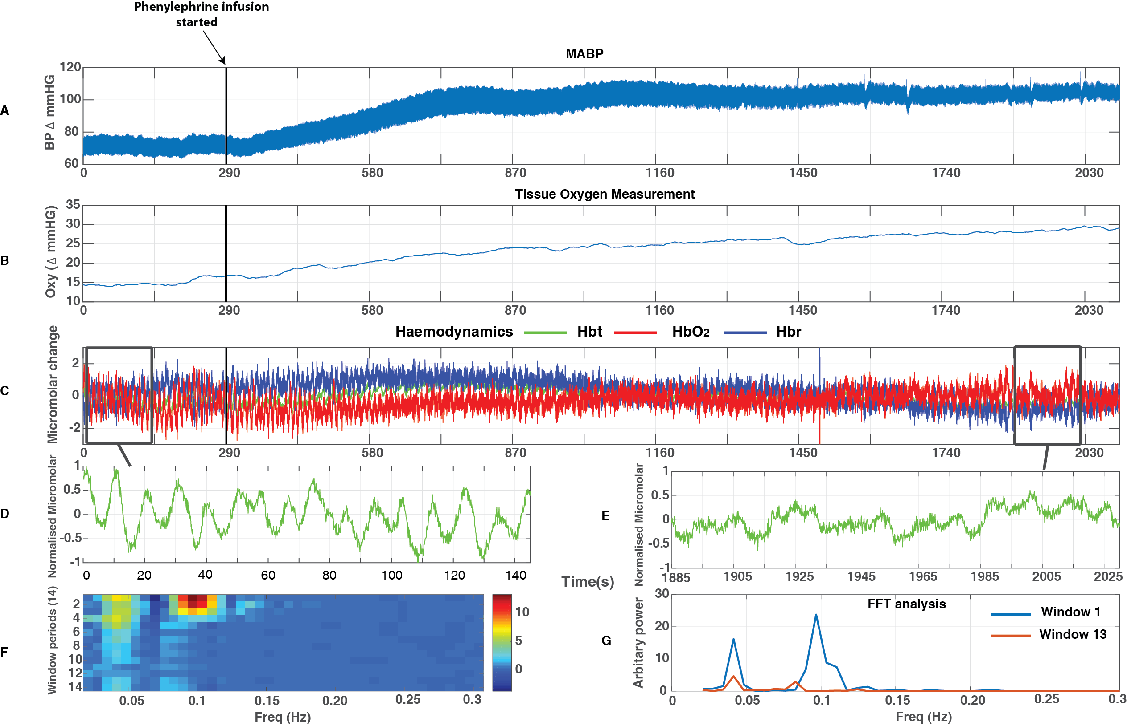
1
13

Magnitude of MABP in the pre-phenylephrine and phenylephrine periods
MABP levels were averaged across animals for the two periods. MABP was higher during phenylephrine infusion than in the time period prior to phenylephrine infusion (pre-phenylephrine) (fig 5.1.2). Indeed, a paired one-tailed t-test showed MABP was significantly higher in the phenylephrine period (M=93.42, SE=3.17) compared to the pre-phenylephrine period (M=68.75, SE=3.14); t(5)=12.75, p<0.001.
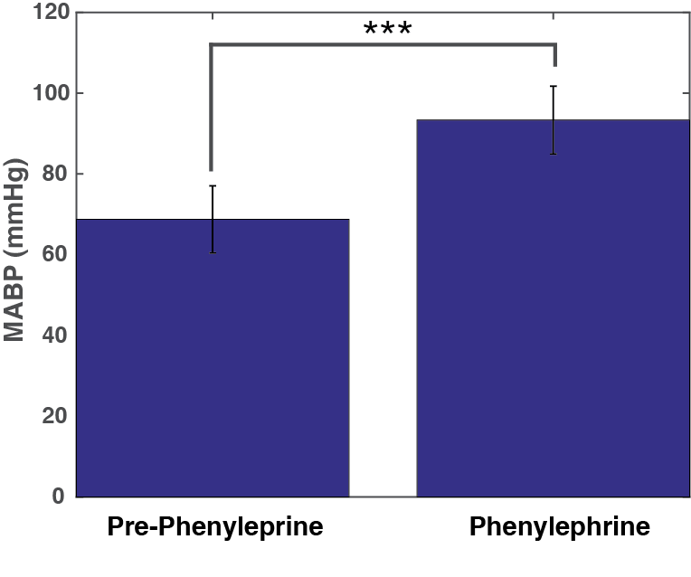

Figure 5.1.2 – Bar chart shows the mean values in MABP (n=6) in the two periods: pre-phenylephrine and phenylephrine

Magnitude of power of ~0.1Hz oscillations in Hbt, Hbr, HbO₂ in the pre-phenylephrine and phenylephrine periods
FFTs allowed for the magnitude of power in oscillations in cerebral haemodynamics: Hbt, HbO₂ and Hbr to be estimated. The mean power between 0.08-0.2Hz was higher during the period prior to phenylephrine infusion (pre-phenylephrine period) than during phenylephrine infusion (phenylephrine period) (fig 5.1.3).
Indeed, a paired one-tailed t-test showed the mean power from FFT for Hbt between frequencies 0.08-0.2Hz was significantly higher in the pre-phenylephrine period (P-P)(M=0.033, SE=0.006) compared to the phenylephrine period (P) (M=0.011, SE=0.003); t(5) =4.21, p<0.01 for Hbt (fig 5.1.3A).
A paired one-tailed t-test also showed a significant difference between the two periods for HbO₂ in the pre-phenylephrine period (M=0.082, SE=0.017), compared to the phenylephrine period (M=0.028, SE =0.007), t(5) =3.28, p<0.05 (fig 5.1.3B).
Similarly, a paired one-tailed t-test also showed a significant difference between the two periods for Hbr in the pre-phenylephrine period (M=0.06, SE=0.013), compared to the phenylephrine period (M=0.021, SE=0.005), t(5) =2.81, p<0.05 (fig 5.1.3C).

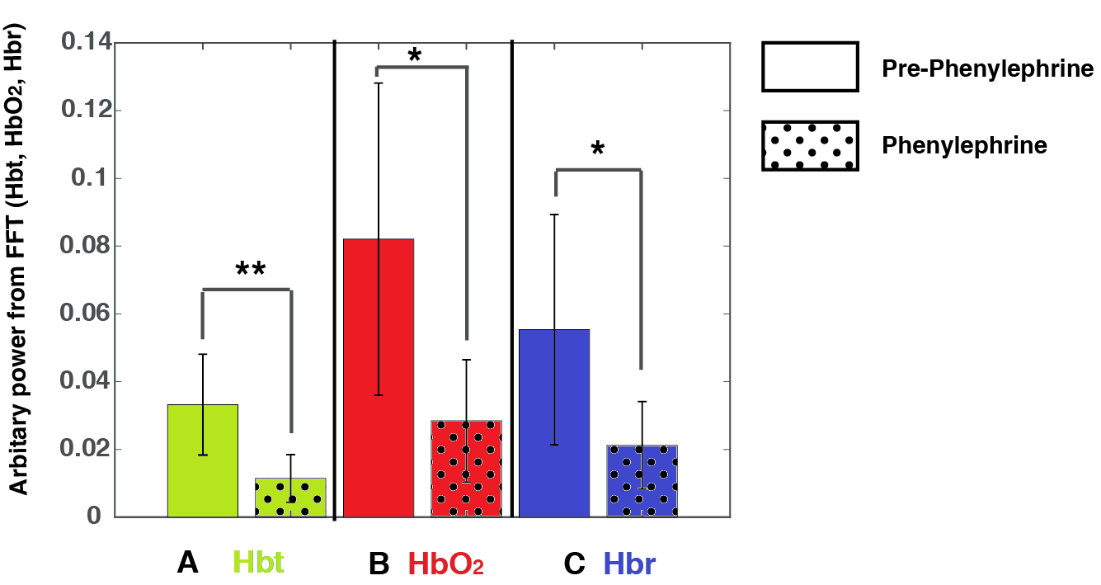

Magnitude of vasomotion oscillations (0.08-0.2Hz)

Figure 5.1.3 – Bar charts show the mean power between 0.08-0.2Hz (n =6) in haemodynamics (A Hbt, B HbO₂, C Hbr); in the pre-phenylephrine and phenylephrine periods.
Hbt – Total blood volume, Hbr – deoxygenated haemoglobin, HbO₂ – Oxygenated haemoglobin

Magnitude of tissue oxygen measurement in the pre-phenylephrine and phenylephrine periods
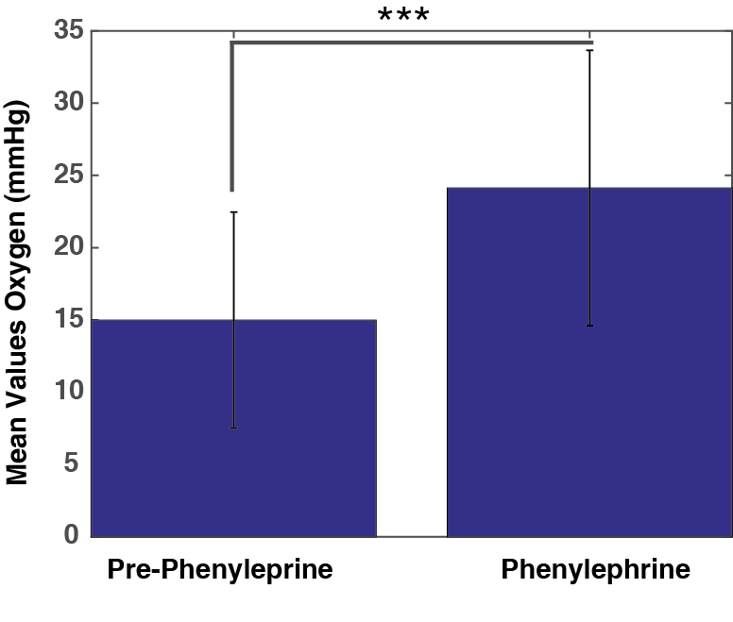
Oxygen tension levels were averaged across animals for the two periods. The mean oxygen tension level was higher in the period where phenylephrine was infused (phenylephrine period) when compared to the period prior to phenylephrine infusion (pre-phenylephrine period). Although, a paired one-tailed t-test showed oxygen tension was significantly higher within the phenylephrine period (M=24.13, SE = 3.60), compared to the pre-phenylephrine period (M=14.99, SE = 2.83), t(5)=7.27, p<0.001 (fig 5.1.4).
Figure 5.1.4 – Bar chart shows the mean values in tissue oxygen tension (n=6) in the two periods: pre-phenylephrine infusion and during phenylephrine infusion

Changes in Blood Oxygen Saturation levels
A comparison was made between the two conditions (pre-phenylephrine (M = 0.43, SE = 0.052) and phenylephrine (M = 0.5, SE = 0) and the mean blood oxygen saturation levels compared (fig 5.1.5). No significant difference was found between saturation levels between the two conditions, t(5) =1.22, p>0.05.
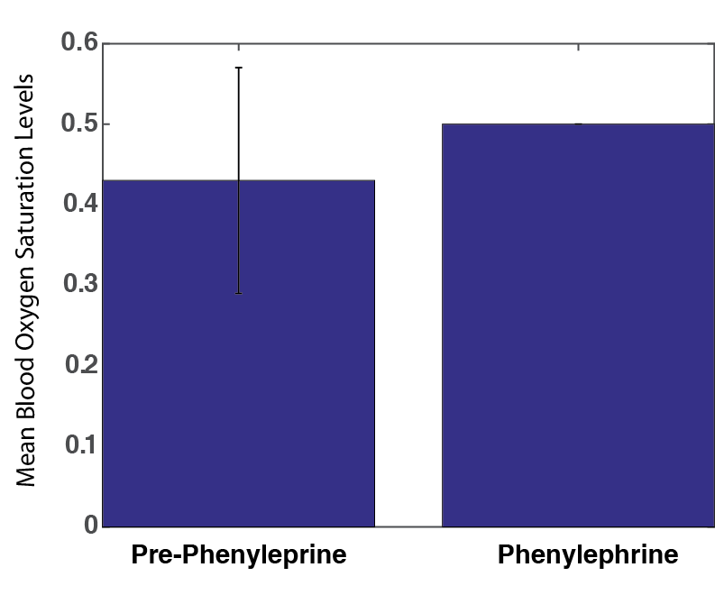
Figure 5.1.5 - Bar chart shows the mean values in blood oxygen saturation levels (n=6) in the two periods: pre-phenylephrine and phenylephrine

Associations between inter-animal variability in MABP and the power of cerebral haemodynamics oscillations
To be able to examine whether there is a relation between MABP and power of the cerebral haemodynamic oscillations for the individual animals, the following figures display the comparison between the individual MABP values and mean power from FFT (Hbt) power on a scatterplot graph (figs 5.1.6A-D).
Within the phenylephrine infusion on period, generally, higher MABP values can be seen to correspond to lower mean power from FFT values. Indeed, a Pearson’s correlation coefficient did show a significant correlation, r(4) = 0.8378, p<0.05 for Hbt (fig 5.1.6A). A Pearson’s correlation coefficient also showed no significant correlation for HbO₂, r(4)= 0.7857, p>0.05 and Hbr, r(4) = 0.7672, p>0.05.
Within the period where the phenylephrine infusion is turned off, lower levels of MABP can been seen to correspond to slightly levels of higher mean power from FFT values. However, a Pearson’s correlation coefficient did not show a significant correlation, r(4) = 0.4821, p>0.05 for Hbt (fig 5.1.6B). A Pearson’s correlation did not show a significant correlation, r(4) = 0.4371, p>0.05 for HbO₂ and r(4)=0.4567, p>0.05 for Hbr. For illustrative purposes, these values are displayed within a scatterplot (fig 5.1.6A-D).
Figure 5.1.6 – Scatterplots displaying MABP and corresponding Hbt power between 0.08-0.2Hz (n=11). A – Scatterplot shows the values within the period with phenylephrine infusion only. B - Scatterplot shows the values within the period without phenylephrine infusion only. C – Values displayed for both periods. D – (Fig C is repeated) data from each animal displayed as a single colour. r and p scores are shown for Hbt.

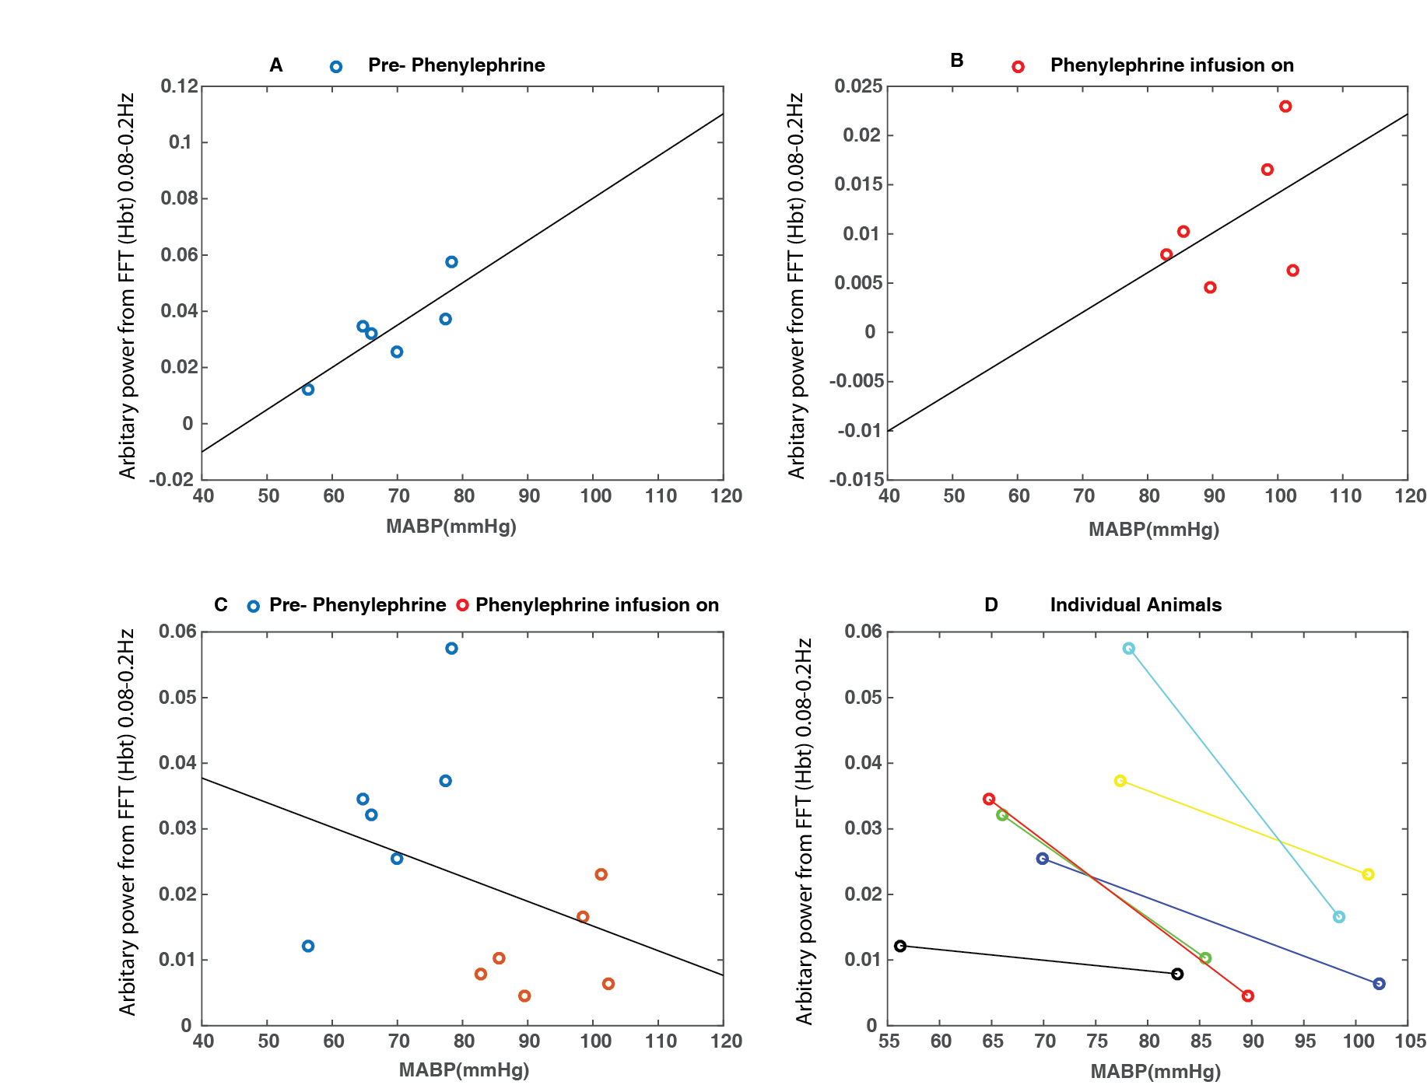
r = -0.3572
p = 0.2543
r = 0.4821
p = 0.3329
r = 0.8378
p = 0.0373

Associations between inter-animal variability in tissue oxygen measurement and the power of cerebral haemodynamics oscillations
To be able to examine whether there is a relation between the tissue oxygen measurement and power of the cerebral haemodynamic oscillations for the individual animals, the following figures display the comparison between the individual tissue oxygen measurement values and mean power from FFT (Hbt) power on a scatterplot graph (figs 5.1.7A-D).
Within the phenylephrine infusion on period, generally, lower tissue oxygen measurement can be seen to correspond to considerably lower mean power from FFT values. A Pearson’s correlation coefficient did not show a significant correlation, r(4) = -0.0109, p>0.05 for Hbt (fig 5.1.7A). A Pearson’s correlation coefficient also showed no significant correlation for HbO₂, r(4) = -0.0003, p>0.05 and Hbr, r(4) = 0.0289, p>0.05.
Within the period where the phenylephrine infusion is turned off, lower levels of tissue oxygen measurement can been seen to correspond to lower levels of mean power from FFT values. However, a Pearson’s correlation coefficient did not show a significant correlation, r(4) = 0.3898, p>0.05 for Hbt (fig 5.1.7B). A Pearson’s correlation also did not show a significant correlation, r(4) = 0.4564, p>0.05 for HbO₂ and r(4)=0.5102, p>0.05 for Hbr. For illustrative purposes, these values are displayed within a scatterplot (fig 5.1.7A-D).
Figure 5.1.7 – Scatterplots displaying MABP and corresponding Hbt power between 0.08-0.2Hz (n=11). A – Scatterplot shows the values within the period with phenylephrine infusion only. B - Scatterplot shows the values within the period without phenylephrine infusion only. C – Values displayed for both periods. D – (Fig C is repeated) data from each animal displayed as a single colour. r and p scores are shown for Hbt.

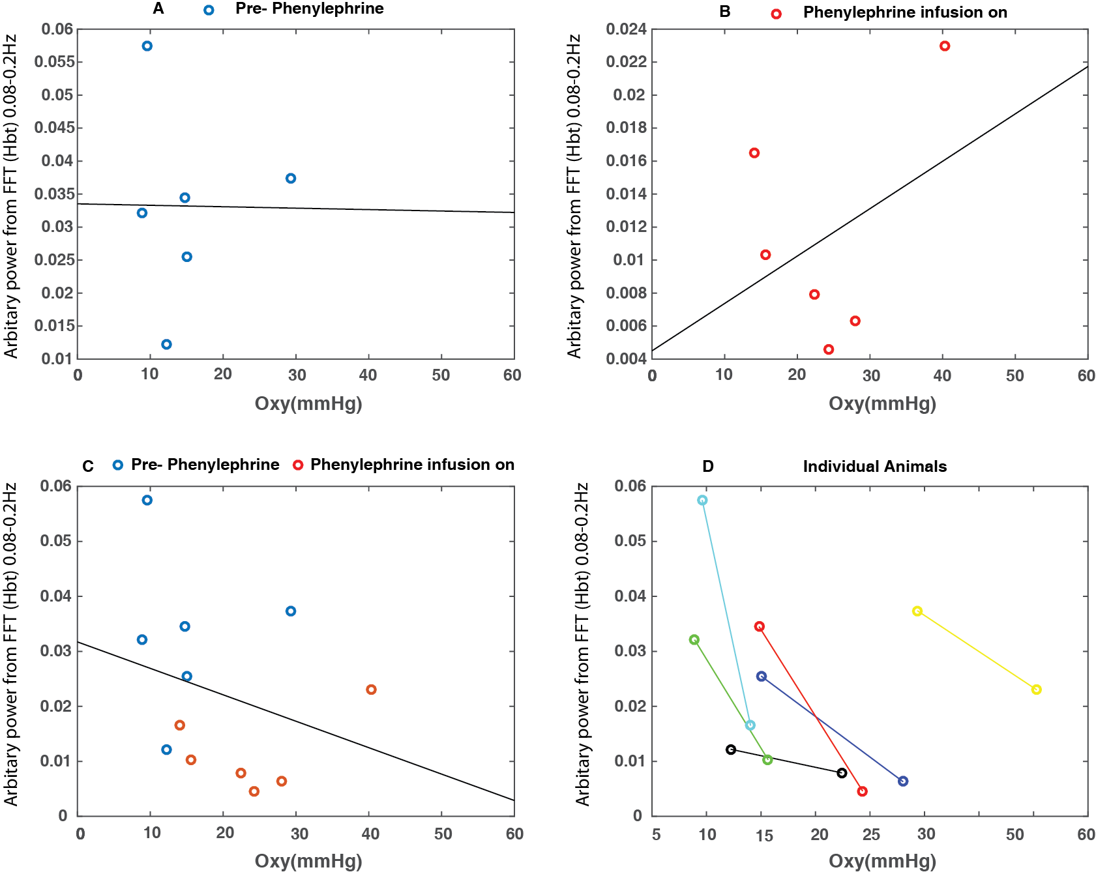

To further display whether the time series of MABP, tissue oxygen measurement, and baseline levels of cortical haemodynamics: Hbt, HbO₂, Hbr and blood oxygen saturation levels were altered phenylephrine infusion, the entire time series of 2100s was averaged across animals (n=6). Phenylephrine infusion began at 290s (fig 5.1.8) and was associated with an increase in MABP across all animals (5.1.8A). The tissue oxygen measurement was also seen to increase following phenylephrine infusion (fig 5.1.8B). Similarly, the blood oxygen saturation levels also show an increase after phenylephrine infusion (fig 5.1.8C). As the phase of the 0.1Hz oscillations was obviously different across animals for a single time point, averaging the time series together removes the appearance of the oscillations. Similarly, in the haemodynamics, an increase in HbO₂ and slight decrease in Hbr (fig 5.1.8C) was seen, possibly showing an association with the phenylephrine infusion. The haemodynamic recording was divided in 14 temporal windows across the average recording. The magnitude of the power at ~0.1Hz is seen to gradually decrease over the recording period (windows 1-14), following phenylephrine infusion (fig 5.1.8D).
Figure 5.1.9– Data from an average of 6 animals (total recording 2100s) showing A – MABP, B – Tissue oxygen measurement, C – Blood Oxygen Saturation level, D – Haemodynamics; Hbt (Green), Hbr (Blue), Hbo (Red), E – Image scale of the change in frequency (Hz) across the recording (14 windows), F - Graph showing the change in frequency (FFT) within the two periods (window 1 &13) – pre-phenylephrine and phenylephrine. Note: The black line at 290s demonstrates the start of the phenylephrine infusion.

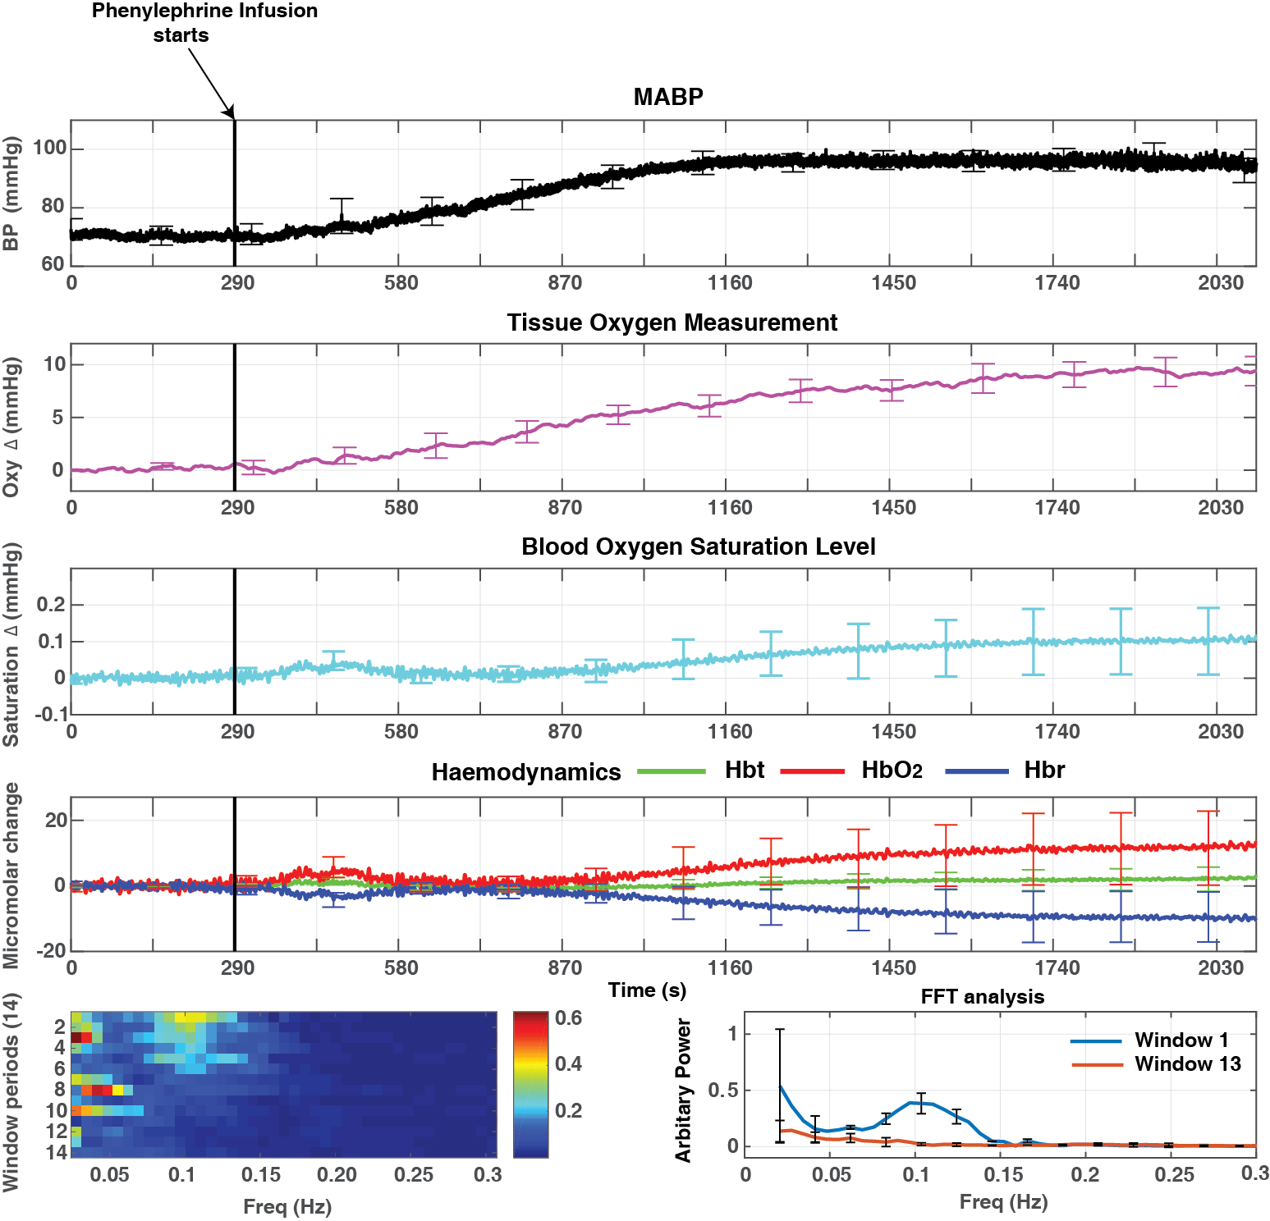

Result 2
This second part of the results section (5.2) will document the replication of chapter 4s experimental paradigm, which involved turning the phenylephrine off and changing the fraction of inspired oxygen (FiO₂) to 100% (hyperoxia) (fig 5.2). The addition of a tissue oxygen sensor to this experimental paradigm as previously identified will provide a measurement of the tissue oxygen tension through the experimental paradigm, therefore being able to measure blood and tissue oxygen concurrently. Note: To be able to view similar figures for the other animals used within this chapter (chapter 5) please refer to Appendices D
Figure 5.2.1– Data from an individual animal (total recording 2100s) showing A – MABP, B – Tissue oxygen measurement, C – Haemodynamics; Hbt (Green), Hbr (Blue), Hbo (Red), D – Phenylephrine infusion – window shows the first 145s of the recording (Hbt), E –Phenylephrine infusion stopped – window shows 145s within this time period, F – Hyperoxia period – window shows 145s within this time period, G - Image scale of the change in frequency (Hz) across the recording (14 windows), H - Graph showing the change in frequency (FFT) within the three periods (windows 1,8,13) – pre-phenylephrine and phenylephrine. Note: The black line at 290s demonstrates the start of the phenylephrine infusion.

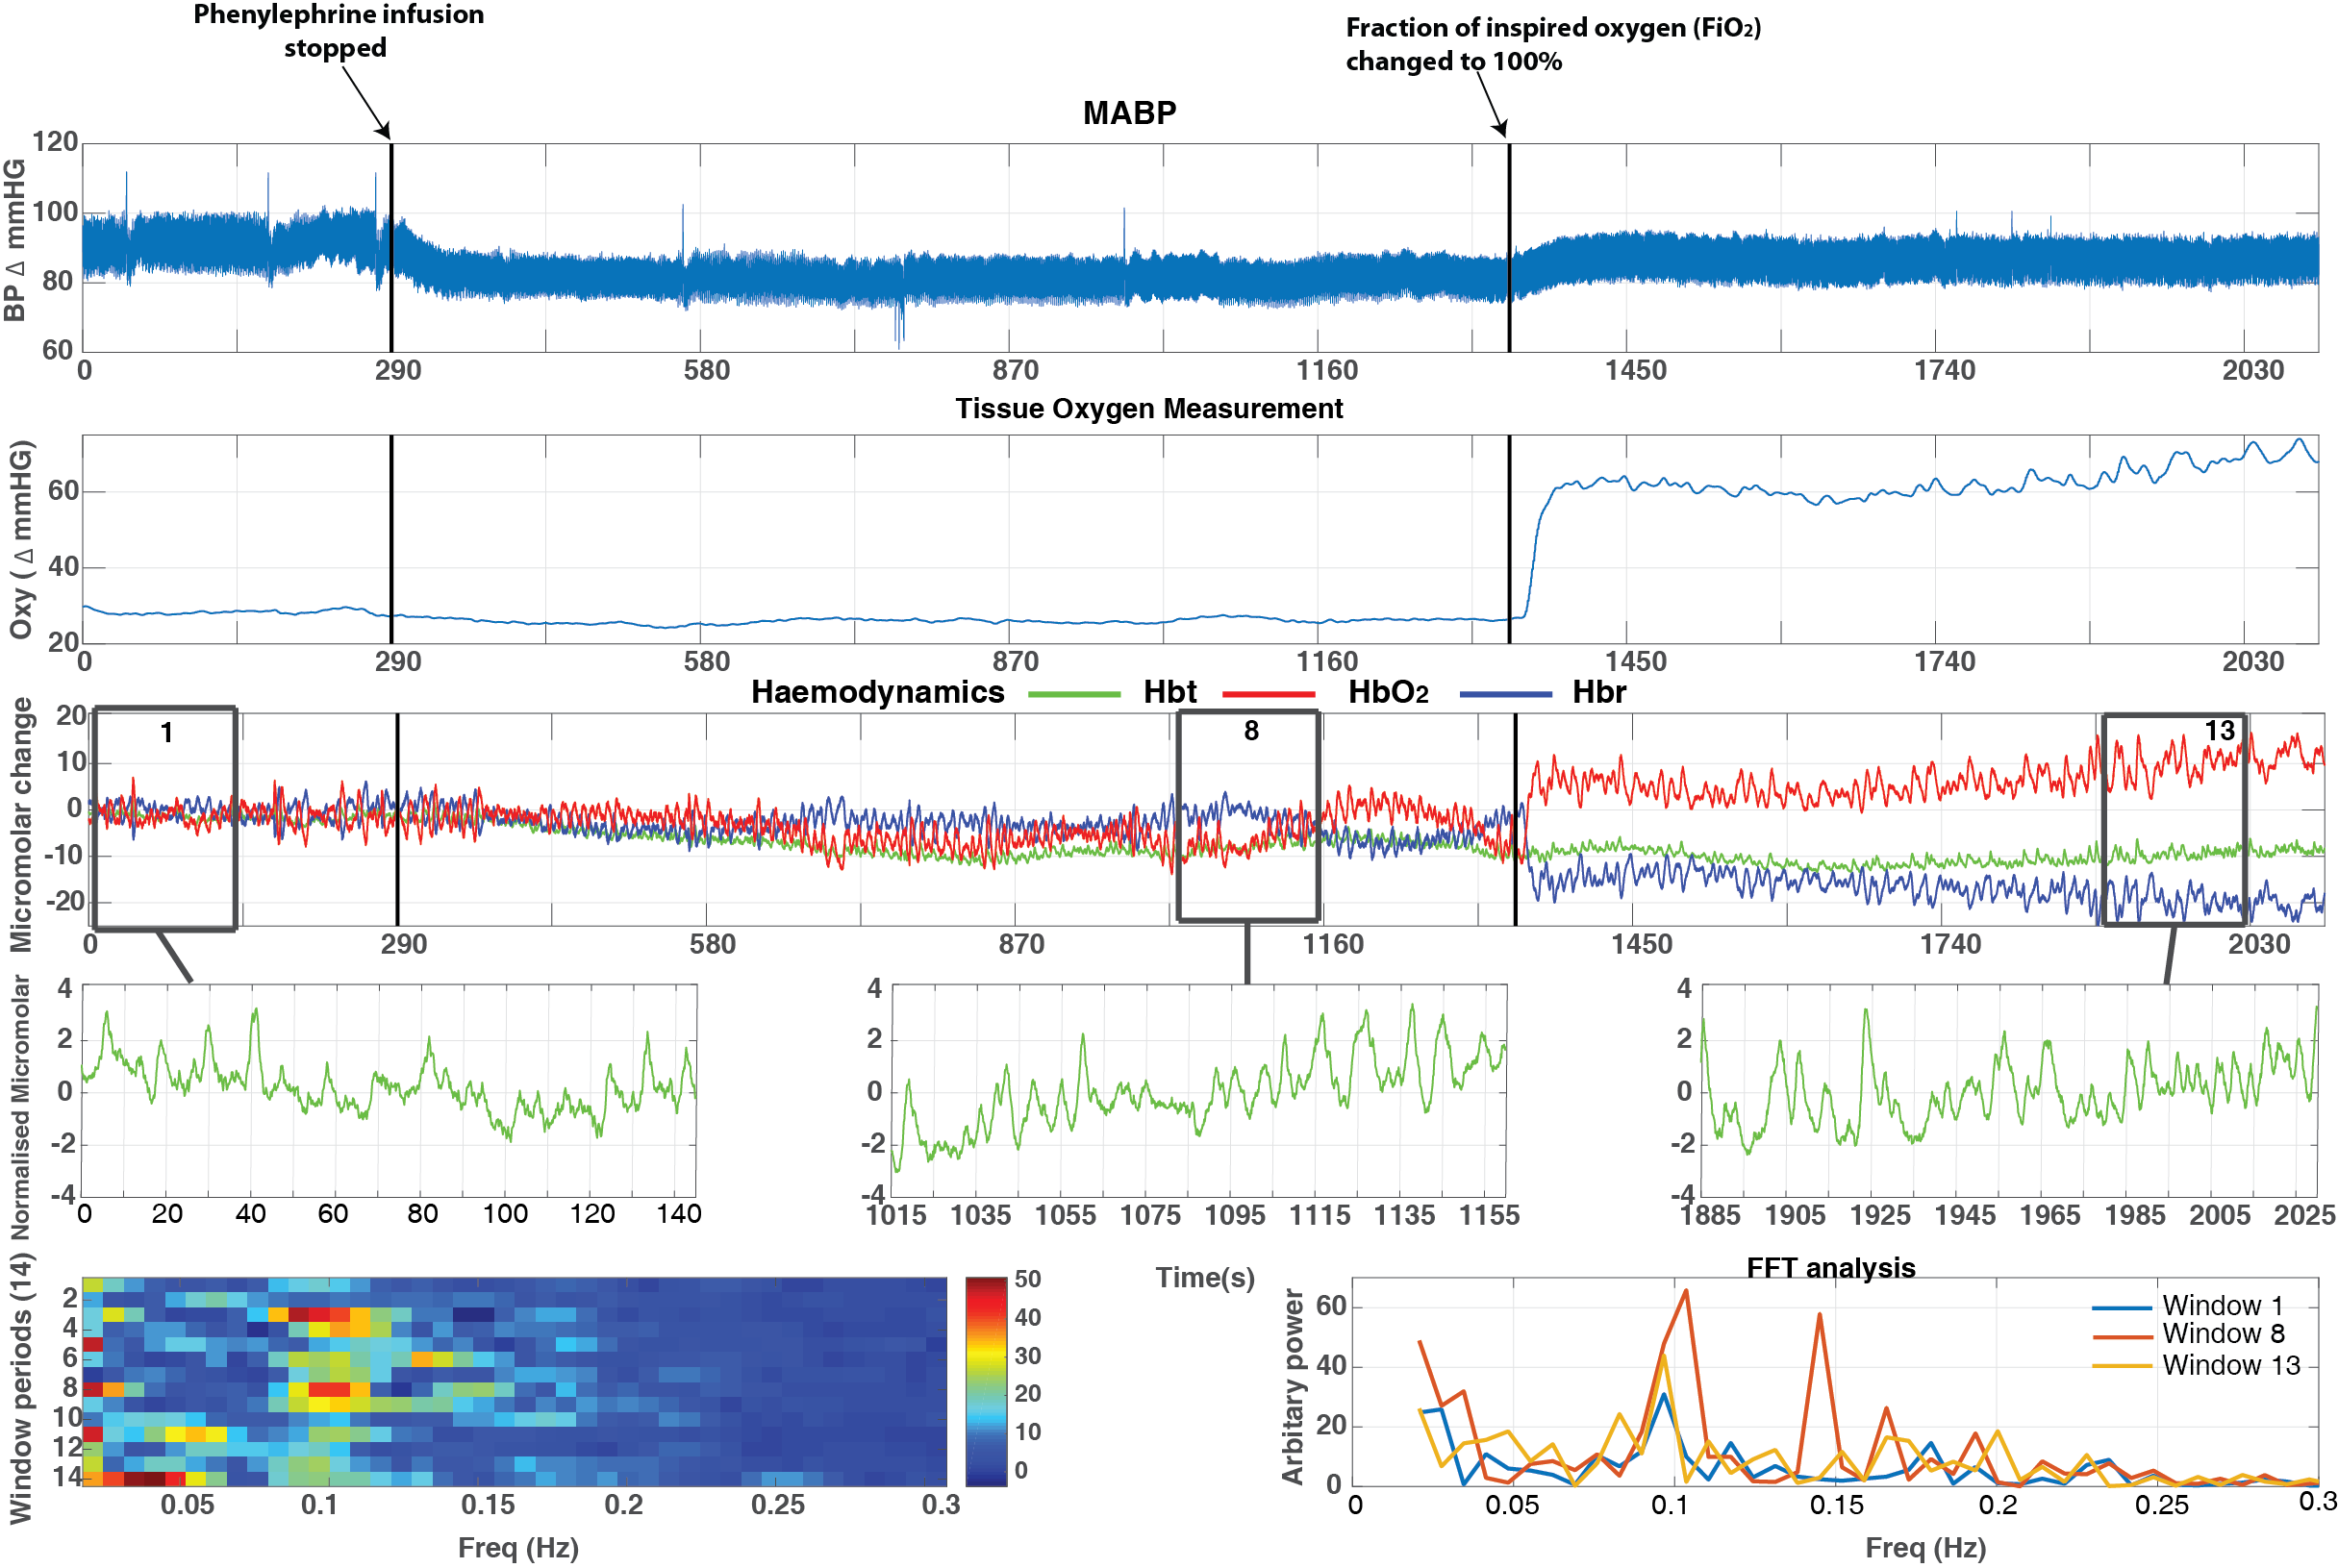
A
B
C
D
E
F
G
H

Magnitude of MABP in the pre-phenylephrine and phenylephrine periods
MABP levels were averaged across animals for the three periods. MABP was higher during the phenylephrine infusion than compared to the other two periods (phenylephrine off and hyperoxia) (fig 5.2.2). Indeed, a one-way within subjects ANOVA was conducted to compare the effect of the three periods; phenylephrine on (M=92.13, SE=4.69), phenylephrine off (M=78.06, SE=3.84) and hyperoxia period (M=83.56, SE=5.94) on MABP. There was a significant effect of the three periods on MABP at the p<0.05 level (F(2,10)=13.590, p<0.01).
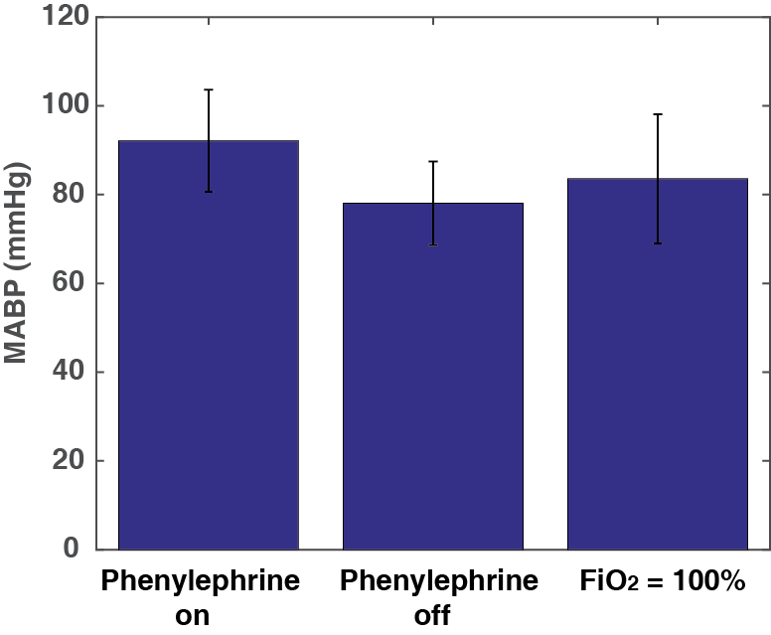
***
***

Hyperoxia
Figure 5.2.2 – Bar chart shows the mean values in MABP (n=6) in the three periods: phenylephrine on, phenylephrine off and hyperoxia

Magnitude of power of ~0.1Hz oscillations in Hbt, Hbr, HbO₂ in three periods (phenylephrine on, phenylephrine off and hyperoxia)
FFT analysis allowed the magnitude of cortical oscillations in cerebral haemodynamics: Hbt, Hbr and HbO₂ to be estimated. The mean power between 0.08-0.2Hz was higher during the phenylephrine off period for Hbt (M =0.025, SE= 0.007) (fig 5.2.3A), and Hbo (M= 0.059, SE= 0.020) (fig 5.2.3B) and Hbr (M=0.043, SE=0.015) (fig 5.2.4C). However, a one way within subjects ANOVA was conducted to compare effect of the three periods on the mean magnitude of cortical oscillations from FFT between frequencies 0.08-0.2Hz was not significant at the p=0.05 level for Hbt (F(2,10)=2.451, p>0.05), for HbO₂ (F(1.062,5.308)=1.959, p>0.05) and for Hbr (F(1.098,5.489)=1.715, p>0.05).
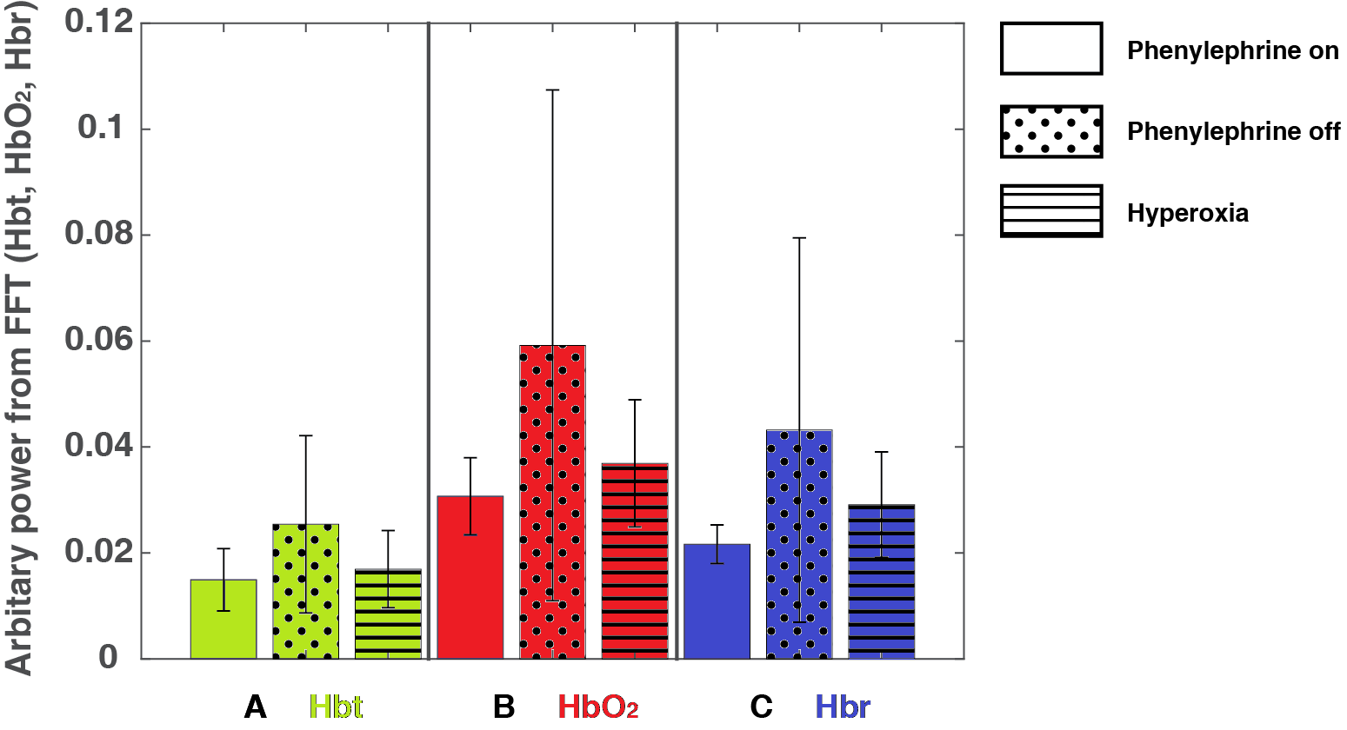
Magnitude of vasomotion oscillations (0.08-0.2Hz)
Figure 5.2.3 – Bar charts shows the mean power between 0.08-0.2Hz (n=6) in haemodynamics (A Hbt, B HbO₂, C Hbr); in the three periods; Phenylephrine on, Phenylephrine off, Hyperoxia
Hbt – Total blood volume, Hbr – Deoxygenated haemoglobin, HbO₂ – Oxygenated haemoglobin

Tissue oxygen measurement
Mean tissue oxygen measurement levels were averaged across animals for the three periods. Tissue oxygen measurements were higher during the period within the hyperoxia period) (fig 5.2.4). Indeed, a one-way within subjects ANOVA was conducted to compare the effect of the three periods; phenylephrine on (M=29.61, SE=4.16), phenylephrine off (M=25.73, SE=3.45) and hyperoxia (M=39.74, SE=7.75) on tissue oxygen measurements. There was not a significant effect of the three periods on tissue oxygen measurements at the p<0.05 level (F(1.094,5.471)=4.259, p>0.05).
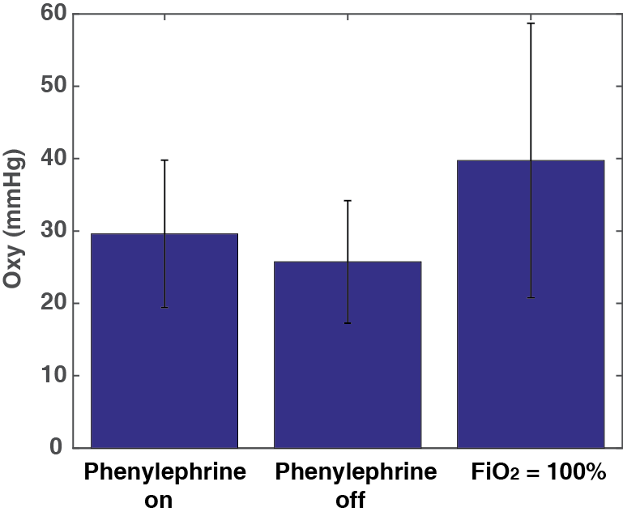

Hyperoxia
Figure 5.2.4 – Bar chart shows the mean values in tissue oxygen measurements (n=6) in the three periods: phenylephrine on, phenylephrine off and hyperoxia

Changes in Blood Oxygen Saturation levels
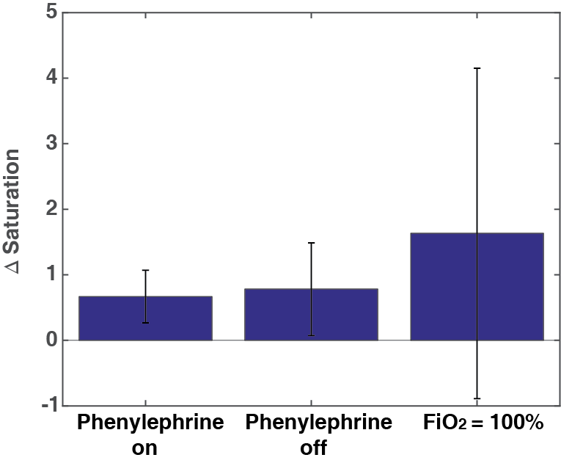
A comparison was made between the three conditions (phenylephrine on, phenylephrine off and hyperoxia) and the mean blood oxygen saturation levels compared (fig 5.2.5). A higher blood oxygen saturation level is seen within the hyperoxia period. However, a one way within subjects ANOVA was conducted to compare effect of the three periods on the mean value of the blood oxygen saturation levels and this was not significant at the p<0.05 level (F(1.0,5.0)=1.267, p>0.05) for Hbt.
Hyperoxia
Figure 5.2.5 –Showing individual animals arbitrary power from FFT (0.08-0.2Hz) (n=6). From left to right - Phenylephrine infusion on period, Phenylephrine infusion off period, Hyperoxia

Associations between inter-animal variability in MABP and the power of cerebral haemodynamics oscillations
To be able to examine whether there is a relation between MABP and power of the cerebral haemodynamic oscillations for individual animals, the following figures display the comparison between the individual MABP values and mean power from FFT (Hbt) power on a scatterplot graph (figs 5.2.6A-D).
Within the phenylephrine infusion on period, generally, higher MABP values can be seen to correspond to lower mean power from FFT values. However, a Pearson’s correlation coefficient did not show a significant correlation, r(4) = 0.0077, p>0.05 for Hbt (fig 5.2.6A). A Pearson’s correlation coefficient also showed no significant correlation for HbO₂, r(4)= -0.1178, p>0.05 and Hbr, r(4) = -0.2351, p>0.05.
Within the period where the phenylephrine infusion is turned off, lower levels of MABP can been seen to correspond to slightly higher levels of mean power from FFT values. However, a Pearson’s correlation coefficient did not show a significant correlation, r(4) = 0.1107, p>0.05 for Hbt (fig 5.2.6B). A Pearson’s correlation also did not show a significant correlation, r(4) =0.0384, p>0.05 for HbO₂ and r(4)=0.0154, p>0.05 for Hbr. For illustrative purposes, these values are displayed within a scatterplot (fig 5.2.6A-D).
Figure 5.2.6 – Scatterplots displaying MABP and corresponding Hbt power between 0.08-0.2Hz (n=6). A – Scatterplot shows the values within the period with phenylephrine infusion only, B - Scatterplot shows the values within the period where phenylephrine infusion was stopped, C – Values displayed for both periods, D – (Fig C is repeated) data from each animal displayed as a single colour. r and p scores are shown for Hbt.

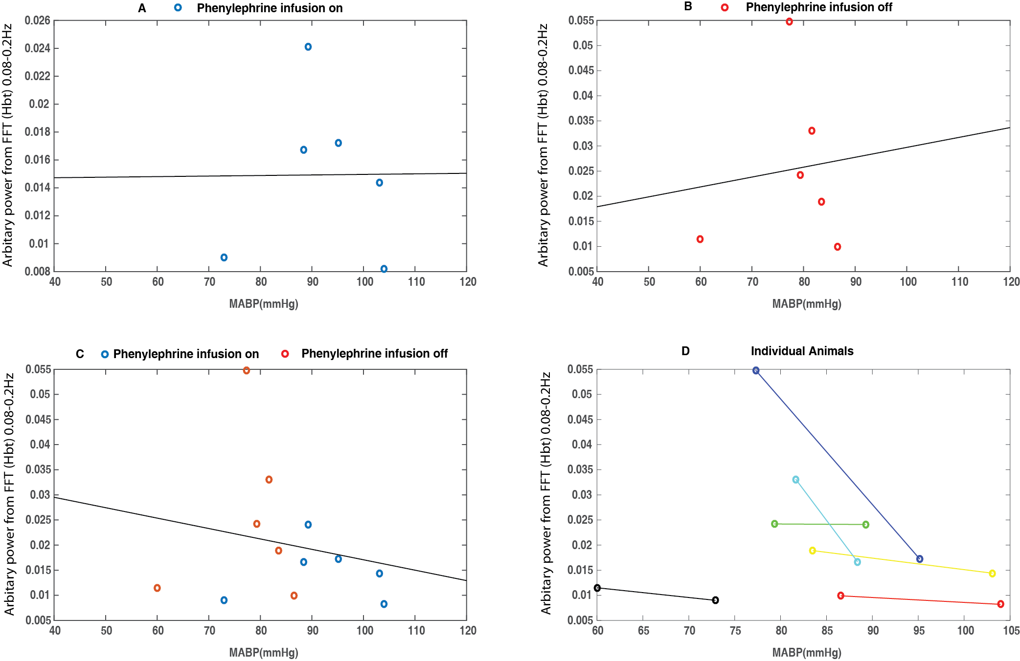
r = 0.0077
p = 0.9884
r = 0.1107
p = 0.8346
r = -0.1958
p = 0.5419

As there is a third period within the recording, the same comparisons were carried out when the phenylephrine infusion is turned off and within the hyperoxia period.
During the hyperoxia period, generally, high levels of MABP can be seen to correspond to low mean power from FFT values. However, a Pearson’s correlation coefficient did not show a significant correlation, r(4) = 0.5668, p>0.05 for Hbt (fig 5.2.7B). A Pearson’s correlation coefficient also showed no significant correlation for HbO₂, r(4)= 0.7982, p>0.05 and Hbr, r(4) = 0.7561, p>0.05. For illustrative purposes, these values are displayed within a scatterplot (fig 5.2.7A-D).
Figure 5.2.7 – Scatterplots displaying MABP and corresponding Hbt power between 0.08-0.2Hz (n=6). A – Scatterplot shows the values within the period where phenylephrine infusion was stopped, B - Scatterplot shows the values within the period where hyperoxia was induced, C – Values displayed for both periods. D – (Fig C is repeated) data from each animal displayed as a single colour. r and p scores are shown for Hbt.

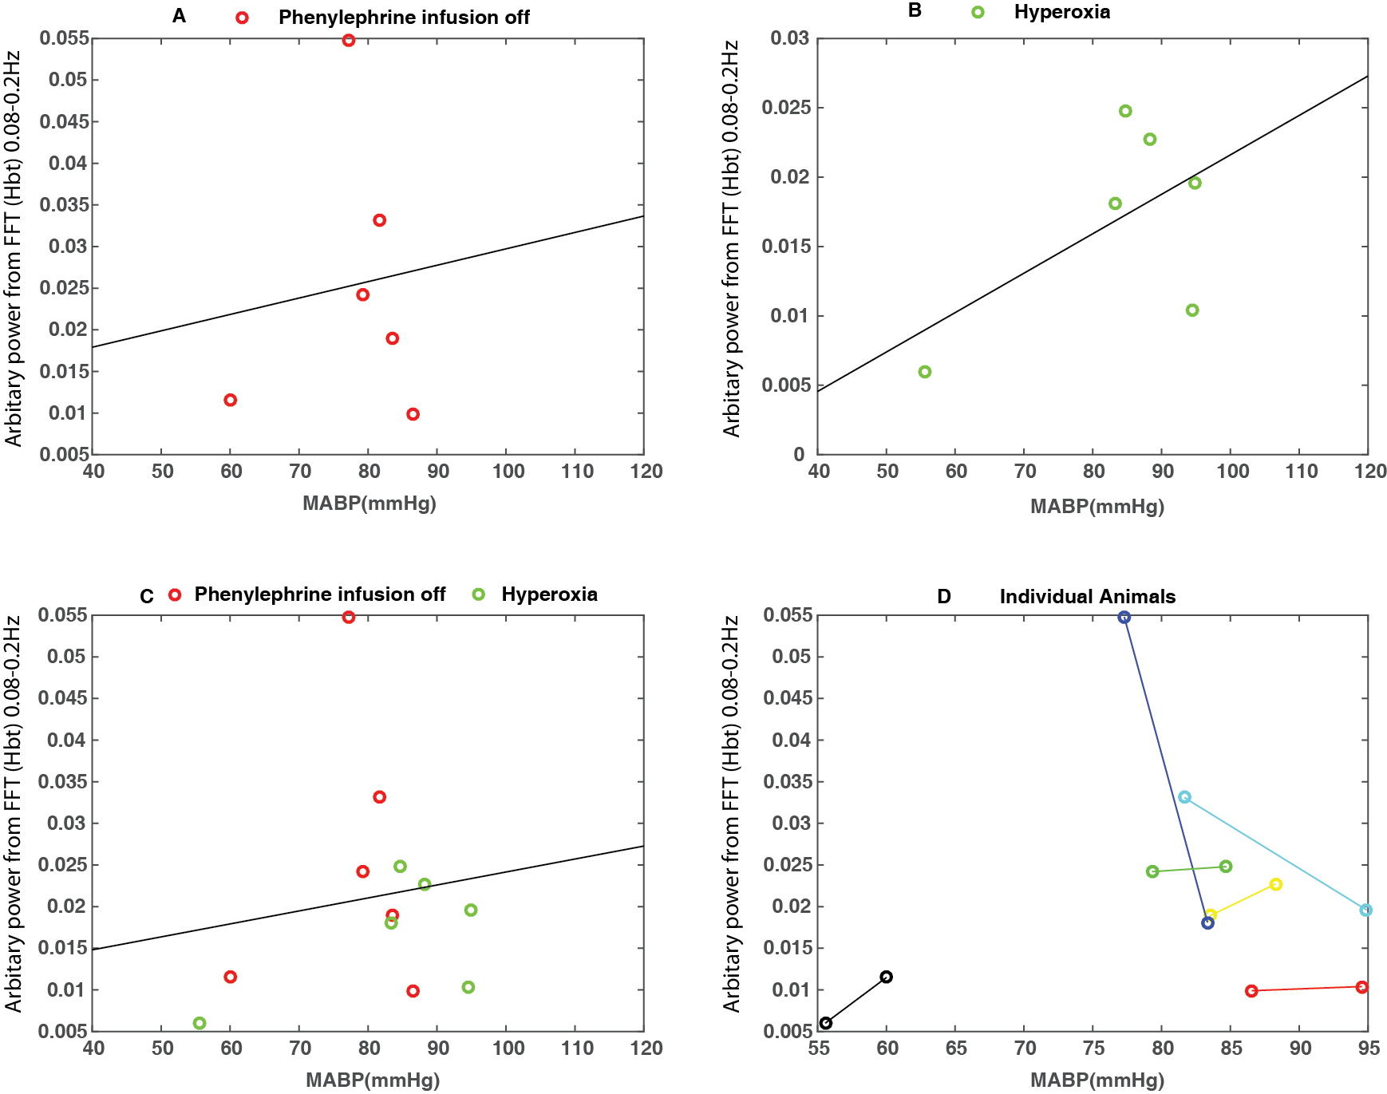
r = 0.1433
p = 0.6568
r = 0.1107
p = 0.8346
r = 0.5668
p = 0.2408

Associations between inter-animal variability in tissue oxygen measurement and the power of cerebral haemodynamics oscillations
To be able to examine whether there is a relation between the tissue oxygen measurement and power of the cerebral haemodynamic oscillations for the individual animals, the following figures display the comparison between the individual tissue oxygen measurement values and mean power from FFT (Hbt) power on a scatterplot graph (figs 5.2.8A-D).
Within the phenylephrine infusion on period, generally, lower tissue oxygen measurement can be seen to correspond to considerably lower mean power from FFT values. A Pearson’s correlation coefficient did not show a significant correlation, r(4) = -0.1293, p>0.05 for Hbt (fig 5.2.8A). A Pearson’s correlation coefficient also showed no significant correlation for HbO₂, r(4) = -0.1655, p>0.05 and Hbr, r(4) = -0.1019, p>0.05.
Within the period where the phenylephrine infusion is turned off, slightly lower levels of tissue oxygen measurement can been seen to correspond to slightly higher levels of mean power from FFT values. However, a Pearson’s correlation coefficient did not show a significant correlation, r(4) = -0.4260, p>0.05 for Hbt (fig 5.2.8B). A Pearson’s correlation also did not show a significant correlation, r(4) = -0.3508, p>0.05 for HbO₂ and r(4)=-0.2977, p>0.05 for Hbr. For illustrative purposes, these values are displayed within a scatterplot (fig 5.2.8A-D).
Figure 5.2.8 – Scatterplots displaying tissue oxygen measurement and corresponding Hbt power between 0.08-0.2Hz (n=6). A – Scatterplot shows the values within the period with phenylephrine infusion only, B - Scatterplot shows the values within the period where phenylephrine infusion was stopped, C – Values displayed for both periods. D – (Fig C is repeated) data from each animal displayed as a single colour. r and p scores are shown for Hbt.

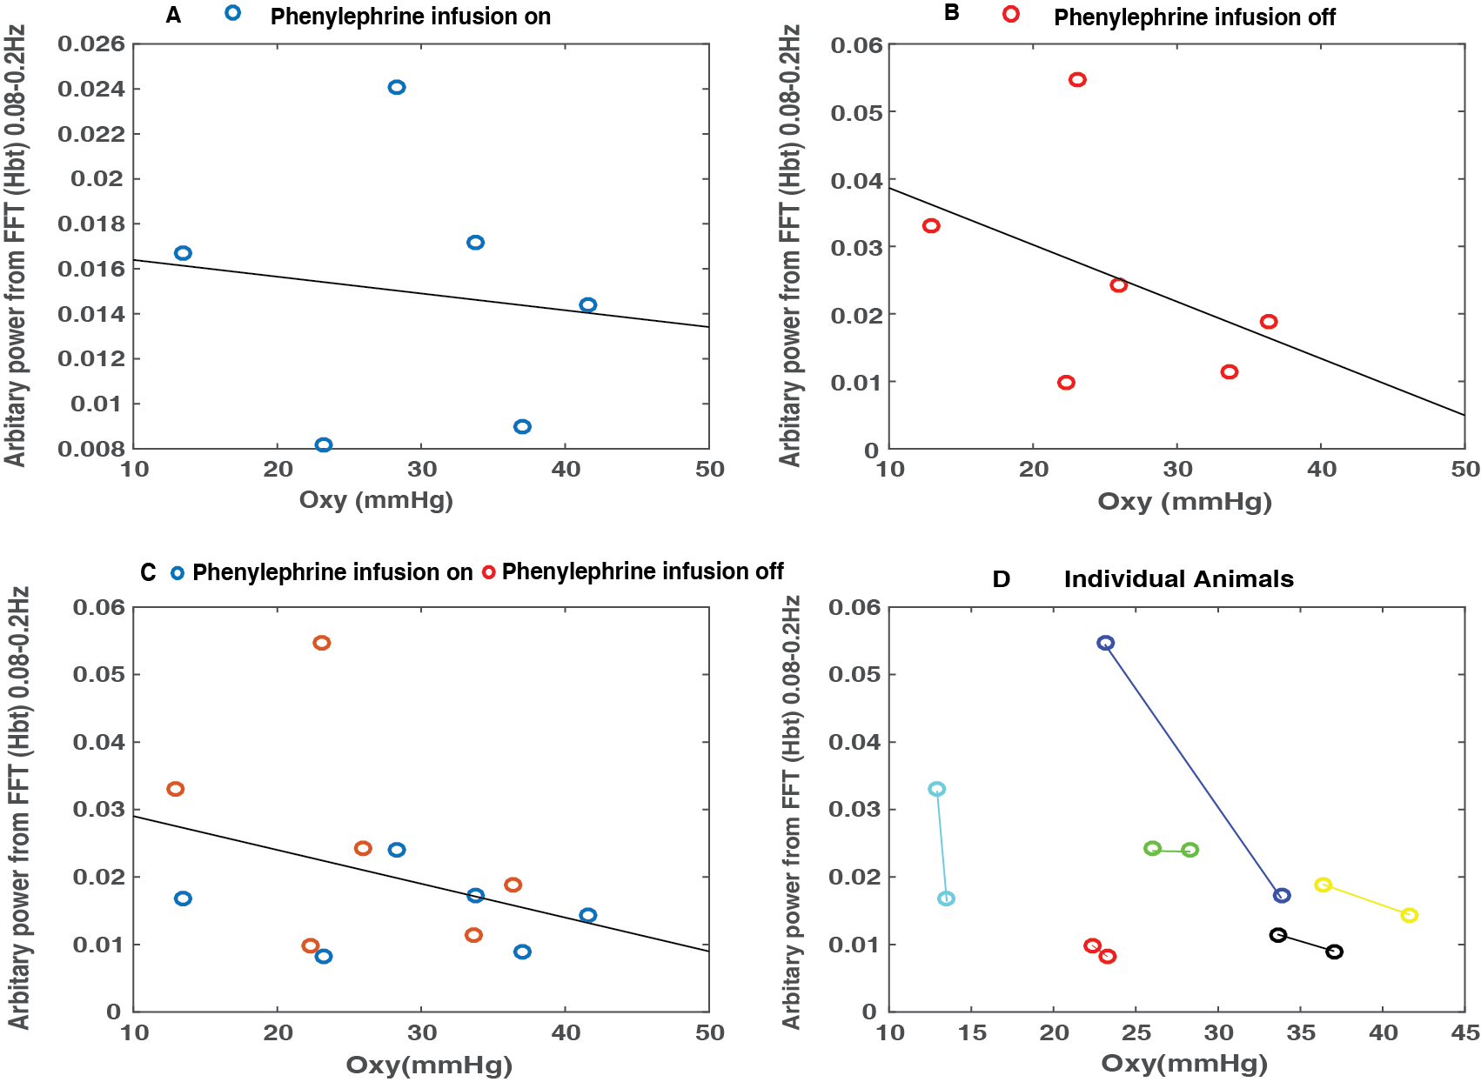
r = -0.3489
p = 0.2664
r = -0.1293
p = 0.8072
r = -0.4260
p = 0.3996

As there is a third period within the recording, the same comparisons were carried out when the phenylephrine infusion is turned off and within the hyperoxia period.
During the hyperoxia period, generally, higher levels of tissue oxygen measurement can be seen to correspond to lower mean power from FFT values. However, a Pearson’s correlation coefficient did not show a significant correlation, r(4) = 0.4324, p>0.05 for Hbt (fig 5.2.9B). A Pearson’s correlation coefficient also showed no significant correlation for HbO₂, r(4)= -0.0259, p>0.05 and Hbr, r(4) = -0.0861, p>0.05. For illustrative purposes, these values are displayed within a scatterplot (fig 5.2.9A-D).
Figure 5.2.9 – Scatterplots displaying tissue oxygen measurement and corresponding Hbt power between 0.08-0.2Hz (n=6). A – Scatterplot shows the values within the period were phenylephrine infusion was stopped, B - Scatterplot shows the values where hyperoxia was induced, C – Values displayed for both periods. D – (Fig C is repeated) data from each animal displayed as a single colour. r and p scores are shown for Hbt.

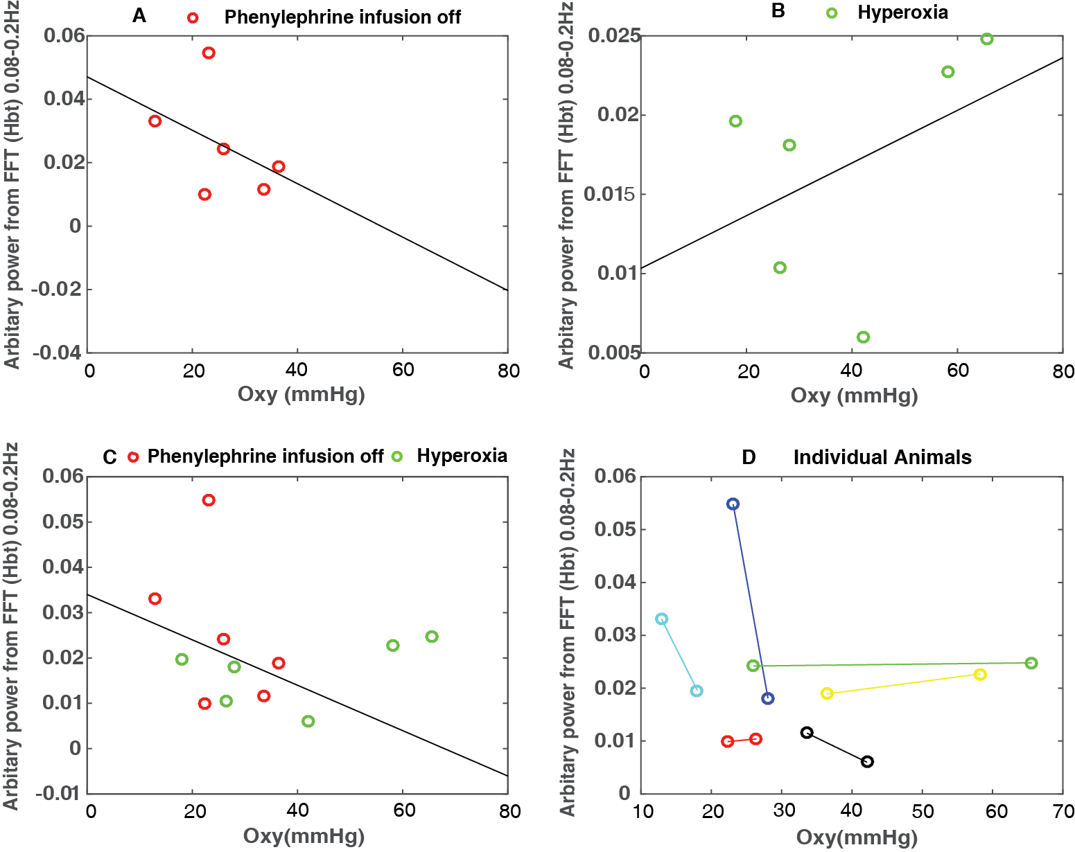
r = -0.1577
p = 0.6246
r = 0.4324
p = 0.3919
r = -0.4260
p = 0.3996

To be able to examine if the magnitude of the cerebral haemodynamic oscillations changes following cessation of phenylephrine and when hyperoxia was induced. The differences in mean power from FFT values (0.08-0.2Hz) in each animal across the three periods within the recording (phenylephrine infusion on, off, and hyperoxia) showed that most animals showed an increase in mean power from FFT values when phenylephrine infusion is turned off (fig 5.2.10).
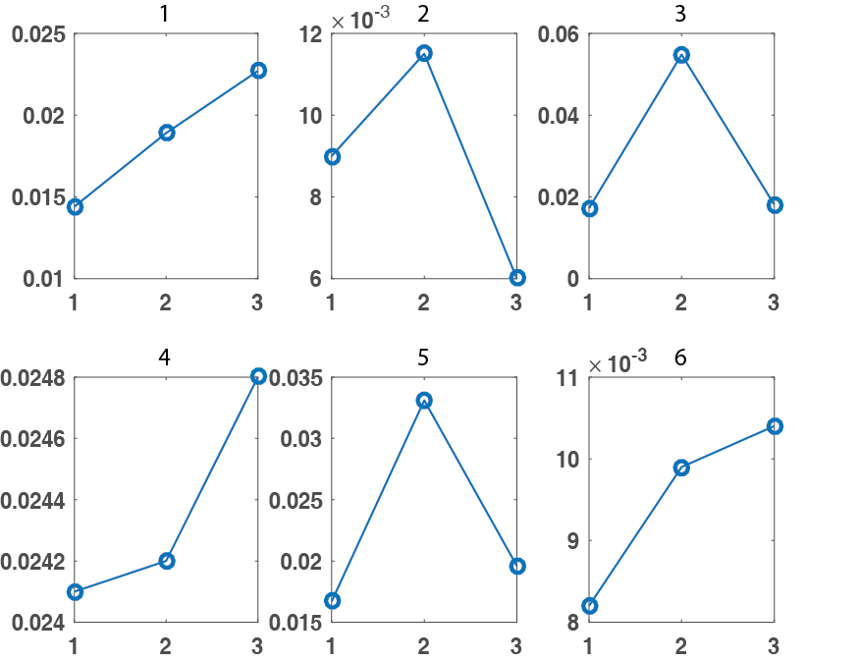

Figure 5.2.10 – Individual plots for each animal showing the mean values for magnitude of oscillations in the three periods. Numbers on the x axis represent: 1 – phenylephrine on, 2 – phenylephrine off, 3 – hyperoxia. Numbers on top each figure shows the animals corresponding number

Mean magnitude of oscillations (Hbt) 0.08- 0.2Hz

To further display whether the time series of MABP, baseline levels of cortical haemodynamics: Hbt, HbO₂, Hbr and blood oxygen saturation levels were altered following cessation of phenylephrine and hyperoxic periods. The entire time series of 2100s was averaged across animals (n=6). The mean MABP time series is shown to decrease after phenylephrine infusion was stopped (at 290s) and then is seen to increase within the hyperoxia periods (at 1390s) (fig 5.2.11A). Tissue oxygen measurement shows a similar trend, a decrease is seen after phenylephrine infusion was ceased and an increase was seen within the hyperoxia period (fig 5.2.11B). Conversely, the blood oxygen saturation levels showed a slight increase in levels following cessation of phenylephrine and then further increased within hyperoxia period) (fig 5.2.11C). The haemodynamics show a slight increase in HbO₂ following the cessation of phenylephrine and a concomitant decrease in Hbr (fig 5.2.11D) and an increase is seen within the hyperoxia period. The haemodynamic recording was divided into 14 temporal windows across the average recording. The magnitude of power at ~0.1Hz is seen to gradually increase once the phenylephrine infusion is ceased and is seen to decrease within the hyperoxic period (fig 5.2.11E & 5.2.11F).
Figure 5.2.11 – Data from an average of 6 animals (total recording 2100s) showing A – MABP, B – Change in blood oxygen saturation level, C - Haemodynamics; Hbt (Green), Hbr (Blue), HbO₂ (Red), D – Image scale of the change in frequency (Hz) across the recording (14 windows), E – Graph showing the change in frequency within the three time periods (windows 1,8,13) – phenylephrine infusion on, phenylephrine infusion off and hyperoxia. Note: The first black line at 290s demonstrates the end of the phenylephrine infusion and the second black line at 1340s demonstrates the start of the hyperoxia period.

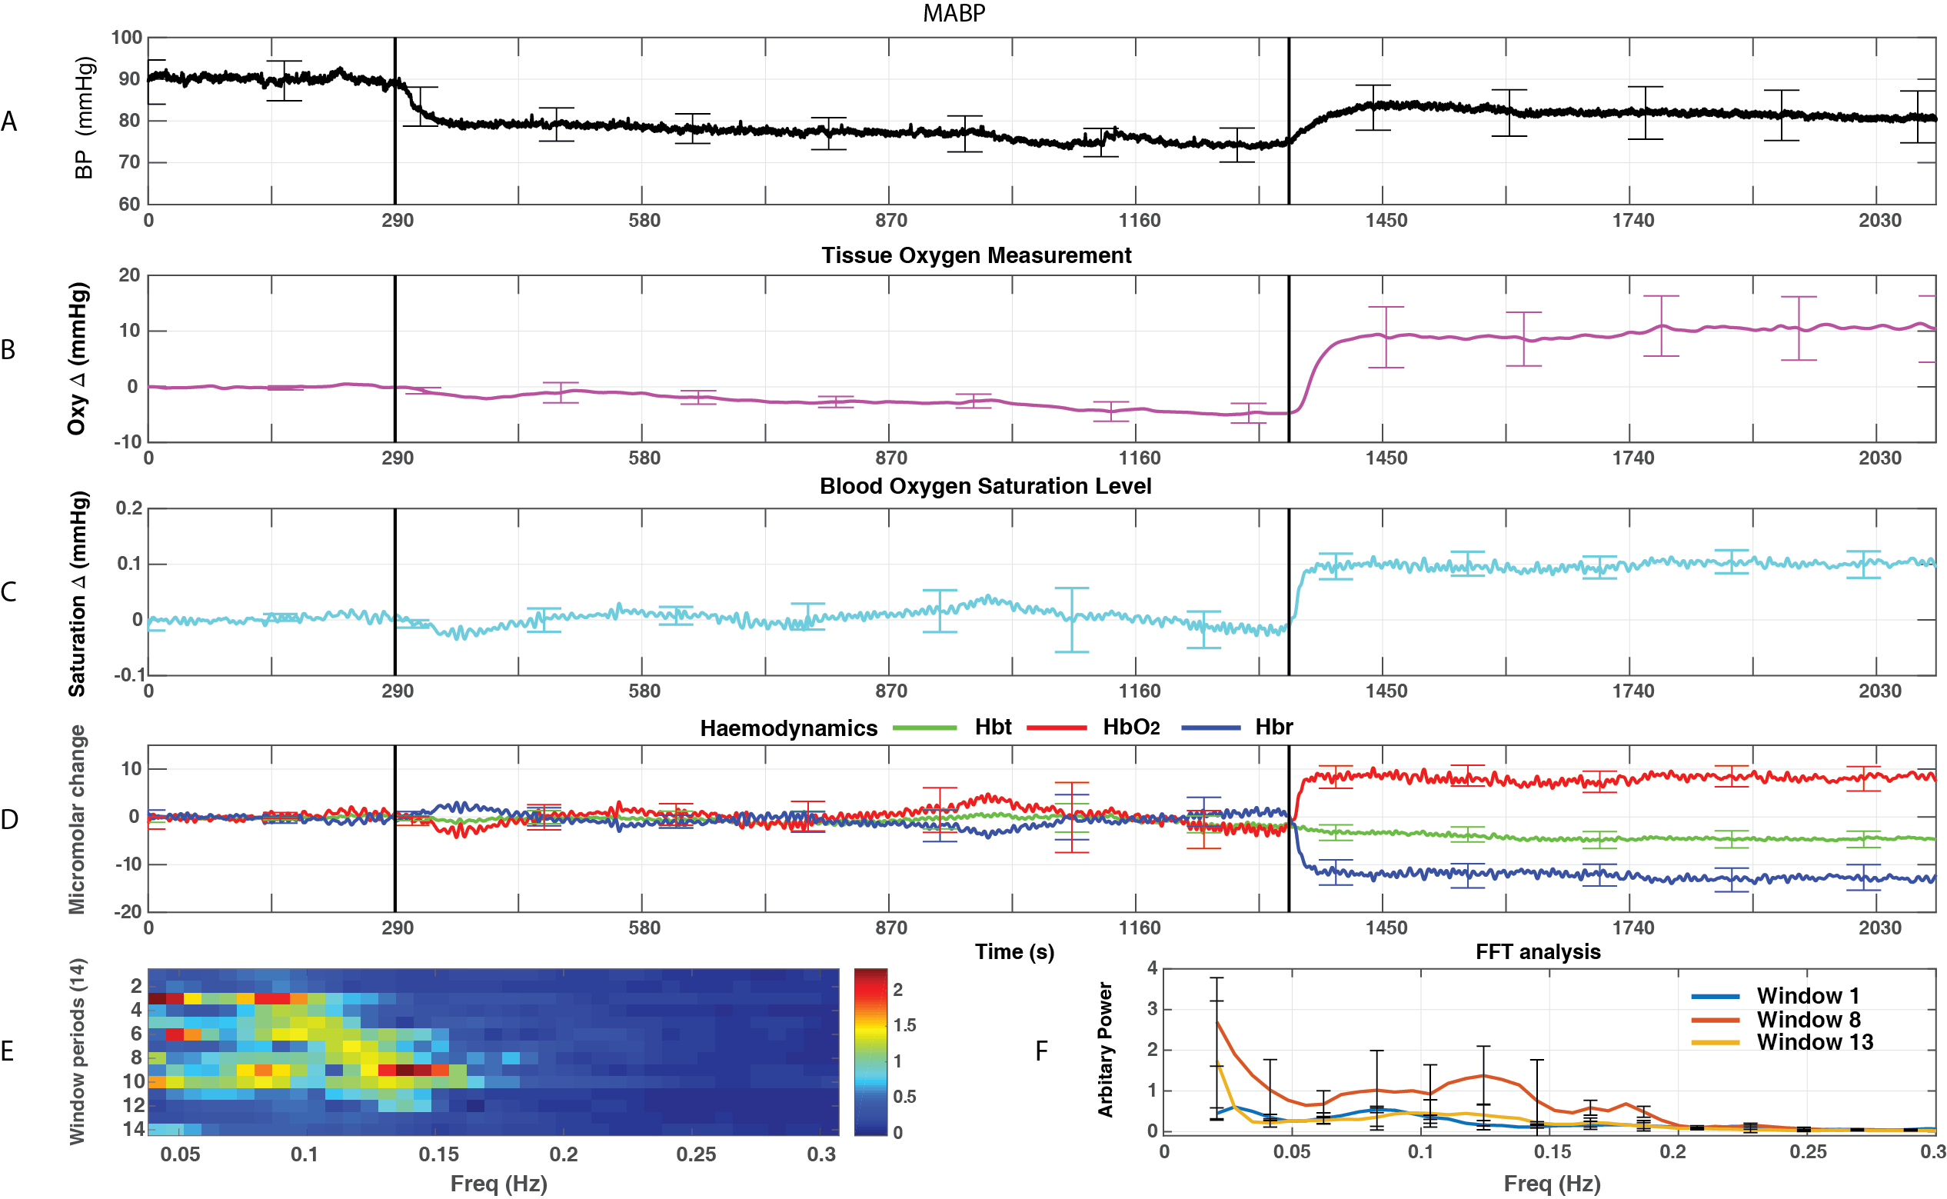

Having established a concomitant relationship between changes in cortical state (synchronised to desynchronised) to changes in blood oxygen saturation levels have been established in the previous chapter. To further elucidate if there is a relationship between cortical states and tissue oxygenation, the same comparison will be made between the two recordings (electrophysiological activity and tissue oxygen measurement) (fig 5.2.12) data is presented in a similar manner (to that seen in chapter 4). Some animals (fig 5.2.12, animals 3 & 5) showed a temporal concomitant relationship between changes in cortical brain state (from synchronised to desynchronised) and increases in tissue oxygen levels within the period following phenylephrine cessation. The remaining animals that showed minimal changes in tissue oxygen levels during this period also had smaller temporal or no changes in cortical state.

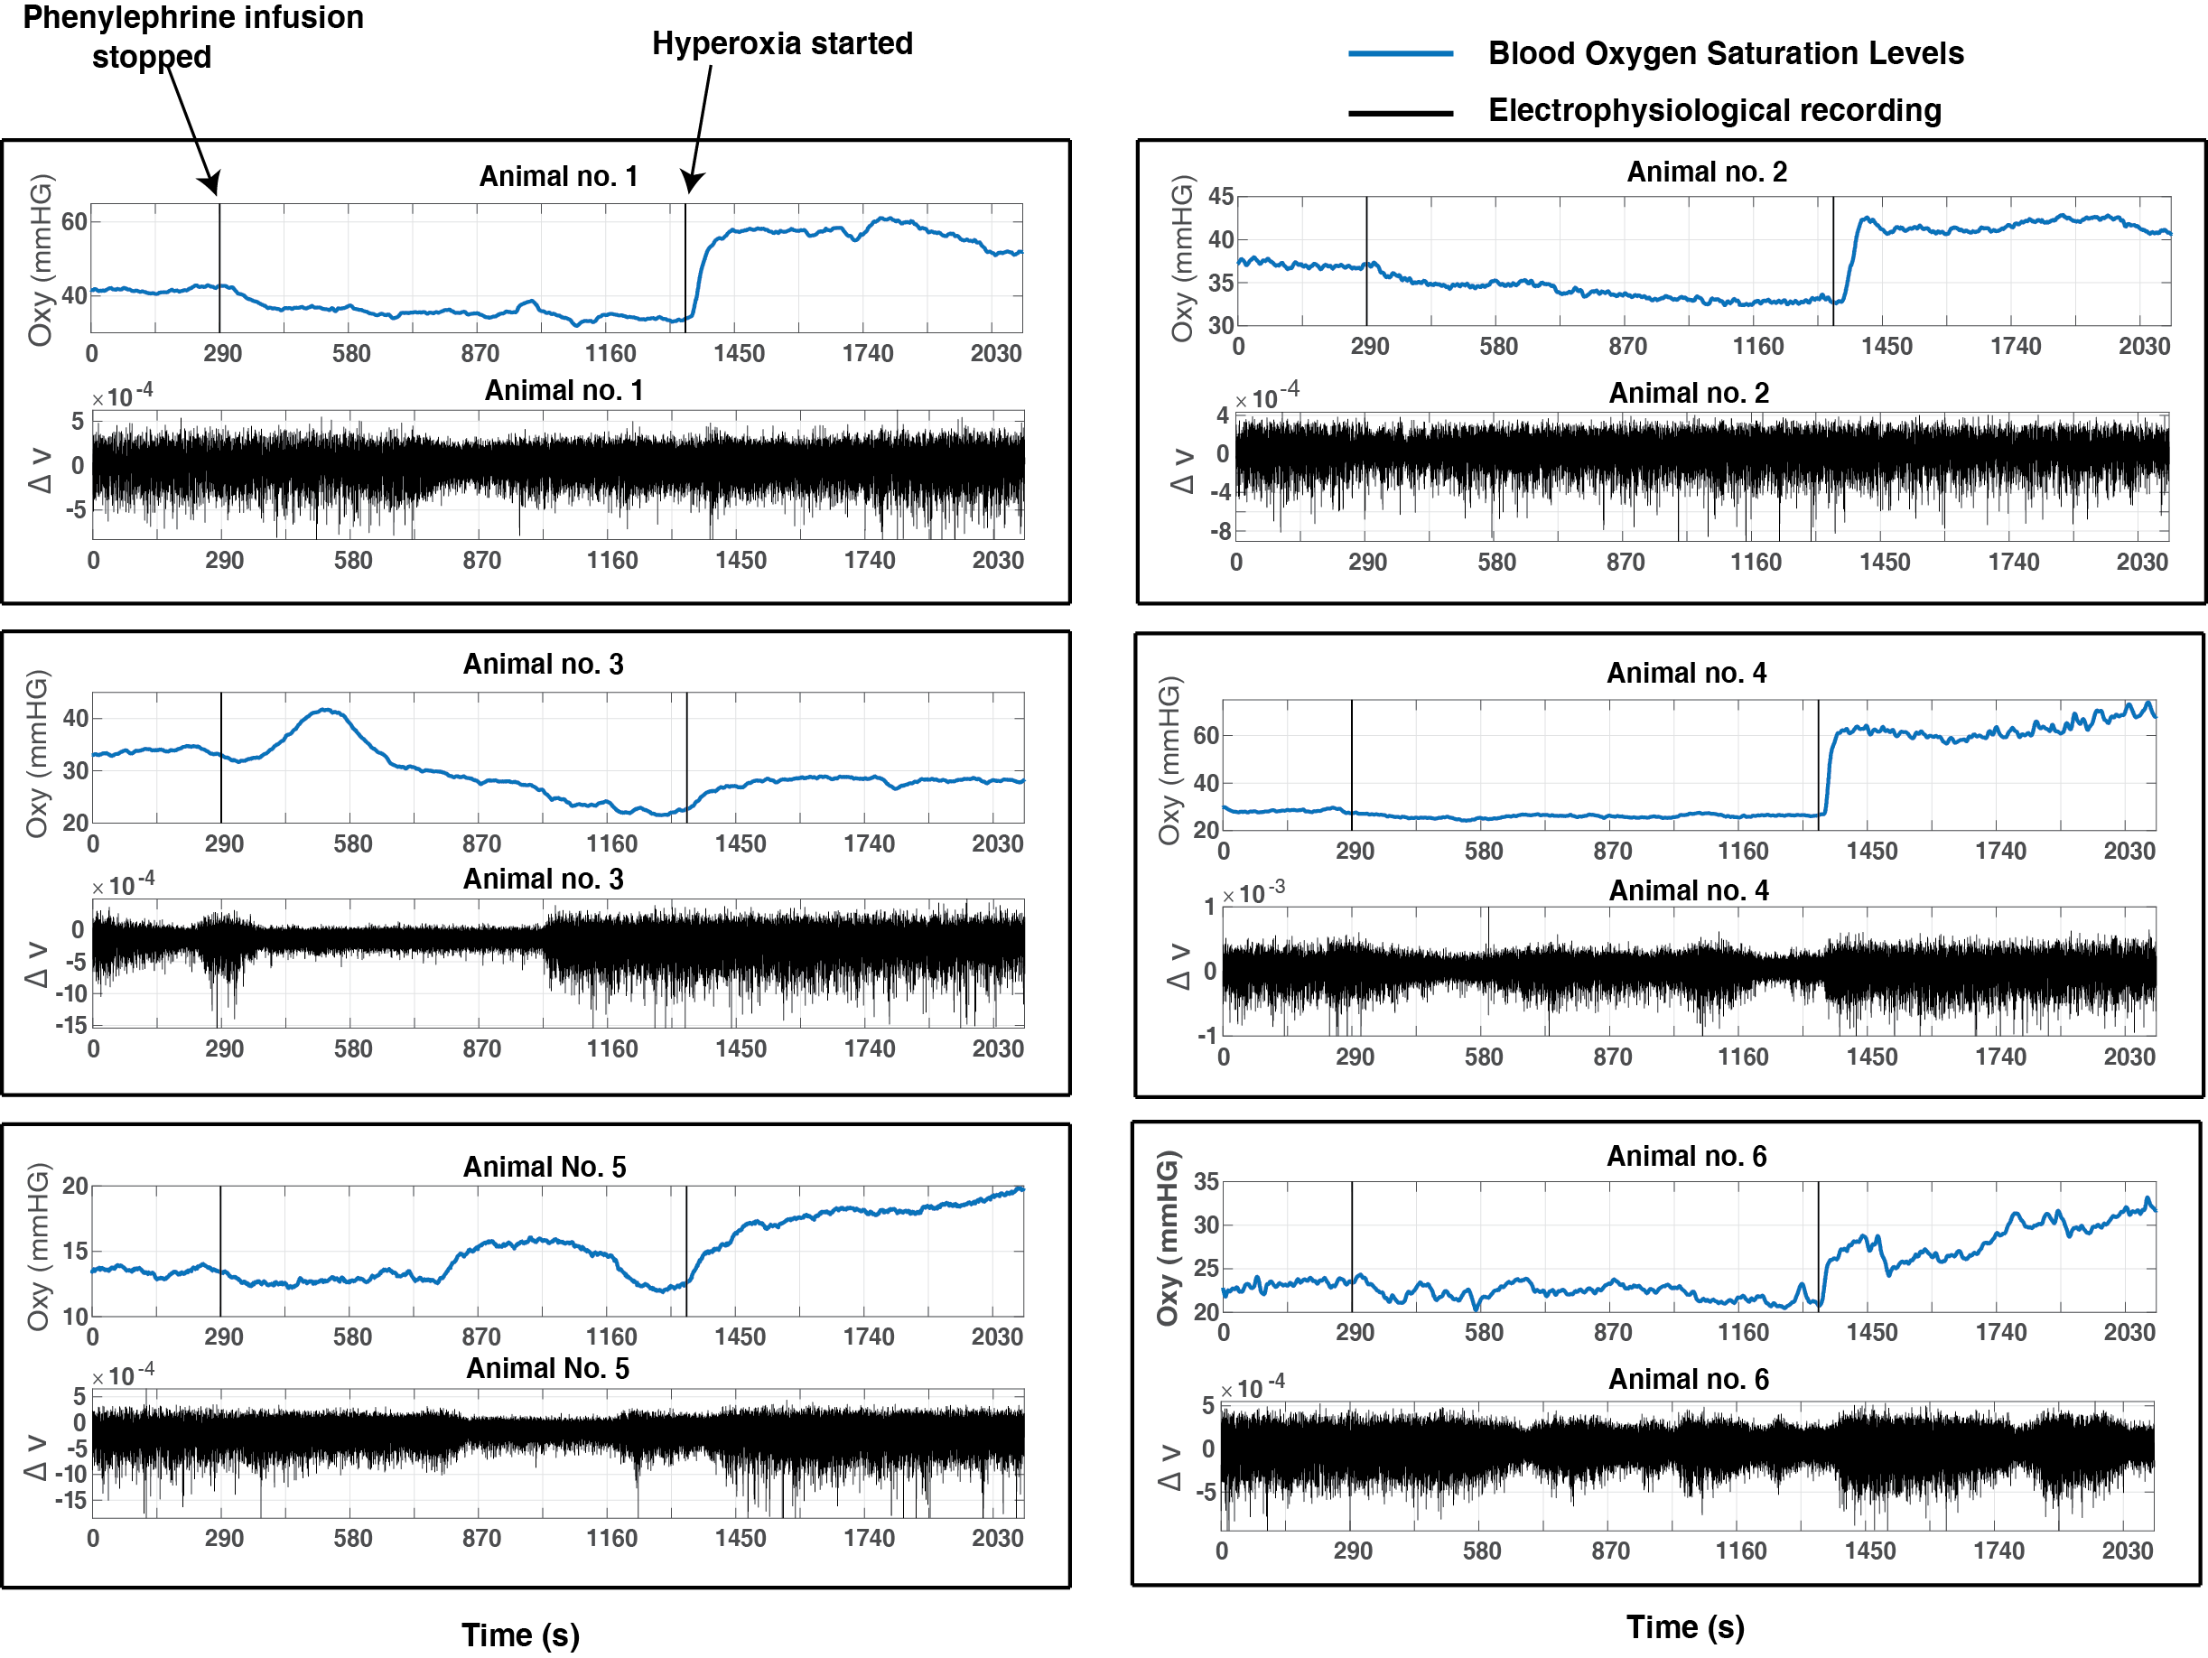

Figure 5.2.12 – Time series’ shows the animals’ (n=6) tissue oxygen measurement (blue) and corresponding electrophysiological recording (black). Some animals show changes in cortical state (synchronised to desynchronised) and also changes in tissue oxygen measurement can be observed particularly in the period where phenylephrine has been turned off.

Discussion
The previous two chapters have shown manipulations of MABP (with phenylephrine infusion) have resulted in variation in the magnitude of vasomotion oscillations. This current study which includes a tissue oxygen sensor has been able to provide a simple metric for the oxygen levels in the tissue so that relationships between vasomotion and cerebral tissue oxygen levels can be better elucidated.
Similar to the results found in chapters 3 & 4, a close relationship can again be observed between MABP and the magnitude of vasomotion oscillations in this chapter. A statistically significant difference was seen prior to and following phenylephrine infusion (fig 5.1.2). The magnitudes of vasomotion oscillations were seen to be larger prior to phenylephrine infusion and there was a significantly different to oscillations during phenylephrine infusion. Inter-animal values for MABP in comparisons to magnitudes of vasomotion oscillations, although not significantly different, a general trend can be seen where all animals showed that magnitudes of oscillations were reduced following increases in MABP (fig 5.1.6). Again, significant differences were observed in MABP following cessation of phenylephrine and also larger magnitudes of vasomotion oscillations were observed during the same period when compared to other two periods (phenylephrine infusion on and hyperoxia).

Investigations into changes in tissue oxygen measurement during periods of normal and lowered systemic MABP
A significant difference was seen between tissue oxygenation levels between the two periods, prior to and during phenylephrine infusion. This could be indication that increases seen following phenylephrine infusion in MABP could be related to increases in tissue oxygen levels. Similar to comparisons made between MABP and magnitude of vasomotion oscillations, comparisons between tissue oxygen levels and magnitudes of vasomotion oscillations showed generally, increases in tissue oxygenation resulted in reduced magnitudes of vasomotion oscillations (fig 5.1.7). Within the hyperoxia period, tissue oxygen levels can be seen to be increased when compared to tissue levels following cessation of phenylephrine. Within animals, the correlation analysis showed that there is little evidence of inter-animal variability and also hard to get an idea of general trends, this could be due to lower animal numbers.

Induction of hyperoxia in animals
Cessation of phenylephrine resulted in the tissue oxygen measurement (along with the MABP) decreasing until hyperoxia is induced upon which, clear increases in tissue oxygen levels were observed. Within animals, there is clearly not much inter-animal variability, although when put together there is a general trend (increase in oxygen levels in tissue, decrease in magnitude of vasomotion oscillations). This provides evidence that the animal preparation carried out was quite similar to one another as the values achieved are also quite similar. Increasing the oxygen levels in the brain could also have an effect on the magnitude of the vasomotion oscillations as these were seen to be reduced within this period; suggestive that a concomitant relation between cerebral oxygen delivery and vasomotion could exist in the brain.

Changes in tissue oxygen measurement and brain cortical states
To be able to assess if the changes in cortical state also had an effect on the tissue oxygen levels, the same comparison was made between the electrophysiological activity and the tissue oxygen levels. Like the previous chapter (chapter 4), some animals showed that when the cortical state was in the desynchronisation period, there was a concomitant increase tissue oxygen levels. Conversely, animals that do not show a change in cortical state also have minimal changes in the tissue oxygen levels. This is similar to the findings in chapter 3, indicating that changes in cortical state does in fact also have an effect on the tissue oxygen level measurements. Interestingly, all animals showed an increase in tissue oxygen level measurement within the hyperoxia period. This could be indicative that an increase in oxygen levels in the brain by increasing the FIO₂ is able to increase the tissue oxygen level.

General discussion
In general, this study has been able to provide an extra measurement via the tissue oxygen sensor, through this it has become clear that a decrease in tissue oxygen levels during periods of lowered MABP would also result in an increase in the magnitudes of vasomotion oscillations and MABP. The rationale for this could be that tissue oxygenation is dependent of blood oxygenation, so the decrease in MABP could have a concomitant decrease on the tissue oxygenation levels. Similarly, raising the MABP levels during hyperoxia could also have an effect on raising the tissue oxygenation; although MABP levels were not raised to the same level as when phenylephrine was infused (fig 5.2.2). Inducing hyperoxia (increase in O₂) has shown this might have vasoconstrictive properties in the brain, causing the blood vessels to constrict and a reduction in blood volume, this could be a reason why the blood pressure is seen to increase. Since blood oxygenation levels are linked the tissue oxygen levels, this could also be a reason as to why increases are seen in both. Further to this, this could suggest that there is a relation between oxygen delivery and vasomotion. Although, due to the confounds of cortical state this is difficult to assess, nevertheless, this study has been able to show that during desynchronised state (also known as aroused state due to nature of LFPs (small amplitude, high frequency), there is an increase in tissue oxygen levels for two animals, supporting the finding that increases in baseline haemodynamics are seen within this state (animals 3 &5 - fig 5.2.12).

Discussion

Summary
The previous chapters have detailed the research that has been conducted throughout this thesis. This chapter begins by summarising the major aims of the work before bringing together the findings of the different experiments presented to discuss the impact of their combined results. This is then followed by a description of the limitations and future work that will extend this work. Finally, the overall conclusions of the thesis are stated.

Research aims
The aims of this research were:
- Identify vasomotion oscillations (~0.1Hz) within the spontaneous cortical haemodynamics measured with 2D-OIS
- Assess the relation between the magnitude of vasomotion oscillations and changes in systemic blood pressure
- Assess the baseline changes in neural activity following changes in systemic blood pressure.
- Investigate a possible association between the magnitude of vasomotion oscillations during differing levels of oxygen tissue levels

Summary of principal research findings
The experiment presented in chapter 3 investigated the relation between vasomotion and systemic MABP. The resting state (spontaneous) haemodynamic changes recorded from the whisker ‘barrel’ cortex showed large magnitude oscillations within blood volume (Hbt), oxyhaemoglobin (HbO₂) and deoxyhaemoglobin (Hbr). The oscillations were sinusoidal in nature, with a period of around 10 seconds (corresponding to a frequency of ~0.1Hz). The magnitudes of these oscillations were reduced when levels of systemic MABP were increased through intravenous phenylephrine infusion. The increase in MABP and reduction in the magnitude of vasomotion oscillations could be indicative of a concomitant relationship, whereby lower levels of MABP could initiate mechanisms for vasomotion. This close relationship between systemic MABP and vasomotion could be due to the inherent ability of vascular resistance to adapt to changes in systemic blood pressure (Nilsson and Aalkjaer., 2003).
In addition to the increases in MABP, a slight increase in the oxygen saturation of the blood was observed during phenylephrine infusion, indicating that oxygen might have a role in mediating the magnitude of vasomotion. To investigate this further, a period of hyperoxia (FiO₂=100%) was introduced into experiments (chapter 4), during periods of lowered MABP, following cessation of phenylephrine. During this period, slight increases in the magnitudes of vasomotion oscillations were observed (~0.1Hz) as well as an increase in blood oxygen saturation. As this was unexpected and as this increase could be related to vasomotion oscillations, further investigations included looking at the corresponding electrophysiological recordings of neural activity. This showed that clear differences occurring in the amplitude of ongoing LFPs could be possibly related to increases in blood oxygen saturation. The differences in neural activity could be attributed to changes in cortical state whereby the cortical neural activity has been reported to change between quiescence (synchronised) and arousal (desynchronised). In particular, periods of desynchronisation were observed to have with increases in baseline cortical oxygen saturation levels. This finding has been corroborated by a recent study by Slack et al., (2016) and here the findings from chapter 4 show that spontaneous changes in ongoing neural activity can result in concomitant changes in baseline haemodynamics. Indeed, cortical desynchronization has been shown to temporally lead the haemodynamics (Slack et al., 2016 and Jones et al., 2008). Leading on from this, a recent article by Kim et al., (2016) whereby a vascular-neural hypothesis was proposed where evidence for a vessel-to-neuron communication in in-vitro brain slices defined as a vasculo-neuronal coupling. This study highlighted the importance of understanding the under play between basal CBF and resting neuronal activity (Kim et al., 2016).
During hyperoxia, smaller magnitudes of vasomotion oscillation were observed, despite lowered levels of MABP (compared to when phenylephrine infusion was on). This is indicates that a relation exists between cerebral oxygen delivery and vasomotion. In addition, a small increase in MABP was observed during the hyperoxia period, a further indication that cerebral oxygen might have a role in mediating systemic blood pressure.
A tissue oxygen probe was used (chapter 5) in experimental paradigms (replications of chapter 3 & 4), to investigate the role of localised tissue oxygenation on the magnitude of vasomotion. During phenylephrine infusion, tissue oxygenation levels were seen to increase in-line with MABP increases (fig 5.1.9). Again, larger magnitudes of vasomotion oscillations were observed before phenylephrine infusion and these were reduced following phenylephrine infusion. These findings were further extended to show that during periods of lowered systemic MABP, lower levels of tissue oxygenation were observed, with oxygenation levels only increasing during periods of hyperoxia. A slight increase in the magnitude of vasomotion observed following cessation of phenylephrine which was then reduced during hyperoxia.

Vasomotion and MABP
The first aim of this thesis was to identify vasomotion oscillations in spontaneous cortical haemodynamics. Indeed, vasomotion oscillations with a frequency of ~0.1Hz were observed in the cortical haemodynamics (Hbt, HbO₂, Hbr). The findings presented in this thesis show similarities to results presented in previous studies (Mayhew et al., 1996, Hudetz et al., 1992, Golanov et al., 1994, Rayshubskiy et al., 2014); large magnitude oscillations found in cortical haemodynamics, around 0.1Hz and pertaining to vasomotion. Interestingly, most of these studies were able to observe these oscillations during various alterations in the physiology. The studies this thesis have investigated the parameters in which vasomotion can manifest and, also the temporal nature of oscillations (e.g. sinusoidal). The studies in this thesis show manipulations of systemic parameters such as blood pressure have produced associated sinusoidal oscillations in the cortical haemodynamics, with varying magnitudes. As such, the second aim of this thesis was to investigate if a concomitant relationship between the magnitude of vasomotion oscillations and systemic MABP exists. The experimental chapters (3, 4 and 5) have shown that a relationship between the two does exist. This is in support of studies such as Ren et al., (1994) & Schmidt et al., (1992) where factors that could lead to larger magnitude of vasomotion oscillations could include manipulations of blood pressure. Systemic blood pressure has been linked to cerebral autoregulation (Paulson et al., 1989) and is important in maintaining homeostasis in the brain, it is thus plausible that lowering of MABP could initiate mechanisms, such as vasomotion. Initiating vasomotion could be important as it has been shown to play an important role in brain tissue oxygenation and maintaining cerebral autoregulation (Turalska et al., 2008). An association between changes in systemic MABP following phenylephrine cessation and varying magnitudes of vasomotion oscillations in the cortical haemodynamics can be observed in all three experimental chapters. Further to this, correlations between individual animal MABP and the magnitude of vasomotion oscillations showed general trends across animals in support of the above statement, increases in MABP showed lower magnitudes of vasomotion oscillations and vice versa.

Observations: Blood oxygen saturation
The relation between increases in MABP and decreases in magnitude of vasomotion oscillations could be better understood by also considering oxygen saturation in the blood. This was seen to also change following phenylephrine infusion, suggestive that this could also have an important role. Here 2D-OIS was used to measure oxygen saturation levels in the blood as well as blood volume (Hbt), oxyhaemoglobin (HbO₂) and deoxyhaemoglobin (Hbr). In chapter 3, as systemic MABP was increased (following phenylephrine infusion), a slight increase was also seen in the blood oxygen saturation. An increase in oxygen saturation levels in the blood suggest that this could also be a factor in mediating fluctuations such as vasomotion, possibly even causal. Hence, chapter 4 included additional manipulations of the inspire gases, namely where FiO₂ was changed to 100% oxygen from normal air, known as the hyperoxia period (will be discussed in section 6.7 – can hyperoxia affect vasomotion?). Interestingly, following the cessation of phenylephrine infusion, a slight increase was observed in the blood oxygen saturation even though MABP levels were lowered. Electrophysiological recordings of neural activity were examined to assess whether changes in neural activity could have caused the unexpected increase in blood oxygenation. Indeed, relationships have been observed previously, linking blood oxygen saturation and distinct differences in neural activity by Slack et al., (2016), this therefore investigated in more detail here (chapter 4).

Issues: Cortical desynchronization
Examination of electrophysiological recordings taken during the changes in phenylephrine infusion period exposed distinct changes in the neural activity recording. Comparing these changes to the previously published data, Jones et al., (2008), allowed identification of two distinct brain states (desynchronised and synchronised) that could be distinguished. Animals that were shown exhibit significant increases (~10-20%) in blood oxygen saturation during periods of lowered MABP, were seen to have associated periods of desynchronised neural activity. Indeed, Slack et al., (2016) has shown that during periods of desynchronisation, increases in the baseline blood volume and oxygen saturation were observed. Since the neural characteristic of the desynchronisation period is described as high frequency and low amplitude neural oscillations (Steriade et al., 1993), this could be an indication that there are increased levels of neural activity as further demonstrated by Jones et al., (2008) where a change in cortical state (from synchronised to desynchronised) was also associated with an increase in multiunit activity (MUA) (the activity recorded from several neurons). Desynchronised periods of neural activity are also known as the arousal period as defined by Slack et al., (2016).
This change
in general cortical state was also associated with an increase in
multiunit activity (MUA;
This change
in general cortical state was also associated with an increase in
multiunit activity (MUA;
This ‘classic’ desyn-
chronization response was evident in the LFPs recorded from
individual electrodes of the multidepth array (Fig. 2A) This change
in general cortical state was also associated with an increase in
multiunit activity (MUA
Since alterations in the local demand for glucose and oxygen during neuronal activity are accompanied by regional changes in cerebral blood volume (CBV) and oxygenation (Kleinfield et al., 2011), haemodynamic activity can be said to mirror neural activity, through the process of neurovascular coupling. It would be plausible to infer that during desynchronised periods, there is a greater local demand of blood volume (Hbt) and blood oxygen saturation, which has been corroborated by the findings in chapter 4. A greater local demand of blood volume (Hbt) could also result in higher saturation levels, so therefore larger magnitudes of vasomotion are perhaps not required. This is perhaps why the magnitudes of vasomotion oscillations were seen to be reduced in these animals during periods of lowered MABP.
Interestingly, further inspection of the electrophysiological recordings of neural activity showed a general trend across animals (chapter 4, fig 11) where cessation of phenylephrine temporal relates to a change in baseline electrophysiological activity (i.e. going from synchronised to desynchronised). Perhaps, the change in electrophysiological activity could be linked to the cessation of phenylephrine and therefore the start of lowering of systemic blood pressure. Manipulations of systemic blood pressure have seldom been linked to changes in cortical brain state. A mechanism that could allow for these changes in brain state could rely upon the action of baroreceptors. These receptors are able to detect changes in arterial pressure and relay this information to neurons in the nervous system, thus this could be one way in which the neuronal activity changes from a quiescent to a more aroused state. However, an argument against baroreceptors as playing a role is that they also act to keep blood pressure constant and thus an increase in blood pressure would also be expected in this time period. Animals that did not show changes in blood oxygen saturation were also examined (fig 4.12). These animals again showed changes in baseline electrophysiological activity, however, these changes, were generally over smaller time periods than were observed within the desynchronised state and the changes in the blood oxygen saturation were quite equivocal.
Animals that were seen to have increases in blood oxygen saturation during periods of lowered MABP were grouped (1). Overall, these animals showed lower magnitudes of vasomotion oscillations during the period of lowered MABP, perhaps providing an indication that vasomotion might be subdued during period of aroused neural activity. The animals that showed minimal changes in blood oxygen saturation were also grouped (2) and showed larger magnitudes of vasomotion during the period of lowered MABP.
To investigate if there was a relationship between baseline neural activity and tissue oxygen levels, a tissue oxygen probes was used in the final set of experiments (fig 5.2.12). Large variations in the oxygenation levels and changes in baseline neural activity made interpretation difficult. There were however, certain similarities to that seen with the blood oxygen saturation recoded using 2D-OIS. Two animals showed an increase in tissue oxygen levels when in the desynchronised period.

Issues: How can hyperoxia affect vasomotion?
Periods of higher blood saturation were typically associated with smaller magnitudes of vasomotion. This suggests that vasomotion oscillations may act to assist oxygen delivery (chapter 3). This was further investigated by measuring vasomotion during periods of hyperoxia (FiO₂ = 100%, chapter 4 & 5). Inducing hyperoxia during periods of lowered MABP produced a reduction in the magnitude of vasomotion oscillations. This observation could be evidence that cerebral oxygen supply could be involved in the regulation of vasomotion. However, rather than there being an oxygen detector per-se in the brain, a possible direct mediating factor between cerebral oxygen supply and vasomotion could be nitric oxide (NO). NO is a molecule that acts to dilate blood vessels as it is thought to be involved in the regulation of vascular tone. Thus NO, could be a candidate for mediating vasomotion. NO release from neurons has been shown to either increase or decrease blood flow depending on O₂ concentrations (Attwell et al., 2010). NO is produced and released locally by astrocytes and could regulate vasomotion relatively locally, although given that it is a diffusible agent, it may not act on small vessels (Attwell et al., 2010). This could make it difficult for NO to be a mediator for vasomotion, although, a study by Abatay and Payne., (2010), through a computational study found that oscillations are abolished for baseline and high blood pressure values within a NO flow dependent system coupled with the myogenic system. However, oscillations were not found to be abolished during low periods of blood pressure (Abatay and Payne., 2010), making this harder relationship to understand and therefore possibly needs more experimental work.
The use of hyperoxia could be seen as an experimental confound, as it was seen to raise MABP levels thus raising the possibility that the reductions in the magnitude of vasomotion oscillations could be associated with MABP rather hyperoxia. However, this seems unlikely as inspection of the averaged MABP values (chapter 4, figure 3) suggests that hyperoxia did not produce MABP values which were in the same range as those observed during phenylephrine infusion, (they were significantly lower, as per the one-way within subjects ANOVA and post hoc tests). This suggests that oxygen has some effects on the magnitude of vasomotion oscillations independent of MABP changes. The increase in MABP observed during inspiration of 100% FiO₂ is not unexpected, since oxygen has been reported to possibly be vasoconstrictive in its nature, and thus increasing the oxygen levels in the brain, might work to also locally constrict blood vessels in addition to increasing systemic BP. Indeed, Bergofsky & Bertun (1966) suggested that, hyperoxia could decrease local blood flow by increasing local vascular resistance, the effects of this being the most marked in the brain. A relationship can be drawn between arterial hyperoxia and regional vasoconstriction which could suggest a mechanism whereby tissue oxygen tensions could be stabilised. In addition to the above study, others have also discovered a marked sensitivity to hyperoxia in the form of vasoconstriction by Kety and Schmidt (1948).
Inducing hyperoxia increases the brain tissue partial pressure of oxygen (pO₂) (Hlatky et al., 2008). Thus, to more thoroughly assess the possible interaction of tissue oxygenation on the magnitude of vasomotion oscillations. A tissue oxygen sensor was used in the final set of experiments (chapter 5).

Tissue oxygen measurement
A tissue oxygen sensing probe was used to measure the levels of tissue oxygenation within the whisker ‘barrel’ cortex and to assess the magnitude of vasomotion oscillations during differing levels of oxygen tissue levels. The first part of chapter 5 (replication of experimental chapter 3) showed that tissue oxygenation levels were seen to increase following phenylephrine infusion along with increase in MABP and blood oxygen saturation. The magnitude of vasomotion oscillations were again was found to be attenuated within this period. The second part of chapter 5 (replication of experimental chapter 4), showed slight decreases in tissue oxygen levels following cessation of phenylephrine, which were was seen to increase considerably within the hyperoxia period. During periods of lowered tissue oxygenation (and MABP also), larger magnitudes of vasomotion oscillations were observed. Interestingly, very slight increases in blood oxygen saturation were also observed. To which, comparisons were made between electrophysiological recordings of neural activity with tissue oxygenation levels (description in the section 6.6 – Issues: cortical desynchronisation).
The advantages of including a tissue oxygen probe is that a probe records more directly from a cortical region, uses a chemical reaction- phosphorescence quenching. Whereas, 2D-OIS uses intrinsic signals and uses a number of assumptions and is limited from only surface measurements. Large increases in tissue oxygenation were observed following infusion of phenylephrine and during hyperoxia; increases were almost two-fold (fig 5.2.11). During hyperoxia, as the tissue oxygenation levels increased, the magnitude of vasomotion oscillations were seen to decrease; thus, providing an indication that a concomitant relationship between cerebral tissue oxygen and magnitudes of vasomotion oscillations might exist. Indeed, studies that investigate the effects of hyperoxia in the brain have shown that during hyperoxia, tissue oxygenation increases and the haemodynamic responses are regulated according to the metabolic demand of oxygen (Lindauer et al., 2003). Theoretical work carried out by Tsai and Integlietta., (1993) suggested that periodic changes in the arteriolar diameter (i.e. vasomotion) in the microcirculation could have significant effects on tissue oxygenation. Note: The polarographic oxygen probe would not be able to reduce the amount of O₂ in the tissue in the aim to manipulate the levels of vasomotion as this is not within the technological limits of the oxygen probe.
Interestingly, within the study presented in chapter 5, there was little evidence from the correlation analysis conducted of variability between the tissue oxygen values within animals. These small differences could be evidence that the animal preparation (surgical preparation) is quite similar to one another as reliable and consistent values are being obtained across animals. Although the variability is small, inspection of the values shows that there are general trends that can be inferred. Generally across experiments, it can be seen that as the values for tissue oxygen increase, the magnitudes of vasomotion oscillations could be seen to be reduced; evidence for correlations between tissue oxygenation values and vasomotion oscillations as shown in chapter 5.
Further theoretical work carried out by Goldman and Popel., (2001) investigated the effect of arteriolar vasomotion on oxygen transport in the brain and found that within well-oxygenated tissue conditions, vasomotion produced little change in the tissue oxygen distribution, whereas within hypoxic conditions (lack of oxygen reaching tissues), high amplitude oscillations in the blood flow were observed. Experimental studies such as Lysiak et al., (2000), suggested that vasomotion could be needed to ensure sufficient O₂ delivery and that normal blood flow is critical to ensure normal conditions. Similarly, Rucker et al., (2000) also suggested that vasomotion is important for O₂ delivery only when local perfusion is abnormally low, and was able to show that capillary blood oscillations was directly related to arteriolar vasomotion. Experimental evidence presented here and the research studies outlined have been able to elucidate the different ways in which vasomotion could have relationships with cerebral tissue supply and thus produce varying tissue oxygen levels. Indeed, these studies have been able to show how vasomotion could be related to changing levels of tissue oxygenation, therefore making this an interesting research avenue. Studying vasomotion could be an important step towards understanding the full complexity of dynamic control of oxygen delivery (Goldman and Popel., 2001).

Spatial maps
Spatial maps of vasomotion frequency oscillations were generated and assessed within the experimental chapters (3 & 4) of this thesis of potentially spatially distinct patterns, within the cortical haemodynamics (Hbt, HbO₂, Hbr), of vasomotion oscillation. The spatial maps were created to show the magnitude of vasomotion oscillations across the cortical surface (chapter 3 figs 3.11 & 3.12, chapter 4 figs 4.19 &4.20) and including the whisker ‘barrel’ region. Interestingly, larger magnitudes of vasomotion oscillations could be observed in the arterial branches (in the middle cerebral artery) during periods where MABP was lowered (chapters 3 & 4) vasomotion oscillations were expected known to be larger. Previous studies have stated that vasomotion is primarily observed in the arteries (Gustafsson., 1993) and has a characteristic frequency (~0.1Hz) for arterioles (Haddock et al., 2002). With frequencies between 0.08-0.2Hz shown to have larger magnitudes of oscillations in the arteries (Hbt), and both arteries and veins (HbO₂). Also, it is important to note that vasomotion oscillations were also present in the veins (perhaps to a lesser magnitude). Indeed, Elwell et al., (1999) suggested that vasomotion effects were primarily seen in HbO₂ and were less prominent in Hbr. If the role of vasomotion was of a protective one, in that it is working to improve aspects of blood flow and/or tissue oxygenation, then it would make sense that vasomotion oscillations are more prominent in the artery where oxygenated haemoglobin (HbO₂) is present.
In experimental chapters (3 & 4), the period where MABP was increased following phenylephrine infusion the magnitudes of vasomotion oscillations were seen to be quite reduced, as the spatial maps are able to show quite a distinct difference between the two periods, indicating that differences in the frequencies present in the cerebral vessels do change following the manipulations created in both experimental chapters. Indeed, the period of hyperoxia, where the vasomotion oscillations were reduced was also depicted within the spatial maps where a marked difference can be seen in the magnitude of frequencies during this period. Again, this provides some evidence that during hyperoxia, the magnitude of frequencies pertaining to vasomotion (~0.1Hz) are present within the cortical haemodynamics.

Implications for research
The spatial analysis completed here, has shown vasomotion like oscillations to be predominately localised to arterial regions. Prominent oscillations can be seen in both the Hbt (total blood volume) and Hbr (deoxygenated blood). This observation is likely to have an impact on BOLD measurements (Elwell et al., 1999). Studies that take BOLD measurements during resting state and/or in the creation of BOLD maps could be affected by vasomotion oscillations. BOLD primarily relies on changes in Hbr. An increase in the BOLD signal is thought to correlate with increased neural activity. Vasomotion, if present during BOLD recordings, may mask or lead to the incorrect interpretation of the underlying changes in neural firing, especially if those measurements were taken from regions having large arteries. For example a study by Saka et al., (2010) showed that the phase of the vasomotion oscillations can affect the magnitude of the stimulus evoked responses. Indeed, oscillations that have low frequencies (0.01-0.15Hz) have been commonly observed in a study that uses BOLD fMRI (Tong et al., 2012). The study was able to identify these low frequencies found in the periphery could be strongly correlated with vascular oscillations present in the brain. These oscillations were observed in healthy participants, indicative that correct identification of these oscillations could be used a useful biomarkers for detecting and also monitoring possible circulatory dysfunction in patients.
BOLD fMRI is a commonly used technique for investigating neuropathologies such as dementia (Hafkemeijer et al., 2012), AD (Sheline and Raichle., 2013). Dementia is a disease that has been identified where low frequencies such as vasomotion (~0.1Hz) could feasibly arise and be present. Having large impacts on resting state connectivity analyses including the interpretation of functional connectivity maps. Since BOLD is sensitive to Hbr and this study has shown that vasomotion oscillations are present in Hbr, it is important to note that it could be challenging to denote cortical regions of the brain not exhibiting low frequency oscillations (~0.1Hz) in the fMRI data as it is possible to detect frequencies (~0.1Hz) using fMRI (Rayshubskiy et al., 2014). Thus to better interpret resting state functional connectivity, it could be important to fully assess and remove low frequency oscillations from the data, otherwise the extent to which information derived about the neuronal activity could be strongly biased by the underlying haemodynamic fluctuations (Tong et al., 2014).
Understanding the nature of low frequency oscillations is important, not only how oscillations such as vasomotion manifest but also how these mechanisms are integral for brain function. A better understanding of this would help to elucidate how vasomotion could be implicated or involved in popular research such as resting state functional connectivity. As the field functional connectivity is a fast growing and extremely popular research area for and a technique now widely used in humans (both healthy and within pathological states such as Alzheimer’s disease and dementia); the presence of these oscillations in the vasculature can lead to misinterpretation. Thus it is important for RSFC researchers to be aware of vasomotion and also promisingly it could be used as a biomarker for early pathologies (Mayhew et al., 1996).

Limitations of this study
The limitations of this study that have been identified have been discussed here.
A limitation of this study relates to the use of phenylephrine to modulate systemic blood pressure. Phenylephrine is not known to cross the BBB (Olesen., 1972). However, the ability to auto-regulate cerebral blood flow by increasing mean arterial pressure, phenylephrine could possibly play a role in the physiology e.g. changes in blood oxygen saturation. It is important to note that phenylephrine is a systemic drug and affects the body throughout so blood pressure is the same across the body. Preliminary experiments within the Sheffield laboratory has shown that similar changes (to those seen following phenylephrine cessation) in the haemodynamics, blood oxygen saturation, blood pressure and neural activity can also take place following a ‘blood letting’ experiment, in which 1 ml of blood was extracted from the rat. A comparison between two identically set up experiments (fig 6.11.1) shows that following cessation of phenylephrine changes in the neural activity (from synchronised to desynchronised cortical brain state), haemodynamics, blood oxygenation saturation and blood pressure can be seen (fig 6.11.1A). A different experiment that involved extracting 1ml of blood from the rat at 290s created the similar changes in the aforementioned measurements. The neural activity was seen to change from synchronised to desynchronised cortical brain state, similar increases can be observed in the haemodynamics and blood oxygen saturation and also a similar decrease can be seen in the blood pressure (fig 6.11.1B). Comparison of two experiments shows that similar changes can be brought about in the brain without phenylephrine infusion. Therefore, suggestive that phenylephrine might not be creating a chemical or neuropharmacological change in the brain.
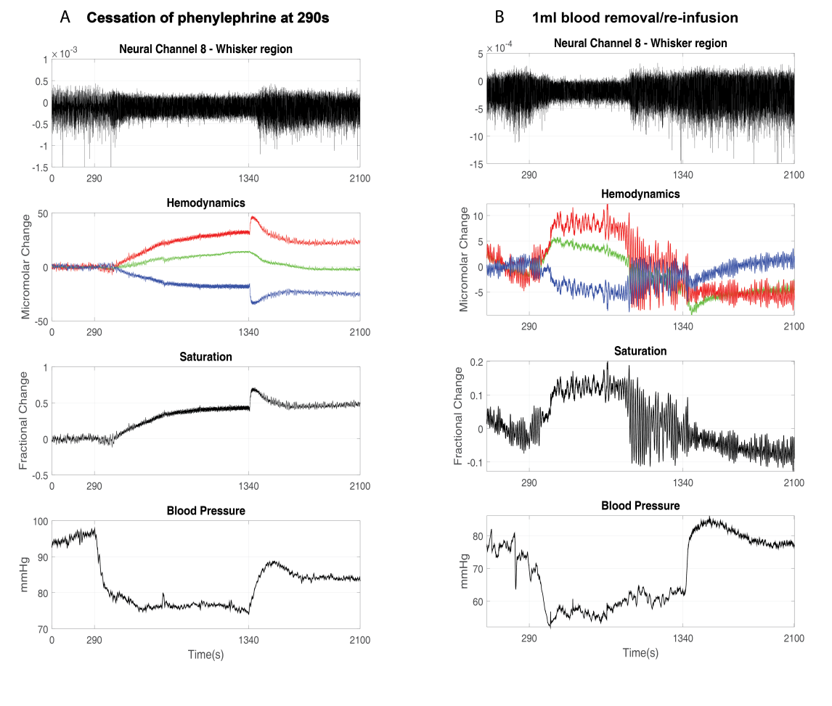
Figure 6.11.1- Comparison of neural activity, haemodynamics, blood oxygen saturation and blood pressure between two experiments. A) Shows cessation of phenylephrine at 290s and then FIO₂ changed to 100% at 1340s. B) Shows 1ml of blood extracted from the arterial cannula of the rat and then reinfused at 1340s. This study is from preliminary work carried out in the Sheffield Laboratory.
A further possible limitation that could be considered is the use of anaesthesia, in further experiments a possibility could be to use an awake animal model for example as demonstrated by Martin et al., (2006) where differences in the neural and haemodynamic responses were shown between awake and anaesthetic animals. Although, it would be difficult due to practical reasons such as cannulation and thinned window preparations. In addition, manipulating the FiO2 and BP could be difficult due to ethical and physiological reasons, making using an awake animal preparation difficult for these experimental paradigms.
Urethane anaesthesia was used throughout all studies of this thesis. Urethane anaesthesia is a commonly used in research, which explores neural and vascular relationships within the rodent brain. As previously discussed in the introduction and method sections, urethane holds a fortuitous position as this inherently lowers systemic blood pressure, in which case this was the physiological parameter manipulated within this study. A confound potentially arises, as the anaesthetic could have a direct effect on the cerebral vasculature. The use of an anaesthetic such as urethane allows for concurrent invasive techniques to be used, although, the inferences made about the changes occurring in the brain is limited. To overcome this possible confound, an awake animal model could be used, whereby the changes occurring in the cerebral vasculature could still be measured and assessed, most likely without the recordings of neural activity.
The experimental studies have shown a close relationship between increases in MABP and cerebral oxygen, this was most apparent during the hyperoxia period, where increases in oxygen also increased MABP. Suggestions that these two elements might be interlinked make it difficult to make inferences about these components individually. However, the concomitant nature of the oxygenation and blood pressure changes could help to understand important aspects of research such as hypotension which is known to be a common complication of preterm birth (Azhan and Wong., 2012)
Different cortical states were observed across subjects (chapter 4) and this related to differences between blood oxygen saturation of the subjects. Thus, the animals were split into sub-groups dependent on their overall state changes. This resulted in a low number of animals for each group. Taking cortical state allows more of the underlying physiology to be investigated, as it offers additional intrinsic states, with differing neural and haemodynamic responses (Slack et al., 2016).
The low temporal resolution of the oxygen probe meant that oscillations in the oxygen levels were not possible (chapter 5). Indeed, perhaps the use of polarographic oxygen sensors (like a Clark’s probe) could be used, as similar oxygen electrodes have been reported to be used in studies that look at the links between vasomotion and spontaneous oscillations in the rat brain (Karkan et al., 1999). However, a limitation with Clark’s electrodes is that they are known to break easily due to the fragility of the sensors.

Future work
Some future work that could be carried out after considering the results of this study have been also stated in the previous section (6.11 – Limitations of this study), some more will be discussed in this section.
The studies of this thesis have laid the foundations for a series of experiments to further investigate the drivers of vasomotion. There are a variety of physiological parameters (MABP, blood oxygen saturation, neural activity, tissue oxygenation) present in the brain that interact with each other. Being able to understand the causal aspects which alter these markers is difficult and also outside the remit of this study. Here the next stages of experimental work are discussed.
Since this thesis utilises manipulations of systemic blood pressure to probe vascular fluctuations and their drivers. Through this manipulation this many other aspects of physiology (blood oxygen saturation, tissue oxygenation) were also seen to be involved, which to some extent the level of interaction was unexpected and has led to further investigations suggested here.
Vasomotion was investigated throughout this thesis, however there are a range of other fluctuations present in the body that could also be considered. An example is Mayer waves, which are oscillations of arterial pressure (known to occur within blood pressure readings) occurring spontaneously with a frequency of ~0.1Hz in humans. Mayer waves are tightly coupled with synchronous oscillations of sympathetic nervous activity and known as a surrogate measure of sympathetic activity (Julien., 2006). There are distinct differences between Mayer waves and vasomotion for example; Mayer waves are known to be systemic oscillations of arterial pressure across the body whereas vasomotion is known to be a local phenomenon to the tissues vessel segment (Nilsson & Aalkjaer., 2003), although, sometimes both oscillations can be confused as they both oscillate within a similar frequency (0.1Hz-0.4Hz) (Bumstead., 2016). Also a recent paper by Bumstead et al., (2016) was able to identify that both vasomotion and Mayer waves (due to the frequency of the oscillations) could have an effect on resting-state functional connectivity analysis. (Note: analysis was carried out to see if ~0.1Hz oscillations were present the MABP data presented in this study and it was not found, therefore Mayer wave was not present within the data).
Hyperoxia was used to investigate the relation between vasomotion and oxygenation (chapters 4 & 5). The FiO₂ was increased to 100%, however, future experiments could involve varying the percentage of oxygen (e.g. 40%, 50%, etc) being administered to see if there are variances in the magnitude of vasomotion oscillations following cessation of phenylephrine, related to inspired oxygen.
Interestingly, vasomotion has been viewed mostly as a myogenic response within the brain, although, some studies have eluded to vasomotion possibly having neural influences (Intaglietta., 1990). A study by Cimponeriu and Kaplan (2001) observed that vasomotion could be stimulus-dependent and can be phase-locked to the stimulus. This study provided evidence that vasomotion is sensitive to neuronal activation. An interesting study would be investigating neural markers of vasomotion. For the study presented in the thesis, efforts were made to see if the 0.1Hz was present within the LFP recordings, although, it was hard to distinguish this from noise or movement artefacts and therefore further analysis would be needed.
Low frequency oscillations such as vasomotion have been observed the brain in a wide range of conditions, e.g. AD, dementia, diabetes, etc. Although, studies investigating these pathologies are seldom able to seen to examine low frequency oscillations such as vasomotion individually and also sometimes the oscillations are dismissed as a consequence of anaesthesia, abnormal blood pressure or an artefact (Golanov et al., 1994, Nakai and Maeda., 1999). Future studies that investigate pathologies such as those mentioned above and especially ones that have a measurement of baseline haemodynamics could consider carrying out extra analyses that look for vasomotion oscillations. One example is a current ongoing study within the Sheffield laboratory which seeks to understand AD in a mouse model. Preliminary results show that differences in the haemodynamics between wild type and animals with AD pathologies exist (fig 6.12.1). During normal air (21% O₂), oscillations at 0.1Hz were more prominent in the animals with AD compared to wild type mice (fig 6.12.1D). Larger magnitudes of oscillations can be seen in the cortical haemodynamics (Hbt, HbO₂, Hbr) in the animals with AD when compared to wild type animals (fig 6.12.1B).

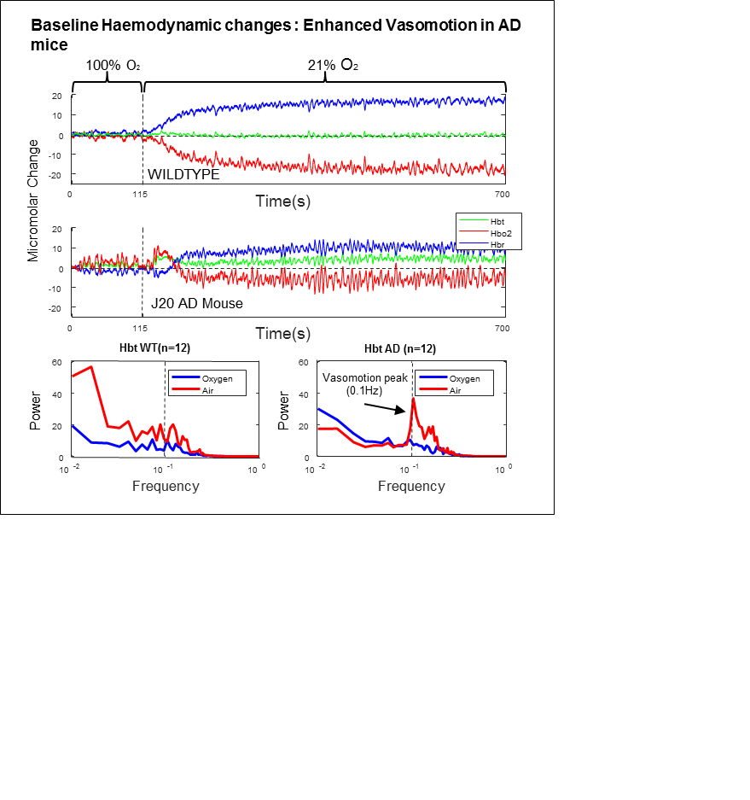
A
B
C
D

Figure 6.12.1 – Preliminary study showing comparison of haemodynamic recordings between wild type and AD mice. A) Haemodynamic recording from wild type animals (n=12), first 115s show FiO₂ = 100% and then changed to normal air. B) Haemodynamic recording from AD animals (n=12), first 115s show FiO₂ = 100% and then changed to normal air. C) FFT analysis shows comparison of the two periods (normal and 100% O₂) in wild type animals. D) FFT analysis shows comparison of the two periods (normal and 100% O₂) in AD animals. A distinct peak at 0.1Hz is shown in the AD animals during normal air. The figure was obtained from an ongoing project funded by Alzheimer’s disease research UK.

The preliminary findings presented suggest that vasomotion oscillations (0.1Hz) can be present within the cerebral haemodynamics of mice with AD pathologies and that vasomotion could be potentially a biomarker in neurodegenerative diseases such AD.
As vasomotion has been linked to many different pathologies (e.g. dementia, AD) many of these diseases have a common aspect which is age. Many of the people that exhibit these pathologies tend to be of the elderly or aging populations. A future study could be to investigate vasomotion, in different aged rats. The manipulations used in this study could also be applied or variations to see if changes measured in the brain changes with age. Some studies have hypothesised that spontaneous oscillations may decrease in the cerebral microvasculature with aging (D’Esposito et al., 2003). This could be due to a declining spontaneous activity occurring in the SMCs, in conjunction with vessel stiffness. Another study (Vermeij et al., 2014) has shown the low frequency oscillations were reduced in older adults compared to younger participants during task performance. Moreover, in addition to vasoregulatory processes, systemic processes such as blood pressure might also influence cerebral haemodynamic signal.
In terms of analysis, various analysis methods could be used to further elucidate different aspects of the data set. For example, greatly discussed in this study are the changes occurring in cortical state. Due to time limitations and availability, a peer-reviewed program developed within the Sheffield laboratory by Slack et al., 2016, which showed separation of cortical states could not be used. A possible extension of this study would be to include this software program for better identification of cortical brain states.
Similarly, vasomotion has been identified to be important for resting state research, whereby functional connectivity maps are an important analysis to be able to map ‘active’ regions of the brain according to changes occurring in blood. To be able to investigate this further, a similar preparation can be carried out in the rat, where the skull overlying both cortices can be thinned and imaged using 2D-OIS. In this way, connectivity maps between the cortical areas (e.g. right and left somatosensory whisker ‘barrel’ cortex) can be created in a similar way to Biswal et al., (1995) demonstrated that low frequency (0.1-0.01Hz) fluctuations were strongly correlated across hemispheres in the bilateral motor cortices. A recent study by Bumstead et al., (2016) created resting state functional connectivity maps from bilateral somatosensory cortices to investigate the presence of vasomotion oscillations could affect the connectivity maps. Indeed, the presence of oscillations at 0.1Hz can confound conclusion drawn from functional connectivity maps if these frequencies are not separated, highlighting the importance of thorough examination of the haemodynamics or BOLD data for vasomotion frequencies.
In these studies, 2D-OIS was used to measure the blood based changes in the cortical surface of the somatosensory cortex. Although, different techniques could be used to measure vasomotion also, BOLD fMRI is one that has been outlined as a technique that is able to detect oscillations such as vasomotion (~0.1Hz). In addition, techniques such as two-photon imaging would allow for measurements of dilation and constriction of the blood vessels which is said to be how vasomotion is exhibited. Aalkjaer et al., (2011) has found that vasomotion (~0.1Hz) has been shown to correspond to synchronisation of the intermittent release of calcium within vascular SMCs. This would be a good experiment to carry out as the exact mechanisms initiating this synchronisation and the cyclic process involved that sustains the oscillations are not that well understood (Aalkjaer and Nilsson, 2005, Haddock and Hill, 2005).

Conclusion
The conclusions of this study are multi-fold. The study has been able to show that vasomotion oscillations do exist within cortical haemodynamics and that the study of this oscillation is important. Understanding the physiological mechanisms and ways in which vasomotion can manifest in the brain are also important in not only being able to understand vasomotion but also how changes within cerebral autoregulation take place. Indeed, the investigations carried out in this thesis shown that magnitudes of vasomotion oscillations can vary depending on systemic changes in blood pressure, indicating that vasomotion could have myogenic properties. In addition, to its relationship with blood pressure, interesting insights were also made with blood oxygen saturation and cerebral tissue oxygenation where indications that cerebral vasomotion is linked to baseline tissue oxygen measurement could be made.
Overall, studies that work to understand the operations in the brain better, must take into account physiological components such as vasomotion that could be implicated in resting state research and analysis. Fluctuations such as vasomotion seen to exhibit at low frequencies (~0.1Hz) could have major influences on resting state functional connectivity related analysis, especially as many fMRI studies are increasingly being applied to pathological states e.g. Alzheimer’s disease (Sheline and Raichle., 2013). Vasomotion oscillations at ~0.1Hz could feasibly arise in conditions such as Alzheimer’s disease which is known to have a vascular component in the pathogenesis (Di Marco et al., 2015); ultimately possibly creating alterations in resting state networks. Vasomotion may well be seen as an artefact confounding these studies. However, its presence may also be a good early biomarker of cerebrovascular pathology which is currently not widely researched.

References

Aalkjær, C., Boedtkjer, D., & Matchkov, V. (2011). Vasomotion–what is currently thought? Acta physiologica, 202(3), 253-269.
Aalkjaer, C., & Nilsson, H. (2005). Vasomotion: cellular background for the oscillator and for the synchronization of smooth muscle cells. British journal of pharmacology, 144(5), 605-616.
Abatay, H., & Payne, S. J. (2010). Analysis of the Effects of Nitric Oxide on Vasomotion. In 6th World Congress of Biomechanics (WCB 2010). August 1-6, 2010 Singapore (pp. 863-866). Springer Berlin Heidelberg.

Achakri, H., Rachev, A., Stergiopulos, N., & Meister, J. J. (1994). A theoretical investigation of low frequency diameter oscillations of muscular arteries. Annals of biomedical engineering, 22(3), 253-263.
Achakri, H., Stergiopulos, N., Hoogerwerf, N., Hayoz, D., Brunner, H. R., & Meister, J. J. (1995). Intraluminal pressure modulates the magnitude and the frequency of induced vasomotion in rat arteries. Journal of vascular research, 32(4), 237-246.
Akselrod, S., Gordon, D., Madwed, J. B., Snidman, N. C., Shannon, D. C., & Cohen, R. J. (1985). Hemodynamic regulation: investigation by spectral analysis. American Journal of Physiology-Heart and Circulatory Physiology,249 (4), H867-H875.
Ances, B. M., Buerk, D. G., Greenberg, J. H., & Detre, J. A. (2001). Temporal dynamics of the partial pressure of brain tissue oxygen during functional forepaw stimulation in rats. Neuroscience letters, 306(1), 106-110.
Attwell, D., Buchan, A. M., Charpak, S., Lauritzen, M., MacVicar, B. A., & Newman, E. A. (2010). Glial and neuronal control of brain blood flow. Nature,468(7321), 232-243.
Auer, L. M., Gallhofer, B., Ladurner, G., Sager, W. D., Heppner, F., & Lechner, H. (1981). Diagnosis and treatment of middle fossa arachnoid cysts and subdural hematomas. Journal of neurosurgery, 54(3), 366-369.
Ayata C, Ma J, Meng W, Huang P, Moskowitz MA (1996) L-NA-Sensitive rCBF Augmentation During Vibrissal Stimulation in Type III Nitric Oxide Synthase Mutant Mice. J Cereb Blood Flow Metab
Azhan, A., & Wong, F. (2012). Challenges in understanding the impact of blood pressure management on cerebral oxygenation in the preterm brain. Frontiers in physiology, 3, 471.
Ba AM, Guiou M, Pouratian N, Muthialu A, Rex DE, Cannestra AF, Chen JW, Toga AW (2002) Multiwavelength optical intrinsic signal imaging of cortical spreading depression. J Neurophysiol 88:2726-2735
Berwick J, Martin C, Martindale J, Jones M, Johnston D, Zheng Y, Redgrave P & Mayhew J (2002) Hemodynamic response in the unanesthetized rat: intrinsic optical imaging and spectroscopy of the barrel cortex. J Cereb Blood Flow Metab, 22(6), 670-679.
Berwick, J., Redgrave, P., Jones, M., Hewson-Stoate, N., Martindale, J., Johnston, D., & Mayhew, J. E. W. (2004). Integration of neural responses originating from different regions of the cortical somatosensory map. Brain research, 1030(2), 284-293.
Berwick, J., Johnston, D., Jones, M., Martindale, J., Redgrave, P., McLoughlin, N.,& Mayhew, J. E. W. (2005). Neurovascular coupling investigated with two‐dimensional optical imaging spectroscopy in rat whisker barrel cortex. European Journal of Neuroscience, 22(7), 1655-1666.
Berwick J, Johnston D, Jones M, Martindale J, Redgrave P, McLoughlin N, Schiessl I, Mayhew JE (2008) Fine detail of neurovascular coupling revealed by spatiotemporal analysis of the hemodynamic response to single whisker stimulation in rat barrel cortex. J Neurophysiol 99:787-798
Bergofsky, E. H., & Bertun, P. (1966). Response of regional circulations to hyperoxia. Journal of applied physiology, 21(2), 567-572.
Biswal, B., Zerrin Yetkin, F., Haughton, V. M., & Hyde, J. S. (1995). Functional connectivity in the motor cortex of resting human brain using echo‐planar mri. Magnetic resonance in medicine, 34(4), 537-541.
Boer, M. P., Wijnstok, N. J., Serné, E. H., Eringa, E. C., Stehouwer, C. D., Flyvbjerg, A., ... & Smulders, Y. M. (2014). Body mass index is related to microvascular vasomotion, this is partly explained by adiponectin. European journal of clinical investigation, 44(7), 660-667.
Boorman, L., Kennerley, A. J., Johnston, D., Jones, M., Zheng, Y., Redgrave, P., & Berwick, J. (2010). Negative blood oxygen level dependence in the rat: a model for investigating the role of suppression in neurovascular coupling. The Journal of Neuroscience, 30(12), 4285-4294.
Brizel, D. M., Rosner, G. L., Harrelson, J.,Prosnitz, L. R and Dewhirst, M W. (1994). International journal of radiation oncology, Biology, Physics, 30:635-642
Bruyns‐Haylett, M., Harris, S., Boorman, L., Zheng, Y., Berwick, J., & Jones, M. (2013). The resting‐state neurovascular coupling relationship: rapid changes in spontaneous neural activity in the somatosensory cortex are associated with haemodynamic fluctuations that resemble stimulus‐evoked haemodynamics. European Journal of Neuroscience, 38(6), 2902-2916.
Bumstead, J. R., Bauer, A. Q., Wright, P. W., & Culver, J. P. (2016). Cerebral functional connectivity and Mayer waves in mice: Phenomena and separability. Journal of Cerebral Blood Flow & Metabolism, 0271678X16629977.
Carreau, A., Hafny‐Rahbi, B. E., Matejuk, A., Grillon, C., & Kieda, C. (2011). Why is the partial oxygen pressure of human tissues a crucial parameter? Small molecules and hypoxia. Journal of cellular and molecular medicine,15 (6), 1239-1253.
Cassaglia, P. A., Griffiths, R. I., & Walker, A. M. (2008). Sympathetic nerve activity in the superior cervical ganglia increases in response to imposed increases in arterial pressure. American Journal of Physiology-Regulatory, Integrative and Comparative Physiology, 294(4), R1255-R1261.
Cassaglia, P. A., Griffiths, R. I., & Walker, A. M. (2009). Cerebral sympathetic nerve activity has a major regulatory role in the cerebral circulation in REM sleep, J Appl Physiol, 2009, vol.106 (pg-1050-1056).
Chance, B. (1991). Optical method. Annual review of biophysics and biophysical chemistry, 20(1), 1-30.
Cheng, H. L. M. (2012). Effect of hyperoxia and hypercapnia on tissue oxygen and perfusion response in the normal liver and kidney. PloS one,7 (7), e40485.
Cimponeriu, A., & Kaplan, E. (2001). Optical imaging of intrinsic signals with blue light. SPIE's Opto Northeast and Imaging.
Clark, L. C., Wolf, R., Granger, D., & Taylor, Z. (1953). Continuous recording of blood oxygen tensions by polarography. Journal of applied physiology,6(3), 189-193.
Clark, L. C., Misrahy, G., & Fox, R. P. (1958). Chronically implanted polarographic electrodes. Journal of applied physiology, 13(1), 85-91.
Coca, D., Zheng, Y., Mayhew, J. E. W., & Billings, S. A. (1998). Non-linear analysis of vasomotion oscillations in reflected light measurements. In Oxygen Transport to Tissue Xx (pp. 571-582). Springer US.
Colantuoni, A., Bertuglia, S., & Intaglietta, M. (1985). Variations of rhythmic diameter changes at the arterial microvascular bifurcations. Pfluegers Archiv, 403(3), 289-295.
Cope, M., & Delpy, D. T. (1988). System for long-term measurement of cerebral blood and tissue oxygenation on newborn infants by near infra-red transillumination. Medical and Biological Engineering and Computing, 26(3), 289-294.
Cushing, H. (1901). Concerning a definite regulatory mechanism of the vaso-motor centre which controls blood pressure during cerebral compression. Johns Hopkins.
Damber, J. E., Lindahl, O., Selstam, G., & Tenland, T. (1983). Rhythmical oscillations in rat testicular microcirculation as recorded by laser Doppler flowmetry. Acta Physiologica Scandinavica, 118(2), 117-123.
Davies, P. W., & Brink Jr, F. (1942). Microelectrodes for measuring local oxygen tension in animal tissues. Review of Scientific Instruments, 13(12), 524-533.
D'Esposito, M., Deouell, L. Y., & Gazzaley, A. (2003). Alterations in the BOLD fMRI signal with ageing and disease: a challenge for neuroimaging. Nature Reviews Neuroscience, 4(11), 863-872.
Devonshire IM, Papadakis NG, Port M, Berwick J, Kennerley AJ, Mayhew JE & Overton PG (2012) Neurovascular coupling is brain region-dependent. Neuroimage, 59(3), 1997-2006.
Devor A, Dunn AK, Andermann ML, Ulbert I, Boas DA, Dale AM (2003) Coupling of total haemoglobin concentration, oxygenation, and neural activity in rat somatosensory cortex, Neuron, 17;39(2):353-359
Devor A, Sakadzic S, Saisan PA, Yaseen MA, Roussakis E, Srinivasn VJ, Vinogradov SA, Rosen BR, Buxton RB, Dale AM, Boas DA (2011). J Neurosci, 31(38):13676-13681
Di Marco, L. Y., Farkas, E., Martin, C., Venneri, A., & Frangi, A. F. (2015). Is vasomotion in cerebral arteries impaired in Alzheimer’s disease? Journal of Alzheimer's Disease, 46(1), 35-53.
Diamond, M. E., von Heimendahl, M., Knutsen, P. M., Kleinfeld, D., & Ahissar, E. (2008). 'Where'and'what'in the whisker sensorimotor system.Nature Reviews Neuroscience, 9(8), 601-612.
Dirnagl, U., Lindauer, U., & Villringer, A. (1993). Role of nitric oxide in the coupling of cerebral blood flow to neuronal activation in rats. Neuroscience letters, 149(1), 43-46.
Elwell, C. E., Springett, R., Hillman, E., & Delpy, D. T. (1999). Oscillations in cerebral haemodynamics. In Oxygen transport to tissue XXI (pp. 57-65). Springer US.
Folkov, B. (1694) Myogenic mechanisms in the control of systemic resistance. Introduction and historical background. J. Hypertens. Suppl 7:S1-S4
Fox, M. D., & Raichle, M. E. (2007). Spontaneous fluctuations in brain activity observed with functional magnetic resonance imaging. Nature Reviews Neuroscience, 8(9), 700-711.
Fox, K. (2008). Barrel cortex. Cambridge University Press
Funk, W., Endrich, B., Messmer, K., & Intaglietta, M. (1982). Spontaneous arteriolar vasomotion as a determinant of peripheral vascular resistance.International journal of microcirculation, clinical and experimental/sponsored by the European Society for Microcirculation, 2(1), 11-25.
Funk, W., & Intaglietta, M. (1983). Spontaneous arteriolar vasomotion. InVasomotion and Quantitative Capillaroscopy (pp. 66-82). Karger Publishers.
Garrity, A. G., Pearlson, G. D., McKiernan, K., Lloyd, D., Kiehl, K. A., & Calhoun, V. D. (2007). Aberrant “default mode” functional connectivity in schizophrenia. American journal of psychiatry, 164(3), 450-457.
Golanov, E. V., Yamamoto, S. E. I. J. I., & Reis, D. J. (1994). Spontaneous waves of cerebral blood flow associated with a pattern of electrocortical activity. American Journal of Physiology-Regulatory, Integrative and Comparative Physiology, 266(1), R204-R214.
Golanov, E. V., & Reis, D. J. (1995). Vasodilation evoked from medulla and cerebellum is coupled to bursts of cortical EEG activity in rats. American Journal of Physiology-Regulatory, Integrative and Comparative Physiology,268 (2), R454-R467.
Goldman, D., & Popel, A. S. (2001). A computational study of the effect of vasomotion on oxygen transport from capillary networks. Journal of Theoretical Biology, 209(2), 189-199.
Golder, F.J., Robertson, S.A., Valverde, A., Bolster, D.C. (2003) Urethane anaesthesia in adult female rats: preliminary observations. Veterinary Anaesthesia and Analgesia, 30:115.
Gusnard, D. A., & Raichle, M. E. (2001). Searching for a baseline: functional imaging and the resting human brain. Nature Reviews Neuroscience, 2(10), 685-694.
Gustafsson, H., Mulvany, M. J., & Nilsson, H. (1993). Rhythmic contractions of isolated small arteries from rat: influence of the endothelium. Acta physiologica Scandinavica, 148(2), 153-163.
Haddock, R. E., & Hill, C. E. (2002). Differential activation of ion channels by inositol 1, 4, 5‐trisphosphate (IP3)‐and ryanodine‐sensitive calcium stores in rat basilar artery vasomotion. The Journal of physiology, 545(2), 615-627.
Haddock, R. E., Hirst, G. D. S., & Hill, C. E. (2002). Voltage independence of vasomotion in isolated irideal arterioles of the rat. The Journal of physiology, 540(1), 219-229.
Haddock, R. E., & Hill, C. E. (2005). Rhythmicity in arterial smooth muscle.The Journal of physiology, 566(3), 645-656.
Haddock, R. E., Grayson, T. H., Brackenbury, T. D., Meaney, K. R., Neylon, C. B., Sandow, S. L., & Hill, C. E. (2006). Endothelial coordination of cerebral vasomotion via myoendothelial gap junctions containing connexins 37 and 40. American Journal of Physiology-Heart and Circulatory Physiology, 291(5), H2047-H2056.
Hafkemeijer, A., van der Grond, J., & Rombouts, S. A. (2012). Imaging the default mode network in aging and dementia. Biochimica et Biophysica Acta (BBA)-Molecular Basis of Disease, 1822(3), 431-441.
Handwerker, D. A., Roopchansingh, V., Gonzalez-Castillo, J., & Bandettini, P. A. (2012). Periodic changes in fMRI connectivity. Neuroimage, 63(3), 1712-1719.
Hathout, G. M., Varjavand, B., & Gopi, R. K. (1999). The early response in fMRI: a modeling approach. Magnetic resonance in medicine, 41(3), 550-554.
Harris, K. D., & Thiele, A. (2011). Cortical state and attention. Nature reviews neuroscience, 12(9), 509-523.
Hawkes, C. A., Jayakody, N., Johnston, D. A., Bechmann, I., & Carare, R. O. (2014). Failure of Perivascular Drainage of β‐amyloid in Cerebral Amyloid Angiopathy. Brain Pathology, 24(4), 396-403.
Hermes, M., Eichhoff, G., & Garaschuk, O. (2010). Intracellular calcium signalling in Alzheimer’s disease. Journal of cellular and molecular medicine,14 (1‐2), 30-41.
Hermsmeyer, K. Multiple pacemaker sites in spontaneous active vascular muscle. Circ. Res. 33:244-251; 1973.
Hewson-Stoate, N., Jones, M., Martindale, J., Berwick, J., & Mayhew, J. (2005). Further nonlinearities in neurovascular coupling in rodent barrel cortex. Neuroimage, 24(2), 565-574.
Heymans, C., & Neil, E. (1958). The effects of drugs on chemoreceptors. InReflexogenic Areas of the Cardiovascular System (pp. 192-199). Churchill Ltd London.
Hlatky, R., Valadka, A. B., Gopinath, S. P., & Robertson, C. S. (2008). Brain tissue oxygen tension response to induced hyperoxia reduced in hypoperfused brain.
Hudetz, A. G., Conger, K. A., Halsey, J. H., Pal, M., Dohan, O., & Kovach, A. G. (1987). Pressure distribution in the pial arterial system of rats based on morphometric data and mathematical models. Journal of Cerebral Blood Flow & Metabolism, 7(3), 342-355.
Hudetz, A. G., Roman, R. J., & Harder, D. R. (1992). Spontaneous flow oscillations in the cerebral cortex during acute changes in mean arterial pressure. Journal of Cerebral Blood Flow & Metabolism, 12(3), 491-499.
Hudetz, A. G., Smith, J. J., Lee, J. G., Bosnjak, Z. J., & Kampine, J. P. (1995). Modification of cerebral laser-Doppler flow oscillations by halothane, PCO2, and nitric oxide synthase blockade. The American journal of physiology, 269(1 Pt 2), H114-20.
Hundley, W. G., Renaldo, G. J., Levasseur, J. E., & Kontos, H. A. (1988). Vasomotion in cerebral microcirculation of awake rabbits. American Journal of Physiology-Heart and Circulatory Physiology, 254(1), H67-H71.
Iadecola, C (2004). Neurovascular regulation in the normal brain and in Alzheimer’s disease. Nature reviews, Neuroscience, 5, 347-359
Intaglietta, M (1990). Vasomotion and flowmotion: physiological mechanisms and clinical evidence. Vasc. Med. Rev. 1, 101-112.
Intaglietta, M. (1991). Arteriolar vasomotion: implications for tissue ischemia. Journal of Vascular Research, 28(Suppl. 1), 1-7.
James, T. W., & Stevenson, R. A. (2012). The use of fMRI to assess multisensory integration.
Johansson, B., & Mellander, S. (1975). Static and dynamic components in the vascular myogenic response to passive changes in length as revealed by electrical and mechanical recordings from the rat portal vein. Circulation Research, 36(1), 76-83.
Jones, T.W. Discovery that the veins of the bat’s wing are endowed with rhythmical contractility and that onward flow of blood is accelerated by each contraction. Phil. Trans. Roy. Soc. Lond. 142 , 131–136 (1852).
Jones, M., Berwick, J., Johnston, D., & Mayhew, J. (2001). Concurrent optical imaging spectroscopy and laser-Doppler flowmetry: the relationship between blood flow, oxygenation, and volume in rodent barrel cortex. Neuroimage, 13(6), 1002-1015.
Jones M, Berwick J & Mayhew J (2002) Changes in blood flow, oxygenation, and volume following extended stimulation of rodent barrel cortex. Neuroimage, 15(3), 474-487.
Jones, M., Hewson-Stoate, N., Martindale, J., Redgrave, P., & Mayhew, J. (2004). Nonlinear coupling of neural activity and CBF in rodent barrel cortex.Neuroimage, 22(2), 956-965.
Jones, M., Berwick, J., Hewson-Stoate, N., Gias, C., & Mayhew, J. (2005). The effect of hypercapnia on the neural and hemodynamic responses to somatosensory stimulation. Neuroimage, 27(3), 609-623.
Jones, M., Devonshire, I. M., Berwick, J., Martin, C., Redgrave, P., & Mayhew, J. (2008). Altered neurovascular coupling during information‐processing states. European Journal of Neuroscience, 27(10), 2758-2772.
Julien, C. (2006). The enigma of Mayer waves: facts and models. Cardiovascular research, 70(1), 12-21.
Karkan, D. M., van Breemen, C., Skarsgard, P. L., Lagaud, G. J., & Hardwick, D. F. (1999). A link between vasomotion and spontaneous oscillations of oxygen in rat brain. In Oxygen Transport to Tissue XXI (pp. 111-116). Springer US.
Katura, T., Tanaka, N., Obata, A., Sato, H., & Maki, A. (2006). Quantitative evaluation of interrelations between spontaneous low-frequency oscillations in cerebral hemodynamics and systemic cardiovascular dynamics. Neuroimage, 31(4), 1592-1600.
Kendall, T. J. G., & Minchin, M. C. W. (1982). The effects of anaesthetics on the uptake and release of amino acid neurotransmitters in thalamic slices. British journal of pharmacology, 75(1), 219-227.
Kennerley, AJ (2006). Investigation of the haemodynamic response: fMRI techniques with concurrent optical measures of cerebral blood flow or volume. (Unpublished doctoral thesis). University of Sheffield, Sheffield, UK
Kennerley, A. J., Berwick, J., Martindale, J., Johnston, D., Zheng, Y., & Mayhew, J. E. (2009). Refinement of optical imaging spectroscopy algorithms using concurrent BOLD and CBV fMRI. Neuroimage, 47(4), 1608-1619.
Kennerley, A. J., Harris, S., Bruyns-Haylett, M., Boorman, L., Zheng, Y., Jones, M., & Berwick, J. (2012). Early and late stimulus-evoked cortical hemodynamic responses provide insight into the neurogenic nature of neurovascular coupling. Journal of Cerebral Blood Flow & Metabolism, 32(3), 468-480.
Kety SS, Schmidt CF (1948) The effects of altered arterial tensions of carbon dioxide and oxygen on cerebral blood flow and cerebral oxygen consumption of normal young men. J Clin Invest, 27(4):484-492
Kim, K. J., Diaz, J. R., Iddings, J. A., & Filosa, J. A. (2016). Vasculo-neuronal coupling: retrograde vascular communication to brain neurons. Journal of Neuroscience, 36(50), 12624-12639.
Kleinfeld, D., Blinder, P., Drew, P. J., Driscoll, J. D., Muller, A., Tsai, P. S., & Shih, A. Y. (2011). A guide to delineate the logic of neurovascular signalling in the brain. Front. Neuroenergetics, 3(1).
Krasowski MD, Harrison NL (1999). General anaesthetic actions on ligand-gated ion channels. Cell Mol Life Sci;55:1278–303.
Lauritzen, M., Jøsrgensen, M. B., Diemer, N. H., Gjedde, A., & Hansen, A. J. (1982). Persistent oligemia of rat cerebral cortex in the wake of spreading depression. Annals of neurology, 12(5), 469-474.
Lecrux, C., & Hamel, E. (2016). Neuronal networks and mediators of cortical neurovascular coupling responses in normal and altered brain states. Phil. Trans. R. Soc. B, 371(1705), 20150350.
Leenen, F. H. H., & Provoost, A. P. (1981). Maintenance of blood pressure by β adrenoceptor mediated renin release during different forms of anaesthesia in rats. Canadian journal of physiology and pharmacology, 59(4), 364-370.
Legatt, A. D., Arezzo, J., & Vaughan, H. G. (1980). Averaged multiple unit activity as an estimate of phasic changes in local neuronal activity: effects of volume-conducted potentials. Journal of neuroscience methods, 2(2), 203-217.
Lindauer, U., Megow, D., Matsuda, H., & Dirnagl, U. (1999). Nitric oxide: a modulator, but not a mediator, of neurovascular coupling in rat somatosensory cortex. American Journal of Physiology-Heart and Circulatory Physiology, 277(2), H799-H811.
Lindauer, U., Gethmann, J., Kühl, M., Kohl-Bareis, M., & Dirnagl, U. (2003). Neuronal activity-induced changes of local cerebral microvascular blood oxygenation in the rat: effect of systemic hyperoxia or hypoxia. Brain research, 975(1), 135-140.
Logothetis, N. K. (2003). The underpinnings of the BOLD functional magnetic resonance imaging signal. The Journal of Neuroscience, 23(10), 3963-3971.
Logothetis, N. K., & Wandell, B. A. (2004). Interpreting the BOLD signal. Annu. Rev. Physiol., 66, 735-769.
Longhi, L., Pagan, F., Valeriani, V., Magnoni, S., Zanier, E. R., Conte, V., ... & Stocchetti, N. (2007). Monitoring brain tissue oxygen tension in brain-injured patients reveals hypoxic episodes in normal-appearing and in peri-focal tissue. Intensive care medicine, 33(12), 2136-2142.
Lysiak, J. J., Nguyen, Q. A. T., & Turner, T. T. (2000). Fluctuations in rat testicular interstitial oxygen tensions are linked to testicular vasomotion: persistence after repair of torsion. Biology of reproduction, 63(5), 1383-1389.
Ma J, Ayata C, Huang PL, Fishman MC, Moskowitz MA (1996) Regional cerebral blood flow response to vibrissal stimulation in mice lacking type I NOS gene expression. Am J Physiol 270: H1085–H1090.
Macey PM, Woo MA, Harper RM (2007) Hyperoxic brain effects are normalised by addition of CO₂. PLoS Med 4(5):e173
Maggi, C. A., & Meli, A. (1986). Suitability of urethane anesthesia for physiopharmacological investigations in various systems Part 1: general considerations. Experientia, 42(2), 109-114.
Magnuson, M., Majeed, W., & Keilholz, S. D. (2010). Functional connectivity in blood oxygenation level‐dependent and cerebral blood volume‐weighted resting state functional magnetic resonance imaging in the rat brain. Journal of Magnetic Resonance Imaging, 32(3), 584-592.
Majeed, W., Magnuson, M., & Keilholz, S. D. (2009). Spatiotemporal dynamics of low frequency fluctuations in BOLD fMRI of the rat. Journal of Magnetic Resonance Imaging, 30(2), 384-393.
Majeed, W., Magnuson, M., Hasenkamp, W., Schwarb, H., Schumacher, E. H., Barsalou, L., & Keilholz, S. D. (2011). Spatiotemporal dynamics of low frequency BOLD fluctuations in rats and humans. Neuroimage, 54(2), 1140-1150.
Mantini, D., Gerits, A., Nelissen, K., Durand, J. B., Joly, O., Simone, L.,Sawamura, H., Wardak, C., Orban G, ... & Vanduffel, W. (2011). Default mode of brain function in monkeys. The Journal of Neuroscience, 31(36), 12954-12962.
Martin C, Berwick J, Johnston D, Zheng Y, Martindale J, Port M, Redgrave P & Mayhew J (2002) Optical imaging spectroscopy in the unanaesthetised rat.. J Neurosci Methods, 120(1), 25-34.
Martin C, Zheng Y, Sibson NR, Mayhew JE & Berwick J (2013) Complex spatiotemporal haemodynamic response following sensory stimulation in the awake rat.. Neuroimage, 66, 1-8.
Martindale, J., Mayhew, J., Berwick, J., Jones, M., Martin, C., Johnston, D., .. & Zheng, Y. (2003). The hemodynamic impulse response to a single neural event. Journal of Cerebral Blood Flow & Metabolism, 23(5), 546-555.
Masamoto, K., Fukuda, M., Vazquez, A., & Kim, S. G. (2009). Dose‐dependent effect of isoflurane on neurovascular coupling in rat cerebral cortex. European Journal of Neuroscience, 30(2), 242-250.
Masamoto K, Kanno I (2012) Anesthesia and the quantitative evaluation of neurovascular coupling. J Cereb Blood Flow Metab 32: 1233–1247. doi:10.1038/jcbfm.2012.50.
Mayer, A. R., Mannell, M. V., Ling, J., Gasparovic, C., & Yeo, R. A. (2011). Functional connectivity in mild traumatic brain injury. Human brain mapping,32(11), 1825-1835.
Mayevsky, A., & Ziv, I. (1991). Oscillations of cortical oxidative metabolism and microcirculation in the ischaemic brain. Neurological research, 13(1), 39-47.
Mayhew, J. E., Askew, S., Zheng, Y., Porrill, J., Westby, G. M., Redgrave, P., Rector, D. M., Harper, R. M. (1996). Cerebral vasomotion: a 0.1-Hz oscillation in reflected light imaging of neural activity. Neuroimage, 4(3), 183-193.
Mayhew, J., Johnston, D., Berwick, J., Jones, M., Coffey, P., & Zheng, Y. (2000). Spectroscopic analysis of neural activity in brain: increased oxygen consumption following activation of barrel cortex. Neuroimage, 12(6), 664-675.
Mayhew J, Johnston D, Berwick J, Jones M, Coffey P & Zheng Y (2001) Spectroscopic analysis of neural activity in brain: Increased oxygen consumption following activation of barrel cortex (vol 12, pg 664, 2000). NEUROIMAGE, 13(3), 540-543.
McBryde, F. D., Malpas, S. C., & Paton, J. F. (2016). Intracranial mechanisms for preserving brain blood flow in health and disease. Acta Physiologica.
Meyer, J. U., Lindbom, L., & Intaglietta, M. (1987). Coordinated diameter oscillations at arteriolar bifurcations in skeletal muscle. American Journal of Physiology-Heart and Circulatory Physiology, 253(3), H568-H573.
Mitra, P. P., Ogawa, S., Hu, X., & Uǧurbil, K. (1997). The nature of spatiotemporal changes in cerebral hemodynamics as manifested in functional magnetic resonance imaging. Magnetic resonance in medicine,37(4), 511-518.
Morita - Tsuzuki, Y., Bouskela, E., & Hardebo, J. E. (1992). Vasomotion in the rat cerebral microcirculation recorded by laser‐Doppler flowmetry. Acta physiologica scandinavica, 146(4), 431-439.
Morita‐Tsuzuki, Y., Bouskela, E., & Hardebo, J. E. (1993). Effects of nitric oxide synthesis blockade and angiotensin II on blood flow and spontaneous vasomotion in the rat cerebral microcirculation. Acta physiologica scandinavica, 148(4), 449-454.
Moruzzi, G., & Magoun, H. W. (1949). Brain stem reticular formation and activation of the EEG. Electroencephalography and clinical neurophysiology,1(1), 455-473.
Murphy, K., Birn, R. M., & Bandettini, P. A. (2013). Resting-state fMRI confounds and cleanup. Neuroimage, 80, 349-359.
Nakai, M., & Maeda, M. (1999). Scopolamine-sensitive and resistant components of increase in cerebral cortical blood flow elicited by periaqueductal gray matter of rats. Neuroscience letters, 270(3), 173-176.
Ngai, A. C., Jolley, M. A., D'Ambrosio, R., Meno, J. R., & Winn, H. R. (1999). Frequency-dependent changes in cerebral blood flow and evoked potentials during somatosensory stimulation in the rat. Brain research, 837(1), 221-228.
Nilsson, H., & Aalkjær, C. (2003). Vasomotion: mechanisms and physiological importance. Molecular interventions, 3(2), 79.
Obrig, H., & Villringer, A. (2003). Beyond the visible—imaging the human brain with light. Journal of Cerebral Blood Flow & Metabolism, 23(1), 1-18.
Olesen, J. (1972). The effect of intracarotid epinephrine, norepinephrine, and angiotensin on the regional cerebral blood flow in man. Neurology, 22(9), 978-978.
Osol, G., & Halpern, W. (1988). Spontaneous vasomotion in pressurized cerebral arteries from genetically hypertensive rats. American Journal of Physiology-Heart and Circulatory Physiology,254(1), H28-H33.
Paulson, O. B., Strandgaard, S., & Edvinsson, L. (1989). Cerebral autoregulation. Cerebrovascular and brain metabolism reviews, 2(2), 161-192.
Paulson, O. B. (2002). Blood–brain barrier, brain metabolism and cerebral blood flow. European Neuropsychopharmacology, 12(6), 495-501.
Pawela, C. P., Biswal, B. B., Cho, Y. R., Kao, D. S., Li, R., Jones, S. R., ... & Hyde, J. S. (2008). Resting‐state functional connectivity of the rat brain.Magnetic Resonance in Medicine, 59(5), 1021-1029.
Pawlik, G., Rackl, A., & Bing, R. J. (1981). Quantitative capillary topography and blood flow in the cerebral cortex of cats: an in vivo microscopic study. Brain research, 208(1), 35-58.
Pradhan, R. K., Chakravarthy, V. S., & Prabhakar, A. (2007). Effect of chaotic vasomotion in skeletal muscle on tissue oxygenation. Microvascular research, 74(1), 51-64.
Pradhan, R. K., & Chakravarthy, V. S. (2011). Informational dynamics of vasomotion in microvascular networks: a review. Acta physiologica, 201(2), 193-218.
Raichle, M. E., & Mintun, M. A. (2006). Brain work and brain imaging. Annu. Rev. Neurosci., 29, 449-476.
Raichle, M. E., & Snyder, A. Z. (2007). A default mode of brain function: a brief history of an evolving idea. Neuroimage, 37(4), 1083-1090.
Rayshubskiy, A., Wojtasiewicz, T. J., Mikell, C. B., Bouchard, M. B., Timerman, D., Youngerman, B. E., McGovern R. A., Otten M. L., Canoll, P., McKhann, G. M., Hillman, E. M. (2014). Direct, intraoperative observation of~ 0.1 Hz hemodynamic oscillations in awake human cortex: implications for fMRI. Neuroimage, 87, 323-331.
Ren, T. Y., Brown, J. N., Nuttall, A. L., & Miller, J. M. (1994). Cochlear flux motion and arterial pressure reduction in guinea pig. Acta oto-laryngologica,114(3), 254-258.
Rolfe, D. F., & Brown, G. C. (1997). Cellular energy utilization and molecular origin of standard metabolic rate in mammals. Physiological reviews, 77(3), 731-758.
Ross, G., Stinson, E., Schroeder, J. T., & Ginsburg, R. (1980). Spontaneous phasic activity of isolated human coronary arteries.Cardiovascular research, 14(10), 613-618.
Rücker, M., Strobel, O., Vollmar, B., Roesken, F., & Menger, M. D. (2000). Vasomotion in critically perfused muscle protects adjacent tissues from capillary perfusion failure. American Journal of Physiology-Heart and Circulatory Physiology, 279(2), H550-H558.
Saka, M., Berwick, J., & Jones, M. (2010). Linear superposition of sensory-evoked and ongoing cortical hemodynamics. Front Neuroenergetics, 2.
Sakurai, T., & Terui, N. (2006). Effects of sympathetically induced vasomotion on tissue-capillary fluid exchange. American Journal of Physiology-Heart and Circulatory Physiology, 291(4), H1761-H1767.
Salvador, R., Suckling, J., Schwarzbauer, C., & Bullmore, E. (2005). Undirected graphs of frequency-dependent functional connectivity in whole brain networks. Philosophical Transactions of the Royal Society of London B: Biological Sciences, 360(1457), 937-946.
Segal, S. S. (1994). Cell-to-cell communication coordinates blood flow control. Hypertension, 23(6 Pt 2), 1113-1120.
Schmidt, C. F. (1932). Carotid sinus reflexes to the respiratory center.American Journal of Physiology--Legacy Content, 102(1), 94-118.
Schmidt, J. A., Intaglietta, M., & Borgstrom, P. (1992). Periodic hemodynamics in skeletal muscle during local arterial pressure reduction. Journal of Applied Physiology, 73(3), 1077-1083.
Schmidt-Lucke, C., Borgström, P., & Schmidt-Lucke, J. A. (2002). Low frequency flowmotion/(vasomotion) during patho-physiological conditions.Life sciences, 71(23), 2713-2728.
Shaw, A. D., Li, Z., Thomas, Z., & Stevens, C. W. (2002). Assessment of tissue oxygen tension: comparison of dynamic fluorescence quenching and polarographic electrode technique. Critical Care, 6(1), 1.
Sheline, Y. I., & Raichle, M. E. (2013). Resting state functional connectivity in preclinical Alzheimer’s disease. Biological psychiatry, 74(5), 340-347.
Slack, R., Boorman, L., Patel, P., Harris, S., Bruyns-Haylett, M., Kennerley, A., & Berwick, J. (2016). A novel method for classifying cortical state to identify the accompanying changes in cerebral hemodynamics. Journal of neuroscience methods, 267, 21-34.
Spitzer, M. W., Calford, M. B., Clarey, J. C., Pettigrew, J. D., & Roe, A. W. (2001). Spontaneous and stimulus-evoked intrinsic optical signals in primary auditory cortex of the cat. Journal of neurophysiology, 85(3), 1283-1298.
Stansberry, K. B., Shapiro, S. A., Hill, M. A., McNitt, P. M., Meyer, M. D., & Vinik, A. I. (1996). Impaired peripheral vasomotion in diabetes. Diabetes care, 19(7), 715-721.
Steriade, M., McCormick, D. A., & Sejnowski, T. J. (1993). Thalamocortical oscillations in the sleeping and aroused brain. SCIENCE-NEW YORK THEN WASHINGTON-, 262, 679-679.
Steriade, M., Timofeev, I., & Grenier, F. (2001). Natural waking and sleep states: a view from inside neocortical neurons. Journal of neurophysiology,85(5), 1969-1985.
Stone, H. B., Brown, J. M., Phillips, T. L., & Sutherland, R. M. (1993). Oxygen in human tumors: correlations between methods of measurement and response to therapy: summary of a workshop held November 19-20, 1992, at the National Cancer Institute, Bethesda, Maryland. Radiation Research, 136(3), 422-434.
Sundberg S (1984). Acute effects and long-term variations in skin blood flow measured with Laser Doppler Flowmetry. Scand. J. Clin. Lab. Invest. 44:341-345
Thal, D. R., Griffin, W. S. T., de Vos, R. A., & Ghebremedhin, E. (2008). Cerebral amyloid angiopathy and its relationship to Alzheimer’s disease.Acta neuropathologica, 115(6), 599-609.
Thiele, R. H., Nemergut, E. C., & Lynch III, C. (2011). The clinical implications of isolated alpha1 adrenergic stimulation. Anesthesia & Analgesia, 113(2), 297-304.
Tong, Y. (2012). Concurrent fNIRS and fMRI processing allows independent visualization of the propagation of pressure waves and bulk blood flow in the cerebral vasculature. Neuroimage, 61(4), 1419-1427.
Tong, Y., Hocke, L. M., Fan, X., & Janes, A. C. (2014). Can apparent resting state connectivity arise from systemic fluctuations? Frontiers in human neuroscience, 9, 285-285.
Travis, R. P., & Clark, L. C. (1965). Changes in evoked brain oxygen during sensory stimulation and conditioning. Electroencephalography and clinical neurophysiology, 19(5), 484-491.
Tsai, A. G., & Intaglietta, M. (1993). Evidence of flowmotion induced changes in local tissue oxygenation. International journal of microcirculation, clinical and experimental/sponsored by the European Society for Microcirculation, 12(1), 75-88.
Turalska, M., Latka, M., Czosnyka, M., Pierzchala, K., & West, B. J. (2008). Generation of very low frequency cerebral blood flow fluctuations in humans. In Acta Neurochirurgica Supplements (pp. 43-47). Springer Vienna.
Van der Zee, P. (1992). Measurement and modelling of the optical properties of human tissue in the near infrared (Doctoral dissertation, University of London).
Van Lieshout, J.J., Wieling, W., Karemaker J.M., Secher N.H (2003). Syncope, cerebral perfusion and oxygenation. J Appl. Physiol 94,833-848.
Vanzetta, I., & Grinvald, A. (1999). Increased cortical oxidative metabolism due to sensory stimulation: implications for functional brain imaging.Science, 286(5444), 1555-1558.
Vermeij, A., Meel-van den Abeelen, A. S., Kessels, R. P., van Beek, A. H., & Claassen, J. A. (2014). Very-low-frequency oscillations of cerebral hemodynamics and blood pressure are affected by aging and cognitive load.Neuroimage, 85, 608-615.
Vern, B. A., Leheta, B. J., Juel, V. C., LaGuardia, J., Graupe, P., & Schuette, W. H. (1997). Interhemispheric synchrony of slow oscillations of cortical blood volume and cytochrome aa 3 redox state in unanesthetized rabbits. Brain research, 775(1), 233-239.
Von Stein, A., & Sarnthein, J. (2000). Different frequencies for different scales of cortical integration: from local gamma to long range alpha/theta synchronization. International Journal of Psychophysiology, 38(3), 301-313.
Wenzel, F., Scheufler, K. M., & Grote, I. (1999). Evaluation of critical oxygen supply in the brain cortex. In Oxygen Transport to Tissue XXI (pp. 759-765). Springer US.
Westerink, B. H., & Cremers, T. I. (2007). Handbook of microdialysis: methods, applications and perspectives (Vol. 16). Academic Press.
Wilson RS, Weir DR, Leurgans SE, Evans DA, Hebert LE, Langa KM, Plassman BL, Small BJ, Bennett DA. Sources of variability in estimates of the prevalence of Alzheimer’s disease in the United States. Alzheimers Dement. 2011;7:74–79.
Wolf, T., Lindauer, U., Villringer, A., & Dirnagl, U. (1997). Excessive oxygen or glucose supply does not alter the blood flow response to somatosensory stimulation or spreading depression in rats. Brain research, 761(2), 290-299.
Zhang, S., & Chiang-shan, R. L. (2012). Functional connectivity mapping of the human precuneus by resting state fMRI. Neuroimage, 59(4), 3548-3562.
Zheng, Y., Martindale, J., Johnston, D., Jones, M., Berwick, J., & Mayhew, J. (2002). A model of the hemodynamic response and oxygen delivery to brain. Neuroimage, 16(3), 617-637.
Zlokovic, B. V. (2011). Neurovascular pathways to neurodegeneration in Alzheimer's disease and other disorders. Nature Reviews Neuroscience,12(12), 723-738.

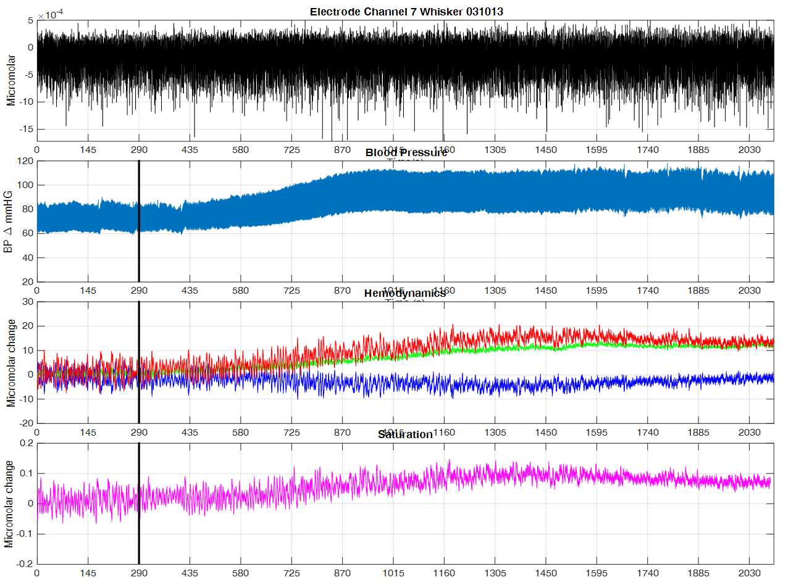
Appendices A (Individual animals presented in Chapter 3)

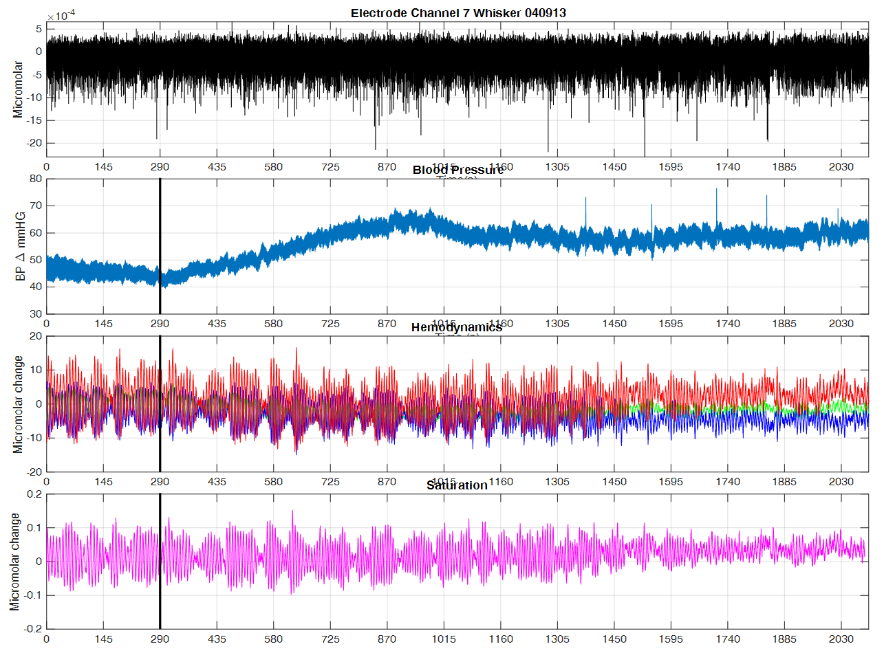
Appendices A

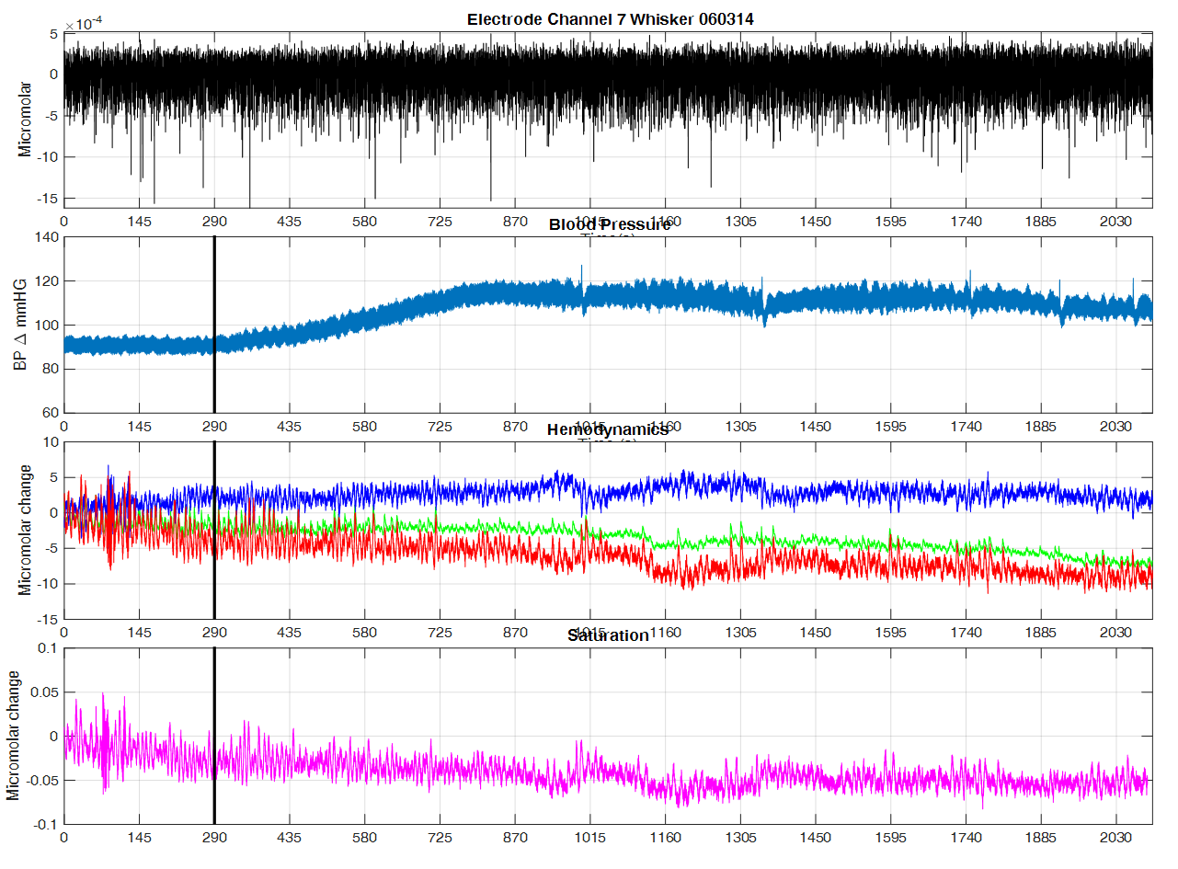
Appendice A
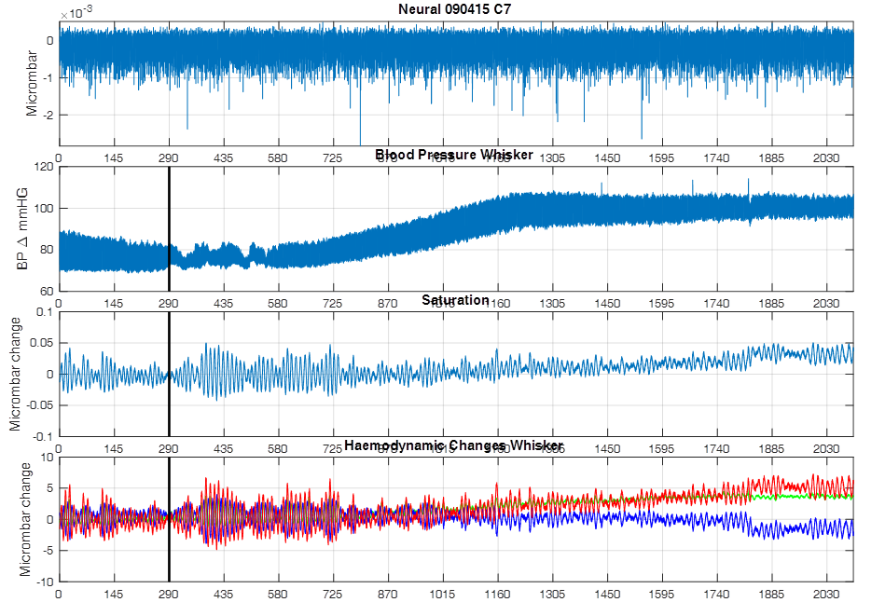
Appendice A
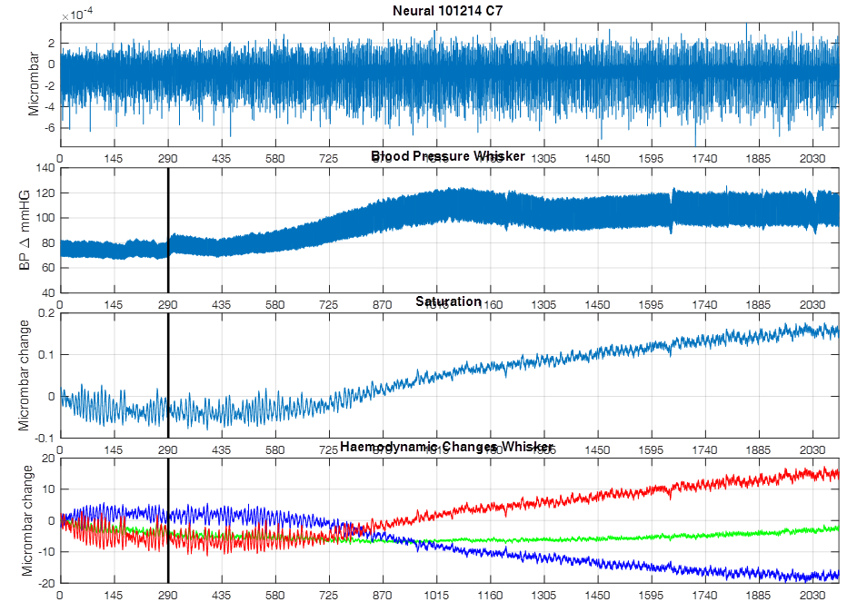
Appendice A
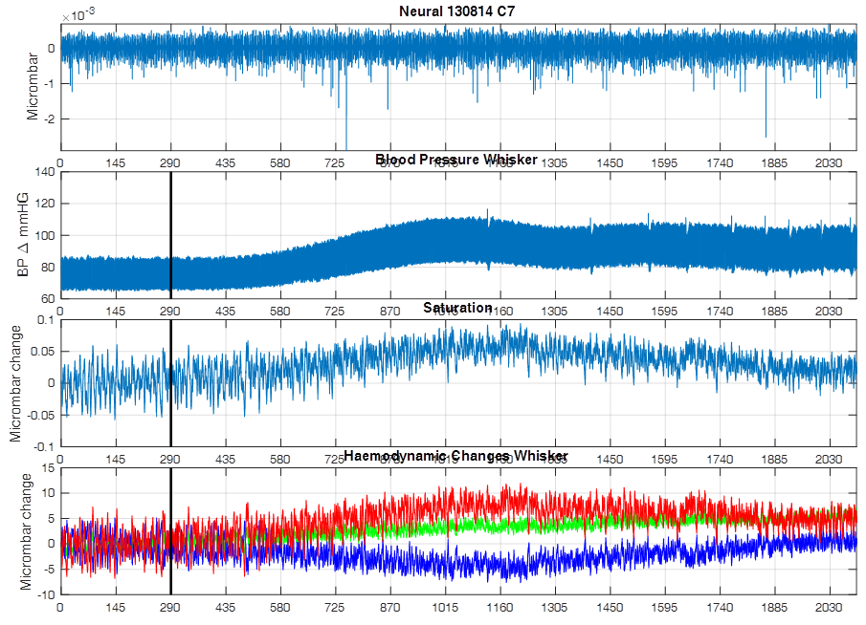
Appendice A
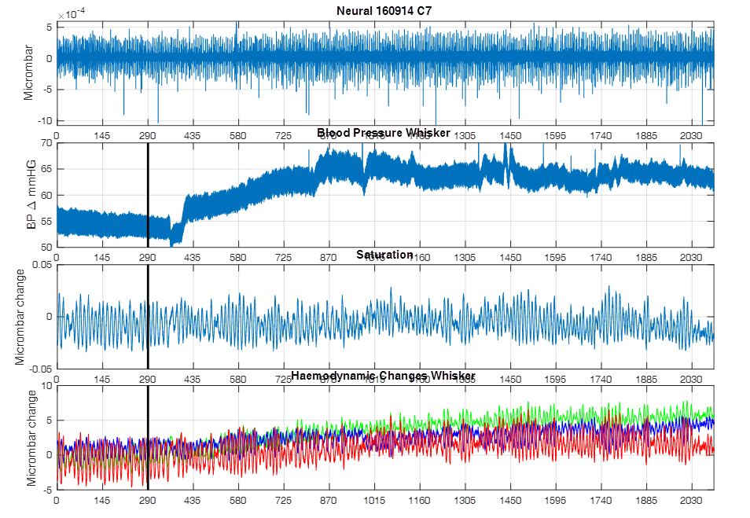
Appendice A
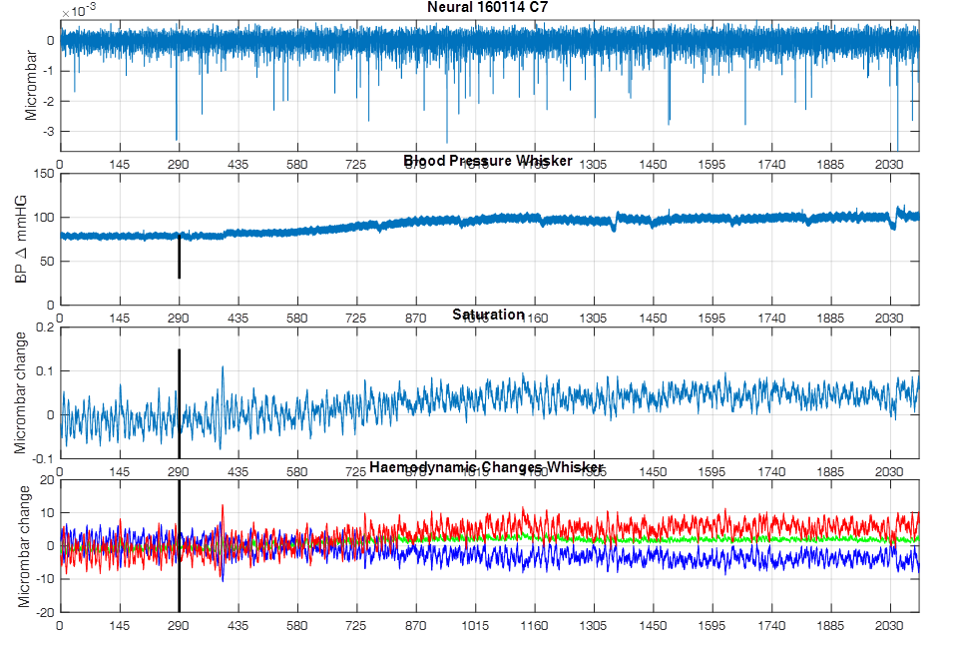
Appendice A
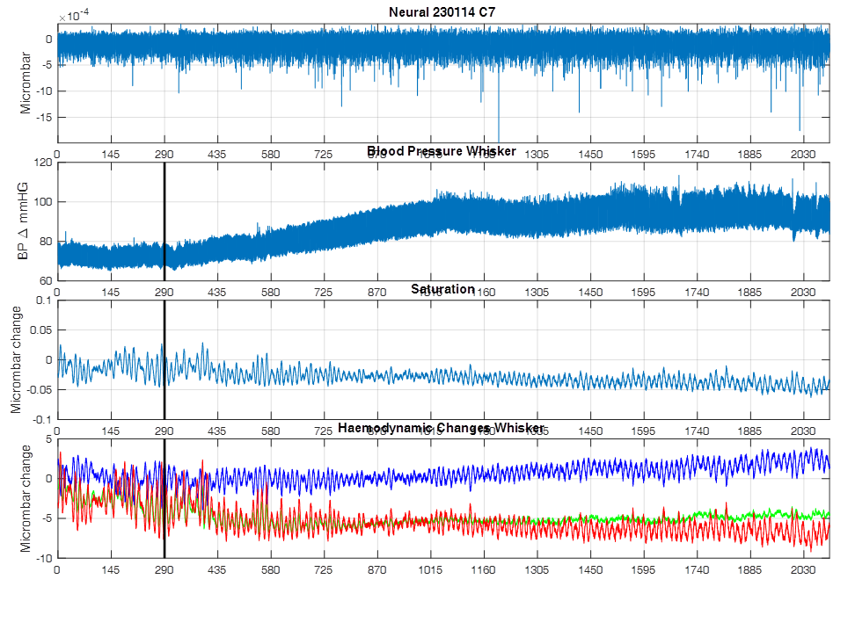
Appendice A
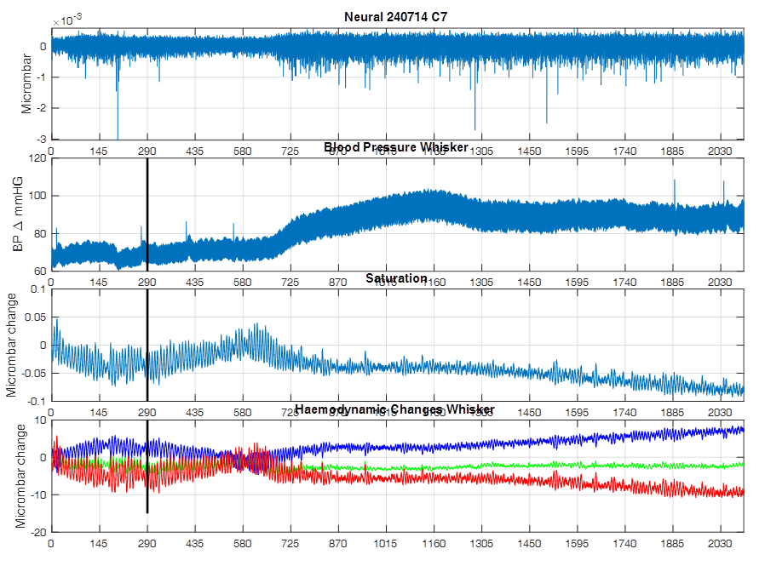
Appendice A
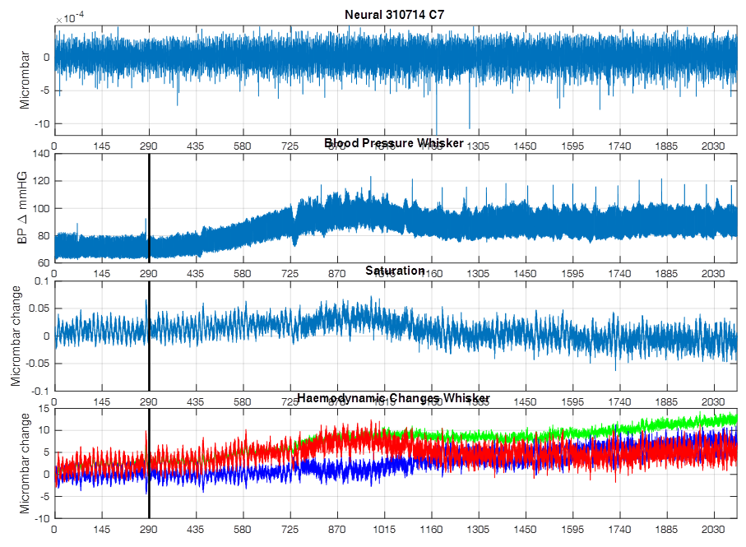
Appendice A

Appendice A
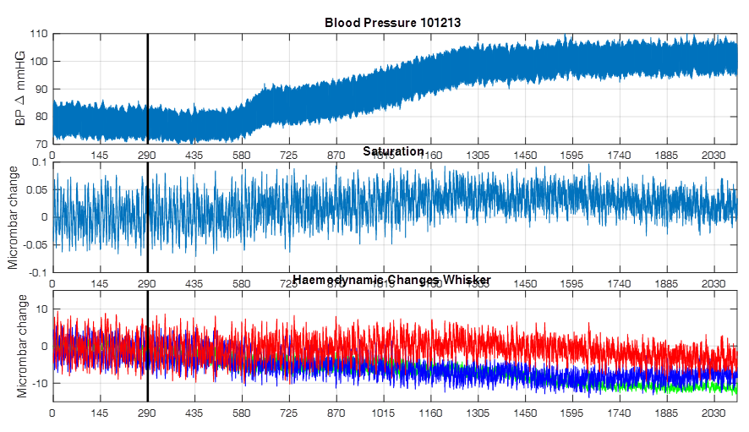
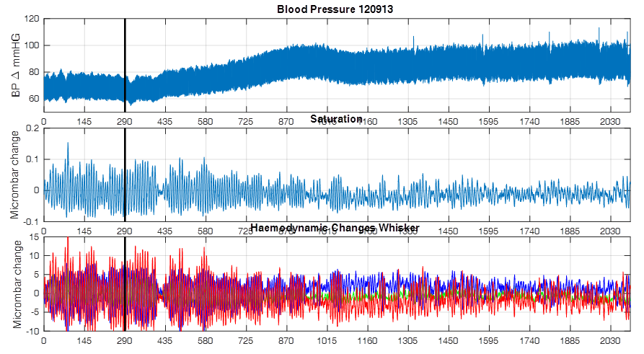
Appendice A

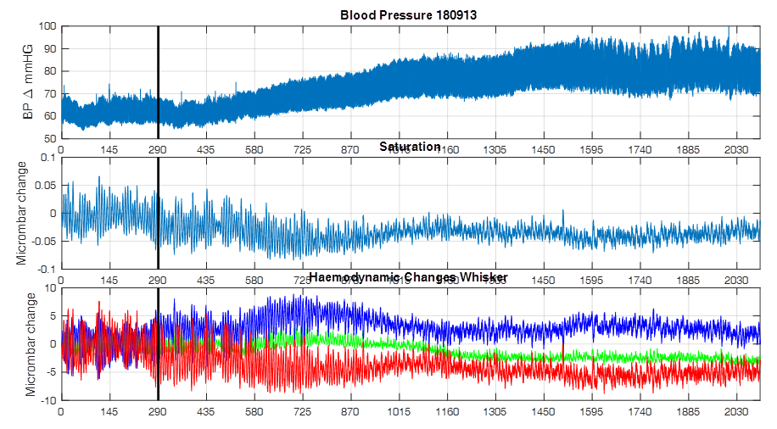
Appendice A

Appendice A
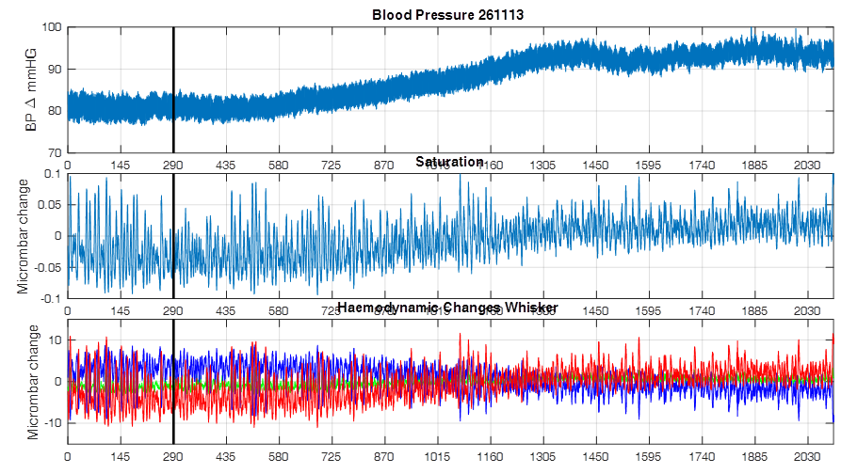

Appendice A
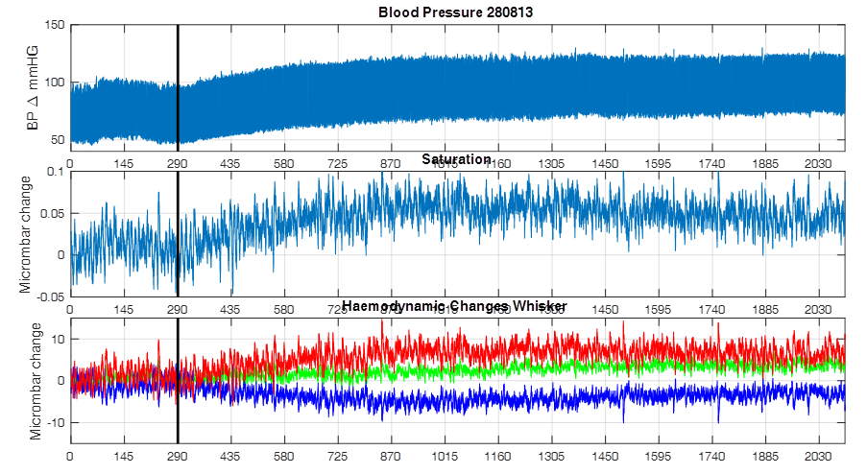

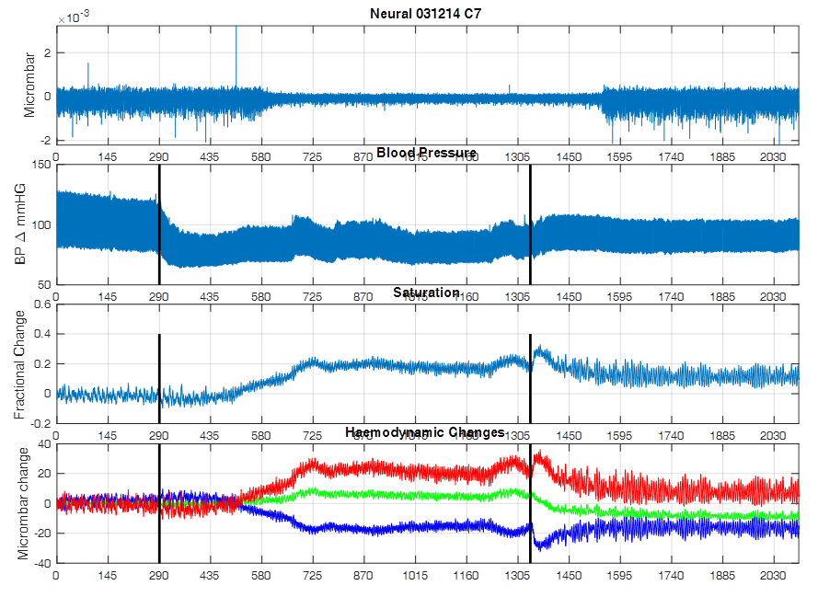
Appendices B (Individual animals in chapter 4)
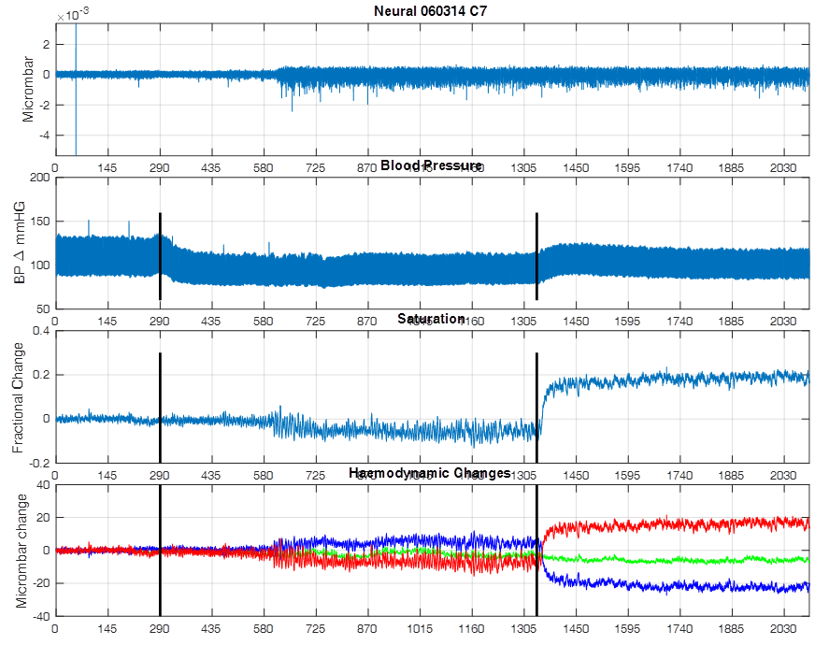
Appendices B
Appendices B
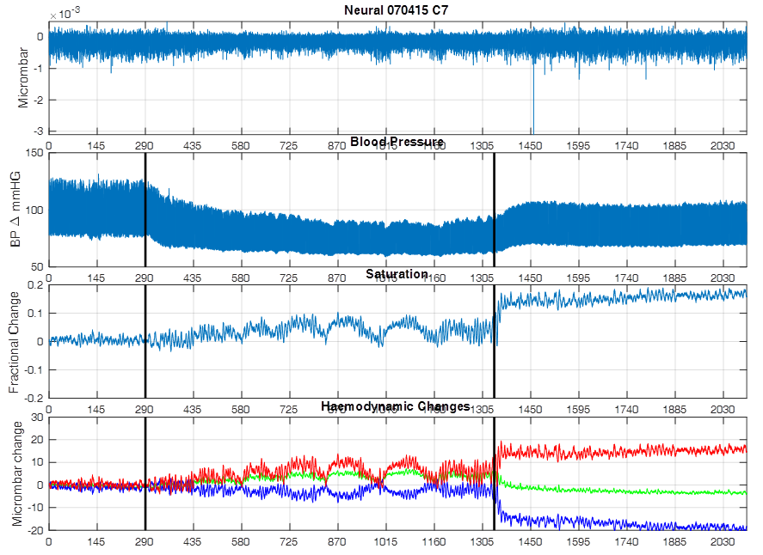
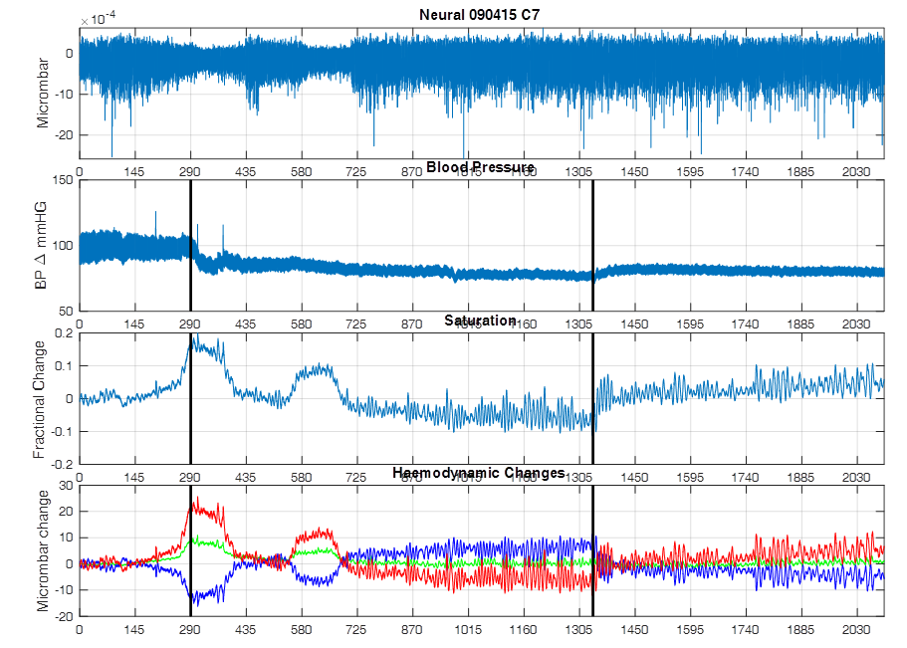
Appendices B
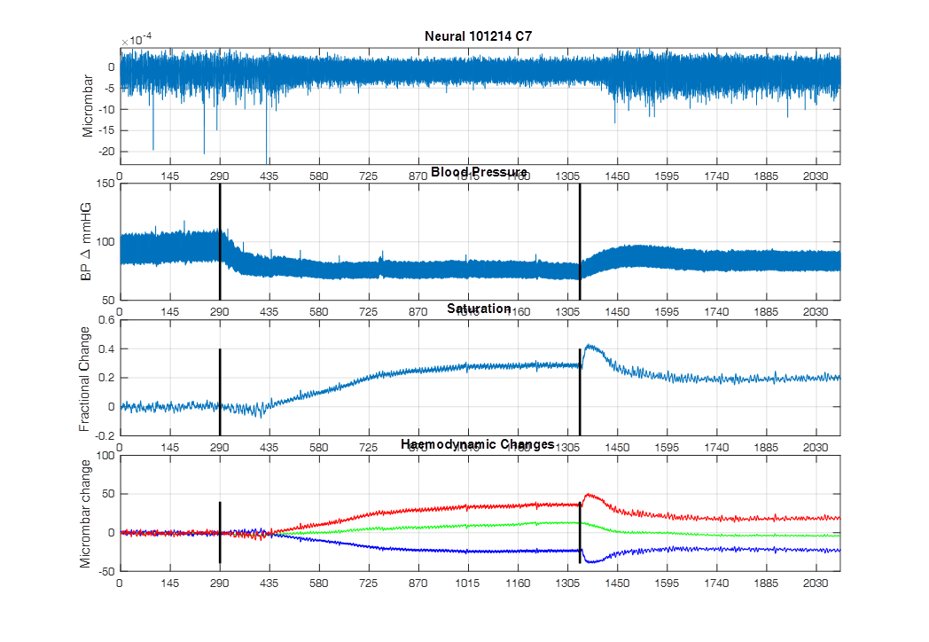
Appendices B

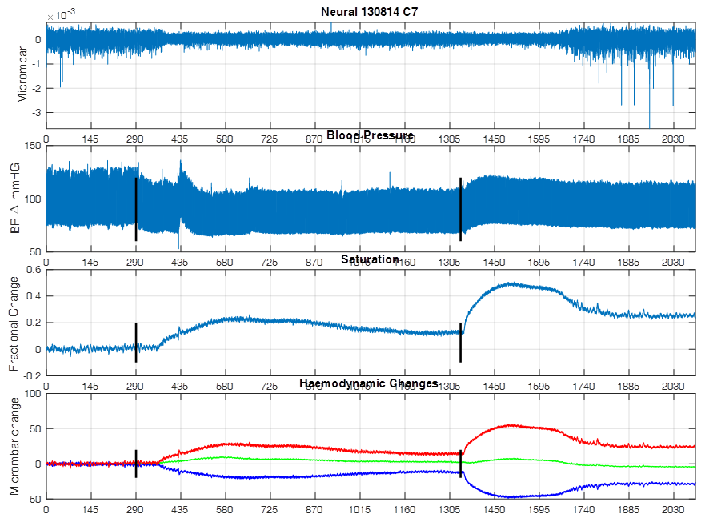
Appendices B
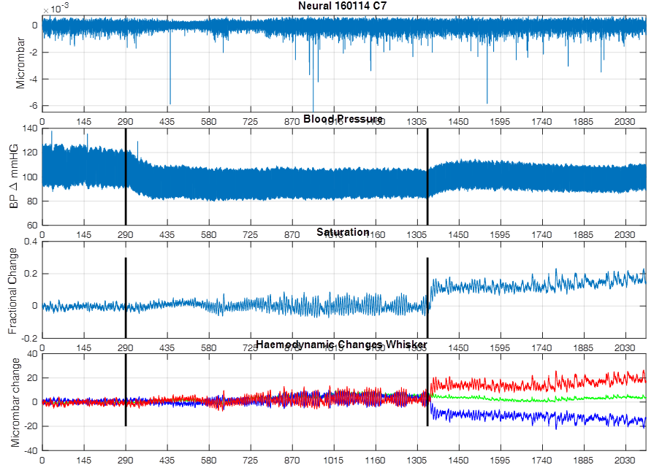
Appendices B

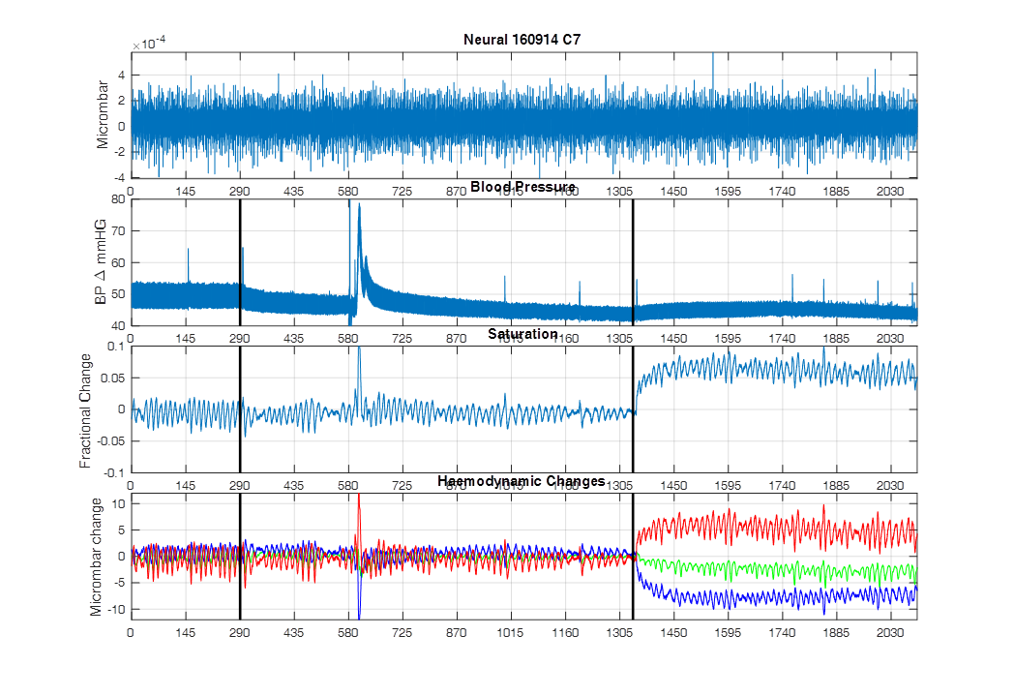
Appendices B

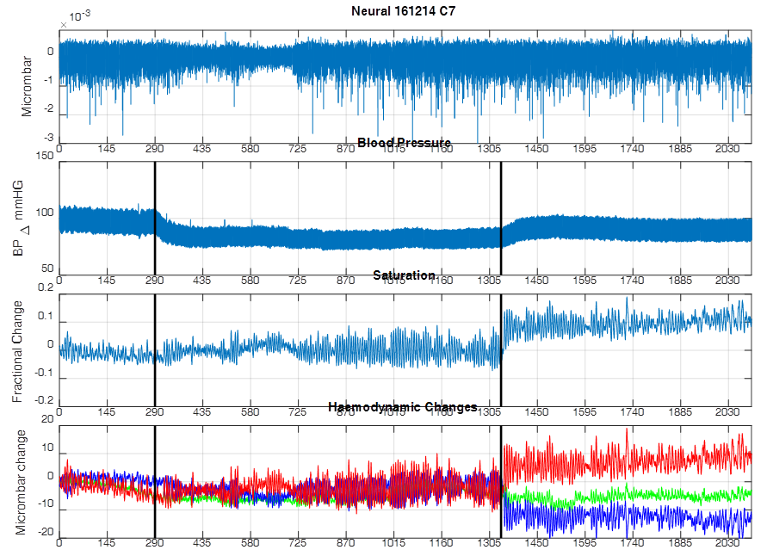
Appendices B
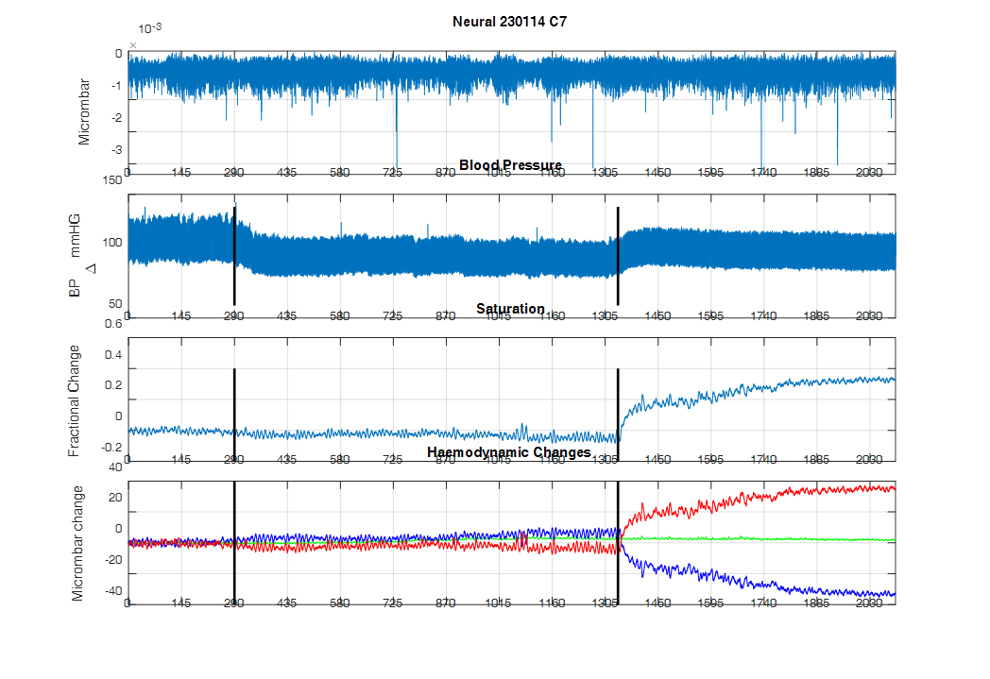
Appendices B

Appendices B
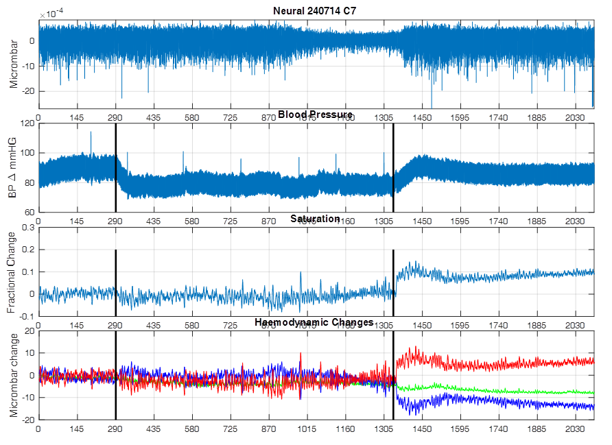
Appendices B
Appendices B
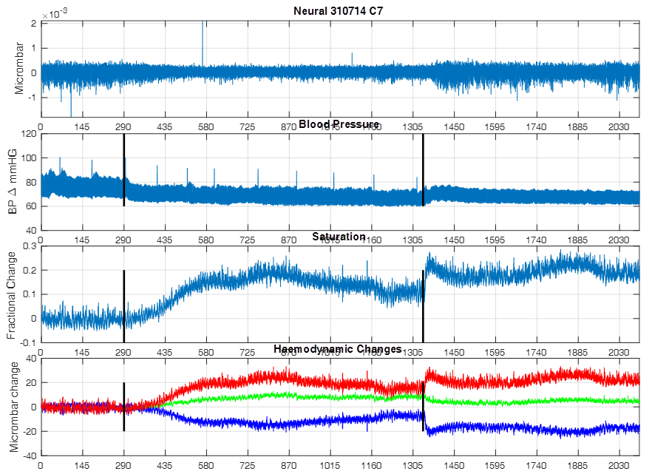
Appendices B

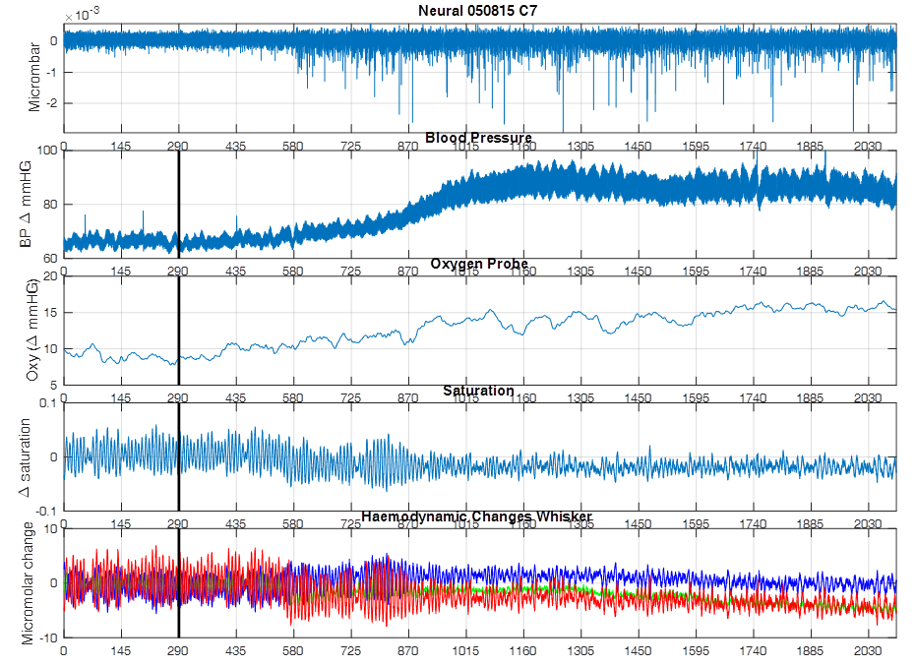
Appendices C (Individual animals in chapter 5 – results 1)
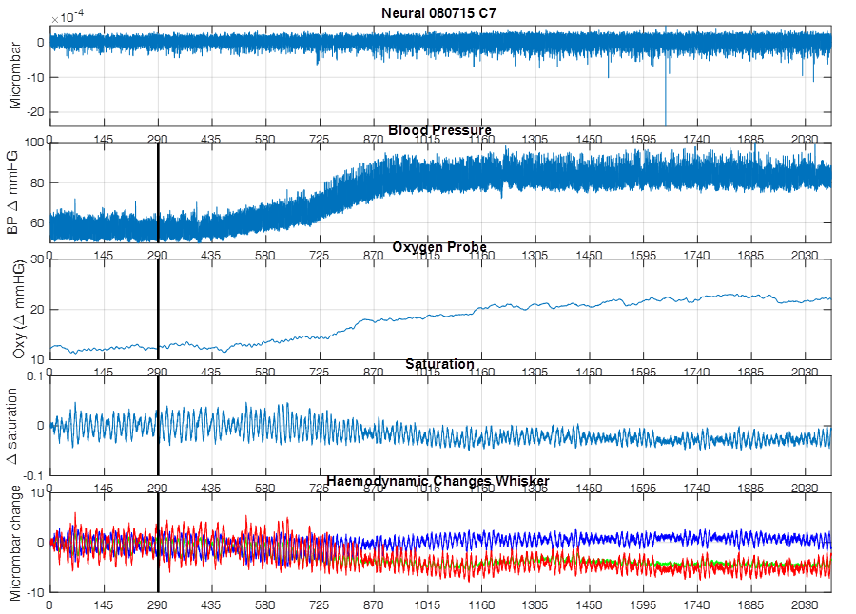
Appendices C
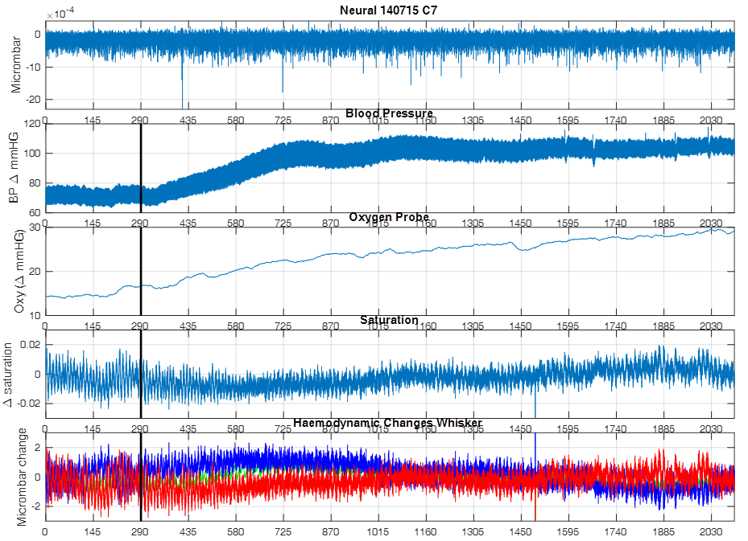
Appendices C
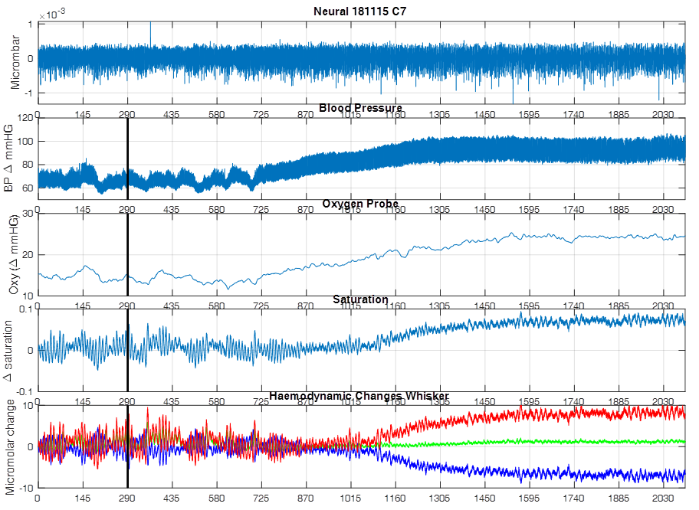
Appendices C
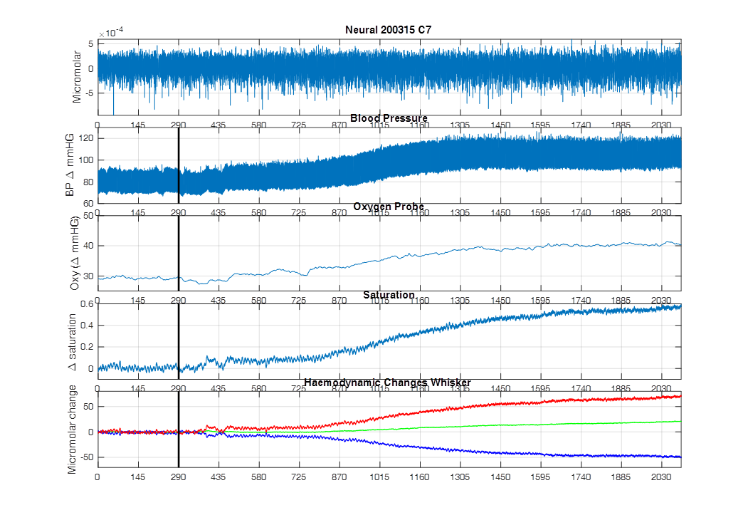
Appendices C
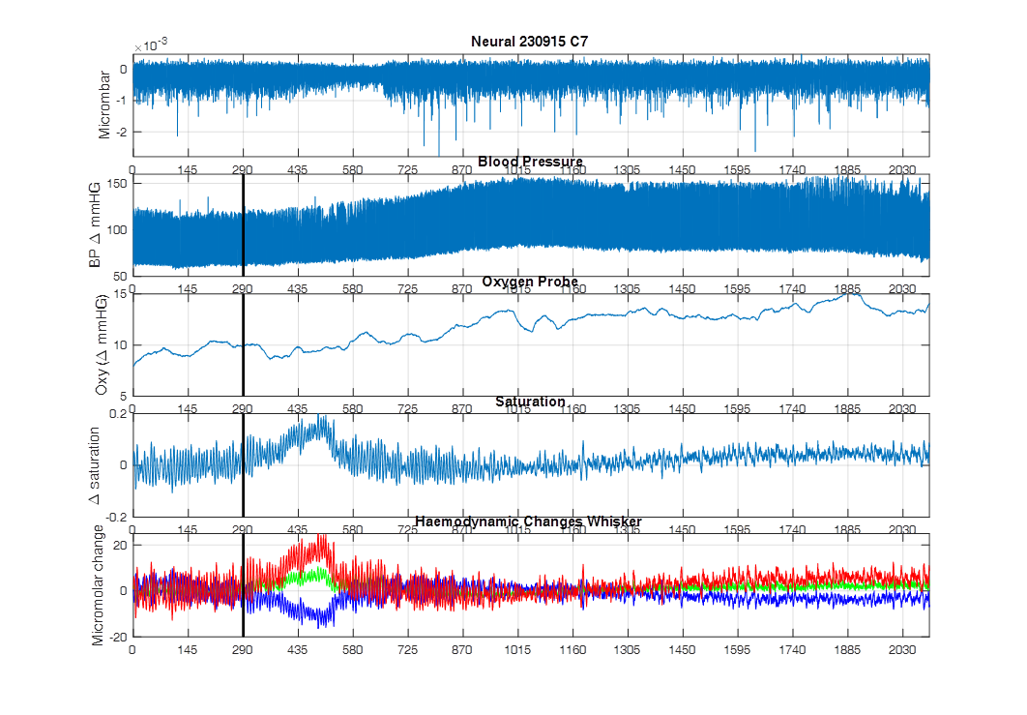
Appendices C

Appendices D (Individuals animals in chapter 5 – results 2)
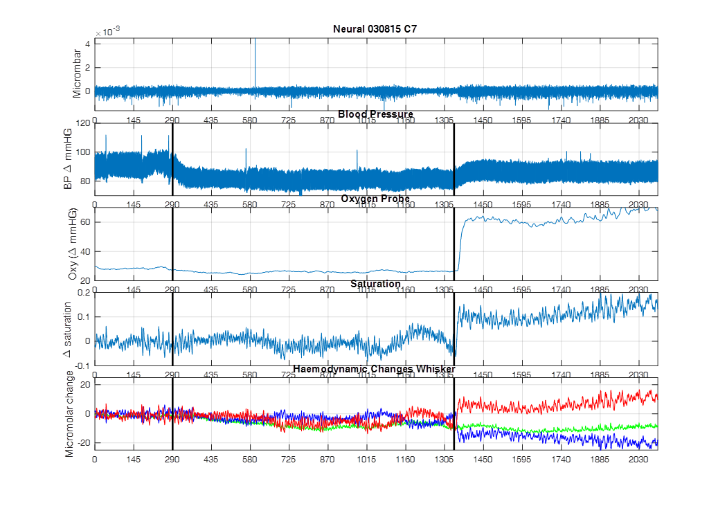
Appendices D

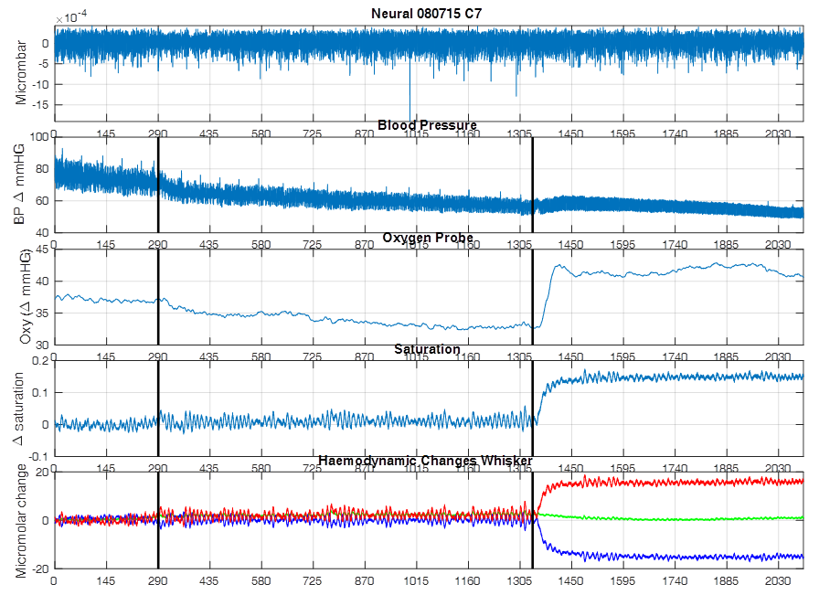
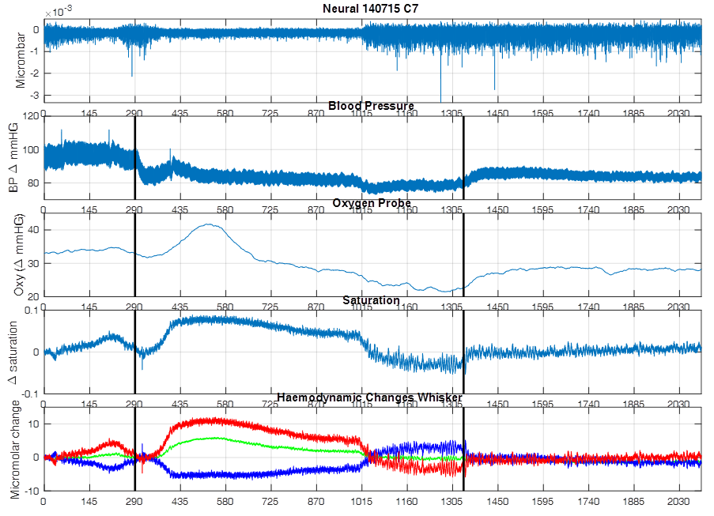
Appendices D
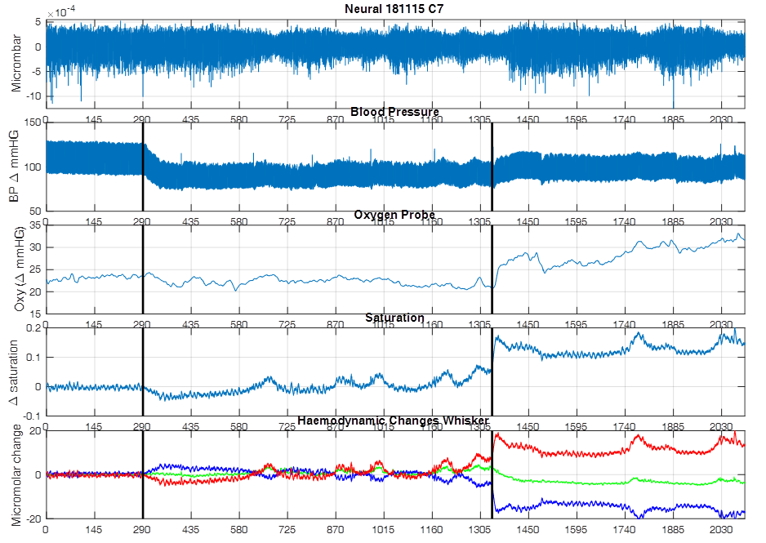
Appendices D

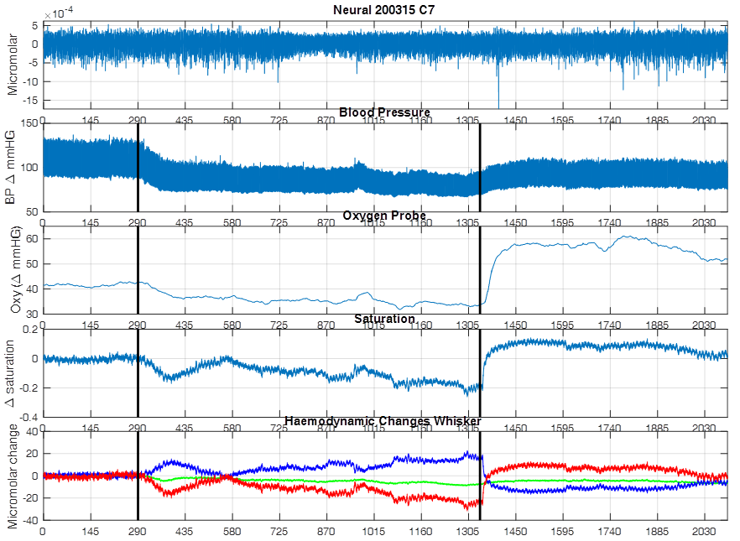
Appendices D
Appendices D
