Improving Corrosion Protection of Magnesium Alloys by Plasma Electrolytic Oxidation Based Coatings

This dissertation is submitted in fulfilment for the degree of Doctor of Philosophy

by

Ming Sun



Department of Materials Science and Engineering
November 2016

Abstract
The high susceptibility to corrosion limits the broad application of magnesium alloys, and therefore, the corrosion protection of magnesium is of major concern in practical conditions. A great effort has been made in the last few decades to solve this problem. Various types of surface coatings have been developed to provide corrosion protection for magnesium alloys, among which plasma electrolytic oxidation (PEO) is one of the most promising techniques. The PEO treatment can produce a hard ceramic-like oxide coating on magnesium and its alloys, leading to significantly enhanced wear and corrosion resistance. However, the intrinsic porous morphology of the PEO coatings still limits their effect of corrosion protection.

The objective of the present work is to overcome this microstructural drawback, and further improve the corrosion protection ability of PEO coatings on magnesium and its alloys. Different approaches have been adopted to reduce the degradation rate of PEO coatings, including optimisation of the PEO treatment itself, sequential processing combining PEO coating with various post-treatments and formation of smart self-healing PEO coatings inspired by biological systems. The PEO process was investigated by analysing the current/voltage transients, and the PEO coatings were systematically characterised by means of scanning electron microscopy (SEM), energy dispersive X-ray spectroscopy (EDX) and X-ray diffraction (XRD). Fourier transform infrared spectroscopy (FTIR) was also used to study the chemical composition of the plasma enhanced chemical vapour deposition (PECVD) coatings on the PEO coated magnesium alloy. The corrosion resistance of the PEO coatings in 3.5 wt.% NaCl solution was investigated by the electrochemical methods, including open circuit potential (OCP) monitoring, electrochemical impedance spectroscopy (EIS) and potentiodynamic polarisation scans (PDP). In addition, the mechanical behaviour of PEO coatings was also examined by scratch testing.

It was found that both voltage and frequency have significant effect on the properties of PEO coatings, and a more compact coating was produced by pulsed bipolar voltage mode. The PECVD post-treatment was proven to be an effective method of improving the corrosion protection ability if appropriate precursors were used, as this method could cause both positive and negative effects. Coating degradation could also occur during immersion post-treatments, although the corrosion resistance of the PEO coating was also improved by the Ce deposition and benzotriazole (BTA) adsorption. In this case, a better corrosion protection was achieved by combining the PEO coating with Ce-based immersion post-treatment, as the insoluble Ce-containing compounds provided both sealing effect and the inhibition of cathodic reaction. Finally, the self-healing PEO coating incorporated with inhibitor loaded nanocontainers was developed and shown a good potential for providing a long-term corrosion protection for magnesium alloys, even though the corrosion resistance was not significantly increased compared with conventional PEO coating. However, none of the above approaches was perfect, indicating that there is still plenty of work to be done in the future.

Acknowledgements
As my fantastic and fulfilling life of PhD study in the UK is reaching the end, I would like thank all the people who have made their contribution to this work. First of all, I would like to express my sincerest gratitude to my supervisors, Dr. Aleksey Yerokhin, Professor Allan Matthews and Dr. Adrian Leyland. Without their encouragement and support, it would have been impossible to accomplish this work. Their rigorous attitude towards science and invaluable guidance are critical factors which deeply affected me in doing research work.

I would like to thank all the members of the Research Centre in Surface Engineering (especially Dr. Chen-Jui Liang, Dr. Yonghao Gao, Dr. Wing Kiu Yeung, Chang Liu, Xingguang Liu, Lian Liu and Husein Meshreghi) and my friends made here, for the help and happiness they brought to me during the period of my PhD study. Thanks are also due to Mikhail Gorbatkov for his kind support with experiment and problem solving in data acquisition. The PECVD post-treatment and some coating characterisation were accomplished with the help from co-workers in the group of Profs Dmitry Shtansky and Evgeny Levashov’s in NUST 'MISiS' and Dr. Michael Thomas’ group in Fraunhofer Institute for Surface Engineering and Thin Films IST, that are greatly appreciated. The valuable suggestions and discussions from my annual progress assessors are also deeply acknowledged.

Last but not least, I would like to give my special appreciation to my wife Xiao Ren, my parents and parents-in-law, who consistently encourage and support me during this period. I am also appreciated for the birth of my daughter, as she brings new hope for my whole family.

Ming Sun
Sheffield

Table of Contents
Abstract I
Acknowledgements III
Table of Contents IV
List of Figures VII
List of Tables XIII
Chapter 1 Introduction 1
1.1 Background 1
1.2 Aims and objectives 2
1.3 Thesis overview 3
Chapter 2 Introduction to Corrosion and Protection of Magnesium and Its Alloys 5
2.1 Corrosion Behaviour of Magnesium and Its Alloys 6
2.1.1 Thermodynamics 6
2.1.2 Surface film 7
2.1.3 Corrosion mechanism and characteristic processes 10
2.2 Corrosion protection strategies 17
2.2.1 Development of corrosion resistant Mg alloys and alloy modification 17
2.2.2 Surface and coatings techniques 18
2.2.3 Change of environment 20
2.3 Summary 20
Chapter 3 Introduction to Plasma Electrolytic Oxidation on Magnesium and Its Alloys 21
3.1 General Principles and characteristics of PEO process 21
3.1.1 Characteristics of the PEO process 21
3.1.2 Fundamental principles and mechanisms of the PEO process 24
3.2 Microstructure and phase composition of the PEO coatings on Mg 27
3.3 Recent developments in the PEO coatings on Mg 31
3.3.1 Process optimization 31
3.3.2 Duplex PEO coatings 32
3.3.3 Composite PEO coatings 34
3.3.4 Self-healing PEO coatings 35
3.4 Summary 37
Chapter 4 Experimental Procedures 38
4.1 PEO coating equipment 38
4.2 Materials 39
4.3 Inhibitor loaded halloysite nanotubes (HNT) preparation 40
4.4 Electrolyte preparation 40
4.5 Plasma enhanced chemical vapour deposition (PECVD) post-treatment 41
4.6 Preparation of BTA and cerium nitrate (Ce(NO₃)₃) post-treatment solutions 42
4.7 Coating characterisation 42
4.7.1 Coating thickness and water contact angle measurements 42
4.7.2 Coating morphology and nanocontainers observation 44
4.7.3 Coating phase examination 46
4.7.4 Scratch testing 48
4.8 Electrochemical corrosion evaluation 49
4.8.1 Open circuit potential 49
4.8.2 Electrochemical impedance spectroscopy 50
4.8.3 Potentiodynamic polarisation 50
4.8.4 Experimental procedures of electrochemical tests 52
4.9 Summary 54
Chapter 5 Effect of Electrical Regime of Plasma Electrolytic Oxidation on Coatings produced on cp-Mg in Silicate-Fluoride Electrolyte 55
5.1 PEO coating preparation 55
5.2 Characteristics of PEO process 57
5.3 Coating morphologies 60
5.4 Coating chemical and phase compositions 65
5.5 Electrochemical corrosion evaluation 67
5.5.1 Electrochemical impedance spectroscopy 67
5.5.2 Potentiodynamic polarisation evaluation 72
5.6 Discussion of the factors influencing corrosion performance of PEO coating 75
5.7 Summary 75
Chapter 6 Investigation of Plasma Electrolytic Oxidation Coatings on cp-Mg with Plasma Enhanced Chemical Vapour Deposition Post-Treatments 77
6.1 PEO coating preparation 78
6.2 PECVD coating preparation 79
6.3 Characteristics of the PECVD coatings 80
6.4 Coating morphologies 81
6.5 Coating chemical and phase compositions 85
6.6 Electrochemical corrosion evaluation 88
6.6.1 Electrochemical impedance spectroscopy 88
6.6.2 Potentiodynamic polarisation evaluation 96
6.6.3 Surface morphologies after electrochemical tests 99
6.7 Summary 101
Chapter 7 Investigation of Plasma Electrolytic Oxidation Coatings on cp-Mg with Cerium Nitrate and Benzotriazole Immersion Post-Treatments 102
7.1 PEO coating preparation 103
7.2 BTA and Ce(NO₃)₃ immersion post-treatment 104
7.3 Coating morphologies 104
7.4 Coating chemical and phase compositions 110
7.5 Electrochemical corrosion evaluation 112
7.5.1 Free corrosion behaviour 113
7.5.2 Electrochemical impedance spectroscopy 114
7.5.3 Potentiodynamic polarisation evaluation 120
7.6 Surface morphologies after electrochemical tests 121
7.7 Summary 124
Chapter 8 Investigation of Plasma Electrolytic Oxidation Coatings Doped with Benzotriazole Loaded Halloysite Nanotubes on AM50 Magnesium Alloy 125
8.1 Preparation of inhibitor loaded halloysite nanotubes 126
8.2 PEO coating preparation 127
8.2 Characteristics of PEO process 128
8.3 Coating thickness 129
8.4 Surface morphology 131
8.5 Coating chemical and phase composition 134
8.6 Surface topography and roughness 136
8.7 Electrochemical evaluation 140
8.7.1 Free corrosion behaviour 140
8.7.2 Corrosion resistance 142
8.7.3 Polarisation behaviour 148
8.7.4 Response to damage induced by anodic polarisation 150
8.8 Mechanisms underlying self-healing functionality of the modified coating 152
8.9 Summary 157
Chapter 9 Conclusions and Prospective 159
9.1 Conclusions 159
9.2 Future work 161
References 163
Appendix Research Activities during PhD Study 176
Conference attendance 176
Paper publications 176

List of Figures
Figure 2-1 E–pH diagram with possible stable substances in a Mg–H₂O electrochemical system [51] 7
Figure 2-2 Schematic presentation of the three-layered structure of the oxide 9
Figure 2-3 Schematic illustration of the NDE phenomenon of Mg [51] 12
Figure 2-4 Schematic illustration of (a) External galvanic corrosion and (b) internal galvanic corrosion [1] 16
Figure 3-1 Electrode processes in electrolysis of aqueous solutions [33] 22
Figure 3-2 Discharge evolution of aluminium alloy samples at different time in the PEO process [98] 24
Figure 3-3 Temporal evolution of voltage during the PEO process on AZ91 Mg alloy [106] 26
Figure 3-4 SEM images of surface morphology of PEO coatings produced on Mg in an alkaline electrolyte at current densities (mA/cm²) of: (a) 30, (b) 40, and (c) 50 [113] 28
Figure 3-5 SEM images of cross-sectional morphology of PEO coatings produced on Mg alloy at different current densities (mA/cm²) of: (a) 15, (b) 75, and (c) 150 for 15 min [85] 28
Figure 3-6 Schematic diagram of a typical cross sectional features of PEO coatings; inserted are SEM micrographs showing typical features of the surface layer [114] 29
Figure 3-7 SEM images of duplex PEO-polymer coatings on Mg alloy with (а) partially sealed pores and (b) pores completely sealed by polymer [127] 33
Figure 3-8 Schematic diagram of a self-repairing PEO coating on Mg alloy [35] 36
Figure 4-1 Schematic view of dielectric barrier discharge system 41
Figure 4-2 Schematic illustration of principle for ATR system 44
Figure 4-3 SEM image showing the TEM sample of HNT nanoparticles on a carbon coated TEM copper grid 46
Figure 4-4 Schematic illustration of XRD principles 47
Figure 4-5 Schematic diagram of scratch test 48
Figure 4-6 Schematic illustration of the Tafel extrapolation method for analysing potentiodynamic polarisation curves 51
Figure 4-7 Schematic illustration of the three-electrode cell applied in this work 53
Figure 5-1 Current and voltage transients of the PEO processes on cp-Mg: (a) group A and (b) group B 59
Figure 5-2 SEM surface morphologies of the PEO coatings produced on cp-Mg at different positive voltages (PBP): (a) 350 V, (b) 400 V and (c) 450 V, and the corresponding cross-sectional morphologies: (d) 350 V, (e) 400 V and (f) 450 V 61
Figure 5-3 SEM surface morphologies of PEO coatings produced on cp-Mg (PUP) at different frequencies: (a) 100 Hz, (b) 500 Hz and (c) 1000 Hz and corresponding cross-sectional morphologies: (d) 100 Hz, (e) 500 Hz and (f) 1000 Hz 63
Figure 5-4 Thickness of the PEO coatings produced on cp-Mg by different electrical regimes and parameters: (a) PBP, (b) PUP 64
Figure 5-5 EDX spectra and relative contents of elements on the surfaces of the PEO coatings produced on cp-Mg by different electrical regimes (a) (PBP) and (b) (PUP) 65
Figure 5-6 XRD patterns of PEO coatings produced on (a) cp-Mg (PBP) and (b) cp-Mg (PUP) 67
Figure 5-7 EIS diagrams of the PEO coatings on cp-Mg (PBP) produced at different positive voltages: (a and c) complex plots, (b) Bode plots and (d) equivalent circuit used to fit. Fitting results are represented by solid lines in the figure 70
Figure 5-8 EIS diagrams of the PEO coatings on cp-Mg (PUP) produced at different frequencies: (a) complex plots and (b) Bode plots 71
Figure 5-9 Potentiodynamic polarisation curves of PEO coatings on cp-Mg produced by different electrical regimes: (a) PBP and (b) PUP 74
Figure 6-1 Typical electrical waveforms collected during the PEO process 79
Figure 6-2 ATR-FTIR spectra of coatings produced with different precursors on PE 80
Figure 6-3 SEM images of surface morphology of (a) bare PEO coating; and then PEO coatings with PECVD post-treatments using different precursors: (b) TEOS, (c) HMDSO, (d) TMOS 82
Figure 6-4 SEM image of damaged areas in the PEO coatings after PECVD post-treatment using TMOS precursor 83
Figure 6-5 SEM images of cross-sectional morphologies of (a) single PEO coating; and PEO coatings with PECVD top layers produced with different precursors: (b) TEOS, (c) HMDSO, (d) TMOS 84
Figure 6-6 Typical EDX spectrum of PEO coatings on cp-Mg prepared in silicate-fluoride electrolyte with and without PECVD post-treatment 85
Figure 6-7 EDX maps showing elemental distributions in PEO and PEO-PECVD coatings 87
Figure 6-8 XRD patterns of cp-Mg and the coated samples 88
Figure 6-9 Impedance spectra (scatter plots) and fitting results (solid lines) of PEO, duplex PEO-PECVD coatings and cp-Mg measured after immersing in 3.5 wt.% NaCl aqueous solution for 4 hrs. (a) Nyquist Plot of coated samples, (b) Nyquist Plot of cp-Mg, (c) Bode plot of cp-Mg coated samples, (d and e) Equivalent circuits for EIS fitting 94
Figure 6-10 Potentiodynamic polarisation curves of cp-Mg and PEO coatings with and without PECVD post-treatment 98
Figure 6-11 Surface morphologies of coated samples after electrochemical tests: (a and e) PEO, (b and f) PEO-TEOS, (c and g) PEO-HMDSO, (d and h) PEO-TMOS 100
Figure 7-1 Typical electrical waveforms collected during the PEO process 103
Figure 7-2 SE SEM images of surface morphologies of (a) PEO; (b) PEO-Ce(NO₃)₃ and (c) PEO-BTA coatings, and the corresponding BE SEM images of the studied coatings:(d) PEO, (e) PEO-Ce(NO₃)₃ and (f) PEO-BTA 106
Figure 7-3 Surface porosity of studied coatings 107
Figure 7-4 SE SEM images of cross-sectional features of (a) PEO; (b) PEO-Ce(NO₃)₃ and (c) PEO-BTA coatings, and the corresponding BE SEM images of the studied coatings:(d) PEO, (e) PEO-Ce(NO₃)₃ and (f) PEO-BTA 109
Figure 7-5 EDX spectra of studied coatings with and without immersion post-treatments: (a) PEO, (b) PEO-Ce(NO₃)₃ and (c) PEO-BTA 110
Figure 7-6 EDX results of Ce-rich area in the PEO-Ce(NO₃)₃ coating 111
Figure 7-7 XRD patterns of cp-Mg and the coated samples 112
Figure 7-8 Open circuit potential evolution of cp-Mg and the PEO coated samples with and without post-treatments in 3.5 wt.% NaCl solution (a) 1st hour, (b) 2nd hour, (c) 3rd hour and (d) 4th hour 114
Figure 7-9 Impedance spectra (scatter plots) and fitting results (solid lines) of (a) cp-Mg, (b) PEO, (c) PEO-Ce(NO₃)₃ and (d) PEO-BTA coatings with immersion time in 3.5 wt.% NaCl solution; (e and f) equivalent circuits used for EIS fitting 116
Figure 7-10 Bode plots of (a) cp-Mg, (b) PEO, (c) PEO-Ce(NO₃)₃ and (d) PEO-BTA coatings with immersion time in 3.5 wt.% NaCl solution 117
Figure 7-11 Evolution of charge transfer resistance of the coated samples during the four hours immersion time in 3.5 wt.% NaCl solution 119
Figure 7-12 Potentiodynamic polarisation curves of cp-Mg and the PEO coatings with and without post-treatment 121
Figure 7-13 Surface morphologies of: (a, b) PEO, (c, d) PEO-Ce(NO₃)₃, and (e, f) PEO-BTA coatings after electrochemical corrosion tests 123
Figure 8-1 Typical appearance of halloysite nanotubes used in this study (a); SEM image, the inset shows chemical structure of 1,2,3-Benzotriazole loaded in the nanotubes. (b) TEM image. EDX spectra of BTA-HNT prepared in solutions: (c) 10 g/L BTA in water and (d) 80 g/L BTA in acetone 127
Figure 8-2 Typical electrical waveforms acquired during PEO treatments 128
Figure 8-3 Voltage transients during PEO treatments of AM50 Mg alloy in three different electrolytes 129
Figure 8-4 Thickness of PEO coatings formed on AM50 Mg alloy in different electrolytes 130
Figure 8-5 Secondary electron images of surface morphologies (a-c) and corresponding cross-sections of the studied coatings (d-f): (a),(d) PEO; (b),(e) HNT-PEO; (c),(f) BTA-HNT-PEO 133
Figure 8-6 Back-scattered electron (BE) images of the studied coatings: (a) PEO, (b) HNT-PEO, (c) BTA-HN-PEO; and (d) characteristics of their surface porosity 134
Figure 8-7 Typical EDX spectrum and relative contents of chemical elements on the surfaces of PEO coatings 135
Figure 8-8 XRD patterns of AM50 Mg alloy and the studied PEO coatings 136
Figure 8-9 Examples of (a) 3D surface topography and (b) corresponding line scan profile, along with the average values of surface roughness derived for the studied PEO coatings 137
Figure 8-10 Results of (a) scratch tests showing typical microscopic appearances of scars at characteristic loads, (b) an example of acoustic emission (AE) and friction coefficient (FC) evolution during the test and derived values of critical loads for the studied coatings 139
Figure 8-11 Open circuit potential evolution of bare and PEO coated AM50 Mg alloy samples in 3.5 wt.% NaCl solution (a) 1st hour, (b) 2nd hour, (c) 3rd hour and (d) 4th hour 141
Figure 8-12 Evolution of impedance spectra of (a) bare AM50 Mg alloy, (b) PEO, (C) HNT-PEO, and (d) BTA-HNT-PEO coatings with immersion time in 3.5 wt.% NaCl solution 144
Figure 8-13 Impedance spectra (scatter plots) and fitting results (solid lines) of bare and PEO coated AM50 Mg alloy samples immersed in 3.5 wt.% NaCl solution for 4 h: (a) complex plots; (b) Bode plots; (c) enlarged complex plot of bare Mg alloy; (d) equivalent circuit used to fit impedance data 146
Figure 8-14 Polarisation curves of bare and PEO coated AM50 Mg alloy samples after 4 h immersion in 3.5 wt.% NaCl solution 150
Figure 8-15 Bode plots of PEO coated AM50 Mg alloy samples immersed in 3.5 wt.% NaCl solution for total 12 h and subjected to PDP scans after 4 h: (a) PEO, (b) HNT-PEO, (c) BTA-HNT-PEO 152
Figure 8-16 Surface morphologies of PEO coatings following electrochemical corrosion tests (a) PEO (b) HNT-PEO, (c) BTA-HNT-PEO (d) enlarged view of the BTA-HNT-PEO coating 154
Figure 8-17 Corrosion degradation and protection mechanisms of AM50 Mg alloy with (a) PEO, (b) HNT-PEO, and (c) BTA-HNT-PEO coatings in NaCl solution 156

List of Tables
Table 1-1 Mole volumes of Mg, Al and their oxides and hydroxides [52] 10
Table 4-1 Chemical composition of substrate materials used for PEO coatings (wt.%). 39
Table 5-1 Electrical parameters and substrate materials applied in the PEO treatment 56
Table 5-2 EIS data fitting results of the PEO coatings 72
Table 5-3 Potentiodynamic polarisation fitting results of the PEO coatings 74
Table 6-1 Plasma parameters for the PECVD process at atmospheric pressure 80
Table 6-2 Elemental compositions of PEO and PEO-PECVD duplex coatings 86
Table 6-3 Typical fitting results for EIS measurements of PEO coatings and cp-Mg 95
Table 6-4 Results of potentiodynamic polarisation analysis for all the coated samples and cp-Mg 98
Table 7-1 Immersion post-treatments applied for the PEO coatings 104
Table 8-1 Fitting results of EIS data 147

Chapter 1 Introduction

1.1 Background
Owing to advantages, such as low density and high strength-to-weight ratio, good electric shielding effect and excellent damping capacity, good thermophysical properties, biocompatibility and recyclability potential, magnesium and its alloys have long been regarded as materials of choice for many industrial applications [1-12]. The usage of magnesium, as the lightest structural metal on earth, has significantly increased during the last decade because of the increasing importance of weight saving in many products, especially related to aerospace, transportation and electronics [10]. However, the high susceptibility to corrosion has significantly restricted further applications of magnesium alloys and effective methods are currently being sought to deal with this issue. To date, a great deal of research focusing on understanding the corrosion behaviour and enhancement of corrosion protection of magnesium alloys has been carried out [12-28]. Among these studies, plasma electrolytic oxidation (PEO) coatings have attracted significant attention, since they can provide relatively good protection for lightweight valve metals, such as aluminium, magnesium, titanium and zirconium [24, 25, 29-34].

As one of the promising techniques, plasma electrolytic oxidation (PEO) is a plasma-assisted electrochemical surface treatment which develops from the conventional anodising process, but with a much higher voltage/current applied on the coated samples. Generally, PEO treatments are processed with both anode (samples need to be treated) and cathode (noble materials such as stainless steel) immersed in an environmentally-friendly alkaline electrolyte. During the PEO treatment, sparks caused by discharging events can be observed on the surface of the substrate, accompanied by heating effects and/or acoustic emission sometimes. PEO coatings can significantly improve the corrosion resistance of magnesium alloys by forming hard oxide coatings on the metal substrate. However, the porous morphology and relatively loose structure compared with PEO coatings on aluminium still limit the corrosion protection ability of the PEO coatings on magnesium. To overcome these drawbacks, great efforts have been made to optimise the electrical parameters and/or modify the electrolyte composition, which is aimed at producing high quality PEO coatings on magnesium by improving coating microstructure (such as compactness) or changing chemical/phase composition. Meanwhile, duplex treatments combined PEO and other methods like organic, sol-gel, and polymer coatings are also of great interest. New and emerging strategies for fabricating composite (like particle contained) and self-healing PEO coatings have also been developed in recent years, which provide a great potential for enhancing coating properties and new research directions for the PEO technique [35-40]. However, the existing methods of producing duplex, composite and self-healing PEO coatings discussed in the published works are far from satisfactory, since also various drawbacks could be found from these methods, such as poor coating uniformity and adhesion to the substrate, improving one coating property by compromising others, as well as a lack of theoretical analyses and insufficient evidence to support original hypothesis, sometimes. Therefore, the development of more reliable and high quality PEO coatings on magnesium using duplex or hybrid methods still deserves further investigation.

1.2 Aims and objectives
In the present study, various approaches were explored to produce duplex or composite PEO coatings on Mg and its alloys, aiming to overcome the intrinsic drawbacks of the PEO coatings and further improve the coating corrosion resistance. In particular, the influence of electrical parameters on the PEO coatings were firstly investigated. Then, two types of post-treatments including plasma enhanced chemical vapor deposition (PECVD) and chemical deposition were carried out to produce duplex and composite PEO coatings on magnesium. A novel method of fabricating PEO coating with self-healing property is also explored in this work. Considering the overall aim, as well as the methods and strategies applied, the following specific objectives need to be identified:

- Study the influence of electrical parameters on the process characteristics, surface morphology, microstructure and composition, as well as corrosion behaviour of the PEO coatings on magnesium.
- Reveal the effects of precursors in the PECVD posttreatment on the composition, structure and corrosion resistance of duplex PEO coatings on magnesium.
- Investigate the effects of Ce- and BTA- based post treatments on structure, composition, and corrosion behaviour of the PEO coatings on magnesium.
- Develop composite PEO coating with smart self-healing functionality on magnesium alloy by in-situ incorporation of corrosion inhibitor loaded nanocontainers in the coating matrix during the PEO process.

1.3 Thesis overview
Chapter2 gives a brief introduction to magnesium and discusses the mechanism and characteristics of corrosion processes on magnesium and its alloys. It also reviews the development of corrosion protection approaches for magnesium and its alloys.

Chapter 3 introduces the general principles and characteristics of PEO processes, as well as the morphology, microstructure and phase composition of the PEO coatings on magnesium and its alloys. It also discusses recent developments relating to PEO coatings on magnesium.

Chapter 4 introduces the materials, equipment and techniques used in the present study. At the same time, it briefly explains the procedures of sample preparation, characterisation, mechanical and electrochemical tests, as well as the corresponding principles.
Chapter 5 discusses the effect of electrical regimes and parameters on PEO coatings on cp-magnesium in an alkaline silicate-fluoride electrolyte. This is followed by comparisons between the PEO coatings produced using different electrical parameters. Moreover, PEO coatings for different post-treatments to be performed at the later stages of this study are selected based on the coating characteristics and properties discussed in this chapter.

Chapter 6 investigates the duplex coatings combining PEO with PECVD coatings as the top-layer. Different types of precursors are applied in the PECVD post-treatment, and the influence of PECVD post-treatment in the coating morphology and microstructure are also discussed. Corrosion resistance performance of the PEO and duplex PEO-PECVD coatings are studied based on the electrochemical test results.

Chapter 7 studies the effect of cerium- and benzotriazole-based immersion post-treatments on the corrosion resistance of the PEO coating. Comparisons are made in terms of the changes in coating morphology and structure, chemical and phase compositions, as well as the underlying corrosion resistance improvement mechanisms of the different immersion post-treatments.

Chapter 8 investigates a smart self-healing composite PEO coating incorporated with inhibitor loaded nanocontainers, which are produced by a novel method. In order to get a better understanding, the composite PEO coating is carefully characterised by various means. Corrosion resistance of the composite PEO coatings with and without corrosion inhibitors, as well as the particle free PEO coating are studied, together with the corresponding principle analyses.

Chapter 9 draws the overall conclusions and provides the future prospective according to the results obtained in the present work.

Chapter 2 Introduction to Corrosion and Protection of Magnesium and Its Alloys
As one of the most abundant elements in the Earth's crust, magnesium (Mg) has many advantages, such as low density and high strength-to-weight ratio, good electric shielding effect, excellent damping capacity, good biocompatibility, non-toxicity, good thermophysical properties and recyclability potential, and have long been regarded as materials of choice for many industrial applications [1-3, 41, 42]. The engineering application of Mg dates back to the 1920s, and it was not regarded to be the ideal material for many applications due to high cost of the products in those days [43]. Magnesium is the lightest structural metal (1.74 g/cm³) on earth. It is 35% lighter than aluminium (2.7 g/cm³) and more than four times lighter than steel (7.86 g/cm³) [11]. The usage of Mg has significantly increased during the last decade, not only because of gradually reducing cost but also the increasing importance of weight saving in many products, especially related to sports, aerospace, transportation and electronics [10, 44, 45].

Despite the widespread use, the low corrosion resistance has significantly restricted further applications of Mg alloys and effective methods are currently being sought to deal with corrosion issues of Mg. To date, a great number of studies focused on understanding the corrosion behaviour and increasing corrosion protection of Mg alloys have been carried out [1, 17, 28, 46-50]. Generally, the corrosion behaviour and protection characteristics of Mg alloys can be associated with their electrochemical behaviour. Revealing electrochemical reactions can provide good insight to the corrosion performance and corrosion protection of Mg alloys.

2.1 Corrosion Behaviour of Magnesium and Its Alloys

2.1.1 Thermodynamics
Thermodynamically, Mg is unstable and can quickly form an oxide or hydroxide surface film when exposed to air or water. The negative standard Gibbs energy changes (G⁰) for the oxidation reactions of Mg shown below indicate that Mg can be easily oxidised by natural environment [51]. As a result, When Mg is exposed to environments containing water or humid air, its surface will be quickly oxidised into Mg(OH)₂ and simultaneously release H₂ according to equation (1.3).

Mg + O₂ + H₂= Mg(OH)₂ ΔG⁰ = -833kJ/mol 1.1
Mg + ½O₂ = MgO ΔG⁰ = -569kJ/mol 1.2
Mg + 2H₂O = Mg(OH)₂ + H₂ ΔG⁰ = -359kJ/mol 1.3

The E-pH diagram can help in predicting the thermodynamic stability of Mg in water. Song [51] has summarized different considerations of possible reactions and concluded the stability of Mg in aqueous solution in one E-pH diagram (Figure 2-1) based on the known Pourbaix (or E-pH) diagrams of Mg. Some unstable substances and intermediate products, like H-, MgOH and MgH, are not included in the diagram. The diagram indicates that in most E-pH regions Mg has the tendency of being oxidised to produce various species such as Mg²⁺, MgO and Mg(OH)₂. It also shows that Mg can keep a passive state due to formation of Mg(OH)₂ in a highly alkaline environment. Unfortunately, practical environments are usually not sufficiently alkaline for self-passivation of Mg, which leads to its continuous corrosion.

It has to be noted that the E-pH diagram is only a method for predicting a tendency or the thermodynamic stability of Mg in aqueous solutions. However, in practical conditions, the aqueous corrosion behaviour of Mg is much more complex and can be affected by various factors. For example, although the pH is the same, the corrosion rates of Mg in two different aqueous solutions with different NaCl concentrations can be quite different. Moreover, the kinetic processes, details of reaction steps and intermediates cannot be presented by the E-pH diagram, and the kinetics is a critical factor in the corrosion behaviour of Mg.

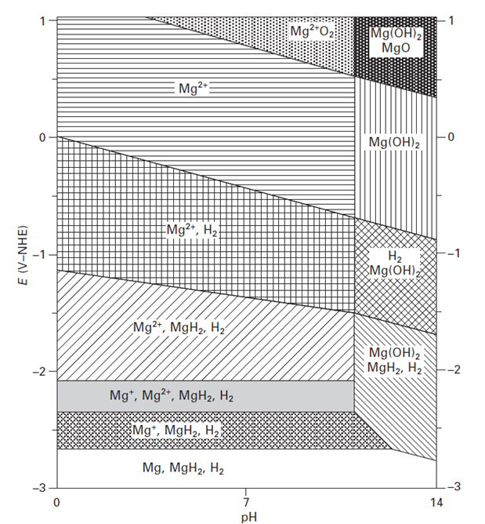
Figure 2-1 E–pH diagram with possible stable substances in a Mg–H₂O electrochemical system [51]

2.1.2 Surface film
Since Mg is chemically very active in practical environments, once exposed to air or aggressive media its surface can be easily oxidised or corroded. Then the subsequent oxides or corrosion products will be deposited on the surface and form a protective surface film on the Mg substrate. The composition and microstructure of surface films formed on Mg alloys could be different, depending on the substrate composition, environment and formation process [51]. Moreover, the understanding of naturally formed surface films is not quite clear at present.

In dry air, the surface film on Mg is mainly composed of MgO. However, the natural environment contains some moisture which leads to the formation of more stable Mg(OH)₂ in the surface film. As a result, both MgO and Mg(OH)₂ can be found in the surface film formed in atmospheric conditions. Generally, the MgO surface film formed in air is compact but very thin with some amorphous characteristics, which cannot provide as good protection for the substrate as the oxide film formed on aluminium. Furthermore, carbon dioxide (CO₂) in humid atmosphere can turn into carbonate, resulting in the formation of Mg carbonate in the surface film. In addition, some industrial pollutants can have reactions with Mg(OH)₂, for example sulphur-containing substances can be detected in the surface film when exposing Mg to polluted air containing SO₂. When Mg is immersed in an aqueous solution, the original surface film will be quickly turned into Mg(OH)₂ by reacting with water [52].

MgO + H₂O → Mg(OH)₂ (1.4)

Similar to the conditions in the air, some constituents in the solution can be combined into the surface film through reactions, such as chlorides and fluorides. For Mg alloys, oxides and hydroxides of trace or alloying elements could also be detected in the surface film. For example, it was reported that the surface film formed on AZ91D Mg alloy in an aqueous solution was mainly composed by Mg and Al hydroxides [53].

The microstructure of naturally formed surface film on Mg and its alloys is more complicated than a single layer, with a multi-layer structure. It is postulated that the surface film on Mg is composed by a thin yet dense inner MgO layer and a relatively thick but porous outer Mg(OH)₂ layer [51]. Moreover, based on transmission electron microscopy (TEM) results, Nordlien et al. [54, 55] found surface films formed on Mg and its alloys having a three layer structure which consists of a hydrated inner layer, a dense intermediate layer similar to the film formed in air and a top layer with platelet-like morphology (Figure 2-2).

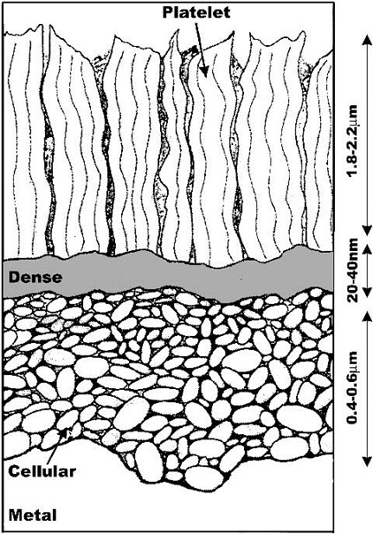
Figure 2-2 Schematic presentation of the three-layered structure of the oxide
films on Mg [55]

It is well known that the corrosion protection ability of Mg surface film is not as good as that of Al, although the surface films have similar microstructure with an inner dense layer and an outer porous layer. A possible reason for this phenomenon could be the volume difference between the metal consumed and oxide formed (Pilling-Bedworth ratio). According to Table 1-1, the volume ratio of MgO/Mg is 0.81, which is smaller than that of Al₂O₃/(Al₂) (1.28). Thus, unlike Al₂O₃ the MgO surface film should be discontinuous, and could not provide sufficient protection for Mg substrate; this is especially noticeable under the high temperature conditions when the surface film is thick and has many cracks due to the small volume ratio [51]. The volume ratio of Mg(OH)₂/Mg is 1.71 which is even more than that of Al₂O₃/(Al₂). However, the corrosion protection ability of the surface film on Mg in aqueous solutions is still not as good as that on Al, even when Mg(OH)₂ is the main constituent in the film. This implies that the volume ratio alone cannot explain all the reasons causing poor corrosion resistance of Mg. Actually, according to the E-pH diagram, Mg(OH)₂ is stable only in strong alkaline solutions. So, because of lack of alkalinity, in natural environments it cannot be thick or compact and offers only limited protection for Mg substrate. In contrast, the surface film on Al consists of Al₂O₃ and Al(OH)₃ which is thermodynamically stable in pH ranging from weak acidic to weak alkaline conditions. Therefore, the aqueous corrosion resistance of Al is better than that of Mg, since its surface film can keep a more stable state.

Table 1-1 Mole volumes of Mg, Al and their oxides and hydroxides [51]
 | Mg | MgO | Mg(OH)₂ | Al | Al₂O₃ | Al(OH)₃
Molar weight (g/mole) | 24.4 | 40.4 | 58.4 | 27 | 102 | 78
Density (g/cm³) | 1.47 | 3.58 | 2.4 | 2.7 | 3.97 | 2.4
Mole Volume (cm³/mole) | 14.2 | 11.28 | 24.33 | 10 | 25.69 | 32.50

2.1.3 Corrosion mechanism and characteristic processes

2.1.3.1 Corrosion reactions
Generally, corrosion of Mg in aqueous solutions is described by an electrochemical reaction with water, resulting in the formation of Mg(OH)₂ and H₂. The overall corrosion process in aqueous environments (1.7) is the combination of partial anodic and cathodic reactions 1.5 and 1.6, respectively [1]:

Mg → Mg²⁺ + 2e⁻ (anodic reaction) (1.5)
2H₂O + 2e⁻ → H₂ + 2OH⁻ (cathodic reaction) (1.6)
Mg + 2H₂O → Mg(OH)₂ + H₂ (1.7)

Although the overall reaction is the same as the oxidation process expressed by reaction 1.3, it has to be noted that the partial anodic reaction probably has intermediate steps that involve monovalent Mg ion (Mg⁺) [48, 51]. Generally, the Mg⁺ ion has a very short life time and will be quickly oxidised into a more stable state (Mg²⁺). The whole process on the surface of Mg takes place immediately and could be described by the following reactions:

Mg → Mg⁺ + e⁻ (1.8)
Mg⁺ → Mg²⁺ + e⁻ (1.9)

The existence of Mg⁺ has however been a controversial issue for many years, because no reliable experimental methods of detecting Mg⁺ ion identified [56]. Some works provide evidence of Mg⁺ intermediate [57], while other researches question its existence [58, 59]. The dissolution of Mg involving Mg⁺ is a critical model for explaining the negative difference effect (NED) in corrosion of Mg, which attracted significant interest and discussions in recent years [1, 28, 60, 61]. Moreover, reduction of hydrogen ions and hydrogen overvoltage can strongly affect the corrosion of Mg. For example, a lower overvoltage on the cathode usually means a higher corrosion rate, causing more hydrogen evolution during the corrosion process. The corrosion process of Mg alloys is similar to that of pure Mg, which means the corrosion reactions of Mg mentioned above are still applicable for the corrosion process of Mg alloy [1]. In addition, the alloying elements like Al and Zn play an important role in the corrosion process of Mg alloy.

2.1.3.2 Negative difference effect (NDE)
The negative difference effect (NDE) is a special and strange electrochemical phenomenon attributed to the corrosion of Mg. The NDE is defined as the difference between hydrogen evolution rate at the open circuit potential and current density at the given anodic polarisation potential [51]. Normally, if the applied potential or current density increase, the rates of anodic and cathodic reaction will increase and decrease, respectively. However, in practical experiment, the cathodic reaction rate on Mg is found to increase with the increasing potential, causing more hydrogen evolution. Moreover, the anodic dissolution rate also exceeds the theoretical value. The NDE phenomenon is schematically illustrated by the potential-current curves in Figure 2-3.

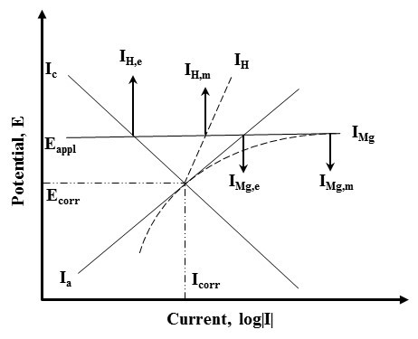
Figure 2-3 Schematic illustration of the NDE phenomenon of Mg [51]

The expected anodic and cathodic partial reactions are represented by the solid lines I_{a} and I_{c}, respectively. However, the experimentally observed behaviour of the anodic and cathodic reactions shown by the dashed lines I_{H} and I_{Mg} respectively is quite different. It can be found that both rates of Mg dissolution and hydrogen evolution increase when the potential increases from E_{corr} to E_{appl}. As a result, both the actual rates of hydrogen evolution (I_{H,m}) and Mg dissolution (I_{Mg,m}) are higher than their theoretical values (I_{H,e} and I_{Mg,e}) at the applied potential E_{appl}. The essential feature of the NDE phenomenon is that the cathodic reaction rate increases with the increasing electrode potential, which is contrary to most metals.

For decades, vast amounts of investigations have been carried out to try to explain the NDE phenomenon. Song et al. [1, 51, 62] systematically summarized the electrochemical reaction mechanisms underlying this phenomenon. Generally, there are four mechanisms proposed, each having some imperfections as discussed below:

- Partially protective surface film. In this model, the NDE phenomenon is explained by the damage of partially protective surface film on Mg during the anodic dissolution. When a higher potential or current applied to the electrode, the partially protective film on Mg will be broken down causing a decreased surface coverage, and increased Mg dissolution and hydrogen evolution. This model is criticized because it has difficulty to explain the corrosion potential of Mg in neutral or low pH conditions.
- Monovalent magnesium ion. According to reaction 1.8 in the previous section, the Mg⁺ could be generated as an intermediate during the corrosion process of Mg in aqueous solutions. It is assumed that Mg⁺ can react with H⁺ in water to produce H₂ by the following reaction:

2Mg⁺ + 2H⁺ → 2Mg²⁺ + H₂ (1.10)
Notably, this model successfully explain the increase of H₂ evolution, but fails to explain the decrease of Mg dissolution rate in some special conditions.
- Undermining particles. This model is set up based on the concept of undermining and falling out of noble second phase particles during the corrosion process. In most cases, the second phase particles are nobler than the Mg matrix, resulting in the formation of micro-galvanic corrosion at the particle boundaries. Therefore, the particles are gradually undermined and fall out, along with the increased hydrogen evolution and mass loss. However, this model was criticized because it is contrary to some electrochemical mechanisms [1] and the actual experimental results obtained by Song et al. [62].
- Formation of magnesium hydride (MgH₂). It has been proved by the ex-situ X-ray diffraction (XRD) result that MgH₂ can be formed on the surface of Mg [63]. As a reactive substance, MgH₂ will quickly react with water and release Mg²⁺ and H₂ during the aqueous corrosion process. However, this is a cathodic reaction which means the reaction rate should decrease with the increasing applied potential (or current), resulting in a reduced hydrogen evolution at E_{appl}. So, this model actually cannot explain the increased hydrogen evolution measured in the experiment.

Generally, the NDE is a common phenomenon in the corrosion process of Mg, as well as its alloys. This should be avoided or supressed in practical applications, since it can accelerate the corrosion rate of metal substrate. From this point of view, surface coating techniques could be one of the choices to deal with the NDE phenomenon, which will be discussed in the following sections.

2.1.3.2 Typical corrosion forms
Mg and its alloys can present various forms of corrosion, which depends mainly on the alloy chemistry and environmental conditions. In most cases, localized corrosion is the main corrosion from for Mg and Mg alloys. Sometimes, however, uniform corrosion could also be observed under certain conditions, such as the atmospheric corrosion in industrial atmospheres. It was found that the corrosion morphology of commercially pure Mg (cp-Mg) is usually non-uniform, whereas Mg alloys tend to have a more uniform corrosion [1, 64]. Basically, the commonly observed forms of corrosion for Mg and its alloys can be summarised as follows:

- Galvanic corrosion. As one of the most significant corrosion phenomena, galvanic corrosion of Mg alloys causes the most damage in practical use. It is usually observed in the form of severe localized corrosion on the surface of Mg alloys. Due to the relatively low standard electrode potential (E° = -2.37 V), Mg is usually served as anode when coupled with other noble metals, such as Fe, Ni, and Cu. Cathodes can be the external metals, internal secondary phases or impurity particles in the Mg matrix to cause micro-galvanic cells as shown in Figure 2-4. There are many factors that can affect the galvanic corrosion rate, including conductivity of the medium, potential difference between anode and cathode, polarisation resistance, area ratio of anode and cathode and distance from anode to cathode [1, 23, 51]. Galvanic corrosion of Mg alloy cannot be avoided, but it can be significantly suppressed by a proper use of alloying elements, insulation materials, reasonable design and coatings [17]. It needs to be noted that in practical applications the changes in factors influencing galvanic corrosion will be quite complicated, making it difficult to accurately predict the galvanic corrosion rate [65].
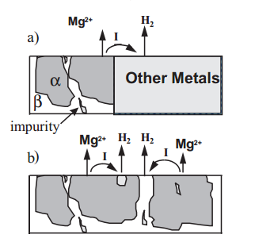
Figure 2-4 Schematic illustration of (a) External galvanic corrosion and (b) internal galvanic corrosion [1]

- Localized corrosion. Pitting corrosion is a form of localized corrosion which can be usually observed on the surface of metals with coatings or passive films in aggressive media [23]. As a self-passivating metal, Mg corrodes in neutral or chloride containing alkaline environments, especially in biological systems, in the form of pitting [66-68]. The pitting corrosion can be accelerated by the heavy metal contamination [1]. In Mg alloys, pitting corrosion is usually formed because of the selective corrosion attack along the second phases or particles, resulting in falling out of grains.

- Filiform corrosion is another common form of corrosion of Mg and its alloys, which is caused by active corrosion cells. It is often observed under protective coatings and anodized films. The filiform corrosion cannot develop on bare cp-Mg, whereas it can be formed on uncoated AZ91 Mg alloy, indicating the metal surface is covered by a relatively anticorrosive passive film.

Other corrosion forms of Mg and its alloys, such as stress corrosion cracking and corrosion fatigue, can also occur under some circumstances, but studies of these corrosion forms are relatively rare compared to the localized corrosion.

2.2 Corrosion protection strategies
The development of corrosion protection approaches for Mg and its alloys is based upon comprehensive understanding of Mg corrosion. There are various approaches that can be applied to effectively provide corrosion protection for Mg and its alloys. The basic principles of corrosion protection strategies for Mg alloys are similar to those for other metals. However, distinctive behaviour and characteristics of Mg corrosion means some specific requirements might be needed in practical applications. In recent years, numerous studies have been carried out to develop corrosion prevention/protection methods for Mg alloys. In this section, some typical corrosion protection methods for Mg and its alloys will be briefly discussed.

2.2.1 Development of corrosion resistant Mg alloys and alloy modification
Generally, the improved corrosion resistance of metal caused by the internal changes such as optimized micro-structure, chemical and phase composition is more reliable and trouble-free than the external changes like surface and coatings technique and environmental modification which will be discussed in the following sections. Since Mg has relatively a low standard electrode potential and is susceptible to corrosion attack, the key to produce Mg alloy with excellent corrosion resistance is to make the Mg matrix inert or passive [48].

One strategy of making corrosion resistant Mg alloys is to use noble metals as alloying elements. This is theoretically achievable, however, some heavy noble metals could significantly increase the density of Mg alloys, resulting in limitations in some light weight demanding applications. Moreover, the physical properties of Mg alloys could be dramatically changed if too much alloying elements were used. Another possible way is to use moderate amounts of alloying elements with high passivation ability, e.g. Al, Ti, and Cr. However, the limited solubility of these alloying elements in Mg matrix significantly restricts the effect of improving passivation ability of Mg alloys in corrosive solutions.

In addition, some modifications to already existing Mg alloys have been proven to be effective in improving the corrosion resistance. The effectiveness of corrosion resistance improvement maybe not comparable with the approaches mentioned above, but it is quite flexible in practical application. For example, a properly designed heat treatment has been found to be effective to improve the corrosion resistance of Mg alloys in some cases, although this could change the mechanical properties of Mg alloys [25, 69, 70].

2.2.2 Surface and coatings techniques
Surface coating is a direct and effective method to improve the corrosion resistance of metal substrates. A coating properly designed for Mg and its alloys can significantly reduce the corrosion rate, and provide a long-term protection for the metal substrate. The improved corrosion resistance is achieved by separating Mg substrate from the corrosive medium and increasing the polarisation resistance.

Various types of coatings such as metallic, ceramic, oxide/hydroxide and organic can be applied for corrosion protection of Mg and its alloys [48]. Metallic coatings have many advantages and can be deposited by various methods including electrodeposition [71, 72], diffusion [73], metal spraying [74-76], chemical vapour deposition (CVD) and physical vapour deposition (PVD) [77-80]. The metallic features of these coatings can be very critical in some applications. However, currently used methods to produce metallic coatings on Mg alloy are relatively expensive and in some cases not-environmentally friendly. Significant effort is therefore required to develop more cost-effective and environmentally friendly techniques for deposition of metallic coatings on Mg.
Organic coatings are one of the most effective methods to provide corrosion protection for Mg alloys at low costs. As a mature corrosion protection technique, there is a number of brands that can offer organic coatings for Mg alloys. However, an appropriate surface treatment is needed before the application of organic coatings, since the highly alkaline surface of Mg is not favourable to many organic compounds [48]. Moreover, due to lack of uniformity and porous characteristics, organic coatings are usually coupled with other treatments to compose a multi-layer structure which can provide more adequate corrosion and wear resistance [81]. It needs to be noted that some organic coating processes are solvent based, which could cause environmental problems. Newly designed environmentally friendly methods to produce organic coatings will be more appreciated in the future.

The application of anodic oxide films is another widely used electrochemical surface treatment for Mg and its alloys. It can produce relatively dense, wear- and corrosion-resistant surface layers on the substrate. During the anodising process, the metal surface is electrochemically converted to its oxide /hydroxide, resulting in formation of a protective film on the metal substrate. However, it is difficult to produce at low voltages anodized films on Mg alloys with adequate resistance to wear and corrosion. As a result, the plasma electrolytic oxidation (PEO) technique is developed based on the conventional anodising technique, which is a relatively new surface treatment and can provide better wear and corrosion protection for Mg and its alloys. The voltage applied in the PEO process is above the dielectric breakdown potential, which is much higher than the conventional anodising process. The main feature of the PEO treatment is microdischarges moving around the surface of the metal substrate. Using the PEO process, a dense, thick, and hard ceramic coating will be formed on the surface of metal, providing excellent corrosion and wear resistance for metal substrate. As a one of the promising surface coating techniques, PEO has attracted significant attentions in recent years [33, 82-86]. Details of PEO technique will be discussed in the following chapter.

2.2.3 Change of environment
Environmental factors are very critical to the corrosion behaviour of Mg and its alloys. A proper change in environment could dramatically reduce the corrosion rate, for example the corrosion rate of Mg in dry air is much lower than that in humid environment. Normally, the environment can be modified in various ways, including changes of pH, reducing the concentration of aggressive species, adding passivators and corrosion inhibitors [48]. It has to be stressed that some changes could cause environmental concerns or be detrimental to other metals. So, a careful consideration is needed before the environmental changes are made.

2.3 Summary
This chapter has discussed some typical methods that can be applied to improve the corrosion protection of Mg and its alloys. There are also some other methods can be used to improve corrosion resistance of Mg alloys, like compositional design, surface modification (using thermal diffusion, surface machining, ion implantation and laser treatments) and cathodic protection. Despite the advantages of these methods, they could also have drawbacks in practical use or be only suitable in a particular environment. Sometimes, one or more approaches could be selected to achieve optimal effect in corrosion protection of Mg alloys, such as the multi-layered coating produced by PEO and sol-gel techniques [87]. So, the selection of corrosion protection methods for Mg alloys in practice needs to be carefully considered.

Chapter 3 Introduction to Plasma Electrolytic Oxidation on Magnesium and Its Alloys

3.1 General Principles and characteristics of PEO process
Plasma Electrolytic Oxidation (PEO), which is also known as micro-arc oxidation (MAO) [88], micro-plasma oxidation (MPO) [29], and anodic spark deposition (ASD) [89], is a plasma-assisted electrochemical surface treatment of lightweight valve metals such as magnesium, aluminium, and titanium. It has a long history of study since the scientists initially found the discharge phenomenon in anodizing process date back to nineteenth-century [33]. Due to the excellent properties, PEO coatings have been widely applied in various fields like automotive, sports, aerospace, oil and gas industries. As a relatively novel and promising surface coating technique, PEO has recently attracted extensive attention from both academics and industrialists across the world [3, 31, 33, 84, 89-97]. In this chapter, the fundamental principles and characteristics of the PEO process, as well as recent developments in PEO coatings on Mg and its alloys are discussed.

3.1.1 Characteristics of the PEO process
The PEO process is usually carried out in a neutral or alkaline electrolyte, with both working electrode (metal substrate) and counter electrode (usually graphite or stainless steel) serving as the anode and cathode, respectively. The energy required for the PEO treatment is provided by an external power supply which connects the electrodes immersed in the electrolyte. The whole system is similar to that used in conventional anodizing treatment, with only significant difference in the applied voltage.

The electrode processes during the PEO treatment are schematically illustrated in Figure 3-1. Gas liberation is a typical phenomenon in the PEO treatment, which can be observed on the surface of both anode and cathode. To be specific, gaseous oxygen and hydrogen are generated and released at the surface of the anode and cathode, respectively. Accompanied by the gas liberation, metal oxidation on the anodic surface and cation reduction on the cathodic surface also occur simultaneously. During the PEO treatment, the operating voltage applied to the electrodes exceeds the dielectric breakdown potential of the oxide film, resulting a large number of mirco-discharges occurring on the surface of metal substrate. These discharges are a very critical factor for the coating formation process, which helps the incorporation of electrolyte compounds into the coating matrix and sintering the oxide film. With the assistance of discharges, a hard ceramic coating can be formed following electrochemical reactions at the metal-electrolyte interface. Therefore, the properties of PEO coatings, such as hardness, wear and corrosion resistance, are usually better compared with conventional anodizing films. However, a porous microstructure caused by the discharging activity and gas liberation provides an obvious shortcoming for the PEO coatings, as this can facilitate the corrosion attack in aggressive environments. Therefore, post-sealing treatments of PEO coating are essential in some practical applications.

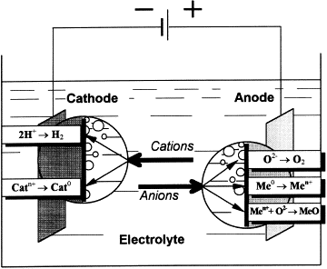
Figure 3-1 Electrode processes in electrolysis of aqueous solutions [33]

Moreover, acoustic and optical emissions, as well as heating effects due to the discharging activity, also can be observed in the PEO process, which would continuously consume energy. It has to be noted that the oxidation process occurred on the anode can not only lead to the formation of oxide film, but also cause metal dissolution, which depends on the electrolyte composition. In addition, gas liberation in the PEO treatment is stronger than conventional anodizing, which can significantly influence the results under certain conditions, indicating the complexity of PEO processes.

Since the discharge activity plays an important role in the electrochemical and thermal reactions which are the critical factors affecting coating properties, such as phase composition, microstructure and stress state, considerable investigations of discharge phenomena have been carried out in recent years [96, 98-105]. A representative evolution of micro-discharge appearance on Al alloy with PEO processing time is presented in Figure 3-2. Gas liberation starts a few seconds after the onset of the PEO treatment and can be observed in the whole process. In terms of discharge events, the following conclusions can be made after careful analysis of the images in Figure 3-2. The number of discharges decreases with the increasing PEO treatment time, and the average discharge size, as well as the individual discharge intensity, increase with the processing time too. Moreover, some orange discharges that are different in colour compared to the bright discharges in the first few minutes can be observed on the metal surface after 15 min of processing time. Similar results can be found in other publications [101, 105]. To better understand the mechanism, Yerokhin et al. [99] investigated the discharge phenomena during the PEO process on Al alloy. According to their research, the discharge population is dominated by small-sized events throughout the oxidation process, with a proportion of only 11% medium-sized and 12% large discharge at the end of the PEO process. The cross-sectional area of a single discharge can reach up to 1.35 mm². More importantly, a new discharge model is suggested according to the glow discharge electrolysis theory, which explains some discharge characteristics that cannot be fitted into existing models (e.g. dielectric breakdown and discharge-in-pore). The discharge temperature was also studied widely, which is estimated in a range of 800 – 20000 K depending on particular discharge activities [33]. The individual discharge lifetime has also been studied broadly by various research methods, it is proven to be in a range from tens to hundreds of microseconds. Moreover, in the PEO process, more than one species would be ionised at different stages, which is the main reason for the change in discharge colour.

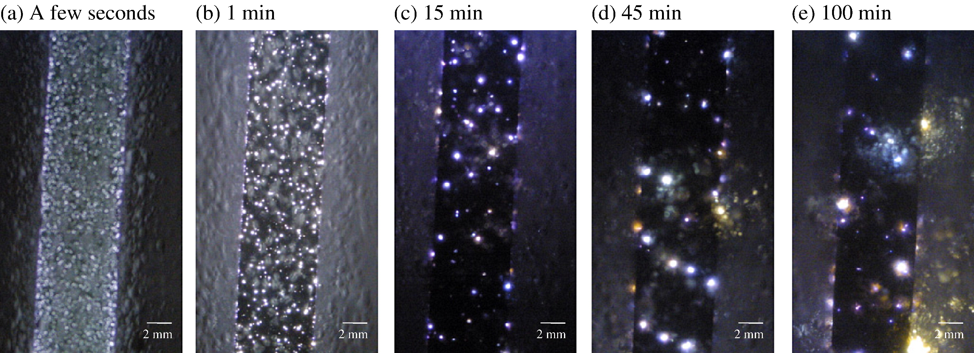
Figure 3-2 Discharge evolution of aluminium alloy samples at different time in the PEO process [98]

The discharge characteristics are dependent on electrolyte chemistry, processing parameters, as well as composition of substrate material. The mechanisms underlying discharge event and their influence on the coating formation are still an open question in PEO related research, which requires further investigation. The studies of these typical phenomena (e.g. gas liberation, discharge activity) can help in better understanding the principles and mechanisms of the PEO process, which could in turn provide a possible theoretical basis for optimising coating properties.

3.1.2 Fundamental principles and mechanisms of the PEO process
In spite of the applied metal substrate and electrical regime, the basic principles and mechanisms of the PEO process are similar for treatments of various metals. Based on the voltage/current transients, the coating formation kinetics are usually described as three or four distinguishing stages, depending on the interpretation of the PEO process [106-112]. Although a disagreement exists in dividing coating evolution during the PEO process, there is no essential difference among these theories.
For example, the PEO treatment of Mg in alkaline electrolytes can be categorized in three stages. Ko et al. [106] presented the typical voltage vs. time curves (Figure 3-3) for the PEO treatment of AZ91 Mg alloy in an alkaline silicate-based electrolyte, showing the three different stages and corresponding characteristics. The first stage is characterized by the passive film formation process, in which Mg(OH)₂ and MgO will be formed on the surface of metal substrate. Concurrently, a dissolution of Mg alloy also takes place in this stage. The substances from the electrolyte can also be detected in the passive film in some cases, indicating the incorporation of electrolyte compounds into the film. In addition, the voltage rapidly increases in this period, with no discharge events observed. The passive film formation process in the first stage can be represented by the following reactions.

Mg → Mg²⁺ + 2e⁻ (3.1)
Mg²⁺ + 2OH⁻ → Mg(OH)₂ (3.2)
Mg(OH)₂ → MgO + H₂O (3.3)

During the second stage, the voltage still quickly increases with the processing time, but the growth rate becomes slower compared with that in the first stage. One obvious characteristic that can be observed in this stage is the initiation of discharge phenomena. It can be explained by the increasing of applied voltage which exceeds the breakdown voltage of the passive film. The discharges observed at this stage are rather fine and bright, with a relatively high density and short life-time. In addition, an intense gas liberation also occurs during this stage.

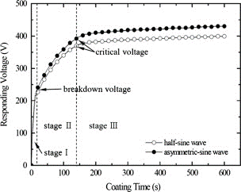
Figure 3-3 Temporal evolution of voltage during the PEO process on AZ91 Mg alloy [106]

When the PEO process evolves to the third stage, an obvious characteristics in the voltage vs. time plot is a dramatically decreased voltage growth rate, as illustrated in Figure 3-3. Due to this, the coating growth rate also becomes slower [82]. Despite the reduced coating growth rate, the voltage applied at this stage reaches a critical value in which the micro-discharges dominate over electrochemical reactions and the average voltage is much higher than the previous stages. With the increasing of processing time, the thickness of oxide film increases and the average size and intensity of discharges become much larger and stronger, whereas the discharge population decreases significantly compared with that in the previous two stages. Another significant feature that can be observed is the change in discharge colour, which indicates different ionization processes species occurring at this stage, as discussed in the previous section.

The basic characteristics and principles of PEO processes discussed above provide the fundamentals for comprehensive understanding of the PEO technique. It also serves as the theoretical basis for the analysis of microstructure and phase composition of PEO coatings, which will be discussed in the following section. As a critical research direction of the PEO technique, principles and mechanisms of the PEO process still attract extensive research nowadays.

3.2 Microstructure and phase composition of the PEO coatings on Mg
The microstructure of PEO coatings can be influenced by many factors, including electrical parameters, electrolyte composition and substrate materials. Usually, PEO coatings exhibit a typical porous morphology with numerous micro pores and cracks distributed on the coating surface and inside the coating matrix. The micro-pore diameter is usually in the range from less than 1 µm to more than 50 µm, depending on the conditions of the PEO process. Figure 3-4 shows typical SEM surface morphologies of PEO coatings produced on Mg in alkaline electrolytes. It can be seen that pores are uniformly distributed on the surface with some cracks propagated among them. The porous microstructure is mainly attributed to the discharge activity and gas liberation during the PEO treatment [113]. It can also be found that the increased current density caused a coarser surface morphology of PEO coating, which could be explained by the increased energy of discharges. Significant temperature difference across the coating/electrolyte interface causes a relatively high cooling rate of PEO coatings, leading to the initiation of cracks induced by local thermal stress.

Figure 3-5 shows the SEM images illustrating cross-sectional features of PEO coatings produced on Mg at different current densities. The cross-sectional morphology is characterized by the extensive networks of micro-cracks, which is more obvious in thicker coatings (Figure 3-5c). Some cracks even connect the surface of the PEO coating to the metal substrate, as shown by the arrows in Figure 3-5b and c. It can be seen that PEO coating produced at the lowest current density (Figure 3-5a) has a more compact structure with less pores and cracks in the coating matrix compared with thicker coatings produced at higher current densities. Thus, the high current density can accelerate coating growth, but would lead to a coarse microstructure with more pores and cracks. Generally speaking, the factors which can influence the cross-sectional morphology of PEO coating are similar to those influencing the surface morphology, as discussed above.
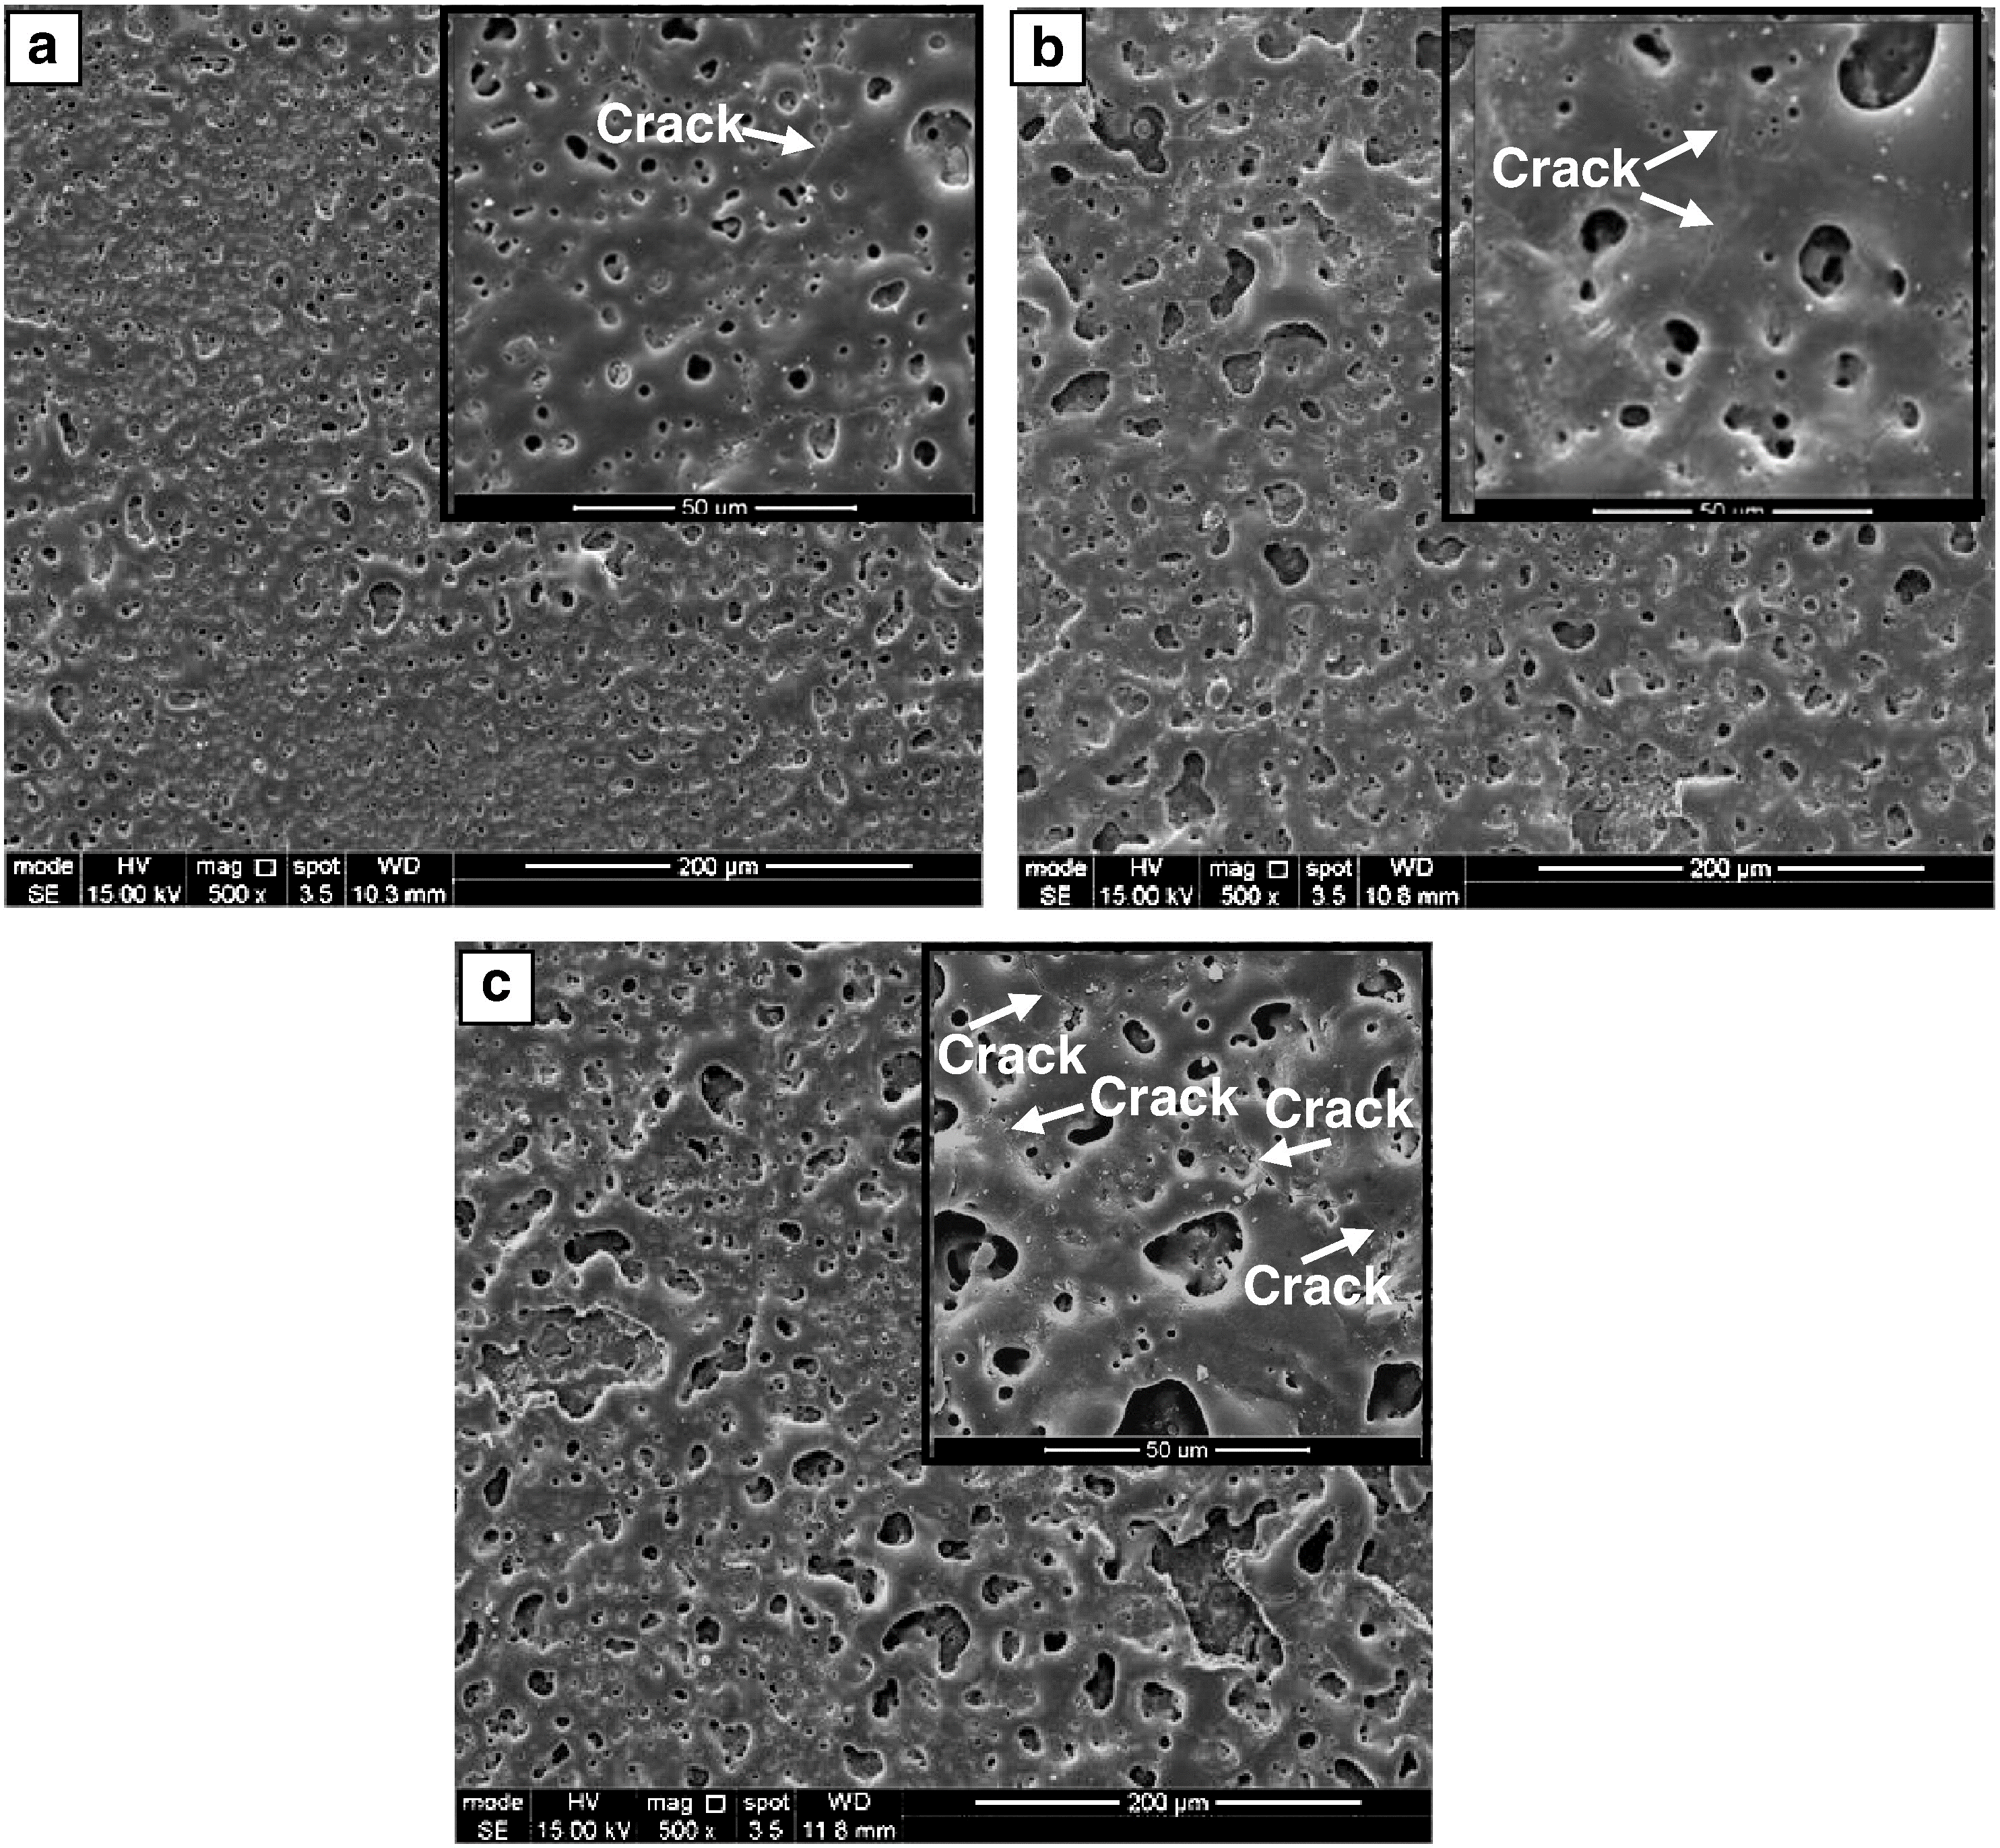
Figure 3-4 SEM images of surface morphology of PEO coatings produced on Mg in an alkaline electrolyte at current densities (mA/cm²) of: (a) 30, (b) 40, and (c) 50 [113]

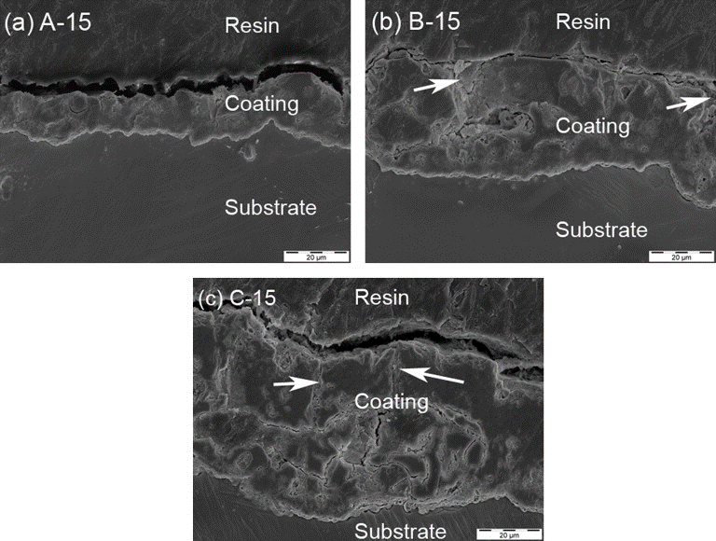
Figure 3-5 SEM images of cross-sectional morphology of PEO coatings produced on Mg alloy at different current densities (mA/cm²) of: (a) 15, (b) 75, and (c) 150 for 15 min [85]
Despite the difference in coating thickness and/or composition, the cross-section of all PEO coatings can be categorised into several regions based on their characteristics. Blawert et al. [114] have divided the PEO coating into four distinct regions as illustrated in Figure 3-6: (i) an outer porous region with craters on the surface, (ii) pore bands with obvious pores and discharge channels, (iii) a relatively compact intermediate layer with few pores, (iv) a very dense and thin inner barrier layer. Since the cross-sectional features of PEO coatings produced in various electrolytes and processing conditions can be significantly different, these could also be divided into two or three distinct regions, depending on the practical conditions. It has to be noted that the features of microstructure discussed above are typical for all PEO coatings, no matter what substrate and electrolyte are applied in the PEO process.

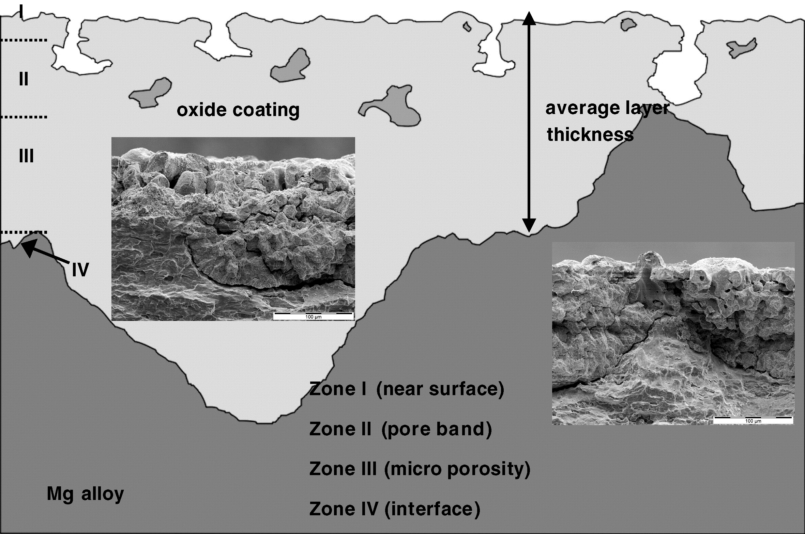
Figure 3-6 Schematic diagram of a typical cross sectional features of PEO coatings; inserted are SEM micrographs showing typical features of the surface layer [114]

Porosity is a critical factor that can affect the properties of PEO coatings, especially the corrosion resistance. It is directly related to the coating microstructure that can be influenced by the electrical parameters, electrolyte properties, substrate material, and treatment time. All these factors play an important role in discharging activity and gas evolution during the PEO process. In the last decade, extensive studies have been carried out to establish factors influencing microstructure of PEO coatings [30, 110, 112, 115-118]. Gnedenkov et al. [30] studied the effect of power supply mode on the structure of PEO coatings produced on MA8 Mg alloy in a silicate-containing electrolyte. According to their results, the PEO coating produced in the bipolar mode has low porosity and more compact microstructure compared that produced in the unipolar mode. Liang et al. [110] reported that the PEO coating produced in the silicate-based electrolyte shows higher microhardness and better corrosion property with relatively dense microstructure and less defects (pores and cracks), compared with those formed in the phosphate electrolyte.

The electrolyte composition and substrate material are the two major factors influencing the phase composition of PEO coatings. The majority of published works on PEO coated Mg uses silicate or phosphate-based electrolytes, with some of them containing fluoride or other substances as additives. It is found that MgO, MgAl₂O₄, MgF₂, Mg₃(PO₄)₂ and Mg₂SiO₄ are the main phase constituents that can be detected in the PEO coatings on Mg and its alloys [3, 85, 107, 113, 119]. It has to be noted that the phase composition could be different even though the electrolyte composition used in different PEO treatments were the similar, indicating the processing parameters also play a role in the phase formation process. Moreover, some additives such as particles can also be incorporated in the PEO coatings.

After analysing the microstructure and phase composition, the advantages and disadvantages of the PEO coatings on Mg are clearly revealed. As ceramic-like coatings with relatively good adhesion property and high thickness, PEO coatings could be one of ideal alternatives of traditional anodising coatings. However, to meet the stringent requirements for practical applications, additional treatments are usually needed to cover the shortcomings of PEO coatings; for example post-sealing treatments to deal with microspores and cracks in the coating.

3.3 Recent developments in the PEO coatings on Mg
Recently, extensive studies have been carried out aiming at obtaining high quality PEO coatings on Mg and its alloys, which are capable of improving corrosion and wear resistance in large scale manufacturing. These interesting researches not only provide an idea for producing high quality PEO coatings, but can also inspire future research and development. Based on these approaches, PEO coatings with multiple or tailored functions could be transferred from concept to reality.

3.3.1 Process optimization
The process optimization has always been of interest in PEO related research. Various approaches have been tried to obtain PEO coating with improved integrity and properties, including using different power supply, auxiliary gas and ultrasonic power, etc.

Gao et al. [120] studied Ca- and P-containing PEO coatings on Mg produced at pulsed unipolar power mode. According to their result, the PEO coating produced at 3000 Hz pulse frequency showed the best corrosion resistance performance compared with those produced at other frequencies. Nominé et al. [121] have reported the effect of cathodic half-period on the discharges and microstructure of PEO coating on Mg alloys. It was claimed that the discharges become shorter and smaller with the increase in the cathodic half-period, which accelerates the coating growth rate, enhances compactness, as well as corrosion resistance. This result is in a good agreement with others [122, 123]. Moreover, the effect of ultrasonic power on the microstructure and properties of the PEO coating on Mg alloys was also studied by Guo et al. [124]. It was found that the ultrasonic power at a constant frequency of 25 kHz and 400 W can effectively enhance the growth rate of PEO coating probably due to the accelerated rate of mass transfer in the coating. It also has significant influence on the formation of microstructure and distribution of chemical elements in the coating during the PEO process. However, no changes in the coating phase composition could be found following the ultrasonic power assisted PEO process. It has to be noted that the optimal parameters for the PEO treatment are subject to the practical conditions, and vary significantly depending on substrate materials and electrolytes.

3.3.2 Duplex PEO coatings
Although the corrosion and wear resistance of Mg can be significantly improved by PEO coatings, the coating porous structure still limits its protection performance especially in aggressive environments. To overcome this disadvantage, additional treatment for the PEO coating is necessary. In this regard, duplex PEO-based coatings have triggered great interest of researchers. It is believed that duplex films can significantly improve corrosion and wear resistance of Mg by increasing total coating thickness and sealing the pores and cracks in the PEO coating. To meet different, often contradictory, requirements and achieve the best results, various methods have recently been considered to produce duplex PEO coatings on Mg, such as electroless plating, PVD, sol-gel, polymer and organic coatings on PEO-coated Mg [14, 87, 125-132].

Li et al. [87] successfully produced a duplex PEO/sol-gel coatings by depositing sol-gel top layer on the PEO treated Mg-Li alloy. The micropores and cracks of the PEO coating were completely sealed after the sol-gel treatment, with only a smooth sol-gel top layer observed. The corrosion tests reveal that the duplex PEO/sol-gel coating has significantly improved corrosion resistance compared with single PEO coating. After 1500 h long-term immersion in a 3.5 wt.% NaCl solution, the PEO coating had completely lost its protection ability for the metal substrate, while the duplex coating retained a relatively good integrity with only few peeled off regions. Duan el al. [14] reported a protective composite PEO coatings on AZ91D Mg alloy. In their research, PEO coatings were covered by a thin, organic top layer by applying multiple immersions into a titanium-containing organic polymer sealing agent under low-pressure conditions. By electrochemical impedance spectroscopy (EIS) and potentiodynamic polarisation tests in 3.5 wt.% NaCl solution, it was found that the composite PEO coatings can effectively improve corrosion resistance of Mg alloy by inhibiting the charge transfer and preventing electrolyte diffusion in the pores. Gnedenkov et al. [127] developed a polymer-containing composite PEO coating incorporating surperdispersed polytetrafluoroethylene (SPTFE) on the surface of MA8 Mg alloy through multiple steps (Figure 3-7). Produced polymer-containing PEO coatings showed a significantly enhanced corrosion resistance (300-fold higher than the single PEO coating) and tribological properties due to insulating and solid lubrication effects of SPTFE additions.

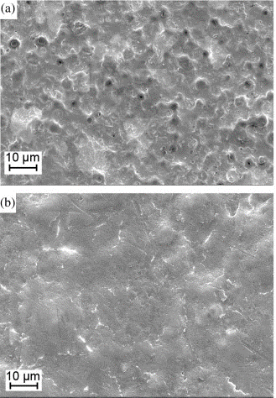
Figure 3-7 SEM images of duplex PEO-polymer coatings on Mg alloy with (а) partially sealed pores and (b) pores completely sealed by polymer [127]

3.3.3 Composite PEO coatings
Recently, composite PEO coatings incorporating particles become more and more popular [36, 37, 133, 134]. It is believed that the mechanical, tribological properties can be effectively improved by introducing selected secondary phases into the PEO coatings. Nevertheless, the corrosion resistance of composite PEO coating varies with the particle types and processing conditions.

The mechanism of particle incorporation, influence of different types of particles on coating morphology, phase composition, wear and corrosion properties of the PEO coatings on Mg have been studied by Lu et al. [36-40, 135]. According to their research, the particle incorporation process in the PEO treatment can be described as two distinct stages, including initial uptake and final incorporation stage. The small size particles were found to be more easily incorporated into the PEO coating compared with those of large size. Moreover, it was reported that the wear resistance of PEO coatings on Mg is improved after incorporating SiO₂ particles, indicating the superior mechanical properties of the composite PEO coating. However, a slightly reduced corrosion resistance can be observed from the corrosion test.

Mohedano et al. [136] developed a composite coating containing CeO₂ particles by PEO treatments of AM50 Mg alloy in a silicate-based electrolyte. It was found that the particle concentration in the composite PEO coating has effect on its corrosion resistance. The composite PEO coating produced in the electrolyte with low CeO₂ particle concentration (3g/L) shows improved corrosion resistance in comparison to the single PEO coating, yet those produced in high concentration electrolytes have a decreased corrosion protection. The corrosion improvement was also found in the PEO coating on Mg alloy wires after C nanoparticles were introduced in the electrolyte, reported by Hua et al. [137]. The incorporation of C nanotubes in the PEO coating not only causes a more compact microstructure, but also leads to the changes in the coating phase composition.

3.3.4 Self-healing PEO coatings
The development of smart self-healing materials is inspired by biological systems which have the ability to repair themselves when the damage occurs. Due to this special property, the self-healing materials can endure a longer service life, offering a great potential of cost reduction, compared with conventional materials. Generally, in a controlled or predetermined way, the healing activities can be triggered by a specific stimulus, which could be stress, temperature, electric, magnetic fields, pH, moisture and other factors, which depends on the practical situation. There are various types of smart self-healing materials and some of these have already applied in our daily life [138-142]. Recently, attempts to produce self-healing PEO coatings on Mg have been made by some researchers, with the objective of improving the corrosion protection ability. Unfortunately, literature about PEO coatings on Mg with self-healing property are relatively rare.

Gnedenkov et al. [24, 143] developed an inhibitor-containing self-healing PEO coating on MA8 Mg alloy by a two-step method. First, the Mg alloy was PEO treated in a silicate-based electrolyte for 10 min, and then the coated sample was immersed in the 8-hydroxyquinoline (8-HQ) solution for 120 min at ambient temperature, followed by drying at 140 °C for 20 min. The corrosion inhibitor (8-HQ) is supposed to repair the damaged PEO coating when the corrosion attack occurs in aqueous solutions. The corrosion current density of self-healing PEO coatings obtained from potentiodynamic polarisation test in a 3 wt.% NaCl solution is significantly lower than that of the single PEO coated Mg alloy. Moreover, after the potentiodynamic polarisation test, the decrease of impedance value of the self-healing PEO coating was much smaller than that for the PEO coating, suggesting a noticeable healing effect and improved corrosion resistance.

Yagi el al. [35] have also reported a self-repairing PEO coating on ACM522 Mg Alloy produced in silicate and phosphate electrolytes. The self-repairing mechanism of the PEO coated Mg alloy is illustrated in Figure 3-8. The PEO coating can be slightly dissolved in aqueous solutions, resulting in release of silicate and phosphate ions. Then the self-repairing functionality is achieved by forming a renewed film integrated by dissolved silicate and phosphate ions with Mg²⁺ ions on corroded areas of the Mg alloy substrate. Additionally, Na₂B₄O₇ additive was found to be helpful to enhance the compactness of the renewed film by reducing the number of cracks. Similar mechanism of self-healing PEO coating on Mg alloy was also reported by Mori, el al. [144].

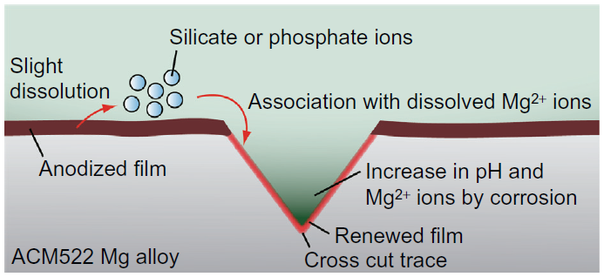
Figure 3-8 Schematic diagram of a self-repairing PEO coating on Mg alloy [35]

The aforementioned investigations are only discussed as representative examples of recent developments of the PEO coatings on Mg and its alloys. In general, these methods of improving corrosion and wear resistance of PEO coatings attract a lot of attention and interest. Usually, some methods successfully improve one property, but fail in another. These methods sometimes can bring both advantages and disadvantages depending on practical conditions. Moreover, production of self-healing coatings is an emerging approach to improve corrosion resistance of PEO coatings. It has a good potential of enhancing the corrosion protection of Mg alloys in the future, although it lacks studies at the moment.

3.4 Summary
As discussed above, PEO is an effective method to provide protection for Mg and its alloys. Meanwhile, advantages and shortcomings of this technique are also quite obvious. Since the corrosion resistance of Mg is always the priority in practical applications, its corrosion protection by PEO coatings is of particular interest. Considerable recent developments in PEO coatings on Mg focused on their corrosion behaviour, with various methods emerging to improve the coating corrosion resistance. In the following chapters, some novel methods for improving the corrosion protection of PEO coatings on Mg will be discussed and analysed.

Chapter 4 Experimental Procedures

4.1 PEO coating equipment
The microstructure, composition and properties of PEO coatings can be affected by many factors during the PEO treatment, such as composition and concentration of the electrolyte, its pH value, temperature, electrical regimes (DC, AC and bipolar) and electrical control parameters. Despite the factors related to the electrolyte, electrical regimes (power supply mode) and parameters are critical for obtaining PEO coatings with desired properties. This means a stable and precise control of the power supplied to PEO cell is required to get reliable results. In the present work, to meet these requirements, the PEO process is operated by a computer controlled system containing three parts: a power supply, an electrolyser and a controlling computer.

The power supply is composed of two DC units (MDX II 15 kW and 30 kW, Advanced Energy Industries, Inc) together with a SPIK2000A pulse unit (Melek GmbH) and an arbitrary waveform generator (Agilent 33220A, 20 MHz). All units are remotely controlled by the controlling computer through a 16 to 29 Bit PXI Platform provided by National Instruments, which is a high-performance deployment platform for demanding applications. The power supply system can provide various electrical regimes and parameters for PEO treatments. To further understand the coating formation mechanism and the treatment process, both voltage and current values applied during the whole PEO process were monitored by a Tektronix A6303 current probe coupled with a Tektronix TM502A current amplifier, a Tektronix P5200A 50MHz high voltage deferential probe, and recorded through a NI-PXI-5922 data acquisition card. Since the electrolyte temperature plays an important role in the PEO treatment and coating formation, significantly affecting the properties of the PEO coating, the evolution of electrolyte temperature was monitored by a thermocouple connected to a NI-PXI-6220 card. The electrolyser was formed by a cylindrical stainless steel tank (Ø 160 ×140 mm) which served as both the container for electrolyte and the counter electrode. Since the electrolyte temperature increases due to the heating effect of the current passing during the PEO treatment, a water cooling system formed by a stainless steel tube in coil shape was applied to keep the electrolyte temperature during the PEO process in a desirable level. The electrolyte was kept stirring by a magnetic stirrer during the PEO treatment to maintain the homogeneity in the temperature and composition.

4.2 Materials
In the present work, both commercially pure magnesium (cp-Mg) and AM50 Mg alloy were utilized as substrates for the PEO coatings. Nominal chemical compositions of these two substrate materials are provided in Table 4-1. Prior to PEO treatment, disc samples of diameter 15.8 mm with thickness 7 mm and diameter 20 mm with thickness 10mm were cut from extruded cp-Mg and AM50 Mg alloy rods, respectively. The cutting process was carried out by two types of precision saws, with Buehler IsoMet 5000 for cp-Mg and Struers Secotom-50 for AM50 Mg alloy. A non-ferrous cutting wheel with thickness of 1 mm was applied to cut the substrate materials at a rotating speed of 3000 – 4000 RPM and a suitable cutting speed which depends on the ability of precision saws. After the cutting process, all disc samples were manually tapped a M3 threaded hole with the purpose of connecting an M3 tapped Al rod with external insulation which served as the sample holder in the PEO process. Before PEO treatment, all samples were ground using abrasive SiC paper up to 1200 grit and ultrasonically degreased in acetone for 5min, rinsed in distilled water and dried in air.

Table 4-1 Chemical composition of substrate materials used for PEO coatings (wt.%).
 | Al | Cu | Fe | Mn | Ni | Si | Zn | Mg
cp-Mg | 0.005 | <0.005 | <0.005 | 0.01 | <0.005 | <0.01 | <0.005 | balance
AM50 Mg alloy | 4.4-5.4 | 0.01 | 0.004 | 0.26-0.6 | 0.002 | 0.1 | 0.22 | balance

4.3 Inhibitor loaded halloysite nanotubes (HNT) preparation
To investigate the influence of inhibitor loaded nanocontainers on the formation and properties of PEO coatings on AM50 Mg alloy, BTA loaded HNT were prepared as an additive to the electrolyte. The HNT and benzotriazole (BTA) precursors were acquired from Sigma-Aldrich, UK. Before loading procedure, both BTA and HNT were weighed by an electrical balance (DENVER Instrument MXX-2001) which has ±0.1g precision. The BTA loaded HNT were prepared using a procedure similar to that described elsewhere [145]. To perform the loading, 20g HNT powder was mixed with 250 ml BTA aqueous solution (10 g/L) in a glass beaker and stirred by a magnetic stirrer. Then, the mixed suspension containing BTA and HNT was evacuated in a vacuum jar to remove air from the hollow core of the HNT. After that, the HNT were extracted from the BTA solution in a centrifuge (Eppendorf 5804), washed by distilled water and dried in air for 72 h. Then the dried BTA loaded HNT were finely powdered in an agate mortar.

4.4 Electrolyte preparation
As discussed in Chapter 3, PEO coatings produced in silicate-based electrolytes are generally more compact with less defects compared with those produced from phosphate electrolytes. Moreover, it was reported that fluoride is helpful to improve the corrosion resistance of the PEO coatings on Mg [146, 147]. Considering these factors, the base electrolyte used in the present work was alkaline silicate-fluoride aqueous solution composed of (g/L): 12 – Na₂SiO₃, 2 – KOH, and 4 – NaF. The base electrolyte was applied for producing PEO coatings on cp-Mg. Additionally, HNT or BTA-loaded HNT prepared as described in Section 4.3 were added in the base electrolyte as an additive for producing self-healing PEO coatings on AM50 Mg alloy. Before preparing the electrolyte, all chemicals were weighed by the same electrical balance as mentioned in Section 4.3. Then the weighed chemicals were dissolved in a glass beaker containing distilled water and kept stirring by a magnetic stirrer for at least one hour to ensure the complete dissolution of the chemicals. Before the PEO treatment, the conductivity and pH of the electrolyte were measured by a conductivity meter (HANNA HI9835) and a pH meter (HANNA pH211), respectively.

4.5 Plasma enhanced chemical vapour deposition (PECVD) post-treatment
The plasma enhanced chemical vapour deposition (PECVD) post-treatment was employed to produce duplex PEO/PECVD coatings on cp-Mg substrate, with the aim of studying the changes in properties of the duplex coating compared with single PEO coating. The PECVD top layer was deposited using a dielectric barrier discharge (DBD) method at atmospheric pressure. The PECVD system (as illustrated in Figure 4-1) was composed of two high-voltage rod electrodes with a square cross section (15 mm × 15 mm) and 100 mm long, and insulated by a ceramic layer with thickness of 0.2 cm. The PEO coated samples were placed on a grounded Al plate (served as the counter electrode) covered by a 0.2 cm thick silicon layer. The gas flow needed in the treatment was introduced by a middle gas shower fitted with MKS flow controllers. Therefore, the DBD microdischarges can directly interact with the surface of the PEO coating samples. Further details of PECVD treatments can be found in Chapter 7.

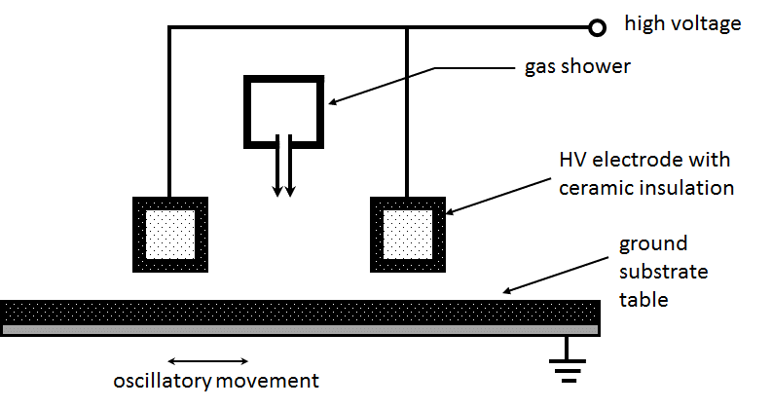
Figure 4-1 Schematic view of dielectric barrier discharge system

4.6 Preparation of BTA and cerium nitrate (Ce(NO₃)₃) post-treatment solutions
In the present work, BTA and Ce(NO₃)₃ were used to prepare aqueous solutions for the immersion post-treatment of PEO coated samples. To prepare the post-treatment solutions, BTA and Ce(NO₃)₃ were firstly weighed by the electrical balance mentioned in previous sections, and then dissolved separately in distilled water with the concentration of 10 g/L for both chemicals. Details of the immersion post-treatment are discussed in Chapter 8.

4.7 Coating characterisation

4.7.1 Coating thickness and water contact angle measurements
The thickness of PEO coatings is an important factor which needs to be considered when investigating the process efficiency and coating properties such as corrosion resistance, mechanical performance. As a result, it is necessary to study the variation in coating thickness, since it can significantly affect the corrosion resistance. In this work, the coating thickness was measured using an Elcometer 355 eddy current coating thickness gauge equipped with a standard No. 4 anodisers probe (± 1 µm). The eddy current technique is usually applied for measuring the thickness of non-conductive coatings on nonferrous metal substrates without any damages. The working principle of eddy current thickness gauge is to use alternating magnetic field at the surface of probe, which is created by a relatively high-frequency current (above 1 MHz). During the measurements, the electric field will induce an eddy current on the surface of the metal substrate, and the eddy current magnitude is affected by the substrate materials and coating thickness. The eddy current can also generate an opposing electromagnetic field which can be detected by the probe and used to calculate the coating thickness according to the interaction between the magnetic field and the probe. Before measuring coating thickness, the gauge was zeroed using a polished bare substrate and calibrated by dielectric films of known thickness. Ten measurements were made on each side of the sample to obtain statistically significant data sets, from which the mean average thickness values and the measurement errors were determined, the latter taking into account both the standard deviation between the readings in the set and the instrumental error.

Fourier transform infrared spectroscopy (FTIR) is a reliable technique which can be used to identify and characterise many substances using an infrared spectrum of tested samples. However, the sample preparation for traditional FTIR measurement is a relatively complex work. To overcome this drawback, ATR (Attenuated total reflection) mode of FTIR measurement was developed to analyse various types of solid and liquid samples in a more convenient way without complicated sample preparation [148, 149]. The principle of the ATR system is illustrated in Figure 4-2. The crystal is made by a parallel-sided plate with one side exposed to the sample. Before the ATR-FTIR measurement, the sample is clamped against the exposed crystal surface to ensure the good optical contact. During the measurement, the incident IR beam enters the dense crystal at a certain angle (typically 45°) and is continuously reflected inside the crystal. Meanwhile, a small fraction of IR, which is known as an evanescent wave, extends beyond the crystal surface and reaches into the surface of the sample. The extended distance of evanescent wave beyond the crystal surface is dependent on many factors like wavelength, sample properties, the refractive indices of ATR crystal, and typically in a range of 0.5 to 5 µm. The evanescent wave is attenuated due to the energy absorption caused by the sample in the spectral regions. Containing the attenuated energy, the IR beam finally exits the ATR crystal at the opposite end and be detected by the IR detector. In the present work, attenuated total reflection fourier transform infrared (ATR-FTIR) spectroscopic measurements were performed using a ThermoScientific Nicolet IS 10 instrument (germanium, single reflection, 4.0 cm⁻¹ resolution, unpolarised) on the films deposited on polyethylene (PE) foils in order to obtain information about thicknesses and chemical composition of the CVD coatings.

In addition, wettability is also of great concern from both fundamental research and industrial applications, as it could have significant influence on the properties of solid surface, as well as the good potential of improving the corrosion resistance [150]. The most commonly used method to evaluate the wetting property of solid surface is the direct measurement of the contact angle, in which the tangent angle of a liquid drop profile at the three-phase contact point is measured by telescope-goniometer. Basically, small and large contact angles correspond to high and low wettability, respectively. To evaluate the hydrophobic property of CVD coatings, the values of water contact angle were obtained from three measurements performed on each sample using an instrument OCA 20 (Data Physics).
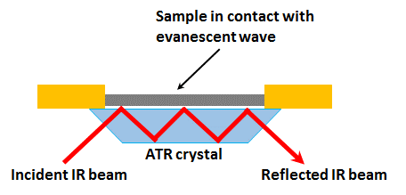
Figure 4-2 Schematic illustration of principle for ATR system

4.7.2 Coating morphology and nanocontainers observation
Surface and cross-sectional observation is one of the most direct and effective ways to evaluate the morphology of PEO coatings. Scanning electron microscopy (SEM) is widely used to obtain microstructure images of various samples of metals, polymers and organics. The method uses a focused electron beam to interact with the atoms of the specimen and generate various types of signal containing information on the studied material such as surface morphology and element composition. Among these signals, secondary electrons (SE) and back-scattered electrons (BE) are sensitive to surface roughness, pores and cracks, and can be used to produce SEM images outlining morphology. In particular, BE imaging can provide more clear and detailed features of pores and cracks in the PEO coatings. Thus, the BE SEM images are preferable to calculate the porosity of PEO coatings. In addition, the elemental composition of the samples can be investigated by the Energy-dispersive X-ray Spectroscopy (EDX) analysis.

In the present work, JEOL JSM-6400 and FEI Inspect F scanning electron microscopes equipped with an EDX detectors (Oxford instruments) were used to analyse the coating microstructure, including surface and cross sectional morphologies, as well as to identify elemental composition. During the SEM characterisation, the accelerating voltage was setup at 20 kV for all samples. The Image J software was applied for analysing the porosity of the PEO coatings. For SEM characterisation, cross-sectional samples were firstly cut into suitable size using the precision saw mentioned in previous sections and then mounted into epoxy resin (MepPrep Ltd.), ground with different grades of SiC abrasive papers up to 4000 grit, polished and finally ultrasonically cleaned in acetone. The samples for surface SEM morphology observation were made by sticking PEO coated Mg on an Al stub (Ø 30 × 10 mm) using a carbon tape. The prepared samples were then coated with a thin layer of carbon to prevent surface charging effects during SEM examination.

The surface morphology of PEO coatings on AM50 Mg alloy was also studied using a Veeco Wyko NT1100 optical profiler, which allows performing non-contact three-dimensional surface profile measurements. The surface roughness was evaluated in vertical scanning interferometry mode using a combination of a Michelson interferometric objective with optical magnification ×5 and a Field-of-view lens without magnification. The size of the analysed surface area was 1.2 mm × 0.9 mm.

The microstructure of HNT nanocontainers was characterised by both transmission electron microscopy (TEM) and SEM methods. TEM is a more powerful electron microscope which can provide high-resolution and high-magnification images. However, the preparation of TEM samples of HNT is usually more complicated than that of SEM samples, as it demands the samples to be relatively thin to meet the requirement of electron transmission. In the present work, HNT nanoparticles are small enough for the TEM observation without laborious preparation. However, in most cases, these particles are gathered as agglomerates that are unsuitable for direct TEM and SEM characterisation. Therefore, the HNT nanoparticles were mixed with isopropanol and then ultrasonically dispersed. After that, the suspended HNT nanoparticles were adsorbed on a carbon-coated TEM copper grid (as shown in Figure 4-3) by dipping the grid in the mixed liquid suspension gently with the help of tweezers. Then, the copper grid was dried in air at room temperature. Produced in such way, TEM samples of HNT nanoparticles are also suitable for SEM investigation. The TEM investigation was carried out using a Phillips 420 transmission electron microscope. The SEM investigation was conducted by FEI Inspect F scanning electron microscope which is the same as mentioned previously.

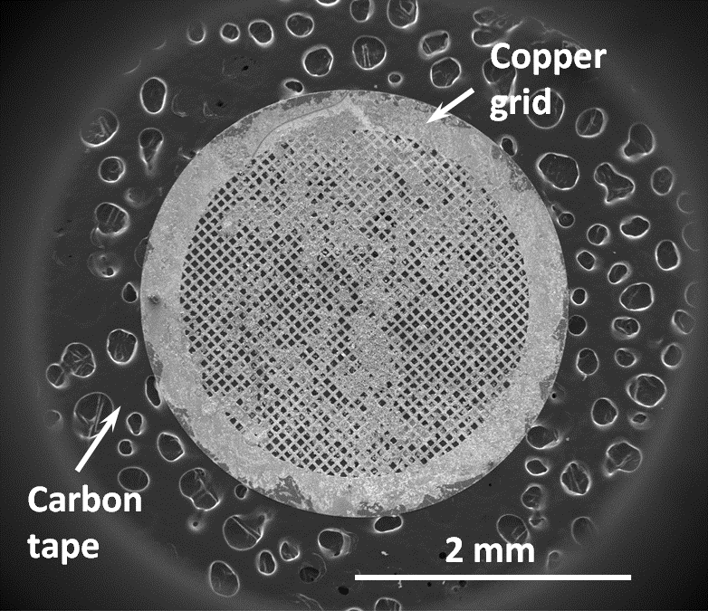
Figure 4-3 SEM image showing the TEM sample of HNT nanoparticles on a carbon coated TEM copper grid

4.7.3 Coating phase examination
X-ray diffraction (XRD) was applied to characterise the phase composition of PEO coatings. The principle of XRD analysis is based on the periodically arranged atoms in crystals, which compose different atomic planes. The atomic plane can reflect the incident X-ray beam with different intensities. When the X-ray is reflected from a crystal, the beams reflected from the atomic plane on the surface travel less distance than those reflected from the planes below. The distance travelled by penetrating X-ray depends on the crystal lattice plane spacing and the angle at which the incident beam enters the crystal. If these reflected X-ray beams (from surface and inside crystal) are in phase, the penetrating X-ray needs to travel an integer number (whole) of wavelengths when inside the crystal. The schematic illustration of the XRD principle is shown in Figure 4-4. Braggs described this phenomenon in an equation known as Braggs’ Law:

2dsinθ = nλ 4.1

where the λ is X-ray wavelength, θ is the incident angle and d is the spacing between the lattice planes. In the present work, the coating phase composition was investigated using a Siemens D5000 X-Ray Diffractometer and/or a Bruker D2 Phaser (XRD, Cu Kα radiation, λ= 0.154059 nm) in normal coupled geometry, with 2θ ranging from 20° to 80° at a 0.02° step size.

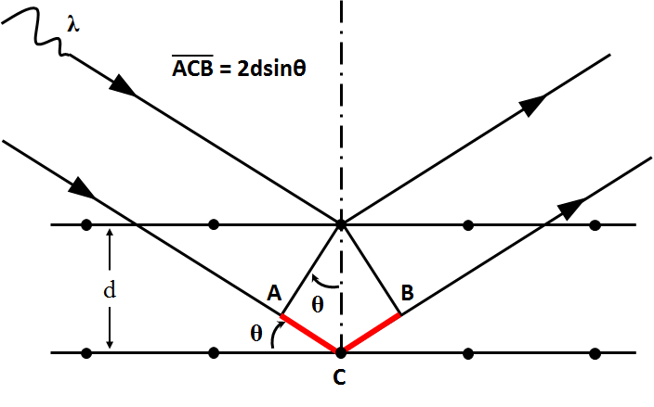
Figure 4-4 Schematic illustration of XRD principles

4.7.4 Scratch testing
Scratch testing is a quick and effective method which is broadly utilised to evaluate adhesion properties of coating. In this work, adhesion strength of PEO coatings was measured using a Revetest scratch tester (CSM Instruments) according to the ASTM C1624-05 standard. During the tests, a diamond stylus with a tip radius of about 200 µm (Rockwell C type) was moved over the coating surface under the normal load increasing from 0.9 to 15 N. The scratch speed and length were 5 mm/min and 5 mm, respectively. For each scratch, the smallest load causing a specific failure event (so called critical load, L_{C}) was registered. Optical microscopy observations along the scratch were used to confirm the starting point of a specific failure mode. In addition, the changes of acoustic emission (AE), friction force and friction coefficient (FC) were registered during the tests. Critical loads corresponding to the first occurrence of coating penetration, exposing the magnesium substrate in the scratch track (L_{C2}), and complete adhesion failure (L_{C3}), wherein the full opening of the substrate was observed, were determined. A schematic diagram of the scratch test is shown in Figure 4-5.
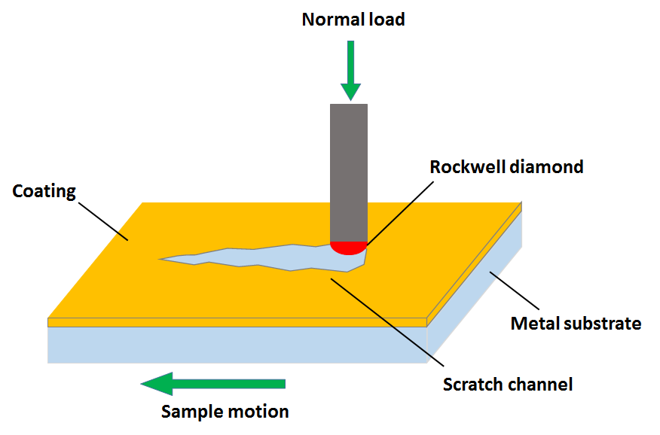
Figure 4-5 Schematic diagram of scratch test

4.8 Electrochemical corrosion evaluation
Although the PEO coating can significantly enhance the corrosion resistance of Mg as discussed in Chapter 3, the microstructural defects (micro-pores and -cracks) still limit its corrosion protection ability, especially in some aggressive environments. To achieve the main objective of this study, electrochemical corrosion tests were employed as a widely used method to investigate the corrosion process of coatings. In general, the corrosion of metals involves oxidation and reduction reactions, with electrons released by metal (anodic reaction) and obtained by corrosive species (cathodic reaction). As a result, an electric current is generated during the corrosion process, which can be measured and controlled by electronic equipment. Therefore, the electrochemical methods could be applied to evaluate the corrosion performance of metals in contact with solutions. In this work, the corrosion behaviour of PEO coatings was investigated by a sequence of electrochemical tests including monitoring the evolution of open circuit potential (OCP) as a function of time, followed by electrochemical impedance spectroscopy (EIS) and potentiodynamic polarisation (PDP) tests.

4.8.1 Open circuit potential
The open circuit potential is the potential of the working electrode measured against the reference electrode when no potential or current is being applied to the cell. Basically, the metal with a lower OCP has a higher corrosion rate in the electrolyte compared with the metal having a higher OCP. The OCP measurement is very critical in the present work, since it not only reflects the trend of free corrosion process but also provides the baseline for the following EIS and PDP tests. However, only OCP cannot provide sufficient information about the corrosion kinetics of the sample under investigation. Because of this, EIS and PDP tests were employed in this work, which can give more insights into the corrosion properties, such as corrosion rate and polarisation resistance, of the studied materials and coatings.

4.8.2 Electrochemical impedance spectroscopy
Electrochemical impedance spectroscopy has been widely used as a characterization method for various materials and coatings in applications, such as corrosion, batteries, and fuel cells. It is a fast and powerful tool which is capable of evaluating the ability of coating to resist deterioration when exposed to corrosive media. The principles of EIS are based on the concept of impedance which unlike resistance is a more general quantity which can help understanding the complex behaviour of electrochemical systems. During the EIS measurement, a small amplitude external AC potential in a certain range of frequencies is applied to the electrochemical system (cell) and the current response is then measured simultaneously. The variation of electrochemical impedance as a function of the perturbation frequency can reveal the internal kinetic processes during corrosion.

To interpret the impedance spectra collected in the electrochemical tests, the equivalent circuit (EC) comprising basic lump elements, like resistors, capacitors and inductors, are assumed to model the impedance behaviour. The introduction of EC modelling of electrochemical impedance provides an insight to the internal structure and properties of PEO coatings. In addition to lump elements of ECs, some special elements like Warburg diffusion and Constant Phase Element (CPE) could be applied to the EC modelling to deal with more complex electrochemical behaviour. In this work, the fitting of EC data with appropriate equivalent circuits was carried out using a commercial software (ZView, Scribner Associates), then the values of each element were estimated. To further understand the corrosion behaviour of the electrochemical system, specific physical meanings of these elements are discussed. The details of data fitting and associated discussions of the physical meanings of EC components are provided in related chapters.

4.8.3 Potentiodynamic polarisation
As an electrochemical method, potentiodynamic polarisation can provide considerable information on electrochemical processes in the studied corroding system. By using this technique, underlying kinetic and thermodynamic information may be acquired through the polarisation curve analysis, such as corrosion rate, susceptibility to corrosion and passivity of the metal electrode. Generally, the potentiodynamic polarisation scan involves the anodic and cathodic branches, which is achieved by applying the external driving force (i.e. potential) to the working electrode and recording corresponding changes in the reaction rate (i.e. current). To interpret polarisation curves obtained in the measurement, the Tafel extrapolation method was applied in the present work. The principle underlying the Tafel extrapolation method is illustrated in Figure 4-6.

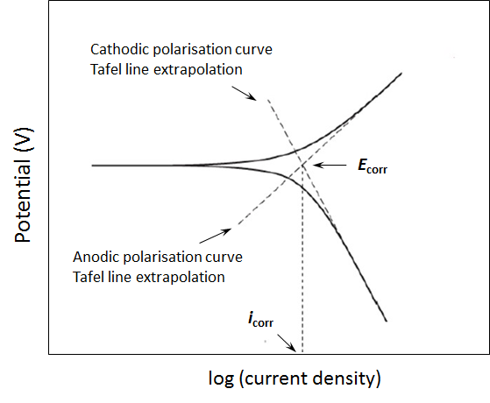
Figure 4-6 Schematic illustration of the Tafel extrapolation method for analysing potentiodynamic polarisation curves

If the corrosion processes are dominated by charge transfer across the metal-electrolyte interface, the polarisation curves demonstrate linear behaviour in the semi-logarithmic coordinate system and the current density can be determined from the Tafel equation:

$η=β log\frac{i}{i_{0}}$ 4.2

Where η is the overpotential, β is the Tafel coefficient, i and i₀ are the current density at the given potential and exchange current density (the rate of corresponding reaction) at the equilibrium potential, respectively. As a result, the corrosion current density (i_{corr}) and the corrosion potential (E_{corr}) can be derived by the extrapolating back from Tafel regions on both anodic and cathodic branches to the intersection (as illustrated in Figure 4-6). By analysing the E_{corr} and i_{corr} of the electrochemical system, the corrosion resistance of the working electrode is eventually obtained. In addition, the anodic polarisation curve behaviour can also indicate essential information or corrosion behaviour on the working electrode, such as passivation and pitting corrosion.

4.8.4 Experimental procedures of electrochemical tests
To perform the electrochemical measurements, a Solartron 1286 electrochemical interface coupled with a Solartron 1250 gain phase analyser were applied in the present work. The measurements were carried out at ambient temperature in a three-electrode cell comprising a reference electrode, a platinum counter-electrode and the tested sample as the working electrode. Figure 4-7 schematically illustrates the three-electrode cell used in this work. The reference electrode in a three-electrode cell was used to facilitate accurate measurement of the potential applied to the working electrode. Both Ag/AgCl (Sat. KCl) and saturated calomel electrode (SCE) reference electrodes have been utilised in the measurements. The electrolyte used in the electrochemical tests was a 3.5 wt.% NaCl aqueous solution prepared by adding NaCl to distilled water. There were two sizes of sample surface area (0.42 and 0.74 cm²) exposed to the solution, which depends on the different cells used in the measurements. Prior to electrochemical measurements, the studied samples were ultrasonically cleaned in appropriate solvent, rinsed in distilled water and dried in air, and all the electrodes were put in suitable positions, as shown in Figure 4-7.
During the measurements, the open circuit potential (OCP) behaviour was firstly recorded to make sure the electrochemical system achieved a steady state before performing the following EIS and PDP tests. Basically, the OCP variation of the electrochemical system less than 10 mV in 10 min period is assumed to be stable. Then, after the OCP measurement, the EIS tests were carried out in the frequency range of 10⁻¹ to 10⁵ Hz with AC perturbation amplitude of 10 mV around the final potential value of preceding OCP measurement. To investigate underlying corrosion kinetics of the electrochemical system, EIS measurements were sometimes needed to repeat several times with different time intervals, which depend on the specific corrosion performance.

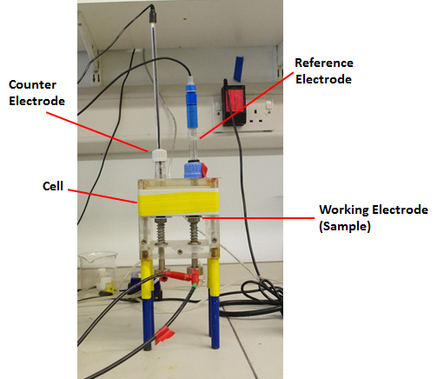
Figure 4-7 Schematic illustration of the three-electrode cell applied in this work

Finally, the potentiodynamic polarisation (PDP) scans were performed since they would cause irreversible damage to the surface of studied samples, and the state of sample surface would also be significantly changed after the PDP tests. In the present study, the potential for PDP measurement was swept from -0.3 to 1 V vs. OCP at a scanning rate of 1.67 mV/s. After the electrochemical measurements, selected samples were examined by SEM with the objective of verifying hypotheses derived from results of OCP, EIS and PDP tests. The sample preparation procedure for SEM was the same as discussed in section 4.7.2.

4.9 Summary
This chapter briefly introduced the experimental methods used in this work and their basic principles. The application of these methods enables the comprehensive understanding of the properties of PEO coatings investigated in the present work to be achieved. It also provides an effective means to fulfil the objectives mentioned in Chapter 1. Detailed information on the application of these methods is provided and discussed in the following part (Chapter 5-8), as specific experimental parameters and analytical procedures may vary depending on specific conditions, such as different substrate materials, post-treatments and PEO coating properties.

Chapter 5 Effect of Electrical Regime of Plasma Electrolytic Oxidation on Coatings produced on cp-Mg in Silicate-Fluoride Electrolyte
As discussed in Chapter 3, the electrical parameters are critical factors for the PEO process, since they can significantly affect the coating characteristics such as surface morphology, discharging activities, coating thickness and phase composition, as well as corrosion resistance properties. The influence of electrical parameters on PEO coatings varies with specific conditions, including substrate materials and electrolyte used in the PEO treatment. As a result, it is necessary to investigate and optimise these electrical parameters to produce desired PEO coatings before carrying out the following post-treatments. In this chapter, two types of electrical regimes (pulsed bipolar (PBP) potentiostatic and pulsed unipolar (PUP) galvanostatic modes) are applied to produce PEO coatings on cp-Mg in an alkaline silicate-fluoride electrolyte. The characterisation of the PEO coatings, including coating morphology, thickness, elemental and phase composition, is performed by the methods discussed in Chapter 4. The corrosion resistance properties of the PEO coatings are also evaluated by the electrochemical techniques. Finally, comparison of the PEO coatings produced by different electrical parameters is made to select appropriate PEO coatings for different post-treatments in the following chapters.

5.1 PEO coating preparation
Disc samples of cp-Mg were made according to the procedures discussed in Chapter 4. The composition, concentration and preparation procedure of the alkaline silicate-fluoride electrolyte applied in the present work are also provided in Chapter 4. In addition, the application of fluoride in the electrolyte is believed to promote formation of the inner barrier layer in the PEO coatings，which can improve the corrosion resistance of the PEO coated samples as discussed Chapter 4. The PEO coatings were produced on cp-Mg by both pulsed bipolar potentiostatic and pulsed unipolar galvanostatic modes, with the objective of studying the influence of electrical regimes and parameters on the coating properties. According to the difference in electrical regimes, PEO coatings were divided into two groups (group A and B). The details of groups and electrical parameters used in this work are shown in Table 5-1. After the PEO treatment, all samples were rinsed in distilled water and dried in air. It has to be noted that there is only one electrical parameter variable in the experiment with other parameters fixed as a constant in the PEO treatments for different groups. Moreover, the fixed electrical parameters (e.g. current density and duty cycle) were optimised and selected by the preliminary experiments before carrying out the final PEO treatments.

Table 5-1 Electrical parameters and substrate materials applied in the PEO treatment
 | Electrical parameters | A1 | A2 | A3 | B1 | B2 | B3
 | U⁺ (V) | 350 | 400 | 450 | - | - | -
 | U⁻ (V) | -30 |  |  | - | - | -
 | Current density (mA/cm²) | - | - | - | 40
 | Frequency (Hz) | 5000 |  |  | 100 | 500 | 1000
 | Duty cycle (%) | 40 |  |  | 10
 | Treatment time (min) | 10 |  |  | 10

5.2 Characteristics of PEO process
Figure 5-1 illustrates the current and voltage transients of the PEO treatments carried out on cp-Mg in the silicate-fluoride electrolyte using different electrical regimes and parameters. Generally, analysis of the current and voltage evolution as a function of PEO treatment time is thought to be a useful means to study the characteristics and mechanisms of coating formation.

Figure 5-1a shows the current-time response of the PEO treatment on cp-Mg in PBP potentiostatic mode (group A) for 10 min. The positive voltage (U⁺) used in the treatment ranges from 350 to 450 V, with a fixed negative voltage (U⁻) set up at -30 V as shown in Table 5-1. Similar to other work [91], several stages can be observed in the whole process depending on the characteristics of current changes. Despite the difference in positive voltage, the current transient evolution during the PEO process for all three samples shows similar trend. At the beginning of the treatment, the positive current transients grow rapidly to the highest value, indicating fast dissolution of the Mg substrate taking place immediately after the polarisation was applied. It can be found that the higher U⁺ applied in the PEO treatment, the higher peak current value is observed during this period. After that all the current transients reduce quickly in the second stage, which could be explained by the formation of an oxidised film on the surface of the cp-Mg substrate. Then the current reduction reaches a slow period. During this period, many fine sparks can be seen on the surface because of the dielectric breakdown of the passive film. As suggested by Snizhko et al. [91], the fast decrease of the dissolution rate should be controlled by the diffusion of dissolved products. It has been reported that discharge characteristics and breakdown voltage are dependent on the electrolyte system and the electrical parameters, which means the performance of the PEO process varies in different conditions [85, 106, 146, 147]. Moreover, an intense gas evolution also appears during this period, comprising predominantly oxygen and minor amounts of hydrogen, as reported in [90, 99]. As the treatment time increase, the oxide film keeps growing and the discharge size becomes larger, in the meantime the discharge density decreases significantly compared with that at the previous stages. In this stage, the current decreases much slower compared to the rapid decrease in the previous stage and the discharges appear orange in colour and have a longer lifetime. The linear behaviour of the current-time response in this stage could be explained by the fact that the diffusion of Mg²⁺ ions through the oxide film limits the dissolution process [91]. It has to be noted that the sample with higher U⁺ always shows higher positive current during the PEO process, suggesting more vigorous electrochemical reactions and more intensive discharging activities taking place on the surface of Mg substrate.

As shown in Figure 5-1b, voltage transients during PEO processes carried out in a PUP galvanostatic mode are similar to those reported previously [117, 151]. According to them, the PEO processes can be characterized in three different stages. In the first stage (I), the voltage increases rapidly when the PEO treatment was started, and some tiny gas bubbles could be observed on the surface of the working electrode. This suggests a rapid passivation process occurring on the sample surface. Moreover, it has been recognised that the voltage increase rate is proportional to the coating growth rate, which indicates the high rate of coating growth in this period. In the second stage (II), the voltage still increased, but at a lower rate compared with that at the first stage. Herein, the voltage exceeds the breakdown voltage and a large number of fine white sparks could be observed on the sample surface, together with a more intensive gas evolution and a shrill sound. When the PEO treatment reached the third stage (III), the fine white sparks turned into large orange discharges, and their number decreased with processing time. In this stage, the voltage increased significantly slower, keeping at around 450 - 500 V with only small variations, depending on the different frequencies applied during the PEO process. It has to be noted that a higher final voltage was observed when the applied frequencies increased from 100 to 1000 Hz, which means a thicker coating is expected for the PEO coatings produced at higher frequencies. In addition, the discharging activities at the end of the PEO treatment under the galvanostatic mode is more intensive than that under the potentiostatic mode, which suggests the PBP voltage control regime is a more gentle way of fabricating PEO coatings than the PUP process with current control.

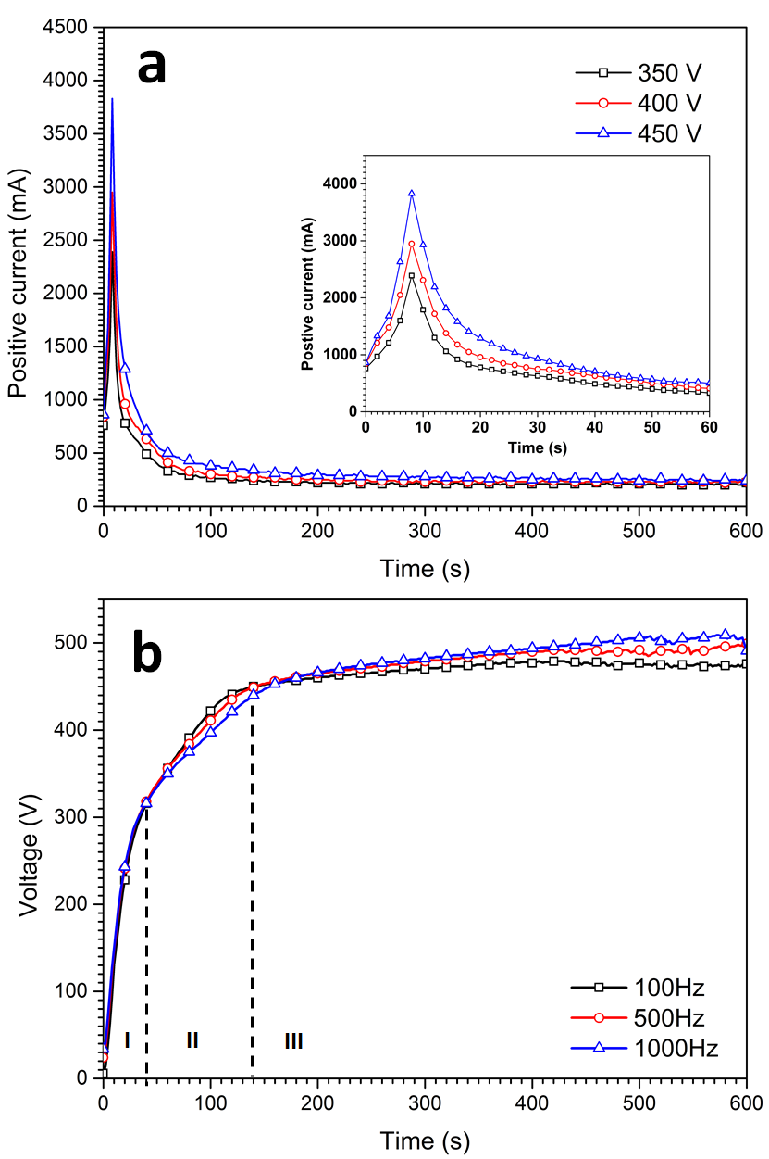
Figure 5-1 Current and voltage transients of the PEO processes on cp-Mg: (a) group A and (b) group B

5.3 Coating morphologies
Figure 5-2 shows the SEM surface morphologies (a, b and c) and corresponding cross-sectional features (d, e, and f) of the PEO coatings on cp-Mg produced by PBP potentiostatic PEO process at different positive voltages ranging from 350 to 450 V. It can be observed that the PEO coatings at all positive voltages have a typical porous surface morphology with a large number of micropores distributing on the coating surface or inside the coating matrix, which could be due to the combined effects of gas liberation and discharging activity accompanying coating growth as discussed in Chapter 3. The diameter of these micropores on the coating surface can range from less than 1 µm up to more than 10 µm. The average pore size in the PEO coatings increases and the surface morphology changes from a fine to a more coarse structure when the applied positive voltage increases from 350 to 450 V. Generally, the higher the applied voltage the higher current density is passed through the PEO coating, leading to a more intensive discharging activity and an enlarged pore size. It can be found that some finer pores are even covered by large pores in the PEO coating produced at 450 V (Figure 5-1c), which indicates more molten oxides ejected from the coating by the strong discharging activity is solidified around the discharge channel when contacted with the cool electrolyte on the coating surface. Additionally, relatively high temperatures in discharge channels cause significant temperature differences across the coating/electrolyte interface. As a result, rapid cooling rates of PEO coating accompanied with local thermal stress are developed, which could possibly induce the formation of microcracks on the surface during the PEO process.

To further investigate the microstructure of the PEO coatings, cross-sectional morphologies were also studied. The SEM images in Figure 5-2 (d, e and f) reveal that the cross-sectional features of PEO coatings can be described as a combination of an inner dense region with an outer porous region. Basically, the boundary between the inner dense and outer porous regions can be clearly observed. PEO coatings usually have a relatively good adhesion to the substrate as they grow up from it, and this is confirmed by the cross-sectional SEM images shown in in Figure 5-2 (d, e and f). It has to be noted that some micropores can also be found inside the bulk of PEO coatings and the size of these micropores also tends to increase with the increasing applied positive voltage, which is consistent with changes observed in the surface morphology.

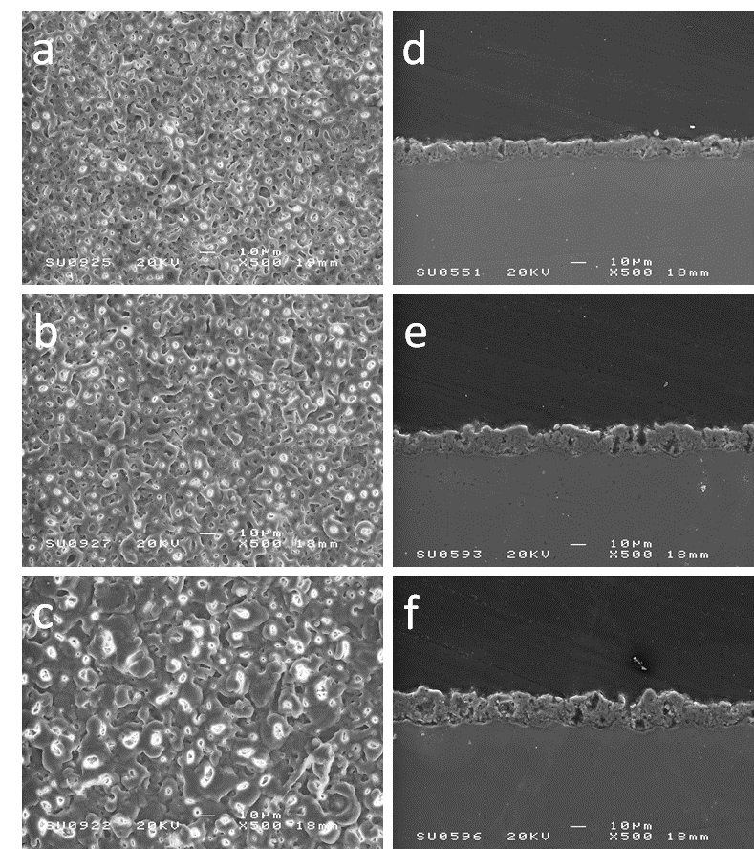
Figure 5-2 SEM surface morphologies of the PEO coatings produced on cp-Mg at different positive voltages (PBP): (a) 350 V, (b) 400 V and (c) 450 V, and the corresponding cross-sectional morphologies: (d) 350 V, (e) 400 V and (f) 450 V

The morphologies of the PEO coatings on cp-Mg produced by PUP mode at 40mA/cm² with different frequencies ranging from 100 to 1000 Hz are illustrated in Figure 5-3. In general, PEO coatings produced by PUP galvanostatic process similar porous morphologies but a more coarse microstructure (larger micropores and more cracks) compared with those produced by PBP potentiostatic mode, indicating the stronger energy injection taking place during the coating formation process. It can be found that there are still numerous fine micropores observed on the surface of PEO coating produced at 100 Hz. However, with the applied frequency increasing to higher values, these fine micropores are gradually overlapped with larger ones and covered by the molten oxide caused by the intensive discharging activities as discussed previously. This phenomenon could be explained by the stronger current flowing through the PEO coating at higher frequencies as presented in Figure 5-1b, which induces a more powerful discharge.

The cross-sectional features of the PEO coatings produced under PUP galvanostatic mode (Figure 5-3d, e and f) also present a more coarse microstructure, as the micropores and discharge channels are more obvious and larger than those produced under the PBP potentiostatic mode. Notably, some micropores and discharge channels even connect the surface to the inner barrier region of PEO coatings. In addition, the inner barrier layer of the PEO coatings produced under the PUP galvanostatic mode is not as obvious as those produced under the PBP potentiostatic PEO regime. This could be due to the changes in mass/charge transfer mechanisms of the PEO treatment (PBP) caused by the introduction of the negative bias [152].

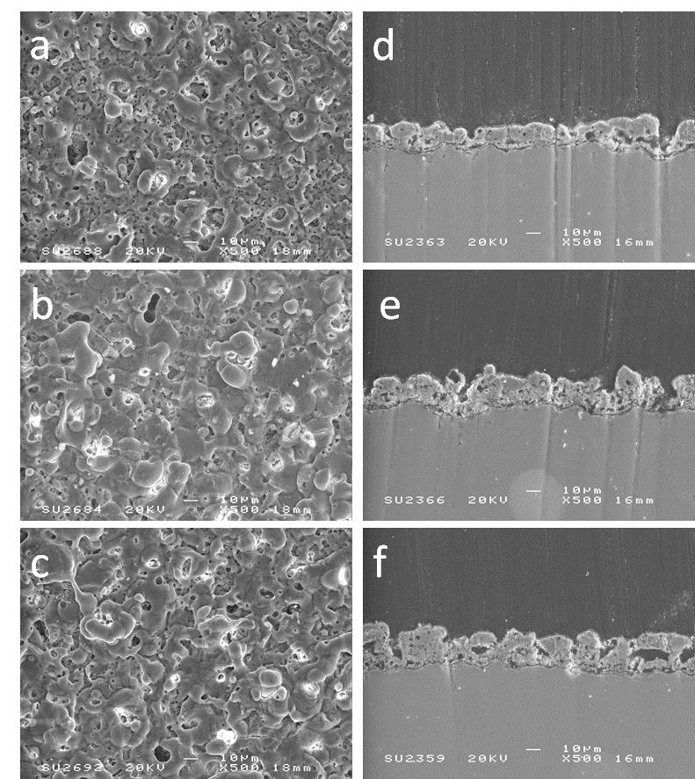
Figure 5-3 SEM surface morphologies of PEO coatings produced on cp-Mg (PUP) at different frequencies: (a) 100 Hz, (b) 500 Hz and (c) 1000 Hz and corresponding cross-sectional morphologies: (d) 100 Hz, (e) 500 Hz and (f) 1000 Hz

The variation of coating thickness with different electrical regimes and parameters is presented in Figure 5-4. In general, no matter what electrical regimes were used in the PEO treatment, the coating thickness shows an upward trend when the applied positive voltage and frequency increase to a higher value. In particular, the voltage has a more significant influence on promoting coating growth rate compared to frequency, since the thickness of the PEO coating on cp-Mg obtained at 450 V (25.7 µm) is almost two times higher than that produced at 350 V (13.4 µm), and the highest increase in coating thickness in the other group is only 42% (Group B). Moreover, the average thickness of PEO coatings produces by the PUP galvanostatic PEO process is higher than that produced by the PBP potentiostatic PEO treatment. It has to be stressed that the PEO coatings on cp-Mg produced by the process with current control present the higher coating roughness compared with the PEO coatings from group A, as suggested by the higher thickness deviation (Figure 5-4b). This could be attributed to the defects (e.g. peeled off regions) existed in the PEO coatings, which is probably caused by the thermal stress created during the PEO treatment.

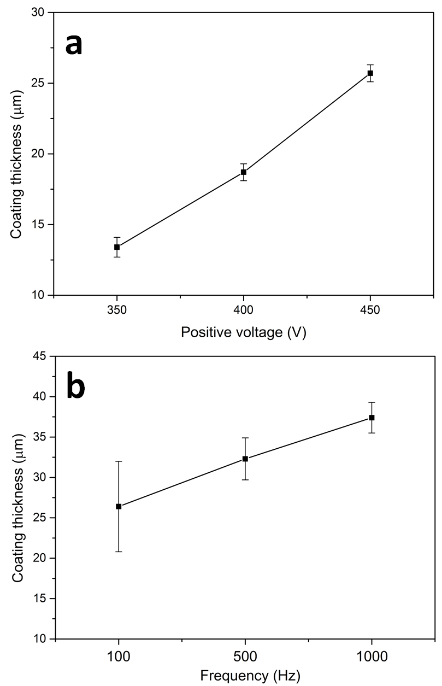
Figure 5-4 Thickness of the PEO coatings produced on cp-Mg by different electrical regimes and parameters: (a) PBP, (b) PUP

5.4 Coating chemical and phase compositions
Typical EDX spectra of the studied PEO coatings are presented in Figure 5-5, with corresponding relative contents of chemical elements detected being provided in corresponding inset tables. All elements existing in the electrolyte can be found in the PEO coatings, indicating all the ingredients of electrolyte have incorporated into the coating by electrochemical reactions. Regardless of the different electrical regimes and parameters utilised during the PEO treatments, the relative contents of elements in PEO coatings on cp-Mg are similar with only small variations. Additionally, the PEO coatings fabricated by the PUP galvanostatic PEO process contain more O compared with that produced from the PBP potentiostatic mode.

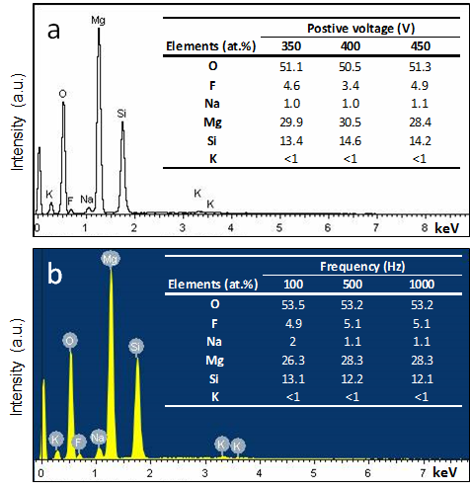
Figure 5-5 EDX spectra and relative contents of elements on the surfaces of the PEO coatings produced on cp-Mg by different electrical regimes (a) (PBP) and (b) (PUP)
The XRD patterns of PEO coatings produced on cp-Mg under different conditions are presented in Figure 5-6. Strong peaks relating to Mg can be seen from all the PEO coatings, which should be attributed to the reflected X-ray from the Mg substrate. It can also be observed that the PEO coatings on cp-Mg are mainly composed of Mg₂SiO₄ and MgO. It needs to be stressed that, for the PEO coatings produced under the potentiostatic mode on cp-Mg (Figure 5-6a), Mg₂SiO₄ can only be obviously observed when the applied positive voltage was 450 V. However, the peaks representing Mg₂SiO₄ are present in coatings formed at all parameters and stronger in those produced under the galvanostatic mode (Figure 5-6b), indicating a higher content of Mg₂SiO₄. According to [152], high temperature can facilitate the formation of Mg₂SiO₄, which suggests the energy injection in the PEO coatings produced by the galvanostatic mode is higher than that in the coatings produced by the potentiostatic mode. These results are consistent with the SEM observations discussed in section 5.3. It also has to be noted that no fluorine containing phase can be observed in the XRD patterns, which indicates that it might be incorporated in the PEO coatings as an amorphous structure. The elemental and phase composition of the PEO coatings are only briefly introduced in this chapter, more details will be discussed when the PEO coatings produced by a specific condition were selected for the post-treatments in the following chapters.

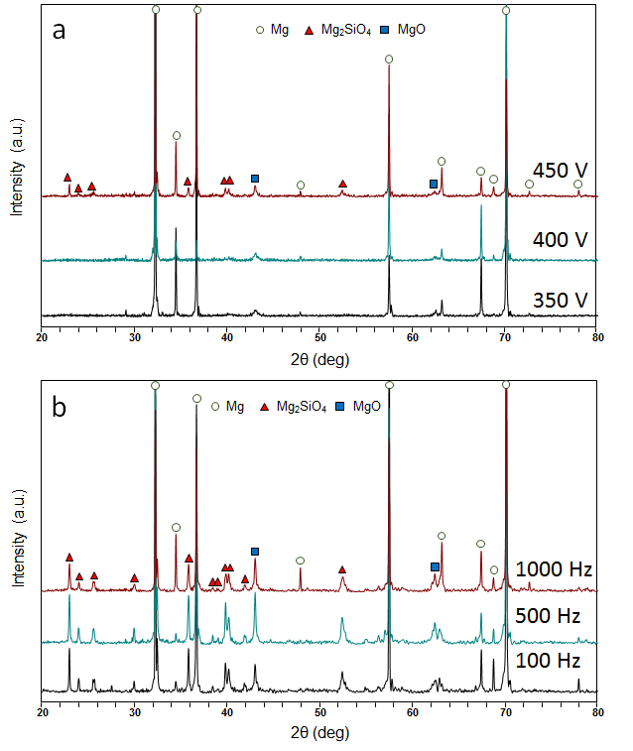
Figure 5-6 XRD patterns of PEO coatings produced on (a) cp-Mg (PBP) and (b) cp-Mg (PUP)

5.5 Electrochemical corrosion evaluation

5.5.1 Electrochemical impedance spectroscopy
Before carrying out the electrochemical tests, the electrical system needs to be stabilised for a certain time when the variation of open circuit potential (OCP) reaches a suitable level. Because of this, the electrochemical impedance spectroscopy (EIS) of the studied PEO samples was performed after 4 hours immersion in a 3.5 wt.% NaCl aqueous solution, when the stable state of OCP was achieved. The impedance plots of the PEO coatings produced on cp-Mg under the PBP potentiostatic mode at different positive voltages are illustrated in Figure 5-7. It can be observed that all the PEO coatings exhibit two resistive-capacitive (RC) loops in the whole frequency range, suggesting two different kinetic processes taking place during the electrochemical measurements. It is believed that the RC loops occurred at high and low frequencies represent the corrosion behaviour of outer porous and inner dense regions of the PEO coatings. Generally, the diameter of the loop is directly proportional to the corrosion resistance of PEO coating. The PEO coating yielding a spectrum with a higher diameter of RC loop is expected to have significantly better corrosion protection ability, and usually presents a lower corrosion current density in the following polarisation test. As shown in the complex plots (Figure 5-7a and c), the diameter of the RC loop increases dramatically when the applied positive voltage increased from 350 V to 400 V. Then it decreases as the positive voltage kept increasing to the highest value of 450 V. This indicates the corrosion resistance of PEO coating can be enhanced by increasing the applied positive voltage. However, a negative influence would occur when the positive voltage exceeds threshold value between 400 and 450 V.

The low-frequency impedance magnitude (|Z|_{f→0}) in the EIS Bode plots (Figure 5-7b) can also be applied to estimate the corrosion protection ability of PEO coatings. With the same order in the size of RC loop, the highest impedance magnitude is possessed by the PEO coating produced at 400 V (U⁺), which suggests the best corrosion protection performance, and the PEO coating obtained from 350 V (U⁺) has the worst corrosion resistance with the lowest |Z|_{f→0.} This result is consistent with the impedance values in the complex plots. The Bode plots also clearly present two time constants for each PEO coating, which is presented by the peaks appearing at high (10⁴ – 10⁵) and medium to low frequency (10¹ – 10²) ranges in the phase angle Bode plots. Therefore, two RC loops are expected to be present in the equivalent circuit (EC) modelling. The EC applied to fit the EIS data of PEO coatings produced on cp-Mg under PBP mode is illustrated in Figure 5-7d, where R_{s} is applied to present the electrolyte resistance between the working and counter electrodes; R_{c} and R_{ct} are used to represent the resistance of the pores filled with NaCl solution and the charge transfer resistance, respectively; CPE_{c} refers to the non-ideal capacitive behaviour of the PEO coatings, and CPE_{dl} corresponds to the imperfect capacitance of the double layer at the metal-oxide interface.

Moreover, the PEO coatings produced on cp-Mg under the PUP galvanostatic mode at different frequencies also present two RC loops as shown in the complex plots (Figure 5-8a). However, the average diameter of capacitive RC of these coatings are significantly smaller than that of PEO coatings produced by PBP mode, which suggests the inferior corrosion resistance. In addition, the influence of frequency on corrosion resistance of PEO coatings is similar to that of voltage as discussed above. Specifically, according to the RC loop, size and |Z|_{f→0} value, the corrosion resistance of PEO coating (PUP) increases to the highest level when the applied frequency increased from 100 to 500 Hz. Then a slightly decreased corrosion resistance is developed when the frequency increased to the highest value of 1000 Hz. Since the EIS shape of PEO coatings (PUP) in complex and Bode plots are similar to that of PEO coatings (PBP), with two time constants being identified, the EC illustrated in Figure 5-7d was also used to carry out the EIS data fitting for PEO coatings (PUP), which is practically identical to that used for PEO coatings (PBP). Each EC element has the same physical meaning as described previously. The results of EIS data fitting of the studied PEO coatings through the ECs shown in Figure 5-7d are summarised in Table 5-2. Based on the physical meanings of EC elements and EIS fitting results, it can be concluded that the PEO coating produced at 400 V exhibits better corrosion resistance in both outer porous and inner dense regions than the other PEO coatings in group A, as indicated by the highest R_{c} and R_{ct} values. The similar condition can also be found on the PEO coating produced at 500 Hz in group B, which shows the highest values of R_{c} and R_{ct} compared with the PEO coatings obtained at other two frequencies. It has to be noted that the overall R_{ct} values of the PEO coatings produced under PBP mode are higher than that of PEO coatings obtained by PUP mode, indicating a superior corrosion resistance of the inner dense region of coatings produced by PBP mode. This result is in a good agreement with the SEM observations of the PEO coatings, as a more obvious and compact inner dense region can be observed from the PEO coatings produced under PBP mode.

Figure 5-7 EIS diagrams of the PEO coatings on cp-Mg (PBP) produced at different positive voltages: (a and c) complex plots, (b) Bode plots and (d) equivalent circuit used to fit. Fitting results are represented by solid lines in the figure

Figure 5-8 EIS diagrams of the PEO coatings on cp-Mg (PUP) produced at different frequencies: (a) complex plots and (b) Bode plots

Table 5-2 EIS data fitting results of the PEO coatings
Sample ID | R_{c}  [Ω⋅cm²] | CPE_{c}-T  [Fs^{n-1}cm⁻²] | CPE_{c}-P | R_{ct}  [Ω⋅cm²] | CPE_{dl}-T  [Fs^{n-1}cm⁻²] | CPE_{dl}-P
A1 | 9.70×10² | 1.51×10⁻⁷ | 0.81 | 4.06×10³ | 5.68×10⁻⁶ | 0.85
A2 | 7.76×10⁴ | 8.30×10⁻⁸ | 0.84 | 7.40×10⁵ | 5.84×10⁻⁸ | 0.86
A3 | 6.96×10³ | 1.16×10⁻⁷ | 0.82 | 1.30×10⁵ | 9.60×10⁻⁷ | 0.91
B1 | 5.38×10² | 3.48×10⁻⁶ | 0.59 | 2.67×10³ | 4.68×10⁻⁶ | 0.95
B2 | 3.81×10³ | 9.97×10⁻⁷ | 0.72 | 3.42×10³ | 1.27×10⁻⁶ | 0.98
B3 | 3.31×10³ | 9.16×10⁻⁷ | 0.75 | 2.82×10³ | 1.56×10⁻⁶ | 0.99

5.5.2 Potentiodynamic polarisation evaluation
After the EIS mesuarements, potentiodynamic polarisation (PDP) tests of the coated samples and cp-Mg were carried out in a 3.5 wt.% NaCl solution. The polarisation curves of the PEO coatings produced under different electrical regimes and parameters, as well as the corrosion behaviour of cp-Mg, are presented in Figure 5-9. By comparing the corrosion potential (E_{corr}) and corrosion current density (I_{corr}) of the PEO coatings obtained under different conditions, the driving force and kenitics of the corrosion process can be revealed. The corresponding valus of I_{corr} of the PEO coatings presenting idealised Tafel behaviour for both anodic and cathodic branches were derived by the Tafel extrapolation method. For the coatings with only partial Tafel behaviour (e.g. cathodic branch) can be observed, the I_{corr} was estimated by analysing the cathodic portion of polarisation curve through the Tafel extrapolation method. The fitting results for the studied polarisation curves are presented in Table 5-3.

According to the polarisation curves shown in Figure 5-9a, the PEO coatings produced by PBP mode significantly depress the corrosion process of the metal substrate, as the polarisation curves for the coated samples moved to the region with higher E_{corr} and lower I_{corr} compared with that of cp-Mg. In particular, the PEO coating produced at the positive voltage of 400 V shows the lowest cathodic and anodic corrosion rates in the coated samples, as indicated by the shift of the polarisation curve to the low current region compared with other PEO coatings, and this is comfired by the smallest I_{corr} (6.0×10⁻³) presented in Table 5-3. The PEO coatings produced at 350 and 450 V have relatively higher I_{corr} compared with that of the coating produced at 400 V, indicating a inferior corrosion protection. It needs to be noted that the trend of I_{corr} evolution is similar to that of EIS results, which means the EIS and PDP measurements are in good agreement.

The polarisation curves of coatings produced by the PUP galvanostatic PEO process at different frequencies are illustrated in Figure 5-9b. It can be observed that these coatings produced by the PUP mode can also effectively improve the corrosion resistance of cp-Mg by decreasing the rate of partial cathodic and anodic reactions. The PEO coatings fabricated at 500 and 1000 Hz have nearly the same corrosion behaviour and can provide better corrosion protection for cp-Mg than the coating produced at 100 Hz. It has to be stressed that the enhancements in corrosion resistance of the PEO coatings produced by the PUP mode are not comparable with those produced by the PBP mode, as reflected by the higher average values of I_{corr.} It also can be found that the voltage applied during the PEO treatmnet is a more effective parameter of improving the coating corrosion resistance than frequency.

Additionally, from the thermodynamic point of view, the PEO coatings with a higher E_{corr} are more likely to have superior corrosion protection for the substrate. However, this is not always the case as illustrated by the polarisation curves in Figure 5-9. In fact, the corrosion of Mg is complicated as discussed in Chapter 2, with various factors could play a role in the corrosion process and affect the final results. As a result, the corrosion evaluation of PEO coated Mg or Mg alloy should be carefully considered comprehensively comparing the EIS and PDP results, as well as the SEM morphologies before and/or after the corrosion tests if necessary.

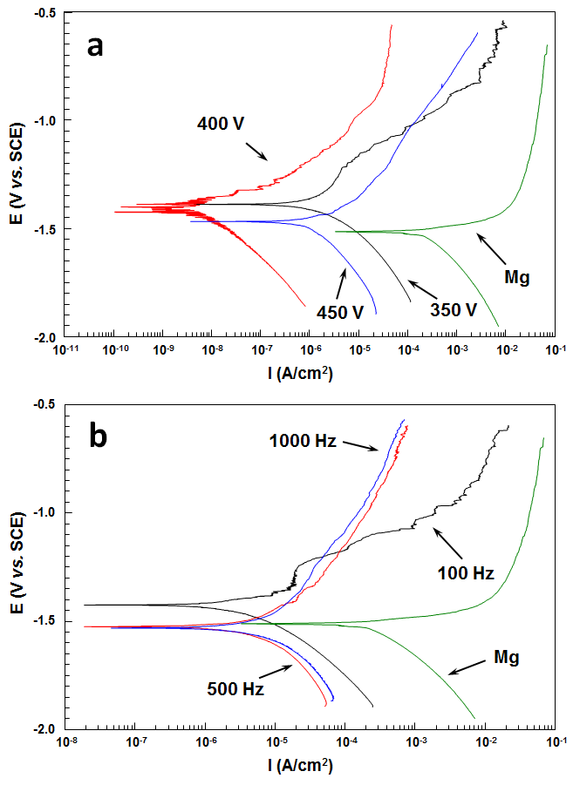
Figure 5-9 Potentiodynamic polarisation curves of PEO coatings on cp-Mg produced by different electrical regimes: (a) PBP and (b) PUP

Table 5-3 Potentiodynamic polarisation fitting results of the PEO coatings
Sample ID | A1_{c} | A2 | A3 | B1 | B2 | B3 | cp-Mg
E_{corr} (V vs. SCE) | -1.39 | -1.40 | -1.47 | -1.42 | -1.52 | -1.53 | -1.52
I_{corr} (µA cm⁻²) | 4.8 | 6.0×10⁻³ | 1.3 | 9.3 | 7.7 | 8.7 | 200

5.6 Discussion of the factors influencing corrosion performance of PEO coating
Considering the similar elemental and phase composition of the PEO coatings produced on cp-Mg by different electrical regimes and parameters, the variation of the corrosion resistance of the PEO coated samples are mainly due to the difference in coating thickness and microstructure. It is believed that a higher coating thickness usually means a better corrosion resistance, and this is confirmed by the PEO coatings produced under some conditions (e.g. from 350 to 400 V and 100 Hz to 500 Hz). But, when the coating thickness exceeds a certain value, the defects (enlarged micropores and cracks) in the coating become more pronounced and play a critical role in the corrosion process. As a result, a decreased corrosion resistance of the PEO coatings occurred when the coating thickness increased by increasing the applied voltage and frequency to the highest value of 450 V and 1000 Hz, respectively. Moreover, with a lower coating thickness, the PEO coating produced at 400 V (PBP) presents a much better corrosion resistance than the PEO coating produced by PUP mode. This suggests that the compact microstructure and inner dense region can also make significant contribution to the corrosion behaviour, which is in good agreement with the studies reported previously [151].

5.7 Summary
Plasma electrolytic oxidation coatings on cp-Mg were produced by pulsed unipolar and bipolar modes with different current and voltage control regimes applied during the treatments. After investigating the coating properties through various techniques, the following conclusions can be made:

- By controlling the energy release, the electrical regimes and parameters can significantly influence the properties of the PEO coatings through changing the coating thickness and microstructure. PEO coatings produced by PBP mode present more compact structure compared with those produced by PUP, which is possibly attributed to the changes induced by the application of the negative bias. Moreover, the coating thickness can be improved by increasing the applied voltage and frequency, but detrimental effects could occur when the values exceeds the limit.
- The PEO coatings produced in silicate electrolyte consist of Mg₂SiO₄ and MgO as the main phases. The high temperature in the discharging channel can help with the formation of crystallite Mg₂SiO₄ during the PEO treatment.
- In general, the PEO coatings produced by the PBP mode provide better corrosion protection than those produced by the PUP mode. Compared with pulse frequency, voltage amplitude is a more effective electrical parameter that can be used to control the corrosion resistance of PEO coatings. The PEO coating fabricated at 400 V by the PBP mode exhibits the best corrosion protection, indicating the corrosion resistance of the PEO coating is not only dominated by the coating thickness, but also can be significantly influenced by the coating microstructure.

In the following chapters, various post-treatment methods and strategies will be applied to the PEO coatings to improve the corrosion protection property. Considering the different characteristics and properties of the post-treatments, different electrical regimes and substrates were chose to produce PEO coatings.

Chapter 6 Investigation of Plasma Electrolytic Oxidation Coatings on cp-Mg with Plasma Enhanced Chemical Vapour Deposition Post-Treatments
As discussed in Chapter 3, there have been numerous reports in the literature about PEO coatings on Mg alloy with duplex treatments [86, 87, 95, 131, 132]. According to these works, the duplex PEO-based coatings can usually exhibit significantly better corrosion protection ability than single PEO coatings, suggesting better application prospects. However, compared with single PEO coatings, the changes caused by the duplex treatments, such as the increased coating thickness, altered surface morphology and coating microstructure cannot be ignored. For example, the coating thickness would be significantly increased after a sol-gel coating is applied to a PEO treated surface [87]. Moreover, the adhesion of duplex PEO and sol-gel coatings could also be of concern.

In Chapter 6, to avoid incurring adverse changes to the surface layer by the post-treatments such as sol-gel, polymers and painting, a newly designed post-treatment for the PEO coating is considered. In particular, a novel duplex coating on a cp-Mg substrate comprising a PEO coating as the base layer and a top layer produced by the plasma enhanced chemical vapour deposition (PECVD) is investigated. According to the SEM and electrochemical test results, the PEO coatings produced by pulsed bipolar potentiostatic mode in alkaline silicate-fluoride electrolyte exhibits superior corrosion resistance due to the more compact microstructure and presence of inner dense region, compared to those produced by pulsed unipolar galvanostatic mode. Meanwhile, the PEO coating produced at U⁺ = 400 V has the best corrosion performance, since it strikes a balance between the coating thickness and compactness, and therefore is chosen as the base layer for development of the PEO-PECVD duplex coatings. The PECVD process was chosen to be carried out using a dielectric barrier discharge at atmospheric pressure which can be used to obtain functional chemical groups, change wettability or barrier properties as reported in [153-158]. In addition, the influence of the PECVD post-treatments using different silicon-based precursors on the structure and properties of PEO coatings is discussed in this Chapter. Correspondingly, the corrosion resistance of the duplex PEO-PECVD coatings is also investigated using electrochemical methods described in Chapter 4.

6.1 PEO coating preparation
The PEO coatings were produced on cp-Mg as the base layer following the procedures described in Chapter 4. Prior to the PEO treatments, silicate-flouride alkaline electrolyte was prepared with the same composition as which used in Chapter 5. The electrolyte was kept below 30 C using a water cooling system during the PEO treatment. Meanwhile, the same pulsed bipolar voltage regime as that applied in Chapter 5 was used to produce PEO coating in this work. Specifically, the frequency (f = 1/(t_{on+}+t_{off+}+t_{on-}+t_{off-})) applied was set at 5000 Hz, with 40 % duty cycle (δ = t_{on}/(t_{on+}+t_{off+}+t_{on-}+t_{off-})×100%) for both positive (400 V) and negative (-30 V) voltages. All samples were treated for 10 min, then rinsed in distilled water and dried in air. The characteristics of the PEO process can be found in the previous chapter and typical electrical waveforms collected during the PEO treatment are illustrated in Figure 6-1.
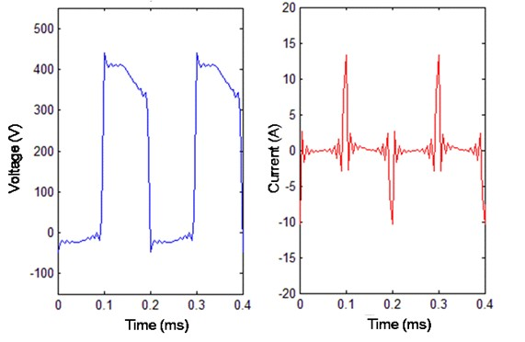
Figure 6-1 Typical electrical waveforms collected during the PEO process

6.2 PECVD coating preparation
The PECVD top layers were produced using the system described in Chapter 4. The processing gas consisted of nitrogen loaded with a silicone bearing precursor via a bubbler system. Tetraethyl orthosilicate (TEOS), hexamethyldisiloxane (HMDSO), and tetramethyl orthosilicate (TMOS) were used as precursors. In the case of TEOS, the gas flow of 10 standard litres per minute (SLPM) was guided completely through the precursor liquid in order to obtain near-saturation vapour pressure of TEOS. For TMOS and HMDSO, only 50 and 40 %, respectively, of the gas was flowing through the precursor, with the remainder being bypassed, as presented Table 6-1.

The speed of the moveable table carrying the substrate was set to 1.0 mm s⁻¹. This resulted in an effective coating time of 30 s. The generator was operated in a continuous wave mode at a frequency of approximately 40 kHz and a power ranging of 100 to 133 W. An overview of the plasma parameters is also provided in Table 6-1. In addition to PEO coated cp-Mg samples, pieces of 150 µm thick polyethylene (PE) foil were treated in order to obtain additional information on the coating process.

Table 6-1 Plasma parameters for the PECVD process at atmospheric pressure
Precursor | N₂ prec.  [SLPM] | N₂ bypass  [SLPM] | Frequency  [kHz] | Power  [W]
TEOS | 10 | 0 | 40 | 133
TMOS | 5 | 5 | 39 | 101
HMDSO | 4 | 6 | 37 | 101

6.3 Characteristics of the PECVD coatings
Consistent with the reported work [158], the thickness of PECVD coatings on the PE foil ranges between 100 nm and 500 nm. The coatings produced with TEOS and TMOS precursors have water contact angles of (64.8 ± 0.9)° and (64.0 ± 1.3)°, respectively, while the HMDSO based coating with a value of (71.8 ± 0.9)° is slightly more hydrophobic. This result is in good agreement with the results from ATR-FTIR analysis shown in Figure 6-2.
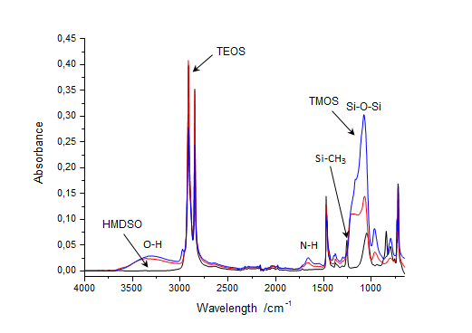
Figure 6-2 ATR-FTIR spectra of coatings produced with different precursors on PE

The TEOS- and TMOS-based coatings show a broad absorption in the range of 3000 - 3600 cm⁻¹, which are assigned to OH groups. The generation of these groups is responsible for the increase in hydrophilicity. Both precursors are sensitive to humidity, so that OH groups can be formed by hydrolysis of ethoxy or methoxy groups during or after the deposition process. Moreover, amines, imines or amides were incorporated in the coating as indicated by a weak absorption at approximately 1700 cm⁻¹. In comparison to these two coatings, the coating based on HMDSO precursor showed prominent absorption peaks in neither the OH nor the NH region but evidence for a high retention of the Si-CH₃ group was found by the presence of a Si-CH₃ peak at 1250 cm⁻¹, indicating a more organic character.

For the HMDSO coating, an O/Si ratio of 1.59 ± 0.02 was determined, using data reported by Schäfer et al. [159] for the ATR-FTIR peak position of the Si-O-Si I bands of SiO_{x} plasma polymers appearing in the range of approximately 1040 cm⁻¹ to 1070 cm⁻¹. Applying this calculation to the TEOS and TMOS coatings, O/Si ratios of 1.91 ± 0.04 and 2.02 ± 0.01 were obtained, respectively.

Moreover a carbon content of about 60 at% was calculated for the HMDSO-derived plasma polymer using an XPS calibration of the ratio R of integrated intensities of ATR-FTIR absorption bands according to equation (6.1):

$R= \frac{I_{Si-CHx}}{I_{Si-O-Si I} + I_{Si-O-Si II} + I_{Si-O-Si III} + I_{Si-CHx}}$ 6.1

6.4 Coating morphologies
The scanning electron microscopy (SEM) images of surface morphologies are shown in Figure 6-3, illustrating the features of single PEO and duplex PEO-PECVD coatings. A typical porous surface morphology with micro-pores ranging from 1 to 7 μm distributed on the PEO coating in a disordered way can be observed in Figure 6-3(a), which could be explained by the gas liberation and discharge events during the PEO treatment. It should be stressed that the edges of pores are quite smooth and no obvious cracks can be found in the PEO coating, indicating good protection properties. However, compared with the single PEO coating, duplex coatings produced sequentially by PEO and PECVD post-treatment using different precursors exhibited quite different features of surface morphology as shown in Figure 6-3(b, c, and d). The surface morphology of PEO coating did not change significantly after the PECVD post-treatment and the porous surface feature can still be observed, indicating the PEO coating was not completely covered by the PECVD film. In fact, the surfaces of duplex PEO-PECVD coatings were combined by a PEO base layer and a PECVD top layer to various degrees, depending on the different precursors used in the post-treatment. In Figure 6-3(b), the PEO coating kept the original surface morphology and showed a smooth pore edge after the PECVD post-treatment using the TEOS precursor. This might be caused by the insufficient thickness of the PECVD layer, which could not effectively seal the pores of the PEO coating. The HMDSO and TMOS precursors could form a thicker PECVD film during post-treatment than TEOS as shown in Figure 6-3(c and d). In these two cases, despite some open pores still existing, the PECVD film sealed the majority of pores of the PEO coating.

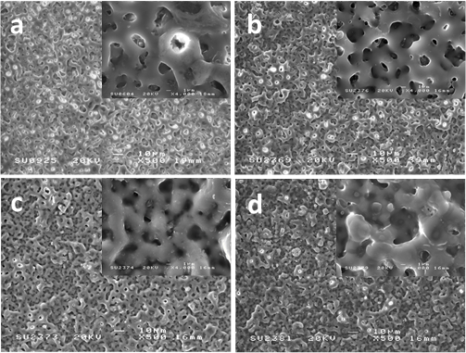
Figure 6-3 SEM images of surface morphology of (a) bare PEO coating; and then PEO coatings with PECVD post-treatments using different precursors: (b) TEOS, (c) HMDSO, (d) TMOS
It should be noted that several obvious defects and damaged regions were observed on the surface of PEO coatings after the post-treatment using the TMOS precursor (Figure 6-4). Considering that the vapour pressure of TMOS is significantly higher than that of TEOS (18 vs. 2 mbar @ 20 °C) and taking into account data of Table 6-1, amounts of TMOS and TEOS precursors in the process gas are estimated to be 0.9 and 0.2 %, respectively. Therefore, the damage could be caused by the plasma or dust particles present in the atmospheric pressure PECVD process, since the probability of particle formation in plasma is much higher for the process with TMOS precursor. As shown in Figure 6-4, the size of the defects can reach up to 100 µm and is generally surrounded by a damaged region. The metal substrate was even exposed to the environment, suggesting a possibly reduced protection ability of PEO-PECVD coating formed with the TMOS precursor.

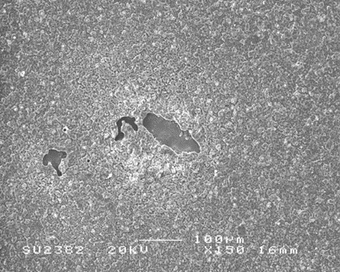
Figure 6-4 SEM image of damaged areas in the PEO coatings after PECVD post-treatment using TMOS precursor

The cross-sectional features of single PEO and duplex PEO-PECVD coatings are presented in Figure 6-5. The PEO coating was composed of an inner barrier layer and an outer porous layer, and it appears to adhere well to the Mg substrate as shown in Figure 6-5(a). It has to be noted that some voids and discharge channels can be seen inside the PEO coating, which is consistent with the surface morphologies. These discharge channels connect the surface to the barrier layer of the PEO coating.

Comparing the SEM images of PEO-PECVD coatings to that of the PEO coating, the following inferences can be made: (i) although the pores and discharge channels within the PEO coatings were partially covered or sealed by a SiO₂ film after the PECVD post-treatment, an obvious double layer structure cannot been seen in the cross-sectional image of the duplex coatings which could be due to the low thickness of the PECVD layer; (ii) a loose multilayer structure near the substrate was observed on the duplex coatings; (iii) numerous defects inside the coating matrix were formed in the PEO-PECVD duplex coatings.

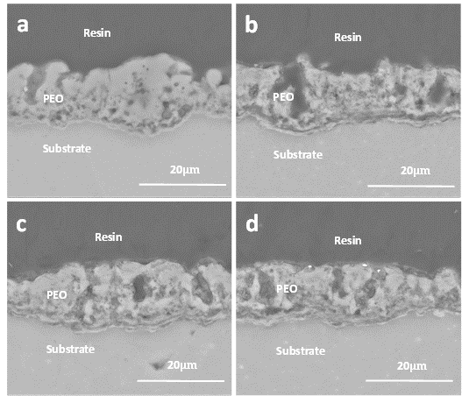
Figure 6-5 SEM images of cross-sectional morphologies of (a) single PEO coating; and PEO coatings with PECVD top layers produced with different precursors: (b) TEOS, (c) HMDSO, (d) TMOS

6.5 Coating chemical and phase compositions
Despite the PECVD post-treatment with different precursors, all the coatings (with and without post-treatment) were composed of O, Mg, Na, Si, F and trace of K, which can be observed in the typical EDX spectrum given in Figure 6-6. The relative contents of elements in the PEO and PEO-PECVD duplex coatings detected are illustrated in Table 6-2. All the elements in the electrolyte can be found in the spectrum, indicating all ingredients of the electrolyte have been involved in the electrochemical reactions of the PEO process. Meanwhile, the O, Mg and Si were incorporated in the coatings in a high proportion and only a small amount of F, Na and K can be detected by EDX. It is important to note that, according to the atomic concentrations of the elements, there are minor differences between PEO and PECVD duplex coatings, suggesting a thin PECVD film on the top of PEO coatings and small influence of PECVD post-treatment on the total elemental composition and concentration of PEO coatings.

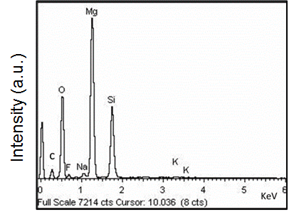
Figure 6-6 Typical EDX spectrum of PEO coatings on cp-Mg prepared in silicate-fluoride electrolyte with and without PECVD post-treatment

Table 6-2 Elemental compositions of PEO and PEO-PECVD duplex coatings
Sample ID | Elemental composition (at.%)
Sample ID | O | F | Na | Mg | Si | K
PEO | 51.1 | 4.6 | 1.0 | 29.9 | 13.4 | <1
PEO-TEOS | 56.9 | 4.2 | 0.8 | 25.6 | 12.5 | <1
PEO-HMDSO | 55.0 | 4.0 | 1.0 | 26.5 | 13.4 | <1
PEO-TMOS | 58.7 | 2.4 | 0.9 | 21.2 | 16.6 | <1

Figure 6-7 shows EDX maps of the four main coating elements (Si, O, Mg and F). It can be seen that all the coatings have similar elemental distributions. Specifically, Si, O and Mg are uniformly distributed throughout the whole thickness of the surface layer, while F is preferentially accumulated in the inner region of the PEO coating. Noteworthy that the post-treatments did not appear to change the elemental distribution in the PEO coatings, which could be due to the low thickness of the top layers and rather moderate thermal impact induced by the PECVD process. Concerning the multilayered structure of the barrier layer observed in the duplex coatings (Figure 6-5), this could be speculated to be triggered by the influence of the PECVD post-treatment on the F-rich inner region of the PEO coating, however no clear evidence of fluorine re-distribution can be revealed by the EDX analysis.

To provide better insights into compositions of single PEO and duplex PEO-PECVD coatings, the X-ray diffraction patterns of the studied coatings are given in Figure 6-8. The XRD patterns show that the PEO and PEO-PECVD coatings are mainly composed of Mg₂SiO₄ and MgO, which is consistent with the EDX results in Table 6-2 and given elements’ stoichiometry, the ratio of these phases can be estimated as close to 1:1. This result is also in agreement with other works, where Mg₂SiO₄ is commonly observed in the PEO coatings on Mg, with corresponding mechanisms discussed by Gnedenkov, et al. [30] The strong Mg peaks shown in the XRD pattern are related to the Mg substrate, which indicates X-rays penetrated throughout the PEO coatings. There are no fluorine or sodium containing phases observed in the spectra which suggests they may be incorporated in the PEO coatings as an amorphous component. In addition, no specific patterns of SiO₂ phase were detected in the XRD spectra of the duplex coatings, which could be due to non-crystalline structure and low thickness the PECVD layer.

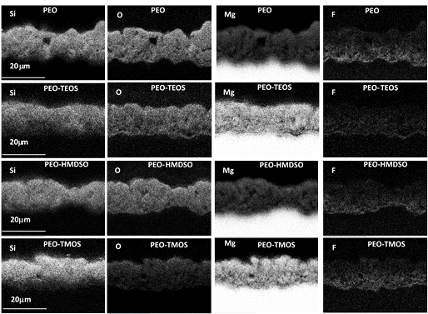
Figure 6-7 EDX maps showing elemental distributions in PEO and PEO-PECVD coatings

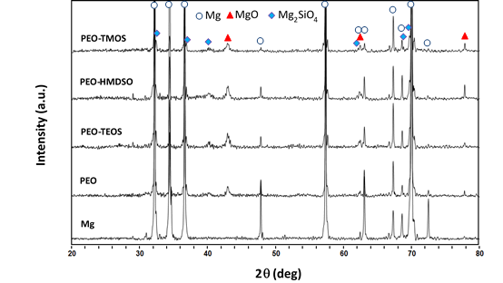
Figure 6-8 XRD patterns of cp-Mg and the coated samples

6.6 Electrochemical corrosion evaluation

6.6.1 Electrochemical impedance spectroscopy
The EIS spectra of the PEO and PEO-PECVD coatings, as well as the Mg substrate, are shown in Figure 6-9(a-c). All spectra of coated samples were obtained after 4 hrs of immersion in 3.5 wt.% NaCl solution to make the open circuit potential (OCP) in a stable state. By analysing the impedance spectra, the corrosion resistance of PEO and PEO-PECVD coatings can be revealed. The EIS spectra of PEO and PEO-PECVD duplex coatings shown in the complex plots (Figure 6-9(a)) display two highly overlapped RC loops that are hard to distinguish in the figure Additionally, three loops including the two RC loops and one RL loop were observed in the EIS spectrum of cp-Mg, as shown in Figure 6-9(b), suggesting three kinetic processes occurred in corrosion. Similar impedance behaviour was also reported in several independent studies [18, 120, 122, 160]. It was believed that the low-frequency inductive behaviour is caused by the adsorption of Mg⁺ intermediate product during pitting corrosion [122, 161]. Therefore, to investigate the inductive behaviour, the EIS measurement of cp-Mg was carried out in a wider frequency range from 10⁻² to 10⁵. Generally, for PEO-coated samples, the RC loops at high (10² to 10⁵ Hz) and medium (10⁰ to 10² Hz) frequencies can be ascribed to the contribution of the coating outer porous and the inner barrier layer, respectively. However, the corrosion process will present a more significant response in the low frequency range (10⁻¹ to 10⁰ Hz), representing scattered impedance spectra or RL loops.

The EIS Bode plots are provided in Figure 6-9(c), showing two time constants for the single PEO and duplex PEO-PECVD coatings, as well as three time constants for cp-Mg, respectively, which is characterised by the peaks present in the phase angle Bode plots. It should be noted that the two time constants of the PEO-coated sample post-treated with the TMOS precursor can be obviously observed, whereas the other coated samples only featured processes with similar time constants, as represented by the flat regions in the phase angle Bode plots. This result is consistent with impedance spectra presented in the complex plots in Figure 6-9(a). Moreover, the positive phase angle can be seen in the low frequency range (10⁻¹ to 10⁰ Hz) in Figure 6-9(c) for cp-Mg, indicating inductive behaviour during the corrosion process.

The low-frequency impedance magnitude can be used to evaluate the corrosion resistance of samples. Generally, a higher value of the impedance magnitude represents a better corrosion performance. It was observed that the highest impedance magnitude (~10⁷ Ω⋅cm²) belonged to the PEO-HMDSO coating, indicating the best corrosion resistance. Whereas, the lowest value of the impedance magnitude (less than 100 Ω⋅cm²) can be seen on cp-Mg, which means it has the worst anti-corrosion performance. Meanwhile, the PEO and PEO-TEOS coatings had almost the same impedance magnitude (~10⁶ Ω⋅cm²) in the Bode plots, suggesting a similar corrosion resistance. The lowest corrosion resistance of the coated samples was found for the PEO-TMOS coating, which had the lowest impedance magnitude. It should be noted that in the high and medium frequency range (10¹ to 10⁵ Hz) all the coated samples except the PEO-TMOS coating exhibited similar straight lines with almost the same slope ($|z|/∆ log⁡(f)$ < 1) in the impedance magnitude Bode plots, with even wider frequency range (10⁰ to 10⁵ Hz) for the PEO-HMDSO coating. However, a much shorter straight line (in frequency range of 10³ to 10⁵ Hz) for the PEO-TMOS coating and almost no straight line for cp-Mg were observed in the Bode plots, respectively. Generally, the straight line in the impedance magnitude Bode plot can be explained by the contribution of capacitive behaviour of the PEO and PEO-PECVD coatings. Since an ideal capacitor should have a straight line in the Bode plot with a slope of 1, the smaller slopes observed in this work could be explained by the dispersed capacitance effect caused by e.g. roughness and defects in the coatings. In addition, for the same slope of the straight segment of the spectra of coated samples, the longer line means the higher impedance magnitude and the better corrosion resistance. The impedance spectra in the high frequency range (10² to 10⁵ Hz) reflect the features of the outer porous layer in the PEO coatings. In Figure 6-9(c), it can be observed that PEO-HMDSO coating showed the highest impedance magnitude, with slight differences in the magnitude for the other coated samples. This indicates that after the PECVD post-treatment using the HMDSO precursor, the PEO coating was effectively sealed by the CVD film, resulting in a reduced porosity and a higher corrosion resistance of the outer porous layer in the PEO coating. However, the reasons for the other two precursors failing to improve the corrosion performance of the outer porous layer of PEO coating might be different. The CVD film produced using TEOS was too thin to effectively seal the pore on the PEO coating, resulting in an insufficient protection. Although TMOS precursor can provide a CVD film with sufficient thickness to seal the pores, the corrosion resistance of corresponding PEO coating was strongly affected by the defects caused by the PECVD process too, so the effects of the CVD film thickness and defects induced counteracted during the corrosion process.

The two equivalent circuits shown in Figure 6-9 (d and e) were applied to fit the EIS data of coatings and Mg substrate, respectively. The physical meaning of EC components including R_{c}, R_{ct}, CPE_{c} and CEP_{dl} is practically identical to that of EC used for the EIS data fitting in Chapter 5 (Figure 5-7). Since the inductive behaviour was observed on the cp-Mg sample, the inductor L is introduced to simulate the adsorption phenomenon of Mg⁺ in the corrosion region, and is connected with R₁ which represents the resistance of corrosion products formed by the electrochemical reactions. It should be noted that the constant phase element (CPE) is applied in this work only to model the non-ideal capacitive behaviour of samples in the electrochemical tests, without a specific physical meaning. The concept of the CPE is defined below [122].

$Z_{CPE}=\frac{1}{Q{(jw)}^{α}}$ 6.2

where α and Q are independent from frequency, $j=\sqrt{-1}$, the exponent α ranges from 0 to 1. When α = 1, Q illustrates the capacity of metal-electrolyte interface and has units of a capacitance. When α = 0, Equation (6.2) represents a pure resistor and the corresponding resistance can be calculated.

The fitting results of the EIS spectra are presented in Table 6-3, showing the adequate goodness of fit (χ² = 0.003 to 0.01) for all the coated samples, as well as Mg substrate. As can be seen from the table, the highest pore resistance (R_{c} = 8×10⁵ Ω⋅cm²) was observed on the PEO-HMDSO coating, suggesting the best corrosion inhibition capacity of the outer porous layer of all the coated samples. The PEO-TEOS coating showed a quite similar value of R_{c} = 6.66×10⁵ Ω⋅cm² compared with that of PEO-HMDSO coating and these values are nearly ten times larger than those of the PEO coating (7.76×10⁴ Ω⋅cm²). However, the least value of R_{c} (6.66×10³ Ω⋅cm²) of all the coated samples was observed for the PEO-TMOS coating. To interpret the difference of R_{c} values of the coated samples, the following equation based on the physical meaning of R_{c} can be applied [122].

$R_{C}=ρd/A$ 6.3

where the ρ represents the resistivity of electrolyte in the pores, d and A are related to the average value of pore depth and diameter. According the Equation (6.3), the significantly increased R_{c} should be explained by the decreased pore diameter caused by the sealing effect of the PECVD film, which can be also verified by the SEM images in Figure 6-3. The depressed R_{c} for PEO-TMOS coating should be due to the damaged regions caused by the PECVD post-treatment, since the characteristic size of these regions is much larger than that of pores, which in turn enlarges the total value of A.

Based on the physical meaning of R_{ct}, the corrosion protection capacity of the inner barrier layer of the single PEO and duplex PEO-PECVD coatings can be evaluated by the value of R_{ct}. Strangely, except for the PEO-HMDSO coating, the other two duplex PEO-PECVD coatings presented significantly lower values of R_{ct} compared to that of the PEO coating. According to the SEM images of the coated samples in Figure 6-5, it is obvious that the structure of the inner barrier layer of PEO coatings was significantly changed by PECVD post-treatments, from a single dense layer to a loose multilayered structure. So, it is likely that the PEO-PECVD post-treatment may have a negative influence on the structure of the inner barrier layer of the PEO coating, resulting in a depressed corrosion resistance. However, the dramatically enhanced R_{ct} of PEO-HMDSO proves that the corrosion resistance of the inner barrier layer can also be improved by the sealing effect of the PECVD film. The eventual effect on the corrosion protection of PEO coatings is determined by the combined impact of positive and negative influences of the PECVD treatment. This effect can be depicted in the values of polarisation resistance (R_{p}) collected in Table 6-3. As previously reported [18, 122], the values of R_{p} can be calculated using the impedance data and corresponding equivalent circuits. For the equivalent circuits shown in Figure 6-9, R_{p} values of coated samples can be obtained from the following equation:

${\text{R}}_{\text{p}}\text{ = }{\text{R}}_{\text{c}}\text{ + }{\text{R}}_{\text{ct}}$ 6.4

It can be seen that the PEO-HMDSO coating had the highest value of polarisation resistance which is significantly higher than that of other coated samples; whereas, the other PEO-PECVD duplex coatings showed a smaller polarisation resistance than the PEO coating. The polarisation resistance values confirm that the PEO-HMDSO coating can provide the best corrosion protection for the Mg substrate.

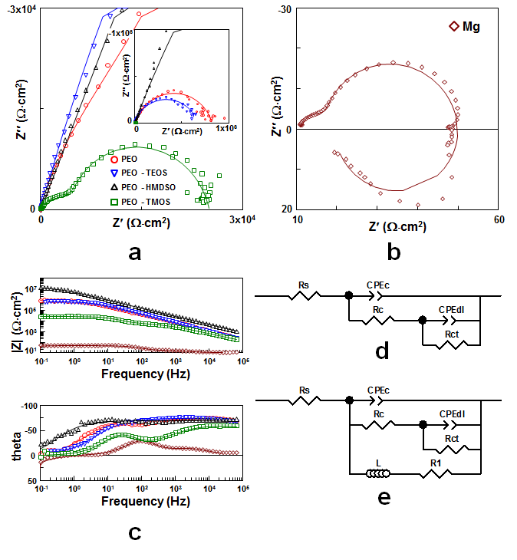
Figure 6-9 Impedance spectra (scatter plots) and fitting results (solid lines) of PEO, duplex PEO-PECVD coatings and cp-Mg measured after immersing in 3.5 wt.% NaCl aqueous solution for 4 hrs. (a) Nyquist Plot of coated samples, (b) Nyquist Plot of cp-Mg, (c) Bode plot of cp-Mg coated samples, (d and e) Equivalent circuits for EIS fitting

Table 6-3 Typical fitting results for EIS measurements of PEO coatings and cp-Mg
Sample ID | CPEc-T  [Fs^{n-1}cm⁻²] | CPEc-P | R_{c}  [Ω⋅cm²] | CPEdl-T  [Fs^{n-1}cm⁻²] | CPEdl-P | R_{ct}  [Ω⋅cm²] | L  [H⋅cm⁻²] | R₁  [Ω⋅cm²]
Mg | 3.08×10⁻⁵ | 0.88 | 8.59 | 8.00×10⁻⁵ | 0.99 | 30.46 | 171.8 | 11.03
PEO | 8.30×10⁻⁸ | 0.84 | 7.76×10⁴ | 5.84×10⁻⁸ | 0.86 | 7.41×10⁵ | -- | --
PEO-TEOS | 1.03×10⁻⁸ | 0.83 | 6.66×10⁵ | 2.10×10⁻⁵ | 0.98 | 1.00×10⁴ | -- | --
PEO-HMDSO | 3.44×10⁻⁸ | 0.79 | 8.00×10⁵ | 3.14×10⁻⁹ | 0.98 | 1.24×10⁷ | -- | --
PEO-TMOS | 5.48×10⁻⁷ | 0.72 | 6.66×10³ | 6.32×10⁻⁷ | 0.99 | 1.84×10⁴ | -- | --

6.6.2 Potentiodynamic polarisation evaluation
The polarisation curves for cp-Mg and coated samples are illustrated in Figure 6-10 and the corresponding parameters are presented in Table 6-4. Generally, the cathodic hydrogen evolution process is represented by the cathodic branches of polarisation curves and metal anodic dissolution, as well as the passivation behaviour of protective coatings, are represented by the anodic branches. It can be seen that all the coatings have significantly improved the corrosion resistance of the Mg substrate as the corresponding polarisation curves of coated samples were obviously moved to the lower current density region. This should be due to the reduced corrosion area provided by the PEO coatings, resulting in depressed rates of anodic and cathodic reactions for the coated samples compared with cp-Mg. After PECVD post-treatments, only the PEO-HMDSO coating exhibited lower current densities in both anodic and cathodic branches than that of the PEO coating, implying the superior corrosion protection among the coated samples. Whereas, the PEO-TEOS duplex coatings showed similar polarisation behaviour compared with the single PEO coating. The cathodic polarisation curves of the PEO-TMOS coating shifted to a higher current density region than that of the PEO coating, which could be attributed to the accelerated reaction rate caused by the direct contact of the metal and the corrosive medium in the damaged area. The anodic polarisation curves, however, still presented quite similar behaviour compared with the PEO coating, which is probably due to the protection by the corrosion product accumulated in the corrosion sites. It should be noted that all the samples presented linear behaviour on the cathodic branches, indicating the domination of activation control in the cathodic reactions. The anodic polarisation curves, however, presented more complicated behaviour, indicating more factors had effects on the anodic process. The polarisation curve of the PEO-HMDSO coating exhibited strong fluctuation behaviour during the whole scan range, which could be indicative of some local instabilities in the corroding system amplified by the logarithmic presentation of the current data.
The corrosion potential (E_{corr}) and corresponding current density estimate (i_{is}) can provide insights into the driving force of the corrosion process and its kinetics, respectively [113]. The meaning of the i_{is} is similar to that of corrosion current density; however, it is not rigorously quantified and used here for comparison purpose only. It can be seen that the E_{corr} and i_{is} for the bare Mg substrate were –1.52 V versus SCE and ≈ 2×10⁻⁴ A cm⁻², respectively, whereas the corrosion potentials for the PEO and PEO-PECVD coatings indicated a more noble behaviour compared with that of bare Mg substrate. Specifically, the duplex PEO-HMDSO coating presented the lowest i_{is} ≈ 3×10⁻⁹ A cm⁻², although the lowest E_{corr} = -1.69 V versus SCE was also observed in this case, which suggests that a better corrosion resistance of the coated samples does not necessarily mean a higher corrosion potential in the polarisation curves. As a result, in terms of corrosion protection evaluation, comparing i_{is} is more practical and meaningful. The duplex PEO-TMOS coating showed the i_{is} ≈ 2×10⁻⁷ A cm⁻², compared with the other coated samples, which means it gave the worst corrosion protection to Mg substrate. This result is consistent with that of EIS impedance spectra and SEM surface morphologies, which could be explained by the defects caused by the PECVD post-treatment. Therefore, the corrosive medium can easily penetrate the protective coating and attack the metal substrate. Finally, the PEO-TEOS coating also presented a higher i_{is} ≈ 2×10⁻⁸ A cm⁻² than the PEO coating (≈ 6×10⁻⁹ A cm⁻²), indicating the detrimental effect of PECVD post-treatment on the corrosion protection of the PEO coating.
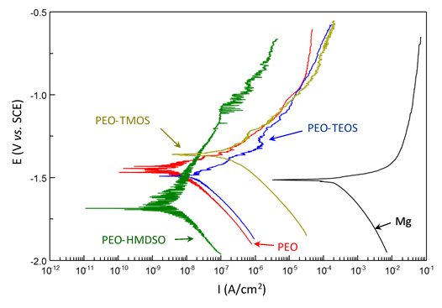
Figure 6-10 Potentiodynamic polarisation curves of cp-Mg and PEO coatings with and without PECVD post-treatment

Table 6-4 Results of potentiodynamic polarisation analysis for all the coated samples and cp-Mg
Sample ID | E_{corr}  [V vs. SCE] | i_{is}  [A cm⁻²]
Mg | -1.52 | 2×10⁻⁴
PEO | -1.40 | 6×10⁻⁹
PEO-TEOS | -1.44 | 2×10⁻⁸
PEO-HMDSO | -1.69 | 3×10⁻⁹
PEO-TMOS | -1.36 | 2×10⁻⁷

6.6.3 Surface morphologies after electrochemical tests
The SEM surface morphologies of corroded PEO and PEO-PECVD duplex coatings after electrochemical tests are shown in Figure 6-11. It is obvious that except for PEO-HMDSO coating all the coated samples exhibited localised corrosion regions with diameters less than 1 mm, as well as a pitting site observed on the PEO-TMOS coating. In the corrosion sites of the coated samples, needle-like crystalline precipitates can be observed which might be Mg(OH)₂ formed by the following reactions:

${\text{Mg}}^{\text{2+}}\text{ + 2}{\text{OH}}^{\text{-}}\text{ → Mg}{\text{(OH)}}_{\text{2}}$ 6.5

$\text{MgO + }{\text{H}}_{\text{2}}\text{O → Mg}{\text{(OH)}}_{\text{2}}$ 6.6

The Mg²⁺ and OH⁻ could originate from the dissolution of the Mg substrate and the electrochemical reactions during the corrosion process (e.g. oxidation of the Mg substrate will simultaneously result in the release of OH⁻). The damage (Figure 6-4) caused by the PECVD post-treatment on the PEO-TMOS coating should be the reason for the pitting observed in Figure 6-11(d), which provided a shortcut for the corroding media to the metal substrate and then resulted in the corrosion. The PEO-HMDSO coating, however, kept a high integrity after the electrochemical tests without any corroded regions occurring on the surface of sample. In other words, these results again prove that the PEO-HMDSO coating has the best corrosion protection on the coated samples and shows a good agreement with previous results.
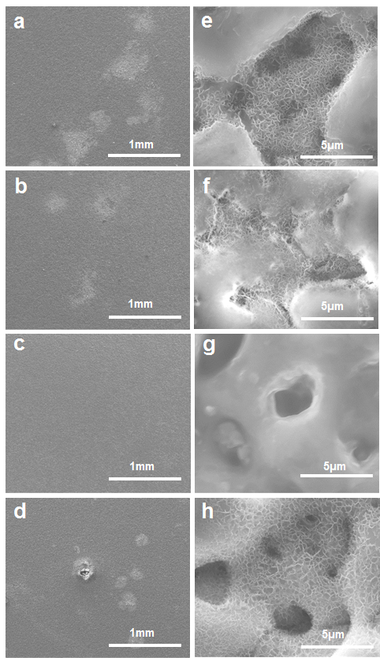
Figure 6-11 Surface morphologies of coated samples after electrochemical tests: (a and e) PEO, (b and f) PEO-TEOS, (c and g) PEO-HMDSO, (d and h) PEO-TMOS

6.7 Summary
After analysing the experimental results of the PEO coatings with and without PECVD post-treatment on the cp-Mg substrate, the following conclusions can be made:

- After the PEO-PECVD post-treatment, the micropores on the surface of PEO coatings can be sealed to different degrees, depending on the type of precursors applied in the PECVD post-treatment. Moreover, the inner barrier layer of PEO coatings was changed to a multilayered structure with increased thickness.
- The PEO coatings were mainly composed of Mg₂SiO₄ and MgO, and the PECVD post-treatment had only a small influence on the chemical and phase composition of the PEO coatings. All PECVD films had an X-ray amorphous structure.
- A better sealing effect was observed with the HMDSO and TMOS precursors. In addition, the PECVD treatment could also cause obvious damage to the PEO coatings, resulting in a depressed corrosion protection of both inner barrier and outer porous layer of the PEO coatings.
- The corrosion resistance of cp-Mg in a 3.5 wt.% NaCl solution was dramatically increased by the PEO coating. However, the effect of the PECVD post-treatment on the corrosion protection of PEO coatings was determined by all the factors discussed above. As a result, only HMDSO precursor could effectively improve the corrosion resistance of the PEO coating, whereas the duplex PEO-TEOS and PEO-TMOS coatings exhibited a reduced corrosion resistance.

Chapter 7 Investigation of Plasma Electrolytic Oxidation Coatings on cp-Mg with Cerium Nitrate and Benzotriazole Immersion Post-Treatments
As discussed in Chapter 6, the corrosion resistance of the PEO coating could be improved to a great extent when covered with a CVD top layer, if an appropriate precursor was used in the PECVD post-treatment. However, the complex process and high cost of PECVD treatment limit the extensive use of PEO-PECVD duplex coatings. To overcome this drawback, a fast, low-cost and effective method of enhancing the corrosion resistance of PEO coatings on Mg has been developed by simply immersing PEO coated samples in solutions containing sealing agent or corrosion inhibitor. As discussed in Chapter 3, a novel self-healing PEO coating on Mg alloy was developed using the immersion post-treatment in a 8-hydroxyquinoline (8-HQ) C₉H₇NO solution [24]. The corrosion tests shows that thus produced corrosion inhibitor (8-HQ) containing PEO coating has a superior corrosion resistance compared with single PEO coating, and exhibits smaller decrease in impedance modulus after potentiodynamic polarisation test. It has also been reported that cerium nitrate (Ce(NO₃)₃) can effectively improve the corrosion resistance of Mg alloys by forming a conversion coating on the surface of metal substrate [162]. Therefore, it has been applied to seal the PEO coating on Mg alloy through immersion and received good results according published work [84]. Meanwhile, as a commonly used corrosion inhibitor for copper, benzotriazole (BTA) has also been proved to be an effective corrosion inhibitor for Mg although there were only few related works published. Considering these factors, to further study the corrosion resistance enhancement of PEO coating, immersion post-treatments in solutions containing Ce(NO₃)₃ sealing agent or BTA corrosion inhibitor were carried out in the present chapter. The PEO coatings produced on cp-Mg with different post-treatments were characterised by various methods, and the corrosion properties of coated samples were also investigated by electrochemical corrosion tests.

7.1 PEO coating preparation
Before the PEO treatment, cp-Mg disc samples were prepared following the procedures described in Chapter 4. Then the PEO coatings were produced in the silicate-fluoride alkaline electrolyte composed of KOH (2g/L), NaF (4g/L) and Na₂SiO₃ (12g/l) by a pulsed unipolar (PUP) galvanostatic mode, since thus produced PEO coatings are more porous and easier to observe the sealing effect. A pulsed unipolar current mode (as shown in Figure 7-1) with current density of 40mA/cm², frequency (f = 1/(t_{on}+t_{off})) of 1000 Hz, 10% duty cycle (δ = t_{on}/(t_{on}+t_{off})×100%) and 10 min treatment time was applied in the present work. During the PEO treatment, the samples were immersed in the electrolyte in a 2-litre stainless steel container, and the electrolyte was kept stirred with the temperature maintained below 35 C by a water cooling system. Once the PEO treatments were finished, all samples were rinsed by distilled water and dried in air before being subjected to the immersion post-treatments.

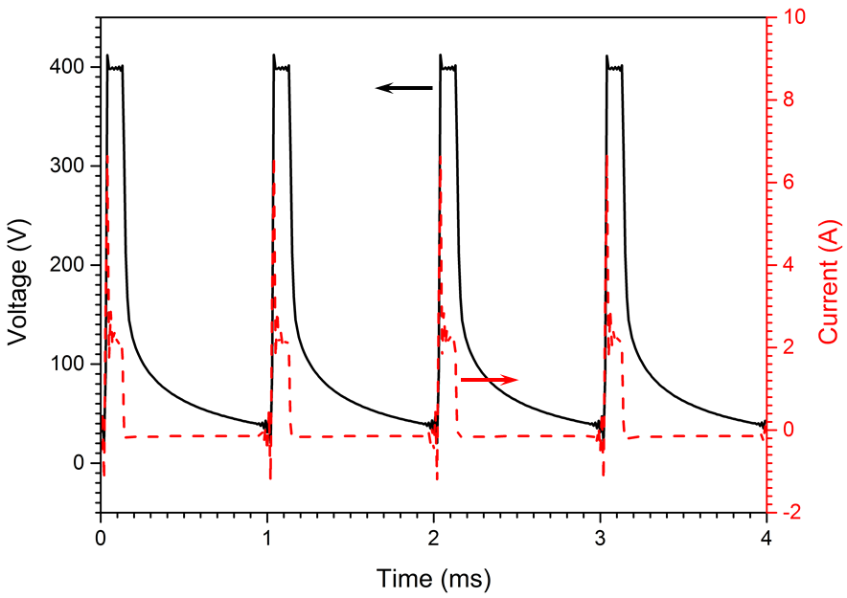
Figure 7-1 Typical electrical waveforms collected during the PEO process

7.2 BTA and Ce(NO₃)₃ immersion post-treatment
Prior to the post-treatment, 10 g/L Ce(NO₃)₃ and 10g/L benzotriazole aqueous solutions were prepared as described in Chapter 4. Then, the PEO coatings were immersed in Ce(NO₃)₃ and BTA solutions at room temperature for one hour as shown in Table 7-1.

Table 7-1 Immersion post-treatments applied for the PEO coatings
 | Post-treatments
 | Ce(NO₃)₃ (10g/L) | BTA (10g/L)
PEO | - | -
PEO- Ce(NO₃)₃ | 1 hour | -
PEO-BTA | - | 1 hour

7.3 Coating morphologies
The surface morphologies of the PEO coatings on cp-Mg with and without immersion post-treatments are presented in Figure 7-2. According to the secondary-electron SEM images (Figure 7-2a, b and c), the PEO coating has a typical porous surface morphology, with some fine micro-pores and -cracks uniformly distributed among the bigger micro-pores. Some fine micropores are even found to be partially covered by the molten oxide materials, which is consistent with the SEM surface morphologies of the PEO coating produced under the same condition (as described in Chatper 5). The coating formation mechanism and the reasons for the porous surface morphology have also been previously discussed in detail in Chapter 5. It can also be observed that there are no significant changes in surface morphology can be found from the SEM images (SE) of the PEO coatings with and without immersion post-treatments.

Since the SEM images in back-scattered electron (BE) mode demonstrate detailed features of micropores and cracks, as well as phase-contrast of the PEO coating, they are also provided to illustrate the differences in morphologies of the studied coatings in this work (as shown in Figure 7-2d, e and f). According to the SEM images (BE) of the PEO coating (Figure 7-2d), the large-sized micropores have an irregular shape and are connected by the microcracks sometimes. The size of these micropores ranges from less than 1 µm up to more than 20 µm. After subjecting to the Ce(NO₃)₃ immersion post-treatment, some micropores and cracks on the surface of PEO coating were successfully sealed as suggested by the bright spots on the surface of PEO-Ce(NO₃)₃ coating in Figure 7-2e. According to Mohedano et al.[84], the formation of bright spots is associated with dissolution of the PEO coating and the precipitation of insoluble oxide/hydroxide Ce compounds. It has to be pointed out that although the sealing effect can be found from the PEO coating treated by Ce(NO₃)₃ immersion post-treatment, there are still numerous open micropores and cracks remaining after the post-treatment. These remaining open micropores and cracks would continue to serve as shortcuts to the Mg substrate and induce corrosive attack. For the PEO-BTA coating, the surface morphology was not significantly changed after the immersion post-treatment in the BTA-containing solution. However, there are some initial signs of coating degradation, as the number of micropores were increased after the BTA immersion post-treatment, suggesting increased porosity of the PEO-BTA coating.

In order to further investigate the surface morphology, the surface porosity of the PEO, PEO-Ce(NO₃)₃, and PEO-BTA coatings were analysed by ImageJ software and presented in Figure 7-3. Obviously, the surface porosity of PEO-Ce(NO₃)₃ coating (6.6 %) was significantly decreased compared with that of the original PEO coating (17.6 %), indicating a good sealing efficiency of the Ce(NO₃)₃ immersion post-treatment. The PEO-BTA coating has the highest surface porosity (21 %) among the coated samples, which should be due to the slightly enlarged micropore size and increased number of cracks caused by the coating degradation process during the BTA immersion post-treatment.
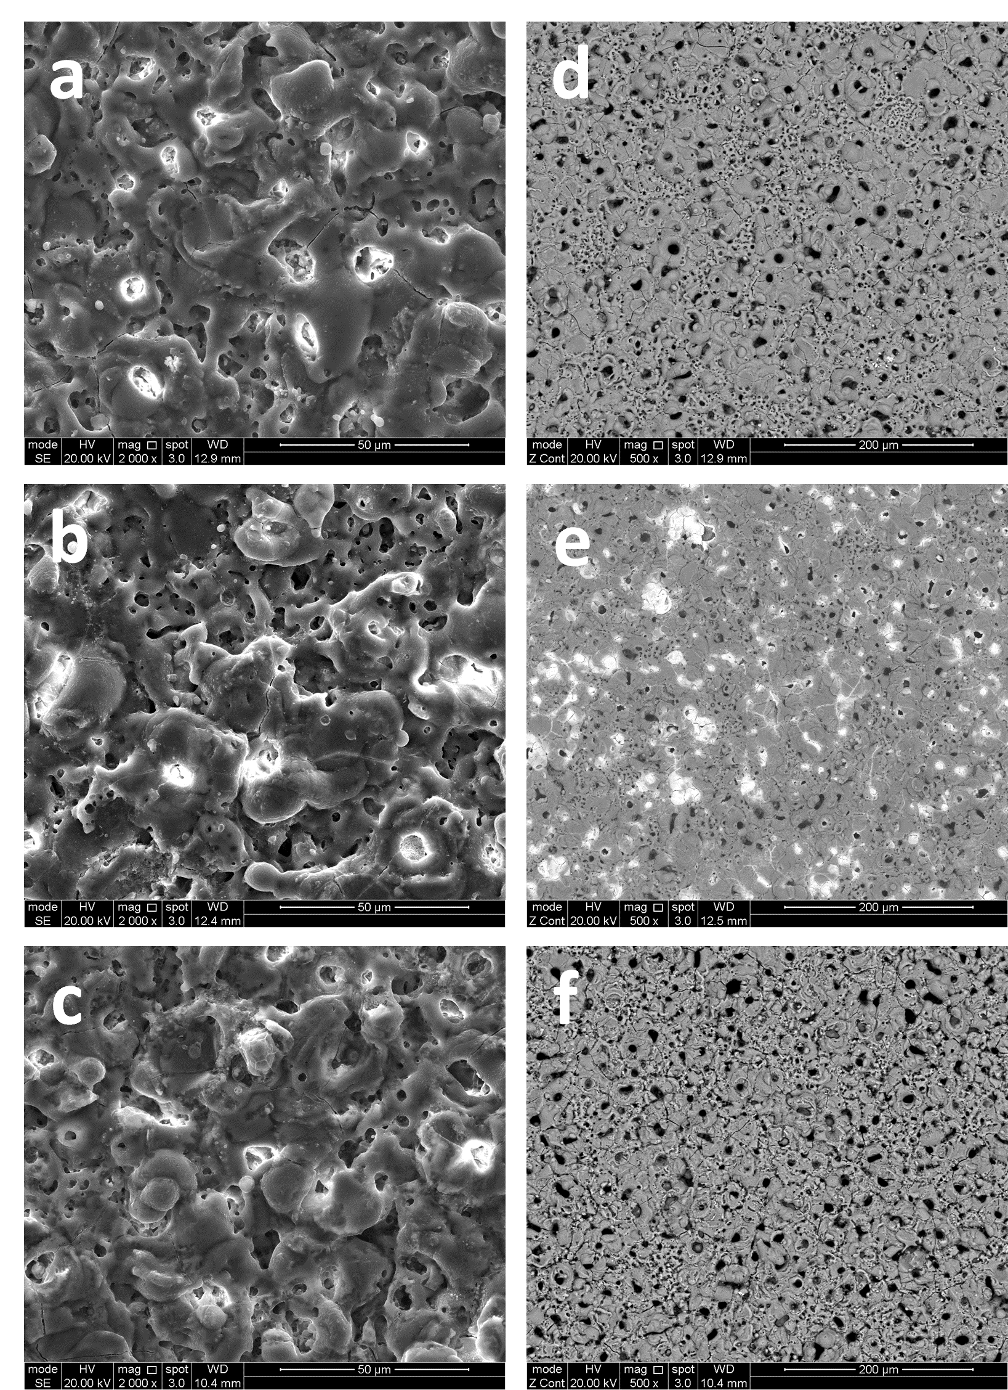
Figure 7-2 SE SEM images of surface morphologies of (a) PEO; (b) PEO-Ce(NO₃)₃ and (c) PEO-BTA coatings, and the corresponding BE SEM images of the studied coatings:(d) PEO, (e) PEO-Ce(NO₃)₃ and (f) PEO-BTA

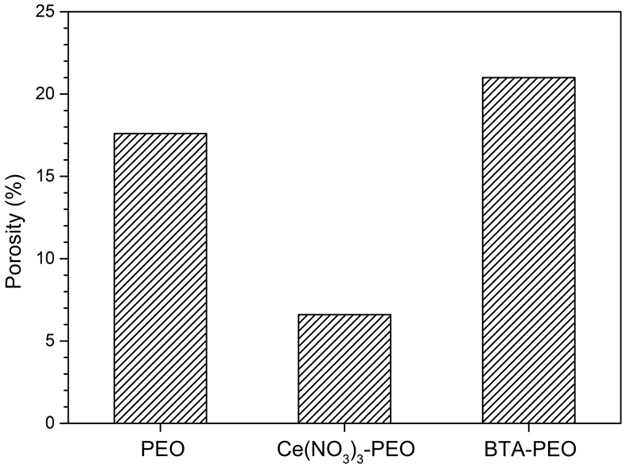
Figure 7-3 Surface porosity of studied coatings

The cross-sectional morphologies of the PEO, PEO-Ce(NO₃)₃ and PEO-BTA coatings on cp-Mg are illustrated in Figure 7-4. Consistent with the results discussed in Chapter 5, the cross-sectional feature of the PEO coating can be described as a two-layered structure including inner dense and outer porous layers. Similar to the surface morphology, the PEO coating matrix contains a large number of micropores in different sizes, as well as some discharge channels. Large-sized micropores are mainly distributed in the outer region of the PEO coating, whereas the fine pores can be observed throughout the coating surface down to the coating-substrate interface. Moreover, the wavy coating-substrate interface suggests the coating formation mechanism is dominated by the localised inward propagation, rather than uniform layer deposition such as in the case of PVD and CVD treatments [120]. According to Figure 7-4e, some micropores are sealed by the Ce-containing compounds marked by the red arrow, which is consistent with the surface observation in Figure 7-2e. In general, the sealing effect can only be found in the outer porous region of the PEO coating, and the PEO coating keeps a good integrity without obvious indication of coating degradation after the Ce(NO₃)₃ immersion post-treatment. However, for the PEO-BTA coating, the cross-section shows some cracks close to the inner dense layer, suggesting the coating degradation occurred during the BTA immersion post-treatment. This result is also in a good agreement with the coating surface morphologies. It needs to be noted that the integrity of the inner dense layer in the PEO-BTA coating is still good, which means the corrosion property should not be significantly influenced by the corrosion attack during the immersion post-treatment, as the major corrosion protection is provided by the inner dense region.

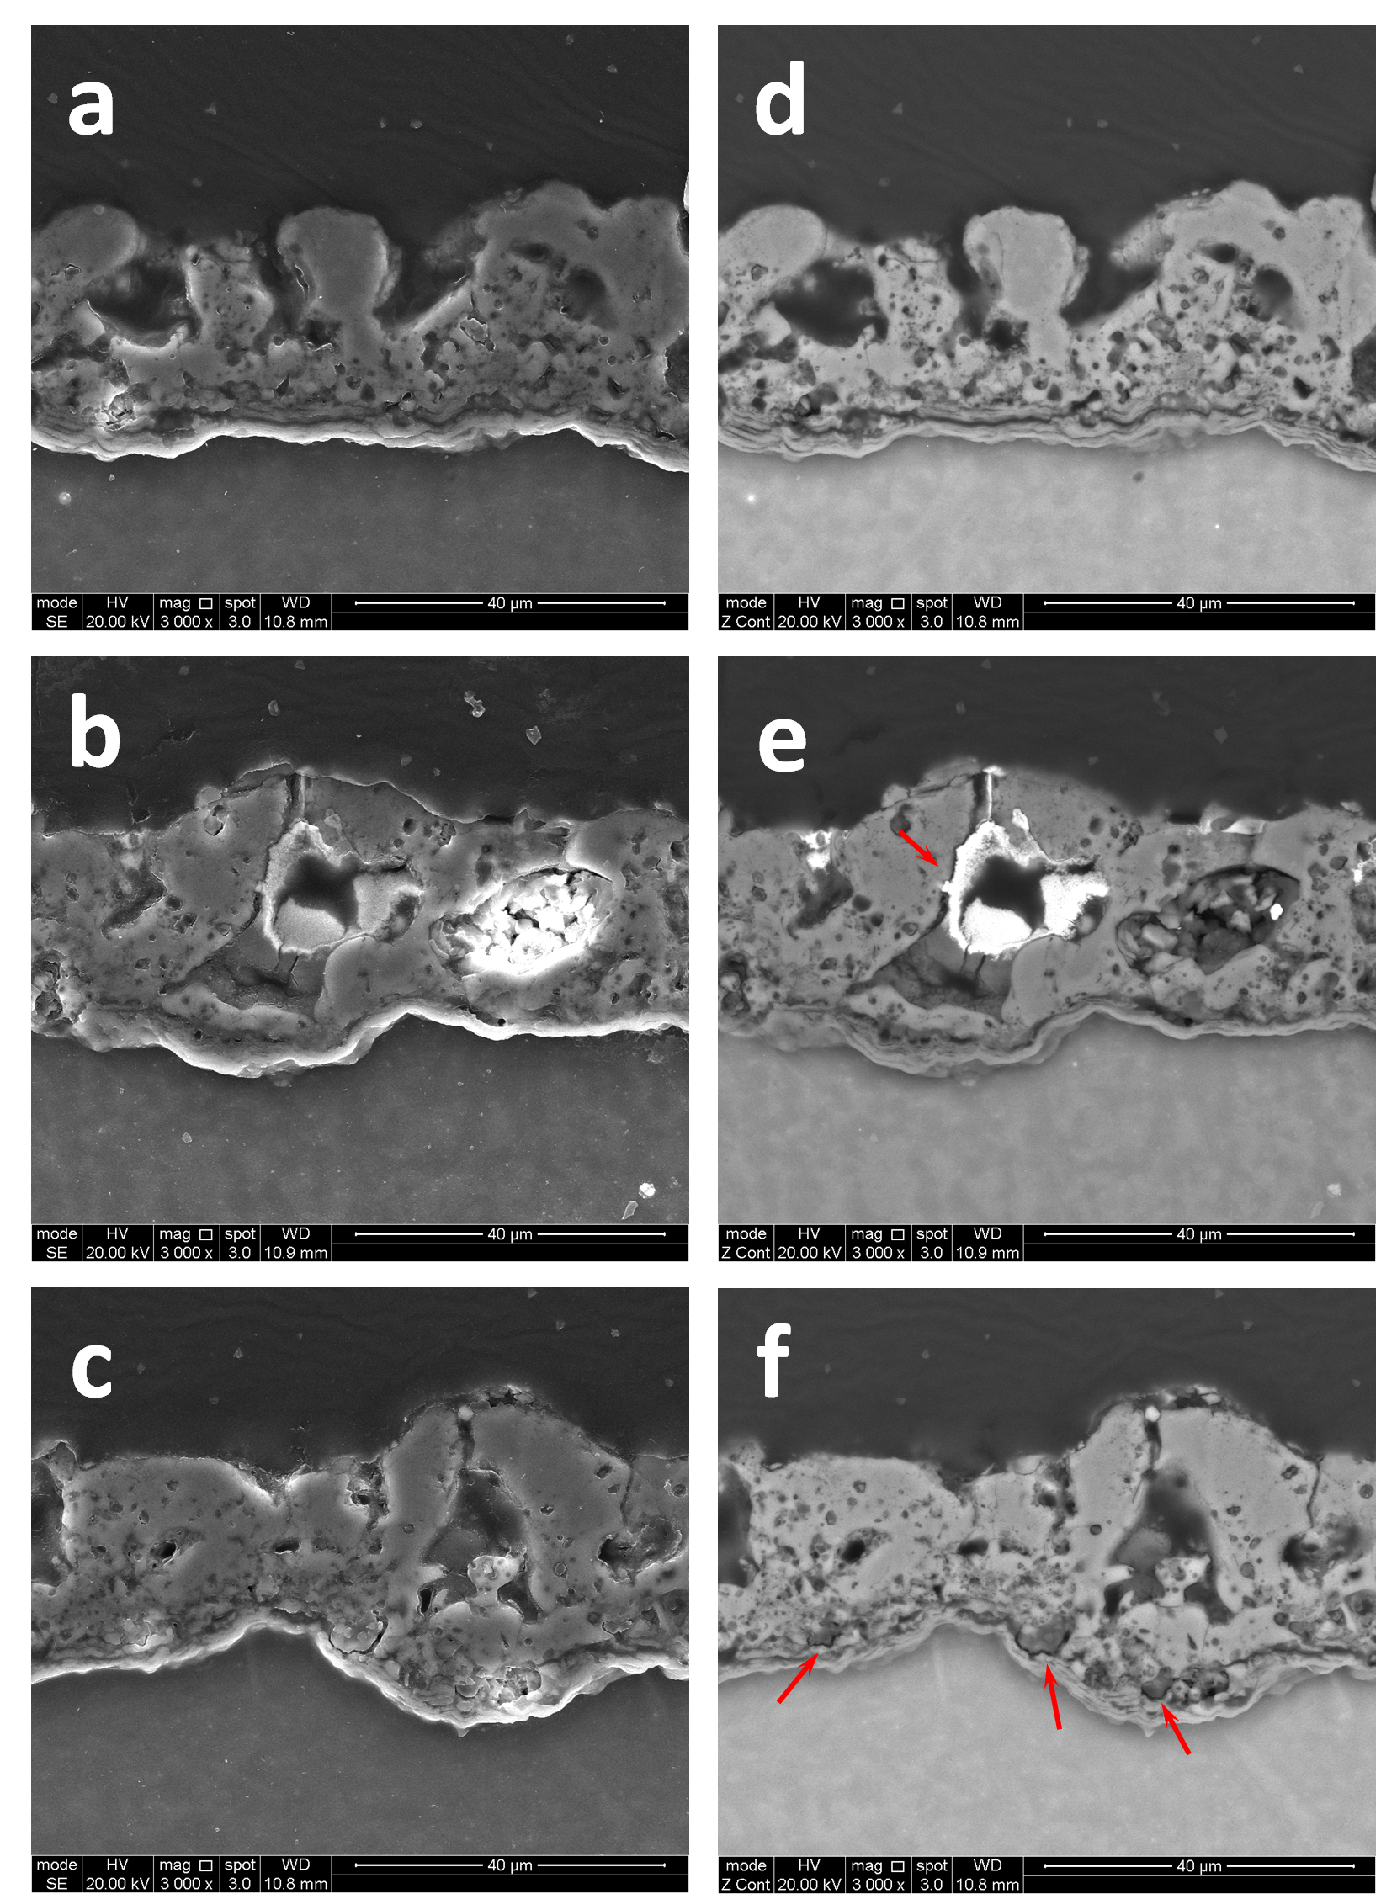
Figure 7-4 SE SEM images of cross-sectional features of (a) PEO; (b) PEO-Ce(NO₃)₃ and (c) PEO-BTA coatings, and the corresponding BE SEM images of the studied coatings:(d) PEO, (e) PEO-Ce(NO₃)₃ and (f) PEO-BTA

7.4 Coating chemical and phase compositions
To investigate the chemical composition, EDX tests were carried out over the coating surface of the PEO, PEO-Ce(NO₃)₃ and PEO-BTA coatings after the surface morphology observation. The EDX results of the studied PEO coatings with and without immersion post-treatments are presented in Figure 7-5. It reveals that the PEO coating is composed of O, F, Na, Mg and Si, which is consistent with the results discussed in Chapter 5. After the immersion post-treatment in the Ce(NO₃)₃ solution, the peaks representing Ce can be obviously observed in the EDX spectrum (Figure 7-5b), indicating the Ce-containing compounds were formed and incorporated in the PEO-Ce(NO₃)₃ coating. However, no peaks representing N can be found from the EDX spectra of both PEO-Ce(NO₃)₃ and PEO-BTA coatings, which is probably due to the low content of N-containing compounds in the coating matrix and difficulty to detect N as a low-Z element. Considering this, additional EDX tests including EDX mapping were performed on the Ce-contained area on the PEO-Ce(NO₃)₃ coating and the corresponding results are illustrated in Figure 7-6. The EDX results from Figure 7-6b confirm the presence of N in the PEO-Ce(NO₃)₃ coating, and it also reveals that the Ce-containing compounds accumulated in the micropores are mainly composed of O, Mg, Si and Ce elements. Considering the elemental composition of the PEO coating, the presence of Mg and Si in Ce-contained area could be caused by the coating dissolution occurring during the post-treatment.

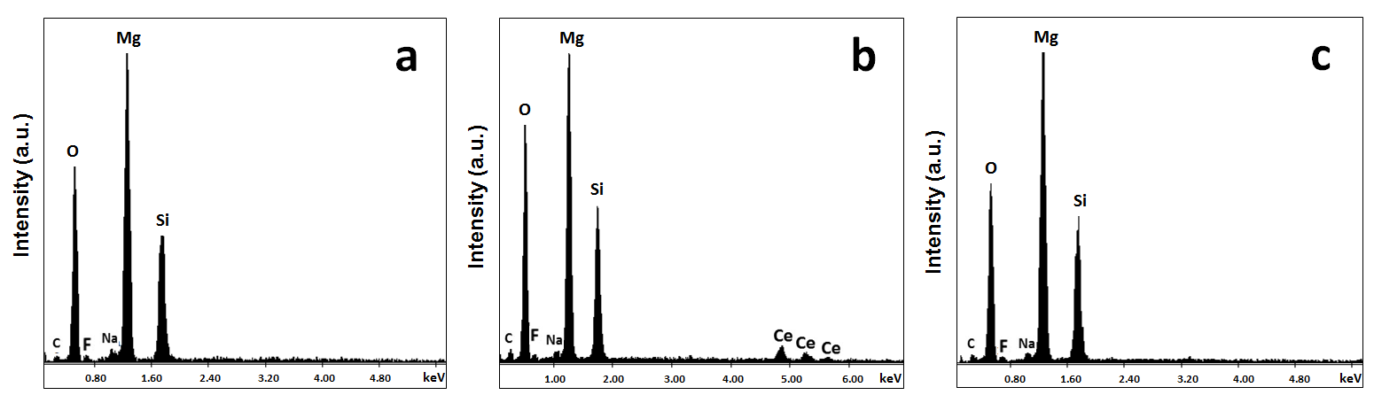
Figure 7-5 EDX spectra of studied coatings with and without immersion post-treatments: (a) PEO, (b) PEO-Ce(NO₃)₃ and (c) PEO-BTA
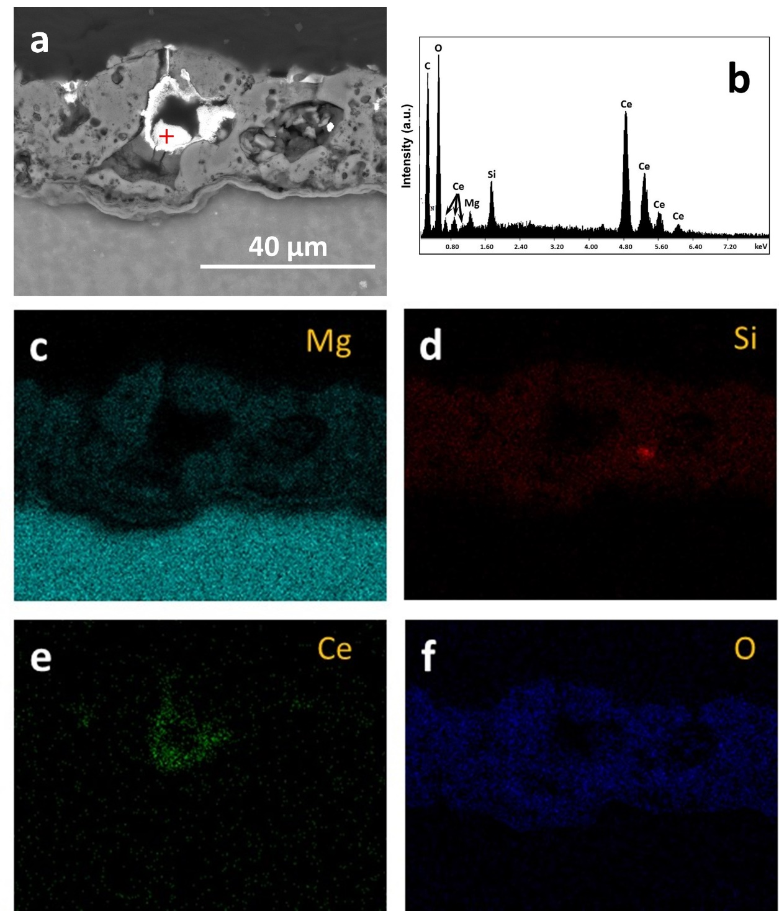
Figure 7-6 EDX results of Ce-rich area in the PEO-Ce(NO₃)₃ coating

The XRD patterns of the studied PEO coatings are illustrated in Figure 7-7, which reveals that the PEO coating is predominantly composed of Mg₂SiO₄ and MgO. This result is in good agreement with the EDX tests discussed above, as well as the XRD results in Chapter 5. In general, the XRD patterns of the PEO, PEO-Ce(NO₃)₃ and PEO-BTA coatings are practically identical, which suggests no significant phase changes occurred during the post-treatment. No Ce-containing crystalline phases can be observed in the XRD pattern of the PEO-Ce(NO₃)₃ coating, which is possibly due to the low content and/or amorphous structure. According to Mohedano et al. [84], CeO₂ and Ce₂O₃ crystalline phases could be formed on the PEO coated Mg alloy during the Ce-based immersion post-treatment, if the concentration of the Ce-containing solution and the treatment time are appropriate. Meanwhile, no new BTA-related crystalline phases can be found from the XRD results, which could also be explained by the low content of BTA in PEO coating.

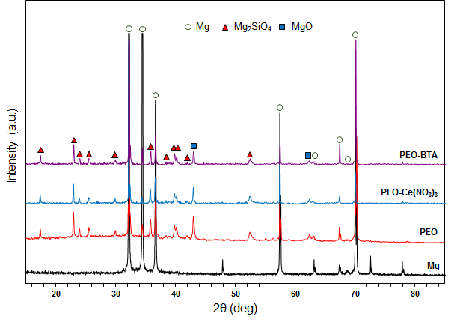
Figure 7-7 XRD patterns of cp-Mg and the coated samples

7.5 Electrochemical corrosion evaluation
As a versatile and well-developed technique, electrochemical tests are extensively used to evaluate the corrosion performance of the coated samples through the analysis of electrical characteristics during their interaction with corrosive environment. In the present work, these were used to investigate the degradation mechanism of the PEO, PEO-Ce(NO₃)₃ and PEO-BTA coatings on cp-Mg and the enhancement in corrosion resistance induced by Ce(NO₃)- and BTA-based immersion post-treatments. EIS and PDP tests were performed on the coated samples, as well as on cp-Mg substrate. In particular, the EIS tests were carried out after every hour of immersion in 3.5 wt.% NaCl solution, and the PDP measurement was performed after four hours of immersion when the EIS tests were completed.

7.5.1 Free corrosion behaviour
As discussed in Chapter 4, OCP is a critical parameter which can reflect trend of free corrosion process of the studied materials in a given environment. The OCP evolution behaviour of cp-Mg and the PEO coated samples with and without post-treatments was recorded for four hours, as presented in Figure 7-8. In the initial stage of immersion, the OCP of the coated samples shifted significantly to low potential region, which is probably due to the effect of penetration process of NaCl solution through the micropores and cracks on the PEO coatings. Moreover, the accumulation of corrosion products around the corroded area also had contribution to the variation of OCP values. The periods of significant changes in OCP values are different for PEO coatings with and without post-treatments, which might be ascribed to the differences in coating properties like porosity and chemical composition. For the OCP evolution of cp-Mg, a significant increase can be observed from the OCP variation immediately after the immersion in NaCl solution. This result could be explained by the rapid formation of a protective passive film on the surface of cp-Mg, since Mg is chemically active and can be easily oxidised as discussed in Chapter 2. After this period, the evolution of OCP values of cp-Mg and the coated samples gradually became stable, which means a stable corrosion condition has been achieved. In addition, the OCP values of the coated samples were quite close to each other after one hour of immersion and exhibited similar performance in the following three hours of immersion. However, compared with the coated samples, the OCP value of cp-Mg shifted to the more noble region since a stable corrosion condition was established. Theoretically, a lower OCP value means a higher susceptibility to corrosion attack. However, the OCP behaviour of the samples studied in the present work indicate that this is not always the case because the coated samples have much higher corrosion resistance than cp-Mg, according to the results of EIS and PDP tests discussed in the following sections.

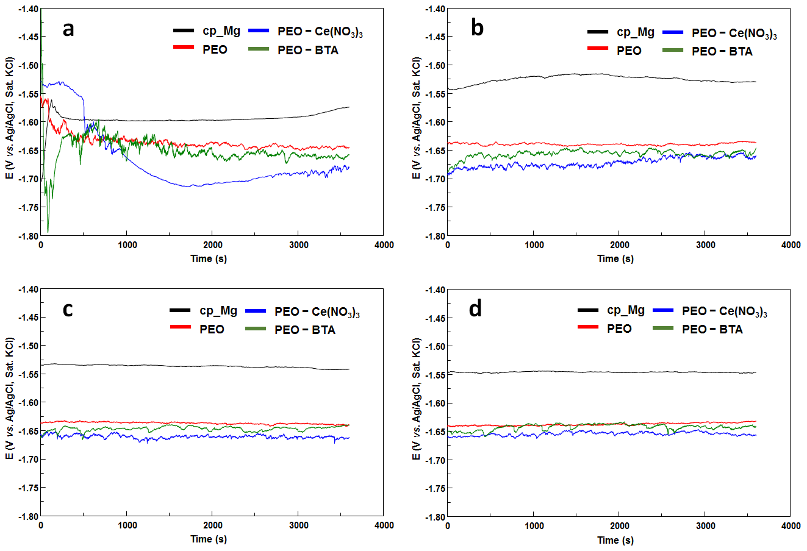
Figure 7-8 Open circuit potential evolution of cp-Mg and the PEO coated samples with and without post-treatments in 3.5 wt.% NaCl solution (a) 1st hour, (b) 2nd hour, (c) 3rd hour and (d) 4th hour

7.5.2 Electrochemical impedance spectroscopy
To investigate the variation of corrosion resistance along with the immersion time for the PEO coatings with and without post-treatments, the impedance spectra of the coated samples recorded after 1, 2, 3 and 4 h of immersion in the 3.5 wt.% NaCl solution are presented in Figure 7-9. The impedance test results of bare cp-Mg are also illustrated for comparison. From the EIS spectra of cp-Mg (Figure 7-9a), it can be found that there is one RC loop displayed and the corrosion resistance of cp-Mg gradually increased during the four hours of immersion as indicated by the increased diameter of the loop. This result should be due to the gradually accumulated corrosion products on the surface of cp-Mg which resisted the penetration of corrosive media to the metal substrate and postponed the corrosion process. However, compared to the PEO coated samples, the coating thickness and corrosion resistance of the protective layer formed by corrosion products is obviously much smaller. In addition, all the coated samples exhibited a gradually decreasing corrosion resistance during the four hours of immersion, which is contrary to that of cp-Mg, indicating the coating degradation occurred in this period. Specifically, despite the difference in post-treatment methods, both PEO-Ce(NO₃)₃ and PEO-BTA coatings had higher corrosion resistance than the PEO coating after one hour of immersion in 3.5 wt.% NaCl solution, with the best corrosion performance possessed by the PEO-Ce(NO₃)₃ coating. After two hours of immersion, all the coated samples showed a significant decrease in corrosion resistance compared with that of the first hour, and no obvious shrinkage of the capacitive semi-circle can be observed in the last two hours of immersion indicating the corrosion resistance gradually stabilised. It can be found that after four hours of immersion in 3.5 wt.% NaCl solution the PEO-Ce(NO₃)₃ coating still had much higher corrosion resistance compared with other PEO coatings. However, the difference in corrosion resistance of the PEO and PEO-BTA coatings is relatively small, with only slightly higher RC semi-circle for the PEO-BTA coating. Figure 7-10 presents the Bode plots of cp-Mg and the coated samples. The impedance magnitude (|Z| vs. frequency) spectra are in a good agreement with the results discussed above, and further confirm the trend of coating degradation during the four hours of immersion. According to the |Z| behaviour, it can be concluded that the corrosion resistance of cp-Mg was significantly improved by the PEO coatings. After the post-treatments, the corrosion protection ability of the PEO coating was further enhanced to a certain extent, which depends on the materials used in the post-treatment. It has to be noted that the phase angle Bode plots of the PEO and PEO-BTA coatings are quite similar, which indicates the coating microstructures were not significantly changed after the BTA-based post-treatment. However, the phase angle at low frequency time constant (from 10¹ Hz to 10³ Hz) of the PEO-Ce(NO₃)₃ coating is obviously higher than the other coated samples, which could be due to the significantly increased corrosion resistance of the inner dense region caused by the sealing effect of Ce-containing compounds on the PEO coating. This result is also consistent with the SEM morphologies of the PEO, PEO-Ce(NO₃)₃ and PEO-BTA coatings illustrated in Figure 7-2 and Figure 7-4.

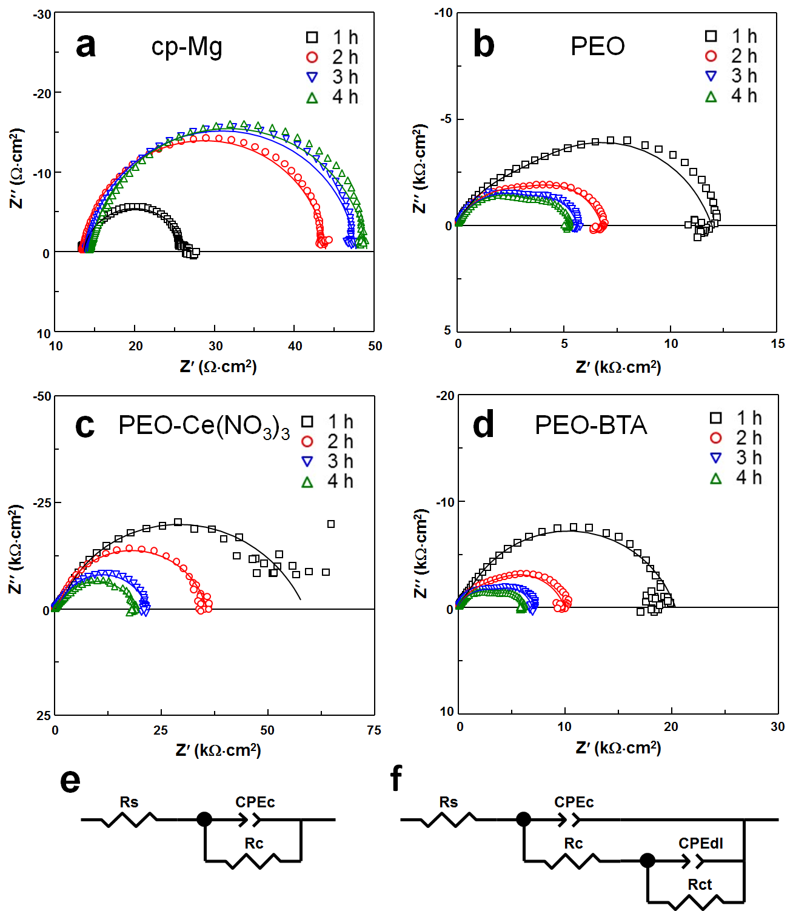
Figure 7-9 Impedance spectra (scatter plots) and fitting results (solid lines) of (a) cp-Mg, (b) PEO, (c) PEO-Ce(NO₃)₃ and (d) PEO-BTA coatings with immersion time in 3.5 wt.% NaCl solution; (e and f) equivalent circuits used for EIS fitting
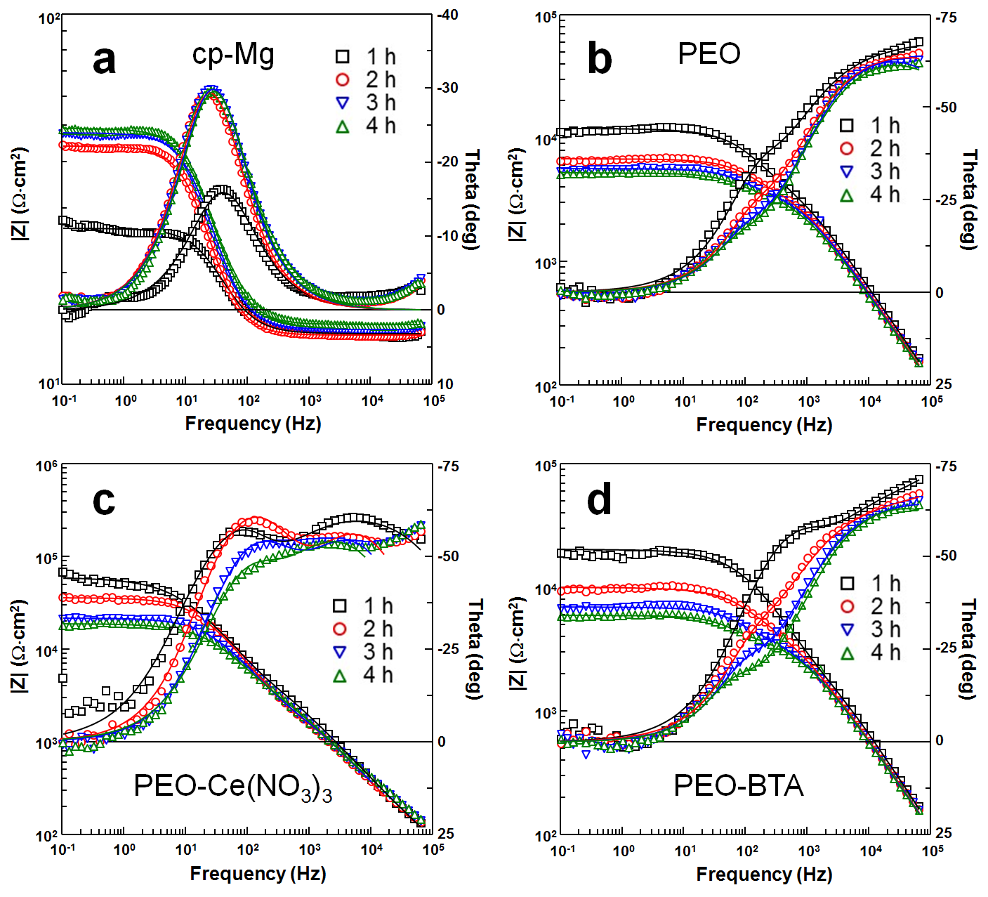
Figure 7-10 Bode plots of (a) cp-Mg, (b) PEO, (c) PEO-Ce(NO₃)₃ and (d) PEO-BTA coatings with immersion time in 3.5 wt.% NaCl solution

It has to be noted that the EIS spectra of the PEO coatings have two RC loops, suggesting more complicated two kinetic processes compared with cp-Mg have taken place during the electrochemical tests. This result is also consistent with the phase angle Bode plots illustrated in Figure 7-10, as two time constants can be observed for the coated samples. Actually, as a two-layered structure including an outer porous layer and an inner dense layer, a typical impedance behaviour containing two RC loops can usually be observed from the EIS complex plots of the PEO coated samples on Mg and its alloys. The loops presented in different frequency ranges are associated with different regions of the PEO coatings, i.e. the semi-circle in high frequency range represents the corrosion process of the outer porous layer, and that in low frequency range is associated with the corrosion performance of the inner dense layer. According to the impedance behaviour, two equivalent circuits (ECs) presented in Figure 7-9 (e and f) are used to fit the EIS data of cp-Mg and the PEO coatings, respectively. The EIS fitting exercise provided good fits with the experimental data, as presented by the solid lines in the complex and Bode plots. Each component in the ECs is assigned a physical meaning, which has already been well discussed in Chapter 5. Similar ECs have also been applied to model EIS behaviour of the PEO coating on Mg alloy with Ce-based post-treatment by others [163].

Since the R_{ct} caused by the inner dense layer of the PEO coating provides the major contribution to the total corrosion resistance, it is necessary to investigate the degradation behaviour of the inner dense layer of the coated samples to better understand the entire corrosion degradation mechanism of the studied coatings. Figure 7-11 illustrates the evolution of R_{ct} of the PEO coatings with immersion time in 3.5 wt.% NaCl solution. All the R_{ct} values were obtained from the results of EIS fitting with EC showed in Figure 7-9f. The corrosion resistance of the inner dense layer of the PEO-Ce(NO₃)₃ and PEO-BTA coatings is better than that of the PEO coating, as indicated by the R_{ct} value after one hour of immersion. In the following three hours of immersion, R_{ct} decreased for all the coated samples, and it was gradually stabilised along with the increasing immersion time, especially in the last two hours of immersion. It can also be concluded that the Ce-based post-treatment can provide significant improvement for the corrosion resistance of the inner region of the PEO coating, even after four hours of immersion. The BTA-based post-treatment can only provide a short-term improvement for R_{ct} of the PEO coating, since it almost lost the effectiveness after two hours of immersion in 3.5 wt.% NaCl solution.

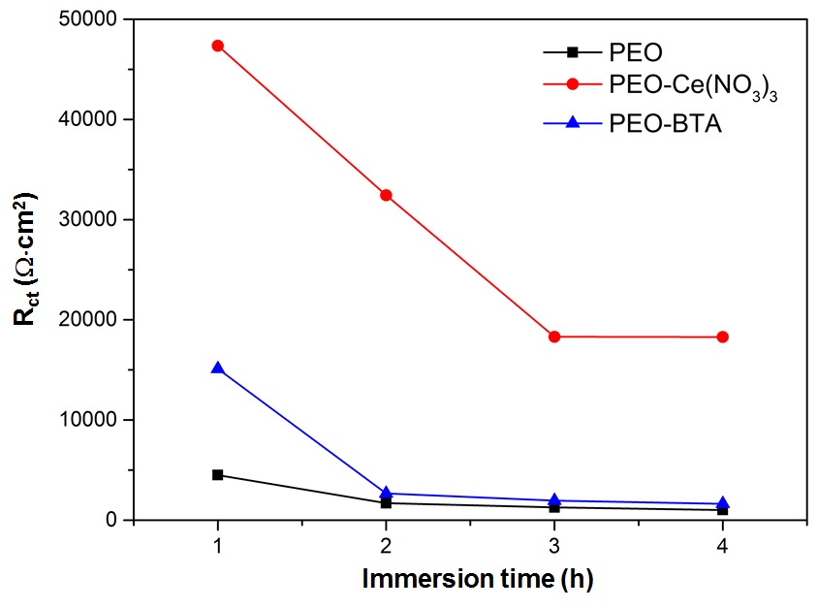
Figure 7-11 Evolution of charge transfer resistance of the coated samples during the four hours immersion time in 3.5 wt.% NaCl solution

In order to understand the corrosion behaviour of the PEO coatings with different post-treatments, it is necessary to comprehensively consider all the results discussed above, as well as the basic principles of Mg corrosion. As suggested by Mohedano et al. [84], CeO₂ and Ce₂O₃ would be formed during the Ce-based post-treatment for the PEO coated Mg alloy. This is consistent with the EDX results in the present work, where strong peaks related to Ce and O could be observed. The formation of insoluble cerium oxides caused the sealing effect during the Ce-based post-treatment. As a result, the corrosion resistance of the PEO-Ce(NO₃)₃ coating was improved since considerable numbers of micropores were sealed, which blocked the penetration of electrolyte down to the inner barrier region and reduced the total exposed area. Meanwhile, the Ce-containing compounds would migrate to the corroded area and provide continuous protection for the coating during corrosion attack. Therefore, the Ce-based post-treatment could provide effective and long-term improvement for the corrosion resistance of the PEO coating.

Moreover, it is well known that the pH value would be increased due to the gradual release of OH⁻ caused by cathodic reaction on Mg during corrosion. It was reported that the presence of BTA is beneficial for the formation of a thin but dense monocrystalline Mg(OH)₂ protective layer on the corrosion sites, especially in the high pH conditions [164]. However, according to the SEM results, it is reasonable to speculate that BTA can only be adsorbed on the PEO coating, rather than through the way of forming insoluble BTA-containing compounds as the Ce-based post-treatment. As a result, the adsorbed BTA on the PEO-BTA coating were gradually dissolved into the 3.5 wt.% NaCl solution along with the increasing immersion time, which means the BTA-based post-treatment could not provide long-term effectiveness for the PEO coating. In addition, without sealing effect, the improvement in corrosion resistance of BTA-based post-treatment is also not comparable with the Ce-based post-treatment. The aforementioned assumptions are in a good agreement with the experimental results.

7.5.3 Potentiodynamic polarisation evaluation
The potentiodynamic polarisation curves of cp-Mg and the PEO coatings after four hours of immersion in 3.5 wt.% NaCl solution are illustrated in Figure 7-12. Consistent with the OCP results, the corrosion potential (E_{corr}) of cp-Mg is higher than that of the coated samples. However, the coated samples are obviously more corrosion resistant compared to the bare cp-Mg, as the polarisation curves of the PEO coatings are in the lower current density region. In general, the cathodic and anodic reactions occurred during the polarisation tests are represented by the cathodic and anodic branches of the polarisation curves. In this regard, the mechanism of the improved corrosion resistance caused by the Ce- and BTA-based post-treatments can be revealed by analysing the behaviour of the polarisation curves of the coated samples. By comparing relative positions of polarisation curves, it can be found that the anodic and cathodic reaction of the PEO-BTA and PEO-Ce(NO₃)₃ coatings respectively were depressed, in regard to those on the PEO coating. Meanwhile, despite the differences mentioned above, the E_{corr} and the other branches of polarisation curves of the PEO coatings with post-treatments are practically identical to those of the PEO coating. Therefore, it is reasonable to deduce that, after four hours of immersion in 3.5 wt.% NaCl solution, the corrosion resistance of the PEO-Ce(NO₃)₃ and PEO-BTA coatings are still better than the PEO coating, which is probably due to the inhibited rates of cathodic hydrogen evolution and anodic Mg dissolution, respectively.

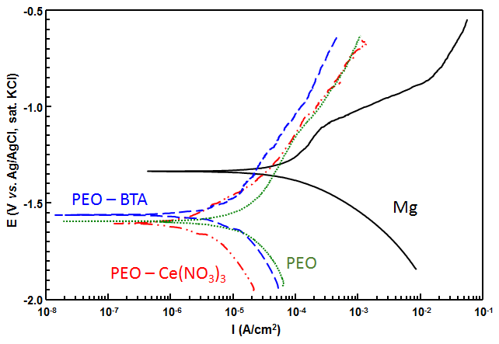
Figure 7-12 Potentiodynamic polarisation curves of cp-Mg and the PEO coatings with and without post-treatment

7.6 Surface morphologies after electrochemical tests
SEM surface morphologies with different magnifications of the coated samples after potentiodynamic polarisation tests were illustrated in Figure 7-13. By comparing the surface morphologies, it can be found that all the PEO coatings were damaged by the corrosion attack to a certain extent, resulting in various traces of corrosion left on the coating surface such as distorted pore edge, corrosion pits and mud-like cracks. These morphologies caused by the corrosion attack on PEO coated Mg in NaCl contained solution are consistent with previous works [109, 120, 165]. Some regions of the PEO coating were even peeled off after the electrochemical tests, which could be caused by the coating dissolution as observed in Figure 7-13b. It can also be observed that Ce-containing compounds still remained on the surface of the PEO-Ce(NO₃)₃ coating after the corrosion tests as suggested by the white spots distributed on the coating surface (Figure 7-13c and d). Comparing with other regions, there are no obvious signs of corrosion in the areas where Ce-containing compounds on the PEO-Ce(NO₃)₃ coating were preserved, indicating a good integrity and effective improvement of corrosion resistance in those areas. According to Gao el al. [120], MgO in the PEO coatings on Mg is favourably converted to Mg(OH)₂ during the corrosion process. Meanwhile, the created Mg(OH)₂ is not thermodynamically stable in a low pH condition and would release Mg²⁺ to the NaCl solution. As a result, magnesium oxychloride which contains Mg²⁺, Cl⁻ and OH⁻ would be formed during corrosion through the following reaction [166-168]:

xMg²⁺ + Cl⁻ +yOH⁻ + zH₂ → Mg_{x}(OH)_{y}Cl∙zH₂O 7.1

The aforementioned magnesium hydroxide and oxychloride composed the main constituent of the corrosion product that can be observed on the coating surface after the corrosion tests. Moreover, the accumulated Mg(OH)₂ on the corroded regions of PEO coating is likely to be dehydrated when exposed to air, which results in the formation of MgO. Due to the different molar volumes of Mg(OH)₂ and MgO, a volume shrinkage would occur during the dehydration process. Therefore, mud-like cracks can also be observed on the corroded coating surface as mentioned previously.
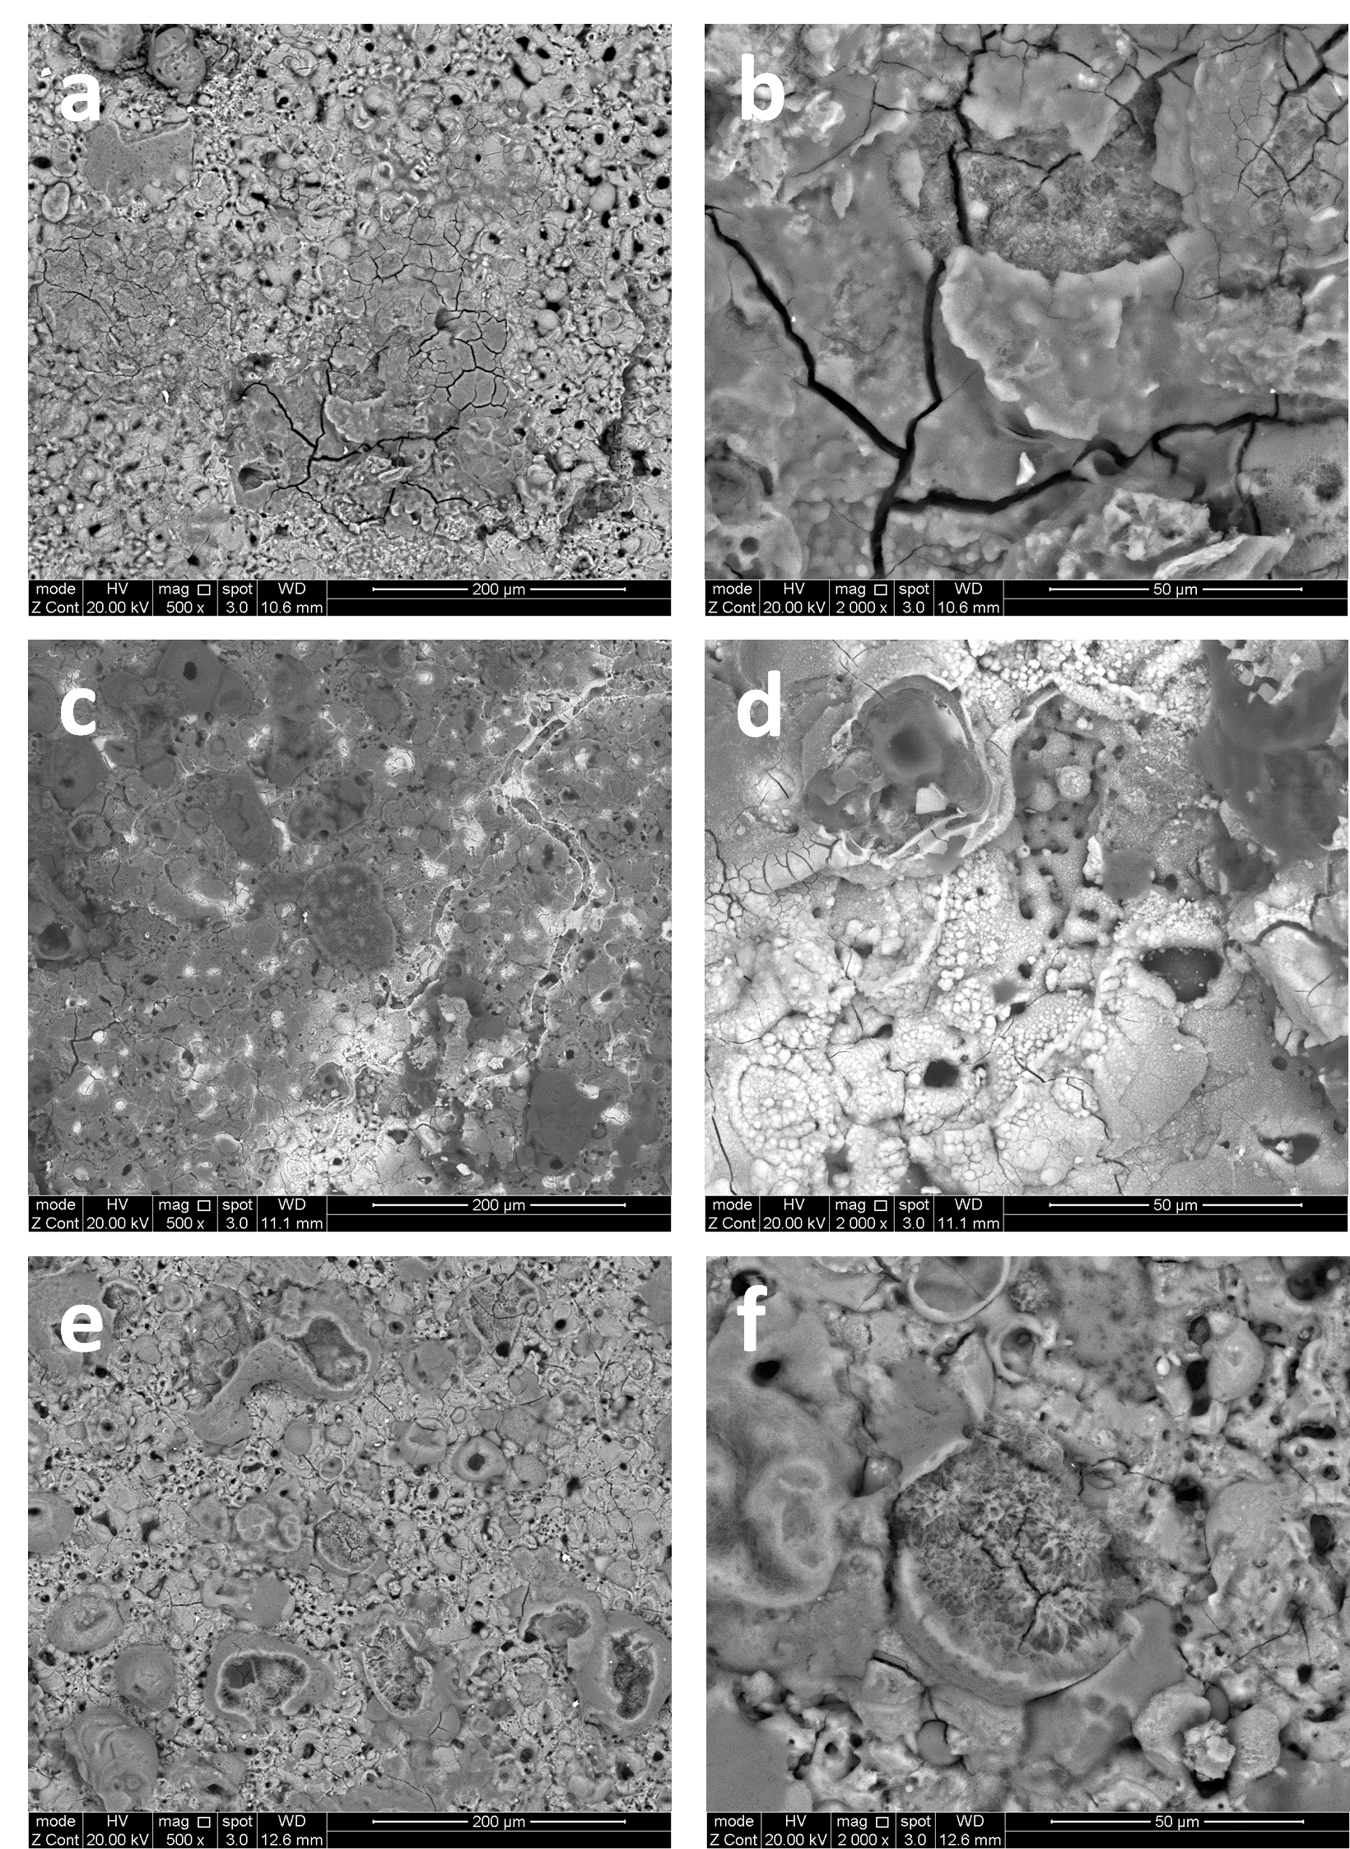
Figure 7-13 Surface morphologies of: (a, b) PEO, (c, d) PEO-Ce(NO₃)₃, and (e, f) PEO-BTA coatings after electrochemical corrosion tests

7.7 Summary
In this chapter, PEO coatings were produced on cp-Mg by pulsed unipolar galvanostatic mode, followed by Ce- and BTA-based post-treatments. According to the coating characteristics and the electrochemical tests results, the following conclusions can be made:

- The micropores and cracks on the PEO coating can be partially sealed by the Ce-containing compounds after Ce-based immersion post-treatments. No significant changes occurred in the surface morphology of the PEO-BTA coating, although some cracks could be observed in the regions close to the metal-oxide interface.
- Ce-containing compounds in the PEO-Ce(NO₃)₃ coating are mainly composed by of O, Mg, Si and Ce, and the presence of Mg and Si could be ascribed to the coating dissolution caused by the post-treatment, whereas, the elemental composition of PEO and PEO-BTA coatings remained the same. The crystalline phase composition was practically identical in all coatings, which is probably due to the relatively low content of crystalline Ce-containing compounds and BTA in the PEO-Ce(NO₃)₃ and PEO-BTA coatings, respectively.
- Due to the combined effect of pore sealing and continuous protection provided by insoluble cerium oxides, PEO-Ce(NO₃)₃ coating exhibited the best corrosion protection ability among the coated samples, as well as a longer-term positive effect on corrosion resistance compared with the PEO-BTA coating. For the latter, BTA was likely to be incorporated by adsorption, which can only provide a short-term improvement in the corrosion resistance due to the dissolution of BTA into the electrolyte. Moreover, without the sealing effect, the enhancement in corrosion resistance caused by the BTA-based post-treatment is also inferior to Ce-based post-treatment.

Chapter 8 Investigation of Plasma Electrolytic Oxidation Coatings Doped with Benzotriazole Loaded Halloysite Nanotubes on AM50 Magnesium Alloy
As discussed in Chapter 3, duplex and hybrid treatments that received significant attention to produce composite PEO coatings can provide synergetic effects leading to significant improvements in corrosion as well as the provision of additional functionalities to the surface. Despite these advantages, the PEO coatings still offer only passive corrosion protection, which relies mainly on their barrier properties, with the research on attaining these coatings with the function of active corrosion protection, e.g. by loading them with inhibitors, being in its infancy.
Inspired mainly by biological systems, in recent years, attempts have been made to develop smart self-healing materials that are able to repair themselves when damage occurs. Due to this special capability, self-healing materials can have a longer service life and a greater potential of overall life-cycle cost reduction, compared with conventional materials. There are various types of self-healing materials and some of them have already been practically applied [138-142]. Recently, several studies have been published on using halloysite nanotubes (HNT) as prospective nanocontainers for corrosion inhibitors to produce anticorrosive coatings with self-healing functionality [169-173]. HNT consist of a two-layered aluminosilicate structure and they can provide suitable containers for corrosion inhibitors and other active agents. Usually, the size of HNT varies from 1 to 15 µm in length and about 10-100 nm inner diameter. A combination of the small particle size with thermal stability of aluminosilicate (which can potentially withstand high instantaneous local temperatures developed at the sites of plasma discharges during the PEO process) makes it attractive candidate to develop hybrid self-healing PEO coatings by incorporating in-situ inhibitor-loaded HNT in the surface layer, during a simple single-step treatment.
In this chapter, the application of corrosion inhibitor benzotriazole (BTA) loaded into HNT containers is considered in order to obtain the self-healing functionality in PEO coatings thus improving the corrosion protection of AM50 Mg alloy. Fabrication, characterisation and comparative evaluation of the three groups of PEO coatings – pristine (PEO), HNT-doped (HNT-PEO) and BTA-loaded-HNT-doped (BTA-HNT-PEO), are studied and discussed.

8.1 Preparation of inhibitor loaded halloysite nanotubes
The morphology and microstructure of HNT and BTA precursors are presented in Figure 8-1a and b. Before the PEO treatment, the BTA loaded HNT were prepared using the procedure described in Chapter 4. To perform the loading, 20g HNT powder was mixed with 250 ml BTA aqueous solution (10 g/L). The mixed suspension containing BTA and HNT was evacuated in a vacuum jar to remove air from the hollow core of the HNT. After that, the HTNs were extracted from the BTA solution by centrifuging, washed in distilled water and dried in air for 48 h. This procedure was deemed to allow efficient BTA loading. However, the subsequent energy dispersive X-ray (EDX) analysis (Figure 8-1c) showed that both carbon and nitrogen were almost below sensitivity limit, possibly due to a combination of several factors, including low BTA solubility in water and shielding by higher-Z elements, such as Al and Si, contained in HNT. Additional verification was therefore performed using HNT loaded with 80 g/L acetone solution of BTA, which confirmed the existence of BTA through the increased peak of carbon and presence of a N peak in the EDX spectrum (Figure 8-1d).

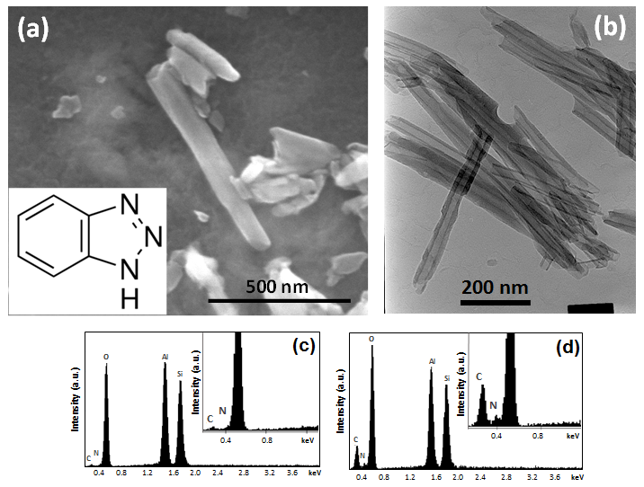
Figure 8-1 Typical appearance of halloysite nanotubes used in this study (a); SEM image, the inset shows chemical structure of 1,2,3-Benzotriazole loaded in the nanotubes. (b) TEM image. EDX spectra of BTA-HNT prepared in solutions: (c) 10 g/L BTA in water and (d) 80 g/L BTA in acetone

8.2 PEO coating preparation
AM50 magnesium alloy samples were also prepared following the procedures discussed in Chapter 4. The PEO treatments were carried out for 10 min in a 2-litre stainless steel container equipped with stirring and cooling systems, which also served as the counter-electrode. Electrolytes used were aqueous alkaline silicate-fluoride solutions composed of (g/L): 12 – Na₂SiO₃, 2 – KOH, and 4 – NaF, with 10 g/L additions of either HNT or BTA-loaded HNT prepared as described in Section 8.1. The electrolyte temperature was kept below 30°C in order to avoid possible adverse effects on the PEO process and resulting coatings. A pulsed unipolar current mode (Figure 8-2) with frequency (f) of 100 Hz, duty cycle (δ) of 10% and the mean average current density of 40 mA/cm² was applied. The frequency f and duty cycle δ can be described as follows:
$f=\frac{1}{(t_{on}+t_{off})}$ 8.1
$δ=\frac{t_{on}}{t_{on}+t_{off}}×100\%$ 8.2

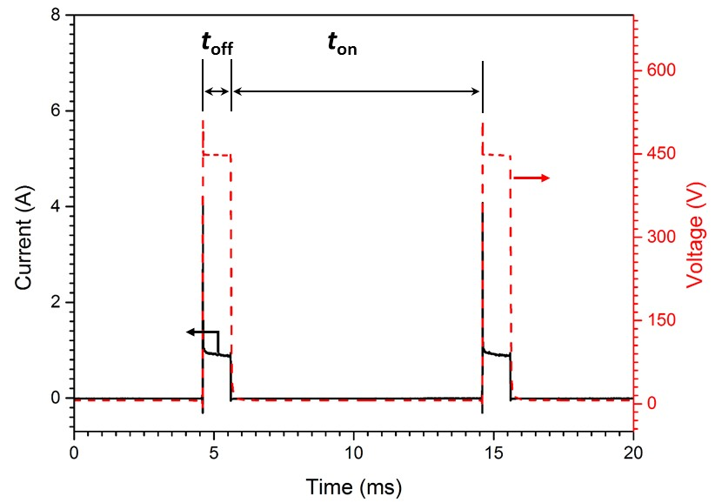
Figure 8-2 Typical electrical waveforms acquired during PEO treatments

8.2 Characteristics of PEO process
Figure 8-3 shows voltage transients for the PEO processes carried out in the three types of electrolytes (silicate-fluoride, HNT- and BTA-HNT modified electrolytes) on AM50 Mg alloy. Generally, the voltage response during the PEO treatment is similar to that discussed in Chapter 5. According to the voltage transients, the PEO processes can be characterised in three different stages. In the first stage (I), the voltage increased rapidly when the PEO treatment was started, and some tiny gas bubbles could be observed on the surface of the Mg alloy electrode. In the second stage (II), the voltage still increased, but at a lower rate compared with that of the first stage. During this stage, a large number of fine white sparks could be observed on the sample surface, together with a more intensive gas evolution and a shrill sound. When the PEO treatment reached the third stage (III), the fine white sparks turned into large orange discharges, and their number decreased with processing time. In this stage, the voltage increased more slowly, remaining at around 450 V with only small variations. It has to be noted that there were only small differences between the voltage transients of PEO treatments in different electrolytes, suggesting that neither HNT nor BTA-HNT additions had a significant effect on the PEO process.

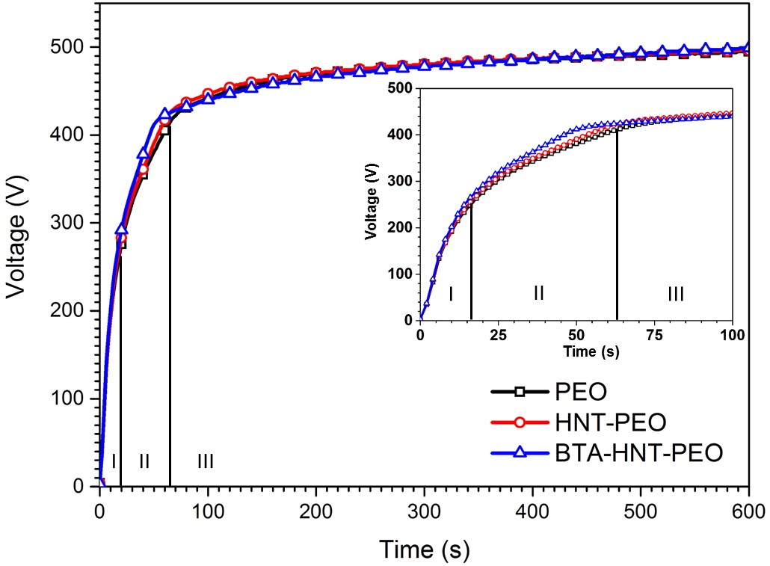
Figure 8-3 Voltage transients during PEO treatments of AM50 Mg alloy in three different electrolytes

8.3 Coating thickness
The thickness of the studied coatings is shown in Figure 8-4. Compared with the PEO coating, the thickness of the HNT-PEO coating changed insignificantly (30.1 ± 2.47 μm vs 29.5 ± 2.50 μm), whereas a slightly larger change was observed for the BTA-HNT-PEO coating, showing an average value of 36.2 ± 2.91 μm. This could be due to an inhibiting action of BTA on anodic dissolution of Mg during PEO processing. It can be speculated that some HNT located in the vicinity of microdischarge events would have experienced short excursions at elevated temperatures, at which point some BTA could be released from those nanotubes due to thermal expansion. This would then react with magnesium lost into the electrolyte, promoting precipitation of Mg(OH)₂ or other insoluble compounds, e.g. silicates, by the mechanisms discussed in [91].

Figure 8-4 Thickness of PEO coatings formed on AM50 Mg alloy in different electrolytes

8.4 Surface morphology
Figure 8-5 shows the secondary electron images of surface morphologies and cross-sectional features of the PEO coatings on AM50 Mg alloy formed in silicate-fluoride, HNT- and BTA-HNT-electrolytes. Characteristic of PEO coatings porous surface morphology can be observed, with uniformly distributed micro-pores and micro-cracks possibly caused by gas liberation and thermal stress related to the discharging activity during the PEO process. Importantly, small particles of a tubular shape can be observed in the magnified insets in Figure 8-5(b,c), indicating the HNT and BTA-loaded HNT were successfully incorporated in the surface layer. At the same time, the surface of the PEO coating produced in the silicate-fluoride electrolyte does not show these features (Figure 8-5(a)), which further substantiates the above inference.

The cross-sectional SEM micrographs presented in Figure 8-5(d–f) indicate that all the coatings have a porous structure and a good bonding to the Mg alloy substrate. Most of the pores are surface connected, contributing to the surface roughness, although some occluded porosity can also be observed. The pore size, and correspondingly the surface roughness, appear to decrease from PEO to BTA-HNT-PEO and further down to the HNT-PEO coating, the latter featuring some elongated pores arranged parallel to the coating-substrate interface, just above the barrier layer. Comparatively more round occluded porosity present in the BTA-HNT- PEO coating is probably responsible for its greater apparent thickness. In terms of microstructural integrity, both coatings fabricated in HNT- and BTA-HNT modified electrolytes could be superior to the original PEO coating, as they feature fewer and smaller voids and a more compact structure.

Back-scattered electron images of the PEO coatings presented in Figure 8-6(a–c) allow phase-contrast observation of their characteristic features, e.g. micro-cracks and pores, especially at a small scale, which cannot be attained by secondary electron imaging. Both HNT-PEO and BTA-HNT-PEO coatings have a more homogeneous structure than the PEO coating, which is identified by the reduced number of small pores and cracks. This is consistent with the cross-sectional features illustrated in Figure 8-5(d-f). Characteristics of coating porosity are presented in Figure 8-6(d). It can be seen that the PEO coating has the highest porosity (31.9%) which is much higher than that of HNT-PEO (13.3%) and BTA-HNT-PEO (15.2%) coatings. Regardless of the difference in porosity, all the PEO coatings show similar trends of pore size distribution. Almost 90% of the pores fall in the range of 0–5 μm, with the percentage of larger pores decreasing progressively, although a few could still reach up to 40 μm in size.

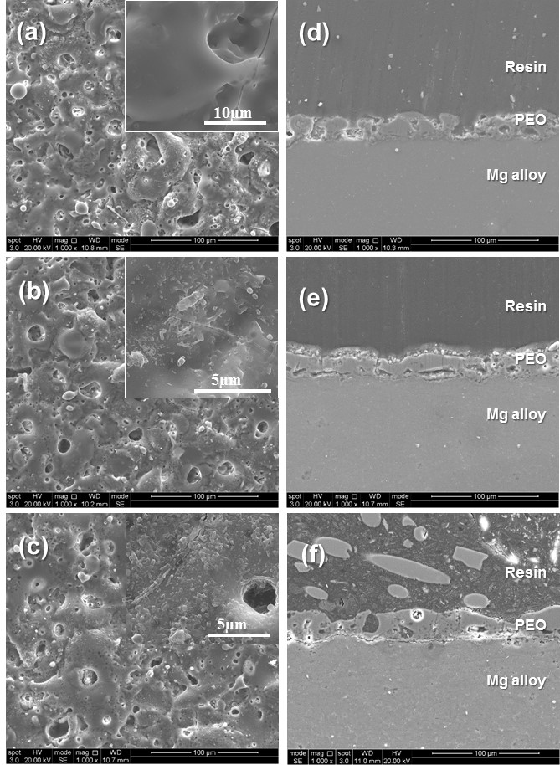
Figure 8-5 Secondary electron images of surface morphologies (a-c) and corresponding cross-sections of the studied coatings (d-f): (a),(d) PEO; (b),(e) HNT-PEO; (c),(f) BTA-HNT-PEO

Figure 8-6 Back-scattered electron (BE) images of the studied coatings: (a) PEO, (b) HNT-PEO, (c) BTA-HN-PEO; and (d) characteristics of their surface porosity

8.5 Coating chemical and phase composition
A typical EDX spectrum and relative contents of elements detected in the PEO coatings produced in different electrolytes are presented in Figure 8-7. There are minor differences in surface chemistry of the coatings fabricated. High surface contents of O and Si suggest that during the PEO treatment, the ingredients of the electrolyte have been engaged in interactions with the Mg-alloy substrate. The Al/Mg ratio in Figure 8-7 shows that surface concentration of Al increased when HNT and BTA-HNT were added in the electrolyte, which indicates the nanotubes have been successfully incorporated in the PEO coatings; this is consistent with the results of SEM analysis presented in Figure 8-5. The highest Al/Mg ratio is observed in the BTA-HNT-PEO coating, which is about two and three times that in HNT-PEO and PEO coatings respectively. At the same time, as discussed in Section 8.1, it is difficult to confirm whether the BTA-HNT incorporation was accompanied with any change in BTA content in the nanotubes.

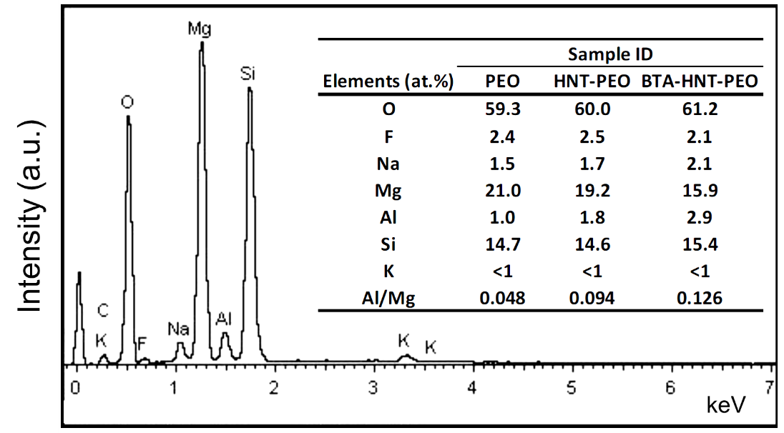
Figure 8-7 Typical EDX spectrum and relative contents of chemical elements on the surfaces of PEO coatings

The X-ray diffraction spectra in Figure 8-8 show that all coatings are mainly composed of Mg₂SiO₄ phase. Strong Mg peaks present in the patterns are related to the Mg substrate, which indicates that X-rays penetrated through the PEO coating. Higher peaks related to Mg₂SiO₄ can be seen in the pattern of the HNT-PEO coating compared to that of the original PEO coating, indicating there is a higher crystalline phase content in the former. However, no MgO crystalline phase was detected in the PEO coatings. The absence of MgO in the PEO coatings on AM50 Mg alloy could be due to the hydrolysis reaction of silicate ions (SiO₃²⁻) contained in the electrolyte which caused the formation of silica (SiO₂), and subsequently consumed MgO by the following reaction [152]:

SiO₂ + 2MgO = Mg₂SiO₄ 8.3

Moreover, there are no fluorine containing phases observed in the spectra, suggesting that it may be incorporated in the coatings as an amorphous constituent. No detectable pattern of HNT was found in the XRD spectrum of the HNT-PEO coating, probably due to their low concentrations. However, obvious HNT peaks can be seen in the spectrum of the BTA-HNT-PEO coating, indicating greater amounts of HNT incorporated there, which is consistent with the results of EDX analysis.

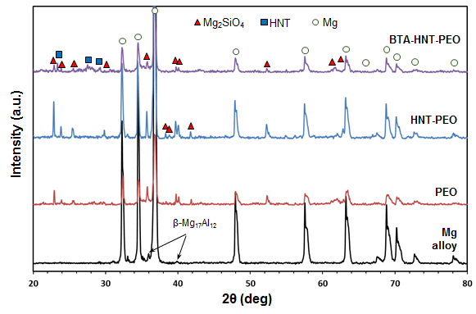
Figure 8-8 XRD patterns of AM50 Mg alloy and the studied PEO coatings

8.6 Surface topography and roughness
Results of surface topography analysis and estimates of average surface roughness (R_{a}) for the studied PEO coatings are presented in Figure 8-9. Probably due to the galvanostatic PEO mode applied in this work, all the coatings show a relatively rough surface morphology (R_{a} = 6.77 – 7.00 μm) characterised by cavities and ridges evenly distributed across the surface. Since both 3D surface topography images and line scan profiles were similar for all coatings, it could be concluded that the introduction of HNT did not significantly influence the surface roughness.
Figure 8-9 Examples of (a) 3D surface topography and (b) corresponding line scan profile, along with the average values of surface roughness derived for the studied PEO coatings

9.6.3 Mechanical properties
Scratch testing is a common laboratory method to assess abrasion resistance, cohesive and adhesive strength of PEO coatings [31, 82, 83]. These characteristics are of interest here, as mechanical failure would usually compromise the barrier protection provided by the PEO coatings, trigger and/or accelerate corrosion of the Mg substrate. Therefore, increased coating strength would postpone the onset of corrosion attack in the case of a component being subjected to mechanical loading in an aggressive environment. Scratch test results for the studied coatings are collated in Figure 8-10, indicating that characteristic critical loads L_{C2} and L_{C3}, corresponding to the first substrate exposure and its complete opening, lie in the ranges 13.6–16.6 N and 18–23.1 N, respectively. Usually the critical loads depend upon stylus tip radius, coating thickness, fracture toughness, and adhesion to the substrate [31]. The coating failure is normally accompanied by changes in AE and/or FC behaviour, so these two characteristics are often used to determine the failure onset point. In the present study, however, due to the porous structure and cracks pre-existing in the PEO coatings, these parameters could not be used, as AE was observed from the very beginning of the test and FC did not show significant variation with normal load. Therefore, the critical loads for the studied coatings were identified by the appearance of visual evidence of failure in the optical micrographs of scratched surfaces. In this case, steady increases in both AE and FC depicted in Figure 8-10 simply reflected increasing contact area due to the diamond indenter ploughing through the coating while the normal load was increasing. A monotonic rise of FC indicates the absence of abrupt adhesive failure or delamination. It is likely that the PEO coatings failed cohesively, being abraded or squashed. The convoluted interface between the PEO coating and Mg alloy substrate appears to have prevented the abrupt adhesive failure and delamination.

Critical loads for HNT-PEO and BTA-HNT-PEO coatings tend to increase compared with that of the pristine PEO coating. Specifically, L_{C2} for the coatings incorporated with HNT and BTA-HNT are approximately 17 and 22% higher than that of the original PEO coating. As far as the L_{C3} is concerned, yet greater disparity was observed between the coatings produced in the silicate-fluoride and HNT-added electrolytes, showing a ∼28% improvement due to HNT incorporation. The increase in L_{C3} for the PEO coating produced in the BTA-HNT electrolyte is rather insignificant. The difference in critical loads between the PEO coatings could be attributed to differences in both coating strength and thickness [31]. Taking account of the coating thickness shown in Figure 8-4, the increased critical loads for the HNT-PEO coating are likely to be due to the improvement in the strength of the coating material by HNT incorporation. However, for the BTA-HNT-PEO coating, the situation appears more complicated, as it is thicker than both PEO and HNT-PEO coatings but only L_{C2} shows a significant increase compared to the PEO coating. This indicates the coating strength is slightly decreased by incorporation with the HNT-PEO coating. The reasons for the enhanced strength of the HNT-PEO coating could be various. Firstly, HNT have high mechanical strength and Young modulus (and are therefore known as an effective additive for strengthening and toughening polymers), which means the strength of PEO coatings on Mg could also be expected to be enhanced by HNT incorporation. Secondly, the difference in the intrinsic coating characteristics (e.g. internal stress distribution) could also have a contribution to the adhesive strength [83], as reflected in the scratch resistance behaviour observed in Figure 8-10. Finally, the differences in coating porosity discussed in Section 8.4 could also play an important role in their mechanical behaviour.

Figure 8-10 Results of (a) scratch tests showing typical microscopic appearances of scars at characteristic loads, (b) an example of acoustic emission (AE) and friction coefficient (FC) evolution during the test and derived values of critical loads for the studied coatings

8.7 Electrochemical evaluation
The corrosion properties of AM50 Mg alloy and the PEO coatings were evaluated by electrochemical tests carried out in a 3.5 wt.% NaCl solution. The open circuit potential (OCP) behaviour was recorded during 12 h of immersion, periodically interrupted by electrochemical impedance spectroscopy (EIS) measurements. The potentiodynamic polarisation (PDP) scans were also performed after 4 h of immersion with the objective of evaluating the corrosion performance of the PEO coatings.

8.7.1 Free corrosion behaviour
The open circuit potential is a suitable parameter which can be used to evaluate the corrosion tendency of PEO coatings in aqueous solutions [122]. Generally, the coatings with higher OCP value would be more difficult to degrade. The evolution of OCP with immersion time during the first four hours of samples exposure to the 3.5 wt.% NaCl solution is presented in Figure 8-11. The vertical dashed lines on the graphs show instances when impedance measurements took place. It can be seen that all the coatings had similar OCP behaviour during the first hour. In particular, the OCP increased with a similar slope immediately after the coated samples were immersed in the NaCl solution. Then, after about 750 s, the OCP values started to fluctuate in the range of −1.55 to −1.45 V vs. Ag/AgCl (Sat. KCl). During this period, the corrosive solution gradually penetrated through the pores and cracks in the PEO coatings towards the metallic substrate. In the initial stage, the corrosion sites were small and would be gradually blocked by accumulated corrosion products, as claimed by Gao et al. [122]. Such products can be treated as an imperfect barrier inhibiting the corrosion process. When most of the corrosion sites were covered by the corrosion products, the OCP value would reach a peak in the graph. Then new corrosion sites will be activated in the PEO coatings, resulting in a sharp decrease in the OCP values. As such, the OCP behaviour illustrated two distinct stages in the first hour of immersion; the initial increasing and subsequent fluctuation stages. It has to be noted that the average OCP value of all the PEO coatings in the fluctuation stage was above −1.525 V vs. Ag/AgCl (Sat. KCl) in the first hour of immersion. The OCP evolution of the bare AM50 Mg alloy was similar to that of the PEO coated samples, however the initial stage was much shorter (about 140 s) and the magnitude of fluctuations was smaller.

In the following immersion period (2–4 h), different PEO coatings showed obvious dissimilarities in the OCP behaviour. First, the OCP of the BTA-HNT-PEO coating gradually tended to stabilise and kept at about −1.525 V vs. Ag/AgCl (Sat. KCl), whereas those of the PEO and HNT-PEO coatings still showed relatively high fluctuations, before exhibiting a decreasing trend towards values below −1.525 V vs. Ag/AgCl (Sat. KCl) at the end of this period. At the same time, the OCP behaviour of the Mg alloy was quite stable, suggesting a steady state reached in the corrosion process.

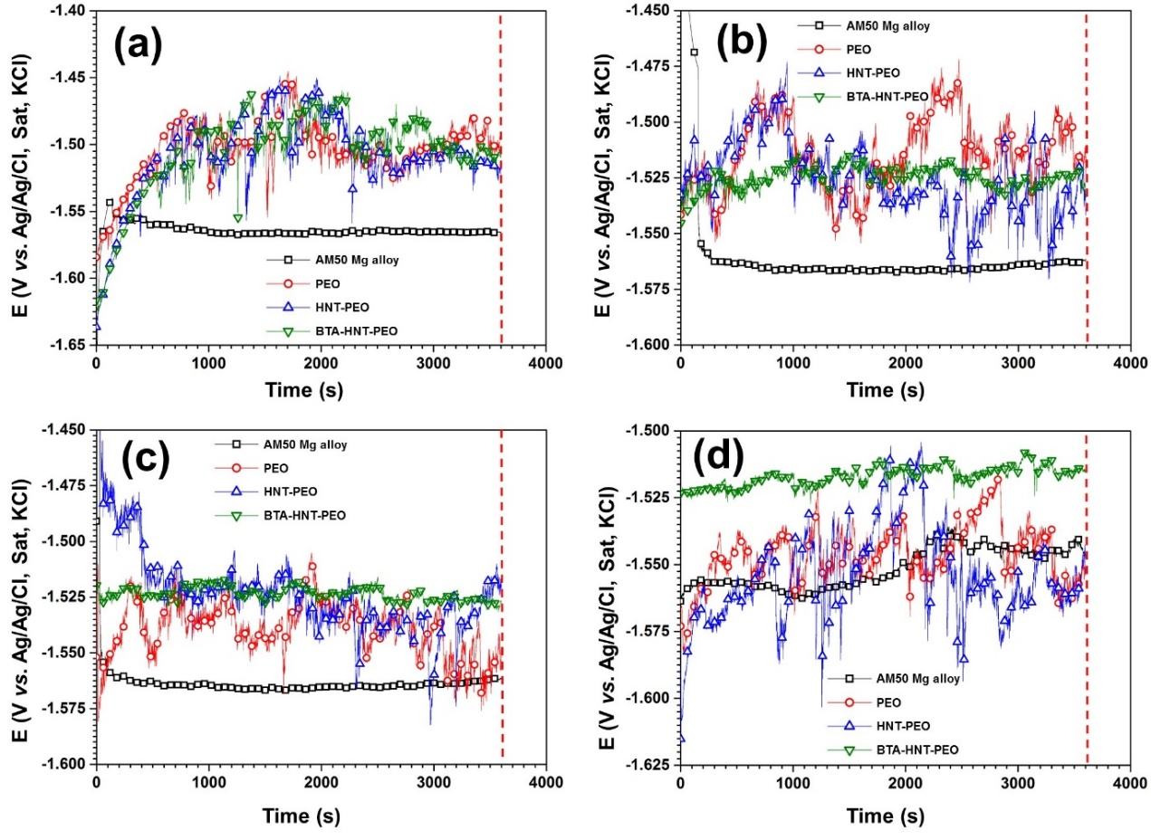
Figure 8-11 Open circuit potential evolution of bare and PEO coated AM50 Mg alloy samples in 3.5 wt.% NaCl solution (a) 1st hour, (b) 2nd hour, (c) 3rd hour and (d) 4th hour

8.7.2 Corrosion resistance
The EIS spectra of the AM50 alloy and PEO coated samples after 1–4 h of immersion in the 3.5 wt.% NaCl solution are shown in Figure 8-12. The complex plot of the Mg alloy (Figure 8-12(a)) exhibits one resistive-capacitive (RC) loop and the resistive-inductive (RL) loop which can also be observed in corresponding plots of the studied PEO coatings (Figure 8-12(b–d)). The inductive loop can be identified by the positive imaginary component (Z′′) and gradually decreasing real component (Z′) at low frequencies, indicating production of Mg²⁺ by pitting corrosion [161, 174]. The RC loop at high and intermediate frequencies originates from the film of corrosion products on the Mg alloy and the porous PEO coatings. Generally, larger RC semi-circles indicate better corrosion resistance and protection, whereas larger inductive loops imply more severe pitting corrosion. In Figure 8-12(a), it can be seen that there was a significant shrinkage of impedance of Mg alloy in the first 3 h of immersion in NaCl solution, and then the impedance increased dramatically after 4 h of immersion, becoming even larger than after the first hour. This phenomenon could be explained by the corrosion process of Mg. Thermodynamically, Mg is unstable and, when exposed to natural environmental condition, can quickly form a surface oxide or hydroxide film according to equations. 8.4-8.5. In particular, in presence of water or humid air, Mg is quickly oxidised into Mg(OH)₂ with a simultaneous release of H₂, as shown in equation 8.5:

Mg+ ½O₂ → MgO 8.4
Mg + 2H₂O → Mg(OH)₂ + H₂ 8.5

So, when the Mg alloy was first immersed in the NaCl solution, its surface was actually protected by a passive film composed of MgO and Mg(OH)₂. With time, the protective film gradually degraded, losing its function, as indicated by the decreasing impedance in the first 3 h of immersion. However, with longer immersion, the corrosion products were accumulated on the surface of Mg alloy and hydrogen bubbles covered the corrosion sites, resulting in an increased resistance to the corrosion process; this is indicated by the enlarged RC loop after 4 h of immersion in NaCl solution. Similar behaviour was also noted by King et al.[18].

For the PEO coating (Figure 8-12(b)), the impedance kept decreasing during 4 h of immersion, indicating continuous dissolution of the PEO coating. The impedance of the HNT-PEO coating (Figure 8-12(c)) showed quite similar behaviour in the first 3 h, before dramatically decreasing and becoming even smaller than that of the PEO coating. The evolution of impedance for the BTA-HNT-PEO coating illustrated in Figure 8-12(d) is substantially different. It can be seen that the impedance measured after 1 h of immersion showed the highest value which then fell and kept at the same level during the subsequent 3 h. At the same time, the impedance spectra showed the smallest inductive loops, indicating that the tendency for pitting corrosion was severely depressed by the addition of BTA.

Figure 8-12 Evolution of impedance spectra of (a) bare AM50 Mg alloy, (b) PEO, (C) HNT-PEO, and (d) BTA-HNT-PEO coatings with immersion time in 3.5 wt.% NaCl solution

Considering that the data collected at longer immersion times would provide more reliable estimates of corrosion resistance, we compared the EIS spectra of bare AM50 Mg alloy and PEO coated samples obtained after 4 h of immersion (Figure 8-13). Obviously, the BTA-HNT-PEO coating provides the highest corrosion resistance compared with other samples, which can be identified by the largest RC loop and the highest impedance magnitude (|Z|_{f→0}) in Figure 8-13(a) and (b), respectively. The worst corrosion resistance is observed for the bare AM50 Mg alloy, exhibiting the smallest semi-circle in the complex plot. This also suggests that the corrosion resistance of the alloy can be significantly improved by all studied coatings. Meanwhile, the PEO coating shows a better corrosion resistance than the HNT-PEO coating, as indicated by the larger RC loop in Figure 8-13(a).

Since there is always one depressed RC loop and an RL loop in all impedance spectra shown in Figure 8-13(a), it can be concluded that two kinetic processes occurred during the corrosion process of both the Mg alloy and the PEO coated samples. As such, the equivalent circuit shown in Figure 8-13(d) was used to analyse the impedance spectra obtained in this work. In this circuit, the physical mean of the EC components has already been discussed in Chapter 5 and Chapter 6. The RL loop could be represented by the inductor (L) and the resistance (R₁) connected in series [120].

Results of EIS fitting by the proposed EC are presented in Figure 8-12 and 13 by solid lines, showing adequate goodness of fit (χ² < 0.02); the values of corresponding elements are summarised in Table 8-1. Based on a simple circuit analysis, the impedance response of such a system can be described by the following equation [18]:
$\left|Z\right|= {\left(\frac{1}{Z_{{CPE}_{C}}}+\frac{1}{Z_{R_{C}}}+\frac{1}{Z_{L}+Z_{R1}}\right)}^{-1}+R_{S}$$\left|Z\right|={\left(\frac{1}{Z_{{CPE}_{C}}}+\frac{1}{Z_{R_{C}}}+\frac{1}{Z_{L}+Z_{R1}}\right)}^{-1}+R_{S}$$\left|Z\right|= {\left(\frac{1}{Z_{{CPE}_{C}}}+\frac{1}{Z_{R_{C}}}+\frac{1}{Z_{L}+Z_{R1}}\right)}^{-1}+R_{S}$ 8.6

where Z_{i} represents the impedance values of the corresponding EC component in Figure 8-13(d). The polarisation resistance R_{p} of the PEO coating and Mg alloy could be defined as the difference between the solution resistance R_{S} ≡ |Z|_{f→∞} and the low frequency resistance |Z|_{f→0} [18, 120]. Since at f→0, impedances of capacitive and inductive components approach infinity (Z_{CPEC}→∞) and zero (Z_{L}→0) respectively, the EC in Figure 8-13(d) is reduced to a combination of R_{S}, R_{C} and R₁. Then the polarisation resistance R_{p} can be estimated from the following equation:

$\frac{1}{R_{p}}=\frac{1}{R_{C}}+\frac{1}{R_{1}}$ 8.7

The calculated R_{p} values are also provided in Table 8-1. Generally, the higher the R_{p} value the lower the corrosion rate of the corroding material. Based on this point, the BTA-HNT-PEO coated sample is expected to have the lowest corrosion rate compared to the other samples, as indicated by the highest R_{p} value (7.81×10⁴ Ω cm²).

Figure 8-13 Impedance spectra (scatter plots) and fitting results (solid lines) of bare and PEO coated AM50 Mg alloy samples immersed in 3.5 wt.% NaCl solution for 4 h: (a) complex plots; (b) Bode plots; (c) enlarged complex plot of bare Mg alloy; (d) equivalent circuit used to fit impedance data

Table 8-1 Fitting results of EIS data
Time | Sample ID | CPE_{c}-T  [Fs^{n-1}cm⁻²] | CPE_{c}-P | R_{c}  [Ω⋅cm²] | L  [H⋅cm⁻²] | R₁  [Ω⋅cm²] | R_{p}  [Ω⋅cm²]
1st hour | AM50 Mg alloy | 1.70×10⁻⁵ | 0.94 | 2.95×10² | 1.44×10² | 1.46×10² | 97.7
1st hour | PEO | 4.65×10⁻⁷ | 0.79 | 1.56×10⁵ | 3.17×10⁵ | 4.43×10⁵ | 1.15×10⁵
1st hour | HNT-PEO | 6.46×10⁻⁷ | 0.74 | 7.86×10⁴ | 9.91×10⁴ | 1.11×10⁵ | 4.60×10⁴
1st hour | BTA-HNT-PEO | 8.22×10⁻⁷ | 0.75 | 1.88×10⁵ | 5.11×10⁵ | 3.38×10⁵ | 1.21×10⁵
2nd hour | AM50 Mg alloy | 2.23×10⁻⁵ | 0.95 | 2.46×10² | 1.24×10² | 1.38×10² | 88.4
2nd hour | PEO | 6.43×10⁻⁷ | 0.78 | 1.43×10⁵ | 7.13×10⁴ | 2.14×10⁵ | 8.57×10⁴
2nd hour | HNT-PEO | 6.77×10⁻⁷ | 0.76 | 1.08×10⁵ | - | - | 1.08×10⁵
2nd hour | BTA-HNT-PEO | 8.71×10⁻⁷ | 0.76 | 9.82×10⁴ | 5.28×10⁵ | 4.49×10⁵ | 8.06×10⁴
3rd hour | AM50 Mg alloy | 2.86×10⁻⁵ | 0.98 | 1.71×10² | 1.00×10² | 0.88×10² | 58.1
3rd hour | PEO | 1.34×10⁻⁶ | 0.70 | 9.80×10⁴ | 1.13×10⁴ | 2.09×10⁴ | 1.72×10⁴
3rd hour | HNT-PEO | 9.08×10⁻⁷ | 0.73 | 1.20×10⁵ | 2.13×10⁴ | 1.00×10⁵ | 5.45×10⁴
3rd hour | BTA-HNT-PEO | 9.60×10⁻⁷ | 0.75 | 9.81×10⁴ | 1.29×10⁵ | 2.64×10⁵ | 7.15×10⁴
4th hour | AM50 Mg alloy | 3.75×10⁻⁵ | 0.95 | 3.70×10² | 1.68×10² | 3.13×10² | 1.69×10²
4th hour | PEO | 8.09×10⁻⁷ | 0.77 | 3.83×10⁴ | 8.36×10³ | 4.77×10⁴ | 2.12×10⁴
4th hour | HNT-PEO | 4.59×10⁻⁷ | 0.86 | 1.26×10⁴ | 2.56×10² | 1.31×10⁴ | 6.42×10³
4th hour | BTA-HNT-PEO | 9.88×10⁻⁷ | 0.75 | 1.08×10⁵ | 1.99×10⁵ | 2.82×10⁵ | 7.81×10⁴
12th hour | PEO | 5.36×10⁻⁷ | 0.85 | 1.37×10⁴ | 2.90×10² | 1.80×10² | 1.78×10²
12th hour | HNT-PEO | 5.49×10⁻⁷ | 0.82 | 1.41×10⁵ | - | - | 1.41×10⁵
12th hour | BTA-HNT-PEO | 9.19×10⁻⁷ | 0.75 | 1.15×10⁵ | 1.44×10⁵ | 2.67×10⁵ | 8.04×10⁴

8.7.3 Polarisation behaviour
Polarisation curves are commonly used to reveal effects of partial anodic and cathodic reactions on the overall corrosion process and evaluate corrosion rates of tested materials. For the studied material-environment combinations, the partial anodic and cathodic reactions can be written as follows:

Mg → Mg²⁺ + 2e⁻ 8.8
2H₂O + 2e⁻ → H₂ + 2OH⁻ 8.9

The PDP curves of AM50 Mg alloy and PEO coated samples after 4 h immersion in the NaCl solution are shown in Figure 8-14. Generally, the relative position of the curve can give an insight to the likely corrosion rate and corrosion tendency of the material being tested. Specifically, the samples with more noble corrosion potential E_{corr} are considered more difficult to corrode and those having PDP curves shifted to the left are expected to show lower corrosion rates. However, a higher E_{corr} does not always mean a better corrosion protection ability for the PEO coated samples [97, 120, 175] and the current densities at the corrosion potentials have to be considered. Therefore, by comparing the relative positions of polarisation curves, it can be seen that all the PEO coated samples have lower corrosion rates than the bare Mg alloy, indicating the studied coatings can provide effective corrosion protection for the Mg alloy substrate. Moreover, it appears that among the coated samples, those with BTA-HNT-PEO and the HNT-PEO coatings should have the lowest and the highest corrosion resistance respectively. Although this appears to be inconsistent with the results of EIS studies (Figure 8-13), such inconsistency is only purported and should be considered along with the OCP evolution of the PEO coatings. In the PDP test, the voltage was scanned from low to high potentials. Therefore, in the beginning of the test, the samples were polarised cathodically and Reaction 8.9 took place at the working electrode/electrolyte interface. The hydroxyl ions created by this cathodic reaction increased local pH at the sample surface, facilitating Mg(OH)₂ precipitation at the sites of corrosion. Additional protection provided by such a process is reflected in the PDP curves (Figure 8-14), wherein the observed values of E_{corr} for the PEO and HNT-PEO coatings are higher than corresponding final OCP values in Figure 8-11d. In contrast, the E_{corr} of the BTA-HNT-PEO coated sample was consistent with its final OCP value, suggesting no additional formation of Mg(OH)₂ occurred during cathodic polarisation period of the PDP test at the BTA-inhibited corrosion cites. Moreover, this is consistent with the smallest size of inductive loops in impedance loci of the BTA-HNT-PEO coated sample (Figure 8-12 and 13), indicating the lowest tendency for pitting corrosion.

Thus, changes to the surface state of some samples occurred during PDP scans cause significant difficulties in evaluation of instantaneous corrosion rates using this method. This is consistent with other reports [18, 49, 50], arguing that potentiodynamic polarisation is unsuitable to compare the corrosion performance of Mg, because of dynamic processes taking place on the polarised surface and in the adjacent electrolyte. Therefore, the EIS results discussed in Section 8.7.2 provide a more reliable estimate of corrosion resistance for the studied samples.

Despite that, another useful observation, which can be made based on the PDP curves, relates to differences in anodic behaviour of the studied materials. For the uncoated AM50 alloy, a tendency for passivation briefly observed at low anodic overpotentials is interrupted at about −1.25 V vs. Ag/AgCl (Sat. KCl) by the onset of pitting corrosion. A similar trend is also observed for the PEO and HNT-PEO coated samples, although the passivity breakdown occurs 50 mV higher and subsequent current behaviour indicates development of metastable pits. Interestingly, the anodic branch of the PDP curve corresponding to the HNT-PEO coated sample exhibits a gentler slope with more disturbances, indicating that the passivation capacity is compromised by introduction of HNT in the PEO coating. In contrast, the anodic behaviour of the BTA-HNT-PEO coated sample is essentially smooth, with only minor perturbations at around −1.15 V vs. Ag/AgCl (Sat. KCl), which suggests that the pitting corrosion is strongly inhibited by this coating. This is in good agreement with the stable OCP behaviour and the smallest inductive loops in the impedance spectra of the BTA-HNT-PEO coated sample noticed earlier (Figure 8-11 and 12 (d) respectively).

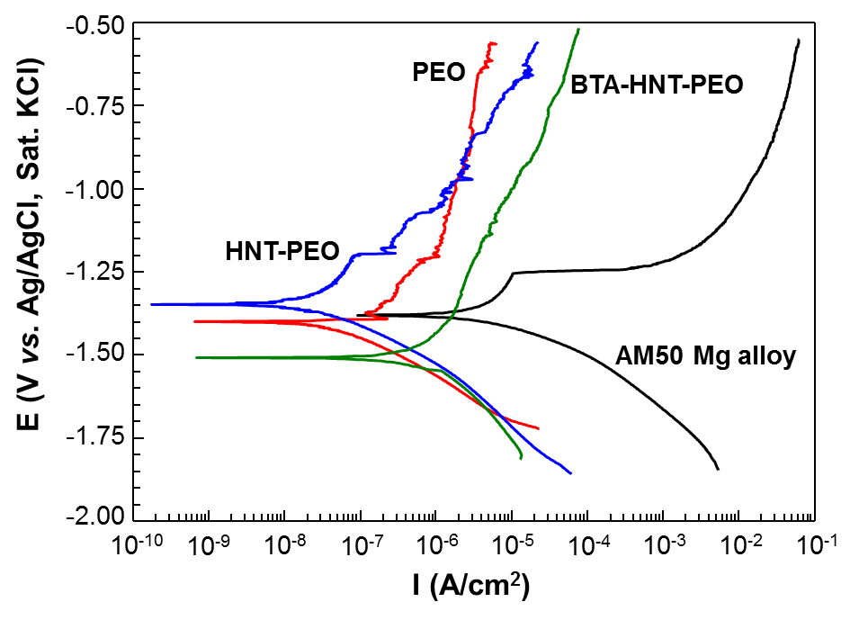
Figure 8-14 Polarisation curves of bare and PEO coated AM50 Mg alloy samples after 4 h immersion in 3.5 wt.% NaCl solution

8.7.4 Response to damage induced by anodic polarisation
Self-healing coatings are supposed to restore and maintain corrosion resistance following damage induced by various external factors, e.g. weathering, mechanical loading or polarisation [176]. Gnedenkov et al. [24] reported inhibitor-containing composite PEO coatings with self-healing functionality, which retained corrosion protection of a Mg alloy after potentiodynamic polarisation tests, showing a relatively good tolerance to the destruction induced by the potentiodynamic polarisation. A similar approach was adopted in the present work to evaluate damage tolerance of the studied coatings. Following PDP scans, the samples were kept in the 3.5 wt.% NaCl solution for up to 12 h in total and then the impedance was re-measured. The spectra of the coated samples taken at this point demonstrate a different trend compared to that after 4 h (Figure 8-15). It can be observed that the corrosion resistance of the PEO coating kept decreasing during 12 h of immersion, with significant fluctuations of |Z| at low frequencies. The corrosion resistance of the HNT-PEO coating also decreased significantly during the first 4 h of immersion. However, after the PDP scan and subsequent immersion, |Z_{|f →0} came to a level which was higher than that after 1 h. This is likely to be due to the formation of a deposited corrosion product at the sites of pitting corrosion induced by the anodic polarisation in the PDP test. It should be noted that irregularities in corrosion behaviour are commonly observed for pure Mg and Mg alloys in NaCl solutions and temporal increases in corrosion resistance could appear after few hours to several days of immersion, lasting for up to several hours until the breakdown of the deposited film of corrosion products occurs [20, 46]. It is therefore conceivable that such periodic behaviour will persist for the samples with coatings containing no inhibitors, causing further localised corrosion attack to the surface. In contrast, the BTA-HNT-PEO coating showed the smallest variation in |Z| during the 12 h of immersion, indicating the most stable corrosion resistance and protection to the substrate. Since significant fluctuations in |Z| could be the sign of coating deterioration via localised corrosion, it can be concluded that the BTA-HNT-PEO coating has the best inhibition to the corrosion attack because of the smallest changes in |Z|, even after destruction caused by the anodic polarisation in the PDP scan.

Figure 8-15 Bode plots of PEO coated AM50 Mg alloy samples immersed in 3.5 wt.% NaCl solution for total 12 h and subjected to PDP scans after 4 h: (a) PEO, (b) HNT-PEO, (c) BTA-HNT-PEO

8.8 Mechanisms underlying self-healing functionality of the modified coating
Figure 8-16 illustrates surface morphologies of the studied coatings after the electrochemical tests. It can be seen that, as a result of the test, both PEO and HNT-PEO coatings suffer pitting corrosion which can be identified by the pits appearing on their surfaces (Figure 8-16(a) and (b) respectively). In contrast, the surface morphology of the BTA-HNT-PEO coating remains intact, with no evidence of corrosion pits observed (Figure 8-16(c)). In the areas where the pitting corrosion has not been initiated, needle-like crystalline precipitates can be found developed on the surfaces of both PEO and BTA-HNT-PEO coatings, indicating uniform degradation of the coating matrix due to the corrosion attack. Similar precipitates comprising a mixture of Mg(OH)₂, MgO and MgCl₂ have been observed by Yang et al. [46] in the case of uniform corrosion of Mg in NaCl solutions. However, such needle-like corrosion products were not present on the surface of the HNT-PEO coating, indicating that the pitting corrosion could have played the major role in its degradation. Since pitting corrosion can significantly reduce the corrosion resistance of barrier coatings, the SEM images of corroded surface of the HNT-PEO coating explain why the relatively stable impedance in the first 3 h of immersion has dramatically decreased during the fourth hour (Figure 8-12(c)). A similar progression of corrosion process in the PEO coating could also be easily deduced from Figure 8-16(a).

Figure 8-16 Surface morphologies of PEO coatings following electrochemical corrosion tests (a) PEO (b) HNT-PEO, (c) BTA-HNT-PEO (d) enlarged view of the BTA-HNT-PEO coating

To better understand how the pitting corrosion was inhibited on the BTA-HNT-PEO coating, one should recall that in neutral or basic solutions, the overall corrosion process of Mg according to reaction 8.5 results in formation of Mg(OH)₂, which is contributed by partial reactions 8.8 and 8.9, leading to the release of Mg²⁺ and OH⁻ respectively [48]. Due to the release of OH⁻, solution pH near the corroding surface of Mg alloy can increase to a relatively high level (pH > 10) [18, 58]. As a result, corrosion sites and the solution in the pores of the PEO coating will be alkalised. According to Wang et al. [164], BTA⁻ anions adsorbed on Mg surface provide nucleation sites for precipitation of crystalline Mg(OH)₂; the nucleation is accelerated in alkaline solutions and may improve the corrosion resistance of Mg. Despite the fact that presence of BTA in the solution may affect the properties of the formed Mg(OH)₂, its nanocrystalline structure is usually denser than that of the routinely formed passive film which is mainly composed of MgO, alone with Mg(OH)₂. Therefore it can be speculated that during the corrosion process, a dense nanostructured crystalline Mg(OH)₂ film could be created on the corrosion sites of the BTA-HNT-PEO coating. To be specific, with the degradation or mechanical damage of the BTA-HNT-PEO coating, the BTA will be gradually released from the HNT to the solution. With time, the solution pH at the corrosion sites will gradually increase to an alkaline level, and then a dense crystalline Mg(OH)₂ protective film would be formed over the corroded area. This is consistent with the stable OCP behaviour observed for the BTA-HNT-PEO coating (Figure 8-11) and steady impedance values during 2–12 h of immersion in NaCl solution. Thus the formation of the dense crystalline Mg(OH)₂ protective film in the sites of corrosion provided the self-healing functionality and partially kept the integrity of the BTA-HNT-PEO coating by preventing pitting corrosion at its initial stage, as shown schematically in Figure 8-17. Despite Mg(OH)₂ and MgO corrosion products also being formed in the PEO and HNT-PEO coatings, these cannot provide sufficient corrosion protection for the Mg alloy because of the loose structure, which can be identified by the significant decrease in impedance after 4 h of immersion in NaCl solution.
Figure 8-17 Corrosion degradation and protection mechanisms of AM50 Mg alloy with (a) PEO, (b) HNT-PEO, and (c) BTA-HNT-PEO coatings in NaCl solution

Notably, the release and adsorption of BTA⁻⁻ could contribute to the anodic current, which would be responsible for gentler anodic slopes observed in the PDP curve of the BTA-HNT-PEO coating in Figure 8-14. However, this current would be distributed uniformly over the whole surface, making corrosion uniform, which is potentially much less dangerous than the development of few large and deep pits. It also has to be stressed that the self-healing functionality of the BTA-HNT-PEO coating will not be triggered until the coating and substrate are corroded, resulting in a release of the BTA and increased pH around the corroded area. Thus, this coating provides an active corrosion protection, responding to the pH change triggered by the corrosion process. Besides, in some harsh environments, a higher coating strength would result in a better corrosion protection for the Mg alloy substrate, since the stronger coating material would be more difficult to damage. So, the HNT-containing PEO coatings would have good prospects in application fields where tougher coatings are required. However, despite these first encouraging results, the influence of BTA concentration on the self-healing functionality and the long-term corrosion behaviour of PEO coatings needs to be further investigated.

8.9 Summary
To improve corrosion resistance in natural environments, AM50 Mg alloy samples were PEO treated in the silicate-fluoride electrolyte, either alone or with additions of HNT, or BTA-loaded HNT. Through surface characterisation and electrochemical tests, it was found that:

- The HNT can be successfully incorporated in the PEO coatings by a simple single-step galvanostatic process; they can effectively reduce coating porosity, without affecting its phase composition, comprising mainly Mg₂SiO₄ phase. The highest Al/Mg ratio found in the BTA-HNT-PEO coating indicates that loading with BTA promoted HNT incorporation in the surface layer under PEO conditions.
- The coating thickness was increased when the BTA-loaded HNT were incorporated, however, the surface roughness of the PEO coatings was affected by neither of the additions. In terms of mechanical properties, the coating adhesive strength was enhanced by incorporation of HNT, whereas this effect was lower for the BTA-HNT-PEO coating, probably due to a slightly higher porosity.
- Both PEO and HNT-PEO coatings developed a tendency for pitting corrosion and substantially degraded after the corrosion tests in 3.5 wt.% NaCl solution. The latter coating was less protective to the Mg alloy during the first 4 h of immersion, despite the fact that uniform corrosion was additionally identified on the surface of the PEO coating.
- The BTA-HNT-PEO coating developed mainly uniform corrosion and showed a superior corrosion resistance, with no substantial changes of impedance observed even after the PDP scan. It was deduced that this coating could inhibit the pitting corrosion by the self-healing functionality. The self-healing was achieved by the BTA mediated formation of a dense nanocrystalline Mg(OH)₂ film in the corrosion sites. The film nucleation was induced by the pH increase in pores of corroding PEO coating, thus triggering the mechanism of active corrosion protection of the Mg alloy.

Chapter 9 Conclusions and Prospective

9.1 Conclusions
This project was mainly focused on optimisation of electrochemical parameters for the PEO process, together with investigation of the influence of different post-treatment strategies on corrosion properties of the PEO coatings. First of all, the studies have been performed into effects of electrical regimes and parameters on PEO coatings. Despite the difference in power supply mode, the PEO process was characterised by several distinct steps, with various phenomena observed. The properties of PEO coatings were strongly affected by the electrical regimes and parameters, through which the coating morphology, microstructure and thickness were changed. Compared with PEO coatings produced by PUP galvanostatic mode, those fabricated by PBP potentiostatic mode were more compact and had a superior corrosion resistance, even though they were relatively thinner. Both frequency and voltage applied during the PEO treatment had the ability of increasing the corrosion resistance of PEO coating within the threshold value, and the applied voltage was found to be more effective than frequency in improving the corrosion protection property of the coatings produced.

Following the optimisation of the PEO treatment, the duplex PEO coatings composed by the PEO base layer and PECVD top layer have been produced and studied. An obvious sealing effect on the micropores of the PEO coating was observed after the PECVD post-treatment. The sealing efficiency was significantly influenced by the types of precursor used in the post-treatment. It was found that HMDSO and TMOS precursors could seal the pores in the PEO coating better than TEOS. The PECVD post-treatments had a relatively complicated influence on the coating properties, with both inner dense and outer porous regions of the PEO coating being affected. The PECVD post-treatment could cause a damage to the PEO coating, as some extra defects would be only observed on the duplex PEO coatings. The corrosion resistance of the duplex PEO coatings was affected by both positive (e.g. sealing effect) and negative (e.g. induction of new defects) influences of the PECVD post-treatment. As a result, only the duplex PEO coating treated with HMDSO-based PECVD post-treatment showed an improved corrosion protection compared with the single PEO coating, which is probably due to the more hydrophobic character of the HMDSO coating.

It was further showed that subsequent Ce- and BTA-based immersion post-treatments provide another strategy for the corrosion protection enhancement for the PEO coating. Similar to the PECVD post-treatment, the Ce-based post-treatment could also introduce sealing effect to the PEO coating by forming insoluble Ce-containing compounds in the micropores and cracks. However, the BTA was more likely deposited on the PEO coating through adsorption process, making no significant changes to the surface morphology and structure. Owning to the sealing effect and possible active protection provided by Ce-containing compounds, the PEO-Ce(NO₃)₃ coating presented a better corrosion protection, with much higher corrosion resistance and longer effective time than the PEO-BTA coating. The latter, however, suffered from BTA dissolution and insufficient sealing, and could only provide a modest short-term corrosion resistance improvement for the PEO coating.

This led us to the development of the novel single-step method for production of smart self-healing PEO coating on Mg alloy by using corrosion-inhibitor-loaded nanocontainers. Except for the reduced surface porosity, the incorporation of nanocontainers in the PEO coating did not induce significant changes in coating morphology and microstructure. The PEO coating incorporated with inhibitor loaded nanocontainers exhibited quite different corrosion behaviour compared with the PEO coatings with and without nanocontainers, in the electrochemical tests. Specifically, no substantial changes of impedance have been observed from the self-healing PEO coating incorporated with inhibitor-loaded nanocontainers after immersion in the 3.5 wt.% NaCl solution for one hour, and it remained stable even after the PDP scan. This phenomenon was deemed to be due to the active protection provided by the corrosion inhibitor incorporated in the PEO coating, as it can facilitate the formation of a dense protective Mg(OH)₂ film in the corroded area.

9.2 Future work
The process optimisation of the PEO treatment is a direct and effective way to produce coatings with desired properties, as indicated by the results in the present work. However, concerning the effect of electrical parameters on the coating properties, some controversial conclusions have been made in the literature. Thus, it is necessary to carry out deeper and more comprehensive studies to clarify this issue.

The PECVD post-treatment has been proven to be effective for improving the corrosion protection of the PEO coating in this study. Nevertheless, the risk of damage to the PEO coating suggests there is still a room for the process optimisation in the PECVD post-treatments. Moreover, it would be interesting to explore a wider range of top layers produced by the PECVD post-treatment in the future.

The Ce- and BTA-based post-treatments could also enhance the corrosion resistance of the PEO coating. However, the coating degradation could also take place during the immersion post-treatment, which weakens the efficiency of corrosion resistance improvement. Thus, increasing the concentration of cerium nitrate and BTA in the electrolyte could be one option to solve this problem Therefore, the influence of electrolyte concentration of the immersion post-treatment on the corrosion protection improvement for the PEO coating should be investigated in the next step.

In the present work, the new strategy to produce self-healing PEO coating has been explored and proven to be promising. There are numerous unsolved problems associated with this method, such as the unknown loading efficiency of the corrosion inhibitor, incorporation rate of the nanocontainers in the PEO coating, as well as a lack of direct experimental evidence that would allow better understanding of interaction mechanisms between BTA and Mg (in this case). These issues also deserve further investigation.

References
[1] G.L. Song, A. Atrens, Corrosion Mechanisms of Magnesium Alloys, Advanced Engineering Materials, 1 (1999) 11-33.
[2] W.A. Badawy, N.H. Hilal, M. El-Rabiee, H. Nady, Electrochemical behavior of Mg and some Mg alloys in aqueous solutions of different pH, Electrochimica Acta, 55 (2010) 1880-1887.
[3] A.L. Yerokhin, A. Shatrov, V. Samsonov, P. Shashkov, A. Leyland, A. Matthews, Fatigue properties of Keronite® coatings on a magnesium alloy, Surface and Coatings Technology, 182 (2004) 78-84.
[4] M.K. Kulekci, Magnesium and its alloys applications in automotive industry, The International Journal of Advanced Manufacturing Technology, 39 (2008) 851-865.
[5] D. Zhao, F. Witte, F. Lu, J. Wang, J. Li, L. Qin, Current status on clinical applications of magnesium-based orthopaedic implants: A review from clinical translational perspective, Biomaterials, 112 (2016) 287-302.
[6] K.U. Kainer, F. Kaiser, Magnesium alloys and technology, John Wiley & Sons, 2003.
[7] J. Yang, F.-z. Cui, I.S. Lee, X. Wang, Plasma surface modification of magnesium alloy for biomedical application, Surface and Coatings Technology, 205, Supplement 1 (2010) S182-S187.
[8] B.L. Mordike, T. Ebert, Magnesium: Properties — applications — potential, Materials Science and Engineering: A, 302 (2001) 37-45.
[9] I.J. Polmear, Magnesium Alloys and Applications, Materials Science and Technology, 10 (1994) 1-16.
[10] H. Friedrich, S. Schumann, Research for a "new age of magnesium" in the automotive industry, Journal of Materials Processing Technology, 117 (2001) 276-281.
[11] M.K. Kulekci, Magnesium and its alloys applications in automotive industry, International Journal of Advanced Manufacturing Technology, 39 (2008) 851-865.
[12] Y.W. Song, D.Y. Shan, E.H. Han, Electrodeposition of hydroxyapatite coating on AZ91D magnesium alloy for biomaterial application, Materials Letters, 62 (2008) 3276-3279.
[13] J.-Y. Chen, X.-B. Chen, J.-L. Li, B. Tang, N. Birbilis, X. Wang, Electrosprayed PLGA smart containers for active anti-corrosion coating on magnesium alloy AMlite, Journal of Materials Chemistry A, 2 (2014) 5738-5743.
[14] H. Duan, K. Du, C. Yan, F. Wang, Electrochemical corrosion behavior of composite coatings of sealed MAO film on magnesium alloy AZ91D, Electrochimica Acta, 51 (2006) 2898-2908.
[15] R. Arrabal, E. Matykina, T. Hashimoto, P. Skeldon, G.E. Thompson, Characterization of AC PEO coatings on magnesium alloys, Surface and Coatings Technology, 203 (2009) 2207-2220.
[16] G. Song, Recent Progress in Corrosion and Protection of Magnesium Alloys, Advanced Engineering Materials, 7 (2005) 563-586.
[17] R.-c. Zeng, J. Zhang, W.-j. Huang, W. Dietzel, K.U. Kainer, C. Blawert, W. Ke, Review of studies on corrosion of magnesium alloys, Transactions of Nonferrous Metals Society of China, 16, Supplement 2 (2006) s763-s771.
[18] A.D. King, N. Birbilis, J.R. Scully, Accurate Electrochemical Measurement of Magnesium Corrosion Rates; a Combined Impedance, Mass-Loss and Hydrogen Collection Study, Electrochimica Acta, 121 (2014) 394-406.
[19] F. Lu, A. Ma, J. Jiang, Y. Guo, D. Yang, D. Song, J. Chen, Significantly improved corrosion resistance of heat-treated Mg–Al–Gd alloy containing profuse needle-like precipitates within grains, Corrosion Science, 94 (2015) 171-178.
[20] A. Pardo, M.C. Merino, A.E. Coy, R. Arrabal, F. Viejo, E. Matykina, Corrosion behaviour of magnesium/aluminium alloys in 3.5 wt.% NaCl, Corrosion Science, 50 (2008) 823-834.
[21] C. Blawert, W. Dietzel, E. Ghali, G. Song, Anodizing treatments for magnesium alloys and their effect on corrosion resistance in various environments, Advanced Engineering Materials, 8 (2006) 511-533.
[22] H. Huo, Y. Li, F. Wang, Corrosion of AZ91D magnesium alloy with a chemical conversion coating and electroless nickel layer, Corrosion Science, 46 (2004) 1467-1477.
[23] E. Ghali, W. Dietzel, K.-U. Kainer, General and localized corrosion of magnesium alloys: A critical review, Journal of Materials Engineering and Performance, 13 (2004) 7-23.
[24] A.S. Gnedenkov, S.L. Sinebryukhov, D.V. Mashtalyar, S.V. Gnedenkov, Protective properties of inhibitor-containing composite coatings on a Mg alloy, Corrosion Science, 102 (2016) 348-354.
[25] G. Song, A.L. Bowles, D.H. StJohn, Corrosion resistance of aged die cast magnesium alloy AZ91D, Materials Science and Engineering: A, 366 (2004) 74-86.
[26] R.O. Hussein, D.O. Northwood, X. Nie, The influence of pulse timing and current mode on the microstructure and corrosion behaviour of a plasma electrolytic oxidation (PEO) coated AM60B magnesium alloy, Journal of Alloys and Compounds, 541 (2012) 41-48.
[27] J.E. Gray, B. Luan, Protective coatings on magnesium and its alloys - a critical review, Journal of Alloys and Compounds, 336 (2002) 88-113.
[28] G.L. Song, A. Atrens, Understanding magnesium corrosion - A framework for improved alloy performance, Advanced Engineering Materials, 5 (2003) 837-858.
[29] Z. Yao, Z. Jiang, S. Xin, X. Sun, X. Wu, Electrochemical impedance spectroscopy of ceramic coatings on Ti–6Al–4V by micro-plasma oxidation, Electrochimica Acta, 50 (2005) 3273-3279.
[30] S.V. Gnedenkov, O.A. Khrisanfova, A.G. Zavidnaya, S.L. Sinebryukhov, V.S. Egorkin, M.V. Nistratova, A. Yerokhin, A. Matthews, PEO coatings obtained on an Mg–Mn type alloy under unipolar and bipolar modes in silicate-containing electrolytes, Surface and Coatings Technology, 204 (2010) 2316-2322.
[31] J.M. Wheeler, J.A. Curran, S. Shrestha, Microstructure and multi-scale mechanical behavior of hard anodized and plasma electrolytic oxidation (PEO) coatings on aluminum alloy 5052, Surface and Coatings Technology, 207 (2012) 480-488.
[32] M. Curioni, E.V. Koroleva, P. Skeldon, G.E. Thompson, Flow modulated ionic migration during porous oxide growth on aluminium, Electrochimica Acta, 55 (2010) 7044-7049.
[33] A.L. Yerokhin, X. Nie, A. Leyland, A. Matthews, S.J. Dowey, Plasma electrolysis for surface engineering, Surface and Coatings Technology, 122 (1999) 73-93.
[34] H. Li, S. Lu, W. Qin, L. Han, X. Wu, Improving the wear properties of AZ31 magnesium alloy under vacuum low-temperature condition by plasma electrolytic oxidation coating, Acta Astronautica, 116 (2015) 126-131.
[35] S. Yagi, K. Kuwabara, Y. Fukuta, K. Kubota, E. Matsubara, Formation of self-repairing anodized film on ACM522 magnesium alloy by plasma electrolytic oxidation, Corrosion Science, 73 (2013) 188-195.
[36] X. Lu, C. Blawert, N. Scharnagl, K.U. Kainer, Influence of incorporating Si3N4 particles into the oxide layer produced by plasma electrolytic oxidation on AM50 Mg alloy on coating morphology and corrosion properties, Journal of Magnesium and Alloys, 1 (2013) 267-274.
[37] X. Lu, C. Blawert, M.L. Zheludkevich, K.U. Kainer, Insights into plasma electrolytic oxidation treatment with particle addition, Corrosion Science, 101 (2015) 201-207.
[38] X. Lu, S.P. Sah, N. Scharnagl, M. Störmer, M. Starykevich, M. Mohedano, C. Blawert, M.L. Zheludkevich, K.U. Kainer, Degradation behavior of PEO coating on AM50 magnesium alloy produced from electrolytes with clay particle addition, Surface and Coatings Technology, 269 (2015) 155-169.
[39] X. Lu, C. Blawert, Y. Huang, H. Ovri, M.L. Zheludkevich, K.U. Kainer, Plasma electrolytic oxidation coatings on Mg alloy with addition of SiO2 particles, Electrochimica Acta, 187 (2016) 20-33.
[40] X. Lu, C. Blawert, K.U. Kainer, M.L. Zheludkevich, Investigation of the formation mechanisms of plasma electrolytic oxidation coatings on Mg alloy AM50 using particles, Electrochimica Acta, 196 (2016) 680-691.
[41] X. Gu, Y. Zheng, Y. Cheng, S. Zhong, T. Xi, In vitro corrosion and biocompatibility of binary magnesium alloys, Biomaterials, 30 (2009) 484-498.
[42] G. Song, Control of biodegradation of biocompatable magnesium alloys, Corrosion Science, 49 (2007) 1696-1701.
[43] M. Gupta, N.M.L. Sharon, Magnesium, magnesium alloys, and magnesium composites, John Wiley & Sons, 2011.
[44] M. Sun, A. Yerokhin, M.Y. Bychkova, D.V. Shtansky, E.A. Levashov, A. Matthews, Self-healing plasma electrolytic oxidation coatings doped with benzotriazole loaded halloysite nanotubes on AM50 magnesium alloy, Corrosion Science, 111 (2016) 753-769.
[45] B. Mordike, T. Ebert, Magnesium: Properties—applications—potential, Materials Science and Engineering: A, 302 (2001) 37-45.
[46] L. Yang, X. Zhou, M. Curioni, S. Pawar, H. Liu, Z. Fan, G. Scamans, G. Thompson, Corrosion Behavior of Pure Magnesium with Low Iron Content in 3.5 wt% NaCl Solution, Journal of the Electrochemical Society, 162 (2015) C362-C368.
[47] I.A. Kartsonakis, S.G. Stanciu, A.A. Matei, E.K. Karaxi, R. Hristu, A. Karantonis, C.A. Charitidis, Evaluation of the protective ability of typical corrosion inhibitors for magnesium alloys towards the Mg ZK30 variant, Corrosion Science, 100 (2015) 194-208.
[48] G.-L. Song, Corrosion prevention of magnesium alloys, Elsevier, 2013.
[49] F. Cao, Z. Shi, J. Hofstetter, P.J. Uggowitzer, G. Song, M. Liu, A. Atrens, Corrosion of ultra-high-purity Mg in 3.5% NaCl solution saturated with Mg(OH)2, Corrosion Science, 75 (2013) 78-99.
[50] Z. Qiao, Z. Shi, N. Hort, N.I. Zainal Abidin, A. Atrens, Corrosion behaviour of a nominally high purity Mg ingot produced by permanent mould direct chill casting, Corrosion Science, 61 (2012) 185-207.
[51] G.-L. Song, Corrosion of magnesium alloys, Elsevier, 2011.
[52] P.M. Bradford, B. Case, G. Dearnaley, J.F. Turner, I.S. Woolsey, Papers presented at a Conference on Ion Implantation and Ion Beam Analysis Techniques in Corrosion StudiesIon beam analysis of corrosion films on a high magnesium alloy (Magnox Al 80), Corrosion Science, 16 (1976) 747-766.
[53] J. Chen, J. Wang, E. Han, J. Dong, W. Ke, States and transport of hydrogen in the corrosion process of an AZ91 magnesium alloy in aqueous solution, Corrosion Science, 50 (2008) 1292-1305.
[54] J.H. Nordlien, K. NişancioǦu, S. Ono, N. Masuko, Morphology and structure of oxide films formed on MgAl alloys by exposure to air and water, Journal of the Electrochemical Society, 143 (1996) 2564-2572.
[55] J.H. Nordlien, S. Ono, N. Masuko, K. Nis, Morphology and structure of oxide films formed on magnesium by exposure to air and water, Journal of the Electrochemical Society, 142 (1995) 3320-3322.
[56] J. Chen, J. Dong, J. Wang, E. Han, W. Ke, Effect of magnesium hydride on the corrosion behavior of an AZ91 magnesium alloy in sodium chloride solution, Corrosion Science, 50 (2008) 3610-3614.
[57] A. Atrens, W. Dietzel, The negative difference effect and unipositive Mg+, Advanced Engineering Materials, 9 (2007) 292.
[58] J. Światowska, P. Volovitch, K. Ogle, The anodic dissolution of Mg in NaCl and Na2SO4 electrolytes by atomic emission spectroelectrochemistry, Corrosion Science, 52 (2010) 2372-2378.
[59] G. Williams, H.N. McMurray, Localized corrosion of magnesium in chloride-containing electrolyte studied by a scanning vibrating electrode technique, Journal of the Electrochemical Society, 155 (2008) C340-C349.
[60] S. Bender, J. Goellner, A. Heyn, S. Schmigalla, A new theory for the negative difference effect in magnesium corrosion, Materials and Corrosion, 63 (2012) 707-712.
[61] S. Bender, J. Goellner, A. Atrens, Corrosion of AZ91 in 1N NaCl and the mechanism of magnesium corrosion, Advanced Engineering Materials, 10 (2008) 583-587.
[62] G. Song, A. Atrens, D. Stjohn, J. Nairn, Y. Li, The electrochemical corrosion of pure magnesium in 1 N NaCl, Corrosion Science, 39 (1997) 855-875.
[63] E. Gulbrandsen, Anodic behaviour of Mg in HCO−3/CO2−3 buffer solutions. Quasi-steady measurements, Electrochimica Acta, 37 (1992) 1403-1412.
[64] R. Tunold, H. Holtan, M.-B.H. Berge, A. Lasson, R. Steen-Hansen, The corrosion of magnesium in aqueous solution containing chloride ions, Corrosion Science, 17 (1977) 353-365.
[65] G. Song, B. Johannesson, S. Hapugoda, D. StJohn, Galvanic corrosion of magnesium alloy AZ91D in contact with an aluminium alloy, steel and zinc, Corrosion Science, 46 (2004) 955-977.
[66] A.M. Lafront, W. Zhang, S. Jin, R. Tremblay, D. Dubé, E. Ghali, Pitting corrosion of AZ91D and AJ62x magnesium alloys in alkaline chloride medium using electrochemical techniques, Electrochimica Acta, 51 (2005) 489-501.
[67] F. Witte, J. Fischer, J. Nellesen, H.-A. Crostack, V. Kaese, A. Pisch, F. Beckmann, H. Windhagen, In vitro and in vivo corrosion measurements of magnesium alloys, Biomaterials, 27 (2006) 1013-1018.
[68] F. Witte, J. Fischer, J. Nellesen, C. Vogt, J. Vogt, T. Donath, F. Beckmann, In vivo corrosion and corrosion protection of magnesium alloy LAE442, Acta Biomaterialia, 6 (2010) 1792-1799.
[69] M.C. Zhao, M. Liu, G.-L. Song, A. Atrens, Influence of homogenization annealing of AZ91 on mechanical properties and corrosion behavior, Advanced Engineering Materials, 10 (2008) 93-103.
[70] M.-C. Zhao, M. Liu, G. Song, A. Atrens, Influence of the β-phase morphology on the corrosion of the Mg alloy AZ91, Corrosion Science, 50 (2008) 1939-1953.
[71] J.-K. Chang, S.-Y. Chen, W.-T. Tsai, M.-J. Deng, I.W. Sun, Electrodeposition of aluminum on magnesium alloy in aluminum chloride (AlCl3)–1-ethyl-3-methylimidazolium chloride (EMIC) ionic liquid and its corrosion behavior, Electrochemistry Communications, 9 (2007) 1602-1606.
[72] J.-K. Chang, S.-Y. Chen, W.-T. Tsai, M.-J. Deng, I.-W. Sun, Improved corrosion resistance of magnesium alloy with a surface aluminum coating electrodeposited in ionic liquid, Journal of the Electrochemical Society, 155 (2008) C112-C116.
[73] C. Zhong, F. Liu, Y. Wu, J. Le, L. Liu, M. He, J. Zhu, W. Hu, Protective diffusion coatings on magnesium alloys: A review of recent developments, Journal of Alloys and Compounds, 520 (2012) 11-21.
[74] K. Spencer, D.M. Fabijanic, M.X. Zhang, The use of Al–Al2O3 cold spray coatings to improve the surface properties of magnesium alloys, Surface and Coatings Technology, 204 (2009) 336-344.
[75] R. Arrabal, A. Pardo, M.C. Merino, M. Mohedano, P. Casajús, S. Merino, Al/SiC thermal spray coatings for corrosion protection of Mg–Al alloys in humid and saline environments, Surface and Coatings Technology, 204 (2010) 2767-2774.
[76] K. Spencer, M.X. Zhang, The use of kinetic metallization to form intermetallic reinforced composite coatings by post-spray heat treatment, Surface and Coatings Technology, 203 (2009) 3019-3025.
[77] H. Altun, S. Sen, The effect of DC magnetron sputtering AlN coatings on the corrosion behaviour of magnesium alloys, Surface and Coatings Technology, 197 (2005) 193-200.
[78] H. Hoche, J. Schmidt, S. Groß, T. Troßmann, C. Berger, PVD coating and substrate pretreatment concepts for corrosion and wear protection of magnesium alloys, Surface and Coatings Technology, 205, Supplement 2 (2011) S145-S150.
[79] G. Reiners, M. Griepentrog, International Conference on Metallurgical Coatings and Thin FilmsHard coatings on magnesium alloys by sputter deposition using a pulsed d.c. bias voltage, Surface and Coatings Technology, 76 (1995) 809-814.
[80] C. Christoglou, N. Voudouris, G.N. Angelopoulos, M. Pant, W. Dahl, Deposition of aluminium on magnesium by a CVD process, Surface and Coatings Technology, 184 (2004) 149-155.
[81] R.-G. Hu, S. Zhang, J.-F. Bu, C.-J. Lin, G.-L. Song, Recent progress in corrosion protection of magnesium alloys by organic coatings, Progress in Organic Coatings, 73 (2012) 129-141.
[82] A.L. Yerokhin, X. Nie, A. Leyland, A. Matthews, Characterisation of oxide films produced by plasma electrolytic oxidation of a Ti–6Al–4V alloy, Surface and Coatings Technology, 130 (2000) 195-206.
[83] A.L. Yerokhin, A. Shatrov, V. Samsonov, P. Shashkov, A. Pilkington, A. Leyland, A. Matthews, Oxide ceramic coatings on aluminium alloys produced by a pulsed bipolar plasma electrolytic oxidation process, Surface and Coatings Technology, 199 (2005) 150-157.
[84] M. Mohedano, C. Blawert, M.L. Zheludkevich, Cerium-based sealing of PEO coated AM50 magnesium alloy, Surface and Coatings Technology, 269 (2015) 145-154.
[85] P. Bala Srinivasan, J. Liang, C. Blawert, M. Störmer, W. Dietzel, Effect of current density on the microstructure and corrosion behaviour of plasma electrolytic oxidation treated AM50 magnesium alloy, Applied Surface Science, 255 (2009) 4212-4218.
[86] P.B. Srinivasan, N. Scharnagl, C. Blawert, W. Dietzel, Enhanced corrosion protection of AZ31 magnesium alloy by duplex plasma electrolytic oxidation and polymer coatings, Surface Engineering, 26 (2010) 354-360.
[87] Z. Li, X. Jing, Y. Yuan, M. Zhang, Composite coatings on a Mg–Li alloy prepared by combined plasma electrolytic oxidation and sol–gel techniques, Corrosion Science, 63 (2012) 358-366.
[88] X. Nie, A. Leyland, A. Matthews, Deposition of layered bioceramic hydroxyapatite/TiO2 coatings on titanium alloys using a hybrid technique of micro-arc oxidation and electrophoresis, Surface and Coatings Technology, 125 (2000) 407-414.
[89] G.P. Wirtz, S.D. Brown, W.M. Kriven, Ceramic Coatings By Anodic Spark Deposition, Materials and Manufacturing Processes, 6 (1991) 87-115.
[90] L.O. Snizhko, A.L. Yerokhin, A. Pilkington, N.L. Gurevina, D.O. Misnyankin, A. Leyland, A. Matthews, Anodic processes in plasma electrolytic oxidation of aluminium in alkaline solutions, Electrochimica Acta, 49 (2004) 2085-2095.
[91] L.O. Snizhko, A. Yerokhin, N.L. Gurevina, D.O. Misnyankin, A.V. Ciba, A. Matthews, Voltastatic studies of magnesium anodising in alkaline solutions, Surface and Coatings Technology, 205 (2010) 1527-1531.
[92] E. Cakmak, K.C. Tekin, U. Malayoglu, S. Shrestha, The effect of substrate composition on the electrochemical and mechanical properties of PEO coatings on Mg alloys, Surface and Coatings Technology, 204 (2010) 1305-1313.
[93] J. Liang, P.B. Srinivasan, C. Blawert, W. Dietzel, Influence of pH on the deterioration of plasma electrolytic oxidation coated AM50 magnesium alloy in NaCl solutions, Corrosion Science, 52 (2010) 540-547.
[94] R.O. Hussein, P. Zhang, X. Nie, Y. Xia, D.O. Northwood, The effect of current mode and discharge type on the corrosion resistance of plasma electrolytic oxidation (PEO) coated magnesium alloy AJ62, Surface and Coatings Technology, 206 (2011) 1990-1997.
[95] R. Arrabal, J.M. Mota, A. Criado, A. Pardo, M. Mohedano, E. Matykina, Assessment of duplex coating combining plasma electrolytic oxidation and polymer layer on AZ31 magnesium alloy, Surface and Coatings Technology, 206 (2012) 4692-4703.
[96] Y.-l. Cheng, X.-Q. Wu, Z.-g. Xue, E. Matykina, P. Skeldon, G.E. Thompson, Microstructure, corrosion and wear performance of plasma electrolytic oxidation coatings formed on Ti–6Al–4V alloy in silicate-hexametaphosphate electrolyte, Surface and Coatings Technology, 217 (2013) 129-139.
[97] F. Muhaffel, F. Mert, H. Cimenoglu, D. Höche, M. L. Zheludkevich, C. Blawert, Characterisation and corrosion behaviour of plasma electrolytic oxidation coatings on high pressure die cast Mg–5Al–0.4Mn–xCe (x&#xa0;=&#xa0;0, 0.5, 1) alloys, Surface and Coatings Technology, 269 (2015) 200-211.
[98] F. Jaspard-Mécuson, T. Czerwiec, G. Henrion, T. Belmonte, L. Dujardin, A. Viola, J. Beauvir, Tailored aluminium oxide layers by bipolar current adjustment in the Plasma Electrolytic Oxidation (PEO) process, Surface and Coatings Technology, 201 (2007) 8677-8682.
[99] A. Yerokhin, L. Snizhko, N. Gurevina, A. Leyland, A. Pilkington, A. Matthews, Discharge characterization in plasma electrolytic oxidation of aluminium, Journal of Physics D: Applied Physics, 36 (2003) 2110.
[100] C.S. Dunleavy, I.O. Golosnoy, J.A. Curran, T.W. Clyne, Characterisation of discharge events during plasma electrolytic oxidation, Surface and Coatings Technology, 203 (2009) 3410-3419.
[101] J. Xu, F. Liu, J. Luo, L. Zhao, Effects of Anodic Voltages on Microstructure and Properties of Plasma Electrolytic Oxidation Coatings on Biomedical NiTi Alloy, Journal of Materials Science & Technology, 29 (2013) 22-28.
[102] A.L. Yerokhin, L.O. Snizhko, N.L. Gurevina, A. Leyland, A. Pilkington, A. Matthews, Spatial characteristics of discharge phenomena in plasma electrolytic oxidation of aluminium alloy, Surface and Coatings Technology, 177–178 (2004) 779-783.
[103] S.C. Troughton, A. Nominé, J. Dean, T.W. Clyne, Effect of individual discharge cascades on the microstructure of plasma electrolytic oxidation coatings, Applied Surface Science, 389 (2016) 260-269.
[104] A. Nominé, S.C. Troughton, A.V. Nominé, G. Henrion, T.W. Clyne, High speed video evidence for localised discharge cascades during plasma electrolytic oxidation, Surface and Coatings Technology, 269 (2015) 125-130.
[105] J. Jovović, S. Stojadinović, N.M. Šišović, N. Konjević, Spectroscopic study of plasma during electrolytic oxidation of magnesium- and aluminium-alloy, Journal of Quantitative Spectroscopy and Radiative Transfer, 113 (2012) 1928-1937.
[106] Y.G. Ko, E.S. Lee, D.H. Shin, Influence of voltage waveform on anodic film of AZ91 Mg alloy via plasma electrolytic oxidation: Microstructural characteristics and electrochemical responses, Journal of Alloys and Compounds, 586, Supplement 1 (2014) S357-S361.
[107] P. Bala Srinivasan, C. Blawert, M. Störmer, W. Dietzel, Characterisation of tribological and corrosion behaviour of plasma electrolytic oxidation coated AM50 magnesium alloy, Surface Engineering, 26 (2010) 340-346.
[108] X. Yu, L. Chen, H. Qin, M. Wu, Z. Yan, Formation process of in situ oxide coatings with high porosity using one-step plasma electrolytic oxidation, Applied Surface Science, 366 (2016) 432-438.
[109] Y. Gao, A. Yerokhin, A. Matthews, Deposition and evaluation of duplex hydroxyapatite and plasma electrolytic oxidation coatings on magnesium, Surface and Coatings Technology, 269 (2015) 170-182.
[110] J. Liang, L. Hu, J. Hao, Characterization of microarc oxidation coatings formed on AM60B magnesium alloy in silicate and phosphate electrolytes, Applied Surface Science, 253 (2007) 4490-4496.
[111] L. Chang, Growth regularity of ceramic coating on magnesium alloy by plasma electrolytic oxidation, Journal of Alloys and Compounds, 468 (2009) 462-465.
[112] S. Sarbishei, M.A. Faghihi Sani, M.R. Mohammadi, Effects of alumina nanoparticles concentration on microstructure and corrosion behavior of coatings formed on titanium substrate via PEO process, Ceramics International, 42 (2016) 8789-8797.
[113] Y. Gao, A. Yerokhin, A. Matthews, DC plasma electrolytic oxidation of biodegradable cp-Mg: In-vitro corrosion studies, Surface and Coatings Technology, 234 (2013) 132-142.
[114] C. Blawert, V. Heitmann, W. Dietzel, H.M. Nykyforchyn, M.D. Klapkiv, Influence of process parameters on the corrosion properties of electrolytic conversion plasma coated magnesium alloys, Surface and Coatings Technology, 200 (2005) 68-72.
[115] J. Liang, L. Hu, J. Hao, Improvement of corrosion properties of microarc oxidation coating on magnesium alloy by optimizing current density parameters, Applied Surface Science, 253 (2007) 6939-6945.
[116] H. Luo, Q. Cai, B. Wei, B. Yu, J. He, D. Li, Study on the microstructure and corrosion resistance of ZrO2-containing ceramic coatings formed on magnesium alloy by plasma electrolytic oxidation, Journal of Alloys and Compounds, 474 (2009) 551-556.
[117] P. Bala Srinivasan, J. Liang, R.G. Balajeee, C. Blawert, M. Störmer, W. Dietzel, Effect of pulse frequency on the microstructure, phase composition and corrosion performance of a phosphate-based plasma electrolytic oxidation coated AM50 magnesium alloy, Applied Surface Science, 256 (2010) 3928-3935.
[118] V. Dehnavi, B.L. Luan, X.Y. Liu, D.W. Shoesmith, S. Rohani, Correlation between plasma electrolytic oxidation treatment stages and coating microstructure on aluminum under unipolar pulsed DC mode, Surface and Coatings Technology, 269 (2015) 91-99.
[119] R. Arrabal, E. Matykina, F. Viejo, P. Skeldon, G.E. Thompson, Corrosion resistance of WE43 and AZ91D magnesium alloys with phosphate PEO coatings, Corrosion Science, 50 (2008) 1744-1752.
[120] Y. Gao, A. Yerokhin, E. Parfenov, A. Matthews, Application of Voltage Pulse Transient Analysis during Plasma Electrolytic Oxidation for Assessment of Characteristics and Corrosion Behaviour of Ca- and P-containing Coatings on Magnesium, Electrochimica Acta, 149 (2014) 218-230.
[121] A. Nominé, J. Martin, G. Henrion, T. Belmonte, Effect of cathodic micro-discharges on oxide growth during plasma electrolytic oxidation (PEO), Surface and Coatings Technology, 269 (2015) 131-137.
[122] Y. Gao, A. Yerokhin, A. Matthews, Effect of current mode on PEO treatment of magnesium in Ca- and P-containing electrolyte and resulting coatings, Applied Surface Science, 316 (2014) 558-567.
[123] F. Jin, P.K. Chu, G. Xu, J. Zhao, D. Tang, H. Tong, Structure and mechanical properties of magnesium alloy treated by micro-arc discharge oxidation using direct current and high-frequency bipolar pulsing modes, Materials Science and Engineering: A, 435 (2006) 123-126.
[124] X.W. Guo, W.J. Ding, C. Lu, C.Q. Zhai, Influence of ultrasonic power on the structure and composition of anodizing coatings formed on Mg alloys, Surface and Coatings Technology, 183 (2004) 359-368.
[125] Z. Liu, W. Gao, A novel process of electroless Ni-P plating with plasma electrolytic oxidation pretreatment, Applied Surface Science, 253 (2006) 2988-2991.
[126] L. Zeng, S. Yang, W. Zhang, Y. Guo, C. Yan, Preparation and characterization of a double-layer coating on magnesium alloy AZ91D, Electrochimica Acta, 55 (2010) 3376-3383.
[127] S.V. Gnedenkov, S.L. Sinebryukhov, D.V. Mashtalyar, V.S. Egorkin, M.V. Sidorova, A.S. Gnedenkov, Composite polymer-containing protective coatings on magnesium alloy MA8, Corrosion Science, 85 (2014) 52-59.
[128] D.K. Ivanou, M. Starykevich, A.D. Lisenkov, M.L. Zheludkevich, H.B. Xue, S.V. Lamaka, M.G.S. Ferreira, Plasma anodized ZE41 magnesium alloy sealed with hybrid epoxy-silane coating, Corrosion Science, 73 (2013) 300-308.
[129] L.-H. Li, T.S.N. Sankara Narayanan, Y.K. Kim, Y.-M. Kong, I.S. Park, T.S. Bae, M.H. Lee, Deposition of microarc oxidation–polycaprolactone duplex coating to improve the corrosion resistance of magnesium for biodegradable implants, Thin Solid Films, 562 (2014) 561-567.
[130] J. Liang, P. Wang, L. Hu, J. Hao, Tribological properties of duplex MAO/DLC coatings on magnesium alloy using combined microarc oxidation and filtered cathodic arc deposition, Materials Science and Engineering: A, 454–455 (2007) 164-169.
[131] P. Shi, W.F. Ng, M.H. Wong, F.T. Cheng, Improvement of corrosion resistance of pure magnesium in Hanks’ solution by microarc oxidation with sol–gel TiO2 sealing, Journal of Alloys and Compounds, 469 (2009) 286-292.
[132] P. Sun, Y. Lu, Y. Yuan, X. Jing, M. Zhang, Preparation and characterization of duplex PEO/MoC coatings on Mg–Li alloy, Surface and Coatings Technology, 205 (2011) 4500-4506.
[133] X. Li, B.L. Luan, Discovery of Al2O3 particles incorporation mechanism in plasma electrolytic oxidation of AM60B magnesium alloy, Materials Letters, 86 (2012) 88-91.
[134] Y.Q. Wang, X.J. Wang, W.X. Gong, K. Wu, F.H. Wang, Effect of SiC particles on microarc oxidation process of magnesium matrix composites, Applied Surface Science, 283 (2013) 906-913.
[135] X. Lu, C. Blawert, M. Mohedano, N. Scharnagl, M.L. Zheludkevich, K.U. Kainer, Influence of electrical parameters on particle uptake during plasma electrolytic oxidation processing of AM50 Mg alloy, Surface and Coatings Technology, 289 (2016) 179-185.
[136] M. Mohedano, C. Blawert, M.L. Zheludkevich, Silicate-based Plasma Electrolytic Oxidation (PEO) coatings with incorporated CeO2 particles on AM50 magnesium alloy, Materials & Design, 86 (2015) 735-744.
[137] Y. Hua, Z. Zhang, W. Li, Microstructure and degradation properties of C-containing composite coatings on magnesium alloy wires treated with micro-arc oxidation, Surface and Coatings Technology, 291 (2016) 70-78.
[138] S. Bode, L. Zedler, F.H. Schacher, B. Dietzek, M. Schmitt, J. Popp, M.D. Hager, U.S. Schubert, Self-Healing Polymer Coatings Based on Crosslinked Metallosupramolecular Copolymers, Advanced Materials, 25 (2013) 1634-1638.
[139] S.H. Cho, H.M. Andersson, S.R. White, N.R. Sottos, P.V. Braun, Polydimethylsiloxane-Based Self-Healing Materials, Advanced Materials, 18 (2006) 997-1000.
[140] B.J. Blaiszik, M.M. Caruso, D.A. McIlroy, J.S. Moore, S.R. White, N.R. Sottos, Microcapsules filled with reactive solutions for self-healing materials, Polymer, 50 (2009) 990-997.
[141] M.R. Kessler, N.R. Sottos, S.R. White, Self-healing structural composite materials, Composites Part A: Applied Science and Manufacturing, 34 (2003) 743-753.
[142] S.R. White, J.S. Moore, N.R. Sottos, B.P. Krull, W.A. Santa Cruz, R.C.R. Gergely, Restoration of Large Damage Volumes in Polymers, Science, 344 (2014) 620-623.
[143] A.S. Gnedenkov, S.L. Sinebryukhov, D.V. Mashtalyar, S.V. Gnedenkov, Localized corrosion of the Mg alloys with inhibitor-containing coatings: SVET and SIET studies, Corrosion Science, 102 (2016) 269-278.
[144] Y. Mori, A. Koshi, J. Liao, H. Asoh, S. Ono, Characteristics and corrosion resistance of plasma electrolytic oxidation coatings on AZ31B Mg alloy formed in phosphate – Silicate mixture electrolytes, Corrosion Science, 88 (2014) 254-262.
[145] E. Abdullayev, Y. Lvov, Clay nanotubes for corrosion inhibitor encapsulation: release control with end stoppers, Journal of Materials Chemistry, 20 (2010) 6681-6687.
[146] H. Duan, C. Yan, F. Wang, Effect of electrolyte additives on performance of plasma electrolytic oxidation films formed on magnesium alloy AZ91D, Electrochimica Acta, 52 (2007) 3785-3793.
[147] L. Wang, L. Chen, Z. Yan, H. Wang, J. Peng, Effect of potassium fluoride on structure and corrosion resistance of plasma electrolytic oxidation films formed on AZ31 magnesium alloy, Journal of Alloys and Compounds, 480 (2009) 469-474.
[148] B.C. Smith, Fundamentals of Fourier transform infrared spectroscopy, CRC press, 2011.
[149] J. Cast, Spectral Properties of Lipids, CRC Press, 1999.
[150] A.M.A. Mohamed, A.M. Abdullah, N.A. Younan, Corrosion behavior of superhydrophobic surfaces: A review, Arabian Journal of Chemistry, 8 (2015) 749-765.
[151] J. Liang, P.B. Srinivasan, C. Blawert, M. Störmer, W. Dietzel, Electrochemical corrosion behaviour of plasma electrolytic oxidation coatings on AM50 magnesium alloy formed in silicate and phosphate based electrolytes, Electrochimica Acta, 54 (2009) 3842-3850.
[152] S. Gnedenkov, O. Khrisanfova, A. Zavidnaya, S. Sinebryukhov, V. Egorkin, M. Nistratova, A. Yerokhin, A. Matthews, PEO coatings obtained on an Mg–Mn type alloy under unipolar and bipolar modes in silicate-containing electrolytes, Surface and Coatings Technology, 204 (2010) 2316-2322.
[153] A. Sonnenfeld, T.M. Tun, L. Zajíčková, K.V. Kozlov, H.E. Wagner, J.F. Behnke, R. Hippler, Deposition Process Based on Organosilicon Precursors in Dielectric Barrier Discharges at Atmospheric Pressure—A Comparison, Plasmas and Polymers, 6 (2001) 237-266.
[154] F. Massines, A. Rabehi, P. Decomps, R.B. Gadri, P. Ségur, C. Mayoux, Experimental and theoretical study of a glow discharge at atmospheric pressure controlled by dielectric barrier, Journal of Applied Physics, 83 (1998) 2950-2957.
[155] R. Foest, F. Adler, F. Sigeneger, M. Schmidt, Study of an atmospheric pressure glow discharge (APG) for thin film deposition, Surface and Coatings Technology, 163–164 (2003) 323-330.
[156] S. Martin, F. Massines, N. Gherardi, C. Jimenez, Atmospheric pressure PE-CVD of silicon based coatings using a glow dielectric barrier discharge, Surface and Coatings Technology, 177–178 (2004) 693-698.
[157] L. Bárdos, H. Baránková, Cold atmospheric plasma: Sources, processes, and applications, Thin Solid Films, 518 (2010) 6705-6713.
[158] M.C. Barreto, J. Borris, M. Thomas, R. Hänsel, M. Stoll, C.-P. Klages, Reduction of Plasticizer Leaching from PVC by Barrier Coatings Deposited Using DBD Processes at Atmospheric Pressure, Plasma Processes and Polymers, 9 (2012) 1208-1214.
[159] J. Schäfer, R. Foest, A. Quade, A. Ohl, K. Weltmann, Local deposition of SiOx plasma polymer films by a miniaturized atmospheric pressure plasma jet (APPJ), Journal of Physics D: Applied Physics, 41 (2008) 194010.
[160] R.O. Hussein, D.O. Northwood, X. Nie, The effect of processing parameters and substrate composition on the corrosion resistance of plasma electrolytic oxidation (PEO) coated magnesium alloys, Surface and Coatings Technology, 237 (2013) 357-368.
[161] Y. Song, D. Shan, R. Chen, E.-H. Han, Corrosion characterization of Mg–8Li alloy in NaCl solution, Corrosion Science, 51 (2009) 1087-1094.
[162] C. Lin, S. Fang, Formation of cerium conversion coatings on AZ31 magnesium alloys, Journal of the Electrochemical Society, 152 (2005) B54-B59.
[163] T.S. Lim, H.S. Ryu, S.-H. Hong, Plasma electrolytic oxidation/cerium conversion composite coatings for the improved corrosion protection of AZ31 Mg alloys, Journal of the Electrochemical Society, 160 (2013) C77-C82.
[164] J.-L. Wang, C. Ke, K. Pohl, N. Birbilis, X.-B. Chen, The Unexpected Role of Benzotriazole in Mitigating Magnesium Alloy Corrosion: A Nucleating Agent for Crystalline Nanostructured Magnesium Hydroxide Film, Journal of the Electrochemical Society, 162 (2015) C403-C411.
[165] K. Murakami, M. Hino, K. Nakai, S. Kobayashi, A. Saijo, T. Kanadani, Mechanism of corrosion protection of anodized magnesium alloys, Materials Transactions, 49 (2008) 1057-1064.
[166] D. Dehua, Z. Chuanmei, The formation mechanism of the hydrate phases in magnesium oxychloride cement, Cement and Concrete Research, 29 (1999) 1365-1371.
[167] H. Bilinski, B. Matković, C. MAŽURANIĆ, T.B. ŽUNIĆ, The Formation of Magnesium Oxychloride Phases in the Systems MgO‐MgCl2‐H2O and NaOH‐MgCl2‐H2O, Journal of the American Ceramic Society, 67 (1984) 266-269.
[168] X. Zhou, L. Jiang, P. Wu, Y. Sun, Y. Yu, G. Wei, H. Ge, Effect of Aggressive Ions on Degradation of WE43 Magnesium Alloy in Physiological Environment, International Journal of Electrochemical Science, 9 (2014) 304-314.
[169] D. Fix, D.V. Andreeva, Y.M. Lvov, D.G. Shchukin, H. Möhwald, Application of Inhibitor-Loaded Halloysite Nanotubes in Active Anti-Corrosive Coatings, Advanced Functional Materials, 19 (2009) 1720-1727.
[170] Y.M. Lvov, D.G. Shchukin, H. Mohwald, R.R. Price, Halloysite clay nanotubes for controlled release of protective agents, Acs Nano, 2 (2008) 814-820.
[171] E. Abdullayev, R. Price, D. Shchukin, Y. Lvov, Halloysite Tubes as Nanocontainers for Anticorrosion Coating with Benzotriazole, ACS Applied Materials & Interfaces, 1 (2009) 1437-1443.
[172] E. Abdullayev, D. Shchukin, Y. Lvov, Halloysite clay nanotubes as a reservoir for corrosion inhibitors and template for layer-by-layer encapsulation, Polym. Mater. Sci. Eng, 99 (2008) 331-332.
[173] E. Abdullayev, V. Abbasov, A. Tursunbayeva, V. Portnov, H. Ibrahimov, G. Mukhtarova, Y. Lvov, Self-Healing Coatings Based on Halloysite Clay Polymer Composites for Protection of Copper Alloys, ACS Applied Materials & Interfaces, 5 (2013) 4464-4471.
[174] Y. Song, D. Shan, R. Chen, F. Zhang, E.-H. Han, A novel phosphate conversion film on Mg–8.8Li alloy, Surface and Coatings Technology, 203 (2009) 1107-1113.
[175] J. Liang, P.B. Srinivasan, C. Blawert, W. Dietzel, Influence of chloride ion concentration on the electrochemical corrosion behaviour of plasma electrolytic oxidation coated AM50 magnesium alloy, Electrochimica Acta, 55 (2010) 6802-6811.
[176] R.B. Figueira, C.J.R. Silva, E.V. Pereira, Organic–inorganic hybrid sol–gel coatings for metal corrosion protection: a review of recent progress, Journal of Coatings Technology and Research, 12 (2015) 1-35.

Appendix Research Activities during PhD Study

Conference attendance
[1] 19th International Vacuum Congress (IVC-19), France, September 2013, Poster presentation.
[2] Department Poster Competition, Sheffield University, May 2014, Poster presentation.
[3] 14th International Conference on Plasma Surface Engineering (PSE 2014), Germany, September, 2014, Poster presentation.
[4] Department 3rd Year PhD Student Seminar, Sheffield University, March 2015, Oral presentation.
[5] 42nd International Conference on Metallurgical Coatings and Thin Films (ICMCTF 2015), USA, April 2015, Oral presentation.
[6] 5th International Conference "Electrochemical and Plasma Electrolytic Modification of Metal Surfaces", Russia, May 2016, Poster presentation.

Paper publications
[1] M. Sun, A. Yerokhin, A. Matthews, M. Thomas, A. Laukart, M. von Hausen, C.P. Klages, Characterisation and Electrochemical Evaluation of Plasma Electrolytic Oxidation Coatings on Magnesium with Plasma Enhanced Chemical Vapour Deposition Post‐Treatments, Plasma Processes and Polymers, 13 (2016) 266-278.
[2] M. Sun, A. Yerokhin, M.Y. Bychkova, D.V. Shtansky, E.A. Levashov, A. Matthews, Self-healing plasma electrolytic oxidation coatings doped with benzotriazole loaded halloysite nanotubes on AM50 magnesium alloy, Corrosion Science, 111 (2016) 753-769.

