The development of a novel brain state classifier to investigate the importance of baseline cortical state in neurovascular coupling

Rebecca Elizabeth Slack

Department of Psychology,
University of Sheffield

Submitted in partial fulfilment for the degree of
Doctor of Philosophy
Faculty of Pure Science
University of Sheffield
Date of submission: September 2016

Abstract

Alterations in cortical state as shown by electrophysiological recordings of neural activity are thought to be heavily involved in priming for sensory discrimination (Zagha et al., 2013). A corollary of these cognitive benefits is that state changes have also been shown to have critical effects on global cerebral perfusion (Braun et al., 1997). However at a detailed level, little is known about how changes in state may impact the interpretation of commonly used imaging techniques such as Blood Oxygen Level Dependent (BOLD) functional magnetic resonance imaging (fMRI) which measure a cerebral vascular response, rather than actual changes in neural activity. In this thesis, a novel automatic brain state classifier (ABSC) algorithm was developed in Chapter 3 and then used to investigate potential differences in haemodynamics during distinct cortical states in Chapters 4 and 5. The ABSC identifies differences in cortical brain state from LFP data by comparing windowed spectral frequency information, with state specific ratios of high to low spectral frequencies, drawn from a initialisation dataset. Using urethane anesthetised rodents allowed recordings of neural signals from 16 channel linear electrodes inserted in the whisker somatosensory and motor cortices respectively. Vascular responses were measured simultaneously with neural recordings, using 2D Optical Imaging Spectroscopy to investigate the impact of these cortical state changes on the concurrent haemodynamics. The ABSC identified two brain states with a high level of accuracy (~90%), compared to expert selection. Separation of state suggests regionally specific alterations in neurovascular parameters. Neurovascular coupling was found to be robust in the whisker barrel cortex, despite state specific changes in the baseline and evoked haemodynamics. In the motor cortex however, the same coupling was not observed with an apparent inversion of coupling found in one of the brain states investigated. The use of the ABSC suggests that spontaneous changes in cortical state may influence cerebral haemodynamics and subsequent evoked responses. The data in this thesis strongly suggests the assessment and categorisation of baseline brain state is necessary for the correct interpretation of blood based imaging such as BOLD fMRI, particularly in the analysis of single trial datasets.

Acknowledgements

This thesis would never have blossomed into a finished piece of work without the help of some very important people in my life.
To Ava: Thanks for all the games, tickles, cuddles, jokes and most importantly, all the love. I couldn’t ask for a better daughter and taking regular time off with you has always refreshed my brain. I love you so much.
To my parents: Thanks to my mum for doing my share of parenting whilst I went to conferences in exciting places and for always encouraging me and believing in me. And thanks for being brave yourself. It’s pretty inspiring seeing that. Thanks to my dad for always being there and helping me to put things into perspective. I feel very lucky to have you both.
To my brother Greg and his wife Soph: Thanks for helping me to chill out now and again and for looking after the two furry ones. Also thanks to Greg for helping to hone my competitive (Jase would say feisty) spirit whilst young. That has definitely come in handy throughout this thesis.
To Michael: Thanks for everything. The endless reading/correcting of work documents and the long academic discussions, but also the relentless hoovering of the kitchen, maniacal loading of the dishwasher, and eating of all the food ;). To most people, juggling a phd, parenting a small child and undertaking a long distance relationship is utterly mad, but you being you made it all worthwhile and I would do it all again in a heartbeat.
To my supervisors: Luke, I’d like to refer to Figure A to show that you’ve been there to help and support me at every step of the thesis, from teaching me the surgery/experiments and panicking every time I swore (a lot) to helping me code for five long years (the masters onwards!), pointing out when I wrote stupid things… the list is endless and you’ve been amazing (Figure A). To Jason, thanks for the boundless inspiring enthusiasm you show for science and all your hard work on my project over the years. From you, I’ve learnt how to take constructive criticism (most of the time), how to argue and why you should never give up. Myles on the other hand, has taught me the clear benefits of why switching tack (not giving up exactly…) is a good idea and why conservative writing can make life much easier! You’re also always pub-ready which is an excellent quality in a supervisor. So many thanks to all three of you, you’ve been fab.
To my friends: Simone, you’re such a warm hearted, awesome, level-headed, funny person and an inspiration to me successfully juggling the kids and the PhD the way you did. Lynsey, the sage advice, breakfast club, childcare, hair styling and wardrobe help has been invaluable. You two are like my sisters, I love you loads and owe you so much. Thanks a million. Thanks to my amazing friends Stu, Kav, Max and Nats for the continual support and the alcohol, love to you all. Thanks to Jack for being an amazing dad to Ava and a great help to me. Thanks to the Friday Club crew and thanks to the solid Alfred Denny crew, Tim (first for once!), Aneurin (I’ll have the last word: maths is definitely better than physics), Sam, Nico, Mariana, Clare, Paul and so many more.
And finally, to my NeuroGirls: What can I say. We’ve been together every step of the way. You’ve both been so important to my life and to my PhD. Priya. You’re so warm, beautiful, open hearted and you always see the best in people. You’ve been the light to my dark and you’ve been with me every single working day of this PhD. I am certain you’ll be a success whatever you do next. Kira. You’ve always lightened my day with a joke or a story. You’ve been my exercise buddy, my drinking buddy and you’re going to make an amazing scientist. I will miss you two girls more than words can say. Love you so much and thanks for everything.

Glossary of terms

Term |  | Definition
µM |  | Micro-Molar
2D-OIS |  | Two dimensional optical imaging spectroscopy
BOLD |  | Blood oxygenation level dependant
CBF |  | Cerebral blood flow
CBV |  | Cerebral blood volume
CCD |  | Charge coupled device
CMRO₂ |  | Cerebral metabolic rate of oxygen consumption
CO₂ |  | Carbon dioxide
CSF |  | Cerebrospinal fluid
DIL |  | Dual in line
EEG |  | Electroencephalography
EPSP's |  | Excitatory post-synaptic potentials
FFT |  | Fast Fourier transform
fMRI |  | Functional magnetic resonance imaging
FWHM |  | Full width half maximum
GABA |  | Gamma aminobutyric acid
GLM |  | General linear model
Hbo |  | Oxyhemoglobin
Hbr |  | Deoxyhemoglobin
Hbt |  | Total blood volume
Hz |  | Hertz
LFP |  | Local field potential
MABP |  | Mean arterial blood pressure
MCS |  | Monte Carlo simulations
MRI |  | Magnetic resonance imaging
MUA |  | Multi-Unit Analysis
NBR |  | Negative BOLD response
NHR |  | Negative Haemodynamic response
OIS |  | Optical Imaging spectroscopy
PBR |  | Positive BOLD response
PHR |  | Positive Haemodynamic response
PCO₂ |  | Partial pressure of carbon dioxide
PV |  | Parvalbumin expressing interneuron
ROI |  | Region of interest
SNR |  | Signal to noise ratio
SOM |  | Somatostatin expressing interneuron
VIP |  | Vasoactive Intestinal Peptide expressing interneuron

Contents
1 Introduction 7
Abstract 7
1.1 Neurovascular Coupling 8
1.1.1 What is known about BOLD fMRI 9
1.1.1.1 Why does functional hyperaemia occur? 10
1.1.1.2 Functional Hyperaemia responses to stimuli 11
1.1.1.3 How does the increase in CBF occur? 12
1.1.2 Current methods used in the measurement of NV coupling 13
1.1.2.1 Two dimensional Optical Imaging Spectroscopy (2D-OIS) 13
1.1.2.2 Electrophysiology 14
1.1.2.3 Additional benefits from concurrent use of electrophysiology and 2D-OIS 16
1.1.3 Are frequency oscillations relevant to the BOLD signal? 16
1.1.4 The negative BOLD signal 17
1.1.4.1 Frequency oscillations and the negative BOLD response 18
1.1.4.2 Measuring estimates of negative BOLD using 2D-OIS 18
1.2 Structure and function of the cortex 19
1.2.1 Somatosensory Cortex 19
1.2.1.1 Topographical Mapping 20
1.2.2 Motor Cortex 22
1.2.2.1 Structure of Motor Cortex 22
1.2.2.2 Neurovascular Coupling in the Motor Cortex 22
1.2.3 The Sensorimotor Loop 22
1.2.4 Thalamocortical Loops 24
1.3 Brain States 25
1.3.1 Defining a brain state 25
1.3.1.1 Synchronised and Desynchronised States 26
1.3.2 Neurovascular coupling in alternate brain states 27
1.3.2.1 How can alternate brain states be created? 27
1.4 Classification Algorithms 29
1.4.1 Why develop an automated classifier? 29
1.4.2 Classifier taxonomy 30
Stability 30
Autonomy 30
Temporality 30
Learning 30
Regularised 30
Online/Offline 30
1.4.3 Existing Automatic Classifiers 31
1.4.4 Threshold/Logic Classification 32
1.4.5 Clustering based Classifiers 33
1.4.7 Data used by Classifiers 34
1.4.8 Evaluation of Classifiers 35
1.5 Aims and Contents of Thesis 36
2 Materials and Methods 37
Abstract 37
2.1 Animal preparation 38
2.1.1 Animals 38
2.1.2 Surgery Preparation 38
2.1.2.1 Brief anaesthesia with isoflurane 38
2.1.2.2 Anaesthesia with urethane 38
2.2 Surgery 39
2.2.1 Tracheotomy and ventilation 39
2.2.2 Vessel cannulation 39
2.2.3 Thinned cranial window 40
2.2.4 Management and monitoring of physiology 42
2.2.5 Stimulus presentation 43
2.3 Experimental Techniques 45
2.3.1 Electrophysiology (all chapters) 45
2.3.1.1 Connection of the electrodes 45
2.3.1.2 Insertion of the electrodes 45
2.3.2 Two Dimensional Optical Imaging Spectroscopy (2D-OIS) (Chapters 4 and 5) 48
2.3.2.1 A brief insight into the theory of Optical Imaging Spectroscopy 48
2.3.2.2 Using a homogenous or heterogeneous tissue model 51
2.3.2.2 Application of the optical imaging method 53
2.3.3 Data Analysis 53
2.3.3.1 Electrophysiological data analysis 53
2.3.3.2 2D-Optical imaging spectroscopy data analysis 54
2.3.4 Multi-Modal Imaging 55
3 Development of a Cortical State Classifier for Local Field Potential Data 57
Abstract 57
3.1. Introduction 59
3.1.1 Classification of observations – benefits and difficulties 59
3.1.2 Identifying an optimal investigation paradigm 62
3.2 Methods 63
3.2.1 Data collection 63
3.2.1.1 Animal preparation and surgery 63
3.2.1.2 Localisation of the somatosensory whisker barrel cortex using Optical Imaging Spectroscopy (OIS) 64
3.2.1.3 Application Protocols 64
(A0, n=18) Single impulse electrical stimulation of the whisker pad 65
(A1, n=12) Spontaneous recordings 65
(A2, n=5) Electrical Stimulation of the Brainstem Reticular Formation 65
3.3 Section 1 – The development of the ABSC 65
3.3.1 Common methodology 65
3.3.2 Feature Extraction 66
3.3.2.1 Data analysis using a moving window 66
3.3.2.2 Analysis Methodology 67
3.3.3 Method 1 – An adjustable threshold based on frequency differences in the 5-15Hz range 68
3.3.3.1 Threshold Sorter Method 68
3.3.3.2 Threshold Sorter Results 70
3.3.3.3 Conclusions from the threshold sorter 74
3.3.4 Method 2 –Clustering using TAFB from whisker somatosensory cortex and a surrounding region. 74
3.3.4.1 Clustering Method 74
3.3.4.2 Clustering Results 75
3.3.4.3 Conclusions from the Clustering Method 77
3.3.5 Method 3 – Vectorised Comparison using Classic EEG frequency bands 78
3.3.5.1 Vectorised Classification Method – Automatic Brain State Classifier (ABSC) 78
3.3.5.2 Vectorised Classification Results 83
3.3.5.3 Conclusions from the Vectorised Classification method 85
3.3.6 Conclusions from Section 1 85
3.4 Section 2 - Rigorous Comparison to Existing Published Methods 85
3.4.1 Tests Datasets used in Section 2 85
3.4.2 Comparison to a published clustering technique 86
3.4.3 Comparison to a ‘power threshold’ technique 86
3.4.4. Results 87
3.4.4.1 The initialisation of the ABSC using spontaneous data (dataset A1) and comparison to alternative techniques. 87
3.4.5 Electrical Stimulation of the Brainstem Reticular Formation – Application Dataset (A2) 88
3.4.6 Conclusions from Section 2 89
3.5 Discussion 89
3.5.2 Methodological considerations 91
3.5.3 Implications for future research 92
3.5.4 Conclusion 92
4 The effects of brain state changes on cerebral haemodynamics using the ABSC. 94
Abstract 94
4.1. Introduction 96
4.2 Method 98
4.2.1 Data collection 98
4.2.1.1 Animal preparation and surgery 98
4.2.1.2 Concurrent electrophysiology and 2D Optical imaging spectroscopy 98
4.2.1.3 Overview of Application Protocols 99
4.2.2 Data analysis 100
4.2.2.1 Application of the ABSC to the experimental datasets 101
4.2.2.5 Sectioning of concurrent haemodynamic data 101
4.3 Results 102
4.3.1 The initialisation of the ABSC using spontaneous data (dataset A1) and comparison to alternative techniques. 102
4.3.2 Classification of cortical state and the implications for associated haemodynamics using a stimulus evoked dataset (A3) 107
4.3.2.1 Comparison with standard averaging of evoked trials, without accounting for state 109
4.4 Discussion 112
4.1 Haemodynamic responses differ in different brain states 113
4.2 Methodological considerations 113
4.3 Implications for future research 114
4.4 Conclusion 115
5 Using the ABSC to investigate the effects of cortical state on neural and haemodynamic data from the motor cortex 116
Abstract 116
5.1 Introduction 117
5.2 Materials and Methods 118
5.2.1 Experimental design 118
5.2.2 Animal Preparation and Surgery 118
5.2.3 Two Dimensional OIS 119
5.2.4 Electrophysiology 122
5.2.5 Experimental Paradigms. 122
5.2.6 Data Analysis 122
5.2.6.1 Electrophysiological data analysis 122
5.2.6.2 State classification 122
5.2.6.3 Multiunit analysis 123
5.2.6.4 Predicted BOLD analysis 123
5.3 Results 124
5.3.1 2D-OIS analysis from a representative animal 127
5.3.2 Comparison with standard averaging of all evoked trials, without accounting for state 128
5.3.3 Cortical state and multiunit power 134
5.3.4 Laminar MUA profiles for the whisker barrel cortex 135
5.3.5 Robustness of results over different data sets and brain regions 136
5.3.6 Predicted BOLD analysis 137
5.4 Discussion 138
5.4.1 Inversion of a haemodynamic response to a long duration 16s stimulation can be observed in motor cortex after classification by cortical state 139
5.4.2 Negative haemodynamic responses are associated with an increase in MUA activity in layer V of the motor cortex 139
5.4.3 Surround inhibition could assist motor representations in layer V motor cortex 140
5.4.4 The role of the cholinergic system to modulate the haemodynamic correlates of the negative BOLD signal 142
5.4.5 The use of urethane as a model to investigate desynchronised versus synchronised brain states 143
5.4.6 Cortical depth penetration with optical imaging 144
5.4.7 Conclusion 144
6 Discussion 145
Abstract 145
6.1 The development of a new automatic classifier 145
6.1.1 The ABSC shows advantages over threshold classifiers 146
6.1.2 Strengths of the ABSC relative to clustering classifiers 147
6.1.3 Future potential investigations to optimise the utility of the ABSC 147
6.2 Using the ABSC to classify coupled haemodynamics 150
6.2.1 Spontaneous and evoked haemodynamics 151
6.2.1.1 Primary somatosensory cortex: the whisker barrels 151
6.2.1.2 The relationship between the frequency band powers and haemodynamic signals such as BOLD fMRI in the cortex 153
6.2.1.3 Sensorimotor Integration 154
6.2.1.4 The motor cortex and the negative BOLD signal 154
6.2.2 What underlies negative BOLD? 156
6.2.3 A model for evoked haemodynamic responses under synchronised and desynchronised states 157
6.2.3.1 What could urethane desynchronised and synchronised states represent? 157
6.2.3.2 Potential interneuron activity during the desynchronised state 157
6.2.3.3 Potential interneuron activity during the synchronised state 158
6.2.3.4 Future explorations of haemodynamics and behavioural state 161
6.3 Advantages of multi-modal measurements 162
6.3.1 Additional methods for future investigations 162
6.4 Could alternate cortical networks underlie different brain states and the corresponding haemodynamic responses? 164
6.4.1 Cortical brain states and interpretations of BOLD fMRI 166
6.5 Final Conclusions 167
References 169
Appendix 187

1 Introduction

Abstract
Cognitive neuroscience is the study of the brain activity that underlies the mental processes of thinking and behaviour. Through it, insight can be gained into healthy processes such as sleep (Sirota et al., 2003, Cajochen et al., 2006, Nishida and Walker, 2007), memory (Gais and Born, 2004, Marshall et al., 2006, Düzel et al., 2010, Antonenko et al., 2013) and learning (Gais et al., 2002, Fogel et al., 2007, Lustenberger et al., 2012), and also into the processes that underlie cognitive deficits in diseases such as epilepsy (Jenssen et al., Asano et al., 2007, Timofeev et al., 2012), Alzheimer’s (Iadecola, 2004, Rauchs et al., 2008) or dyslexia (Bruni et al., 2009) to name a few. How then, can cognitive neuroscience be investigated? This chapter will review the development of new blood based neuroimaging techniques that have allowed such investigations and advanced our understanding of the function and workings of the brain. However, these techniques critically rely on the correct interpretation of the signals they collect. The signals collected are vascular and therefore an excellent understanding of the neural events that lead to those vascular signals is paramount to the understanding of the brain itself in such studies. This chapter will discuss why the rodent somatosensory and motor cortices offer well-defined and studied locations to investigate the coupling of the neural and vascular signals. The impact of changes in brain state on such a coupling has yet to be thoroughly characterised. What is known is discussed in this chapter. In order to further investigate such cortical brain state changes, a brain state classifier is necessary in order to correctly characterise the data. A status report on the development of such classifiers is given here and the aims of this thesis to test a classifier on neurovascular data are described.

1.1 Neurovascular Coupling
Our brains transmit information directly through neuronal activity, a complicated process that places large energetic demands. Neurons, and their supporting cells - glia - make up 2% of our body weight, but take up 20% of the bodies energetic resources (Attwell et al., 2010). In the developing human child, this rises to respective levels of 6% of body weight, and a staggering 50% of energetic resources (Durnin, 1981). Neurons and their supporting cells require a constant supply of oxygen and glucose – carried through the blood – or they become damaged or die (Fordel et al., 2007). The brain has evolved a system whereby the demands of active neurons are met with an increased flow of blood to the area, a process called functional hyperaemia (Hillman, 2014). This process is mediated through mechanisms coupling the neurons and their blood supply termed ‘neurovascular coupling’. Although there are obvious downsides to such a high metabolic demand for the brain, there has also been an unexpectedly fruitful bonus of this coupling between brain cells and their energetic supporters: the development of blood based neuroimaging methods.
Prior to the development of blood based neuroimaging methods, the information that could be gathered about the workings of the live brain came from limited techniques. Data could be taken from electrodes placed on the surface of the scalp via non-invasive techniques such as electroencephalography. The collection of data from the scalp necessarily entails a loss in the quality of the data. As depth from the scalp increases, high resolution information is very hard to obtain, and it is impossible to record from some of the deepest brain areas at all. Alternatively, brain information could be gathered invasively by inserting electrodes directly into the brains of animals such as rodents or non-human primates. As this is an invasive method, human brains cannot be used except in exceptional circumstances such as neurosurgery. Rarely, brain signals are able to be sourced via direct electrode from humans who are already undergoing invasive brain surgery for existing brain-related problems, but these patients are few, and have severe medical problems therefore providing a non-representative sample of normal brains. Metabolic and haemodynamic activity throughout the brain could be monitored by the use of a nuclear medicine functional imaging technique called positron emission topography (PET). As this requires the injection of radioactive substances to the body, it presents certain problems especially in the measurement in children.
The introduction of blood based neuroimaging methods that do not require exogenous contrast agents therefore offered a new way to glean information about the brain. Blood based imaging is made possible by the aforementioned large energetic demands of the brain cells, the extensive vascularisation of the brain and the magnetic properties of blood. One of the most attractive properties of blood based imaging methods is their potential to study whole brain activity. The most commonly used method of blood based neuroimaging is Blood Oxygen Level Dependent functional Magnetic Resonance Imaging (BOLD fMRI) (Ogawa et al., 1992; Bandettini et al., 1993; Gruber et al., 2002). Methods such as BOLD fMRI are able to scan non-invasively and permit observation of the functional changes in the blood that can be related back to the corresponding neural activity. This makes it an ideal method for cognitive neuroscience investigations such as those mentioned above. However, the utility of blood based neuroimaging methods like BOLD fMRI critically depends upon the spatial and temporal resolution that can be achieved (Logothetis, 2008). In other words, studies using BOLD fMRI must be able to ensure that it accurately reflects the location and time course of the neural events it is purported to record. Of equal importance is whether the interpretation of BOLD fMRI signals allows for source specificity. For example, is it possible to differentiate between neural excitation and inhibition in the blood based imaging signal? The resolution of these questions underlies the amount of trust that can be placed in the many cognitive neuroimaging studies that utilise BOLD fMRI.

1.1.1 What is known about BOLD fMRI
Despite over 20 years passing since the first study using fMRI was published, the fMRI BOLD signal is still poorly understood (Attwell et al., 2010, Logothetis, 2010, Hillman, 2014). Initially it was thought that an fMRI ‘activation’ (an increase in the fMRI signal received) represented an increase in neural spiking activity (Rees et al., 2000, Smith et al., 2002). However, it is now apparent that this interpretation is an oversimplification (Logothetis and Wandell, 2004, Viswanathan and Freeman, 2007, Rauch et al., 2008) and that the signal is likely instead to represent perisynaptic activity (see 1.1.2.2.2 for more detail). Difficulties with the interpretation of the BOLD signal are unsurprising, given that the BOLD signal can be influenced by changes in cerebral blood flow (CBF), cerebral blood volume (CBV) and blood oxygenation (D'Esposito et al., 2003, Brown et al., 2007). In particular, the BOLD signal is sensitive to local concentrations of paramagnetic deoxyhaemoglobin (Hbr). An increase in the BOLD signal corresponds to a decrease in the amount of Hbr and an increase in blood oxygenation to the local area (see Fig 1 and also Attwell and Iadecola (2002)). The fractional change in the total CBV (to its baseline level) also increases in some current models of BOLD and is thought to correspond to the fractional change in the venous CBV as most of the Hbr is found there (Buxton, 2012). However, it is difficult to obtain an increase in CBV without an increase in CBF or in blood oxygenation and therefore the physiology behind the BOLD effect can be opaque.
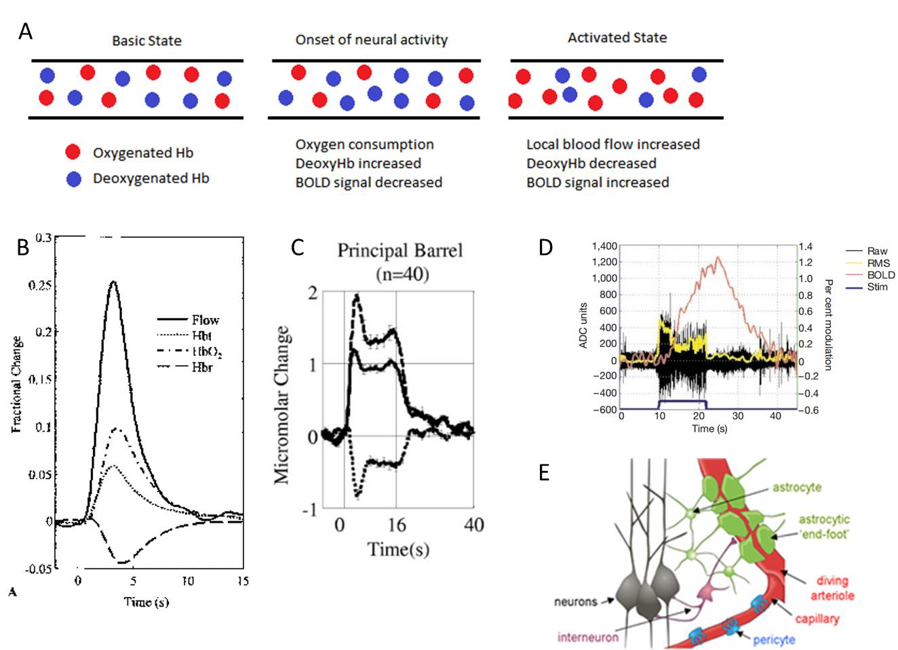
Figure 1: The biological processes thought to underly the BOLD signal. A Response of a vessel to neural activity Left: The baseline state of a vessel before neural activity occurs. Middle: Immediately after neural activity the proportion of deoxygenated blood increases and the BOLD signal decreases. Right: The proportion of deoxygenated blood decreases and the BOLD signal increases. B Example haemodynamic response for a short duration stimuli (up to 3-4s). Shown are CBF (solid black line), CBV (solid grey line), oxygenated (uneven dashes) and deoxygenated blood (even dashes) (Martindale et al., 2003). C Example haemodynamic response to long-duration (16s) stimuli showing peak and plateau response. Shown are CBV (solid black line), oxygenated (dashed line) and deoxygenated (dots) blood (Berwick et al., 2008). D Example haemodynamic response to long duration (22s) stimulation showing rise to plateau response. Shown are BOLD response (orange), raw LFP (black) and root-mean square of LFP (yellow) (Logothetis et al., 2001). E The different cells that form part of the neurovascular coupling unit and how they link. Adapted from (Gordon et al., 2007)

1.1.1.1 Why does functional hyperaemia occur?
So what generates this functional hyperaemia for the activated region of the brain? Both animals (Lindauer et al., 2010) and humans (Powers et al., 1996) have been placed into states of hyperoxia and yet still display hyperaemia in response to stimuli. Therefore the response does not appear to come from the extra demand for resources being sensed locally. These studies indicate that even when the amount of oxygen needed to meet the demands of the stimulation is already present locally, an increase in blood flow to the responding area still occurs. Supporting the theory that the hyperaemia response is not necessary for the immediate oxygenation of the neurons is the fact that the measurable firing responses of the neurons may have ended far before the response of the blood subsides. The onset of the haemodynamic response is also slower, occurring up to 500ms after the stimulation has begun (review on response by Hillman, 2014). A recent review (Brown and Ransom, 2007) suggests that nearby astrocytes could supply the glucose needed during at least the initial part of the haemodynamic response. This would also mean that local oxygen was reserved directly for neuronal use, rather than being needed for glycolysis as it otherwise would be (Pellerin et al., 2007). The increase in blood supply could therefore be initially to replenish these lost nutrients and perhaps thereafter to supply the neurons directly (Hillman, 2014). Therefore, the role of the response may be to supply higher levels of glucose, rather than oxygen, a view inferred by many (Fox and Raichle, 1986, Heeger and Ress, 2002, Brown and Ransom, 2007, Paulson et al., 2010, Brown and Ransom, 2015). The role of functional hyperaemia is therefore suggested to be actively triggered soon after stimulation, but not critical for the immediate nutritional needs created by it. An alternative explanation could come from considering a wider region than the vascular source of the response. A recent study (Devor et al., 2011) postulates that the increased haemodynamic response during stimulation may occur to ensure that areas that are distant from the responding vessel do not experience a sustained drop in supply. The underlying use for this haemodynamic response to stimulation is therefore still unresolved. This gap in the knowledge regarding why functional hyperaemia occurs means that knowledge of the BOLD fMRI signal is also incomplete.

1.1.1.2 Functional Hyperaemia responses to stimuli
Why functional hyperaemia is needed is not the only characteristic of the response that is not fully understood. A consensus is yet to be achieved on the profile of functional hyperaemia responses under certain circumstances. Whilst short stimuli (up to 3-4s long) generate a similar shape regardless of duration (magnitude and width of the response may change, but the profile remains the same, see Fig. 1B or Martindale et al., (2003), Hirano et al., (2011)), there tends to be more variation in the profiles seen in response to longer-duration stimuli. Long-duration haemodynamic responses to stimulation tend to be composed of a peak-then-plateau profile (Fig 1C or Dunn et al., (2005), Berwick et al., (2008), Drew et al., (2011)), however others have seen a rise to plateau profile (Fig 1D or Mandeville et al., (1999), Logothetis et al., (2001)), predominately in BOLD responses. The reason for these different profile responses is still not fully understood and improving understanding of why these different profiles are found could aid understanding of why functional hyperaemia occurs.

1.1.1.3 How does the increase in CBF occur?
Whilst the previous section discussed why functional hyperaemia might occur and create an ‘activated’ BOLD signal, it is also important to understand how changes in the underlying haemodynamics could be occurring. Initially it was thought that the local fall in nutrients during the initial response to neuronal activity was sensed and that this triggered the increase in blood flow as discussed above. However, rather than such a feedback system creating functional hyperaemia, it is now thought that a feedforward system is at work instead, with active signals from neurotransmission a key part in the regulation of blood flow during neuronal activity (Attwell et al., 2010). Historically it was thought that these active signals were acting directly on the vasculature (Attwell and Iadecola, 2002). Now the general consensus is that cellular mediators are involved. There are several ways in which blood flow could be actively regulated. It is known that stimulation of interneurons can cause arteriolar vasoconstriction both in sliced tissue (Cauli et al., 2004; Perrenoud et al., 2012) and by optogenetic manipulation of interneurons in-vivo (Uhlirova et al., 2016). Interneuron mediated regulation could therefore potentially be responsible for local haemodynamic constriction by the release of vasoactive substances such neuropeptide Y (NPY) and somatostatin (SOM) (Cauli et al., 2004). The same study by Cauli et al. (2004) also provided evidence that vasoactive intestinal peptide (VIP) and nitric oxide (NO) release by interneurons could be responsible for local vasodilation.
Astrocytes are thought to play an important role in neurovascular coupling. They are situated so they have contact with both neurons and vessels such as diving arterioles, capillaries and venules (see Fig 1E). Critically they can also dilate and constrict vessels (Zonta et al., 2003, Mulligan and MacVicar, 2004, Metea and Newman, 2006). Previous work has shown that neuronally released glutamate can also act on astrocyte glutamate receptors, raising astrocyte calcium levels and triggering the production of vasoactive metabolites near arterioles (taken from a review by Howarth, 2014). However, it has been suggested that astrocytes alone are unlikely to be able to mediate functional hyperaemia due to a mismatch in timing between observed calcium transients and arteriole dilation (Schummers et al., 2008, Nizar et al., 2013). Additionally evidence comes from functional hyperaemia persisting in the absence of glial calcium signals (Schulz et al., 2012) or despite a lack of astrocytic inositol triphosphate which is responsible for generating intracellular calcium increases (Nizar et al., 2013, Takata et al., 2013). A recent review (Howarth, 2014) has suggested that astrocytes may therefore be responsible for late responses during long duration functional hyperaemia. In addition to these two explanations for how functional hyperaemia may be mediated, it has previously been shown that pericytes can cause diameter changes in capillaries (Peppiatt et al., 2006) and also that propagated vasodilation (where the vessels can cause self-dilation that travels via the endothelial cells) is possible (Bagher and Segal, 2011). It still remains to be seen then, exactly how the increase in CBF that underlies the positive BOLD signal is mediated. The understanding of how it is mediated could be crucial in the interpretation of BOLD fMRI studies for cognitive neuroscience studies.

1.1.2 Current methods used in the measurement of NV coupling
In order to investigate neurovascular coupling, measurements of both vascular responses and the underlying neural activity are required. This thesis uses multi-modal imaging to investigate neurovascular coupling, specifically, concurrent recordings using electrophysiology (neural signals measured with laminar Neuronexus electrodes) and two-dimensional optical imaging spectroscopy (vascular signals).

1.1.2.1 Two dimensional Optical Imaging Spectroscopy (2D-OIS)
For more than 50 years intrinsic optical changes related to neural and haemodynamic activity have been studied (Devor et al., 2012). However, it is only in the past 30 years that optical imaging as it is now commonly understood has been used (Grinvald et al., 1986). Optical imaging spectroscopy uses a CCD camera to record reflected light from the surface of the cortex. It does not require injections of substances such as voltage sensitive dyes, recording instead the intrinsic signals that are already present. Two dimensional optical imaging provides high spatiotemporal resolution. This macro-scale recording of the haemodynamics provides a comparative (although higher resolution) spatial and temporal signal to that which would be found in BOLD fMRI. The reflected light can be compared to known absorption spectra of oxy and deoxyhaemoglobin and converted into estimates of cerebral blood volume (Hbt), oxyhemoglobin (Hbo) and the values thought to best underlie the BOLD signal: estimates of the deoxyhaemoglobin (Hbr) present. In the first study to experimentally co-localise both temporally and locally BOLD and iOIS signals in human subjects, Cannestra et al., (2001) have shown slight differences in the timings of the two signals with BOLD showing a 2-3 s delay compared to OIS. However, they found that the BOLD signal closely resembled the iOIS signal and concluded that differences that were found were most likely due to the relative contributions of vessels such as capillaries and veins to the recorded signals. Previous studies have suggested that BOLD and OIS may share similar etiologies (Hess et al., 2000; Pouratian et al., 2002) and 2D-OIS has been used previously to investigate different aspects of the haemodyanamic response with clear similarities between the BOLD and OIS signal demonstrated (Berwick et al., 2005b, Kennerley et al., 2005, Berwick et al., 2008, Boorman et al., 2010, Bruyns-Haylett et al., 2010, Harris et al., 2014). 2D-OIS has also been validated as a tool for imaging deeper layers of the cortex (Kennerley et al., 2012b). Therefore the spatial and depth resolution of 2D-OIS ensure it is a good tool to investigate vascular signals arising from neural events.

1.1.2.2 Electrophysiology
Electrophysiology allows for direct recordings of electrical neuronal activity and is viewed as the ‘gold standard’ in imaging neurons compared to such techniques as voltage sensitive dye imaging (dye molecules bind to the membrane and act as molecule transducers to transform changes in membrane potential into optical signals) or calcium sensitive dyes (molecules fluoresce when calcium ions bind). Voltage sensitive dye imaging requires the injection of exogenous contrast agents and also requires the removal of tissue including the dura in order to work, which is not optimal. Problems with calcium imaging include difficulties in labelling particular classes of cells such as interneurons and issues with performing chronic preparations (Grienberger and Konnerth, 2012). Electrophysiology is generally performed in-vivo by recording with a microelectrode from the extracellular space to measure electrical potentials. Recordings are measured in respect to a distant electrode which acts as a reference. Electrophysiology can however also be used in in-vitro work, or to record intracellularly from a single cell using a ‘patch’ configuration. This kind of configuration provides little assistance in understanding population activity. As the cortex alone is predicted to contain between 10¹⁰ and 10¹³ connections (Logothetis, 2008), it would seem redundant to try and translate this kind of recording to a large region haemodynamic signal such as that which might be captured in BOLD fMRI (each voxel in BOLD can contain as many as 100000+ neurons). In recording from the extracellular space however, multiple components of neural activity are able to be sampled that have been shown to capture a more extensive sample of neurons.

1.1.2.2.1 Multi-unit recordings
Extracellular electrophysiology can capture multiple unit activity (MUA) which represents the spiking activity of neural populations within 100-300μm of the electrode tip, thought to be around 1000 neurons depending on the region examined (Henze et al., 2000). MUA signals are usually obtained by high-pass filtering the extracellular signal at ~300Hz (Boorman et al., 2015). The spikes represented by the activity will be susceptible to size bias (Towe and Harding, 1970) and also to cell-type bias (Stone, 1973). These biases are inter-related, for example, a larger cell will generate a larger potential, which will remain above the noise level for a greater distance than a smaller cell. Therefore, these cells are likely to give greater weight to the final signal in the extracellular electrode, and the spiking reported is likely to preferentially sample these principle cells. In the cortex, these are the pyramidal cells.

1.1.2.2.2 Local Field Potentials
Extracellular electrophysiology can also capture local field potential (LFP) activity. The local field potential signal is thought to originate in the neuronal activity that is slower than the spiking activity found in the MUA signal. MUA activity generally lasts ~1ms and the LFP response is based on the synaptic potentials, which last from 10 – 100ms in duration (Devor et al., 2012). Whilst this includes both excitatory and inhibitory post-synaptic potentials, it also represents additional types of slow wave activity such as voltage-dependent membrane oscillations (Kamondi et al., 1998) as well as spike after potentials (Buzsáki et al., 1988) which are thought to be generated by calcium activated potassium currents (Harada and Takahashi, 1983). These activities can be grouped by the term perisynaptic activity. As mentioned briefly before, it has been shown that these perisynaptic activities represented by the LFP correlate more closely with BOLD than MUA activity (Logothetis et al., 2001, Goense and Logothetis, 2008). As these multiple activities are all encapsulated in the LFP signal, this can make it more difficult to work out an unambiguous interpretation of the electrode recording. A common resolution to this problem is to separate the LFP using frequency band information, as this can provide important information about the origin of the signal (Logothetis and Panzeri, 2015). The spatial extent of the recorded LFP signal is thought to be larger than MUA, reflecting a weighted average of the neural population within 0.5-3mm of the electrode tip (Mitzdorf, 1985). Together extracellular electrodes giving LFP and MUA can capture large spatiotemporal insight into neuronal activity during neurovascular coupling that is not possible using intracellular methods.
Another advantage of extracellular electrophysiology over methods such as voltage sensitive dyes is the accurate depth profile that can be achieved. It is well known that cortical connections can be layer specific as well as cell-type-specific (Dantzker and Callaway, 2000, Briggs and Callaway, 2001). Additionally, projections to and from subcortical structures can be layer specific as well (see Fig. 3 in section 1.2.4 or Hooks et al., (2011)). Extracellular electrophysiology can be used with a linear style electrode that allows high resolution recordings to be simultaneously collected from all cortical layers. In conjunction with 2D-OIS, laminar electrophysiology would allow additional insight into the possible laminar-specific firing patterns of neurons associated with particular vascular events such as functional hyperaemia.

1.1.2.3 Additional benefits from concurrent use of electrophysiology and 2D-OIS
In additional to the benefits discussed above, obtaining direct measurements of neural activity using extracellular electrophysiology whilst simultaneously recording Hbo, Hbr and Hbt with 2D-OIS poses some advantages over other multi-modal set-ups such as EEG-fMRI. The relative strengths and weaknesses of EEG-fMRI relative to electrophysiology-2D-OIS are now introduced. Multi-modal set-ups involving dual EEG-fMRI have been used to investigate neurovascular coupling and have proved successful in numerous ways. In disease, the dual set up has given insight into the cerebral generators and other brain regions involved in epileptic spike activity (Gotman, 2008). It has also helped uncover the basic principles of neurovascular coupling such as the potential origins of decreases in the BOLD signal (Mullinger et al., 2014). Finally, dual EEG-fMRI show great potential for uncovering the haemodynamic correlates of neural signals found in complex brain activities such as thalamocortical sleep spindles (Schabus et al., 2007). In human studies, EEG-fMRI currently represents one of the best multi-modal methods for investigating neurovascular coupling. However there are still significant problems inherent in this dual method integration (Ritter and Villringer, 2006, Rosa et al., 2010, Mullinger et al., 2014). Experiments involving sensorimotor and auditory cortices have occurred where fMRI and EEG each implicated significantly different regions of activation (Gonzalez Andino et al., 2001), potentially due to interpretation of neurovascular coupling at the macroscopic level in each recording modality. Whilst EEG records extra cranial electrical potentials, the signal in fMRI can reflect the metabolic processes of supporting, as well as neuronal cells (see section 1.1.1). Simultaneous EEG-fMRI measurements are also subject to lowered signal to noise ratio because in addition to the usual signal-to noise issues found with EEG and fMRI separately, the electromagnetic interference is reciprocal, meaning artefacts can mask the true signal (Rosa et al., 2010), although the corruption of the EEG signal by the magnetic susceptibility effects of fMRI is minor compared to the reciprocal effect (Mullinger and Bowtell, 2011). In using a 2D-OIS-electrophysiology set-up, the noise issues are lower for each modality separately as for instance, an electrode sited in the brain is closer to the point where the neural signal is being generated. There is also less reciprocal interference as the electrodes and optical signals do not interfere with one another. With invasive methods such as these however, an animal modal must be used.

1.1.3 Are frequency oscillations relevant to the BOLD signal?
It was briefly mentioned earlier (see section 1.1.2.2.2) that the LFP signal can be split into frequency band components. These are usually based on the classical EEG frequency bands delta (0-4Hz), theta (4-8Hz), alpha (8-13Hz), beta (12-30Hz) and gamma (30-80Hz) that initially came from the EEG literature (Pedley and Traub, 1990). Each different band shows a strong correlation with a distinct behavioural state (Belitski et al., 2008). The bands are also proposed to show differences in their genesis. Some previous studies have shown the delta, theta and alpha bands may be associated with the thalamocortical loop and the ascending network and forebrain ((Steriade et al., 1993, Destexhe and Sejnowski, 2001, Steriade and McCarley, 2013), although other recent work on primates has found cortical contributions to the generation of these bands (Bollimunta et al., 2008, Jutras et al., 2013) gamma oscillations are thought to reflect the interaction of local inhibition and excitation. The frequency bands are strongly related to the BOLD signal (Niessing et al., 2005, Laufs et al., 2006, Yuan et al., 2011, Magri et al., 2012). A previous study (Kilner et al., 2005) proposed that the neural marker for increases in hemodynamic signals was an increase in the upper spectral frequencies of the local field potential (LFP) relative to the lower frequencies. This theory is based on the idea that it is the relative differences in the spectral band power (for example between the alpha band frequency power and the total frequency power at that moment) that are of importance to the haemodynamics, rather than a single, or pair of frequencies. Recent support for this theory (Magri et al., 2012) comes from an in-vivo primate study that the amplitude of BOLD responses to stimulus evoked neural activity was also dependent upon the power of gamma relative to alpha, rather than exclusively on the total LFP power or the power of a single frequency band. Whilst the authors found an increase in alpha power with no total power increase gave a reduction in the BOLD signal, an increase in gamma power with no total power increase gave the opposite: an increased BOLD signal. A similar finding came from Scheeringa et al., (2011), although they found these correlations using EEG in human participants. Therefore, the frequency oscillations have been shown to be relevant to the BOLD signal.

1.1.4 The negative BOLD signal
The previous sections have generally discussed increases in the BOLD signal, however, a decrease below baseline in BOLD signal in the brain has also often been seen in response to stimuli (Harel et al., 2002, Shmuel et al., 2006, Bressler et al., 2007, Boorman et al., 2010, Yin et al., 2011, Mullinger et al., 2013, 2014, Ma et al., 2016). This reduction below baseline is termed is termed a negative BOLD signal and is produced by a negative haemodynamic response (NHR). The origins of the negative BOLD signal is still debated (Hayes and Huxtable, 2012, Lauritzen et al., 2012, Ma et al., 2016, Uhlirova et al., 2016). Whilst some have found a decrease in neuronal activation (Shmuel et al., 2006, Boorman et al., 2010, Yin et al., 2011, Boorman et al., 2015, Ma et al., 2016) is responsible for an NHR, others have implicated a blood based or ‘vascular steal’ origin for the NHR (Harel et al., 2002, Kannurpatti and Biswal, 2004, Puckett et al., 2014, Hu and Huang, 2015). The theory underlying the ‘vascular steal’ hypothesis is that during stimulation, highly activated regions of the brain claim additional blood from adjacent regions, with insufficient replenishment to these regions restoring baseline levels during the response. However, negative BOLD responses have reliably been found to occur in the ipsilateral cortex to the stimulus, whilst a positive BOLD response occurs in the contralateral cortex (Newton et al., 2005, Bressler et al., 2007, Kastrup et al., 2008). It would seem unlikely that this negative BOLD is generated by vascular steal given the distance between the regions, therefore indicating that whilst vascular steal negative BOLD signals may be seen, it is highly likely that additional mechanisms underlying negative BOLD also exist. In addition to the previous findings, some have found that a NHR can be accompanied by an increase in neuronal activity (Devor et al., 2008, Schridde et al., 2008, Mishra et al., 2011). Again, the ambiguity of the BOLD fMRI signal means that careful signal interpretation is needed to ensure that the correct scientific claims are made. It is clear from the conflicting explanations above that negative BOLD signals could arise from a number of mechanisms, and these are not necessarily mutually exclusive. Therefore, additional markers to ensure that the correct interpretation is made are required and the establishment of these need further research.

1.1.4.1 Frequency oscillations and the negative BOLD response
Investigations into frequency oscillations and the negative BOLD response have been undertaken (Ritter et al., 2009, Yuan et al., 2011, Mayhew et al., 2013, Mullinger et al., 2014). There is some disagreement amongst the results however. Whilst (Yuan et al., 2011) found that there was no correlation between the negative BOLD signal they saw and the EEG signal or its constituent frequency bands, (Mullinger et al., 2014) demonstrated a negative correlation between the amplitude in the power of the mu frequency (which is used by the authors in this context to denote the alpha frequency in the sensorimotor cortex: 8-13Hz) and the amplitude of BOLD responses on a trial-by-trial basis. Furthermore, it was found (Mayhew et al., 2013) that if a visual stimuli was delivered during periods of high baseline alpha power, it resulted in enhanced negative BOLD responses in the auditory cortex.

1.1.4.2 Measuring estimates of negative BOLD using 2D-OIS
Previous work (Kennerley et al., 2012b) has shown that optical imaging spectroscopy is a valid method to investigate aspects of the negative BOLD signal. They used concurrent fMRI and 2D-OIS to show that accurate maps of the negative BOLD phenomenon could be generated using a biophysical model of BOLD signal change in conjunction with optical imaging recordings. As concurrent fMRI and electrophysiology is possible, but still very challenging as amongst other problems, the strong magnetic field required for fMRI can incapacitate equipment used for the electrophysiology such as pre-amplifiers (Logothetis et al., 2001). Therefore having an alternative method with which to study negative BOLD is useful for multi-modal set-ups. Whilst much of the previous work that has investigated negative (and positive) BOLD has been performed in monkeys (Logothetis et al., 2001, Shmuel et al., 2006, Goense and Logothetis, 2008, Magri et al., 2012) and humans (Newton et al., 2005, Schabus et al., 2007, Kastrup et al., 2008, Schabus et al., 2012, Mayhew et al., 2013, Mullinger et al., 2013, 2014, Sclocco et al., 2014), the rodent cortex also provides a useful model in which to investigate the still incomplete understanding of this signal due to the advanced understanding of the precise topographical structure and function of this brain area in this particular model.

1.2 Structure and function of the cortex
The rodent neocortex is made up of cortical columns that are considered to be the basic processing unit for all cortical areas. These columns are divided up into layers and so a layered cortical column is thought to form a microcircuit, made up of a few thousand neurons (Douglas et al., 1989). Investigating sensory stimuli in the cortex has advantages as the stimuli that are applied in sensory function can be subject to tighter experimental control than higher cognitive processes. However, investigations have shown that even with simple sensory inputs such as hindpaw stimulation, the cortex does not simply process details of the inputs, but adds in via top-down processing, additional information about what else is going on in the brain (Feldmeyer et al., 2013, Manita et al., 2015), especially when primary cortex links to associative cortex (Manita et al., 2015). Whilst most of the literature used in this section is from rat cortex studies, some are from mice, however the organisation of the barrels and other regions appears to be very similar (Feldmeyer et al., 2013).

1.2.1 Somatosensory Cortex
The somatosensory cortex of the anaesthetised rat was used throughout the chapters in this thesis, although the main focus of chapter 5 was the motor cortex. The rat whisker barrel somatosensory cortex has a highly ordered spatial topography (Chapin and Lin, 1984) as well as a well-defined blood supply (Patel, 1983, Cox et al., 1993) and is a very popular model for investigating structure and function relationships, as well as the aforementioned neurovascular coupling elements. This means that large amounts of data already exist on cortico-cortical connections (Kim and Ebner, 1999, Petersen et al., 2003, Veinante and Deschênes, 2003, Douglas and Martin, 2004, Aronoff et al., 2010, Hooks et al., 2011, Mao et al., 2011), cortico-thalamic (Allendoerfer and Shatz, 1994, Sherman and Guillery, 2001, Timofeev and Bazhenov, 2005) and other cortico-subcortical loops ((Hooks et al., 2011) or for review see Bosman et al. (Bosman et al., 2011)). Information is beginning to emerge on less well known properties also, such as the inhibitory connections and cell types of the region also (Feldmeyer et al., 2013).

1.2.1.1 Topographical Mapping
The whisker barrel somatosensory cortex of the rat is a highly used model, partially because of the precise topographical mapping that it displays. Sensory input from the whiskers first travels along the lemniscal pathway (originating in the trigeminal complex) before being relayed through the thalamus and onto layer IV of the whisker barrel somatosensory cortex. The input is precise enough that an individual whisker twitch causes an activation in the corresponding barrel region of the cortex (Barrels can be seen in Fig. 2A). Once activation reaches layer IV, it is most likely to be transferred to layers II/III, as this is the strongest projection and then henceforth onto layer V (see Fig. 3 for more information or other relevant references (Feldmeyer et al., 2013) (Mao et al., 2011)). This activity is not just limited to the neural responses. An alternative study (Berwick et al., 2008) has shown that a single whisker twitch results in a highly localised vascular response that is centred on the corresponding cortical column.
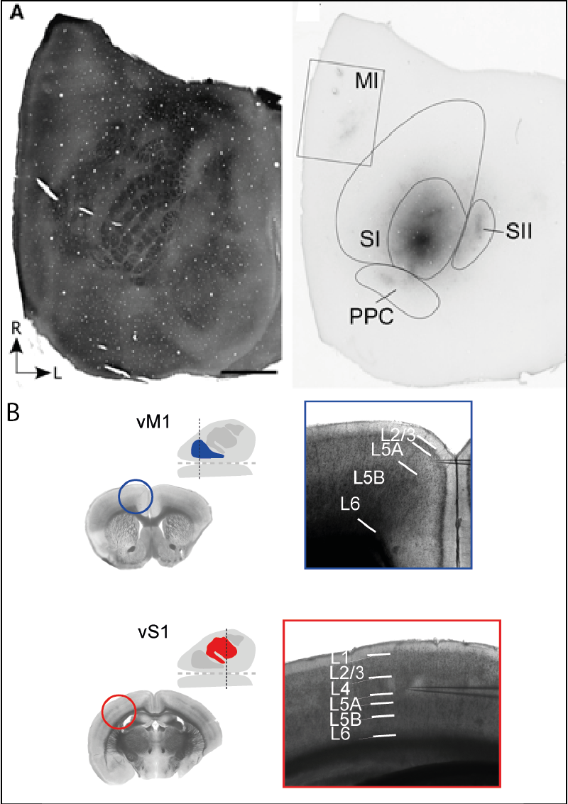
Figure 2: Demonstrating the spatial locations of S1 and M1 as well as the laminar structure of the two regions. A (left) Tangential section processed for cytochrome oxidase (CO) shows the spatial distribution of the layer IV barrels in SI cortex. (right) An adjacent section Contour lines indicate the primary (SI) and secondary (SII) somatosensory cortical areas as well as the posterior parietal cortex (PPC). Figure has been adapted (Smith and Alloway, 2013). B Schematic of vM1 (vibrissal) location (inset, blue) and vS1 (inset red) with approximate plane of coronal section indicated (dashed line). Anterior is to the left, and lateral is at top. Adjacent low power brightfield image (left) shows coronal section of vM1 and vS1. Higher power brightfield image (right) shows vM1and vS1 slice used for recording. White lines indicate approximate cytoarchitectonic laminar boundaries. No division was evident between L2 and L3 or L5B and L6 in motor cortex. Images in B are taken from (Hooks et al., 2011). NB B is taken from a mouse model.

1.2.2 Motor Cortex
The motor cortex is central to the planning, production and control of voluntary movements. The primary motor cortex is thought to be the main contributor in generating neural impulses that produce movement. Although a great deal of research on motor cortex comes from monkey experiments, the rodent can also provide a complementary model for research (Brecht et al., 2015). Despite recent progress in the understanding of this region, the underpinnings of what exactly the motor cortex does, and how it does it are still not yet fully known (Capaday et al., 2015).

1.2.2.1 Structure of Motor Cortex
The rodent motor cortex is located anterior to the somatosensory cortex and closer to the midline (see Fig. 2B left). The laminar structure of the motor cortex is less clear than the somatosensory cortex, with separations of layers difficult to perceive by eye (see Fig. 2B right). Like the somatosensory cortex, it also possesses links from layers V and VI to sub-cortical structures such as the striatum, the thalamus and other frontal association areas (see Fig. 3 or (Mao et al., 2011)). Most input to motor cortex is assumed to go to layers II/III (Kaneko et al., 1994), although see below section 1.2.3 for discussion of layer IV in motor cortex.

1.2.2.2 Neurovascular Coupling in the Motor Cortex
Neurovascular coupling in motor cortex has rarely been investigated. Recent work (Zhou et al., 2014) used optogenetic stimulation of the pyramidal cells in motor cortex and monitored the results using electrophysiology and optical intrinsic signal imaging. Interestingly, they found that no neural measure (MUA, LFP and gamma band power) could be used to predict all durations of haemodynamic responses and suggest that neurovascular coupling in the motor cortex is non-linear for short-stimuli but linear for long stimuli. The motor cortex does not function in isolation however, but is part of complex loops. It is unknown whether similar results would be achieved if the motor cortex was activated as part of its normal function in a cortical loop.

1.2.3 The Sensorimotor Loop
Interactions between different brain areas such as sensory and motor cortex is thought to be of critical importance for fundamental tasks such as sensory perception (Crochet and Petersen, 2015). Their relative spatial locations can be seen in the right image in Fig. 2A whilst the left image shows a slice of tissue stained with cytochrome oxidase so the individual barrels in the cortex can be seen. In this thesis both sensory and motor cortex were used as the regions of choice in the investigations. The stimuli used were sensory stimuli administered to the whisker pad of an anaesthetised rodent. The structure of the somatosensory cortex and the motor cortex is fairly similar (see Fig. 2B or (Hooks et al., 2011)). The existence of a layer IV in motor cortex is the subject of some debate. It was previously thought that the areas had strong differences in mid-layers of cortex with the barrel cortex having a large layer IV and motor having none (Hooks et al., 2011). However, strong evidence has been found suggesting that layer IV in the motor cortex does exists in rats (Skoglund et al., 1997) and receives inputs from the thalamus, similarly to the somatosensory cortex , as seen in mice models by (Yamawaki et al., 2014). Therefore in this work it is assumed that layer IV does exist in rat motor cortex and the depth separations of the laminar layers are taken from the rat model in Skoglund et al. (1997) (see Chapter 5 for a full layer information from the paper).
Connections between the two regions are reciprocal (Felleman and Van Essen, 1991, Cauller et al., 1998). It has been shown that a single barrel in vS1 projects to a single band of vM1 (Aronoff et al., 2010) and that this projection is topographic (Mao et al., 2011). In contrast, the return projections from vM1 to vS1 are much more diffuse, covering not only the barrel field, but also adjacent cortex also (Veinante and Deschênes, 2003). Sensory evoked stimuli such as the stimulations to the whisker pad that are used in this thesis are initially present in S1 before being projected to M1 (Kleinfeld et al., 1999, Ferezou et al., 2007). (Kaneko et al., 1994) applied micro-stimulation to the somatosensory cortex of cats which caused activation in layer II/III of motor cortex, and, the authors suggest that this is then transferred to layer V cells, which contain amongst others, the giant Betz cells which generate motor output. Fig. 3 shows a more complete diagram of the sensorimotor and other subcortical projections. Only the stronger projections are shown in this diagram as the weaker projections are also diffuse and therefore it would be difficult to discern those that may be of most importance. Although the sensorimotor loop has been well defined by these studies, the neurovascular coupling at different points of this loop has seldom being investigated.

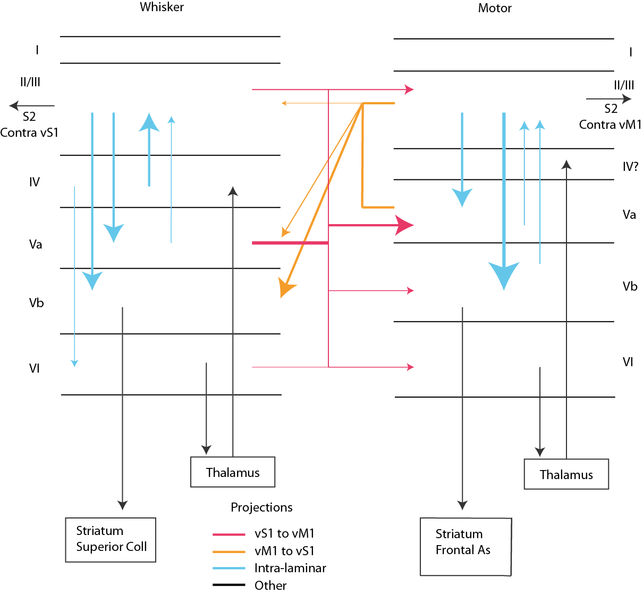
Figure 3: The structure and projections of whisker barrel somatosensory cortex (vS1) and vibrissal motor cortex (vM1). Diagram created using information from published sources (Hooks et al., 2011, Mao et al., 2011, Feldmeyer et al., 2013). Thickness of coloured (not black) lines denotes strength of projection. The five strongest projections (other than those depicted in colour) are shown although additional projections exist and can be found in (Mao et al., 2011).

1.2.4 Thalamocortical Loops
Thalamocortical assemblies are responsible for many of the coherent oscillations that are shown throughout the brain (Destexhe and Sejnowski, 2001). The evolution of the thalamus was closely correlated with the evolution of the cortex evidenced by the general topographic relationship that exists between thalamic and cortical regions (Jones et al., 1985, Sherman and Guillery, 2001). Neuronal inputs and outputs between the thalamus and cortex are restricted, inputs from thalamus to cortex mainly terminate on layer IV, and returning outputs go from layer VI of the cortex to the thalamus (Allendoerfer and Shatz, 1994). Few of the pyramidal cortical synapses in layer IV of the cortex originate in the thalamus however, only 10-20%, with the majority coming from other cortical pyramidal cells (Douglas and Martin, 2004). The thalamus can be split into two discrete sections. The dorsal nucleus, which receives inputs from the main sensory pathways (the optic tract, medial lemniscus, interior colliculus and the brainstem modulatory systems) and the RE nucleus form a triad with the cortex, the end result of which is the rhythmic oscillations that occur in these three areas (Timofeev and Bazhenov, 2005). Whilst the thalamus is not directly investigated in the experiments in this thesis, the rhythmic oscillations that occur from the interactions in these three areas are thought to result in the lower frequency bands of delta, theta and alpha which have been shown to be related to the BOLD signal (Goldman et al., 2002, Laufs et al., 2006, Magri et al., 2012, Mayhew et al., 2013). These frequency bands have been linked to task specific exercises, and have also previously been used to characterise certain brain states.

1.3 Brain States
“Brain state” is used prominently in two different ways in fairly similar literature fields. The parlance with which it is used in this thesis is to refer to the endogenously produced spontaneous patterns in the brain that are highly structured both in space and in time (Ringach, 2009, Harris and Thiele, 2011). This “brain state” determines spiking patterns, neuronal correlations and even resting state potentials and is usually relatable to a behavioural condition such as alertness or quiescence. “Brain state” can also be used to mean the sensory or behavioural events or mental processes that neuroimaging research may wish to define in terms of neural correlates, for example, as used by (LaConte, 2011). This thesis does not use this meaning for brain state.

1.3.1 Defining a brain state
The perception, transmission and interpretation of incoming sensory stimuli to the brain, and in particular, the cortex is not a passive process. It can vary strongly depending on the particular brain state that is being experienced at the time (Steriade et al., 2001, Castro-Alamancos, 2004b, Haider and McCormick, 2009, Harris and Thiele, 2011, Zagha and McCormick, 2014, Pachitariu et al., 2015). Understanding how these brain states work and the impact they have is critical to the correct interpretation of how the nervous system operates, both in health and in disease. But how do brain states alter the interpretation of a stimulus? The answer to this question is still not completely understood. Some studies suggest that rather than the quality of the sensory processing being altered to adjust the processing of an incoming stimuli, instead the saliency levels can be adjusted by scaling down the inhibition and excitation present, with evidence suggesting that this may be laminae-specific (Zhou et al., 2014, Pachitariu et al., 2015). Separation of brain state is clearly essential, but this begets the question, on what basis can it be said that one brain state is different to another?

1.3.1.1 Synchronised and Desynchronised States
Since the studies of Morruzzi and Magoun (1949) it has been known that the cortex does not remain in one state. Initially, cortical state was studied using the patterns of activity seen with EEG. Two distinct states – synchronised and desynchronised can be found in an EEG trace. Identification of the states is helped by their intrinsic properties. In the synchronised state, cells generally either fire in synchrony, or are silent. This tends to create large amplitude low frequency oscillations. In the desynchronised state, cells do not fire in synchrony and the large amplitude low frequency oscillations are replaced by high frequency oscillations of smaller amplitude (see Fig. 4).
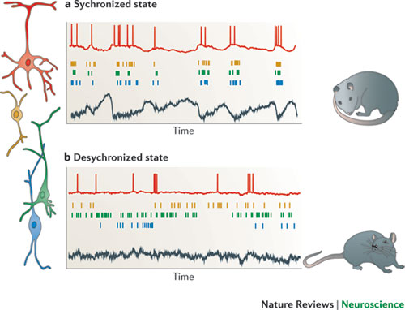
Figure 4: The difference in firing between synchronised and desynchronised states. The red trace depicts an intracellular recording showing depolarisations and hyperpolarisations and the black trace shows a deep layer cortical LFP. In a, (the synchronised state) all neuronal classes either fire together, or do not fire at all. This type of firing has been seen in animals in a quiescent or asleep state, and also in certain types of anaesthesia. By contrast, in the desynchronised state shown in b the cells do not usually fire together. This brain state is usually found in awake alert and/or exploring animals and also under certain types of anaesthesia. The schematic image is taken from a review by Harris & Thiele (2011).
Classic depictions of synchronised and desynchronised states have described them as functions of the sleep cycle. During slow-wave sleep (SWS), the cortex is thought to be in a synchronised state, and during rapid eye movement sleep (REM) sleep, a desynchronised one (Steriade and McCarley, 2013). Experiments have also found that cortical state can vary during wakefulness (Gervasoni et al., 2004, Crochet and Petersen, 2006, Ferezou et al., 2007, Poulet and Petersen, 2008) with alert or whisking animals showing a desynchronised state and quiescent animals showing smaller, more synchronised spontaneous fluctuations in cortical activity. Therefore, although further subdivisions could be made, dividing brain state into synchronised and desynchronised would seem to capture the major changes that occur during different brain states. The work in this thesis therefore divides neural data into synchronised and desynchronised brain states.

1.3.2 Neurovascular coupling in alternate brain states
Given that brain states affect the processing of incoming sensory stimuli, it is perhaps unsurprising that previous studies have found that brain state can affect the interpretation of blood based neuroimaging signals. Jones et al. (2008) previously created a change of state from synchronised to desynchronised by electrically stimulating the reticular formation in an anaesthetised rodent and measuring the responses to stimulation in the whisker barrel somatosensory cortex in both states. They found that haemodynamic responses were reduced in the desynchronised state. Additionally others (Berwick et al., 2005a, Niessing et al., 2005, Schei et al., 2009) have also investigated alterations to haemodynamic responses during alternate brain states whether pharmacologically induced, or created artificially. However, some aspects of neurovascular coupling during difficult brain states have not yet been explored, for example, additional regions of cortex such as motor cortex, or capturing the changes that arise in naturally occurring fluctuations of brain state.

1.3.2.1 How can alternate brain states be created?
Different brain states occur naturally during non-anaesthetised animal experiments and the neural activity can be monitored directly with implanted electrodes (Gervasoni et al., 2004), or alternatively by measuring EEG signals with radio transmitters (Stephenson et al., 2009) or wire screws (Gilmour et al., 2010). Ziv et al., (2013) measured the changes in the neural activity in a freely moving animal by conducting 2-photon microscopy using an implanted microscope equipped with a microendoscope and injecting/expressing dyes to monitor neural changes (Ziv et al., 2013). It would theoretically be possible to concurrently monitor the blood in this set-up, however the authors did not do this in their paper, so it is possible there are challenges to this approach that are unknown. This data collection would potentially be extremely complicated to collect however and goes beyond the remit of this thesis. A simpler way to concurrently collect both neural and vascular data during different brain states is to use an anaesthetic in combination with a drug that produces fluctuating brain states, or alternatively, an anaesthetic that causes fluctuating brain states. Neural and vascular data can then be gathered using invasive methods if desired. Anaesthesia can be a simple and effective way of creating alternate brain states. Urethane creates a continuum of cortical states (Curto et al., 2009, Renart et al., 2010, Harris and Thiele, 2011) ranging from a slow synchronous state through to a highly desynchronised state which has been compared to the rapid-eye movement sleep state (Clement et al., 2009; Pagliadini et al. 2011) and to the awake cortical state (Boon et al., 2004). Urethane anaesthesia is a commonly used anaesthetic for in-vivo studies, as it creates long-lasting stable periods of anaesthesia (Hara and Harris, 2002). Unlike other anaesthetics that may have preferential effects on one neurotransmitter, for example, the 100% potentiation of propofol on GABA A (Table 1, line 4), urethane exerts minor effects on almost all types of neurotransmitters (Table 1, line 1).

 |  | GABAA | nACh | NMDA | AMPA | Glycine
10mM | Urethane | 23 % P | 15 P | 10 I | 18 I | 33 % P
10μM | Ketamine | 0 | 50 I | 80 I | 0 | 0
50μM | Pentobarbital | 100 % P | 50 I* | 9 I | 50 I | 17 % P
1μM | Propofol | 100 % P | 0 | 3 I | 0% | 10 % P
 | Volatile agents | 100 % P | I** | I | ~0 | 100% P
Table 1: The contrasting effects of different anaesthetic agents on the main types of neurotransmitters – taken from Hara and Harris (2002) I refers to an inhibitory effect, P a potentiating effect. * A pento-barbital like agent was used.** - concentration dependent.
Urethane is therefore thought to meet the demands of studying neurovascular coupling under alternate brain states as is intended in this thesis. However, there is a problem with using urethane anaesthesia. It creates spontaneously fluctuating periods of synchronised and desynchronised states. In order to be able to group this data in a useful way, it is then necessary to classify the exact points, or at least classify the trials that are in each of the two states. This begets the question, what measures or algorithms can be used to classify different brain states?

1.4 Classification Algorithms

1.4.1 Why develop an automated classifier?
Classification can be described mathematically. What classification attempts to do is to find the true label y* for an observation x by using a mapping f (Lotte et al., 2007) .
$$y* =f(x)$$
Many traditional classification methods come from sleep and sleep disorder research, with rats being the most frequently used species in animal sleep studies (Gilmour et al., 2010). Although classification can be done manually, there are several issues with this. Firstly, observer interpretation of data is time consuming and can also be subject to interpretation bias (Gandolfo et al., 1988). Data tends to be split into epochs to ensure each segment is evaluated independently, however some authors have (Becq et al., 2005) provided plausible reasoning that the observer knows the classification of the previous epoch, and this must still influence the subsequent epoch judgement. Observer to observer disagreement tends to be around 10 – 20% (Robert et al., 1999). For these reasons, automatic brain state classifiers have been under construction since 1974 (Kohn et al., 1974) and the following section discusses the progress that has been made since then.

1.4.2 Classifier taxonomy
There is much variation already in existing classifiers. The commonly used factors of influence in the state classification programs already available are as follows:
Stability – Whether or not small differences in the initialisation set used affect the performance of the classifier. Classifiers that are unaffected by these small differences are said to be stable, whereas those affected are labelled unstable.
Autonomy – How much input the classifier needs. The amount of autonomy a classifier has can be varied from little or no initial input for a dataset, through to specific input needed for each subject in the dataset to be classified. Other terms for autonomy is supervised. A classifier that is autonomous requires no supervision, and vice versa.
Temporality – Some classifiers, for example cluster based techniques, cannot take into account temporal information, these classifiers are known as static classifiers. In contrast, dynamic classifiers such as hidden Markov models can classify using temporal information such as a sequence of features.
Learning – Classifiers that learn a single way of assigning a brain state directly to a set of features are called discriminative classifiers. Classifiers that use a threshold are an example of discriminative classifiers. Informative classifiers calculate the likelihood of a feature such as an information vector belonging to a certain state.
Regularised – how robust a classifier is with regards to outliers. A classifier with good regularisation will control the complexity of the classifier in order to prevent overtraining.
Online/Offline – Some classifiers are suitable to be used in an online environment so that data can be classified during an experiment. Others require all the data to be present in order to make the classification for that experiment or dataset. This factor overlaps with the following speed factor, as to be suitable for online use, a classifier must be fast.
The above features of a classifier will affect the eventual success of the classifier, which depends on speed and accuracy of classification and complexity of use. These three parameters are interlinked. Classifiers should be as fast as possible in their processing, whilst still maintaining a good level of accuracy that approaches the levels seen in manual judgement (as above 10-20% error (Robert et al., 1999)). However, classifiers often have high complexity in order to give high accuracy, but an increase in complexity can often result in increased time to process. Finally, if a classifier is too complex, this can impact on its usability for those who are not its developers.

1.4.3 Existing Automatic Classifiers
Most automatic classifiers have two stages, which can contain multiple sub-stages (Kohn et al., 1974, Gandolfo et al., 1988, Benington et al., 1994, Nurnberger et al., 1999, Robert et al., 1999, Gervasoni et al., 2004, Stephenson et al., 2009, Gilmour et al., 2010, Petrovic et al., 2014). In the first main stage, features are extracted from the data that are of most interest in the subsequent classifications, for example, some classifiers select the power in certain frequency ranges to examine, such as delta or theta in isolation, indeed most early classifiers used band powers in isolation. Others look at a combination of frequency band powers as a measure, so beta/theta (see Fig. 5A (Gilmour et al., 2010) for examples). Some calculate the amplitude of the raw LFP (Papanicolaou et al., 1986) and use that as their feature of interest. The second stage assigns the extracted features to the particular set in which it is calculated they belong. Most classifiers tend to use the following methods either singularly, or in combination: Threshold/Logic classification, Clustering, Learning Algorithms. Each of the particular methods has both advantages and disadvantages, so many permutations exist to try and maximise the outcome of the classification. However, too many permutations inevitably increases the complexity with the aforementioned problems in processing time and usability.
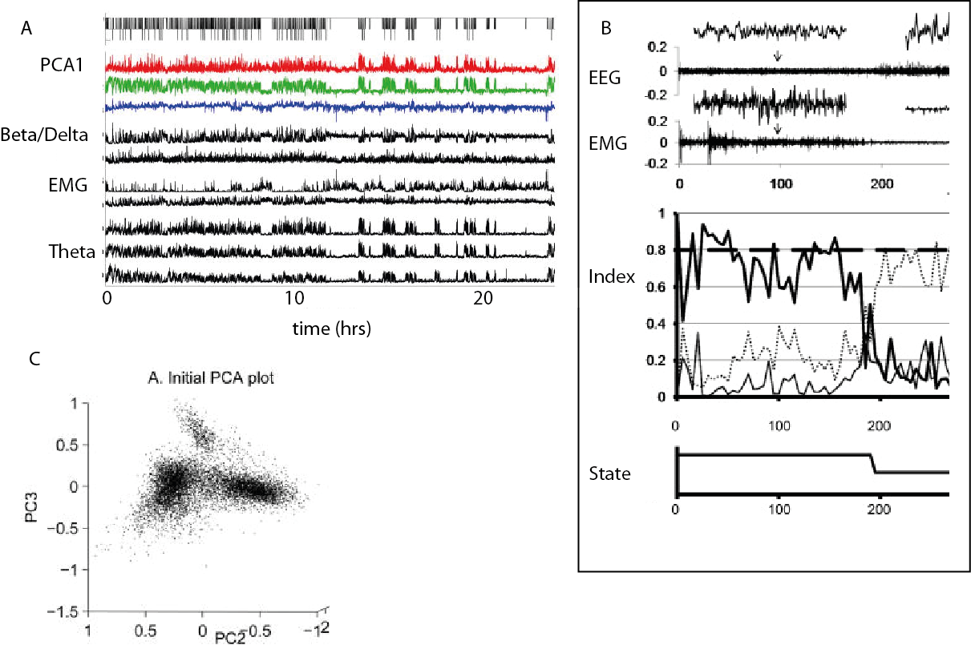
Figure 5: Information used in classification algorithms. Data in A and C (Gilmour et al., 2010). A A 24hr recording of the various frequency band powers either in raw or manipulated form from EEG recordings in a sleeping rat. EMG recording taken from an electrode in the neck is also shown. Some combinations of these measures are commonly used as the features of interest in classification algorithms. B An example of a threshold classifier. Top: EEG and EMG recordings from a freely behaving rat. Middle: Thresholded values of re-scaled and normalised state index values corresponding to the data in the top line. Bottom: Hypnogram indicating sleep-wake state (Stephenson et al., 2009) C An example of a clustering classifier showing data from the same series of experiments as A.

1.4.4 Threshold/Logic Classification
The first brain state classifiers were simple threshold classifiers (Kohn et al., 1974, Johns et al., 1977, Gandolfo et al., 1988). Threshold classifiers are static, discriminative classifiers. Their mechanism of operation is to set a threshold, based on a certain feature of the data. Once this is set, the data is split based on whether it is above or below the threshold. For example, data might be split by grading the power of a frequency band relative to a predefined standard value (Gandolfo et al., 1988). An example of a threshold classifier is shown in Fig. 5B (Stephenson et al., 2009). Threshold classifiers can also include a transition boundary to exempt data that is in the process of transitioning from one state to another. A strength of this method is in its autonomy. It tends to be unsupervised once outliers have been removed and initial parameters set. Threshold classifiers are usually very quick and relatively simple to use and understand. However, a large weakness with this method is that it can only partition data into two at any stage. Therefore, either data can only be split into two states, or, multiple threshold classification stages need to occur, sometimes requiring an additional source of data (Benington et al., 1994). If multiple threshold classification stages occur, this is termed a logical classifier, for example the system in 5B (Stephenson et al., 2009). Other logical classifiers use fuzzy logic (a combination of ‘if’ and ‘and’ statements (Nurnberger et al., 1999)). As in section 1.3.1.1, many different brain states can be experienced, therefore partitioning the data in two groups does not always account for all the brain states being studied. Threshold classifiers are also usually unstable, with each threshold being particular to the subject currently under examination. Threshold Classifiers are generally unsuitable as online classifiers due to their inherent subject to subject instability. However, they do show advantages over other classifiers due to their speed and simplicity and therefore a threshold based classifier has been chosen for evaluating brain state information in the data collected for this thesis

1.4.5 Clustering based Classifiers
Another main method of classification is to cluster the particular feature or features of interest extracted from the data. An example of sleep data that has been clustered can be seen in Fig. 5C (Gilmour et al., 2010). Classifiers based on clustering techniques show more diversity in the number of brain states that they can classify than threshold classifiers with some being capable of discriminating more than five brain states (Gervasoni et al., 2004, Petrovic et al., 2014). However, the decision regarding how many clusters are present in the data and what each cluster represents is an issue with this type of technique, and usually requires the involvement of additional stages of classification, increasing the complexity of the method (Gervasoni et al., 2004, Gilmour et al., 2010, Güneş et al., 2010). Most cluster classifiers are not autonomous. Some initialisation is therefore necessary, and usually post-clustering analysis is necessary also, with cluster assignment to state based on location in the cluster 2D state space (Gervasoni et al., 2004), or the additional use of a logical classification stage such as k-nearest neighbour (Güneş et al., 2010). Clustering classifiers are unsuitable for online classifiers as a large amount of data is needed for reliable clustering to occur. Clustering classifiers can be discriminative, or informative depending on their initial set-up. As clustering classifiers are a popular choice and show the possibility to easily diversify to capture additional brain states as necessary, a cluster based classifier has also been chosen for evaluating brain state information from the data collected for this thesis

1.4.6 Other classifiers
In addition to the two main types of classifiers discussed previously, methods have also been developed based on learning algorithms. The two main types of learning algorithm classifiers are those based on Bayesian probability: linear and quadratic classifiers, k-nearest neighbour and Parzen estimator with Gaussian kernals or those based on neural networks (as reviewed (Becq et al., 2005)). In their review paper, the authors compare these main types of learning algorithms. As with other methods, these have individual parameters that need to be tuned, for example, neural network classifiers need the number of neurons in each chosen layer to be optimised. Therefore these classifiers are not autonomous. The error rate for the neural network was 29%, which is fairly high. However, error rates in the Bayesian classifiers were significantly higher, from 42-53% error rates. The accuracy increases when data undergoes a Gaussian transformation, but error rates remain between 28-37%. That the data needs to simulate a certain distribution in order for only two thirds of the data to be classified correctly, demonstrates that these classifiers did not display good regularisation. It is difficult to judge the level of stability of the classifiers. In the discussion of Becq et al., (2005) the authors describe that none of the classifiers were adapted to one individual, indicating that the classifiers did provide high levels of stability. However, this stability is dependent upon the assumption that the aforementioned tuning therefore came from previous parameters mentioned in associated literature, and not from a initialisation dataset, something which I could not discern from the review paper. These types of classifiers do not therefore seem to provide a good enough model for development in this thesis and were not used.

1.4.7 Data used by Classifiers
Here again is an area with much variation within the world of brain state classification. There tends to be two main groups of classifiers. Those that classify based on a neural signal alone, such as EEG and those that also use an additional measure such as electromyography (EMG) and/or electrooculography (EOG). Whilst additional measures such as EMG and EOG can help to improve accuracy in state identification, it is more convenient to take a single measure such as EEG. In addition to this there are rarer methods that tend to use slow physiological features to classify brain state, such as breathing rate or blood pressure. These factors are either used alone, or in combination with the earlier discussed two main groups. Problems with using slow physiological factors for identification is that they can be hampered or even redundant in experiments where physiological features are artificially maintained (for example, in experiments on anaesthetised animals, artificial ventilation is often employed to maintain a constant breathing rate). To keep experiments in this thesis as close as possible to previous successful preparations (Berwick et al., 2008, Jones et al., 2008, Boorman et al., 2010, Boorman et al., 2015). EMG data was not collected and classifications are to be made from neural data collected from an electrode placed in the cortex.

1.4.8 Evaluation of Classifiers
The features of importance with brain state classification are ease of use, percentage accuracy of a dataset, amount of dataset that can be classified and time taken to classify dataset. One problem with finding the correct mapping for a data point that is seen in many classifiers is the accuracy-sensitivity trade-off (also known as the bias-variance trade-off (Lotte et al., 2007)). This is where stable classifiers usually have high accuracy, but with a high sensitivity to the initialisation dataset used. Unstable classifiers tend more towards a low sensitivity to the initialisation dataset, but combined with a lower accuracy overall. Overcoming the accuracy-sensitivity problem is a challenge that is yet to be met to my knowledge with the available classifiers. This review of the current types of classification systems, both automatic and manual shows that there is still much room for improvement. To the best of my knowledge, the classifiers were not developed with neurovascular coupling experiments in mind. Instead, classifiers either exist that were created only to classify neural “brain state” data, without tests to see if differences in any accompanying concurrent haemodynamics are seen to that classification. Alternatively classifiers have been developed to classify fMRI data, however in this case, these classifiers are looking for the alternative usage of the “brain state” definition: they classify to find the sensory or behavioural events or mental processes that a neuroimaging research may wish to define in terms of neural correlates (an example of this type of classifier is support vector machine algorithms (Mourão-Miranda et al., 2005, LaConte et al., 2007, Sitaram et al., 2011)). As described above, problems exist with all classifiers. Threshold classifiers and cluster classifiers seem to offer the best combination of speed, accuracy and complexity, if used in simplistic forms as their accuracy rates are usually 80-90%. Therefore, in development of a classifier for neurovascular coupling data, it would make sense to use one of these methods as the basis for the second stage of classification. Frequency band power has consistently been used throughout the state classification literature (see section 1.4.3), and therefore it would seem obvious to continue to use this in any new classification method.

1.5 Aims and Contents of Thesis
The main aim of this thesis is to develop and implement a classification algorithm that could be used to group haemodynamic data by cortical brain state. It is hoped that any differences in haemodynamics that are found in classifying by the cortical state can be used to gain further understanding in interpretations of the BOLD signal. Fluctuating changes in cortical brain state from synchronised to desynchronised are created by anaesthetising the rodent model with urethane. Chapter 3 details the development and testing of three potential methods: threshold classification, cluster classification and vectorised classification. These methods are tested using neural LFP data from the rodent whisker barrel somatosensory cortex. It also describes the rigorous testing of the chosen classification method (vectorised classification) against the other methods (Papanicolaou et al., 1986) (Gervasoni et al., 2004). Chapter 4 takes the classification method validated in Chapter 3 and uses it to group concurrent 2D-optical imaging spectroscopy recordings of Hbt, Hbo and Hbr again taken from the whisker barrel cortex. The chapter investigates whether selectively averaging ‘spontaneous’ (where no stimulation is applied) time periods by cortical brain state yields significant differences in state-specific baseline haemodynamics. Long duration stimulus evoked haemodynamic trials are also selectively averaged by cortical brain state and compared to an unclassified average to examine which gives higher quality data. In Chapter 5, the classification algorithm from Chapter 3 is again used to investigate how grouping concurrent neural and haemodynamic data by cortical state compares to grouping all trials together in an unclassified average, however in this Chapter, the region of cortex investigated is the motor cortex. The final chapter 6 discusses the main findings of the research performed in the experimental chapters and suggests hypotheses to explain the results seen, with potential further questions that could be investigated described.

2 Materials and Methods

Abstract
This Chapter sets out the materials and methods used to perform all experimental procedures in this thesis. The surgical procedures to create a stable preparation where physiological parameters were kept within the normal range for the rat are detailed. The creation of a thin cranial window and the insertion of two linear array electrodes in the motor and whisker barrel cortex are also explained. The application and characterisation of the electrical stimulation to the whisker pad is described. Following this, the experimental techniques of 2D-OIS and electrophysiology are included, with basic theory, method of application and analysis given in such detail that reproduction of the experiments would be possible. All surgery and experiments in this thesis were non-recovery under terminal anaesthesia. Following cessation of the experiments, animals were euthanised using Schedule 1 techniques of overdose followed by cervical dislocation.
All data collected for the work in this thesis came from experiments performed by Miss Rebecca Slack, Miss Priya Patel, Dr Luke Boorman and Dr Jason Berwick. Miss Rebecca Slack and Miss Priya Patel collected all data used in Chapters 4 and 5 with assistance and/or supervision from Drs Berwick and Boorman. Some experiments used in Chapter 3 (from dataset A0) were collected by Dr Boorman.

2.1 Animal preparation
All experiments were performed in accordance with the Animal (Scientific Procedures) Act 1986, with approval from the United Kingdom Home Office.

2.1.1 Animals
The animals used in the experiments in this thesis were all female Hooded Lister rats, with weights ranging from ~200g-~350g. The rats were kept in a suitable microenvironment with a 12 hr light/dark cycle. The temperature and humidity of the environment was kept within the normal appropriate range for the species.

2.1.2 Surgery Preparation
Animals were all anaesthetised prior to surgical or experimental procedures (details below). Anaesthesia can result in the build-up of excessive respiratory secretions, thus atropine, an anti-cholinergic agent, was administered subcutaneously at a low dosage of 0.4mg/kg to reduce mucous secretions. Throughout surgery and subsequent experiments, animals were continually monitored using rectal measurements of temperature to automatically adjust a homoeothermic heating blanket (Harvard Instruments, UK), to maintain core body temperature at 37 ˚C.

2.1.2.1 Brief anaesthesia with isoflurane
. Rats were briefly placed (<30s) into an induction chamber whilst the gaseous anaesthetic, isoflurane was administered at 3.0% by use of an anaesthetic machine. The brief use of isoflurane ensured that the animals did not experience stress during the administration or induction of the main anaesthetic agent, urethane. Isoflurane was not used as the main anaesthetic agent for the procedure and subsequent experiments as it did not present with as many advantages as urethane (detailed below) and can cause respiratory and cardiovascular depression.

2.1.2.2 Anaesthesia with urethane
Animals were intraperitoneally (i.p.) injected with 1.25 g/kg urethane. At higher doses of urethane, blood glucose levels can reach abnormal levels. With i.p. injections of this dose, stage 3 plane 2 anaesthesia was reached, often described as medium anaesthesia. The stage of anaesthesia was ascertained by checks to see that the pedal, palpebral and corneal reflexes are absent. Additional doses of 0.1ml of urethane were administered if necessary to maintain the correct stage of anaesthesia. Urethane has a number of advantages; it is a long lasting and stable anaesthetic. It is also suitable for work monitoring concurrent neural and vascular responses as it produces minimal cardiovascular and respiratory depression. It also has a high degree of analgesia. Urethane also produces little effect on the time course or amplitude of synaptically evoked inhibitory responses (Scholfield, 1980). It has been suggested that the mechanism of action of urethane differs from most anaesthetics (Koblin, 2002) as it has relatively small effects on all major ion channels examined; Glycine, AMPA NMDA, nACh and GABAA by Hara and Harris (2002) and glutamate, GABAA and GABAB (Sceniak and MacIver, 2006).

2.2 Surgery
All surgical tools, clothing and equipment were sterilised before procedures took place.

2.2.1 Tracheotomy and ventilation
A tracheotomy was performed to enable artificial ventilation (Harvard Instruments, UK) and to monitor end-tidal CO₂ (CapStar-100, CWE Systems, USA). To perform the tracheotomy the animals were placed in the supine position, with their limbs secured. A small incision was made (~20mm) with a scalpel from below the mouth to above the ribcage. Once the incision was made, tweezers were used to perform blunt dissection of the connective tissue below to expose the trachea. A small hole was created in the tissue below the trachea and a loose suture was fed through the hole and around the trachea. Microscissors were used to cut a small incision in the exposed trachea between two sections of cartilage close to the mouth. A bevelled cannula (Portex, 40mm long, 2.8mm outer diameter, with inserted needle for CO2 measurements) was gently inserted into the incision until the end lay just above the rib cage. The loose suture was then used to secure the cannula in place, and the major tracheotomy incision was sutured closed and superglued to securely seal the wound and hold the trachotomy tube in place. The subsequent ventilation allowed the animal to maintain normal physiological limits of blood oxygen saturation and CO₂ levels.

2.2.2 Vessel cannulation
Following the tracheotomy, the femoral artery and ipsilateral vein were cannulated. Venous cannulation allowed the infusion of phenylephrine at 0.13 to 0.26mg/h to allow the maintenance of mean arterial blood pressure (MABP) within normal physiological limits of 100 and 110mmHg (Golanov et al., 1994, Nakai and Maeda, 1999). Cannulation of the femoral artery allowed the MABP to be continuously monitored, and also allowed blood samples to be collected and analysed for blood oxygen saturation. An incision was made in the rostromedial direction (towards the midline of the animal) of approximately 25mm in length. Following the incision, the connective tissue underneath was blunt dissected until the femoral artery, nerve and vein were exposed in a cluster. Blunt dissection below the skin in the leg then made a small opening. At the anterior end above the clustered vessels/nerve the exterior of the peritoneal cavity was visible. Using a suture, a small stitch was made in the surrounding muscle and then secured away from the subject to create the space for the cannulation. Forceps were placed into the exposed area so that the view to the clustered vessels is clear. The nerve was gently separated from the artery and vein using tweezers. This separation was followed by pushing upwards gently but firmly between the two vessels to separate the artery and the vein. Any excess tissue was cleared from the vessels. The vein was cannulated first. Two sutures were inserted under the vessel. The posterior suture was tightly secured (double knot) as distally as possible (creating vessel occlusion) whilst the anterior suture was grasped with forceps, but not tied and tensioned to lift the vein for greater access. A sprung clamp was placed proximally (close to the stomach) to prevent blood flow from the body. Microscissors were used to make a small (1/4 through) v-shaped incision in the vessel. A pre-bevelled cannula (0.4mm internal diameter, 0.8mm external diameter) was inserted into the incision and fed forward till it reached the placement of the clamp. Holding the cannula in place, the clamp was removed and the cannula again fed forward till it was fully inserted (5-10mm). The anterior suture was then tightened around the vessel and cannula (without occluding the vein) and tied with a double knot. The posterior suture was also tied around the cannula to secure it. After drawing back on the syringe to check that a small amount of blood was visible, the cannulation was termed successful and the same process began on the artery. The cannulas were pre-filled with heparinised saline (50 units of heparin per unit of saline) from 1ml syringes. Heparinised saline was used to prevent clotting of blood in the cannula. Once both cannula were inserted, the wound was sutured closed and superglue was again used to fully seal the incision and hold the cannula in place as they are prone to twisting. As an additional check, the cannulas were placed on the inside of the leg and a suture was used to secure them to the skin of the leg.

2.2.3 Thinned cranial window
A thinned cranial window was created which allowed direct viewing and optical imaging of the veins, arteries and parenchyma of the cortical surface (see Fig. 2D for example of thin cranial window). Animals were placed in a prone position and secured into a stereotaxic frame (Kopf instruments, Inc). Ear bars and a bite bar were used to ensure that the head was fixed. An incision was then made down the midline of the skull, beginning posterior to the nose. Blunt dissection removed the skin tissue and fascia from the right hand side of the brain. The right temporalis muscle covering the lateral aspect of the right side of the skull was pulled back and sutures were used to secure its position exposing the side of the skull. The area 1mm lateral to midline down to the base of the temporalis muscle and from 2mm anterior of bregma to 5mm anterior of lambda was selected. The region selected contained both motor cortex and the barrel cortex (positioned 1-4mm posterior and 4-8mm lateral to bregma (Chapin and Lin, 1984) as well as a significant portion of the surrounding cortex. Using a dental drill (Pro-Lab Basic, Bein Air) fitted with a steel ball drill bit (No.4), the skull was carefully thinned to a depth of approximately 100-200µm (to achieve translucency). Saline was repeatedly swabbed across the skull to cool the surface and clear bone dust. Skull vessels that bled during the procedure were carefully drilled to staunch the bleeding, or if the bleeding did not cease, bone wax was applied until it did. Once the drilling was complete, the middle cerebral artery (MCA) could be seen as well as other vessels and parenchyma. The bone sutures and edges of the window were then sealed with superglue to create structural integrity for the fitting of a circular well.
A circular plastic well (17mm interior diameter) was attached over the window using dental cement to securely fix it into place (see Fig. 1). It was filled with saline which was allowed to infuse and exit the well at a slow constant rate. This ensured that optical specularities were kept to a minimum and translucency was maximised. The slow infusion also countered the evaporation which would otherwise have altered the optical properties. The infusion inlet was a cannula such as was used for the cannulations in 2.2.2. It was glued to the skull at the edge of the cranial window, prior to the dental cement being applied.
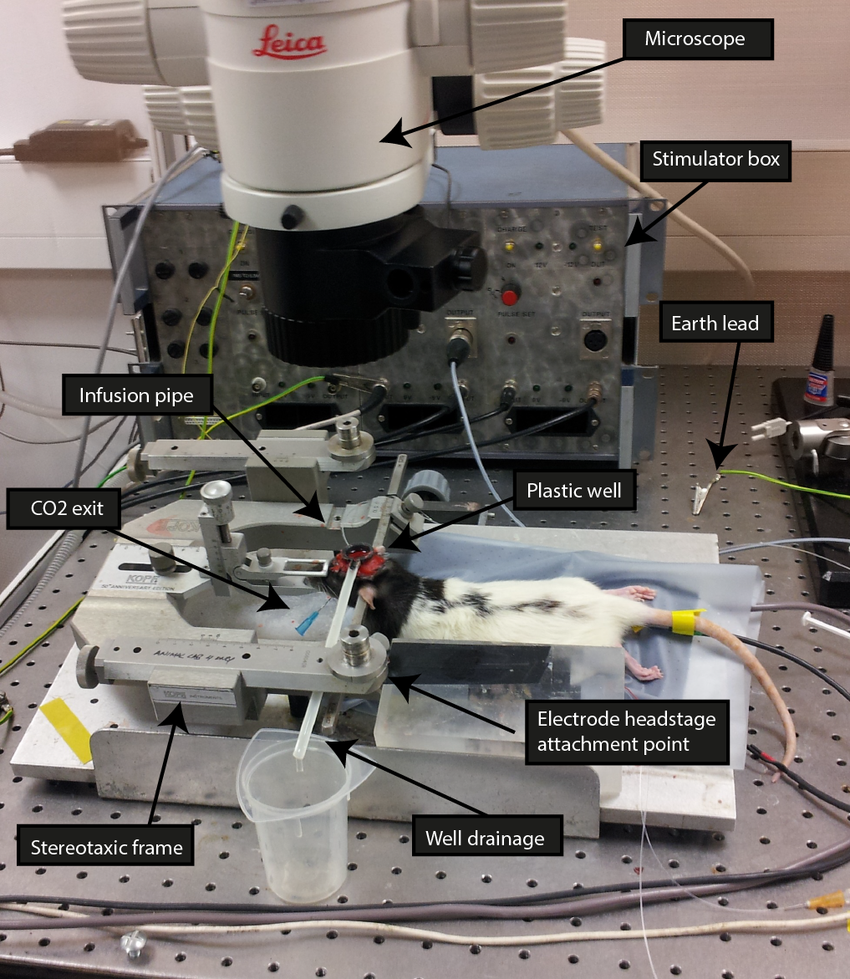
Figure 1: Demonstrating the partial set up for the multimodal imaging (photo of authors experimental prep). The animal is in-situ on the experimental table, placed in the stereotaxic frame. The underside of the plastic well has been affixed to the head by way of the red dental cement. Saline has been placed into the well to check for any leaks and to check drainage occurs at a slow and consistent rate. The tracheotomy and cannulations have been performed, but constant monitoring of the physiological parameters is yet to begin.

2.2.4 Management and monitoring of physiology
Following the attachment of the well the surgery was considered to be complete. After surgery, the animal was placed (on the stereotaxic frame) in to a Faraday cage (a large metal cage that surrounds the equipment being used and is earthed in order to exclude electrostatic or electromagnetic influences). The animal was connected to a ventilator (Zoovent, Havard Instruments, UK) which administered compressed medical grade air (max pressure 4 bar) at a speed of 70-80 breaths per minute (1.15-1.3 Hz, similar to the normal physiological breaths of the animal, each animal was matched to their pre-ventilation breathing rate). Controlling for the breathing rate helped to maintain normal blood oxygen saturation which is essential in experiments examining vascular responses, but useful in any experiment using a healthy anaesthetised animal. Continuous end-tidal CO₂ (CWE Systems, USA) recordings were used to adjust the ventilator parameters (using a 1:1 inspiration/expiration cycle) on an ongoing basis if necessary.
MABP was also monitored throughout the subsequent experiments. A diaphragm unit was filled with heparinised saline (50 units per ml) and attached to the arterial cannula. Any bubbles of air that appeared throughout the arterial line were dispatched before cannulation and any that appeared in the diaphragm were also removed as the air can compromise the reliability of the MABP recordings. Following this, the diaphragm was connected to a transducer (NL108T1, Neurolog) and this signal was amplified (NL108, Neurolog) and relayed through a high speed data acquisition system (Plus 1401, Cambridge Electronic Devices (CED) LTD) to a PC. The output was displayed and recorded using Spike2 software. If the recordings showed that MABP was not within normal physiological limits for the animal, then either ventilator parameters were adjusted, or the infusion dosage of phenylephrine was altered (0.13-0.26 mg/hr) using a syringe pump (SP200i, World Precision Instruments; WPI). Although urethane maintains a good standard of cardiovascular and respiratory function for the animal, it can cause reductions in blood pressure or alterations in breathing. Using phenylephrine and artificial ventilation ensures that the animal is maintaining normal physiological limits throughout the experiments that follow.

2.2.5 Stimulus presentation
Two stainless steel electrodes (Plastics one, Inc) were inserted into the left whisker pad of the subjects (a left whisker pad stimulation will functionally affect the right hand side of the cortex). The electrodes were insulated to within 2mm of the tip and were placed between rows A/B and rows C/D of the whisker pad in a posterior direction (see Fig. 2 for barrel organisation). Trial stimulations ensured that a strong movement of the whisker pad took place. A mains isolated (battery powered) constant current stimulator (built in-house, see Fig. 1) produced the electrical pulse/s that made up the stimulations with this also being controlled by Spike2 software. Pulses were sent to the stimulator via a data acquisition device (CED1401, Cambridge Electronic Devices, UK). This stimulation was also sent in parallel to the Spike2 PC software to maintain a record of the pulses and to ensure that the obtained pulse shape, timing, and current amplitude matched the desired parameters. When non-stimulation (spontaneous) experiments occurred, the current amplitude was set to 0 so that a record of the non-stimulation could be kept to ensure that the synchrony of the electrophysiological and optical imaging recordings was exact.
Throughout all stimulation experiments a current of between 0.8 and 1.2mA was used (adjusted dependent on animal response, for example due to exact positioning of stimulation electrodes). The pulses were applied at a frequency of 5Hz for either 0.15s (single impulse responses – dataset A0), or 16s (80 impulses – dataset A3). The duration of each pulse was 0.3ms. A stimulation frequency of 5Hz has previously been shown to produce the strongest haemodynamic response (Ngai et al., 1999). Identical stimulation parameters have been used in recent neurovascular studies (Boorman et al., 2010; Boorman et al., 2015). End-tidal CO₂ and MABP did not change during the stimulations providing confidence that the parameters were within a safe, normal physiological range for the animal.
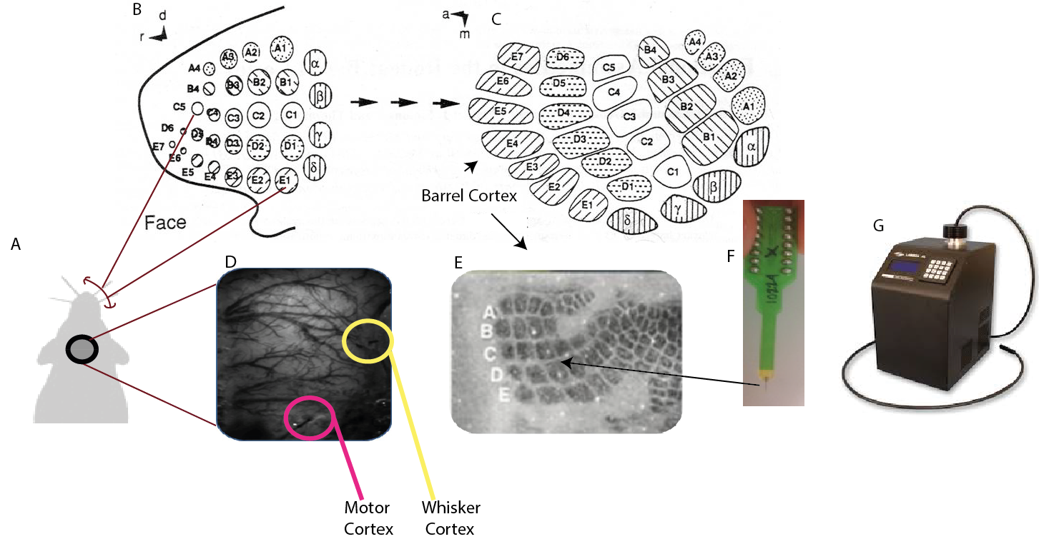
Figure 2: From the stimulation of the whisker pad to recording in the barrel cortex. A Top down view of rats head. Black circle denotes plastic well. Arrow shows range of whiskers stimulated. B Enhanced view of whisker pad showing individual follicles from which whiskers protrude. Stimulation electrodes are inserted into two regions to generate movement of the entire whisker pad. B and C Showing the topographic mapping between each whisker and each barrel field in the cortex. D Grayscale camera image of the thin cranial window in which the vessels and surrounding tissue is clearly visible. E An illustrative example of the clearly defined barrels in the cortex. Post mortem histology uses cytochrome oxidase to visualise the barrels. F A 16 channel electrode with arrow showing example placement of electrode perpendicular to barrel cortex (an additional electrode was placed in the motor cortex). G An example of a 4 wavelength switching galvanometer.

2.3 Experimental Techniques
The following section provides an overview of the theory and practical endeavours that underlie each of the techniques used for the multi-modal imaging in this thesis (Electrophysiology and 2D-OIS).

2.3.1 Electrophysiology (all chapters)
The neural activity in the motor and whisker barrel cortices was recorded using linear array electrodes (Neuronexus Technologies, Ann Arbor, MI, USA, see Fig. 2F). Each electrode had 16 sites, spaced 100µm apart (Fig. 3A-C). The area of each site was 177µm² and the impedance ranged from 1.5-2.7 MΩ. The width of the probe tip was 33µm, increasing up to 123µm at the uppermost recording site. The sampling rate for each electrode site was 24.41KHz. Each electrode was inserted perpendicular to the cortical surface.

2.3.1.1 Connection of the electrodes
The procedure for the connection of the whisker barrel electrode within the experimental set-up is now detailed. A ‘headstage’ consisting of a 32 pin D-sub socket (Tucker Davis Technologies; TDT) connected to an 18 pin dual-in-line (DIL) socket which was attached to a stereotaxic arm (see electrode headstage attachment point in Fig. 1). The top left DIL pin was used to connect to a reference (indifferent) electrode. The reference electrode was a piece of silver wire approximately 10cm in length that was inserted subcutaneously through the skin on the back of the animal’s neck. Connected into the top right DIL pin was a ground lead that was connected to the Faraday cage. The linear electrode was placed into the pins below these two holes. The headstage was then connected to an isolated pre-amplifying device (Medusa Bioamp, TDT) which was connected in turn to a data acquisition unit (TDT). This procedure was repeated for the motor electrode.

2.3.1.2 Insertion of the electrodes
The region for electrode insertion was chosen using a functional localisation 2D-OIS technique. This is explained in full in 2.3.3.2.1. The localisation created a map of haemodynamic activation in response to electrical stimulation of the whisker pad. This was then registered and overlaid onto a reference grayscale image of the cortex so that the whisker barrel region and motor region could be clearly seen. If the localisation process failed to show a clear indication of the motor cortex region on the first attempt, a second localisation experiment was performed. Analysis from Chapter 5 indicates that the motor cortex may not have appeared clearly on the first attempt if an even, or fairly even split of cortical state between synchronised and desynchronised appeared. After the localisation map was created, two sites were chosen that avoided major dural or cortical vessels. If a vessel is pierced by inserting the electrode, then blood could escape into the saline filled well at any point from insertion through to later experimental recordings. Visually this would prevent accurate recording of the 2D-OIS and could also affect the electrophysiological recordings. Once suitable sites had been chosen, the well was cleared of saline, and the drill was fitted with a smaller bit (No. 1). Holes were drilled in the skull overlaying the two sites chosen for insertion. A fine tipped needle was then used to make a hole in the dura. Clarification of success was obtained by observing the emergence of cerebrospinal fluid into the electrode site using an MZ9.5 Leica microscope (see Fig. 1).
The electrode was attached to the headstage and the stereotaxic arm adjusters were then used for the minute complex adjustments that ensured the electrode entered the cortex in the correct location. Further use of the microscope ensured that the electrode was inserted until all sites were no longer visible. The profile of the raw data responses could be viewed in TDT viewing software (OpenEX, TDT, Fig. 3D). The preparation was allowed to stabilise for up to an hour after the electrodes were inserted. Some have found that cortical spreading depression (a wave of hyperactivity followed by a wave of inhibition) can occur after electrode insertion, therefore a period of up to an hour was allowed for the preparation to stabilise to avoid this possibility (Lauritzen et al., 1982, Ba et al., 2002). A short whisker stimulation experiment was then run to check that the whisker electrode was inserted correctly. The whisker stimulation test sequence consisted of stimulations at 5Hz for 1s duration (5 pulses), repeated 10 times with an inter-trial interval of 2s (current used 0.8-1.2mA). The resultant field potentials were averaged and examined to check for normal patterns of field potentials (see Fig. 3E). If the pattern did not match the exemplar pattern, then minute adjustments were made to the electrode depth and the test repeated until the match occurred.
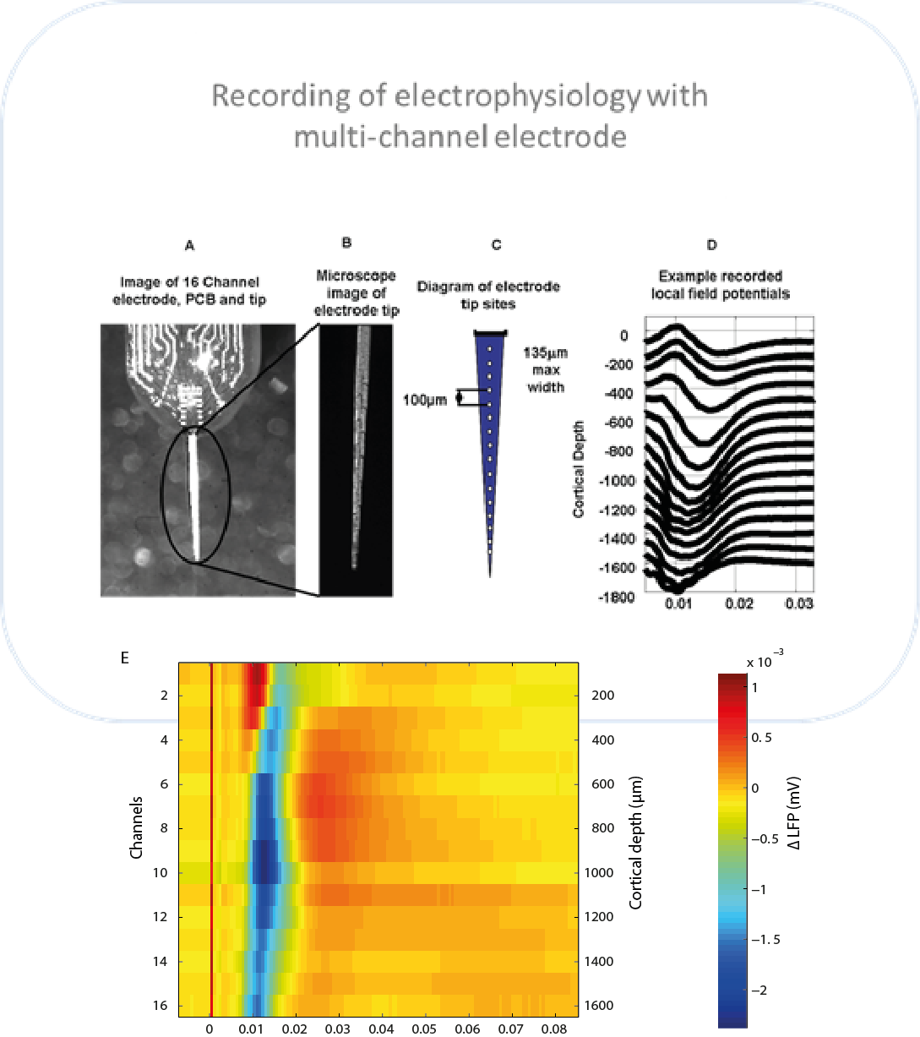

Figure 3: Details of the laminar electrodes used and the field potentials recorded. A The end of the multichannel electrode. Circled is the area that was inserted into the cortex. B Enhanced view of the electrode tip. C Schematic of electrode tip next to photo for comparison. Distances between sites and width at the top is given. D Example of how the LFPs change with descending cortical depth in anesthetised rat cortex. NB, the 16 channel electrode is placed in the experiments in this thesis to capture depth up to 1600µm. E An image representing correct cortical depth in anesthetised rat cortex. The stimulation pulse occurs at time 0 and the resultant wave of red and blue shows the following depth changes that occur. A-D are from Boorman (2009). E is authors own work and further details can be seen in Chapter 5.

2.3.2 Two Dimensional Optical Imaging Spectroscopy (2D-OIS) (Chapters 4 and 5)
2D-OIS is a well-established technique that uses the absorption spectra of oxyhaemoglobin (Hbo) and deoxyhaemoglobin (Hbr) to approximate the changes in blood volume (Chance, 1991) and blood oxygen saturation present across the two dimensional plane of the cortex (in this instance). 2D-OIS has previously been used in many studies (Berwick et al., 2005a, Berwick et al., 2005b, Berwick et al., 2008, Boorman et al., 2010, Harris et al., 2014, Boorman et al., 2015). Although it does not have the depth resolution of a technique such as BOLD fMRI, it does boast the advantage of being significantly cheaper when investigating haemodynamic responses in animal models such as the rat, and can also be combined fairly easily with other techniques such as Laser Doppler Flowmetry (Boorman et al., 2010) or electrophysiology (see section 2.3.4).

2.3.2.1 A brief insight into the theory of Optical Imaging Spectroscopy
Different wavelengths of light have different absorption coefficients for Hbo and Hbr. Four wavelengths (495nm, 559nm, 575nm, 587nm at full width half maximum, FWHM) are shown in Figure 4 below where the difference can clearly be seen between Hbo and Hbr.
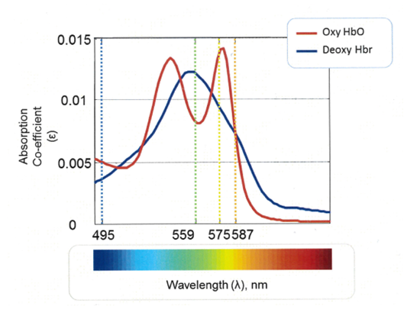
eox
Figure 4 (above): A simplified Hbo and Hbr absorption spectra adopted from Bruyns-Haylett (2013). The absorption co-efficients (ε) scale can be observed on the y-axis and wavelength is shown on the x-axis. Hbo and Hbr are plotted. Although Hbo and Hbr follow a relatively similar path, at three separate full width half maximum (FWHM) wavelength points (495nm, 559nm and 575nm, plotted as coloured dotted lines) they show maximally different absorption co-efficients, whilst at the fourth (587nm) the absorption spectra is similar for both.
Supposing white light of known intensity $I_{0}$ shines upon a sample such as the cortex. Some light will be absorbed by the sample and the rest will be remitted at an intensity of I. I can also be measured. Therefore, the attenuation (level of absorbance) can be calculated as long as the photons of light are not assumed to scatter. However, within a medium such as brain tissue, it must also be assumed that photons of light will scatter, thus creating longer path lengths than in a non-scattering medium. If the path lengths are longer, this increases the chance that the photon will be absorbed into the medium and not remitted. The calculation of the path lengths cannot be exact as an ongoing measurement of the pathways that the photons of light take through the brain tissue would not be possible. Instead, a Monte Carlo simulation (MCS) model estimates the unknown differential path length ($∆l$) that a photon of light would take at different concentrations of absorbents (∆c) taking into account the different scattering angles (u) and thus scattering coefficients ($µ_{s}$) that may occur. This can be related to the differential attenuation ($∆A)$ that occurs.

2.3.2.1.1 Monte Carlo Simulations of path length
The MCS used in the work in this thesis uses a ‘random walk’ function, where each ‘step’ in the path of the photon has a non-isotropic angle (see Fig. 5). The simulation creates estimations of how many ‘steps’ a photon will take before it is remitted (if it is remitted). In Fig. 5 shown below, the green path length is shorter. The photon only takes one step before being remitted. The blue path length has four steps in it, being longer. Therefore the scattering coefficients (µ_{s}) of the two will be different: the blue scattering coefficient will be larger than the green scattering coefficient. To find the path length estimations, the MCS algorithm requires the angle of scattering (g) as well as the aforementioned scattering coefficient (µ_{s.}).
The angle of scattering (u) can be estimated. The Henyey-Greenstein probability function can be used to create a weighting factor, g:
$g=\int_{0}^{2π}{\cos{ϑ.p\left(ϑ\right).dϑ}}$ (1)
Whereby if g = 0, random erratic movement is expected
g = 1, no scattering occurs
g = -1, the photon reverses its previous movement
Within the model used in calculations in this thesis, a scattering angle of g = 0.85 is assumed, which should ensure a large proportion of forward scattering (Cope and Delpy, 1988). The assumption is based on in-vivo measurements by (Johns et al., 2005) that indicate that the scattering is largely homogeneous over the superficial 2mm of cortex that the OIS is most sensitive to.
The following equation is used to create the scattering angle, (u) by calculating a randomised weighting (t) for each path length, where s is a randomly generated number.
$t=\frac{(1+g^{2}- {(\frac{1-g^{2}}{1+\left(g*s\right)})}^{2}}{2*g}$ (2)
$∴u=arccos⁡(t)$ (3)
The scattering angle, (u) can be used to create the reduced scattering co-efficient $µ_{s}‘$.
$µ_{s}‘ = µ_{s}(1-u)$ (4)
Once the scattering co-efficient has been created, it can be used within the MCS to create a density function $φ\left(x\right)$of path lengths, that can be binned into segments $\left(x\right)$. Again, in Fig. 5, L1 has two paths, and L2 has 5. An exponential decay function is included that includes the baseline attenuation coefficient, μ_{a}. The density function can therefore be used to calculate the differential path length:
$∆l=\frac{\int_{0}^{∞}{φ\left(x\right)*x*e^{-xμ_{a}}dx}}{\int_{0}^{∞}{φ\left(x\right)}.dx}$ (5)
Different wavelengths will have altered differential path lengths ($∆l\left(λ\right)$). These different path lengths can be used within a modified Beer-Lambert equation where
$∆A\left(λ\right)=∆l\left(λ\right).\left(ε_{{HbO}_{2}}\left(λ\right).∆\left[Hbo\right]+ε_{Hbr}\left(λ\right).∆\left[Hbr\right]\right)$ (6)
Within this equation the change in attenuation is a measured variable for each wavelength of light used ($∆\tilde{A}\left(λ\right)$), the path lengths for the wavelengths can be calculated as detailed above ($∆l\left(λ\right)$) and the specific absorption coefficients (ε) for oxy (Hbo) and deoxy (Hbr) haemoglobin are known for the different wavelengths (see Fig. 4), this leaves equation 6 with two unknowns. The change in the concentration of Hbo ($∆\left[Hbo\right]$) and the change in the concentration of Hbr ($∆\left[Hbr\right]$). Using four wavelengths generates four equations whereby it becomes possible to solve for the unknown concentrations by way of simultaneous equations.
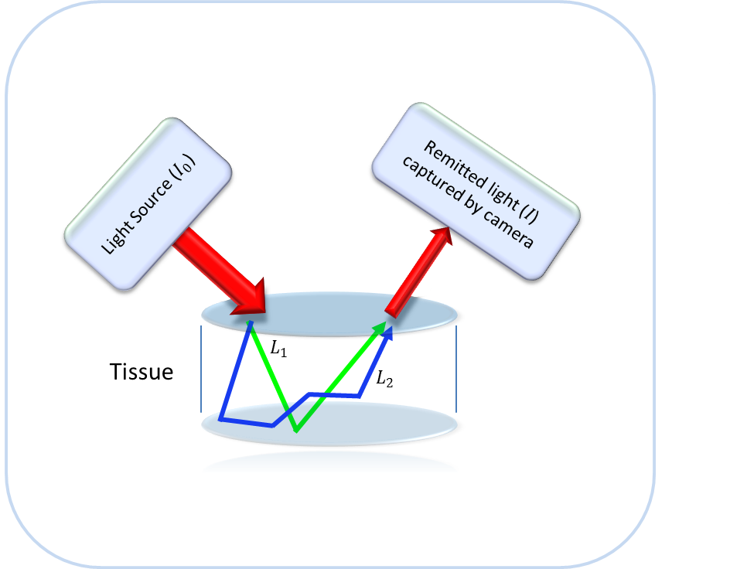
Figure 5: The random paths that photons of light may take within a tissue. In both examples shown in this figure the two photons of light are remitted (neither are absorbed). However, the path lengths of the two photons is different, with L₂ having a longer path length than L₁.

2.3.2.2 Using a homogenous or heterogeneous tissue model
Initially, the 2D-OIS studies conducted with this model used a homogeneous tissue model (Martindale et al., 2003, Berwick et al., 2005b, Jones et al., 2005, Kennerley et al., 2005) that assumed that baseline levels of cerebral blood volume (Hbt₀) and oxygenation (Hbo₀) and the resultant changes of these variables were the same throughout the layers of tissue. However, the brain displays a heterogeneous distribution of vascular structures (Pawlik et al., 1981) which indicated that the model needed to be updated to improve estimation accuracy. In earlier work, (Kennerley et al., 2009) fMRI data is used to parameterise a layered heterogeneous tissue model. The depth splits for the MCS of light were 100, 300, 700 and 1500 and 10000µm. As previously mentioned, the scattering can be assumed to be homogeneous throughout the superficial 2mm of the cortex therefore in the heterogeneous model, the reduced scattering coefficient is given by the following equation from (Van der Zee, 1992):
$µ_{s}‘ \left(λ\right)=2.7*{\left(\frac{λ}{560}\right)}^{-1}$ (7)
Therefore the coefficients that vary as the layers vary are as follows:
- The coefficient of absorption ($µ_{a}$). Rather than being a single homogenous value, $µ_{a}$ now has five values, each value for one of the previous five layers in the model.
μ_{a}(λ) ∝ (ɛ_{Hbo}(λ)Hbo + ɛ_{Hbr}(λ)Hbr) (8)
- Baseline values of total haemoglobin (Hbt₀)
- Baseline values of oxygen saturation (Hbo₀)
Further details about how the layer coefficients for these parameters were calculated can be found in the original paper (Kennerley et al., 2009). Briefly, they used the BOLD signal and other relevant fMRI measurements to inform the updated 2D-OIS algorithm. The relationship between the BOLD and CBV fMRI measurements and the predicted Hbr of the 2D-OIS algorithm can be seen in Fig. 6 alongside a coronal histological section of the cortex stained with cytochrome oxidase.
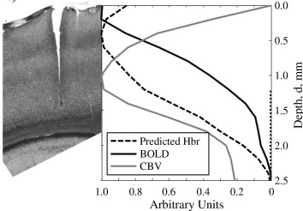
Figure 6: Right How mean BOLD and CBV fMRI signals are used within an inverse MCS of magnetic resonance signal attenuation to produce a predicted Hbr changes profile. Left A coronal section stained with cytochrome oxidase showing the tear in the cortex caused by a 16 channel laminar electrode.

The total blood volume/haemoglobin is a summation of the values for the oxy and deoxy haemoglobin together:
$∆\left[Hbt\right]=∆\left[Hbo\right]+∆\left[Hbr\right]$ (9)

2.3.2.2 Application of the optical imaging method
Following surgery (section 2.2), a white light source (400 watt halogen) was filtered through a switching galvanometer system (lambda DG-4 Sutter Instruments Company). Four wavelengths were selected and presented sequentially as follows: 575, 559, 495 and lastly 587. The filters were switched in sequence and each was presented for 1/32 of a second, giving a rate of 32Hz for all filters and a frame rate of 8Hz for each individual filter. The remitted light was passed through a lens (focal length 100mm, Leica) followed by a microscope with magnification 0.63-6x (MX9.5, see Fig. 1) and then finally into a charge coupled device (CCD) camera recording at 32Hz (Dalsa 1M30P, Silicone Mounted Design: SMD, USA). The camera operated in a 4x4 binning mode. The size of the thinned cranial window provided the restraints for the size of the region of interest recorded, and was of size 128*128 pixels. The data had a temporal resolution of 125ms.

2.3.3 Data Analysis

2.3.3.1 Electrophysiological data analysis
The electrophysiological data analysis has been split into pre-processing, state classification and multi-unit power analysis.

2.3.3.1.1 Pre-processing
Electrical stimulation of the whisker pad produces very brief stimulus artefacts in electrophysiological recordings and can be seen in raw data as a large thin spike that occurs a few milliseconds after each stimulus (Fig. 3E). The stimulation artefacts occur at the same time point before the stimulation and therefore can be removed by interpolating over the data points associated with the noise spike. After artefacts were removed, the data were downsampled from 24.4KHz, according to the later type of analysis that was to be performed. For data to be used for local field potentials (LFP) analysis, including that used for state classification, data were downsampled to 1.6KHz. Data used for multi-unit analysis were downsampled to 6.1KHz.

2.3.3.1.2 State classification and multi-unit power analysis
The details regarding state classification have been included in their respective methods sections for each chapter. Briefly, a sliding window was applied to LFP data and a Fourier transform used to extract the relative frequency components that were present in the time-series. The frequency components were grouped according to the following classical EEG bands: delta (0.5-3.9Hz), theta (4-7.9Hz), alpha (8-12.9Hz), beta (13-30.9 Hz), gamma (31-80 Hz) and multi-unit (300-3000Hz). These groupings were then used for subsequent analysis.

2.3.3.2 2D-Optical imaging spectroscopy data analysis
The 2D-OIS data analysis has been split into localisation of ROI, haemodynamic analysis parameters, haemodynamic response analysis and predicted BOLD analysis.

2.3.3.2.1 Localisation of active regions for electrode placement.
All data analysis was performed using custom written scripts in MATLAB (Mathworks, Inc). Analysis of 2D-OIS data required the four-wavelength data to be converted to provide measures of Hbt, Hbo and Hbr andfollowed the equations and method detailed in 2.3.2.1.
For localisation experiments, an electrical stimulation was applied to the whisker pad (0.8-1.2mA current, 25s inter-stimulus interval, 5Hz frequency, 2s stimulation). Results were averaged and displayed using an in-house software tool (MATLAB script ‘fMR_ui’). To isolate the whisker barrel somatosensory cortex, a SPM design matrix optimised for the typical haemodynamic profile expected for the 2s whisker stimulation was applied. The z-score based changes were viewed superimposed on a 2D cortical region of thinned cranial window. From these changes, the whisker barrel cortex and the motor cortex could be observed. If the changes in the motor region could not be observed, the experiment was re-run (to see if state confounds could be causing problems with a visible haemodynamic response in motor cortex). Responses in motor cortex were seen on either the first or second localisation experiment. The locations were subsequently used for the placement of multichannel electrodes (see 2.3.1.2 and Fig. 7D).

2.3.3.2.2 Haemodynamic parameters for analysis
For haemodynamic data analysis, parameter estimations of 104μM for the concentration of haemoglobin and 50% blood oxygen saturation were used during the synchronised brain state. Parameter estimates of 106μM for the concentration of haemoglobin and 58% blood oxygen saturation were used during the desynchronised brain state (Slack et al., 2016).

2.3.3.2.2 Analysis of haemodynamic responses from 2D-OIS
To examine the 2D-OIS data over time, a region of interest (ROI) was selected, centred on the electrode, and extended to capture the cortical region that was associated with the stimulus evoked haemodynamics, elicited in the initial experiment. Again, a general linear model (GLM) was used to generate a spatial map of z-score fit (using a design matrix optimised for the typical haemodynamic profile expected for a short duration stimulation for the single impulse experiments, or specifically optimised for the 16s duration stimulation experiments – the design matrix was convolved with a haemodynamic response function for the particular stimulation involved) with the trial-averaged 2D haemodynamic information. The average ROI size overlying the whisker barrel cortex was 515 pixels with a SD of 202.6 (1 pixel ~49 μm²). The average size of the motor ROI was 257 pixels with a SD of 39.0 pixels. Following this, in-house MATLAB scripts were used to create the continuous time-series of the haemodynamic data for these regions, and to cut this continuous data into baseline normalised trial data.

2.3.3.2.3 Analysis of predicted BOLD information from 2D-OIS recordings
In Chapter 5, predicted BOLD information is created from the 2D-OIS recordings. A forward biophysical model of the underlying haemodynamics enabled a BOLD fMRI prediction to be made from the 2D-OIS data. This method has been previously validated to provide an appropriate model to study both positive (Kennerley et al., 2009) and negative BOLD (Kennerley et al., 2012b) responses. The model uses a MCS method of signal attenuation to generate a look-up-table (LuT) from which predictions are made for BOLD signal change at 7T.

2.3.4 Multi-Modal Imaging
In Chapters 4 and 5, 2D-OIS and electrophysiological data were used. This data was collected concurrently. The following approaches were used to minimise interaction between the modalities.
The main challenge when using 2D-OIS and two linear array electrodes was to ensure that the positioning of the electrodes did not cast a shadow on the regions of cortex that were being actively investigated (the motor and whisker cortices) and to minimise any shadow that might occur otherwise. It was also necessary to position the electrode perpendicular to the cortex, but whilst minimising any obstruction to the field of view of the CCD camera. The plastic well used to hold the saline that reduced the optical specularities also necessitated that the electrode be placed a certain distance away from the edge of the well. This problem was largely overcome by creating a large cranial window so that moving the electrode inwards did not obstruct the regions of particular interest and minimised the effects on the entire window (see Fig. 7D).
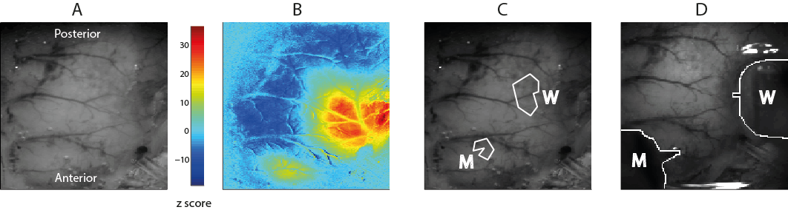
Figure 7: ROI location selection. A, Grayscale CCD camera image of RHS thinned window. B, Activation map showing change in Hbt during stimulation (2s electrical stimulation of the whisker pad at 5Hz frequency with 0.8mA amplitude). Map created by statistical parametric mapping (SPM) GLM with boxcar haemodynamic response function. Colour-bar scale represents z-score. C, ROIs selected using activation map in B. ROI over whisker barrel cortex (W) and motor cortex (M). D, Electrodes have been outlined to show placement in functional regions of whisker barrel cortex and motor cortex.

3 Development of a Cortical State Classifier for Local Field Potential Data

Abstract
Neuroimaging commonly relies on the recording of secondary measures of neural activity, such as haemodynamic changes, as in fMRI. However, these secondary measures are often highly complex, for example, they are affected by both physiological and non-physiological changes. A key task in neuroimaging is to extract the desired information, such as that attributed to the underpinning neural changes and to remove the unwanted ‘noise’ components. One of the phenomena that can cause complications in extracting the desired information is a change in brain state. Conventional brain state terminology divides brain state into synchronised (large amplitude low frequency neuronal oscillations) and desynchronised (small amplitude high frequency oscillations) states. Therefore accurate classification of brain state should be a pre-requisite for in-vivo neuroimaging work, especially where brain state may be subject to spontaneous state changes. Automatic state classifiers can present many advantages over expert identification of state, for example, increase in speed of classification, accuracy, continuity between datasets and minimal chance of experimenter classification bias. This chapter describes the development and testing of an Automatic Brain State Classifier (ABSC), which shows improvement in state identification compared to other methods. The classifier was initialised and validated on data from anaesthetised rodents. The ABSC, takes neural activity in the form of local field potentials, which are temporally windowed, before the spectral frequency power is calculated and then coded into vectors. The subjects current state is then classified by comparing the vectorised information against that calculated from state specific initialisation datasets. During technique development the ABSC was compared to a theta and alpha band (5-15Hz) threshold discriminator and a k-means based clustering classifier. The ABSC showed improvements over both of these methods as an automatic classifier. During formal testing, the ABSC identified two user defined brain states (synchronised and desynchronised), with greater accuracy (~90%) than the Gervasoni clustering (~66%) or ‘power threshold’ (~64%) methods of comparison. It was also shown to be a stable classifier, correctly identifying state changes in previous data from Jones et al. (2008). The accuracy of ABSC makes it a useful tool for detecting and classifying state, it will be applied throughout this thesis, to investigate the effects of cortical state on neurovascular coupling.

Section 2 (3.4) covers part of the publication:
Slack R, Boorman L, Patel P, Harris S, Bruyns-Haylett M, Kennerley A, Jones M, Berwick J (2016) A novel method for classifying cortical state to identify the accompanying changes in cerebral hemodynamics. J Neurosci Methods 267:21-34.

3.1. Introduction

3.1.1 Classification of observations – benefits and difficulties
Since the 1950s (Moruzzi and Magoun, 1949) it has been known that the cortex can interchange between states of quiescence and activation (Castro-Alamancos, 2004a). These two states were traditionally referred to as synchronised (large amplitude low frequency oscillations) and desynchronised (high frequency low amplitude oscillations). During periods of synchronised state activity, it is thought that the average firing rate of a particular cortical area, such as a cortical column fluctuates greatly over a relatively long timescale (100ms or less). It is clear that identifying which state the brain is currently in is of great importance, especially to cognitive neuroscience as the perception and processing of sensory stimuli by the brain can show great variation dependent upon the current brain state that is experienced (Castro-Alamancos, 2004b, Harris and Thiele, 2011, Zagha and McCormick, 2014). Based on the above descriptions of synchronised and desynchronised states, state classification could be attempted by searching for these markers of state by observation alone, however, the problem of state identification is made more difficult by a multitude of factors.
State changes can be instantaneous, clear and distinct (see example data in Fig. 1A), or can be more subtle, taking place over a longer duration (Fig. 1B). The frequency of state change occurrence can also vary greatly. For example, over a long period of time (1000s), state change frequency can be high (Fig. 1C) or low (Fig. 1D). Additionally, over the course of a 45 minute experiment, the brain can remain constant in either state (Fig. 1E&F). The intrinsic brain state variability of neural data means that classification of state by observation becomes a laborious task for an expert observer, especially when faced with large often multi-channel datasets, commonly collected in sleep research. Secondly, if state changes can be subtle and can occur over a lengthy period of time, rather than appearing as clear and distinct changes, then the question of where to place the cut-off point for the change of state becomes very open to observational bias. The cut-off point could potentially be placed at many points and the choice of cut-off could affect the results that are found. Some (Robert et al., 1999) have found that expert observers agreed with one another 80-90% of the time indicating that improvements by automated classification are possible.
An alternative to classification by observation is computationally based automatic classification. Several automatic classification systems for distinguishing between brain states have already been proposed (Gervasoni et al., 2004, Michel et al., 2012). For an in depth review of the benefits and difficulties of the automatic state classification systems already published see Chapter 1 (Section 1.4). In brief, several possible methods of classification were investigated to see if a stable, fast and accurate automatic classifier could be developed that would improve on the performance of the existing methods. Additionally, existing classifiers are often multi-staged making then complex to implement, and most do not have the potential to be adapted for use as online classifiers. Good speed, accuracy and stability were the primary goals for development of the state classifier. However, developing a clear and simple method that demonstrates good potential for online state classification was designated an important secondary goal

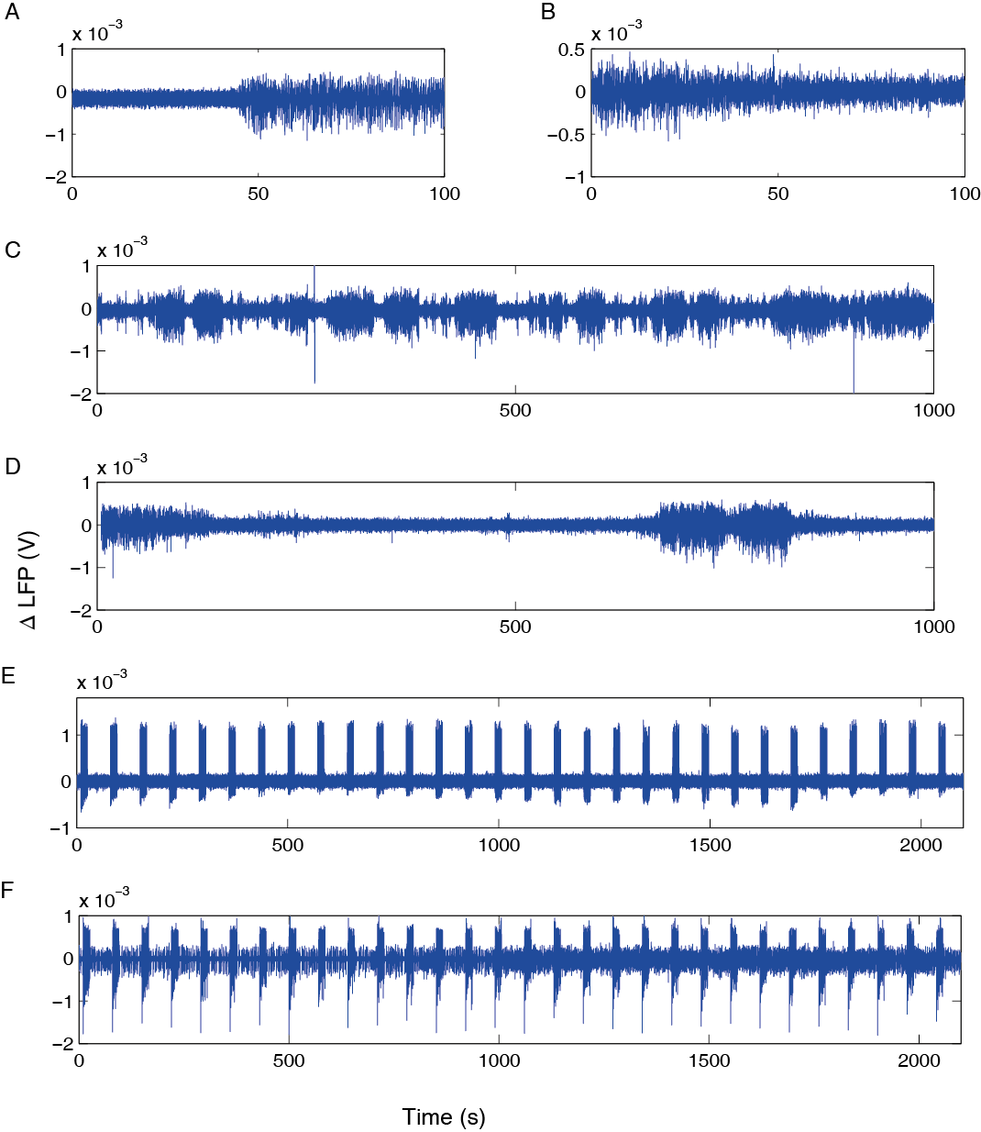
Figure 1: Classic examples of state changes displaying some of the variations in changes that occur. All signals shown are LFP recordings from a multi-channel electrode placed in the whisker barrel cortex to layer Vb. A-D are sections of continuous recordings from non-stimulation experiments, E-F are recordings with 16s electrical stimulation of the whisker pad at intervals, (ISI) of 70s. A Instantaneous change of state. B Graded state change occurring over a long duration. C Multiple short duration state changes. D Long duration state changes. E A full experimental recording where the brain state remained in the desynchronised state. F A full experiment where the brain state remained in the synchronised state. All data from single subjects.

3.1.2 Identifying an optimal investigation paradigm
A rodent model is already in place which is ideally suited to the needs of such development. The somatosensory cortex of the anesthetised rodent allows invasive electrophysiological recordings to be made which provides high laminar and temporal resolution of neural recordings. Furthermore, urethane anaesthesia is used, which is an ideal model with which to investigate state changes, as it induces cyclic and spontaneous changes in cortical state (Friedberg et al., 1999, Clement et al., 2008), as observed in the ongoing local field potential (LFP).
This chapter is split into two sections. In the first section the development of the new classifier is detailed. The evaluation of the initial methods tested uses visual judgement and accuracy measures to evaluate best performance. Visual judgement gives a quick evaluation by an observer to see if the state classifier appears to have correctly captured the state or states of the data. Accuracy measures compare single trial state classification of the method undergoing testing with the previous judgement of an ‘expert’ observer. The method with the highest accuracy and visual judgement performance is adopted ready for further testing in section 3.4 of this chapter. In the second section, a more rigorous comparison of the chosen method with previously published methods is undertaken. Every data point is evaluated for state classification accuracy rather than whole trial comparisons and a new dataset is evaluated. Finally, the stability of the new method on novel data is examined using a third dataset.
In section one all development investigations examine the classification of state using frequency band information taken from the LFP. Evaluations were made for three methods:
- An adjustable threshold to separate states based on frequency band differences in the theta/alpha range (5-15Hz).
- Simple data clustering using this frequency band range (5-15Hz) and taking this measure from the whisker barrel cortex and motor cortex to create a 2D state space within which clusters were identified.
- The use of a vectorised neural marker to classify states based on a ratio of the classic frequency bands Delta (δ, 0.5-3Hz), Theta (θ, 4-7Hz), Alpha (α, 8-12Hz), Beta (β, 13-30Hz) and Gamma (γ, 31-80Hz).
Ultimately, the third method was the most successful and the Automatic Brain State Classifier (ABSC), a novel method that efficiently identifies a neural marker to classify different brain states was created. In section two, the ABSC underwent more rigorous testing to evaluate whether it outperformed currently published state classifiers and to see if it gave a consistent performance when classifying previously published data from earlier experiments i.e. from Jones et al., (2008).
The ABSC outperformed the currently published state classifiers in the additional tests in section two therefore again being the most successful classifier. Once initialised, the ABSC can be used in an unsupervised manner, and is a stable, absolute classifier able to detect state from small time periods of data without needing prior observation of a state change before classification. During desynchronised states, the ABSC used vectorised information describing an increase in the power of the upper spectral frequencies (e.g. gamma 30-80Hz) relative to the lower spectral frequencies (e.g. alpha 8-13Hz) to classify. This method therefore finds and uses a previously undocumented neural marker for state classification.
The results confirm and extend previous work (Papanicolaou et al., 1986, Gervasoni et al., 2004, Berwick et al., 2005a, Jones et al., 2008) and underscore the utility of the ABSC in conducting either online or post-experiment state classification.

3.2 Methods

3.2.1 Data collection
This section details a brief description of the collection of data for this chapter. For further details please see Chapter 2.

3.2.1.1 Animal preparation and surgery
All experiments were performed in accordance with the Animal (Scientific Procedures) Act 1986, with approval from the United Kingdom Home Office. Neural and haemodynamic responses were collected from adult female Hooded Lister rats weighing (200-350g). Rats were kept in a 12 hr light/dark cycle and allowed access to food and water ad libitum. After being briefly anaesthetised with isoflurane, the animals were intraperitoneally injected with 1.25g/kg urethane. After the injection, a homoeothermic heating blanket (Harvard Instruments, UK) with rectal monitoring was subsequently used to maintain the core body temperature at 37˚C until the termination of the experiment. Atropine was administered at 0.4 mg/kg subcutaneously to decrease mucous secretions during surgery. To allow artificial ventilation (Harvard Instruments, UK) and to monitor end-tidal CO₂ recordings (CapStar-100, CWE Systems, USA), the animals were tracheotomised. The cannulation of the femoral artery and vein permitted the monitoring of the mean arterial blood pressure (MABP) and the infusion of phenylephrine (0.13-0.26 mg/h) respectively, ensuring MABP was kept between 100 and 110 mmHg (Golanov et al., 1994, Nakai and Maeda, 1999). The arterial cannulation also allowed blood samples to be taken for measurement of blood oxygen saturation. This ensured that the ventilator parameters could be adjusted to maintain the animal within normal physiological limits. Animals were placed in a stereotaxic frame (Kopf Instruments), and the surface of the head was exposed. Following this, the right side of the skull was thinned to translucency using a dental drill. Following functional localisation, small holes for electrode insertion were further drilled to the level of the dura which was then pierced with a needle to allow penetration of an electrode into the brain below.

3.2.1.2 Localisation of the somatosensory whisker barrel cortex using Optical Imaging Spectroscopy (OIS)
An initial optical imaging spectroscopy experiment was conducted to localise the whisker barrel region. Haemodynamic responses were evoked in the whisker barrel cortex and the motor cortex, through electrical stimulation of the whisker pad, further detail is described in Chapter 2. The haemodynamic data were analysed using a standard GLM approach, to localise the region overlying the whisker barrel somatosensory cortex and the motor cortex, activated by the stimuli.
The resultant ‘activation map’ was used to guide the insertion of two 16 channel linear array electrodes (NeuroNexus technologies, USA) into regions perpendicular to the whisker barrel and motor cortical surfaces. The electrodes were inserted into, and normal to, the cortex to a depth of 1500 μm (i.e. approximately layer VI) and sampling occurred at 24.414 KHz. The data were then downsampled to 1.53 KHz. The electrodes had 16 channels in total with 100 μm spacing, site area 177 μm², 1.5–2.7 MΩ impedance, and 33 μm tip width (Neuronexus Technologies, Ann Arbor, MI, USA).

3.2.1.3 Application Protocols
Multiple experiments were performed with each animal, with the order of the particular experiments performed being random from animal to animal. Three datasets were used throughout this chapter and are described in detail below. In section one, A0 was used for simple evaluation and development of the state classification method and A1 was briefly used for initialisation of the ABSC. In section two, A1 is used for the rigorous comparison of the ABSC with the previously published methods and A2 is used to check the stability of the ABSC over time.

(A0, n=18) Single impulse electrical stimulation of the whisker pad
Two insulated stainless steel electrodes (2mm exposed tip) were inserted subcutaneously into the whisker pad between rows A/B and C/D. Electrical stimulation (0.8-1.2mA; 300μs pulse width, 0.15s duration at 5Hz) caused a visible full pad whisker twitch confirming that stimulation was effective. This stimulation caused no changes to the MABP or end tidal CO₂ recordings. Neural signals were recorded for 2500s, split into 100 trials of 25s inter-trial interval with the stimulus applied after 5s from 18 subjects.

(A1, n=12) Spontaneous recordings
Neural signals were recorded for 1000 to 2500s, in the absence of stimuli, from 12 subjects.

(A2, n=5) Electrical Stimulation of the Brainstem Reticular Formation
The third dataset used neural recordings presented previously (Jones et al., 2008), where brainstem stimulation was applied to actively change brain state. Details of the exact procedure can be found in Jones et al. (2008). In brief, the method of data collection followed that detailed above. Modulation of cortical state was produced in 4 out of 5 animals by direct electrical stimulation of the brainstem reticular formation (2s duration, 200 Hz, stimulation current: < 200 µA, pulse duration: 3ms).

3.3 Section 1 – The development of the ABSC
Development of the classifier is described in this section. As detailed in section 2.1.3 above, the dataset used for development testing in section 1 was the A0 dataset (single impulse stimulations of the whisker pad). Some methodology is common to all three methods of classification tested and is presented first, followed by the individual methodology and evaluation of each method.

3.3.1 Common methodology
Initially, a frequency spectrogram taken from spontaneous dataset A0 was examined for any areas of clear visual difference between states (Fig. 2).
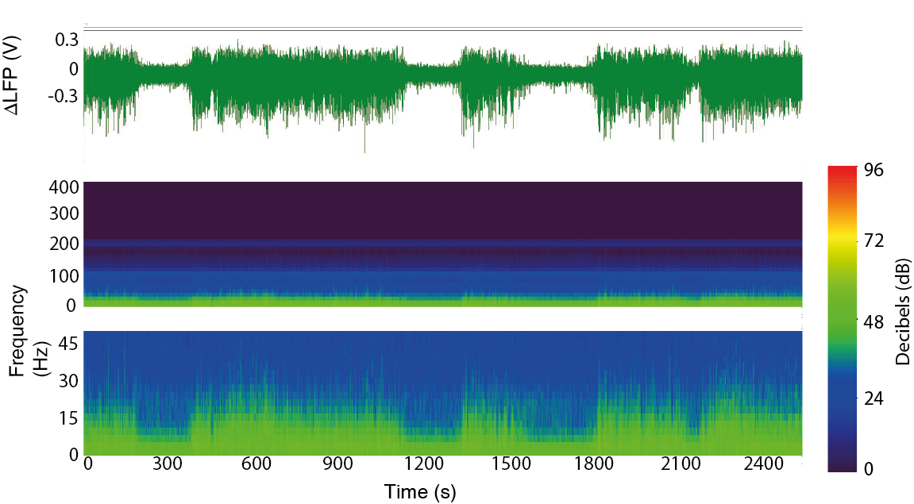
Figure 2: Top line: Spontaneous LFP data showing clear synchronised and desynchronised time periods. Recordings are from a multi-channel electrode placed in the whisker barrel cortex to approximately layer Vb of the whisker barrel cortex. Middle: Spectrogram displaying the differences in the frequency power (0-400Hz) that are evident in the synchronised and desynchronised states. Signal intensity is set in decibels, which is a logarithmic measure of ratio, usually of amplitudes or power. 20 dB is a factor of 10 in amplitude. Bottom: Enhanced view of lower frequencies (0-45Hz) where differences are most evident.
Clear differences in spectral frequencies between the two states can be observed (Fig 2 spectrograms). Before detailing exactly how the spectral frequencies can be used to distinguish between states, a description of how the frequency band information is extracted from the broadband LFP is given. This initial step is common to all stages of development of the state classifier and so is detailed here.

3.3.2 Feature Extraction

3.3.2.1 Data analysis using a moving window
Almost all methods used in this chapter calculate the frequency and power for the neural time points contained within a temporal moving window. A moving window selects data points for a calculation, or series of calculations using a particular subset of points from the main dataset, for example, subset A. Once the calculations for subset A have been performed, the same calculations are then performed on a new subset of points, subset B for example. Subset B will contain some of the same points as subset A, as the new subset is obtained by ‘shifting forwards’ along the dataset. The simplest way to obtain subset B is to exclude the first data point in subset A and include the next point following subset A (see Fig 8C for diagram). This process is the repeated along the entire data series. Alterations in window size can affect the resolution of the results. Longer windows lose temporal resolution, but reduce the computational overhead. A moving window can also act as a smoothing function. It is worthwhile examining several window sizes before deciding on one for a program. With the data for this chapter, a Fast Fourier Transform (FFT) was applied to raw neural recordings from channels 13 to 16 (~1200 to 1500μm, below the cortical surface, approximately layer Vb and VI according to depth information found in Wright and Fox (2010) or (Meyer et al., 2013)), which were split with a moving window of length 10s (overlapped by 1/10 of the window size – 1s step), giving a frequency resolution of 0.1Hz. A window length of 10s was chosen as this gave a good speed of state classification, given that the typical experiments analysed were less than an hour in duration, whilst still giving a fine enough resolution to be able to detect changes in the frequency band information. A reduction in the window size would have provided a greater resolution but the processing time for the classification would have increased. For this work, a certain amount of trial and error was needed before the size of window was believed optimal for the aims of these studies. It is worth running a selection of different window sizes during initialisation in order to select an optimal one. Electrode channels 13-16 were used the analysis in this Chapter, as the deeper channels have previously been shown to give the best signal power, especially in some of the EEG bands such as delta (Rappelsberger et al., 1982, Sirota et al., 2003).

3.3.2.2 Analysis Methodology
Each method was evaluated for accuracy by both visual inspection of the performance of the state classification method (Visual Categorisation), and by taking the average number of correct trial classifications (Classification Accuracy).

3.3.2.2.1 Visual Categorisation
Animals were visually sub-divided into three possible categories after undergoing classification by each brain state classifier. In Category A (‘Good sort’), results demonstrated an excellent neural classification where visual inspection could find no or minor difficulties in state classification (Fig. 5A, 6A and 9A). In Category B (‘Partial sort’), the classification performance was mostly accurate with some difficulties displayed (Fig. 5B, 6B and 9B). In Category C (‘Bad sort’), the classifier did not appear able to correctly categorise most, or all of the data (Fig. 5C, 6C and 9C). This information provides a good performance estimate of each classifier. The benefit of visual categorisation is that the experimenter visually examines each experiment from each animal, making it easy to see if the methodology is performing in the expected way. Visual categorisation was used in combination with a more standardised statistical verification of performance.

3.3.2.2.2 Classification Accuracy
In addition to visual classification, each classifier was evaluated based on accuracy of data classification. Data from each stimulation trial, from each animal was state classified by an ‘expert’. This ‘expert classification’ was then used as the gold standard to which the various version classifications were compared. A percentage accuracy was calculated based on the number of trials correctly identified. The amount of data that was unable to be classified, or ‘lost data’ was also evaluated for each method.

3.3.2.2.3 Expert Classification
To classify, the ‘expert’ examined the entire time series visually (in a MATLAB figure window, with the ability to adjust the zoom function) and the points in time at which state changes occurred, based on reductions in the broadband LFP amplitude, were recorded using a custom written MATLAB (The Mathworks USA) script. The ‘expert’ observer also indicated if the state was stable for the entire experiment, and if so, in what state the experiment remained. An ‘expert’ here is defined as someone who has previously published work on brain states.

3.3.3 Method 1 – An adjustable threshold based on frequency differences in the 5-15Hz range
Single thresholds
As simplicity and speed are of value in state classification, the initial version of the state classifier was based around a simple threshold sorter. Threshold sorters separate data into two sets. Data that exceed the threshold were said to be in set A and data that do not, were said to be in set B.
Double thresholds
Additionally, it is possible to set two thresholds so that data that exceed threshold 1 was placed in set A and data below threshold 2 belong to set B. Data below threshold 1 but exceeding threshold 2 are usually dismissed as ‘transition data’ – data that belongs to neither set. One flaw in this methodology lies in the fact that it must be possible to split the data into no more and no less than two sets, or three if transition data is counted as an additional set. As the data indicated only synchronised and desynchronised states, this did not seem to preclude this method from being utilised if results were strong enough.

3.3.3.1 Threshold Sorter Method
Initially a single frequency range was chosen as a metric for sorting the data into synchronised and desynchronised trials (see section 3.1.2 above).

3.3.3.1.1 Choosing the frequency range
Frequencies above 400Hz displayed no visible differences across states (Fig.2 middle row) and so were removed from consideration. Also demonstrated in Fig. 2 (bottom row) the higher frequencies of 50-400 Hz appear to offer little or no difference between states. However, in lower frequency bands, a noticeable difference arises (Fig. 2 bottom line), with greater power in the 5-30Hz range found in synchronised, rather than desynchronised states. These observable differences were greatest between 5-15Hz and encompassed the theta and alpha frequency bands (TAFB). Therefore the state classifier was initially designed to use this particular range with high TAFB power found in synchronised and low TAFB power in the in desynchronised data.

3.3.3.1.2 Thresholds and Smoothing
As previously stated, high amounts of TAFB were found in synchronised periods of data. To designate a high amount of TAFB in a window of data however, it is necessary to assign a cut-off point, or threshold. The standard deviation (std) from the mean provides a good measure of the variation in the data. To include most of the data in either the synchronised or desynchronised time periods, excluding only periods of time where the data were transitioning from one state to the other, a lower std was used (mean ± 0.5σ – see green threshold lines on Fig. 3B). The empirical rule states that for a normally distributed population 99.7% of the data will fall within three std of the mean (Moivre, 1718). As a threshold of the mean ± 0.5σ is used, over 50% of the data will fall into the synchronised and desynchronised categories following the inclusion-exclusion principle published in da Silva, date unknown (Yoda, 2013). As TAFB power has both rapid fine changes and also will encompass some experimental noise, a Savitzky-Golay finite impulse response (FIR) filter function (sgolayfilt in MATLAB) was used to capture the important features in the TAFB (Fig. 3A shows an example animal with clear distinct state changes). It can be seen that most of the data is captured above the synchronised threshold or below the desynchronised threshold (i.e. Few data are lost as transition data between the two thresholds). The raw TAFB crosses the two thresholds multiple times in one second. Multiple state changes within that time period are avoided by using filtered data to create the boundary points at which state changes occur (see enhanced view of changing TAFB power in Fig. 3B).
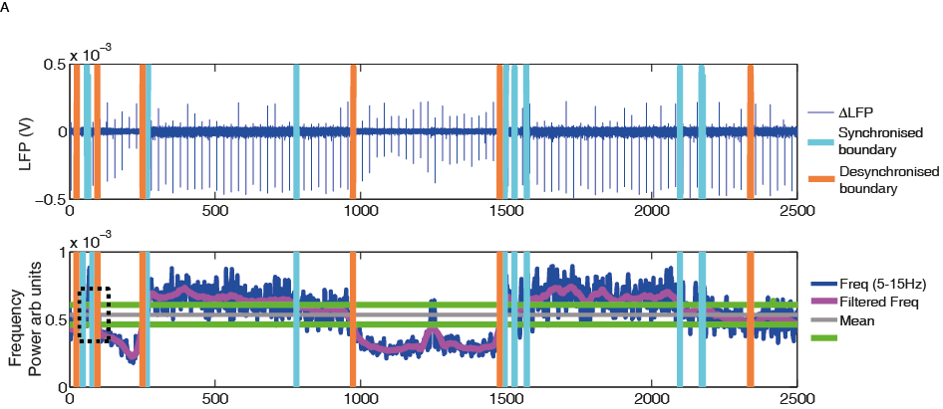
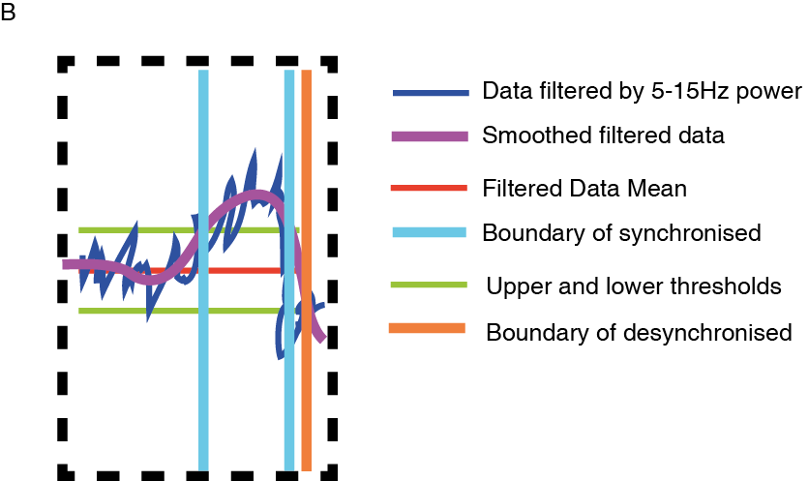
Figure 3: Example animal demonstrating the classification of the synchronised and desynchronised trials. A Top: LFP showing 100 single impulse pulse stimulation trials with boundaries of synchronised (light blue) and desynchronised (orange) periods marked in orange and light blue. Middle: Demonstrating the feature extraction step of the method, the windowed frequency band information is plotted continuously on the same time scale as the neural data (see B for further detail). B Demonstrating the 5-15Hz power, the smoothed power data overlaid on top and the points at which it crosses the upper and lower boundary thresholds. All time periods that do not cross the thresholds are denoted ‘transition’ (unclassified) periods.

3.3.3.2 Threshold Sorter Results
Initially the threshold sorter was run on a dataset of 18 animals and was evaluated for accuracy and efficiency (efficiency was defined as the amount of data that was able to be classified). Some animals did not appear to present a state change (Fig. 5C). For animals without a clear change in state, threshold sorting will always cause a large amount of accuracy error and much data will be lost as ‘transitional’ data, making the method inefficient. To attempt to counter this problem, the data were subject to pre-screening to remove experiments deemed to be in a single-state and were then evaluated with the threshold sorter. The Hartigans Dip Test (see below) was used to pre-screen the datasets to identify if an experiment presented with more than one state. If the dip test revealed a high likelihood that there is only one state in the data, then the experiment should not be assessed by the threshold sorter.

3.3.3.2.1 A short explanation of Hartigans Dip Test
First proposed by (Hartigan and Hartigan, 1985) the Dip Test provides a measure of likelihood that the empirical data being tested has only one mode in it (the Dip statistic). The test measures the maximum difference between the empirical distribution function and the unimodal distribution function. P-values are calculated by comparing the obtained Dip statistic with those for repeated samples of the same size from a normal distribution. The P-values can range between 0 and 1, where a P-value of less than 0.05 gives a strong indication that the data considered is significantly likely to contain more than one mode (Fig. 4 shows two examples of Histograms computed from the TAFB values of an experiment).. The code used to generate the Hartigans Dip examples is a direct translation by F. Mechler (2002) into MATLAB code from the original FORTRAN code of Hartigans subroutine DIPTST algorithm. Some additional parameter inputs were needed and these are referenced in Appendix A, section 1.

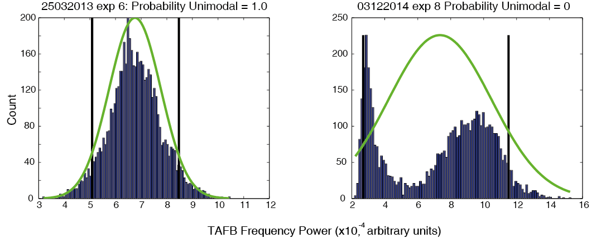
Figure 4 Left: A Histogram of the TAFB power from an example animal with a Dip Statistic of 1. Right: A Histogram of the TAFB power from an example animal with a Dip Statistic of 0. Green lines represent the curve that would be expected if the empirical data were normally distributed (i.e. one mode).

A dip statistic of 1 means that the data is highly likely to have a single mode within it and therefore, a single brain state (Fig. 4 left). The LFP from the corresponding experiment can be seen in Fig. 5Cα, demonstrating that it does in fact represent a single brain state. The figure on the left has A Dip Statistic of 0 strongly suggests there is more than one mode in the data, as can be seen from the obvious bimodal peaks in Fig.4 right. The bimodal peaks suggest that two brain states are likely to be occurring in the data. The LFP from the experiment can be seen in Fig. 5Aα, demonstrating that two clear brain states are represented.
Thirteen experiments from nine animals had a dip statistic of less than 0.05. This dataset will be referred to as A0*. Some animals had multiple experiments belonging to more than one category. These animals would therefore be counted in the running totals for each category in the Table. Therefore although the number of experiments will always match the total experiments performed, the total number of animals cannot be summed from the table below as the same animal sometimes had experiments in each category.
Threshold Classifier | A0: All Animals |  | A0*: Hartigans Dip Animals
Accuracy (%) | M = 80.87 | Std = 14.25 | M = 90.57 | Std = 7.17
‘Transitional’ (Unclassified) Data Loss (%) | M = 32.60 | Std = 10.63 | M = 35.54 | Std = 19.41
No. in Category A (‘Good sort’)  (animals/experiments) | 9/12 |  | 7/10
No. in Category B (‘Partial sort’)  (animals/experiments) | 7/9 |  | 3/3
No. in Category C (‘Bad sort’)  (animals/experiments) | 5/5 |  | 0
*(Results accurate to 2sf)
Table 1: Assessment of state sorter efficacy. Showing the accuracy results and data lost in transitional states for the threshold sorter method using animals in dataset A0 (all animals, n= 18) and modified dataset A0* (Hartigans Dip animals, n= 9). Accuracy percentages are given for correctly classified trials. Category A animals indicate no or minor difficulties in state classification, with Category B animals performance was partially accurate with some difficulties displayed and in Category C animals most or all data were incorrectly categorised.

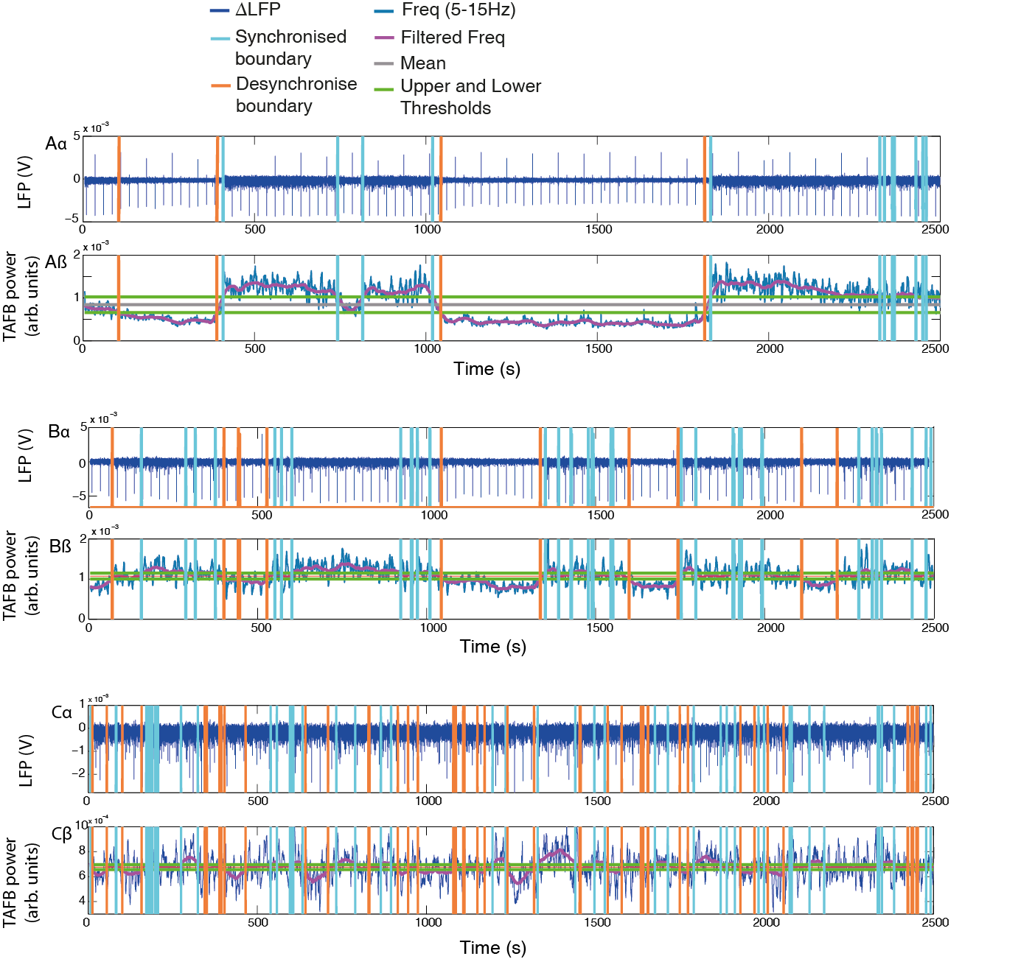
Figure 5: Three main categories of threshold sorting for example animals. Neural recordings taken from layer Vb of the whisker barrel cortex Aα. LFP data showing clear distinct changes that can clearly be seen to be captured by the threshold sorter with very little, or no error. Aβ The associated TAFB power (5-15Hz). Bα: LFP data showing smaller state changes where the changes are mostly captured by the threshold sorter with some error. Bβ The associated TAFB power. Cα: LFP data shows an animal which the threshold sorter fails to classify correctly (Category C). Cβ: The associated TAFB power.

3.3.3.2.2 Visual Categorisation
When all animals were analysed, most fell into category A or B representing a good, or partially good sort, with only 5 animals meeting category C criteria (a bad sort). When Hartigans Dip criteria was applied, all animals were in category A or B. This indicates that the threshold sorter had difficulty capturing a neural change when the animal had all, or most data, in a single brain state. Otherwise, the threshold sorter appeared to give a fairly good performance.

3.3.3.2.3 Classification Accuracy
Assessment of classification accuracy showed that the method of threshold state sorting gives a good level of accuracy (~80%, Table 1, top line). However, approximately a third of data is ‘transitional’ (unclassified) data and therefore cannot be classified as either synchronised or desynchronised state. This average accuracy rating, along with the high level of unclassified data indicates that threshold sorting without additional measures leaves much room for improvement. The introduction of Hartigans Dip test to remove animals in a single state improves accuracy of state identification from ~80% to ~90%. However, data classified as transitional data increased slightly from ~32 trials to ~36 trials per experiment. The number of animals that can be used halved, from eighteen to nine.

3.3.3.3 Conclusions from the threshold sorter
Therefore, although the threshold sorter can be a good tool under certain circumstances, it has two definitive flaws. It cannot classify single state data and at least a third of the data cannot be classified, being lost as transitional data. For these reasons, it was decided that an alternative approach would be developed and tested to find a less restrictive state classifier.

3.3.4 Method 2 –Clustering using TAFB from whisker somatosensory cortex and a surrounding region.
A clear advantage of cluster based sorting methods, is that they can be used without needing to rely on an intrinsic measure, such as a within-subject threshold. It was decided to reuse the TAFB frequency range as a measure of state, but to alter the separation technique to use clustering to try to overcome the need for an intrinsic measure. A further advantage afforded by clustering techniques is that it is possible to assign each data point to a cluster, meaning in the case of state classification no data is ‘lost’ as transition data. It was hoped that this change in technique would overcome some of the previous issues experienced with the threshold sorter.

3.3.4.1 Clustering Method
The TAFB (5-15Hz) frequency band power from the whisker barrel cortex was previously considered to give a reasonable accuracy, especially when combined with the Hartigans Dip test (see 3.3.3.2.3) and was again utilised here. However, an additional source was needed as creating clusters requires a 2D domain. The brain states in whisker and motor cortex change in synchrony (for examples see appendix Fig. A1), similarly to the synchrony across brain states found in forebrain regions in (Gervasoni et al., 2004). Therefore, additional concurrent TAFB information recorded from the motor cortex was used to create a 2D domain for this clustering classification method.
A custom built MATLAB script utilising the built in function ‘gmdistributionfit’ was used to cluster the data. The ‘gmdistribution’ function is built around an expectation maximisation algorithm. The expectation algorithm assigns a point to a certain cluster when the theoretical likelihood that the point belongs to that cluster is maximised in previous iterative guesses. The algorithm requires an a-priori parameter: the number of expected clusters in the data. As it is known that the data being tested had a maximum of two states in it (synchronised and desynchronised) the expected number of clusters was set to two.
The same method of visual categorisation (see section 3.3.2.2.1) was again used for analysing how well the method classified the data, thus animals were assigned into Category A, B and C (see section 3.3.2.2.1 for definitions of A, B, C. Figure 6 below gives an example animal to show the clustering for each category). Following this, classification accuracy was measured by evaluating the percentage of correctly classified trials, when compared to that classified by an expert sorter.

3.3.4.2 Clustering Results
The clustering method was tested on the A0* dataset, which was subject to the Hartigans Dip test (to avoid animals that did not present a state change - see section 3.3.3.2.1 for further details) and as a standalone method (using the A0 dataset).

Some animals had multiple experiments belonging to more than one category. These animals would therefore be counted in the running totals for each category in the Table. Therefore although the number of experiments will always match the total experiments performed, the total number of animals cannot be summed from the table below as the same animal sometimes had experiments in each category.
Clustering | A0: All Animals |  | A0*: Hartigans Dip Animals
Accuracy (%) | M = 77.32 | Std = 22.68 | M = 87.81 | Std = 22.17
‘Transitional’ (Unclassified) Data Loss (%) | M = 0 | Std = 0 | M = 0 | Std = 0
No. in Category A  (‘Good sort’)  (animals/experiments) | 6/6 |  | 4/4
No. in Category B  (‘Partial sort’)  (animals/experiments) | 5/5 |  | 5/5
No. in Category C  (‘Bad sort’)  (animals/experiments) | 11/15 |  | 4/4
*(Results accurate to 2sf)
Table 2: Assessment of classification accuracy of the clustering method. Showing the accuracy results and data lost in transitional states for the clustering method using animals in dataset A0 (n=18) and modified dataset A0* (n=9). Category A animals indicate no or minor difficulties in state classification, with Category B animals performance was partially accurate with some difficulties displayed and in Category C animals most or all data were incorrectly categorised.

3.3.4.2.1 Visual Categorisation
All animals were analysed using the classifier, with the majority of animals found to be in category C (Table 2). C contained half the animals, with the other half split approximately equally across both A and B. So generally, assessing the clustering technique using visual categorisation implied that many obvious classification mistakes were being made. When the Hartigans Dip criteria was additionally applied (using dataset A0*), roughly equal numbers of animals were placed into categories A, B and C. Thus visual categorisation indicated that the clustering technique had difficulty capturing a neural change when the animal had all, or most data, in a single brain state and gave the poorest visual performance out of all three development methods.

3.3.4.2.2 Classification Accuracy
The accuracy for the clustering method was lower when the method was used without the Hartigans Dip criteria for exclusion (Table 2). This implies that this method also had difficulty in capturing a neural change when the animal had all, or most data, in a single brain state (Table 2, All Animals). The clustering method performed well reaching an overall accuracy level of ~77% for all animals and ~88% with the modified A0* dataset.
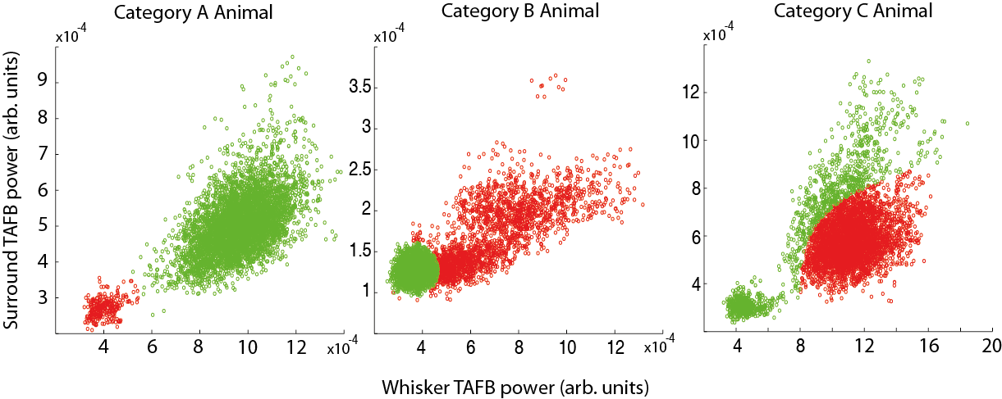
Figure 6: Exemplar classifications of state using the clustering method. Red = desynchronised data, green = synchronised data. In Category A (‘Good sort’), the animals demonstrated an excellent neural sort with each cluster clearly and separately defined. In Category B (‘Partial sort’), although the clustering had identified two clusters, it failed to fully capture the extent of the cluster shown in green. In Category C (‘Bad sort’), the clustering algorithm clearly misidentified a large amount of the information, so did not provide an accurate neural sort.

3.3.4.3 Conclusions from the Clustering Method
Interestingly, the clustering method did not perform as well as the threshold method in the visual categorisation of animals. Many animals still displayed a poor visual sort even after the Hartigans Dip test removed animals that did not show both synchronised and desynchronised data.
The clustering method was slightly less accurate (~77%, Table 2) than the threshold sorter (80%, Table 1). However no data were lost as ‘transition’ (unclassified) data, every data point was categorised, leading to an overall increase in the amount of accurately classified data. This high average accuracy rating paired with the ability to use all data shows an improvement over the aforementioned threshold sorter. Similarly to the threshold sorter, the introduction of Hartigans Dip test, used to remove animals in a single state, again improves accuracy of state identification from ~77% to ~87%.
The clustering technique offers a useful tool in classifying state however, like the thresholding approach it does have clear flaws. In this clustering method, single state data could not be identified, giving accuracy errors as data were coerced into either of the two pre-defined states. When this problem was circumvented using the Hartigans Dip test to identify animals where two states were present, accuracy did improve, however the number of animals that can be used halved, from eighteen to nine. This loss of almost half of the dataset is not ideal. A final method was therefore developed and evaluated to see if it presented a possible improvement over clustering and thresholding.

3.3.5 Method 3 – Vectorised Comparison using Classic EEG frequency bands
The use of a single frequency range such as the 5-15Hz of TAFB power was altered when developing the third method of state classification. One of the underlying problems with the state categorisation methods examined here is the consistency of data across subjects. Both the threshold measures and the clustering parameters that were used in the methods above needed to be redrawn with each new animal or experiment. Although both programs did this automatically to reduce input needed from the user, it meant that the categorisation boundaries for one animal could be very different to those used for another animal. The need to classify a data point in relation to all other data points in that experiment was also creating additional problems. Ideally, a method where each data point could be classified in isolation would provide a more robust solution. For the third method, a state categorisation method was developed that used the same categorisation parameters for all experiments, allowing data points to be classified in isolation. EEG band analysis was applied to all data. When assessing all bands, a clear difference in the relative frequency power information could be visually observed between the synchronised and desynchronised states (see Fig. 9). This difference appeared to be robust and stable between animals, as well as within. The Automatic Brain State Classifier (ABSC) was developed to capture this stable difference using vectorised information obtained from the windowed spectral frequency power of the local field potential. Current state was then classified by comparing this vectorised information against that calculated from a state specific initialisation dataset.

3.3.5.1 Vectorised Classification Method – Automatic Brain State Classifier (ABSC)
This method was also tested with and without the Hartigans Dip criteria. All further neural data presented in this Chapter was recorded from the whisker barrel somatosensory cortex.

3.3.5.1.1 Overview of Application Protocols
The ABSC used two datasets; the ABSC was initialised using a ‘spontaneous’ dataset (A1), and then the usual dataset A0 was used to examine the effectiveness of the ABSC. The spontaneous dataset was used for initialisation as no stimulations were present to interfere with the creation of the model vectors (see 3.3.5.1.4). The spontaneous dataset has been labelled (A1) and is made up of n=12 subjects. Neural signals were recorded concurrently for 1000 to 2500s, in the absence of stimuli, from 12 subjects. A single animal from A1 was used to initialise the ABSC.

3.3.5.1.2 Data analysis
The ABSC method to classify the different brain states consists of three main component; Feature Extraction, Model Vector Definition and Model Vector Comparison. The main components are described in detail below.
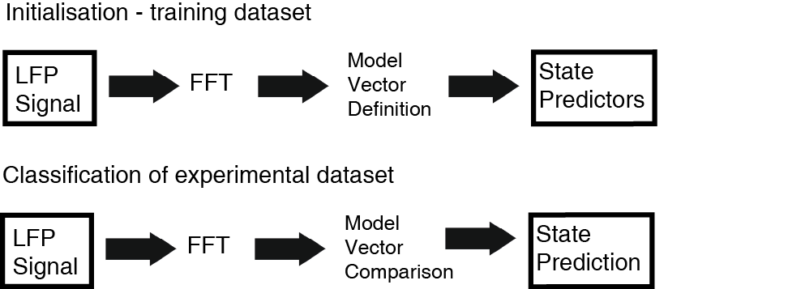
Figure 7: Protocol for classifying brain state from LFP data. The ABSC is initialised on an experiment from a single animal (the initialisation dataset) and then classification of the remaining experiments and animals takes place.

3.3.5.1.3 Feature Extraction
A Fast Fourier Transform (FFT) was applied to data (for more detail see section 3.3.2). A different window size and overlap was used for initialisation (see 3.3.5.1.4) than in testing. In the ABSC method, the spectral power was then subdivided into the five main frequency bands: Delta (δ, 0.5-3Hz), Theta (θ, 4-7Hz), Alpha (α, 8-12Hz), Beta (β, 13-30Hz) and Gamma (γ, 31-80Hz), to obtain frequency power time series for each band (f_{i}) and each channel (13-16).

3.3.5.1.4 Model Vector Definition
The ABSC was initialised on state separated data previously classified by an ‘expert’. The initialisation dataset was a subset of A1. The model vector is a vector that encapsulates state specific relative differences in the classic EEG frequency band powers. It gives a measure of how similar each frequency band is to the other frequency bands within a specific state. For example initialisation data will be split into state specific datasets. Then within the desynchronised dataset, each element of the coded vector will represent how similar the magnitude of a particular frequency band is to another frequency band at that windowed point in time. A specific example would be that one of the coded elements in the model vector will be a representation of how similar the magnitude of alpha frequency power is to the magnitude of delta frequency power at that particular moment in time.
The five most frequently occurring model vectors (M_{l}) were obtained by following steps 1-4 (described below) for each state specific initialisation dataset. This resulting from initialising the ABSC, explained 76.4% of the coded vector variance in the desynchronised state spectral information from the initialisation dataset and were set as the desynchronised model vectors. To keep the number of vectors consistent, the five most frequently occurring vectors in the synchronised state were also set as the model vectors for the state sorter, giving a total of 10 model vectors. Once the model vectors were selected, the ABSC was applied to the experimental dataset. All animals and experiments in the ‘spontaneous’ dataset (A1) were classified by a human ‘expert’ observer (see section 3.3.2.2.3).
Approximately 10% of this dataset was designated as an initialisation dataset (a single full experiment, Fig. 8A) and was used to generate the model vectors (M_{l}) for the state classifier. Additional tests were performed to ensure that the single animal used for initialisation did not bias the accuracy of the classifier. The results from these (concurring) tests are given in Chapter 4. Therefore the single animal is justified as the initialisation dataset. The initialisation dataset was split into synchronised and desynchronised states defined by the ‘expert’ observer and the feature extraction step performed. The only change to the feature extraction step detailed above (3.3.5.1.3) is that a 4s window with a 0.4s step was used in initialisation (giving a frequency resolution of 0.25Hz). A smaller window was used during initialisation to capture more of the time variations present in the raw data, as at this initial stage, more detail with regards to time variation was more valuable than processing speed. After initialisation a larger window (10s, 1s step) was used, as this reduced processing time, which was deemed to be more valuable than the finer time resolution, especially when processing larger datasets. Each state subset of the initialisation dataset was examined as follows, with the desynchronised subset examined first:
- A simple measure of the relation of each frequency band power to the other four bands was calculated for each window of data using subtraction of each frequency power time series from the other bands frequency power time series, ensuring each band was only examined in relation to the others once (i.e. combinations were used, so alpha is subtracted from delta but delta is not subtracted from alpha).
$$f_{i} = [δ, θ, α, β, γ]$$
$Err_{k}=f_{i}-f{}_{i+1} ∀ 1≤ i≤5, k=1:10$ (1)
This produces a set of ten time series (Err_{k} ), providing a measure of the relation of each frequency band power to the others, rather than an absolute frequency power measure. Each point (j) in each time series represents a measure of a pair of relative frequencies for a particular window of LFP data. The absolute value of each data point is then taken to negate the importance of the order of subtraction.
${Err}_{kj} = {|(Err}_{kj})| j≥1$ (2)
- Upper ($UB)$and lower ($LB)$ error bands were automatically set. The mean of each windowed point in the state specific dataset was calculated. The absolute value of this mean was taken to ensure differing windows did not cancel one another out in as these meaned windowed points were then averaged across the state specific initialisation dataset. Mathematically this gives the equation:

$UB=mean_{SSID}(|mean\left(Err_{k}\right)|)$ (Rounded to the nearest decimal place)
$$SSID=state specific initialisation dataset$$
$LB=0.5*UB$ (3)
These bounds can only be set once, as consistency in the coded vectors needs to be maintained. They should be set from the state subset of initialisation data that shows the smallest variance in frequency power. In this paper, the bounds were set in the desynchronised state as this had smaller variance in frequency power than the synchronised state (Fig. 8D).

- Each data point in each of the subtracted time series was then coded (CErr_{kj}) to classify it, based on its relation to the upper and lower bounds. This gives three possible codes for each point.
Case 1: If ${Err}_{kj}< LB {CErr}_{kj}=C1$
Case 2: If $LB < {Err}_{kj} < UB {CErr}_{kj}=C2$
Case 3: if ${Err}_{kj} > UB {CErr}_{kj}=C3$ (4)

At any time point (j), this therefore gives a 10 point coded vector (V_{j}) representing the 10 subtracted frequency band pairs for a window of LFP data (see Fig 8C for example). Here, I set C1 = 2, C2 = 3 and C3 = 4, but any integer separated coding could be used to the same effect.

- The l most frequently occurring coded vectors in the desynchronised classified state were set as the model vectors (M_{l}), where l vectors explained 76.4% of the coded vector variance in the desynchronised state. The same number of model vectors were selected for the synchronised state to maintain a consistent comparison, although this number explained less vector variance (8.4%). These vectors were defined as the model vectors.

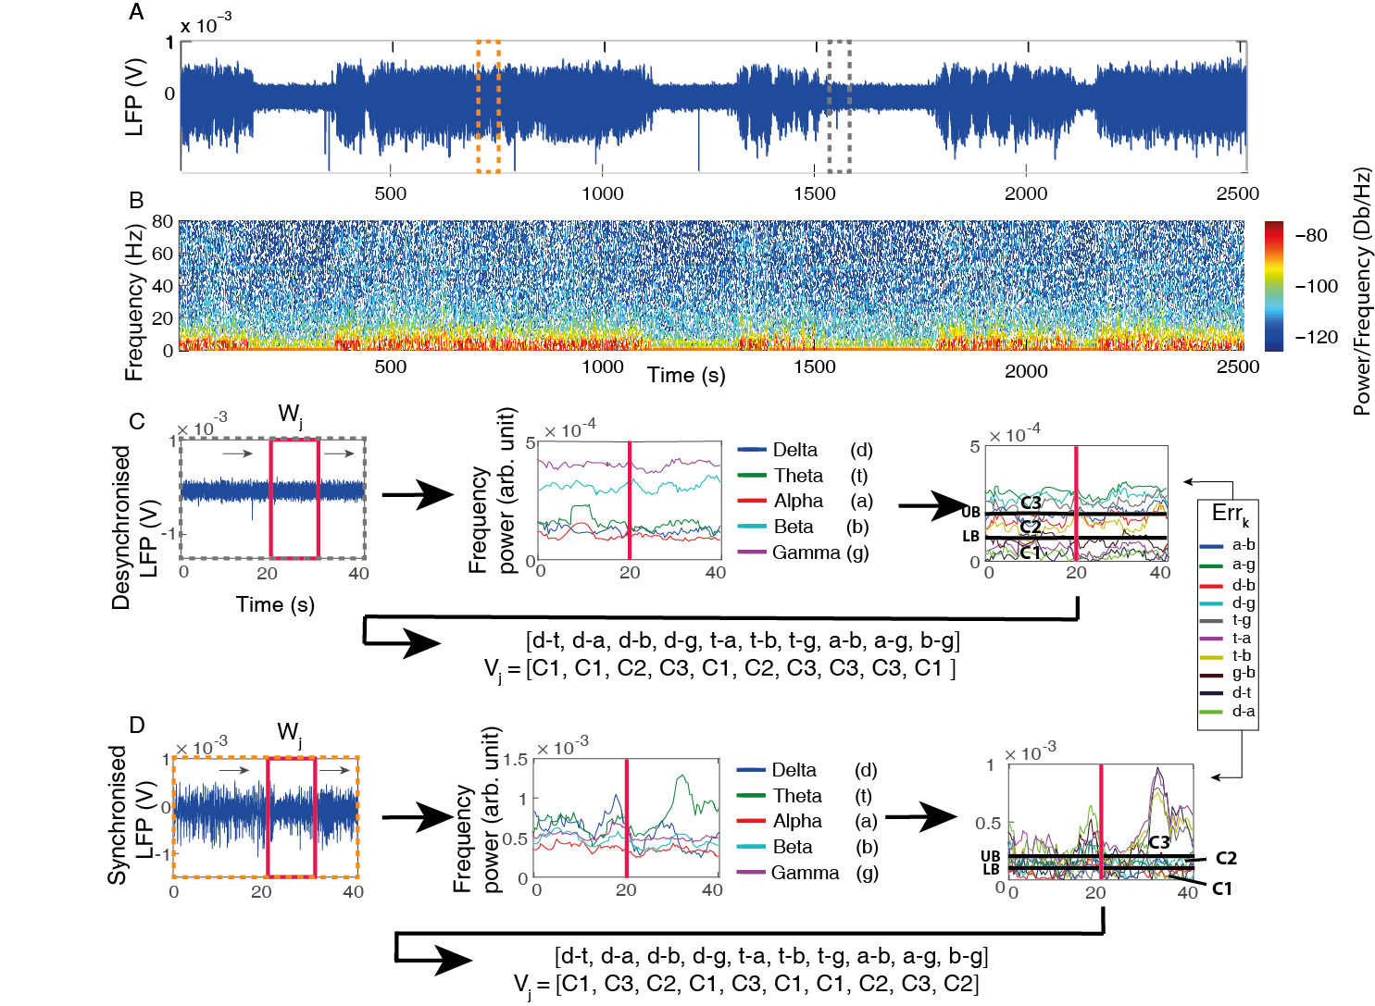
Figure 8: Defining the model vectors for the ABSC classification. A Exemplar raw initialisation data showing LFP recording (channel 13-16, averaged) with clear distinction between the two states within the data. B Fourier power spectrogram of the LFP data in A. C Obtaining coded vectors from desynchronised initialisation data. A sliding window Fourier transform was applied to the neural recording to calculate the classical EEG bands (middle). The red vertical lines mark the time point for the frequency power band information obtained from the moving window (left, red box). The EEG bands were then subtracted from one another to give relative frequency information. This information was coded with regards to an upper bound (UB) and a lower bound (LB), see Model Vector Definition, point 2 for how the bounds were obtained and point 3 for coding. An example of the coded model vector that would be obtained at the time point of the red line is then given below. D As C, but with synchronised initialisation data. Note, UB and LB are the same as C, this is necessary to keep coding of the vectors consistent.

3.3.5.1.5 Model Vector Comparison
The data from A0 was used to test the state classifier. Steps 1 and 3 from the model vector definition were performed. The coded vector (V_{j}) was subtracted from each of the model vectors (M_{l}) from both states with the best fit (smallest summation of the absolute remainder) selected as the state, desynchronised or synchronised, for that window of LFP data (W_{j}).
${SW}_{j}=\min_{l}\left(Ʃ\left|V_{j} - M_{l}\right|\right)$ $SW_{j}∈\{desynchronised, synchronised\}$ (5)

3.3.5.2 Vectorised Classification Results
The ABSC was also tested on the A0 dataset in combination with Hartigans Dip test (to avoid animals that did not present a state change - see section 3.3.3.2.1 for further details) and as a standalone method. Some animals had multiple experiments belonging to more than one category. These animals would therefore be counted in the running totals for each category in the Table. Therefore although the number of experiments will always match the total experiments performed, the total number of animals cannot be summed from the table below as the same animal sometimes had experiments in each category.
ABSC | A0: All Animals |  | A0*: Hartigans Dip Animals
Accuracy (%) | M = 81.67 | Std = 24.08 | M = 92.23 | Std = 8.59
‘Transitional’ (Unclassified) Data Loss (%) | M = 0 | Std = 0 | M = 0 | Std = 0
No. in Category A  (‘Good sort’)  (animals/experiments) | 14/19 |  | 7/9
No. in Category B  (‘Partial sort’)  (animals/experiments) | 3/4 |  | 2/2
No. in Category C  (‘Bad sort’)  (animals/experiments) | 3/3 |  | 0/0
*(Results accurate to 2sf)
Table 3: Examining the ABSC classification accuracy. Showing the accuracy results and data lost in transitional states for the ABSC method using animals in dataset A0 (n=18) and modified dataset A0* (n=9). Category A animals indicate no or minor difficulties in state classification, with Category B animals performance was partially accurate with some difficulties displayed and in Category C animals most or all data were incorrectly categorised.

3.3.5.2.1 Visual Categorisation
The visual categorisation shows a large improvement over the clustering method and a small improvement over the threshold method. Most animals presented as category A, meaning that visually, the sorter was giving an excellent performance, and appeared to be capturing the state changes well (Fig. 9). Again, applying the Hartigans Dip criteria improved the visual categorisation as all animals in A0* were either in category A or B.

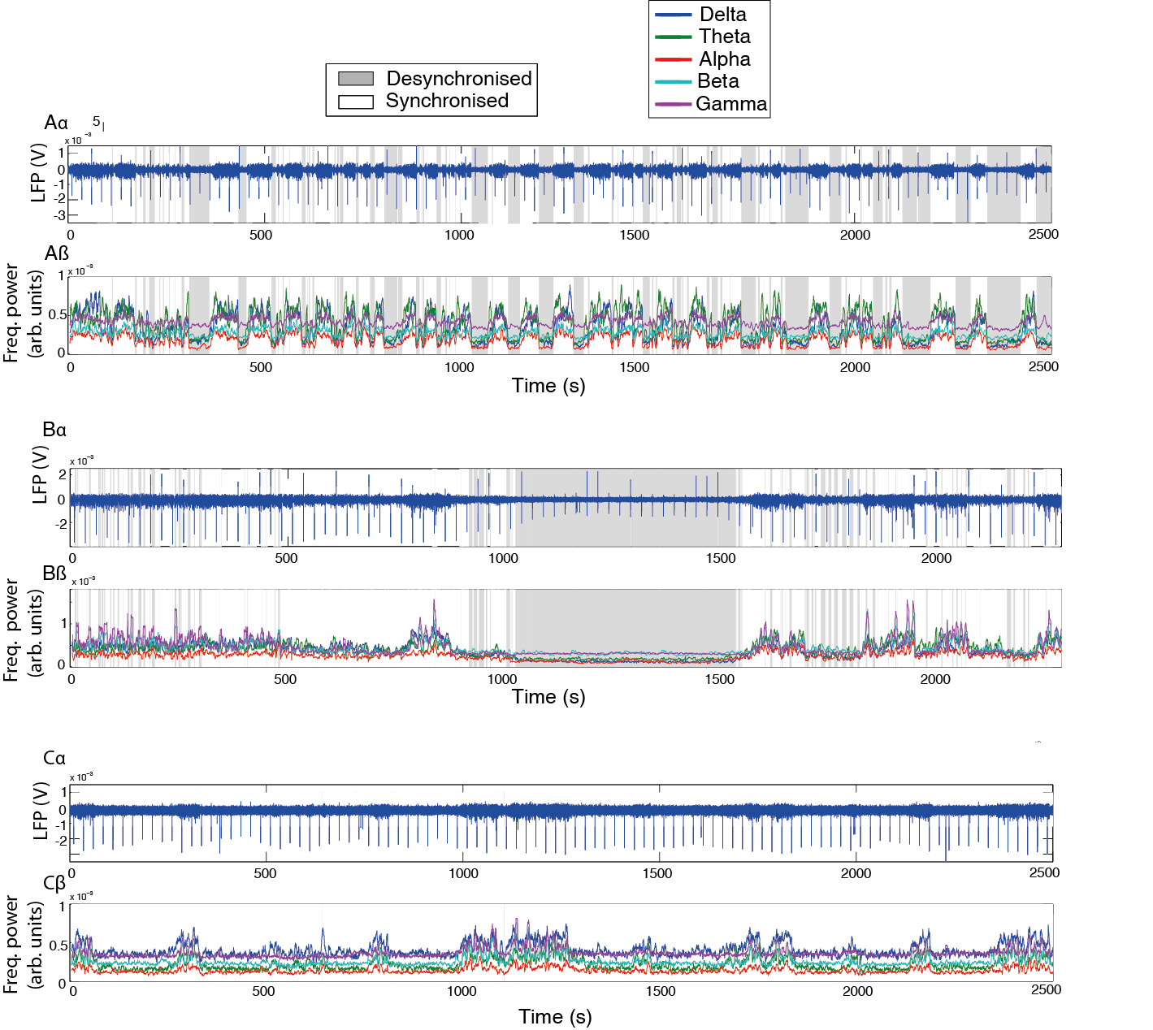Figure 9: Example animals for the visual categorisation for the ABSC vectorised classification. Areas shaded in grey are classified as belonging to the desynchronised state whilst areas in white are classified as synchronised. Aα Demonstrating the potential of the ABSC to classify time-series with many state changes with excellent visual-judged accuracy (Category A). Aβ The corresponding frequency power time-series of the neural activity in Aα. Bα An animal where the ABSC has demonstrated a fairly good sort with some clear classification errors (Category B). Bβ The corresponding frequency power time-series. Cα Example animal where classification has not worked well (Category C). Cβ The corresponding frequency power time series.

3.3.5.2.2 Classification Accuracy
The ABSC showed a clear improvement over both previously tested methods, giving both an increase in accuracy and no data loss (approximately one third data could not be used in the threshold method (Table 1). This was true for both the standard dataset A0 ~82% (Table 3) compared to ~80% of the threshold classifier (Table 1) and ~77% of the clustering classifier (Table 2) and using the modified dataset A0* ~92% (Table 3) compared to the ~90% of the threshold classifier and ~87% of the clustering classifier.

3.3.5.3 Conclusions from the Vectorised Classification method
The new ABSC method developed presents a clear advantage over both the clustering method and the basic threshold sorter. It has higher levels of accuracy, when compared to either alternative methods and gives the best visual capture of the state changes also with the minimum number of animals in category C and highest levels of animals in categories A and B (see section for definitions of A, B and C).

3.3.6 Conclusions from Section 1
It seems clear from the previous comparisons that the third method (ABSC) considered gives the most accurate performance when classifying cortical state. Under the visual categorisation assessment, it also captured the best classification of cortical state from dataset A0 (and modified dataset A0*). It therefore seems appropriate to select this method to undergo more rigorous testing, such as tests on alternative datasets and more rigorous comparisons to already published state classifiers.

Section 2 - Rigorous Comparison to Existing Published Methods
The ABSC was compared to two other typical state sorting methods, one based on a popular clustering methodology taken from the paper by Gervasoni et al. (2004), the other using a simple ‘power threshold’ of the raw LFP signal similar to that used by (Papanicolaou et al., 1986). The A1 ‘spontaneous’ dataset was used for testing these methods (excluding the animal used to initialise the ABSC). The accuracy of the ABSC was systematically evaluated across all twelve animals by comparing the ABSC classified state time periods to ‘expert’ classified state time periods on a point by point basis and additionally, the time taken to classify the dataset was also taken into consideration. Following this second verification of the suitability of the ABSC, it’s stability over time was also put to the test. To further test the stability of the ABSC data from Jones et al (2008) was used to see if the ABSC could capture the state change caused by direct stimulation of the brainstem reticular formation.

Tests Datasets used in Section 2
All data used in section 2 was recorded from the whisker barrel somatosensory cortex. Again, electrode channels 13-16 were used for the analysis in this section with the same reasoning as before: the deeper channels have previously been shown to give the best signal power, especially in some of the EEG bands such as delta (Rappelsberger et al., 1982, Sirota et al., 2003).
(A1) The A1 Dataset (spontaneous) was used in initialising the ABSC and for comparison with the two existing methods of classification. The ABSC was applied to classify the whole of dataset A1. The ABSC classification of A1 was then compared to the ‘expert’ classification of A1 (see 3.3.5.1.4) to check classification timings and accuracy.
(A2) The A2 dataset (‘electrical stimulation of the brainstem reticular formation’) followed the feature extraction and pattern classification steps. The period of stimulation was not subject to classification by the ABSC.
The model vectors came from dataset A1 and were kept constant for A2, to allow assessment of the stability of the vectors over time

3.4.2 Comparison to a published clustering technique
The methodology presented by Gervasoni et al. (2004) was also used to cluster the A1 dataset. I am grateful to the authors for kindly supplying their code for this comparison, which was used for the more complicated analysis stages, occurring after extracting the spectral ratio and performing the principal component analysis (PCA). The only alteration made to their methodology was to decrease the window size, as the A1 dataset was much smaller than the dataset they used. To partially compensate, a 1s window with a 0.5s step was used, rather than the 2s window with a 1s step which was in their original paper.

3.4.3 Comparison to a ‘power threshold’ technique
A simple ‘power threshold’ technique (Papanicolaou et al., 1986) was applied to the raw LFP data within the A1 dataset, and as the threshold required for this technique is based on absolute power it was recalculated for each experiment and is described below.
Obtaining the ‘power threshold’
- LFP Data were obtained from channels 13 to 16 within a moving window of size 10s (stepped by 1s) to extract raw power information from these neural recordings.
- To obtain the RMS of each temporal window, each data point within the window was squared, the mean of these points was calculated, and then the square root of the mean was obtained.
- Data were averaged across channels 13 to 16.
- The threshold for each individual experiment was calculated. The average value of all the RMS windowed data points for the experiment was taken and this number was set as the individual state threshold for the experiment.

RMS windowed data points that were higher than the individual threshold were classified as synchronised and data points that were lower than this threshold were classified as desynchronised.

3.4.4. Results
The ABSC was used to classify temporal periods of neural recordings into two brain states.

3.4.4.1 The initialisation of the ABSC using spontaneous data (dataset A1) and comparison to alternative techniques.
The accuracy of the ABSC was systematically evaluated across all twelve animals by comparing the ABSC classified state time periods to ‘expert’ classified state time periods on a point by point basis (Table 4, row 2). The performance of the ABSC was also compared to the performance of two alternative methods of classification, a clustering technique (Table 4, row 3) and a ‘power threshold’ technique (Table 4, row 4). The alternative methods were assessed in the same way as the ABSC by comparison to ‘expert’ classified state time periods on a point by point basis.
Method | Accuracy |  |  | Time taken  (s) | Fully automated?
 | % Classified correctly | % of Data unable to classify | % Total  Accuracy
ABSC | M = 90.01  SD = 7.72 | 0 | M = 90.01  SD = 7.72 | 626.37 | Y  (after initialisation)
Clustering (Gervasoni et al., 2004) | M = 95.09  SD = 9.38 | M = 28.78  SD = 39.04 | M = 66.31  SD = 36.93 | 3402.17 | N – requires identification of cluster centres
Power Threshold | M = 64.88  SD = 53.04 | 0 | M = 64.88  SD = 53.04 | 60.14 | Y

Table 4: Showing the comparison between the ABSC and two alternative methods for state classification. Computer spec: 4.2GHz quad core processor, 16GB of RAM, with neural data downsampled to 1.53KHz.
The Gervasoni clustering method had a slightly higher accuracy than the ABSC on the data points it assigned to a particular cluster (Table 4, column 2), however, when the amount of data it was unable to classify was taken into account, the total accuracy was greatly reduced compared to that of the ABSC (Table 4, column 4). The Gervasoni clustering method was often unable to identify periods of desynchronised data, only succeeding when large amounts of very clearly distinct data were present in the desynchronised state. In contrast, the ABSC classified on a point by point basis and so did not have the same drawback as the Gervasoni clustering. The ‘power threshold’ technique also had a greatly reduced accuracy rate when compared to the ABSC (Table 4, column 4), again this technique suffered when the neural data did not have even temporal periods in either of the two states. Thus, the ABSC presents advantages over the other two techniques.

3.4.5 Electrical Stimulation of the Brainstem Reticular Formation – Application Dataset (A2)
The ABSC was also tested using data from Jones et al. (2008) to check the stability of the model vectors. Jones et al., stimulated the brainstem directly to produce a cortical desynchronisation, so the time at which the state change took place was artificially fixed and allowed for a further validity check. Using the same initialisation settings as in (A1), the ABSC successfully identified the brainstem stimulation in four out of five cases (Fig. 7), demonstrating clear stability. In the fifth case, the ABSC did not find a clear change in state, however upon evaluation by an expert, it appeared that the cortical state had not been artificially changed in this case (see appendix A Fig. A2 for further information).
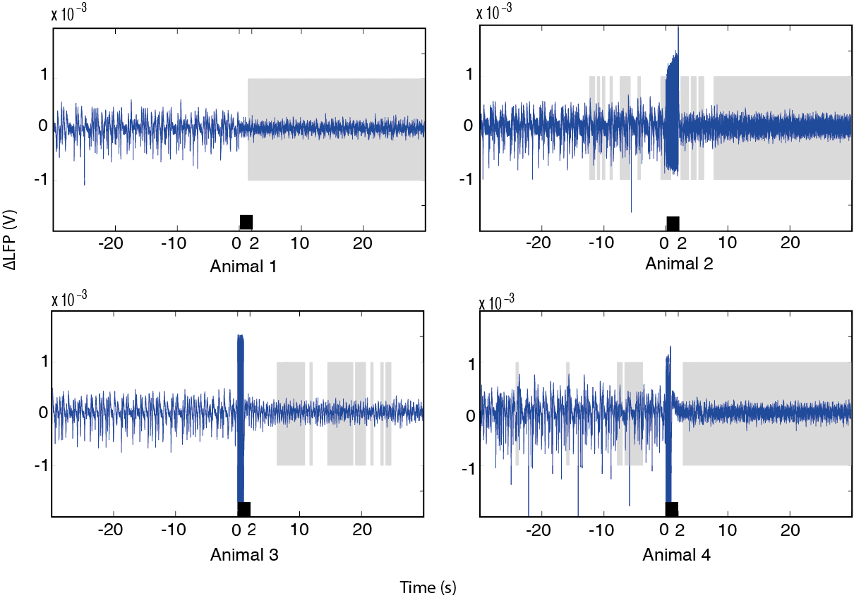

Figure 10: The application of the ABSC to four animals from the dataset of Jones et al. (2008). Neural activity with ABSC classified sections shaded in grey for desynchronised brain state and white for synchronised. The black bars denote the duration of time that the reticular stimulation was applied. Stimulation artefacts can be seen in three out of four animals.

3.4.6 Conclusions from Section 2
Rigorous testing using two additional datasets and two further methods of comparison, has again demonstrated that the ABSC remains the method of choice for cortical state evaluation. It presents an excellent level of classification accuracy, fast timings for processing of the datasets examined and is stable over time. It is therefore concluded that the newly developed ABSC should be the state classifier of choice for all further data in this thesis.

3.5 Discussion
In this chapter the development of a fast, accurate and reliable state classifier was undertaken. A threshold based classifier was tested. Whilst it was found to give a good level of accuracy, a large amount of data was lost as ‘transition’ data. Further to this, a clustering based classifier was tested. This classifier also gave good (if slightly lower) levels of accuracy. However, visual categorisation indicated that the clustering classifier failed to accurately classify almost half of the testing dataset. Therefore testing of a final classification method was performed. This method, the ABSC, used a ratio based coding of the relative differences in state specific spectral information to classify neural brain state. The ABSC has novel methodological aspects for the area of brain state classification. It was validated by classifying three experimental datasets – one of ‘spontaneous’ neural signals, a second dataset of neural signals where a single pulse of electrical stimulation was applied to the whisker pad and a final dataset where neural signals were recorded whilst electrical stimulation of the reticular brainstem formation was used to artificially change brain state. During the desynchronised brain state, an increase in the ratio of higher spectral frequencies to lower spectral frequencies was identified. The overall magnitude of the summation of the frequency power dropped in the desynchronised state, however, a specific separation where the magnitude of the power in the gamma and beta bands became relatively high compared to the magnitude of the power in the alpha, delta and theta bands occurred. To my knowledge, this corresponding frequency ratio change has not previously been documented. It showed clear advantages over other classifiers which will now be discussed.
This method (ABSC) for classifying brain states, based on relative frequency band vectors, was shown to be both stable and accurate for state classification. Previous brain state classifiers have relied upon popular methods such as clustering neural data, with post-clustering coherence analysis and supervised clustering of data (Gervasoni et al., 2004, Michel et al., 2012). The ABSC was compared to the clustering method put forward by Gervasoni et al. and whilst the accuracy for the data that could be classified was slightly higher than the accuracy of the ABSC, there was much data that the technique was unable to identify, leading to a large overall drop in accuracy. The Gervasoni clustering method was weakest at identifying the desynchronised brain state, which the animals spent less time in. Therefore, with large continuous time periods such as the recordings of 48hrs+ that the authors used, the performance of the clustering method may improve. This however, does not help those with small datasets to classify. The ABSC was also compared to a method of taking an RMS ‘power threshold’ from the raw neural data. The ‘power threshold’ was found to be less accurate than the ABSC or the clustering technique. The poor performance of an RMS ‘power threshold’ technique is unsurprising given the bias that it must entail towards a particular state, unless approximately equal time periods are spent in each of the examined brain states within an experiment.
Whilst these alternative methods can identify distinct brain states, the ABSC represents a different approach. One strength of the ABSC is that it does not rely on human input to detect state, post initialisation. This makes the ABSC an autonomous objective classifier. Therefore, a change of state is not required in order to classify subsequent data correctly. Additionally, the ABSC can be modified to search and classify as many states as set by the user. In this thesis, the classifier was initialised by an expert to identify only two selected states: synchronised and desynchronised as these were clearly present in the data. Its design however, means that it could be adapted to incorporate identifications of multiple states, for example, rapid eye movement, slow wave sleep and awake states. A point to note on this matter is that the initialisation dataset would therefore need to include time periods of all the states that were to be classified. Importantly, the ABSC has the potential to classify brain state in real-time. This potential is based upon two important qualities that it displays: Firstly, its initialisation parameters are stable over time and across different subjects; Secondly, the ABSC classification is absolute, as it classifies on an automated point by point basis. This implies that it could potentially classify a trial using only a small section of the dataset. The stability of the initialisation parameters was demonstrated by using the single animal initialisation data to classify a much older dataset (Jones et al., 2008) where the state was actively changed by stimulating the brainstem.
Further stability of the ABSC could be shown by using initialisation datasets from an alternative single subject or a merge of subjects, and identifying if high levels of classification accuracy were still achieved. Nonetheless, whilst initial parameters may need to be set offline, future experiments have the potential to be classified in real-time. With accurate online classification, more understanding of the data in single trial experiments is possible as differences in the data from the brain state rather than the experimental manipulation are more likely to be identified. Additionally, more control is possible in complex experiments such as those involving drug infusions. If baseline state can be verified online, then infusions can always begin when the brain is in the same state. This could reduce the systematic error in the population data, and potentially reduce the number of animals needed in an experiment.

3.5.1 Application of the ABSC to other animals
Whilst the ABSC has been validated on data from an anaesthetised rat, theoretically it could be applied to data from other animals, or even humans. When utilising the ABSC, establishing the correct model vectors is crucial to its performance success. In order optimise the ABSC, the number of model vectors must be chosen carefully, the window size should be evaluated and the initialisation data should be of high quality. To expand upon these points – it is crucial that high quality data from each different state present in the experimental dataset has enough high quality initialisation data. In the experiments in this thesis, the initialisation dataset was 1/10 of the size of the experimental dataset. However, once the model vectors were set, they were used on additional experimental datasets with no modification needed. If adapting this for use on different animals, I would recommend ensuring that initialisation dataset is at least 1/10 of the size of the initial experimental dataset examined. Further experimental datasets may be classified without the need for more model vectors. To ensure that an optimal number of model vectors is used, a trial and error learning approach is recommended with a minimum of 5 model vectors. It would also be useful to look at the variance in the model vectors that are obtained. If many different vectors are obtained but minimal variance is observed between the vectors (for example the vectors only vary minimally in one or two elements) then a lower number of model vectors can confidently be used. With the window size that is to be used, again a trial and error learning approach is recommended. With both window size and model vectors it will be useful for the user to record both accuracy and processing time. Whilst accuracy will not vary depending on the computer used, the processing time will, therefore results should be examined with regards to this. If all three of these factors are optimised, then the performance of the ABSC has the highest chance of optimally classifying the data from other animals. It is beyond the scope of this thesis to do this however.

3.5.2 Methodological considerations
Adding to the guidance discussed above, this section contains more general advice for optimising the performance of the ABSC. For instance, a compromise of accuracy over efficiency can be made by selecting a larger sliding window, or a larger step size. The five most frequently occurring model vectors were selected to initialise the ABSC, as this captured a large amount of the calculated vector variance, whilst still making the comparisons with the dataset vectors not too computationally intensive. When variations in the window size between 1s and 30s were performed on datasets in this thesis, the variation in processing time did not exceed additional processing time of 15 minutes or a decrease in processing time below 3 minutes. No trials were performed with additional numbers of model vectors, but theoretically, the results should give similar variations in processing time. However, additional vectors could be selected to capture more of the variance if the speed of classification was of less importance. Combining additional vectors with a multicore CPU or graphical processing units (GPU, e.g. with 1280 cores) could potentially optimise both the speed and the accuracy of the ABSC.
In this work, all 5 frequency bands have been considered in relation to one another. This approach ensures that good levels of accuracy can be seen when classifying state even if one of the commonly used frequency bands such as gamma encounters problems such as noise, or other issues which mean changes in the variance of the magnitude of the gamma band power do not occur. It has been observed that although the magnitude of all five frequency band powers can change with state (see for example Fig. 9), there are also occasions when this does not happen (see Fig. A4 in Appendix for example). Therefore, the inclusion of all 5 frequency bands ensures that the highest levels in state classification accuracy are achieved, even when the data used in the classifier shows variations from what may be considered the “norm”.
A urethane anaesthetised rodent model was used, as urethane is thought to produce similar physiological patterns to the sleep cycle (Clement et al., 2008, Pagliardini et al., 2013), and certainly shows irregular fluctuating periods of synchronised and desynchronised brain states. Urethane is also a stable anaesthetic, causing minimal changes in the ratios of neurotransmitter levels compared to other anaesthetics such as propofol, ketamine or isoflurane (Hara and Harris, 2002) and with minor cardiovascular effects (Maggi and Meli, 1986). Urethane is therefore a favourable choice of anaesthetic for investigating the spontaneous variations in neural activity.

3.5.3 Implications for future research
An understanding of neurovascular coupling during different brain states is an obvious application for a brain state classifier such as this. Inferred differences in stimulus evoked haemodynamics or the underlying activity may be wholly or partially due to differences in brain state. This chapter describes the development of a novel, robust method of neural state classification that can be applied to multimodal data sets in which neural and hemodynamics are collected. The sorter would also benefit from further investigation into its stability to see if alteration of the model vectors affected its performance. It would also be useful to investigate whether experiment trials can be classified by small amounts of baseline data, prior to the beginning of a stimulus. If these two possibilities were to be realised, the ABSC would show further potential as an online classifier.

3.5.4 Conclusion
This chapter presents the development and testing of a novel automatic state classifier. During development, three classification methods were tested on a single impulse dataset: a threshold classifier, a clustering classifier and a vector coding classifier (the ABSC). The ABSC was found to be the best method and was taken forward to undergo rigorous testing. This involved testing against two published classification methods as well as checking for stability by classifying a previously published dataset.
The ABSC was optimised with a initialisation dataset as a method to examine changes in cortical state. The ABSC used only neural data, decomposed into five frequency bands examined in relation to one another to classify the state. A ratio-based signature of these frequencies was found that marked periods of desynchronisation. By comparison with the two published methods, the ABSC was found to be efficient and accurate. By classifying the dataset from 2008, it was shown to be stable over long periods of time. The interesting prospect remains to investigate what the associated haemodynamic changes are that occur with cortical state changes.

4 The effects of brain state changes on cerebral haemodynamics using the ABSC.

Abstract
Many brain imaging techniques interpret the haemodynamic response as an indirect indicator of underlying neural activity. However, a challenge when interpreting this blood based signal is how changes in brain state may affect both baseline and stimulus evoked haemodynamics such as blood oxygen saturation or total blood volume. In the previous chapter, the ABSC was validated as a novel method to identify brain states. In this chapter the ABSC is used on two datasets: a spontaneous dataset (A1) where no stimuli were used and a stimulus evoked dataset (A3), where an electrical stimulation was applied unilaterally to the whisker pad for 16s at a frequency of 5Hz. The ABSC consistently identified two user defined brain states (synchronised and desynchronised), with high accuracy (~90%) and this was then used to classify the concurrently recorded haemodynamics for both datasets. Baseline (‘spontaneous’) haemodynamics were found to be significantly different in the two identified states with increased levels of blood oxygen saturation (Hbo) and total blood volume (Hbt) in the desynchronised state. In the previous chapter the desynchronised state is described as having increased levels of high frequency power in the LFP relative to low frequency power. Therefore the baseline haemodynamic state specific findings from this Chapter along with the frequency ratio detailed in Chapter 3 for the spontaneous dataset (A1) agree with the theoretical predictions of Kilner et al., (2005) and the previous experimental work of Magri et al., (2012). The findings give evidence for their idea that the relative frequency power profile determines the magnitude of the haemodynamics, rather than the magnitude of the haemodynamics depending on the absolute power of any frequency range in particular. During the desynchronised state (when periods of baseline haemodynamics were elevated) results from a novel dataset A3 showed significant decreases in evoked haemodynamic responses (trial averaged within state) to somatosensory stimuli. This agrees with previous results using brainstem stimulations to produce a desynchronised state by Jones et al. (2008). The novel approach of pre-classifying stimulus trials by brain state before group averaging, yields higher quality data than creating single averages from all stimulus trials. The ABSC can account for some of the commonly observed trial-to-trial variability in haemodynamic responses which here has been shown to arise from spontaneous changes in cortical state. This variability might otherwise be incorrectly attributed to alternative interpretations. A greater understanding of the effects of cortical state on haemodynamic changes could be used to inform techniques such as general linear modelling (GLM), commonly used in fMRI.

This chapter covers part of the publication:
Slack R, Boorman L, Patel P, Harris S, Bruyns-Haylett M, Kennerley A, Jones M, Berwick J (2016) A novel method for classifying cortical state to identify the accompanying changes in cerebral hemodynamics. J Neurosci Methods 267:21-34.

4.1. Introduction
It is unclear whether, and to what extent, cerebral haemodynamics are modulated by spontaneous changes in cortical state. This is important for the accurate interpretation of perfusion-related imaging signals, such as Blood Oxygen Level Dependent Functional Magnetic Resonance Imaging (BOLD fMRI). BOLD fMRI infers the location and magnitude of neural responses to stimuli or cognitive tasks by exploiting a process known as neurovascular coupling, in which concurrent alterations in the local demand for glucose and oxygen during neuronal activation are accompanied by regional changes in cerebral blood flow (CBF), blood volume (CBV) and oxygenation (Attwell et al., 2010, Kleinfeld et al., 2011, Masamoto and Kanno., 2012). Within such techniques, brain responses to identical stimuli routinely exhibit considerable trial to trial variability in their timing and magnitude (Duann et al., 2002, Mullinger et al., 2013). This information may well be behaviourally meaningful, but a full understanding of its origins is currently lacking.
Since haemodynamic responses to stimuli/task presentations are often small, typically representing a small fractional change from baseline conditions, a common approach in brain imaging studies is to average across multiple stimulus evoked trials in order to enhance the signal to noise ratio (SNR) (Boorman et al., 2010, Martin et al., 2013). However, such methods implicitly assume that the baseline brain state remains constant during the experiment, which may not be appropriate. Indeed, changes in brain state have been widely reported in both human and animal studies (see Chapter 1 and 3 for further details), with brain states noted for their importance in the perception and neural processing of incoming sensory stimuli (Castro-Alamancos, 2004b, Zagha and McCormick, 2014). Both baseline and stimulus evoked haemodynamics have been previously shown to be altered during changes in cortical state actively induced by direct stimulation of the brainstem (Jones et al., 2008), intravenous infusion of psychostimulants (Berwick et al., 2005), and during hypercapnia challenge (Kennerley et al., 2012). Notwithstanding these insights, the question remains as to whether haemodynamics are altered during spontaneous changes in brain state.
(Kilner et al., 2005), proposed that the neural marker for increases in hemodynamic signals such as focal fMRI activations could be increased in the upper spectral frequencies of the local field potential (LFP) relative to the lower frequencies. This theory is based on the idea that it is the relative differences in the spectral band power that are of importance to haemodynamics such as the activations measured by fMRI, rather than a single, or pair of frequencies, or even an excess of spikes. (Magri et al., 2012) gave support for this theory as they showed that the amplitude of BOLD responses to spontaneous neural activity was also dependent upon the power of gamma frequency relative to alpha in the state-specific baseline, rather than exclusively on the total LFP power or the power of a single frequency band. They did not, however, investigate stimulus evoked haemodynamics in relation to relative frequency band changes. The ABSC (Chapter 3) showed that a specific relationship in the frequency bands caused by a brain state alteration from a synchronised LFP to a desynchronised LFP could be captured by the ABSC. Under Kilner’s theory, this shift should cause a significant change to the state-specific baseline and evoked haemodynamics which has rarely been previously investigated.
Using the somatosensory cortex of the anaesthetised rodent allows invasive concurrent optical measures of cortical haemodynamics and electrophysiological recordings to be made. Furthermore, urethane anaesthesia is an ideal model with which to perform state classification investigations using an invasive rodent model, as it induces cyclic and spontaneous changes in cortical state, as observed in the ongoing LFP (Friedberg et al., 1999). Two states have been routinely identified in previous studies and were traditionally referred to as synchronised (large amplitude low frequency neuronal oscillations) and desynchronised (high frequency low amplitude neuronal oscillations) (Steriade et al., 1993, Lampl et al., 1999, Steriade et al., 2001, Jones et al., 2008, Curto et al., 2009). Although many different brain states can be experienced (see 1.3), Harris and Thiele (2011) suggest these brain states make up a continuum from the synchronised to the desynchronised state. This idea is discussed further in section 6.2.3.1, however using this simple separation should therefore capture the overall changes in brain state alterations to concurrent haemodynamics, if they should occur.
This chapter demonstrates the importance of classifying brain state when performing blood based neuroimaging studies in order to account for spontaneous variations in brain state that may cause trial-to-trial variations in evoked haemodynamics or alterations to the baseline levels of blood oxygen saturation and total blood volume that may otherwise bias the interpretation of findings in neuroimaging studies.

4.2 Method
In this chapter, a novel method to evaluate cerebral haemodynamics by automatically classifying the concurrent neural brain state is described. The method for data collection is described, followed by a brief explanation of the novel analysis technique (see Chapter 3 for further detail) with details of its application to haemodynamic data. As in Chapter 3, the ABSC is initialised on LFP data, where synchronised and desynchronised states are both present (subset of dataset A1).

4.2.1 Data collection

4.2.1.1 Animal preparation and surgery
As in Chapter 3.

4.2.1.2 Concurrent electrophysiology and 2D Optical imaging spectroscopy
2D-OIS was used to measure the haemoglobin concentration and blood oxygen saturation across the surface of the somatosensory (S1) cortex. The imaging procedure followed that detailed in section 2.3.2 of this thesis. An initial optical imaging spectroscopy experiment was conducted to localise the whisker barrel region as in Chapter 3. Concurrent electrophysiological and 2D-OIS (haemodynamic) data were recorded. To examine the 2D-OIS data over time, a region of interest (ROI) was selected, centred on the electrode, and extended to capture the cortical region that was associated with the stimulus evoked haemodynamics, elicited in the initial experiment. The average ROI size for an animal was 515 pixels with a SD of 202.6 (1 pixel ~49 μm²).

4.2.1.3 Overview of Application Protocols
Two datasets were used. These datasets were different to those used in 3.3 of Chapter 3 in order that the data were not reanalysed again, given that the data had already been analysed three times. The first dataset made state comparisons of the haemodynamic changes occurring when no stimulations were present. This dataset was used once in 3.4 of Chapter 3. The second dataset was novel. It was used to investigate the effect of sorting data into synchronised and desynchronised when long-duration stimulations (16s) were used. The two datasets are described in more detail below.
(A1, n=12) Spontaneous recordings
Concurrent neural and haemodynamic changes were recorded concurrently for 1000 to 2500s, in the absence of stimuli, from twelve subjects. A subset of the recordings were used to initialise the ABSC, before the ABSC was applied to classify the whole dataset. The ABSC classification of A1 was then compared to the ‘expert’ classification of A1 (see 4.2.2.2) to check classification timings and accuracy.
(A3, n=14) Electrical Stimulation of the Whisker Pad
The initialised ABSC was applied to concurrent neural and haemodynamic recordings, acquired during electrical stimulation of the whisker pad. The classifications arising from the ABSC were again compared to an ‘expert’ classification. Stimulation of the whisker pad was evoked through two insulated stainless steel electrodes (2mm exposed tip) inserted subcutaneously into the whisker pad between rows A/B and C/D. Electrical stimulation (0.8-1.2mA; 300μs pulse width, 16s duration at 5Hz) caused a visible full pad whisker twitch confirming that stimulation was effective. This stimulation caused no changes to the MABP or CO₂ recordings. Haemodynamic and neural signals were recorded concurrently for 2100s, split into 30 trials of 70s inter-trial interval with the stimulus applied after 10s.

4.2.2 Data analysis
The ABSC method was used to classify the different brain states was used (see Chapter 3, section 3.3.5 for further details).

4.2.2.1 Application of the ABSC to the experimental datasets
(A1) The A1 Dataset (spontaneous) was used in initialising the ABSC and testing whether there were differences in the concurrently recorded haemodynamic changes, between the two brain states inferred from the LFP.
The model vectors from the initial analysis (A1) were kept constant during A3.
(A3) The A3 test dataset (‘stimulus evoked’) was subject to the above feature extraction and pattern classification steps with a minor amendment. During the feature extraction step, time points during the 16s period of stimulation (-0.001 to 16.432s for each trial) were ignored to prevent the interference of the stimulus in the spectral analysis. Once the ABSC had been applied to each subject dataset, trials were classified using only a pre-stimulation period of varying length (1-10s – this was the time closest to the onset of stimulation). The length of the pre-stim period was varied to observe how the accuracy of the ABSC changed as it was given decreasing amounts of data with which to classify. The most commonly occurring state was found for the pre-stim time period and the trial was classified as belonging to that state. Accuracy levels of the ABSC compared to the ‘expert’ classified trials were calculated.

4.2.2.5 Sectioning of concurrent haemodynamic data
The ABSC was used to partition the concurrent haemodynamic data for each of the applicable experimental datasets, descriptions for each dataset are given below.
(A1) If the time period of a cortical state detected from the neural recordings was stable for a long duration (>30s), then the concurrently measured haemodynamics were examined over that same time period. These long duration haemodynamic time periods were then averaged across time to obtain the mean concentration of Hbo, Hbr and Hbt for each state.
(A3) The individual 70s stimulation trials were grouped and averaged according to the state classification from the neural activity, during the pre-stimulus state-specific baseline period and again the concurrent haemodynamics (Hbo, Hbr and Hbt) were examined for each state. An inclusion criteria was specified, to reduce potential noise from subjects that did not have many simulation trials in a specific state. Thus for an experimental run to be included in the overall state classified haemodynamic averaged, it must be found to provide at least five trials in that particular state.

4.3 Results
The ABSC was used to classify temporal periods of neural recordings into two brain states. These classifications were then used to investigate whether a change in brain state caused changes in state-specific baseline and stimulus evoked haemodynamics.

4.3.1 The initialisation of the ABSC using spontaneous data (dataset A1) and comparison to alternative techniques.
Data were collected from 13 experiments across 12 animals, where no stimulus was applied. Each experiment involved the concurrent recording of neural and haemodynamic data for durations between 1100 to 2500s. Each animal contributed one experiment to the experimental dataset, while one animal also provided an additional experiment which was used solely as initialisation data. The ABSC was initialised on state separated data previously classified by an ‘expert’. The five most frequently occurring model vectors (M_{l}), resulting from initialising the ABSC, explained 76.4% of the coded vector variance in the desynchronised state spectral information from the initialisation dataset and were set as the desynchronised model vectors. To keep the number of vectors consistent, the five most frequently occurring vectors in the synchronised state were also set as the model vectors for the state sorter, giving a total of 10 model vectors. The synchronised state model vectors explained 8.4% of the model vector variance in this state. Whilst the difference between the variance may appear large, in actual fact it is more of a representation of the size of the window compared to the variance in each state. The desynchronised state shows less variation over time in the relative frequency band power differences in general, therefore a 4s window captures most of the variance within the state. The synchronised state shows more variation in the relative frequency band power differences, therefore less of this is captured by a 4s window. However, if a larger window were to be used, more of the variance in the synchronised state would be captured by the same number of model vectors. The variance explained by the desynchronised vectors would also increase, although depending on the window size used, a ceiling effect may well be reached. Therefore, the variance explained by the model vectors is a useful indicator of the amount of variance of the frequency band power over time, but does not limit the use of a small number of vectors in this case. If more states were being classified, it would be important to ensure that all but one of the states had most of the variance explained by the model vectors used. The easiest way to achieve this would be to vary the window size until a good degree of the variance could be explained in almost all of the states, or to use a higher number of model vectors for each state. Using a higher number of vectors would ensure greater accuracy, however this process may increase computation processing time. The size of the dataset to be processed, the variance explained by the model vectors and the computer specification used all need to be considered when deciding on the optimal number of model vectors to be used. Once the model vectors were selected, the ABSC was applied to the experimental dataset. A demonstration of the application of the ABSC for state sorting is shown for three subjects in Fig.1.
The ABSC classified time periods, of synchronised and desynchronised state, were used to extract the concurrent haemodynamics (Fig. 1, bottom row). Clear increases in Hbo and Hbt can be seen, with a drop in Hbr during extended time periods of desynchronisation. During these periods, the levels of Hbt rose to a peak and remained elevated. Decreases back to state-specific baseline were identified by the ABSC as occurring during the synchronised time periods, following periods of desynchronisation. Three animals were classified as having no state changes, and so were excluded from further analysis. Across the remaining nine animals, the concentrations of Hbo, Hbr and Hbt were examined (Fig. 2A). Only time periods where the neural activity was classified as being in a single state stable for longer than 30s was included, since shorter time periods would render data more vulnerable to noise distortions and the effects of state transitions. The average state-specific baseline concentration of Hbt was significantly larger during desynchronised, rather than synchronised states (Fig. 2B, p = 0.0104, t-test, p corrected for multiple comparisons). Hbo was also significantly larger (p = 0.0025, t-test p corrected) and Hbr was significantly lower (p = 0.01, t-test p corrected) during these respective states.

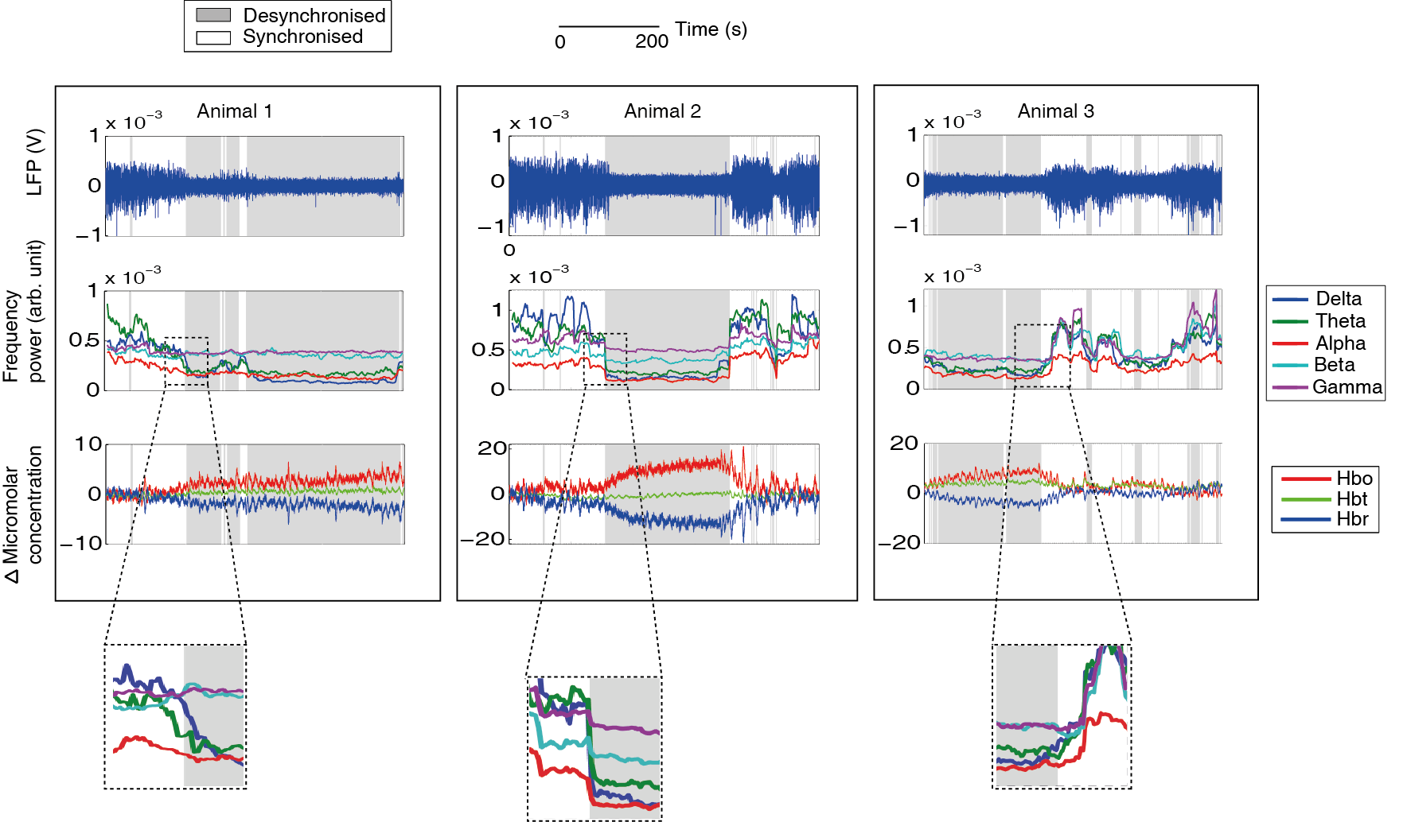

Figure 1 (above): The application of the ABSC demonstrating classification of concurrently recorded neurovascular coupled spontaneous data. 500s of data shown for each example animal. Top LFP with classified section shaded in grey for desynchronised brain state and white for synchronised (repeated throughout figure). Middle Demonstrates feature extraction step of the method, the windowed frequency bands are plotted continuously on the same time scale as the neural and haemodynamic data. Bottom Concurrent haemodynamic time series showing micromolar changes in Hbo, Hbr and Hbt from state-specific baseline levels. Insets indicate a zoomed view of the ratio changes in the frequency bands as the cortical state changes.
To ensure the haemodynamic effects found during state sorting, were not different by chance, the time periods identified by the ABSC were randomly assigned to either the synchronised or desynchronised state for each animal, then averaged within and across animals for the two states, again using only periods of 30s+ stable state. This randomisation was then repeated 50 times and the results compared to the ABSC averages (Fig. 2C).The results indicate that the differences in the haemodynamic state-specific baseline between the two cortical states are not due to chance as the ABSC difference was the only outlier in each box plot analysis. Thus, it was demonstrated that the state sorter can effectively classify LFP data into two states and this classification has a significant effect on the levels of concurrently measured Hbo, Hbr and Hbt during spontaneous recordings.
In order to exclude the possibility that the initialisation data chosen could have unduly influenced the results of the ABSC, the ABSC was initialised using either initialisation data from an alternative individual animal (within A1) or initialisation data from an average of six animals (the experimental dataset being the seven remaining experiments from the other six animals in A1) and the assessment of state sorting accuracy repeated. The mean percentage error when comparing the ABSC results to the ‘expert’ sort using alternative initialisation datasets were similar, with only one animal providing an outlying accuracy measure for both alternative datasets (Fig. 2D). A repeated measures ANOVA revealed no significant variation in accuracy between the initialisation datasets (F(1.131, 12.44) = 0.694, p = 0.438, Greenhouse-Geisser values used as Mauchley’s test of sphericity was significant), indicating that the accuracy of the ABSC was independent of the initialisation datasets used.
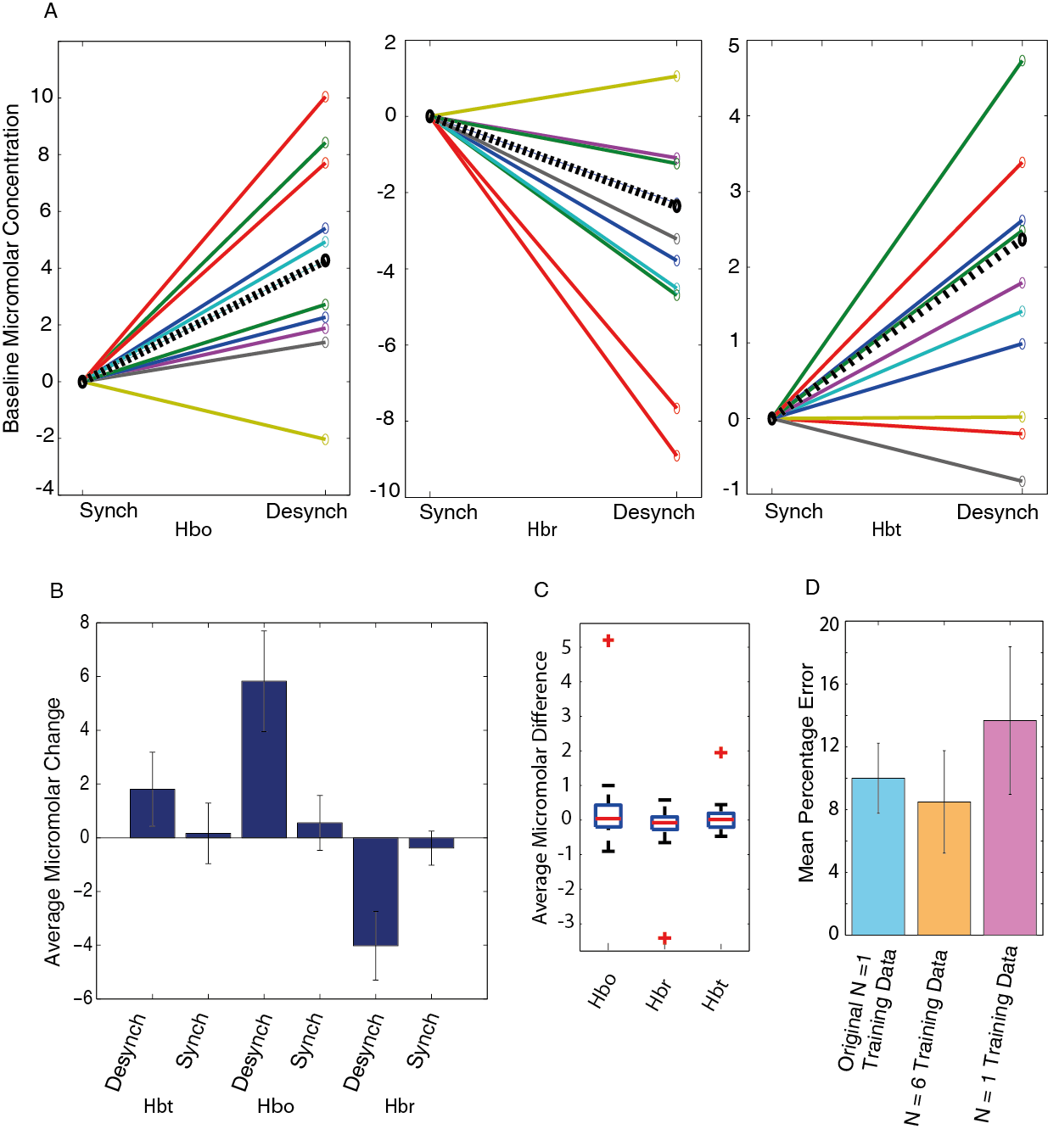
Figure 2: State-specific baseline haemodynamic changes observed during periods of classified state in the absence of stimuli (A1). A Changes in Hbo (left), Hbr (middle) and Hbt (right) between synchronised (S) and desynchronised (D) states for all animals. Synchronised state values have been normalised to 0 to allow observation of the changes in state-specific baseline concentrations. Dotted black lines show the change averaged across all animals. B State-specific average micromolar changes in Hbt, Hbo and Hbr across all animals with error bars showing standard error of the mean. C Boxplot denoting variation in spontaneous haemodynamic averages from randomised periods of synchronised and desynchronised time periods (control analysis, randomisation classifications were performed 50 times and ABSC classifications were included in plotted data). For each state, the average across animals was found and then the desynchronised average was subtracted from the synchronised. On each box, the central red line is the median, the edges of the box are the 25th and 75th percentiles, the whiskers extend to the most extreme data points not considered outliers, and outliers (defined by the MATLAB boxplot function) are plotted individually (red crosses – these mark the ABSC classified averages). D Variation in the accuracy of the ABSC by using alternative initialisation datasets to initialise the model vectors (original animal, N=6 average initialisation set, alternative single animal initialisation dataset).

4.3.2 Classification of cortical state and the implications for associated haemodynamics using a stimulus evoked dataset (A3)
The ABSC was used to classify the state of neural activity, recorded during 16s 5Hz electrical stimulation of the whisker pad. The ABSC used the same initialisation as before (dataset A1, section 3.3.5). The classification of stimulus evoked data allows for examination of the effect of cortical state on the stimulus-evoked neurovascular responses. Neural and haemodynamic data were recorded during 30 stimulus presentation trials, with 70s between each stimulus presentation. In addition to the classification of the entire time series of neural recordings (as in A1), the ABSC was also applied to 10s of pre-stimulation state-specific baseline neural information data to predict the cortical state of each stimulus trial. This was extended further to take only 5s and then 1s of pre-stimulation state-specific baseline neural information to see if classification was possible from very small amounts of data.
The state classifier took 1085s (computer CPU specifications: 4 core, 4.2GHz) to classify all 16s 5Hz stimulation data (14 animals and 24 experiments, giving a total of 875 minutes of data).. Again comparisons were made on a single window basis between ‘expert’ classified data and the ABSC, this gave the classifier an accuracy of 88.6% (SD = 8.54%). On this occasion, the ‘expert’ was unable to correctly classify three experiments from three animals where the state was invariant. Based on the ratio of the upper and lower spectral frequencies, it appeared the ABSC made the correct classification of these experiments (see Appendix, Fig. A3 for further information) and examination of the time-course of haemodynamic changes also reinforced the ABSC classification. The state invariant experiments were therefore removed from the overall accuracy measure for the 16s stimulation data (n = 13) and highlight the importance of using an automatic classifier.

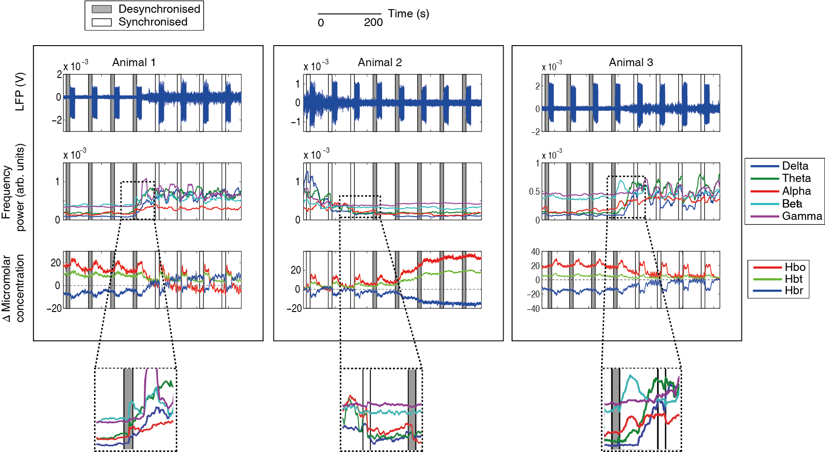Figure 3: The predictive classification of stimulus evoked trials by the ABSC for concurrent neural and haemodynamic data to three exemplar animals which have been subject to 16s electrical stimulation of the whisker pad. Eight individual stimulation trials of 70s length are shown for each example animal. Top LFP with the

10s pre-stimulus period, used by the ABSC, boxed and shaded in grey for desynchronised brain state and white for synchronised (repeated throughout figure). Middle Demonstrating the feature extraction step of the method, the windowed frequency bands are plotted continuously on the same time scale as the neural and haemodynamic data. Bottom Concurrent haemodynamic time series showing micromolar changes in Hbo, Hbr and Hbt from state-specific baseline levels. Insets indicate a expanded view of the changes in the frequency band power as the cortical state alters.
Variable amplitude oscillations can be observed, during the non-stimulation periods, in the time course of the neural responses (see Fig. 3, top row, for exemplar subjects demonstrating clear periods of synchronised and desynchronised state in their neural recordings). Periods of desynchronisation are marked by decreases in the amplitude of LFP oscillations (Fig. 3, trials marked with grey sections), when compared to synchronised periods (Fig. 3, trials marked with white sections). Spectral frequency power analysis of the same desynchronised periods shows the characteristic increases in the ratio of higher to lower spectral frequencies (Fig. 3 middle row), as seen in the exemplar spontaneous data (Fig. 1). During the same periods of desynchronisation, increases in the state-specific baseline Hbt and Hbo and decreases in Hbr can also be observed (Fig.3, bottom row), when compared to synchronised periods. In contrast to the state-specific baseline haemodynamic changes, the stimulus evoked haemodynamic changes show an inverse relationship, whereby responses evoked during periods classified as desynchronised show evoked Hbo, Hbr and Hbt responses that are attenuated, or greatly reduced, whilst responses evoked during periods classified as synchronised appear robust, with clear differences from state-specific baseline present in Hbo, Hbr and Hbt. The large differences in evoked neural and haemodynamic responses across the different states could have a large effect on the accurate interpretation of neuroimaging data, therefore an unclassified average across all stimulation trials has been compared to averaging selectively by using the cortical state sorter.

4.3.2.1 Comparison with standard averaging of evoked trials, without accounting for state
To better understand how the state classification of neural data and the subsequent classification of the concurrent haemodynamics affects evoked responses, the average neurovascular responses across all animals for trials classified as desynchronised (Fig. 4B) and synchronised (Fig. 4C) were generated and the state classified averages were compared with the standard method of averaging across all trials for all animals (Fig. 4A). Following on from the investigation of the effects of cortical state on state-specific baseline haemodynamics, the average change in state-specific baseline haemodynamics for the desynchronised state was calculated to be an increase of 8.56 μM for Hbo, 2.00μM for Hbt and a decrease of 5.56 μM for Hbr, when compared to the synchronised state. These changes altered the initial parameter assumptions for the desynchronised state, giving a new micromolar concentration of 106 and blood saturation of 58% (Fig. 4B &C reflect these parameters). The average neural responses (Fig. 4, top row) show distinct differences after the onset of stimulation, for the different conditions. Stimulus evoked LFP depolarisations in the desynchronised state (Fig. 4B), start with a small magnitude, but then increase gradually in magnitude with the subsequent stimulation pulses. Stability in the magnitude of the LFP depolarisations is achieved approximately 10-12s after stimulus onset. Conversely in the synchronised state, the initial LFP depolarisation is of greater magnitude (Fig. 4C), followed by a fast return to a smaller more stable LFP magnitude, approximately 8-10s after stimulus onset. The averaged unclassified neural response can be seen to be a combination of the neural responses from desynchronised and synchronised classified trials. In contrast to the desynchronised LFP responses, the standard average response shows a maximal LFP on the first response, although the magnitude of this is not as large as the synchronised initial LFP. The subsequent LFPs reach a steady magnitude by approximately 9-10s after stimulation onset.
The stimulus evoked haemodynamic changes accompanying the changes in neural activity have magnitudes which are modulated in a similar manner to that observed for the state sorted neural activity. Haemodynamic responses in the synchronised state (Fig. 4C, bottom) display a larger initial peak around 5s after stimulus onset, followed by a subsequent plateau and return to state-specific baseline, whilst evoked haemodynamic changes during desynchronised periods (Fig.4B bottom) do not show an initial peak and reach their maximum around 16s after stimulus onset, before returning to state-specific baseline.
Figure 4 (below): Application of the ABSC to neurovascular coupled 16s 5Hz whisker pad stimulation data. Each trial response was normalised to an average of 5 seconds of trial-specific baseline haemodynamic data before state averages were taken. A. Undivided averaged responses from all trials, from all animals (neural activity top left and haemodynamics bottom left). The error patches on the haemodynamic figures show 1 unit of standard deviation for each time series. B Average responses from all stimulation trials classified in the desynchronised brain state (n=13, one animal did not show a desynchronised time-period) average neural activity (top) and haemodynamic responses (middle). C Average responses from all stimulation trials classified in the synchronised brain state (n=14) average neural activity (top) and haemodynamic responses (middle). D State classified micromolar changes in Hbt, Hbo and Hbr, averaged by mean response over 0-10s after stimulation and averaged across all subjects, with error bars showing 1 unit of standard error. E Box plot denoting variation in evoked haemodynamic averages from 50 randomised trial selection datasets. For each randomised trial set, the average across animals was found and then the desynchronised average was subtracted from the synchronised. For each box, the central red line is the median, the edges of the box are the 25th and 75th percentiles, the whiskers extend to the most extreme data points not considered to be outliers, and outliers (defined by the MATLAB box plot function) are plotted individually (red crosses mark the ABSC classified trial set). F Variation in the accuracy of the predictive trial onset by period of time provided to the ABSC (10, 5 and 1s) as well as by initialisation of ABSC by alternative initialisation dataset (original animal, N=6 average initialisation set and Alternative single animal initialisation dataset). Horizontal black bars denote stimulation period.
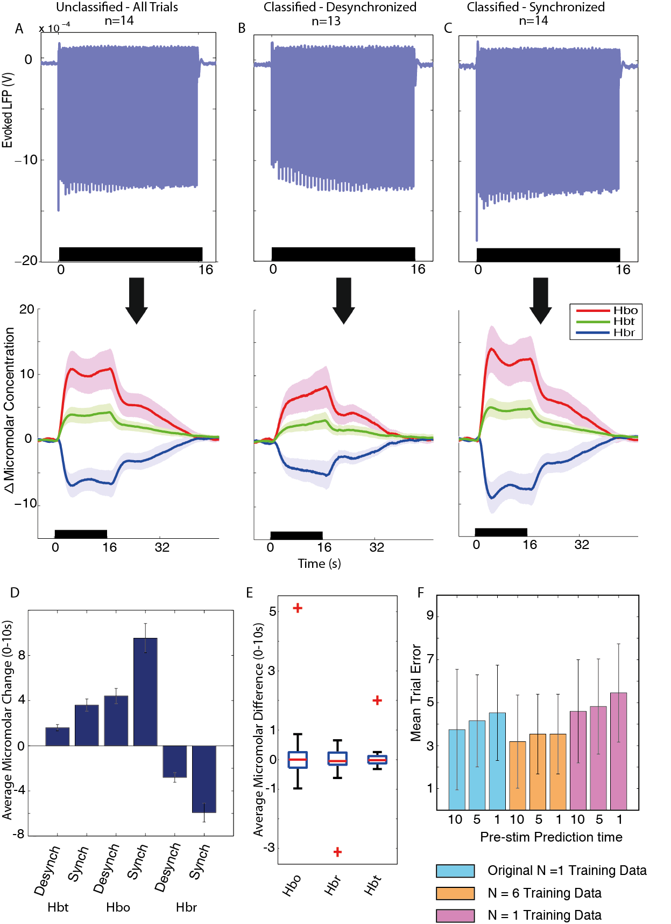
Evoked Hbt responses were significantly larger during the synchronised state compared to the desynchronised state (Fig. 4D, p = 0.00023, t-test, corrected for multiple comparisons), Hbo was also significantly larger (p = 0.00018, t-test, corrected) and Hbr was significantly lower (p = 0.00011, t-test, corrected) during these respective states.
To ensure the haemodynamic effects found were not significantly different due to chance, haemodynamic trials were randomly assigned to either the synchronised or desynchronised state for each animal, and then averaged within and across animals for the two states (Fig. 4E). This was then repeated 50 times and the results were plotted in a box plot including the real ABSC averages. The standard formula to determine outliers in this dataset of 51 averages was used: $x>Q3+1.5*IQR or x<Q1+1.5*IQR$, where x is the average micromolar difference, IQR is the inter-quartile range and Q1 and Q3 are the 25th and 75th percentiles respectively. The ABSC averages were the only outliers in this data group, indicating that the effect of extracting and averaging sections of haemodynamic data is reliant upon the ABSC method of classification.
The effect on classification accuracy of varying the time period of data the ABSC was applied to, before each stimulus onset, to predict the classification of the state was also investigated. Results showed that a decrease in the amount of time allowed for predictive trial classification, did cause a slight drop in the accuracy of the sorter, but this was not significantly different (Fig. 4F, p = 0.399, one way ANOVA). It was also found that using an alternative single animal or average of six animals to create the initialisation initialisation dataset (the animals used for Fig. 4D) had virtually no effect on the overall classification accuracy rates.

4.4 Discussion
A spectral frequency ratio-based coding of neural data to classify cortical state was proposed and validated on neural data (Chapter 3). Here, it has been investigated whether the simultaneously collected, concurrent haemodynamic changes show differences when classified by cortical state changes. This method has novel aspects for the analysis of neurovascular coupled data. The ABSC method has been validated by classifying two experimental datasets – one of concurrent ‘spontaneous’ neural and haemodynamic signals and a second dataset of concurrent neural and haemodynamic signals where 16s of electrical stimulation was applied to the whisker pad. It was demonstrated that the method of classifying brain state using the ABSC gave important insight into the differences in the both state-specific baseline and stimulus evoked haemodynamic changes, especially when compared to unclassified data. The method described also provides an explanation for some of the inherent variability commonly seen in BOLD fMRI signals.

4.1 Haemodynamic responses differ in different brain states
Neural data were classified according to brain state and the concurrently recorded haemodynamic data were extracted and averaged. During the desynchronised brain state, an increase in the ratio of higher spectral frequencies to lower spectral frequencies was identified. This ratio change corresponded with significant increases in the state-specific baseline CBV and blood oxygen saturation, which agrees with the theoretical predictions of Kilner et al. (2004) and the experimental work of Magri et al. (2012). Along with increases in the state-specific baseline haemodynamics, decreases in stimulus evoked response magnitudes were again associated with the desynchronised state. The decreases in the evoked response magnitude in desynchronised state are consistent with previous investigations into state evoked haemodynamics (Niessing et al. 2005; Schei et al., 2009; Jones et al. 2008; Berwick et al., 2005), although the corresponding frequency ratio has not previously been documented to my knowledge. This decreased evoked haemodynamic signal could not be identified in the gross unclassified average, and thus the additional haemodynamic information would have been lost, with the resultant average signal reflecting a weaker version of the synchronised average. The ABSC has therefore been validated as identifying brain state changes that have robust effects on the concurrently recorded haemodynamics.

4.2 Methodological considerations
The ABSC was developed and used to investigate the effects of state classification on concurrent neural and haemodynamic data gathered from anaesthetised animals., The effects of the anaesthesia may mean that results would alter in the awake/sleep cycles of animals. However, it would be very challenging and beyond the scope of this thesis to collect high quality invasive neural and haemodynamic data whilst allowing an animal to freely move and behave as it wished. Such an experiment is theoretically possible (Ziv et al., 2013), but needs additional techniques to monitor vascular changes as well as neural activity (see section 1.3.2.1). Potentially in the future, this, or a similar technique could be used to study the effects of alterations in brain state on neurovascular coupled data without the possible confounds of anaesthesia. However, currently, a simpler way to collect the data is to use urethane as it produces similar physiological patterns to the sleep cycle (Clement et al., 2008, Pagliardini et al., 2013), and certainly shows irregular fluctuating periods of synchronised and desynchronised brain states. Urethane is also a stable anaesthetic, causing minimal changes in the ratios of neurotransmitter levels compared to other anaesthetics such as propofol, ketamine or isoflurane (Hara and Harris, 2002) and with minor cardiovascular effects (Maggi and Meli, 1986). Urethane is therefore a favourable choice of anaesthetic for investigating the changes in haemodynamics that occur from spontaneous variations in neural activity, but results could be further investigated by the use of alternative anaesthetics. For instance, isoflurane may provide an interesting anaesthetic to study as depth can be easily, and reversibly, altered. Caution should be exercised in the interpretation of results using isoflurane however, given its large potentiation effects on GABAA (Hara and Harris, 2002).

4.3 Implications for future research
An understanding of neurovascular coupling during different brain states may be a vital prerequisite for uncovering the aetiology of neurodegenerative diseases such as dementia (D'Esposito et al., 2003, Iadecola, 2004, Kövari et al., 2007), hypertension (Kazama et al., 2003; Calcinaghi, 2013) and ischemic stroke (Shin et al., 2006; Lin et al., 2011), because observed differences in stimulus evoked haemodynamics or the inferred differences in underlying activity may be wholly or partially due to differences in brain state. This chapter gives a robust method for investigating and understanding how differences in brain state affect both state-specific baseline and stimulus evoked haemodynamics and this understanding may therefore benefit research into the aetiology of neurodegenerative diseases.
The ABSC shows potential as a tool to enhance blood based neuroimaging techniques such as BOLD fMRI, particularly when used with paradigms using single or low numbers of trials. The ability to detect and account for cortical state as a component of the trial-to-trial variability in fMRI could then be used to increase the accuracy of the interpretation of experimental data, such as when a decreased haemodynamic response is a function of state, rather than being generated by stimulus evoked neural changes (Boorman et al., 2015). One potential way to do this would be to include EEG recordings to identify brain state in BOLD fMRI paradigms. Here, the ABSC can potentially use the EEG recording either prior to stimulus presentation, or in real-time, to classify brain state from periods of data (1-10s) short enough not to interfere with experiment length. In addition, when considering fMRI experiments that investigate the BOLD signal without a direct measure of neural activity, this chapter shows that state-specific baseline haemodynamic drifts can provide information regarding changes in cortical state. For example, state-specific baseline haemodynamics could be used as an indication of subjects becoming cortically aroused during an experiment, information which would previously have been disregarded as noise.

4.4 Conclusion
In this chapter an automatic state classifier, optimised with a initialisation dataset, was used as a method to examine how changes in cortical state affected coupled haemodynamic signals. The ABSC used only neural data, decomposed into five frequency bands examined in relation to one another to classify the state. A ratio-based signature of these frequencies was found that marked periods of desynchronisation. This was then used to group the concurrent haemodynamic changes. When these desynchronised time periods occurred for more than 30s, they denoted a significant increase in the state-specific baseline CBV and blood oxygen saturation. This increase in state-specific baseline haemodynamics was accompanied by a decrease in stimulus evoked haemodynamics. Therefore the grouping of haemodynamic data by neural brain state is essential for the full understanding of neurovascular coupled datasets. This approach will allow more stable responses with less variance to be extracted from neuroimaging data, increasing the quality of the data interpretation and at the same time reducing the number of subjects required.

5 Using the ABSC to investigate the effects of cortical state on neural and haemodynamic data from the motor cortex

Abstract
One challenge when analysing indirect signals of brain activity in the evoked blood oxygen level-dependent (BOLD) functional magnetic resonance imaging (fMRI) response is separating a meaningful signal from the physiological and technological ‘noise’ that is inherent in any experimental set up. Few investigations have considered the part that cortical state might play in contributing to this physiological ‘noise’. This Chapter extends the work of the previous chapters by examining the effects of cortical state in a new anatomical region: the motor cortex. A multimodal setup was used to record neural and haemodynamic responses in the motor cortex during the application of a 16s electrical stimulation to the whisker pad of an anaesthetised rat. The polarity of average evoked haemodynamic responses were found to be dependent on cortical state (either synchronised or desynchronised) ascertained from the ongoing local field potentials (LFPs). A validated computational model was used to convert haemodynamic responses to predicted BOLD and showed that the desynchronised state predicted a negative BOLD response and was associated with an increase in MUA power (300-3000Hz) in layer V of the rat motor cortex. In contrast, a synchronised state predicted a positive BOLD response, and was associated with a decrease in MUA power relative to state-specific baseline firing. One explanation for this is that the negative BOLD may arise as a by-product of the cortical state conditions. In the desynchronised state, inhibition may be increased to facilitate precise coding of stimuli, leading to a net inhibition effect and a negative haemodynamic response (by precise coding, it is meant that the decrease in general firing will mean that any firing that does occur will be easier to identify). By contrast, under synchronised conditions, precise coding is not expected to be necessary and therefore larger amounts of indiscriminate excitation could result in a net excitation effect and a positive haemodynamic response. Therefore, the polarity or magnitude of the haemodynamic response may be at least partially indicative of cortical state, rather than a wholly tuned response to particular stimuli. Thus, this work strongly supports the importance of accounting for state-specific baseline cortical state in neuroimaging investigations.

5.1 Introduction
The use of non-invasive blood based neuroimaging methods such as Blood oxygenation level dependent (BOLD) functional magnetic resonance imaging (fMRI) has transformed the understanding of the human brain. These methods do not provide a direct measure of neuronal activity, relying instead on knowledge of neurovascular coupling to link the secondary haemodynamic response to the underlying neuronal information. Although there are many studies such as Logothetis (2008) that connect a positive haemodynamic response (PHR) to increases in local field potential (LFP) amplitude and multi-unit activity (MUA), the origin of the negative haemodynamic response (NHR) is still open to debate (Hayes and Huxtable, 2012, Lauritzen et al., 2012, Ma et al., 2016, Uhlirova et al., 2016). Whilst some have found a decrease in neuronal activation (Boorman et al., 2010, Yin et al., 2011, Boorman et al., 2015, Ma et al., 2016) is responsible for an NHR, others have implicated a vascular based or ‘blood steal’ origin for the NHR (Harel et al., 2002, Hu and Huang, 2015). Additionally, some have found that a NHR can be accompanied by an increase in neuronal activity (Devor et al., 2008, Mishra et al., 2011). It is clear from these conflicting explanations that the NHR mechanisms need further research.
Adding to the problem of elucidating how the NHR is generated are additional difficulties such as global brain changes in network dynamics like the ones caused by alterations in cortical brain states. Brain state is also known to have significant effects on global cerebral perfusion (Braun et al., 1997). Previous research (Jones et al., 2008, Schei et al., 2009, Slack et al., 2016) has elucidated that cortical state effects the size and shape of neural responses, as well as PHRs, but the association between cortical state and NHRs has yet to be investigated.
To investigate the relationship between cortical state and NHRs, an anaesthetised rodent model was used. This allowed neural recordings using a linear microelectrode array to be made in combination with multi-wavelength two-dimensional optical imaging spectroscopy (2D-OIS). 2D-OIS was selected to measure changes in cerebral blood volume as well as saturation, as these changes underlie blood based imaging such as fMRI (Kennerley et al., 2012). Using the automatic state classifier (ABSC; see Slack et al. (2016) and Chapters 3 and 4) on the neural data, two brain states (synchronised and desynchronised) were identified with a high level of accuracy (~90%). Results suggested that the temporal profiles of the evoked haemodynamic responses in the motor cortex to a 16s 5Hz electrical stimulation of the whisker pad were at least partially dependent upon the pre-stimulus neural state-specific baseline state. Furthermore, the stimulus-evoked haemodynamic response in motor cortex ‘switched’ from a PHR to a NHR, (a response inversion) depending upon the pre-stimulus neural state-specific baseline state. Further investigation revealed an increase in MUA associated with the NHR and a decrease in MUA associated with the PHR. The results show the importance of accounting for state-specific baseline state when using blood based imaging techniques and provide additional insight into the possible mechanisms underlying negative haemodynamic signals.

5.2 Materials and Methods

5.2.1 Experimental design
Linear array electrodes (16 channels) were placed in whisker barrel somatosensory cortex and motor cortex. Their spatial position was selected from 2D-OIS regional activation maps taken in response to a current regulated 2s electrical stimulation of the contralateral whisker pad. Individual trials of the neural responses from each subject were classified according to cortical state using an automatic state classifier. The concurrently recorded haemodynamic trials were then grouped accordingly, and averaged to create time series of the cerebral blood volume (CBV) and blood oxygen saturation according to the two different cortical states.

5.2.2 Animal Preparation and Surgery
As in Chapter 3.

5.2.3 Two Dimensional OIS
As in Chapter 4. However in this Chapter, whisker and motor regions were defined for analysis. A general linear model (GLM) was used to generate a spatial map of z-score fit with the trial-averaged 2D haemodynamic information (Fig. 1B). The size of the whisker ROI was fixed between 650 and 750 pixels for every animal and the size of the motor ROI was fixed between 250 and 350 pixels. Pixels within the two regions were independently averaged to create the timeseries for Hbt, Hbr and Hbo. The ROIs were selected to include pixels surrounding the electrode tip (Fig. 1D).
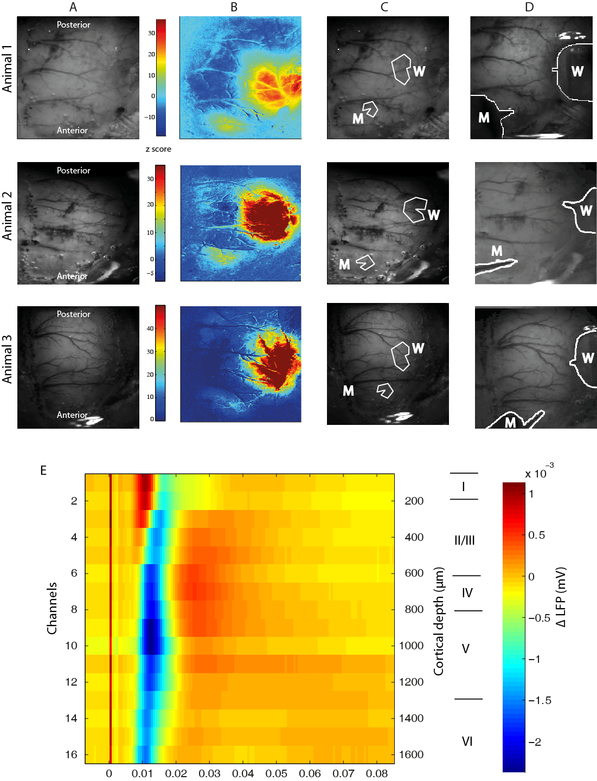
Figure 1: ROI location selection and electrode depth selection, example from a representative subject. A Grayscale CCD camera image of RHS thinned window. B Activation map showing change in Hbt during stimulation (2s electrical stimulation of the whisker pad at 5Hz frequency with 0.8mA amplitude). Map created by statistical parametric mapping (SPM) GLM with boxcar haemodynamic response function. Colour-bar scale represents z-score. C ROIs selected using activation map in B. ROI over whisker barrel cortex (W) was selected to include 650-750 pixels for each animal and ROI over motor cortex (M) was selected to be 250-350 pixels in size. D Electrodes have been outlined to show placement in functional regions of whisker barrel cortex and motor cortex. E The depth of the whisker electrode was functionally localised, however this was not possible with the motor electrode. Instead, the first peak response of the LFP was used as in the image here and all subsequent animals data was depth aligned to this. Layer information for the motor cortex was taken from (Skoglund et al., 1997).

5.2.4 Electrophysiology
As in Chapter 3 however a motor electrode was also inserted.

5.2.5 Experimental Paradigms.
After the functional localization was performed, a previously validated stimulation paradigm was performed consisting of long-duration stimulations. 80 electrical stimuli were presented to the whisker pad over 16s at a frequency of 5Hz. An inter-stimulus interval of 70s was used and pulses were current fixed at either 0.8 or 1.2 mA intensity for all 30 trials. This paradigm, produces robust positive and negative haemodynamic responses, similar to those that might be measured by BOLD fMRI (Boorman et al., 2010, Kennerley et al., 2012a).

5.2.6 Data Analysis

5.2.6.1 Electrophysiological data analysis
To eliminate any variation in the depth of recordings from each electrode, data were post-processed to ensure that all channels that were averaged across animals corresponded to the same depth of cortex. An example of an animal where the electrode is aligned correctly is given in Fig. 1E.

5.2.6.2 State classification
The neural data were downsampled to 1.6KHz and sorted into synchronised and desynchronised states by the Automatic Brain State Classifier (ABSC; (Slack et al., 2016)). In brief, 10s of local field potential data were taken immediately before each stimulation began, and was used to classify each trial by looking for a pre-specified pattern in the relative frequency power of delta (0.5-3.9Hz), theta (4-7.9Hz), alpha (8-12.9Hz), beta (13-30.9 Hz) and gamma (31-80 Hz) (see Fig. 2 for an example). Electrode channels 13-16 (1300-1600μm) were averaged together to provide the power input to the ABSC as these channels have previously been shown to give the best signal power, especially for EEG bands such as delta (Rappelsberger et al., 1982, Sirota et al., 2003).
Once state classification was complete, the resultant data were examined to assess the relationship between the local field potentials and the concurrent haemodynamic changes, during the two different states. Previous research has demonstrated robust correlations between local field potential activity, thought to represent the input to the electrode from the surrounding perisynaptic neuronal activity, and the positive BOLD signal (Logothetis and Wandell, 2004, Magri et al., 2012). However, evidence for the putative neural generators of the negative BOLD signal remains an actively researched question (Hayes and Huxtable, 2012, Mullinger et al., 2014).

5.2.6.3 Multiunit analysis
Multi-unit activity (MUA) can offer insight into extracellular recordings. Whilst local field potential (LFP) activity is thought to represent the input from the neuronal activity surrounding the electrode, MUA is said to represent the spiking output from the same area (Logothetis, 2008). For the multi-unit analysis in the present study, data were downsampled to 6.104kHz as the frequency resolution of the original data must be high enough to pick up on changes in the commonly defined MUA frequency range: 300-3000Hz (Shmuel et al., 2006, Boorman et al., 2010). After downsampling, data were separated into the state classified trial averages. They were then placed into 150ms bins with the first 45ms after a stimulation impulse and the last 5ms before the next impulse in the train being eliminated to avoid saturation of the power analysis from the very large amounts of frequencies present during the initial field potential depolarisation to the stimulus. After this, a Fourier transform was used to extract the frequency-power information in the MUA range (300-3000Hz). Once the transform was complete a one dimensional median filter (‘medfilt1’ in MATLAB) was used to reduce noise that might be present in the data. Neural activity recorded from channels 9 to 12 (900-1200μm below the cortical surface) were averaged together to create the LFP averages as state classified MUA power analysis (Fig. 5C) indicated that the largest differences in motor cortex occur in layer V corresponding to channel 9-12.

5.2.6.4 Predicted BOLD analysis
A forward biophysical model of the underlying haemodynamics enabled a BOLD fMRI prediction to be made from the 2D-OIS data. This method has been previously validated to provide an appropriate model to study both positive (Martindale et al., 2008) and negative BOLD (Kennerley et al., 2012b) responses. The model uses a Monte Carlo Simulation method of signal attenuation to generate a look-up-table (LuT) from which predictions are made for BOLD signal change at 7T. Six sets of BOLD predictions were generated. Three sets of averaged original 2D-OIS data were used: all trials, all synchronised trials and all desynchronised trials. These original datasets were used in conjunction with two sets of parameters for the desynchronised and synchronised to create the six separate predictions. For each of the six predictions, a general linear model (GLM) was used to generate a spatial map of z-score fit as with the trial-averaged 2D haemodynamic information (Fig. 1B). The example spatial maps in Fig. 6 give thresholded results for the three sets of data using the synchronised parameters, at z-score = ±8.4 for the full spatial window, overlaid onto an average camera image of the window. Subsequent analysis in Fig. 6 uses the ROIs from the original 2D-OIS analysis.

5.2.6.4.1 Parameter assumptions
The model requires several parameters to generate an accurate prediction of the BOLD signal. Two sets of parameters were needed for state-specific baseline oxygen saturation and state-specific baseline blood volume fraction when investigating BOLD predictions for the two cortical states as these have previously been shown to vary between the synchronised and desynchronised states. The synchronised parameters used the standard parameters as defined in previous papers such as (Kennerley et al., 2012a). State-specific baseline oxygen saturation was set at 50% and was assumed to be homogeneous throughout the different layers of the cortex. This assumption agrees with two photon measurements of mean oxygen tension (Sakadžić et al., 2010) of ~40 mmHg which corresponds to blood oxygen saturation level of 50% (in accordance with the oxyhaemoglobin dissociation curve of blood in the rat (Gray and Steadman, 1964)). State-specific baseline blood volume fraction was set at 6%, which corresponds to 104μM. Values were altered for the desynchronised state to match those given in a recent study (Slack et al., 2016) and Chapter 4. Blood oxygen saturation level changed to 57.13% and state-specific baseline blood volume fraction altered minimally to 6.14% corresponding to 106μM.

5.3 Results
The ABSC was used to classify trials of electrophysiology recordings from the motor cortex of 13 animals (22 experiments) into synchronised and desynchronised states (Fig. 2, top row). Animals in a desynchronised state, show a clear separation of the upper EEG band power in beta and gamma, from the other three bands, alpha, delta and theta (see spectral power information for the continuous neural recordings, Fig. 2 row 2). Concurrently, changes in the state-specific baseline levels of Hbo and Hbt are increased in the desynchronised state whilst levels of Hbr are decreased, compared to the synchronised state (Fig. 2, bottom row for continuous haemodynamic recordings).

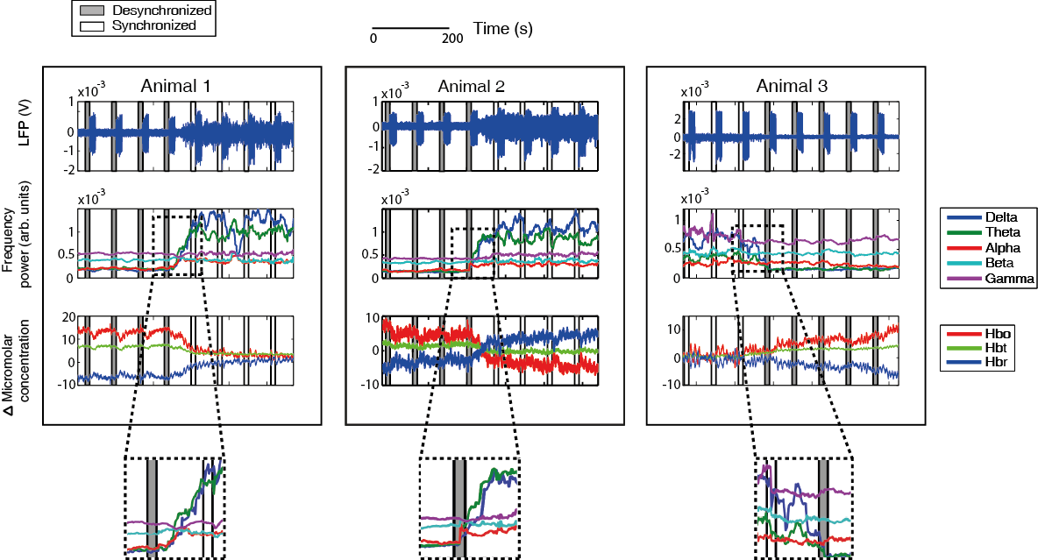
Figure 2: Cortical state classification of stimulus evoked trials, by the ABSC for concurrent neural and haemodynamic data from the motor cortex. Each exemplar animal was subject to 16s electrical stimulation of the left whisker pad at 5Hz frequency. Top LFP with pre-stimulus period, used by the ABSC, boxed and shaded areas denote the time period used for trial classification and are shaded in grey for desynchronised brain state and white for synchronised (repeated throughout figure). Middle Demonstrating the windowed frequency bands plotted continuously on the same time scale as the neural and haemodynamic data (above and below). Bottom Concurrent haemodynamic time series showing micromolar changes in Hbo, Hbr and Hbt from state-specific baseline levels. Insets indicate a close view of the changes in the frequency band power as the cortical state alters.

5.3.1 2D-OIS analysis from a representative animal
When all trials from an experiment are averaged together, less haemodynamic information can be found than when the trials are separated by state (see Fig. 3A-C which shows spatial analysis from a representative animal). The unclassified average Hbt response (Fig. 3A) is most similar to that of the synchronised state. This is evident in the time series response (Fig. 3B, bottom row) as well as the spatial analysis (Fig. 3, top row). However, the responses in the undivided average are smaller versions of the synchronised state, containing as they do, the reduced, or negative haemodynamic responses of the desynchronised state. For example, the initial peak seen in the synchronised time-series is higher than in the unclassified average for both whisker and motor region. After the initial peak in the timeseries, a plateau is seen in all three states (approximately 12s onwards). Interestingly the profile and amplitude of the plateau is similar in the whisker region. In the motor region however, the plateau has almost disappeared in the unclassified average, compared to the synchronised average. When comparing the desynchronised case (Fig. 3C) to the other two cases, large differences are clearly observable. The spatial extent and magnitude of the haemodynamic response in the whisker region is much smaller in the desynchronised state compared to the synchronised. The whisker time-series shows no initial peak, instead demonstrating a slight rise to a steady plateau. This information corroborates that seen in Slack et al. (2016) which investigated the haemodynamic effects of state changes in the whisker somatosensory region. However, the previously unreported effects of state change on the motor region of cortex are even more dramatic, showing an inversion of response, with a negative Hbt response seen both spatially, and as an extracted time-series for the desynchronised state trials. This negative haemodynamic response contrasts sharply with the positive seen in the undivided or synchronised trials. The combination of this negative response, combined with the positive from the synchronised trials gives rise to the almost negligible response seen in the unclassified average.
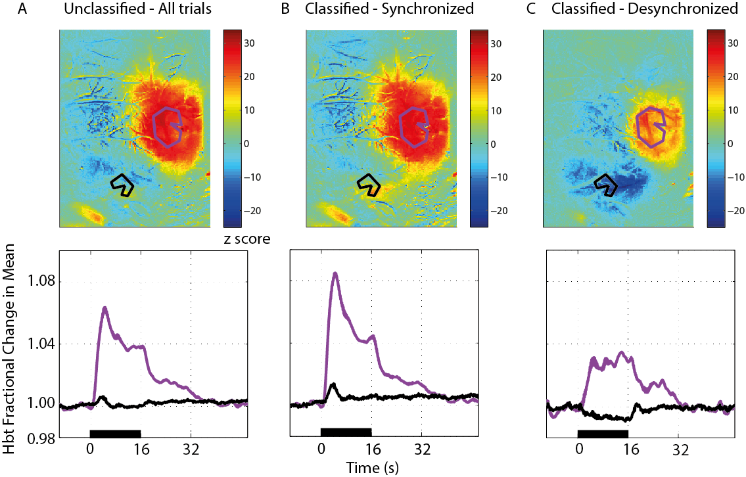
Figure 3: Changes in Hbt from 2D-OIS spatial analysis from an example animal. Whisker regions are given in purple and motor in a solid line. Below each spatial region is a time-series of the averaged trials included in the spatial image. A Undivided averaged responses from all trials. B Average responses from all stimulation trials classified in the synchronised brain state (n=18, (trials)). C Average responses from all stimulation trials classified in the desynchronised brain state (n=12, (trials)).

5.3.2 Comparison with standard averaging of all evoked trials, without accounting for state
To understand how state classification can reveal important additional information in both the neural and haemodynamic signals, all animals and all trials were selectively averaged according to state and compared to the unclassified average (Fig. 4). The profiles of unclassified, synchronised and desynchronised average peak amplitude LFP impulse responses in the motor cortex to 16s electrical stimulation of the left whisker pad differ in their general shape (see Fig. 4A-C). The synchronised neural responses (Fig. 4B) show greatest magnitude initially, before dropping to a steady plateau (an inverted peak and plateau shape), whilst the desynchronised responses increase in magnitude steadily before also forming a plateau. As with the previous analysis from a single animal (Fig. 3), it can clearly be seen that the unclassified average neural response resembles that of the average synchronised response. The coupling between LFP and vascular responses is noticeable in the synchronised and unclassified averages as both display a positive peak and plateau Hbo and Hbt response and an inverted peak and plateau Hbr response. However, in the desynchronised response although the LFP shows a rise to a plateau following the onset of stimulation, the vascular responses do not mimic the profile of the peak amplitudes of the LFP responses to the stimulus train. Instead a rise to a plateau is seen in the Hbr response with a fall to plateau in the Hbt and Hbo responses – a negative haemodynamic response is seen during positive LFPs. Thus, an inversion of the haemodynamic response can be seen between the synchronised and desynchronised states. The haemodynamic difference between the states was tested for significance for all measures using three paired t tests, and p values were Bonferroni corrected (p values were multiplied by 3) for multiple comparisons in each case (see Fig. 4D). The haemodynamic average during the period of stimulation (0-16s) was significantly different between the synchronised and desynchronised states for Hbo (corrected p = 0.0048), Hbt (corrected p = 0.0045) and Hbr (corrected p = 0.0069).
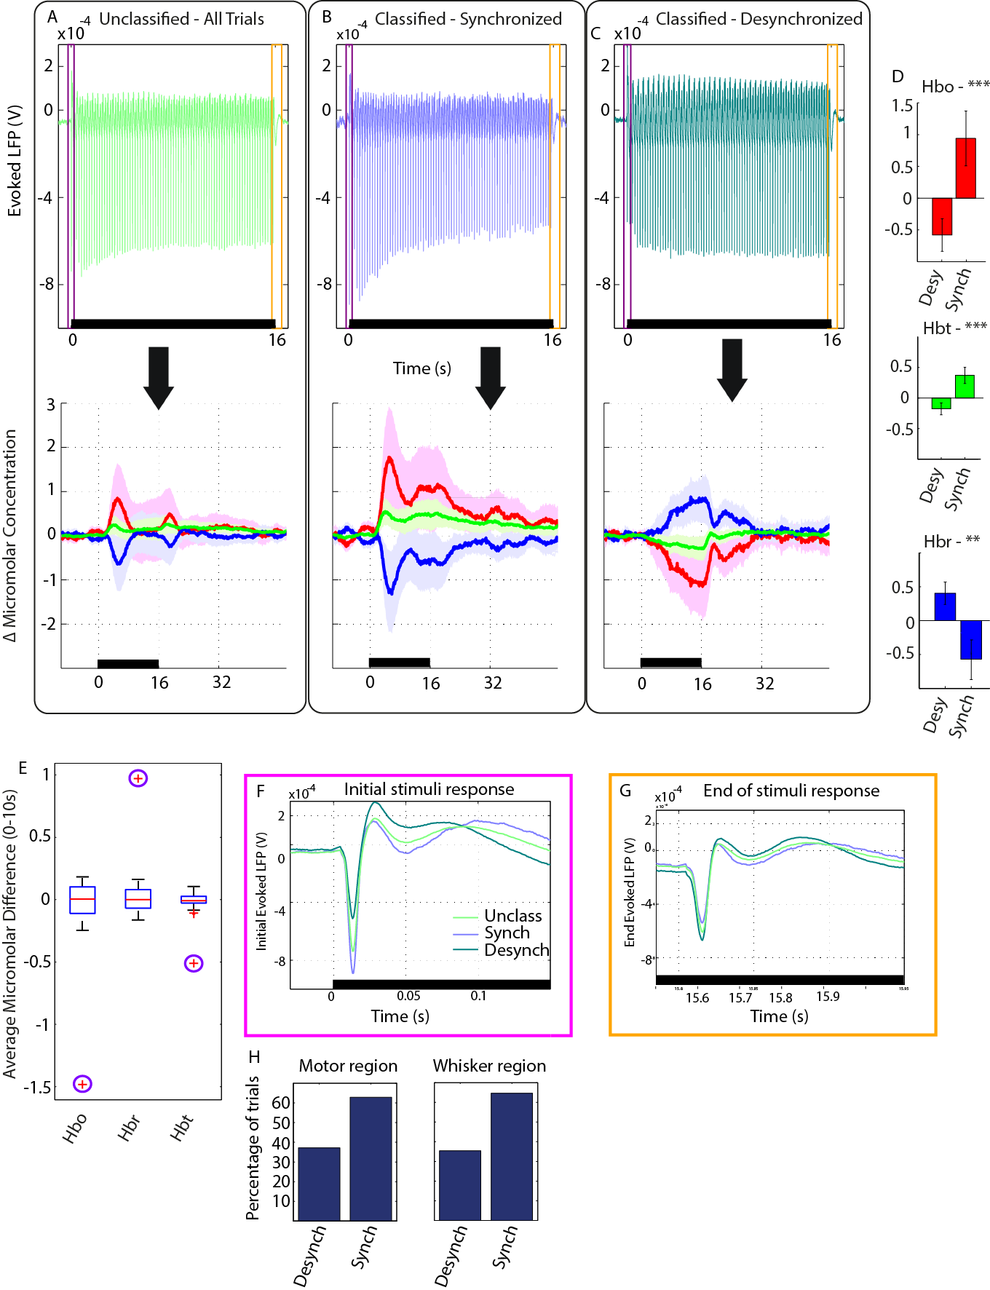
Figure 4: State classification of data recorded from the motor cortex. Neural and haemodynamic signals were collected for trials where a 16s 5Hz electrical stimulation was applied to the whisker pad. A Unclassified averaged responses from all trials and animals (LFP neural activity top left and haemodynamics bottom left). Error patches on the haemodynamic figures show 1 unit of standard deviation for each time series. B As in A, however averages are from stimulation trials classified in the synchronised brain state, averaged across all subjects. C As in A, however averages responses from stimulation trials classified in the desynchronised brain state. D Average micromolar changes in Hbt, Hbo and Hbr across all animals, with error bars showing standard error of the mean. E Control analysis, boxplot denoting variation in evoked haemodynamic averages from randomised trials taken from both synchronised and desynchronised time periods (Randomisation classifications were performed 50 times and ABSC classifications were included in plotted data – they are the red crosses surrounded by circles). For each state, the average micromolar difference between 0-10s for Hbt, Hbo and Hbt across all animals was found. Then the desynchronised average was subtracted from the synchronised. On each box, the central red line is the median, the edges of the box are the 25th and 75th percentiles, the whiskers extend to the most extreme data points not considered outliers, and outliers (defined by the MATLAB boxplot function) are plotted individually (red crosses ). F and G Enhanced view of neural signals recorded during the first and last impulse response to stimulation (F = first, G = last). Overlaid are averages of the unclassified trials, the synchronised trials and the desynchronised trials. Colours follow those in A, B and C. H Total trial split between the desynchronised and synchronised state across all 13 animals.

To further ensure that the observed haemodynamic differences were linked to the state classification, 50 control runs of haemodynamic averaging using the same number of trials in each state as indicated by the ABSC were computed, but with the trials themselves randomly assigned to the synchronised or desynchronised state (Fig. 4E). Averaging was performed within and then across animals, as in the ABSC trial sorting. The standard formula to determine outliers in this dataset of 51 averages (50 randomised classification and the classification by the ABSC) was used: 𝑥>𝑄3+1.5∗𝐼𝑄𝑅 𝑜𝑟 𝑥<𝑄1+1.5∗𝐼𝑄𝑅, where x is the average micromolar difference, IQR is the inter-quartile range and Q1 and Q3 are the 25th and 75th percentiles respectively. The ABSC averages were outliers in this data group, indicating that the effect seen in averaging the haemodynamic trials is reliant upon the ABSC as a method of state classification.
To asses to effects of cortical state on the motor region LFP the first and last neural responses to the stimulation train were investigated. The largest neural difference between the synchronised and desynchronised state can be seen in the initial depolarisation, with the largest response occurring in the synchronised state (Fig. 4F). The magnitude of the initial depolarisation decreased by approximately 50% from the synchronised (~-8x10⁻⁴) to the desynchronised state (~-4x10⁻⁴ )(see Fig. 4F for details). Interestingly, the post stimulus neural rebound was largest in the desynchronised state, although all three LFP timeseries displayed a rebound past LFP state-specific baseline levels. After approximately 100ms, the desynchronised and synchronised timeseries intersect, with the desynchronised dropping below state-specific baseline level. By the final stimulation pulse, all responses were of approximately equal size. Similarly to the initial pulse, the post stimulus neural rebound was largest in the desynchronised state and a similar intersection occurred again at 100ms. Total trial analysis for the motor cortex showed that approximately two thirds of trials were classified as synchronised (Fig. 4H), so the bias of the average unclassified result towards the synchronised state throughout Fig. 4 is expected. The whisker barrel cortex showed a similar split of classified trials indicating that the anaesthetic does not weight one region more heavily towards a synchronised state than the other (for further evidence that state is similar in both regions see example animals in Appendix Fig. A1, or see (Gervasoni et al., 2004) or (Cheng-yu et al., 2009).

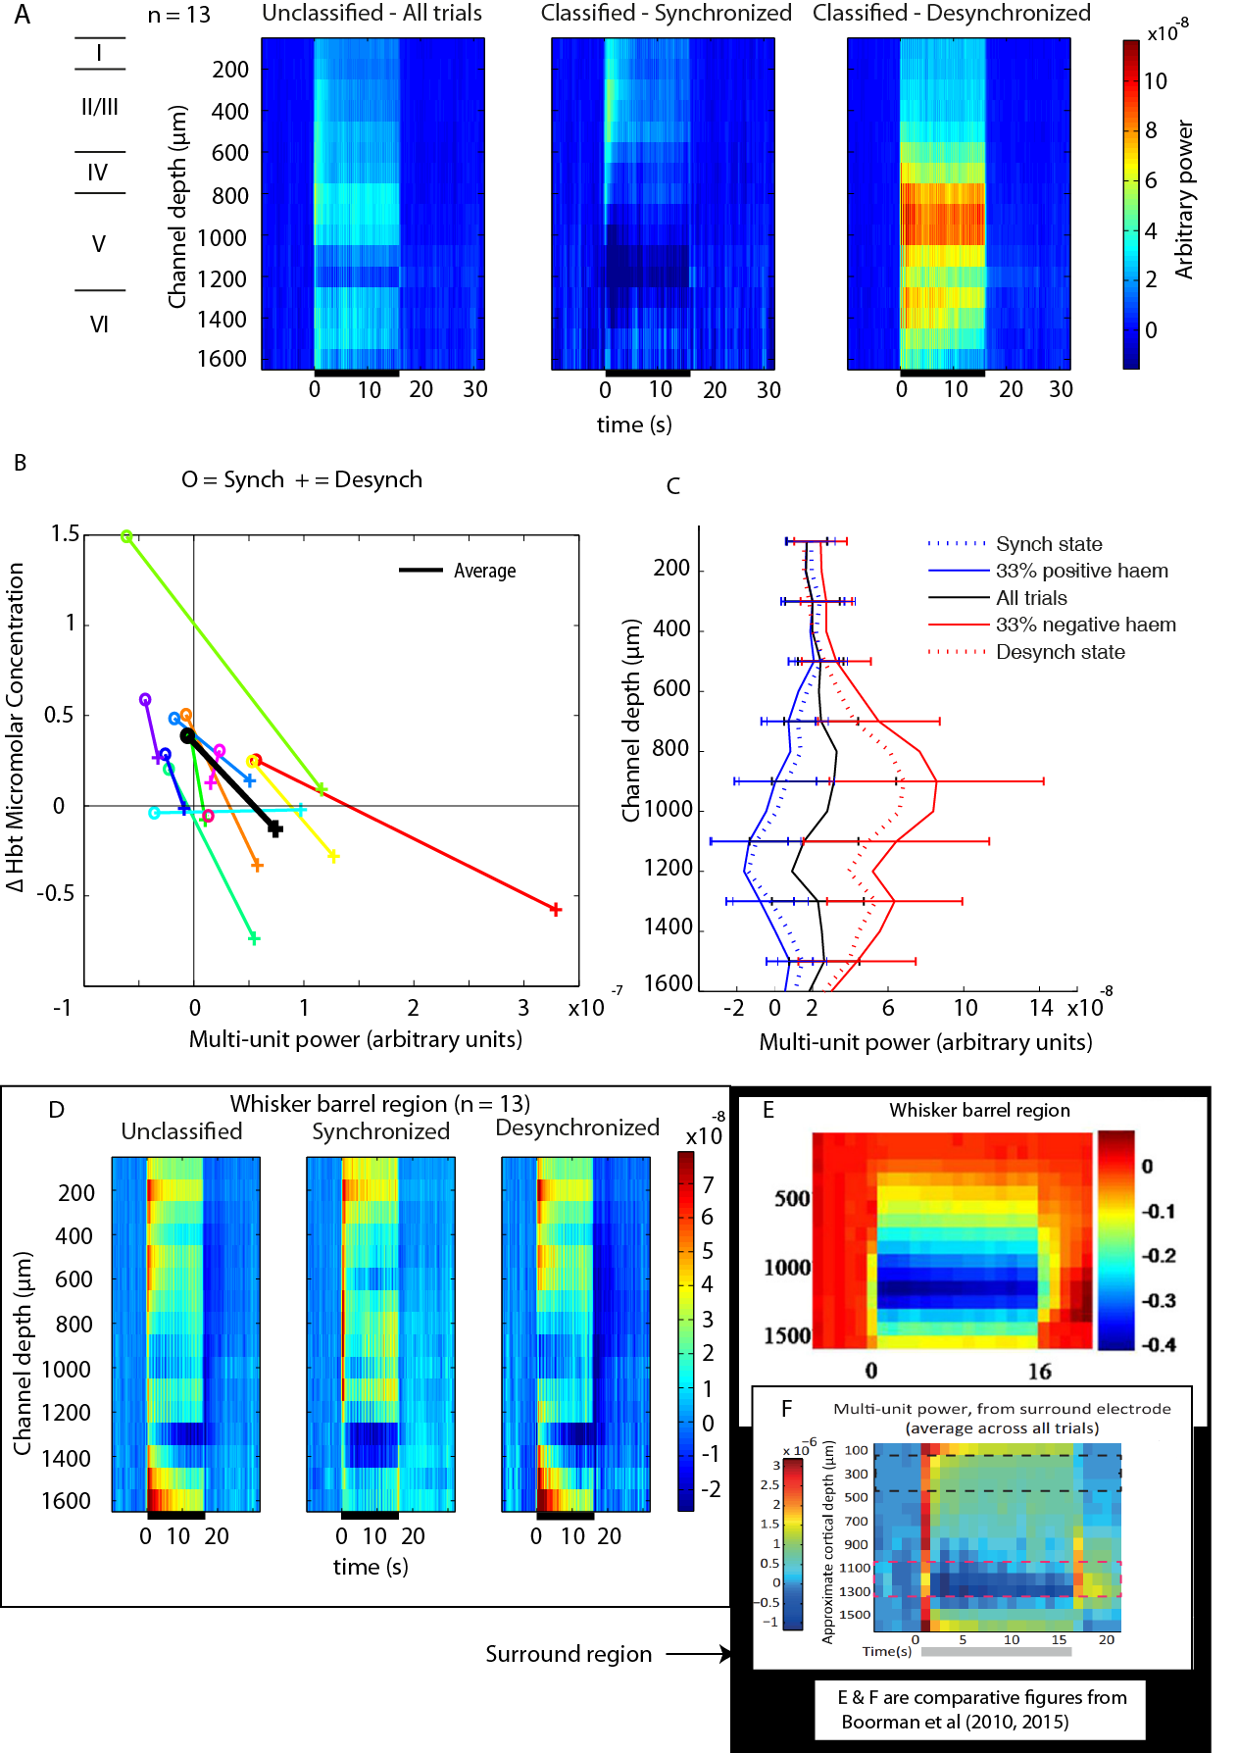
Figure 5: Multiunit power during different cortical states. Multiunit (300-3000 Hz) power analysis of neural activity recorded during16s 5Hz whisker stimulation, with -5 to 45ms after each stimulus impulse removed (n = 13). A Multiunit power recorded from the motor cortex. Left: the average response from all animals and trials. Middle: The average response from trials designated as synchronised by the ABSC. Right: The average response from ABSC classified desynchronised trials. B Average Hbt responses over 16s plotted against average multiunit power over 16s from the motor region. C Depth profiles showing average multiunit response when trials are sorted by: synchronised and desynchronised states and, when they are sorted by the 33% most negative and 33% most positive haemodynamic responses (Hbt averaged over 0-16s) and the average of all unsorted trials. D Multiunit power simultaneously recorded from the whisker barrel cortex. Left, Middle and Right as in A. E Multiunit responses from whisker barrel cortex from a different cohort of animals, figure from Boorman et al. (2010). F Multiunit responses from surround cortex from an alternative cohort of animals, figure from Boorman et al. (2015).

5.3.3 Cortical state and multiunit power
Having established that the polarity of stimulus evoked haemodynamic responses in the motor region can be dependent upon the state of the cortex, the next step was to investigate the spiking activity present in the different cortical states. Multi-unit activity (300-3000Hz) was chosen as it has previously been linked to negative haemodynamic responses in rodent cortex (Boorman et al., 2010, Boorman et al., 2015). Layer information for the motor cortex was taken from (Skoglund et al., 1997).
Averaged unclassified neural recordings from the motor cortex showed slight increases in multiunit power from state-specific baseline normalized measures across all cortical layers (Fig. 5A). In the synchronised state, neural responses were similar in the upper layers to those seen for the unclassified trials, but showed a decrease relative to the state-specific baseline in layer V. This contrasts further with the desynchronised state which showed an increase in layer V. In layer VI increases were found for all classified and unclassified averages, but were strongest in the desynchronised trial average.
These increases in multiunit activity in layer V in the desynchronised state occurred when a negative haemodynamic response was observed. Interestingly, whilst the LFP shows minimal cortical state differences in response magnitude and shape during the latter part of the stimulation (~12s onwards Fig. 4 B-C), this is not the case with the multiunit responses. Clear state differences in responses are seen for the complete duration of the stimulation. To further elucidate the relationship between the cortical states and the haemodynamic responses average MUA power between 0 and 16s was plotted against average change in Hbt (ACH) between 0 and 16s for each individual animal and in each state (Fig. 5B). In almost every case, MUA power increased when transitioning from the synchronised to desynchronised state and ACH decreased. However, not every animal produced a negative response when changing state. Therefore, an overall reduction in ACH can be seen, but one that is indicative of a decrease relative to the micromolar level during the synchronised state, rather than one which consistently generates a negative haemodynamic response. This relative decrease was consistently paired with an increase in firing in layer V, as seen in the moderate negative correlation between the decrease in Hbt (synchronised to desynchronised averaged between 0 and 16s) and the increase in MUA firing (synch to desynch averaged between 0 and 16s) r = -.051, p = 0.011 (a non-significant correlation).
Sorting the neural data according to the magnitude of the concurrently recorded haemodynamic responses showed that trials with the most negative responses had the highest MUA power (Fig. 5C). The MUA power depth profile for the most negative haemodynamic responses formed a similar depth profile to that created for the average ABSC desynchronised classification. Correspondingly, the trials with the most positive haemodynamic responses had the lowest, or most negative MUA power. This followed the MUA power depth profile for the ABSC synchronised classification closely. A mixed ANOVA was performed to look for statistical effects of brain state (synchronised or desynchronised), laminar depth (deep (channels 8-12, approx. layer V) and shallow (1-5, approx. layer I and II/III)) and classification method (haemodynamic classification of the neural or ABSC classification of the neural). Results indicated there was no main effect of the classification type used ( F(1,23) = 0.56; p =0.462, Greenhouse-Geisser values used throughout as sphericity could not be assumed). Therefore sorting for state using the ABSC gives MUA power depth profiles that are extremely similar to those gained from sorting from the haemodynamics alone. The ANOVA also indicated there was no main effect of laminar depth when looking between deep and shallow layers (F(1,23) = 2.575; p=0.122) and no main interaction between laminar depth, brain state and classification method (F(1,23) = 0.951; p=0.340). However, there was a highly significant effect when looking at the interaction between laminar depth and brain state (F(1,23) = 12.44; p=0.002). This indicates again that the ABSC gives similar depth profiles to classifying by haemodynamics and also indicates that the different brain states give very different MUA responses in layer V of the cortex, rather than in layers I and II/III.

5.3.4 Laminar MUA profiles for the whisker barrel cortex
Whilst state classified averages of neural and haemodynamic responses to 16s 5Hz stimulation have been previously been published for the whisker barrel cortex (Slack et al., 2016), no such investigations into MUA power have been recorded for the motor cortex during whisker stimulation. To compare results from the whisker somatosensory cortex with those from the motor cortex, the MUA power analysis (again using the data during the stimulation but with -5 to 45ms after each stimulus impulse removed) was repeated for the whisker barrel cortex (concurrent neural and haemodynamic recordings were also collected for this region). Responses did not show the large state variation that was observed for the motor cortex (Fig. 5D). Unlike the motor cortex, the main stimulus evoked differences in MUA were in layer VI, where a large increase in MUA power was seen in the desynchronised state, whilst the synchronised state displayed a smaller increase. Post-stimulation, a large decrease in MUA power can be seen between 400-900μm below the cortical surface in the desynchronised state.

5.3.5 Robustness of results over different data sets and brain regions
To assess the robustness of the observed changes in MUA, the unclassified neural and haemodynamic changes recoded here from the whisker barrel region were compared to previously published dataset. The data were also recorded from the whisker barrel region and used similar analysis (Fig. 5E taken from (Boorman et al., 2010)). A similar pattern of neural activity is seen with greater MUA in the upper layers and less activity around the deeper cortical layers (approximately 1000μm - 1300μm), before a return to high activity in the deepest recorded cortical layers (approximately 1300μm - 1600μm). Although there are differences between the datasets (Fig. 5E and Fig. 5D Unclassified), it should be noted that the previous data analysis used a longer window (1s) and did not exclude the immediate period encompassing the main stimulus evoked LFP response. Given the large degree of similarity, it seems the MUA power response in the whisker region may be stable across different datasets. Previous research (Boorman et al., 2015) found a negative haemodynamic response in surround cortex and noted that this was accompanied by a decrease in multiunit power in the deeper cortical layers 1050-1350μm below the surface. The analysis for the surround region in their 2015 paper was very similar to the analysis in this Chapter (Fig. 5A and D), with the immediate period encompassing the main stimulus response excluded in their work also. However, their results from surround cortex contrast with the results found here in the motor cortex suggesting that MUA power responses to a negative haemodynamic may not be stable for different cortical regions.
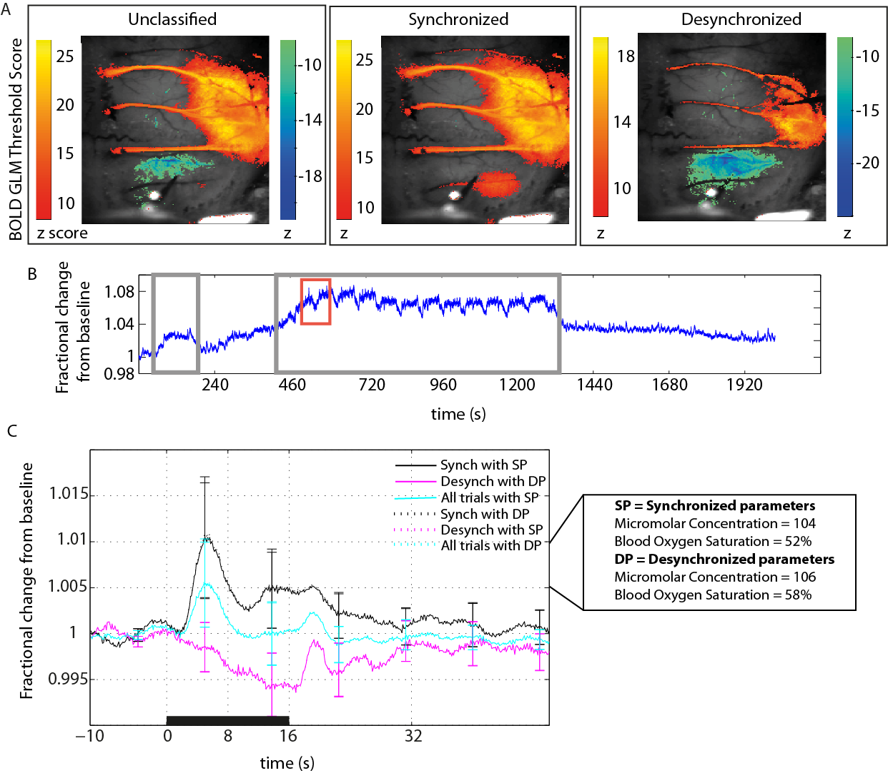
Figure 6: Predicted 7T BOLD responses. A and B show example animal which differs from that used in Figure 3. A GLM spatial maps for example animal. All spatial maps were thresholded at Z score ±8.4. The synchronised average BOLD response did not have any negative pixels and therefore no colourbar is included. Total trials = 30, synchronised trials = 14, desynchronised trials = 16. B Continuous predicted 7T BOLD timeseries for example animal, showing responses to all trials. Desynchronised trials are outlined in grey boxes. Example of negative haemodynamic response to 16s stimulation marked in red box. C Predicted BOLD in unclassified, desynchronised and synchronised cortical states, average of all subjects (n=13). BOLD was predicted using two sets of parameters. The standard parameters reflecting the assumptions for a synchronised state (SP) and altered parameters reflecting state-specific baseline conditions in a desynchronised state (DP). Parameters taken from Slack et al. 2016.

5.3.6 Predicted BOLD analysis
To enable interpretation of the findings presented here, in terms of the commonly used neuroimaging technique BOLD fMRI, a previously validated predictive model was used to translate the 2D-OIS signals into BOLD signals (Martindale et al., 2008). This model has also been validated for the investigation of the negative BOLD signal using 2D-OIS techniques (Kennerley et al., 2012b). An example animal displaying thresholded levels (z–score threshold set at ±8.4) of the predicted BOLD signal overlaid on the corresponding image of the cortical surface shows a negative BOLD signal is predicted in the motor cortex in the desynchronised state (Fig. 6A). In the same animal and region, a positive BOLD signal is predicted in the synchronised state to an identical stimulus. BOLD timeseries were predicted from haemodynamic timeseries extracted for each animal above.
An example continuous predicted BOLD timeseries is given (Fig. 6B), for all stimulation trials recorded in an experimental run. Fluctuations in the state-specific baseline level of the predicted BOLD were found to occur throughout the timeseries, with the highest levels of state-specific baseline BOLD change occurring in the desynchronised state (marked in Fig. 6B with grey box). During the second desynchronised period, the trial responses to a long-duration 16s stimulation cause a drop in BOLD below the trial state-specific baseline which would create negative BOLD responses. An example of such a trial is outlined in a red box in Fig. 6B.
The average state split response followed the previous 2D-OIS findings and showed a positive BOLD signal predicted in the synchronised state and a negative BOLD predicted in the desynchronised state for the motor region (Fig 6C). The unclassified average again represented a reduced magnitude version of the synchronised response as expected from the earlier analysis of time spent in each state (Fig 4H). The haemodynamic parameters (micromolar concentration of 104 and blood oxygen saturation of 53%) used for creating the predicted BOLD timeseries were those from the synchronised state-specific baseline state (Slack et al., 2016). To investigate if using the parameters matched to the desynchronised state-specific baseline state had an effect, the timeseries was re-created with those parameters (Fig 6C). There was no discernible difference between the timeseries indicating that the separation of trials by state is of greater importance than altering the analysis parameters to reflect the state-specific baseline changes in different states.

5.4 Discussion
The physiological basis of the negative BOLD signal is still widely debated, with some studies implicating a vascular steal mechanism (Harel et al., 2002, Kannurpatti et al., 2004, Hu et al., 2015) , and some pointing to neural inhibition as underpinning the phenomenon (Shmuel et al., 2006, Boorman et al., 2010, Yin et al., 2011, Boorman et al., 2015, Ma et al., 2016). This research used a spectral frequency ratio-based coding of neural data to classify cortical state. The results of the classification indicated that the polarity of average evoked haemodynamic responses to a long duration were found to be dependent on cortical state (either synchronised or desynchronised) ascertained from the ongoing local field potentials (LFPs).

5.4.1 Inversion of a haemodynamic response to a long duration 16s stimulation can be observed in motor cortex after classification by cortical state
A negative haemodynamic response to an electrical whisker pad stimulus was seen in the motor cortex during the desynchronised cortical state. In contrast, during a synchronised cortical state, a positive haemodynamic response occurred in the same region, to an identical stimulus. The separation of these haemodynamic responses was achieved by trial sorting based on cortical state classification from state-specific baseline neural data. This method could potentially allow a greater understanding of BOLD as some negative BOLD signals may only be observed in particular brain states. Grouping together responses from different states might mask the presence of a negative BOLD response to a stimulation (given that it is typically of a smaller magnitude than a positive BOLD response). When comparing the LFP responses to the stimulus train across both cortical states, the state-specific deflections were of similar profile to those seen in Chapter 4 (or in Slack et al. (2016)). Of interest, the first deflections of the LFP response to the stimulus train associated with the NHR were of reduced amplitude compared to those in the LFP when a positive haemodynamic response was observed, potentially implying that neural inhibition is stronger in this state. This was also the case in Chapter 4 (where this experiment was conducted in the whisker barrel somatosensory cortex), however in the desynchronised state in Chapter 4 the haemodynamic responses were positive in both brain states. Therefore the profile of the LFP alone cannot explain the alteration in polarity of the haemodynamic response.

5.4.2 Negative haemodynamic responses are associated with an increase in MUA activity in layer V of the motor cortex
To further investigate the alteration in polarity of the haemodynamic response, MUA analysis of the electrophysiology signal was conducted. This revealed that although a negative haemodynamic response was observed in the desynchronised state, positive MUA relative to state-specific baseline levels were recorded. This MUA analysis came from the intervals between the LFP deflections to individual pulses in the stimulus train as multi-unit responses saturated during the stimulus responses themselves. The strongest MUA responses during the desynchronised brain state were observed in layer V. Conversely, in the synchronised condition where positive haemodynamic responses were observed, the MUA in the same layer in this condition showed a decrease from state-specific baseline levels. This work is not the first to find that both LFP and MUA increases occurred in conjunction with a NHR, although to my knowledge it is the first to link such findings to a change in cortical state. Devor et al. (2008) previously linked a negative haemodynamic response to an electrical stimulation of the forepaw with an increase in spiking and glucose consumption (although this occurred in the ipsilateral cortex to the forepaw stimulation). Mishra et al. (2011) also found increases in LFP and MUA (relative to state-specific baseline) co-occurring with a NHR in the caudate-putamen of rats and suggested that strong striatal inhibitory interneuron activity might be responsible. Others have also observed negative haemodynamic responses linked to increases in neural activity (Choi et al., 2006, Shih et al., 2009).
Importantly, the link between positive MUA power in the desynchronised state versus negative MUA power in the synchronised state seen in layer V (Fig. 5) could point to a state-dependent activation/deactivation of a specific set of cells. Indeed, responses of cells in neocortex have previously been shown to be state specific (Sakata, 2016). Therefore GABAergic cells could be more active in the desynchronised state rather than the synchronised state as the subthreshold dynamics of most cortical cells have been shown to alter with state transitions (Haider and McCormick, 2009, Zagha and McCormick, 2014), including interneurons .

5.4.3 Surround inhibition could assist motor representations in layer V motor cortex
It has been suggested previously, that the desynchronised state represents similar cortical dynamics to those found in the awake, exploring rodent (Harris, 2011). The desynchronized state has been reported to have reduced neural firing, which some have speculated makes it easier to detect behaviourally relevant stimuli (Curto et al., 2009, Goard and Dan, 2009, Marguet and Harris, 2011, Zagha et al., 2013, Zagha and McCormick, 2014, Pachitariu et al., 2015) as spike patterns are more reliable and less susceptible to noise correlations, something which would be necessary in an awake exploratory state. The motor cortex has been found to have intracortical inhibition, which may project to nearby pyramidal neurons and supress any excitatory drive from surrounding representations, thus ensuring that only the region of the motor cortex associated with the representation is activated, and that the neighbouring areas are suppressed (Jacobs and Donoghue, 1991). Furthermore, it is known that stimulation of interneurons can cause arteriolar vasoconstriction both in sliced tissue (Cauli et al., 2004; Perrenoud et al., 2012) and by optogenetic manipulation of interneurons in-vivo (Uhlirova et al., 2016). Thus, it could be possible that the NHR observed in the desynchronised state could be the result of net inhibition in M1, where the haemodynamic effects from the positively affected whisker region of M1 are smaller than the negative haemodynamic effects arising from the inhibited neighbouring regions (see Fig. 7 for diagram). This would agree with previous work by Devor et al. (2008) who showed that vasoconstriction can dominate dilation in certain areas of cortex. The synchronised state is thought to represent a quiescent state in the rodent, in which movement is not expected (Crochet and Petersen, 2006, Poulet and Petersen, 2008). The general amplitude of firing is increased during this state as synchronous firing of cell activity is commonplace (Poulet et al., 2012, Zagha and McCormick, 2014) and precise decoding of relevant representations is less necessary (Goard and Dan, 2009, Marguet and Harris, 2011, Zagha et al., 2013). Following on from this, it could be that inhibitory interneurons would therefore be less active during this state as behavioural representations of movement are fewer, and less GABA may therefore reach the vasculature to cause constriction (Cauli et al., 2004, Perrenoud et al., 2012, Uhlirova et al., 2016). Therefore, the PHR observed in the synchronised state could be the summation of the positively affected whisker region of M1 and the positively affected neighbouring regions (that are not subject to the same degree of inhibitory activity observed in the desynchronised state). In both states, the electrode would record the positive LFP response in M1 from the affected whisker region, whilst the MUA power in M1 layer V could represent interneuron firing to inhibit surrounding areas. This explanation would fit with a previous study that found a negative relationship in the motor cortex between movement and the haemodynamic response within that activation spot (Riecker et al., 2003).
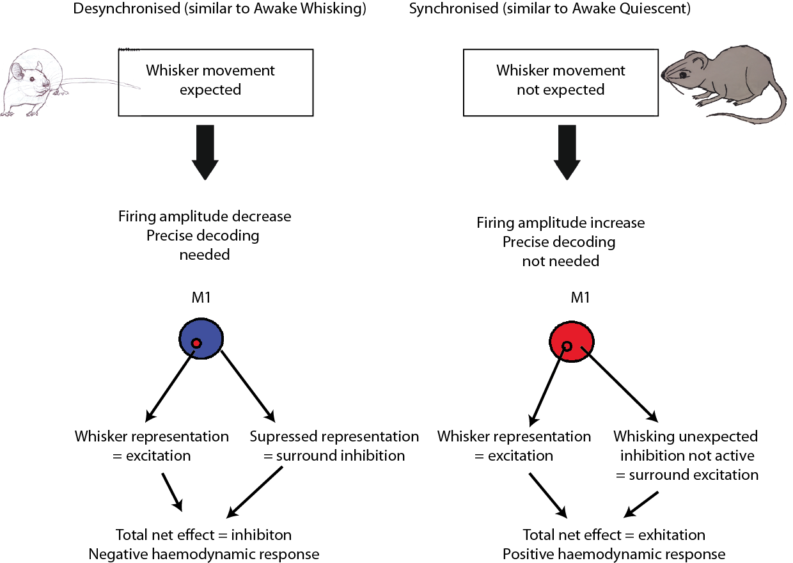
Figure 7: Illustrating a possible explanation for the opposite haemodynamic responses seen in each state. M1 is shown as a simple circle with a smaller circle within representing the affected whisker region. Blue colour is for neural inhibition and red is for neural excitation.

5.4.4 The role of the cholinergic system to modulate the haemodynamic correlates of the negative BOLD signal
An alternative explanation to that proposed above, could be that cholinergic modulation of the cortex facilitates somatostatin expressing interneurons (SOM interneurons). Acetylcholine (ACh) afferents from the basal forebrain innervate the cortex and can induce a desynchronised brain state (Metherate, Cox & Ash, 1992). ACh has been shown by Chen et al., (2015) to directly activate SOM neurons. These SOM interneurons are inhibitory and the negative haemodynamic response could be due to the inhibition of parvalbumin-expressing (PV) interneurons in the motor cortex, with the positive firing of the SOM interneurons accounting for the increase in neural activity from state-specific baseline (see Figure 8 for diagram). Kruglikov et al., (2008) showed that cholinergic agonists can inhibit PV interneurons. As PV interneurons in turn inhibit pyramidal neurons (Fino and Yuste, 2011, Pfeffer et al., 2013), the chain of events started by ACh from the forebrain could potentially result in excitatory activity facilitating motor movement by disinhibition pyramidal neurons. If, as previously stated, the desynchronised state is analogous to the awake active brain state, then disinhibition of pyramidal neurons could facilitate movement. In the synchronised state, the activation of SOM neurons may not occur, meaning that PV neurons continue to fire and the pyramidal cells are not disinhibited. Indeed, if the synchronised state is analogous to the quiescent state of an animal (Harris, 2011), then this hypothesis becomes behaviourally coherent as the animal would then remain stationary. Further elucidation of the key cell types involved in state mediated changes in the motor cortex that cause a resultant negative haemodynamic response will be an important piece of future research and would help to further resolve the mechanism by which the motor NHR may be generated.
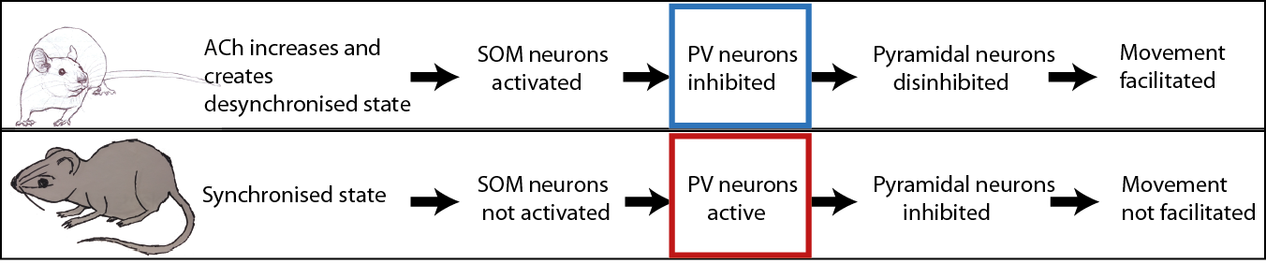
Figure 8: The possible chain of actions that could underlie the change in polarity seen in the haemodynamic responses in the different brain states. The negative haemodynamic in the desynchronised state could come from the neural inhibition of the PV neurons by SOMs (outlined in blue) and the positive haemodynamic seen in the synchronised state could occur when SOM neurons are not active, as then PV neurons would fire (outlined in red).

5.4.5 The use of urethane as a model to investigate desynchronised versus synchronised brain states
Again, as in previous chapters this present study used urethane as an anaesthetic to create conditions necessary for extended acquisition of invasive concurrent 2D-OIS and electrophysiology data during application of electrical stimulation to the rodent whisker pad. It must be acknowledged again that when compared to an awake model, an anaesthetised model could potentially disrupt neurovascular coupling mechanisms and provide a physiological confound. To review the physiological and neuroscience specific arguments that mean urethane is still a good choice for state investigations see sections 2.1.2.2, 3.5.2 or 4.2. Additionally, other studies exist that specifically used urethane to further state specific understanding in neuroscience: trial to trial variability in state specific network dynamics (Curto et al., 2009), cortical representations of specific stimuli (Marguet and Harris, 2011), state specific haemodynamics (Jones et al., 2008, Slack et al., 2016), and state specific plasticity (Contreras et al., 2013).

5.4.6 Cortical depth penetration with optical imaging
Imaging using OIS to detect haemodynamic changes is mainly thought to be informative about the upper layers of the cerebral cortex due to the restraints of light penetration (Tian et al., 2011; Hillman et al., 2007). Improvements have been made to the analysis of 2D-OIS since this cited evidence. Kennerley et al. (2009) have shown that by using a five layer heterogeneous tissue model that has been validated using 3D data from fMRI, it is possible to analyse 2D-OIS data and gain information about the deeper layers. They have also shown in a later paper (Kennerley et al., 2012b) that by using a heterogeneous tissue model 2D-OIS becomes a viable measurement technique with which to investigate negative BOLD signal. There much evidence to show that vascular responses to stimuli increase in parallel throughout the layers of a cortical column (for a full discussion see (Huo et al., 2014)). Briefly though, measurements of CBV with MRI have consistently found that increases that occur in surface vessels also occur in the deeper layers of the cortex (Jin and Kim, 2008, Hirano et al., 2011, Kim and Kim, 2011, Herman et al., 2013, Huber et al., 2014)

5.4.7 Conclusion
A negative haemodynamic response to a whisker stimulus was associated with positive MUA power when the motor cortex was in a desynchronised state. Conversely, when the motor cortex was in a synchronised state, a decrease in MUA power was observed. This haemodynamic response 'flip' may be related to specific cell types that are activated and deactivated during these states, and care should be taken when interpreting blood-based neuroimaging techniques such as BOLD fMRI in the motor cortex as the response could be dependent upon state network properties.

6 Discussion

Abstract
The research in this thesis addresses the concerns of a recent review (Lecrux and Hamel, 2016) which indicated very little is known about the reliability of neurovascular coupling across different brain states. Cognitive neuroscience (and other disciplines) rely heavily on neurovascular coupling based techniques such as fMRI, particularly for use with human imaging. Ultimately, such studies will generally utilise data in which brain function deviates from state-specific baseline conditions. Therefore, without a full understanding of how neurovascular coupling functions under alternate brain states, it becomes difficult to identify the reliability of such techniques. In this thesis a novel automatic brain state classifier was developed and tested using the whisker-to-barrel pathway in a urethane anaesthetised rodent as a model to investigate coupling in synchronised and desynchronised brain states. Neurovascular coupling was found to be robust in the whisker barrel cortex, despite state specific changes in the state-specific baseline and evoked haemodynamics. In contrast, the same coupling reliability was not observed for the motor cortex, which was investigated simultaneously. The motor region had an apparent inversion of coupling found in one of the brain states investigated. This research indicates that neurovascular coupling may be regionally specific, although further investigations are still necessary to ascertain the contributions of factors, other than region; such as stimulus type and duration, anaesthesia and/or species type used.

6.1 The development of a new automatic classifier
The transmission and processing of sensory stimuli by the brain is not static and unchanging. Likewise, the resultant effect of such a stimulus is not always the same. Instead it is influenced by the particular underlying cortical state that is taking place at the very moment that the stimulus is presented (Steriade et al., 2001, Castro-Alamancos,2004, Haider and McCormick,2014, Harris and Thiele, 2011, Zagha and McCormick, 2014). It is therefore useful to quickly and correctly identify brain state. Three popular types of classification methods were developed (Chapter 3) and tested using electrophysiology data recorded from a 16 channel laminar electrode placed in the rat whisker barrel cortex. Previous literature has generally used electromyography (EMG) or electrooculography (EMO) measures alongside a neural measure to classify state (Kohn et al., 1974, Benington et al., 1994, Stephenson et al., 2009, Gilmour et al., 2010). The methods developed here avoided using these additional measures in order to create a classification algorithm suitable for a wider variety of experimental set-ups. The successful classification method (developed in Chapter 3) was termed the Automatic Brain State Classifier (ABSC). This novel method used vector coding of relative spectral power to classify data into synchronised and desynchronised brain states. The new method performed better than the other methods to which it was compared, in this thesis.

6.1.1 The ABSC shows advantages over threshold classifiers
The ABSC showed a similar speed of classification to threshold classifiers (assessed in Chapter 3, an in-house theta and alpha band (TAFB , 5-15Hz) based classifier and one following the method found in Papanicolaou et al., 1986). One of the advantages of threshold classifiers is that they can be very fast and simplistic. However, the threshold classifiers were less accurate than the ABSC, particularly if brain state did not change during an experiment. Evidence from Chapter 3 points toa key weakness herebeing the need for a within subject comparison in order to make the classification. One reason why between subject comparisons are difficult could be the result of individual differences between subjects (Khazipov and Luhmann, 2006, Allene and Cossart, 2010). Therefore, it is important to classify state using a measure that is stable between subjects. Thus to optimise classficiation, threshold classifiers require a within-subject limit to partition the dataand so when this is internally calculated, they work best when there are equal splits of brain state in the data. This may not be a problem when assessing sleep data from healthy subjects, as sleep cycles tend to containsteady fluctuations in state, that follow a predefined pattern. However, an awake subject is unlikely to follow such steady patterns, nor is it certain that sleep would occur at regular time intervals, even in a healthy volunteer. It is already known that sleep cycles can change with disease (Asano et al., 2007), therefore even sleep patterns may struggle to be classified by a threshold classifier when health is compromised. The ABSC avoids this problem. Although the ABSC also uses a relative measure (a pattern matching system, based on the coding of ‘model’ vectors reflecting the relative frequency band powers in the LFP) as the basis for its classification proceedure, the measure appears to be stable over different datasets and brain regions. This stability was shown when the ABSC was able to accurately classify five different datasets using the same initalisation parameters: single-impulse stimuli (A0), ‘spontaneous’ (A1), brainstem stimulation data (A2) and 16s long-duration stimuli (A3) from the whisker barrel somatosensory cortex and 16s long-duration whisker stimuli from the motor cortex. The method of using model vectors was also shown to be stable, by assesing classfication accuracy when using several different initialisation datasets. Classification accuracy was high when using initialisation datasets that were small (~10%) and, large (~45%), when compared to the experimental dataset.

6.1.2 Strengths of the ABSC relative to clustering classifiers
Two clustering methods were used to comparatively assess the performance of the ABSC (an in-house clustering method based on k-means classification and a popular method by Gervasoni et al., (2004)). Although accuracy performance of the cluster based methods was good (77% in house clusterer, 66% Gervasoni clusterer), they struggled to classify small amounts of data. A key advantage of the ABSC is that it is successful at classifying very short (1s+) segments of data without needing recourse to a full timeseries, as cluster classifiers require. Each epoch of data that is classified by the ABSC can be set to be as little as a 1s window. In Chapter 4 it was shown that once the ABSC was initialised, the 1s windows of data could be used to classify an experimental trial, with no significant loss of accuracy, when compared to a substantially longer window (10s). The clustering methods were also less autonomous than the ABSC, as post-initialisation, the ABSC did not require further input. Both clustering methods required cluster assignment to state as well as additional initialisation. The Gervasoni method also took longer to classify the data, a typical problem with methods that are high in complexity.

6.1.3 Future potential investigations to optimise the utility of the ABSC
Although only used to classify synchronised and desynchronised states in this thesis, the ABSC has been designed to classify any number of brain states (not exceeding the permutations of the codings for the model vectors). Theoretically, the only barriers to adding additional states to classify, is finding high quality initialisation data showing inter-state variance within the frequency bands. Potentially, it would be simple to adapt the vector coding to take in additional relative measures such as EMG to delta power, or MUA power to alpha power also. I was able to adapt the ABSC to search for an additional, but infrequently seen third state that appears to be a substate within the synchronised data (see Fig. 1). This third state (called synchronised ‘state 1’) was rarely observed within the data collected for this thesis. It is characterised by square neural (for multiple presented stimuli, taking the peak deflection amplitude profile, Fig. 1B left) and haemodynamic response profiles, here the data do not show an initial peak, just a plateau response. Synchronised ‘state 2’ and the desynchronised states show the usual characteristic responses (Fig. 1B middle and right). As the synchronised ‘state 1’ response was rarely observed, a formal classification of this state is not included in this thesis, although the response is in itself of interest. It appears to be characterised by a relative drop in delta, and/or theta power, but without the normal separation of frequency bands that is seen in the desynchronised state. Synchronised states are often described in the literature as a cycle of ‘up’ states, where large network activity takes place and ‘down’ states, where network silence persists (Steriade et al., 2001, Curto et al., 2009, Marguet and Harris, 2011). Hypothetically, the two states seen in the synchronised data here could represent different speeds in the alternation of these ‘up’ and ‘down’ states. For example, synchronised ‘state 1’ could represent slow alternations between the ‘up’ and ‘down’ states and synchronised ‘state 2’ could represent fast alternations between the two sub-states. As ‘state 1’ is rarely observed in the data, further investigations into these synchronised sub-states would seem redundant at this time. A potentially far more useful line of enquiry would be to take the ABSC and use it to explore different awake/sleep cycles in unanaesthetised animal subjects. Furthermore, because the frequency bands used for the ABSC analysis are those typically employed when investigating human EEG data, it could be used to explore different brain states in these studies.
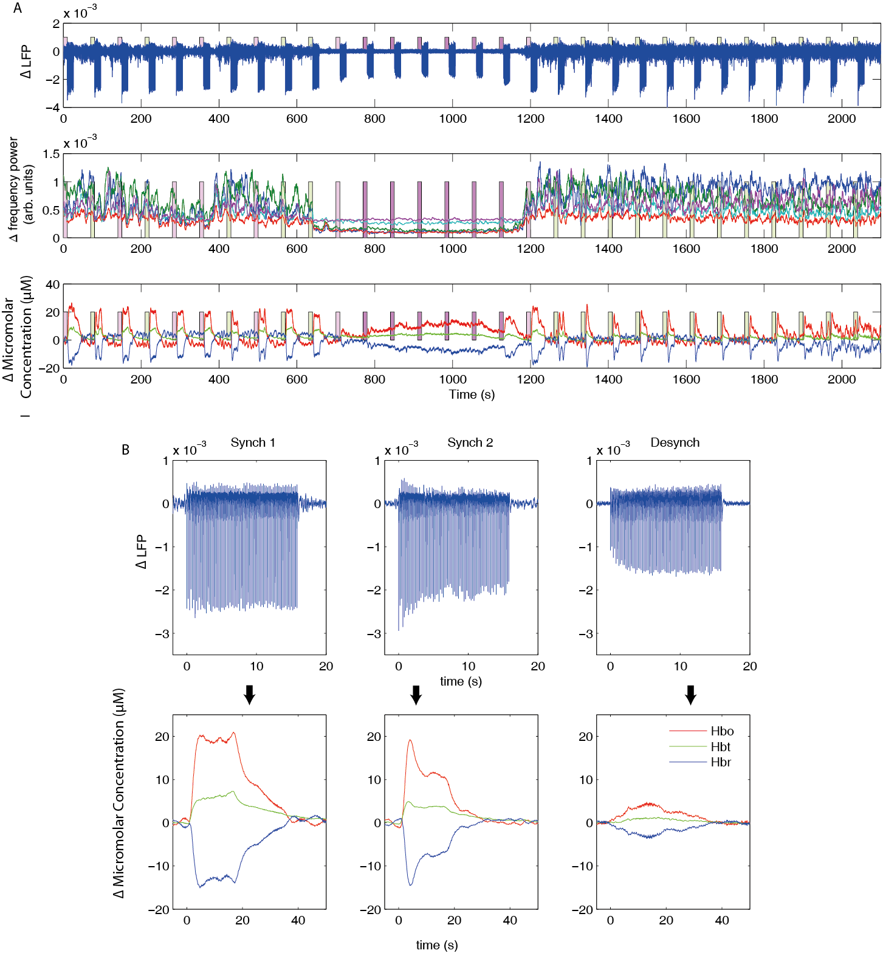
Figure 1: A demonstration of the ability of the ABSC to capture a possible third brain state in a representative animal. Long-duration electrical stimulations (16s) of the whisker pad were applied. Neural and haemodynamic responses were captured by recording simultaneous LFP and 2D-OIS from the whisker barrel somatosensory cortex. A State classification was made using 10s state-specific baseline neural data and coloured boxes showing the brain state of each trial are shown throughout. Pink boxes show synchronised state 1 trials, Green show synchronised state 2 and red show the desynchronised state. Top Continuous LFP recordings. Middle The frequency power for the classical EEG frequency bands Bottom The concurrent Hbt, Hbo and Hbr for the full timeseries of the experiment. B Segmentation of the trials shown in A by cortical state classification. Above Average LFP recordings for each state. Below Average Hbo, Hbt and Hbr recordings for each state.

Importantly, three qualities of the ABSC gives it the potential to classify brain state in real-time. Firstly, its initialisation parameters are stable over time and across different subjects. Secondly, the ABSC requires a small sample of the dataset to make a classification and finally, the ABSC classification is absolute, as it classifies on an automated point by point basis. The stability of the initialisation parameters was demonstrated by using the single animal initialisation data to classify a much older dataset (A2 in Chapter 3 or see Jones et al., (2008) where the state was actively changed by stimulating the brainstem. Further stability of the ABSC was shown by using initialisation datasets from an alternative single subject or a merge of subjects, and yet still achieved the high levels of classification accuracy. Therefore, whilst initial parameters may need to be set offline, future experiments could be classified in real-time. The small number of neural sampling points required to give high accuracy classification of experimental trials was demonstrated by the ABSC achieving similar levels of accuracy in single trial brain state prediction when using 10, 5 and 1 s as the time range of data given to the ABSC to classify. With accurate online classification, more understanding of the data in single trial experiments is possible as differences in the data from the brain state rather than the experimental manipulation are more likely to be identified.

6.2 Using the ABSC to classify coupled haemodynamics
In addition to the benefits that the ABSC displays as a neural brain state classifier, it also has a novel function. To my knowledge, it is the first automatic classifier that has been designed with the analysis and classification of concurrent haemodynamic data in mind, and the first to be validated on such data. Previous work has used the temporally deterministic beginning of a stimulation, such as a stimulation to the brainstem reticular formation to investigate haemodynamics associated with desynchronising the cortex (Jones et al., 2008). Results from Schei et al., (2009) have perhaps most closely approximated the current work as they performed optical studies in freely behaving animals and also had a simple EEG/EMG measure with which to score the data and classify the cortical state. However, their neural and haemodynamic data appeared to demonstrate low signal-to-noise ratios and they used only single-wavelength imaging, resulting in the inability to distinguish between Hbt, Hbo and Hbr, as has been done in this study. Similar to the work in this thesis, the authors found a significant difference in both neural and haemodynamics when alterations in state occurred, but concluded that “additional experiments with multiple wavelengths” were necessary to distinguish the fine detail in the state differences. With the incorporation of an automatic classifier, this thesis observed similar findings, and extended them. The results from Chapter 4 showed that the ABSC was able to successfully classify synchronised and desynchronised brain state data using a ratio-based frequency band signature and that this classification could subsequently be used on the four-wavelength 2D-OIS data to extract changes in Hbt, Hbo and Hbr.

6.2.1 Spontaneous and evoked haemodynamics

6.2.1.1 Primary somatosensory cortex: the whisker barrels
Previous work has found that alterations in global brain state can profoundly affect cerebral perfusion. Braun et al., (1997) found that typically desynchronised brain states such as wakefulness and the rapid-eye movement (REM) sleep state, showed significant baseline increases in regional CBF compared to a typically synchronised state - slow-wave sleep. The work in Chapter 4 complements the work of Braun et al., (1997) as it shows that under ‘spontaneous’ (no stimulation) conditions, the state-specific baseline levels of CBV and blood oxygen saturation are increased in the desynchronised state compared to the synchronised state. In addition to the work looking at haemodynamic changes under ‘spontaneous’ conditions, this thesis also investigated neural and haemodynamic responses to long duration stimuli. Although the state-specific baseline levels of Hbo, Hbt and Hbr increased during the desynchronised state, the magnitude of the evoked responses decreased. The evoked haemodynamic responses showed the greatest magnitude in the synchronised state, but both states showed positive haemodynamic responses. The profiles of the state specific responses to long-duration stimuli seen in Chapter 4 can offer an explanation for the peak-and-plateau vs rise-to-plateau debate. Some have found a peak-and-plateau response to a long-duration stimulation (Dunn et al., 2005, Berwick et al., 2008, Drew et al., 2011), whilst others have found that a rise-to-plateau response profile occurs (Mandeville et al., 1999, Logothetis et al., 2001). In this work, it is demonstrated that both profiles can be obtained to an identical long-duration (16s) stimulation in the whisker barrel somatosensory cortex, with the different haemodynamic profiles occurring when trials are classified according to state-specific baseline cortical state. The peak-and-plateau response is seen in the synchronised state and may therefore be expected in a subjects response to long duration stimuli during quiescent states or slow-wave sleep. In contrast, the rise-to-plateau response is seen in the desynchronised state and may therefore be expected to be found during REM or actively whisking (in rodents) states. Furthermore, the profile of the maximum amplitudes of the LFP neural deflections matched the corresponding positive haemodynamic profiles, showing a tightly coupled response.
Current work debates whether or not functional hyperaemia is necessary for the initial oxygenation of responding neurons with several studies implying that it is not (Powers et al., 1996, Lindauer et al., 2010). This work found an increase in state-specific baseline levels of blood oxygen saturation and total blood volume in the desynchronised brain state in the whisker barrel somatosensory region, but still found functional increases in Hbo, Hbr and Hbt in response to a long duration electrical stimulation of the whisker pad during the desynchronised state (Chapter 4). The fact that these functional increases persisted despite the increase in state-specific baseline oxygen saturation and total blood volume may add to evidence indicating that the functional response does not reflect an immediate oxygen need. The haemodynamic responses to the long duration stimuli also lasted longer than the neural responses, supporting the idea that functional hyperemia may occur to refuel the stores of nutrients that neurons and their associated support cells potentially hold (Brown and Ransom, 2007). This was also reinforced by the delay in the return to state-specific baseline post-stimulation in both states (even though state-specific baseline oxygen saturation and total blood volume were higher in the desynchronised state). Caution must be used in this interpretation of these results though, as the direct interpretation of functional hyperaemia is an increase in blood flow to an activated region. The experiments in this thesis did not measure the blood flow directly, instead recording blood volume and blood oxygen saturation. Additionally, although functional haemodynamic increases in Hbo and Hbt did still occur in the desynchronised state (where state-specific baseline levels of blood oxygen saturation and total blood volume were higher), the responses were reduced. Potentially then, although the increased levels of state-specific baseline saturation did not completely remove the need for functional hyperaemia, it could have reduced the magnitude of this requirement. Tissue oxygen measurements at the level of the mitochondria may well be important to determine the precise requirements of functional hyperaemia in the future.

6.2.1.1.1 The potential role of astrocytes in hyperaemia and cortical state
The mechanisms which cause changes in CBF underlying functional hyperaemia are still unknown. Recent work has implicated astrocytes in generating / regulating the later component of the haemodynamic response (Howarth, 2014). In Chapter 4, it is shown that a similar late plateau is reached in the haemodynamic measures in response to 16s stimulation in the whisker barrel somatosensory cortex in both states. If astrocytes are responsible for mediating late haemodynamic responses during long duration functional hyperaemia as suggested in a recent review review (Howarth, 2014), then the findings of this current work imply that they are likely to be similarly active in generating the later responses in both synchronised and desynchronised states. Indeed, in addition to their potential involvement in functional hyperaemia a recent paper (Poskanzer and Yuste, 2016) suggests that astrocytes may actually regulate cortical state switching. They used optogenetic stimulation to activate astrocytes in-vivo and found that this switched the brain state from desynchronised to synchronised. More work seems necessary to discover the role that astrocytes could play in modulating or mediating cortical state

6.2.1.2 The relationship between the frequency band powers and haemodynamic signals such as BOLD fMRI in the cortex
Previous work has found an anti-correlation between the resting state BOLD signal and the power of 8-13Hz alpha – when alpha increases, baseline BOLD decreases (Goldman et al., 2002, Laufs et al., 2006). This work agrees with this finding, as increases in state-specific baseline blood oxygen saturation and volume are seen in the desynchronised state in Chapter 3, where decreased state-specific baseline alpha power is usually found. However, reductions in other frequency bands such as delta are also seen in the desynchronised state, and large variations in the alpha frequency between states are not always seen (see Appendix, Fig. A4). Buzsaki (2012) proposed that the delta wave of the EEG signal is not the result of synaptic activity, but reflects a summation of long lasting after-hyperpolarisations of layer V pyramidal neurons. He further suggested that the suppression of delta waves during neocortical arousal is attributable mainly to blockade of this hyperpolarisation by cholinergic input. This blockade during neocortical arousal could be occurring in the desynchronised state classified in this thesis. Previous theoretical work (Kilner et al., 2005) has suggested that changes in the haemodynamic responses seen in signals such as BOLD are a reflection of relative, rather than absolute changes in frequencies. For example, Kilner’s theory would suggest that the BOLD signal would increase if a loss of power occurred in the alpha band relative to gamma band. Experimental work by Magri et al., (2012) has been shown to be compatible with this theory. They found that the BOLD signal correlated with the relative spectral profile of alpha and gamma, beyond what could be explained by the relationship between BOLD and a single frequency band, or the total LFP alone. The work in this thesis reinforces this theory, as state classification can be achieved from the encoding of relative spectral frequencies (Chapter 3), and that the classification of the concurrent state specific haemodynamics gives significantly different results (Chapter 4). Therefore, the relative power of alpha and gamma could be important to the haemodynamic response, as in Magri’s work it could serve as an index into the cortical state of the subject at the time.

6.2.1.3 Sensorimotor Integration
This thesis has examined responses in both primary somatosensory (S1) and primary motor cortices (M1) to evoked by electrical stimulation of the whisker pad. It has previously been suggested that the integration between these two regions is crucial in ensuring that the motor responses to the environment are updated directly (via a cortico-cortical pathway rather than the thalamus) with respect to changes that may occur in the sensory periphery(Hoffer et al., 2003). Therefore, feedforward (S1-M1) and feedback (M1-S1) connections are thought to exist (Chakrabarti and Alloway, 2006). The current literature regarding S1-M1 loops implies that neural activity would feed forward from the whisker region particularly to layers II/III and Va of the motor region (Hooks et al., 2011, Mao et al., 2011, Feldmeyer et al., 2013). These same layers are most likely to project back to layer V of the whisker barrel cortex. The work in this thesis did not specifically investigate these sensorimotor loops, however it is worth keeping the structure of these loops in mind as the results from investigations into the state specific neurovascular coupling in the motor cortex are explored. The structure of the whisker barrel somatosensory and motor cortices are broadly similar, with the exception of layer IV about which there is some debate (see section 1.2.3). The neurovascular coupling in the whisker barrel cortex has been detailed above (see 6.2.1.1) and the simultaneous coupling in the motor cortex that occurred will now be discussed.

6.2.1.4 The motor cortex and the negative BOLD signal
Positive and negative haemodynamic responses were observed during different trials in the motor cortex (Chapter 5), in the same animal and in response to the same type of stimulus. The mechanisms underlying the negative BOLD signal are still not fully understood (Hayes and Huxtable, 2012). The cortical state was found to be altered when the polarity of the haemodynamic response changed from negative to positive. Indeed, the inversion of the haemodynamic response in the motor cortex could be observed by trial-sorting the haemodynamics, based on the pre-stimulus baseline neural state. This has implications for the interpretation of the BOLD signal. If individual trial responses are not classified and grouped by cortical state, then the combination of all trial responses together might mask the presence of a BOLD response. This BOLD response would most likely be negative, given that it is typically of a smaller magnitude than the positive BOLD response, or that the positive trial responses combined with the negative trial responses might produce a net response that is negligible overall. Some previous literature has suggested that a decrease in the LFP is associated with a negative haemodynamic response (Shmuel et al., 2006, Boorman et al., 2010, Yin et al., 2011, Ma et al., 2016). When comparing the LFP responses to the 16s duration stimulation in the two states, a reduction in amplitude (compared to the synchronised state) is seen in the initial deflections in the desynchronised state. Previously, a decrease in the LFP responses to the long-duration stimulation in the different states were similar in both the whisker barrel somatosensory and the motor cortices (see Fig. 2). However, although haemodynamic responses were attenuated in the desynchronised state in the whisker region, responses were positive in both states. Therefore the decrease in profile of the LFP is unable to fully explain the inversion in the haemodynamic response in motor cortex. In fact, although it has been found that positive BOLD correlates more closely with LFP signals (representing perisynaptic activity, see section 1.1.2.2.2) than with MUA (Logothetis et al., 2001, Goense and Logothetis, 2008), studies investigating negative BOLD have suggested that it may be created through different mechanisms to positive BOLD (Goense et al., 2012, Mullinger et al., 2014).
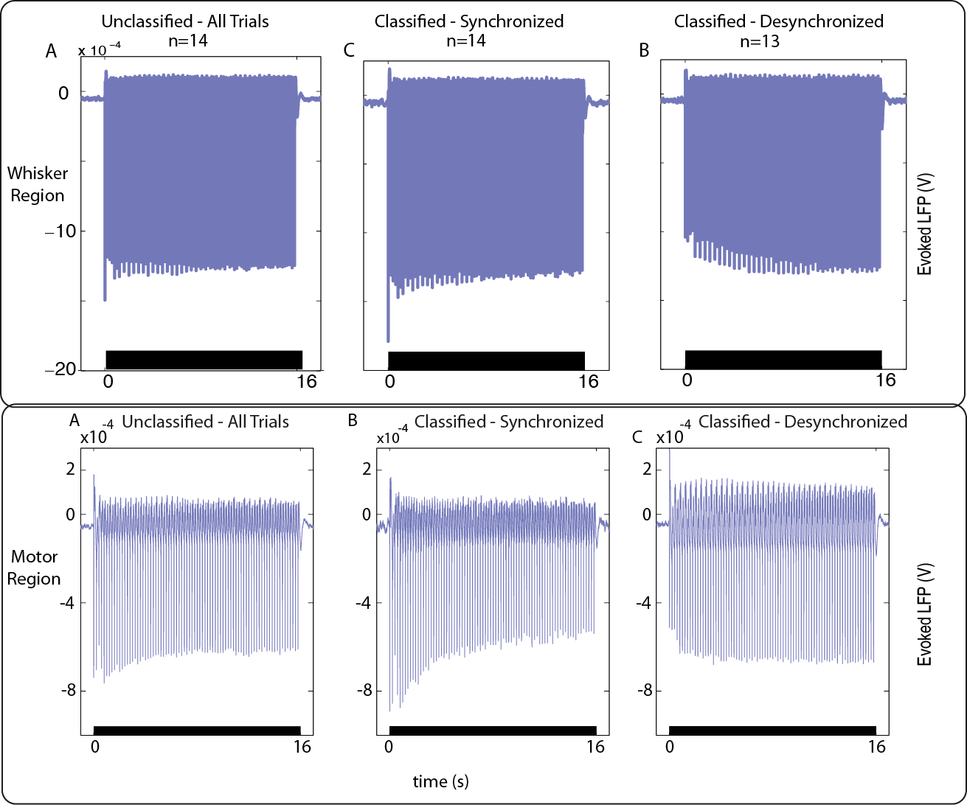
Figure 2: Comparison of state specific LFP trials from the whisker and motor region. Similar profiles can be seen for each state. Data taken from anaesthetised rodents from Chapters 4 and 5 and brought together for direct comparison.

6.2.2 What underlies negative BOLD?
The work in this thesis cautiously agrees with others that have found increases in neural activity associated with negative haemodynamic signals (Choi et al., 2006, Devor et al., 2008, Schridde et al., 2008, Shih et al., 2009, Mishra et al., 2011) . (Schridde et al., 2008) found increases in neuronal activity associated with a negative BOLD signal in the hippocampus, whilst Mishra et al., (2011) found increases in both LFP and MUA in the caudate putamen where decreases in the BOLD signal occurred.(Devor et al., 2008) found a blood flow decrease combined with vasoconstriction occurred despite an increase in 2-deoxyglucose intake. An increase in spiking was also seen in this study although this was measured during separate experiments, rather than simultaneously. Like these studies, when MUA analysis was undertaken in Chapter 5, an increase (thought to represent spiking activity) was seen in the desynchronised motor cortex along with negative haemodynamic responses. This increase was laminar specific, occurring in layer V. Interestingly, in their study Devor et al. (2008) reported that increases in spiking were greatest in the infragranular layers (V and VI). The study in Chapter 5 did not find this increase in layer V MUA when the motor cortex was in a synchronised state and positive haemodynamics were observed. A strong layer V increase in MUA was also not observed in any brain state in the whisker barrel cortex (where corresponding positive haemodynamic responses were observed in both states). As described earlier (see 1.2.3 or 6.2.1.3), the main projections from layer V in motor cortex terminate in somatosensory cortex, or in subcortical regions such as the striatum. The caudate putamen is part of the striatum and is where previous studies have also seen increases in neuronal activity accompanied by decreases in BOLD (Shih et al., 2009; Mishra et al., 2011). As a point to note, this MUA analysis came from the intervals between the LFP deflections to individual pulses in the stimulus train as multi-unit responses saturated during the stimulus responses themselves. Therefore it is possible that rather than seeing the responses of the primary excitatory cells in the motor cortex layer V (Betz cells), the MUA analysis represents the firing of local inhibitory interneurons (similarly, Mishra et al., (2011) suggest that the negative BOLD they see in the caudate putamen could be the result of striatal interneurons). If this is the case then the link between the desynchronised state and positive MUA power, versus negative MUA power in the synchronised state, could point to state specific alterations in firing of GABAergic interneurons in layer V of motor cortex. State specific firing of cells has already been shown, along with alterations to subthreshold dynamics, of nearly all cortical cells (Haider and McCormick, 2009 Zagha and McCormick, 2014, Sakata, 2016).

6.2.3 A model for evoked haemodynamic responses under synchronised and desynchronised states

6.2.3.1 What could urethane desynchronised and synchronised states represent?
Previously in Chapter 5 the comparison was drawn between the desynchronised brain state seen under urethane and the desynchronised brain state seen in the awake exploring rodent, and conversely the synchronised quiet/quiescent awake state and the synchronised brain state seen under urethane. These comparisons are made based on evidence from many studies (Fanselow and Nicolelis, 1999, Castro-Alamancos, 2004a, Harris and Thiele, 2011, Poulet et al., 2012). Others have noted clear similarities between brain sleep states such as the desynchronised rapid eye movement (REM) sleep and the desynchronised periods seen in urethane and within the same study, synchronisation seen in slow-wave sleep (SWS) and the synchronised periods seen under urethane (Clement et al., 2008). However, the inference is not that desynchronised brain states under urethane are the same as the desynchronised brain state in the awake exploring rodent or in REM sleep. Instead, it is theorised that perhaps the pairings might share similar cortical network dynamics. To put it simply, perhaps processing of stimuli during the brain state generated during awake exploring/REM sleep/urethane desynchronised is similar, as a similar system is generating each particular instance of desynchronised state. Most likely there will exist at least some variation between the different types of desynchronised state, but it is conjectured here that the variation between these different desynchronised states (and different synchronised states) will be minor compared to the differences between synchronised and desynchronised as a whole.

6.2.3.2 Potential interneuron activity during the desynchronised state
If the desynchronised urethane - awake behaving rodent, and the synchronised urethane – quiet awake state comparison is made, it could help to provide an explanatory model for some of the results seen in this thesis. One marker noted for the desynchronised state is the reduced levels of neural firing, which could make identification of behaviourally relevant stimuli easier (Curto et al., 2009, Goard and Dan., 2009, Marguet and Harris, 2011, Zagha et al., 2013, Zagha and McCormick, 2014, Pachitariu et al., 2015). Spike patterns under such conditions are more reliable with a higher signal-to-noise ratio, which would be of benefit in the awake exploratory state where whisker movements are more likely. Under such circumstances, clear representation in the somatosensory and motor cortex of whisker representations would seem necessary. Indeed in the motor cortex, it has been shown that inhibition occurs in the areas that are not to do with the representation itself (Jacobs and Donoghue, 1991). In the quiet state it is likely by definition that no exploratory movements are expected to be generated by the animal itself. If an external movement occurred, this would likely put the animal out of a quiet state and into an exploratory state. However, under anaesthesia, this does not occur and the animal remains in the synchronised state during the long duration whisker stimulation that is applied. In the two regions, the same mechanisms could drive the different haemodynamic effects seen. In M1 during the desynchronised state, secondary excitation of the whisker representation is likely to occur. This potentially comes from S1 and the thalamus (see sensorimotor integration 6.2.1.3 or 1.2.3). However, this could be surrounded by the inhibition generated by interneurons firing to create suppression (which could be represented by the increased MUA power seen in layer V) in the regions representing other areas such as forepaw or hindpaw. Overall, this would create a net inhibition response, which could be driving arteriolar vasoconstriction (Cauli et al., 2004; Perrenoud et al., 2012; Uhlirova et al., 2016) and giving the observed negative haemodynamic response (see Fig. 3). Supporting this theory is evidence from Devor et al. (2008) who showed that it is possible for vasoconstriction to dominate dilation. Work from (Ma et al., 2016) also supports this theory as they showed that both neuronal inhibition and excitation together could coexist in a negative hemodynamic response region. In S1, the excitation of the whisker representation is likely to be far stronger as a sensory stimulation is being applied. Thus, even if interneurons again created inhibition in the surrounding regions, it is likely that the summation of this would cause the observed reduction in the positive haemodynamic response seen in S1, and not a negative haemodynamic response. The functional inhibition of cortical areas that are not represented by the stimulus may however create negative surround haemodynamic responses such as those seen in (Boorman et al., 2010) where negative haemodynamic responses occur in cortical regions surrounding the whisker barrel cortex and is in agreement with previous work (Kastrup et al., 2008) which suggests that ipsilateral negative BOLD to a contralateral stimulus reflects functional inhibition in the somatosensory cortex.

6.2.3.3 Potential interneuron activity during the synchronised state
As mentioned earlier, previous work has suggested that the synchronised state resembles the awake quiet or quiescent state (Crochet and Petersen, 2006, Poulet and Petersen, 2008) during which movements would not be expected to occur. Firing generally occurs in synchrony, creating a larger amplitude baseline (Poulet et al., 2012, Zagha and McCormick, 2014) from which precise representations are harder to decode (Goard and Dan, 2009, Marguet and Harris, 2011, Zagha et al., 2013). As precise whisker movements are unlikely to occur however, this would not be a problem. Within the paradigm used in this thesis, whiskers are still stimulated during this state. Potentially, the inhibition is less active in this state and an excitatory response from the whisker representation and from the surrounding representations occurs, creating a strong positive haemodynamic response (see Fig. 3). Although this response would be stronger in the primary somatosensory region, S1, the same excitation could occur to a lesser degree in M1. In both regions and both states the electrode would record the depolarised train of responses to the stimulation of the whiskers, whilst the haemodynamics may represent the summation of responses at the electrode and surrounding areas.

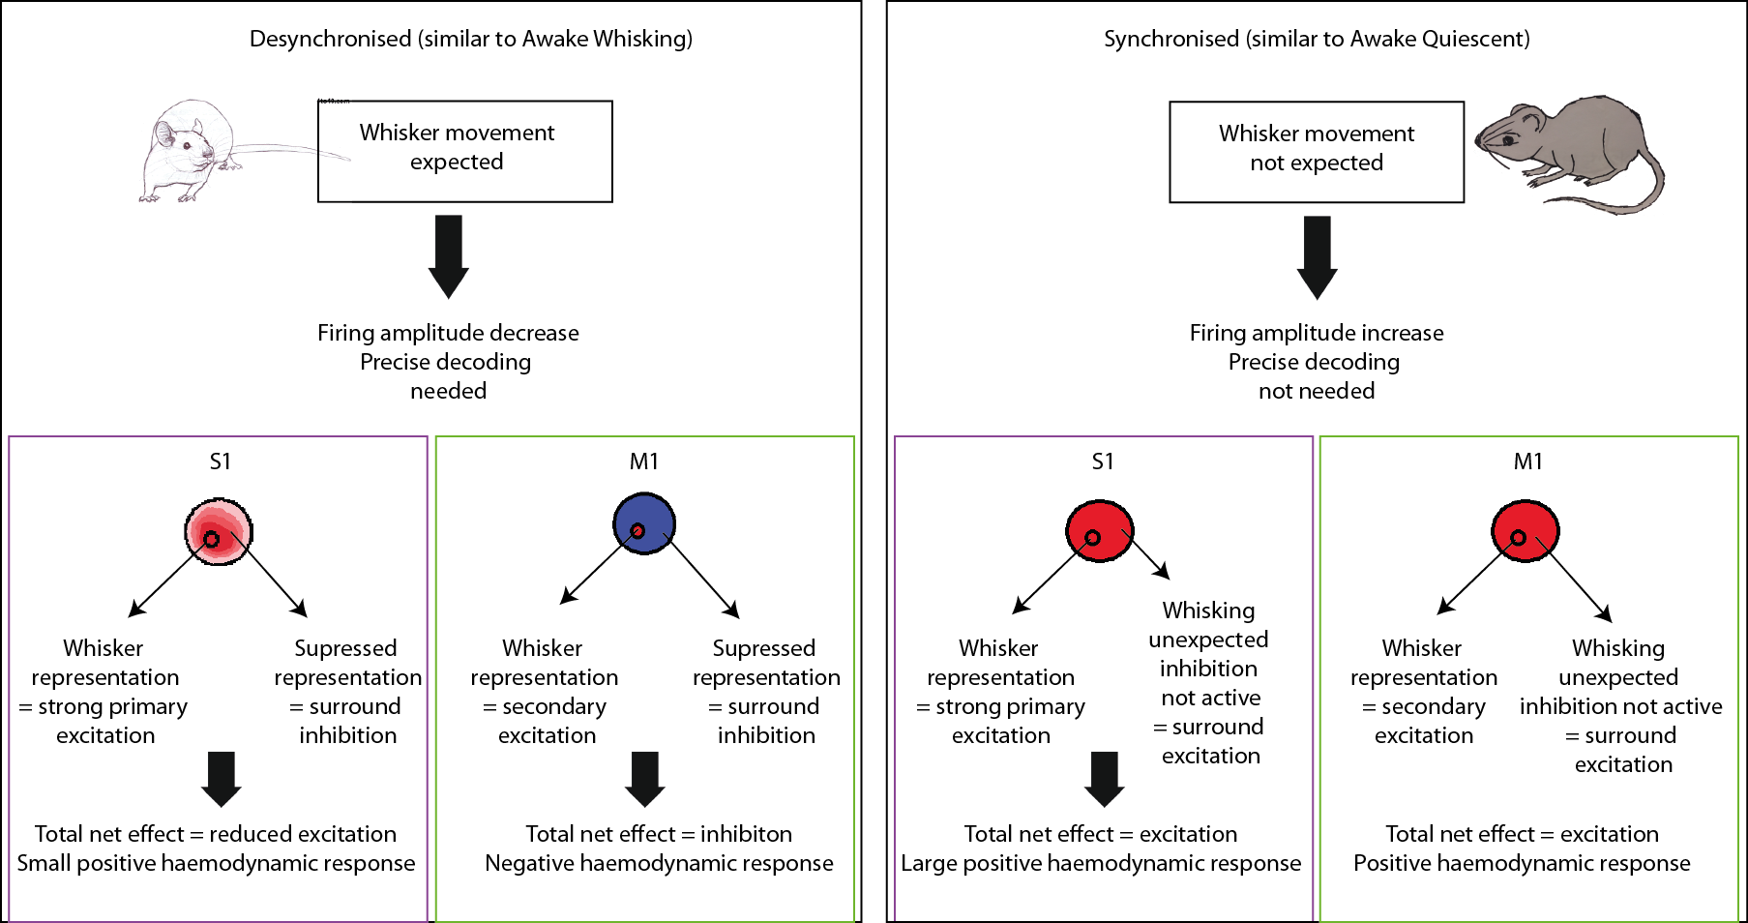
Figure 3: A possible explanation for the different haemodynamic responses seen in each state. S1 and M1 are both represented as simple circles, with smaller circles inside to show the affected whisker regions in both. Blue is for neural inhibition and red is for neural excitation. Purple boxes show explanations for the somatosensory region and green for the motor region.

6.2.3.4 Future explorations of haemodynamics and behavioural state
The possible theory behind the state specific haemodynamics covered in section 6.2 allows the idea that the large positive responses seen in the synchronised state are partly because inhibition is not as active as whisking responses are not expected. One way to test this theory would be to monitor neural and vascular responses in an animal that is not anaesthetised. Indeed, (Feldmeyer et al., 2013) suggests in his seminal paper on barrel cortex function that because of the complex relays that exist between the cortex and sub-cortical structures, for a full understanding of neocortical function, investigations should ideally take place in a behaving subject, rather than an anaesthetised one as the function of these relays may alter depending on the type of anaesthesia used. This thesis has detailed the development of the ABSC, an automatic classifier that has been developed and tested on neurovascular coupled data. Therefore, the combination of the ABSC to monitor state together with neural and vascular measurements from an animal that can display quiet awake periods and awake exploratory behaviour would provide a good model to further test the ideas discussed in this section. Preliminary work has already been undertaken to investigate neurovascular coupling in alternate brain states in an awake animal (Winder and Drew, 2015) and indicates that the hemodynamic signals are not well predicted by local neural activity, potentially agreeing with the theory discussed here that the haemodynamics could reflect the net of inhibition and excitation of the affected and surrounding regions of cortex. Once work by Winder and colleagues has been published, it will be interesting to review the differences between haemodynamic responses in quiet brain states as well as in actively whisking ones. The work in this thesis provides support for negative BOLD signals potentially being generated as the result of functional inhibition, rather than as a result of vascular steal. The region of the negative haemodynamic response was not adjacent to the positive responding region, and it’s existence was state dependent. As discussed previously there is already evidence to show that a negative BOLD response is associated with cortical inhibition. A study by Northoff et al. (2007) demonstrated that GABA concentrations from inhibitory interneurons in the anterior cingulate cortex predicted the relative magnitudes of negative BOLD responses. Again, it would be interesting to monitor, brain state, neural and vascular responses and GABA concentrations, however such work is beyond the remit of the current thesis.

6.3 Advantages of multi-modal measurements
The choice of a multi-modal set-up using extracellular electrophysiology and 2D-OIS to investigate state-related neurovascular coupling in the whisker barrel somatosensory and the motor cortex has yielded high quality informative data. From the extracellular electrophysiology, MUA and LFP signals were recorded. In both regions of cortex, classification of synchronised and desynchronised state was possible because the baseline LFP showed state specific distinct patterns of frequency band information. The LFP responses in the whisker barrel cortex also gave distinct state specific profiles in response to a long-duration (16s) electrical stimulation of the whisker pad. These LFP profiles matched the profiles of the functional haemodynamic response recorded in the corresponding region using 2D-OIS. Therefore the combination of LFP and 2D-OIS indicated that state specific neurovascular coupling in the whisker somatosensory cortex remained consistent with previous findings (Jones et al., 2008). The addition of MUA data proved particularly useful when examining responses in the motor cortex. In this region, the profiles of the LFP responses matched the haemodynamic responses only in the synchronised state. In the desynchronised state, a mismatch occurred where a positive LFP profile was matched to a negative haemodynamic response. The provision of additional MUA information (collected from a laminar electrode) from the time between the neural responses to the long-duration train of stimuli showed that an increase in spiking from state-specific baseline occurred in layer V of the motor cortex in the desynchronised state, and a decrease in firing occurred in the same layer in the synchronised state. The provision of this additional information provided possible explanations for the alteration in neurovascular coupling in this region that would not otherwise have been available (see 6.2.2). The use of 2D-OIS allowed an examination of the haemodynamic responses in not just the whisker barrel somatosensory and motor cortex, but across a wide range of the contralateral cortex also. Therefore, the use of concurrent extracellular electrophysiology and 2D-OIS was suitable for the work investigated here.

6.3.1 Additional methods for future investigations
The investigations from Chapter 5 in the motor cortex indicated that interneurons were potentially more active in the desynchronised state, leading to a negative haemodynamic response. Other research has also indicated that inhibitory GABA interneurons co-synthesize vasoactive intestinal peptide (VIP), somatostatin (SOM), nitric oxide (NO) or neuropeptide Y (NPY), all of which display in-vitro vasoactive properties that could mediate the neurovascular response (Cauli et al.,2004). Somatostatin expressing interneurons, have been also been indicated as a potential key player in surround inhibition (Sturgill, 2015). Future investigations could benefit discerning if the state specific activation of specific cell types such as somatostatin interneurons (shown by Urban-Ciecko and Barth, 2016) could be the mechanism underlying the negative haemodynamic response (see 6.4 for an in depth discussion). Optogenetic activation of somatostatin interneurons is already possible within the limits of current neuroscience. Therefore, multimodal imaging using optogenetic activation of somatostatin interneurons in combination with a modified version of the model in this thesis (the anaesthetic preparation would potentially need to switch to a mouse model) could be used to investigate this. Indeed pilot data from our laboratory has indicated that this could be a fruitful line of investigation. The optogenetic activation of somatostatin interneurons in a transgenic mouse model caused a desynchronization of the whisker barrel somatosensory cortex (Fig. 4A). State-specific baseline Hbt and Hbo increased and Hbr decreased during this desynchronisation in a manner very similar to that seen during desynchronised periods in the experiments investigated in this thesis (Fig. 4B). Additionally, responses to a 2s mechanical whisker stimulation showed positive CBV responses in the whisker region during synchronised and desynchronised time periods, but a negative CBV response in the surround region only during the desynchronised, and somatostatin activated time periods (Fig. 4C). Thus inhibition created by somatostatin interneurons may be at least partially responsible for negative haemodynamic responses. This cell type-specific pilot investigation fits in with a review of the literature concerning the neuronal basis of functional neuroimaging. In this review(Devor et al., 2012) Devor et al. (2012) surmise that cell type-specific activity needs to be identifiable in neurovascular coupling investigations as a wide body of research now supports the release of a vascular mediator that is cell type-specific and regulates blood flow.
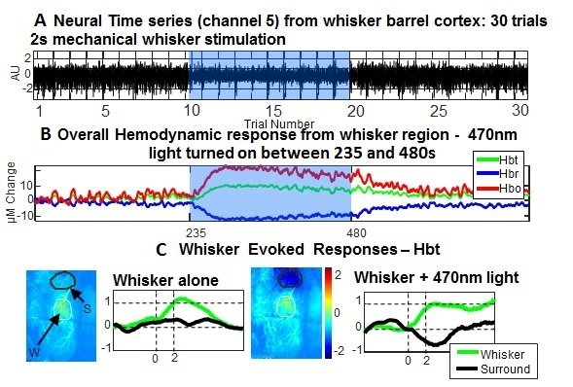
Figure 4: Pilot data displaying the neural (LFP) and haemodynamic (2D-OIS) responses to optogenetic activation (470nm light) of somatostatin (SOM) neurons in a mouse model. A 30 trial 2s whisker stimulation experiment. Neural LFP recordings showing pronounced cortical desynchronisation in response to continuous 470nm light. B Blood volume increase in response to 470nm light after the 10th trial Large increase in blood volume and saturation in the illuminated area. C Spatial blood volume responses during control and under 470nm light. There is a clear decrease in blood volume in the motor cortex region.

6.4 Could alternate cortical networks underlie different brain states and the corresponding haemodynamic responses?
The investigations of cell type-specific activities may be of particular interest when looking at brain states, and state specific haemodynamic responses. As described in Chapter 5, cholinergic afferents from the basal forebrain innervate the cortex and can induce a desynchronised brain state (Metherate, Cox & Ash, 1992). These cholinergic afferents can activate SOM interneurons which Fig. 4 shows can create a negative haemodynamic response. In addition to interneurons such as SOMs being sufficient to desynchronise the cortex (Fig. 4 or (Chen et al., 2015)), some propose an interesting theory that a blanket of inhibition of pyramidal cells (PCs) could be created by SOMs, parvalbumin (PV) and chandelier (Ch) cells (Karnani et al., 2014, Karnani et al., 2016). One use of a type of interneurons known by the vasoactive intestinal peptide they release (VIP interneurons) in this scenario would be to create functional ‘holes’ in this ‘blanket’ by disinhibiting the region of activation. Such a system could exist to help create accurate representations of whisker movements in the corresponding regions of cortex, as discussed in section 6.2.3.2. SOM and other interneurons could also create a blanket of inhibition that is responsible for generating the net inhibition proposed in the desynchronised state in the motor region (see Fig. 5). This could generate the observed negative haemodynamic response (Cauli et al., 2004; Perrenoud et al., 2012, Uhlirova et al., 2016). VIP interneurons could be responsible for inhibiting SOMs in the correct region of whisker representation, allowing a focused disinhibition of pyramidal cells (PC) in that region. Some evidence for this comes from a recent study (Gentet et al., 2012). They activated the C2 whisker in a mouse and then measured the activity of different interneurons from the C2 whisker barrel cortex. They found that during passive and active whisking (such as might be found in an exploratory desynchronised state) SOM interneurons were hyperpolarised, whilst fast spiking (potentially VIP) and PC neurons increased firing. This would agree with the cell activity described in Fig. 5A&B. It would be interesting to see interneuron activity more distant from the activated whisker, to see if the recordings agree with the hypothesised cell activity at points C & D. The authors positing the blanket inhibition theory cite computational modelling evidence from (Kohonen, 2006) and (Kohonen and Oja, 1976) to show that it would be necessary to create self-organising functional maps in the cortex, which is a similar theory to that described here. (Sanes and Donoghue, 2000) have also suggested that intracortical connections found in layers 2/3 and in layer V of the cortex could prove a basis for dynamic moment to moment modulation of the functional architecture of M1, which would also fit in with this theory. The theory described here and in Fig. 5 is beyond the scope of this thesis, however it is interesting to hypothesise how the current thesis work may fit within the emerging neuroscience landscape.
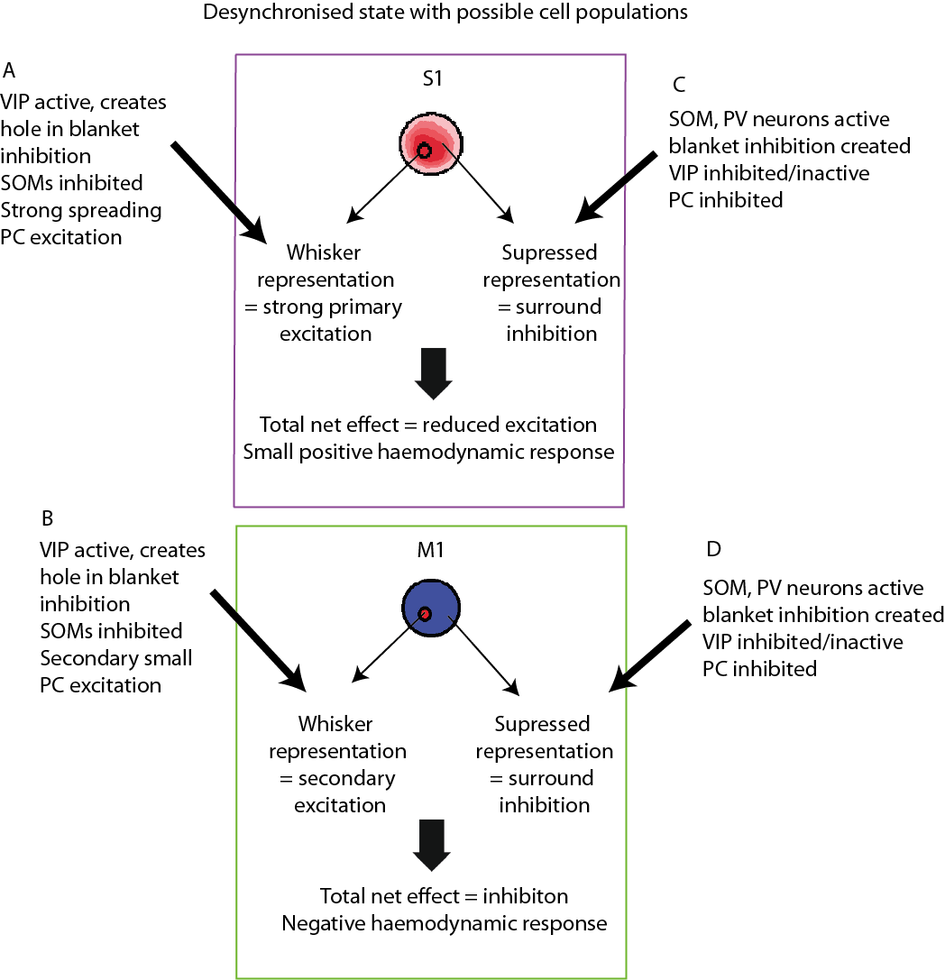
Figure 5: An example of the possible cellular excitation inhibition that could create the observed haemodynamics in S1 and M1 in the desynchronised state. S1 and M1 are both represented as simple circles, with smaller circles inside to show the affected whisker regions in both. Blue is for neural inhibition and red is for neural excitation.

6.4.1 Cortical brain states and interpretations of BOLD fMRI
(LaConte, 2011) discusses some problems with temporally adaptive brain state (TABS) real-time fMRI (rtfMRI) in a recent paper. The findings from this thesis may help with some of these issues. The author describes how the difference between inter-task and intra-task variability is small, which can make it hard to discern when a signal fluctuation is of significance. Although the term brain state is used in a different context in LaConte’s paper, the point regarding the challenge of discerning when a signal fluctuation is of significance remains applicable here. This work has shown that the identification and grouping of trials by brain state can help to identify, and therefore reduce some of the intra-task variance. Additionally, the author describes problems with signal drift. In Chapter 4, it is shown that an increased or decreased drift of haemodynamic signals may represent an alteration in brain state for the subject. Therefore there is potential future work in developing a brain state classifier using just the BOLD fMRI time series. This would be valuable in not only increasing the quality of fMRI data collection but would also allow greater investigation of the deep brain structures responsible for brain state change. Such a classifier would need to account for non state-specific baseline effects such as scanner temperature and is beyond the scope of the current thesis.
However, caution must be used when extrapolating between the results shown here and fMRI results showing negative BOLD. Although previous studies have shown that it is possible to investigate the negative BOLD phenomena using 2D-OIS (Kennerley et al., 2012b), it has also been suggested that negative BOLD signals may represent increases in CBV and decreases in CBF (Schridde et al., 2008, Goense et al., 2012). In the studies in this thesis CBF was not measured, but the negative haemodynamic responses occurred when CBV decreased, rather than increased. The paper (Goense et al., 2012) used MION (an injectable contrast agent used in fMRI studies) data in place of real CBV changes. As no formal conversion between MION and CBV has been documented it is difficult to know how reliable this finding is. The work (Schridde et al., 2008) used injections of bicuculline to provoke seizures, creating unusual alterations in brain chemistry and close examination of the paper revealed that the average BOLD response to CBV increases in the hippocampus was negligible, with a strong decrease only shown in an example animal. Although these studies show potential flaws, this possible discrepancy in findings only serves to underscore how little is still known about the mechanisms of the negative BOLD and why further investigations are needed to be able to reliably interpret BOLD fMRI findings.

6.5 Final Conclusions
The study in Chapter 3 developed a new analysis methodology (the ABSC) to investigate changes in cortical brain state by classifying the LFP signal into synchronised and desynchronised data. LFP data was collected using a linear electrode in the whisker barrel cortex of the urethane anaesthetised rat. The novel method involved a vector based classification system, coded using the relative frequency power of the classic EEG bands. The method was tested against five different classification techniques and gave the best balance of speed and accuracy, additionally presenting the possibility of online classification. In Chapter 4, the classifications by the ABSC were used to group concurrently collected ‘spontaneous’ (no stimulation) and evoked haemodynamic data from the whisker barrel somatosensory cortex. State-specific baseline haemodynamics were found to be significantly different in the two identified states. During desynchronised state defined periods of elevated state-specific baseline haemodynamics, significant decreases in evoked haemodynamic responses to somatosensory stimuli were found. In Chapter 5, state classification was again used to group the corresponding evoked haemodynamics, this time in the motor cortex. Interestingly, in this region haemodynamic responses associated with the desynchronised state were negative. Potentially, a centre-excitation, surround-inhibition system may be creating the reduced, and negative haemodynamic responses in the desynchronised state. The variability of the haemodynamic responses seen under alternate states emphasizes that caution should be taken in interpretation of blood based imaging techniques such as BOLD fMRI as stimuli used will interact with the underlying cortical state and as such, responses could be misinterpreted. The use of brain state classification systems such as the ABSC can be used to inform such techniques and obtain higher quality data.

References

Appendix
Section 1: Parameters used to conduct the Hartigans Dip Test.

Section 2: Additional figures.
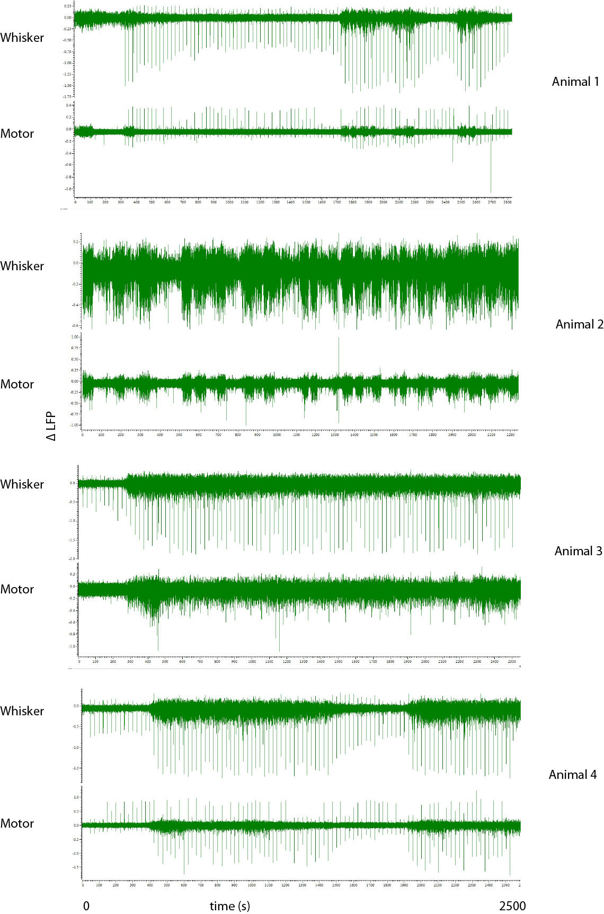
Figure A1: Demonstrating the synchrony of changes of brain state in the whisker and motor regions. Four example animals are shown. The timeseries demonstrate LFP data from channel 8 of the whisker and motor linear electrodes and are shown as viewed in the Spike 2 software.
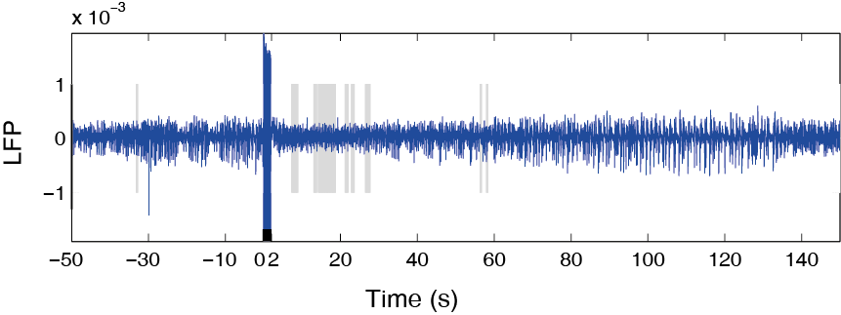
Fig.A2: The application of the ABSC to the fifth animal from the dataset of Jones et al., (2008). Grey sections denote time periods of desynchronisation and white section show sections of synchronisation. The black bar shows the time period of brainstem stimulation and the resulting stimulus artefact can be seen in the LFP.
The ABSC did not find a clear state change after the brainstem stimulation. Whilst some periods of change were found, these were intermittent. The amplitude of the LFPs indicated that over a short period of time, the cortical state returned to synchronised, despite the brainstem stimulation, indicating that the ABSC correctly interpreted the state change as brief and intermittent.
The ABSC categorised animals 1 and 3 as being in the synchronised state for the full experiment and animal 2 as being in the desynchronised state. This is in contrast to the expert who categorised animals 1 and 3 as deysynchronised and 2 as synchronised. The frequency power for the experiments shown on the second line down for animal 2 shows the large amounts of beta and gamma power, relative to alpha, theta and delta. This frequency band pattern is the same as that seen in the desynchronised states in the other experimental data presented here (e.g. in Fig. 4.). The haemodynamic data also supports the classification of the ABSC. For example, animal 2, show an increase in the state-specific baseline Hbt and Hbo whilst Hbr decreases, which matches the previous changes in state-specific baseline haemodynamics in the desynchronised state (Fig. 2). In Animals 1 and 3, changes in state-specific baseline Hbo, Hbr and Hbt are not seen, which matches the previous data in the synchronised state, as seen in Fig.1. It therefore follows that that the ABSC correctly classified the stable state experiments, whilst the expert could not always do this.
Figure A3 (below): Three example animals showing the full experiment timeseries and demonstrating invariant state. Each animal shows (in descending order): the LFP, the frequency power for the classical EEG frequency bands and the concurrant Hbt Hbo and Hbr for the full timeseies of 2100s.

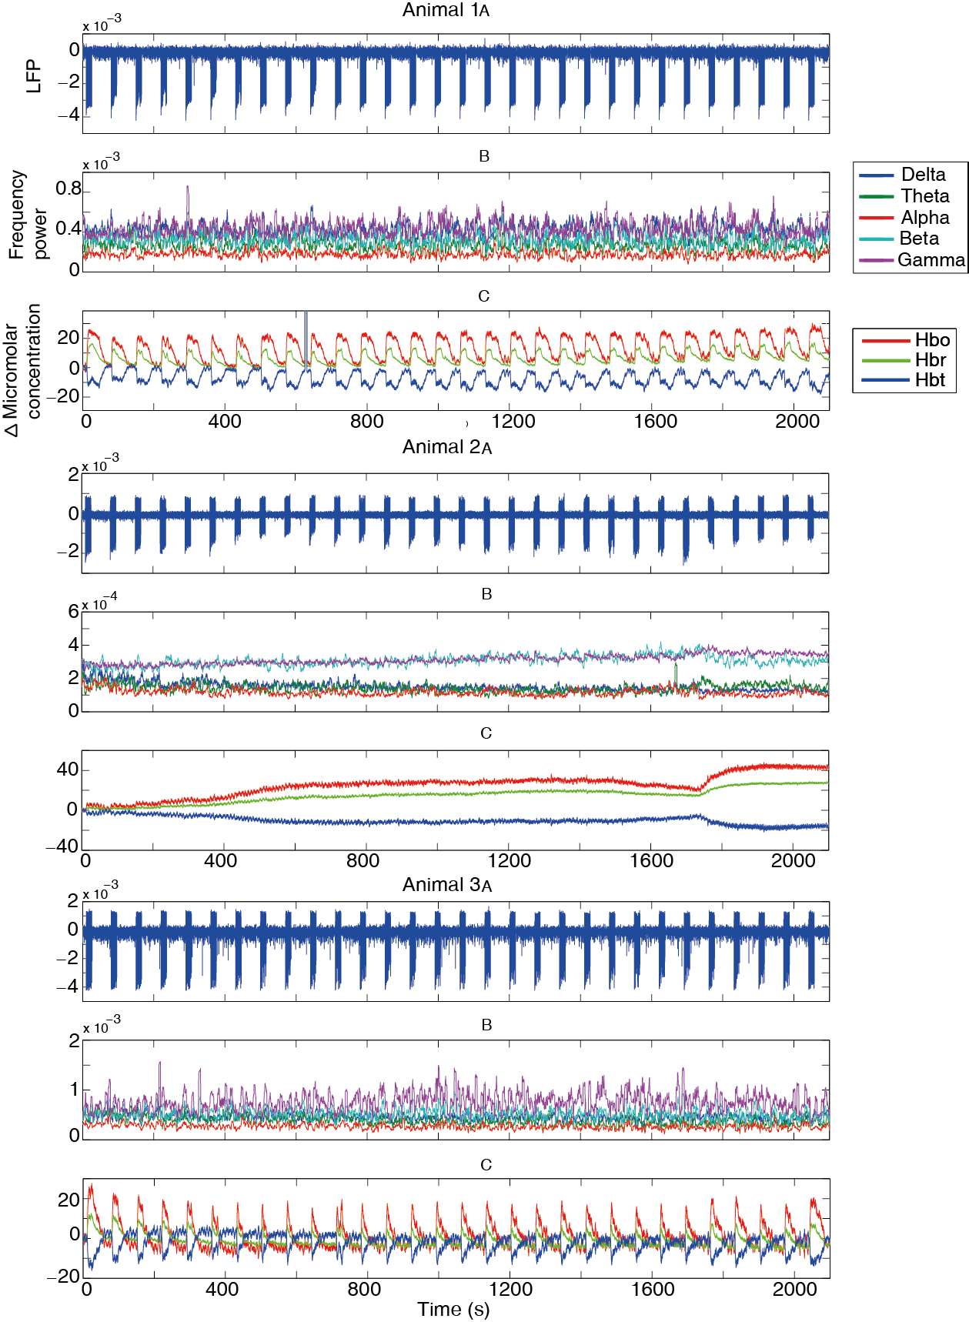
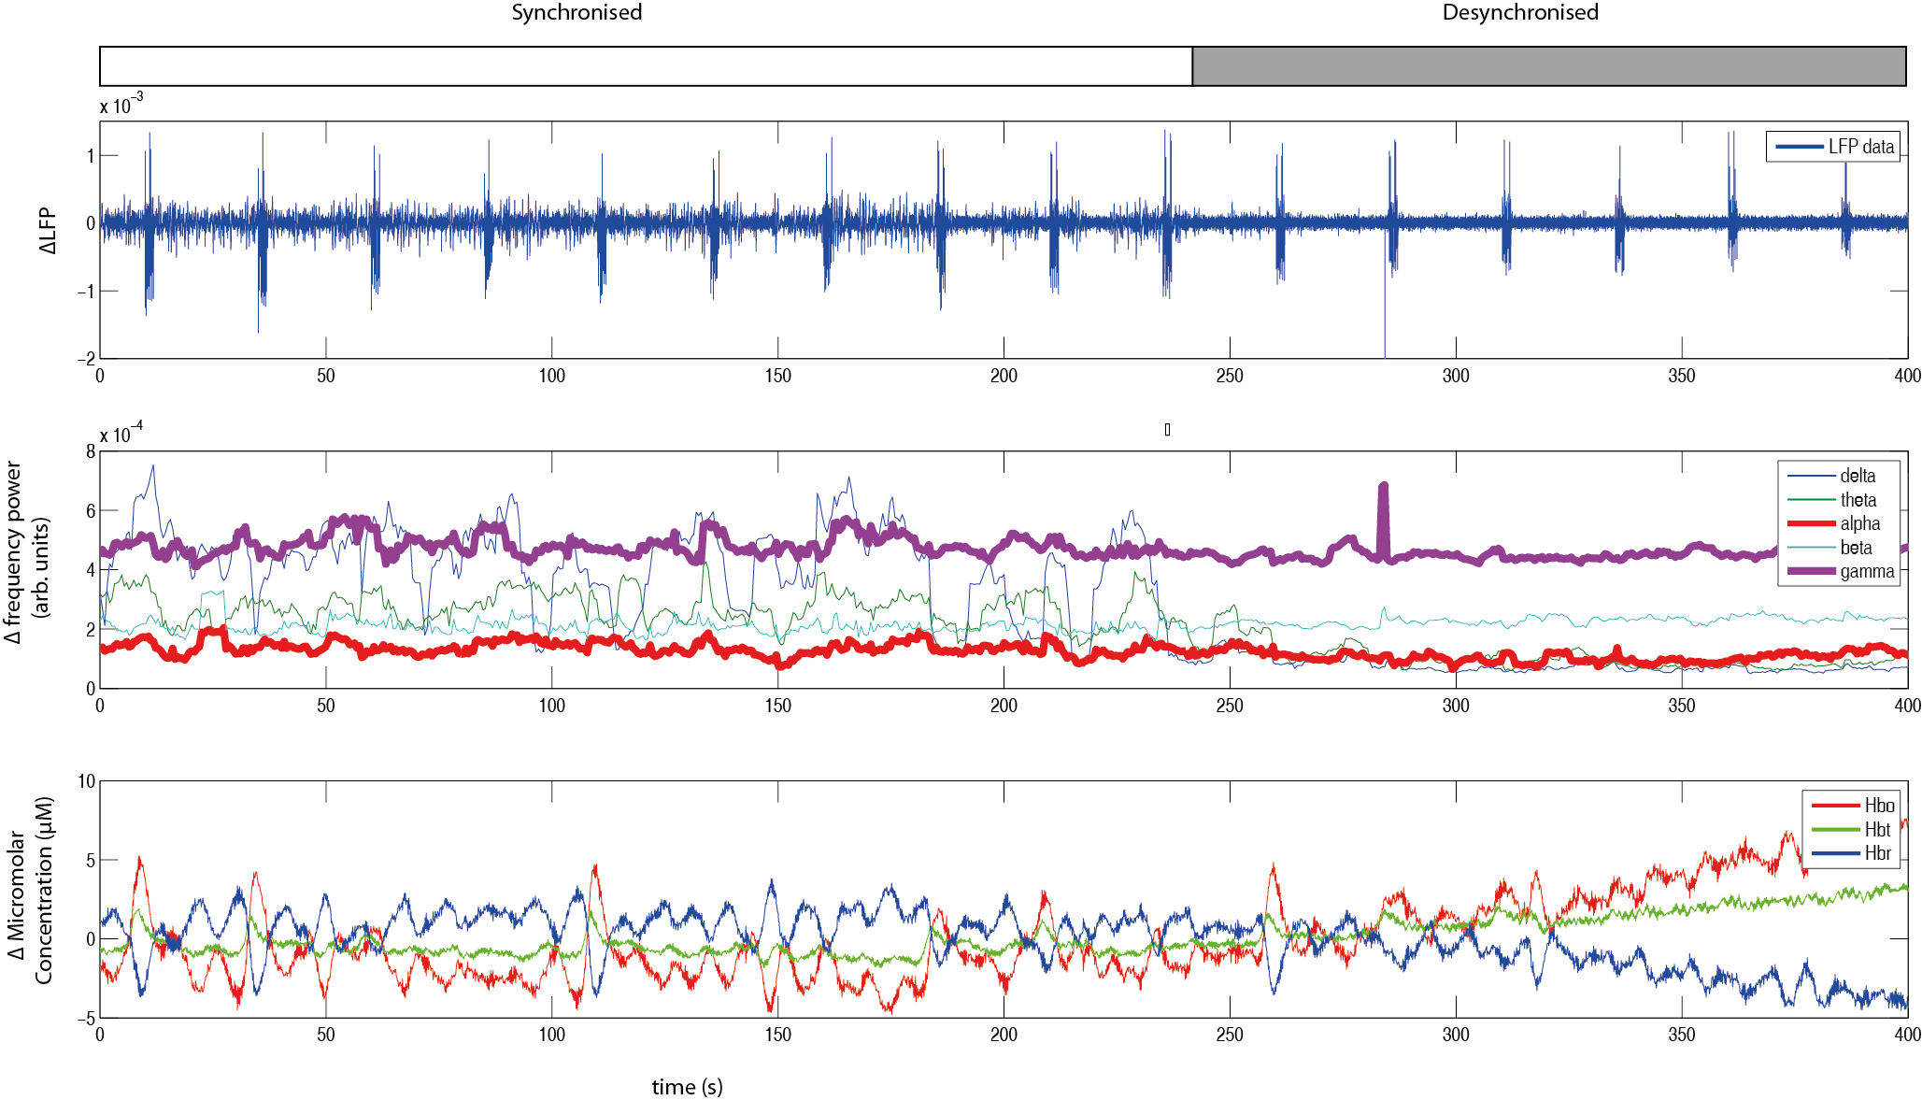
Figure A4: Showing an animal exhibiting a neural state change, and the expected changes in haemodynamics, but without large changes in baseline gamma or alpha frequency power. Data is taken from a urethane anaesthetised rat from the whisker barrel somatosensory region. A 2s electrical stimulation at a frequency of 5Hz is applied every 25s to the whisker pad. Top: Continuous electrophysiology recordings of raw LFP data. Middle Baseline frequency power for the five classic EEG bands. Gamma (30-80Hz) and alpha (8-13Hz) are enhanced for ease of viewing. Bottom Continuous micromolar changes of Hbo, Hbt and Hbr. The classic rise in Hbo and Hbt and fall in Hbr can be seen as the cortex enters a desynchronised state at approximately 250s.

Allendoerfer KL, Shatz CJ (1994) The subplate, a transient neocortical structure: its role in the development of connections between thalamus and cortex. Annu Rev Neurosci 17:185-218.
Allene C, Cossart R (2010) Early NMDA receptor‐driven waves of activity in the developing neocortex: physiological or pathological network oscillations? The Journal of physiology 588:83-91.
Antonenko D, Diekelmann S, Olsen C, Born J, Molle M (2013) Napping to renew learning capacity: enhanced encoding after stimulation of sleep slow oscillations. Eur J Neurosci.
Aronoff R, Matyas F, Mateo C, Ciron C, Schneider B, Petersen CC (2010) Long‐range connectivity of mouse primary somatosensory barrel cortex. Eur J Neurosci 31:2221-2233.
Asano E, Mihaylova T, Juhász C, Sood S, Chugani HT (2007) Effect of sleep on interictal spikes and distribution of sleep spindles on electrocorticography in children with focal epilepsy. Clin Neurophysiol 118:1360-1368.
Attwell D, Buchan AM, Charpak S, Lauritzen M, MacVicar BA, Newman EA (2010) Glial and neuronal control of brain blood flow. Nature 468:232-243.
Attwell D, Iadecola C (2002) The neural basis of functional brain imaging signals. Trends Neurosci 25:621-625.
Ba AM, Guiou M, Pouratian N, Muthialu A, Rex DE, Cannestra AF, Chen JW, Toga AW (2002) Multiwavelength optical intrinsic signal imaging of cortical spreading depression. J Neurophysiol 88:2726-2735.
Bagher P, Segal SS (2011) Regulation of blood flow in the microcirculation: role of conducted vasodilation. Acta Physiologica 202:271-284.
Becq G, Charbonnier S, Chapotot F, Buguet A, Bourdon L, Baconnier P (2005) Comparison between five classifiers for automatic scoring of human sleep recordings. In: Classification and Clustering for Knowledge Discovery, pp 113-127: Springer.
Belitski A, Gretton A, Magri C, Murayama Y, Montemurro MA, Logothetis NK, Panzeri S (2008) Low-frequency local field potentials and spikes in primary visual cortex convey independent visual information. The Journal of Neuroscience 28:5696-5709.
Benington JH, Kodali SK, Heller HC (1994) Scoring transitions to REM sleep in rats based on the EEG phenomena of pre-REM sleep: an improved analysis of sleep structure. SLEEP-NEW YORK- 17:28-28.
Berwick J, Devonshire I, Martindale A, Johnston D, Zheng Y, Kennerley A, Overton P, Mayhew J (2005a) Cocaine administration produces a protracted decoupling of neural and haemodynamic responses to intense sensory stimuli. Neuroscience 132:361-374.
Berwick J, Johnston D, Jones M, Martindale J, Martin C, Kennerley A, Redgrave P, Mayhew J (2008) Fine detail of neurovascular coupling revealed by spatiotemporal analysis of the hemodynamic response to single whisker stimulation in rat barrel cortex. J Neurophysiol 99:787.
Berwick J, Johnston D, Jones M, Martindale J, Redgrave P, McLoughlin N, Schiessl I, Mayhew J (2005b) Neurovascular coupling investigated with two‐dimensional optical imaging spectroscopy in rat whisker barrel cortex. Eur J Neurosci 22:1655-1666.
Boorman L, Harris S, Bruyns-Haylett M, Kennerley A, Zheng Y, Martin C, Jones M, Redgrave P, Berwick J (2015) Long-latency reductions in gamma power predict hemodynamic changes that underlie the negative BOLD signal. The Journal of Neuroscience 35:4641-4656.
Boorman L, Kennerley AJ, Johnston D, Jones M, Zheng Y, Redgrave P, Berwick J (2010) Negative blood oxygen level dependence in the rat: a model for investigating the role of suppression in neurovascular coupling. The Journal of Neuroscience 30:4285-4294.
Bosman LW, Houweling AR, Owens CB, Tanke N, Shevchouk OT, Rahmati N, Teunissen WH, Ju C, Gong W, Koekkoek SK (2011) Anatomical pathways involved in generating and sensing rhythmic whisker movements. Front Integr Neurosci 5:53.
Braun A, Balkin T, Wesensten N, Carson R, Varga M, Baldwin P, Selbie S, Belenky G, Herscovitch P (1997) Regional cerebral blood flow throughout the sleep-wake cycle. Brain 120:1173-1197.
Brecht M, Hatsopoulos NG, Kaneko T, Shepherd GM (2015) Motor cortex microcircuits. Motor Cortex Microcircuits (Frontiers in Brain Microcircuits Series) 4.
Bressler D, Spotswood N, Whitney D (2007) Negative BOLD fMRI response in the visual cortex carries precise stimulus-specific information. PLoS One 2:e410.
Briggs F, Callaway EM (2001) Layer-specific input to distinct cell types in layer 6 of monkey primary visual cortex. The Journal of Neuroscience 21:3600-3608.
Brown AM, Ransom BR (2007) Astrocyte glycogen and brain energy metabolism. Glia 55:1263-1271.
Brown AM, Ransom BR (2015) Astrocyte glycogen as an emergency fuel under conditions of glucose deprivation or intense neural activity. Metab Brain Dis 30:233-239.
Brown GG, Perthen JE, Liu TT, Buxton RB (2007) A primer on functional magnetic resonance imaging. Neuropsychol Rev 17:107-125.
Bruni O, Ferri R, Novelli L, Terribili M, Troianiello M, Finotti E, Leuzzi V, Curatolo P (2009) Sleep spindle activity is correlated with reading abilities in developmental dyslexia. Sleep 32:1333.
Bruyns-Haylett M, Zheng Y, Berwick J, Jones M (2010) Temporal coupling between stimulus-evoked neural activity and hemodynamic responses from individual cortical columns. Phys Med Biol 55:2203.
Buxton RB (2012) Dynamic models of BOLD contrast. Neuroimage 62:953-961.
Buzsáki G, Bickford RG, Ponomareff G, Thal L, Mandel R, Gage FH (1988) Nucleus basalis and thalamic control of neocortical activity in the freely moving rat. The Journal of neuroscience 8:4007-4026.
Cajochen C, Münch M, Knoblauch V, Blatter K, Wirz-Justice A (2006) Age-related changes in the circadian and homeostatic regulation of human sleep. Chronobiol Int 23:461-474.
Capaday C, Ethier C, Van Vreeswijk C, Darling WG (2015) On the functional organization and operational principles of the motor cortex. Motor Cortex Microcircuits (Frontiers in Brain Microcircuits Series) 44.
Castro-Alamancos MA (2004a) Absence of rapid sensory adaptation in neocortex during information processing states. Neuron 41:455-464.
Castro-Alamancos MA (2004b) Dynamics of sensory thalamocortical synaptic networks during information processing states. Prog Neurobiol 74:213-247.
Cauli B, Tong X-K, Rancillac A, Serluca N, Lambolez B, Rossier J, Hamel E (2004) Cortical GABA interneurons in neurovascular coupling: relays for subcortical vasoactive pathways. The Journal of Neuroscience 24:8940-8949.
Cauller LJ, Clancy B, Connors BW (1998) Backward cortical projections to primary somatosensory cortex in rats extend long horizontal axons in layer I. J Comp Neurol 390:297-310.
Chakrabarti S, Alloway KD (2006) Differential origin of projections from SI barrel cortex to the whisker representations in SII and MI. J Comp Neurol 498:624-636.
Chance B (1991) Optical method. Annu Rev Biophys Biophys Chem 20:1-30.
Chapin JK, Lin CS (1984) Mapping the body representation in the SI cortex of anesthetized and awake rats. J Comp Neurol 229:199-213.
Chen N, Sugihara H, Sur M (2015) An acetylcholine-activated microcircuit drives temporal dynamics of cortical activity. Nat Neurosci 18:892-902.
Cheng-yu TL, Poo M-m, Dan Y (2009) Burst spiking of a single cortical neuron modifies global brain state. Science 324:643-646.
Choi J-K, Chen YI, Hamel E, Jenkins BG (2006) Brain hemodynamic changes mediated by dopamine receptors: role of the cerebral microvasculature in dopamine-mediated neurovascular coupling. Neuroimage 30:700-712.
Clement EA, Richard A, Thwaites M, Ailon J, Peters S, Dickson CT (2008) Cyclic and sleep-like spontaneous alternations of brain state under urethane anaesthesia. PLoS One 3:e2004.
Contreras EJB, Schjetnan AGP, Muhammad A, Bartho P, McNaughton BL, Kolb B, Gruber AJ, Luczak A (2013) Formation and reverberation of sequential neural activity patterns evoked by sensory stimulation are enhanced during cortical desynchronization. Neuron 79:555-566.
Cope M, Delpy DT (1988) System for long-term measurement of cerebral blood and tissue oxygenation on newborn infants by near infra-red transillumination. Med Biol Eng Comput 26:289-294.
Cox SB, Woolsey TA, Rovainen CM (1993) Localized dynamic changes in cortical blood flow with whisker stimulation corresponds to matched vascular and neuronal architecture of rat barrels. J Cereb Blood Flow Metab 13:899-913.
Crochet S, Petersen CC (2006) Correlating whisker behavior with membrane potential in barrel cortex of awake mice. Nat Neurosci 9:608-610.
Crochet S, Petersen CC (2015) Cortical sensorimotor reverberations. Neuron 86:1116-1118.
Curto C, Sakata S, Marguet S, Itskov V, Harris KD (2009) A simple model of cortical dynamics explains variability and state dependence of sensory responses in urethane-anesthetized auditory cortex. The Journal of Neuroscience 29:10600-10612.
D'Esposito M, Deouell LY, Gazzaley A (2003) Alterations in the BOLD fMRI signal with ageing and disease: a challenge for neuroimaging. Nature Reviews Neuroscience 4:863-872.
da Silva D Proprietades geraes. J de l’Ecole Polytechnique, I: cah 30:1854.
Dantzker J, Callaway E (2000) Laminar sources of synaptic input to cortical inhibitory interneurons and pyramidal neurons. Nat Neurosci 3:701-707.
Destexhe A, Sejnowski TJ (2001) Thalamocortical Assemblies: How Ion Channels, Single Neurons and Large-Scale Networks Organize Sleep Oscillations.
Devor A, Boas DA, Einevoll GT, Buxton RB, Dale AM (2012) Neuronal basis of non-invasive functional imaging: from microscopic neurovascular dynamics to BOLD fMRI. In: Neural Metabolism In Vivo, pp 433-500: Springer.
Devor A, Hillman EM, Tian P, Waeber C, Teng IC, Ruvinskaya L, Shalinsky MH, Zhu H, Haslinger RH, Narayanan SN (2008) Stimulus-induced changes in blood flow and 2-deoxyglucose uptake dissociate in ipsilateral somatosensory cortex. The Journal of Neuroscience 28:14347-14357.
Devor A, Sakadžić S, Saisan PA, Yaseen MA, Roussakis E, Srinivasan VJ, Vinogradov SA, Rosen BR, Buxton RB, Dale AM (2011) “Overshoot” of O2 is required to maintain baseline tissue oxygenation at locations distal to blood vessels. The Journal of Neuroscience 31:13676-13681.
Devor A, Tian P, Nishimura N, Teng IC, Hillman EM, Narayanan S, Ulbert I, Boas DA, Kleinfeld D, Dale AM (2007) Suppressed neuronal activity and concurrent arteriolar vasoconstriction may explain negative blood oxygenation level-dependent signal. The Journal of Neuroscience 27:4452-4459.
Douglas RJ, Martin KA (2004) Neuronal circuits of the neocortex. Annu Rev Neurosci 27:419-451.
Douglas RJ, Martin KA, Whitteridge D (1989) A canonical microcircuit for neocortex. Neural Comput 1:480-488.
Drew PJ, Shih AY, Kleinfeld D (2011) Fluctuating and sensory-induced vasodynamics in rodent cortex extend arteriole capacity. Proceedings of the National Academy of Sciences 108:8473-8478.
Duann J-R, Jung T-P, Kuo W-J, Yeh T-C, Makeig S, Hsieh J-C, Sejnowski TJ (2002) Single-trial variability in event-related BOLD signals. Neuroimage 15:823-835.
Dunn AK, Devor A, Dale AM, Boas DA (2005) Spatial extent of oxygen metabolism and hemodynamic changes during functional activation of the rat somatosensory cortex. Neuroimage 27:279-290.
Durnin J (1981) Basal metabolic rate in man. Report of a Joint FAO/WHO/UNU Expert Consultation on Energy and Protein Requirements.
Düzel E, Penny WD, Burgess N (2010) Brain oscillations and memory. Curr Opin Neurobiol 20:143-149.
Fanselow EE, Nicolelis MA (1999) Behavioral modulation of tactile responses in the rat somatosensory system. The Journal of neuroscience 19:7603-7616.
Feldmeyer D, Brecht M, Helmchen F, Petersen CC, Poulet JF, Staiger JF, Luhmann HJ, Schwarz C (2013) Barrel cortex function. Prog Neurobiol 103:3-27.
Felleman DJ, Van Essen DC (1991) Distributed hierarchical processing in the primate cerebral cortex. Cereb Cortex 1:1-47.
Ferezou I, Haiss F, Gentet LJ, Aronoff R, Weber B, Petersen CC (2007) Spatiotemporal dynamics of cortical sensorimotor integration in behaving mice. Neuron 56:907-923.
Fino E, Yuste R (2011) Dense inhibitory connectivity in neocortex. Neuron 69:1188-1203.
Fogel S, Nader R, Cote K, Smith C (2007) Sleep spindles and learning potential. Behav Neurosci 121:1.
Fordel E, Thijs L, Martinet W, Schrijvers D, Moens L, Dewilde S (2007) Anoxia or oxygen and glucose deprivation in SH-SY5Y cells: a step closer to the unraveling of neuroglobin and cytoglobin functions. Gene 398:114-122.
Fox PT, Raichle ME (1986) Focal physiological uncoupling of cerebral blood flow and oxidative metabolism during somatosensory stimulation in human subjects. Proceedings of the National Academy of Sciences 83:1140-1144.
Friedberg MH, Lee SM, Ebner FF (1999) Modulation of receptive field properties of thalamic somatosensory neurons by the depth of anesthesia. J Neurophysiol 81:2243-2252.
Gais S, Born J (2004) Declarative memory consolidation: mechanisms acting during human sleep. Learn Mem 11:679-685.
Gais S, Mölle M, Helms K, Born J (2002) Learning-dependent increases in sleep spindle density. The Journal of Neuroscience 22:6830-6834.
Gandolfo G, Glin L, Lacoste G, Rodi M, Gottesmann C (1988) Automatic sleep-wake scoring in the rat on microcomputer apple II. Int J Biomed Comput 23:83-95.
Gentet LJ, Kremer Y, Taniguchi H, Huang ZJ, Staiger JF, Petersen CC (2012) Unique functional properties of somatostatin-expressing GABAergic neurons in mouse barrel cortex. Nat Neurosci 15:607-612.
Gervasoni D, Lin S-C, Ribeiro S, Soares ES, Pantoja J, Nicolelis MA (2004) Global forebrain dynamics predict rat behavioral states and their transitions. The Journal of Neuroscience 24:11137-11147.
Gilmour TP, Fang J, Guan Z, Subramanian T (2010) Manual rat sleep classification in principal component space. Neurosci Lett 469:97-101.
Goard M, Dan Y (2009) Basal forebrain activation enhances cortical coding of natural scenes. Nat Neurosci 12:1444-1449.
Goense J, Logothetis NK (2008) Neurophysiology of the BOLD fMRI signal in awake monkeys. Curr Biol 18:631-640.
Goense J, Merkle H, Logothetis NK (2012) High-resolution fMRI reveals laminar differences in neurovascular coupling between positive and negative BOLD responses. Neuron 76:629-639.
Goldman RI, Stern JM, Engel Jr J, Cohen MS (2002) Simultaneous EEG and fMRI of the alpha rhythm. Neuroreport 13:2487.
Gonzalez Andino S, Blanke O, Lantz G, Thut G, Grave de Peralta Menendez R (2001) The use of functional constraints for the neuroelectromagnetic inverse problem: alternatives and caveats. Int J of Bioelectromag 3.
Gordon GR, Mulligan SJ, MacVicar BA (2007) Astrocyte control of the cerebrovasculature. Glia 55:1214-1221.
Gotman J (2008) Epileptic networks studied with EEG‐fMRI. Epilepsia 49:42-51.
Gray L, Steadman J (1964) Determination of the oxyhaemoglobin dissociation curves for mouse and rat blood. The Journal of physiology 175:161-171.
Grienberger C, Konnerth A (2012) Imaging calcium in neurons. Neuron 73:862-885.
Grinvald A, Lieke E, Frostig RD, Gilbert CD, Wiesel TN (1986) Functional architecture of cortex revealed by optical imaging of intrinsic signals.
Güneş S, Polat K, Yosunkaya Ş (2010) Efficient sleep stage recognition system based on EEG signal using k-means clustering based feature weighting. Expert Systems with Applications 37:7922-7928.
Haider B, McCormick DA (2009) Rapid neocortical dynamics: cellular and network mechanisms. Neuron 62:171-189.
Hara K, Harris RA (2002) The anesthetic mechanism of urethane: the effects on neurotransmitter-gated ion channels. Anesth Analg 94:313-318.
Harada Y, Takahashi T (1983) The calcium component of the action potential in spinal motoneurones of the rat. The Journal of physiology 335:89.
Harel N, Lee S-P, Nagaoka T, Kim D-S, Kim S-G (2002) Origin of negative blood oxygenation level–dependent fMRI signals. J Cereb Blood Flow Metab 22:908-917.
Harris KD, Thiele A (2011) Cortical state and attention. Nature reviews neuroscience 12:509-523.
Harris S, Ma H, Zhao M, Boorman L, Zheng Y, Kennerley A, Bruyns-Haylett M, Overton PG, Berwick J, Schwartz TH (2014) Coupling between gamma-band power and cerebral blood volume during recurrent acute neocortical seizures. Neuroimage 97:62-70.
Hartigan JA, Hartigan P (1985) The dip test of unimodality. The Annals of Statistics 70-84.
Hayes DJ, Huxtable AG (2012) Interpreting deactivations in neuroimaging. Front Psychol 3:27.
Heeger DJ, Ress D (2002) What does fMRI tell us about neuronal activity? Nature Reviews Neuroscience 3:142-151.
Henze DA, Borhegyi Z, Csicsvari J, Mamiya A, Harris KD, Buzsáki G (2000) Intracellular features predicted by extracellular recordings in the hippocampus in vivo. J Neurophysiol 84:390-400.
Herman P, Sanganahalli BG, Blumenfeld H, Rothman DL, Hyder F (2013) Quantitative basis for neuroimaging of cortical laminae with calibrated functional MRI. Proceedings of the National Academy of Sciences 110:15115-15120.
Hillman EM (2014) Coupling mechanism and significance of the BOLD signal: a status report. Annu Rev Neurosci 37:161.
Hirano Y, Stefanovic B, Silva AC (2011) Spatiotemporal evolution of the functional magnetic resonance imaging response to ultrashort stimuli. The Journal of Neuroscience 31:1440-1447.
Hoffer ZS, Hoover JE, Alloway KD (2003) Sensorimotor corticocortical projections from rat barrel cortex have an anisotropic organization that facilitates integration of inputs from whiskers in the same row. J Comp Neurol 466:525-544.
Hooks B, Hires SA, Zhang Y-X, Huber D, Petreanu L, Svoboda K, Shepherd GM (2011) Laminar analysis of excitatory local circuits in vibrissal motor and sensory cortical areas. PLoS Biol 9:e1000572.
Howarth C (2014) The contribution of astrocytes to the regulation of cerebral blood flow. Front Neurosci 8:103.
Hu D, Huang L (2015) Negative hemodynamic response in the cortex: evidence opposing neuronal deactivation revealed via optical imaging and electrophysiological recording. J Neurophysiol 114:2152-2161.
Huber L, Goense J, Kennerley AJ, Ivanov D, Krieger SN, Lepsien J, Trampel R, Turner R, Möller HE (2014) Investigation of the neurovascular coupling in positive and negative BOLD responses in human brain at 7T. Neuroimage 97:349-362.
Huo B-X, Smith JB, Drew PJ (2014) Neurovascular coupling and decoupling in the cortex during voluntary locomotion. The Journal of Neuroscience 34:10975-10981.
Iadecola C (2004) Neurovascular regulation in the normal brain and in Alzheimer's disease. Nature Reviews Neuroscience 5:347-360.
Jacobs KM, Donoghue JP (1991) Reshaping the cortical motor map by unmasking latent intracortical connections. Science 251:944-947.
Jenssen S, Gracely E, Sperling M, Ludanyi A, Eross L, Czirjak S Brain Mechanisms Linking Epilepsy to Sleep. Computational Neuroscience 22:105-128.
Jin T, Kim S-G (2008) Cortical layer-dependent dynamic blood oxygenation, cerebral blood flow and cerebral blood volume responses during visual stimulation. Neuroimage 43:1-9.
Johns M, Giller C, German D, Liu H (2005) Determination of reduced scattering coefficient of biological tissue from a needle-like probe. Opt Express 13:4828-4842.
Johns T, Piper D, James G, Birtley R, Fischer M (1977) Automated analysis of sleep in the rat. Electroencephalogr Clin Neurophysiol 43:103-105.
Jones EG, Steriade M, McCormick D (1985) The thalamus: Plenum Press New York.
Jones M, Berwick J, Hewson-Stoate N, Gias C, Mayhew J (2005) The effect of hypercapnia on the neural and hemodynamic responses to somatosensory stimulation. Neuroimage 27:609-623.
Jones M, Devonshire IM, Berwick J, Martin C, Redgrave P, Mayhew J (2008) Altered neurovascular coupling during information‐processing states. Eur J Neurosci 27:2758-2772.
Kamondi A, Acsády L, Buzsáki G (1998) Dendritic spikes are enhanced by cooperative network activity in the intact hippocampus. The Journal of neuroscience 18:3919-3928.
Kaneko T, Caria MA, Asanuma H (1994) Information processing within the motor cortex. II. Intracortical connections between neurons receiving somatosensory cortical input and motor output neurons of the cortex. J Comp Neurol 345:172-184.
Kannurpatti SS, Biswal BB (2004) Negative functional response to sensory stimulation and its origins. J Cereb Blood Flow Metab 24:703-712.
Karnani MM, Agetsuma M, Yuste R (2014) A blanket of inhibition: functional inferences from dense inhibitory connectivity. Curr Opin Neurobiol 26:96-102.
Karnani MM, Jackson J, Ayzenshtat I, Sichani AH, Manoocheri K, Kim S, Yuste R (2016) Opening holes in the blanket of inhibition: localized lateral disinhibition by VIP interneurons. The Journal of Neuroscience 36:3471-3480.
Kastrup A, Baudewig J, Schnaudigel S, Huonker R, Becker L, Sohns JM, Dechent P, Klingner C, Witte OW (2008) Behavioral correlates of negative BOLD signal changes in the primary somatosensory cortex. Neuroimage 41:1364-1371.
Kennerley AJ, Berwick J, Martindale J, Johnston D, Papadakis N, Mayhew JE (2005) Concurrent fMRI and optical measures for the investigation of the hemodynamic response function. Magn Reson Med 54:354-365.
Kennerley AJ, Berwick J, Martindale J, Johnston D, Zheng Y, Mayhew JE (2009) Refinement of optical imaging spectroscopy algorithms using concurrent BOLD and CBV fMRI. Neuroimage 47:1608-1619.
Kennerley AJ, Harris S, Bruyns-Haylett M, Boorman L, Zheng Y, Jones M, Berwick J (2012a) Early and late stimulus-evoked cortical hemodynamic responses provide insight into the neurogenic nature of neurovascular coupling. J Cereb Blood Flow Metab 32:468-480.
Kennerley AJ, Mayhew JE, Boorman L, Zheng Y, Berwick J (2012b) Is optical imaging spectroscopy a viable measurement technique for the investigation of the negative BOLD phenomenon? A concurrent optical imaging spectroscopy and fMRI study at high field (7T). Neuroimage 61:10-20.
Khazipov R, Luhmann HJ (2006) Early patterns of electrical activity in the developing cerebral cortex of humans and rodents. Trends Neurosci 29:414-418.
Kilner JM, Mattout J, Henson R, Friston K (2005) Hemodynamic correlates of EEG: a heuristic. Neuroimage 28:280-286.
Kim T, Kim S-G (2011) Temporal dynamics and spatial specificity of arterial and venous blood volume changes during visual stimulation: implication for BOLD quantification. J Cereb Blood Flow Metab 31:1211-1222.
Kim U, Ebner FF (1999) Barrels and septa: separate circuits in rat barrel field cortex. J Comp Neurol 408:489-505.
Kleinfeld D, Berg RW, O'CONNOR SM (1999) Invited Review Anatomical loops and their electrical dynamics in relation to whisking by rat. Somatosens Mot Res 16:69-88.
Kleinfeld D, Blinder P, Drew PJ, Driscoll JD, Muller A, Tsai PS, Shih AY (2011) A guide to delineate the logic of neurovascular signaling in the brain. Front Neuroenergetics 3.
Koblin DD (2002) Urethane: help or hindrance? Anesth Analg 94:241-242.
Kohn M, Litchfield D, Branchey M, Brebbia D (1974) An automatic hybrid analyzer of sleep stages in the rat. Electroencephalogr Clin Neurophysiol 37:518-520.
Kohonen T (2006) Self-organizing neural projections. Neural networks 19:723-733.
Kohonen T, Oja E (1976) Fast adaptive formation of orthogonalizing filters and associative memory in recurrent networks of neuron-like elements. Biol Cybern 21:85-95.
LaConte SM (2011) Decoding fMRI brain states in real-time. Neuroimage 56:440-454.
LaConte SM, Peltier SJ, Hu XP (2007) Real‐time fMRI using brain‐state classification. Hum Brain Mapp 28:1033-1044.
Laufs H, Holt JL, Elfont R, Krams M, Paul JS, Krakow K, Kleinschmidt A (2006) Where the BOLD signal goes when alpha EEG leaves. Neuroimage 31:1408-1418.
Lauritzen M, Jøsrgensen MB, Diemer NH, Gjedde A, Hansen AJ (1982) Persistent oligemia of rat cerebral cortex in the wake of spreading depression. Ann Neurol 12:469-474.
Lauritzen M, Mathiesen C, Schaefer K, Thomsen KJ (2012) Neuronal inhibition and excitation, and the dichotomic control of brain hemodynamic and oxygen responses. Neuroimage 62:1040-1050.
Lecrux C, Hamel E (2016) Neuronal networks and mediators of cortical neurovascular coupling responses in normal and altered brain states. Phil Trans R Soc B 371:20150350.
Lindauer U, Leithner C, Kaasch H, Rohrer B, Foddis M, Füchtemeier M, Offenhauser N, Steinbrink J, Royl G, Kohl-Bareis M (2010) Neurovascular coupling in rat brain operates independent of hemoglobin deoxygenation. J Cereb Blood Flow Metab 30:757-768.
Logothetis NK (2008) What we can do and what we cannot do with fMRI. Nature 453:869-878.
Logothetis NK (2010) Neurovascular uncoupling: much ado about nothing. Front Neuroenergetics 2.
Logothetis NK, Panzeri S (2015) Local field potential, relationship to BOLD signal. In: Encyclopedia of Computational Neuroscience, pp 1560-1568: Springer.
Logothetis NK, Pauls J, Augath M, Trinath T, Oeltermann A (2001) Neurophysiological investigation of the basis of the fMRI signal. Nature 412:150-157.
Logothetis NK, Wandell BA (2004) Interpreting the BOLD signal. Annu Rev Physiol 66:735-769.
Lotte F, Congedo M, Lécuyer A, Lamarche F, Arnaldi B (2007) A review of classification algorithms for EEG-based brain–computer interfaces. Journal of neural engineering 4:R1.
Lustenberger C, Maric A, Durr R, Achermann P, Huber R (2012) Triangular relationship between sleep spindle activity, general cognitive ability and the efficiency of declarative learning. PLoS One 7:e49561.
Ma Z, Cao P, Sun P, Zhao L, Li L, Tong S, Lu Y, Yan Y, Chen Y, Chai X (2016) Inverted optical intrinsic response accompanied by decreased cerebral blood flow are related to both neuronal inhibition and excitation. Sci Rep 6.
Magri C, Schridde U, Murayama Y, Panzeri S, Logothetis NK (2012) The amplitude and timing of the BOLD signal reflects the relationship between local field potential power at different frequencies. The Journal of Neuroscience 32:1395-1407.
Mandeville JB, Marota JJ, Ayata C, Zaharchuk G, Moskowitz MA, Rosen BR, Weisskoff RM (1999) Evidence of a cerebrovascular postarteriole windkessel with delayed compliance. J Cereb Blood Flow Metab 19:679-689.
Manita S, Suzuki T, Homma C, Matsumoto T, Odagawa M, Yamada K, Ota K, Matsubara C, Inutsuka A, Sato M (2015) A top-down cortical circuit for accurate sensory perception. Neuron 86:1304-1316.
Mao T, Kusefoglu D, Hooks BM, Huber D, Petreanu L, Svoboda K (2011) Long-range neuronal circuits underlying the interaction between sensory and motor cortex. Neuron 72:111-123.
Marguet SL, Harris KD (2011) State-dependent representation of amplitude-modulated noise stimuli in rat auditory cortex. The Journal of neuroscience 31:6414-6420.
Marshall L, Helgadóttir H, Mölle M, Born J (2006) Boosting slow oscillations during sleep potentiates memory. Nature 444:610-613.
Martindale J, Kennerley AJ, Johnston D, Zheng Y, Mayhew JE (2008) Theory and generalization of Monte Carlo models of the BOLD signal source. Magn Reson Med 59:607-618.
Martindale J, Mayhew J, Berwick J, Jones M, Martin C, Johnston D, Redgrave P, Zheng Y (2003) The hemodynamic impulse response to a single neural event. J Cereb Blood Flow Metab 23:546-555.
Masamoto K, Kanno I (2012) Anesthesia and the quantitative evaluation of neurovascular coupling. J Cereb Blood Flow Metab 32:1233-1247.
Mayhew SD, Ostwald D, Porcaro C, Bagshaw AP (2013) Spontaneous EEG alpha oscillation interacts with positive and negative BOLD responses in the visual–auditory cortices and default-mode network. Neuroimage 76:362-372.
Metea MR, Newman EA (2006) Glial cells dilate and constrict blood vessels: a mechanism of neurovascular coupling. The Journal of neuroscience 26:2862-2870.
Metherate R, Cox CL, Ashe JH (1992) Cellular bases of neocortical activation: modulation of neural oscillations by the nucleus basalis and endogenous acetylcholine. The Journal of Neuroscience 12:4701-4711.
Meyer HS, Egger R, Guest JM, Foerster R, Reissl S, Oberlaender M (2013) Cellular organization of cortical barrel columns is whisker-specific. Proceedings of the National Academy of Sciences 110:19113-19118.
Mishra AM, Ellens DJ, Schridde U, Motelow JE, Purcaro MJ, DeSalvo MN, Enev M, Sanganahalli BG, Hyder F, Blumenfeld H (2011) Where fMRI and electrophysiology agree to disagree: corticothalamic and striatal activity patterns in the WAG/Rij rat. The Journal of Neuroscience 31:15053-15064.
Mitzdorf U (1985) Current source-density method and application in cat cerebral cortex: investigation of evoked potentials and EEG phenomena: American Physiological Society.
Moivre Ad (1718) The doctrine of chances: or, a method of calculating the probability
of events in play.: W. Pearson.
Moruzzi G, Magoun HW (1949) Brain stem reticular formation and activation of the EEG. Electroencephalogr Clin Neurophysiol 1:455-473.
Mourão-Miranda J, Bokde AL, Born C, Hampel H, Stetter M (2005) Classifying brain states and determining the discriminating activation patterns: support vector machine on functional MRI data. Neuroimage 28:980-995.
Mulligan SJ, MacVicar BA (2004) Calcium transients in astrocyte endfeet cause cerebrovascular constrictions. Nature 431:195-199.
Mullinger K, Bowtell R (2011) Combining EEG and fMRI. Magnetic Resonance Neuroimaging: Methods and Protocols 303-326.
Mullinger KJ, Mayhew SD, Bagshaw AP, Bowtell R, Francis ST (2013) Poststimulus undershoots in cerebral blood flow and BOLD fMRI responses are modulated by poststimulus neuronal activity. Proceedings of the National Academy of Sciences 110:13636-13641.
Mullinger KJ, Mayhew SD, Bagshaw AP, Bowtell R, Francis ST (2014) Evidence that the negative BOLD response is neuronal in origin: a simultaneous EEG–BOLD–CBF study in humans. Neuroimage 94:263-274.
Newton JM, Sunderland A, Gowland PA (2005) fMRI signal decreases in ipsilateral primary motor cortex during unilateral hand movements are related to duration and side of movement. Neuroimage 24:1080-1087.
Ngai AC, Jolley MA, D'Ambrosio R, Meno JR, Winn HR (1999) Frequency-dependent changes in cerebral blood flow and evoked potentials during somatosensory stimulation in the rat. Brain Res 837:221-228.
Niessing J, Ebisch B, Schmidt KE, Niessing M, Singer W, Galuske RA (2005) Hemodynamic signals correlate tightly with synchronized gamma oscillations. Science 309:948-951.
Nishida M, Walker MP (2007) Daytime naps, motor memory consolidation and regionally specific sleep spindles. PLoS One 2:e341.
Nizar K, Uhlirova H, Tian P, Saisan PA, Cheng Q, Reznichenko L, Weldy KL, Steed TC, Sridhar VB, MacDonald CL (2013) In vivo stimulus-induced vasodilation occurs without IP3 receptor activation and may precede astrocytic calcium increase. The Journal of Neuroscience 33:8411-8422.
Northoff G, Walter M, Schulte RF, Beck J, Dydak U, Henning A, Boeker H, Grimm S, Boesiger P (2007) GABA concentrations in the human anterior cingulate cortex predict negative BOLD responses in fMRI. Nat Neurosci 10:1515-1517.
Nurnberger A, Klose A, Kruse R (1999) Discussing cluster shapes of fuzzy classifiers. In: Fuzzy Information Processing Society, 1999 NAFIPS 18th International Conference of the North American, pp 546-550: IEEE.
Pachitariu M, Lyamzin DR, Sahani M, Lesica NA (2015) State-dependent population coding in primary auditory cortex. The Journal of Neuroscience 35:2058-2073.
Papanicolaou AC, Loring DW, Deutsch G, Eisenberg HM (1986) Task-related EEG asymmetries: a comparison of alpha blocking and beta enhancement. Int J Neurosci 30:81-85.
Patel U (1983) Non-random distribution of blood vessels in the posterior region of the rat somatosensory cortex. Brain Res 289:65-70.
Paulson OB, Hasselbalch SG, Rostrup E, Knudsen GM, Pelligrino D (2010) Cerebral blood flow response to functional activation. J Cereb Blood Flow Metab 30:2-14.
Pawlik G, Rackl A, Bing RJ (1981) Quantitative capillary topography and blood flow in the cerebral cortex of cats: an in vivo microscopic study. Brain Res 208:35-58.
Pedley TA, Traub RD (1990) Physiological basis of the EEG. Current practice of clinical electroencephalography 2:107-137.
Pellerin L, Bouzier‐Sore AK, Aubert A, Serres S, Merle M, Costalat R, Magistretti PJ (2007) Activity‐dependent regulation of energy metabolism by astrocytes: an update. Glia 55:1251-1262.
Peppiatt CM, Howarth C, Mobbs P, Attwell D (2006) Bidirectional control of CNS capillary diameter by pericytes. Nature 443:700-704.
Perrenoud Q, Rossier J, Férézou I, Geoffroy H, Gallopin T, Vitalis T, Rancillac A (2014) Activation of cortical 5-HT (3) receptor-expressing interneurons induces NO mediated vasodilatations and NPY mediated vasoconstrictions. Cortical NO interneurons from embryogenesis to functions 156.
Petersen CC, Hahn TT, Mehta M, Grinvald A, Sakmann B (2003) Interaction of sensory responses with spontaneous depolarization in layer 2/3 barrel cortex. Proc Natl Acad Sci U S A 100:13638-13643.
Petrovic J, Lazic K, Kalauzi A, Saponjic J (2014) REM sleep diversity following the pedunculopontine tegmental nucleus lesion in rat. Behav Brain Res 271:258-268.
Pfeffer CK, Xue M, He M, Huang ZJ, Scanziani M (2013) Inhibition of inhibition in visual cortex: the logic of connections between molecularly distinct interneurons. Nat Neurosci 16:1068-1076.
Poskanzer KE, Yuste R (2016) Astrocytes regulate cortical state switching in vivo. Proceedings of the National Academy of Sciences 113:E2675-E2684.
Poulet JF, Fernandez LM, Crochet S, Petersen CC (2012) Thalamic control of cortical states. Nat Neurosci 15:370-372.
Poulet JF, Petersen CC (2008) Internal brain state regulates membrane potential synchrony in barrel cortex of behaving mice. Nature 454:881-885.
Powers WJ, Hirsch IB, Cryer PE (1996) Effect of stepped hypoglycemia on regional cerebral blood flow response to physiological brain activation. American Journal of Physiology-Heart and Circulatory Physiology 270:H554-H559.
Puckett AM, Mathis JR, DeYoe EA (2014) An investigation of positive and inverted hemodynamic response functions across multiple visual areas. Hum Brain Mapp 35:5550-5564.
Raichle PTME, Mintun MA (1986) Nonoxidative glucose consumption during focal physiologic neural activity. Cell Biol 102:2076.
Rappelsberger P, Pockberger H, Petsche H (1982) The contribution of the cortical layers to the generation of the EEG: field potential and current source density analyses in the rabbit's visual cortex. Electroencephalogr Clin Neurophysiol 53:254-269.
Rauch A, Rainer G, Logothetis NK (2008) The effect of a serotonin-induced dissociation between spiking and perisynaptic activity on BOLD functional MRI. Proceedings of the National Academy of Sciences 105:6759-6764.
Rauchs G, Schabus M, Parapatics S, Bertran F, Clochon P, Hot P, Denise P, Desgranges B, Eustache F, Gruber G (2008) Is there a link between sleep changes and memory in Alzheimer's disease? Neuroreport 19:1159.
Rees G, Friston K, Koch C (2000) A direct quantitative relationship between the functional properties of human and macaque V5. Nat Neurosci 3:716-723.
Renart A, De La Rocha J, Bartho P, Hollender L, Parga N, Reyes A, Harris KD (2010) The asynchronous state in cortical circuits. Science 327:587-590.
Riecker A, Wildgruber D, Mathiak K, Grodd W, Ackermann H (2003) Parametric analysis of rate-dependent hemodynamic response functions of cortical and subcortical brain structures during auditorily cued finger tapping: a fMRI study. Neuroimage 18:731-739.
Ringach DL (2009) Spontaneous and driven cortical activity: implications for computation. Curr Opin Neurobiol 19:439-444.
Ritter P, Moosmann M, Villringer A (2009) Rolandic alpha and beta EEG rhythms' strengths are inversely related to fMRI‐BOLD signal in primary somatosensory and motor cortex. Hum Brain Mapp 30:1168-1187.
Ritter P, Villringer A (2006) Simultaneous EEG–fMRI. Neurosci Biobehav Rev 30:823-838.
Robert C, Guilpin C, Limoge A (1999) Automated sleep staging systems in rats. J Neurosci Methods 88:111-122.
Rosa M, Daunizeau J, Friston K (2010) EEG-fMRI integration: a critical review of biophysical modeling and data analysis approaches. J Integr Neurosci 9:453-476.
Sakadžić S, Roussakis E, Yaseen MA, Mandeville ET, Srinivasan VJ, Arai K, Ruvinskaya S, Devor A, Lo EH, Vinogradov SA (2010) Two-photon high-resolution measurement of partial pressure of oxygen in cerebral vasculature and tissue. Nature methods 7:755-759.
Sakata S (2016) State-dependent and cell type-specific temporal processing in auditory thalamocortical circuit. Sci Rep 6.
Sanes JN, Donoghue JP (2000) Plasticity and primary motor cortex. Annu Rev Neurosci 23:393-415.
Sceniak MP, MacIver MB (2006) Cellular actions of urethane on rat visual cortical neurons in vitro. J Neurophysiol 95:3865-3874.
Schabus M, Dang-Vu TT, Albouy G, Balteau E, Boly M, Carrier J, Darsaud A, Degueldre C, Desseilles M, Gais S, Phillips C, Rauchs G, Schnakers C, Sterpenich V, Vandewalle G, Luxen A, Maquet P (2007) Hemodynamic cerebral correlates of sleep spindles during human non-rapid eye movement sleep. Proc Natl Acad Sci U S A 104:13164-13169.
Schabus M, Dang-Vu TT, Heib DPJ, Boly M, Desseilles M, Vandewalle G, Schmidt C, Albouy G, Darsaud A, Gais S (2012) The fate of incoming stimuli during NREM sleep is determined by spindles and the phase of the slow oscillation. Front Neurol 3.
Schei JL, Foust AJ, Rojas MJ, Navas JA, Rector DM (2009) State-dependent auditory evoked hemodynamic responses recorded optically with indwelling photodiodes. Applied optics 48:D121-D129.
Scholfield C (1980) Potentiation of inhibition by general anaesthetics in neurones of the olfactory cortex in vitro. Pflügers Archiv 383:249-255.
Schridde U, Khubchandani M, Motelow JE, Sanganahalli BG, Hyder F, Blumenfeld H (2008) Negative BOLD with large increases in neuronal activity. Cereb Cortex 18:1814-1827.
Schulz K, Sydekum E, Krueppel R, Engelbrecht CJ, Schlegel F, Schröter A, Rudin M, Helmchen F (2012) Simultaneous BOLD fMRI and fiber-optic calcium recording in rat neocortex. Nature methods 9:597-602.
Schummers J, Yu H, Sur M (2008) Tuned responses of astrocytes and their influence on hemodynamic signals in the visual cortex. Science 320:1638-1643.
Sclocco R, Tana MG, Visani E, Gilioli I, Panzica F, Franceschetti S, Cerutti S, Bianchi AM (2014) EEG-informed fMRI analysis during a hand grip task: estimating the relationship between EEG rhythms and the BOLD signal. Front Hum Neurosci 8.
Sherman SM, Guillery RW (2001) Exploring the thalamus: Academic Press.
Shih Y-YI, Chen C-CV, Shyu B-C, Lin Z-J, Chiang Y-C, Jaw F-S, Chen Y-Y, Chang C (2009) A new scenario for negative functional magnetic resonance imaging signals: endogenous neurotransmission. The Journal of Neuroscience 29:3036-3044.
Shmuel A, Augath M, Oeltermann A, Logothetis NK (2006) Negative functional MRI response correlates with decreases in neuronal activity in monkey visual area V1. Nat Neurosci 9:569-577.
Sirota A, Csicsvari J, Buhl D, Buzsáki G (2003) Communication between neocortex and hippocampus during sleep in rodents. Proceedings of the National Academy of Sciences 100:2065-2069.
Sitaram R, Lee S, Ruiz S, Rana M, Veit R, Birbaumer N (2011) Real-time support vector classification and feedback of multiple emotional brain states. Neuroimage 56:753-765.
Skoglund T, Pascher R, Berthold C (1997) The existence of a layer IV in the rat motor cortex. Cereb Cortex 7:178-180.
Slack R, Boorman L, Patel P, Harris S, Bruyns-Haylett M, Kennerley A, Jones M, Berwick J (2016) A novel method for classifying cortical state to identify the accompanying changes in cerebral hemodynamics. J Neurosci Methods 267:21-34.
Smith AJ, Blumenfeld H, Behar KL, Rothman DL, Shulman RG, Hyder F (2002) Cerebral energetics and spiking frequency: the neurophysiological basis of fMRI. Proceedings of the National Academy of Sciences 99:10765-10770.
Smith JB, Alloway KD (2013) Rat whisker motor cortex is subdivided into sensory-input and motor-output areas. Frontiers in neural circuits 7:4.
Stephenson R, Caron AM, Cassel DB, Kostela JC (2009) Automated analysis of sleep–wake state in rats. J Neurosci Methods 184:263-274.
Steriade M, McCormick DA, Sejnowski TJ (1993) Thalamocortical oscillations in the sleeping and aroused brain. Science 262:679-685.
Steriade M, Timofeev I, Grenier F (2001) Natural waking and sleep states: a view from inside neocortical neurons. J Neurophysiol 85:1969-1985.
Steriade MM, McCarley RW (2013) Brainstem control of wakefulness and sleep: Springer Science & Business Media.
Stone J (1973) Sampling properties of microelectrodes assessed in the cat's retina. J Neurophysiol 36:1071-1079.
Sturgill JF, Isaacson JS (2015) Somatostatin cells regulate sensory response fidelity via subtractive inhibition in olfactory cortex. Nat Neurosci 18:531-535.
Takata N, Nagai T, Ozawa K, Oe Y, Mikoshiba K, Hirase H (2013) Cerebral blood flow modulation by Basal forebrain or whisker stimulation can occur independently of large cytosolic Ca 2+ signaling in astrocytes. PLoS One 8:e66525.
Timofeev I, Bazhenov M (2005) Mechanisms and biological role of thalamocortical oscillations. Trends in chronobiology research 1-47.
Timofeev I, Bazhenov M, Seigneur J, Sejnowski T (2012) Neuronal synchronization and thalamocortical rhythms in sleep, wake and epilepsy. Jasper's Basic Mechanisms of the Epilepsies.
Towe A, Harding G (1970) Extracellular microelectrode sampling bias. Exp Neurol 29:366-381.
Uhlirova H, Kılıç K, Tian P, Thunemann M, Desjardins M, Saisan PA, Sakadžić S, Ness TV, Mateo C, Cheng Q (2016) Cell type specificity of neurovascular coupling in cerebral cortex. eLife 5:e14315.
Urban-Ciecko J, Barth AL (2016) Somatostatin-expressing neurons in cortical networks. Nature Reviews Neuroscience.
Van der Zee P (1992) Measurement and modelling of the optical properties of human tissue in the near infrared. University of London.
Veinante P, Deschênes M (2003) Single‐cell study of motor cortex projections to the barrel field in rats. J Comp Neurol 464:98-103.
Viswanathan A, Freeman RD (2007) Neurometabolic coupling in cerebral cortex reflects synaptic more than spiking activity. Nat Neurosci 10:1308-1312.
Wright N, Fox K (2010) Origins of cortical layer V surround receptive fields in the rat barrel cortex. J Neurophysiol 103:709-724.
Yamawaki N, Borges K, Suter BA, Harris KD, Shepherd GM (2014) A genuine layer 4 in motor cortex with prototypical synaptic circuit connectivity. Elife 3:e05422.
Yin H, Liu Y, Li M, Hu D (2011) Hemodynamic observation and spike recording explain the neuronal deactivation origin of negative response in rat. Brain Res Bull 84:157-162.
Yoda K (2013) Properties and solutions of a class of stochastic programming problems with probabilistic constraints. Rutgers University-Graduate School-New Brunswick.
Yuan H, Perdoni C, Yang L, He B (2011) Differential electrophysiological coupling for positive and negative BOLD responses during unilateral hand movements. The Journal of Neuroscience 31:9585-9593.
Zagha E, Casale AE, Sachdev RN, McGinley MJ, McCormick DA (2013) Motor cortex feedback influences sensory processing by modulating network state. Neuron 79:567-578.
Zagha E, McCormick DA (2014) Neural control of brain state. Curr Opin Neurobiol 29:178-186.
Zhou M, Liang F, Xiong XR, Li L, Li H, Xiao Z, Tao HW, Zhang LI (2014) Laminar-specific Scaling Down of Balanced Excitation and Inhibition in Auditory Cortex by Active Behavioral States. Nat Neurosci 17:841.
Ziv Y, Burns LD, Cocker ED, Hamel EO, Ghosh KK, Kitch LJ, El Gamal A, Schnitzer MJ (2013) Long-term dynamics of CA1 hippocampal place codes. Nat Neurosci 16:264-266.
Zonta M, Angulo MC, Gobbo S, Rosengarten B, Hossmann K-A, Pozzan T, Carmignoto G (2003) Neuron-to-astrocyte signaling is central to the dynamic control of brain microcirculation. Nat Neurosci 6:43-50.

