Agriculture and Settlement in Medieval
Husthwaite and Baxby, North Yorkshire

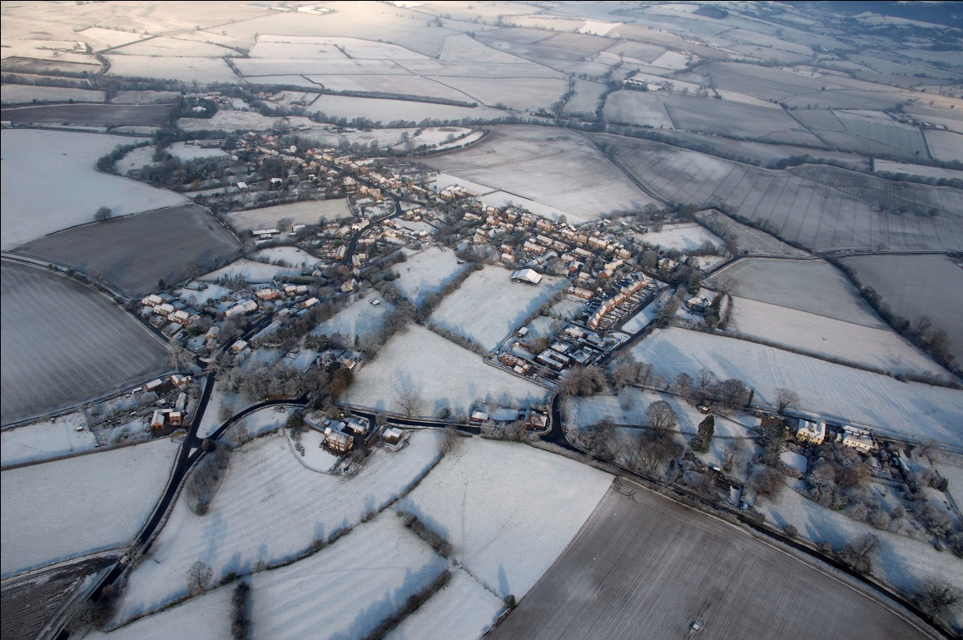

By Anne Bennet Richardson
Master of Arts (by research)

Department of Archaeology, University of York
September 2011

Abstract

Title: Agriculture and Settlement in Medieval Husthwaite and Baxby, North Yorkshire

Master of Arts (by research): Landscape Archaeology

This dissertation considers evidence for agriculture and settlement in Husthwaite and Baxby from the Saxon period to enclosure. Evidence is sought for an early-middle Saxon settlement and a field system of long lands. The establishing of a later complex common field system, its further restructuring and subsequent decline will be followed. The relationship between field system and settlement morphology will be discussed, and evidence is given for dispersed settlement, nucleated settlement, and the subsequent re-planning of the latter. Reasons will be sought for the co-existence of both woodland and common arable field systems, and comparisons will be made to field systems elsewhere in Yorkshire. Husthwaite’s court roll is used as the principal research tool in determining the field systems.

Table of Contents

Abstract i
List of Figures iv
List of Tables v
Acknowledgements vi
Abbreviations vii
Chapter One: Introduction 1
Chapter Two: Methodology and sources 6
Chapter Three: Review of previous research 15
3.1 The early Saxon period 15
3.2 The middle Saxon period 17
3.3 Co-aration and holding regularity 20
3.4 The debate over dating fields of long lands 22
3.5 Nucleation of settlement 26
3.6 The creation of an Anglo-Scandinavian society 29
3.7 Changes in settlement layout 31
3.8 The common-field system: previous research 33
3.9 Restructuring of townships in the late 11th-13th centuries 36
3.10 The breakdown of the tenurial system in Yorkshire 41
Chapter Four: The geology and early medieval topography of Bachesbi 46
4.1 Geology 46
4.2 Topography of Bachesbi in the early medieval period 48
Chapter Five: Husthwaite and Baxby - previous research 52

Chapter Six: The proposed evolution of the field systems and settlements of Husthwaite and Baxby manors 58
6.1 The search for evidence of early Saxons in Bachesbi 58
6.2 Fields of long lands in Bachesbi 61
6.3 Nucleation of settlement in Bachesbi 65
6.4 The arrival of the Scandinavians 68
6.5 Settlement in Husthwaite manor 69
6.6 Settlement in Baxby manor 72
6.7 Husthwaite’s common arable fields 74
6.8 Factors leading to the adoption of a common-field system in Husthwaite 79
6.9 Baxby manor’s field system 83
6.10 The restructuring of Husthwaite township 86
6.11 The restructuring of Husthwaite’s field system 91
6.12 The decline of the common–field system in Husthwaite 96
Chapter Seven: Discussion 98
Tables 103
Appendix 1: Evidence of ‘ridge and furrow’ in Husthwaite 116
Appendix 2: The possibility of a Roman road through Husthwaite 117
Appendix 3: Footpaths and cart tracks 119
Appendix 4: Medieval land measurement in Husthwaite 122
Appendix 5: Flatting, and the demise of the common fields in Husthwaite 128
Appendix 6: Maps and documents consulted in this dissertation 134
Appendix 7: Maps referred to in text 138
Primary Sources 157
Maps 158
Secondary Sources 159

List of Figures

Figure 1. The location of Husthwaite and Baxby. 138
Figure 2 The 1841 Tithe map of Husthwaite. 139
Figure 3 The Central Provinces 140
Figure 4 Early-middle Saxon sites in North Yorkshire. 141
Figure 5 Crayke field system 142
Figure 6 Townships examined by Harvey in the Central Vale of York and the Wolds 143
Figure 7 The field-system of Husthwaite township in the early seventeenth century, with its division into fields and flatts 144
Figure 8 Geological map of Bachesbi. 145
Figure 9 Townships with woodland and wood-pasture around Husthwaite referred to in charters of the Honour of Mowbray. 146
Figure 10 Fields of long lands in Bachesbi . 147
Figure 11 The village plan in the 1841 Tithe Map of Husthwaite, showing conformity of toft boundaries 148
Figure 12 Possible area of settlement in the middle Saxon period . 149
Figure 13 Map of Baxby manor field showing location of Tofts close. 150
Figure 14 The common fields of Husthwaite 151
Figure 15 Footpaths/cart-tracks in Husthwaite village. 152
Figure 16 Husthwaite's field-system circa late 11th-13th centuries 153
Figure 17 Possible Roman road going through Husthwaite. 154
Figure 18 Footpaths/cart-tracks in Husthwaite township 155
Figure 19 Village tofts in 1841 156

List of Tables

Table 1 Field-names with elements referring to woodland 103
Table 2. Field-names indicating land usage other than woodland. 109

Acknowledgements

Firstly, I would like to thank my Supervisor, Dr. Aleksandra McClain. Her encouragement, advice and support throughout the writing of this dissertation are much appreciated and I will always remember our meetings with great pleasure. Further thanks are due to Dr. Helen Goodchild for her considerable help - and patience! - in the production of maps for this dissertation. I am also indebted to Ms. Dot Salmon at the North Yorkshire County Record office, Northallerton, for her assistance in translating the Latin in the early 17th century surrenders; the information she provided was invaluable. I would like to thank the following for sharing their documents, time, and observations with me: Professor Stuart Marriott for documents concerning the manors of Husthwaite and Baxby, Mrs. Elaine Smith for access to 19th century plans of Baxby Manor lands and the Highthorne Sale schedule of 1886, Mr. Geoffrey Wise for the 1890 Flower o May farm plan, and Mr. Jan Janiurek for aerial photographs of the village, including that on the title page. Finally, I would like to thank the staff of the North Yorkshire County Record office whose willingness to help was greatly appreciated.

Abbreviations

BI: Borthwick Institute of Historical research
cbe: containing by estimation
EHP: English Heritage Pastscapes
HER: Historic Environment Record
ME: Middle English language, approx. 12th to 16th century
OE: Old English language, approx. 5th to 12th century
ON: Old Norse language
NA: Nottinghamshire Archives
NYCRO: North Yorkshire County Record Office
RAF: Royal Air Force
SA: Sheffield Archives
SFB: Sunken-featured building
TCCA: Trinity College, Cambridge Archives
VCH: Victoria County History, Yorkshire, North Riding, vol.2 (1923)

Chapter One: Introduction

This dissertation aims to explore the evolution of the field systems and settlements in the townships of Husthwaite and Baxby and in doing so hopefully add to the current knowledge of the early medieval period in northeast Yorkshire. Research at township level, as in this dissertation, is essential to test the generalisations of broader studies, and to evaluate the extent to which individual townships such as Husthwaite conformed - or not - to the conclusions reached by researchers of early medieval agricultural systems and settlement.
The township of Husthwaite is situated approximately seventeen miles north of the city of York (fig.1) and the 1841 Tithe map of Husthwaite shows that Baxby manor consisted of five parcels of land lying within Husthwaite manor (fig.2). Although administratively they remained two distinct manors, through purchase, marriage and inheritance the two communities of Baxby and Husthwaite became integrated, and farmers owned land in both manors and shared the meadows and commons. This intermix of economies is reported in a Tithe Cause of 1557 (BI: CPH 1164).
Roberts and Wrathmell (2000b, 68) place the northern Vale of York, the region in which the two manors lie, within the ‘Central Provinces’, an area stretching from Northumberland and Durham in the north to Dorset and Wiltshire in the southwest (fig.3). Extensive research has been done on settlements and field systems in the Central Provinces, not only by Roberts and Wrathmell, but also by Hall (1995) in Northamptonshire, and Lewis, Mitchell-Fox and Dyer (2007) in Northamptonshire, Bedfordshire, Buckinghamshire and Leicestershire. It is argued that this province is characterised predominantly by nucleated settlements associated with a complex common-field system referred to as the ‘Midland’ system. Many of the conclusions reached - for instance what circumstances led to the creation of the Midland system and which key features define it - are widely accepted and regarded as relevant to field arrangements generally in this region.
Outside the Central Provinces, systems with subtle differences are numerous (Baker and Butlin 1973; Campbell 1981, 112-29), and research has shown that communities tended to establish a field system relevant to their needs, topography and soil, and other factors such as improvements in technology, demographic changes and historical events also influenced agrarian arrangements. Diversity also appears within regions. The extent of local variation in field arrangements can only be revealed by studies of individual townships such as those carried out by Dyer (1991) at Hanbury (Worcs), and by Jones and Page (2003) at Whittlewood (Northants/Bucks). Their research indicates that the field systems of these townships, both in the Central Provinces, had features not wholly consistent with the criteria laid down for the Midland system that is said to be characteristic of the region. The field arrangements and settlements of Husthwaite and Baxby will be examined to establish whether they conformed to the Midland criteria, or whether they, too, developed their own unique systems. The greater the number of individual townships that are investigated, the better tested is the validity of the criteria said to define the Midland system.
Compared to regions elsewhere in the Central Provinces, only a limited amount of research has been done on field systems in north and northeast Yorkshire. Some important studies have been carried out, however. Harvey (1982, 1983, 1984 and 1985) has done considerable work on field systems in Holderness, the Wolds and the Central Vale of York (from York in the north to Selby in the south). Sheppard (1966) has traced the evolution of the agrarian arrangements in the township of Wheldrake (6 miles southeast of York) from the twelfth to the eighteenth century. Allerston (1970) has researched the organisation of arable land in the Vale of Pickering, and Beresford and Hurst (1990) have studied the field arrangements at Wharram Percy. While Sheppard (1974 and 1976) has done considerable research on Yorkshire village plans that includes villages in the Vale north of York, no research has been done on the field systems of these townships, and it is hoped that this dissertation will add to our understanding of field system development and settlement evolution in this area. By establishing the nature of Husthwaite’s and Baxby’s field arrangements and comparing them to other field systems in northeast Yorkshire already established by previous research – in particular, those in the Central Vale of York and the Wolds - the degree of commonality between these areas and Husthwaite can be determined. Harvey’s research (1984 and 1985) led her to believe that the field systems of the Central Vale and the Wolds had a common origin, but she was unable to reach any conclusion regarding the nature and date of that common origin; this dissertation, building on the evidence from Husthwaite, will suggest a possible solution.
Field systems are fundamental to our understanding of rural life in the medieval period. Land was England’s greatest resource and a profitable agrarian system was crucial both at township level and, in a wider context, the medieval economy. Such was the importance of the agrarian economy that it is thought that field systems influenced the pattern of settlement, and that the establishing of large arable fields was a factor in settlement nucleation (Lewis et al 2007, 171). It is hoped the study of Husthwaite’s field system will add to the existing knowledge of this important subject.
In this dissertation evidence will be sought for agricultural regimes in the late Saxon period, and likely arrangements for earlier periods will be suggested. The dissertation also examines the relationship between fields and settlement morphology. The creation of the lordship of Husthwaite and the effect this had on agrarian arrangements and settlement form will also be discussed. Comparisons will be made between the early medieval agrarian systems of Husthwaite and those of townships elsewhere in northeast Yorkshire. Evidence for late medieval restructuring of the field system and settlement will be examined in light of such factors as the economic, demographic and climatic downturns of this period which may well have had substantial effects on agriculture and daily life (Dyer 1997, 160-1; Miller 1991, 44; Pollard 1989, 93,103; Newman 1999, 85).
The main source used for this research is Husthwaite’s court roll (in which all copyhold land transactions are recorded), and close scrutiny of its entries provides valuable insights into Husthwaite’s early field arrangements. Use of the manorial court roll in determining Husthwaite’s field system is an innovative method and one that may be of value in identifying field arrangements where maps and surveys no longer survive. A further advantage is that, unlike maps and surveys that can give only a snapshot of a field system at one point in time, the court roll provides information that enables the evolution of the field system to be determined. This is achieved by retrogressive analysis (trying to ascertain earlier conditions through studying later forms of evidence). By working backwards through the court roll earlier field arrangements are revealed. This method may be of particular use in identifying field systems similar to those found by Hall in Northamptonshire (1995, 137). His research there led him to believe that the origin of the common field system may lie in fields of long lands (arable strips), and the possibility that a similar arrangement may have existed in Husthwaite will be explored by examination of Husthwaite’s court roll. If the presence of long lands can be proven by this means for Husthwaite, it raises the possibility that in other townships where presently only medieval field systems are recognised, fields of long lands can be identified through examination of court rolls and Hall’s theory that such fields are the initial stage of more complex field systems will be verified.

Chapter Two: Methodology and sources
Hall (1983, 115) asserts that to identify early field systems and tenurial arrangements, three sources are essential: an open field plan, a field book, and adequate documentary records. Regarding the latter category, Hall specifies charters, extents and deeds, but makes no mention of court rolls. The previous research done by the author to identify the seventeenth-century field systems of Husthwaite, on which much of this dissertation is based, could not have been achieved without close examination of the court roll of the seventeenth, eighteenth, and nineteenth centuries (NYCRO: ZBQ). Indeed, of all sources available, it is the court roll, in conjunction with the 1841 Tithe maps of Husthwaite and Thornton-cum-Baxby that the research has relied on most heavily (BI: TA 333M and NYCRO: ZDV respectively). This approach was adopted out of necessity. There is a paucity of documentary evidence concerning Husthwaite and Baxby as no open field plans, field books or maps pre-dating the nineteenth century have survived, glebe terriers are uninformative, and indentures and charters are very few.
Husthwaite’s manorial court roll consists of ‘surrenders’ and ‘admittances’ that detail copyhold land ownership. When land or property was sold, or when the tenant died, the property was ‘surrendered’ back to the lord; when the new tenant came forward to register his title to the land he requested to be ‘admitted’ to the property. In this way, all transactions of copyhold land were recorded at the manor court. The roll survives, although incomplete, from 1625, and this was examined in the original and on microfilm at the North Yorkshire County Records Office. Fragments of Husthwaite’s court roll for the period 1625 to 1668 are also found in two separate deposits in the Nottinghamshire Archives, and these, too, have been examined in the original (DD/S/47/1-19 and DD/S/47/45). Unfortunately, the court roll for Baxby manor no longer survives.
Deciphering the text in early surrenders can be difficult where the sprawling Secretary Hand was used by the scribe, where extreme forms of abbreviation were used, where the writing was tiny and feint, and where it was difficult to determine the letters represented by minims (the short vertical strokes used to make the letters i, m, n, u and v). Illegibility due to poor preservation was always a problem. The court roll did not become a continuous roll until 1769 at which point the surrenders became laced together head to tail. Before that date the roll consisted of individual membranes and, consequently, many earlier surrenders are lost. There is a gap of twelve years between 1698 and 1710, for example, although a summary book held at Nottingham provided some of the missing information. Until 1733 the roll legally had to be written in Latin, with the exception of the Civil War period or when the business described did not fit into the standard legal verbal formulae. Enrolments prior to the middle of the seventeenth century were very brief, often lacking information that would help to locate the parcel of land being conveyed.
Despite these drawbacks, it was possible to use the court roll, in conjunction with the Tithe map of Husthwaite, to reconstruct the early seventeenth-century field arrangements of Husthwaite. (The nature and purpose of Tithe maps is described below.) The significance of the Tithe map is that it records the names and locations of the (small) fields of Husthwaite that existed in 1841. The reconstruction of the early seventeenth-century field system was then achieved by retrogressive analysis. This technique has been used successfully by Sheppard (1974) and Roberts (1970) to determine early village plans in Yorkshire and Durham. Roberts again used it with Wrathmell (2002, ix) in a further study of rural settlements, and Hall used retrogressive analysis to calculate the final complete form of the Midland field system (1995, 135). The ownership of Husthwaite’s (small) fields was followed backwards through the court roll, and by this method, the history of each field was traced back to the pre-enclosure period. This was a time when farmers held individual lands (strips or selions) rather than enclosed parcels, and these lands were located within a flatt, a division of the common arable field referred to elsewhere as a ‘furlong’ or cultura. An example of a typical early surrender of this period is an exchange of 1627 between George Rosse and John Dove in which the former’s parcel is described as ’certain selions in the knapperan field viz two selions in Bryflattes between the lands of Thos Stavely on the west and lands of Wm Fishear on the east…’. Harvey (1982, 37) also found the method of describing a parcel’s location by reference to its neighbours present in the Wolds. She believes it implies that the lands were always bounded by the lands of the same two holdings and is, therefore, an indication of holding regularity.
A problem encountered in tracing the history of the fields is that the loss of membranes of the early period caused gaps in the sequence of ownership of lands, making it difficult to establish the location of some parcels. In these circumstances, although the transactions between sellers and buyers could not be followed, the location of parcels could often be determined by reference to their neighbours. A second problem was that when lands (strips) were amalgamated, the enclosure thus formed was given a new field-name, and no reference was made to the name of the flatt the enclosure had once been part of. Again, by identifying the neighbours, the flatt in which the parcel formerly lay could often be determined.
Having established Husthwaite’s seventeenth-century field system, surrenders were again examined to determine the orientation of lands in the flatts. Fortunately, the medieval format of locating lands by reference to neighbours on either side being on a specific compass point indicates land orientation. If neighbours are on the east and west, it follows that the orientation of the land is north-south. The orientation of lands in adjacent flatts can then be compared, and where there is a common orientation, it suggests the possibility of long lands. Long lands are also suggested by field-names such as ‘Long Sandlands’, ‘Long Acres’ and ‘Long Roods’. Where lands had been amalgamated and enclosed prior to the survival of records, surrenders make no reference to the orientation of lands within these parcels, and so other methods were used to establish orientation. By walking Husthwaite’s public footpaths it was possible to identify remnant ‘ridge and furrow’ and observe land orientation. Headlands (the build-up of soil at the end of a land), were also identified, and they, too, indicate the direction of lands.
Footpath-walking also reveals medieval arable in areas where documentary sources suggest otherwise. Surrenders from the early 17th century onwards describe land in the Highthorne Field as pasture and meadow, yet walking reveals clear ‘ridge and furrow’ in most of this area. (This also illustrates the importance of adopting different methods of investigation.) Ditches and a holloway that are thought to represent the boundary of the early nucleated settlement at Husthwaite were also identified by footpath-walking. It is believed most present-day public footpaths in Husthwaite were established in the late Saxon period, and one may be Middle Saxon in origin. Evidence for this theory is given in Appendix 3, ‘Footpaths and Cart-tracks’.
Because no excavation has taken place in Husthwaite, dating is problematic, and it is only possible to suggest a sequence of events rather than propose specific dates for each stage in the development of the township. A relative chronology can be surmised by comparing events in Husthwaite with similar events elsewhere where excavation has taken place. Although current practice often avoids using the label ‘Anglo-Saxon’ (which has cultural and ethnic connotations) and instead uses the more neutral term ‘early medieval’ (Lucy 2000, 16-7; Dyer 1990, 38), the divisions of early, middle and late Saxon are used here in order to put the events into a chronology. The dates for these divisions are taken from Reynolds (1999, 23): Early Saxon c.450 - c.650, Middle Saxon c.650 - c.850 and Late Saxon c.850 - 1066. The following medieval period is divided into the relevant centuries.
Numerous maps and documents were examined in this research and these are detailed in Appendix 6, ‘Maps and documents consulted in this dissertation’. Of the thirteen maps examined, the most important was the 1841 Tithe map of Husthwaite. Tithe maps were produced at the time of the abolition of the system of tithe payment in which one tenth of a farmer’s produce was given to the Church (later to private individuals). This required the preparation of Tithe maps with Schedules that listed the owner, occupier, field number, field name, field use, acreage and tithe apportionment of each field in the township. A plan of the village indicating toft boundaries was also included. The maps were produced to calculate the amount of money rent to be paid by landowners in lieu of tithes.
Whilst being an invaluable source of information, Husthwaite’s Tithe map has, nevertheless, to be used with caution as inaccuracies have been found on the map and in its accompanying Schedule. It would appear mistakes arise because the scribe misunderstands what he is being told. For example, on the map a parcel that is spelt ‘Haugh’ in 28 surrenders from the 1630s onwards, is seen on the Tithe map as ‘Offs’, probably because the pronunciation of this word sounds like ‘hoff’ (Beckensall 2006, 35). Another example is that of two adjacent fields that were originally one parcel. Whereas the compiler of Husthwaite’s map names one parcel ‘Row Kills’, the compiler of the Thornton-cum-Baxby Tithe map calls the adjacent parcel ‘Roke Hills’ – the former is a corruption of the latter. Mistakes regarding the drawing up of field boundaries have also been found as descriptions in surrenders of parcels in the High Field do not agree with field boundaries on the Tithe map. A study of Tithe maps has shown that only one in six was deemed accurate (Evans and Crosby 1997). The 1841 Thornton-cum-Baxby Tithe map (NYCRO: ZDV) was also examined for field-names and acreages.
The earliest documentary record of Husthwaite and Baxby is an entry in the Domesday Book of 1086 (Faull and Stinson 1986; folios 303a, b and 327b). This records the co-existence of the two manors, both appearing under the name Bachesbi. One entry refers to 15 bovates of land owned by Hugh son of Baldric, the other to 6 carucates and 1 bovate owned by Ulfr. The 1841 Tithe maps of Husthwaite and Baxby indicate that Husthwaite was the larger manor, as Husthwaite is described as ‘containing by estimation’ 1500 acres whereas Baxby manor is said to be around 300 acres. As the two manors of Husthwaite and Baxby are referred to as ‘Bachesbi’ in the Domesday Book, this name will be used for the whole area until the manor of Husthwaite is created, after which the two manors will be referred to by name.
The Domesday Book records the extent of cultivable land in the township in the 11th century. It was once thought that the carucate recorded in the Domesday Book was a statement of tax liability rather than an accurate description of cultivable land. This is no longer thought to be true, however, as the research by Eyre (1990), Sheppard (1975), and Harvey (1985) has found that ‘There are strong grounds for believing that (in Yorkshire) carucate assessment in the Domesday Book did reflect agrarian conditions of the early 11th century fairly closely’ (Harvey 1985, 42). This being so, it was possible to calculate to a reasonable degree of accuracy the quantity and location of land cultivated in Husthwaite in 1086.
The Domesday Book indicates there were six carucates and one bovate of cultivated land in Husthwaite at the end of the 11th century. A carucate represented the amount of land a team of eight oxen could plough in a year – in theory this was 120 acres but in practice it varied from area to area according to the quality of the land (Williamson 2004, 69). There were eight oxgangs, or bovates, in a carucate. As early seventeenth-century surrenders in the court roll indicate that in Husthwaite an oxgang was 10 customary acres, there were, therefore, 490 customary acres of cultivable land in the township in 1086. It has been calculated by the author that a customary acre equalled 1.2 statutory acres in Husthwaite. (Evidence for this is shown in Appendix 4 ‘Medieval Land Measurement in Husthwaite’). Thus there were 588 statutory acres of cultivable land in Husthwaite manor in 1086.
Various indentures, lease/releases, cause papers, a letter of 1613, a 12th century charter, aerial photographs, inventories, terriers, miscellaneous items from Newburgh Estate archives, and Husthwaite’s court roll, Accounts of Fine and other manorial and enclosure records, have been examined. Details of these are also given in Appendix 6.
Field-names reflect the fundamental relationship between people and the landscape, and their study can be a valuable source of information reflecting topography, land usage and, to a limited extent, chronology. It is essential to find the earliest version of the name as later versions, although seeming appropriate, can be corrupted and misleading. For example, the first impression given by the field-name ‘Buttery Stubbs’ is that it is derived from Old English butere meaning ‘good pasture’, or, ‘place where butter is made’ (Gelling 2011, 997). In a document of 1659 and in following documents, however, the parcel was called ‘Burtry Stubbs’ and the derivation is actually OE burtr, ‘elder tree’, and OE stubb, ‘land cleared of trees/tree stump’, thus meaning ‘place cleared of elder trees’ (Field 1972, 33 and 222). Indentures indicate the name did not become Burtery until some time between 1704 and 1747. Thus the most reliable names are the earliest. Pronunciation must also be taken into consideration. In 1637 a surrender refers to a field called Reed Kells – the derivation seemingly OE hreod, ‘reed’ and ON kelda, a spring (Field 1972, 181; Gelling 2003, 18). All other surrenders refer to this parcel as ‘Red’ Kells, however, this being a description of the red colour of the iron-rich water. It seems ‘Reed’ Kells reflects the pronunciation of the owner when relating the description of the parcel to the scribe.
A further hazard is that places and fields can be re-named thus giving a false date for the original occupation of that place. Baxby manor is in an area where all field-names have an Old English derivation which is indicative that a settlement existed there in the Saxon period, yet the name ‘Baxby’ is believed to be Scandinavian in origin. Without reference to the field-names, Baxby might be judged to be a settlement of Scandinavian origin, rather than pre-dating this period. This practice of renaming settlements was not uncommon and another example of this is the Saxon settlement Streonaeshalh which was renamed Hviti + by by the Scandinavians, later becoming known as Whitby (Faull 1984, 140).
It must be remembered that even though fields may all have, for example, Scandinavian derivations, it does not mean they all came into existence at the same time, or were all assarted by the Scandinavians. Some fields could have been assarted decades after the Scandinavians’ arrival in the township, by which time elements of the Scandinavian language would be in common usage by the indigenous people. A further point is that the languages of the Scandinavians and Saxons were not dissimilar (Hadley 2006, 131; Richards, J, 2006, 62), and this can create difficulties as the similarity of words can make it impossible to be sure of the derivation, eg OE aecer and ON akr (Gelling 2003, 263). Finally, it is possible that speakers of one language could adopt and use place- and field-names in another language - they did not need to speak the language or understand its etymology to use the name (Hadley 2001, 14).
We are fortunate in that Husthwaite’s court roll survives, although incomplete, from 1625, as it is in the early decades of the seventeenth century that surrenders record the cultivation of ‘selions’ and ‘lands’. By 1685, all but six lands in Short Knaprons had been amalgamated and enclosed, and flatts in the Arteby Field, the main area of cultivation, no longer existed, being replaced by the small enclosed fields seen on the Tithe map. Without these early entries, the early arrangements of flatts, and the flatt-names, would be lost, and this research would have been greatly diminished. All the maps and documents listed in Appendix 6 made a contribution to the understanding of Husthwaite’s field system, some in a minor way, others more significantly. Even later documents which one would not expect to contain any relevant information can be rewarding. For example, the relatively late map of 1874, the ‘Rough Plan of John and Thomas Woodward’s Estate’, contained field-names of Old English origin, whereas the names for the same fields in the Thornton-cum-Baxby Tithe map of 1841 were ‘modern’. All ‘avenues’ are worth pursuing. Similarly, before the evidence for Husthwaite and Baxby is presented, it is important to examine previous work regarding early medieval settlements and field systems in order to provide a context for our study, and to aid our understanding of the Saxon and Norman periods. For this reason, the conclusions arrived at by scholars of the early medieval period will be reviewed.

Chapter Three: Review of previous research

3.1 The early Saxon period
Early Saxon settlements at West Stow in Suffolk (West 1985) and Mucking in Essex (Hamerow 1993) have provided a wealth of information for this period but Powlesland’s excavations at West Heslerton in North Yorkshire (fig.4) will be the main area of discussion as it provides an insight into an early Saxon settlement approximately thirty miles from Bachesbi (Powlesland 1999 and 2004). If a settlement had existed in Bachesbi in this period, it may have shared some of the features found at West Heslerton. Powlesland describes the community as a sophisticated society living in high-quality housing, having a well-developed agricultural regime of mixed farming supported by domestic industry, and trading in goods that came from places such as the Red Sea and Scandinavia (Powlesland 2004, 67). He found spatial variation in the layout of the settlement, with areas set aside for particular functions – crafts, housing, agricultural processing and a multi-functional zone. It appears that the early Saxon site, an area of 45 acres, was laid out in zones from its inception, and these zones were in use for most of the life of the site (c.380-850) (Powlesland 2000, 22). Evidence from excavated cemeteries elsewhere suggests that the population for settlements of this period may have been around 30-50 people (Hamerow 2010, 9).
In general, evidence of early Saxon settlements is difficult to find. Preservation of pottery is poor as it was handmade and liable to disintegrate. Buildings (sunken-featured buildings (SFBs) and timbered halls) were mainly wooden, and preservation of these and other everyday objects made of wood, leather or fabric are unlikely to survive (Hamerow 2011, 120; Lewis et al 2007, 74). Nevertheless, early Saxon cemeteries, sculptures, hoards and other artefacts have been found in north Yorkshire, not only in the Vale of Pickering, but also in the Vale of York in which Bachesbi lies (fig.4; Powlesland 2004, 63). Consequently, Powlesland believes that more early Saxon sites may have existed than have so far been found in this area of north Yorkshire, and he argues that rural populations may have maintained similar high levels in the early Saxon period as they had done in the Iron Age and Roman period (Powlesland 2004, 66).
A feature of this period is ‘settlement shift’. Settlement shift might consist of replacing one building with another built nearby, or might involve a more substantial migration, a relocation of the population over a short distance, perhaps to more fertile ground (Hamerow 1991, 5, 11). The first form of settlement shift is seen at West Stow where seven halls and seventy SFBs spread across 4.5 acres appeared to be the result of the gradual movement of occupation, involving the rebuilding of the homes and outbuildings of three family groups (West 1985, 15, 167-8). Hamerow (2010, 7) identifies the second form of settlement shift at Mucking, where the hamlet appears to have twice moved about 400 metres each time (although she recognises the possibility that two of the three foci of settlement may have overlapped chronologically). Hamerow based her belief that settlement shift had taken place at Mucking on the lack of stratified deposits, and on her analysis of pottery found in individual SFBs which suggested that not all the buildings were contemporary. She believes there was no discontinuity of settlement, rather a gradual change in the focus of settlement. The possibility that settlement shift occurred in Bachesbi will be discussed below.
Early Saxon farmers favoured a particular type of environment and this is discussed in order that comparisons can later be made to the location of settlement sites in Husthwaite and Baxby. While previously some Romano-British peasants had cultivated heavy soils, after the collapse of Roman Britain the cultivation of such soils was, to a considerable extent, abandoned, and cultivation was concentrated on the lighter sands and gravels (Oosthuizen 2011, 381; Higham 2010, 18). Early Saxon farmers used the ard, a light plough that merely broke up the soil but did not do so to any great depth and did not create ridges – a relatively inefficient piece of equipment that could not cope with heavy soils (Williamson 2004, 122). Williamson (2003, 32) argues that,
‘In early Saxon times population densities were, to judge from the available archaeological evidence, most closely related to the ease with which soils could be cultivated, rather than to their fertility’.
Evidence of this was found by West (1985, 168) at the early-fifth-century Saxon site at West Stow where the early Saxons showed a constant preference for light soils and an avoidance of clay.
Early Saxon farmers cultivated the land using an infield-outfield system with an intensively cultivated, well-manured infield, perhaps divided into strips between individuals – open, but not held in common, and not subject to strict regulations regarding cultivation and grazing arrangements. In the outfield, plots of land would be brought into cultivation from time to time and then abandoned (Oosthuizen 2011, 380). At West Stow, West identified a mixed economy of arable farming (barley, rye and wheat) and animal farming (sheep, cattle and pigs). Deer, fishing and fowling supplemented the diet (West 1985, 169).

3.2 The middle Saxon period
The middle Saxon period was characterized by technological change, a rapid expansion in the area of land under the plough, improved methods of fertilizing the fields, and the specialisation and intensification of crop production (Oosthuizen 2011, 384). Old field systems were abandoned and new arrangements established, one of which was a system characterised by lands of great length (Oosthuizen 2011, 383-6; Hall 1995, 137). It is possible that fields of long lands were cultivated in Husthwaite, and so the dating and origins of such fields are discussed below.
The establishing of fields of long lands is associated with the re-introduction of the mouldboard plough, last used in the Roman period (Oosthuizen 2011, 385). Although there is no direct evidence of use of this plough in the middle Saxon period, it is suggested by late Saxon ploughshares and eleventh-century manuscripts. Williamson (2004, 120) states,
‘there can be little doubt they (mouldboard ploughs) had come into widespread use in middle Saxon times simply because, by the eighth century, settlement had expanded once more onto the kinds of heavy soil which could not be easily cultivated without them’.
The re-adoption of the mouldboard plough influenced the whole pattern of agriculture, leading to a change in the morphology of the strip and field shape. With the ard, land had to be cross-ploughed, and so fields tended to be small and square in shape. Heavier mouldboard ploughs, however, were pulled by large teams of oxen - as many as eight oxen, resulting in a 12 metres long ploughteam – which, given the difficulty of turning, were most efficient if they were run in long stretches. This led to the cultivation of large fields of long lands (Hall 1981, 37; 1982, 53; 1995; Matzat 1988, 140; Williamson 2003, 119-122).
Hall found evidence for these long lands in the alignment of lands in furlongs, seen clearly in aerial photographs. Hall states, ‘Countless aerial photographs show blocks of furlongs with lands lying at exactly the same angle’ (Hall 1985, 64; 1995, 133-5). Hall (1995, 133-135) gives the examples of Raunds and Wollaston in the Midlands. At Raunds six furlongs seem to have been created from one smooth curve of lands nearly a mile long, and at Wollaston fourteen furlongs had strips in exactly the same orientation, suggesting they were originally one set of strips 12,500 metres long. Further evidence for the subdivision of larger units at Wollaston is seen in furlong names e.g. Upper Whines and Lower Whines. The possibility that fields of long lands existed in Husthwaite, and that those fields were later subdivided as at Wollaston, will be explored below.
Fields of long lands have been found in northeast Yorkshire. In the Wolds, Hall found them in the deserted medieval villages of Wharram Percy, Burdale, Wharram-le-Street and Towthorpe, and Harvey found them in the Wold villages of Kilham, Butterwick, Wetwang and Southburn (Hall 1978; 1995, 131; Harvey 1982, 30; 1983, 91). Harvey also found that long lands were typical in Holderness (Harvey 1982, 29). Harris (1981) has identified them at Thornholme, and Allerston (1970, 105) found references in documents to ‘langlandes’ in the villages of Brompton, Allerston and Pickering, all of which are in the Vale of Pickering. (For the location of the Wolds, Holderness and the Vale of Pickering see fig.1) Locally, there may have been long lands at Easingwold, four miles south of Husthwaite, as an area of the township is called ‘Longlands’, and field boundaries in the 1856 O.S. 6” map of Crayke, five miles from Husthwaite, suggest long lands of approximately 1300 metres long (fig.5; Adams 1990, 48).
The length of the Crayke lands is not unusual for northeast Yorkshire. In Holderness, Harvey describes lands over 1,000 metres as quite common, and at Butterwick and Wetwang in the Wolds they reached 2,000 metres (Harvey 1982, 29-30). Hall (1995, 132) found lands of similar length at Middleton near Pickering, and Matzat (1988, 134) has identified long lands of approximately 2,700 metres at East Halsham in Holderness. The extreme length of some lands raises doubts about the practicalities of cultivating such strips, however. Roberts (1988, 170), whose research in Cumbria also revealed long lands, questions whether they were always ploughed as a whole, and Howell’s research in Pembrokeshire leads him to believe they were not. He found long strips in the manor of Newton and Jameston running north-south across an area where the geological trends, including bog-land, ran east-west. He concludes that the purpose of the long lands running across the geological features was so that the scattering of strips in order to ensure an equitable share of good and bad land was not necessary (Howell 1971, 18).

3.3 Co-aration (the sharing of a ploughteam) and holding regularity
Suggestions of organised land distribution in the middle Saxon period can be found in the laws of Ine (678-726), which refer to ‘meadow or other land divided into shares’ (Roberts and Wrathmell 2002, 134-5). Also, Hooke’s research into charters of the Saxon period lead her to conclude that intermixed strip fields were ‘well established’ in the tenth century, an example being a reference to ‘every third acre’ of bean-land (Hooke 1981, 58). This implies that intermixed holdings may have been established earlier, in the middle Saxon period.
Intermixed holdings may have been a consequence of using the mouldboard plough. As many farmers would be unable to afford a plough and full team of oxen, it seems likely a team and plough were shared (Williamson 2010, 139). Variations in slope, aspect, and the mineralogical qualities of the soil meant that some parts of the field might be more fertile than others, and so it is only fair to all the cultivators participating in the ploughing that they all have a share in those areas as well as poorer areas. Co-aration was particularly relevant in areas where the land was heavy and clay was prevalent. The ploughing of boulder clay required careful timing. Such soil tends to puddle and compact - it has to be ploughed at the right condition of humidity and left strictly alone when wet. With such short ‘windows of opportunity’ some parts of the field would be ploughed whilst other areas would have to wait for the next ‘window’. As every farmer would want the part that was ploughed rather than wait indefinitely until ploughing was again possible in other areas, intermixed holdings may have been introduced to give each cultivator a chance of getting a strip ploughed before it was time to sow (Williamson 2004, 141-147).
Hall believes that holding regularity was introduced at an early date, arguing that it is a ‘fundamental feature’ of early field systems, and concludes, ‘fields were laid out in the late Middle Saxon period in a planned, large-scale manner, with a regular tenurial order’ (Hall 1995, 137). Oosthuizen (2011, 391-392), however, while acknowledging that large, open, arable fields subdivided into strips were present in the middle Saxon period, argues that nothing is known about tenure.
In general, the middle Saxon period is one of greater organisation, suggesting that a new form of tenure and holding regularity are not impossible. This is seen in a more hierarchical society, the creation of large estates, and changes in settlement morphology. Excavation at early Saxon settlements appears to indicate land and resources were exploited by extended families, as Hamerow (1991, 6) found at Mucking. This is suggested by the loose groupings of buildings with no apparent demarcation in either internal boundaries or external boundaries such as fences. Powlesland (2004, 66) found a similar situation at the early Saxon settlement of West Heslerton where there was no obvious hierarchy, leading him to describe the community as having a ‘limited range of social stratification’. Like Hamerow, he found no property boundaries even where the survival of strata would have preserved such evidence (Powlesland 2000, 22). The emergence of a more stratified society appears to have taken place around the seventh century when there is evidence in settlements of greater organisation and an increase in the demarcation of property (Reynolds 1999, 50). Brown and Foard (1998, 77) found ‘planned regularity’ in the later middle Saxon sites of North Elmham in Norfolk and Pennyland in Buckinghamshire, suggesting land and property are now held by individuals. At West Stow, West (1985, 162), too, found indications of property ownership on a personal or immediate family basis in the middle Saxon period.
As a more hierarchical society developed, land was organised into ‘multiple estates’ consisting of an estate centre or caput and a number of outlying settlements (Williamson 2004, 37-38; Reynolds 1999, 50; Brown and Foard 1998, 77). Each settlement supplied its own basic needs but also provided special commodities for other settlements, thus creating an intermixed economy among hamlets (Hadley 2006, 84; Richards 2010, 50-52). Although evidence for holding regularity in the middle Saxon period is not conclusive, it seems possible that a society as described above would be capable of a degree of sophistication in the partitioning of its fields.

3.4 The debate over dating fields of long lands
Such was the extent of fields of long lands, Hall believes they were laid out in a planned way, in a single operation, and that the most likely period of their introduction is in the 8th century. His reasoning is that landscapes of extensive arable fields are closely associated with nucleation, and it is thought that, in general, nucleation took place before the introduction of Saxo-Norman pottery around 850. This is based on fieldwalking evidence in the East Midlands that indicates the abandonment of dispersed settlements before the appearance of Saxo-Norman pottery (Hall 1995, 137).
Hall believes fields of long lands were the initial stage of the later, more complex, common field system (Hall 1995, 135). That long lands pre-date the short furlongs of the common field is seen in South Cave in the Yorkshire Wolds where it appears that long lands were the core area of arable with shorter furlongs added later (Matzat 1982, 139). Hall’s theory that long strips were restructured to create shorter furlongs is not new. In 1944 Muller-Wille and Niemeier, independently, concluded that, in Germany, long lands of 300-600 metres long were the oldest form of field layout, dating from the third to the fifth century. This view was supported by Mortensen and Scharlau in 1949, who argued that German long lands were later reorganised into the multiple short furlong type (Matzat 1988, 138-9).
This chronology is not universally accepted, however. In eastern Yorkshire fields of long lands survived until enclosure, leading Harvey (1981 and 1983) to believe that in Holderness and on the Wolds there was originally an irregular field layout that was then replaced by a regular long strip system. She identified three main features of this regular system - long lands, a standard orientation of lands, and relatively few furlongs that were virtually identical in terms of the number of lands within them (Harvey 1982, 30). She argues that such is the simplicity of the fields and the degree of regularity, that reorganisation of field-systems here was carried out at one point in time according to a pre-determined plan, and that this must have been done when the landscape was already fully exploited and the population levels high (Harvey 1984, 64). She further believes that the reorganisation could only be carried out under a unified lordship, as ‘The presence of a large number of estates would be less likely to result in the uniformity (of field layout) which exists in eastern Yorkshire (Harvey 1983, 95). The most likely period, she says, is following the Scandinavian invasions in the late 9th century (Harvey 1983, 103). Scandinavian society included a substantial class of noblemen called ‘holds’ (a higher rank than a thegn) who had considerable territorial power and held large tracts of land. The name ‘Holderness’ suggests this region was once the landed estate of such a noble, and Harvey sees no reason to suppose that the Wolds, also, was not part of a large estate or estates (Harvey 1983, 97). She also draws parallels between the degree of regularity in the flatts in east Yorkshire to the Scandinavian solskifte, a system whereby every flatt’s strips lay in the same sequence and this regularity was reflected in the location of the tofts in the village.
Her argument that the Scandinavians may be responsible for the introduction of the long strip layouts is not without flaws, however. Harvey’s major premise is that such a field-system could only be achieved by a unified lordship, but there is no evidence of the existence of such unity following the Scandinavian invasions. On the contrary, from the ninth century onwards there is evidence that when Scandinavians took over existing Saxon estates they divided them up, granting land to supporters as a reward. This policy is described by Roger of Wendover in a thirteenth-century compilation based on earlier records, ‘Halfdan (in 876) occupied Northumbria and divided it among himself and his thegns and had it cultivated by his army’ (Hadley 2006, 85). Nor is Harvey’s argument that long strip layouts were not the forerunner of the more complex common field system convincing. She argues (1983, 103) that ‘Unlike the examples in Northamptonshire the long lands in eastern Yorkshire were never subdivided to create shorter lands and more furlongs.’ This is not so in all cases as at Thornholme (in the Wolds) long lands were later divided into three fields (Matzat 1988, 137 and 141). Finally, Goransson (1961, 99) suggests the system was of pre-Scandinavian origin in England as the introduction of such field systems into Scandinavia post-dates the Viking occupation of England.
Fields of long lands extending across most/all of the townships in the Wolds in middle Saxon times is not impossible, as archaeological investigation suggests that the landscape had been extensively exploited since the Late Iron Age (Richards 2000a, 27). This occupation continued into the Roman period. York was an important Roman town, being one of only four towns in England granted the title of colonia in the third century, and Roman estates were established in the Vale of York and around the fort at Malton in the Wolds (Muir 1997, 76). Occupation does not appear to be disrupted, and excavations at Cottam and Wharram Percy suggest there was extensive settlement in the Wolds in the following Saxon period (Richards 2000, 28). This is confirmed by place-names studies that show that in both Holderness and the Wolds there was a fairly intensive pattern of settlement by the Saxon period (Harvey 1983, 100). Furthermore, analysis of entries in the Domesday Book by Darby and Maxwell (2008, 121, 196) support this view. Compared to the northern Vale of York, where the population level was just over one person per square mile, the population in the southern part of the Wolds and Holderness was between 2 and 3.6 persons per square mile (Darby and Maxwell 2008, 121, 197). Even in the northern part of the Wolds, where the population was only 0.5-0.8 persons per square mile, Harvey believes some townships may have achieved maximum cultivation by 1086, an example being Kilham which was assessed at 384 bovates in both 1086 and 1729 (Harvey 1983, 101). In general, she found that in most townships on the Wolds, land assessed for taxation occupied virtually all available land (Harvey 1984, 67). Why this should be so in the lesser populated areas is unknown. It may be the poor quality of the land (limestone and chalk) resulted in poor harvests, necessitating the cultivation of larger expanses of arable than would be required elsewhere. In short, it is not impossible that in many places in the Wolds, extensive cultivation of townships in the form of long lands took place in the middle Saxon period before the arrival of the Scandinavians.

3.5 Nucleation of settlement
Another feature of this period, and one associated with the laying out of large arable fields, is the nucleation of settlements. Research done by Hall in Northamptonshire leads him to believe that, as there was little time between the abandoning of dispersed settlements and evidence (from charters) of the existence of intermixed strip fields, the two events were probably simultaneous (Hall 1995, 131). Thus nucleation is discussed below in order to give an insight into the dating and origins of Husthwaite village.
Hall (1995, 131) believes that, in general, nucleation probably happened around the eighth century, although there are examples of nucleation taking place earlier - rectilinear, planned nucleations were laid out in the 6th or 7th centuries at, for example, West Heslerton in the Wolds (Hall 1981, 37; 1995, 131; 0osthuizen 2010, 119-20). Hall’s general date for nucleation is agreed by Brown and Foard (1998), Rippon (2010, 51-7), Higham (2010, 11), Oosthuizen (2010, 130-131) and Williamson (2004, 66). However, Lewis, Dyer and Mitchell-Fox (2007, 81) associate nucleation only with the complex common field system, and so believe nucleation to be a 9th or 10th century phenomenon.
It may be that complete nucleation of a township did not happen at one point in time. Rippon (2007, 120) and Brown and Foard (1998, 75-79) envisage at least two stages of nucleation: initial nucleation in the 8th century followed by the emergence of fully nucleated villages and the common-field system in the 10th century. Early nucleations may have been of a loose, informal nature, lacking alignment of structures and enclosures. Settlements may have only become more regular in the later stages of development (Oosthuizen 2010, 113-114). Also, later phases of restructuring villages may explain why there are numerous examples of settlements laid out over pre-existing open- or common- field systems. Oosthuizen (2010, 118) lists many such sites throughout England, and Harvey (1985, 41) recognised this phenomenon in the Central Vale of York.
Nucleation became necessary when large arable fields were established - any small settlements scattered about would form an obstruction and consequently their inhabitants moved, or were moved, to a central place that may already have been regarded as the more important site. An alternative theory put forward by Brown and Foard (1998, 76) is that nucleation came about though the failure of lesser sites, perhaps due to population decline and the growth of the surviving settlements. Co-aration may also have encouraged nucleation, as the clustering of farms would enable the rapid assembly of ploughteams (Williamson 2004, 181; Higham 2010, 19).
Hamerow (2010, 10-20) proposes three types of settlement layout for the middle Saxon period, namely, settlements without enclosures, settlements established in the early Saxon period that gained enclosures in the middle Saxon period, and settlements that were founded with rectilinear enclosures. The introduction of enclosures in settlements may reflect changes in animal husbandry in this period. It suggests animals were being kept closer to home, perhaps as a result of the setting aside of land for hay meadows, the introduction of which is thought to be a feature of the middle Saxon period (Oosthuizen 2011, 386). It is also thought that the introduction of common pasture rights probably occurred at the same time as the creation of large fields and nucleation of settlement (Brown and Foard 1998, 80-1). Thus the basic framework for replanning in the late Saxon period may have already been carried out in the middle Saxon period.
Hall (1995, 139) argues that the decision to nucleate and restructure the field system could have been a communal, rather than a signeurial, one. Dyer agrees, arguing that the influence of the village community should not be underestimated in a township’s restructuring (Dyer 1991, 60). He believes that, on the balance of probability, the self-government of villages existed before it was common for lords to impose their authority on village communities, and therefore it is possible that nucleation was not necessarily a seigneurial decision (Dyer 1994, 414-5). He argues,
‘We should surely open our minds to the possibility, indeed the likelihood, that villagers rather than lords were responsible for the planning of villages and field-systems’ (Dyer 2000, 11).
The laissez faire attitude of some lords in allowing villagers control over their field arrangements can be seen in tenth-century Somerset where Rippon (2007, 110-1) found that the bishops of Bath and Wells allowed their tenants to determine their own form of husbandry. Similarly, Dyer’s research at Hanbury (Worcs) led him to conclude that the lords there did not provide the crucial impetus for nucleation (Dyer 1991, 60).
The authority of the lord becomes more apparent in the tenth and eleventh centuries. This was due, perhaps, to the fragmentation of estates and the creation of one-township manors that resulted in a new class of independent local lords (Williamson 2004, 44-6; Dodgshon 1980, 153). In the northeast of England the breaking-up of Saxon multiple estates and creation of lordships was accelerated by the arrival of the Scandinavians, as Viking leaders divided their estates among their followers in reward for military service (Hadley 2006, 84-5; Richards 2007, 1).

3.6 The creation of an Anglo-Scandinavian society
Husthwaite and Baxby lie seventeen miles north of York, which, in 867, was captured by the Scandinavians. York became the capital of a Viking kingdom ruled by Halfdan, and occupation by the Scandinavians in the area around York is reflected in the number of villages with the element ‘by’ in their name - of which Baxby is one. Research by Abrams and Parsons (2004, 379-431) found that 80% of such names have Old Norse rather than Old English first elements, and that half of these are personal. They identified certain characteristics of –by place-names: they are rare on estates that were continuously in the hands of English lords, they are usually found in areas of dense Scandinavian settlement, and they are associated with lower status sites and poor quality agricultural land. Abrams and Parsons concluded that the majority of such names were likely to have been created by Old Norse-speaking settlers before extensive assimilation with the local population had occurred, implying a date of around the late 9th century.
As Husthwaite and Baxby lie within territory occupied by the Scandinavians, it is relevant to discuss the impact of the latter on Saxon settlements and society. In general, there is no indication of major reorganisation or interruption in the way estates were run after Scandinavian occupation, and it appears in many cases they continued to use the established administrative structure (Hadley 1997, 76 and 1996, 5; Richards 2007, 51). Neither has any evidence of aggression been found in excavated sites. Usually, as at Cottam in the Wolds, there are no signs of a violent take-over (Richards 2000, 306). It appears a modus vivendi was reached between the two ethnic groups.
Scandinavian influence may be seen in the octonal and duodecimal division of land (Sheppard 1974, 120). In the northeast part of the country that lay within the Danelaw, the administrative units are duodecimal or octonal; such field-systems are common in Yorkshire and are also found in Leicestershire and other areas in the northern Danelaw. In the southwest, however, decimal units favoured by the Saxons are the norm and the field-systems reflect this. Brown and Foard’s research found this to be the case in Northamptonshire (Brown and Foard 1998, 87). This theory is not universally accepted, however, as in Normandy it is the decimal system that is seen to be Scandinavian in origin (Richards 2010, 55).
Although perhaps not aggressive in their occupation, it may be that the Scandinavians’ arrival led to some replanning of settlements. This may have happened at Wharram Percy (Beresford and Hurst 1990, 84). Although Beresford and Hurst acknowledge the date of the replanning of the settlement is unclear, they argue the most likely period is that of the Scandinavian occupation when there is evidence of tenurial changes, and when the pressure of population could have necessitated modifications to the settlement.
The integration of the Scandinavians may have been aided by a similarity in the Saxon and Scandinavian languages. It is also possible that, if the invasion was not single-phased, it could be that war-bands were not composed exclusively of people from the same region, and so it may be that there was no strong feeling of common identity among the Scandinavians (Hadley 1997, 84). These factors, together with the Scandinavians’ willingness to compromise on matters of custom, makes Hadley (1997, 87) believes that within sixty or so years it would be difficult to distinguish people of exclusively Saxon or Scandinavian descent. Intermarriage and living side-by-side in small communities must have led to the rapid disappearance of cultural differences.
This willingness of the Scandinavians to have an amicable relationship with the indigenous population is seen in the alliance between the pagan Danish kings of York and the Saxon archbishops of York. This was a mutually beneficial arrangement, in which the Vikings used the authority of the Church to consolidate their position while the ecclesiastics could continue their way of life unhindered. It illustrates the Viking modus operandi of achieving integration by amicable means. Current opinion is that the Scandinavian and Saxon cultures integrated to the extent that we should talk of a fusion of the two ethnic groups (Richards 2000, 302-303).
Although it is thought that the arrival of the Scandinavians may have led to the establishing of new lordships, it has been argued that changes in townships in this period are unlikely to be due to the ethnicity of a new lord. Dyer (1990, 38) believes that the ethnic origin of the population is an irrelevance, and changes in a township were more likely to happen as a result of fluctuations in climate or populations, or the adoption of new technology and new methods of land management. Williamson (2004, 182) agrees with Dyer in that ethnicity was irrelevant, but believes it was the creation of new lordships, and the new lord’s desire for improved efficiency in agrarian arrangements, that were the ‘driving force in landscape change’. Dodgshon (1980, 137) also believed that ‘it goes without saying’ that the splitting of townships and creation of lordships provided the impetus and opportunity for landscape restructuring. Such landscape change took the form of the re-planning of both settlements and field-systems.

3.7 Changes in settlement layout
The creation of a lordship brought changes to a settlement, two of which were the building of a manor house and church. This is discussed below as there are parallels between the conclusions reached by McDonagh (2007) in her research on the relationships of manor, church and settlement on the Yorkshire Wolds, and the location and relationship of Husthwaite’s manor house and church.
McDonagh found that the building of manor houses on the periphery of settlements was typical of village plans of the late Saxon period; to erect them on the periphery was a deliberate attempt to keep separate from the rest of the community, a way of asserting and maintaining the lord’s superior status. The manor house reflected status, wealth, lineage and authority, and its distance from the rest of the village emphasised these attributes. McDonagh found that peripheral sites were by far the most common location for manor houses, with 68% of manor houses located on the edge of a settlement (McDonagh 2007, 190).
McDonagh (2007, 187) also found that in 57 per cent of the sample the church is built next to the manor house. Daniels (1996, 109), has undertaken similar research in the relationship between the church, manor and settlement in the Tees valley, and he, too, came to the conclusion that ‘the position of the manorial complex was the most influential factor in deciding where to place the church’. To build a church was a mark of status and was expected of a lord. The so-called ‘promotion law’ of Archbishop Wulfstan II of York (1002-23) recognised church ownership as one of the key criteria making a man worthy of being called a thegn (McDonagh 2007, 191). By building a church adjacent to the manor house, the lord was not only implying ownership of the church, but also co-opting the authority of the Church as an institution. It appears that the building of churches at the same time as the creation of a manor was common practice as the proliferation of local lordships at this time corresponds to a proliferation of local churches being established (Lewis et al 2007, 88).
The fact that a church was built does not necessarily indicate a Christian Saxon lord. As mentioned above (3.7), the Vikings had a pragmatic attitude to religion; they recognised the advantages of ecclesiastical support and found no difficulty in collaborating with the Christian elite.
This period is also associated with the restructuring of arable land, and, in particular, the introduction of a complex common-field system. Roberts and Wrathmell (2000b) argue this type of field system was largely restricted to the Midland areas of England, or ‘Central Provinces’ and thus it has become known as the ‘Midland system’. Husthwaite lies within the Central Provinces (Roberts and Wrathmell 2000b, 68), and for this reason the field-system will be discussed in order that comparisons can be made between the field system of Husthwaite and the criteria defining the Midland system.

3.8 The common-field system: previous research
In 1964 Thirsk believed an earlier, irregular, relatively simple, multi-field system was adapted to accommodate an increasing population in the 10th century. She believed that as communities expanded, so did the arable area, upsetting the balance between arable and pasture. This led to the few remaining parcels of pasture becoming overgrazed, and farmers were then obliged to use the fallow for grazing. As farmers cultivated intermixed strips, co-operation among farmers became essential to avoid animals grazing neighbouring, unharvested, strips. The solution was to reorganise the arable land. Strips were grouped into furlongs (called ‘flatts’ in Yorkshire). The furlongs were then grouped into two or more large fields of roughly equal size, among which the arable strips of holdings were more or less equally apportioned. A feature of this system was the regularity in the disposition of the holdings – the sequence of lands was the same in all the furlongs, and farmers would have the same neighbours throughout the fields. Each year a compact block of land, usually one of the fields, was left fallow and allocated as common grazing for the animals of all cultivators - this is regarded as one of the key characteristics of this system (Oosthuizen 2011, 393; Fox 1981, 66; Lewis et al 2007, 199). Meadow, too, was thrown open for common pasturage after the hay had been gathered, and there was also common pasturage of waste with rights to gather timber, turf etc. Other characteristics are that farmers cultivating a common-field system tended to live in nucleated settlements, and that the activities of the inhabitants of the township were regulated by a manorial court – a panel of freeholders and copyhold tenants (Aston 2008, 126; Williamson 2004, 1-2).
Many of Thirsk’s views are accepted by, for example, Lewis, Mitchell-Fox and Dyer, whose research in Leicestershire, Northamptonshire, Bedfordshire and Buckinghamshire leads them to agree that increasing population, shortage of pasture and partible inheritance were the major factors in the introduction of the common-field system (Lewis et al 2007, 198-201). Fox (1981) also agreed with Thirsk that shortage of pasture was a major factor in the creation of the system, but queried her date of its introduction. Thirsk believed that the fully developed system only came into existence in the twelfth or thirteenth century, whereas Fox argued that the system ‘had been or was about to be put into practice’ by the tenth century (Fox 1981, 88). Roberts and Wrathmell (2002, 141) agree with Fox’s chronology.
There were, perhaps, reasons other than population growth that led to the introduction of this system. A factor may have been the proliferation of manors that is characteristic of this period. It is suggested that changes to the arable arrangements of townships was a result of the new lords re-organising the field systems to maximise the profit from the land (Campbell 1981, 129). Another factor may have been the development of cultivating heavy soils. Cultivation of such soils required the use of the mouldboard plough; use of this plough led to co-aration which may have led to intermixed holdings in order to achieve ‘equality of share’ amongst those farmers sharing the plough (Williamson 2004, 156, 199).
The significance of the Midland system may be overstated as research has revealed a wide variation in field systems across the country (Baker and Butlin 1974, Roberts 2002, 2). In the same period in which the Midland system evolved in the Central Provinces, changes in agricultural methods took place elsewhere, but in those areas, new arrangements did not emulate the Midland system, instead evolving in distinct ways appropriate to their own environment. This may also have happened in Husthwaite where it is suggested a hybrid field system evolved as a response to the poorer soil conditions in the western part of the township.
Examples can be found at Hanbury (Worcs), the South West peninsula, and East Anglia. Dyer (1991, 60-1) found the organisation of agricultural land at Hanbury followed a ‘woodland’ pattern, yet to the south of Hanbury was a Midland system even though there was no discernible difference in the terrain. (Characteristics of a woodland field system are outlined in Chapter 5 below.) Dyer concluded that, in adjoining districts, people could live according to different rules and adopt different ways of life either by their own choosing or their lord’s, as a matter of personal preference.
In the South West peninsula Rippon, Fyfe and Brown (2006) found palaeoenvironmental evidence showing a distinctive form of agriculture that first appears around the 7th-8th centuries and continues uninterrupted into the late medieval times. These changes involve an increase in cereals, but without a decline in woodland and pasture. This does not represent a simple expansion of cereal cultivation, but rather a form of agriculture in which the majority of fields were subject to alternating grain and grass crops - ‘convertible husbandry’. This change to farming by convertible husbandry occurring around the 7th-8th centuries is broadly contemporary with the period of landscape reorganisation in the Midlands and the establishing of the Midland system. The conclusion reached by Rippon et al. is that the South West developed its own very successful, regionally distinctive approach to landscape management which did not require the nucleation of villages. East Anglia, too, developed its own regional field system that was distinct from that in the Midlands by being more irregular in character. Archaeological evidence shows that here and in the Midlands, scattered early Saxon settlements were replaced by a more stable and nucleated pattern in middle Saxon times. In the late Saxon period, however, while settlements expanded on the nucleated sites on the Midlands, in East Anglia isolated farmsteads and hamlets started to appear around the edges of commons. This became the most distinctive feature of the medieval landscape in northern East Anglia and is an example of the evolution of a regionally distinctive field system (Williamson 2004, 118).
A variety of factors influenced the character of field layout. While some, such as geology and topography, remained relatively constant, others, such as political and demographic changes, could result in major alterations to a township. Such factors may have been responsible for the further restructuring of the field systems and settlements that took place around the late 11th-13th centuries, described below.

3.9 Restructuring of townships in the late 11th-13th centuries
A large number of villages in Yorkshire, Durham, Northumberland and Cumberland appear to have been planned, or replanned, in the medieval period (Sheppard 1976, 3). Sheppard has researched regularly planned villages in Yorkshire and has concluded that these were established between the late-11th and early-13th centuries (Sheppard 1974, 133). Allerston (1969) and Roberts (1972), who have also researched planned villages in the northeast, support Sheppard’s timescale.
The reason for the (re)planning of the villages is unclear. Roberts (1982, 17; 1992) suggests the catalyst may have been the ‘Harrying of the North’ that took place in 1069-79. When William I became king in 1066, a rebellion rose against him in the northeast. William came north to regain control of the rebellious areas, and it is said by some (e.g. Palmer, 1998, 273-4) that he caused considerable destruction in doing so, resulting in the depopulation of many townships. Sheppard (1976, 18) suggests that many lords may have subsequently experienced difficulties in finding tenants for all of their manorial land, and so tenancies were made more attractive by the (re)planning of villages and removal of unpopular obligations.
The degree of disturbance to the townships caused by the harrying is debatable, however. Although Maxwell, in his analysis of entries recorded in the Domesday Book, found that 57% of townships in the North Riding were wholly or partially ‘waste’, the exact meaning of waste is unclear (Maxwell 1962, 139, 142). Palliser (1993, 12) argues that ‘waste’ need not necessarily refer to ruination of the countryside by William’s army, but could be an accounting device describing uninhabited and uncultivated land, or land from which no tax was forthcoming.
Some townships may have been replanned by choice, not necessity (Roberts 1992, 23). Roberts argues that (for whatever reason) certain villages were remodelled, and the success of these villages may have led to the restructuring of others, especially those on the same estates. Another possibility is that the increase in population in the late 12th and 13th centuries may have made it necessary to expand a settlement by taking in part of its former arable fields, and in doing so a regular plan of tofts was laid out (Sheppard 1976, 19). A further factor may have been the low population density in the northeast. In many townships even minor slaughter carried out by William’s armies would quickly lead to severely depopulated townships which were later replanned when the population recovered (Roberts 1992, 26). These theories may answer queries raised by, for example, Palliser (1993, 4) who believes that the degree of devastation suggested by the number of planned villages in Yorkshire and Durham - 66% of Durham villages are regularly planned (Roberts 1992, 23) – was not possible in the time-span of the harrying.
Sheppard (1976, 6) envisages three types of village format in this period: regular, partly regular, and irregular. A regular or planned village has rows of near-rectangular house plots (tofts) of equal size facing a straight street or a green (Sheppard 1974, 120; Harrison and Roberts 1996, 83-86). There was often a back lane to the rear of the tofts parallel to the frontage; it is thought that villages with back lanes pre-date similar linear villages that have no back lane (Harrison and Roberts 1996, 84; Roberts 1990a, 107-126). In Husthwaite, today, a public footpath runs behind the village tofts, parallel with the main street, and reasons are stated below for believing that this was originally a back lane. Often planned villages were laid out over common fields, and examples in the Vale of York include Copt Hewick, Thornton-le-Beans, Upper Poppleton, Bulmer, Green Hammerton and Bickerton (Oosthuizen 2010, 118; Harvey 1985, 41). This is also believed to have happened in Husthwaite.
That villages were expanding on to former common fields, may reflect an increasing population. This period is characterized by a rise in population nationally from around 2.5 million people in 1086 to 6 or 7 million in 1300. An explosion in population also meant that existing arable land was unable to meet the needs of the people. A large acreage of new arable land was needed, and, consequently, the area under cultivation in England increased from over 7 million acres to over 8 million at this time (Miller 1988, 245-259). Much of this new arable took the form of closes.
Closes were sometimes referred to as afnam or foreland (Sheppard 1973, 170). Afnam took the form of parcels of land similar to flatts, and while some were held in severalty, others, through sale or partible inheritance, became fragmented into strips, becoming ‘subdivided closes’. This land was measured in acres, not oxgangs or bovates as in the common field. The farmer’s main holding of arable land lay in the common field, and this afnam was considered secondary, and appurtenant, to it. Field (1998, 18) gives the derivation of afnam as the OE ofniman or ON afnima meaning ‘to seize’, signifying land removed from the regulated common-field system and let for rent, usually as pasture closes. Sheppard’s definition is ‘land detached from the estate’ (Sheppard 1973, 170).
Bishop, in his examination of Yorkshire charters, found many examples where holdings include both bovates and acres, referred to in such a way as to imply two types of arable land. He concluded that so great was the number of farmers with not only a holding in the common field but also land in closes, or afnam, that afnam ‘was a normal appurtenance’ (Bishop 1935, 25-26).
The size of the plot of afnam tended to vary in the different parts of Yorkshire and could vary from one or two acres in size to around 50 acres. The total area of afnam was relatively small in Holderness, the Tabular Hills and the northern Vale of York, slightly greater on the Wolds, and ‘of considerable extent’ in the southern Vale of York (Sheppard 1973, 170-171). Harvey (1984, 66) found evidence of afnam in charters of Fountains Abbey, which recorded land grants at Long Marston in the Vale that distinguished between oxgang land and land measured in acres. Afnam is also present in Wheldrake, recorded in a 1394 rental, but thought by Sheppard (1966, 65) to have been originally assarted in the 13th century.
There was probably more than one reason for the creation of closes, but one suggested by Sheppard (1976, 18) is that some may have been a consequence of the Harrying of 1069-70. It is said above that in order to attract new tenants to depopulated townships, many lords made tenancies more attractive by removing unpopular obligations. The creation of closes reflects this relaxation of villeinage.
Another factor leading to the creation of closes was that in the 12th and early 13th centuries legal and tenurial changes took place, culminating in the 1236 Statute of Merton. This allowed manorial waste to be regarded as the property of the lord who could now grant it in the form of farms for rents outside the fiscal framework of the township (Dyer 1994a, 24). Before the 12th century, when new land was cleared, it was incorporated into the common arable field and added to the oxgang holdings of the villagers. Now, however, new clearances could be assigned their own form of tenure and held in severalty outside the common-field system.
Many of the new closes were taken from woodland. This increase of arable land at the expense of woodland can be seen in the area around Husthwaite. McDonnell (1992, 118) suggests that, in the reign of Henry II (1154-89), Galtres forest had become so fragmented with clearances that it had virtually ceased to be a hunting forest. Surviving charters of the Mowbray family show that many Mowbray tenants in the townships near the royal forests of Galtres were amerced for offences concerning the clearing of woodland in the 1160s and later. The charters also indicate that in the neighbourhood of Coxwold, Kilburn, Yearsley and Hovingham considerable assarting was taking place, with new place-names appearing and old arable land being extended. They also show that assarting had to be limited around Kilburn and Yearsley to protect the common wood-pastures, and at Hovingham Mowbray had a forester to protect the woodland (fig.9; Greenway 1972, l).
In Wheldrake, an increase in population led to land being reclaimed from woodland or waste around 1140-50 (Sheppard 1966, 70). Some of the assarts have names compounded of rudding (OE ryding, or ON rydde = the clearing of trees) and a personal name, indicating they were either cleared by an individual, or were created for that individual, and in several cases persons with these names are known to have lived in Wheldrake during the late 12th and early 13th centuries (Sheppard 1966, 69). Another field-name suggesting that land may have been assarted in this period is pingle, meaning ‘a small enclosure’. Pingle is derived from the Middle English word pinghtel or pingel, and its use dates from the 12th century (Field 1972, 168). Use of the name pingel, however, can only give us a terminus post quem of the 12th century; they may have been established any time after that date.

3.10 The breakdown of the tenurial system and decline of the common field system in Yorkshire
Harvey (1984) believes the extent of the assarting described above may have brought about the breakdown of tenurial holdings in the Vale of York, in which Husthwaite lies. She reached this conclusion after comparing field systems in the Central Vale of York (from York in the north to Selby in the south) with field systems in the Wolds (fig.6). By studying sixteenth- and seventeenth-century surveys and maps she found that several differences between the two areas:
In the Wolds furlongs were large and few in number; lands tended to have a common orientation, and, consequently, furlong boundaries were not usually associated with changes in land alignment. She found that the majority of townships had only two or three fields, and the simplicity of those fields leads her to believe that these were established at one point in time and were not the result of gradual development. Arable land occupied almost all of the townships (Harvey 1984, 62-64).
In the Central Vale of York, however, Harvey found evidence of more complex, irregular field-systems. Lands were usually much shorter, rarely extended across the length of a field, and there was often a change in their orientation. Flatts varied greatly in size within a township and severally held closes were common. One of the main differences between the Wolds and Central Vale is the proportion of a township’s land under cultivation; in the Central Vale, less than half the land was regular open-field, and commons for animal pasturage were prevalent (Harvey 1984, 66-9).
Despite these differences, Harvey’s research indicated that in both the Wolds and in the Central Vale there was a similar relationship between oxgangs and lands, and both areas were ‘remarkably similar’ in holding regularity (Harvey 1984, 66). Holding regularity is expressed in the layout of a farmer’s land. The holding was measured in oxgangs, or bovates, and it is generally thought the holding of an average villein or small freeholder consisted of one or two oxgangs. These lands were originally allocated with great precision, and a farmer’s land, or lands, would be in the same position and same sequence in each flatt. Given this similarity in holding regularity, Harvey argued it was possible that field systems in the Central Vale and the Wolds had a common origin, and believed a pre-Conquest origin was the most likely (Harvey 1984, 72; 1985).
Harvey believed the reason for the field-systems becoming different in character was assarting, common in the Central Vale but not in the Wolds (1984, 66). She argued that the presence of assarts and closes in the Vale of York was only possible because townships there often had large expanses of common providing an opportunity for further development of the land, whereas in the Wolds, open fields often occupied almost all available land, leaving little opportunity for further assarting (Harvey 1984, 67).
Harvey argues that assarting in the Central Vale led to the breakdown of regularity in landholding and the cessation of the practice of measuring holdings in oxgangs. She found that in some townships, e.g. in Fangfoss and Grimston Cross, sixteenth-century oxgang totals were the same as those recorded in the Domesday Book. This stability in the number of holdings suggests either cultivation had reached its maximum extent or, in those townships that were not fully exploited, newly reclaimed land was held under a different form of tenure. Harvey concluded that the framework of landholding had become fixed by the eleventh century, and that land brought into cultivation after that date was not subject to the obligations imposed on holdings in the common fields, and was distinguished from the common field by being measured in acres. By the late sixteenth century the integrity of the oxgangs in the fields broke down and all holdings in the township came to be measured in one common unit, ie. the acre (Harvey 1984, 64-7). Regularity in landholding was further broken down when subsequent buying and selling, exchange, gifts, partition of the land and inheritance destroyed the ordered distribution of lands in the flatts. This situation is in contrast to that found in townships on the Wolds and in Holderness, where a more regular system continued, and landholding was still based on the ordered disposition of oxgangs (Harvey 1984, 61 and 67). Such was the extent of the cultivated land in the Wolds that opportunities for assarting were restricted, and so the integrity of the oxgang as the tenurial unit prevailed.
In the following centuries other factors also brought about the disintegration of common field husbandry. Famine came in 1315-1318 after persistent bad weather caused a series of bad harvests, and it is thought that half a million people died at this time (Dyer 1997, 160). This was followed by the Black Death, and again the death toll was considerable. The 1377 Poll Tax suggests a population of around 2.5 million people in England, which was less than half the number in 1300 (Dyer 1997, 161).
Evidence suggests that the plague of 1348-9 affected every part of Yorkshire, but, in particular, affected the northern Wolds and the Vale of York (Miller 1991, 44). There was little chance of recovery as the plague returned again in the 1360s, and in most places in Yorkshire the population levels became even lower than before 1349. Pestilence and harvest failure recurred in the 1430s in England as a whole, but was particularly severe in the northeast. References are made to these misfortunes in two 15th century chronicles: according to Gregory’s chronicle ‘there was grete pestylaunce, and namely in the northe contraye’ which lasted from 1438 until 1440. The high mortality rate in 1438 ‘throughout the realm and principally at York and in the North Country’ was also noted in the Brut chronicle (Pollard 1989, 93). The situation was aggravated by bad weather, failed harvests and famine, and this was almost certainly the worst agrarian crisis in the Northeast since the second decade of the 14th century (Pollard 1989, 103).
The situation had not improved by the end of the century. Harvests were consistently poor nationwide for the early 1480s, and 1482 was a famine year (Newman 1999, 85). The north was again ravaged by widespread sickness in 1493, 1494 and in the first decade of the 16th century.
Reduced populations could not cope with the quantity of land under cultivation and untenanted arable land was abandoned. It also meant a shortage of labour to work the land, and, as labour became scarce, the power of the lord declined and the nature of feudal tenures changed. This is reflected in the decline of demesne farming that led to an increase in leasehold tenures and to the commutation of labour services. Thus the oppressed tenant who was obliged to do labour service on demesne land was gradually becoming replaced by the copyholder who paid rent and held land for life (Campbell 1995, 112; Muir 1997, 164). This period is also characterised by the break-down of the distinction between free and customary tenure, a tendency aggravated by the fact that many individuals held land by a variety of titles, holding freehold, leasehold and copyhold land (Miller 1991, 598).
Another factor was that during the course of the fourteenth and early fifteenth centuries there was a swing from arable to pasture due to the growth of sheep farming and a rapidly expanding wool trade (Campbell 1995, 105-6). Thus this period in Yorkshire is characterised by the formation of closes and an increase in pastoral farming (Miller 1991, 48-9). In particular, the appearance of leys (arable land that was converted to pasture) is associated with the 15th and 16th centuries (Hall 1995, 23). The advantages of enclosure then became apparent to farmers who still farmed strips in the communally worked common-fields. Dissatisfaction with the common-field system grew and it began to be accepted that the advantages of enclosure outweighed the disadvantages. As a preliminary to enclosure farmers began to exchange lands so that several lands could be consolidated into one block, thus giving the farmers fewer but larger parcels that could then be enclosed. This exchange of lands was called ‘flatting’ and this practice heralded the end of the common arable fields.

Chapter Four: The geology and early medieval topography of Bachesbi

4.1 Geology
Underlying geology influences the pattern of settlement and landscape and for this reason the geology of Bachesbi will be examined.
Although Bachesbi lay in low-lying ground known as the ‘Coxwold–Gilling Gap’, there is a west-facing escarpment of Jurassic rock on the northeastern corner of the township (fig.8). Movement of ice-sheets has created a complicated soil structure that varies over very short distances from coarse sand to heavy clay, and from lime-rich loam to acid peat. Nevertheless, it is still possible to generalise about the character of the soils.
In the northwest corner of the township where Baxby manor, Providence Hill farm (in Birker close), Outcrofts farm (in Outstocks close) and Woolpotts farm are situated, there is a mixture of lacustrine soils, sand and gravel, a small amount of boulder clay, and underlying rock of Saltwick formation (an intermediate soil type of sandy clay with gravel and boulders). Lacustrine deposits are deposits that have accumulated in lakes in prehistoric times, are generally present in low lying ground where there is a high water table, and are prone to flooding. Such areas are identified in the township as meadowland and carr. A large area of lacustrine deposits in the northwest corner of the township was used as meadowland and was known as the ‘Town Ings’. Eyre (1991, 5) describes this area as poor and ill-drained, and doubts whether this area was ever used as arable land. Sands and gravels are poor soils. They are permeable and rain can easily wash away nutrients, in particular nitrogen that is essential for plant growth. Sandy soils have the advantage of being ‘early’ land, in that it warms up faster than soils formed in clay, but the downside is that they dry out very quickly and suffer from drought during the summer months, thereby restricting the growth of grain crops and grass (Williamson 2004, 33). Such soils are found on the west side of Bachesbi and it is noticeable that there is little ‘ridge and furrow’ visible on the 1946 aerial photograph of this area.
The southwest, the area of Scaw Carr and ‘Husthwaite Woods and Commons’, consists of lacustrine soil on the western boundary, and elsewhere, glacial lake deposits of sand and gravel.
The northeast of Bachesbi is mainly boulder clay, with Saltwick formation and its overlying sediments present in the Highthorne, High Field and Lea Field areas. The southeast corner of the township is mainly boulder clay. A feature of the township’s soil is its variability within a small area, and this is reflected in field-names that indicate areas of sand in the east part of the township which is generally boulder clay. Although clay soils are fertile containing the nutrients required for plant growth, they are not without drawbacks, namely, their propensity for waterlogging, compaction and puddling. Waterlogged soils are bad for plant growth, preventing the absorption of nutrients, and are ‘claggy’, sticking to the plough and making cultivation difficult. They are also difficult to cultivate when very dry as they have a tendency to become hard. The timing of ploughing such soils is critical. The disadvantages can be negated, however, by deep ploughing (thus exposing the soil to the elements), incorporating humus, and improving drainage. An unavoidable problem, however, is that clay soils are ‘cold’ and do not warm up rapidly in spring with the result that germination and plant growth are delayed (Williamson 2004, 142-7). They are, however, fertile, and these soils eventually became the preferred sites for cultivation by the early medieval farmer in Bachesbi.

4.2 Topography of Bachesbi in the early medieval period
Field-names, charters, and Bachesbi’s entry in the Domesday Book indicate much of Bachesbi was covered by woodland. At a perambulation of 1316 evidence was given that, prior to the reign of Henry II (i.e. prior to 1154), Husthwaite was included in the woodland known as the Forest of Galtres (Cowling 2001, 153). The Forest was said to be at its greatest extent in the 11th and early 12th centuries, comprising 100,000 acres and 60 townships (Dormor 2004, 79). Further evidence that Bachesbi was within the Forest is seen in a pipe-roll of 1167 that records a small sum of money was paid to the king by ‘Sothane of Husthwaite’ in connection with the Forest of Galtres, so that Sothane might be ‘outside forest law’ (Prof Stuart Marriot, pers. comm.).
McDonnell (1992), who has studied references to Yorkshire woodland in the Domesday Book, found little information regarding the nature of the woodland, however, and the entry for Bachesbi is typical in that it describes the extent of the woodland but not its character. Bachesbi is simply described as lying within a territory of 9 leagues by 4 leagues, of which 8 leagues by 3 leagues, 4 furlongs were woodland (Faull and Stinson 1986, folio 327b (24)). A league in Yorkshire in 1086 was 12 furlongs, or one and a half miles (Derby and Maxwell 2008, 126). No indication is given of whether this area was densely forested or just well-wooded countryside, but Cowling (2001, 154), who has researched the history of the Forest of Galtres, suggests this area was probably open woodland. McDonnell (1992, 113) agrees, arguing that woodland in Yorkshire probably consisted of ‘a modest quantity of tall timber…with a good deal of underwood (silva minuta)’, and he suggested the Forest of Galtres may have been ‘virtually unwooded’.
The charters of the Honour of Mowbray, however, indicate a more wooded environment in the area around Husthwaite than McDonnell suggests. In 1142x7 Roger de Mobray gives Byland Abbey easements in his forests of Coxwold, Bagby, Balk, Hovingham and Scackleton (fig.9; Greenway 1972, 33). Forests in Kilburn, Thorpe-le-Willows and Yearsley are also mentioned, and in the woods around Bagby the Templars are given rights of grazing and are allowed to take wood for fuel, building and making fences (Greenway 1972, 27, 34, 52 and 184). Some charters suggest the woodland was substantial. A charter of 1152x86 refers to a gift to Malton Priory of 40 cartloads of wood a year, for use in the canons’ kitchen, to be taken from the forest at Hovingham. More open woodland was ‘wood-pasture’ (silva pastilis), a compromise between encouraging the presence of trees, a valuable resource, and yet having enough pasture to support livestock. A Mowbray charter of 1147x1164 describes a gift to Byland Abbey of silva pastilis in Thorpe–le-Willows in the parish of Coxwold, and the extent of the land was described in a perambulation. The perambulation cites as one of its boundaries the road going through ‘Uffisthwaite’ (Husthwaite) indicating Husthwaite was also in this area of wood-pasture (Greenway 1972, 39).
The name given to Husthwaite’s commons, ‘’Husthwaite Woods and Commons’ suggests wood-pasture (Cause Paper BI: CP H 1164 dated 1557). Furthermore, names given to fields created after the 1613 enclosure of commons suggest a wooded environment. Many of the parcels created were called ‘Wood Close’, implying the survival of woodland up to that point. An enrolment of 1649 (TNA C54/3445) refers to 60 acres called ‘Wood closes alias Akester Hill … being part of the recent enclosure of Husthwaite Wood’. The name ‘Boscar’ in the southwest of the commons also indicates woodland. Boscar, called ‘Balschaw’ in a charter of 1142, is derived from ‘shaw,’ a derivative of the OE sceaga, meaning ‘woodland’ (Smith 1969, 26), and there is a surrender of 1629 regarding the sale of a ‘wood close’ in this area which abuts on the east ‘the common way leading to the forest’.
Husthwaite’s Lea Field was probably wood-pasture prior to being meadowland. It is no longer thought that leah originally meant ‘woodland’, changing its meaning to 'pasture, meadow’ in the 10th century. Leah is now believed to refer to wood-pasture ‘which might be anything from fairly open woodland to trees widely spaced in grassland’ (Gelling 2011, 997). The existence of trees in the Lea Field is seen in a surrender of 1620 that refers to a 6-acre close in the ‘leafield’ which is sold with all appurtenances including woods.
The parcel called Layer Barrowes in Husthwaite manor may have been another area of wood-pasture, one that was used for the grazing of swine. The derivation of the field-name appears to be derived from OE leah and baer, the latter meaning swine pasture (Hooke 2011, 158). Place-name evidence suggests that in the north of England pigs tended to have their own particular grazing areas (McDonnell 1992, 112).
Other names in the township also imply woodland. A surrender of 1669 refers to the lane from the village to Easingwold as ‘Eller Lane’, ‘eller’ being derived from ON elri, an alder tree. This was originally an area of alder woodland as substantial parcels of land on either side of the lane have the element ‘Ridding’ or ‘Rudding’ in their names - the derivation of which is ON rydde or OE ryding, ‘to grub up trees’ (Gelling 2003, 244). The parcel west of the lane was once referred to as ‘Eller Ridding’, and further south are several parcels of land that also have the element ‘eller’ in their name. The west side of the township also appears to have been wooded as Woolpotts Lane was called ‘Westwood Yate’ in a surrender of 1631, the name suggesting this was once an area of woodland. (Roads are named on fig.10.)
Field-names can suggest the date of the clearing of woodland. In the northeast of the township field-names include the element ‘skews’, derived from the Old Norse skogr, meaning ‘woodland’. Another form of skogr is ‘scaw’, seen on the west side of the township. That field-names have Old Norse derivations implies assarting did not take place there until after the arrival of the Scandinavians in the late ninth century, and was undertaken either by the Vikings themselves or by Anglo-Scandinavians at a later date (skogr was later absorbed into Middle English, a form of language used c. 1100-1500: Gelling 2003, 248). On balance, the terminology suggests these fields were not primary areas of cultivation, though it is always possible that Scandinavian names replaced Saxon ones.
Thus Husthwaite’s field-names indicate that in the early medieval period Bachesbi had woodland consisting mainly of alder with, to a lesser extent, birch and elder, and that the spread across the township of these field-names indicates that this woodland occupied most of Bachesbi (Table 1, ‘Field-names with elements referring to woodland’). Although the degree of density of this woodland cannot be established, it suggests, nevertheless, a more wooded environment than is proposed by McDonnell and the charters of the Honour of Mowbray support this view. The significance of this is that, as landscape influences the type of husbandry adopted by communities, a woodland environment combined with poor soil may explain the presence of a woodland field in an otherwise Midland field system in Husthwaite manor in the early seventeenth century. This is the conclusion reached from the author’s previous research that traced cultivation by common-field in the early 1600s to enclosure in 1780. It has been said above that establishing the early medieval field system in Bachesbi was achieved by retrogressive analysis, and, in particular, by using Husthwaite’s seventeenth-century field system as a starting point. For this reason, the main characteristics of Husthwaite’s seventeenth-century fields will be described below.

Chapter Five: Husthwaite and Baxby- previous research

There are indications that Bachesbi was occupied in the Iron Age and Roman periods. A Late Iron Age roundhouse (100BC to 42AD) was found at Acaster Farm (Wood, 2000: HER MNY23954), and a beehive quern was found at Baxby Mill, which, as a stray find, is impossible to date to any particular period and so was given the broad range of Early Iron Age to Roman, i.e. 800BC to 409AD (EHP 2010, Monument 907410). A hoard of around 400 Roman coins was found on Flower o’ May farmland and dated to 300AD-409AD (EHP 2010, Monument 57006), and two potsherds found at Swales Garth in the village are thought by Anne Jenner, pottery specialist at York Archaeological Trust, to belong to the Romano-British period (1st-5th centuries). The next indication of occupation is found in the Domesday Book of 1086.

Research by the author has identified Husthwaite’s seventeenth-century field system (fig.7). As has been described in Chapter Two, this was achieved by examination of the township’s court roll which survives from 1625. The medieval field system in Husthwaite was coming to an end in the early seventeenth century but had not quite disappeared, and so information regarding the composition of the fields can be gleaned from surviving surrenders in the roll. It is evident that Husthwaite had a hybrid landscape including more than one type of field arrangement. Characteristics of the field system are as follows:
- The West Field was a ‘woodland’ or ‘ancient’ field system. It consisted of two 60-acre fields, or closes, referred to as ‘Birker’ and ‘Outstocks’, and five small parcels of land. A woodland field system differed from the Midland system in that it was characterised by a scattered pattern of settlement consisting of isolated farms and hamlets, each having their own field that was smaller than those of the Midland system. These were irregular in nature, having only a few tenants, and had few communal controls regarding their cultivation. The fields were often interspersed with severally-held hedged parcels of land. Such a system is often found in areas of poor soils, and consequently tends to be pastoral rather than arable (Williamson 2004, 5).
- High Field and Arteby Field had features of the complex common-field system being divided into flatts of 19-24 statutory acres, the majority being 20-21 acres. Surrenders indicate that the flatts were subdivided into lands, or strips, and that the farmers’ holdings were scattered throughout the fields. This system is associated with the nucleated settlement of Husthwaite village.
- Acres Field is thought to have been afnam, a later modification to Husthwaite’s field-system, perhaps established between 11th-13th centuries.
- Seventeenth-century surrenders show that much of Highthorne Field is freehold, raising the possibility it may have been created as such around the 11th-13th centuries.
- A letter of 1613 records the presence of a common, called ‘Husthwaite woods and commons’. (For details of the letter, see Appendix 6, ‘Maps and documents consulted in this dissertation’).
- Parcels of land in the Town Ings and the Lea Field were referred to in surrenders as common meadowland.

The common field system is identified by the terminology used in surrenders concerning parcels in High Field and Arteby Field, namely, flatts, selions, lands, roods, gare, and headlands. The smallest unit in the common-field was a ploughed strip. In Husthwaite the earliest surviving surrenders use the term selion for these strips, but by the middle of the 17th century the word land was used. There are references in Husthwaite’s surrenders to both ‘narrow lands’ and ‘broad lands’ (lands of double width), for example, ‘two broad atherbys and two narrow atherbys’ (1629), and ‘two selions of land called one broad knappran’ (1631). By the seventeenth century lands varied considerably in area due to enclosure. Lands in flatts with names prefixed with ‘Short’ – Shortsandlands, Short Knapprans, Short Acres, Short Lands – were ¼ acre, or one rood, in size. The addition of the prefix ‘Short’ suggests ¼-acre lands were an aberration from the norm, a later introduction. Lands in Brayflattes and Attherbys were ½ to ¾ acre, while in the High Field lands were around one acre in area. In general, however, lands in Husthwaite were in the region of ¹/₃ - ½ acre. According to Beresford (1951, 345), this size is average for Yorkshire. Surrenders indicate that holdings were intermixed and a farmer’s lands were scattered around the fields. Another term associated with common fields is gare, from ON geiri or OE gara, which refers to an odd shaped or triangular piece of land left between flatts, or in the corner of a flatt. This term appears in a Husthwaite surrender of 1639 when Edward Fisher surrendered to John Clark ‘two selions of land and one gare in le knapperans feild.’
Acres Field is thought to have been afnam and therefore is likely to have been established as severally held closes (3.9). Surrenders show that by the seventeenth century the two parcels called ‘Long Acres’ in Acres Field were still held by individual farmers. The parcel referred to as Short Acres on the Tithe map, however, was divided into two, the northern half being in intermixed strips. Although subdivision of afnam into strips may have taken place as a result of inheritance or agreement, the strips would not have been subject to the strict regulations of the common field (Roberts and Wrathmell 2002, 2).
Another feature of the common field system is the ox close, usually a parcel of land of considerable size. In the Domesday Book, Baxby manor is part of a group of townships totalling 30 carucates. The entry continues ‘there is land for 15 ploughs’, giving a carucate:ploughteam ratio of 2:1. As Baxby and Husthwaite manors together cultivated 8 carucates of land, four ploughteams would be needed, and as there were eight oxen to a plough, at least 32 oxen would be required. With the addition of breeding animals the total number of oxen in the township would be in excess of this number. A field of substantial acreage would be needed to support Husthwaite’s oxen, and it is thought Husthwaite’s ox close was originally a field of around 80 acres. Roads very often indicate ancient boundaries, and Husthwaite’s ox close has a road on three sides and a lane on the north.
A Cause Paper dated 1557 (BI: CP H 1164) describes the intercommoning of Baxby and Husthwaite; ‘…the tenants of husthwaite and Baxby hath bite of mouth together with their cattle in the fields aforesaid and also in the commons called husthwaite woods and commons…’, and in the letter written in 1613 from Sir Thomas Bellasis to the Bursar of Trinity College, Cambridge, the common is described as ‘beinge a Comon of large quantatie and above 600 acres.’
By the date of the earliest surviving surrender (1625) the meadows of Town Ings and the Lea Field were enclosed and the land allocated to the tenant farmers. The lack of flatt-names in surrenders concerning parcels in these fields indicates they had never previously been divided into flatts, and there are no references to lands (selions). Descriptions of parcels were basic, e.g. in 1629 George Proud sold to Hester Wiseman ‘a close of meadow called le leay field’. Later transactions listed the names of adjoining farmers to indicate location. Nor is there any evidence of surviving ‘ridge and furrow’ in the original Lea Field. (It is thought that the Eller Lands flatts were a later addition to the Lea Field (6.7).) Meadowlands were essential and highly valued, and there was a clear distinction between meadow and pasture. This is seen in the description of a Husthwaite parcel called Little Field, which, despite being only 2 acres in size, was described in 1762 as being ‘one acre of meadow and one acre of pasture’.
As a general rule, there were two principal layouts of demesne land: compact demesne where it lay in large blocks of land near to the manor house, or dispersed demesne where the lord owned groups of lands scattered throughout the fields (Hall 1995, 66). In Husthwaite the demesne land was principally in blocks around the village (Hall Garth, Hall Barfs, and Town End Closes), although by the 17th century there were a (very) few parcels of demesne spread around the landscape. The court rolls also indicate the existence of a manorial court. All the above are characteristics of a Midland field system.
No open-field terminology is used in surrenders concerning the parcels of land in the woodland West Field, and neither is there any reference to division into flatts or lands. A woodland field system is associated with low-density population, and this seems to apply to the two 60-acre closes of Birker and Outstocks. Whereas by the 17th century, arable strips and flatts in Husthwaite’s Midland fields were still owned by many different farmers and were communally cultivated, from the early seventeenth century onwards, at any one time, Outstocks only had one owner and Birker, four owners. (By the seventeenth century Birker was divided into four parcels.) Perhaps because this area was not particularly fertile, there is little evidence of ‘ridge and furrow’ in the West Field. A mainly pastoral economy may have been practised, and this is suggested by a surrender of 1633 which describes one of Birker’s three closes as ‘a close of land of meadow and pasture’, making no mention of arable, whereas the standard legal format in surrenders referring to parcels in Husthwaite’s common fields was ‘arable, meadow or pasture’. Also part of the West Field were, in the south, the parcels of Long Roods, Mire Thwaite (Mire Witts on the Tithe map) and Thick Close, and, in the north, Red Kells (Red Hills on Tithe) and the Haugh (Offs on Tithe). The last two parcels do not appear to have been cultivated as Red Kells was described in 1669 as ‘the boggy or marrish ground’, and the Haugh was described in 1679 as ‘the sometimes parcel of common of hustwhaite (sic) and baxby’.
Baxby manor’s field system consisted of three fields, or closes. The Baxby manor field had about 76 acres of cultivable land, Woolpotts 35 acres, and Scaw Carr, 40 acres. Baxby’s court roll has not survived and so we have no documentary information on the Baxby fields. Indentures referring to the sale of Baxby manor exist, and also nineteenth-century maps that show the layout of individual fields, but there is nothing to indicate the nature of the medieval husbandry. It is not possible, therefore, to say whether Baxby manor had adopted a woodland field system. On the one hand, the manor is in an area of poor soil commonly associated with woodland systems and is adjacent to the woodland Birker and Outstocks. By the seventeenth century, however, field-name evidence suggests Baxby manor field and Scaw Carr field seem to be divided into regular parcels similar in size to the flatts in Husthwaite’s common fields. It is not known whether these parcels were subdivided into intermixed strips. It is possible the Baxby’s fields were originally a ‘woodland’ field system, but later adopted a common-field format. Clear ‘ridge and furrow’ on post-war aerial photographs indicate that Woolpotts, on more fertile soil, was entirely cultivated in the medieval period. The location of Woolpotts, on boulder clay, suggests it was assarted after the introduction of the mouldboard plough. It is not known whether, or how, these areas were subdivided.

Chapter Six: The proposed evolution of the field systems and settlements of Husthwaite and Baxby manors

6.1 The search for evidence of early Saxons in Bachesbi
Although there is no conclusive evidence that Bachesbi was occupied in the early Saxon period, it is not impossible. The extent of the amount of early Saxon material found in this area of North Yorkshire (fig.4) leads Powlesland to believe that many settlement sites remain undiscovered (Powlesland 2004, 66). As mentioned above, there is evidence for an Iron Age settlement in Bachesbi, and it is possible that occupation of this area continued into the Roman period. Roman estates are generally found in locations offering good soil and easy access to urban or military markets, and the Vale of York in which Bachesbi lies fulfills these prerequisites (Muir 1997, 81). Bachesbi’s proximity to the Roman town of Eboracum (York), the fact that a Roman road may have passed through, or near, Husthwaite, the finding of a Roman hoard of coins and two pieces of Romano-British pottery in Husthwaite, suggest occupation of this area in the Roman period is not impossible. That no settlement has been found dating to the following early Saxon period may be due to the perishable nature of the artefacts and buildings (3.1). Continuity of occupation in this area generally is seen by the fact that, after the withdrawal of the Romans in the fifth century, York continued to be occupied by the Saxons who renamed the settlement ‘Eoforwic’.
The name ‘Baxby’ is said by Smith (1969, 191) to be Scandinavian in origin, being derived from the ON personal name ‘Bak’ combined with ON ‘by’, meaning ‘Bak’s farm’. The structure of this name, however, suggests the presence of an already-existing Saxon settlement. Unlike Scandinavia, in Saxon England it was considered appropriate to attach the lord’s name to a particular estate. Place-names with ‘by’ in Scandinavia are less likely to have a personal name as a first element than is the case in England. Thus, if a settlement’s name includes a Scandinavian personal name, it suggests contact with the Saxon population and an adaptation to their customs and attitudes to landholding (Hadley 1997, 74). This means that place-names like ‘Baxby’ cannot be regarded as purely Scandinavian settlements on virgin territory, but instead implies the existence of a Saxon settlement prior to Scandinavian occupation. In Baxby, this is corroborated by the fact that its field-names are derived from the Old English, not Old Norse, language, suggesting a pre-existing settlement in, at least, the middle Saxon period.
Locations where early-middle Saxons may have settled, other than the Baxby manor field, are Outstocks field and Birker field (locations of these fields are seen in fig.10). Muir (2006, 175) believes present-day dispersed farmsteads frequently stand on medieval farmstead sites, and so it is not impossible that the modern farms of Providence Hill (in Birker) and Outcrofts (in Outstocks) stand in the same vicinity as farms of the Saxon period. That Providence Hill may be on the site of an early medieval farm is suggested by the name of the fields lying between the farm and the road. The Tithe map refers to the two fields on either side of the drive leading to the farm as ‘East Quart Gates’ and ‘West Quart Gates,’ and in a 1659 Indenture (SA: MD789) they are called ‘Wharfe Gates’. The derivation of ‘Wharfe’ is either ON thverr/thvers (Field 1998, 136) or ME thvert (Fellowes-Jensen 1974, 49), both meaning ‘athwart’, and ‘gates’ is from ON gata, or ‘road’. Thus the definition of ‘Wharfe Gates’ is ‘a piece of land crossed by a road’. If the name is derived from the Old Norse language, it raises the possibility that the track, perhaps leading to a farm or settlement, may have existed here in the ninth century. A 1946 RAF aerial photograph shows ‘ridge and furrow’ around the farm, suggesting cultivation at some point in the medieval period. Although the geology on which a settlement lies can sometimes suggest the period of occupation (3.1), the geological evidence for Providence farm is ambiguous. Whereas to the west of the farm is sand and gravel (a soil type preferred by early Saxons), to the east is boulder clay (the preferred soil type of middle Saxon and later farmers), and the farm itself sits on a thin strip of Saltwick formation, an intermediate soil type of sandy clay with gravel and boulders. Nor is the derivation of ‘Birker’ helpful; it could have either an Old English or Old Norse derivation.
‘Outstocks’ is derived from OE ut, ‘land further out’, and OE stoc, ‘outlying farm or hamlet’ (Watts 2004, 456 and 577). The description ‘the outlying farm or hamlet’ would be true for a settlement here prior to the late ninth century, as the derivations of field-names further south at Scaw Carr are Viking/Anglo-Scandinavian in origin, suggesting Scaw Carr was not assarted until the late Saxon period. Geologically, Outstocks lies on sand and gravel, although immediately to the north and east of the farm is boulder clay.
Evidence of the presence of man in Bachesbi in the Iron Age and Roman period, the close proximity to Eoforwic, the relatively high level of Saxon occupation proposed by Powlesland, the probability of a Roman road at/near Husthwaite with its advantage of good communications, fields with Old English names located on poor soils, the finding of Romano-British pottery sherds - all these factors suggest that occupation of Bachesbi in the early Saxon period is possible. It must be said, however, that as the evidence presented above is somewhat tenuous, it may be better to date settlement in this area to the early-middle Saxon period. The probability of settlement in the middle Saxon period, however, is indicated by the cultivation of the boulder clay soil and the laying out of fields of long lands.

6.2 Fields of long lands in Bachesbi
The establishing of fields of long lands in the middle Saxon period in the Wolds and elsewhere is discussed above (3.2 to 3.4). Study of the orientation of lands in surrenders in Husthwaite’s court roll suggests that two fields of long lands, approximately 60 and 75 acres in size, were created in an area of boulder clay on the east side of Bachesbi (fig.10).
The northern field is called hereafter ‘Village Field’ as it is here the village of Husthwaite now stands. Scrutiny of the village section of the 1841 Tithe map shows that the toft boundaries on the north of Low Street correspond to those on the south, and this conformity suggests lands on either side of the street were originally one long uninterrupted land running from north to south, around 600-650 yards long (fig.11). Hall (1995, 131) found this length typical in the Yorkshire Wolds at Wharram Percy, Burdale and Wharram-le-Street. ‘Ridge and furrow’ can still be seen in the tofts attached to present-day houses in Husthwaite village.
Hall (1981, 37) has raised the possibility that fields of long lands were initially marked out with ditches and this feature is seen here – the southern boundary of ‘Village Field’ is demarcated by a narrow, steep ditch. A ditch would not only prevent animals from entering the cultivated land but also would carry off water draining from the field, and, indeed, ‘Village Field’s ditch is situated at the bottom of a slope.
South of Highthorne Lane the land rises sharply, and it is on the south-facing side of this hill that the other field of long lands, approximately 60 acres, was situated. Unfortunately, very little ‘ridge and furrow’ survives here as this area continues to be a main area of cultivation, but it is thought this block of long lands stretched from, on the west, the cart-track referred to in the seventeenth century as ‘the common highway’ (which survives today as a public footpath), to Eller Lane on the east.
The (small) fields that made up this field of long lands are seen on Husthwaite’s Tithe map (fig.2) as Middle Close, Far Flatt, Second Pasture, Little Marrs, Great Marrs, Naprons, Napron Lands, Cow Hill, Clover Close, part of Little Knaprons, part of Great Knaprons, part of Norwood, all of Sandlands and all of Low Attherbys. It must be noted, however, that many of these names on the Tithe map are inaccurate. In surrenders the ‘Napron’ parcels are consistently spelt with a ‘K’, Norwood is called ‘Normancroft’, Sandlands is ‘Shortsandlands’, and Low Attherbys is ‘Land Ends’. In this dissertation the correct names are deemed to be those in the court roll and they will be the ones that are used. Evidence for these parcels having lands with the same orientation is as follows:
- Surrenders in the court roll show that Middle Close, Far Flatt, Second Pasture, Little Marrs and half of Great Marrs were all originally part of the same parcel called ‘Marrs’. This is indicated, for example, in a surrender of 1681 that refers to the whole area as a ‘parcel of ground as it is now divided into several parts called the Marres’. Later surrenders make similar references. Footpath-walking shows a headland on the west side of Marrs. A headland is at the end of the land where the plough turns; as the plough was lifted out, earth was deposited, and thus headlands are characterised by a build-up of soil. There is a marked difference in height between Brayflatts and Middle Close on one side, and George Close and Wimp Field on the other; the latter closes are much lower than the former and the headland does not appear to be associated with them (i.e. George Close and Wimp Field). Furthermore, the slope of the land in George Close and Wimp Field suggests the lands there ran north-south. Thus the headland must be that of Middle Close and Far Flatt, indicating that lands in ‘Marrs’ ran east-west.
- We know the lands in Shortsandlands ran in an east-west direction as in a surrender of 1667x8 from Johnson to Dobson neighbouring lands are referred to as being on the south and north, indicating an east-west orientation of the lands. Field boundaries on the Tithe map suggest the parcel of land to the east of Shortsandlands was originally part of Shortsandlands. This parcel was referred to as ‘land ends or atherby flatts’ in a surrender of 1686 and continued to be so-called until it was named Low Attherbys on the 1841 Tithe map. The name ‘Land Ends’ also suggests an east-west orientation of lands in Shortsandlands.
- Early seventeenth-century surrenders in the court roll indicate that Knaprons and Knapron Lands were originally part of a flatt called Short Knaprons, and that this flatt also included the southern parts of both Little Naprons and Great Naprons as seen on the Tithe map. The Tithe map is misleading, however. It shows Little Naprons and Great Naprons as a 7-acre parcel divided on a north/south axis, with a 1-acre parcel called Naprons and 2-acre Napron Lands to the south. Seventeenth-century surrenders, however, clearly indicate that the ground was divided, not north to south, but from east to west, on the north a 5-acre parcel (Great Knaprons) and on the south another 5-acre parcel (Short Knaprons). The surrenders also show that lands in Short Knaprons ran east-west whereas lands in Great Knaprons ran north-south. It is surmised that in the middle Saxon period the Short Knaprons parcels were part of the field of long lands while the Great Knaprons area remained uncultivated.
- In the court roll, from 1630 to 1824, Cow Hill and Clover Close are known as ‘Long Sandlands’ or ‘Great Sandlands’ suggesting long lands. ‘Ridge and furrow’ with an east-west orientation can still be seen here.
- In the court roll up until 1822, Normancroft (Norwood on Tithe) is described as being 4 acres; after that date it is increased to 5¾ acres. Similarly, the adjacent Knapron Close is described as 4 acres between 1649 and 1807, after which it becomes 5 acres. It is thought the 4-acre parcels were originally part of the field of long lands, while the additional land annexed later was waste lying between the parcels and the road.
There may have been a third field of around fifty acres where Acres Field was located (see fig.7 for the location of Acres Field). The slope of the land suggests all the lands would run in a north-south direction. It is thought that this area was restructured sometime between late 11th-13th centuries and so evidence for this third field is tenuous, based only on field-names:
- Long Acres and Great Acres (as seen on Tithe) were referred to as one flatt called Long Acres in 1669.
- North of Long Acres are four fields called Dobson’s Close – these were also one flatt referred to as ‘a parcel called grene gates or longe acres’ in 1637, and in 1788 the parcel was described as ‘all those four closes (heretofore in one close) commonly called …Green Gates, Long Acres or Dobson’s Close’.
- In 1657 Short Acres was described as ‘one p(ar)cell of ground commonly called by the name of short aikers as it is now divided’, indicating the four parcels seen on the Tithe map – all called ‘Short Acres’ - were originally one flatt. Early seventeenth-century surrenders suggest the original close was divided from west to east, thus halving the lands, hence the name ‘Short Acres’.
It is not known whether both/all of Bachesbi’s fields of long lands were set out at the same time or not. Allerston (1970, 104-7) believes that single-field layouts of long lands were the initial form of field-system in the nearby Vale of Pickering. Nevertheless, it is thought that in the middle Saxon period generally, there was an intensification of crop production and less emphasis on pastoralism (Hooke 2011a, 316), and so it possible that both/all the fields of long lands in Bachesbi were established around the same time.

6.3 Nucleation of settlement in Bachesbi
There is no way of knowing whether a settlement, or, perhaps, a number of dispersed settlements, existed in the early Saxon period on the east side of Bachesbi, the area that later became Husthwaite manor. Unlike the farms in the west part of Bachesbi, there is no suggestion that present-day farms in the Husthwaite area had origins in the medieval period; surrenders in the court roll indicate that farms here were established post-enclosure (6.5). It is possible that cultivation and settlement in the Husthwaite area is an example of ‘settlement shift’, farmers moving here in the middle Saxon period after the adoption of the mouldboard plough made it possible to cultivate the boulder clay that is characteristic of this area.
Although mostly boulder clay, there are, nevertheless, small areas of sand and gravel in the Husthwaite area that might have appealed to the early Saxon farmer. If a settlement, or settlements, did exist in the early-middle Saxon period, it may not have been necessary to disrupt them after the laying out of the first field of long lands; nucleation may only have become necessary with the creation of subsequent fields.
There are indications that a nucleated village existed between the two fields of long lands, located in the southernmost part of the present-day village (fig.12). West of, and parallel to, the medieval main street (today called ‘The Nookin’) is a lane, the present-day Walker Lane. It runs northwards from Highthorne Lane, and where it turns east, this stretch of path is about four feet lower than the land on the south side; such a sunken track, or holloway, denotes an ancient pathway. A similar arrangement appears to have existed east of the main street. Here a lane also ran northwards, from Malton Street; half of this lane survives today giving access to the northern half of present-day Tenter Field. A hedge continues northwards from where the current lane ends, marking, it is surmised, where the lane once continued. There is a slight difference in the height of the land between the two fields on either side of the hedge (Tenter Field is higher than Top Field) suggesting the boundary between the two fields is ancient. Walker Lane meets the public footpath running east-west that was the southern boundary of ‘Village Field’; the Tenter Field lane may have done so also. The amount of land on either side of the Nookin is much the same; according to the 1911 Ordnance Survey 25-inch map, there are 5.1 acres of land between the Nookin and the lane on the west, and 4.2 acres between the Nookin and the lane on the east.
There is no indication that the original settlement on the west side of Bachesbi was disrupted in any way by the laying out of the new field system of long lands. Replanning was unnecessary as there was ample space to establish the new fields without disrupting the original dispersed settlements. Jones and Page (2003, 20) found this situation in Whittlewood where there was also ample space to replan the landscape without any need to replan settlements.
Although there is no evidence on the west side of Bachesbi of the creation of large fields of long lands, a new settlement and field may have been created at Woolpotts in the middle-late Saxon period. The amount of land held by Baxby manor in 1086 indicates Woolpotts was under cultivation at that time, giving us a terminus ante quem for the creation of the field, and a terminus post quem is suggested by the fact that the field is located on boulder clay, a soil generally avoided by the early Saxons.
The question of who instigated nucleation and changes in field-layout in this period has been discussed above (3.5), and the conclusion reached is that such changes do not necessarily imply coercion by a lord of the manor. Indeed, it is thought Husthwaite manor did not exist at this point (6.4). Thus the person or persons responsible for introducing nucleation of settlement and fields of long lands in the middle Saxon period was either the lord of Baxby, his steward, or the village community itself. As no evidence survives to indicate who the instigator was, however, the question must remain open.
For the village community to undertake massive changes it would require a considerable level of control and organisation, perhaps not always possible to achieve. A lord, however, who would have the power and authority to restructure the fields, institute regulations, and who had an established framework for the enforcing and regulating of the system, would be better placed to instigate extensive changes (Campbell 1981, 126). For this reason, it is thought that the next stage in the development of Husthwaite’s field-systems, the introduction of the complex common-field system, occurred after the creation of the lordship of Husthwaite. This appears to have taken place after the arrival of the Scandinavians, and evidence for this is presented below.

6.4 The arrival of the Scandinavians and creation of Husthwaite manor
The Anglo-Saxon Chronicle records that in 876 the Scandinavians began to settle in Northumbria, and Saxon York, or Eoforwic, became the capital of a Viking kingdom ruled by Halfdan. Husthwaite township was within easy distance of York - only 17 miles to the north and adjacent to, perhaps on, the Roman network of roads – and so it is probable that this area was settled by the Scandinavians sooner rather than later. This view is supported by the research of Abrams and Parsons (3.6) which suggests that, such is the structure of the name ‘Baxby’, it is likely the area was settled by the Vikings at an early date, possibly the late ninth century. (The characteristics of -by townships described in (3.6) all apply to Baxby manor.)
Hadley and Richards found no evidence that the Scandinavians were aggressive in their occupation of townships (3.6). Local examples of such amicable integration are fields called ‘Cope land’ which, although in the neighbouring Thornton-on-the-Hill manor, are contiguous with Husthwaite manor. The name is derived from ON kaupa+land meaning ‘bought land’, suggesting the Scandinavians also bought, rather than seized, land in this area (Richards 2010, 51; Hadley 2006, 87).
In (3.4) above it is described how the Scandinavian lords took over many of the Saxon multiple estates and divided them among their thegns. This led to a large number of townships with divided lordships (Hadley 2006, 89), and it is possible that, just as it seems that Bachesbi was granted to a Scandinavian lord, the manor of Husthwaite was created to reward another Viking leader.
It appears that the two manors remained part of a multiple estate as in the Domesday Book of 1086, Bachesbi is described as being ‘in Coxwold’, a settlement two miles away. Dependence of satellite settlements on a caput is demonstrated in the subsidiary status of their churches, which were daughter churches to the minster of the caput, and it is known from a Cause Paper that the mother church for Baxby and Husthwaite was at Coxwold (BI: CPH1164). In the early medieval period the mother church in Coxwold was a monastery. Evidence for its existence is found in a letter written in 757x8 by Pope Paul 1 to Eadbehrt, King of Northumbria. The letter asked the King to restore to their rightful owner three monasteries at Coxwold, Stonegrave and Donaemuthe (location unknown) which were taken from the abbot Forthred by the King, who had then given them to his (the King’s) brother (Whitelock, 1979, 830 cited in Morris 1989, 121). The importance of Coxwold is also implied by its entry in the Domesday Book which records that, whereas surrounding settlements were greatly reduced in value by 1086, Coxwold’s worth increased from £6 in the time of Edward the Confessor to £12 in 1086 - an indication, perhaps, of the importance of the manor and that efforts were made to ensure its survival.

6.5 Settlement in Husthwaite manor
The creation of the lordship of Husthwaite brought changes to the settlement, one of which was the building of a manor house. It is thought that the present-day manor house in Husthwaite is built on the site of the original manor house. In an Indenture dated 1649, referring to the sale of the manor (TNA C 54/3445 Close Roll, 1649, Pt viii, no.30), a parcel of land called Hall Garth is described as being on the north side of the manor house; Hall Garth can be identified on the Tithe map of 1841, and its location is north of the present-day manor house. Furthermore, the location of the manor house in relation to the middle Saxon settlement suggests this was the original site. The manor house is built at a distance from the village, at the end of the medieval main street which was extended into the field of long lands. It has been described above (3.7) how research by McDonagh (2007) has shown that the building of manor houses on the periphery of settlements was typical of village plans of the late Saxon period in the Wolds.
It is known that the proliferation of local lordships at this time corresponds to a proliferation of local churches being established (Lewis et al 2007, 88). McDonagh found that a common feature in Yorkshire village plans is the building of the church next to the manor house, located together at the end of a row of houses and at a distance from them (3.7). This is exactly the situation in Husthwaite. Thus it is may be that the earliest church in Husthwaite dates from this period. That the Domesday Book makes no mention of a church in Bachesbi is of no consequence as Faull (1984, 132-3) argues that the Domesday Book is inconsistent with the recording of churches, and Morris (1985, 53) points out that the Domesday survey was undertaken by different compilers who differed in their interpretation of what should be included. If no church is recorded it cannot be assumed none existed.
Although Saxon in origin, the village eventually became known by the Scandinavian name of ‘Husthwaite’, derived from ON hus, ‘house’ or ‘homestead’, and thwaite, ‘woodland clearing’. ‘Meadow’ and ‘paddock’ are probably later meanings of thwaite (Roberts and Wrathmell 2002, 21). Two other names within the village also show Scandinavian influence: ‘Yorker Hill’, the name given in 1633 to the hill at the southern end of the road called ‘The Nookin,’ may be a corruption of the Viking personal name Jorekr, and ‘Town Gate’ is from ON gata, meaning ‘road’. If the lord of the manor was a Viking, the Scandinavian name for the village may have come into common usage, replacing the Saxon name - if it had one at this time.
It is quite possible that the village had not been named prior to the Viking occupation, or even for some time afterwards. In the Domesday Book of 1086 both the Baxby and Husthwaite settlements appear under the name ‘Bachesbi’. Often when townships were subdivided, both units would continue to be called by the same name, and it was only later that it was felt necessary to distinguish between the two. An example of this is seen in a c.1030 list of vills owned by the Archbishop of York in which two adjacent vills are described as ‘Hawksworth’ and ‘the other Hawksworth’ - the Domesday Book fifty or so years later still described the vills as ‘Hawksworth and another Hawksworth’ (Faull 1984, 140). It must also be remembered that Scandinavian place-names continued to be coined into the 12th century and ‘the linguistic impact of the Scandinavian settlers is unlikely to have been confined to the ninth or early tenth centuries’ (Hadley 1997, 73). Thus it is possible that the village of Husthwaite did not become known by its Scandinavian name until some considerable time after the Scandinavians’ arrival in the township. The earliest known reference to ‘Husthwaite’ is in 1167 (4.2).
Other settlements in the early medieval period are suggested by field-names, though later restructuring of agrarian arrangements removed all traces of occupation. ‘Artebys’, a parcel of land that lies adjacent to the southern field of long lands and which appropriates the southeast corner of the field, could be derived from a Scandinavian personal name. With the addition of ‘-by’, (farmstead), the name could mean ‘the farmstead of (for example) Heorta’. The second field-name suggesting a settlement is ‘Scawthorpe Hill’ on the east side of Husthwaite Woods and Common. Thorp means ‘a secondary settlement, an outlying farmstead or a small hamlet dependent on a larger place’ (Hadley 1997, 72), and ‘scaw’ is from skogr meaning ‘wood’ (Gelling 2000, 248). Thus ‘Scawthorpe’ may refer to a ‘farmstead in the wood’. A footpath runs from Eller Lane down to, and beyond, Scawthorpe Hill where there is a parcel called Foot Trod Close, the name a reference to this path. ‘Trod’ meaning ‘footpath’ is common in areas occupied by the Scandinavians and the word is derived from ON trod, a path. Scawthorpe Hill and Foot Trod Close can be seen on the 1841 Tithe map (fig.2). Contiguous with Scawthorpe Hill are at least 32 acres of fields with Scandinavian names (in Thornton-on-the-Hill manor), including the three fields called ‘Cope Land’ mentioned above (6.4) that imply the Scandinavians bought land here. Such settlements would be removed when the common arable fields and common land were established.
There does not appear to be any other area of settlement dating to the early medieval period in the Husthwaite area. According to the letter of Sir Thomas Bellasis, enclosure of the meadows and commons occurred in 1613, and so only after that date could farms be established on the erstwhile common land. Thus Lodge Farm in the Lea Field (former meadowland), is referred to in a surrender as being ‘lately built‘ in 1636, and Acaster Farm, originally part of ‘Husthwaite woods and common’, is described as ‘a new dwelling house at Akester Hill’ around 1655. Enclosure of the common arable field was not completed until 1780, and hence there is a later date for the establishing of Flower o May Farm, described in a surrender as a ‘newly erected farmhouse’ in 1788.

6.6 Settlement in Baxby manor
Although, today, only Baxby manor house and Baxby mill remain, originally there was an adjacent settlement. An Indenture of 1659 lists fields owned by Baxby manor among which is ‘Tofts Close’. By comparing the information in this Indenture to that in a Lease/Release of 1791, we know ‘Tofts’ (as it now appears) is 24 acres, and by referring to the 1841 Tithe map for Baxby, we can locate ‘Tofts Close’ to immediately southwest of Baxby manor. On the west boundary of the Tofts flatt a green lane runs northwards to the beck - perhaps this originally gave tenants access to water (fig.13).
Early charters refer to ‘tofts’ as enclosed plots of severally-held arable land and were areas of early settlement. Allerston (1970, 105) thinks that a field called ‘Tofts’ may represent an early settlement site at Spaunton in the Vale of Pickering, and Matzat (1988, 138) wonders whether adjacent flatts with the names ‘Long Tofts’ and ‘Short Tofts’ in Thornholme in the Yorkshire Wolds represent the former site of the village. At Wheldrake, Sheppard (1966, 71-2) found a 70-acre flatt called Toft Acres was situated adjacent to the south side of the village street and lying within the turf dyke that represents the limits of the early 11th century arable. She believes that Toft Acres was originally severally-held land attached to the homesteads of the six tenants of Wheldrake mentioned in the Domesday Book. Perhaps in Baxby manor ‘Tofts Close’ was also formerly severally-held land attached to homesteads. Five references to Baxby tenants have been found:
- 1301. An entry for ‘Thorneton super Montem et Baxby’ in the Yorkshire Lay Subsidy had thirteen houses subject to tax (Brown, 1897).
- 1557. A Cause Paper refers to ‘the inhabitants of Baxby’ (BI: CP H 1164).
- 1606. An inquisition post mortem records two messuages, Baxby manor and Skonoker House (Chan Inq. p.m. (Ser2) ccxci 7, cited in VCH 1923). It is thought Skonoker House was at Scaw Carr.
- 1659. An Indenture lists eight ‘tenements and garths’ occupied (SA: MD 789).
- 1662. The Hearth Tax records indicate 9 taxpayers (NA: E179 261/32).

6.7 Husthwaite’s common arable fields
It has been said above (3.10) that Harvey believes that the structure of common-field systems in townships in the Central Vale of York had become fixed by the eleventh century. The extent of Husthwaite’s common arable fields may also have become fixed in the eleventh century as the amount of copyhold land in seventeenth-century surrenders appears to be the same as the amount of cultivable land recorded in the Domesday Book. For this reason, the field system described in Husthwaite’s court roll in the first decades of the seventeenth century may closely reflect the situation in the late Saxon period.
Field-names suggest that after the arrival of the Scandinavians, around the late ninth century, more land was brought into cultivation. (It is noticeable that field-names on the perimeter of the township’s cultivated land have a predominance of Old Norse derivations.) It is also thought that the lordship of Husthwaite was established at this time, and that changes made to the field system were a result of the new lord’s desire to integrate the new assarts with the already existing arable land, and in doing so construct a more efficient and profitable farming regime. The following are believed to be characteristics of Husthwaite’s late Saxon field system:
- There is evidence in the court roll of two common fields, Arteby Field and High Field (thought to have included Eller Lands at this juncture), and it is believed a third also existed (fig.14). Early seventeenth-century surrenders indicate that Arteby Field and High Field were divided into regular-sized flatts that were subdivided into intermixed holdings – these are characteristics of common fields in the late Saxon period (3.8). The laying out of these fields in the early medieval period is confirmed by flatt-names that are either Old English or Old Norse in derivation. ‘Ridge and furrow’ can still be seen in parts of the fields (Appendix 1).
- It is thought that the third field lay between the Arteby field on the east and Westwood Yate (Woolpotts Lane) on the west. It is also thought that this field was divided into flatts, but as this area was restructured at some point, no evidence of these flatts remains.
- The ‘Village Field’ of the middle Saxon period appears to have been reorganised into three flatts and a block of demesne land. Two other blocks of demesne lay adjacent to these flatts, outside the area that had once been the ‘Village Field’ but near to the manor house and village. The location of the demesne land lying close to the village, occupying the most accessible land, is a common feature of the late Saxon period (Williamson 2004, 156).

It is suggested that the division of the field system into flatts (as seen in fig.7) was done as follows:
A new track, later called ‘Town Gate’, ran east-west across ‘Village Field’ dividing the field into parcels of 20 acres. Behind the manor house on the north side of Town Gate was a 20-acre block of demesne land (Hall Garth). On either side of Hall Garth were two parcels of land that were shared among the tenant farmers, and which, together, also equalled 20 acres. The location of demesne land next to the manor house is typical in the Saxon period, and the interruption of the regular tenurial order of lands by a block of demesne is also known elsewhere (Hall 1983, 117; 1995, 137). South of Town Gate and west of the medieval main street was a 21-acre parcel, and east of the main street, a 20-acre parcel. That we have a flatt on the east implies that settlement had either not yet extended east of the main street, or the inhabitants had been moved elsewhere. It is possible that houses had advanced northwards along the extended main street, but it is doubtful whether settlement spread east or west along Town Gate as land here must have been arable at this juncture in order to reach the total of cultivable land recorded in the Domesday Book of 1086.
The land between Highthorne Lane and the southern field of long lands was divided into two flatts, Brayflatts and Knaprons, which were 14 acres and 13 acres respectively. They were divided by a cart-track (which survives today as a public footpath) and, as the former field of long lands on the south was also being divided into flatts, this track extended southwards between the flatts providing access to farmers’ lands.
The division of the field of long lands south of Brayflatts and Knaprons suggests re-organisation after the arrival of the Scandinavians, thus giving a terminus post quem for the restructuring of the field-system. Prior to the Scandinavians this field of 60 acres could have been neatly divided into three 20-acre parcels, but this is not what happened. The Tithe map (fig.2) shows several parcels called ‘Atherbys’, and this assart appears to have appropriated the southeast corner of the southern field of long lands. The name ‘Arteby’ (later spelt ‘Atterbys’ or ‘Atherbys’) is Old Norse in derivation, suggesting it is either a Viking or Anglo-Scandinavian assart. When the field of long lands was divided into flatts of around 20 acres, the annexation of its southeast corner into the Arteby flatt left a parcel of 12 acres, known in seventeenth-century surrenders as ‘Long Sandlands’ (Cow Hill and Clover Close on Tithe). In order to create a flatt of sufficient size, Long Sandlands was combined with another Viking/Anglo-Scandinavian assart, called in seventeenth-century surrenders ‘Rarum Buskes’ (Barn Close and Low Marrs on Tithe), thus forming a clumsy ‘L’-shaped parcel. In surrenders the two parcels are always described as one unit called ‘Long Sandlands and Rarum Buskes’. The earliest surviving surrender concerning ‘Long Sandlands and Rarum Buskes’ is in 1669, and this, and following surrenders, describe the united parcel as ‘two bovates, containing by estimation 20 acres’ (24 statutory acres). This rather awkward allocation of land suggests the division into flatts happened after the Vikings’ arrival.
The division of the former field of long lands into flatts is described below and the (small) fields can be identified on fig.10:
- On the west side of the cart-track, the closes seen on the Tithe map as Middle Close, Far Flatt, Second Pasture, Little Marrs and (the western half of) Great Marrs formed one parcel of 21 acres. Early seventeenth-century surrenders refer to this parcel as ‘Marrs’. That Great Marrs was originally two parcels is seen in a surrender of 1711 in which Robert Burnitt the Elder leaves one half of Great Marrs to his son John and the other half to his son Robert.
- On the east side of the cart-track was the 19-acre parcel consisting of Shortsandlands, the eastern half of Great Marrs, part of Knapron Close, part of Normancroft, and Short Knaprons (Short Knaprons is seen on the Tithe map as Naprons, Napron Lands, and the southern parts of Little and Great Napron).
- The 24-acre parcel of Long Sandlands and Rarum Buskes has been discussed above.
The division of arable land into flatts is seen elsewhere. The two flatts referred to as Eller Lands, situated south of Malton Street, were 21 acres and 20 acres, and are thought to have been part of the High Field. (‘Ridge and furrow’ here can be seen in the foreground of the title page of this dissertation.) Acreage of the flatts in the High Field is less exact as the flatts depicted on the Tithe map and described in its Schedule are inconsistent with descriptions of parcels in surrenders. It seems Dally Buskes was around 19-20 acres, Bean Skews 21-22 acres and Beacon Skews 17 acres. Lists was 10 acres. Although ‘Lists’ may be derived from the OE language, ‘Dally Buskes’, ‘Bean Skews’ and ‘Beacon Skews’ have ON elements in their names suggesting this field was a Viking/Anglo-Scandinavian assart. The influence of the Scandinavians in this area is further indicated by the name of the footpath running from High Field to the neighbouring manor of Thornton-on-the-Hill. In 1636 and in following surrenders, this was referred to as ‘Steelebecke Gate’, all three elements in this name being Old Norse in origin (Appendix 3, ‘Footpaths and cart-tracks’).
Oosthuizen (2011, 377) argues that, in general, arable land in townships tended to lie in equal-sized fields, and this characteristic is reflected in the size of Husthwaite’s fields:
- Arteby Field, c.113 acres
- High Field and Eller Lands, c.111 acres
- Field west of Arteby Field (original name unknown), c.117 acres.
The three flatts in the ‘Village Field’ and the three blocks of demesne were also approximately equal in size, the flatts being 20, 20, and 19 acres, and the blocks of demesne 21, 21, and 27 acres. The equality of these figures suggests every third year a field, a block of demesne, and a village flatt were left fallow.
The total acreage of the above fields, flatts, and blocks of demesne equals 469 acres. Husthwaite also had the woodland West Field (119 acres). This totals 588 statutory acres which equals 490 customary acres, or 49 oxgangs as recorded in the Domesday Book. (Customary acre = 1.2 statutory acres, see Appendix 4, ‘Medieval Land Measurement in Husthwaite’.) The acreages of the fields are calculated from Husthwaite’s Tithe Map Schedule that lists the acreage of each (small) field, and the court roll indicates the common field in which the small fields were located. An advantage is that Husthwaite is a small township and therefore the margin for error in the calculations is reduced. Even allowing for minor errors in the calculations, the total would still be very similar to that of the Domesday total, and this permits us to be confident of our conclusions.

6.8 Factors leading to the adoption of a common arable field system in Husthwaite
Current thinking is that, in general, an increasing population led to an expansion of arable land at the expense of pasture, in turn causing a shortage of grazing, and that this led to the reorganisation of arable land into the regulated common arable fields (3.8). Lack of sufficient pasture may have been a problem for many of the townships in the Midland Counties where this system predominated, but this was not the case in Husthwaite as the township had 600 acres of common (Chapter Five). Thus there does not seem to have been a crisis in resources in Husthwaite. In this particular, therefore, Husthwaite’s field system is not in agreement with the accepted criteria for the Midland system.
Nevertheless, other factors that led to the adoption of a common-field system and which are listed in (3.3) and (3.8) above are relevant to Husthwaite. Husthwaite’s common fields were located on boulder clay requiring cultivation by the heavy mouldboard ploughs; it has been discussed above how this may have led to co-aration, and how co-aration could lead to intermixed strips (3.3). In Husthwaite, having intermixed strips was particularly necessary because, although the soil was principally boulder clay, it could vary considerably, and some areas would be more difficult to cultivate and less fertile than others. Such variable soil conditions may have led to demands for a more sophisticated organisation of the arable land so that each cultivator had parcels of land of equivalent character.
There were other reasons for tenants preferring a more equitable dispersion of strips. Land lying nearer the village was generally of higher value as it was more convenient and could be reached quickly, an important attribute at harvest time. It was also more fertile, being more intensively manured from the manure of cattle kept in yards, and from household middens that were carted to the nearest fields. Another factor was that this was a period when there was a considerable increase in service-tenancies (in which the tenant owes labour services to the lord), achieved by the downgrading of those once holding by free tenure, and by the emancipation of slaves (Williamson 2004, 182). Whereas, before, individuals owed only sporadic services to their lord at harvest, ploughing and haymaking, in the late Saxon period these duties became more onerous, and documents show that by the 11th century the majority of the population were bound to supply heavy and more regular services, and were also obliged to pay numerous other dues to their lord (Williamson 2004, 45). The reason for this more demanding treatment of tenants was that new lords required labour to service their demesne lands. With the creation of the lordship of Husthwaite and creation of demesne lands, it is likely an increase in service-tenancies would occur in Husthwaite. Thus, the establishing of the regular distribution of equal-sized holdings was an important consideration as each farmer made the same contribution in terms of labour service. Taxes were another factor. They were based on the area of land held rather than its productivity, and so equal holdings would allow the tax burden to be evenly distributed. It also meant that good and bad land had to be distributed fairly as tenants paying the same amount of tax would want the same quality of land. Because of the above factors, the attitude of the farmers may have been more than just acceptance of the new regime, they may even have pressed for it, and it has already been said above (3.5) that Dyer (1994, 2000) believes that the village community could exert considerable influence over agricultural matters. Nevertheless, it is thought that the authority of a lord was required to introduce such large-scale changes. The laying out of an extensive new field system, occurring at one point in time and which involved modification to the form of landholding, was a massive change suggesting deliberate planning; it is easier to conceive a lord being able to impose extensive changes on a community than the community undertaking such modifications by itself (Campbell 1981, 119-20, 127).
Perhaps, then, the catalyst for the changes in the field-system was the creation of the lordship of Husthwaite. The belief that the emergence of the common-field system at this time was the result of the breaking-up of estates and the creation of new lordships is held by Rippon (2007, 92), Williamson (2004, 182), Brown and Foard (1998, 91), Hall (1995, 130-1) and Dodgshon (1980, 137). Dodgshon (1980, 137) says ‘it goes without saying’ that the splitting of townships meant a radical restructuring of field layout. In Husthwaite, circumstances for the creation of a manor were favourable at this time. The amount of land under cultivation in the middle Saxon period, and the subsequent arrival of the Scandinavians, indicate there are enough people to support a new lord in rents, labour and dues. Lewis, Dyer and Mitchell-Fox (1997, 207) believe it is minor gentry like the lord of Husthwaite who would take a particular interest in revamping the township.
‘Perhaps the type of lord most likely to have pursued order and efficiency might have been the numerous lesser aristocrats, thegns in the pre-Conquest period, knights and minor gentry in the succeeding centuries, whose small manors gave them the incentive to make the most profitable use of limited resources, and whose continued residence on the spot made them knowledgeable of the local terrain. They had both an interest and the ability to re-organise in detail the land and peasant holdings’.
Whilst such drastic changes could, perhaps, only be achieved by the power and authority of the lord, the lord and the village community had a symbiotic relationship; one relied on the other for his/its existence, and it would be in the interests of both parties to reach an amicable agreement. Hall (1995, 58) offers the village of Harlestone as an example of this unity; a document of 1410 describes how six lords and representatives of the village of Harlestone came together to solve a problem concerning the township’s field-system. Certainly, such is the degree of restructuring of Husthwaite’s field system, it seems more than likely that the community supported the scheme, and reasons for it doing so have been stated above. From the lord of Husthwaite’s point of view, the disorder of the existing field-layout - a mixture of small, irregular parcels (such as the Knaprons/Brayflatts area and Lists), fields of long lands, and new Scandinavian/Anglo-Scandinavian assarts (the Artebys, Rarum Buskes and the High Field parcels) - required reorganization to become more efficient and profitable. It has been stated above (3.6) that Beresford and Hurst (1990, 84) believe that the catalyst for the reorganization of Wharram Percy may have been the arrival of the Scandinavians, and it is thought the restructuring of Husthwaite may have been a consequence of the creation of Husthwaite manor, itself perhaps, a consequence of Scandinavian occupation.

6.9 Baxby manor’s field system
It is unclear what form of field-system Baxby had. Baxby manor consisted of three fields: Baxby manor field (on alluvium, boulder clay, sand and gravel), Woolpotts (boulder clay) and Scaw Carr (sand and gravel). The arrangement of cultivable land in small fields of approximately 40-70 acres, each apparently associated with a settlement, suggests a woodland system, yet study of the Thornton-cum-Baxby Tithe map and field-names suggests a division into flatts of 20-25 acres in Baxby manor field and Scaw Carr. Cultivated land in Baxby manor field is divided into Far-West-Under-the-Hill (25 acres), Tofts (24) and Burtrie Stubbs (22); Scaw Carr is divided into two 20-acre flatts. These parcels are similar in size to the flatts of Husthwaite’s Midland field-system. It would be interesting to know whether Scaw Carr’s and Baxby manor’s flatts were subdivided into intermixed strips, but, unfortunately, the Baxby manor court roll that would record this information has not survived. It is possible that Scaw Carr, given the Old Norse derivation for its field-names and its location on the periphery of the cultivated land, was created in the late Saxon period around the time the common-field system was introduced into the new manor of Husthwaite; perhaps Scaw Carr’s creation at this time presented an opportunity to lay out a system of flatts similar to Husthwaite’s.
Arable flatts with intermixed holdings at Scaw Carr and in Baxby manor generally would not be impossible. Although the geology is mixed in this area with sand and gravel as well as clay, open-fields have been found on light soils such as this on the wolds, downs and heath (Williamson 2007, 95). Much depends on the quality of the soil, however. The mouldboard plough could improve cultivation of the lighter soils by turning over the soil completely and allowing weeds to be thoroughly buried, and by bringing leached nutrients back up to the surface, but this would only be of limited benefit and the introduction of the mouldboard plough would have had little impact on a very poor soil.
While in some places the quality of the soil may have prevented an extensive arable system, the alternative was not necessarily an inferior option. The value of woodland should not be underestimated, especially in the early medieval period. There were many essential uses to which woodland material could be put. Wood, bark, leaves, grass and hay are all potential crops, and wooded areas would have been managed to take full advantage of what the landscape had to offer. In some areas, for example in the clayland districts of East Anglia, east Hertfordshire and north Essex, woodland field systems predominated, yet this land would have been ideal for the cultivation of cereals (3.8). The choice of the farmers to adopt a woodland rather than common-field system emphasises that woodland was regarded as a resource and not simply as unproductive land. A woodland field system was an alternative form of husbandry, not a lesser one. The realisation of what a woodland landscape had to offer may have been the reason behind the hybrid landscape at Wicken in Northamptonshire which had ten relatively small common fields surrounded by woodland. Brown and Foard (1998, 90) explain this irregularity by saying,
‘The main topographical factor responsible for this less systematic approach to landscape planning was probably the presence of substantial, yet discrete, blocks of woodland which would have made the creation of large and continuous fields difficult’.
However, this hybrid landscape may have evolved out of choice rather than because of ‘difficulties’ the presence of woodland caused. There are other examples of wood-pasture resources being preserved in areas where a common arable field system predominates. Roberts and Wrathmell (2002, 28) have identified areas of extensive woodland in the Central Provinces in the period AD730-1086, especially in north Bedfordshire and northeast Buckinghamshire. These areas have been studied by Brown and Taylor (1989) who found evidence of townships where there is a mix of dispersed settlement with enclosures, and nucleated settlement with common arable (Roberts and Wrathmell 2002, 86-9). Thus to have both woodland and Midland field systems in a single township as in Husthwaite, and perhaps Baxby, is not unprecedented.
It may be that, given the variability of soil in the three Baxby manor fields, they practised a different form of husbandry compared to that of Husthwaite, resulting in a hybrid landscape of woodland and irregular open fields. The apparent division into c.20-acre parcels may be due to emulation of Husthwaite’s field system. It is thought Baxby manor field was cultivated in the early-middle Saxon period, yet the apparent division into flatts seen on later maps is a characteristic of the common-field system, a late Saxon introduction. Perhaps the system of flatts in Baxby manor field and Scaw Carr was copied from the common fields of Husthwaite manor - Roberts and Wrathmell (2002, 132) argue that emulation and prevailing fashion should not be underestimated as factors in the type of system established/introduced. Jones and Page (2003, 20-1) also believe that in Whittlewood emulation of the neighbouring communities was a factor in the introduction of the Midland form of field system into an otherwise woodland pays. This spread of ideas among townships, in particular the spread of the Midland system by emulation, is argued by Lewis, Dyer and Mitchell-Fox (2007, 200) and Williamson (2004, 192-3; 2007, 103-4). Perhaps personal preference was also a factor resulting in a hybrid landscape, as Dyer found at Hanbury, and Rippon found in Somerset (3.8).

6.10 The restructuring of Husthwaite township
Later changes to Husthwaite’s settlement and field system are described in greater depth below, but a summary is given here to try to establish the date of the reorganisation.
A very regular planned extension to Husthwaite village was laid out at some point in the medieval period. There is a terminus post quem of 1086 for the laying out of the regular part of the village as it is situated on former open field, land that must have been arable in 1086 in order to reach the total of cultivable land recorded in the Domesday Book. A terminus ante quem can be calculated by comparing Husthwaite village to other regularly-planned villages in the northeast. Such is the degree of regularity in Husthwaite, that parallels can be drawn to similarly planned villages researched by Allerston (1970), and Harrison and Roberts (1996, 86). They concluded that the laying-out of such villages most likely occurred in the late eleventh and twelfth centuries. Sheppard, also, has studied villages of regular plan in Yorkshire, and, though agreeing in general with this time-scale, extends it to include the early thirteenth century at the latest (Sheppard’s italics; 1974, 121-124). In particular, she found that villages using the 18-foot perch in the laying out of regular streets date from this period. Here it is argued that, as the author has calculated that the regular part of Husthwaite village was laid out using the 18-foot perch (Appendix 4, ‘Medieval Land Measurement in Husthwaite’), the restructuring of Husthwaite village was also completed by the early thirteenth century at the latest. It is interesting to note the date of two pieces of pottery found at Swales Garth, a village toft, that have been examined by Anne Jenner, medieval pottery specialist at York Archaeological Trust. Jenner believes that one is a Brandsby-type dating from late-13th to late-14th century. Brandsby, where pottery kilns of this period have been found (Jennings 1992, 24), is less than ten miles from Husthwaite. Jenner believes the other sherd, although much abraided, to be York Glazed Ware of the late-12th to mid-13th century.

It appears that major changes in Husthwaite’s layout of arable land were also carried out in this period. In order to reach the total of cultivable land recorded in the Domesday Book, the area between the Arteby Field and Westwood Yate must have been part of the common-field system in the eleventh century, yet by the seventeenth century it is divided into two parcels of equal size and both these closes, or fields, were, to a greater or lesser extent, free of the restrictions and regulations imposed on holdings in the common fields. A possibility is that at some stage the land was abandoned and then later reclaimed, at which point it took the form of closes. Sheppard (1976), Bishop (1935) and Harvey (1984) date such relaxation of villeinage to no later than the twelfth or thirteenth centuries. Political and demographic factors are examined below to provide an explanation for this restructuring.
The Harrying of the North in 1069-70 has been discussed above (3.9). Although there is no proof of destruction in Husthwaite, given its close proximity to York it is unlikely the township totally escaped the ravages of William’s army. The likelihood of spoliation is increased by the fact that Husthwaite may have been situated on, or close to, a Roman road (6.1). Sheppard (1976, 10) comments that, although she has no evidence to support the view, it is probable that William’s armies made use of the Roman network of roads. Furthermore, entries in the Domesday Book show that the value of townships in the area around Husthwaite fell substantially between 1066 and 1086, suggesting the despoilation of this area. The entry referring to the group of townships in which Husthwaite was included describes them in the time of King Edward as ‘Between them all, 19 carucates and 7 bovates: 10 ploughs possible’ (Faul and Stinson 1986, folios 303a, 303b. A plough in this context is a measure of agricultural capacity). After the harrying the situation has changed, however, and the townships are now described as ‘waste, except for 4 villagers who have two ploughs, paying 2s. Value TRE (before 1066) 60s.’ Thus the townships were considerably devalued. Nearby townships also suffered, e.g. in Easingwold, four miles from Husthwaite, there were only 2 villagers and 4 smallholders with 1½ ploughs on land for 20 ploughs; the rest of the land was waste (Faul and Stinson 1986, folio 299a).
It is possible that the township suffered some depopulation during the Harrying leading to the abandonment of one of the common fields. Shortly afterwards, two closes that were free of the restrictions imposed on the common fields may have been created in this abandoned field as a means of attracting people to the township. This conforms to a theory put forward by Sheppard (3.9). Another possibility is that, even if the disruption in Husthwaite was minor, the lord of Husthwaite may have viewed it as an opportunity to improve the layout of the field-system and village. Irrespective of whether or not Husthwaite had suffered some depopulation at the time of the Harrying, the population subsequently appears to have increased to the extent that new arable land was required. This is reflected in field-names with the elements rydings and pingle (3.9), which indicate the clearing of previously uncultivated land and the creation of new closes. The fact that the new, regular, planned extension to the village was created over former arable land also reflects an increase in population. It seems possible, therefore, that modifications to Husthwaite village and fields did not occur at one point in time but continued throughout this period.

Husthwaite village comes into the partly-regular category devised by Sheppard (1976, 6). The south end of the village is the irregular part, thought to have been the original nucleated settlement in middle Saxon times. The regular part of the village consists of the tofts that were laid out in a systematic fashion on either side of Town Gate in what once were arable flatts. This laying out of a new settlement over common fields is widespread in Yorkshire and examples have been given in (3.9) above.
The Tithe map plan of Husthwaite village shows that the regular division of the arable lands into tofts along Town Gate (present-day Low Street and High Street) (fig.19). This is clearly seen on the southwest side of the street, but is not so apparent on the north side. That it is not discernible on the north is partly due to the fact that a 20-acre parcel in the middle of this area was demesne, and so was never divided into tofts. On either side of the demesne land, toft boundaries are present, though regularity in the division of the land here is no longer obvious.
Another feature common to regularly planned villages is the presence of a back lane to the rear of the tofts, and there is evidence of a former lane, still surviving as a public footpath, at the back of Husthwaite’s tofts and running parallel to Town Gate. That this was once a cart-track is suggested by the fact that there is surviving evidence that two of four access routes joining Town Gate to the back lane were wide enough to accommodate carts, and in one instance the right of vehicular access still remains. It is likely that all four access routes were cart-tracks originally. A surrender of 1629 records a rental agreement between George Laund and William Rosse in which the former rents Brayflatts to the latter. In the agreement Laund reserves the right to cross Brayflatts in order to transport his dung from the village to Marrs, and also to take his corn from Marrs back to his homestead in the village. This indicates that these rights of way were likely to be cart-tracks rather than footpaths. The tracks are indicated in fig.15 and are described below:
- One was along the west side of Wilton Croft. Remains of the cart-track survive today in the form of a cobbled track several feet wide that lies underneath the grass; it still bridges the ditch at the bottom of the toft. (Information from Mrs Rose Lawrence, owner.)
- Another point of access was down Goulton Garth - this right of way survives today and nearby houses still have the right of vehicular access. (Information from Mrs Elizabeth Jupp, Mrs Audrey Raper and Mr Euan Crawshaw, owners of land/houses with access.)
- A track ran down between Swales Garth and Quince Cottage, described as four feet wide in 1844 (NYCRO: ZBQ 627 ‘Plan of the Allotments of Waste Lands in the township of Husthwaite’).
- Another track ran from the Elphin View area to Highthorn Lane. This may have been the western boundary of the field.
The back lane was linked to Highthorne Lane by four tracks; two crossed Hall Barfs, one was Walker Lane, and the fourth was the southern end of the Nookin. There were no fields on the north side of the village so one track was sufficient to connect Town Gate with Elphin Bridge Lane, the northern boundary of the township. This track ran northwards from the church, separating demesne land on the east from tenants’ strips on the west. The 1911 Ordnance Survey map (25” to the mile) shows half of this cart-track survived into the 20th century.
The planned format of the tofts is best seen on the southwest side of Town Gate. Homesteads front the public street and behind them are long thin tofts that are/were held in severalty. These tofts were created from what originally had been the long lands of the middle Saxon field (though Town Gate subsequently divided these lands when flatts were created in the late Saxon period). By measuring plot frontages of eight present-day contiguous house-plots, and by reference to acreages in the 1841 Tithe Map Schedule, the author has calculated that the standard toft in the late Saxon period had a frontage of 38 feet and an area of 89 perches. Thus, it seems a toft in the ‘Village Field’ was allocated a broad land, the equivalent of two standard lands. Further details are given in Appendix 4, ‘Medieval land measurement in Husthwaite’.

6.11 The restructuring of Husthwaite’s field system
Even if some destruction of settlements and slaughter of inhabitants had taken place after the Harrying, field-systems could still have remained reasonably intact, and if sufficient members of the community survived there would be a degree of continuity in the cultivation of the fields. Husthwaite’s early 17th century surrenders show that Scandinavian and Saxon flatt-names survived in the Arteby Field and High Field, suggesting continuity in cultivation in those areas. There may not have been any change in the West Field - a reduced population makes little difference to woodland systems which tend to be more pastoral than arable, and so any disturbance, for whatever reason, would have less effect on the West Field. This flexibility of woodland systems was noted by Lewis et al (2007, 192).
It is in the area south of Highthorne Lane that major changes appear to have been made. Land between Highthorne Lane in the north and the Oxclose on the south, and between Westwood Yate (Woolpotts Lane) on the west and Eller Lane on the east, was divided in two (fig.16). Much of the east side, which at some point became known as ‘Arteby Field’, had been cultivated since the middle Saxon period. It has been said in (6.10) that most of the west side, with the exception of woodland later called Thistle/Eller Riddings, was also probably part of the common arable field-system in the late Saxon period.
The two areas were divided by a cart-track running from north to south, approximately 113 acres of cultivable land on the east side (Arteby Field) and 117 acres on the west. Much of the track dividing this area survives today as a public footpath, but in the medieval period it was a substantial cart-track, described in an inquisition of 1630 and in surrenders of 1669 and 1671 as ‘comminem viam’, a contemporary translation of this being ‘the common highway’. It is probable this track already existed prior to the changes of the 11th-13th centuries as it was the western boundary of the middle Saxon field of long lands.
A second track runs from the aforementioned track to Westwood Yate on the west, and again this survives today as a public footpath. This track separates two parcels of land exactly equal in area, both Highthorne Field in the north and Acres Field in the south being 65 acres. The regularity of the division suggests deliberate planning. These fields appear to have been under a form of tenure different from that in the common fields of Arteby Field and High Field. Harvey (1984, 69, and paragraph (3.10) above) believes that in the Central Vale of York, land brought, or brought back, into cultivation after the eleventh century was not added to the common-field system but was held by a different form of tenure and measured in acres. Similarly, in Husthwaite, it may be that, for whatever reason, the area of Highthorne Field and Acres Field was abandoned at some point, and then later brought back into cultivation under new tenurial arrangements.
The earliest surviving surrenders refer to Highthorne Field as ‘a close called highthorne field’, and in 1631 and 1632 it is called ‘le high thornefield’. Although seventeenth-century surrenders suggest most of Highthorne at that time was pasture or meadow, footpath-walking reveals a considerable amount of clear ‘ridge and furrow’. Most of Highthorne Field appears as freehold land in the seventeenth century, raising the possibility that originally the whole parcel was granted as freehold. The Tithe Cause of 1557 (BI: CPH1164) lists copyhold land of the manor, mentioning High Field, Arteby Field, West Field and Acres Field, but does not mention Highthorne Field.
That some parcels within the Field later appear in the court roll as copyhold, does not necessarily mean they were created as such, as it is possible for freehold land to ‘slip’ into the copyhold system. Sale and partible inheritance would cause the parcels of land to be subdivided; the problems of access to the strips thus created would lead to the necessity of having some form of communal control over cropping and grazing. There are examples of land that was originally cultivated by an individual later becoming incorporated into, or reverting into, a common arable field. For example, in Balderby (Yorks), in the 13th century, various tenants cultivated strips in the flatt called Gikelflat; this flatt was probably originally severally cultivated as it is known that a man called Gikel held land in Balderby in the middle of the 12th century, and was no doubt responsible for creating the assart (Bishop 1935, 23). Other examples in North Yorkshire are seen at Osgodby, Kirkby Knowle and Dalton (the last two near Thirsk), where early charters show that severally cultivated assarts were the norm in the 12th century, but by the 13th century they had reverted to open-field cultivation (Bishop 1935, 24). Sheppard (1966, 68) also found this at Wheldrake where parcels that started life in the 12th century as severally-held closes became incorporated into a common field by the end of the 14th century.
There are parallels to Highthorne in Wheldrake where there was also deliberate re-organisation by the lord of the manor to attract freeholders to the township (Sheppard 1966, 71). In Wheldrake, there was no evidence of freeholders in 1086, but by the 13th century the arable area known as the Flatts consisted of freehold and demesne land. Sheppard believes that Wheldrake suffered from William’s campaign, and this land may have lain waste after 1069-70 until some time between 1086 and 1140 when, in order to attract new tenants to the township, it was offered to freemen for a fixed sum without the obligation of labour services. It is tempting to believe that a similar sequence of events may have happened in Husthwaite.
Like Highthorne Field, perhaps Acres Field was cultivated in late Saxon times, later abandoned, and then brought back into cultivation under a new form of tenure. The earliest surviving reference to Acres Field is in the Tithe Cause of 1557 (BI: CP H1164). By the seventeenth century, Acres Field consisted of a group of four contiguous flatts, three of which have the element ‘Acres’ in their name. The fourth parcel, Long Close, was demesne land and it is thought that prior to the creation of Acres Field, it was originally part of the adjacent woodland called Thistle/Eller Riddings. Nowhere else in the township were parcels of land referred to as ‘acres’ in this period. This suggests that Acres Field was afnam, enclosed land that was not subject to the obligations imposed on holdings in the open-fields.
It is thought that around the time of, or shortly after, the creation of Highthorne Field and Acres Field, new closes were created in Husthwaite at the expense of woodland. McDonnell’s (1992) research shows that in the reign of Henry II (1154-89) the Forest of Galtres (in which Husthwaite lay) had become so fragmented with clearances it had ceased to become a hunting forest (3.9). Records show that Husthwaite was dis-afforested by 1316 and the township was described as being ‘outside forest law’ (Farrer 1915, 330). Closes with the element ‘riddings’, ‘ruddings’ or ‘ryding’ in their name, indicating tree clearance, are believed to have been assarted at this time. Like Wheldrake’s rydings (3.9), there are rydings in Husthwaite prefixed by personal names. This is seen in a deed of 1346 that states in 1217 or thereabouts Ulric held a ryding at Husthwaite known as Wluerikridding; adjacent enclosures were called Gamelriddings (Gamall’s enclosure), Normanridding (the Norseman’s enclosure) and le Suterridding (Sutari’s enclosure) (Smith 1969, 191). These rydings were on the east side of Eller Lane and can be identified on the OS map Pathfinder series, 642, as ‘The Ruddings’ at Acaster Farm. This woodland originally extended westwards, and on the west side of the lane the woodland became known as ‘Thistle/Eller’ Ridding’ (Long Field, Fogg Close, Coarse Close, and the New Laids parcels on Tithe). Documents referring to the sale of the manor of Husthwaite indicate this was demesne land (Appendix 6: Maps and documents consulted in this dissertation).
The Ruddings at Acaster Farm are contiguous with the Pingle parcels, and the latter may also have been cleared and enclosed in this period. (The Pingle parcels included Pingle Close, Narrow Pingle Close, Little Pingle Close, Far Pingle Close, and First Pingle Close as seen on Tithe.) This 15-acre parcel consisted of the thin strip of waste between Eller Lane and the neighbouring manor of Thornton-on-the-Hill. The name ‘Pingle’ suggests enclosure in this period as it is derived from a Middle English word, a form of language in use from AD 1100 to AD 1500 (Alexander 1962, 33). The word is from pinghtel or pingel, meaning ‘small enclosure’ (Beckensall 2006, 85).
Sheppard (1966, 67-8) believes that assarting in Wheldrake was carried out by the lord of the manor post 1235, and that contributing factors were the 1236 Statute of Merton and the easing of regulations regarding assarting in the adjacent Royal Forest of Between Ouse and Derwent (sic). Perhaps the lord of Husthwaite was also encouraged to assart by the passing of the Statute of Merton and by the disafforestation of large areas of the Galtres Forest in the reign of Henry II.
Harvey argues that the breakdown of the tenurial system in the Central Vale of Yorkshire was due to assarting and the creation of closes (3.10). Perhaps in Husthwaite, assarting and the creation of new closes also led to the decline of the township’s common-field system.

6.12 The decline of the common–field system in Husthwaite
In the common-field system the farmer’s holding was measured in oxgangs, or bovates, and it is generally thought that the holding of an average villein or small freeholder consisted of one or two oxgangs. Surrenders indicate in Husthwaite an oxgang was 10 customary acres (12 statutory acres). Surrenders also show that while the smallest lands were ¼ (statutory) acre and the largest around one acre, the majority of lands were in the region of ¹/₃ to ½ acre, and so a holding of two oxgangs represented, on average, about 40-60 lands scattered throughout the fields. These lands were originally allocated with great precision, and a farmer’s land, or lands, would be in the same position and same sequence in each flatt. The regularity in size of Husthwaite’s flatts suggests that originally there was regularity in the distribution of tenant’s holdings within the flatts.
Harvey found that by the late 16th century such regularity in landholding and the practice of measuring holdings in oxgangs had disappeared in most townships in the Central Vale of York, and that land was now described in terms of acres, not oxgangs (3.10). She believes that the reason for this is that common-fields in the Central Vale often took up less than half of a township’s area, and so there was plenty of opportunity for the creation of closes which were preferable to land held in the common-field where there were strict regulations (Harvey 1984, 67, 69; 1985, 36-7). Thus the creation of closes led to the decline of the common-field system. The township of Husthwaite was similar to townships researched by Harvey in the Central Vale in that less than 50% of the land was cultivated. The Domesday Book indicates only 588 statutory acres out of c.1500 acres (the acreage of Husthwaite township according to the 1841 Tithe map), or 39%, was arable, and thus there was plenty of scope for assarting and the creation of closes. Perhaps the creation of the two closes of Acres Field and Highthorne Field marks the beginning of the breakdown of the regular sequence of landholding in Husthwaite.
In the following centuries famine and plague took their toll and one agrarian crisis followed another in the northeast (3.10). The likelihood is that Husthwaite and surrounding vills were also affected by these disasters and with one setback after another, it was unlikely that the agrarian system in this part of Yorkshire would ever return to the common arable field format. This proved to be the case as surrenders in the court roll show that by the early 1600s most of Husthwaite’s arable land was enclosed and evidence of the common-field system in Husthwaite had almost totally disappeared. The final years of the common-field system in Husthwaite can be followed in Appendix Five.

Chapter Seven: Discussion

Studying the evolution of the field system and settlement of a single township has brought to the fore questions regarding commonly held theories. Issue is taken with the belief held by Oosthuizen (2011, 393-4) that fully developed common-field cultivation did not occur before 1100. Her argument is that the Domesday Book shows that the proportion of land under the plough in each township had not reached its maximum by 1086, and therefore, with no shortage of grazing, there would be no requirement for the communal regulation of fallowing to provide pasture. As the latter was a ‘key indicator’ of common-field cultivation, it follows that the common-field system had yet to be fully established (0osthuizen 2011, 393). By this line of reasoning not only did Husthwaite not have a fully developed common-field system by 1100, but also it never would have; by the 17th century Husthwaite still had 600 acres of common and therefore no requirement for fallowing fields to provide grazing. Yet in all other respects Husthwaite’s fields had characteristics of a common-field system i.e. division of arable into equal-sized fields and equal-sized flatts, intermixed holdings, common meadows and pasture, and communal regulation. The equality in size of fields and flatts suggests this was a common-field system rather than a more irregular open field system. It has been argued above that the extent of Husthwaite’s common arable fields may have become fixed by the eleventh century as the amount of copyhold land in seventeenth-century surrenders is the same as the amount of cultivable land recorded in the Domesday Book. These facts suggest a common field system was fully developed prior to 1100, contrary to Oosthuizen’s theory.
The issue of shortage of pasture also dominates the question of why common arable field systems had fields of equal size, said to be another key feature of the common field system. (There was no necessity for equal-sized fields in the more irregular open fields as fallowing could be achieved by furlong (Oosthuizen 2011, 377).) The conclusion reached by, for example, Fox (1981, 66), was that equality of field size ensured the amount of arable remained the same when a field was left fallow for grazing. As explained above, Husthwaite had equal-sized fields, village flatts, and blocks of demesne, but also had plenty of grazing in more than 600 acres of common. Thus another reason for the regularity in Husthwaite’s field size must be sought. Oosthuizen (2011, 385-6) argues that the middle Saxon period was characterised by improved methods of fertilisiation of the fields - there is evidence that legumes were more common in this period and she speculates they may have been grown as a green manure. It may be that each year in Husthwaite a green manure was grown in one field, in one block of demesne and in one ‘Village Field’ flatt in order to fertilise the land. Even if a green manure was not grown, fallowing fields was important as a method of weed control; repeated ploughing would destroy the weeds and their remains would provide nutrients for the soil (Williamson 2004, 66). In general, the use of fallow fields for grazing may have only come about when the population increased in 10th-12th centuries and more land was converted to arable, thus creating a shortage of pasture.
Study of the field system of Husthwaite may help to shed light on the common origin of the field-systems on the Wolds and those in the Central Vale of York (from York in the north to Selby in the south). Although Harvey (1984, 64) found differences in the field systems of the two areas, her research indicated that in both the Wolds and in the Central Vale there was a similar relationship between oxgangs and lands. Harvey believed, therefore, it was possible that field systems in the Central Vale and the Wolds had a common origin (Harvey 1984, 72). In a paper in the following year Harvey (1985) reached the conclusion that a pre-Conquest origin was the most likely, but could go no further. Here it is argued that it may be possible to push back the period of common origin of field systems to the middle Saxon period by using methods described in this dissertation to determine earlier forms of field systems in the townships in the Central Vale, namely, fields of long lands, the principal characteristic of field systems in the Wolds. Scrutiny of the court rolls in these townships may reveal that fields of long lands in the middle Saxon period were the common origin of holding regularity in both areas.
Perhaps the apparent differences between the Central Vale and Wold field systems noted by Harvey may have been because she studied the field systems using 16th and 17th century surveys and maps. The ‘differences’ may have come about through the decay of the field systems in the Central Vale, and, consequently, original field structures would not be apparent in the later field plans. Harvey (1984, 66) stated ‘furlongs (in the Central Vale) often varied greatly in size within a single township’ and she gave the example of Green Hammerton where furlongs varied from 71 acres to 1¼ acres (1985, 37). Study of Husthwaite’s surrenders in the court roll enabled the writer to reconstruct Husthwaite’s common fields and it was found they were originally divided into regular flatts (furlongs) of around 19-24 acres; in the late sixteenth and seventeenth centuries, however, the movement towards enclosure had led to the disintegration of these flatts and the creation of smaller parcels of differing size. Perhaps the variation in size of furlongs Harvey found was due to the breaking down/amalgamation of furlongs over time, and therefore the original, regular-sized furlongs would not be apparent in the later surveys and maps she examined.
Harvey also believes lands were shorter in the Central Vale than in the Wolds, but evidence from Husthwaite’s court roll and Tithe map shows that the original field system consisted of long lands, longer than appears on later maps. Examination by Harvey of sixteenth- and seventeenth-century surveys and maps would not necessarily reveal the early structure of fields in her sample townships in the Central Vale.
Another comment by Harvey was that, unlike the Wolds, in the Central Vale there were ‘frequent changes in the orientation of lands’ (Harvey 1985, 37). It is possible, however, that after long lands became divided their orientation was changed. Hall found evidence of this in Northamptonshire, concluding this occurred ‘in the early days of breaking long lands down into smaller furlongs’ (Hall 1995, 133).
Perhaps Harvey is right in saying a major factor in explaining the different field-systems of the Wolds and Central Vale is due to the amount of unexploited land in the Vale townships. As said in (3.5) above, the Wolds are thought to have been a fully exploited landscape since the Iron Age, and so there may have been little opportunity for further assarting, hence the continuation of fields of long lands. In the Vale of York, however, there was room for incomers to assart and maybe, as appears possible in Husthwaite, the disorder of different parcels, fields of long lands and new assarts required the reorganisation of existing field-systems to make townships more efficient and profitable.
This research has shown that there were many similarities between Husthwaite’s field system and those studied by Harvey (1984) in the Central Vale of York (from York in the north to Selby in the south). Further research is required on field systems of other townships in the Northern Vale of York to establish the extent of commonality between the two areas.
It is argued in this dissertation that using sixteenth and seventeenth century maps and surveys as Harvey did is only of limited use. The evolution of a field-system cannot be ascertained from field surveys and maps; the presence of earlier fields of long lands can be disguised by subsequent subdivision of fields into furlongs, and changes in orientation of shortened lands can further conceal their original form. Surveys and maps can only provide a snapshot of the field-system at a certain date, whereas by studying the court roll the development of the system can be followed. Using the court roll to identify fields of long lands is also useful in areas where ‘ridge and furrow’ no longer survives and cannot be revealed by aerial photography. This illustrates the value of in-depth studies of single townships, and such studies should be carried out as well as the more general study of entire regions. The importance of individual township research is summed up by Roberts (2007, 74) who states, ‘Individual local studies are, and will remain, the foundation of historical landscape enquiry’.

Tables

Table 1 Field-names with elements referring to woodland in the 1841 Tithe Map of Husthwaite and 1838 Map of Disputed Lands.
OE = Old English language used c. 5th to 12th centuries.
ME = Middle English used 12th - 15th centuries (Alexander 1962, 33)
ON = Old Norse, introduced by Vikings c. 9th century. (Mills 2003, xvi)
Beacon Skews  And Bean Skews  ON baun, bean, bonfire or OE bean, bean  ON skogr, woodland (Gelling 2003, p248) | Bean Skews and Beacon Skews were adjacent flatts on the escarpment now called Beacon Banks. A beacon, the ‘Sonnecliffe beacon’, was erected on Beacon Banks in the 17th century as part of a national system of warning beacons, the beacon communicating with those at Ampleforth and Whitwell. Records in the Quarter Sessions show that in 1623 the beacon blew down and had to be rebuilt, and in 1688 required to be repaired again. It is thought this particular beacon was located on the edge of Dally Buskes where in 1974 a mound 7 metres in diameter and 0.6 metres high was reported (EHP monument 56856). A surrender of 1642 indicates the presence of a beacon; it describes the footpath along Beacon Banks as ‘the highway leading from Husthwaite to the Beacon on the north’.  There may have been a beacon here in the early medieval period. It was an ancient Viking tradition to light a bonfire the night before midsummer’s eve, This custom is still kept in Denmark but after the country’s conversion to Christianity in 965 the Church adopted the tradition and the midsummer bonfires are now lit to celebrate the life of St John the Baptist, the day now being known as ‘Sankt Hans aften’. The Saxons also used beacons as part of a warning system throughout southern England (Reynolds 1999,92-6)
Birker, Bircar, Burker  OE birce or ON birkr, birch tree  OE aecer or ON akr, cultivated land  (Gelling 2003 p263, 264) | This area was referred to as birkeker in a charter of 1169x93. (Farrer 1915, 132)  Both OE and ON derivations mean ‘a plot of newly broken-in cultivated land from which birch trees have been cleared’. Gelling describes use of aecer and akr as ‘used for farms on the edge of cultivation, probably for the most part new establishments of the Anglo-Saxon or Viking periods’. (Gelling 2003, 264)
Burtry Stubbs  OE burtre, elder tree  OE stubb, land covered with tree stumps  (Fields 1972 pp33, 222) | Means ‘land cleared of elder trees’. Part of Baxby manor demesne land.
Buske Ends  and  Bussy Croft (consistently called this in surrenders from 1674 until renamed Top Field on 1841 Tithe map)  OE busc, land covered with bushes, scrub (Field 1972, 34) or  ON buskr, or buske, brushwood (Field, 1998, 67) | Part of Baxby manor demesne land.  It is possible that land described as ‘scrub’ or brushwood was some kind of coppice. Coppiced material was used extensively in early medieval times, for example, for fencing, building, hurdles, baskets, trugs and to produce charcoal. (Grocock 2010,37)
Dally Buskes
OE dal (or dael) or ON deill, share, portion of land (Fellows-Jensen 1974, 48)
OE busc or ON buskr, buske, brushwood, thicket (Field 1972, 34 and 1998, 67)
Eller Butts  ON elri, alder tree (Cameron 1996, 7)  OE butt, tree stump, ME butte, strip of land shorter than others in the same flatt (Field 1972, 268) | The word ‘Eller’ is common in the eastern part of the township. ‘Eller Lane’ is the road that runs from Husthwaite village south to Easingwold and Eller Lands is contiguous with it. Further south to the west of Eller Lane was Eller/Thistle Riddings, and on the other side of the road was another block of woodland also called Eller Riddings/Ruddings (another indication that formerly this whole area was once one large expanse of alder woodland). There was also an Eller Close, Eller Hill and Eller Butts. In the Danelaw, field-names with the specific ‘eller’ are derived from the Old Norse elri, meaning alder; outside the Danelaw Old English derivations are used and field-names with the specific eller, or ellern are derived from the OE ellern, or ellen, meaning elder, and the alder tree is derived from OE alor. Marshall, writing in 1788 and who was a native of Yorkshire, gives the definition of ‘eller’ as alder.
Eller Lands  ON elri, alder tree  OE and ON land, land, estate, new arable area, strip in the open-field | The name suggests this area was formerly woodland/wood pasture before being cleared in medieval times – there is evidence of medieval ploughing in the curved field boundaries and surviving ridge and furrow.
Eller Riddings  ON elri, alder tree  ON rydde or OE ryding, to grub up trees. (Gelling 2003, 244) | This woodland extended eastwards across Eller Lane - another area called The Ruddings lies east of Acaster Farm.  Ryding is normally associated with assarts of the 12th and 13th centuries (Lewis 1997, 142).  This area was also called Thistle Riddings.
Goose Butts
OE butt, tree stump, ME butte, strip of land shorter than others in the same flatt
Layer Barrowes  OE leah, wood- pasture  OE baer, swine pasture (Hooke, 2011, 158) | Leah is now believed to refer to wood-pasture. (Gelling 2011, 997; Hooke 2011, 150-4)
Low Lease
OE laes, pasture
Low Saw Carrs
Could be OE salh or saugh, a sallow tree but in this instance saw is probably a corruption of scaw as Scaw Carr Farm lies within this parcel. OE carr or ON kjarr, boggy land overgrown with brushwood
Mire Witts  ON myrr, boggy ground or OE (ge)maere, boundary  ON thveit, woodland clearing. Later meanings are meadow, paddock  (Gelling 2003, p249) | ‘Mire’ could be derived from either ON myrr or OE (ge)maer - either definition could apply as this parcel is between cultivated land on the north and woodland on the south, but it could also refer to marshy land as it lies adjacent to fields called Carr. The derivation (ge)maere is perhaps more likely as examples of flatt names with this element depicting woodland boundaries have been found elsewhere e.g. at Raunds, Northamptonshire (Hall 1995, 105).  Although called Mire Witts on the 1841 Tithe map, in all surrenders from 1649 to 1821 the parcel is called Mire Thwaite.
Rarum Buskes  ON ra, boundary (Mills 2003, 526)  ON rum, clearing or OE rum, empty, unoccupied land (Fields 1972, 187)  ON buskr/ buske, or OE busc, brushwood, thicket | Means ‘clearing at the edge of the woodland’. (This parcel was originally on the edge of woodland.)
Ruddings, Riddings, Little Rudding, Great Rudding, Ploughed Ruddings, Thistle/Eller Ruddings  ON rydde or OE ryding, to grub up trees. (Gelling 2003, 244) | Eyre (1991,8) believes that from their position and from documentary evidence ‘riddings’ or ‘ruddings’ can usually be shown to have been cleared of trees in late medieval times, post Domesday. Often, as in the case of Husthwaite, they were not incorporated into open-fields.
Saw Carr
Could be OE salh, saugh, a sallow tree, but more likely to be a corruption of ‘scaw’ from ON skogr, woodland (Gelling 2003, p248)
Scawbrill Close  ON scaw, from skogr, wood. Reference as above. | Gelling 2000, 152 identifies ‘brill’ as ‘hill’.
Scawthorpe Hill  ON scaw, wood Reference as above.  ON thorpe, secondary settlement, farmstead | ‘Farmstead in the wood’
Seavey Marrs  ON sef, sedge  ON marrs, boggy ground (Field 1972, 195) | Seavey Marrs was the original name for Fogg Close and the adjacent Long Field.  Sedge is a plant found in wet woodlands. This parcel is adjacent to Thistle Riddings and Rarum Buskes, the derivations of which also refer to woodland.
Thick Close
ME thicce, thicket (Gelling 2000, 177)
Westwood Yate | Later called Woolpotts Lane
Wood Field, Wood Close(s), Wood House | An entry in the court roll dated 1629 exists relating to a parcel called le Wood Close is described as ‘abutting on the south the spring called the Kilds, on the west and north lands of John Dowe, and on the east part the common way leading to the forest’. This is at Baldrence, the Kilds being the Kyle, and the common way the south end of Woolpotts Lane.  Several closes are/were called ‘Wood Close’ in the area that was once ‘Husthwaite Woods and Commons’.  The earliest record found for Wood House is an entry in the court roll for 1631, the farm being occupied by ‘Thomas Stavely of Woodhouse and Petronella his wife’.
Westsceugh (Woolpotts Lane)
ON skogr, wood Reference as above.
Table 2 Field-names indicating land usage other than woodland.
Field-names can indicate not only the nature of the topography in the early medieval period but also the Saxon’s perception of the landscape and their use of it. The following features can be identified: woodland (scaw, skew, thveit); the presence of specific trees (eller, burtrie, birkr); scrub/coppicing (busc, coppy); carr and bog (haugh, carr, myrr); hills (bottom, barf); springs (kelda, Well Close); vegetation (seavey, Clover Close, Thistle Riddings); geology (Sand Lands, Clay Close); tree clearance (rydings, stubb, butts, leah and thwaite); arable land (flatt, aecer, butt(e), stripe, land and rood); meadow or pasture (ings, leys, leas, plane, sic and dale); swine pasture (baer); location of beehives in summer (beale banks, beale close); land held in severalty (pingle, toft, close, intak, croft, hop); quarrying (Wharrel Hole, Quarry Bank); the limits of cultivated land (ut, maer, rarum); settlement (-by, -thorpe), buildings (helm), the quality of the land (Sweet Pasture, Blowaway). A new type of husbandry can be identified in names with the prefix ‘Short’ indicating the subdivision of long lands, and ‘Lays’, indicating convertible husbandry. Authority is reflected in field-names with the qualifier ‘Hall’ which denotes demesne land.
Amplecarr  OE ampre dock or sorrel (Gelling 2003, 75)  OE carr or ON kjarr, boggy ground overgrown with brushwood (Field 1972, 268) | Wet, uncultivable ground used, if at all, for rough grazing.
Arteby | ‘Arteby’ could be derived from the Anglo-Saxon personal names such as Aarta (‘like an eagle’), but given its ON generic by ‘farmstead’) it is more likely to be a Viking personal name such as Heorta.
Bell Banks/Bell Close, both referred to in surrenders as Beale Close  OE beo+hyll, ’bee hill’, where the bees were put in summer (Beckensall 2006, 50) | Bell Banks in Baxby manor was called ‘Beale Close’ in the 17th and 18th centuries. ‘Belle Lane’ running from Bell Banks to Baxby manor was spelt ‘Bel Lane’ in 1641 and probably takes its name from Beale Close.  Husthwaite’s Bell Close was situated at the junction of Eller Lane and Malton Street.  Neither of these names is thought to be derived from a personal name as there is no mention of anyone with the name Beale or Bell in surrenders in the Court Roll, Hearth Tax Lists, Subsidy Lists, Tithe rent lists, or inventories.
Boscar, Boasker Bottoms, Boasker Hill  ME balgh, rounded hill + OE sceaga, wood ((Smith 1969, 26)  OE botm, flat, wet land at the bottom of a hill (Gelling 2003, 98-100) | An alternative is that the first element is a personal name in the same way that Easingwold is ‘the forest of Esa’s people’.
Brayflatts/Breer flatts  ON bra, or OE breg, hillside, a slope (Field 1972, 268)  ON flat, division of the common field. (Field 1972, 269) ‘Flat(t)’ is later adopted into Middle English (Beckensall 2006, 24) | Footpath-walking and the relief map of Husthwaite show this flatt to be on a slope.
Carr  ON kjarr, marshy land overgrown with brushwood (Field 1972, 268) | This is frequently found in northern and eastern England with meanings a ‘low-lying land apt to be flooded’ and ‘a wood of alder or other trees in a moist, boggy place’ (Fellowes-Jensen 2011, 81-2). It is unlikely to have been arable.
Cart Helm Field and Helm Close
OE helm, cattle shed (Beckensall 2006, 61)
Coalmires  OE col Gelling gives the derivation of this as either charcoal or ‘cold’. (Gelling 2003, 8)  ON myrr, bogg or OE (ge)maer, boundary (Gelling 2003, 61, 216) | This parcel is meadowland on the boundary of Husthwaite and Carlton Husthwaite so either derivation of the ‘mire’ element would apply.
Dale Close  OE dal or ON deill, share of the common field (Field 1972, 269, Fellowes-Jensen 1974, 48) | (No farmer with the name ‘Dale’ was found in the court roll).
Dally Buskes
OE dal, or ON deill, share of the common field (Fellowes-Jensen 1974, 48)
ON buske, bush, thicket (Field 1972, 34)
Foot Trod Close
ON trod, a path (Pease 1928)
Gibbet Hill | Location of gallows
Hall Barfs, Hall Garth,
‘Hall’ refers to demesne land.
‘Barf’ is derived from OE berg, rounded hill (Gelling 2003, 149)
Haugh  OE halh, healh, wet land by a stream (Beckensall 2006, 35) | This was uncultivable land as the names of two closes present here in 1638, Eller Butts and Goose Butts, indicate the clearance of alder trees, suggesting the area was alder carr. Alder is a tree dominant in bogs and associated with carrs (Johnson and More 2004, 190). The wet nature of the Haugh is recorded in a surrender of 1669 which describes the haugh as ‘boggy or marrish ground’, and in 1671 it is described as ‘sometime parcel of the Comon of Baxby and Husthwaite’, implying communal grazing.  This ground today is often waterlogged in wet weather.
Hop(p) Garth  OE hop, an enclosure in boggy ground or wasteland. (Gelling 2003, 133) | This is adjacent to, or within, the boggy area called Amplecarr.
Horse Coppy  Coppice, plantation of young trees | The term ‘coppice’, derived from the Old French copiez ‘to cut’, is not used before the thirteenth century (Hooke, 2011, 159).
Ings, Yngs  OE ing or ON eng meadow, pasture (Beckinsall 2006, 85) | Low-lying meadows used for the production of hay.
Knaprons/Knapprans/Napprons or Knapperon  Cnapa, personal name, or OE cnaepp, hill, or ON knepp/knapp, hill (Beckinsall 2006, 24; Field 1972, 271) | This flatt is on a fairly steep incline.
Lea Field Lays  OE leah, wood-pasture (Hooke 2011, 150-4) | ‘Lays‘ indicates convertible husbandry when meadow or pasture was cultivated and arable land left fallow.
Lists
OE liss, chief house in the district or OE laes, meadow (Beckinsall 2006, 85)

Low Lease
OE laes, pasture, meadow Beckinsall 2006, 85)
Long Roods | A rood was ¼ acre; it also refers to a ploughed strip
Long Stripe | Either a reference to the shape of the field or a reference to a ‘land’, a ploughed strip or furrow.
Low Sharroe Close, Low Sharroll Close | Corruption of the name ‘Sharrow’, landowners in the 17th century
Marrs
ON marrs, boggy ground or OE (ge)maere, boundary
Mire Witts/Mire Thwaite  ON myrr, boggy ground, or  OE (ge)maere, boundary. ‘Mire’ is either derived from ON myrr, bog, or OE (ge)maer - either definition could apply as this parcel is between cultivated land on the north and waste on the south, but it could also refer to marshy land as it lies adjacent to the fields called ‘Carr’.  ON thveit, woodland clearing (Gelling 2003, 61,216,250) | Although called Mire Witts on the 1841 Tithe map, in all surrenders from 1649 to 1821 the parcel is called ‘Mire Thwaite’.
Outstocks
OE ut, land further out OE stoc, outlying farm or hamlet (Watts 2004, 456; Mills 2003, 526)
Pingle
ME pinghtel or pingel, a small enclosure (Field 1972, 168)

Red Kells  ON kelda, spring (Gelling 2003, 18) | Red is a description of the colour of the iron-rich water.
Sand Lands
OE or ON sand, sandy OE or ON land, new arable land (Gelling 2003, 279)
Seavey Marrs  ON sef, sedge ON myrr, swamp (Gelling 2003, 61) | Sedge is a grass found in wet ground. It was used for thatching.
Sicklin Field  Either from (1) OE sic, land beside a stream, or small stream flowing through flat or marshy ground, or from (2) ON sik, ditch. Another definition is ‘stream that forms a boundary’.  OE lin, flax (Beckinsall 2006, 154, 26) | Flax was grown and made into linen. Bryan Jackson of Husthwaite was a ‘Lynnen weaver’ in an inventory of 1687. Thomas Jackson, weaver, died in 1680 (a relative?) He left ‘in the workhouse one loom and web with worke geare belonging it with 12 score yarn… value £2 13s 4d.’
Stabler Field | In 1743 John Stabler was a farmer in Husthwaite
Stack Garth
ON stakkr, land containing a stack of corn or hay (Cameron 1996, 8)
Stock Ings  OE stocc, or ON stokkr, tree stump or OE stocking, clearing (Field 1972, 219-220) or ON stakkr, land containing a stack of corn or hay (Cameron 1996, 8) | Stock Ings is meadow land so stakkr seems most likely. In 1649 this parcel was referred to as ‘Stack Ings’.
Tenter Close | After fulling cloth was stretched, or tented, and dried on outdoor frames to ensure evenness of shape and to prevent shrinkage. Alternatively, a tenterhook was used to create a state of tension or suspension - is this a reference to the presence of the adjacent gallows at Gibbet Hill?
Toft Hill
ON toft, a curtilage, a messuage (Cameron 1996, 6)
Wharfe Gates  ON thverr or thvers, athwart (Cameron 1996, 7) ON gata, road | Land divided by a road.
Woolpotts  ‘Wool’ may be derived from a Saxon personal name, or OE wylle, a spring, or  OE wulf = wolf and potte = deep hole, pit, a place where wolves were trapped (Watts (2004, 697-9) | The derivation wylle is possible as the farmstead is adjacent to a spring, and adjoining fields were called Red Kelds, from ON kelda, a spring.  ‘Wolf-pit’ is also possible as a study of place-names associated with wolves (Aybes and Yalden, 1995) shows that the largest category of names are those that include elements referring to wolf pits, indicating this was the most commonly used method for killing wolves, and there are many similar names of places in England eg Woolmead, Woolpitt, Woolley, Woolage Green, etc said to be references to wolves and the trapping of them. It is also possible that although a farm existed here in Saxon times it was renamed at a later date.

Appendix 1: Evidence of ‘ridge and furrow’ in Husthwaite

Footpath-walking has revealed several areas in Husthwaite and Baxby where ‘ridge and furrow’ survives. For the location of the fields see fig.2, the 1841 Tithe map of Husthwaite.
- Long Field in Birker
- Fields east of Baxby manor house
- Goulton Garth and Mount House Garth in the village
- Hall Barfs south of the village
- Cow Hill and Clover Close in Arteby Field
- Cow Hill south of the Lea Field
- House Close at Scaw Carr
- Lists in High Field
- Bell Close and Eller Lands south of Lists
- Woolpotts Close and Red Hills at Woolpotts farm
- Rush Close, Row Lands, Great Park, Quarry Field, Wimp Field and Bull Flatt in Highthorne Field.
- Long Close, the Thornton-cum-Baxby garth south of the Lea Field

Appendix 2: The possibility of a Roman road through Husthwaite

Both Malton (Derventio) and Aldborough (Isurium) were each the location of a Roman fort and vicus (Wacher 1978, 395, 309-404). Margary (1973, 423) has identified a Roman road running from Malton as far as Hovingham, and it is thought by the writer that Bachesbi may have been located on a continuation of this road going to Aldborough (fig.17, p.133). This road was probably not a full military road but a road carrying local traffic and trade, and as such would not be as substantial or straight as the main Roman routes.
From Malton, the road went along the present-day B1267 to Hovingham where a Roman farm or villa has been found (EHP Monument 58446). The names of the villages Appleton-le-Street and Barton-le-Street on this road ‘make it reasonable to accept this road as Roman’ (Margary 1973, 424). It then went to Coulton - the 1852 Ordnance Survey map calls the Hovingham-Coulton road ‘Malton St’. There is a farm called ‘Cold Harbour farm’ on this road. This name is often found near Roman roads and it is suggested by some that such places were once the location of a shelter for travellers (Muir 2000, 102; Hindle 2005, 19). The road continues to Yearsley. This road from Hovingham to the cross-roads near the Yearsley Long Barrow is also referred to as Malton Street. This stretch continues to Oulston where another Roman villa has been found (EHP Monument number 56890).
A charter of 1251 set out the boundaries of Oulston in detail. The northern boundary ran from ‘Starditch’ along the ‘ancient road’ (Malton Street) to ‘Thursdene’ (‘Thorsden’s Neuk’) at which point it turns south (Oulston History Group 2000, 9). This ‘ancient road’ is the east end of Husthwaite’s Malton Street, where it meets the Coxwold-Oulston road. Roman roads were often used as property boundaries (Margary 1973, 507) and Malton Street was the boundary between Oulston on the south and Newburgh Priory lands on the north. In a perambulation describing the extent of Newburgh’s land, the road is again referred to as ‘the said great road and ancient street’ (Cal Patent Rolls 1388-92,160-2). Another possible reference to an ancient road at Oulston is a charter of 1201 that refers to a wood called ‘Haresteingate’ – the last two syllables probably refer to a ‘stone street’ (Oulston History Society 2000, 8).
There is a reference to an ancient road at/in/near Baxby and Husthwaite (antiqua via apud Baxebi et Husthweyt) in a charter dated 1169x93 (Farrer 1915, 132). In Cowling’s unpublished notes on the history of Husthwaite he says ‘It is said that in draining, an old roadway was found deep down under the present road’ (Husthwaite History Society). Going in an westwardly direction, Husthwaite’s Malton Street becomes ‘Highthorne Lane’ for a short stretch and then continues to the A19, unnamed on the Ordnance Survey Pathfinder 642 map although locally referred to as the Amplecarr road. (The name ‘Amplecarr’ refers to a parcel of land adjacent to the village.)
At the point it crosses the A19 there is another farm called Cold Harbour Farm at Raskelf (Ordnance Survey Landranger map Malton and Pickering). From here it goes west to Helperby. English Heritage has identified, from aerial photographs, six sites in Helperby that are potentially Roman. These are dated Iron Age/Roman, but given the extent of the sites and overlapping features that imply long occupation, Roman settlement is a possibility. (EHP, Helperby). From here the road goes to Aldborough.

Appendix 3: Footpaths and cart tracks

Evidence that present-day public footpaths were originally early medieval is seen in their location - they are situated around the perimeters of flatts and common fields. There is an early medieval reason for the location of every present-day public footpath whether it is to give the farmer access to his strips in the field, to drive his oxen to the Oxclose, or to take his cart to the common to collect wood or bracken. As it is thought the common fields of Husthwaite were established pre-1086 (6.7), this gives a terminus ante quem of 1086 for the footpaths.
Until the 19th century, Husthwaite farmers lived, not in farmhouses surrounded by their land, but in the village. Consequently, the harvest had to be carted back to the village for storage. It follows that some (all?) of the footpaths that exist today were more substantial in the past, cart-tracks rather than footpaths. The transportation of grain back to the village, and dung from the village to the Marrs flatt, is seen in the rental agreement of 1629 mentioned in (6.10) above.
The footpath that today runs south from Highthorne Lane, between Highthorne on the west and Arteby Field on the east, was once a major cart-track and was described in surrenders of 1630, 1669 and 1671 as ‘comminem viam’ - a contemporary translation of this was ‘the common highway’. This ran down the headland of what was originally the southern field of long lands and therefore may have its origins in the middle Saxon period. It is mentioned in an inquisition of 1630 in which William Dobson is brought before the manor court accused of not keeping in good repair the ‘common way’ because he did not ‘set a style between sandlands (Cow Hill) and the close called highthornfeild’, the fields ‘being enjoined’. (The pain laid, or fine, was 3s 4d.; Dobson was late in carrying out this demand, however, and a later inquisition records that, as it was ’18 weeks that the same was undone after the time limited for doing the same’, he was fined another 18 shillings.)
At the point where the track reaches Acres Field it divides in two. One track turns west straight across to Woolpotts farm, dividing Highthornefield from Acres Field. The original width of this cart-track can still be seen today. At the point where the path turns west at the corner of Cow Hil, seventeen metres of this track survives, now dividing a (small) field from a copse. It is 3.4m in width.
The other track carries on south dividing what was woodland on the east (Thistle Riddings) with cultivated land on the west (Acres Field). Arriving at Long Close, the track crosses this parcel rather than going around the perimeter - this may be because Long Close, demesne land, was originally part of the wood-pasture called Thistle Riddings. From Long Close the track passes through the Oxclose. The track then comes out on Westwood Yate (Woolpotts Lane) at the boundary between the bottom of West Field and the top of ‘Husthwaite woods and commons’ at Mire Witts. (The derivation of this name is ‘the clearing at the boundary’.) This track was the most direct route to the commons from the village and can be seen on the Tithe map.
Another path referred to as a ‘highway’ in 1642 was the path along the top of Beacon Banks; this was referred to as the ‘highway leading from Husthwaite to the Beacon on the north’. It was also referred to as a ‘horse route’ in 1838 and ‘Beacon Banks Horse Road’ in 1855 and 1859. This footpath runs along the northern boundary of High Field.
The public footpath that today doubles as the drive to Flower o’ May Farm divided Brayflatts on the west from the Knapprans flatt on the east. Where this track met the field of long lands it turned eastwards, along the balk and headland of the Knapprans flatt. This footpath no longer survives today, but was mentioned in surrenders of 1669, 1686 and 1704, being referred to as ‘a footway to Autherbys over little sandlands’. When the field of long lands was subdivided into flatts, the track from Highthorne Lane continued southwards dividing the field into the Marrs flatt on the west and Shortsandlands flatt on the east. After enclosure the Flower o’ May farm was built at the end of this track.
Other examples of footpaths indicating former boundaries are the track running from Woolpotts Lane across to Eller Lane dividing Acres Field and Arteby Field on the north from the Oxclose on the south, and the footpath in the Lea Field running south from Malton Street that divided the arable on the west from the meadowland on the east. This footpath continues eastwards in the direction of the manor of Thornton-on-the-Hill where at some point it crosses a brook. This was referred to in a surrender of 1636 as ‘Steelebecke Yaite’, meaning, in Old Norse, ‘the path where the brook is crossed by a stile’. ‘Stee’ is a common corruption of the ON stige meaning stile, ON bekkr means ‘brook’, and ON gata, means ‘road’. The name indicates the antiquity of the path; later seventeenth and eighteenth surrenders also refer to it.
Another lane referred to in early surrenders is Walker laine, mentioned in a surrender of 1633 (DD/S/47/8) as ‘the laine…to Baxbie called Baxbie laine’. This lane would be the track where there is currently no vehicular access, not the present-day drive to Baxby manor.

Appendix 4: Medieval land measurement in Husthwaite

Husthwaite’s customary acre: use of the 18 statute foot (22 natural foot) perch
Sheppard (1974, 118-119) described the measurements used in the medieval Yorkshire as follows:
‘The Pythic or natural foot of 9.9 statute inches and the northern foot of 13.2 statute inches were used for both buildings and land.
The other principal medieval land measure was the perch which also varied in length, being longer in the northern than in southern districts. Although the statute perch of 16.5 statute feet was established by 1305, in the north of England the customary perch was retained for many centuries, although redefined in units of statute feet. Hence, whilst the actual length of the foot changed during medieval times, the actual length of local perches did not.
The length of perches mentioned in medieval land records in Yorkshire range from 17½ feet – 24 feet, with most references being to perches of 18 feet and 20 feet. Although it was not specified these were statute feet, it seems reasonable to assume they were…These perches are likely to have been made up of whole unit multiples of either the natural foot (9.9 inches) or the northern foot (13.2 inches) but it is not immediately clear which of these two units prevailed in Yorkshire since one of the common lengths, 20 statute feet is equivalent to 18 northern feet, whilst 18 statute feet is equivalent to 22 natural feet. It seems feasible, therefore, that both natural and northern units were used in the county prior to the thirteenth century and that different lengths of perch was associated with each.’
An acre consists of 4 roods of 40 square perches, so the length of the perch used determines the size of the acre. The statute acre uses a perch of 5½ yards/16½ feet giving an acre of 4840 square yards, but in Husthwaite’s West Field the perch was 6 yards (18 statute feet or 22 natural feet), and the corresponding acre was 5760 square yards, or 1.2 of a statute acre. That parcels in the West Field used an 18-foot perch is seen by the fact that the names and descriptions of the parcels in surrenders do not correspond with the statute acreage. For example:
- Surrenders repeatedly refer to ‘Birker close of 20 acres’ and there is no mistaking the parcels of land that made up the ‘Birker close of 20 acres’, yet in the 1841 Tithe map schedule these parcels total 23, not 20, acres.
- Westfeild close (Outstocks) was always sold as a ‘parcel of 50 acres’, but, although there is little room for error in calculating the parcels of land that make up this close, the total acreage according to the Tithe Map Schedule is 60, not 50, acres.
- The parcel referred to as ‘Birker close of one Oxgang’ was always described as 10 acres, yet according to the Tithe Map Schedule it is 12 acres.
When the statute method of measuring was adopted these parcels still retained their names and descriptions even although they did not accurately reflect the statute acreages. This was due to the custom of repeating verbatim the description of parcels in surrenders (in order to avoid confusion with other parcels). If the dimensions of the parcel to be conveyed had not changed, nor did the terminology used to describe it. As the boundaries of the West Field parcels remained constant, the descriptions of the parcels also remained the same and were repeated verbatim in every transaction.
The 18-foot perch was also used in laying out the tofts in Husthwaite village (see below). Husthwaite’s use of the 18-foot perch was the norm for Yorkshire in this period. Research by H. M. and J. Taylor (1965; cited in Sheppard 1974, 119) on the interior dimensions of 25 Yorkshire churches suggests the natural foot and its associated 18-foot perch were the indigenous measurement units of the Yorkshire countryside. Sheppard’s study of the dimensions of village tofts leads her to concur with the Taylors. Her study of 100 villages of regular plan in Yorkshire indicated the 18-foot perch was used in the laying out of regular streets (Sheppard 1974, 121-2). She also found that some settlements that were originally laid out using 18-foot perches had later extensions using 20-foot perches, and therefore use of the 18-foot perch predates that of the 20-foot perch. The later extensions to the villages were presumably due to population growth, and, as an increase in population is associated with the twelfth and thirteenth centuries, Sheppard concluded that the original village plans using the 18-foot perch date from the early thirteenth century at the latest (to allow time for the need for further development of the village to become necessary) (Sheppard’s italics; 1974, 124).
As the Baxby manor court roll no longer survives it is not possible to say whether the customary acre was used in Baxby manor.
Analysis of plots 136-146 depicted on 1841 Tithe Map Plan of the Village, described in the Tithe Map Schedule (TMS), and measured by the author
Notes:
- Swales Garth (plot 142) was measured and found to be approximately 214 yards long. Contiguous tofts appear to be the same length.
- An ideal land described by Walter of Henley, circa 1276, was one statute perch by 40 statute perches (5.5x220 yards) and 40 square perches in area (Oschinsky 1971, 321). A broad land, or double land, would, therefore, be 33 feet wide and 80 perches in area. In Husthwaite, the 18-foot perch was used and therefore a land was one (18-foot) perch by 34 (18-foot) perches which, in area, was equal to the standard 40 statute perches. Using an 18 foot perch, a broad land would be 36 feet wide and 80 perches in area.
- In Low Street three contiguous tofts were described in the Tithe Map Schedule as 89 perches (plots 142, 143 and 144), suggesting 89, not 80, perches was the standard allocation for each toft. Analysis shows other plots were multiples of 89 perches. The ‘extra’ nine perches are explained by the fact that each toft was 38 feet wide, not 36 feet which one would expect for a broad land. The ‘extra’ two feet in width was presumably either for demarcation purposes, or was to make a footpath. (A footpath described as 4 feet wide between Swales Garth and Quince Cottage is recorded in the Survey for Inclosure Map 1842 (NYCRO ZBQ).)
- The plots (136 to 146) can be identified on figure 19.

Plot 136 (Old School House) and approximately half of plot 135. Plot 136=11 perches; plot 135=142 perches (acreages given in TMS) =11+ (approx) 71 = (approx) 82 perches = 2 lands. Measured frontage is 34 feet.
Plots 137 and 138 (Old School) including (approx) half of 135 (Goulton Garth). Plot 137=11 perches; plot 138=5 perches; plot 135=142 perches (acreages given in TMS) =11+5+ (approx) 71= (approx) 87 perches = 2 lands. Measured frontage of plot 138 is 38 feet.
Plot 139 (Golden Garth) and part of plot 141. Measured frontage is 38 feet, therefore acreage = 89 perches. (38 feet = 12.6 yards; 12.6 x 214 yards (calculated length of toft) =2,696 yards; divide by 30.25 (square yards in a square perch) = 89 perches =2 lands
Plot 140 and part of 141 (Laurel House) = approximately 130 perches Measured frontage is 57 feet = (38+ 19) =3 lands. Sheppard (1974, 125) noted that the lengths of frontages were determined by the number of oxgangs held – two perches of frontage for every oxgang. Perhaps this person held 1½ oxgangs. Or was this originally two holdings, one of two oxgangs, and another of a single oxgang?
Plot 142 (Swales Garth) = 89 perches (acreage given in TMS) = 2 lands. Frontage calculated: Frontage = 89 square perches/2692 square yards divided by 214 (length of plot) = 12.6 yards = 38 feet.
Plot 143 (Part of Quince cottage) = 89 perches (acreage given in TMS) = 2 lands. Measured frontage is 38 feet
Plot 144 (Part of Quince cottage) = 89 perches (acreage given in TMS) = 2 lands Measured frontage is 38 feet.
Plots 145 and 146 (Old Stores and Wilton Croft) These two properties are taken together as former Old Stores land was amalgamated into Wilton Croft (146) by 1841. The tofts together = 276 perches (acreages given in TMS) divided by 89 = 3.1= 3 tofts of 2 lands?

Appendix 5: Flatting, and the demise of the common fields in Husthwaite

The court roll and the Tithe cause of 1557 indicate there were four fields in Husthwaite at the end of the sixteenth century. It is unlikely much of the area under cultivation was common field, however. West Field was a woodland field, and Acres Field, as afnam, may have had severally held parcels from its inception. By the 1620s and 1630s nearly all arable land in Arteby Field and High Field was in closes. Either there was rapid amalgamation and enclosing of lands in Husthwaite after the government removed their objections to enclosure at the beginning of the 17th century, or the movement towards enclosure had started earlier, in the 16th century. Perhaps it was the latter; the extent of enclosure by the 1630s suggests this practice may have begun decades earlier; depopulation in the 16th century caused by famine and disease may have been the catalyst that led to the disintegration of the common fields.
That there was a mood for enclosure in Husthwaite in the early 17th century is seen in the enclosure of the commons in 1613. This was done by common consent, as described in the letter written by Sir Thomas Bellasis to the Bursar of Trinity College, Cambridge,
‘…the Towne of Hustwhaite belongs to a Prebend of Yorke wch is Mr. Doctor Morton the Deane of Winchester, his Tenants are many of them Coppyhoders who wth his consent doe agree to this Inclosure…’.
Elsewhere in the area around Husthwaite, enclosure was gaining pace. Around 1619 people were stealing timber and hedges from the Forest Of Galtres in order to create new enclosures …
‘the great spoile of his Mats (Majesty’s) woodes and underwoods vizt Elders and Thornes by the rootes …for the fenceinge of a new Inclosure, which is a great impoverishinge and an utter undoinge of his Mats game within his Mats Forest of Galtres…the quantitie of the said Elders and Thornes in number Eleaven hundred and twelve for the fenceing of the said new Inclosures’ (Cowling 2001, 185).
The trend in creating small enclosures was accelerated by improvements in agricultural methods and equipment allowing the ploughing of short, straight strips, and this led to the subdivision of the flatts. Eyre (1955, 92) believes that long ploughteams, and the ploughing of long furrows, were obsolete by 1600.

Flatting
As the advantages of enclosure became apparent to farmers who still farmed strips in the common-fields, ‘flatting’ became common. ‘Flatting’ was the exchange of lands (i.e. selions) so that several lands could be consolidated into one block, thus giving the farmers fewer, but larger, parcels that could then be enclosed. Sheppard (1973, 155) believes that this practice became common in Yorkshire in the 17th and 18th centuries.
In Husthwaite, the seventeenth-century court roll survives mainly in the form of individual membranes and, consequently, most of the early records are lost. What is clear from those that exist, however, is that there is a great enthusiasm for amalgamation in the early seventeenth century, and almost all surviving transactions between 1627 and 1637 involve the exchange of lands (i.e. selions). Also, though some membranes are missing after 1637, enough survive to show that flatting ceases in Husthwaite after the 1630s, after which date there is very little cultivation in lands in Acres Field, Arteby Field and High Field. Transactions concerning lands are still mentioned after 1637, but they are very few, and lands are purchased, not exchanged.
It is not possible to speculate when flatting began. As mentioned above, previously abandoned land may have been re-established as closes when the community recovered after the disasters of the 14th and 15th centuries. Thus, if a substantial amount of arable was already enclosed by the beginning of the 17th century, the few remaining lands could be exchanged quite quickly in which case flatting may have commenced at the time the Government adopted a more laissez-faire attitude to enclosure in the first decades of the 17th century (Thirsk 1990, 86, 90-2). If, however, a considerable amount of common-field survived into the 15th and 16th centuries then, such is the degree of enclosure by the 1630s, flatting in Husthwaite must have begun earlier, in the 16th century.
For the period 1627–1637 there are at least 38 surviving transactions concerning the conveyancing of arable land in the common fields. Thirty of these entries are exchanges (i.e. 15 agreements to exchange, each party of the agreement submitting a surrender). It is possible some of the remaining entries are also exchanges but the condition of the membranes makes them difficult to read.
The best-preserved membranes for this period are those for the year 1631 and the Easter session of 1632; out of twenty-four transactions twenty-two were part of an exchange. Only eight entries have survived for the period 1627 to 1630 (inclusive), six of which are exchanges; the other two entries are not clear. This period was probably also one of considerable flatting, but not enough membranes have survived to demonstrate this.
In 1637 there is an exchange between George Dove and John Calvert. Whilst this is definitely an exchange, it is unusual in that it is an exchange of two closes. The fact that this concerns two closes is symptomatic of the fact that cultivation in lands has almost disappeared. Entries in the roll now regularly refer to ‘parcels’ or ‘closes’ of land in what were once the common arable fields.
Flatting seems to be an arrangement instigated by the farmers themselves. These private exchanges were unprecedented; this is indicated by the fact that there was no established Latin formula to describe them when entering them in the court roll. (Surrenders and admittances were written in Latin at this time.) Consequently, scribes reverted to English to describe exchanges.
A gradual amalgamation of lands by inheritance, purchase, gift and exchange may have occurred over time but amalgamation accelerated when flatting began. The first field to cease cultivating in lands is Acres Field. Surviving surrenders of the 1630s refer to at least twelve lands in Short Acres - there were a few more but the exact number is unknown as not all surrenders specify the number of lands. Sometime between 1632 and 1655/6 these lands are exchanged and amalgamated, and Acres Field is enclosed.
The next field to become enclosed is High Field. Early surrenders mention 24 lands, four in Lists, ten in the western part of Dally Buskes, and ten in the eastern part of Dally Buskes. Lands in the latter parcel were the last to be amalgamated and so that parcel itself became known as the ‘high feild’. The lands in the ‘high feild’ were amalgamated in 1662.
By the 1630s, the only flatts in Arteby Field where cultivation in lands survives are the Artherby flatt, Brayflatts, Shortsandlands, Knaprons and Short Knaprons. At least 10 lands in the Atherby flatt survive until amalgamation in 1631, and the last lands in Brayflatts are also amalgamated around this time. Shortsandlands is the next to become enclosed in 1685.
Thus the last two flatts to be cultivated communally are Knaprons and Short Knaprons. Such is the extent of the disintegration of Arteby Field that by the 17th century the name ‘Arteby Field’ is abandoned and the Knaprons flatts are themselves referred to as a field, the ‘Knapron’ or ‘Knapperon Field’. This appears to be a period of flux. Surrenders between 1627 and 1637 indicate the Knaprons flatts are sometimes referred to as a flatt within the Arteby Field, but also sometimes as a field in their own right. The name ‘Arteby Field’ falls into disuse while the name ‘Knapperon Field’ becomes used more commonly. This is explained by the phenomenon of the appearance of smaller fields that emerged when common-field cultivation was coming to an end in the 16th and 17th centuries (Sheppard 1973, 163). When lands became amalgamated, closes were created throughout much of the field - but there still remained parts of the field where communally worked arable land survived. Those pockets of land where common-field husbandry was still being practised came to be regarded as fields in their own right.
Thus the Knapperon Field consisted of the Knaprons and Short Knaprons flatts. The parcels of land that made up these flatts are described in (6.2) above. The Knaprons is the first to cease cultivation in lands, complete amalgamation being achieved in 1669.
By 1685 the southernmost two acres of Short Knaprons have become demesne land and are now known as Knapron Lands (Napron Lands on Tithe), and sometime before 1698 the four lands north of Knapron Lands also become amalgamated and become known as the ‘Knapperon lands of one acre’ (Naprons on Tithe).
This leaves a two-acre parcel between the ‘Knapperon lands of one acre’ and the 5-acre Knaprons close to the north. It is in this parcel that the last six lands owned by different farmers are located. The final trading of these six lands can be followed from 1698 to their amalgamation in 1780. So it seems that if it were not for those six lands in the Short Knaprons, enclosure in Husthwaite would have been achieved by the end of the 17th century; as it was, complete enclosure did not happen until almost a hundred years later.
Thus, the medieval practice of intermixed lands is last seen in Husthwaite in the Short Knaprons. Whether or not in the final days these lands were cultivated communally as in the past is another matter; there is not enough evidence to determine when this practice ceased. It is possible that all the lands were ploughed at the same time for practical reasons, as a matter of convenience rather than due to any obligation. Williamson (2004, 150) thinks it is likely that even in the early medieval period all the strips in the same flatt were ploughed at the same time. What is certain is that, when Thomas Jackson inherited his uncle’s lands in April 1780, all the lands in this part of the flatt were now owned by one individual, thus bringing to an end the medieval strip system of land ownership in Husthwaite.

Appendix 6: Maps and documents consulted in this dissertation

- The 1841 Tithe map of Husthwaite (BI: TA 333M)
- The 1841 Tithe map of Thornton-cum-Baxby (NYCRO: ZDV)
- The 1856 6” (sheet 104) Ordnance Survey map (NYCRO). This records former rights of way from the village to the fields on the south, the main area of cultivation.
- The 1844 ‘Plan of the Allotments of Waste Lands in the Township of Husthwaite’ (NYCRO ZBQ 627). This records rights of way between tofts.
- The 1842 ‘Survey for Inclosure’ (NYCRO ZBQ mic1504 fr258-68)
- The Ordnance Survey Landplan Data 1:10 000 relief map centred on coordinates 451890 474430 was examined for contour information. Southampton: Ordnance Survey
- The 1911 and 1913 25” to the mile Ordnance Survey Maps (NYCRO: mic1831 fr. 624ff)
- Highthorne Field in Husthwaite was mostly freehold and as such does not appear in Husthwaite’s court roll. The Highthorne estate was sold in 1886, however, and the particulars of sale include a map recording field-names for this area (source: Mrs. Elaine Smith of Baxby manor).
- The 1838 ‘Map of the Boundaries of the Townships of Husthwaite and Baxby in the North Riding of the County of York and the Disputed Lands in the said Townships with the Roads and Brooks’ (NYCRO: ZBQ mic 2055 fr 0363). Field-names in this map have Old English derivations compared to the more modern names on the 1841 Husthwaite and Thornton-cum-Baxby Tithe maps.
- Geological information for Husthwaite and Baxby is taken from the British Geological Survey Thirsk, Sheet 52, Drift Edition, 1:50 000.
- The 1874 ‘Rough Plan of John and Thomas Woodward’s Estate (Baxby manor)’ (source: Mrs. Elaine Smith of Baxby Manor). Despite its late date, field-names in this map were derived from the Saxon, or Old English, language.
- Map of Flower o’ May Farm, Husthwaite, dated 1890. (Source: Mr. Geoffrey Wise, owner of Flower o’ May.) This farm is situated in the centre of what was the Arteby Field.

Documents consulted were as follows:
- Husthwaite’s Accounts of Fine, manorial and inclosure records (NYCRO: ZBQ).
- Miscellaneous items from Newburgh Estate archives (NYCRO: ZDV, ZJP and ZPV).
- Cause Papers (i.e. records of disputes taken before the Archbishop of York’s Court usually concerning Tithes, marital or defamation complaints) were examined. Two were found to contain information regarding Husthwaite’s fields, i.e. those dated 1557 (BI: CP H 1164) and 1584 (BI: D/C CP 1584/1).
- A reference to lands in Husthwaite was found in a charter of 1169x1193 (Farrer 1915, 132).
- Husthwaite inventories (BI: Husthwaite Peculiar, 1680-1750, mic.1273) were examined for references to fields.
- A letter dated 13th October 1613 written by Sir Thomas Bellasis to Trinity College, Cambridge referred to the enclosing of the common, its division into 8-acre parcels and their allocation to the inhabitants of the township. (Sir Thomas leased the tithes of the parishes of Husthwaite and Coxwold from the College.) (TCCA: Box 16/1/12 via Professor Stuart Marriott.)
- Terriers, written descriptions of the land belonging to a particular church, were examined as they can often provide considerable information about a township’s field system. Unfortunately, however, Husthwaite’s terriers of 1727, 1778, 1809, 1825, 1849, 1853 and 1861 (BI: TER N Bulmer) are uninformative. All the terriers are in the Borthwick Institute with the exception of that dated 1778 which is in York Minster Library (ref. no. 67). No other field-books that might indicate tenurial holdings have survived.
- Aerial photographs covering the area of land cultivated in medieval times have been examined for ‘ridge and furrow’ and other archaeological features. Two Royal Air Force photographs (RAF 106 g UK 1306 dated 26th March 1946, and RAF 58 1273 dated 12th September 1953) and photographs taken in 2009 by Mr. Jan Janiurek of Husthwaite were examined.
- Information on demesne land, i.e. land held by the lord of the manor, is found in indentures referring to the sale of Husthwaite manor. Several survive, including the following:
  - The Sale of 1649 (NA: TNA C 54/3445 (Close Roll, 1649, Pt viii, no 30).
  - ‘A True particular of the Real Estate at Husthwaite as it was sett in Rould Dands Time’ (NA: DDS 47/36.) This copy was made about 1740; the original is lost but the copy is datable to 1648x55.
  - Indentures dated 15th and 16th May 1696 are referred to in TNA C 33/377, f 581 (1741) in the Nottinghamshire Archives.
  - Lease/Release dated 4th/5th May 1703 (source as above).
  - Prebendal Estate in 1745 (BI: CC.P/Hus 10).
(Information from the above five indentures is from Professor Stuart Marriott.)
  - Lessees freehold properties 1746 (NYCRO: NRRD 131/78).
  - Lease/Release dated 17th/18th July (NYCRO: ZPV/1/5/1).

Three indentures provide information regarding Baxby manor lands:
- Indenture dated 23rd September 1659 (SA: MD 789)
- Lease/Release dated 17th/18th March 1736 (NYCRO: NRRD A 158/168)
- Lease/Release dated 18th/19th May 1791 (NYCRO: NRRD CH/308/363)

Appendix 7: Maps referred to in text
Figure 1. The location of Husthwaite and Baxby, the Baxby lands lying within Husthwaite township. Source: J.A. Sheppard (1976, 9), with the addition of Husthwaite township by the author. The Roman roads are taken from I.D. Margary (1967) Roman Roads in Britain.
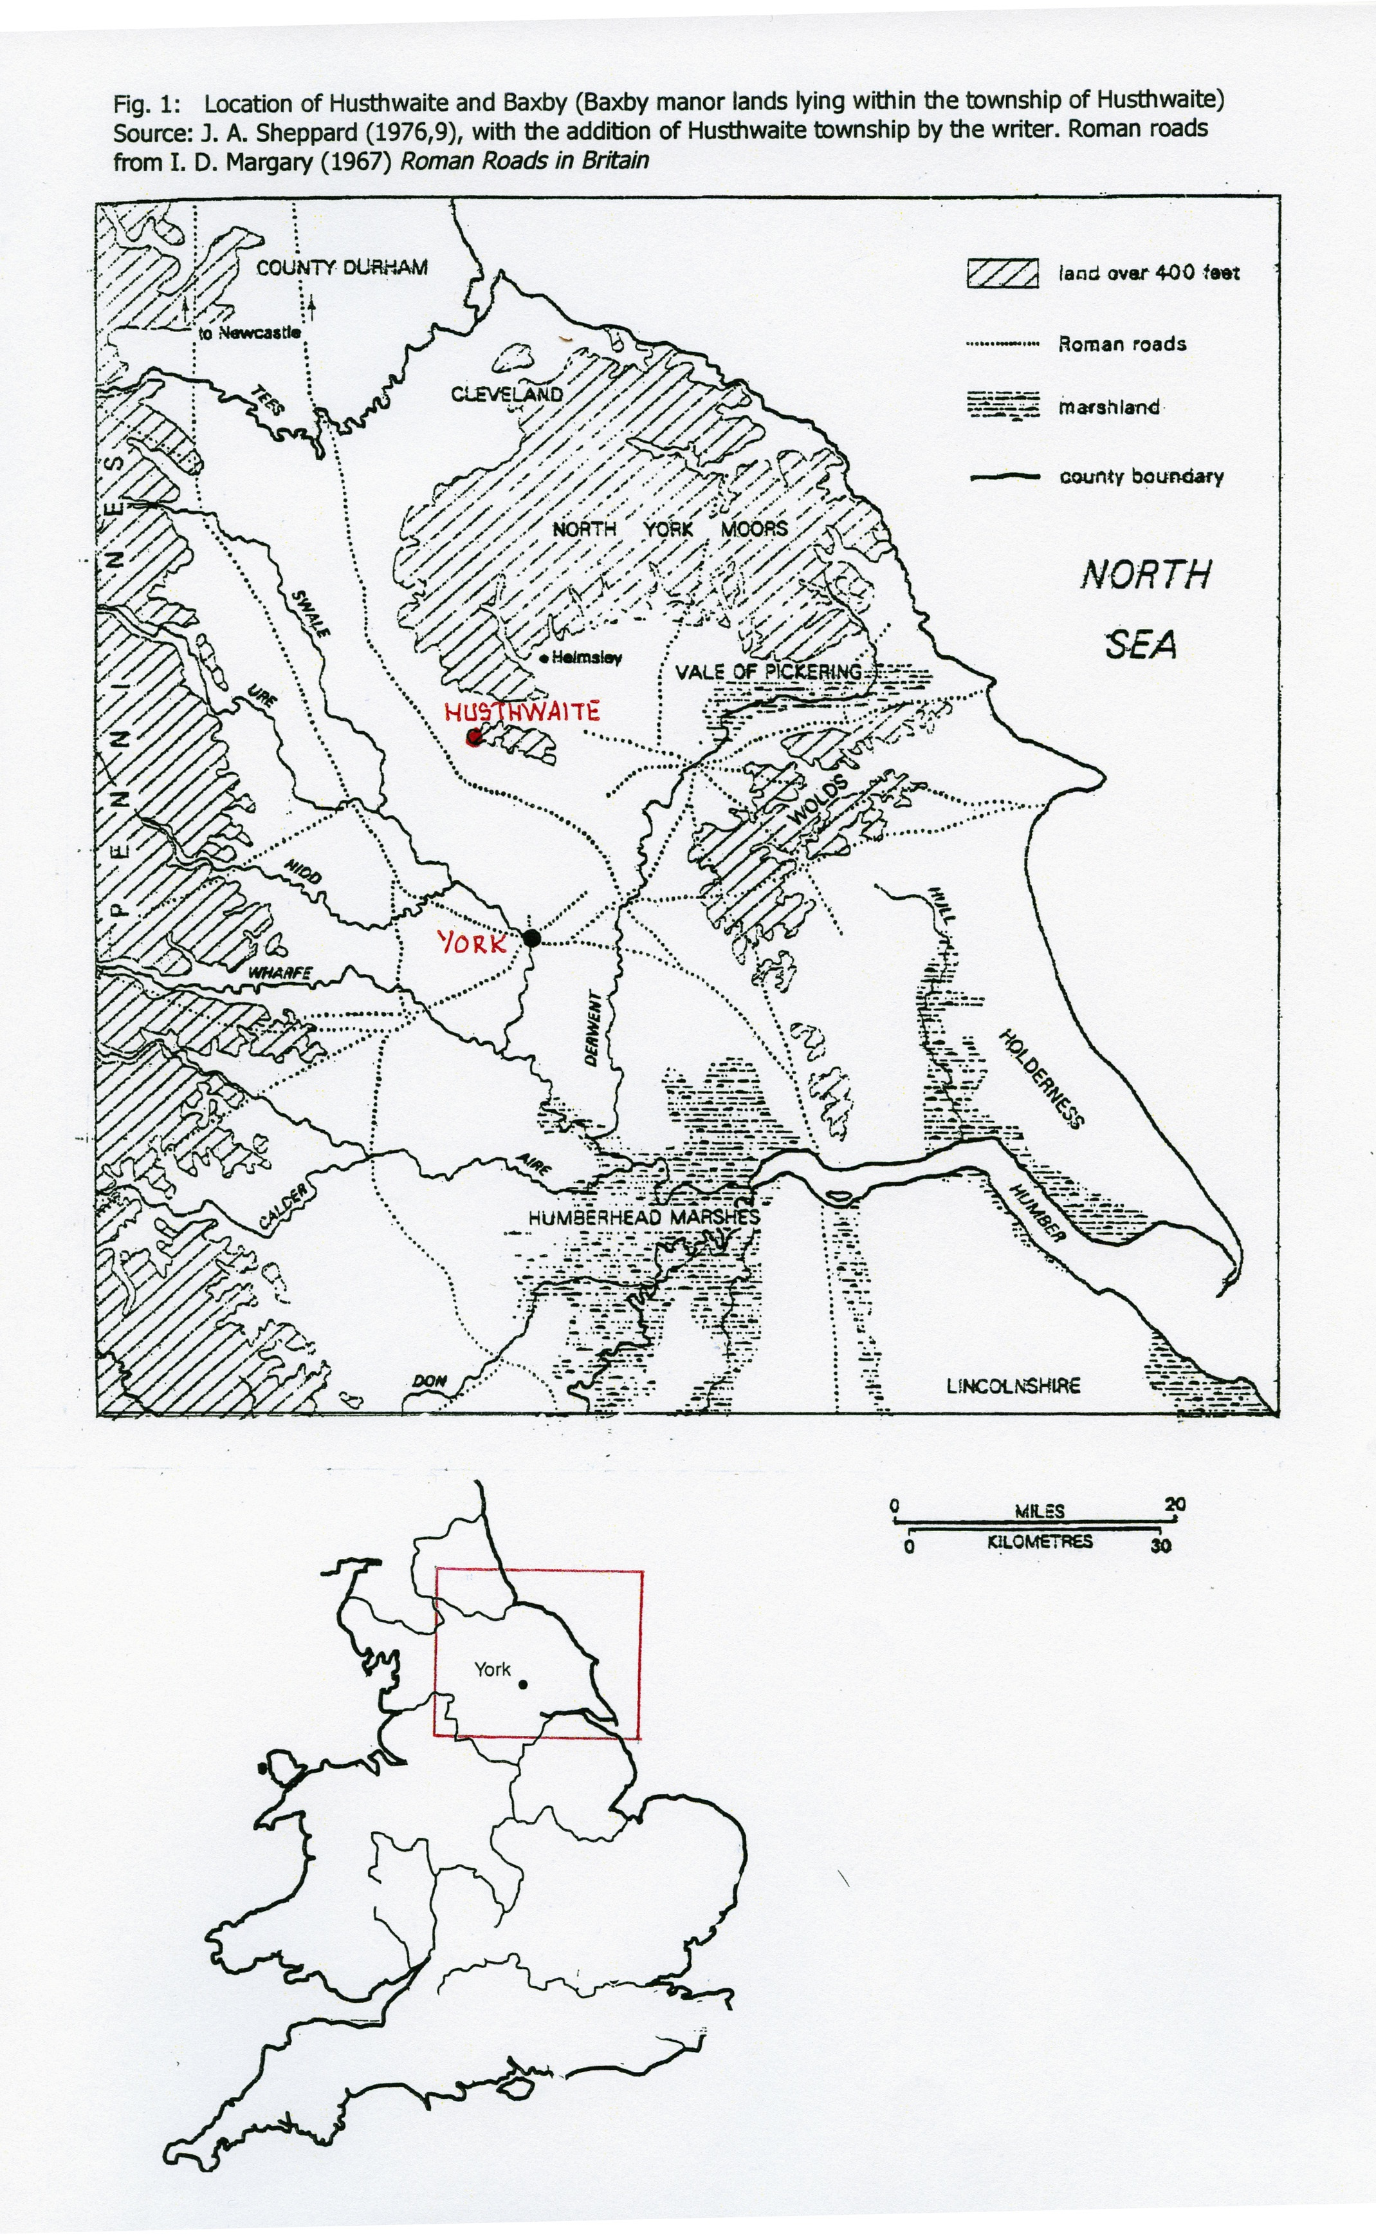
Figure 2. The 1841 Tithe map of Husthwaite. Source: the Borthwick Institute. ‘B’ denotes Baxby manor land.

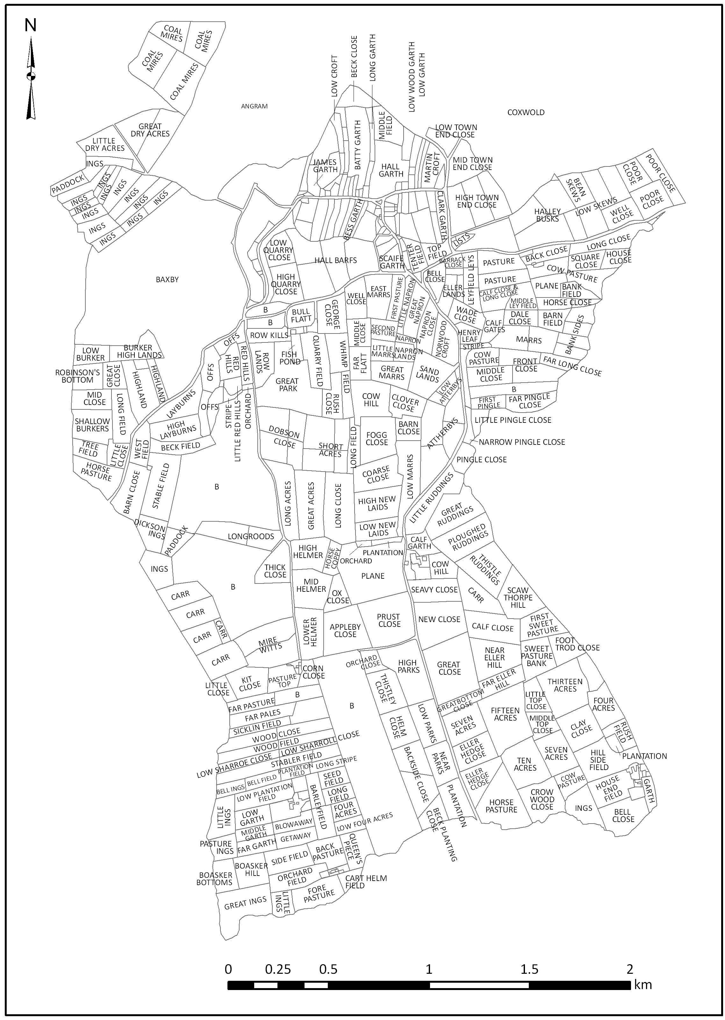
Figure 3. The Central Provinces. Source: B. K. Roberts and S. Wrathmell (2002) Region and Place, fig.5.2
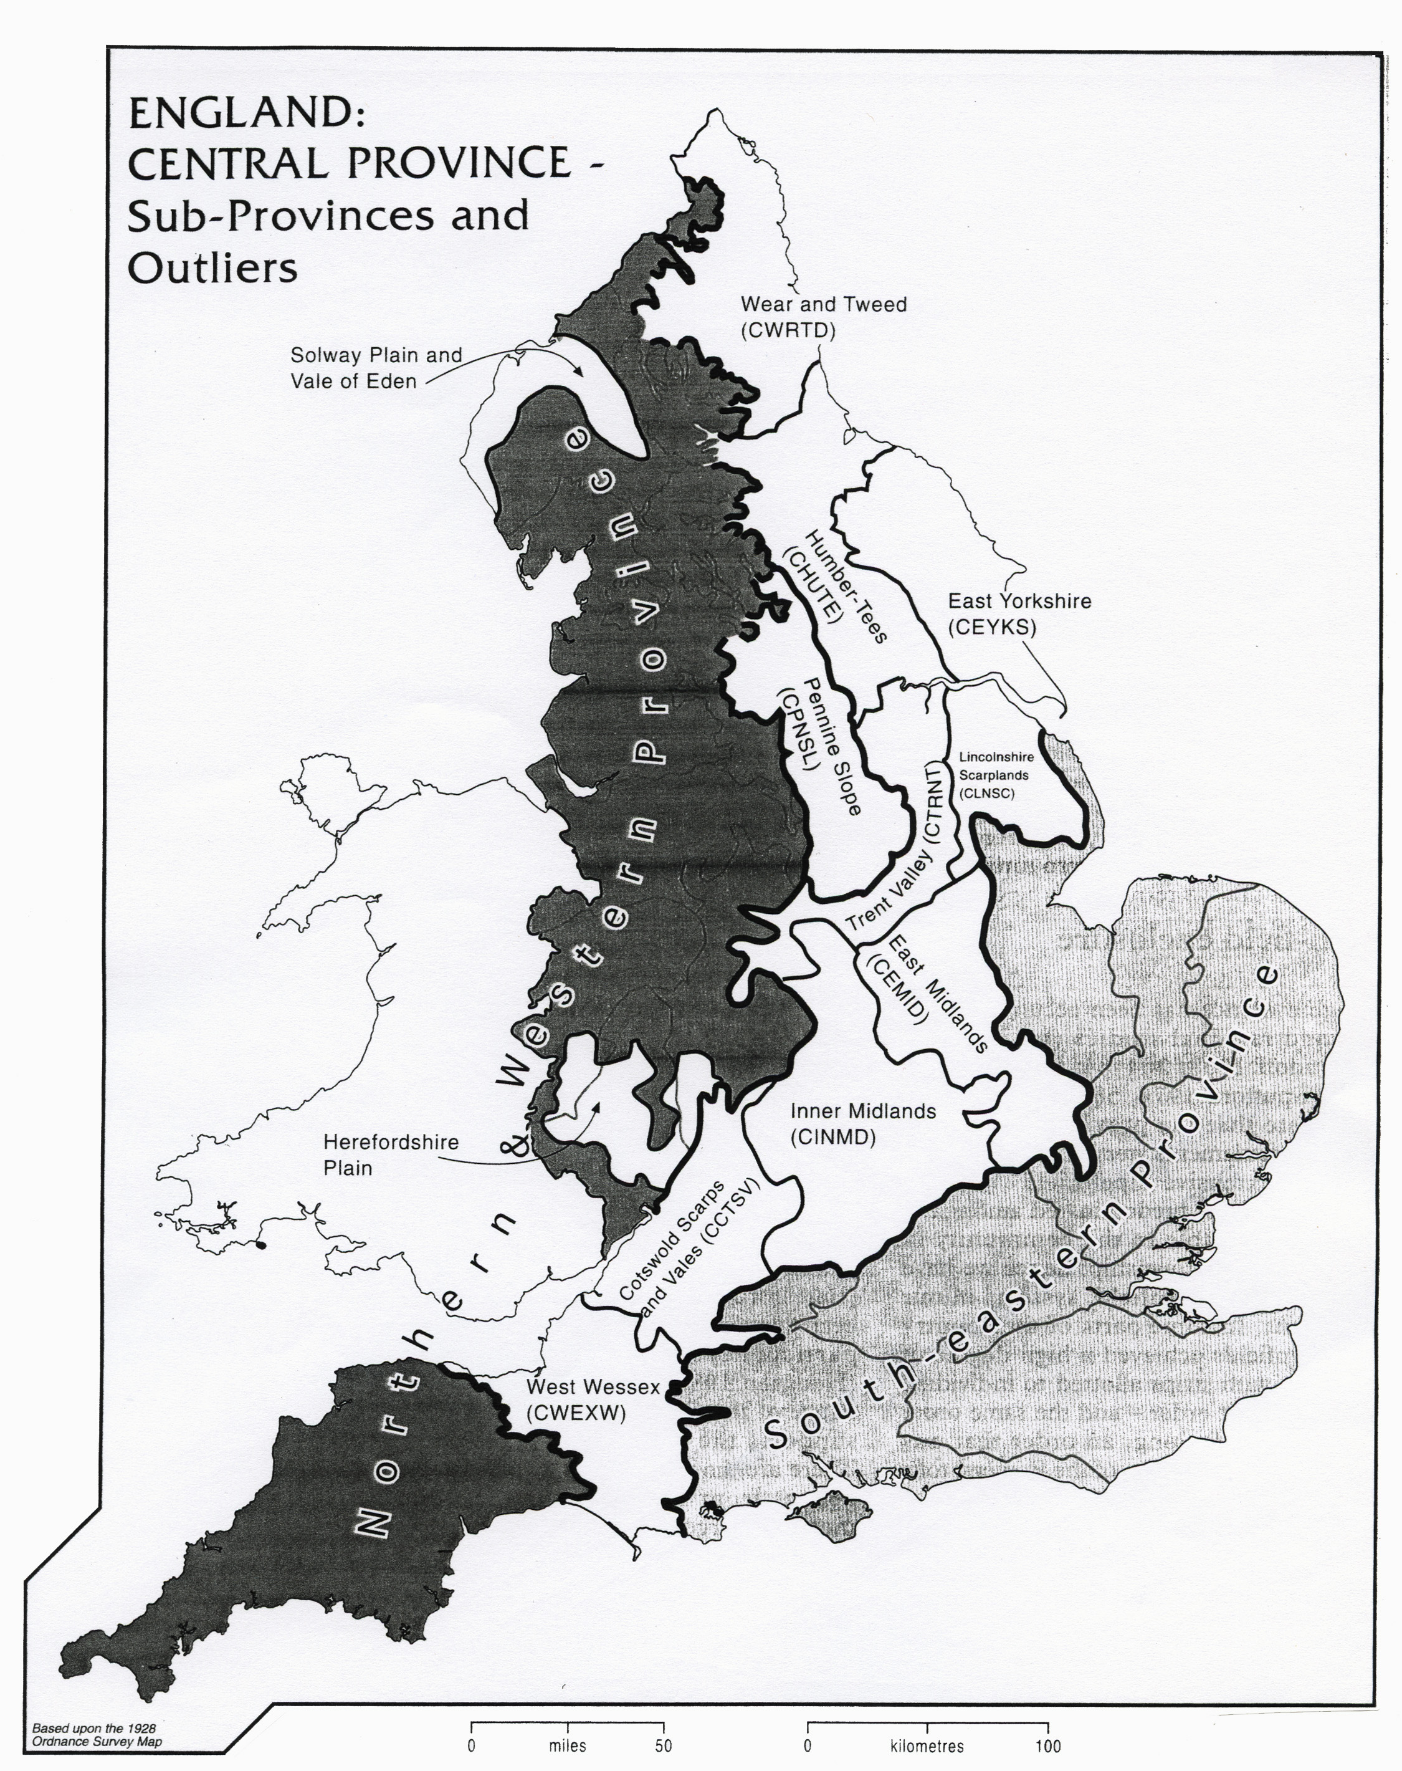
Figure 4. Early-middle Saxon sites in North Yorkshire. Source: D. Powlesland (2004) 'The Early Medieval Period' in R.A. Butlin (ed) Historical Atlas of North Yorkshire, with the addition of Husthwaite township (H) by the author.

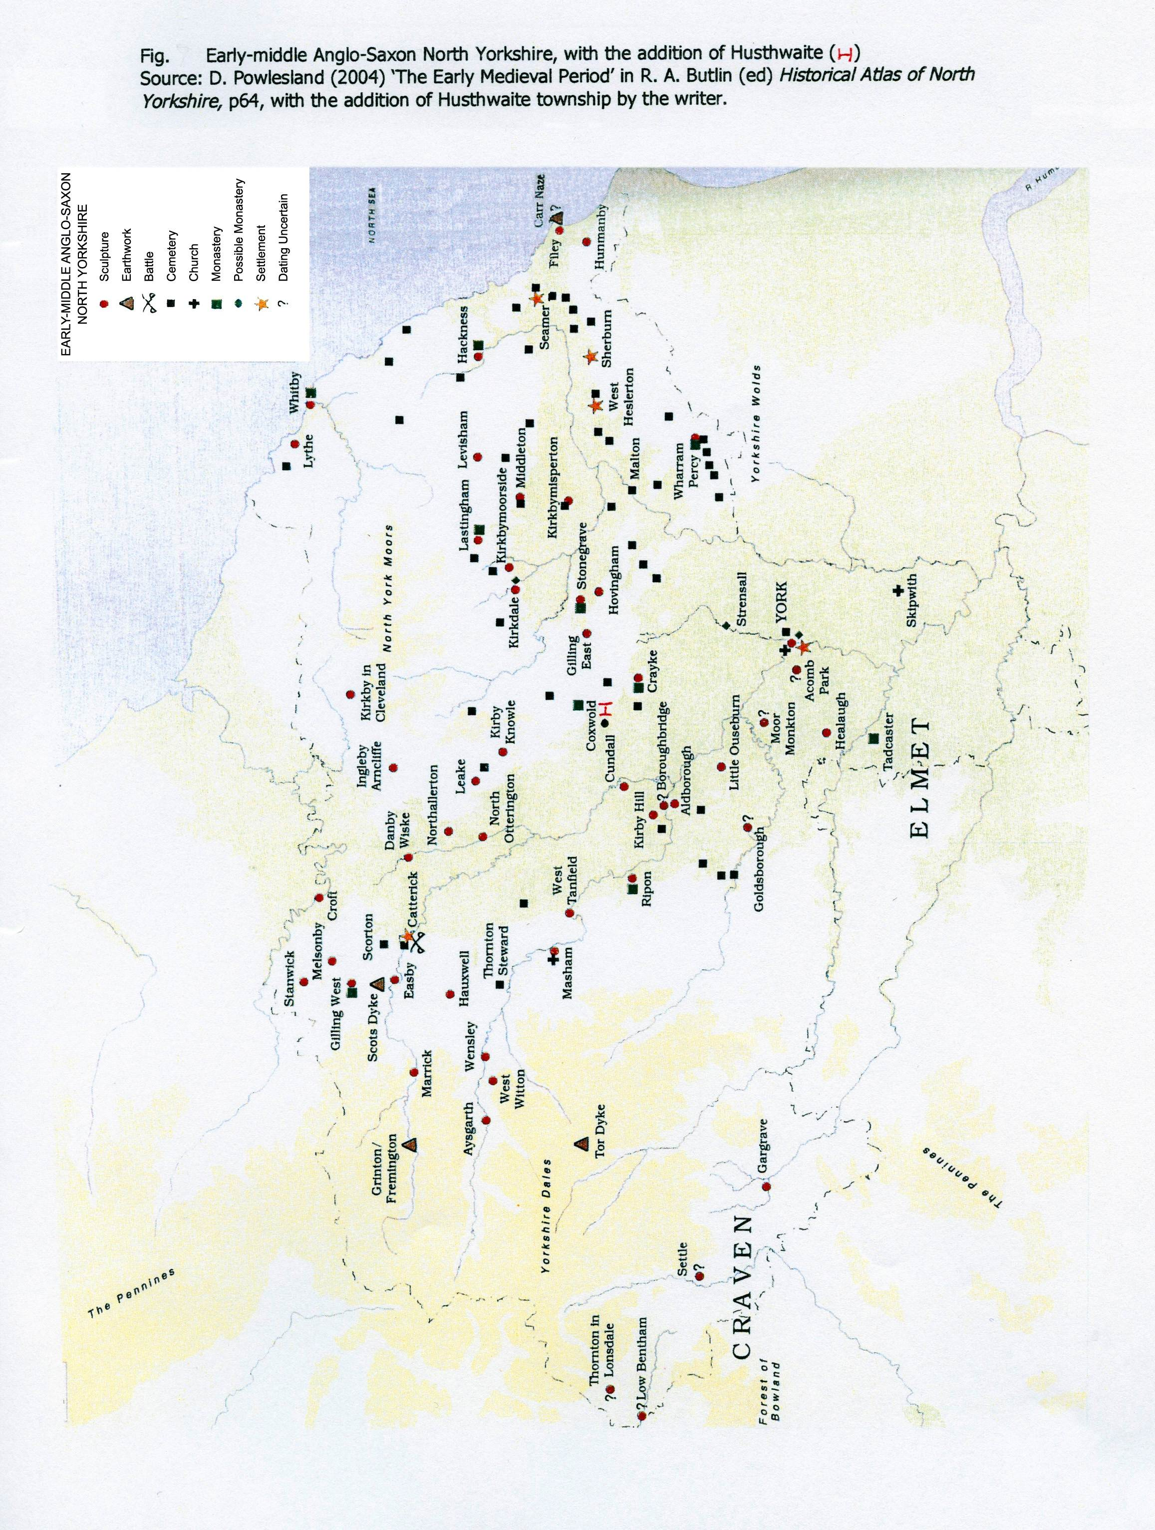
N

Figure 5. Crayke field system. Source: K.A. Adams (1990) 'Monastery and village at Crayke, North Yorkshire' in The Yorkshire Archaeological Journal, vol.62
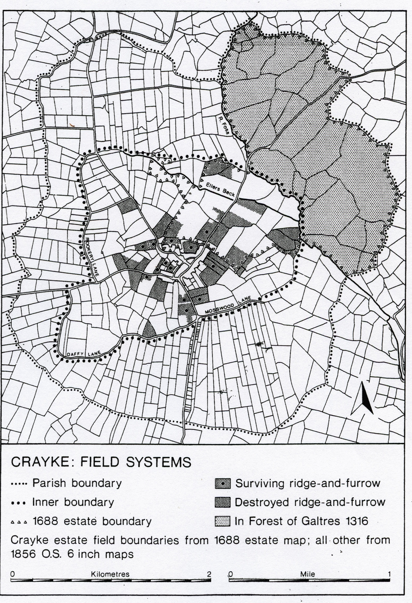
Figure 6. Townships examined by Harvey in the Central Vale of York and the Wolds with the addition of Husthwaite by the author. Source: M. Harvey (1984) ‘Open-field structure and landholding arrangements in eastern Yorkshire’ in Transactions of the Institute of British Geographers 1984 vol.9 pt.1
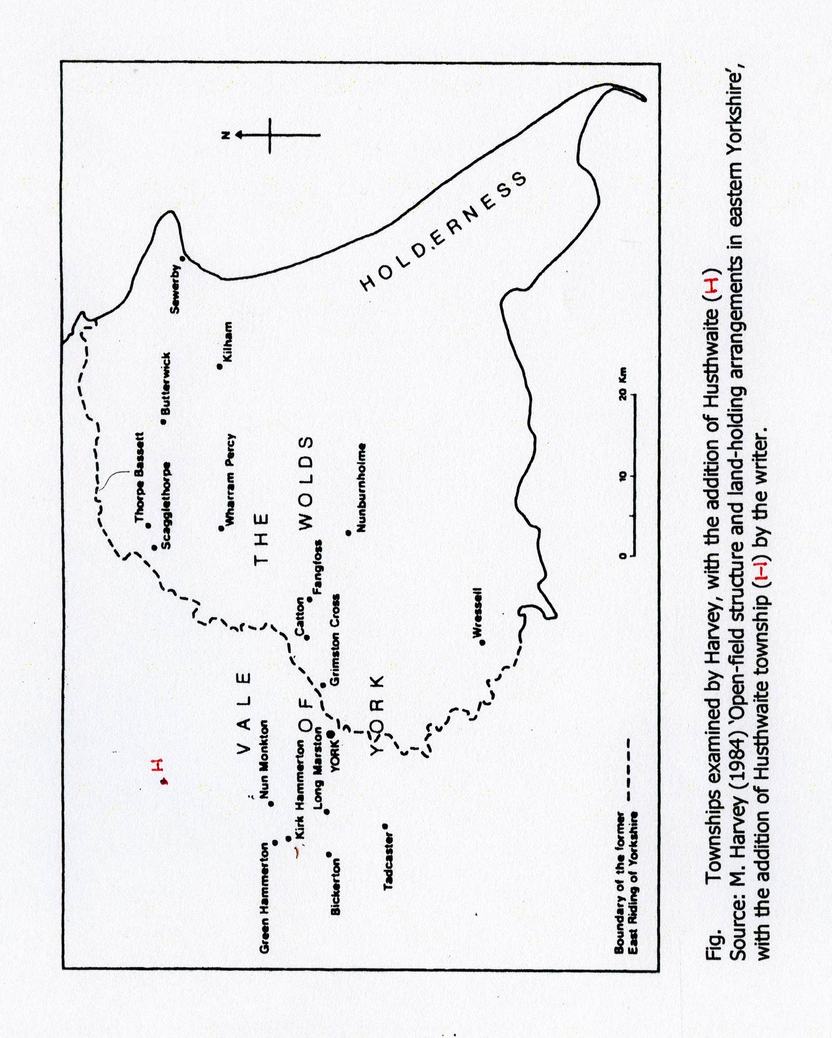

Figure 7 The field-system of Husthwaite township in the early seventeenth century, with its division into fields and flatts. Source: the author.
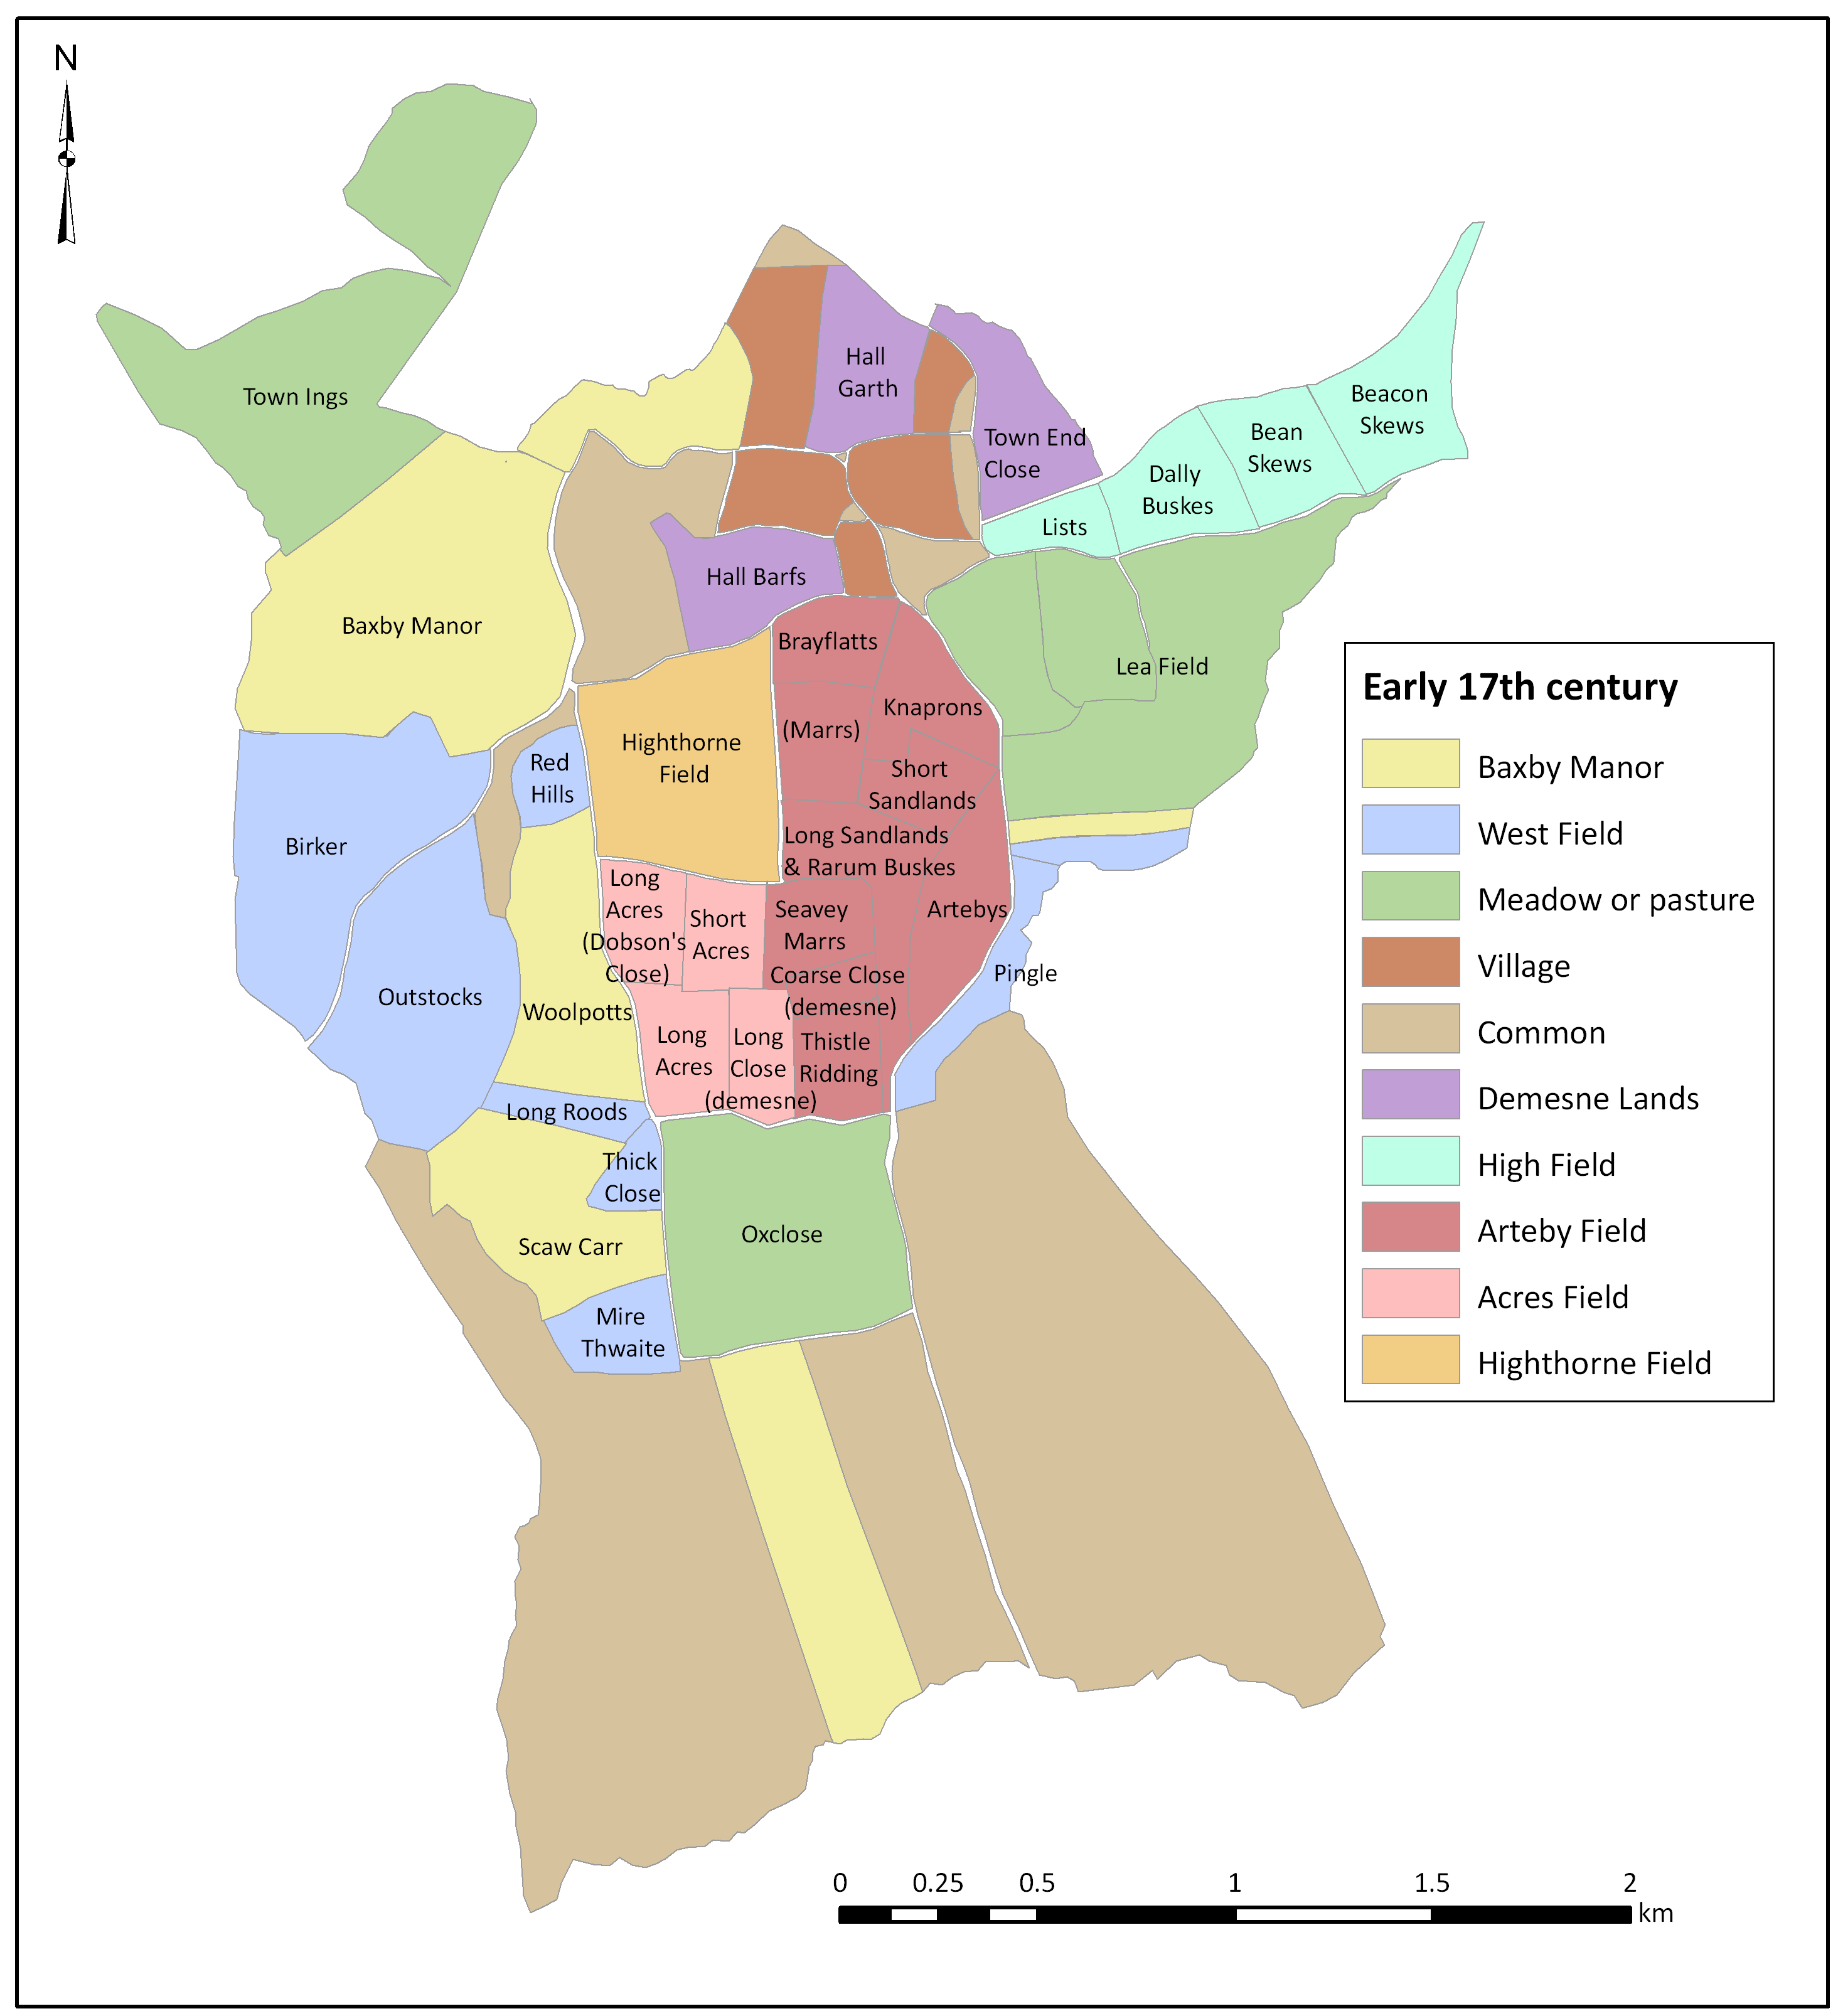
Figure 8 Geological map of Bachesbi. Source: British Geological Survey, Ordnance Survey, Southampton, Sheet 52, Drift Edition, Thirsk.
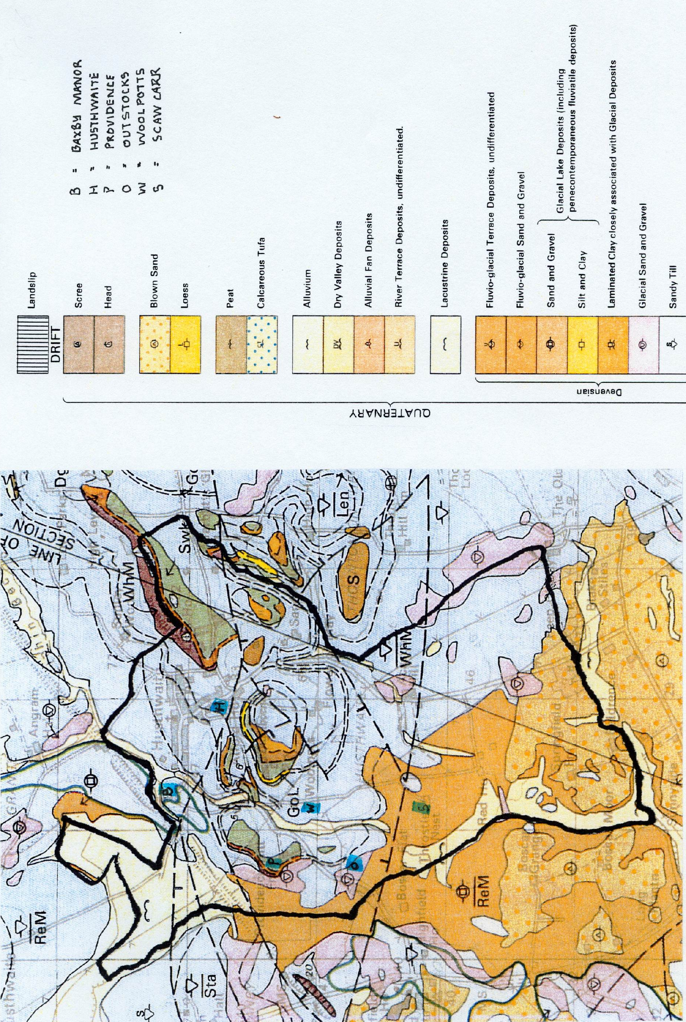
Figure 9. Townships with woodland and wood-pasture around Husthwaite referred to in charters of the Honour of Mowbray. Source: D. E. Greenway (1972) Charters of the Honour of Mowbray 1107-1191, end-map, with the addition of Husthwaite township (H) by the author.

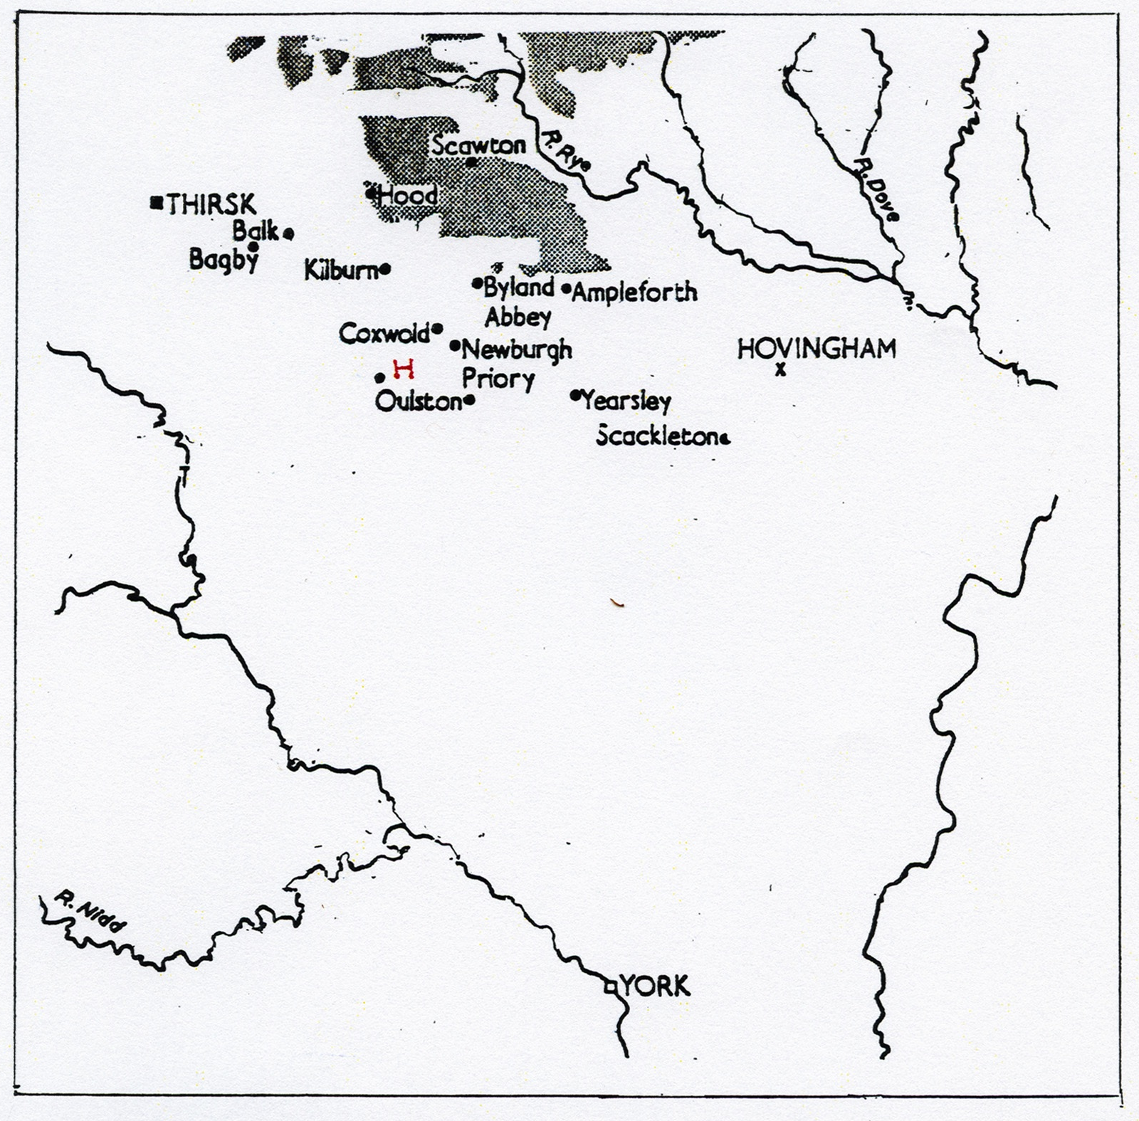
North
Figure 10 Fields of long lands in Bachesbi (depicted in blue). The small fields named did not exist in the middle Saxon period, and are entered only for explanatory purposes.
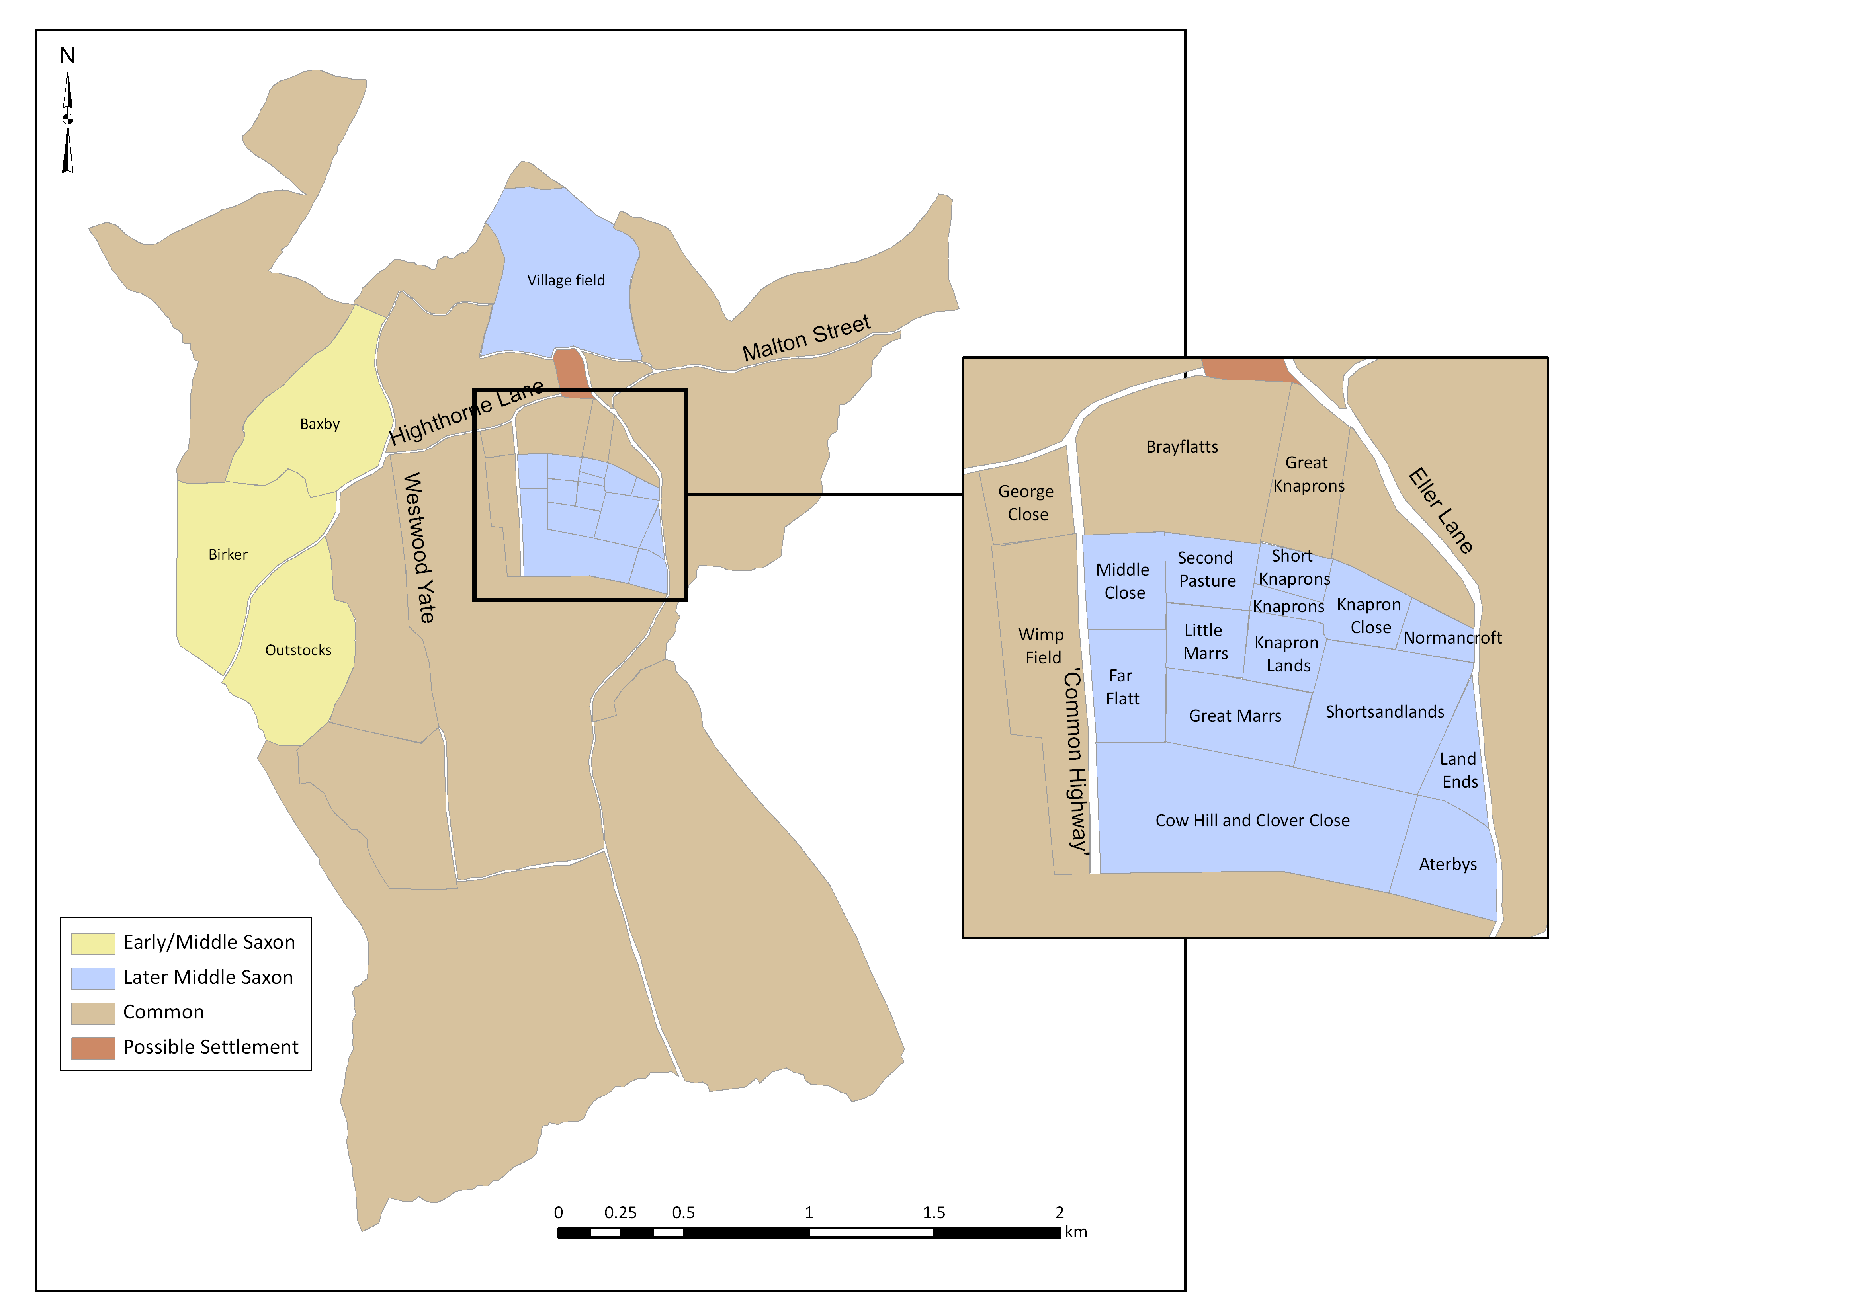
Figure 11. The village plan in the 1841 Tithe Map of Husthwaite, showing conformity of toft boundaries. (Red lines added by the author.)
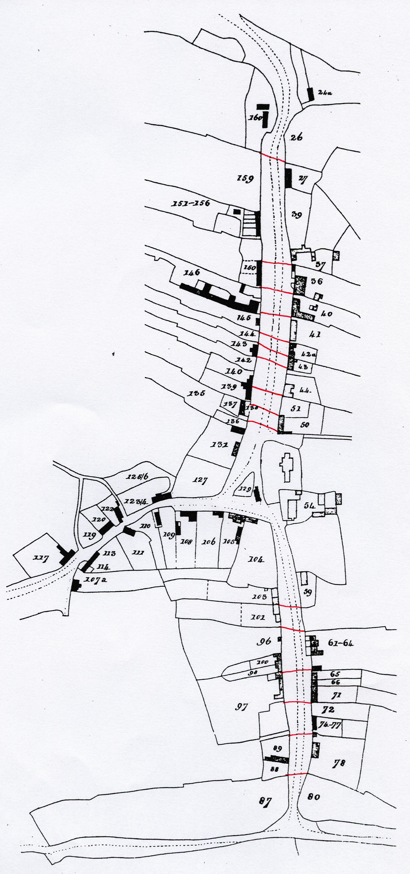
Figure 12. Possible area of settlement in the middle Saxon period (between present-day Walker Lane and Tenter field lane). Source: 1856 6” (sheet 104) Ordnance Survey map (NYCRO), with additions in red ink by the author.

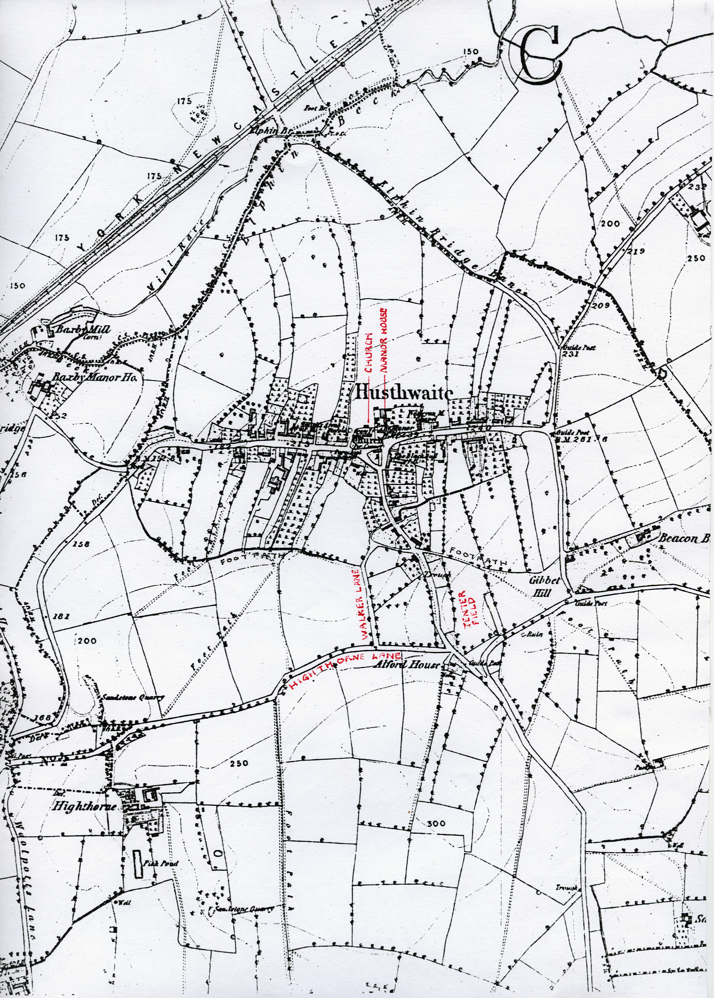
Figure 13. Map of Baxby manor field showing location of Tofts close. Field-names are taken from a Lease-Release of 1791.

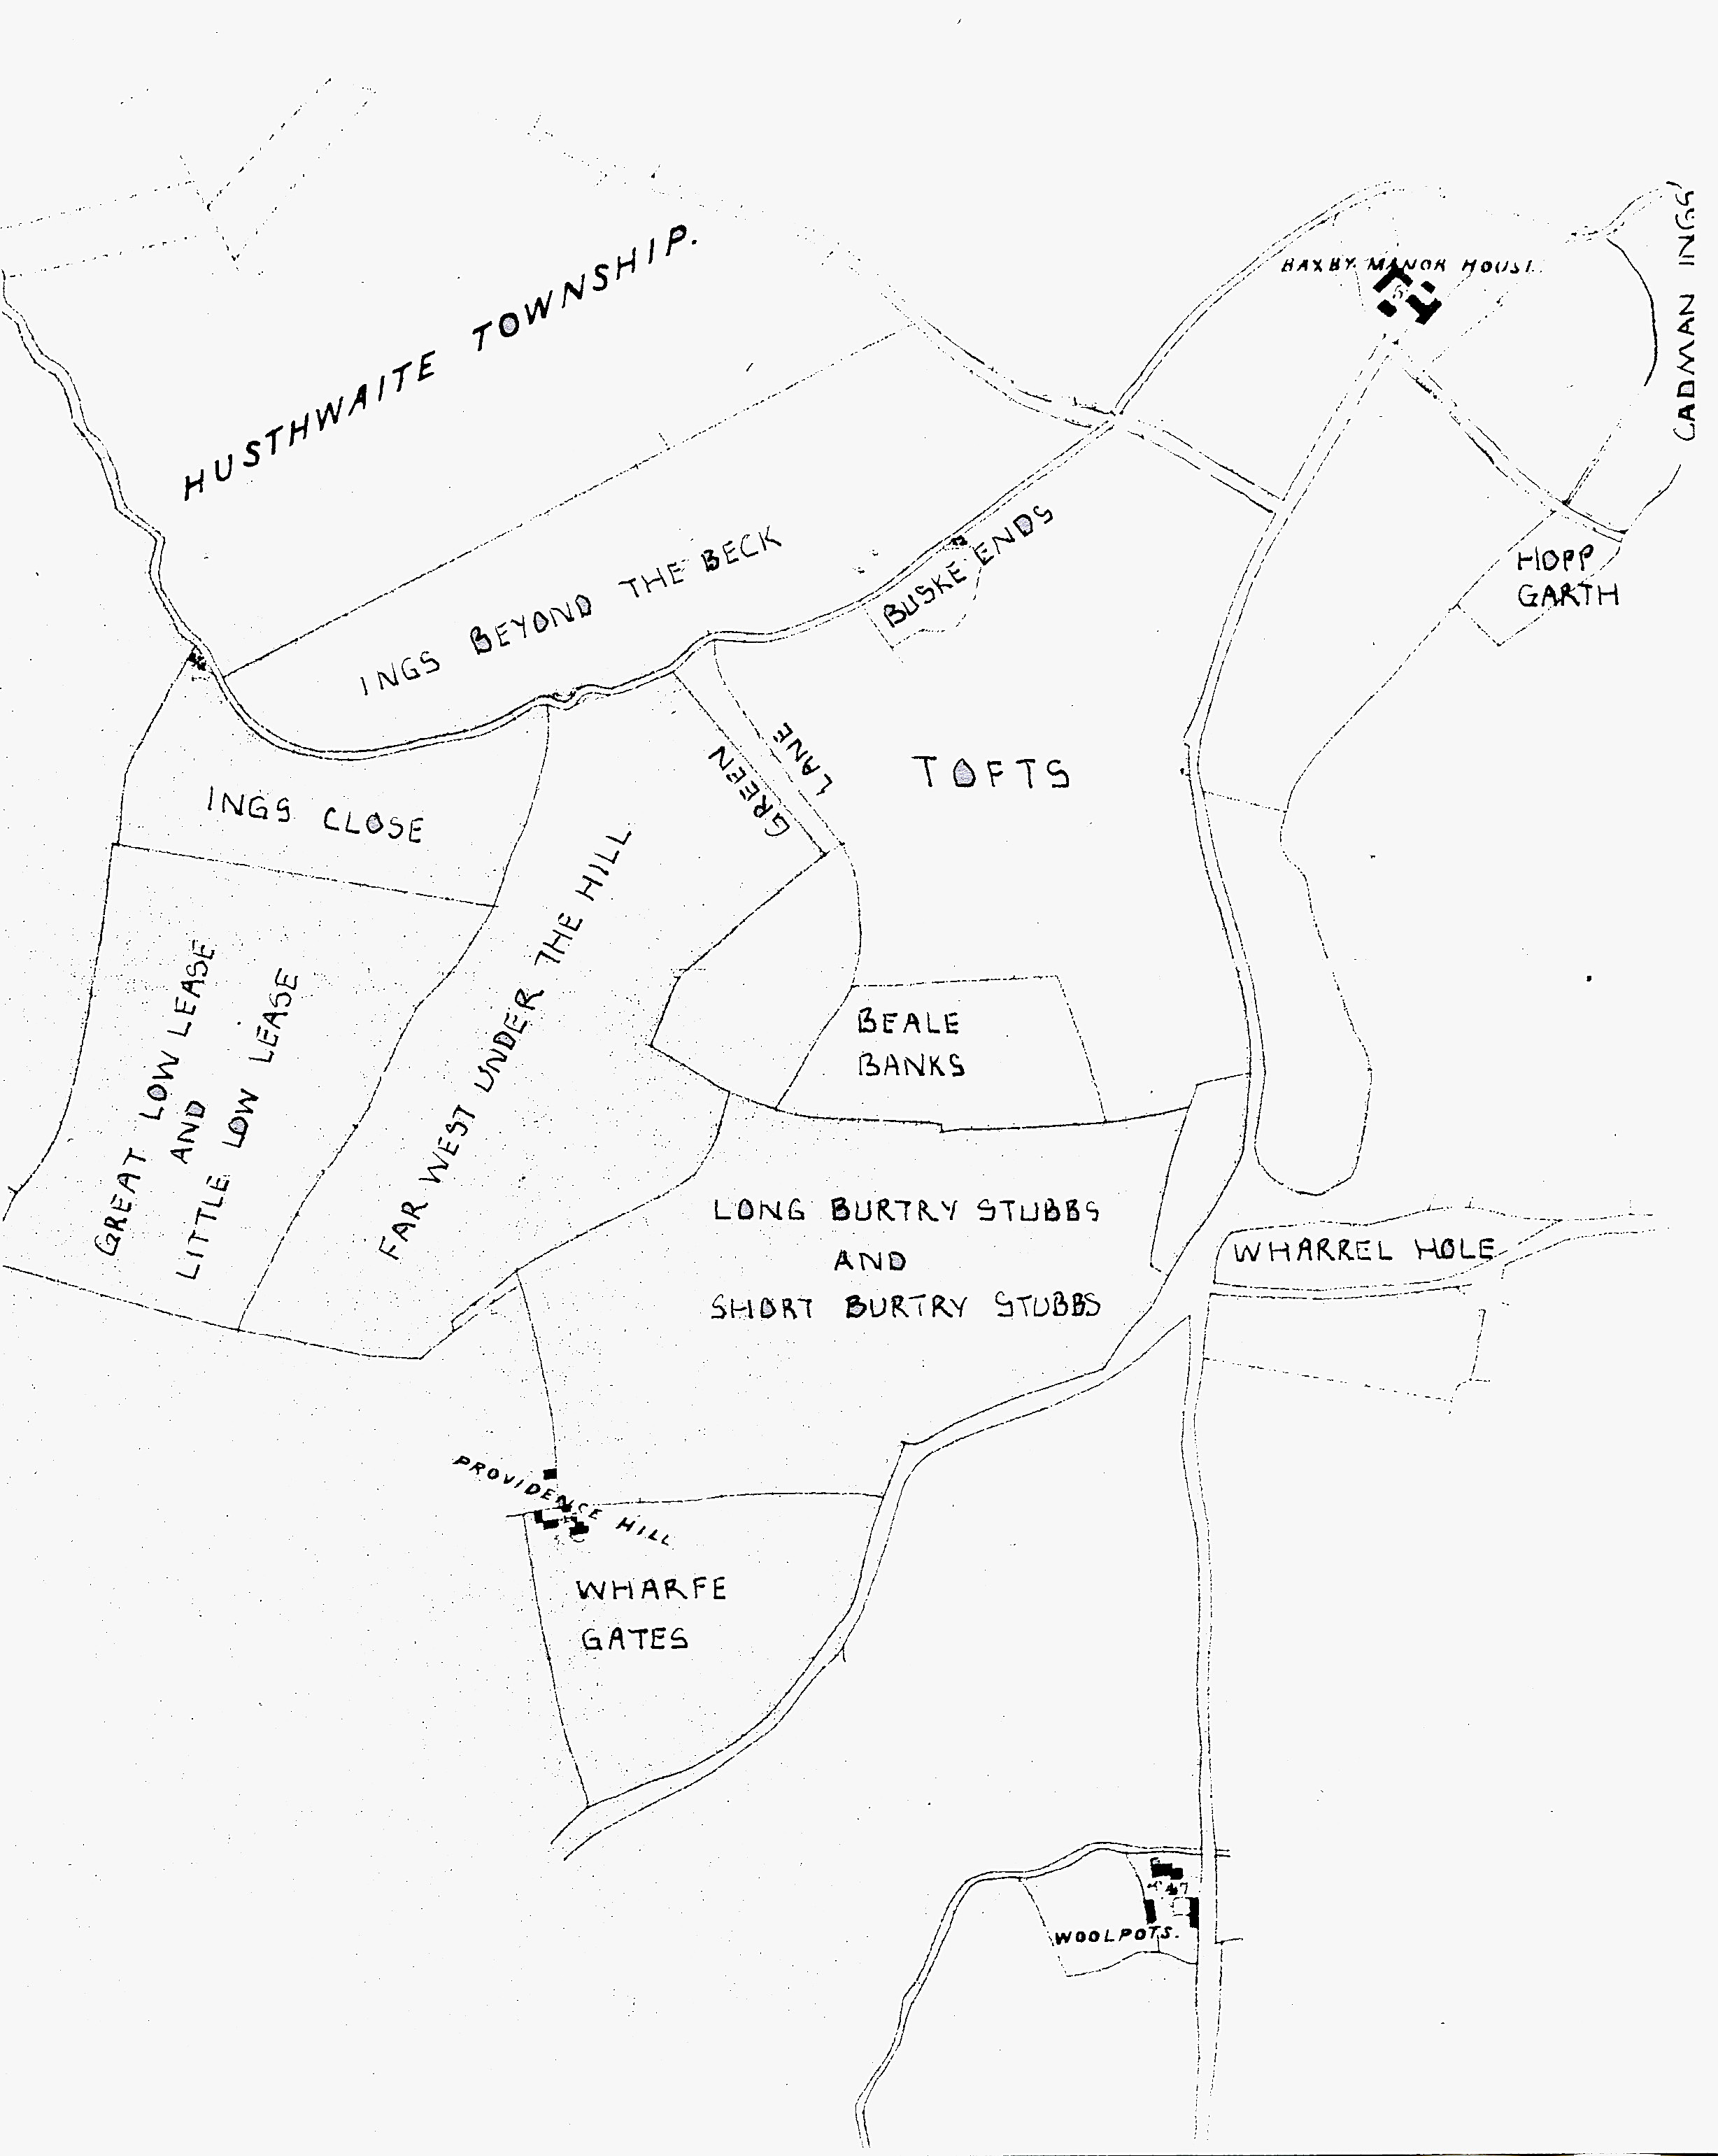
Figure 14 The common fields of Husthwaite, thought to have been introduced in the late Saxon period. Source: the author
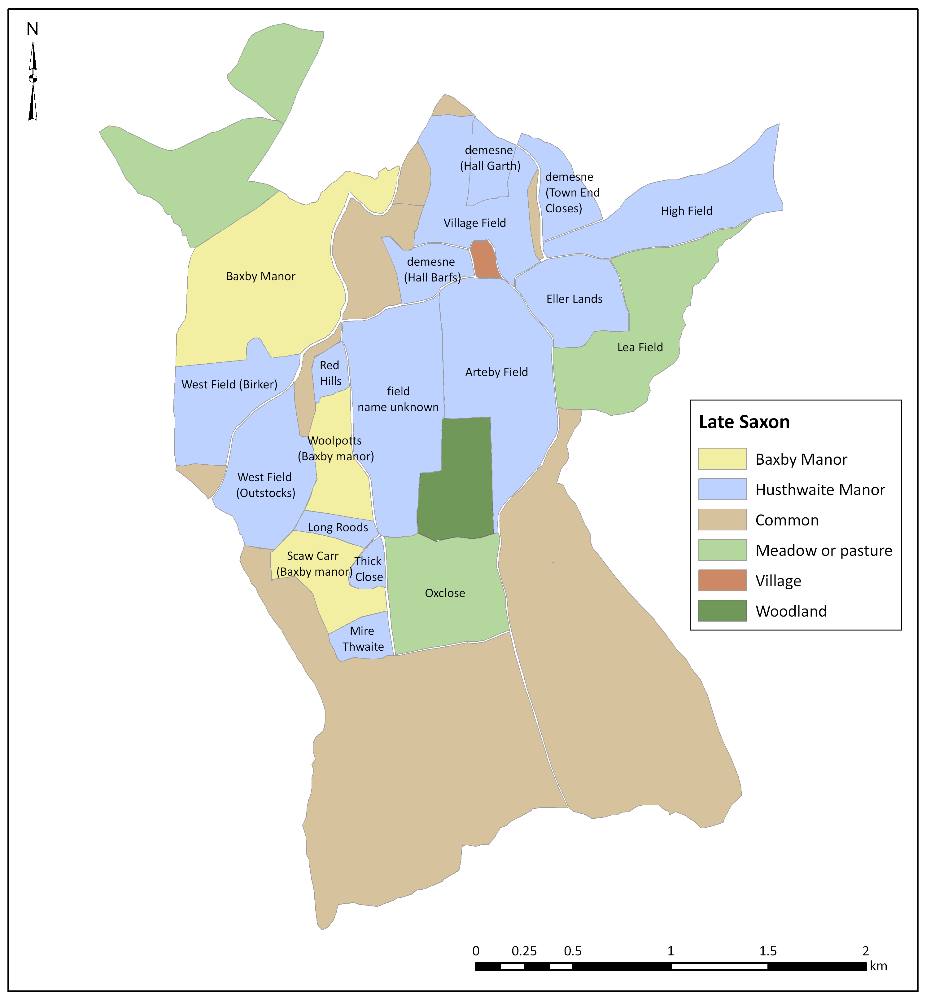
Figure 15. Footpaths/cart-tracks in Husthwaite village. Source: additions in red ink are by the author, superimposed on the 1856 6” Ordnance Survey map, sheet 104.

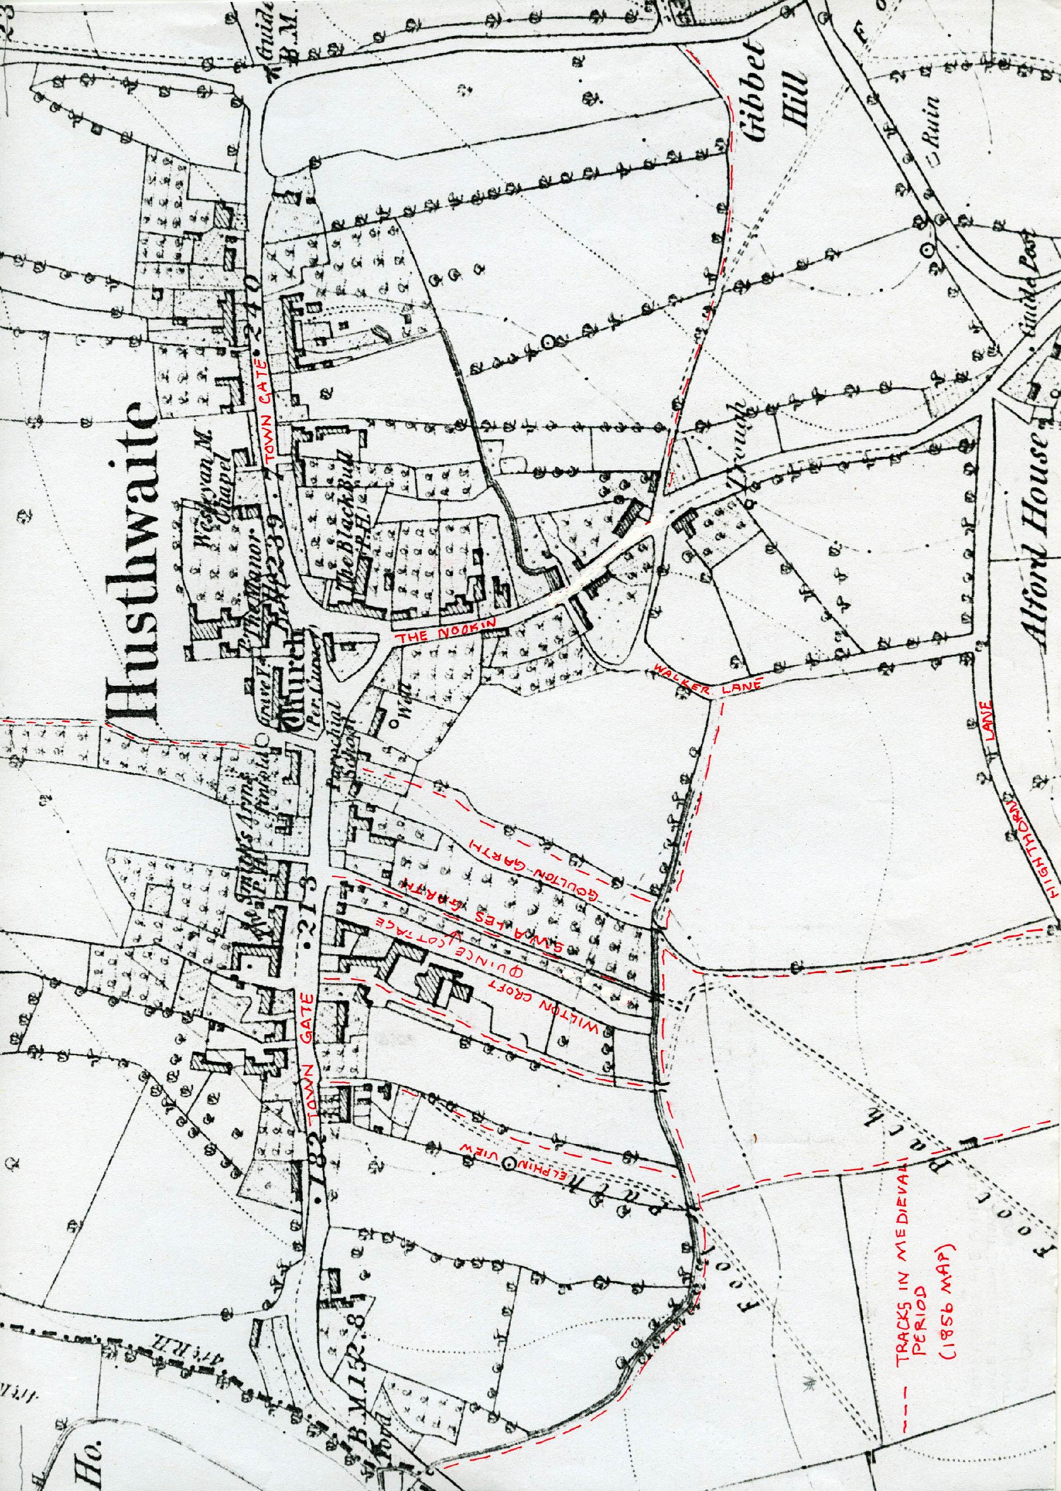
Figure 16. Husthwaite's field-system circa late 11th-13th centuries showing the addition to the field system of Highthorne Field, Acres Field and assarts mentioned in text. Source: the author
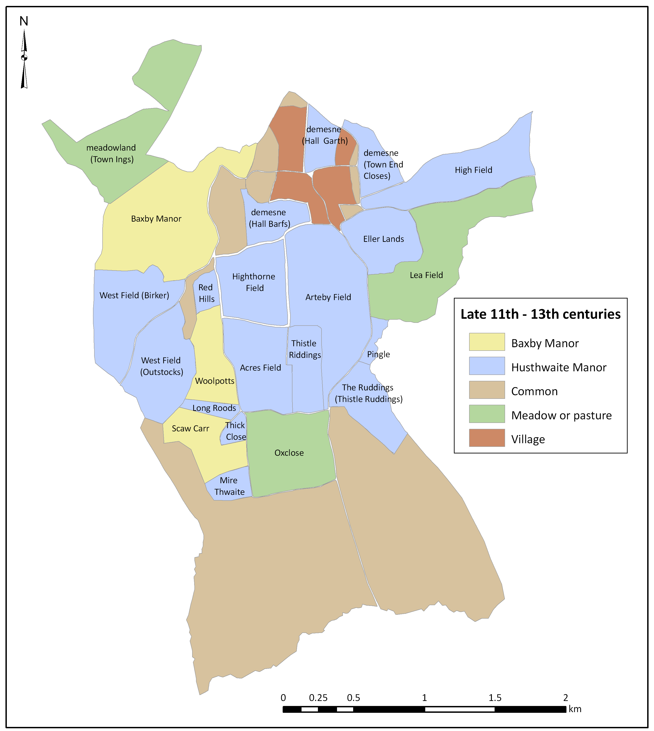
Figure 17 Possible Roman road going through Husthwaite. Source: J. A. Sheppard (1976, 9) with the addition of Roman roads from I. D. Margary (1967) Roman Roads in Britain, with further additions by the author of Malton (M), Appleton-le-Street (A), Barton-le-Street (B), Hovingham (H), Coulton (C), Yearsley (Y), Oulston (O), Husthwaite (HUS), Helperby (He) and Aldborough (Ald).
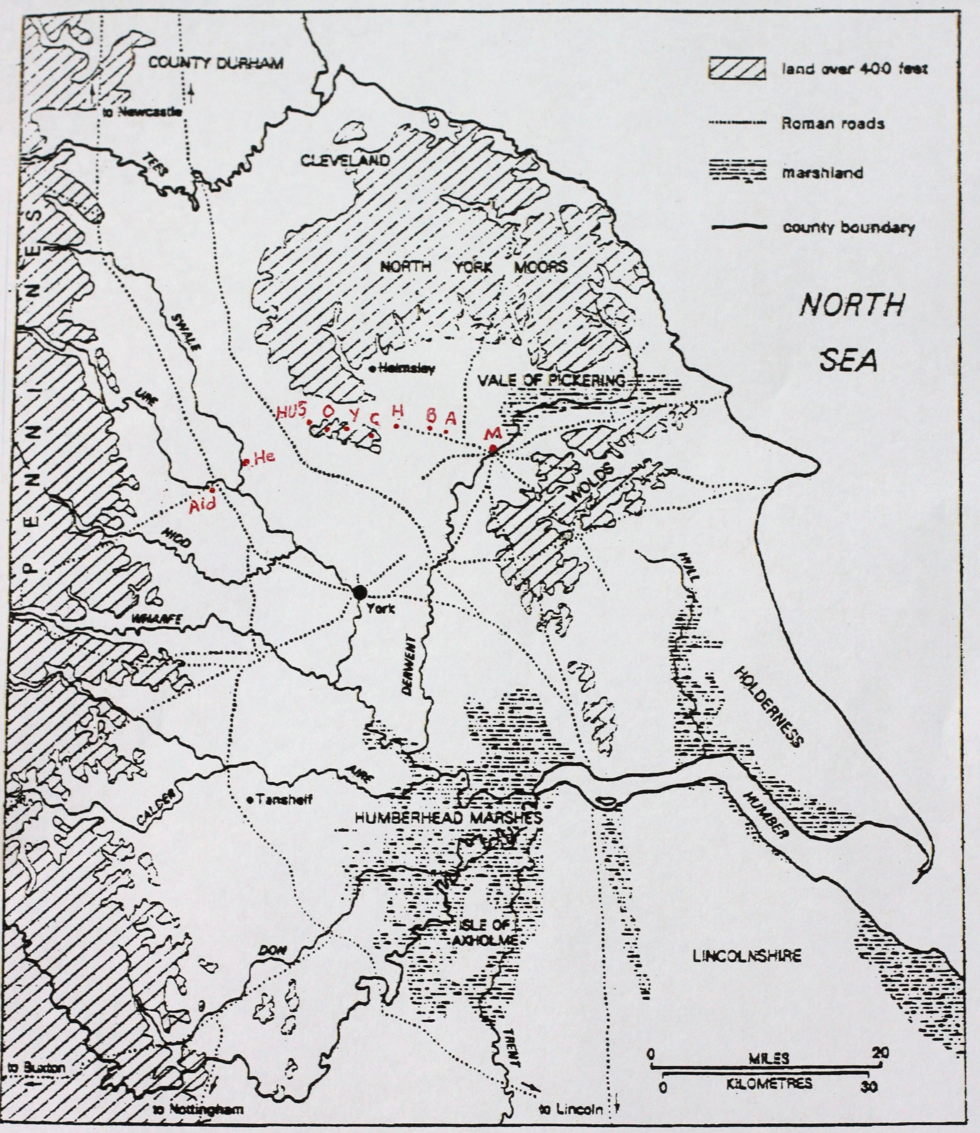
Figure 18 Footpaths/cart-tracks in Husthwaite township. Source: the author
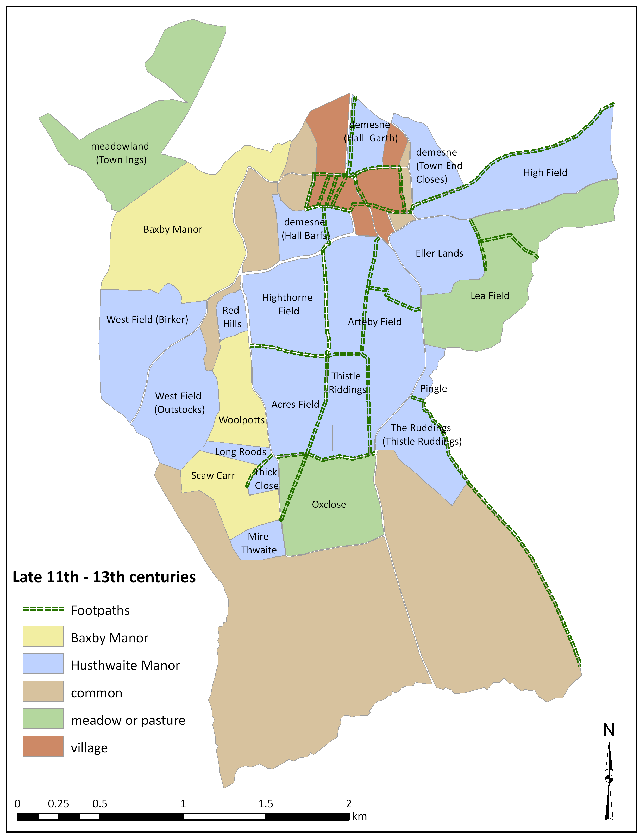
Figure 19 Village tofts in 1841. Source: 1841 Tithe Map of Husthwaite
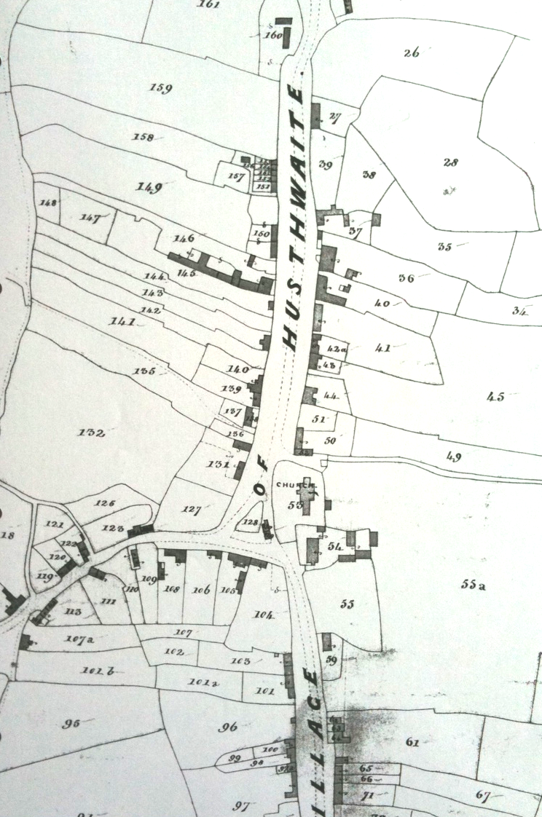
N
Bibliography

Primary Sources

A Six Months' Tour through the North of England. Young, A. (1771). (London)
Charters of the Honour of Mobray 1107-1191. Greenway, D.E. (ed) (1972). Records of Social and Economic History New Series 1. Published for The British Academy, Oxford University Press (London)
Domesday Book. Faull, M. and Stinson, M. (1986). In J. Morris (ed) Domesday Book vol. 30: Yorkshire, Vols 1-2. Phillimore & Co. (Chichester)
Early Yorkshire Charters vols 1&2. Farrer, W. (1914 and 1915), Ballantyne, Hanson & Co (Edinburgh)
English Historical Documents, 1. Whitelock, D. (ed) (1979).
General View of Agriculture of the North Riding of Yorkshire. Tuke, J. (1800), G Nichol (London)
Historic Environment Records. County Hall, Northallerton
Husthwaite Manorial Court Roll (1625-1780) North Yorkshire County Record Office. Northallerton
Husthwaite Terriers, Tithe Causes, Wills and Inventories. Borthwick Institute of Historical Research; York Minster Library
Rural Economy in Yorkshire in 1641 being the Farming and Accounts Books of Henry Best of Elmswell in the East Riding of Yorkshire. Best, H. (1857). Surtees Society Publication Vol. 33
The Rural Economy of Yorkshire: comprising the management of landed estates and the present practice of husbandry in the agricultural districts of that county. Marshall, W. (1788), T. Cadell (London)
Victoria County History, Yorkshire, North Riding, Vol.2. Page, W. (ed) (1923) 8-24. Available at http://www.british-history.ac.uk Accessed 31 January 2011
Walter of Henley and other Treatises on Estate Management and Accounting. Oschinsky, D. (1971), Clarendon Press (Oxford)
Yorkshire Deeds. Yorkshire Archaeological Society. Northallerton County Library
Yorkshire Lay Subsidy: 30Ed1 (1301). Brown, W. (1897). Available at http://www.british-history.ac.uk (Accessed 21 December 2010)
English Heritage Pastscape (2007). Available at: http://www.pastscape.og.uk/ (Accessed 14 November 2010).

Maps
Map of the Boundaries of the Townships of Husthwaite and Baxby in the North Riding of the County of York and the Disputed Lands in the said Townships with the Roads and Brooks. (1838) North Yorkshire County Records Office (Northallerton)
Husthwaite Tithe Map and Schedule (1841) Borthwick Institute of Historical Research, University of York
Thornton-cum-Baxby Tithe Map and Schedule (1841) North Yorkshire County Record Office (Northallerton)
Survey for Inclosure (1842) North Yorkshire County Records Office (Northallerton)
Plan of the Allotments of Waste Lands in the Township of Husthwaite (1844) North Yorkshire County Records Office (Northallerton)
Rough Plan of John and Thomas Woodward’s Estate (1874) Mrs Elaine Smith, Baxby Manor (Husthwaite)
Highthorn Plan and Particulars (1886) Mrs Elaine Smith, Baxby Manor (Husthwaite)
Flower o’ May Farm Map (1890) Mr. Geoffrey Wise, Flower o’ May Farm (Husthwaite)
Ordnance Survey Maps (25” to the mile) 1911 and 1913 North Yorkshire County Records Office (Northallerton)
Ordnance Survey Pathfinder 642, Dalton and Coxwold 1: 25 000 (1984) Ordnance Survey (Southampton)
Ordnance Survey Landplan Data Map 1: 10 000. (2008) Centred on coordinates 451890 474430. Ordnance Survey (Southampton)
Ordnance Survey Map, 6” to the mile, Sheet 104. North Yorkshire County Records Office (Northallerton)
British Geological Survey Thirsk, Sheet 52, Drift Edition 1: 50 000 (1992) Ordnance Survey (Southampton)

Secondary Sources

Abrams, L. and Parsons, D. (2004) ‘Place-names and the history of Scandinavian settlement in England’ in Hines, Lane and Redkap (eds.) Land, Sea and Home. Society for Medieval Archaeology Monograph 20, Maney Publishing (Leeds): 379-432.
Adams, K. A. (1990) ‘Monastery and Village at Crayke, North Yorkshire’, The Yorkshire Archaeological Journal vol. 62, 29-50
Allerston, P. (1970) ‘English village development’, Transactions of the Institute of British Geographers, 51, 95-109
Alexander, H. (1962) The Story of Our Language, Thos. Nelson and Sons (New York)
Aston, M. (2008) Interpreting the Landscape: Landscape Archaeology in Local Studies, Routledge (Oxford)
Aston, M., Austin, D., and Dyer, C. (eds.) (1989) The Rural Settlements of Medieval England, Basil Blackwell (Oxford): 105-28
Austin, D. (1989) ‘The Excavation of Dispersed Settlement in Medieval Britain’, in M. Aston, D. Austin and C. Dyer (eds.) The Rural Settlements of Medieval England, Blackwell (Oxford): 105-128
Austin, D. (1990) ‘Medieval Settlement in the Northeast of England - Retrospect, Summary and Prospect, in Medieval Rural Settlement in Northeast England, Architectural and Archaeological Society of Durham and Northumbria (Durham): 141-150.
Aybes, C. and Yalden, D. W. (1995) ‘Place-name evidence for the former distribution and status of Wolves and Beavers in Britain’ Mammal Review, 25 (4)
Baker, A. R. H. and Butlin, R. A. (1973) Field Systems of the British Isles, Cambridge University Press (Cambridge)
Banham, D. (2010) ‘In the sweat of thy brow shalt thou eat bread’, in N. J. Higham and M. J. Ryan (eds.) Landscape Archaeology of Anglo-Saxon England, The Boydell Press (Woodbridge)
Beckinsall, S. (2006) Place Names and Field Names of Northumberland, Tempus (Stroud)
Beresford, M. W. (1950) ‘Glebe Terriers and Open Field, Yorkshire’, Yorkshire Archaeological Journal vol. 37, 325-59
Bishop, T. A. M. (1935) ‘Assarting and the Growth of Open Fields’, The Economic History Review, 6, 13-29
Brookes, S. (2010) ‘Population and Ecology and Multiple Estate Formation: the Evidence from Eastern Kent’, in N.J. Higham and M.J. Ryan (eds.) Landscape Archaeology of Anglo-Saxon England. The Boydell Press. (Woodbridge): 65-82
Brown, A. E. and Taylor, C. C. (1989) ‘The origins of dispersed settlement; some results from fieldwork in Bedfordshire’, Landscape History vol. 11 61-81
Brown, T. and Foard, G. (1998) ‘The Saxon Landscape: a Regional Perspective’, in P. Everson and T. Williamson (eds.) The Archaeology of Landscape: Studies presented to Christopher Taylor, Manchester University Press (Manchester): 67-94
Bucher, J. L. (ed) (2004) The Metrology Handbook. The Measurement Quality Division, American Society for Quality, (USA) Available at http://www.google.co.uk (Accessed 12th January 2011)
Butlin, R. A. (ed.) (2004) Historical Atlas of North Yorkshire, Westbury (Otley)
Butlin, R.A. (1973) ‘Field Systems of Northumberland and Durham’, in A. R. H. Baker and R. A. Butlin (eds.) Field Systems of the British Isles, Cambridge University Press (Cambridge): 93-143
Cameron, K. (1996) ‘The Scandinavian element in minor names and field-names in north-east Lincolnshire’, Nomina (The Society for Name Studies in Britain) vol 19, 5-27
Campbell, B. M. S. (1981) ‘Commonfield Origins – the Regional Dimension’, in T. Rowley (ed.) The Origins of Open-field Agriculture, Croom Helm (London): 112-129
Campbell, B. M. S. (1995) ‘People and Land in the Middle Ages 1066-1500’, in R. A. Dodgshon and R. A. Butlin (eds.) An Historical geography of England and Wales, Academic Press Ltd (London)
Catling, C. (2010) ‘Raiders and Traders’ Current Archaeology, 245, August, 12-21
Carpenter, D. (2004) The Struggle for Mastery: Penguin History of Britain 1066-1284, Penguin Books (London)
Cole, A. (2011) ‘Place-Names as Travellers’ Landmarks’, in N. J. Higham and M. J. Ryan (eds.) Place-Names, Language and the Anglo-Saxon Landscape, Boydell Press (Woodbridge): 51-68
Cowling, G. C. (2001) The History of Easingwold and the Forest of Galtres, G. H. Smith and Son (Easingwold)
Daniels, R. (1996) ‘The Church, the Manor and the Settlement: the evidence from theTees Valley, England’, in J. Fridrich et al (eds.) Ruralia I, Institute of Archaeology (Prague): 102-114
Darby, H. C. (1977) Domesday England, Cambridge University Press (Cambridge)
Darby, H. C. and Maxwell, I. S. (1962) The Domesday Geography of Northern England (The Domesday Geography of England vol 4). Cambridge University Press (Cambridge)
Dilley, R. (1975) ‘The Customary Acre’, Agricultural Historical Review, 23 (2), 173-176
Dodgshon, R. (1980) British Field Systems: An Interpretation, Academic Press Inc (London) Ltd (London)
Dodgshon, R. (1981) ‘The Interpretation of Subdivided Fields’, in T. Rowley (ed.) The Origins of Open-Field Agriculture, Croom Helm Ltd (London): 130-145
Dormor, I. (2004) ‘Medieval Forests and Parks’, in R.A. Butlin (ed.) Historical Atlas of North Yorkshire, Westbury (Otley): 78-82
Dyer, C. (1989) Standards of Living in the Later Middle Ages: Social Changes in England c. 1200-1520, Cambridge University Press (Cambridge)
Dyer, C. (1990) ‘The Past, the Present and the Future in Medieval Rural History’, Rural History 11, 37-49
Dyer, C. (1991) Hanbury: Settlement and Society in a woodland landscape, Leicester University Press (Leicester)
Dyer, C. (1994) ‘The English Medieval Village and Its Decline’, Journal of British Studies 33, 407-429
Dyer, C. (1994a) ‘Documentary Evidence: Problems and Enquiries’, in G. Astill and A. Grant (eds.) The Countryside of Medieval England. T. J. Press (Padstow) Ltd (Cornwall): 21-35
Dyer, C. (1997) ‘Economy and Society of Medieval England’, in N. Saul (ed.) The Oxford Illustrated History of Medieval England. Oxford University Press (Oxford): 137-173
Dyer, C. (2000) Everyday Life in Medieval England. Hambledon and London (London)
Evans, E.J. and Crosby, A.G. (1997) Tithes - Maps, Apportionments and the 1836 Act: a guide for local historians, British Association for Local Historians
Eyre, S. R. (1955) ‘The Curving Plough Strip and Its Historical Implications’, Agricultural History Review 4, 80-94
Eyre, S. R. (1991) Open-Field Cultivation and the Domesday Record for the North Riding of Yorkshire, Working Paper, School of Geography, University of Leeds, 91/7
Eyre, S. R. (1992) ‘Northumbria and the Conquest’, in Coxwoldshire, Husthwaite Local History Society (York)
Faull, M. (1979) ‘Use of Place Names in Reconstructing History’, Landscape History 1, 34-43
Faull, M. (1984) ‘Late Anglo-Saxon settlement patterns in Yorkshire’, in M. Faull (ed.) Studies in Late Anglo-Saxon Settlement Oxford University Press (Oxford): 129-142
Fellows-Jensen, G. (1972) Scandinavian Settlement-Names in Yorkshire, Copenhagen
Fellowes-Jensen, G. (1974) ‘English field-names and the Danish settlement’, Festskrift til Kristian Hald. Ed. Poul ANDERSON et al (Navnestudier udgivet af Institut for Navneforskning, 13. Kobenhavn: Akademisk Forlag Volume 1974, 45-55

Fellows-Jensen, G. (2011) ‘ Light Thrown By Scandinavian Place-Names on the Anglo-Saxon Landscape’, in N. J. Higham and J. M. Ryan (eds) Place-Names, Language and the Anglo-Saxon Landscape, Boydell Press (Woodbridge): 69-84
Field, J. (1972) English Field Names: a Dictionary, David and Charles (Newton Abbott)
Field, J. (1998) A History of English Field-Names, Addison, Wesley and Longman Ltd (Harlow)
Fleming, A. (1997) ‘Towards a History of Wood Pasture in Swaledale (North Yorkshire)’, Landscape History 19, 57-74
Foard, G. (1978) ‘Systematic fieldwalking and the investigation of Saxon settlement in Northamptonshire’, World Archaeology 9, 357-374
Foard, G. and Brown, T. (1998) ‘The Saxon landscape: a regional perspective’, in P. Everson and T. Williamson (eds.) The Archaeology of Landscape: Studies Presented to Christopher Taylor, Manchester University Press (Manchester): 67-94
Fowler, P.J. (1976) ‘Agriculture and Rural Settlement’, in D. M. Wilson (ed.) The Archaeology of Anglo-Saxon England, Cambridge University Press (Cambridge): 23-48
Fox, H.A.S. (1981) ‘Approaches to the Adoption of the Midland System’, in T. Rowley (ed.) The Origins of Open-field Agriculture, Croom Helm (London): 64-111
Fox, H.A.S. (1986) ‘The Alleged Transformation from Two-field to Three-field Systems in Medieval England’, Economic History Review 39 (4), 526-548
Gardiner, M. (2007) ‘The Origins and Persistence of Manor Houses in England’, in M. Gardiner and S. Rippon (eds.) Medieval Landscapes, Windgather Press (Macclesfield): 170-184
Gardiner, M. and Rippon, S. (2007) Medieval Landscapes, Windgather Press (Macclesfield)
Gelling, M. (2011) ‘Place-Names and Archaeology’, in Hamerow, H., Hinton, D.A. and Crawford, S. (eds.) The Oxford Handbook of Anglo-Saxon Archaeology, Oxford University Press (Oxford): 986-1002
Gelling, M. and Cole, A. (2003) The Landscape of Place-names’, Shaun Tyas (Stamford)
Gill, Thos. (1974) Vallis Eboracensis, G H Smith & Son (Easingwold)
Grocock, C. (2010) ‘Barriers to Knowledge: Coppicing and Landscape Usage’ in N. J. Higham and M. J. Ryan (eds.) Landscape Archaeology of Anglo-Saxon England, Boydell Press (Suffolk)
Hadley, D. M. (1997) ‘And they proceeded to plough and to support themselves’: the Scandinavian settlement of England’, Anglo-Norman Studies 19, 69-96
Hadley, D. M. (2001) ‘In search of the Vikings: the problems and the possibilities of interdisciplinary approaches’ in J. Graham-Campbell, J. Jesch and D. Parsons (eds.) The Vikings and the Danelaw, Oxbow Books (London): chapter 2, 13-29
Hadley, D. M. (2006) The Vikings in England, Manchester University Press (Manchester)
Hall, D. (1978) Medieval Research Group Annual Report 26, (London)
Hall, D. (1981) ‘The Origins of Open-field Agriculture – the Archaeological Fieldwork Evidence’, in T. Rowley (ed.) The Origins of Open-field Agriculture, Croom Helm (London): 22-38
Hall, D. (1982) Medieval Fields, Shire Publications (Aylesbury)
Hall, D. (1983) ‘Fieldwork and Field Books: Studies in Early Layout’, in B.K. Roberts and R. E. Glasscock (eds.) Villages, Fields and Frontiers, (Oxford): 115-131
Hall, D. (1985) ‘Later Saxon Topography and Early Medieval Estates’, in D. Hooke (ed.) Medieval Villages, Oxford University Committee for Archaeology 61-70
Hall, D. (1988) ‘The late Saxon countryside: villages and their fields’, in D. Hooke (ed.) Anglo-Saxon Settlements, Basil Blackwell (Oxford): 99-122
Hall, D. (1989) ‘Field Systems and Township Structure’, in M. Aston, D. Austin and C. Dyer (eds.) Rural Settlements of Medieval England, Blackwell (Oxford): 191-205
Hall, D. (1995) ‘The Open Fields of Northamptonshire’, Publications – Northamptonshire Record Society. Northampton Record Society (Northampton)
Hallam, H. E. (1988) ‘England before the Norman Conquest’, in H. E. Hallam (ed.) The Agrarian History of England and Wales vol ii 1042- 1350, Cambridge University Press (Cambridge): 1-44
Hamerow, H. F. (1991) ‘Settlement Mobility and the ‘Middle Saxon Shift’: rural settlements and settlement patterns in Anglo-Saxon England’, Anglo-Saxon England 20, 1-17
Hamerow, H. F. (1993) Excavations at Mucking: The Anglo-Saxon Settlement (Historic Buildings and Monuments Commission for England: Archaeological Report) English Heritage
Hamerow, H. F. (2010) ‘The development of Anglo-Saxon rural settlement forms’, Landscape History vol 31, 5-22
Hamerow, H., Hinton, D. A., and Crawford, S. (2011) The Oxford Handbook of Anglo-Saxon Archaeology, Oxford University Press (Oxford)
Harris, A. (1981) The Open Fields of East Yorkshire East Yorkshire Local History Society (Beverley)
Harrison, B. J. D. and Roberts, B. K. (1996) ‘The Medieval Landscape’, in D. A. Spratt and B. J. D. Harrison (eds.) The North York Moors, North Yorkshire Moors National Park (Gainsborough): 72-112
Harrison, B. J. D. (1970) ‘The 1377 Poll Tax Returns for the North Riding’, The Cleveland and Teeside Local History Society 10, 1-8
Harvey, M. (1980) ‘Regular field and tenurial arrangements in Holderness Yorkshire’, Journal of Historical Geographers 6 (1), 3-16
Harvey, M. (1982) ‘Regular open-field systems on the Yorkshire Wolds’, Landscape History 4, 29-40
Harvey, M. (1983) ‘Planned Field Systems in Eastern Yorkshire: Thoughts on their Origin’, Agricultural History Review 31 (2), 91-103
Harvey, M. (1984) ‘Open-field structure and landholding arrangements in eastern Yorkshire’, Transactions of the Institute of British Geographers new series 9, 60-74
Harvey, M. (1985) ‘The Development of Open-Fields in the Central Vale of York: a Reconsideration’, Geografiska Annaler 67B, 35-44
Harvey, P. D. A. (1989) ‘Initiative and Authority in Settlement Change’, in M. Aston, D. Austin and C. Dyer (eds.) The Rural Settlements of Medieval England Basil Blackwell (Oxford): 31-44
Harvey, S. (1988) ‘Domesday England’, in H. E. Hallam (ed.) The Agrarian History of England and Wales, vol ii 1042-1350. Cambridge University Press (Cambridge): 45-136
Hastings, R. P. Essays in North Riding History,Northallerton County Record Office
Higham, N. J. and Ryan, M. J. (2010) Landscape Archaeology of Anglo-Saxon England, Boydell Press (Woodbridge)
Hinde, T. (ed.) (1985) The Domesday Book, Guild Publishing (London)
Hindle, P. (2005) Roads and Tracks for Historians Phillimore & Co Ltd (Chichester)
Hooke, D. (1981) ‘Open-field Agriculture – The Evidence from Pre-Conquest Charters’, in T. Rowley (ed.) The origins of open-Field Agriculture, Crooke Helm (London): 39-63
Hooke, D. (1989) ‘Early Medieval Estate and Settlement Patterns’, in M. Aston, D. Austin and C. Dyer (eds.) The Rural Settlements of Medieval England, Basil Blackwell (Oxford): Ltd 9-30
Hooke, D. (1989) ‘Pre-Conquest Woodland: its Distribution and Usage’, Agricultural History Review 37, 113-129
Hooke, D. (2011) ‘The Woodland Landscape of Early Medieval England’, in N. J. Higham and J.M Ryan (eds.) Place-Names, Language and the Anglo-Saxon Landscape, Boydell Press (Woodbridge): 143-174
Hooke, D. (2011a) ‘Overview: Rural Production’, in H. Hamerow, D. Hinton and S. Crawford (eds.) The Oxford Handbook of Anglo-Saxon Archaeology, Oxford University Press (Oxford): 315-326
Howell, B. (1971) ‘Open Fields and Farmsteads in Pembrokeshire’, The Pembrokeshire Historian: the Journal of the Pembrokeshire Local History Society vol 3. Available at http/www.welshjournals.llgc.org.uk (Accessed 25 December 2010)
Jennings, S. (1992) Medieval Pottery in the Yorkshire Museum, The Yorkshire Museum (York)
Johnson, O. and More, D. (2004) Tree Guide. D&N Publishing (Hungerford)
Jones, R. and Page, M. (2003) ‘Characterizing Rural Settlement and Landscape: Whittlewood Forest in the Middle Ages’, Medieval Archaeology 47, 53-83
Jones, G.R.J. (1961) ‘Settlement Patterns in Anglo-Saxon England’, Antiquity 35, 221-232
Lewis, C. Mitchell-Fox, P., and Dyer, C. (2007) Village, Hamlet and Field, Windgather Press (Macclesfield)
Lucy, S. J. (2000) ‘Early Medieval Burials in East Yorkshire: reconsidering the evidence’, in H. Geake and J. Kenny (eds.) Early Deira, Oxbow Books (Oxford): 11-19
Margary, I. (1973) Roman Roads, Redwood Press Ltd (Trowbridge)
Marwood, J. (1995) History of Gilling. Available at http://ap1385.com/gilling/history/chapter6.htm(Accessed 2 January 2011)
McDonagh, B. (2007) ‘Powerhouses of the Wolds Landscape: Manor Houses and Churches in Late Medieval and Early Modern England’, in M. Gardiner and S. Rippon (eds.) Medieval Landscape, Windgather Press (Macclesfield): 185-200
McDonnell, J. (1992) ‘Pressures on Yorkshire Woodland in the Later Middle Ages’, Northern History 28, 110-25
Margary, I. D. (1973) Roman Roads in Britain, John Baker (London)
Matzat, W. (1988) ‘Long strip field layouts and their later subdivisions’, Geografiska Annaler, 70B 133-147
Miller, E. (ed.) (1991) The Agrarian History of England and Wales vol. iii 1348-1500, Cambridge University Press (Cambridge)
Miller, E. (1988) ‘New Settlement: Northern England’, in H. E. Hallam (ed.) The Agrarian History of England and Wales, vol ii, 1042-1350’, Cambridge University Press (Cambridge): 245-59
Mills, A.D. (2003) Oxford Dictionary of British Place Names, Oxford University Press (Oxford)
Moore, J. S. (1997) ‘Quot Homines? The Population of Domesday England’, Anglo-Saxon Studies, 19, 307-334
Morris, R. K. (1985) ‘The Church in the Countryside: two lines of inquiry’, in D. Hooke (ed.) Medieval Villages, Oxford University Committee for Archaeology Monograph 5: 47-60
Morris, R. (1989) Churches in the Landscape, J. M. Dent & Sons Ltd (London)
Muir, R. (1997) The Yorkshire Countryside: a Landscape History, Keele University Press (Edinburgh)
Muir, R. (2006) The New Reading the Landscape, University of Exeter Press (Exeter)
Newman, C. M. (1999) Late Medieval Northallerton, Shaun Tyas (Stamford)
Oosthuizen, S. (2010) ‘Medieval Field Systems and Settlement Nucleation: Common or Separate Origins?’ in N. J. Higham and M. J. Ryan (eds.) Landscape Archaeology of Anglo-Saxon England, The Boydell Press (Woodbridge): 107-132
Oosthuizen, S. (2011) ‘Anglo-Saxon Fields’, in H. Hamerow, D. A. Hinton and S. Crawford (eds.) The Oxford Handbook of Anglo-Saxon Archaeology, Oxford University Press (Oxford): 377-404
Oulston History Group. (2000) Ulueston to Oulston: a Village History, Oulston History Group (Easingwold)
Overton, M. (1996) Agricultural Revolution in England: the transformation of the agrarian economy 1500-1850, Cambridge University Press (Cambridge)
Palliser, D.M. (1993) ‘Domesday Book and the Harrying of the North’, Northern History: a Review of the history of the North of England, 29, 1-23
Palliser, D.M. (1973) ‘Epidemics in Tudor York’, Northern History 8, 45-63

Palmer, J. J. N. (1998) ‘War and Domesday Waste’, in M. Strickland (ed.) Armies, Chivalry and Warfare in Medieval Britain and France, Proceedings of the 1995 Harlaxton Symposium. (Stamford): 256-78
Pease, Sir Alfred (1928) A Dictionary of the Dialect of the North Riding of Yorkshire, (microfilm, NYCRO) (Whitby)
Pollard, A. J. (1989) ‘The northeastern economy and the agrarian crisis of 1438-140’, Northern History 25, 88-105
Powlesland, D. (1999) ‘The Anglo-Saxon Settlement at West Heslerton, North Yorkshire’, in J. Hawkes and S. Mills (eds.) Northumbria’s Golden Age, Sutton (Stroud): 55-65
Powlesland, D. (2000) ‘West Heslerton Settlement Mobility: a case of static development’, in H. Geake and J. Kenny (eds.) Early Deira, Oxbow Books (Oxford): 19-26
Powlesland, D. (2004) ‘The Early Medieval Period’, in R. Butlin (ed.) Historical Atlas of North Yorkshire, Westbury Publishing (Otley): 62-67
Purvis J. S. (1949) ‘Select XVI Causes in Tithe’, Yorkshire Archaeological Society Record Series 94
Rackham, O. (2003) Ancient Woodland, Castlepoint Press (Dalbeattie)
Reynolds, A. (1999) Later Anglo-Saxon England: Life and Landscape, Tempus Publishing (Stroud)
Richards, J. D. (1999) ‘Cottam: An Anglian and Anglo-Scandinavian settlement on the Yorkshire Wolds’, Archaeological Journal 156, 1-110
Richards, J. D. (2000) ‘Identifying Anglo-Scandinavian Settlements’, in J. D. Richards and D. Hadley (eds.) Cultures in Contact: Scandinavian Settlement in England in the Ninth and Tenth Centuries, Brepols (Turnhout): 295-309
Richards, J. D. (2000a) ‘Anglo-Saxon Settlements and Archaeological Visibility in the Yorkshire Wolds’, in H. Geake and J. Kenny (eds.) Early Deira, Oxbow Books (Oxford): 27-39
Richards, J. D. (2001) ‘Finding the Vikings’, in J. Graham-Campbell, J. Jesch and D. Parsons (eds.) Vikings and the Danelaw, Proceedings of the thirteenth Viking Congress 269-277
Richards, J. D. (2010) Viking Age England, History Press (Stroud)
Rippon, S.J., Fyfe, R.M., and Brown, A. G. (2006) ‘Beyond Villages and Open-fields; The Origins and Development of a Historic Landscape Characterised by Dispersed Settlement in South West England’, Medieval Archaeology 50, 31-70
Rippon, S. J. (2007) ‘Emerging regional variation in historic landscape character; the possible significance of the ‘long eighth century’, in M. Gardiner and S. Rippon (eds.) Medieval Landscapes, Windgather Press (Macclesfield): 105-121
Rippon, S. (2008) Historic Landscape Analysis, Council for British Archaeology (Ripponden)
Roberts, B. K. (1970) The Regulated Village, Durham County Local History Society Bulletin 12, 1- 4.
Roberts, B. K. (1972) ‘Village Plans in County Durham: a preliminary study’, Medieval Archaeology vol 16, 35-36
Roberts, B. K. (1982) ‘The anatomy of the village: observation and extrapolation’, Landscape History vol 4, 11-20
Roberts, B. K. (1988) ‘Norman Village Plantations and Long Strip Fields in Northern England’, Geofriska Annaler 70B, 169-177
Roberts, B. K. (1990) ‘Rural Settlement and Regional Contrasts’, Rural History 1, 51-72
Roberts, B. K. (1990a) ‘Back Lanes and Tofts, Distribution Maps and Time: Medieval Nucleated settlement in the North of England’, in B. E. Vyner (ed.) Medieval Rural Settlement in North-east England, Architectural and Archaeological Society of Durham and Northumberland (Durham): 107-126
Roberts, B. K. (1992) ‘Dating villages: theory and practice’, Landscape History vol 14, 19-30

Roberts, B. K. and Harrison, B. J. D. (1996) ‘The Medieval Landscape’ in D. A. Spratt and B. J. D. Harrison (eds.) The North York Moors, North Yorkshire Moors National Park (Guisborough): 72-112
Roberts, B. K. and Wrathmell, S. (2000a) ‘Peoples of wood and plain: an exploration of national and local regional contrasts’, in D. Hooke (ed.) Landscape: the Richest Historical Record (London): 85-96
Roberts, B. K. and Wrathmell, S. (2000b) An Atlas of Rural Settlement in England, English Heritage (London)
Roberts, B. K. and Wrathmell, S. (2002) Region and Place, English Heritage (London)
Rowley, T.R. (e.d) (1981) The Origins of Open Field Agriculture, Croom Helm (London)
Rowley, T. (1997) Norman England; an archaeological perspective on the Norman Conquest, Batsford (London)
Sheppard, J. A. (1966) ‘Pre-enclosure field and settlement patterns in an English township Wheldrake, York’ Geografiska Annaler. Series B, Human 59-77
Sheppard, J. A. (1973) ‘Field Systems of Yorkshire’ in A. R. H. Baker and R. A Butlin (eds.) Studies of Field Systems in the British Isles, Cambridge University Press (Cambridge): 145-187
Sheppard, J. A. (1974) ‘Metrological analysis of regular village plans in Yorkshire’, Agricultural History Review 22, 118-35
Sheppard, J.A. (1975) ‘Pre-Conquest Yorkshire: fiscal carucates as an index of land exploitation’, Transactions of the Institute of British Geographers 2, 67-78
Sheppard, J. A. (1976) ‘Medieval village planning in northern England: some evidence from Yorkshire’, Journal of Historical Geography 2 (1), 3-20
Smith, A. H. (1969) The Place Names of the North Riding of Yorkshire, English Place Name Society Volume V., A. Mawer and F. M. Stenton (eds.) Cambridge University Press (Cambridge)
Soanes, C. and Stevenson, A. (eds.) (2005) Oxford Dictionary of English, Oxford University Press (Oxford)
Spratt, D. A. and Harrison, B. J. D. (1996) ‘The Medieval Landscape’, in D. A. Spratt and B. J. D. Harrison (eds.) The North York Moors, The North York Moors National Park (Guisborough): 72-112
Swanton, M. (1996) The Anglo-Saxon Chronicle, J. M. Dent (London)
Taylor, C.C. (1981) ‘Archaeology and the Origins of Open-field Agriculture’, in T. Rowley (ed.) The Origins of Open-field Agriculture, Croom Helm (London): 13-21
Taylor, H. M. and J. (1965) Anglo-Saxon Architecture, Cambridge
Thirsk, J. (1984) The Rural Economy of England: collected essays, Hambledon Press (London)
Thirsk, J. (ed.) (1990) Agricultural change: policy and practice 1500-1750, Chapters from The Agrarian History of England and Wales vol 3. Cambridge University Press (Cambridge)
Townend, M. (2007) Scandinavian Culture in Eleventh-century Yorkshire, Trustees of the Friends of St Gregory’s Minster (York)
Unwin, T. (1988) ‘Towards a model of Anglo-Scandinavian Rural Settlement in England’, in D. Hooke (ed.) Anglo-Saxon Settlements Basil Blackwell (Oxford): 77-98
Wacher, J. (1978) The Towns of Roman Britain, Book Club Associates (London)
Watts, V. (ed.) (2004) The Cambridge Dictionary of English Place-names, Cambridge University Press (Cambridge)
West, S (1985) West Stow, The Anglo-Saxon Village, East Anglian Archaeology, Suffolk County Planning Department
Whitelock, D., Douglas, D. C., and Tucker, S. L. (1961) The Anglo-Saxon Chronicle, Eyre and Spottiswoode (London)
Williamson, T. (2004) Shaping Medieval Landscapes, Settlement, Society, Environment, Windgather Press (Macclesfield)
Williamson, T. (2007) ‘The distribution of Woodland and Champion landscapes in medieval England’, in M. Gardiner and S. Rippon (eds.) Medieval Landscapes, Windgather Press (Macclesfield): 89-104
Williamson, T. (2010) ‘The Environmental Contexts of Anglo-Saxon Settlement’, in N. J. Higham and M. J. Ryan (eds.) Landscape Archaeology of Anglo-Saxon England, The Boydell Press (Woodbridge): 133-157
Wood, P. (2000) TESP Site 716 Acaster Hill, Husthwaite: Archaeological Excavation Report, Northern Archaeological Associates (Barnard Castle)

Appendix 2 ‘The possibility of a Roman road through Husthwaite’.
The road implied in the name is unlikely to have been the nearby main road to Husthwaite, as fields on the latter’s east side still have names derived from the earlier Old English language. (Another example of a field divided by a road called ‘Whartgates’ is at Galby, Leics (Field 1993, 136).
‘Birker’ could be from either OE birce + OE aecer, or ON birkr + ON akr, both meaning ‘marginally cultivated land of limited extent where birch trees grow’ (Gelling 2011, 998; 2003, 263-264).
Depicted on the Tithe Map as Long Field, Fogg Close, Coarse Close, High New Laids and Low New Laids. It is thought Long Close was also originally part of this woodland.
Thistle Riddings was composed of Long Field, Fogg Close, Coarse Close, Coarse Field, High New Laids, and Low New Laids as seen on the 1841 Tithe map. Long Close is also thought to have been part of this woodland at one time.

