

Access to Electronic Thesis

Author: | Timur Tadjiev
Thesis title: | Crystal Structures of Helical Columnar π-Conjugated Systems and Biodegradable Polyester
Qualification: | PhD

This electronic thesis is protected by the Copyright, Designs and Patents Act 1988. No reproduction is permitted without consent of the author. It is also protected by the Creative Commons Licence allowing Attributions-Non-commercial-No derivatives.

If this electronic thesis has been edited by the author it will be indicated as such on the title page and in the text.

Crystal Structures of Helical Columnar π-Conjugated Systems and Biodegradable Polyester

by Timur R. Tadjiev



Dissertation submitted in fulfilment for the degree of
Doctor of Philosophy in Materials Science and Engineering

Department of Materials Science and Engineering
The University of Sheffield

July 2011

Abstract
Crystal structures of helical columnar π-conjugated systems, namely helicene-bisquinone and dendronized perylene bisimide derivative as well as of a biodegradable aliphatic polyester, namely poly-9-hydroxynonanoate, have been resolved by means of fibre X-ray diffraction.
Enantiopure and racemic helicene-bisquinones are found to be organized into columnar liquid crystalline phases. The internal structure of the columns is 13₂ hollow helix with the asymmetric unit comprised of six-molecules, hence of 78 molecules and two turns in a period of 112 Å. The long-range order among the columns is found to be laterally high but longitudinally - low. This is the first atomic-level determination of a helical columnar liquid crystalline phase.
The crystal structure of N,N’-di-(3,4,5-dodecyloxy-oxyphenylethyl)-perylene bisimide is approximated by distorted helical columns arranged within an orthorhombic unit cell with lattice parameters a = 70.2 ± 0.02 Å, b = 41.1 ± 0.02 Å, and c = 45.5 ± 0.02 Å. The space group is determined to be P2₁2₁2₁. The internal structure of the columns is approximated by 6₁ helices. The structure is based on four-molecule repeat units (tetramers). There are 24 molecules and two turns in a 45.51 Å period of the distorted 6-fold helix. The tetramer is comprised of 2 dimers (two boat-shaped molecules placed side-by-side) facing each other in the tetramer. The rotation angle between the dimers within the tetramer is 100°. Charge mobility along the columns has been found to depend critically on the detailed molecular packing.
The crystal structure of poly-9-hydroxynonanoate is established to be polyethylene-like except that the ester groups are randomly distributed throughout the lattice. The molecular chain of poly-9-hydroxynonanoate is determined to possess planar zigzag conformation with two such chains arranged within an orthorhombic unit cell with lattice parameters, a = 7.47 ± 0.02 Å, b = 5.00 ± 0.02 Å and c = 2.47 ± 0.02 Å. The space group is determined to be Pnam. The angle between the C-C-C... zigzag plane of poly-9-hydroxynonanoate and the b-axis is determined to be 32.7°. Torsion of carbonyl group at this particular angle between the C-C-C... zigzag plane of poly-9-hydroxynonanoate and the b-axis is determined to be 0°. Hitherto this is the first time that a space group for aliphatic polyester of the type [-(CH₂)_{n}-CO-O-]_{x} with even number of methylene units between successive ester groups is determined because poly-9-hydroxynonanoate is the first to show Bragg reflections on the non-equatorial layer line.

Acknowledgements
I am heartily thankful to my supervisor, Prof Goran Ungar, his encouragement, guidance and support enabled me to develop an understanding of the subject. He made available his support in a number of ways, I would say in all possible ways, supported me and my family morally and professionally, inspired me to be a systematic scientist rather than an automatic technician.
This thesis would not have been possible unless constant support of Dr Xiangbing Zeng, my second supervisor. I appreciate his cooperation and useful advice during my research. I am indebted to many of my colleagues who supported me and also made this thesis possible, Dr Maxim Shcherbina, Dr Feng Liu, Mr Xiangbing Mang and Mr Ruibin Zhang. I would like to acknowledge people from other research groups. Thank to our cooperation and mutual understanding we were able to resolve the given tasks within the time constrains. In particular, I would like to mention Professor Thomas Katz and his research group from Columbia University, Professor Virgil Percec and his research group from University of Pennsylvania, Professor Zoran Petrovic and his research group from University of Pittsburg. I would like to show my gratitude to Dr Peter Baker from the Department of Molecular Biology and Biotechnology of the University of Sheffield. He allowed me using their in-house X-ray facility for X-Ray measurements, his attitude to our research group and our requests were very genuine and he always gave very useful advice.
I owe my deepest gratitude to my mother, Dinara Tadjieva, who has been supporting me through all my life with her wholesome advice. It was her sacred dream that both her twin boys would gain a PhD degree. I am grateful to my wife, Dinara Tadjieva, who has been successfully getting along living abroad for 3 years. She was taking care of me and our 2 years old son, Oscar who was born on my 2nd year of PhD course. I thank my brother, Damir Tadjiev, who helped me with his useful advice in regarding life in Sheffield, since he was here first and had huge experience.
It is an honour for me to thank the University of Sheffield and Department of Materials Science and Engineering. Thank to the University of Sheffield Studentship and Professor Goran Ungar’s help I was able to study my PhD degree. I am indebted to many of the University of Sheffield staff to support me and also made this thesis possible.

Attestation
I understand the nature of plagiarism, and I am aware of the policy of the University of Sheffield on this. I certify that this dissertation reports the original work by me during my University project except for the following:
- Study 1 discussed in the Chapter 4 was carried out mainly by Dr Maxim Shcherbina. I joined the project at a later stage and worked on structure refinement.
- Study 2 discussed in the Chapter 5 was investigated in collaboration with Professor Percec’s group from the University of Pennsylvania. The results shown herein were obtained by me, while the results on the full project are published in a full paper in the Journal of the American Chemical Society (see the list of the journal papers).
- The electron density maps in all three studies were produced by Dr X. Zeng using his own program written in C++ language.

Preface
The thesis describes the research carried out in the Department of Materials Science and Engineering of the University of Sheffield from Sep 2008 to Sep 2011. The research described herein was funded mainly by the University of Sheffield Studentship and partially by the Laboratory of Liquid Crystals and Polymers of the Department of Materials Science and Engineering and supervised by Prof Goran Ungar and Dr Xiangbing Zeng. Aspects of the work presented in the thesis were published in international peer-reviewed journals and presented at conferences and workshops as follows:
Journal Papers:
- M.A. Shcherbina, X. Zeng, T. Tadjiev, G. Ungar, S.H. Eichhorn, K.E.S. Phillips, and T.J. Katz. Hollow Six-Stranded Helical Columns of a Helicene // Angew. Chem. Int. Ed. 2009. 48: p. 1-5.
- V. Percec, P. Mihai, T. Tadjiev, X. Zeng, G. Ungar, et al. Self-Assembly of Dendronized Perylene Bisimides into Complex Helical Columns // Journal of the American Chemical Society. 2011. 133: p. 12197-12219.
- T. Tadjiev, X. Zeng, G. Ungar, Z. Petrovic. Unusual Type of Disorder in Crystals of an Aliphatic Polyester: Nematic on a Lattice // to be submitted shortly.
Conference and Workshop Presentations:
- T.R. Tadjiev, X. Zeng, G. Ungar, M. Peterca, V. Percec. Crystalline Structure of N,N′-Di-3,4,5-Tridodecyloxyphenylethyl-Perylene Bisimide. British Liquid Crystal Society Workshop, 6-8 Jan 2010, the University of Hull.
- T.R. Tadjiev, X. Zeng, G. Ungar, M. Peterca, V. Percec. Crystalline Structure of Perylene Bisimide Derivative. The 1st North African Crystallographic Conference, 23-26 Nov 2010, Casablanca, Morocco.
- T.R. Tadjiev, X. Zeng, G. Ungar, M. Peterca, V. Percec. Crystalline Structure of Liquid Crystalline Perylene Bisimide Derivative. The 11th European Conference on Liquid Crystals, 6-11 Feb 2011, Maribor, Slovenia.
- T.R. Tadjiev, G. Ungar, X. Zeng, H. Zhang, Z. Petrovic. Unusual Type of Disorder in Crystals of Aliphatic Polyester: Nematic on a Lattice. International Discussion Meeting on Polymer Crystallization Close-end program embedded in the KITPC program "Growth of Hierarchical Functional Materials in Complex Fluids", 1-5 Aug 2011, Beijing, China.

Table of Contents
Abstract ii
Acknowledgements iii
Attestation iv
Preface v
Table of Contents vi
Chapter 1 – Introduction 1
1.1 Scope and Objectives 1
1.2 Achievements 1
1.3 Thesis structure 2
Chapter 2 – X-ray Diffraction 3
2.1 Background 3
2.2 Structure determination 3
2.2.1 Phase problem 4
2.2.2 Deduction method 5
2.2.3 Trial-and-Error Method 6
2.3 Diffraction Geometry 6
2.3.1 Ewald Sphere 6
2.4 One-dimensional crystal 8
2.4.1 Formation of a Diffraction Pattern 8
2.4.2 Bernal Chart 10
2.4.3 Intensity of Layer Lines 13
2.5 Diffraction from a helix 14
2.5.1 Continuous helix 15
2.5.2 Discontinuous helix 16
2.6 Three-Dimensional Crystal 17
2.7 Fibre Diffraction 20
Chapter 3 – Molecular Modelling 23
3.1 Background 23
3.2 Universal Force Field 23
3.3 Energy Minimization 24
3.4 Geometry Optimization 25
3.4.1 Steepest Descent Algorithm 25
3.4.2 Conjugate Gradient Algorithm 26
3.4.3 Newton-Raphson Algorithm 27
3.4.4 Smart Algorithm 27
3.5 Constant Temperature Molecular Dynamics 27
Chapter 4 – Crystallography Basics 29
4.1 Unit cell 29
4.2 Symmetry 29
4.3 Point group and space group 30
4.4 Systematic Absences 30
Chapter 5 – Experiment and Analysis 34
5.1 Sample Preparation 34
5.2 X-ray Diffraction Experiment 34
5.3 Calibration 35
5.4 X-ray Pattern Processing 35
5.5 Structure Modelling and Minimization 36
5.6 X-ray Pattern Simulation 36
Chapter 6 – Study 1: Helicene-bisquinone 37
6.1 Literature Review 37
6.1.1 Introduction 37
6.1.2 Crystal Structures of Helicenes 38
6.1.3 Summary 43
6.2 Analysis and Interpretation of Results 43
6.2.1 Experimental Fibre Diffraction Pattern 43
6.2.2 Modelling and Simulation of Structures 44
6.2.3 Comparison of the Calculated and Experimental X-ray Patterns 48
6.3 Summary 52
Chapter 7 – Study 2: Perylene Bisimide Derivative 53
7.1 Literature Review 53
7.1.1 Introduction 53
7.1.2 Crystal Structures of PBIs 54
7.2 Analysis and Interpretation of Results 63
7.2.1 Experimental Fibre Diffraction Pattern 63
7.2.2 Space Group Assignment 65
7.2.3 3D Reconstructed Electron Density Maps 67
7.2.4 Modelling and Simulation of Crystal Structures 69
7.2.5 Comparison of the Calculated and Experimental X-ray Patterns 74
7.3 Summary 77
Chapter 8 – Study 3: Poly-9-hydroxynonanoate 78
8.1 Literature Review 78
8.1.1 Introduction 78
8.1.2 Crystal Structure of Aliphatic Polyesters of the type [-(CH₂)_{n}-CO-O-]_{x} 78
8.1.3 Summary 87
8.2 Analysis and Interpretation of Results 87
8.2.1 Experimental Fibre Diffraction Pattern 87
8.2.2 Space Group Assignment 92
8.2.3 Modelling of PHN Crystal Structure 93
8.2.4 Setting angle of PHN monomer 94
8.2.5 Torsion of the carbonyl group 97
8.2.6 3D structure 99
8.2.7 Comparison of the Calculated and Experimental X-ray Patterns 102
8.3 Summary 105
Chapter 9 – Conclusions and Further Works 106
9.1 Conclusions 106
9.2 Further Work 107
Bibliography 108
Appendix 1 116
Appendix 2 117
Appendix 3 124

Chapter 1 – Introduction

Scope and Objectives
No comprehensive software product has been developed hitherto which is capable of solving structures of crystals from fibre patterns that could be applied to polymers or oriented liquid crystals or soft crystals. Furthermore, with liquid crystals we cannot use classic crystallographic refinement based on matching electron density maps to the atoms of known numbers, types and mutual connectivity in the molecule. As we are dealing with mesoscale structures, individual atoms are not resolved, but instead distribution of electron density maxima and minima of a priori unknown shapes, numbers and connectivity are to be determined. To be able to resolve a structure of such a system one is forced to use a combination of different approaches as further described herein.
This thesis consists of three studies in which the common method of structure resolution is X-ray fibre diffraction:
Study 1: Structure of an enantiopure and racemic helicene-bisquinones organized into columnar liquid crystalline phases at room temperature with improved properties as compared with isolated molecules of heterohelicenes.
Study 2: Structure of N,N’-di-oxyphenylethyl-perylene bisimide forming organized supramolecular assembly.
Study 3: Structure of an aliphatic biodegradable polyester, poly-9-hydroxynonanoate.
It is important to understand the structure of such materials as it most often affects their properties.

Achievements
In all three studies the crystal structures have been resolved. A good fit between the experimental X-ray fibre diffraction pattern and the calculated one was observed.
In case of helicene-bisquinone, this is the first atomic-level determination of a helical columnar liquid crystalline phase.
In case of N,N’-di-oxyphenylethyl-perylene bisimide, atomic-level determination of a helical “soft crystal” or “ordered columnar” thermotropic phase was carried out successfully.
In case of poly-9-hydroxynonanoate, this is the first time that a space group for aliphatic polyester of the type [-(CH₂)_{n}-CO-O-]_{x} with even number of methylene units between successive ester groups is determined because poly-9-hydroxynonanoate is the first to show Bragg reflections on the non-equatorial layer line.

Thesis structure
Chapter 1 gives the scope of the thesis and describes the achievements gained after the research has been carried out.
Chapter 2 provides some theory and overview of X-ray diffraction. Some basic information is given about structure determination by means of X-ray diffraction. Fibre X-ray diffraction, diffraction from one-dimensional and three-dimensional crystals as well as diffraction from a helix are discussed here.
Chapter 3 introduces some theory of molecular modelling and dynamics simulation.
Chapter 4 delineates some basics of crystallography.
Chapter 5 is devoted to experimental technique and analysis.
Chapter 6 describes Study 1 where the structure of π-conjugated columnar liquid crystalline helicene-bisquinone was resolved.
Chapter 7 is concerned with Study 2 where the structure of π-conjugated columnar soft-crystal, namely N,N’-di-oxyphenylethyl-perylene bisimide was resolved.
Chapter 8 describes Study 3 where the structure of the biodegradable aliphatic polyester, namely poly-9-hydroxynonanoate was resolved.
Chapter 9 Proposes further steps to the studies carried out herein. Appendix 1 contains supporting information for the study 1, Appendix 2 - for the Study 2 and Appendix 3 - for the Study 3.

Chapter 2 – X-ray Diffraction

Background
X-ray diffraction is a non destructive method of characterization of matter in its variety of states. X-ray diffraction is a versatile technique and one of its most common applications includes investigation of structure, i.e. to determine the positions of atoms in crystals and molecules. When X-rays are directed in matter they will scatter from its electrons and atoms in predictable patterns based upon the internal structure of the matter. In crystals electrons and atoms are regularly spaced which can be described by imaginary planes. The distance between these planes is called the d-spacing. Every material has a unique pattern of arrangement of atoms which is like a “finger print” for that matter.
Small-angle X-ray scattering (SAXS) is X-ray diffraction techniques where the elastic scattering of X-rays, λ = 0.1-0.2 nm, is recorded at very low angles, θ = 0.1 - 10° [1]. This angular range contains information about the shape and size of macromolecules, characteristic distances of partially ordered materials, pore sizes, and other data. SAXS is capable of delivering structural information of macromolecules between 5 and 25 nm, of repeat distances in partially ordered systems of up to 150 nm [1].
Wide angle X-ray scattering (WAXS) [2] is X-ray diffraction techniques that are usually employed to resolve the crystal structure of polymers. According to this method the sample is scanned in a wide angle X-ray goniometer, and the scattering intensity is plotted as a function of the 2θ angle.
X-ray fibre diffraction has been developing mainly since the Second World War. Right after the War most studies were concentrated on structures of polymers since in their case it is impossible to grow a single crystal. The studies included both WAXS and SAXS. In X-ray fibre diffraction molecular structure is determined from scattering data which do not change, as the sample is rotated about a unique axis called the fibre axis. Such uniaxial symmetry is frequent with filaments or fibres consisting of biological or man-made macromolecules.

Structure determination
Whatever the application of X-ray diffraction is, the aim of an X-ray diffraction experiment is to measure Fourier transform, $F\left(\underline{Q}\right)$, which represents the wave scattered from matter, over a space, called reciprocal space and defined by many Q vectors, and therefore to obtain information about electron density, $ρ\left(\underline{r}\right)$. As soon as the information about $ρ\left(\underline{r}\right)$ has been gained it is possible to determine structure of matter. High resolution measurement of $ρ\left(\underline{r}\right)$ gives molecular level information, e.g. positions of atoms in a molecule. Low resolution measurement of $ρ\left(\underline{r}\right)$ shows intermolecular level information, e.g. positions of molecules in a crystal.
The Fourier transform, $F\left(\underline{Q}\right)$, of a function, $ρ\left(\underline{r}\right)$, is defined by:
$F\left(\underline{Q}\right)=\int_{S}{ρ\left(\underline{r}\right)}e^{i\underline{r}∙\underline{Q}}dr$ (1)
where: s - integration over all space; $\underline{r}∙\underline{Q}$ – phase difference.
There is an equation, called the inverse Fourier transform, which serves to calculate $ρ\left(\underline{r}\right)$ from $F\left(\underline{Q}\right)$:
ρ$\left(\underline{r}\right)=\int_{S}{F\left(\underline{Q}\right)}e^{-i\underline{r}∙\underline{Q}}dQ$ (2)

Phase problem
An issue arises since only the modulus of $F\left(\underline{Q}\right)$ can be obtained from a diffraction experiment and, as a result, the equation (2) cannot be applied directly to calculate ρ$\left(\underline{r}\right)$. The reason is that X-ray detector measures the intensity, $I(\underline{Q})$, as defined by equation:
$I(\underline{Q})=F\left(\underline{Q}\right)F^{*}(\underline{Q})$ (3)
where: $F^{*}$ - complex conjugate of F.
Measurement of $I(\underline{Q})$ does not allow its real and imaginary parts to be separated. Even if F(Q) is real it is necessary to know if it is positive or negative to apply equation (2) but the problem is that this information is lost when I(Q) is measured.
Because only the modulus of $F\left(\underline{Q}\right)$ can be measured, it is only the amplitude and not the phase of the resultant X-ray scattered in the direction specified by Q which can be obtained. As the result, the phases of the scattered X-rays are lost when a diffraction pattern is recorded. This loss of phase information constituted the “phase problem” of X-ray diffraction analysis. Thus, determination of a structure by X-ray diffraction amounts to overcoming the phase problem so that ρ$\left(\underline{r}\right)$ could be calculated from the completely specified $F\left(\underline{Q}\right)$. There are two approaches to overcoming this problem and as a result solving the structures: deduction or trial-and-error.

Deduction method
If ρ$\left(\underline{r}\right)$ is to be deduced from an X-ray pattern, some method is required to deduce $F\left(\underline{Q}\right)$ from $I(\underline{Q})$. In general this deduction will involve finding the real and imaginary parts of the complex $F\left(\underline{Q}\right)$. There are two approaches which are described in details in [3-5].
First deductive approach consists of two methods: “heavy atom” method and “isomorphous replacement” method.
Heavy atom method requires the presence of a few electron-dense atoms in a molecule.
If two real functions, $\left(\underline{r}\right)$ and $\left(\underline{r}\right)$ are multiplied, them the $F\left(\underline{Q}\right)$ of their product is given by convolution of the $F\left(\underline{Q}\right)$ of the two functions which is written as $\left(\underline{r}\right)\left(\underline{r}\right)$ and is defined by the Patterson function which represents cross-correlation of two real functions ρ$\left(\underline{r}\right)$ and ψ(r):
$\left(\underline{r}\right)\left(\underline{r}\right)=\int_{S}{\left({\underline{r}}_{1}\right)\left(\underline{r}-{\underline{r}}_{1}\right)}d{\underline{r}}_{1}$ (4)
The Patterson function helps locating the positions of the few electron-dense atoms in a molecule using Heavy atom method. Since these electron-dense atoms make an important contribution to ρ$\left(\underline{r}\right)$, they tend to dominate the X-ray scattering and their positions can be used as a first step in an iterative solution of the phase problem.
Isomorphous replacement method can be used if electron-dense atoms can be attached to a specimen without disrupting its structure. X-ray diffraction experiments performed on both the specimen and this chemical derivative can be used to solve the phase problem. “Isomorphous replacement” method is described in detail in [3-5].
The second deductive approach is based on recovering the missing phase information by “direct methods”. As an example of the direct method, the one dimensional case is considered where $F\left(\underline{Q}\right)$ can be completely deduced from $I(\underline{Q})$. The electron density along a line can be represented by ρ$\left(\underline{r}\right)$ since a point on the line can be defined with respect to some origin by a scalar $r$.
From equation (1) the Fourier transform of ρ$\left(\underline{r}\right)$ is:
$F\left(\underline{Q}\right)=\int_{-∞}^{∞}{\left(r\right)exp⁡(i r Q)dr}$ (5)
This can be further rewritten as:
$F\left(\underline{Q}\right)=\int_{0}^{∞}{\left(-r\right)exp⁡(-i r Q)dr}+\int_{0}^{∞}{\left(r\right)exp⁡(i r Q)dr}$ (6)
If ρ$\left(\underline{r}\right)$ has a centre of symmetry $F\left(\underline{Q}\right)$ is real. The problem of recovering the lost information reduces to finding when $F\left(\underline{Q}\right)$ is positive and when it is negative. For every feature in a centrosymmetric ρ$\left(\underline{r}\right)$ there will be an identical feature on the other side of the centre of symmetry. Thus, equation (6) becomes:
$F\left(\underline{Q}\right)=2\int_{0}^{∞}{\left(r\right)cos⁡(r Q)dr}$ (7)
From the identity it follows that the final form of equation (7) becomes:
$\exp\left(iX\right)=cosX-isinX$ (8)
According to equation (7) $F\left(\underline{Q}\right)$ is real when ρ$\left(\underline{r}\right)$ is centrosymmetric. $F\left(\underline{Q}\right)$ is also real for centrosymmetric function in 2D and 3D. A positive value of $F\left(\underline{Q}\right)$ implies a phase of 0 for the scattered X-rays and a negative value implies a phase of π radians.

Trial-and-Error Method
The method is based on building a trial model for ρ$\left(\underline{r}\right)$ by inspection of $I(\underline{Q})$. From the trial model of ρ$\left(\underline{r}\right)$ the expected $I(\underline{Q})$ can be calculated via (1) and (3). The observed and calculated $I(\underline{Q})$ are then compared. On the basic of comparison three different conclusions might be reached: a) reject the model for ρ$\left(\underline{r}\right)$ as being unsatisfactory, b) accept the model or c) modify the model to improve the agreement. In most cases, when the proposed trial model is accepted it still goes through the refinement procedure. The limitation of the method is that one cannot be sure that all possible models have been considered, i.e. the real structure may have been overlooked. In consequence the resulting models cannot be established with the same degree of certainty as can deductive models.

Diffraction Geometry

Ewald Sphere
The Ewald sphere is a geometric construction demonstrating the relationship between the wave vector of the incident and diffracted X-ray beams, the diffraction angle for a given reflection and the reciprocal lattice of the crystal. The Ewald sphere was introduced by Paul Peter Ewald, a German physicist and crystallographer who called his invention the sphere of reflection [6]. In 3D the reciprocal vector, Q, is the vector defining a point at which the three-dimensional Fourier transform, $F\left(\underline{Q}\right)$, can be calculated. The space, defined by reciprocal vectors Q is called Q-space or reciprocal space. The origin of these Q vectors is O'.
From the relationship between $I(\underline{Q})$ and $F\left(\underline{Q}\right)$ represented by equation (3) it may be considered that $I(\underline{Q})$ exists throughout the whole of Q-space. Therefore there is distribution of intensity existing in Q-space, surrounding the origin, O', and moreover there is distribution of electrons surrounding the origin, O, of real space.
By measuring the intensity of the scattered X-ray it is possible to investigate the distribution of intensity in reciprocal space. Since diffraction experiments measure $I(\underline{Q})$ therefore diffraction patterns are records of intensity distribution in a region of reciprocal space. But as will be shown herein not all of reciprocal space is accessible to diffraction experiments.
Figure 1 shows an X-ray beam which is incident on a specimen with origin O. The specimen scatters X-rays in all directions. Each scattered direction corresponds to a vector Q. The origin of all these vectors is at O' and distant 2π/λ away from O along the direction of the incident beam. Each of the vectors Q meets the scattered beam to which it corresponds at a distance 2π/λ away from O. It may be seen that whatever the scattering direction the vector Q defined by scattered beams will describe a sphere of radius 2π/λ and origin at O. This sphere is called Ewald sphere (Figure 1).
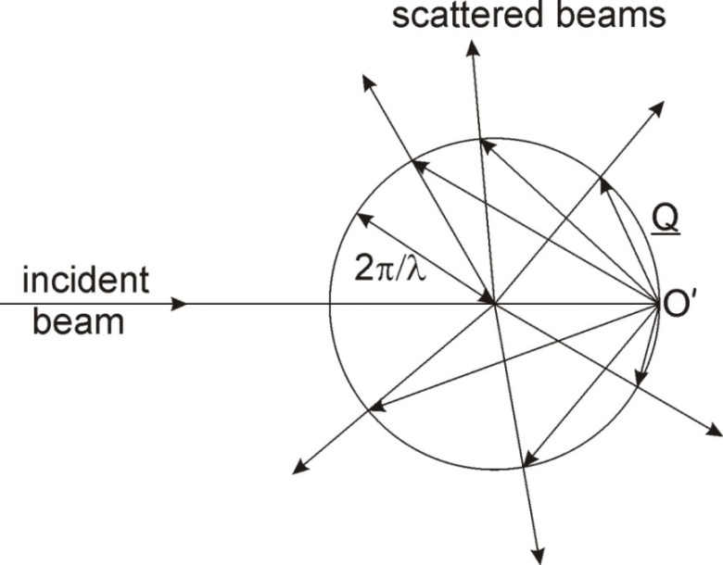
Figure 1 Ewald sphere [7].
As may be concluded, diffraction experiments provide values of $I(\underline{Q})$ at those points in reciprocal space which lie on the surface of the Ewald sphere, considering that the incident beam is fixed. This is due to the fact that scattered X-rays may correspond to those $\underline{Q}$ vectors which terminate at the surface of the Ewald sphere. Thus, it is considered that diffraction patterns are formed by the intersection of the Ewald sphere with the distribution of intensity in reciprocal space. $I(\underline{Q})$ depends only on the modulus of $\underline{Q}$, but not on its direction and is written as $I(\underline{Q})$. Figure 2 shows a spherical shell in reciprocal space. If $I(\underline{Q})$ is spherically symmetric it will have the same value over the shell. In Figure 2 the shell intersects the Ewald sphere at A and B. In 3D, A and B will lie on a circle with centre at P and which will have uniform intensity. The circle encloses a plane surface perpendicular to the plane of Figure 2. For a scatterer with spherical symmetry the diffraction pattern will have circular symmetry.
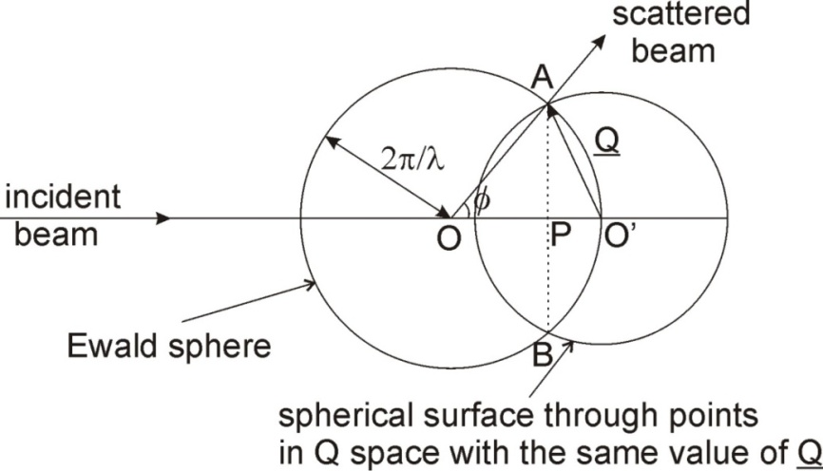
Figure 2 Diffraction geometry for a spherically-averaged scatterer [7].

One-dimensional crystal

Formation of a Diffraction Pattern
From equation: $\underline{c}∙\underline{Q}=2πl$ it follows that the intensity of X-rays, $I(\underline{Q})$, scattered by a one-dimensional crystal is non-zero only on a set of planes, spaced 2π/c distance apart in reciprocal space which are perpendicular to the c-axis direction (Figure 4). The interference function, $S\left(\underline{Q}\right)$, from equations:
$I\left(\underline{Q}\right)=S\left(\underline{Q}\right)F\left(\underline{Q}\right)F^{*}(\underline{Q})$ (9)
$S\left(\underline{Q}\right)=\sin^{2}\left(N\underline{c}∙\frac{\underline{Q}}{2}\right)\sin^{2}(\underline{c}∙\frac{\underline{Q}}{2})$ (10)
is non-zero when equation $\underline{c}∙\underline{Q}=2πl$is satisfied.
Where: $l$ - any integer with positive, negative or 0 values. The analytical approach of deriving this equation is described by Lipson and Taylor [8]. Figure 3 shows a set of parallel planes perpendicular to the c-axis, considering that $\underline{c}∙\underline{Q}=\underline{Q}∙\underline{c}$ and that the dot product of two vectors is the projection of the first on to the second – multiplied by the length of the second. When l is zero, Q must be perpendicular to c because only then can their dot product be zero, e.g. $\underline{Q}$₄ and $\underline{Q}$₅ in Figure 3. All such vectors lie on a plane perpendicular to c. Vectors, such as $\underline{Q}$₆ and $\underline{Q}$₇, for which $\underline{Q}$·c equals 2π (hence l = 1), all end in a plane parallel to the l = 0 plane and distant 2π/c from it. In the same fashion, vectors $\underline{Q}$₈ and $\underline{Q}$₉ define another plane with l = 2. For $\underline{Q}$₁, $\underline{Q}$₂ and $\underline{Q}$₃, the dot product c·$\underline{Q}$ equals -2π. Hence these vectors define a plane distant 2π/c from l = 0 plane, but in the opposite direction to the l = 1 plane, this plane has l = -1. Because $S\left(\underline{Q}\right)$ is non-zero only on these planes, it follows from equations (9) and (10) that $I(\underline{Q})$ also is non-zero only on them.
Figure 4 shows that the diffraction pattern is confined to a series of lines, known as “layer lines”. These layer lines are formed when the planes on which $I(\underline{Q})$ is non-zero, intersect the surface on the Ewald sphere. In the figure a beam of X-rays in incident at right angles to the c-axis of a one-dimensional crystal. O - is the origin of real space defined by the intersection of the diffracted beam with the direction of the undeflected beam. It may be seen in Figure 4 how the planes intersect the Ewald sphere along layer lines. These layer lines can be indexed by the value of l. By definition the plane containing O' has a zero value of l. The corresponding layer line, with l = 0, is called the “equator”, the line on the diffraction pattern which is parallel to the c-axis and therefore perpendicular to the equator is called the “meridian”. The ζ-axis of Q-space is defined to be parallel to the c-axis of real space. It passes through O' the origin of Q-space. The planes on which $I(\underline{Q})$ is non-zero are perpendicular to the c-axis and therefore to the ζ-axis. The l^{th} plane of Q-space crosses the c-axis at a distance ζ = 2πl/c from O'. Except for the trivial case when l equals zero, the ζ-axis does not touch the surface of the Ewald sphere. However, if c is sufficiently large, ζ will be very small for the first few planes of non-zero $I(\underline{Q})$. Consequently, these intersect such a limited region of the surface of the Ewald sphere, around O', that is effectively a plane which is perpendicular to the incident beam direction. Then ζ effectively lies on the surface of the sphere for small values of l. As a result the meridian of the diffraction pattern corresponds to the ζ-axis of Q-space, for layer lines with low l values, provided c is sufficiently large. The distances between layer lines can be measured on the diffraction pattern and converted into Q-space using equation:
$Q=\left(\frac{4π}{}\right)\sin\left[\frac{1}{2}\tan^{-1}(\frac{X}{R})\right]$ (11)
where: X is theta angle, R – specimen-to-detector distance; they can be equated with ζ of equation ζ = 2πl/c in order to determine c.
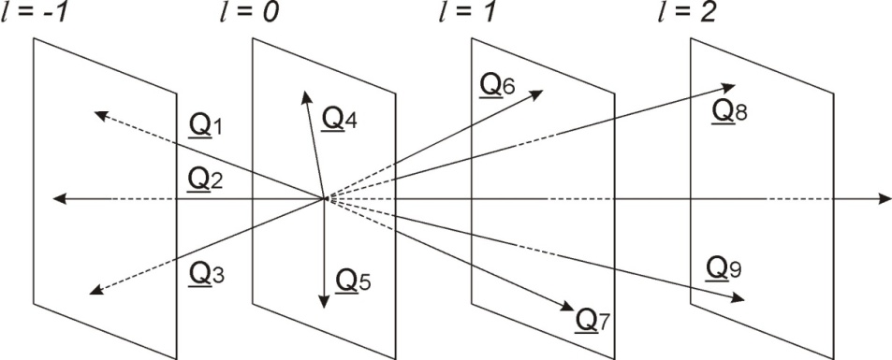
Figure 3 Equation $\underline{c}∙\underline{Q}=2πl$ defines a set of planes in Q-space which are perpendicular to the c-axis direction [7].
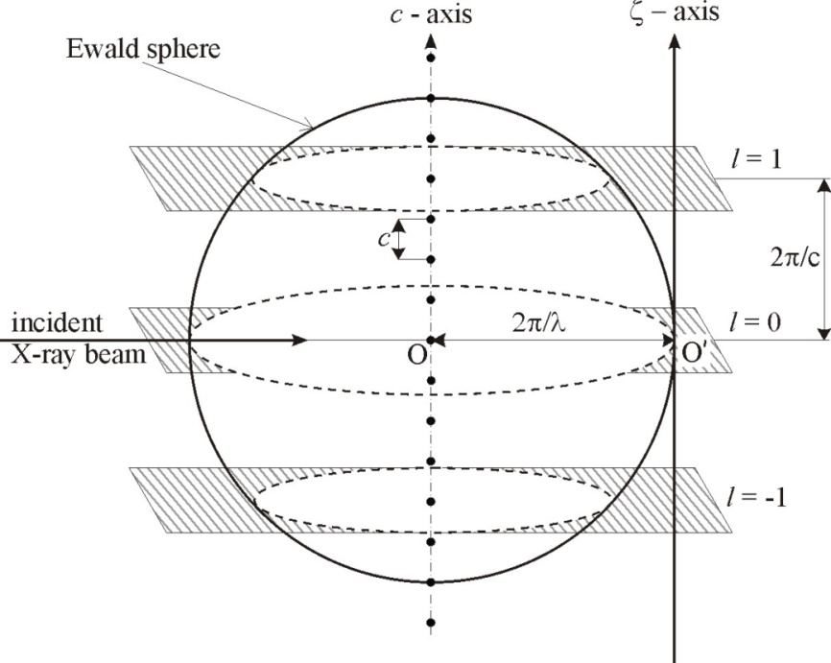
Figure 4 Formation of the diffraction pattern from a one-dimensional crystal [7].

Bernal Chart
Bernal chart is used to measure ζ from the diffraction pattern even when c is small using equation ζ = 2πl/c. Figure 5 shows a vector Q which terminates at A – the intersection of the Ewald sphere with a point on the l^{th} plane on which $I(\underline{Q})$ is non-zero. Thus the intensity at A gives rise to a point on the diffraction pattern. If the pattern is recorded on a flat film, the distance of this point from the centre of the pattern (the intersection of the equator and meridian) is related to Q by equation (11).
Now Q has components ζ and ξ which are, respectively, parallel and perpendicular to the ζ-axis. ξ is the distance of A from B – B is the point where the l^{th} plane intersects ξ-axis. In the same fashion, the corresponding point on the film has equatorial and meridional components x and y. The Bernal chart deals with distortions in both ζ and ξ and differs for different detector geometries.
Figure 6 shows a Bernal chart which is a two-dimensional ruler for measuring ζ and ξ directly from the diffraction pattern. For a given value of R, the relationships:
$x=R\tan{\cos^{-1}\left\{γ/2{\left[1-{\left({}/{2π}\right)}^{2}\right]}^{\frac{1}{2}}\right\}};$ (12)
$y={2R\left({}/{2π}\right)}/{γ;}$ (13)
$γ=2-{{\left({}/{2π}\right)}^{2}-\left({}/{2π}\right)}^{2};$ (14)
where: x, y – real coordinates, ξ, ζ - reciprocal space coordinates, λ - beam wavelength, R – specimen to detector distance.
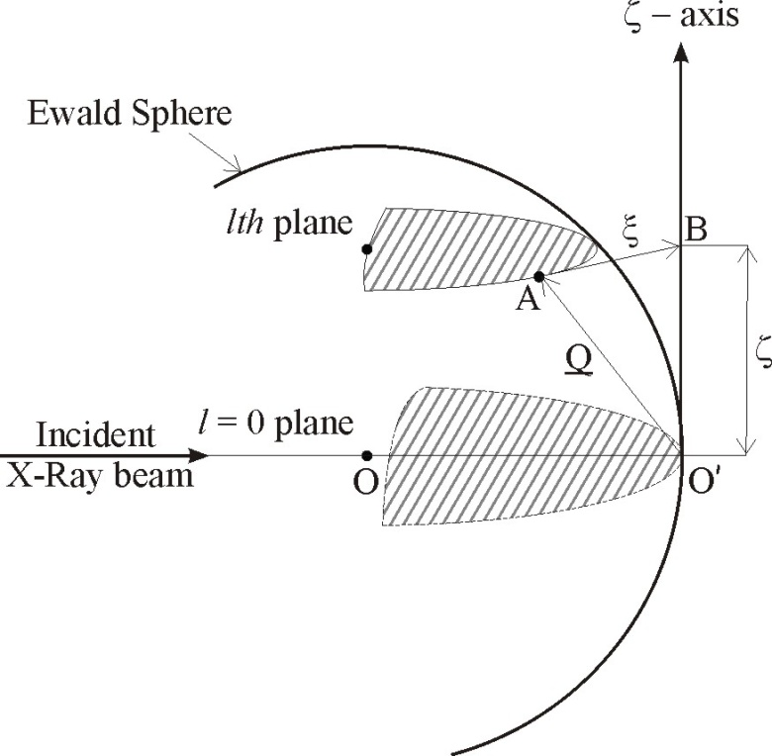
Figure 5 Definition of ζ and ξ [7].
Bernal chart can be used to plot lines which pass through equal values of ζ and ξ on the film. R can be measured during an experiment. Bernal chart is laid on the pattern and the value of ζ corresponding to the layer line separation is read directly. The spacing c can be calculated from ζ using equation ζ = 2πl/c. The intensity distribution along the ζ-axis can be recorded by tilting the one-dimensional crystal so that its c-axis is no longer perpendicular to the beam (Figure 7). When tilted ζ-axis touches the Ewald sphere on the l^{th} layer line if it is tilted through an appropriate angle, α, where:
$sin⁡〖α=((/2))/(2π/)〗$ (15)
From equation above and equation ζ = 2πl/c we have:
$a=\sin^{-1}(\frac{l}{2c})$ (16)
According to this equation, a separate tilt angle is required for each of the planes on which I(Q) is non-zero, since l has a different value for each plane. From the rotation properties of the Fourier transform it follows that a tilt in real space is accompanied by an equal tilt in the same direction about a parallel axis in Q-space. Therefore in order to tilt the ζ-axis as required, the crystal c-axis is tilted so that it departs, by an angle α, from the perpendicular to the incident beam.
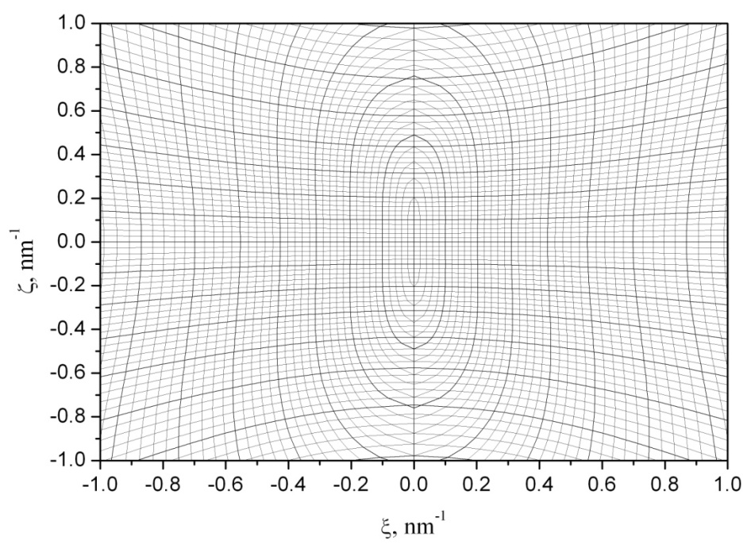
Figure 6 Bernal chart for the diffraction pattern from a one-dimensional crystal. Incident X-ray beam is perpendicular to the c axis recorded on a detector. The chart was generated using equations 12, 13 and 14 for the specimen-to-detector distance is 15 cm.
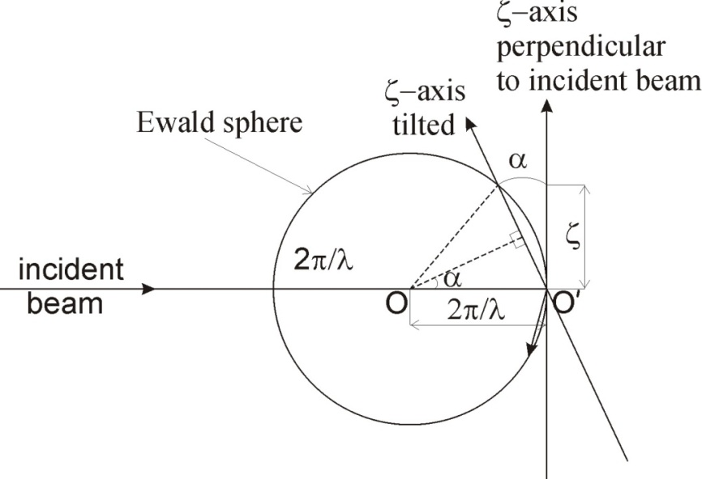
Figure 7 Section of the Ewald sphere showing the effect of tilting ζ-axis [7].

Intensity of Layer Lines
Not all layer lines on Figure 5 have the same intensity. According to the equations (9) and (10) a non-zero value of S(Q) only determines that the layer lines are allowed. The intensity of a layer line is given by $F(\underline{Q})F^{*}(\underline{Q})$ amplified by the value of S(Q) – which is the same for every layer line but zero elsewhere. Since $F(\underline{Q})$ is the Fourier transform of the electron density in a layer line of the one-dimensional crystal, it is the structure of one of the layers shown in Figure 8, which determines the intensity along a layer line.
The equator provides information about the structure of the one-dimensional crystal projected on to the plane of a layer, i.e. perpendicular to its c-axis. Similarly the ζ-axis provides information about the structure of the crystal projected on to the c-axis. A line in Q-space passing through O' provides information about the scattering specimen projected on to a parallel line in real space.
The Fourier transform from a one-dimensional crystal is given by $\left(\underline{Q}\right)(\underline{Q})$, , where $\left(\underline{Q}\right), another real function,$ leads to the intensity, and hence the transform, $F\left(\underline{Q}\right)$, of a layer in one-dimensional crystal being amplified along certain planes of Q-space but obliterated elsewhere. To calculate the Fourier transform of a one-dimensional crystal we need to calculate the transform of a single layer and the calculation can be confined to the planes in Q-space which are specified by integral values of l.
Because we are concerned with the transform along the ζ-axis, we need to calculate the Fourier transform of the electron density of a single layer of the one-dimensional crystal projected on to the c-axis. The projected electron density in a single crystal layer is denoted by ρ(z); where a displacement along the c-axis is denoted by r = Z_{c}. Here Z is the fractional translation since c, as in Figure 8, is the distance between the crystal layers; if Z were greater than unity than we would be considering the structure of the next layer. Because we are calculating the Fourier transform along the ζ-axis, which is parallel to c, the dot product, which arises in the definition of the Fourier transform, becomes:
$\underline{r}∙\underline{Q}=rQ=Zc=2lZ$ (17)
From equations ζ = 2πl/c and r = Zc equation $\underline{r}∙\underline{Q}=rQ=Zc=2lZ$ gives the values of $\underline{r}∙\underline{Q}$ along the ζ-axis where the Fourier transform of the one-dimensional crystal is non-zero.
The Fourier transform, $F\left(\underline{Q}\right)$, of a function, ρ(Q), is defined by (1). Thus, from equations (1) and (17) the Fourier transform of the single layer projected on to the c-axis direction, when it forms part a one-dimensional crystal, is given by:
$F\left(l\right)=\int_{0}^{1}{ρ\left(Z\right)}exp⁡(2ilZ)dZ$ (18)
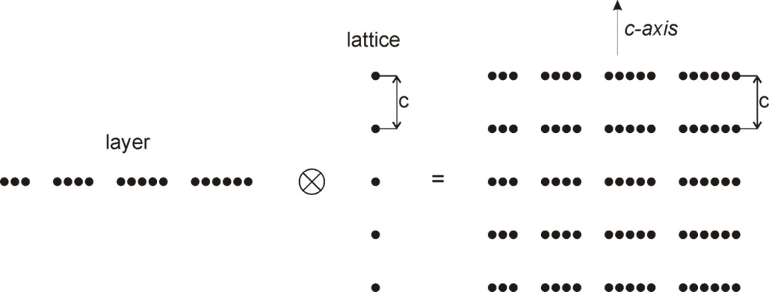
Figure 8 Generation of a one-dimensional crystal by convolution [7].

Diffraction from a helix
Helices are examples of one-dimensional crystals. A helix possesses the repetitive structure in a single direction which characterises a one-dimensional crystal. Calculating the x-ray diffraction pattern from a helix was of central significance in the development of molecular biology. X-ray diffraction from a helix was first described in 1953 by Francis Crick in his PhD thesis “X-Ray Diffraction: Polypeptides and Proteins” [9]. Crick wanted to understand the X-ray diffraction to be expected from an alpha-helix. However, the theory was very quickly applied to structure determination of DNA. The original Watson - Crick Model of double-stranded DNA is depicted in Figure 9.
Crick showed that the diffraction from a helix occurs along layer-lines rather than the Bragg spots one obtains from a three-dimensional crystal. These layer-lines are at right angles to the axis of the fibre and the scattering along each layer-line is made up from Bessel functions (Figure 10).
Fourier used Bessel functions to calculate the flow of heat in cylindrical objects. In helical diffraction Bessel functions take the place of sines and cosines one uses for crystals: Bessel functions (written J_{n}(x), where n is called the order and x the argument) are the forms that waves take in situations of cylindrical symmetry (e.g. the waves you get if you throw a pebble into the middle of a pond). Bessel functions characteristically begin with a strong peak and then oscillate like a damped sine wave as x increases. The position of the first strong peak depends on the order n of the Bessel function. A Bessel function of order zero begins in the middle of the pattern, a Bessel function of order 5 has its first peak at about x = 7, a Bessel function of order 10 does everything roughly twice as far out (Figure 10).
There are two types of helices, namely continuous and discontinuous.

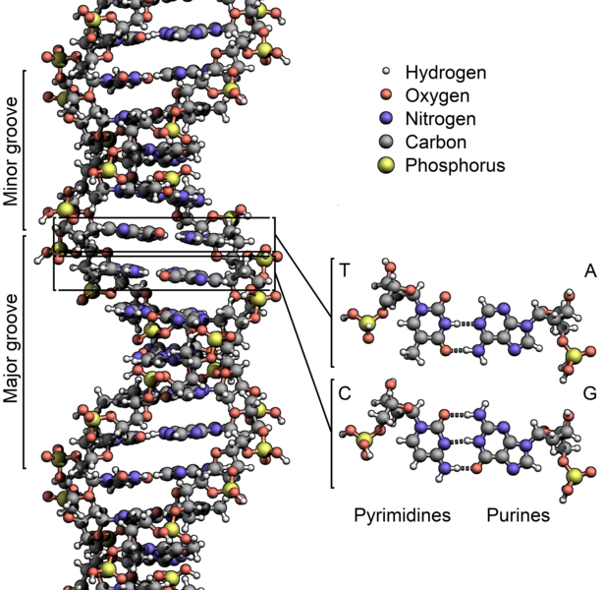
Figure 9 Structure of the DNA double helix. The atoms in the structure are colour coded by element and the detailed structure of two base pairs is shown in the bottom right [10].

Continuous helix
Crick showed that for a continuous helix the order of Bessel function n occurring on a certain layer line is the same as the layer line number l (counted from the middle of the diffraction pattern). In Figure 11 (a) a continuous helix and its diffraction pattern is shown. Because the order of Bessel function increases with layer line number so does the position of the first strong peak which then form the characteristic "helix cross". The position of the first strong peak is also inversely proportional to the radius of the helix. There is a reciprocal relationship between the layer line separation and the pitch- small separation large p, large separation small p.

Discontinuous helix
However, real helical molecules or assemblies are not continuous; rather they consist of repeating groups of atoms or molecules. The symmetry of a discontinuous helix can be defined in a number of ways: the most general is to quote how far one goes along the axis from one repeating subunit to the next in the macromolecule and by what angle you turn between one subunit and the next. This is enough to define a helix. Directly derivable from these parameters is the pitch p. The main effect of shifting from a continuous to a discontinuous helix is to introduce new helix crosses with their origins displaced up and down the meridian axis of the diffraction pattern by a distance 1/p. The diffraction pattern of a discontinuous helix is shown in Figure 11 (b). The layer-lines can be grouped into two kinds: those which are strong on the meridian of the fibre diffraction pattern and those which have no intensity on the meridian. For a simple helix which repeats in one turn the fundamental layer line repeat is 1/p. The distance out along the meridian of the first layer-line with non-zero meridional intensity gives 1/p.
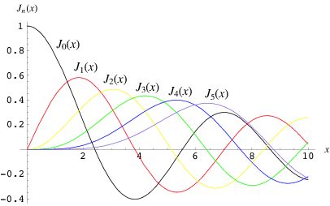
Figure 10 Squared Bessel functions.
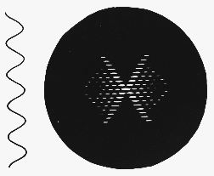 | 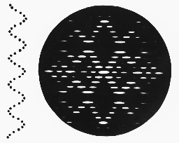
a) | b)
Figure 11 a) A continuous helix and its diffraction pattern and b) discontinuous helix and its diffraction pattern

Three-Dimensional Crystal
Any real crystal has a structure which is repetitive in 3D. The arrangement of atoms which repeats itself regularly within a crystal is called “unit cell.” It is shown in Figure 12 that two-dimensional crystal can be generated by the convolution of the unit cell content with a two-dimensional lattice of points but it is possible to work with the figure just imagining that the structure is regularly repetitive in all three dimensions.
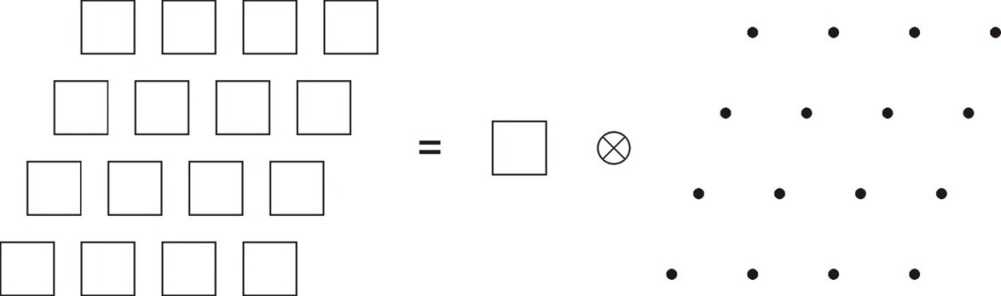
Figure 12 Generation of a crystal structure by convolution. [7]
A 3D lattice is defined by three unit vectors, a, b and c (Figure 13). Moduli of a, b and c and the angles between them are required to define the lattice. The angles between vectors are denoted as following: between a and b - γ, between b and c - α, between a and c – β. In Figure 13 the intersection of the two vectors a with b is taken to be the origin of the unit cell; in 3D a vector $\underline{c}$ intersects the other two at O and points out of the plane of the figure but not necessarily perpendicular to it. The position of atom j in the unit cell is given by:
${\underline{r}}_{j}=x_{j}\underline{a}+y_{j}\underline{b}+z_{j}\underline{c}$ (19)
where: $x_{j}$, $y_{j}$ and $z_{j}$ are translations along the vectors a, b and c called “fractional unit cell coordinates” and expressed as fractions of their length. The vector is defined as:
${\underline{x}}_{j}=\left[\begin{matrix}x_{j} \\ y_{j} \\ z_{j}\end{matrix}\right]$ (20)
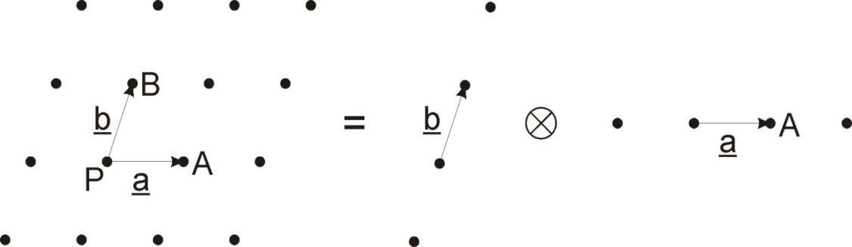
Figure 13 Generation of two-dimensional lattice by convolution. [7]
As shown in Figure 13 a three dimensional lattice is the convolution of three one-dimensional lattices. As seen in Figure 14 Fourier transform of a three-dimensional lattice is non-zero only at a set of points called the “reciprocal lattice”. The real space in Figure 13 can be generated by convolution. F(Q) of a three-dimensional lattice is given by the product of the transforms of each of the three one-dimensional lattices. As seen in Figure 14, transforms of the one-dimensional lattices are non-zero on a set of planes spaced 2π/a apart and perpendicular to a, 2π/b apart and perpendicular to b, 2π/c apart and perpendicular to c. The product of three transform is non-zero in the regions of Q-space where each of the three is non-zero, i.e. where their planes intersect at a set of points as seen in Figure 14.
The reciprocal lattice can be defined by three vectors, a*, b* and c* (Figure 14). The angles between vectors are denoted as following: between a* and b* - γ*, between b* and c* - α*, between a* and c* – β*. In Figure 14 a*⋅ a is the projection of a*on to the horizontal direction which equals 2π/a, multiplied by a – the result is 2π. Similarly:
$${\underline{a}}^{*}∙\underline{a}=2π {\underline{a}}^{*}∙\underline{b}={\underline{a}}^{*}∙\underline{c}=0$$
${\underline{b}}^{*}∙\underline{b}=2π {\underline{b}}^{*}∙\underline{a}={\underline{b}}^{*}∙\underline{c}=0$ (21)
$${\underline{c}}^{*}∙\underline{c}=2π {\underline{c}}^{*}∙\underline{a}={\underline{c}}^{*}∙\underline{b}=0$$
This equation shows that from construction of Figure 14 a* is always perpendicular to both b and c, b* is always perpendicular to both a and c, and c* is always perpendicular to both a and b.
Reciprocal lattice points are specified by the values of three integers: h, k and l. The vectors Q which terminate at reciprocal lattice points are given by:
$\underline{Q}=h{\underline{a}}^{*}+k{\underline{b}}^{*}+l{\underline{c}}^{*}$ (22)
where h, k and l are integral and a value of zero at the origin of Q-space, O'.
Figure 15 shows a two-dimensional example where h and k integers are required. The value of Q corresponding to the reciprocal lattice points is expressed as:
$Q={\left(h^{2}{a^{*}}^{2}+k^{2}{b^{*}}^{2}+l^{2}{c^{*}}^{2}+2hka^{*}b^{*}cosγ^{*}+2hklb^{*}c^{*}cosα^{*}+2hla^{*}c^{*}cosβ^{*}\right)}^{\frac{1}{2}}$ (23)
The above equation gives the values of Q corresponding to the reciprocal lattice points. and
The more symmetrical the unit cell, the simpler is the equation (23).
The Fourier transform of the crystal is obtained by multiplying the transform of the electron density distribution in a unit cell by the transform of the lattice. This is because the crystal structure is generated by the convolution of the unit cell contents with the lattice.
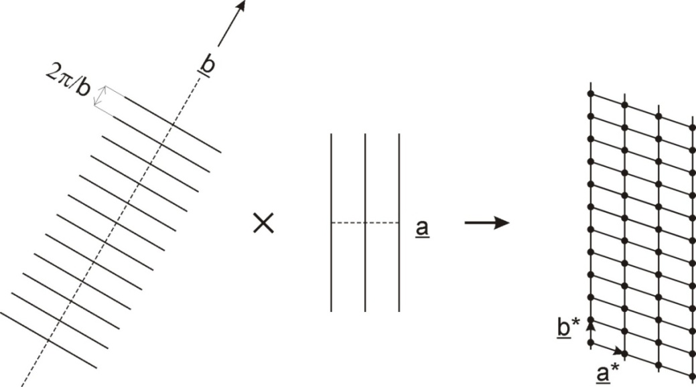
Figure 14 Generation of reciprocal lattice by multiplication [7]
The Fourier transform of the crystal is given by:
$F\left(\underline{h}\right)=\sum_{j}{f_{j}}exp2πi\underline{h}∙{\underline{X}}_{j}$ (23)
where f_{j} – atomic scattering factor.
The summation has to be taken over all the atoms in a unit cell. Now the Fourier transform is non-zero only at those points in Q-space which are given by integral components of h and hence can be written as $F\left(\underline{h}\right)$ instead of $F(\underline{Q})$. The Fourier transform of a crystal, $F\left(\underline{h}\right)$, at the reciprocal lattice points are called “structure factors” although this term is applied sometimes to the modulus of $F\left(\underline{h}\right)$.
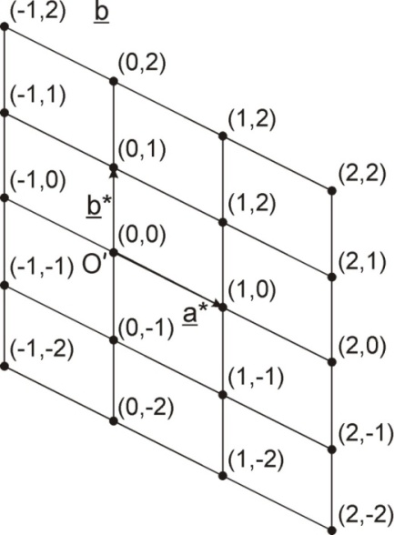
Figure 15 Assigning indices to reciprocal lattice points [7].
Scattered intensity is confined to reciprocal lattice points and is given by:
$I\left(\underline{h}\right)=F\left(\underline{h}\right)F^{*}\left(\underline{h}\right)$ (24)
$F^{*}\left(\underline{h}\right)$ is the complex conjugate of $F\left(\underline{h}\right)$. The point on the diffraction pattern where a value of $I\left(\underline{h}\right)$ is recorded is called a “reflection.”

Fibre Diffraction
Many biological macromolecules do not crystallize. However, most of them form orientated fibres in which the axes of the long polymeric structures are parallel to each other. Often the orientation is intrinsic but sometimes the long molecules can be induced to form orientated fibres by pulling them from a gel with tweezers, sometimes by flowing gel through a capillary tube, or even by subjecting them to intense magnetic fields. The experimental set-up is rather simple: the orientated fibre is placed in a collimated x-ray beam at right angles to the beam and the "fibre diffraction pattern" is recorded on a film placed a few cm away from the fibre.
Fibres show helical symmetry rather than the three-dimensional symmetry taken on by crystals. By analysing the diffraction from orientated fibres one can deduce the helical symmetry of the molecule and in favourable cases one can deduce the structure. In general this is done by constructing a model of the fibre and then calculating the expected diffraction pattern.
In the crystalline case, the long fibrous molecules pack to form long thin micro-crystals which share a common axis referred as the c-axis. The micro-crystals are randomly arranged around c axis. The resulting diffraction pattern (Figure 16 a) is equivalent to taking one long crystal and spinning it about its axis during the x-ray exposure. All Bragg reflexions are registered at one time. The reflexions are grouped along "layer-lines" which arise from the repeating structure along the c-axis. In non-crystalline fibres, e.g. B-form of DNA, the long fibrous molecules are arranged parallel to each other but each molecule takes on a random orientation around the c-axis. The resulting diffraction pattern is shown in Figure 16 b. The intensity along the layer-lines is continuous and can be calculated via a "Fourier-Bessel Transform" of the repeating structure of the fibrous molecule.
An ideal fibre diffraction pattern shows four-quadrant symmetry as may be seen on Figure 17. The vertical, fibre, axis is called the meridian and the horizontal axis is called the equator. As compared with single-crystal diffraction more reflections appear in fibre diffraction pattern. The reflections are arranged along layer lines running almost parallel to the equator. Reflections here are labelled by the Miller indices, hkl.
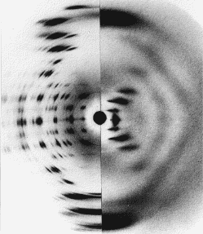
a) | b)
Figure 16 Diffraction from the a) A and b) B forms of DNA
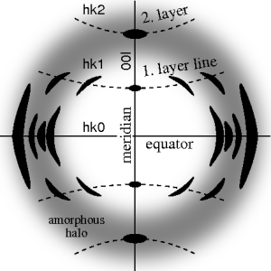
Figure 17 Ideal fibre diffraction pattern of a semi-crystalline material with amorphous halo and reflections on layer lines. High intensity is represented by dark colour. The fibre axis is vertical

Chapter 3 – Molecular Modelling

Background
As the classical simulation theory stipulates, an accurate simulation of atomic and molecular systems generally involves the application of quantum mechanical theory. However, quantum mechanical techniques are computationally expensive and are usually only applied to small systems containing between 10 and 100 atoms, or small molecules. It is not practical to model large systems such as a condensed polymer containing many thousands of monomers in this way. Even if such a simulation were possible, in many cases much of the information generated would be discarded. This is because in simulating large systems, the goal is often to extract bulk properties, such as diffusion coefficients or Young's moduli, which depend on the location of the atomic nuclei or, more often, an average over a set of atomic nuclei configurations. Under these circumstances the details of electronic motion are lost in the averaging processes, so bulk properties can be extracted if a good approximation of the potential in which atomic nuclei move is available and if there are methods that can generate a set of system configurations which, while they may not follow the exact dynamics of the nuclei, are statistically consistent with a full quantum mechanical description. There are a number of forcefields and distribution generating techniques available and they are collectively referred to as classical simulation methods. The term classical is used because some of the earliest simulations generated configurations by integrating the Newtonian equations of motion and this approach is still widely used.

Universal Force Field
The Universal force field (UFF) is a purely diagonal, harmonic forcefield. Bond stretching is described by a harmonic term, angle bending by a three-term Fourier cosine expansion, and torsions and inversions by cosine-Fourier expansion terms. The van der Waals interactions are described by the Lennard-Jones potential. Electrostatic interactions are described by atomic monopoles and a screened (distance-dependent) Coulombic term. UFF has full coverage of the periodic table. UFF is moderately accurate for predicting geometries and conformational energy differences of organic molecules, main-group inorganics, and metal complexes. It is recommended for organometallic systems and other systems for which other forcefields do not have parameters.
The Universal forcefield includes a parameter generator that calculates forcefield parameters by combining atomic parameters. Thus, forcefield parameters for any combination of atom types can be generated as required.
The atomic parameters are combined using a prescribed set of equations (rules) that generate forcefield parameters for bond, angle, torsion, inversion (i.e., out-of-plane), and van der Waals and Coulombic energy terms. The potential energy is expressed as a sum of valence or bonded interactions and non-bond interactions:
$E=E_{R}+E_{θ}{+E}_{}+E_{ω}+E_{vdw}+E_{el}$ (25)
where: $E_{R}$ - covalent bond stretching interactions, $E_{θ}$ - bond angle bending interactions, $E_{}$ - dihedral bending interactions, $E_{ω}$ - sinusoidal dihedral torsion interactions, $E_{vdw}$ - non-bond van der Waals interactions, $E_{el}$ - electrostatic interactions.

Energy Minimization
Once the wave function is determined, the program uses it to evaluate the energy of the molecule, the atomic forces, and many other electronic properties. The energy and the atomic forces are used to optimize the geometry of the molecule to a stationary point, minimum or transition state, at which the atomic forces are ideally all zero. There is potential energy surface (PES) which helps in determining these states (Figure 18).
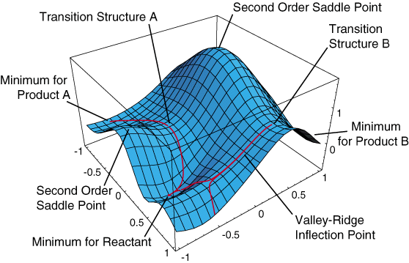
Figure 18 Schematic representation of the potential energy surface [11]
A local maximum is the point on the (PES) representing the highest value in a particular section of the PES. A global maxima is the point on the PES representing the highest value in the entire the PES. A local minimum is the point on the PES that is representing the lowest value in the particular section of the PES. A global minimum is that point on the PES representing the lowest values in the entire PES. Saddle point shows a maximum in one direction and a minimum in the other. Saddle points represent a transition structure connecting two equilibrium structures. A transition state is a first-order saddle point. Stationary point represents a point on the PES where the gradient is zero. In most cases one will descovered that the minimum found is a local minimum but not the global one. To be able to find the global minimum one should perform a more accurate scan of the PES with a wider range of variables to see other potential minima.

Geometry Optimization
The procedure which aims to find the configuration of the minimum energy of the structure is called geometry optimization. Geometry optimization is carried out with the following purposes: find the local minimum structure, find the global minimum structure and find the transition state structure.
Forcite module of Materials Studio Modelling® offers the following algorithms for geometry optimization: Steepest descent, Conjugate gradient, Newton-Raphson and Smart which is a cascade of the steepest descent and Newton-Raphson methods.

Steepest Descent Algorithm
Steepest descent is the method most likely to converge, no matter what the function is or where it begins. It will quickly reduce the energy of the structure during the first few iteration procedures. However, convergence will slow down considerably as the gradient approaches zero. It should be used when the gradients are very large and the configurations are far from the minimum; typically for poorly refined crystallographic data, or for graphically built molecules. In the steepest descent method, the line search direction is defined along the direction of the local downhill gradient (Figure 19). Each line search produces a new direction that is perpendicular to the previous gradient but the directions oscillate along the way to the minimum. Such inefficient behaviour is characteristic of steepest descents.
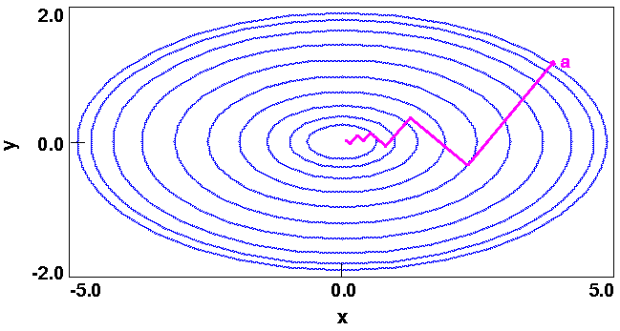
Figure 19 Path of minimization for the steepest descents algorithm.
The exclusive reliance on gradients by the steepest descents method is both its weakness and its strength. Convergence is slow near the minimum because the gradient approaches zero, but the method is extremely robust, even for systems that are far from harmonic. It is the method most likely to generate the true low-energy structure, regardless of what the function is or where the process begins.

Conjugate Gradient Algorithm
This method improves the line search direction by storing information from the previous iteration. It is the method of choice for systems that are too large for storing and manipulating a second-derivative matrix. The time per iteration is longer than for steepest descents, but this is more than compensated for by efficient convergence. The reason that the steepest descent method converges slowly near the minimum is that each segment of the path tends to reverse the progress made in an earlier iteration. For example, in Figure 19, each line search deviates somewhat from the ideal direction to the minimum. Successive line searches correct for this deviation, but they cannot do so efficiently because each direction must be orthogonal to the previous direction. Thus, the path oscillates and continually over corrects for poor choices of direction in earlier steps. It would be preferable to prevent the next direction vector from undoing earlier progress. This means using an algorithm that produces a complete basis set of mutually conjugate directions such that each successive step continually refines the direction toward the minimum. If these conjugate directions truly span the space of the energy surface, then minimization along each direction in turn must, by definition, end in arrival at a minimum. Conjugate gradients is the method of choice for large models because, in contrast to Newton-Raphson methods, where storage of a second-derivative matrix is required, only the previous gradients and directions have to be stored. However, to ensure that the directions are mutually conjugate, more complete line search optimizations must be performed along each direction. Since these line searches consume several function evaluations per search, the time per iteration may be longer for conjugate gradients than for steepest descents. This is more than compensated for by the more efficient convergence to the minimum achieved by conjugate gradients.

Newton-Raphson Algorithm
All the Newton methods require computation and storage of second derivatives and are thus expensive in terms of computer resources. The Newton-Raphson method is only recommended for systems with a maximum of 200 atoms. It has a small convergence radius but it is very efficient near the energy minimum.
As a rule, N² independent data points are required to solve a harmonic function with N variables numerically. Since a gradient is a vector N long, the best you can hope for in a gradient-based minimizer is to converge in N steps. However, if you can exploit second-derivative information, an optimization could converge in one step, because each second derivative is an N x N matrix. This is the principle behind the variable metric optimization algorithms, of which Newton-Raphson is perhaps the most commonly used.

Smart Algorithm
Different algorithms are better suited to certain circumstances, e.g., if the structure is far from equilibrium, it is best to use steepest descent. It is, therefore, often beneficial to combine algorithms in a cascade, such that, as the potential minimum is approached, a more appropriate method is used. The Smart algorithm was employed allowing Materials Studio Modelling® software to apply the optimal method, cascade of the steepest descent and Newton-Raphson methods, automatically at the appropriate time during the optimization process.

Constant Temperature Molecular Dynamics
In the constant temperature (NVT) molecular dynamics, number of moles (N), volume (V) and temperature (T) are kept constant. Here, the energy of endothermic and exothermic processes is exchanged with a thermostat. A number of thermostat methods are available to add and remove energy from the boundaries of a molecular dynamics system in a more or less realistic way, approximating the canonical ensemble. Popular techniques to control temperature include velocity rescaling, the Nosé-Hoover thermostat, Nosé-Hoover chains, the Berendsen thermostat and Langevin dynamics. It is not trivial to obtain a canonical distribution of conformations and velocities using these algorithms depending on system size, thermostat choice, thermostat parameters, time step and integrator.

Chapter 4 – Crystallography Basics

Unit cell
A crystal structure is regularly repetitive in 3D. The repeating unit is called the “unit cell”. The unit cells stack in three-dimensional space and describe the bulk arrangement of atoms of the crystal. The crystal structure has a three dimensional shape. The unit cell is given by its lattice parameters, the length of the cell edges (a, b c) and the angles between them (α, β, γ) (Figure 20). The positions of the atoms inside the unit cell are described by the set of atomic positions (x_{i}, y_{i}, z_{i}) measured from a lattice point. For each crystal structure there is a conventional unit cell (Figure 20) which is chosen to display the full symmetry of the crystal. The conventional unit cell is not always the smallest possible choice. A primitive unit cell of a particular crystal structure is the smallest possible volume one can construct with the arrangement of atoms in the crystal such that, when stacked, completely fills the space. In a unit cell each atom has an identical environment when stacked in the lattice. In a primitive cell, each atom may not have the same environment.
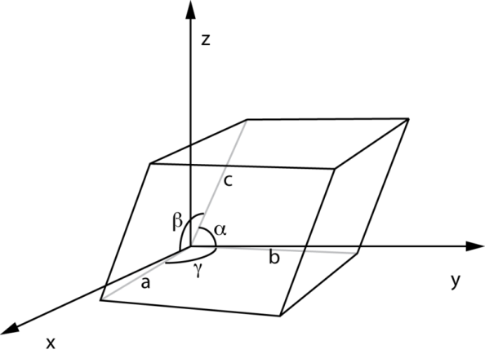
Figure 20 Unit cell representation: a parallelepiped with lengths a, b, c and angles α, β, and γ between sides

Symmetry
The unit cell possesses symmetry if the positions of all its atoms can be generated by the operation of symmetry elements on a subset of these positions. This subset, from which all the other positions can be generated, is called the “asymmetric unit” of the unit cell. Symmetry elements reflect, rotate, and translate a point to an equivalent point. Some symmetry elements perform a combination of symmetry operations, i.e. translation + rotation. Only 230 combinations of symmetry elements are allowed. The reason is that the combination of two or more symmetry elements can generate further symmetry elements and only certain combinations are then compatible.

Point group and space group
The crystallographic point group or crystal class is the mathematical group comprising the symmetry operations that leave at least one point unmoved and that leave the appearance of the crystal structure unchanged. There are 32 possible crystal classes. Each one can be classified into one of the seven crystal systems (Table 1).
The space group of the crystal structure is composed of the translational symmetry operations in addition to the operations of the point group. These include pure translations which move a point along a vector, screw axes, which rotate a point around an axis while translating parallel to the axis, and glide planes, which reflect a point through a plane while translating it parallel to the plane. There are 230 distinct space groups [12].

Systematic Absences
The space group of the crystal is determined from systematic absences in the diffraction pattern which arise when symmetry elements contain translational components (Table 2). The systematic absences are used to detect screw axes, glide planes, and lattice centring. The space group of the crystal allows determining the space group of the reciprocal lattice which in turn allows determining the orientations of the crystal. All reciprocal lattices are centrosymmetric. By determination of the space group of the reciprocal lattice we reduce possible 230 space groups to 11 different groups, called Laue groups where a centre of symmetry is added (
Table 3
). For each Laue group it is possible to calculate the fraction of unique reflections by comparing intensities of symmetry equivalent data for various possible crystal symmetries. Systematic absences conditions appropriate for the given Laue group are tested to determine cell centring, glide planes and screw axis (Table 4). The list of possible space groups is found at the end and these space groups should be considered for further investigation.
Table 1 Crystal systems and corresponding Bravais lattices.
Crystal system | Bravais lattices
Triclinic | P
Triclinic | 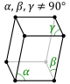
Monoclinic | P | C
Monoclinic | 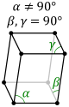 | 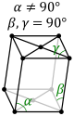
Orthorhombic | P | C | I | F
Orthorhombic | 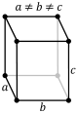 | 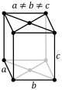 | 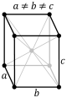 | 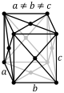
Tetragonal | P | I
Tetragonal | 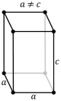 | 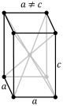
Rhombohedral  (Trigonal) | P
Rhombohedral  (Trigonal) | 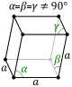
Hexagonal | A
Hexagonal | 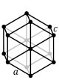
Cubic | P (PCC) | I (BCC) | F (FCC)
Cubic | 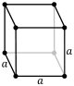 | 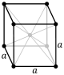 | 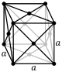

Table 2 List of systematic absences and conditions when they occur [12].
Symmetry operations | Reflections | Absent when:
Screw axis along b | 0h0 | k is odd
Screw axis along a | h00 | l is odd
Screw axis along c | 00l | l is odd
Glide plane perpendicular to a, along b | 0kl | k is odd
Glide plane perpendicular to a, along c | 0kl | l is odd
Glide plane perpendicular to b, along a | h0l | h is odd
Glide plane perpendicular to b, along c | h0l | l is odd
Glide plane perpendicular to c, along a | hk0 | h is odd
Glide plane perpendicular to c, along b | hk0 | k is odd
Glide plane perpendicular to a, along the diagonal | 0kl | k+l is odd
Glide plane perpendicular to b, along the diagonal | h0l | h+k is odd
Glide plane perpendicular to c, along the diagonal | 0kl | k+l is odd

Table 3 Eleven Laue point groups or crystal classes [12].
Crystal system | Laue point group  and centrosymmetric  point group | Non-centrosymmetric  point groups belonging  to the Laue point group
Cubic  (two Laue point groups) | mm | 432 m | 3m
Cubic  (two Laue point groups) | m | 23
Tetragonal | 4/mmm | 422 | 4mm | 2m
(two Laue point groups) | 4/m | 4
Orthorhombic | Mmm | 222 | mm2
Trigonal | m | 32 | 3m
(two Laue point groups) |  | 3
Hexagonal | 6/mmm | 622 | 6mm | m2
(two Laue point groups) | 6/m | 6
Monoclinic | 2/m | 2 | m
Triclinic |  | 1
Table 4 Translational symmetry elements and conditions of their extinction [12].
Lattice or symmetry elements | Set of reflections | Condition of extinction
Primitive, P | hkl | none
Body centred, I | hkl | h+k+l = 2n+1
Base centred, A, B, C | hkl | k+l = 2n+1  h+l = 2n+1  h+k = 2n+1
Face centred, F | hkl | h+k = 2n+1,  k+l = 2n+1,  h+k = 2n+1
Rhombohedral, R | hkl | k-h+l = 3n+1.5  h-k+l = 3n+1.5
Glide plane (001) a | hk0 | h = 2n+1
Glide plane (001) b | hk0 | k = 2n+1
Glide plane (001) n | hk0 | h+k = 2n+1
Glide plane (001) d | hk0 | h+k = 4n+2
Glide plane (100) b | 0kl | k = 2n+1
Glide plane (100) c | 0kl | l = 2n+1
Glide plane (100) n | 0kl | k+l = 2n+1
Glide plane (100) d | 0kl | k+l = 4n+2
Glide plane (010) a | h0l | h = 2n+1
Glide plane (010) c | h0l | l = 2n+1
Glide plane (010) n | h0l | h+l = 2n+1
Glide plane (010) d | h0l | h+l = 4n+2
Screw axis [100] 2₁ 4₂ | h00 | h = 2n+1
Screw axis [100] 4₁ 4₃ | h00 | h = 4n+2
Screw axis [010] 2₁ 4₂ | 0k0 | k = 2n+1
Screw axis [010] 4₁ 4₃ | 0k0 | k = 4n+2
Screw axis [001] 2₁ 4₂ 6₃ | 00l | l = 2n+1
Screw axis [001] 3₁ 3₂ 6₂ 6₄ | 00l | l = 3n+1.5
Screw axis [001] 4₁ 4₃ | 00l | l = 4n+2
Screw axis [001] 6₁ 6₅ | 00l | l = 6n+3

Chapter 5 – Experiment and Analysis

Sample Preparation
Study 1: Helicene-bisquinone
Professor S. Holger Eichhorn of University of Windsor situated in Windsor (Canada) provided the fibres of the helicene-bisquinone. His group drew fibres from 10 wt% solutions in heptane at 80 °C [13].
Study 2: Perylene bisimide derivative
Professor Virgil Percec of University of Pennsylvania situated in Pennsylvania (USA) provided the fibres of N,N’-di-(3,4,5-dodecyloxy-oxyphenylethyl)-perylene bisimide (PBI 12-2). I in turn heated the fibres in a hot stage up to 45 °C (5 °C below their melting temperature, T_{m} = 50 °C) with a rate of 3 °C/min, annealed for 24 hrs and then cooled down to room temperature (T_{R} = 20 °C) with a rate of 3 °C/min.
Study 3: Poly-9-hydroxynonanoate
Professor Zoran Petrovic of Pittsburgh State University situated in Kansas (USA) provided the fibres of biodegradable polyester, poly-9-hydroxynonanoate. His group synthesized them from dicarboxylic acid using an excess of 1,4-butanediol by thermal polycondensation in vacuum at 180 °C with titanium tetrabutoxide as a catalyst [14]. They preheated the fibres at 60-65 °C and stretched them. I, in turn, heated the fibres in a hot stage up to 65 °C (5.5 °C below their melting temperature, T_{m} = 70.5 °C [14]) with a rate of 3 °C/min, annealed for 24 hrs and then cooled down to room temperature (T_{R} = 20 °C) with a rate of 3 °C/min.

The orientation of all above mentioned fibres was reasonable as could be observed from the diffraction patterns obtained later. Annealing was carried out to improve crystal perfection. Additional weak reflections became visible after the annealing as was confirmed later for all the fibres investigated.

X-ray Diffraction Experiment
Dr Maxim Shcherbina and Dr Zeng carried X-ray analysis of the fibres of helicene- bisquinone at Station 2.1 of the SRS Synchrotron at old Daresbury covering a wide angular region. The MarResearch 345 Image Plate Detector was used. As for the small-angle region with higher resolution, they covered it at the beam line I22 [15] situated at the Diamond Light Source (Didcot, Oxfordshire, UK). Rapid-II multi-wire area detector, developed by the Daresbury Detector Group, was used.
I carried out X-ray analyses of the fibres of PBI 12-2 and PHN samples. WAXS measurements were performed with the help of the Rigaku rotating anode generator with wavelength of 1.5418 Å. I used multilayer focusing mirrors and the MAR 345 Imaging Plate as a detector (MarResearch GmbH, Norderstedt, Germany [16]) situated at the Department of Molecular Biology and Biotechnology of the University of Sheffield.
All X-ray measurements were carried out at room temperature (T_{R} = 20°). All experimental X-ray diffraction patterns were recorded with the fibre axis vertical and perpendicular to the beam (φ = 0), as well as inclined at different angles (φ > 0) so that the entire reciprocal space could be explored. Here φ represents a fibre tilt angle.

Calibration
Before any diffraction pattern can be analyzed it needs to be calibrated. The calibration procedure is used to define the experimental parameters of the particular experiment. This may be carried out by means of fitting the experimental parameters of a well known standard. In our X-ray experiments, as an external standard specimen, we used commercially available n-tetracontane (C₄₀H₈₂) in form of powder from SIGMA chemical company (99% purity). It has discrete diffraction rings with d₀₀₂ = 5.26 nm [17]. N-tetracontane powder was inserted into a thin-walled 1 mm diameter glass capillary. The glass capillary then was heated in a hot stage up to 81 °C (T_{m} = 80-84 °C [18]). This allowed obtaining completely melted sample from crystals of n-tetracontane powder.

X-ray Pattern Processing
In order to index the reflections correctly on the patterns obtained they were processed using the CCP13 program suite [19]. Diffuse background was partially ironed out using the “roving window” method. An exact fibre tilt angle was determined, then the pattern was converted from detector coordinates to reciprocal cylindrical coordinates q_{xy} and q_{z} using FTOREC program from the CCP13 program suite [19].
Calculation of the real d-spacing for orthorhombic lattice (in case of PBI 12-2 and PHN) was carried out using the following equation:
$\frac{1}{d^{2}}=\left(\frac{h^{2}}{a^{2}}+\frac{k^{2}}{b^{2}}+\frac{l^{2}}{c^{2}}\right)$ (33)
where: d – d-spacing, h, k, and l – Miller indexes for corresponding planes; a, b, and c – unit cell parameters.
Theoretical density of the compounds was calculated using the equation:
$\frac{m}{V}=ρ=\frac{ N}{N_{A}}\frac{1}{abc}$ (34)
where: m – mass of a compound; V – volume of a compound; ρ - density of a compound; μ - quantity of matter; N – number of molecules; N_{A} – Avogadro’s number (6.022 × 10²³); a, b, c – lattice parameters. This was done for calculating the number of molecules within the unit cell and for the comparison of the theoretical and measured values of density. Peaksolve software purchased from Galactic Industries Corporation was used for intensity integration and peak resolution.

Structure Modelling and Minimization
Modelling of molecules and crystal structures in all three studies was performed with the help of Materials Studio Modelling® Software [20]. During the minimizations cell parameters (a, b and c) and angles (α, β and γ) were kept fixed. VAMP module of Materials Studio Modelling® which is a semiempirical quantum mechanics program was employed in the Study 2, for minimization of a single PBI 12-2 molecule, which allowed optimization of the single molecule taking into consideration only quantum mechanical rules without applying any particular force field. Forcite module in Materials Studio Modelling [20] with the Universal force field [21-24] was employed for performing minimizations of the crystal lattices of the structures. Forcite module allowed refinement of the geometry of the structures using an iterative process, in which the atomic coordinates were adjusted until the total energy of the structures was minimized. The forces on an atom were calculated from the potential energy expression and depended on the Universal forcefield.

X-ray Pattern Simulation
From the model of the crystal structure one can calculate the intensities of the reflections, which are straightforwardly dependent on the atomic positions of atoms. The simulation of the diffraction pattern is required in determination of the real crystal structure by comparing how the diffraction intensities change as the atomic positions change, so that a close match between the experimental diffraction pattern and simulated pattern is observed. In this research Cerius-2® software [25] was employed for simulation of the diffraction patterns of the modelled crystal structures of the investigated compounds. Diffraction and Crystal modules of the Cerius-2® were employed which are computational instruments for the simulation of X-ray, electron, and neutron diffraction patterns from crystalline models [25].

Chapter 6 – Study 1: Helicene-bisquinone

Literature Review

6.1.1 Introduction
Helicenes belong to the group of orthocondensed polycyclic aromatic ring compounds. Helicene core may consists of 5, 6, 7, etc. rings consequently changing the names to pentahelicenes, hexahelicenes, heptahelicenes, etc. A century has passed since the first helicenes were synthesized by Meisenheimer and Witte [26]. The systematic name “helicene” was proposed by Newman and Lednicer in 1950s when they discovered a very interesting property of helicenes, i.e. that of chirality [27-29]. Schematic representation of the numbered model of the hexahelicene synthesised for the first time by Newman and Lednicer is depicted in Figure 21 [28, 29].
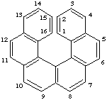
Figure 21 Numbering of the helicene skeleton by Newman [29].
The discovery of chirality led to a keen interest in these compounds. Chirality describes a property of an object that is non-superposable on its mirror image [30]. Two mirror images of a chiral molecule are called enantiomers or optical isomers. Pairs of enantiomers are often designated as "right-" and "left-handed". Chirality of molecules is interesting because of its application in inorganic and organic chemistry, physical chemistry, biochemistry and supramolecular chemistry. Chirality of helicenes in particular is notable due to the absence in them of an asymmetric carbon or any other chiral centre; here it is caused by intermolecular “overcrowding” as named by Newman and Lednicer [29]. By convention in helicenes the enantiomers are denoted + and -.
When a mixture has equal amounts of left- and right-handed enantiomers of a chiral compound it is called a racemic mixture, or racemate. A racemic mixture of helicenes is denoted by the prefix (±). A racemate is optically inactive, i.e. there is no net rotation of plane-polarized light. Though the two enantiomers rotate plane-polarized light in opposite directions, the rotations cancel because they are present in equal amounts. In contrast to the two pure enantiomers, which have identical physical properties except for the direction of rotation of plane-polarized light, a racemate may have a different property from either of the pure enantiomers, e.g. different melting point, different solubility or different boiling points.
A number of helicene derivatives have been synthesized since they were discovered [31-38]. Helicenes and their derivatives were investigated by Katz et al. for their properties such as electronic properties [39], metal complexation [40-43], aggregation [44-49] and asymmetric catalysis [50-52].
For a long time there was almost no application found for helicenes but an academic curiosity pushed further investigations of these materials. However with recent discoveries it was established that these unique and interesting materials may find their application.

6.1.2 Crystal Structures of Helicenes
A great deal of investigations have been devoted to the synthesis of helicenes. A very good review on helicenes was done by Martin over 35 years ago [53]. He reviewed in detail synthetic problems of isolated molecules of helicenes as well as their conformations and structural determinations. At that time no liquid crystal forming helicenes were known. Other, recent, reviews on helicenes, by Grimme at al [54], by Katz [39], by Urbano [55], and by Collins and Vachon [56] have also mainly concentrated on synthesis and structure of isolated helicene molecules. No information in respect to self-assembly of helical molecules into columnar structures was given in any of these works because, presumably, they did not attach aliphatic chains that are necessary for liquid crystal formation.
Before the self-assembly of helicene molecules into columnar structures will be reviewed it is worth to review several studies on single crystal of helicenes.
The pioneering work was done by Stulen and Visser [57]. The crystal structure of a heterohelicene (Figure 22) was investigated. It was concluded that the carbon atoms 1-7 (Figure 22 b) formed an irregular helix in which irregularity was reflected by the variation in the dihedral angles at the bonds 2-3—5-6 (Figure 22 b). The conformation of the heterohelicene molecule resulted in large distances between the atoms of the rings A and F (Figure 22 b). The shortest distance between the pair of non-bonded carbon atoms 1-7 (Figure 22 b) was found to be 2.91 Å which was in good agreement with the value of 3 Å obtained from theoretical calculations [58].
Figure 22 Structure of a heterohelicene molecule: a) projection of the molecule on the (010) plane. The relative heights of the atoms are given in Å; b) numbering of some of the atoms and dihedral angles for the helix 1-7. At bond 2-3 the angle 123 and 234 is given. The angles between the successive planes are given in degrees at the lines of intersection of the planes [57].
Mackay et al. determined the crystal structure of a 1:1 complex hexahelicene/4-bromo-2,5,7-trinitrofluorene (Figure 23 a) [59]. It was found that in the unit cell two of the four hexahelicene molecules were left-handed enantiomers and two were right-handed enantiomers. Each of the left-handed enantiomers was related to right-handed enantiomers via the centre of symmetry. The distortion from planarity which was required of the individual rings was not uniformly distributed (Figure 23 b). The shortest distance between the pair of non-bonded carbon atoms (1 and 1' in Figure 23 a) was found to be ~ 3 Å which was again in good agreement with the value obtained from theoretical calculations [58].
a) | b)
Figure 23 Hexahelicene/4-bromo-2,5,7-trinitrofluorene complex studied by Mackay et al. [59].
Lightner et al. investigated a crystal structure of optically active 2-bromohexahelicene to establish the absolute stereochemistry of hexahelicene [32]. As shown in Figure 24 the shortest C-H intramolecular distances in the molecule’s inner core between the observed carbon positions and calculated hydrogen positions are of the order of 2.5 Å. Photodebromination of (-)-2-bromohexahelicene yielded levorotatory hexahelicene.
Figure 24 Interatomic distances and torsion angles in (-)-2-bromoghexahelicene. Distances between calculated hydrogen positions and carbons in the inner core of the 2-bromhexahelicene molecule. Torsion angles about the inner core carbon-carbon bonds shown in degrees. Bromine atom and hydrogen atoms on carbon 1 and 16 shown as solid black circles [32].
Frank et al. resolved the crystal structure of 2-methylhexahelicene which is isomorphous with crystal structure of 2-bromhexahelicene [60]. A number of unusually short carbon-carbon bonds were found around the periphery of the helix while those in the helix core were lengthened. It is worth to mention that the benzene rings were distorted into a boat conformation and the interplanar angle between the terminal rings was found to be 54.8°. The overall bond length was found to be 1.41 Å. Intramolecular non-bonded interactions in the helix core for carbon-carbon interactions were found to be around 3Å and for carbon-hydrogen interactions 2.5 Å.
Doolittle and Bradsher proposed that hexahelicenes may be characterized by three planes as depicted in Figure 25. The interplanar angle between the terminal rings is 58.5°. The average bond length for the carbon-carbon bonds is 1.437 Å. Length of the bonds parallel to bonds on the periphery is 1.334 Å [61, 62]. However, much smaller interplanar angle between the terminal rings, 29.6° versus 58.5° was observed in hexahelicene by Laarhoven et al. [63].
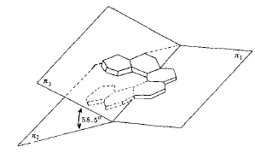
Figure 25 Three planes characterising helicenes by Doolittle and Bradsher [61, 62].
Columnar liquid crystalline phases of helicenes [44, 46, 49, 64, 65] have been studied very little. Similar to planar aromatic compounds surrounded by alkyl chains, columnar liquid crystalline phases of nonracemic helicenes as compared to the isolated molecules, exhibit unique properties such as enhanced circular dichroism and optical activity [39, 48, 66], second-harmonic generating ability [49, 64, 67, 68], and fluorescence emissions shift [48, 66].
Lovinger et al. investigated the columnar liquid crystalline phase formed by a nonracemic helicene [44]. X-ray and electron diffraction as well as transmission electron microscopy revealed showing that the molecules of nonracemic helicene (1 in Figure 26) were organized into hexagonally packed columns with parallel helix axes (2 in Figure 26) which may be represented as 3 in Figure 26. Optical microscopy revealed that the stack of lamellae constituted fibres (Figure 27). Further polarized light microscopy confirmed that the columns were stacked so their long axes were parallel to the long axes of the fibres. Molecules of helicenes aggregated in dodecane solution into similar columnar structures. Circular dichroism, specific rotation and shifted fluorescent emission of both the pure material and the aggregates in solution were enhanced in comparison to the isolated molecules.
Nuckolls and Katz resolved the structure of the nonracemic helicene forming a liquid crystalline phase with hexagonal ordering at room temperature and columnar aggregates in dodecane solution [46]. As in previously described works properties improved as compared with the isolated molecules.

Figure 26 Nonracemic helicene 1 molecules organized into columnar liquid crystalline phase 2 represented as an analogue of helical molecules 3 by Lovinger et al. [44].
Figure 27 Schematic representation showing how columns of helicenes 1 are organized in the fibres. The hexagonal lattice parameter a is 4.14 nm [44].
Vyklicky et al. [68] analyzed structures of helicene-bisquinones with different side chains. All derivatives with side chains bonded to helical cores by ether linkages assembled into hexagonally arranged columns. Derivatives with three asymmetrically disposed side chains formed liquid crystalline phases while those with dodecyloxymethoxy groups did not. Differences in side chain chirality affected melting point and the packing arrangement as shown in Figure 28. In Figure 28 a it is shown that helicene cores rotate freely giving rise to a truly LC hexagonal columnar mesophase. In Figure 28 b it is shown that helicene cores because of their lateral dipoles and wedge shapes are favoured therefore they pack into more ordered antiparallel arrangement which is three-dimensional crystalline or two-dimensional LC phase [69]. In Figure 28 C helicene cores because of π-π interactions pack closely into helices with 3-4 molecules per turn and hence give rise to a crystalline phase [68].
Figure 28 Dimensions of the helicene molecules and models showing how they might pack into columns by Vyklicky et al. [65].

6.1.3 Summary
Helicenes form columnar structures with parallel helix axes. Long columns of helicenes run along the fibre length further forming lamellae in turn stacks of lamellae form fibres.
The shortest distance between the pair of non-bonded carbon atoms in all cases studied was found to be ~ 3 Å which corresponds to the value obtained from theoretical calculations [58].
Nonracemic helicenes form hexagonal columnar liquid crystalline phases at room temperature which shows improved properties as compared with the isolated molecules of helicenes.
The number and type of the side chains attached to helicene cores affect the final packing of the helicene molecules both in crystalline and liquid crystalline phases.
Lovinger et al. as well as Vyklicky et al. stated that the helicene molecules simply stack one on top of another. This made no sense when you calculate the density, i.e. their density would be 6 times lower (~ 0.2 gm/cm³) than the one which is measured (~ 1.2 gm/cm³, see Analysis and Interpretation of Results: Modelling and Simulation of Structures).

Analysis and Interpretation of Results

Experimental Fibre Diffraction Pattern
Figure 29 shows the chemical structure of the enantiopure helicene-bisquinone molecule investigated.
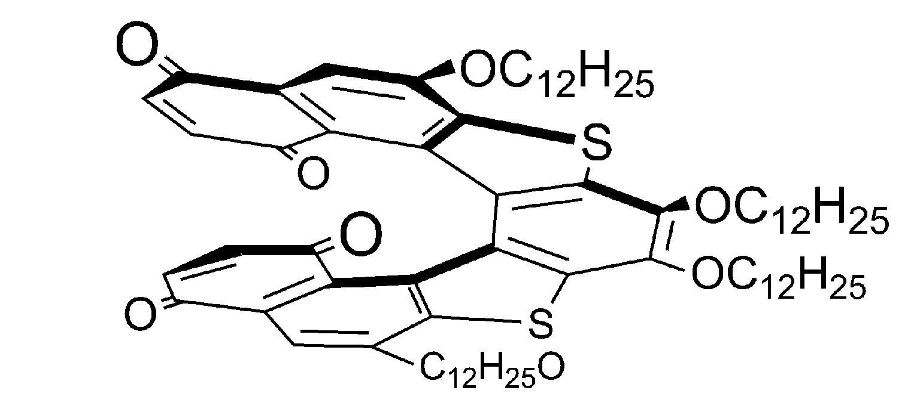
Figure 29 Enantiopure helicene-bisquinone molecule investigated [13].
Experimental WAXS fibre diffraction pattern of extruded fibres of the racemic helicene-bisquinone is shown in Figure 30. The WAXS pattern of enantiopure helicene-bisquinone was determined to be indistinguishable from that of racemic one therefore only one WAXS pattern is shown. WAXS patterns were recorded with the fibre axis vertical and perpendicular to the beam (φ = 0). Further, at still at wide angles, WAXS fibre diffraction patterns reveal no sharp reflections in the 2π/q region of 0.3-0.5 nm, which confirms the liquid crystallinity of helicene-bisquinone.
To reveal differences between racemic and enantiopure helicene-bisquinones their SAXS fibre diffraction patterns were recorded (Figure 31). The fibre axis is vertical and inclined to the beam (φ > 0). The small-angle reflections, marked in Figure 31 a, b with red arrows, show the differences between racemic (Figure 31 a) and enantiopure (Figure 31 a) helicene-bisquinones. The experimental WAXS fibre diffraction pattern shows sharp Bragg reflections on 0th and 2nd layer-lines and diffuse streaks on other layer lines. The equatorial reflections, with q² values in the ratio 1:3:4:7:9:12:13 (Table 5), characterize hexagonal order of the helicene-bisquinone columns. The experimental diffraction pattern was indexed in terms of hk for a two-dimensional hexagonal lattice (Figure 30). The unit cell parameter was determined to be a_{hex} = 40.01 Å. The diffuse streaks on the higher layer lines form a triple cross pattern, with the centres of the first, second and third meridional crosses on the 0th, 13th, and 26th layer-lines. Near the 0th and 26th layers only even lines are observed, namely the 0th, 2nd, 4th, and 24th (weak), 26th, 28th, and 30th (weak). In comparison, near the 13th layers scattering is visible only on odd lines: the 11th (weak), 13th, 15th, and 17th. Such diffraction pattern describes a 13₂ helix (see Chapter 2 “Diffraction from a helix”).

Modelling and Simulation of Structures
It has been defined that the diffraction pattern describes a 13₂ helix. Then it was established that the structure of columnar liquid crystalline helicene-bisquinone consists of 13₂ helical columns sited on a hexagonal two-dimensional lattice with long-range order in the xy plane. The helices on neighbouring columns were weakly correlated. The layer-line spacing, d_{layer} = 111.9 Å, was equal to the repeat period along the column axis, called herein as c₀. But the pitch of the continuous helix, i.e. of the helical column disregarding its internal structure, was c₀/2 = 55.6 Å. If the helicene-bisquinone molecules stacked on top of one another like those in most discotic liquid crystals [49, 64] there would have been 13 molecules in a unit cell. But the corresponding density, given the measured cell-dimensions, would have been 0.16 g/cm³. However, the experimentally measured density is equal to 1.058 ± 0.002 g/cm³ at T = 20°C. This is more than 6 times higher which means that a helical repeat unit consists of 6-7 helicene-bisquinone molecules but not just one. Figure 32 shows circular high electron density zone representing the aromatic core of each column. It is seen that there is a fairly deep electron density minimum in the very centre indicating a void in the centre of the column.
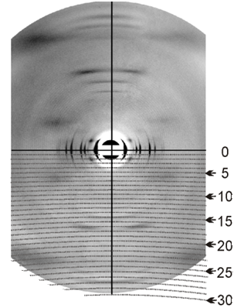
Figure 30 Experimental WAXS fibre pattern of racemic and enantiopure helicene-bisquinones with layer lines applied for clarity. Fibre axis is vertical [13].
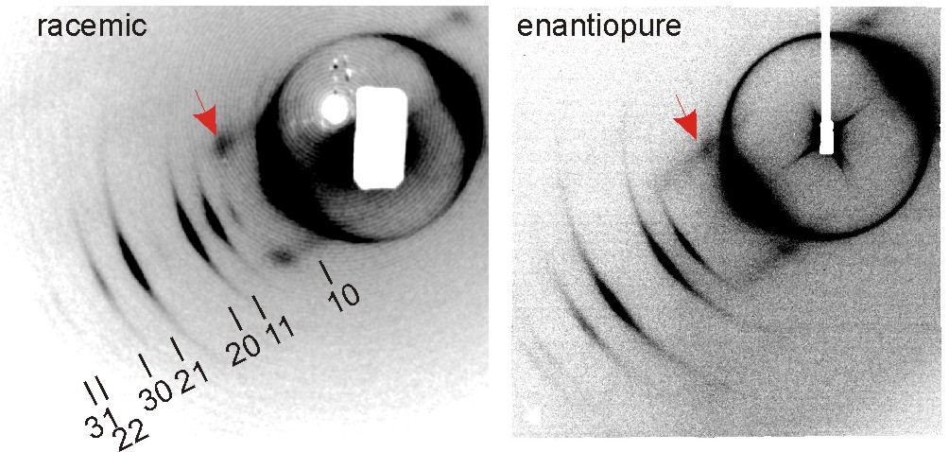
a) | b)
Figure 31 Experimental SAXS fibre patterns of a) racemic and b) enantiopure helicene-bisquinones. Fibre axis is tilted. Red arrows mark the position of the small-angle reflection [13].
Table 5 Equatorial (l = 0) reflections: spacing, spacing ratios, intensities, structure factor phases used in the reconstruction of the electron density map (Figure 32). Diffraction intensities were Lorentz and multiplicity corrected. a_{hex} = 40.01 Å [13].
Reflection # | d, Å | Index, hk | (d₁/d_{N})²_{theor} | (d₁/d_{N})²_{exp} | Intensity | Phase
1 | 34.65 | 10 | 1 | 1.000 | 100 | 0
2 | 20.10 | 11 | 3 | 2.972 | 2.01 | π
3 | 17.31 | 20 | 4 | 4.007 | 5.52 | π
4 | 13.10 | 21 | 7 | 6.996 | 7.93 | π
5 | 11.55 | 30 | 9 | 9.000 | 2.61 | π
6 | 10.00 | 22 | 12 | 12.006 | 0.52 | π
7 | 9.62 | 31 | 13 | 12.972 | 0.46 | π
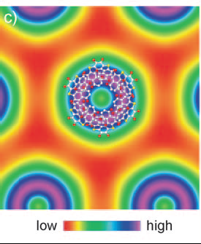
Figure 32 Picture representing an asymmetric unit without hydrogen atoms superimposed on the electron density map and illustrating the origin of the high-electron-density ring (purple) [13].
To find out how the molecules assemble we tried to build a reasonably close-packed motif of 6-7 molecules of helicene-bisquinones leading naturally to a ring of 6 or 7 tilted molecules arranged in a truncated cone (Figure 33) for 6 molecules. By rotating the molecules around two axes, x and y, 6 molecules could be fitted around the ring with a high packing efficiency, while in case of 7 molecules there were steric clashes which could not be avoided.
With the help of annealing dynamics simulations (NVT) and energy minimizations we tried to find out a similarity between the 2D electron density map of the structure projected onto the XY plane normal to the column axis and a map derived by Fourier transforming the corrected intensities of equatorial (l = 0) Bragg reflections.
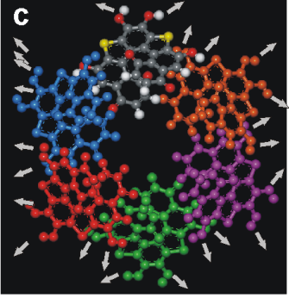
Figure 33 Asymmetric unit organization in the 6-stranded 13₂ helical column of helicene-bisquinones. White arrows mark the positions of the dodecyl alkyl tails [13].
Internal molecular coordinate axes x, y, z (Figure 34 a) were obtained by diagonalizing the associated matrix to define the molecular mass tensor. A single 13₂ helical column was then built from such 6-molecule motifs, with the dodecyloxy chains replaced by methoxy groups. By means of the Cerius-2 [25] the diffraction patterns of the structures were simulated, dodecyl chains were added and five parameters were adjusted in the structures (Figure 34 a, b): R₀ - distance of the molecular centre of gravity from the column axis; ρ₀ - angle of rotation around the radius R; ω₀ - tilt around the internal coordinate axis y; φ₀ - rotation around the Z axis between successive molecules; Z₀ - shift along the Z axis between successive molecules.
R₀ was determined from the equatorial electron density map shown in Figure 32. Z₀ was initially set at c/(13 × 6). ρ_{0,} ω₀ and φ₀ and Z₀ were then varied, and the optimum values for φ₀ and Z₀, as well as the range of interest for ρ₀ and ω₀, were chosen on the basis of diffraction patterns simulated by Cerius-2 [25]. It is worth to mention that the value of φ₀ was practically fixed by the steric requirements of the alkoxy tails. To account for liquid-like disorder of dodecyl alkyl tails, a dynamically disordered aliphatic sheath was generated by dynamics simulation while the aromatic cores were held fixed. Single column diffraction patterns were then simulated by a unit cell large enough to make the reciprocal lattice approximate a continuum. The “propeller” angle ρ₀ and the “pine-tree”-like tilt ω₀ were then varied in steps of 10°, followed by a van der Waals energy minimisation. The match between the measured and calculated layer-line intensity distributions is shown in
Table 6
. The best values for all the structural parameters are displayed in Figure 34 a, in a box.
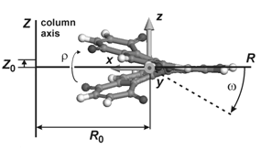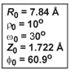 | 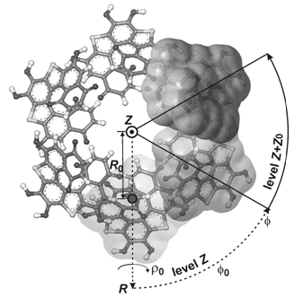
a) | b)
Figure 34 a) Definition of coordinates: x, y, z – principal axes of the molecular mass tensor; Z, R, φ₀- cylindrical coordinates with column axis as reference (note that the OC₁₂H₂₅ groups are replaced by OH groups in the derivation of the tensor); adjustable parameters: R₀, ω₀, ρ₀, R; b) arrangement of the helicene-bisquinones in the 6-molecule asymmetric unit: molecule i+1 is related to molecule i by rotation around Z by φ₀ and translation along Z by Z₀. The best fit parameters are listed in the box in a) Reproduced from [13].

Comparison of the Calculated and Experimental X-ray Patterns
The best simulated WAXS fibre diffraction pattern represented in Figure 36 b is compared with the experimental one represented in Figure 36 a. The simulated X-ray pattern shows the side view of just over one repeat of length along the column axis. One repeat contains 2 helical turns and 13 motifs of 6 molecules each, i.e. 65 molecules in total. Since the columns in the simulated pattern are not on a lattice, the scattering on all layer-lines with l > 2 is diffuse. Helicene-bisquinone has an awkward shape for stacking in columns and therefore the unusual self-assembly form. However, the “pine-tree” structure based on tilted (ρ₀ > 0) phenyl rings has previously been found in columns formed by benzylether-based mesogens even though they had less awkward shapes [70-73]. For the four dodecyl chains to stay at the column periphery, the thick region of the molecule, where the quinone rings overlap, must be near the column’s centre. The relatively high tilt ρ₀ in combination with a suitable φ₀ enables the thick quinone parts of the molecules to stagger up and down along the columns. It would appear that the very diffuse off-meridional scatter, observed between layer-lines 21 and 24 and not reproduced by the simulation in Figure 36 b, may be due to the partially ordered alkyl chains somewhat tilted toward the equatorial plane.
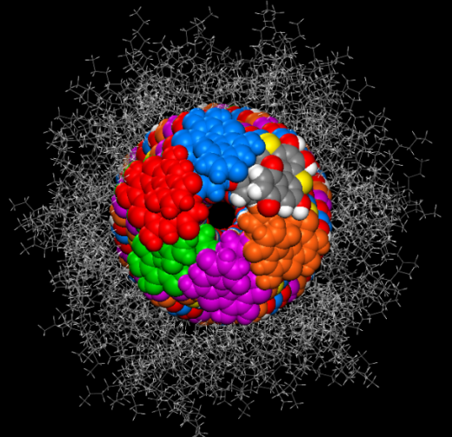
a)
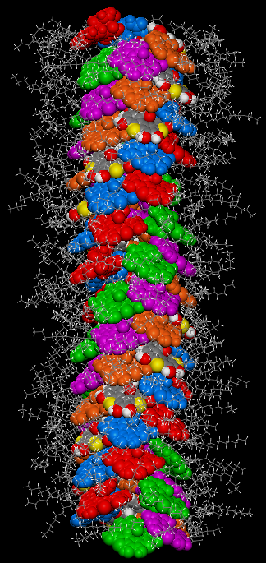
b)
Figure 35 Molecular organization in the 6-stranded 13₂ helical column of enantiopure helicene-bisquinone; A) top-view - along column axis, (b) side view. Aromatic cores and the alkyl tails are shown with space-filling and CPK models.

Table 6 Effect of varying the “propeller-blade” angle, ρ_{0,} and the “pine-tree” tilt, ω₀. Optimum parameters: ρ₀ = 10° and ω₀ = 30° were chosen on the basis of the smallest R-factor which was calculated as: $R=\sum{{\left(\left|F_{0}\right|-\left|F_{0}\right|\right)}^{2}}/\sum{{\left|F_{0}\right|}^{2}}$ [13].
 |  | Layer line
ρ₀ | ω₀ | 13 | 15 | 17 | 26 | 28 | R(%)
0 | 30 | 3.3 | 30.2 | 54.5 | 4.6 | 7.4 | 5.7
30 | 0 | 9.5 | 14.9 | 1.9 | 39.4 | 34.3 | 45.5
10 | 10 | 11.3 | 50.63 | 19.4 | 8.7 | 10.3 | 19.2
10 | 20 | 9.4 | 43.7 | 29.3 | 6.3 | 11.3 | 11.6
10 | 30 | 4.5 | 27.9 | 46.7 | 7.0 | 13.9 | 2.2
10 | 40 | 4.5 | 43.4 | 43.3 | 0.9 | 7.9 | 13.8
20 | 10 | 11.9 | 49.1 | 4.9 | 15.3 | 18.8 | 34.9
20 | 20 | 9.7 | 49.6 | 18.0 | 9.4 | 13.3 | 18.4
20 | 30 | 9.8 | 50.7 | 16.9 | 9.2 | 13.3 | 19.7
20 | 40 | 8.9 | 70.2 | 10.6 | 1.6 | 8.7 | 39.8
30 | 10 | 11.3 | 36.3 | 1.9 | 24.5 | 26.0 | 41.7
30 | 20 | 9.3 | 42.5 | 24.0 | 13.4 | 10.8 | 12.8
30 | 30 | 6.9 | 45.0 | 24.0 | 12.7 | 11.0 | 12.8
30 | 40 | 7.2 | 51.8 | 38.3 | 1.1 | 1.5 | 24.8
40 | 30 | 9.9 | 45.8 | 37.0 | 0.0 | 7.3 | 22.4
Exp. |  | 4.2 | 16.7 | 50.4 | 10.6 | 18.1

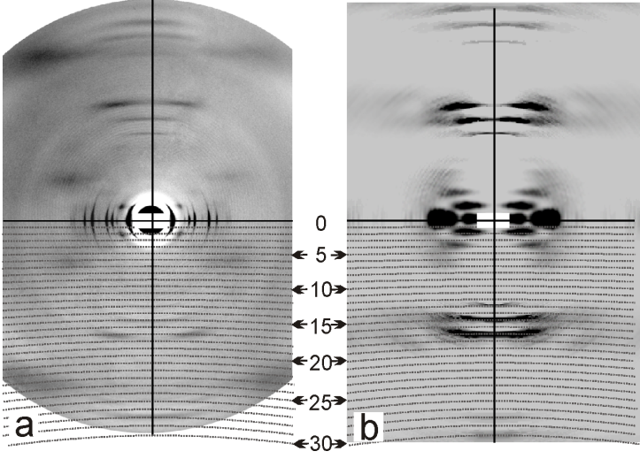
a) | b)
Figure 36 Comparison of the (a) experimental and (b) simulated diffraction patterns of single column of helicene-bisquinone [13].
The diffraction on nonzero layer-lines consists of diffuse streaks, indicating that the internal structures of different columns are uncorrelated. But the equatorial reflections are radially sharp and resolution-limited, showing that there is true long range order among column positions on the 2D hexagonal lattice. The structure is thus that of a liquid crystal.
Of special interest is the relatively sharp reflection on the 2nd layer line, marked with red arrows in Figure 31 a, b. This is the only diffraction feature that distinguishes the enantiopure- from racemic helicene-bisquinone. In the enantiopure (Figure 31 b) the reflection can be indexed as (102) while in the racemate (Figure 31 a) this reflection is shifted along the layer line further away from the meridian and is incommensurate with the hexagonal lattice. The existence of the off-meridional Bragg reflection on the second layer line indicates that there is a degree of long-range correlation between the helices in longitudinal position and angle of rotation around the helix axis. However, that no other sharp non-equatorial reflections are seen means that these correlations are weak and that the mean square deviation is high. Significantly, the correlation is between helical envelopes rather than the individual molecules.
While an ideal 3D hexagonal structure consisting of static helices of the same hand allows all helices to have the same position and rotation angle (Figure 37 a, c), hexagonal symmetry must be broken if half the helices are right- and half left-handed, as envisaged for racemic helicene-bisquinone (Figure 37 b, d).
Generally, in ordered 1:1 mixtures of right and left-handed helices the symmetry is reduced to triclinic, but monoclinic or orthorhombic are possible for discrete helices. The symmetry of racemic helicene-bisquinone cannot be established from just one non-equatorial reflection, but it is clear that, while the reciprocal x*y*-plane is perpendicular to the fibre axis, z* is tilted. Hence the helices are still parallel to the fibre but are sheared longitudinally (Figure 37 d). In fact both Figure 31 a and Figure 31 b show a weak streak along the 2nd layer line in addition to the Bragg reflection, indicating that a small portion of both samples contains a range of shear defects.
To account for the liquid-like disorder of the aliphatic chains in the columnar liquid crystal phase, a dynamically disordered aliphatic sheath was generated by dynamics simulation while the aromatic cores were held fixed. Single column diffraction patterns were then simulated using Cerius2 with a unit cell large enough to make the reciprocal lattice approximate a continuum. Geometrical and crystal size parameters used to display the simulated diffraction pattern in Figure 32b, were: azimuthal half-width = 3°, fiber out-of-plane tilt = 4°, crystallite size along helical axis 100 nm. 1 helical column was put in a large unit cell. This gave a quasi-diffuse scatter from the single column form factor, i.e. a series of closely spaced Bragg reflections which are then smeared out by finite crystal size etc, to give the impression of diffuse scatter.
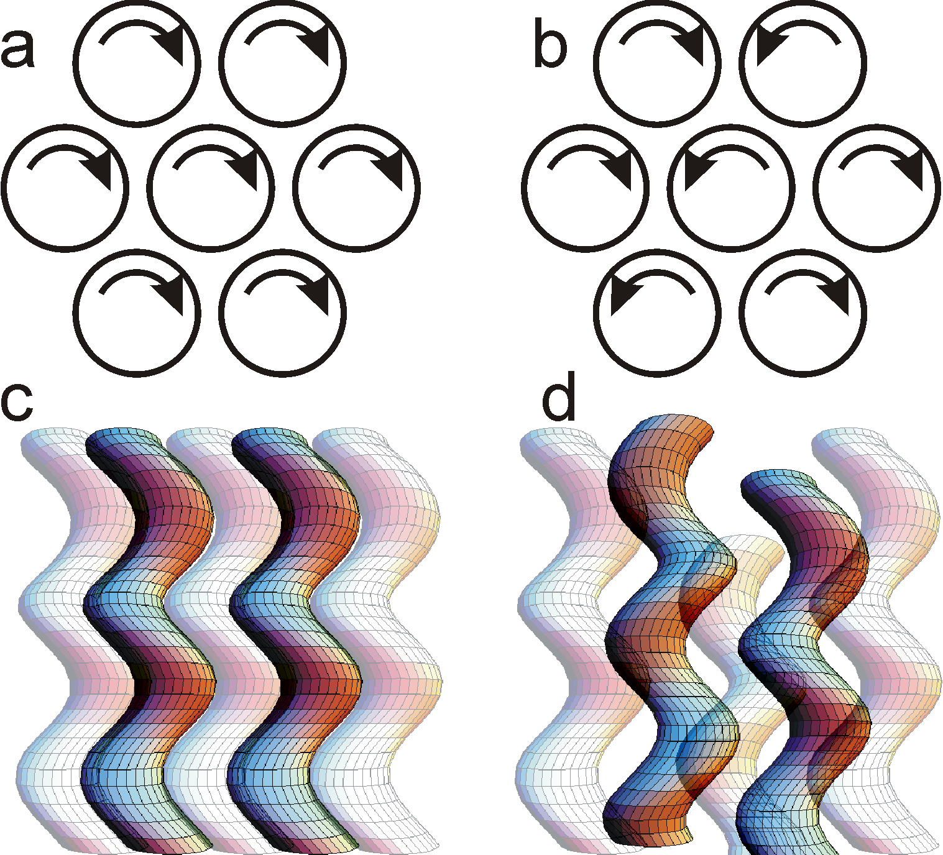
Figure 37 Stacking of helical columns (schematic). (a, c): enantiopure compound, (b, d): racemate, with enantiomers segregated in separate right and left helical columns. In (a, b) arrows show the sense of the helix. In (c, d) the darker helices are in the front row, the pale helices are behind [13].

Summary
It has been established that enantiopure and racemic helicene-bisquinones form hexagonal columnar phases in which the internal structures of the columns are 13₂ hollow helices based on 6-molecule repeat units. Long-range order among the columns laterally is high and longitudinally is low. Enantiopure helicene-bisquinone forms a true hexagonal structure while racemic one achieves optimum packing by longitudinally displacing columns of segregated enantiomers.

Chapter 7 – Study 2: Perylene Bisimide Derivative

Literature Review

Introduction
Control over supramolecular arrangement of perylene bisimide (PBI) dyes is very important to improve performance of existing electronic devices as well as to design new PBI dye-based materials with new properties. Unique properties of supramolecular systems including fast response to changes of ambient conditions make these systems very attractive for advanced application areas. It is very important to understand how a particular molecular conformation is formed, since it will determine the further packing of the final structure which in turn will determine the final properties of the PBI compound. As was already established, the molecular conformation of the final PBI compounds is very much dependent on the substituents which the perylene aromatic core bears. Recently synthesized liquid crystalline PBIs play a very important role since they are able to form highly-ordered helical columnar mesophases due to the close π-π interactions. These close π-π interactions facilitate high charge transport and therefore lead to high charge mobility which is very useful property, in particular for the semiconductor industry. Up to present the structure of liquid crystalline perylene bisimide derivatives self-assembled into highly ordered helical columnar structures remains little explored.
A keen interest in PBIs results from their interesting and unique properties, such as good photoconductivity [74], good photoluminescence [75, 76], high quantum yields [77], interesting redox properties [78-84], high charge carrier mobility [85-87], etc. The one property of PBIs which requires to be particularly emphasized is their excellent n-type semiconductivity and it has been proved PBIs are the best n-type organic semiconductors to date [87-91]. Thanks to their interesting and unique properties PBIs are used as: fluorescent solar collectors [92-94], photovoltaic devices [89, 90, 95-97], membrane labels in artificial and biological systems [98], organic field-effect transistors [99-104], thin film transistors [91, 105], organic light emitting diodes [106-109], laser dyes [110-113], molecular switchers [114]. They also used in the field of electrophotography as xerographic photoreceptors [74]. It was revealed there is a possibility to apply these materials as fluorescent dyes and even as artificial light-harvesting systems [115-117] as well as photo-induced electron transfer systems [114, 118, 119].
Liquid crystalline PBIs were discovered in 1997 [120] and 1998 [121]. But the problem with the found liquid crystalline PBIs was that the liquid crystal phase in them took place only upon standing [121]. These first works motivated the discovery of liquid crystalline phases of the related PBI dyes [122]. These days PBI dyes forming a liquid crystalline phase over a broad temperature range in the solid state have been discovered [83]. It is assumed that π-systems pack in similar ways as observed for the dye aggregates in solution despite additional packing constrains arising in the bulk of the liquid crystalline phase. Credit to this assumption is given by wide angle WAXS data which show an increasing distance between π-systems with increasing sterical demand of the substituents at the bay positions [83]. Also using SAXS data a hexagonal columnar packing was revealed in LC PBIs [83]. LC PBIs with simple aliphatic chains have been reported later on [77]. Several crystalline and LC phases between room temperature and the clearing points of the final PBI compounds were shown. Liquid crystalline PBI compounds exhibited high structural ordering in all 3D pointing to smectic layers with alkyl chains in 1D and columnar ordering with co-facially π-π stacked PBI dyes in 2D [77].

Crystal Structures of PBIs
The general chemical structure of PBIs is depicted inFigure 38. As it can be seen, PBI molecule is composed of two naphthalene half-units, each of which is attached to an imide unit and connected to the other naphthalene unit via carbon sp² – carbon sp² single bonds.
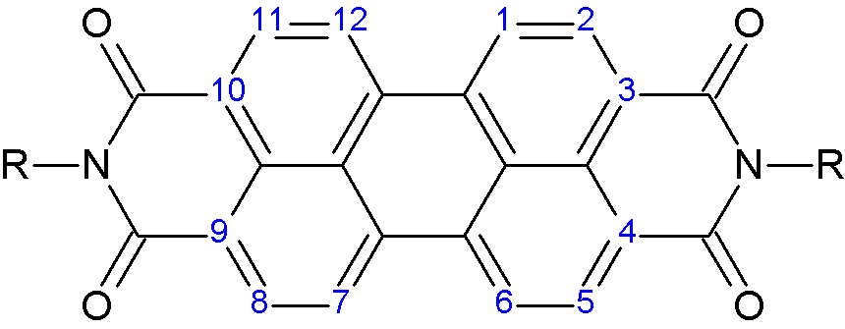
Figure 38 Chemical structure of perylene bisimide molecule. Numbers 1, 2, 5, 6, 7, 8, 11 and 12 represent bay positions at which substituted can be added.
Graser and Hädicke were the first to begin solving the crystal structures of PBI derivatives [123-125]. It was found that some structures exhibited flat perylenetetracarboxylic diimide part with bent side chains; some structures were arranged in stacks (Figure 39 and Figure 40) with a distance between the flat parts around 3.5 Å and in some structures the stacks of molecules made different angles.
Figure 39 Stereo packing plot projected down c for N,N'-Dipropylperylene-3,4:9,10-bis-(dicarboximide). The b axis is horizontal, left to right; the a axis is vertical, top to bottom [125].
Figure 40 Stereo packing plot projected down c for N,N'-Diethylperylene-3,4:9,10-bis (dicarboximide). The b axis is horizontal, left to right; the a axis is vertical, top to bottom [125].
Figure 41 Stereo packing plot projected down b for N,N'-Bis (2,6-xylyl) perylene-3,4:9,10-bis (dicarboximide). The c axis is horizontal, left to right; the a axis is vertical, top to bottom [125].
In each stack of N,N'-Diethylperylene-3,4:9,10-bis (dicarboximide) the molecules were alternately oriented and the nearest neighbours were rotated by an angle of 31.0 (25)°, where the nearest-but-one neighbours had the same orientation. Due to the nearly perpendicular arrangement of the phenyl rings to the perylene-imide ring system of structure of N,N'-Bis (2,6-xylyl) perylene- 3,4:9,10-bis (dicarboximide), no stacks could be formed (Figure 41). Thus, the molecular packing here differed from that of the other PBI derivatives pigments investigated in this research.
The same authors later solved more PBI derivatives [124]. The flat portions of neighbouring molecules were around 3.45 Å apart and packed in stacks (correlated with previous research). The packing was shown only for N,N'-Bis (2-ethoxyethyl) perylene-3,4:9,10-bis (dicarboximide) (Figure 42) and N,N'-Bis (2-methylbutyl) perylene-3,4:9,10-bis (dicarboximide) (Figure 43). In all the investigated compounds the molecules showed a flat perylenetetracarboxylic diimide part with bent side chains. The phenyl rings of the side chains of N,N'-Bis (2-phenylpropyl) perylene-3,4:9,10-bis (dicarboximide), N,N'-Bis (2-phenylethyl) perylene-3,4:9,10-bis (dicarboximide) and N,N'-Bis (4-methoxybenzyl) perylene-3,4:9,10-bis (dicarboximide) were turned 13.5 (25) °, 19.0 (7) ° and 70.7 (6)° respectively out of the plane of the perylene-imide ring systems.
In conclusion for all PBI derivatives, solved by the team of Hädicke, all compounds exhibited a planar perylenetetracarboxylic diimide portion in common but their two N atoms bore differently bent side chains. Most of the molecules packed in stacks and the mutual arrangement of neighbours in the stacks was shown to be dependent on the different substituents which determined the longitudinal and transverse shifting of the perylene π-systems. It was shown also that mutual arrangement of the neighbouring molecules in the crystals was determined by the substituents. Finally, it was concluded that the geometrical overlap of the perylene systems of neighbouring molecules varied within the series and the intermolecular interactions between the vicinal chromophors which affected the colour of the modified pigment.
Klebe in cooperation with Graser and Hädicke, after investigating correlations between molecular conformation, crystal packing and colour in PBI derivatives, described crystal structure determination of four PBI derivatives which were first described by Graser and Hädicke [126] and established a correlation function between packing arrangements and absorption of light [126]. The established correlation function was considered as a good approximation for substituted PBIs which crystallized in a unit cell with one very short axis leading to a perylene separation distance between two adjacent molecules of about 3.5 Å.
Figure 42 A stereo packing plot projected down a for N,N'-Bis (2-ethoxyethyl) perylene-3,4:9,10-bis (dicarboximide). The c axis is horizontal, left to right; the b axis is vertical, top to bottom [124].
Figure 43 stereo packing plot projected down c for N,N'-Bis (2-methylbutyl) perylene-3,4:9,10-bis (dicarboximide). The b axis is horizontal, left to right; the a axis is vertical, top to bottom [124].
It was confirmed further with the first works [126, 127] that most of the reported crystal structures of PBI dyes display a parallel packing of molecules along the molecular axis with longitudinal and transversal offsets between adjacent dyes [127]. Thus, crystal structures of all compounds which have been investigated so far exhibit planar geometry of PBIs, which were arranged in stacks showing a parallel orientation of the dyes at a distance around 3.5 Å [127]. For the stacking distance and the longitudinal and transverse offset between neighbouring PBIs steric requirements of the imide substituents seem to be of primary importance.
Zugenmaier et al. [128] solved crystal and molecular structures of six differently substituted PBI derivatives. Major packing differences (Figure 44) were revealed due to big differences in unit cell dimensions. The packing in different arrangements caused the twist of the benzene ring to differ with respect to the perylene ring and amounts to 111.4, 112.3, 98.6, 105.1, 80.3 and 72.0° for the sequence of six compounds listed above respectively. For all six compounds the planes of two adjacent perylene skeleton planes were around 3.5 Å apart which corresponds well to the data in previous researches. In this research two of the solved structures could be classified with the parameters already introduced by Klebe et al. [126]. It is worth to mention though, the research mentioned above was conducted using single crystals which are very small and might cause serious limitations in the quality of the structure determination, though the results obtained using single crystals could still represent an important step forward in the elucidation of structure-property relationships of PBIs [126].
Mizuguchi et al. [129] solved a structure of N,N'-Bis (2-phenethyl) perylene-3,4:9,10-bis (dicarboximide) which is a commercially used black pigment. It was found that the perylene ring system was entirely planar but was not fully delocalized. The phenyl rings at both ends of the molecule were not completely parallel to the perylene skeleton but were slightly twisted in the same direction by about 2.7 (2)°. The molecules were arranged in a zigzag fashion along the b axis (Figure 45). Later, the same authors solved structure of another PBI derivative, namely N,N’-di-2-pyridylperylene-3,4:9,10-bis (dicarboximide) [130] where two independent molecules (A and B in Figure 46) were stacked alternately along the b-axis. Molecular conformations of these molecules were quite similar but the twist angle of the pyridyl rings was different. The angles between each of the pyridyl rings and the perylene-imide skeleton were 77.7 (1)° in molecule A and 72.8 (1)° in molecule B. The perylene-imide skeleton was found to be planar. And again the same authors solved the structure of another PBI derivative, namely N,N’-di-3-pyridyl-perylene-3,4:9,10-bis (dicarboximide) [131], the angle between each of the pyridyl rings and the perylene-imide skeleton was 54.88 (10)° and the perylene-imide skeleton was found to be planar . The molecules slipped by 45° within molecular stacks crossing each other in a fence-like structure along the b axis (Figure 47).
Since the first trial to solve the structure of PBIs [123-125] and many further works when the structures of PBI derivatives were solved, only a few works showing rotational displacements leading to a screw-type stacking of dyes have been published [83, 126-128].
In 2007 Chen et al. showed the lowest energy conformation of PBIs substituted with n-C₁₂H₂₅, after assessing via molecular modelling, involved two phenyl rings at imide positions which were not co-planar with PBI unit and due to the bulkiness of the phenyl rings, a rotation displacement was demanded for π-π stacking of PBI dyes (Figure 48, Figure 49) [132].
The structure of dipyrrolidinyl-substituted PBI after molecular modelling showed two substituents pointing toward the same side of the molecular plane (Figure 48, a) with two distinct π-surfaces of the molecule. Since one side was sterically more encumbered that the other one due to the bay substituents during self-assembly, the two sterically less hindered faces of the molecules stacked together to form an energy minimized dimeric unit through larger π-π overlap to minimize the energy of the system.

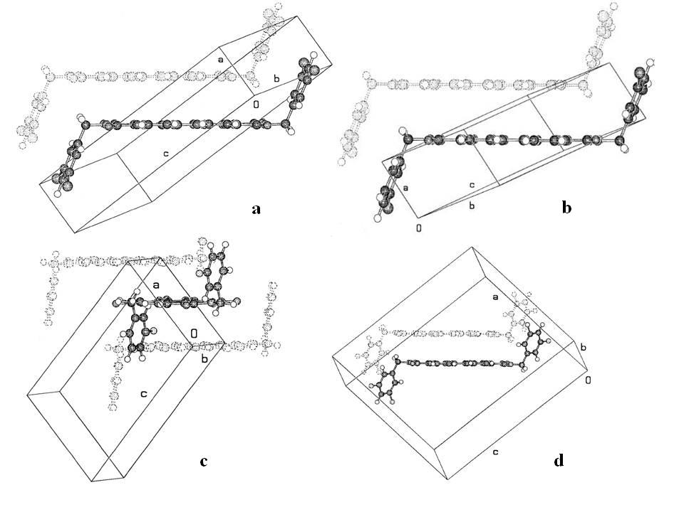
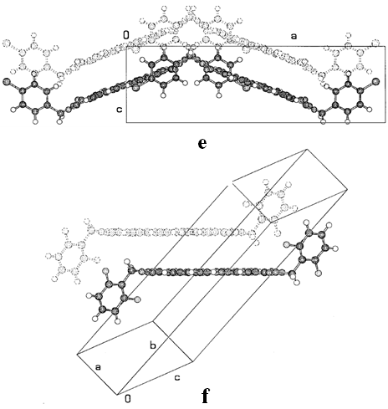
Figure 44 Packing arrangement of (a) bis (3,5-dichlorobenzimido) perylene molecules, (b) bis (3-chlorobenzimido) perylene molecules, (c) bis (3-fluorobenzylimido) perylene molecules, (d) bis (3,5-difluorobenzylimido) perylene molecules, (e) bis (4-chlorobenzylimido) perylene molecules, and (f) bis (2,6-difluorobenzylimido) perylene molecules along the stacks [128].

Figure 45 Packing of N,N'-Bis (2-phenethyl) perylene-3,4:9,10-bis (dicarboximide) showing a side view of the molecule [129].
Figure 46 Projection of the N,N’-di-3-pyridylperylene-3,4:9,10-bis (dicarboximide) structure on to the ac plane. Molecules A and B are stacked alternately along the b axis [130].
Figure 47 Packing arrangements of N,N’-di-3-pyridyl-perylene-3,4:9,10-bis (dicarboximide) molecules [131].
It was further revealed a rotational displacement around the stacking axis might reduce the steric congestion of the substituents and enforce π-π contact (Figure 48, b) but further aggregation of such dimeric units was disfavourable due to the steric hindrance of the bulky substituents at the accessible π faces. Thus dimerization of bay-substituted PBI dyes in solution was favoured with respect to further aggregation. For N,N’-Di(3,4,5-tridodecylphenyl)-1,6,7,12-tetrachloroperylene-3,4:9,10-tetracarboxylic acid bisimide the rotational displacement of the molecule that was a prerequisite for the formation of a hexagonal lattice was hindered because of the bulky chlorine atoms while when the molecules stacked on top of each other with longitudinal offsets along the molecular axis they formed rectangular phase (Figure 49). With four bulky phenoxy-substituents the core of N,N’-Dicyclohexyl-1,7-dibromoperylene bisimide 1,7-3 was found to be nearly disk-like.
Figure 48 (a) Molecular structure of dipyrrolidinyl-substituted PBI (view along the N–N axis) obtained from molecular modelling; (b) Top view of the dimeric unit of N,N'-Dicyclohexyl-1,7-dibromoperylene bisimide 1,7-3 compound in crystal structure with a rotational displacement of about 35°; (c) Side view of the dimeric unit of N,N'-Dicyclohexyl-1,7-dibromoperylene bisimide 1,7-3 compound in crystal structure [132].
Figure 49 Schematic representation of the proposed packing patterns and the orientation of the transition dipole moments in columnar LC phases of the core-twisted PBI dyes: a) J-type π–π stacking of N,N’-Di(3,4,5-tridodecylphenyl)-1,6,7,12-tetrachloroperylene-3,4:9,10-tetracarboxylic acid bisimide, and b) co-facial π-π stacking of N,N’-Di(3,4,5-tridodecylphenyl)-1,7-dibromoperylene-3,4:9,10-tetracarboxylic acid bisimide and N,N’-Di(3,4,5-tridodecylphenyl)-1,7-di(4-tert-butylphenoxy)perylene-3,4:9,10-tetracarboxylic acid bisimide [132].
A simple empirical relationship was established for dependence of a crystal colour on the longitudinal and transverse offsets in PBIs after a number of other comprehensive studies were carried out [126, 127]. Thus, for small-transverse offsets the π-π interactions are brought to a minimum leading to pigments with little crystallochromic shift compared with their solution spectra. Due to the more extended chromophoric systems in the longitudinal direction, slipping in this direction was found to be less effective in reducing the coupling between neighbouring π-systems. It was concluded PBIs without or with only a little transverse offset are often black due to the strongest electronic interaction between neighbouring dyes.

Analysis and Interpretation of Results

Experimental Fibre Diffraction Pattern
Figure 50 shows experimental diffraction patterns of an extruded N,N’-di-(3,4,5-dodecyloxy-oxyphenylethyl)-perylene bisimide (PBI 12-2) fibre annealed at T = 65° for 24 hrs. Patterns were recorded with the fibre axis vertical and perpendicular to the beam (φ = 0), as well as inclined at different angles (φ > 0) to reveal reflections in the entire reciprocal space.
In order to index the reflections correctly the diffraction patterns in Figure 50 was subjected to processing using the CCP13 program suite [19]. First, the diffuse background was partially removed using the “roving window” method. Then the patterns were converted from detector coordinates to reciprocal cylindrical coordinates q_{xy} and q_{z} using FTOREC [19] The result is represented in Figure 51.
Using the processed experimental fibre diffraction patterns in Figure 51 the reflections were indexed on an orthorhombic unit cell with a = 70.2 ± 0.02 Å, b = 41.1 ± 0.02 Å, and c = 45.5 ± 0.02 Å. The list of observed reflections and their indexing is given in the Appendix 2: Table 11. It is worth to mention that the ratio a/b = 1.709 here is very close to which is the value for a hexagonal lattice. Thus, in common with other pseudohexagonal lattices, reflections on row-lines 11l and 20l, 02l and 31l, etc., are difficult to resolve. However, the structure deviates distinctly from a hexagonal one as illustrated by the presence of the strong (211) reflection; 21l reflections have no equivalent in a hexagonal crystal system.
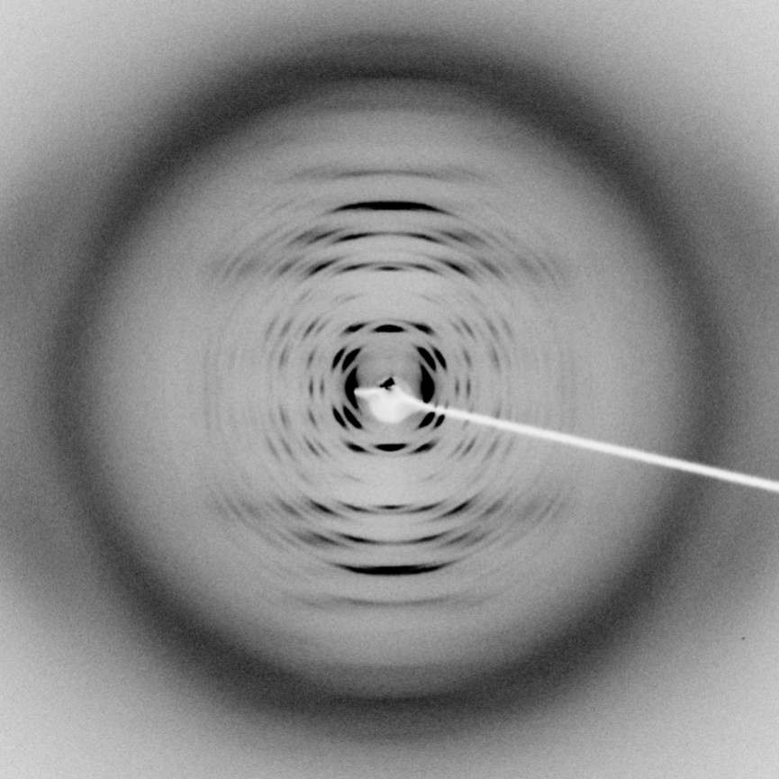
a)
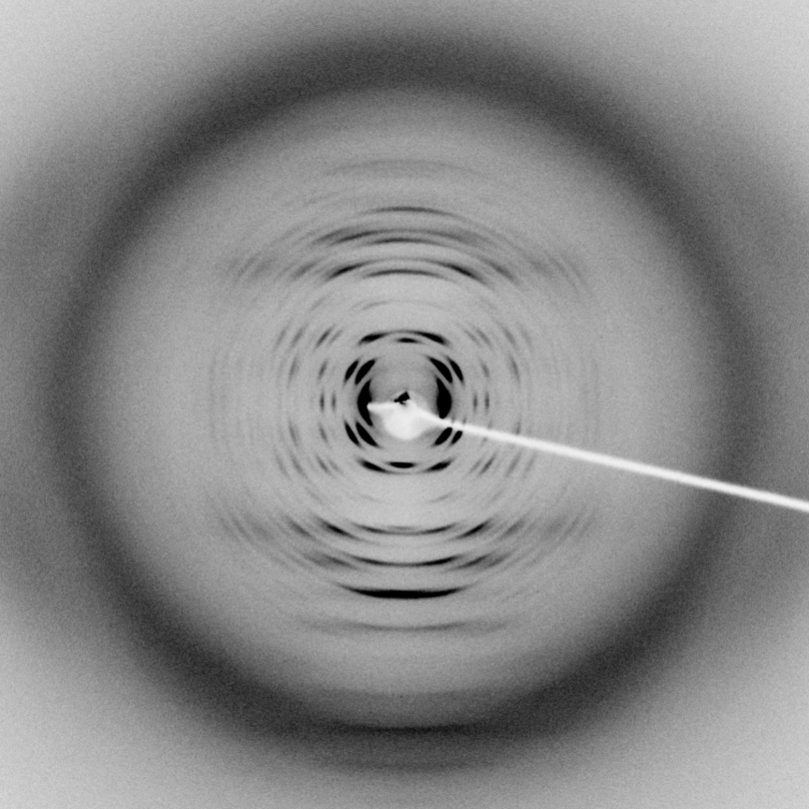
b)
Figure 50 Experimental fibre diffraction patterns of a fibre of PBI 12-2 annealed at 65°C for 24 hrs, recorded at 20 °C, at wide angle region: a) fibre axis is vertical and perpendicular to the beam normal, b) inclined at 13° to the beam normal.

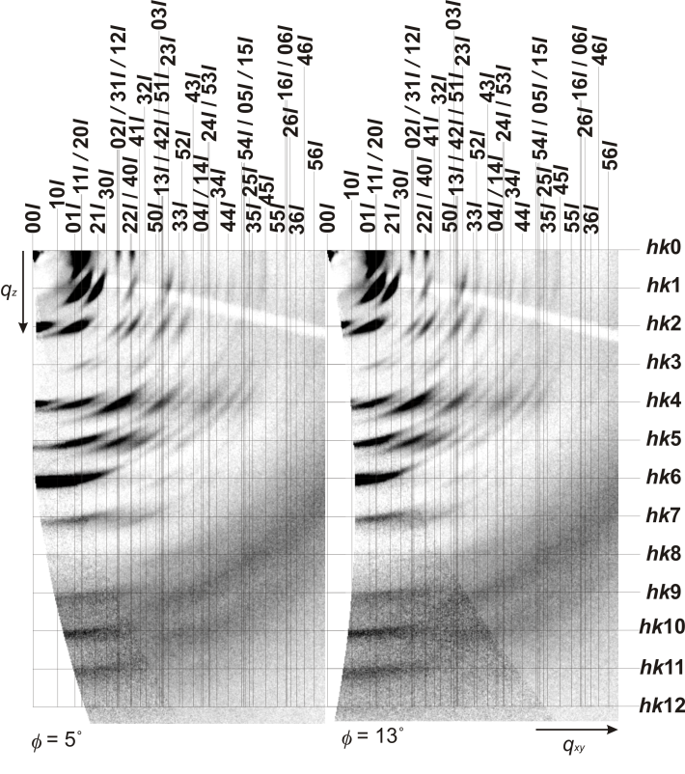
Figure 51 Processed experimental diffraction patterns of a fibre of PBI-12-2: a) fibre axis is inclined at 5° the beam normal and b) at 13°. Diffuse background was partially removed and the patterns were then transposed to reciprocal space coordinates q_{xy} and q_{z} for easier indexing. Indexed row- and layer-lines are shown. Shaded area indicates halo which is coming from liquid aliphatic chains (C₁₂H₂₅O).

Space Group Assignment
The P2₁2₁2₁ space group (Figure 52) was determined taking into consideration the observed extinction conditions (general): h00: h = 2n, 0k0: k = 2n, 00l: l = 2n. Due to the presence of a screw axi in the three orthogonal directions, multiplicity of a motif in general position, or the asymmetric unit, is 4.

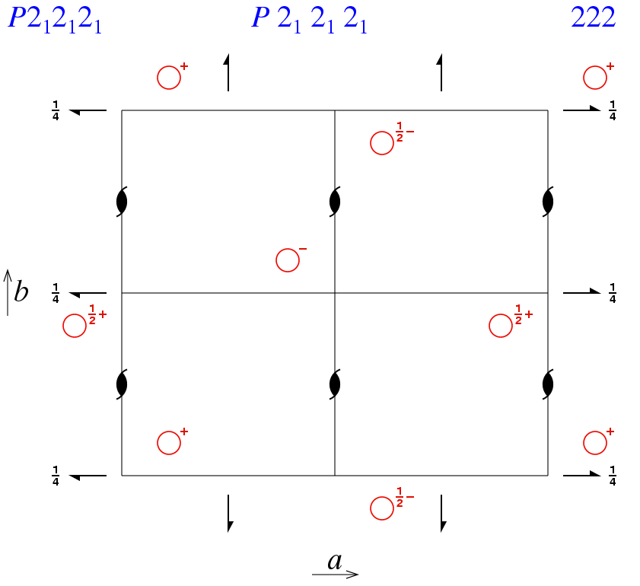
a)
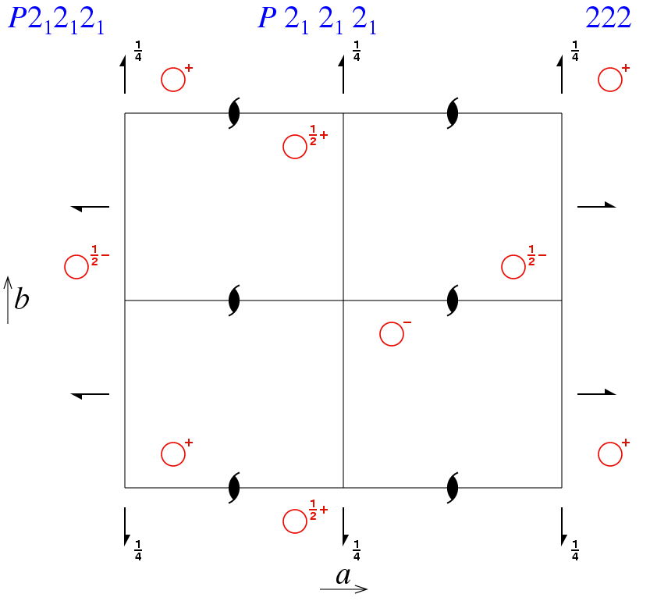
b)
Figure 52 Diagrams for symmetry elements and of the general positions of the P2₁2₁2₁space group: a) along [001], b) along [100] and [010].
From the volume of the unit cell V = 131 × 103 Å, the molecular mass M = 1703, and the experimental density of 1.025 g/cm³, the number of molecules per unit cell was calculated using equation (34) as 47.6 and then rounded as 48. As the structure developed from the hexagonal columnar phase we assumed that this basic structure was preserved, implying that there were two columns per unit cell of the P2₁2₁2₁ pseudohexagonal phase. Therefore it was concluded that there were twenty four PBI 12-2 molecules per each column and hence twelve PBI 1-2 molecules in an asymmetric unit.

3D Reconstructed Electron Density Maps
According to the symmetry of the space group P2₁2₁2₁, the structure factor F₂₀₀ must be real (phase angle 0 or π) while F₁₁₀ and F₂₀₁ must be imaginary (phase angle ± π/2). The contribution of F₂₀₀ and F₁₁₀ to the electron density map is essentially to produce columns without helicity. Their phases are chosen so that the cores of the columns, formed by the aromatic parts of the molecules, have higher electron density than the alkyl-comprising surroundings.
The addition of 201 and 111 reflections makes the columns helical, but the columns are all at the same height (same z) (Figure 53 c and d). The sense of the helix (left or right) determines the phase angle of 201. In this case the phase angle is chosen arbitrarily to be +π/2 corresponding to left-handed columns.
After the phases of the first three peaks had been determined, F₁₁₁ was added and its phase angle was varied between 0 and 2π in π/6 increments. The resulting 12 electron density maps were examined using isoelectron surfaces at different levels. The best phase angle was chosen so as to produce the smoothest helical columns. This procedure is qualitatively equivalent to the maximum entropy method, where the “correct” map is the one containing least structural detail.
The next step was the addition of F₂₁₁, with its phase angle chosen according to the same criterion. As shown in Figures Figure 53b and Figure 53b d, the addition of F₂₁₁ introduces a vertical shift of alternate columns up and down the z-axis. The difference to the maps caused by the inclusion of F₂₁₁ is further highlighted in Figure 54. All intensities and phase angles used in the calculation of the maps in Figure 53 b, d are listed in Table 7.
Table 7 Diffraction intensities and phases of the low-angle reflections of the pseudohexagonal phase of PBI 12-2 used in the reconstruction of the electron density maps. Diffraction intensities are measured from the fibre diffraction pattern and multiplied by q_{xy} (the component of q in the plane perpendicular to the fibre axis) and divided by multiplicity. Due to the pseudohexagonal symmetry of the structure, 20l and 11l peaks cannot be resolved experimentally in the diffraction pattern, but are assumed to have equal intensities.
Index | Intensity  I ∙ q_{xy} | Phase
200 | 100 | π
110 | 100 | -π/2
201 | 6.69 | π/2
111 | 6.69 | 4π/3
211 | 2.37 | π/3

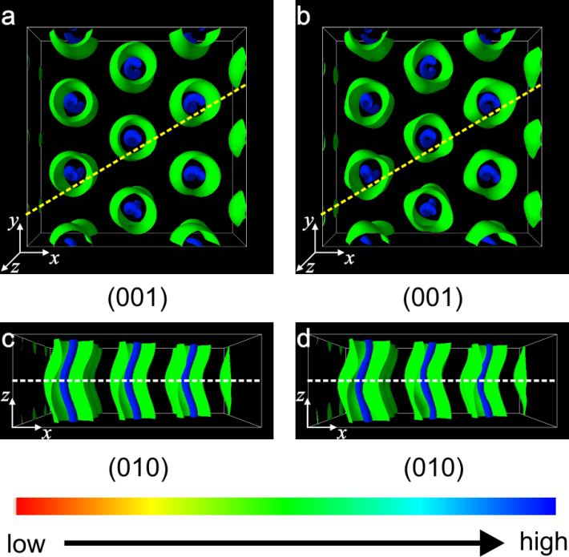
Figure 53 Reconstructed electron density maps of PBI-2-12. (a) and (c) are reconstructed using diffraction intensities of (200), (110), (201) and (111) peaks, while (211) is further included in (b) and (d). The green iso-electron surface enclose the high density (aromatic) regions of the structure, while the helical nature of the columns is shown more evidently by the blue (higher) iso-electron surfaces. In the projected view along the (010) direction, the green iso-electron surfaces are cut open along the yellow line indicated in (a) and (b) in order to reveal the blue iso-electron surfaces inside. The broken white lines are added in (c) and (d) to guide the eye and to show more clearly the vertical shifts of columns in (d).

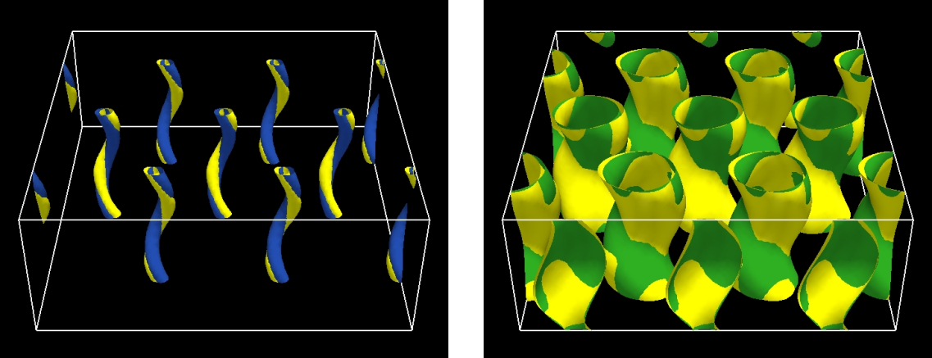
a)
b)
Figure 54 Comparison between reconstructed electron density maps, with (yellow and blue iso-electron surfaces) or without (yellow and green green) the (211) diffraction peak. The blue and green iso-electron surfaces are the same as shown in Figure 53 a and Figure 53 c.

Modelling and Simulation of Crystal Structures
The information on the internal structure of the columns is contained in the wide-angle reflections. These are arranged on layer lines and only those close to the meridian are observed. This indicates a highly anisotropic Debye-Waller factor; i.e. the “vibration ellipsoids” describing the deviation of atoms from their mean positions in the lattice is very wide in the xy plane but reasonably narrow along z plane direction. In other words, while there is 3D long range order, and its intracolumnar component is reasonably high, its intercolumnar component is low. Furthermore the fact that no Bragg reflections are observed in the 2π/q range around 4 Å except near the meridian, and that only a diffuse halo is observed elsewhere in that q-range, suggests that the aliphatic chains are disordered and liquid-like, their atoms not having a preferred position in the lattice.
As it was mentioned earlier, taking into consideration the density measurement it was concluded that there were 24 molecules in a column of length c = 45.5 Å. If the perylene cores formed a single file stack along z, their stacking period would have had to have an unrealistically low value, 45.5 / 24 = 1.9 Å. It is well known, however, that almost twice that value, i.e. 3.8 Å is very close to the range of 3.34- 3.55 Å which is the interplanar distance for unsubstituted perylene bisimides [126] and 3.37 Å which is the interplanar distance for graphite [133]. Thus, we postulate that two PBI-12-2 molecules lay side-by-side in a column. We shall refer to the couple of PBI 12-2 molecules as the 'dimer'.
The conformation of the single PBI 12-2 molecule was determined with the help of the VAMP module of Materials Studio Modelling® [20]. This semiempirical quantum mechanics program allowed optimization of the single PBI 12-2 molecule taking into consideration only quantum mechanical rules without applying any particular force field. The initial conformation of the PBI 12-2 molecule as well as the resultant one, after VAMP geometry optimization has been carried out, are shown in Figure 55. As may be observed the optimized molecule possesses a planar perylene core (Figure 55 c, d).
The geometry of the dimer was optimised via exploration of the energy landscape and by selecting a series of starting configurations at position increments smaller than the trapping radius of the energy minimization routine; this way it was ensured that the structure was not stuck in a local minimum.

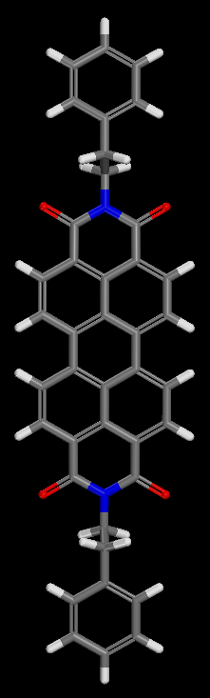 | 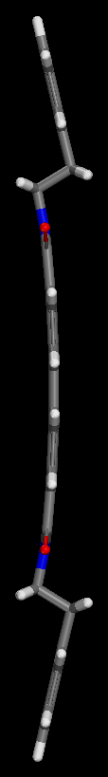 | 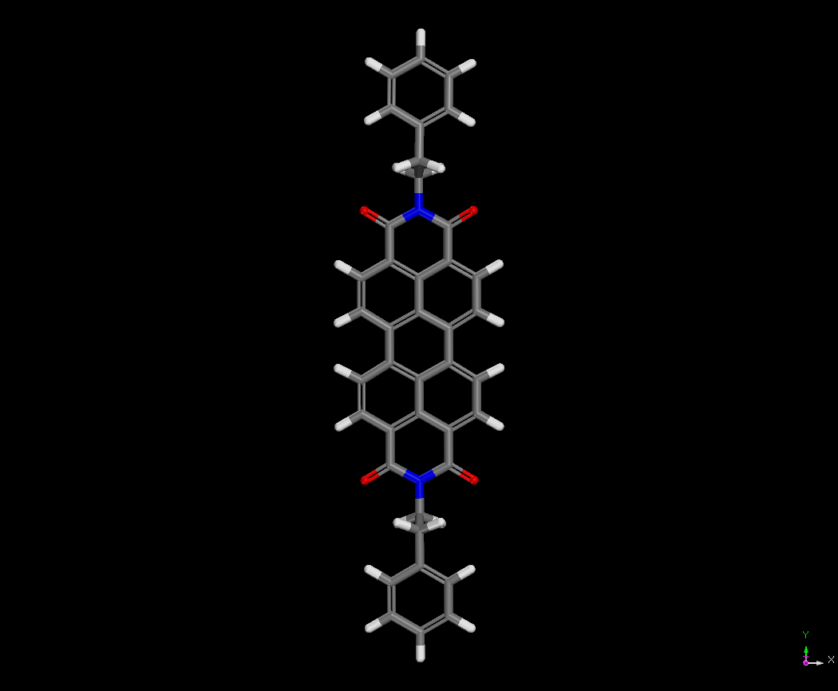 | 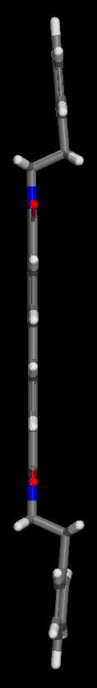
a) | b) | c) | d)
Figure 55 a) top-view and b) side view of the PBI 12-2 molecule before submission to minimization using VAMP, c) top-view and d) side-view of the PBI 12-2 molecule after minimization using VAMP.
There are two possibilities of transversal shift (shift parallel to the molecular long axis) for the molecules, 1.2 and 3.7 Å as may be seen in Figure 56. However, 1.2 Å distance was chosen since the distance of 3.7Å was considered as too large taking into consideration that the dimers would further stack into columns and there was no extra space for them if they possessed such a large transversal shift. Thus, the optimal displacement between the molecular centres within the dimer was found to be 8.8 Ǻ perpendicular to the molecular long axis and 1.2 Ǻ parallel to it (Fugure 57).
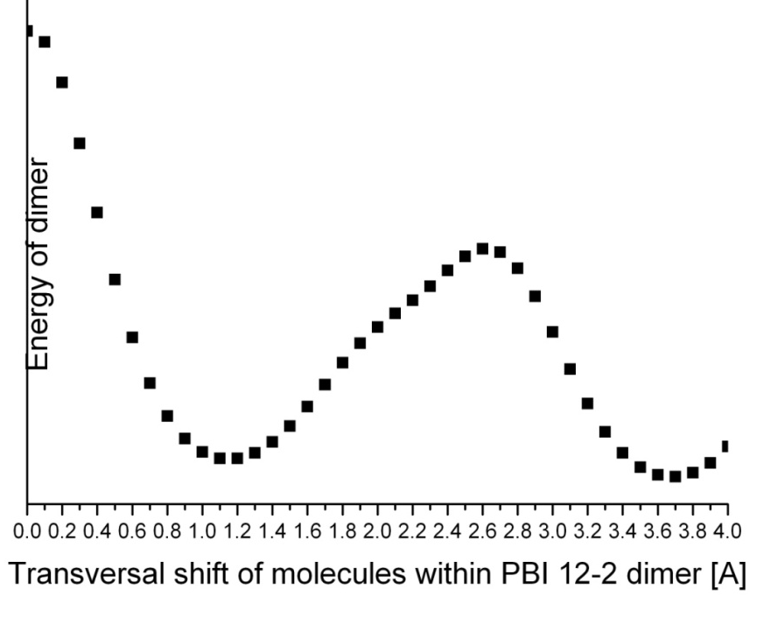
Figure 56 Energy of PBI 12-2 dimer upon transversal shift of the molecules within the dimer.
Turning to the diffraction pattern in Figure 50 a, its appearance is reminiscent of that of a six-fold helix, if one ignores features like 002 and 004 reflections, which should be absent for an ideal 6₁ helix. The key feature here is the strong reflection appearing at a centre of a cross on the 6th layer line. Figure 51 a, recorded with a tilted fibre, shows that this reflection is indeed meridional, i.e. is 006. The presence of 002 and 004 reflections shows that the helix is distorted; nevertheless a 6₁ helix is a useful starting model. Its pitch is 45.5 Å. However, as the first non-equatorial cross is centred on the 6th and not on the 12th layer line, i.e. since we don’t have a 12₁ but a 6₁ helix, the spacing between the repeat units decorating the helix is 45.5/6 = 7.6 Å and not 45.5/12 = 3.8 Å as would be expected from the stacking of PBI 12-2 dimers. This doubling of the spacing between the repeat units suggests that they are made up of four rather than two molecules, i.e. that the basic repeat unit is a tetramer, made up of two dimers stacked on top of each other.
The conformations of the four ethane spacers of the dimers were chosen so as to have all four phenyl rings in the plane above that of the perylene cores (Figure 48 c). This boat-shaped conformation was required in order to achieve the necessary difference between dimer A and dimer B, which in turn could produce a strong 006 and nearby reflections. Furthermore, the strong intensity on and around the 6th layer line indicates that in the electron density profile along the z-axis there is a significant ABAB… alternation in heights of the electron density maxima, with A and B representing individual dimers. As the electron density profile along z does not depend on rotation around z, we conclude that A and B dimers are related to each other by rotation around an axis in the xy plane, in addition to any rotation around z.
The initial structure of such a tetramer was determined by molecular modelling and energy minimization using the ForcitePlus module of Material Studio [134] based on the Universal Force Field [21-24]. Alkyl chains were excluded from the calculations.

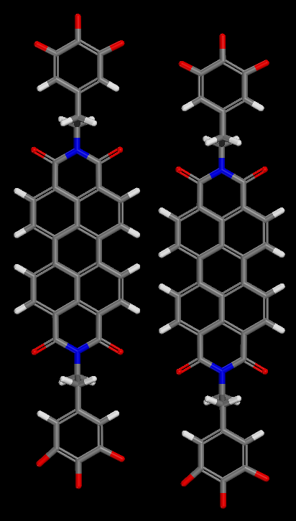 | 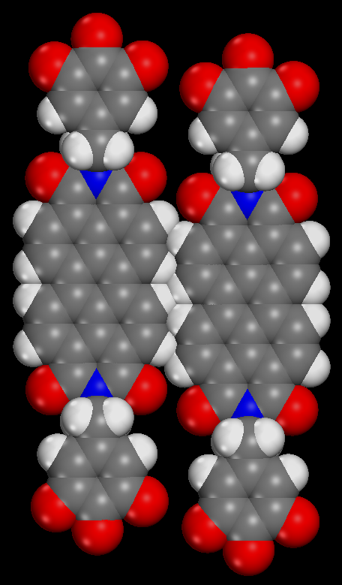
a) | b)
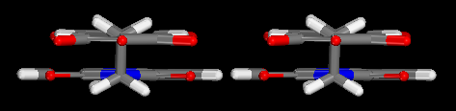
c)
Figure 57 Optimized arrangement of the PBI-12-2 molecules, minus the alkyl chains, in a dimer: a) top-view (stick model); b) CPK model; c) bottom view of a); Displacement between the molecular centres within the dimer perpendicular to the molecular long axis 8.8 Ǻ and parallel to it 1.2 Ǻ.
The tetramer was produced by placing dimer B on top of dimer A face to face (Figure 58). Following the 6₁ helix model, dimers A in successive tetramers must be related by a 60° rotation about, and a 7.59 Å translation along, z. However, the centres of the dimers must be displaced sideways by the amplitude of the helix, i.e. 2.7 Å, as determined from the electron density maps in Figure 53 b, d. In accordance with the 6₁ helical model, the only remaining parameter for a full description of the position of dimer A in a column is the direction angle η at which the dimer is shifted by 4 Å relative to the long molecular axis.
Energy calculations were performed where η was varied in 30° steps, with dimer A and dimer A' on successive tetramers being fixed by the choice of η, the 6₁ symmetry operation, and the 4 Å helical radius. Dimer B, placed face down between A and A', was systematically rotated in-plane between δ = 0 and 170° in steps of 10° and the non-bonded interaction energy was calculated at each step. The energy was lowest in the region 80° < δ < 100° (Appendix 2: Table 12 and Table 13). Next, having fixed dimers A and A', dimer B was allowed to relax as a rigid body. It is clear that δ around 100° are strongly preferred (Appendix 2: Table 14). The most favourable configuration energetically is displayed in Figure 58 (only one tetramer is shown), and the stacking of tetramers in helical columns of the P2₁2₁2₁ pseudohexagonal soft crystal phase of PBI 12-2 is shown in Figure 59 (no aliphatics is displayed for clarity).
From the electron density maps (Figure 53 b, d) it is seen that the neighbouring columns are shifted in respect to one another within the structure. In order to reveal the value of the axial shift, exploration of potential energy of PBI 12-2 crystal structure as a function of the rotation of the columns along the c axis, δ, and their displacement in respect to one another, ψ, within the unit cell, was carried out (Appendix 2: Table 15, Table 16, Table 17, Table 18).
The value of ψ was found to be fixed to either 1.9/-1.9 or 5.7/-5.7 Å, i.e. shift of the columns when layers of planar phenyl rings with the attached long aliphatic chains interdigitate. The centre of dimer A was displaced by 4 Å away from the column axis in the xy plane in the direction perpendicular to the long axis of the perylene molecule (η = 90°) as well as at 60°, 30° and 0°. Due to the symmetry of the P2₁2₁2₁ space group, when one column is shifted up, another goes down. The same refers to rotation, i.e. when one rotation is clockwise, the neighbouring one goes counter-clockwise.
The structure with the following parameters: η = 0°, δ = 0° and ψ = 5.7 Ǻ was chosen after the potential energy examination and comparison of WAXS patterns were carried out for different values of η, δ and ψ. Further, aliphatic chains were added to the structure and it was submitted to the constant volume (NVT) molecular dynamics simulation. The structure was annealed through typically 30 heating and cooling cycles, 1000 steps each, between 300 and 800 K, with an overall duration of typically 50 ps.

Comparison of the Calculated and Experimental X-ray Patterns
The resulting calculated WAXS pattern matches very well the experimental diffraction pattern except that there is no 2nd and 4th meridional reflection which are quite strong in the experimental one (Figure 60). It is believed that there is additional distortion along the c axis which causes these reflections to appear. Figure 60 shows good agreement between the experimental X-ray fiber pattern and the fibre pattern calculated from the PBI 12-2 model. There are several differences between the intensity of the experimental and simulated diffraction features. For example, the (211) diffraction peak was observed experimentally but is weak or absent in the simulated fibre pattern presented in Figure 12. The other main discrepancy between model and experiment in Figure 60 is that the values of intensity on higher layer lines in the experimental pattern are weaker than those in the simulated one. This is due to the fact that the Debye-Waller factor (thermal disorder) in the simulation was not included. The effect of this factor is a reduced diffraction intensity at increasing angles. Further refinement of this model will be reported in a more specialized publication.
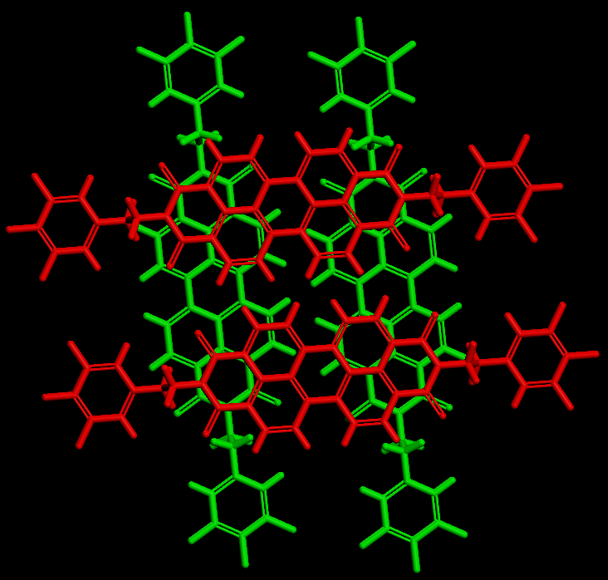
a)
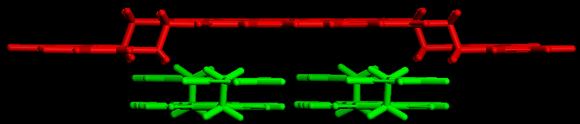
b)
Figure 58 Arrangement of PBI-12-2 molecules in a tetramer where dimers are rotated by δ = 100°: a) top-view, b) bottom view 'Face-to-face' arrangement of the dimers.
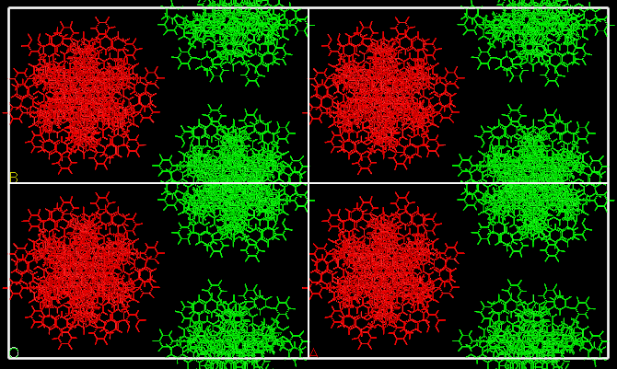
a)
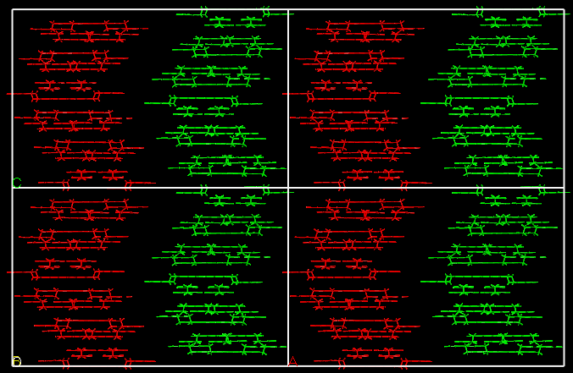
b)
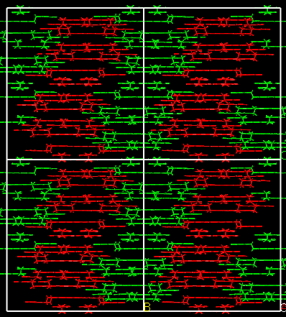
c)
Figure 59 Arrangement of molecular tetramers in the pseudohexagonal P2₁2₁2₁ soft crystal of PBI-12-2: a) top view b) front view and c) side view (compare with 3D ED maps).
Figure 60 Comparison between the WAXS patterns the experimental pattern (a) and calculated from the current model (b). Both patterns have a Bernal chart superimposed to allow easy recognition of row- and layer-lines.

Summary
Based on the X-Ray data, the model of the PBI 12-2 structure has been found to be approximated by distorted helical columns. There are two columns in an orthorhombic unit cell. Each column is comprised of 6 tetramers where each tetramer in turn is comprised of 2 dimers. Based on the computed potential energy of PBI 12-2 molecules within the dimer it has been established that the displacement between the molecular centres within the dimer perpendicular to the molecular long axis 8.8 Ǻ and parallel to it 1.2 Ǻ. Based on computed potential energy of the dimers within the tetramer it has been established that the dimers are ordered facing each other and the rotation angle between the dimers is 100°. It is further established that such a 'face-to-face' conformation of tetramers forms a strong 006 reflection on the calculated X-ray pattern. The fact that time-of-flight experiments showed charge mobility to depend critically on the detailed structure of the columnar soft crystal warrants further structural studies.

Chapter 8 – Study 3: Poly-9-hydroxynonanoate

Literature Review

Introduction
Chemical inertness of polymers has both positive and negative effects. On the one hand, it allows using polymers in many areas, e.g. storing food and chemicals, production of toys, light and long-lasting plastic windows, stationery, car parts, etc. On the other hand, the same property makes it difficult to dispose of polymers. A key to solve the problem of polymer disposal is to use biodegradable polymers. Carrier and refuse bags made of biodegradable polymers are already available at present. Further, biodegradable polyesters are also applied as sutures, in the processes of controlling drug release, tissue engineering, etc. To be able to understand and control physical properties of biodegradable polyesters one should know their structure first. Polyesters are included into the family of polymers divided into two main groups: aliphatic and aromatic. While most aromatic polyesters are not biodegradable, most aliphatic ones do biodegrade thanks to their potentially hydrolysable ester bonds. This review deals with the group of linear aliphatic polyesters of the type [-(CH₂)_{n}-CO-O-]_{x}, where 'm' represents the number of methylene units between successive ester groups.

Crystal Structure of Aliphatic Polyesters of the type [-(CH₂)_{n}-CO-O-]_{x}
The crystal structure of poly(glycolic acid), the simplest polyester of type [-(CH₂)_{n}-CO-O-]_{x}, with n = 1, was investigated by Chatani et al. [135], and is depicted in Figure 61. The molecular chain of poly(glycolic acid) was determined to posses a planar zigzag conformation. Two such planar zigzag chains were arranged within an orthorhombic unit cell with unit cell parameters similar to those of polyethylene [136]. However, the molecular arrangement of poly(glycolic acid) was found to be different from that of polyethylene. The chain axis possesses a two-fold screw symmetry along the c-axis. The first chain lies in the ac plane at b/4 while the second one, which is the mirror image of the first chain rotated 180° about c, lies in the ac plane at 3b/4 [135] (see Figure 61). The space group of the structure is determined to be Pcmn.
a) | b)
Figure 61 Crystal structure of poly(glycolic acid) by Chatani [135].
The Crystal structure of poly-β-propiolactone, investigated by Suehiro et al. [137], where the number of methylene units is 2, is shown in (Figure 62). It also has unit cell parameters a and b similar to those of polyethylene [136]. An all-trans, planar chain conformation was formed (Figure 62 a). No space group could be determined for the structure due to the poor X-ray pattern (Figure 63) since no discrete diffraction signals but streaks were observed on all layer lines except for the 0th one. It was suggested that the chains had no axial register and that the structure resembled a liquid crystalline nematic.
Furuhashi et al. [138] reported the structure of poly-β-propiolactone. Lattice parameters were found to be more or less similar to those by Suehiro [137] except that they determined the angle between the C-C-C... zigzag plane of poly-β-propiolactone and the b-axis to be equal to 51.5° (Figure 64). Accurate stereochemical calculations with matching the intensity values of X-ray and electron diffraction patterns showed that the value of a parameter of the unit cell was 10% smaller and the value of b – 9% greater as compared to those by Suehiro [137]. However, still, no space group could be determined for the structure due to the absence of any nonzero layer line reflections at the X-ray pattern derived from oriented sedimented mats of poly-β-propiolactone single crystals (Figure 65).
Figure 62 Crystal structure of poly-β-propiolactone proposed by Suehiro et al. [137]; (a) projection of the all-trans molecular chain in ball-and-stick mode with periodicity of 0.477 nm. (b) view parallel to the c-axis showing the chain setting angle of 0° in respect to the ab basal plane.
Figure 63 X-ray fibre photograph of poly-β-propiolactone by Suehiro et al. [137].
Studies on the structure of poly(4-hydroxybuturate) [139-141], where the number of methylene units is 3, have shown that as compared to poly-β-propiolactone, the monomer of which may exist in the all-trans confirmation [137, 138, 142], the all-trans conformation of poly(4-hydroxybuturate) (Figure 66 a) cannot exist. Pazur et al. [139] have established with the help of molecular dynamics simulations that there is an inherent regular torsion along the molecular chain of poly(4-hydroxybuturate) (Figure 66 b). The crystal structure of poly(4-hydroxybuturate) was not shown by either of the authors and therefore is not depicted here.
The crystal structure of poly(δ-valerolactone) studied by Furuhashi et al. [143], where the number of methylene units is 4, is depicted in Figure 67. Unit cell parameters were determined to be similar to those of polyethylene [136], with the angle between the C-C-C... zigzag plane of poly(δ-valerolactone) and the b-axis equal to 58 ± 1°. It was established that there were two poly(δ-valerolactone) chains in the unit cell with all-trans conformation. And again, lack of X-ray data (Figure 68, Figure 69) did not allow determination of the space group for the structure studied. The authors claimed that they observed a pair of streaks on the first layer line which they could not index on the poly(δ-valerolactone) lattice. However, these cannot be considered as genuine diffraction signals.
The crystal structure of poly(ε-caprolactone) studied by Chatani et al. [144], where the number of methylene units is 5, is depicted in Figure 70. The chain conformation of poly(ε-caprolactone) was found to be almost planar zigzag but deviating from the fully extending form. The planes of atoms of the ester groups tilted slightly to the fibre axis. The arrangement of molecular chains was the same as of those of polyethylene [136] except for the fact that the carbonyl groups of the two chains within the unit cell were separated by 3c/14 along the fibre axis. Studies on structures of poly(ε-caprolactone) by Bittinger [145], Hu [146] and Dorset [147] were in agreement with the data published by Chatani [144] except that the value of the angle between the C-C-C... zigzag plane of poly(ε-caprolactone) and the b-axis was equal to 28° as compared to 40° determined by Chatani [144].
The longest among aliphatic polyesters of the group [-(CH₂)_{n}-CO-O-]_{n} studied hitherto is poly(hydroxy-ω-decanoate), with 9 methylene units [148]. It was investigated more than 70 years ago. Due to poor X-ray pattern (Ошибка! Источник ссылки не найден.), where nothing could be observed but equatorial reflections only, and absence of any crystal structure in the publication, i.e. molecular conformation and 3D arrangement of the molecule within the structure, it may be suggested that the structure of poly(hydroxy-ω-decanoate) is yet to be further investigated and reconfirmed.
Figure 64 Crystal structure of poly-γ-propiolactone. View is parallel to the c axis. The boxes represent the unit cell. The chain setting angle in respect to the ab basal planes is 51.5°. In the stick/ball-and-stick model on the left, the diagonal continuous and dashed lines represent the folding direction, top and bottom of the crystal, respectively [138].
Figure 65 WAXS pattern from oriented sedimented mats of poly-γ-propiolactone. Incident beam parallel to mat surface and mat normal vertical [138].
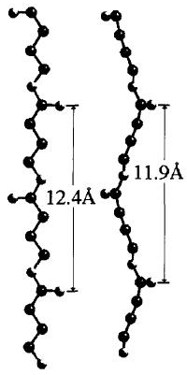
Figure 66 Orthogonal and down chain projections of poly(4-hydroxybuturate): a) straight chain with all-trans conformation, c = 12.4 Å, b) conformation with c = 11.90 Å obtained via molecular dynamics simulation corresponds to the observed X-ray fibre repeat [139].
Figure 67 Projections parallel to the c axis of the poly(δ-valerolactone) straight-stem crystal structure that the best match the experimental diffraction data. The boxes represent the unit cell. The chain setting angle in respect to the ab basal plane is ±58°. A stick and stick/ball model is shown [143].
Figure 68 (a) WAXS pattern from poly(δ-valerolactone) chain-folded lamellae crystallized from 2-methylbutane-2-ol and sedimented into oriented mats. Incident beam directed parallel to the mat surface (mat normal vertical). The mat has been tilted slightly (≈6°) to enhance the 001 meridional diffraction signals (0.742-nm spacing) in the top half of the pattern. This causes the noticeable (white) horizontal sample absorption line to rise off the equator. The upper inset shows the 001diffraction signal (arrowed), together with a pair of off-meridional first-layer-line streaks, in more detail. The first and second orders for lamellar stacking periodicity = 7.26 nm, obtained in the low-angle diffraction region, are shown in the lower right inset. (b) Computer-simulated WAXS pattern of poly(δ-valerolactone) lamellar crystals. The lamellar normal is tilted 6° from the vertical. The crystalline pattern has been overlaid with a small proportion of the molecular transform of the two-chain motif [143].
Figure 69 (a) WAXS pattern obtained from a poly(δ-valerolactone) film prepared from the melt, drawn at room temperature, and annealed. The inset shows the first order for lamellar stacking periodicity = 12 nm in the low-angle X-ray diffraction region. (b) Computer simulated WAXS pattern calculated for the in-register (c/2 displaced), ant parallel two-chain motif positioned on the poly(δ-valerolactone) ab rectangular lattice with variable c axis shear [143].
a) | b)
Figure 70 Poly(ε-caprolactone) molecular arrangement within the unit cell of the space group P2₁2₁2₁ by Chatani et al. [144]: a) viewed along ab plane, b) view along c axis.
Already more than 70 years ago Fuller at al. suggested that higher members of the group of aliphatic polyesters of the group [-(CH₂)_{n}-CO-O-]_{x} had crystal structures similar to that of polyethylene [148]. However, they implied that the members of the group [-(CH₂)_{n}-CO-O-]_{x} with an even number of methylene units possessed the monoclinic system, while those with an odd number of methylene units had an orthorhombic one. This is not true as can be seen from (Table 8) but one should take into consideration that this statement was made 70 years ago and they did not conduct any structural analysis. In fact, as can be confirmed from the Table 8, both even and odd numbered members except the one studied by Fuller et al. [148], have the orthorhombic crystal system.
Table 8 Summary for the aliphatic polyesters of the group [-(CH₂)_{n}-CO-O-]_{x}.
Name of  aliphatic polyester | Space  group | Lattice parameters | Molecular  conformation | Reference
Poly(glycolic acid) | Pcmn | Orthorhombic:  a = 5.22 Ǻ, b = 6.19 Ǻ, c = 7.02 Ǻ. | all-trans | [135, 149]
Poly(β-propiolactone) | undefined | Orthogonal:  a = 7.73 Ǻ, b = 4.48 Ǻ, c = 4.77 Ǻ, ψ∗ = 90°. | all-trans | [137, 142, 150]
Poly(γ-propiolactone) | undefined | Orthorhombic:  a = 7.00 Ǻ, b = 4.90 Ǻ, c = 4.93 Ǻ, ψ = 51.5° | all-trans | [138]
poly(4-hydroxybuturate) | P2₁2₁2₁ | Orthorhombic:  a = 7.75 Ǻ, b = 4.79 Ǻ, c = 12.40 Ǻ. | close to all-trans | [139]
poly(4-hydroxybuturate) | P2₁2₁2₁ | Orthorhombic:  a = 7.75 Ǻ, b = 4.79 Ǻ, c = 12.04 Ǻ. | close to all-trans | [141]
poly(4-hydroxybuturate) | P2₁2₁2₁ | Orthorhombic:  a = 7.75 Ǻ, b = 4.77 Ǻ, c = 11.99 Ǻ. | close to all-trans | [140]
Poly(δ-valerolactone) | undefined | Orthorhombic:  a = 7.47 Ǻ, b = 5.02 Ǻ, c = 7.42 Ǻ, ψ = 58±1° | all-trans | [143]
Poly(ε-caprolactone) | P2₁2₁2₁ | Orthorhombic:  a = 7.50 Ǻ, b = 4.97 Ǻ, c = 17.30 Ǻ, ψ = 28° | close to all-trans | [145]
Poly(ε-caprolactone) | P2₁2₁2₁ | Orthorhombic:  a = 7.47 Ǻ, b = 4.98 Ǻ, c = 17.05 Ǻ, ψ = 40° | close to all-trans | [144, 151]
Poly(ε-caprolactone) | P2₁2₁2₁ | Orthorhombic:  a = 7.48 Ǻ, b = 4.98 Ǻ, c = 17.26 Ǻ, ψ = 40° | close to all-trans | [146]
Poly(hydroxynonanoate) | studied  here | studied here | studied  here | studied here
Poly(hydroxy-ω-decanoate) | undefined | Monoclinic:  a = 7.45 Ǻ, b = 4.97 Ǻ, c = 27.10 Ǻ. | close to all-trans | [148]
∗ ψ - the angle between the C-C-C... zigzag plane of a polymer and the b axis.

Summary
With the exception of poly(glycolic acid) which is the simplest polyester of the [-(CH₂)_{n}-CO-O-]_{x} type with n=1, all other members of the series, starting with poly(β-propiolactone) (n=2) to poly(ε-caprolactone) (n = 5), through poly(4-hydroxybuturate) (n = 3) and poly(δ-valerolactone) (n = 4), exhibit X-ray fibre diffraction patterns similar to that of polyethylene.
When equatorial reflections of the [-(CH₂)_{n}-CO-O-]_{n} type and of polyethylene [136] were compared they were almost identical. It has been established that for aliphatic polyesters of the group [-(CH₂)_{n}-CO-O-]_{x} the conformation of chain structure is of a planar zigzag type and the chains lie along the fibre axis. It was concluded that for the group of aliphatic polyesters [-(CH₂)_{n}-CO-O-]_{x} with an odd number of methylene units, n = 1, 3, 5, etc., the ester units are distributed regularly on both sides of the chain (left / right) while in case of an even number of methylene units, n = 2, 4, etc., the ester units are distributed only on one side. Hence in the case of odd numbered members, the c parameter of unit cell doubles. Thus, these two groups, i.e. with odd - and even number of methylene units, are different. Hitherto there has been no space group determined for the aliphatic polyesters of the group [-(CH₂)_{n}-CO-O-]_{x} with even numbers of methylene units.

Analysis and Interpretation of Results

Experimental Fibre Diffraction Pattern
The experimental X-ray fibre patterns of PHN show two layer lines and the reflections from about 17 different diffracting planes (Figure 71).
The fibre patterns were processed using the FibreFix program included in the CCP13 software package [19], i.e. an exact centre and fibre tilt angle were determined and then the patterns were converted from detector coordinates to reciprocal space coordinates q_{xy} and q_{z} for easier indexing (Figure 72). The converted patterns were indexed on an orthorhombic unit cell with the lattice parameters at T = 20°: a = 7.52 Å, b = 4.97 Å, and c = 12.24 Å. Further, the obtained lattice parameters were refined by a least-squares fitting procedure and they were defined to be : a = 7.47 Å, b = 5.00 Å, and c = 12.37 Å. The observed reflections from 17 families of diffracting planes are listed in (Table 9).
If one compares the X-ray fibre diffraction pattern of poly-9-hydroxynonanoate with that of polyethylene [136] it is obvious that the equatorial and off-meridional reflections are almost identical to those of polyethylene, except that in case of polyethylene there are other reflections in wider regions of 2θ observed. Moreover, lattice parameters are quite similar:
a = 7.47 Ǻ, b = 5.00 Ǻ, c = 12.37 (c / 5 = 2.47 Ǻ) Ǻ for poly-9-hydroxynonanoate,
a = 7.40 Ǻ, b = 4.93 Ǻ, c = 2.53 Ǻ for polyethylene.
The theoretical density of poly-9-hydroxynonanoate, ρ = 1.12 g/cm³. This compares with the experimental density of the drawn PHN fibre, ρ = 1.06 g/cm³. The agreement is satisfactory since the density of the drawn PHN fibre, which is partially amorphous, would be expected to be less than that of the pure crystalline polymer.
From the volume of the unit cell, V = 462 × 10³ Å, the molecular mass, M = 164, and the experimental density, ρ = 1.12 g/cm³, the number of PHN monomers per unit cell were calculated using equation (34) as 1.9 and then rounded as 2.
As it may be observed from the (Table 9), it is unclear whether there is 020 or 300 reflection since they coincide. X-ray experiments at different temperatures, i.e. at -30, 20, 60, 66 and 68 °C, were carried out to confirm the nature of the reflection. It was established that the reflection investigated was clearly a 020 reflection but not a 300 reflection. For this purpose, a and b parameters were calculated at the lowest and the highest temperature. Then d₃₀₀ and d₀₂₀ were calculated at the lowest and highest T and the differences were observed. Then values of shift expected if it was 020 and if it was 300 were compared with the observed ones.
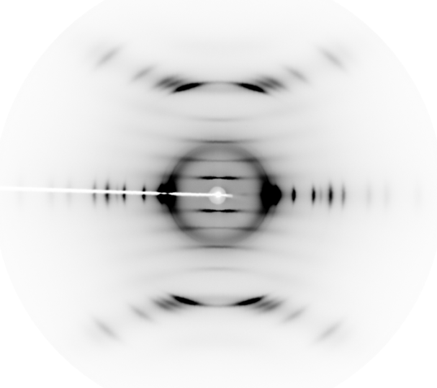
a)
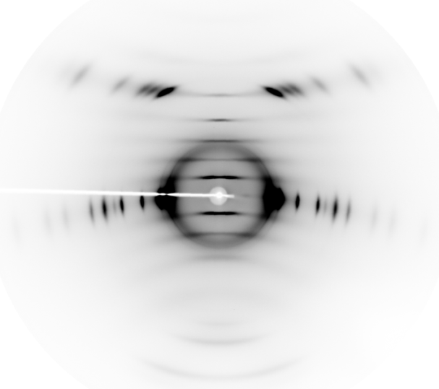
b)
Figure 71 WAXS fibre diffraction patterns of PHN annealed at T = 65 °C for 24 hrs and recorded at T = 20 °C: a) fibre axis is vertical b) fibre axis is inclined at 18.16° to the beam normal. Reflections at meridional layer lines are not actual reflections but streaks; this was confirmed by inclination of the fibre at different 2θ for 00l. Specimen-to-detector distance is 100 mm.

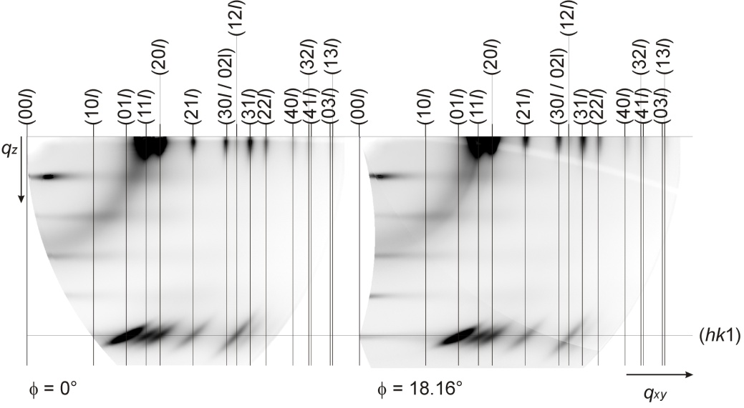
a)
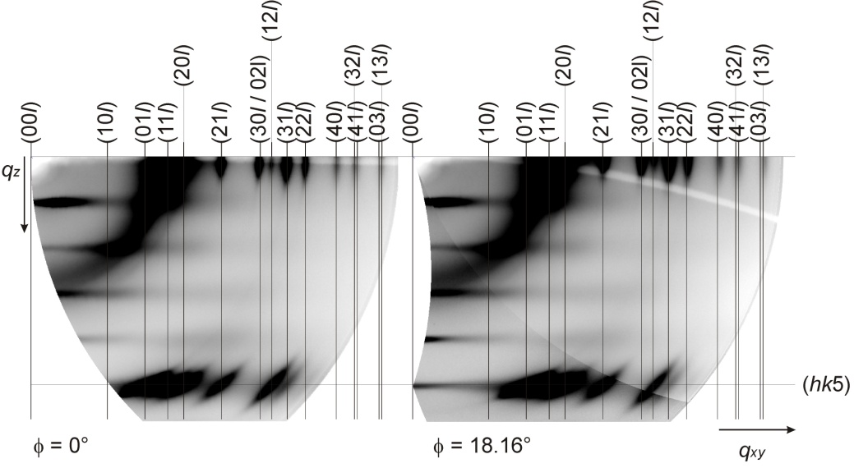
b)
Figure 72 Diffraction patterns of PHN at different exposure times: a) shows strong reflections while b) weak ones; at φ = 0° - fibre axis is vertical, at φ = 18.16° - fibre axis is inclined to the beam normal; X-ray patterns were processed and transposed to reciprocal space coordinates q_{xy} and q_{z}. Indexed row- and layer-lines are shown. Specimen-to-detector distance is 10 cm.

Table 9 Calculated and observed parameters for PHN fibre indexed on an orthorhombic unit cell with refined lattice parameters: a = 7.47 Å, b = 5.00 Å, and c = 12.37 Å (where c parameter coincides with the fibre axis).
Reflection # | d_{obs}, Ǻ | d_{calc}, Ǻ | St. dev. | h | k | l | I_{obs}
0th layer line
1 | 4.148 | 4.155 | 0.00005 | 1 | 1 | 0 | VS
2 | 3.760 | 3.735 | 0.00062 | 2 | 0 | 0 | VS
3 | 2.984 | 2.992 | 0.00006 | 2 | 1 | 0 | S
4 | 2.495 | 2.490 | 0.00003 | 3 | 0 | 0 | M
 | 2.495 | 2.500 | 0.00002 | 0 | 2 | 0 | M
5 | 2.370 | 2.371 | 0.00000 | 1 | 2 | 0 | W
6 | 2.224 | 2.229 | 0.00002 | 3 | 1 | 0 | M
7 | 2.071 | 2.078 | 0.00004 | 2 | 2 | 0 | M
8 | 1.862 | 1.868 | 0.00003 | 4 | 0 | 0 | VW
9 | 1.773 | 1.764 | 0.00008 | 3 | 2 | 0 | VW
10 | 1.755 | 1.749 | 0.00003 | 4 | 1 | 0 | VW
11 | 1.631 | 1.627 | 0.00002 | 1 | 3 | 0 | VW
1st layer line
12 | 2.212 | 2.217 | 0.00003 | 0 | 1 | 1 | VS
13 | 2.128 | 2.126 | 0.00001 | 1 | 1 | 1 | M
14 | 2.065 | 2.063 | 0.00001 | 2 | 0 | 1 | M
15 | 1.911 | 1.907 | 0.00002 | 2 | 1 | 1 | W
16 | 1.709 | 1.712 | 0.00001 | 1 | 2 | 1 | W
17 | 1.650 | 1.656 | 0.00004 | 3 | 1 | 1 | VW
18 | 1.596 | 1.591 | 0.00003 | 2 | 2 | 1 | VW
∗Abbreviations denote relative intensities: VS – very strong, S – strong, M - Medium, W – weak, VW – very weak; St. dev. – standard deviation, St. dev. = (d_{calc} – d_{obs})². Shaded area denotes coinciding reflections.

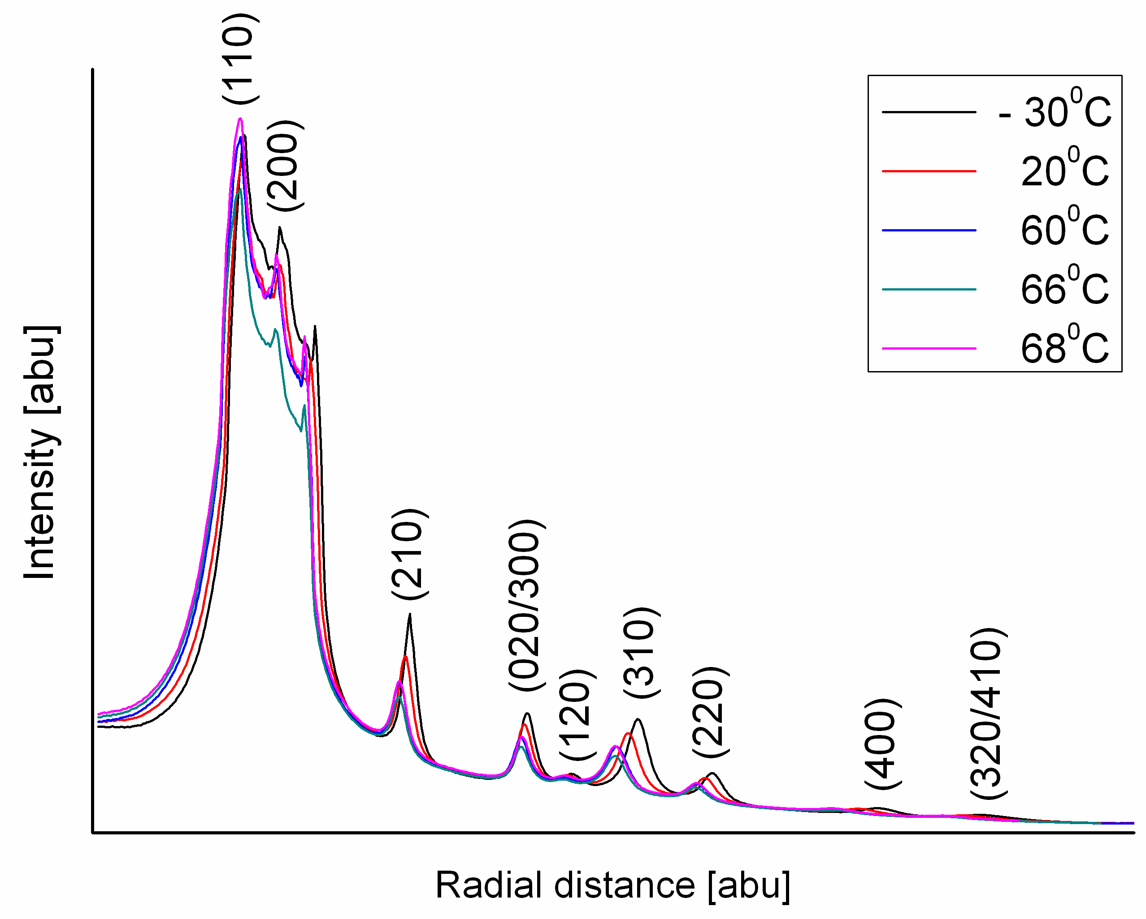
Figure 73 WAXS intensity profile of equatorial reflections upon changing temperatures.

Space Group Assignment
From the list of reflections of 18 diffracting planes (Table 9), after the confusion with 020/300 reflection has been resolved, it has been established that the following reflection conditions occur for absences: h00: h = 2n, 0k0: k = 2n, h0l: h = 2n, 0kl: k + l = 2n and 00l: l = 2n. Systematic absence conditions h00: h = 2n, 0k0: k = 2n and h0l: h = 2n imply a plane group p2gg. Based on the established reflection conditions only two space groups could be assigned which were Pna2₁ and Pnam.
Pna2₁ space group lacks centre of symmetry and the mirror plane normal to chains. That would mean that PHN chains would have a preferred direction (up or down), i.e. in all ester groups the O atom will be positioned above the CO group. This is nonsense in a disordered structure like ours. In fact, in Pna2₁ not only is there no mirror, but there are no 2 or 2₁ axes normal to the c chain, so all chains would have to be pointing up. There would be a ferroelectric. During crystallization 1/2 of chains could not incorporate unless they turned upside down. Besides, it is not just carbonyl group but it is ester groups. The CO is not randomly oriented in all directions normal to the c chain, but only along two equivalent antiparallel directions. The random displacement of ester groups (i.e. chains) along the c chain is not an issue of space group but of unit cell size. Hence Pnam (Figure 75) was assigned to the structure since the CO is randomly oriented in all directions normal to the c chain.
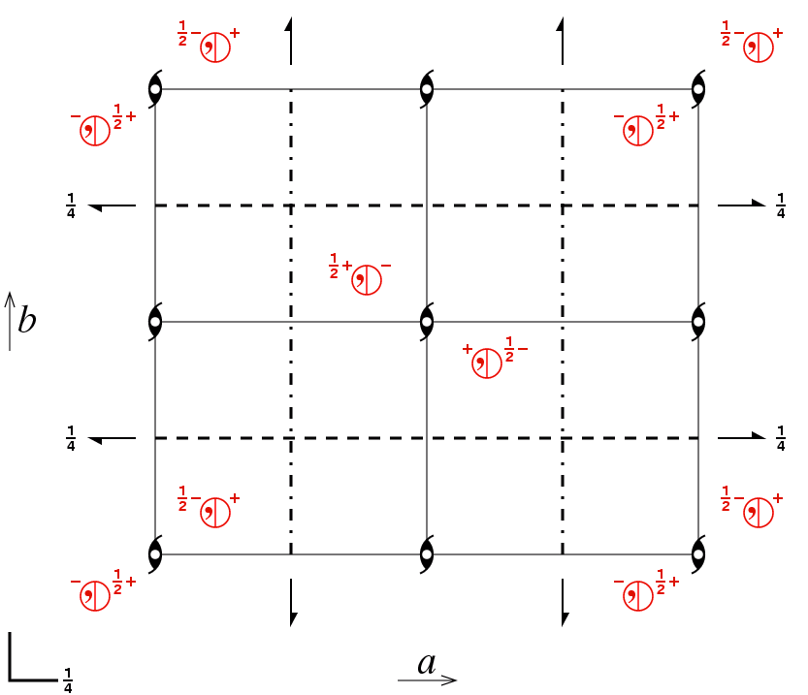
Figure 74 Diagram for symmetry elements and of the general positions of the Pnam space group.
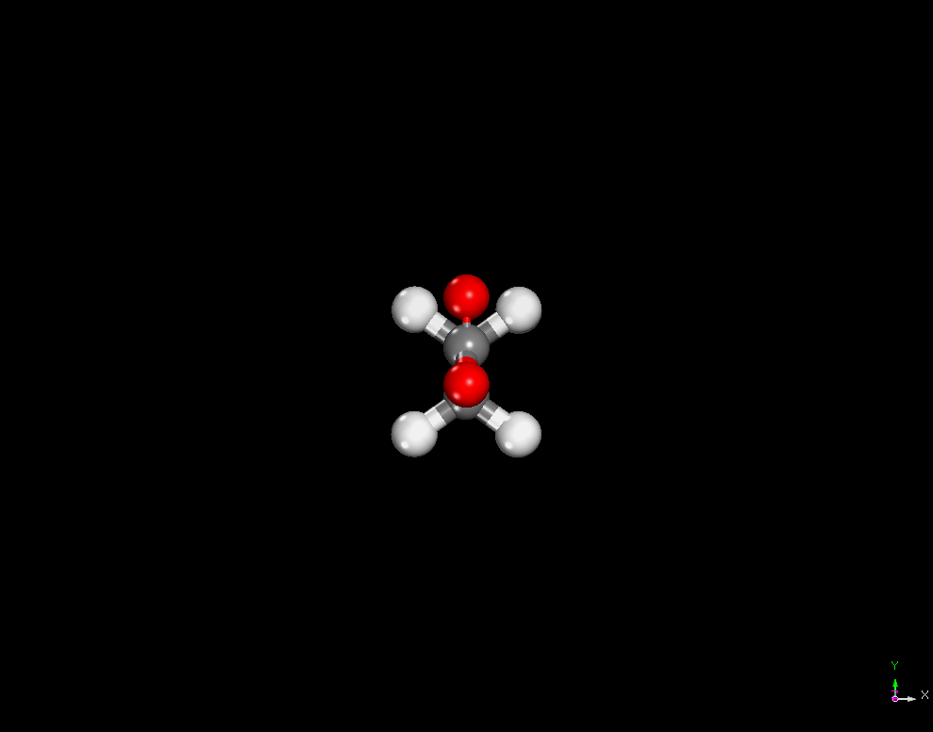  a) | 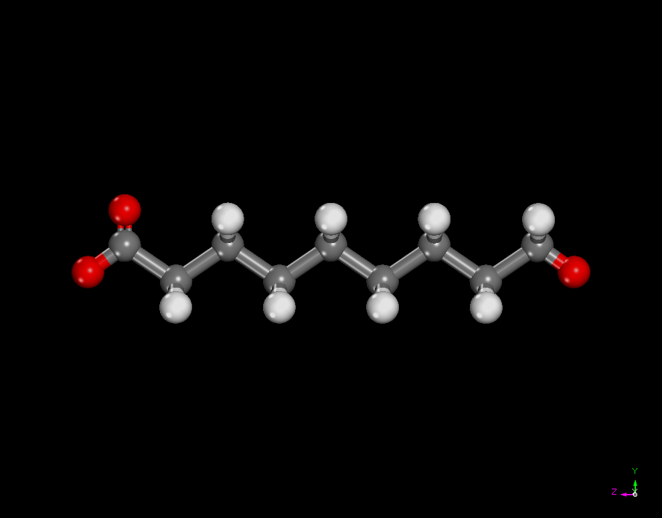
 | b)
 | 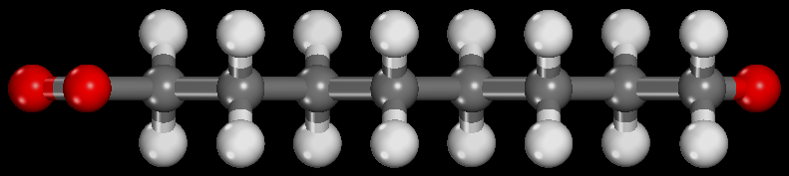
 | c)
Figure 75 PHN monomer: a) side-, b) front- and c) top-view. White atom represents hydrogen, gray – carbon and red – oxygen.

Modelling of PHN Crystal Structure
Stereo-chemical parameters for PHN, as can be seen from Figure 76, after energy minimization were as follows: carbon-carbon bond length is 1.53 Å, carbon-oxygen (oxygen of carbonyl group) bond length is 1.24 Å and carbon-hydrogen bond length is 1.09 Å. Carbon- carbon-carbon angle is 112°, carbon-carbon-oxygen (oxygen of carbonyl group) is 125.5°. Figure 76 also represents the asymmetric unit which was used to build a crystal structure of PHN.

Setting angle of PHN monomer
The next step was to define the angle between the C-C-C... zigzag plane of poly-9-hydroxynonanoate and the b axis (setting angle for short). It is well known that the intensity of the equatorial reflections directly depends on the angle and hence the angle may be determined by comparison of the experimental intensities of equatorial reflections with the calculated ones. Thus, intensities were retrieved from the experimental diffraction pattern (Figure 77) and the peaks were integrated with the help of Peaksolve Galactic software. The 120 peak was omitted due to the very low height. Calculated diffraction patterns were produced for the crystal structures with different values of the setting angle, ψ, and their intensity values were retrieved directly from the Cerius-2 software [25] for further comparison with the experimental values of intensity.
Exploration of the setting angle, ψ, was carried out in several stages. In the first stage the range of ψ = 0 - 90° was explored with the step of 10° (Appendix 3: Table 19 and Table 20). Values of the obtained variance were compared graphically (Figure 78). From the plotted graph it is obvious that the best match of ψ lies somewhere between 25-35°. Smoother exploration, ψ = 26 – 34° with the step of 1° (Appendix 3: Table 21 and Table 22) and the values of the variance were compared graphically (Figure 79). Lastly, exploration within the range of 32.0 – 32.9° was done with the step of 0.1° (Appendix 3: Table 23 and Table 24). From the graphical representation of the values of variance it was determined that ψ = 32.7° (Figure 80).
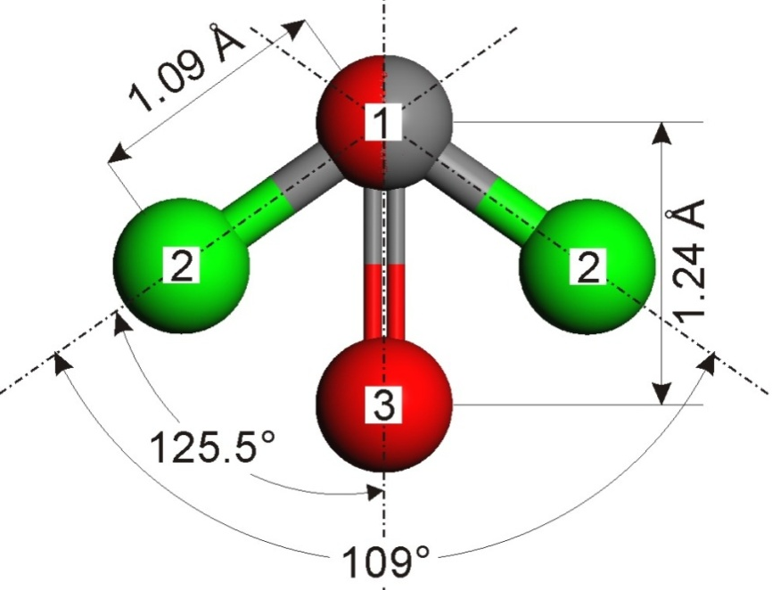
Figure 76 The asymmetric unit of PHN used to build randomized crystal structure with Pnam symmetry for determination of the setting angle. 1 - one oxygen and nine carbon atoms at a position, 2 - eight hydrogen atoms at a position, 3 - one oxygen atom at a position.
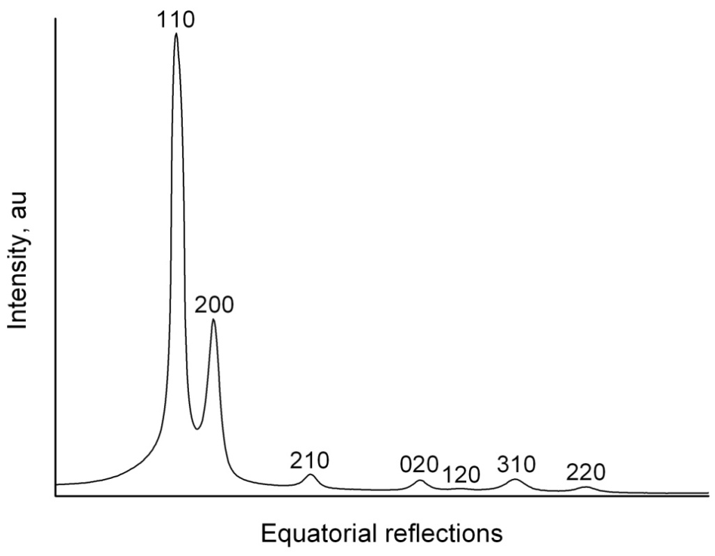
Figure 77 Intensity profile of equatorial reflections derived from the experimental WAXS pattern (Figure 71 a). Intensity values of the peaks were obtained by further integration of the peak profiles using Galactic Peaksolve program. Value of intensity for 120 reflection was not measured due to the very low height of the peak.
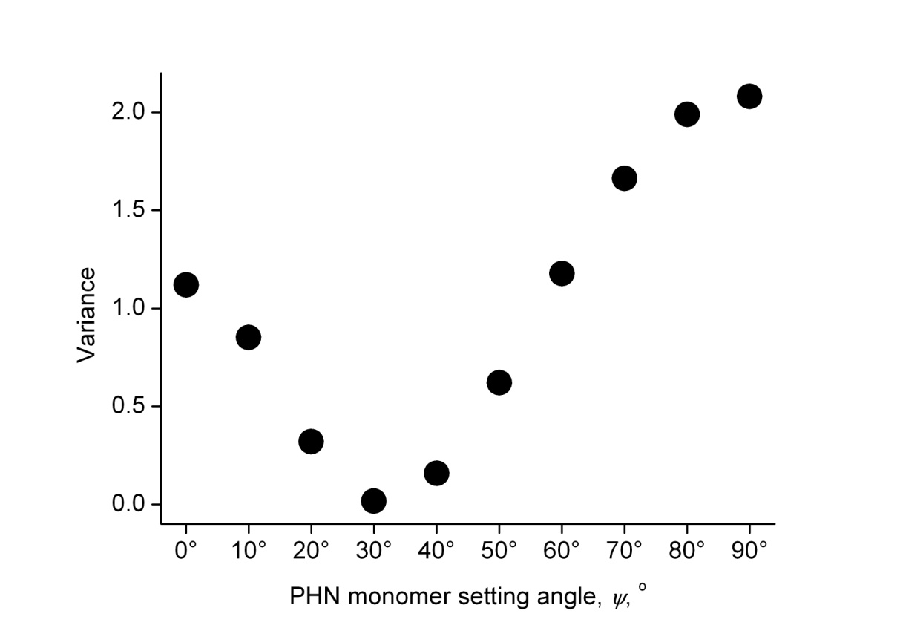
Figure 78 Graphical representation of the best matching value of intensity of equatorial reflections between the experimental and calculated X-ray diffraction patterns. The graph shows that the value lies somewhere in the range of 25 – 35°.
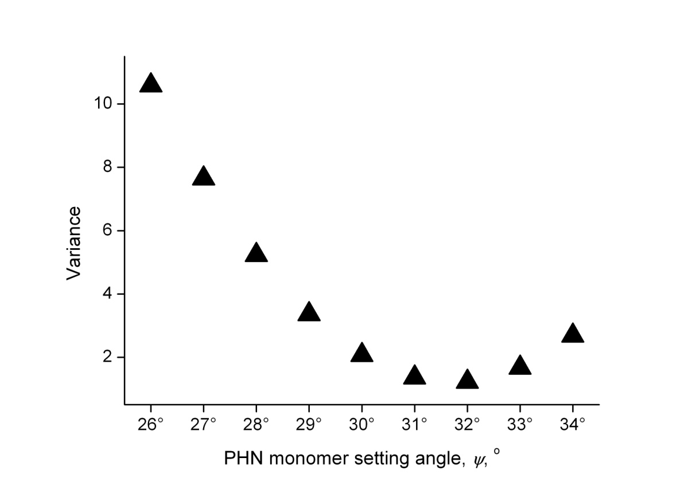
Figure 79 As in Figure 78 but for the range of 26 – 34°.
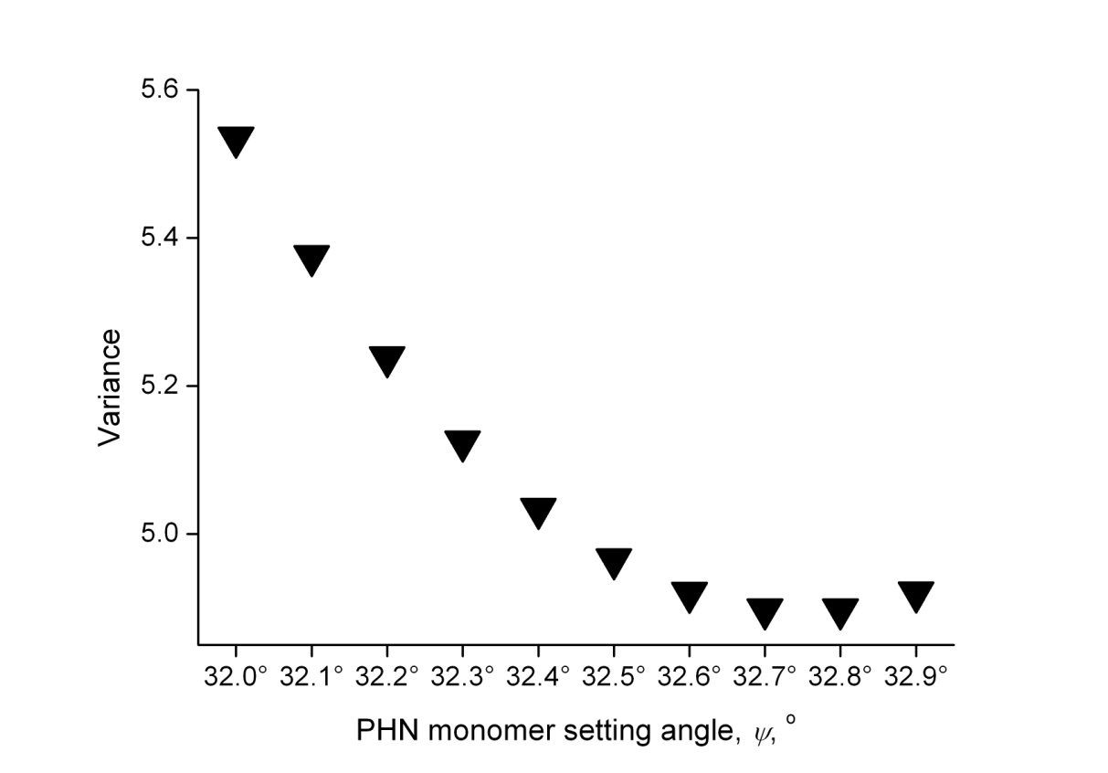
Figure 80 As in Figure 78 but for the range of 32.0 – 32.9°. The graph shows the value of 32.7° (for the difference at the setting angle of 32.7° and 32.8° see the values in Appendix 3, Table 24).

Torsion of the carbonyl group
Next, when the value of the setting angle has been determined, ψ = 32.7°, exploration of the tilt of the carbonyl group, φ was carried out in the same fashion as the exploration of the setting angle of PHN monomer, i.e. the carbonyl group was rotated (Figure 81) to the left (-) and right (+) at the setting angleψ = 32.7° and the WAXS intensities were calculated in the range of φ = 10-90°. Values of intensity were retrieved from the calculated diffraction patterns and compared with those of the experimental one. Results for the tilt of the carbonyl group towards the (+) direction are shown in Table 25 and Table 26. The same but for the (-) direction is represented in Table 27 and Table 28. Graphically, using values of variance, results are depicted in Figure 82. It is shown that at the tilt φ = 0° the calculated diffraction pattern matches the experimental the best. The values of -60° and +80° are unphysical because of O…H clashes. To confirm this, the energy was calculated using Materials Studio Software [25].

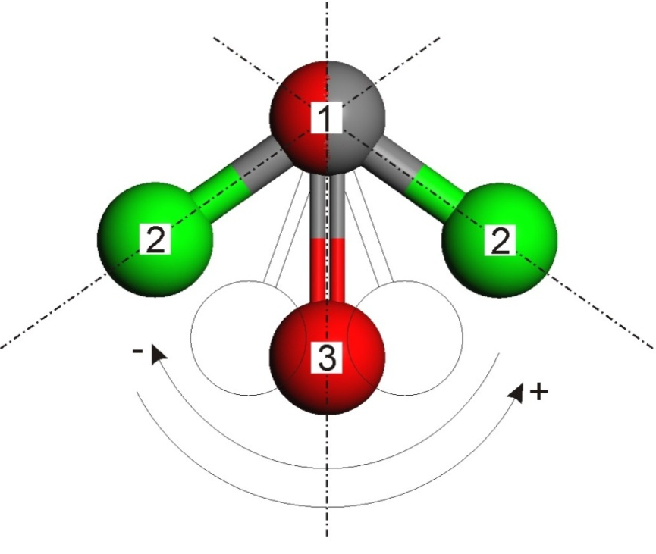
Figure 81 Tilt of carbonyl group to left (-) and right (+) directions to determine an optimum tilt angle. Numbers should be read as in Figure 76.
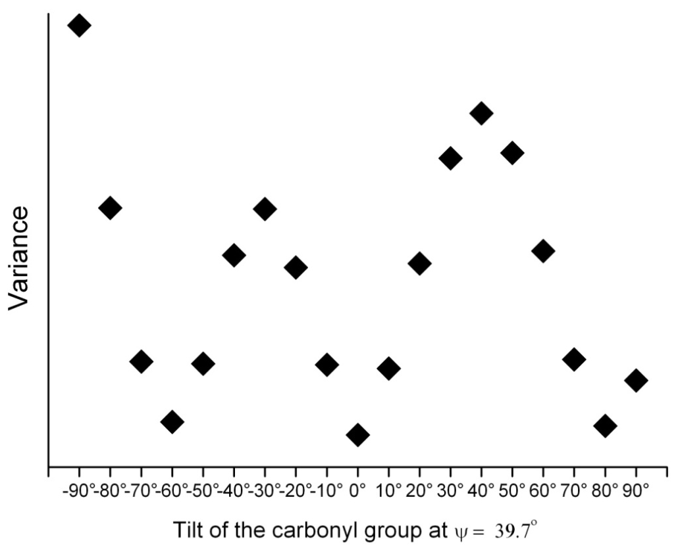
Figure 82 Graphical representation of the tilt of the carbonyl group best matching the value of intensity of equatorial reflections between the experimental and calculated X-ray diffraction patterns. The graph shows the value of 0°. The values of -60° and +80° are unphysical because of O…H clash.

3D structure
The all-trans conformation of the PHN chain is depicted in Figure 83. The crystal structure of the PHN was built of such chains where the carbonyl groups of the chains were randomly displaced along the c axis and randomly pointed in a direction perpendicular to the axis of the chains. As an example, a lattice of 3×3 unit cells is depicted in Figure 84 and Figure 85. Further, to develop randomization of the chains within the structure, which will be as close as possible to the real situation, bigger super cells were generated, i.e. 6×6, 9×9 and 12×12 (Figure 87). Their WAXS patterns were calculated. They will be discussed in the next section.
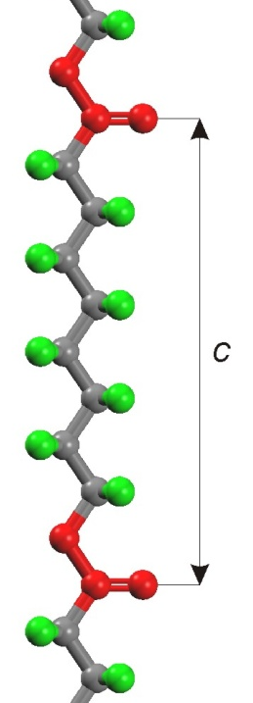
Figure 83 Ball and stick computer refined all-trans conformation of PHN chain with length, c = 12.37±02 Å.
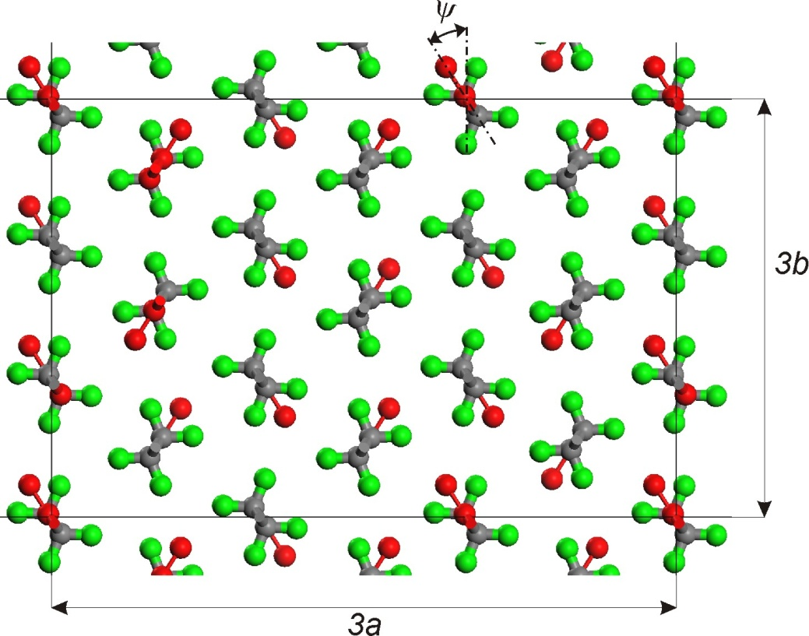
a)
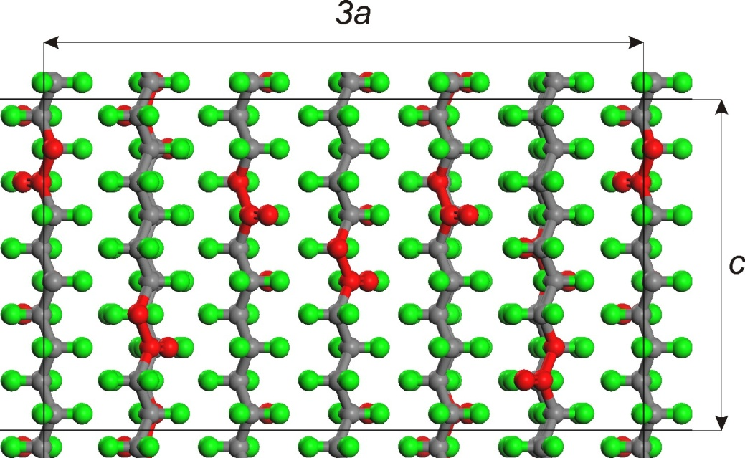
b)
Figure 84 Ball and stick model of the lattice of 3×3 unit cells where: a = 7.47 Å, b = 5.00 Å. (a) View is parallel to c axis showing setting angle of PHN chains in respect to ab basal plane, ψ = 32.7°, and showing random trend of carbonyl groups. Ball and stick model of the lattice of 3×3 unit cells where: a = 7.47 Å and c = 12.37 Å. (b) View is perpendicular to c axis showing random distribution of carbonyl groups along c axis.
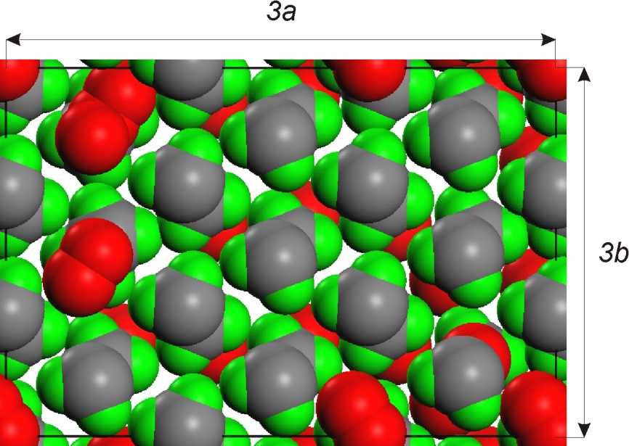
a)
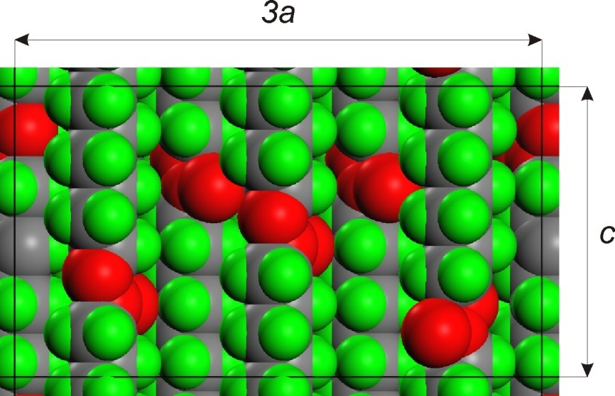
b)
Figure 85 As Figure 84 but in CPK to reveal good packing of the chains within the structure.
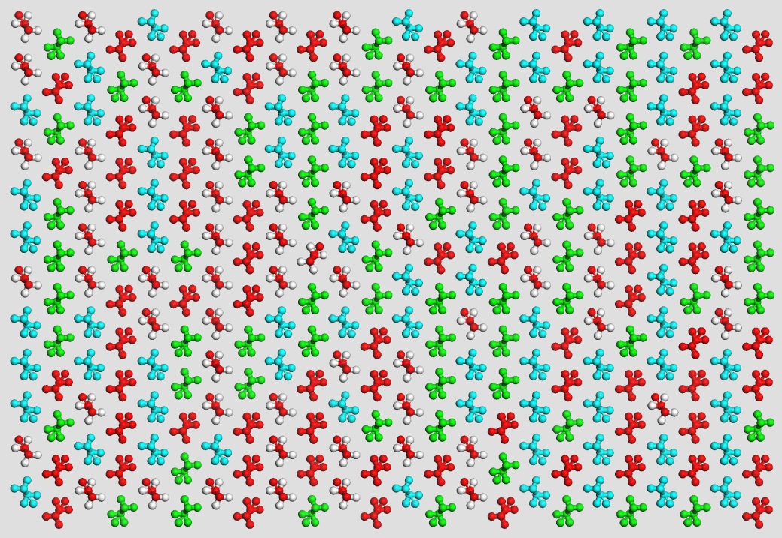
Figure 86 View parallel to c axis showing lattice of 12×12 unit cells where chains with the same direction of the carbonyl group perpendicular to the molecular chain are represented in different colours.

Comparison of the Calculated and Experimental X-ray Patterns
WAXS patterns of super cells with increasing numbers of unit cells within are depicted in Figure 87. It may be seen how Bragg spots on meridional layer lines develop into streaks for the large lattice of 12×12 unit cells (Figure 87). Comparison of the WAXS pattern of the largest super cell, 12×12, with the experimental WAXS pattern is shown in Figure 88. As may be observed, all the reflections on the experimental WAXS pattern match those on the calculated one. In order to best match the calculated WAXS pattern with the experimental one, geometrical and crystal size parameters used to display the calculated diffraction patterns were: azimuthal half-width = 3.5°, crystallite size along axes a, b and c = 200 × 200 × 200 Å. Moreover, there was distortion applied to the structure as follows: lattice strain along axes: 0.15 × 0.15 × 0.0 %, Debye Waller factor along axes: 0.15 × 0.15 × 0.0 A².
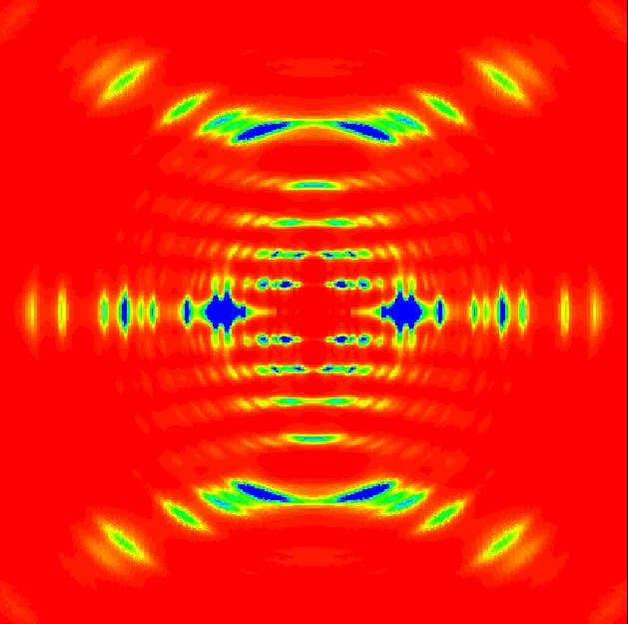 | 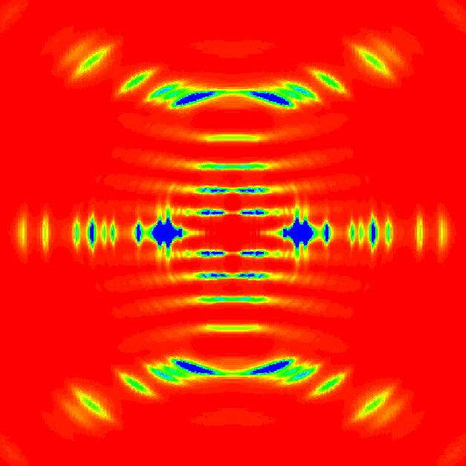
a) | b)
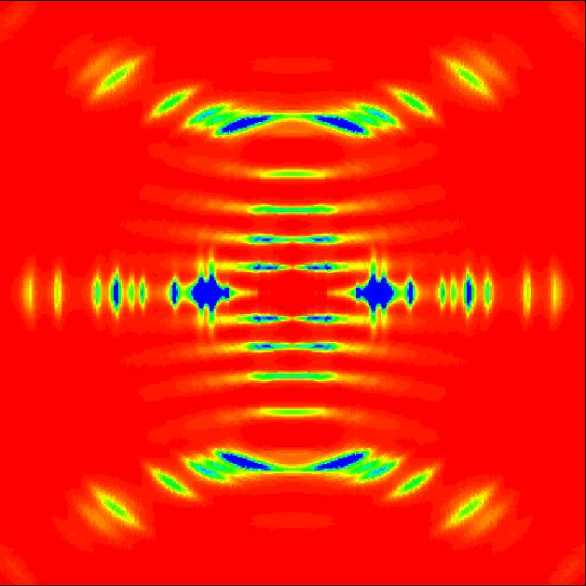 | 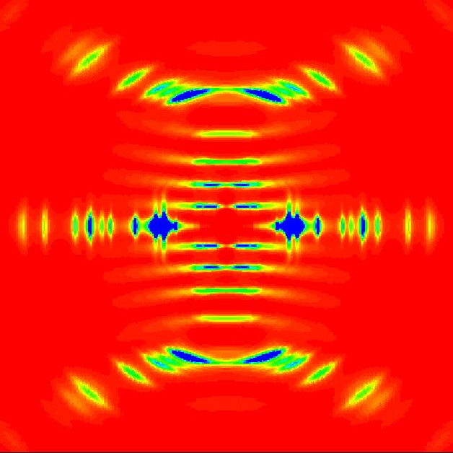
c) | d)
Figure 87 WAXS patterns of super cells: a) with no distortion showing the development of streaks. Geometrical and crystal size parameters used to display the calculated diffraction patterns were: azimuthal half-width = 3.5°, crystallite size along axes a, b and c = 150 × 150 × 150 Å,

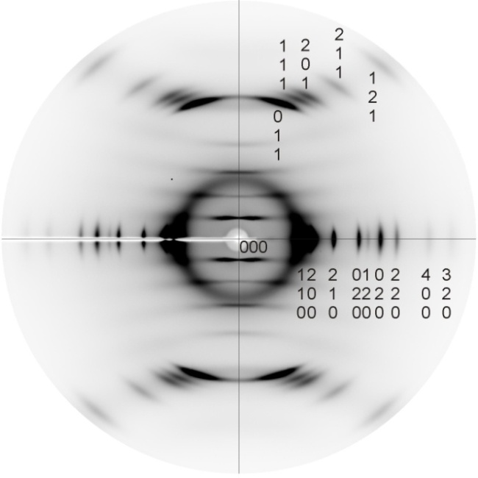 | 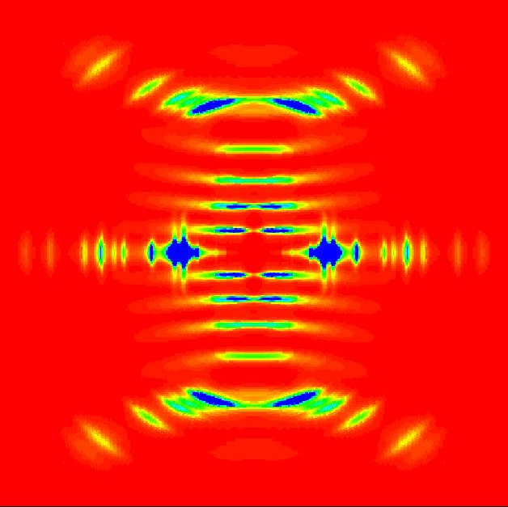
a) | b)
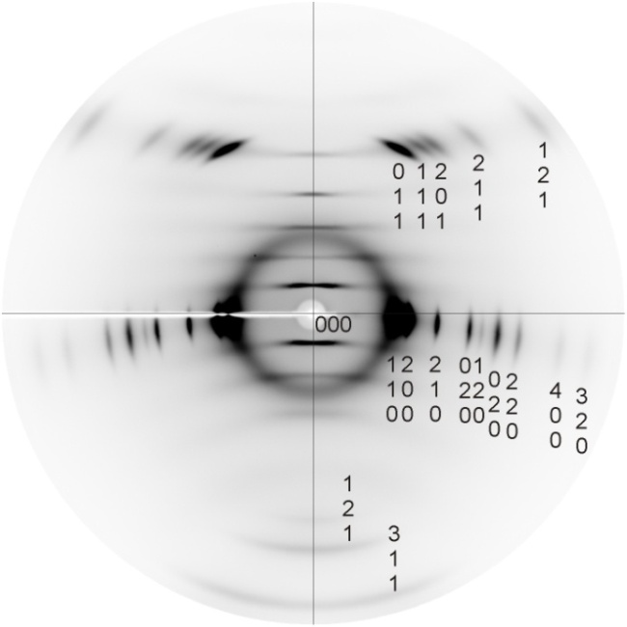 | 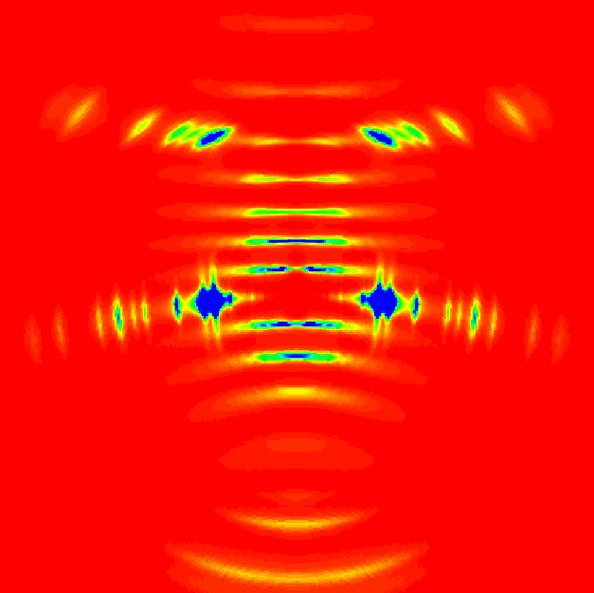
c) | d)
Figure 88 Comparison of the indexed experimental (a, c) and the calculated (b, d) WAXS fibre patterns of PHN crystal. In case of (a, b) the fibre axis is vertical, whereas in (c, d) it is inclined at 18.6° to the beam normal. Geometrical and crystal size parameters used to display the calculated diffraction patterns were: azimuthal half-width = 3.5°, crystallite size along axes a, b and c = 200 × 200 × 200 Å, lattice strain along axes: 0.15 × 0.15 × 0.0 %, Debye Waller factor along axes: 0.15 × 0.15 × 0.0 A².

Summary
The crystal structure of poly-9-hydroxynonanoate is established to be polyethylene-like except that the ester groups are randomly distributed throughout the lattice. The deviation from randomness, i.e. the constant distance between the ester groups along each individual chain gives rise to the false meridional streaks, the equivalent to diffuse scattering in single crystals with correlated fluctuations. The molecular chain of poly-9-hydroxynonanoate is determined to possess a planar zigzag conformation. Two of such chains are arranged within an orthorhombic unit cell with lattice parameters, a = 7.47 ± 0.02 Å, b = 5.00 ± 0.02 Å, c = 12.37 ± 0.02 Å, very similar to those of polyethylene, a = 7.40 ± 0.02 Ǻ, b = 4.93 ± 0.02 Ǻ, c = 2.53 ± 0.02 Ǻ. The space group is determined to be Pnam. The angle between the C-C-C... zigzag plane of poly-9-hydroxynonanoate and the b-axis is determined to be 32.7°. Torsion of the carbonyl group at this particular angle between the C-C-C... zigzag plane of poly-9-hydroxynonanoate and the b-axis is determined to be 0°. The diffraction pattern shows sharp equatorial reflections and a series of reflections on the non-equatorial layer line, although one could confuse it with the 5th layer line due to the presence of noncrystallographic meridional streaks of periodicity of 12 Å. Hitherto this is the first time that a space group for an aliphatic polyester of the type [-(CH₂)_{n}-CO-O-]_{x} with an even number of methylene units between successive ester groups is determined because poly-9-hydroxynonanoate is the first to show Bragg reflections on the non-equatorial layer line. In all previous cases studied there were no non-zero layer lines on the diffraction patterns and hence no space group could be determined. In fact, all previous polymers of the type [-(CH₂)_{m}-CO-O-]_{n,} with an even number of methylene units between successive ester groups, had no three-dimensional long range order but only two-dimensional and this is why, theoretically, they could be considered as columnar liquid crystals.

Chapter 9 – Conclusions and Further Works

9.1 Conclusions
Crystal structures of helical columnar π-conjugated systems, namely helicene-bisquinone and dendronized perylene bisimide derivative, as well as of a biodegradable aliphatic polyester, namely poly-9-hydroxynonanoate, have been resolved by means of fibre X-ray diffraction.
Enantiopure and racemic helicene-bisquinones are found to be organized into columnar liquid crystalline phases. The internal structure of the columns is 13₂ hollow helix with the asymmetric unit comprised of six molecules, Hence of 78 molecules and two turns in a period of 112 Å. The long-range order among the columns is found to be laterally high but
longitudinally low. This is the first atomic-level determination of a helical columnar liquid crystalline phase.
The crystal structure of N,N’-di-(3,4,5-dodecyloxy-oxyphenylethyl)-perylene bisimide is
approximated by distorted helical columns arranged within an orthorhombic unit cell with lattice parameters a = 70.2 ± 0.02 Å, b = 41.1 ± 0.02 Å, and c = 45.5 ± 0.02 Å. The space group is determined to be P2₁2₁2₁. The internal structure of the columns is
approximated by 6₁ helices. The structure is based on four-molecule repeat units (tetramers). There are 24 molecules and two turns in a 45.51 Å period of the distorted 6-fold helix.
The tetramer is comprised of 2 dimers (two boat-shaped molecules placed side-by-side) facing each other in the tetramer. The rotation angle between the dimers within the tetramer is 100°. Charge mobility along the columns has been found to depend
critically on the detailed molecular packing.
The crystal structure of poly-9-hydroxynonanoate is established to be polyethylene-like except that the ester groups are randomly distributed throughout the lattice. The molecular chain of poly-9-hydroxynonanoate is determined to possess planar zigzag conformation with two such chains arranged within an orthorhombic unit cell with lattice parameters, a =
7.47 ± 0.02 Å, b = 5.00 ± 0.02 Å and c = 2.47 ± 0.02 Å. The space group is determined to be Pnam. The angle between the C-C-C... zigzag plane of poly-9-hydroxynonanoateand the b – axis is determined to be 32.7°. Torsion of carbonyl group at this particular angle between the
C-C-C... zigzag plane of poly-9-hydroxynonanoateand the b – axis is determined to be 0°. itherto this is the first time that a space group for aliphatic polyester of the type [-(CH₂)_{n}-CO-O-]_{x} with even number of methylene units between successive ester groups is determined because poly-9-hydroxynonanoateis the first to show Bragg reflections on the non-equatorial layer line.

9.2 Further Work
The following could be done for the improvement of the fit between the
calculated and the experimental diffraction patterns in all three studies:
- More detailed investigation of the anisotropic thermal motions of the atoms in all three directions, i.e. along a, b and c. It should be taken into consideration that vibrations along a and b axes have large amplitudes than those along c axis. Numerical data retrieved from the experimental and calculated diffraction patterns may help to improve the fit between the experimental and the calculated patterns.
- More detailed investigation of the lattice distortion/strain in all three directions. It is possible that the crystal is bent in some way and the planes of atoms parallel to one of the three axes are distorted. The distribution of atomic displacements from the ideal position would be similar to those from anisotropic thermal vibrations. Again numerical data comparison could improve the fit between the experimental and the calculated patterns.
Additionally, in case of perylene bisimide derivative, it would be interesting to investigate how the structure relates to charge mobility.

Bibliography
1. Glatter, O. and O. Kratky, Small Angle X-ray Scattering. 1982: Academic Press.
2. Podorov, S.G., et al., A new approach to wide-angle dynamical X-ray diffraction by deformed crystals. Journal of Applied Crystallography, 2006. 39: p. 652-655.
3. Pickworth, J.G. and K.N. Trueblood, Crystal Structure Analysis: A Primer. 1972, London: Oxford University Press.
4. Wolfson, M.M., In introduction to X-ray Crystallography. 1970, Cambridge: Cambridge University Press.
5. Blundell, T.L. and L.N. Johnson, Protein Crystallography. 1976, London: Academic Press.
6. Ewald, P.P., Introduction to Dynamical Theory of X-Ray Diffraction. Acta Crystallographica Section a-Crystal Physics Diffraction Theoretical and General Crystallography, 1969. A 25: p. 103-&.
7. Hukins, D.W.L., X-ray Diffraction by Disordered and Ordered Systems. 1981, Oxford: Pergamon Press
8. Lipson, H. and C.A. Taylor, Fourier transforms and X-ray diffraction. 1958, London: Bell.
9. Crick, F., X-Ray Diffraction: Polypeptides and Proteins. 1953, Gonville and Caius College of Cambridge University: Cambridge
10. DNA. Available from: http://en.wikipedia.org/wiki/DNA.
11. Encyclopedia of Computational Chemistry. Geometry Optimization, ed. P.H.B. Schlegel. Vol. 1. 1998, USA: Wiley.
12. International Tables for Crystallography. Space-group symmetry, ed. T. Hahn. Vol. A 1996, Dordrecht: Kluwer Academic Publishers.
13. Shcherbina M. A., Z.X., Tadjiev T.R., Ungar G., Eichhorn S.H., Phillips K. E. S., Katz T., Hollow Six-Stranded Helical Columns of a Helicene. Angewandte Chemie, 2010(121): p. 7977-7980.
14. Petrovic, Z.S., et al., A Chemical Route to High Molecular Weight Vegetable Oil-Based Polyhydroxyalkanoate. Macromolecules, 2010. 43(9): p. 4120-4125.
15. Diamond Light Source Ltd. 2011; Available from: http://www.diamond.ac.uk/Home/Beamlines/I12.html.
16. Sheffield University. 2011; Available from: http://www.shef.ac.uk/mbb/research/plant/xtal.
17. Nyburg, S.C. and Potworow.Ja, Prediction of Units Cells and Atomic Coordinates for Normal Alkanes. Acta Crystallographica Section B-Structural Science, 1973. B 29(Feb15): p. 347-352.
18. Book, C. Chemical Book. 2010; Available from: http://www.chemicalbook.com/ChemicalProductProperty_EN_CB6425049.htm.
19. Terrill, N., S. King, and T. Wess, CCP13 in Fibre Diffraction and Solution Scattering. 2011.
20. Accelrys Software Inc, MS Modelling, ver. 4.0. 2005.
21. Casewit, C.J., K.S. Colwell, and A.K. Rappe, Application of a Universal Force-Field to Main Group Compounds. Journal of the American Chemical Society, 1992. 114(25): p. 10046-10053.
22. Casewit, C.J., K.S. Colwell, and A.K. Rappe, Application of a Universal Force-Field to Organic-Molecules. Journal of the American Chemical Society, 1992. 114(25): p. 10035-10046.
23. Rappe, A.K., et al., Uff, a Full Periodic-Table Force-Field for Molecular Mechanics and Molecular-Dynamics Simulations. Journal of the American Chemical Society, 1992. 114(25): p. 10024-10035.
24. Rappe, A.K., K.S. Colwell, and C.J. Casewit, Application of a Universal Force-Field to Metal-Complexes. Inorganic Chemistry, 1993. 32(16): p. 3438-3450.
25. Molecular Simulations Inc, Cerius2, ver. 3.8 1998.
26. Meisenheimer, J. and K. Witte, The reduction of 2-nitronaphthaline. Berichte Der Deutschen Chemischen Gesellschaft, 1903. 36: p. 4153-4164.
27. Newman, M.S. and M. Wolf, A New Synthesis of Benzo(C)Phenanthrene - 1,12-Dimethylbenzo(C)Phenanthrene. Journal of the American Chemical Society, 1952. 74(13): p. 3225-3228.
28. Newman, M.S., W.B. Lutz, and D. Lednicer, A New Reagent for Resolution by Complex Formation - the Resolution of Phenanthro-[3,4-C]Phenanthrene. Journal of the American Chemical Society, 1955. 77(12): p. 3420-3421.
29. Newman, M.S. and D. Lednicer, The Synthesis and Resolution of Hexahelicene. Journal of the American Chemical Society, 1956. 78(18): p. 4765-4770.
30. IUPAC. Compendium of Chemical Terminology, 2nd ed. (the "Gold Book"). 1997, Oxford Blackwell Scientific Publications.
31. Goedicke, C., Resolution and Racemization of Pentahelicene. Tetrahedron Letters, 1970(12): p. 937-&.
32. Lightner, D.A., et al., Hexahelicene - Absolute Configuration. Journal of the American Chemical Society, 1972. 94(10): p. 3492-3497.
33. Martin, R.H. and M.J. Marchant, Resolution and Optical-Properties ([Alpha]Max, Ord and Cd) of Hepta-Helicene, Octa-Helicene and Nonahelicene. Tetrahedron, 1974. 30(2): p. 343-345.
34. Martin, R.H. and M.J. Marchant, Thermal Racemization of Hepta-Helicene, Octa-Helicene, and Nonahelicene - Kinetic Results, Reaction Path and Experimental Proofs That Racemization of Hexahelicene and Heptahelicene Does Not Involve an Intramolecular Double Diels-Alder Reaction. Tetrahedron, 1974. 30(2): p. 347-349.
35. Kim, Y.H., et al., Chiral Differentiation by the P-(+)-Hexahelicene-7,7'-Dicarboxylic Acid Disodium Salt - Resolution of N-2,4-Dinitrophenyl-Alpha-Amino-Acid Esters by High-Performance Liquid-Chromatography. Journal of the Chemical Society-Chemical Communications, 1982(23): p. 1336-1337.
36. Yamada, K., H. Nakagawa, and H. Kawazura, Thermal Racemization of Thiaheterohelicenes. Bulletin of the Chemical Society of Japan, 1986. 59(8): p. 2429-2432.
37. Willmore, N.D., L.B. Liu, and T.J. Katz, A Diels-Alder Route to [5]-Helicenes and [6]-Helicenes. Angewandte Chemie-International Edition in English, 1992. 31(8): p. 1093-1095.
38. Tanaka, K., H. Osuga, and H. Suzuki, Diastereocontrolled Synthesis of Optically Pure Functionalized Heterohelicenes. Tetrahedron-Asymmetry, 1993. 4(8): p. 1843-1856.
39. Katz, T.J., Syntheses of functionalized and aggregating helical conjugated molecules. Angewandte Chemie-International Edition, 2000. 39(11): p. 1921-+.
40. Katz, T.J. and J. Pesti, Synthesis of a Helical Ferrocene. Journal of the American Chemical Society, 1982. 104(1): p. 346-347.
41. Dai, Y.J., T.J. Katz, and D.A. Nichols, Synthesis of a helical conjugated ladder polymer. Angewandte Chemie-International Edition in English, 1996. 35(18): p. 2109-2111.
42. Dai, Y.J. and T.J. Katz, Synthesis of helical conjugated ladder polymers. Journal of Organic Chemistry, 1997. 62(5): p. 1274-1285.
43. Fox, J.M., et al., Synthesis, self-assembly, and nonlinear optical properties of conjugated helical metal phthalocyanine derivatives. Journal of the American Chemical Society, 1999. 121(14): p. 3453-3459.
44. Lovinger, A.J., C. Nuckolls, and T.J. Katz, Structure and morphology of helicene fibers. Journal of the American Chemical Society, 1998. 120(2): p. 264-268.
45. Lovinger, A.J., C. Nuckolls, and T.J. Katz, Structure and morphology of helicene fibers (vol 120, pg 264, 1998). Journal of the American Chemical Society, 1998. 120(8): p. 1944-1944.
46. Nuckolls, C. and T.J. Katz, Synthesis, structure, and properties of a helical columnar liquid crystal. Journal of the American Chemical Society, 1998. 120(37): p. 9541-9544.
47. Nuckolls, C., et al., Synthesis and aggregation of a conjugated helical molecule. Journal of the American Chemical Society, 1999. 121(1): p. 79-88.
48. Nuckolls, C., et al., Circular dichroism and UV-visible absorption spectra of the Langmuir-Blodgett films of an aggregating helicene. Journal of the American Chemical Society, 1998. 120(34): p. 8656-8660.
49. Phillips, K.E.S., et al., Synthesis and properties of an aggregating heterocyclic helicene. Journal of the American Chemical Society, 2001. 123(48): p. 11899-11907.
50. Dreher, S.D., et al., Application of the Russig-Laatsch reaction to synthesize a bis[5]helicene chiral pocket for asymmetric catalysis. Journal of Organic Chemistry, 2000. 65(3): p. 815-822.
51. Weix, D.J., S.D. Dreher, and T.J. Katz, [5]HELOL phosphite: A helically grooved sensor of remote chirality. Journal of the American Chemical Society, 2000. 122(41): p. 10027-10032.
52. Wang, D.Z.G. and T.J. Katz, A [5]HELOL analogue that senses remote chirality in alcohols, phenols, amines, and carboxylic acids. Journal of Organic Chemistry, 2005. 70(21): p. 8497-8502.
53. Martin, R.H., The Helicenes. Angewandte Chemie-International Edition in English, 1974. 13(10): p. 649-659.
54. Grimme, S., et al., Structure/Chiroptics relationships of planar chiral and helical molecules. European Journal of Organic Chemistry, 1998(8): p. 1491-1509.
55. Urbano, A., Recent developments in the synthesis of helicene-like molecules. Angewandte Chemie-International Edition, 2003. 42(34): p. 3986-3989.
56. Collins, S.K. and M.P. Vachon, Unlocking the potential of thiaheterohelicenes: chemical synthesis as the key. Organic & Biomolecular Chemistry, 2006. 4(13): p. 2518-2524.
57. Stulen, G. and G.J. Visser, Crystal Structure of a Heterohelicene. Journal of the Chemical Society D-Chemical Communications, 1969(17): p. 965-&.
58. Herraez, M.A. and F. Sanchez, Estructura Molecular Del Fenantro (3,4c) Fenantreno. Anales De La Real Sociedad Espanola De Fisica Y Quimica Seria B-Quimica, 1965. B 61(9-10): p. 953-&.
59. Mackay, I.R., Robertso.Jm, and J.G. Sime, Crystal Structure of Hexahelicene. Journal of the Chemical Society D-Chemical Communications, 1969(24): p. 1470-&.
60. Frank, G.W., Hefelfin.Dt, and D.A. Lightner, Crystal and Molecular-Structure of 2-Methylhexahelicene. Acta Crystallographica Section B-Structural Science, 1973. B 29(Feb15): p. 223-230.
61. Doolittl.Re and C.K. Bradsher, Phenanthridizinium Derivatives by Photochemical Cyclodehydrogenation of 1-Styrylpyridinium Salts. Chemistry & Industry, 1965(38): p. 1631-&.
62. Doolittl.Re and C.K. Bradsher, Photochemical Methods in Synthesis of Heterocyclic Compounds .I. Phenanthridizinium Perchlorates. Journal of Organic Chemistry, 1966. 31(8): p. 2616-&.
63. Laarhove.Wh and T.J.H.M. Cuppen, Conformational Studies on Hexahelicenes .4. Conformation of 1,16-Dimethylhexahelicene. Tetrahedron, 1974. 30(9): p. 1101-1106.
64. Verbiest, T., et al., Second-order nonlinear optical properties of highly symmetric chiral thin films. Langmuir, 2001. 17(16): p. 4685-4687.
65. Vyklicky, L., S.H. Eichhorn, and T.J. Katz, Helical discotic liquid crystals. Chemistry of Materials, 2003. 15(19): p. 3594-3601.
66. Nuckolls, C., T.J. Katz, and L. Castellanos, Aggregation of conjugated helical molecules. Journal of the American Chemical Society, 1996. 118(15): p. 3767-3768.
67. Busson, B., et al., Quasi-phase-matching in chiral materials. Physical Review Letters, 2000. 84(1): p. 79-82.
68. Van Elshocht, S., et al., Beneficial effect of heating on the morphology and second-order nonlinear optical efficiency of anisotropic thin films. Chemical Physics Letters, 2000. 323(3-4): p. 340-344.
69. Glusen, B., A. Kettner, and J.H. Wendorff, A plastic columnar discotic phase. Molecular Crystals and Liquid Crystals Science and Technology Section a-Molecular Crystals and Liquid Crystals, 1997. 303: p. 115-120.
70. Kwon, Y.K., et al., Supramolecular Tubular Structures of a Polymethacrylate with Tapered Side-Groups in Aligned Hexagonal Phases. Macromolecules, 1994. 27(21): p. 6129-6132.
71. Kwon, Y.K., et al., Effect of Temperature on the Supramolecular Tubular Structure in Oriented Fibers of a Poly(Methacrylate) with Tapered Side-Groups. Macromolecules, 1995. 28(5): p. 1552-1558.
72. Kwon, Y.K., et al., Comparison of the Supramolecular Structures Formed by a Polymethacrylate with a Highly Tapered Side-Chain and Its Monomeric Precursor. Macromolecular Symposia, 1994. 87: p. 103-114.
73. Chvalun, S.N., et al., Two- and three-dimensional mesophases formed by monodendrons based on gallic acid with partially fluorinated alkyl tails. Polymer Science Series A, 2002. 44(12): p. 1281-1289.
74. Law, K.Y., Organic Photoconductive Materials - Recent Trends and Developments. Chemical Reviews, 1993. 93(1): p. 449-486.
75. Neuteboom, E.E., et al., Photoluminescence of self-organized perylene bisimide polymers. Macromolecular Chemistry and Physics, 2004. 205(2): p. 217-222.
76. Langhals, H., J. Karolin, and L.B.A. Johansson, Spectroscopic properties of new and convenient standards for measuring fluorescence quantum yields. Journal of the Chemical Society-Faraday Transactions, 1998. 94(19): p. 2919-2922.
77. Quante, H., Y. Geerts, and K. Mullen, Synthesis of soluble perylenebisamidine derivatives. Novel long-wavelength absorbing and fluorescent dyes. Chemistry of Materials, 1997. 9(2): p. 495-500.
78. Chen, Z.J., et al., Tetrachloro-substituted perylene bisimide dyes as promising n-type organic semiconductors: Studies on structural, electrochemical and charge transport properties. Chemphyschem, 2004. 5(1): p. 137-140.
79. Salbeck, J., et al., Electron-Transfer (Et) Behavior of Fluorescent Dyes - Studied in Perylenebisdicarboximides and Dioxaindenoindenedione Using Cyclovoltammetry and Uv/Vis-Spectroelectrochemistry. Chimia, 1989. 43(1-2): p. 6-9.
80. Ahrens, M.J., M.J. Fuller, and M.R. Wasielewski, Cyanated perylene-3,4-dicarboximides and perylene-3,4 : 9,10-bis(dicarboximide): Facile chromophoric oxidants for organic photonics and electronics. Chemistry of Materials, 2003. 15(14): p. 2684-2686.
81. Y. Zhao, M.R.W., Tetrahedron Letters, 1999(40): p. 7047.
82. Lukas, A.S., et al., Biomimetic electron transfer using low energy excited states: A green perylene-based analogue of chlorophyll a. Journal of Physical Chemistry B, 2002. 106(6): p. 1299-1306.
83. Würthner, F., et al., Fluorescent J-type aggregates and thermotropic columnar mesophases of perylene bisimide dyes. Chemistry-a European Journal, 2001. 7(10): p. 2245-2253.
84. Lee, S.K., et al., Electrochemistry, spectroscopy and electrogenerated chemiluminescence of perylene, terrylene, and quaterrylene diimides in aprotic solution. Journal of the American Chemical Society, 1999. 121(14): p. 3513-3520.
85. Hassheider, T., et al., Color-tuned electroluminescence from columnar liquid crystalline alkyl arenecarboxylates. Angewandte Chemie-International Edition, 2001. 40(11): p. 2060-2063.
86. Alibert-Fouet, S., et al., Electroluminescent diodes from complementary discotic benzoperylenes. Chemphyschem, 2003. 4(9): p. 983-985.
87. Struijk, C.W., et al., Liquid crystalline perylene diimides: Architecture and charge carrier mobilities. Journal of the American Chemical Society, 2000. 122(45): p. 11057-11066.
88. Strohriegl, P. and J.V. Grazulevicius, Charge-transporting molecular glasses. Advanced Materials, 2002. 14(20): p. 1439-+.
89. Horowitz, G., et al., Evidence for n-type conduction in a perylene tetracarboxylic diimide derivative. Advanced Materials, 1996. 8(3): p. 242-&.
90. Schlettwein, D., et al., Conduction Type of Substituted Tetraazaporphyrins and Perylene Tetracarboxylic Acid Diimides as Detected by Thermoelectric-Power Measurements. Chemistry of Materials, 1994. 6(1): p. 3-6.
91. Malenfant, P.R.L., et al., N-type organic thin-film transistor with high field-effect mobility based on a N,N-'-dialkyl-3,4,9,10-perylene tetracarboxylic diimide derivative. Applied Physics Letters, 2002. 80(14): p. 2517-2519.
92. Seybold, G. and A. Stange. 1987.
93. Seybold, G. and G. Wagenblast, New Perylene and Violanthrone Dyestuffs for Fluorescent Collectors. Dyes and Pigments, 1989. 11(4): p. 303-317.
94. Ford, W.E. and P.V. Kamat, Photochemistry of 3,4,9,10-Perylenetetracarboxylic Dianhydride Dyes .3. Singlet and Triplet Excited-State Properties of the Bis(2,5-Di-Tert-Butylphenyl)Imide Derivative. Journal of Physical Chemistry, 1987. 91(25): p. 6373-6380.
95. Schmidt-Mende, L., et al., Self-organized discotic liquid crystals for high-efficiency organic photovoltaics. Science, 2001. 293(5532): p. 1119-1122.
96. Li, Y.J., et al., Self-assembled monolayers of C-60-perylenetetracarboxylic diimide-C-60 triad on indium tin oxide surface. Carbon, 2005. 43(9): p. 1968-1975.
97. Tang, C.W., 2-Layer Organic Photovoltaic Cell. Applied Physics Letters, 1986. 48(2): p. 183-185.
98. Schmidt, C.D., C. Boettcher, and A. Hirsch, Synthesis and aggregation properties of water-soluble Newkome-dendronized perylenetracarboxdiimides. European Journal of Organic Chemistry, 2007(33): p. 5497-5505.
99. Dimitrakopoulos, C.D. and P.R.L. Malenfant, Organic thin film transistors for large area electronics. Advanced Materials, 2002. 14(2): p. 99-+.
100. Horowitz, G., Organic field-effect transistors. Advanced Materials, 1998. 10(5): p. 365-377.
101. Katz, H.E., Z. Bao, and S.L. Gilat, Synthetic Chemistry for Ultrapure, Processable, and High-Mobility Organic Transistor Semiconductors. Accounts of Chemical Research 2001. 34(5).
102. Kraft, A., Organic field-effect transistors - The breakthrough at last. Chemphyschem, 2001. 2(3): p. 163-165.
103. Würthner, F., Plastic transistors reach maturity for mass applications in microelectronics. Angewandte Chemie-International Edition, 2001. 40(6): p. 1037-+.
104. Würthner, F., Kunststoff-Transistoren werden reif für Massenanwendungen in der Mikroelektronik. Angewandte Chemie, 2001. 113(6).
105. Würthner, F. and R. Schmidt, Electronic and crystal engineering of acenes for solution-processible self-assembling organic semiconductors. Chemphyschem, 2006. 7(4): p. 793-797.
106. Kraft, A., A.C. Grimsdale, and A.B. Holmes, Electroluminescent conjugated polymers - Seeing polymers in a new light. Angewandte Chemie-International Edition, 1998. 37(4): p. 402-428.
107. Kalinowski, J., et al., Voltage-induced evolution of emission spectra in organic light-emitting diodes. Journal of Applied Physics, 1998. 83(8): p. 4242-4248.
108. Karapire, C., C. Zafer, and S. Icli, Studies on photophysical and electrochemical properties of synthesized hydroxy perylenediimides in nanostructured titania thin films. Synthetic Metals, 2004. 145(1): p. 51-60.
109. Pan, J.F., et al., Dendron-functionalized zed perylene diimides with carrier-transporting ability for red luminescent materials. Polymer, 2005. 46(18): p. 7658-7669.
110. Gvishi, R., R. Reisfeld, and Z. Burshtein, Spectroscopy and Laser Action of the Red Perylimide Dye in Various Solvents. Chemical Physics Letters, 1993. 213(3-4): p. 338-344.
111. Sadrai, M., et al., Lasing Action in a Family of Perylene Derivatives - Singlet Absorption and Emission-Spectra, Triplet Absorption and Oxygen Quenching Constants, and Molecular Mechanics and Semiempirical Molecular-Orbital Calculations. Journal of Physical Chemistry, 1992. 96(20): p. 7988-7996.
112. Lohmannsroben, H.G. and H. Langhals, Laser Performance of Perylenebis(Dicarboximide) Dyes with Long Secondary Alkyl Chains. Applied Physics B-Photophysics and Laser Chemistry, 1989. 48(6): p. 449-452.
113. Langhals, H., Cyclic Carboxylic Imide Structures as Structure Elements of High-Stability - Novel Developments in Perylene Dye Chemistry. Heterocycles, 1995. 40(1): p. 477-500.
114. Oneil, M.P., et al., Picosecond Optical Switching Based on Biphotonic Excitation of an Electron Donor-Acceptor-Donor Molecule. Science, 1992. 257(5066): p. 63-65.
115. DeSchryver, F.C., et al., Energy Dissipation in Multichromophoric Single Dendrimers. Accounts of Chemical Research, 2005. 38(7).
116. Sautter, A., et al., Ultrafast energy-electron transfer cascade in a multichromophoric light-harvesting molecular square. Journal of the American Chemical Society, 2005. 127(18): p. 6719-6729.
117. Ishi-i, T., et al., Light-harvesting and energy-transfer system based on self-assembling perylene diimide-appended hexaazatriphenylene. Organic Letters, 2005. 7(15): p. 3175-3178.
118. Prodi, A., et al., Wavelength-dependent electron and energy transfer pathways in a side-to-face ruthenium porphyrin/perylene bisimide assembly. Journal of the American Chemical Society, 2005. 127(5): p. 1454-1462.
119. Beckers, E.H.A., et al., Charge separation and recombination in photoexcited oligo(p-phenylene vinylene): Perylene bisimide arrays close to the marcus inverted region. Journal of Physical Chemistry A, 2004. 108(34): p. 6933-6937.
120. Cormier, R.A. and B.A. Gregg, Self-Organization in Thin Films of Liquid Crystalline Perylene Diimides. The Journal of Physical Chemistry B, 1997. 101.
121. Cormier, R.A. and B.A. Gregg, Synthesis and characterization of liquid crystalline perylene diimides. Chemistry of Materials, 1998. 10(5): p. 1309-1319.
122. Göltner C., P.D., Müllen K. and Spiess H.W., Liquid-Crystalline Perylene Derivatives as “Discotic Pigments”. Angewandte Chemie International Edition, 1993. 32(11).
123. Graser, F. and E. Hadicke, Crystal-Structure and Color of Perylene-3,4-9,10-Bis(Dicarboximide) Pigments .2. Liebigs Annalen Der Chemie, 1984(3): p. 483-494.
124. Hadicke, E. and F. Graser, Structures of 11 Perylene-3,4-9,10-Bis(Dicarboximide) Pigments. Acta Crystallographica Section C-Crystal Structure Communications, 1986. 42: p. 189-195.
125. Hadicke, E. and F. Graser, Structures of 3 Perylene-3,4-9,10-Bis(Dicarboximide) Pigments. Acta Crystallographica Section C-Crystal Structure Communications, 1986. 42: p. 195-198.
126. Klebe, G., et al., Crystallochromy as a Solid-State Effect - Correlation of Molecular-Conformation, Crystal Packing and Color in Perylene-3,4-9,10-Bis(Dicarboximide) Pigments. Acta Crystallographica Section B-Structural Science, 1989. 45: p. 69-77.
127. Würthner, F., Perylene bisimide dyes as versatile building blocks for functional supramolecular architectures. Chemical Communications, 2004(14): p. 1564-1579.
128. Zugenmaier, P., J. Duff, and T.L. Bluhm, Crystal and molecular structures of six differently with halogen substituted bis (benzylimido) perylene. Crystal Research and Technology, 2000. 35(9): p. 1095-1115.
129. Mizuguchi, J., N,N '-bis(2-phenethyl)perylene-3,4 : 9,10-bis(dicarboximide). Acta Crystallographica Section C-Crystal Structure Communications, 1998. 54: p. 1479-1481.
130. Mizuguchi, J., et al., N,N '-di-2-pyridylperylene-3,4 : 9,10-bis(dicarboximide). Acta Crystallographica Section E-Structure Reports Online, 2005. 61: p. O437-O439.
131. Mizuguchi, J., et al., N,N '-di-3-pyridylperylene-3,4 : 9,10-bis-(dicarboximide). Acta Crystallographica Section E-Structure Reports Online, 2005. 61: p. O434-O436.
132. Chen, Z.J., et al., Photoluminescence and conductivity of self-assembled pi-pi stacks of perylene bisimide dyes. Chemistry-a European Journal, 2007. 13(2): p. 436-449.
133. Forrest, S.R., M.L. Kaplan, and P.H. Schmidt, Organic-on-Inorganic Semiconductor Contact Barrier Diodes .1. Theory with Applications to Organic Thin-Films and Prototype Devices. Journal of Applied Physics, 1984. 55(6): p. 1492-1507.
134. Accelrys Software Inc., MS Modelling. 2005.
135. Chatani, Y., et al., Structural Studies of Polyesters .I. Crystal Structure of Polyglycolide. Makromolekulare Chemie-Macromolecular Chemistry and Physics, 1968. 113(Apr): p. 215-&.
136. Bunn, C.W., The crystal structure of long-chain normal paraffin hydrocarbons. The "shape" of the > CH2 group. Transactions of the Faraday Society, 1939. 35(1): p. 0482-0490.
137. Suehiro, K., Y. Chatani, and H. Tadokoro, Structural Studies of Polyesters .6. Disordered Crystal-Structure (Form-2 of Poly(Beta-Propiolactone). Polymer Journal, 1975. 7(3): p. 352-358.
138. Furuhashi, Y., et al., Structure and morphology of the aliphatic polyester poly-beta-propiolactone in solution-grown chain-folded lamellar crystals. Macromolecules, 2000. 33(25): p. 9423-9431.
139. Pazur, R.J., et al., Molecular modelling of helical and extended-chain polyhydroxybutyrates and polytetramethylene succinate. Polymer, 1998. 39(14): p. 3065-3072.
140. Su, F.Y., et al., Electron and X-ray diffraction study on poly (4-hydroxybutyrate). Polymer, 2001. 42(21): p. 8915-8918.
141. Mitomo, H., et al., Polemer Preprints, Japan, 1995. 44.
142. Okamura, S., et al., Infra-Red Absorption Spectrum of Poly-Beta-Propiolactone Obtained by 2 Kinds of Ionic Polymerization. Makromolekulare Chemie, 1962. 54: p. 226-229.
143. Furuhashi, Y., et al., Structure and morphology of the aliphatic polyester poly (delta-valerolactone) in solution-grown, chain-folded lamellar crystals. Journal of Polymer Science Part B-Polymer Physics, 2001. 39(21): p. 2622-2634.
144. Chatani, Y., et al., Structural studies of polyesters. III. Crystal structure of poly-ε-caprolactone. Polymer Journal, 1970. 1(5).
145. Bittiger, H. and R.H. Marchessault, Crystal structure of poly(ε-caprolactone). Acta Crystallographica, 1970. B26.
146. Hu, H.L. and D.L. Dorset, Crystal-Structure of Poly(Epsilon-Caprolactone). Macromolecules, 1990. 23(21): p. 4604-4607.
147. Dorset, D.L., Chain-Length and the Cosolubility of N-Paraffins in the Solid-State. Macromolecules, 1990. 23(2): p. 623-633.
148. Fuller, C.S. and C.J. Frosch, Further investigation of the chain structure of linear polyesters. Journal of Physical Chemistry, 1939. 43(3): p. 323-334.
149. Montes, H. and I.M. Ward, Structure and mechanical properties of PGA crystals and fibres. Polymer, 2006. 47.
150. Okamura, S., Y. Kitanishi, and K. Hayashi, Radiation-Induced Solid-State Polymerization of Ring Compounds. Journal of Polymer Science, 1962. 58(166): p. 925-&.
151. Dorset, D.L., Direct determination of polymer crystal structures from fibre and powder X-ray data. Polymer, 1996. 38(2).

Appendix 1
Table 10 Atom coordinates of the helicene-bisquinone molecule
atom | x_{real} | y_{real} | z_{real} | x | y | z
C | 3.78 | -6.31 | -2.25 | 945.75 | -1577.00 | -200.89
C | -0.48 | -5.77 | 1.12 | -120.25 | -1442.25 | 99.60
C | -3.14 | -6.62 | 1.56 | -784.50 | -1654.25 | 139.08
S | -2.45 | -9.16 | 0.79 | -613.00 | -2291.00 | 70.84
C | -0.23 | -8.04 | -0.01 | -56.75 | -2010.75 | -0.71
C | -0.87 | -9.27 | 0.13 | -218.00 | -2317.50 | 11.70
C | -0.23 | -10.48 | -0.24 | -57.00 | -2618.75 | -21.26
C | 1.09 | -10.41 | -0.75 | 272.50 | -2602.75 | -67.08
C | 1.65 | -9.16 | -1.03 | 413.50 | -2288.75 | -91.56
C | 0.95 | -7.98 | -0.80 | 236.50 | -1995.25 | -71.19
H | 1.83 | -11.57 | -1.04 | 456.25 | -2891.25 | -93.17
H | 1.35 | -12.43 | -0.82 | 337.75 | -3107.75 | -73.25
H | -0.84 | -11.73 | -0.07 | -209.00 | -2931.25 | -5.90
H | -1.77 | -11.70 | 0.33 | -442.00 | -2924.00 | 29.03
C | -2.19 | -7.49 | 1.02 | -546.25 | -1872.50 | 91.47
C | -0.92 | -7.05 | 0.68 | -229.25 | -1761.25 | 60.56
C | 1.59 | -6.90 | -1.41 | 396.50 | -1726.00 | -125.59
C | 2.87 | -7.26 | -1.79 | 718.50 | -1815.50 | -159.45
S | 3.22 | -8.94 | -1.68 | 805.25 | -2234.00 | -149.98
C | -1.46 | -4.85 | 1.56 | -364.00 | -1211.75 | 139.62
C | -2.78 | -5.27 | 1.77 | -696.00 | -1318.25 | 157.66
H | -4.42 | -7.08 | 1.85 | -1105.25 | -1771.00 | 165.61
H | -5.03 | -6.37 | 2.24 | -1257.75 | -1593.25 | 200.27
H | -3.53 | -4.58 | 2.14 | -881.50 | -1144.50 | 190.89
C | 1.09 | -5.62 | -1.75 | 272.75 | -1405.00 | -156.05
C | 2.02 | -4.62 | -2.12 | 505.25 | -1155.75 | -189.64
C | 3.37 | -4.97 | -2.35 | 841.50 | -1242.50 | -210.27
H | 5.09 | -6.69 | -2.58 | 1271.75 | -1672.50 | -230.10
H | 5.67 | -5.92 | -2.90 | 1416.25 | -1480.50 | -258.69
H | 4.08 | -4.22 | -2.67 | 1018.75 | -1053.75 | -238.59
C | 0.95 | -5.39 | 1.29 | 236.75 | -1348.00 | 115.50
C | 1.31 | -3.98 | 1.49 | 326.75 | -994.25 | 132.92
C | 0.37 | -3.06 | 1.74 | 92.00 | -765.50 | 155.43
C | -1.05 | -3.45 | 1.85 | -262.75 | -862.25 | 165.16
O | 1.82 | -6.24 | 1.37 | 454.00 | -1560.50 | 122.38
H | 2.35 | -3.68 | 1.46 | 587.25 | -920.25 | 130.50
H | 0.66 | -2.03 | 1.90 | 164.25 | -507.75 | 169.72
O | -1.88 | -2.61 | 2.17 | -469.25 | -652.75 | 193.39
C | -0.35 | -5.30 | -1.90 | -88.25 | -1324.50 | -169.36
C | -0.78 | -3.89 | -1.99 | -195.00 | -972.50 | -177.49
C | 0.12 | -2.92 | -2.17 | 28.75 | -729.25 | -193.66
C | 1.55 | -3.23 | -2.30 | 387.50 | -806.75 | -205.72
O | -1.18 | -6.18 | -2.04 | -295.75 | -1544.75 | -181.87
H | -1.83 | -3.65 | -1.94 | -458.50 | -911.50 | -173.29
H | -0.22 | -1.89 | -2.25 | -55.25 | -472.75 | -201.16
O | 2.34 | -2.33 | -2.55 | 584.00 | -582.50 | -228.05

Appendix 2
Table 11 Observed reflections from PBI 12-2 fibre
d_{obs}, Å | d_{calc}, Å | dev, % | h | k | l | qualitative I_{obs}*
35.35 | 35.47 | 0.36 | 1 | 1 | 0 | VS
35.35 | 35.12 | 0.64 | 2 | 0 | 0 | VS
27.97 | 27.98 | 0.03 | 1 | 1 | 1 | VS
27.97 | 27.80 | 0.60 | 2 | 0 | 1 | VS
23.07 | 23.03 | 0.16 | 2 | 1 | 1 | VS
22.75 | 22.76 | 0.01 | 0 | 0 | 2 | VS
20.46 | 20.55 | 0.45 | 0 | 2 | 0 | M
20.46 | 20.34 | 0.57 | 3 | 1 | 0 | M
19.99 | 19.91 | 0.40 | 0 | 1 | 2 | VS
19.19 | 19.15 | 0.19 | 1 | 1 | 2 | VS
19.19 | 19.10 | 0.48 | 2 | 0 | 2 | VS
17.67 | 17.74 | 0.38 | 2 | 2 | 0 | M
17.67 | 17.56 | 0.63 | 4 | 0 | 0 | S
17.29 | 17.32 | 0.17 | 2 | 1 | 2 | VW
16.45 | 16.53 | 0.47 | 2 | 2 | 1 | M
16.45 | 16.38 | 0.40 | 4 | 0 | 1 | W
15.19 | 15.25 | 0.42 | 0 | 2 | 2 | W
15.19 | 15.17 | 0.14 | 3 | 1 | 2 | W
14.89 | 14.90 | 0.07 | 1 | 2 | 2 | W
13.90 | 13.99 | 0.66 | 2 | 2 | 2 | S
13.87 | 13.95 | 0.60 | 1 | 1 | 3 | VW
13.91 | 13.93 | 0.12 | 2 | 0 | 3 | VW
13.90 | 13.90 | 0.04 | 4 | 0 | 2 | S
13.10 | 13.19 | 0.67 | 2 | 1 | 3 | VW
12.79 | 12.81 | 0.16 | 4 | 2 | 1 | W
12.69 | 12.78 | 0.74 | 3 | 2 | 2 | VW
12.79 | 12.76 | 0.24 | 5 | 1 | 1 | W
11.51 | 11.58 | 0.59 | 1 | 3 | 2 | W
11.47 | 11.51 | 0.39 | 4 | 2 | 2 | M
11.47 | 11.48 | 0.07 | 5 | 1 | 2 | M
11.41 | 11.44 | 0.30 | 3 | 3 | 1 | VW
11.35 | 11.38 | 0.29 | 0 | 0 | 4 | VS
10.82 | 10.83 | 0.16 | 1 | 1 | 4 | VS
10.82 | 10.82 | 0.03 | 2 | 0 | 4 | VS
10.38 | 10.47 | 0.81 | 2 | 1 | 4 | VW
10.35 | 10.33 | 0.17 | 5 | 2 | 2 | W
9.92 | 9.95 | 0.38 | 0 | 2 | 4 | VS
9.92 | 9.93 | 0.10 | 3 | 1 | 4 | VS
9.92 | 9.86 | 0.62 | 1 | 2 | 4 | VS
9.52 | 9.58 | 0.56 | 2 | 2 | 4 | VW
9.08 | 9.16 | 0.83 | 3 | 2 | 4 | W
8.82 | 8.82 | 0.03 | 1 | 1 | 5 | VS
8.82 | 8.81 | 0.10 | 2 | 0 | 5 | VS
8.71 | 8.75 | 0.49 | 0 | 3 | 4 | M
8.62 | 8.69 | 0.75 | 1 | 3 | 4 | M
8.71 | 8.66 | 0.59 | 4 | 2 | 4 | M
8.62 | 8.64 | 0.27 | 5 | 1 | 4 | M
8.62 | 8.64 | 0.27 | 5 | 1 | 4 | M
8.30 | 8.32 | 0.27 | 0 | 2 | 5 | VS
8.30 | 8.31 | 0.10 | 3 | 1 | 5 | VS
8.30 | 8.26 | 0.43 | 1 | 2 | 5 | VS
8.14 | 8.12 | 0.23 | 5 | 2 | 4 | VW
7.86 | 7.84 | 0.23 | 3 | 2 | 5 | W
7.58 | 7.54 | 0.54 | 1 | 3 | 5 | VW
7.51 | 7.54 | 0.37 | 1 | 3 | 5 | VW
7.49 | 7.52 | 0.40 | 4 | 2 | 5 | VW
7.49 | 7.51 | 0.27 | 5 | 1 | 5 | VW
7.45 | 7.46 | 0.12 | 0 | 1 | 6 | VS
7.41 | 7.45 | 0.56 | 2 | 4 | 4 | VW
7.41 | 7.43 | 0.25 | 5 | 3 | 4 | VW
7.46 | 7.42 | 0.60 | 1 | 1 | 6 | VS
7.46 | 7.41 | 0.62 | 2 | 0 | 6 | VS
7.38 | 7.41 | 0.41 | 2 | 3 | 5 | VW
6.99 | 6.99 | 0.06 | 4 | 4 | 4 | VW
6.64 | 6.66 | 0.34 | 0 | 5 | 4 | VW
6.64 | 6.63 | 0.10 | 1 | 5 | 4 | VW
6.60 | 6.61 | 0.08 | 1 | 3 | 6 | VW
6.38 | 6.39 | 0.26 | 1 | 1 | 7 | S
6.38 | 6.39 | 0.20 | 2 | 0 | 7 | M
6.34 | 6.32 | 0.37 | 2 | 1 | 7 | M
4.52 | 4.54 | 0.47 | 1 | 0 | 10 | M
4.50 | 4.52 | 0.52 | 0 | 1 | 10 | M
4.51 | 4.51 | 0.20 | 1 | 1 | 10 | M
4.51 | 4.51 | 0.07 | 2 | 0 | 10 | M
4.08 | 4.11 | 0.69 | 1 | 1 | 11 | W
3.79 | 3.77 | 0.40 | 1 | 1 | 12 | M
3.79 | 3.77 | 0.52 | 2 | 0 | 12 | M
*VS – very strong, S – strong, M – medium, W – weak, VW – very weak

Table 12 Potential energy of a set of three dimers of PBI 12-2, ABA', where dimers A and A' belong to successive tetramers, as a function of the rotation of the inverted dimer B placed between dimers A and A'. The centre of dimer A is displaced by 4 Å away from the column axis in the xy plane in the direction perpendicular to the long axis of the perylene molecule (η = 90°) and at 60°, 30° and 0°. Dimers A and A' are related through the 6₁ screw axis coinciding with the column axis. Energies are in J/mol of hexamer, relative to the minimum energy configuration. As the molecules were kept as rigid bodies, the energy differences reflect only non-bonded interactions. Alkyl chains are not included in the calculations. Low energy configurations are shaded.
Initial angle between  dimers A and B  in tetramer, δ, ° | Direction of displacement  of dimers A in the xy plane, η, °
Initial angle between  dimers A and B  in tetramer, δ, ° | 90 | 60 | 30 | 0
Initial angle between  dimers A and B  in tetramer, δ, ° | Energy (J/mol)
0 | > 10⁶ | > 10⁶ | > 10⁶ | > 10⁶
10 | 328,364 | > 10⁶ | > 10⁶ | 328,386
20 | 22,587 | 106,091 | 106,091 | 22,598
30 | 30,333 | 138,544 | 138,544 | 30,355
40 | 57,424 | 251,871 | 251,871 | 57,440
50 | > 10⁶ | > 10⁶ | > 10⁶ | > 10⁶
60 | > 10⁶ | > 10⁶ | > 10⁶ | > 10⁶
70 | 4,998 | 32,657 | 32,657 | 5,047
80 | 129 | 12,117 | 12,117 | 138
90 | 56 | 11,869 | 11,869 | 79
100 | 0 | 11,618 | 11,618 | 19
110 | 11,857 | 61,227 | 61,227 | 11,876
120 | > 10⁶ | > 10⁶ | > 10⁶ | > 10⁶
130 | 976,798 | > 10⁶ | > 10⁶ | 976,791
140 | 49,756 | 219,701 | 219,701 | 49,751
150 | 27,925 | 128,342 | 128,342 | 27,916
160 | 20,548 | 97,513 | 97,513 | 20,548
170 | 342,521 | > 10⁶ | > 10⁶ | 342,521

Table 13 As Table 12, but after dimer B had been allowed to take up the minimum energy position and orientation between dimers A and A' on consecutive tetramers. Low energy configurations are shaded.
Initial angle between  dimers A and B  in tetramer, δ, ° | Direction of displacement  of dimers A in the xy plane, η, °
Initial angle between  dimers A and B  in tetramer, δ, ° | 90 | 60 | 30 | 0
Initial angle between  dimers A and B  in tetramer, δ, ° | Energy (J/mol)
0 | 7,454 | 7,455 | 7,471 | 7,459
10 | 12,428 | 12,440 | 12,433 | 12,437
20 | 8,286 | 1,313 | 1,263 | 8,292
30 | 7,379 | 7,380 | 7,377 | 7,384
40 | 2,044 | 1,883 | 1,697 | 1,640
50 | 113,071 | 113,098 | 113,082 | 113,094
60 | 35 | 50 | 64 | 50
70 | 33 | 112 | 40 | 45
80 | 33 | 49 | 33 | 50
90 | 33 | 49 | 41 | 46
100 | 33 | 47 | 27 | 1
110 | 33 | 48 | 37 | 42
120 | 33 | 48 | 40 | 46
130 | 125,983 | 125,964 | 125,971 | 125,984
140 | 632 | 604 | 607 | 578
150 | 13,260 | 13,256 | 13,251 | 13,265
160 | 651 | 609 | 1,581 | 2,808
170 | 7,097 | 7,062 | 7,095 | 7,145

Table 14 Orientation angle of dimer B relative to dimer A after it had been allowed to take up the minimum energy position and orientation between dimers A and A' on consecutive tetramers (energies are listed in Table 13).
Initial angle between  dimers A and B  in tetramer, δ, ° | Direction of displacement  of dimers A in the xy plane, η, °
Initial angle between  dimers A and B  in tetramer, δ, ° | 90 | 60 | 30 | 0
Initial angle between  dimers A and B  in tetramer, δ, ° | Final angle between dimers A and B in tetramer,  after energy minimization, δ, °
0 | -20 | -20 | -20 | -20
10 | 20 | 20 | 20 | 20
20 | 20 | 22 | 23 | 20
30 | 27 | 27 | 26 | 27
40 | 34 | 34 | 34 | 33
50 | 46 | 46 | 47 | 45
60 | 100 | 100 | 95 | 100
70 | 100 | 87 | 100 | 100
80 | 100 | 100 | 100 | 100
90 | 100 | 100 | 100 | 100
100 | 100 | 100 | 100 | 100
110 | 100 | 100 | 100 | 100
120 | 100 | 100 | 100 | 100
130 | 134 | 134 | 134 | 135
140 | 141 | 141 | 140 | 142
150 | 153 | 153 | 153 | 153
160 | 154 | 149 | 158 | 160
170 | 160 | 160 | 160 | 160

Table 15 Potential energy of PBI 12-2 crystal structure as a function of the rotation of columns along c axis, δ, and their displacement in respect to one another, ψ, within the unit cell. Here: ψ = 1.9 Ǻ. The centre of dimer A is displaced by 4 Å away from the column axis in the xy plane in the direction perpendicular to the long axis of the perylene molecule (η = 90°) and at 60°, 30° and 0°. Dimers A and A' are related through the 6₁ screw axis coinciding with the column axis. Energies are in J/mol relative to the minimum energy configuration. Alkyl chains were included in the calculations. Low energy configurations are shaded. '(' - represent the shape of a column turned right, while ')' – turned left. Due to the 3D electron density map the shape should be '(('.
Angle between columns 1 and 2 in unit cell, δ, ° | Direction of displacement of dimers A and B  in the xy plane, η, °
Angle between columns 1 and 2 in unit cell, δ, ° | 0 | Profile | 30 | Profile | 60 | Profile | 90 | Profile
Angle between columns 1 and 2 in unit cell, δ, ° | Energy after minimization, J/mol
0 | 3224 | ( ( | 3291 | ( ( | 3484 | ( ( | 7764 | ) )
10 | 3605 | ( ( | 3360 | ( ( | 3588 | ( ( | 5698 | ) )
20 | 3670 | ( ( | 3433 | ( ( | 112599 | ( ( | 5919 | ) )
30 | 3250 | ( ( | 3394 | ( ( | 3435 | ( ( | 7270 | ) )
40 | 3298 | ( ) | 3411 | ( ( | 3718 | ( ( | 5478 | ) )
50 | 3626 | ( ) | 3549 | ( ) | 3601 | ( ( | 5379 | ) )
60 | 3457 | ( ) | 3255 | ( ) | 3413 | ( ) | 7764 | ) )
70 | 3364 | ) ) | 3612 | ( ) | 3291 | ( ) | 5754 | ) )
80 | 3253 | ) ) | 3285 | ( ) | 3328 | ( ) | 5531 | ) )
90 | 3275 | ) ) | 3724 | ( ) | 3362 | ( ) | 7696 | ) )
Table 16 Same as Table 15 but for ψ = 5.7 Ǻ.
Angle between columns 1 and 2 in unit cell, δ, ° | Direction of displacement of dimers A and B  in the xy plane, η, °
Angle between columns 1 and 2 in unit cell, δ, ° | 0 | Profile | 30 | Profile | 60 | Profile | 90 | Profile
Angle between columns 1 and 2 in unit cell, δ, ° | Energy after minimization, J/mol
0 | 3498 | ( ) | 3693 | ( ) | 3376 | ( ( | 3280 | ) )
10 | 3516 | ( ) | 3516 | ( ) | 3607 | ( ( | 3241 | ) )
20 | 3289 | ( ) | 3668 | ( ) | 3481 | ( ) | 3380 | ) )
30 | 3101 | ( ) | 3194 | ( ) | 3347 | ( ) | 3163 | ) )
40 | 172672 | ( ) | 3290 | ( ) | 35495 | ( ) | 3377 | ) )
50 | 3501 | ( ) | 3816 | ( ) | 3629 | ( ) | 3200 | ) )
60 | 3377 | ( ) | 3508 | ( ) | 3778 | ( ) | 3395 | ) )
70 | 3151 | ) ) | 9693 | ( ) | 3342 | ( ) | 3227 | ( )
80 | 3160 | ) ) | 5720 | ( ) | 3293 | ( ) | 3295 | ( )
90 | 3186 | ) ) | 7846 | ( ) | 3229 | ( ) | 3414 | ( )
Table 17 Same as Table 15 but for ψ = - 1.9 Ǻ.
Angle between columns 1 and 2 in unit cell, δ, ° | Direction of displacement of dimers A and B  in the xy plane, η, °
Angle between columns 1 and 2 in unit cell, δ, ° | 0 | Profile | 30 | Profile | 60 | Profile | 90 | Profile
Angle between columns 1 and 2 in unit cell, δ, ° | Energy after minimization, J/mol
0 | 3197 | ( ( | 3287 | ( ( | 3177 | ( ) | 3314 | ( )
10 | 3592 | ( ( | 3330 | ( ( | 3511 | ( ) | 3341 | ( )
20 | 3329 | ( ( | 3352 | ( ( | 3704 | ( ) | 3474 | ( )
30 | 3255 | ( ( | 3103 | ( ( | 3477 | ( ) | 3765 | ( )
40 | 3614 | ( ( | 3429 | ( ( | 3532 | ( ( | 3532 | ) )
50 | 3387 | ( ( | 3416 | ( ( | 3556 | ( ( | 3476 | ) )
60 | 3079 | ( ) | 3403 | ( ( | 3280 | ( ( | 3459 | ) )
70 | 3379 | ( ) | 3437 | ( ( | 3587 | ( ( | 3370 | ) )
80 | 3657 | ( ) | 3235 | ( ( | 3386 | ( ( | 3324 | ) )
90 | 3247 | ( ) | 3435 | ( ( | 3464 | ( ( | 3039 | ) )

Table 18 Same as Table 15 but for ψ = - 5.7 Ǻ.
Angle between columns 1 and 2 in unit cell, δ, ° | Direction of displacement of dimers A and B  in the xy plane, η, °
Angle between columns 1 and 2 in unit cell, δ, ° | 0 | Profile | 30 | Profile | 60 | Profile | 90 | Profile
Angle between columns 1 and 2 in unit cell, δ, ° | Energy after minimization, J/mol
0 | 3213 | ( ( | 3530 | ( ( | 3402 | ( ) | 3182 | ) )
10 | 3335 | ( ( | 3338 | ( ( | 3525 | ( ) | 3624 | ) )
20 | 3230 | ( ( | 3460 | ( ( | 112660 | ( ) | 3424 | ) )
30 | 3427 | ( ( | 3585 | ( ( | 3510 | ( ) | 3042 | ) )
40 | 3349 | ( ( | 3463 | ( ( | 3743 | ( ( | 3373 | ) )
50 | 3445 | ( ) | 3357 | ( ( | 3665 | ( ( | 3546 | ) )
60 | 3553 | ( ) | 3691 | ( ) | 3295 | ( ( | 3464 | ) )
70 | 3432 | ( ) | 3677 | ( ) | 3372 | ( ( | 3349 | ) )
80 | 3474 | ( ) | 3521 | ( ) | 3310 | ( ( | 3557 | ) )
90 | 3115 | ( ) | 3141 | ( ) | 3393 | ( ( | 3187 | ) )

Appendix 3
Table 19 Experimental and calculated values of intensity from equatorial reflections for PHN diffraction patterns. The values are for the range of 0-90° with the step of 10°.
Indices |  |  | I_{calc} upon setting angle of PHN monomer, [au] |  |  |  |  |  |  |  |  |  | Iexp, [au]
h | k | l | 0° | 10° | 20° | 30° | 40° | 50° | 60° | 70° | 80° | 90° | peaksolve
1 | 1 | 0 | 4.04E+07 | 4.04E+07 | 4.04E+07 | 4.04E+07 | 4.04E+07 | 4.04E+07 | 4.04E+07 | 4.04E+07 | 4.04E+07 | 4.04E+07 | 4.04E+07
2 | 0 | 0 | 2.64E+07 | 2.51E+07 | 2.19E+07 | 1.77E+07 | 1.36E+07 | 1.00E+07 | 7.42E+06 | 5.69E+06 | 4.72E+06 | 4.41E+06 | 1.70E+07
2 | 1 | 0 | 0.00E+00 | 2.63E+05 | 9.13E+05 | 1.59E+06 | 1.92E+06 | 1.75E+06 | 1.23E+06 | 6.28E+05 | 1.69E+05 | 0.00E+00 | 1.40E+06
0 | 2 | 0 | 2.63E+05 | 3.28E+05 | 5.36E+05 | 9.03E+05 | 1.39E+06 | 1.95E+06 | 2.56E+06 | 3.20E+06 | 3.74E+06 | 3.96E+06 | 7.82E+05
3 | 1 | 0 | 2.97E+06 | 2.92E+06 | 2.70E+06 | 2.19E+06 | 1.54E+06 | 9.88E+05 | 6.49E+05 | 4.75E+05 | 3.97E+05 | 3.75E+05 | 1.34E+06
2 | 2 | 0 | 7.22E+05 | 7.01E+05 | 6.76E+05 | 7.21E+05 | 8.76E+05 | 1.09E+06 | 1.26E+06 | 1.29E+06 | 1.25E+06 | 1.23E+06 | 3.30E+05
Table 20 Optimum setting angle was chosen on the basis of the smallest value of variance (Var**). Least square deviation (LSD*) values were first calculated LSD = $\sum_{hk}{{\left(I_{exp}-I_{calc}\right)}^{2}}$ and then Var =$\frac{LSD}{\sum_{10°}^{90°}{LSD}/10}$.
Indices |  |  | I_{calc} upon setting angle of PHN monomer, [au]
h | k | l | 0° | 10° | 20° | 30° | 40° | 50° | 60° | 70° | 80° | 90°
1 | 1 | 0 | 1.82E-06 | 7.97E-05 | 3.91E-07 | 2.40E-07 | 2.23E-07 | 9.85E-05 | 6.27E-07 | 7.99E-05 | 7.58E-05 | 4.00E-05
2 | 0 | 0 | 8.70E+13 | 6.59E+13 | 2.42E+13 | 5.07E+11 | 1.21E+13 | 4.89E+13 | 9.23E+13 | 1.29E+14 | 1.52E+14 | 1.59E+14
2 | 1 | 0 | 1.95E+12 | 1.29E+12 | 2.35E+11 | 3.79E+10 | 2.74E+11 | 1.28E+11 | 2.66E+10 | 5.92E+11 | 1.51E+12 | 0.00E+00
0 | 2 | 0 | 2.69E+11 | 2.06E+11 | 6.02E+10 | 1.46E+10 | 3.71E+11 | 1.36E+12 | 3.16E+12 | 5.86E+12 | 8.77E+12 | 1.01E+13
3 | 1 | 0 | 2.65E+12 | 2.51E+12 | 1.84E+12 | 7.18E+11 | 3.83E+10 | 1.24E+11 | 4.78E+11 | 7.49E+11 | 8.89E+11 | 9.32E+11
2 | 2 | 0 | 1.54E+11 | 1.38E+11 | 1.20E+11 | 1.53E+11 | 2.99E+11 | 5.83E+11 | 8.57E+11 | 9.28E+11 | 8.55E+11 | 8.08E+11
LSD |  |  | 9.21E+13 | 7.01E+13 | 2.64E+13 | 1.43E+12 | 1.30E+13 | 5.11E+13 | 9.68E+13 | 1.37E+14 | 1.64E+14 | 1.71E+14
Var** |  |  | 1.1197 | 0.8524 | 0.3211 | 0.0174 | 0.1586 | 0.6211 | 1.1775 | 1.6629 | 1.9888 | 2.0806

Table 21 Same as Table 19 but the range of 26-34° with the step of 1°.
Indices |  |  | I_{calc} upon setting angle of PHN monomer, [au] |  |  |  |  |  |  |  |  | Iexp, [au]
h | k | l | 26° | 27° | 28° | 29° | 30° | 31° | 32° | 33° | 34° | peaksolve
1 | 1 | 0 | 4.04E+07 | 4.04E+07 | 4.04E+07 | 4.04E+07 | 4.04E+07 | 4.04E+07 | 4.04E+07 | 4.04E+07 | 4.04E+07 | 4.04E+07
2 | 0 | 0 | 1.95E+07 | 1.90E+07 | 1.86E+07 | 1.82E+07 | 1.77E+07 | 1.73E+07 | 1.69E+07 | 1.64E+07 | 1.60E+07 | 1.70E+07
2 | 1 | 0 | 1.64E+06 | 1.61E+06 | 1.59E+06 | 1.56E+06 | 1.59E+06 | 1.65E+06 | 1.69E+06 | 1.74E+06 | 1.78E+06 | 1.40E+06
0 | 2 | 0 | 9.07E+05 | 9.08E+05 | 9.09E+05 | 9.09E+05 | 9.10E+05 | 9.47E+05 | 9.92E+05 | 1.04E+06 | 1.09E+06 | 7.82E+05
3 | 1 | 0 | 2.42E+06 | 2.37E+06 | 2.31E+06 | 2.25E+06 | 2.19E+06 | 2.12E+06 | 2.06E+06 | 1.99E+06 | 1.93E+06 | 1.34E+06
2 | 2 | 0 | 6.91E+05 | 6.97E+05 | 7.04E+05 | 7.12E+05 | 7.21E+05 | 7.32E+05 | 7.44E+05 | 7.82E+05 | 8.29E+05 | 3.30E+05
Table 22 Same as Table 20 but the range of 26-34°.
Indices |  |  | I_{calc} upon setting angle of PHN monomer, [au]
h | k | l | 26° | 27° | 28° | 29° | 30° | 31° | 32° | 33° | 34°
1 | 1 | 0 | 4.90E-07 | 1.96E-05 | 4.82E-05 | 2.16E-06 | 2.40E-07 | 7.56E-06 | 1.54E-10 | 1.00E-04 | 3.60E-05
2 | 0 | 0 | 5.96E+12 | 4.05E+12 | 2.49E+12 | 1.31E+12 | 5.07E+11 | 7.75E+10 | 2.36E+10 | 3.40E+11 | 1.02E+12
2 | 1 | 0 | 5.88E+10 | 4.67E+10 | 3.59E+10 | 2.63E+10 | 3.79E+10 | 6.16E+10 | 8.86E+10 | 1.18E+11 | 1.47E+11
0 | 2 | 0 | 1.57E+10 | 1.59E+10 | 1.61E+10 | 1.63E+10 | 1.65E+10 | 2.73E+10 | 4.44E+10 | 6.61E+10 | 9.29E+10
3 | 1 | 0 | 1.17E+12 | 1.05E+12 | 9.38E+11 | 8.26E+11 | 7.18E+11 | 6.15E+11 | 5.18E+11 | 4.29E+11 | 3.47E+11
2 | 2 | 0 | 1.30E+11 | 1.34E+11 | 1.40E+11 | 1.46E+11 | 1.53E+11 | 1.62E+11 | 1.71E+11 | 2.05E+11 | 2.49E+11
LSD |  |  | 7.34E+12 | 5.30E+12 | 3.62E+12 | 2.33E+12 | 1.43E+12 | 9.43E+11 | 8.46E+11 | 1.16E+12 | 1.86E+12
Var** |  |  | 10.5879 | 7.6449 | 5.2304 | 3.3590 | 2.0670 | 1.3612 | 1.2214 | 1.6709 | 2.6795

Table 23 Same as Table 19 but for the range of 32.0-32.9° with the step of 0.1°.
Indices |  |  | I_{calc} upon setting angle of PHN monomer, [au] |  |  |  |  |  |  |  |  |  | Iexp, [au]
h | k | l | 32.0° | 32.1° | 32.2° | 32.3° | 32.4° | 32.5° | 32.6° | 32.7° | 32.8° | 32.9° | peaksolve
1 | 1 | 0 | 4.04E+07 | 4.04E+07 | 4.04E+07 | 4.04E+07 | 4.04E+07 | 4.04E+07 | 4.04E+07 | 4.04E+07 | 4.04E+07 | 4.04E+07 | 4.04E+07
2 | 0 | 0 | 1.73E+07 | 1.73E+07 | 1.72E+07 | 1.72E+07 | 1.71E+07 | 1.71E+07 | 1.70E+07 | 1.70E+07 | 1.70E+07 | 1.69E+07 | 1.70E+07
2 | 1 | 0 | 1.65E+06 | 1.65E+06 | 1.66E+06 | 1.66E+06 | 1.67E+06 | 1.67E+06 | 1.68E+06 | 1.68E+06 | 1.69E+06 | 1.69E+06 | 1.40E+06
0 | 2 | 0 | 9.47E+05 | 9.51E+05 | 9.56E+05 | 9.60E+05 | 9.65E+05 | 9.70E+05 | 9.74E+05 | 9.79E+05 | 9.83E+05 | 9.88E+05 | 7.82E+05
3 | 1 | 0 | 2.12E+06 | 2.12E+06 | 2.11E+06 | 2.11E+06 | 2.10E+06 | 2.09E+06 | 2.09E+06 | 2.08E+06 | 2.07E+06 | 2.07E+06 | 1.34E+06
2 | 2 | 0 | 7.32E+05 | 7.33E+05 | 7.34E+05 | 7.35E+05 | 7.36E+05 | 7.38E+05 | 7.39E+05 | 7.40E+05 | 7.41E+05 | 7.42E+05 | 3.30E+05
Table 24 Same as Table 20 but for the range of 32.0-32.9°.
Indices |  |  | I_{calc} upon setting angle of PHN monomer, [au]
h | k | l | 32.0° | 32.1° | 32.2° | 32.3° | 32.4° | 32.5° | 32.6° | 32.7° | 32.8° | 32.9°
1 | 1 | 0 | 7.56E-06 | 7.17E-05 | 3.24E-07 | 2.94E-05 | 8.42E-05 | 7.78E-05 | 7.05E-05 | 1.68E-05 | 3.95E-05 | 5.53E-06
2 | 0 | 0 | 7.75E+10 | 5.53E+10 | 3.68E+10 | 2.21E+10 | 1.11E+10 | 3.87E+09 | 3.64E+08 | 5.84E+08 | 4.54E+09 | 1.22E+10
2 | 1 | 0 | 6.16E+10 | 6.41E+10 | 6.68E+10 | 6.94E+10 | 7.21E+10 | 7.47E+10 | 7.75E+10 | 8.02E+10 | 8.30E+10 | 8.58E+10
0 | 2 | 0 | 2.73E+10 | 2.88E+10 | 3.03E+10 | 3.19E+10 | 3.36E+10 | 3.52E+10 | 3.70E+10 | 3.88E+10 | 4.06E+10 | 4.24E+10
3 | 1 | 0 | 6.15E+11 | 6.05E+11 | 5.95E+11 | 5.85E+11 | 5.76E+11 | 5.66E+11 | 5.56E+11 | 5.47E+11 | 5.37E+11 | 5.28E+11
2 | 2 | 0 | 1.62E+11 | 1.63E+11 | 1.63E+11 | 1.64E+11 | 1.65E+11 | 1.66E+11 | 1.67E+11 | 1.68E+11 | 1.69E+11 | 1.70E+11
LSD |  |  | 9.43E+11 | 9.16E+11 | 8.93E+11 | 8.73E+11 | 8.58E+11 | 8.46E+11 | 8.38E+11 | 8.35E+11 | 8.35E+11 | 8.38E+11
Var** |  |  | 5.5354 | 5.3754 | 5.2388 | 5.1250 | 5.0341 | 4.9659 | 4.9206 | 4.89819 | 4.89825 | 4.9211

Table 25 Experimental and calculated values of intensity from equatorial reflections for PHN diffraction patterns at different tilt angle of the carbonyl group towards (+) direction at the setting angle of the PHN molecule of 39.7°. The values are for the range of 0-90° with the step of 10°.
Indices |  |  | I_{calc} upon tilt of carbonyl group at setting angle of the PHN molecule of 39.7°, [au] |  |  |  |  |  |  |  |  |  | Iexp, [au]
h | k | l | 0° | 10° | 20° | 30° | 40° | 50° | 60° | 70° | 80° | 90° | peaksolve
1 | 1 | 0 | 40447817 | 40447817 | 40447817 | 40447817 | 40447817 | 40447817 | 40447817 | 40447817 | 40447817 | 40447817 | 40447817
2 | 0 | 0 | 17208785 | 15667582 | 14586094 | 13887675 | 13585851 | 13674444 | 14165505 | 15100979 | 16534742 | 18480128 | 17028828
2 | 1 | 0 | 1829293 | 1464583 | 1209621 | 889554 | 589026 | 352030 | 190372 | 97810 | 59124 | 62329 | 1397217
0 | 2 | 0 | 2427670 | 3051879 | 3547146 | 3917571 | 3967693 | 3626190 | 3029418 | 2424935 | 2000864 | 1818047 | 781763
3 | 1 | 0 | 2891542 | 2542415 | 2096387 | 1803954 | 1689788 | 1746963 | 1964267 | 2323577 | 2769462 | 3180032 | 1340115
2 | 2 | 0 | 1088964 | 1377301 | 1373324 | 1278872 | 1202094 | 1210440 | 1281699 | 1321334 | 1245510 | 1071049 | 329875
Table 26 Same as Table 20 but for tilt of carbonyl group within the range of 0-90°.
Indices |  |  | I_{calc} upon tilt of carbonyl group at setting angle of the PHN molecule of 39.7°, [au]
h | k | l | 0° | 10° | 20° | 30° | 40° | 50° | 60° | 70° | 80° | 90°
1 | 1 | 0 | 1.E-04 | 5.E-05 | 1.E-04 | 3.E-05 | 2.E-05 | 2.E-06 | 1.E-04 | 1.E-05 | 4.E-05 | 4.E-05
2 | 0 | 0 | 3.E+10 | 2.E+12 | 6.E+12 | 1.E+13 | 1.E+13 | 1.E+13 | 8.E+12 | 4.E+12 | 2.E+11 | 2.E+12
2 | 1 | 0 | 2.E+11 | 5.E+09 | 4.E+10 | 3.E+11 | 7.E+11 | 1.E+12 | 1.E+12 | 2.E+12 | 2.E+12 | 2.E+12
0 | 2 | 0 | 3.E+12 | 5.E+12 | 8.E+12 | 1.E+13 | 1.E+13 | 8.E+12 | 5.E+12 | 3.E+12 | 1.E+12 | 1.E+12
3 | 1 | 0 | 2.E+12 | 1.E+12 | 6.E+11 | 2.E+11 | 1.E+11 | 2.E+11 | 4.E+11 | 1.E+12 | 2.E+12 | 3.E+12
2 | 2 | 0 | 6.E+11 | 1.E+12 | 1.E+12 | 9.E+11 | 8.E+11 | 8.E+11 | 9.E+11 | 1.E+12 | 8.E+11 | 5.E+11
LSD* |  |  | 6.E+12 | 1.E+13 | 2.E+13 | 2.E+13 | 2.E+13 | 2.E+13 | 2.E+13 | 1.E+13 | 6.E+12 | 9.E+12
Var** |  |  | 0.4280 | 0.6917 | 1.1085 | 1.5257 | 1.7043 | 1.5476 | 1.1586 | 0.7280 | 0.4635 | 0.6441

Table 27 Same as Table 25 but for tilt towards (-) direction.
Indices |  |  | I_{calc} upon tilt of carbonyl group at setting angle of the PHN molecule of 39.7°, [au] |  |  |  |  |  |  |  |  |  | Iexp, [au]
h | k | l | 0° | 10° | 20° | 30° | 40° | 50° | 60° | 70° | 80° | 90° | peaksolve
1 | 1 | 0 | 40447817 | 40447817 | 40447817 | 40447817 | 40447817 | 40447817 | 40447817 | 40447817 | 40447817 | 40447817 | 40447817
2 | 0 | 0 | 17208785 | 18490579 | 19661540 | 20173347 | 19798052 | 18606286 | 16936517 | 15209761 | 13745916 | 12691812 | 17028828
2 | 1 | 0 | 1829293 | 1409242 | 1075776 | 679941 | 358095 | 170609 | 96324 | 94227 | 153247 | 283075 | 1397217
0 | 2 | 0 | 2427670 | 2280843 | 2087133 | 1993940 | 1974046 | 2019307 | 2146430 | 2391320 | 2790225 | 3341178 | 781763
3 | 1 | 0 | 2891542 | 3478891 | 3707315 | 3714788 | 3545242 | 3236822 | 2818104 | 2357196 | 1961143 | 1713811 | 1340115
2 | 2 | 0 | 1088964 | 1029030 | 844333 | 758676 | 793016 | 937406 | 1145183 | 1316796 | 1335061 | 1164036 | 329875
Table 28 Same as Table 26 but for the tilt towards (-) direction.
Indices |  |  | I_{calc} upon tilt of carbonyl group at setting angle of the PHN molecule of 39.7°, [au]
h | k | l | 0° | 10° | 20° | 30° | 40° | 50° | 60° | 70° | 80° | 90°
1 | 1 | 0 | 1.E-04 | 1.E-04 | 1.E-04 | 1.E-04 | 4.E-06 | 7.E-05 | 1.E-04 | 1.E-04 | 3.E-05 | 8.E-05
2 | 0 | 0 | 3.E+10 | 2.E+12 | 7.E+12 | 1.E+13 | 8.E+12 | 2.E+12 | 9.E+09 | 3.E+12 | 1.E+13 | 2.E+13
2 | 1 | 0 | 2.E+11 | 1.E+08 | 1.E+11 | 5.E+11 | 1.E+12 | 2.E+12 | 2.E+12 | 2.E+12 | 2.E+12 | 1.E+12
0 | 2 | 0 | 3.E+12 | 2.E+12 | 2.E+12 | 1.E+12 | 1.E+12 | 2.E+12 | 2.E+12 | 3.E+12 | 4.E+12 | 7.E+12
3 | 1 | 0 | 2.E+12 | 5.E+12 | 6.E+12 | 6.E+12 | 5.E+12 | 4.E+12 | 2.E+12 | 1.E+12 | 4.E+11 | 1.E+11
2 | 2 | 0 | 6.E+11 | 5.E+11 | 3.E+11 | 2.E+11 | 2.E+11 | 4.E+11 | 7.E+11 | 1.E+12 | 1.E+12 | 7.E+11
LSD* |  |  | 6.E+12 | 1.E+13 | 6.E+12 | 9.E+12 | 1.E+13 | 2.E+13 | 2.E+13 | 9.E+12 | 6.E+12 | 1.E+13
Var** |  |  | 0.4280 | 0.6917 | 0.4424 | 0.7071 | 1.0933 | 1.3244 | 1.1412 | 0.7104 | 0.4799 | 0.7190

Note that the sense of the helix cannot be determined with conventional crystallography using elastic scattering, and requires the use of anomalous (resonance) scattering.

