IGF1 Signalling Impairment In Human Astrocytes and The Impact On Neuronal Support

by

Laura Elizabeth Ratcliffe



Sheffield Institute for Translational Neuroscience
The University of Sheffield

Department of Neuroscience

Submitted for the degree of Doctor of Philosophy (PhD)

Date: August 2016

This is for you Robert Joseph Ratcliffe,

“Grandad Bob”

Acknowledgements

Firstly, I would like to thank my academic supervisors, Professor Stephen Wharton and Dr Claire Garwood, for their support and guidance throughout my PhD and giving me a platform from which to develop as a research scientist.

Claire, you took me under your wing from the beginning and constantly encouraged me in every aspect of my PhD, especially motivating me to pursue opportunities outside the lab.

I am especially grateful to Paul Heath, Heather Mortiboys, Scott Allen, Laura Ferraiuolo and Eric Hill who willingly offered their scientific expertise at points when I felt out of my depth. They not only provided the experimental tools but a forum in which to discuss scientific ideas and gave me the confidence to pursue them.

I owe a lot to my friends in SITraN who have really made my PhD experience unforgettable. Their support and advice have been priceless over the years and I especially want to thank them for all the coffee trips between experiments and “Francis Friday” pick-me ups.

I couldn’t have got to this point without my boyfriend, Rob. He has offered unwavering support and picked me up after many a tough day in the lab, often literally. He has believed in me when I haven’t and made what seemed impossible possible. I want to thank him for being so understanding, seeing the best in every situation and keeping life fun.

Finally, I want to thank my parents, as I know I wouldn’t have made it this far without them. At one point, this all felt totally out of my grasp but my parents helped me believe again. I can’t thank them enough for all the times they have coached me on the phone or in person. They constantly inspire and motivate me and I will be forever grateful.

Never Again (Baker, 2015)

Abstract

Alzheimer’s disease (AD) is a progressive neurodegenerative disorder that is classically characterised by the presence of amyloid beta (Aβ) plaques and neurofibrillary tangles (NFTs) and research to date has largely focused on how these plaques and tangles affect neuronal function. However, there is evidence to suggest that the fundamental homeostatic support offered by astrocytes may be dysregulated early on in AD progression. Changes in cell signalling, particularly impairments in the insulin/insulin-like growth factor 1 (IGF1) pathway are now widely reported in AD and more recently, alterations to this pathway have been identified in astrocytes. The contribution of impaired insulin/IGF1 signalling in AD is unclear since there is also extensive literature showing an association between dysregulated insulin/IGF1 signalling and longevity.

The aim of this thesis is to understand how impaired IGF1 signalling affects the function of human astrocytes and their support for neurons. To achieve this, human astrocytes were treated with a monoclonal antibody (MAB391) that specifically targets insulin-like growth factor 1 receptor (IGF1R), causing downregulation of the receptor. A novel human astrocyte-neuron co-culture was developed to establish a physiologically relevant environment for the astrocytes and so that any alterations in astrocyte neuronal support could be observed. IGF1 signalling impaired astrocytes were less able to support neurons when challenged with hydrogen peroxide, as revealed in a neurite outgrowth assay. Using FACS sorting, astrocytes were enriched from the co-cultures and the transcriptomic profile of MAB391-treated astrocytes was assessed compared to control. Dysregulation in cell pathways involved in astrocyte energy metabolism were identified, with particular defects in complex I activity being validated.

Therefore, loss of IGF1R may impair astrocyte energy metabolism and reduce support for neurons in conditions of external stress. This could suggest that therapeutically restoring the IGF1 signalling pathway in astrocytes may preserve support for neurons during ageing and AD-associated stress.

Table of Contents
Acknowledgements 3
Abstract 4
Abbreviations 15
Chapter 1 20
Introduction 20
1.1 Alzheimer’s Disease 20
1.1.1 AD pathology 21
1.2 Astrocytes 24
1.2.1 A short history 24
1.2.2 Astrocyte morphology 26
1.2.3 Astrocyte diversity 27
1.3 The role of astrocytes 29
1.3.1 Gliotransmission 29
1.3.2 Neurovascular coupling 32
1.3.3 Regulation of neuronal metabolism 34
1.3.4 Astrocytes and neuroinflammation 36
1.3.5 Antioxidant capacity 38
1.4 How astrocytes are involved in neurodegeneration and AD progression 43
1.4.1 Reactive astrocytes 44
1.4.2 Astrodegeneration and morphological changes 46
1.4.3 Physiological changes 47
1.4.4 Altered signalling 50
1.4.5 Other changes in astrocytes observed in neurodegenerative disease 52
1.5 Insulin/IGF1 signalling in the brain 54
1.5.1 Overview of the Insulin/IGF1 signalling Pathway 54
1.5.2 Role of Insulin/IGF1 signalling in the brain 58
1.6 Impairments in Insulin/IGF1 promote longevity 59
1.7 Insulin/ IGF1 signalling pathway is implicated in AD 61
1.7.1 Altered expression in insulin/IGF1 signalling at the cell surface/receptor level 62
1.7.2 Downstream pathway modifications and AD 65
1.8 Therapeutically targeting the Insulin/IGF1 pathway for treatment of neurodegeneration, with a focus on AD 68
1.9 Role of Insulin/IGF1 signalling in astrocytes 71
1.10 Overall aims of this thesis 74
Chapter 2 75
Materials and Methods 75
2.1 Materials 75
2.1.1 Cell culture and treatments 75
2.1.2 Biochemicals 78
2.1.3 Western Blotting 79
2.1.4 RNA isolation, cDNA synthesis and qRT-PCR 82
2.1.5 CyQUANT assay 85
2.1.6 MTT assay 85
2.1.7 Immunocytochemistry (ICC) 85
2.1.8 CellRox 87
2.1.9 Lactate Assay 87
2.1.10 Complex I Assay 87
2.1.11 Lentiviral production 88
2.1.12 Glyco-blue™ Co-precipitation 88
2.1.13 Materials used for Gene Expression Profiling 89
2.1.14 Pre-amplification and reverse-transcription of low RNA yields 90
2.1.15 Immunohistochemistry 91
2.2 Methods 92
2.2.1 Cell culture 92
2.2.2 Protein Analysis 101
2.2.3 RNA analysis 103
2.2.4 Immunohistochemistry 104
2.2.5 Gene Expression Profiling Methods 106
2.2.6 Bioinformatics Analysis 111
2.2.7 Statistical analysis 112
Chapter 3 113
Modelling impaired IGF1 signalling in human astrocytes 113
3.1 Introduction 113
3.2 Aims and Objectives 115
3.3 Methods 115
3.4 Results 116
3.4.1 IGF1 signalling is present and functional in human astrocytes 116
3.4.2 Inhibiting IGF1 signalling in human astrocytes using an IGF1R monoclonal antibody. 119
3.4.3 Optimisation of model of IGF1R loss in human astrocytes 120
3.4.4 Loss of IGF1R occurs at the protein level 128
3.4.5 Impaired IGF1 has no impact on cell growth 130
3.4.6 Impaired IGF1 signalling has no impact on GFAP, γH2AX or ROS levels in astrocytes 132
3.4.7 IGF1R is present in many cell types, including astrocytes, in adult brain tissue 135
3.5 Discussion 138
3.5.1 Human Astrocytes have an intact and functional IGF1 signalling pathway 138
3.5.2 Downregulation of the IGF1 signalling pathway in human astrocytes using a monoclonal antibody specific to IGF1R (MAB391) 139
3.5.3 Different downstream signalling responses through Akt as a result of IGF1R loss in a panel of human astrocytes 141
3.5.4 Impaired IGF1 signalling does not produce an observable phenotype in human astrocytes in monoculture 144
3.5.5 Expression of IGF1R in human tissue 145
3.6 Summary 146
3.7 Main Conclusions 146
Chapter 4 147
Establishing a novel human astrocyte-neuron co-culture system and investigating whether impaired IGF1 signalling affects astrocytic support for neurons 147
4.1 Introduction 147
4.2 Aims and Objectives 150
4.3 Methods 150
4.4 Results 151
4.4.1 Establishing a human astrocyte-neuronal co-culture system 151
4.4.2 Trialling different coating conditions 155
4.4.3 Developing a model to measure neurite outgrowth in the astrocyte-neuronal co-culture 157
4.4.4 Generating stably expressing GFP LUHMES 161
4.4.5 Assessing astrocyte maturity in the co-culture system 164
4.4.6 GFAP-positive astrocytes are associated with neurons 166
4.4.7 Astrocytes prolong neuronal survival 168
4.4.8 Neurite outgrowth is facilitated by direct contact with astrocytes 170
4.4.9 Loss of IGF1R in astrocytes does not affect neuronal bundle formation 173
4.4.10 Loss of IGF1R in astrocytes does not affect neurite outgrowth during neuronal differentiation 174
4.4.11 Reduced astrocytic pAkt (s473) limits the support for neurite outgrowth during differentiation 177
4.4.12 Pre-treatment of astrocytes with hydrogen peroxide does not affect support for neurite outgrowth 183
4.4.13 Loss of IGF1R in astrocytes impairs protection of neurons against oxidative stress 186
4.5 Discussion 192
4.5.1 Development and characterisation of a novel human astrocyte-neuronal co-culture system 192
4.5.2 Impairments in IGF1 signalling in astrocytes in the co-culture system 195
4.5.3 Loss of IGF1R impairs ability of astrocytes to support neurons during oxidative stress 197
4.6 Summary 199
4.7 Main conclusions: 200
Chapter 5 201
Gene expression profiling of IGF1 signalling impaired astrocytes 201
5.1 Introduction 201
5.2 Aims and Objectives 202
5.3 Methods 202
5.4 Results 204
5.4.1 Isolating populations of astrocytes and LUHMES from co-cultures 204
5.4.2 FACS sorting of co-cultures 206
5.4.3 FACS sort of co-cultures for microarray analysis 210
5.4.4 Testing RNA integrity of sorted astrocytes 212
5.4.5 RNA precipitation of FACS sorted astrocytes 213
5.4.6 Preparation of RNA for Microarray analysis 214
5.4.7 Affymetrix® Quality Control Metrics 217
5.4.8 Data Analysis 225
5.4.9 Biological Pathways of Interest 234
5.4.10 Validation of genes selected from the microarray using qRT-PCR 243
5.4.11 Validation of Gene Expression Profiling Data using Functional Asssays 249
5.4.12 Comparison of transcriptomic analysis on Astocytes isolated from ageing Alzheimer’s brain with IGF1 signalling impaired astrocytes in culture 251
5.5 Discussion 253
5.5.1 Separation of co-cultured cells 253
5.5.2 Impaired IGF1 signalling alters the astrocyte transcriptome 254
5.6 Summary 270
5.7 Main Conclusions 272
Chapter 6 273
Discussion 273
6.1 Introduction 273
6.2 Summary of main findings 273
6.3 Main findings 274
6.3.1 IGF1 signalling in primary human astrocytes 274
6.3.2 A novel human co-culture system 275
6.3.3 Impaired IGF1 signalling affects astrocyte function 276
6.4 Further considerations 277
6.5 Future Work 279
6.5 Conclusion 285
Chapter 7 286
Appendix 286
References 288

List of Figures

Figure 1.1. The amyloidogenic and non-amyloidogenic pathways. 22
Figure 1.2. Glutathione cycle. 39
Figure 1.3. A schematic diagram displaying the many roles performed by astrocytes. 43
Figure 1.4. Summary of molecular defects in astrocytes shown to contribute to AD 53
Figure 1.5. A schematic diagram to summarise the key steps in the insulin/ IGF1 signalling pathway. 57
Figure 1.6. Impairments in the Insulin/IGF1 signalling pathway identified in AD. 68
Figure 1.7. Schematic diagram to summarise the known roles of insulin/IGF1 signalling in rodent astrocytes. 73
Figure 2.1. LUHMES differentiation protocol. 93
Figure 2.2. Method of capturing images for neurite outgrowth assay. 98
Figure 3.1. Schematic diagram depicting the treatment of primary human astrocytes with a monoclonal antibody against IGF1R (MAB391). 116
Figure 3.2. Characterisation of the IGF1 signalling pathway in human primary astrocytes. 118
Figure 3.3. Proof of principle experiment to show a monoclonal antibody (MAB391) reduces IGF1 signalling. 119
Figure 3.4. IGF1 signalling impairment in ScienCell (1) astrocytes. 122
Figure 3.5. IGF1 signalling impairment in ScienCell (1) astrocytes. 124
Figure 3.6. IGF1 signalling impairment in astrocytes taken from epileptic temporal lobe resections. 126
Figure 3.7. Model of IGF1 signalling impairment in ScienCell (2) astrocytes. 127
Figure 3.8. Changes in IGF1R localisation following treatment of astrocytes for 24 hours and 72 hours PME with MAB391. 130
Figure 3.9. Loss of IGF1R does not alter cell growth. 131
Figure 3.10. Investigating the levels of GFAP/γH2AX following loss of IGF1R. 133
Figure 3.11. Assessing ROS levels in MAB391-treated astrocytes. 134
Figure 3.12. IGF1R expression in the dentate gyrus (DG) and temporal cortex (TCx) of human control and AD cases. 137
Figure 3.13. Co-localisation of IGF1R in GFAP expressing astrocytes. 137
Figure 4.1. Astrocyte and LUHMES co-culture model. 152
Figure 4.2. Establishing a human astrocyte-neuronal co-culture model (1). 153
Figure 4.3. Establishing a human astrocyte-neuronal co-culture model (2). 154
Figure 4.4. Different coating conditions affect how astrocyte-neuronal co-cultures form. 156
Figure 4.5. Image outline the co-culture model to assess astrocytic support for neurite outgrowth. 158
Figure 4.6. Developing a model to assess neurite outgrowth in a human astrocyte-neuron co-culture. 159
Figure 4.7. PSD95 expression in LUHMES, astrocytes and in the co-culture model. 160
Figure 4.8. FACS sorting of untransfected and LV-GFP transfected HeLa and LUHMES cells to establish MOI of LV-GFP. 162
Figure 4.9. Confirming GFP expression in LUHMES following transduction with lentivirus. 163
Figure 4.10. Relocalisation and post-translational modification of Connexin 43 (Cx43) in astrocytes in co-culture. 166
Figure 4.11. GFAP+ve astrocytes have altered morphology in co-culture and relocalise to neuronal networks. 167
Figure 4.12. Astrocytes enhance the survival of LUHMES. 170
Figure 4.13. Astrocyte conditioned media (ACM) does not enhance neurite outgrowth. 171
Figure 4.14. Neuron-astrocyte conditioned media (NACM) does not enhance neurite outgrowth but appears to be a contact-dependent mechanism. 172
Figure 4.15. Loss of IGF1R in astrocytes does not affect neuronal bundle formation. 173
Figure 4.16. Timeline of neurite outgrowth assay to assess effect of MAB391/IgG pretreatment of astrocytes on neurons. 175
Figure 4.17. Astrocytes enhance neurite outgrowth during LUHMES differentiation, however loss of IGF1R in astrocytes does not affect rate of neurite outgrowth during the differentiation process. 176
Figure 4.18. Loss of phosphorylated Akt (s473) in primary human astrocytes following treatment with Wortmannin. 178
Figure 4.19. Akt inhibition reduces astrocyte viability when plated at low densities. 179
Figure 4.20. Reduced pAkt in astrocytes affects support for neurite outgrowth during neuronal differentiation. 181
Figure 4.21. Treatment of primary human astrocytes with Wortmannin does not significantly affect astrocyte cell number. 182
Figure 4.22. Treatment of astrocytes with 50μM H₂O₂ does not change cell viability or change intracellular ROS levels. 184
Figure 4.23. Astrocytes treated with 50μM H₂O₂ retain their support for neurons as determined by measuring neurite lengths. 185
Figure 4.24. Neurite outgrowth assay model used to assess the neuroprotective capacity of astrocytes in co-culture. 186
Figure 4.25. Loss of IGF1R in astrocytes impairs protection of neurons against H₂O₂ in co-culture. 191
Figure 4.26 Neuronal blebbing observed in LUHMES co-cultured with astrocytes pre-treated with MAB391 and exposed to oxidative stress. 191
Figure 5.1. Outline of the experimental workflow for the treatment, co-culture and separation of human astrocytes and LUHMES prior to gene expression profiling. to assess the gene expression profile of IGF1 signalling impaired astrocytes. 203
Figure 5.2. Cold-jet PBS separation of astrocytes from neurons. 205
Figure 5.3. Optimising FACS sorting of astrocytes and LUHMES from co-culture 1. 207
Figure 5.4. Optimising FACS sorting of astrocytes and LUHMES from co-culture 2. 209
Figure 5.5. Percentage of astrocyte and neuronal populations FACS sorted. 211
Figure 5.6. Representative graphs of the FACS separation of MAB391-treated or untreated astrocytes co-cultured with LUHMES for microarray analysis. 211
Figure 5.7 Assessment of RNA integrity of astrocytes using the Agilent 2100 Bioanalyzer 213
Figure 5.8. Assessing fragmentation of ss-cDNA. 216
Figure 5.9. Assessing biotinylation of fragmented ss-cDNA. 217
Figure 5.10. Assessing the hybridisation intensities of the poly-A RNA spike-in controls on GeneChip arrays. 218
Figure 5.11. Eukaryotic Hybridisation controls for Astrocytes. 219
Figure 5.12. A histrogram (A) and Pearson’s correlation (B) performed to compare the signal intensities of the different probe sets between the six samples (C1-M3) 221
Figure 5.13. A graph to demonstrate the positive versus negative AUC values across the six arrays. 222
Figure 5.14. Relative log expression (RLE) box plots for GENE level arrays. 224
Figure 5.15. Clustering analysis of Untreated astrocytes (C1-C3) compared with MAB391-treated astrocytes (M1-M3). 226
Figure 5.16. Clustering analysis of Untreated astrocytes (C1-C2) compared with MAB391-treated astrocytes (M1-M2). 227
Figure 5.17. Downregulated genes in the oxidative phosphorylation pathway (KEGG). 236
Figure 5.18. Altered transcripts in gene expression profiling of IGF1 signalling impaired astrocytes found in the glycolysis pathway. 239
Figure 5.19. qRT-PCR Validation of NDUFA2 and NDUFB6 levels. 246
Figure 5.20. qRT-PCR Validation of GLRX3, PRDX3 and MGST1 levels. 247
Figure 5.21. qRT-PCR Validation of TPI1 and ENO2 levels. 248
Figure 5.22. Loss of IGF1R in astrocytes causes impairment in complex I activity in astrocyte-neuron co-cultures. 249
Figure 5.23. Loss of IGF1R in astrocytes co-cultured with neurons does not alter lactate levels in the media. 250
Figure 5.24. Venn diagrams showing the differentially expressed genes shared by an in vitro study of human astrocytes with impaired IGF1 signalling (blue) and astrocytes isolated from human ageing, Alzheimer brain (yellow). 252
Figure 5.25. A schematic diagram showing the location of the complex I subunits altered following IGF1R loss in astrocytes. 258
Figure 5.26. A hypothetical model of how IGF1 signalling impairment affects astrocytic function. 271
Figure 6.1. A schematic diagram indicating parameters/ molecular targets to measure in future experiments and arrows indicate how they are predicted to alter in IGF1-impaired astrocytes (red- decrease, green-increase). 284
Figure 7.1. Treatment of ScienCell (1) astrocytes with IgG and MAB391 for 24 hours. 286
Figure 7.2. Treatment of ScienCell (2) astrocytes with IgG and MAB391 for 24 hours. 287
Figure 7.3. FACS sorting of co-cultures. 287

List of Tables

Table 2.1. Primary antibodies used for western blotting 80
Table 2.2. Secondary antibodies used in western blotting 82
Table 2.3. List of Primers used in PCR and qRT-PCR 83
Table 2.4. List of all PrimeTime® qPCR Assays used for validating genes identified in Gene expression profiling 84
Table 2.5. Primary antibodies used for immunocytochemistry. 86
Table 2.6. Secondary antibodies for immunocytochemistry. 87
Table 2.7. Age, sex and post mortem delay (PMD) of cases 91
Table 2.8. Antibodies used for immunohistochemistry, source and specificity 91
Table 2.9. Composition of 4% stacking gel, 8 resolving gel and 15% resolving gel 102
Table 5.1. Number of astrocytes and neurons collected from FACS sorted co-cultures. 210
Table 5.2 Quality and yield of RNA extracted from control (untreated) and MAB391-treated astrocytes. 212
Table 5.3. Volumes of RNA used for glycoblue RNA precipitation to generate 250ng of input RNA. 214
Table 5.4. Yield of cRNA post-amplifcation 214
Table 5.5. Yield of ss-cDNA (ng/μl) in a total of 31.2 μl 215
Table 5.6. Summary of quality control metrics for control and MAB391 gene arrays. 223
Table 5.7. DAVID Functional Annotation Clustering Analysis of all 2815 transcripts in MAB391-treated astrocytes compared with control treated astrocytes with FC≥1.2 and P<0.05. 228
Table 5.8. DAVID Functional Annotation Clustering Analysis of 1520 downregulated transcripts in MAB391-treated astrocytes compared with control treated astrocytes with FC≥1.2 and P<0.05. 229
Table 5.9 DAVID Functional Annotation Clustering Analysis of 1295 upregulated transcripts in MAB391-treated astrocytes compared with control treated astrocytes with FC≥1.2 and P<0.05. 229
Table 5.10. IMPALA Enrichment Pathway analysis for all 2815 transcripts in MAB391 astrocytes compared to untreated astrocytes with FC≥1.2 and P<0.05 231
Table 5.11. IMPALA Enrichment Pathway analysis for 1520 downregulated transcripts in MAB391 astrocytes compared to untreated astrocytes with FC≥1.2 and P<0.05. Highlighted in yellow are pathways with a similar theme. 232
Table 5.12. IMPALA Enrichment Pathway analysis for 1295 upregulated transcripts in MAB391 astrocytes compared to untreated astrocytes with FC≥1.2 and P<0.05. Highlighted in yellow are pathways with a similar theme. 233
Table 5.13. Transcripts involved in oxidative phosphorylation dysregulated in IGF1R impaired astrocytes. 235
Table 5.14. Transcripts involved in mitochondrial function that are dysregulated in IGF1R impaired astrocytes. 237
Table 5.15. Transcripts involved glycolysis that are dysregulated in IGF1R impaired astrocytes. 238
Table 5.16. Antioxidant-related transcripts dysregulated in IGF1R impaired astrocytes. 240
Table 5.17. Transcripts involved in astrocyte-neuron interactions, neuronal synapse formation and signalling that are dysregulated in IGF1R impaired astrocytes. 241
Table 5.18. Transcripts involved in an immune-like response differentially regulated in MAB391-treated astrocytes. 242
Table 5.19. List of genes selected for validation. 244
Table 5.20. Amount of astrocytes and neurons collected by FACS 245
Table 5.21. Yield of RNA extracted from control (untreated), IgG- and MAB391-treated astrocytes. 245
Table 5.22. Yield of cDNA from control (untreated), IgG- and MAB391-treated astrocytes following amplification. 245
Table 5.23. A list of the top ten pathways altered from the 81 genes shared between in vitro IGF1 signalling impaired astrocytes and an in vivo study of astrocytes isolated from the ageing, Alzheimer brain. 252

Publications arising from this thesis

Ratcliffe L.E., Vazquez Villasensor I., Heath P.R, Mortiboys H, Simpson J.E, Ince P.J., Garwood C.J.*Wharton S.B. Loss of IGF1R in human astrocytes alters complex I activity and support for neurons (in preparation).

Garwood C.J.*Ratcliffe L.E., Simpson JE., Heath P.R., Ince P.J., Wharton S.B (2016) Review: Astrocytes in Alzheimer’s disease and other age-associated dementias; a supporting player with a central role. Neuropathol Appl Neurobiol (in print).

Garwood C.J* Ratcliffe L.E*., Morgan S.V., Simpson J.E., Owens H., Vazquez-Villasenor I, Heath P.R, Romero I.A., Incle P.G., Wharton S.B. (2015) Insulin and IGF1 signalling pathways in human astrocytes in vitro and in vivo; characterisation, subcellular localisation and modulation of the receptors. Mol Brain. 8:51
*joint authorship

Abbreviations

20-HETE | 20-Hydroxyeicosatetaenoic acid
AACD | Aging-assoicated cognitive decline
ABCC5 | ATP binding cassette subfamily C member 5
ACM | Astrocyte conditioned media
AD | Alzheimer’s Disease
ADRB1 | Adrenoceptor beta 1
Akt | Protein kinase B
ALDH1L1 | Aldehyde dehydrogenase 1 family member L1
ALS | Amyotrophic Lateral Sclerosis
AM | Astrocyte media
ANLS | Astrocyte-neuron lactate shuttle
ANOVA | Analysis of variance
APE1 | Apurinic/apyrimidinic endonuclease 1
APP | Amyloid precursor protein
APS | Ammonium persulphate
AQP4 | Aquaporin 4
ARE | Antioxidant response element
ATP | Adenosine triphosphate
AUC | Area under curve
Aβ | Amyloid beta
BACE1 | Beta-secretase 1
BCA | Bicinchoninic acid assay
C1/2/3 | Control 1/2/3
CAMKII | Calcium/calmodulin-dependent protein kinase II
cAMP | Cyclic adenosine monophosphate
CD44 | Cluster of differentiation 44
cDNA | Complementary DNA
cDNA | Complimentary DNA
CEL | Affymetrix CEL file
cGMP | Cyclic guanosine monophosphate
CHAT | Choline acetyltransferase
CNR1 | Cannabinoid receptor 1
CNS | Central nervous system
CO₂ | Carbon dioxide
cRNA | Complementary RNA
CSF | Cerebral spinal fluid
Cx43 | Connexin 43
DAVID | Database for Annotation, Visualisation and Integrated Discovery
DCF | Dichlorofluorescein
DE | Differentially expressed
dH₂O | Distilled water
DMF | Dimethylformamide
DMSO | Dimethyl sulfoxide
DNA | Deoxyribonucleic acid
DNA-PK | DNA-dependent protein kinase
DVL3 | Dishevelled 3
EAAT 1/2 | Excitatory amino acid transporter 1/2
ECL | Enhanced chmiluminescence
ECM | Extracellular matrix
EDTA | Ethylenediaminetetraacetic acid
ENO2 | Enolase 2
EOAD | Early onset Alzheimer's Disease
ERK | Extracellular signal-regulated kinase
FACS | Fluorescence-activated cell sorting
FBS | Fetal bovine serum
FCG1RB | Fc receptor fragment B
FGF | Fibroblast growth factor
FITC | Fluorescein isothiocyanate
FOXO | Forkhead box O
FSC | Forward scatter
GABRB1 | Gamma-aminobutyric acid type A receptor Beta 1 subunit
GAG | Glycosaminoglycan
GAP43 | Growth associated protein 43
GAPDH | Glyceraldehyde 3-phosphate dehydrogenase
GDNF | Glial-derived neurotrophic factor
GFAP | Glial fibrillary acidic protein
GFP | Green fluorescent protein
GGT1 | Gamma-glutamyltransferase 1
GLAST | Glutamate aspartate transporter
GLP1 | Glucagon-like peptide 1
GLRX3 | Glutaredoxin 3
GLT1 | Glutamate transporter 1
GLUT1/2/3 | Glucose transporter 1/2/3
GPCR | G-protein coupled receptor
GRM6 | Glutamate metabotropic receptor 6
GS | Glutamine synthetase
GSH | Glutathione
GSSG | Glutathione disulphide
GST | Human Gene ST array
GST3α | Glutathione-S-transferase 3α
GYS1 | Glycogen synthase 1
H2AX | H2A histone family, member X
H₂O₂ | Hydrogen peroxide
HDAC | Histone deacetylase
HIF1α | Hypoxia-inducible factor 1-alpha
HIP1 | Huntintin interacting protein 1
HNE | Hematoxylin
HRP | Horseradish peroxidase
IDTE | Integrated DNA Technologies Tris-EDTA buffer
IGF1 | Insulin-like growth factor 1
IGF1R | Insulin-like growth factor 1 receptor
IGFBP1 | Insulin-like growth factor binding protein 1
IgG | Immunoglobulin G
IL15 | Interleukin 15
IL23A | Interleukin 23A
IL6 | Interleukin 6
IMPALA | Intergrated Molecular Pathway Level Analysis
IP₃ | Inositol trisphosphate
IR | Insulin receptor
IRS 1/2 | Insulin receptor substrate 1/2
JAK | Janus kinase
JNK | c-Jun N-terminal kinase
KCND1 | Potassium voltage-gated channel subfamily D, member 1
KCNK6 | Potassium voltage-gated channel subfamily K, member 6
KCNQ2 | Potassium voltage-gated channel subfamily Q, member 2
KEGG | Kyoto Encyclopedia of Genes and Genomes
KRLB | Kinase regulatory loop binding
LCM | Laser capture microdissection
LDH | Lactate dehydrogenase
LOAD | Late onset Alzheimer's Disease
LPS | Lipopolysaccharide
LRP1 | Lipoprotein receptor-related protein 1
LTP | Long-term potentiation
LUHMES | Lund-Human Mesencephalic cells
LV | Lentivirus
M1/2/3 | MAB391 1/2/3
MAB002 | Monoclonal antibody 002
MAB391 | Monoclonal antibody 391
MAP1B | Microtubule associated protein 1B
MAPK | Mitogen-activated protein kinase
MCI | Mild cognitive impairment
MCT 1/2 | Monocarboxylate transporter 1/2
mGluR | Metabotropic glutamate receptor
MGST1 | Microsomal glutathione-s-transferase 1
miRNA | Micro-RNA
MMSE | Mini-mental state examination
MOI | Multiplicity of Infection
mRNA | Messenger RNA
MTNR1A | Melatonin receptor 1A
MTOR1/2 | Mammalian target of rapamycin 1/2
MTORC2 | Mammalian target of rapamycin complex 2
MTT | 3-(4,5-dimethylthiazol-2-yl)-2,5-diphenyltetrazolium bromide
NACM | Neuron-astrocyte conditioned media
NAD+ | Nicotinamide adenine dinucleotide
NADH | Nicotinamide adenine dinucleotide+ hydrogen
NADPH | Nicotinamide adenine dinucelotide phosphate + hydrogen
NDUFA1 | NADH: ubiquinone oxidoreductase subunit A1
NDUFA2 | NADH: ubiquinone oxidoreductase subunit A2
NDUFAB1 | NADH: ubiquinone oxidoreductase subunit AB1
NDUFB3 | NADH: ubiquinone oxidoreductase subunit B3
NDUFB6 | NADH: ubiquinone oxidoreductase subunit B6
NDUFS4 | NADH: ubiquinone oxidoreductase subunit S4
NeuN | Hexaribonucleotide binding protein-3
NFL | Neurofilament light
NFT | Neurofibrillary tangle
NIRKO | Neuron-specific insulin receptor knockout
NO | Nitric oxide
NOS | Nitric oxide synthase
NOX1 | NADPH oxidase 1
NRF2 | Nuclear factor (erythroid-derived 2)-like 2
nSMase2 | Sphingomyelin phosphodiesterase 2
NTC | No template control
P2X7 | P2X purinoreceptor 7
P2Y1 | P2Y purinoreceptor 1
PAP | Peripheral astrocyte processes
PAR4 | Prader Willi/Angelman region RNA 4
PBS | Phosphate-buffered saline
PBST | Phosphate-buffered saline with tween
PCA | Principal component analysis
PCR | Polymerase chain reaction
PD | Parkinson's Disease
PDE4A | Phosphodiesterase 4A
PDH | Pyruvate dehydrogenase
PDK | Pyruvate dehydrogenase kinase
PEI | Polyethylenimine
PET | Positron emission tomography
PFA | Paraformaldehyde
PFK | Phosphofructokinase
PGK | Phosphoglycerate kinase
PI3K | Phosphoinositide 3-kinase
PIP2 | Phosphatidylinositol 4,5-bisphosphate
PIP3 | Phosphatidylinositol (3,4,5)-trisphosphate
PKA | Protein kinase A
PME | Post-media exchange
PRDX3 | Peroxiredoxin 3
PRKAR2B | Protein kinase cAMP-dependent type II regulatory subunit beta
PS | Presenilin
PSD95 | Postsynaptic density protein 95
PTAFR | Platelet activating factor receptor
PTEN | Phophatase and tensin homolog
qPCR | Quantitative PCR
qRT-PCR | Quantitative real-time PCR
RAPGEF2 | Rap guanine nucleotide exchange factor 2
RIN | RNA integrity number
RLE | Relative log expression
RNA | Ribonucleic acid
ROS | Reactive oxygen species
rRNA | Ribosomal RNA
S1PR1 | Sphingosine-1-phosphate receptor 1
S1PR4 | Sphingosine-1-phosphate receptor 4
SDS | Sodium dodecyl sulphate
SDS-PAGE | Sodium dodecyl sulphate polyacrylamide gel electrophoresis
SEM | Standard error of the mean
SERPINI1 | Serpin Family I member 1
siRNA | Small interfering RNA
SLC16A3 | Solute carrier family 16 member 3
SMO | Smoothened
SOD1 | Superoxide dismutase 1
SOS | Son of sevenless
ss-cDNA | Single stranded cDNA
SSC | Side scatter
STAT3 | Signal transducer and activator of transcription 3
SYT12 | Synaptotagmin 12
T2D | Type-2 diabetes
tBHQ | Tert-butylhydroquinone
TBS | Tris-buffered saline
TCA | Tricarboxylic acid
TdT | Terminal deoxynucleotidyl transferase
TLR | Toll-like receptor
TPI1 | Triosephosphate isomerase 1
TRAP | Translating ribosome affinity purification
TXNDC12 | Thioredoxin domain containing 12
TXNIP1 | Thioredoxin interacting protein
TXNL1 | Thioredoxin-like 1
UDG | Uracil-DNA glycosylase
UDPG | UrIdyl diphosphate glucose pyrophosphorylase
VEGF | Vascular endothelial growth factor

Chapter 1

Introduction

1.1 Alzheimer’s Disease

Alzheimer’s Disease (AD), first described by Alois Alzheimer in 1906, is the most common cause of dementia in the elderly and is estimated to affect approximately 850 000 people in the UK alone (https://www.alzheimers.org.uk/statistics). It is characterised by progressive memory loss and cognitive decline and in the latter stages of the disease profound dementia, which can be accompanied by behaviour changes and motor deficits (Alzheimer’s Association et al. 2013). Although our understanding of this complex disease is advancing and therapies have been developed to offer symptomatic relief (Yiannopoulou & Papageorgiou 2013) there is currently no cure or treatment to slow or prevent disease progression.
Neuropathologically, AD is characterised by the presence of extraneuronal senile plaques and intraneuronal neurofibrillary tangles (NFTs) and in the latter stages of the disease, significant neuronal atrophy and synaptic loss in the cortex and hippocampus. The majority of research has focused on therapeutically targeting amyloid beta (Aβ) and tau, which are the key proteins that constitute the senile plaques and NFTs. So far these treatments have had little success in the clinic (Rosenblum 2014), yet they remain the most studied aspects of AD. As well as gaining a better appreciation of the function of non-neuronal cells in the brain, scientists are now exploring mechanisms underlying ageing and the stages that precede development of AD pathology. There is a new perspective in the field that AD is the result of a complex systematic malfunction and not simply driven by plaque and tangle formation.

AD pathology

AD is classically attributed to the formation of plaques and NFTs and their involvement in the disease will be described in more detail below.

Senile Plaques
Senile plaques are commonly referred to as amyloid plaques. They are predominantly composed of insoluble fibres of Aβ and are characterised histologically by a core of fibrillar amyloid surrounded by oligomeric Aβ as well as degenerating neurites, activated astrocytes and microglia (Serrano-Pozo et al. 2013; Koffie et al. 2009). Plaque morphology is heterogeneous and is found free of swollen neurites (diffuse plaques) or closely associated with dystrophic neurites, which can also contain abnormally phosphorylated tau (neuritic plaques). Diffuse plaques are common in ageing and correlate well with neuritic plaques (Morris et al. 1996).
Aβ is generated through cleavage of amyloid precursor protein (APP) by several different proteases called secretases and is deposited in the brain and blood vessels. The processing of APP, an integral membrane protein, is complex but can be broadly separated into two pathways, the non-amyloidogenic pathway and the amyloidogenic pathway (figure 1.1). In the non-amyloidogenic pathway, generation of Aβ is precluded by the cleavage of APP by α-secretase within the Aβ sequence, which with the aid of γ-secretase generates a large soluble extracellular N-terminal fragment (sAPPα) and a smaller C-terminal fragment (C83). In the amyloidogenic pathway APP is cleaved by β-secretase (also referred to as BACE1) generating a 99 residue C-terminal fragment that is membrane bound and includes the intact Aβ sequence. Subsequent cleavage by γ-secretase results in the generation of Aβ and the APP intracellular domain (AICD). Aβ can vary in length depending on the exact point of cleavage by γ-secretase with Aβ₁₋₄₂ being the most hydrophobic (other forms include Aβ₁₋₄₀) and therefore more prone to oligomerisation. Aβ oligomerises to form fibrils that can aggregate into dense sticky plaques (Jarrett et al. 2002). In addition, Aβ fragments also form soluble dimers or non-fibrillar oligomers, which at subnanomolar concentrations are believed to be more toxic to neurons than plaque density and correlate better with cognitive impairment in AD (Lue et al. 1999; Koss et al. 2016). More recently, Aβ₄₃ has been implicated in amyloid-β aggregation, although is less efficient at forming spontaneous aggregates (Chemuru et al. 2016) or seeding Aβ₄₂ formation and has been shown to be regulated by PSEN1 mutation status (Xia et al. 2016; Veugelen et al. 2016).
In early onset AD (EOAD) which accounts for approximately 5-10% of cases, the increase in Aβ can be attributed to genetic mutations in either presenilin 1, presenilin 2 (PS1/2) or APP, all of which will increase the levels of Aβ or the propensity of it to aggregate (Goate et al. 1991; Sherrington et al. 1995). In addition, APP is encoded on chromosome 21, which means that individuals with Down syndrome, who have three copies of chromosome 21, invariably develop deposits of Aβ in their brain. Therefore, an increase in Aβ deposition can result from an increase in gene dosage but in general, duplication of the APP gene is rare in individuals with AD (Podlisny et al. 1987; Sleegers et al. 2006). It is less clear why there is an increase in Aβ in late onset AD (LOAD), although possession of the ε4 of apolipoprotein (Saunders et al. 1993), which is present in 50-60% of individuals with AD, and increased oxidative stress are known risk factors for developing the disease. The accumulation and deposition of Aβ in the brain over many years is suggested to drive AD progression (the amyloid cascade hypothesis) (Hardy & Higgins 1992), although it is estimated that Aβ starts to accumulate 15-20 years before symptoms occur.
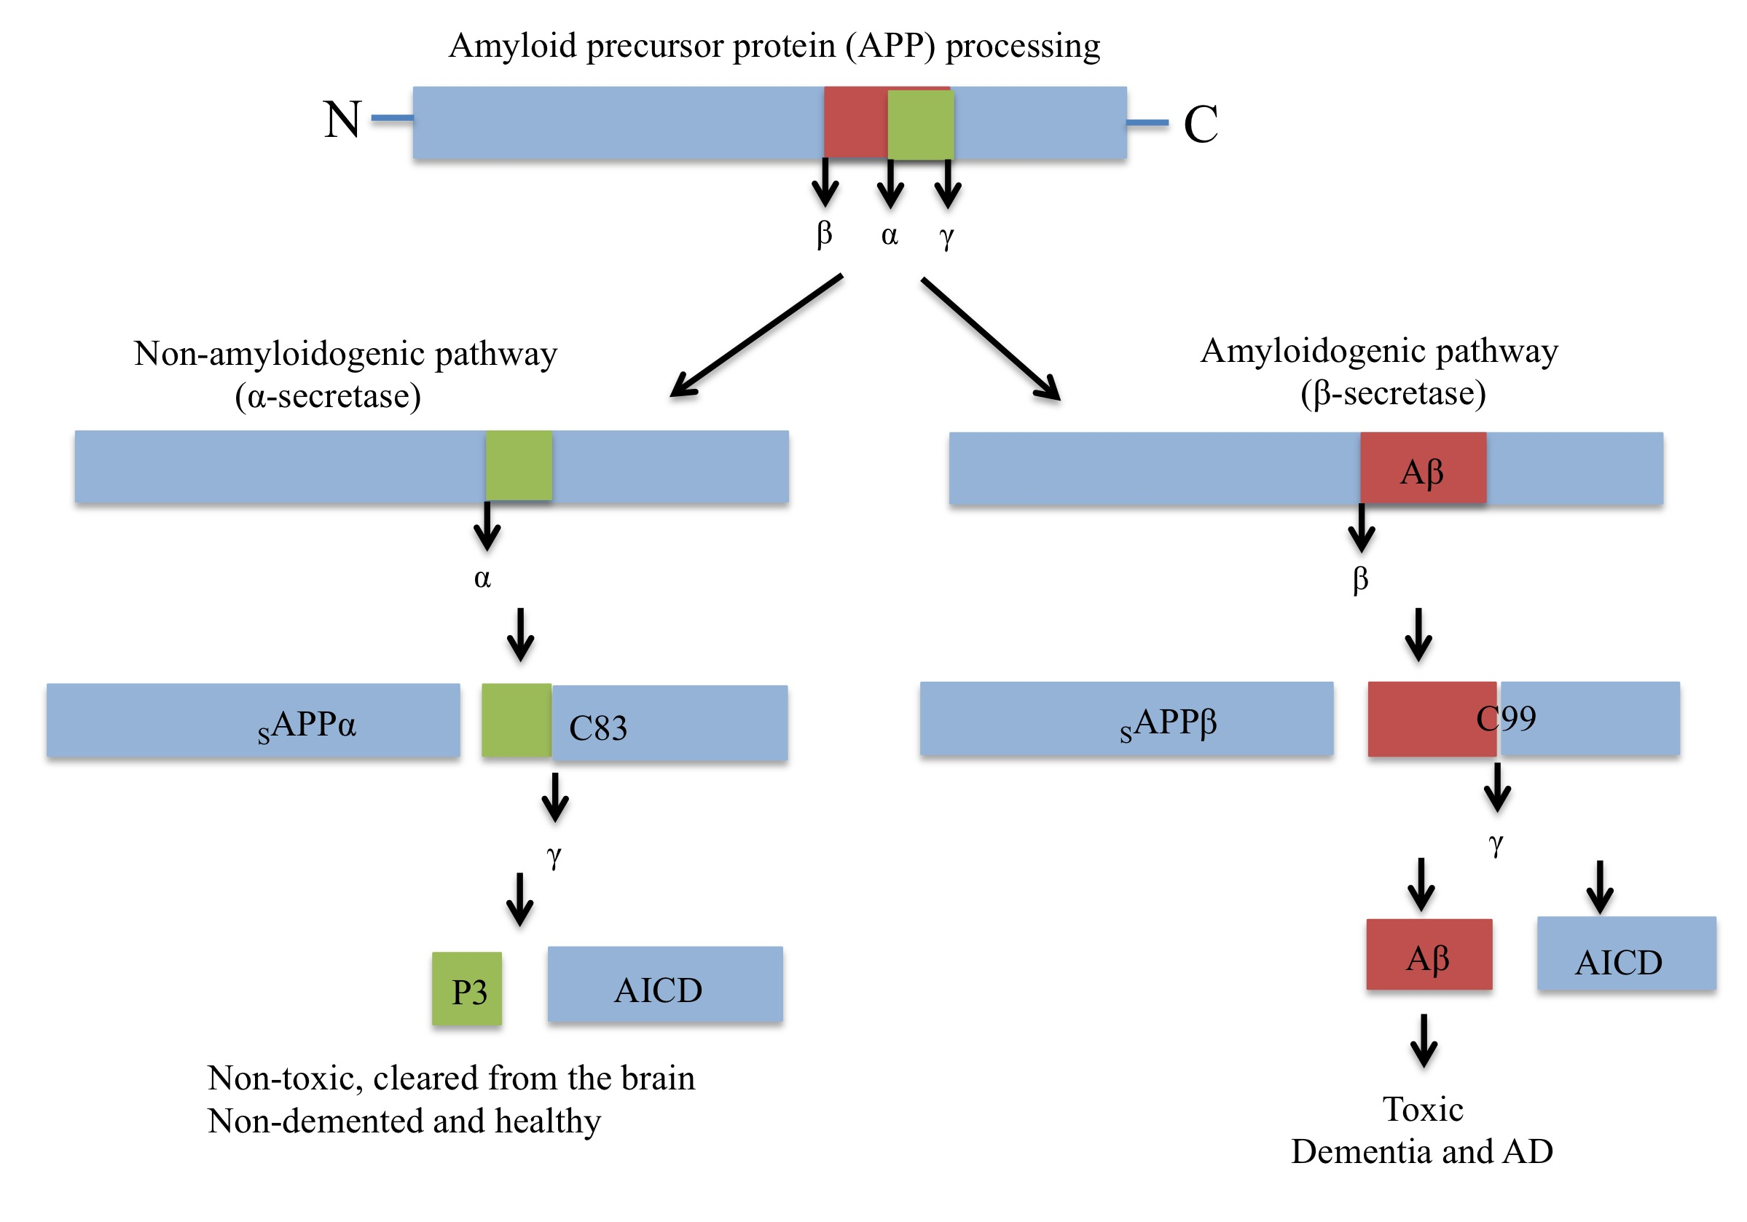
Figure 1.1. The amyloidogenic and non-amyloidogenic pathways.
Amyloid precursor protein (APP) can be processed via the amyloidogenic or non-amyloidogenic pathways. The non-amyloidogenic pathway involves the cleavage of APP by α-secretase, which generates a large soluble extracellular N-terminal fragment, sAPPα, and a smaller C-terminal fragment, C83. The C83 fragment is then cleaved by γ-secretase to generate APP intracellular domain (AICD) and the P3 peptide fragment, which are non-toxic and cleared from the brain. The amyloidgenic pathway involves cleavage of APP with β-secretase (BACE1), which generates a large soluble N-terminal fragment, sAPPβ, and an N-terminal membrane bound C99 fragment that is subsequently cleaved by γ-secretase to produce a toxic form of Aβ of varying length and AICD.

Neurofibrillary tangles
NFTs are comprised of hyperphosphorylated microtubule-associated tau and are the second classically recognised pathology of AD. Hyperphosphorylated tau is observed in neurons during AD progression, particularly in the isocortical region of the brain, (Braak et al. 1994; Braak & Braak 1991). This hyperphosphorylation event suggests there is an imbalance in protein kinases and phosphatases known to regulate tau phosphorylation. However, neuronal phospho tau in certain brain regions precedes clinical AD by many years (Mitchell et al. 2002). Normally, microtubule associated tau is involved in assembly and stabilisation of microtubules (Weingarten et al. 1975; Wang & Liu 2008; Black et al. 1996). However in AD, abnormal hyperphosphorylation sequesters normal tau preventing assembly and inducing destabalisation of microtubules (Alonso et al. 1994). Tau can be phosphorylated at over 30 serine/threonine residues by protein kinases such as protein kinase A (PKA), calcium/calmodulin- dependent protein kinase (CAMKII), c-Jun N-terminal kinase (JNK) and glycogen synthase kinase 3β (GSK3β). Altered upstream signalling can therefore modify tau phosphorylation and both insulin and Aβ can regulate this process (Jin et al. 2011; Hong & Lee 1997; Planel et al. 2007).
As AD progresses, NFTs progress sequentially through the neuroanatomy from the entorhinal cortex (Braak stages 1-2) to the limbic system (Braak stages 3-4) and eventually to the isocortex (Braak stages 5-6) (Braak & Braak 1991; Braak et al. 2006). However, although senile plaques and NFTs are the classical lesions associated with AD, it is increasingly apparent now that these neuropathologies are not confined to clinically defined AD and can exist in the normal ageing brain (Crystal et al. 1988; Arriagada et al. 1992; Matthews et al. 2005; Bennett et al. 2006). Furthermore, neither plaques nor tangles correlate well with cognitive performance and there is an overlap between demented and non-demented individuals with respect to AD pathology, which increases with age (Savva et al. 2009). This highlights the need for other diagnostic biomarkers of disease progression that reflect cognitive decline. In addition caspases have been implicated in the formation of AD-related tau pathology as they have been shown to cleave tau, which induces nucleation dependent filament formation and subsequent formation of pathological forms of tau (Rissman et al. 2004). Recent work suggests that caspase 2 may be implicated in this step as opposed to caspase 3 and that Aβ aggregation initially triggers the caspase-induced tau cleavage (Holtzman et al. 2016; Lin et al. 2011; Rissman et al. 2004).

1.2 Astrocytes

Astrocytes, together with other cells of glial lineage such as microglia and oligodendrocytes, have long been regarded as the connecting cells in the brain, merely holding neurons together. For decades, neurodegenerative research has focused on the role of neurons in disease progression. However, in more recent years there has been a growing interest in the role of glia and in particular how astrocytes contribute to brain health and function. Pioneering work by Kuffler and colleagues in 1964 triggered this interest, since they showed that astrocyte-like cells in the optic nerve of the salamander could respond to neuronal activity and regulate the neuronal microenvironment (Kuffler et al. 1966). It is now recognised that astrocytes are key in supporting neuronal integrity and have a critical role in the neurovascular unit, therefore astrocyte dysfunction may play a central role in neurodegenerative processes. Restoring astrocyte function is becoming an attractive therapeutic target to preserve neuronal function and delay neurodegeneration.

1.2.1 A short history

The concept of neuroglia was first introduced by Rudolf Virchow, in 1858, as a “substance… which lies between the proper nervous parts, holds them together and gives the whole its form in a greater or lesser degree”(Virchow et al. 1860). In the late 19th century, Otto Deiter drew astrocytes as stellate cells and observations were also made by Jacob Henle and Friedrich Merkel about the networks formed by these cells in the grey matter. Using a silver chromate staining technique in 1872, Camillo Golgi was able to describe the morphology of glial cells and based on the interactions he observed between astrocytic end-feet and blood vessels, he postulated that there could be metabolic exchange between glia and other cells. The term “astrocyte” was first used by Michael von Lenhossek in 1893, which uses a combination of latin words to define the morphology of these cells. This word is derived from two latin words “astra” and “cyte”, which can be translated to mean star-shaped cell. Astrocytes were later classified by Kolliker and Andrizen, who defined these cells as protoplasmic or fibrous depending on their location in the grey (protoplasmic) or white (fibrous) matter and how elaborate their processes were (Kettenmann and Verkhratsky, 2008).

By the beginning of the 20th century, there was some acknowledgment of the heterogeneity of glia but the diversity of astrocytes was not fully appreciated until Santiago Ramón y Cajal (1913) developed the gold chloride-sublimate staining technique, which was the first astrocyte-specific stain. Cajal realised that the experimental methods and techniques did not yet exist to gain any real understanding of the role of these cells (Ramon y Cajal, 1899). However, based on his drawings Cajal proposed theories about neuroglia function, which are not too far removed from our understanding of them today. In 1895, he proposed the “insulation theory”, which suggested that astrocytes separate the activity of neighbouring neurons (Navarette and Araque, 2014) and made references to the intimate associations between astrocytes and neurons, stating that this was important to their function. Limited techniques were available to test his theories, therefore research on astrocytic function stalled for many years.

In the latter part of the twentieth century many new scientific techniques were developed, including patch-clamping, fluorescence imaging, generation of dyes for calcium imaging and confocal and multiphoton microscopy, which enabled new insights into cellular function, particularly in the neuroscience field. This advance in technology in the 1990’s was critical for discovering that astrocytes are not just passive players in the brain but are integral to maintaining brain health and function.

1.2.2 Astrocyte morphology

Mammalian astrocytes are classified into 2 morphological groups on the basis of their anatomical location and morphology; these are either protoplasmic or fibrous astrocytes. Protoplasmic astrocytes reside in the grey matter and have a globular shape with many finer processes extending from thicker processes. Fibrous astrocytes are located in the white matter and have many longer-finer processes.

On average, an individual protoplasmic astrocyte has between 5-8 major processes extending from the cell body and many finer processes associated with each of these. Injection of fluorescent dyes has revealed that protoplasmic astrocytes occupy spatially distinct, non-overlapping domains (Bushong, Martone, Jones, & Ellisman, 2002). Less has been reported on the spatial distribution of fibrous astrocytes but is likely the same as in the grey matter. Whilst astrocytes maintain distinct territories, they are also intimately associated with neurons and vascular walls within these territories. This allows astrocytes to coordinate synaptic transmission with dynamic changes in nutrient availability in the blood (Zonta et al. 2003).

Compared to their rodent counterparts, human cortical astrocytes have a three-fold larger diameter and more morphological diversity (characterised by GFAP staining). In addition, human astrocytes in layers 1, 5 and 6 extend longer projections than rodent astrocytes (Oberheim et al. 2006) and it is suggested that more than just two morphological subtypes of astrocytes exist in humans. The number of synapses in contact with an individual astrocyte also varies between species. A rodent astrocyte typically contacts 1x10⁵ synapses (Bushong, Martone, Jones, & Ellisman, 2002), between 300-600 neuronal dendrites and interacts with four neuronal cell bodies (Halassa et al. 2007), whereas human astrocytes isolated from the cortex are in contact with 1x10⁶ synapses. Human protoplasmic astrocytes also propagate calcium waves 4 –10 fold faster than rodent astrocytes, at a speed of 36μm/s (Oberheim et al. 2009). Recently, human astrocytes have been isolated using an immunopanning technique and the transcriptomic profiles of human and mouse astrocytes investigated, which revealed 600 genes enriched in human astrocytes not present in their rodent counterparts (Zhang et al. 2016). Consistent with experiments performed in vivo (Oberheim et al. 2009), human astrocytes grown in vitro were approximately 8.6 fold larger and had twice the number of processes as rat astrocytes grown in culture.

These additional complexities observed in astrocytes, which are not seen in neurons during phylogeny are thought to contribute to the higher intellectual capacities of humans. In support of this, human astrocytes were implanted into mouse brain, which accentuated synaptic transmission and long term potentiation (LTP) resulting in an increased ability of the mice to learn (Han et al. 2013). However, as the processing power and synaptic coverage of human astrocytes is greater, impairments in these cells are more likely to be detrimental to brain function than alterations in rodent astrocytes. The impact of changes in astrocyte function to neurons is evident in several models of epilepsy where the domain organisation of astrocytes is altered. This is associated with hypertrophy of apical dendrites and results in continuous neuronal excitation that is detrimental to neuronal function (Oberheim et al. 2008).

1.2.3 Astrocyte diversity

Astrocytes have long been considered a heterogeneous population of cells and in recent years, research has shown that astrocytes are not only morphologically diverse in different regions of the brain but functionally distinct too. There is accumulating evidence showing differences in the gene expression profile of astrocytes across the brain, variations in their functional state, and their ability to respond to insult or injury (Zhang & Barres 2010; Oberheim et al. 2012).

There are several techniques that have been developed for cell specific gene expression profiling; one of these is called translating ribosome affinity purification (TRAP). This technique is advantageous over other methods, such as laser capture microdissection (LCM), as it does not require a cell dissociation step and assesses the mRNAs that are actively translated at a particular time point (Heiman et al. 2014). TRAP has been used to investigate the translated mRNA profile of mouse cortical astrocytes, cerebellar astrocytes and Bergman glia, showing that there are distinct differences in the expression profile of these cells in different regions of the brain (Doyle et al. 2008). These findings were supported by microarray studies revealing differences in the gene expression profile of cultured mouse astrocytes isolated from four different brain regions (Yeh et al. 2011). Specific differences in the expression of glycoprotein (Barbin et al. 1988), neuropeptide (Klein & Fricker 1992) and neurotransmitter receptor (Reuss et al. 2000; Perego et al. 2000) genes have been demonstrated in astrocytes in different brain regions, suggesting variation in neuronal interaction and ability to regulate neurotransmission.

Astrocyte heterogeneity identified at a genetic level has also been validated functionally. Astrocytes differ in their ability to take up glutamate from synapses (Drejer et al. 1982) and in vitro experiments have shown that astrocytes from different areas of the brain are able to support neurite outgrowth and branching to varying degrees (Denis-Donini et al. 1984; Garcia-Abreu et al. 1995). Astrocytes communicate to one another by calcium wave propagation, which can occur spontaneously or in reponse to an electrical stimulus depending on the region of the brain in which these cells are located (Matyash & Kettenmann 2010). Differences in rates of calcium wave propagation and different gene expression profiles in response to brain injury have also been observed in rodent astrocytes (Hill et al. 1996). Morphological and proliferation rates also differ in human astrocytes isolated from the cerebral cortex and hypothalamus following stimulation in vitro (Sharif & Prevot, 2012). In addition, differences in neuroprotective capacities have been identified following alterations in cell signalling pathways in mouse astrocytes (Wagner et al. 2006). Variations in astrocytes within the same brain region have also been demonstated; for example measurements of gap junction communication between astrocytes differ between cortical layers 1, 2 and 3 compared with cortical layers 4 and 5 (Houades et al., 2006), which is reflected by differences in calcium signalling in astrocytes between cortical layers (Takata & Hirase 2008).

Collectively, these studies suggest that there are clear subsets of astrocytes that are able to perform different roles in the brain. These differences are likely a reflection of the different types of neurons and glia surrounding the astrocytes, as well as the different demands exerted by these cells that mean astrocytes need to tailor their homeostatic support appropriately. As a result, these intrinsic molecular differences may determine how specific astrocyte subpopulations respond to an insult or injury. For example, a study has shown lower promoter activity and protein levels of glutamate transporter 1 (GLT1) in spinal cord astrocytes (Regan et al. 2007). This may mean that there is limited clearance of potentially excitotoxic levels of glutamate and suggest an underlying vulnerability to developing diseases such as amyotrophic lateral sclerosis (ALS).

1.3 The role of astrocytes

Astrocytes play a central role in maintaining brain homeostasis. Features allowing astrocytes to support and protect neuronal function are described below and summarised in figure 1.3.

1.3.1 Gliotransmission

The “tripartite synapse”
Astrocytic processes are intimately associated with neuronal synapses, this allows them to exert control and regulate synaptic plasticity and neurotransmission. In 1999, Araque and colleagues used the term “tripartite synapse” to describe the close proximity of astrocytic processes with the pre and post synaptic neuronal elements (Araque et al. 1999). Although astrocytes are “non-excitable” cells, as they cannot generate their own action potential, they can respond to neuronal activity and communicate to one another through waves of calcium signalling (Verkhratsky et al. 2012). The positioning of astrocytic processes near the synapse is important for relaying neuronal information to the astrocyte, which involves converting an electrical stimulus to chemical signals. Ultimately, this allows local and widespread communication of information across the brain.

Astrocytes express metabotropic and ionotropic receptors that are capable of binding to neurotransmitters released from the pre-synaptic cleft. Neurons can release a number of neurotransmitter at any one time, which are termed co-transmitters and can exist in their own synaptic vesicles (Purves et al. 2001). The types of transmitter released include glutamate, noradrenaline, histamine and acetylcholine. Following release these will bind to receptors on astrocytic processes, which triggers transient increases in calcium, the extent of this varies depending on the concentration of neurotransmitter within the synaptic cleft (Haydon 2001).

Calcium Signalling
Increases in calcium can be restricted to a microdomain within the astrocytic process (Kettenmann et al. 1999) or extend across the astrocyte into the cell soma, where increases in calcium are then observed in neighbouring astrocytes. A single astrocyte in the hippocampus of a rodent brain is in contact with approximately 140 000 different synapses (Bushong et al., 2002), meaning that a single astrocyte can integrate the activity of thousands of neurons and produce calcium waves that reflect the magnitude of external synaptic activity.

Calcium waves can propagate via gap junctions to neighbouring astrocytes to relay this neuronal activity (Goldberg et al. 2010). Intracellular calcium levels are regulated by inositol triphosphate (IP₃), which after reaching a minimum threshold level will trigger release of calcium from endoplasmic reticulum stores. Propagation of calcium signals between astrocytes is mediated either by transfer of IP₃ through gap junction hemichannels or diffusion of ATP that binds to plasma membrane receptors on astrocytes less than 120μM apart, causing an increase in IP₃ (Guthrie et al. 1999; Scemes & Giaume 2006). These events are not mutually exclusive and are likely to occur at the same time, which allows an individual astrocyte to coordinate the activity of groups of cells. In addition, by having two different calcium propagation mechanisms astrocytes can compensate when one of the systems is impaired.

Calcium is believed to be the main regulator of gliotransmission and triggers exocytotic release of vesicles containing gliotransmitter. Calcium oscillations in astrocytes are triggered by the direct binding of neurotransmitter such as synaptically released glutamate to glutamate receptors on astrocytes (Parpura & Haydon 2000). Repetitive neuronal firing can increase the frequency of calcium oscillations within an adjacent astrocyte, therefore astrocytes are able to adjust their response to synaptic activity accordingly and have the potential to amplify synaptic activity (Pasti et al. 1997). Calcium oscillations resulting in glutamate release from astrocytes can also occur spontaneously (Angulo et al. 2004). This means that astrocytes can initiate neuronal activity before synaptic transmission influences a response from astrocytes. There is also evidence that reactive astrocytes are not spontaneously active, which suggests that in a disease state this bi-directional communication between astrocytes and neurons is lost (Agulhon et al., 2012).

Calcium signalling triggers gliotransmitter release, which serves to regulate neurotransmission. This has led to the idea that an individual astrocyte can regulate “islands” of synapses through the gliotransmitters released within a particular domain and co-ordinate these activities with regulating access to nutrients in the blood (Halassa et al. 2007).

Gliotransmitters
Astrocytes release chemical transmitters called gliotransmitters in response to neuronal activity. These include glutamate, adenosine triphosphate (ATP) and D-serine that can bind to receptors on neurons and modulate synaptic strength (Parpura et al. 1994; Cotrina et al. 1998; Schell et al. 1995). Gliotransmitters are thought to enhance synaptic transmission although metabolites of ATP have also been shown to inhibit release of neurotransmitters such as glutamate (Koizumi et al. 2003). Therefore an imbalance in gliotransmission, which may occur when astrocytes become reactive or in response to factors released from the vasculature during an immune response, may alter neuronal activity (Agulhon et al., 2012; Kumaria, Tolias, & Burnstock, 2008). For example, excessive glutamate released from astrocytes causes prolonged neuronal depolarisation and is therefore thought to be responsible for epileptic seizures (Tian et al. 2005). There are a number of different mechanisms used for gliotransmitter release; calcium dependent exocytosis (Bezzi & Volterra 2014), non-exocytotic release from cytosolic pools and calcium independent channel mediated release (Di Castro et al. 2011)

In addition, calcium mediated glutamate release from astrocytes can be modulated by factors released by microglia during an inflammatory response. Therefore, it has been suggested that upstream signalling of microglia and astrocytes contributes to neuronal hyperexcitability and death observed in many neurological disorders (Agulhon et al., 2012). Gliotransmitters also have the capacity to interact with other cells in the near vicinity including microglia and vascular cells, which allows fine-tuned control of synaptic activity with a dynamic microenvironment.

Glutamate recycling
In addition to regulating synaptic activity through release of gliotransmitters, astrocytes can modulate neuronal excitability by removing neurotransmitters from the synaptic cleft. For example, astrocytes import glutamate to prevent neurotoxicity and simultaneously provide glutamine to replenish glutamate stores in neurons (glutamate-glutamine cycle) (Bak et al. 2006). This is essential since neurons lack the enzyme pyruvate carboxylase, which is necessary for glutamate synthesis from glucose, and glutamine synthetase, which is needed to produce a constituent of glutamate called glutamine that is shuttled back to neurons (Hallermayer et al. 1981; Yu et al. 1983).

1.3.2 Neurovascular coupling

The close proximity of astrocytes to neurons and cerebral vessels facillitates simultaneous regulation of synaptic transmission whilst at the same time maintaining a consistent supply of nutrients to sustain neuronal metabolism, this phenomenon is known as neurovascular coupling or functional hyperemia and appears to be dysregulated in AD (Iadecola 2004). By this process astrocytes are able to regulate glucose and oxygen supply to meet neuronal energetic demand.

Regulation of blood flow
Neurons regulate blood flow directly through glutamate mediated nitric oxide synthase (NOS) activation resulting in nitric oxide (NO) production and activation of the cyclic guanosine monophosphate (cGMP) pathway in smooth muscle cells (Fergus & Lee 1997). Astrocytes are also able to regulate blood flow due to close apposition of astrocytic end-feet with the vasculature. Typically it is thought that neuronally derived glutamate can bind to astrocytic mGluR receptors, triggering calcium dependent phospholipase A2 to catalyse the conversion of arachidonic acid to prostaglandin E₂ and epoxyeicosatrienoic acid (Zonta et al. 2003). The release of these metabolites from astrocytic end-feet activates potassium channels in smooth muscle cells resulting in dilation of blood vessels. Arachidonic acid can also induce formation of 20-HETE (20-hydroxyeicosatetraenoic acid) in smooth muscle cells, resulting in vasoconstriction. Therefore release of astrocyte-derived metabolites can regulate vascular tone. However, specifically blocking mGluR5 did not affect the hemodynamic response following whisker stimulation in mice, which suggests that astrocytes have alternative ways of responding to glutamatergic neurotransmission (Calcinaghi et al. 2011).

Other changes that regulate hemodynamic control include oxygen and various changes in ion concentration. For example, an increased oxygen supply induces the conversion of arachidonic acid to 20-HETE, leading to vessel constriction, whereas low levels of oxygen trigger vessel dilation (Howarth 2014). Potassium released by astrocytes can also trigger vessel dilation by passing through inwardly rectifying potassium channels on smooth muscle cells resulting in Na⁺K⁺ ATPase activation and hyperpolarisation. In addition, increased calcium in astrocytes can trigger the release of ATP, which binds to P2XY receptors on arterioles resulting in vessel constriction (MacVicar & Newman 2015). Therefore, there are a number of ways astrocytes can modulate vascular tone and rates of blood flow, which are influenced by external factors in the blood and released by neurons. However, recent evidence has questioned the role of astrocytes in regulating cerebral blood flow. Studies have shown that arteriole dilations resulting from neural activity precede calcium signalling in astrocytes (Nizar et al. 2013) and can also occur in the absence of glial signals (Schulz et al. 2012), although fast and slow calcium responses have been identified in astrocytes in response to neurotransmission that may resolve this controversy (Lind et al. 2013).

Glucose transport
Glucose is transported into astrocytes by the glucose transporter GLUT1. Neurons do not express GLUT1, whereas a 55kDa isoform of GLUT1 is found in brain endothelial cells and a shorter 44kDa isoform of GLUT1 is expressed in astrocyte end-feet. In vitro experiments have demonstrated that astrocytes starved of glucose can upregulate GLUT1 expression in endothelial cells by releasing soluble factors (Régina et al. 2001). Loss of GLUT1 in the brain endothelia rather than in astrocytes of an AD mouse model has been shown to exacerbate AD by accelerating β-amyloidosis and neuronal dysfunction (Winkler et al. 2015). Although loss of GLUT1 in endothelial cells resulted in an increase in the expression of GLUT2 and GLUT3 in neurons, suggesting that compensatory responses exist in an attempt to restore brain energy metabolism.

In certain neurological conditions such as ischemia or after a brain injury, neurovascular coupling can become inverted, which means loss of neuronal activity is accompanied by a drop in cerebral blood flow (Petzold & Murthy 2011). Soluble and insoluble forms of Aβ have been shown to reduce functional hyperemia (Niwa et al. 2000), which together with reported disruptions in calcium homeostasis may exacerbate the loss of hyperemia and drive AD progression.

1.3.3 Regulation of neuronal metabolism

Astrocytes act as energy reserves for neurons and are able to respond to local neuronal activity in order to provide them with energy substrates necessary to support and maintain proper function.

Glycogenolysis
Glycogen is an important energy store in the brain that under conditions of hypoglycemia will rapidly undergo glycogenolysis to provide an energy supply for neurons. During brain development, glycogen resides in neurons and glia but as the brain matures glycogen stores diminish in neurons and in adults glycogen is only found in astrocytes (Brown & Ransom 2007). Unlike endothelial cells, astrocytes and neurons have higher metabolic rates and can phosphorylate glucose to form glucose-6-phosphate, which is trapped inside these cells. Astrocytes convert glucose-6-phosphate to glycogen using glycogen synthase. Neuronal levels of glycogen synthase are much lower (Pellegri et al. 1996), in part due to the malin-forin complex causing permanent degradation of glycogen synthase but also residual activity of this enzyme is prevented by phosphorylation (Vilchez et al. 2007). Under hypoglycaemic conditions, astrocytes are unable to pass glycogen to neurons because glycogen is too large and also because glucose-6-phosphatase is not expressed in astrocytes (Forsyth et al. 1996). Therefore astrocytes cannot provide free glucose to neurons. Instead, astrocytes possess a unique isoform of lactate dehydrogenase (LDH) that is used to convert glucose to lactate (Bittar et al. 1996). Neuronal survival is improved when in contact with glia (Whatley et al. 1981), which is due to astrocytic glycogen stores maintaining an energy supply to the neurons during glucose deprivation (Swanson & Choi 1993). Lactate is then exported through the monocarboxylate transporter, MCT1, and shuttled across to neurons (Pellerin & Magistretti 1994) where it is taken up by the monocarboxylate transporter, MCT2 (Pierre et al. 2000) and converted to pyruvate for re-entry into oxidative phosphorylation.

Lactate and the astrocyte-neuron lactate shuttle hypothesis
Lactate is the preferred energy substrate in neurons (Itoh et al. 2003) and important to sustain a number of neurophysiological mechanisms. Recently, the importance of l-lactate has been recognised in protecting neurons from glutamate mediated neurotoxicity and has been shown to exert it’s protective effects through activation of the PI3K-Akt pathway and K⁺ATP channels in neurons (Jourdain et al. 2016).

Lactate production in astrocytes is also modulated by neurotransmission, particularly after neuronal release of glutamate (Pellerin & Magistretti 1994). Astrocytic processes are decorated with glutamate transporters, which are involved in glutamate uptake and can prevent glutamate-induced neurotoxicity (Yi & Hazell 2006). Glutamate transporters are dependent on transmembrane K⁺ gradients and for every glutamate that is transported into the astrocyte, there is also co-transport of 3Na+ in exchange for 1K⁺ that is pumped out. This is an energetically demanding process, which results in increased glucose utilisation and lactate production through glycolysis. This process produces ATP, which facilitates glutamate transport and conversion of glutamate to glutamine (mentioned previously). The series of steps taken by astrocytes to provide lactate to neurons is called the astrocyte-neuron lactate shuttle (ANLS) and was first proposed by Perrellin and Magestretti in 1994. Loss of the glutamate transporter GLAST from the somatosensory cortex in rats, results in a 50% reduction in glucose metabolism following activation of the whisker-to-barrel pathway (Cholet et al. 2001). This provides evidence that astrocytic uptake of glutamate is directly coupled to brain metabolism and provides further support for the ANLS hypothesis (Pellerin & Magistretti 1994).

The metabolic link between astrocytes and neurons through lactate has been demonstrated in brain slices and primary neurons and astrocytes from different non-human species (Pellerin 2003). More recently, this system was demonstrated in a human stem cell derived astrocyte-neuron co-culture model. In this model the complexity of ANLS was revealed, as lactate production occurred in astrocytes following neurotransmission and hypoglycemia (Tarczyluk et al. 2013). In addition, the study highlighted the importance of glutamate uptake through transporters as opposed to activation of glutamate receptors and showed stimulation of Na⁺K⁺ ATPase by K+ was required to drive lactate production in astrocytes. However, there is also evidence that neuronal activity does not rely solely on lactate as a metabolic substrate for oxidative phosphorylation, since inhibition of the enzyme that converts pyruvate to lactate, lactate dehydrogenase (LDH), does not alter extracellular oxygen or NADH levels in rat hippocampal slices (Hall et al. 2012).

1.3.4 Astrocytes and neuroinflammation

Inflammatory role of astrocytes
Astrocytes can have anti-inflammatory or pro-inflammatory roles in the brain. This has been demonstrated by looking at the transcriptomic profile of astrocytes under different cytotoxic stressors. Both in vitro and in vivo treatment with LPS or cytokines produces a shift towards a more proinflammatory, cytotoxic profile (Hamby et al. 2012; John et al. 2005), whereas mimicking stroke in the brain creates a more neuroprotective transcriptomic profile (Zamanian et al. 2012). Astrocytes can respond to lesions or foreign matter in the brain by becoming reactive and forming a functional barrier called a glial scar, which regulates entry of other inflammatory cells such as leukocyte or microglia. Loss of astrocyte reactivity reduces scar formation and has been shown to exacerbate inflammation (Bush et al. 1999). Astrocytes are able to regulate BBB permeability and thereby control movement of leukocytes into the CNS. For example, stimulation of astrocytes with IL1β, increases vascular endothelial growth factor (VEGF) production causing disruption of BBB and extravasation of leukocytes (Argaw et al. 2012). Alternatively, secretion of sonic hedgehog (SHH) can promote repair of BBB and reduce the inflammatory response (Alvarez et al. 2011). When astrocytes are presented with foreign matter, demonstrated by Aβ treatment of rat astrocytes, the levels of chemoattractant necessary to recruit microglia and levels of proinflammatory cytokines increase (Johnstone et al. 1999). Furthermore, activation of the toll-like receptor (TLR) pathway, which determines pathogen presentation, increases the pro-inflammatory response in mouse astrocytes and induces neuronal death, which is not observed when the TLR pathway is activated in neurons alone (Ma et al. 2013).

Therefore, context-dependent activation of different signalling cascades in astrocytes will determine whether the response is pro- or anti-inflammatory and whether other inflammatory cells are recruited.

Interaction with microglia
Astrocytes also communicate with microglia, which are the brain’s resident immune cells. Microglia survey the brain for accumulation of foreign matter or changes in the brain microenvironment. They are able to rapidly respond to changes and achieve this much more quickly than astrocytes are able to (Ni et al. 2011). These changes in the microglia are then relayed to astrocytes, which adjust their physiology to maintain homeostasis and thereby preserve support for neuronal networks. This has been demonstrated in microglia challenged with the neurotoxicant methyl mercury, which respond by increasing exocytosis of ATP and stimulating P2Y1 (purinoreceptor 1) receptors on astrocytes resulting in the release of IL6 (interleukin 6) for protection of neurons (Shinozaki et al. 2014). In another study, activation of microglia following LPS (lipopolysaccharide, a proinflammatory molecule) treatment resulted in the release of ATP, triggering glutamate export from astrocytes that binds to metabotropic glutamate receptor 5 and thereby modulates neuronal activity (Pascual et al. 2012). Microglia not only relay information to astrocytes, but can also receive messages. Calcium signalling in astrocytes can be triggered following neuronal glutamate release and there is evidence to suggest that calcium waves are propagated to microglia as ATP. ATP binds to the purinoreceptor P2X7, but as a result can cause an imbalance in calcium homeostasis and induce microglial death (Verderio & Matteoli 2001).

Microglia, like astrocytes, have been shown to establish contact with synapses, which has led to a new term being adopted to describe the functional elements present at a synapse, this is the “quadpartite synapse”. Microglia are highly motile cells that can increase the frequency of contacts made with synaptic elements based on levels of neuronal activity (Tremblay et al. 2010) and as they are phagocytic cells, they are involved in pruning synapses during brain maturation and may also have a role in synaptic turnover (Paolicelli et al. 2011). Microglia are able to exert control of synapses directly or indirectly through regulating astrocyte homeostasis. However, during an immune response crosstalk between microglia, astrocytes and neurons can be disrupted resulting in altered functioning of these cells. For example, stimulation of microglia with LPS causes release of l-glutamate from microglia and simultaneous loss of l-glutamate transporters in astrocytes. Loss of glutamate uptake by astrocytes and an additional glutamate load is thought to result in excessive stimulation of l-glutamate receptors and neurotoxicity (Takaki et al. 2012), this process is now referred to as the “collusion” theory and could represent early stages in neuroinflammation.

1.3.5 Antioxidant capacity

Oxidative stress occurs when there is an imbalance between pro-oxidants (such as hydrogen peroxide [H₂O₂] and transition metals) and antioxidative mechanisms required to remove reactive oxygen species (ROS). The brain is especially susceptible to oxidative stress on account of its high oxygen utilisation necessary to drive oxidative metabolism and the large amounts of oxidation-prone polyunsaturated fatty acids found in the lipid membranes of neurons (Friedman 2011). “The Free Radical Theory of Ageing” (Harman, 1956) suggests that oxidative metabolism, a system designed by nature to support cell survival, is ultimately the process that results in cellular degeneration due to the release of free radicals that induce oxidative damage (Cadenas & Davies 2000).

Despite neurons being more metabolically active and having higher levels of ROS, the
antioxidant levels in these cells are low. As neurons are post-mitotic and cannot
regenerate, they depend upon the protective capacity of astrocytes to survive years of
exposure to oxidative stress. In order to preserve brain function in the presence of high
levels of ROS, astrocytes are equipped with antioxidant defense mechanisms.
Astrocytes have the highest concentration of antioxidants in the brain, which makes
them both resilient to oxidative stress and capable of supporting other brain cells in the
event of an oxidative insult (Desagher, Glowinski, & Premont, 1996).

Glutathione System
The glutathione system is the main way that astrocytes can dispose of pro-oxidants. In this process, glutathione (GSH) serves as a substrate for an electrophile, antioxidant or scavenging enzyme. Typically glutathione peroxidase catalyses the removal of an electron and hydrogen ion from glutathione in order to reduce H₂O₂ to water (Esposito et al. 2000). This causes glutathione to react with another molecule of glutathione forming a more stable glutathione disulphide (GSSG). Glutathione reductase is involved in regenerating reduced GSH from GSSG by using nicotinamide adenine dinucleotide phosphate (NADPH) as an electron donor. However, cysteine rich proteins are also liable to oxidation, which can result in irreversible damage and protein degradation. Astrocytes avoid this by using an enzyme called glutathione-s-transferase, which employs GSH to add a disulphide group to the protein, thereby increasing protein stability. Glutaredoxin will restore the protein back to its active state when oxidative stress subsides and thus GSH is made accessible again in its reduced form (the glutathione cycle is summarised in Figure 1.2). Glutathionylation of the 20S proteasome can occur in response to oxidative stress. However instead of offering protection, this modification inhibits protein degradation that could result in increased protein aggregation (Höhn & Grune 2014). This could provide the link between oxidative stress and accumulation of Aβ observed in AD.
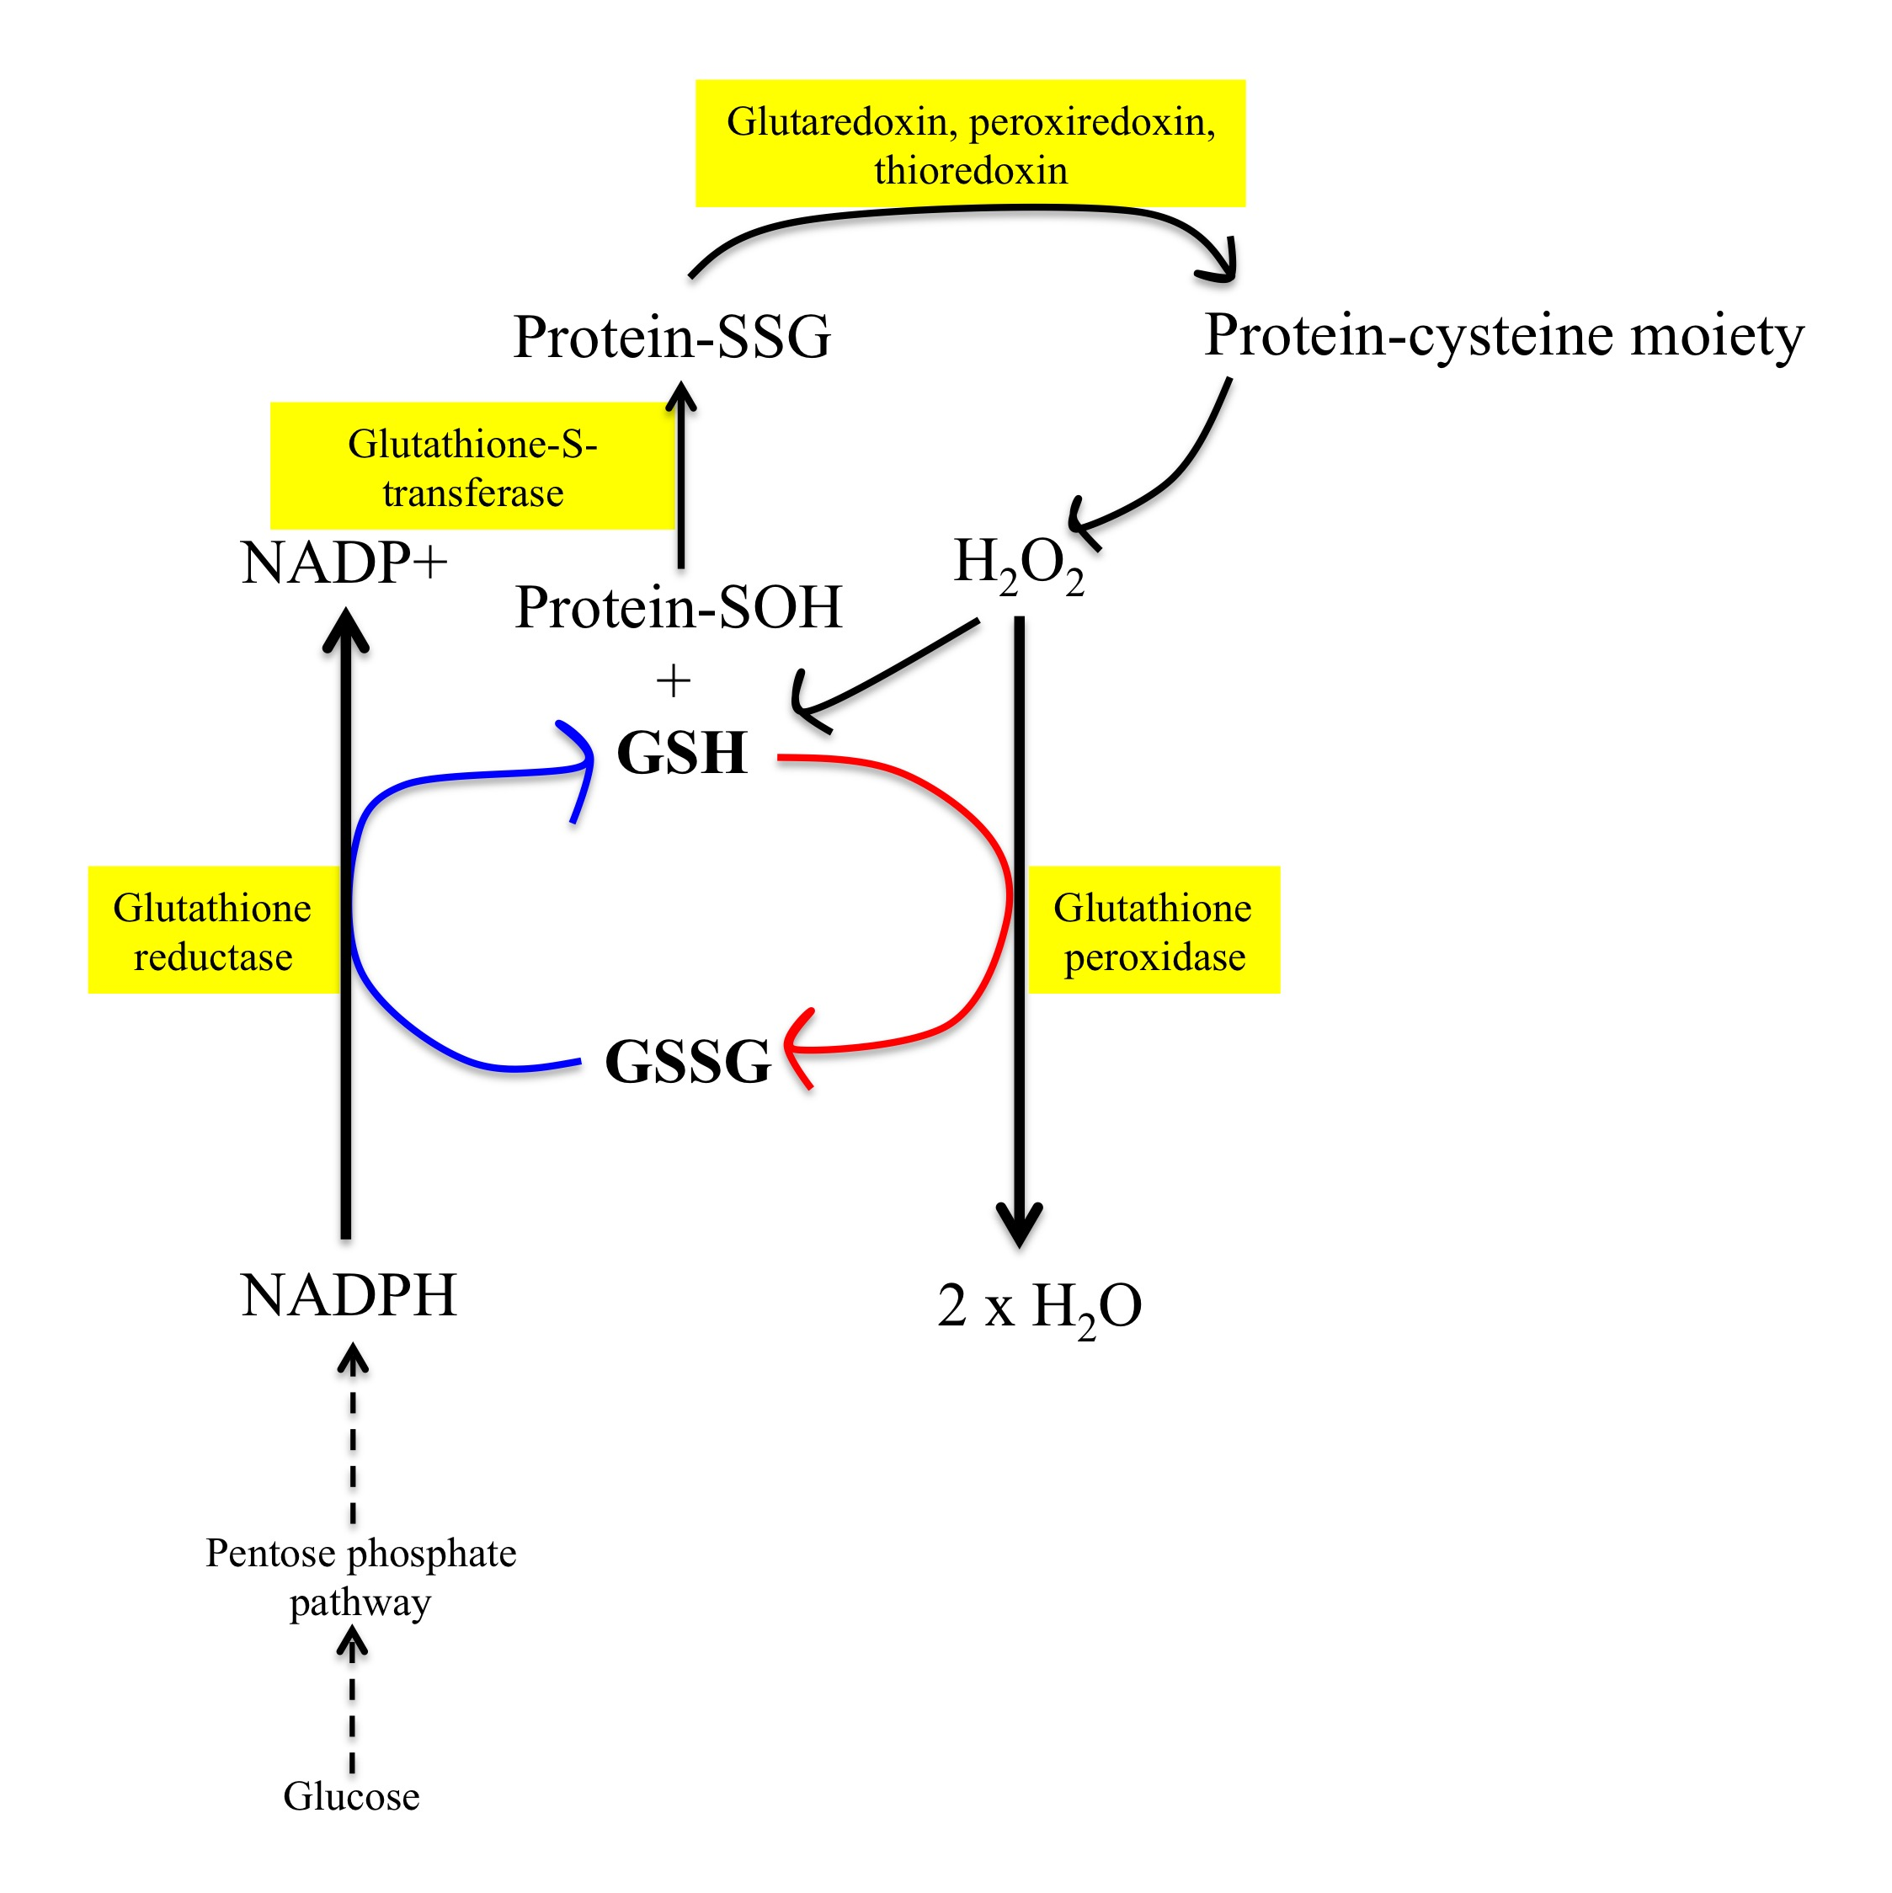
Figure 1.2. Glutathione cycle.
Hydrogen peroxide can be reduced by glutathione using glutathione peroxidase. Electrons donated by NADPH are used to recycle oxidised glutathione disulphide (GSSG) back to reduced glutathione (GSH), catalysed by glutathione reductase. Proteins can be oxidised under conditions of oxidative stress. Glutathione-s-transferase incorporates a disulphide group from reduced glutathione to a reactive cysteine group. When stress subsides, oxidised glutathione is recycled back to reduced GSH using enzymes such as glutaredoxin, peroxiredoxin and thioredoxin.

Glutathione is present in astrocytes at high concentrations but not in neurons
(Raps et al. 1989). The lack of glutathione in neurons means that they heavily rely on
astrocytes for support during periods of oxidative stress. However, astrocytes are also
capable of supplying neurons with their own glutathione so that they can establish their
own antioxidant reserve. Glutathione is released by ectoenzymes that re-constitute the
molecule into glutamate, glycine, amino acids and cysteine. Neurons are then capable of
taking up these components and resynthesising glutathione (Hirrlinger & Dringen
2010). In addition, glutathione can be exported from the astrocyte and in culture is
released in vast quantities (Hirrlinger, Schulz, & Dringen, 2002; Minich et al., 2006).

Nuclear factor erythroid 2 factor
Nuclear factor erythroid 2 related factor 2 (NRF2) is the master regulator of many
antioxidant genes, including those involved in the glutathione system. Under basal
conditions, NRF2 is targeted for proteosomal degradation, however when oxidative
stress occurs NRF2 translocates to the nucleus where it increases the transcription of
genes incorporating the antioxidant response element (ARE) (Nguyen, Nioi, & Pickett,
2009).

During early development, the NRF2 promoter is epigenetically repressed so
that redox sensitive pathways JNK and WNT are activated appropriately allowing
proper neuronal development. However, this means that there are low levels of
activated NRF2 in neurons even after oxidative stress (Bell et al. 2015). Therefore loss of NRF2 from neurons does not increase susceptibility to H₂O₂, whereas in astrocytes it does. Further work has identified that histone deacetylase (HDAC) inhibitors can be used to deacetylate the NRF2 promoter and sensitise neuronally derived NRF2 to oxidative stress (Bell et al. 2015). As neurons have low antioxidant capacity, it is important that they are able to influence the antioxidant status of astrocytes and are able to regulate astrocytic NRF2 signalling through synaptic activity (Habas, Hahn, Wang, & Margeta, 2013).

Other antioxidant mechanisms
In the event that the glutathione system is dysregulated, astrocytes will use other antioxidant mechanisms. Catalase is often used to reduce H₂O₂ to water. If both the glutathione and catalase antioxidant defense mechanisms are impaired, astrocytes are still capable of neutralising H₂O₂. H₂O₂ can react with pyruvate (Wang & Cynader 2001; Desagher et al. 1997) and the peroxiredoxin system (Hattori et al. 2003), suggesting that there are reserve antioxidant processes in place in astrocytes to deal with oxidative stress. The antioxidant capacity of astrocytes is tightly coupled to neurotransmission. Astrocytes release the antioxidant anion ascorbate following stimulation with glutamate (Wilson et al. 2000) and under prolonged periods of oxidative stress will reduce glutamine synthetase (GS) activity, especially in the absence of glutathione peroxidase (Knorpp et al. 2006).

Astrocytic antioxidant capacity in ageing
It has been postulated that during ageing the antioxidant capacity of astrocytes declines, meaning neurons are more susceptible to oxidative damage. This was demonstrated in vitro in aged rat cortical astrocytes where astrocytes at a later passage had higher ROS levels, reduced mitochondrial activity and were more susceptible to oxidative stress (Pertusa et al. 2007). This was later supported by a study looking at the antioxidant profile of neonatal, mature, old and senescent astrocytes, where it was shown that there was a significant reduction in H₂O₂ clearance capacity between neonatal and mature astrocytes due to a reduction in glutaredoxin activity (Liddell et al. 2010). However, antioxidant defenses were not compromised in older astrocytes and instead there was a trend towards increased antioxidative capacity. GSH efflux from older astrocytes increased, which suggests an increased demand on the astrocytes to supply GSH to the neurons possibly due to oxidative stress and an ability to respond to this demand.

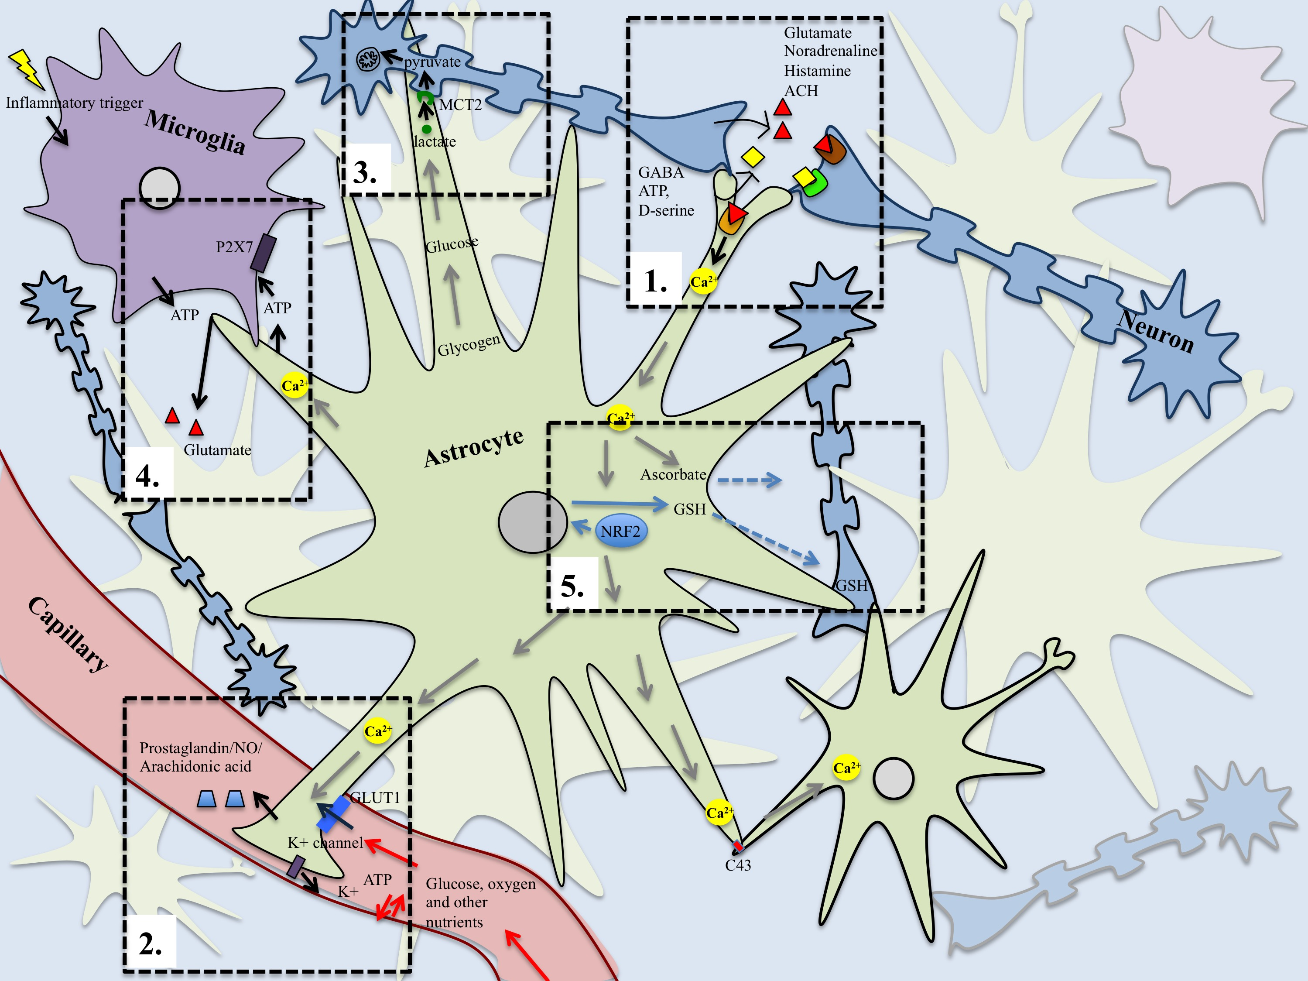
Figure 1.3. A schematic diagram displaying the many roles performed by astrocytes.
Each hashed box represents a different astrocytic function and each is labelled on the diagram numerically (1-5) according to the order in which they have been discussed in the text. 1. Gliotransmission: Neurotransmitters bind to metabotropic/ionotropic receptors on astrocyte cell surfaces, which triggers calcium-mediated release of gliotransmitter that can modulate synaptic activity 2. Neurovascular coupling: Neurotransmission triggers calcium signalling, which stimulates conversion of arachidonic acid to prostaglandin E₂ and epoxyeicosatrienoic acid that cause vasodilation. Potassium, oxygen and ATP can regulate vascular tone and glucose enters from blood through glucose transporters (GLUT1) in astrocytic end-feet.
3. Regulation of neuronal metabolism Neurotransmission is coupled to glycolysis, producing the energy substrate lactate that can be shuttled across to neurons in the astrocyte neuron lactate shuttle (ANLS). 4. Interaction with microglia Upstream signalling from microglia can influence gliotransmission and due to the high motility of processes are involved in synaptic pruning. 5. Antioxidant capacity. Oxidative stress induces an NRF2 response, which provides an internal and external supply of the antioxidant glutathione. There are also compensatory and reserve antioxidant mechanisms present in astrocytes.

1.4 How astrocytes are involved in neurodegeneration and AD progression

Neurodegenerative diseases such as Parkinson’s Disease (PD), Amylotrophic Lateral Sclerosis (ALS) and AD have long been attributed to neuronal dysfunction. However, the 1990’s marked a new era in neuroscience as discoveries of the critical roles played by neuroglia were made, in particular the contributions of astrocytes in maintaining brain health. These insights have generated new theories as to how neurodegenerative diseases develop and an increasingly popular idea is that neuronal dysfunction may stem from impaired astrocytic function or “astrodegeneration” (Pekny et al. 2016). This section focuses on the changes identified in astrocytes in the AD brain and how these changes affect neuronal function (summarised in figure 1.4).

Increased glial reactivity is observed during ageing (Nichols et al. 1993) and has been shown to both precede and correlate with AD type pathology (Serrano-Pozo et al. 2011; Heneka et al. 2005; Carter et al. 2012). Interestingly, AD resilient subjects with normal cognitive function but high plaque and tangle burden have been shown to have a higher density of reactive astrocytes versus demented individuals with a high plaque and tangle density (Arnold et al. 2013). This suggests a neuroprotective capacity of the reactive astrocytes and also that there are age-related factors and changes in glia that add complexities to a once solely considered tangle and plaque causing disease.

1.4.1 Reactive astrocytes

Astrocytes are dynamic cells that undergo morphological and functional changes in response to alterations in the extracellular environment. This change to a “reactive” state is typically defined by increased expression of the intermediate filaments glial fibrillary acidic protein (GFAP) and vimentin (Boyes et al. 1986; Ridet et al. 1997) as well as hypertrophy of the cell soma and processes (an increase in cell volume). There are several levels of astrocyte reactivity depending on the type and extent of stimulus (Sofroniew & Vinters 2010). Moderate reactivity is often associated with innate immune activation, it involves little reorganisation and proliferation of astrocytes and low expression of GFAP. More severe astrocyte reactivity occurs in response to chronic neurodegenerative triggers and when the brain encounters trauma it can involve a long-lasting rearrangement and proliferation of GFAP-positive astrocytes to form a glial scar, which acts as a barrier between a lesion and healthy brain tissue.
Astrocyte reactivity (astrogliosis) was initially thought to be detrimental to neuronal health as several studies have shown that glial scar formation following trauma inhibits axon regeneration (Fawcett & Asher, 1999; Mckeon, Schreiber, Rudge, & Silver, 1991). In GFAP-vimentin double knockout mice, astrocytes undergo less hypertrophy and show increased neuronal regeneration following trauma (Wilhelmsson et al. 2004). However, there is now considerable evidence showing that astrogliosis is part of the cells normal behaviour and actually beneficial to many aspects that support neuronal function. Astrocytes increase uptake of potentially excitotoxic glutamate (Vermeiren et al. 2005), increase glutathione levels to protect from oxidative stress (Vargas et al. 2008; Shih et al. 2003) and increase trophic support, which includes upregulation of IGF1 (Eddleston & Mucke 1993). These changes may reflect increased physiological demands on the astrocyte that may be met by increasing metabolism and protein synthesis, such as GFAP. However, increased astrogliosis also correlates with different pathologies found in neurodegenerative disorders, including an association with AD- type pathology. Unfavourable changes in ECM (extracellular matrix) and inflammatory processes associated with astrogliosis may contribute to disease progression (Lin et al. 2006; Summers et al. 2010).

Astrogliosis in AD
Using GFAP as the histological marker of astrogliosis, the relationship of reactive astrocytes to Alzheimer-type pathology has been examined. GFAP expression has been shown to correlate with increasing Braak neurofibrillary tangle stage (tau burden) (J E Simpson, Ince, Lace, et al. 2010) and higher levels of GFAP have been found in the CSF of AD patients (Fukuyama et al. 2001). In addition, a recent proteomic study has shown elevated GFAP expression in the CA1 and subiculum of the hippocampus of AD patients with increased tau pathology (Hondius et al. 2016). PET tracers have also identified increased astrogliosis in the prodromal stage of AD (Carter et al. 2012). Therefore, astrocyte reactivity has been associated with AD, particularly at the earliest stages and there is a correlation with tau pathology.
The relationship between astrocytes and plaques is not yet fully understood. Astrocytes are able to phagocytose Aβ associated with neuron specific proteins a7nAChR (alpha 7 nicotonic acetylcholine receptor) and ChAT (Choline Acetyltransferase) (Nagele et al. 2004) and these intracellular deposits of Aβ in astrocytes may cause cell lysis and impair neuronal support (Nagele et al. 2003). Astrocytes also prolong neuroinflammation and overexpress BACE1, an amyloid precursor protein-processing enzyme (Rossner et al. 2005). However, two distinct astrocytic populations are believed to exist in proximity to plaques; those <50µm away from the plaque have been shown to undergo hypertrophy, whilst astrocytes localised distantly >50µm from plaque borders undergo atrophy (Olabarria et al. 2010). Simpson et al (2010) also show that astrogliosis is more specific to neuritic plaques than diffuse plaques and that plaques and astrogliosis do not always co-exist. Therefore, whilst astrocyte reactivity is related to plaque deposition, there seem to be other factors that are responsible for triggering astrogliosis, as highlighted in an APP/PS1 mouse model of AD where astrogliosis preceded Aβ deposition (Heneka et al. 2005). However, studies have also revealed that astrogliosis around plaques can improve cognition, as indicated by low MMSE scores in patients, which suggests a potential protective role of reactive astrocytes (J E Simpson, Ince, Lace, et al. 2010; Mathur et al. 2015). In addition, genetic deletion of GFAP and vimentin from APP/PS1 mice resulted in increased plaque load and dystrophic neurites, which adds support to the idea that astrogliosis is a protective response in AD (Kraft et al. 2013). Furthermore, the Aβ deposition saturation model states that enhanced astrogliosis is considered a better indicator of AD progression than plaque load (Serrano-Pozo et al. 2011). However it is not yet fully understood whether the increase in gliosis associated with AD pathology is a demonstration of increased astrocytic support or development of a toxic microenvironment in the brain.
In addition to tau and Aβ pathology other mechanisms are involved in astrogliosis such as the Ca²⁺/calmodulin dependent protein phosphatase calcineurin, which is involved in regulating inflammatory processes, increases with age and is frequently associated with plaques (Norris et al. 2005). The JAK/STAT3 signalling pathway is activated in reactive astrocytes in mouse models of AD (APP/PS1 and 3xTg-AD) and Huntington’s disease (HD). Increasing the expression of SOCS3 (a STAT inhibitor) caused reactive astrocytes to return to a resting state, reduced microglial recruitment and in the HD mouse model increased mutant huntingtin aggregates (Ben Haim et al. 2015). Therefore manipulation of either the calmodulin or JAK/STAT pathways may provide ways to regulate astrocyte reactivity and assess its contribution in neurodegenerative disease.

1.4.2 Astrodegeneration and morphological changes

In addition to astrocyte hypertrophy, studies have recently shown that there is evidence of astrocyte atrophy. Astrocyte atrophy has been shown to occur prior to plaque formation in the dentate gyrus of a triple transgenic AD mouse model (Olabarria et al. 2010) and a reduction in primary and secondary astrocyte branches in the entorhinal cortex has also been observed in this mouse model (Yeh et al. 2011). It is suggested that a decrease in astrocyte surface area and complexity of processes early in AD progression reduces homeostatic support and ultimately results in failure to support synaptic activity (Verkhratsky et al. 2010). Synaptic loss and reduced plasticity are better correlates of cognitive decline in AD than Aβ plaques and NFTs. Therefore it is predicted that astrocyte atrophy precedes and is responsible for synaptic loss due to reduced synaptic coverage and reduced functional support

1.4.3 Physiological changes

Changes in energy metabolism
Brain energy metabolism has been shown to be impaired prior to plaque and tangle formation. This has been demonstrated by position emission tomography (PET) imaging studies that show reduced glucose metabolism in the brains of individuals with AD and also demonstrated in individuals with ageing-associated cognitive decline (AACD) prior to AD progression (Hunt et al. 2007). In addition, reduced expression of GLUT1 and 3 (glucose transporters) is observed in the cerebral cortex of AD patients (Simpson et al. 1994). As astrocytes constitute approximately half of the brain’s mass, it is thought that impaired astrocytic glucose uptake is a feature of AD. In vitro studies have demonstrated that Aβ reduces glucose uptake in rat hippocampal astrocytes and in tandem reduces the incorporation of glutamate (Parpura-Gill et al. 1997), suggesting a link between defective energy metabolism in astrocytes and propagation of glutamate neurotoxicity, both of which are features of AD.

Glutamate
One of the most important roles played by astrocytes is to regulate glutamate levels at the synapse. Loss of glutamate uptake and release of glutamine is affected in AD (Li et al. 1997; Masliah et al. 1996; Le Prince et al. 1995), as alluded to previously. The excitatory amino acid transporter (EAAT2 [GLT-1 in rodents]) is predominantly expressed by astrocytes and necessary for glutamate uptake. In AD, increased gliosis is correlated with reduced EAAT2 levels (J E Simpson, Ince, Lace, et al. 2010), indicating astrocytes may be less able to regulate external glutamate levels and elevates the risk of glutamate-mediated neurotoxicity. In a separate study, pyramidal neurons containing NFTs in the cerebral cortex of AD patients also showed increased expression of glial specific EAAT1 (Scott et al. 2002). Although, this was not linked to decreases in glutamate transport in astrocytes it may suggest a compensation mechanism in neurons to prevent glutamate-mediated excitoxicity. Increased GS expression in pyramidial neurons and decreased GS expression in astrocytes have been observed in the temporal cortex of AD cases compared with age-matched controls (Robinson 2000), which might reflect a compensatory mechanism employed during AD when the glutamate-glutamine cycle is impaired (Robinson 2000). Amidation of glutamate by GS is also used to prevent ammonia- induced toxicity so this could also be a protective mechanism employed by neurons when astrocytes are not working efficiently in the disease state.

Changes in astrocyte antioxidant capacity
The antioxidant capacity of astrocytes is also altered in AD and the prodromal phase of the disease, mild cognitive impairment (MCI). Increased protein oxidation and lipid peroxidation have been identified in individuals with MCI and AD (Aksenov et al. 2001; Calabrese et al. 2006). Oxidation can reduce protein activity (Sultana & Butterfield 2004) and in AD, these oxidative modifications occur in mitochondrial related proteins, providing a link between increased oxidative stress and decreased cellular energetics in AD and MCI (Sultana & Butterfield 2009). In addition levels of protein glutathionylation, a mechanism employed by cells to prevent oxidation-mediated protein degradation, is increased in AD brain. In particular, individuals with AD have increased glutathionylation of glycolytic enzymes, such as GAPDH and enolase, which may result in a reduction in glucose breakdown and associated impairments in energy metabolism (Newman et al., 2007).

Impairments in glutaredoxin activity have also been reported leading to increases in gluthathionylated proteins in the cerebrum and cerebellum of one month old APP/PS1 mice (Zhang et al. 2012). In addition, Aβ acts as a prooxidant and aberrant gluthathionylation of tau is speculated to result in increased tau levels (Johnson et al. 2012). These changes may suggest dysregulation of antioxidant processes in astrocytes early on in AD progression that make neurons more susceptible to oxidative stress (Fuller et al. 2010).

Studies have also shown increased glutathionylation of 4-hydroxynonenol (HNE), a product formed following peroxidation of polyunsaturated fatty acids, in AD subjects to prevent its toxic effects (Sultana & Butterfield 2004). As the levels of reduced glutathione are also lower in AD subjects, there is less possibility of reversing this glutathionylation step (Newman et al., 2007).
Astrocytic ageing and AD
Ageing is the biggest risk factor for AD progression. During ageing, the ability of the brain to clear misaggregated protein such as Aβ diminishes (Mawuenyega et al. 2010; Kress et al. 2014), which includes defects in cellular proteostasis. In more recent years this has been shown to result from impairments in the “glymphatic system”. The “glymphatic system” is designed to remove waste products from the brain and involves exchange of cerebral spinal fluid (CSF) that surrounds the subarachnoid space with interstitial fluid found between cells in the brain (Jessen et al. 2015). This process occurs during sleep and relies on expression of a water channel called aquaporin 4 (AQP4), which is specifically expressed in astrocytic end-feet that ensheath the cerebral vasculature. This protein provides a low resistance pathway through which interstitial solutes can be cleared from the brain parenchyma to the paravascular spaces. Mice lacking AQP4 have significantly reduced influx of CSF into the brain and reduced clearance of solutes, such as Aβ (Iliff et al. 2012). In addition, loss of AQP4 from astrocytes reduces reactivity and better preserves viability following treatment with Aβ₁₋₄₂, which is the result of decreased uptake of Aβ following an associated decrease in LRP1 levels (a multiligand cell-surface receptor) (Yang et al. 2012). A recent study identified upregulation of AQP4 in a proteomic screen of hippocampal tissue in late stage Braak AD cases (Hondius et al. 2016). The result of this may be increased clearance of toxic interstitial solutes from the brain but at the same time impair astrocytic health due to uptake of toxic aggregates and eventually could affect the ability to support neurons.
In vitro studies have also demonstrated age-associated impairments in astrocyte metabolism, including increased ROS production and decreased mitochondrial activity, that in turn reduce the ability of astrocytes to support neuronal health (Pertusa et al. 2007).
Aβ and astrocytes
In addition to investigating astrocyte reactivity in response to Aβ (section 1.4.1), there are studies looking at the effect of Aβ on astrocyte metabolism. However in vitro experiments give variable effects according to the species from which the astrocytes originate. Astrocytes derived from the cerebral cortex of mice increase glucose utilisation following treatment with Aβ in vitro. Changes in glycogen levels and lactate production also occurred following exposure to Aβ (Allaman et al. 2010). Treatment of human tetracarcinoma-derived astrocytes with Aβ resulted in reduced glucose utilisation, reduced lactate uptake and increased levels of extracellular pyruvate. In addition, Aβ caused reduction in ATP production and increased the levels of oxidized GSSG to GSH (Tarczyluk et al. 2015). The experiments in human astrocytes are more consistent with reports of hypometabolism in AD compared with the experiments performed in mouse astrocytes. In addition, pretreatment of mouse astrocytes with Aβ was toxic to neurons but these effects could be reversed by inhibiting the Akt pathway (Allaman et al. 2010). These studies performed in mouse and human astrocytes demonstrate the importance of performing experiments on human astrocytes as there are clearly interspecies differences with regards to the effect of Aβ on energy metabolism. In the AD brain, differences in the levels of phosphofructose kinase (PFK), a critical enzyme involved in glycolysis, have been observed. Increased PFK levels were observed in astrocytes and decreased levels were detected in neurons surrounding Aβ plaques (Bigl et al. 1999). This shows that Aβ affects astrocyte and neuron metabolism in different ways.
In support of the Allaman et al (2010) study, rat astrocytes have been shown to exacerbate Aβ-induced neuronal death. In addition, caspase 3-cleaved tau was increased in primary neurons and inhibition of the astrocytes inflammatory response reduced caspase 3-truncated tau species and neuronal loss (Garwood et al. 2011). Therefore, Aβ could drive a pro-inflammatory response in astrocytes that is detrimental to neurons.

1.4.4 Altered signalling

The ability of astrocytes to perform a diverse range of functions relies on the activity of different signalling pathways, which in turn is regulated by the interactions made with other cells. It is likely that modifications in signalling, due to mutation, an altered stimulus or acquisition of protein aggregrates or exposure to stress, will alter the ability of astrocytes to perform. Therefore, maintaining finely tuned control of various signalling pathways in astrocytes may be important for preserving overall brain homeostasis and maintaining support for neurons in old age (Chow et al. 2010).

Alterations in intracellular calcium signalling in astrocytes in AD
One pathway shown to co-ordinate a range of astrocyte functions is the calcium-signalling pathway and there is evidence that this pathway is disrupted in astrocytes in AD. Microarray analysis of the astrocyte transcriptome using the Medical Research Council Cognitive Function and Ageing Study (MRC-CFAS) cohort has identified the calcium signalling pathway to be affected early on in AD (Simpson et al. 2011) with further investigation determining that the calcium signalling molecules CAMKII and calpain-10 are dysregulated as Alzheimer-type pathology develops (Garwood et al. 2013). Furthermore, in astrocyte-neuron co-cultures treatment with Aβ results in sporadic influx of calcium as well as calcium oscillations in astrocytes, which is accompanied by neuronal toxicity (Abramov et al. 2004). These changes were associated with increased ROS, which was attributed to increased NADPH oxidase (NOX1) activity, loss of glutathione and altered mitochondrial function (Abramov et al. 2004), also suggesting Aβ induces early alterations in astrocytes that then impact neurons.

Insulin/IGF1 signalling and associated downstream pathways are altered in astrocytes in AD
Simpson et al (2011) also identified dysregulation of insulin-signalling associated transcripts and downstream phosphatidylionsitol-3 kinase (PI3K)-Akt and MAPK signalling pathways with increasing levels of Alzheimer-type pathology. This included downregulation of the insulin receptor (IR) and insulin-like growth factor receptors (IGFR1 and 2) as well as downstream signalling components such as adaptor protein IRS2, IRS1, Akt and MAPK. Although IGFR1 expression has been found as predominantly neuronal in both control and AD brain (Moloney et al., 2010), the potential importance of IGF1 signalling in astrocytes has been recognised. Increased levels of IGF1 have been shown in AD astrocytes isolated from human brain (Jafferali et al. 2000), with increased IGF1R identified in astrocytic processes surrounding Aβ plaques (Moloney et al., 2010). Conversely, decreased IGF1/2 and IGF1R mRNA and protein levels have been reported in the hippocampus and hypothalamus of AD brain homogenates (Steen et al. 2005) however this included the changes in other cell types too. Most of the studies to date have investigated global insulin/IGF1 signalling impairment in the brain, with a focus on changes in neurons, the CSF and blood of AD patients and control with less attention on astrocytes. There is evidence that the insulin/IGF1 signalling pathway is dysregulated in astrocytes in AD but the role this plays in disease progression is unclear. Astrocytes are intrinsically designed to adapt to changes in the extracellular environment. Downregulation of this signalling axis could be an adaptive response to age-related changes in the brain that either have beneficial or detrimental effects and altered insulin/IGF1 signalling could represent an additional complexity in Alzheimer’s progression, besides tau and plaque pathology.

1.4.5 Other changes in astrocytes observed in neurodegenerative disease

Mutations
Astrocytes can provide hostile environments for neurons. This is probably best demonstrated by work carried out in the ALS field. One of the most common causes of inherited ALS is due to a mutation that arises in SOD1 (superoxide distmutase). In a mutant SOD1 ALS mouse model, decreasing levels of mutant SOD1 in astrocytes reduced microglial activation by lowering inducible nitric oxide synthase (iNOS) activity and slowed late-stage disease progression (Yamanaka et al. 2008). Another common mutation that occurs in ALS is a large hexanucleoutide expansion repeat in the ORF 72 on chromosome 9 (C90RF72). Skin fibroblasts from patients with C9ORF72 and SOD1 mutation have been reprogrammed to generate induced neuronal progenitor cells and eventually differentiated into astrocytes. These mutant astrocytes display toxicity to the motor neurons when grown in co-culture (Meyer et al., 2014) and in similar experiments in rats, there is evidence that it is a soluble factor that mediates its toxicity through a Bax-dependent mechanism (Nagai et al. 2007). As of yet, there are no studies that involve reprogramming of skin fibroblasts from AD patients back to astrocytes to assess effects when in co-culture with neurons. These will be important experiments that will further our understanding of how astrocytes are altered during AD progression and whether this affects neuronal health.

Exosomes
Exosomes are small, ceramide enriched, membranous vesicles secreted from cells that carry a range of cargo including protein, mRNA and miRNA (microRNA). Exosomes function to transmit signals between cells and remove unwanted proteins. However they have recently been implicated in the transfer of pathologically associated species such as Aβ (Perez-Gonzalez et al. 2012). Astrocytes are capable of secreting exosomes and in the SOD1 G93A mouse model of ALS have been shown to propagate the spread of SOD1 to spinal neurons and induce motor neuron death (Basso et al. 2013). In AD, both astrocytic dysfunction and atrophy have been observed, particularly in association with senile plaques (Kobayashi et al. 2002). A possible explanation for this is that astrocytes exposed to Aβ increase the release of PAR4 and ceramide enriched exosomes mediated by neural sphingomyelinase 2 (nSMase2), which in turn cause astrocyte apoptosis (G. Wang et al. 2012). Further work has demonstrated that inhibition of nSMase 2 in a mouse model of AD reduces exosome release from astrocytes and reduces the overall plaque burden in the brain (Dinkins et al. 2014). Therefore, therapeutically targeting this process of exosome release from astrocytes could offer new ways to preserve astrocytic function and maintain neuronal health.
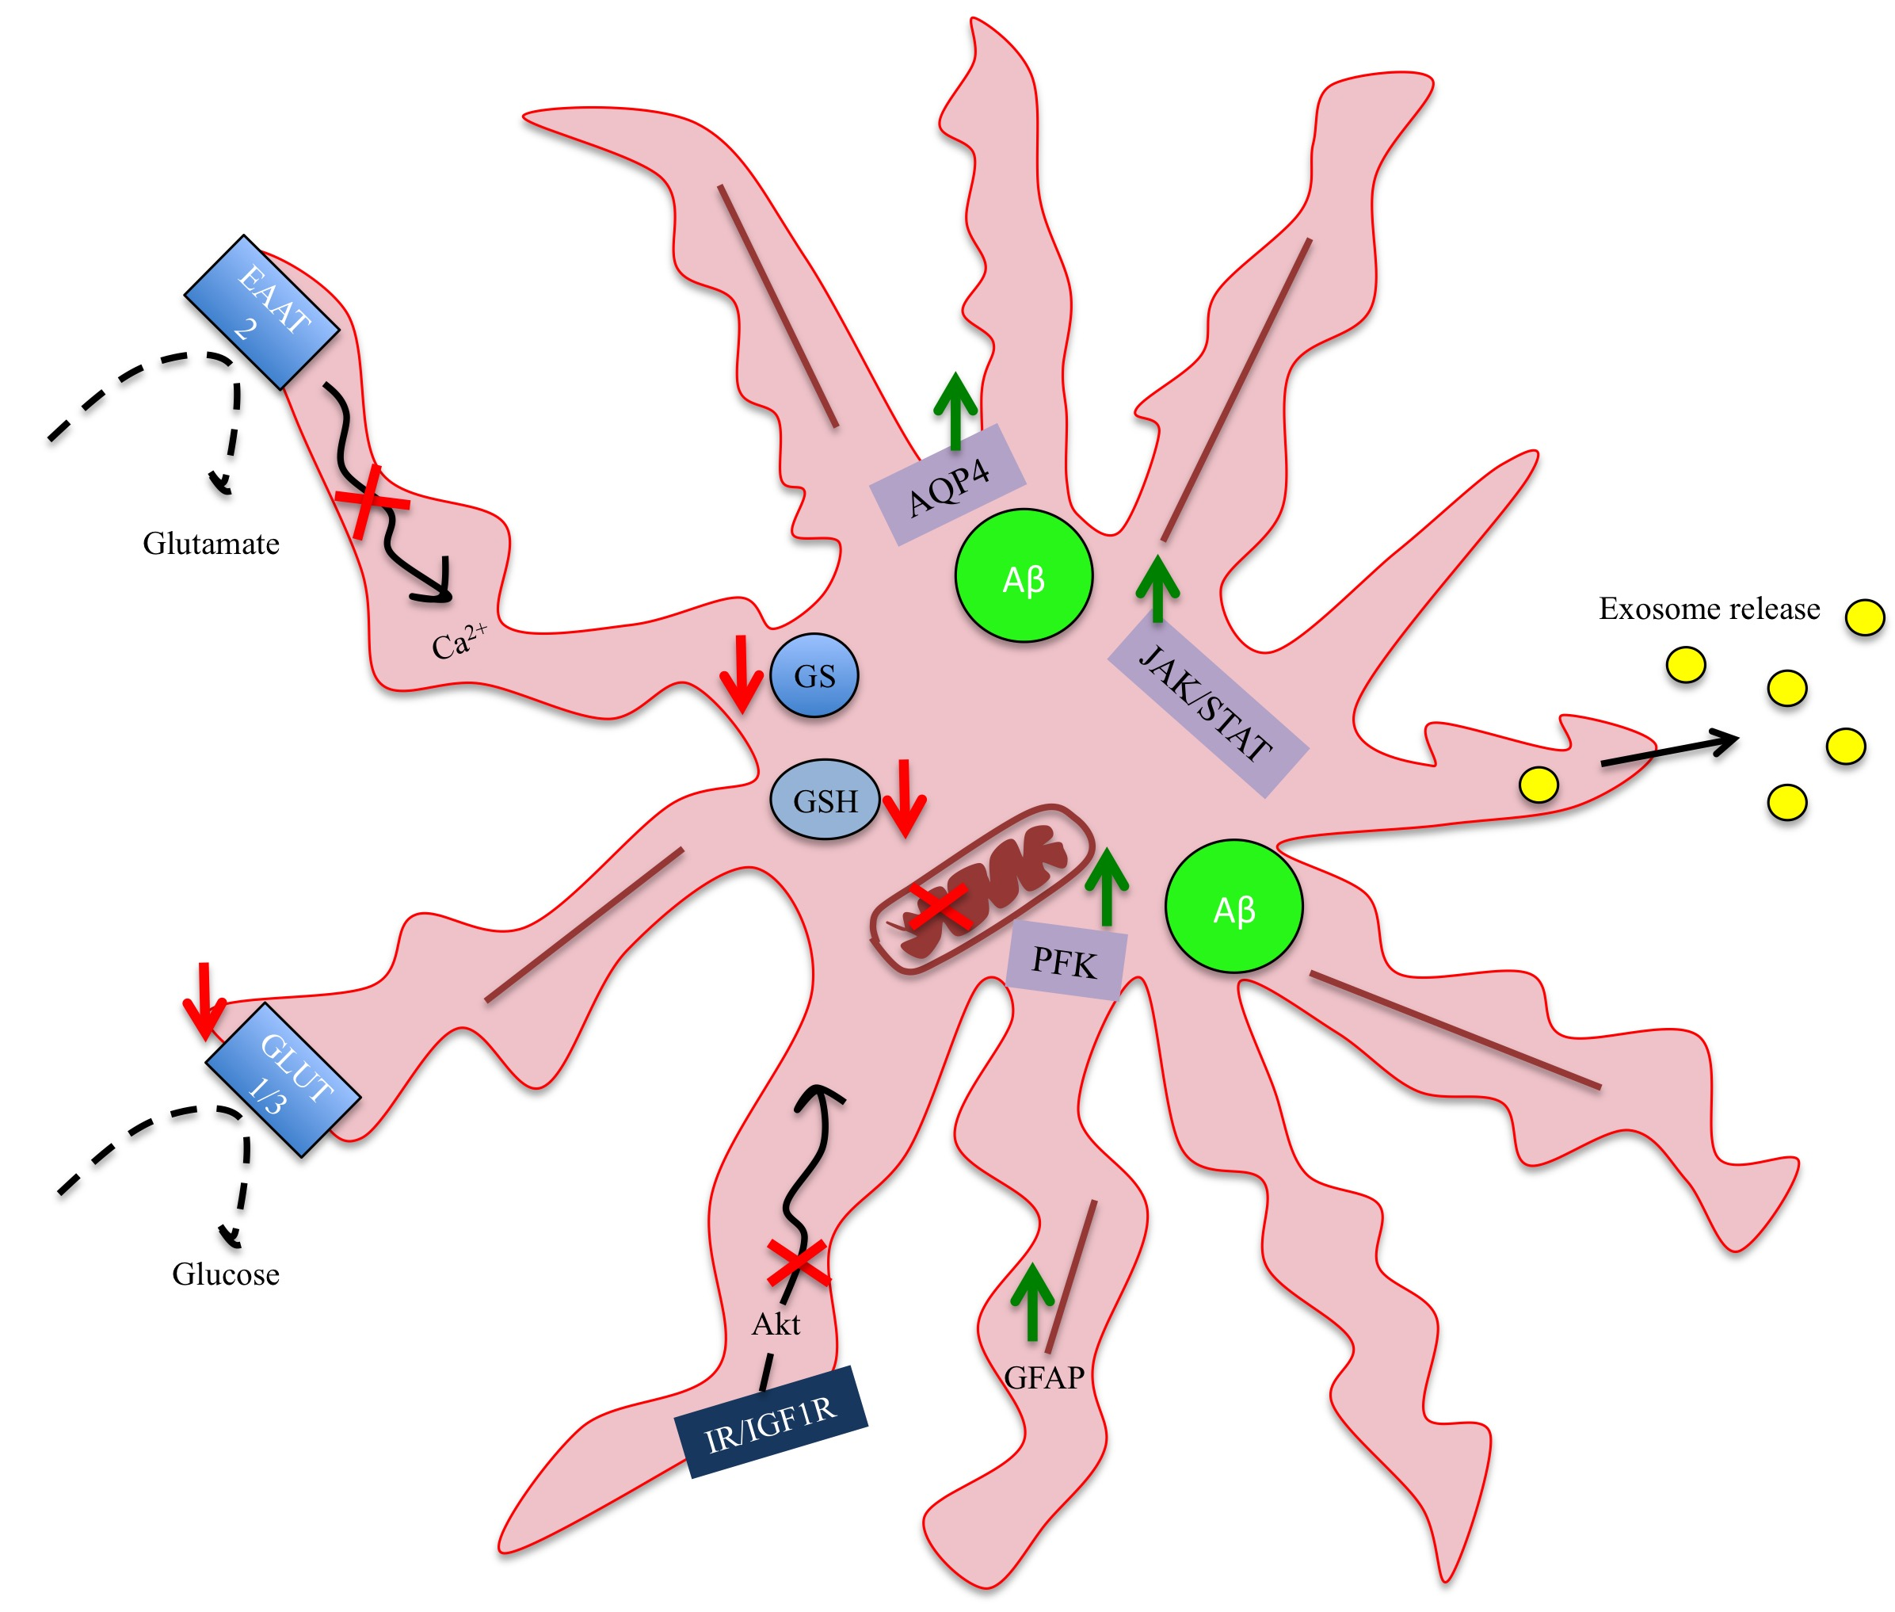

Figure 1.4. Summary of molecular defects in astrocytes shown to contribute to AD
This diagram summarises the changes that have been described to occur in astrocytes in AD. Increased astrocytic reactivity has been observed triggered by tau/ Aβ, which may result from altered signalling through the Janus kinase/signal transducers and activators of transcription (JAK/STAT) pathway. Glial fibrillary acidic protein (GFAP) is elevated in association with AD type pathology. Accumulation of Aβ occurs in astrocytes, which can alter mitochondrial metabolism and increase phosphofructokinase (PFK) involved in glycolysis. Impairments in glucose and glutamate uptake, due to reduced levels of glucose transporters (GLUT1/2) and glutamate transporter (EAAT2) respectively. Less glutamine synthetase (GS), which is responsible for recycling glutamate. Sporadic calcium oscillations occur, which alters communication between astrocytes and neurons. Impaired glutathione (GSH) redox cycling suggesting a lack of antioxidant protection. Increased aquaporin 4 (AQP4) may allow for increased Aβ accumulation. Propagation of Aβ or pathologically-associated species via the release of exosomes. Altered intracellular signalling, such as insulin/IGF1, may alter astrocyte function and create underlying impairments that contribute to AD progression.

1.5 Insulin/IGF1 signalling in the brain

1.5.1 Overview of the Insulin/IGF1 signalling Pathway

The insulin/IGF1 pathway involves a complex network of intracellular molecules that integrate a range of insulin-like stimuli to drive important cellular processes such as proliferation and metabolism. The pathway is heavily regulated as aberrant activation of the insulin/IGF1 signalling pathway could have profound metabolic consequences. An overview of the insulin/IGF1 signalling pathway is shown in Figure 1.5.

Insulin and IGF1 receptors and their adaptor proteins
Insulin and IGF1 are part of a family of insulin-like peptides that initiate signalling by binding their respective disulphide linked α2β2 hetratetrameric receptors, IR or IGFR1, which are mostly described as homodimers. Hybridisation of the IR and IGFR1 has been reported, which could explain the crossover in signalling observed in these pathways (Treadway et al. 1989). Ligand binding to the respective IRα and α subunits causes tyrosine phosphorylation of the two beta kinase domains and a series of transphosphorylation steps, with adjacent beta subunits phosphorylating each other. The pathway is made more complex as there are two splice-isoforms of IR, IR-A and IR-B, each of which are able to form a heterodimer with IGF1R. The IR-A/IGF1R hybrid has higher affinity for IGF1, whereas IR-B/IGF1R hybrids have an equal affinity for insulin and IGF2 (Pandini et al. 2002). In human breast cancer cells, signalling through IR/IGF1R hybrid receptors leads to increased proliferation compared with signalling through the IGF1R homodimer following IGF1 treatment, suggesting that heterodimers are the major mediators of IGF1 signalling (Pandini et al. 1999). Stimulation of the insulin/IGF1 pathway is further regulated by the presence of IGF1-binding proteins (IGFBP), of which there six (IGFBP1-6). These control the bioavailability of IGF ligand by binding to IGF1 and IGF2, thereby blocking receptor activation, although some studies show IGFBPs potentiate IGF activity (Chen et al. 1994). However IGFBPs are also regulated by IGFBP proteases that will digest IGFBPs and increase IGF bioavailability (Salahifar et al. 1997).
Activation of various combinations of IR/IGF1R will lead to recruitment of adaptor molecules and so far 11 substrates have been identified, these include: IR substrates (IRS1-6), Grb2-associated binder 1 (Gab1), Cas-Br-M (murine) ecotropic retroviral transforming sequence homologue (Cbl) and Src homology/collagen domain protein (SHC). IRS1 and IRS2 are the most widely distributed forms of the six known IRS protein, which are phosphorylated after recruitment to the receptor. IRS proteins have more than 20 known tyrosine residues and approximately 70 serine resides in IRS1 that can be phosphorylated, typically tyrosine phosphorylation activates IRS whereas serine phosphorylation deactivates the protein (Copps & White 2012). Activation of adaptor molecules such as IRS will activate SH2- containing signalling proteins, including PI3K and the Ras-mitogen activated protein kinase, MAPK. There is evidence to suggest that in the brain, IR specifically recruits IRS1 and IGF1R recruits IRS2 for propagation of the signal (Talbot et al., 2012). This is likely because brain IR is smaller than peripheral IR and thus potentially lacks the capacity to bind IRS2 through its KRLB (kinase regulatory loop binding) domain (Copps & White 2012).

Downstream signalling through PI3K and MAPK
PI3K and MAPK are divergent signalling pathways that are responsible for the metabolic actions of the ligands and regulation of gene expression necessary for cell growth and differentiation. Activation of PI3K results in phosphorylation of the membrane lipid phosphatidylinositol 4,5-bisphosphate (PIP₂) to produce phosphatidylinositol (3,4,5)-trisphosphate (PIP₃), this then recruits the serine/threonine protein kinase Akt to the membrane for phosphorylation. Full activation of Akt is achieved by phosphorylation at serine 473, which is induced by both mTORC2 (mammalian target of rapamycin complex 2) and DNA protein-kinase (DNA-PK). There are many upstream activators and downstream targets of Akt, which therefore position this molecule as a nodal point in the signalling pathway. Amongst its downstream targets is fork head transcription factor (FoxO), which is important in regulating cell proliferation, oxidative stress and apoptosis (Honda & Honda 1999). In C.elegans, mutations in daf16, which is an ortholog of FoxO, cause an increase in stress resistance and extension of lifespan (Barthel et al. 2005). Akt also modulates mTOR, of which there are two forms: mTOR1 and mTOR2. mTOR1 will activate p70S6K to regulate protein synthesis, whilst mTOR2 can activate several kinases (one of which is Akt) that affect cell migration and proliferation. In addition Akt is responsible for regulating cell cycle through activation of cAMP responsive element binding protein (CREB), is involved in translocation of glucose transporters to the plasma membrane and controls glycogen production through inactivation of glycogen synthase kinase βeta (GSKβ). Insulin/IGF1 signalling also triggers activation of Son of sevenless (SOS) and as a result downstream signalling through ERK (extra-cellular regulated kinase), otherwise known as MAPK P44/42. Signalling via the MAPK pathway is responsible for long-term memory storage in the brain (Zhao & Alkon 2001).

Insulin/IGF1 signalling and ROS
The insulin/IGF1 signalling pathway is a redox-sensitive pathway and its activity is regulated according to the redox balance maintained within the cell (Fisher-Wellman et al. 2012). Stimulation with insulin/IGF1 has been shown to elevate NOX (NADPH oxidase) activity at the plasma membrane, which generates ROS (Mahadev et al. 2004). In addition, insulin/IGF1 upregulation of glucose transporters, as reported in astrocytes (Dávila, Fernández, & Torres-Alemán, 2016), could provide more substrate for and result in increased mitochondrial metabolism and ROS production due to increased leakage of electrons from complex I and III of the electron transport chain. Protein phosphatases are susceptible to oxidation due to the presence of cysteines in their catalytic domains, which can induce conformational changes that inactivate the enzyme (Tonks 2005) . Protein phosphatases such as PTP1B and PTEN can be oxidised, which allows signalling to persist through the insulin/IGF1 pathway and permits a physiological response. Once the insulin/IGF1 signal passes, the redox balance is resolved by the action of antioxidants such as glutathione and the normally dominant phosphatase activity is restored. It is important that this is tightly regulated, as an imbalance in redox status within the cell can reduce phosphatase tone and cause chronic activation of stress kinases such as JNK that are believed to make cells insensitive to insulin/IGF1 (Aguirre et al. 2000; Kamata et al. 2005)

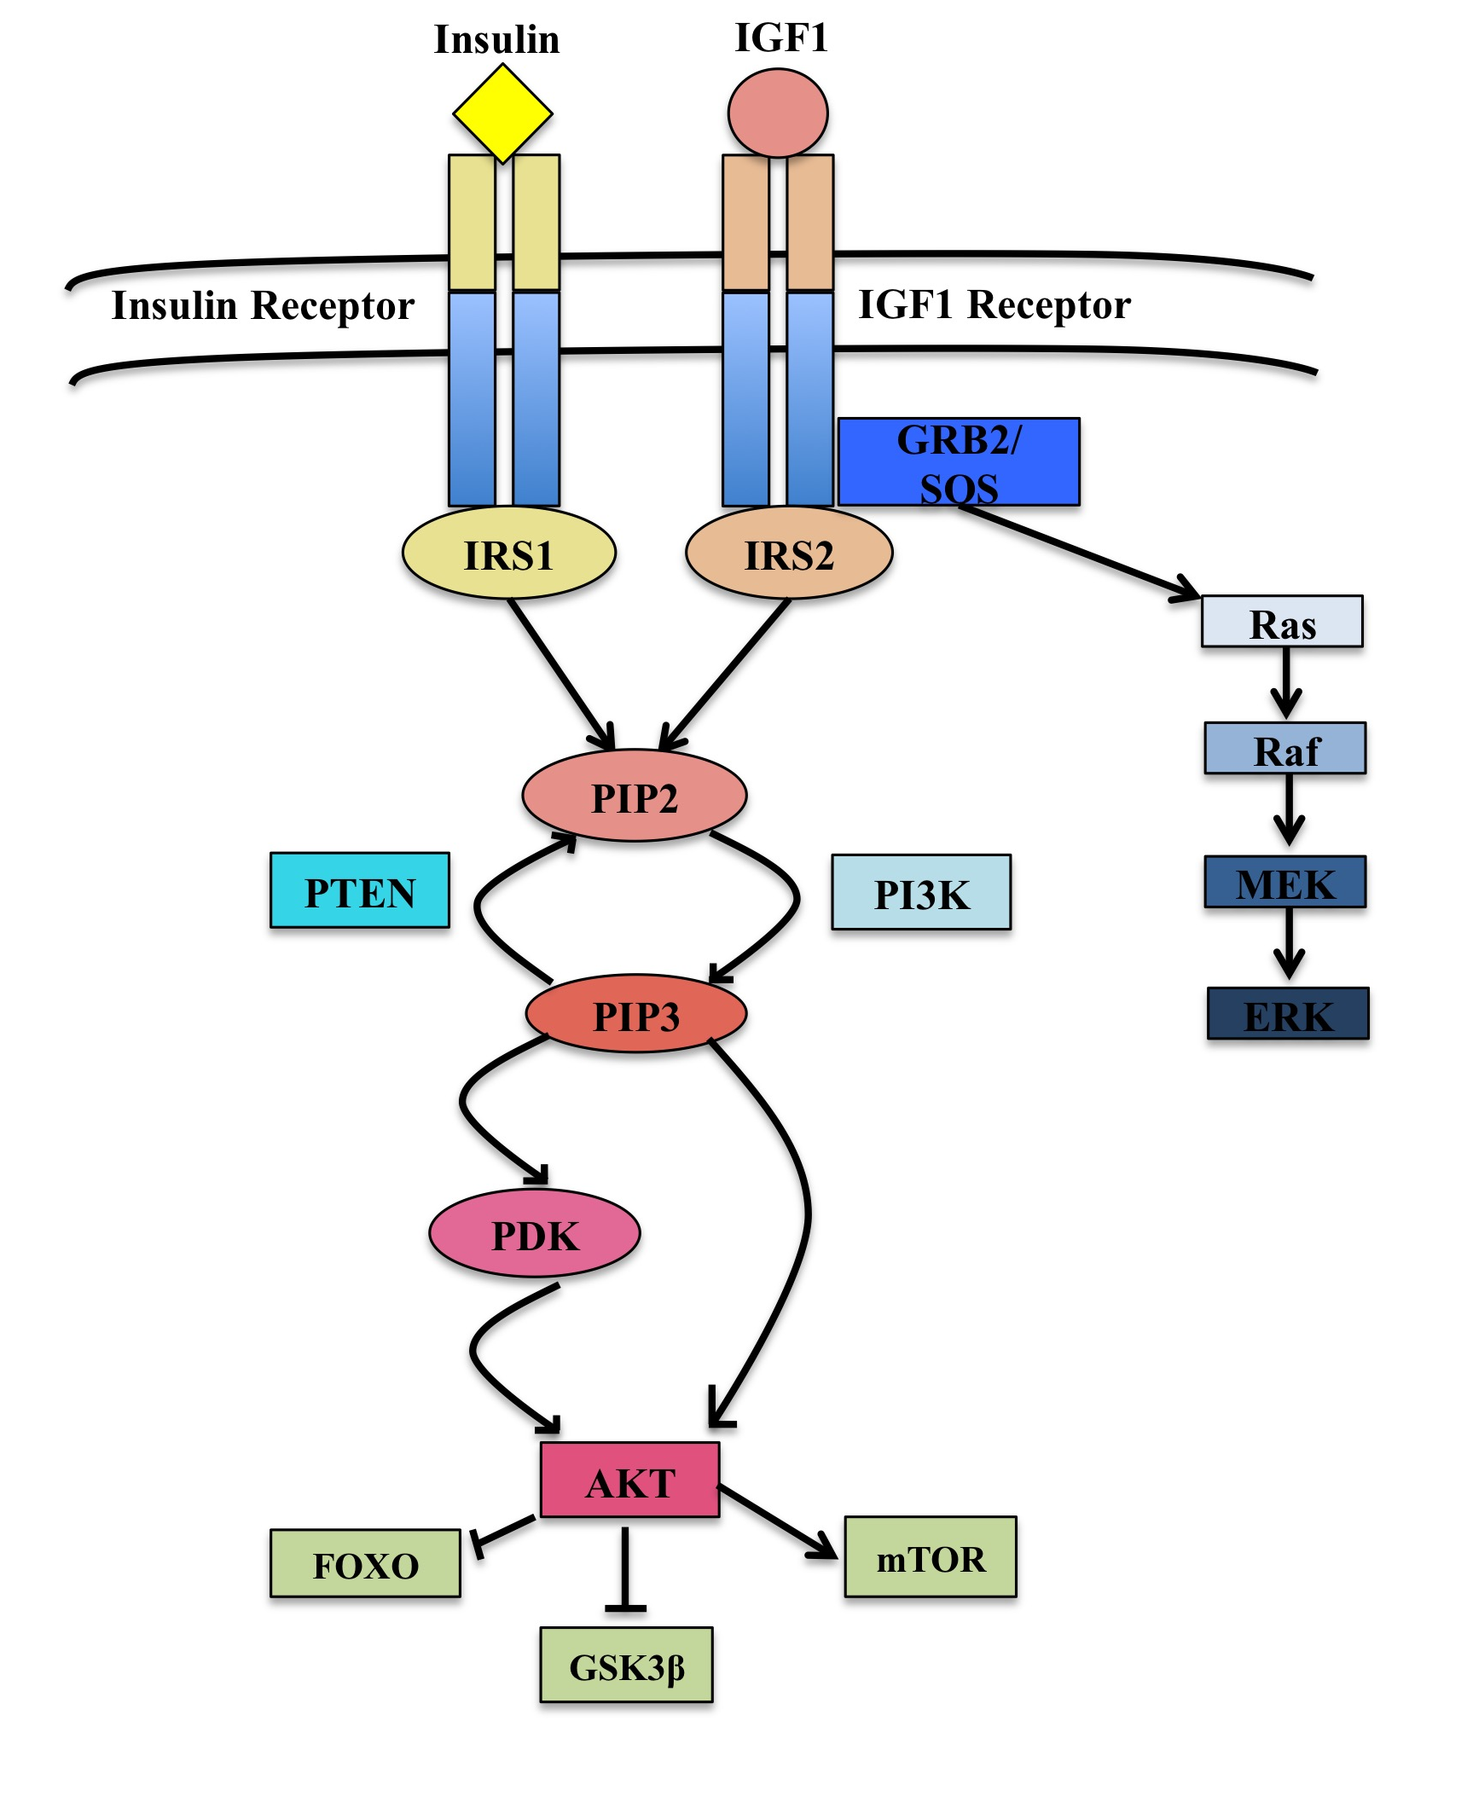
Figure 1.5. A schematic diagram to summarise the key steps in the insulin/ IGF1 signalling pathway.
Insulin and Insulin-like growth factor 1 (IGF1) activate insulin receptor (IR) and insulin-like growth factor 1 receptor (IGF1R). This leads to the recruitment of adaptor proteins such as insulin receptor substrates 1 and 2 (IRS1/2) that trigger downstream phosphorylation cascades and control the activation of divergent signalling pathways protein kinase A (Akt) and extracellular-signal regulated kinase (ERK). These pathways are responsible for cell survival, growth and differentiation.

1.5.2 Role of Insulin/IGF1 signalling in the brain

Insulin
In peripheral tissue, insulin receptors are necessary to mediate glucose transport (Chang et al. 2004). However, the presence and function of insulin receptors in the brain is somewhat of an enigma despite discovery of their expression in the brain many years ago (Unger et al. 1989). Insulin receptors are densely localised in the hippocampus, entorhinal cortex, frontal cortex and synapses of the brain (Frölich et al. 1998). Brain IR has a lower molecular weight as it is less glycosylated than peripheral IR suggesting that brain IR might serve a different role to IR found in peripheral tissue (Boyd & Raizada 1983). More recently, different splice isoforms have been identified in human astrocytes and in a human neuronal cell line, with astrocytes predominantly expressing the IR-B isoform than IR-A (Garwood et al. 2015). Another study has shown that chronic stimulation with insulin causes downregulation of IR in glia and not neurons (Clarke et al. 1984). Taken together, this may suggest that expression of IR-B makes astrocytes more prone to insulin-resistance but further work is necessary to investigate this. Current evidence suggests that the IR serves to facilitate tight regulation of glucose transport to specfic regions in the brain (Hill et al. 1986), aid the development of the CNS and modulate neuronal excitability and synaptic plasticity (Wan et al. 1997; Chiu et al. 2008). Insulin binds and is transported across the blood brain barrier (BBB) by insulin receptors present on endothelial cells, which occurs by mechanisms that are so far unclear. Insulin is then capable of transversing directly into neurons or believed to reach neurons indirectly through astrocytes, this is also true for IGF1. Insulin is also produced locally in the brain and plays important roles in learning and memory formation (Zhao & Alkon 2001). In addition, administration of insulin has been shown to cause significant improvements in cognitive performance in individuals with AD (Craft et al. 2012; Reger et al. 2008; Craft et al. 1999) (described in detail later).

IGF1
The insulin/IGF1 signalling system mediates the growth of 50% of the brain and body, as demonstrated by severe growth deficiency in mice with a null mutation in the IGF1R gene (Liu et al. 1993). IGF1 is made in the liver, where its production is regulated by growth hormone (GH), which can then move from the plasma across the BBB into the CNS (Coculescu n.d.). A tertiary complex of IGF1, IGFBP3 and an acid-labile subunit is suspected to form, which subsequently binds LRP1-IGF1R receptor complexes on endothelial cells allowing for transcytosis of IGF1 (Nishijima et al. 2010). Movement of IGF1 across the BBB is regulated by neuronal activity, which was demonstrated by an increase in IGF1 in the somatosensory cortex of the brain following unilateral whisker stimulation in rats(Nishijima et al. 2010). As well as moving across the BBB, IGF1 can be produced locally in the brain independent of GH action either by cerebral vascular cells or by neurons and glia in the brain parenchyma (Sun et al. 2005). The function of IGF1 is context dependent, which means its effects vary according to cell type, concentration and developmental status. The IGF1 signalling pathway is suspected to have a neuroprotective role and like the insulin pathway is critical for peripheral and central growth, as well as crucial for synaptic plasticity.
Although the distinct actions of insulin and IGF1 can be described it is well recognized that they act in concert and for this reason the signalling pathway is commonly referred to as the insulin/IGF1 signalling pathway.

1.6 Impairments in Insulin/IGF1 promote longevity

A number of in vivo studies in lower organisms have demonstrated that reduced signalling through the insulin/IGF1 pathway correlate with stress resistance and increased longevity. This was initially identified in C.elegans where loss of the insulin/IGF1 receptor orthologue daf2 results in a two fold-extension in survival (Kenyon et al. 1993) and since, impairments in this system have shown reproducible effects in other model organisms including flies (Clancy et al. 2001) and mice (Holzenberger et al., 2003). A five-fold increase in longevity was later demonstrated in a daf2 rsks1 (C.elegans S6K orthologue) C.elegans mutant, showing synergistic effects on lifespan extension when multiple insulin/IGF1 signalling proteins are targeted (Chen et al. 2013). In addition, mutations in IGF1R associated with downregulated receptor activity and low expression of IGF1, PI3K and IRS1 have been identified in female centenarians (Suh et al. 2008; Bonafè et al. 2003) In a separate study, loss of IGF1 was found in a group of centenarians however dementia was more prevalent in individuals with the lowest levels of IGF1 (Arai et al. 2001). These results suggest that impaired insulin/IGF1 signalling is beneficial for longevity. However some degree of pathway activity is necessary as complete deletion of IR/IGF1R is lethal in mice (Holzenberger et al. 2003) and very low IGF1 levels have been associated with cognitive decline (Arai et al. 2001). Furthermore, reduced insulin/IGF1 signalling seems to confer protection from toxic protein aggregates such as the Huntington’s disease associated polyQ peptide and the Alzheimer-linked Aβ peptide in the brain (Cohen et al. 2006).
Upregulation of stress defense mechanisms could explain how impairments in insulin/IGF1 are associated with longevity. One of the defined mechanisms involves activation of the transcription factor FoxO (Samuelson et al. 2007). Insulin/IGF1 can signal through Akt and ultimately induce phosphorylation of FoxO so that it is retained in the cytosol. However, inhibition of insulin/IGF1 signalling causes translocation of unphosphorylated FoxO to the nucleus where it transcriptionally regulates antioxidant genes such as catalase and superoxide dismutase (Klotz et al. 2015). Although temporary ROS production is managed by FoxO mediated antioxidant generation, sustained levels of ROS can induce FoxO mediated apoptosis by stimulating the expression of pro-apoptotic factors, BIM and Fas ligand (Manolopoulos et al. 2010). This further highlights that disruption of this signalling pathway can have both beneficial and detrimental effects and is also time-scale dependent.

A second way that longevity might be associated with insulin/IGF1 could be linked to changes in mitochondrial metabolism. Reduced input through the insulin/IGF1 pathway essentially signals to the cell that there is a nutrient deficiency, which can elevate mitochondrial metabolism through a suspected AMPK dependent mechanism, where AMPK acts to sense energy depletion in the cell. Increased mitochondrial metabolism causes an associated increase in ROS levels, which upregulates antioxidant defense mechanisms and operates in an NRF2 dependent manner in C.elegans (Zarse et al. 2012; Chen et al. 2013).

Increasing levels of oxidative stress and reduced levels of glutathione have been detected in the brains of MCI and AD patients (Mandal et al. 2012; Ansari et al. 2010). In addition, significant oxidative-stress induced DNA damage has been observed in astrocytes in an ageing cohort of brains, although did not correlate with Alzheimer-type pathology (J E Simpson, Ince, Haynes, et al. 2010). This has led to clinical trials being conducted to assess the efficacy of antioxidants in delaying AD associated cognitive decline. However, many of these antioxidants have failed to delay disease progression and in some instances accelerated memory decline (Persson et al. 2014). This has led to the development of a new theory, which proposes that the generation of ROS during ageing and associated with impairments in insulin/IGF1 allows cells to evolve and develop stress-resistant mechanisms to not only cope with immediate elevations of ROS but to further oxidative insults. This adaptive response is called mitochondrial hormesis (Ristow & Zarse 2010) and is being used to explain longevity associated with calorie restriction and physical exercise, both of which create energy deficits (like insulin/igf1 impairment) that lead to increased mitochondrial metabolism, elevations in ROS and an adaptive upregulation of antioxidants.

However new theories are emerging on the concept of longevity, which was highlighted in a more recent study where the healthspan of longer-living mutant C.elegans was measured (Bansal et al. 2015). It is often assumed that an extension of life correlates with an extension in health, however this study demonstrated that longer-living C.elegans mutants, such as the daf2 mutant, spend considerably more time with age-associated defects (oxidative stress resistance, heat resistance and motility were all parameters measured). Furthermore, impairments in the GH/IGF1 signalling axis result in dwarf mice that despite living 50% longer are obese in their old age (Donahue & Beamer 1993). A congenital deficiency in IGF1 production in humans called Laron Syndrome, results in significantly shorter, obese individuals, with no apparent extension of life that are resistant to cancer and diabetes. (Guevara-Aguirre et al. 2015). Studies like these may redefine how assessments of lifespan are made, such that measurements of time spent in a frail or compromised state are also accounted for.

1.7 Insulin/ IGF1 signalling pathway is implicated in AD

Maintaining the correct balance of insulin/IGF1 signalling is imperative to preserving normal cell function and aberrant control of the downstream PI3K/Akt pathway is an emerging theme in all diseases of ageing including cancer, heart disease, type-2-diabetes and neurodegeneration. Impaired Akt activity in neurons is considered an early feature of AD progression (de la Monte, 2012; Moloney et al., 2010; Talbot et al., 2012) and these changes have been linked to altered insulin/IGF1 signalling. The levels and activity of several molecules in the insulin/IGF1 signalling pathway have been reported to change in AD (summarised in Figure 1.6). Although there is a lot of dichotomy in the literature regarding the specific molecular changes in the insulin/IGF1 pathway, overall there appears to be decreased signalling through this pathway, with both upstream and downstream signalling molecules affected. Most of the work carried out to date has identified an insulin/IGF1 resistant state in neurons, with less known about changes in other cell types in the brain.

1.7.1 Altered expression in insulin/IGF1 signalling at the cell surface/receptor level

IGF1 and IGF1R
Reduced levels of IGF1 ligand have been reported in an ageing AD rat model (Carro et al. 2002), in human AD brain (Steen et al. 2005; Vidal et al. 2016) and significantly increased in the serum of the offspring of patients with AD (van Exel et al. 2014). In contrast, increased expression of IGF1 has been shown in astrocytes and in association with Aβ, suggesting possible trophic support for degenerating neurons that is consistent with upregulation of IGF1 in the brain following injury (Jafferali et al. 2000; Madathil et al. 2013). Increased levels of IGF1 have also been detected in the serum and CSF from patients with AD which might suggest a compensatory, neuroprotective response (Tham et al. 1993; Salehi et al. 2008).
At the receptor level, IGF1R has been shown to increase in astrocytes surrounding amyloid containing plaques in AD post-mortem cases, with an associated decrease in the levels of insulin like growth factor binding protein 2 (IGFBP2) (Moloney et al., 2010). This might suggest that astrocytes have adapted to reduced IGF1 ligand levels by upregulating IGF1 receptors and decreasing IGFBP2. In addition, increased activation of the IGF1 pathway could help protect against toxic Aβ aggregates, since IGF1 regulates expression of proteins involved in clearance of Aβ, such as albumin and transthyretin (Cohen et al., 2009, 2006). Moloney et al (2010) also report increased IGF1R expression within Aβ plaques and NFTs and decreased expression in neurons, although this was attributed to neuronal atrophy in the AD brain.
In an adult APP/PS1 AD with an inducible knockout of neuronal IGF1R (ADINKO mice), impaired IGF1 signalling alleviates soluble and insoluble Aβ accumulation. These mice had reductions in neuronal soma size, sustained downregulation of the PI3K-Akt-mTOR signalling pathway and decreased levels of the autophagosome marker LC3II, which was associated with decreased autophagic vacuoles containing Aβ. In addition, female ADINKO mice showed improvements in cognition and behaviour compared with wild-type mice (Gontier et al. 2015). This study is also consistent with previous studies, showing that loss of neuronal IGF1R in two different AD mouse models alleviates AD associated cognitive deficits (Cohen et al., 2009; Susanna Freude et al., 2009).
Insulin and IR
Variable levels of IR have been detected in the AD brain. Moloney et al. (2010) reported that IR levels were unchanged overall in AD brain, although observed an increase in IR expression in neuronal nuclei suggesting reduced response to insulin. Other studies have also reported that basal expression of IR (and IGF1R) are unchanged in the the cerebral cortex and hippocampus of AD brain (Talbot et al. 2012; Jafferali et al. 2000). However, Talbot et al (2012) demonstrate that insulin/IGF1 resistance is apparent in AD cases when stimulated with ligand. They also show that signalling is less well preserved through both IR and IGF1R in the hippocampus than in cortex, which is consistent with progression of AD pathology in the brain. Transcriptomic studies of astrocytes in the ageing Alzheimer brain have also identified downregulation of IR and IGF1R at the transcript level (J E Simpson, Ince, Lace, et al. 2010).
As insulin can cross the BBB, peripheral levels of insulin may be able to reflect activation of this pathway in the brain. In AD, both loss of insulin in CSF and an increase in blood plasma insulin have been identified (Craft et al. 1998). There are reports of activated central insulin signalling as a result of injecting insulin peripherally, which raises the question whether hyperinsulinemic states in Type 2 diabetes (T2D) results in decreased sensitivity to insulin in the brain (Freude et al. 2005). In the NIRKO mouse model (brain/neuron specific insulin receptor knockout), Freude et al also demonstrate that within ten minutes of administering insulin peripherally there is tau phosphorylation at a site that correlates with tangle formation, thus potentially linking a hyperinsulinemic state with Alzheimer pathology.

Relationship between Aβ and insulin/IGF1 signalling
Aβ and insulin also share a common recognition motif for the IR, therefore, Aβ can competitively bind to IR reducing both insulin binding and IR autophosphorylation (Xie et al. 2002; Townsend et al. 2007). Insulin also stimulates Aβ production and prevents the extracellular degradation of Aβ by competing with the metalloproteinase insulin degrading enzyme (IDE), which is capable of the breakdown of both insulin and Aβ (Gasparini et al. 2001). IDE production is stimulated by insulin as a feedback-inhibitory response. It serves to cleave several proteins that form beta-pleated sheet rich amyloid fibrils including Aβ, insulin, glucagon and amylin. Levels and activity of IDE are decreased in AD brain tissue and are also associated with increased Aβ levels (Cook et al. 2003; Pérez, et al. 2000). There is also a strong correlation between IDE levels and Apoε4 genotype, with lower levels of IDE being detected in AD cases with two copies of the Apoε4 allele compared to high levels of IDE being present in cases with no copies of the allele (Zhao et al. 2004). These findings have led to the hypothesis that Aβ oligomers accumulate and impair insulin/IGF1 signalling, which further exacerbates Aβ oligomerisation and toxicity due to reduced clearance by IDE, transthyretin and albumin. However, in contrast, Aβ monomers have been shown to have a neuroprotective effect by binding IR/IGF1R and activating downstream signalling through the pathway and promoting neuronal survival (Giuffrida et al. 2009). Therefore the types of Aβ present in the brain could also determine activity of the insulin/IGF1 pathway.

Challenges
A population-based approach has also been used to assess changes in the insulin/IGF1 signalling pathway in AD. A recent meta-analysis combined the data from 9 different population-based studies and found no significant correlation in serum IGF1 and AD (Ostrowski et al. 2016). The variability of these studies may result from differences in an individual’s environmental exposures during their lifetimes, such as tobacco smoke, which has been shown to impair central insulin/IGF1 signalling (Deochand et al. 2015). Many of these studies also do not account for the stage of AD progression and generally only explore insulin/IGF1 levels in serum instead of additionally assessing levels in the CSF or regulatory proteins such as IGFBP’s. In addition genetic polymorphisms such as mutations in gamma-secretase and presenilin-1 were not accounted for. More recently, polymorphisms in IGF1 have been identified and shown to be elevated in AD subjects with increased levels of IGF1 in serum (Vargas et al. 2011; W. Wang et al. 2012). Each of the features listed here could alter insulin/IGF1 signalling to different degrees and require different levels of therapeutic supplementation to restore signalling.
The effects of impairing upstream insulin/IGF1 signalling also produce variable effects, which makes it difficult to define how aberrant insulin/IGF1 signalling is involved in AD. For example, NIRKO mice experience no changes in survival, development and apoptotic levels in the brain following knockout of the insulin receptor (Schubert et al. 2004). This may suggest that compensatory pathways are employed to maintain brain structure and function. In support of this, heterozygous inactivation of IGF1R in the mouse brain decreases growth and increases longevity yet no cognitive defects are observed, which may be the result of compensatory increased activation of remaining IGF1R (Kappeler et al. 2008). As the insulin and IGF1 signalling pathways are interlinked, it makes it challenging to dissect out the individual contribution of these pathways in AD.

1.7.2 Downstream pathway modifications and AD

Insulin receptor substrate
Changes in the levels of adaptor proteins IRS1 and IRS2 have also been reported in AD. Phosphorylation of IRS1 can occur at over 70 distinct residues, which will modulate IRS1 activity. In general, tyrosine phosphorylation will activate IRS1, whereas serine phosphorylation inactivates IRS1 by either targeting it for degradation or making it a weaker substrate for RTK activation (Gual et al. 2005). In AD neurons both IRS1 and IRS2 are reduced, and this is associated with increased phosphorylation at IRS1 serine residue 312 (S312), S636 and S616 and colocalisation with NFTs (Bomfim et al., 2012; Moloney et al., 2010; Yarchoan et al., 2014). Increased activity of ERK and mTOR (mammalian target of rapomycin) are able to trigger feedback inhibition of the insulin/IGF1 pathway by phosphorylating serine residues on IRS1 (Gual et al. 2003). In agreement with this, hippocampal neurons of post-mortem AD tissue have enhanced ERK activity in comparison with control (Sun et al. 2003). Increased IRS1 serine phosphorylation also occurs in response to oxidative stress induced JNK signalling pathway activation (Bomfim et al. 2012). This therefore provides a link between oxidative stress, known to occur early in AD progression, and an insulin resistant state in the brain. In T2D, increased serine phosphorylation at serine residue 636 has been identified as a mechanism by which skeletal muscle becomes resistant to insulin (Bouzakri et al. 2003). Elevated phosphorylation of IRS1 at serine residue 636 has also been identified in the hippocampus of Alzheimer’s patients (Talbot et al. 2012a). This raises the question of whether the molecular changes that occur in T2D are similar to changes that occur in AD and further supports the idea that Alzheimer’s is an age-related metabolic disorder. Phosphorylation of IRS2 is less well studied as there are fewer phospho-specific antibodies available. However, IRS2 knockout in mice reduces brain growth and promotes tau phosphorylation (Schubert et al. 2003), suggesting an important role of IRS2 in maintaining brain function.
Both IRS1 and IRS2 adaptor proteins converge on signalling through either the MAPK or PI3K signalling pathways. Downstream of MAPK is glycogen synthase kinase 3 (GSK3). GSK3 is believed to play a pivotal role in the pathogenesis of sporadic and familial cases of AD (Hooper et al. 2008), which has led to the “GSK3 hypothesis of AD”. This hypothesis states that constitutive activation of GSK3β causes hyperphosphorylation of tau incorporated intro NFTs (Ferrer et al. 2002), increased plaque burden, microglial activation and memory impairment. However the AD pathology attributed to GSK3β may be encompassed by upstream alterations in the insulin/IGF1 signalling. Levels of GSK3β are upregulated in the hippocampus of AD patients (Hooper et al. 2008).

Akt
In addition, elevated Akt activity has been shown in response to Aβ (Bhaskar et al. 2009; Chiang et al. 2010), which also causes feedback inhibition of the insulin/IGF1 pathway by increasing serine phosphorylation of IRS1. Impaired insulin/IGF1 signalling could provide the link between Aβ and tau pathology. Aβ can bind IR/IGF1R and by causing Akt hyperactivity would induce feedback inhibition of the pathway and an associated increase in GSK3β-mediated hyperphosphorylation of tau. Administration of insulin in AD patients with hyperactivated Akt may not have the desired effect Craft et al (2012) predicts, since the insulin dose may not be able to outcompete Aβ binding to IR and if able to bind could further downregulate the pathway through Akt mediated feedback inhibition.

Phosphatase and tensin homologue (PTEN)
PTEN is a negative regulator of the insulin/IGF1 signalling pathway and is responsible for modulating the level of Akt activation. In AD, PTEN is lost from neurons, which is thought to be responsible for constitutive activation of Akt and hyperphosphorylation of downstream targets, mTOR, tau and GSK3β (ser9) (Griffin et al. 2005). Signalling through Akt in many mitotic cells provides a survival advantage. However, continuous overactivation of Akt may be detrimental to post-mitotic cells such as neurons, which may explain the loss of neurons and increased pAkt activation in the hippocampus of the AD brain. Phosphorylation at serine 9 is responsible for inactivation of GSK3β and therefore this study would suggest less phosphorylation of downstream tau. It would also contradict other reports in the field that have shown increased GSK3β activity giving rise to hyperphosphorylated tau and ultimately tau pathology (Noble et al. 2013). However, Griffin et al (2005) also show elevated phosphorylation of GSK3β at tyrosine 216, which demonstrates that both inhibitory and stimulatory phosphorylation inputs to this protein are impaired in AD.

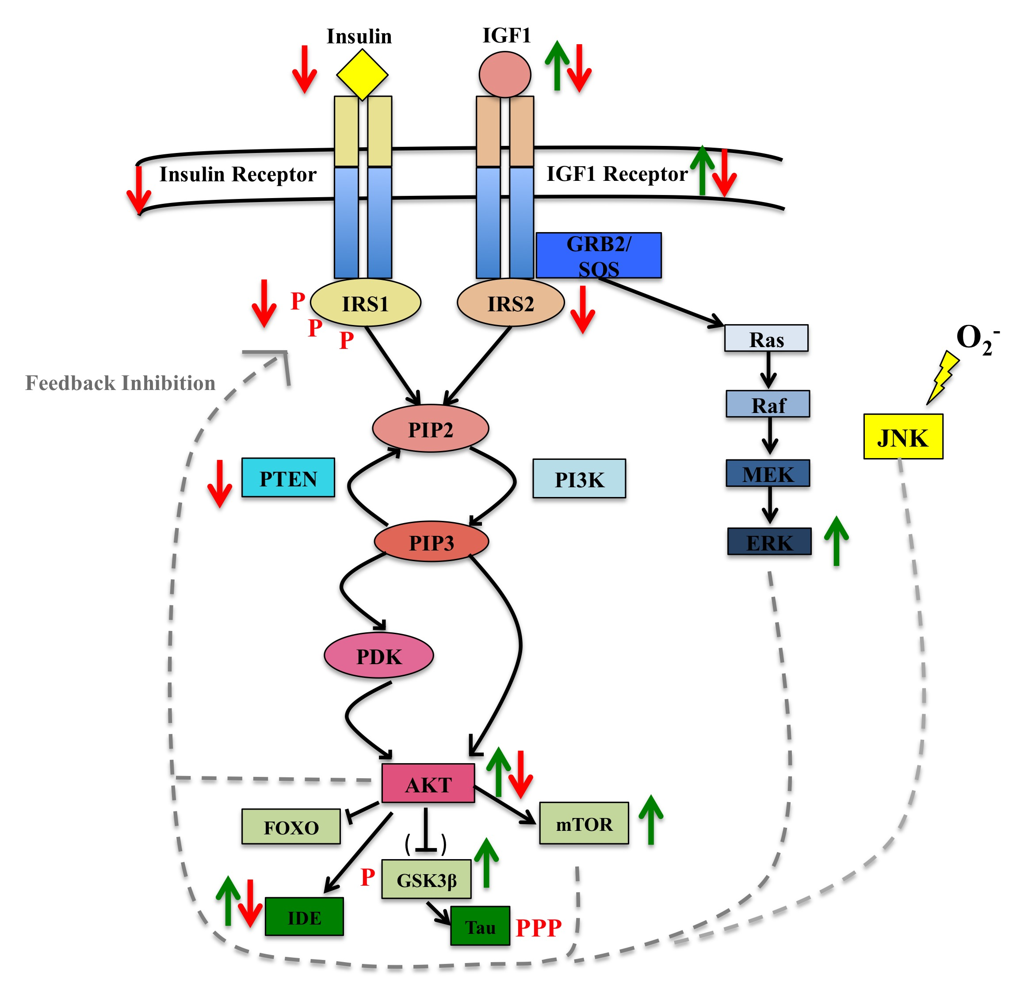
Figure 1.6. Impairments in the Insulin/IGF1 signalling pathway identified in AD.
A schematic diagram to illustrate the signalling molecules impaired in the insulin/IGF1 pathway in AD. Changes in activity, mRNA and protein expression are represented in green (increase) and red (decrease) arrows. Hashed lines show feedback inhibitory effects on the pathway shown to be implicated in AD.

1.8 Therapeutically targeting the Insulin/IGF1 pathway for treatment of neurodegeneration, with a focus on AD

IGF1 as a potential therapy in neurodegenerative disease
IGF1 is currently used in the treatment of diabetes and growth deficiency but its neurotrophic properties means that it also offers potential in the treatment of pathological neurodegenerative conditions. The therapeutic potential of IGF1 has been studied most extensively in ALS, which is classically characterised by the loss of upper and lower motor neurons. In vitro studies have demonstrated that IGF1 is protective against glutamate mediated caspase 3 cleavage and associated DNA damage in motor neurons (Vincent et al. 2004) and an in vivo study using the G93A mouse model has corroborated these findings; intrathecal injection of IGF1 into the lumbal spinal cord improved survival, delayed disease onset and retained functionality of motor neurons in these mice (Nagano et al. 2005). This study also demonstrated that the key survival pathways Akt and Erk were activated in non-neuronal cells such as astrocytes following continuous IGF1 administration, suggesting that the pro-survival effects of IGF1 are not confined to neurons. In the same way, viral delivery of IGF1 prolonged survival of a SOD1 ALS mouse model, even at late stages in disease progression (Kaspar et al. 2003) and attenuated microglial activation by reducing NO and tumor necrosis factor (TNF)-α levels (Dodge et al. 2008). In addition, expression of a muscle restricted IGF1 isoform maintains muscle integrity and prolongs survival of a SOD1 G93A ALS mouse model (Dobrowolny et al. 2005).

Studies suggest that the levels of circulating IGF1 in ALS patients is varied, although one such study demonstrated a 36% increase in IGF1 levels and a 34% decrease in IGFBP1 compared with healthy controls in the longest living ALS patients. To assess the therapeutic implications for ALS patients, IGF1 has been administered subcutaneously to affected individuals in two randomized double blind placebo controlled phase III trials. The results of these trials conflicted with one another showing both no difference and a delay in motor neuron dysfunction following IGF1 treatment (Lai et al. 1997; Borasio et al. 1998). A study has also been conducted in a small ALS patient subset in Japan, where patients with intrathecal IGF1 injection showed delayed muscle deterioration (Nagano et al. 2005). IGF1 therapy in ALS patients may offer a promising strategy to delay motor neuron degeneration, however it is still not clear whether there is any therapeutic benefit.

A study has shown that as rats age there is decreased IGF1 present in the serum, which correlated with an increase in cholesterol, reduced antioxidant capacity and impairments in mitochondrial function, however each of these was restored following IGF1 treatment (García-Fernández et al. 2008). Each of these studies formed a basis to test the therapeutic potential of IGF1 in the context of AD. Pfizer conducted a trial in several AD mouse models to assess whether IGF1 administration could delay disease progression since IGF1 has been shown to be involved in Aβ clearance (Carro et al. 2002). Acute and prolonged IGF1 delivery in plasma was unable to lower levels of Aβ in the brain or CSF in in vivo mouse models (Lanz et al. 2008). However additional complexities arise from treating with IGF1, as this neurotrophic factor drives cell growth and metabolism and at high enough concentrations could be pro-oncogenic. Also, since loss of IR/IGF1R can enhance longevity and may protect against AD-type pathology, introducing high concentrations of insulin or IGF1 ligand may have adverse effects. A growth hormone secretagogue, MK-677, was trialled in AD patients to assess whether GH-induced secretion of IGF1 affected AD progression over 12 months compared with placebo. Despite increased IGF1 being detected in the serum of AD patients, the rate of cognitive decline was not improved (Sevigny et al. 2008).

Restoring insulin sensitivity in AD
Diabetes treatments have also been investigated in subjects with AD. Trials involving intranasal insulin delivery to AD patients have been conducted to assess whether resensitisation of insulin signalling in the brain can restore memory and cognition. To avoid hypoglycemia and peripheral insulin resistance, insulin has to be administered intranasally, which also allows rapid access to the brain and little changes to peripheral insulin levels. One trial involving daily intranasal insulin treatment over three weeks, in patients with AD or amnestic mild cognitive impairment (MCI), resulted in better recall of verbal information and lowered pathologically associated forms of Aβ₁₋₄₂ (Reger et al. 2008). Long term administration of insulin to MCI and AD patients over a four year period, has shown therapeutic benefit with improvements observed in cognitive function and delayed in development of hypometabolism. These improvements persisted in individuals two months after insulin treatment was stopped (Craft et al. 2012). Due to the relatively short half-life of recombinant human insulin, clinical trials have also been conducted using the insulin analog detemir. After a three week treatment with detemir, APOε4 positive AD patients were the only group who showed improvements in verbal and working memory (Claxton et al. 2015), which was attributed to the higher levels of insulin resistance in APOε4 positive AD individuals. This suggests that APOε4 status effects the insulin-associated improvements in cognitive function in AD patients and may be indicative of a more insulin-resistant like state in the brain. However a drawback of using insulin, as identified in the diabetes field and in this study, is that despite causing temporary induction of the pathway treatment with insulin can also result in pathway desensitization. These trials are still ongoing and more AD/MCI patients are being recruited to further assess the effects of insulin on cognition.

Other pathways are also being therapeutically targeted to improve insulin sensitivity and avoid inducing insulin resistance following prolonged treatments with insulin. Exendin 4 is a GLP1 (glucagon-like peptide 1) agonist currently used as an anti-diabetic agent that can modulate insulin signalling without affecting insulin receptor activity. Exendin 4 can decrease Aβ oligomer induced phosphorylation of IRS1 serine 636/639 and resensitise insulin signalling in hippocampal neurons in an AD mouse model (Bomfim et al. 2012). More recently, GLP1 has been shown to protect mouse hippocampal neurons against additional AD associated stressors such as l-glutamate and tunacamycin and this relies on activation of Akt and MAPK signalling (Yoshino et al. 2015). Increased signalling through PI3K/Akt occurs following an exendin 4 dependent elevation of insulin levels, which additionally reduces tau hyperphosphoryltion in a Type-2 diabetic rat model (Yang et al. 2016).

1.9 Role of Insulin/IGF1 signalling in astrocytes

Astrocyte-enriched rodent cultures treated with insulin or IGF1 have increased glucose uptake, glycogen content and higher levels of leucine incorporated in astrocytic proteins (R Dringen & Hamprecht 1992; Kum et al. 1992). Stimulation of the insulin/IGF1 signalling pathway also activates glutamate synthase which produces glutamate and directly influences glucose uptake in rodent astrocytes (Hamai et al. 2002). In addition, insulin is involved in regulating the distribution and levels of the glutamate transporter GLT1, which is expressed by astrocytes. Similarly, IGF1 enhances glutamate transport in rat astrocytes through increased transcription and translation of GLAST (Suzuki et al. 2001). Therefore, insulin/IGF1 signalling in astrocytes may co-ordinate energy metabolism with neurotransmission. This link has recently been made in a mouse model in which IGF1 has been virally knocked down in the liver, which reduces levels of IGF1 in the serum and the cortex. Using this model, they show that an overall IGF1 deficit in the brain lowers the expression of astrocytic metabotropic glutamate receptors and reduces the release of vasodilator mediators such as arachidonic acid, causing neurovascular uncoupling and impairments in learning and spatial working memory (Toth et al. 2015).

The link between insulin/IGF1 and glucose metabolism has been further substantiated recently. In mouse astrocytes, reduced basal expression of IR downregulates glucose uptake whilst loss of IGF1R increases glucose uptake indicating that unbound IR has a stimulatory effect whereas IGF1R has an inhibitory effect on glucose entry into the cell. The same study also demonstrated that both insulin and IGF1 ligands are necessary to increase glucose uptake, as this increases recycling of IGF1R and GLUT1 to the membrane (Hernandez et al., 2015). Therefore, a fine balance in the levels of ligand and receptors in this pathway are necessary to maintain glucose uptake into cells, which they showed was absent in neurons and endothelial cells. In addition, this study showed that loss of IGF1R and reductions in IGF1 do not produce the same effect and that beneficial effects on glucose uptake are apparent when IGF1R levels are low and IGF1 levels are high, as also demonstrated in previous studies (Carro et al., 2002; Ehud Cohen et al., 2009).

IGF1 has been shown to have antioxidant properties in rodent astrocytes. Signalling through the IGF1 pathway increases the resilience of astrocytes to oxidative stress and acts co-operatively with stem-cell factor (SCF) secreted from astrocytes to provide support for neurons (Genis et al. 2014). In this study, direct treatment of neurons with IGF1 was not protective against oxidative stress but in astrocytes this pathway is necessary to preserve neuronal function, especially during oxidative insult. In neurons it has been demonstrated that oxidative stress causes activation of p38 kinase, which prevents docking of phosphorylated IRS1 on IGF1R thereby inhibiting downstream signalling through Akt. In rodent astrocytes, IGF1 induced signalling through Akt is preserved despite p38 kinase activation following a similar oxidative insult (Dávila, Fernández, & Torres-Alemán, 2016). In addition, IGF1 signalling in astrocytes is sustained over longer periods than in neurons. This is because stimulation with IGF1 results in phosphorylation of PTEN, which is further enhanced during oxidative stress, thereby preserving Akt activity and Foxo3 inactivation. This study also demonstrated that IGF1 signalling through Akt protects against ROS formation in astrocytes and prevents neuronal damage during oxidative stress. The neuroprotective effect of IGF1 has not yet been confirmed in human astrocytes. The known roles of insulin/IGF1 signalling in rodent astrocytes are summarised in figure 1.7.

Since human astrocytes are more complex than their rodent counterparts (Oberheim et al. 2006), there are likely to be species-specific differences in the kinetics and function of signalling pathways in astrocytes. Stimulation of human astrocytes (commercially available from Lonza) with insulin promotes glycogen storage in a PI3K-Akt dependent manner and also regulates cell growth (Heni et al. 2011; Pellerin & Magistretti 1994). Treatment of human astrocytes (ScienCell) with Aβ₁₋₄₂ impairs insulin signalling via ERK mediated phosphorylation of IRS1 at serine resides 636/639, which suppresses insulin-induced glycogen storage (Q. Zhang et al. 2015). Currently, there are no known in vitro or in vivo demonstrations of what the role of IGF1 signalling is in human astrocytes. These experiments will be necessary to decide whether impairments in IGF1 signalling in astrocytes contribute to progression of neurodegenerative diseases, such as AD.
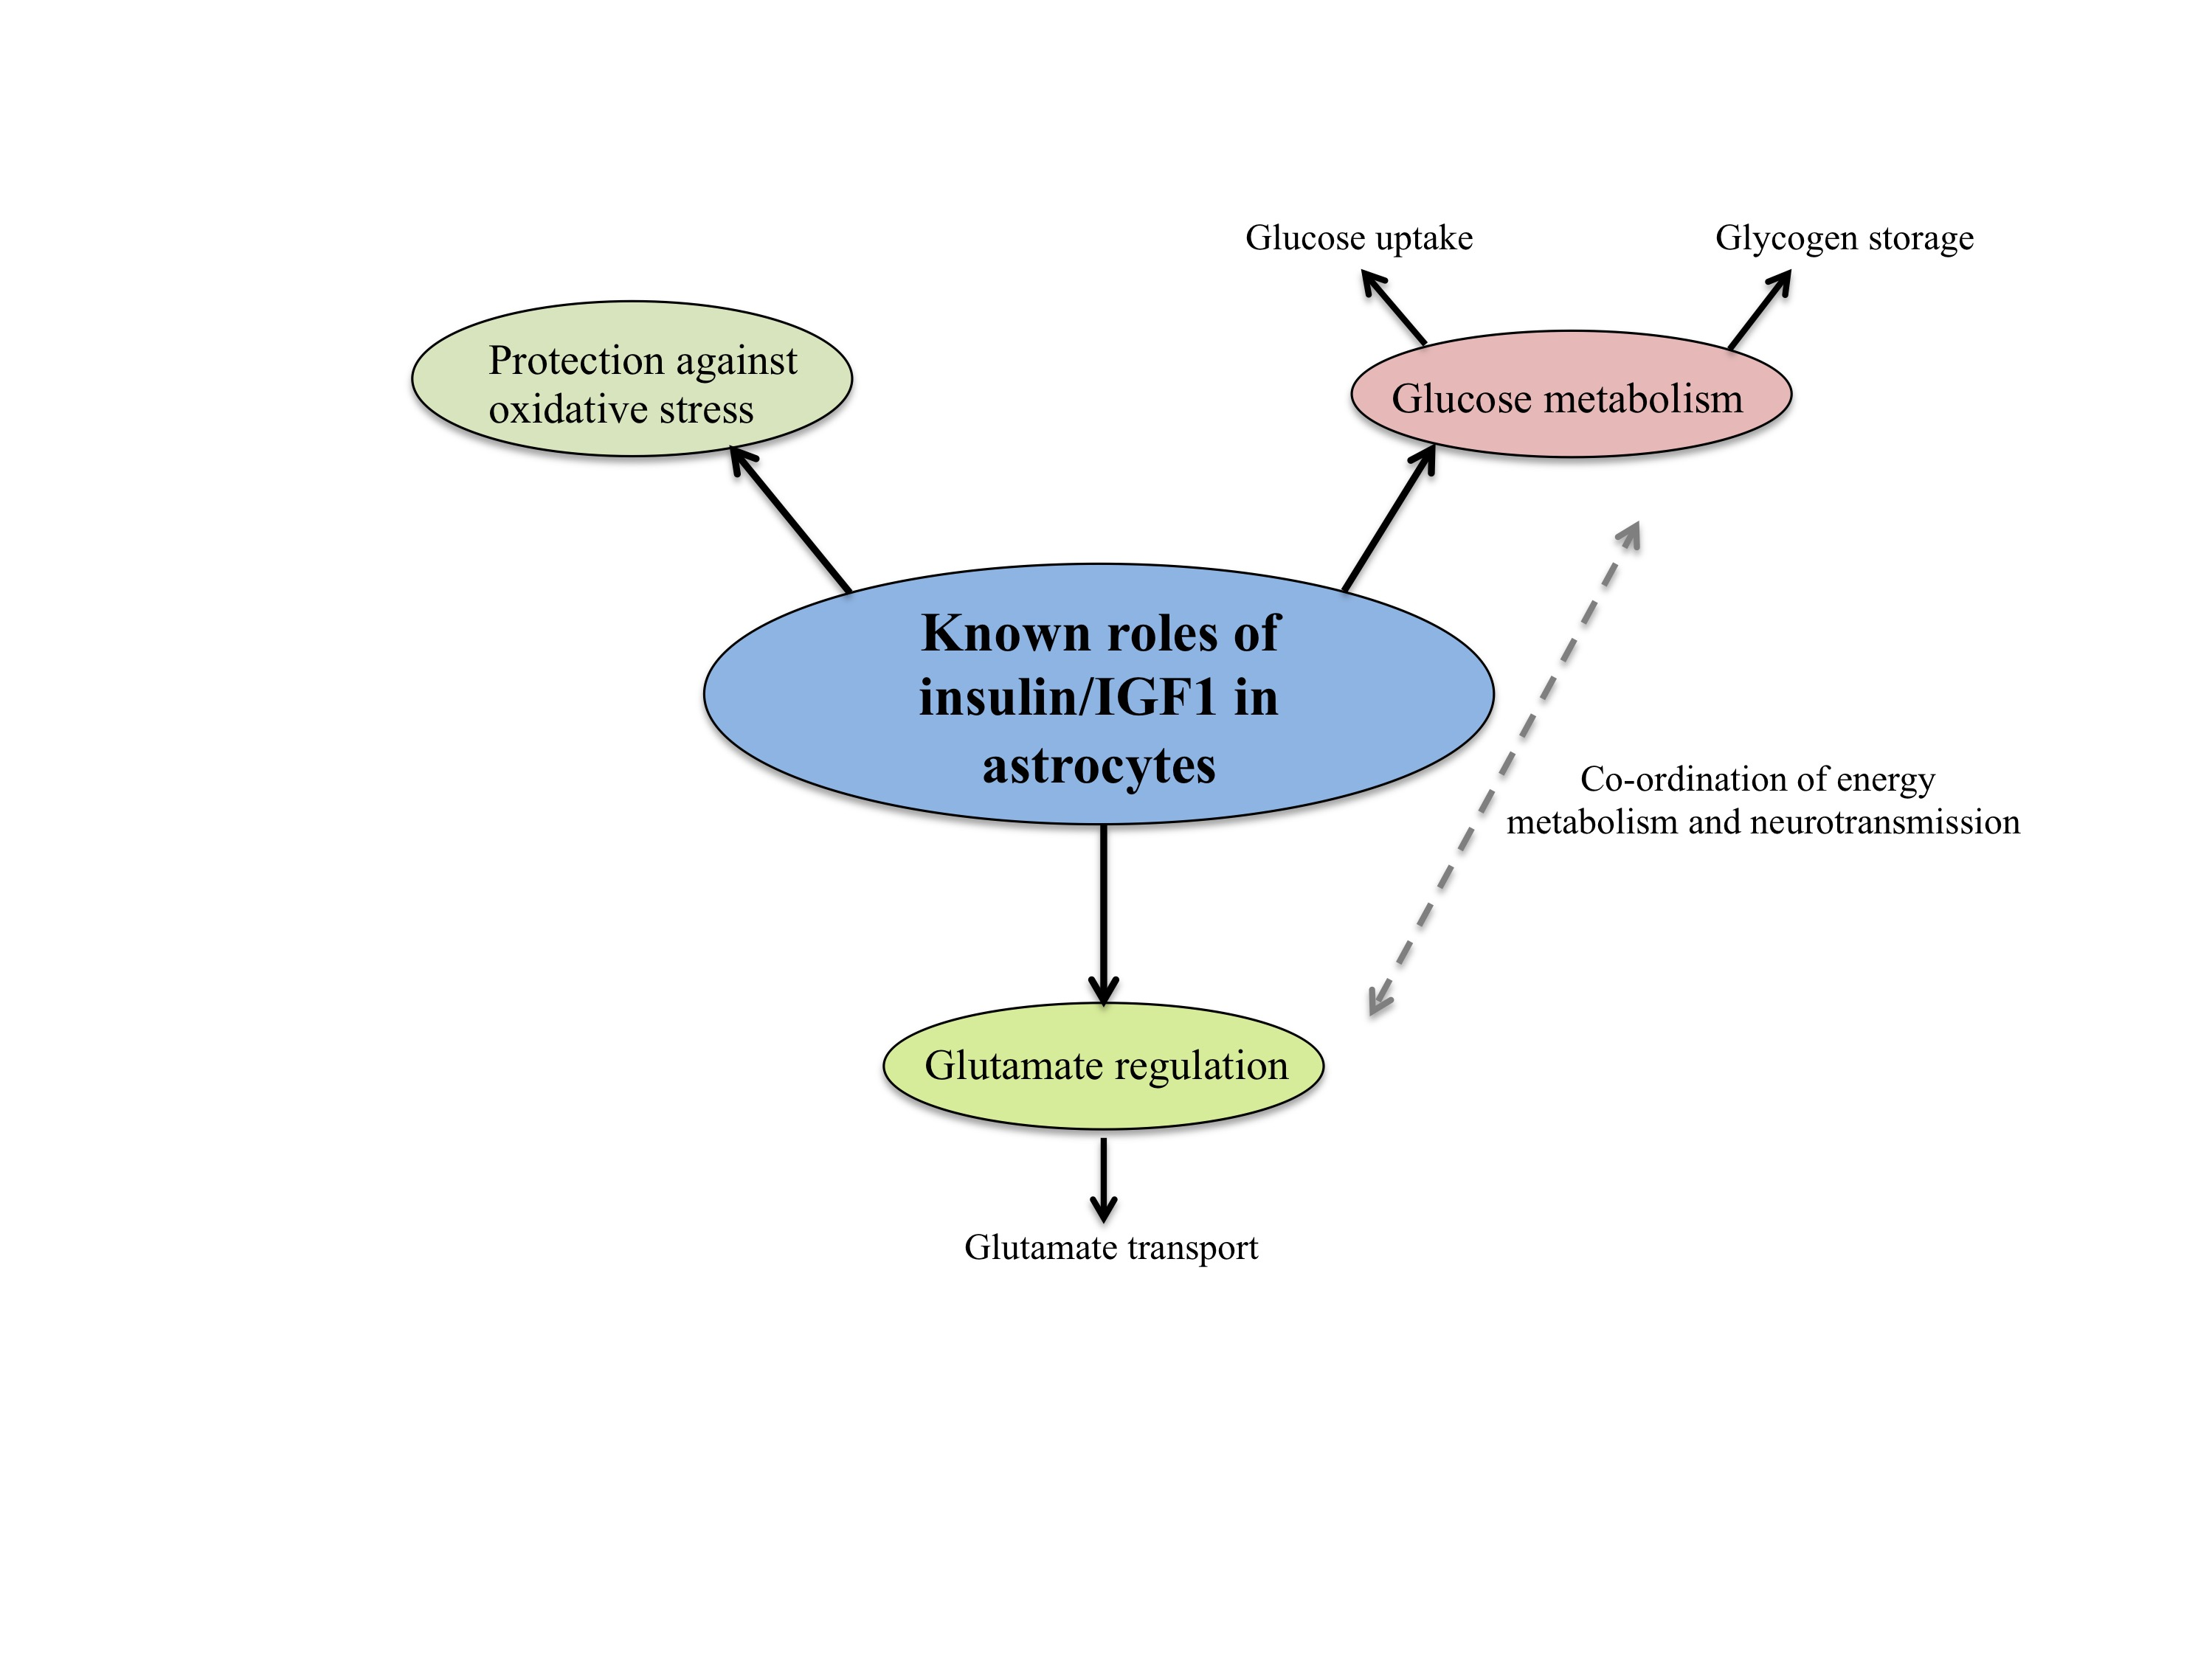
Figure 1.7. Schematic diagram to summarise the known roles of insulin/IGF1 signalling in rodent astrocytes.

1.10 Overall aims of this thesis

Astrocytes are critical in maintaining brain homeostasis. They accomplish this by integrating stimulus from their surroundings and tailor their function to provide maximum support for neurons. Studies have demonstrated changes in astrocyte function during ageing and neurodegenerative diseases such as AD, which have profound effects on brain function. One of these changes is an impairment in the insulin/IGF1 signalling pathway. Altered IGF1 signalling in astrocytes in the ageing AD brain has also been demonstrated at both the transcript and protein level (Moloney et al., 2010; Julie E Simpson et al., 2011). There are conflicting reports of the role of IGF1 in ageing and AD, with demonstrations that IGF1 deficiency contributes to both longevity and neurodegeneration. The role of IGF1 signalling in rodent astrocytes has been investigated however the function of this pathway has not yet been explored in human astrocytes in vitro or in vivo. It is important to fill this gap in knowledge since human astrocytes are much more complex than their rodent counterparts (Oberheim et al. 2006) and are a more relevant model to investigate human disease.

This thesis will specifically investigate the role of IGF1 signalling in human astrocytes, how downregulation of this pathway alters astrocytic function and whether this affects support for neurons. It is hypothesised that impairments in the IGF1 signalling pathway in astrocytes will impair the capacity to support and protect neurons. To investigate this, the following objectives will be carried out:

1. Determine whether IGF1 signalling is present and functional in human astrocytes.
2. Establish a model of IGF1 signalling pathway impairment and characterise astrocyte function.
3. Establish a human astrocyte-neuronal co-culture system and develop an assay to assess astrocytic support for neurons. Investigate whether intact IGF1 signalling in astrocytes is important to retain support for neurons.
4. Explore the transcriptomic differences in IGF1 signalling pathway impaired astrocytes to determine potential astrocytic cellular pathways accounting for changes in neuronal support.

Chapter 2

Materials and Methods

2. Materials and Methods

2.1 Materials
Unless stated otherwise:
- All molecular biology and cell culture reagents were purchased from Gibco, Invitrogen Ltd (UK)
- All other chemicals were purchased from Sigma-Aldrich Company Ltd (UK).
- Stock solutions and buffers were prepared using ultrapure H₂O from an Elga Maxima purification system.
- Where necessary, solutions were sterilized by autoclaving for 20 minutes at 15lb/square inch.

2.1.1 Cell culture and treatments

a) General

1x Phosphate buffered saline
8g/L Sodium chloride
0.2g/L Potassium chloride
1.44g/L Sodium phosphate dibasic
0.24g/L Potassium phosphate monobasic
Diluted in ultrapure H₂O
pH 7.4

Trypsinising Solution
Trypsin-versene (EDTA) (Lonza (UK)
Diluted in 1x PBS.

b) Astrocytes

Astrocyte medium

Astrocyte medium
2% (v/v) fetal bovine serum (FBS)
1% (v/v) astrocyte growth supplement (AGS)
1% (v/v) penicillin/streptomycin (P/S) solution
all ScienCell ResearchLaboratories™ Carlasbad, CA, USA

F10:MEMα medium
50:50 mix of 1 x F10 Nutrient mixture (Ham’s) and Minimum essential media alpha medium (MEM)
10% (v/v) fetal bovine serum (FBS) Biosera, South America origin
1% penicillin/streptomycin (P/S) solution, Lonza, Walkersville, USA

Astrocyte cryopreservation media.
80% FBS
20% Dimethyl sulphoxide (DMSO) Cat no. D2650

Recombinant human insulin-like growth factor (IGF1)
200μg/ml Recombinant Human IGF1 (R & D systems/ Bio-Techne, Abingdon, UK) in 1 x PBS (sterile)

Monoclonal anti-human IGF-1R antibody (MAB391)
500ug/ml MAB391 (clone 33255 lot number YY15) (R & D systems/ Bio-Techne, Abingdon, UK) in 1 x PBS (sterile)

Mouse monoclonal IgG₁ Isotype control antibody (MAB002)
500μg/ml MAB002 (clone 11711, lot number IX2612061) (R & D systems/ Bio-Techne, Abingdon, UK) in 1 x PBS.

Wortmannin
2mM Wortmannin (Cell Signaling Technologies (CST), Hertfordshire, UK)
in DMSO

Hydrogen peroxide (H₂O₂)
30% (w/w) in H₂O.
diluted in 1 x PBS for cell treatments.

c) Lund Human Mesencaephalic embryonic cells (LUHMES)

Poly-L-Ornithine
50 µg/mL poly-L-ornithine (p-L-o)
in 1x PBS

Fibronectin
1 µg/mL fibronectin
in 1 x PBS

Proliferation media
Dulbecco's Modified Eagle Medium/Nutrient Mixture F-12 (DMEM/F12) GlutaMAXTM supplement medium
1% N2 supplement-100X (Life Technologies, Grand Island NY, USA)
40 ng/mL human recombinant basic fibroblast growth factor (bFGF) (Gibco®, Life Technologies, Grand Island NY, USA

Differentiation media
Dulbecco’s Modified Eagle Medium/Nutrient Mixture F-12 (DMEM/F12) GlutaMAXTM supplement medium (3.5g/L, with phenol red)
1% N2 supplement
1 µg/mL tetracycline (Sigma-Aldrich, St. Louis, MO, USA).

LUHMES cryopreservation media
70% Advanced DMEM media
10% FBS
20% DMSO

2.1.2 Biochemicals

a) Protein extraction and bicinchoninic acid (BCA) protein assay

Extra strong lysis (XSLB)
10mM Tris-HCL (pH 7.5)
0.5% (w/v) sodium dodecyl sulphate (SDS)
0.5% (w/v) sodium deoxycholate
1% (v/v) Triton X-100, 75mM sodium chloride
10mM ethylenediaminetetraacetic acid
2mM sodium orthovanadate
1.25mM sodium fluoride
Protease inhibitor cocktail (PIC) for mammalian tissues (1 tablet/ 10ml of XSLB) (Roche, Mannheim, Germany)
Phosphatase inhibitor tablets (PhosSTOP™) (1 tablet used/ 10ml XSLB) (Roche, Mannheim, Germany)

Bichinoic (BCA) protein assay
BCA Protein Assay Kit (ThermoFisher Scientific, Waltham, MA, USA)

Bovine serum albumin (BSA) standard
Thermo Scientific™Pierce™ Albumin standard (Pierce Endogen, Rockford, IL, USA)

b) Sodium Dodecyl Sulphate Polyacrylamide gel electrophoresis (SDS-PAGE)

30% Acrylamide/Bis solution (Bio-Rad Laboratories Ltd., Hertfordshire, UK)

Ammonium Persulphate (APS) (Cat. No- A3678)
Tetramethylethylenediamine (TEMED) Thermo Scientific, Cat. No.-17919

Resolving buffer 1.5M Tris-HCl pH 8.8
4% (v/v) 10% SDS solution

Stacking buffer 0.5M Tris HCl pH 6.8
4% (v/v) 10% SDS solution

NuPAGE Bis-Tris Pre-cast gel
4-12% Bis-Tris Mini (8cm x8m) Precast gels (Life Technologies, grand Island, NY, USA) of 1.0mm thickness and 15 wells, used for the separation of larger molecular weight proteins ranging from 150-200kDa

6x Laemmli Sample buffer 60mM Tris, pH 6.8
12% (w/v) SDS
47% (v/v) glycerol
0.12% beta-mercaptoethanol
0.6M DTT

Running buffer 24.8mM Tris base, pH 8.3
192mM Glycine

Protein ladder The Precision Plus Dual Color Protein Standard was used as the standard for Western Blot analysis consisting of 10 pre-stained bands ranging from 250 kDa to 4 kDa (Bio-Rad Laboratories Ltd., Hertfordshire, UK)

2.1.3 Western Blotting

Western blotting transfer buffer 25mM Tris
100mM glycine
10% (v/v) methanol

Ponceau Red 0.1%(w/v) Ponceau S
in 5%(v/v) acetic acid diluted in ddH₂O.

Nitrocellulose membrane (GE Healthcare, Little Chalfont, Bucks, UK)

Blocking solutions:
Milk-PBST 5% (w/v) Marvel Original Dried Skimmed Milk
0.01% (v/v) Tween 20
in 1x PBS

BSA-PBST 5% Albumin bovine fraction V (BSA) (Melford
Laboratories Ltd., Chelsworth, Ipswich, UK)
0.01% (v/v) Tween20
in 1x PBS

Western Ezier Super Blocking Buffer for Phospho-Specific Antibody
Purchased from GenDEPOT to specifically preserve phosphoprotein antigen during blotting (GenDEPOT, Barker, TX, US)

Wash buffer 0.01% (v/v) Tween-20
in 1 x PBS

Enhanced chemiluminescent substrate (ECL) (EZ-ECL Biological Industries, Israel)

Table 2.1. Primary antibodies used for western blotting
Primary antibodies used for western blotting in this study. Antibody name, specificity, species, dilution, and source are shown. Abbreviation CST – Cell Signaling Technology. Beverly, MA, US
Antibody | Specificity | Species/Type | Diluent and dilution | Source
IGF1Rβ (C-20) | C-terminus of the IGF1 receptor β | Rabbit polyclonal | 5% BSA/PBST  1:50 | Santa Cruz Biotechnlogy (SCBT), Dallas, Texas, US
IRβ | C-terminus of the human insulin receptor β | Rabbit monoclonal | 5% BSA/PBST  1:1000 | CST
IRS1 | Amino acids 905-1070 of IRS-1 human protein. | Rabbit polyclonal | Western Ezier  1:1000 | CST
IRS2 | IRS-2 human protein | Rabbit polyclonal | Western Ezier  1:1000 | CST
Phospho Akt XP (ser473) | Human Akt phosphorylated at ser473 site. | Rabbit monoclonal | Western Ezier  1:1000 | CST
Akt | Akt human protein | Rabbit polyclonal | Western Ezier  1:1000 | CST
Phospho-p44/42 MAPK (Erk1/2) (Thr202/Tyr204) | MAPK human protein phosphorylated at residue Thr202/Tyr204 | Rabbit polyclonal | Western Ezier  1:1000 | CST
p44/42 MAPK (Erk1/2) | MAPK human protein | Rabbit polyclonal | Western Ezier  1:1000 | CST
β-actin antibody | β-actin human protein | Mouse monoclonal | 5% Milk/PBST  1:10000 | Abcam, Cambridge, UK
ϒ-H2AX | Phosphopeptide containing human Histone H2AX S139 site | Rabbit  polyclonal | Western Ezier  1:1000 | R&D systems, MN, USA
GFAP | GFAP | Rabbit polyclonal | Western Ezier  1:1000 | Abcam, Cambridge, UK  Ab7260
Alpha-tubulin | Synthetic peptide conjugated to KLH derived from within residues 1 - 100 of Human alpha Tubulin. | Rabbit polyclonal | Western Ezier  1:5000 | Abcam, Cambridge, UK  Ab4074
Neurofilament Light (NFL) | NFL | Mouse monoclonal | Western Ezier  1:1000 | Novus Biologicals  NB300-132B1

Table 2.2. Secondary antibodies used in western blotting
Secondary antibodies used for western blotting in this study. Antibody reactivity, dilution and source are shown. Abbreviation HRP- Horseradish peroxidase

Antibody | Dilution | Source
Goat anti-rabbit IgG-HRP | 1/5000 | DAKO, Copenhagen, Denmark
Goat anti-mouse IgG-HRP | 1/5000 | DAKO, Copenhagen, Denmark

2.1.4 RNA isolation, cDNA synthesis and qRT-PCR

TRIzol® Reagent (Life Technologies, Carlasbad, CA Ref 15596026)

RNA clean and concentrator isolation kit Direct-Zol™ RNA isolation kit (Zymo Research, Irvine, CA, USA) Cat no. R1015

iScript TM Select cDNA synthesis kit (Bio-Rad, Hercules, CA)

qScript™ cDNA SuperMix (Quanta, Biosciences, Beverly, US)

Table 2.3. List of Primers used in PCR and qRT-PCR
Abbreviations from table 2.3 IGF1R- Insulin-like growth factor 1 receptor, β-actin- Beta actin, GFAP- Glial fibrially acidic protein, NFL- Neurofilament light, NeuN- neuronal nuclear antigen

Primer type | Forward sequence | Reverse Sequence
IGF1R | ACCTCAACGCCAATAAGTTCGT | CGTCATACCAAAATCTCCGATTT
β-actin | TCCCCCAACTTGAGATGTATGAAG | AACTGGTCTCAAGTCAGTGTACAGG
GFAP | GCAGAAGCTCCAGGATGAAAC | TCCACATGGACCTGCTGTC
NFL | GGCTCTCAGTGTATTGGCTTCTGT | AACCCAGGTCTAGTAAGCAGAAAT
NeuN | ACGATCGTAGAGGACGGAA | AATTCAGGCCCGTAGACTGC

Brilliant III SYBR Green qPCR Mastermix (2 x) Agilent Technologies Ltd, Santa
Clara, USA

DreamTaq Green PCR Master Mix (2x) Thermo Scientific Cat No 1081

Hyperladder V Bioline, London

TE buffer 10mM Tris
0.1mM EDTA in ddH₂O, pH 8.0
PrimeTime® qPCR Assay (Integrated DNA Technologies®). Mini qPCR assays were resuspended in 200μl 1x TE buffer and standard qPCR assays were resuspended in 1000 μl 1 x TE buffer. All assays can be found in table 2.4.

Table 2.4. List of all PrimeTime® qPCR Assays used for validating genes identified in Gene expression profiling
PrimeTime® Assay ID, Ref Seq, Region, Primer Sequence and Probe Sequence are shown
Gene | PrimeTime® Assay ID | Ref Seq | Region | Primer Sequence | Probe Sequence
NDUFA2 | Hs.PT.58.38915668 | NR_033697 | Exon 2-3 | 5'-AGCACTGAAGTTGTTCAAAGG-3' | 5'-/56/FAM/TCCCGACCT/ZEN/ACCCATCCTAATCCG/SIABkFQ/-3'
 |  |  |  | 5'-GACTTCATTGAGAAACGCTACG-3'
PRDX3 | Hs.PT.58.20414791 | NM_014098 | Exon 6-7 | 5'-TCAACTGTGGTTCTTCTCTCAG-3' | 5'/56fFAM/AGATCACCC/ZEN/ATGTGTATCTGCACCTTC/3IABkFQ/-3'
 |  |  |  | 5'-GAAGTCTGCCCAGCGAA-3'
TPI1 | Hs.PT.58.40028166.g | NM_001159287 | Exon 3-4 | 5'-TCCGCAGTCTTTGATCATGC-3' | 5'-/56-FAM/AGCCACAGC/ZEN/AATCTTGGGATCTAGC/3IABkFQ/-3'
 |  |  |  | 5'-CTACTGCCTATATCGACTTCGC-3'
GLRX3 | Hs.PT.58.19556026 | NM_001199868 | Exon 1-3 | 5'-GAACACCTTCAGCTTCCAAC-3' | 5'-/56-FAM/CCCATGGTG/ZEN/CCCAGAAATGGAC/3IABkFQ/-3'
 |  |  |  | 5'-CCTCAAAGCCAAGTCCCT-3'
ENO2 | Hs.PT.58.578449 | NM_001975 | Exon 7-8 | 5'-TTCCTTCACCAGCTCCAAG-3' | 5'-/56-FAM/AGCCACCTT/ZEN/CATCCCCCACATT/3IABkFQ/-3'
 |  |  |  | 5'-CAGAGGTCTACCATACACTCAAG-3'
MGST1 | Hs.PT.58.47792779 | NM_001260512 | Exon 6-7 | 5'-CTGCCGTTCAAATATGCTAATCG-3' | 5'-/56-FAM/ACAGCTTTA/ZEN/CAATGACTGCGTACACGT/3IABkFQ/-3'
 |  |  |  | 5'-CAATCCAGAAGACTGTGTAGCA-3'
NDUFB6 | Hs.PT.58.20921068.g | NM_002493 | Exon 1-1 | 5'-CATCGCCTTCTCAGCTCTC-3' | 5'-/56-FAM/CCGTGTCCT/ZEN/TTTGCGTTGGTACC/SIABkFQ/-3'
 |  |  |  | 5'-CTAGTCCGTAGTTCGAGGGT-3'
GAPDH | Hs.PT.39a.22214836 | NM_002046 | Exon 2-3 | 5'TGTAGTTGAGGTCAATGAAGGG-3' | 5'-/56-FAM/AAGGTCGGA/ZEN/GTCAACGGATTTGGTC/3IABkFQ/3'
 |  |  |  | 5'ACATCGCTCAGACACCATG-3'

2.1.5 CyQUANT assay

CyQUANT® Direct Cell Proliferation Assay (Life Technologies, USA)

2.1.6 MTT assay

MTT reagent 5mg/ml MTT
In 1 x PBS
Filter sterilised before use.

SDS/DMF 20% (w/v) sodium dodecyl sulphate
in 50% dimethylformamide

2.1.7 Immunocytochemistry (ICC)

Glass Coverslips (SLS) 13mm diameter.

4% paraformaldehyde (PFA) 4% (w/v) PFA
in 1 x PBS
Filtered through 0.45μM filter

Permeabilising solution 0.03% (v/v) Triton- X100
In 1 x PBS

ICC Blocking solution 3% Albumin bovine fraction V (BSA) (Melford
Laboratories Ltd., Chelsworth, Ipswich, UK)
0.01% Tween20
in 1 x PBS

Hoescht staining solution (33342) 10mg/ml Bisbenzimide H 33342 trihydrochloride
In dd H₂O

Mounting media Fluoromount Aqueous mounting medium (Sigma F4680)

Table 2.5. Primary antibodies used for immunocytochemistry.
Antibody reactivity, dilution and source are shown.

Antibody | Specificity | Species/Type | Diluent and dilution | Source
IGF1Rβ (C-20) | C-terminus of the IGF receptor β | Rabbit polyclonal | 3% BSA/PBST  1:25 | Santa Cruz Biotechnlogy (SCBT), Dallas, Texas, US
IRβ | C-terminus of the human insulin receptor β | Rabbit monoclonal | 3% BSA/PBST  1:25 | Santa Cruz Biotechnlogy (SCBT), Dallas, Texas, US
Vimentin | Vimentin | Mouse monoclonal | 3% BSA/PBST  1:250 | Abcam, Cambridge, UK,  Ab8978
β3-Tubulin | Synthetic peptides from β3-Tubulin | Chicken polyclonal | 3% BSA/PBST 1:1000 | Millipore  Lot 2424655
GFAP | Full length GFAP | Rabbit polyclonal | 3% BSA/PBST  1:1000 | Abcam, Cambridge, UK,  Ab 7260
ALDH1L1 | C-terminus of ALDH1L1 | Rabbit polyclonal | 3% BSA/PBST 1:100 | Abcam, Cambridge, UK,  Ab 79727
Connexin 43 (Cx43) | C-terminal segment of the cytoplasmic domain of Cx43 (amino acids 363-382 with N-terminally added lysine) | Rabbit polyclonal | 3% BSA/PBST  1:100 | Sigma  C6219  061M4823
CD44 | CD44 | Mouse monoclonal | 3% BSA/PBST  1:100 | Dako, Copenhagen, Denmark,  Clone DF1485
Neurofilament-light (NFL) | NFL | Mouse monoclonal | 3% BSA/PBST 1:250 | Novus Biologicals  NB 300-132

Table 2.6. Secondary antibodies for immunocytochemistry.
Antibody reactivity, dilution and source are shown.

Antibody | Species/Type |  | Diluent and dilution | Source
Alexa fluor 488 (labelled with green fluorescent dye) | Goat anti rabbit IgG (H-L) |  | 3% BSA/PBST  1:1000 | Life technologies, Grand Island, NY, USA
Alexa fluor 568 (labelled with orange-red fluorescent dye) | Goat anti mouse IgG (H-L) |  | 3% BSA/PBST  1:1000 | Life technologies, Grand Island, NY, USA
Alex fluor 488  (labelled with green fluorescent dye) | Goat anti chicken IgG (H-L) | 3% BSA/PBST  1:1000 |  | Life technologies, Grand Island, NY, USA

2.1.8 CellRox

CellROX® Green Reagent (C10444, Life technologies, Oregon, USA Ref C10444)

2.1.9 Lactate Assay

Lactate Assay Kit, including lactate standards (KA0833, Abnova).

2.1.10 Complex I Assay

Complex I enzyme activity microplate assay kit (Abcam, ab109721, Cambridge, UK)

2.1.11 Lentiviral production

EMEM full media EMEM (Sigma) Cat. No.- M2279
2mM glutamine, sigma
1% NEAA, Sigma,
10% FBS, Gibco

DMEM full media DMEM with 4.5g/L glucose, L-glutamine
without Na pyruvate
10% (v/v) FBS
1% (v/v) Pen/Strep

Ultracentrifugation of viral batches: S128 rotor and pots, 6 Beckman tube (BECL343058)

PBS/ BSA 1% BSA (Fluka)
In 1 x PBS 500ml
Filtered through a 0.22 µM filter

Plasmids
- LV-GFP
- pCMV_DR8.92 (packaging plasmid encoding al the viral genes needed in trans)
- pMD.2G (plasmid encoding the vesicular stomatitis virus G envelope)
- pRSV-Rev (plasmid encoding the rev protein of HIV-1)

PEI (polyethylenimine) 1μg/μl PEI (Polysciences, Inc)
In ddH₂O

2.1.12 Glyco-blue™ Co-precipitation

Purchased from Ambion, which was used as a visible co-precipitant for nucleic acids.

2.1.13 Materials used for Gene Expression Profiling

GeneChip® WT PLUS Reagent Kit and Whole Transcript 100-Format Array (Affymetrix)
First-strand enzyme and first-strand buffer
Second-strand enzyme and second-strand buffer
IVT enzyme and IVT buffer
Control RNA (1mg/ml HeLa total RNA)
2nd-Cycle Primers
2nd-Cycle ss-cDNA Enzyme
2nd-Cycle ss-cDNA Buffer
RNase H
nuclease-free water
magnetic purification beans
Poly-A control stock
Poly-A control dilution buffer
10x cDNA fragmentation buffer
UDG (10U/μl)
APE 1, 1000U/μL
5x TdT Buffer
TdT, 30U/μl
5mM DNA labelling reagent
20 x Hybridisation controls
3nM control Oligo B2

GeneChip® Hybridisation, Wash and Stain Kit

This kit contained: Pre-hybridisation mix
2x Hybridisation mix
DMSO
Nuclease-free water
stain module
stain cocktail 1 and 2
array holding buffer, wash buffer A and B.

Gel-shift assay Affymetrix® Ltd. 5 X Novex® Hi-Density TBE
sample buffer (Life Technologies)
4-20 % TBE Gel, 1.0 mm (Life Technologies)
10 mg/mL NeutrAvidin (Thermo Scientific)

Instrumentation and Software
GeneChip® Scanner 3000
GeneChip® Fluidics Station 450
GeneChip® Comman Console Software and
Affymetrix® Expression Console
Affymetrix® Transcriptomics Analysis Console
(TAC) (Software, all purchased from Affymetrix®
Ltd)

Functional annotation clustering tools included the
Database for Annotation and Visualisation and
Integrated Discovery (DAVID; bioinformatics
resources 6.7) https://david.ncifcrf.gov/ and the
Integrated Molecular Pathway Level Analysis
(IMPaLA; version 9; build January 2015)
http://impala.molgen.mpg.de/.

2.1.14 Pre-amplification and reverse-transcription of low RNA yields

QuantiTect® Whole Transcriptome (Qiagen) (Cat No. 207043)

Qubit® fluorometer

Qubit® dsDNA BR Assay kit ThermoFisher Scientific (Cat No. Q32853)

2.1.15 Immunohistochemistry

HRP-conjugated avidin-biotin complex Vectastain Elite kit, Vector Laboratories,
Peterborough, UK
Diaminobenzidine (DAB) Vector Laboratories
Avidin-biotin blocking kit Vector Laboratories.

Table 2.7. Age, sex and post mortem delay (PMD) of cases

Case | Sex | Age | PMD
Control | M | 63 | Not recorded
Control | F | 59 | 5hr
Control | M | 67 | 63hr
AD | F | 79 | 24hr
AD | F | 71 | No record
AD | F | 79 | 24hr

Table 2.8. Antibodies used for immunohistochemistry, source and specificity

Antibody | Species, dilution, incubation | Antigen retrieval method
IGF1Rβ | Rabbit polyclonal, 1/50, 1hr | EDTA, pH 8.0, pressure cooker 1hr
GFAP | Rabbit IgG, 1/500, overnight, 4°C | Used after IGF1Rβ

2.2 Methods

2.2.1 Cell culture

a) Human Astrocytes

ScienCell Astrocytes

Primary human astrocytes from ScienceCell Research Laboratories (Carlasbad, CA, USA) were used for the majority of experiments. Two batches of ScienCell astrocytes were used over the duration of the project. ScienCell (1) astrocytes were used in chapter 3 to establish a model of IGF1R impairment and initial functional studies in monoculture. ScienCell (2) astrocytes were used to confirm the use of MAB391 to downregulate the IGF1 pathway, taken forward to establish co-cultures with and used in the gene expression profiling experiments. According to the supplier, astrocytes were obtained from the cerebral cortex of the brain and cryopreserved at passage one.

Cells were maintained in filtered T75 flasks in astrocyte medium (AM) at 37 °C and 5 % CO₂ and culturing media was changed every 2-3 days. Cells were passaged when they had reached 90 % confluency, by washing the cell layer with 1 x PBS prior to incubation in 1 x trypsin versene (Lonza, UK) for 5-10 minutes at 37°C to detach cells from the surface of the flask. Trypsin was then inactivated by the addition of complete AM. The cell suspension was centrifuged for 4 minutes at 400 x g_{av} and the resultant pellet was resuspended in 5 ml of AM. The cell suspension was then distributed into flasks/plates according to relevant experiments. When precise numbers of cells were necessary for experiments, cells were counted using a haemocytometer, Previous work in the group has shown that protein expression is lower (specifically Insulin/IGF signalling proteins) (unpublished data) in AM media but is increased when cells are grown in F10MEM media. Therefore 48 hours prior to experiments, cell media is changed from AM to F10MEM media.

Temporal Lobe Astrocytes

An additional source of human primary astrocytes was obtained from collaborators at The Open University, London (Ignacio A Romero, The Open University). These were derived from adult temporal lobe resections and we used to validate loss of IGF1R following IGF1R treatment.

(b) Culturing and Differentiation of Lund Human Mesencephalic cells (LUHMES)

LUHMES cells are ventral mesencephalic precursor cells from a human female fetus that have been conditionally immortalised by a v-myc oncogene that is controlled in a “tet off” manner. In this state, LUHMES can be cultured in Advanced MEM (Gibco) containing 2mM L-glutamine, 1 x N2 supplement and 1% PenStrep) supplemented with 40ng/ml basic fibroblast growth factor (FGF). By inactivating this transgene with tetracycline (1μg/ml) on day one of pre-differentiation and by performing a replating step on day three, the differentiation of LUHMES cells can be rapidly synchronised (Scholz et al, 2011) (figure 2.1).

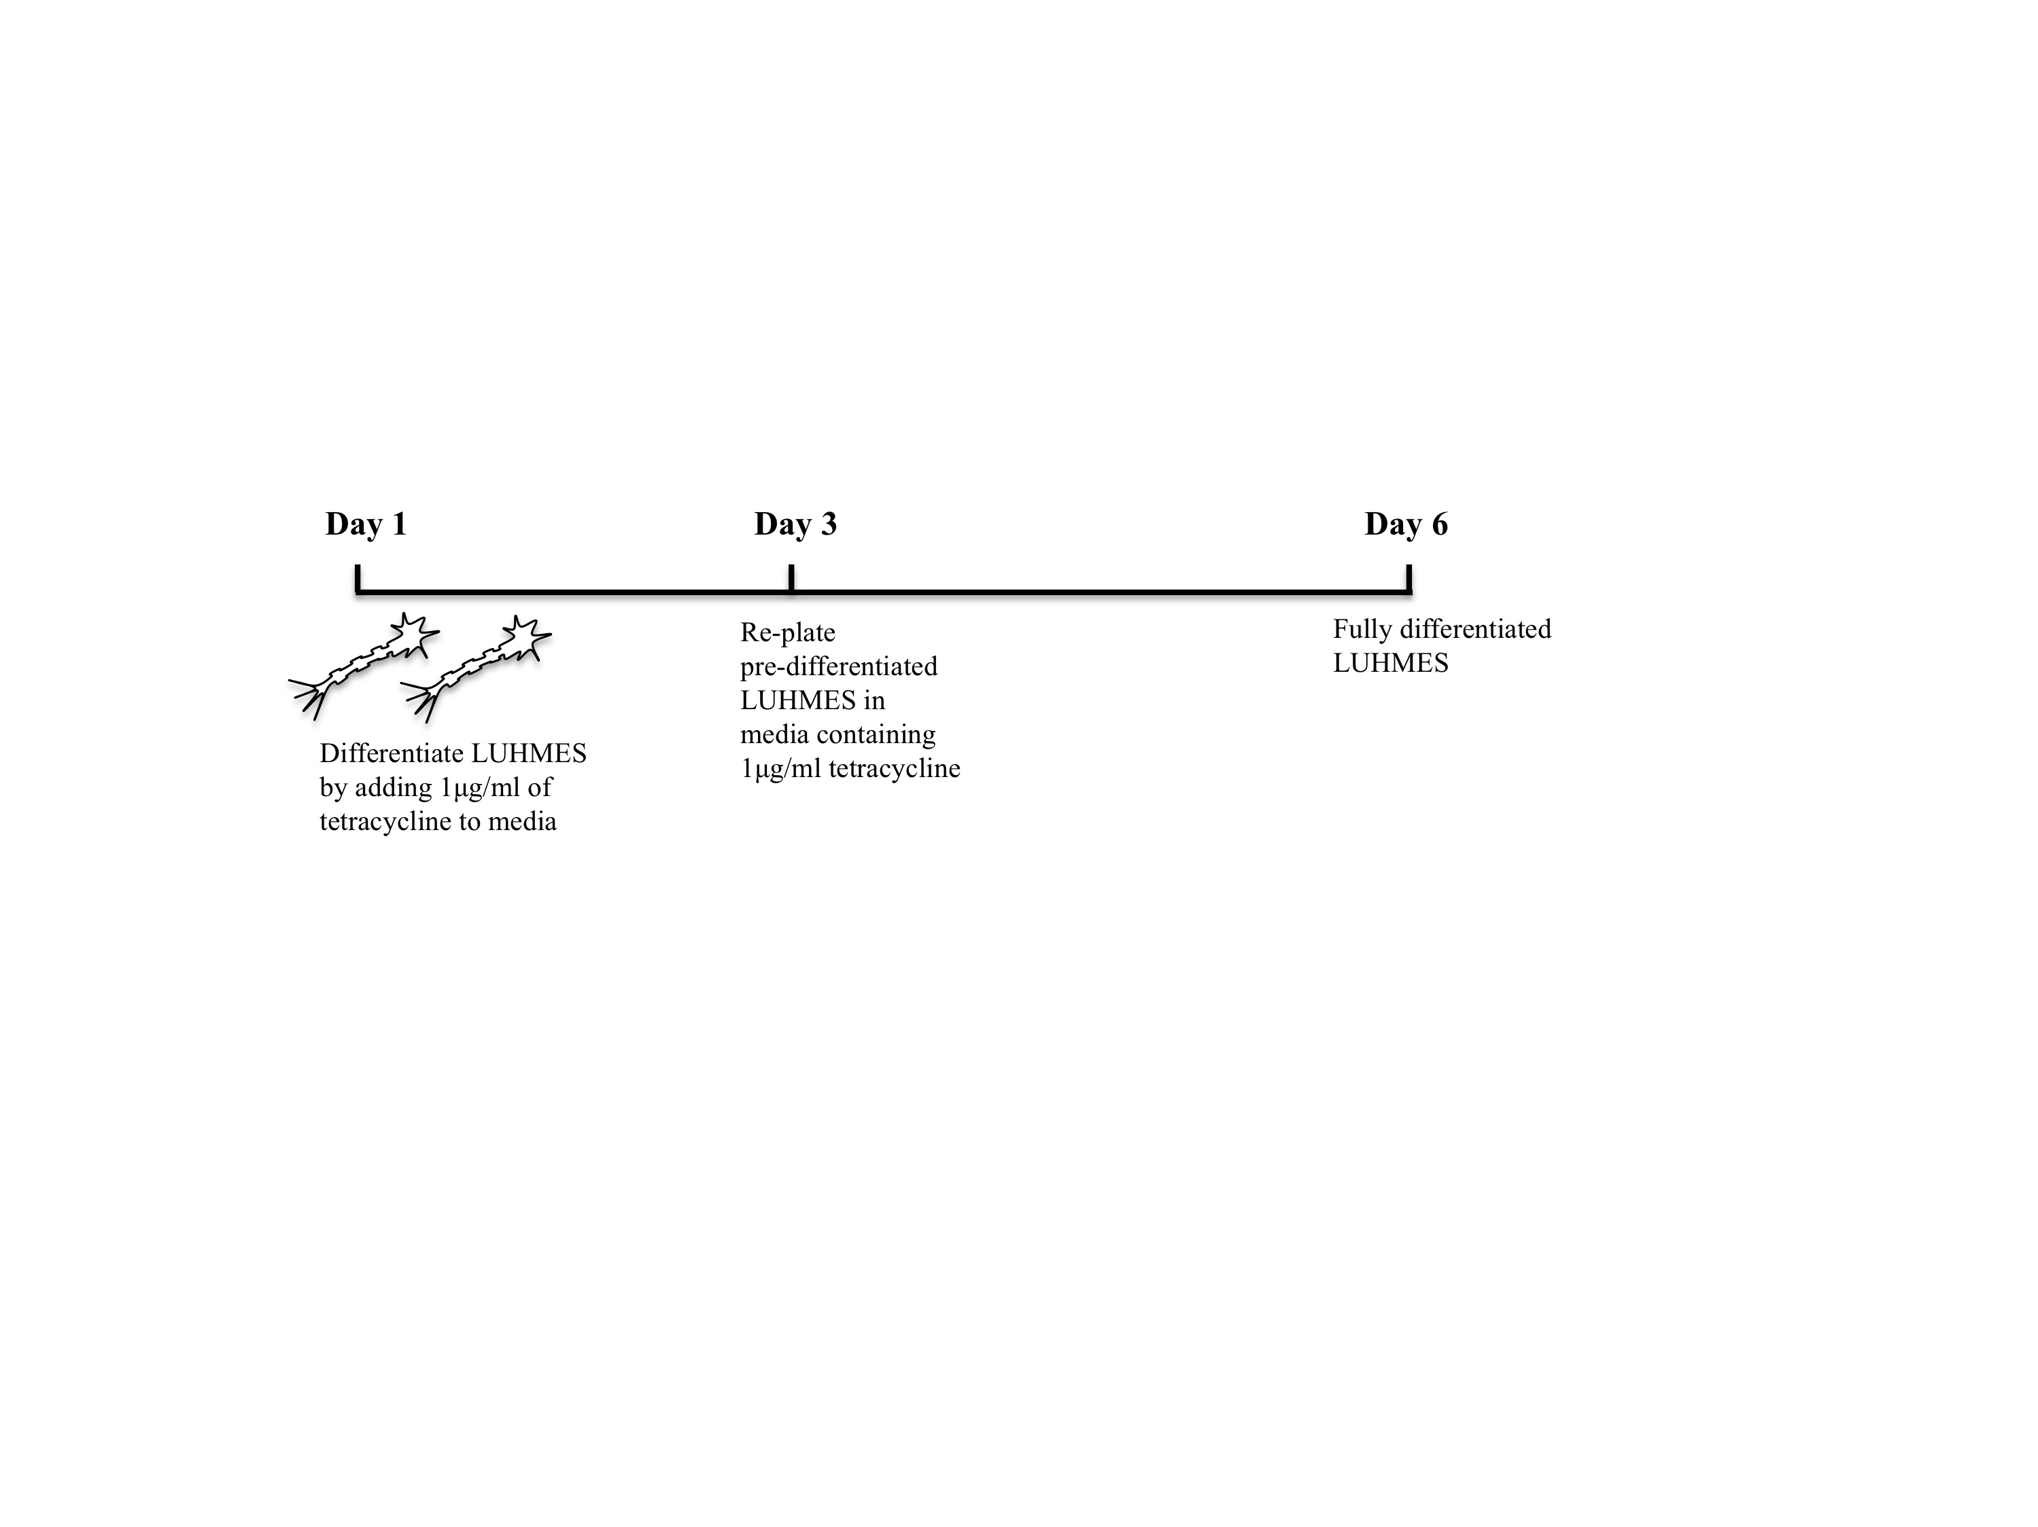
Figure 2.1. LUHMES differentiation protocol.
On the first day of differentiation, media was replaced with Advanced MEM supplemented with 1μg/ml of tetracycline. On the third day LUHMES were replated and by day 6 were fully differentiated, post-mitotic cells (Scholz et al. 2011).

(c) Cryopreservation of cells

Astrocytes/ LUHMES

To cryopreserve human astrocytes, cells were trypsinised as described above and then resuspended in cryopreservation media at 1x10⁶ cells/ml. The cell suspension was transferred to cryogenic vials and stored in CoolCell® SV2 (Biocision) at -80°C for 24 hours before transferring cryovials to liquid nitrogen for long-term storage.
(d) Astrocyte treatment protocols

Human IGF1 stimulation experiments (pathway characterisation)
Stimulation experiments were performed in both the presence and absence of serum to account for the impact of growth factors in serum. Astrocytes were cultured in F10MEM medium with or without 10% serum in 10cm dishes for 24 hours prior to stimulation with 10 nM human recombinant IGF1 ligand for 2 hours before harvesting cells for western blotting.

IGF1R monoclonal antibody and isotype control (MAB391/MAB002) treatment
Cells were treated with 11 μg/ml of MAB391/MAB002(IgG) for 24 hours. After 24 hours the cells were washed with 1 x PBS and fresh F10MEM media mix was added back to the cells for 72 hours.

DMSO/ Wortmannin treatment
Cells were treated with 1μM of Wortmannin or an equivalent volume of DMSO for 24hours. For longer treatments, the cells were washed at 24 hours with 1xPBS and F10MEM media added to the cells for 72 hours.

e) Generation of GFP-LUHMES

Plasmid transfection of HEK-293T cells for Lentiviral production
On day 1, four T75 flasks of confluent HEK293T cells were seeded into 20 x 10cm plates with 3x10⁶ cells seeded per plate. HEK293T cells were grown in complete DMEM media (DMEM, 10% FBS, 1% Pen/Strep). The following day HEK293T cells were transfected using PEI (polyethylenimine) transfection reagent with the lentiviral and packaging DNA plasmids in order to begin to generate virus. Prior to transfection, the following lentiviral and packaging DNA plasmids were vortexed with 10ml serum-free DMEM:
- 99μg LV-GFP
- 99 μg pCMV_DR8.92
- 29 μg pMD.2G
- 23 μg pRSV-Rev
In parallel, 750 μl of 1mg/ml PEI transfection reagent (pH 7.0) was mixed in 10ml serum-free DMEM for 15 seconds. The DNA and PEI solutions were combined in a 50ml falcon tube and vortexed for 30 seconds. After 20 minutes incubation at room temperature, 1ml of DNA/PEI mix was added to each plate and plates were returned to 37°C. Twenty-four hours following transfection, media from dishes was replaced with fresh complete DMEM media. On the third day following transfection, the lentiviral particles were harvested. Media from all 20 x 10cm dishes was collected and filter sterilised using 0.45μm filter. Cell supernatants were then spun at 19000rpm using the ultra-centrifuge for 90 minutes at 4°C, resuspended in 1% BSA in PBS and store at -80°C.

Lentiviral tittering for FACS
To estimate the multiplicity of infection (MOI) of LV-GFP in LUHMES, serial dilutions of LV-GFP were added to both HeLa (control) and LUHMES cells.
Both HeLa and LUHMES cells were plated at a density of 75 000 cells per well in a 12 well plate. HeLa cells were plated in EMEM (Sigma) (2mM glutamine, sigma, 1% NEAA, Sigma, 10% FBS, Gibco) and LUHMES in Advanced MEM media. LV-GFP was added at 1:100, 1:1000 and 1:10000 dilutions to cells for 4 hours before replacing media. After a 72 hour incubation (at 5% CO₂, 37°C), each well of cells was trypsinised and centrifuged at 200g_{av} for 5 minutes. Pellets were resuspended in 4% PFA and stored at 4°C. Transduced cells were sorted using the FACS LSRII and the MOI was calculated for the LV-GFP according to the FACS results. The MOI for the LV-GFP in LUHMES was approximately 8.

Production of GFP-LUHMES
To generate stably expressing GFP LUHMES, low passage (p3-p5) LUHMES seeded at 1.5x10⁶ cells per T75 flask were transduced with 1:100 LV-GFP stock in 1%BSA-PBS made up in complete Advanced MEM + FGF for 24 hours (at 37°C 5% CO₂). Media was then replaced with fresh complete media + FGF and left for a further 72 hours before further passaging/differentiating cells. Stocks of GFP expressing LUHMES were frozen and kept at -80°C for further experiments.

(f) Co-culturing astrocytes and neurons

ScienCell astrocytes were co-cultured with LUHMES cells. Astrocytes were first plated on fibronectin-coated plastics and pre-differentiated LUHMES were replated on top of a bed of confluent astrocytes. Typically, in a 24 well plate 30 000 astrocytes were plated per well of a 24 well plate on day one. In parallel, tetracycline (1μg/ml) was added to a separate T75 flask of LUHMES cells on day one. To ensure synchronisation of this differentiation procedure, LUHMES cells were replated on day three. To set up astrocyte-neuronal co-cultures day 3 pre-differentiated LUHMES were replated on top of astrocytes at low (7500/well) or high (100 000 cells/well) densities.

(g) Immunocytochemistry

Cells were washed once with PBS pre-warmed to 37ºC followed by fixation in 4 %(w/v) PFA in PBS for 5 minutes at 37ºC. Following fixation, cells were washed a further three times in ice-cold PBS and permeabilised in permeabilisation solution (0.3 % (v/v) Triton X-100 in PBS) for 3 minutes. Coverslips were blocked for 1 hour in ICC blocking solution (1 % (w/v) BSA in PBS-T) prior to incubation with primary antibody (table 3.3), diluted in ICC blocking solution, for 90 minutes at ambient temperature. Following three washes with PBS, cells were incubated with the appropriate species of secondary antibody (table 3.4), diluted in ICC blocking solution, for one hour, followed by three further washes in PBS. Nuclei were stained with Hoescht 33342 (5 μg/ml Bisbenzimide in PBS) before mounting in fluorescent mounting medium (DakoCytomation). Cells were visualised using a LV100ND microscope fitted with a DS Ri1 Eclipse camera (Nikon, Tokyo, Japan).

(h) Assays performed in astrocyte monocultures

CyQUANT Assay
The CyQUANT assay is used to determine the density of cells in culture and is based on a green fluorescent dye, CyQUANT GR dye®, which exhibits strong fluorescent enhancement when bound to cellular nucleic acids. Astrocytes were plated at 5000 cells per well in a 96 well plate and cells treated according to the protocol in section 3.2.2. At the conclusion of the treatment protocol culturing medium was removed and 200 μl of CyQUANT GR dye/cell-lysis buffer was added to each well and cells then incubated for 30 minutes at 37°C, in a CO₂ free atmosphere. Fluorescence was determined using the FLUOstar Omega plate reader (BMG Labtech) with the filters set to 480nm excitation and 520nm emission maxima.

MTT assay
The MTT assay is used to determine mitochondrial activity but is widely used as a cell viability assay. In this assay yellow MTT (3-(4,5-Dimethylthiazol-2-yl)-2,5-diphenyltetrazolium bromide) is reduced to a purple formazan product in the mitochondria of living cells. The absorbance of this product can be measured at between 500 and 600nm by a spectrophotometer. This value correlates with the reductase activity in mitochondria of live cells and thus will provide an indication of the number of live cells present.
A 1:10 dilution of MTT was added directly to each well of a 24 well plate including a well with no cells present. Plates were protected from light and incubated at 37°C with 5 % CO₂ for 3 hours prior to addition of SDS/DMF (20% sodium dodecyl sulphate in 50% dimethylformamide, 1:1 SDS/DMF:media). Plates were placed on an orbital shaker (Bibby Scientific, Stone, UK) for 30 minutes to solubilise the purple formazan crystals and then 100ul of sample was added into a 96 well plate (in duplicate) and absorbance was measured using a PHERAstar FS plate reader (BMG labtech Ltd).

CellRox® Assay
CellRox® reagent is a cell permeable dye that emits strong fluorescence when oxidised and was therefore used to identify ROS species in astrocytes. Following treatment with MAB391/IgG or 50μM H₂O₂, CellRox ® reagent was added to cells at a final concentration of 5μM and incubated at 37°C for 30 minutes. Media was removed and cells washed 3 times with 1 x PBS. Cells were permeabilised with 1 x PBS 0.1% Triton before incubating with Hoescht for 5 minutes. After washing 3 times with 1 x PBS, coverslips were mounted on slides with Fluoromount aqueous mounting media.

(i) Assays performed in astrocyte-neuron co-cultures

Neurite outgrowth assay
The neurites of LUHMES were measured in order to determine astrocytic support during neuronal differentiation. First, astrocytes were seeded on coverslips in a 24 well plate (coated with 1μg/ml human fibronectin) at 30 000 cells/well. In parallel, tetracycline (1μg/ml) was added to the GFP LUHMES to initiate pre-differentiation. Twenty-four hours following plating, astrocytes were treated with MAB/IgG/DMSO/Wortmannin and after a further 24 hours LUHMES were replated at 7500 cells/well alone or on top of astrocytes. Astrocytes were washed with PBS prior to addition of GFP LUHMES cells to remove any remaining MAB/IgG/DMSO/Wortmannin. Co-cultures were fixed with 4% PFA every 24 hours over a 72 hour period. Five FITC images of each coverslip were captured (3 coverslips per condition per experiment) and neurite length was measured using an ImageJ plugin called Simple Neurite Tracer (figure 2.2).

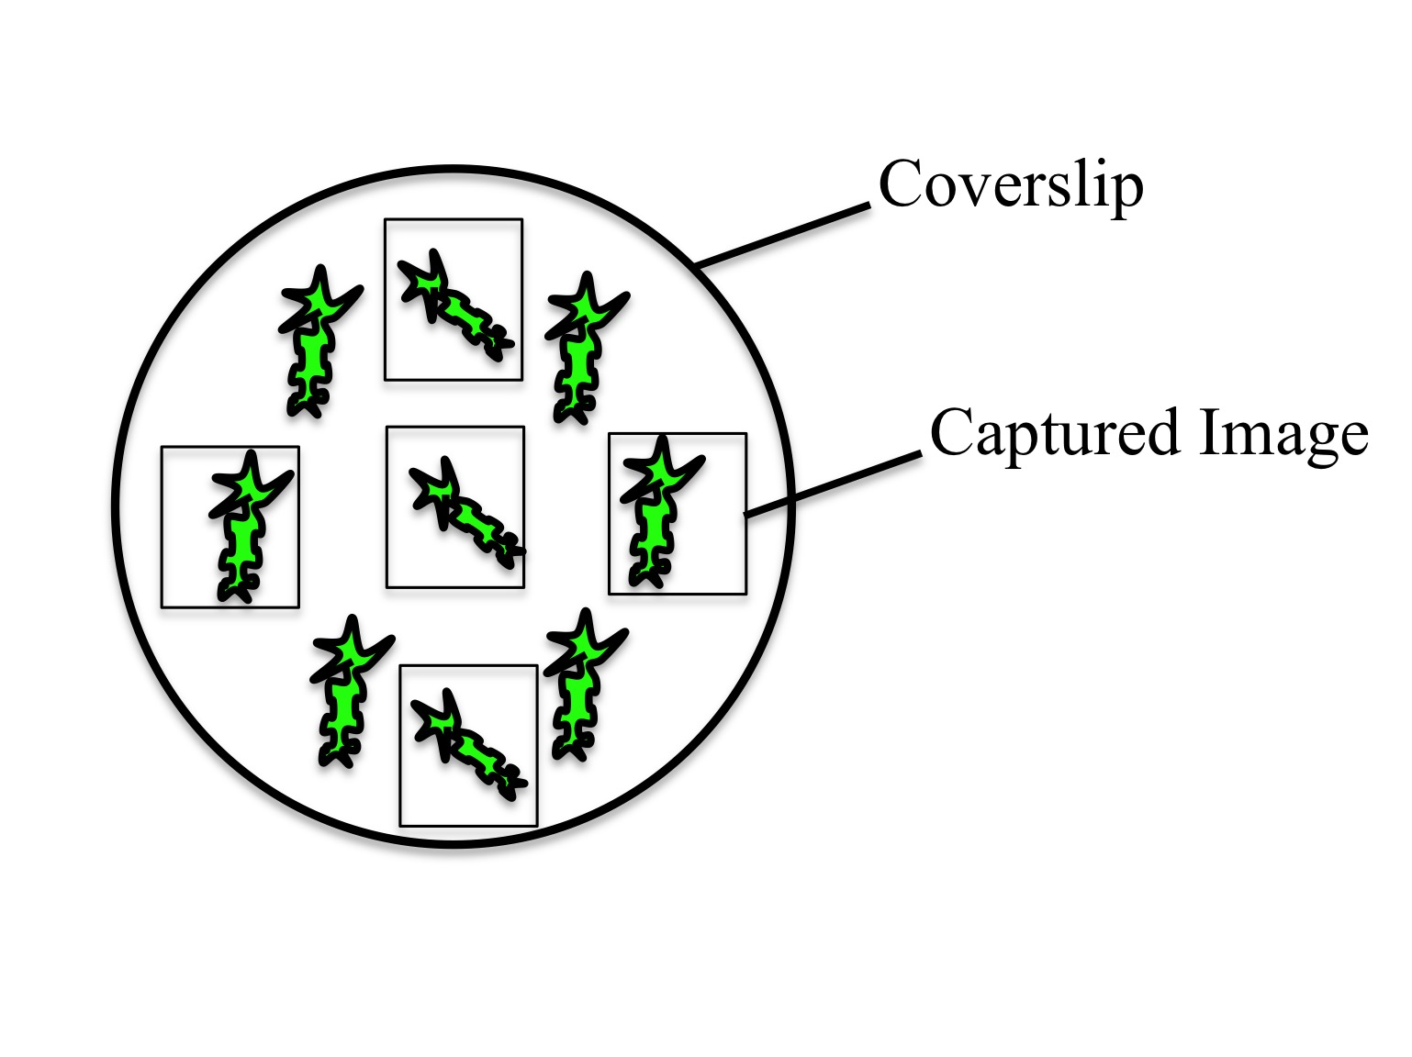
Figure 2.2. Method of capturing images for neurite outgrowth assay.
Diagram illustrating the method used to capture images of neurons in the neurite outgrowth assays. 5 images were captured per coverslip, with 3 coverslips per experiment and 3 independent experiments in total (diagram not to size).

Neurite outgrowth assay adapted to look at protection of neurons from hydrogen peroxide
Neurite length following exposure of co-cultures to H₂O₂ was performed to assess susceptibility of neurons to oxidative stress in different conditions. In this assay, astrocytes were seeded on fibronectin coated coverslips at a density of 30 000 cells per well of a 24 well plate. GFP LUHMES were differentiated in parallel by adding tetracycline (1μg/ml) to cell culture media. Twenty-four hours following plating, astrocytes were treated with 11μg/ml of MAB391/IgG and after a further 24 hours GFP LUHMES were seeded on astrocytes at a density of 7500 cells per well. After 72 hours in co-culture, cells were exposed to 50μM of H₂O₂ (9M stock solution) and fixed with 4% PFA two hours later. Using the Nikon microscope, five FITC images of each coverslip were captured (3 coverslips per condition per experiment) and neurite length was measured using the ImageJ plugin called Simple Neurite Tracer.

Lactate Assay
Lactate levels in cell media were measured using a lactate assay kit purchased from Abnova. Astrocytes were plated at 30 000 cells per well in a 24 well plate and treated with and without either IgG/MAB391 for 24 hours before co-culturing with LUHMES for 72 hours. Media was collected from co-cultures and centrifuged at 4°C for 4 minutes at 400g before filtering through a 0.2μM filter. Reaction was performed according to the protocol provided with the kit. Lactate standards (provided in the kit) and samples were loaded in a 96 well plate (Costar) and absorbance was measured at 570nm using a PHERAstar FS plate reader (BMG labtech Ltd).

Complex I Assay
NADH-dependent complex I activity was measured using the Complex I Enzyme Activity Microplate Assay Kit purchased from Abcam (the manufacturer states that the antibody binds to all subunits of complex I). As NADH is oxidised to NAD+, the molecular probe provided with the kit is reduced and absorbance can be measured.

Astrocytes were plated at 1x10⁶ cells per 10cm dish and treated with or without IgG/MAB391 for 24 hours. Two day pre-differentiated LUHMES were subsequently plated on top of astrocytes at a density of 3.3x10⁶ cells per 10cm dish. 72 hours later, cells were harvested using a cell scraper in 40μl of 1 x PBS. A BCA assay was performed to determine protein concentration. 10 x detergent was added to each sample, incubated on ice for 30 minutes and centrifuged at 14000g for 20 minutes. 250μg of sample was loaded into each well of a plate provided in the kit and left to incubate at room temperature for 3 hours. The next steps were performed according to the manufacturer’s protocol. Absorbance was measured at 450nm every 15 seconds over a period of 30 minutes with shakes between reads on a PHERAstar FS plate reader (BMG labtech Ltd).

(j) Co-culture Separation Techniques

PBS-jet wash co-culture separation
Recent reports suggest that astrocyte-neuronal co-cultures can be separated using ice-cold PBS (Goudriaan et al. 2014). This was replicated to separate ScienCell Astrocyte and LUHMES co-cultures. This involved placing 6 well plates of co-cultures on ice to pre-chill the cells and adding approximately 200μl of ice-cold PBS in concentric circles to the cells in order to encourage detachment of neurons from the astrocyte-neuronal co-cultures. In theory astrocytes shouldn’t detach and are scaped with a cell scraper from the wells before adding to Extra Strong Lysis Buffer. Cell separation using this technique was assessed by western blotting.

FACS sorting of human astrocyte-LUHMES co-cultures
Astrocyte and GFP LUHMES co-cultures were separated using FACS (fluorescence activated cell sorting). Astrocytes (P7) taken forward for microarray analysis were plated on fibronectin-coated T75 flasks at 750 000 cells per flask and treated with or without IgG (MAB002)/ MAB391. GFP LUHMES (P5, 2 x 10⁶ pre-differentiated cells) were replated on treated or untreated astrocytes for 72 hours. Co-cultures were trypsinised, centrifuged for 4 minutes at 400g_{av} and resuspended vigorously in 1ml of Advanced MEM media to achieve single cell suspensions and stored on ice prior to sorting. Sorts were performed on the FACS ARIA cell sorter (BD Biosciences). GFP LUHMES, non-GFP LUHMES and astrocyte monoculture suspensions were used to set the sort gates. To sort, cells were excited with a 488nm laser and forward scatter (FSC)/ side scatter (SSC) size dimensions were used to sort for viable cells. In order to obtain a pool of pure GFP expressing cells (GFP LUHMES) and a negative GFP pool of cells (astrocytes), a third pool containing LUHMES with low fluorescence and astrocytes with a size profile that overlapped the LUHMES, were discarded. GFP gates were stringently set to discard populations with low fluorescence and therefore avoid any astrocytic contamination. Sorted cells were collected in 1ml of Advanced MEM media and kept on ice prior to centrifugation at 400g_{av} for 4 minutes to pellet the sorted cell populations. Cell populations were then resuspended in 200μl of TRIzol® reagent and stored at -80°C before isolating RNA.

(k) Preparation of cell lysates

Protein analysis
For cell harvesting and protein extraction, media was removed and cells were washed twice with ice-cold 1 x PBS. Cells grown in 10cm dishes were harvested in 50 μl of extra strong lysis buffer and incubated on ice for 15 minutes. Cells were scraped using a cell scraper and the supernatant collected before sonicating on ice at 60 % amplitude for 5 seconds. Lysates were centrifuged at 17000 x g_{av} for 30 minutes at 4 °C, the supernatant was collected and stored at -20 °C. Long-term storage of lysates occurred at -80°C.

RNA analysis
RNA isolation was performed using the RNA clean and concentrator isolation kit purchased from Zymo Research (Epigenetics Company) and used according to manufacturer’s instructions. RNA was collected to perform PCR/qRT-PCR and for gene expression profiling.

2.2.2 Protein Analysis

Bicinchoninic acid (BCA) Assay
Protein concentrations of cell lysates were determined using a bicinchoninic acid (BCA) protein assay according to the manufacturer’s instructions (ThermoFisher Scientific, Waltham, MA, USA). This assay utilises a colourimetric technique based on the reduction of Cu⁺² to Cu⁺¹ by proteins present in the samples, under alkaline conditions. The resulting Cu⁺¹ is detected by bicinchoninic acid, generating a purple solution of varying intensity depending on the protein concentration. This is measured at 562 nM by spectrophotometry.

A set of BSA standards in extra strong lysis buffer were freshly prepared at concentrations ranging from 0-2 mg/ml each time the assay was performed. Absorbance readings were recorded at a wavelength of 550 nm using a FLUOstar Omega plate reader (BMG Labtech), and values were compared to a standard curve to determine protein concentration in μg/μl. Samples were then diluted in the appropriate volume of extra strong lysis buffer to ensure equal protein concentrations.

SDS-polyacrylamide gel electrophoresis (SDS-PAGE)
Prior to electrophoresis, cell lysates were mixed with Laemmli sample buffer (6x). Samples were heated at 100ºC for 5 minutes before centrifugation at 10,000 g_{av} for one minute. Molecular weight standards, Precision Plus Dual Color Protein Standard (Bio-Rad Laboratories Ltd., Hertfordshire, UK) and proteins were loaded onto 8% or 15% (w/v) polyacrylamide gels with 4% stacking gel (table 2.7). Gels were electrophoresed at 120 V, until the dye front reached the bottom of the gel or the protein of interest was suitably resolved.

Table 2.9. Composition of 4% stacking gel, 8% resolving gel and 15% resolving gel

 | 4% Stacking gel | 8% Resolving gel | 15% Resolving gel
Acrylamide | 4% (w/v) | 8% (w/v) | 15% (w/v)
Resolving buffer | - | 25% (v/v) | 25% (v/v)
Stacking buffer | 25% (w/v) | - | -
10% (w/v) APS | 0.1% (w/v) | 0.1% (w/v) | 0.1% (w/v)
TEMED | 0.1% (v/v) | 0.1% (v/v) | 0.1% (v/v)

Western blotting
Gels were placed onto 0.45 μm nitrocellulose membranes (AmershamTM Hybond ECL, GE Healthcare Life Sciences), sandwiched between Grade 1A filter papers (Whatman Laboratories) and sponges in an X-Cell transfer module (LifeTechnologies), immersed in transfer buffer. Proteins were transferred onto nitrocellulose at 300 mA for 120 minutes and the efficiency of the transfer checked using Ponceau Red. Non-specific binding of primary antibodies was blocked by incubating membranes in either 5 % (w/v) BSA in PBS-T or West Ezier Blocking Buffer (GenDEPOT) for 60 minutes at ambient temperature, and membranes were incubated overnight at 4 ºC with primary antibodies (see table 3.1), in the appropriate blocking solution.

Following incubation with primary antibodies, membranes were washed three times in PBS-T for ten minutes prior to the addition of species-specific HRP conjugated secondary antibodies (see table 3.2) diluted in 5 % milk/PBS-T for one hour at ambient temperature. A series of 3 x 10 minutes washes was carried out with 1 x PBST before incubating with ECL and visualising using the G-box Chemi-XT CCD Gel imaging system (Syngene, Cambridge, UK). Semi-quantitative densitometry analysis was performed using the ImageJ software.

2.2.3 RNA analysis

cDNA synthesis for qRT-PCR/ PCR
cDNA was synthesised using the iScript TM Select cDNA synthesis kit (BioRad)/ qScript™ cDNA SuperMix (Quanta), involving an incubation with oligo (dT) at 65°C for 5 minutes and reverse transcribed at 42°C for 50 minutes.

PCR
A mastermix containing 10 μl DreamTaq polymerase, 1 μl of forward and 1 μl of reverse primers and 7 μl of nuclease free water were combined. cDNA was added to the mastermix and amplified on a G-storm thermal cycler (G-storm, Somerset, UK) using the following reaction profile: 94°C for 30 seconds, 67°C for 1 minute, 72°C for 30 seconds for 35 cycles.

Agarose gel electrophoresis
Agarose gels were prepared by adding 3g of agarose in 100ml of TAE buffer (40mM Tris, 40mM acetate, 1mM EDTA, pH 8.0) (3% agarose gel). The solution was heated in the microwave until fully dissolved and ethidium bromide was added to the agarose at a final concentration of 100ng/ml. The agarose was poured into a cassette with a gel comb and left for 30 minutes before placing in an electrophoresis tank containing TAE buffer. DNA samples were loaded onto a 3% agarose gel and ran for 45 minutes at 80V. 2 µL of Hyperladder V was used as the DNA ladder and loaded into the first well. Agarose gels were imaged using the GENI UV light imaging system (Syngene).

qRT-PCR (Quantitative real time PCR)
qRT-PCR was carried out for detecting expression levels of IGF1R against β-actin control. IGF1R and β -actin primers were designed, where possible, to span between adjacent exons. qRT-PCR was undertaken using 100ng of cDNA, 1x SYBR Green PCR mastermix (Applied Biosystems, UK) forward and reverse primers (concentrations were previously optimised) and a total volume of 20μl. After denaturation at 95°C for 10 minutes the products were amplified (40 cycles at 95°C for 30 seconds and 60°C for 60 seconds) using the BioRad CFX96 Real time system (BioRad). β-actin was amplified on each plate to normalise expression levels of IGF1R.

PrimeTime® qPCR Assays
PrimeTime® qPCR Assays were used to validate changes in transcript levels identified by microarray analysis. Each assay was resuspended in IDTE buffer (10mM Tris, 0.1mM EDTA, pH 8.0). All mini qPCR assays were resuspended in 200 μl of IDTE buffer and standard qPCR assays (GAPDH) were resuspended in 1000 μl of IDTE buffer. Assays were then centrifuged at 750 x g_{av} for 10 seconds and each assay was at a final concentration of 500 nM.

PrimeTime® qPCR assays were performed in duplicate 20µl reactions with a non-template control (NTC) control in 96 well qRT-PCR plates. Each well contained 60ng of cDNA, 500nM forward and reverse primer, and a 250nM probe (table 2.4) resuspended in TE buffer (10mM Tris-HCl, 1mM EDTA, pH7.5), 2 x Brilliant III qPCR Master mix and nuclease free dH₂O. Plates were centrifuged to ensure samples collected at the bottom of the wells. Samples were run on a 2 step profile on a Strategene Mx3000P™ Real Time Thermal Cycler (Agilent Technologies Ltd). Samples were incubated as follows: 10 minutes at 95°C then 40 cycles of 30 seconds at 95°C, 60 seconds at 60°C and 60 seconds at 72°C.

2.2.4 Immunohistochemistry

Post mortem control (n=3) and Alzheimer’s (n=3) lateral temporal cortex (Brodmann area 21/22) and hippocampus, approximately at the level of the lateral geniculate nucleus, were obtained from the Sheffield Brain Tissue Bank in accordance with Research Ethics committee approval (08/MRE00/103) (table 2.7). Immunohistochemistry was carried out on formalin fixed paraffin embedded tissue sectioned at 9μM. Each section was dewaxed, dehydrated and blocked with 3% H₂O₂ before undertaking antigen retrieval. For IGF1Rβ, this involved putting sections in the pressure cooker for 1 hour with 1 x Tris-EDTA pH 8.0. Sections were subsequently blocked with 1.5% normal serum for 30 minutes and incubated with IGF1Rβ (SantaCruz) 1:50 at room temperature. Vectastain Elite kits (Vector Laboratories, Peterborough, UK) were used to visualise primary antibody. First a HRP-conjugated avidin-biotin complex was added followed by diaminobenzidine substrate. Sections were then incubated for 1 minute in Harris’s haemotoxylin then submerged in acid alcohol followed by Scott’s top water. Sections were then dehydrated through a series of diluted ethanol solutions (75%, 95% and 2 x absolute ethanol). Xylene was used to clean the sections before putting coverslips on sections using DPX mounting media (Sigma).

Double staining for IGF1Rβ and GFAP was performed. Single staining for IGF1Rβ was carried out using the protocol used above. Subsequent to the reaction with DAB, the sections were blocked with 1.5% normal serum (Vectastain Laboratories) for 30 minutes at RT. The sections were then incubated with avidin solution for 15 minutes at RT (from avidin-biotin blocking kit, Vectastain Laboratories), washed with TBS and then incubated with biotin solution from the avidin-biotin blocking kit for a further 15 minutes at RT. After removing the solution, the sections were incubated with anti-GFAP rabbit polyclonal antibody (DAKO) at 4°C overnight diluted 1:500 in blocking solution. After washing sections with TBS, they were incubated with streptavidin FITC (BioRad) for 1 hour at RT. Sections were washed with TBS before incubating for 1 minute in Harris’s Haematoxylin then submerged in acid alcohol followed by Scott’s tap water. Sections were then dehydrated through a series of different alcohol dilutions (75%, 95% and 2 x absolute ethanol) before treatment with xylene and mounting with DPX mounting media (Sigma).

2.2.5 Gene Expression Profiling Methods

RNA Extraction for Gene Expression Profiling Analysis
Following FACS sorting of human astrocytes from LUHMES and suspension in TRIzol® reagent, RNA was extracted from cells using the Direct-zol™ RNA isolation kit. 200μl of 100% ethanol was added to each of the samples and vortexed. Samples were then loaded into Zymo-Spin™ II columns in collection tubes. These were centrifuged at 17,000 x g_{av} for 1 minute at room temperature. Flow-through was discarded and 400μl of RNA PreWash buffer was added to each of the columns. Samples were centrifuged at 17, 000 x g_{av} for 1 minute at room temperature. 700 μl of RNA Wash Buffer was added to each column and centrifuged for 1 minute at room temperature. This step was repeated but centrifuged for 2 minutes at 17 000 x g_{av} to ensure complete removal of wash buffer. The column was then transferred to an RNAse free 1.5ml eppendorf. RNA was eluted in 10 μl of DNase/RNase-free water. RNA samples were stored at -80°C until required.

Glyco-blue™ Co-precipitation
To facilitate the precipitation of nucleic acid from the samples collected after FACS sorting, the Ambion® GlycoBlue™ Coprecipitant was used. This enhances precipitation without introducing exogenous nuclei acids. Ammonium acetate was added to each sample to 0.5M followed by GlycoBlue at a final concentration of 50 μg/ml. 1 volume of 100% isopropanol was then added to each sample and incubated at -20°C for 24 hours and centrifuged at 13 000 rpm for 15 minutes. Nucleic acid coprecipitates with the GlycoBlue Coprecipitant. All samples were then resuspended in 3μl of nuclease free H₂O₂ and stored in 200μl eppendorfs at -80°C.

Assessing yield and quality of RNA
RNA concentration and purity was initially assessed using the Nanodrop™ 1000 Spectrophotomer (Thermo Fisher Scientific® Inc.). Ratios of absorbance at 260nm and 280nm, and 260nm and 280nm are calculated to assess RNA quality and purity. RNA intergrity was measured using a Picochip and an Agilent 2100 Bioanalyser (Agilent Technologies Ltd.). An electropherogram determined RNA quality and any RNA degradation.

WT PLUS amplification and labeling of samples
The GeneChip® WT PLUS reagent kit (Affymetrix) was used to produce amplified, fragmented and labelled sense-strand DNA targets from total RNA. All samples (control 1-3 and MAB 1-3) were taken through the process together.

Poly-A-RNA Control Preparation
A series of poly-A-RNA controls were first spiked in at different concentrations to each sample to provide exogenous positive controls to monitor the entire target preparation. Approximately 250ng of starting RNA material was taken forward in each reaction. Based on this, the poly-A-RNA control stock was diluted 1:20, then 1:50, then 1:50 and finally 1:4 before adding 2μl of the final diluted 1 in 200 000 solution. Each samples was then made up to 5 μl.

First strand cDNA Synthesis
RNA is reverse transcribed to single stranded cDNA (ss-cDNA) with a T7 promoter sequence at the 5’ end. This is achieved by priming the total RNA with primers containing a T7 promoter sequence. The first-strand master mix was first prepared by adding 52μl first strand-buffer with 13 μl first strand enzyme, vortexing and centrifuging. 5 μl of first strang master mix was added to each sample on ice and mixed thoroughly before incubating in a thermal-cycler for 1hr at 25°C, then 1 hr at 42°C and 2 minutes at 4°C. Samples were centrifuged to collect first-strand cDNA/RNA at the bottom of the tube.

Second strand cDNA Synthesis
Double stranded cDNA (ds-cDNA) was synthesised from ss-cDNA to provide a template for in vitro transcription. The reaction incorporates DNA polymerase to synthesise the second strand of cDNA and RNase H to digest the RNA. The second strand master mix was made up by adding 225 μl of second strand buffer with 25 μl of second strand enzyme. The mixture was vortexed and centrifuged before adding 20 μl of reaction mix to each of the first strand cDNA samples. Samples were vortexed and briefly centrifuged then incubated in a thermal-cycler for 1 hour at 16°C, then 10 minutes at 65°C and 2 minutes at 4°C. After, samples were centrifuged to collect samples at the bottom of tubes.
In vitro transcription to synthesise purified Complementary RNA
Complementary RNA (cRNA) was synthesised and amplified by in vitro transcription (IVT) of the ds-cDNA template using a T7 RNA polymerase. At room temperature, the IVT master mix is prepared. 300 μl of IVT buffer and 25 μl of IVT enzyme were mixed thoroughly and centrifuged. 30 μl of the IVT enzyme/buffer mix was added to each of the second-strand cDNA samples. The samples were then incubated in a thermal cycler for 16 hours at 40°C and kept at 4°C after centrifugation.
To remove enzymes, salts, unincorportated nucleotides and inorganic phosphates a purification step was carried out. This entailed mixing each sample of cRNA with 100 μl of magnetic purification beads. This was thoroughly mixed by pipetting the beads and the solution up and down 10 times before a 10- minute incubation. The purification beads were recaptured using a magnetic stand for approximately 5 minutes. Supernatant was removed with minimal disturbance to the beads. Beads were washed with 200 μl of 80% ethanol for 30 seconds and supernatant was discarded. This was repeated 3 times to enhance purification of cRNA. After air-drying the purification beads, cRNA was eluted by adding 27 μl of preheated (65°C) nuclease free-water. After a 1 minute incubation the supernatant was transferred to a nuclease-free tube.
Yields of cRNA were assessed on the Nanodrop™ 1000 Spectrophotomer (Thermo Fisher Scientific® Inc.).

Second-cycle single-strand cDNA synthesis
cRNA was reverse transcribed using 2nd-cycle primers to generate sense strand cDNA. 15μg of cRNA was combined with 4μl of 2nd-cycle primers. These were mixed thoroughly before incubating for 5 minutes at 70°C, then 5 minutes at 25°C and 2 minutes at 4°C. The 2nd-cycle ss-cDNA master mix was made with 8μl of 2nd cycle ss-cDNA buffer and 4μl of 2nd-cycle ss-cDNA enzyme. Components were combined and mixed thoroughly before centrifuging and incubating for 10 minutes at 25°C, 90 minutes at 42°C, then 10 minutes at 70°C and 2 minutes at 4°C.

Hydrolysis of RNA using RNAse H
To remove the cRNA template from the ss-cDNA, samples were incubated with RNase H. On ice, 4 μl of RNase H was added per sample and mixed thoroughly by vortexing. Samples were incubated for 45minutes at 37°C, then 5 minutes at 95°C and 2 minutes at 4°C. 11 μl of nuclease free water was added to each sample to make a final reaction volume of 55 μl.

Second strand cDNA purification and assessment of yield
Following hydrolysis to remove template cRNA, the remaining cDNA was purified to remove enzymes, salts and unincorporated dNTPs. 100 μl of purification beads are added to samples, which will be bound by ss-cDNA. 150 μl of 100% ethanol was incubated with the beads for 20 minutes before capturing the purification beads on a magnetic stand. Supernatant was carefully removed. Beads were washed with 80% ethanol and incubated for 30 seconds before discarding supernatant. This was repeated 3 times to ensure efficient purification of ss-cDNA. Purfication beads were left to air-dry for 5 minutes before eluting ss-cDNA with 30 μl of nuclease water heated to 65°C.

ss-cDNA fragmentation and labelling
The unnatural dUTP residues previously incorporated into the samples act as fragmentation points for uracil-DNA glycosylase (UDG) and apurinic/apyrimidinic endonuclease 1 (APE1). 5.5μg of fragmented cDNA was labelled by deoxynucleotidyl transferase (TdT) using the labeling reagent provided with the kit that is covalently linked to biotin. The fragmentation master mix was prepared by combining 10μl of nuclease-free water, 10x cDNA fragmentation buffer, 10U/μl UDG and 1, 1,000U/μl of APE1. This was mixed thoroughly before adding 16.8μl of the master mix to each purified sample of ss-cDNA and incubating for 1 hour at 37°C, 2 minutes at 93°C and 2 minutes at 4°C. Fragmentation was assessed using the Agilent 2100 Bioanalyser (Agilent Technologies Ltd.). The suggested fragments should be 40-70 nucleotides.

Gel-shift assay
To verify labelling of fragmented ss-cDNA, a gel shift assay was carried out. NeutrAvidin was prepared at 2mg/ml in PBS. Neutravidin binds to biotin and slows the movement of biotin-labelled ss-cDNA movement during gel electrophoresis. Fragmented biotin-labelled ss-cDNA was pre-heated to 70°C for 2 minutes before adding 5 μl of 2mg/ml of neutravidin solution or PBS to act as a negative control. Samples were mixed after a 5 minute incubation at room temperature and loaded on a 4-20 % TBE Gel, 1.0 mm and ran for 2 hours at 100V. The gel was subsequently stained with 0.001% (w/v) ethidium bromide in TAE buffer (40mM Tris, 40mM Acetate, 1mM EDTA, pH 8.0) for 30 minutes at room temperature on a shaker. After, the gel was imaged on the GENi UV light imagine system (Syngene).

WT-Array Hybridisation
Fragmented and labelled ss-cDNA was hybridised to GeneChip® Human Gene ST (GST) Arrays using the GeneChip® Hybridisation, Wash and Stain Kit. All samples were hybridised to arrays on the same day. Hybridisation master mix was prepared by combining: control oligo B2, 20x hybridisation controls (bioB, bioC, bioD, cre) heated to 65°C, 2x hybridisation mix, DMSO and nuclease-free water in volumes according to the manufacturer’s protocol. This was mixed thoroughly and centrifuged before adding to fragmented and labelled ss-cDNA. The hybridisation cocktail was then incubated for 5 minutes at 99°C, then 5 minutes at 45°C in a thermal cycler. Samples were then injected and hybridised onto GeneChip® Human GST cartridges and incubated in a GeneChip® hybridisation oven 645 at 16rpm for 16 hours at 45°C.
After hybridisation, the hybridisation cocktail was removed and a series of washes was performed according to the Fluidics Protocol (FS450_0002). Scanning was performed on GeneChip® Scanner 3000 and the GeneChip® expression console generated CEL files, which correlated to raw signal intensity values.

QuantiTect Whole Transriptome
To validate candidate genes identified in the microarray, FACS sorted astrocyte RNA needed to be amplified. The QuantiTect Whole Transcriptome kit enables the preamplification and reverse transcription of limited amounts of RNA to generate high yields of cDNA. 40ng of Astrocyte RNA was incorporated in the amplification reaction. RNA was reverse transcribed by combining 4μl T-script buffer and 1μl T-script enzyme and adding to each 5μl of sample. Reaction mixes were incubated on a thermal cycler at 37°C for 30 minutes and stopped by incubating at 95°C for 5 minutes. A ligation mix was prepared by adding 6μl ligation buffer, 2μl ligation reagent, 1μl ligation enzyme 1 and 1μl ligation enzyme 2. The 10μl ligation mix was then added to each of the reverse transcription mixes and incubated at 22°C for 2 hours. An amplification mix was then prepared by combining 29μl REPLI-g Midi Reaction Buffer and 1μl REPLI-g Midi DNA polymerase. 30μl of amplification mix was then added to each ligation reaction, vortexed and centrifuged before incubating at 30°C for 4 hours. The reaction was stopped by heating the samples at 95°C for 5 minutes. Undiluted samples were stored at -20°C until used for qRT-PCR.

Qubit® fluorometer
The Qubit® was used to assess the amount of amplified cDNA following use of the QuantiTect® Whole Transcriptome kit.
The Qubit® working solution was first prepared by diluting Qubit® dsDNA BR reagent 1:200 in Qubit® dsDNA BR Buffer. 190 μl of Qubit® working solution was added to each of the 0ng/μl and 100ng/μl standards (10 μl of each). 2 μl of cDNA sample was added to 1μl Qubit® dsDNA BR reagent and 197 μl of Qubit® dsDNA BR Buffer. Samples were all vortexed and incubated at room temperature for 2-3 minutes before reading on the Qubit® fluorometer.

2.2.6 Bioinformatics Analysis

Affymetrix Expression Console Software
Raw data was exported from the GeneChip® command console, these are known as the CEL files and are a collection of signal intensities acquired from an individual array. The CEL files were converted to RMA-GENE FULL CHP files in the Affymetrix® Expression console. Quality control checks were performed to assess the positive versus negative area under the curve (AUC), the relative log expression (RLE) signal, the all probe set mean, hybridisation controls and poly-A labelling controls.

Qlucore Omics Explorer
The Qlucore Omics Explorer (3.0) software was used to open all Affymetrix® RMA-GENE-FULL CHP files and all normalised according to the RMA-sketch method. Differentially expressed genes were identified with a fold change (FC) of ≥ 1.2 and p<0.05. This program can be used to generate visual PCA (point component analysis) and hierarchical clustering maps that act as a visual measure of the separation between genes in different groups of data incorporated.
Gene and pathway enrichment analysis
The Database for Annotation and Visualisation and Integrated Discovery (DAVID) https://david.ncifcrf.gov/) was used to perform gene ontology analysis. Official gene symbols of differentially expressed genes were inputted into the DAVID analysis software, with a background set as homo sapiens. Functional annotation clustering was then performed and KEGG_PATHWAY terms were investigated.
Official gene symbols were also imported into the Integrated Molecular Pathway Level Analysis (IMPaLA) enrichment tool (http://impala.molgen.mpg.de/), which deduced pathways altered according to differentially expressed genes inputted into the software.

2.2.7 Statistical analysis

Densitometry for the Western Blots was carried out in ImageJ and analysed using a one-way analysis of variance (ANOVA) with multiple comparisons and Tukey’s post-hoc analysis (Graphpad Prism 5.0, Software, Graphpad Software Inc., La Jolla, CA, USA).
Data for the Cyquant assay, MTT analysis, qRT-PCR, Neurite outgrowth assays, Lactate, complex I and Cell Rox assays were all analysed using a one-way ANOVA with multiple comparisons and Tukey’s post-hoc analysis (Graphpad Prism 5.0, Software, Graphpad Software Inc., La Jolla, CA, USA). Data for Neurite outgrowth assays was also statistically analysed using unpaired t-tests.

One-way ANOVA compares the mean numerical value from one group against the mean numerical values from separate groups. Tukey’s test compares the mean values of every condition with the means calculated for every other treatment and is used in conjunction with one-way ANOVA to establish whether the mean values from different groups are significantly different from one another. Unpaired t-tests compare two independent, random samples. In all tests, the null hypothesis states that there are no differences within and between groups. Differences were considered significant when p values were less than 0.05.

Chapter 3

Modelling impaired IGF1 signalling in human astrocytes

3.1 Introduction

IGF1 signalling has been characterised in many cell types in the brain but as of yet there are no studies that demonstrate the importance and functioning of this pathway in human astrocytes. IGF1 expression has been identified in microglia (Suh et al. 2013) and in neurons it is known to inhibit apoptosis and maintain survival (Aizenman & de Vellis 1987; Torres-Aleman et al. 1990). Expression of IGF1 and activation of the IGF1 receptor have been detected in mouse and rat astroglial cells (Ballotti et al. 1987) and mouse astrocytes have been shown to mediate the pro-survival effects of IGF1 on motor neurons (Ang et al. 1992), suggesting functional IGF1 signalling in mouse astrocytes. However, human astrocytes are structurally more complex and diverse than their rodent counterparts (Oberheim et al. 2006; Oberheim et al. 2009) and it is therefore important to determine the presence and functionality of IGF1 signalling in human astrocytes, especially when making parallels with changes that occur in this pathway in the human brain.

Insulin signalling has been demonstrated in foetal human astrocytes and has been shown to stimulate cell growth and glycogen storage (Heni et al. 2011). Insulin and IGF1 are closely related peptides that are capable of cross-reacting with the insulin and IGF1 receptors, however each receptor is capable of binding its own ligand at 100-1000 fold higher affinity (Dupont et al. 2001). Despite the similarities of the insulin and IGF1 pathways both at the level of the receptor/ligand structure and convergence on the same signalling proteins, it has been shown that the biological outputs of these pathways are distinct. To test if IGF1 signalling through its cognate receptor can compensate for loss of the insulin receptor, IR null mice were treated with IGF1 following birth. Despite IGF1 inducing a reduction in plasma glucose levels, it is unable to fully rescue the metabolic abnormalities observed in IR null mice (Di Cola et al. 1997). Furthermore, in a separate set of experiments a cDNA microarray was conducted on mouse fibroblasts to distinguish the gene expression profile of cells treated with insulin or IGF1. Analysis revealed that IGF1 stimulation induces the expression of genes involved in mitogenesis and differentiation, whereas insulin stimulated cells had no distinct categories of upregulated genes (Dupont et al. 2001). Therefore, the insulin and IGF1 pathways produce distinguished effects on cells, and with research focusing on the role of insulin signalling in human astrocytes there is a clear gap in knowledge of the specific role of IGF1 signalling in human astrocytes. Recent evidence shows that IGF1 signalling can promote glucose uptake in mouse astrocytes, which was observed following stimulation with IGF1 causing MAPK activation and recruitment of IGF1R and GLUT1 to the membrane (Hernandez et al., 2015). However, it remains to be answered what purpose the IGF1 signalling pathway serves in human astrocytes and whether this pathway is necessary for astrocytes to support a neuronal network.

It is widely reported that levels of individual proteins in the insulin/IGF1 signalling pathway are dysregulated in AD, with a significant focus in the literature on alterations to this pathway in neurons. More recently there has been a shift to studying the role played by other cellular components in the brain during neurodegeneration and research has particularly focused on the involvement of astrocytes. Astrocytes are rapidly being unveiled as the support network and resource centre of the brain. They are simultaneously able to process information from different cell types, allowing them to finely tune the complex neuronal circuitry with a dynamic microenvironment. However, in many neurodegenerative diseases their role can become compromised. In AD, it has been identified that GFAP expression increases and EAAT2 levels decrease in astrocytes in association with increased Braak staging (J E Simpson, Ince, Lace, et al. 2010). It has also been shown that there are significant alterations in the insulin/ IGF1 signalling pathway in astrocytes during ageing and AD progression (Simpson et al. 2011). What is not understood is why this signalling pathway is dysregulated in astrocytes in AD and how these changes affect astrocyte function and contribute to disease progression. To answer this question an in vitro system of IGF1 signalling impairment in human astrocytes has been developed.

This chapter confirms the presence and functionality of the IGF1 signalling pathway in human astrocytes and describes the model generated to investigate reduced IGF1 signalling in human astrocytes. It will focus specifically on how the IGF1 signalling pathway was characterised, how a model of IGF1 signalling impairment was established in human astrocytes and the assays used to identify how reduced signalling affects astrocyte function in mono-culture.

3.2 Aims and Objectives

1) Confirm functional IGF1 signalling in human astrocytes.
2) Establish a model of IGF1 signalling impairment in astrocytes.
3) Assess functional changes in the astrocytes as a result of IGF1R loss.
4) Characterise expression of IGF1R in human brain tissue.

3.3 Methods

Detailed methods for this section can be found in chapter 2. In summary, a recombinant human IGF1 ligand was used to stimulate ScienCell (1) astrocytes in the presence and absence of serum and western blotted to identify changes in IGF1 signalling proteins. To inhibit IGF1 signalling, astrocytes were treated with a monoclonal antibody against the IGF1R (MAB391) for 24 hours followed by western blotting to determine changes in signalling proteins. An IgG isotype control (MAB002) was included to ensure that observed changes were not due to the antibody treatment. In addition astrocytes were treated with MAB391 for 96 hours, with a media exchange after 24 hours (also referred to as 72hr post-media exchange [PME]) to identify how persistent the effect on IGF1R was (figure 3.1). Functional assays were conducted to investigate how impaired IGF1 signalling affects astrocyte function; these assays were chosen based on the involvement of IGF1 signalling in mitogenesis and protection against oxidative stress.

To test the robustness of the model, adult astrocytes from epileptic temporal lobe resections and ScienCell (2) astrocytes (refer to Chapter 2, section 2.1.1) were also treated with MAB391 in the same way. In addition, expression of IGF1R was confirmed in astrocytes in human brain tissue.
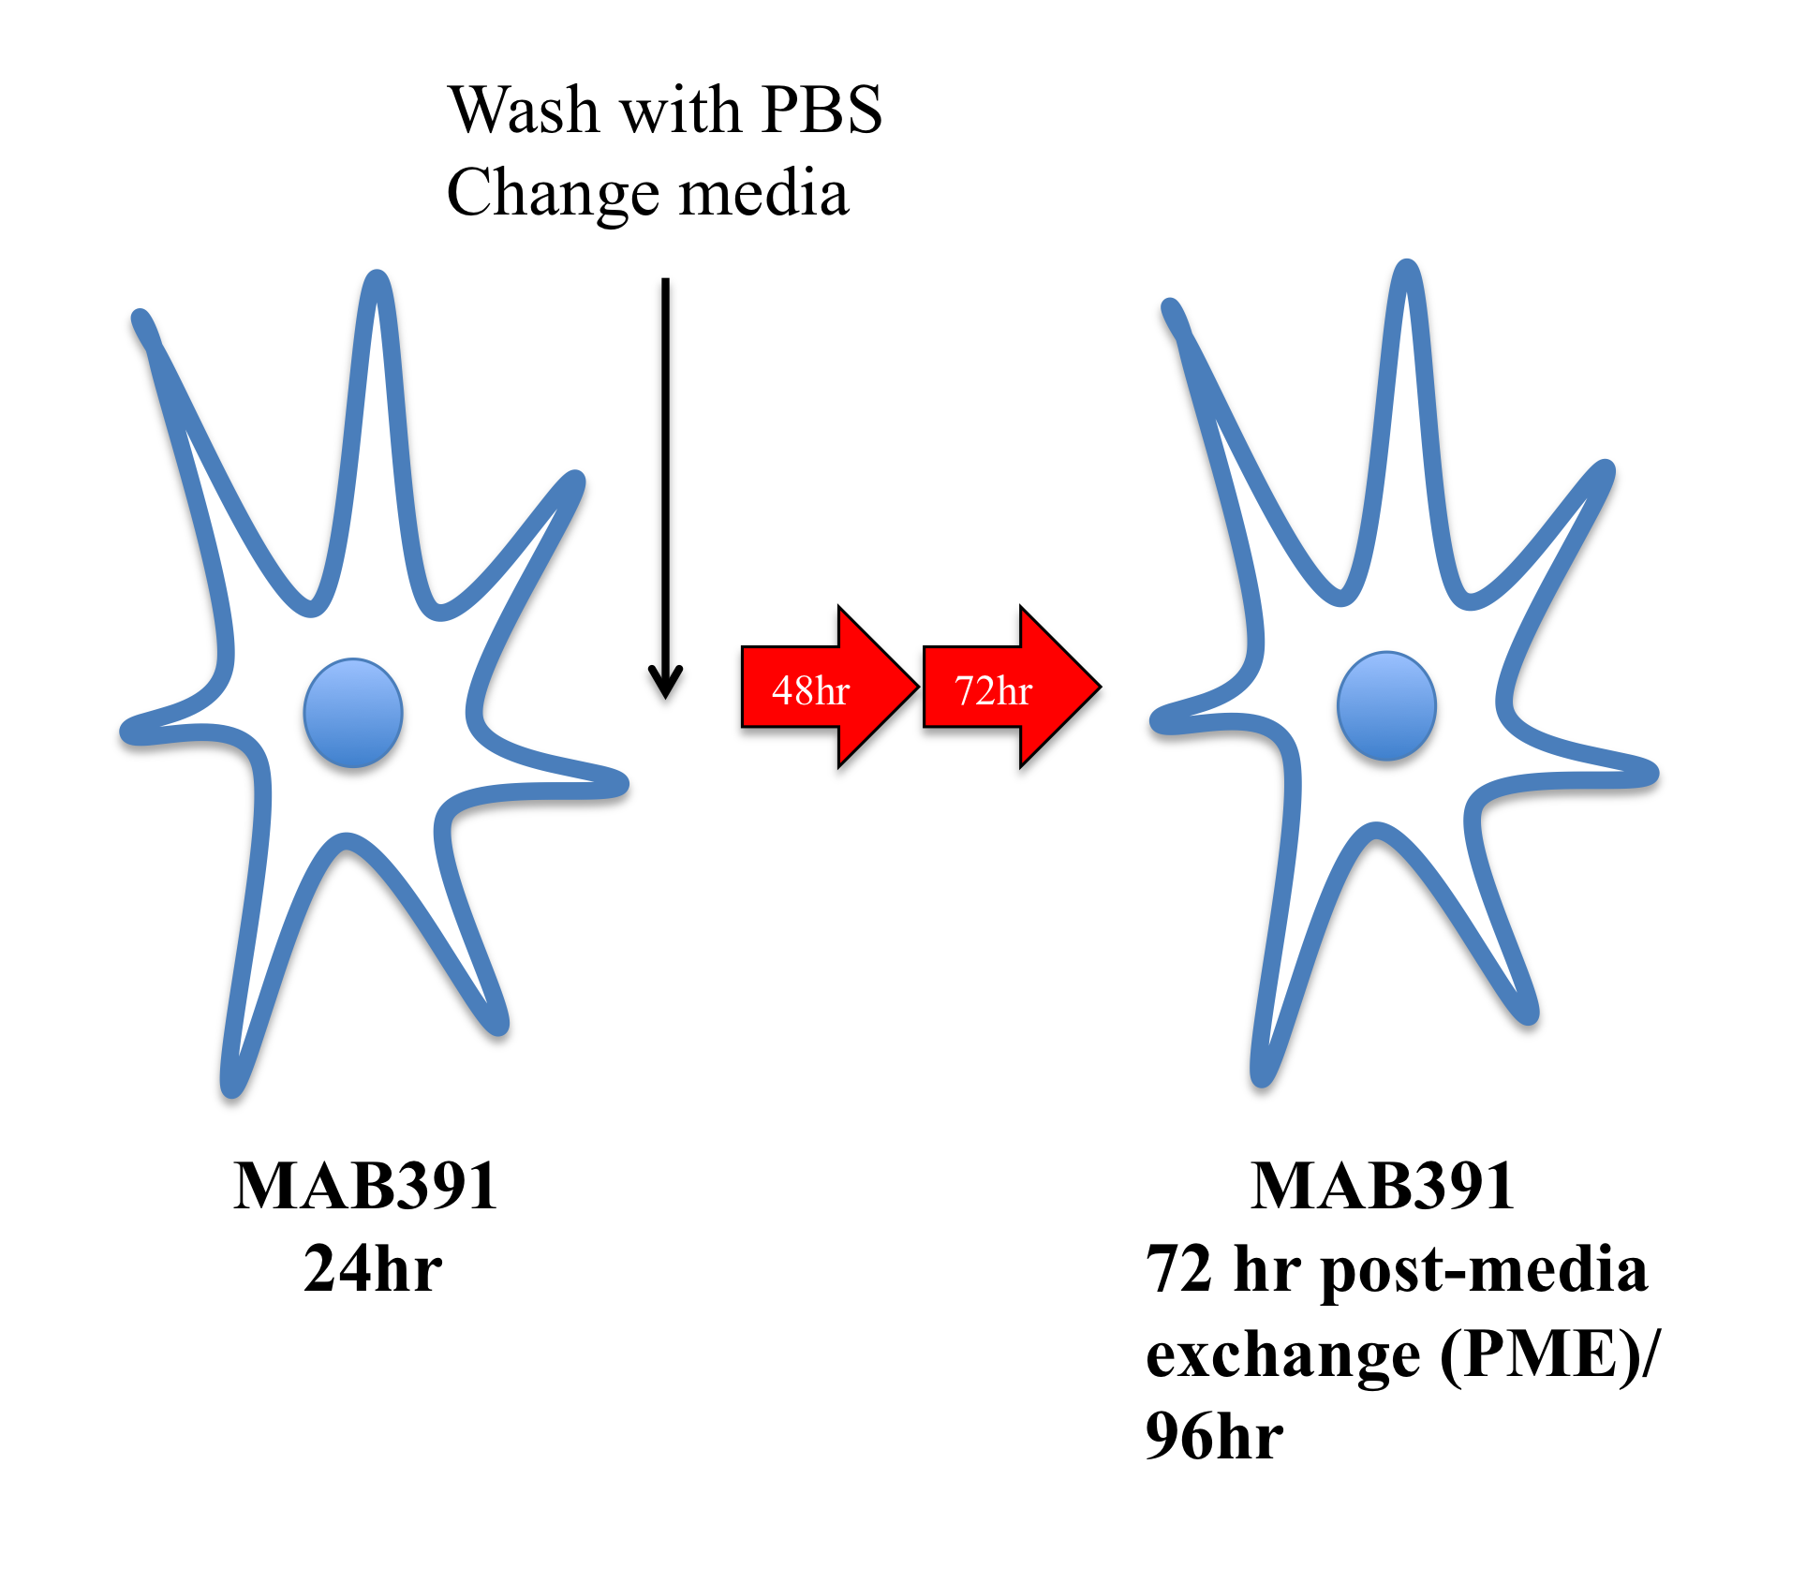

Figure 3.1. Schematic diagram depicting the treatment of primary human astrocytes with a monoclonal antibody against IGF1R (MAB391).
Astrocytes were treated with MAB391 for 24 hours and cells were either harvested or media was exchanged. Cells were maintained in normal growth media for a further 72 hours before harvesting.

3.4 Results

3.4.1 IGF1 signalling is present and functional in human astrocytes

To demonstrate functional IGF1 signalling, primary human astrocytes (ScienCell (1)) were first cultured in the presence and absence of serum for 24 hours. Astrocytes were cultured in the absence of serum as this is considered a more physiologically relevant condition as discussed in 3.5.1. Following this, cells were incubated with 10nM human recombinant IGF1 for 2 hours and harvested for protein and western blotted to identify activation at different points in the IGF1 signalling pathway. There was a shift in total IRS1 and IRS2 in response to stimulation with IGF1 ligand, which likely represents a molecular weight change following phosphorylation (figure 3.2). Signalling through IRS1/IRS2 is known to result in phosphorylation of Akt, resulting in its activation. Akt activation was significantly increased (p<0.001) when primary human astrocytes were first cultured in serum free media for 24 hours followed by stimulation with IGF1 compared with normal serum containing media and IGF1 (figure 3.2 A and B). The IGF1 signalling pathway diverges at the receptor and ultimately activates P44/42 MAPK and Akt. The significant activation of Akt following stimulation with IGF1 was not as apparent at the level of phospho P44/42 MAPK. This may indicate the preferential use of Akt to alleviate stress induced by removing nutrients/ growth factors from the media.

A.
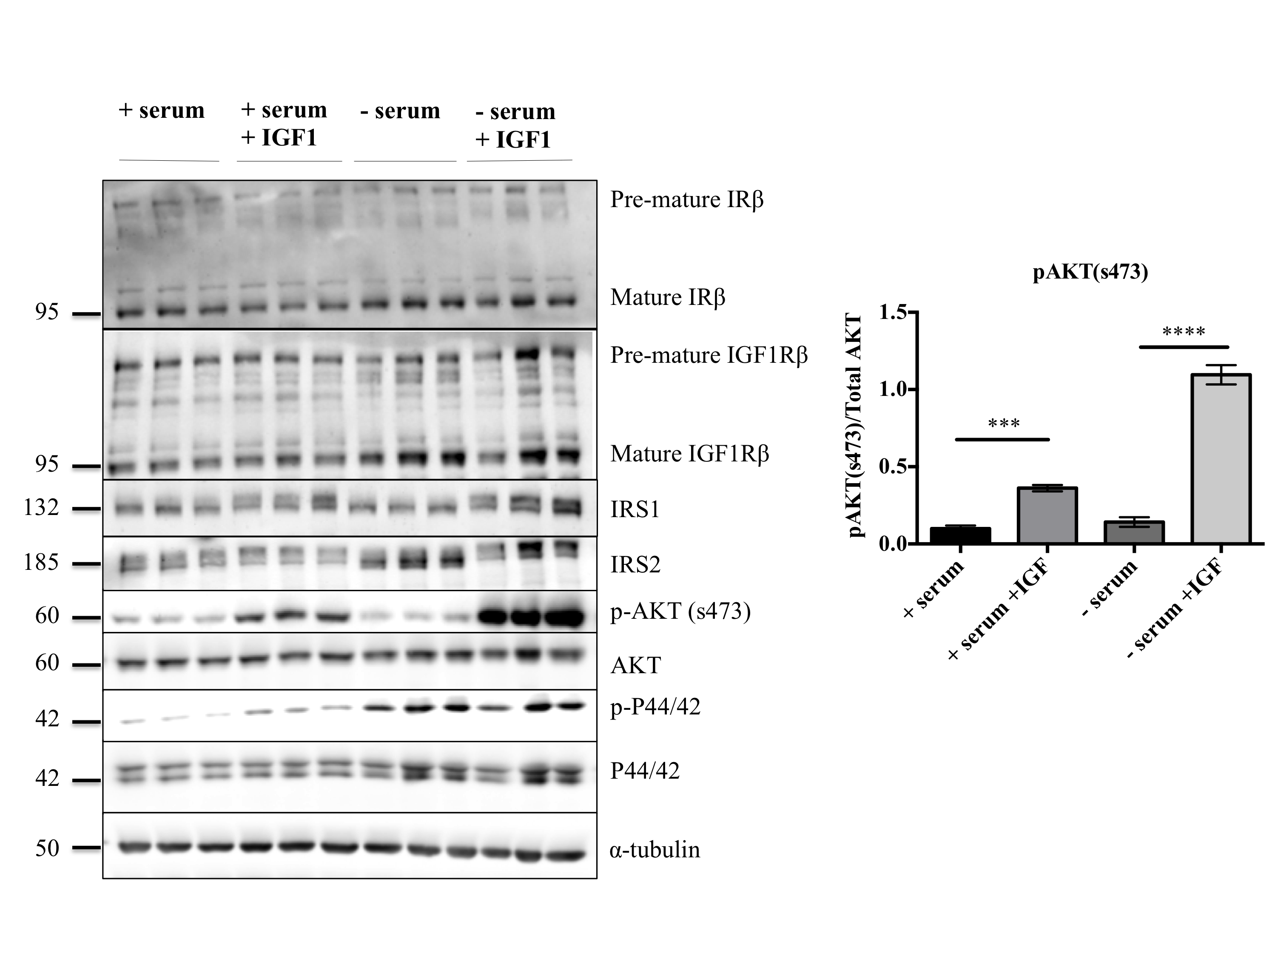

B.
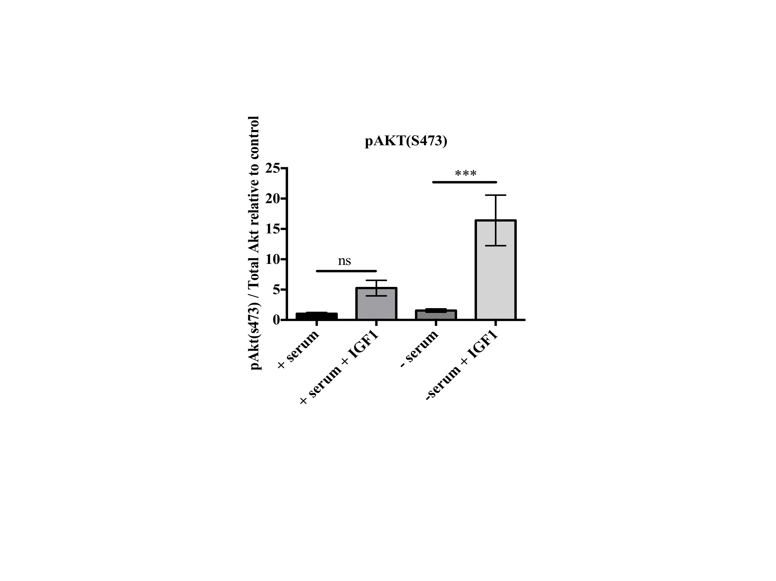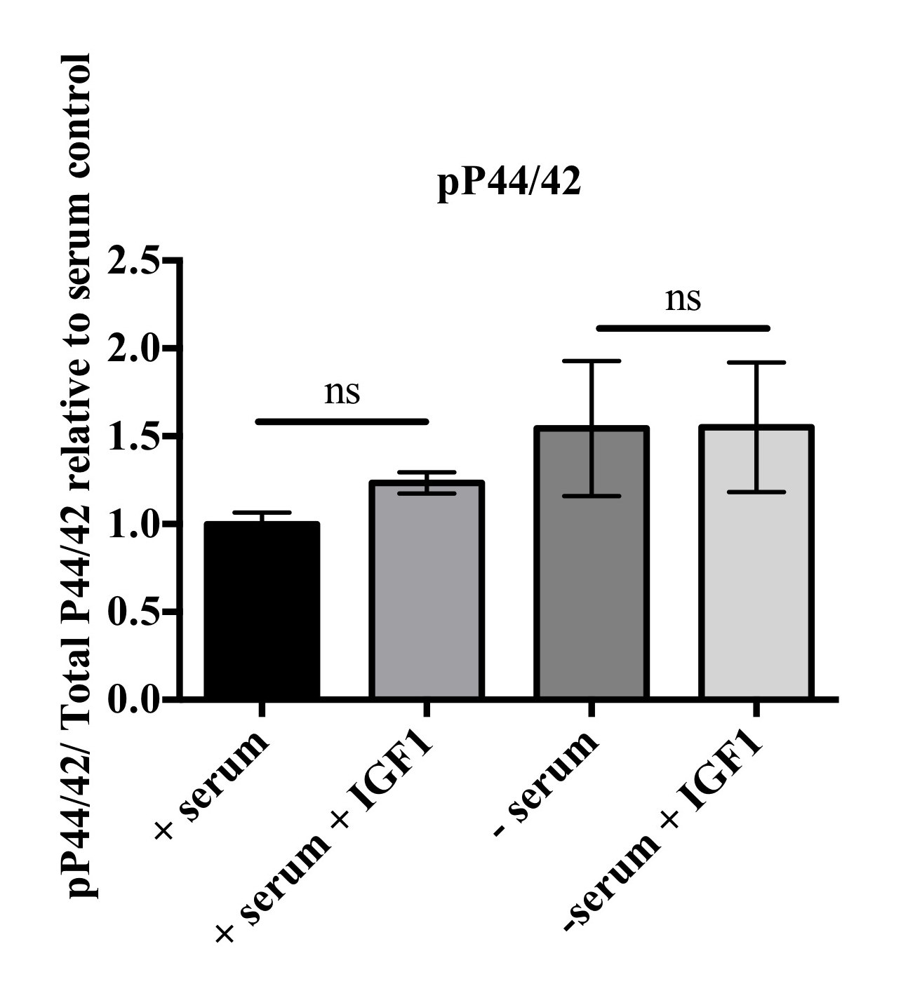

Figure 3.2. Characterisation of the IGF1 signalling pathway in human primary astrocytes.
A. Western bloting of cell lysates from human primary astrocytes cultured in the presence or absence of serum with and without 10nM recombinant human IGF1. Representative western blots probed with antibodies against IRβ, IGF1Rβ, IRS1, IRS2, pAkt (s473), Total Akt, pP44/42 MAPK and P44/42 MAPK are shown, with α-tubulin used as loading control (representative loading control shown). Molecular weight markers are indicated (kDa) B: Bar charts show quantification of pAkt and pP44/42 under each condition, pAkt was normalised to T-Akt amount and pP44/42 was normalised to P44/42. Data is mean ± SEM (n=3, 3 replicates/experiments, One way ANOVA with post-hoc analysis ***p<0.001).

3.4.2 Inhibiting IGF1 signalling in human astrocytes using an IGF1R monoclonal antibody.

An initial proof of principle experiment was conducted to demonstrate that a monoclonal antibody specific to IGF1R (MAB391, R & D Systems) could downregulate IGF1 signalling in human astrocytes (figure 3.3). Astrocytes were serum starved for 24 hours and then treated with IGF1 ligand for 2 hours with or without a 24 hour pre-incubation with 11μg/ml of MAB391. Cells treated with MAB391 showed a reduction in the mature form of IGF1R as well as reduction in pAkt (s473) confirming that this antibody could downregulate IGF1 signalling.
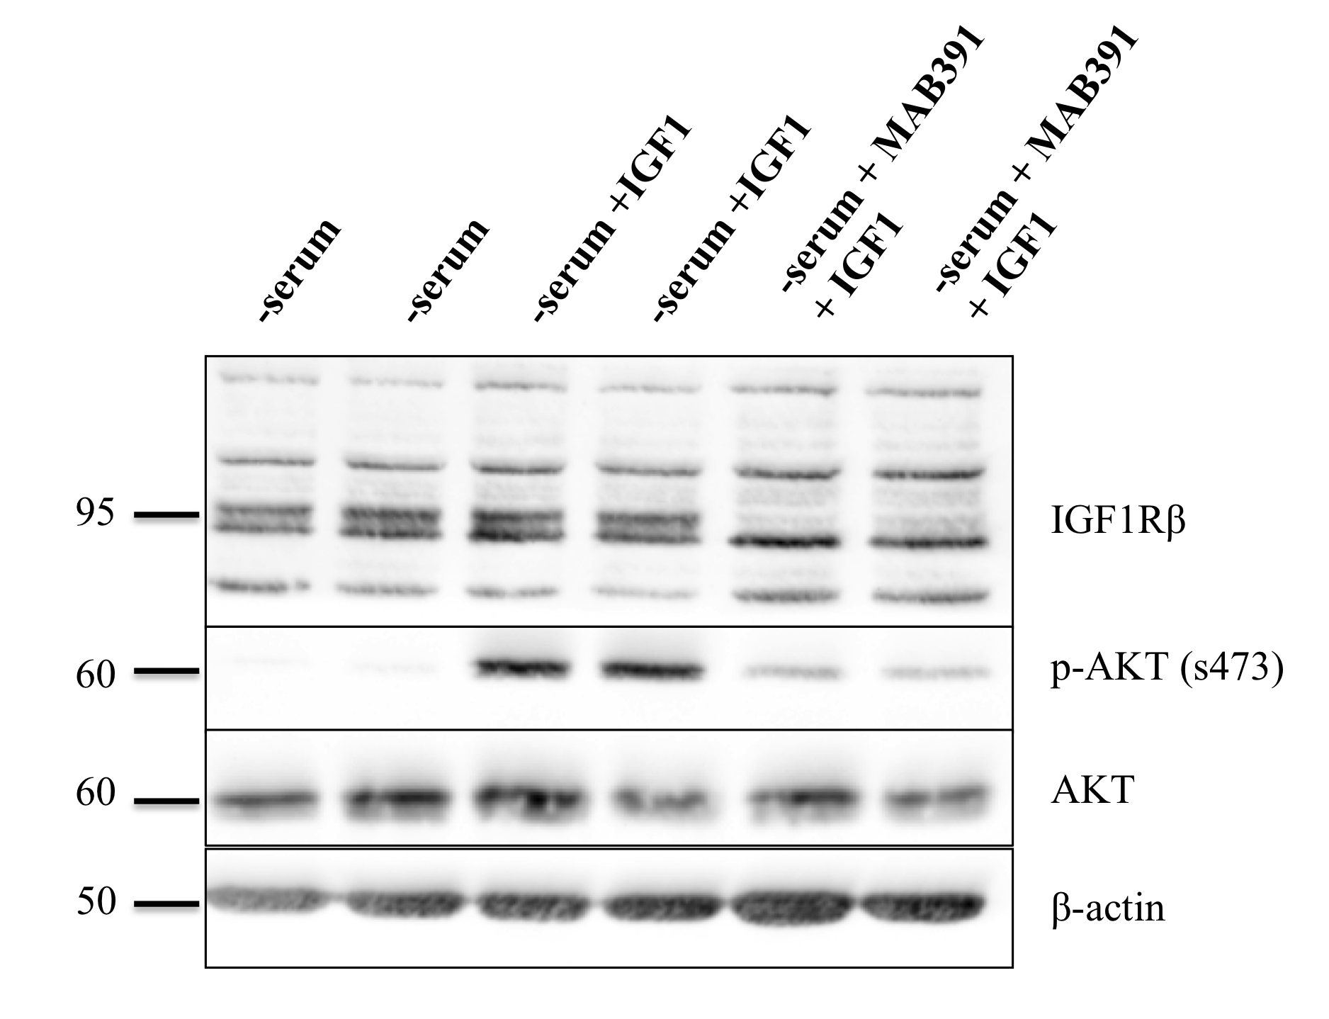

Figure 3.3. Proof of principle experiment to show a monoclonal antibody (MAB391) reduces IGF1 signalling.
Western blots of cell lysates from serum-deprived human primary astrocytes treated with 11μg/ml MAB391. Blots were probed with antibodies against IGF1Rβ, pAkt (s473), Total Akt and β-actin. Molecular weights are indicated (kDa).

3.4.3 Optimisation of model of IGF1R loss in human astrocytes

In order to develop a more physiologically relevant model of impaired IGF1 signalling in human astrocytes, MAB391 treatment was performed on ScienCell (1) astrocytes cultured in serum rich F10MEM media. A significant reduction in IGF1R was observed after 24 hour MAB391 treatment (figure 3.4 A and B, p<0.0001). Treatment with MAB391 also resulted in decreased phosphorylated Akt (s473) (figure 3.4 A and B, p< 0.001). To control for the presence of immunoglobulins, an IgG mouse monoclonal control was included (MAB002). MAB002 treatment did not reduce IGF1R or pAkt (S473) levels (see appendix, supplementary figure 7.1). Levels of p P44/42 MAPK were initially assessed and showed no changes following MAB391 treatment. Due to no observable changes being detected, assessment of changes in pMAPK P44/42 was not pursued. These results may also suggest that astrocytes preferentially signal through Akt over the P44/42 MAPK pathway.

A.
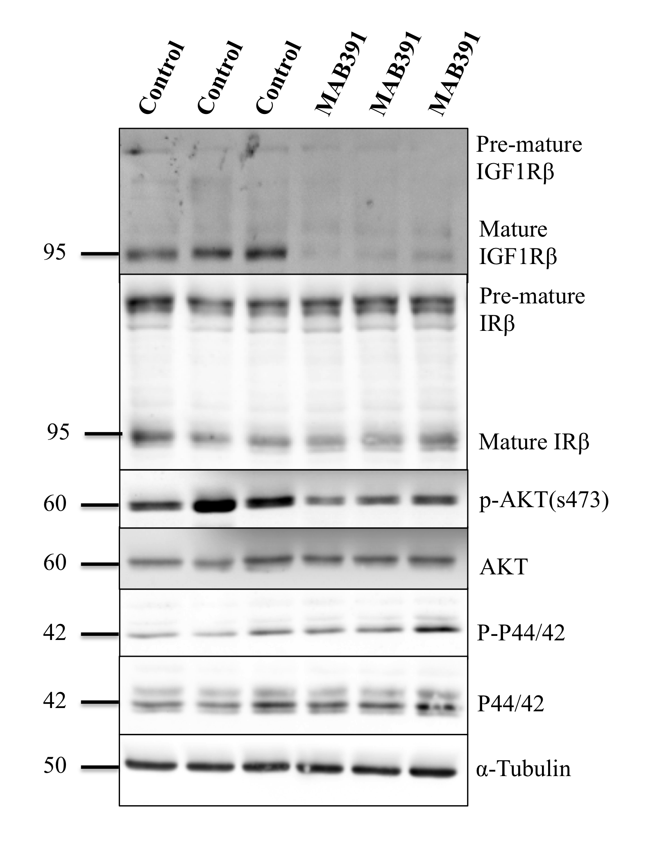

B.
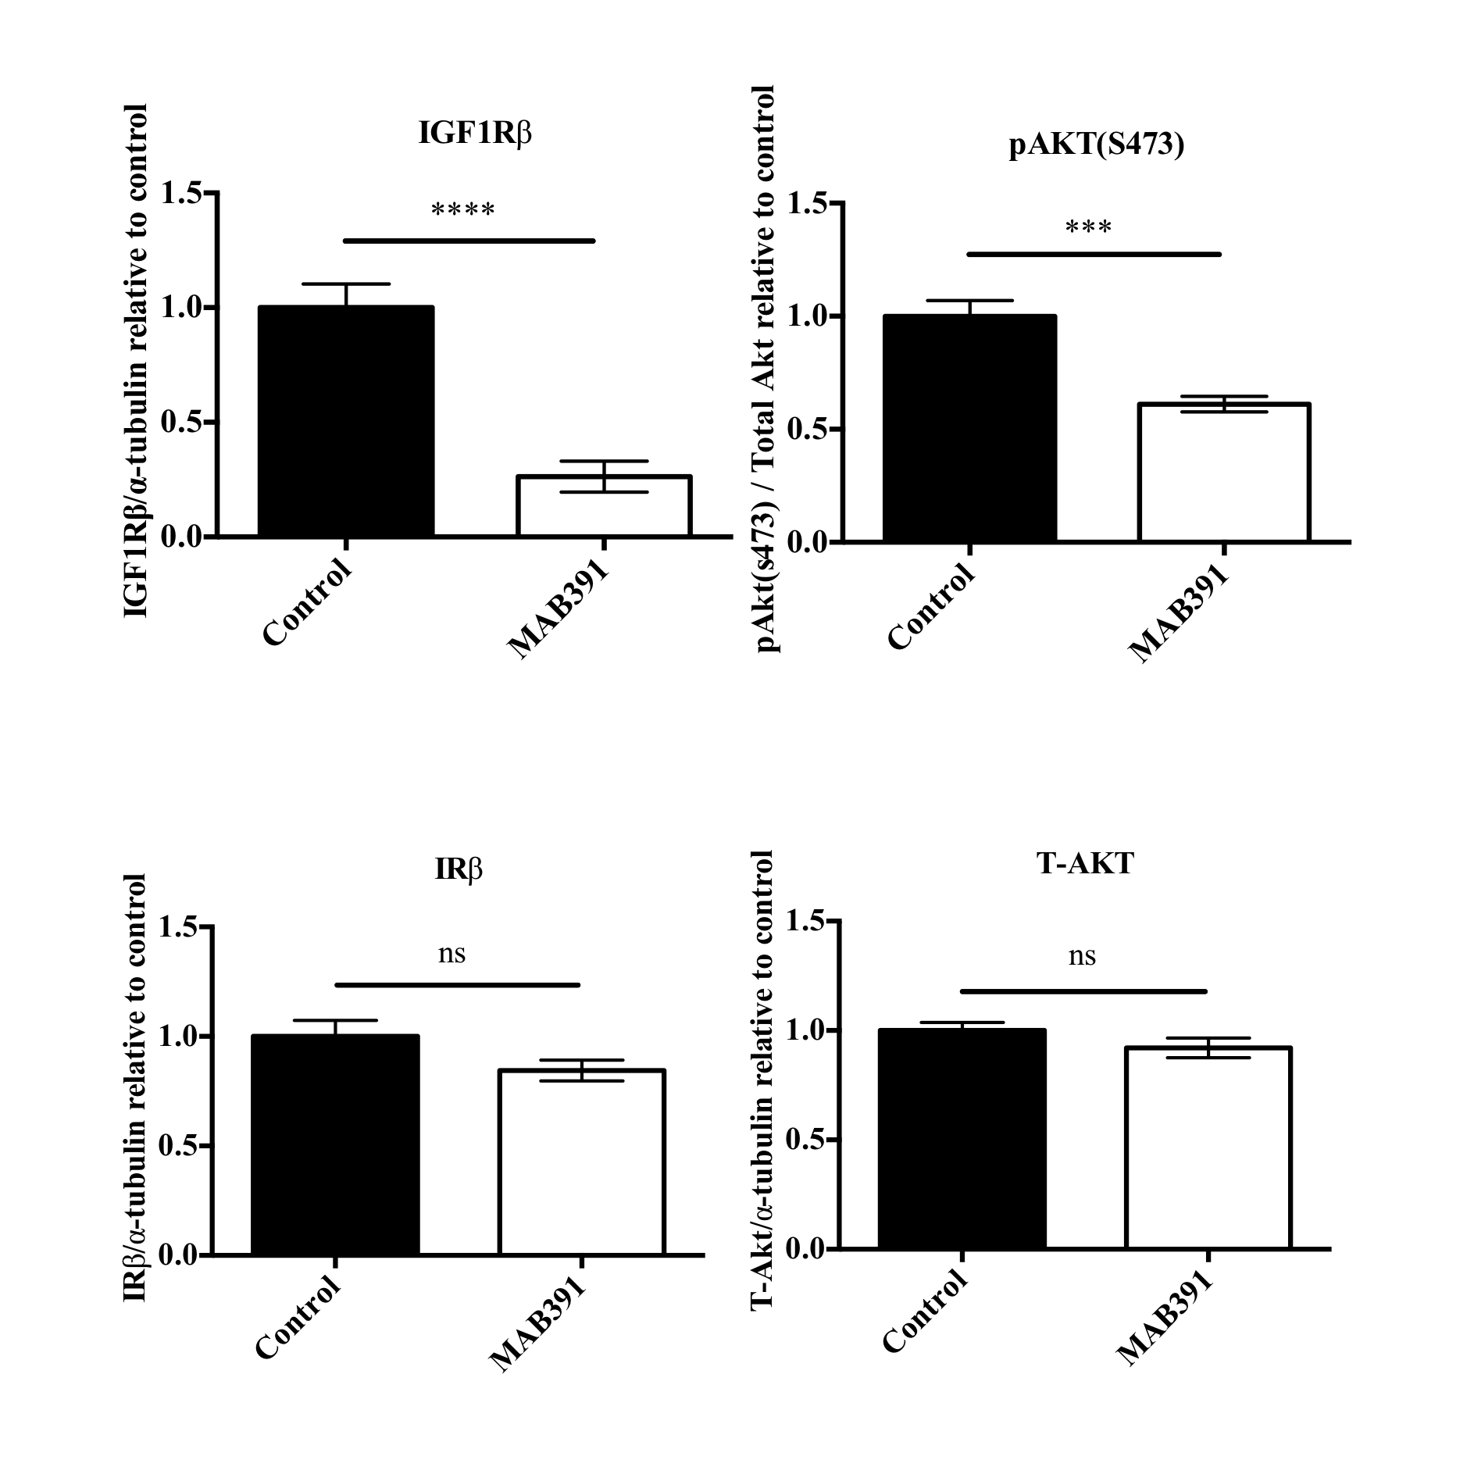

Figure 3.4. IGF1 signalling impairment in ScienCell (1) astrocytes.
A: Treatment of astrocytes for 24 hours with 11μg/ml of MAB391 caused loss of IGF1R and reduced phospho Akt (s473). Representative western blots probed with antibodies against IRβ, IGF1Rβ, pAkt, Total Akt, pP44/42 MAPK and P44/42 MAPK are shown, with α-tubulin used as loading control (representative loading control shown). Molecular weight markers are indicated (kDa) B: Bar charts representing changes in IGF1Rβ, IRβ, phospho Akt (s473) and T-Akt as a result of MAB391 treatment. Data are mean ± SEM (n=3, 3 replicates/experiments, unpaired t-test ***p<0.001, ****p<0.0001).

An extended timepoint was also included to determine whether the reduction in IGF1R levels and signalling through Akt persisted. Astrocytes were cultured with MAB391 for 24 hours, media was then exchanged and astrocytes cultured for a further 72 hours. The reduction in IGF1R persisted at this later timepoint (96hr) (figure 3.5 A and B, p< 0.0001) but there was no significant difference in pAkt levels between control and MAB391 treatment, (Figure 3.5 A and B) indicating a recovery of Akt activity. pP44/42 MAPK levels were also unchanged at the 96hr timepoint. The impact of MAB391 on insulin receptor (IR) levels was also determined since IGF1R subunits are able to form heterodimers with IR subunits. IR levels were significantly reduced at the 96hr timepoint (figure 3.5 A and B, p< 0.05).

A.
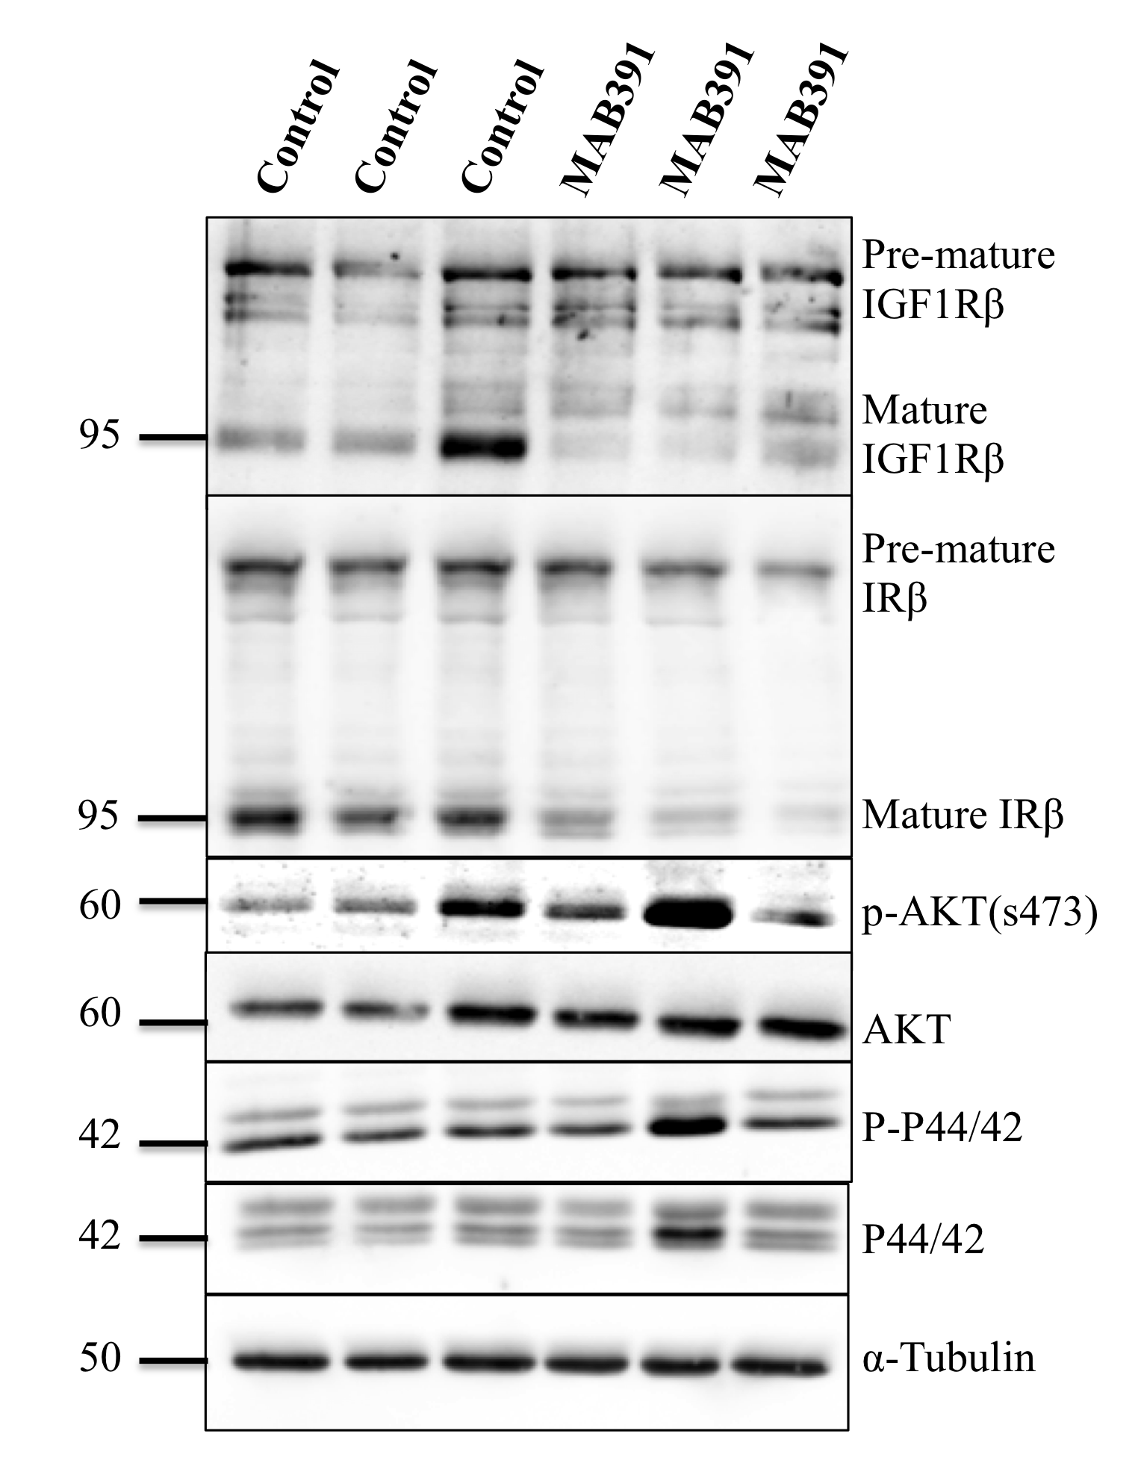

B.
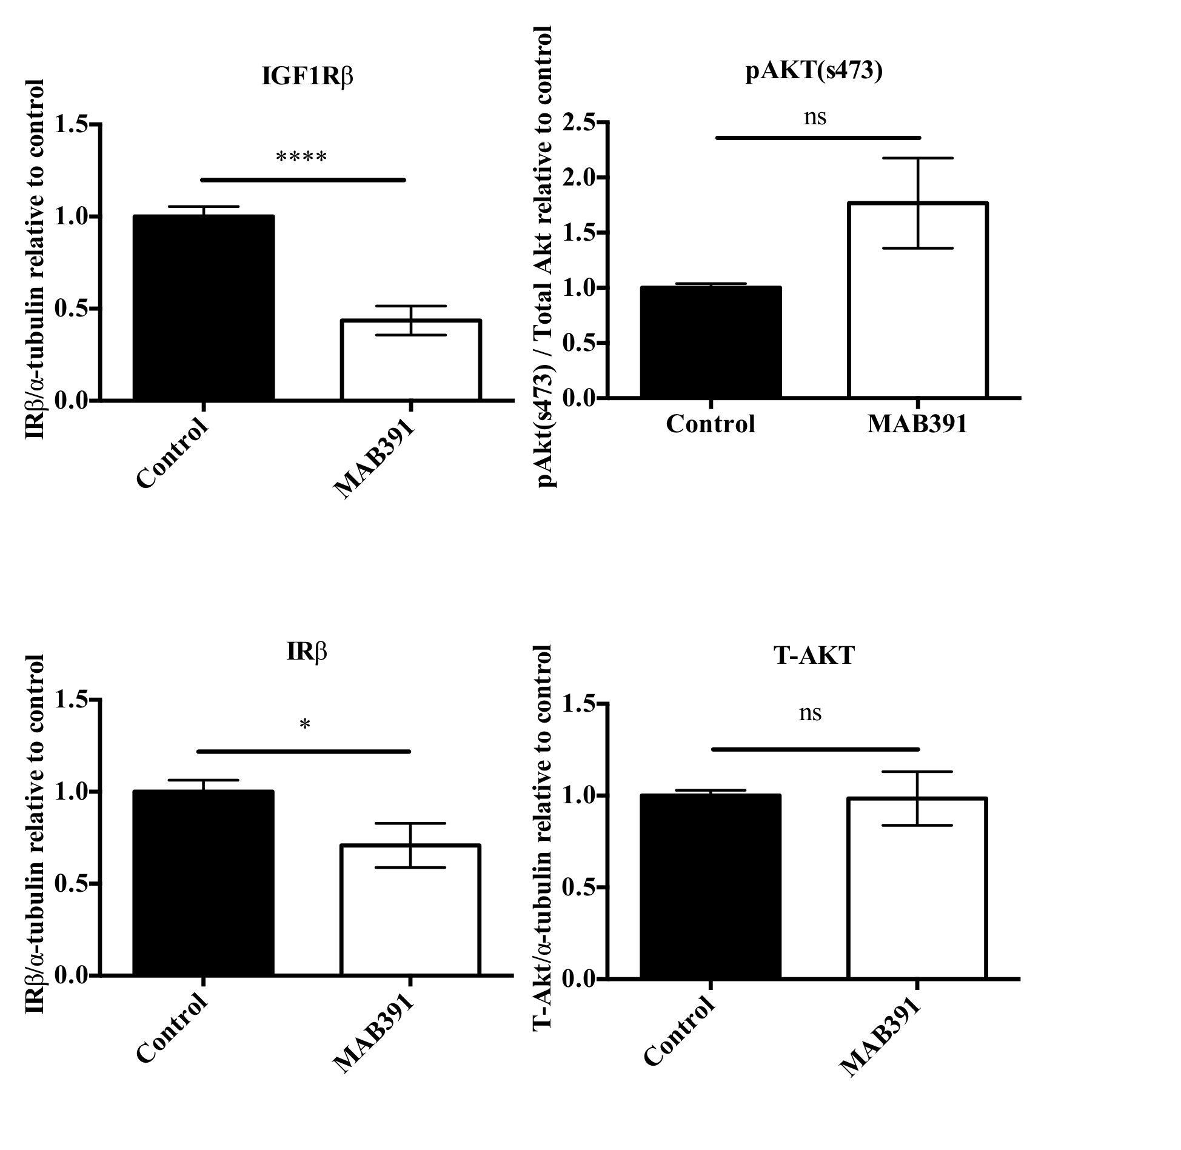

Figure 3.5. IGF1 signalling impairment in ScienCell (1) astrocytes.
A: Treatment of astrocytes for 96 hours/ 72hours post media exchange (PME) with 11μg/ml of MAB391 caused maintained loss of IGF1R and recovery of phospho Akt (s473). Representative western blots probed with antibodies against IRβ, IGF1Rβ, pAkt, Total Akt, pP44/42 MAPK and P44/42 MAPK are shown, with α-tubulin used as the loading control (representative loading control shown). Molecular weight markers are indicated (kDa) B: Bar charts representing changes in IRβ, IGF1Rβ, pAkt (s473) and T-Akt as a result of MAB391 treatment. Data are mean ± SEM (n=3, 3 replicates/experiments, unpaired t-test *p<0.05, ****p<0.0001).

To determine whether treatment with MAB391 is a robust model to reduce IGF1R and causes a similar impairment in IGF1 signalling in different human astrocytes, MAB391 treatments were replicated in two additional astrocyte populations.

The model was replicated on human adult astrocytes derived from temporal lobe epileptic resections and on a separate vial of cerebral cortex astrocytes supplied by ScienCell (ScienCell (2) also used in chapter 4 and 5). Due to the use of the ScienCell astrocytes being limited between passage 3-7, the extent to which these cells can be cultured is restricted. Moreover, ScienCell do not disclose the specifics of where each vial of astrocytes is derived from other than they are foetal cerebral cortex astrocytes.

Adult astrocytes taken from temporal lobe resections were treated for 24 hours with MAB391 resulting in loss of IGF1R (figure 3.6). However, there was no effect on pAkt (s473) levels indicating that there was no impact on signalling through Akt (figure 3.6). In addition, ScienCell (2) astrocytes also showed a reduction in IGF1R after a 24 hour MAB391 treatment but similarly showed no change in pAkt (s473) (figure 3.7A). MAB002 treatment did not downregulate IGF1R levels in these cells (see appendix, supplementary figure 7.2). At 72hr PME in these cells, the reduction in IGF1R persisted but conversely there was a significant increase in pAkt (s473) (figure 3.7B). These results suggest that MAB391 is a robust method to induce chronic loss of IGF1R but there are differences in downstream signalling through Akt in different astrocytes.

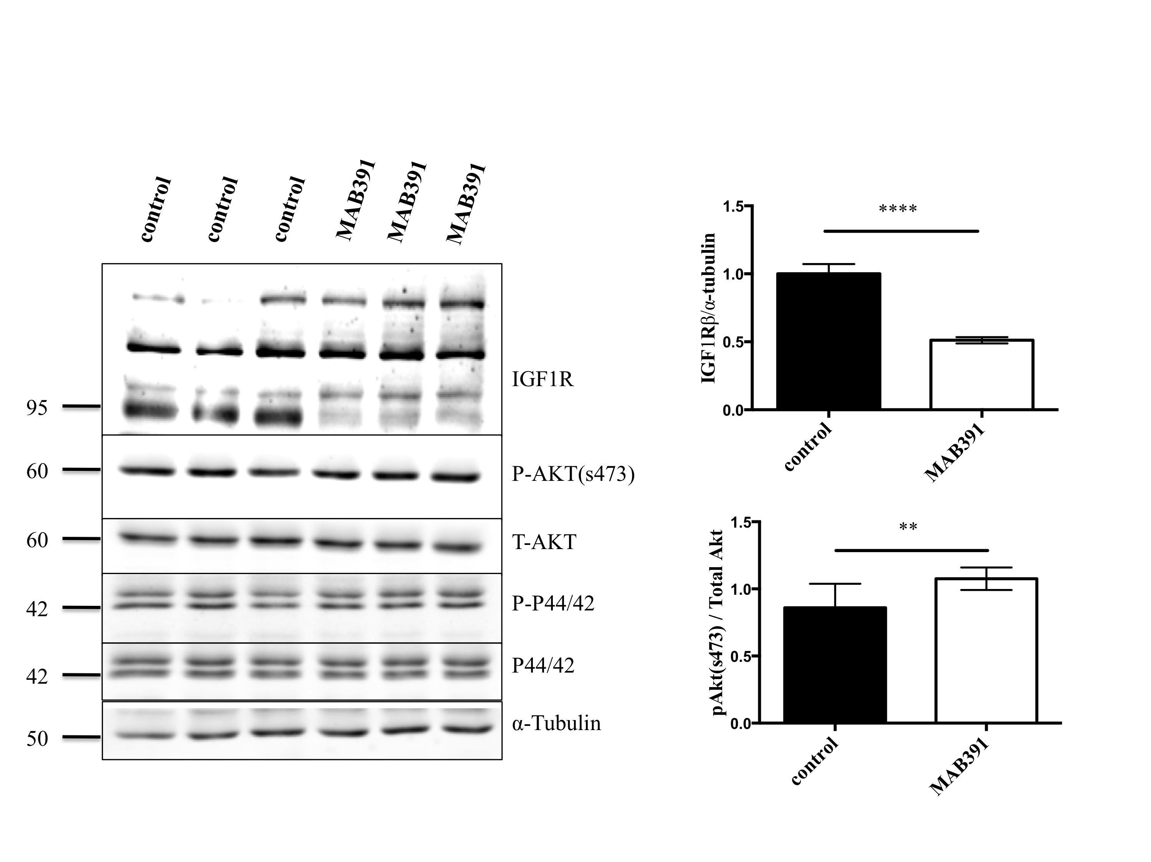

Figure 3.6. IGF1 signalling impairment in astrocytes taken from epileptic temporal lobe resections.
Treatment with 11μg/ml of MAB391 for 24 hours induced loss of IGF1R but there was no change in the level of pAkt (s473). Bar charts show significant loss of IGF1R and a significant increase in pAkt levels after 24 hours. (This is representative of n=3, 3 replicates, 3 experiments/replicate. Data are mean ± SEM (n=3, 3 replicates/experiments, Unpaired t-test with post-hoc analysis **p<0.01, ****p<0.0001).

A.
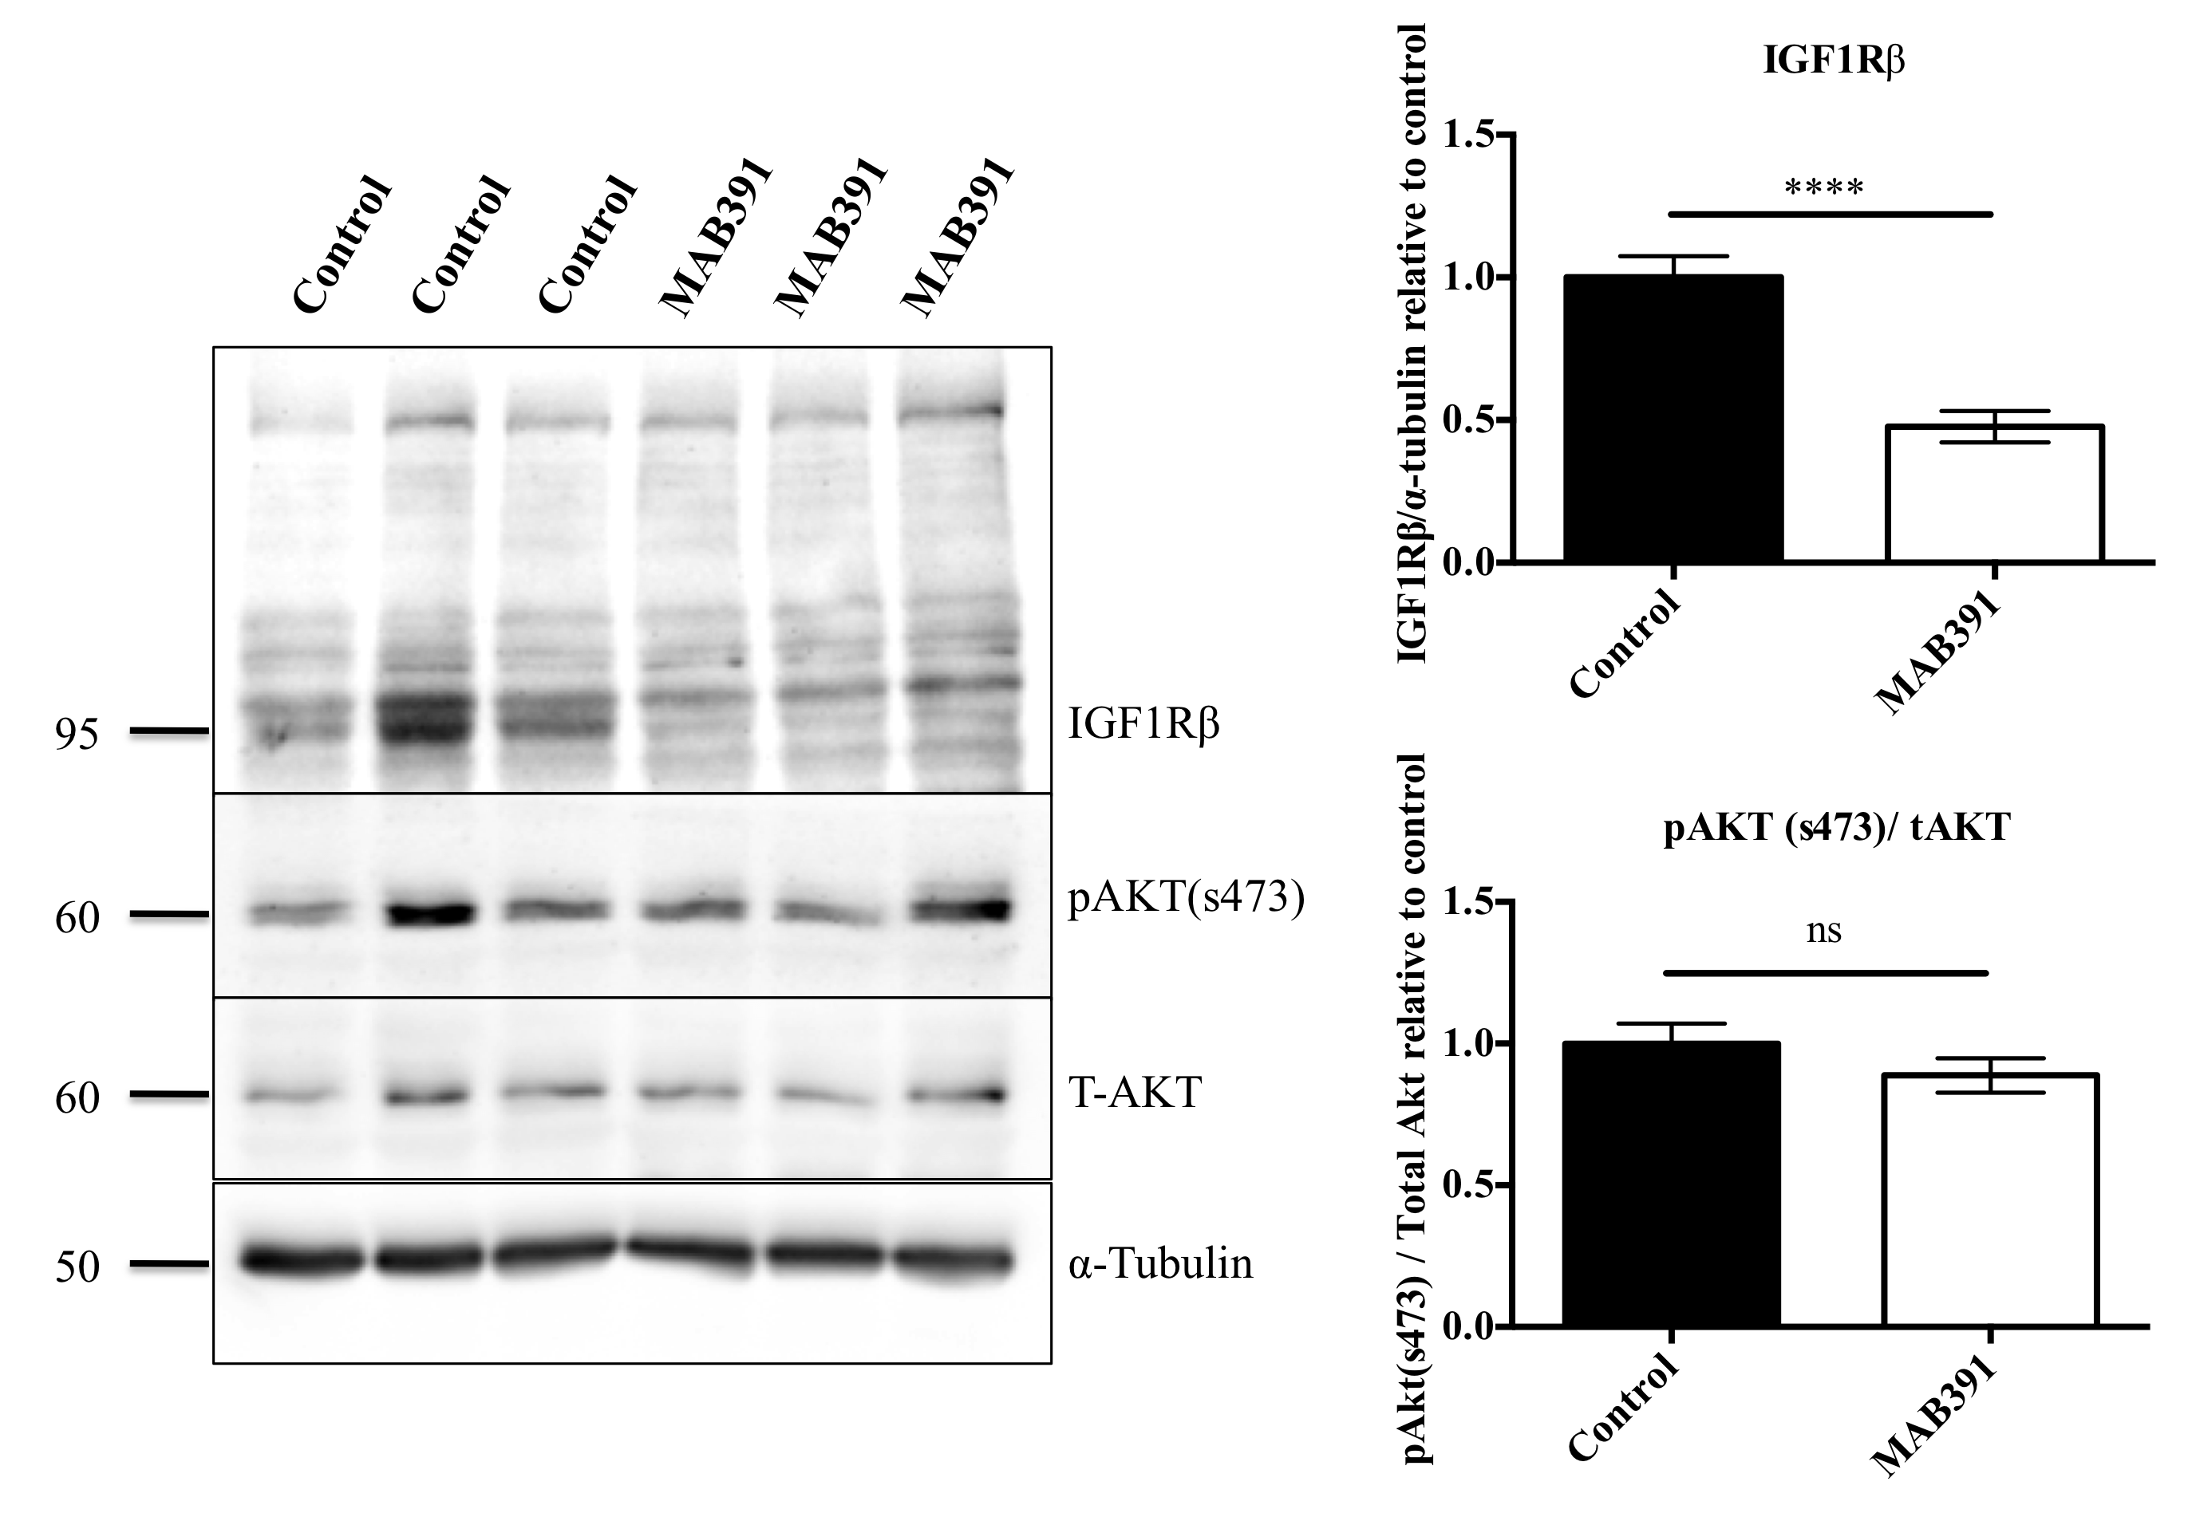
B.
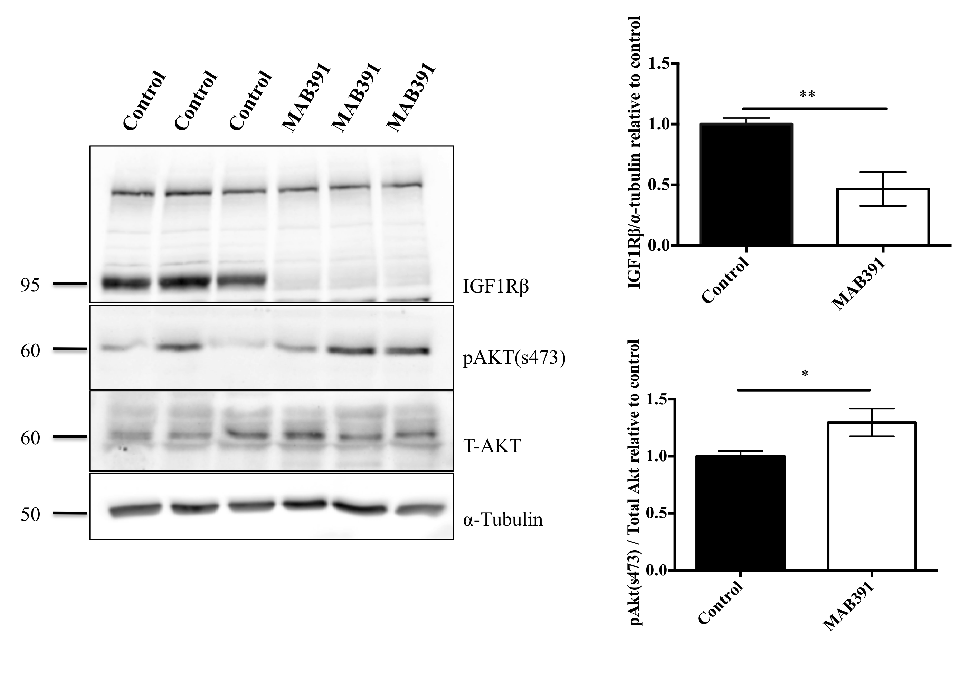
Figure 3.7. Model of IGF1 signalling impairment in ScienCell (2) astrocytes.
A: Treatment with 11μg/ml of MAB391 for 24 hours induced loss of IGF1R but did not change levels of pAkt (s473). Bar charts show significant loss of IGF1R and no change in pAkt levels after 24 hours. B: Treatment of astrocytes with MAB391 for 72 hours post-media exchange (PME). Western blots demonstrate continued loss of IGF1R, with a significant recovery in levels of pAkt. Bar charts display these observable changes. (Western blots are representative of n=3, 3 replicates, 3 experiments/replicate. Data are mean ± SEM (Unpaired t-test with post-hoc analysis *p<0.05, **p<0.01, ****p<0.0001).

3.4.4 Loss of IGF1R occurs at the protein level

It has been reported that MAB391 causes internalisation and targeting of IGF1R to lysosomes for degradation (Hailey et al. 2002). Western blotting revealed loss of IGF1R following MAB391 treatment at 24 hr and 72hr PME. To further assess whether MAB391 causes loss of IGF1R at the protein level, immunocytochemistry was carried out on MAB391-treated ScienCell (1) astrocytes at both the 24hr and 72hr PME time points, in conjunction with qRT-PCR to identify changes at the transcript level. After 24 hours of MAB391 treatment, IGF1R appeared to be localised in punctate vesicles, which may coincide with the reports of IGF1R being internalised into endosomes following MAB391 treatment (Hailey et al. 2002). At 72 hr PME, there appeared to be an increased distribution of IGF1R throughtout the cytoplasm, however not to the same extent as control astrocytes.

Analysis of cell lysates harvested from MAB391-treated astrocytes using qRT-PCR showed no changes in the level of IGF1R at the RNA level at either 24 hours or 72 hours PME (figure 3.8B), suggesting that MAB391 acts at the level of the protein.

A.
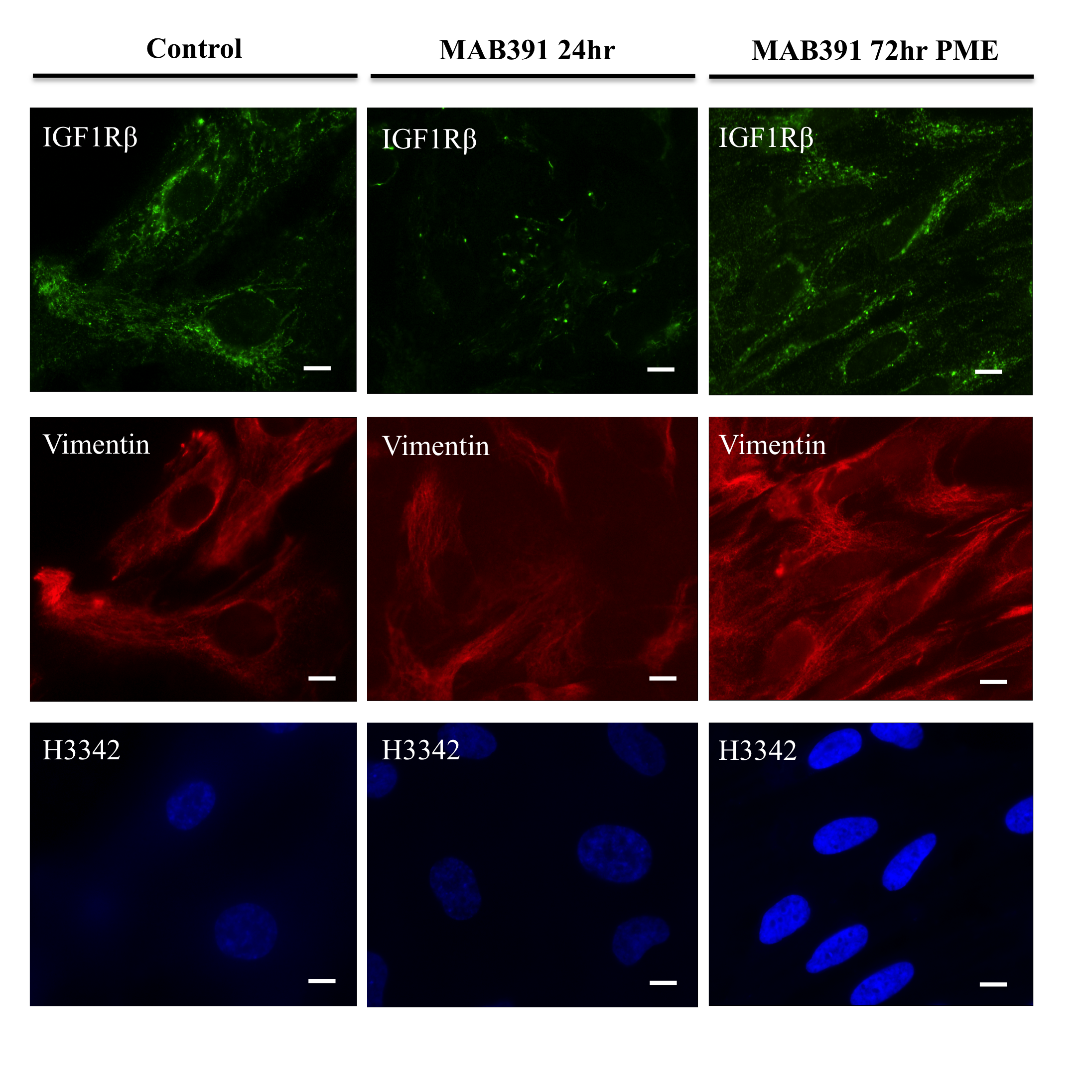
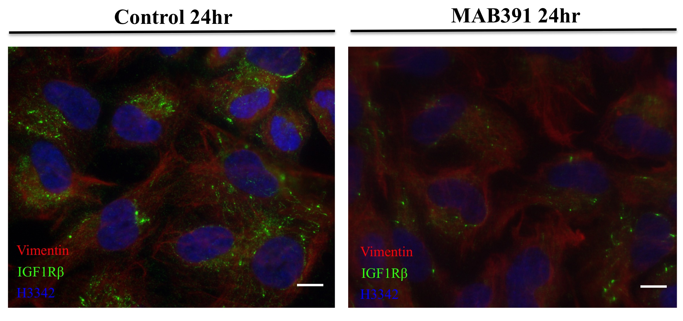

B.
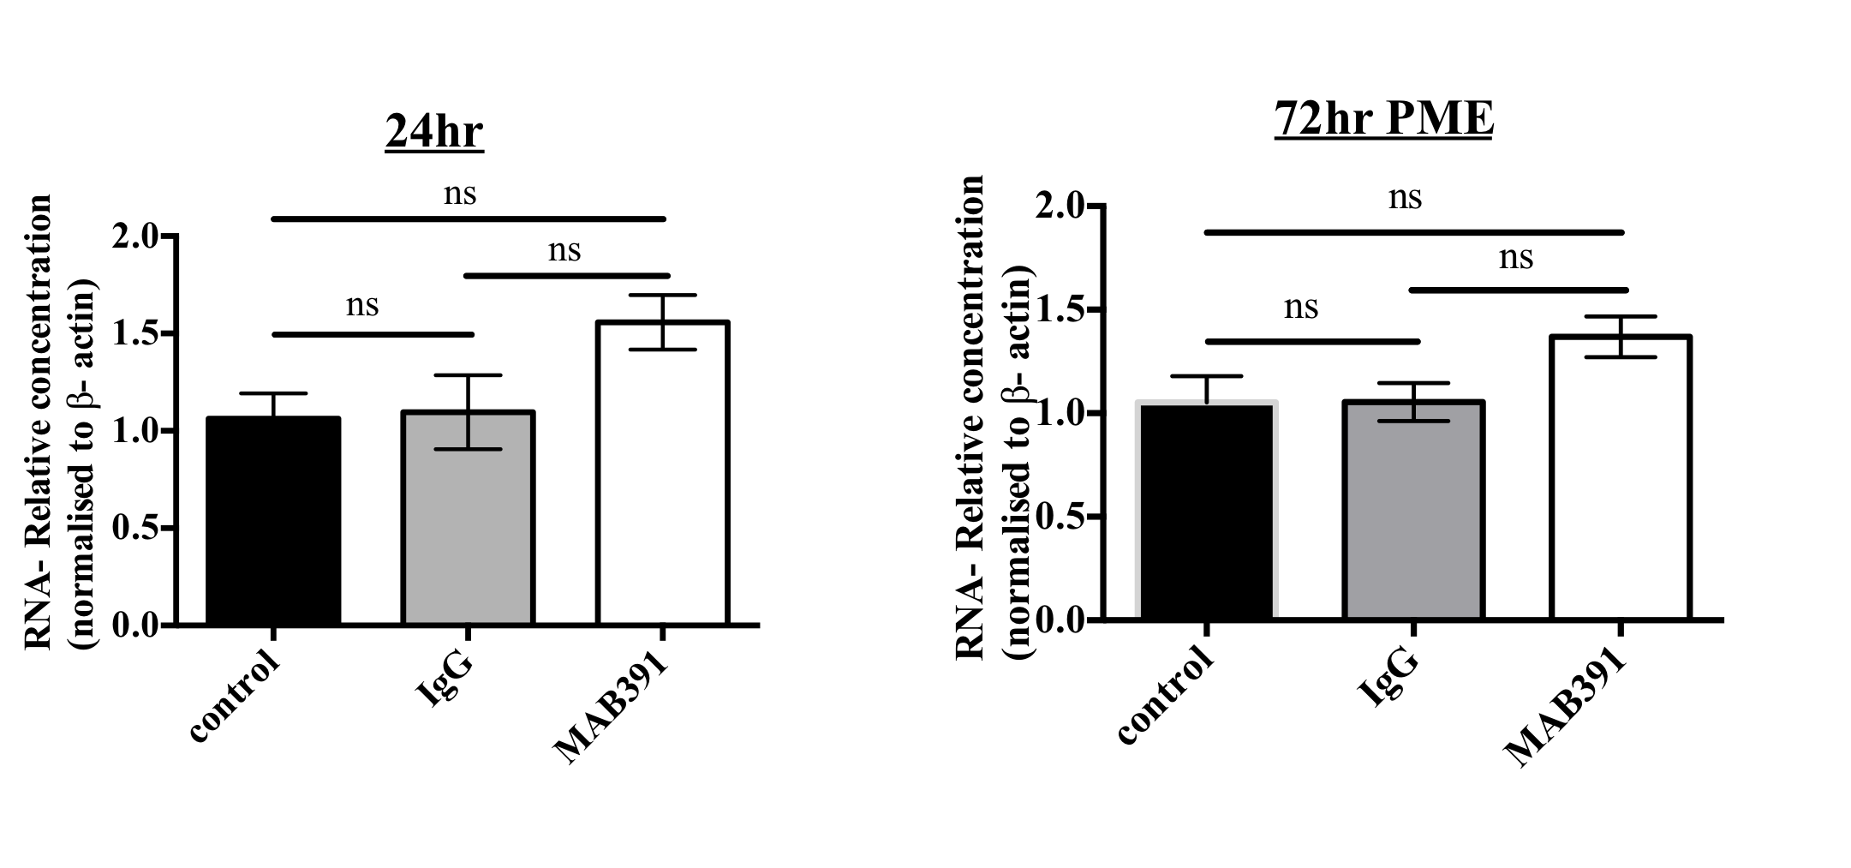
Figure 3.8. Changes in IGF1R localisation following treatment of astrocytes for 24 hours and 72 hours PME with MAB391.
(A) Following treatments cells were fixed at 24 and 72 hrs and immunostained with an antibody against IGF1R (green), an astrocyte marker (vimentin, red) and nuclei were labelled with H3342 (blue). Scale bar represents 10μM.
(B) MAB391 treatment does not affect IGF1R transcript levels. Bar charts show qPCR analysis of IGF1Rβ showing no differences at RNA level. Data are mean ± SEM (n=3, 3 replicates/experiments, One way ANOVA with post-hoc analysis).

3.4.5 Impaired IGF1 has no impact on cell growth

IGF1 is believed to drive mitogenesis and signalling through Akt is a key survival pathway. Impaired signalling through Akt has been shown to reduce cell viability in many cancer models. In the loss of IGF1R model in the ScienCell (1) astrocytes, changes in cell viability were assessed using two different assays. The MTT assay is a colourmetric assay that measures NAD(P)H-dependent cellular oxidoreductase enzyme activity, which can be used as an indirect method of assessing cell viability. A Cyquant assay, which is a fluorescent-based method for the quantification of DNA content, was used to validate the MTT results.

The results from the MTT assay showed significant differences between control and MAB391-treated astrocytes. However, the inclusion of an isotype control indicated that this difference was due to treatment with IgG rather than the reduction in IGF1R and associated signalling. There was also a recovery in absorbance levels after 96 hours for both IgG and MAB391 treatments (figure 3.9).

Cyquant assays showed that MAB391 treatment did not affect cell number compared to IgG-treated or control astrocytes (figure 3.9). Taken together, these results suggest that impaired IGF1 signalling did not affect astrocyte viability. Furthermore, persistent loss of IGF1R was not accompanied by downregulation of signalling downstream which might in part explain the lack of impact on cell viability.

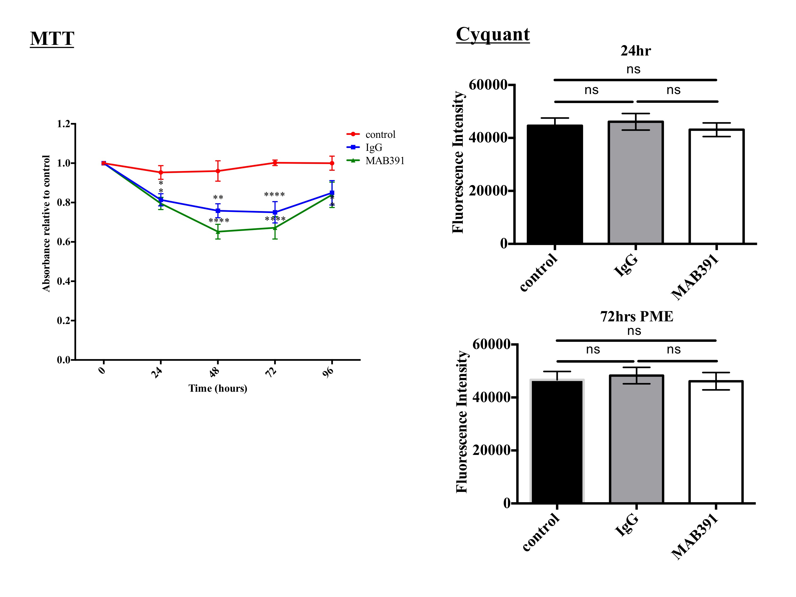

Figure 3.9. Loss of IGF1R does not alter cell growth.
ScienCell (1) astrocytes were treated with MAB391 for 24 hours before media exchange and assessment of cell viability using MTT and Cyquant analysis was performed up to 96 hours. MTT analysis shows no differences in cell viability between IgG (MAB002) and MAB391 treatments over the 96 hour period. A cyquant assay was used to validate these findings and confirmed no change in cell viability following impairment of IGF1 signalling. Graphs are representative of n=3, 3 experiments/replicate. (Data are mean + SEM, One way ANOVA with post-hoc analysis **p<0.01, ****p<0.0001).

3.4.6 Impaired IGF1 signalling has no impact on GFAP, γH2AX or ROS levels in astrocytes

With a view to determine whether loss of IGF1R induces stress in the astrocytes, GFAP and γH2AX levels were assessed by western blotting following a 24 hour MAB391/ IgG treatment in ScienCell (1) astrocytes. GFAP is an astrocytic marker that is elevated when astrocytes become functionally mature or stressed and has been associated with AD pathology (Fukuyama et al. 2001; J E Simpson, Ince, Lace, et al. 2010). Despite there being a significant change in GFAP levels following MAB391 treatment relative to control astrocytes (figure 3.10, p< 0.01), when compared to the IgG isotype control treatment this was a non-significant effect.

γH2AX is an indicator of early DNA damage. Levels of γH2AX have been shown to be both elevated and unchanged in the nuclei of astrocytes residing in the AD brain (Myung et al. 2008; J E Simpson, Ince, Haynes, et al. 2010). Loss of IGF1R was not associated with changes in γH2AX in ScienCell astrocytes (figure 3.10).

ROS levels were also assessed following treatment of astrocytes with IgG/MAB391 for 24 hours since there are links between IGF1 signalling and oxidative stress in rodent astrocytes (Genis et al. 2014). However, no change in ROS production was observed in astrocytes following loss of IGF1R when compared against no treatment or IgG treatment (figure 3.11).

In conclusion there were no changes in GFAP, γH2AX or ROS production following loss of IGF1R for 24 hours in astrocytes.

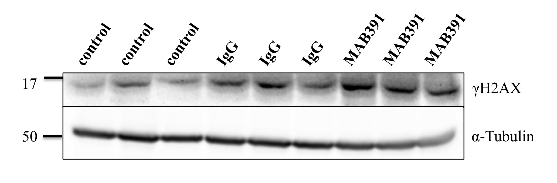
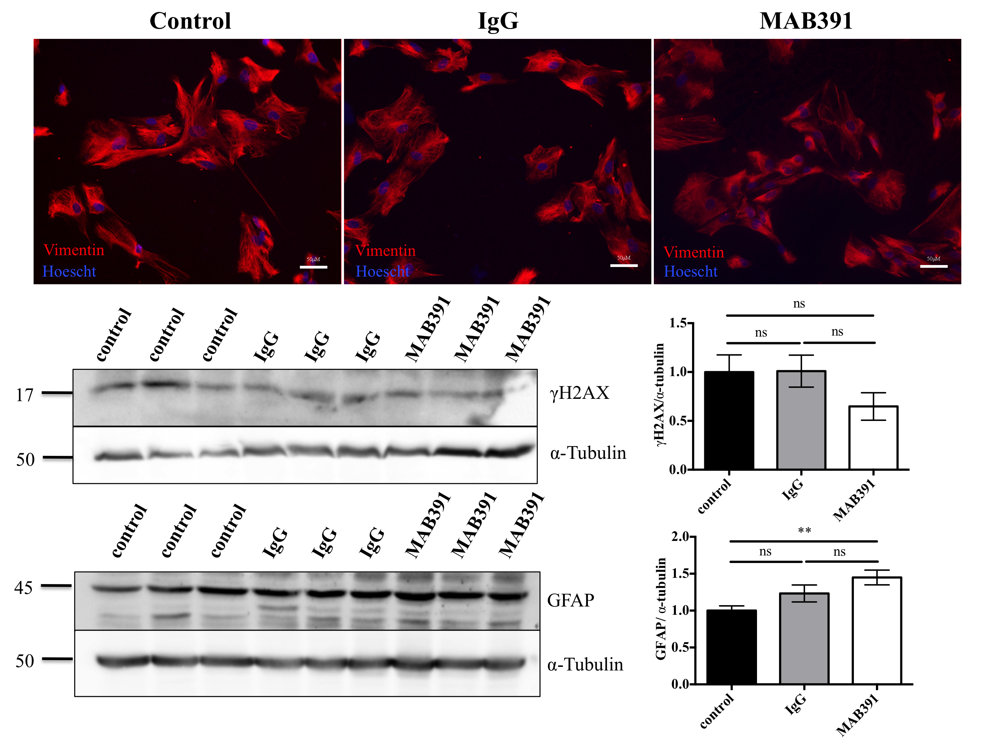

Figure 3.10. Investigating the levels of GFAP/γH2AX following loss of IGF1R.
MAB391/IgG-treated ScienCell (1) astrocytes were western blotted for GFAP and γH2AX immunoreactivity, with α- tubulin as a loading control and representative western blots are shown. Bar charts show quantification of western blots and show no changes in GFAP or γH2AX levels following a 24 hour treatment with MAB391. Data represents mean ± SEM (n=3, at least 3 replicates/experiment, one way ANOVA with post-hoc analysis **p<0.01).

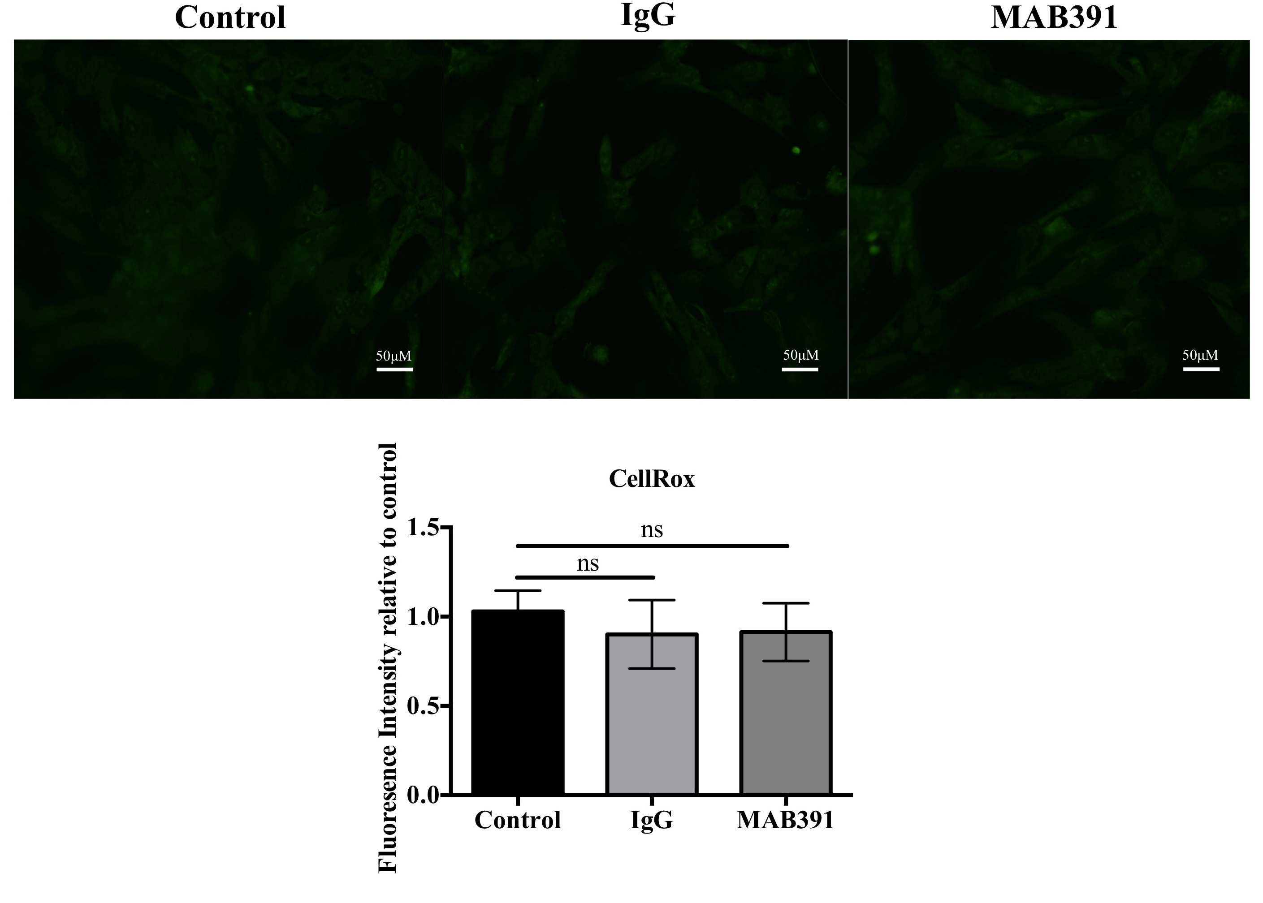

Figure 3.11. Assessing ROS levels in MAB391-treated astrocytes.
MAB391/IgG-treated ScienCell (1) astrocytes were incubated with CellRox® to determine the presence of ROS (representative images shown). Scale bar represents 50μM. Bar chart shows quantification of fluorescence determined using ImageJ. Data represents mean ± SEM (n=3, at least 3 replicates/experiment, one way ANOVA with post-hoc analysis).

3.4.7 IGF1R is present in many cell types, including astrocytes, in adult brain tissue

Immunohistochemistry was performed to demonstrate expression of IGF1R in the human brain and determine whether IGF1R was specifically present in astrocytes. IGF1R staining was carried out on three control and three AD cases (see section 2.1.15, table 2.7 for details of cases used) to assess if there were any apparent differences in IGF1R expression. Dual labelling was subsequently performed to see whether IGF1R staining colocalised with GFAP-expressing astrocytes.
Representative images in figure 3.12 are from the temporal cortex and dentate gyrus of control and AD cases. These regions were chosen as they represent different stages of AD progression. Glial and neuronal nuclear staining was observed in both the temporal cortex and dentate gyrus, with little differences observed between control and AD cases. IGF1R staining was also observed in blood vessels, in glial processes and processes surrounding plaque deposits. Dual labelling also identified colocalisation of IGF1R in the soma of GFAP-labelled astrocytes (figure 3.13).

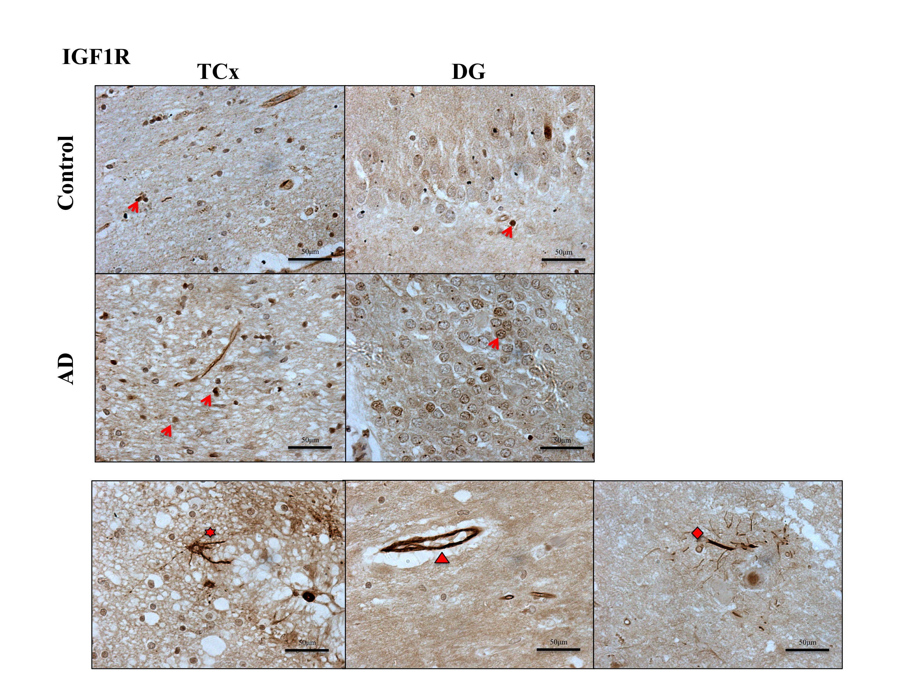
Figure 3.12. IGF1R expression in the dentate gyrus (DG) and temporal cortex (TCx) of human control and AD cases.
Upper images show IGF1R staining in the temporal cortex and dentate gyrus of control and AD cases, indicated by red arrows. Lower panel shows representative images of IGF1R staining found in control and AD cases, with specific regions of interest indicated with a red arrow. From left to right: glia, vessel wall and processes surrounding plaques.

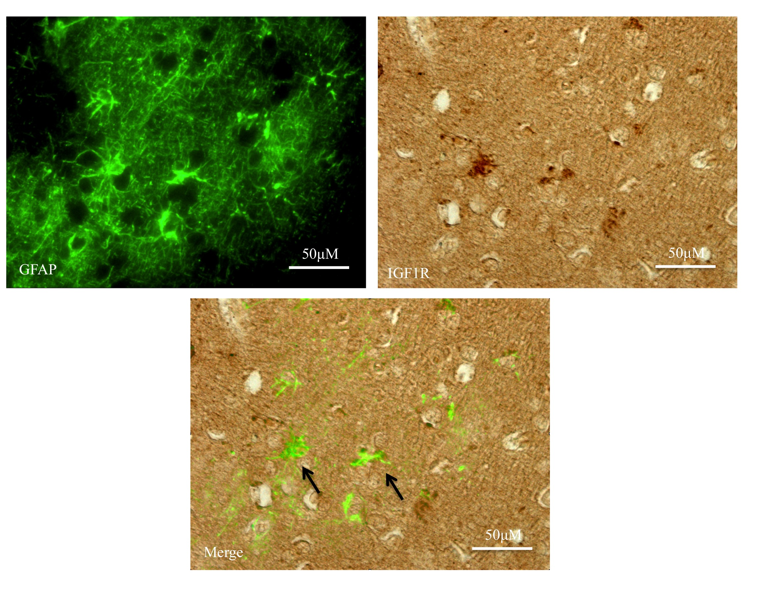
Figure 3.13. Co-localisation of IGF1R in GFAP expressing astrocytes.
Upper panel represents GFAP labelling and DAB staining of IGF1R. Lower panel identifies IGF1R localised to GFAP positive cells (indicated by black arrows).

3.5 Discussion

3.5.1 Human Astrocytes have an intact and functional IGF1 signalling pathway

Cultured human astrocytes have an intact and functional IGF1 signalling pathway. This was determined by culturing astrocytes in the presence and absence of serum, stimulating cells with a supraphysiological concentration of IGF1 (10nM) and performing western blots to determine total or phosphorylated forms of proteins involved in the IGF1 signalling pathway. Experiments were conducted with and without serum present to assess the effect of excess IGF1 in physiological conditions compared with conditions where serum derived growth factors and cytokines have been eliminated that may dilute out the effects of the stimulus. However, astrocytes in vivo are shielded from blood-derived factors by the BBB, so exposure to high concentrations of serum may also not be physiologically relevant. In support of this, it has been demonstrated that astrocytes cultured in the absence of serum have a gene expression profile similar to in vivo astrocytes than astrocytes cultured in the presence of serum (Foo et al. 2011). This study also showed that astrocytes subjected to temporary serum withdrawal continue to express genes switched on by originally culturing astrocytes in the presence of serum.

Expression of the receptors IR and IGF1R, adaptor proteins IRS1 and IRS2 and downstream signalling proteins Akt and P44/42 MAPK (ERK 1/2) were all detected in the ScienCell human astrocytes. The pre and mature forms of the IGF1R and IR were not altered by serum levels or following IGF1 stimulation. In response to IGF1 stimulation, there were noticeable shifts in the molecular weights of IRS1 and IRS2, which likely indicate the increased phosphorylation states of these proteins (although glycosylation and other post-translational modifications cannot be ruled out). Levels of phosphorylated Akt and P44/42 were also investigated to determine activation through divergent downstream signalling pathways. As full activation of Akt is achieved by phosphorylation at serine residue 473 (Alessi et al. 1996; Hemmings & Restuccia 2012), these levels were investigated in astrocytes following IGF1 stimulation. A significant increase in pAkt (s473) was observed (p<0.001) when astrocytes were initially serum starved and then treated with IGF1 ligand. Serum starvation is likely to induce growth arrest in the astrocytes and cause cells to enter the same phase of the cell cycle, so that upon addition of a huge growth stimulus, such as IGF1, the astrocytes have a synchronised and maximal response to addition of ligand. There were no significant differences in P44/42 phosphorylation following IGF1 stimulation, even in serum-deprived conditions. These results are consistent with experiments where ScienCell astrocytes have been stimulated with supraphysiological concentrations of insulin (Garwood et al. 2015). In addition, there was a trend towards astrocytes having elevated levels of phosphorylated P44/42 under conditions of serum deprivation. Taken together, this may suggest that astrocytes compensate for the lack of surrounding growth factors present in serum by upregulating basal activation of P44/42 and addition of IGF1 does not enhance this effect.

Talbot et al (2012) took an ex vivo approach to demonstrate insulin/IGF1 signalling in the brain and showed that in AD brain there is a drastically reduced response to insulin/IGF1. Also, IGF1R was shown to be preferentially associated with signalling through IRS2 and that it is specifically through IRS2 that there is reduced signalling upon stimulation with 1nM of IGF1 in AD brain. Talbot et al (2012) report a less striking preference of IGF1R for IRS2 when 10nm of IGF1 is used, but maintain the idea that signalling occurs more frequently through this route. In culture, human astrocytes potentially activate both IRS adaptor proteins in response to IGF1 stimulation, which may suggest redundancy of this signalling pathway in the astrocytes or that at the concentration of IGF1 used, both adaptor proteins are recruited for signalling. Also, the ex vivo approach provides a general assessment of IGF1 signalling pathway activation across many different cell types in the brain whereas this work investigates IGF1 signalling in astrocytes specifically.

3.5.2 Downregulation of the IGF1 signalling pathway in human astrocytes using a monoclonal antibody specific to IGF1R (MAB391)

Having shown that astrocytes have functional IGF1 signalling, a model of IGF1 signalling impairment was generated. Prior to this project a number of techniques were used to downregulate the levels and activity of IGF1R in human astrocytes, including pharmacological inhibition, shRNA and siRNA. The most successful method used to impair IGF1R levels involved treating the astrocytes with a monoclonal antibody specific to IGF1R (MAB391). This monoclonal antibody was used by Hailey et al (2002) to downregulate IGF1R levels in MCF7 cells (human mammary carcinoma cells). In these experiments, MCF7 cells were pre-treated with MAB391 for 1-1.5hours prior to the addition of excess IGF1 ligand. In this study they reported that MAB391 inhibits IGF1R phosphorylation by outcompeting IGF1 ligand and that MAB391 is responsible for the internalisation and lysosomal targeting of IGF1R (Hailey et al. 2002). It has also been shown that compared with dual IGF1R and IR inhibitors, use of MAB391 can reduce IGF1R to comparable levels in colorectal cells but has minimal effects on Erk and Akt activity (Buck et al., 2010).

In order to reduce IGF1R levels in human astrocytes and thereby impair IGF1 signalling, cells were treated for 24 hours with 11μg/ml of MAB391 (recommended EC50 value provided by R & D Systems). After a 24 hour treatment, there was roughly a 75% reduction in IGF1R with an associated 50% reduction in phosphorylated Akt (s473) but with no observable change in phosphorylated P44/42 MAPK levels. This experiment showed that MAB391 could be used to impair IGF1 signalling at both the receptor level and at the level of downstream signalling, which was an effect specific to using MAB391 and not an IgG isotype control (MAB002). Loss of IGF1R does not appear to affect signalling through P44/42 MAPK and instead its effects are mediated through Akt. This may suggest preferential signalling of IGF1R through Akt and that other RTKs maintain signalling through MAPK. Also after 24 hours of MAB391 treatment, astrocytes may have compensated for any lost MAPK signalling and restored activation of this pathway, hence why there are no observable changes in the levels of phosphorylated MAPK. Furthermore, this data may link back to the IGF1 stimulation experiments, suggesting that P44/42 phosphorylation is preserved when astrocytes are exposed to less growth factors (serum deprivation) and more specifically IGF1.

Using MAB391, we can model an acute loss of IGF1 signalling impairment and a more chronic loss of the IGF1R. These models allow identification of changes that occur in the astrocytes over a longer time period. Following a media exchange at 24 hours after MAB391 treatment and growth for a further 72 hours, the astrocytes showed continued loss of IGF1R by around 60%. However, by this time point the astrocytes have restored signalling through the Akt pathway, with a trend towards an increase in Akt activity. In addition, insulin receptor levels were significantly reduced. Sandwich-ELISA’s performed by R and D systems do not state off-target binding of IR by MAB391, therefore it is likely that IR levels are reduced as a result of the antibody binding to heterodimers of IGF1R and IR (Bailyes et al. 1997; Soos et al. 1990). Formation of IGF1R and IR heterodimers have not been reported in human astrocytes but since both receptors are expressed in these cells this is likely to occur. Taken together, this shows that IGF1R levels can be reduced for up to 96 hours after the initial MAB391 treatment. At the same time, insulin receptor levels were also reduced but astrocytes compensate for these losses and restored downstream signalling through Akt. Astrocytes may upregulate the expression of other RTKs or intracellular kinases to drive elevated Akt activity and restore signalling through this pathway. Previously, use of MAB391 in colorectal cells showed that loss of IGF1R results in a compensatory increase in insulin receptor activation (Buck et al., 2010), indicating cross-talk between these pathways. Therefore, despite lower levels of IR being observed at 96 hours after MAB391 treatment, there may be increased activation of this receptor to restore downstream signalling. To further investigate this, an antibody detecting phosphorylated IR would need to be used.

Compensatory signalling mechanisms displayed by human astrocytes have also been identified in many cancer cell lines in response to RTK treatment. RTK inhibitors and antibodies have been designed by pharmaceutical companies to target certain cancers where there is RTK overexpression or activity in order to inhibit cell proliferation. However, the effectiveness of these RTK inhibitors is short-lived as the cancer cells can compensate for reduced activation of a single receptor and empower another RTK or intracellular kinase to restore downstream signalling (Sun & Bernards 2014). For example, resistance to EGFR or HER2 TKI’s is overcome in cancer cells by increasing levels or activity of MET and IGF1R (Engelman et al. 2007; Bean et al. 2007). Similarly, loss of IGF1R in astrocytes may result in increased expression of RTKs such as EGFR to compensate for reduced downstream signalling.

3.5.3 Different downstream signalling responses through Akt as a result of IGF1R loss in a panel of human astrocytes

The use of MAB391 as a tool to impair IGF1 signalling was tested in two other astrocyte cell populations. These experiments were conducted to examine if the changes in IGF1R and phosphorylated Akt in other astrocytes paralleled observations in the ScienCell (1) astrocytes. In astrocytes derived from adult temporal lobe resections, loss of IGF1R was also induced following treatment with MAB391 for 24 hours. However, despite there being a reduction in IGF1R there was no change in the level of phosphorylated Akt (s473). This highlights the differences in response to reduced IGF1R at the level of downstream signalling. Although, as these astrocytes are derived from epileptic adult temporal lobes it is not known whether the differences are based on age, disease or area from which the astrocytes were isolated. The loss of IGF1R model was also successfully generated in another batch of foetal astrocytes from ScienCell. The limitations of using these cells are several fold: the company does not disclose the specifics of where the astrocytes are derived from i.e the specific area of the cerebral cortex or whether they are taken from a different foetus, and these cells have a limited number of passages before they can no longer be used. For these reasons, the MAB391 treatments were repeated on a new batch of these cells to define changes in IGF1R and phosphorylated Akt (s473) at 24 hours and 72 hours PME. Loss of IGF1R was replicable at both time points however unlike the first batch of ScienCell astrocytes (ScienCell (1)) there was no change in Akt phosphorylation. It was also found that these astrocytes had reduced Akt signalling after a 4 hour treatment with MAB391, which suggests an earlier compensatory mechanism in these cells (data not shown).

Therefore, the model of IGF1R loss is replicable in three astrocyte populations but they differ in their responses to this loss at the level of downstream signalling through Akt. Interestingly though, all three astrocyte populations display a trend to or significant recovery in phosphorylated Akt following IGF1R loss. This may indicate that the astrocytes are actively trying to restore signalling and negate the loss of IGF1R. It may also be that loss of IGF1R forces the cells to overcompensate through the Akt signalling axis, which some papers demonstrate is not necessarily beneficial. For example, a chronic increase in activated Akt can lead to feedback inhibition of IRS/ PI3K in cardiomyocytes (Nagoshi et al, 2005) and thus inevitably impair this pathway further. Based on this, it would be interesting to assess the effect of the MAB391 at time points beyond 96 hours to investigate whether Akt signalling is impaired at these later time points.

The differences in the downstream signalling response to loss of IGF1R, highlights the heterogeneity of astrocytes. Astrocytes are still crudely classified into two types: protoplasmic or fibrous depending on their complexity and origin. However, studies have highlighted the pleomorphism of these cells and that they are structurally, functionally and genetically distinct in different brain regions (Oberheim et al. 2012; Yeh et al. 2009). These region-specific differences give rise to changes in the morphology, density and proliferation of astrocytes, in the level of response to various neurotransmitter, the ability to secrete certain gliotransmitter and mechanisms of calcium wave propagation to nearby astrocytes (Emsley & Macklis, 2006; Regan et al., 2007). Thus, the differences in the signalling pathways observed between the astrocytes following MAB391 treatment may reflect the different dependencies of these cells on the IGF1 pathway. For example, there may be more resilience to Akt signalling impairment after a 24 hour MAB391 treatment in a particular astrocytic population, so that associated neurons reliant on this pathway being functional are not detrimentally affected. These differences in signalling behaviour have been identified in mouse cortical and midbrain astrocytes. Loss of EGFR in mouse cortical astrocytes has been found to induce apoptosis by a caspase and Akt dependent mechanism, which is not observed in astrocytes from the midbrain (Wagner et al. 2006). In addition, neuronal survival is impaired in the presence of EGFR depleted cortical astrocytes compared with the midbrain astrocytes. In this case, neurons in association with the midbrain astrocytes may be more dependent on sustained astrocytic EGFR signalling and there may be coping mechanisms within the astrocytes that allow continued support to surrounding neurons. These findings could explain why EGFR^{-/-} mice experience neurodegeneration only in the cortex and olfactory bulbs (Sibilia et al. 1998). In addition, Emsley and Macklis (2006) showed that proliferation of astrocytes varies in different subregions of the brain in different neuronally defined regions. Rates of proliferation between human hypothalamic and cortical astrocytes also differ, which is based on the different expression profiles of ErbB receptors (Sharif et al. 2009). Therefore, as early work suggests IGF1 contributes to astrocyte proliferation (Chernausek 1993) and as regional differences have been observed in EGF signalling in astrocytes, it could be hypothesised that human astrocytes vary in their response to IGF1 in different regions of the brain.

3.5.4 Impaired IGF1 signalling does not produce an observable phenotype in human astrocytes in monoculture

Having developed a model of IGF1 signalling impairment, changes to astrocyte function were explored. In monoculture, loss of IGF1R did not result in any profound changes in astrocyte phenotype. The functional assays were only carried out in the ScienCell (1) astrocytes due to these cells displaying early changes in phosphorylated Akt (s473). Astrocytes treated with MAB391 did not exhibit changes in GFAP or γH2AX. These markers were investigated as both increase with age and AD progression (J. E. Simpson et al. 2010; J E Simpson, Ince, Lace, et al. 2010). In addition, GFAP is used as a marker of astrocyte reactivity and differentiation, whilst γH2AX is a marker of DNA damage and another way of assessing cell injury.

Glycogen content was also investigated based on reports of insulin inducing increased glycogen content in astrocytes (Ralf Dringen & Hamprecht 1992; Kum et al. 1992), but as initial observations did not demonstrate striking effects following MAB391 treatment this was not pursued further. There were also no obvious changes in cell morphology or growth, which suggests that astrocytes do not become activated following MAB391 treatment and this was further confirmed by observing no differences in the levels of GFAP. Two assays were used to assess cell viability; this included a Cyquant and an MTT assay. The Cyquant assay provides a measure of cell number based on DNA content, whereas the MTT assay measures NAD(P)H oxidoreductase activity and therefore also assesses mitochondrial function. No differences were detected in the DNA content between IGF1R impaired and control astrocytes, suggesting that growth of the astrocytes was not inhibited. However, there was a significant decrease in cell viability between control and MAB391-treated astrocytes, as measured by the MTT assay. There was also a decrease in the cell viability of MAB391-treated astrocytes compared with IgG-treated astrocytes, however this was not significant. Thus this assay may hint at mitochondrial defects in the astrocytes as a result of antibody treatment and this effect may be further exaggerated by loss of IGF1R, but this would need to be confirmed by using more specific approaches that assess changes in mitochondrial function (Brand & Nicholls 2011).

Overall, there did not appear to be any obvious differences in the astrocytes as a result of impairing the IGF1 signalling pathway. These results may not be surprising since signalling through Akt was moderately impaired by loss of IGF1R after 24 hours and by 72hr PME astrocytes had compensated for loss of IGF1R and restored downstream signalling through Akt. Also, IGF1 signalling was preserved through P44/42, which may be a compensatory feature of human astrocytes to withstand changes in growth factor signalling. It would be interesting to explore whether a 24 hour treatment with MAB391 in conjunction with inhibition of the P44/42 pathway would result in a more distinct change in astrocyte phenotype.

Recently, hippocampal astrocytes of 90 day old (mature) and 180 day old (aged) Wistar rats have been grown in culture and assessed for age and disease associated changes. Some of the assays used to identify these changes were also assessed in the IGF1R impaired astrocytes, which suggests that they were appropriate measures to take. MAB391 treatment does not result in a significant change in ROS and GFAP levels yet in aged rat astrocytes GFAP levels significantly decreased, whilst ROS levels significantly increased (Bellaver et al. 2016). There are likely to be many contributing factors that cause age-associated changes in the Wistar rat astrocytes that are not replicated simply by loss of IGF1R. NRF2, GSH, glutamate receptor and inflammatory levels were also altered in the aged rat astrocytes, which were not explored in the MAB391-treated astrocytes. Changes in these different features cannot be ruled out in the IGF1R impaired astrocytes, especially as NRF2 and GSH are modulated by Akt activity. Therefore, there may be underlying defects in the IGF1R impaired astrocytes but the assays used have not uncovered any IGF1-related changes.

3.5.5 Expression of IGF1R in human tissue

IGF1R staining of human tissue was performed to primarily assess where this protein was localised to in the brain and more importantly if it could be detected in astrocytes. IGF1R expression was detected in GFAP positive astrocytes. It was also present in blood vessels and in the nucleus of glia and neurons. The strong immunoreactivity in blood vessels indicates an ability to respond to IGF1 in endothelial cells. Consistent with previous reports, IGF1R was also found in processes surrounding plaques (Moloney et al., 2010), although dual labelling with an antibody that detects Aβ would need to be performed to confirm this. However this observation may support the findings of Moloney and colleagues and provide further evidence that dysregulation of IGF1 signalling is apparent in astrocytes in association with AD pathology. IGF1R staining was not quantified since there was considerable background staining.

3.6 Summary

IGF1R was present in human astrocytes in vitro and in post-mortem tissue. IGF1 signalling was impaired by treating human astrocytes with a monoclonal antibody that specifically targets IGF1R (MAB391). This caused persistent loss of IGF1R (up to 96 hours) at the protein level but no changes in the expression of IGF1R at the gene level. Loss of IGF1R impaired signalling through Akt differently across a panel of different human astrocytes suggesting varying susceptibilities to IGF1R loss at the level of Akt in these cells. No obvious changes were detected in the morphology, viability, stress or ROS production as a result of IGF1 signalling pathway impairment.

3.7 Main Conclusions

- IGF1 signalling was present and functional in primary human astrocytes
- MAB391 treatment was used to create a model of both acute and chronic IGF1R loss in a range of different astrocytes
- Loss of IGF1R in astrocytes was associated with reduction in Akt signalling, although there was compensation by unknown mechanisms to restore downstream signalling through this pathway.
- Human astrocytes responded differently at the level of downstream signalling through Akt following loss of IGF1R.
- Loss of IGF1R was not attributed to reduced viability but could indicate changes in mitochondrial function.
- No observable changes in cell stress or morphology were detected following IGF1R loss in the ScienCell (1) astrocytes as measured by levels of GFAP, γH2AX and ROS.
- IGF1 signalling proteins have been identified in human brain tissue, with IGF1R expression demonstated in human astrocytes.

Chapter 4

Establishing a novel human astrocyte-neuron co-culture system and investigating whether impaired IGF1 signalling affects astrocytic support for neurons

4.1 Introduction

There is growing evidence that astrocytes become functionally mature when cultured with neurons. This has been demonstrated by various groups who report significant upregulation of a number of genes typically associated with mature astrocytes when astrocytes are co-cultured with neurons. In monoculture, astrocytes have been shown to express minimal levels of the glutamate transporter GLT1 (EAAT2) and higher levels of EAAT1 (Duan et al, 1990). When rodent astrocytes are co-cultured with neurons there is significant upregulation of GLT1 (Swanson et al. 1997; Yang et al. 2009) and gap junction proteins connexin 43/30 (Koulakoff et al. 2008; Rouach et al. 2000). In addition, transcriptome analysis of mono-cultured astrocytes is similar to the gene expression profile of immature astrocytes in vivo (Cahoy et al. 2008). Separation of astrocytes from astrocyte-neuron co-cultures also revealed different transcriptomic profiles compared with astrocytes cultured alone (Goudriaan et al. 2014). Taken together, this suggests a strong neuron-dependent induction of astroglial genes in cultured astrocytes, possibly through contacts made with neuronal receptors or neurotransmitters that induce a signalling response in the astrocyte. Therefore, functional changes in astrocytes following a disease or age-related alteration (such as impaired IGF1 signalling), may only become apparent when astrocytes are co-cultured with neurons since they are more functionally mature. Furthermore, neuronal survival critically depends on the astrocytes ability to maintain homeostasis, offer metabolic support and operate antioxidant defence mechanisms necessary to protect the neurons against insult. Thus, by establishing a human astrocyte-neuronal co-culture, the neurons can be used both as a tool to encourage astrocyte maturation and as a measure of astrocyte health.

To date, a significant amount of astrocyte neuronal co-culture work has been conducted using rodent cells, which has been important in understanding the fundamental relationship between these two cell types. However in order to investigate particular mechanisms and extrapolate these back into a human disease context it is necessary to conduct in vitro studies with human astrocytes and neurons. The current human astrocyte-neuron co-culture models that have been established use human stem cell derived co-cultures. One such stem cell line is NT2 (NTERA-2), which is a human germ cell carcinoma capable of being differentiated into NT2 neurons and astrocytes following prolonged retinoic acid treatment. This co-culture has been extensively characterised and there is evidence that shows communication between astrocytes and neurons in a potentially tripartite manner (Hill et al. 2012) making it a functional co-culture system to study molecular mechanisms of neurodegeneration.

The model of IGF1R impairment established and characterised in chapter 3, uses ScienCell human astrocytes. At present, there are no reports of these cells being co-cultured with human neurons. The co-culture model established in this chapter offers a novel system with which to study these astrocytes in a more physiologically relevant context, where the astrocytes are likely to display a broader spectrum of functions.
The neurons chosen for the development of a co-culture system are Lund Human Mesencephalic precursor cells (LUHMES) derived from a human female fetus that have been conditionally immortalised by v-myc under the control of tetracycline (tet-off system). These cells can be differentiated over a five-day period into fully post-mitotic, electrically active neurons (fully characterised by Krug et al., 2014; Schildknecht et al., 2013; Scholz et al., 2011). Although more widely used in the Parkinson’s field, they have been used for AD related research due to expression of Aβ and recent evidence that the midbrain is implicated in AD progression (Scholz et al. 2013).

In chapter 3, a model of impaired astrocytic IGF1 signalling was described, although there was no obvious change in cell phenotype. By developing a co-culture system, the focus is shifted from assessing specific pathways or targets that may be altered in the astrocyte to measuring changes in neurons, which will be critically dependent on proper astrocyte functioning. One typical measure of astrocyte support is in the ability of neurons to extend axons and dendrites (collectively known as neurites), which is necessary for establishing synaptic contact. Neurite length can be measured and used as an indication of the extent of astrocytic support and thus provide information on whether there are any functional changes in the astrocytes.

There are reports that IGF1 enhances neurite outgrowth in a PI3K/Akt dependent manner (Laurino et al. 2005). Expression of IGF1R has been identified in neuronal growth cones and following reduction of IGF1R by siRNA there is a reported reduction in neurite outgrowth (Sosa et al. 2006). This may mirror reports of IGF1R knockout mice having a marked decrease in axon density and severe defects in CNS development (Liu et al. 1993). It has also been suggested that the increase in axonal length following IGF1 treatment is mediated by astrocytes (Ang et al. 1992). Therefore it is plausible that a loss of IGF1R from astrocytes limits the IGF1 mediated effect of astrocytes to support neuronal outgrowth. Additionally, loss of IGF1 signalling may influence astrocyte to neuron communication or interfere with contacts made between the cells that in turn influence neuronal outgrowth. To investigate this, a neurite outgrowth assay was developed to assess whether loss of a functional IGF1 signalling pathway in astrocytes was detrimental to neurite outgrowth.

The neurite outgrowth assays were developed using a stable GFP expressing neuronal cell line (GFP LUHMES). They have provided extensive information on the co-culture model and the effect of co-culturing IGF1 signalling impaired astrocytes with neurons. Furthermore, this chapter explores whether astrocytes with impaired IGF1 signalling can protect neurons against oxidative stress since loss of functional IGF1 signalling in rodent astrocytes results in neurons being more susceptible to oxidative damage due to the increases in astrocytic levels of the proxidant TXNIP1 (Genis et al, 2013). More recently it has been demonstrated that astrocytes are able to exert protection against H₂O₂ through functional IGF1 signalling operating in an Akt dependent manner (Dávila et al., 2016).

4.2 Aims and Objectives

- To establish and characterise a human astrocyte-neuron co-culture model.
- To generate stably expressing GFP neurons in order to develop a neurite outgrowth assay to assess astrocytic support for neurons.
- Investigate how impairments in the IGF1 signalling pathway affect astrocytic support for neurons under basal and oxidative stress conditions.

4.3 Methods

Detailed methods for this section can be found in chapter 2. In summary, human astrocytes (ScienCell (2)) were cultured with LUHMES to establish a unique human astrocyte-neuron co-culture model. Neurite outgrowth is supported by the presence of astrocytes. This feature was exploited for the design of a neurite outgrowth assay, which would be able to determine the ability of astrocytes to support this process under conditions of impaired IGF1 signalling. For this assay, stably expressing GFP LUHMES were generated using lentiviral transduction and used in the assay as outlined in section 2.2.1(h). In addition, the antioxidant capacity of the astrocytes was tested by incorporating H₂O₂ treatments (50μM for 2 hours) into the neurite outgrowth assay.

4.4 Results

4.4.1 Establishing a human astrocyte-neuronal co-culture system

Human ScienCell astrocytes were successfully co-cultured with LUHMES. The co-culture procedure was developed around the differentiation protocol of the LUHMES and is outlined in figure 2.1 (Scholz et al. 2011). Astrocytes were first plated on a 24 well plate and in parallel tetracycline was added to fresh media to initiate differentiation of the LUHMES. The LUHMES require a replating step 48 hours following differentiation, which ensures a homogeneous population of differentiating cells are replated for further experiments (Scholz et al. 2011). In this co-culture model, the LUHMES were replated on top of the confluent astrocyte monolayer (figure 4.1). The LUHMES are not considered fully differentiated until day 6, which is 72 hours following replating (Scholz et al. 2011).

ScienCell (2) astrocytes were co-cultured with LUHMES for 24 hours and stained with Beta-III-tubulin (β3-tubulin) and a range of astrocytic markers Cluster of differentiation 44 (CD44), GFAP, vimentin and aldehyde dehydrogenase 1 family member L1 (ALDH1L1)) to characterise expression of cell-specific markers in the co-culture system (figure 4.2). The astrocytes express astrocytic markers and LUHMES express the neuronal marker β3-tubulin after 24 hours in co-culture.

ScienCell (2) astrocytes were successfully co-cultured with LUHMES for 72 hours, stained with β3-tubulin and a range of astrocytic markers (Vimentin, GFAP and ALDH1L1) (figure 4.3).

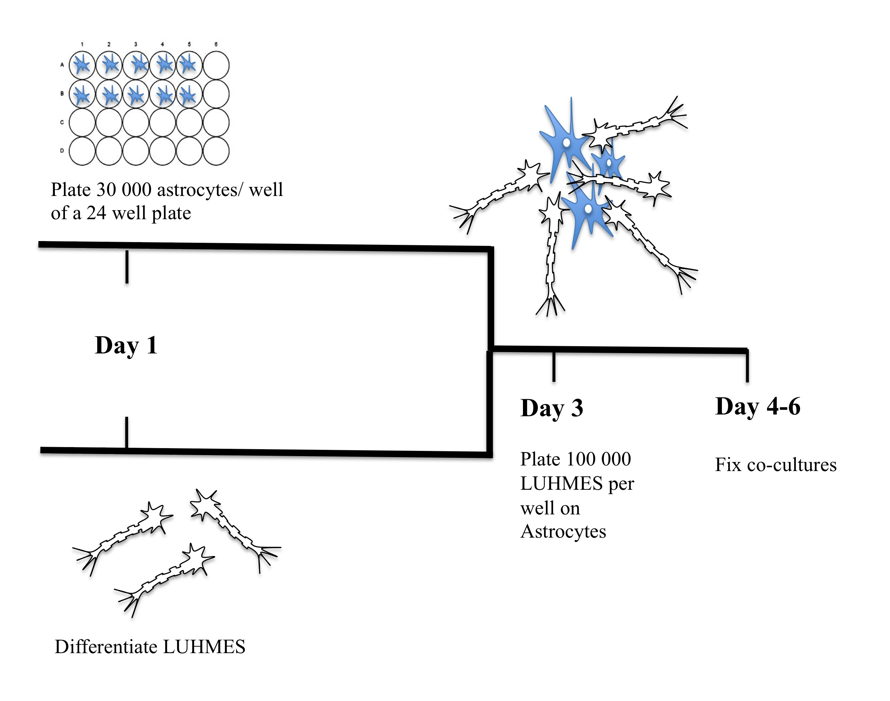

Figure 4.1. Astrocyte and LUHMES co-culture model.
Astrocytes were plated on day one and in parallel LUHMES cells were differentiated. On day 3, pre-differentiated LUHMES were replated on astrocytes, the cells were fixed 24-72 hours later and stained with a panel of neuronal and astrocytic markers.

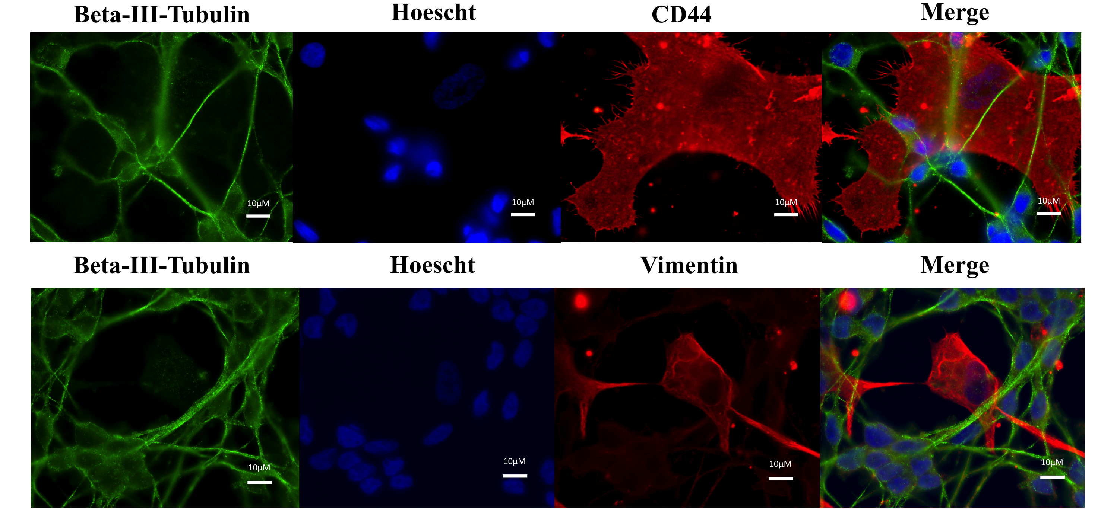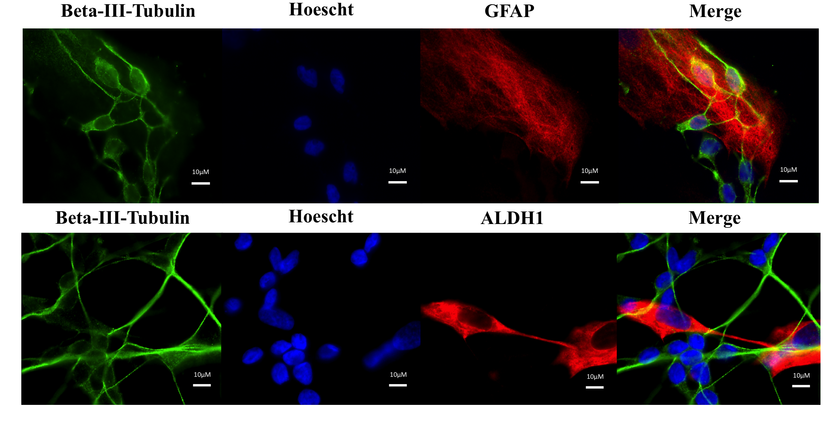 Figure 4.2. Establishing a human astrocyte-neuronal co-culture model (1).
Co-cultured astrocytes and neurons were fixed after 24 hours and stained with a panel of antibodies. Representative images are of LUHMES stained with β3-tubulin (green) and astrocytes stained with a range of astrocytic markers including CD44, GFAP, ALDH1L1 and vimentin (red). The nuclei of both cell types is stained with Hoescht (blue). Scale bar represents 10μM.

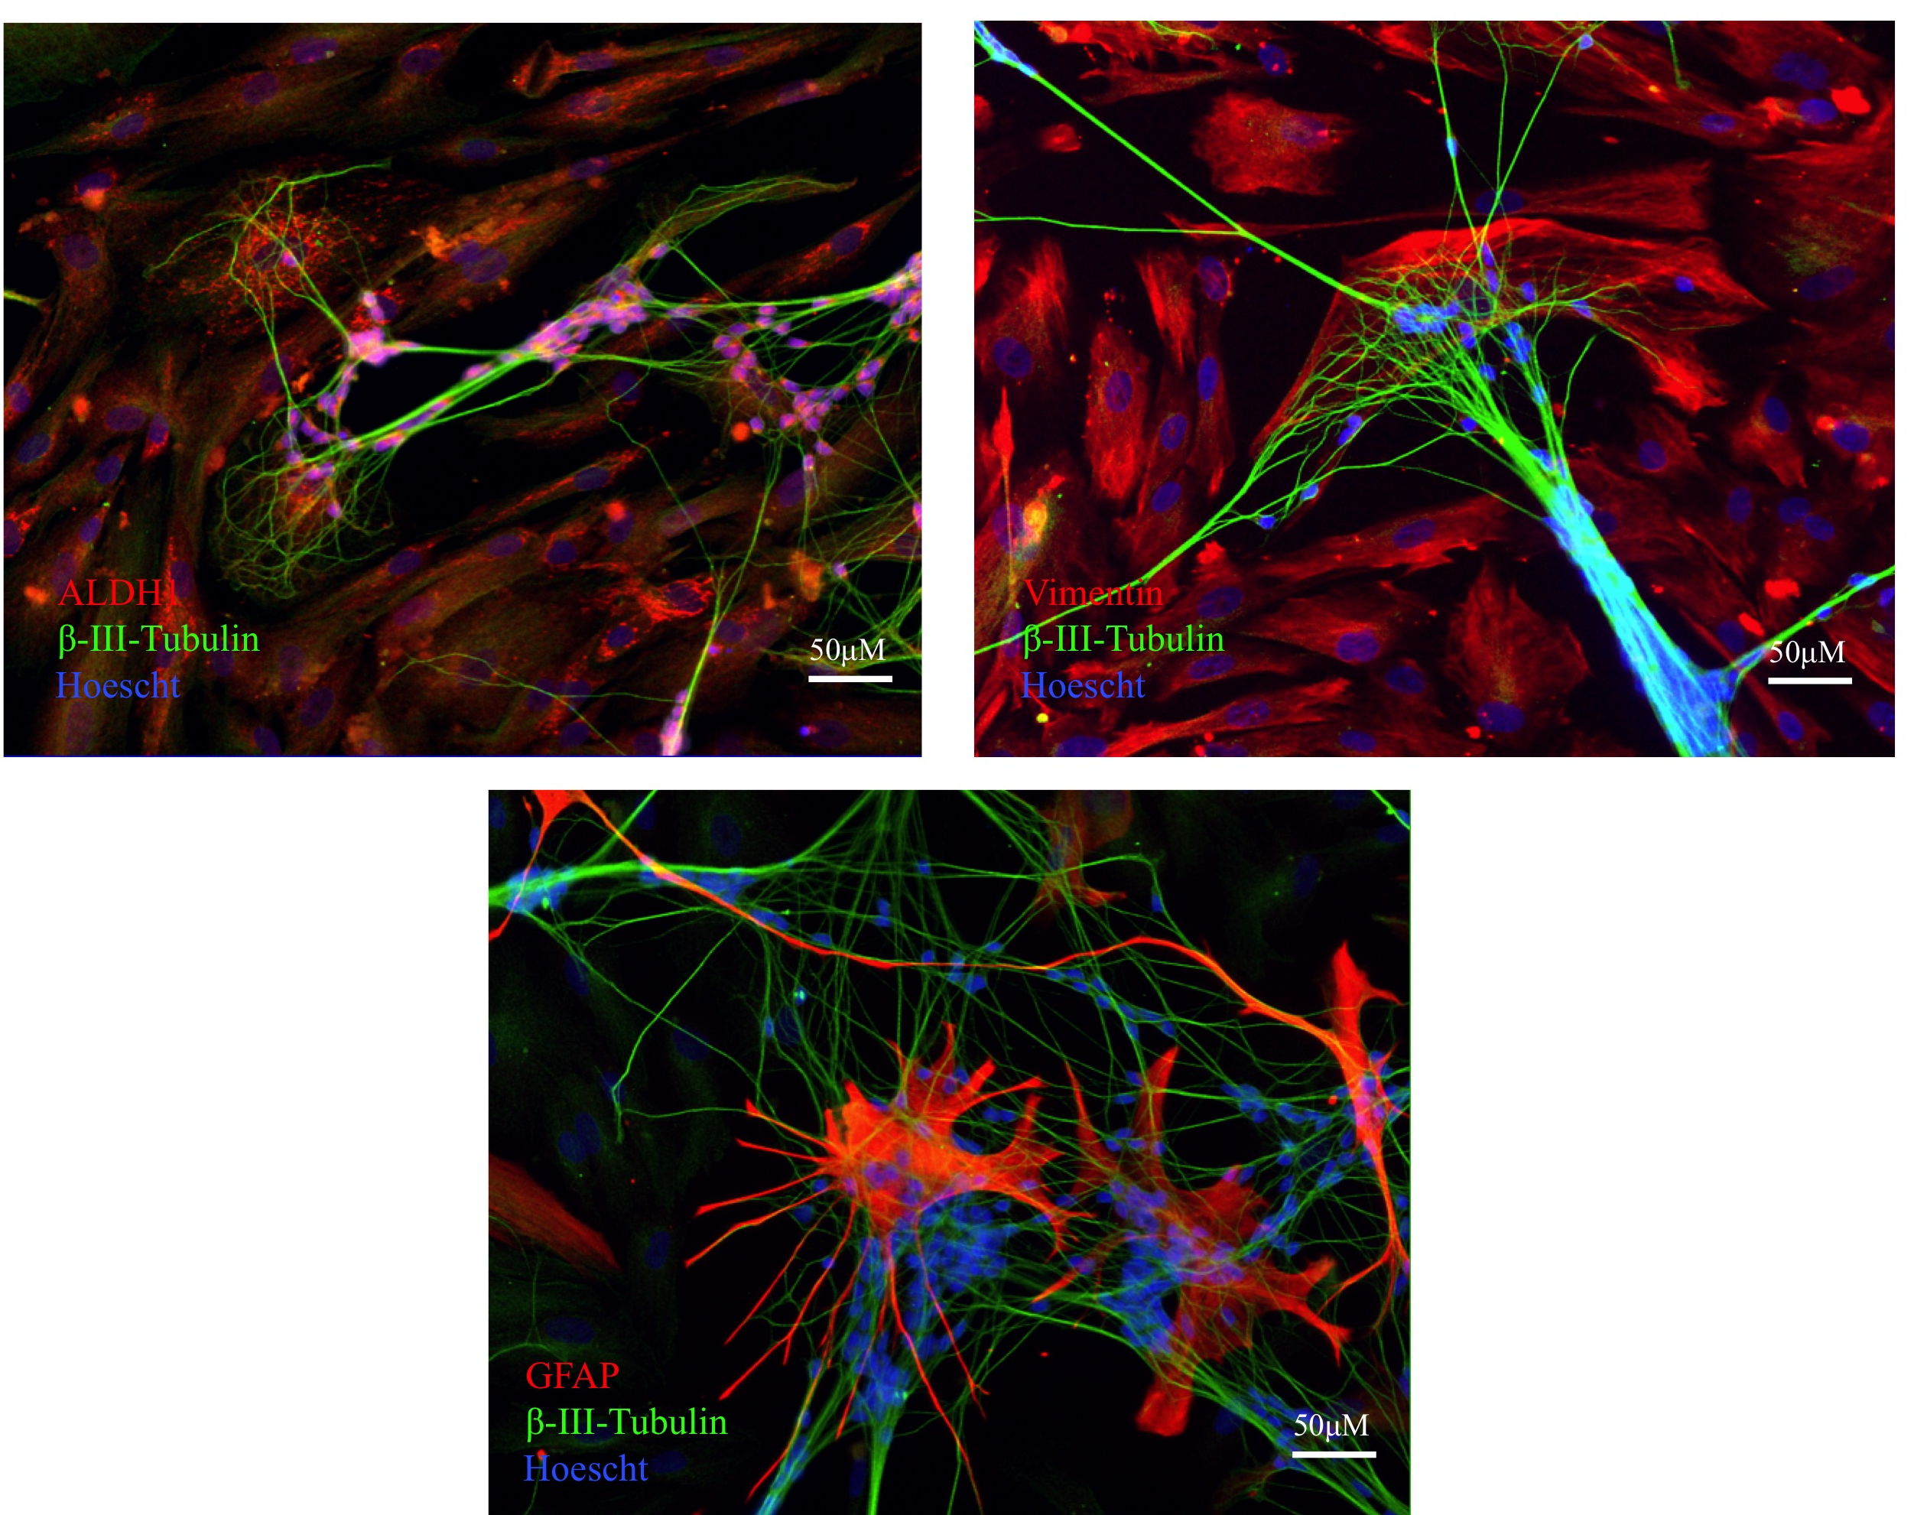

Figure 4.3. Establishing a human astrocyte-neuronal co-culture model (2).
Co-cultured astrocytes and neurons were fixed after 72 hours and stained with a panel of antibodies. Representative images are of LUHMES stained with β3-tubulin (green) and astrocytes stained with a range of astrocytic markers including GFAP, ALDH1L1 and vimentin (red). The nuclei of both cell types is stained with Hoescht (blue). Scale bar represents 50μM.

4.4.2 Trialling different coating conditions

Coating conditions for culturing LUHMES have been previously optimised (Scholz et al. 2011). Poly-l-ornithine and fibronectin in combination were used to coat plasticware to promote neuronal survival and growth. In the model defined in section 4.4.1, the astrocytes are first plated two days before predifferentiated LUHMES are added.

Astrocytes did not adhere well to coverslips pre-coated with poly-l-ornithine and fibronectin, however in spite of this the LUHMES were well dispersed in co-culture on the astrocytes. To improve adherence of astrocytes to coverslips, different coating conditions were trialled.

The astrocytes did not adhere well to poly-l-ornithine coated coverslips (figure 4.4) but coating with just fibronectin improved astrocyte adherence. It was important to have a healthy and confluent bed of astrocytes in order to investigate the support provided by astrocytes for neurons. If astrocytes are already stressed by the coating conditions prior to the addition of treatments, then the readout of the level of the support for the neuron is not strictly due to the selected treatments applied to the astrocytes. Therefore fibronectin alone was used in further experiments to coat coverslips. In these conditions, an evenly dispersed neuronal network was compromised in order to achieve a well-distributed and more confluent layer of astrocytes.

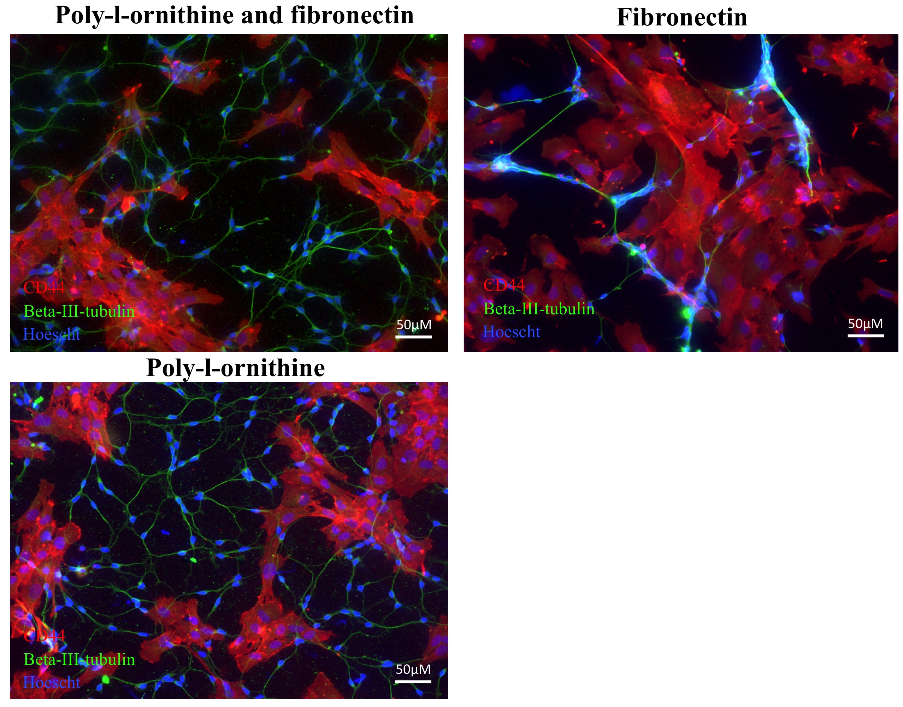

Figure 4.4. Different coating conditions affect how astrocyte-neuronal co-cultures form.
Images represent 24 hour co-cultures of human astrocytes and LUHMES on coverslips coated with a) poly-l-ornithine and fibronectin b) fibronectin alone c) poly-l-ornithine alone. The same number of astrocytes and LUHMES were plated in each condition, however less astrocytes adhered to coverslips coated with poly-l-ornithine alone or in combination with fibronectin. In contrast, the LUHMES require poly-l-ornithine to form well-dispersed networks. Scale bar represents 50μM.

4.4.3 Developing a model to measure neurite outgrowth in the astrocyte-neuronal co-culture

To develop a neurite outgrowth assay, the number of LUHMES plated on the astrocytes was carefully optimised. LUHMES have a tendency to bundle together when plated on astrocytes making neurite length very difficult to measure. Using the co-culture system established in section 4.4.1, a low density of LUHMES was optimised and plated on a confluent astrocyte monolayer. This co-culture system was used to assess whether the ScienCell astrocytes are able to support the outgrowth of the LUHMES in the final 72 hours of differentiation (figure 4.5).

A low density of 7500 LUHMES were plated on a confluent bed of 30 000 astrocytes per well of a twenty-four well plate. The co-cultures were fixed with 4% PFA and stained with β3-tubulin and GFAP every 24 hours over the 72 hour period until the LUHMES in monoculture are reported as being fully differentiated (Scholz et al. 2011). There was a clear increase in neurite outgrowth when the neurons were co-cultured with the astrocytes compared to when they were cultured alone. This effect was observed at all three time points and suggests astrocytic support was offered consistently during the 72 hours in co-culture. The LUHMES in monoculture appeared to have more branch points (figure 4.6) but there was an obvious elongation of neurites when co-cultured with astrocytes.

LUHMES were also stained with an antibody against Post synaptic NMDA receptor (PSD95) to assess formation of synapses in monoculture versus co-culture. Expression of PSD95 was observed by both western blotting and immunofluorescence and was present in the LUHMES in monoculture and co-culture. Unexpectedly, expression of PSD95 was also observed in the astrocytes, both in mono-culture and co-culture (figure 4.7).

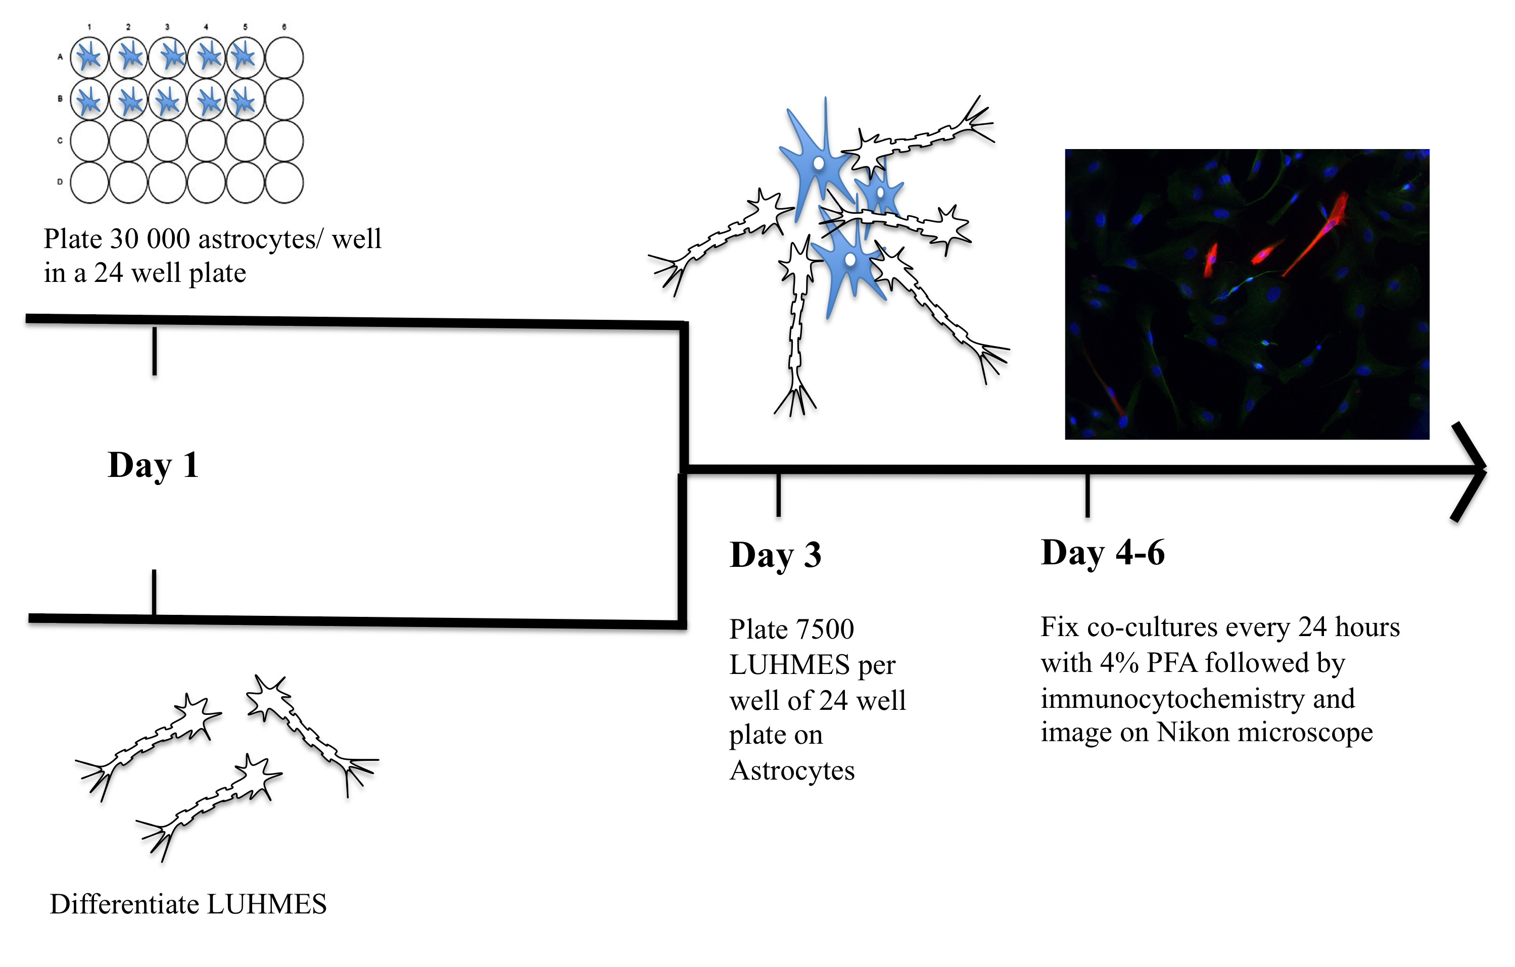
Figure 4.5. Image outline of the co-culture model to assess astrocytic support for neurite outgrowth.
On day 1 astrocytes were plated and in parallel, differentiation media was added to LUHMES. LUHMES were replated on astrocytes on day 3 and co-cultures were fixed every 24 hours over a 72 hour time course to assess changes in the neuronal development.
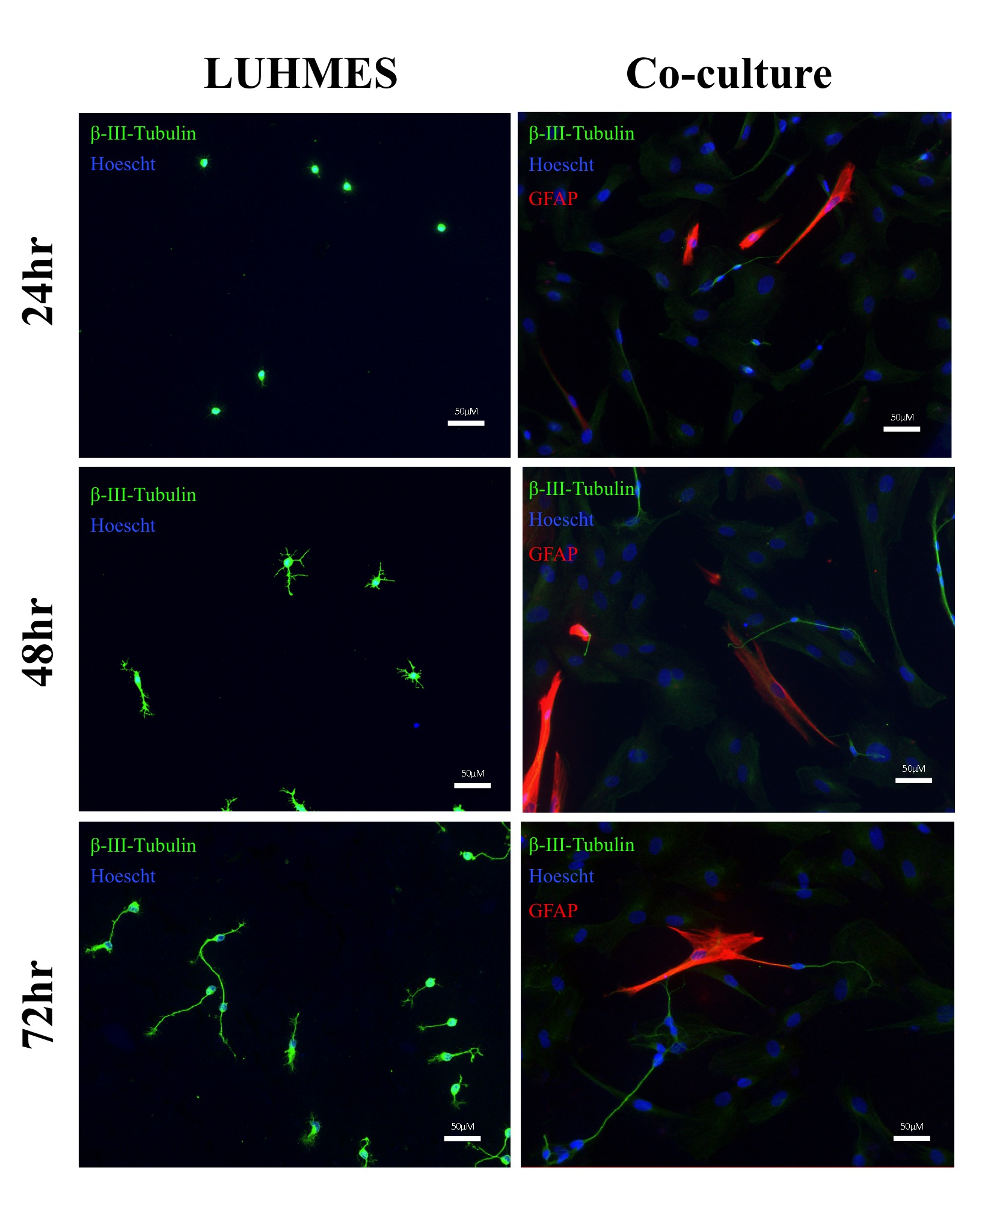
Figure 4.6. Developing a model to assess neurite outgrowth in a human astrocyte-neuron co-culture.
Immunocytochemistry of Beta-III-tubulin labelled LUHMES and GFAP labelled astrocytes during a 72-hour co-culture period (days 3-6). LUHMES show enhanced neurite outgrowth in monoculture, which is further enhanced in co-culture with astrocytes. In co-culture, GFAP labelled astrocytes appear to associate with Beta-III-tubulin labelled LUHMES. Scale bar represents 50μM.

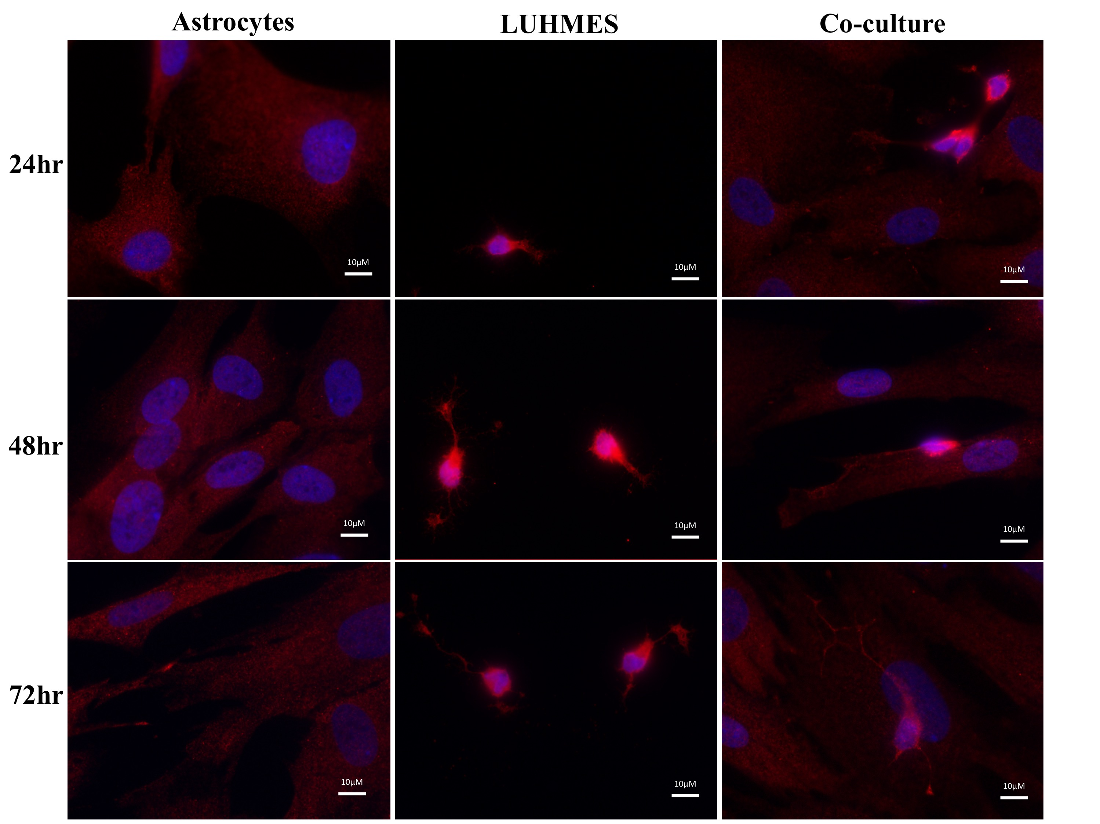
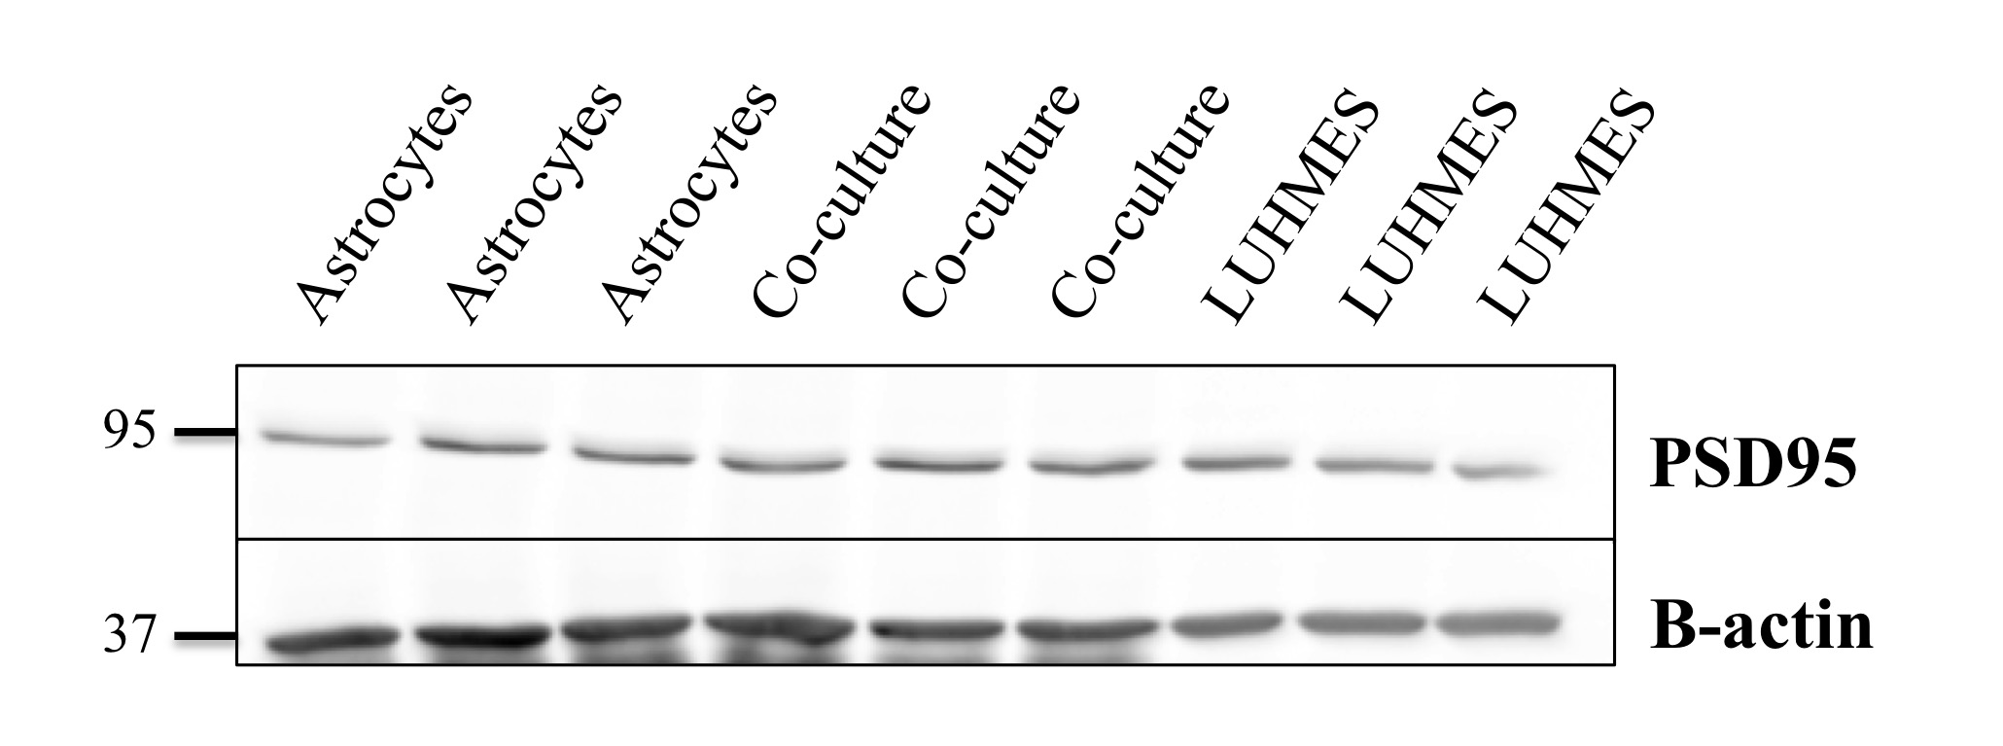
Figure 4.7. PSD95 expression in LUHMES, astrocytes and in the co-culture model.
(A) Immunocytochemistry of PSD95 labelled LUHMES in monoculture or in co-culture with astrocytes for 72 hours (days 3-6). LUHMES show expression of PSD95 alone or in the presence of the astrocytes. Astrocytes also express PSD95. Scale bar represents 10μM (B) Immunblotting of PSD95 in astrocytes, LUHMES and in co-culture on day 6. PSD-95 was present in all culturing conditions. β-actin was used as a loading control.

4.4.4 Generating stably expressing GFP LUHMES

In the last section, the number of LUHMES and astrocytes used in the neurite outgrowth assay was optimised. To increase the speed at which these assays could be performed and to overcome the issues with background staining of astrocytes associated with β3-tubulin, a stably expressing GFP LUHMES cell line was generated.

Lentivirus encoding GFP (LV-GFP) under the phosphoglycerate kinase (PGK) promoter was produced and HeLa cells and LUHMES were transduced with different concentrations of LV-GFP. Transduction efficiency was then calculated using FACS sorting. Three days following transduction with LV-GFP, GFP expression was observed in the LUHMES. Immunocytochemistry and western blots were used to confirm GFP expression in the LUHMES compared to non-transduced LUHMES.

HeLa and LUHMES cells were transduced with 1 in 100 dilution of LV-GFP and FACS sorted (figure 4.8). This dilution of lentivirus resulted in successful transduction of approximately 99% of LUHMES cells. The calculated multiplicity of infection (MOI) of the lentivirus was 8. Subsequently, early passage undifferentiated LUHMES (passage number <4) were transduced with the GFP lentivirus, split 72 hours later and maintained in culture for various assays. The expression of GFP in fully differentiated LUHMES was initially confirmed by western blotting and immunocytochemistry prior to further culturing and use in future assays (figures 4.9).

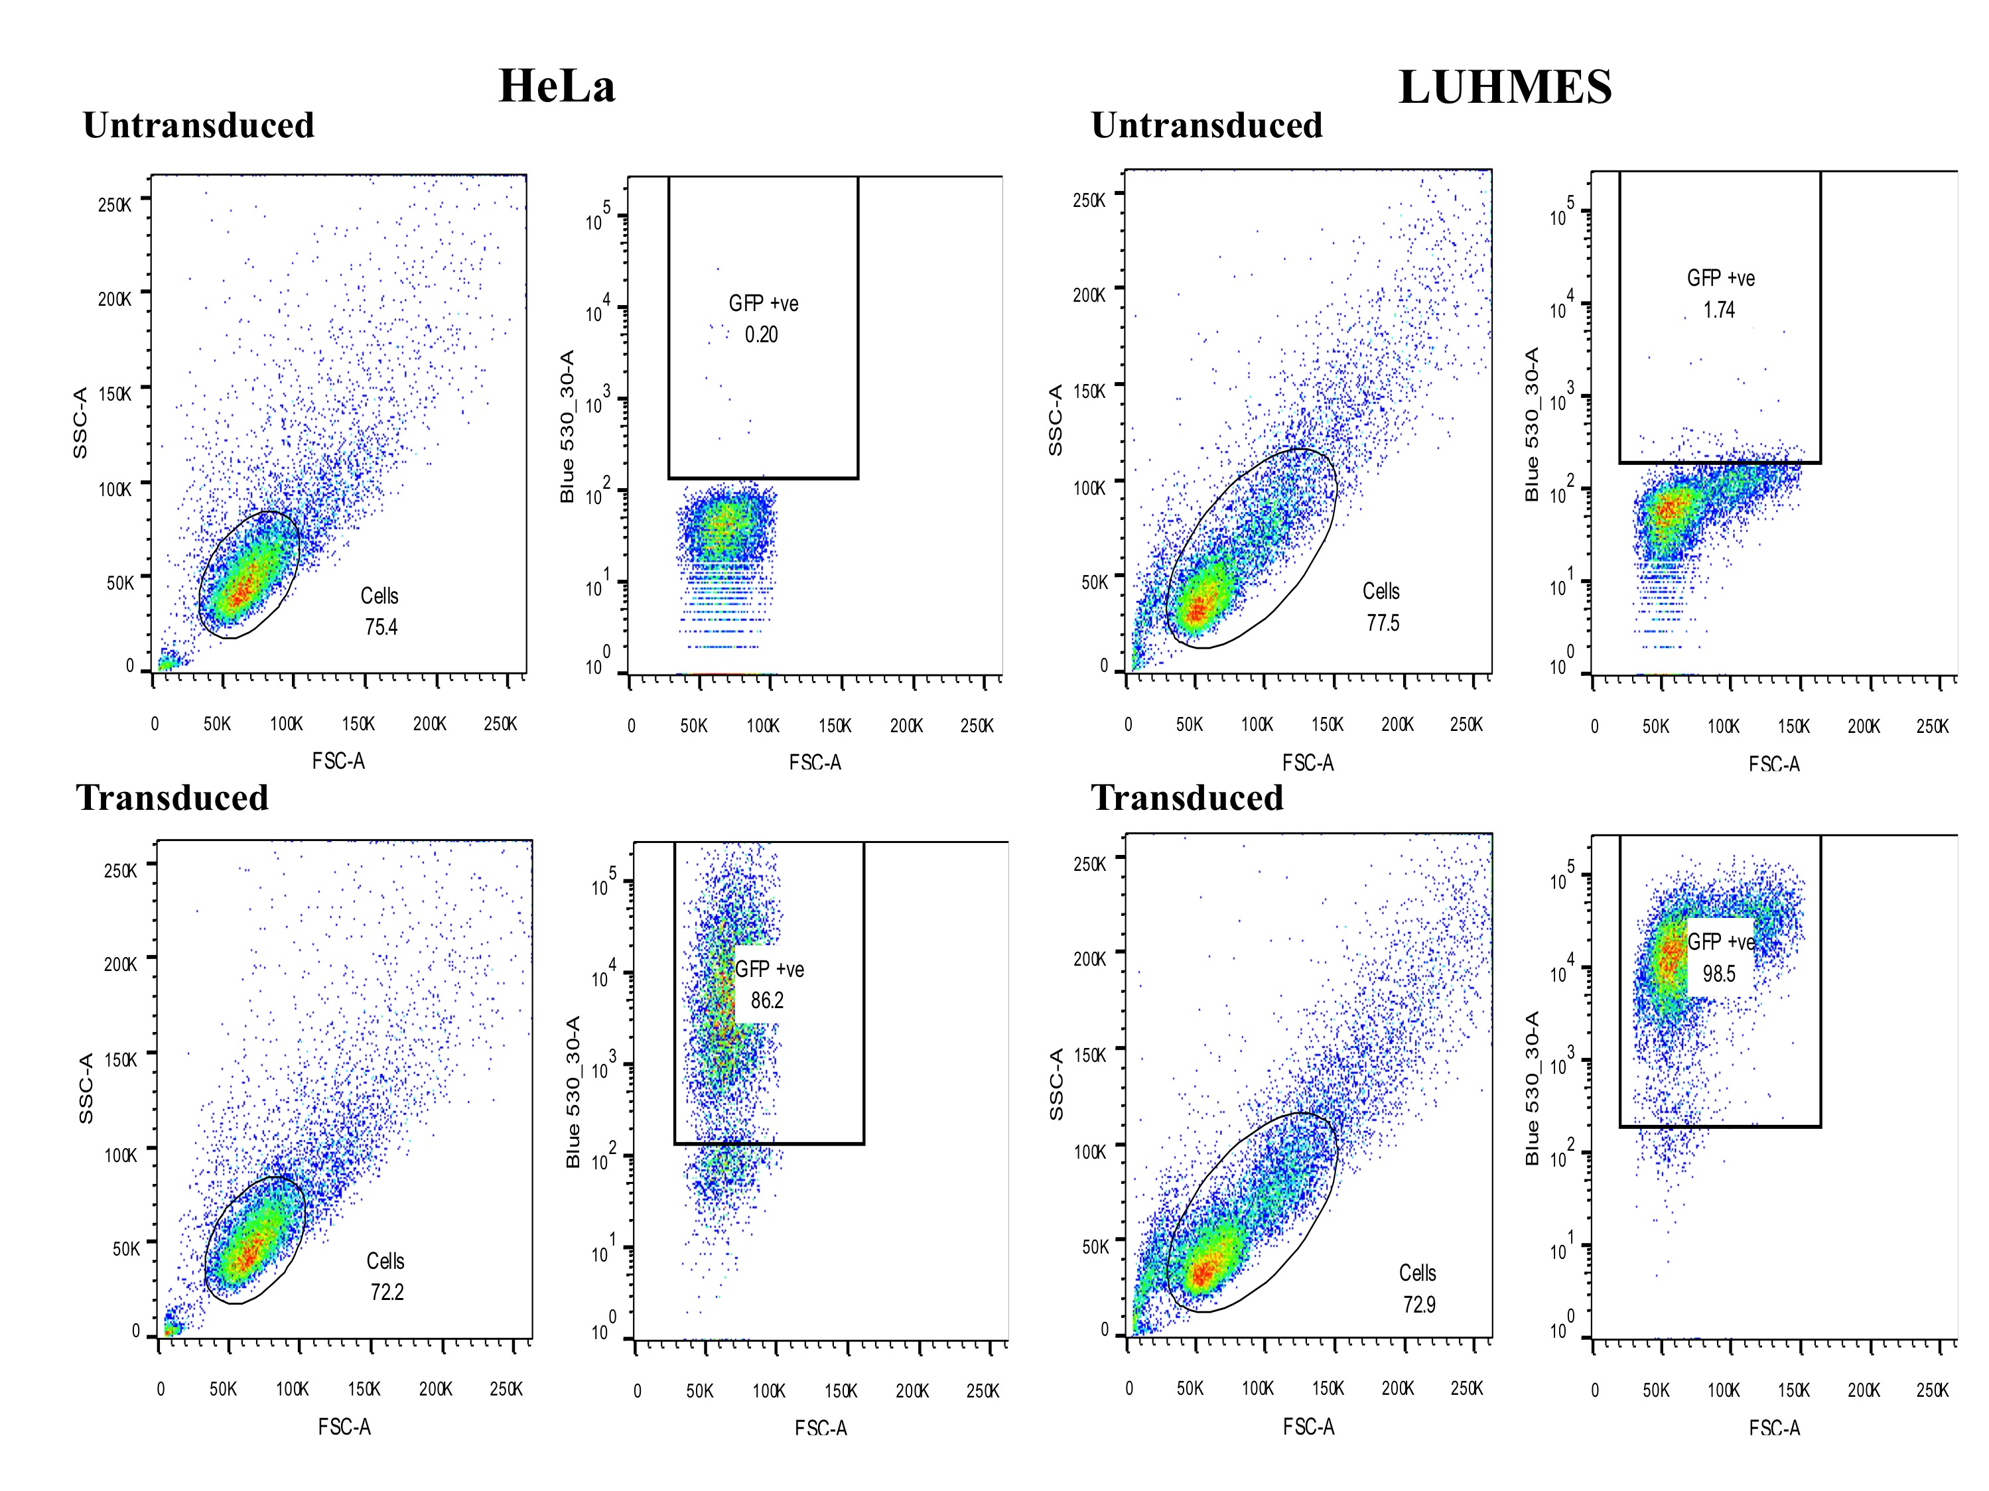
Figure 4.8. FACS sorting of untransfected and LV-GFP transfected HeLa and LUHMES cells to establish MOI of LV-GFP.
Graphs represent both the side scatter (SSC) versus forward scatter (FSC) profiles and distribution of fluorescence versus FSC profiles of HeLa and LUHMES cells following treatment with 1:100 of stock LV-GFP. 98.5% LUHMES and 86.2% HeLa cells were successfully transfected
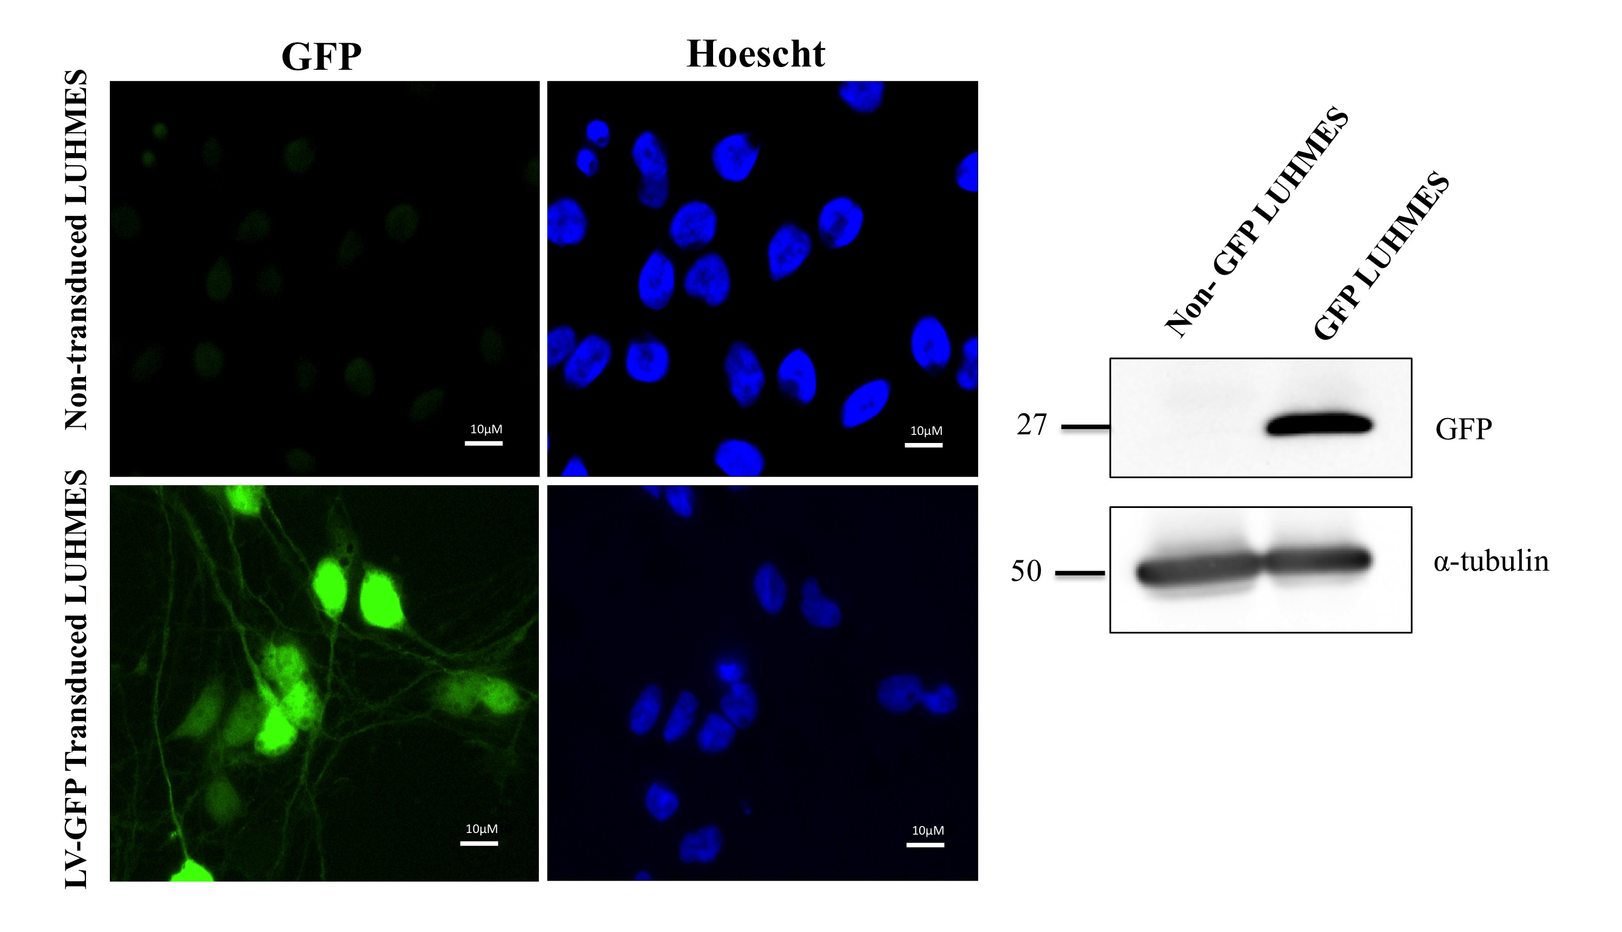
Figure 4.9. Confirming GFP expression in LUHMES following transduction with lentivirus.
Following a 24 hour transduction with GFP encoding lentivirus (LV-GFP) and a further 48 hours of growth, pre-differentiated LUHMES began to express GFP. Both non-transduced and LV-GFP transduced LUHMES were differentiated into post-mitotic neurons (day 6). Immunocytochemistry and western blotting confirm expression of GFP in LUHMES. Scale bar represents 10μM.

4.4.5 Assessing astrocyte maturity in the co-culture system

There is evidence to suggest astrocytes change when co-cultured with neurons or neuronal cell lines and are more representative of astrocytes observed in vivo. To test this hypothesis in the co-culture model, the expression and localisation of an astrocyte-specific marker known to change in co-culture was assessed. The astrocyte specific marker, connexin 43 (Cx43), has previously been shown to be elevated in rodent astrocytes co-cultured with neurons (Koulakoff et al. 2008). Cx43 is a gap junction protein that facilitates calcium signalling between astrocytes and allows transmission of chemical signals between astrocytes in response to neuronal electrical activity (Solan & Lampe 2009). Therefore, changes in the expression of Cx43 in astrocytes in co-culture may suggest altered communication between astrocytes in response to synaptic activity and potentially act as an indicator of changes in astrocyte function in the presence of neurons.

ScienCell astrocytes were stained with Cx43 when in monoculture and co-culture. In monoculture astrocytes expressed Cx43, as observed by both western blot and immunocytochemistry (figure 4.10). In co-culture astrocytes associated specifically with dense networks of neurons showed a distinct increase in the amount of Cx43, as demonstrated by immunocytochemistry. Western blots did not reflect this increase in total Cx43 and remained unchanged in astrocytes in co-culture. However, there was a significant decrease in the upper two bands of Cx43 levels, which might represent different phosphorylated forms of Cx43 (figure 4.10C p< 0.001). Taken together this may indicate a relocalisation and/or change in activity of Cx43 in astrocytes more initimately associated with neuronal bundles.

A.
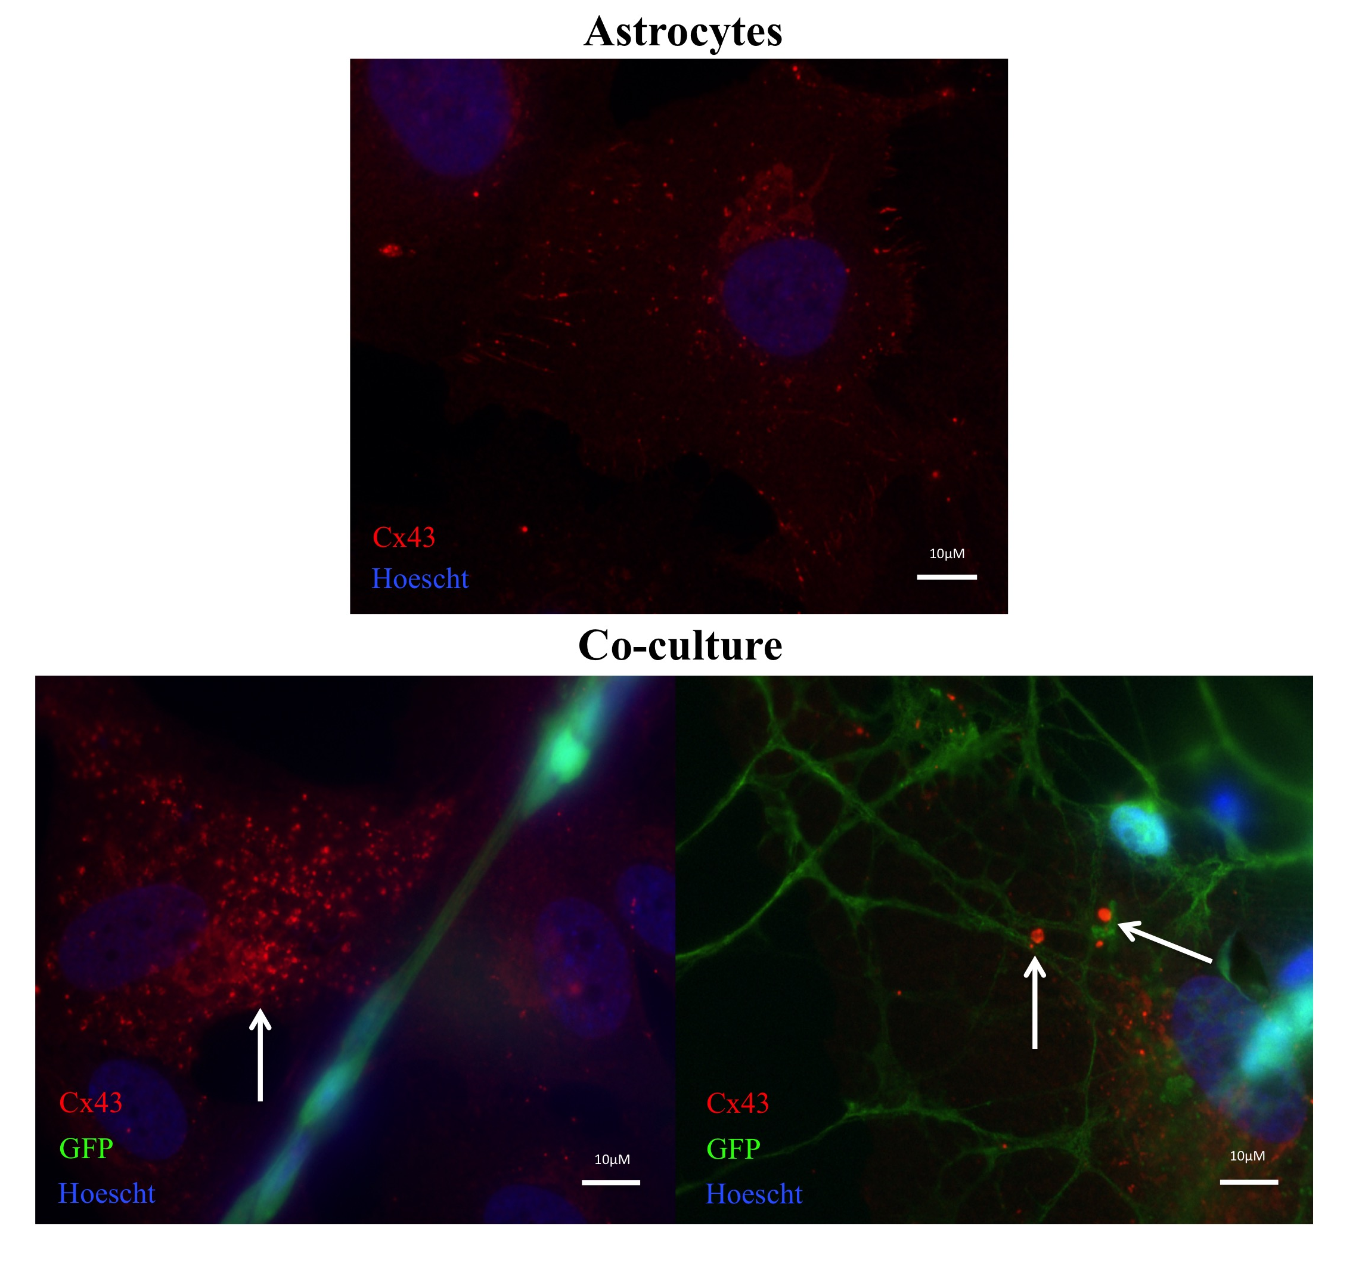
B.
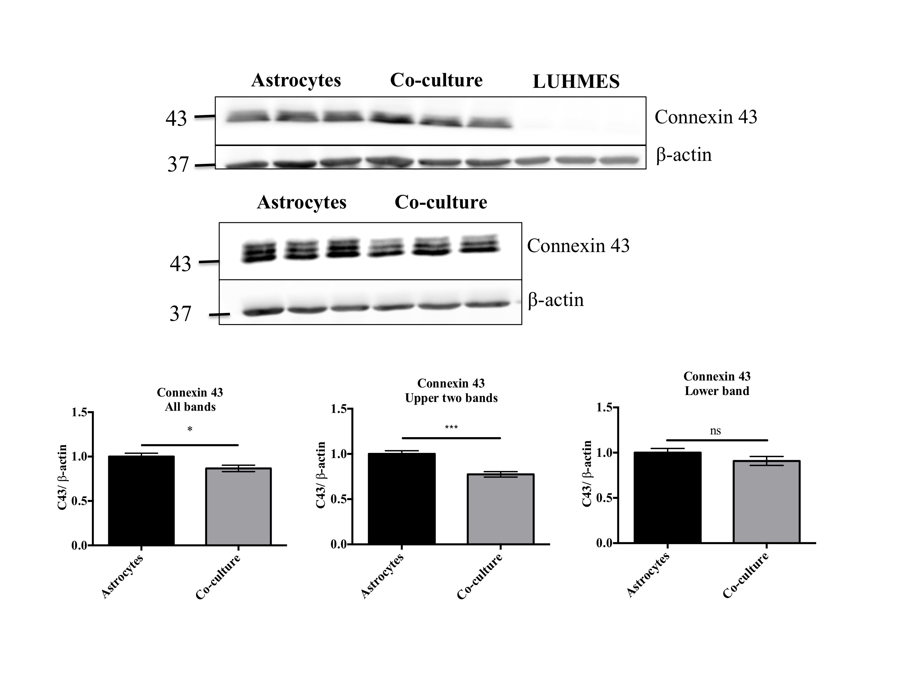

C. 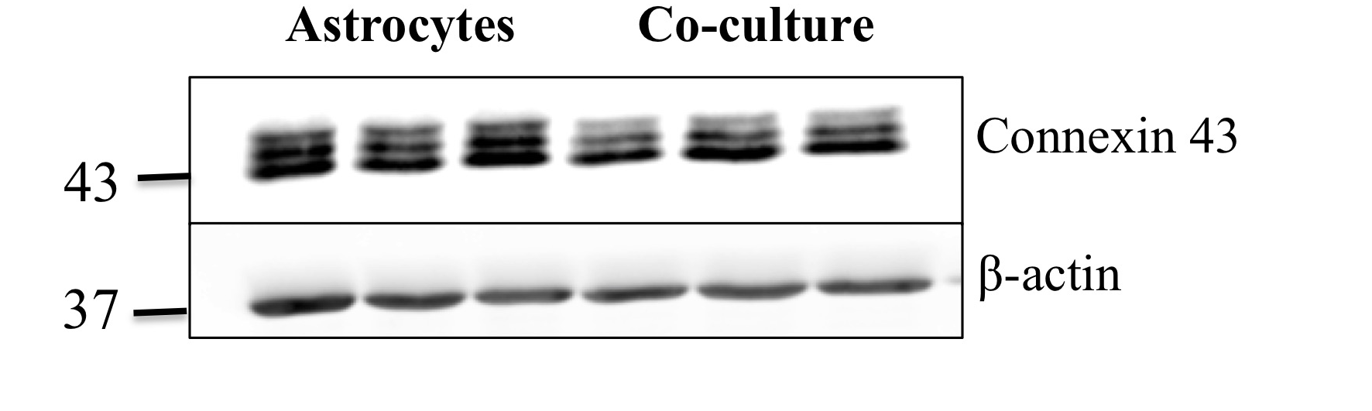

Figure 4.10. Relocalisation and post-translational modification of Connexin 43 (Cx43) in astrocytes in co-culture.
(A) Immunocytochemistry of Cx43 (red) in astrocytes in monoculture or in co-culture with astrocytes for 72 hours. White arrows indicate increased expression of Cx43 around neuronal networks. Scale bar represents 10μM (B) Immunblotting of Cx43 in astrocytes, LUHMES and in co-culture. (C) Western blotting of Cx43 in astrocytes and co-cultures to increase resolution of the three Cx43 bands. Bar charts show quantification of all 3 bands of Cx43, the two upper bands of Cx43 and the lower band of Cx43.Data represents mean ± SEM (n=3, 3 replicates/experiment, unpaired t-test *p<0.05 **p<0.01).

4.4.6 GFAP-positive astrocytes are associated with neurons

Following observations made in section 4.4.3, immunocytochemistry was used to assess the relationship between GFAP expression in astrocytes and the localisation of the LUHMES at two different plating densities of GFP LUHMES in co-culture.

In monoculture, astrocytes expressed low levels of GFAP (figure 4.11 A). When low (7500 cells per well) and high (100 000 cells per well) densities of GFP LUHMES were present, there was an upregulation of GFAP in astrocytes closely associated with the LUHMES (figure 4.11 B and figure 4.11 C). This was particularly evident when higher densities of LUHMES were co-cultured with astrocytes, as GFAP-positive astrocytes appeared to congregate around neuronal bundles (figure 4.11 C). Morphological changes in GFAP-positive astrocytes did not occur as a result of switching the culturing media from F10MEM to the neuronal media (MEM+ Tet) (figure 4.11 D and figure 4.11 E).

In addition, GFAP-positive astrocytes closely associated with neuronal
bundles changed morphologically (figure 4.11 F). In monoculture GFAP-expressing astrocytes appeared larger and flatter but GFAP-positive astrocytes associated with neuronal bundles become stellate, bearing a morphology more typically associated with astrocytes. These results may provide additional evidence that astrocytes adopt new functions in the presence of neurons.
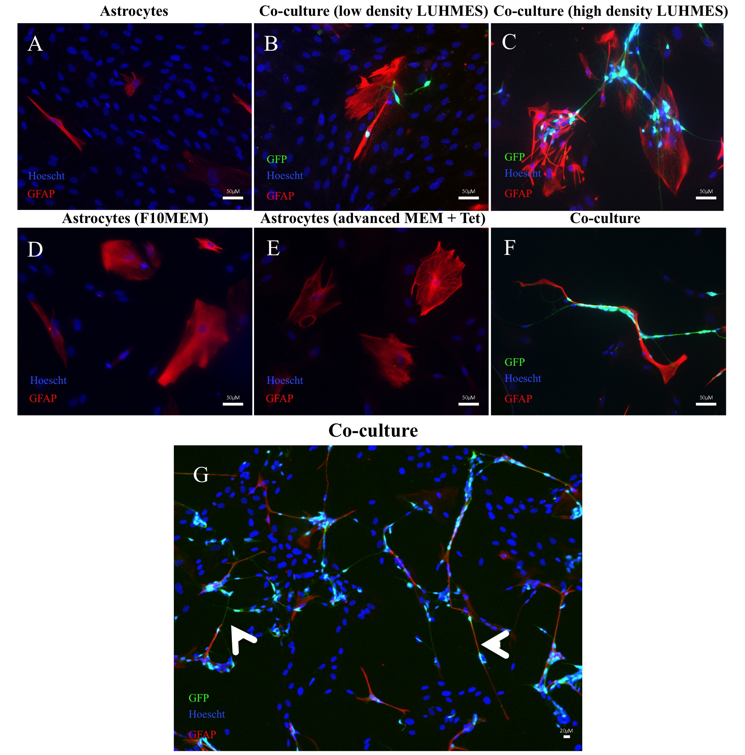

Figure 4.11. GFAP+ve astrocytes have altered morphology in co-culture and relocalise to neuronal networks.
Human astrocytes and LUHMES were co-cultured together for 72hr and immunostained for GFAP (red) whilst nuclei were labelled with a nuclear dye (Hoescht H3342) and LUHMES expressed GFP (green). Images show GFAP +ve astrocytes develop a more stellate morphology and relocalise to neuronal bundles in co-culture. White arrows show association of GFAP +ve astrocytes with neuronal networks at low power. Scale bar represents 10μM (A-F) and 20μM (G).

4.4.7 Astrocytes prolong neuronal survival

Astrocytes support neuronal homeostasis and therefore enhance neuronal survival. In NT2 neuron-astrocyte co-cultures astrocytes enhance neuronal survival approximately three-fold (Hill et al. 2012).

To determine whether human astrocytes (ScienCell) were able to extend neuronal survival in this co-culture system, GFP LUHMES were grown alone or in co-culture with astrocytes. GFP LUHMES were plated at equivalent densities on glass coverslips, in the presence or absence of astrocytes and cells were then fixed at 24 hour points for a period of 14 days (media was not changed during the course of the experiment).

Astrocytes appeared to support neurite integrity and prolong the formation of neuronal networks (figure 4.12 A and B), this was demonstrated by capturing images of LUHMES/GFP LUHMES in monoculture or co-culture with astrocytes.

GFP LUHMES appeared healthy at day 6 of differentiation in monoculture and at an equivalent point in coculture (third day in co-culture). LUHMES were well distributed in monoculture whereas in co-culture they formed bundles on top of the astrocytes. At day 8, very few LUHMES survived when cultured in isolation (figure 4.12 B). However, in co-culture the LUHMES formed strong networks of neuronal bundles on top of the astrocytes. By day 14 (or 12 days in co-culture), there were no GFP-expressing LUHMES present in monoculture whereas neurons in co-culture were still present indicating that astrocytes could prolong the survival of LUHMES in this co-culture system.

A.
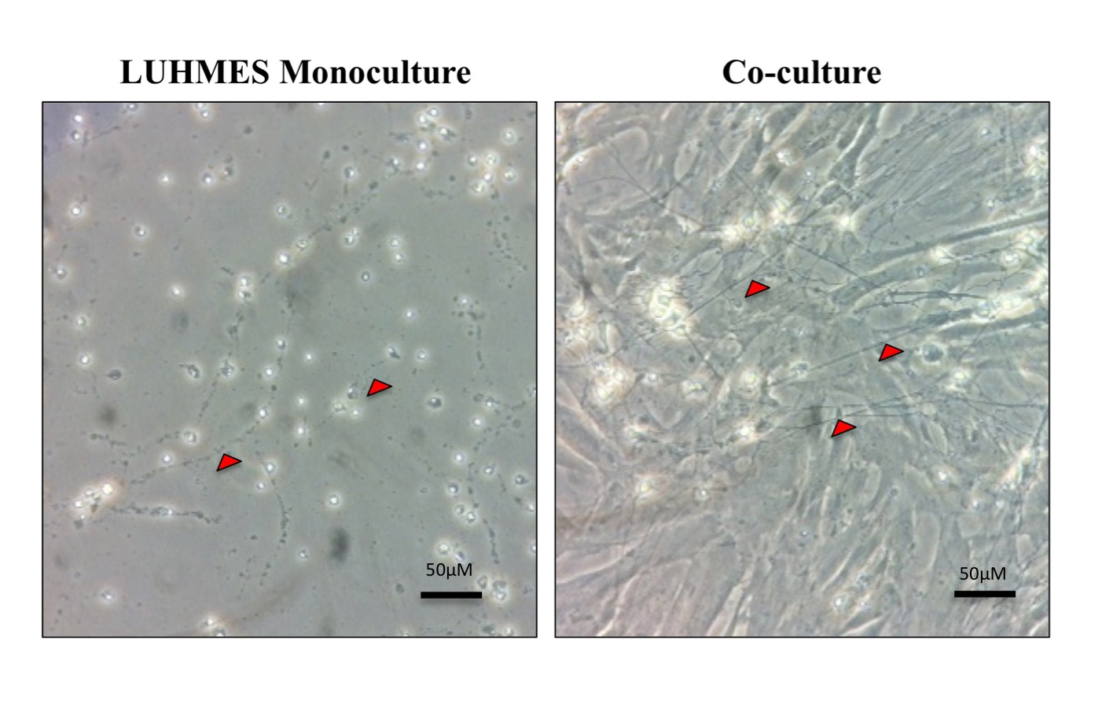

B.
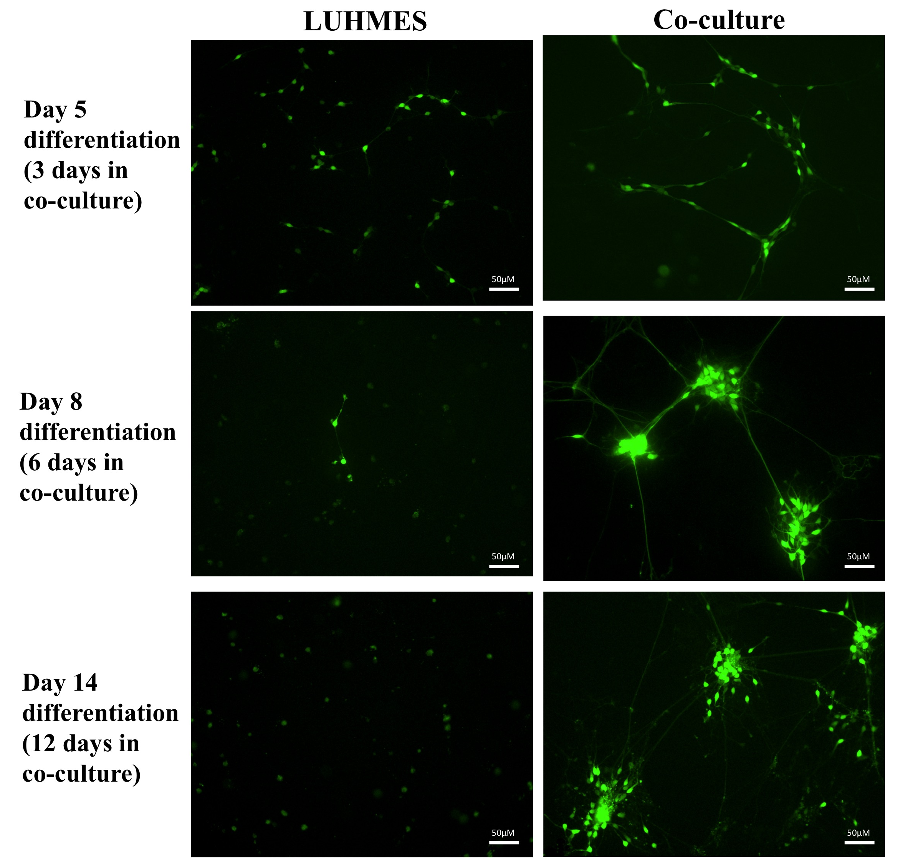

Figure 4.12. Astrocytes enhance the survival of LUHMES.
(A) Brightfield images of LUHMES on the 10th day in isolation or in co-culture with astrocytes. Axons were preserved when neurons were co-cultured with astrocytes compared to neurons in isolation, as indicated by the red arrows. (B) GFP LUHMES were grown in isolation or co-cultured with astrocytes for 3, 6 and 12 days and subsequently fixed and imaged for GFP-expressing LUHMES (green). Scale bar represents 50μM.

4.4.8 Neurite outgrowth is facilitated by direct contact with astrocytes

Following observations made in section 4.4.3 and reports in the literature that astrocytes enhance neurite outgrowth, an assay was designed to measure the neurite length of the GFP LUHMES in monoculture and in co-culture with human astrocytes. An ImageJ plugin called Simple Neurite Tracer was used to measure neurite lengths, this method was inspired by earlier work that developed a similar tool in ImageJ to trace neurite lengths (Pool et al. 2008). This assay was also used to determine whether enhanced neurite outgrowth was due to the release of soluble factors from astrocytes or if any enhanced neurite outgrowth was reliant upon direct contact with the astrocytes.

In these experiments, the astrocytes were cultured in the Advanced MEM (+ tetracycline) for 24 hours, which is defined as the astrocyte conditioned media (ACM). LUHMES were cultured in isolation, in ACM or in co-culture with astrocytes to determine if neurite outgrowth was i) influenced by the presence of astrocytes and ii) whether any astrocytic influence was contact-mediated or was due to a soluble factor released into the media. In these experiments, neurite outgrowth was significantly increased by astrocytes, and the results indicate that this increase is contact dependent since there was no increase in neurite outgrowth when LUHMES were cultured in ACM (figure 4.13). However, a limitation of this experiment was that it failed to consider soluble factors released by astrocytes are likely to be influenced by the presence of LUHMES.

To address this, co-cultures were incubated with the advanced media for 24 hours, and the media taken from these co-cultures was referred to as neuron-astrocyte conditioned media (NACM). LUHMES cells were grown in normal differentiation media, in NACM or in direct contact with the astrocytes for 24 hours before recording neurite lengths (figure 4.14). The results support the finding that neurite outgrowth is driven by direct contact with astrocytes and not by an astrocyte derived soluble factor.
A.
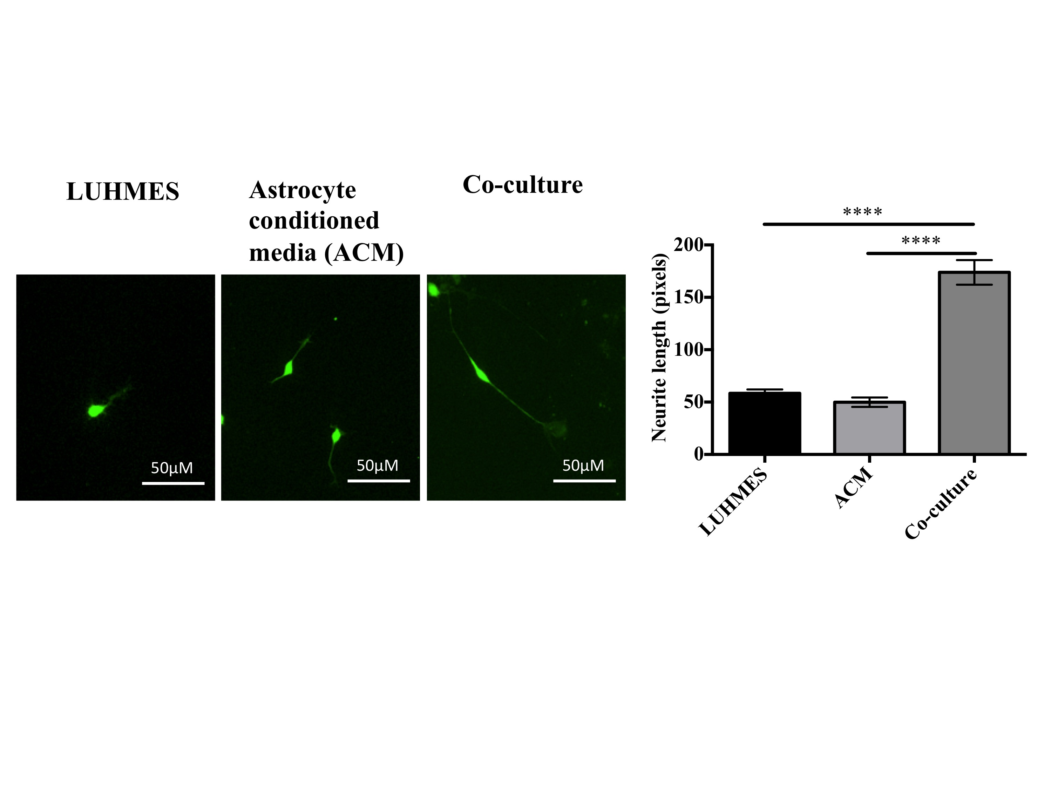
B.
Figure 4.13. Astrocyte conditioned media (ACM) does not enhance neurite outgrowth.
LUHMES were cultured in normal media, ACM and cultured in co-culture with astrocytes for 24 hours. Astrocytes were seeded at 30 000 cells per well and GFP LUHMES were seeded at a density of 7500 cells per well in a 24 well plate. (A) Images of GFP-expressing LUHMES under each of the culturing conditions. (B) Bar chart shows quantification of neurite outgrowth in LUHMES. Data represents mean ± SEM (n=3, 3 replicates/experiment, 5 fields counted per coverslip (represents 1 replicate but repeated 3 times in one experiment, one way ANOVA with post-hoc analysis ****p<0.0001) Scale bar represents 50μM

A.
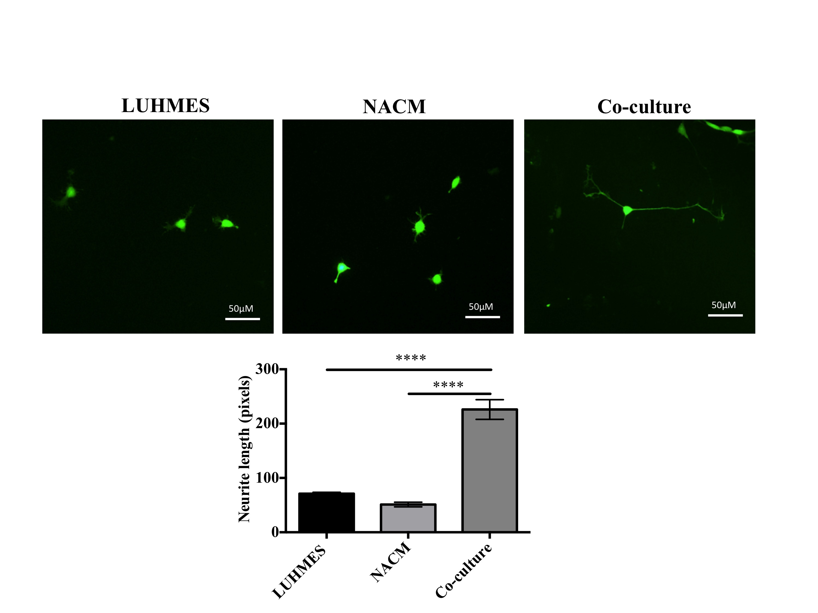

B.

Figure 4.14. Neuron-astrocyte conditioned media (NACM) does not enhance neurite outgrowth but appears to be a contact-dependent mechanism.
LUHMES were cultured in normal media, NACM (media taken from co-cultures after 24hours) and in co-culture with astrocytes for 24 hours. Astrocytes were seeded at
30 000 cells per well and GFP LUHMES were seeded at a density of 7500 cells per well in a 24 well plate. (A) Images of GFP-expressing LUHMES under each of the culturing conditions. (B) Bar chart shows quantification of neurite outgrowth in LUHMES. Data represents mean ± SEM (n=3, 3 replicates/experiment, 5 fields counted per coverslip (represents 1 replicate), one way ANOVA with post-hoc analysis ****p<0.0001) Scale bar represents 50μM.

4.4.9 Loss of IGF1R in astrocytes does not affect neuronal bundle formation

To assess whether loss of astrocytic IGF1R affects neuronal survival, GFP LUHMES were cultured with IgG or MAB391 pretreated astrocytes for 3, 6 and 12 days. Pretreatment of astrocytes with MAB391 or IgG isotype control does not affect the ability of the astrocytes to support neuronal survival (figure 4.15). In these experiments the media was not changed after replating LUHMES. This suggests that astrocytes are able to replenish the nutrients and fulfill a homeostatic role within this co-culture system despite loss of IGF1R or pretreatment with IgG isotype control. These experiments are limited by the tendency of the LUHMES to bundle on astrocytes making it difficult to extrapolate quantifiable data.

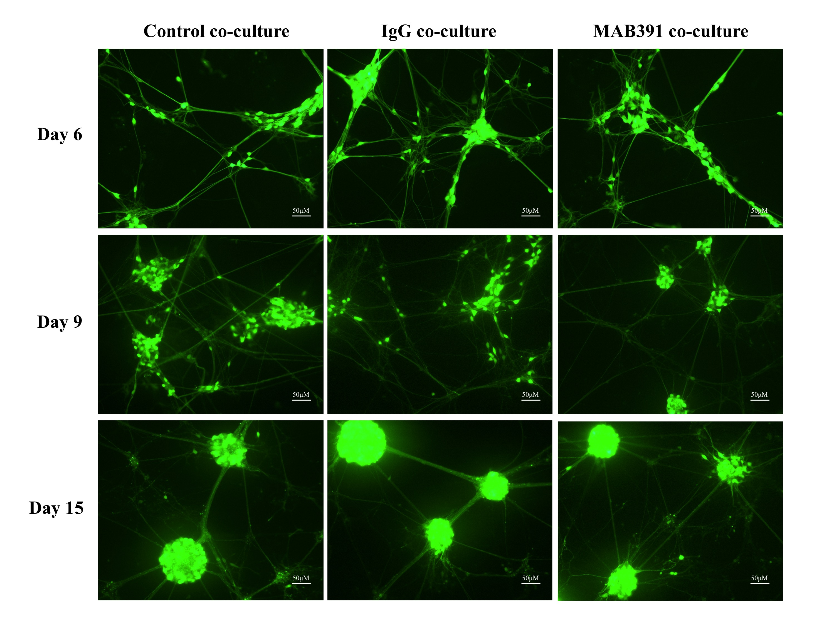
Figure 4.15. Loss of IGF1R in astrocytes does not affect neuronal bundle formation.
GFP LUHMES were grown in co-culture with control/ IgG or MAB391 pretreated astrocytes for 3, 6 and 12 (day 6, day 9 and day 15 respectively) days to assess neuronal network formation and survival. Images show GFP-expressing LUHMES (green) and scale bar represents 50μM.

4.4.10 Loss of IGF1R in astrocytes does not affect neurite outgrowth during neuronal differentiation

To elucidate whether impairment of the IGF1 signalling pathway affects the ability of astrocytes to support neurite outgrowth during neuronal differentiation, astrocytes were treated with MAB391/IgG (figure 4.16) for 24 hours prior to co-culture with GFP LUHMES. In Chapter 3 it was shown that astrocytic IGF1R levels were reduced 24 hours after MAB391 treatment but there were no changes in the levels of phosphorylated Akt (s473) (chapter 3, figure 3.7A) and there was a persistent loss of IGF1R 72 hours after this time point. Therefore with the MAB391 pretreatment, astrocytes have reduced IGF1R levels when the LUHMES are plated with them and in monoculture at least, this is true during the full course of neuronal differentiation. Astrocytes were also pre-treated with Wortmannin to assess how downregulation of Akt signalling in astrocytes affects neurite outgrowth (this will be discussed in section 4.4.11).

Astrocytes significantly enhanced neurite outgrowth during the 72 hour co-culture period compared to neurons grown alone. However, loss of IGF1R did not affect the ability of astrocytes to support neurite outgrowth during this period. (figure 4.17).

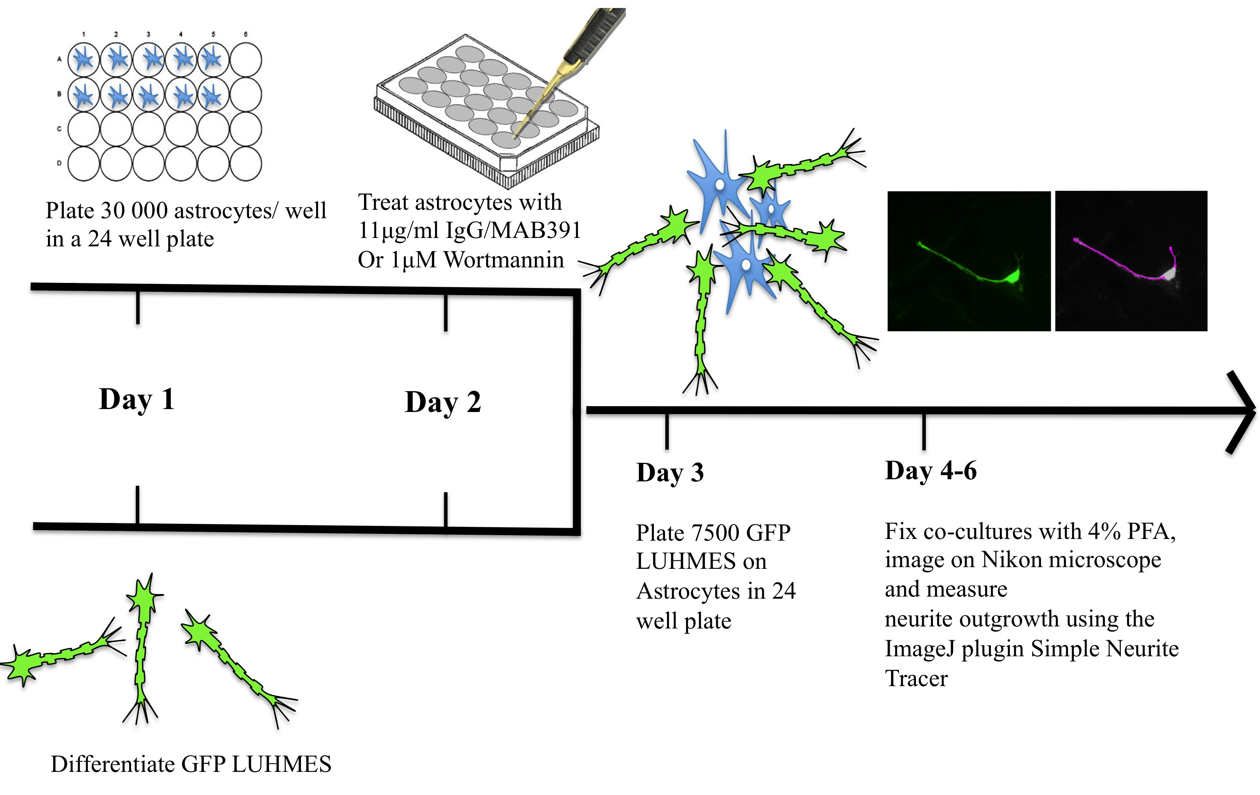

Figure 4.16. Timeline of neurite outgrowth assay to assess effect of MAB391/IgG pretreatment of astrocytes on neurons.
On day 1 30 000 astrocytes were plated per well of a 24 well plate in astrocyte media (F10MEM) and in parallel differentiation of the GFP LUHMES was initiated. On day 2 the astrocytes were treated with IgG/MAB391 (or Wortmannin, which will be discussed later) for 24 hours. Astrocytes were washed with PBS on day 3 and GFP LUHMES were replated on the astrocytes in the neuronal media (Advanced MEM media + Tet) at a density of 7500 LUHMES per 24 well. On day 4, 5 and 6, which represent 24, 48 and 72 hours in co-culture respectively, co-cultures were fixed with 4% PFA, stained with Hoescht and images captured on the Nikon microscope for image analysis using Simple Neurite Tracer (an ImageJ plugin).

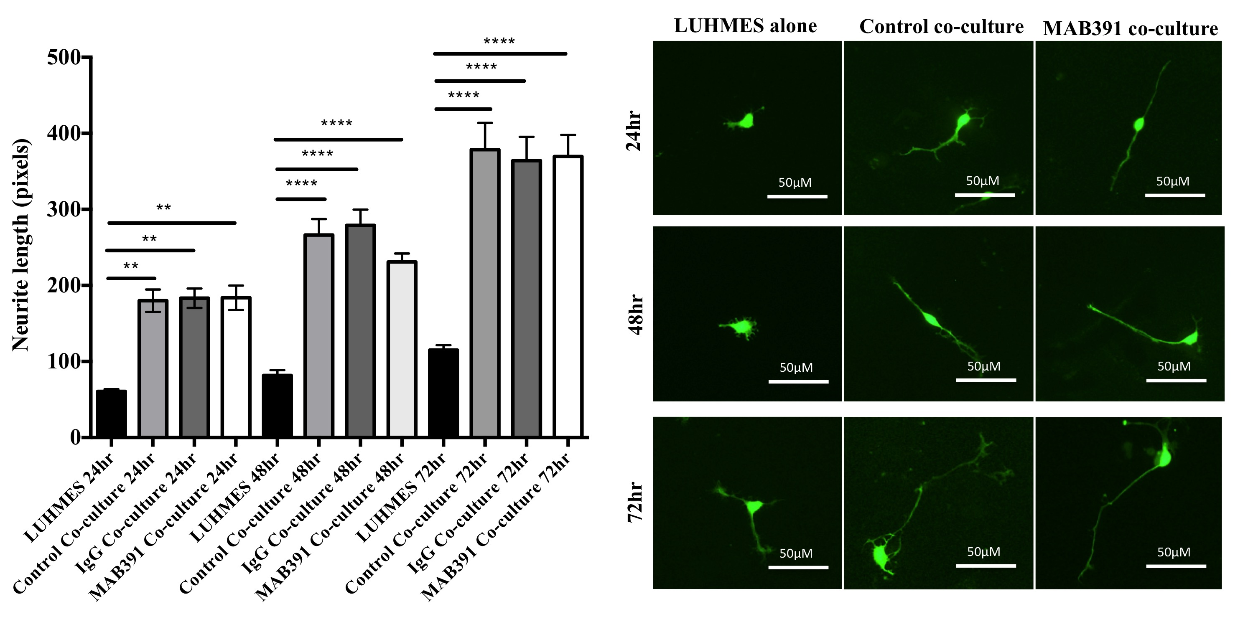

Figure 4.17. Astrocytes enhance neurite outgrowth during LUHMES differentiation, however loss of IGF1R in astrocytes does not affect rate of neurite outgrowth during the differentiation process.
Data represents mean ± SEM (n=3, 3 replicates/experiment, 5 fields counted per coverslip (represents 1 replicate), one way ANOVA with post-hoc analysis **p<0.01 ****p<0.0001

4.4.11 Reduced astrocytic pAkt (s473) limits the support for neurite outgrowth during differentiation

Despite a reduction in astrocytic IGF1R following treatment with MAB391 there was no observable reduction in Akt signalling at either the 24 hr or 96 hr timepoint, which might reflect compensatory signalling mechanisms (figure 3.7).

Effect of Akt inhibition in astrocytes in monoculture
To investigate whether reduced Akt activity in astrocytes was detrimental to neurite outgrowth in LUHMES, a model of Akt inhibition was developed in human astrocytes. Astrocytes were treated with the irreversible non-competitive PI3K inhibitor Wortmannin (1μM) for 24 hours, which resulted in a significant reduction in Akt activity as measured by phosphorylated Akt (pAkt S473) (p<0.0001). To replicate conditions used in the MAB391 co-culture experiments a media change was carried out at 24 hours. Astrocytes harvested 24 hours after the media change had restored levels of pAkt S473, with a trend towards an increase in phosphorylation (figure 4.18A). The morphology of astrocytes treated with Wortmannin for 24 hours was assessed to see whether inhibition of Akt altered cell morphology. Astrocytes were immunolabelled with vimentin and GFAP (figure 4.18 B) but no obvious differences were observed in cell morphology or GFAP levels. In addition, viability of astrocytes following Wortmannin treatment was assessed over a 72 hour period using an MTT assay. As with MAB391 treatments, media was changed after the initial 24 hour treatment. When astrocytes were plated at 15 000 cells per well, an initial reduction in Akt activity caused a significant reduction in viability observed over the 72 hour period (figure 4.19).

A.
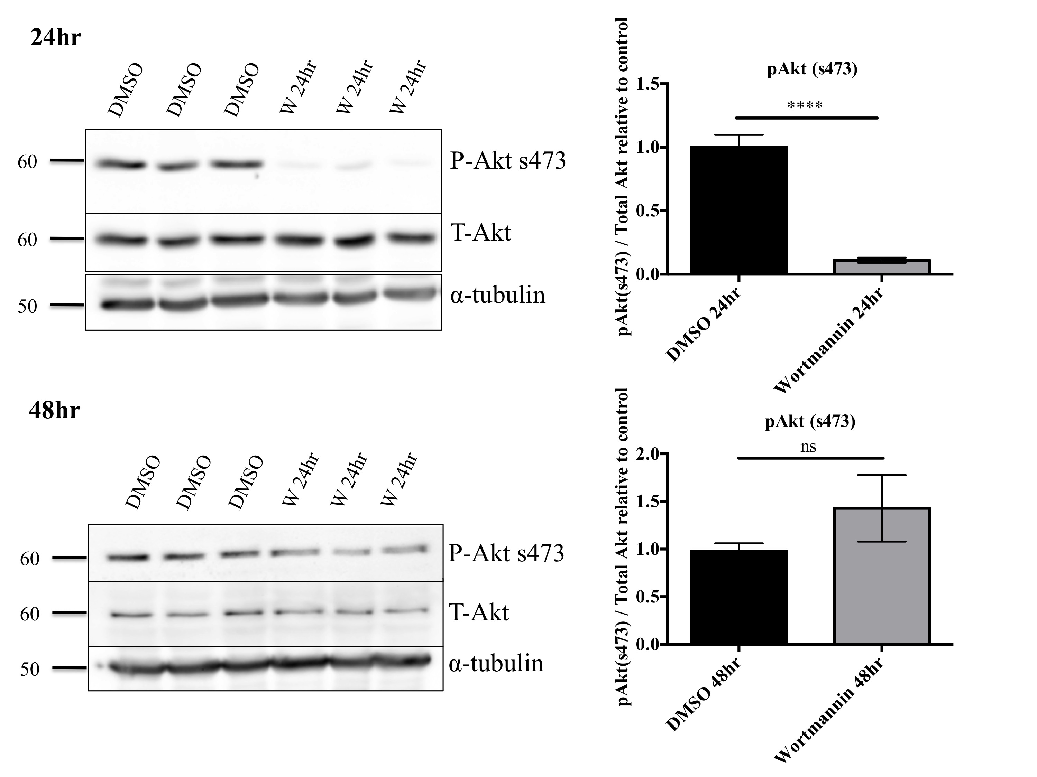
B.
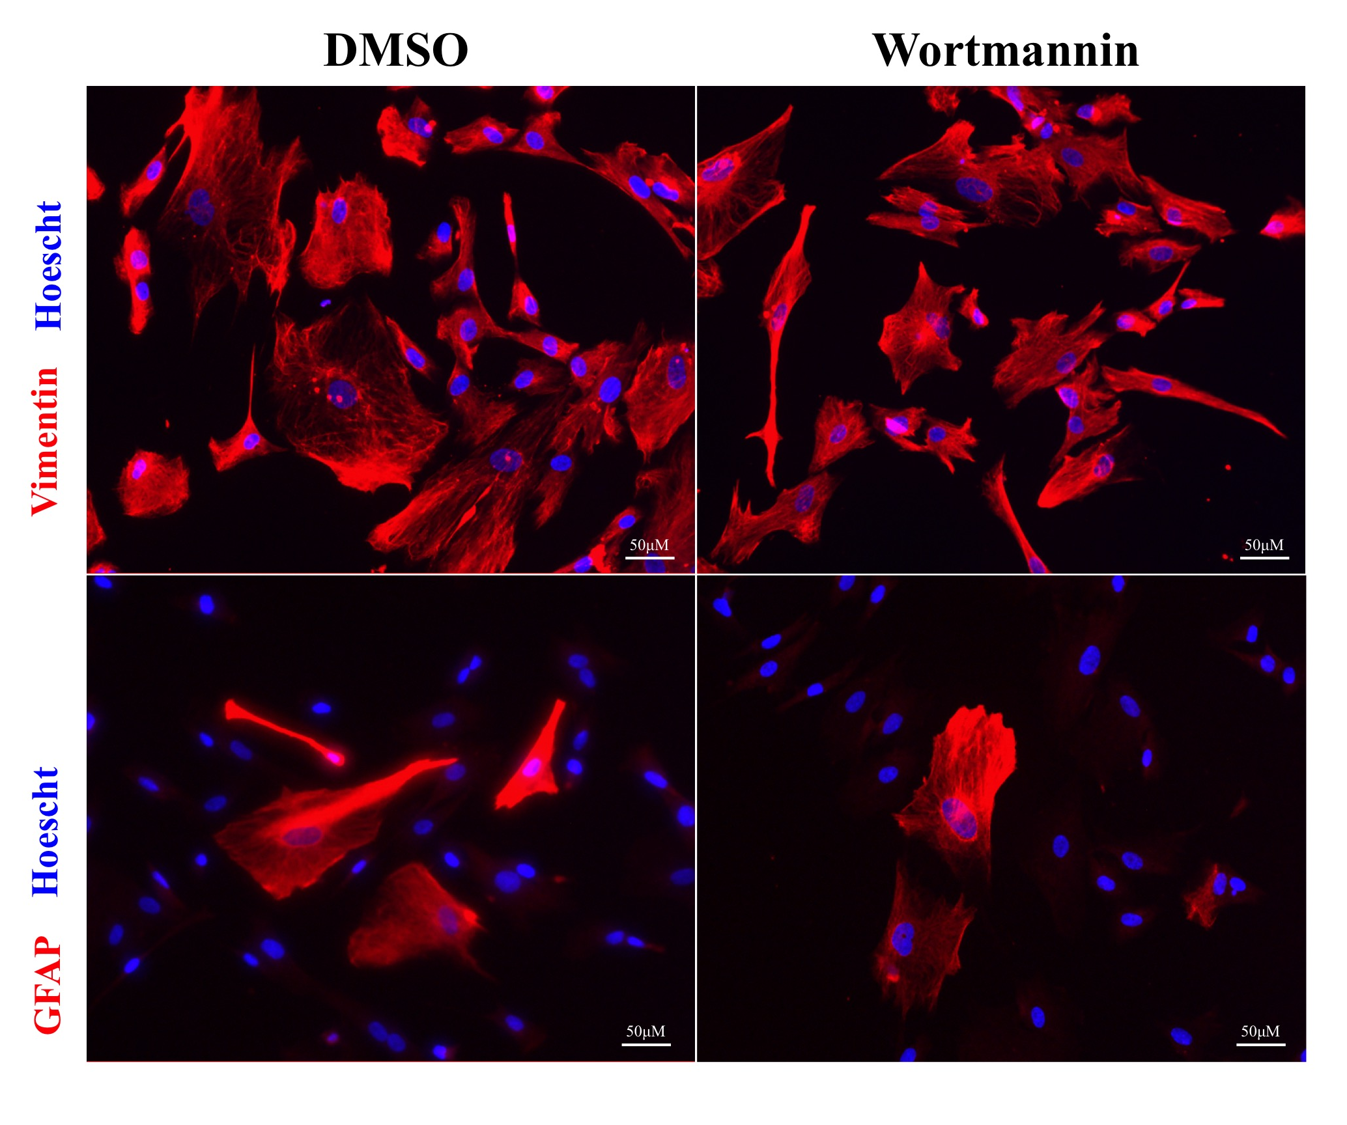

Figure 4.18. Loss of phosphorylated Akt (s473) in primary human astrocytes following treatment with Wortmannin.
A. ScienCell (2) astrocytes were treated with 1μM Wortmannin for 24 hours (top) or 48 hours, with a media exchange after 24 hours (bottom). Representative western blots probed with antibodies against pAkt (s473), Total Akt are shown with α-tubulin used as a loading control (a representative loading control is shown). Molecular weight markers are indicated (kDa) Bar charts show quantification of western blots. Data are mean + SEM (n=3, 3 replicates/experiments, unpaired t-test ****p<0.0001) B. ScienCell (2) astrocytes were treated with 1μM Wortmannin for 24 hours and morphology was assessed by staining with Vimentin and GFAP (both in red) and Hoescht to stain nuclei.

Figure 4.19. Akt inhibition reduces astrocyte viability when plated at low densities.
MTT assay of Wortmannin treated astrocytes in monoculture, when cells are plated at 15 000/ well in a 24 well. Graphs represent n=3, 3 experiments/ replicate. (Data are mean + SEM, unpaired t-test **p<0.01 and ***p<0.001).
In the Wortmannin model, pAkt (s473) was significantly reduced after 24 hours (p<0.0001 figure 4.18A). This means that astrocytes (ScienCell (2)) pretreated with Wortmannin would have impaired pAkt (s473) levels at the point of co-culturing with the LUHMES. However, 48 hours after initially treating astrocytes with Wortmannin, there was recovery in the Akt pathway. Treatment with Wortmannin was used to assess whether impairments in Akt signalling in astrocytes affected neurite outgrowth in the LUHMES.

Determining how reduced signalling through Akt effects neuronal support
To determine if impairing Akt signalling in the astrocytes has an impact on the support for neurite outgrowth, astrocytes were pretreated with Wortmannin for 24 hours and cultured with GFP LUHMES for 72 hours over which period neurite lengths were measured. An initial impairment of Akt signalling in the astrocytes consistently and significantly reduced the neurite outgrowth during the 72 hour differentiation process compared to DMSO treated astrocytes (p<0.0001) (figure 4.20). To investigate whether treating astrocytes with Wortmannin causes a reduction in astrocyte cell number at the density of astrocytes used in this assay, both an MTT assay and a count of the number of astrocyte nuclei in the co-culture system were conducted (figure 4.21A and 4.21B). Astrocytes were plated at 30 000 astrocytes per well in a 24 well plate, which was double the amount of cells used in the previous MTT assay (figure 4.19). At these densities, both the MTT assay and nuclei count data suggested that Wortmannin, despite causing an initial reduction in Akt signalling, did not cause any significant changes in astrocyte cell number over the 72 hour co-culture period. Therefore, impaired neurite outgrowth on Wortmannin pre-treated astrocytes might be explained by more than a subtle reduction in astrocyte number.

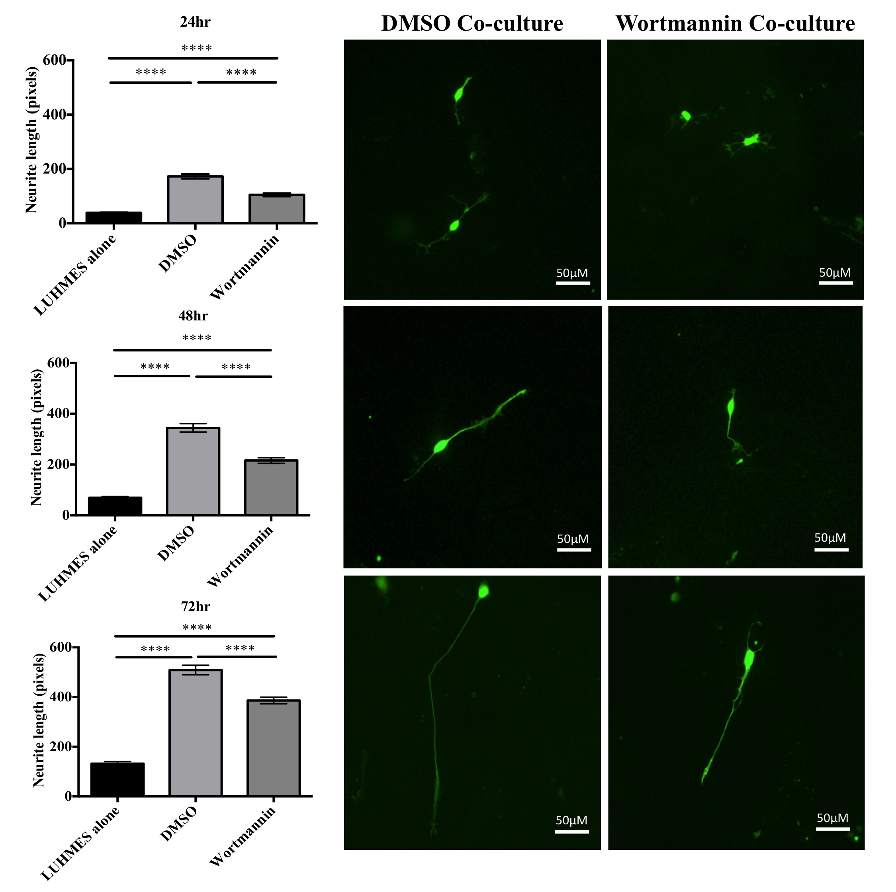
Figure 4.20. Reduced pAkt in astrocytes affects support for neurite outgrowth during neuronal differentiation.
GFP LUHMES were co-cultured with DMSO or Wortmannin pretreated astrocytes for 24, 48 and 72 hours. Representative images show GFP LUHMES co-cultured with DMSO and Wortmannin pretreated astrocytes. Bar charts represent the quantification of the neurite outgrowth at each time point. Data represents mean ± SEM (n=3, 3 replicates/experiment, 5 fields counted per coverslip (represents 1 replicate), one way ANOVA with post-hoc analysis **p<0.01 ****p<0.0001).

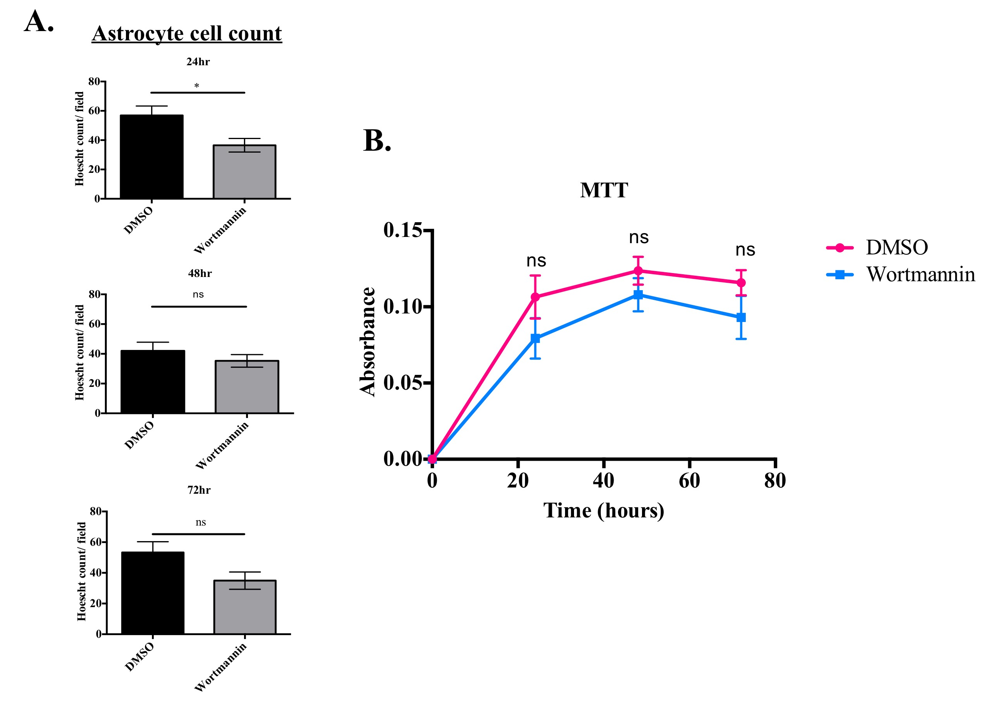
Figure 4.21. Treatment of primary human astrocytes with Wortmannin does not significantly affect astrocyte cell number.
(A) Bar graphs represent astrocyte nuclei counts in neurite outgrowth assays. Data represents mean ± SEM (n=3, 3 replicates/experiment, 5 fields counted per coverslip (represents 1 replicate), unpaired t-test *p<0.05 (B) MTT assay of Wortmannin treatment of astrocytes in monoculture, at cell densities used in the neurite outgrowth assay. Graphs represent n=3, 3 experiments/ replicate. (Data are mean + SEM, One way ANOVA with post-hoc analysis).

4.4.12 Pre-treatment of astrocytes with hydrogen peroxide does not affect support for neurite outgrowth

Astrocytes are capable of neutralizing pro-oxidants due to their high antioxidant capacity. In rodent astrocytes this has been shown to be dependent on functional IGF1 signalling (Genis et al. 2014). To assess whether IGF1 signalling is important in human astrocytes to preserve support for neurons under additional stress, a sublethal concentration of H₂O₂ in astrocytes needed to first be determined. It was important to select a concentration of H₂O₂ that does not affect cell viability since this would impact the number of astrocytes supporting the neurons in the co-culture system and would limit the conclusions that could be drawn from the neurite outgrowth assay. Previous work has demonstrated that 50μM H₂O₂ is a sublethal concentration to use in rat astroglial cells (Röhrdanz et al. 2001) and it has been demonstrated that higher concentrations reduced astrocyte viability and increased mitochondrial ROS production (Genis et al. 2014). A 50μM H₂O₂ treatment was selected to see whether this was sublethal in the astrocytes.

An MTT assay was first performed to determine whether treatment of astrocytes with 50μM H₂O₂ altered cell viability. 50μM H₂O₂ was a sublethal dose in these astrocytes and did not alter viability as measured by MTT (figure 4.22A). To assess whether H₂O₂ treatment resulted in an increase in reactive oxygen species (ROS) in the astrocytes, a CellRox assay was performed. There was no obvious change in ROS levels in astrocytes following treatment with 50μM H₂O₂ (figure 4.22B).

Following this optimization in monoculture, 50μM H₂O₂ treatments were repeated within the co-culture system (figure 4.23). An initial 24 hour treatment with 50μM H₂O₂ did not impact astrocytic support for neurite outgrowth.

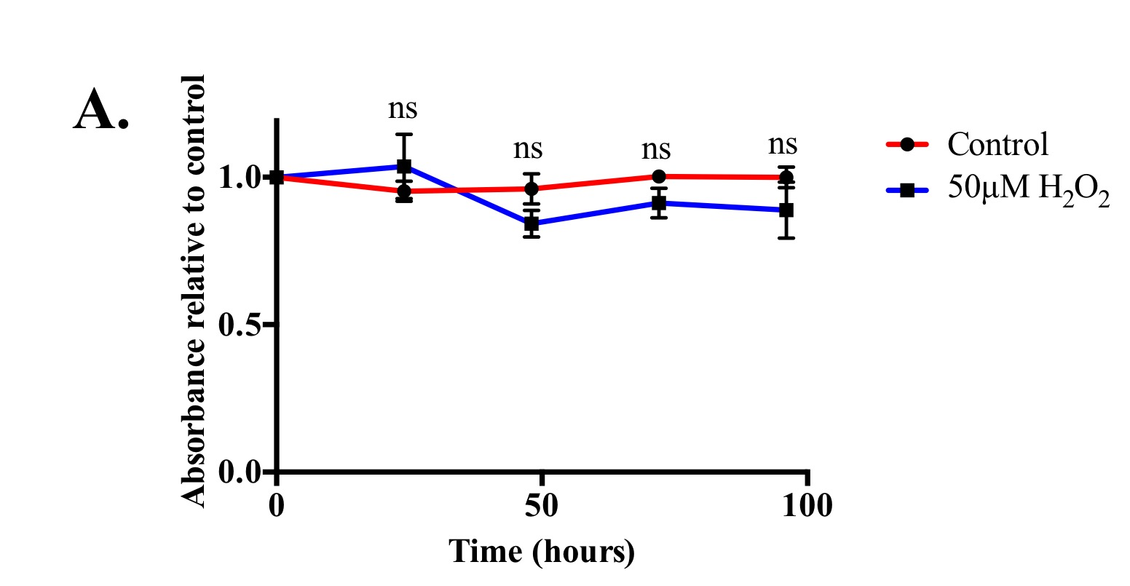
B.
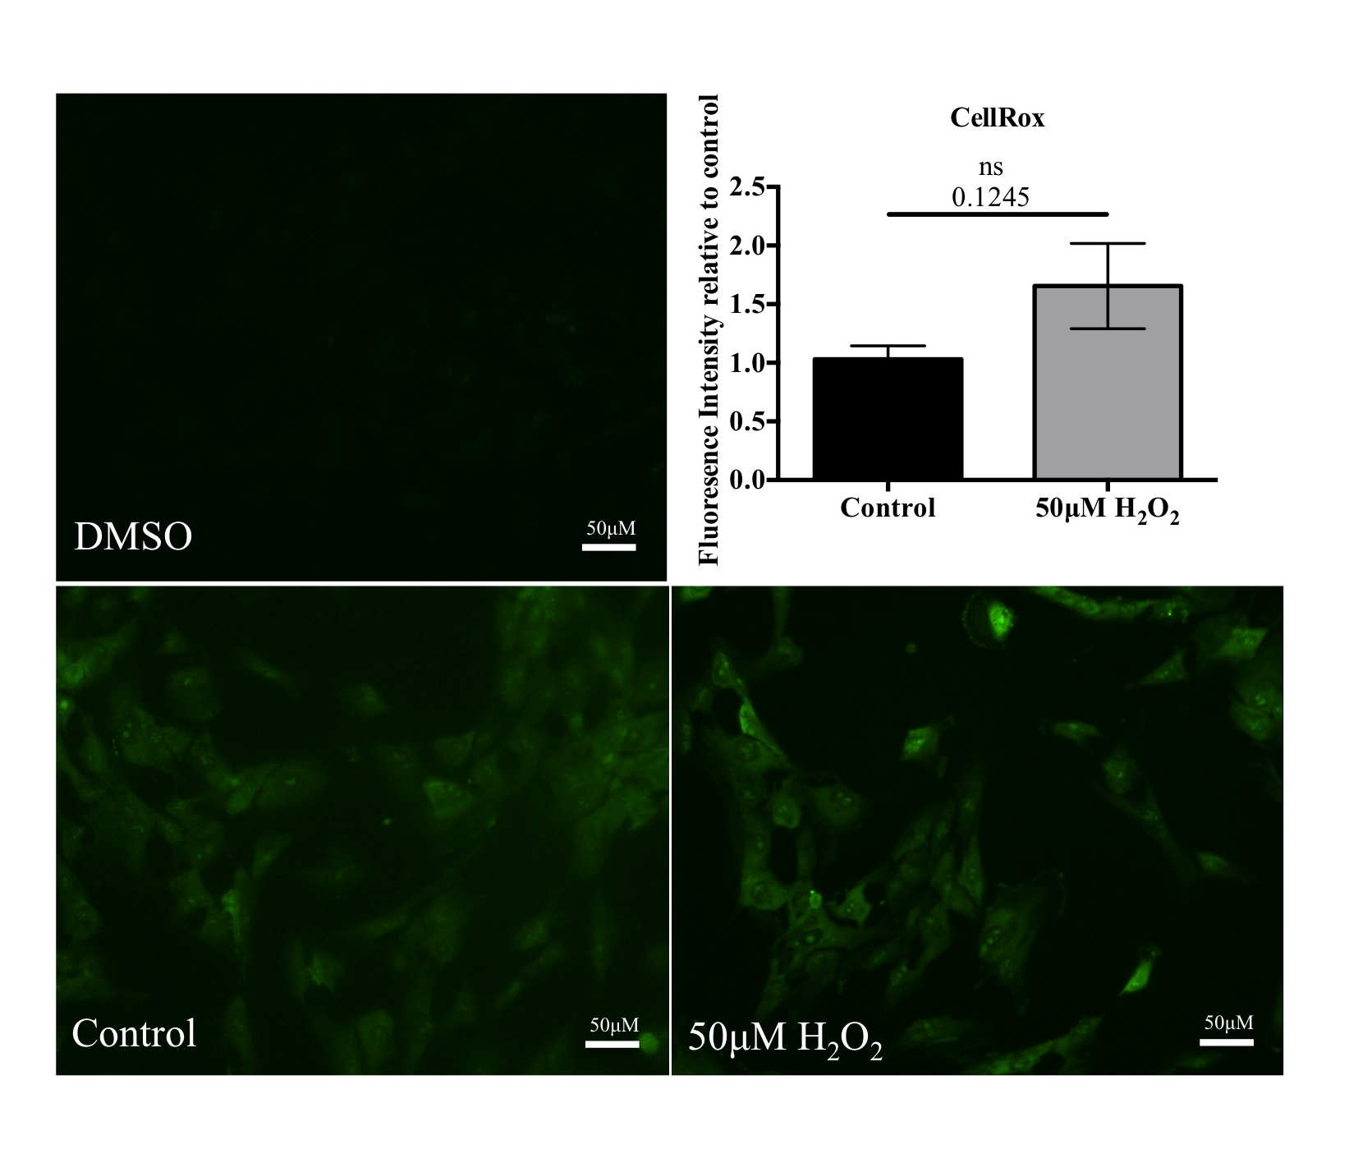

Figure 4.22. Treatment of astrocytes with 50μM H₂O₂ does not change cell viability or change intracellular ROS levels.
(A) Treatment of astrocytes with 50μM H₂O₂ does not affect cell viability as identified by MTT. Graph represents n=3, 3 experiments/ replicate. (Data are mean ± SEM, One way ANOVA with post-hoc analysis). (B) A CellRox assay was performed to determine ROS levels in astrocytes following treatment with 50μM H₂O₂ for 24 hours. Bar chart represents n=3, 3 experiments/replicate (Data are mean ± SEM, unpaired t-test).

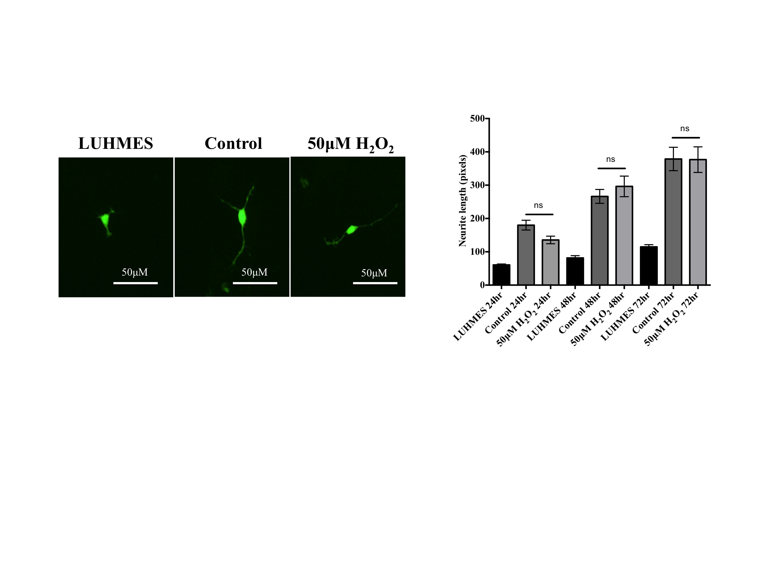
Figure 4.23. Astrocytes treated with 50μM H₂O₂ retain their support for neurons as determined by measuring neurite lengths.
Astrocytes were pre-treated with 50μM H₂O₂ for 24 hours prior to co-culture with GFP LUHMES and neurite outgrowth of LUHMES was determined over a 72 hour period. Representative images are of GFP LUHMES cultured alone or in the presence of astrocytes treated with and without 50μM H₂O₂ for 72 hours. Bar chart shows that neurite outgrowth was not altered after pretreating astrocytes with 50μM H₂O₂. Bar chart represents n=3, 3 experiments/ replicate (Data are mean ± SEM, One way ANOVA with post-hoc analysis).

4.4.13 Loss of IGF1R in astrocytes impairs protection of neurons against oxidative stress

Following treatment with 50μM H₂O₂, astrocyte cell number was unaffected, ROS levels did not significantly increase and astrocytes continued to support neurite outgrowth.

It has been shown in vitro that astrocytes can protect neurons from H₂O₂ toxicity (Desagher, Glowinski, & Premont, 1996). In this section, the aim was to assess if IGF1 signalling impaired astrocytes were still able to protect neurons from oxidative stress. Astrocytes and GFP LUHMES were co-cultured as described previously for a total of 72 hours before addition of 50μM of H₂O₂ for 2 hours on day 6 (figure 4.24). The astrocytes were also either pre-treated with IgG/MAB391 for 24 hours, which has already been shown not to reduce neurite outgrowth, or left untreated before co-culturing with the GFP LUHMES.

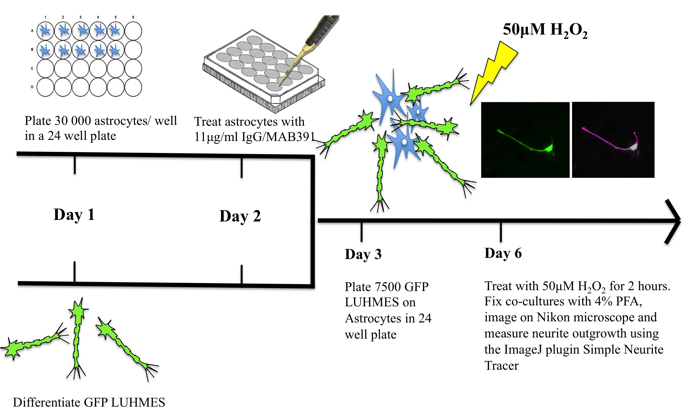
Figure 4.24. Neurite outgrowth assay model used to assess the neuroprotective capacity of astrocytes in co-culture.
On day 1 astrocytes were plated at 30 000 cells per well in a 24 well plate and in parallel differentiation media was added to GFP LUHMES. Astrocytes were treated with IgG/MAB391 on day 2 and on day 3 7500 GFP LUHMES were plated on the astrocytes. On day 6, 50μM H₂O₂ was added to the co-culture and coverslips were fixed and stained with Hoescht for imaging analysis.

In mono-culture, there was a significant reduction in neurite length when GFP LUHMES were treated with 50μM H₂O₂ for 2 hours (p =0.0007, figure 4.25). When GFP-LUHMES were co-cultured with astrocytes, addition of H₂O₂ did not cause a retraction in neurite length (figure 4.25). This suggests that the astrocytes were able to protect the LUHMES from the effects of H₂O_{2.}

Treatment with MAB391 induces loss of IGF1R for the duration of the co-culture period. In co-cultures where astrocytes were pre-treated with MAB391 but not IgG, there was a significant reduction in neurite length following application of the H₂O₂ (p < 0.0001). This suggests that loss of IGF1R impairs the neuroprotective capacity of the astrocytes. In addition, breakdown of neurites on top of MAB391-treated astrocytes following H₂O₂ treatment was observed (figure 4.26). This phenomenon is called “neuronal blebbing” and suggests that the plasma membrane of the neurons was
compromised in these conditions. This was also observed when LUHMES grown in mono-culture were exposed to H₂O₂.
A.
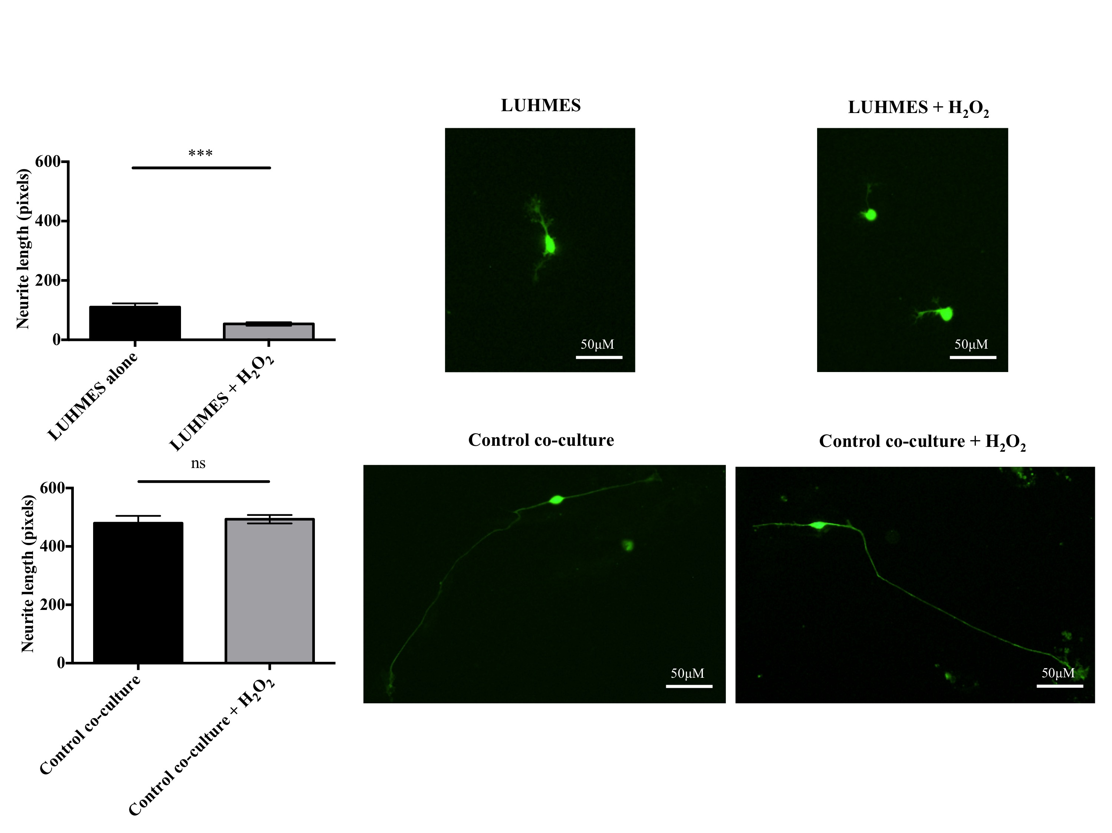
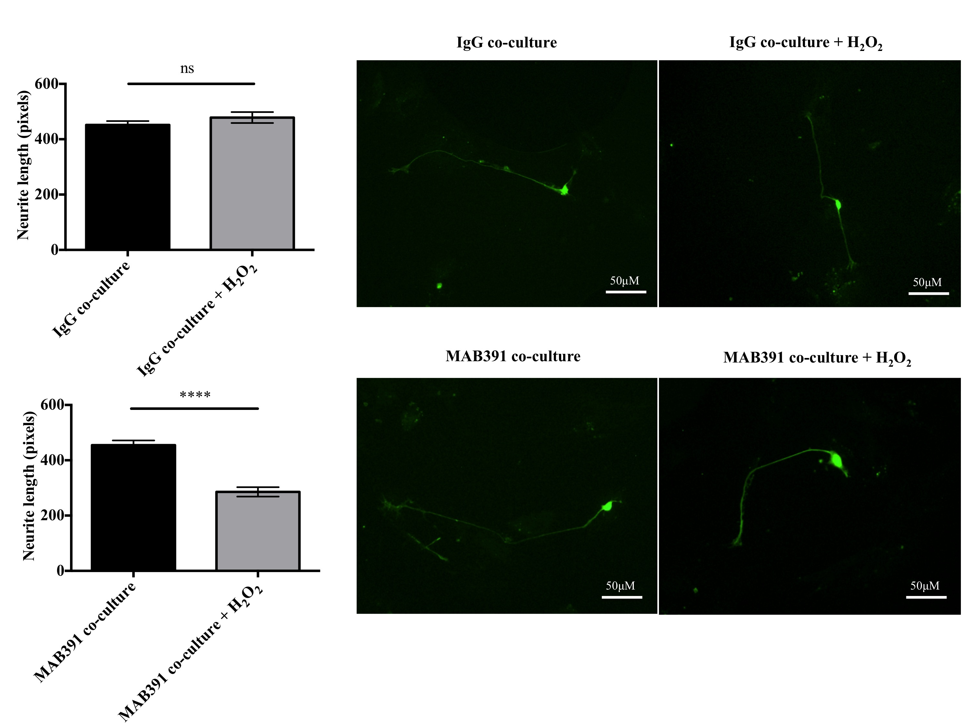

Figure 4.25. Loss of IGF1R in astrocytes impairs protection of neurons against H₂O₂ in co-culture.
Untreated, IgG and MAB391-treated astrocytes were co-cultured with GFP LUHMES prior to addition of 50 μM H₂O₂ for 2 hours on day 3 of co-culture (day 5 of LUHMES differentiation). Average neurite length per soma was calculated for each co-culture and for the LUHMES alone. LUHMES in mono-culture have reduced neurite length when treated with 50μM H₂O₂. Astrocytes were able to support LUHMES and prevent reduction of neurite length. Treating astrocytes with MAB391 caused a significant reduction in neurite length in conditions of oxidative stress. Data represents mean ± SEM (n=3, 3 replicates/experiment, 5 fields counted per coverslip (represents 1 replicate), one way ANOVA with post-hoc analysis ***p<0.001 ****p<0.0001).
Figure 4.26 Neuronal blebbing observed in LUHMES co-cultured with astrocytes pre-treated with MAB391 and exposed to oxidative stress.
Immunocytochemistry of GFP LUHMES showing neuronal blebbing occured both in LUHMES treated with H₂O₂ and LUHMES associated with MAB391 pretreated astrocytes.

4.5 Discussion

The work in this chapter was focused on developing a novel human astrocyte-neuron co-culture system to investigate whether impairments in the IGF1 signalling pathway in astrocytes alter the support for neurons.

4.5.1 Development and characterisation of a novel human astrocyte-neuronal co-culture system

Initial characterisation of the astrocytes and neurons in the co-culture system was performed to ensure appropriate expression of neuronal and astrocytic markers.
Antibodies recognising CD44, GFAP, Vimentin and ALDH1L1 were used to identify astrocytes within the co-culture system. CD44 is a transmembrane glycoprotein involved in cell-matrix adhesion and signalling, which has been identified as both a marker of mature astrocytes and of astrocyte restricted precursor cells that are committed to an astrocyte phenotype (Liu et al. 2004). CD44 is also suggested to precede GFAP expression in astrocytes. GFAP is the major protein of glial intermediate filaments (Eng 1985) that is typically expressed by astrocytes undergoing differentiation or gliosis and is present in a subset of the human ScienCell astrocytes both in monoculture and co-culture. Vimentin is another intermediate filament protein expressed in glial precursors during embryonic development. Gene expression profiling of astrocytes isolated from the mouse forebrain has demonstrated that an enzyme involved in formate oxidation, ALDH1L1, is a selective marker of astrocytes with a broader pattern of expression than the classic astrocyte marker GFAP (Cahoy et al. 2008). All four of these classic astrocyte markers were identified in astrocytes in the co-culture system.

Increasingly, astrocytes have been reported to express some neuronal markers. For example, mature astrocytes in adult human neocortex have been shown to express the early neuronal marker doublecortin, a marker of neogenesis (Verwer et al. 2007) and expression of a neuron specific glutamate transporter EAAT4 has also been identified in astrocytes (Hu et al. 2003). Similarly, this work shows that PSD95, a marker of pre and post-synaptic neuronal regions, is expressed by human astrocytes. Discovery of these typically neuron-associated proteins in astrocytes suggests that some markers used to define lineage are not completely lineage-specific but also highlights there is still so much left to understand about the basic physiology of these cells.

Astrocytes and neurons have also been shown to develop a more mature phenotype in co-culture compared to cells in monoculture. In the presence of neurons, astrocytic function alters as evidenced by the upregulation of the glutamate transporter EAAT2 and the gap junction protein Cx43 in rodent astrocytes (Koulakoff et al. 2008) whilst astrocytic support for neurons is visible through enhanced neuronal survival, controlling synapse number and protection from neurotoxicants (Ullian et al. 2001; Efremova et al. 2016). Changes in Cx43 and GFAP have also been observed in human astrocytes co-cultured with LUHMES, which may provide some evidence that astrocytes are responding to being in contact with neurons.

Cx43 is a gap junction protein that facilitates dialogue between astrocytes through calcium wave propagation. It has previously been reported that Cx43 is upregulated in astrocytes in direct contact with neurons (Koulakoff et al. 2008). In this co-culture system, there were no changes in total Cx43 as evidenced by western blotting and immunocytochemistry. However, relocalisation of Cx43 to astrocytes specifically associated with neuronal bundles was observed by immunocytochemistry and western blotting revealed changes in the molecular weight of Cx43, indicating that this protein may undergo post-translational modifications when cultured with neurons. When treated with an alkaline phosphatase, the additional upper bands are not observed in HeLa cells thus suggesting that the extra bands represent different phosphorylated forms of Cx43. A decrease in phosphorylation at serine residues 279/282 on connexin 43 is reported to cause a conformational change in the protein that results in the gap junction channels of Cx43 in the astrocytes being more open (reviewed by Solan & Lampe, 2009). This may suggest that changes in the phosphorylation state of connexin 43 enables increased flux of calcium through gap-junction channels to facilitate astrocytic communication in response to a neuronal stimulus. A specific phospho-Cx43 antibody would need to be used to verify whether the post-translational modifications in Cx43 are due to changes in phosphorylation status of the protein.

GFAP expression in astrocytes also changes in the co-culture system. In monoculture, human astrocytes expressed low levels of GFAP, whereas in co-culture GFAP-positive astrocytes have an altered morphology and expression is increased adjacent to neurons. This increase in GFAP expression may indicate a stress response, where the GFAP positive astrocytes are facilitating support for neuronal survival perhaps due to higher metabolic needs or other physiological demands. However, since at low densities of neurons astrocytes can significantly increase neurite outgrowth an increase in GFAP expression may indicate increased neurotrophic support. For example, during ischemia reactive rodent astrocytes increase IGF1 signalling proteins to maintain neuronal support (Beilharz et al. 1998). GFAP-positive astrocytes may also indicate that the astrocytes are more functionally mature. Alternatively, increased GFAP expression may reflect a more general increase in protein expression to increase neuronal support (however no obvious changes in morphology were seen when astrocytes were stained with other astrocytic markers).

Changes in Cx43 and GFAP in astrocytes co-cultured with neurons provide additional evidence that astrocytes respond to external neuronal cues and tailor their function accordingly. Although changes in Cx43 would need validating further by assessing calcium oscillations in astrocytes close to neuronal bundles compared with those more distant to the neurons. The heterogeneity of astrocytes observed in the brain may therefore be a reflection of the regional demands for neuronal support and neuronal activity. There are several studies that have illustrated the dynamic changes that occur in astrocytes as a result of being cultured with neurons. A recent study using microfluidic chambers to co-culture rodent astrocytes and neurons has shown that neurons can influence the spatial distribution and increase the frequency of calcium signalling in astrocytes (Gao et al. 2016). Direct co-culture of astrocytes and neurons also showed increased frequency of calcium signalling compared to separation of astrocytes and neurons into distinct compartments in the microfluidic chambers. In addition, there is evidence of mitochondrial relocalisation to astrocytic processes and colocalisation with GLT1, which is suggestive of increased supply of ATP for Na-K+ ATPases that drive GLT1 activity (Ugbode et al. 2014). Furthermore recent work shows that the molecular profile of astrocytes is dynamic and that neuron-derived cues can alter the specifities of astrocytes. Altering the levels of sonic hedgehog has been show to alter the phenotype of cerebral cortex derived astrocytes (Farmer et al. 2016).

4.5.2 Impairments in IGF1 signalling in astrocytes in the co-culture system

This novel human astrocyte-LUHMES co-culture system was used to investigate factors that modulate astrocytic support for neurons. GFP-tagged LUHMES survive better when co-cultured with astrocytes. Media was not changed during the course of assessing survival, yet in the presence of astrocytes neuronal networks were maintained. Provision of key substrates by astrocytes such as lactate or removal of ROS by the glutathione system is a likely reason why neuronal integrity was preserved. Loss of astrocytic IGF1R in astrocytes does not appear to reduce the formation of neuronal networks, indicating that the capacity of the astrocytes to support the neurons is maintained despite the loss of this receptor.

To assess in more detail the level of neuronal support provided by astrocytes and the importance of astrocytic IGF1R in providing this support, a neurite outgrowth assay was designed. This assay was used as a tool to measure both the astrocytic support for neuronal development during differentiation and the protection offered to neurons during condtions of oxidative stress.

Human astrocytes support neurite outgrowth and support for this process is strongly dependent on physical associations between the astrocytes and neurons. Previously it has been shown that N-cadherins, integrins and neural cell adhesion molecule (NCAM) on the surface of astrocytes are integral to supporting this axonal extension process (Neugebauer 1988). In addition, it has been shown that contact made with astrocytes results in the redistribution of neuronal growth associated proteins such as GAP43 and microtubule associated protein 1B (MAP1B) to the distal end of axons (Piontek et al. 2002), which further encourages axonal elongation.

Loss of astrocytic IGF1R after a 24 hour MAB391 treatment does not reduce Akt activity (Chapter 3, figure 3.7A). Therefore in the neurite outgrowth assays in which astrocyte IGF1R is reduced, effects on neurite outgrowth cannot be attributed to a reduction in Akt activity. Loss of astrocytic IGF1R has no effect on neurite outgrowth. This contradicts previous reports showing that IGF1 enhanced neurite outgrowth is mediated by astrocytes (Ang et al. 1992). These differences could be explained by a number of reasons, which are listed below.
Human astrocytes in this model may have compensated earlier for loss of IGF1R signalling by restoring Akt activation through upregulation of another RTK. This is supported by the literature; in the cancer field recovery of Akt activity following inhibition of upstream receptor tyrosine kinases has been frequently observed. For example, in acute myeloid leukemia cells there are high levels of phosphorylated Akt that are believed to drive increased proliferation. A series of Akt inhibitors were used by Bertacchini et al (2014) to blunt Akt phosphorylation at 4 hours but led to recovery and a two-fold increase in phosphorylated Akt at 20 hours. This is explained by increased RTK expression, which drives back through the PI3K/Akt axis or stabilisation of IRS1 following inactivation of mTORC1 and S6K that under normal conditions negatively regulate PI3K signalling by degrading IRS1 (Bertacchini et al. 2014). Since astrocytes need to be resilient to changes in the brain and there is a demand on astrocytes to maximally support other surrounding cells in the brain, the return in signalling through Akt is not surprising.

In addition the IGF1 mediated astrocyte support for neurite outgrowth was demonstrated in a mouse astrocyte neuron co-culture model (Ang et al. 1992). Furthermore, supraphysiological concentrations of IGF1 were used to stimulate co-cultures in these experiments, which may drive other astrocytic support responses that have not been accounted for.

Based on this result it was predicted that compensation in Akt signalling following IGF1R loss was the reason why support for neurite outgrowth was maintained. To test whether loss of Akt signalling reduces support for neurite outgrowth in the co-culture system, Wortmannin was used to indirectly inhibit Akt signalling in the astrocytes. After a 24 hour treatment with Wortmannin, Akt signalling was inhibited by approximately 90% but signalling through Akt was restored by 48 hours. Therefore, pretreating astrocytes with Wortmannin is able to test whether an initial inhibition of Akt signalling has an effect on the support for neurite outgrowth. Results from the neurite outgrowth assay show that temporary impairment in Akt signalling limits astrocytic support for neurons during outgrowth but this effect is not due to a loss in astrocyte number. Prior to this, experiments showed that enhanced neurite outgrowth on astrocytes is a contact-dependent effect. As Wortmannin treatment does not signficantly reduce astrocyte cell number it may be possible that Akt inhibition reduces the expression of proteins on the astrocyte surface that interact with the neurons and encourage outgrowth. It has been reported that integrins and selectins on the surface of the astrocytes are able to accelerate axonal elongation, which may explain enhancement of neurite outgrowth being dependent on contact with the astrocytes (Tomaselli et al. 1988). In addition, growth factors such as glial-derived neurotrophic factor (GDNF) and FGF are able to bind to proteoglycans on the cell surface with effects downstream being mediated by Akt (Beller & Snow 2014). Proteoglycans have been shown to modulate neurite outgrowth and therefore inhibiton of an Akt-mediated effect may impair support for neurite outgrowth. These experiments also suggest that inactivation of a nodal point in the signalling pathway is more immediately detrimental to astrocytic support for neurite outgrowth, however these downstream signalling modifications are still restored by astrocytes.

4.5.3 Loss of IGF1R impairs ability of astrocytes to support neurons during oxidative stress

Astrocytes were also pretreated with a sublethal concentration of H₂O₂ that does not induce ROS production in the astrocytes. Astrocytes pre-exposed to oxidative stress support neurite outgrowth as much as untreated astrocytes. The concentration of H₂O₂ used in these experiments was determined from experiments on rodent astrocytes, where the same concentration had a similar effect on cell viability (Röhrdanz et al. 2001). The high intrinsic antioxidant capacity of human astrocytes allows these cells to maintain support for neurons when challenged with H₂O₂.

Several papers have recently reported that functional IGF1 signalling in rodent astrocytes is essential to protect neurons from oxidative stress (Genis et al. 2014; Dávila et al. 2016b). Thus the next step involved testing the antioxidant capacity of the ScienCell (2) astrocytes in the co-culture system by exposing the co-culture to H₂O₂. On day 6 of the co-culture procedure, 50 μM of H₂0₂ was added to the cells for 2 hours prior to fixation and image analysis. These experiments revealed the importance of astrocytes in protecting the neurons from oxidative stress, as revealed by neurite lengths being preserved and no neuronal blebbing being apparent after H₂O₂ treatment compared to neurons alone. Astrocytes pre-treated with MAB391 were unable to protect neurons from oxidative stress, as indicated by a significant reduction in neurite length (figure 4.25, p< 0.0001) and evidence of neuronal blebbing. This result corroborates the earlier finding that rodent astrocytes require functional IGF1 signalling to protect neurons from H₂O₂ (Genis et al. 2014). Furthermore, these results may suggest underlying impairments in the glutathione capacity of the astrocytes following IGF1R loss, since this is the most abundant non-protein thiol used by astrocytes to protect themselves and neighbouring cells against ROS. Also, it has been shown that removal of glucose in conjunction with H₂O₂ challenge limits recycling of oxidised glutathione (GSSG) back to GSH (Dringen & Hamprecht 1997). Loss of IGF1R could be perceived by the astrocytes as limited nutrient availability, and a further challenge with H₂O₂ may limit the pool of reduced GSH present to deal with challenge by ROS.

A recent paper has demonstrated that IGF1 mediated Akt signalling in rodent astrocytes is important in preventing ROS formation and promoting neuronal support following treatment with H₂O₂ (Dávila et al., 2016). Loss of IGF1R in the ScienCell (2) astrocytes does not result in reduced signalling through Akt between 24 and 96 hours following initial treatment with MAB391. Therefore, the suggestion from the neurite outgrowth experiment shown in figure 4.25 is that loss of neuroprotection following MAB391 treatment is not necessarily an Akt-dependent mechanism and that there may be other underlying changes in IGF1R deficient astrocytes that contribute to the loss of protection against H₂O₂. These differences may stem from the different complexities in astrocytes observed between rodents and humans (Oberheim et al. 2006; Oberheim et al. 2009). Although the findings from Davila et al. paper report different findings with regards to Akt, both results suggest the importance of IGF1R in facilitating protection against H₂O₂ in a co-culture system. Also, MAB391 treatment causes an associated reduction in the levels of insulin receptor, which is not the case in the Dávila et al (2016) study, which uses IGF1 to stimulate IGF1R. Furthermore, the model of IGF1 signalling impairment in this thesis measures the effects of a prolonged loss of this specific receptor in astrocytes with serum levels maintained. The Dávila et al (2016) study assesses the effects of IGF1 and H₂O₂ after serum starvation and then assesses the contribution of the Akt pathway by overexpressing a constitutively active form of PTEN for a 48 hour to 72 hour period. The models used to investigate the importance of IGF1 signalling in astrocytes to protect against additional oxidative stress are therefore very different and probably the reason for differences observed in these models.

Recently, a co-culture system using the LUHMES and IMA’s (immortalized mouse astrocytes) or human astrocytes commercially available from Lonza has been established (Efremova et al. 2015; Efremova et al. 2016). Pretreatment of the IMA’s with a cytokine mix of TNFα and ILβ reduces the neuroprotective capacity of astrocytes to peroxynitrite insult (Efremova et al. 2016). This suggests that astrocytes respond well to an initial insult but due to underlying changes resulting from this first challenge are less able to respond to the second insult.

4.6 Summary

An intact and functional IGF1 signalling pathway in astrocytes is important to support neuronal development and protect from oxidative stress (in the form of H₂O₂). It suggests that whilst reduced signalling through the downstream signalling protein Akt is important to support neurite outgrowth, that maintaining levels of IGF1R is also key for the astrocytes to retain full support for neurons. Recently it has been shown that IGF1 signalling through Akt is necessary for rodent astrocytes to exert neuroprotective effects in co-culture (Dávila et al., 2016). The observation that loss of IGF1R affects the ability of astrocytes to protect against H₂O₂ may seem surprising since Akt is significantly upregulated by 72hr PME in monoculture. However, there may already be impairments downstream in the pathway that are not reflected by this recovery in Akt phosphorylation, or the increase in Akt phosphorylation may in itself be detrimental to the astrocytes and an indicator that the astrocytes are working harder to preserve function. When faced with an additional insult, like H₂O₂, a system that may already be challenged in astrocytes may not operate effectively to deal with any additional challenge. After this first challenge, the astrocytes may focus on compensating and restoring their own function, with a lowered capacity to perform other roles, which include the support for other cell types. Hence, when the second insult is applied to the co-culture the astrocytes display less support for neurons. Thus impairments in the IGF1 signalling pathway may affect astrocyte “luxury function”, a phrase coined after murine neuroblastoma cells were treated with virus, which resulted in disturbance of differentiated or “luxury” function without affecting the cell’s vital functions (Oldstone et al. 1977).

4.7 Main conclusions:

- A unique co-culture system of human ScienCell astrocytes and LUHMES was established.
- LUHMES can stably express GFP following lentiviral transduction.
- Redistribution of astrocytic proteins, GFAP and Cx43, was observed in astrocytes in close proximity to neuronal networks.
- Astrocytes prolong the survival of LUHMES but loss of IGF1R does not appear to affect neuronal network formation.
- Astrocytes enhance neurite outgrowth in a contact-dependent manner.
- Loss of IGF1R in astrocytes does not affect support for neurite outgrowth.
- Temporary impairment in Akt signalling reduces astrocytic support for neurite outgrowth.
- Astrocytes protect LUHMES from H₂O₂ induced oxidative stress
- Loss of IGF1R expression in astrocytes impairs neuroprotection under additional challenge with H₂O₂

Chapter 5

Gene expression profiling of IGF1 signalling impaired astrocytes

5.1 Introduction

The work in chapter 4 suggested that astrocytes with impaired IGF1 signalling are unable to effectively protect neurons from oxidative stress. This chapter aims to identify possible mechanisms and/or pathways altered in IGF1 signalling impaired astrocytes which might explain reduced neuronal support under conditions of oxidative stress using microarray profiling. Microarray profiling is an experimental tool used to identify alterations in the level of RNA transcripts across the genome and thus highlight individual genes or particular biological pathways dysregulated as a result of changes in response to a specific treatment or set of conditions.

It was hypothesised that changes in the gene expression profile of IGF1R impaired astrocytes occurs prior to treatment of co-cultures with H₂O₂. Therefore to investigate this a microarray experiment was performed on control and MAB391-treated astrocytes isolated from co-cultured neurons.

To achieve this, a method was established to separate astrocytes from neurons in co-culture. Goudriaan et al (2014) recently described a cold-jet PBS wash separation method, which exploited the differential adherent properties of the cells (Goudriaan et al. 2014). Owing to limited success with this technique, an alternative approach was developed using FACS to sort GFP LUHMES from astrocytes. Cell sorting technology has previously been used to enrich for a population of GFP-glia and unlabelled neurons from co-culture with the intention of assessing the gene expression profile of these cells in relation to the neuroprotective effects of ARE activation and Nrf2 dependence (Kraft et al. 2004). Using this approach, astrocyte and neuronal populations were enriched from co-culture, enabling gene expression profiling to be performed on IGF1 signalling impaired astrocytes separated from LUHMES. Changes in specific genes and pathways were identified that could potentially explain the alterations in neuronal support, as observed in the neurite outgrowth assays in chapter 4.

5.2 Aims and Objectives

The aim of the experiments performed in this chapter was to identify potential mechanisms and signalling pathways impacted by reduced IGF1R that could explain impaired ability of astrocytes to support neurons. Specifically:
1) A method to separate co-cultured astrocyte and LUHMES was optimised.
2) Assess gene expression changes between IGF1R impaired astrocytes and untreated astrocytes isolated from co-culture.
3) Validate differentially expressed genes by qRT-PCR and functionally validate these changes.

5.3 Methods

For gene expression profiling Affymetrix GeneChip® Whole Transcript Arrays were used. Control and MAB391-treated astrocytes co-cultured with GFP LUHMES were FACS sorted producing enriched populations of astrocytes and neurons. RNA was subsequently isolated from astrocytes and amplified to produce single stranded complementary DNA (ss-cDNA). The ss-cDNA was then fragmented and fluorescently labelled before being hybridised to the microarray chip. The chip is made up of multiple ss-cDNA probes with known target identities to which the ss-cDNA within each of the samples will bind. The fluorescent signal intensities on the array are proportional to the ss-cDNA bound to each of the probes. This will produce thousands of different intensity readings with each one relating to a particular gene of interest. Therefore, the result should provide an extensive profile of differentially expressed genes allowing the investigation of potential pathways altered following impairment of IGF1 signalling. Differentially expressed genes that emerged from the microarray were inputted into different analysis programs to identify potential pathways altered in the IGF1R impaired astrocytes isolated from co-culture. A selection of genes from the most enriched pathways were validated by qRT-PCR and a subset of these were further analysed using functional assays.

For detailed methods refer to Chapter 2, sections 2.2.8 to 2.2.10, an outline of the experimental workflow is shown in Figure 5.1.
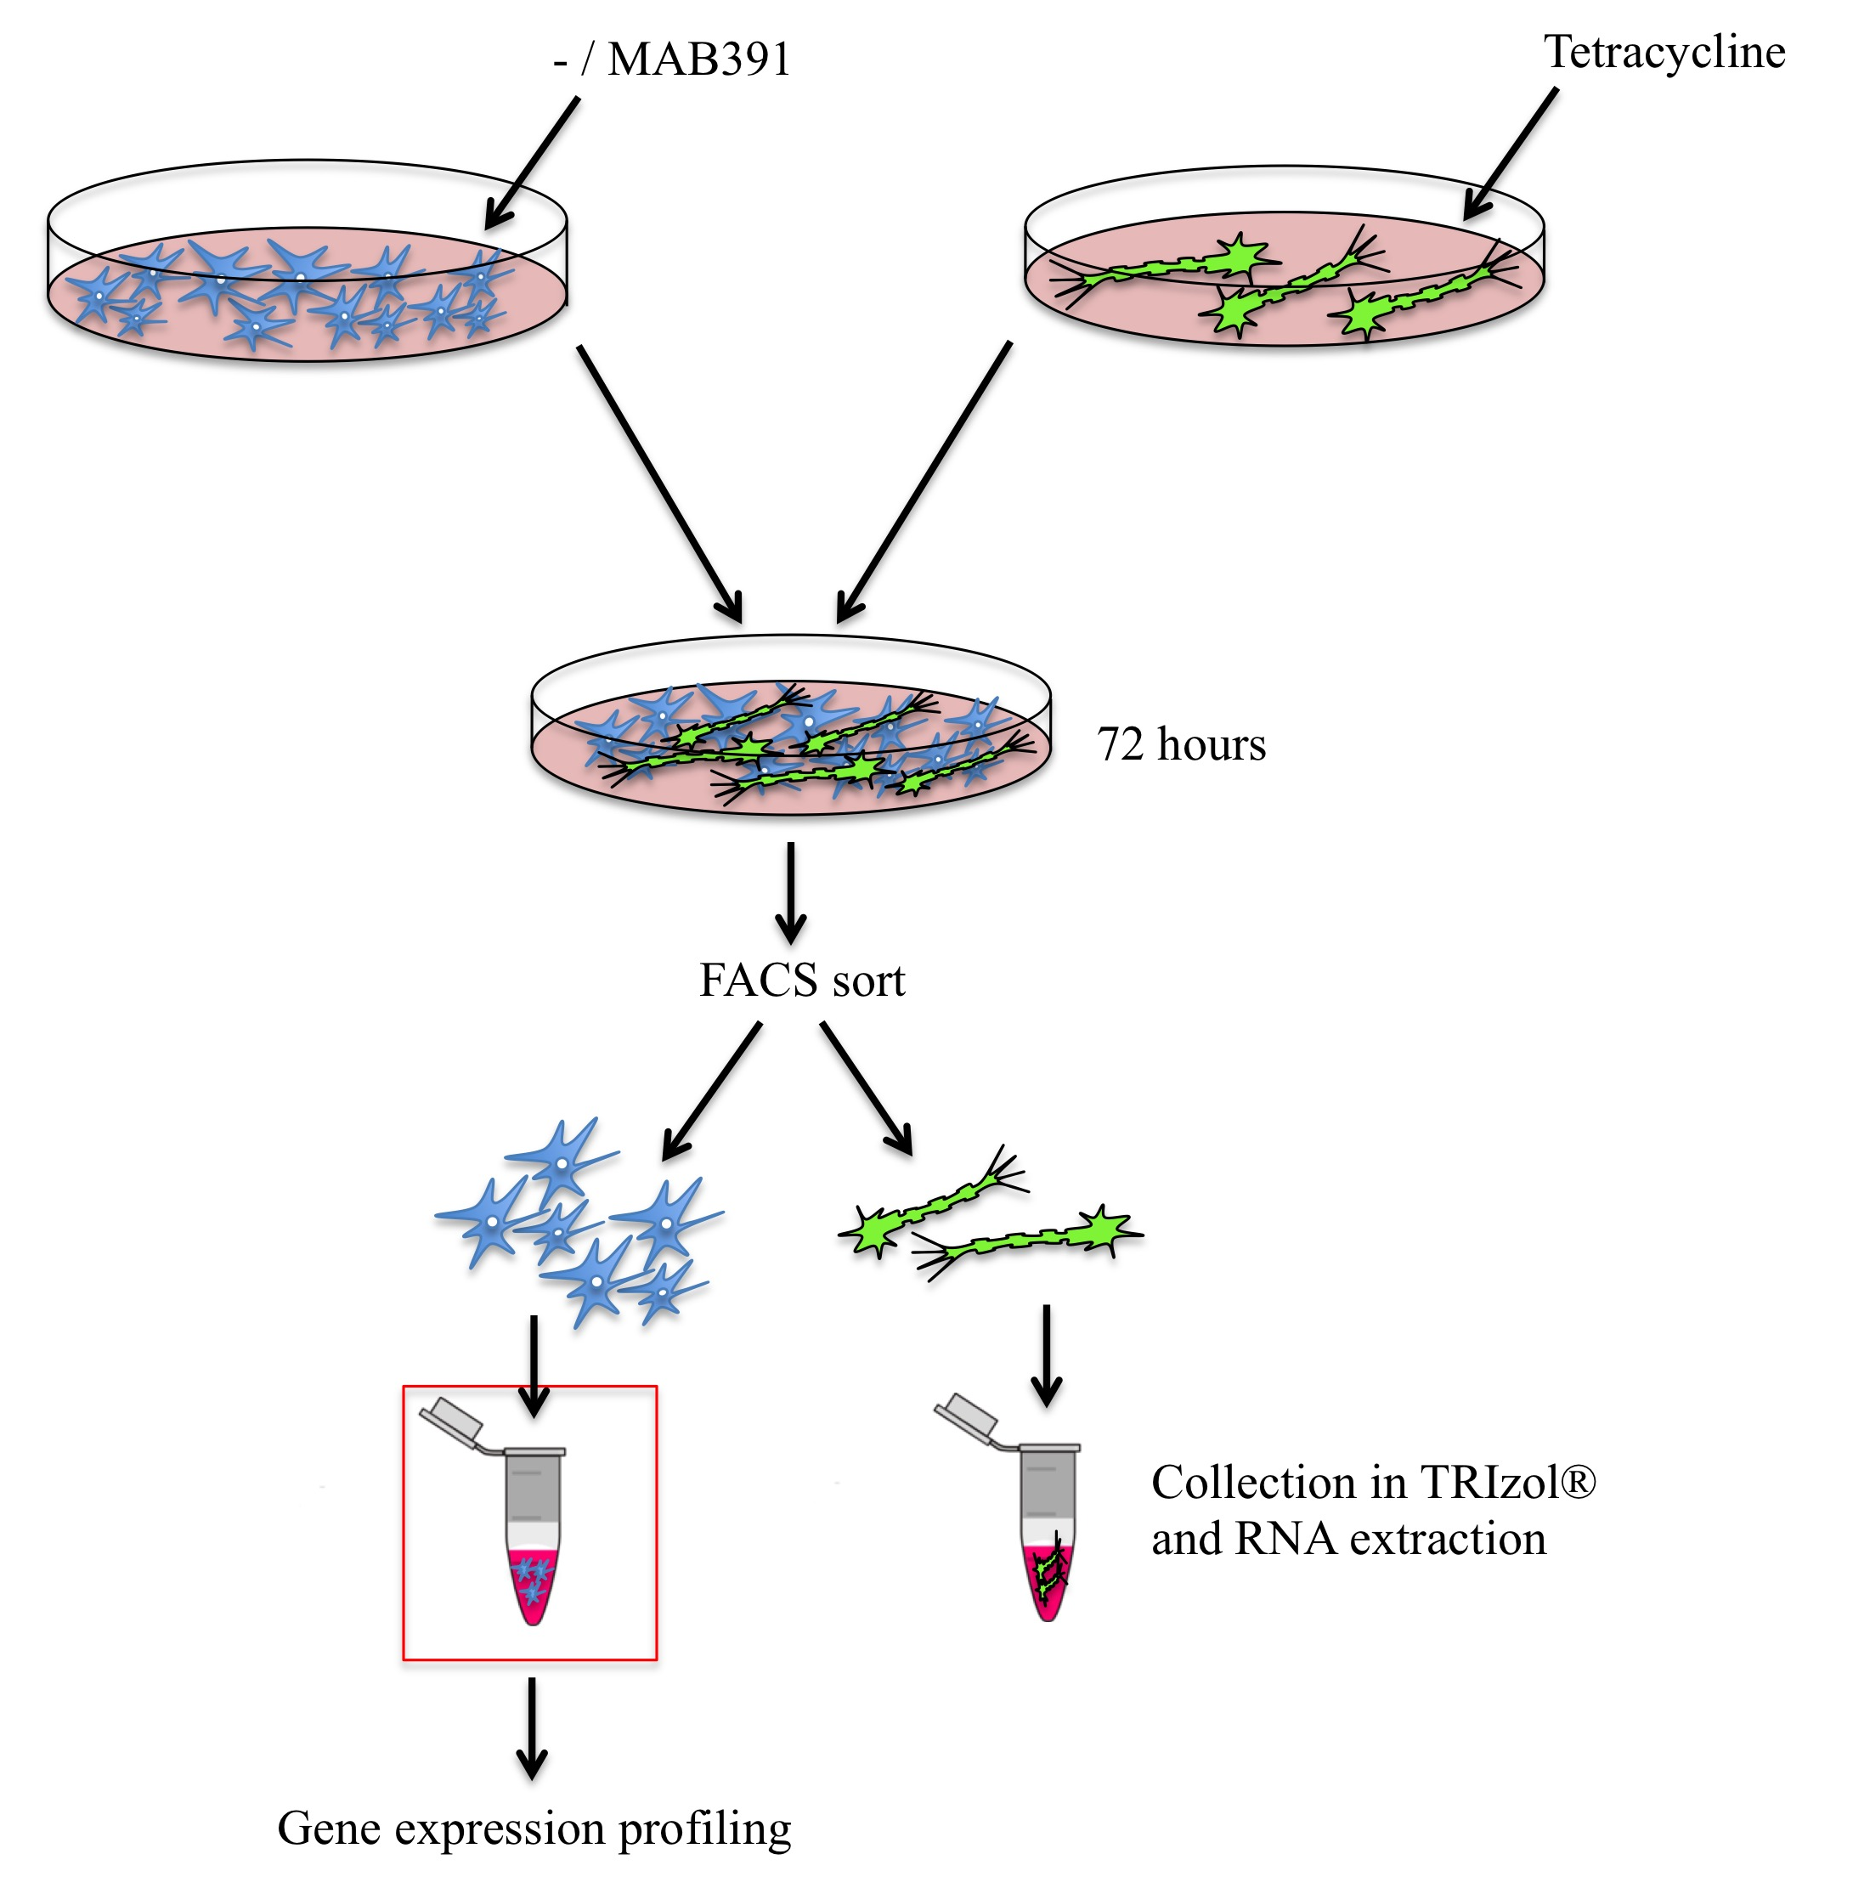

Figure 5.1. Outline of the experimental workflow for the treatment, co-culture and separation of human astrocytes and LUHMES prior to gene expression profiling. to assess the gene expression profile of IGF1 signalling impaired astrocytes.
Astrocytes were cultured in the presence and absence of MAB391 or IgG control for 24 hours prior to co-culturing with pre-differentiated GFP LUHMES for 72 hours. Co-cultures were then FACS sorted to enrich for neuronal and astrocyte populations. RNA was isolated from astrocytic populations and gene expression profiling undertaken to identify differentially expressed genes in IGF1 signalling impaired astrocytes compared with control astrocytes.

5.4 Results

5.4.1 Isolating populations of astrocytes and LUHMES from co-cultures

Cold-jet PBS wash technique
To identify the individual changes that occur in astrocytes in the co-culture system a protocol needed to be established to separate the astrocytes and neurons from each other in the co-culture system. Goudriaan et al (2014) demonstrated successful separation of astrocyte-neuronal co-cultures by cold-jet PBS wash. This technique is reported to achieve removal of 90% of neuronal bodies and associated neurons from co-cultured astrocytes (Goudriaan et al. 2014) and is based on cold PBS causing preferential detachment of neurons from the astrocytes.

Co-cultures were set up by plating two-day pre-differentiated neurons on top of astrocytes and cells were then co-cultured for 72 hours. Ice-cold PBS was ejected quickly from a pipette onto the cells in a concentric circling motion (as described by Goudriaan et al, 2014) to detach the upper layer of neurons from astrocytes. Despite observing detachment of neurons from astrocytes under the microscope, western blotting suggested cross-contamination of the astrocyte and neuronal populations (figure 5.2). NFL (neurofilament light) was used to detect neurons and GFAP to detect astrocytes. Due to the degree of cross contamination, an alternative method was developed to separate the cell populations.

A.

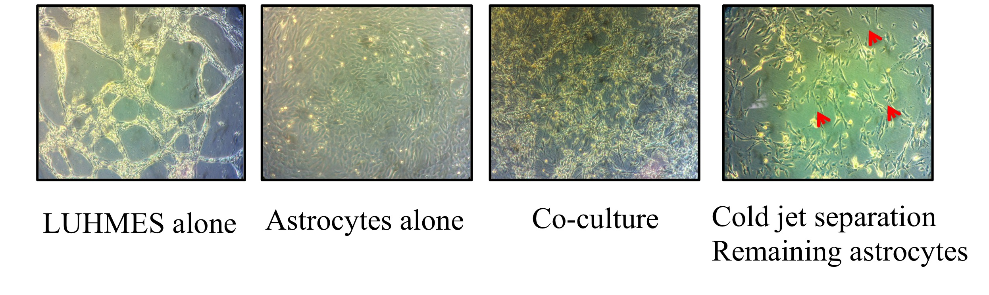
B.

Figure 5.2. Cold-jet PBS separation of astrocytes from neurons.
(A) Images represent LUHMES and astrocytes cultured separately, together, or show astrocytes remaining (red arrows) after using the cold-jet PBS separation technique to remove neuronal content. (B) Western blotting of glial fibrillary acidic protein (GFAP) (50kDa) and neurofilament-light (NFL) (68kDa) in astrocytes and neurons separated using the cold jet PBS separation technique. A1 are astrocytes separated from co-culture with N1 neurons. A2 are astrocytes separated from co-culture with N2 neurons (Co-cultures were established for 72 hours). Molecular weight markers are indicated (kDa).

5.4.2 FACS sorting of co-cultures

Co-cultured astrocytes and neurons have previously been successfully separated by FACS sorting. GFP astrocytes were separated from non-GFP neurons in an investigation of Nrf2 dependent genetic changes that alter astrocyte-neuron interactions and influence neuroprotection (Kraft et al. 2004). Here, GFP LUHMES were separated from unlabelled astrocytes using the FACS Aria. Two key features of the LUHMES enabled this technique to be used: LUHMES have much smaller cell bodies than astrocytes and they stably express GFP following lentiviral transduction. LUHMES could therefore be sorted from astrocytes based on fluoresence and size, which removed the need to fluorescently label the astrocytes. Optimisation of cell sorting was conducted on two independent co-culture populations in order to assess levels of separation at the RNA and protein level.

Following separation of the first co-culture, the sorted cells were lysed, protein was extracted and a western blot was used to assess separation of astrocytes and LUHMES. FACS sorted astrocytes expressed GFAP with no detectable amount of the neuronal marker NFL (Figure 5.3). FACS sorted neurons expressed NFL as well as low levels of GFAP. The supplier of the GFAP antibody (AbCam) suggest that the lower band in the western blot corresponds to a GFAP derived protein, whilst the upper band at 55kDa is the true GFAP band. Taken together, this blot suggests that the FACS sorting process has successfully enriched for astrocytic and neuronal populations at the protein level.

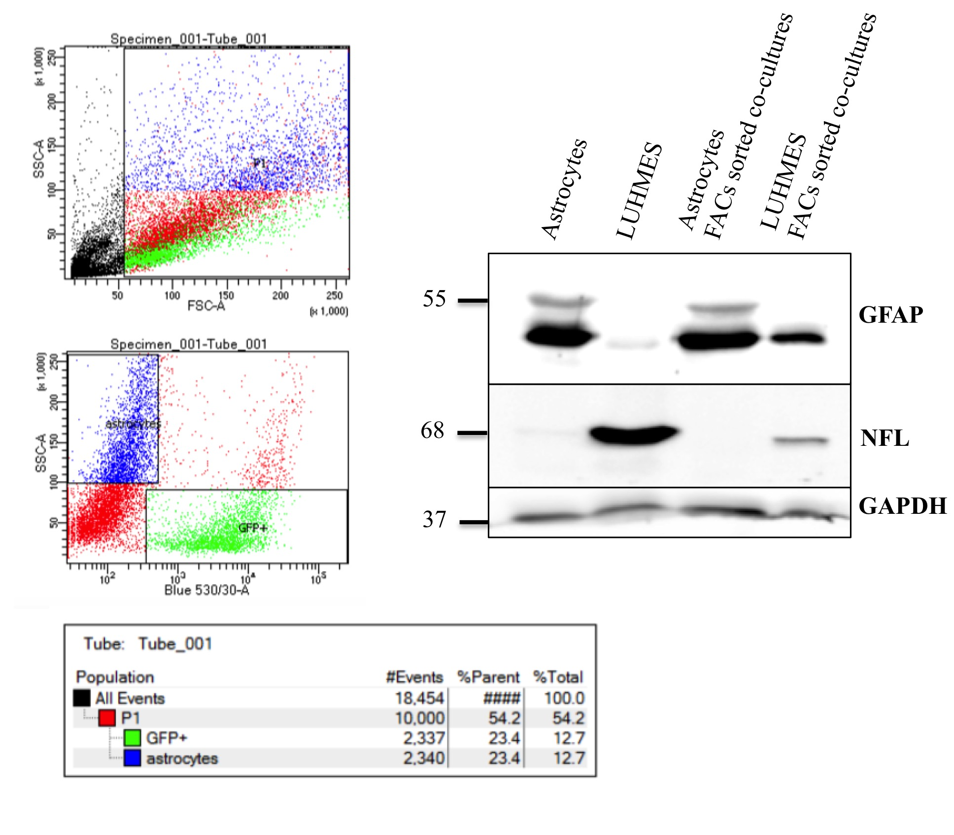
Figure 5.3. Optimising FACS sorting of astrocytes and LUHMES from co-culture 1.
Graphs show FACS sorting of astrocyte and GFP LUHMES co-cultures using the FACS ARIA. Co-cultures were separated according to size (FSC) and granularity (SSC), then assessed for the presence of GFP (Blue 530/30-A) to achieve populations of astrocytes (blue) and GFP+ neurons (green). In red are the astrocyte and neuron populations that could not be differentiated from each other and cell debris. Equal amounts of astrocytes and neurons were successfully sorted (12.7%). Sorted cell populations were then lysed and western blotted to assess levels of separation of co-cultures. FACS sorted co-cultures were also ran against both cell types in mono-culture. Glial fibrillary acidic protein (GFAP) was used to identify astrocytes and neurofilament-light (NFL) was used to detect neuronal presence, with glyceraldehyde 3-phosphate dehydrogenase (GAPDH) used as a loading control. The western blot demonstrates enrichment of astrocytes and LUHMES from co-culture at the protein level. Molecular weight markers are indicated (kDa).

Co-cultures were set up for a second time and FACS sorting was repeated to determine the level of separation of astrocytes and neurons at the gene expression level (figure 5.4 and appendix figure 7.3). Sorted astrocytes and neurons were harvested in TRIzol® reagent for RNA isolation and the expression levels of GFAP, NFL and NeuN transcripts were assessed in the FACS sorted co-culture compared with astrocytes and LUHMES in monoculture. Mono-cultured astrocytes express NFL at the RNA level, which makes NFL a poor choice of transcript for assessing separation of the astrocytes and LUHMES. Instead, NeuN expression was chosen to assess separation of the LUHMES and astrocytes as this is not expressed by astrocytes in monoculture. FACS sorted astrocytes have high expression of GFAP at the RNA level, with some expression of NeuN (figure 5.4). This suggests that there is some neuronal contamination of the astrocytes, which is not surprising since this is a contact dependent co-culture system. The FACS sorted neurons do not express GFAP at the RNA level and have high expression of NeuN (figure 5.4).

Taken together, these results indicate that FACS sorting of GFP LUHMES from astrocytes can produce enriched populations of both cell types, as revealed by RNA and protein expression.

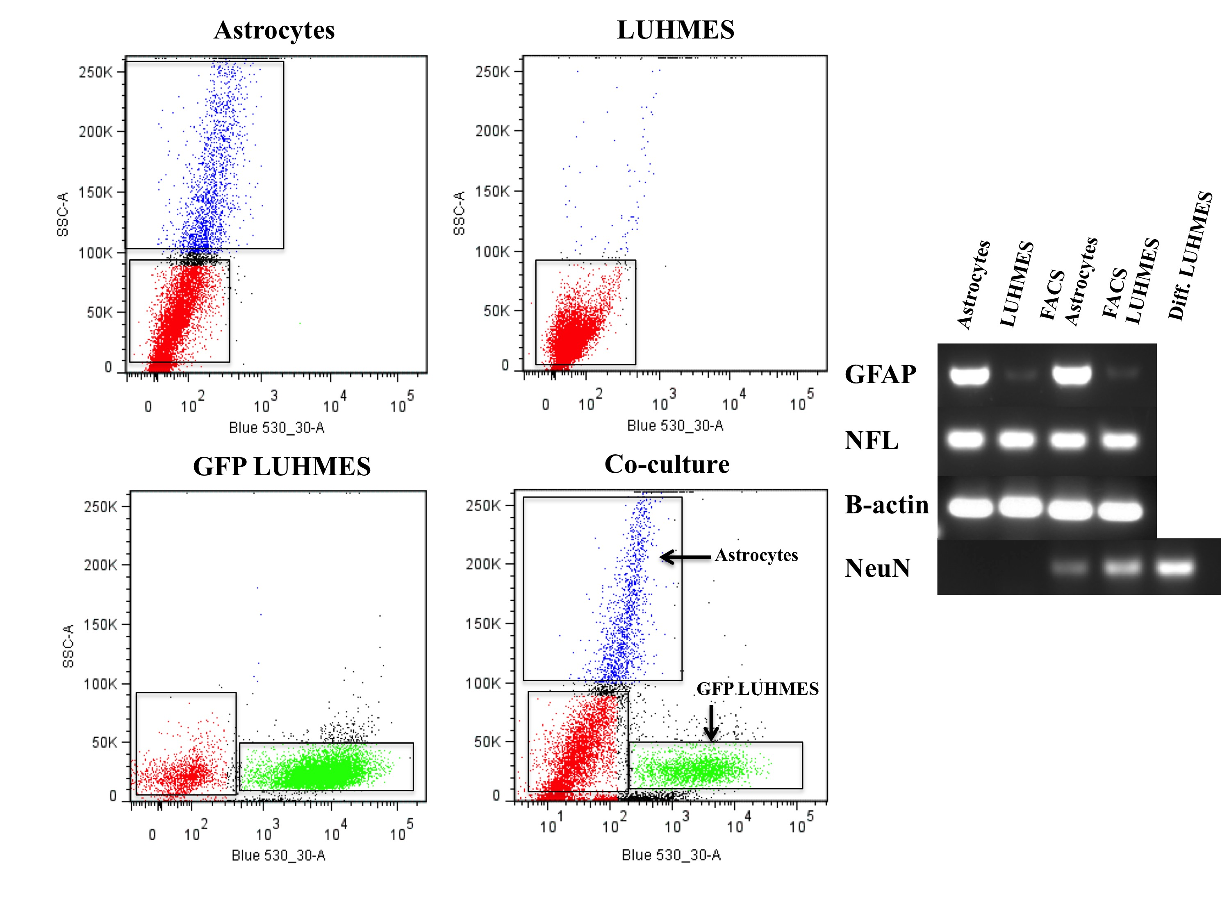

Figure 5.4. Optimising FACS sorting of astrocytes and LUHMES from co-culture 2.
FACS sorting of astrocytes and GFP LUHMES from co-culture using the FACS ARIA, with control astrocytes, LUHMES and GFP LUHMES used to set the gates. 18% of the total population of FACS sorted co-cultured cells were GFP LUHMES (green) and 11.2% were FACS sorted astrocytes (blue). Cells in red represent untransduced LUHMES or astrocytes that cannot be distinguished from one another. Co-cultures were separated according to size (FSC) and granularity (SSC), then assessed for the presence of GFP. DNA gel shows expression of the astrocytic marker glial fibrillary acidic protein (GFAP) and neuronal markers neurofilament-light (NFL) and the neuronal specific nuclear protein (NeuN) across a panel of astrocytes and LUHMES in monoculture or FACS sorted from co-culture. The DNA gel shows enrichment of astrocyte and neuronal populations following FACS sorting.

5.4.3 FACS sort of co-cultures for microarray analysis

Control and MAB391-treatd astrocytes were co-cultured with LUHMES for 72 hours prior to FACS sorting and separation of the co-cultures back into the individual cell types. Three sets of co-cultures were established from P5 GFP LUHMES and P7 ScienCell astrocytes. These were all plated, treated and FACS sorted on consecutive days. Samples will be referred to as C1/2/3 and M1/2/3, where C represents control, M represents MAB391-treated and the number indicates the independent co-culture experiment (for example C1 and M1 are control and MAB391-treated co-cultures set up at the same time).

On average, approximately 140 000 astrocytes and 132 000 neurons were collected from the FACS sort (figure 5.5 and table 5.1). Approximately 10% of the FACS sorted co-cultures were astrocytes and 15% of the total cell population of sorted cells were GFP LUHMES (figure 5.6). Cells were collected straight into media and later harvested in TRIzol® before isolating RNA using the Zymo Clean and Concentrate kit.

Table 5.1. Number of astrocytes and neurons collected from FACS sorted co-cultures.
FACS ARIA was used to separate control astrocytes from neurons and MAB391-treated astrocytes from neurons. Numbers are representative of cells collected.

Sample | Astrocytes collected | Neurons collected
Control 1 | 145735 | 83024
MAB391 1 | 142711 | 113649
Control 2 | 101038 | 127444
MAB391 2 | 89551 | 122781
Control 3 | 206968 | 155059
MAB391 3 | 176915 | 190594
AVERAGE | 143820 | 132092

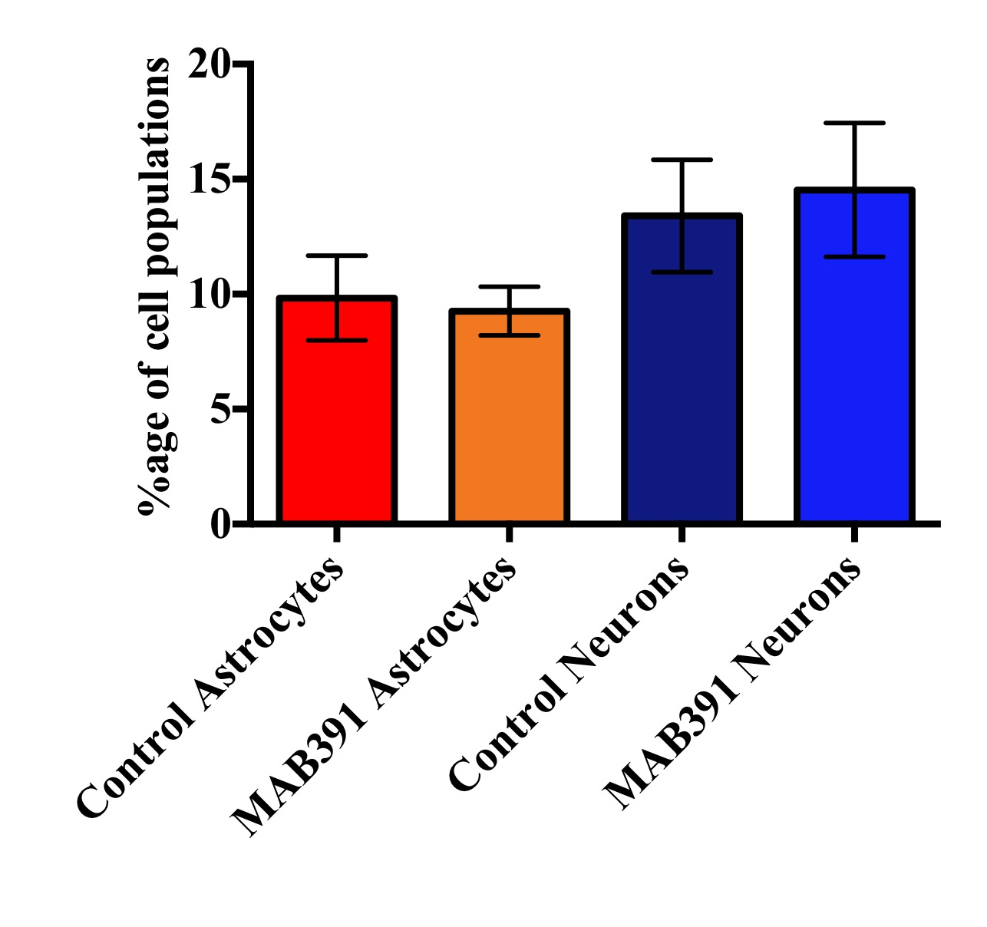

Figure 5.5. Percentage of astrocyte and neuronal populations FACS sorted.
On average, 10% of co-culture populations FACS sorted were astrocytes and approximately 15% collected were GFP LUHMES.

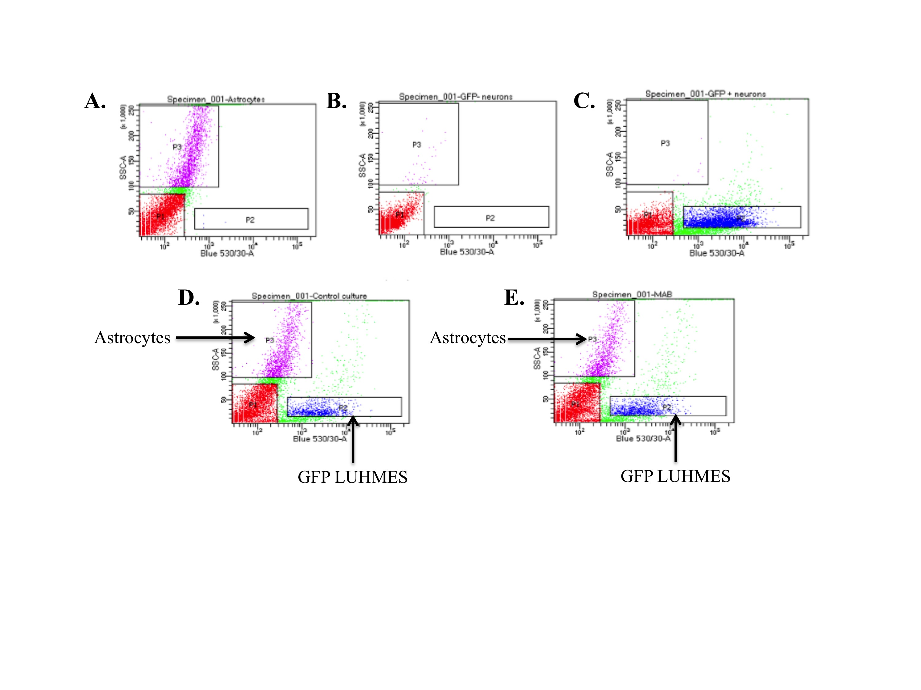

Figure 5.6. Representative graphs of the FACS separation of MAB391-treated or untreated astrocytes co-cultured with LUHMES for microarray analysis.
(A-C) Control astrocytes, GFP –ve neurons and GFP +ve neurons used to establish gates with which to sort co-cultures. (D-E) Cell sorting of untreated/MAB391-treated astrocytes co-cultured with GFP LUHMES. Graphs show two distinct cell populations according to the side scatter and fluoresence profile of the cells. Gate P2 (blue) represents GFP LUHMES and gate P3 (pink) represents an enriched population of astrocytes. The population of cells represented in red were disposed of and excluded from the study.

5.4.4 Testing RNA integrity of sorted astrocytes

Following RNA extraction, the RNA quality and yield were assessed using the Nanodrop™ 1000 spectrophotometer. On average the RNA yield was 46.07ng/μl ± 18.27 in a total of 10 μl nuclease free water. Quality of RNA was defined by using the ratio of A260/280 and each sample had a 260/280 ratio of approximately 2.00 (2.02 ± 0.13). Assessments of RNA Integrity (RIN) on the Agilent 2100 Bioanalyzer suggested high quality RNA with values of approximately 9.7 (9.65 ± 0.23) (Table 5.2). In addition, all RNA samples produced distinct 28S and 18S rRNA peaks on the electropherograms (figure 5.7), indicating that RNA was intact.

Table 5.2 Quality and yield of RNA extracted from control (untreated) and MAB391-treated astrocytes.
A Nanodrop™ 1000 spectrophotometer and Agilent 2100 Bioanalyzer were used to measure the concentration and quality of RNA extracted from control and MAB391-treated astrocytes. Quality of RNA was defined by using the ratio of A260/280. RNA integrity was measured using the Agilent 2100 Bioanalyzer. RNA Integrity Number (RIN) is measured on a scale of 0-10, with values of 0 representative of completely degraded material and values of 10 being completely intact.

Sample | RNA yield (ng/μl) | A260/280 | A260/230 | RIN | 28S/18S rRNA ratio
Control 1 | 34.73 | 2.01 | 1.84 | 9.7 | 2.1
MAB391 1 | 43.33 | 2.05 | 2.13 | 9.5 | 2.1
Control 2 | 39.84 | 1.8 | 1.57 | 10 | 1.7
MAB391 2 | 37.26 | 2.02 | 0.32 | 9.4 | 2.1
Control 3 | 82.91 | 2.08 | 1.16 | 9.8 | 1.7
MAB391 3 | 38.32 | 2.2 | 1.85 | 9.5 | 2.2
Mean ± SD | 46.07 ± 18.27 | 2.02 ± 0.13 | 1.48 ± 0.65 | 9.65 ± 0.23 | 1.98 ± 0.22

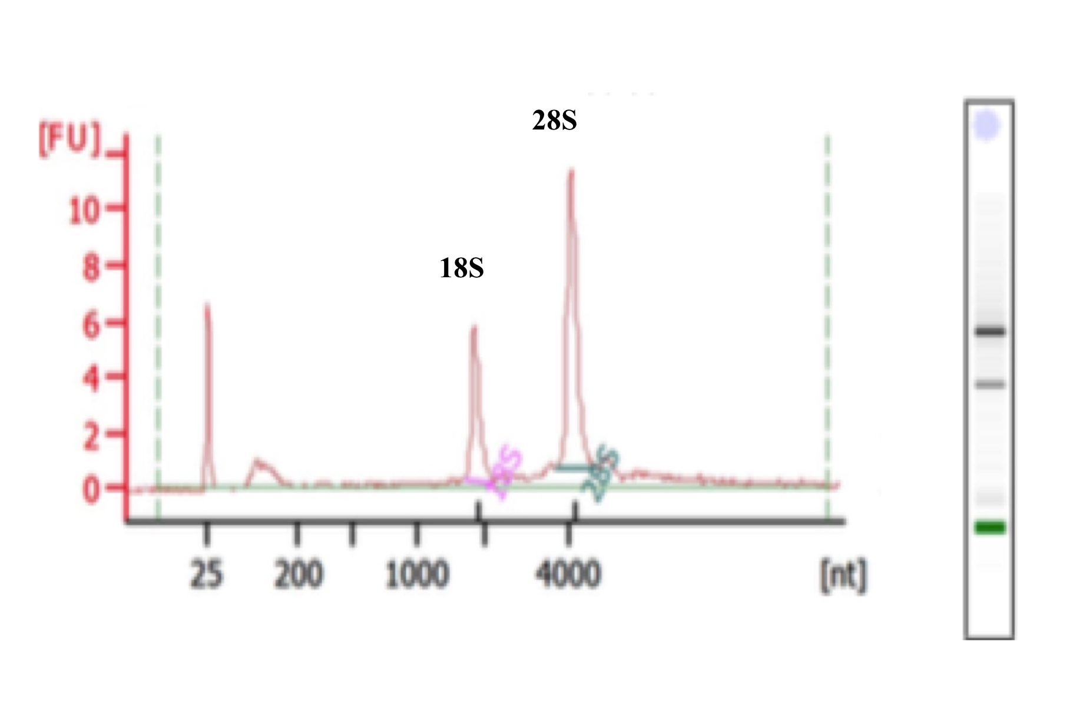
Figure 5.7 Assessment of RNA integrity of astrocytes using the Agilent 2100 Bioanalyzer
An example electropherogram and corresponding electrophoresis gel produced by the Agilent 2100 Bioanalyzer used to assess the RNA integrity of extracted RNA samples from FACS sorted astrocytes. The labelled peaks are representative of 18S and 28S rRNA and suggest that the RNA was intact. (FU-fluorescence unit).

5.4.5 RNA precipitation of FACS sorted astrocytes

Affymetrix recommend that the input RNA for microarray analysis is between 50ng and 500ng. Due to the low RNA yields being collected from the FACS sorted astrocytes and in order to generate an optimum concentration of RNA for the microarray preparation steps, a glycoblue precipitation process was carried out. Ambion® GlycoBlue™ coprecipitant (described in chapter 2, section 2.2.5) was used to facilitate precipitation of the nucleic acid and incubated with RNA samples for 24 hours at -20°C using the ratios calculated in table 5.3. The sample was then centrifuged and washed with 70% ethanol before resuspending in 3μl of nuclease free water. This ensured that 250ng of RNA of each sample could be included in the subsequent preparations.

Table 5.3. Volumes of RNA used for glycoblue RNA precipitation to generate 250ng of input RNA.

Sample | Sample (μl) | Glyco Blue (μl) | Ammonium acetate (μl) |  | Isopropanol (μl)
Control A | 7.2 | 1 |  | 0.5 | 8.7
MAB391 A | 5.8 | 1 |  | 0.5 | 7.2
Control B | 6.3 | 1 |  | 0.5 | 7.8
MAB391 B | 8.0 | 1 |  | 0.6 | 9.6
Control C | 3.0 | 1 |  | 0.3 | 4.0
MAB391 C | 6.5 | 1 |  | 0.5 | 8.0

5.4.6 Preparation of RNA for Microarray analysis

250ng of input RNA was reverse transcribed using a mixture of both random and oligo dT primers containing a T7 promoter sequence. This reaction synthesizes single-stranded cDNA with a T7 promoter sequence at the 5’ end. DNA polymerase and RNase H are then used to synthesise a second strand of cDNA and in parallel nick the RNA. T7 RNA polymerase was then be used to transcribe and amplify the second-strand cDNA template to complimentary RNA (cRNA). Purification beads were used to remove salts, enzymes, inorganic phosphates and unincorporated nucleotides from cRNA. The NanoDrop 1000 spectrophotometer was used to determine the yield of purified cRNA. On average, 1294.48 ± 651.93 ng of cRNA was collected following purification, with a 260/280 ratio of 2.14 ± 0.03 (table 5.4).

Table 5.4. Yield of cRNA post-amplifcation

Sample | cRNA yield (ng) | 260/280
Control 1 | 993.88 | 2.17
MAB391 1 | 2594.12 | 2.13
Control 2 | 789.33 | 2.16
MAB391 2 | 1055.07 | 2.18
Control 3 | 1186.58 | 2.1
MAB391 3 | 1147.88 | 2.12
Mean ± SD | 1294.48 ± 651.93 | 2.14 ± 0.03

15μg of cRNA was reverse transcribed using in vitro transcription to synthesise sense-strand cDNA, with dUTP’s being incorporated into the ss-cDNA. RNase H was then used to hydrolyse the cRNA template leaving the single stranded cDNA (ss-cDNA). A second purification was carried out using purification beads to remove salts, enzymes and unincorporated dNTPs. The Nanodrop 1000 Spectrophotometer identified that approximately 311.48 ± 77.84ng of ss-cDNA was generated from this process (table 5.5).

Table 5.5. Yield of ss-cDNA (ng/μl) in a total of 31.2 μl

Sample | Single-stranded cDNA yield (ng/μl) | 260/280
Control 1 | 263.95 | 2.16
MAB391 1 | 445.20 | 2.13
Control 2 | 245.43 | 2.11
MAB391 2 | 364.00 | 2.11
Control 3 | 261.05 | 2.08
MAB391 3 | 289.24 | 2.05
Mean ± SD | 311.48 ± 77.84 | 2.11 ± 0.04

5.5μg of purified ss-cDNA was fragmented by uracil-DNA glycosylase (UDG) and apurinic/apyrimidinic endonuclease 1 (APE 1) at the dUTP residues to break the DNA strand. Fragmentation was confirmed using the Agilent 2100 Bioanalyser (figure 5.8). The fragmented cDNA was then labelled with biotin using terminal deoxynucleotidyl transferase (TdT) and the Affymetrix proprietary DNA labelling reagent that is covalently linked to biotin. A gel-shift assay was used to assess biotin labelling of the cDNA (figure 5.9) and demonstrated successful labelling of all six samples (C1-M3). This labelling step is important for efficient hybridisation of samples to GeneChip arrays (washing and hybridisation steps are described in chapter 2, section 2.2.6).

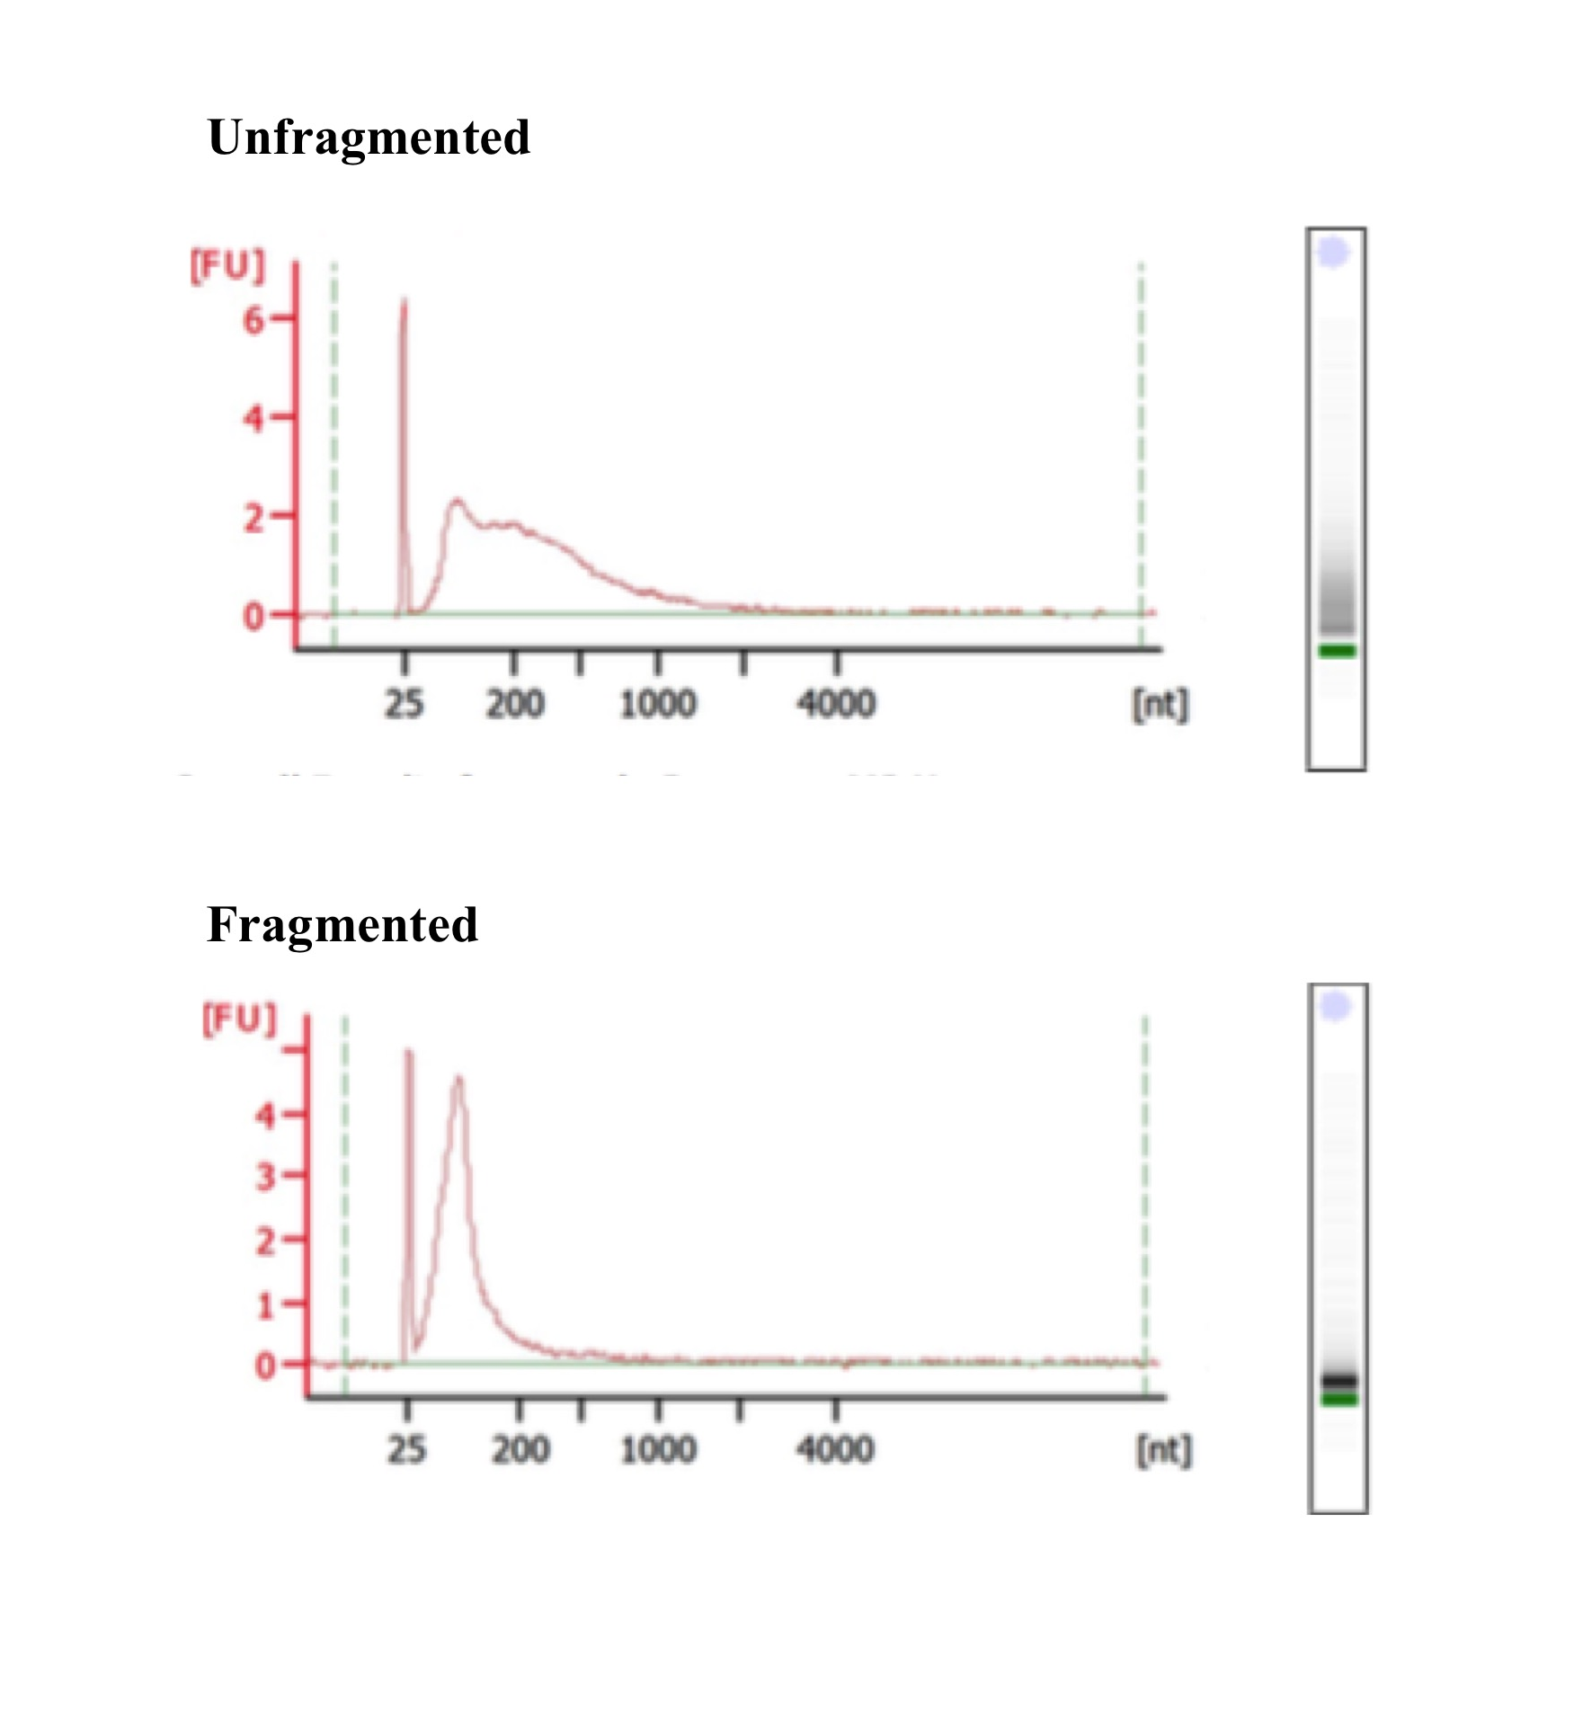
Figure 5.8. Assessing fragmentation of ss-cDNA.
An example electropherogram and corresponding electrophoresis gel produced by the Agilent 2100 Bioanalyzer used to assess fragmentation of ss-cDNA. The shift in the peak to the left is indicative of successful fragmentation. (FU=fluorescence unit).

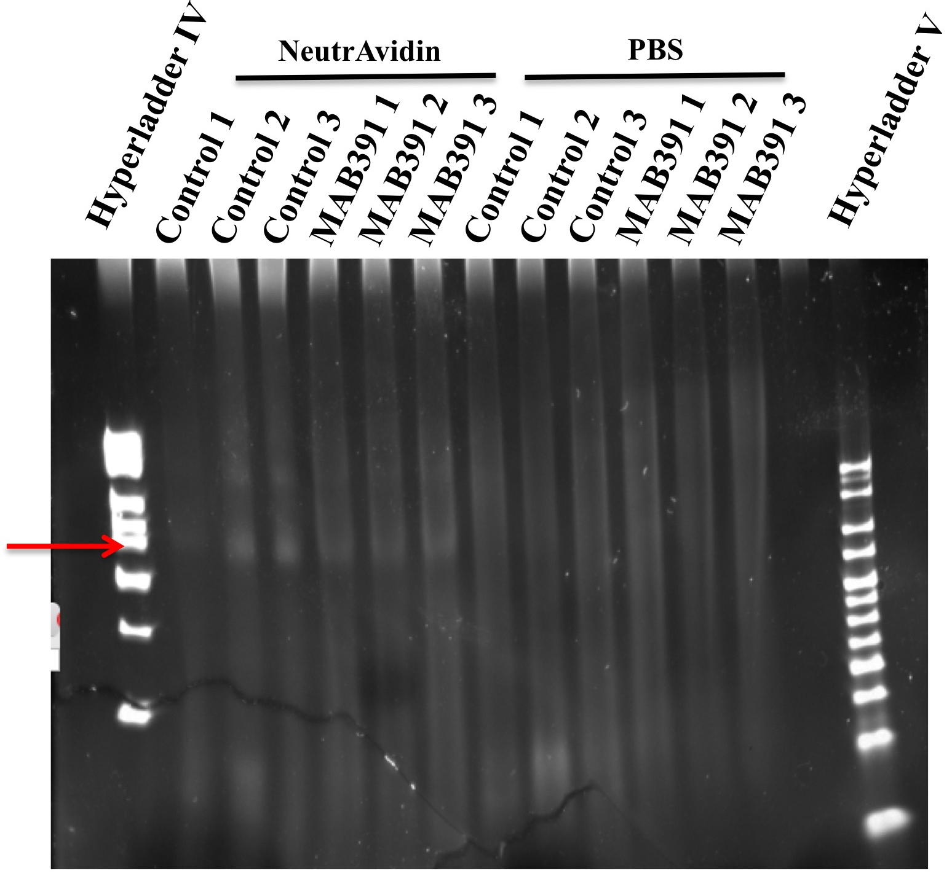

Figure 5.9. Assessing biotinylation of fragmented ss-cDNA.
Fragmented samples were treated with NeutrAvidin or PBS prior to electrophoresis and gels were stained with SYBRgold to stain nucleic acids. The red arrow indicates successful biotinylation across all six NeutrAvidin treated fragmented samples.

5.4.7 Affymetrix® Quality Control Metrics

There are several parameters that need to be checked to ensure reliable data could be retrieved from the arrays. Affymetrix® recommend monitoring hybridisation and labelling, assessing the positive versus negative area under the curve (pos vs neg AUC), the all probe set mean signal intensities and the relative log expression (RLE) mean. By assessing each of these parameters in turn, any outlier experiments can be removed at later stages of statistical analysis. It is also recommended that values should be within 2 standard deviations of the mean and any sample outside of this value should be considered an outlier. Arrays with values that regularly fall outside of the standard deviation should be omitted from the study.

Assessment of labelling and hybridisation
Bacterial poly-A transcripts supplied by Affymetrix were spiked in to each sample to monitor the entire target preparation, irrespective of the starting material quality. The eukaryotic Genechip arrays contain probe sets of a panel of B.subtilis genes that are added to individual samples at different concentrations in the order lys, phe, thr and dap (1:100 000, 1:50 000, 1:25 000 and 1:6667). By assessing the hybridisation intensities of these poly A controls, the efficiency of the labelling process could be examined. From figure 5.10, it is evident that the labelling efficiency of samples C3 and M3 is lower, particularly with regards to the dap and thr poly-A RNA spike-in controls. The signal intensities for the other samples C1, C2, M1 and M2 appear to have been labelled efficiently.

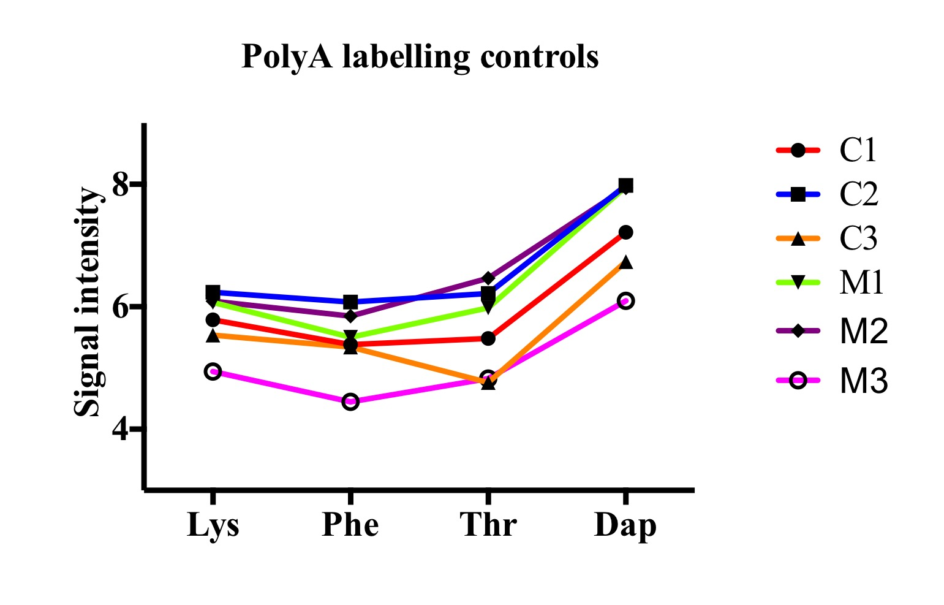
Figure 5.10. Assessing the hybridisation intensities of the poly-A RNA spike-in controls on GeneChip arrays.
Signal intensities for the four poly-A RNA spike in controls, which were added to individual samples (dap, thr, phe and lys, listed from highest to lowest spike-in concentration) as an independent assessment of the labelling process. (C=control astrocytes and M=MAB391-treated astrocytes and the number indicates the experiment)

In addition, four spike in controls BioB, BioC, BioD (biosynthesis genes found in E.coli) and Cre (a recombinase gene found in P1 bacteriophage) were added to the hybridisation master mix at increasing concentrations (1.5, 5, 25 and 100pM). These should not cross-react with the astrocytic derived ss-cDNA and therefore higher concentrations of spike-in controls should produce greater signal intensities. As shown in figure 5.11, there is a trend towards an increase in signal intensity with higher concentrations of spike in controls, in each of the samples C1-M3. Sensitivity of the assay is displayed by spiking in the BioB control, which at the concentration of BioB used, is at the detection limit of the array. These results suggest that labelling of samples C3 and M3 has not occurred as efficiently as with the other samples but overall, hybridisation across samples was successful.

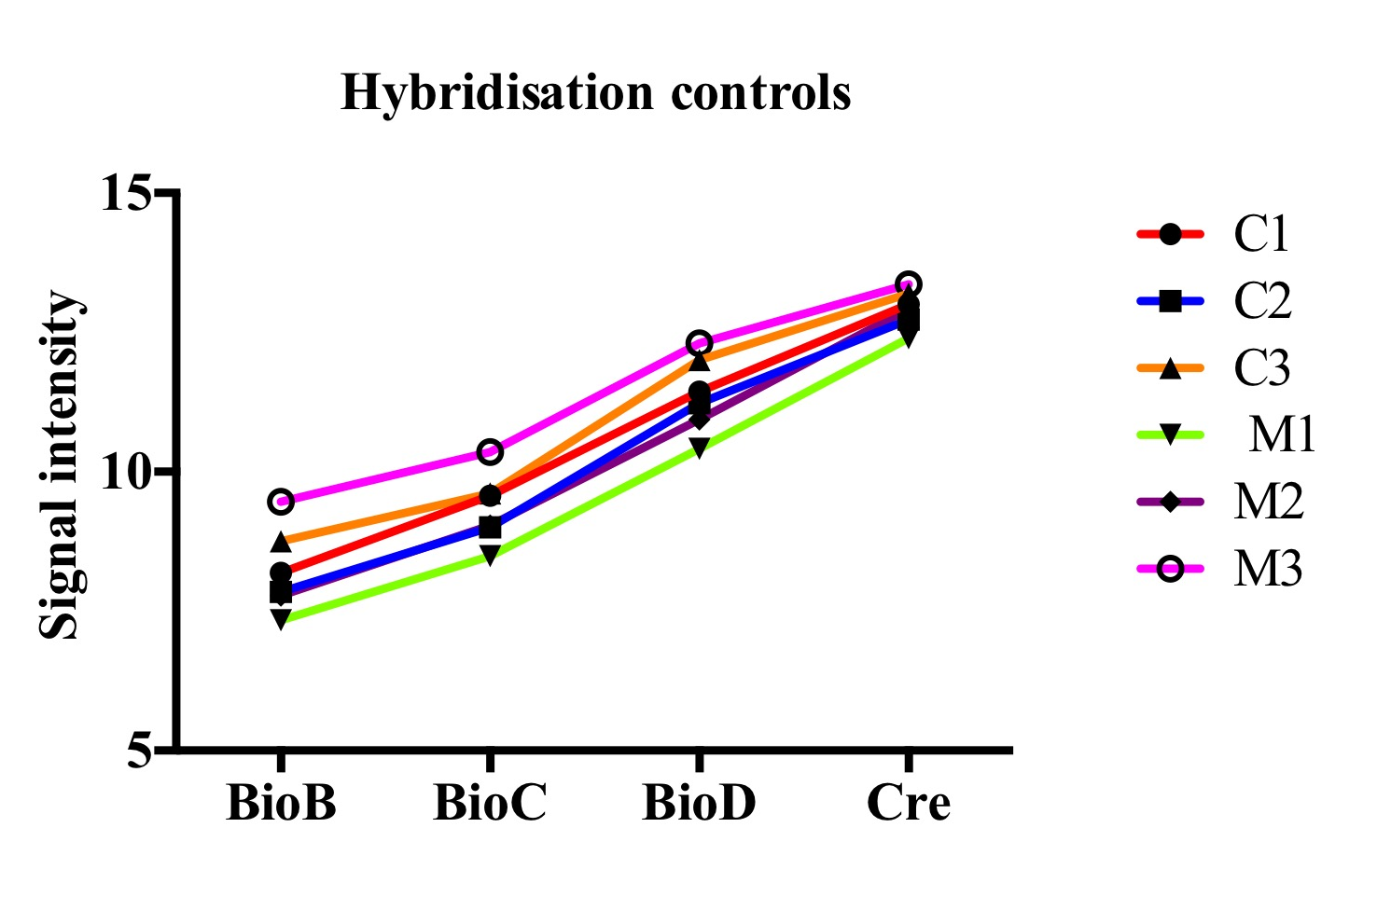
Figure 5.11. Eukaryotic Hybridisation controls for Astrocytes.
Signal intensities of eukaryotic hybridisation controls (BioB, BioC, BioD and CreX) at increasing concentrations (1.5, 5, 25 and 100pM) in the hybridisation mix of each sample. Measurements taken on the Affymetrix Expression Console. (C=control astrocytes and M=MAB391-treated astrocytes and the number indicates the experiment).

Comparing signal intensities between the arrays.
The GeneChip® Human Gene ST (GST) arrays feature 352859 different probe sets. A histogram (figure 12A) has been used to directly compare the intensity of signals of the different probe sets across the six samples. In theory, the profile of the signal intensities should be the same across the different samples. This is true of all samples apart from C3 and M3, and is consistent with earlier findings that the labelling process may also not have worked as effectively in these samples. A Pearson’s correlation was carried out (figure 12B) to compare signal intensities for each of the probe sets between different samples. It is clear that the signal intensities of C3 and M3 lie outside the range of the other samples in the array.

Positive vs Negative Area Under the Curve (AUC)
Positive versus negative area under the curve is a value assigned to the overall data quality. Essentially it is a measure of the detection of the positive control over a false detection of a negative control and therefore measures how well an array can detect the “true” signal over background noise. AUC values of 1 are a reflection of detecting true signal perfectly over noise. AUC values of 0.5 are indicative of background noise. The mean AUC value for the six arrays is 0.83 (table 5.6), which suggests that there is more detection of true signal over noise. AUC values of 0.8 or below should be flagged as potential outliers. The “M3” array has an AUC of 0.77 and therefore should be highlighted as a potential outlier. The “C3” array also has an AUC value that sits closer to 0.8. Figure 5.13, displays these metrics graphically and highlights differences between the C3 and M3 arrays compared with the other four arrays, however the values for these are still within 2 standard deviations of the mean. Therefore although C3 and M3 have lower AUC values, in general there appears to be no signficant differences in the AUC values between the arrays.
A.
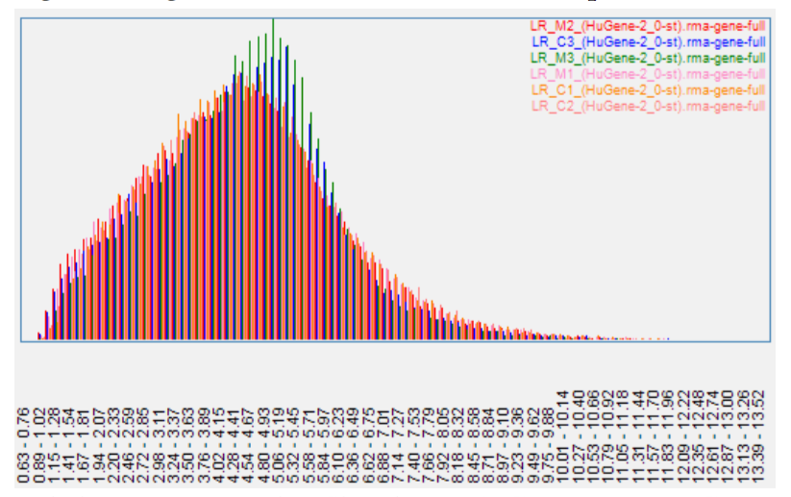

B.
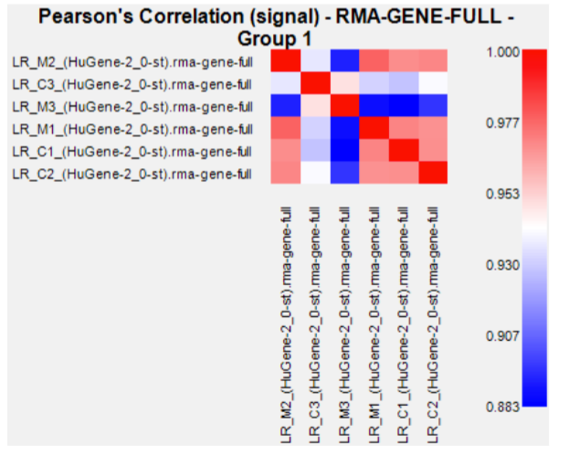

Figure 5.12. A histrogram (A) and Pearson’s correlation (B) performed to compare the signal intensities of the different probe sets between the six samples (C1-M3)
(C=control astrocytes and M=MAB391-treated astrocytes and the number indicates the experiment).

Figure 5.13. A graph to demonstrate the positive versus negative AUC values across the six arrays.
AUC is a measure of data quality, which has been displayed graphically for each of the samples C1-M3. (C=control astrocytes and M=MAB391-treated astrocytes and the number indicates the experiment)

All Probe Set Mean
The all probe set mean identifies the level of signal of all the probe sets in an array and therefore provides a measure of how bright or dim an array is. Across all six arrays the all probe set mean is 4.49 ± 0.03 (table 5.6). The all probe set mean value appears to be slightly higher in sample M3, but this is not more than 2 standard deviations higher than the mean. This suggests that the all probe set mean values across the arrays are relatively similar.

Table 5.6. Summary of quality control metrics for control and MAB391 gene arrays.
Displayed are the positive versus negative AUC, all probe set mean and standard deviation and all probe set RLE means and standard deviation. The mean and standard deviations are shown at the bottom of the table for all metrics. Potential outliers are highlighted in yellow.

Sample | Pos vs Neg AUC | All probe set mean | All probe set Stdev | All probe set RLE mean | All probe set RLE Stdev
C1 | 0.84 | 4.49 | 1.75 | 0.21 | 0.24
C2 | 0.84 | 4.49 | 1.78 | 0.21 | 0.22
C3 | 0.81 | 4.50 | 1.69 | 0.32 | 0.36
M1 | 0.86 | 4.46 | 1.8 | 0.21 | 0.22
M2 | 0.85 | 4.47 | 1.79 | 0.19 | 0.21
M3 | 0.77 | 4.54 | 1.59 | 0.46 | 0.49
Mean | 0.83 | 4.49 | 1.73 | 0.27 | 0.29
Stdev | 0.03 | 0.03 | 0.08 | 0.11 | 0.11

Relative Log Expression (RLE) Signal
The Relative Log Expression (RLE) signal is calculated by comparing the signal intensity of each probe against the median signal value across all arrays in the experiment. The standard deviation of the RLE of all probe sets can be plotted, which provides a robust tool to assess data quality across arrays within the same experiment. Poor quality arrays can be identified by a large spread of data and should be highlighted as potential outliers. Figure 5.14 shows box plots of the RLE signals across the six different arrays. Most of the arrays show a similar spread of RLE signal at the gene level, however the RLE mean for M3 is outside the range of the standard deviation of the mean of all the experiments and although this is not the case for C3, the RLE mean values are noticeably higher. Based on the RLE mean values alone, M3 appears to be an outlier and C3 shows a similar trend to M3, but is not strictly an outlier.

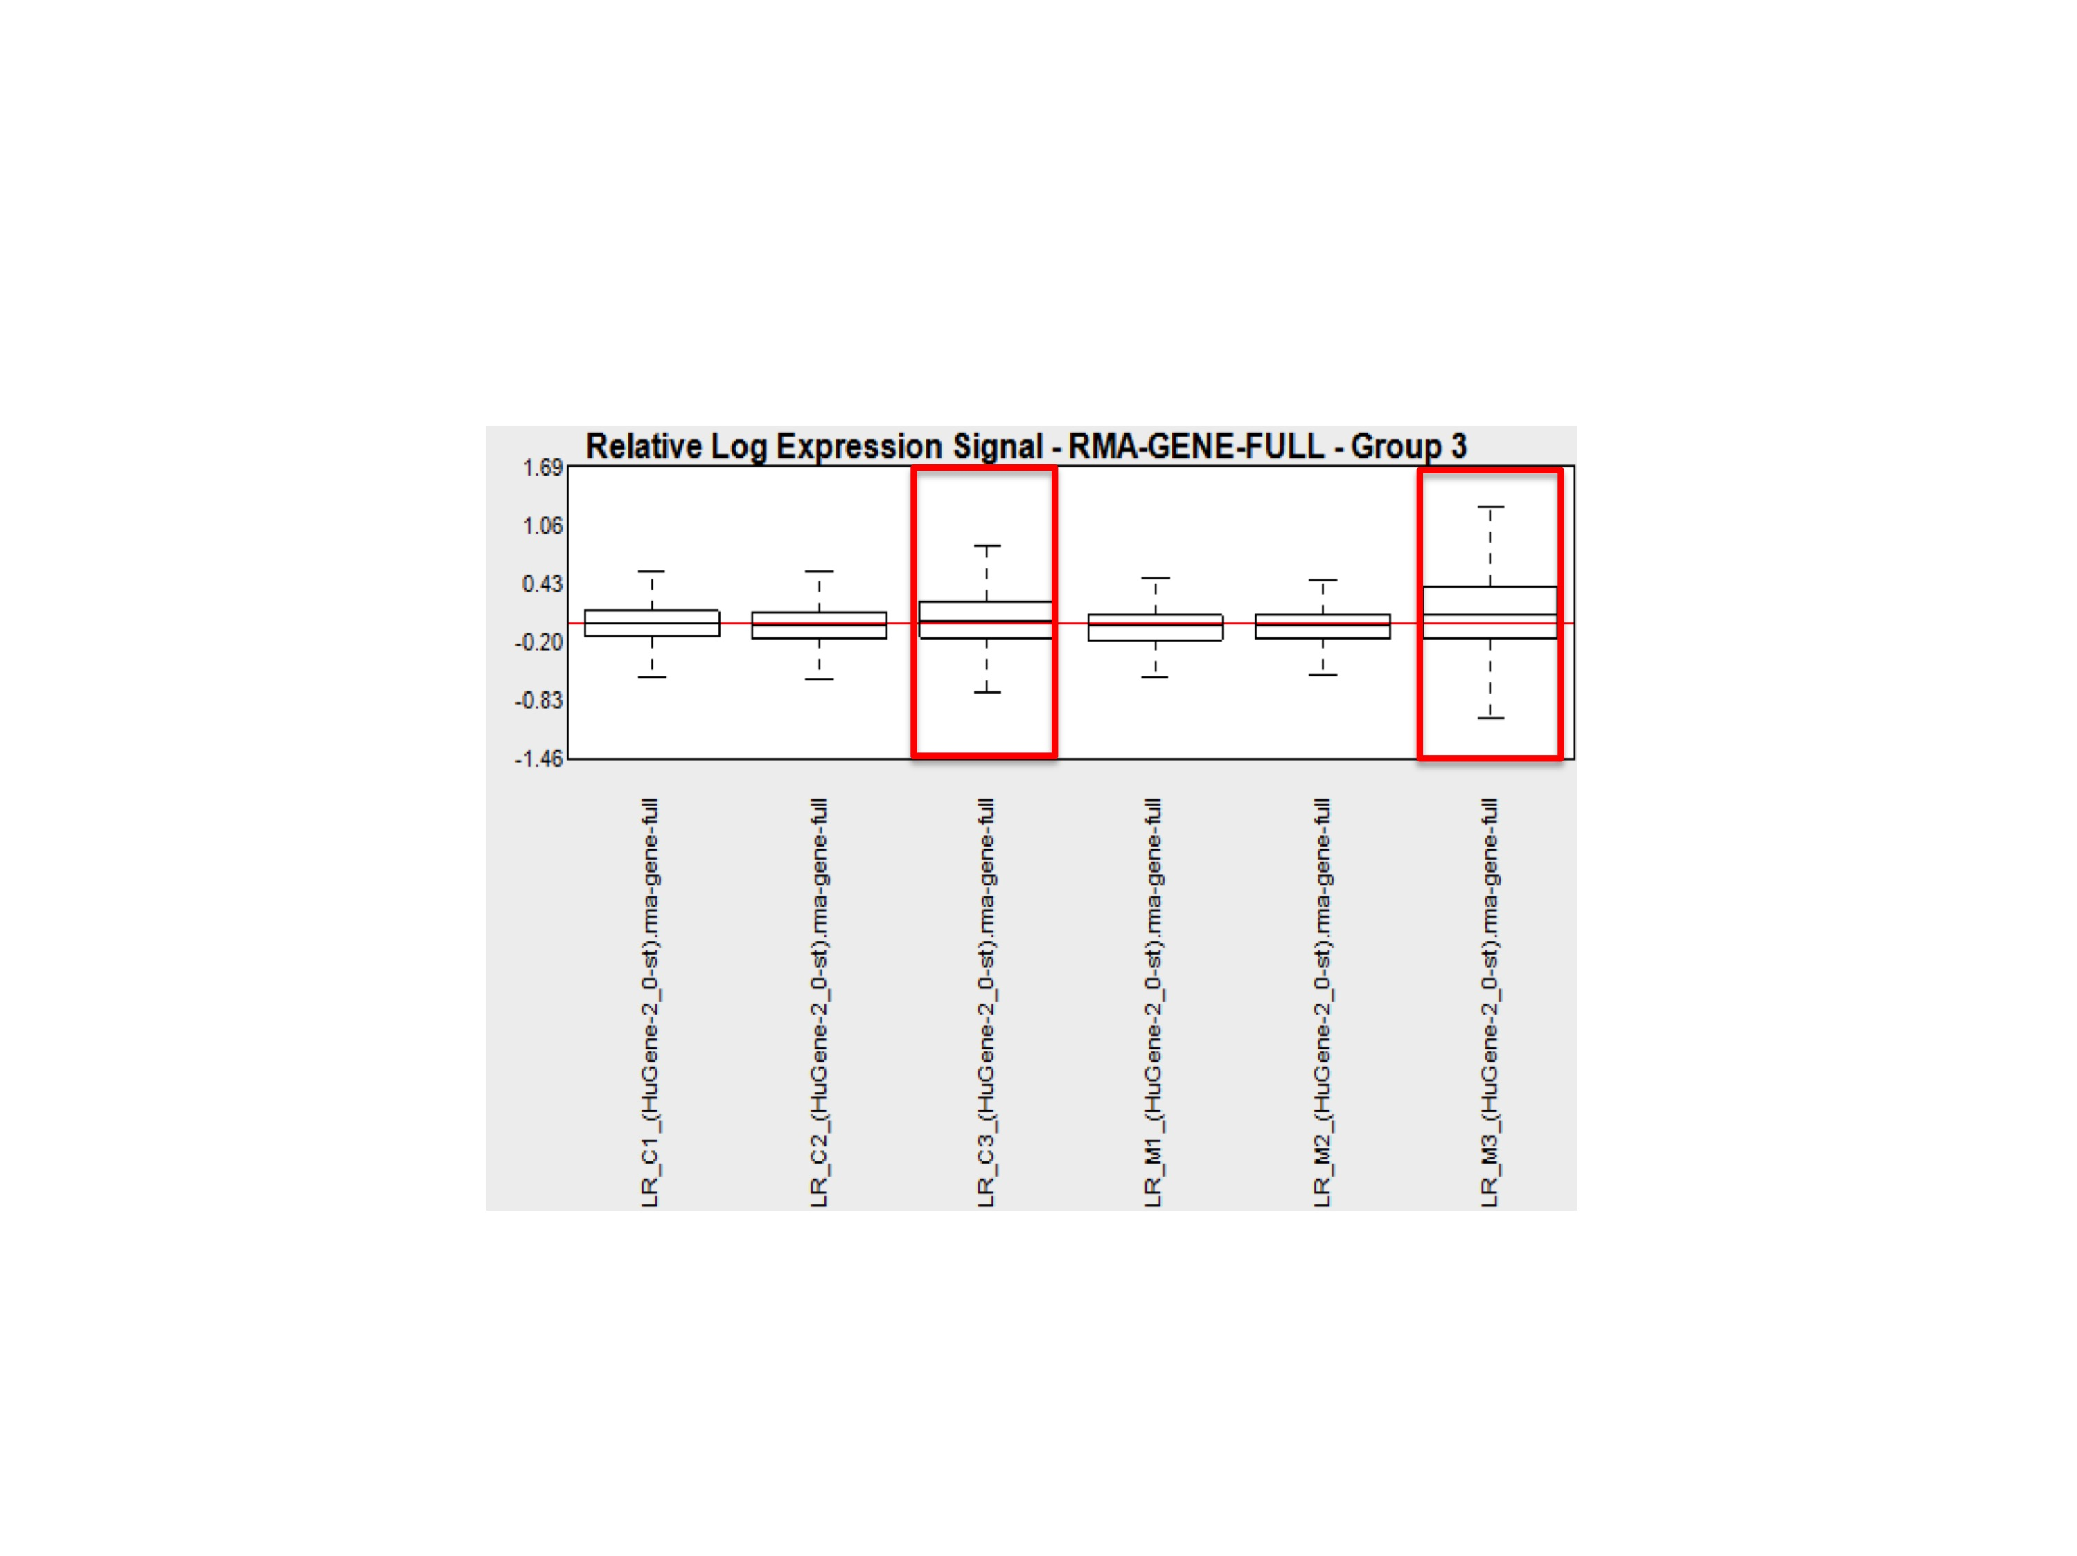

Figure 5.14. Relative log expression (RLE) box plots for GENE level arrays.
Box plots display the distribution of RLE values for the GENE level arrays. Red boxes indicate potential outliers (C3 and M3).

Quality Control Summary and justification for exclusion of samples
After performing the recommended quality control checks, it was apparent that the “M3” array consistently had metrics that were outside of the trend of the other arrays and sometimes had values that Affymetrix® recommend not to pursue further. Array “C3” also had a trend towards values that reflected those in the “M3” array. Based on this, it was decided that the parallel experiments “C3” and “M3” would be omitted from the pathway analysis performed in section 5.4.8.2 and 5.4.8.3. However, signal intensities from these arrays were later used as a guide to select genes to validate the differentially expressed genes identified from the comparison of C1 and C2 versus M1 and M2.

5.4.8 Data Analysis

i) Clustering Analysis performed by Qlucore Omics Explorer to identify differentially expressed genes in IGF1 signalling impaired astrocytes
All Affymetrix CEL.files were imported into Qlucore Omics Explorer (version 3.0) for identification of the most significant changes in genes between control and MAB391-treated astrocytes. The RMA sketch method was used to normalise the data and subtract background signal. One of the main criteria for analysis performed in Qlucore Omics Explorer is that a sufficient number of differentially expressed transcripts are generated. To aid programs such as The Database for Annotation, Visualisation and Integrated Discover (DAVID) and Integrated Molecular Pathway Level Analysis (IMPALA), which are used to deduce hypothetical pathways that could be altered between groups, it is important to input a comprehensive list of significantly altered genes. Programs such as DAVID can analyse up to 3000 transcripts. A filtering criteria of FC (fold change) ≤ 1.2 and a significant value of P < 0.05 was set, which identified changes in 2815 transcripts between the two groups. An FC of 1.2 was chosen as it meant that more transcripts showing significant differences could be inputted into pathway enrichment analysis and help highlight which biological pathways were altered, if any.

Clustering analysis was initially performed on all six arrays using multi-group analysis and a PCA plot was used to display these results (figure 5.15). The PCA plot clearly segregates the control (blue) and MAB391 (yellow) treated astrocytes into two distinct clusters. The upper blue and yellow circles in the PCA plot are C3 and M3, which are not as well aligned with the other arrays represented on the PCA plot. This is consistent with earlier quality control checks observed in section 5.4.7. Hierarchical clustering (Student’s t test at p<0.05, FC ≥ 1.2) was also used to visualise differences between the two groups (figure 5.15). This shows a clear difference in the transcriptomic signal between the two groups. Due to the differences observed during assessment of the quality of the arrays, a PCA plot was also performed with exclusion of C3 and M3 (figure 5.16) and it is the differentially expressed genes from the comparison of C1-C2 and M1-M2 that were incorporated into pathway analysis.

Control
Treated
Figure 5.15. Clustering analysis of Untreated astrocytes (C1-C3) compared with MAB391-treated astrocytes (M1-M3).
Hierarchical clustering heat map of control astrocytes compared with MAB391-treated astrocytes to display groups of differentiated genes between the two groups. Red: upregulated genes and green: downregulated genes. PCA plot of control astrocytes (blue) and MAB391-treated astrocytes (yellow) to display the level of separation of differentially expressed genes between the two groups.

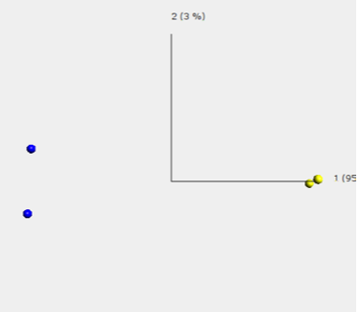
Figure 5.16. Clustering analysis of Untreated astrocytes (C1-C2) compared with MAB391-treated astrocytes (M1-M2).
PCA plot of control astrocytes (blue) and MAB391-treated astrocytes (yellow) to display the level of separation of differentially expressed genes between the two groups.

ii) Pathway Enrichment Analysis
DAVID Functional Enrichment Analysis of IGF1R impaired astrocytes FACS sorted from co-culture
The official gene symbols of each of the differentially expressed transcripts from the comparison of untreated astrocytes (C1-C2) against IGF1R impaired astrocytes (M1-M2) were inserted into the functional annotation tool on DAVID Bioinformatics Resources 6.7. Initially, all 2815 transcripts were imported into DAVID’s functional analysis tool (table 5.7). Upregulated and downregulated transcripts were also uploaded separately to specifically assess the pathways changing in the same direction (table 5.8 and table 5.9). Functional clusters highlighted by DAVID include Parkinson’s Disease, drug metabolism, ubiquitin mediated proteolysis and oxidative phosphorylation. All of the genes listed in the tables were assigned to biological pathways emerging from the KEGG_PATHWAY pathway term.

Pathway Name | Pathway source | Number of DE genes in pathway | P value (most significant term) | FDR(most significant term)
1. Parkinson's Disease | KEGG | 16 | 7.08E-03 | 6.90E-01
2. Ascorbate and aldarate metabolism | KEGG | 5 | 1.50E-02 | 7.10E-01
3. Pentose and glucuronate interconversions | KEGG | 5 | 1.80E-02 | 6.40E-01
4. Drug metabolism | KEGG | 9 | 2.60E-02 | 6.70E-01
5. Huntington's Disease | KEGG | 18 | 3.20E-02 | 6.60E-01
6. Retinol metabolism | KEGG | 8 | 3.60E-02 | 6.40E-01
7. Ubiquitin mediated proteolysis | KEGG | 14 | 5.40E-02 | 7.40E-01
8. Metabolism of xenobiotics by cytochrome P450 | KEGG | 8 | 5.80E-02 | 7.10E-01
9. Androgen and estrogen metabolism | KEGG | 6 | 6.10E-02 | 6.90E-01
10. Oxidative phosphorylation | KEGG | 13 | 7.40E-02 | 7.30E-01

Table 5.7. DAVID Functional Annotation Clustering Analysis of all 2815 transcripts in MAB391-treated astrocytes compared with control treated astrocytes with FC≥1.2 and P<0.05. DE- differentially expressed.

Table 5.8. DAVID Functional Annotation Clustering Analysis of 1520 downregulated transcripts in MAB391-treated astrocytes compared with control treated astrocytes with FC≥1.2 and P<0.05. DE- differentially expressed.

Pathway Name | Pathway source | Number of DE genes in pathway | P value (most significant term) | FDR(most significant term)
1. Parkinson's disease | KEGG | 11 | 1.20E-03 | 1.40E-01
2. Ubiquitin mediated proteolysis | KEGG | 11 | 2.00E-03 | 1.20E-01
3. Ascorbate and aldarate metabolism | KEGG | 4 | 7.80E-03 | 2.80E-01
4. Pentose and glucuronate interconversions | KEGG | 4 | 9.20E-03 | 2.50E-01
5. Retinol metabolism | KEGG | 6 | 1.00E-02 | 2.30E-01
6. Oxidative phosphorylation | KEGG | 9 | 1.50E-02 | 2.70E-01
7. Metabolism of xenobiotics by cytochrome P450 | KEGG | 6 | 1.60E-02 | 2.50E-01
8. Drug metabolism | KEGG | 6 | 1.80E-02 | 2.50E-01
9. Huntington's disease | KEGG | 10 | 3.40E-02 | 3.80E-01
10. Olfactory transduction | KEGG | 16 | 4.60E-02 | 4.50E-01

Table 5.9 DAVID Functional Annotation Clustering Analysis of 1295 upregulated transcripts in MAB391-treated astrocytes compared with control treated astrocytes with FC≥1.2 and P<0.05. DE-differentially expressed.

Pathway Name | Pathway source | Number of DE genes in pathway | P value (most significant term) | FDR(most significant term)
1. Leukocyte transendothelial migration | KEGG | 8 | 9.70E-02 | 1.00E+00
2. Notch signalling pathway | KEGG | 6 | 1.90E-02 | 9.30E-01

IMPALA Pathway enrichment analysis of IGF1R impaired astrocytes FACS sorted from co-culture
The officical gene symbols of each of the differentially expressed transcripts were uploaded into IMPALA version 9 to identify enriched biological pathways from the microarray data set. The most enriched pathways from all of the genes input into the analysis include small ligand GPCRs, ubiquitin mediated proteolysis, Parkinson’s Disease and glycolysis (table 5.10). Analysis of the 1520 downregulated transcripts showed enrichment of genes involved in Parkinson’s Disease, electron transport chain and oxidative phosphorylation pathways (table 5.11). From the 1295 upregulated transcripts, the most enriched pathways include glycolysis, gluconeogenesis and glycine, serine and threonine metabolism (table 5.12).

Table 5.10. IMPALA Enrichment Pathway analysis for all 2815 transcripts in MAB391 astrocytes compared to untreated astrocytes with FC≥1.2 and P<0.05. DE- differentially expressed.

Pathway Name | Pathway source | Number of DE genes in the pathway | Total number of genes in the pathway | P value (most significant term) | FDR (most significant term)
1. Proteoglycan syndecan-mediated signaling events | PID | 3 | 4 (4) | 0.000382 | 0.832
2. Small Ligand GPCRs | Wikipathways | 5 | 15 (19) | 0.000426 | 0.832
3. Parkin-Ubiquitin Proteasomal System pathway | Wikipathways | 10 | 72 (73) | 0.00168 | 1
4. Purine salvage | Reactome | 4 | 13 (14) | 0.00233 | 1
5. Ubiquitin mediated proteolysis - Homo sapiens (human) | KEGG | 14 | 132 (137) | 0.00316 | 1
6. Glycolysis | HumanCyc | 5 | 25 (26) | 0.00514 | 1
7. Parkinson's disease - Homo sapiens (human) | KEGG | 14 | 141 (143) | 0.00572 | 1
8. Gluconeogenesis | HumanCyc | 5 | 26 (27) | 0.00613 | 1
9. Superpathway of conversion of glucose to acetyl CoA and entry into the TCA cycle | HumanCyc | 7 | 48 (52) | 0.00621 | 1
10. Urea cycle | Reactome | 3 | 9 (10) | 0.00673 | 1

Pathway name | Pathway source | Number of DE genes in pathway | Total number of genes in pathway | P value (most significant term) | FDR (most significant term)
1. Parkinsons disease - Homo sapiens (human) | KEGG | 12 | 141 (143) | 3.35E-05 | 0.131
2. Ubiquitin mediated proteolysis - Homo sapiens (human) | KEGG | 11 | 132 (137) | 8.64E-05 | 0.169
3. The citric acid (TCA) cycle and respiratory electron transport | Reactome | 11 | 147 (156) | 0.000225 | 0.249
4. Electron Transport Chain | Wikipathways | 9 | 103 (103) | 0.000267 | 0.249
5. Respiratory electron transport_ ATP synthesis by chemiosmotic coupling | Reactome | 9 | 107 (113) | 0.000355 | 0.249
6. Respiratory electron transport | Reactome | 8 | 86 (92) | 0.000382 | 0.249
7. Oxidative phosphorylation - Homo sapiens (human) | KEGG | 8 | 132 (133) | 0.00593 | 1
8. Huntington’s disease - Homo sapiens (human) | KEGG | 10 | 190 (193) | 0.00597 | 1
9. Mitochondrial Electron Transport Chain | SMPDB | 3 | 19 (20) | 0.00656 | 1
10. Antigen processing: Ubiquitination & Proteasome degradation | Reactome | 9 | 163 (178) | 0.00659 | 1

Table 5.11. IMPALA Enrichment Pathway analysis for 1520 downregulated transcripts in MAB391 astrocytes compared to untreated astrocytes with FC≥1.2 and P<0.05. Highlighted in yellow are pathways with a similar theme. DE-differentially expressed.
Pathway name | Pathway source | Number of DE genes in pathway | Overlapping genes | Total number of genes in pathway | P value (most signifciant term) | FDR (most signifcant term)
1. Small Ligand GPCRs | Wikipathways | 5 | PTGER2;S1PR4;PTAFR;S1PR1;MTNR1A | 15 (19) | 2.68E-05 | 0.105
2. glycolysis | HumanCyc | 5 | TPI1;PGAM2;ENO2;PGAM4;ENO1 | 25 (26) | 0.000384 | 0.606
3.gluconeogenesis | HumanCyc | 5 | TPI1;PGAM2;ENO2;PGAM4;ENO1 | 26 (27) | 0.000465 | 0.606
4. Glycolysis | Reactome | 5 | TPI1;PGAM2;ENO2;PGAM4;ENO1 | 28 (29) | 0.000666 | 0.651
5. Gluconeogenesis | Reactome | 5 | TPI1;PGAM2;ENO2;PGAM4;ENO1 | 32 (33) | 0.00126 | 0.828
6. Lysosphingolipid and LPA receptors | Reactome | 3 | S1PR4;S1PR1;LPAR3 | 9 (9) | 0.00127 | 0.828
7. Parkin-Ubiquitin Proteasomal System pathway | Wikipathways | 7 | UBA1;PSMD2;PSMD9;PSMD11;TUBA4B;TUBA8;TUBB2B | 72 (73) | 0.00249 | 1
8. Glycine_ serine and threonine metabolism - Homo sapiens (human) | KEGG | 5 | GCAT;GNMT;PGAM4;PGAM2;CBS | 39 (40) | 0.0031 | 1
9. Rapoport-Luebering glycolytic shunt | HumanCyc | 2 | PGAM2;PGAM4 | 4 (6) | 0.00385 | 1
10. catecholamine biosynthesis | HumanCyc | 2 | PNMT;DBH | 4 (4) | 0.00385 | 1

Table 5.12. IMPALA Enrichment Pathway analysis for 1295 upregulated transcripts in MAB391 astrocytes compared to untreated astrocytes with FC≥1.2 and P<0.05. Highlighted in yellow are pathways with a similar theme. DE- differentially expressed.

5.4.9 Biological Pathways of Interest

From the functional annotation analysis performed in DAVID and IMPALA, there were several common pathways that emerged that were altered in MAB391-treated astrocytes. Both pathway enrichment programs suggest transcriptomic changes in the energy metabolism of IGF1 impaired astrocytes compared with untreated astrocytes. In particular, there is an agreement between the two programs that there is a signifcant downregulation of genes involved in oxidative phosphorylation (using DAVID p=0.015 and in IMPALA p=0.00593). In addition, analysis performed in IMPALA suggested upregulation of a number of pathways in IGF1 impaired astrocytes. One of these was upregulation of genes involved in glycolysis, which might indicate a compensatory mechanism since oxidative phosphorylation was downregulated. Closer inspection of the gene expression profile data revealed that a number of genes involved in synaptic support and antioxidant capacity were altered in the MAB391-treated astrocytes. These changes are discussed in more detail below.

Oxidative Phosphorylation

Both DAVID and IMPALA enrichment analysis identified the downregulation of genes involved in oxidative phosphorylation in IGF1-impaired astrocytes. Eight genes involved in oxidative phosphorylation were differentially expressed in MAB391-treated astrocytes and these are listed in table 5.13. Five of these eight genes listed encode subunits that form part of complex I of the mitochondrial respiratory chain (NDUFA2, NDUFB3, NDUFAB1, NDUFA1, NDUFB6), which is known to form ROS if not functioning properly (Jastroch et al. 2010). These downregulated genes have also been marked with a red star in a KEGG pathway diagram of oxidative phosphorylation (figure 5.17). Closer inspection of the clustering analysis performed by DAVID revealed 33 genes involved in mitochondrial function were downregulated in IGF1-impaired astrocytes (table 5.14). Together these results suggest loss of IGF1R results in mitochondrial dysfunction at the transcript level, particularly in the oxidative phosphorylation pathway.

Table 5.13. Transcripts involved in oxidative phosphorylation dysregulated in IGF1R impaired astrocytes.
There are 8 genes involved in oxidative phosphorylation that are differentially expressed in IGF1R impaired astrocytes compared with untreated astrocytes. Fold change (FC) and P-values are also shown.

Gene symbol | Gene Name | FC | P-value
ATP5C1 | ATP synthase, mitochondrial F1 complex, gamma polypeptide | 0.72 | 0.050
NDUFA1 | NADH: ubiquinone oxidoreductase alpha subcomplex subunit A1 | 0.65 | 0.030
NDUFA2 | NADH: ubiquinone oxidoreductase subunit 2 | 0.71 | 0.004
NDUFAB1 | NADH: ubiquinone oxidoreductase subunit AB1 | 0.77 | 0.001
NDUFB3 | NADH: ubiquinone oxidoreductase subunit B3 | 0.73 | 0.030
NDUFB6 | NADH: ubiquinone oxidoreductase subunit B6 | 0.53 | 0.003
SDHB | Succinate dehydrogenase complex, subunit B | 0.76 | 0.010
UQCRB | Ubiquinol cytochrome c reductase binding protein | 0.60 | 0.006

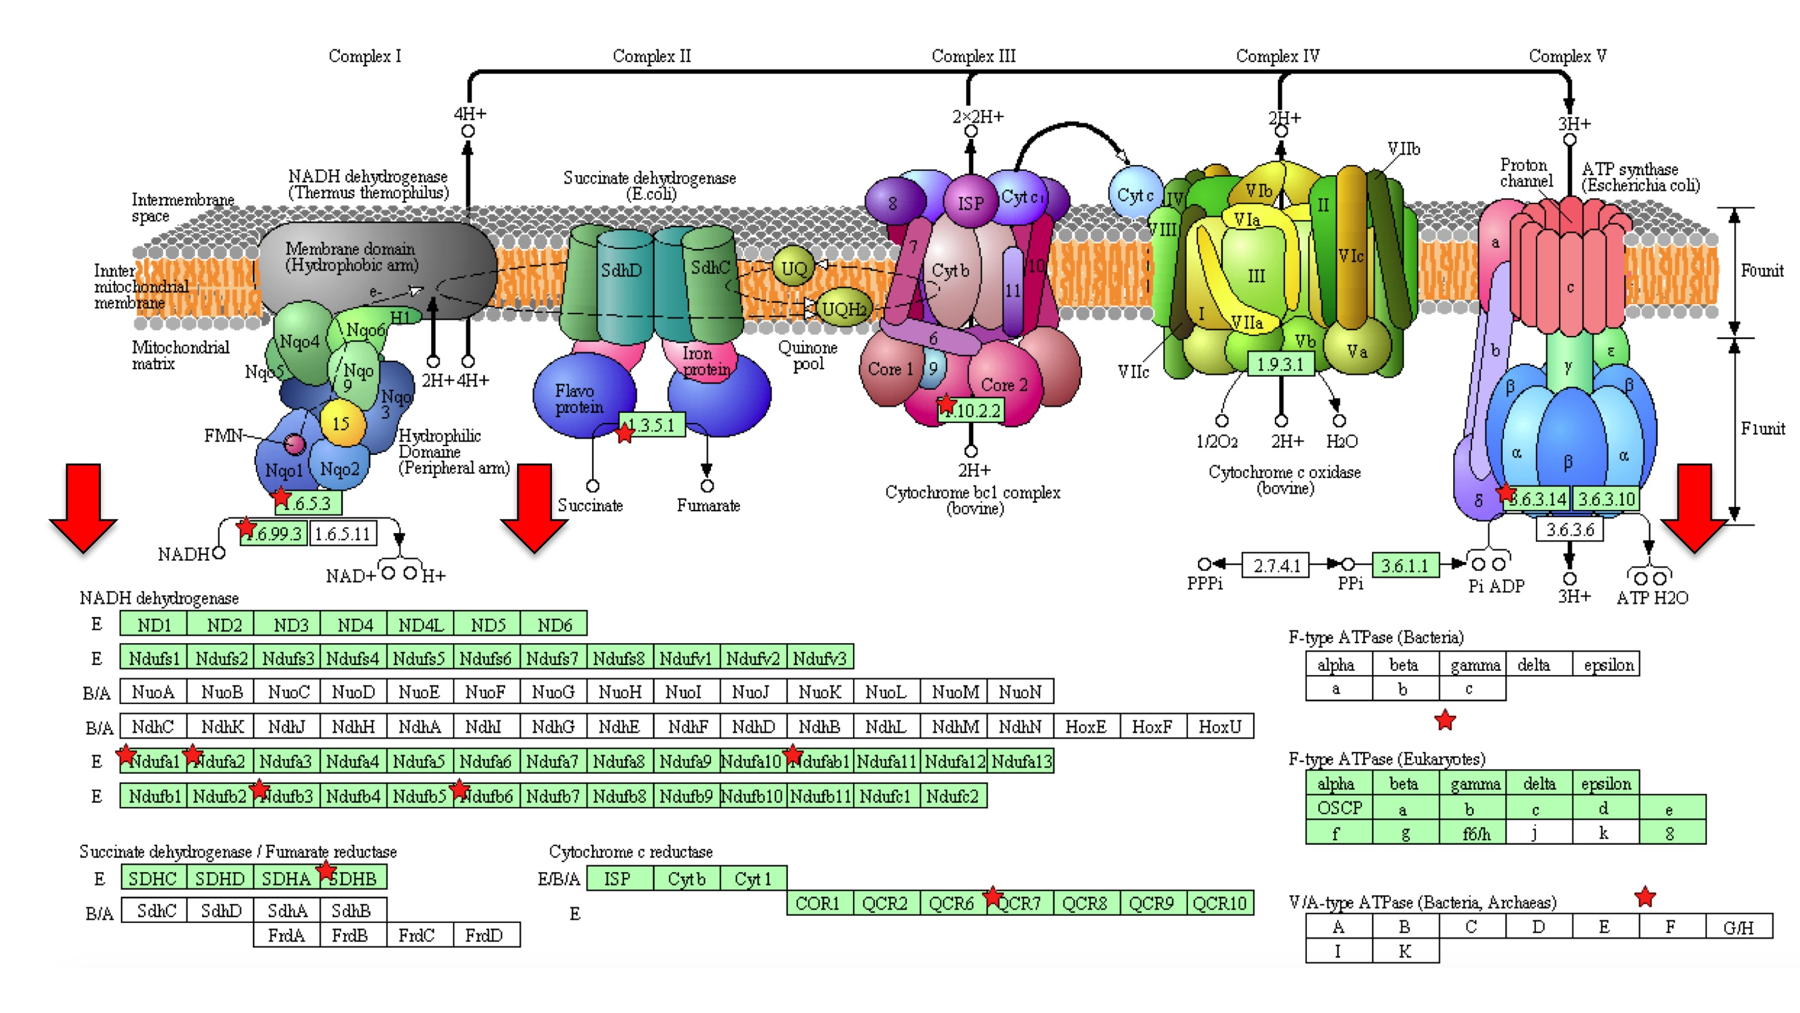
Figure 5.17. Downregulated genes in the oxidative phosphorylation pathway (KEGG).
The oxidative phosphorylation pathway is critical for sustaining ATP production for the cell. Red stars highlight particular genes downregulated in IGF1R impaired astrocytes. The red arrows indicate the complexes in the mitochondrial respiratory chain in which the downregulated genes are found. (Diagram was taken from http://www.genome.jp/kegg/pathway/map/map00190.html.)

Table 5.14. Transcripts involved in mitochondrial function that are dysregulated in IGF1R impaired astrocytes.
A list of 33 genes involved in mitochondrial function that are downregulated in IGF1R impaired astrocytes compared with untreated astrocytes. Fold change (FC) and P-values are also shown.

Gene Symbol | Gene Name | FC | P-value
ATP5C1 | ATP synthase, H+ transporting, mitochondrial F1 complex, gamma polypeptide 1 | 0.72 | 5.0E-02
NDUFA1 | NADH dehydrogenase (ubiquinone) 1 alpha subcomplex, 1 | 0.65 | 3.0E-02
NDUFA2 | NADH dehydrogenase (ubiquinone) 1 alpha subcomplex, 2 | 0.71 | 4.0E-03
NDUFB3 | NADH dehydrogenase (ubiquinone) 1 alpha subcomplex, 3 | 0.73 | 3.0E-02
NDUFB6 | NADH dehydrogenase (ubiquinone) 1 alpha subcomplex, 6 | 0.53 | 3.0E-03
NDUFAB1 | NADH dehydrogenase (ubiquinone) 1 alpha/beta subcomplex, 1 | 0.77 | 1.0E-03
YME1L1 | YME1-like 1 | 0.58 | 1.0E-03
ARG2 | Arginase, type II | 0.76 | 4.0E-03
ETFA | Electron-transfer-flavoprotein, alpha polypeptide | 0.71 | 4.0E-03
GOLPH3 | Golgi phosphoprotein 3 | 0.82 | 3.0E-02
MMADHC | Methylmalonic aciduria | 0.71 | 3.0E-04
MGST1 | Microsomal glutathione S-transferase 1 | 0.77 | 2.0E-02
MRPL3 | Mitochondrial ribosomal protein L3 | 0.76 | 2.0E-02
MRPL32 | Mitochondrial ribosomal protein L32 | 0.80 | 2.0E-02
MRPL46 | Mitochondrial ribosomal protein L46 | 0.64 | 3.0E-02
MRPS18A | Mitochondrial ribosomal protein S18A | 0.82 | 3.0E-02
NLN | Neurolysin | 0.69 | 2.0E-02
NMNAT3 | Nicotinamide nucleotide adenylyltransferase 3 | 0.77 | 3.0E-02
OGDHL | Oxoglutarate dehydrogenase-like | 0.82 | 2.0E-02
PMPCB | Peptidase (mitochondrial processing) beta | 0.75 | 4.0E-02
PRDX3 | Peroxiredoxin 3 | 0.72 | 2.0E-03
PPP2R2B | Protein phosphatase 2 (formerly 2A) regulatory subunit B, beta isoform | 0.61 | 2.0E-03
PDK3 | Pyruvate dehydrogenase kinase, isozyme 3 | 0.58 | 5.0E-02
ROMO1 | Reactive oxygen species modulator 1 | 0.61 | 1.0E-04
SFXN4 | Sideroflexin 4 | 0.80 | 2.0E-02
UQCRB | Ubiquinol-cytochrome C reductase binding protein | 0.66 | 6.0E-03
SSBP1 | Single-stranded DNA binding protein 1 | 0.68 | 5.0E-02
SLC25A14 | Solute carrier 25 (mitochondrial carrier, brain) | 0.79 | 2.0E-02
SDHB | Succinate dehydrogenase complex, subunit B | 0.76 | 1.0E-02
SUCLA2 | Succinate-coA ligase, ADP forming, beta subunit | 0.76 | 4.0E-02
TXNDC12 | Thioredoxin domain containing 12 | 0.77 | 6.0E-03
TIMM9 | Translocase of inner mitochondrial membrane 9 | 0.76 | 3.0E-02
TOMM6 | Translocase of outer mitochondrial membrane 6 | 0.69 | 1.0E-02

Glycolysis
The glycolysis pathway was highlighted in the IMPALA analysis as a key pathway
upregulated following MAB391 treatment of astrocytes. The glycolysis and gluconeogenesis pathway use the same enzymes and generate the same intermediate molecules, therefore it is also possible that the IMPALA analysis is indicative of upregulation of gluconeogenesis, which drives the cell toward glucose rather than pyruvate production. However, since the five genes specifically involved in this pathway (table 5.15, excluding SLC16A3) are found in the lower half of the glycolysis pathway (figure 5.18), it might be hypothesised that IGF1R impaired astrocytes are upregulating glycolysis rather than gluconeogenesis. In addition, close inspection of the microarray data shows upregulation of a gene encoding a monocarboxylate transporter, which is used to rapidly shuttle monocarboxylates such as lactate and pyruvate across the plasma membrane (SLC16A3). Pyruvate dehydrogenase kinase (PDK) was also significantly downregulated in MAB391-treated astrocytes (FC = 0.58, P-value = 0.05). This enzyme is required in conjunction with pyruvate dehydrogenase to convert pyruvate to acetyl-coA for entry into the TCA cycle. However, since the levels of PDK are reduced in tandem with increased SLC16A3, it is likely that glycolysis is upregulated.

Table 5.15. Transcripts involved glycolysis that are dysregulated in IGF1R impaired astrocytes.
Genes involved in the glycolysis pathway that are differentially expressed in IGF1R impaired astrocytes compared with untreated astrocytes. Fold change (FC) and P-values are also shown.

Gene symbol | Gene Name | FC | P-value
ENO1 | Enolase 1 | 1.23 | 0.0400
ENO1-AS | Enolase 1-alpha | 1.85 | 0.0030
ENO2 | Enolase 2 | 1.46 | 0.0100
PGAM2 | Phosphoglycerate mutase 2 | 1.42 | 0.0006
SLC16A3 | Solute Carrier Family 16, Member 3 | 2.04 | 0.0200
TPI1 | Triosephosphate isomerase 1 | 1.59 | 0.0300

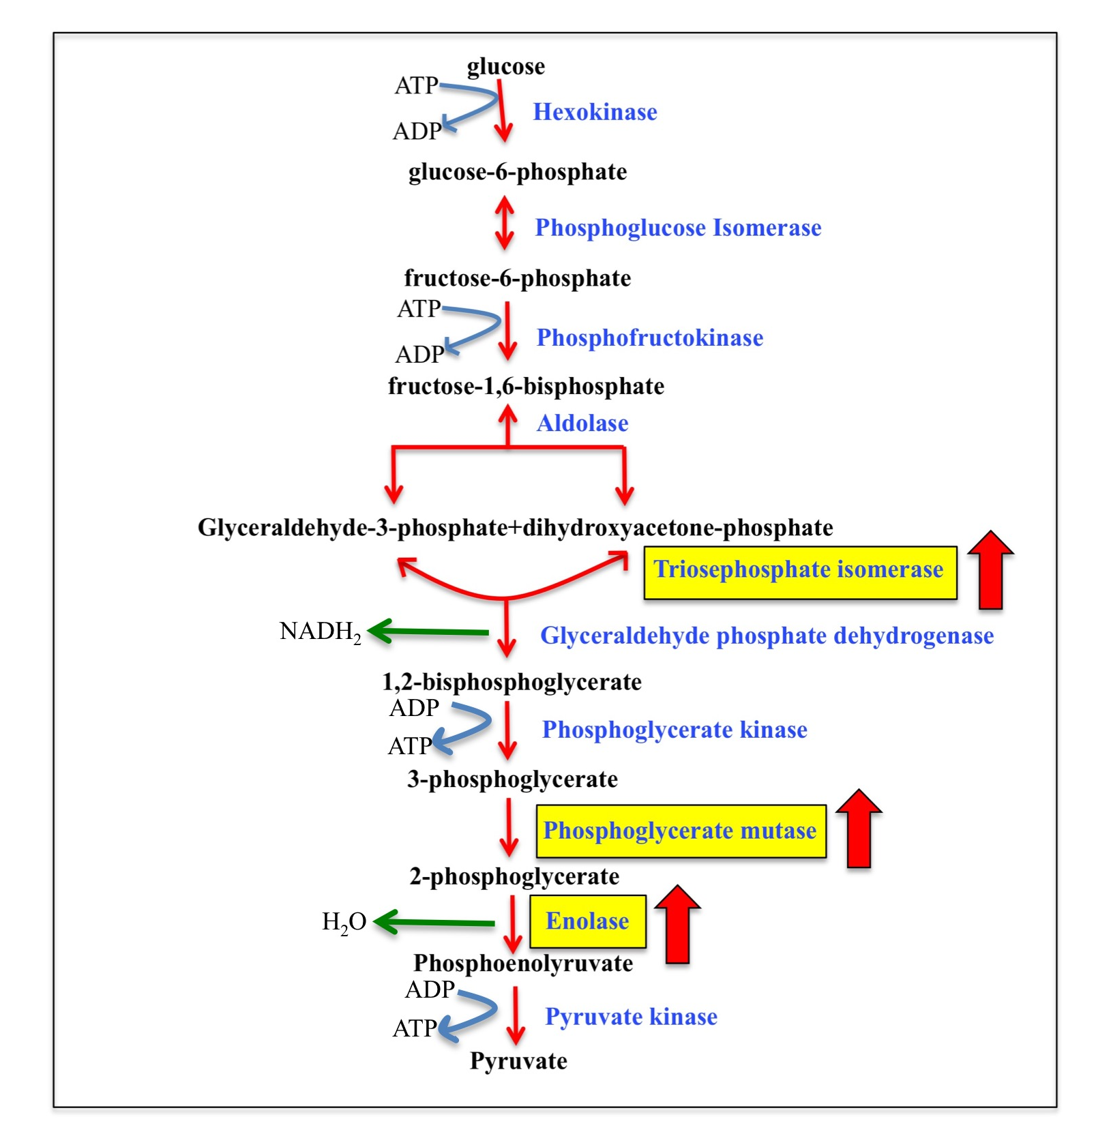

Figure 5.18. Altered transcripts in gene expression profiling of IGF1 signalling impaired astrocytes found in the glycolysis pathway.
The enzymes found in yellow boxes are representative of the genes upregulated in IGF1 signalling impaired astrocytes. The four genes (triosephosphate isomerase, phosphoglycerate mutase, enolase 1 and enolase 2) feature in the lower half of the glycolysis pathway and likely reflect a drive towards increased glycolysis rather than glycogenesis.

Antioxidant pathway
In total, 11 genes associated with antioxidant capacity of astrocytes were differentially expressed in MAB391-treated astrocytes (table 5.16). The mRNA of several enzymes involved in reducing oxidised glutathione are downregulated (GLRX3, TXNL1, TXNDC12, PRDX3, MGST1) and other mRNA involved in glutathionylating proteins to protect them from further oxidation (GSTA3) are increased. mRNA for GGT1, ABCC5, NOXA1 were also upregulated; GGT1 breaks down GSH in order to supply the more accessible glutamine form to the neurons; ABCC5 exports glutathione from cells and NOXA1 is involved in activating NOX1, a superoxide-producing NADPH oxidase.

Table 5.16. Antioxidant-related transcripts dysregulated in IGF1R impaired astrocytes.
Genes involved in the antioxidant pathway that are differentially expressed in IGF1R impaired astrocytes compared with untreated astrocytes. Highlighted in red are downregulated genes and in green are upregulated genes. Fold change (FC) and P-values are also shown.

Gene symbol | Gene Name | FC | P-value
ABCC5 | ATP binding cassette subfamily C member 5 | 1.21 | 0.050
GGT1 | Gamma-glutamyltransferase 1 | 1.41 | 0.030
GLRX 3 | Glutaredoxin 3 | 0.69 | 0.010
GSTA3 | Glutathione-S-transferase alpha 3 | 1.66 | 0.009
GSTTP1 | Glutathione-S-transferase theta pseudogene 1 | 0.70 | 0.008
MGST1 | Microsomal glutathione-s-transferase 1 | 0.77 | 0.020
NOXA1 | NADPH oxidase activator 1 | 1.27 | 0.050
PRDX3 | Peroxiredoxin 3 | 0.72 | 0.002
TXNDC12 | Thioredoxin domain-containing 12 | 0.77 | 0.006
TXNL1 | Thioredoxin-like 1 | 0.83 | 0.009
TXNRD2 | Thioredoxin reductase 2 | 1.41 | 0.030

Synaptic support
Analysis of the gene expression profile data also revealed genes involved in astrocytic support for neuronal synapses (table 5.17) were altered. In IGF1-impaired astrocytes there was increased expression of several genes involved in responding to neurotransmitter (GABRB1 and GRM6) and downregulation of expression of genes involved in axonal growth and development of synaptic plasticity (SERPINI1 and SYT12).

Gene symbol | Gene Name | FC | P-value
CNR1 | Cannabinoid receptor 1 | 0.64 | 0.030
GABRB1 | Gamma-aminobutyric acid type A receptor beta 1 | 1.26 | 0.030
GRM6 | Glutamate receptor, metabotropic 6 | 1.50 | 0.040
ITGB3BP | Integrin subunit beta 3 binding protein | 0.82 | 0.030
KCND1 | Potassium voltage gated channel, subfamily D | 1.22 | 0.030
KCNK6 | Potassium voltage gated channel, subfamily K | 1.49 | 0.010
KCNQ2 | Potassium voltage gated channel, subfamily Q | 1.29 | 0.002
LAMB1 | Laminin subunit beta 1 | 1.33 | 0.030
NRXN1 | Neurexin 1 | 0.67 | 0.040
OXTR | Oxytocin Receptor | 1.64 | 0.020
P2RY13 | Purinergic receptor P27, G-protein coupled 13 | 0.68 | 0.040
P2RY6 | Purinergic receptor P27, G-protein coupled 6 | 1.37 | 0.040
SERPINI1 | Serpin peptidase inhibitor, clade 1 | 0.41 | 0.001
STXBP4 | Syntaxin binding protein 4 | 0.79 | 0.001
SYT12 | Synaptotagmin 12 | 0.79 | 0.001

Table 5.17. Transcripts involved in astrocyte-neuron interactions, neuronal synapse formation and signalling that are dysregulated in IGF1R impaired astrocytes.
Genes involved in the antioxidant pathway that are differentially expressed in IGF1R impaired astrocytes compared with untreated astrocytes. Highlighted in red are downregulated genes and in green are upregulated gene. Fold change (FC) and P-values are also shown.
Inflammatory response
As the method used to downregulate IGF1R involved treatment with a mouse monoclonal IgG antibody, the array data was interrogated for differences in the expression of genes that could be involved in an immune-like response. There were 18 genes differentially expressed genes following treatment with MAB391 (table 5.18), which might be attributed to the Fc fragment of the antibody binding to Fc receptors on the surface of the astrocytes. Despite the treatment involving use of a mouse IgG antibody, it is possible that human Fc receptors could bind with high affinity and associated pathways activated (Lubeck et al. 1985). 12 of the 18 differentially expressed genes involved in an immune response were upregulated, this includes upregulation of genes involved in cytokine production such as IL15 and IL23A. Downregulated genes include FCGR1B, which is a fragment to which the Fc portion of the MAB391 may bind and might indicate an attempt to downregulate the immune response.

Table 5.18. Transcripts involved in an immune-like response differentially regulated in MAB391-treated astrocytes.
Genes involved in the inflammatory pathway that are differentially expressed in IGF1R impaired astrocytes compared with untreated astrocytes. Highlighted in red are downregulated genes and in green are upregulated genes. Fold change (FC) and P-values are also shown.

Gene Symbol | Gene Name | FC | P-value
IL21 | Interleukin 21 | 0.71 | 0.020
IGHG1 | Immunoglobulin heavy constant gamma 1 | 0.50 | 0.010
IGHV3-23 | Immunoglobulin heavy variable 3-23 | 0.53 | 0.010
IGHV3-64 | Immunoglobulin heavy variable 3-64 | 0.69 | 0.010
FCGR1B | Fc fragment of IgG receptor B | 0.68 | 0.009
IGH | Immunglobulin heavy locus | 1.20 | 0.003
IGSF9 | Immunglobulin superfamily, member 9 | 1.36 | 0.030
IGSF9B | Immunglobulin superfamily, member 9B | 1.39 | 0.030
IGLV2-23 | Immunoglobulin light variable 2-23 | 1.55 | 0.030
IGLV2-8 | Immunoglobulin light variable 2-8 | 1.58 | 0.030
IL15 | Interleukin 15 | 1.23 | 0.010
IL17RA | Interleukin receptor 17A | 1.30 | 0.030
IL23A | Interleukin 23A | 1.70 | 0.030
TRBJ2 | T-Cell receptor beta joining 2 | 2.37 | 0.006
TNFRSF10C | Tumour necrosis factor receptor superfamily, member 10c | 1.20 | 0.005
TNFSF13 | Tumour necrosis factor superfamily, member 13 | 1.32 | 0.008
C1QTNF1 | C1q and tumour necrosis factor-related protein 1 | 1.70 | 0.043
IGHV3-38 | Immunoglobulin heavy variable 3-38 | 1.62 | 0.040

5.4.10 Validation of genes selected from the microarray using qRT-PCR

Overall, the microarray data suggests dysregulation of genes involved in energy metabolism in IGF1R impaired astrocytes. In particular, there are indications that genes involved in glycolysis are upregulated whilst genes involved in oxidative phosphorylation are downregulated, especially within complex I of the mitochondrial respiratory chain. Therefore, genes were selected from both of these pathways that were differentially expressed across all three sets of untreated (C1-C3) and MAB391 (M1-M3) treated astrocytes (list of candidate genes and signal intensities across the six individual arrays, table 5.19).

To validate downregulation of genes involved in complex I of the mitochondrial respiratory chain, changes in the expression of NDUFA2 (NADH: ubiquinone oxidoreductase subunit 2) and NDUFB6 (NADH: ubiquinone oxidoreductase beta subcomplex subunit 6) were further investigated at the RNA level. TPI1 (triosephosphate isomerase 1) and ENO2 (Enolase 2) were selected for validating upregulation of the glycolytic pathway. To explore changes in the antioxidant capacity of astrocytes and to link back to the results in chapter 4, a panel of antioxidant genes were selected: GLRX3 (Glutaredoxin 3), PRDX3 (Peroxiredoxin 3) and MGST1 (microsomal glutathione-S-transferase).

To validate the selected genes, co-cultures were setup to replicate all conditions used previously; passage numbers for astrocytes and GFP LUHMES were matched as were plating densities and FACS sorting. IgG-treated astrocytes separated from GFP LUHMES were included in the validation step to demonstrate that observations seen in the gene expression profiling were unique to IGF1 signalling impairment and not an effect of the antibody itself.

Table 5.19. List of genes selected for validation.
Numbers in the table represent relative signal intensities from each of the samples used in the arrays. Genes selected for validation were chosen based on C3 and M3 having signal intensities that showed a trend towards the results from the Qlucore Omics analysis.

Gene | Control 1 | Control 2 | Control 3 | MAB391 1 | MAB391 2 | MAB391 3
PRDX3 | 9.38 | 9.42 | 8.81 | 8.87 | 8.98 | 7.75
GLRX3 | 6.91 | 6.97 | 7.25 | 6.58 | 6.50 | 7.09
NDUFA2 | 6.76 | 6.96 | 6.42 | 6.30 | 6.27 | 6.34
NDUFB6 | 6.86 | 6.83 | 7.10 | 6.24 | 6.04 | 7.25
MGST1 | 4.34 | 4.25 | 4.13 | 3.90 | 4.58 | 4.01
TPI1 | 5.07 | 4.71 | 5.17 | 5.40 | 5.56 | 5.63
EN02 | 4.72 | 4.90 | 4.61 | 4.99 | 5.16 | 4.87

Acquisition of cDNA for qRT-PCR validation
Astrocytes treated with IgG/MAB391 and untreated astrocytes were co-cultured with LUHMES for 72 hours before FACS sorting. Table 5.20 shows the amount of cells collected during the FACS sort, with an average of 52 628 astrocytes and 241 000 neurons collected during this procedure. In an attempt to improve RNA quality, astrocytes were sorted directly into 200μl of Trizol®. RNA was isolated from astrocytes using the Zymo RNA extraction kit and measured on the NanoDrop 1000 spectrophotometer. Table 5.21 shows less RNA was extracted than in previous cell sorts (table 5.2) but 260/280 and 260/230 ratios were more consistent and closer to a ratio of 2 than previously. Owing to limited availability of RNA material and to maximise the number of target genes that could be validated by qRT-PCR, a QuantiTect® Whole Transcriptome amplification kit was used to increase the amount of cDNA material. 40ng of RNA was incorporated into the amplification reactions and after reverse transcription and subsequent amplification this resulted in the synthesis of approximately 9μg of cDNA (table 5.22), as measured by the Qubit fluorometer.

Table 5.20. Amount of astrocytes and neurons collected by FACS

Sample | Astrocytes collected | Neurons Collected
Control | 56000 | 180000
IgG | 56915 | 255000
MAB391 | 45000 | 288000
AVERAGE | 52638 | 241000

Table 5.21. Yield of RNA extracted from control (untreated), IgG- and MAB391-treated astrocytes.
A Nanodrop™ 1000 spectrophotometer was used to measure the concentration and quality of RNA extracted from control and MAB391-treated astrocytes. Quality of RNA was defined by using the ratio of A260/280 and A 260/230.

Sample | RNA yield (ng/μl) | A260/280 | A260/230
Control | 24.08 | 2.02 | 2.31
IgG | 17.56 | 2.05 | 1.85
MAB391 | 20.65 | 2.11 | 1.85

Sample | Initial concentration ng/μl | Final concentration ng/μl | Total concentration (μg) in 48μl
Control | 40 | 178 | 8.5
IgG | 40 | 239 | 11.5
MAB391 | 40 | 163 | 7.8

Table 5.22. Yield of cDNA from control (untreated), IgG- and MAB391-treated astrocytes following amplification.
A QuantiTect® Whole Transcriptome RNA amplifcation kit was used to reverse transcribe RNA and amplify to improve yields of cDNA for qRT-PCR validation of target genes.

Validating Oxidative phosphorylation genes
qRT-PCR showed a signficant decrease (p<0.05) in NDUFA2 levels with MAB391 treatment compared with control and IgG treatment (figure 5.19) There is a trend towards a decrease in NDUFB6 levels with MAB391 treatment compared with control. When compared with IgG treatment, there is a significant difference resulting from MAB391 treatment (p<0.05). However, the results suggest that there is an antibody effect that increases NDUFB6, which can be reduced after MAB391 treatment.
These results validate downregulation of complex I genes observed in the microarray analysis.

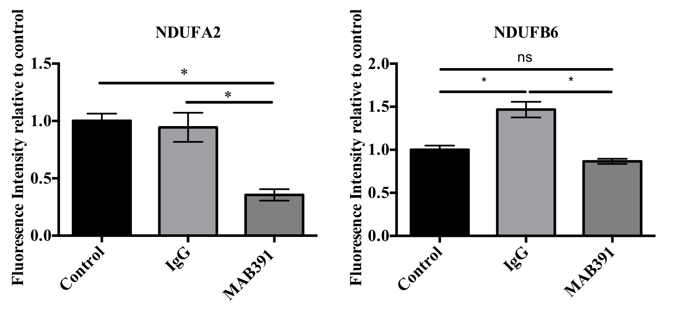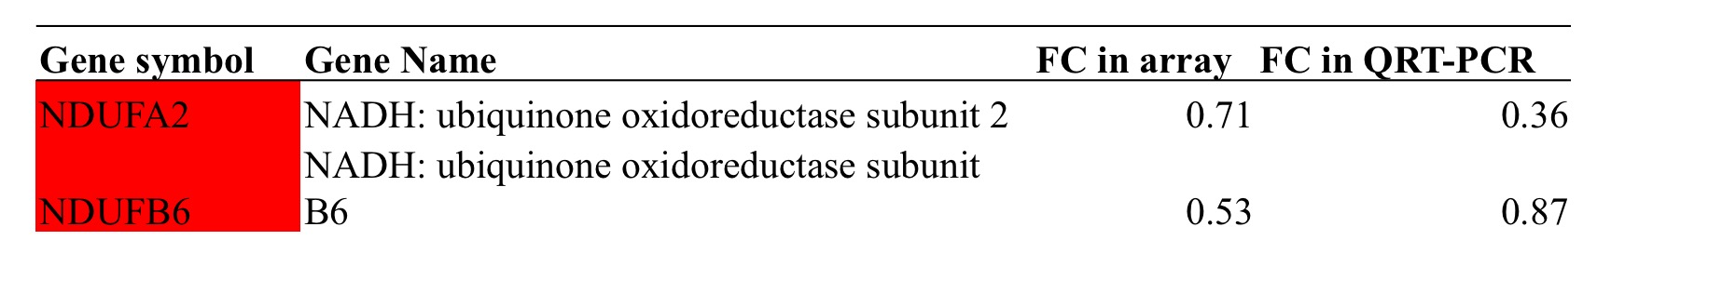
Figure 5.19. qRT-PCR Validation of NDUFA2 and NDUFB6 levels.
Astrocytes were treated with and without IgG/MAB391 for 24 hours and co-cultured with GFP LUHMES for 72 hours prior to FACS sorting to isolate astrocytes. qRT-PCR was performed on NDUFA2 and NDUFB6 and normalised to GAPDH (One-way ANOVA; Data are means ± SEM; n=1 in duplicate).

Validating Antioxidant genes
Five genes were chosen for validation: GLRX3, PRDX3, MGST1, GST3α and GGT1, however the primers for GST3α and GGT1 did not work and validation of these targets was not pursued further. qRT-PCR analysis revealed there were no significant differences in GLRX3 levels between MAB391-treated astrocytes and a signifcant decrease in MAB391 versus IgG-treated astrocytes (p<0.01). MGST1 levels were signifcantly downregulated following IgG treatment whereas MAB391 treatment resulted in a significant increase in MGST1 levels compared to control and IgG-treated astrocytes. The reduction in PRDX3 validated the findings of the microarray analysis, althought this was only significant when compared against the IgG-treated astrocytes
(figure 5.20). GLRX3 and MGST1 did not validate the findings in the microarray analysis.

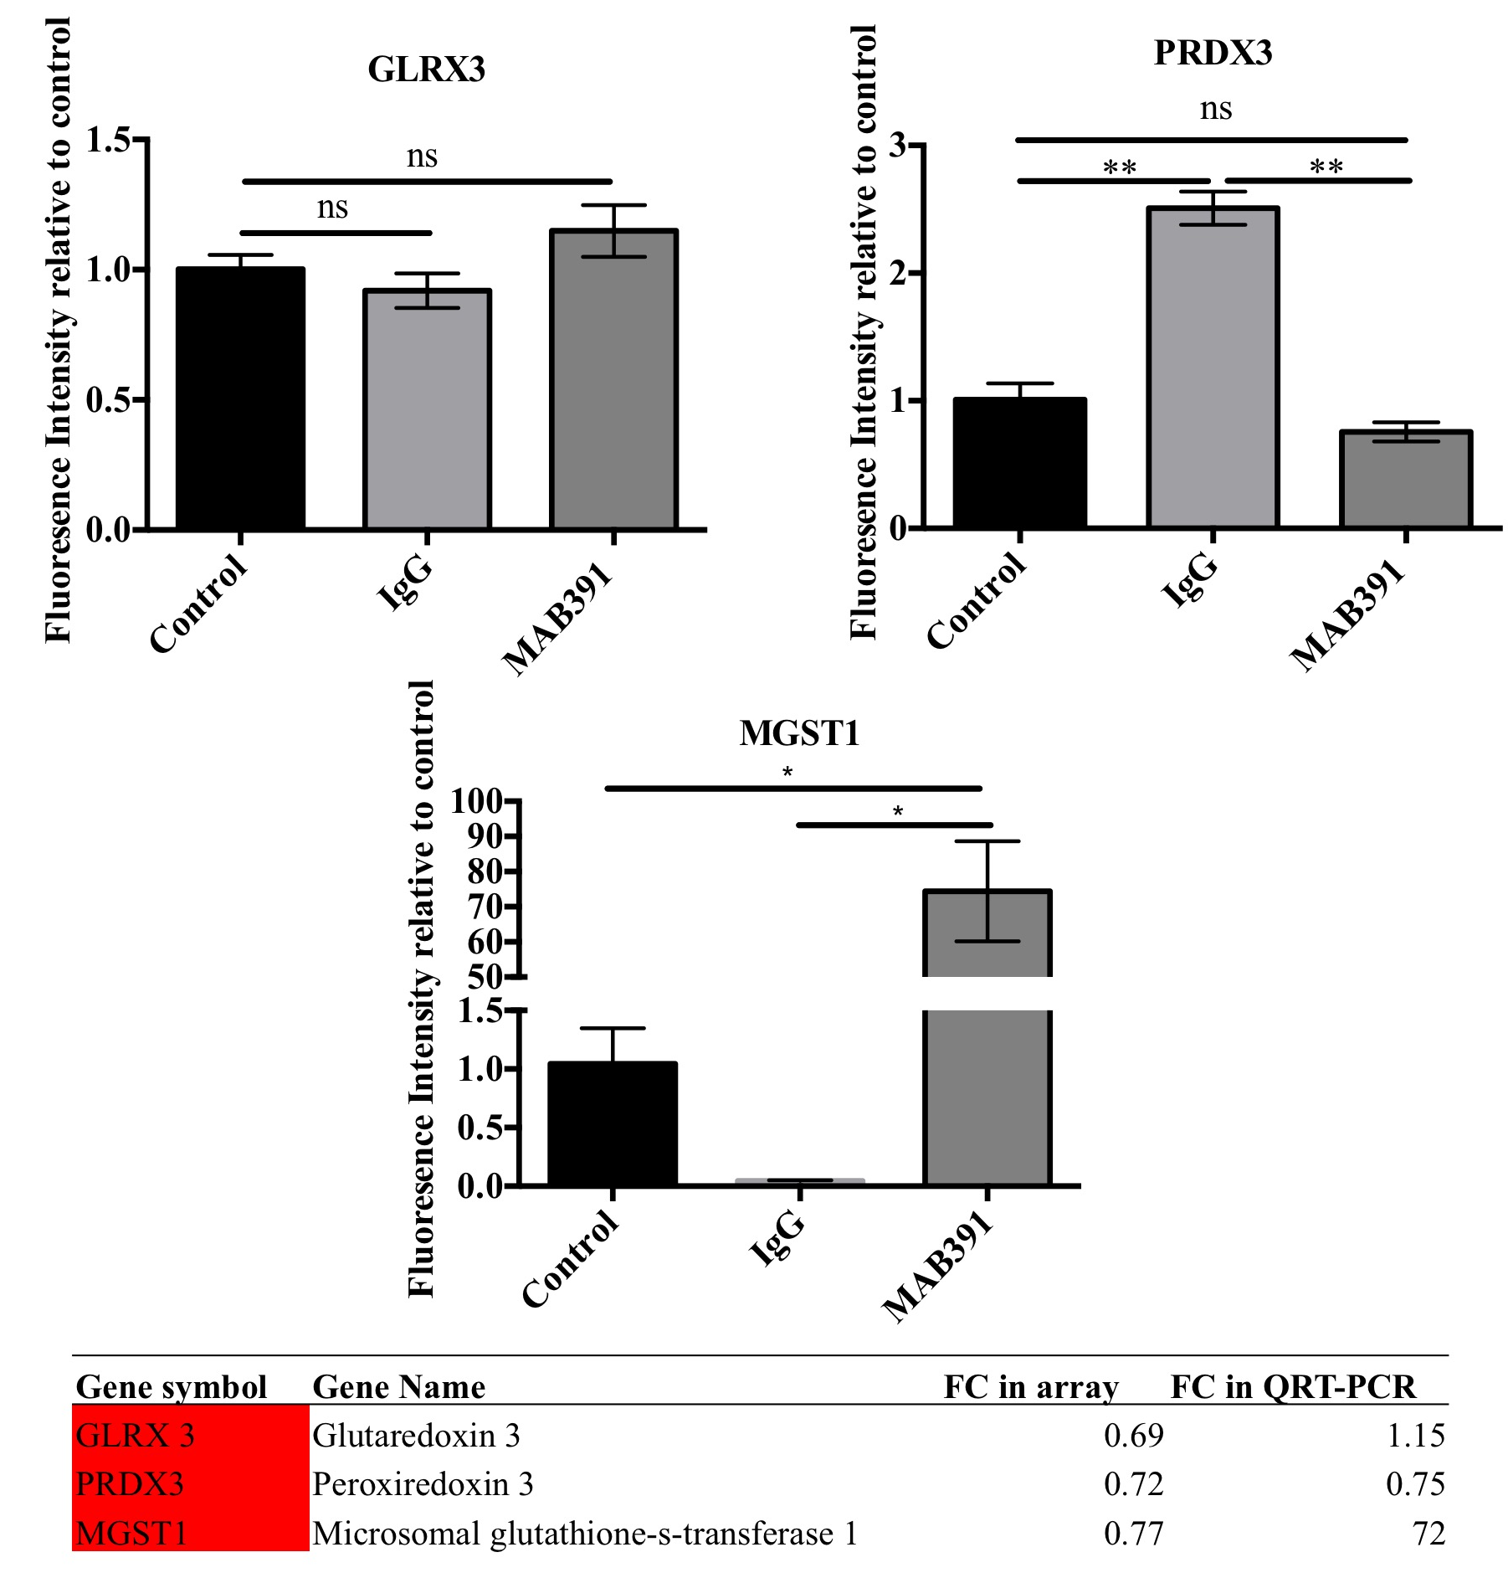
Figure 5.20. qRT-PCR Validation of GLRX3, PRDX3 and MGST1 levels.
Astrocytes were treated with and without IgG/MAB391 for 24 hours and co-cultured with GFP LUHMES for 72 hours prior to FACS sorting to isolate astrocytes. qRT-PCR was performed on GLRX3, PRDX3 and MGST1 and normalised to GAPDH (One-way ANOVA; Data are means ± SEM; n=1 in duplicate).

Validating Glycolysis genes
TPI1 and ENO2 were selected as gene targets to validate upregulation of glycolysis observed in the array. ENO2 levels significantly increase with IgG treatment compared with control and also have a trend towards an increase with MAB391, which is consistent with the array data. However, this difference was not significant due to the large increase resulting from IgG treatment (figure 5.21). There is a signifcant reduction in TPI1 levels in MAB391-treated astrocytes (p<0.05) but this was also observed after IgG treatment (p<0.05) and is the opposite of what was observed in the microarray analysis.
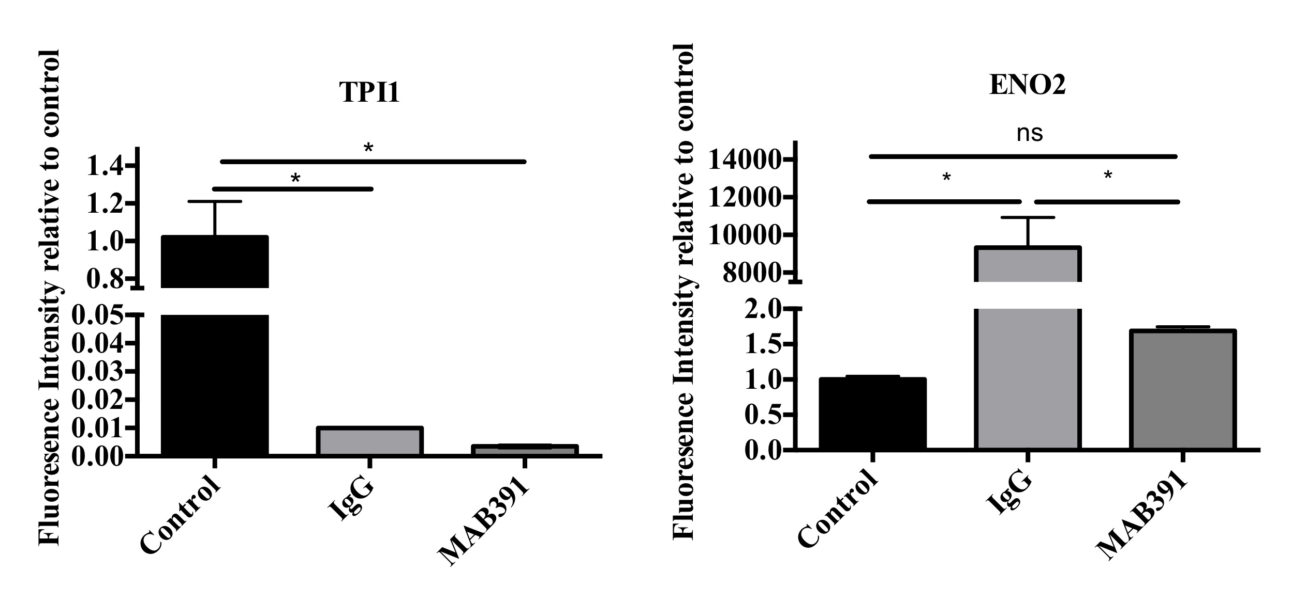
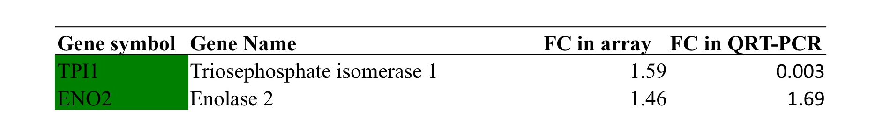

Figure 5.21. qRT-PCR Validation of TPI1 and ENO2 levels.
Astrocytes were treated with and without IgG/ MAB391 for 24 hours and co-cultured with GFP LUHMES for 72 hours prior to FACS sorting to isolate astrocytes. qRT-PCR was performed on TPI1 and ENO2 and normalised to GAPDH (One-way ANOVA; Data are means ± SEM; n=1 in duplicate).

5.4.11 Validation of Gene Expression Profiling Data using Functional Asssays

Complex I Assay
To validate altered expression of complex I genes in IGF1R impaired astrocytes a complex I assay was performed. This assay measures the NADH-dependent activity of complex I. The gene expression profiling data showed downregulation of several genes involved in complex I assembly, which were validated by qRT-PCR. Therefore it was predicted that the activity of complex I would be reduced following treatment with MAB391.

Since the levels of protein that can be extracted from astrocytes following FACS sorting of astrocyte-neuron co-cultures is low, the complex I assay was conducted on co-cultures. Pretreatment of astrocytes with MAB391 causes a significant impairment in complex I activity in astrocyte-neuron co-cultures compared with untreated (p<0.0001) and IgG-treated controls (p<0.0001) (figure 5.22). This supports the changes in complex I associated genes identified and validated by qRT-PCR.

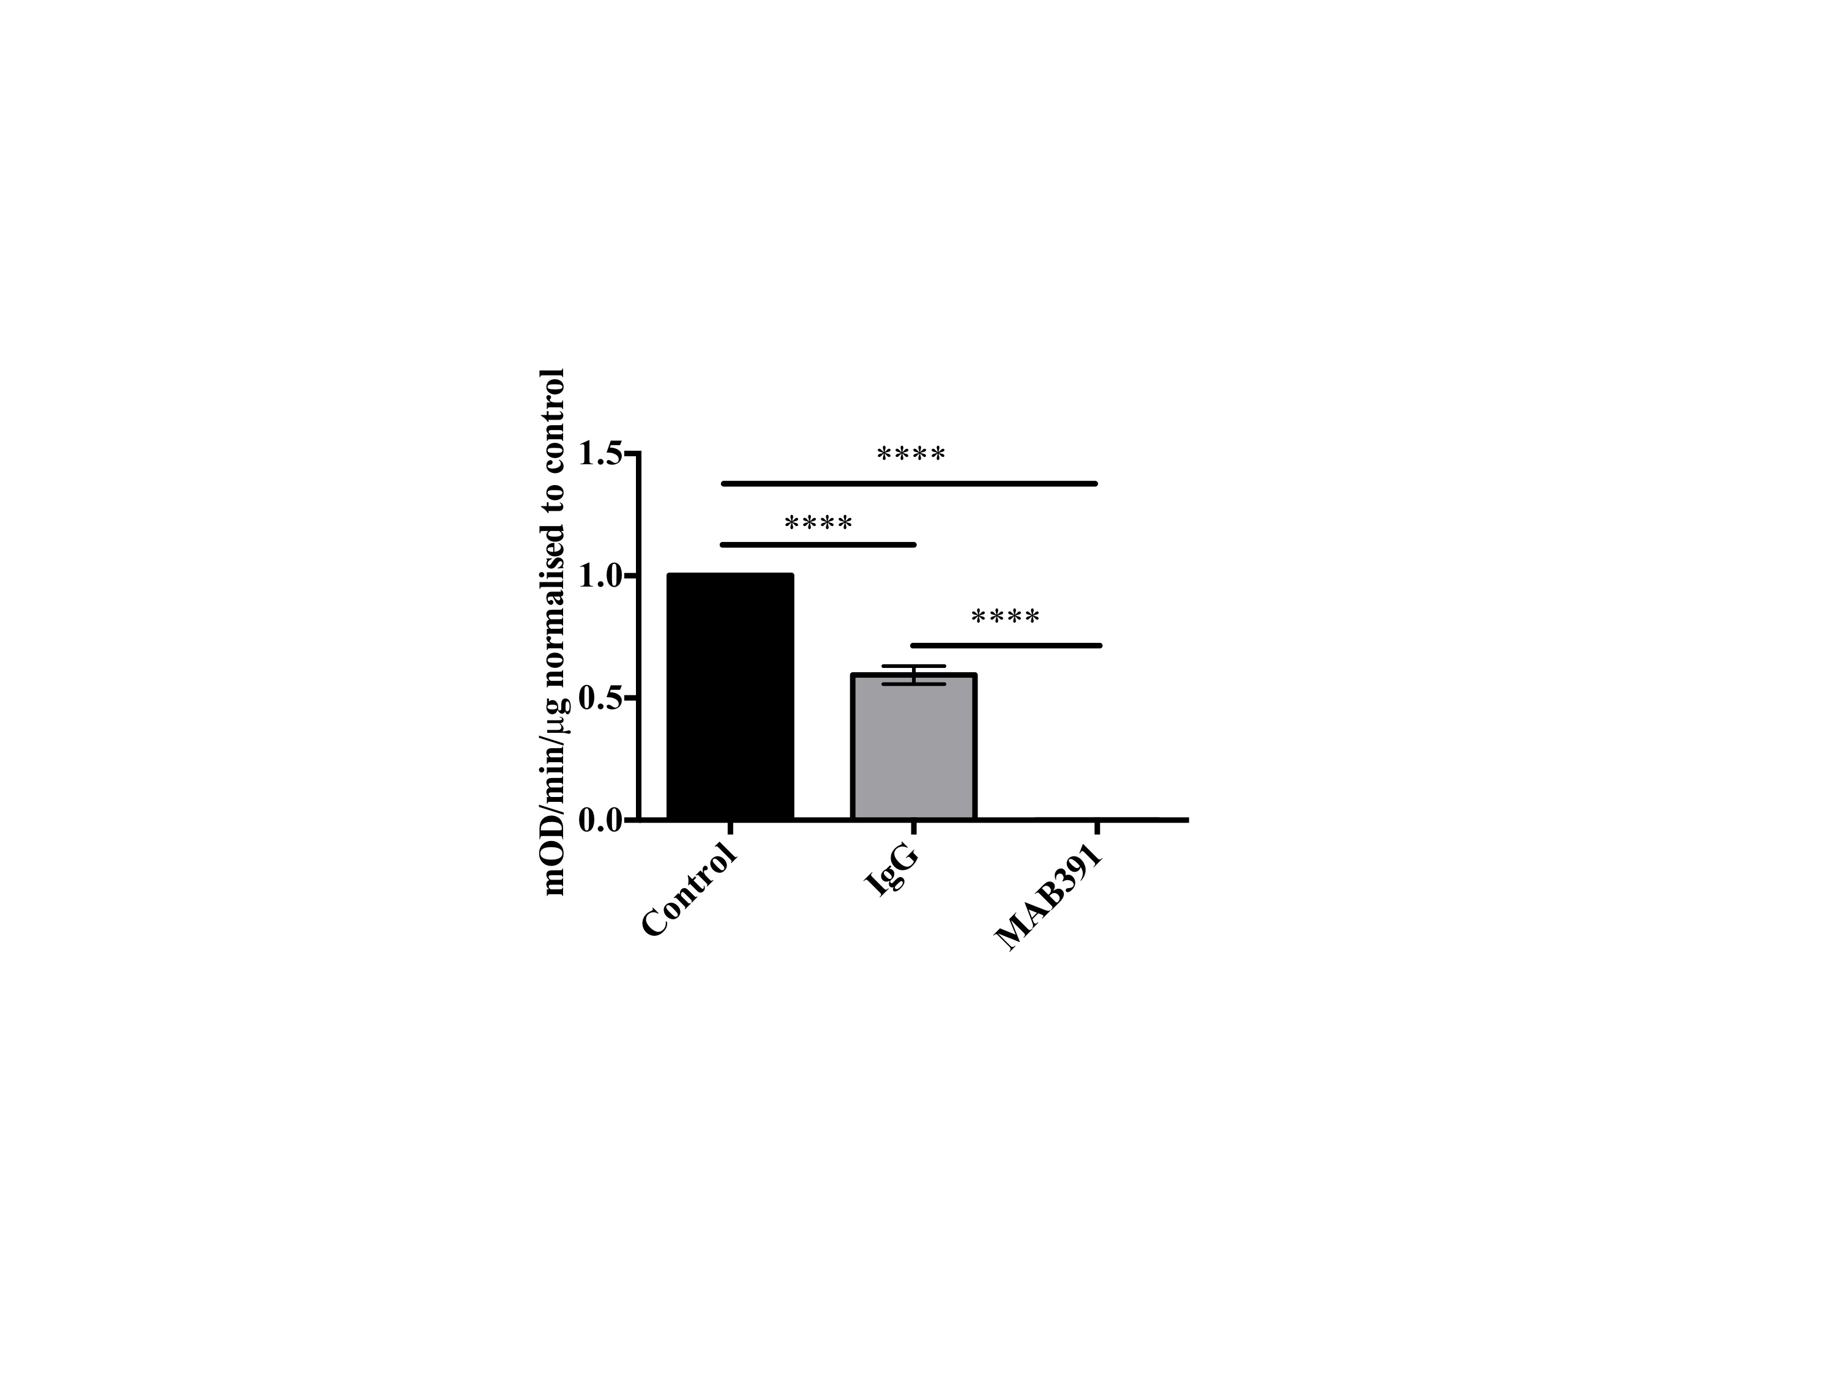
Figure 5.22. Loss of IGF1R in astrocytes causes impairment in complex I activity in astrocyte-neuron co-cultures.
NADH-dependent complex I activity measured in astrocyte-neuron co-cultures following pretreatment of astrocytes with or without IgG/MAB391. Graphs are representative of n=3 (One-way ANOVA; Data are means ± SEM).

Lactate Assay
Based on the gene expression profiling data it was predicted that lactate production might increase following IGF1R loss in astrocytes. This is due to two main findings: a) There was an increase in the expression of genes involved in glycolysis and a pyruvate/lactate transporter following MAB391 treatment b) Lactate production has been demonstrated to increase following impairment of oxidative phosphorylation in astrocytes (Almeida et al. 2001), which was also suggested in the array data. Therefore astrocytes may be increasing lactate production to resolve the imbalance in energy homeostasis following IGF1R loss.

A lactate assay (using a kit purchased from Abnova) was performed to assess the lactate content of media in which untreated IgG-and MAB391-treated astrocytes were grown with neurons for 72 hours. There were no changes in lactate content of the media as a result of IgG/MAB391 treatment of astrocytes (figure 5.23). This might suggest an upregulation of glycolysis, as implied by the array data, does not increase lactate production.
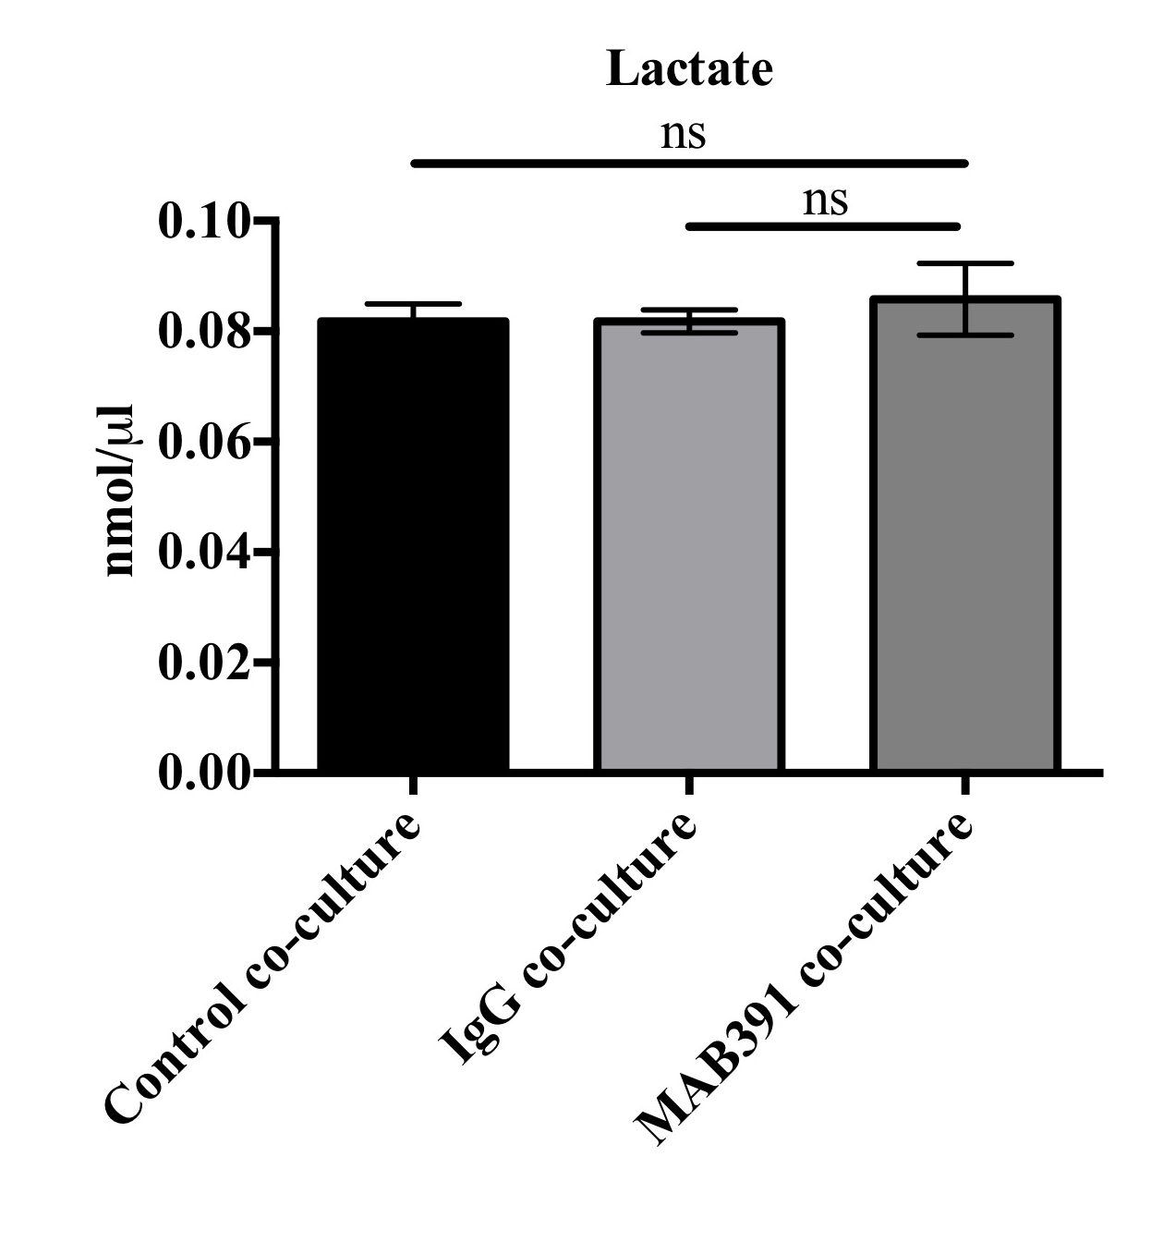

Figure 5.23. Loss of IGF1R in astrocytes co-cultured with neurons does not alter lactate levels in the media.
Lactate levels measured in the media of astrocyte-neuron co-cultures following pretreatment of astrocytes with or without IgG/MAB391. Graphs are representative of n=3, 3 experiments/replicate pooled together (One-way ANOVA; Data are means ± SEM).

5.4.12 Comparison of transcriptomic analysis on Astocytes isolated from ageing Alzheimer’s brain with IGF1 signalling impaired astrocytes in culture

An assessment was made of whether the transciptomic changes in IGF1 signalling impaired human astrocytes in culture mirror any changes in transcripts in astrocytes isolated from the ageing Alzheimer’s brain. To do this, the lists of differentially expressed genes from this study and those from the original comparison of astrocytes isolated from the temporal cortex of brain with low and high Braak pathology (Simpson et al. 2011) were input into the software Venny 2.1.0. A comparison of all differentially expressed genes between the two data sets was performed and then separated into lists of genes that were commonly up- and downregulated (figure 5.24).

When comparing the entire lists of differentially expressed genes, there were 81 altered transcripts shared by both lists. There were no common genes shared by the lists of upregulated genes, whereas 34 differentially expressed genes were shared by both data sets. This could demonstrate that the altered transcripts in astrocytes in the ageing Alzheimer brain may in part be the result of IGF1 signalling impairment.

The 81 genes shared by both data sets were analysed in IMPALA to assess which pathways they were involved in. In general, the genes listed in table 5.23 are involved in regulating mitochondrial biogenesis, protein degradation and calcium signalling.

Table 5.23. A list of the top ten pathways altered from the 81 genes shared between in vitro IGF1 signalling impaired astrocytes and an in vivo study of astrocytes isolated from the ageing, Alzheimer brain.

Pathway Name | No. transcripts | Transcript | P value
RAC1 signaling pathway | 3 | LIMK1;BAIAP2;NOXA1 | 0.00119
Parkin-Ubiquitin Proteasomal System pathway | 3 | SIAH1;UBE2G1;PSMD11 | 0.00273
regulation of pgc-1a | 2 | MEF2D;PPP3CC | 0.00297
cGMP-PKG signaling pathway | 4 | MEF2D;ATP2B1;PPP3CC;ADRB1 | 0.00361
Hyaluronan biosynthesis and export | 1 | ABCC5 | 0.00390
Calcium signaling pathway | 4 | ADRB1;ATP2B1;HTR2A;PPP3CC | 0.00394
role of mef2d in t-cell apoptosis | 2 | MEF2D;PPP3CC | 0.00526
Monoamine GPCRs | 2 | ADRB1;HTR2A | 0.00602
Thiopurine Pathway | 2 | ABCC5;CBS | 0.00683
ATM pathway | 2 | UBE2NL;CTBP1 | 0.00769

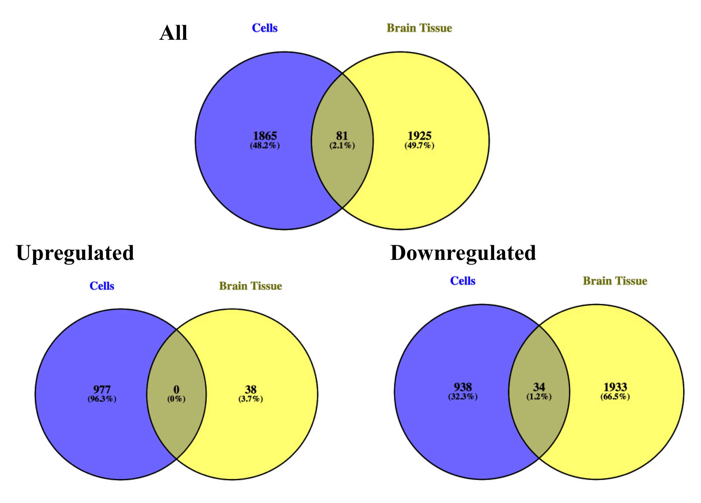

Figure 5.24. Venn diagrams showing the differentially expressed genes shared by an in vitro study of human astrocytes with impaired IGF1 signalling (blue) and astrocytes isolated from human ageing, Alzheimer brain (yellow).
All lists of differentially expressed genes were compared, lists of differentially upregulated and downregulated genes were also compared.

5.5 Discussion

In this chapter microarray analysis of MAB391-treated co-cultured astrocytes was performed in order to identify the mechanisms that might underlie the reduction in astrocytic support described in Chapter 4. FACS analysis was used to separate cell populations followed by microarray analysis of the astrocyte transcriptome. Pathway analysis revealed that genes involved in oxidative phosphorylation, glycolysis and antioxidant capacity were preferentially dysregulated. A subset of genes from each of the groups was then validated using qRT-PCR and functional analysis was also carried out. Overall, these experiments suggest that impaired IGF1 signalling in astrocytes results in mitochondrial complex I dysfunction.

5.5.1 Separation of co-cultured cells

To investigate changes occuring in MAB391-treated co-cultured astrocytes a method to separate astrocytes from LUHMES was optimised. Most of the reported astrocyte and neuronal co-cultures in the literature do not require separation since neurons are often cultured in transwells over a feeder layer of astrocytes or in different compartments in microfluidic chambers. Here, separation of the two cell populations was required as astrocyte support, in the form of enhanced neurite outgrowth, was reliant upon direct contact between the cells (Chapter 4, section 4.4.8).

Astrocyte-neuron co-cultures can be separated using cold PBS-jet wash separation, acutase treatment or FACS sorting (Goudriaan et al. 2014; Kraft et al. 2004; Lovatt et al. 2007). Here, separation of co-cultures was initially attempted using the cold PBS-jet wash method described by Goudriaan et al, 2014 but this technique did not achieve the same levels of separation in this co-culture system. There are several reasons that could explain the differences in separation efficiency. Goudriaan and colleagues co-cultured rat astrocytes and mouse neurons for 10/14 days on non-coated plastics before separation. However, separation of human astrocytes and neurons co-cultured for 3 days on fibronectin coated plastics was attempted here. Goudriaan et al (2014) also demonstrate that the length of time in co-culture can affect the efficiency of separation and by microarray analysis show that the fundamental transcriptomic changes in co-cultured astrocytes are upregulation of cell adhesion and extracellular matrix proteins. Therefore, the differences are likely a result of the interspecies variation in adherent properties, the length of time the co-cultures were set up for and whether pre-coating plastics influenced astrocyte-neuron interactions.

Because of this, an alternative method was established to separate the human astrocyte-neuron co-cultures. Previously, Kraft et al (2004) utilised FACS sorting to enrich for populations of mouse GFP astrocytes from neurons. Using this method, enriched populations of GFP LUHMES and astrocytes were obtained, the purity of the neuronal population was assessed using NFL and the astrocyte population using GFAP. Western blots and DNA gels demonstrated that FACS sorting of GFP LUHMES and astrocyte co-cultures can enrich for both populations of cells. It was also noted that the mono-cultured astrocytes expressed low levels of NFL and LUHMES expressed low levels of GFAP. Although GFAP is still used as the prototypical astrocyte marker (Sofroniew & Vinters 2010) it is also expressed by neural progenitors in the adult hippocampus and by developing ependymal cells (Imura et al. 2003; Liu et al. 2010; Roessmann et al. 1980). In addition, the NFL antibody could be binding to nestin, a class IV neurofilament, which is known to be highly expressed in astrocytes. The manufacturer of the NFL antibody does not disclose the epitope for this antibody, so it is also possible that nestin and NFL share epitopes. There are no previous reports of expression of neurofilament proteins outside of neurons so these observations raise intriguing questions about the expression of these proteins and may hint at a common lineage shared by astrocytes and neurons when grown in culture. Ideally, the FACS sorted astrocytes and LUHMES would have been reloaded into the FACS machine to assess purity of the sorted populations, however the cell yield was too low to do this.

5.5.2 Impaired IGF1 signalling alters the astrocyte transcriptome

Gene expression profiling was used to assess transcriptomic differences between IGF1 signalling impaired astrocytes compared with untreated astrocytes isolated from co-culture with neurons. Using the Affymetrix GeneChip arrays, 2815 genes were found to be differentially expressed in MAB391-treated astrocytes, with approximately half of these being upregulated and half downregulated. Pathway enrichment analysis programs DAVID and IMPALA were used to identify which biological pathways were most altered at the transcript level. Initially, DAVID was used to assess the trancriptomic profile of IGF1 signalling impaired co-cultured astrocytes and was able to annotate 23% of differentially expressed genes to a KEGG pathway. This figure seemed low and as a result an alternative pathway enrichment tool, called IMPALA, was used. IMPALA is able to annotate genes from 11 different public databases (including KEGG) (Kamburov et al. 2011) and successfully annotated 26% of differentially expressed genes to a biological pathway. The difference between the analysis performed by these two pieces of software does not seem that great, however overall IMPALA recognised more of the input genes (1946) than DAVID did (1270) and listed 20 times more biological pathways potentially altered by the MAB391 treatment. However, both the DAVID and IMPALA analysis showed specific alterations in energy metabolism pathways in IGF1 signalling impaired co-cultured astrocytes. The key pathways that emerged were oxidative phosphorylation and glycolysis, which suggest a shift in the energy metabolism in the astrocytes. In addition, other genes identified in the array indicated disruption of glutathione metabolism, changes to endocytosis (that may be consistent with treating the astrocytes with high concentrations of antibody), altered synaptic support and mitochondrial dysfunction. Each of these are discussed in more detail below.

Oxidative phosphorylation and mitochondrial defects
Pathway analysis performed by DAVID and IMPALA, identified downregulation of oxidative phosphorylation and defects in mitochondrial function. A total of 33 differentially expressed genes involved in mitochondrial function and stability were downregulated and of the eight differentially expressed genes involved in oxidative phosphorylation, five of these genes encoded subunits of complex I.

i) Complex I
Complex I is an NADH:ubiquinone oxidoreductase and is the largest and most intricate of the 5 complexes that consitute the mitochondrial respiratory chain. The purpose of this sequence of events is to remove electrons from the citric acid cycle and generate a proton motive force across the inner mitochondrial membrane that ultimately generates ATP. Complex I is the initial entry point of electrons and by oxidising NADH begins to establish a proton motive force. Impairments in complex I activity are associated with increased ROS production, since electrons that fail to be properly funneled through the complex will combine with oxygen to produce superoxide anions. Complex I deficiency has been recognised in a number of different diseases, most notably in Parkinson’s Disease, where reduced complex I activity and subsequent oxidative damage to complex I subunits is observed in dopaminergic neurons in the substantia nigra of patients with Parkinson’s disease (Schapira et al. 1990). In addition, oxidative damage and mitochondrial dysfunction may represent some of the earliest changes in AD progression. The mRNA levels of ND4, a subunit present in complex I, was found to be significantly downregulated in temporal cortex of AD patients relative to control (Fukuyama et al. 1996) and point mutations in ND2 (another subunit in complex I) have also been detected in AD patients (Lin et al. 1992). Furthermore, assessment of the mitochondrial proteome of a triple transgenic AD mouse model (APP_{Swe}, PS1_{M146V} and Tau_{P301L}) revealed changes in oxidative phosphorylation prior to development of AD type pathology, with specific downregulation of complex I proteins being found that are consistent with changes observed in early and late AD (Chou et al. 2011; Manczak et al. 2004).There are very few studies that investigate the specific contribution of complex I activity to astrocytic function, how its activity is regulated and the important contribution made in these cells to sustaining neuronal health.

Initially, qRT-PCR was carried out to validate downregulation of complex I transcripts, as observed in the microarray. NDUFA2 and NDUFB6 were both significantly downregulated in MAB391-treated astrocytes compared with IgG-treated control and showed either a significant decrease or a trend to a decrease compared with untreated control. To further explore changes in complex I activity of IGF1R impaired co-cultured astrocytes, the NADH dependent activity of complex I was assessed in the co-culture system. Loss of astrocytic IGF1R resulted in a significant impairment in the complex I activity of the co-culture system compared to both the untreated and IgG-treated controls. This is consistent with validated changes in expression of NDUFA2 and NDUFB6. As the assay was performed on astrocytes and neurons in co-culture, the complex I activity of both cell types was measured and so impairments in neuronal complex I activity cannot be ruled out. However, as changes in complex I transcripts were identified in IGF1 signalling impaired astrocytes and only the astrocytes were treated with MAB391, the reduction in complex I activity is most likely attributed to changes in the astrocytes.

Complex I is made up of mutliple subunits, with each one playing a different role. The specific biological roles of the transcripts altered in the array were investigated to see whether there was a link to changes in the NADH-dependent complex I activity. Complex I is composed of 45 subunits and three functional modules known as N, Q and P that are arranged in an L-shaped structure. Module “N” accepts electrons from NADH, “Q” transfers these to ubiquinone and “P” is involved in pumping protons across the inner mitochondrial membrane (figure 5.25). Each of the 45 subunits serve different purposes, with only 7 of the nuclear encoded complex I subunits considered as core elements. The five genes originally identified in the array (NDUFA1, NDUFA2, NDUFB3, NDUFB6 and NDUFAB) are all “supernumerary” and so far have not been shown to be directly involved in complex I activity. There are reports that these subunits are located in the “P” module and are necessary for assembly of the membrane arm (Mimaki et al. 2012), in particular NDUFA1 has been shown to be a membrane anchor to which membrane subunits attach (Yadava et al. 2002). In addition, mutations in NDUFA2 result in reduced assembly of mature complex I and formation of subcomplexes that may perturb mitochondrial membrane potential (Hoefs et al. 2008). If this is the case, then the capture antibodies used in the complex I activity kit may bind less of or misassembled forms of complex I, resulting in less efficient oxidation of NADH. Western blotting would need to be performed to assess whether the decrease in activity is due to a reduction in complex I.
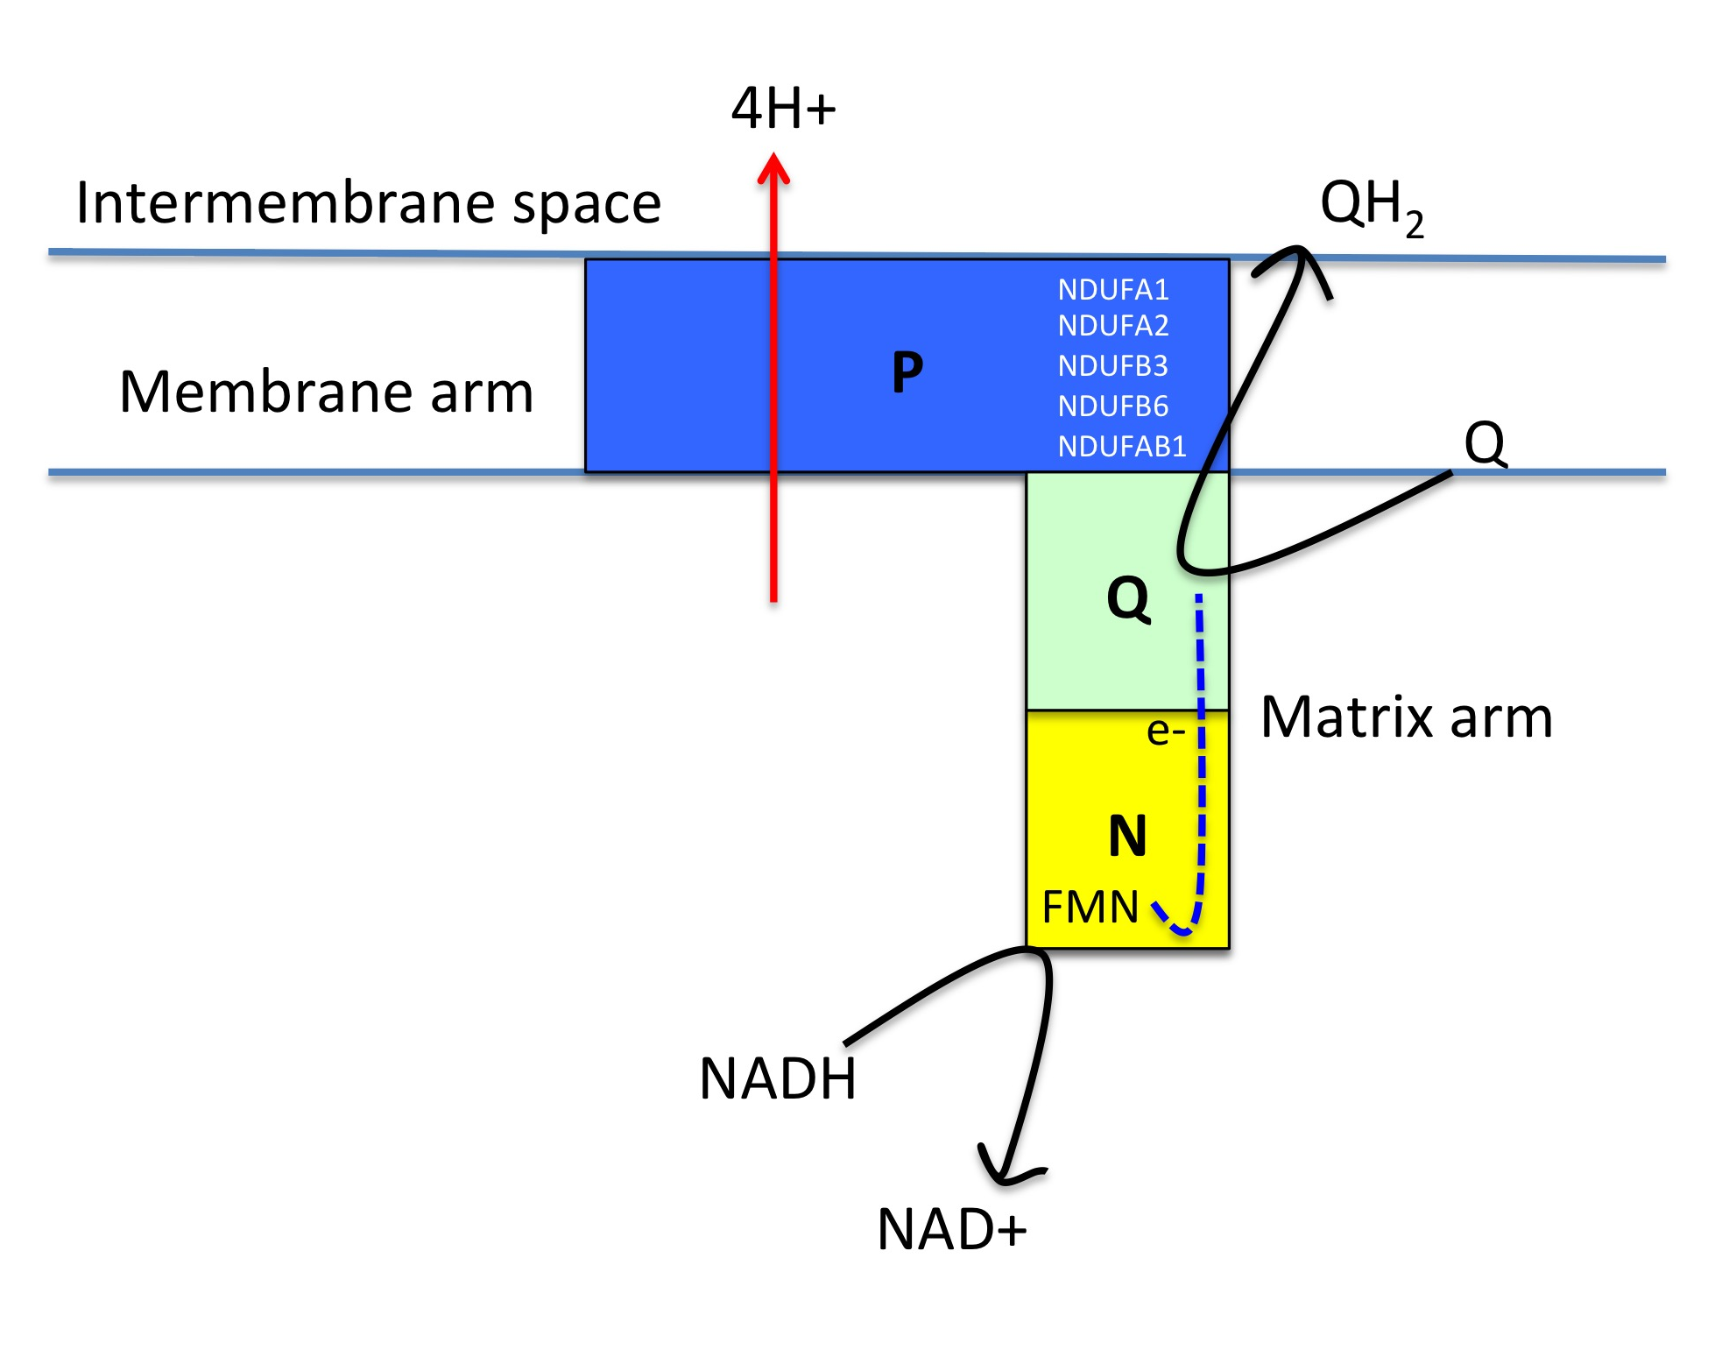 Figure 5.25. A schematic diagram showing the location of the complex I subunits altered following IGF1R loss in astrocytes.
Complex I is composed of three functional modules N, Q and P. The five genes with altered expression following IGF1R impairment in astrocytes have been shown to be located in the membrane arm of complex I (blue).

Initial characterisation of IGF1 signalling impaired astrocytes in monoculture may support this complex I defect. Impaired complex I activity is associated with increased ROS formation, which in turn results in increased Akt activation (Sharma et al. 2011). In chapter 1 figure 3.7, loss of IGF1R for 96 hours causes a significant increase in phosphorylated Akt (s473). Although an increase in ROS has not been demonstrated at this time point, impairments in complex I activity may be responsible for this increase in Akt activity. In addition, an MTT assay was performed in chapter 3 to assess cell viability (figure 3.9) but this can also be used as a measure of complex I activity, as the assay determines the activity of NADH oxidoreductases. Significant differences in the MTT assay were observed between control and MAB391-treated ScienCell(1) astrocytes, with a trend towards a decrease between IgG and MAB391 treatment. Although cell number did not change (as validated by using a cyquant assay), the changes identified in the MTT assay may have been early indications of a complex I defect. Also, the decrease observed in the MTT assay was more pronounced between the IgG and MAB391 treatment at earlier time points (between 48-72 hours MAB391 treatment) than used in the gene expression profiling experiments. The recovery observed in the MTT assay by 96 hours could be explained by upregulation of genes involved in cAMP signalling (as discussed later), which could restore some of the complex I activity and thereby rescue some of the defect seen in the MTT assay.

It is evident that treating astrocytes with IgG also reduced the complex I activity of the astrocytes (p< 0.0001) but did not reduce NDUFA2 and NDUFB6 transcript levels, as identified by qRT-PCR. The IgG treatment may induce a similar stress-like response but not result in all the effects observed following IGF1R loss, such as reduced levels of the PRDX3 transcript (discussed later). Following IgG treatment the PRDX3 transcript levels were signfiicantly increased compared with untreated control and as one of the main antioxidants in the mitochondria it may be able to deal with any ROS accumulation thereby better preserving complex I activity.

Overall, these results suggest that IGF1 signalling regulates complex I activity in astrocytes and that prolonged impairments in IGF1R levels potentially affect complex I assembly and stability. The literature suggests that impaired complex I activity can be detrimental to cellular function, however a study has shown in an AD mouse model has shown moderate inhibition of complex I to have neuroprotective effects (L. Zhang et al. 2015). This links back to the concepts of mitohormesis and impairments in IGF1 signalling promoting longevity, where alterations in the IGF1 pathway have a beneficial effect by elevating ROS levels and the antioxidant response. Furthermore, this highlights the need to maintain a balance in intracellular signalling systems to avoid detrimental effects.

ii) cAMP/PKA signalling
In response to complex I dysregulation, cells can upregulate cAMP/PKA signalling which is able to rescue the inactivity and reverse ROS accumulation (Papa & De Rasmo 2013). This, in part, is achieved by promoting import of complex I subunits, such as NDUFS4, which will replace existing subunits and be involved in reassembly of the complex (De Rasmo et al. 2012). The array data identified that a number of genes involved in cAMP/PKA signalling were altered in MAB391-treated astrocytes. Small GPCR ligands were highlighted as one of the top dysregulated pathways and included five GPCRs which were upregulated (PTGER2, S1PR4, PTAFR, S1PR1, MTNR1A). Four genes (PDE4A, PRKAR2B, ADRB1, RAPGEF2) were affected in the cAMP signalling pathways, in general there was an increase in the expression of these genes, which may suggest compensatory mechanisms in the astrocytes to restore complex I activity (Papa et al., 2012; Valenti et al., 2011). In foetal skin fibroblasts with Down’s syndrome, addition of cAMP derivatives has been shown to increase phosphorylation of complex I subunits, restore its activity and resolve ROS levels (Valenti et al. 2011). Astrocytes are robust cells that adapt to change and when complex I activity is compromised they may upregulate GPCRs and cAMP/PKA genes to increase the input through this pathway and resolve the defect. There was also significant downregulation of the cannabinoid receptor (CNR1). CNR1 is localised in the mitochondrial membrane of neurons and when activated decreases cAMP influx into mitochondria leading to reduced complex I activity (Bénard et al. 2012). Reduced expression in CNR1 in this array may support increased avaliability of cAMP within mitochondria to restore complex I function.

iii) Mitochondrial structure and stability
In addition to the changes observed in complex I genes, 33 genes involved in maintaining mitochondrial structure and stability were downregulated following loss of astrocytic IGF1R. This included genes involved in facillitating transport of molecules across the inner mitochondrial membrane and further highlights mitochondrial defects resulting from IGF1R loss. Upregulated genes included SLC25A3P1, SLC25A2, SLC25A23, SLC25A47, which are all involved in facillitating transport of molecules such as ornithine and phosphates across the inner mitochondrial membrane. Increased expression of SLC25A47 has been reported to cause dissipation of the mitochondrial membrane potential, which can lead to cell death (Gutiérrez-Aguilar & Baines 2013).
The changes observed in the mitochondrial associated genes would suggest energetic defects in IGF1 impaired astrocytes, with particular disruption in complex I of the mitochondrial respiratory chain. However, there was also evidence of potential compensatory mechanisms through upregulation of genes involved in cAMP/PKA signalling.

Recently mitochondrial defects, particularly in complex I and IV, have been reported in an insulin resistant model in rat cortical neurons (Peng et al. 2016). This supports the link between defective IGF1R signalling and mitochondrial impairments identified in this array. In addition, the link between insulin signalling impairment and mitochondrial dysfunction has been made in a NIRKO mouse model (brain-specific knockout of IR in mice). This study demonstrated complex I dysfunction and aberrant dopamine clearance as a result of IR loss (Kleinridders et al. 2015), but the specific contributions made by different cell types was not identified. However, in a separate study a list of mitochondrial genes were found to be differentially expressed in astrocytes isolated from the posterior cingulate in AD subjects, which is one of the brain regions with the earliest changes in glucose metabolism (Sekar et al. 2015). Furthermore, studies on the involvement of insulin/IGF1 in longevity suggest that downregulation of this pathway increases mitochondrial metabolism and thereby increases mitochondrial ROS production in the process of mitohormesis (Ristow & Zarse 2010; Zarse et al. 2012). Although it is predicted that stress resistance is upregulated by mitohormesis there may also be oxidative damage to mitochondrial DNA and genes that cause mitochondrial dysfunction, which may have been detected in this microarray study.

Glycolysis
Glycolysis is the metabolic pathway that converts glucose into pyruvate and hydrogen, generating free energy in the process. Pathway enrichment analysis performed by IMPALA found 6 genes involved in glycolysis and gluconeogenesis that were upregulated in MAB391-treated astrocytes. Gluconeogenesis refers to the process of forming glucose from non-carbohydrate carbon substrates and many of the enzymes involved in the later stages of glycolysis are also important in the early stages of gluconeogenesis. The upregulation of these genes suggest that either, or both, of these pathways could be upregulated in MAB391-treated astrocytes, however other genes identified in this array, together with existing literature, indicate a shift towards glycolysis following loss of IGF1R. The reasons for a suspected increase in glycolytic activity in IGF1 signalling impaired astrocytes are discussed below.

Firstly, astrocytes have been described as the “glycolytic” cell of the brain (Pellerin & Magistretti 1994). Transcriptomic analysis has identified enrichment of glycolysis genes in rodent astrocytes compared with other brain cells (Rossner et al. 2006; Cahoy et al. 2008; Lovatt et al. 2007) and differences have been detected in specific isoforms of glycolytic enzymes, particularly in rate limiting enzymes such as Pdk and Pkm (Zhang et al. 2014). Furthermore, in vivo studies have demonstrated increased glucose uptake by astrocytes during periods of intense neuronal activity (Chuquet et al. 2010), which is later converted to lactate and exported to neurons (astrocyte-neuronal lactate shuttle hypothesis). (Mächler et al. 2015; Kasparov 2016). In response to mitochondrial stress astrocytes will upregulate glycolysis to maintain the mitochondrial membrane potential, this has been demonstrated by treating rat astrocytes with the NO donor Diethylenetriamine (DETA) NO, which causes inhibition of cytochrome oxidase and disruption of mitochondrial membrane potential (Almeida et al. 2001; Bolaños et al. 2008). In addition, astrocytes can compensate by upregulating the transcription factor HIF1α, which increases the transcription of genes involved in glycolysis and causes elevation of extracellular lactate (Brix et al. 2012; Marcillac et al. 2011).

Secondly, the downregulation of genes involved in oxidative phosphorylation in MAB391-treated astrocytes may indicate a switch from oxidative phosphorylation to glycolysis in these cells and may explain why no obvious phenotype was observed in monoculture. Treating astrocytes with NO causes astrocytes to switch from oxidative phosphorylation to glycolysis to support neuronal networks (Almeida et al. 2001), which could be a similar mechanism employed by IGF1-signalling impaired astrocytes to maintain the mitochondrial membrane potential, avoid apoptosis and maintain neuronal support.

Other genes present in the array that provide evidence for increased glycolysis are PDK3 and SLC16A3. PDK3 phosphorylates pyruvate dehydrogenase (PDH) and thereby inhibits entry of pyruvate into the TCA cycle. Expression of PDK3 was downregulated following MAB391 treatment suggesting reduced regulation of the PDH complex and increased entry of pyruvate into the TCA cycle. This could provide intermediates needed for synaptic support or improve the supply of intermediates needed for oxidative phosphorylation, such as alpha ketoglutarate for glutamine synthesis (Hertz et al. 2007). SLC16A3, which encodes for the protein MCT4, was upregulated following MAB391 treatment. MCT4 is an astrocyte-specific proton-linked pyruvate/lactate transporter that is homologous to the classic lactate exporter MCT1 also found in astrocytes. However, changes in the expression of SLC16A3 and PDK3 seem contradictory. Increased expression of SLC16A3 would potentially result in increased export of pyruvate/lactate whereas downregulation of PDK3 would increase entry of pyruvate into the TCA cycle where it could provide the intermediates needed in oxidative phosphorylation. Downregulation of PDK3 may be a compensatory mechanism employed in response to MAB391 treatment to potentially increase levels of NADH generated from the TCA cycle with the aim of restoring defects in oxidative phosphorylation. Although, lactate release may also increase in MAB391-treated astrocytes since a study has demonstrated that treating rats with DCF, a known PDH activator, reduced the release of lactate from astrocytes (Itoh et al. 2003).

Pyruvate has also been shown to be an intra- and extracellular antioxidant defence mechanism. When added to neurons, pyruvate reacts with H₂O₂ in a process called oxidative decarboxylation to produce acetate, carbon dioxide and water. The protective effects of pyruvate are mediated by this process rather than by increasing energy metabolism (Desagher et al. 1997). In addition pyruvate is released from astrocytes to protect against oxidised cysteine mediated toxicity (Wang & Cynader 2001). Therefore if ROS levels do increase from a complex I defect, then pyruvate may act as an antioxidant mechanism intracellularly or for the neurons. In addition, as the glutathione system also seems impaired at the transcript level, the astrocytes may need to upregulate other antioxidant defence mechanisms.

A further consideration is that astrocytes on a cellular level are made up of four subcompartments: the soma, larger processes, peripheral astrocytes processes (PAPs) and large end feet. Each part of the astrocyte is attributed to performing a different role, since the larger processes contact arterioles and PAPs are in close proximity with synapses. The PAPs are too narrow to accommodate mitochondria and therefore in order to respond to a sudden energetic demand, such as glutamate release at the synapse, ATP needs to be readily available. Glycolysis and glycogenolysis are able to provide more immediate supplies of ATP (Hertz et al. 2007). Therefore, the increase in the glycolytic genes observed in this array could suggest that there is at energetic demand near the PAP’s as a result of IGF1R loss.

Astrocytes can resolve defects in oxidative phosphorylation by increasing glycolysis and generating more lactate to sustain an energy supply for neurons (Pellerin & Magistretti 1994; Almeida et al. 2001). The array data showed increased expression of a number of glycolytic genes, including elevated expression of a pyruvate/lactate transporter (although validation of these glycolytic genes by qRT-PCR was unclear). Therefore, lactate production was assessed in co-cultures to assess whether there was compensation in astrocytes following IGF1R related impairments in energy metabolism. There were no changes in lactate levels in co-cultures when astrocytes were treated with MAB391 compared with controls. However, a lactate assay alone is not sufficient to confirm if astrocytes are able to compensate for defective oxidative phosphorylation. The glycolytic activity of IGF1R impaired astrocytes could be altered but instead of supplying lactate could be raising pyruvate levels to compensate for changes in oxidative phosphorylation. Therefore, glycolytic rates and pyruvate levels in astrocytes would need to be assessed to investigate whether astrocytes are indeed able to restore energy metabolism following IGF1R loss. Furthermore, external lactate levels may not be altered as neurons may upregulate lactate transporters such as MCT2 when astrocytes increase lactate production as a result of impairments in oxidative phosphorylation. Thus, measurements of lactate levels in the media may show no differences (as demonstrated here) as astrocytes may be releasing more lactate but this may be taken up more effectively by surrounding neurons.

Taking all of this into account, loss of IGF1R could be elevating expression of glycolytic genes to increase glycolytic activity and thereby compensate for defects in oxidative phosphorylation. It is not clear whether increased glycolysis would result in lactate production to maintain an energy supply to neurons, or whether glycolysis is upregulated to provide more substrate eventually for oxidative phosphorylation. Alternatively, pyruvate production may be preferred and used both as an intracellular or extracellular antioxidant.

Antioxidant pathway
Given the finding that MAB391-treated astrocytes were less able to support neurons under conditions of oxidative stress it was predicted that there may be changes in genes involved in the antioxidant pathway. Astrocytes predominantly use glutathione and catalase as their antioxidant defence mechanism (Dringen & Hamprecht 1997). A compromised glutathione system in astrocytes may contribute to a reduced capacity to defend against extracellular ROS, which could increase the susceptibility of astrocytes and neighbouring cells to ROS (Dringen et al. 2000).
IMPALA and DAVID pathway enrichment analysis did not identify changes in the antioxidant status of the cells and therefore the data was manually interrogated for any changes in antioxidant genes. Ten genes were identified as dysregulated in the IGF1-impaired astrocytes indicating an overall impairment in the ability of the astrocytes to process ROS. This included enzymes involved in converting oxidised glutathione back to reduced glutathione (in particular PRDX3 and GLRX3), which would limit the glutathione avaliable to reduce ROS. Reduced PRDX3 at the transcript level was validated by qRT-PCR, whereas GLRX3 did not validate. PRDX3 is found in the mitochondria and reduced levels of this transcript may suggest an inability to process ROS generated from defective complex I (Chen et al. 2008).

Glutathione s transferase alpha 3 (GSTA3) mRNA expression levels were significantly upregulated. GSTA3 increases conjugation of GSH to cellular proteins that may have undergone oxidative stress (Salinas & Wong 1999), and further suggests reduced GSH within the astrocytes. There are also changes in the glutathione related genes that indicate astrocytes are compensating following treatment with MAB391. Loss of IGF1R led to upregulation of gamma-glutamyltranspeptidase (GGT1) and ATP-binding cassette subfamily C member 5 (ABCC5). GGT1 encodes a protein that catalyses the breakdown of glutathione into its constituent parts glutamine and cysteine and ABCC5 encodes a protein involved in transport of glutathione to the extracelluar space. Altered trafficking of GSH from astrocytes to the neurons renders neuronal mitochondrial respiration more susceptible to inactivation by oxidising species (Gegg et al. 2005). However, upregulation of both of these genes suggests increased export of GSH and its precursors to either restore or improve the GSH status within the neurons.

In addition, underlying stress is suggested from the microarray data since upregulation of NOXA1 is observed and this is involved in activating a superoxide producing NADPH oxidase (NOX1). Therefore, when co-cultures are exposed to additional oxidative stress there may not be sufficient reserves of astrocytic glutathione to deal with external ROS, resulting in neuronal dysfunction.

An increase in glutathionylation within the cell and export of glutathione, as suggested from changes in the gene expression profile of IGF1R impaired astrocytes, would indicate that the pool of total GSH within the astrocytes is reduced but with potential increases in extracellular and neuronal GSH levels. This could explain why preliminary functional studies measuring the GSH:GSSG ratio of IGF1R impaired astrocytes co-cultured with neurons did not identify differences in the levels of GSH (data not shown in this thesis).

Changes in glutathione-associated transcript levels in astrocytes are altered in an NRF2 dependent manner, as demonstrated by microarray analysis of primary mouse cortical astrocytes overexpressing NRF2 (Lee et al. 2003). Changes in the expression of NRF2 itself was not detected in the astrocytes following IGF1R loss but clusters of genes related to NRF2 activity identified in the Lee et al 2003 study were also changed, these included GSTs, thioredoxin and UDP glycosyltransferases. Under oxidative stress NRF2 translocates to the nucleus, where it binds to the ARE sequence and leads to transcriptional acitvation of downstream genes (Nguyen et al. 2009). Studying NRF2 localisation and associated gene expression changes following MAB391 treatment at earlier time points may be interesting to determine if IGF1R loss triggers an NRF2-ARE mediated response.

Even if the glutathione system in the astrocytes was impaired, astrocytes could still cope with ROS through the use of the enzyme catalase (Dringen & Hamprecht 1997). Levels of catalase were not altered at the transcript level, which would suggest that the astrocytes could use this as an alternative way of processing ROS, but perhaps less effectively.

Synaptic Support
In addition to changes in genes involved in energy metabolism, alterations were also observed in genes involved in synaptic support. Increased expression of oxytocin receptor and glutamate receptor were found in IGF1R impaired astrocytes. Upregulation of the oxytocin receptor may occur in astrocytes in response to being cultured with dopaminergic neurons, which are known to secrete oxytocin in the mesolimbic area of the brain (Succu et al. 2007). Analysis in IMPALA also identifed dysregulation of the the dopamine deficiency pathway, as both upregulation of dopamine-beta hydroxylase (DBH) and phenylethanolamine N-methyltransferase (PNMT) were found in the array and these are suggestive of increased breakdown of dopamine. This is interesting since the LUHMES are originally derived from the midbrain, where dopamine is a neurotransmitter, and potentially suggests astrocytes have tailored their support to the neurons they have been cultured with. In addition, there was a significant increase in GABRB1 in the astrocytes following IGF1R loss, which could suggest increased capacity to respond to neurotransmitter and exert control at synapses. As the FACS sorting process achieved an enriched population of astrocytes, these differences may result in varying levels of neuronal contamination across the astrocytic samples. However, an array conducted on astrocytes separated from neurons using the cold-jet PBS wash approach identified a significant upregulation of GABRB1 in astrocytes co-cultured with neurons than in astrocytes cultured alone (Goudriaan et al. 2014). Therefore, identification of neuronal-associated genes in astrocytes may be a reflection of co-culture conditions as well. In relation to the increase observed in GABRB1, loss of IGF1R also led to an increase in three genes involved in potassium channel formation (KCND1, KCNQ2 and KCNK6). Astrocytes clear potassium from the neuronal microenvironment to ensure the level of potassium ions do not reach levels that could interfere with neuronal activity (Kofuji & Newman 2004). An increase in these genes, as demonstrated in table 5.18, could suggest that the surrounding levels of potassium have increased and astrocytes have upregulated potassium channels to reduce neuronal exposure to potassium. In addition, glycolysis is regulated by potassium influx into astrocytes (Bittner et al. 2011) and an increase in the transcript levels of glycolytic enzymes and potassium channels may suggest that IGF1 signalling impaired astrocytes are under higher metabolic demand from the neurons. GRM6 was also upregulated following MAB391 treatment, which may indicate that astrocytes are trying to resolve glutamate levels present in the co-culture system. Glutamate has also been shown to stimulate glucose uptake into astrocytes (Loaiza et al. 2003), which could provide substrates for glycolysis.

Further changes in synaptic support were observed as SERPINI1 and STXBP4 were both downregulated, both of which are involved in axonal and synaptic development. Downregulation of both of these genes was found in astrocytes treated with tBHQ and separated from neurons by FACS (Kraft et al. 2004). This suggests that there may be reduced support for neuronal development, which is not just an artefact of the co-culture separation method. Furthermore, reduced expression of these genes may be an additional reason for IGF1R impaired astrocytes not being able to support neurons under conditions of oxidative stress.

Upregulation of SMO, HIP1, WNT4 and DVL3 were also found in IGF1R impaired astrocytes. These genes are necessary in facillitating Shh signalling, which has been shown to be important in astrocytes to respond to meet the demand of local neural circuits (Garcia et al. 2010; Farmer et al. 2016). Increased expression of genes, in particular SMO, may suggest that changes have occurred in the neurons in response to loss of IGF1R in the astrocytes that mean the astrocytes must alter their function accordingly.

Therefore, at the gene expression level, loss of IGF1R may result in increased response to neurotransmitter, a possible loss of support for neuronal development and possibly a specific tailoring of astrocytic function to try to meet neuronal needs. Thus, these changes could indicate that at the transcript level loss of IGF1R in astrocytes not only affects astrocyte function but affects neuronal function too.

Other differences identified in the array
The array data was also examined for any changes in RTK expression that would suggest a mechanism by which the astrocytes can compensate for loss of IGF1R and maintain signalling through Akt. However, there didn’t appear to be increased expression of any RTK in the MAB391-treated astrocytes. There were also no changes in IR expression following IGF1R loss, which may have been expected since earlier work suggested increased dependency on IR following treatment with MAB391 (Buck et al., 2010). In addition, upregulation of genes encoding proteins involved in endocytosis were found in MAB391-treated astrocytes. This may support earlier evidence in chapter 1 and reports that MAB391 causes internalisation of IGF1R by endocytosis and targeted lysosomal degradation (Hailey et al. 2002). Also, there were no changes in IGF1R, which validates earlier qRT-PCR data showing MAB391 treatment does not reduce expression of IGF1R in this model.

It is evident from examining changes in the expression of genes following IGF1R loss that astrocytes could be compensating for impairments. This was hinted at in the monoculture work but was reinforced following the gene expression profile study of IGF1R impaired astrocytes. Defects in mitochondrial energy metabolism may be compensated for by an increase in glycolysis, loss of synaptic support could lead to increased response to neurotransmitter and use of glutathione in protecting oxidised protein looks to be matched by increased export of available glutathione. Also, the fold changes of the differentially expressed genes identified were not huge, which may also be because the astrocytes are being examined 96 hours following initial treatment with MAB391. This may also be an effect of examining whole mRNA molecules with multiple probes, which can cause a smoothing of the signal intensity.

It was suspected from assessing the effect of MAB391 in monoculture that loss of IGF1R would cause cells to upregulate other pathways to restore downstream signalling through Akt. IGF1 belongs to the insulin family which is divided into two groups of peptides: one includes insulin and IGF and the other is relaxins and insulin-like hormones. Previously, loss of IGF1R caused cells to upregulate IR to restore downstream signalling (Hailey et al. 2002), although no change was observed in IR at the level of gene expression. However, there was a significant upregulation of relaxin-1 (FC=1.65 and p≤0.02) and insulin-like 6 (FC=1.24 and p≤0.0007). This may suggest that astrocytes compensate and restore downstream signalling of Akt by upregulating expression of both of these ligands.

Based on earlier studies in rodent astrocytes, which showed insulin/IGF1 promotes glycogen storage, expression of genes involved in converting glucose to glycogen, such as GYS1 (glycogen synthase) and UDPG (uridyl diphosphate glucose pyrophosphorylase), were investigated. However, persistent loss of IGF1R does not regulate expression of these genes.

The differences identified in the expression of inflammatory genes highlight astrocytic response to the antibody used to downregulate IGF1R. There was increased expression of several genes related to an immune response following treatment with MAB391, which suggest that the effects observed in these cells are not simply the result of IGF1R loss but also Fc receptor binding and associated downstream activation. There was also a significant loss in expression of an Fc receptor fragment (FCG1RB) at the level of gene expression (FC=0.68, p≤0.009), which highlights a mechanism used by the astrocytes to prevent continued activation of this receptor and associated response. These results further indicate the importance of using an IgG type control in elucidating how MAB391 associated IGF1R loss may be affecting astrocytic function and that this serves as the real experimental control.

5.6 Summary

The gene expression profiling data has been used to predict how impaired IGF1 signalling alters astrocytic function (outlined in figure 5.26). Loss of IGF1R could impair oxidative phosphorylation, specifically complex I activity, leading to ROS production and protein oxidation. As a compensatory response, astrocytes may increase intracellular supplies of glutathione to protect proteins from further oxidation-induced stress and degradation. This may limit the availability of reduced glutathione to deal with any further oxidative stress and could support earlier findings showing reduced neuronal support when challenged with H₂O₂. To compensate for reductions in mitochondrial respiration astrocytes can upregulate glycolysis, which was one of the most enriched pathways upregulated following MAB391 treatment.

Validation of the array confirmed reduced complex I activity both at the RNA and at a functional level, whereas the changes in glycolysis and lactate production are less clear. In conclusion, loss of IGF1R in astrocytes dysregulates energy metabolism and may contribute to the reduced support for neurons during AD progression. Dysregulated energy metabolism is a recognised feature of AD and a similar pattern of changes in oxidative phosphorylation and glycolysis as reported here, were observed by proteome profiling hippocampal tissue in late Braak stage AD subjects (Hondius et al. 2016).

This thesis may position the IGF1 signalling pathway in astrocytes as a key regulator of astrocyte-neuron energy metabolism, although further work is needed to investigate this. Furthermore, the changes in IGF1 signalling in astrocytes do not account for all of the changes in gene expression observed in the original Simpson et al (2011) study, suggesting that there are other impairments in astrocytes that contribute to the transcriptomic phenotype observed in AD.

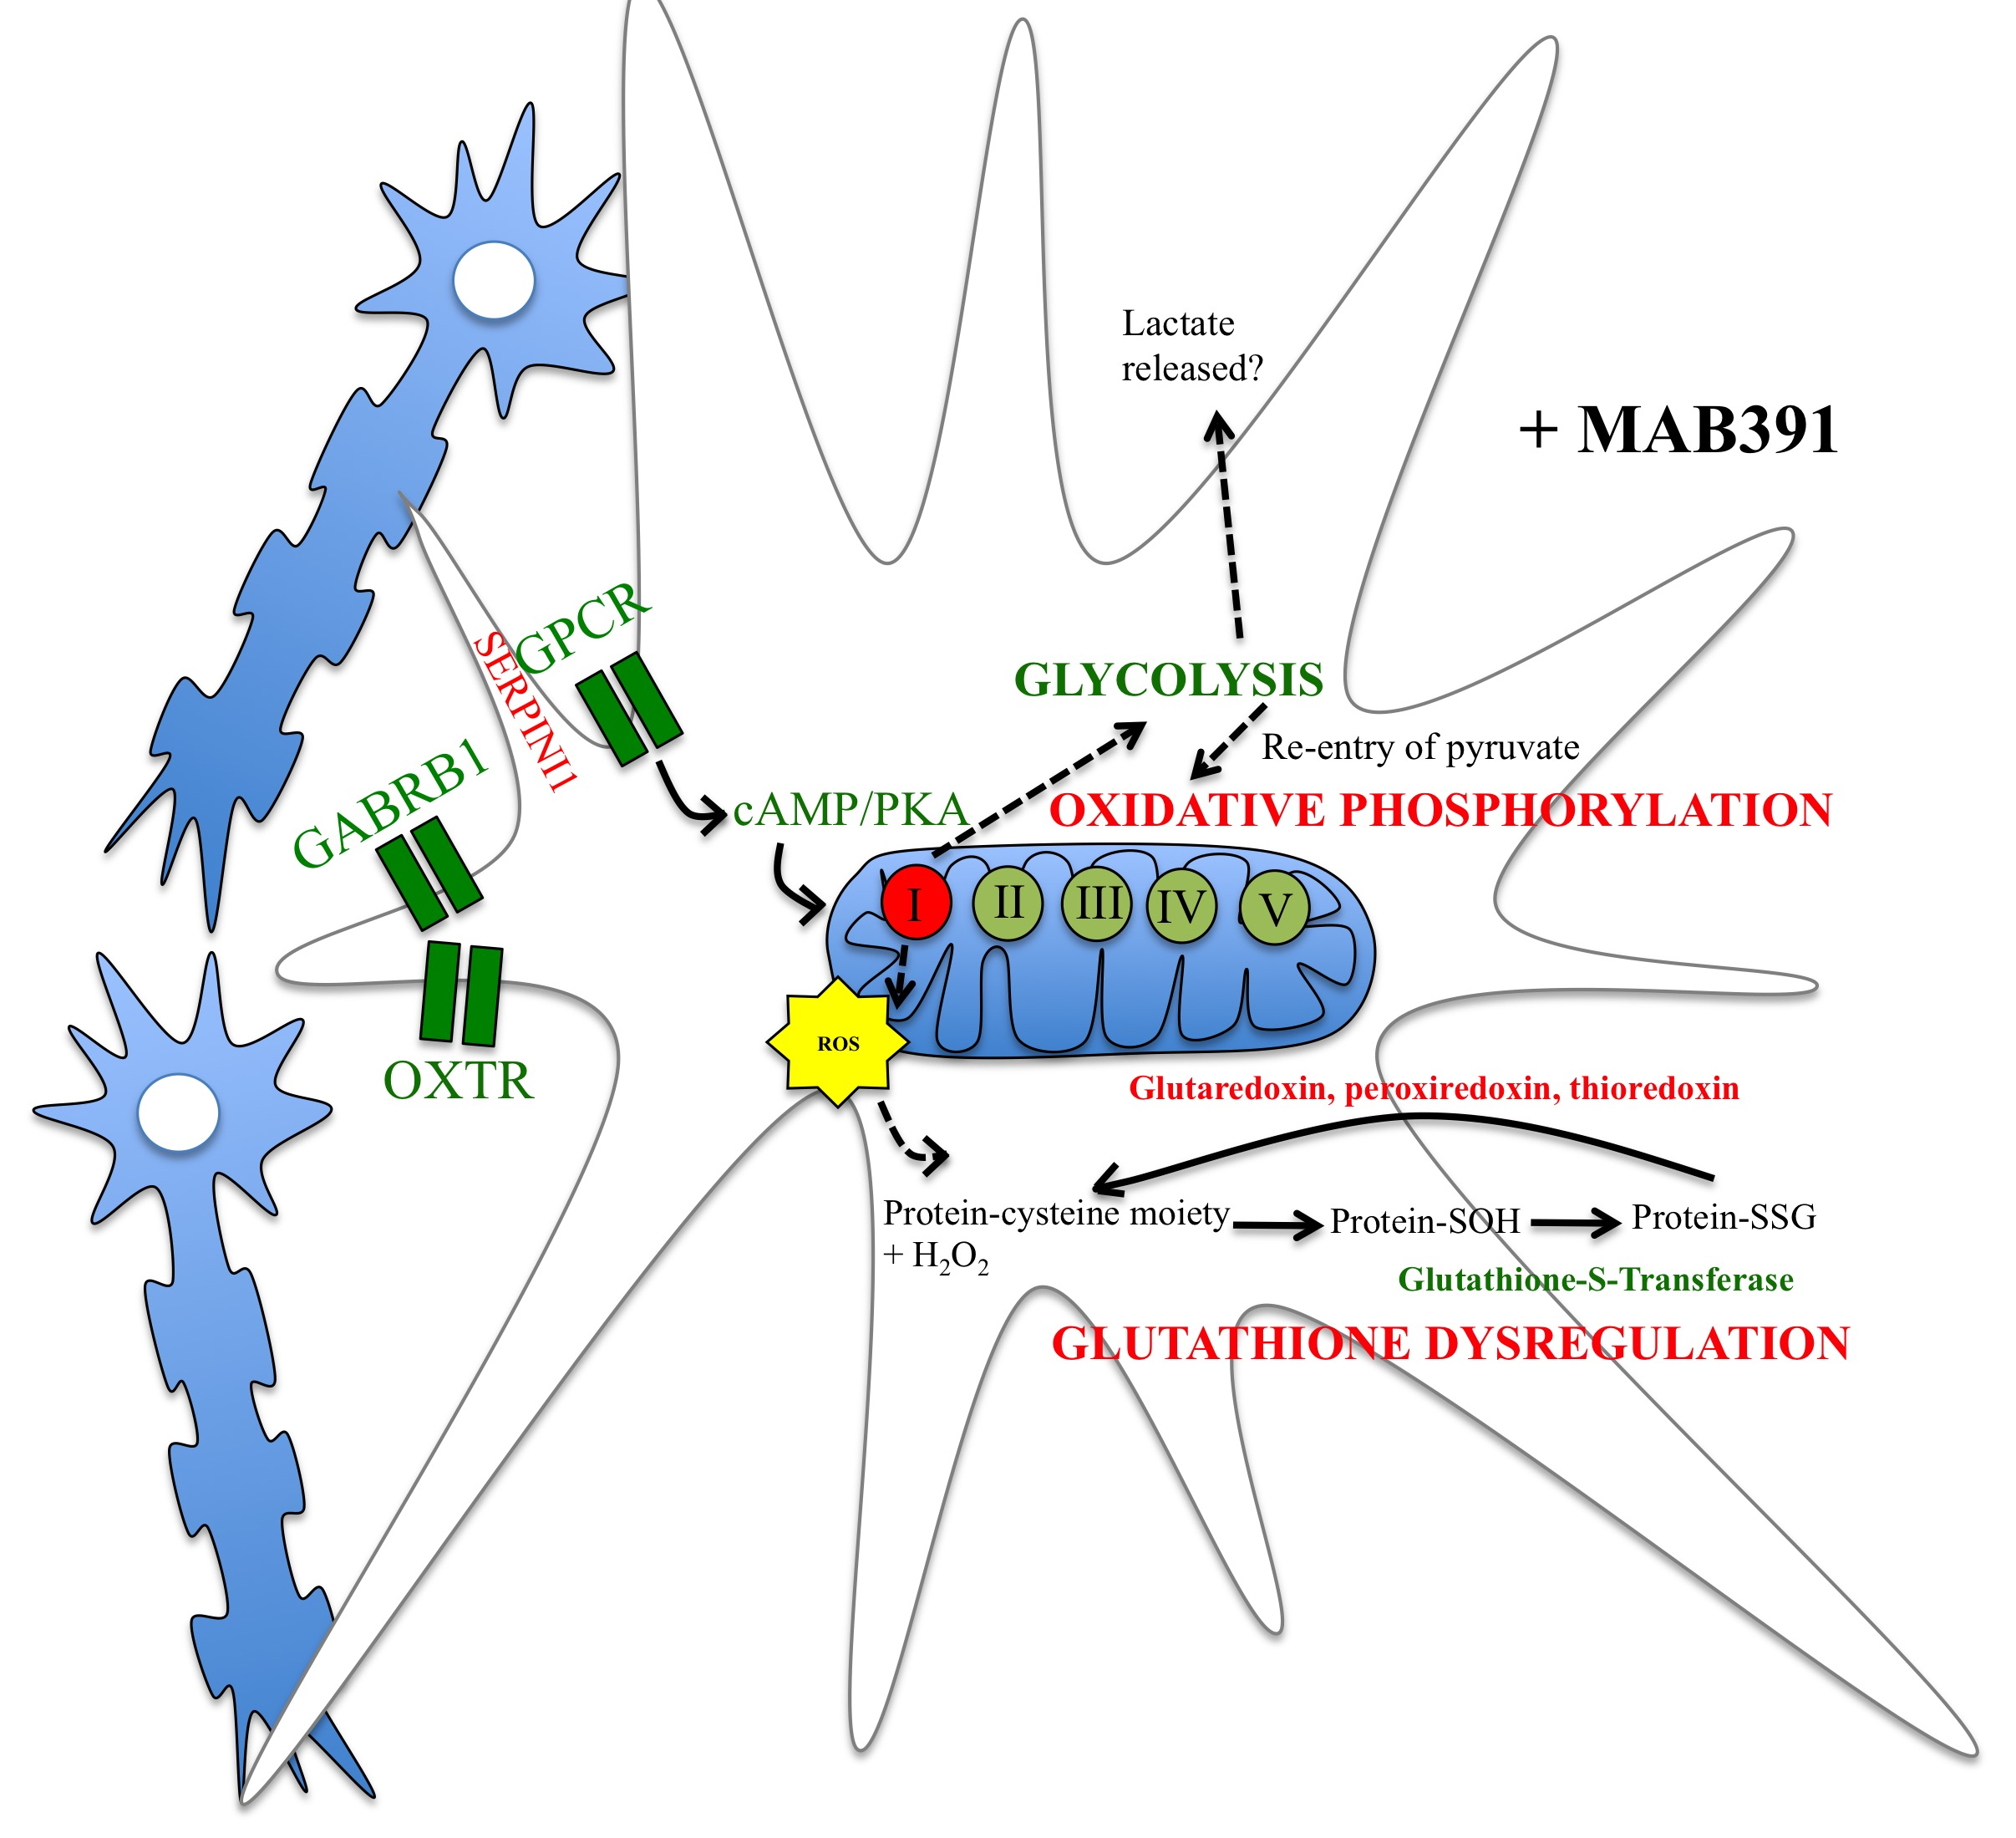

Figure 5.26. A hypothetical model of how IGF1 signalling impairment affects astrocytic function.
This illustrates the biological pathways (generated from DAVID and IMPALA analysis of the microarray data) that may be altered following loss of IGF1R. The text in red indicates genes or pathways downregulated following MAB391 treatment and in green are the genes or pathways upregulated following MAB391 treatment.

5.7 Main Conclusions

- Human astrocytes and LUHMES can be FACS sorted to produce enriched populations of astrocytes and LUHMES.
- Gene expression profiling identified impairments in mitochondrial function and the antioxidant capacity of astrocytes following IGF1R loss.
- Astrocytes upregulate genes involved in glycolysis following IGF1R loss, which may be an indication of compensation for mitochondrial energetic defects.
- Loss of IGF1R in astrocytes results in impaired NADH-dependent activity of complex I in astrocyte-neuron co-cultures, possibly as a result of altered assembly of this complex.
- IGF1 signalling in astrocytes may regulate oxidative phosphorylation.
- Changes in IGF1 signalling in astrocytes do not account for all of the transcriptomic changes observed in the Simpson et al (2011) study.

Chapter 6

Discussion

6.1 Introduction

The principal aim of this study was to investigate the impact of impaired IGF1 signalling on human astrocyte function and whether this impairment affects neuronal support. Impairments in astrocytic IGF1 signalling have been described in AD brain and therefore understanding the impact this has on astrocytic function is important in further understanding the processes that underly the pathogenesis of this disease.

To address this question, an in vitro model of IGF1R impairment was generated in human astrocytes. Changes to astrocytic function were then assessed in monoculture and a co-culture system was developed with human neurons to further identify how impaired IGF1 signalling in astrocytes affects neuronal support. The transcriptomic profile of IGF1R impaired astrocytes isolated from co-culture was also investigated.

6.2 Summary of main findings

In summary the main findings were:

- IGF1 signalling proteins are present in human astrocytes in vitro and in human brain tissue. Functional IGF1 signalling was demonstrated in astrocytes in vitro.
- A monoclonal antibody against IGF1R, MAB391, can be used to reduce IGF1R levels in human astrocytes however this does not necessarily confer reduced signalling downstream through Akt.
- There is no obvious impact of reduced IGF1R on astrocytic phenotype. (astrocyte morphology, cell viability, GFAP levels, γH2AX expression, ROS levels).
- Human astrocytes and LUHMES can be co-cultured, with networks of LUHMES being supported by astrocytes. Expression of GFAP and Cx43 is altered in co-cultured astrocytes, suggesting a change in astrocyte function when in contact with neurons.
- Astrocytes enhance neurite outgrowth in a contact-dependent manner.
- Loss of astrocytic IGF1R does not impair neurite outgrowth but inhibition of
Akt signalling using Wortmannin does result in reduced neurite outgrowth.
- Impaired IGF1-signalling alters the ability of astrocytes to support neurite outgrowth in the presence of oxidative stress.
- Enriched populations of astrocytes can be isolated from co-cultured GFP-LUHMES using FACS.
- Gene expression profiling of IGF1R impaired astrocytes co-cultured with GFP-LUHMES identified underlying changes in transcripts involved in energy metabolism, antioxidant capacity and synaptic support.
- A number of targets identified in the array were validated using qRT-PCR. This included the genes involved in Complex I activity, which were further validated using a functional assay.

6.3 Main findings

6.3.1 IGF1 signalling in primary human astrocytes
Although insulin/IGF1 is a crucial signalling pathway both centrally and peripherally there was no literature detailing the presence and functionality of this pathway in primary human astrocytes. The use of primary human astrocytes is in itself relatively novel, and the majority of astrocytes used in this thesis were foetal-derived, the use of these cells is discussed under further considerations. Initial experiments confirmed the presence of all of the key components of this signalling pathway in these cells and, further, by modulating the components of the media, alterations in downstream signalling through Akt and MAPK P44/42 were demonstrated. This then enabled the focus to move to the development of a model, which could impair signalling through the IGF1R. Picropodophyllin is a chemical inhibitor that can achieve this but also targets the insulin receptor. Downregulation of the receptor using IGF1R siRNA was also trialled (data not shown) but transfecting these primary cells efficiently was problematic and for this reason an alternative method was pursued. The monoclonal antibody MAB391, used in this study, has been used extensively in the cancer field, since the IGF1 signalling pathway is a key oncogenic pathway. Here it was used to effectively downregulate IGF1R in primary human astrocytes. Although robust downregulation of IGF1R was achieved, the impact on downstream signalling through Akt was variable and is likely due to a number of reasons. Akt is a key kinase involved in cell survival, therefore downregulation of one receptor upstream will result in the upregulation of other receptors involved in activating this kinase (Buck et al., 2010). Indeed the concept of a signalling network, as opposed to the impact of individual signalling pathways is one that is increasingly being addressed.

Another reason for the variability likely reflects the inherent genetic variability in the human astrocytes used. Assessment of signalling pathways was carried out on three separate sets of cells, two from ScienCell (both foetal-derived) and one using adult astrocytes derived from temporal lobe resections. The results from this work formed a major part of a recent publication (Garwood et al. 2015). Although there was no obvious impact of IGF1R receptor reduction on the morphology or phenotype of astrocytes there is an increasing body of literature that suggests in order to observe impairments in astrocyte function neurons must be present since the central role of these astrocytes is to maintain maintain the brain environment, and by default neuronal health (Desagher et al., 1996; Jourdain et al., 2016; Sofroniew & Vinters, 2010; Swanson & Choi, 1993). Therefore a co-culture system was developed in order to model the effects of impaired IGF1 signalling in a novel co-culture system.

6.3.2 A novel human co-culture system

A novel human co-culture model was established using ScienCell astrocytes and LUHMES. Although LUHMES were originally derived from the midbrain, have a dopaminergic background and have been widely used in Parkinson’s disease research, there are several advantages of using them to develop a co-culture model in the context of understanding mechanisms that may be driving AD progression.

LUHMES exist in an immortalised state due to the presence of a v-myc oncogene, which means a large quantity of cells can be produced in a short period of time and with their differentiation into post-mitotic neurons taking less than a week, this makes them an attractive neuronal cell type to use. In addition LUHMES express Aβ (Scholz et al. 2013), which makes them a relevant model for AD research and have been successfully co-cultured with immortalised murine astrocytes and human astrocytes (not including the foetal human ScienCell astrocytes used here) to investigate astrocytic support for neuronal networks following cytokine challenge (Efremova et al., 2016). Previously NT2 cells have been used to establish human astrocyte-neuron co-cultures (Hill et al. 2012), however these cells are derived from embryonic tetracarcinomas and likely to feature several oncogenic mutations. As this study investigated the effects of impairing an oncogenic pathway, using the NT2 cells to establish co-cultures did not seem an appropriate system to use. Human induced pluripotent stem cells (iPSCs) may have provided an alternative source of neurons but differentiation is costly, labour intensive and does not guarantee homogeneous populations of cells.

Here, human ScienCell astrocytes have been shown to support neurite outgrowth and formation of neuronal networks. In addition, increased expression of Cx43 and GFAP around neuronal networks (as reported in other co-culture models) indicates changes in astrocyte function in response to being cultured with neurons. This novel co-culture system has provided a tool to study astrocytic support for neurons and could be used in the future to explore how many other astrocyte-related factors regulate neuronal activity in health and disease.

6.3.3 Impaired IGF1 signalling affects astrocyte function

Under normal culturing conditions IGF1-impaired astrocytes are able to support neuronal function, as measured by neurite outgrowth. However, under conditions of stress these astrocytes lose their ability to protect neurons. Microarray analysis was performed on IGF1-impaired co-cultured astrocytes to investigate the underlying mechanisms responsible for this. There were many interesting changes in the levels of transcripts related to energy metabolism, antioxidant capacity and synaptic support. In particular, there was reduced expression of complex I genes, which were later validated at an mRNA and functional level. Therefore, an underlying defect in complex I activity may alter astrocyte energy metabolism and affect the way astrocytes support neurons under external oxidative challenge. Altered complex I activity and oxidative stress respresent some of the early changes that occur in AD, prior to plaque and tangle formation (Chou et al. 2011; Manczak et al. 2004; Lin et al. 1992). Impairments in IGF1 signalling in astrocytes may precede these changes in mitochondrial activity, and therefore targeting this pathway to preserve astrocyte energy metabolism and support for neurons under age and disease related stress may be an attractive therapeutic avenue.

6.4 Further considerations

One of the initial challenges of this project was to develop a model of IGF1 signalling impairment. Prior to starting this project, both shRNA and pharmacological inhibition were used to downregulate the IGF1 signalling pathway, but both methods proved unsuccessful. At the beginning of this project siRNA-targeting IGF1R was also used but the astrocytes proved difficult to transfect. However, sustained loss of IGF1R at the protein level was eventually achieved by treating astrocytes with MAB391. The main drawback of using MAB391 is that it is an antibody, which is not only capable of binding specifically to IGF1R but also binds to Fc receptors. Astrocytes are decorated with Fc receptors and so as well as binding IGF1R, the MAB391 is likely to bind these receptors and trigger intracellular signalling (Nitta et al. 1992). These events were predicted in the early phases of the project, therefore experiments were also controlled with an IgG isotype control from which the MAB391 is originally derived. Effects of the IgG isotype control were apparent in assessing astrocytic function in monoculture, with changes being mostly apparent in the MTT assay. It was decided that any changes induced by MAB391 had to be significant when compared with both the untreated and IgG-treated controls. When manually interrogating the microarray analysis of untreated and MAB391-treated astrocytes, it was apparent that there were changes in gene expression as a result of the antibody technique being used. This was particularly evident by a decrease in expression of the gene FCGR1B, suggesting a way in which the astrocyte could prevent binding to the Fc fragment of the MAB391. Therefore, MAB391 treatment may model both an immune response and an impairment of IGF1 signalling in astrocytes. These observations showed that it was crucial to validate changes identified in the array against the effects of the IgG isotype control and reaffirmed the importance of earlier decisions to incorporate an IgG isotype control, which is not present in other studies using MAB391 (Hailey et al. 2002).

This study was performed on foetal human astrocytes and neurons, which is a novel co-culture system. Many studies use rodent cells to investigate processes that occur in human disease; however, human astrocytes are much more complex than their rodent counterparts (Oberheim et al. 2006). Therefore, to address a question that relates to an age-associated disease, it would be important to repeat these experiments in adult astrocytes and neurons. It is now possible to reprogram human fibroblasts back to neuroprogenitor cells and establish co-cultures of astrocytes and neurons (Meyer et al., 2014). The experiments in this thesis could be performed in fibroblast-derived adult astrocyte-neuron co-cultures but these cells would not necessarily need to be derived from people with AD. The fibroblasts that are reprogrammed will have inherent age-associated changes that will be carried through to the astrocytes and neurons that are generated. Therefore loss of IGF1R in astrocytes can be assessed in the presence of other confounding age-related factors. However, the benefits of using foetal cells is that it allows a more specific examination of one system instead of manipulating a pathway in the context of other age-associated factors. In addition, IGF1 levels should be highest in foetal cells as levels progressively deteriorate during ageing (Lamberts et al. 1997; Tatar et al. 2003; Parekh et al. 2010). Thus, using foetal astrocytes may show the maximal effect of impairing the IGF1 pathway.

Providing the co-cultures with a suitably adherent surface also proved problematic. Eventually, a coating solution was chosen that appealed most to the adherent properties of astrocytes but promoted bundling in the neurons. Bundling of neurons has been attributed to stress in the past (Efremova et al., 2016) but in this state neurons can still retain their electrophysical properties (Hill et al. 2012). As astrocytes tailor their function to meet neuronal needs, there may be an underlying stress within the neurons that the astrocytes are contending with. However culturing conditions are stressful environments anyway, so it is likely that regardless of whether neuronal bundles are present, astrocytes would still be regulating other external stresses.

A further consideration is the selection process of the cells for the microarray study. This was conducted on an enriched population of astrocytes isolated from the co-culture system. A significant proportion of the astrocytes and neurons were discarded during the FACS sorting process, which was due to the two cell populations overlapping in size and because not all of the LUHMES expressed GFP. The population of astrocytes extracted in the FACS procedure is a population of the largest astrocytes. This may be representative of astrocytes that have undergone hypertrophy and therefore have potentially different characteristics to the rest of the astrocyte population. Therefore the changes identified in the array may only represent a subpopulation of astrocytes that have responded in a particular way to the MAB391 treatment. However, astrocytes are intrinsically heterogeneous cells and so this subpopulation may not actually reflect differences in response to MAB391.

Functional validation of the complex I defect was performed on unseparated co-cultures due to limited protein yield being obtained from the FACS sorting process. Therefore, the complex I assay accounts for the activity of the entire population of astrocytes in co-culture with neurons. Complex I activity of the neurons may also be altered but since the microarray identified changes in complex I subunit transcripts in astrocytes it is assumed that the defects are in these cells. It would be interesting to measure complex I activity in MAB391-treated astrocytes in monoculture to assess whether the defect depends on the co-culture system but also confirm that the defect is in the astrocytes.

The limitations listed here aim to highlight areas that could be developed to improve the model system developed here. However, this project uniquely identifies how impairments in IGF1 signalling affect energy metabolism in human astrocytes and demonstrates this in a novel human astrocyte-neuron co-culture system, which has not been attempted previously.

6.5 Future Work

Drawing on knowledge in the literature and changes identified in the microarray, a schematic diagram has been made to represent the different parameters and molecular targets that could be assessed to further confirm how impairments in IGF1 signalling may be affecting astrocyte energy metabolism figure 6.1.

A significant reduction in complex I activity was shown in IGF1R impaired astrocytes co-cultured with neurons. Complex I activity may be dysregulated if it is overloaded with nutrients from the TCA cycle, such as NADH. In rodent astrocytes, loss of IGF1R is associated with increased GLUT1 and an associated increase in glucose uptake (Hernandez et al., 2015). GLUT1 levels in human astrocytes may be similarly elevated following IGF1R loss, which would increase glycolytic rates and provide more NADH to supply oxidative phosphorylation. However, excess NADH can create a back-pressure on complex I and lead to increased leakage of electrons that ultimately accumulate as ROS. To investigate this, GLUT1 could be measured by western blotting and glucose uptake assessed using a glucose nanosensor based on FRET, which offers high temporal resolution and provides a measure of the dynamic changes in glucose (Muhič et al. 2015). NADH levels could also be assessed to verify whether there is an increased nutrient load to the mitochondria following loss of IGF1R. As levels of the superoxide anion are predicted to increase at complex I, a MitoSOX™ assay could be performed, where MitoSOX™ is a reagent readily oxidised by superoxide that upon binding to nucleic acids emits fluorescence. MitoSOX™ is an assay that can be performed live, therefore the levels of complex I derived ROS could be tracked during the period in which MAB391-treated astrocytes are co-cultured with neurons.

Maintaining a redox balance in the cell is important, particularly in regulating signalling pathways. Protein phosphatases are regulated by redox processes and are normally active to prevent overactivation and aberrant signalling through pathways. When ROS levels are elevated, cysteine residues on protein phosphatases such as PTEN and PTP1B become oxidised leading to protein inactivation. In chapter 3, prolonged loss of IGF1R resulted in a significant increase in pAkt levels in ScienCell (2) astrocytes. This may indicate increased ROS generation from a nutrient-overloaded complex I and inactivation of PTEN/PTP1B that has led to increased signalling through pAkt. In fibroblasts, the balance of H₂O₂ and superoxide anions determines activity of protein phosphatases, as they were shown to inactivate and activate them respectively (Singh et al. 2015). Therefore assessment of membrane localization and phosphatase activities of both PTEN/PTP1B could be performed. To further demonstrate ROS production, protein and lipid oxidation levels could be assessed, as well as assessments of GSH:GSSG ratios. Lipid peroxidation may destabilise the inner mitochondrial membrane and lead to increased leakage of electrons and protons, thus contributing to defective oxidative phosphorylation. It is also predicted that the levels of reduced GSH would be lower in astrocytes due to downregulation of PRDX3 transcript levels and an increase in GSTA3, as demonstrated in the array. Initial experiments investigating the GSH:GSSG were performed on MAB391-treated astrocytes in contact with neurons compared with untreated astrocytes in co-culture. No obvious differences were measured but this assay was performed on co-cultures and it is not known whether there was compensation in the co-culture system or what the changes were in the neurons. This experiment was conducted on co-cultures due to the limited protein yield from astrocytes after FACS separation of co-cultures.

Complex I oxidises NADH and begins to establish a proton motive force across the inner mitochondrial membrane. The genes identified in the microarray suggest instability and improper formation of complex I and therefore indicate an inability to generate the initial proton motive force in the electron transport chain. This could affect the overall ATP production, which would provide less energy for events such as glutamate transport into the astrocyte, as well as subsequent recycling to glutamine (Voloboueva et al. 2007). Astrocytes are able to take up glucose and metabolise it more quickly than neurons (Jakoby et al. 2014), which may be based on astrocytic GLUT1 having a better kinetic profile than the neuronal GLUT3. This means that neurons are reliant on energy produced by astrocytes. If there are energetic defects in the astrocytes then this could result in a decreased supply of energy substrates to sustain neuronal function. In addition, the majority of glucose that is able to enter neurons is shuttled into the pentose phosphate pathway as opposed to glycolysis, which is necessary to produce NADPH and maintain a reduced pool of GSH (Fernandez-Fernandez et al. 2012). To further investigate changes in energy metabolism in MAB391-treated astrocytes, the mitochondrial membrane potential (MMP) and ATP levels should be assessed. Rodent C6 astroglial cells treated with the complex I inhibitor rotenone show decreased mitochondrial activity by MTT, increased ROS/nitrite levels and increased DNA damage as well as elevated GFAP expression (Goswami et al. 2015). In chapter 3, ROS, GFAP and γH2AX were all investigated after a 24 hour treatment with MAB391 but no differences were detected. Using these parameters as clues for impairments in complex I activity, it may be that a 24 hour treatment with MAB391 does not produce a signficant defect. Loss of complex I activity in the astrocytes may be a result of persistent IGF1R loss and influenced by contacts made with neurons. In addition, it would be interesting to assess whether defects in complex I alter extracellular and intracellular glutamate levels since glutamate uptake is an ATP-dependent process.

Glycolytic enzymes were upregulated in the microarray, which could suggest increased rates of glycolysis. Initially, it was predicted that lactate production by glycolysis would be increased in astrocytes as a compensatory mechanism to defects in complex I of electron transport chain. However there were no changes in lactate levels detected in the media from co-cultures where astrocytes had been pre-treated with MAB391. The increase in expression of the SLC16A3 gene may actually reflect an increase in pyruvate levels, which would not only serve as an energy substrate for oxidative phosphorylation in the neurons but also act as an antioxidant in an increasingly oxidised environment. In addition, increasing the pyruvate content may help compensate for impairments in oxidative phosphorylation in the astrocytes or contribute to enhanced ROS accumulation as a result of defective complex I activity. Pyruvate levels could be measured both intra- and extra-cellularly to determine if this is the case. During the FACS procedure, RNA was also collected from neurons. This could be submitted for gene expression profiling to investigate whether defects in astrocyte energy metabolism are mirrored by the neurons and whether stress-induced genes are switched on more when co-cultured with MAB391-treated astrocytes. In particular, it would be interesting to assess whether there is increased expression of MCT2 in neurons as this may indicate increased uptake of pyruvate/lactate into the neurons and reflect the predicted increase in pyruvate in astrocytes following IGF1R loss.

MAB391-treated astrocytes were less able to support neurites under oxidative stress. It has been demonstrated previously that rodent astrocytes aged in vitro are less able to take up glutamate when treated with H₂O₂ (Pertusa et al. 2007). It is predicted that MAB391-treated astrocytes have defective ATP production because of impairments in oxidative phosphorylation and may be unable to supply sufficient energy to drive demanding processes such as glutamate uptake. Additional oxidative stress may further hinder uptake of glutamate into astrocytes and overload the extracellular space with glutamate that is toxic to the neurons. Therefore the reduction in neurite length may be explained by excess extracellular glutamate rather than defects in antioxidant capacity when additional H₂O₂ is added to co-cultures. Furthermore, in rodent astrocytes it has already been reported that IGF1 regulates glutamate levels (Suzuki et al. 2001). In addition, H₂O₂ reversibly inhibits TCA cycle enzymes such as alpha-ketoglutarate and succinate dehydrogenase, which are important in supplying NADH for oxidative phosphorylation and also inhibit ATP synthesis by this process (Persson et al. 2014). Therefore, treatment with H₂O₂ following loss of IGF1R might be more detrimental to mitochondrial function, providing even less ATP for energetically demanding processes that are necessary to support neuronal health. Thus, defects in oxidative phosphorylation following IGF1R may provide a link between IGF1 and glutamate regulation.

To restore astrocytic energy metabolism in the absence of IGF1R, a mitochondrially-targetted antioxidant such as MitoQ could be used (Reddy 2006). In an AD mouse model, treatment with MitoQ was able to reduce synaptic loss, astrocyte reactivity, oxidative stress and Aβ burden (McManus et al. 2011). If the destabilisation of complex I in astrocytes following MAB391 treatment is the result of increased nutrient load and subsequent high levels of ROS production, then MitoQ treatment may help to resolve the ROS levels and preserve the mitochondrial membrane potential. MitoQ could be added prior to MAB391 treatment of astrocytes and measurements of mitochondrial ROS production, lipid peroxidation and mitochondrial membrane potential could be measured. In addition, assessments of whether MitoQ can rescue the defect in astrocyte support for neurite outgrowth under oxidative stress could be made.

In addition, it would be interesting to use the MAB391 treatment in human astrocytes to further investigate whether impaired IGF1 signalling has beneficial or detrimental effects, which is a conflicting area in the literature. There are many reports showing loss of IGF1 signalling, through genotoxic damage or calorie restriction (de Cabo et al. 2003), results in increased stress resistance and longevity. Using MAB391 at various concentrations, different amounts of IGF1R could be downregulated over different periods of time. In the experiments carried out in this thesis a high dose of MAB391 was used, which caused on average 80% of IGF1R to be downregulated and resulted in complex I defects. There may be a fine balance between the amount of IGF1 signalling that is lost that proves beneficial or detrimental. In this thesis, the high doses of MAB391 may tip the balance such that the loss of signalling through this pathway is no longer beneficial and unable to upregulate stress resistance mechanisms. Instead, excess ROS production in the mitochondria could lead to complex I defects. The dichotomy in the literature may result from the different levels of IGF1 pathway inactivation achieved, which is complicated by experiments being carried out in a range of different species at various different ages.

Together, these additional experiments would hopefully support early demonstrations in this thesis that impairments in IGF1R affect astrocytic metabolism and support for neurons. It would also provide justifications for trying to therapeutically target the IGF1 signalling pathway as a way to preserve astrocytic health and maintain brain energy homeostasis in an ageing AD brain.

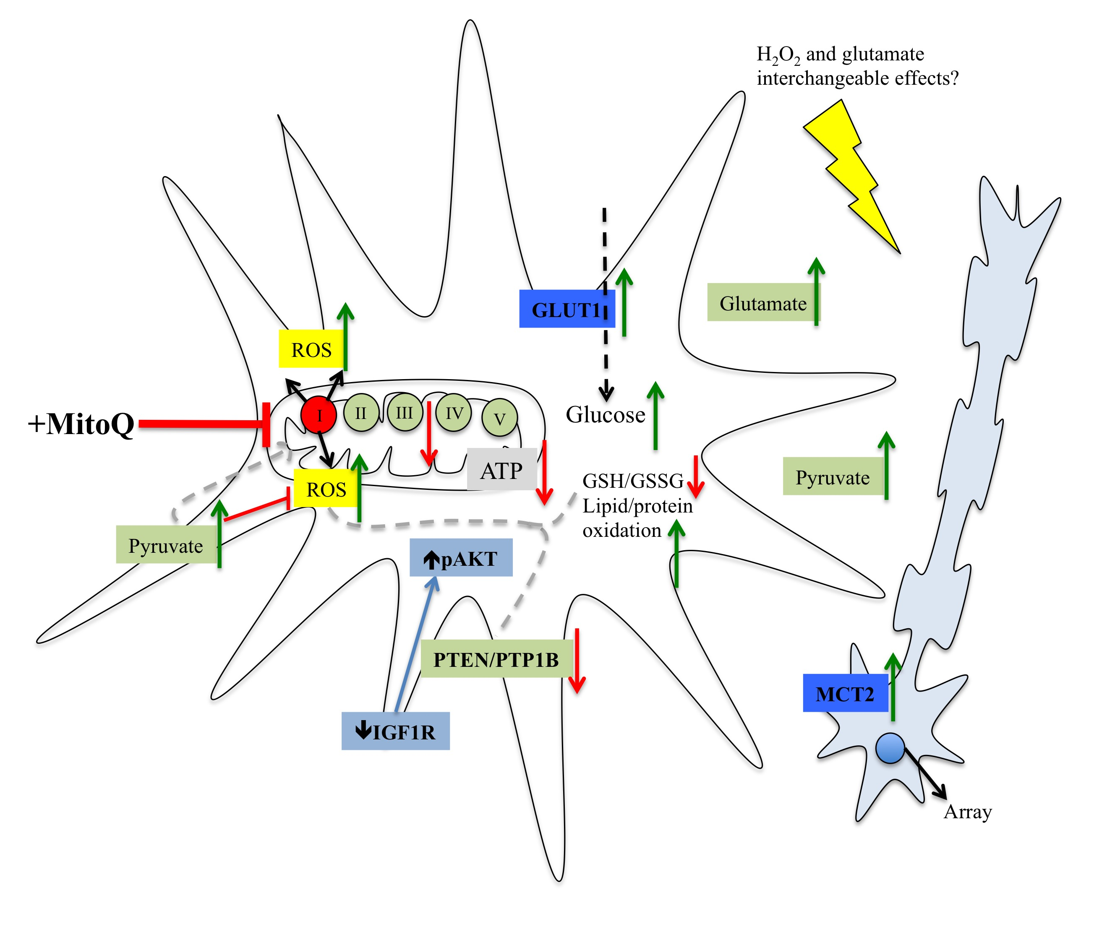
Figure 6.1. A schematic diagram indicating parameters/ molecular targets to measure in future experiments and arrows indicate how they are predicted to alter in IGF1-impaired astrocytes (red- decrease, green-increase).

6.5 Conclusion

Astrocytes are critically involved in maintaining brain homeostasis. One way they achieve this is through regulating neuronal metabolism. Loss of IGF1R, as observed at the transcript level in astrocytes in the ageing Alzheimer brain (Simpson et al. 2011), may dysregulate metabolic support for neurons and contribute to early stages of disease progression. Prolonged loss of IGF1R in co-cultured astrocytes resulted specifically in significant defects in complex I activity. Although mitochondrial ATP levels have not been investigated, it is predicted that there is reduced energy production in astrocytes that may limit other important functions such as glutamate uptake. Loss of IGF1R and associated defects in complex I was not detrimental in the contact-mediated support for neurite outgrowth, possibly due to upregulation of glycolysis in astrocytes, but under additional oxidative stress there was less protection offered to the neurons.

Changes in IGF1R levels, oxidative stress and mitochondrial function are all early features of AD (Chou et al., 2011; Lin et al., 1992; J. E. Simpson et al., 2010; Julie E Simpson et al., 2011; Talbot et al., 2012). Although the literature suggests that each of these have beneficial effects in ageing, this may not be the case in astrocytes. This study may provide an important link between each of these events in the context of astrocyte function, with the IGF1 pathway being central to maintaining proper astrocyte mitochondrial function and protection against oxidative stress. Therapeutically restoring astrocytic IGF1 signalling may provide a way to preserve cell function and maintain neuronal health in ageing and AD.

Chapter 7

Appendix

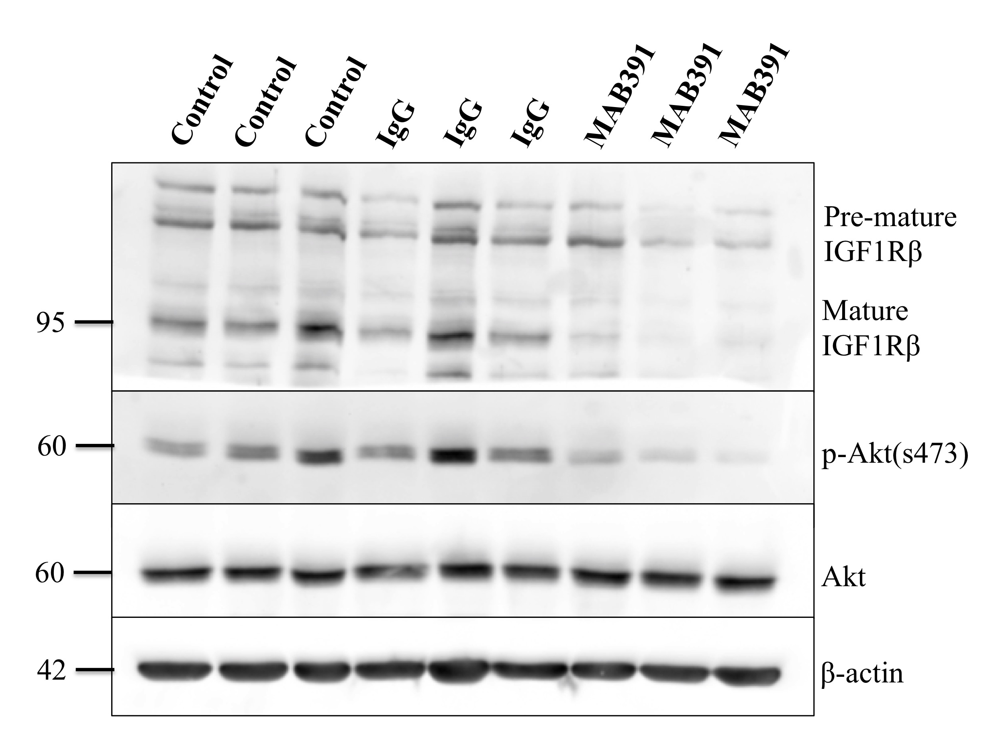

Figure 7.1. Treatment of ScienCell (1) astrocytes with IgG and MAB391 for 24 hours.
Loss of IGF1R and pAkt (s473) occurs after 24 hour treatment with MAB391 compared with untreated and IgG-treated astrocytes.
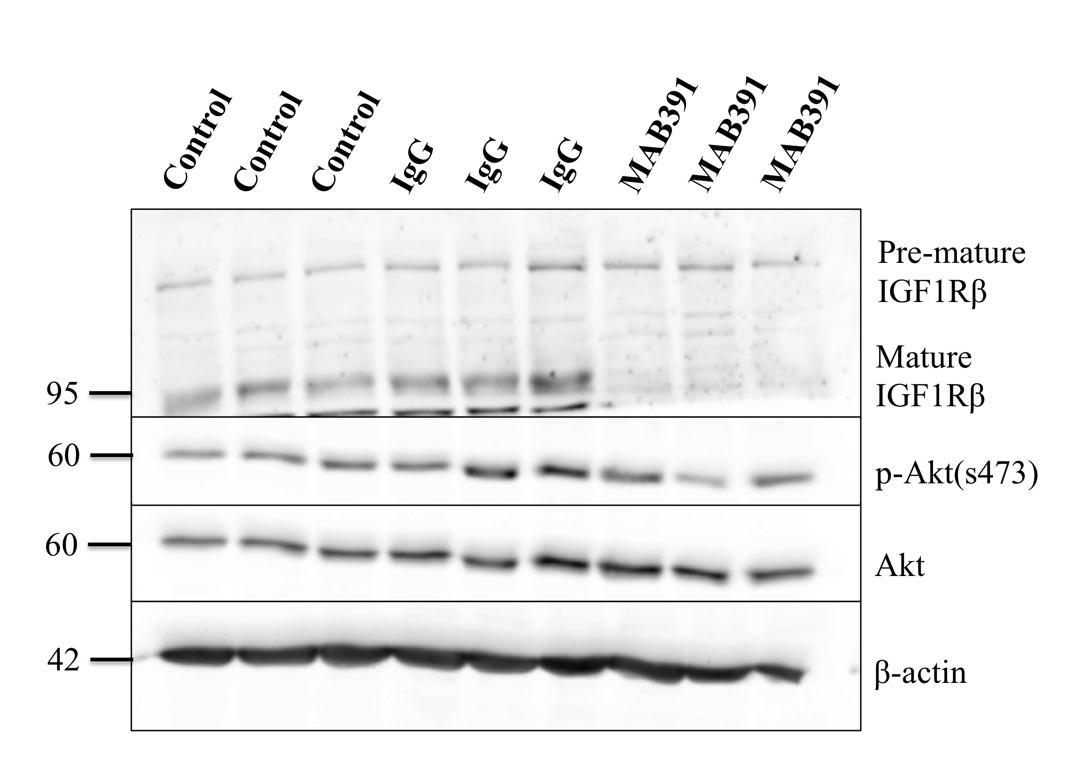

Figure 7.2. Treatment of ScienCell (2) astrocytes with IgG and MAB391 for 24 hours.
Loss of IGF1R occurs following treatment with MAB391 compared with untreated and IgG-treated astrocytes. No observed differences in pAkt (s473) levels with IgG/MAB391 treatments compared with controls.

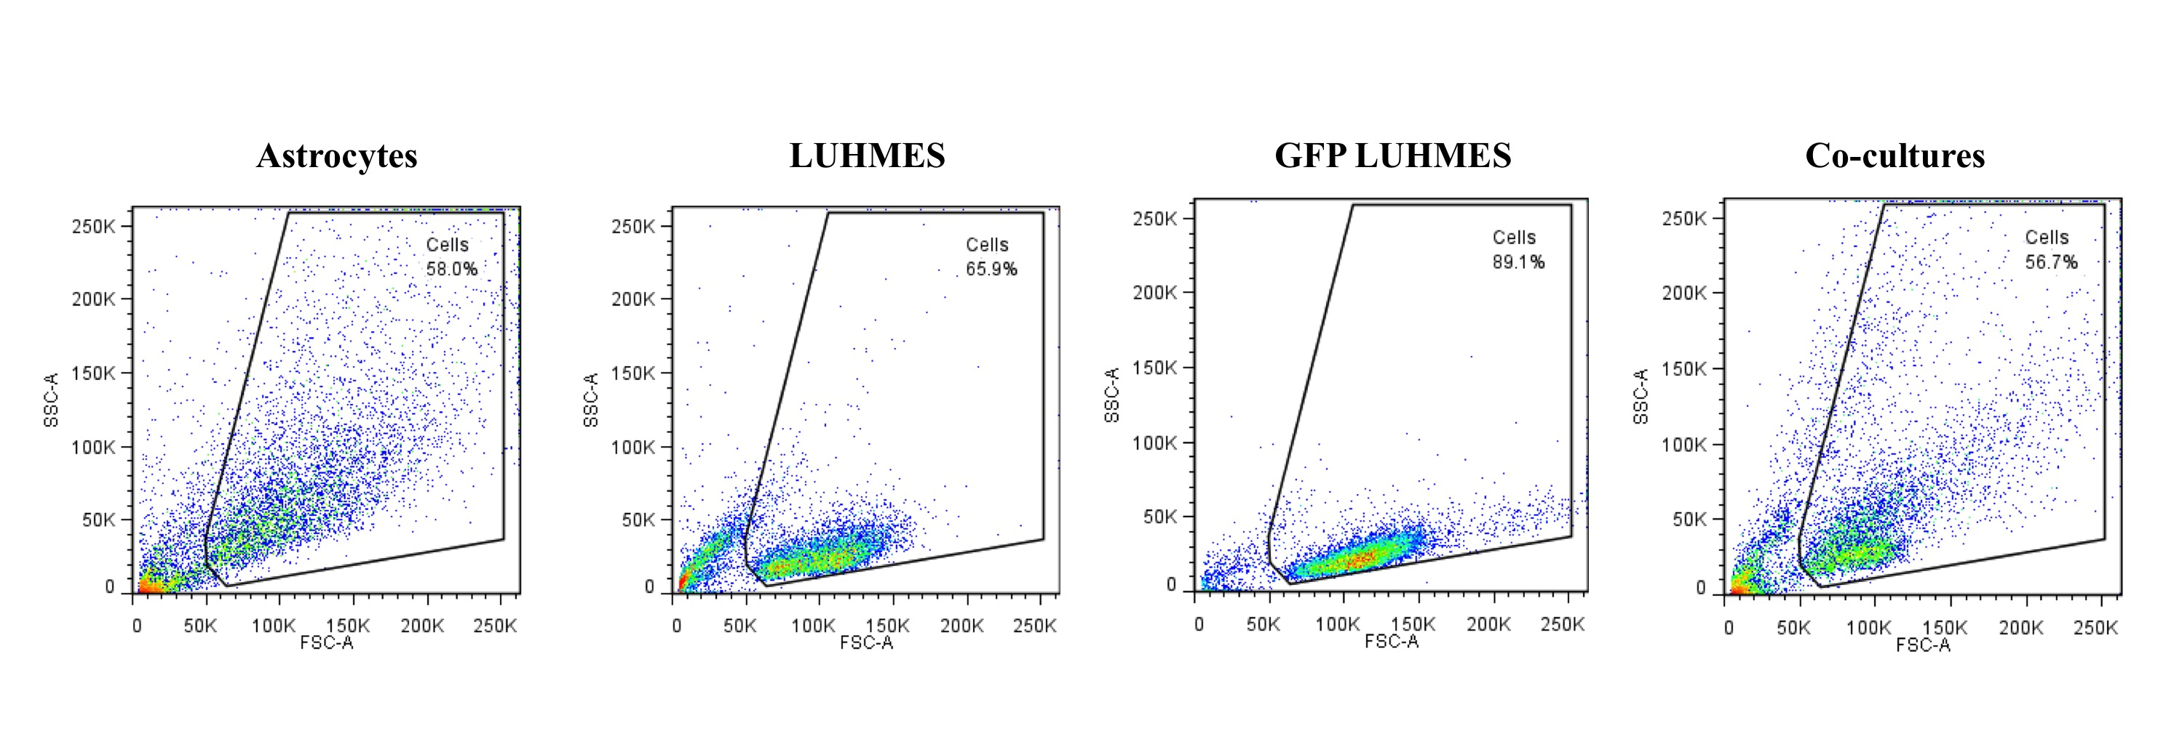
Figure 7.3. FACS sorting of co-cultures.
Co-culture sorted according to FSC (relative size of the cell) and SSC (cell granularity) cell profiles, with astrocytes, LUHMES and GFP LUHMES FACS sorts as controls.

References

Abramov, A.Y., Canevari, L. & Duchen, M.R., 2004. -Amyloid Peptides Induce Mitochondrial Dysfunction and Oxidative Stress in Astrocytes and Death of Neurons through Activation of NADPH Oxidase. Journal of Neuroscience, 24(2), pp.565–575.
Aguirre, V. et al., 2000. The c-Jun NH(2)-terminal kinase promotes insulin resistance during association with insulin receptor substrate-1 and phosphorylation of Ser(307). The Journal of biological chemistry, 275(12), pp.9047–54.
Agulhon, C. et al., 2012a. Calcium Signaling and Gliotransmission in Normal vs. Reactive Astrocytes. Frontiers in pharmacology, 3, p.139.
Aizenman, Y. & de Vellis, J., 1987. Brain neurons develop in a serum and glial free environment: effects of transferrin, insulin, insulin-like growth factor-I and thyroid hormone on neuronal survival, growth and differentiation. Brain research, 406(1–2), pp.32–42.
Aksenov, M.Y. et al., 2001. Protein oxidation in the brain in Alzheimer’s disease. Neuroscience, 103(2), pp.373–83.
Alessi, D.R. et al., 1996. Mechanism of activation of protein kinase B by insulin and IGF-1. The EMBO journal, 15(23), pp.6541–51.
Allaman, I. et al., 2010. Amyloid- Aggregates Cause Alterations of Astrocytic Metabolic Phenotype: Impact on Neuronal Viability. Journal of Neuroscience, 30(9), pp.3326–3338.
Almeida, A. et al., 2001. Different responses of astrocytes and neurons to nitric oxide: the role of glycolytically generated ATP in astrocyte protection. Proceedings of the National Academy of Sciences of the United States of America, 98(26), pp.15294–9.
Alonso, A.C. et al., 1994. Role of abnormally phosphorylated tau in the breakdown of microtubules in Alzheimer disease. Proceedings of the National Academy of Sciences of the United States of America, 91(12), pp.5562–6.
Alvarez, J.I. et al., 2011. The Hedgehog pathway promotes blood-brain barrier integrity and CNS immune quiescence. Science (New York, N.Y.), 334(6063), pp.1727–31.
Alzheimer’s Association, A.P. et al., 2013. 2013 Alzheimer’s disease facts and figures. Alzheimer’s & dementia : the journal of the Alzheimer’s Association, 9(2), pp.208–45.
Ang, L.C. et al., 1992. Effects of astrocytes, insulin and insulin-like growth factor I on the survival of motoneurons in vitro. Journal of the Neurological Sciences, 109(2), pp.168–172.
Angulo, M.C. et al., 2004. Glutamate released from glial cells synchronizes neuronal activity in the hippocampus. The Journal of neuroscience : the official journal of the Society for Neuroscience, 24(31), pp.6920–7.
Ansari, M.A. et al., 2010. Oxidative stress in the progression of Alzheimer disease in the frontal cortex. Journal of neuropathology and experimental neurology, 69(2), pp.155–67.
Arai, Y. et al., 2001. Serum Insulin-like Growth Factor-1 in Centenarians: Implications of IGF-1 as a Rapid Turnover Protein. The Journals of Gerontology Series A: Biological Sciences and Medical Sciences, 56(2), pp.M79–M82.
Araque, A. et al., 1999. Tripartite synapses: glia, the unacknowledged partner. Trends in Neurosciences, 22(5), pp.208–215.
Argaw, A.T. et al., 2012. Astrocyte-derived VEGF-A drives blood-brain barrier disruption in CNS inflammatory disease. The Journal of clinical investigation, 122(7), pp.2454–68.
Arnold, S.E. et al., 2013. Cellular, synaptic, and biochemical features of resilient cognition in Alzheimer’s disease. Neurobiology of aging, 34(1), pp.157–68.
Arriagada, P. V., Marzloff, K. & Hyman, B.T., 1992. Distribution of Alzheimer-type pathologic changes in nondemented elderly individuals matches the pattern in Alzheimer’s disease. Neurology, 42(9), pp.1681–1681.
Bailyes, E.M. et al., 1997. Insulin receptor/IGF-I receptor hybrids are widely distributed in mammalian tissues: quantification of individual receptor species by selective immunoprecipitation and immunoblotting. The Biochemical journal, 327 ( Pt 1, pp.209–15.
Bak, L.K., Schousboe, A. & Waagepetersen, H.S., 2006. The glutamate/GABA-glutamine cycle: aspects of transport, neurotransmitter homeostasis and ammonia transfer. Journal of Neurochemistry, 98(3), pp.641–653.
Ballotti, R. et al., 1987. Insulin-like growth factor I in cultured rat astrocytes: expression of the gene, and receptor tyrosine kinase. The EMBO journal, 6(12), pp.3633–9.
Bansal, A. et al., 2015. Uncoupling lifespan and healthspan in Caenorhabditis elegans longevity mutants. Proceedings of the National Academy of Sciences of the United States of America, 112(3), pp.E277-86.
Barbin, G. et al., 1988. Brain astrocytes express region-specific surface glycoproteins in culture. Glia, 1(1), pp.96–103.
Barthel, A., Schmoll, D. & Unterman, T.G., 2005. FoxO proteins in insulin action and metabolism. Trends in endocrinology and metabolism: TEM, 16(4), pp.183–9.
Basso, M. et al., 2013. Mutant Copper-Zinc Superoxide Dismutase (SOD1) Induces Protein Secretion Pathway Alterations and Exosome Release in Astrocytes: Implications for disease spreading and motor neuron pathology in Amyotrophic Lateral Sclerosis. Journal of Biological Chemistry, 288(22), pp.15699–15711.
Bean, J. et al., 2007. MET amplification occurs with or without T790M mutations in EGFR mutant lung tumors with acquired resistance to gefitinib or erlotinib. Proceedings of the National Academy of Sciences of the United States of America, 104(52), pp.20932–7.
Beilharz, E.J. et al., 1998. Co-ordinated and cellular specific induction of the components of the IGF/IGFBP axis in the rat brain following hypoxic–ischemic injury. Molecular Brain Research, 59(2), pp.119–134.
Bell, K.F.S. et al., 2015. Neuronal development is promoted by weakened intrinsic antioxidant defences due to epigenetic repression of Nrf2. Nature Communications, 6, p.7066.
Bellaver, B. et al., 2016. Hippocampal Astrocyte Cultures from Adult and Aged Rats Reproduce Changes in Glial Functionality Observed in the Aging Brain. Molecular neurobiology.
Beller, J.A. & Snow, D.M., 2014. Proteoglycans: road signs for neurite outgrowth. Neural regeneration research, 9(4), pp.343–55.
Bénard, G. et al., 2012. Mitochondrial CB₁ receptors regulate neuronal energy metabolism. Nature neuroscience, 15(4), pp.558–64.
Bennett, D.A. et al., 2006. Neuropathology of older persons without cognitive impairment from two community-based studies. Neurology, 66(12), pp.1837–44.
Bertacchini, J. et al., 2014. Feedbacks and adaptive capabilities of the PI3K/Akt/mTOR axis in acute myeloid leukemia revealed by pathway selective inhibition and phosphoproteome analysis. Leukemia, 28(11), pp.2197–205.
Bezzi, P. & Volterra, A., 2014. Imaging Exocytosis and Recycling of Synaptic-Like Microvesicles in Astrocytes. Cold Spring Harbor Protocols, 2014(5), p.pdb.prot081711-prot081711.
Bhaskar, K. et al., 2009. The PI3K-Akt-mTOR pathway regulates Aβ oligomer induced neuronal cell cycle events. Molecular Neurodegeneration, 4(1), p.14.
Bigl, M. et al., 1999. Activities of key glycolytic enzymes in the brains of patients with Alzheimer’s disease. Journal of neural transmission (Vienna, Austria : 1996), 106(5–6), pp.499–511.
Bittar, P.G. et al., 1996. Selective distribution of lactate dehydrogenase isoenzymes in neurons and astrocytes of human brain. Journal of cerebral blood flow and metabolism : official journal of the International Society of Cerebral Blood Flow and Metabolism, 16(6), pp.1079–89.
Bittner, C.X. et al., 2011. Fast and reversible stimulation of astrocytic glycolysis by K+ and a delayed and persistent effect of glutamate. The Journal of neuroscience : the official journal of the Society for Neuroscience, 31(12), pp.4709–13.
Black, M.M. et al., 1996. Tau is enriched on dynamic microtubules in the distal region of growing axons. The Journal of neuroscience : the official journal of the Society for Neuroscience, 16(11), pp.3601–19.
Bolaños, J.P. et al., 2008. Regulation of glycolysis and pentose-phosphate pathway by nitric oxide: impact on neuronal survival. Biochimica et biophysica acta, 1777(7–8), pp.789–93.
Bomfim, T.R. et al., 2012. An anti-diabetes agent protects the mouse brain from defective insulin signaling caused by Alzheimer ’ s disease – associated A β oligomers. , 122(4), pp.1339–1353.
Bonafè, M. et al., 2003. Polymorphic Variants of Insulin-Like Growth Factor I (IGF-I) Receptor and Phosphoinositide 3-Kinase Genes Affect IGF-I Plasma Levels and Human Longevity: Cues for an Evolutionarily Conserved Mechanism of Life Span Control. The Journal of Clinical Endocrinology & Metabolism, 88(7), pp.3299–3304.
Borasio, G.D. et al., 1998. A placebo-controlled trial of insulin-like growth factor-I in amyotrophic lateral sclerosis. European ALS/IGF-I Study Group. Neurology, 51(2), pp.583–6.
Bouzakri, K. et al., 2003. Reduced activation of phosphatidylinositol-3 kinase and increased serine 636 phosphorylation of insulin receptor substrate-1 in primary culture of skeletal muscle cells from patients with type 2 diabetes. Diabetes, 52(6), pp.1319–25.
Boyd, F.T. & Raizada, M.K., 1983. Effects of insulin and tunicamycin on neuronal insulin receptors in culture. The American journal of physiology, 245(3), pp.C283-7.
Boyes, B.E. et al., 1986. Immunohistochemical co-localization of S-100b and the glial fibrillary acidic protein in rat brain. Neuroscience, 17(3), pp.857–865.
Braak, H. et al., 2006. Staging of Alzheimer disease-associated neurofibrillary pathology using paraffin sections and immunocytochemistry. Acta neuropathologica, 112(4), pp.389–404.
Braak, H. & Braak, E., 1991. Neuropathological stageing of Alzheimer-related changes. Acta neuropathologica, 82(4), pp.239–59.
Braak, H., Braak, E. & Strothjohann, M., 1994. Abnormally phosphorylated tau protein related to the formation of neurofibrillary tangles and neuropil threads in the cerebral cortex of sheep and goat. Neuroscience Letters, 171(1), pp.1–4.
Brand, M.D. & Nicholls, D.G., 2011. Assessing mitochondrial dysfunction in cells. The Biochemical journal, 435(2), pp.297–312.
Brix, B. et al., 2012. Endothelial cell-derived nitric oxide enhances aerobic glycolysis in astrocytes via HIF-1α-mediated target gene activation. The Journal of neuroscience : the official journal of the Society for Neuroscience, 32(28), pp.9727–35.
Brown, A.M. & Ransom, B.R., 2007. Astrocyte glycogen and brain energy metabolism. Glia, 55(12), pp.1263–71.
Buck, E. et al., 2010a. Compensatory insulin receptor (IR) activation on inhibition of insulin-like growth factor-1 receptor (IGF-1R): rationale for cotargeting IGF-1R and IR in cancer. Molecular cancer therapeutics, 9(10), pp.2652–64.
Bush, T.G. et al., 1999. Leukocyte Infiltration, Neuronal Degeneration, and Neurite Outgrowth after Ablation of Scar-Forming, Reactive Astrocytes in Adult Transgenic Mice. Neuron, 23(2), pp.297–308.
Bushong, E.A. et al., 2002a. Protoplasmic astrocytes in CA1 stratum radiatum occupy separate anatomical domains. The Journal of neuroscience : the official journal of the Society for Neuroscience, 22(1), pp.183–92.
de Cabo, R. et al., 2003. An in vitro model of caloric restriction. Experimental Gerontology, 38(6), pp.631–639.
Cadenas, E. & Davies, K.J.A., 2000. Mitochondrial free radical generation, oxidative stress, and aging. Free Radical Biology and Medicine, 29(3), pp.222–230.
Cahoy, J.D. et al., 2008. A transcriptome database for astrocytes, neurons, and oligodendrocytes: a new resource for understanding brain development and function. The Journal of neuroscience : the official journal of the Society for Neuroscience, 28(1), pp.264–78.
Calabrese, V. et al., 2006. Nitrosative stress, cellular stress response, and thiol homeostasis in patients with Alzheimer’s disease. Antioxidants & redox signaling, 8(11–12), pp.1975–86.
Calcinaghi, N. et al., 2011. Metabotropic glutamate receptor mGluR5 is not involved in the early hemodynamic response. Journal of cerebral blood flow and metabolism : official journal of the International Society of Cerebral Blood Flow and Metabolism, 31(9), pp.e1-10.
Carro, E. et al., 2002. Serum insulin-like growth factor I regulates brain amyloid-beta levels. Nature medicine, 8(12), pp.1390–7.
Carter, S.F. et al., 2012. Evidence for Astrocytosis in Prodromal Alzheimer Disease Provided by 11C-Deuterium-L-Deprenyl: A Multitracer PET Paradigm Combining 11C-Pittsburgh Compound B and 18F-FDG. Journal of Nuclear Medicine, 53(1), pp.37–46.
Di Castro, M.A. et al., 2011. Local Ca2+ detection and modulation of synaptic release by astrocytes. Nature neuroscience, 14(10), pp.1276–84.
Chang, L., Chiang, S.-H. & Saltiel, A.R., 2004. Insulin signaling and the regulation of glucose transport. Molecular medicine (Cambridge, Mass.), 10(7–12), pp.65–71.
Chemuru, S., Kodali, R. & Wetzel, R., 2016. C-Terminal Threonine Reduces Aβ43 Amyloidogenicity Compared with Aβ42. Journal of Molecular Biology, 428(2), pp.274–291.
Chen, D. et al., 2013. Germline signaling mediates the synergistically prolonged longevity produced by double mutations in daf-2 and rsks-1 in C. elegans. Cell reports, 5(6), pp.1600–10.
Chen, J.-C. et al., 1994. Insulin-like growth factor-binding protein enhancement of insulin-like growth factor-i (IGF-I)-mediated DNA synthesis and IGF-I binding in a human breast carcinoma cell line. Journal of Cellular Physiology, 158(1), pp.69–78.
Chen, L. et al., 2008. Reduction of mitochondrial H2O2 by overexpressing peroxiredoxin 3 improves glucose tolerance in mice. Aging cell, 7(6), pp.866–78.
Chernausek, S.D., 1993. Insulin-like growth factor-I (IGF-I) production by astroglial cells: regulation and importance for epidermal growth factor-induced cell replication. Journal of neuroscience research, 34(2), pp.189–97.
Chiang, H.-C. et al., 2010. PI3 kinase signaling is involved in Abeta-induced memory loss in Drosophila. Proceedings of the National Academy of Sciences of the United States of America, 107(15), pp.7060–5.
Chiu, S.-L., Chen, C.-M. & Cline, H.T., 2008. Insulin receptor signaling regulates synapse number, dendritic plasticity, and circuit function in vivo. Neuron, 58(5), pp.708–19.
Cholet, N. et al., 2001. Local injection of antisense oligonucleotides targeted to the glial glutamate transporter GLAST decreases the metabolic response to somatosensory activation. Journal of cerebral blood flow and metabolism : official journal of the International Society of Cerebral Blood Flow and Metabolism, 21(4), pp.404–12.
Chou, J.L. et al., 2011. Early dysregulation of the mitochondrial proteome in a mouse model of Alzheimer’s disease. Journal of Proteomics, 74(4), pp.466–479.
Chow, S. et al., 2010. Amyloid β-peptide directly induces spontaneous calcium transients, delayed intercellular calcium waves and gliosis in rat cortical astrocytes. ASN NEURO, 2(1), pp.15–23.
Chuquet, J. et al., 2010. Predominant enhancement of glucose uptake in astrocytes versus neurons during activation of the somatosensory cortex. The Journal of neuroscience : the official journal of the Society for Neuroscience, 30(45), pp.15298–303.
Clancy, D.J. et al., 2001. Extension of life-span by loss of CHICO, a Drosophila insulin receptor substrate protein. Science (New York, N.Y.), 292(5514), pp.104–6.
Clarke, D.W. et al., 1984. Insulin binds to specific receptors and stimulates 2-deoxy-D-glucose uptake in cultured glial cells from rat brain. The Journal of biological chemistry, 259(19), pp.11672–5.
Claxton, A. et al., 2015. Long-acting intranasal insulin detemir improves cognition for adults with mild cognitive impairment or early-stage Alzheimer’s disease dementia. Journal of Alzheimer’s disease : JAD, 44(3), pp.897–906.
Coculescu, M., Blood-brain barrier for human growth hormone and insulin-like growth factor-I. Journal of pediatric endocrinology & metabolism : JPEM, 12(2), pp.113–24.
Cohen, E. et al., 2006. Opposing activities protect against age-onset proteotoxicity. Science (New York, N.Y.), 313(5793), pp.1604–10.
Cohen, E. et al., 2009a. Reduced IGF-1 signaling delays age-associated proteotoxicity in mice. Cell, 139(6), pp.1157–69.
Cohen, E. et al., 2009b. Reduced IGF-1 signaling delays age-associated proteotoxicity in mice. Cell, 139(6), pp.1157–69.
Di Cola, G., Cool, M.H. & Accili, D., 1997. Hypoglycemic effect of insulin-like growth factor-1 in mice lacking insulin receptors. The Journal of clinical investigation, 99(10), pp.2538–44.
Cook, D.G. et al., 2003. Reduced hippocampal insulin-degrading enzyme in late-onset Alzheimer’s disease is associated with the apolipoprotein E-epsilon4 allele. The American journal of pathology, 162(1), pp.313–9.
Copps, K.D. & White, M.F., 2012. Regulation of insulin sensitivity by serine/threonine phosphorylation of insulin receptor substrate proteins IRS1 and IRS2. Diabetologia, 55(10), pp.2565–82.
Cotrina, M.L., Lin, J.H. & Nedergaard, M., 1998. Cytoskeletal assembly and ATP release regulate astrocytic calcium signaling. The Journal of neuroscience : the official journal of the Society for Neuroscience, 18(21), pp.8794–804.
Craft, S. et al., 1998. Cerebrospinal fluid and plasma insulin levels in Alzheimer’s disease: Relationship to severity of dementia and apolipoprotein E genotype. Neurology, 50(1), pp.164–168.
Craft, S. et al., 1999. Enhancement of memory in Alzheimer disease with insulin and somatostatin, but not glucose. Archives of general psychiatry, 56(12), pp.1135–40.
Craft, S. et al., 2012. Intranasal insulin therapy for Alzheimer disease and amnestic mild cognitive impairment: a pilot clinical trial. Archives of neurology, 69(1), pp.29–38.
Crystal, H. et al., 1988. Clinico-pathologic studies in dementia: nondemented subjects with pathologically confirmed Alzheimer’s disease. Neurology, 38(11), pp.1682–7.
Dávila, D., Fernández, S. & Torres-Alemán, I., 2016. Astrocyte Resilience to Oxidative Stress Induced by Insulin-like Growth Factor I (IGF-I) Involves Preserved AKT (Protein Kinase B) Activity. The Journal of biological chemistry, 291(5), pp.2510–23.
Denis-Donini, S., Glowinski, J. & Prochiantz, A., 1984. Glial heterogeneity may define the three-dimensional shape of mouse mesencephalic dopaminergic neurones. Nature, 307(5952), pp.641–643.
Deochand, C. et al., 2015. Tobacco Smoke Exposure Impairs Brain Insulin/IGF Signaling: Potential Co-Factor Role in Neurodegeneration. Journal of Alzheimer’s disease : JAD, 50(2), pp.373–86.
Desagher, S., Glowinski, J. & Premont, J., 1996a. Astrocytes protect neurons from hydrogen peroxide toxicity. J. Neurosci., 16(8), pp.2553–2562.
Desagher, S., Glowinski, J. & Prémont, J., 1997. Pyruvate protects neurons against hydrogen peroxide-induced toxicity. The Journal of neuroscience : the official journal of the Society for Neuroscience, 17(23), pp.9060–7.
Dinkins, M.B. et al., 2014. Exosome reduction in vivo is associated with lower amyloid plaque load in the 5XFAD mouse model of Alzheimer’s disease. Neurobiology of aging, 35(8), pp.1792–800.
Dobrowolny, G. et al., 2005. Muscle expression of a local Igf-1 isoform protects motor neurons in an ALS mouse model. The Journal of cell biology, 168(2), pp.193–9.
Dodge, J.C. et al., 2008. Delivery of AAV-IGF-1 to the CNS extends survival in ALS mice through modification of aberrant glial cell activity. Molecular therapy : the journal of the American Society of Gene Therapy, 16(6), pp.1056–64.
Donahue, L.R. & Beamer, W.G., 1993. Growth hormone deficiency in “little” mice results in aberrant body composition, reduced insulin-like growth factor-I and insulin-like growth factor-binding protein-3 (IGFBP-3), but does not affect IGFBP-2, -1 or -4. Journal of Endocrinology, 136(1), pp.91–104.
Doyle, J.P. et al., 2008. Application of a translational profiling approach for the comparative analysis of CNS cell types. Cell, 135(4), pp.749–62.
Drejer, J., Larsson, O.M. & Schousboe, A., 1982. Characterization of L-glutamate uptake into and release from astrocytes and neurons cultured from different brain regions. Experimental brain research, 47(2), pp.259–69.
Dringen, R., Gutterer, J.M. & Hirrlinger, J., 2000. Glutathione metabolism in brain. European Journal of Biochemistry, 267(16), pp.4912–4916.
Dringen, R. & Hamprecht, B., 1992. Glucose, Insulin, and Insulin-Like Growth Factor I Regulate the Glycogen Content of Astroglia-Rich Primary Cultures. Journal of Neurochemistry, 58(2), pp.511–517.
Dringen, R. & Hamprecht, B., 1992. Glucose, insulin, and insulin-like growth factor I regulate the glycogen content of astroglia-rich primary cultures. Journal of neurochemistry, 58(2), pp.511–7.
Dringen, R. & Hamprecht, B., 1997. Involvement of glutathione peroxidase and catalase in the disposal of exogenous hydrogen peroxide by cultured astroglial cells. Brain Research, 759(1), pp.67–75.
Dupont, J. et al., 2001. Insulin and IGF-1 induce different patterns of gene expression in mouse fibroblast NIH-3T3 cells: identification by cDNA microarray analysis. Endocrinology, 142(11), pp.4969–75.
Eddleston, M. & Mucke, L., 1993. Molecular profile of reactive astrocytes--implications for their role in neurologic disease. Neuroscience, 54(1), pp.15–36.
Efremova, L. et al., 2015. Prevention of the degeneration of human dopaminergic neurons in an astrocyte co-culture system allowing endogenous drug metabolism. British journal of pharmacology, 172(16), pp.4119–32.
Efremova, L. et al., 2016. Switching from astrocytic neuroprotection to neurodegeneration by cytokine stimulation. Archives of Toxicology.
Emsley, J.G. & Macklis, J.D., 2006. Astroglial heterogeneity closely reflects the neuronal-defined anatomy of the adult murine CNS. Neuron glia biology, 2(3), pp.175–86.
Eng, L.F., 1985. Glial fibrillary acidic protein (GFAP): the major protein of glial intermediate filaments in differentiated astrocytes. Journal of Neuroimmunology, 8, pp.203–214.
Engelman, J.A. et al., 2007. MET amplification leads to gefitinib resistance in lung cancer by activating ERBB3 signaling. Science (New York, N.Y.), 316(5827), pp.1039–43.
Esposito, L.A. et al., 2000. Mitochondrial oxidative stress in mice lacking the glutathione peroxidase-1 gene. Free radical biology & medicine, 28(5), pp.754–66.
van Exel, E. et al., 2014. Insulin-like growth factor–1 and risk of late-onset Alzheimer’s disease: findings from a family study,
Farmer, W.T. et al., 2016. Neurons diversify astrocytes in the adult brain through sonic hedgehog signaling. Science, 351(6275), pp.849–854.
Fawcett, J.W. & Asher, R.., 1999. The glial scar and central nervous system repair. Brain Research Bulletin, 49(6), pp.377–391.
Fergus, A. & Lee, K.S., 1997. Regulation of cerebral microvessels by glutamatergic mechanisms. Brain research, 754(1–2), pp.35–45.
Fernandez-Fernandez, S. et al., 2012. Antioxidant and bioenergetic coupling between neurons and astrocytes. The Biochemical journal, 443(1), pp.3–11.
Ferrer, I., Barrachina, M. & Puig, B., 2002. Glycogen synthase kinase-3 is associated with neuronal and glial hyperphosphorylated tau deposits in Alzheimer’s disease, Pick’s disease, progressive supranuclear palsy and corticobasal degeneration. Acta neuropathologica, 104(6), pp.583–91.
Fisher-Wellman, K.H. et al., 2012. Linking mitochondrial bioenergetics to insulin resistance via redox biology. Trends in endocrinology and metabolism: TEM, 23(3), pp.142–53.
Foo, L.C. et al., 2011. Development of a method for the purification and culture of rodent astrocytes. Neuron, 71(5), pp.799–811.
Forsyth, R. et al., 1996. A role for astrocytes in glucose delivery to neurons? Developmental neuroscience, 18(5–6), pp.360–70.
Freude, S. et al., 2009. Neuronal IGF-1 resistance reduces Abeta accumulation and protects against premature death in a model of Alzheimer’s disease. FASEB journal : official publication of the Federation of American Societies for Experimental Biology, 23(10), pp.3315–24.
Freude, S. et al., 2005. Peripheral Hyperinsulinemia Promotes Tau Phosphorylation In Vivo. Diabetes, 54(12), pp.3343–3348.
Friedman, J., 2011. Why Is the Nervous System Vulnerable to Oxidative Stress? In Oxidative Stress and Free Radical Damage in Neurology. Totowa, NJ: Humana Press, pp. 19–27.
Frölich, L. et al., 1998. Brain insulin and insulin receptors in aging and sporadic Alzheimer’s disease. Journal of Neural Transmission, 105(4), p.423.
Fukuyama, R. et al., 1996. Gene expression of ND4, a subunit of complex I of oxidative phosphorylation in mitochondria, is decreased in temporal cortex of brains of Alzheimer’s disease patients,
Fukuyama, R., Izumoto, T. & Fushiki, S., 2001. The cerebrospinal fluid level of glial fibrillary acidic protein is increased in cerebrospinal fluid from Alzheimer’s disease patients and correlates with severity of dementia. European neurology, 46(1), pp.35–8.
Fuller, S., Steele, M. & Münch, G., 2010. Activated astroglia during chronic inflammation in Alzheimer’s disease--do they neglect their neurosupportive roles? Mutation research, 690(1–2), pp.40–9.
Gao, Y. et al., 2016. Functional imaging of neuron–astrocyte interactions in a compartmentalized microfluidic device. Microsystems & Nanoengineering, 2, p.15045.
Garcia-Abreu, J. et al., 1995. Regionally specific properties of midbrain glia: I. Interactions with midbrain neurons. Journal of neuroscience research, 40(4), pp.471–7.
García-Fernández, M. et al., 2008. Low doses of insulin-like growth factor I improve insulin resistance, lipid metabolism, and oxidative damage in aging rats. Endocrinology, 149(5), pp.2433–42.
Garcia, A.D.R. et al., 2010. Sonic hedgehog regulates discrete populations of astrocytes in the adult mouse forebrain. The Journal of neuroscience : the official journal of the Society for Neuroscience, 30(41), pp.13597–608.
Garwood, C. et al., 2013. Calcium dysregulation in relation to Alzheimer-type pathology in the ageing brain. Neuropathology and applied neurobiology, 31(4), pp.578–90.
Garwood, C.J. et al., 2011. Astrocytes are important mediators of Aβ-induced neurotoxicity and tau phosphorylation in primary culture. Cell death & disease, 2, p.e167.
Garwood, C.J. et al., 2015. Insulin and IGF1 signalling pathways in human astrocytes in vitro and in vivo; characterisation, subcellular localisation and modulation of the receptors. Molecular brain, 8, p.51.
Gasparini, L. et al., 2001. Stimulation of beta-amyloid precursor protein trafficking by insulin reduces intraneuronal beta-amyloid and requires mitogen-activated protein kinase signaling. The Journal of neuroscience : the official journal of the Society for Neuroscience, 21(8), pp.2561–70.
Gegg, M.E., Clark, J.B. & Heales, S.J.R., 2005. Co-culture of neurones with glutathione deficient astrocytes leads to increased neuronal susceptibility to nitric oxide and increased glutamate-cysteine ligase activity. Brain research, 1036(1–2), pp.1–6.
Genis, L. et al., 2014. Astrocytes require insulin-like growth factor I to protect neurons against oxidative injury. F1000Research, 3.
Giuffrida, M.L. et al., 2009. -Amyloid Monomers Are Neuroprotective. Journal of Neuroscience, 29(34), pp.10582–10587.
Goate, A. et al., 1991. Segregation of a missense mutation in the amyloid precursor protein gene with familial Alzheimer’s disease. Nature, 349(6311), pp.704–6.
Goldberg, M. et al., 2010. Nonlinear Gap Junctions Enable Long-Distance Propagation of Pulsating Calcium Waves in Astrocyte Networks B. S. Gutkin, ed. PLoS Computational Biology, 6(8), p.e1000909.
Gontier, G. et al., 2015. Blocking IGF Signaling in Adult Neurons Alleviates Alzheimer’s Disease Pathology through Amyloid-β Clearance. The Journal of neuroscience : the official journal of the Society for Neuroscience, 35(33), pp.11500–13.
Goswami, P. et al., 2015. Astrocyte activation and neurotoxicity: A study in different rat brain regions and in rat C6 astroglial cells. Environmental Toxicology and Pharmacology, 40(1), pp.122–139.
Goudriaan, A. et al., 2014. Novel cell separation method for molecular analysis of neuron-astrocyte co-cultures. Frontiers in cellular neuroscience, 8, p.12.
Griffin, R.J. et al., 2005. Activation of Akt/PKB, increased phosphorylation of Akt substrates and loss and altered distribution of Akt and PTEN are features of Alzheimer’s disease pathology. Journal of neurochemistry, 93(1), pp.105–17.
Gual, P. et al., 2003. MAP kinases and mTOR mediate insulin-induced phosphorylation of insulin receptor substrate-1 on serine residues 307, 612 and 632. Diabetologia, 46(11), pp.1532–42.
Gual, P., Le Marchand-Brustel, Y. & Tanti, J.-F., 2005. Positive and negative regulation of insulin signaling through IRS-1 phosphorylation. Biochimie, 87(1), pp.99–109.
Guevara-Aguirre, J. et al., 2015. GH Receptor Deficiency in Ecuadorian Adults Is Associated With Obesity and Enhanced Insulin Sensitivity. The Journal of clinical endocrinology and metabolism, 100(7), pp.2589–96.
Guthrie, P.B. et al., 1999. ATP released from astrocytes mediates glial calcium waves. The Journal of neuroscience : the official journal of the Society for Neuroscience, 19(2), pp.520–8.
Gutiérrez-Aguilar, M. & Baines, C.P., 2013. Physiological and pathological roles of mitochondrial SLC25 carriers. The Biochemical journal, 454(3), pp.371–86.
Habas, A. et al., 2013. Neuronal activity regulates astrocytic Nrf2 signaling. Proceedings of the National Academy of Sciences, 110(45), pp.18291–18296.
Hailey, J. et al., 2002. Neutralizing anti-insulin-like growth factor receptor 1 antibodies inhibit receptor function and induce receptor degradation in tumor cells. Molecular cancer therapeutics, 1(14), pp.1349–53.
Ben Haim, L. et al., 2015. The JAK/STAT3 pathway is a common inducer of astrocyte reactivity in Alzheimer’s and Huntington’s diseases. The Journal of neuroscience : the official journal of the Society for Neuroscience, 35(6), pp.2817–29.
Halassa, M.M. et al., 2007. Synaptic Islands Defined by the Territory of a Single Astrocyte. Journal of Neuroscience, 27(24), pp.6473–6477.
Hall, C.N. et al., 2012. Oxidative phosphorylation, not glycolysis, powers presynaptic and postsynaptic mechanisms underlying brain information processing. The Journal of neuroscience : the official journal of the Society for Neuroscience, 32(26), pp.8940–51.
Hallermayer, K., Harmening, C. & Hamprecht, B., 1981. Cellular Localization and Regulation of Glutamine Synthetase in Primary Cultures of Brain Cells from Newborn Mice. Journal of Neurochemistry, 37(1), pp.43–52.
Hamai, M., Minokoshi, Y. & Shimazu, T., 2002. L-Glutamate and Insulin Enhance Glycogen Synthesis in Cultured Astrocytes from the Rat Brain Through Different Intracellular Mechanisms. Journal of Neurochemistry, 73(1), pp.400–407.
Hamby, M.E. et al., 2012. Inflammatory Mediators Alter the Astrocyte Transcriptome and Calcium Signaling Elicited by Multiple G-Protein-Coupled Receptors. Journal of Neuroscience, 32(42), pp.14489–14510.
Han, X. et al., 2013. Forebrain Engraftment by Human Glial Progenitor Cells Enhances Synaptic Plasticity and Learning in Adult Mice. Cell Stem Cell, 12(3), pp.342–353.
Hardy, J.A. & Higgins, G.A., 1992. Alzheimer’s disease: the amyloid cascade hypothesis. Science (New York, N.Y.), 256(5054), pp.184–5.
Hattori, F. et al., 2003. Mitochondrial peroxiredoxin-3 protects hippocampal neurons from excitotoxic injury in vivo. Journal of Neurochemistry, 86(4), pp.860–868.
Haydon, P.G., 2001. Glia: listening and talking to the synapse. Nature Reviews Neuroscience, 2(3), pp.185–193.
Heiman, M. et al., 2014. Cell type–specific mRNA purification by translating ribosome affinity purification (TRAP). Nature Protocols, 9(6), pp.1282–1291.
Hemmings, B.A. & Restuccia, D.F., 2012. PI3K-PKB/Akt pathway. Cold Spring Harbor perspectives in biology, 4(9), p.a011189.
Heneka, M.T. et al., 2005. Focal glial activation coincides with increased BACE1 activation and precedes amyloid plaque deposition in APP[V717I] transgenic mice. Journal of Neuroinflammation, 2(1), p.22.
Heni, M. et al., 2011. Insulin promotes glycogen storage and cell proliferation in primary human astrocytes. K. Maedler, ed. PloS one, 6(6), p.e21594.
Hernandez, E. et al., 2015. Insulin growth factor I and its receptor are antagonistic modulators of glucose handling by astrocytes, Cold Spring Harbor Labs Journals.
Hertz, L., Peng, L. & Dienel, G.A., 2007. Energy metabolism in astrocytes: high rate of oxidative metabolism and spatiotemporal dependence on glycolysis/glycogenolysis. Journal of Cerebral Blood Flow & Metabolism, 27(2), pp.219–249.
Hill, E.J. et al., 2012. NT2 derived neuronal and astrocytic network signalling. PloS one, 7(5), p.e36098.
Hill, J.M. et al., 1986. Autoradiographic localization of insulin receptors in rat brain: Prominence in olfactory and limbic areas. Neuroscience, 17(4), pp.1127–1138.
Hill, S.J., Barbarese, E. & McIntosh, T.K., 1996. Regional Heterogeneity in the Response of Astrocytes following Traumatic Brain Injury in the Adult Rat. Journal of Neuropathology and Experimental Neurology, 55(12), pp.1221–1229.
Hirrlinger, J. & Dringen, R., 2010. The cytosolic redox state of astrocytes: Maintenance, regulation and functional implications for metabolite trafficking. Brain research reviews, 63(1–2), pp.177–88.
Hirrlinger, J., Schulz, J.B. & Dringen, R., 2002. Glutathione release from cultured brain cells: multidrug resistance protein 1 mediates the release of GSH from rat astroglial cells. Journal of neuroscience research, 69(3), pp.318–26.
Hoefs, S.J.G. et al., 2008. NDUFA2 complex I mutation leads to Leigh disease. American journal of human genetics, 82(6), pp.1306–15.
Höhn, T.J.A. & Grune, T., 2014. The proteasome and the degradation of oxidized proteins: part III-Redox regulation of the proteasomal system. Redox biology, 2, pp.388–94.
Holtzman, D.M. et al., 2016. Tau: From research to clinical development. Alzheimer’s & Dementia, 12(10), pp.1033–1039.
Holzenberger, M. et al., 2003. IGF-1 receptor regulates lifespan and resistance to oxidative stress in mice. Nature, 421(6919), pp.182–7.
Honda, Y. & Honda, S., 1999. The daf-2 gene network for longevity regulates oxidative stress resistance and Mn-superoxide dismutase gene expression in Caenorhabditis elegans. FASEB journal : official publication of the Federation of American Societies for Experimental Biology, 13(11), pp.1385–93.
Hondius, D.C. et al., 2016. Profiling the human hippocampal proteome at all pathologic stages of Alzheimer’s disease. Alzheimer’s & dementia : the journal of the Alzheimer’s Association.
Hong, M. & Lee, V.M.-Y., 1997. Insulin and Insulin-like Growth Factor-1 Regulate Tau Phosphorylation in Cultured Human Neurons. J. Biol. Chem., 272(31), pp.19547–19553.
Hooper, C., Killick, R. & Lovestone, S., 2008. The GSK3 hypothesis of Alzheimer’s disease. Journal of neurochemistry, 104(6), pp.1433–9.
HOUADES, V. et al., 2006. Shapes of astrocyte networks in the juvenile brain. Neuron Glia Biology, 2(1), p.3.
Howarth, C., 2014. The contribution of astrocytes to the regulation of cerebral blood flow. Frontiers in neuroscience, 8, p.103.
Hu, W.-H. et al., 2003. Neuronal glutamate transporter EAAT4 is expressed in astrocytes. Glia, 44(1), pp.13–25.
Hunt, A. et al., 2007. Reduced cerebral glucose metabolism in patients at risk for Alzheimer’s disease. Psychiatry research, 155(2), pp.147–54.
Iadecola, C., 2004. Neurovascular regulation in the normal brain and in Alzheimer’s disease. Nature Reviews Neuroscience, 5(5), pp.347–360.
Iliff, J.J. et al., 2012. A paravascular pathway facilitates CSF flow through the brain parenchyma and the clearance of interstitial solutes, including amyloid β. Science translational medicine, 4(147), p.147ra111.
Imura, T., Kornblum, H.I. & Sofroniew, M. V, 2003. The predominant neural stem cell isolated from postnatal and adult forebrain but not early embryonic forebrain expresses GFAP. The Journal of neuroscience : the official journal of the Society for Neuroscience, 23(7), pp.2824–32.
Itoh, Y. et al., 2003. Dichloroacetate effects on glucose and lactate oxidation by neurons and astroglia in vitro and on glucose utilization by brain in vivo. Proceedings of the National Academy of Sciences of the United States of America, 100(8), pp.4879–84.
Jafferali, S. et al., 2000. Insulin-like growth factor-I and its receptor in the frontal cortex, hippocampus, and cerebellum of normal human and alzheimer disease brains. Synapse (New York, N.Y.), 38(4), pp.450–9.
Jakoby, P. et al., 2014. Higher transport and metabolism of glucose in astrocytes compared with neurons: a multiphoton study of hippocampal and cerebellar tissue slices. Cerebral cortex (New York, N.Y. : 1991), 24(1), pp.222–31.
Jarrett, J.T., Berger, E.P. & Jr., P.T.L., 2002. The carboxy terminus of the .beta. amyloid protein is critical for the seeding of amyloid formation: Implications for the pathogenesis of Alzheimer’s disease.
Jastroch, M. et al., 2010. Mitochondrial proton and electron leaks. Essays in biochemistry, 47, pp.53–67.
Jessen, N.A. et al., 2015. The Glymphatic System: A Beginner’s Guide. Neurochemical research, 40(12), pp.2583–99.
Jin, M. et al., 2011. Soluble amyloid -protein dimers isolated from Alzheimer cortex directly induce Tau hyperphosphorylation and neuritic degeneration. Proceedings of the National Academy of Sciences, 108(14), pp.5819–5824.
John, G.R. et al., 2005. IL-1-regulated responses in astrocytes: relevance to injury and recovery. Glia, 49(2), pp.161–76.
Johnson, W.M., Wilson-Delfosse, A.L. & Mieyal, J.J., 2012. Dysregulation of glutathione homeostasis in neurodegenerative diseases. Nutrients, 4(10), pp.1399–440.
Johnstone, M., Gearing, A.J.. & Miller, K.M., 1999. A central role for astrocytes in the inflammatory response to β-amyloid; chemokines, cytokines and reactive oxygen species are produced. Journal of Neuroimmunology, 93(1), pp.182–193.
Jourdain, P. et al., 2016. L-Lactate protects neurons against excitotoxicity: implication of an ATP-mediated signaling cascade. Scientific reports, 6, p.21250.
Kamata, H. et al., 2005. Reactive Oxygen Species Promote TNFα-Induced Death and Sustained JNK Activation by Inhibiting MAP Kinase Phosphatases. Cell, 120(5), pp.649–661.
Kamburov, A. et al., 2011. Integrated pathway-level analysis of transcriptomics and metabolomics data with IMPaLA. Bioinformatics (Oxford, England), 27(20), pp.2917–8.
Kappeler, L. et al., 2008. Brain IGF-1 receptors control mammalian growth and lifespan through a neuroendocrine mechanism. PLoS biology, 6(10), p.e254.
Kaspar, B.K. et al., 2003. Retrograde viral delivery of IGF-1 prolongs survival in a mouse ALS model. Science (New York, N.Y.), 301(5634), pp.839–42.
Kasparov, S., 2016. Are Astrocytes the Pressure-Reservoirs of Lactate in the Brain? Cell metabolism, 23(1), pp.1–2.
Kenyon, C. et al., 1993. A C. elegans mutant that lives twice as long as wild type. Nature, 366(6454), pp.461–4.
Kettenmann, H. et al., 1999. Microdomains for neuron|[ndash]|glia interaction: parallel fiber signalingto Bergmann glial cells. Nature Neuroscience, 2(2), pp.139–143.
Klein, R.S. & Fricker, L.D., 1992. Heterogeneous expression of carboxypeptidase E and proenkephalin mRNAs by cultured astrocytes. Brain research, 569(2), pp.300–10.
Kleinridders, A. et al., 2015. Insulin resistance in brain alters dopamine turnover and causes behavioral disorders. Proceedings of the National Academy of Sciences of the United States of America, 112(11), pp.3463–8.
Klotz, L.-O. et al., 2015. Redox regulation of FoxO transcription factors. Redox biology, 6, pp.51–72.
Knorpp, T. et al., 2006. Glutathione peroxidase-1 contributes to the protection of glutamine synthetase in astrocytes during oxidative stress. Journal of neural transmission (Vienna, Austria : 1996), 113(9), pp.1145–55.
Kobayashi, K. et al., 2002. Apoptosis of astrocytes with enhanced lysosomal activity and oligodendrocytes in white matter lesions in Alzheimer’s disease. Neuropathology and Applied Neurobiology, 28(3), pp.238–251.
Koffie, R.M. et al., 2009. Oligomeric amyloid beta associates with postsynaptic densities and correlates with excitatory synapse loss near senile plaques. Proceedings of the National Academy of Sciences of the United States of America, 106(10), pp.4012–7.
Kofuji, P. & Newman, E.A., 2004. Potassium buffering in the central nervous system. Neuroscience, 129(4), pp.1045–56.
Koizumi, S. et al., 2003. Dynamic inhibition of excitatory synaptic transmission by astrocyte-derived ATP in hippocampal cultures. Proceedings of the National Academy of Sciences, 100(19), pp.11023–11028.
Koss, D.J. et al., 2016. Soluble pre-fibrillar tau and β-amyloid species emerge in early human Alzheimer’s disease and track disease progression and cognitive decline. Acta Neuropathologica, 132(6), pp.875–895.
Koulakoff, A., Ezan, P. & Giaume, C., 2008. Neurons control the expression of connexin 30 and connexin 43 in mouse cortical astrocytes. Glia, 56(12), pp.1299–311.
Kraft, A.D., Johnson, D.A. & Johnson, J.A., 2004. Nuclear factor E2-related factor 2-dependent antioxidant response element activation by tert-butylhydroquinone and sulforaphane occurring preferentially in astrocytes conditions neurons against oxidative insult. The Journal of neuroscience : the official journal of the Society for Neuroscience, 24(5), pp.1101–12.
Kraft, A.W. et al., 2013. Attenuating astrocyte activation accelerates plaque pathogenesis in APP/PS1 mice. The FASEB Journal, 27(1), pp.187–198.
Kress, B.T. et al., 2014. Impairment of paravascular clearance pathways in the aging brain. Annals of neurology, 76(6), pp.845–61.
Kuffler, S.W., Nicholls, J.G. & Orkand, R.K., 1966. Physiological properties of glial cells in the central nervous system of amphibia. Journal of neurophysiology, 29(4), pp.768–87.
Kum, W. et al., 1992. Effect of insulin on glucose and glycogen metabolism and leucine incorporation into protein in cultured mouse astrocytes. Glia, 6(4), pp.264–8.
Kumaria, A., Tolias, C.M. & Burnstock, G., 2008. ATP signalling in epilepsy. Purinergic signalling, 4(4), pp.339–46.
de la Monte, S.M., 2012. Brain insulin resistance and deficiency as therapeutic targets in Alzheimer’s disease. Current Alzheimer research, 9(1), pp.35–66.
Lai, E.C. et al., 1997. Effect of recombinant human insulin-like growth factor-I on progression of ALS. A placebo-controlled study. The North America ALS/IGF-I Study Group. Neurology, 49(6), pp.1621–30.
Lamberts, S.W. et al., 1997. The endocrinology of aging. Science (New York, N.Y.), 278(5337), pp.419–24.
Lanz, T.A. et al., 2008. Peripheral elevation of IGF-1 fails to alter Abeta clearance in multiple in vivo models. Biochemical pharmacology, 75(5), pp.1093–103.
Laurino, L. et al., 2005. PI3K activation by IGF-1 is essential for the regulation of membrane expansion at the nerve growth cone. Journal of cell science, 118(Pt 16), pp.3653–62.
Lee, J.-M. et al., 2003. Identification of the NF-E2-related factor-2-dependent genes conferring protection against oxidative stress in primary cortical astrocytes using oligonucleotide microarray analysis. The Journal of biological chemistry, 278(14), pp.12029–38.
Li, S. et al., 1997. Glutamate transporter alterations in Alzheimer disease are possibly associated with abnormal APP expression. Journal of neuropathology and experimental neurology, 56(8), pp.901–11.
Liddell, J.R. et al., 2010. Astrocytes retain their antioxidant capacity into advanced old age. Glia, 58(12), p.n/a-n/a.
Lin, F.-H. et al., 1992. Detection of point mutations in codon 331 of mitochondrial NADH dehydrogenase subunit 2 in alzheimer’s brains. Biochemical and Biophysical Research Communications, 182(1), pp.238–246.
Lin, H.-W. et al., 2006. Astrogliosis is delayed in type 1 interleukin-1 receptor-null mice following a penetrating brain injury. Journal of neuroinflammation, 3(1), p.15.
Lin, W.-L., Dickson, D.W. & Sahara, N., 2011. Immunoelectron microscopic and biochemical studies of caspase-cleaved tau in a mouse model of tauopathy. Journal of neuropathology and experimental neurology, 70(9), pp.779–87.
Lind, B.L. et al., 2013. Rapid stimulus-evoked astrocyte Ca2+ elevations and hemodynamic responses in mouse somatosensory cortex in vivo. Proceedings of the National Academy of Sciences, 110(48), pp.E4678–E4687.
Liu, J.P. et al., 1993. Mice carrying null mutations of the genes encoding insulin-like growth factor I (Igf-1) and type 1 IGF receptor (Igf1r). Cell, 75(1), pp.59–72.
Liu, Y. et al., 2004. CD44 expression identifies astrocyte-restricted precursor cells. Developmental biology, 276(1), pp.31–46.
Liu, Y. et al., 2010. Glial fibrillary acidic protein-expressing neural progenitors give rise to immature neurons via early intermediate progenitors expressing both glial fibrillary acidic protein and neuronal markers in the adult hippocampus. Neuroscience, 166(1), pp.241–251.
Loaiza, A., Porras, O.H. & Barros, L.F., 2003. Glutamate triggers rapid glucose transport stimulation in astrocytes as evidenced by real-time confocal microscopy. The Journal of neuroscience : the official journal of the Society for Neuroscience, 23(19), pp.7337–42.
Lovatt, D. et al., 2007. The transcriptome and metabolic gene signature of protoplasmic astrocytes in the adult murine cortex. The Journal of neuroscience : the official journal of the Society for Neuroscience, 27(45), pp.12255–66.
Lubeck, M.D. et al., 1985. The interaction of murine IgG subclass proteins with human monocyte Fc receptors. Journal of immunology (Baltimore, Md. : 1950), 135(2), pp.1299–304.
Lue, L.F. et al., 1999. Soluble amyloid beta peptide concentration as a predictor of synaptic change in Alzheimer’s disease. The American journal of pathology, 155(3), pp.853–62.
Ma, D. et al., 2013. The neurotoxic effect of astrocytes activated with toll-like receptor ligands. Journal of neuroimmunology, 254(1–2), pp.10–8.
Mächler, P. et al., 2015. In Vivo Evidence for a Lactate Gradient from Astrocytes to Neurons. Cell Metabolism, 23(1), pp.94–102.
MacVicar, B.A. & Newman, E.A., 2015. Astrocyte regulation of blood flow in the brain. Cold Spring Harbor perspectives in biology, 7(5), p.a020388-.
Madathil, S.K. et al., 2013. Astrocyte-Specific Overexpression of Insulin-Like Growth Factor-1 Protects Hippocampal Neurons and Reduces Behavioral Deficits following Traumatic Brain Injury in Mice M. V. Schmidt, ed. PLoS ONE, 8(6), p.e67204.
Mahadev, K. et al., 2004. The NAD(P)H oxidase homolog Nox4 modulates insulin-stimulated generation of H2O2 and plays an integral role in insulin signal transduction. Molecular and cellular biology, 24(5), pp.1844–54.
Manczak, M. et al., 2004. Differential Expression of Oxidative Phosphorylation Genes in Patients With Alzheimer’s Disease: Implications for Early Mitochondrial Dysfunction and Oxidative Damage. NeuroMolecular Medicine, 5(2), pp.147–162.
Mandal, P.K., Tripathi, M. & Sugunan, S., 2012. Brain oxidative stress: Detection and mapping of anti-oxidant marker “Glutathione” in different brain regions of healthy male/female, MCI and Alzheimer patients using non-invasive magnetic resonance spectroscopy,
Manolopoulos, K.N. et al., 2010. Linking Alzheimer’s disease to insulin resistance: the FoxO response to oxidative stress. Molecular Psychiatry, 15(11), pp.1046–1052.
Marcillac, F. et al., 2011. Nitric oxide induces the expression of the monocarboxylate transporter MCT4 in cultured astrocytes by a cGMP-independent transcriptional activation. Glia, 59(12), pp.1987–95.
Masliah, E. et al., 1996. Deficient glutamate tranport is associated with neurodegeneration in Alzheimer’s disease. Annals of Neurology, 40(5), pp.759–766.
Mathur, R. et al., 2015. A reduced astrocyte response to β-amyloid plaques in the ageing brain associates with cognitive impairment. PloS one, 10(2), p.e0118463.
Matthews, F. et al., 2005. The Incidence of Dementia in England and Wales: Findings from the Five Identical Sites of the MRC CFA Study R. J. Harvey, ed. PLoS Medicine, 2(8), p.e193.
Matyash, V. & Kettenmann, H., 2010. Heterogeneity in astrocyte morphology and physiology. Brain Research Reviews, 63(1), pp.2–10.
Mawuenyega, K.G. et al., 2010. Decreased clearance of CNS beta-amyloid in Alzheimer’s disease. Science (New York, N.Y.), 330(6012), p.1774.
Mckeon, R.J. et al., 1991. Reduction of Neurite Outgrowth in a Model of Glial Scarring following CNS Injury Is Correlated with the Expression of Inhibitory Molecules on Reactive Astrocytes. The Journal of Neuroscience, 7(711).
McManus, M.J., Murphy, M.P. & Franklin, J.L., 2011. The Mitochondria-Targeted Antioxidant MitoQ Prevents Loss of Spatial Memory Retention and Early Neuropathology in a Transgenic Mouse Model of Alzheimer’s Disease. Journal of Neuroscience, 31(44), pp.15703–15715.
Meyer, K. et al., 2014. Direct conversion of patient fibroblasts demonstrates non-cell autonomous toxicity of astrocytes to motor neurons in familial and sporadic ALS. Proceedings of the National Academy of Sciences of the United States of America, 111(2), pp.829–32.
Mimaki, M. et al., 2012. Understanding mitochondrial complex I assembly in health and disease. Biochimica et biophysica acta, 1817(6), pp.851–62.
Minich, T. et al., 2006. The multidrug resistance protein 1 (Mrp1), but not Mrp5, mediates export of glutathione and glutathione disulfide from brain astrocytes. Journal of neurochemistry, 97(2), pp.373–84.
Mitchell, T.W. et al., 2002. Parahippocampal tau pathology in healthy aging, mild cognitive impairment, and early Alzheimer’s disease. Annals of Neurology, 51(2), pp.182–189.
Moloney, A.M. et al., 2010. Defects in IGF-1 receptor, insulin receptor and IRS-1/2 in Alzheimer’s disease indicate possible resistance to IGF-1 and insulin signalling. Neurobiology of aging, 31(2), pp.224–43.
Morris, J.C. et al., 1996. Cerebral amyloid deposition and diffuse plaques in &quot;normal&quot; aging: Evidence for presymptomatic and very mild Alzheimer’s disease. Neurology, 46(3), pp.707–19.
Muhič, M. et al., 2015. Insulin and Insulin-like Growth Factor 1 (IGF-1) Modulate Cytoplasmic Glucose and Glycogen Levels but Not Glucose Transport across the Membrane in Astrocytes. The Journal of biological chemistry, 290(17), pp.11167–76.
Myung, N.-H. et al., 2008. Evidence of DNA damage in Alzheimer disease: phosphorylation of histone H2AX in astrocytes. Age (Dordrecht, Netherlands), 30(4), pp.209–15.
Nagai, M. et al., 2007. Astrocytes expressing ALS-linked mutated SOD1 release factors selectively toxic to motor neurons. Nature neuroscience, 10(5), pp.615–22.
Nagano, I. et al., 2005. Therapeutic benefit of intrathecal injection of insulin-like growth factor-1 in a mouse model of Amyotrophic Lateral Sclerosis. Journal of the neurological sciences, 235(1–2), pp.61–8.
Nagele, R.G. et al., 2003. Astrocytes accumulate Aβ42 and give rise to astrocytic amyloid plaques in Alzheimer disease brains. Brain Research, 971(2), pp.197–209.
Nagele, R.G. et al., 2004. Contribution of glial cells to the development of amyloid plaques in Alzheimer’s disease. Neurobiology of aging, 25(5), pp.663–74.
Neugebauer, K.M., 1988. N-cadherin, NCAM, and integrins promote retinal neurite outgrowth on astrocytes in vitro. The Journal of Cell Biology, 107(3), pp.1177–1187.
Newman, S.F. et al., 2007. An increase in S-glutathionylated proteins in the Alzheimer’s disease inferior parietal lobule, a proteomics approach. Journal of Neuroscience Research, 85(7), pp.1506–1514.
Newman, S.F. et al., 2007. An increase in S-glutathionylated proteins in the Alzheimer’s disease inferior parietal lobule, a proteomics approach. Journal of neuroscience research, 85(7), pp.1506–14.
Nguyen, T., Nioi, P. & Pickett, C.B., 2009. The Nrf2-Antioxidant Response Element Signaling Pathway and Its Activation by Oxidative Stress. Journal of Biological Chemistry, 284(20), pp.13291–13295.
Ni, M. et al., 2011. Comparative study on the response of rat primary astrocytes and microglia to methylmercury toxicity. Glia, 59(5), pp.810–20.
Nichols, N.R. et al., 1993. GFAP mRNA increases with age in rat and human brain. Neurobiology of Aging, 14(5), pp.421–429.
Nishijima, T. et al., 2010. Neuronal Activity Drives Localized Blood-Brain-Barrier Transport of Serum Insulin-like Growth Factor-I into the CNS. Neuron, 67(5), pp.834–846.
Nitta, T. et al., 1992. Expression of Fc gamma receptors on astroglial cell lines and their role in the central nervous system. Neurosurgery, 31(1), pp.83-7-8.
Niwa, K. et al., 2000. Abeta 1-40-related reduction in functional hyperemia in mouse neocortex during somatosensory activation. Proceedings of the National Academy of Sciences of the United States of America, 97(17), pp.9735–40.
Nizar, K. et al., 2013. In vivo stimulus-induced vasodilation occurs without IP3 receptor activation and may precede astrocytic calcium increase. The Journal of neuroscience : the official journal of the Society for Neuroscience, 33(19), pp.8411–22.
Noble, W. et al., 2013. The importance of tau phosphorylation for neurodegenerative diseases. Frontiers in Neurology, 4 JUL.
Norris, C.M. et al., 2005. Calcineurin triggers reactive/inflammatory processes in astrocytes and is upregulated in aging and Alzheimer’s models. The Journal of neuroscience : the official journal of the Society for Neuroscience, 25(18), pp.4649–58.
Oberheim, N.A. et al., 2006. Astrocytic complexity distinguishes the human brain. Trends in neurosciences, 29(10), pp.547–53.
Oberheim, N.A. et al., 2008. Loss of astrocytic domain organization in the epileptic brain. The Journal of neuroscience : the official journal of the Society for Neuroscience, 28(13), pp.3264–76.
Oberheim, N.A. et al., 2009. Uniquely hominid features of adult human astrocytes. The Journal of neuroscience : the official journal of the Society for Neuroscience, 29(10), pp.3276–87.
Oberheim, N.A., Goldman, S.A. & Nedergaard, M., 2012. Heterogeneity of astrocytic form and function. Methods in molecular biology (Clifton, N.J.), 814, pp.23–45.
Olabarria, M. et al., 2010. Concomitant astroglial atrophy and astrogliosis in a triple transgenic animal model of Alzheimer’s disease. Glia, 58(7), pp.831–8.
Oldstone, M.B., Holmstoen, J. & Welsh, R.M., 1977. Alterations of acetylcholine enzymes in neuroblastoma cells persistently infected with lymphocytic choriomeningitis virus. Journal of cellular physiology, 91(3), pp.459–72.
Ostrowski, P.P. et al., 2016. Meta-Analysis of Serum Insulin-Like Growth Factor 1 in Alzheimer’s Disease. PloS one, 11(5), p.e0155733.
Pandini, G. et al., 2002. Insulin/Insulin-like Growth Factor I Hybrid Receptors Have Different Biological Characteristics Depending on the Insulin Receptor Isoform Involved. Journal of Biological Chemistry, 277(42), pp.39684–39695.
Pandini, G. et al., 1999. Insulin and insulin-like growth factor-I (IGF-I) receptor overexpression in breast cancers leads to insulin/IGF-I hybrid receptor overexpression: evidence for a second mechanism of IGF-I signaling. Clinical cancer research : an official journal of the American Association for Cancer Research, 5(7), pp.1935–44.
Paolicelli, R.C. et al., 2011. Synaptic pruning by microglia is necessary for normal brain development. Science (New York, N.Y.), 333(6048), pp.1456–8.
Papa, S. et al., 2012. Respiratory chain complex I, a main regulatory target of the cAMP/PKA pathway is defective in different human diseases. FEBS Letters, 586(5), pp.568–577.
Papa, S. & De Rasmo, D., 2013. Complex I deficiencies in neurological disorders. Trends in molecular medicine, 19(1), pp.61–9.
Parekh, N. et al., 2010. Lifestyle, Anthropometric, and Obesity-Related Physiologic Determinants of Insulin-like Growth Factor-1 in the Third National Health and Nutrition Examination Survey (1988–1994). Annals of Epidemiology, 20(3), pp.182–193.
Parpura-Gill, A., Beitz, D. & Uemura, E., 1997. The inhibitory effects of β-amyloid on glutamate and glucose uptakes by cultured astrocytes. Brain Research, 754(1–2), pp.65–71.
Parpura, V. et al., 1994. Glutamate-mediated astrocyte-neuron signalling. Nature, 369(6483), pp.744–7.
Parpura, V. & Haydon, P.G., 2000. Physiological astrocytic calcium levels stimulate glutamate release to modulate adjacent neurons. Proceedings of the National Academy of Sciences, 97(15), pp.8629–8634.
Pascual, O. et al., 2012. Microglia activation triggers astrocyte-mediated modulation of excitatory neurotransmission. Proceedings of the National Academy of Sciences of the United States of America, 109(4), pp.E197-205.
Pasti, L. et al., 1997. Intracellular calcium oscillations in astrocytes: a highly plastic, bidirectional form of communication between neurons and astrocytes in situ. The Journal of neuroscience : the official journal of the Society for Neuroscience, 17(20), pp.7817–30.
Pekny, M. et al., 2016. Astrocytes: a central element in neurological diseases. Acta neuropathologica, 131(3), pp.323–45.
Pellegri, G. et al., 1996. Cloning, localization and induction of mouse brain glycogen synthase. Molecular Brain Research, 38(2), pp.191–199.
Pellerin, L., 2003. Lactate as a pivotal element in neuron–glia metabolic cooperation. Neurochemistry International, 43(4), pp.331–338.
Pellerin, L. & Magistretti, P.J., 1994. Glutamate uptake into astrocytes stimulates aerobic glycolysis: a mechanism coupling neuronal activity to glucose utilization. Proceedings of the National Academy of Sciences of the United States of America, 91(22), pp.10625–9.
Peng, Y. et al., 2016. Mitochondrial dysfunction precedes depression of AMPK/AKT signaling in insulin resistance induced by high glucose in primary cortical neurons. Journal of neurochemistry.
Perego, C. et al., 2000. The GLT-1 and GLAST glutamate transporters are expressed on morphologically distinct astrocytes and regulated by neuronal activity in primary hippocampal cocultures. Journal of neurochemistry, 75(3), pp.1076–84.
Perez-Gonzalez, R. et al., 2012. The exosome secretory pathway transports amyloid precursor protein carboxyl-terminal fragments from the cell into the brain extracellular space. The Journal of biological chemistry, 287(51), pp.43108–15.
Pérez, A. et al., 2000. Degradation of Soluble Amyloid β-Peptides 1–40, 1–42, and the Dutch Variant 1–40Q by Insulin Degrading Enzyme from Alzheimer Disease and Control Brains. Neurochemical Research, 25(2), pp.247–255.
Persson, T. et al., 2014. Oxidative Stress in Alzheimer’s Disease: Why Did Antioxidant Therapy Fail? Oxidative Medicine and Cellular Longevity, 2014, pp.1–11.
Pertusa, M. et al., 2007. Astrocytes aged in vitro show a decreased neuroprotective capacity. Journal of neurochemistry, 101(3), pp.794–805.
Petzold, G.C. & Murthy, V.N., 2011. Role of astrocytes in neurovascular coupling. Neuron, 71(5), pp.782–97.
Pierre, K. et al., 2000. Cell-specific localization of monocarboxylate transporters, MCT1 and MCT2, in the adult mouse brain revealed by double immunohistochemical labeling and confocal microscopy. Neuroscience, 100(3), pp.617–627.
Piontek, J., Régnier-Vigouroux, A. & Brandt, R., 2002. Contact with astroglial membranes induces axonal and dendritic growth of human CNS model neurons and affects the distribution of the growth-associated proteins MAP1B and GAP43. Journal of neuroscience research, 67(4), pp.471–83.
Planel, E. et al., 2007. Insulin Dysfunction Induces In Vivo Tau Hyperphosphorylation through Distinct Mechanisms. Journal of Neuroscience, 27(50), pp.13635–13648.
Podlisny, M.B., Lee, G. & Selkoe, D.J., 1987. Gene Dosage of the Amyloid β Precursor Protein in Alzheimer’s Disease. Source: Science, New Series Nature Proc. Nati. Acad. Sci. U.S.A. Science Mol. Brain Res. Science Gene, 238(49), pp.669–671.
Pool, M. et al., 2008. NeuriteTracer: a novel ImageJ plugin for automated quantification of neurite outgrowth. Journal of neuroscience methods, 168(1), pp.134–9.
Le Prince, G. et al., 1995. Glutamine synthetase (GS) expression is reduced in senile dementia of the Alzheimer type. Neurochemical Research, 20(7), pp.859–862.
Purves, D. et al., 2001. Neurons Often Release More Than One Transmitter.
Raps, S.P. et al., 1989. Glutathione is present in high concentrations in cultured astrocytes but not in cultured neurons. Brain research, 493(2), pp.398–401.
De Rasmo, D. et al., 2012. Activation of the cAMP cascade in human fibroblast cultures rescues the activity of oxidatively damaged complex I. Free radical biology & medicine, 52(4), pp.757–64.
Reddy, P.H., 2006. Mitochondrial Oxidative Damage in Aging and Alzheimer’s Disease: Implications for Mitochondrially Targeted Antioxidant Therapeutics. Journal of Biomedicine and Biotechnology, 2006, pp.1–13.
Regan, M.R. et al., 2007. Variations in promoter activity reveal a differential expression and physiology of glutamate transporters by glia in the developing and mature CNS. The Journal of neuroscience : the official journal of the Society for Neuroscience, 27(25), pp.6607–19.
Reger, M.A. et al., 2008. Intranasal insulin administration dose-dependently modulates verbal memory and plasma amyloid-beta in memory-impaired older adults. Journal of Alzheimer’s disease : JAD, 13(3), pp.323–31.
Régina, A. et al., 2001. Factor(s) released by glucose-deprived astrocytes enhance glucose transporter expression and activity in rat brain endothelial cells. Biochimica et Biophysica Acta (BBA) - Molecular Cell Research, 1540(3), pp.233–242.
Reuss, B. et al., 2000. Regionally Distinct Regulation of Astroglial Neurotransmitter Receptors by Fibroblast Growth Factor-2. Molecular and Cellular Neuroscience, 16(1), pp.42–58.
Ridet, J.L. et al., 1997. Reactive astrocytes: cellular and molecular cues to biological function. Trends in Neurosciences, 20(12), pp.570–577.
Rissman, R.A. et al., 2004. Caspase-cleavage of tau is an early event in Alzheimer disease tangle pathology. The Journal of clinical investigation, 114(1), pp.121–30.
Ristow, M. & Zarse, K., 2010. How increased oxidative stress promotes longevity and metabolic health: The concept of mitochondrial hormesis (mitohormesis). Experimental gerontology, 45(6), pp.410–8.
Robinson, S.R., 2000. Neuronal expression of glutamine synthetase in Alzheimer’s disease indicates a profound impairment of metabolic interactions with astrocytes. Neurochemistry International, 36(4–5), pp.471–482.
Roessmann, U. et al., 1980. Glial fibrillary acidic protein (GFAP) in ependymal cells during development. An immunocytochemical study. Brain Research, 200(1), pp.13–21.
Röhrdanz, E. et al., 2001. The influence of oxidative stress on catalase and MnSOD gene transcription in astrocytes. Brain Research, 900(1), pp.128–136.
Rosenblum, W.I., 2014. Why Alzheimer trials fail: removing soluble oligomeric beta amyloid is essential, inconsistent, and difficult. Neurobiology of Aging, 35(5), pp.969–974.
Rossner, M.J. et al., 2006. Global transcriptome analysis of genetically identified neurons in the adult cortex. The Journal of neuroscience : the official journal of the Society for Neuroscience, 26(39), pp.9956–66.
Rossner, S. et al., 2005. Alzheimer’s disease beta-secretase BACE1 is not a neuron-specific enzyme. Journal of neurochemistry, 92(2), pp.226–34.
Rouach, N., Glowinski, J. & Giaume, C., 2000. Activity-Dependent Neuronal Control of Gap-Junctional Communication in Astrocytes. The Journal of Cell Biology, 149(7), pp.1513–1526.
Salahifar, H., Baxter, R.C. & Martin, J.L., 1997. Insulin-like growth factor binding protein (IGFBP)-3 protease activity secreted by MCF-7 breast cancer cells: inhibition by IGFs does not require IGF-IGFBP interaction. Endocrinology, 138(4), pp.1683–90.
Salehi, Z., Mashayekhi, F. & Naji, M., 2008. Insulin like growth factor-1 and insulin like growth factor binding proteins in the cerebrospinal fluid and serum from patients with Alzheimer’s disease. BioFactors (Oxford, England), 33(2), pp.99–106.
Salinas, A.E. & Wong, M.G., 1999. Glutathione S-transferases--a review. Current medicinal chemistry, 6(4), pp.279–309.
Samuelson, A. V, Carr, C.E. & Ruvkun, G., 2007. Gene activities that mediate increased life span of C. elegans insulin-like signaling mutants. Genes & development, 21(22), pp.2976–94.
Saunders, A.M. et al., 1993. Association of apolipoprotein E allele epsilon 4 with late-onset familial and sporadic Alzheimer’s disease. Neurology, 43(8), pp.1467–72.
Savva, G.M. et al., 2009. Age, Neuropathology, and Dementia. New England Journal of Medicine, 360(22), pp.2302–2309.
Scemes, E. & Giaume, C., 2006. Astrocyte calcium waves: What they are and what they do. Glia, 54(7), pp.716–725.
Schapira, A.H. et al., 1990. Mitochondrial complex I deficiency in Parkinson’s disease. Journal of neurochemistry, 54(3), pp.823–7.
Schell, M.J., Molliver, M.E. & Snyder, S.H., 1995. D-serine, an endogenous synaptic modulator: localization to astrocytes and glutamate-stimulated release. Proceedings of the National Academy of Sciences of the United States of America, 92(9), pp.3948–52.
Scholz, D. et al., 2011. Rapid, complete and large-scale generation of post-mitotic neurons from the human LUHMES cell line. Journal of neurochemistry, 119(5), pp.957–71.
Scholz, D., Chernyshova, Y. & Leist, M., 2013. Control of Aβ release from human neurons by differentiation status and RET signaling. Neurobiology of Aging, 34(1), pp.184–199.
Schubert, M. et al., 2003. Insulin Receptor Substrate-2 Deficiency Impairs Brain Growth and Promotes Tau Phosphorylation. J. Neurosci., 23(18), pp.7084–7092.
Schubert, M. et al., 2004. Role for neuronal insulin resistance in neurodegenerative diseases. Proceedings of the National Academy of Sciences of the United States of America, 101(9), pp.3100–5.
Schulz, K. et al., 2012. Simultaneous BOLD fMRI and fiber-optic calcium recording in rat neocortex. Nature Methods, 9(6), pp.597–602.
Scott, H.L. et al., 2002. Aberrant expression of the glutamate transporter excitatory amino acid transporter 1 (EAAT1) in Alzheimer’s disease. The Journal of neuroscience : the official journal of the Society for Neuroscience, 22(3), p.RC206.
Sekar, S. et al., 2015. Alzheimer’s disease is associated with altered expression of genes involved in immune response and mitochondrial processes in astrocytes. Neurobiology of aging, 36(2), pp.583–91.
Serrano-Pozo, A. et al., 2013. Differential relationships of reactive astrocytes and microglia to fibrillar amyloid deposits in Alzheimer disease. Journal of neuropathology and experimental neurology, 72(6), pp.462–71.
Serrano-Pozo, A. et al., 2011. Reactive glia not only associates with plaques but also parallels tangles in Alzheimer’s disease. The American journal of pathology, 179(3), pp.1373–84.
Sevigny, J.J. et al., 2008. Growth hormone secretagogue MK-677: no clinical effect on AD progression in a randomized trial. Neurology, 71(21), pp.1702–8.
Sharif, A. et al., 2009. Differential erbB signaling in astrocytes from the cerebral cortex and the hypothalamus of the human brain. Glia, 57(4), pp.362–79.
Sharif, A. & Prevot, V., 2012. Isolation and culture of human astrocytes. Methods in molecular biology (Clifton, N.J.), 814, pp.137–51.
Sharma, L.K. et al., 2011. Mitochondrial respiratory complex I dysfunction promotes tumorigenesis through ROS alteration and AKT activation. Human molecular genetics, 20(23), pp.4605–16.
Sherrington, R. et al., 1995. Cloning of a gene bearing missense mutations in early-onset familial Alzheimer’s disease. Nature, 375(6534), pp.754–60.
Shih, A.Y. et al., 2003. Coordinate Regulation of Glutathione Biosynthesis and Release by Nrf2-Expressing Glia Potently Protects Neurons from Oxidative Stress. J. Neurosci., 23(8), pp.3394–3406.
Shinozaki, Y. et al., 2014. Microglia trigger astrocyte-mediated neuroprotection via purinergic gliotransmission. Scientific reports, 4, p.4329.
Sibilia, M. et al., 1998. A strain-independent postnatal neurodegeneration in mice lacking the EGF receptor. The EMBO journal, 17(3), pp.719–31.
Simpson, I.A. et al., 1994. Decreased concentrations of GLUT1 and GLUT3 glucose transporters in the brains of patients with Alzheimer’s disease. Annals of neurology, 35(5), pp.546–51.
Simpson, J.E., Ince, P.G., Lace, G., et al., 2010. Astrocyte phenotype in relation to Alzheimer-type pathology in the ageing brain. Neurobiology of aging, 31(4), pp.578–90.
Simpson, J.E. et al., 2011. Microarray analysis of the astrocyte transcriptome in the aging brain: relationship to Alzheimer’s pathology and APOE genotype. Neurobiology of aging, 32(10), pp.1795–807.
Simpson, J.E. et al., 2010. Population variation in oxidative stress and astrocyte DNA damage in relation to Alzheimer-type pathology in the ageing brain. Neuropathology and Applied Neurobiology, 36(1), pp.25–40.
Simpson, J.E., Ince, P.G., Haynes, L.J., et al., 2010. Population variation in oxidative stress and astrocyte DNA damage in relation to Alzheimer-type pathology in the ageing brain. Neuropathology and applied neurobiology, 36(1), pp.25–40.
Singh, K. et al., 2015. Superoxide anion radicals induce IGF-1 resistance through concomitant activation of PTP1B and PTEN. EMBO molecular medicine, 7(1), pp.59–77.
Sleegers, K. et al., 2006. APP duplication is sufficient to cause early onset Alzheimer’s dementia with cerebral amyloid angiopathy. Brain, 129, pp.2977–2983.
Sofroniew, M. V & Vinters, H. V, 2010. Astrocytes: biology and pathology. Acta neuropathologica, 119(1), pp.7–35.
Solan, J.L. & Lampe, P.D., 2009. Connexin43 phosphorylation: structural changes and biological effects. The Biochemical journal, 419(2), pp.261–72.
Soos, M.A. et al., 1990. Receptors for insulin and insulin-like growth factor-I can form hybrid dimers. Characterisation of hybrid receptors in transfected cells. The Biochemical journal, 270(2), pp.383–90.
Sosa, L. et al., 2006. IGF-1 receptor is essential for the establishment of hippocampal neuronal polarity. Nature neuroscience, 9(8), pp.993–5.
Steen, E. et al., 2005. Impaired insulin and insulin-like growth factor expression and signaling mechanisms in Alzheimer’s disease--is this type 3 diabetes? Journal of Alzheimer’s disease : JAD, 7(1), pp.63–80.
Succu, S. et al., 2007. Stimulation of dopamine receptors in the paraventricular nucleus of the hypothalamus of male rats induces penile erection and increases extra-cellular dopamine in the nucleus accumbens: Involvement of central oxytocin. Neuropharmacology, 52(3), pp.1034–1043.
Suh, H.-S. et al., 2013. Insulin-like growth factor 1 and 2 (IGF1, IGF2) expression in human microglia: differential regulation by inflammatory mediators. Journal of neuroinflammation, 10, p.37.
Suh, Y. et al., 2008. Functionally significant insulin-like growth factor I receptor mutations in centenarians. Proceedings of the National Academy of Sciences, 105(9), pp.3438–3442.
Sultana, R. & Butterfield, D.A., 2009. Oxidatively modified, mitochondria-relevant brain proteins in subjects with Alzheimer disease and mild cognitive impairment. Journal of bioenergetics and biomembranes, 41(5), pp.441–6.
Sultana, R. & Butterfield, D.A., 2004. Oxidatively modified GST and MRP1 in Alzheimer’s disease brain: implications for accumulation of reactive lipid peroxidation products. Neurochemical research, 29(12), pp.2215–20.
Summers, L. et al., 2010. Adhesion to the extracellular matrix is required for interleukin-1 beta actions leading to reactive phenotype in rat astrocytes. Molecular and cellular neurosciences, 44(3), pp.272–81.
Sun, A. et al., 2003. P38 MAP kinase is activated at early stages in Alzheimer’s disease brain. Experimental neurology, 183(2), pp.394–405.
Sun, C. & Bernards, R., 2014. Feedback and redundancy in receptor tyrosine kinase signaling: relevance to cancer therapies. Trends in biochemical sciences, 39(10), pp.465–74.
Sun, L.Y. et al., 2005. Local expression of GH and IGF-1 in the hippocampus of GH-deficient long-lived mice. Neurobiology of Aging, 26(6), pp.929–937.
Suzuki, K. et al., 2001. Transient upregulation of the glial glutamate transporter GLAST in response to fibroblast growth factor, insulin-like growth factor and epidermal growth factor in cultured astrocytes. Journal of cell science, 114(Pt 20), pp.3717–25.
Swanson, R.A. et al., 1997. Neuronal regulation of glutamate transporter subtype expression in astrocytes. The Journal of neuroscience : the official journal of the Society for Neuroscience, 17(3), pp.932–40.
Swanson, R.A. & Choi, D.W., 1993. Glial glycogen stores affect neuronal survival during glucose deprivation in vitro. Journal of cerebral blood flow and metabolism : official journal of the International Society of Cerebral Blood Flow and Metabolism, 13(1), pp.162–9.
Takaki, J. et al., 2012. L-glutamate released from activated microglia downregulates astrocytic L-glutamate transporter expression in neuroinflammation: the “collusion” hypothesis for increased extracellular L-glutamate concentration in neuroinflammation. Journal of neuroinflammation, 9(1), p.275.
Takata, N. & Hirase, H., 2008. Cortical layer 1 and layer 2/3 astrocytes exhibit distinct calcium dynamics in vivo. PloS one, 3(6), p.e2525.
Talbot, K. et al., 2012. Demonstrated brain insulin resistance in Alzheimer’s disease patients is associated with IGF-1 resistance, IRS-1 dysregulation, and cognitive decline. The Journal of clinical investigation, 122(4), pp.1316–38.
Tarczyluk, M.A. et al., 2015. Amyloid β 1-42 induces hypometabolism in human stem cell-derived neuron and astrocyte networks. Journal of cerebral blood flow and metabolism : official journal of the International Society of Cerebral Blood Flow and Metabolism, 35(8), pp.1348–57.
Tarczyluk, M.A. et al., 2013. Functional astrocyte-neuron lactate shuttle in a human stem cell-derived neuronal network. Journal of cerebral blood flow and metabolism : official journal of the International Society of Cerebral Blood Flow and Metabolism, 33(9), pp.1386–93.
Tatar, M. et al., 2003. The endocrine regulation of aging by insulin-like signals. Science (New York, N.Y.), 299(5611), pp.1346–51.
Tham, A. et al., 1993. Insulin-like growth factors and insulin-like growth factor binding proteins in cerebrospinal fluid and serum of patients with dementia of the Alzheimer type. Journal of Neural Transmission - Parkinson’s Disease and Dementia Section, 5(3), pp.165–176.
Tian, G.-F. et al., 2005. An astrocytic basis of epilepsy. Nature medicine, 11(9), pp.973–81.
Tomaselli, K.J. et al., 1988. N-cadherin and integrins: two receptor systems that mediate neuronal process outgrowth on astrocyte surfaces. Neuron, 1(1), pp.33–43.
Tonks, N.K., 2005. Redox Redux: Revisiting PTPs and the Control of Cell Signaling. Cell, 121(5), pp.667–670.
Torres-Aleman, I., Naftolin, F. & Robbins, R.J., 1990. Trophic effects of insulin-like growth factor-I on fetal rat hypothalamic cells in culture. Neuroscience, 35(3), pp.601–608.
Toth, P. et al., 2015. IGF-1 deficiency impairs neurovascular coupling in mice: implications for cerebromicrovascular aging. Aging Cell, 14(6), pp.1034–1044.
Townsend, M., Mehta, T. & Selkoe, D.J., 2007. Soluble Abeta inhibits specific signal transduction cascades common to the insulin receptor pathway. The Journal of biological chemistry, 282(46), pp.33305–12.
Treadway, J.L. et al., 1989. Assembly of insulin/insulin-like growth factor-1 hybrid receptors in vitro. The Journal of biological chemistry, 264(36), pp.21450–3.
Tremblay, M.-È., Lowery, R.L. & Majewska, A.K., 2010. Microglial interactions with synapses are modulated by visual experience. PLoS biology, 8(11), p.e1000527.
Ugbode, C.I., Hirst, W.D. & Rattray, M., 2014. Neuronal influences are necessary to produce mitochondrial co-localization with glutamate transporters in astrocytes. Journal of neurochemistry, 130(5), pp.668–77.
Ullian, E.M. et al., 2001. Control of synapse number by glia. Science (New York, N.Y.), 291(5504), pp.657–61.
Unger, J. et al., 1989. Distribution of insulin receptor-like immunoreactivity in the rat forebrain. Neuroscience, 31(1), pp.143–57.
Valenti, D. et al., 2011. Deficit of complex I activity in human skin fibroblasts with chromosome 21 trisomy and overproduction of reactive oxygen species by mitochondria: involvement of the cAMP/PKA signalling pathway. The Biochemical journal, 435(3), pp.679–88.
Vargas, M.R. et al., 2008. Nrf2 activation in astrocytes protects against neurodegeneration in mouse models of familial amyotrophic lateral sclerosis. The Journal of neuroscience : the official journal of the Society for Neuroscience, 28(50), pp.13574–81.
Vargas, T. et al., 2011. IGF-I gene variability is associated with an increased risk for AD. Neurobiology of Aging, 32(3), p.556.e3-556.e11.
Verderio, C. & Matteoli, M., 2001. ATP Mediates Calcium Signaling Between Astrocytes and Microglial Cells: Modulation by IFN- . The Journal of Immunology, 166(10), pp.6383–6391.
Verkhratsky, A. et al., 2010. Astrocytes in Alzheimer’s disease. Neurotherapeutics : the journal of the American Society for Experimental NeuroTherapeutics, 7(4), pp.399–412.
Verkhratsky, A., Rodríguez, J.J. & Parpura, V., 2012. Calcium signalling in astroglia. Molecular and cellular endocrinology, 353(1–2), pp.45–56.
Vermeiren, C. et al., 2005. Acute up-regulation of glutamate uptake mediated by mGluR5a in reactive astrocytes. Journal of neurochemistry, 94(2), pp.405–16.
Verwer, R.W.H. et al., 2007. Mature astrocytes in the adult human neocortex express the early neuronal marker doublecortin. Brain : a journal of neurology, 130(Pt 12), pp.3321–35.
Veugelen, S. et al., 2016. Familial Alzheimer’s Disease Mutations in Presenilin Generate Amyloidogenic Aβ Peptide Seeds. Neuron, 90(2), pp.410–416.
Vidal, J.-S. et al., 2016. Low Serum Insulin-Like Growth Factor-I Predicts Cognitive Decline in Alzheimer’s Disease. Journal of Alzheimer’s disease : JAD, 52(2), pp.641–9.
Vilchez, D. et al., 2007. Mechanism suppressing glycogen synthesis in neurons and its demise in progressive myoclonus epilepsy. Nature neuroscience, 10(11), pp.1407–13.
Vincent, A.M. et al., 2004. IGF-I prevents glutamate-induced motor neuron programmed cell death. Neurobiology of disease, 16(2), pp.407–16.
Virchow, R. et al., 1860. Cellular pathology as based upon physiological and pathological histology; twenty lectures delivered in the Pathological Institute of Berlin during the months of February, March, and April, 1858 /, London : John Churchill,.
Voloboueva, L.A. et al., 2007. Inhibition of mitochondrial function in astrocytes: implications for neuroprotection. Journal of neurochemistry, 102(4), pp.1383–94.
Wagner, B. et al., 2006. Neuronal survival depends on EGFR signaling in cortical but not midbrain astrocytes. The EMBO journal, 25(4), pp.752–62.
Wan, Q. et al., 1997. Recruitment of functional GABAA receptors to postsynaptic domains by insulin. , 388(6643), pp.686–690.
Wang, G. et al., 2012. Astrocytes Secrete Exosomes Enriched with Proapoptotic Ceramide and Prostate Apoptosis Response 4 (PAR-4): POTENTIAL MECHANISM OF APOPTOSIS INDUCTION IN ALZHEIMER DISEASE (AD). Journal of Biological Chemistry, 287(25), pp.21384–21395.
Wang, J.-Z. & Liu, F., 2008. Microtubule-associated protein tau in development, degeneration and protection of neurons. Progress in Neurobiology, 85(2), pp.148–175.
Wang, W. et al., 2012. Insulin-like growth factor 1 (IGF1) polymorphism is associated with Alzheimer’s disease in Han Chinese,
Wang, X.F. & Cynader, M.S., 2001. Pyruvate released by astrocytes protects neurons from copper-catalyzed cysteine neurotoxicity. The Journal of neuroscience : the official journal of the Society for Neuroscience, 21(10), pp.3322–31.
Weingarten, M.D. et al., 1975. A protein factor essential for microtubule assembly. Proceedings of the National Academy of Sciences of the United States of America, 72(5), pp.1858–62.
Whatley, S.A., Hall, C. & Lim, L., 1981. Hypothalamic Neurons in Dissociated Cell Culture: The Mechanism of Increased Survival Times in the Presence of Non-Neuronal Cells. Journal of Neurochemistry, 36(6), pp.2052–2056.
Wilhelmsson, U. et al., 2004. Absence of glial fibrillary acidic protein and vimentin prevents hypertrophy of astrocytic processes and improves post-traumatic regeneration. The Journal of neuroscience : the official journal of the Society for Neuroscience, 24(21), pp.5016–21.
Wilson, J.X. et al., 2000. Glutamate stimulates ascorbate transport by astrocytes. Brain Research, 858(1), pp.61–66.
Winkler, E.A. et al., 2015. GLUT1 reductions exacerbate Alzheimer’s disease vasculo-neuronal dysfunction and degeneration. Nature neuroscience, 18(4), pp.521–30.
Xia, D., Kelleher, R.J. & Shen, J., 2016. Loss of Aβ43 Production Caused by Presenilin-1 Mutations in the Knockin Mouse Brain. Neuron, 90(2), pp.417–422.
Xie, L. et al., 2002. Alzheimer’s beta-amyloid peptides compete for insulin binding to the insulin receptor. The Journal of neuroscience : the official journal of the Society for Neuroscience, 22(10), p.RC221.
Yadava, N. et al., 2002. Species-specific and mutant MWFE proteins. Their effect on the assembly of a functional mammalian mitochondrial complex I. The Journal of biological chemistry, 277(24), pp.21221–30.
Yamanaka, K. et al., 2008. Astrocytes as determinants of disease progression in inherited amyotrophic lateral sclerosis. Nature neuroscience, 11(3), pp.251–3.
Yang, W. et al., 2012. Aquaporin-4 mediates astrocyte response to β-amyloid. Molecular and cellular neurosciences, 49(4), pp.406–14.
Yang, Y. et al., 2016. Exendin-4 reduces tau hyperphosphorylation in type 2 diabetic rats via increasing brain insulin level. Molecular and cellular neurosciences, 70, pp.68–75.
Yang, Y. et al., 2009. Presynaptic Regulation of Astroglial Excitatory Neurotransmitter Transporter GLT1. Neuron, 61(6), pp.880–894.
Yarchoan, M. et al., 2014. Abnormal serine phosphorylation of insulin receptor substrate 1 is associated with tau pathology in Alzheimer’s disease and tauopathies. Acta neuropathologica, 128(5), pp.679–89.
Yeh, C.-Y. et al., 2011. Early astrocytic atrophy in the entorhinal cortex of a triple transgenic animal model of Alzheimer’s disease. ASN neuro, 3(5), pp.271–9.
Yeh, T.-H. et al., 2009. Microarray analyses reveal regional astrocyte heterogeneity with implications for neurofibromatosis type 1 (NF1)-regulated glial proliferation. Glia, 57(11), pp.1239–49.
Yi, J.-H. & Hazell, A.S., 2006. Excitotoxic mechanisms and the role of astrocytic glutamate transporters in traumatic brain injury. Neurochemistry International, 48(5), pp.394–403.
Yiannopoulou, K.G. & Papageorgiou, S.G., 2013. Current and future treatments for Alzheimer’s disease. Therapeutic advances in neurological disorders, 6(1), pp.19–33.
Yoshino, Y. et al., 2015. Glucagon-like peptide-1 protects the murine hippocampus against stressors via Akt and ERK1/2 signaling. Biochemical and biophysical research communications, 458(2), pp.274–9.
Yu, A.C.H. et al., 1983. Pyruvate Carboxylase Activity in Primary Cultures of Astrocytes and Neurons. Journal of Neurochemistry, 41(5), pp.1484–1487.
Zamanian, J.L. et al., 2012. Genomic Analysis of Reactive Astrogliosis. Journal of Neuroscience, 32(18), pp.6391–6410.
Zarse, K. et al., 2012. Impaired insulin/IGF1 signaling extends life span by promoting mitochondrial L-proline catabolism to induce a transient ROS signal. Cell metabolism, 15(4), pp.451–65.
Zhang, C. et al., 2012. Prediction of S-glutathionylated proteins progression in Alzheimer’s transgenic mouse model using principle component analysis. Journal of Alzheimer’s disease : JAD, 30(4), pp.919–34.
Zhang, L. et al., 2015. Modulation of Mitochondrial Complex I Activity Averts Cognitive Decline in Multiple Animal Models of Familial Alzheimer’s Disease. EBioMedicine, 2(4), pp.294–305.
Zhang, Q. et al., 2015. Amyloid β oligomer-induced ERK1/2-dependent serine 636/639 phosphorylation of insulin receptor substrate-1 impairs insulin signaling and glycogen storage in human astrocytes. Gene, 561(1), pp.76–81.
Zhang, Y. et al., 2014. An RNA-Sequencing Transcriptome and Splicing Database of Glia, Neurons, and Vascular Cells of the Cerebral Cortex. The Journal of neuroscience : the official journal of the Society for Neuroscience, 34(36), pp.11929–47.
Zhang, Y. et al., 2016. Purification and Characterization of Progenitor and Mature Human Astrocytes Reveals Transcriptional and Functional Differences with Mouse. Neuron, 89(1), pp.37–53.
Zhang, Y. & Barres, B.A., 2010. Astrocyte heterogeneity: an underappreciated topic in neurobiology. Current opinion in neurobiology, 20(5), pp.588–94.
Zhao, L. et al., 2004. Insulin-degrading enzyme as a downstream target of insulin receptor signaling cascade: implications for Alzheimer’s disease intervention. The Journal of neuroscience : the official journal of the Society for Neuroscience, 24(49), pp.11120–6.
Zhao, W.-Q. & Alkon, D.L., 2001. Role of insulin and insulin receptor in learning and memory. Molecular and Cellular Endocrinology, 177(1–2), pp.125–134.
Zonta, M. et al., 2003. Neuron-to-astrocyte signaling is central to the dynamic control of brain microcirculation. Nature neuroscience, 6(1), pp.43–50.

