Development of nanostructured silicones to deliver antimicrobials to treat human infected wounds


Simon Finnegan

A Thesis submitted for the Degree of Doctor of Philosophy

Department of Chemistry, University of Sheffield
August 2016

Acknowledgements
I would like to thank Professor Steve Percival, Professor Steve Rimmer and Professor Sheila MacNeil for their technical input and guidance, helping me to develop the skills needed to progress with my PhD project and with my career.
Rob Hanson for his support with SEC, GPEC and saving me an incredible amount of time with UV/VIS experiments. Nicola Green for her confocal spectroscopy expertise. Rebecca Booth, Simon Hayes, Sean Kelly and Chloe Baker especially for making the industrial placement a more enjoyable experience.
I would like to thank all of the former Rimmer crew for all their help during the progress through my PhD, especially Sarah Canning for help with SEM, TEM, contact angle calculations and general moral support from beginning until the end; Laura Shallcross for her consistent persistence for perfection and amazing proof-reading abilities; Pavintorn Teratanatorn for all of her input and spending all of that time enjoying the 'fresh air'. Thomas Swift for the many 'near death' experiences, Kathryn Murray for the perpetual singing outbursts, Dominic Gray for being 'the Dom'.
Special thanks to Kayleigh Williams, Kiara Williams, Leon Williams and Willow for putting up with the long hours away from home, the short fuse. I hope that for all of us, it was worth it!

Abstract
A ring opening anionic polymerisation (ROAP) has been used to synthesise varying molecular weight PDMS macromonomers. These macromonomers have then been functionalised with allyl and vinyl chloroformate to allow for free radical copolymerisation with N-vinyl pyrrolidone (NVP). Each macromonomer ('short, medium and long' chain) has been reacted at a molar ratio of 1:1, 1:3 and 3:1 with NVP respectively to produce a library of amphiphilic graft copolymers. These materials are designed to be used as additives to deliver antimicrobials and/or other hydrophilic molecules to treat human infected wounds, from a commercially available PDMS membranes used as the contact layer in current wound dressings for Scapa Healthcare™. The graft copolymers are intended by design to form micelles the morphology of which is solvent dependent. The amphiphilic graft copolymers were synthesised in two steps; firstly, hexamethyltrisiloxane (HMTS) was reacted with lithium isopropoxide (LIP) in tetrahydrofuran (THF) under a nitrogen atmosphere at room temperature (RT). Secondly, the PDMS macromonomers were functionalised with either allyl or vinyl chloroformate. Analysis by ¹H NMR showed a percentage functionality of 90% and 40% respectively. Following this, the PDMS macromonomers were subsequently reacted with NVP. Zeta potential measurements produced a net result of zero which is expected, as these grafts are non-charged. Particle sizing of the graft copolymer in both aqueous and organic solutions was what was expected considering the relative size and ratio of NVP to PDMS, previously determined by ICP-MS and elemental analysis. SEM images of the modified PDMS membranes revealed changes in surface morphology with increasing roughness in tangent with increasing the concentration of graft copolymer content. Applying Fowkes adapted equation, using the contact angle measurements obtained, revealed that the % polarity of the surface increases with the graft copolymer concentration. The addition of a fluorophore (Rhodamine B) to the membrane was analysed by confocal microscopy showing a distribution throughout the entire membrane with release experiments showing release profiles of Fickian and non-Fickian behaviour dependent on composition. Loading of antimicrobials agents (silver and iodine) was also achieved with antimicrobial loaded modified PDMS membranes releasing antimicrobial agents and having good efficacy against test bacteria (Pseudomonas aeruginosa and Staphylococcus aureus). Cytotoxicity experiments (Alamar blue, pico green and lactose dehydrogenase assays) on human dermal fibroblasts (HDF's) coincided with what was already known in literature, incorporation of antimicrobials having a negative effect on cell viability. Furthermore, this effect was enhanced when cells were subjected to direct contact rather than indirect contact with modified membranes.

Table of Contents
Acknowledgements i
Abstract...................................................................................................................................................ii
Table of contents...................................................................................................................................iii
List of abbreviations..............................................................................................................................1
Chapter 1................................................................................................................................................2
1. Introduction......................................................................................................................................3
1.1 Silicone.................................................................................................................................3
1.1.1 Silicone nomenclature 3
1.1.2 Properties of silicones...........................................................................................5
1.1.3 Medical devices that use PDMS...........................................................................6
1.1.4 Biocompatibility of silicones................................................................................7
1.1.5 PDMS in pharmaceuticals....................................................................................8
1.1.6 Medical grade silicone........................................................................................10
1.2 N-vinyl pyrrolidone and polyvinyl pyrrolidone..................................................................11
1.2.1 Synthesis of N-vinyl pyrrolidone........................................................................11
1.2.2 Properties of PVP................................................................................................14
1.2.3 PVP in wound care.............................................................................................15
1.3 Radical copolymerisation of PDMS...................................................................................17
1.3.1 Synthetic routes to achieve PDMS backbone.....................................................17
1.3.1.1 Chain end functionalisation................................................................18
1.3.1.2 Macromonomer Precursor..................................................................19
1.3.2 Copolymers synthesis (controlled radical polymerisation)…............................19
1.3.2.1Initiator-Transfer-Termination (Iniferter)............................................20
1.3.3 Atom-transfer radical polymerisation (ATRP)...................................................21
1.3.3.1 Graft copolymerisation using ATRP..................................................22
1.3.3.1.1 Macromonomer route.........................................................22
1.3.3.1.2 Pendent side groups............................................................22 1.3.3.1.3 Surface initiation.................................................................23
1.3.3.1.4 Star copolymers..................................................................23
1.3.4 Reversible Addition-Fragmentation Chain Transfer (RAFT) polymerisation...24
1.3.4.1 Graft copolymer synthesis using RAFT.............................................25
Chapter 2..............................................................................................................................................26
2. Wounds and wound healing..................................................................................................27
2.1 Healing: The process.............................................................................................27
2.1.1 Stage 1: Haemostasis and inflammation................................................27
2.1.2 Stage 2: Migration and proliferation......................................................28
2.1.3 Stage 3: Contraction..............................................................................29
2.1.4 Stage 4: Epithelialization.......................................................................29
2.1.5 Stage 5: Remodelling.............................................................................30
2.2 Wounds that become chronic.................................................................................31
2.2.1 Tissue Hypoxia and ischemia................................................................31
2.2.2 Bacterial burden………….....................................................................32
2.2.3 Biofilms.................................................................................................33
2.1.3.1 Biofilm formation..................................................................33
Chapter 3..............................................................................................................................................35
3. Wound care...........................................................................................................................36
3.1 Current wound care products.................................................................................36
3.1.1 Dressings cataloging..............................................................................36
3.1.2 Topical Pharmaceutical Formulations...................................................36
3.1.3 Hydrocolloid Dressings.........................................................................37
3.1.4 Alginate Dressings.................................................................................38
3.1.5 Hydrogel Dressings...............................................................................39
3.1.5 Foam Dressings.....................................................................................40
3.1.6 Biological Dressings..............................................................................41
3.1.7 Tissue Engineered Skin Substitutes.......................................................42
Chapter 4..............................................................................................................................................44
4. Drug delivery devices……………………………………………………………………...45
4.1 Pressure sensitive adhesives (PSA’s)……………………………………………45
4.1.1 Skin adhesion………………………………………………………….45
4.1.2 Transdermal Drug Delivery Devices………………………………….48
Project aims and objectives………………………………………………………………………….50
Chapter 5……………………………………………………………………………………………..52
Aims and objectives………………………………………………………………………………….53
5.1 Introduction………………………………………………………………………54
5.1.1 Diffusion ordered Spectroscopy (DOSY) NMR……............................54
5.1.2 Gradient polymer elution chromatography……………………………60 5.2 Results and discussion.…………………………………………………………..61 5.2.1 PDMS Macromonomer synthesis and analysis……………………….61 5.2.1.1 Diffusion-Ordered NMR (DOSY).........................................72
5.2.2 PDMS-NVP graft copolymer…............................................................77
5.2.2.1 Synthesis and SEC analysis………………………………...77
5.2.2.2 NMR analysis………………………………………………82
5.2.2.2.1 ¹H NMR.................................................................82
5.2.2.2.2 ¹³C NMR................................................................83
5.2.2.2.3 DOSY……............................................................84
5.2.2.2 ATR-FTIR……………………………………………….....94
5.2.2.3 Gradient polymer elution chromatography (GPEC).............97
5.2.2.3.1 Reverse phase GPEC.............................................97
5.2.2.3.2 Normal phase GPEC..............................................98
5.2.2.4 Thermal gravimetric analysis (TGA)..................................100
5.2.2.5 Differential scanning calorimetry (DSC) analysis...............101
5.2 Conclusion...........................................................................................................105
Chapter 6............................................................................................................................................106
Aims and objectives………………………………………………………………………………...107
6.1 Results and discussion.........................................................................................108
6.1.1 Encapsulation of H₂O inside micelles in organic solvent....................108
6.1.2 Particle size analysis............................................................................112
6.1.2.1 Aqueous solution.................................................................112
6.1.2.2 Organic solution..................................................................113
6.1.3 Transmission electron microscopy (TEM)..........................................114
6.2 Conclusion...........................................................................................................117
Chapter 7............................................................................................................................................118
Aims and objectives………………………………………………………………………………...119
7.1 Introduction………………………………………………………………….....120
7.1.1 Peel and adhesion testing…………………………………………….120
7.1.2 Moisture vapour transfer rate………………………………………...121
7.2 Results and discussion.........................................................................................122
7.2.1 PDMS Membrane preparation.............................................................123
7.2.2 Scanning electron microscope (SEM) images of membrane...............124
7.2.2.1 10 wt% loading peel test......................................................125
7.2.3 Confocal microscopy...........................................................................126
7.2.3.1 Rhodamine B encapsulation................................................126
7.2.3.2 Copolymerisation with Fluorescein o-acrylate....................127
7.2.3.3 DOSY-NMR........................................................................130
7.2.4 Surface properties................................................................................132
7.2.4.1 Contact angle measurements...............................................132
7.2.5 Peel adhesion testing............................................................................138
7.2.6 Moisture vapour transfer rates (MVTR)..............................................141
7.4 Conclusion...........................................................................................................144
Chapter 8............................................................................................................................................145
Aims and objectives.……………………………………………………………………………......146
8.1 Introduction……………………………………………………………………..147
8.2 Results and discussion.........................................................................................148
8.2.1 Rhodamine B release...........................................................................148
8.2.1.1 Release using Tissue Culture plastic...................................148
8.2.1.2 Seven day release experiment in glass................................152
8.2.1.3 72 hour time point release profile........................................153
8.2.1.4 48 hour time point release profile........................................155
8.3 Conclusion...........................................................................................................162
Chapter 9............................................................................................................................................163
Aims and objectives.……………………………………………………………………………......164
9.1 Results and discussion.........................................................................................165
9.1.1 Antimicrobial release...........................................................................165
9.1.1.1 Silver release........................................................................165
9.1.1.2 Silver and iodine release......................................................168
9.1.1.2.1 Silver release.......................................................168
9.1.1.2.2 Iodine release.......................................................169
9.1.2 Antimicrobial efficacy.........................................................................171
9.1.2.1 Corrected zone of inhibition................................................171
9.1.2.2 Antimicrobial activity test ISO22196 - Fluid efficacy........177
9.1.2.2.1 2.5 Wt% Silver loading.......................................177
9.1.2.2.2 1.25 Wt% Silver and 1.25 Wt% Iodine loading..178
9.2 Conclusion...........................................................................................................180
Chapter 10..........................................................................................................................................181
Aims and objectives……………………………………..…………………………………….........182
10.1 Results and discussion.......................................................................................183
10.1.1 Cytotoxicity tests...............................................................................183
10.1.1.1 Alamar blue assay..............................................................183
10.1.1.2 Picogreen assay..................................................................189
10.1.1.3 Lactose dehydrogenase (LDH) assay)…………………...192
10.1.2 Cell staining.......................................................................................195
10.1.2.1 DAPI and Phalloidin..........................................................195
10.1.2.1.1 Indirect contact..................................................196
10.1.2.1.2 Direct contact.....................................................198
10.1.2.2 Giemsa staining.................................................................200
10.1.2.2.1 Direct contact.....................................................200
10.1.2.2.2 Indirect contact..................................................203
10.2 Conclusion.........................................................................................................207
11. Overall Conclusion.......................................................................................................................208
12. Future work..................................................................................................................................211
13. Experimental and Materials.......................................................................................................212
13.1 Materials............................................................................................................212
13.2 Synthesis of functionalised PDMS macromonomer..........................................212
13.3 Synthesis of PDMS-g-NVP copolymer.............................................................213
13.3.1 Synthesis of PDMS-g-NVP with fluorescein o-acrylate...................213
13.4 Synthesis of PDMS adhesive doped with PDMS-g-NVP copolymer...............214
13.5 Culture of human dermal fibroblasts (HDF)......................................................214
3.5.1 Passage of HDF...................................................................................214
13.5.2 Cryopreservation................................................................................215
13.5.3 Thawing.............................................................................................215
13.5.4 Cell counting......................................................................................215
13.6 Cell staining.......................................................................................................216
13.6.1 DAPI staining....................................................................................216
13.6.2 Phalloidin staining.............................................................................216
13.6.3 Giemsa staining.................................................................................216
13.7 Corrected Zone of inhibition (CZOI).................................................................217
13.8 Gravimetric method for quantifying silver release............................................217
13.9 Antimicrobial ISO standard test ISO022196.....................................................218
13.10 Alamar Blue Assay..........................................................................................218
13.11 Picogreen Assay...............................................................................................219
13.12 Moisture vapour transfer rate (MVTR)...........................................................219
14. Equipment and instrumentation................................................................................................220
14.1 ¹H and ¹³C NMR................................................................................................220
14.2 MALDI TOF Mass Spectroscopy......................................................................220
14.3 Elemental Analysis............................................................................................220
14.4 Particle Sizing Analysis.....................................................................................220
14.5 Zeta Potential Measurements.............................................................................220
14.6 Size exclusion chromatography.........................................................................221
14.7 Freeze-pump-thaw Polymerisation....................................................................221
14.8 Contact angle measurements.............................................................................221
14.9 UV/VIS spectrometer........................................................................................221
14.10 Scanning electron microscopy (SEM).............................................................221
14.11 Confocal microscopy.......................................................................................221
14.12 Peel force - Adhesion tests...............................................................................221
14.13 Gel permeation elution chromatography (GPEC)...........................................222
14.1.3.1 Normal phase..................................................................................222
14.1.3.2 Reverse phase.................................................................................222
14.14 Thermogravimetric Analysis (TGA)...............................................................222
14.15 Differential Scanning Calorimetry (DSC).......................................................222
14.16 Light microscope images.................................................................................222
14.17 Transmission electron microscopy (TEM)......................................................222
14.18 Diffusional NMR (DOSY)...............................................................................223
14.19 96 well plate reader..........................................................................................223
14.20 ATR-FTIR………………………………………………………...................223
15. References.....................................................................................................................................224
16. Appendix………………………………………………………………………………………...234

List of abbreviations
ATR FTIR Attenuated total reflectance fourier transform infra-red spectroscopy
bFF Basic fibroblast factor
Ð Dispersity
DOSY Diffusion-ordered NMR spectroscopy
DSC Differential scanning calorimetry
ECM extra cellular matrix
EPS Extra-polymeric substances
FGF Fibroblast growth factor
Fn Functionality
GPEC Gradient polymer elution chromatography
HDF Human dermal fibroblasts
HIF Hypoxia-inducible factor
HMDS Hexamethyldisiloxane
HMTS Hexamethyltrisiloxane
HPLC High performance liquid chromatography
HTV High temperature vulcanized
ICP-MS Inductively coupled plasma mass spectroscopy
IL-1 Interleukin-1
LIP Lithium isopropoxide
MALDI TOF Matrix assisted laser desorption ionisation time of flight
MMM Mixed matrix membranes
Mn Number average molecular weight
MVTR Moisture vapour transfer rate
Mw Weight average molecular weight
MWD Molecular weight distribution
Mz Higher average molecular weight
NVP N-vinylpyrrolidone
PDGF Platelet-derived growth factor
PDMS Polydimethylsiloxane
PMMA Poly (methyl methacrylate)
PSAs Pressure sensitive adhesives
PVP Poly-vinylpyrrolidone
PVP-I Povidone
ROP Ring opening polymerisation
RT Room temperature
SEC size exclusion chromatography
SEM Scanning electron microscopy
SIPN Semi-interpenetrating network
TDDS Transdermal drug delivery systems
TEM Transmission emission microscopy
TF Micro-vesicular tissue factor
Tg Glass transition temperature
TGA Thermal gravimetric analysis
TGF- β Transforming growth factor-beta
THF Tetrahydrofuran
Tm Melting temperature
TNF-α Tumor necrosis alpha
VEGF Vascular endothelial growth factor

Chapter 1

1. Introduction

1.1 Silicone
Silicones are polymers formed from repeat units with silicone bonded to oxygen and hydrocarbons attached pendant to the silicon. Silicones are also known as polysiloxanes.

1.1.1 Silicone nomenclature
As silicone compounds used in applications are often polymeric rather than monomeric, a chemical nomenclature has been previously developed to ease the process of naming them, this nomenclature was developed by Alfred Stock back in 1916 ¹. He referred to silicon hydride compounds as silanes; SiH₄ is mono silane, Si₂H₆ is disaline and so forth. Upon the addition of oxygen these compounds were named siloxanes, with polymeric versions being referred to as polydimethylsiloxanes (PDMS) as typically the repeat units carry two methyl groups.
This nomenclature system has been adapted and abbreviated by modern chemists to create four types of basic building blocks when considering PDMS as depicted in table 1.1.

Notation | Building block | Description | Notation | Building block
M unit is mono substituted |  | Chain stopper | M’ unit is mono substituted with organofunctionality
D unit is di-substituted |  | On-chain repeat unit | D’ unit is di-substituted with organofunctionality
T unit is tri-substituted |  | Branching unit | T’ unit is tri-substituted with organofunctionality
Q unit is tetra-substituted |  | Multiple branching unit | There is no Q’ unit since there is no possibility of functional groups being present
Table 1.1: Nomenclature for silicone building blocks ¹.

The chain stopper unit is monovalent i.e. it can only react through one bond of the silicon, it is given the shorthand notation of M or M’ if it contains organofunctionality other than carbon. The on chain repeat unit is referred to as D, as it is difunctional; there are two bonds in which the polymer chain can grow. An example of a linear silicone polymer named using this abbreviation would be MD_{x}M. If one of the methyl groups present in the D group is replaced with an organic moiety the notation becomes D’, an example is given below in figure 1.1.
Figure 1.1: In shorthand notation the silicone structure would be represented as MD₂D’₃M.
Using the example from figure 1.1 if a third “D” unit was present within the polymer, with a different organic moiety attached then the nomenclature would be MD₂D’₃D’’₃M. The nomenclature would then continue in this way for any additional “D” units containing different organic moieties. Trifunctional groups referred to as “T” units provide a large degree of branching due to the silicone segment being able to react through all three oxygen atoms. The cosmetic industry uses highly branched silicones frequently and refer to these as T resins ². The “Q” unit is a quadravalent silicone allowing for branching to occur at each of the four oxygen atoms attached ². It is worth noting that this nomenclature becomes less intuitive the more complex the PDMS architecture becomes and therefore is only intuitive when naming simple PDMS.

1.1.2 Properties of silicones
The flexibility and structural properties unique to silicones when compared to their organic counterparts makes them very desirable for many applications. A comparison of typical properties of a silicone and a hydrocarbon are given in table 1.2.

 | Silicone – PDMS | Hydrocarbon
Polymer form when n = 25 (where n is the number of repeat monomeric units) | Fluid | Paraffin wax
Polymer form when n = 7000 | Gum | High density polyethylene
Polymers are attacked by: | Hydrofluoric acid, strong bases, strong acids  and solvents (Swelling) | O₂, O₃, UV, Temperature (properties change) and fire (consumed)
Polymer resistant to: | O₂, O₃, UV, heat (533K), cooling (289K) and electricity | Various bases, acids, some solvents and electricity
Table 1.2: Comparison of polydimethylsiloxane and polyethylene properties.
Silicones are resistant to many things which attack their organic counterparts (e.g. ultraviolet radiation, heat and oxidants). On the other hand, they are vulnerable to attack from strong acids (hydrofluoric acid) or bases, which organic polymers are resilient to ³. The lower temperature stability of silicones is also a desirable feature. They have pour points and glass transition temperatures of around 213K and 150K respectively ³. The glass transition is a reversible transition in either amorphous materials or in amorphous regions within semi crystalline materials. The transition causes a change in the material from a hard brittle like state into a rubber-like state. The glass transition temperature occurs when cooperative main chain segmental rotation begins at a critical temperature, known as the glass transition temperature. The pour point of a liquid is the temperature at which it becomes semi solid and thus loses its flow characteristics. Silicones maintain low viscosities at low temperature compared to organic counterparts. As a result, silicone polymers are often classified commercially on the basis of their viscosity rather than their molecular weight.
The main source of these differences in properties between silicone and organic polymers are the weak intermolecular attractive forces characteristic of silicone polymers. The four main factors contributing to this gain of internal stability are: The Si-O bond angle is much flatter (i.e. closer to 180º); an increased bond length of the Si-O-Si in comparison to C-O-C or C-C bonds; a larger degree of freedom of rotation about the Si-O bond and the methyl (CH₃) groups of siloxanes are free to rotate. This free rotation of methyl groups allows them to orientate at the surface and allows the polymer chains to become more extended (figure 1.2) ⁴. Silicone properties vary much less with increased molecular weight or temperature change than their hydrocarbon counterparts.
1 2 3 4 5
Figure 1.2: Relationship between structure and associated properties of silicone bonds. Silicones have weak intermolecular forces (3) when compared to carbon-carbon and carbon-oxygen bonds (1, 2). Secondly the free rotation of methyl groups (4) and the large degree of movement about the –Si-O-Si- bond (5) allows the chains to move and align.
The Si-O-Si bond allows for a large degree of freedom of rotation about the bond as shown in figure 1.2. This enables the lowest energy configuration to be adopted leading to a bond strength of the Si-O bond in siloxanes of ~108 Kcal mol⁻¹, being considerably higher than ~83 Kcal mol⁻¹ for the C-C carbon bond of organic polymers ⁵.
Silicones, for the same reason, have a very low surface tension, high spread ability and diffusivity coefficients, allowing unmodified silicone polymers to be spread into highly permeable thin films ⁶.

1.1.3 Medical devices that use PDMS
Silicone materials became commercially available in the late 1940’s, when methylchlorosilanes were first used to treat glassware to prevent blood from clotting ⁷. Since then the field has become vast and silicones are now found in a large variety of medical devices such as: external feeding tubes; aspirating pumps; hearing aids; pacemakers and hydrocephalus shunts ⁸. Silicones are also used in many pharmaceutical applications from process aids, tubing used to manufacture pharmaceuticals, inactive substances used as carriers (excipients) in topical formulations ⁹. This is all due to the high degree of biocompatibility of silicones.

1.1.4 Biocompatibility of silicones
There is a wide variety of physical forms of silicones available from volatile low molecular weight oligomers to high molecular weight polymers. Viscosities can range from 6.5x10⁻⁷ m²s⁻¹ (0.65 cSt) to 20m²s⁻¹ (20x10⁶ cSt). Furthermore, viscoelastic compounds and cross linked elastomers also exist. Biocompatibility is defined as “the ability of a material to perform with an appropriate host response in a specific situation” ^{10, 11}. The biocompatibility of a new biomaterial is typically assessed by comparison to prior approved standards, these are often defined as the 'gold standard'.
Medical grade silicones, and in particular PDMS, satisfy all of the requirements of a medical device; including non-irritating and non-sensitizing properties. These properties explain their wide use in the cosmetic industry, as well as their frequent use in the chemical industry. PDMS has a long history of use in medical devices, adding to its biocompatible status. However, these requirements do not fully address the impact of the host on the foreign material, due to the difficulties in obtaining bio-durability data ⁸.
Due to the heavy use of methyl cyclic monomers, silicones with side-chain groups other than methyl (Me) are uncommon. The physicochemical properties leading to successful biocompatibility of PDMS materials are therefore not yet fully understood. However, various factors have been suggested to explain the successful use of PDMS based materials, these include:
- Flexibility of the PDMS backbone: Exposure of low interacting Me group substituents at multiple interfaces. This lowers surface tension, surface energy and lowering overall intermolecular interactions. Overall lowering the level of interaction at the surface ¹².
- Composition: PDMS materials do not require additional stabilisers due to their intrinsic stability and PDMS elastomers do not require plasticizers because of their inherent low glass transition temperature (Tg) ¹³.
- Impurities are well characterized, with their toxicology profiled in detail. Other impurities acquired during initial polymerization, such as: traces of catalyst, acids or bases, are also easy to eliminate.

1.1.5 PDMS in Pharmaceuticals
The extensive use of silicones in medical and pharmaceutical industry is due to a host of desirable properties. These properties include a low critical surface tension of 24mNm⁻¹ and a low liquid surface tension of 20.4mNm⁻¹ ⁴. Therefore, PDMS materials can be applied to form films over substrates and can be reapplied easily over their own absorbed film. Resin reinforced silicones and moderately crosslinked silicones show viscoelastic behavior ⁵, resulting in a soft and rubbery nature ideal for use in many applications.
Weak adhesion to tissue allows for gentle removal from sensitive wound beds allowing for the use of PDMS in applications such as transdermal drug delivery devices within the wound care sector ¹⁴. High permeability allows the diffusion of gases and the diffusion of various active agents such as plant extracts, drugs or even proteins. Controlled drug delivery systems have been made and evaluated extensively from silicone materials ¹⁵⁻¹⁷. Sterilization is trivial and is often done by steam or by ethylene oxide. However, gamma radiation sterilization is avoided as this can induce unwanted radical reactions and crosslinking reactions ¹⁸. The properties of various PDMS polymers and their applications are outlined in table 1.3.

Silicone material | Characteristics | Medical and pharmaceutical application
Fluids;  PDMS  Organofunctional siloxane;  - Silicone polyether  - Silicone alkyl wax | Spread ability, film-forming, dispersing properties  Hydrophobicity  Lubricant properties  Emulsifying properties | Siliconisation of needles and syringes  Device lubrication  Carrier in topical solutions  Skin protection
Compounds;  Silica + PDMS | Antifoaming properties  Dispersing property | Skin adhesive  Non adherent contact layer in a wound dressing  drug delivery
Gels:  Cross-linked  PDMS | Increased resilience  Increased transparency  Adjustable curing conditions | Cushioning material  Gentle adhesive for skin  Wound interface  drug delivery
Elastomers:  Reinforced cross-linked PDMS. Radical, hydrosilylation, condensation curing. | Rubbery in nature  High mechanical wear  Tailored modulus  Variable curing temperatures  variable cross-linking  parameters  film forming capabilities | Medical devices such as; catheters  Implants with increased biocompatibility
Pressure sensitive adhesives (PSAs) | Adhesion to skin | Non-permanent device fixation to skin
Table 1.3: Typical characteristics and current applications of silicones materials ¹⁵⁻¹⁸.

1.1.6 Medical grade silicone
Medical grade silicone undergoes a process of vulcanisation (figure 1.3), to cure the silicone into a rubber-like form. Vulcanisation is a process, which converts polymers into more durable materials via the addition of curatives. These additives modify the polymer by forming crosslinks between the individual polymer chains ¹⁸.
Silicones do have limitations as a medical material. For example; silicone in catheters exhibit poor tear strength and poor resistance to fatigue. Brittle fractures can occur from defects within sections due to a lack of control during the vulcanisation process, as seen in the high failure rates in breast implants ¹⁹.
Figure 1.3: High temperature free radical peroxide curing, producing high temperature vulcanized (HTV) silicone rubber. The rubber produced is a highly crosslinked PDMS network ¹⁸.

1.2 N-vinyl Pyrrolidone and polyvinyl Pyrrolidone

1.2.1 Synthesis of N-vinyl Pyrrolidone
N-vinylpyrrolidone (NVP) is a product of acetylene chemistry originally founded by Reppe in 1954, the reaction proceeded by reacting acetylene and formaldehyde, as shown in figure 1.4 ²⁰.
Figure 1.4: Reacting acetylene and formaldehyde forming 1, 4-butynediol which is subsequently hydrogenated to butanediol. Proceeding to oxidative cyclisation to butyrolactone which when reacted with ammonia pyrrolidine is then formed by the removal of H₂O. The functional vinyl group is then introduced forming N-vinylpyrrolidone-2(1-(2-oxo-pyrrolidinyl)-ethylene) or N-vinylpyrrolidone.
This is not the only synthetic route to produce NVP it can also be produced from succinimide as shown in figure 1.5, this reaction proceeds at much lower pressures and is more useful industrially.
Figure 1.5: Synthesis of N-Vinylpyrrolidone from succinimide ²¹.
N-vinyl Pyrrolidine can then be easily polymerised in bulk in either solution or suspension and has been used extensively in a huge array of industries including but not limited to; pharmaceuticals, cosmetics, health care, wound care and the food industry. Typically, free radical polymerisations are used, especially when producing homopolymers of PVP, to produce a variety of different average molar mass polymers (usually between 1x10³-10x10⁷ g mol⁻¹). Typically, polymerisations are carried out in H₂O using hydrogen peroxide as an initiator as shown in figure 1.6. Tailoring the amount of hydrogen peroxide also gives a certain degree of control of the average molar mass of the resulting homopolymers produced, with the more hydrogen peroxide used the shorter polymer chains produced.
Figure 1.6: Aqueous radical polymerisation of polyvinylpyrrolidone using hydrogen peroxide as the initiator ²¹.
In figure 1.6 the hydroxyl radicals are generated from hydrogen peroxide, which results in them being the end group of the resulting PVP homopolymer. Furthermore, an aldehyde is typically found at the other end group, which is due to the other hydroxyl radical joining during the termination step, which further reacts to liberate a pyrrolidine. It is worth noting that disproportionation is not typically seen under these conditions. In figure 1.7 is a simple typical scheme of the synthesis of PVP in organic solutions.
Figure 1.7: Free radical polymerisation of polyvinylpyrrolidone in organic solutions (alcohols, toluene etc.) using organic peroxides as the initiator such as ditertiary butyl peroxide to form solvent radicals ²¹.
PVP synthesis in organic solution proceeds in a slightly more complex manner, with alkoxy radicals reacting to produce solvent radicals by hydrogen abstraction. As a result, the solvent is the initiator for the start of the polymerisation, with chain propagation occurring in a similar fashion as shown previously.

1.2.2 Properties of PVP
As with most radical polymerisations upon polymerising NVP a distribution of molar masses is produced, the broadness of these distributions is average molar mass dependent with lower molar mass products having a lower dispersity than that of higher molar mass PVP polymers. The solubility of PVP is a very attractive trait as it is one of few polymers soluble in water. This is due to the inherent amphiphilic nature of PVP, with a larger list of solubility shown in table 1.4.
Soluble in: | Insoluble in:
Water | Acetone
Methanol | Diethyl ether
Ethanol | Toluene
Propanol | Xylene
Butanol | Ethyl acetate
Cyclohexanol | Dioxane
Chloroform | Cyclohexane
Dichloromethane
Glycerol
Acetic acid
Table 1.4: Typical solvents and solubility or lack of for polyvinyl Pyrrolidone ²².
This desirable trait of solubility in aqueous solutions can also be hindering, as PVP is inherently hygroscopic, drying becomes difficult. The glass transition temperature as with many polymers increases with average molar mass. However, this only occurs up to ~1x10³ g mol⁻¹. The observed average Tg regardless of average molar mass is ~175ºC. Furthermore, water uptake causes a drop in observed Tg ²³. PVP has high-dielectric constant, long storage stability and a high biocompatibility with a host of tissues such as skin. Large scale printing of PVP films can also be performed at relatively low costs. Due to the Pyrrolidine group of PVP preferentially complexing with most inorganic salts fine dispersion and surface passivation also occurs when producing films. Furthermore, PVP can be thermally crosslinked with composites having a higher degree of thermal stability and higher mechanical strength. Moreover, the amorphous structure of PVP also provides low scattering loss, which makes it an ideal polymer for composite materials within the optical industry ²⁴.
In practice, it has been observed that the manual handling of PVP can pose difficulties because of the attention necessary to prevent mechanical damage during application; this is especially so when used in wound care and this is the main reason why PVP is typically used as a copolymer or as a blend of several homopolymers. Because of its excellent qualities, PVP usage is becoming more widespread, especially in the ﬁelds of medicine, foods, cosmetics and other areas relevant to human health and well-being ²⁵.

1.2.3 PVP in wound care
In wound care PVP is best known for being used as an iodophore (iodine carrier) and is a major component in several hydrogel wound dressings. Elemental Iodine has been used for decades as an antiseptic for example lugol’s solution which is a mixture of potassium iodide dissolved in ethanol being used to treat wounds since the early 19th century ²⁶. However, adverse effects were noted at high concentrations such as; pain and irritation at the area of application, increased risk of depression, bouts of insomnia and hypersensitivity ^{26, 27}. PVP complexes strongly with iodine as shown in figure 1.8 and has allowed for higher concentrations of Iodine to be delivered without these previously noted adverse effects ²⁸.

Figure 1.8: Iodine complexing with PVP backbone creating Povidone iodine (PVP-I).
PVP-I is a water-soluble complex composed of elemental iodine and PVP as shown in figure 1.8 and is currently available in two forms; a topical solution and in a whole host of dressing impregnated with PVP-I. It has been shown that PVP-I is less irritating to the skin compared to iodine tinctures ^{29, 30}. Its main use in wound care has been to treat infected wounds ³¹. However, some recommend against its use on healing wounds or pressure ulcers due to its toxicity to host tissue ³².

PVP-I has been proven to have a broad spectrum of activity against gram-positive (including MRSA) and gram-negative bacteria, fungi, viruses, protozoa and bacterial spores ^{33, 34}. PVP-I has been shown previously to reduce bacterial count without significant cytotoxicity towards host cells when compared to silver sulphadiazine or chlorhexidine ³⁵. Furthermore, other studies such as Thorn et al (2007) have shown PVP-I impregnated wound dressings to have a broad spectrum of antibacterial activity ³⁶.
Although many studies have shown PVP-I to have a positive effect on wound healing ³⁷⁻⁴¹ a recent study has concluded that the use of higher concentrations of PVP-I is unsuitable for use in wound care due to cytotoxicity ⁴⁴. With PVP-I solutions reported to be toxic to granulocytes and fibroblasts in concentrations greater than 0.05% ^{50, 51}.
Recently PVP-I liposome hydrogels have shown superior microbicide activity and enhanced epithelialisation of healing wounds compared with a standard PVP-I formulations ^{46, 47}. However, although positive effects of this dressing have been widely demonstrated, adverse effects have been reported ⁴⁹⁻⁵⁴. One possible explanation for some preparations showing less cytotoxicity may be due to the presence of different additives present in some preparations ⁵⁵.
Despite these conflicting data, the current consensus is that commercially available PVP-I products are not detrimental to wound healing at the considered appropriate concentrations ⁴⁵.

Another use of PVP is to enhance other materials properties such as creating Interpenetrating polymer networks (IPNs). IPN's are defined as a combination of two or more polymers in a network form that are synthesized in coincidence, creating interpenetration. However, most IPNs do not actually interpenetrate on a molecular scale, most form finely divided phases, with most IPNs exhibiting co-continuous phases. This is where two or more polymers in a given system form phases that are continuous on a macroscopic scale rather than a molecular scale ⁵⁶.
In figure 1.9 it is shown that there are a variety of ways in which two polymers can mixed these include; simple mixing (polymer blending), chemical bonding between polymers depending on where the attachment creates either a graft or block copolymer. Other types include AB crosslinked copolymers resulting in one network being formed from two polymers, IPNs and semi IPNs (SIPNs).

4
3
2
1

6
5

Figure 1.9: Simple combinations of two polymers; 1, Polymer blend with no chemical bond between chains. 2, a graft copolymer. 3, a block copolymer. 4, an AB-graft copolymer. 5, an IPN and 6 an SIPN.
IPNs have been used to enhance properties of PVP materials for example IPN’s composed of PVP and gelatine as non-fouling materials for devices in direct contact with blood. PVP was shown to have less adhesion to cells in either IPN forms or PVP crosslinked sheets when compared to that of PVC ⁵⁷. Moreover, Wang et al (2007) blended Carboxymethyl cellulose (CMC) and PVP to synthesize hydrogels by ⁶⁰Co γ-ray irradiation, observing that the PVP/CMC blended hydrogels compared to the pure PVP or CMC hydrogels possessed improved gel strength, flexibility and transparency. They also compared these blends to a commercial hydrogel wound dressing and found a similar moisture retention capability but an improved swelling rate ⁵⁸. Additionally, Risbud et al reported a growth promoting effect of a PVP-co-Chitosan hydrogel, finding that a chitosan-co-PVP hydrogel gave better cell viability than chitosan gels alone ⁵⁹.

1.3 Radical copolymerisation of PDMS
Within this section only radical polymerisation of PDMS backbones will be discussed, as they are the most relevant to this thesis. However, the methyl group along the backbone can be replaced by other functional groups either random, systematically or entirely allowing for characteristics of the backbone to be varied.
Radical polymerisation has several advantages when compared to other polymerisation techniques that increase its use at an industrial level. These include; low purity of reagents required, broad spectrum of monomers available (acrylates, vinyl esters, acrylamides, halogenated vinyl monomers) and numerous architectures attainable (diblock, triblock, multiblock, graft and star copolymers).

1.3.1 Synthetic routes to achieve PDMS backbone
Ring opening polymerisation (ROP), polycondensation and redistribution are some routes available to synthesise polysiloxanes. ROP of cyclic siloxane monomers is the favoured route as it allows for better control over average molar mass than the other methods mentioned. Typically, the two monomers chosen for ROP are hexamethylcyclotrisiloxane (D3) and octamethylcyclotetrasiloxane (D4). It is worth noting that D4 has not been widely studied, mainly because of the lower reactivity and lack of control over average molar masses during polymerisation when compared with the D3 unit and will not be discussed any further.
The living anionic polymerisation of D3 (Figure 1.10), leads to monofunctional polysiloxanes, which are initiated by either strong organic, inorganic and organometallic bases ⁶⁰. The example shown in figure 1.10 uses butyllithium (BuLi) to initiate polymerisation. The formation of a silanolate anion allows for propagation by addition of another siloxane cyclic monomer. The counter ion is usually an alkali metal. However, it is possible to initiate polymerisation of D3 with larger entities other than the butyl anion. Thus, upon deactivation a functional group can be introduced which allows for further copolymerisation of the chain end ²⁵⁸, providing good control of the average molar mass.
Figure 1.10: Ring opening polymerisation of hexamethylcyclortrisiloxane (D3) using anionic polymerisation with butyl lithium as the initiator to yield ω-monofunctional polysiloxanes.
As well as monofunctional polysiloxanes it is possible to synthesise difunctional polysiloxanes hydrolyse dichloro- or dialkoxysilanes and control the water content, this allows for better control of the molar mass distributions of the products ⁶¹. Silanol end groups are obtained by hydrolysis of the chloronated capped chain ends. Hydrogenopolysiloxanes are prepared by condensation reactions of dichlorodimethylsilane in the presence of chlorodimethylsilane ⁶²⁻⁶⁴.

1.3.1.1 Chain end functionalisation
There are several routes organic synthetic routes available to functionalise polysiloxane chain ends these are shown in Figure 1.11.
Figure 1.11: Typical chain functionalisation reactions performed on polysiloxanes. Esterification, amidification, and two nucleophilic substitution reactions shown above (a to e respectively).

Hydrosilylation is the addition of Si-H bonds across unsaturated bonds. It is catalysed by various metals, such as Karstedt's catalyst ⁶⁵. The general scheme of hydrosilylation is given in Figure 1.12. The addition of silicone carbon bonds is an attractive prospect and as a result this technique is very common use in industry and research.
Figure 1.12: General scheme for hydrosilylation of polysiloxanes.

1.3.1.2 Macromonomer Precursors
Macromonomer precursors are composed of a low molar mass chain that has a functional group present at its chain end. Functionality allows for the copolymerisation of the macromonomer with many different monomers to generate graft copolymers via a “grafting through” mechanism. Typically, the monomers chosen are vinylic in nature. The grafting-through mechanism is also known as the ‘macromonomer method’.

1.3.2 Copolymer synthesis (Controlled Radical Polymerisation)
These types of radical polymerisation are very common due to the innate ability to control the average molar mass and to some extent the polymerisation process itself. Common controlled radical polymerisation (CRP) methods include; iniferters, atom-transfer radical polymerisation (ATRP) and reversible addition-fragmentation chain transfer polymerisation (RAFT) ^{69, 70}.
All of the methods described rely on a very similar set of principles with reversible activation-deactivation process between dormant chains (or capped chains) and active chains (or propagating radicals) with different rate constants k_{act} and k_{deact} (Figure 1.13) ^{67, 68}.
Figure 1.13: General scheme for most reported controlled radical polymerisations.

1.3.2.1 Initiator-Transfer-Termination (Iniferter)
Iniferters are reagents that progress in a radical polymerisation via initiation, propagation, primary radical termination, and transfer to initiator (Figure 1.14) ⁷¹.
Polymerisation are driven by the inclusion of a monomeric unit into the iniferter bond as a result the polymer chain ends become capped with a non-living thermal iniferter that allow for controlled molar mass. The reason this occurs is that the polymerisation reaction is no longer dictated by bimolecular termination.
Figure 1.14: Initiation, propagation, primary radical termination, and chain of a thermal iniferter transfer, where M is a monomer unit.

Alternatively, PDMS-based macroiniferters can also be synthesised and used. The synthesis of a commonly used PDMS-macroiniferter is shown in Figure 1.15.

Figure 1.15: PDMS macroiniferters synthesis using a hydrosilylation reaction. PDMS terminated with Si-H reducing allyl-N-methylamine. CS₂ and oxidative coupling using I_{2.} (thiocarbamylation reaction) provides extension of the macrodiamine chain.
PDMS macroiniferter shown in Figure 1.15 can yield triblock copolymers if initiated thermally in the presence of vinylic monomers. The central polymeric block is vinylic with segments of PDMS at either end of the polymer chain. MMA and styrene polymerisations have also been produced using this macroiniferter ⁷².

1.3.3 ATRP
A mechanistic representation of ATRP is shown in Figure 1.16. ATRP harnesses a state of equilibrium between propagating and dormant species, this equilibrium allows for greater control of the polymerisation, with lower concentrations of the propagating species decreasing the amount of irreversible termination and further contributing to better control. There are two methods of irreversible termination that can occur either disproportionation or combination ⁷⁴. K_{act} and K_{deact} defining equilibrium rate constants in the process.
Figure 1.16: General mechanism for ATRP

1.3.3.1 Graft Copolymers using ATRP

1.3.3.1.1 Macromonomer Route.
During CRP chains growth occurs in a controlled manner to provide a well-defined composition throughout. Reactivity ratios between the two monomeric units dictate the distance between side chains, each monomeric unit will differ in its reactivity ratio and is dependent on their chemical structure. Furthermore, intramolecular interactions such as; hydrostatic repulsion steric hindrance of extending polymer chains will have an effect on composition ⁷⁵⁻⁷⁶.
Shinoda et al (2001) used ATRP to copolymerised methacrylate-terminated PDMS and MMA (5/95 mol %) using ethyl 2-bromoisobutyrate as the initiator to produce a copolymer with a composition close the feed of monomeric units. However, Shinoda et al (2001) using the same initiator and CuCl/dNbpy catalyst proceeded to scale up the reaction. Due to the increase in volume two phases were noted, one contains the PDMS macromonomer and the other containing the growing PMMA chain causing the copolymer composition to vary from the monomer feed ^{77, 78}.

1.3.3.1.2 Pendant Side Groups.
Graft copolymerisation using the ATRP method from pendant side groups has been widely researched. Typically, macro initiators are prepared by hydrosilylation of a pendant vinyl-functionalised PDMS with a 2-(4-chloromethylphenyl) ethyldimethylsilane (Figure 1.17) ^{80, 81, 82}.
Figure 1.17: Hydrosilylation of a pendant vinyl-functionalised PDMS with a 2-(4-chloromethylphenyl) ethyldimethylsilane to produce a macro initiator ready for graft copolymerisation.
Styrene has previously been copolymerized with the macro initiator show in figure 1.17, displaying a worthy efficacy (>97%). However, due to the large amount of initiating sites per PDMS chain the resulting Ð was shown to have a value of between 2 and 3.

1.3.3.1.3 Surface Initiation.
Using the ATRP method allows for grafting of suitably prepared PDMS surfaces. A well-described example is the self-assembly of 2-bromoisobutyryl-functionalised trichlorosilane onto silicon wafers using ATRP initiators. Furthermore, tethering of initiators is also possible using the same method if the surface is ozone treated prior to the reaction proceeding as shown in Figure 1.18 ⁸⁴. Previous examples exist with acrylamide in a water solution being previously grown from a PDMS film surface using this method ⁸⁴.
Figure 1.18: Addition of trichlorosilane onto PDMS films following UV/ozone treatment.

1.3.3.1.4 Star Copolymers.
Multifunctional ATRP initiators are used to synthesise star copolymers. For example, tetramethylcyclotetrasiloxane has been hydrosilylated with p-vinylbenzyl chloride (Figure 1.19).
Figure 1.19: Hydroylsilyation of tetramethylcyclotetrasiloxane with p-vinylbenzyl chloride using a karstedt catalyst to produce a four armed siloxane ATRP initiator.

The four-arm siloxane ATRP initiator shown in figure 1.19 under catalytic conditions (CuCl/dNbpy) has been used to polymerise styrene with a conversion of 70% being achieved ^{85, 86}. An almost pure star copolymer was obtained, although thermal initiation of styrene produced a small fraction of low molar mass dead chains. Low molar mass chains were seen as a side product; these were however noted at very low concentrations.
Within CRP the ATRP method especially with respect to PDMS initiators is one of the most well researched with the list of monomeric units being investigated seemingly limitless and growing. High monomer conversions, low dispersity of these complex copolymer architectures has only been possible due to controlled polymerisations using ATRP.
However, as with all methods there are limitations with some poor initiator efficacy being observed due some common catalysts being insoluble resulting in a lack of control over average molar masses of synthesised copolymers.

1.3.4 Reversible Addition-Fragmentation Chain Transfer (RAFT) Polymerisation
RAFT polymerisation involves dithiocarbonyltransfer agents containing the general formula Z-C(S)S-R and is based on a degenerative transfer as shown in figure 1.20 ⁸⁹.
Initiator decomposition causes the addition of a radical to the double bond between carbon and sulphur of the dithiocarbonyl group, beta fragmentation of one of the intermediate radicals C-S bonds then proceeds ⁸⁸. Furthermore, if a xanthate is used the process becomes “MADIX” which is the macromolecular design through the Interchange of Xanthates ⁹⁰.
Figure 1.20: General scheme for RAFT polymerisation.

1.3.4.1 Graft Copolymer synthesis using RAFT
Copolymer synthesis using the RAFT method has been previously described ⁹¹⁻⁹³. Shinoda et al. noted difficulties whilst used a RAFT transfer agent (cumyl dithiobenzoate) for the copolymerisation of MMA and PDMS macro monomer with the addition of a chemical homgenesiser (xylene) ^{91, 92}. The reactivity ratios of the monomeric units with MMA being greater resulted in faster incorporation of MMA into the copolymer back bone ⁹³. However, the Jaacks method allows for better defined architectures to be achieved with macromonomer incorporation to be regular during copolymerisation ⁹³.
RAFT allows the controlled polymerisation of a host of monomeric units such as; styrenes, methacrylate’s (such as MMA and MAA), acrylates (BuA, MeA, and AA) acrylamides, N-vinyl monomers (NVP), vinyl esters (vinyl acetate, vinyl benzoate) and halogenated monomers (vinylidene chloride) have been previously described ⁹⁵.
Decomposition of chain ends of RAFT initiators leading to possible toxic side products is the major limiting factors of RAFT synthesis.

1.4 Wounds and wound healing

1.4.1 Healing: The process
A wound is defined as a gap in continuous epithelium, with damage to connective tissues beneath defining the degree of a wound. Caused by physical or thermal insult to an area or/and diagnosed/undiagnosed medical conditions within an individual ^{96, 97}. There are two types of wounds acute wounds and chronic, with the preceding being wounds which undergo normal healing, with scarring and closure occurring in a timely manner, between 2–3 months ⁹⁶. The latter are wounds which fail to heal or closure of the wound occurs beyond 12 weeks and/or reoccurs it is deemed to be chronic ⁹⁷. Usually wounds that are chronic are due to undiagnosed/diagnosed medical conditions. For example, it is well known that diabetes plays a large role in chronic wound reoccurrence ⁹⁸.
Wound healing is a precise biological process of growth and regeneration of tissue; here we will focus on skin regeneration and growth ^{99, 100}. The wound healing process today is said to comprise of five overlapping and intertwined stages, in which both biochemical and cellular processes play large roles each step to regenerate insulted tissue ¹⁰¹.

1.4.1.1 Stage 1: Haemostasis and Inflammation
When the tissue receives an injury, bleeding usually occurs at the site of insult, this serves two purposes; firstly, to self-irrigate the wound of bacterial burden (a steady state of replicating organisms are attaching to the wound tissue and multiplying but are not intrinsically associated with tissue damage or delayed healing) and secondly to activate haemostasis. Haemostasis is a process in which platelets within the area of insult adhere to the walls of nearby blood vessels and to any collagen that has become exposed ¹⁰¹. This triggers the release of chemical signaling molecules such as; cytokines, growth factors, pro-inflammatory mediators, leading to the activation of coagulation pathways, which coincides with the formation of a fibrin clot. Sealing any injured blood vessels preventing any further blood loss ¹⁰².
Attracted white blood cells sustain the clot by increasing the local concentration of micro-vesicular tissue factor (TF). Simultaneously Platelet-derived growth factor (PDGF) initiates the attraction of neutrophils and macrophages. Additionally, PDGF stimulating mitogenesis (induced mitosis) of smooth muscle cells and fibroblasts create a cascade effect ¹⁰².
Subsequently macrophages attracted to the wound site by transforming growth factor-beta (TGF-β) attract additional cytokines to the site. PDGF and TGF-β can therefore be said to be the instigators in the production of and the regeneration of cells. These two factors are mediators in reestablishing the skin barrier via extra cellular matrix (ECM) production ¹⁰¹.
The inflammatory phase occurs in parallel to haemostasis ¹⁰³. During haemostasis the coagulation cascades stimulates the release of cytokines such as prostaglandins and histamine. Mast cells in response to the injury are stimulated by coagulation, an increase in vasodilation and capillary permeability and cause the further release of cytokines ¹⁰⁰. Thus, capillaries become more penetrable, driving the migration of monocytes to the site of injury. Neutrophils likewise also accumulate within the site of injury attracted by bacteria ¹⁰², characteristically appearing as yellow 'pus' within the wound bed, this is due to their mode of action. Slowly neutrophils are removed, roughly after 3 days via the process of apoptosis. Subsequently monocytes infiltrate the wound and become activated to wound macrophages.
Macrophages, like neutrophils, clean the wound removing dead cells and various tissue debris .They also have an antimicrobial effect via the release of nitric oxide ¹⁰³. Macrophages then prepare the wound bed for angiogenesis by attracting vascular endothelial factor (VEGF) ¹⁰⁰.

1.4.1.2 Stage 2: Migration and proliferation
Epithelial and fibroblast cells migrate to the wound bed with the intent of replacing damaged and/or lost tissue ⁹⁸. Regeneration occurs from the margins of the wound, moving inwards regenerating the epithelium simultaneously ¹⁰⁰.
Proliferation typically lasts between 2 to 3 days ⁹⁸ during which time the wound bed is filled with granulation tissue, which is vascular connective tissue and is mediated by VEGF. The expression of VEGF is vital to healing and its initial release is as a direct result of the initial injury. The damage caused to a wound site causes the accumulation of acid species such as lactate. The poor blood supply and drop in pH releases hypoxia-inducible factor (HIF). All of these factor upregulate the expression of VEGF ⁹⁹.
Endothelial cells next to the site of injury project pseudopods into the site of injury initiating vessel production and secrete enzymatic species to breakdown the adjacent extracellular matrix ¹⁰². The role of these enzymes is to create defects for capillary vessels to infiltrate, hopefully restoring vascularity ¹⁰¹. As new blood vessels penetrate into the wound environment, oxygen level increase, inhibiting HIF, lowering VEGF production decreasing overall proliferation.
Angiogenesis cannot proceed until formation of an ECM to support new vascularization. Fibroblasts synthesise the ECM by increasing their collagen production at the wound site ^{98,101} initially producing type III collagen, comprising of roughly 30% granulation tissue ¹⁰³. As this collagen matures it becomes type I collagen, with synthesis and re-modulation of this collagen having the potential to continue for several months after the initial injury ¹⁰³. The amount produced is dependent on the scale of the wound with the matrix eventually being replaced with fibronectin and hyaluronic acid ^{102,104}.

1.4.1.3 Stage 3: Contraction
Contraction predominantly takes place in exposed areas of tissue damage, where the degree of contraction is determined almost entirely on the mobility of the surrounding tissues ¹⁰⁴. Mostly, it is a desirable effect due to increased healing rates by reduction in size of the wound bed. However, it is worth noting on joints where mobility is essential for function it can have adverse effects. The exact mechanism of contraction has not been established but two theories have been suggested. Firstly, Berry et al. argues that myofibroblasts physically pull the wound site closed ¹⁰⁴. Rudolph et al. proposes that collagen fibers are synthesized in such a manner that interactive forces between fibres pull in the wound edges ^{106,} ¹⁰⁷. The exact mechanism of contracture is still under debate within the field but all of these theories can be said to suggest that cells contract the tissue with the most likely candidates being fibroblasts.

1.4.1.4 Stage 4: Epithelialization
Epithelialization occurs via two methods: primary or secondary intention ¹⁰⁷. Epithelialisation and connective tissue deposition occur simultaneously during primary intention. On the contrary filling with granulation tissue takes place before epithelisation during secondary intention. During both processes epithelialization is heavily dependent on the environment of the wound, with cells migrating until the wound has regained normal function ¹⁰³.

1.4.1.5 Stage 5: Remodeling
This phase is indefinite and extends up to and beyond a year, the ECM is in a constant state of flux between being degraded and synthesized until the maximum 80% of the tensile strength of the native tissue has been restored ¹⁰³.
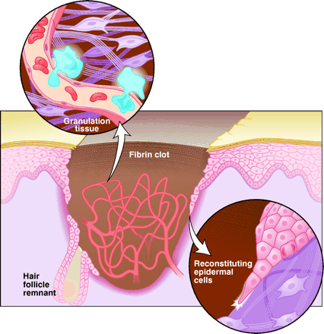
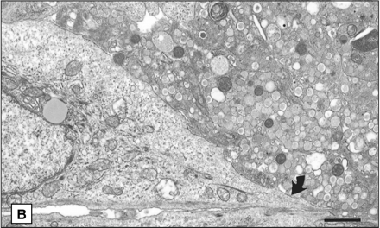
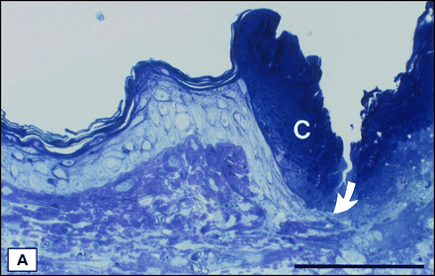

Figure 1.21: Left: Schematic of the key features in skin healing. The defect is temporarily plugged with a fibrin clot, which is infiltrated by inflammatory cells, fibroblasts and granulation tissue. An epidermal covering is reconstituted from the edges of the wound. At the migrating keratinocyte leading edge, cells bore a passageway. Cell division then occurs back from the leading edge. Monocytes migrate from the wound capillaries into the granulation tissue, contracting by means of smooth muscle-like myofibroblasts that tug on each other and surrounding collagen ¹⁰⁸. Right: Histology of adult skin repair. (A) Resin section through the leading front of keratinocytes (arrow) as they cut their way through a clot (C).

1.4.2 Wounds that become chronic
Chronic wounds and associated problems are a health problem of immense magnitude affecting millions of patients worldwide ¹⁰⁹. Interestingly, chronic wounds do not occur in other animals, meaning that establishing a true chronic wound model in animals has been met with little success. As a result, most of our understanding of chronic wounds has come from people suffering from them ¹¹⁰. Furthermore, the experimental studies which can be employed are limited mostly to observation, biopsy and analysis of wound fluids. Enormous gaps have formed in our knowledge of the etiology (origin) and pathogenesis (mechanism) of chronic wounds. Limited success of growth factor treatment has been observed with extensive failure of clinical trials by several biotechnology companies^{110, 111}. This suggests that the concept of a non-healing wound only lacking growth factors is naïve and a better understanding is needed. Chronic wounds have diverse etiologies, which may still be linked, but not by a single aspect as first perceived.
There are three major groups when considering chronic wounds these are; venous ulcers, pressure sores and diabetic ulcers. Upon first inspection, these categories seem to have little in common and have been researched treated previously as separate entities. However, Mustoe et al ¹¹² examined their commonalities in more detail, this has led to an interesting hypothesis that human chronic wounds are a result of combination of common factors with these combinatory factors overwhelming the overall healing process.

1.4.2.1 Tissue Hypoxia and ischemia
Tissue ischemia is defined as the restriction of blood supply to a given tissue or tissues, impairing healing significantly with lower extremities with a partial oxygen pressure at the toe of less than 30 mmHg not having the ability to heal if injured ¹¹³. However, partial tissue oxygen pressure is affected by several factors that make it very difficult to measure the extent of ischemia ¹¹⁵. Animal models have been used to study and provide evidence for ischemia (such as the ears of rabbits), all conversing to the same end, major impairment seen in wound healing ¹¹⁴. Diabetic foot ulcers (DFU's) are also said to frequently occur due to ischemia ¹¹⁴. However, venous ulcers and pressure sores are not thought to be subject to ischemia with no direct correlation being recorded¹¹³.
Edema (the swelling of tissue caused by an increased fluid retention) is another factor, which plays an important role. If you increase the distance between capillaries and the insulted tissue, the distance for oxygen to diffuse is increased, lowering local oxygen levels within that area. When considering venous ulcers edema plays the largest role in the cause and their refusal to heal. As a result, compression bandages have been successfully used in many clinical studies in closure of venous ulcers ¹¹⁵.
When treating DFU’s or pressure sores vacuum-assisted wound treatment, wherein a reduced pressure is applied to the wound site, has shown promise regardless of current dispute on whether edema plays a role in delayed healing of these types of chronic wounds. These clinical studies support the hypothesis that non-healing wounds have reduced oxygen levels in the local environment negatively affecting wound healing to some degree ¹¹⁶.

1.4.2.2 Bacterial burden
Bacteria from the surrounding tissue and environment quickly infects an open wound, so as one can imagine a wound that does not heal can have a large degree of bacterial colonization ¹¹⁶. However, it is difficult to distinguish between normal colonization and critical colonization, in the absence of cellulitis. The host immune response to bacteria is inflammation, as with a breach in skin integrity. As covered in the previous section on wound healing, this creates a large influx of leukocytes releasing entities that prevent the formation of new matrix and subsequently prevent healing.
Skin grafts have been reported to fail as a direct result of critical colonization (bacteria counts of 10x10⁴ mm³), using irrigation techniques and topical antibiotics has shown that a reduction in bacterial numbers was enough in some cases to heal chronic wounds rapidly, even in some patients with several years of non-healing wounds ¹¹⁷. Suggesting that critical colonization of a wound can also be an important factor in non-healing wounds.
When comparing the fluid of a non-healing wound to a normal healing wound there are distinct differences. With the prior exhibiting higher levels of protease and pro-inflammatory cytokines ¹¹⁸⁻¹²⁰, as well as this fibronectin and matrix degradation is also observed, explaining the delay in re-epithelialization and a lack of granulation tissue characteristic of chronic wounds ^{121, 122}.
Anaerobic bacteria are more likely to be present in chronic wounds due to the low levels of oxygen ^{117, 122, 123}. The exact details of the mechanism or roles these bacteria play in non-healing wounds are still elusive. However, it is apparent that they play a negative role.

1.4.2.3 Biofilms
Within a wound bed microorganisms exist in mainly two states; the planktonic state, and the sessile state. Biofilms are commonly associated with chronic wounds and are microbial accretions which readily establish on solid surfaces, including the skin, and are surrounded by a self-produced extracellular matrix of hydrated extrapolymeric substances (EPS) ¹⁵⁵. The dermal wound bed provides bacteria with the perfect environment in which to flourish, hence their prevalence. Within the biofilm state, bacteria are protected from the external environmental stresses and inhibitors ¹⁵⁶. In addition bacteria within the biofilm state have a greater protection from the host immune response and antimicrobial interventions and exhibit easier gene transfer leading to the sharing of beneficial characteristics. This results an increased virulence between neighbouring bacteria ^{157, 158}.

1.4.2.4 Biofilm Formation
Biofilm formation happens in numerous phases as shown in figure 1.22, forming typically within hours of attachment to a surface. With the rate of growth influenced by external and internal conditions ¹⁵⁸. Bacteria have the greatest resistance to antimicrobials within a biofilm state and have proven to be extraordinarily resilient when trying to remove them from wounds. Further advantages of being in a biofilm are; increased metabolic efficiency, and substrate accessibility ¹⁵⁹.
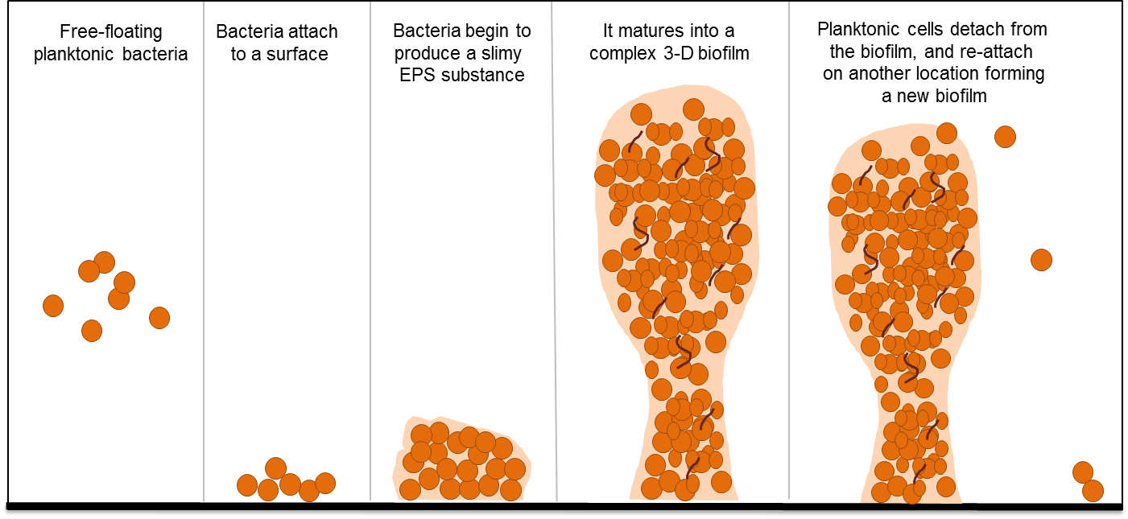
Figure 1.22: Cartoon representation summarising the steps of biofilm formation through the attachment of bacteria to a given surface ¹⁵⁹.
Almost all non-healing wounds have a biofilm present within them, this will contribute to the lack of healing and persistence of the wound. The first association of biofilms and wounds was discovered when bacterial colonies were analysed obtained from sutures and staples removed from a healed wound site of surgical incision ¹⁶⁰. The National Institutes of Health estimate that pathogenic biofilms are involved in as many as 80% of all human infectious diseases.

Clinical and in-vitro studies have confirmed the presence of biofilms in many different types of chronic wounds ¹⁶¹⁻¹⁶³. However, further scientific and clinical data is needed in diagnosis and identification of biofilms, which currently is the main limiting factor in determination of biofilm presence ¹⁶⁴. Biofilms in chronic wounds reduce the efficacy of phagocytic host cells and therefore reduce their risk of annihilation ^{165, 166}. Moreover, The EPS of biofilms has the ability to absorb and subsequently degrade a variety of therapeutic agents. This has been thought to be 'the' major reasons wounds fail to heal despite the use of an array of antimicrobials ¹⁹¹. Several studies have focused on biofilm resistance, in particular their resistance to antimicrobials and a hosts immune responses ¹⁶⁶⁻¹⁶⁸.
Microorganisms exhibit an altered growth and metabolic rate whilst in a biofilm state which creates additional resistance to antimicrobials ¹⁶⁹. The synergy of microorganisms and their ability to co-inhabit with other biofilms adds additional complexity to both the management and treatment of wounds, also enhancing their ability to adapt to drastic pH change ¹⁷⁰, increased damage (virulence) to host tissues¹⁷¹ and most impressively evidence of indirect pathogenicity ^{173, 174}. To further add complexity is the area of quorum sensing in biofilms. This field has revealed its role in biofilm formation and enhanced resistance of colonising bacteria ¹⁷¹ and such a phenomenon has been reported in wound healing ¹⁷⁵⁻¹⁷⁷. Quorum Sensing is the ability of bacteria to chemically sense their surroundings in particular the local bacterial density
Disrupting the protective biofilm EPS destroying both sessile and planktonic bacteria is essential in annihilation of biofilms and their residing residence. This is essential for the future of wound care and in the management of chronic wounds. Previous therapeutic interventions have been well documented over the last few years including: the use of enzymatic disruption which demonstrated some efficacy ¹⁷⁸; the use of bacteriophages ¹⁷⁹; electrolytic killing and removal of S. epidermis biofilms ¹⁸⁰ and quorum sensing blocking molecules ¹⁷⁵.
Clinical approaches currently being applied to assist the body to help a non-healing wound to heal use strategies such as cleaning of the wound using debridement, which aids removal of devitalised tissue and residing biofilms ^{181, 182} promoting wound healing.

1.5 Wound care

1.5.1 Current wound care products
Initially the field of wound care used natural remedies such as a variety of herbs, plants (Guiera senegalensis) and honey to treat wounds; today however, there are much more sophisticated methods such as tissue-engineered scaffolds used to deliver an array of antimicrobial agents ¹⁸³⁻¹⁸⁷. Within this section, some wound care products, which are currently commercially available will be discussed showing the breadth of variety available to a patient.

1.5.1.1 Dressing cataloging
Dressings are catalogued dependent on their intended function. Firstly, whether they function as debridement, antibacterial, occlusive, absorbent and their adherence strength ¹⁸⁶. Secondly, on the type of material used i.e. hydrocolloid, alginate, collagen etc. ¹⁸⁷. Thirdly, they are classified on their form i.e. an ointment, film, foam or gel ^{188, 189}, then as either primary, secondary or as island dressings ¹⁹⁰. Primary dressings make direct contact with a wound and are typically covered with a secondary dressing that adheres the dressing to the area of injury. Island dressings contain an outer adherent section with an absorbent region central to the dressing. It is worth noting there are different classifications of dressings that are not been mentioned here.
Classification criteria are useful, but it is worth noting that a given dressing may fit with more than one of the criteria described, increasing complexity ¹⁹⁰.

1.5.1.2 Topical Formulations
Are typically prepared as liquid solutions, suspensions, emulsions, semi-solid ointments and creams with worldwide use.
As discussed previously PVP-I is a common solution used and has shown much promise in reducing bacterial burden with most efficacy being seen if used as a first approach. It is also less commonly used as a debridement agent (necrotic tissue removal) ¹⁸⁸, due to low exposure, at a wound site. Especially in cases where patients exuding large amounts of exudate (wound fluid), liquid formulations are often very ineffective at delivering antimicrobial action. Exposure time can be increased by using ointment and creams and are often used to treat infected wounds over liquid counterparts for this reason ^{195, 196}. However, these have their own shortcomings, as they are super absorbent, highly exudating wounds because the thicker ointments to become more mobile with time reducing their effective exposure time at the wound site ¹⁹⁵.
As well as direct application liquid solutions can be used to impregnate wound dressings, this is commonly seen using antimicrobial agents such as; silver sulphazide, polyhexamethylene biguanide (PHMB) and PVP-I creating an antibacterial impregnated dressing ¹⁹⁰⁻¹⁹⁴.

1.5.1.3 Hydrocolloid Dressings
Hydrocolloid dressings are one of the most common dressings used today with their properties, mode of action and their appropriate use previously reviewed ^{197, 198}.
Hyrocolloid dressings are made from colloidal materials that form gels; typically, these are then combined with other materials to obtain a desired adherence and absorbance. There are a host of gel forming agents used in these dressings for example but not limited to; carboxymethylcellulose or CMC (cellulose derivative), gelatin (partially hydrolysed collagen) and pectin (heteropolysaccharide found in plant cell walls). Examples of current commercially available hydrocolloid dressings include; GranuflexTM and AquacelTM, ComfeelTM and TegasorbTM .

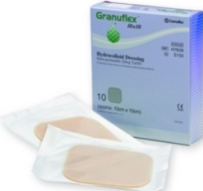
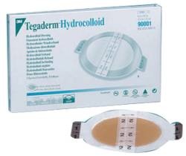
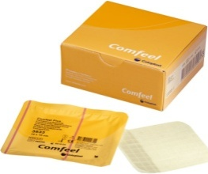
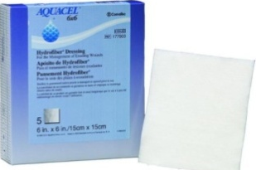

Figure 1.23: Hydrocolloid dressings left to right; GranuflexTM and AquacelTM (Conva Tec, Hounslow, UK), ComfeelTM (Coloplast, Peterborough, UK) and TegasorbTM (3M Healthcare, Loughborough, UK).
Hydrocolloid dressings can be formed as thin films and sheets (Figure 1.23) or as composite dressings in combination with other materials such as alginates (linear unbranched polymers containing linked D-mannuronic acid and guluronic acid residues) ¹⁹⁴⁻²⁰².
Hydrocolloid dressings are one of the most common wound dressings seen today due to their inherent ability to adhere to both moist and dry wound beds ¹⁹⁹. Furthermore, they can treat a wide range of exudating wounds including pressure sores and leg ulcers which are becoming more commonly seen in a clinical setting due to the rise in diabetes amongst the western world ²⁰⁰. These dressings are initially impermeable to H₂O vapour; however, upon application and eventual absorption of exudates the hydrocolloid becomes a gel that progressively becomes more permeable to liquid and gas as it swells respectively ²⁰¹.
The adherence of these dressings to the wound is weak, resulting in little pain being reported by patients upon removal ²⁰¹. In paediatric applications, this makes the hydrocolloid dressing the best option for the treatment of chronic wounds ²⁰².
A comparative study between Comfeel Ulcer DressingTM (hydrocolloid dressing) combined with Unna boot (compression bandage) and a Unna boot alone for treating venous ulcers found that Comfeel Ulcer Dressing combinatory treatment to be more effective ¹⁹⁸.
Another more recent study comparing CMC hydrocolloid and alginate dressings for their ability to absorb harmful bacteria showed that the CMC dressings upon hydration and gel formation was very effective in encapsulating large numbers of Staphylococcus aureus and Pseudomonas aeruginosa. These bacteria being the two most abundant aerobic bacteria found residing in chronic wounds by currently available techniques ²⁰³.
There are a few disadvantages of hydrocolloid dressings, these include that they generally have an occlusive (air and watertight) outer cover preventing water vapour exchange between the wound and the outside air. This is detrimental for wounds that require a high degree of oxygen to heal such as chronically infected wounds. Furthermore, deposition of fibers from the dressing into the wound during dressing changes forces debridement to be performed between each dressing change.

1.5.1.4 Alginate Dressings
The synthesise of these dressings comes from calcium and sodium salts of alginic acid, a polysaccharide containing a mixture of guluronic and mannuronic acid segments shown in figure 1.24 ²⁰³⁻²¹⁵.
M
M
G
G
Figure 1.24: Schematic of linear unbranched polymers containing β 1,4 linked D-mannuronic acid (M) and α 1,4 linked L-guluronic acid (G) residues, alginic acid.
Alginate dressings occur either as foams (freeze-dried porous sheets) or as flexible fibres, the latter being specifically used to pack large wounds cavities ²⁰³⁻²¹⁵. Alginates have similar properties to hydrocolloid dressings with the ability to form gels upon contact with wound exudates. The high absorption occurs because of the inherent hydrophilic nature of the polymer forming a hydrophilic gel, which as well as limiting the wound secretions is said to reduce bacterial contamination ²⁰⁴.
Alginates rich in mannuronate form very soft and fairly flexible gels when hydrated compared to those rich in guluronic acid which form much firmer durable gels upon absorbing wound exudate due to their ability, to pack chains against each other ²⁰⁵.
Some dressings contain calcium alginate fibers, thus ion exchange within the wound bed can occur. This causes a thin film to form which coincidently creates an ideal water vapor concentration for healing to occur ²⁰⁵. Calcium alginate dressings are also often ideal candidates for tissue engineering scaffolds this is due to their ability to be crosslinked, thus the degradation time can be altered ^{206, 207}.
Alginate dressings have a distinct advantage over hydrocolloid dressings that they can be left on a wound for longer durations between dressing changes ^{208.} Additionally, it is well known that calcium plays an essential role in wound healing for example calcium alginates increased fibroblast proliferation during healing in mice ^{209, 210}. Calcium ions also play a physiological role in aiding clotting during haemostasis ^{213–216}. Human macrophages upon exposure to calcium produce TNFα initiating the healing process ²¹¹. These findings suggest that calcium alginate dressings perhaps mediate and improve some aspects of wound healing. Furthermore, alginates used in neurosurgery provide a host of evidence to the material having an extremely low toxicity ²¹⁷.
Another advantage is the solubility and biodegradable nature of alginate fibres, when deposited into a wound during dressing changes they can be easily removed not disrupting any granulation tissue that has formed ²¹⁸. The main disadvantage of these dressings is if the wound is low exudating it will further dehydrate the wound and delay wound healing ²¹⁸.

1.5.1.5 Hydrogel Dressings
Hydrogels retain large volumes of water, swelling to many times their original volume. They are materials comprised of hydrophilic materials such as synthetic polymers and/or combinations of polymers examples include but are not limited to; poly(methacrylates) (PMA) and polyvinylpyrrolidone (PVP). Nu-gelTM (Johnson & Johnson, Ascot, UK) and PurilonTM (Coloplast) are examples of hydrogel alginate dressings. Hydrogels can be applied as either amorphous gels or as elastic, solid sheets/films as shown in figure 1.25.
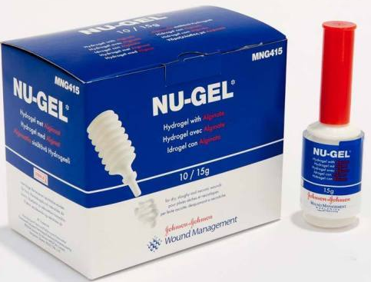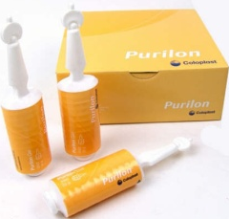
Figure 1.25: Two examples of commercially available hydrogel/ alginate wound dressings. Left: Nu-gelTM (Johnson & Johnson, Ascot, UK). Right: PurilonTM (Coloplast).
To prepare hydrogel sheets polymers are crosslinked so that they physically entrap and retain significant volumes of water and do not dissolve. If application occurs in the physical form of a gel, a secondary dressing is applied to hold the gel at the wound site. Due to the absorbent nature of hydrogels it will require changing often ²¹⁹. Conversely, if the hydrogel is a flexible sheet then no secondary dressing is required
Hydrogel sheets have the distinct advantage of having a high moisture vapour transfer rate (MVTR) allowing for equilibrium to be maintained and have proven to promote wound healing. The ease of physical manipulation and application of hydrogel sheets makes them also an attractive option to clinicians.
Hydrogel dressings contain typically between 70–90% water, thus cannot absorb much exudate; practically apply to light exuding wounds only. If used on highly exudating wounds fluid builds leading to skin maceration, which, results in an awful smell rising from the wound bed ²²⁰. Hydrogels although easy to manipulate and apply have a low mechanical strength and are renowned for being notoriously difficult to handle in practice ^{220, 221}.
In summary, they possess several desirable characteristics of a wound dressing; Rehydrating dry wounds by rehydrating necrotic tissues ²²⁰, increased permeability to metabolites, non-irritant ²²², promotion of moist healing, non-adherent and have low pain upon removal ²²³.

1.5.1.6 Foam Dressings
Foam dressings typically consist of porous polyurethane foams, with or without an adhesive border and contain an additional layer to reduce adherence to wounds. If applying to a dry wound with no exudate a non-permeable polymer backing is applied to the back of the dressing to prevent further dehydration ²²⁴. Foam dressings help sustain high water vapour content around the wound and deliver a small degree of thermal insulation ²²⁵. They are highly absorbent and this can be tailored by varying both the thickness and pore size within the foam resulting in a relatively high moisture vapour transmission rate ^{226, 227}.
The porous structure of foam dressings leads to them being extremely absorbent materials making them very well suited for use in burns patients and exudating wounds requiring marginal or modest drainage. The wide range of applications comes from the ability to tailor pour size during synthesis varying absorbent properties ²²⁸. Examples of foam dressing include; Lyofoam^{Tm} (ConvaTec) and Allevyn^{Tm} (Smith and Nephew), these are shown in figure 1.26.

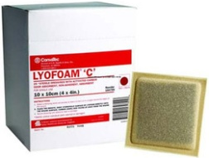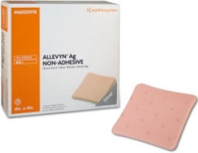
Figure 1.26: Two examples of commercially available Foam wound dressings. Left: Lyofoam (ConvaTec). Right: Allevyn (Smith and Nephew).

Foam dressings have been reported to be preferred to gauze for the significant reduction in pain, patient satisfaction and reduced nursing time which in turn reduces the overall cost of treatment ²²⁹. Furthermore, they also help prevent over-granulation in wounds ²³⁰.
There are a few instances were foam dressings are not applicable such as dry epithelializing wounds as they rely on exudates to achieve an optimal environment for healing to occur ²³¹.

1.5.1.6 Biological Dressings
Biological dressings or bio-active dressings consist of biological materials that contribute to healing. An example of a Bio-active dressings are tissue engineered products derived from naturally occurring polymers such as collagen, hyaluronic acid, chitosan and elastin ²³²⁻²³⁵. As these polymers are a part of tissues naturally, they possess properties, which are desirable; they are highly biocompatible and biodegradable ^{236, 237}. Incorporation of antimicrobials and growth factors is also possible and is now common place in most dressings ^{238, 239}.
Collagen is a component within connective tissue, with its structural, physical, chemical, biological and immunological properties being previously reviewed and discussed extensively in previous literature ^{240, 238}. It plays an essential role in wound healing, from the initiation of clot formation to the creation and remodeling of scar tissue. Epithelial migration and fibroblast formation during wound healing is also linked to cell collagen interaction ²³⁹. Collagen matrices for delivery of different agents have been reviewed widely ^{241, 242}. Hyaluronic acid is another example of a biological dressing with high biocompatibility. It consists of glycosaminoglycan ^{243,244}. Hosts of agents have been reported to be delivered from Hylauronic acid platforms (crosslinked hyaluronic acid, hyaluronic acid-modified liposomes) such as; growth factors, antimicrobial agents and several dyes ²⁴³⁻²⁴⁵. Chitosan has a very similar in structure to hyaluronic acid as shown in figure 1.27. It is known to accelerate healing during the proliferative stage, and its wound healing applications are well-documented ²⁴⁶.
Taking into account the reasons discussed here it can be easily understood why bio-active dressings are reported to be superior to ‘classical’ dressings ²⁴⁶.
Hyaluronic Chitosan
Figure 1.27: The chemical structure of the repeat unit of Left: Hyaluronic acid consists of subunits of glucuronic acid and N-acetylglucosamine Right: Chitosan a linear polysaccharide composed of β-1-4 linked D-glucosamine.

1.5.1.7 Tissue Engineered Skin Substitutes
This field has arisen from the need replace lost tissue which modern day dressing are un able to achieve. Tissue engineered substitutes can be used to replace large regions of dermis, thus making them ideal for severe burns patients ²⁴⁷.
Modern day biochemical skills and advancements in culturing techniques have allowed biochemists to grow patient’s own cells and apply these to bio-active scaffolds which allow remodeling and eventual replacement of the synthetic polymers with natural tissue ²⁴⁸. Thus, these are effective skin replacements. It therefore can be said that these scaffolds do not just facilitate wound healing but take an active role through promotion of normal physiological responses during the healing process, such as facilitating the migration of various cell types to the correct location ^{249, 250}.
There are typically two major types of matrices used acellular and cell containing matrices. Acellular matrices contain no cells and are typically produced from synthetic collagen or ECM combinations such as hyaluronic acid, for example Integra^{TM 251}. Cell containing tissue engineered dressings include biodegradable films formed from collagen and glycosaminoglycan, with ApligrafTM being a commercially available example. These scaffolds can be can be seeded with autologous cells and vitally possess properties and characteristics such as mechanical and their susceptibility to degradation similar to the native tissue ²⁵². This allows for the scaffold to be remodeled and for native connective tissue to replace the synthetic scaffold ²⁵¹.
There are many advantageous of tissue engineered scaffolds over all other dressings described previously these include; properties similar to native tissue, capability of accommodating living cells ²⁵⁴ and the ability to deliver a host of different agents (cytokines, living cells, antimicrobial agents, growth factors) ²⁵⁵.
In summary, these dressings have superior potential especially in the treatment of non-healing wounds and for severe burns patients. However, they have limitations such as increased costs, risk of infection, time to patient (harvest and growth of patient’s cells) ²⁵⁶.

1.6 Drug delivery devices

1.6.1 Pressure sensitive adhesives (PSA's)

1.6.1.1 Skin Adhesion
Adhesives have been available for many centuries with the most primitive materials originally used in hospital being natural rubber based but nowadays-synthetic materials are dominant. Originally, these synthetic materials were developed for industrial use. Johnson & Johnson can be said to be the first to see the potential of these materials as skin adhesives with the use of pressure sensitive adhesives (PSAs) in bandages in 1899. Today there is a whole host of different types of PSAs available from transdermal drug delivery systems (TDDS) which systemically transport agents through the skin to subdermal drug delivery devices (SDDD) which deliver drugs subdermally.
Before examining devices available that fall under the umbrella of PSAs, first it seems sensible to consider adhesion itself. There are a couple of fundamental requirements, the first of which is the thermodynamic requirement; the measured energy of the surface of the adhesive must equal or be less than the surface energy of human skin otherwise it will not adhere. The other requirements for adhesion involves wetting rates and viscoelasticity of the adhesive, these are kinetic requirements.
Originally critical contact angle measurements of skin where performed using numerous liquids to gain the surface energy or critical surface tension of skin ²⁵⁷. Using this technique on pre-cleaned and dried human skin, the critical surface tension was said to be between 28—29 dyn cm⁻¹, these units were made in the cgs system where they used the dynamic viscosity of water in terms of centipoise instead of Pascals, which is now used. This number however increases if the measurements are taken on unwashed skin. This is explained by looking in detail at the structure of skin and taking into account the parameters discussed previously needed for adhesion to occur.
The skin is a vital barrier for the body from the outside world consisting of five layers within the epidermis with the stratum corneum being the outermost, least permeable consisting mainly of dead cells ²⁵⁸ an example of which is shown in figure 10. Consisting of lipophilic (hydrophobic) and hydrophilic domains with dispersed hair follicles and sweat glands throughout. This said it has a low water content ~19%, which lies mainly in the keratin layers between the dead keratin-filled squamous cells commonly referred to as 'horny cells'. The keratin is highly crosslinked providing a fairly stiff and non-permeable layer. Furthermore, the elasticity is dependent on the water content and age of the person; ageing causes a reduction in water content and a reduction in elasticity. On the contrary, skin that is younger tends to be more elastic. Moreover, excessive sweating under an impermeable membrane such as a patch or plaster creates a much moister surface causing the skin to become more elastic.
Taking these factors above into considerations uncontaminated, dry skin is in essence lipophilic with a low surface energy. Non-washed or moist skin is thus hydrophilic in nature with an increased surface energy. Interestingly, hydrogels, which are hydrophilic, adhere to skin and this alludes to it being ‘wet’. However, the presence of follicles and sweat glands will contribute to successful adherence ²⁵⁸.
Modern measurements to acquire the surface energy of skin are typically done using a RameHart NRL contact-angle goniometers ²⁵⁹. The modern day measurements came to the same conclusion as the old where surface energy of the skin increased with increasing water content.
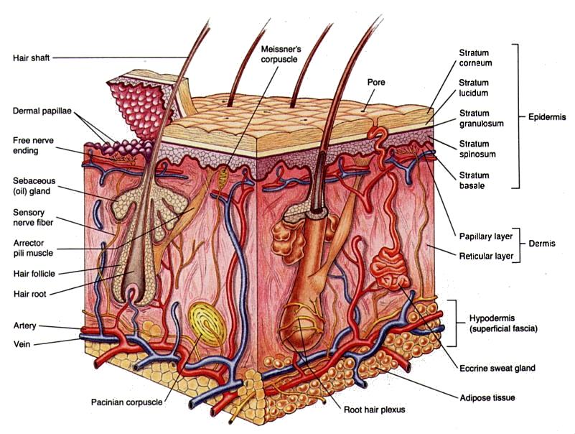
Figure 1.28: Schematic representation of a cross section of skin, showing all the complex layers from the outer most layer of the epidermis the stratum corneum to the underlying adipose tissue ²⁶⁰.
The same modern day technique can be applied to PSAs to measure their critical surface tensions (Cst). Table 1.5 summarises CST's of PSA materials. With silicones, acrylates and polyisobutylenes satisfing the thermodynamic criteria to effectively adhere to human skin.
Adhesive | Cst at 20ºC (mNm⁻¹)
Polytetrafluoroethylene (Teflon®) | 18
High density polyethylene (HDPE) | 31
Polyethylene terephthalate | 43
Poly vinyl alcohol | 37
Poly vinyl chloride | 40
Polyisobutylene | 30
PDMS | 22
Polyacrylate | 35
Table 1.5: Critical surface tension of some commonly used materials needed in adhesion for both manufacturing and skin adhesion ²⁶¹.
If the thermodynamic requirements presented in table 1.5 stood the solitary property required for significant skin adhesion, polyethylene would be a good candidate.
However, this is not the case due to crystalline regions in polyethylene. These regions cause it to become a solid, preventing ﬂow on the molecular scale preventing interaction on the molecular scale. Therefore, the kinetic property of the adhesive is vital and the adherent must be able to ﬂow on the molecular level to allow interactions to occur. Quantifying an acceptable level of adherence which industry have to match, or the compliance of adhesive, equates to 10⁶ cm²dyn⁻¹ ²⁶². This requirement only takes into consideration adhesion but not removal force, which is a vital criteria when developing PSAs as skin trauma could result upon removal.
Several techniques to evaluate adhesive performance exist these include; tack, peel adhesion and shear strength. Tack is a measurement of the speed that an adhesive can be applied to a substrate in terms of pressure and is highly subject to error. Peel adhesion is the measure of how much force is necessary to remove a given adhesive from a substrate. Shear strength is the measure of cohesive strength of the adherent, essentially the capability of an adhesive to be removed from a substrate.
However, there are several problems with the measurements regularly used in industry. Firstly all the measurements depend heavily on the substrate and on the backing material attached to the adhesive. Thus, this is not a true representation of the adhesive properties of the material. These measurements are also fraught with human error.
However, using all three methods and with well-defined standard substrates, backings and acceptable ranges being agreed by consumers and manufacturers has overcome the problems, allowing for direct comparison between different types of adhesives produced by manufacturers.

1.6.1.2 Transdermal Drug Delivery Devices (TDDDS)
Human skin is the largest and most easily accessible surface for drug delivery systems. TDDDS have the ability to deliver drugs systematically with a variety of advantages compared with orally taken drugs.
This is particularly useful when there is likelihood that the liver will prematurely metabolise drugs. Transdermal delivery also has advantages over hypodermic injections due to; associated pain, generation of dangerous medical waste and of course the risk of the transmission of dangerous diseases ²⁶³. Moreover, TDDDS are non-invasive, provide long periods of sustained release and allow the patient to self-administer, saving time and money in the healthcare sector.
TDDD systems however face an inherent problem that skin penetration for reasons described previously is extremely difficult with only a few drugs commercially available that can penetrate the barrier. However enhancers, such as oleic acid, oleic acid esters and poly(ethylene glycol) are typically supplementary to transdermal formulations to enhance delivery performance ^{264, 265}. Typically, the transdermal agent is encased in a patch consisting of layers; backing layer, membrane, adhesive layer and a liner ²⁶⁶.
There are two main types of TDDS; reservoir and matrix delivery. Reservoir delivery involves the active agents being in solution or a suspension held between the backing layer and a membrane which controls the rate of release shown in figure 1.29: a. Matrix delivery involves the drug suspension being dispersed into a polymer matrix and held in contact with the skin by using an adhesive shown in figure 1.29: b. A refinement of these delivery systems is a drug-in-adhesive matrix in which the adhesive polymer contains the drug as dispersion ²⁶⁶.
Backing layer
Drug in matrix
Drug Reservoir
Release membrane
Adhesive layer
b
a

Figure 1.29: Schematic of two typical TDDS; left; reservoir system, Right; matrix-type system.
TDDS are typically used to deliver drugs in somewhat small and daily doses. Examples of such drugs include nitroglycerin (for chest pain), scopolamine (for motion sickness), nicotine (for smoking cessation), clonidine (for high blood pressure), fentanyl (for pain relief), and estradiol (treatment for symptoms of menopause) ²⁶⁷.
PSAs are vital constituents of TDDDS as they guarantee intimate contact between the drug and the substrate (skin); essential for controlled and sustained ^{265,} ²⁶⁸.
The major classes of medical PSAs are acrylics, silicones, and polyisobutylenes as discussed previously, with the first TDDDS being developed in the 1980’s, known as Transderm Scop, marketed by CIBA Co. Releasing scopolamine, which is an anti-motion sickness drug, shown in figure 1.30 ²⁶⁷.
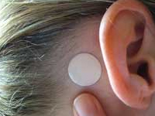
Figure 1.30: Transderm Scop TDDS designed in the 1980’s, intended use of preventing the user from motion sickness. The TDDS is a tanned coloured patch, which sits neatly behind the ear of the user.
There are several other TDDDS that use silicone adhesives to add adhesion and therefore delivery of agents; Vivelle-DotTM (for estradiol release) by Noven Pharmaceuticals, MatrifenTM transdermal pain patch (for fentanyl release) by Nycomed Co., DuragesicTM (for fentanyl release) by Alza/Janssen Pharmaceutica Co ^{270, 271}.

Project aims
The aim of this research is to enhance the properties of a commercially available PDMS membrane currently used in wound dressings manufactured and supplied by Scapa healthcare™.
Several material characteristics of the PDMS membrane would be beneficial to retain these include; low adhesive force upon removing the membrane from a skin substrate (low peel adhesion). Curing conditions used to cure the PDMS membranes (i.e. curing time and temperature) to be consistent with the current manufacturing process would be desirable, as it allows for easy industrial translation.
The properties of the material that would be beneficial to change are; increased permeability of the membrane to moisture, increased hydrophilicity at the surface and the ability of the material to deliver antimicrobial agents. Enhancing these properties would allow for effective treatment of human infected wounds, which the current material properties do not allow.
Synthesising an amphilic graft copolymer library of PDMS-g-PNVP copolymers with differing hydrophilicities and combining these in systematic formulations with the manufacturers PDMS membrane should allow for a semi interpenetrating (SIPN) network to be formed. This will increase all of the fore mentioned properties and allow for the opportunity to load hydrophilic agents such as antimicrobials into the modified PDMS membrane.

Project objectives

1. To synthesise narrowly disperse polydimethylsiloxane (PDMS) functionalised macromonomers with three well-defined increasing average molar masses with the ability for graft copolymerisation with N-vinyl Pyrrolidine. Ring opening anionic polymerisation of hexamethylcyclortrisiloxane using Lithium isopropoxide as the initiator will yield ω-monofunctional polysiloxanes. Molecular weight will be controlled by varying monomer feed and initiator concentration. Chain ends will be functionalised via the addition of allyl chloroformate once polymerisation is complete to allow for further grafting. (Chapter 5).
2. To Synthesise PDMS-g-PNVP copolymers with varying degrees of hydrophilicity using three different molar feed ratios per PDMS macromonomer, increasing NVP feeds respectively. Creating a PDMS-g-PNVP copolymer library. The reaction will precede using free radical polymerisation with 4, 4’-azobis (4-cyanovaleric acid) as the radical initiator. (Chapter 5)
3. Analyse solution behaviour of the amphiphilic PDMS-g-PNVP graft copolymers. Solution behaviour of PDMS-g-PNVP copolymers will be observed in both aqueous and organic solvents. Size of particles and the effects of solvents will be analysed using a ZETA PALS instrument. Morphology of particles will also be visualised using TEM. (Chapter 6).
4. PDMS membranes supplied by Scapa Healthcare™ will be modified with PDMS-g-PNVP copolymers at increasing concentrations to evaluate the mechanical, adhesive and surface characteristics of modified membranes. Adhesive parameters will be evaluated using peel adhesion tests. Contact angle measurements will be used to evaluate the surface hydrophilicity. (Chapter 7)
5. Load and monitor the release of an array of hydrophilic agents. Initially a fluorescent dye (Rhodamine B) will be loaded and release monitored using UV VIS spectroscopy to determine if release from modified membranes can be achieved. Subsequently, FDA approved antimicrobials will be loaded. (Chapter 8 and 9)
6. Antimicrobial loaded modified membranes efficacy on Staphylococcus aureus and pseudomonas aeruginosa will be determined using a combination of experiments. CZOIs and a fluid model (submergence of modified membranes into bacterial loaded solutions) will be conducted to determine both dry and wet efficacy of membranes against bacteria organisms. (Chapter 9)
7. Determine cell cytotoxicity of modified membranes on human dermal fibroblasts (HDFs). Alamar blue, Picogreen and LDH assays will be performed to fully evaluate cytotoxicity. The alamar blue assay will evaluate the metabolic activity of a population of cells using a fluorometric/colorimetric indicator. The Picogreen® dye is a fluorescent nucleic acid stain for quantifying double-stranded DNA (dsDNA); it can be used to measure the proliferation capacity of cells. Lactate dehydrogenase is a stable enzyme, present in all cell types, and is rapidly released into cell culture medium upon damage of the plasma membrane. Thus, the LDH assay will determine cell membrane integrity. (Chapter 10)
8. Determine any morphological changes to HDFs after exposure to membranes using cell straining and imaging techniques. The two techniques chosen to qualitatively evaluate morphology was firstly confocal microscopy with HDFs being stained with DAPI (nucleous stain) and phalloidin (actin stain) to visualise any morphological changes. Secondly, light microscopy was used using a Giemsa stain to visualise if the cell population were free from infection prior to subjecting HDFs to cytotoxicity experiments. (Chapter 10)

Chapter 2

Objectives

- Synthesise narrow disperse PDMS macromonomers with three increasing average molar masses functionalised using either allyl chloroformate or vinyl chloroformate capping agents.

- Characterise PDMS macromonomers using the following analytical techniques; ¹H NMR, MALDI-TOF MS, ATR FTIR, SEC and DOSY NMR.

- Determine suitability of vinyl and allyl termini macromonomers for free radical graft copolymerisation with NVP.

- Synthesise PDMS-g-PNVP copolymer library by reacting each PDMS macromonomer with NVP at three different molar feed ratios.

- Characterise PDMS-g-PNVP copolymers using the following analytical techniques; ¹H NMR, ¹³C NMR, ATR FTR, SEC, DSC and TGA.

- Determine homopolymer content using DOSY NMR and GPEC.

2.1 Introduction

2.1.1 Diffusion ordered spectroscopy (DOSY) NMR
This technique combines radio-frequency pulses with magnetic field gradients that encodes spatial information on molecules ²⁷¹. Here I will describe the simplest pulsed gradient diffusion experiment called a pulse field gradient echo (PGSE) as shown in figure 2.1 ²⁷².
Observation
channel
H¹
Relaxation
time
Acquisition
180⁰x
90⁰x
Gradient
channel
δ
1
1
Δ

Figure 2.1: Pulse field gradient NMR spectroscopy
Initially magnetisation is excited with a 90⁰ radio frequency pulse; a magnetic field gradient pulse then disperses this. After a period, (Δ/2) an 180⁰ radio frequency pulse reverses the magnetization. Thus, after a period of Δ the initial magnetization is now the negative of what it was following the initial pulse. A second gradient allows for refocusing and acquisition as shown in figure 2.2.
Total signal
Signal cancels
Total signal
Dephasing pulsed
field-gradient
Refocusing pulsed
field-gradient

Figure 2.2: A dephasing pulse causes the magnetisation vectors to rotate differently at different positions within the sample cancelling out the total signal. A refocusing pulsed field-gradient pulse provides an output signal.
If the nuclei have moved a significant amount within the sample refocusing is achieved, otherwise signals are lost ²⁷³. Furthermore, if the nuclei diffuse too far within the sample their signals also become lost and the intensity of the refocused signal is reduced as shown in figure 2.3.
Total signal
Dephasing pulsed
field-gradient
Refocusing pulsed
field-gradient
Diffusion
Total signal
reduced by
diffusion
Figure 2.3: The diffusion of nuclei reduces the ability of the refocusing pulse. Thus, the output signal is reduced and information is lost. Diffusion and magnetic pulses have a combinatory effect.
This technique requires parameters to be balanced to obtain a good signal to noise ratio with the larger and longer duration of magnetic pulses allowing for more spatial information to be obtained but at reduced signal intensity. Conversely, the weaker the magnetic pulse the larger the refocusing signal obtained but reduced spatial information ²⁷⁴.
To increase the strength of the output pulse sequences are used. These are sequences which are repeated several times and are increased after each pulse with the time between pulses being kept the same throughout as shown in figure 2.4.

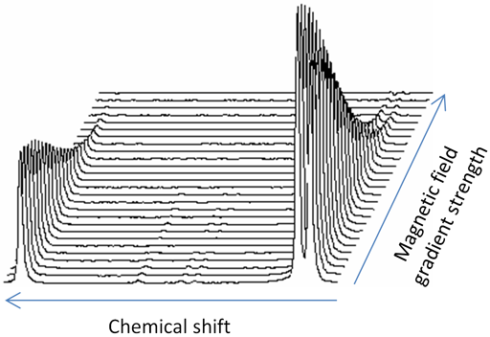
Figure 2.4: The Chemical shift peaks decay with increasing magnetic gradient strength. Peaks which decay faster have a low diffusion constant (left) and peaks which decay slower have a higher diffusion constant (right).
The plot can be transformed to yield intensity against gradient strength as shown in figure 2.5. The intensity is proportional to $e^{\{{-\left(γgδ\right)}^{2}D\left(∆-\frac{δ}{3}\right)\}}$ where γ is the gyromagnetic ratio, g is the gradient strength, Δ and δ are delays and D is the diffusion constant ²⁷⁵. A Gaussian decay is produced and the diffusion constant is extracted via the use of a non-linear curve fit.

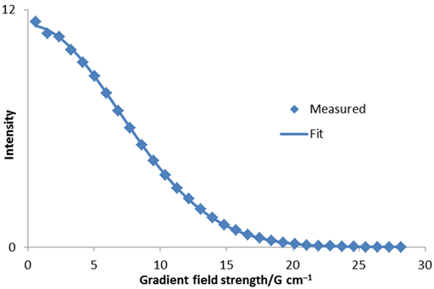
Figure 2.5: Diffusion constant extracted using a non linear fit.
Diffusion rates can also be obtained from using a linear fit of ln(I) against g² as shown in figure 2.6. However, due to deviation from the fit which occurs in many cases this technique for extracting the diffusion constant is less accurate than the Gaussian fit ²⁷⁶.
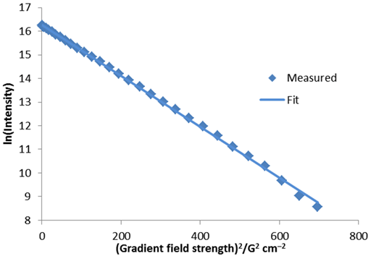
Figure 2.6: Linear fit of ln(I) against g² to obtain diffusion constant.
As seen with most NMR techniques signals often overlap or arise from multiple environments with the same molecule. When this occurs the diffusion constant can only be obtained using a non linear fit. The experimentally measured diffusions are a combination of the various diffusions from different molecules, deconvolution allows for peaks that create the observed data to be revealed as shown in figure 2.7.
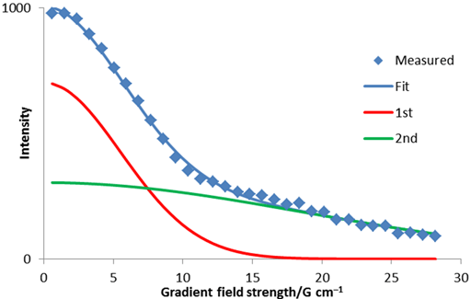
Figure 2.7: Bigaussian fit to diffusion peak intensity using a non-linear fit. The red and green lines are parts of the whole measured data.
Derivation of diffusion constants is possible using a non-linear inversion of the Laplace transform (ILT). Decay constants are then divided by ${-\left(γδ\right)}^{2}(Δ-\frac{δ}{3})$ and subsequently plotted onto a logarithmic scale. The reason they are plotted onto a logarithmic scale is that decay constants are typically many orders of magnitude different to one and another as shown in figure 2.8 ²⁷⁷.
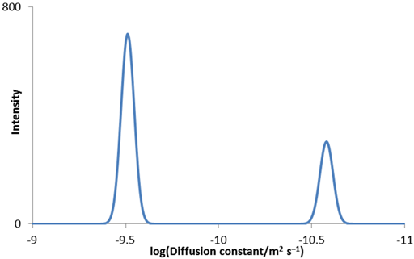
Figure 2.8: ILT of a bigaussian decay converted to diffusion constants and plotted on a logarithmic scale.
DOSY spectra are typically shown as a 2 dimensional plot as shown in figure 2.9 with Chemical shift plotted against the log of diffusion constant. As shown in figure 2.9 differentiating between different signals when DOSY data is presented in this form is trivial. However, if the signals overlap or differ by less than 25% in diffusion resolving the data becomes very difficult ²⁷⁸.
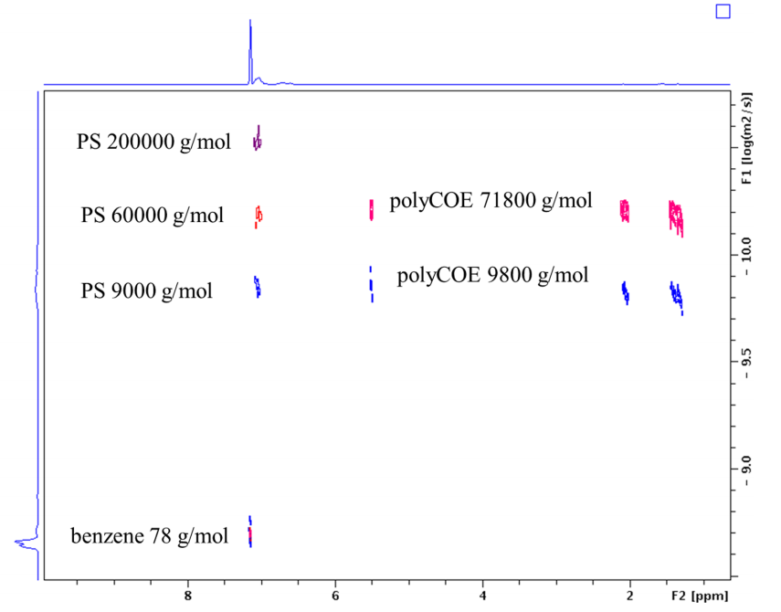
Figure 2.9: Example DOSY spectrum of common polystyrene and polycyclocetene standards of different average molar masses depicting the effect of molecular weight on diffusion constant ²⁷⁹.
The NMR spectrum of each component makes up the 2 dimensional DOSY spectrum with diffusion constants being extracted directly from the spectrum itself ²⁷⁹.
In summary, DOSY allows for the separation of mixtures containing a host of different chemical entities entirely by the differences in their size, shape and mobility. The main advantage to DOSY is that unlike many other techniques that separate based on mobility such as liquid chromatography techniques, DOSY requires no pre-treatment before analysis so chemical environment of the sample is maintained. Furthermore, the amount of sample required is minimal.

2.1.2 Gradient polymer elution chromatography (GPEC)
GPEC is a chromatographic technique that separates polymer solutions by application of an eluent gradient. The technique uses HPLC equipment for example columns that are commonplace in HPLC machines with both phases being applicable. Again like HPLC GPEC uses detectors that remain un effected by the eluents detectors include but are not limited to; Evaporating light scattering (ELS), UV-VIS and refractive index detectors ²⁸⁰.
To obtain good separation of mixtures, correct eluent choice is essential, for example if a hydrophobic macromonomers was copolymerised linearly to form a diblock with a hydrophilic macromonomer the resulting copolymer would be amphilic. The eluent choice in this case to gain optimum separation would consist of a gradient from a non-polar solvent to one polar. Initially the copolymer is partially soluble and the hydrophilic macromonomer would remain undissolved on top of the column, the hydrophobic non-reacted macromonomer would then elute first, then as the eluent becomes more favourable, the amphilic copolymer fully dissolves and elutes. As the solvent moves to become increasingly polar, any non-reacted hydrophilic macromonomer dissolves and elutes.
Another important factor when performing GPEC is that if the eluent choice is poor the molecule-column interaction will dominate and size exclusion chromatography is being performed ²⁸¹.
GPEC is an excellent technique for analysing materials with a chemical composition distribution such as copolymers.

2.2 Results and discussion

2.2.1 PDMS Macromonomer synthesis and analysis
PDMS functionalised macromonomers were synthesised by living anionic polymerisation with lithium isopropoxide as the initiator using allyl chloroformate or vinyl chloroformate to cap chain ends, as shown in figure 2.11.
Figure 2.11: PDMS macromonomer synthesis using ILP as the initiator and allyl or vinyl chloroformate as the capping agent
The ratio of Lithium isopropoxide initiator (ILP) to hexamethylcyclotrisiloxane starting material (HMCTS) was varied to obtain average molar masses of approximately 2,000, 5,000 and 10,000 g mol⁻¹ for both the allyl and vinyl termini functionalised macromonomers. The M_{w}, M_{n}, Ð, percentage functionality (%Fn) and yield are summarised in Table 2.1, with the percentage functionality being calculated using ¹H NMR using the integration of relevant peaks. The %Fn was also calculated using MALDI TOF mass spectroscopy by comparing the area of peaks derived from the mass spectra with the hydroxyl termini groups and ally or vinyl termini groups.

Allyl  ILP:HMCTS | SEC |  |  |  |  | MALDI |  |  |  | SEC |  |  |  | MALDI |  | Yield  %
Allyl  ILP:HMCTS | M_{w} (x10³) | M_{n}  (x10³) |  | Ð  (M_{z}/M_{n}) |  | M_{w}  (x10³) |  | M_{n}  (x10³) | Ð | %Fn
 |  |  |  |  |  |  |  |  |  | Initial |  | Post |  | %Fn
1:10 | 5.5 | 4.5 |  | 1.10 |  | 6 |  | 5.5 | 1.1 | 50 |  | 90 |  | 70 |  | 85
1:20 | 13 | 11 |  | 1.08 |  | 16 |  | 18 | 1.1 | 50 |  | 95 |  | 75 |  | 80
1:40 | 23 | 15 |  | 1.10 |  | 21 |  | 23 | 1.1 | 50 |  | 90 |  | 70 |  | 75
Vinyl
ILP:HMCTS
1:10 | 3.7 |  | 3.4 |  | 1.07 |  |  |  |  |  | 30 |  | 50 |  |  |  | 40
1:10 | 16.5 |  | 12.3 |  | 1.53
1:20 | 8.4 |  | 8 |  | 1.26 |  |  |  |  |  | 25 |  | 55 |  |  |  | 45
1:20 | 26.8 |  | 24 |  | 1.33
1:40 | 12 |  | 11.5 |  | 1.40 |  |  |  |  |  | 30 |  | 50 |  |  |  | 40
1:40 | 33 |  | 30 |  | 1.51
Table 2.1: Characterisation of functionalised PDMS macromonomers chain capped with either allyl or vinyl chloroformate.
The average M_{w}, M_{n} and Ð were all determined by size exclusion chromatography (SEC), which had been previously calibrated with Polymethyl methacrylate (PMMA) standards. The aim was to produce macromonomers with average molar masses of 2,500, 5,000 and 10,000 gmol⁻¹. The macromonomers obtained have average molar masses of 5,000 10,000 and 20,000 g mol⁻¹, the variation in theoretical and experimental is due to the initiator being deactivated as it is moisture sensitive which will increase the average molar mass of PDMS macromonomers obtained. However, the general trend is an increase in size of PDMS macromonomer as intended. The dispersities of all samples were low showing normal distributions of molar masses. The vinyl capped PDMS macromonomer was shown to produce two distinct populations showing a bimodal distribution, shown in figure 2.12.
Figure 2.12: SEC was carried out with PLgel columns (Polymer Laboratories), using Chloroform as an eluent, a flow rate of 1.0 mL min⁻¹ and a refractive index detector. Top; Allyl PDMS macromonomer. Bottom; Vinyl PDMS macromonomer.
Analysis of SEC derived molar mass distributions given in figure 2.12 showed that allyl functionalised PDMS macromonomers produced a single distribution with an increase in size when increasing the ratio of initiator to starting material; this trend of increasing size was shown for the vinyl functionalised PDMS macromonomer. However, the vinyl capped macromonomers showed a bimodal distribution present regardless of average molar mass targeted. Origin software was used to deconvolute bimodal distributions using a Gaussian fit to produce the two individual populations, which make up the original bimodal peak, shown in figure 2.13. Deconvoluted peaks were used to determine the M_{w} and M_{n} of each individual peak and the data are summarised in table 2.2.
Figure 2.13:Top to bottom; PDMS(5,000), (10,000), (20,000). Peak colours; dark grey; 1st deconvoluted peak, Light grey; 2nd deconvoluted peak, Black; raw data.
Vinyl  ILP:HMCTS | Deconvoluted SEC chromatograph
Vinyl  ILP:HMCTS | M_{w} | M_{n} | M_{z} | Ð
 |  |  |  | M_{w}/M_{n} | M_{z}/M_{w}
1:10 | 4,000 | 3,000 | 4,500 | 1.33 | 1.13
1:10 | 17,000 | 12,000 | 26,000 | 1.12 | 1.53
1:20 | 9,000 | 8,000 | 19,000 | 1.12 | 2.1
1:20 | 27,000 | 24,000 | 30,500 | 1.12 | 1.13
1:40 | 12,000 | 12,000 | 34,000 | 1 | 2.83
1:40 | 33,000 | 30,000 | 52,000 | 1.51 | 1.57

Table 2.2: Deconvoluted SEC bimodal distribution of vinyl macromonomers deconvoluted using origin to obtain individual peaks M_{w}, M_{n}, M_{z} and Ð.
The Gaussian model was used to deconvolute the bimodal distributions and showed a good fit for all data. Back biting reactions have previously been observed in ROAP reactions of hexamethylcyclotrisiloxane, which creates two populations explaining the bimodal distribution observed. There is also a side reaction which explains the bimodal distribution observed this would synthesise much larger macromonomers than intended, shown in figure 2.14 ²⁷⁴.

Figure 2.14: Suggested mechanism for bimodal molar mass distributions of vinyl capped PDMS macromomners. The vinyl alcohol leaving group formed can tautomerise into acetylaldehyde which is volatile at room temperature. Thus, driving this reaction.
The mechanism for vinyl capped PDMS macromonomers shown in figure 2.14 would lead to a bimodal distribution observed in SEC chromatographs. This is not seen for allyl capped macromonomers as the allyl alcohol is a poor leaving group. However, the vinyl alcohol due to delocalisation and tautomerization is a plausible leaving group.
Initial synthesis of macromonomers showed poor functionality (table 2.1); this was due to the presence of water within the reaction. Water essentially quenched the oxygen anion of the PDMS before the addition of the chloroformate minimising the reaction of the chain end with the chloroformate. Hence, reactions were then run in dry conditions. The nitrogen supply was passed over CaCl₂, HMCTS was dried for 24hrs prior to use in a vacuum desiccator and all glassware was dried at 70⁰C for 24hrs prior to use. This yielded a significantly higher %Fn (table 2.1). The reduction in water content of HMCTS via ¹H NMR is shown below in figure 2.15.

H₂O
H₂O

Figure 2.15: ¹H NMR of HMCTS showing the integral peaks of H₂O and CH₃ of HMCTS. The ratio of integrals of the peaks gave a water percentage content of the material. Left; Before drying, 10% H₂O. Right; After 24hrs of drying, 3% H₂O.
The structure and functionality of PDMS macromonomers were determined by ¹H NMR. The structure closely matches a typical siloxane, showing the vinyl peaks of the functionalised macromonomer (peaks 3, 4) in the ¹H NMR, shown in figure 2.16.
3 4
5
1
2
6 7 8
9

Figure 2.16: ¹H NMR of allyl PDMS macromonomer used to determine %Fn of macromonomers. A double of doublets correpsponding to a vinyl peak can be seen between 5 and 5.5ppm.
The %Fn was calculated using the integration of proton peaks 1, and 9 in the case of the allyl capped macromonomers. The %Fn of the vinyl capped macromonomers was calculated using peaks 3,4 and 9. This is due to the prescence of proton peak 9 in both functionalised and non-functionalised PDMS macromonomers whilst peaks 3, 4, and 1 are only present in the functionalised PDMS macromonomers as shown in figure 2.17.

1 9
3 4

Figure 2.17: Expanded ¹H NMR chromatogram of a typical PDMS macromonomer, showing peaks used for integration to determine percentage functionality of both vinyl and ally capped PDMS macromonomers.
The significantly lower %Fn, low yield and bimodal molar mass distribution produced when using vinyl chloroformate as the functionalising reagent resulted in these macromonomers not being used for copolymerisation synthesis. The allyl-PDMS macromonomers are more appropriate for translation into an industrial process due to the reasons explained and also the lower price of the ally chloroformate.
The MALDI-TOF mass spectra of the each PDMS macromonomer are shown in figure 2.18a-c. The data showed two peaks one with the functionalised end group and the other with a hydroxyl end group. The difference between two main peaks is m/z 74 confirming the presence of -Si-O- repeat unit.

Figure 2.18a: MALDI-TOF mass spectra of PDMS (5000) functionalised with allyl chloroformate, peaks for both allyl and hydroxyl terminated macromonomer are present.
Figure 2.18b: MALDI-TOF mass spectra of PDMS (10,000) functionalised with allyl chloroformate, peaks for both allyl and hydroxyl terminated macromonomer are present.
Figure 2.18c: MALDI-TOF mass spectra of PDMS (20,000) functionalised with allyl chloroformate peaks for both allyl and hydroxyl termini macromonomer are present.

The percentage of chain end capping was calculated by taking the area under each peak across the entire spectra for both the hydroxyl termini and allyl termini macromonomers and comparing the ratio between the two peaks, shown in Figure 2.19 and table 2.3.
B
A
B
B
A
A
B
A
B
A
Figure 2.19: Expanded region between 1200 and 2000 m/z, both hydroxyl and allyl termini PDMS macromonomers were observed.
Attenuated total reflectance Fourier transform infrared spectroscopy (ATR-FTIR) was performed on PDMS macromonomers. The data are shown in figure 2.20 with the spectra for each PDMS macromonomer overlaid.
(CH₃)₃-Si
[(CH₃)₂SiO]_{x}
(CH₃)₃-Si
sp2 C-H
sp3 C-H
Figure 2.20: Overlaid ATR FTIR transmittance spectra for PDMS (5,000), PDMS (10,000) and PDMS (20,000) macromonomers, peaks correspond to a siloxane.
The IR concurs with ¹HNMR and MALDI TOF analysis showing peaks corresponding to the target PDMS macromonomer. A very similar spectra was observed for all macromonomers tested, as shown in figure 2.20.

2.2.1.1 Diffusion-Ordered NMR (DOSY)
DOSY was performed on each of the allyl reacted PDMS macromonomers under the conditions stated in the experimental section. DOSY is versatile; it offers distinct chemical information about discrete chemical species that can be separated both by chemical environment (¹H NMR), size and macromolecular conformation.
DOSY NMR was used here confirm the presence and incorporation of the allyl functionality. If the allyl group has been incorporated onto the chain ends of the polymer the alkenyl hydrogens will be shown to diffuse at the same rate as the methyl groups in the PDMS backbone. With the chemical shifts being between 4-6ppm for the alkenyl and 0ppm for the hydrogens of the methyl backbone. The diffusion constants have been calculated using Bruker xwinnmr software package (version 3.0 based on intensity of the signal.

PDMS (5,000)
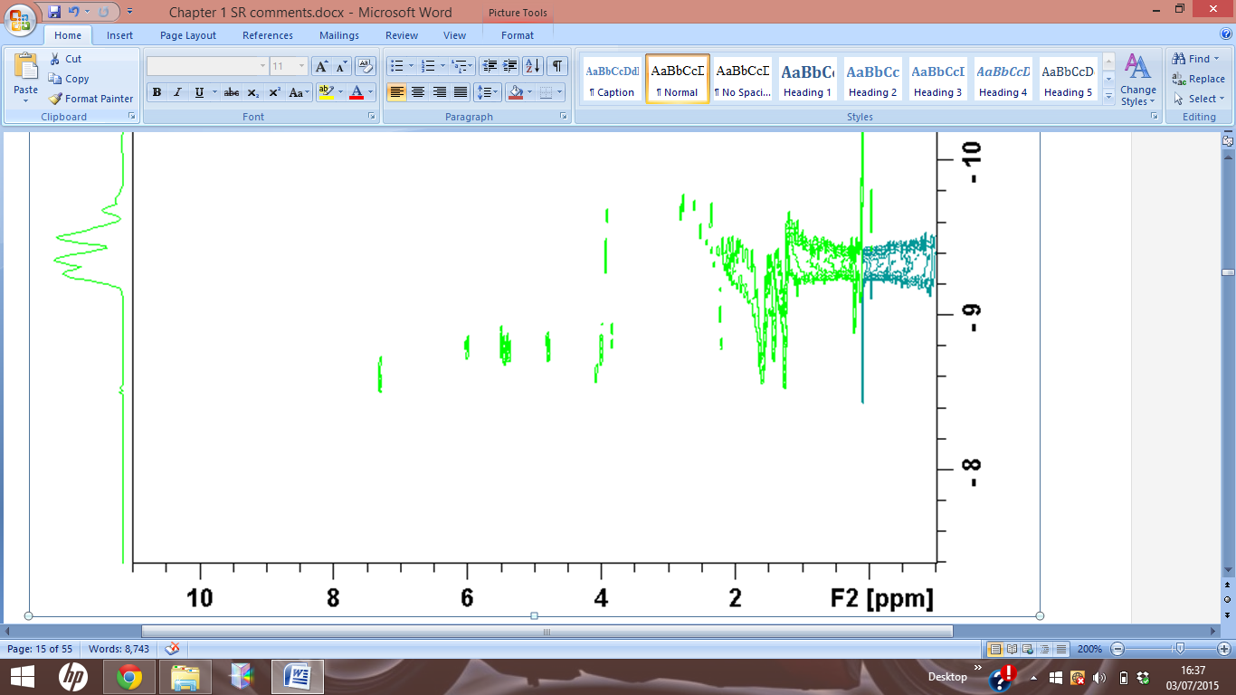
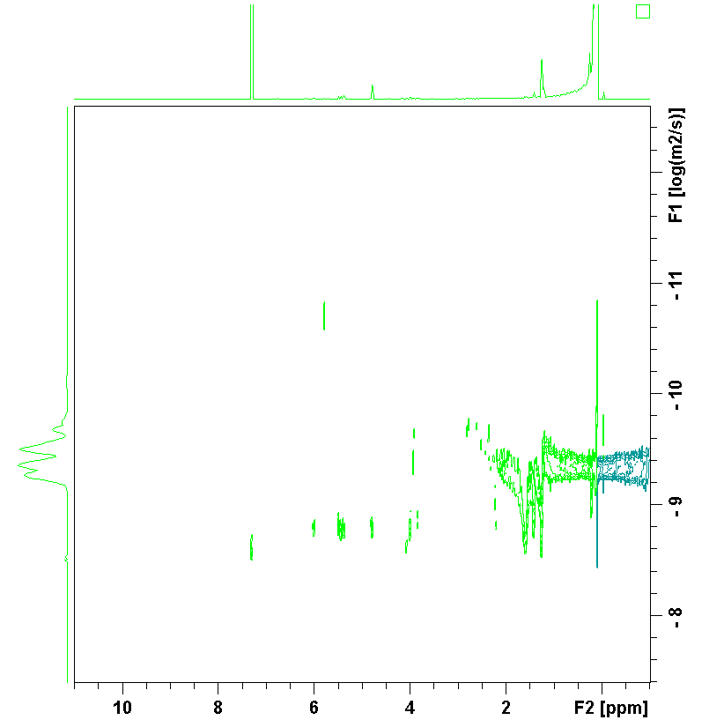

Intensity |  | Area
Peak  Ppm | diffusion constant  log | Peak  ppm | diffusion constant  log
5.978 | 1.67x10⁻⁹ | 6.125 - 5.867 | 1.05x10⁻⁹
5.371 | 1.78x10⁻⁹ | 5.550 - 5.327 | 1.38x10⁻⁹
4.792 | 1.79x10⁻⁹ | 4.928 - 4.752 | 1.41x10⁻⁹
4.67 | 1.20x10⁻⁹ | 4.154 - 3.755 | 1.38x10⁻⁹
3.994 | 1.46x10⁻⁹ | 1.714 - 1.514 | 1.56x10⁻⁹
1.207 | 1.81x10⁻⁹ | 1.327 - 1.127 | 1.13x10⁻⁹
0.81 | 1.67x10⁻⁹ | 098 - 0.08 | 1.23x10⁻⁹

PDMS (10,000)
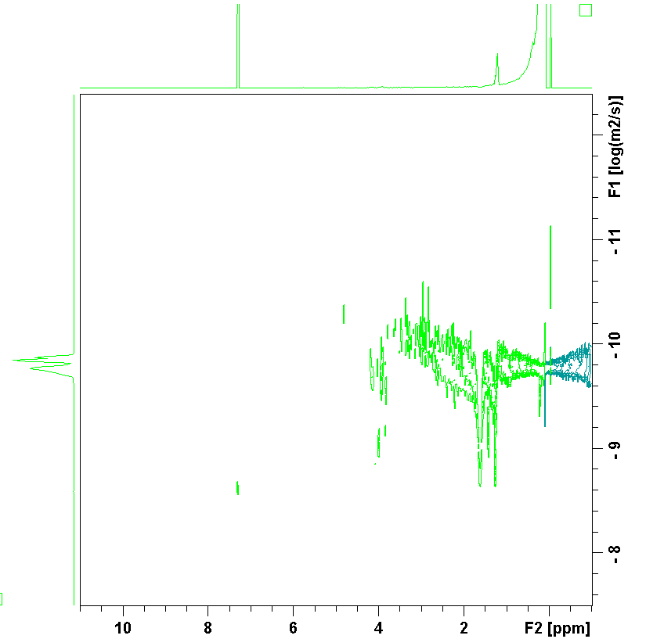

Intensity |  | Area
Peak  Ppm | diffusion constant  log | Peak  ppm | diffusion constant  log
7.298 | 2.52E-09 | 7.427 - 7.016 | 1.70E-10
4.726 | 1.12E-09 | 4.916 - 4.717 | 1.60E-10
4.395 | 1.08E-09 | 4.653 - 3.661 | 1.52E-10
3.209 | 4.18E-9 | 3.324 - 2.054 | 1.76E-10
1.607 | 1.77E-09 | 1.831 - 1.491 | 5.42E-10
1.407 | 1.10E-09 | 1.479 - 1.373 | 2.27E-10
0.856 | 2.12E-09 | 1.362 - 0.127 | 3.66E-10

PDMS (20,000)
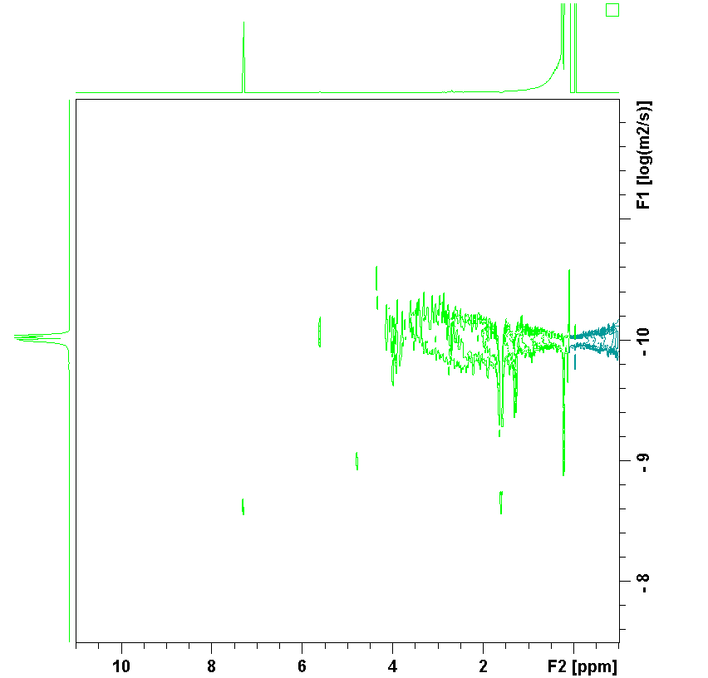
Intensity |  | Area
Peak  ppm | diffusion constant | Peak  ppm | diffusion constant
7.298 | 1.50x10⁻⁹ | 7.125 - 5.890 | 1.42x10⁻¹⁰
5.97 | 1.04x10⁻⁹ | 5.99 - 5.573 | 1.42x10⁻¹⁰
5.371 | 1.09x10⁻⁹ | 5.550 - 5.327 | 2.22x10⁻¹⁰
4.77 | 1.16x10⁻⁹ | 4.83 - 4.21 | 1.22x10⁻¹⁰
3.984 | 1.99x10⁻¹⁰ | 4.107 - 3.732 | 1.38x10⁻¹⁰
0.183 | 2.98x10⁻⁹ | 0.986 - 0.181 | 1.04x10⁻¹⁰
Figure 2.21: DOSY NMR spectra of all PDMS macromonomers synthesised with corresponding table displaying relevant peaks and associated diffusion constants.

The DOSY spectra show a spread of diffusion components for the CH₃ moiety of PDMS between 0-1ppm. This is due to each Polymer having a distribution of molar mass as shown in SEC chromatograms previously, resulting in them having a variation in relaxation and diffusion constant ²⁷⁵. Furthermore, using the same rationale, selecting an area of this peak rather than a specific region based on its intensity gives a more reasonable diffusion constant that fits with the diffusion constants obtained for the other peaks. The diffusion constants can be seen to decrease moving from low (PDMS (5,000)) to high (PDMS (20,000)) average molar mass, indicating an increase in size of the macromonomer as they diffuse slower. The data coincides with results obtained using SEC which also showed an increase in size. The allyl functional group can be seen to be incorporated into the chain end of macromonomers, as the alkenyl hydrogens diffuse at the same rate as the methyl groups in the macromonomers backbone. These alkenyl and methyl protons are circled in the spectra shown in figure 2.21.

2.2.2 PDMS-g-PNVP copolymer synthesis and analysis

2.2.2.1 Synthesis and SEC analysis
PDMS-g-PNVP copolymers were produced following the reaction shown in figure 2.22.
Figure 2.22: PDMS-g-PNVP copolymer synthesis.
A library of graft copolymers was constructed by combing the three differing average molar mass macromonomers individually with different molar feed ratios of NVP. Each macromonomer was reacted with NVP in the following molar weight ratios; 3:1, 1:1 and 1:3, respectively. The results of the SEC analysis and mass percentage yield of copolymerisation is summarised in table 2.3.

PDMS:NVP |  | Code | SEC (g mol⁻¹) |  |  | Fractional conversion of NVP
PDMS:NVP |  | Code | M_{w} | M_{n} | Ð
1:3 | PDMS(5,000)  PDMS(5,000)  PDMS(5,000) | :5PNVP | 72,000 | 52,000 | 1.40 | 0.95
1:1 | PDMS(5,000)  PDMS(5,000)  PDMS(5,000) | :7PNVP | 76,000 | 50,500 | 1.51 | 0.95
3:1 | PDMS(5,000)  PDMS(5,000)  PDMS(5,000) | :0.5PNVP | 67,000 | 40,300 | 1.67 | 0.90
1:3 | PDMS(10,000) | :2.15PNVP | 72,000 | 51,500 | 1.6 | 0.90
1:1 | PDMS(10,000) | :2.57PNVP | 66,000 | 44,000 | 1.6 | 0.95
3:1 | PDMS(10,000) | :0.5PNVP | 70,000 | 49,000 | 1.6 | 0.90
1:3 | PDMS(20,000) | 1.08 PNVP | 122,800 | 77,700 | 1.4 |  | 0.90
1:1 | PDMS(20,000) | 5.8 PNVP | 130,000 | 83,000 | 1.5 |  | 0.92
3:1 | PDMS(20,000) | 2.4 PNVP | 107,200 | 68,500 | 1.5 |  | 0.95
Table 2.3: Comparing M_{w}, M_{n}, Ð and NVP conversion of graft copolymer library. Size exclusion chromatography (SEC) was carried out with PLgel columns (Polymer Laboratories), using Chloroform as an eluent, a flow rate of 1.0 mL min⁻¹ and a refractive index detector.
In table 2.3 there is a small variance between the average molar mass of PDMS (5,000) graft copolymers and PDMS (10,000) graft copolymers, while PDMS (20,000) graft copolymers are significantly larger. This is due to the small difference in average molar masses of the PDMS (5,000) and PDMS (10,000) macromonomers, whilst PDMS (20,000) is considerably larger. The molar mass distributions for the PDMS-g-PNVP copolymers produced are shown in figure 2.23a-c.

Figure 2.23a: Chromatogram of PDMS-g-PNVP copolymers PDMS (5,000). SEC was carried out with PLgel columns (Polymer Laboratories), using Chloroform as an eluent, at a flow rate of 1.0 mL min⁻¹ and using a refractive index detector. Solid black line PDMS(5,000):5PNVP, dashed dark grey line PDMS(5,000):7PNVP and dotted light grey line PDMS(5,000):0.5PNVP.
Figure 2.23b: Chromatogram of PDMS-g-PNVP copolymers PDMS (10,000). Solid black line PDMS(10,000):2.15PNVP , dashed dark grey line PDMS(10,000):2.57PNVP and dotted light grey line PDMS(10,000):0.5PNVP.
Figure 2.23c: Chromatogram of PDMS-g-PNVP copolymers PDMS (20,000). Solid black line PDMS(20,000):1.08PNVP, dashed dark grey line PDMS(20,000):5.8PNVP and dotted light grey line PDMS(20,000):2.4PNVP.
The ratio of PDMS to NVP was determined using elemental analysis (nitrogen content) and inductively coupled plasma mass spectrometry (ICP-MS) was used to determine the silicon content, results are shown in table 5.4.
Code | N (mg mg⁻¹ ×10⁻³) | Si (mg mg⁻¹×10⁻³) | Molar feed |  | Experimental
Code | N (mg mg⁻¹ ×10⁻³) | Si (mg mg⁻¹×10⁻³) | PDMS | NVP | PDMS | NVP
1a | 10 | 50 | 1 | 3 | 1 | 5
1b | 9 | 63.10 | 1 | 1 | 1 | 7
1c | 120.90 | 6.89 | 3 | 1 | 1.50 | 1
2a | 10.70 | 23 | 1 | 3 | 1 | 2.15
2b | 10.54 | 27.10 | 1 | 1 | 1 | 2.57
2c | 10.94 | 7.20 | 3 | 1 | 1.50 | 1
3a | 10.97 | 11.90 | 1 | 3 | 1 | 1.08
3b | 9.78 | 56.70 | 1 | 1 | 1 | 5.80
3c | 3.58 | 8.59 | 3 | 1 | 1 | 2.40
Table 2.4: Nitrogen to silicon ratio determined via ICP-MS and elemental analysis for graft copolymer library synthesised using allyl termini PDMS macromonomers.
The molar feed ratios and experimentally determined ratios differ; this explains difficulties encountered when dissolving PDMS-g-PNVP copolymers in organic solvent, with such a large degree of NVP component being present, the graft copolymer is highly hydrophilic in nature.

2.2.2.2 NMR analysis

2.2.2.2.1 ¹H NMR
The spectra for the ¹H NMR of a graft copolymer is shown in figure 5.24, the broad peaks present are indicative of poly N-vinylpyrrolidone (1.5 - 2.5 and 3-4ppm).
3
Solvent
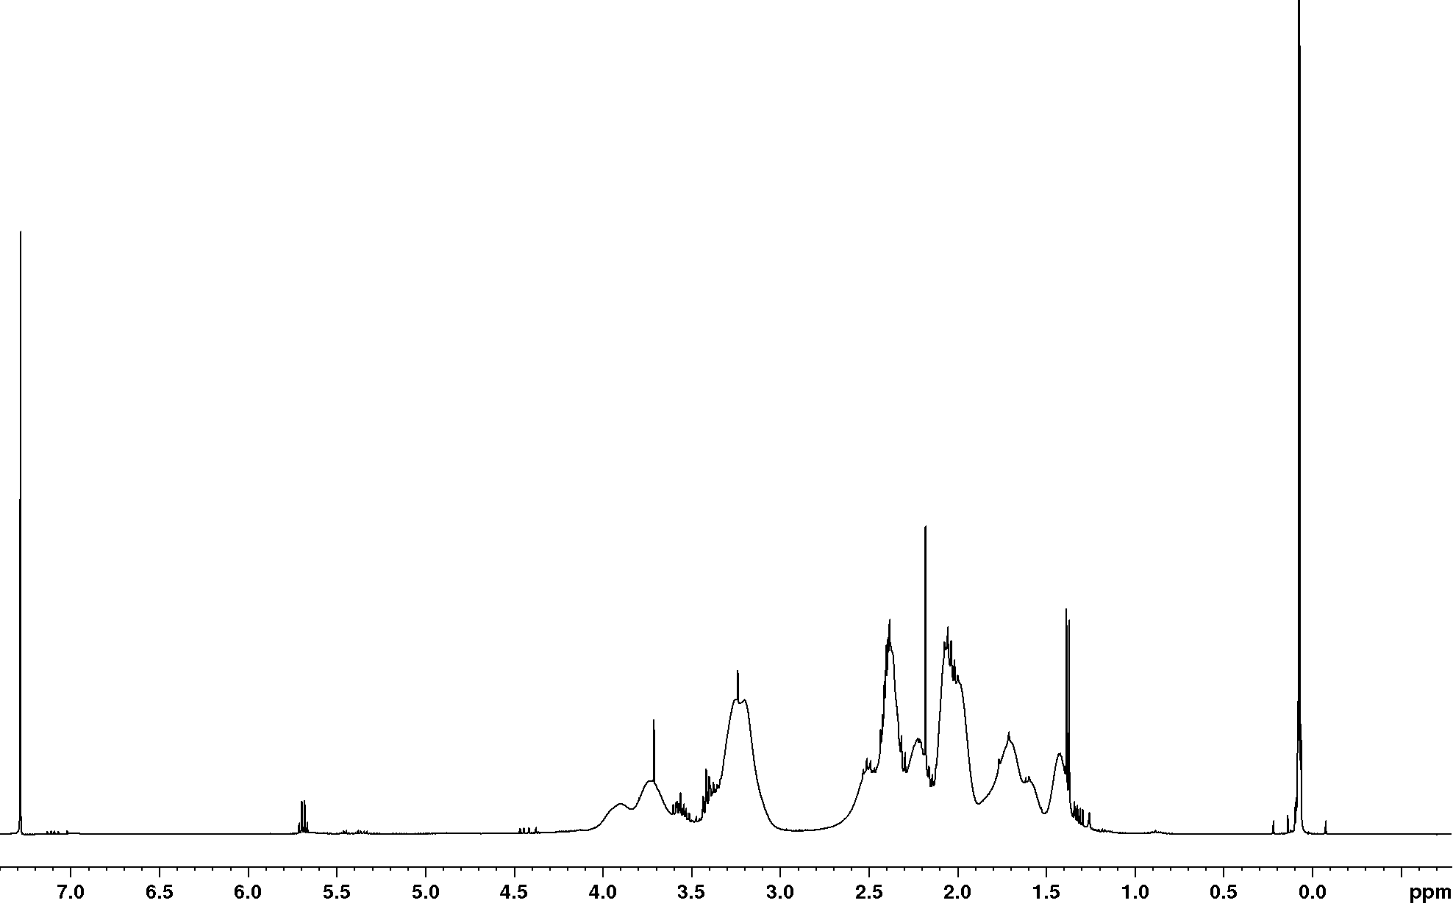
5
10
9
4 2
8
7
6
1
Figure 2.24: ¹H NMR in CDCl₃of a PDMS-g-PNVP copolymer.
The Spectra shown in figure 2.24 shows that the vinyl peaks between 5 and 5.5ppm visible before graft copolymerisation are no longer present; suggesting that all of the allyl functionalised PDMS macromonomer has reacted.

5.2.2.2.2 ¹³C NMR
A ¹³C NMR of a graft copolymer is shown in figure 2.25, the resulting ¹³C NMR was obtained by running the sample over a 24 hour time period.
9
CDCl₃
876
5
4 3
2 1
Figure 2.25: ¹³C NMR of a PDMS-g-PNVP copolymer, run over 24hours.
Carbons belonging to the NVP component of the graft were more readily detected than the PDMS backbone as this component is the largest of PDMS-g-PNVP copolymers synthesised.

2.2.2.2.3 DOSY NMR
DOSY NMR can be useful for polymer analysis as well as providing a chemical spectra, the data is resolved along a second axis that describes the diffusion constant of the polymer chain. The diffusion constant is related to the hydrodynamic volume by the Stokes Einstein equation. DOSY was performed on each of PDMS-g-PNVP copolymers as stated in the experimental. Diffusion constants were calculated using Bruker xwinnmr software package (version 3.0) based on the intensity of the signal received. PDMS(20,000):5PNVP is shown in figure 2.26 other graft copolymer spectra are in the appendix of this thesis.

PDMS (5,000)5PNVP Wt. %: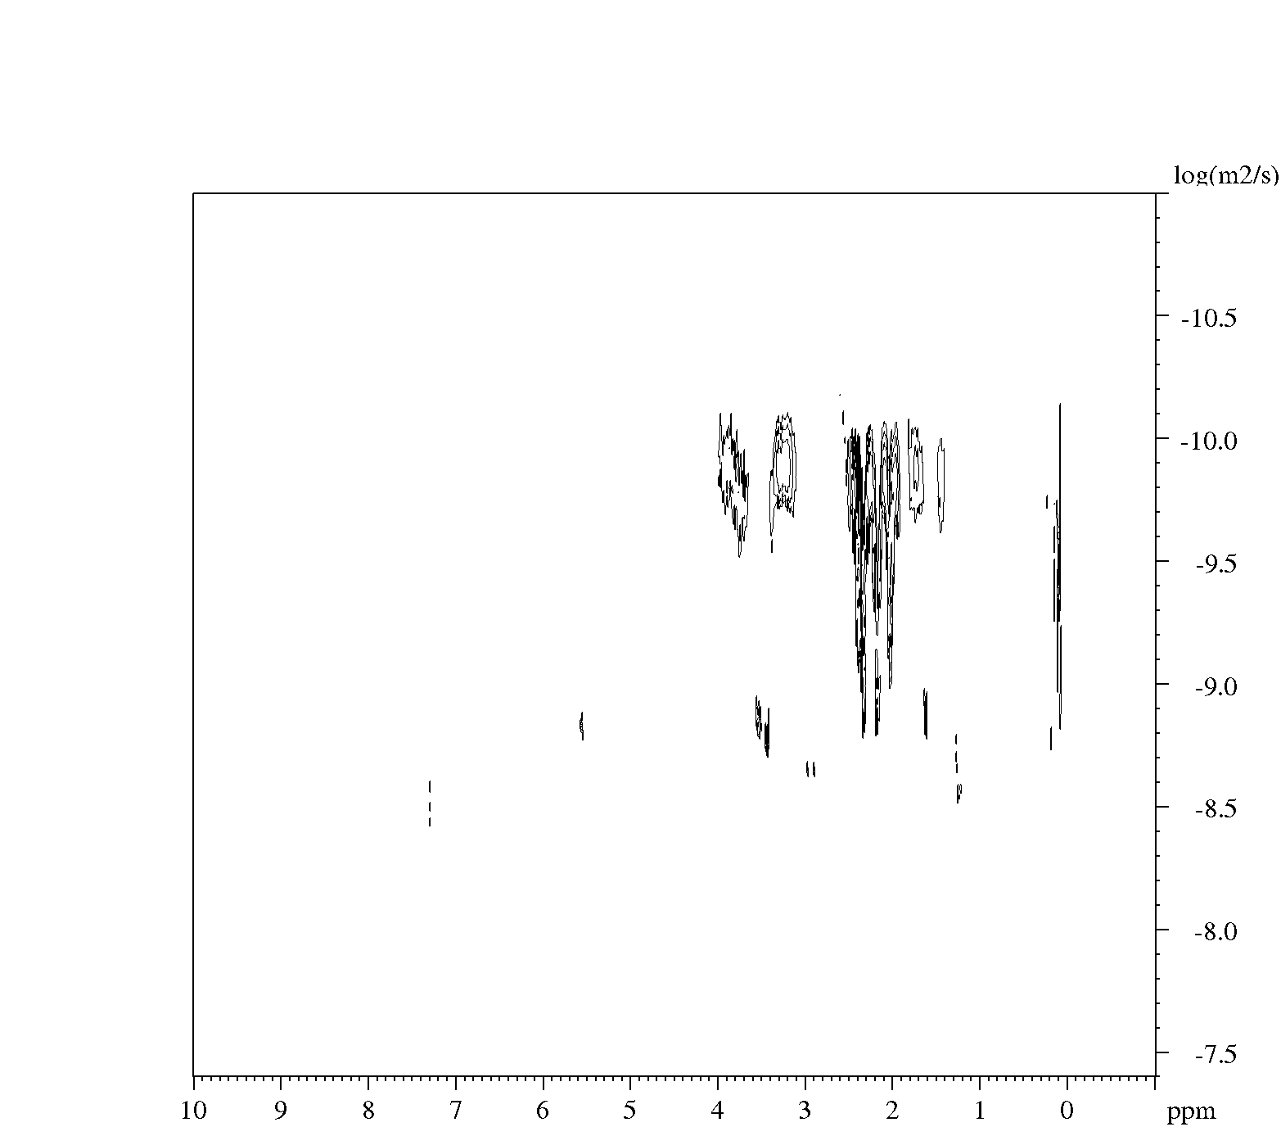
PDMS
PNVP
PDMS-g-PNVP

Intensity |  | Area
Peak  ppm | diffusion constant  log | Peak  ppm | diffusion constant  log
3.727 | 1.56E-09 | 3.827 - 3.641 | 2.54E-10
3.432 | 1.90E-09 | 3.498 - 3.390 | 1.38E-09
3.215 | 1.20E-10 | 3.368 - 3.073 | 1.42E-10
2.388 | 6.85E-10 | 2.472 - 2.318 | 3.49E-10
2.184 | 1.57E-09 | 2.286 - 2.121 | 3.29E-10
2.025 | 8.71E-10 | 2.121 - 1.903 | 2.33E-10
1.865 | 7.93E-11 | 1.925 - 1.837 | 3.12E-10
1.722 | 7.49E-10 | 1.827 - 1.673 | 1.56E-10
1.419 | 1.31E-10 | 1.510 - 1.390 | 1.77E-10

Figure 2.26: DOSY NMR spectra of PDMS(5,000):5PNVP copolymer shown with corresponding table displaying relevant ¹H NMR peaks and associated diffusion constants.
The free radical graft copolymer synthesise is complex as shown by DOSY NMR. Figure 2.26 shows the presence of non-functionalised PDMS macromonomer, homopolymer PVP and graft copolymer. Therefore, there is a large spread of diffusion constant for a single proton; this can be seen when focusing on a single proton present in either homopolymer PVP or the PDMS-g-PNVP copolymer.

2.2.2.2 Attenuated total reflectance Fourier transform infrared spectroscopy (ATR-FTIR)
ATR-FTIR was used to confirm the synthesis of PDMS-g-PNVP copolymers. The spectra show firstly differences in peaks between each PDMS-g-PNVP copolymer set (i.e. PDMS(5,000) copolymers). Secondly, a comparison between the change in absorption between a synthesised PDMS macromonomer and the resulting PDMS-g-PNVP copolymers synthesised from the macromonomer shown in figure 2.27.
(CH₃)₃-Si
(CH₃)₃-Si
sp2 C-H
sp3 C-H
OH
[(CH₃)₂SiO]_{x}
C=O
(CH₃)₃-Si
C=O
OH
sp3 C-H
sp2 C-H
(CH₃)₃-Si
[(CH₃)₂SiO]_{x}
[(CH₃)₂SiO]_{x}
(CH₃)₃-Si
OH
C=O
sp2 C-H
sp3 C-H
(CH₃)₃-Si
Figure 2.27: Overlaid ATR FTIR spectra of PDMS macromonomers with PDMS-g-PNVP copolymers synthesised.
The IR spectra of the copolymer synthesised from each PDMS macromonomers (PDMS (5,000), (10,000) and (20,000)) were similar. The spectra for PDMS-g-PNVP copolymers show the presence of more functional groups than spectra for the PDMS macromonomers. The broad OH peak seen at 3500cm⁻¹ in these spectra's is due to the hydroscopic nature of the NVP component of the copolymer. The difference between the overlaid spectra is the peak at 1600 cm⁻¹ that is due to the amide present in NVP and not in PDMS macromonomers.

2.2.2.3 Gradient polymer elution chromatography (GPEC)
All gel permeation elution chromatography experiments were performed by addition of 20 mg of substrate to the solvent in which they would not dissolve and the favourable solvent was added drop wise until the mixture went cloudy so that upon addition to the system the substrate would precipitate onto the column. The reference homopolymers used were PVP obtained from Aldrich with an average molar mass of 20,000 gmol⁻¹ and PDMS macromonomers used to synthesise each of the PDMS-g-PNVP copolymers.

2.2.2.3.1 Reverse phase GPEC
All PDMS-g-PNVP copolymers were run under the same conditions as stated in experimental section, results are shown in figure 5.28.
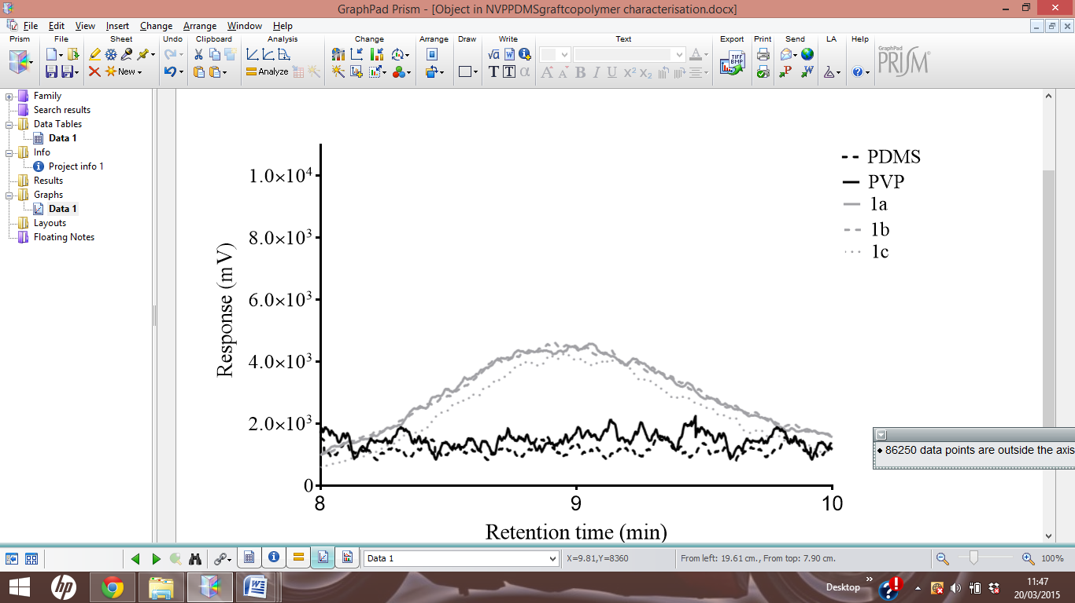
Figure 2.28: Chromatogram of PDMS(20,000):5PNVP Wt.%-1c showing retention time (minutes) against response (mV). Legend: Solid black line is PVP, black dashed line is PDMS macromonomer, solid grey line 1a, dashed dark grey 1b and dotted grey line is 1c.
The signal for PVP in figure 2.28 (1-3minutes) confirms the presence of PVP homopolymer, secondly it shows that the PVP homopolymer in the graft copolymer mixture has a different solubility than the PVP reference used, due to the variations in retention time. The graft copolymerisation reaction produces homopolymers of PVP at different average molar masses due to the different molar feed ratios explaining the difference in response time for the observed PVP homopolymers peaks from each graft copolymer synthesis. Figure2.28 shows the presence of PDMS macromonomer (12-16 minutes), this coincides with MALDI TOF analysis and ¹HNMR spectroscopy. These techniques confirmed that PDMS macromonomers were not 100% functionalised. The peaks between 8 and 10 minutes are PDMS-g-PNVP copolymer with copolymers eluting at a similar time. The slight variation between response times is due to the differences in molar feed ratios of NVP varying their amphiphilic nature. There is also a sharp peak observed at 7 minutes for both the PDMS reference and PDMS(5,000):5PNVP copolymer. This peak is unreacted hydroxyl termini PDMS macromonomer.
The relatively low amount of graft copolymer produced can be said to be due to the difference in reactivity ratios between NVP and the allyl termini PDMS macromonomers. This has been previously documented when trying to react NVP with styrene with the resulting polymer was not conducive to compositions close to the feeds: r_{sty}= 15.7 and rNVP = 0.045 ²⁸². The large degree of homopolymer can be utilised for loading of Iodine to create PVP-I in situ within modified membranes. The mass percentage of PDMS-g-PNVP copolymer was determined using the area under the curve using normal and reverse phase runs, and is shown in table 2.5.

2.2.2.3.2 Normal phase GPEC
All PDMS-g-PNVP copolymers were run under the same conditions as stated in experimental section, results are shown in figure 5.29
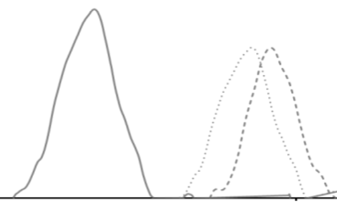
Figure 2.29: Chromatogram of PDMS(20,000):5PNVP Wt.%-1c showing the retention time (minutes) against response (mV). Legend: Solid black line is PVP, black dashed line is PDMS macromonomer, solid grey line 1a, dashed dark grey 1b and dotted grey line is 1c.

Normal phase runs (figure 2.29) were shown to cause a larger separation of PDMS-g-PNVP copolymer peaks, with reverse phase runs eluting all PDMS-g-PNVP graft compositions at a similar time. This is due to the grafts containing a large degree of NVP, as a result the mobile phase becomes more thermodynamically favourable they elute as solvency conditions increase as the stationary phase is hydrophobic and the better separation is therefore seen when the stationary phase is polar.
Code |  | Wt. % of graft copolymer | Molar feeds |  | Actual ratio
 |  | Wt. % of graft copolymer | PDMS | NVP | PDMS | NVP
PDMS(5,000) | :5PNVP | 22 | 1 | 3 | 1 | 5
PDMS(5,000) | :7PNVP | 13 | 1 | 1 | 1 | 7
PDMS(5,000) | :0.5PNVP | 14 | 3 | 1 | 1.50 | 1
PDMS(10,000) | :2.15PNVP | 21 | 1 | 3 | 1 | 2.15
PDMS(10,000) | :2.57PNVP | 10 | 1 | 1 | 1 | 2.57
PDMS(10,000) | :0.5PNVP | 6 | 3 | 1 | 1.50 | 1
PDMS(20,000) | :1.08PNVP Wt. % | 10 | 1 | 3 | 1 | 1.08
PDMS(20,000) | 5.8PNVP Wt. % | 7 | 1 | 1 | 1 | 5.80
PDMS(20,000) | 2.4 PNVP Wt. % | 18 | 3 | 1 | 1 | 2.40
Table 2.5: Average weight percentage of PDMS-g-PNVP copolymer obtained from the copolymerisation of allyl functionalised PDMS macromonomers calculated from the area under the peaks for both normal phase and reverse phase runs.
The reduced amount of copolymer synthesised is due to the difference in reactivity ratios between NVP and the allyl functionalised PDMS macromonomers, with NVP preferentially reacting with itself. As stated previously, the large degree of homopolymer PVP present in the mixture will be beneficial whilst loading Iodine into the membranes as it will allow in situ production of PVP-I complexes. The large degree of PVP homopolymer present in the mixture also explains difficulties encountered when trying to dissolve these grafts in a hydrophobic solvent system.

2.2.2.4 Thermal gravimetric analysis (TGA)
TGA was performed to determine the temperature range which would be appropriate to use for DSC analysis before polymer degradation started to occur. All samples were run from 25^{O}C to 250^{O}C at a rate of 10^{O}C per minute. There is an initial loss of weight between 0 and 100^{O}C this is thought to be the loss of organic solvent, short chain PDMS macromonomer or short chain PVP homopolymer. The graft copolymer started to degrade at approximately 225^{O}C and rapidly decomposed above temperatures of 250 ^{O}C.
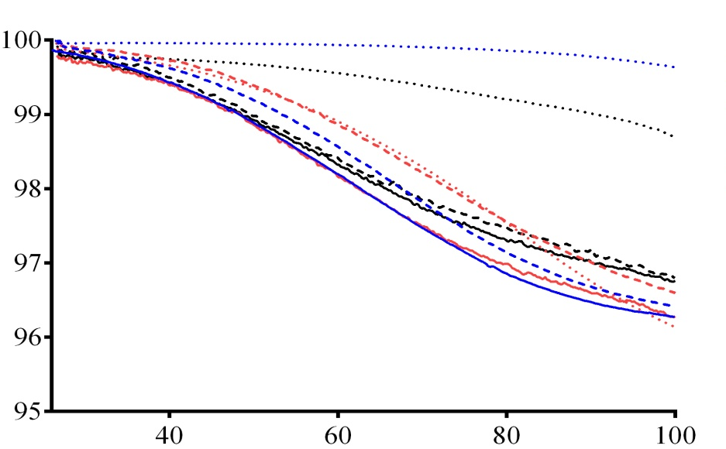
Figure 2.30: TGA of the graft copolymer library. Showing % weight loss over an increasing temperature range at a rate of 10 degrees per minute, below is the expanded image of the region between 0ºC and 100ºC. Legend: Solid lines black, red and blue respectively 1a-3a, Dashed lines black, red and blue respectively 1b-3b, Dotted lines black red and blue respectively 1c-3c.

Code |  | Wt. % loss
PDMS(5,000) | :5PNVP | 4
PDMS(5,000) | :7PNVP | 4
PDMS(5,000) | :0.5PNVP | 2
PDMS(10,000) | :2.15PNVP | 4
PDMS(10,000) | :2.57PNVP | 4
PDMS(10,000) | :0.5PNVP | 4
PDMS(20,000) | :1.08PNVP | 4
PDMS(20,000) | 5.8PNVP | 4
PDMS(20,000) | 2.4 PNVP | 1
Table 2.6: Comparison of % weight loss at 100^{O}C between PDMS-g-PNVP copolymers.

2.2.2.5 Differential scanning calorimetry (DSC) analysis
DSC was performed using a temperature range from -80 ^{O}C to 100 ^{O}C at a rate of 10 degrees per minute, performing two heating cycles and one cooling cycle between on each run. The first heating cycle of PDMS (10,000):0.5PNVP Wt.% is shown in figure 2.31a, two T_{g}s were observed (50 ^{O}C, 63 ^{O}C) this is due two components being present and phase separated initially. However, on the second heating cycle (figure 2.31b) only one T_{g} is observed (61 ^{O}C) due to the individual components now being mixed.
Figure 2.31a: DSC of PDMS(10,000):0.5PNVP first heating cycle shown in black with the cooling shown in grey, the two observed Tgs are circled.
Figure 2.31b: DSC of PDMS(10,000):0.5PNVPsecond heating cycle with only one T_{g} being observed.
The same procedure was performed on the remaining graft copolymer library. Results are shown in figure 2.32 and table 2.7 with individual DSC graphs provided in the appendix.
Figure 2.32: T_{g} vs. graft copolymer ratios of PDMS to NVP for the graft copolymer library synthesised, standard deviations are also shown. Legend: Black; PDMS(5,000) graft copolymers, dark grey; PDMS(10,000) graft copolymers and light grey; PDMS(20,000) graft copolymers.
Code |  | T_{g} (^{O}C)
PDMS(5,000) | :5PNVP | 59
PDMS(5,000) | :7PNVP | 70
PDMS(5,000) | :0.5PNVP | 25
PDMS(10,000) | :2.15PNVP | 71
PDMS(10,000) | :2.57PNVP | 67
PDMS(10,000) | :0.5PNVP | 44
PDMS(20,000) | :1.08PNVP | 61
PDMS(20,000) | 5.8PNVP | 76
PDMS(20,000) | 2.4 PNVP | 70
Table 2.7: Comparison of the Tgs of PDMS-g-PNVP copolymer library calculated using DSC.
The larger the PDMS macromonomer the larger the average T_{g}, shown in Figure 2.32. Within each sample group (i.e. PDMS(5,000) graft copolymers only) the larger the NVP component the larger the observed T_{g}. This is due to the increase in size, as the ratio of NVP increases the size of the copolymer also increases.
Literature references show a wide range of values that have been reported for the Tg of PVP, ranging from 54°C to 175°C ²⁷⁷. Tan and Challa suggested that the hygroscopic nature of PNVP is responsible, following an experimental demonstration that water depresses Tg, by a plasticising effect ²⁸³. Typically, PDMS has a very low Tg -150ºC so the Tg reported here for the graft copolymers are in the middle of this range. However, it is possible that only the homopolymer PVP Tg is being observed ²⁸⁴.

2.3 Conclusion
PDMS macromonomers were synthesised using ROAP of hexamethylcyclotrisiloxane and functionalised with either allyl or vinyl chloroformate allowing for graft copolymerisation with NVP. ¹H NMR, MALDI TOF and ATRFT IR showed peaks corresponding to a functionalised PDMS macromonomer, a % Fn of >75% was shown after analysis of ¹H NMR and MALDI TOF spectra for allyl termini macromonomers and a weight % >60% after precipitation was obtained. SEC of the resulting PDMS macromonomers coincided with DOSY spectra showing an increase in molar mass. A bimodal molar mass distribution was shown for PDMS macromonomers functionalised with vinyl chloroformate. The %Fn for these PDMS macromonomers was lower than their allyl functionalised counterparts, these PDMS macromonomers were not used for the synthesis of PDMS-g-PNVP copolymers.
Free radical polymerisation of NVP with PDMS macromonomers was shown to produce a mixture of products. GPEC showed peaks corresponding to a mixture of un-functionalised PDMS macromonomer, PVP homopolymer and PDMS-g-PNVP copolymer. ¹H NMR, ¹³C NMR and ATR FTIR showed appropriate peaks indicative of a PDMS-g-PNVP copolymer, with a mass yield of >30%. The ratio of NVP to PDMS was determined using ICP-MS and elemental analysis showing that the molar feed ratios and experimental ratios varied. However, these experimentally calculated ratios between Si and N can only be used as a guide due to the presence of homopolymer present in the mixture. DSC revealed that as the NVP content increased within the graft copolymer the Tg also increased which agrees with what has been previously stated previously in literature.

Chapter 3

Objectives

- Observe solution behaviour of PDMS-g-PNVP copolymers in both aqueous and organic solvents .e. particulate formation.

- Determine the size of PDMS-g-PNVP particulates formed in solution and determine solvent effects on morphology.

- Confirm morphology of particulates using TEM

3.1 Results and discussion

3.1.1 Encapsulation of H₂O inside copolymer aggregates
The addition of 400 µl of H₂O to 10ml of dichloromethane (DCM) caused a visible phase separation between the liquids; this was used as a control to compare the water uptake of graft copolymers dissolved in DCM. 10 mg of each copolymer was dissolved in 10 ml of DCM. Once dissolved 1.1 ml of H₂O was added drop-wise to the stirring solution. PDMS(20,000):5PNVP Wt.% copolymer was dissolved in DCM and had a maximum load of 1.1 ml of H₂O before phase separation; this is about a ~10 weight percent uptake (i.e. for each g of copolymer dissolved in solution, 10g of H₂O could be retained within solution without phase separation). Samples were left to stand and were monitored using optical microscopy. Photographic images were taken at 0, 4, 8, 24 and 48 hrs at 20x objective magnification to determine stability and/or changes in morphologies of 'micelle' like structures. Figure 3.1 shows comparison between 100µl of PDMS (5,000), (10,000) and (20,000) graft copolymer solutions.

PDMS(5,000):5PNVP
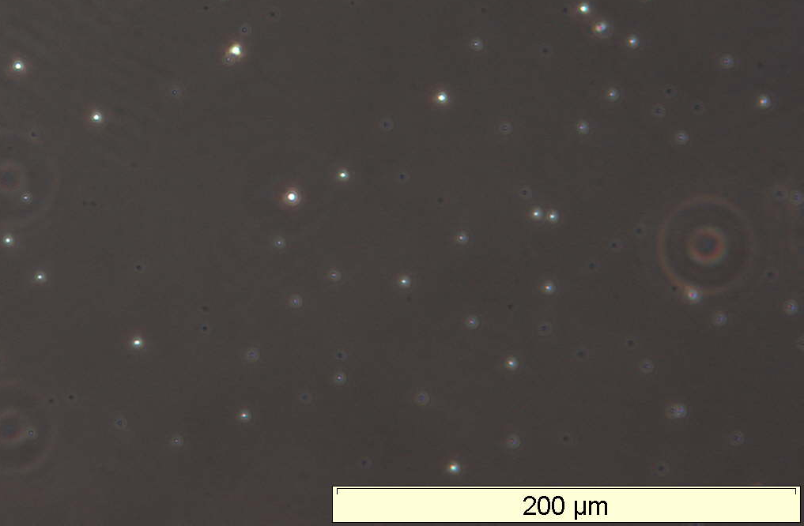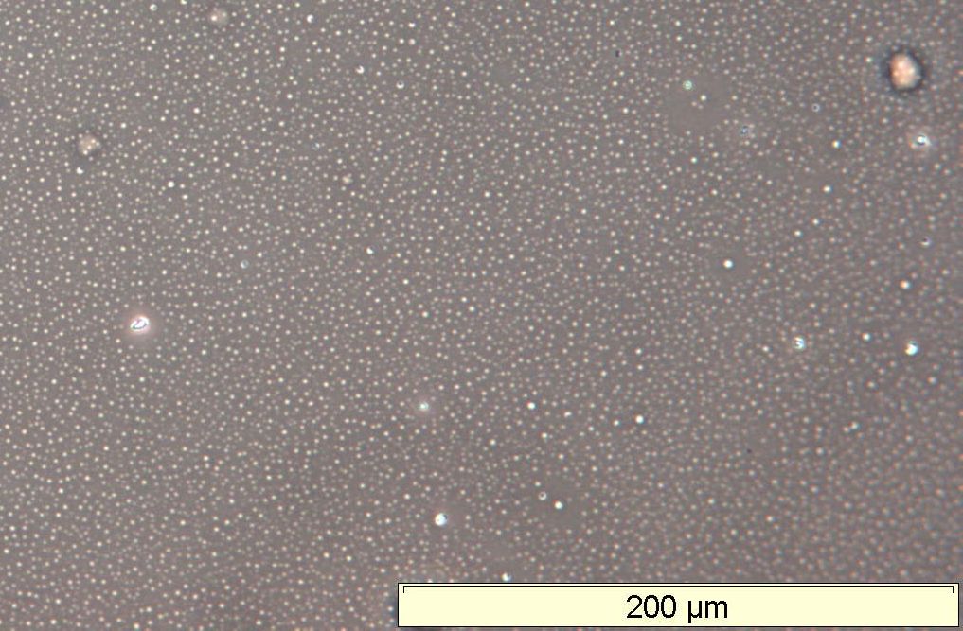
0 hr 4hr
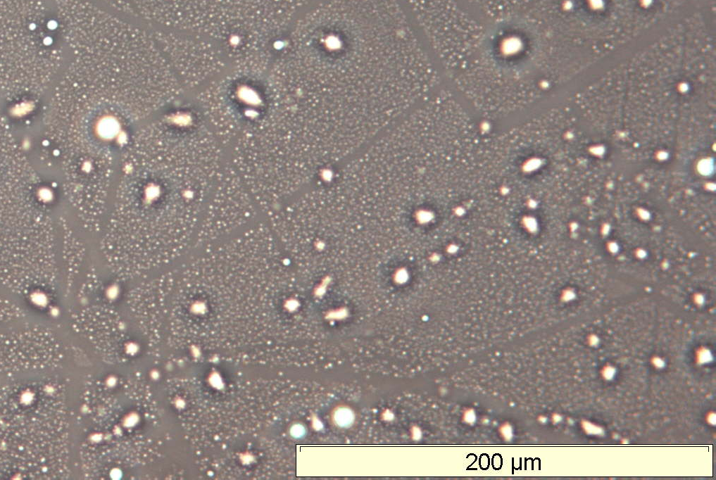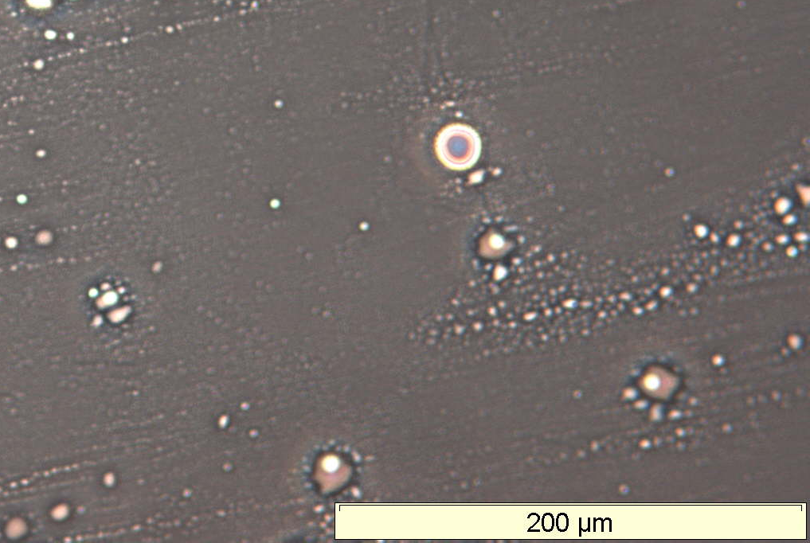
8hr 24hr
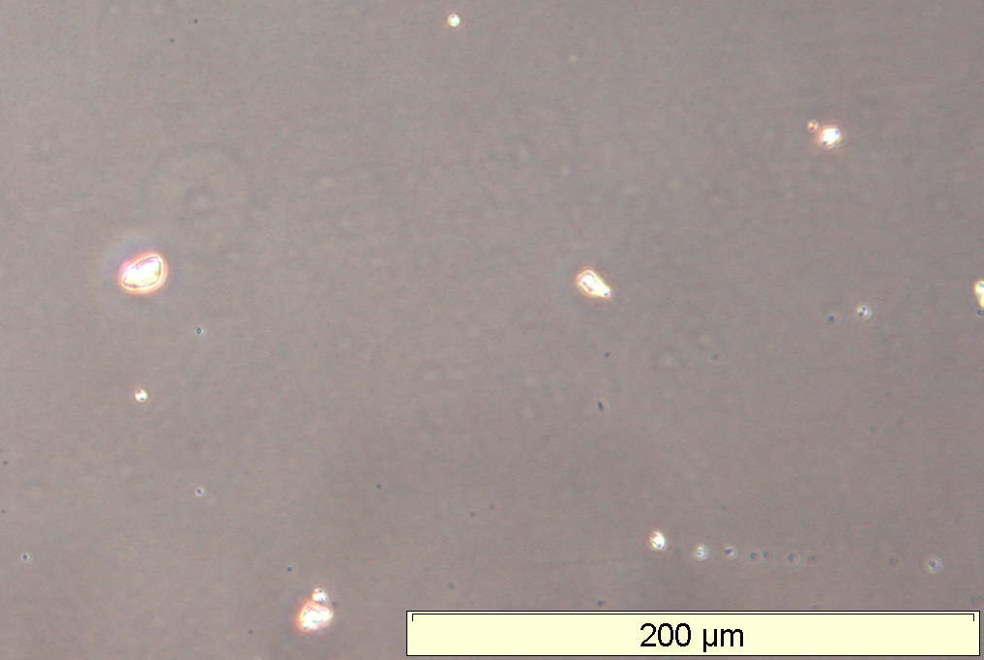
48hr

PDMS(10,000):2.15PNVP
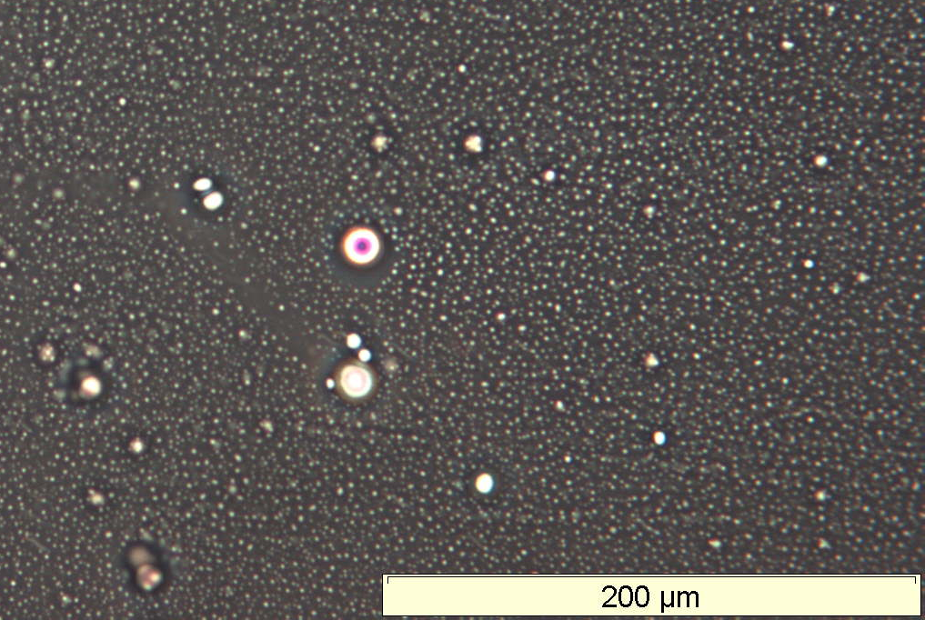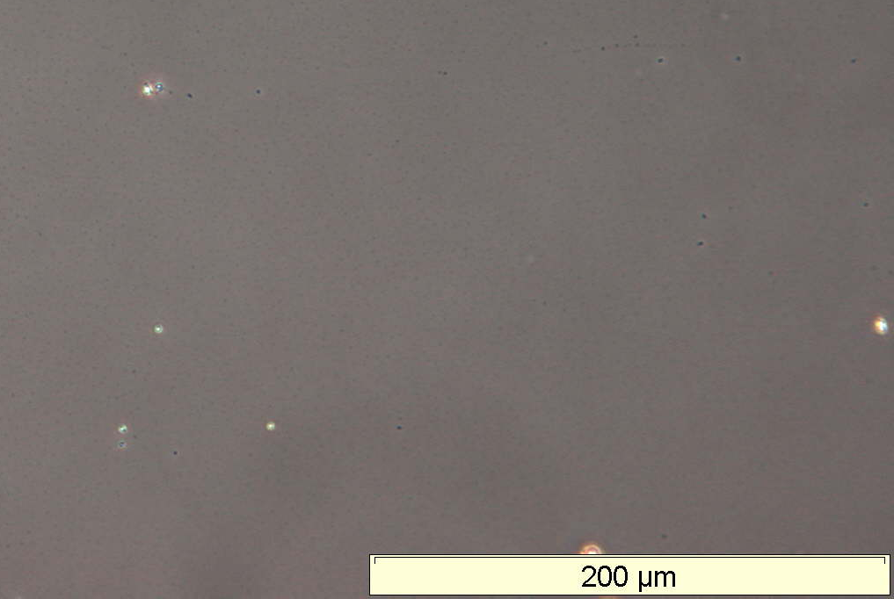
0hr 4hr
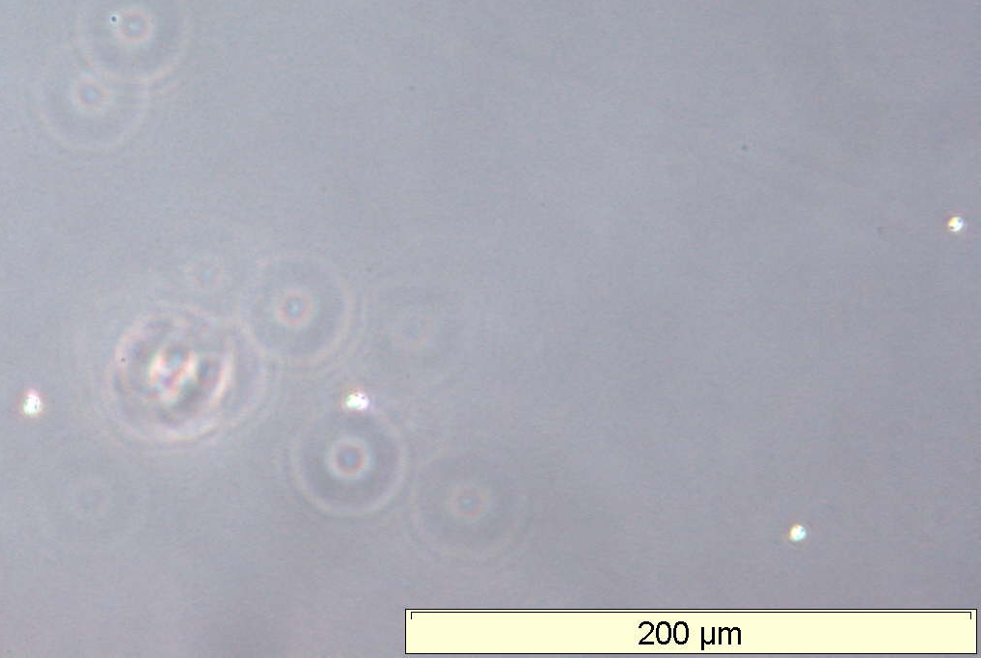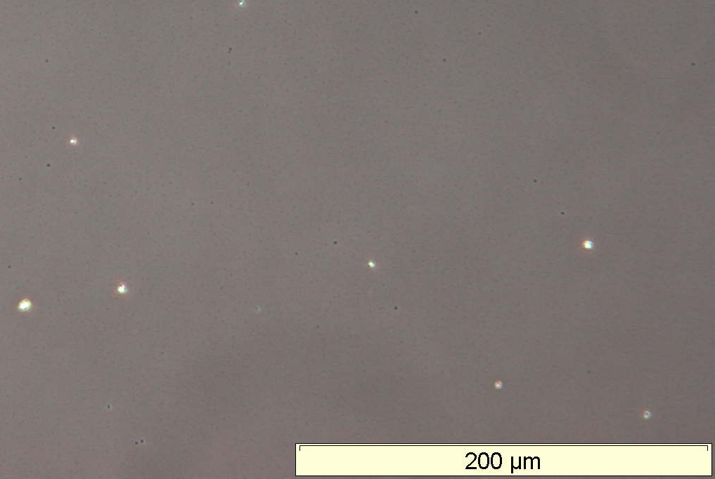
8hr 24hr
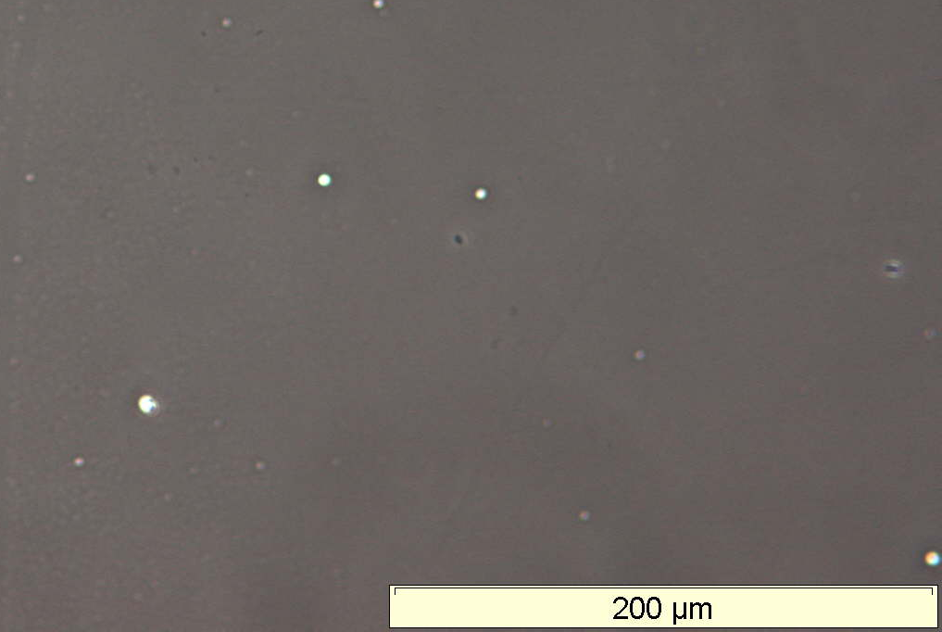
48hr

PDMS(20,000):1.08PNVP
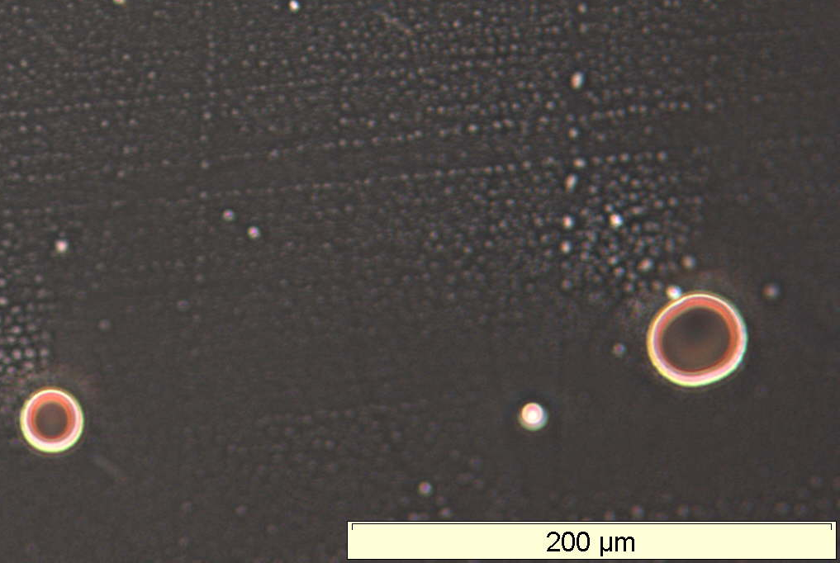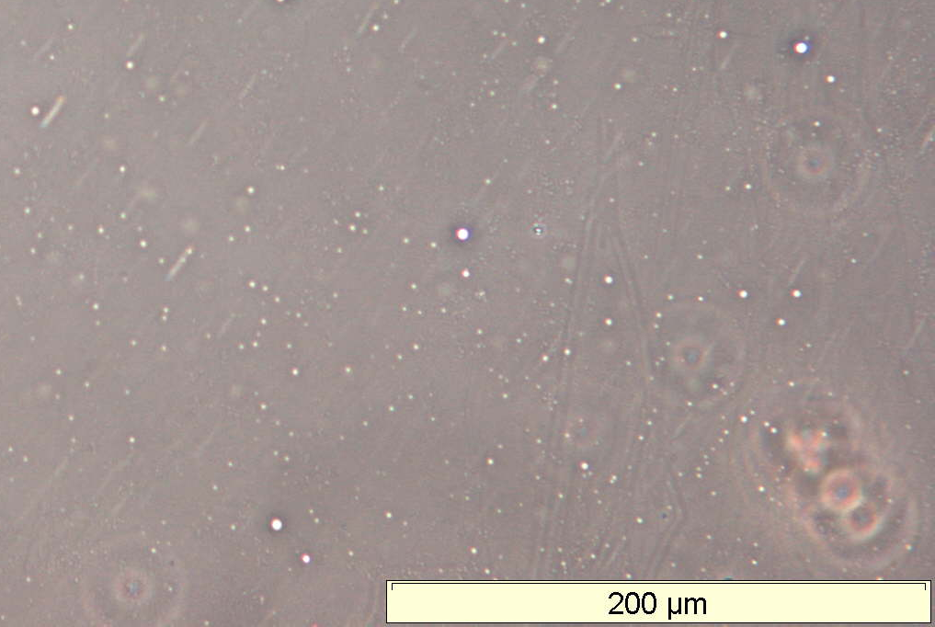
0hr 4hr
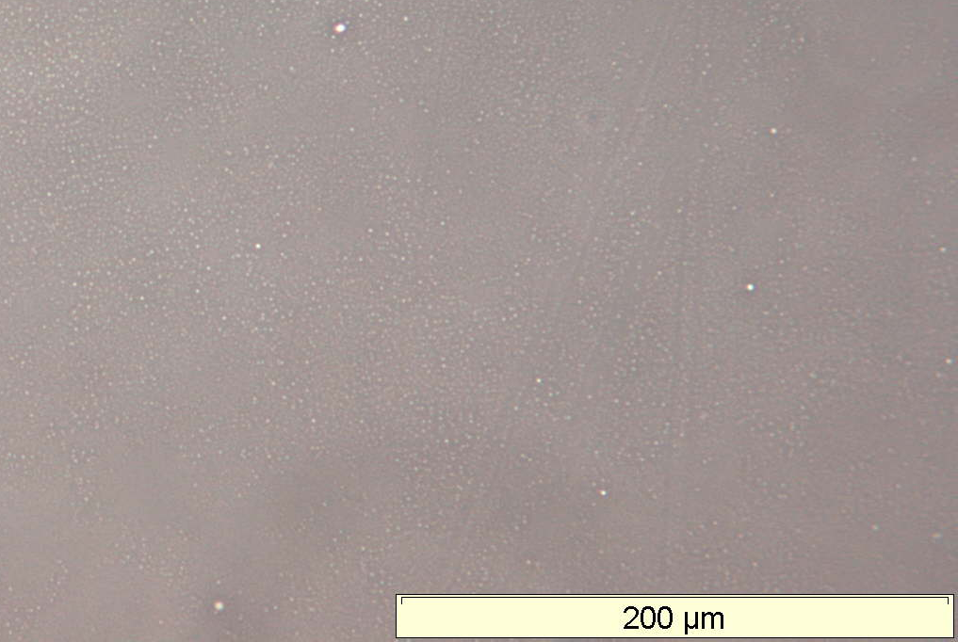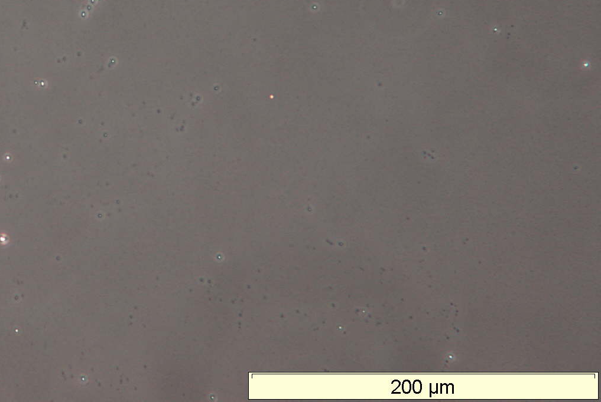
8hr 24hr
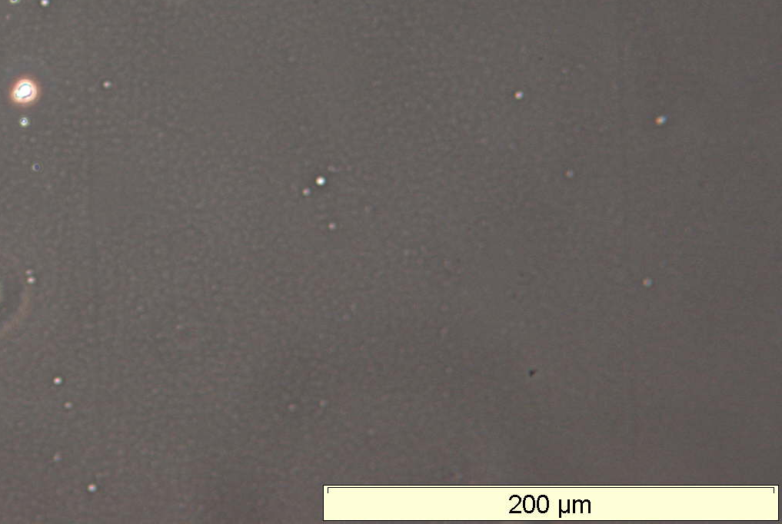
48hr
Figure 3.1: Photomicrography images of PDMS(5,000):5PNVP, PDMS(10,000):2.15PNVP and PDMS(20,000):1.08PNVP Wt.%. swollen 'micelle' like structures in DCM at 0, 4, 8, 24 and 48hrs taken at 20x objective magnification.
There are large’ micelle like’ structures or aggregates which form, these slowly disappear over time. However, after 48 hrs none of the water is released, as no phase separation occurs. These initial large micelles are unstable and reform into smaller micelles, creating a larger number of micelles within the solution, which over time can be seen to aggregate. The driving force for the micelle formation is to reduce interfacial tension.

3.1.2 Particle size analysis
Phase Analysis Light Scattering was used to determine particle size; analysis was performed in both aqueous (H₂O) and organic (hexamethyldisiloxane) solutions.

3.1.2.1 Aqueous system
Figure 3.2: Particle size analysis of PDMS-g-PNVP copolymer library in an aqueous solution. Legend: Black spheres PDMS(5,000), dark grey squares PDMS(10,000) and light grey triangles PDMS(20,000) graft copolymers.
As the NVP weight ratio is increased within the copolymer, the general trend is that the sizes of particles decrease, due to the increase in hydrophilic interactions between the hydrophilic component of the graft copolymer and solvent. The PDMS macromonomer component of the copolymer does not have an effect on the size of the particles formed. This is due to the relative size of this hydrophobic component compared with the larger hydrophilic component.

3.2.1.2 Organic system
Figure 3.3: Particle size analysis of PDMS-g-PNVP copolymer library in an hexamethyldisiloxane solution. Legend: Black spheres PDMS(5,000), dark grey squares PDMS(10,000) and light grey triangles PDMS(20,000) graft copolymers.
As the NVP ratio increases the general trend is that the size of particles increases due to the unfavourable interactions between the hydrophilic component and the hydrophobic solvent. The size of these particles are large, this is due to the large degree of PVP homopolymer present in the mixture. These homopolymers aggregate with the graft copolymer to reduce inter-facial tension. The particle sizing aqueous system coincides with what was seen in the organic system where the PDMS macromonomer component of the copolymer does not affect the size of the particles formed.

3.1.3 Transmission electron microscopy (TEM)
Samples were prepared and visualised as described in the materials and methods section, the images shown in figure 3.4 are; PDMS(5,000):5PNVP, PDMS(10,000):2.15PNVP and PDMS(20,000):1.08PNVP Wt.%. These were chosen to determine the effect of PDMS macromonomer size and graft copolymer composition on morphology of graft copolymers in solution. Graft copolymers were stained with ruthenium prior to imagining, ruthenium stains polymers containing: ether, alcohol, aromatic or amide moieties. Thus, only the NVP components of graft copolymers were stained.

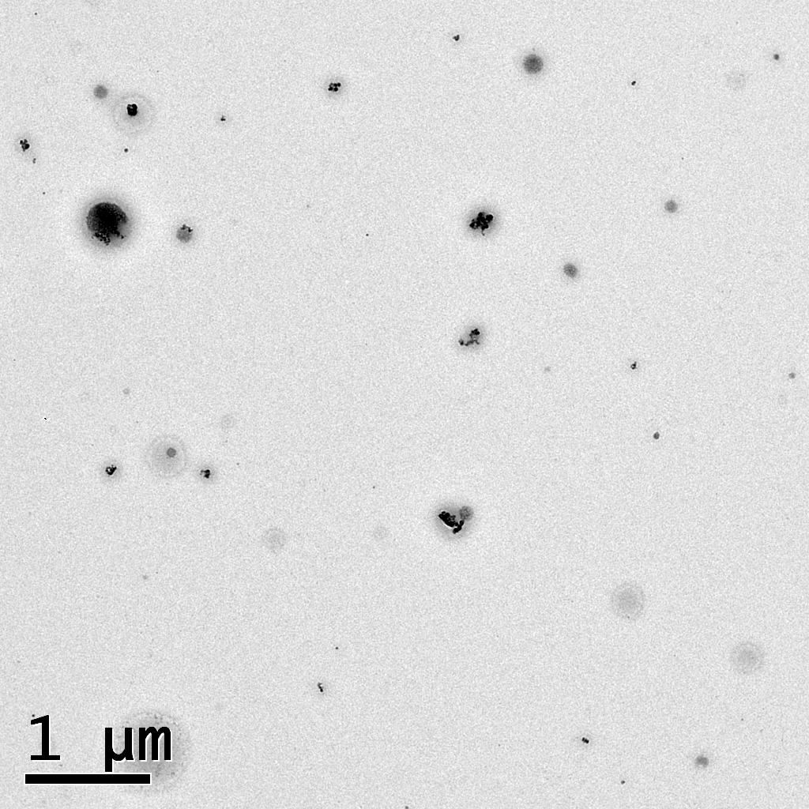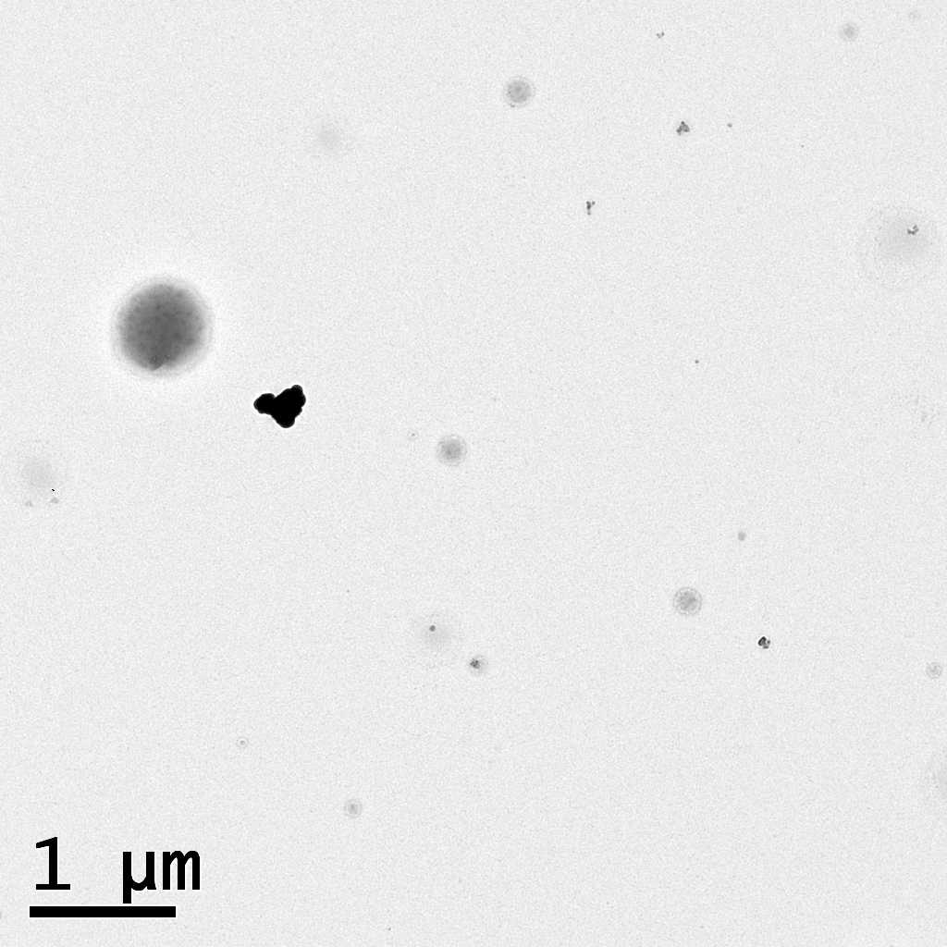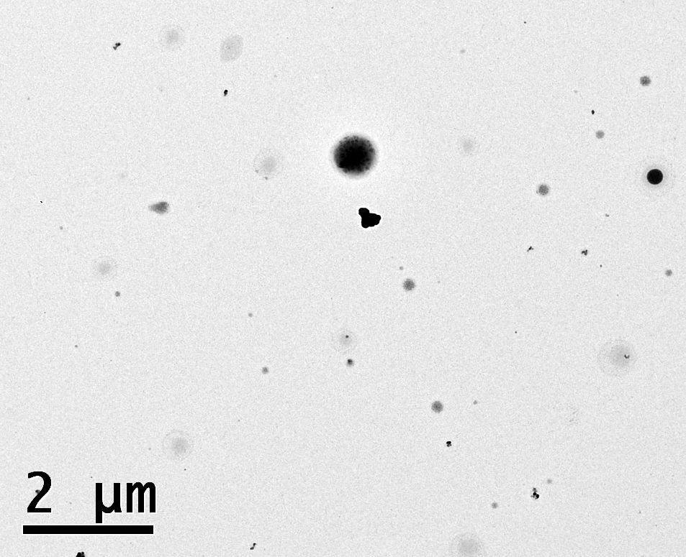
Figure 3.4: TEMs of graft copolymers stained with ruthenium, shown Left to right respectively; PDMS(5,000):5PNVP, PDMS(10,000):2.15PNVP and PDMS(20,000):1.08PNVP Wt.%.
All graft copolymer compositions formed micelles of varying size, consistent with the particle size measurements. Much darker stained entities are also present; these regions are collapsed polymer, these regions are a combination of graft copolymer mixed with aggregated PVP homopolymer. Shown in figure 3.5 is graft copolymer with aggregated regions. These regions were present in each graft copolymer imaged.
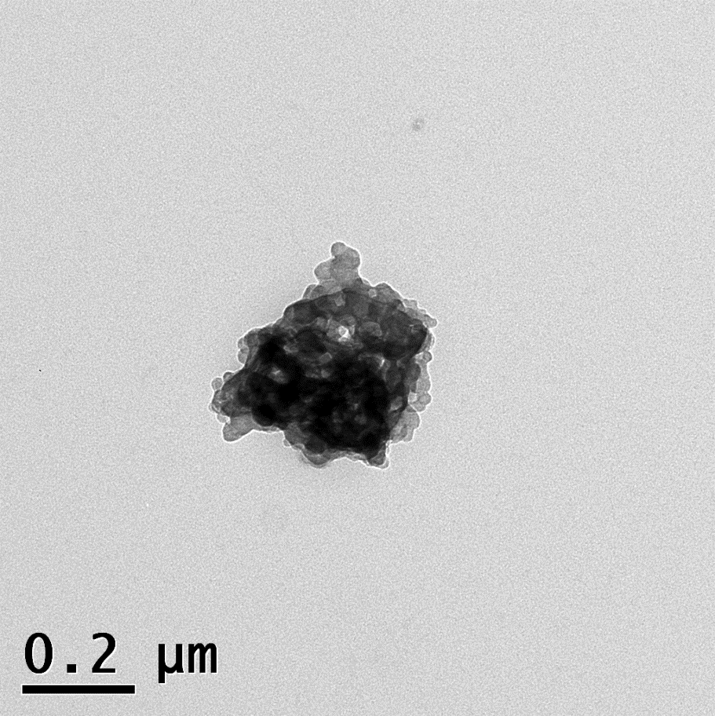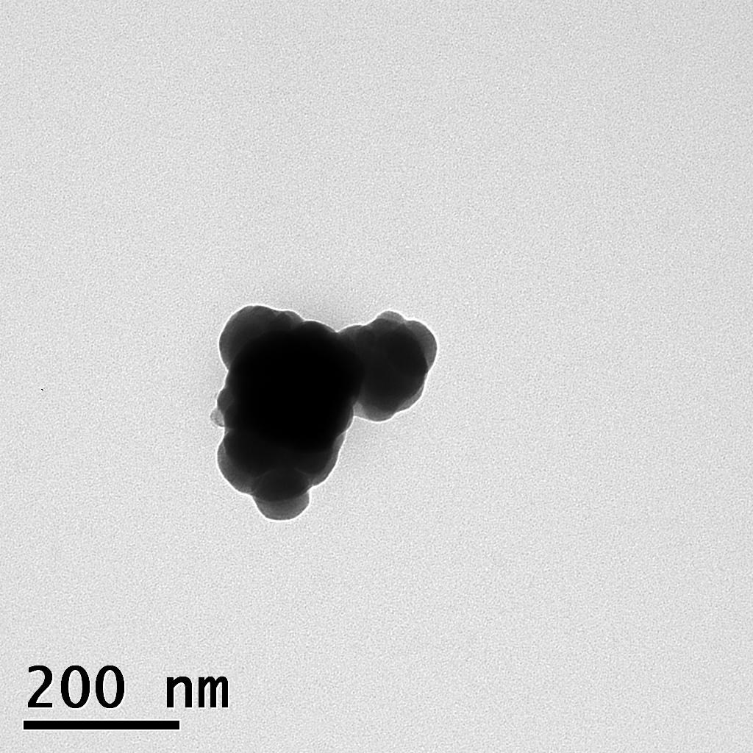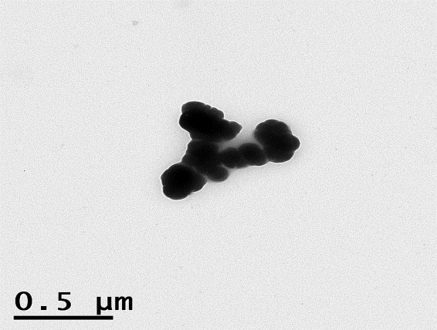
Figure 3.5: Graft copolymer with aggregate regions containing a larger degree of staining. Left to right respectively; PDMS(5,000):5PNVP, PDMS(10,000):2.15PNVP and PDMS(20,000):1.08PNVP Wt.%.
As well as graft copolymer aggregate regions shown in figure 6.5, other entities also appear within samples stained with micelle like morphology, shown in figure 6.6.

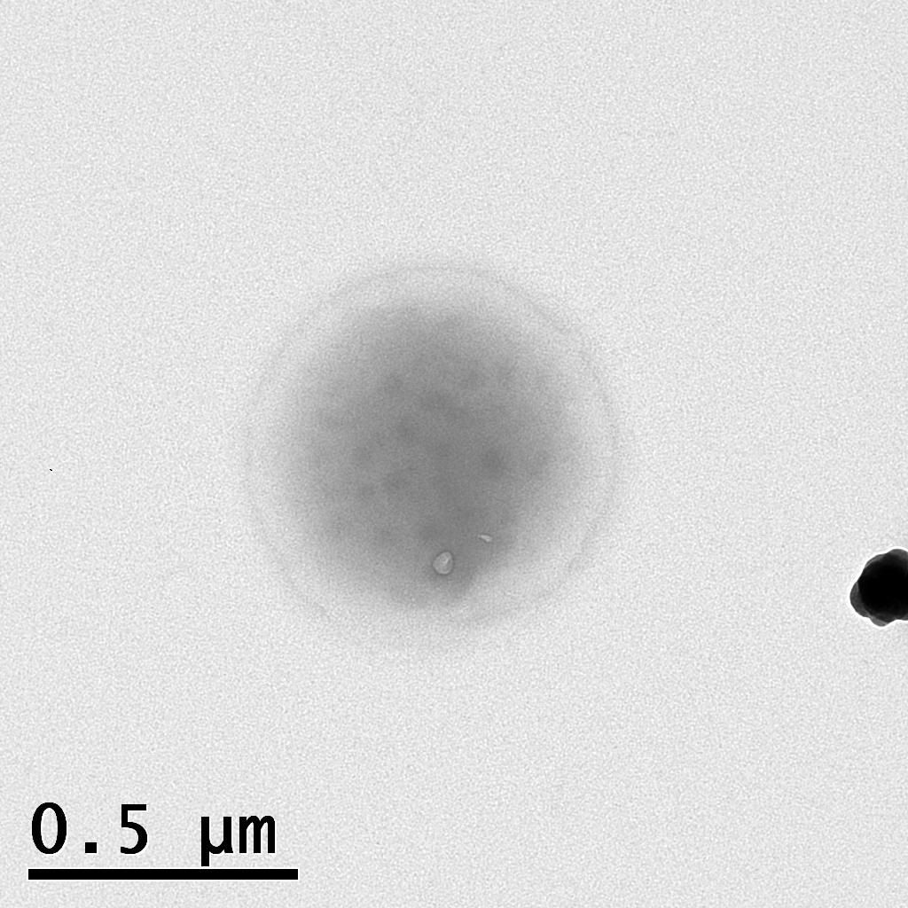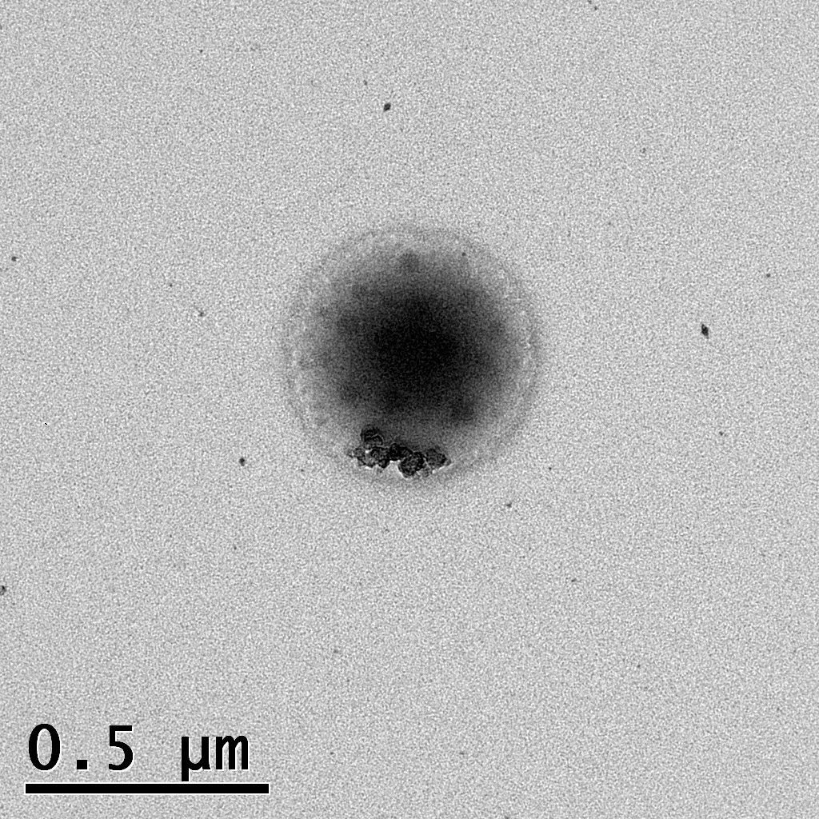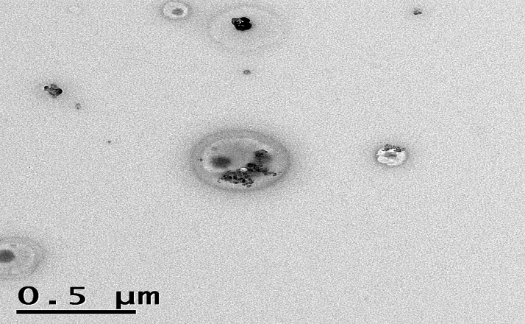

Figure 3.6: Enlarged areas showing aggregates forming micelle like microstructures. Left to right respectively; PDMS(5,000):5PNVP, PDMS(10,000):2.15PNVP and PDMS(20,000):1.08PNVP Wt.%
‘Micelle like’ morphology shown in figure 3.6 is complex. Both graft copolymer and homopolymer can interact influencing the size, stability and abundance of particles. The PVP homopolymer can interact with the appropriate segments of graft copolymers, whether this is the inner core or the outer shell is solvent dependent. This will change the nature of the folding of the amphiphilic graft copolymer and thus where the PNVP or PDMS macromonomer interact, to form the most kinetically stable structure.
However, sample preparation means that the resulting images presented here cannot exactly represent graft copolymers in solution. Due to the solution being left to evaporate, the resulting precipitant is stained and visualised. To obtain a true image of these graft copolymers morphology in solution cryogenic TEM would have to be performed. Due to time constraints this was not possible.

3.2 Conclusion
Particle sizing showed that as the NVP segment of the graft copolymer was increased, the size of the particles formed also increase/ decrease accordingly dependent on the continuous phase used due to favourable or unfavourable solvent interactions.
The relative size of the PDMS macromonomer segment within the graft copolymers meant this had little effect on particle size with the NVP component dominating the process in both continuous phases used (aqueous and hydrophobic).
TEM coincided with results obtained from light microscopy images, showing clear particulates being formed with varying morphology, with aggregate regions and 'micelle' like structures being observed in all compositions imaged. The sizes of these particulates were also similar values to that obtained from particle size analysis, being between 0.5µm and 7.5µm. This large variation in size was deemed to be due to co aggregation of particulates forming larger structures as seen when visualising these dispersed particulates over 24hrs using a light microscope where large structures where seen to disperse and then reform.

Chapter 4

Objectives

- Characterise the surface of modified membranes using SEM with increasing concentrations of PDMS-g-PNVP.

- Load a fluorescent hydrophilic agent (Rhodamine) into modified membranes and visualise incorporation using confocal microscopy.

- Incorporate fluorescein o-acrylate into PDMS-g-PNVP copolymer backbones and confirm incorporation using DOSY NMR.

- Visualise interaction between fluorescein o-acrylate labelled PDMS-g-PNVP copolymer and Rhodamine B in solution and within modified membranes using confocal microscopy.

- Determine hydrophilicity of modified membrane surfaces at increasing PDMS-g-PNVP concentrations.

- Characterise adhesive properties of modified membranes at increasing PDMS-g-PNVP concentrations.

- Examine moisture vapour transfer rates of modified membranes at increasing PDMS-g-PNVP concentrations.

4.1 Introduction

4.1.1 Peel and adhesion testing
Within industry, the strength of an adhesive is vital information to make sure that the adhesive in question is fit for its proposed purpose. For example, a low strength adhesive would not be appropriate for a construction material where the adhesive plays a large role in the structural integrity of a building or fitting. On the contrary a very strong adhesive would be ill suited to a wound dressing where low adhesion is required to exhibit low levels of pain a patient receives upon removal.
Adhesive strength measurements include; tensile testing, shear testing, compression testing and peel testing, with the choice of test being dependent on which is most appropriate ²⁸⁵. These tests have been standardised so that comparisons between appropriate products and minimum requirements can be set. Different types of peel adhesion tests used within industry as standards are shown in figure 4.1.

Figure 4.1: Five of the most common peel adhesive tests performed by industry on adhesive products.
The test that is appropriate to PSAs and therefore this thesis is the peel test, other testing methods will not be discussed here but there is information readily available ²⁸⁵. There are several angles which peel tests can be conducted under either 90,115 or 180º, the choice is dependent on the intended function of the adhesive, with the 180º peel test being the most appropriate for wound dressing. During a peel test the adhesive is stuck to a stationary phase (such as polycarbonate or stainless steel) and a tensiometer machine attaches to the adhesive itself and records the force required to remove the adhesive from the stationary phase. Thus, giving a standardised method for measuring adhesive strength between a host of different materials intended for the same purpose ²⁸⁶.

4.1.2 Moisture vapour transfer rate (MVTR)
MVTR is a measure of the amount of water vapour loss through a given material.
This has great importance in industries where the moisture content is vital in product preparation. Examples include air sensitive compounds such as; foods, pharmaceuticals and a host of chemicals compounds used in research and industry. Thus, the MVTR of materials used to seal air sensitive items is rigorously tested and plays an important role in products arriving in tact and safely to their intended destination ²⁸⁷. In wound care the MVTR is vital for determining the suitability of a dressing to a wound, with highly exudating wounds requiring a higher MVTR ²⁸⁸.
The Paddington cup method is the gold standard used in industry to determine the MVTR of many materials. The Paddington cup is an air tight chamber which can hold water with a circular hole at the top to allow for a material to be effectively clamped to be the barrier between the chamber and the outside air. Once the chamber is filled with water and weighed the material is then cut into circular sections to fit around the lid of the cup and secured in place. The water vapour evaporates through the material and the amount loss can be measured by the difference in weight before and after a given time. The measurement can be done at room temperature and humidity or in a desiccated oven to accelerate the evaporation process with units typically given as g/m²/day ²⁸⁹. However, conditions have to be stated and kept constant, as clearly these will affect MVTR rates considerably. Furthermore, results can only be comparable if the conditions during the MVTR were identical.

4.2 Results and discussion

4.2.1 PDMS membrane preparation
PDMS membranes were prepared by the addition of Rhodamine B (dissolved in water) to an agitated copolymer solution containing hexamethyldisiloxane (HMDS). This was then added to 5g of 'component A' of the PDMS membrane and stirred to create a homogenous mixture before adding 5g of 'component B' (both components provided by Scapa Healthcare™). Once both components had been added the viscous solution was drawn down using a K bar of 200 µm and left in an oven at 60ºC for 10 minutes to cure. 200 µm K bars were used to create membranes that resemble the thickness used in industrial manufacturing processes.
The exact amounts of Rhodamine B and PDMS-g-PNVP copolymer used and associated solvents are given in table 4.1 to yield modified membranes containing 0.1, 0.5, 1, 2.5, 5 and 10 Wt.% graft copolymers. The copolymer initially chosen to trial the feasibility and properties of modified membranes was PDMS(5,000):5PNVP.

Code | Rhodamine  B (mg),  H₂O (ml) | Copolymer (mg),  HMDS  (ml) | Weight percent of PDMS membrane |  | Ratio
Code | Rhodamine  B (mg),  H₂O (ml) | Copolymer (mg),  HMDS  (ml) | Copolymer | Rhodamine  B |  | Copolymer | Rhodamine  B
1a | 2, 0.2 | 10, 2 | 0.1 | 0.02 | 5 |  | 1  1  1  1  1  1  1  1  1  1  1  1  1  1  1  1  1  1
1b | 2, 0.2 | 10, 2 | 0.1 | 0.02 | 5 |  | 1  1  1  1  1  1  1  1  1  1  1  1  1  1  1  1  1  1
1c | 2, 0.2 | 10, 2 | 0.1 | 0.02 | 5 |  | 1  1  1  1  1  1  1  1  1  1  1  1  1  1  1  1  1  1
2a | 20, 2 | 50, 10 | 0.5 | 0.2 | 2.5 |  | 1  1  1  1  1  1  1  1  1  1  1  1  1  1  1  1  1  1
2b | 20, 2 | 50, 10 | 0.5 | 0.2 | 2.5 |  | 1  1  1  1  1  1  1  1  1  1  1  1  1  1  1  1  1  1
2c | 20, 2 | 50, 10 | 0.5 | 0.2 | 2.5 |  | 1  1  1  1  1  1  1  1  1  1  1  1  1  1  1  1  1  1
3a | 40, 4 | 100, 20 | 1 | 0.4 | 2.5 |  | 1  1  1  1  1  1  1  1  1  1  1  1  1  1  1  1  1  1
3b | 40, 4 | 100, 20 | 1 | 0.4 | 2.5 |  | 1  1  1  1  1  1  1  1  1  1  1  1  1  1  1  1  1  1
3c | 40, 4 | 100, 20 | 1 | 0.4 | 2.5 |  | 1  1  1  1  1  1  1  1  1  1  1  1  1  1  1  1  1  1
4a | 100, 8 | 250, 40 | 2.5 | 1 | 2.5 |  | 1  1  1  1  1  1  1  1  1  1  1  1  1  1  1  1  1  1
4b | 100, 8 | 250, 40 | 2.5 | 1 | 2.5 |  | 1  1  1  1  1  1  1  1  1  1  1  1  1  1  1  1  1  1
4c | 100, 8 | 250, 40 | 2.5 | 1 | 2.5 |  | 1  1  1  1  1  1  1  1  1  1  1  1  1  1  1  1  1  1
5a | 200, 10 | 500, 60 | 5 | 2 | 2.5 |  | 1  1  1  1  1  1  1  1  1  1  1  1  1  1  1  1  1  1
5b | 200, 10 | 500, 60 | 5 | 2 | 2.5 |  | 1  1  1  1  1  1  1  1  1  1  1  1  1  1  1  1  1  1
5c | 200, 10 | 500, 60 | 5 | 2 | 2.5 |  | 1  1  1  1  1  1  1  1  1  1  1  1  1  1  1  1  1  1
6a | 400, 15 | 1000, 150 | 10 | 4 | 2.5 |  | 1  1  1  1  1  1  1  1  1  1  1  1  1  1  1  1  1  1
6b | 400, 15 | 1000, 150 | 10 | 4 | 2.5 |  | 1  1  1  1  1  1  1  1  1  1  1  1  1  1  1  1  1  1
6c | 400, 15 | 1000, 150 | 10 | 4 | 2.5 |  | 1  1  1  1  1  1  1  1  1  1  1  1  1  1  1  1  1  1
Table 4.1: Modified membranes constituents to create the library of modified membranes for a single PDMS-g-PNVP copolymer PDMS(5,000):5PNVP.

4.2.2 Scanning electron microscope (SEM) images of membranes
Membranes were treated and loaded as described in table 7.1, excluding Rhodamine B. The three concentrations chosen for SEM imaging were 0, 1 and 10 Wt. % PDMS(5,000):5PNVP modified membranes, shown respectively from left to right in figure 7.2.
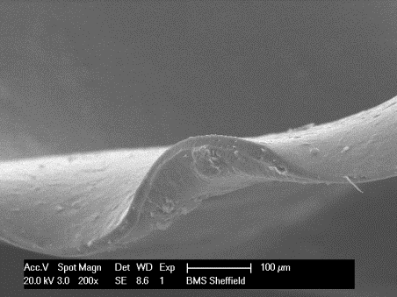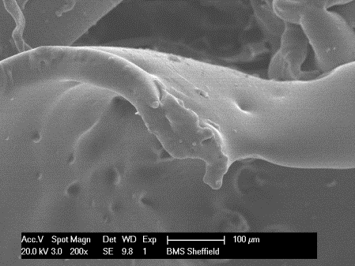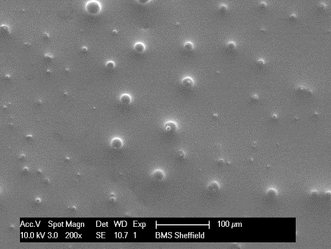

Figure 4.2: 200 x magnification SEM images of 0, 1 and 10 Wt. % modified membranes shown left to right, respectively.
Membranes chosen for SEM imaging were 0.1, 1 and 10 Wt. %, this was due to these compositions being the most varied within the sample range. As the copolymer content increased from 0 to 10 Wt.% within membranes there was a change in surface morphology from smooth to rough with increasing populations of 'pimples/protrusions' appearing at the surface. This is due to the particles previously observed in solution protruding from the surface of the material as it becomes saturated.

4.2.2.1 10 Wt. % loading peel test
Peel tests were conducted to determine integrity of modified membrane surfaces shown in figure 4.3. These were conducted by taking the 'stub' used for SEM imaging, and imprinting this onto the membrane and imaging the stub. Peel tests were performed on 0, 1 and 10 Wt. % modified membranes. However, only 10 Wt. % modified membranes deposited onto the stubs; this is due to there being increased amount of loosely bound copolymer present at the membranes surface. Moreover, upon adding 10 Wt. % of graft copolymer the stability of the membrane was compromised, in terms of integrity and the membrane could not be manipulated.
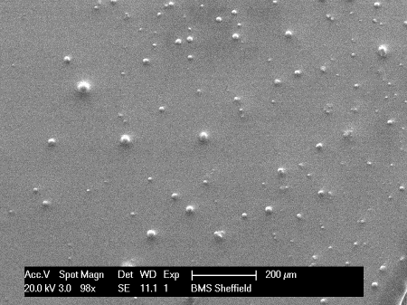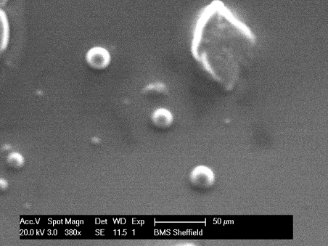

Figure 4.3: SEM images of 10 Wt. % modified membrane at magnifications of 98 x, 200 x, 380 x (left to right, respectively). Top; before peel test. Bottom; sphere like structures present after conducting the peel test.
The aggregates formed on the surface were shown to be loosely embedded at the membrane surface and upon peeling with the SEM 'stub' they were removed intact and could be imaged to show micelle like structures. For the same reason the 10 Wt. % modified membrane can be said to have less crosslinking unlike the other membranes tested at lower concentrations.

4.2.3 Confocal microscopy

4.2.3.1 Rhodamine B encapsulation
Modified membranes were prepared and imaged as stated in the experimental section. Images were taken of 0.1, 1 and 10 Wt. % modified membranes, images were then Z- stacked to produce a projected image side on, shown in figure 4.4. The software used to reconstruct these images was LSM image browser (Zeiss).
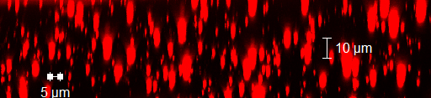
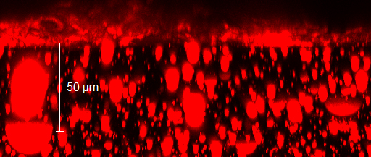
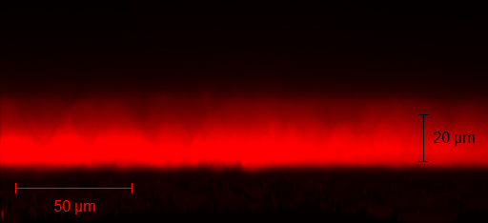
Figure 4.4: Confocal images of three modified membranes Z stacked using LSM image browser. Top; 0.1 Wt. % modified membrane showing elongated spheres ranging from 5-15 µm in length and 5µm in width. Middle; 1 Wt.% modified membrane showing large elongated spheres, with a more diverse range of sizes from 5 up to 50µm. Bottom; 10 Wt.% modified membrane showing a diffuse layer of copolymer and Rhodamine B throughout the membrane.
Figure 4.4 shows Rhodamine B encapsulated within the membrane, suggesting that this hydrophilic molecule is being stabilised by graft copolymer domains. The amount of Rhodamine B incorporated and encapsulated into the membrane increases as the loading into the membrane is increased. As seen upon comparison between 0.1 Wt. % loading and 1 Wt. % (Figure 4.4: Top, middle respectively). The 1 Wt. % loading shows concentrated regions of Rhodamine B up to 50 µm in length and up to 20 µm across. Particle size analysis of PDMS-g-PNVP copolymers yielded micelles with the largest diameter of 8µm, suggesting these micelles seen with the Rhodamine B incorporated aggregate together to form much larger ones.
The 10 Wt. % modified membrane (Figure 4.4: Bottom) showed a thin layer of Rhodamine B. This is due to the lack of crosslinking between component A and B which has been restricted by PDMS-g-PNVP copolymer and Rhodamine B present in the mixture; resulting in the formation of a highly viscous solution being formed rather than a crosslinked membrane. This is also supported images from the SEM peel test conducted on the 10 Wt. % modified membrane (Figure 4.3: Right).

4.2.3.2 Copolymerisation with Fluorescein o-acrylate
Upon copolymerisation with fluorescein o-acrylate the copolymer location can be seen in relation to Rhodamine B, expanding on the findings made in 4.4. Labelled PDMS-g-PNVP copolymer and Rhodamine B were initially analysed in solution, both in aqueous (Figure 4.5: A) and organic (Figure 4.5: B) solution, after which both were loaded into a PDMS membrane (Figure 4.6)
A
B
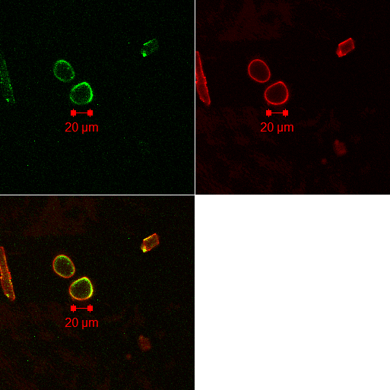
Figure 4.5: A; Copolymer containing fluorescein o-acrylate dissolved in H₂0 at 5mg/ml concentration. Top left; fluorescein o-acrylate. Top right; Rhodamine B. Bottom; overlaid images with the yellow being the combination of both green and red fluorescence. B; PDMS-g-PNVP copolymer containing fluorescein o-acrylate dissolved in hexamethyldisiloxane at 5mg/ml concentration. Top left; fluorescein o-acrylate. Top right; Rhodamine B. Bottom; overlaid images with the yellow being the combination of both green and red fluorescence.
These images confirm the conclusions made using light microscopy previously; the PDMS-g-PNVP copolymer forms micelle like structures in hydrophobic solvent and not in a hydrophilic solvent, confirming that the hydrophilic NVP component of the graft copolymer is much larger. Thus, the graft copolymer forms much smaller particles in aqueous solution.
The structures formed in figure 4.5; B showed that Rhodamine B accumulates in the outer shell of micelles and not in the centre. This is due to the Rhodamine B forming clusters in pockets between the NVP grafted chain ends as depicted by figure 4.6, with the centre being packed with densely collapsed PVP homopolymer or/and H₂O.
H₂O/Collapsed polymer
Figure 4.6: Cartoon depiction of micelles formed in hydrophobic solution. Black; PDMS component. Blue; NVP component. Red; Clusters of Rhodamine B.
Once it had been seen that Rhodamine B and the fluorescence o-acrylate labelled PDMS-g-PNVP copolymer interact in solution, fluorescein o-acrylate labelled PDMS-g-PNVP copolymers were loaded at a 0.1 Wt. % concentration into a PDMS membrane. Firstly without Rhodamine B (figure 4.7) and then with Rhodamine B (figure 4.8) to compare localisation of the graft copolymer and Rhodamine B.
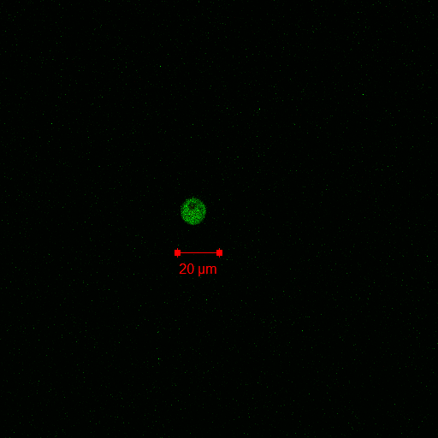
Figure 4.7: 0.1 Wt. % incorporated fluorescein o-acrylate modified membrane. Left; 'bird's eye view' slice image with a clear cluster of labelled PDMS-g-PNVP copolymer present. Right; 20µm Z-stacked images throughout the modified membrane.
Labelled fluorescein o-acrylate PDMS-g-PNVP copolymers can be seen to form cluster regions within the membrane, this is to reduce interfacial tension between the NVP component of copolymers and the hydrophobic matrix of the membrane. However, it was also seen that when sliced images were Z-stacked PDMS-g-PNVP copolymers were dispersed throughout the membrane forming a similar structure to form a semi inter penetrating network (SIPN). The formation of a SIPN also explains how a hydrophilic agent would be released upon submersion within a given liquid.
B
A
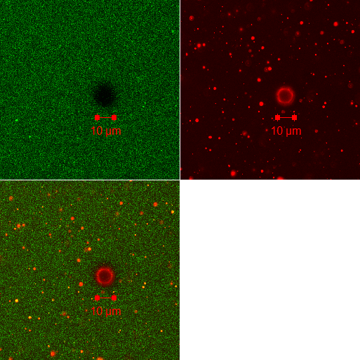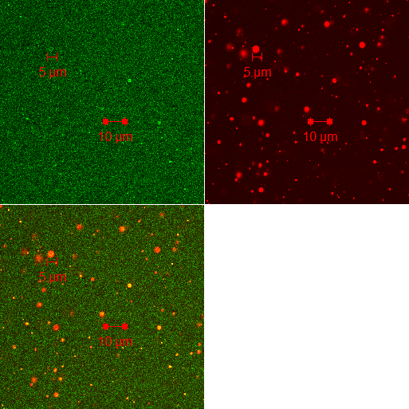
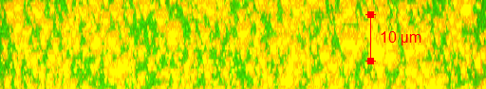
Figure 4.8: 0.1Wt% modified membrane containing fluorescein o-acrylate labelled PDMS-g-PNVP copolymer and Rhodamine B. The two images were taken using the same membrane from two different depths. The first was taken close to the surface second at 10µm from the bottom. A; Top left, Fluorescein o-acrylate. Top right, Rhodamine B. Top Bottom, overlaid images with the yellow being the combination of both green and red fluorescence. Bottom, Images-z stacked. B; Top left, Fluorescein o-acrylate. Top right, Rhodamine B. Top Bottom, overlaid images with the yellow being the combination of both green and red fluorescence. Bottom, Images z-stacked.
Figure 4.8 shows PDMS-g-PNVP copolymer cluster formation within the membrane, as well as dispersing itself throughout. Rhodamine B was seen to concentrate in cluster regions of PDMS-g-PNVP. This provides an increase in stability of these hydrophilic agents in a hydrophobic environment reducing interfacial tension. The low amount of PDMS-g-PNVP copolymer present as shown by GPEC, suggests these large aggregates are stabilised by a thin outer layer of PDMS-g-PNVP copolymer as shown in figure 4.6.

4.2.3.3 DOSY-NMR
DOSY was performed to provide evidence of successful incorporation of fluorescence o-acrylate into PDMS-g-PNVP copolymers. Using the proton shown in figure 4.9 which appears around 8.2ppm in H¹ NMR, with the resultant diffusion constant data, attachment to the polymer can be examined shown in Figure 4.10.
Figure 4.79 Fluorescence o-acrylate, showing the aromatic proton used to examine incorporation into PDMS-g-PNVP copolymers.
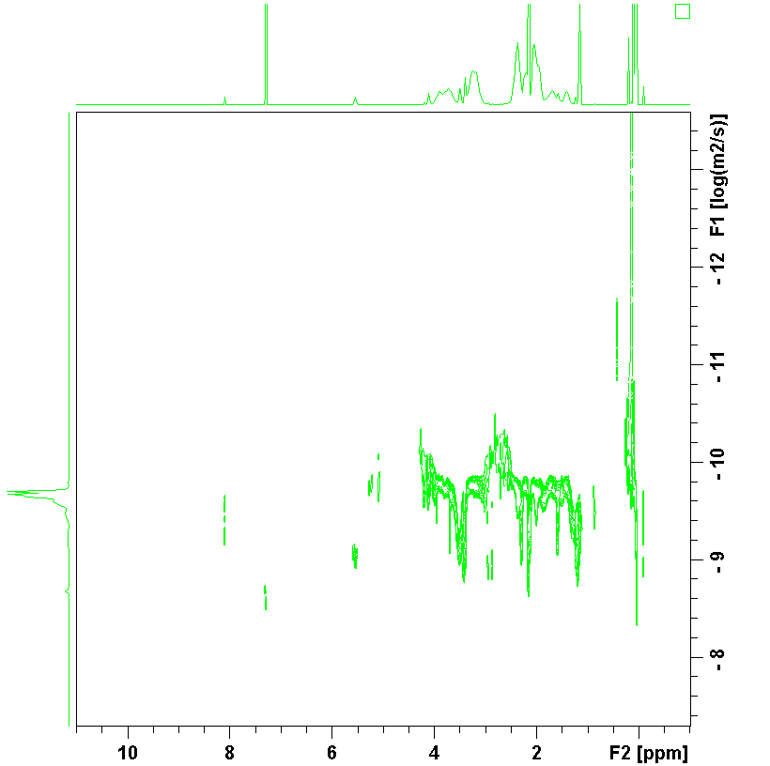

Figure 4.10: DOSY NMR spectra of PDMS-g-PNVP copolymer with incorporated Fluorescein o-acrylate.
The 2D spectrum shows the proton from fluorescein o-acrylate has a very similar diffusion constant to the PDMS-g-PNVP copolymer protons, strongly suggesting that chemical attachment has been achieved. Furthermore, this is strengthened by the images obtained using confocal microscopy.

4.2.4 Surface properties

4.2.4.1 Contact angle measurements
Contact angle measurements were conducted using a goniometer, microscope and a pipette containing ultrapure H₂O and 1-Bromonaphthalene. Measurements were taken in repeats of five, results are shown in figure 4.11a-b for PDMS(5,000):5PNVP.
Figure 4.11a: Contact angles as a dependency of PDMS-g-PNVP copolymer (PDMS (5000) 1a) concentration given as a mass fraction present within modified membranes. H₂O was the contact dispersive.

Figure 4.11b: Contact angles as a dependency of PDMS-g-PNVP copolymer (PDMS(20,000):5PNVP Wt.%) concentration given as a mass fraction present within modified membranes. 1-Bromonaphthalene was the dispersive.
Increasing the amount of PDMS-g-PNVP copolymer increases the likelihood of the hydrophilic component, NVP, being present at the surface. The more hydrophilic the surface the lower contact angles for aqueous media, or higher when using 1-Bromonaphthalene, as this is a non-polar hydrophobic solvent.
Using the contact angles obtained it is possible to determine the polar and the non-polar dispersive components of the surface energy of a solid using the Fowkes equation. Using this equation, the adhesion energy is a sum of two partial contributions, each of which is expressed as the geometric mean of two adhesion parameters, γ_{L} and γ_{S}, the first of which characterizes the "adhesive power" of the liquid, and the second, of the solid.
Equation 4.1: $γ\text{L}(1+ \cos{θ)}=\text{2}\left[\sqrt{γ\text{d}\text{L}\text{γ}\text{d}\text{S}}+\sqrt{γ\text{p}\text{L}\text{γ}\text{p}\text{S}} \right]$
γ^{d}_{L} - Dispersion forces surface energy of the liquids
γ^{d}_{S} - Dispersion forces surface energy of the solid
γ^{p}_{L} - Polar interaction surface energy of the liquids
γ^{p}_{s} - Polar interaction surface energy of the solid

The adhesion parameters of the dispersive liquids are known (Table 4.2). Therefore, by measuring the contact angles for two different liquids the remaining two parameters, those of the solid, can be found.

Liquid | γ_{L} (mJ/m²) | γ_{L}^{d} (mJ/m²) | γ_{L}^{p} (mJ/m²)
Water | 72.8 | 21.8 | 51
1-Bromonaphthalene | 50.8 | 50.8 | 0
Table 4.2: The surface energies, dispersion forces and polar interactions of H₂O and 1-Bromonapthalene.
Using 1-Bromonapthalene allows for the equation to be simplified and solved as the polar component (γ_{L}^{p}) is zero. As a result the total surface energy and % polarity of the surface can be calculated, which is shown in table 4.3 for PDMS(5,000):5PNVP.
Wt.% Copolymer | γ_{s}^{d} (mJ/m²) | γ_{s}^{p} (mJ/m²) | γ^{tot} (mJ/m²) | % Polarity  (γ^{tot}/ γ_{s}^{d})
0.1 | 11.88 | 0.037 | 11.92 | 0.31
0.5 | 11.47 | 0.32 | 11.79 | 2.73
1 | 6.57 | 0.75 | 7.32 | 10.29
2.5 | 1.74 | 2.43 | 4.16 | 58.31
5 | 1.66 | 2.83 | 5.49 | 57.90
10 | 10.99 | 9.42 | 20.41 | 46.14
Table 4.3: Total surface energy and % polarity for PDMS(5,000):5PNVP.
The addition of PDMS-g-PNVP copolymer to the PDMS membrane causes the surface energy to decrease. As surface energy is an adhesive parameter, this lowering in energy means a decrease in energy gained upon bringing the surface into contact with other materials. The result of this is that the membrane becomes less adhesive.
The % polarity of the surface increases when increasing the amount of copolymer; the surface is becoming more polar. With the exception of 10 Wt. %, these membranes are not cured explaining the lower % polarity observed. One other consideration is the total saturation of the material at the surface; Table 4.3 suggests a maximum % polarity obtainable at the surface of ~58% (γ^{tot}/ γ_{s}^{d}). This corresponds to a PDMS-g-PNVP concentration of 2.5 Wt. %.
The trends observed for PDMS(20,000):5PNVP Wt.% were seen for each modified membrane containing the other PDMS-g-PNVP copolymers. The same concentrations of 0.1 to 10 Wt. % were used, results are shown in figure 4.12a-c. Individual graphs are presented within the appendix of this thesis.
Figure 4.12a: The % polarity of the surface of modified membranes containing PDMS(5,000) graft copolymers at five concentrations: 0.1, 0.5, 1, 2.5, 5 and 10 Wt. %. Legend: Black PDMS(5,000):5PNVP, dark grey PDMS(5,000):7PNVP, light grey PDMS(5,000):0.5PNVP.
Figure 4.12b: The % polarity of the surface of modified membranes containing PDMS(10,000) graft copolymers at five concentrations: 0.1, 0.5, 1, 2.5, 5 and 10 Wt. %. Legend: Black PDMS(10,000):2.15PNVP, dark grey PDMS(10,000):2.57PNVP, light grey PDMS(10,000):0.5PNVP.
Figure 4.12c: The % polarity of the surface of modified membranes containing PDMS(20,000) graft copolymers at five concentrations: 0.1, 0.5, 1, 2.5, 5 and 10 Wt. %. Legend: Black PDMS(20,000):1.08PNVP, dark grey PDMS(20,000):5.8PNVP, light grey PDMS(20,000):2.4PNVP.

4.2.5 Peel adhesion testing
Membranes were loaded at the same concentrations as shown in table 7.1, excluding Rhodamine B. The method of testing is explained in the material and methods section and is in accordance with industrial standard testing (ISO 8510 - 180 degrees peel test), the results shown in figure 7.13a-c. All membranes were tested under climate controlled conditions (constant temperature and humidity) as temperature effects adhesive properties of silicone adhesives, due to a change in molecular flow characteristics ²⁸⁰.

Figure 4.13a: PDMS(5,000) graft copolymer peel adhesion force against PDMS-g-PNVP Wt. % membrane concentration. The region shown between the two black dotted lines is the peel adhesions of PDMS membranes excluding graft copolymer made under both typical industry curing temperature of 120^{O}C (top triangle) and curing temperatures used to make the modified membranes (70^{O}C, bottom triangle). The standard deviation is shown. Legend: Black PDMS(5,000):5PNVP, dark grey PDMS(5,000):7PNVP and light grey PDMS(5,000):0.5PNVP.
Figure 4.13b: PDMS(10,000) graft copolymers peel adhesion force against PDMS-g-PNVP Wt. % membrane concentration. Legend: Black PDMS(10,000):2.15PNVP Wt.%, dark grey PDMS(10,000):2.57PNVPand light grey PDMS(10,000):0.5PNVP Wt.%.
Figure 4.13c: PDMS(20,000) graft copolymers peel adhesion force against PDMS-g-PNVP Wt. % concentration. Legend: Black PDMS(20,000):1.08PNVP Wt.%, dark grey PDMS(20,000):5.8PNVP Wt.% and light grey PDMS(20,000):2.4PNVP Wt.%.
The region between the dotted black lines shown in figures 4.13a-c is typically between 1.6 N and 2.9 N, this region is the adhesion of silicone currently used by industry. Both PDMS controls were made by adding equal amounts of component A and B as done previously. However, the temperature and time of curing differs between the two, with one control being cured at 120 ^{O}C for two minutes and the other being cured at 70 ^{O}C for 15minutes. The reason the curing procedure differs between the two controls is due to the modified membranes containing a large amount of H₂O, thus the higher temperature causes the water to evaporate rapidly leaving behind a UN even surface not suitable for application, and so a lower temperature and longer curing time has been used.
As the concentration of PDMS-g-PNVP copolymer for PDMS(5,000) graft copolymers increased the peel adhesion reduced. However, the majority of concentrations tested were within the control region. PDMS(10,000) graft copolymers showed a sharper decrease in peel adhesion with increasing concentrations, only half of the modified membranes were within the control region. As the polycarbonate substrate is a hydrophobic surface with a low surface energy, the increase in PDMS-g-PNVP copolymer present at the surface of modified membranes decreases the adhesion between the two surfaces, thus decreasing peel adhesion. PDMS(20,000) graft copolymers compositions peel adhesion force stayed consistent across the concentration range, with all peel forces below the control region.
Comparing the peel adhesion between groups it can be said that as the average molar mass of the graft copolymer present in the modified membranes is increased there is a decrease in adhesion. This is due to the probability of hydrophilic regions being present at the surface, as the size of the PDMS-g-PNVP copolymers is increased there are more protrusions from the surface, coinciding with what was observed from SEM imaging.

4.2.6 Moisture vapour transfer rates (MVTR)
Modified membranes were cut to size using the lid of a sealable vessel. 20ml of deionised water added to each cup (sufficient to leave an air gap of 5mm between the liquid surface and the modified membrane) as shown in the experimental section. The samples were then clamped within vessels to ensure a water tight seal. Samples were then weighed and placed in an oven for 3 hrs at 37^{O}C; samples were then weighed to calculate the amount of H₂O loss. The data presented in figure 4.14a-c is extrapolated to gain the mass of water lost through membranes over a 24hr period.
Figure 4.14a: PDMS(5,000) graft copolymers MVTR as a dependence of PDMS-g-PNVP concentration within modified membranes. The dotted line represents the MVTR of PDMS membranes currently used by industry. MVTR rates increase relative to the increasing concentration of PDMS-g-PNVP copolymer present within modified membranes. Legend: Black PDMS(5,000):5PNVP, Dark grey PDMS(5,000):7PNVP and light grey PDMS(5,000):0.5PNVP.
Figure 4.14b: PDMS(10,000) graft copolymers MVTR as a dependence of PDMS-g-PNVP Wt. % concentration. Legend: Black PDMS(10,000):2.15PNVP Wt.%, Dark grey PDMS(10,000):2.57PNVPand light grey PDMS(10,000):0.5PNVP Wt.%.

Figure 4.14c: PDMS(20,000) graft copolymers MVTR as a dependence of PDMS-g-PNVP Wt. % concentration. Legend: Black PDMS(20,000):1.08PNVP Wt.%, Dark grey PDMS(20,000):5.8PNVP Wt.% and light grey PDMS(20,000):2.4PNVP Wt.%.

Moisture transfer from any modified membrane containing 2.5 Wt. % or more PDMS-g-PNVP copolymer increased the MVTR three fold. The increase in MVTR provides insight into the structure of graft copolymer within the membrane, supporting the idea of SIPN formation. This would allow for an increase in MVTR through channels created within modified membranes, coinciding with results obtained from confocal microscopy (figure 4.8).

4.4 Conclusion
PDMS membranes provided by Scapa healthcare™ were successfully modified with PDMS-g-PNVP copolymers synthesised in Chapter 1. SEM images suggest a change in surface morphology, with increasing protrusions being present at the surface and a saturation point of equal to the addition ~5 Wt. % graft copolymer to membranes observed. Increasing concentrations of modified membranes was found to have a detrimental effect of adhesive properties, reducing adhesion respectively. However, increased concentrations increased the MVTR three fold. Contact angle measurements gave insight into two points, firstly, providing an explanation for the decrease in adhesion, due to the increase in hydrophilicity of the surface. Secondly, confirming there is a saturation point of 5 Wt. %. This is further supported by the lack in change of hydrophilicity of the surface past 5 Wt. % concentrations.
The loading of a hydrophilic fluorescent agent Rhodamine B allowed for confocal imaging. This provided information on the location of Rhodamine B within modified membranes. In addition, inclusion of Fluorescein O-acrylate into PDMS-g-PNVP graft copolymer backbones allowed for the location of both Rhodamine B and graft copolymer to be visualised together. It was found that Rhodamine B formed clusters that coincided with clusters of PDMS-g-PNVP copolymers suggesting that Rhodamine B is stabilised in a hydrophobic environment by the addition of the amphiphilic graft. Moreover, PDMS-g-PNVP graft copolymers were found to be dispersed throughout modified membranes suggesting SIPN formation.

Chapter 5

Objectives

- Determine the parameters required for release of Rhodamine B from modified membranes.

- Optimise parameters for optimum release of Rhodamine B from modified membranes.

- Evaluate type of release being observed from modified membranes using Peppas power relationship between amount of a substance loaded and the amount released.

5.1 Introduction
Diffusion is the process by which matter is transported from one part of a system to another as a result of random molecular motions. Transfer of heat by conduction is also due to random molecular motions. The relationship between these two processes was first recognized by Fick (1855) and brought about Fickians first law of diffusion;
$$F= -D\frac{∂C}{∂x}$$where F is the rate of transfer per unit area, C the concentration of diffusing substance, x the space coordinates measured normal to the section, t is time, and D is called the diffusion coefficient. Fickian used this law to create a second law which describes the release of a diffusate from thin films;
$\frac{∂C}{∂t}=D\frac{∂^{2}C}{∂x^{2}}$
Peppas et al ²⁹⁰ used an approximation of the exact solution of Fick’s second law for thin films called the power law;
$$\frac{M^{t}}{M^{∞ }}=Kt^{n}$$
Here, M^{t} and M∞ are the absolute cumulative amount of drug released at time (t) and at infinite time respectively. K is a proportionality constant which incorporates structural and geometric characteristics of the material, and 'n' is the diffusional exponent, which indicates the type of mechanism for drug release.
The power law can be seen as a generalisation of the observation that the suspension of two apparently independent mechanisms of drug transport, Fickian diffusion and case-II transport. It describes many cases of dynamic swelling of and drug release from polymers, regardless of the type of coupling or relaxation and diffusion.
If the ‘n’ exponent takes a value of 1 this creates zero order release kinetics, as it is independent of time, thus case II transport is observed. When n=1 the relaxation of polymers upon water uptake is the rate controlling step. Water can be said to be acting as a plasticiser, decreasing the Tg of the polymer. Once the Tg is equal to the temperature of the system, the polymeric chains change from glassy to a rubbery state, thus increasing mobility and volume.
The power equation can then be considered to have two physical meanings where n=0.5 (indicates diffusion-controlled release) and n=1 (indicating swelling-controlled drug release). However, values of n between 0.5 and 1 are often an indicator of the phenomena of anomalous transport. Anomalous diffusion is a diffusion process with a non-linear relationship to time.

5.2 Results and discussion

5.2.1 Rhodamine B release

5.2.1.1 Release using Tissue Culture plastic
Increasing concentrations of PDMS (5,000):5PNVP Wt. % and Rhodamine B were loaded in PDMS membranes to determine if release of rhodamine B was possible and if so at what concentrations of both graft and agent was required. Modified membranes were submerged into 2 ml of PBS in tissue culture plastic and the absorption between 500-600nm was recorded at 0, 0.5, 1.5, 4, 24 and 48 hr time points. Results are shown in figure 5.1.
Figure 5.1: Release profile of 0.1 Wt. % Rhodamine B from modified membranes at 0, 0.5, 1.5, 4, 24, 48 hr time points. Black; 0hr (solid), 0.5hr (lines), 1.5hr (Dotted). Grey; 4hr (solid), 24hr (lines), 48hr (dotted).
The release profiles shown in figure 5.1 shows more Rhodamine B released at 0 hr than for later time points. However, this absorption is shown to decrease at later time points. The large initial release observed is a result of loosely attached Rhodamine B being released from the surface, this then re-enters the modified membrane as it has been submerged allowing for re-absorption to occur. Rhodamine B is subsequently slowly released until about 4 hours in each case. Adsorption of Rhodamine B to the tissue culture plastic occurs at 48 hr release, which accounts for this being the lowest absorption observed. Due to the lack of crosslinking in the 10 Wt. % graft copolymer modified membrane it was seen to dissolve in the PBS over time.
The problems which were observed in this experiment were rectified with the replacement of tissue culture plastic with glass and the temperature was increased to 37ºC to mimic that of a wound site.

5.2.1.2 Seven day release
Samples were made according to table 5.1 and placed in 5 ml of PBS within sealed glass sample tubes and incubated at 37 ^{O}C. Results are shown below in figure 5.2.
Figure 5.2: The seven day release profiles of 0.1, 0.5, 1, 2.5, 5 and 10 Wt. % modified membranes. As the amounts of Rhodamine B and PDMS(5,000):5PNVPcopolymer were increased a larger absorption was observed after seven days.
Comparing this release profile with the profiles previously shown in figure 5.1, these data show an increase in release of Rhodamine B that correlates with an increase in initial loading. The 10 Wt. % modified membrane release data is removed from this graph as the absorption was a magnitude higher than the other release profiles observed distorting the graph, for reasons discussed previously the 10 Wt. % modified membrane will be taken no further in these release studies. This experiment has a large error associated with it, due to the lack of number of repeats and time points and was used as an indicator experiment to determine if release from modified membranes was possible.

5.2.1.3 Release over 72 hours
This experiment was carried out following the same procedure as the experiment in section 5.12. However, both the number of repeats and time points were increased. The results were corrected to concentration using the Beer Lambert law, using a molar extinction coefficient of 101,000 mol L⁻¹ for Rhodamine B.
Figure 5.3: Release profile of 0.1 to 5 Wt. % modified membranes. Absorption was monitored at 30 minute intervals for the first 4 hrs and then every hour until 12 hrs. The remaining time points were taken at 16, 24, 36, 48, 60 and 72 hrs. The results are shown with the standard deviation
A steady release for all modified membranes tested was observed in figure 5.3. However, at certain concentrations the addition of more PDMS-g-PNVP copolymer and Rhodamine B did not equate to more being released. This can be shown for concentrations 0.5 and 1 Wt. % a larger amount of rhodamine B in these samples is released from 0.5 Wt. %, which is ideal from a manufacturing point of view because they can get a larger release from the use of less material. The results obtained in figure 5.3 can be applied to Ficks second law of diffusion. Peppas²⁹⁰ suggests using a power relationship for the release rate and Ficks second law of diffusion of a diffusate from a hydrogel as shown in equation 5.1.
$$\frac{M^{t}}{M^{∞ }}=Kt^{n}$$
Equation 5.1: The power relationship can only be applied to 60% of the total amount of drug released otherwise Fickians second law of diffusion does not hold. Here, M^{t} and M∞ are the amounts of drug released at time (t) and at equilibrium, respectively. K is a proportionality constant, and 'n' is the diffusional exponent.
Figure 5.4: Fraction of Rhodamine B released (Mt/M∞) to obtain power exponent 'n' of 0.1-5 Wt. % PDMS(5,000):5PNVP graft copolymer modified membranes.
PDMS(5,000):5PNVP concentration Wt. % | 'n' exponent | Standard error
0.1 | 0.68 | 0.053
0.5 | 0.69 | 0.045
1 | 0.68 | 0.047
2.5 | 0.63 | 0.12
5 | 0.49 | 0.02
Table 5.1: PDMS(5,000):5PNVP diffusional ‘n’ exponent, with 0.5 Wt. % concentration expressing the highest diffusional exponent.
The 'n' values were calculated and tabulated to allow for easy comparison shown in figure 5.4 and table 5.1. The majority of modified membranes values were found to be above 0.5 indicating anomalous (non-Fickian) transport with 5 Wt. % being the only Fickian diffusion based composition.

5.2.1.4 48hr time point release profile of Rhodamine B
The remaining PDMS-g-PNVP copolymer compositions (1a-3c) were monitored over 48hrs, as this was seen to be the time period to reach maximum release for PDMS(5,000):5PNVP. The results are shown in figure 5.5a-c.
Figure 5.5a: Maximum release over 48hrs for PDMS(5,000) graft copolymers at five increasing concentrations of graft copolymer. Two controls were used; firstly membranes loaded with equivalent amounts of Rhodamine B excluding PDMS-g-PNVP copolymer and secondly membranes loaded with equivalent amounts of PVP and Rhodamine B. The results are shown with the associated standard deviation.
Figure 5.5b: Maximum release over 48hrs for PDMS(10,000) graft copolymers at five increasing concentrations of graft copolymer. The results are shown with the associated standard deviation.
Figure 5.5c: Maximum release over 48hrs for PDMS(20,000) graft copolymers at five increasing concentrations of graft copolymer. The results are shown with the associated standard deviation.
Typically increasing the amount of Rhodamine B within modified membranes increases the maximum amount released as shown in figures 5.5a-c. The total amount of rhodamine B released was shown to vary between copolymers. PDMS(10,000):2.15PNVP 0.1 Wt. % was shown not to release rhodamine B over the 48hr time period. PDMS (20,000)3b 5 Wt. % was shown to release the largest concentration of Rhodamine B over the 48hr time period.
Two controls were used; membranes loaded with just Rhodamine B and membranes loading with PVP and rhodamine B. Membranes loaded with just Rhodamine B were shown to release less Rhodamine B than modified membranes. The small release observed is Rhodamine B being released from the surface.
PVP loaded membranes were exceptionally difficult to cure, due to the lack of the hydrophobic component found in the PDMS-g-PNVP copolymers. The maximum release achieved was typically 50% less when compared to PDMS-g-PNVP copolymer modified membranes. The ‘n’ exponent was calculated for all graft copolymer compositions, shown in figure 5.6a-c.
Figure 5.6a: Calculated Fickian constants for PDMS(5,000) graft copolymers at five increasing concentrations of graft copolymer. Two controls have been used firstly PDMS loaded with equivalent amounts of Rhodamine B excluding PDMS-g-PNVP copolymer and secondly PVP homopolymer and rhodamine B loaded membranes containing equivalent amounts to modified membranes. The standard deviation is also shown.
Figure 5.6b: Calculated Fickian constants for PDMS(10,000) graft copolymers at five increasing concentrations of graft copolymer.

Figure 5.6c: Calculated Fickian constants for PDMS(10,000) graft copolymers at five increasing concentrations of Rhodamine B (0.1, 0.5, 1, 2.5 and 5 Wt. %).
Figures 5.6a-c show that the rate of release varies depending on PDMS-g-PNVP copolymer composition and Wt. % used in the composition. There can be two key points that can be made from these observations. Firstly, that each PDMS-g-PNVP copolymer composition affects the modified membrane internal morphology to different degrees, thus different amounts of Rhodamine B is released. Secondly the amount of graft copolymer concentration also affects morphology. Thus, potentially this library of Modified membranes allows for the tailoring of a delivery system, to be either slow or rapid releasing based on the composition chosen.
The differences in these release profiles are caused by cluster regions of Rhodamine B with no route to be released out of the modified membrane i.e. surrounded by hydrophobic segments. This effect is more prominent in some compositions than in others. These clusters or pockets of Rhodamine B were observed in confocal microscopy studies, shown in figure 5.7.
Figure 5.7: Modified membrane containing 0.1 Wt. % of PDMS(5,000):5PNVP copolymer with incorporated fluorescein o-acrylate and Rhodamine B. Top left, Fluorescein o-acrylate. Top right, Rhodamine B. Bottom, overlaid images with the yellow being the combination of both green and red fluorescence.
In a system with the intended use of drug delivery to human infected wounds, Fickian diffusion is preferential (‘n' value of 0.5). However, the total amount of Rhodamine B released is also an important consideration when choosing a delivery composition. These data show a large degree of copolymer compositions at various loading concentrations are capable of achieving these requirements.

5.3 Conclusion
Release studies showed successful release of Rhodamine B, generating a library of release profiles which were composition dependent. Using Peppas power relationship between rate of release and maximum release, 'n' values were able to be determined. The ‘n’ exponent indicates the mechanism of release, with most compositions being anomalous diffusion.
The PDMS-g-PNVP copolymer chosen and loading concentration was shown to affect the behaviour of Rhodamine B release. The reasons for the variation in mechanism in release seen are due to compositions containing a different amount of hydrophilic matrixes within a hydrophobic matrix, which controls drug release. The inward flux of solvent and consequent swelling of the polymer matrix controls the rate of release. As solvent enters the polymer matrix and begins to 'swell' two phases are formed. The drug molecules are able to diffuse out of the hydrophilic phase of the polymer. Clearly, the drug release is controlled by the velocity of the influx at these interfaces and the positions of the interfaces themselves, since no drug diffuses out of the hydrophobic region of the polymer. The variations in compositions affect the abundance and positions of these interfaces.
The first detailed model of drug transport with concentration dependent diffusion coefficients was developed by Korsmeyer at al. (1986) ²⁹¹.
Loose Rhodamine B attached to the surface that would diffuse or dissolve quickly into the solution could also explain the observed increase in 'n' value and non Fickian behaviour of release being observed. The optimum concentration: taking into account the maximum amount released; the rate of release; and manufacturing cost was deemed to be 2.5 Wt. % of PDMS-g-PNVP copolymer.

Chapter 6

Objectives

- Optimise release of Ag from modified membranes.

- Determine bacteriostatic activity of Ag loaded modified membranes against staphylococcus aureus and pseudomonas aeruginosa using the clear zone of inhibition method (CZOI).

- Determine bacteriostatic activity of Ag and Ag + I₂ loaded modified membranes against inoculated media containing either staphylococcus aureus or pseudomonas aeruginosa.

6.1 Results and discussion

6.1.1 Antimicrobial release

6.1.1.1 Silver release
Silver release studies were performed as described in the experimental section with an initial release screening process being conducted of the entire PDMS-g-PNVP copolymer library to determine if silver release was possible, shown in figure 6.1. Following this three graft copolymers were chosen based on their release profiles and were loaded with Ag at 2.5 Wt.% into membranes shown in figure 6.2. Graft copolymers were loaded at a 2.5 Wt. % concentration as this was deemed the optimum concentration from Rhodamine B release studies.
Figure 6.1: Modified membranes were loaded with 1 Wt. % Ag and 2.5 Wt. % PDMS-g-PNVP copolymer. Release was monitored via a gravimetric method. PDMS(5,000):5PNVP, PDMS(10,000):2.15PNVP and PDMS(20,000):2.4PNVP were shown to release the maximum amount of Ag. The standard deviation is shown.
The gravimetric method for monitoring the release of a small amount of Ag has a large error associated. Thus, these results were obtained by increasing the number of repeat measurements. The equation to precipitate AgCl is shown in figure 6.2 with the relevant solubility constant in H₂O is also shown. The solubility constant Ksp is the equilibrium constant for a solid substance dissolving in an aqueous solution. It represents the level at which a solute dissolves in solution. The more soluble a substance is in a given solvent, the higher the Ksp.
$$\text{AgNO}\text{3}\text{-}\text{ + NaCl → AgCl + NaNO}\text{3}\text{-}$$
Ksp = [Ag⁺ ][Cl⁻ ] = 1.8 x 10⁻¹⁰
Figure 6.2: Precipitation of Ag using NaCl.
Silver release was achieved from modified membranes. However, certain compositions were shown to release more Ag than others. PDMS(5,000):5PNVP, PDMS(10,000):2.15PNVP and PDMS(20,000):2.4PNVP were shown to have the highest release. PDMS(10,000):0.5PNVP Wt.%and PDMS (20,000)3b were shown to release no Ag over the five day period. This is most likely due to Ag being encapsulated and held within isothermal domains that inhibit diffusion. GPEC analysis showed PDMS(10,000):0.5PNVP Wt.%and PDMS (20,000)3b to have the lowest percentage of PDMS-g-PNVP copolymer present (~7%). The lack of PDMS-g-PNVP copolymer within modified membranes would increase the prevalence of isothermal domains.
The maximum release obtained was from PDMS(5,000):5PNVP, PDMS(10,000):2.15PNVP and PDMS(20,000):2.4PNVP compositions. Modified membranes containing PDMS(5,000):5PNVP, PDMS(10,000):2.15PNVP or PDMS(20,000):2.4PNVP were shown to be the only graft copolymer compositions to show bacteriostatic activity. The effect on the bacteria observed was only bacteriostatic not bactericidal at 1Wt% Ag. Where Bacteriostatic is the ability of an agent to arrest the growth or multiplication of bacteria and bactericidal is an agent which kills bacteria. To kill bacteria concentrations were increased to 2.5 Wt. % Ag. Thus, these compositions were then monitored with an increased amount of Ag. The results are shown in figure 6.3.
Figure 6.3: Modified membranes were loaded at a 2.5 Wt. % Ag. Release was measured via a gravimetric method. PDMS(5,000):5PNVP was shown to release the maximum amount of Ag.
The results shown in figure 6.3 correspond with the results shown previously in figure 6.1 (1 Wt. % Ag loading) with the maximum release shown to be; PDMS(5,000):5PNVP, PDMS(10,000):2.15PNVP and PDMS(20,000):2.4PNVP , respectively.

6.1.1.2 Silver and iodine release

6.1.1.2.1 Silver release
Following silver loading, Iodine was also loaded into modified membranes. This was done to provide a multi component approach to reduce a bacterial burden. The total loading concentration remained at 2.5 Wt. %, with 1.25 Wt. % Ag and 1.25 Wt. % Iodine being the two individual components. The silver release profile is shown in figure 6.4 with release being monitored via a gravimetric method.
Figure 6.4: Modified membranes loaded at a 1.25 Wt. % Ag and 1.25 Wt. % I₂. Ag release was monitored via a gravimetric method. PDMS(5,000):5PNVP was shown to release the maximum amount of Ag.
Combining Ag with Iodine was shown to reduce the total amount of Ag released compared to that previously observed in Ag only loaded modified membranes. The silver is complexing with iodine to form silver iodide, explaining the colour change of the membranes from grey to yellow. Moreover, as silver iodide is insoluble in water, it would not dissolve out of the hydrophilic channels present within the modified membranes explaining the reduction in total Ag release.

6.1.1.2.2 Iodine release
Iodine release was monitored using UV/VIS spectroscopy, measuring absorbance between the wavelengths of 400 to 650nm. The maximum absorbance was shown to be 445nm ²⁹². The data was then converted from absorption into concentration using a calibration curve shown in figures 6.5.
Figure 6.5: Iodine calibration curve. Using known concentration iodine and observing the absorbance at 445nm to convert absorbance into concentration of test samples.
Using the calibration curve shown in figure 6.5 absorbance measurements taken over five days were converted into concentration, show in figure 6.6.
Figure 6.6: Modified membranes loaded at a 1.25 Wt. % Ag and 1.25 Wt. % I₂ and 2.5 W% PDMS-g-PNVP copolymer concentrations. Release was monitored via UV/VIS spectroscopy. PDMS(5,000):5PNVP was shown to release the maximum amount of I₂.
The release profile in figure 6.6 shows a small increase in release of I₂ from day 1 to day 5 for all compositions tested. This suggests that the iodine being released upon day one is loosely bound to the surface. Moreover, it is apparent from the amount of I₂ released that a majority of the loaded iodine is in a non-water soluble state such as silver iodate and is unable to flow from modified membranes. The maximum release of Iodine observed coincides with what was observed with the silver release, with PDMS(5,000):5PNVP releasing the most and PDMS(20,000):2.4PNVP releasing the least, for reasons explained previously.

6.1.2 Antimicrobial efficacy

6.1.2.1 Corrected zone of inhibition (CZOI)
Wound dressing were cut to size and applied to bacterial colonies pre grown on agar plates and incubated at 37^{O}C for 24hrs in an incubator. PDMS membranes were subsequently removed and bacterial re-growth after 24hr re-incubation was determined. The full method for testing the CZOI is detailed in the experimental section. No CZOI was observed at 1 Wt. % Ag for any modified membranes tested. Three graft copolymers compositions (PDMS(5,000):5PNVP, PDMS(10,000):2.15PNVP and PDMS(20,000):2.4PNVP ) were shown to have bacteriostatic properties against the re-growth of Staphylococcus aureus and Pseudomonas aeruginosa shown in figure 6.7. Submergence of modified membrane in an inoculated bacterial medium will allow for better assessment of bactericidal activity, as the Ag in these modified membranes is not released unless there is an influx of fluid into the system.
PDMS(5,000):5PNVP, 2.5 Wt. %
1 Wt. % Ag, Staphylococcus aureus.
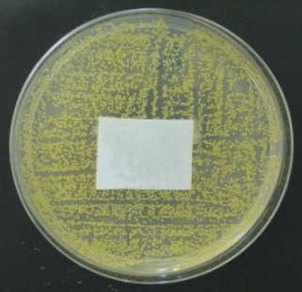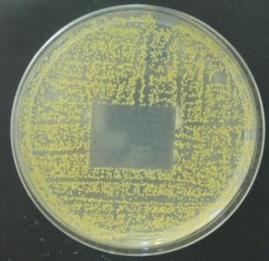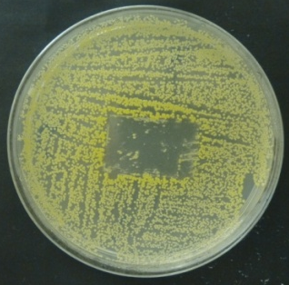
PDMS(5,000):5PNVP, 2.5 Wt. %
No Ag, Staphylococcus aureus
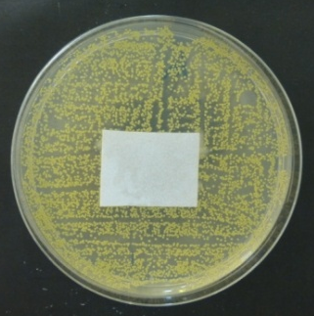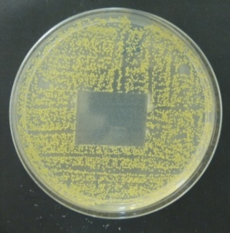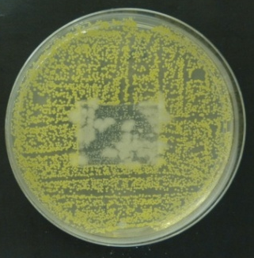

PDMS(5,000):5PNVP, 2.5 Wt. %
1 Wt. % Ag, Pseudomonas aeruginosa
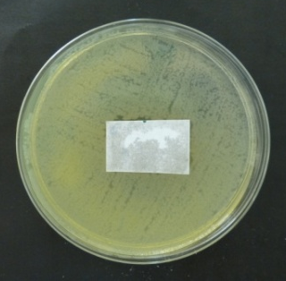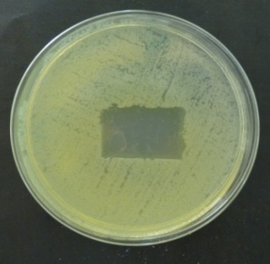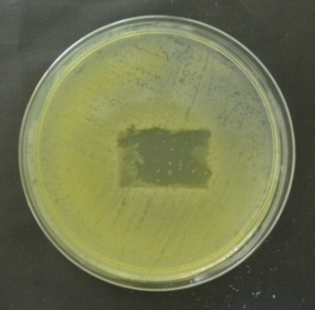

PDMS(5,000):5PNVP, 2.5 Wt. %
No Ag, Pseudomonas aeruginosa
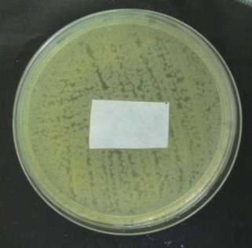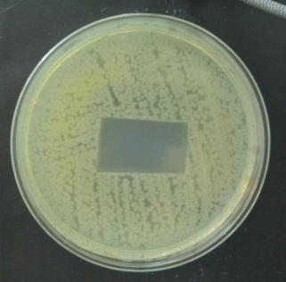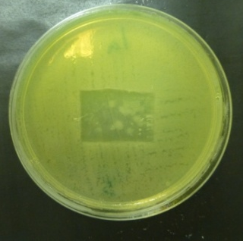

PDMS(10,000):2.15PNVP, 2.5 Wt. %
1 Wt. %, Ag Staphylococcus aureus
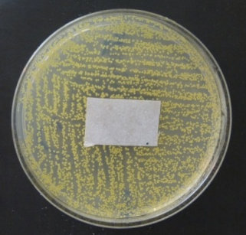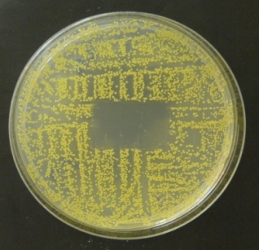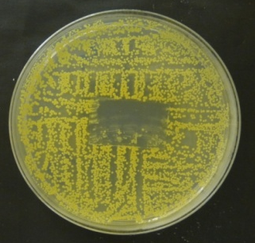
PDMS(10,000):2.15PNVP, 2.5 Wt. %
No Ag, Staphylococcus aureus
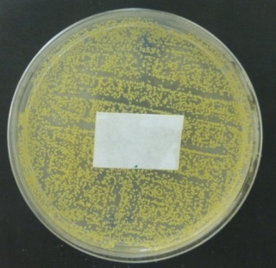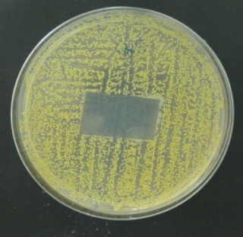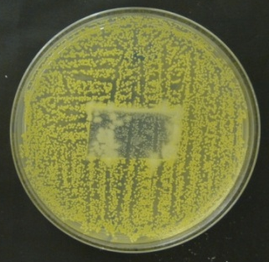
PDMS(10,000):2.15PNVP, 2.5 Wt. %
1 Wt. % Ag, pseudomonas aeruginosa
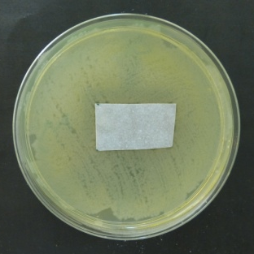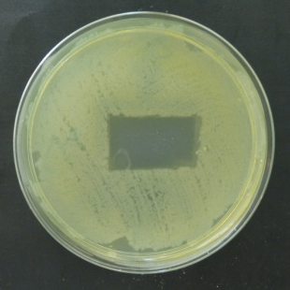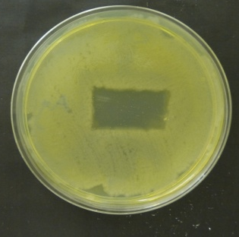

PDMS(10,000):2.15PNVP, 2.5 Wt. %
No Ag, pseudomonas aeruginosa
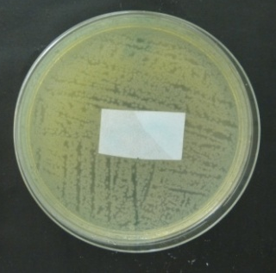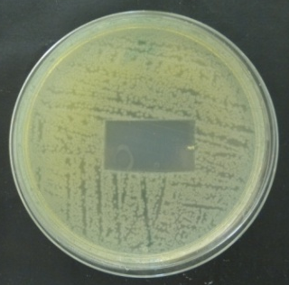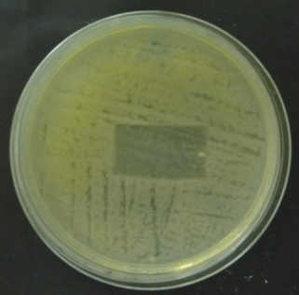

PDMS(20,000):2.4PNVP, 2.5 Wt. %
1 Wt. % Ag, Staphylococcus aureus
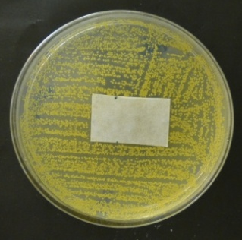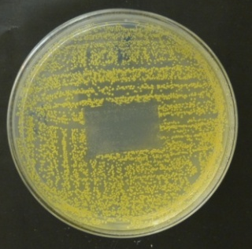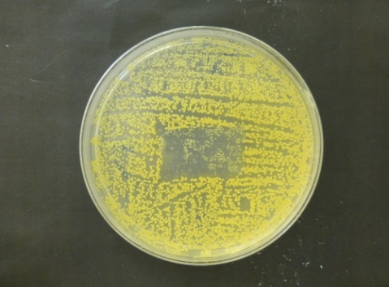
PDMS(20,000):2.4PNVP, 2.5 Wt. %
No Ag, Staphylococcus aureus
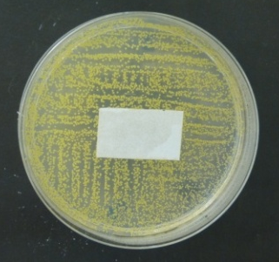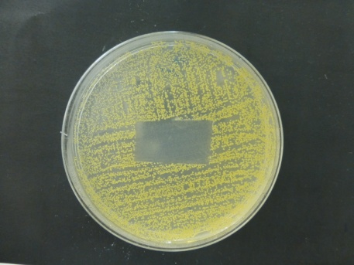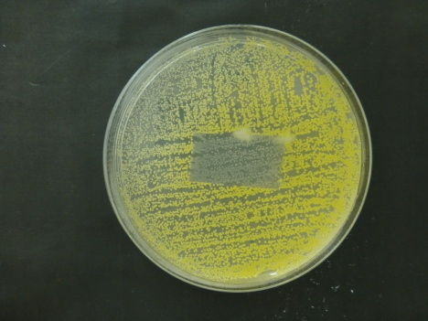
PDMS(20,000):2.4PNVP, 2.5 Wt. %
1 Wt. % Ag, pseudomonas aeruginosa
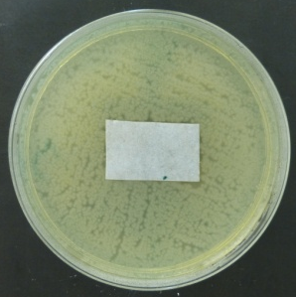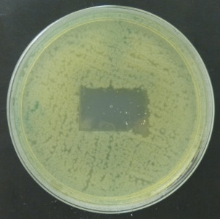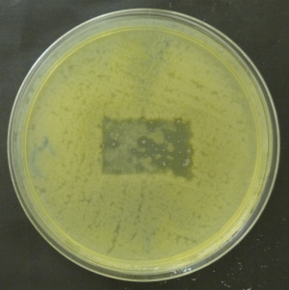
PDMS(20,000):2.4PNVP, 2.5 Wt. %
No Ag, pseudomonas aeruginosa
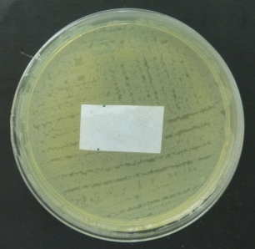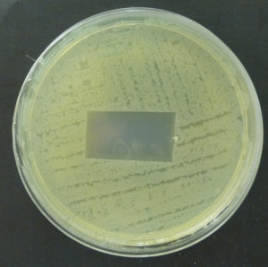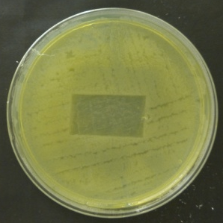

Controls
(No PDMS-g-PNVP copolymer)
1 Wt. % Ag, Staphylococcus aureus
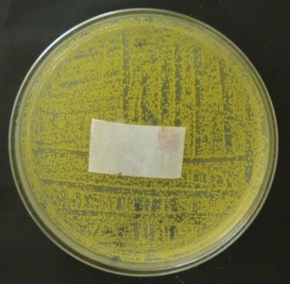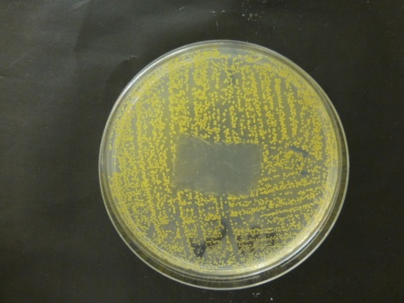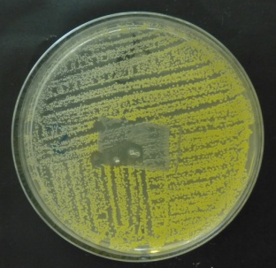
1 Wt. % Ag + H₂O, Staphylococcus aureus
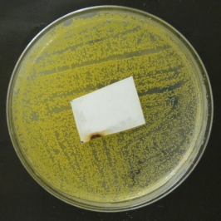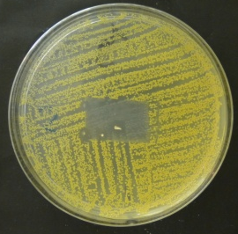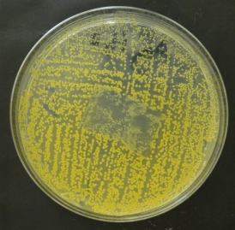

1 Wt. % Ag, Pseudomonas aeruginosa
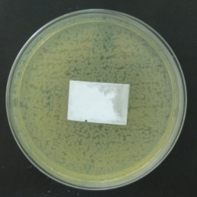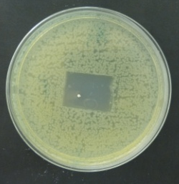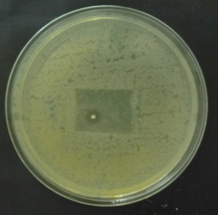
1 Wt. % Ag + H₂O, Pseudomonas aeruginosa
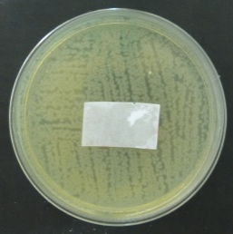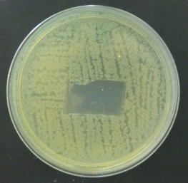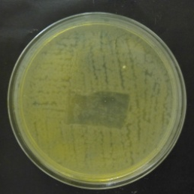
Figure 6.7: Left; wound dressing is applied and incubated at 37^{O}C for 24hr. Middle; PDMS membrane removal. Right; bacterial re-growth after 24hr re-incubation.

Figure 6.7 shows that membranes without Ag promote the growth of microorganisms. The sample with highest efficacy visually is PDMS(5,000):5PNVP, PDMS(10,000):2.15PNVP and PDMS(20,000):2.4PNVP , respectively. The control membranes containing Ag but excluding PDMS-g-PNVP copolymer showed efficacy towards both species of bacteria, this is due to these membrane depositing clumps of Ag upon removal of the dressing before the 24hr re-incubation, as these membranes contain Ag only at the surface.

6.1.2.2 Antimicrobial activity test ISO22196 - Fluid efficacy

6.1.2.2.1 2.5 Wt. % Silver loading
Antimicrobial activity tests were performed as stated in the experimental section using modified membranes containing 2.5Wt% PDMS(5,000):5PNVP, PDMS(10,000):2.15PNVP or PDMS(20,000):2.4PNVP and 2.5 Wt. % Ag, for reasons described previously. All tests were performed as stated in the ISO22196 standard protocol explained in the experimental section. The results are shown in figure 6.8.
***
**
***
***
Figure 6.8: The initial inoculation of bacteria is shown on the left in black with the corresponding 24hr incubation without challenge control shown adjacent in white. The P value for the column factor (treatment) was 0.0002.
After initial inoculation the control sample which contains no PDMS-g-PNVP copolymer or Ag shows a 2 log increase in CFU after a 24hr incubation period. This confirms that the bacteria being used are proliferating at a normal rate. After incubation with the three modified membrane compositions (PDMS(5,000):5PNVP, PDMS(10,000):2.15PNVP and PDMS(20,000):2.4PNVP ) the proliferation of these bacteria was halted and the bacteria begin to die. PDMS(20,000):2.4PNVP was the only composition tested to reduce bacteria burden by a single log, this correlates with what was observed previously in CZOI experiments where it was also least effective. Modified membranes containing PDMS(5,000):5PNVP and PDMS(10,000):2.15PNVP performed almost identically, >10¹ log CFU of Pseudomonas aeruginosa and a 3 log reduction of Staphylococcus aureus detected. These results confirm that these systems are much more effective at delivering a given antimicrobial in the presence of a liquid interface as predicted.

6.1.2.2.2 1.25 Wt. % Silver and 1.25 Wt. % Iodine loading
***
**
***
***
Figure 6.9: The initial inoculation of bacteria is shown on the left in black and control is shown adjacent to this in white. All modified membranes were tested against both Staphylococcus aureus and Pseudomonas aeruginosa. The P value for the column factor (treatment) was 0.0005.
After initial inoculation the control sample which contains no PDMS-g-PNVP copolymer or Ag shows a 2 log increase in CFU after a 24hr incubation period. This confirms that the bacteria being used are proliferating at a normal rate. After incubation with the three modified membranes (PDMS(5,000):5PNVP, PDMS(10,000):2.15PNVP or PDMS(20,000):2.4PNVP ) the proliferation of these bacteria was halted and the bacteria begin to die. PDMS(20,000):2.4PNVP was shown to reduce Staphylococcus aureus by a single log and a two log reduction in Pseudomonas aeruginosa. Modified membranes containing PDMS(5,000):5PNVP and PDMS(10,000):2.15PNVP performed almost identically, >10¹ log CFU of Pseudomonas aeruginosa and a 5 log reduction in Staphylococcus aureus were detected. These results collectively suggest the system is delivering the given antimicrobials in the presence of a liquid interface.

6.2 Conclusion
Release of silver was determined using a gravimetric approach; it was shown that modified membranes would release Ag into solution. PDMS(5,000):5PNVP, PDMS(10,000):2.15PNVP and PDMS(20,000):2.4PNVP were shown to release the highest amount of Ag over a five day period, so were used in antimicrobial studies. Combing silver with Iodine (1.25 Wt. % each) caused silver release to decrease below what was observed initially from modified membranes containing silver alone. This is due to silver complexing with iodine to form an insoluble silver iodate complex.
CZOI experiments were initially performed to determine the bactericidal activity of modified membranes. The data showed that this system only released a given substrate in direct contact with fluid. As an influx of fluid within the modified membrane allows for a channel of release.
ISO22186 bacterial fluid efficacy tests showed that PDMS(5,000):5PNVP was the most effective at reducing bacterial burden of both pseudomonas aeruginosa and Staphylococcus aureus regardless of antimicrobial loaded. A multifactorial approach to tackling bacterial burden was shown to be superior with silver and iodine loaded modified membranes outperforming silver only loaded modified membranes.

Chapter 7

Objectives

1. Perform cytotoxicity assays; alamar blue, Picogreen and Lactose dehydragenase to evaluate cytotoxicity of membranes on human dermal fibroblast (HDF) cells.

2. Evaluate effect on morphology of HDF cells after exposure to modified membranes.

3. Determine if HDF cells contain bacterial infection after exposure to modified membranes.

7.1 Results and discussion

7.1.1 Cytotoxicity tests

7.1.1.1 Alamar blue assay (metabolic activity)
Alamar blue was used to evaluate the metabolic activity of a population of cells using a fluorometric/colorimetric indicator. The reducing environment of cells causes the reduction of resazurin to resorufin as shown in Figure 7.1.
Figure 7.1: The principle reaction observed in alamar blue assays, reduction of resazurin to resorufin.
This results in colorimetric (absorbance) and fluorescence changes. Resazurin is blue and non-fluorescent whereas resorufin is red and highly fluorescent. This can be related to the cytotoxicity of a test substance presented to a population of cells when compared to cells which have not been treated. Assays were performed by seeding 2,000 human dermal fibroblast (HDF) cells and presented with the substrate in two different ways.
Firstly, modified membranes were placed suspended above HDF cells in media (Indirect contact). Secondly modified membranes were placed directly on top of HDF cells (direct contact). HDF Cells with and without membrane exposure were incubated (5% CO₂, 90% humidity, 37ºC) for 48hrs prior to testing, results are shown in figures 7.2 and 7.3. Cytotoxicity was calculated using the % reduction of alamar blue of control HDF cells compared with treated cells, using the following equation;
$$\frac{λ\text{2 }Aλ\text{1 }- λ\text{1 }Aλ\text{2}}{λ\text{2 }Åλ\text{1 }- λ\text{1 }Åλ\text{2}}\text{= Cytotoxicity}$$
A = Absorbance of test well
Å = Absorbance of positive control
λ₁ = observed at 570nm
λ₂ = Observed at 600nm

****
****
****
Figure 7.2: HDF percentage survival of treated cells compared with untreated cells in direct contact with membranes, calculated using alamar blue assay. Legend; black without copolymer, white with copolymer, dark grey copolymer with Ag, grey copolymer with Ag and I₂
****
**
***
****
****
Figure 7.3: HDF percentage survival of treated cells compared with untreated cells in indirect contact with membranes, calculated using alamar blue assay. Legend; black without copolymer, white with copolymer, dark grey copolymer with Ag, grey copolymer with Ag and I_{2.}
Figure 7.2 (direct contact) shows that membranes containing no PDMS-g-PNVP copolymer are more cytotoxic than PDMS(5,000):5PNVP and PDMS(10,000):2.15PNVP modified membranes. This could be due the PDMS-g-PNVP copolymer containing PVP homopolymer which has been previously shown to have little inhibitory effect on proliferation or cell growth ²⁸³. PDMS(20,000):2.4PNVP did not have this effect due to the reduction in PVP homopolymer present within this sample.
There is a reduction in cell viability obtained when HDF cells were exposed to antimicrobial agents. Furthermore, this cytotoxic effect increased when the substrate was in direct contact with cells. To obtain the number of cells a calibration curve was used by a rearrangement of the equation of a straight line. The linear calibration is shown in figure 7.4.
Figure 7.4: Calibration curve showing the reduction of alamar blue as a dependency of cell seeding density.
The calibration curve shown in figure 10.4 was performed by counting HDF cells prior to loading into a 96well plate using a haemocytometer and trypan blue stain. Rearrangement of the equation: $Y=Mx+C$ to $X=\frac{Y}{M}-C$ allow for the previous data to be converted to the number of cells, shown in figures 10.5 and 10.6.
Figure 7.5: Comparison between the numbers of treated cells to untreated positive growth in direct contact, calculated using alamar blue assay and experimental calibration curve.

Figure 7.6: Comparison between the numbers of treated cells to untreated positive growth indirect contact, calculated using alamar blue assay and experimental calibration curve.
Figures 7.2 and 7.3 coincide with figures 7.5 and 7.6 as it is the same data presented. The membranes without PDMS-g-PNVP copolymer have a lower cell number when compared to modified membranes PDMS(5,000):5PNVP and PDMS(10,000):2.15PNVP Wt.%. PDMS(20,000):2.4PNVP was shown to have a lower cell number for reasons discussed previously. A reduction in cell number was seen when exposing the cells to antimicrobial agents. This effect increased when the substrate was in direct contact with cells.

7.1.1.2 Picogreen assay (cell proliferation)
The Picogreen® dye is a fluorescent nucleic acid stain for quantifying double-stranded DNA (dsDNA), it can be used to measure the proliferation capacity of cells and it can also be used to evaluate the cytotoxicity of various substrates on a population of cells compared with non-treated cells.
As with the alamar blue assay, the assay was performed by seeding 2,000 HDF cells and presented with the membranes in two different ways. Membranes were placed suspended above the cells (Indirect contact). Secondly membranes were placed directly on top of cells (direct contact). Cells with and without membranes were incubated (5% CO₂, 90% humidity, 37ºC) for 48hrs prior to mechanical lysis and dsDNA testing. Results are shown in figures 7.8 and 7.9 were calculated using the standard curve provided with the assay shown in figure 7.7.

Figure 7.7: Linear regression fit of the DNA standards provided in the Picogreen assay kit.
***
***
***
Figure 7.8: Comparison of untreated HDF cells to treated HDF cells in direct contact with membranes, calculated using Picogreen assay.
***
****
***
****
***
****
Figure 7.9: Comparison of untreated HDF cells to treated HDF cells in indirect contact with membranes, calculated using Picogreen assay.
HDF cell numbers reduced when treated with membranes in direct contact or in indirect contact when compared to untreated cells. Furthermore, membranes in direct contact were more cytotoxic when compared to indirect. The proliferative capacity of cells was not increased when presented with any modified membrane composition, while the metabolic activity was, determined by the alamar blue assay. This is most likely due to cells suffering a small amount of stress due to the low concentration of graft copolymer coming into contact with them. This causes an increase in metabolic activity as observed during the alamar blue assay ²⁹³.

7.1.1.3 LDH (Lactose dehydragenase) Cytotoxicity Assay
Cell death or cytotoxicity is classically evaluated by the quantification of plasma membrane damage. Lactate dehydragenase (LDH) is a stable enzyme, present in all cell types, and is rapidly released into cell culture medium upon damage of the plasma membrane. LDH is therefore the most widely used marker in cytotoxicity studies, thus this study would be incomplete without it. The cytotoxicity was determined using the equation 7.1, where the low control is cells in media and the high control is cells placed in a 10% cell lysis solution.
$\text{Cytotoxicity }\left(\text{\%}\right)\text{=}\frac{\text{(Test sample-Low control)}}{\text{(High control-Low control)}}$ X 100
Equation 7.1: Determination of cytotoxicity of modified membranes on HDF's using the LDH assay
As with the previous cytotoxicity experiments the assay was performed by seeding 2,000 HDF cells and presenting the substrate in two different ways. Membranes were placed suspended above cells (Indirect contact). Second; membranes were placed directly on top of cells (direct contact). Cells with and without membranes were incubated (5% CO₂, 90% humidity, 37ºC) for 48hrs prior to testing. Results are shown in figures 7.10 and 7.11.
*
**
***
*
**
***
*
**
***
Figure 7.10: Comparison of % cytotoxicity of untreated HDF cells with treated cells in direct contact with membranes, calculated using LDH assay. Legend; black positive control, white membrane without copolymer, light grey membrane and copolymer, grey membrane and copolymer with Ag, dark grey membrane and copolymer with Ag and I₂.
***
**
***
***
Figure 7.11: Comparison of % cytotoxicity of untreated HDF cells with treated cells in indirect contact with membranes, calculated using LDH assay. Legend; black positive control, white membrane without copolymer, light grey membrane and copolymer, grey membrane and copolymer with Ag, dark grey membrane and copolymer with Ag and I₂.
HDF cells that were treated with membranes in direct contact were less viable than cells treated in indirect contact. The cells treated with modified membranes containing PDMS(5,000):5PNVP and PDMS(10,000):2.15PNVP compositions without antimicrobials were shown to have no inhibitory effect of cells.
Modified membranes containing iodine were in a state of PVP-I, due to the large amount of PVP in the composition. Although this is less toxic than elemental iodine, it is still has a detrimental effect on cell viability shown in all cytotoxicity experiments performed ²⁹⁴.
Silver ions are biologically active and readily interact with proteins, amino acid residues, free anions and receptors of eukaryotic cell membranes and are renowned for being cytotoxic, which is shown in the cytotoxicity experiments presented here ²⁹⁵. Combining I₂ and Ag caused a more potent effect on cell viability. This is due to these antimicrobials having different modes of action resulting in a multifactorial attack on HDF cells biological pathways ²⁹⁶.

7.1.2 Cell staining

7.1.2.1 DAPI and Phalloidin

Phalloidin is a seven amino acid peptide toxin from the mushroom Amanita phalloides, which binds specifically and with high affinity (Kd 20 nM) to the polymerized form of actin (F-actin). Phalloidin has been labelled with a proprietary far-red fluorescent dye which allows it to be used to stain actin filaments in tissue cultured cells. DAPI (4',6-diamidino-2-phenylindole) is a fluorescent stain that binds strongly to A-T rich regions in DNA. It is used extensively in fluorescence microscopy. As DAPI can pass through an intact cell membrane, it can be used to stain both live and fixed cells, though it passes through the membrane less efficiently in live cells.
HDF cells were presented against each modified membrane composition, stained and then imaged to see the effects on morphological changes in shape of actin filaments and the nucleus. Indirect and direct contact methods were performed on HDF cells, photographic images are shown in figure 7.12.

7.1.2.1.1 Indirect contact
Controls
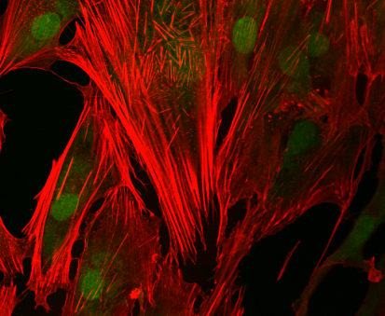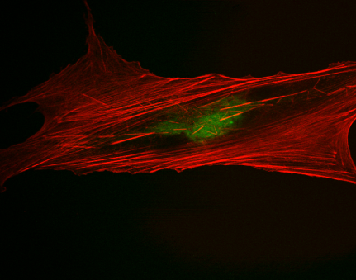
50µm
20µm
Cells only PDMS only
PDMS(5,000):5PNVP
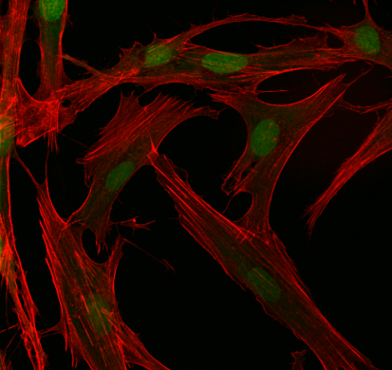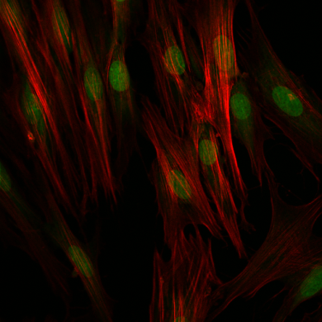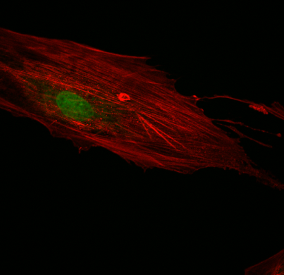
20µm
50µm
50µm
PDMS(5,000):5PNVP 1a + Ag 1a + Ag + I₂
PDMS(10,000):2.15PNVP
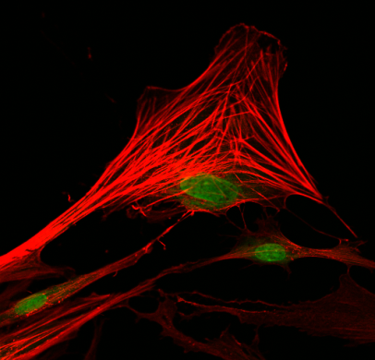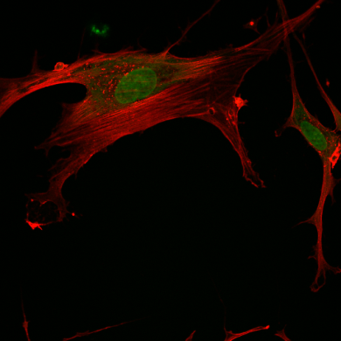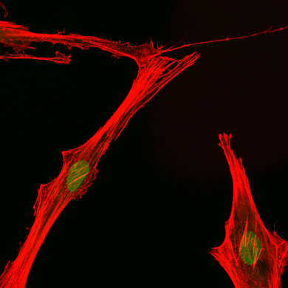
20µm
50µm
20µm
PDMS1:202a 2a + Ag 2a + Ag + I₂

PDMS(20,000):2.4PNVP
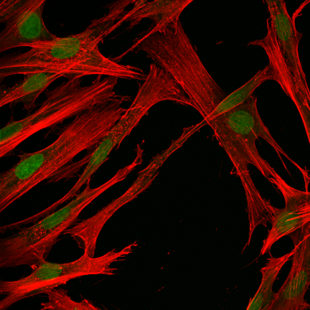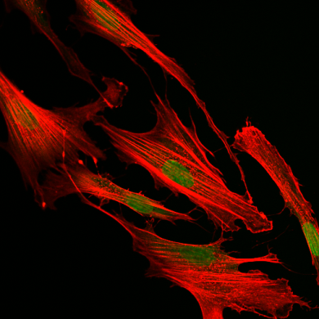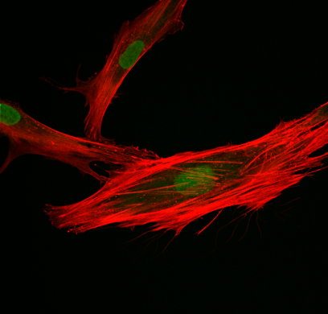
50µm
50µm
50µm
PDMS1:403c 3c + Ag 3c + Ag + I₂

7.1.2.1.2 Direct contact
Controls
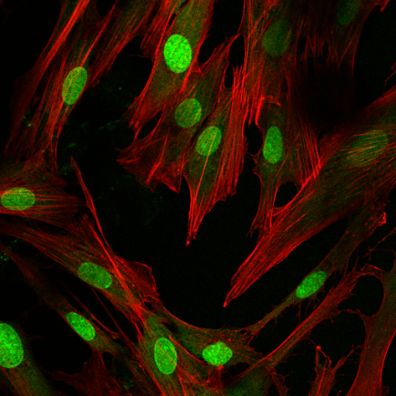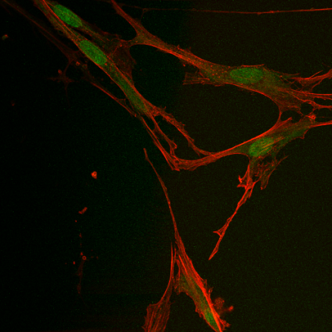
50µm
50µm
Control cells only PDMS only
PDMS(5,000):5PNVP
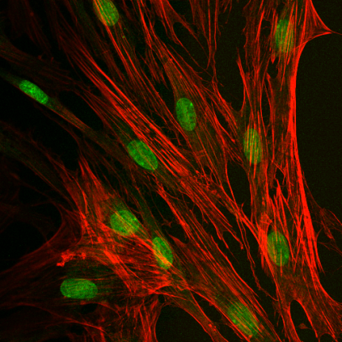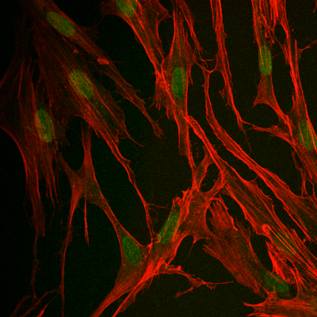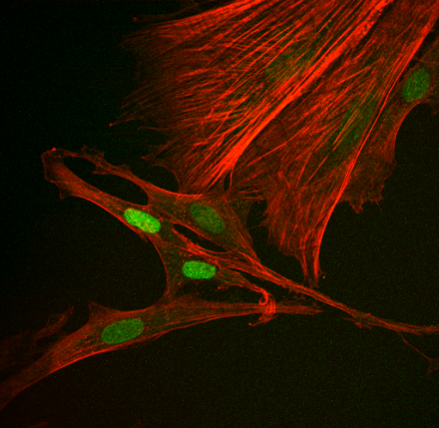
50µm
50µm
50µm
PDMS1:101a 1a + Ag 1a + Ag + I₂
PDMS(10,000):2.15PNVP
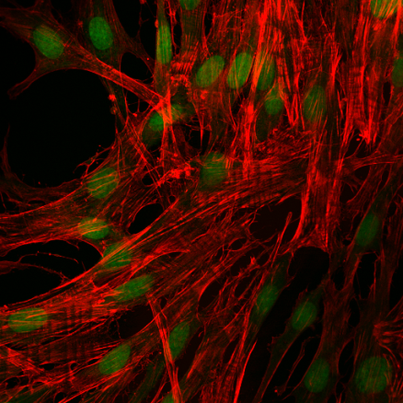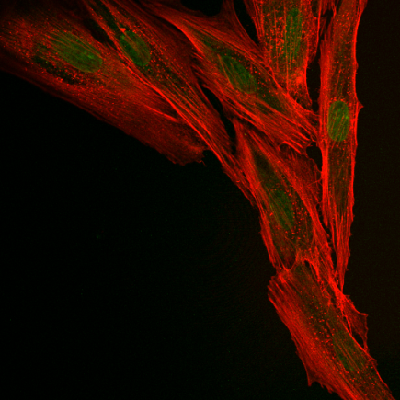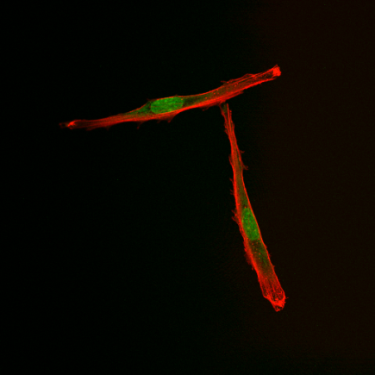
50µm
50µm
50µm
PDMS1:202a 2a + Ag 2a + Ag + I₂

PDMS(20,000):2.4PNVP
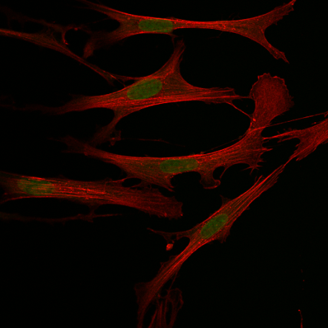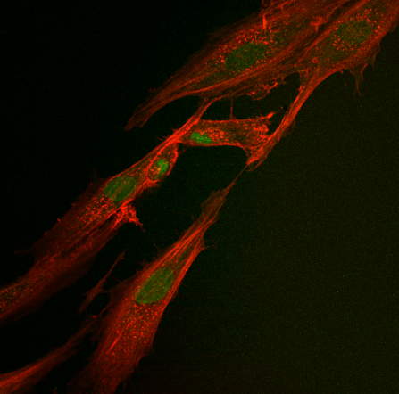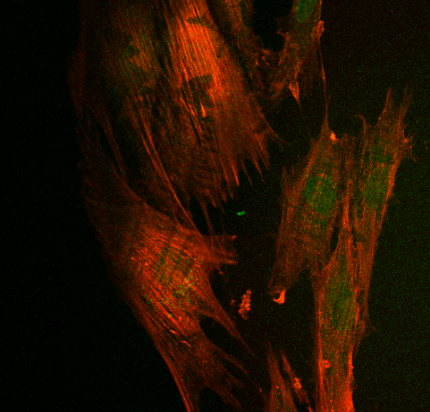
50µm
50µm
50µm
PDMS1:40 3c 3c + Ag 3c + Ag +I₂
Figure 7.13: Confocal microscopy images of Human dermal fibroblasts stained with DAPI and Phalloidin. Images were taken after exposure of PDMS membranes to antimicrobial agents in both indirect and direct contact.
The photographic images shown in Figure 7.13 showed that HDFs exposed to antimicrobials reduced the amount of cells available for imaging. This was amplified when visualising HDFs treated with modified membranes in direct contact opposed to indirect contact. These results coincide with cytotoxicity experiment. Membranes containing no graft copolymer were seen to have a negative effect on cell numbers than modified membrane compositions containing no antimicrobials, coinciding with what was observed during cytotoxicity testing.
Abnormal morphological changes were not observed from any images taken of HDF cells regardless of membrane composition exposure.

7.1.2.2 Giemsa staining
HDFs were stained with a giemsa stain after exposure to membranes in both direct and indirect contact, as explained previously. Giemsa stain is a differential stain (differential Staining is a staining process which uses more than one chemical stain. Using multiple stains can better differentiate between different microorganisms), when combined with Wright stain to form Wright-Giemsa stain. It differentially stains human and bacterial cells purple and pink, respectively. The stain in this case has been used to evaluate whether the cells have any parasitic or bacterial infection when treated under the same conditions used for DAPI and Phalloidin staining, a full description of the procedure is given in the experimental section. Photographic images are shown in figure 10.14.

7.1.2.2.1 Direct contact
PDMS(5,000):5PNVP
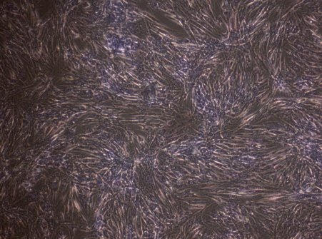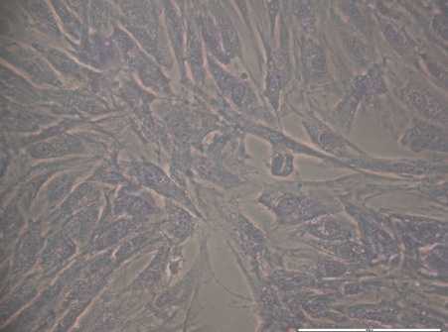 Copolymer Copolymer + Ag
200µm
100µm
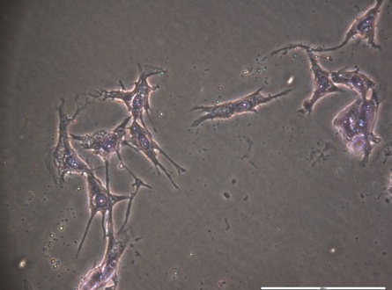
50µm
Copolymer + Ag + I₂

PDMS(10,000):2.15PNVP
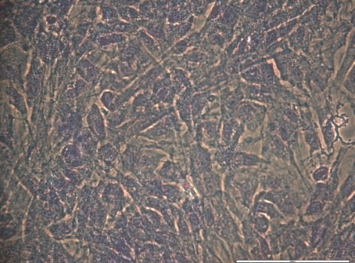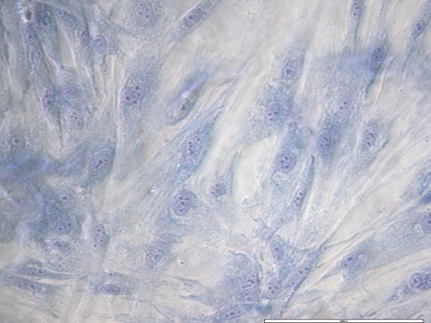
50µm
100µm
Copolymer Copolymer + Ag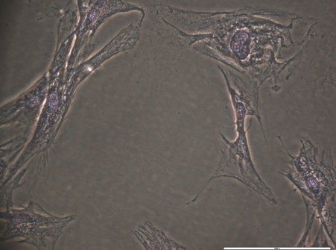
50µm
Copolymer + Ag + I₂

PDMS(20,000):2.4PNVP
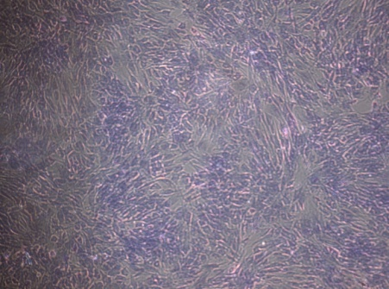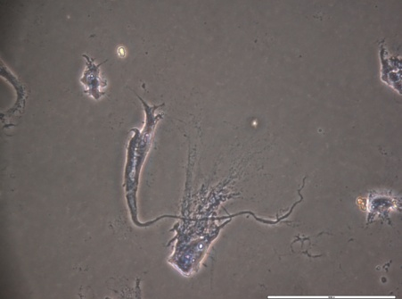 Copolymer Copolymer + Ag
200µm
50µm
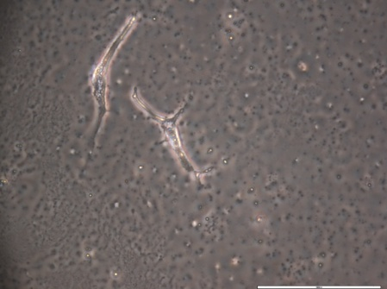
50µm
Copolymer + Ag + I₂
Cells alone
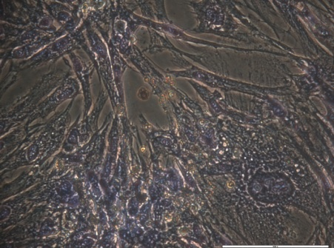
50µm

7.1.2.2.2 Indirect contact
PDMS(5,000):5PNVP
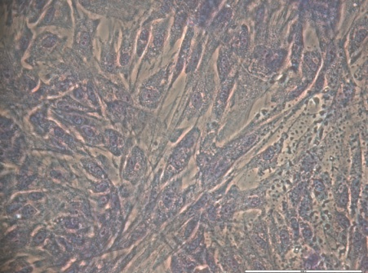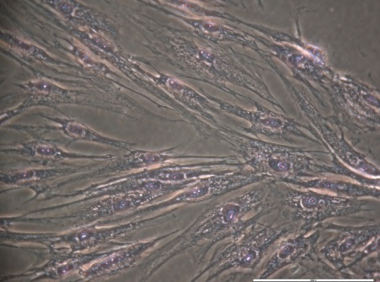
50µm
50µm
Copolymer Copolymer + Ag
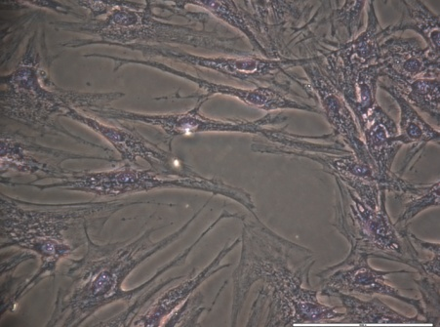
50µm
Copolymer + Ag + I₂

PDMS(10,000):2.15PNVP
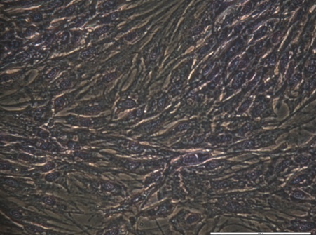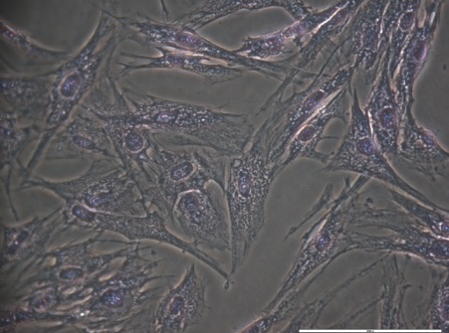
50µm
50µm
Copolymer Copolymer + Ag
50µm
Copolymer + Ag + I₂

PDMS(20,000):2.4PNVP
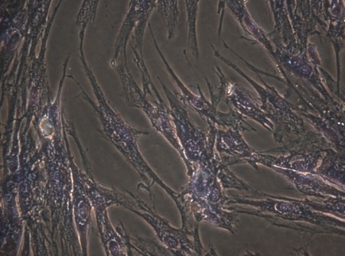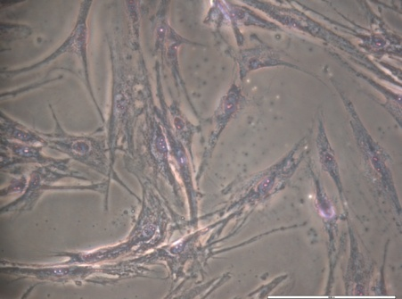 Copolymer Copolymer + Ag
50µm
50µm
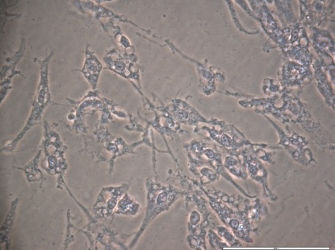
100µm
Copolymer + Ag + I₂
Cells alone
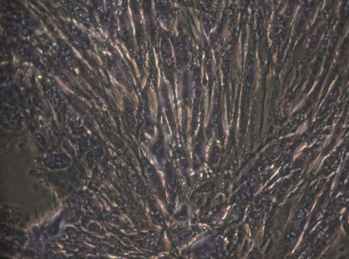
100µm
Figure 7.14: Photographic images of HDF's stained with Giemsa. Images were taken after HDF cells were exposed to membrane compositions in both indirect and direct contact.

The number of cells available for visualisation is decreased when HDF were exposed to antimicrobials. An unexpected morphology was observed for direct contact PDMS(20,000):2.4PNVP + Ag + I₂ which was not observed during confocal microscopy. It is known that Ag nano particles induce apoptosis via their interactions with the cell membrane and induce a large amount of oxidative stress ²⁹⁷. It is therefore plausible that ionic silver is behaving in a similar manner creating these abnormalities.

7.2 Conclusion
All cytotoxicity tests performed showed that the inclusion of antimicrobial agents into modified membranes increased the cytotoxicity towards HDFs. This effect was amplified when HDFs were in direct contact with membranes. It has also been shown that modified membranes excluding antimicrobial agents were less cytotoxic than UN modified membranes. One reason to explain this is that the crosslinking agent typically used in silicones is peroxide agents; the addition of graft copolymer compositions could lower the unreacted peroxide within membranes. Thus, reducing the cytotoxicity.
Cell staining studies coincided with cytotoxicity tests with the number of cells being available for visualisation decreasing with the introduction of antimicrobials to modified membranes. Furthermore, this effect was amplified when membranes were in direct contact with the cells.
Cell morphology remained un-changed throughout exposure to antimicrobial agents, with a single exception being observed: direct contact PDMS(20,000):2.4PNVP Ag and Ag + I₂. The cell membrane visually looked impaired and abnormal upon comparison with other tested cells. Giemsa staining showed that there was no bacterial infection in the HDF cell populations affecting cytotoxicity results.

8. Overall conclusions
PDMS macromonomers were successfully synthesised using ROAP of hexamethylcyclotrisiloxane and were functionalised with allyl chloroformate, allowing for graft copolymerisation with NVP. ¹H NMR and ATRFT IR showed appropriate peaks corresponding with a PDMS macromonomer. ¹H NMR and MALDI TOF were used to show a %Fn of >70% typically. SEC coincided with DOSY spectra showing an increase in average molar mass of PDMS macromonomers. The vinyl chloroformate was found to be inadequate for functionalisation of PDMS macromonomers, producing a low % of chain ends being functionalised. Furthermore, a bimodal average molar mass distribution was produced due to side reaction. The vinyl alcohol leaving group formed during this side reaction can tautomerise into acetylaldehyde which is volatile at room temperature. Thus, driving the reaction.
The properties due to the decrease in flexibility that the vinyl capping agent would cause between the two chain segments (PDMS-g-PNVP) could therefore not be analysed. However, the use of multiple capping agents was vital to determine the most appropriate for industrial translation.
Free radical polymerisation of functionalised PDMS macromonomers with NVP produced yields between 20- 30 Wt. %. GPEC analysis showed a mixture of un-reacted PDMS macromonomer; PVP homopolymer; and PDMS-g-PNVP copolymer present. The ratio of NVP to PDMS within graft copolymers was determined using ICP-MS and elemental analysis, showing that the molar feed ratios and experimental ratios varied. This variation between molar feed ratios and experimental is due to the difference in reactivity ratios of the allyl functional group of the PDMS macromonomer and the allyl functional group of NVP, this also can explain the presence of PNVP homopolymer. DSC analysis showed that as the NVP content of grafts is increased the Tg also increased, following current literature findings.
As the NVP component of grafts is increased, particle size analysis showed the size of the particles formed also increased in organic solution and decreased in aqueous solvent as a direct effect of unfavourable or favourable solvent interactions respectively. PDMS macromonomer size was shown to have little effect on particle size due to the relatively small segment size compared to the PNVP segment. TEM images showed clear particulates being formed with varying size and morphology with sizes of these particulates being similar in size to those obtained from particle size analysis.
PDMS membranes provided by Scapa healthcare™ were modified with PDMS-g-PNVP copolymers. SEM images showed changes in surface morphology, with increasing protrusions being present at the surface as concentrations of grafts were increased. A maximum saturation point of ~ 5 Wt. % concentrations was observed. Increasing concentrations was also found to decrease adhesive properties of modified membranes compared to non-modified membranes. Adhesive properties required for wound dressings have already being well defined this was seen as a detrimental effect on performance. The MVTR was shown to increase up to three fold in some modified membrane compositions with moisture being able to now travel through hydrophilic channels now incorporated throughout the membranes from the introduction of the PNVP segments. The hydrophilicity of the surface of modified membranes also increased again with a maximum saturation point of ~ 5 Wt. % concentrations being observed. This increase in MVTR allows for the material to be used in heavy exudating wounds. Furthermore, this allows for the material to be tailored to specific wound requirements by varying the amount of PDMS-g-PNVP present.
A hydrophilic fluorescent agent (Rhodamine B) was loaded into modified membranes. Confocal microscopy confirmed that Rhodamine B was incorporated throughout modified membranes. Inclusion of Fluorescein O-acrylate into PDMS-g-PNVP copolymer backbones allowed for the location of grafts within modified membranes to be determined. Confocal microscopic images showed that Rhodamine B accumulated in regions with PDMS-g-PNVP copolymers, suggesting that the hydrophilic agent was stabilised within a hydrophobic environment by the amphiphilic grafts. PDMS-g-PNVP copolymers were found to be dispersed throughout the modified membranes, suggesting an SIPN formation. An SIPN formation is required for a steady release of a substrate from modified membranes providing hydrophilic routes for substrates to flow from.
Release studies on Rhodamine B produced a large library of release profiles, release profiles of Rhodamine B were also seen to be composition dependent. With scope to again tailor release dependent on the requirements of application. The use of Peppas power relationship was used to examine the release kinetics of modified membranes. Using this power relationship showed that modified membranes showed both Fickian behaviour and non Fickian behaviour depending on the composition used. The optimum concentration: taking into account the maximum release of Rhodamine B; the rate of release; and manufacturing cost was deemed to be 2.5 Wt. % graft copolymer for any composition used.
Successful release using Rhodamine B allowed for subsequent loading of antimicrobial agents. Silver was loaded into modified membranes and was shown to release from PDMS(5,000):5PNVP, PDMS(10,000):2.15PNVP and PDMS(20,000):2.4PNVP compositions only. The loading of both silver and Iodine into modified membranes was shown to reduce silver release below what was seen in silver only loaded modified membranes. This is due to silver complexing with iodine to form an insoluble silver iodate complex, thus is unable to release out of modified membranes. Although less silver was released due to the presence of multiple antimicrobial agents these compositions antibacterial effects were subsequently analysed.
Clear zone of inhibition experiments showed no antimicrobial release. Thus, antimicrobial release from modified membranes requires the system to be in direct contact with a liquid. An influx of fluid within the membrane allows for a channel of release for antimicrobials. This suggests that the influx of fluid expands the hydrophilic channels which are collapsed prior to submergence. Furthermore, ISO22186 bacterial fluid efficacy tests performed confirmed this, with PDMS(5,000):5PNVP showing the most effective kill of both pseudomonas aeruginosa and Staphylococcus aureus regardless of antimicrobial loaded. Combining silver and iodine was shown to increase efficacy over silver loaded modified membranes regardless of the reduction in antimicrobials being delivered.
All cytotoxicity tests performed concluded that the inclusion of antimicrobial agents into modified membranes increased cytotoxicity towards HDF's. Furthermore, this effect was seen to increase when the HDF's were in direct contact with modified membranes.
Cell staining (DAPI and Phalloidin) and confocal imaging coincided with results of cytotoxicity tests performed. The number of viable cells available for imaging was shown too decreased when cells were exposed to modified membranes containing antimicrobials. Cell morphology remained intact for all HDF's imaged except: direct contact PDMS(20,000):2.4PNVP Ag and Ag + I₂, where the cell membrane was seen to be impaired and abnormal when compared to other treated cells. All cell populations were seen to be viable and free from bacterial infection as shown by giemsa staining.
In conclusion PDMS macromonomers were successfully functionalised and grafted to NVP to form a library of amphilic graft copolymers capable of creating an SIPN within a silicone membrane to successfully deliver antimicrobials whilst maintaining adhesive properties and increasing the MVTR of the membranes. The overall manufacturing process currently used in industry of these membranes has also been adopted. Thus, these modified membranes could potentially be made on mass with little change required to the current manufacturing process.

9. Future work
The ratio between graft copolymer and PVP homopolymer within compositions was seen to impact the overall mechanical properties and release characteristics of modified membranes. Varying this ratio by either the removal of PVP (via preparative HPLC) or addition of more PVP would have a significant effect, as significant differences were observed between graft copolymer compositions. Moreover, this formulation process would allow for 'fine tuning' of a graft copolymer composition for a specific use in industry i.e. fast release or a slow release with tailored adhesive characteristics.
Different amphiphilic graft copolymer compositions could have also been used. It is essential to retain the backbone as PDMS, as this allows for successful incorporation into PDMS membranes. However, the hydrophilic grafting moiety could be varied. Acrylated monomers that could be used to replace NVP include but is not limited to; N, N-Dimethylacrylamide, 2-hydroxyethylmethacrylate (HEMA), acrylamide (AAm), 2-Methoxyethyl acrylate (MEA).
The antimicrobials included (silver and iodine) in modified membranes were chosen as they were FDA approved and common in the market place. However in principle this could work on a variety of antimicrobial agents such as: Polyhexamethylene Biguanide (PHMB); Ethylenediaminetetraacetic acid (EDTA); Chlorhexidine (CHX); Quaternary ammonium compounds (QACs); Octenidine hydrochloride (OH); Benzalkonium chloride (BAC). Furthermore, as well as the incorporation of different antimicrobials agents testing the efficacy on a wider range of bacteria would also be beneficial to gain scope into the modified membranes efficacy. There are many species of bacteria (polymicrobial) from aerobes to anaerobes present within chronically infected wounds making up its etiology, including but not limited to: Escherichia coli, Meticillin Sensitive Staphylococcus aureus, Enterococcus fecalis, Peptostreptcoccus sp, Porphyromonas spp and Bacteroides fragilis.
Modified membranes tested in this report are functional and for industrial purpose. Therefore, aesthetics is an important consideration when producing a medical product to a consumer. The colour of modified membranes containing silver were grey, this has little appeal to the consumer and would cause a reduction in sales for Scapa healthcare™. Exploring other additives such as dyes to improve the aesthetics would also have been useful for industrial translation.

10. Experimental and materials

10.1 Materials
4, 4’-azobis (4-cyanovaleric acid) (ACVA, >98% Aldrich), methanol (Fisher), acetone (Fisher), diethyl ether (Fisher), chloroform (Fisher), dichloromethane (DVM, Fisher), Lithium isopropoxide solution 2.0 M in THF (Aldrich), allyl chloroformate (97% Aldrich), vinyl chloroformate (99% Aldrich) were obtained from the suppliers indicated.
Hexamethyltrisiloxane (99% Aldrich) was dried in a desiccator for 24 hr prior to use. N-vinylpyrrolidone (>97%) was distilled under reduced pressure to remove inhibitors present.
Tetrahydrofuran (THF) was obtained from the Grubbs dry solvent system.

10.2 Synthesis of functionalised PDMS macromonomer
PDMS functionalised macromonomers were prepared under a nitrogen atmosphere using living anionic polymerisation. For example, a solution of hexamethylcyclotrisiloxane (0.03 mol, 7 g) and lithium isopropoxide (3 mol %, 0.4 ml 2M solution in THF) in THF (10 ml) was injected into a pre-sealed glass tube. The solution was stirred at room temperature for 3 h and then allyl chloroformate (3 mol %) was injected into the solution. The reaction mixture was ultra-sonicated for 20 min and then stirred at room temperature for 24 h. The solvent was evaporated by rotary evaporation under reduced pressure and the liquid oligomer was dissolved in chloroform. The solution was washed several times with water and the organic layer collected. Chloroform was removed by rotary evaporation and the product was dried under vacuum at 40 ⁰C. Functionalised oligomers were then characterized by ¹H NMR, SEC and MALDI TOF mass spectrometry.
Vinyl PDMS Macromonomer: ¹H NMR: (400MHz, CDCl₃) δ/ppm: 0.15 (br, 3H, -CH₃), 1.25 (d, 3H, -CH₃), 4.1 (sep, 1H, CH), 4.25 (d, 2H, CH₂), 5.1 (d, 1H, C=CH), 5.3 (d, 1H C=CH), 5.9 (br, 1H, C=CH)
Allyl PDMS Macromonomer: ¹H NMR: (400MHz, CDCl₃) δ/ppm: 0.15 (br, 3H, -CH₃), 1.25 (d, 3H, -CH₃), 4.1 (sep, 1H, CH), 5.4 (d, 1H, C=CH), 5.9 (d, 1H C=CH)

10.3 Synthesis of PDMS-g-PNVP copolymer
N-vinylpyrrolidone (NVP), PDMS functionalised macromonomer, ACVA and THF were mixed together in the desired ratio until the solid initiator had dissolved. The resulting solution was pipetted into a 100 ml ampoule and placed on a high vacuum line. The solution was then frozen with liquid nitrogen and vacuum was applied until a steady vacuum was achieved (3x10⁻³ mBar typically) and then closed. The ampoule was defrosted with tepid water, once thawed this process was repeated until the ampoule was completely degassed. The ampoule was sealed using gas/oxygen blow torch and placed in a water bath at 60^{O}C for up to 24 hr to undergo polymerisation. The ampoule was opened by cracking and the product was removed via pipetting. The solvent was evaporated by rotary evaporation under reduced pressure and the product was precipitated and repeatedly washed with diethyl ether. This was removed by vacuum filtration obtaining a white powder which was vacuum dried for 24 hr. The resulting PDMS-g-PNVP copolymers were then characterized by ¹H NMR, ¹³C NMR, SEC, TGA, DSC, Elemental analysis, ICP-MS
¹H NMR (400MHz, CDCl₃) δ/ppm: 0.15 (s, 3H, -CH₃), 1.24 (br, 3H, -CH₃), 1.25 (br,CH₂CH₂), 1.9 (br, 2H, -NC(=O)CH₂CH₂CH₂)2.2 (br, 2H, -NC(=O)CH₂CH₂CH₂), 3.2 (br, 2H, -NC(=O)CH₂CH₂CH₂) 3.76 (q, 1H, -NCH-)
¹³C NMR (600MHz, CDCl₃, CPD) δ/ppm: 1 (1C, CH₃Si-R), 18 (1C, -CH₂CH₂CH₂C(=O)N-), 30 (1C, -CH₂CH₂CH₂C(=O)N-), 41 (1C, -CH₂CHN-) 43 (1C, -CH₂CHN-),44 (1C, -CH₂CH₂CH₂C(=O)N-), 176 (1C, -N(C=O)CH₂-)

10.3.1 Synthesis of PDMS-g-PNVP copolymer with fluorescein o-acrylate
PDMS functionalised macromonomers were reacted with N-vinylpyrrolidone in the same method as explained in section 13.3 with the addition of fluorescein o-acrylate at 1Wt. % of NVP added to the reaction mixture.

10.4 Synthesis of PDMS adhesive modified with PDMS-g-PNVP copolymer
Modified membranes were prepared by adding an amount PDMS-g-PNVP copolymer solution (table 7.1) to 5 g of component A. This was then stirred to create a homogenous mixture before adding 5 g of component B (provided by Scapa healthcare™). The viscous solution was drawn down using a K bar of 200µm and left in an oven at 70 ^{O}C for 15 minutes to cure. The same procedure was used to make unmodified membranes and modified membranes containing Rhodamine B, with Rhodamine B being added to the copolymer solution before addition of component A.

10.5 Culture of human dermal fibroblasts
Materials
Primary normal dermal fibroblasts (ATCC), Dulbecco‘s modified Eagle‘s medium (HEPES buffered, high glucose, + pyruvate, Life Technologies), fetal bovine serum (FBS; sterile filtered, non-USA origin, Sigma), penicillin-streptomycin (pen-strep; 10000μl, Life Technologies), trypsin-EDTA (0.25%, Life Technologies), trypan blue stain (Life Technologies).
Method
60 mL of DMEM was removed from the 500 mL bottle, and replaced with 50 mL FBS and 10 mL penicillin-streptomycin. The bottle was agitated before 9 mL of complete medium was removed and placed in a T75 cell culture flask. This aliquot of medium was warmed in the incubator for 30 minutes, whilst the remaining media was stored in the fridge for up to six weeks. After 30 minutes the cryopreserved cells were gently agitated in a water bath at 37°C for 1 minute, until the frozen plug broke inside the vial. The cells were then quickly transferred to the pre-prepared T75 and gently swirled to thaw completely. The cells were kept in the incubator at 5% CO₂, 37 °C for 24 hours, in order to adhere, before a complete media change was performed. Complete media changes were then performed every 2-3 days, with daily checks of cell health using phase contrast microscopy.

10.5.1 Passage of HDF
Materials
Trypsin 0.25% with EDTA 4Na (Invitrogen), Trypsin neutralize solution (Invitrogen), Sterile phosphate buffered saline (Invitrogen) and complete medium.
Method
Cells were passaged upon reaching 90% confluence determine by microscopy. Old medium was removed from the flask and the cells were washed with 10 ml of sterile phosphate buffered saline (PBS). 5ml of trypsin was added to the cells and the flask was agitated vigorously at room temperature. Optical microscopy was used to observe the detachment of cells, and when 90% complete detachment observed 5 ml of trypsin solution was added to the flask. The entire contents of the flask were then added to a sterile centrifuge tube and spun at 1500 rpm for 5 minutes. The supernatant was removed from the tube and the cells were re-suspended in a known amount of media. An appropriate amount of cell solution was then added to fresh, sterile T75 flasks and then serum-free media added to make a total 10 ml. The flasks were then placed in an incubator at 37C⁰, 5% CO₂.

10.5.2 Cryopreservation
Materials
Dimethyl sulfoxide (≥99.9% bio reagent, Sigma), Trypsin 0.25% EDTA 4Na (Invitrogen), Sterile phosphate buffered saline (Invitrogen) and Foetal bovine serum (Invitrogen).
Method
The CoolCell (Biocision) container was placed in a polystyrene container and surrounded with dry ice to cool down.
The cell freezing medium was prepared by adding10% DMSO in FBS.
The cells were washed with sterile PBS and trypsin was added as described above in the passage protocol. After removal of the supernatant after centrifugation, the cells were resuspended in freezing medium and placed in a cryovial with a density of ~1x10⁶ cells per ml. the cryovials were then promptly placed in the cooled CollCell (Biocision). After 24 hours the cryovials were removed and placed in canes within liquid nitrogen dewar at -196⁰C.

10.5.3 Thawing
The cryovial was removed from the liquid nitrogen container and it was thawed water bath at (37⁰C) for 2 minutes. The cryovial was rinsed thoroughly with 70% ethanol under a laminar flow, and then opened. The vial was then transferred to a cell culture flask that contained pre-warmed medium.

10.5.4 Cell counting
Materials
Haemocytometer, trypan blue, cells suspension and microscopy.
Method
Cell counts were performed by resuspending cells in a known volume of fibroblast culture media. 100μl of this cell solution and 100μl of the trypan blue stock solution were mixed to form a 1:1 solution. 10μl of this solution was then withdrawn and placed into the chamber of the Neubauer haemocytometer. Non-viable cells are stained blue by the trypan blue. Cells were visualised using a phase contrast microscope and viable cells counted.
The concentration of viable cells was determined by Equation 1.
Cells / ml = n x 2 x m x 10000
Equation 1: Determination of the cell concentration.
Where n = Number of viable cells counted and m = Volume of fibroblast culture media cells were resuspended in.
Cells were counted in the central square, 1.0mm² area as depicted below;
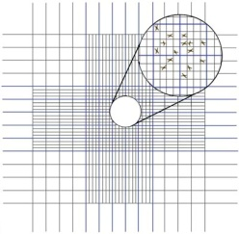

10.6 Cell staining
Cell culture media was removed and cells were washed once with PBS at room temperature. Cells were then fixed using formaldehyde and left to fixate for 20minutes. Following this cells were then permeabilized using TRITON X for 10minutes. Cells were then washed three times with PBS at RT for 30 s. Cells were fixed with formaldehyde and permeabilized prior to any exposure to dyes.

10.6.1 DAPI staining
5 mg/mL DAPI stock solution was made from 14.3 mM of dihydrochloride or 10.9 mM for the dilactate, the contents of one vial (10 mg) was dissolved in 2 mL of deionized water.

10.6.2 Phalloidin staining
A 100 nM working stock of Acti-stain™ 670 phalloidin was made by diluting 3.5 μl of 14 μM stock phalloidin into 500 μl of PBS.

10.6.3 Giemsa staining
Giemsa stock solution was purchased from Sigma Aldrich, this was then added to fixed cells and allowed to stain for 25minutes before washing with water several times to remove excess water.

10.7 Corrected Zone of inhibition (CZOI)
Under sterile conditions membrane samples were cut into 3 x 3cm² samples and a challenge Inoculum was then prepared by Disperse representative colonies of the chosen challenge organism in Maximum Recovery Diluent (MRD) to achieve a specific optical density (OD₅₅₀) equivalent to approximately 1x10⁸ cfu/ml. The solution was then diluted 1 in 10 in MRD until to a final population concentration of approximately 1x10⁶ cfu/ml was achieved. A total viable count (TVC) using the surface count method was then is performed to determine the number of viable organisms per millilitre Inoculation of test plates was performed using a sterile swab before addition to suspension onto Wilkins-Chalgren Agar plates. Plates were then incubated for 4 hours in an appropriate atmosphere (37^{O}C, 5% CO₂).
After the initial incubation, membrane samples were antiseptically transferred to the centre surface of an inoculated plate and pressed down lightly to ensure intimate contact with the agar. A negative control plate was also set up by placing a sample of gauze or the test sample without the antimicrobial in the centre of a previously inoculated plate. Plates were inoculated for a further 24hrs. CZOI was calculated as follows;
After digital callipers were used to determine the zones of inhibition Four measurements were taken A, B, C and D.
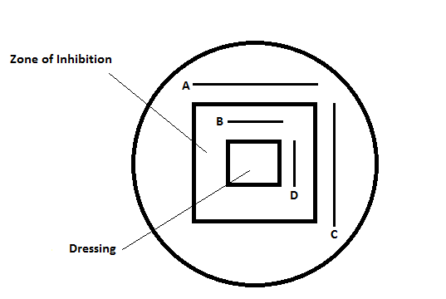
The zone of inhibition (ZOI) is determined by multiplying A by C. With the dressing size being determined by multiplying B by D. The corrected zone of inhibition (CZOI) can then be determined by subtracting the dressing size from the ZOI as shown below in equation x;

CZOI = (A x C) – (B x D)

10.8 Gravimetric method for quantifying silver release
3 by 3cm² squares of silver containing PDMS membranes were added to 5ml of ddH₂O and incubated at 37ºC for 48hrs. NaCl₂ was added to the solution causing the precipitation of Silver Chloride (AgCl), NaCl₂ was added until precipitate stopped forming. This precipitate is then filtered, dried, and it’s mass determined. From the mass of the AgCl, the mass of Ag in the Solution can be determined.

10.9 Antimicrobial ISO standard test ISO022196
Under aseptic conditions PDMS membrane samples were cut to 5 x 5cm² and transferred to a sterile Petri dish. 4 x 4cm² film samples were also cut and transferred to a sterile Petri dish so that every test sample has a film sample.
Challenge Inoculum was prepared by dispersing representative colonies of the chosen challenge organism in Tryptone Soya Broth (TSB) to achieve a specific optical density (OD₅₅₀) equivalent to approximately 1x10⁸ cfu/ml. This was then diluted to a final population concentration of approximately 6x10⁵ cfu/ml. A standard plate count (0hr) was then performed on this suspension to determine the number of viable organisms per millilitre.
Test materials were then Inoculated via pipetting 400µl volume of the challenge organism (approximately 6x10⁵ cfu/ml) onto each test sample, then by placing a film sample on top of each test sample so that the liquid spreads across the surface of the test sample. Negative controls were also prepared using non-antimicrobial sample. Test and control samples were then incubated at 35°C (±3°C) for 24 hours. Total Viable Counts (TVC’s) were then performed by firstly pipetting 10ml volumes of DE Neutralising Broth (DENB) into each test and control Petri dish. Secondly, microbial plate counts were made by making serial, ten-fold dilutions in DENB from the test/control Petri dish. Following this, 1ml/100µl volumes were dispensed onto duplicate Tryptone Soya Agar (TSA). Inoculum was then spread using L shaped spreaders and plates were then incubated at 35°C (±3°C) for 48 hrs.
Antimicrobial activity of test samples was measured by the log reduction compared to that of the control samples.

10.10 Alamar Blue Assay
HDF Cells were grown as described previously and seeded at 2,000 cells per well (6-well plate) in a volume of 2ml of Dulbecco's modified eagle medium (life technologies) and treated with various PDMS test samples in Indirect contact and direct contact via the use of crown insertions into 24 well plates. Control wells were also used with cells alone. These were then incubated for 48hrs (37ºC, 5% CO₂). After incubation cell crowns and test samples were removed and 100µl of cell solution were transferred to a 96 well plate reader. 1/10th volume of Alamar blue reagent (life technologies) was added to each well and samples were protected from light and incubated for four hours (37ºC, 5% CO₂), including alamar blue and media alone to use a negative control. Absorbance was then measured using a 96 well plate reader (570nm, 600nm as the reference). Cytotoxicity was calculated by the % reduction of alamar blue of control cells when compared with that of the treated cells, the following equation was used;
$$\frac{λ\text{2 }Aλ\text{1 }- λ\text{1 }Aλ\text{2}}{λ\text{2 }Åλ\text{1 }- λ\text{1 }Åλ\text{2}}\text{= Cytotoxicity}$$
A = Absorbance of test well
Å = Absorbance of positive control
λ₁ = 570nm
λ₂ = 600nm

10.11 Picogreen assay
HDF Cells were grown as described previously and seeded at 2,000 cells per well (6-well plate) in a volume of 2ml of Dulbecco's modified eagle medium (Life Technologies™) and treated with membranes in indirect contact and direct contact via the use of crown insertions into 6 well plates. Control wells were cells alone without exposure to membranes. Cells were then incubated for 48hrs (37ºC, 5% CO₂). After incubation cell crowns and test samples were removed and 100µl of cell solution were transferred to a 96 well plate reader. Quant-iT™ PicoGreen® reagent was then added to each test sample well, shaken and kept from sunlight. Sample fluorescence was measured using a 96 well plate reader (excitation 480 nm, emission 520 nm). The amount of dsDNA can then be calculated using the calibration curve provided.

10.12 Moisture vapour transfer rate (MVTR)
The flange of a Paddington cup was used as a template and three repeats of each test sample were cut. The base of three Paddington cups were clamped together and 20ml of deionised water added to each cup (sufficient to leave an air gap of 5mm between the liquid surface and the dressing sample). The dressing samples were then clamped onto the Paddington cups to ensure a water tight seal. Samples were then weighed and placed in an oven for 3hrs at 37^{O}C; samples were then weighed to calculate weight loss. This data was then extrapolated to gain the mass of water lost.

11. Equipment and instrumentation

11.1 ¹H and ¹³C NMR
All NMR spectra were recorded at ambient temperature on Bruker AV-250, AV-400 or DRX-500 at 250, 400 or 500MHz (64 scans averaged per spectrum). Samples of mass 20-40mg were dissolved in deuterated chloroform (CDCl₃) or alternative solvent system, filtered and placed in 7 mm NMR tubes.

11.2 MALDI TOF Mass Spectrometry
MALDI-MS spectrum was obtained by using Tof Spec-2E Spectrometer by using N₂ laser at 337 nm (pulse rate of 10 Hz) with positive polarity in the linear mode. The accelerating voltage was 20 kV. The applied pressure was 3.59×10⁻⁷ Torr. The sample was prepared by taking 20 mg of polymer dissolved in 0.5 ml THF. 2-[(2E)-3-(4-tert-Butylphenyl)-2-methylprop-2-enylidene] malononitrile (DCTB) was used as matrix (20 mgcm⁻³). 0.5 mg Sodium trifluroacetate was dissolved in 0.5 ml THF used as ionization promoter. Then after mixing them together at 1:1000:10 ratio 1 µl of this solution was applied to a Matrix plate. The matrix was dried and experiment was carried out.

11.3 Elemental Analysis
Elemental Analysis was performed on a Perkin-Elmer 2400 CHNS/O Series 2 Elemental Analyser. 5-10 mg of sample was combusted in the presence of excess oxygen and combustion reagent to form CO₂ and water. Levels of each element were detected using a thermal conductivity detection system.

11.4 Particle Sizing Analysis
Particle size analysis was carried out on a Brookhaven Instruments Corporation ZetaPALS Zeta Potential Analyser with the 90Plus/BI-MAS Multi Angle Particle Sizing Option. Samples were prepared at 0.5 % concentration (5 mgml⁻¹) by either dissolving directly in the required solvent or by using the solvent switch method. Polymer samples were dissolved in organic solvent (hexamethyldisiloxane) then ultrapure H₂O was added drop-wise to the stirring solutions. Samples were left to stir for several hours for the organic solvent to evaporate. 15 μl of sample was then added to 3 ml of 10 mmol KCl solution, sonicated for 20 seconds, filtered through a 1μm filter. Measurements were made at 25 °C unless otherwise stated. 10 analysis runs were made in triplicate for each sample.

11.5 Zeta Potential Measurements
Zeta potentials were measured on a Brookhaven Instruments Corporation ZetaPALS Zeta Potential Analyser. Samples were prepared in ultrapure H₂O using the same method as for particle size analysis. 15 μl of sample was added to 1.5 ml of 1 mmol KCl solution. Measurements were made at 25 °C in triplicate for each sample in 5 cycles of 2 minute runs

11.6 Size exclusion chromatography
Molecular weight and molecular weight distributions were measured relative to PMMA standards by GPC with PL gel mixed-B (10 µm particle size, 100-10⁶ Å pore size, effective MW ranges 10³ - 10⁶, 3x 30 cm + guard columns) (polymer laboratories UK) on an RI detector. The mobile phase was Chloroform (GPC grade) set to a flow rate of 1 ml min⁻¹. Sample concentration used was 2 mg ml⁻¹, filtered prior to injection. Samples were injected manually.

11.7 Freeze-pump-thaw Polymerisation
Ampoules were degassed on a high vacuum line equipped with a Pirani gauge.

11.8 Contact angle measurements
Contact angles were measured using a Rame-Hart goniometer by the sessile drop method. The sample stage was made level using a bulls-eye level; the sample was then placed on the stage. A water droplet (2 μl) was formed on the surface with a microliter syringe. The angle of the liquid-solid-gas/vapour interface was measure. Three measurements were taken for each sample in separate areas of the sample and the average value recorded.

11.9 UV/VIS spectrometer
A VARIAN CARY 50 Probe UV-visible spectrometer was used with a HAAKE K20 water bath set to 40ºC to conduct release experiments. The machine was set to scan every 15minutes for 48hours at a wavelength of 551nm. The machine was blanked before each loading and all release studies were conducted in a quartz cuvette.

11.10 Scanning electron microscopy (SEM)
Membranes were applied to an aluminium stub (0.5 inch diameter) using a carbonised sticky tab as an adhesive. The stub(s) were coated with gold using and Edwards S150b coater and viewed using a Philips XL-20 SEM at 20Kv.

11.11 Confocal microscopy
Images (512 x 512 x 182) were obtained using a Zeiss LSM 10Meta inverted confocal microscope and EC Plan-Neofluar 40x/1.30 oil DIC, with a pixel dwell time of 1.61µs.
Rhodamine B was excited using a 543 nm laser (31% transmission). All image analysis was performed using Zeiss LSM Image Browser.

11.12 Peel force - Adhesion tests
A Housefield Tensionometer was used with a 5 Newton load cell to conduct all peel tests. The test conditions were as follows for all tested materials; 19^{O}C, 55% humidity, 25mm width, 225mm peel length at a speed of 300mm/min with a start tension of 0.08N, with polycarbonate being used as the stationary phase. All data was recorded and analysed with QMat professional 5 series.

11.13 Gradient polymer elution chromatography (GPEC)
Both Normal and reverse phase GPEC analysis were performed using an LC-20ADXR Prominence pump and SIL-20AXR Prominence auto sampler with a CTO-10AS column oven set to 40^{O}C using analytical grade solvents with a Shimadza ELSD-LT detector with the data being analysed by LC Solution software 1.25. The machine was equilibrated for 1hr prior to use and a 5minute equilibrium period was done between each sample run to allow for solvent gradient to reach 100% of chosen solvent before the next run.

11.13.1 Normal phase
The gradient performed was as follows; Hexane 100% for 4minutes, up to 20% IPA over next 2minutes then hold for 4minutes, up to 40% IPA over next 2minutes and hold for 4minutes then increase the gradient to 100% IPA over the next 5minutes

11.13.2 Reverse phase
The column used for all reverse phase runs was a Nova-Pak silica 4µm 3.9x150mm cartridge. The gradient performed was as follows; IPA 100% for 4minutes, up to 20% Hexane over next 2minutes then hold for 4minutes, up to 40% Hexane over next 2minutes and hold for 4minutes then increase the gradient to 100% Hexane over the next 5minutes.

14.14 Thermogravimetric Analysis (TGA)
A Perkin Elmer TGA pyris 1 was used with the pan being supported via a “hangdown” position. With Pyris manager 11.1 software being used to collate data.

11.15 Differential Scanning Calorimetry (DSC)
A Perkin Elmer DSC pyris 1 was used, with Pyris manager 11.1 software being used to collate data.

11.16 Light microscope images
All light microscope images were obtained using an Olympus CX41 upright light microscope and visualised using Olympus Cell^B software.

11.17 Transmission electron microscopy (TEM)
Sodium periodate (4 g) was dissolved in deionized water (100 ml, 25^{O}C) and chilled. RuO₂-_{x}H₂0 (0.6 g) was added to the aqueous NaIO₄ solution. All of the black ruthenium dioxide powder dissolved, producing a stable yellow solution of RuO₄.
This yellow solution was then poured into the bottom of a sealable container and the parafilm with the grids was balanced above the solution (typically 11µl of the desired sample was allowed to dry on the grids previous to this). The container was then sealed and the fumes allowed to deposit the ruthenium onto the grids for 7 minutes.
TEM imaging was carried out using a Philips CM 100 instrument operating at 100 kV. Polymer samples dispersed in ultrapure H₂O as described above, or ethanol where stated, were prepared for TEM by adsorbing a 5 μl drop of sample onto a glow-discharged carbon-coated grid for 1 minute. The grid was blotted, washed with a drop of distilled water and blotted again. The grid was then washed in a drop of uranyl formate, blotted and then negatively stained by holding the grid in a drop of uranyl formate for 20 seconds.

11.18 Diffusion-Ordered NMR (DOSY)
20mg of sample were dissolved in 80µL CDCl₃. Diffusion-ordered NMR spectroscopy (DOSY, sometimes referred to as pulsed-field gradient or spin-echo NMR) experiments were performed on a Bruker Avance III 400 MHz spectrometer at 25±1°C, with a temperature stabilization time of at least 5 minutes. The samples were not spun. The gradient strength was increased linearly from 2% to 95% over 16 steps. The maximum gradient strength used was 0.535 T/m. Bipolar rectangular gradients were used with a duration of 2 ms and the gradient recovery delay was 200 µs. Diffusion times were between 0.5 and 1.0 s. The spectrum was phased and baseline corrected before 2D processing via Topspin 2.1.6 software (Bruker)

11.19 96 well plate reader
All absorbance and fluorescence experiments involving a 96 well plate were performed on an Infinite F50 TECAN plate reader and data was processed and analysed using megellan F50 v7.0 software.

11.20 ATR-FTIR (attenuated total reflection Fourier transform infrared spectroscopy)
All samples were placed without dilution on the crystal of Bruker ALPHA platinum - ATR and analysed using OPUS 7.5. The crystal was cleaned with methanol between sample loadings.

12. References
1. Sauer, R. O. (1944) Nomenclature of organosilicon compounds. J. Chem. Educ. 21: 303 – 305.
2. Goddard, D. E., James V. Gruber, V. J. Principles of Polymer Science and Technology in Cosmetics and Personal Care. Chapter 7: Silicones in Cosmetics pg 289 – 338.
3. Stern, S. A., Shah, V. M., Hardy, B. J. (2003) Structure-permeability relationships in silicone polymers. Journal of Polymer Science. 25: 1263–1298.
4. Bhattacharya, S. (2005) Studies on surface wettability of poly(dimethyl) siloxane (PDMS) and glass under oxygen-plasma treatment and correlation with bond strength. Journal of Microelectromechanical Systems. 14: 590 – 597.
5. Demrtine, M. L., Cussler, E. L. (2006) Predicting subjective spreadability, viscosity, and stickiness. 64: 976 – 982.
6. Jaques, L. B., Fidlar, E., Feldsted, E. T., MacDonald, A. G. Can. Med. Assoc. J. 1946, 55, 26.
7. Curtis, J. M., Colas, A. Dow. Corning. Silicone Biomaterials: History, Chemistry & Medical
Applications of Silicones, In Biomaterials Science, 2nd Edition; Ratner, B. D., Ed.; Elsevier: London,
UK, 2004, 80.
8. Leeper, H. M. Wright, R. M. Rubber Chem. Technol. 1983, 56 (3), 523.
9. Black, J. Biological Performance of Materials: Fundamentals of Biocompatibility, Marcel Dekker: New
York, 1992; 3-28.
10. Remes, A., Williams, D.F. Biomaterials 1992, 13 (11), 731.
11. Owen, M. J. Chemtech. 1981 11, 288. This article has been updated and republished in Chimie Nouvelle
2004, 85, 27.
12. Harmand, M. F. and Briquet, F. Biomaterials. 20 (17), 1561.
13. Silicone Adhesives in Healthcare Applications, Dow Corning technical paper, Form No. 52-1057-01.
14. Liu, J. C.; Tan, E. L.; Chiang, C. C.; Tojo, K.; Chien, Y. W. Drug Dev. Ind. Pharm. 1985, 11 (6-7),1373.
15. Etienne, A. S.T.P. Pharma. 1990, 6 (1), 33.
16. William R.; Sweet, Randall P.; Walters, Patrick A. Silicone-Based Sustained- and Controlled-
Release Drug Delivery Systems, Natl. SAMPE Symp. Exhib., (Proc.), 30 (Adv. Technol. Mater.
Processes), 1985, 490-8.
17. Moreau, J. C., Mazan, J., Leclerc, B., Avril, J. L., Couarraze, G. Optimization of a Silicone Polymer for
Drug Controlled Release. Congr. Int. Technol. Pharm., 6th, Volume 3, Assoc. Pharm. Galenique Ind.:
Chatenay Malabry, Fr. 1992; 323-32.
18. Williams, D. (1996) Silicon, silicone and silica: the importance of the right ending. Medical Device Technology January/February 1996, pages 7-11.
19. SCENIHR (Scientific Committee on Emerging and Newly Identified Health Risks), Safety of PIP Silicone Breast Implant, 1 February 2012.
20. W. Reppe. Polyvinylpyrolidone. Verlag Chemie, Weinheim. 1954.
21. Ushakov, S. N., Davidenkova, V. V., & Lushchik, V. V. (1961). The synthesis of vinylpyrrolidone. Russian Chemical Bulletin, 10(5), 831-833.
22. Sun, N., Wei, X., Wu, B., Chen, J., Lu, Y., & Wu, W. (2008). Enhanced dissolution of silymarin/polyvinylpyrrolidone solid dispersion pellets prepared by a one-step fluid-bed coating technique. Powder Technology,182(1), 72-80.
23. Stubberud, L., Arwidsson, H. G., Hjortsberg, V., & Graffner, C. (1996). Water-solid interactions. III. Effect of glass transition temperature, Tg, and processing on tensile strength of compacts of lactose and lactose/polyvinyl pyrrolidone. Pharmaceutical development and technology, 1(2), 195-204.
24. Jones, L., Evans, K., Sariri, R., Franklin, V., & Tighe, B. (1997). Lipid and protein deposition of N-vinyl pyrrolidone-containing group II and group IV frequent replacement contact lenses. Eye & Contact Lens, 23(2), 122-126.
25. Hsiao, C. N., & Huang, K. S. (2005). Synthesis, characterization, and applications of polyvinylpyrrolidone/SiO2 hybrid materials. Journal of applied polymer science, 96(5), 1936-1942.
26. Hugo WB. (1991). A brief history of heat and chemical preservation and disinfection. J Appl Bacteriol. 71, 9–18.
27. Richardson ML, Gangolli S. The dictionary of substances and their effects. Vol 5. Cambridge: The Royal Society of Chemistry, 1994:47.
28. Goodman, Id., y d Gilman. A,, "The Pharmacological Basis of Therapeutics, The Macmillan Co., N. Y., 1941, p. 844.
29. Lipsky BA, Hoey C. (2009). Topical antimicrobial therapy for treating chronic wounds. Clinical infectious diseases. 49(10), 1541-1549.
30. Kramer SA. (1999). Effect of povidone-iodine on wound healing: a review. Journal of Vascular Nursing. 17(1), 17-23.
31. Hampton S. (2008). Malodorous fungating wounds: how dressings alleviate symptoms. British Journal of Community Nursing, 13(6), S31-S38.
32. Burks RI. (1998). Povidone iodine solution in wound treatment. Phys. Ther. 78, 212-218.
33. Gordon J. (1993). Clinical significance of methicillin-sensitive and methicillin-resistant Staphylococcus aureus in UK hospitals and the relevance of povidone-iodine in their control. Postgrad. Med. J. 69, 106-116.)
34. Müller G, Hai DN, Kramer A. (2006). Lack of in vitro Genotoxicity of Povidone-Iodine in Solution, in Ointment or in a Liposomal Formulation (Repithel®). Dermatol. 212, 94-97.
35. Fumal I, Braham C, Pacquet P, Pierard-Franchimont C, Pierard C. (2002). The beneficial toxicity paradox of antimicrobials in leg ulcer healing impaired by a polymicrobial flora: a proof-of-concept study. Dermatol. 204, 70-74.
36. Veiga DF, Damasceno CA, Veiga Filho J, Silva Jr RV, Cordeiro DL, Vieira AM, Andrade CH, Ferreira LM. (2008). Influence of povidone-iodine preoperative showers on skin colonization in elective plastic surgery procedures. Plast. Reconstr. Surg. 121, 115-118.
37. Thorn RMS, Nelson SM, Greenman J. (2007). Use of a Bioluminescent Pseudomonas aeruginosa Strain within an In vitro Microbiological System, as a Model of Wound Infection, To Assess the Antimicrobial Efficacy of Wound Dressings by Monitoring Light Production. Antimicrob. Agents Chemother. 51, 3217-3224.
38. Viljanto J. (1980). Disinfection of surgical wounds without inhibition of normal wound healing. Archives of Surgery. 115(3), 253.
39. Wagner KH, Jürß A, Zarembach B, Elmadfa I. (2004). Impact of antiseptics on radical metabolism, antioxidant status and genotoxic stress in blood cells: povidone-iodine versus octenidine dihydrochloride. Toxicology in vitro. 18(4), 411-418.
40. Muller G, Kramer A. (2006). Comparative study of in vitro cytotoxicity of povidone-iodine in solution, in ointment or in a liposomal formulation (Repithel®) and selected antiseptics. Dermatol. 212, 91-93.
41. Niedner R. (1997). Cytotoxicity and sensitization of povidone-iodine and other frequently used anti-infective agents. Dermatol. 195, 89-92.
42. Shi CM, Nakao H, Yamazaki M, Tsuboi R, Ogawa H. (2007). Mixture of sugar and povidone-iodine stimulates healing of MRSA-infected skin ulcers on db/db mice. Arch Dermatol Res. 299, 449-456.
43. Campbell N, Campbell D. (2013). Evaluation of a non-adherent, povidone-iodine dressing in a case series of chronic wounds. J Wound Care. 22(8), 404-6.
44. Lineaweaver W, Soucy D, Howard R. (1985). Cellular and bacterial toxicities of topical antimicrobials. Plast. Reconstr. Surg. 75, 394-396.
45. Mayer DA, Tsapogas MJ. (1993). Povidone-iodine and wound healing: a critical review. Wounds. 5, 14-23.
46. Niedner R. (1997). Cytotoxicity and sensitization of povidone-iodine and other frequently used anti-infective agents. Dermatol. 195, 89-92.
47. Vogt PM, Hauser J, Roßbach O, Bosse B, Fleischer W, Steinau HU, Reimer K. (2001). Polyvinyl pyrrolidone‐iodine liposome hydrogel improves epithelialization by combining moisture and antisepis. A new concept in wound therapy. Wound Repair and Regeneration. 9(2), 116-122.
48. Balogh DM, Bauer JM, Anderl HH. (2004). Iodine resorption and excretion in Betaisodona® (Betadine®) treatment of extensive burns. Eur. J. Plastic Surg. 5, 127-134.
49. Lavelle KJ, Doedens DJ, Kleit SA, Forney RB. (1975). Iodine absorption in burn patients treated topically with povidone-iodine. Clin. Pharmacol. Ther. 17, 355-62.
50. Tatnall FM, Leigh IM, Gibson JR. (1987). Comparative toxicity of anti microbial agents on transformed keratinocytes. J. Invest. Dermatol. 89, 316-317.
51. Van den Broek PJ, Buys LF, Van Furth R. (1982). Interaction of Povidone Iodine compounds and phagocytic cells and microorganisms. Antimicrob. Agents Chemother. 22, 593-597.
52. Balin AK, Pratt L. (2002). Dilute Povidone‐Iodine Solutions Inhibit Human Skin Fibroblast Growth. Dermatologic surgery. 28(3), 210-214.
53. Burks RI. (1998). Povidone iodine solution in wound treatment. Phys. Ther. 78, 212-218.
54. Muller G, Kramer A. (2006). Comparative study of in vitro cytotoxicity of povidone-iodine in solution, in ointment or in a liposomal formulation (Repithel®) and selected antiseptics. Dermatol. 212, 91-93.
55. Niedner R. (1997). Cytotoxicity and sensitization of povidone-iodine and other frequently used anti-infective agents. Dermatol. 195, 89-92.
56. Sperling, L. H. Interpenetrating Polymer Networks and Related Materials; Plenum: New York, 198.
57. Lopes, C. M., & Felisberti, M. I. (2003). Mechanical behaviour and biocompatibility of poly (1-vinyl-2-pyrrolidinone)–gelatin IPN hydrogels.Biomaterials, 24(7), 1279-1284.
58. Wang, M., Xu, L., Hu, H., Zhai, M., Peng, J., Nho, Y., ... & Wei, G. (2007). Radiation synthesis of PVP/CMC hydrogels as wound dressing. Nuclear Instruments and Methods in Physics Research Section B: Beam Interactions with Materials and Atoms, 265(1), 385-389.
59. Risbud, M., Hardikar, A., & Bhonde, R. (2000). Growth modulation of fibroblasts by chitosan-polyvinyl pyrrolidone hydrogel: Implications for wound management?. Journal of biosciences, 25(1), 25-30.
60. Chojnowski, J.; Cypryk, M.; Fortuniak, W.; Kazmierski, K.; RozgaWijas, K.; Scibiorek, M. ACS Symp. Ser. 2003, 838, 12
61. Belorgey, G.; Sauvet, G. In Silicon-containing polymers; Chojnowski, J., Ed.; Kluwer Academic Publishers: Dordrecht, 2000.
62. Yeboah, Y. D. (General Electric Co., USA). US 4423240, 1983.
63. Ganachaud, F.; Boileau, S. In Handbook of Ring Opening Polymerisation; Dubois, P., Coulembier, O., Raquez, J.-M., Eds.; Wiley VCH: Weinheim, 2009, 65.
64. Dvornic, P. R.; Govedarica, M. N.; Jovanovic, J. D.; Gerov, V. V.; Antic, M. P. Polym. Bull. 1995, 35, 539.
65. Marciniec, B. ComprehensiVe Handbook on Hydrosilylation; Pergamon Press: New York, 1992.
66. Braunecker, W. A.; Matyjaszewski, K. Prog. Polym. Sci. 2007, 32, 93.
67. Matyjaszewski, K. ACS Symp. Ser. 1998, 685, 2.
68. Goto, A.; Fukuda, T. Prog. Polym. Sci. 2004, 29, 329.
69. Matyjaszewski, K.; Xia, J. Chem. ReV. 2001, 101, 2921.
70. Rizzardo, E.; Chiefari, J.; Mayadunne, R.; Moad, G.; Thang, S. Macromol. Symp. 2001, 174, 209.
71. Otsu, T. J. Polym. Sci., Part A: Polym. Chem. 2000, 38, 2121.
72. Clouet, G.; Kayser, D. J. Polym. Sci., Part A: Polym. Chem. 1993, 31, 3387. Clouet, G.; Kayser, D. J. Polym. Sci., Part A: Polym. Chem. 1994, 32, 1423.
73. Matyjaszewski, K.; Xia, J. Chem. ReV. 2001, 101, 2921.
74. Matyjaszewski, K.; Lutz, J.-F.; Shinoda, H. (Carnegie Mellon University, USA) WO 2002068485, 2002.
75. Shinoda, H.; Matyjaszewski, K. Polym. Prepr. (Am. Chem. Soc., DiV. Polym. Chem.) 2001, 42, 161.
76. Shinoda, H.; Miller, P. J.; Matyjaszewski, K. Macromolecules 2001, 34, 3186
77. Shinoda, H.; Matyjaszewski, K.; Okrasa, L.; Mierzwa, M.; Pakula, T. Macromolecules 2003, 36, 4772.
78. Shinoda, H.; Miller, P. J.; Matyjaszewski, K. Macromolecules 2001, 34, 3186.
79. Nakagawa, Y.; Miller, P. J.; Matyjaszewski, K. Polymer 1998, 39, 5163.
80. Nakagawa, Y.; Miller, P.; Pacis, C.; Matyjaszewski, K. Polym. Prepr. (Am. Chem. Soc., DiV. Polym. Chem.) 1997, 38, 701.
81. Matyjaszewski, K.; Beers, K. L.; Coca, S.; Gaynor, S. G.; Miller, P. J.; Paik, H.-J.; Teodorescu, M. Polym. Prepr. (Am. Chem. Soc., DiV. Polym. Chem.) 1999, 40, 95.
82. Taran, E.; Donose, B.; Higashitani, K.; Asandei, A. D.; Scutaru, D.; Hurduc, N. Eur. Polym. J. 2005, 42, 119.
83. Pyun, J.; Miller, P. J.; Matyjaszewski, K. Polym. Prepr. (Am. Chem. Soc., DiV. Polym. Chem.) 2000, 41, 536.
84. Xiao, D.; Zhang, H.; Wirth, M. Langmuir 2002, 18, 9971.
85. Matyjaszewski, K.; Miller, P. J.; Pyun, J.; Kickelbick, G.; Diamanti, S. Macromolecules 1999, 32, 6526.
86. Kickelbick, G.; Miller, P. J.; Matyjaszewski, K. Polym. Prepr. (Am. Chem. Soc., DiV. Polym. Chem.) 1998, 39, 284.
87. Monteiro, M. J. J. Polym. Sci., Part A: Polym. Chem. 2005, 43, 3189. (301) Favier, A.; Charreyre, M.-T. Macromol. Rapid Commun. 2006, 27, 653.
88. Destarac, M. (Rhodia Chimie, Fr.) WO 2002022688, 2002.
89. Destarac, M.; Brochon, C.; Catala, J.-M.; Wilczewska, A.; Zard, S. Z. Macromol. Chem. Phys. 2002, 203, 2281.
90. Matyjaszewski, K.; Lutz, J.-F.; Shinoda, H. (Carnegie Mellon University, USA) WO 2002068485, 2002.
91. Matyjaszewski, K.; Okrasa, L.; Mierzwa, M.; Pakula, T. Macromolecules 2003, 36, 4772.
92. Shinoda, H.; Matyjaszewski, K. Macromol. Rapid Commun. 2001, 22, 1176.
93. Jaacks, V. Makromol. Chem. 1972, 161, 161.
94. Monteiro, M. J. J. Polym. Sci., Part A: Polym. Chem. 2005, 43, 3189.)( Favier, A.; Charreyre, M.-T. Macromol. Rapid Commun. 2006, 27, 653.
95. Moad, G.; Rizzardo, E.; Thang, S. H. Aust. J. Chem. 2006, 59, 669.
96. Wu, L., Brucker, M., Gruskin, E., Roth, S. I., and Mustoe, T. A. Differential effects of PDGF-BB in accelerating wound healing on aged versus young animals: The impact of tissue hypoxia. Plast. Reconstr. Surg. 99: 815, 1997.
97. Bowler, P. G. Wound pathophysiology, infection and therapeutic options. Ann. Med. 34: 419, 2002.
114. Robson, M. C. Wound infection: A failure of wound healing caused by an imbalance of bacteria. Surg. Clin. North Am. 77: 637, 1997.
98. Robson, M. C. Wound infection: A failure of wound healing caused by an imbalance of bacteria. Surg. Clin. North Am. 77: 637, 1997.

99. Trengove, N. J., Bielefeldt-Ohmann, H., and Stacey, M. C. Mitogenic activity and cytokine levels in non-healing and healing chronic leg ulcers. Wound Repair Regen. 8: 13, 2000.
100. Ng, C. S., Wan, S., and Yim, A. P. Pulmonary ischaemiareperfusion injury: Role of apoptosis. Eur. Respir. J. 25: 356, 2005.
101. Trengove, N. J., Stacey, M. C., Macauley, S., et al. Analysis of the acute and chronic wound environments: The role of proteases and their inhibitors. Wound Repair Regen. 7: 442, 1999.
102. Verhamme P, Hoylaerts MF. Haemostasis and inflammation: two of a kind? Thromb J 2009; 7: 1e3.
103. Diegleman RF, Evans MC. Wound healing: an overview of acute, fibrotic and delayed healing. Front Biosci 2004; 9: 283e9.
104. Hunt TK, Van Winkle W. Normal repair. In: Hunt TK, Dunphy JE, eds. Fundamentals of wound management. New York: Appleton-Century-Crofts, 1997.
105. Berry DP, Harding KG, Stanton MR, Jasani B, Ehrlich HP. Human wound contraction: collagen organization, fibroblasts, and myofibroblasts. Plast Reconstr Surg 1998; 102: 124e34.
106. Rudolph R. Location of the force of wound contraction. Surg Gynaecol Obstet 1979; 148: 547e51.
107. Kuhn MA, Smith PD, Hill DP, et al. In vitro fibroblast populated collagen lattices are not good models on in vivo clinical wound
healing. Wound Repair Regen 2000; 8: 270e6.
108. Basic science of wound healing Beldon p. BASIC SCIENCE SURGERY 28:9 2010 409-412.
109. Wild, S., Roglic, G., Green, A., et al. Global prevalence of diabetes. Estimates for the year 2000 and projections for 2030. Diabetes Care. 2004, 27: 1047-1053.
110. Robson, M. C., Mustoe, T. A., and Hunt, T. K. The future of recombinant growth factors in wound healing. Am. J. Surg.176: 80, 1998.
111. Cross, K. C., and Mustoe, T. A. Growth factors in wound healing. Surg. Clin. North Am. 83: 531, 2003.
112. Moreau, J. C., Mazan, J., Leclerc, B., Avril, J. L., Couarraze, G. Optimization of a Silicone Polymer for Drug Controlled Release. Congr. Int. Technol. Pharm., 6th, Volume 3, Assoc. Pharm. Galenique Ind.: Chatenay Malabry, Fr. 1992; 323-32.
113. Ballard, J.L., Eke, C.C., Bunt, T.J., Killeen, J.D. A prospective evaluation of transcutaneous oxygen measurements in the management of diabetic foot problems. J. vascular surgery. 1999.
114. Sisco, M., and Mustoe, T. A. Animal models of ischemic wound healing: Toward an approximation of human chronic cutaneous ulcers in rabbit and rat. Methods Mol. Med. 78: 55, 2003.
115. Philbeck TE Jr, Whittington KT, Millsap MH, Briones RB, Wight DG, Schroeder WJ. The clinical and cost effectiveness of externally applied negative pressure wound therapy in the treatment of wounds in home healthcare Medicare patients. Ostomy Wound Manage 1999;45:41-50.
116. Bowler, P. G. Wound pathophysiology, infection and therapeutic options. Ann. Med. 34: 419, 2002.
117. Robson, M. C. Wound infection: A failure of wound healing caused by an imbalance of bacteria. Surg. Clin. North Am. 77: 637, 1997.
118. Medina, A., Scott, P. G., Ghahary, A., and Tredget, E. E. Pathophysiology of chronic non-healing wounds. J. Burn Care Rehabil. 26: 306, 2005.
119. Mast, B. A., and Schultz, G. S. Interactions of cytokines, growth factors, and proteases in acute and chronic wounds. Wound Repair Regen. 4: 411, 1996.
120. Yager, D. R., and Nwomeh, B. C. The proteolytic environment of chronic wounds. Wound Repair Regen. 7: 433, 1999.
121. Palolahti, M., Lauharanta, J., Stephens, R. W., Kuusela, P., and Vaheri, A. Proteolytic activity in leg ulcer exudate. Exp. Dermatol. 2: 29, 1993.
122. Edwards, R., and Harding, K. G. Bacteria and wound healing. Curr. Opin. Infect. Dis. 17: 91, 2004
123. Wall, I. B., Davies, C. E., Hill, K. E., et al. Potential role of anaerobic cocci in impaired human wound healing. Wound
Repair Regen. 10: 346, 2002.
124. Daniel, R. K., Priest, D. L., and Wheatley, D. C. Etiologic factors in pressure sores: An experimental model. Arch. Phys. Med. Rehabil. 62: 492, 1981.
125. Mustoe, T. A. Understanding chronic wounds: A unifying hypothesis on their pathogenesis and implications for therapy. Am. J. Surg. 187: 65, 2004.
126. Thompson, D. A critical review of the literature on pressure ulcer aetiology. J. Wound Care. 14: 87, 2005.
127. Peirce, S. M., Skalak, T. C., and Rodeheaver, G. T. Ischemiareperfusion injury in chronic pressure ulcer formation: A skin model in the rat. Wound Repair Regen. 8: 68, 2000.
128. Peirce, S. M., Skalak, T. C., and Rodeheaver, G. T. Ischemiareperfusion injury in chronic pressure ulcer formation: A skin model in the rat. Wound Repair Regen. 8: 68, 2000.
129. Toledo-Pereyra, L. H., Lopez-Neblina, F., and Toledo, A. H. Reactive oxygen species and molecular biology of ischemia/ reperfusion. Ann. Transplant. 9: 81, 2004.
130. Anaya-Prado, R., and Toledo-Pereyra, L. H. The molecular events underlying ischemia/reperfusion injury. Transplant. Proc. 34: 2518, 2002.
131. Toledo-Pereyra, L. H., Toledo, A. H., Walsh, J., et al. Molecular signaling pathways in ischemia/reperfusion. Exp. Clin. Transplant. 2: 174, 2004.
132. Seal, J. B., and Gewertz, B. L. Vascular dysfunction in ischemia-reperfusion injury. Ann. Vasc. Surg. 19: 572, 2005.
133. Eltzschig, H. K., and Collard, C. D. Vascular ischaemia and reperfusion injury. Br. Med. Bull. 70: 71, 2004.
134. Chant, A. The biomechanics of leg ulceration. Ann. R. Coll. Surg. Engl. 81: 80, 1999.
135. Mannarino, E., Pasqualini, L., Maragoni, G., et al. Chronic venous incompetence and transcutaneous oxygen pressure: A controlled study. Vasa 17: 159, 1988.
136. Fagrell, B. Microcirculatory disturbances: The final cause for venous leg ulcers? Vasa 11: 1982.
137. Angel, M. F., Ramasastry, S. S., Swartz, W. M., et al. The causes of skin ulcerations associated with venous insufficiency: A unifying hypothesis. Plast. Reconstr. Surg. 79: 289, 1987.
138. Coleridge-Smith, P. D. Deleterious effects of white cells in the course of skin damage in CVI. Int. Angiol. 21: 26, 2002.
139. He, C. F., Cherry, G. W., and Arnold F. Postural vasoregulation and mediators of reperfusion.
140. Coleridge-Smith, P. D. From skin disorders to venous leg ulcers: Pathophysiology and efficacy of Daflon 500 mg in ulcer healing. Angiology 54: 45, 2003.
141. Bouskela, E., Cyrino, F. Z., and Lerond, L. Microvascular reactivity after ischemia/reperfusion in the hamster cheek pouch: Beneficial effects of different oral doses of S-5682 (Daflon 500 mg). Angiology 48: 33, 1997.
142. Eltzschig, H. K., and Collard, C. D. Vascular ischaemia and reperfusion injury. Br. Med. Bull. 70: 71, 2004.
143. LoWthian, P. Notes on the pathogenesis of serious pressure sores. Br. J. Nurs. 6: 907, 1997.
144. Schubert, V., and Heraud, J. The effects of pressure and shear on skin microcirculation in elderly stroke patients lying in supine or semi-recumbent positions. Age Ageing 23: 405, 1994.
145. Woolsey, R. M., and McGarry, J. D. The cause, prevention, and treatment of pressure sores. Neurol. Clin. 9: 797, 1991.
146. Salcido, R., Donofrio, J. C., Fisher, S. B., et al. Histopathology of pressure ulcers as a result of sequential computer-controlled pressure sessions in a fuzzy rat model. Adv. Wound Care. 7: 23, 1994.
147. Reid, R. R., Sull, A. C., Mogford, J. E., et al. A novel murine model of cyclical cutaneous ischemia-reperfusion injury. J. Surg. Res. 116: 172, 2004.
148. Jeffcoate, W. J., and Harding, K. G. Diabetic foot ulcers. Lancet 361: 1545, 2003.
149. Delamaire, M., Maugendre, D., Moreno, M., et al. Impaired leucocyte functions in diabetic patients. Diabet. Med. 14: 29, 1997.
150. Tandara, A. A., Kloeters, O., Kim, I., Mogford, J. E., and Mustoe, T. A. Age effect on HSP70: Decreased resistance to ischemic and oxidative stress. J. Surg. Res. 132: 32, 2006 (Epub Nov. 16, 2005).
151. Gurjala, A., Liu, W. R., Mogford, J. E., Procaccini, P. S., and Mustoe, T. A. Age-dependent response of primary human dermal fibroblasts to oxidative stress: Cell survival, pro-survival kinases, and entrance into cellular senescence. Wound Repair Regen. 13: 565, 2005.
152. Wright, W. E., and Shay, J. W. The two-stage mechanism controlling cellular senescence and immortalization. Exp. Gerontol. 27: 383, 1992.
153. Wlaschek, M., and Scharffetter-Kochanek, K. Oxidative stress in chronic venous leg ulcers. Wound Repair Regen. 13: 452, 2005.
154. Marucha, P. T., Kiecolt-Glaser, J. K., and Favagehi, M. Mucosal wound healing is impaired by examination stress. Psychosom. Med. 60: 362, 1998.
155. Davis, SC., Martinez, L., Kirsner, R. The diabetic foot: the importance of biofilms and wound bed preparation. Current Diabetes Reports 2006; 6(6):439-445.
156. Percival, S., Bowler, P. Understanding the effects of bacterial communities and biofilms on wound healing. World Wide Wounds 2006.

157. Percival, SL., Bowler, P., Woods, EJ. Assessing the effect of an antimicrobial wound dressing on biofilms. Wound Repair and Regeneration 2008; 16:52-57.
158. Thomson, CH. Biofilms: do they affect wound healing? International Wound Journal (2011) 8:63-67.

159. McCarty, S., Jones, E. M., Finnegan, S., Woods, E., Cochrane, C. A., Percival, S. L. Chapter eighteen – Wound infection and biofilms, In biofilms in infection prevention and control , edited by Steven L. Percival David W. Williams, Jacqueline Randle and Tracey Cooper, Academic Press, Boston, 2014, Pages 339-358.
160. Gristina AG., Price JL. Bacterial colonisation of percutaneous sutures. Surgery 1985; 98(1): 12–19.
161. Ryan, T.J. Infection following soft tissue injury: its role in wound healing. Curr Opin Infect Dis 2007; 20: 2, 124-128.
162. Costerton, J.W., Stewart, P.S. Battling biofi lms. Sci Am 2001; 285: 1, 74-81.
163. Ten Cate, J.M. Biofi lms, a new approach to the microbiology of dental plaque. Odontology.
164. Minutes of the National Advisory Dental and Craniofacial Research Council, 153rd Meeting. National Institutes of Health. 9 September.
165. Davis, S.C., Ricotti, C., Cazzaniga, A. et al. Microscopic and physiologic evidence for bioi lm-associated wound colonization in vivo. Wound Repair Regen 2008; 16: 1, 23-29.
166. Percival, S.L., Bowler, P. G., Dolman, J. Antimicrobial activity of silver-containing dressings on wound microorganisms using an in vitro biofilm model. Int Wound J. 2007; 4: 2, 186-191.
167. Oggioni, M.R., Trappetti, C., Kadioglu, A. et al. Switch from planktonic to sessile life: a major event in Pneumococcal pathogenesis. Mol Microbiol 2006; 61: 5, 1196-2110.
168. Burmolle, M., Webb, J.S., Rao, D., Hansen, L.H. et al. Enhanced biofilm formation and increased resistance to antimicrobial agents and bacterial invasion are caused by synergistic interactions in multispecies biofilms. Appl Environ Microbiol 2006; 72: 6, 3916-3923.
169. Sun, I.F., Lee, S.S., Chiu, C.C. et al. Hyperbaric oxygen therapy with topical negative pressure: an alternative treatment for the refractory sternal wound infection. J Card Surg 2008, September 10.
170. Simon, C., Capuano, F., Roscitano, A., Sinatra, R. A case of permanent pacemaker lead infection. Nat Clin Pract Cardiovasc Med 2008, August 26.
171. Bernstein, L.R. Mechanisms of therapeutic activity for gallium. Pharmacol Rev 1998; 50: 4, 665-682.
172.Handbook of Pharmaceutical Excipients (4 edn). Washington,2003.
173. Ehrlich, G.D., Hu, F.Z., Shen, K. et al. Bacterial plurality as a general mechanism driving persistence in chronic infections. Clin Orthop Relat Res 2005; 437: 20-24.
174. Stapleton, J.J., Rodriguez, R.H., Jeffries, L.C., Zgonis, T. Salvage of the first ray with concomitant septic and gouty arthritis by use of a bone block joint distraction arthrodesis and external fixation. Clin Podiatr Med Surg 2008; 25: 4, 755-762.
175. Wolcott, R.D., Rhoads, D.D. A Study of biofilm based wound management in subjects with critical limb ischemia. J Wound Care 2008, in press.
176. Rumbaugh, K.P., Griswold, J.A., Hamood, A. N. The role of quorum sensing in the in vivo virulence of Pseudomonas aeruginosa. Microbes Infect 2000; 2: 14, 1721-1731.
177. Rumbaugh, K.P. Convergence of hormones and auto inducers at the host/pathogen interface. Anal Bioanal Chem 2007; 387: 2, 425-235.
178. Schaber, J.A., Triffo, W.J., Suh, S.J. et al. Pseudomonas aeruginosa forms biofilms in acute infection independent of cell-to-cell signaling. Infect Immun 2007; 75: 8, 3715-3721.
179. Shiner, E.K., Terentyev, D., Bryan, A. et al. Pseudomonas aeruginosa auto inducer modulates host cell responses through calcium signalling. Cell Microbiol 2006; 8: 10, 1601-1610.
180. Hong ,W., Pang, B., West-Barnette, S., Swords, W.E. Phosphorylcholine expression by non type able Haemophilus influenza correlates with maturation of biofilm communities in vitro and in vivo. J Bacteriol 2007, June 15.
181. Mikkelsen, H., Duck, Z., Lilley, K.S., Welch, M. Interrelationships between colonies, biofilms, and planktonic cells of Pseudomonas aeruginosa. J Bacteriol 2007; 189: 6, 2411-2416.
182. Sauer, K., Camper, A.K., Ehrlich, G.D. et al. Pseudomonas aeruginosa displays multiple phenotypes during development as a biofilm. J Bacteriol 2002; 184: 4, 1140-1154.
183. Kudi, A.C., Umoh, J.U., Eduvie, L.O., Gefu, J. 1999. Screening of some Nigerian medicinal plants for
antibacterial activity. J Ethnopharmacol 67:225– 228.
184. Inngjerdingen K, Nergard CS, Diallo D, Mounkoro PP, Paulsen BS. 2004. An ethnopharmacological survey of plants used for wound healing in Dogonland, Mali, West Africa. J Ethnopharmacol 92: 233–244.
185. Inngjerdingen K, Nergard CS, Diallo D, Mounkoro PP, Paulsen BS. 2004. An ethnopharmacological survey of plants used for wound healing in Dogonland, Mali, West Africa. J Ethnopharmacol 92: 233–244.
186. Purner, S.K., Babu, M. 2000. Collagen based dressings— A review. Burns 26:54–62.
187. Queen. D, Orsted, H., Sanada, H., Sussman, G. 2004. A dressing history. Int Wound J 1:59–77.
188. Falabella, A.F. 2006. Debridement and wound bed preparation. Dermatol Ther 19:317–325.
189. Eccleston, G.M. 2007. Wound dressings. In: Aulton ME, editor. Pharmaceutics: The science of dosage form design. 3rd edition. UK: Churchill Livingstone. pp 264–271.
190. British Pharmacopoiea Monograph 1988. Polyamide and Cellulose Contour Bandage, Knitted BP.
191. Misra, A., Nanchahal, J. 2003. Use of gauze soaked in povidone iodine for dressing acute wounds. Plast Reconstr Surg 111:2105–2107.
192. Motta, G.J., Milne, C.T., Corbett, L.Q. 2004. Impact of antimicrobial gauze on bacterial colonies in wounds that require packing. 75. Ostomy Wound Manag 50:48–62 Fukunaga A, Naritaka H, Fukaya R, Tabuse M, Nakamura T. 2006. Our method of povidone-iodine and gauze dressings reduced catheter-related infection in serious cases. Dermatology 212: 47–52.
193. Farstvedt, E., Stashak, T.S., Othic, A. 2004. Update on topical wound medications. Clin Tech Equine Pract 3:164–172.
194. Dealey, C. 1993. Role of hydrocolloids in wound management. Br J Nurs 2:358–362.
195. Hudspith, J., Rayatt, S. 2004. ABC of burns; first aid and treatment of minor burns. Br Med J 328:1487– 1489.
196. Liao, Z.J., Huan, J.N., Lv, G.Z., Shou, Y.M., Wang, Z.Y. 2006. Multi-centre clinical study of the effect of silver nitrate ointment on the partial thickness burns.
197. Dealey, C. 1993. Role of hydrocolloids in wound management. Br J Nurs 2:358–362.
198. Fletcher, J. 2005. Understanding wound dressings: Hydrocolloids. Nurs Times 101:51.
199. Heenan, A. 1998. Hydrocolloids: Frequently asked questions. World Wide Wounds 1:1–17.
200. Koksal, C., Bozkurt, A.K. 2003. Combination of hydrocolloid dressing and medical compression stocking versus Unn’s boot for the treatment of venous leg ulcers. Swiss Med Wkly 133:364–368.
201. Thomas, S., Loveless, P.A. 1997. A comparative study of twelve hydrocolloid dressings. World Wide Wounds 1:1–12.
202. Thomas, S. 1992. Hydrocolloids. J Wound Care 1: 27–30.
203. Walker, M., Hobot, J.A., Newman, G.R., Bowler, P.G. 2003. Scanning electron microscopic examination of bacterial immobilisation in a carboxymethylcellulose (AquacelR) and alginate dressings. Biomaterials 24:883–890.
204. Heenan A. 1998. Alginates: Frequently asked questions. World Wide Wounds 1:1–7.
205. Thomas, S. 2000. Alginate dressings in surgery and wound management—Part 1. J Wound Care 9:56–60.
206. . Kuo, C.K., Ma, P.X. 2001. Ionically crosslinked alginate hydrogels as scaffolds for tissue engineering: Part 1. Structure, gelation rate and mechanical properties. Biomaterials 22:511–521.
207. Wang, L., Shelton, R.M., Cooper, P.R., Lawson, M., Triffitt, J.T., Barralet, J.E. 2003. Evaluation of sodium alginate for bone marrow cell tissue engineering. Biomaterials 24:3475–3481.
208Ichioka, S., Harii, K., Nakahara, M., Sato, Y. 1998. An experimental comparison of hydrocolloid and alginate dressings, and the effect of calcium ions on the behaviour of alginate gel. Scand J Plast Reconstr Surg Hand Surg 32:311–316.
209. Schmidt, R.J., Turner, T.D. 1986. Calcium alginate dressings. Pharm J 236:578.
210. Doyle, J.W., Roth, T., Smith, M. 1996. Effects of calcium alginate on cellular wound healing processes modelled in vitro. J Biomed Mater Res 32: 561–568.
211. Thomas, A., Harding, K.G., Moore, K. 2000. Alginates from wound dressings activate human macrophages to secrete tumour necrosis factor-a. Biomaterials 21:1797–1802.
212. Lansdown, A.B. 2002. Calcium: A potential central regulator in wound healing in the skin. Wound Repair Regen 10:271–285.
213. Jarvis, P.M., Galvin, D.A.J., Blair, S.D. 1987. How does calcium alginate achieve haemostasis in surgery? Proceedings of the 11th Congress on Thrombosis and Haemostasis, 58: 50.
214. Collins, F., Hampton. S., White R. 2002. A-Z Dictionary of Wound Care. Dinton, Wiltshire: Mark Allen Publishing Ltd.
215. Blair, S.D., Jarvis, P., Salmon, M., McCollum, C. 1990. Clinical trial of calcium alginate haemostatic swabs. Br J Surg 77:568–570.
216. Blair, S.D., Backhouse, C.M., Harper, R., Matthews, J., McCollum, C.N. 1988. Comparison of absorbable materials for surgical haemostasis. Br J Surg 75:69–71.
217. Oliver, L.C., Blaine, G. 1950. Haemostasis with absorbable alginates in neurosurgical practice. Br J Surg 37:307–310.
218. Gilchrist, T., Martin, A.M. 1983. Wound treatment with Sorbsan—An Alginate fibre dressing. Biomaterials 4:317–320.
219. Debra, J.B., Cheri, O. 1998. Wound healing: Technological innovations and market overview. 2:1–185.
220. Martin, L., Wilson, C.G., Koosha, F., Tetley, L., Gray, A.I., Senel, S., Uchegbu, I.F. 2002. The release of model macromolecules may be controlled by the hydrophobicity of palmitoyl glycol chitosan hydrogels. J Control Release 80:87–100.
221. Morgan, D.A. 1999. Wound management products in the drug tariff. Pharm J 263:820–825.
222. Wichterle, O., Lim, D. 1960. Hydrophilic gels for biological use. Nature 185:117–118.
223. Moody, A. 2006. Use of a hydrogel dressing for management of a painful ulcer. Br J Comm Nurs 11:S12–S17.
Hampton, S. 1999. Dressing for the occasion. Nurs Times 95:58–60.
224. Hampton, S. 1999. Dressing for the occasion. Nurs Times 95:58–60.
225. Wound care guidelines, 2005. Medicines Management Committee Report. 1–33.
226. Thomson, T. 2006. Foam Composite. US Patent 7048966.
227. Marcia. E.S, Castro, M.C.R. 2002. New dressings, including tissue engineered living skin. Clin Dermatol 20:715–723.
228. Thomas, S., editor. 1990. Wounds and wound healing in: Wound management and dressings. 1st edition. London: Pharmaceutical Press. pp 1–14.
229. Vermeulen, H., Ubbink, D.T., Goossens, A., de Vos, R., Legemate, D.A. 2005. Systematic review of dressings and topical agents for surgical wounds healing by secondary intention. Br J Surg 6:665–672.
230. Young, T. 1997. Matching the dressing to the wound. Community Nurse 3:31–35.
231. Marcia, R.S., Castro, M.C.R. 2002. New dressings, including tissue engineered living skin. Clin Dermatol 20:715–723.
232. Barlett, R.H. 1981. Skin substitutes. J Trauma 21: S731.
233. Ramshaw, J.A.M., Werkmeister, J.A., Glatteur, V. 1995. Collagen based biomaterials. Biotechnol Rev 13:336–382.
234. Doillon, C.J., Silver, F.H. 1986. Collagen-based wound dressing: Effect of hyaluronic acid and fibronectin on wound healing. Biomaterials 7:3–8.
235. Ishihara, M., Nakanishi, K., Ono, K., Sato, M., Kikuchi, M., Saito, Y., Yura, H., Matsui, T., Hattori, H., Uenoyama M, Kurita A. 2002. Photocrosslinkable chitosan as a dressing for wound occlusion and accelerator in healing process. Biomaterials 23: 833–840.
236. Kollenberg, L.O. 1998. A new topical antibiotic delivery system. Surgical Materials Testing Laboratory, Wales, UK: World wide wounds. Edition 1.0.
237. Ueno, H., Yamada, H., Tanaka, I., Kaba, N., Matsuura, M., Okumura, M., Kadosawa, T., Fujinaga, T. 1999. Accelerating effects of chitosan for healing.
238. Rao, K.P. 1995. Recent developments of collagen based materials for medical applications and drug delivery. J Biomater Sci Polym Ed 7:623–645.
239. Mian, M., Beghe, F., Mian, E. 1992. Collagen as a pharmacological approach in wound healing. Int J Tissue React 14:1–9.
240. Liu, S.H., Yang, R.S., Al-Shaikh, R., Lane, J.M. 1995. Collagen in tendon, ligament and bone healing. Clin Orthop Res 318:265–278.
241. Schwarzer, T.P. 1999. Manufacturing principles of freeze-dried collagen sponges: Characteristics and applications. In: Rey L, May JC, editors. Lyophilization of pharmaceutical and biological products. New York: Marcel Dekker. Vol. 96 pp 359–372.
242. Ruszczak, Z., Friess, W. 2003. Collagen as a carrier for on-site antibacterial drugs. Adv Drug DelivRev 55:1679–1698.
243. Yerushalmi, N., Arad, A., Margalit, R. 1994. Molecular and cellular studies of hyaluronic acid-modified liposomes as bioadhesive carriers for topical drug delivery in wound healing. Arch Biochem Biophys 313:267–273. Vercruysse, K.P., Prestwich, G.D. 1998. Hyalurunate derivatives in drug delivery. Crit Rev Ther Carrier Syst 15:513–555.
245. Ueno, H., Mori, T., Fujinaga, T. 2001. Topical formulations and wound healing applications of chitosan. Adv Drug Deliv Rev 52:105–115.
246. Pruitt, B.A., Levine, N.S. 1984. Characteristics of and uses of biological dressings and skin substitutes. Arch Surg 19:312.
247. Andreadis, S.T., Geer, D.J. 2006. Biomimetic approaches to protein and gene delivery for tissue regeneration. Trends Biotechnol 24:331–337.
248. Horch, R.E., Kopp, J., Kneser, U., Beier, J., Bach, A.D. 2005. Tissue engineering of cultured skin substitutes. J Cell Mol Med 9:592–608.
249. Whitaker, M.J., Quirk, R.A., Howdle, R.A., Shakesheff, K.M. 2001. Growth factor release from tissue engineering scaffolds. J Pharm Pharmacol 53:1427– 1437.
250. Supp, D.M., Boyce, S.T. 2005. Engineered skin substitutes: Practices and potentials. Clin Dermatol 23:403–412.
251. Burke, J.F., Yannas, I.V., Quinby, W.C., Bondoc, C.C., Jung, W.K. 1981. Successful use of a physiologically acceptable artificial skin in the treatment of extensive burn injury. Ann Surg 194:413–428.
252. Sefton, M.V., Woodhouse, K.A. 1998. Tissue engineering. J Cutan Med Surg 3:18–23.
253. Storie, H., Mooney, D.J. 2006. Sustained delivery of plasmid DNA from polymeric scaffolds for tissue engineering. Adv Drug Deliv Rev 58:500–514.
254. Hoffman, A.S. 2002. Hydrogels for biomedical applications. Adv Drug Deliv Rev 43:3–12.
255. Ruszczak, Z. 2003. Effect of collagen matrices on dermal wound healing. Adv Drug Deliv Rev 55: 1595–1611.
256. Stewart J. 2002. Next generation products for wound management. Surgical Materials Testing Laboratory, Wales, UK: Worldwide wounds.
257. Ginn ME, Noyes CM, Jungermann E. J Coll Interf Sci 1968; 26:146.)(Adamson AW, Kunichiko K, Shirley F, Oregon M. J Chem Ed 1968;45:702.
258. Mokawa, G., Abe, A., Jin, K., Higaki, Y., Kawashima, M., A. Decreased level of ceramides in stratum corneum of atopic dermatitis: an etiologic factor in atopic dry skin?. Journal of investigative dermatology. 91, 523-526, 1991.
259. Kenney JF, Haddock TH, Sun RL, Parreira HC. J Appl Polym Sci 1992;45:355.
260. Mark, R. Prausnitz, Samir, M. Robert, L. Current status and future potential of transdermal drug delivery Nature Reviews Drug Discovery 3, 115-124, 2004.
261. Mangipudi, V., Tirrell, M., & Pcius, A. V. (1994). Direct measurement of molecular level adhesion between poly (ethylene terephthalate) and polyethylene films: Determination of surface and interfacial energies.Journal of adhesion science and technology, 8(11), 1251-1270.
262. Dahlquist, C. A., Hendricks, J. O., & Sohl, W. E. (1950). U.S. Patent No. 2,532,011. Washington, DC: U.S. Patent and Trademark Office.
263. Miller, M.A. & Pisani, E. (1999) The cost of unsafe injections. Bull. World Health Organ. 77, 808–811.
264. Mathiowitz E, Encyclopedia of Controlled Drug Delivery, Wiley, New York, 1006-1037, 1999.
265. Guy, R.H., Hadgraft, J., Transdermal Drug Delivery, Informa Health Care, New York, 5-7, 2002.
266. Shah, S.H., Shah, D., Transdermal drug delivery technology revisited: recent advances, Pharmaceut Rev, 6, 2008.
267. Dumitriu, S., Polymeric Biomaterials, CRC, New York, 703-710, 2001.
268. http://www.pharma.us.novartis.com/product/pi/pdf/Vivelle_DOT.pdf, 2004.
269. Hair, P.I., Keating, G.M., McKeage, K., Transdermal matrix fentanyl membrane patch (Matrifen®): in severe cancer-related chronic pain, Drugs, 68, 2001-2009, 2008.
270. Venkatraman, S., Gale, R.. Skin adhesives and skin adhesion. I: transdermal drug delivery systems, Biomaterials, 19, 1119-1136, 1998.
271. Kärger, J., & Pfeifer, H. N. M. R. (1987). NMR self-diffusion studies in zeolite science and technology. Zeolites, 7(2), 90-107.
272. Price, W. S. (1997). Pulsed‐field gradient nuclear magnetic resonance as a tool for studying translational diffusion: Part 1. Basic theory. Concepts in magnetic resonance, 9(5), 299-336
273. Stejskal, E. O. (1965). Use of spin echoes in a pulsed magnetic‐field gradient to study anisotropic, restricted diffusion and flow. The Journal of Chemical Physics, 43(10), 3597-3603.
274. Tanner, J. E. (1970). Use of the stimulated echo in NMR diffusion studies.The Journal of Chemical Physics, 52(5), 2523-2526.
275. Pelta, M. D., Barjat, H., Morris, G. A., Davis, A. L., & Hammond, S. J. (1998). Pulse sequences for high‐resolution diffusion‐ordered spectroscopy (HR‐DOSY). Magnetic resonance in chemistry, 36(10), 706-714.
276. Delsuc, M. A., & Malliavin, T. E. (1998). Maximum entropy processing of DOSY NMR spectra. Analytical Chemistry, 70(10), 2146-2148.)
277. Chen, A., Wu, D., & Johnson Jr, C. S. (1995). Determination of molecular weight distributions for polymers by diffusion-ordered NMR. Journal of the American Chemical Society, 117(30), 7965-7970.
278. Morris, K. F., & Johnson Jr, C. S. (1993). Resolution of discrete and continuous molecular size distributions by means of diffusion-ordered 2D NMR spectroscopy. Journal of the American Chemical Society, 115(10), 4291-4299.
279. Lin, M., Jayawickrama, D. A., Rose, R. A., DelViscio, J. A., & Larive, C. K. (1995). Nuclear magnetic resonance spectroscopic analysis of the selective complexation of the cis and trans isomers of phenylalanylproline by β-cyclodextrin. Analytica chimica acta, 307(2), 449-457.)
280. Cools, P. J. C. H., Maesen, F., Klumperman, B., Van Herk, A. M., & German, A. L. (1996). Determination of the chemical composition distribution of copolymers of styrene and butadiene by gradient polymer elution chromatography. Journal of Chromatography A, 736(1), 125-130.)
281. Striegel, A. M. (2002). Determining the vinyl alcohol distribution in poly (vinyl butyral) using normal-phase gradient polymer elution chromatography. Journal of Chromatography A, 971(1), 151-158.).
282. Bork, J. F., & Coleman, L. E. (1960). Nitrogen‐containing monomers. II. Reactivity ratios of n‐vinyloxazolidone and N‐vinylpyrrolidone with vinyl monomers. Journal of Polymer Science, 43(142), 413-421.
283. Tan, Y. T. and Challa, G. Polymer 1976, 17, 739.
284. Sarker, P., Rehman, S. U., & Rimmer, S. (2013). A macromonomer approach to the synthesis of poly (1, 1‐bis (ethoxycarbonyl)‐2‐vinyl cyclopropane‐graft‐dimethyl siloxane). Journal of Polymer Science Part A: Polymer Chemistry,51(8), 1822-1830.
285. Pashley, D. H., Sano, H., Ciucchi, B., Yoshiyama, M., & Carvalho, R. M. (1995). Adhesion testing of dentin bonding agents: a review. Dental Materials, 11(2), 117-125.
286. Fowler, C. S., Swartz, M. L., Moore, B. K., & Rhodes, B. F. (1992). Influence of selected variables on adhesion testing. Dental Materials, 8(4), 265-269.
287. Siracusa, V., Rocculi, P., Romani, S., & Dalla Rosa, M. (2008). Biodegradable polymers for food packaging: a review. Trends in Food Science & Technology, 19(12), 634-643.)
288. Boateng, J. S., Matthews, K. H., Stevens, H. N., & Eccleston, G. M. (2008). Wound healing dressings and drug delivery systems: a review. Journal of pharmaceutical sciences, 97(8), 2892-2923.
289. Crosby, P. M. (1989). U.S. Patent No. 4,862,730. Washington, DC: U.S. Patent and Trademark Office.
290. R.W. Korsmeyer, S.R. Lustig, N.A. Peppas, Solute and penetrant diffusion in swellable polymers. I. Mathematical modeling, J. Polym. Sci., Polym. Phys. 24 (1986) 395±408.
291. R.W. Korsmeyer, S.R. Lustig, N.A. Peppas, Solute and penetrant diffusion in swellable polymers. I. Mathematical modeling, J. Polym. Sci., Polym. Phys. 24 (1986) 395±408.
292. Wei, Y. J., Liu, C. G., & Mo, L. P. (2005). [Ultraviolet absorption spectra of iodine, iodide ion and triiodide ion]. Guang pu xue yu guang pu fen xi= Guang pu, 25(1), 86-88.
293. Brauer, M. J., Huttenhower, C., Airoldi, E. M., Rosenstein, R., Matese, J. C., Gresham, D., ... & Botstein, D. (2008). Coordination of growth rate, cell cycle, stress response, and metabolic activity in yeast. Molecular biology of the cell, 19(1), 352-367.
294. . Balin, A. K., & Pratt, L. (2002). Dilute Povidone‐Iodine Solutions Inhibit Human Skin Fibroblast Growth. Dermatologic surgery, 28(3), 210-214.
295. Greulich, C., Braun, D., Peetsch, A., Diendorf, J., Siebers, B., Epple, M., & Köller, M. (2012). The toxic effect of silver ions and silver nanoparticles towards bacteria and human cells occurs in the same concentration range.RSC Advances, 2(17), 6981-6987.
296. Percival, S. L., Finnegan, S., Donelli, G., Vuotto, C., Rimmer, S., & Lipsky, B. A. (2014). Antiseptics for treating infected wounds: efficacy on biofilms and effect of pH. Critical reviews in microbiology, (0), 1-17.
297. Mukherjee, S. G., O’Claonadh, N., Casey, A., & Chambers, G. (2012). Comparative in vitro cytotoxicity study of silver nanoparticle on two mammalian cell lines. Toxicology in vitro, 26(2), 238-251.

13. Appendix

13.1 Particle size distributions

13.1.1 Aqueous system

PDMS(5,000):5PNVP

PDMS(5,000):7PNVP

PDMS(5,000):0.5PNVP

PDMS(10,000):2.15PNVP

PDMS(10,000):2.57PNVP Wt.%

PDMS(10,000):0.5PNVP Wt.%

PDMS(20,000):1.08PNVP

PDMS(20,000):5.8PNVP Wt.%

PDMS(20,000):2.4PNVP

13.1.2 Organic system

PDMS(5,000):5PNVP

PDMS(5,000):7PNVP

PDMS(5,000):0.5PNVP

PDMS(10,000):2.15PNVP

PDMS(10,000):2.57PNVP Wt.%

PDMS(10,000):0.5PNVP Wt.%

PDMS(10,000) 3a

PDMS(10,000) 3b

PDMS(10,000) 3c

13.2 GPEC

13.2.1 Normal phase

13.2.2 Reverse phase

13.3 C13 NMR

PDMS(5,000):5PNVP

PDMS(5,000):7PNVP

PDMS(5,000):0.5PNVP

PDMS(10,000):2.15PNVP

PDMS(10,000):2.57PNVP Wt.%

PDMS(10,000):0.5PNVP Wt.%

PDMS(20,000):1.08PNVP

PDMS(20,000):5.8PNVP Wt.%

13.4 DSC

PDMS(5,000):5PNVP

PDMS(5,000):7PNVP

PDMS(5,000):0.5PNVP

PDMS(10,000):2.15PNVP

PDMS(10,000):2.57PNVP Wt.%
PDMS(20,000):1.08PNVP

PDMS(20,000):5.8PNVP Wt.%

PDMS(20,000):2.4PNVP

13.5 DOSY NMR PDMS-g-PNVP

PDMS(5,000):5PNVP

Intensity |  | Area
Peak  ppm | diffusion constant  log | Peak  ppm | diffusion constant  log
3.727 | 1.56E-09 | 3.827 - 3.641 | 2.54E-10
3.432 | 1.90E-09 | 3.498 - 3.390 | 1.38E-09
3.215 | 1.20E-10 | 3.368 - 3.073 | 1.42E-10
2.388 | 6.85E-10 | 2.472 - 2.318 | 3.49E-10
2.184 | 1.57E-09 | 2.286 - 2.121 | 3.29E-10
2.025 | 8.71E-10 | 2.121 - 1.903 | 2.33E-10
1.865 | 7.93E-11 | 1.925 - 1.837 | 3.12E-10
1.722 | 7.49E-10 | 1.827 - 1.673 | 1.56E-10
1.419 | 1.31E-10 | 1.510 - 1.390 | 1.77E-10

PDMS (5,000)1b
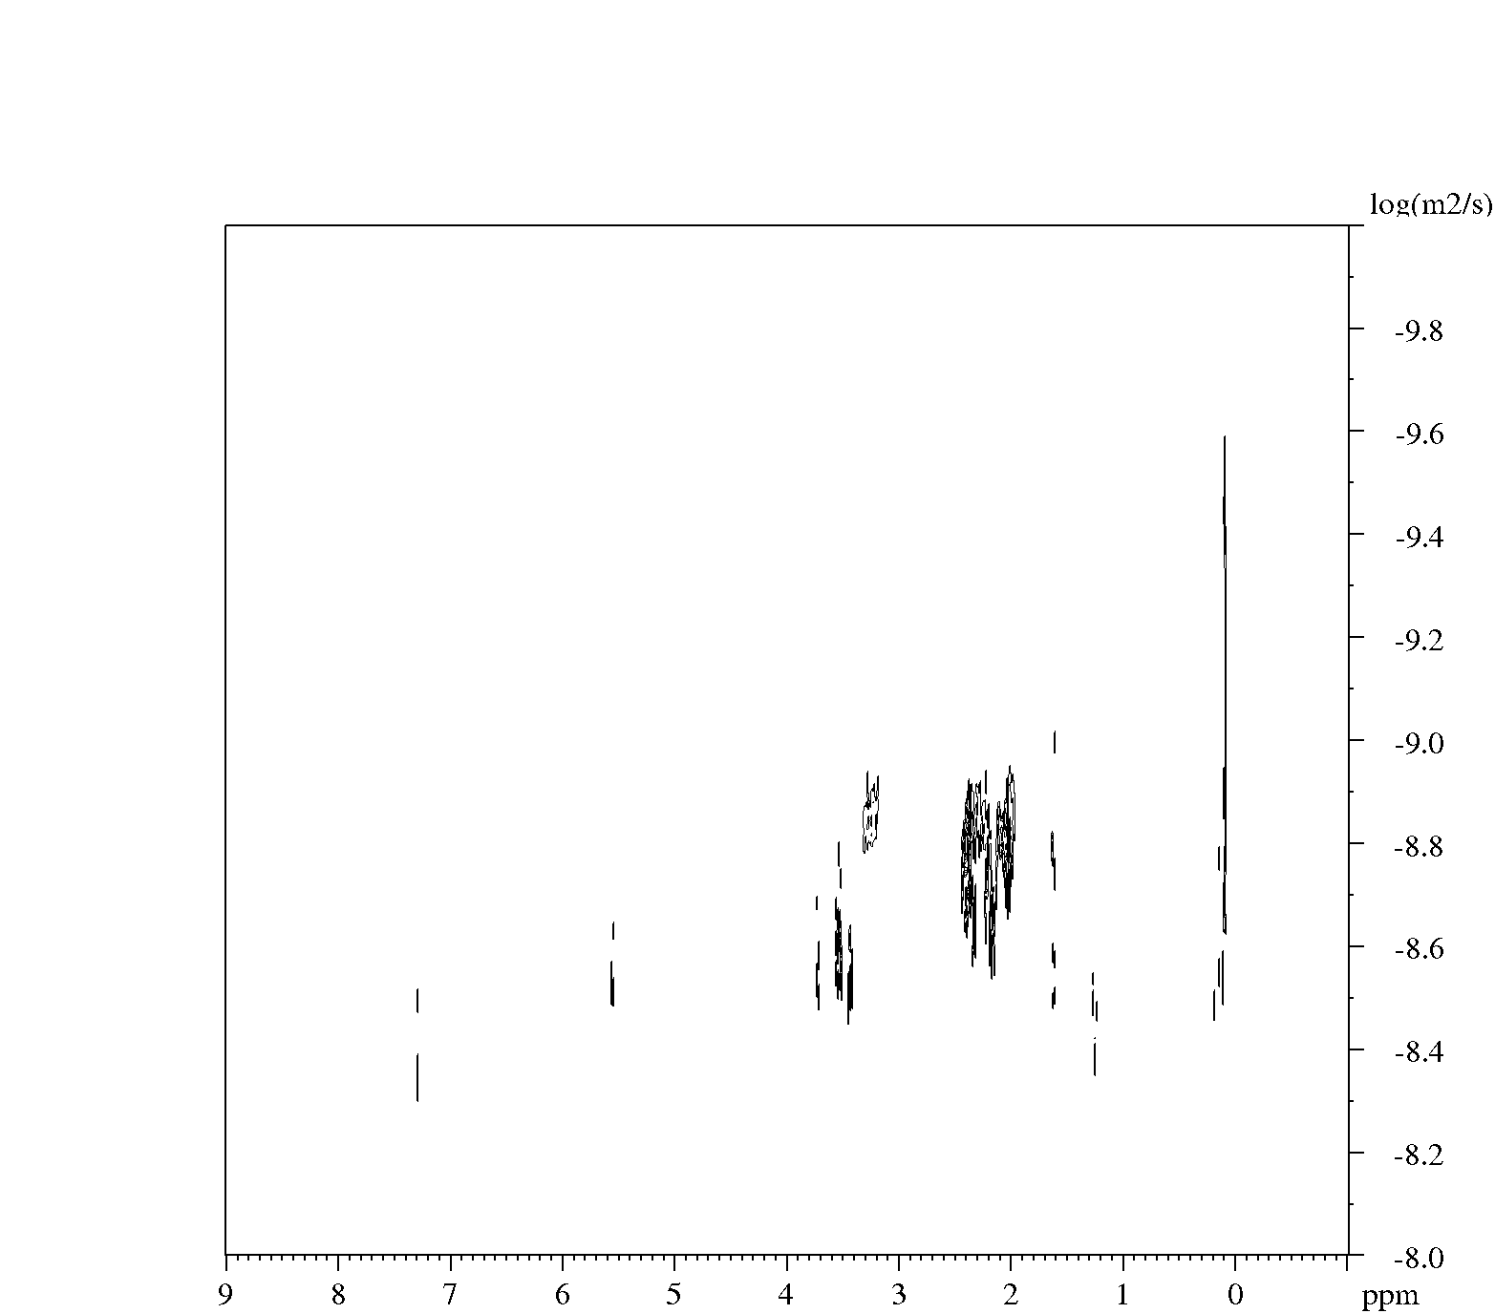
Intensity |  | Area
Peak  ppm | diffusion constant  log | Peak  ppm | diffusion constant  log
7.298 | 3.09E-09 | 7.509 - 7.110 | 2.15E-09
5.978 | 1.67E-09 | 6.125 - 5.867 | 1.05E-09
5.371 | 1.78E-09 | 5.550 - 5.327 | 1.38E-09
4.792 | 1.79E-09 | 4.928 - 4.752 | 1.41E-09
4.67 | 1.20E-09 | 4.752 - 4.658 | 5.72E-10
3.994 | 1.46E-09 | 4.154 - 3.755 | 8.88E-10
2.208 | 1.32E-09 | 2.277 - 2.077 | 5.32E-10
1.588 | 8.54E-10 | 1.714 - 1.514 | 1.56E-09
1.407 | 1.81E-09 | 1.514 - 1.327 | 7.96E-10
1.256 | 2.70E-09 | 1.327 - 1.127 | 1.13E-09
1.106 | 5.06E-10 | 0.892 - -0.820 | 4.01E-10
1.439 | 1.03E-09
1.346 | 2.50E-09
1.247 | 4.03E-09
0.183 | 3.98E-09
0.081 | 2.07E-09

PDMS (5,000)1c
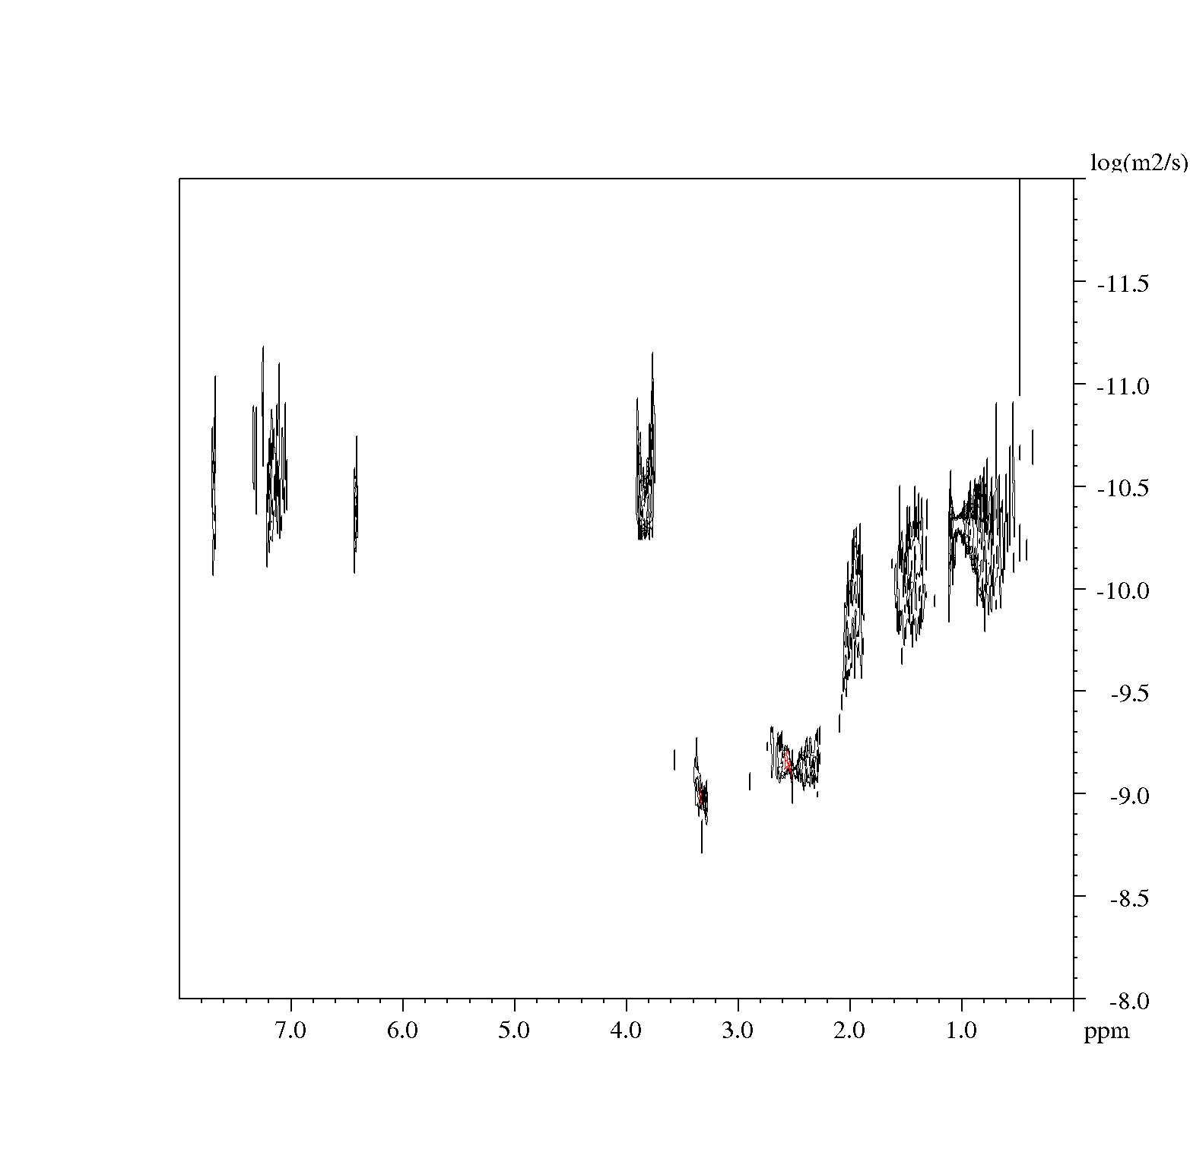
Intensity |  | Area
Peak  ppm | diffusion constant  log | Peak  ppm | diffusion constant  log
7.296 | 2.58E-08 | 7.374 - 7.194 | 4.74E-09
5.556 | 9.83E-10 | 5.661 - 5.513 | 5.34E-09
3.73 | 9.83E-10 | 4.119 - 3.863 | 5.06E-09
3.553 | 2.79E-08 | 3.831 - 3.693 | 2.05E-08
3.459 | 2.67E-08 | 3.576 - 3.501 | 2.49E-08
3.296 | 1.97E-09 | 3.501 - 3.406 | 2.78E-08
2.369 | 2.93E-08 | 3.341 - 3.129 | 1.59E-09
2.184 | 2.69E-08 | 2.511 - 2.331 | 2.72E-08
2.036 | 2.45E-08 | 2.256 - 2.129 | 2.73E-08
1.64 | 2.70E-08 | 2.129 - 1.916 | 2.44E-09
1.2634 | 8.38E-10 | 1.724 - 1.566 | 3.12E-09
0.092 | 2.41E-08 | 1.341 - 1.139 | 3.73E-09
1.346 | 2.50E-09 | 0.128 - 0.001 | 1.62E-09
1.247 | 4.03E-09
0.183 | 3.98E-09
0.081 | 2.07E-09

PDMS(10,000):2.15PNVP
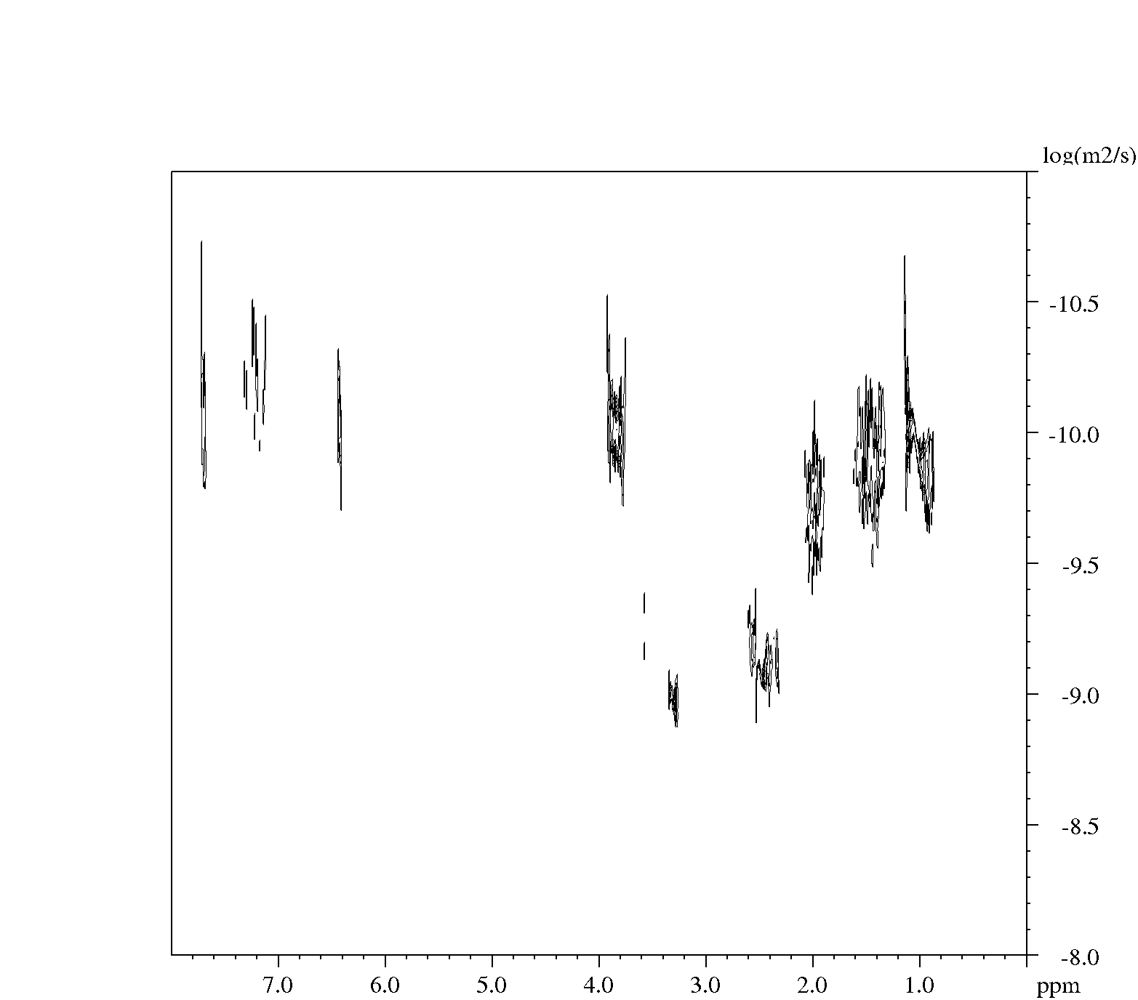
Intensity |  | Area
Peak  ppm | diffusion constant  log | Peak  ppm | diffusion constant  log
8.093 | 3.77E-10 | 8.159 to 8.081 | 2.21E-10
7.997 | 9.47E-10 | 8.069 to 7.924 | 7.10E-11
7.296 | 2.11E-09 | 7.622 to 7.511 | 2.93E-08
6.084 | 9.29E-10 | 7.343 to 7.153 | 2.03E-09
5.535 | 9.44E-10 | 7.041 to 6.807 | 8.71E-11
4.181 | 2.04E-10 | 6.169 to 5.958 | 5.52E-10
3.938 | 8.48E-10 | 4.270 to 4.147 | 1.44E-10
3.638 | 6.31E-10 | 4.147 to 4.023 | 1.64E-10
3.507 | 9.21E-10 | 3.946 to 3.812 | 1.68E-10
3.393 | 1.18E-09 | 3.844 to 3.566 | 2.06E-10
3.177 | 1.69E-10 | 3.588 to 3.454 | 6.57E-10
2.943 | 1.41E-09 | 3.454 to 3.353 | 7.47E-10
2.357 | 2.83E-10 | 3.353 to 2.995 | 1.76E-10
1.683 | 1.80E-10 | 2.192 to 2.102 | 1.11E-09
1.407 | 1.83E-10 | 1.788 to 1.655 | 1.80E-10
1.141 | 2.51E-10 | 1.498 to 1.319 | 1.89E-10
0.196 | 1.78E-10 | 1.263 to 1.208 | 5.57E-10

PDMS (10,000)2b
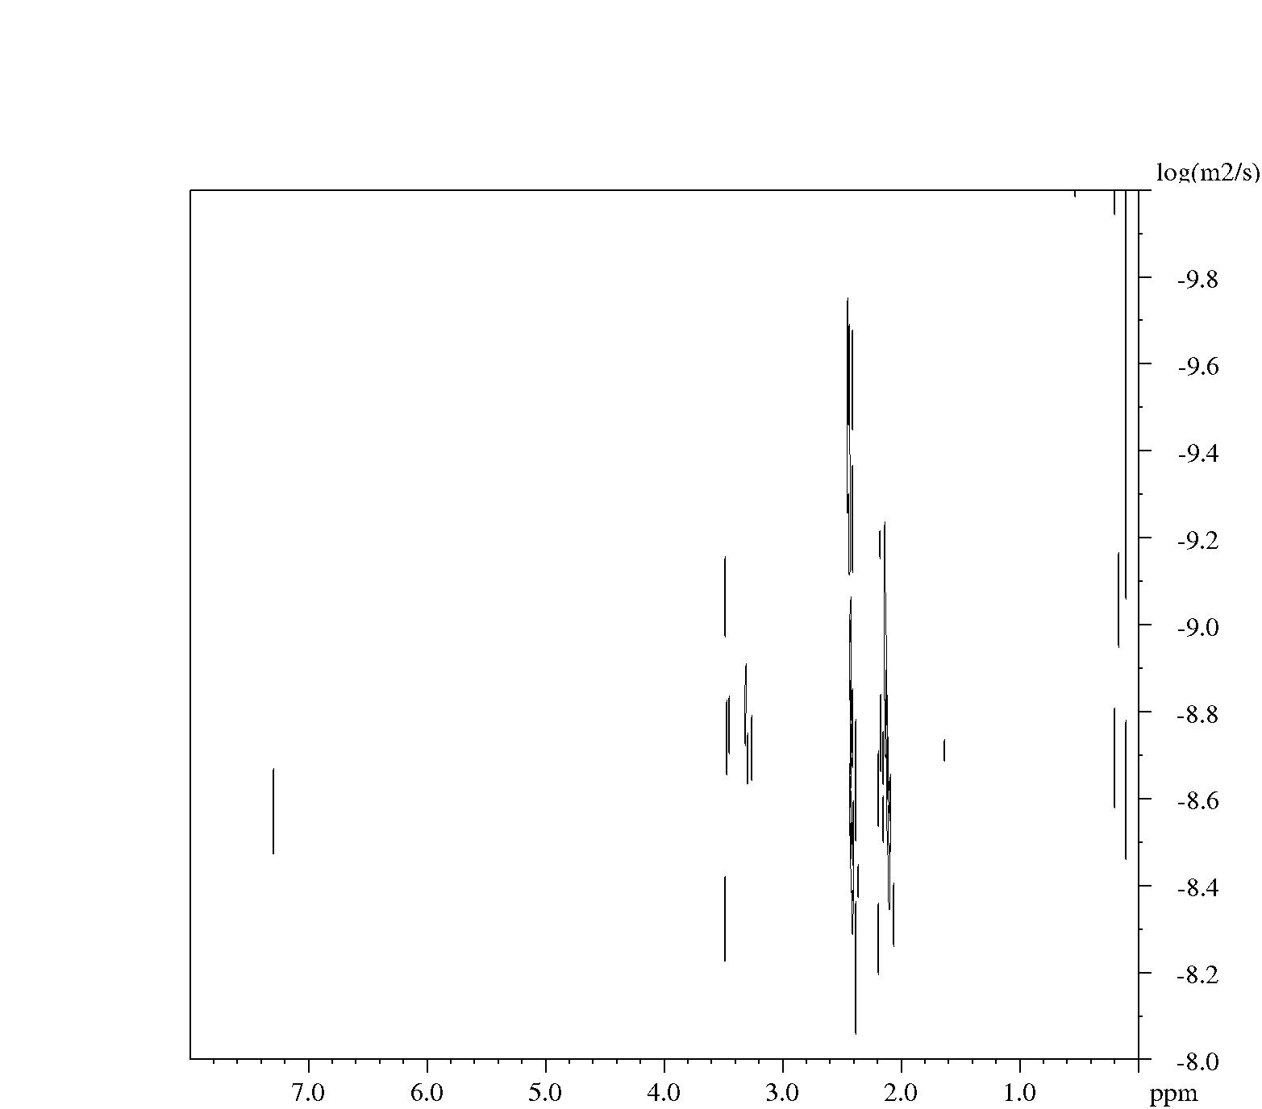
Intensity |  | Area
Peak  ppm | diffusion constant  log | Peak  ppm | diffusion constant  log
7.296 | 5.00E-09 | 7.393 -7.151 | 3.51E-09
5.569 | 3.11E-09 | 5.638 -5.518 | 2.20E-09
5.33 | 8.34E-10 | 5.396 -5.299 | 4.74E-10
4.393 | 8.35E-10 | 4.441 -4.356 | 1.07E-10
3.976 | 8.43E-10 | 4.078 -3.921 | 7.23E-10
3.723 | 2.82E-09 | 3.872 -3.654 | 1.76E-09
3.548 | 3.36E-09 | 3.630 -3.509 | 2.56E-09
3.46 | 3.65E-09 | 3.509 -3.388 | 3.04E-09
3.252 | 8.69E-10 | 3.400 -3.086 | 2.40E-09
2.978 | 8.49E-10 | 3.013 -2.965 | 2.48E-09
2.372 | 3.48E-09 | 2.506 -2.287 | 2.56E-09
2.18 | 3.50E-09 | 2.239 -2.118 | 2.78E-09
2.032 | 3.14E-09 | 2.118 -1.925 | 2.96E-09
1.617 | 3.83E-09 | 1.803 -1.513 | 3.75E-09
1.45 | 2.90E-09 | 1.513 -1.368 | 3.82E-09
1.258 | 8.53E-10 | 1.356 -1.151 | 2.80E-08
0.08 | 2.63E-09 | 0.158 --0.048 | 2.66E-09

PDMS (10,000)2c

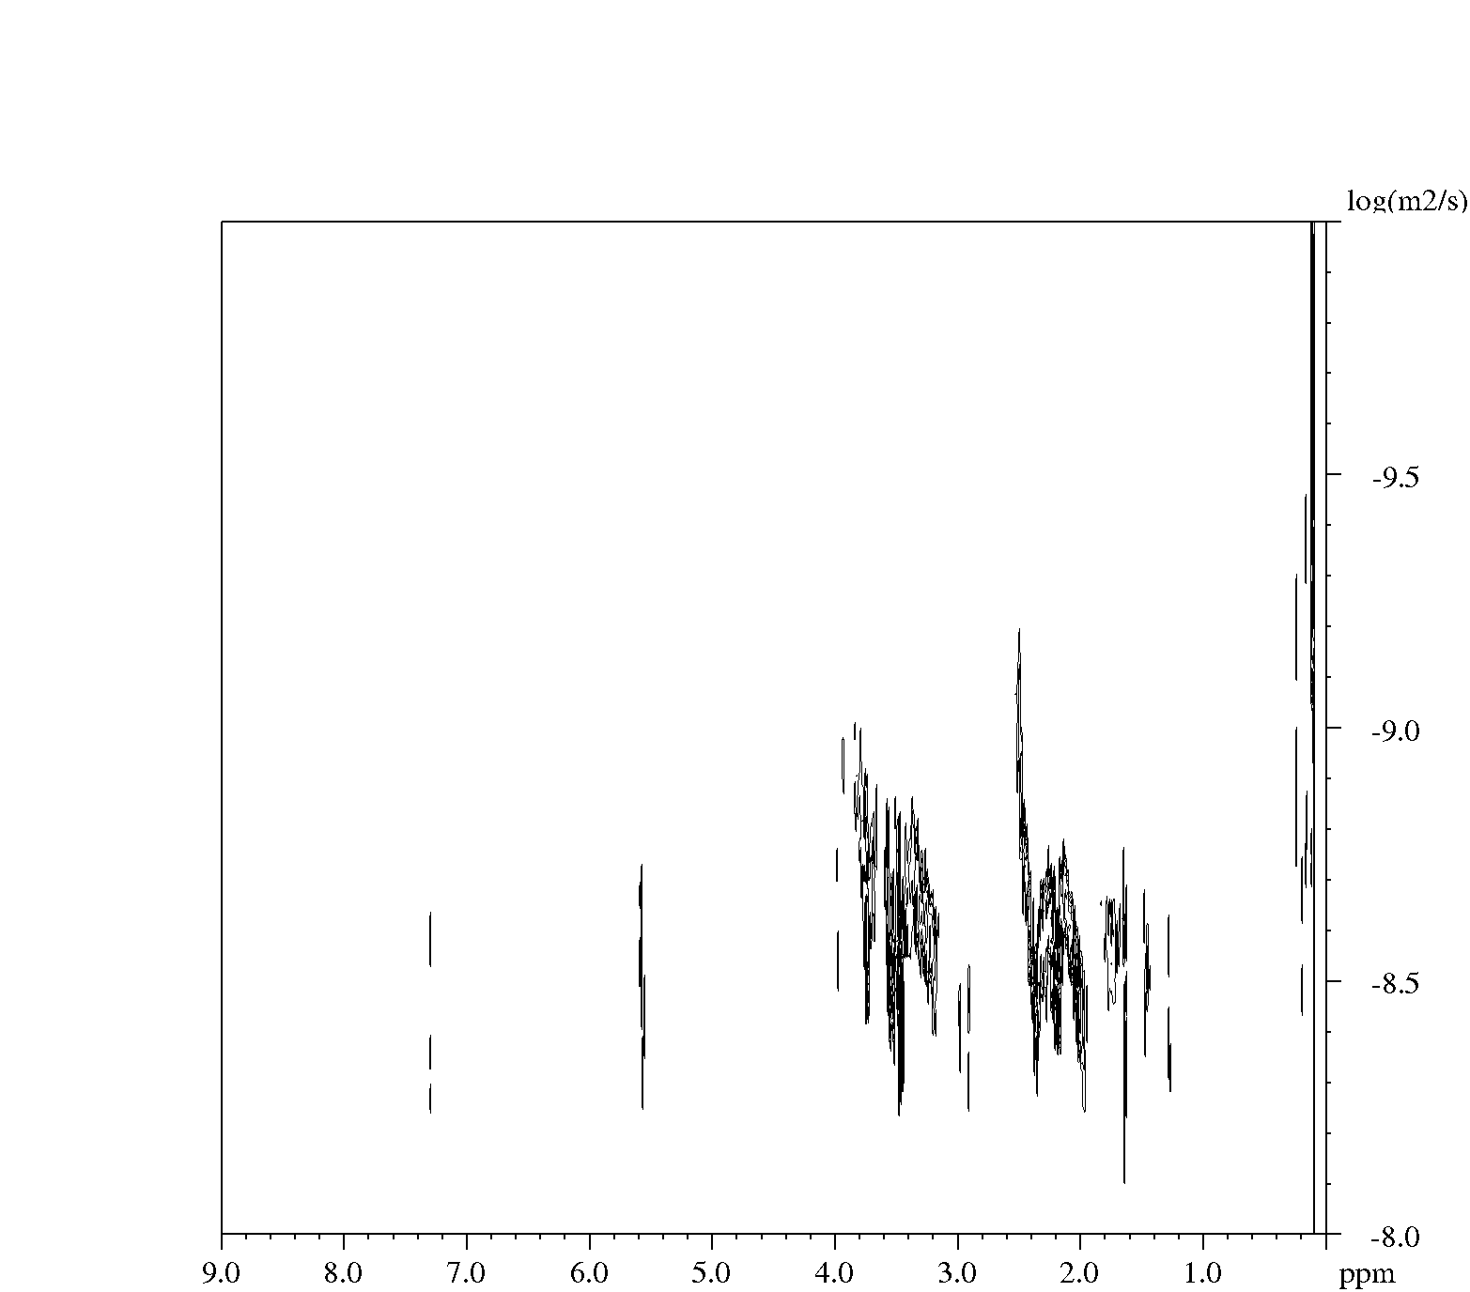
Intensity |  | Area
Peak  ppm | diffusion constant  log | Peak  ppm | diffusion constant  log
7.296 | 4.75E-09 | 7.335 to 7.261 | 5.08E-09
5.569 | 3.11E-09 | 5.638 to 5.518 | 2.20E-09
5.333 | 8.34E-10 | 5.396 to 5.299 | 4.74E-10
4.393 | 8.35E-10 | 4.441 to 4.356 | 1.07E-10
3.976 | 8.43E-10 | 4.078 to 3.921 | 7.23E-10
3.732 | 2.82E-09 | 3.872 to 3.654 | 1.76E-09
3.548 | 3.36E-09 | 3.630 to 3.509 | 2.56E-09
3.252 | 8.69E-10 | 3.400 to 3.086 | 2.40E-09
2.978 | 8.49E-10 | 3.013 to 2.965 | 2.48E-09
2.372 | 3.48E-09 | 2.506 to 2.287 | 2.56E-09
2.18 | 3.50E-09 | 2.239 to 2.118 | 2.78E-09
2.032 | 3.14E-09 | 2.118 to 1.925 | 2.96E-09
1.617 | 3.83E-09 | 1.803 to 1.513 | 3.75E-09
1.258 | 8.53E-10 | 1.356 to 1.151 | 2.80E-08
0.087 | 2.63E-09 | 0.158 to 0.048 | 2.66E-09

PDMS(20,000):1.08PNVP
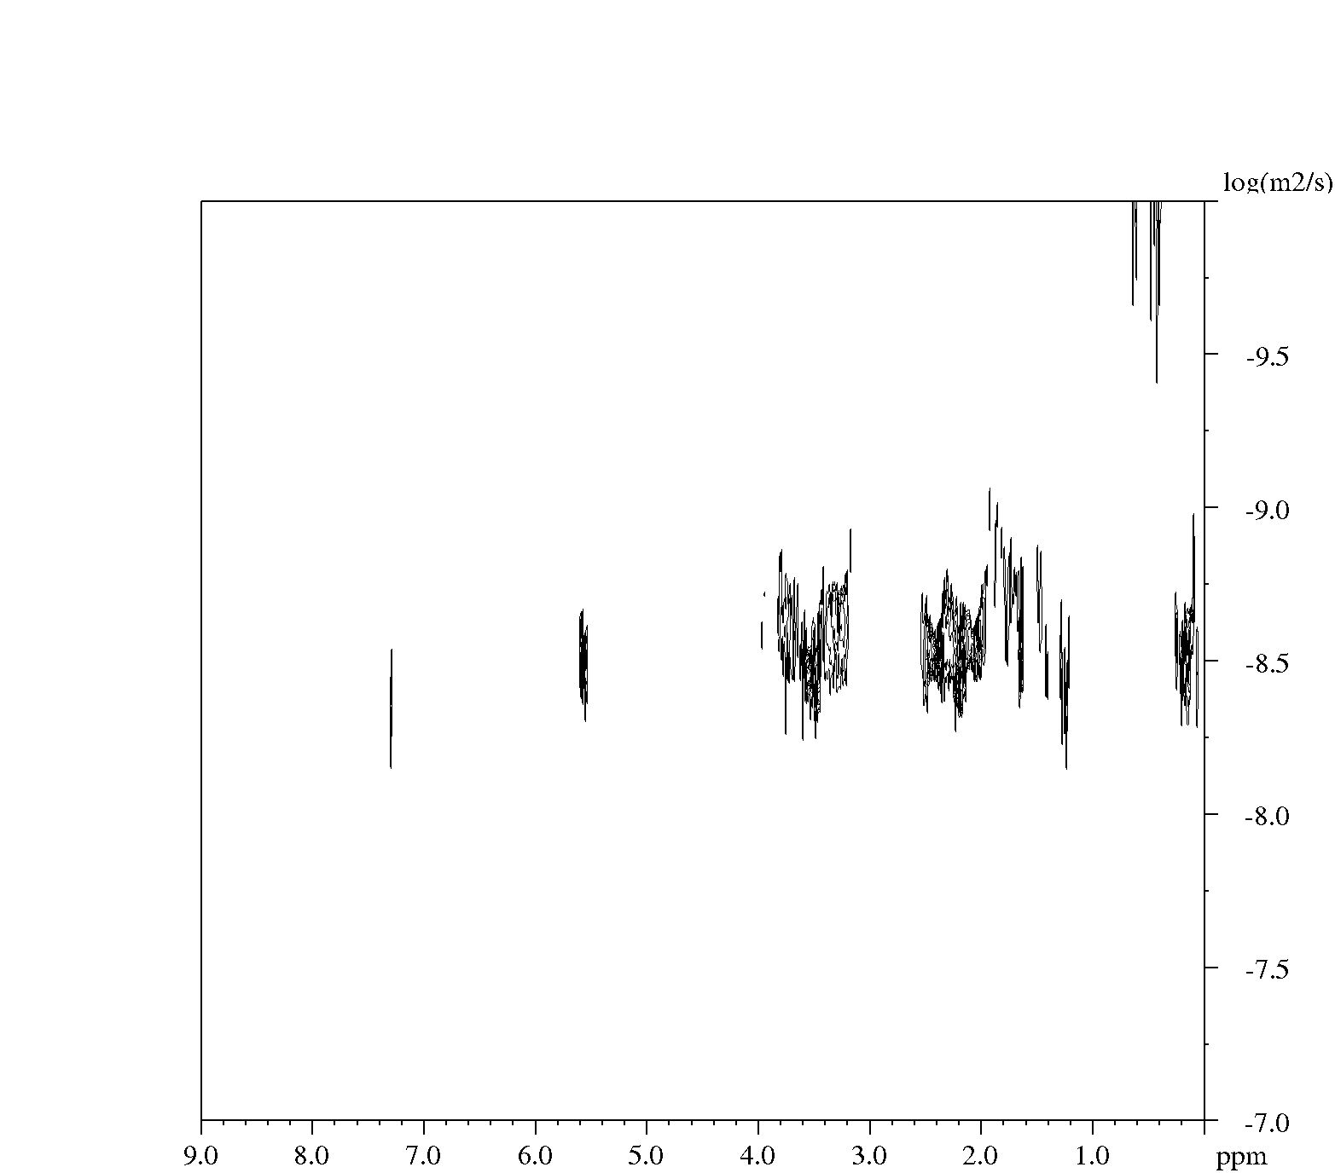
Intensity |  | Area
Peak  ppm | diffusion constant  log | Peak  ppm | diffusion constant  log
8.025 | 1.19E-09 | 8.081 to 7.958 | 5.70E-10
7.289 | 2.65E-08 | 7.421 to 7.141 | 3.33E-09
5.543 | 2.89E-08 | 5.689 to 5.477 | 1.48E-09
4.38 | 1.02E-09 | 4.471 to 4.303 | 3.35E-10
3.751 | 8.74E-10 | 3.856 to 3.600 | 3.26E-09
3.212 | 5.65E-10 | 3.443 to 3.075 | 2.75E-08
2.966 | 8.39E-10 | 3.041 to 2.850 | 3.00E-09
2.218 | 8.53E-10 | 2.291 to 2.168 | 2.73E-08
2.02 | 2.79E-08 | 2.168 to 1.878 | 2.95E-08
1.859 | 3.00E-08 | 1.912 to 1.810 | 3.00E-08
1.72 | 8.69E-10 | 1.810 to 1.677 | 2.72E-08
1.604 | 2.40E-08 | 1.677 to 1.544 | 2.62E-08
1.438 | 8.72E-10 | 1.544 to 1.365 | 2.98E-08
1.205 | 2.84E-08 | 1.297 to 1.017 | 2.87E-08
0.885 | 9.26E-10 | 0.973 to 0.838 | 2.86E-08
0.074 | 2.87E-08 | 0.291 to 0 | 2.95E-08

PDMS (20,000)3b
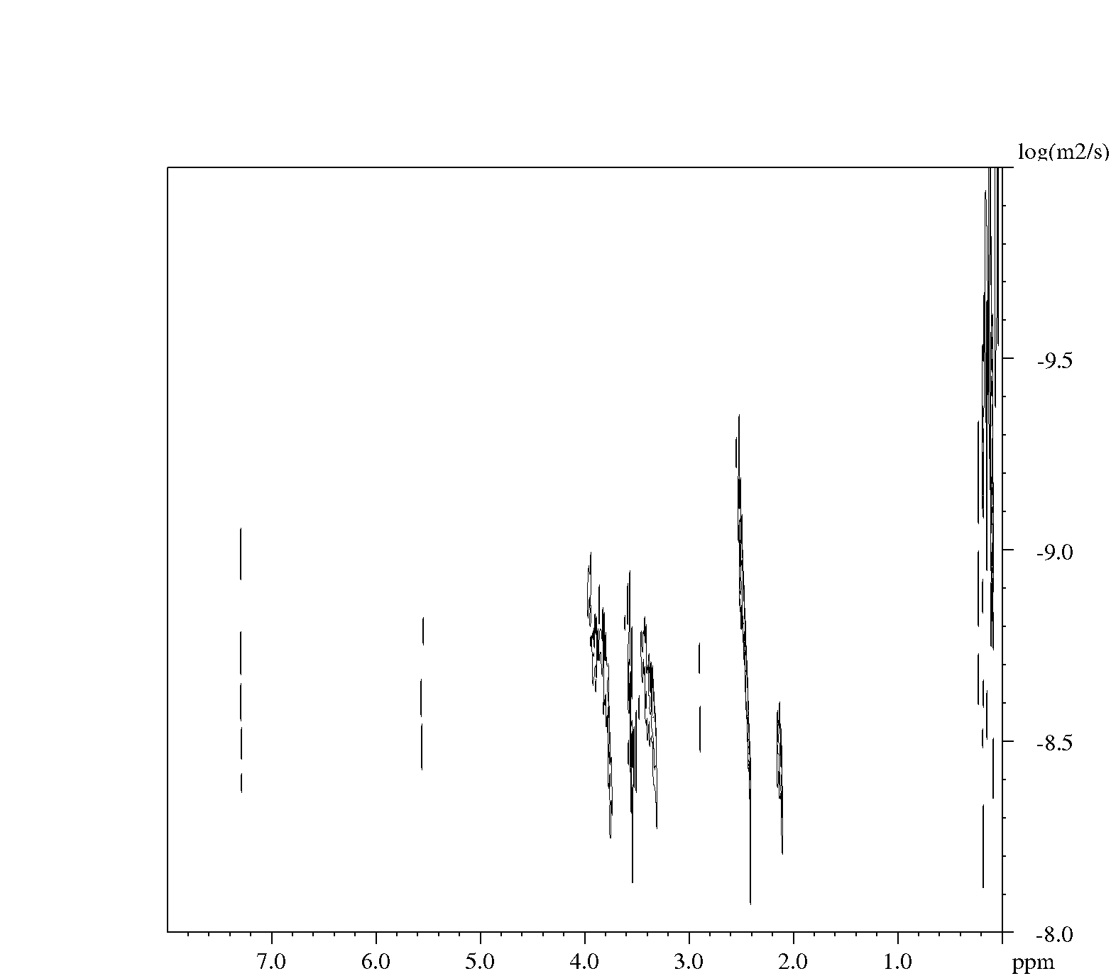
Intensity |  | Area
Peak  ppm | diffusion constant  log | Peak  ppm | diffusion constant  log
7.295 | 4.31E-09 | 7.409 to 7.153 | 2.68E-08
5.53 | 2.96E-09 | 5.634 to 5.477 | 2.71E-08
4.686 | 9.15E-10 | 4.695 to 4.371 | 6.07E-10
3.726 | 2.51E-09 | 3.834 to 3.666 | 1.37E-09
3.457 | 3.45E-09 | 3.666 to 3.365 | 2.90E-09
3.224 | 1.22E-09 | 3.365 to 3.007 | 1.39E-09
2.369 | 2.67E-09 | 2.504 to 2.269 | 1.76E-09
2.181 | 3.00E-09 | 2.269 to 2.113 | 1.94E-09
2.014 | 2.11E-09 | 2.113 to 1.844 | 1.56E-09
1.637 | 2.85E-09 | 1.699 to 1.520 | 1.66E-09
1.409 | 8.49E-10 | 1.520 to 1.319 | 1.49E-09
1.259 | 3.35E-09 | 1.319 to 1.017 | 1.98E-09
0.089 | 2.26E-09 | 0.381 to 0 | 1.33E-09

PDMS(20,000):2.4PNVP
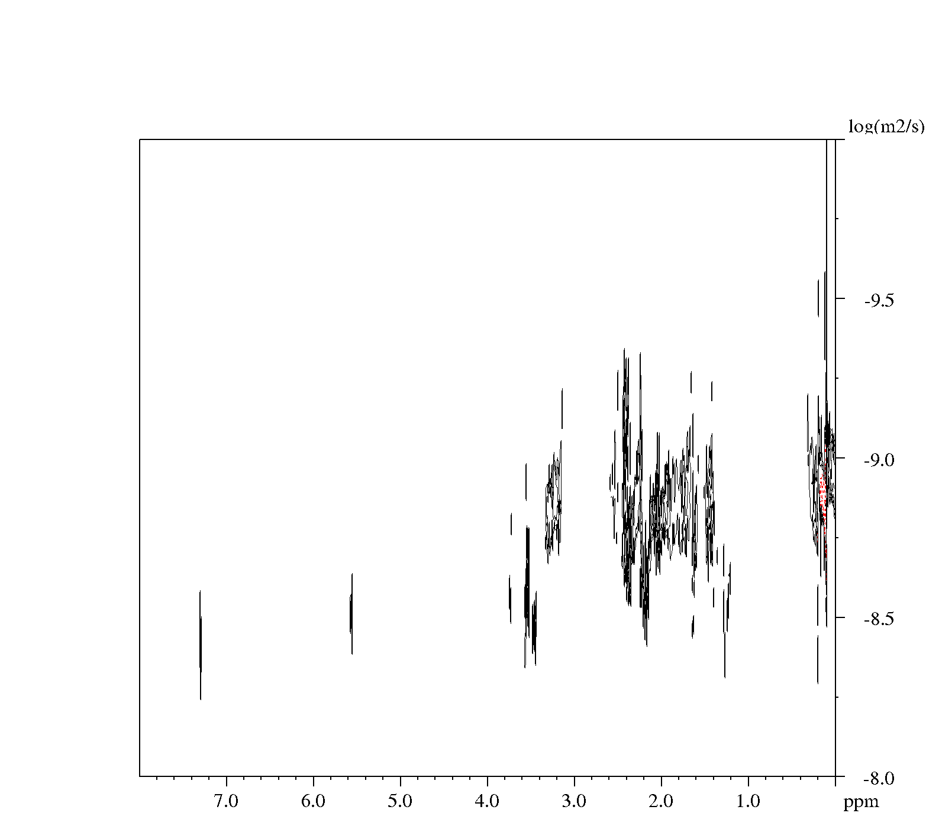
Intensity |  | Area
Peak  ppm | diffusion constant  log | Peak  ppm | diffusion constant  log
7.695 | 8.34E-12 | 7.835 to 7.667 | 2.77E-11
7.207 | 1.17E-11 | 7.566 to 6.807 | 3.12E-11
6.418 | 3.77E-11 | 6.538 to 6.314 | 2.21E-11
4.342 | 8.80E-10 | 4.459 to 4.270 | 5.23E-10
3.831 | 3.14E-11 | 3.990 to 3.655 | 2.88E-11
3.567 | 6.97E-10 | 3.644 to 3.498 | 1.21E-09
3.318 | 9.52E-10 | 3.375 to 3.085 | 9.91E-10
2.544 | 6.58E-10 | 2.973 to 2.538 | 6.43E-10
2.501 | 7.38E-10 | 2.548 to 2.113 | 7.42E-10
2.08 | 4.24E-10 | 2.113 to 1.822 | 2.13E-10
1.461 | 1.15E-10 | 1.810 to 1.208 | 1.85E-10
1.038 | 5.04E-11 | 1.196 to 0.504 | 5.23E-11
 |  | 0.381 to 0 | 1.33E-09

13.6 Confocal images contributing to Z-stack

0.1 Wt. % Rhodamine B
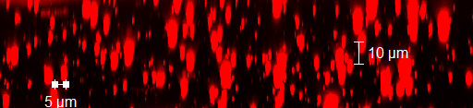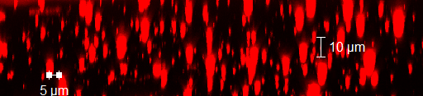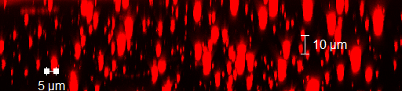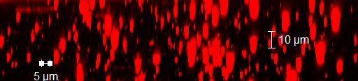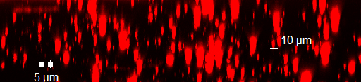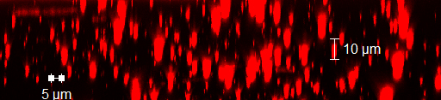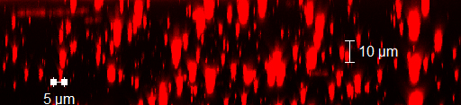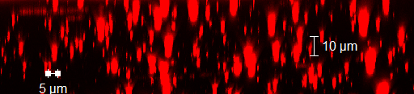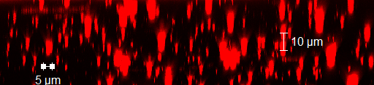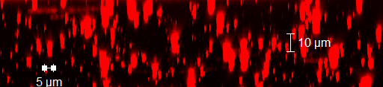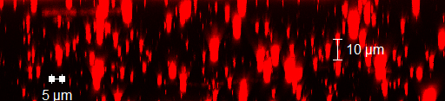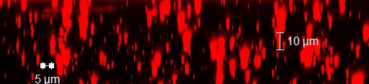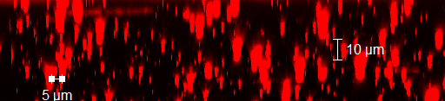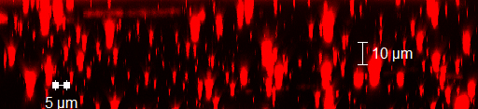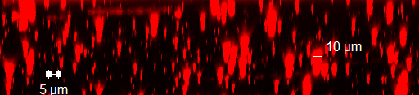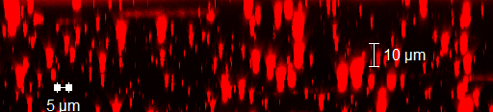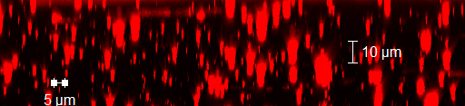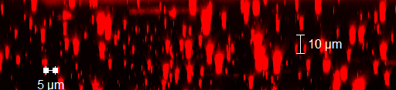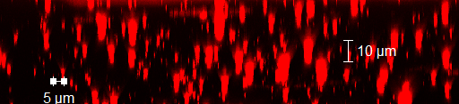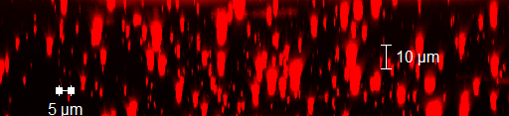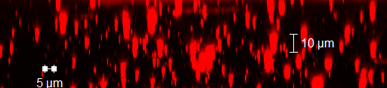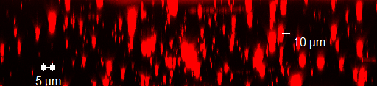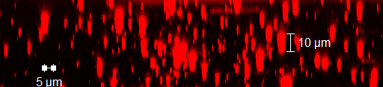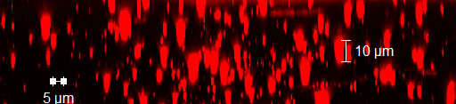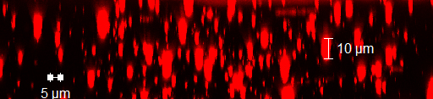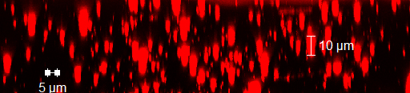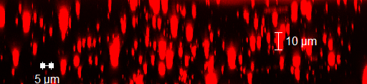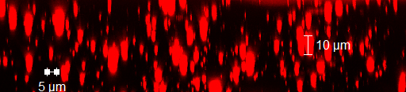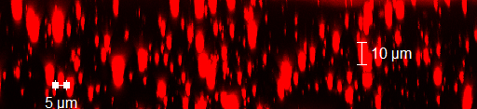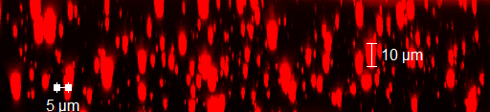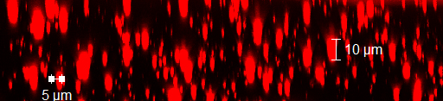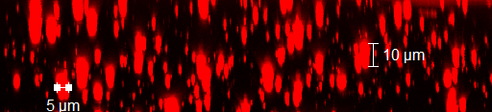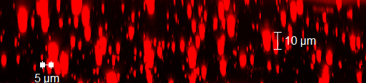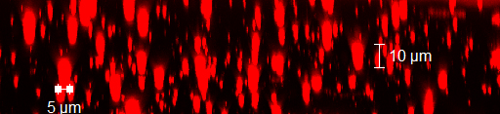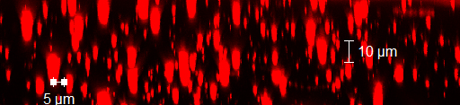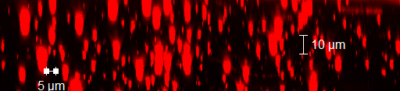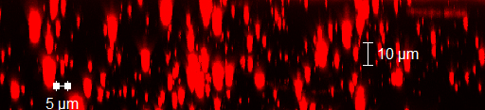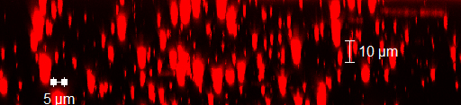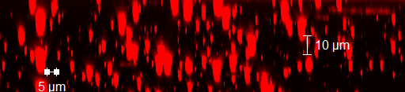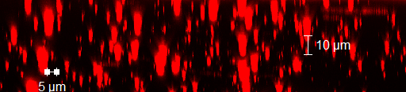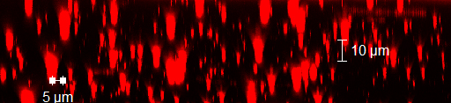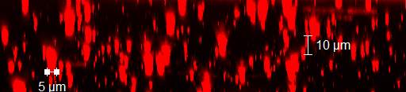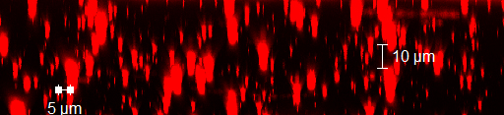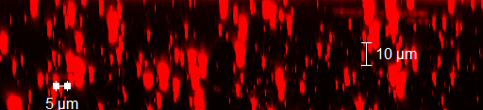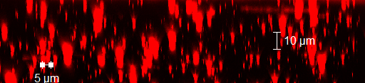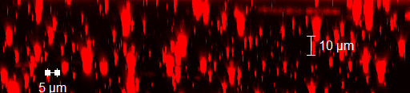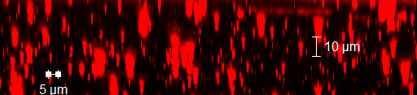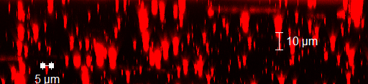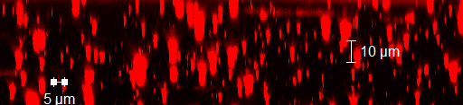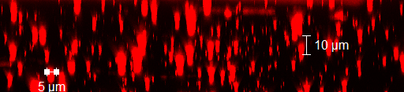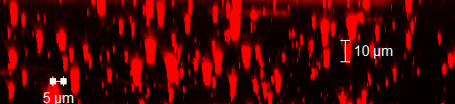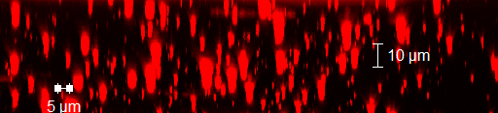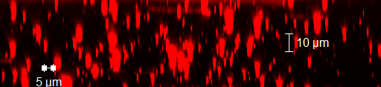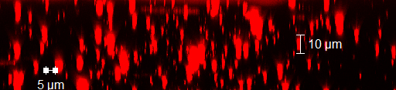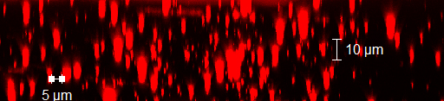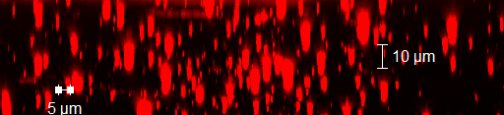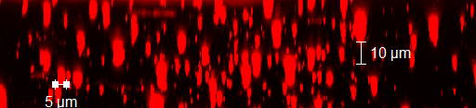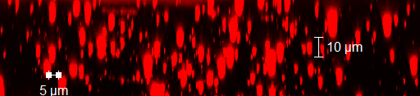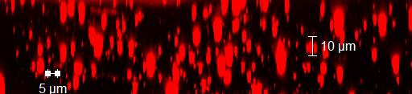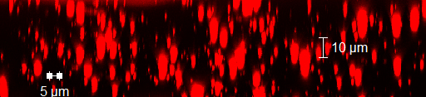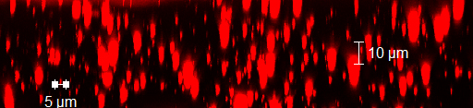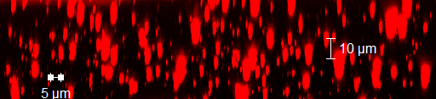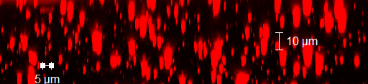

1 Wt. % Rhodamine B loading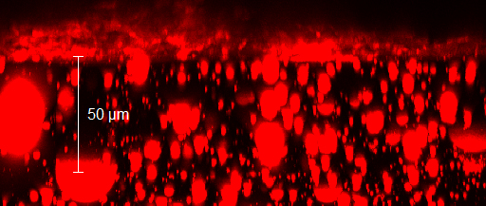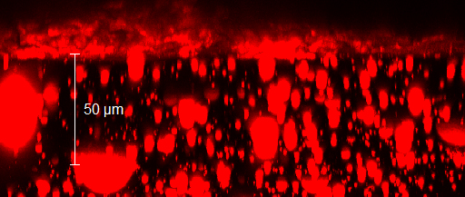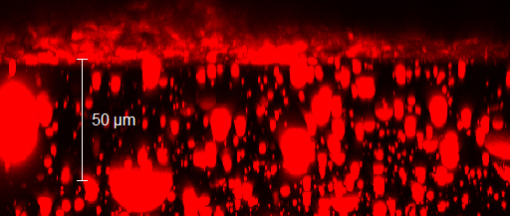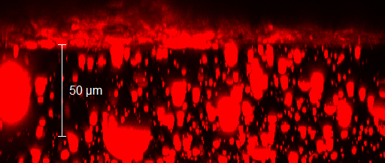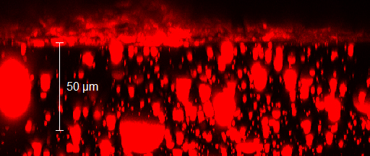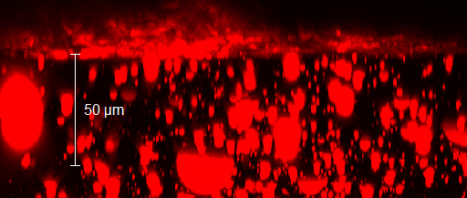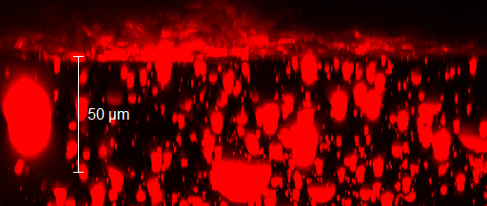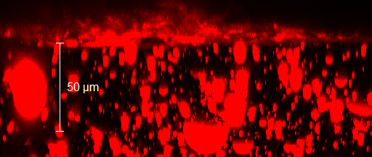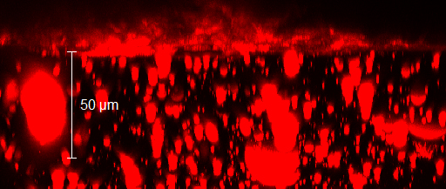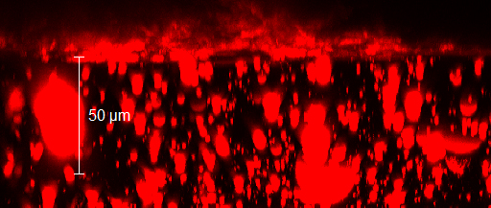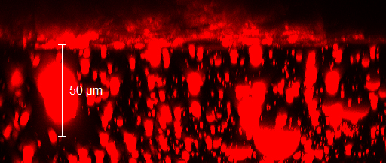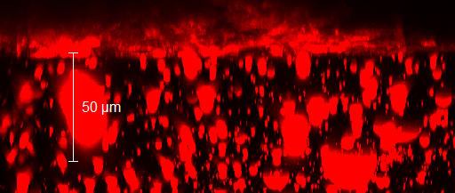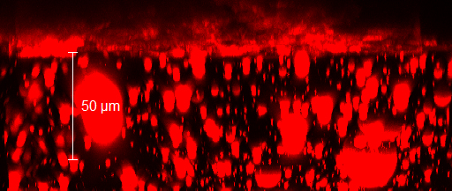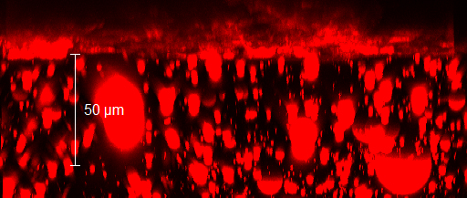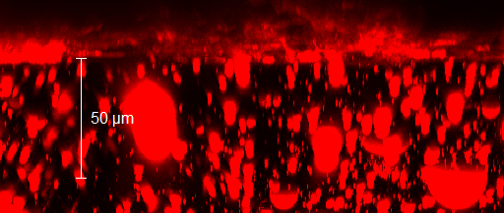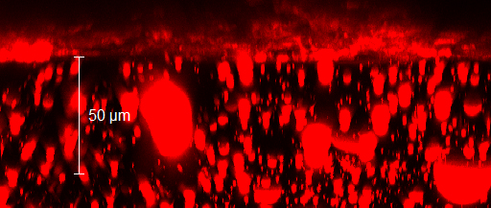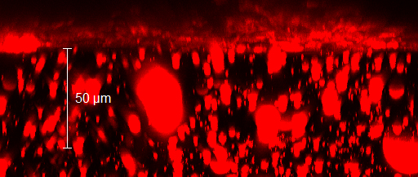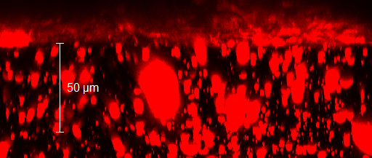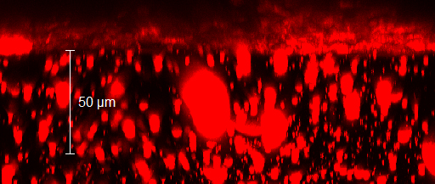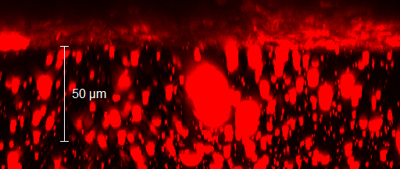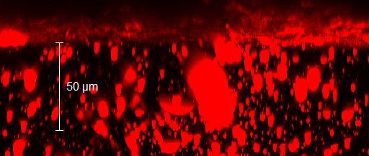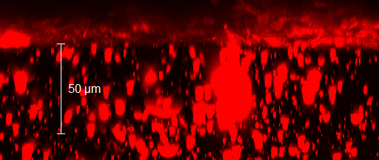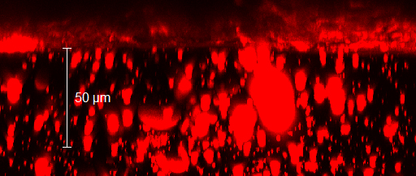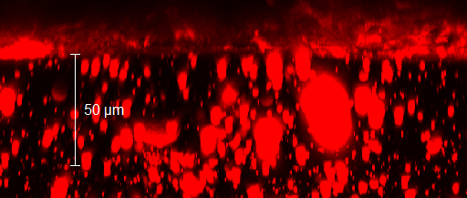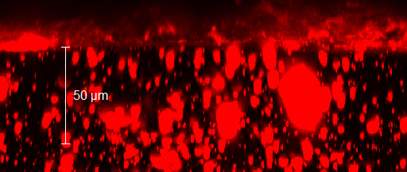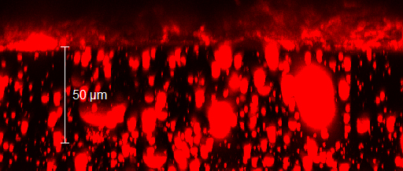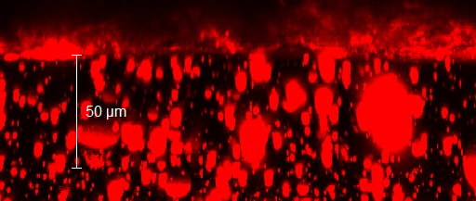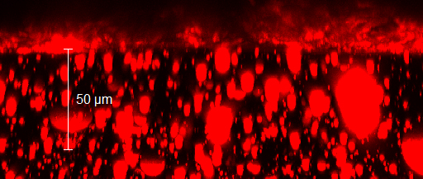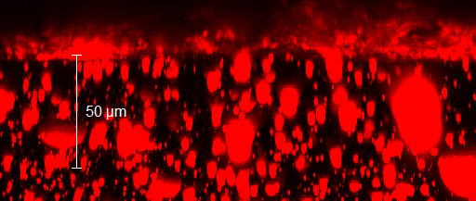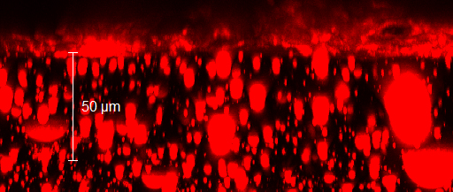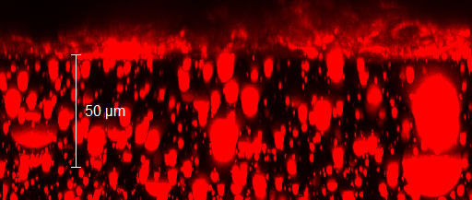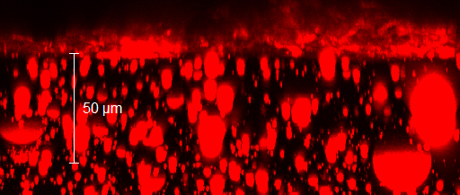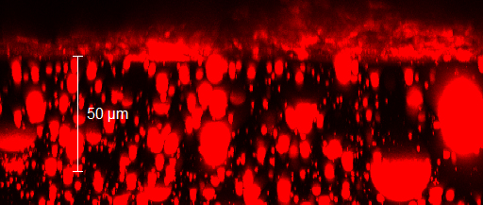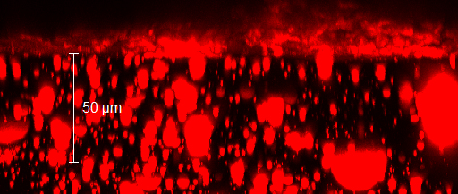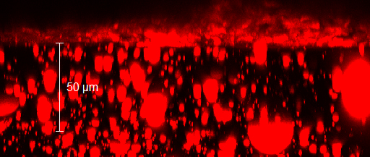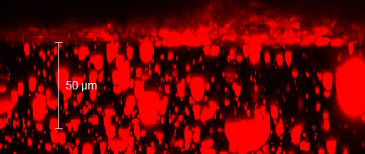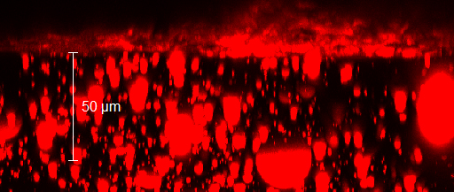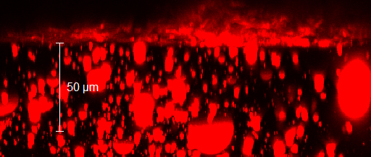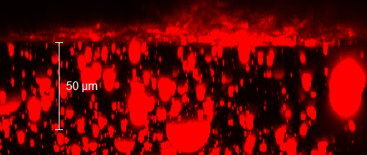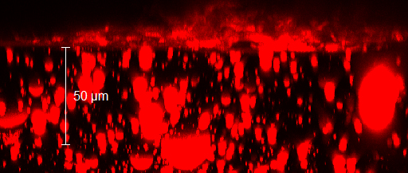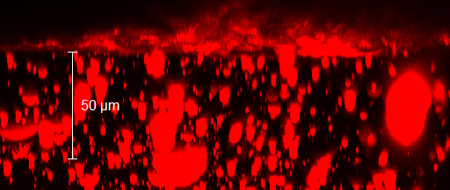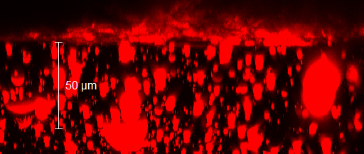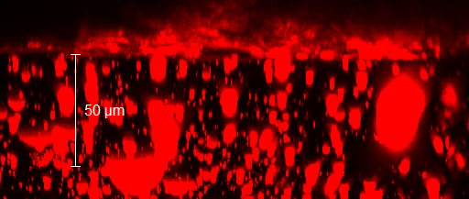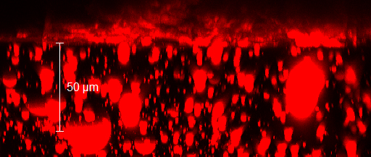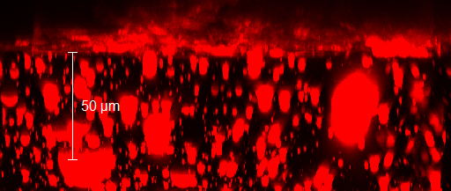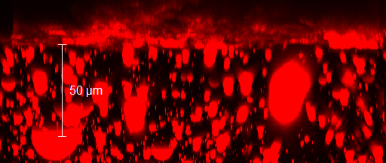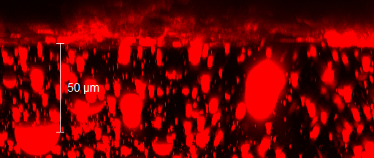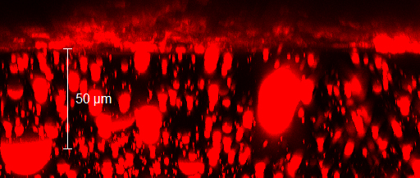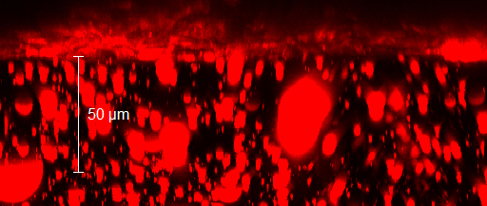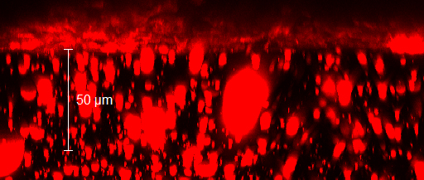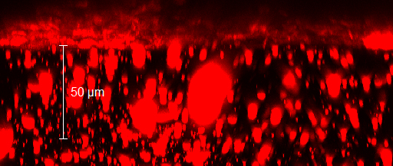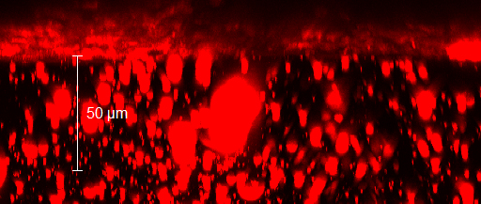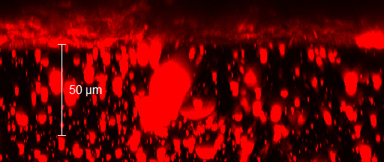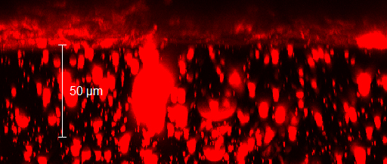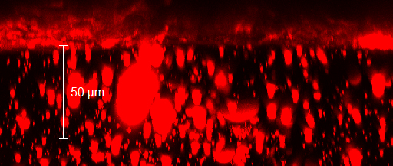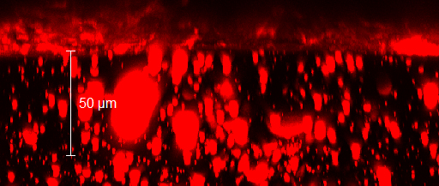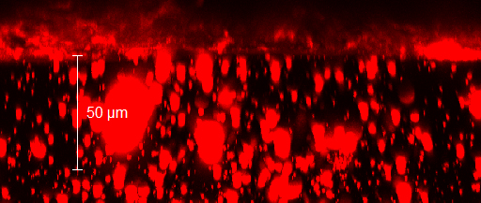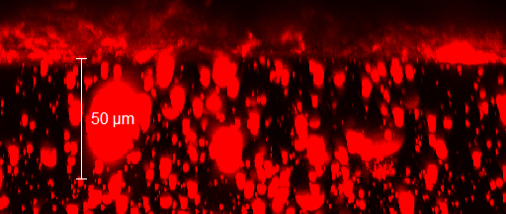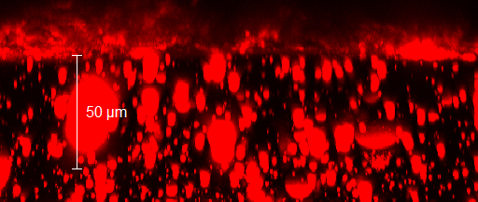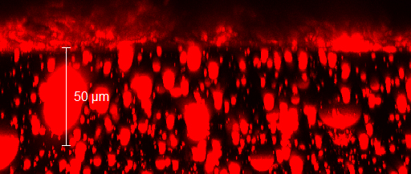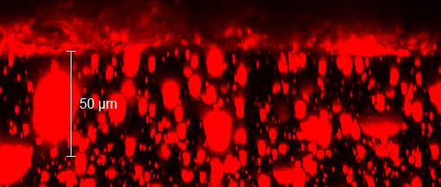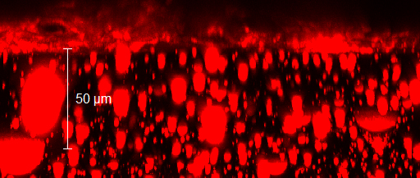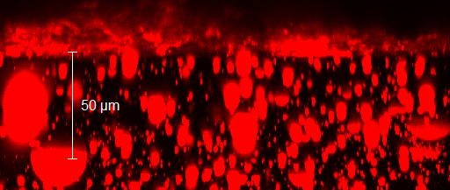

10 Wt. % Rhodamine B loading
